First round evaluation: March 2014
Second round evaluation: July 2014

AusPAR Attachment 2

Extract from the Clinical Evaluation Report for Ponatinib Hydrochloride
  - Proprietary Product Name: Iclusig
  - Sponsor: Ariad Pharmaceuticals (Australia) Pty Ltd

About the Therapeutic Goods Administration (TGA)
- The Therapeutic Goods Administration (TGA) is part of the Australian Government Department of Health, and is responsible for regulating medicines and medical devices.
- The TGA administers the Therapeutic Goods Act 1989 (the Act), applying a risk management approach designed to ensure therapeutic goods supplied in Australia meet acceptable standards of quality, safety and efficacy (performance), when necessary.
- The work of the TGA is based on applying scientific and clinical expertise to decision-making, to ensure that the benefits to consumers outweigh any risks associated with the use of medicines and medical devices.
- The TGA relies on the public, healthcare professionals and industry to report problems with medicines or medical devices. TGA investigates reports received by it to determine any necessary regulatory action.
- To report a problem with a medicine or medical device, please see the information on the TGA website <https://www.tga.gov.au>.
About the Extract from the Clinical Evaluation Report
- This document provides a more detailed evaluation of the clinical findings, extracted from the Clinical Evaluation Report (CER) prepared by the TGA. This extract does not include sections from the CER regarding product documentation or post market activities.
- The words [Information redacted], where they appear in this document, indicate that confidential information has been deleted.
- For the most recent Product Information (PI), please refer to the TGA website <https://www.tga.gov.au/product-information-pi>.
Copyright
© Commonwealth of Australia 2015
This work is copyright. You may reproduce the whole or part of this work in unaltered form for your own personal use or, if you are part of an organisation, for internal use within your organisation, but only if you or your organisation do not use the reproduction for any commercial purpose and retain this copyright notice and all disclaimer notices as part of that reproduction. Apart from rights to use as permitted by the Copyright Act 1968 or allowed by this copyright notice, all other rights are reserved and you are not allowed to reproduce the whole or any part of this work in any way (electronic or otherwise) without first being given specific written permission from the Commonwealth to do so. Requests and inquiries concerning reproduction and rights are to be sent to the TGA Copyright Officer, Therapeutic Goods Administration, PO Box 100, Woden ACT 2606 or emailed to <tga.copyright@tga.gov.au>.

Contents
List of abbreviations 5
1. Clinical rationale 7
2. Contents of the clinical dossier 8
2.1. Scope of the clinical dossier 8
2.2. Paediatric data 8
2.3. Good clinical practice 8
3. Pharmacokinetics 8
3.1. Studies providing pharmacokinetic data 8
3.2. Summary of pharmacokinetics 9
4. Pharmacodynamics 17
5. Dosage selection for the pivotal studies 17
6. Clinical efficacy 17
6.1. Pivotal efficacy study – Study 201 17
6.2. Supportive efficacy study – Study 101 36
6.3. Analyses performed across trials (pooled analyses and meta-analyses) 45
6.4. Evaluator’s conclusions on clinical efficacy 45
7. Clinical safety 46
7.1. Studies providing evaluable safety data 46
7.2. Pivotal studies that assessed safety as a primary outcome 47
7.3. Patient exposure 47
7.4. Adverse events 49
7.5. Safety issues with the potential for major regulatory impact 78
7.6. Evaluator’s overall conclusions on clinical safety 79
8. First round benefit-risk assessment 79
8.1. First round assessment of benefits 79
8.2. First round assessment of risks 80
8.3. First round assessment of benefit-risk balance 80
9. First round recommendation regarding authorisation 81
10. Clinical questions 81
10.1. General 81
10.2. Pharmacokinetics 81
10.3. Pharmacodynamics 81
10.4. Efficacy 81
10.5. Safety 81
11. Second round evaluation of clinical data submitted in response to questions 82
11.1. PK in hepatic failure 82
11.2. Efficacy data 82
11.3. Safety findings from the EPIC study 83
11.4. Vascular AEs 88
11.5. Heart failure 94
11.6. Hepatic failure 96
11.7. Coagulation parameters, cardiac troponins and TSH in Study 101 97
11.8. Dosing considerations 98
11.9. Other data 106
11.10. Comparison with bosutinib 107
12. Second round benefit-risk assessment 110
12.1. Second round assessment of benefits 110
12.2. Second round assessment of risks 110
12.3. Second round assessment of benefit-risk balance 110
13. Second round recommendation regarding authorisation 110
14. References 110

List of abbreviations
Abbreviation | Meaning
AE | Adverse Event
ALL | Acute Lymphoblastic Leukaemia
ALT | Alanine Transaminase
AP-CML | Chronic myeloid leukaemia in accelerated phase
ASCT | Allogeneic Stem Cell Transplantation
AST | Aspartate Transaminase
ARTG | Australian Register of Therapeutic Goods
AUC | Area under the curve
BP-CML | Chronic myeloid leukaemia in blast phase
CBC | Complete Blood Count
CCyR | Complete Cytogenetic Response
CHR | Complete Haematological Response
C_{max} | Maximum concentration
CML | Chronic myeloid leukaemia
CP-CML | Chronic myeloid leukaemia in chronic phase
CYP | Cytochrome P450
DILI | Drug Induced Liver Injury
DLT | Dose-limiting toxicity
DoR | Duration of Response
EMA | European Medicines Agency
FDA | Food and Drug Administration
GCP | Good Clinical Practice
ICH | International Conference on Harmonisation
IV | Intravenous
LDH | Lactate Dehydrogenase
MaHR | Major Haematological Response
MCyR | Major Cytogenetic Response
MTD | Maximum Tolerated Dose
NEL | No Evidence of Leukaemia
OS | Overall Survival
PADER | Periodic Adverse Drug Reaction Experience Report
PCR | Polymerase Chain Reaction
pCRKL | Phosphorylated CRKL
PCyR | Partial Cytogenetic Response
PD | Pharmacodynamics
PFS | Progression free survival
Ph+ | Philadelphia chromosome positive
PI | Product Information
PK | Pharmacokinetics
SAE | Serious Adverse Event
TGA | Therapeutic Goods Administration
TKI | Tyrosine Kinase Inhibitor
T_{max} | Time of maximum concentration
TSH | Thyroid Stimulating Hormone

Clinical rationale
The Bcr-Abl protein produced by the t(9,22) translocation has a kinase domain. The kinase function is unregulated and it causes constitutive activation of mitogenic signals, reduced apoptosis and altered adhesion properties in affected cells ⁽¹⁾. Inhibition of the TKI activity is intended to impair the disease process. Other Bcr-Abl TKIs (imatinib, dasatinib, nilotinib) have been shown to have substantial clinical activity in CML and Ph+ve ALL.
Resistance to currently available Bcr-Abl TKIs can occur. The most common mechanism of resistance is the development of mutations in the kinase domain of the Bcr-Abl protein. A large number of such mutations have been described. One such mutation is the substitution of threonine at position 315 of the molecule with isoleucine (T315I). This particular mutation renders the Bcr-Abl molecule resistant to all currently available Bcr-Abl TKIs ⁽²⁾. The purported advantage of ponatinib is that it is effective in subjects who are resistant or intolerant to currently available Bcr-Abl TKIs, including subjects who have the T315I mutation.
A summary of the approved indications for registered Bcr-Abl TKIs and the proposed indications for ponatinib is given in Table 1.

Table 1: Approved and proposed indications for Bcr-Abl TKIs in Australia
 | Imatinib | Dasatinib | Nilotinib | Ponatinib ⁽¹⁾ (proposed)
CML indications
CML – First line treatment | CP, AP, BP | CP only | CP only | -
CML – after failure of imatinib | - | CP, AP, BP | CP, AP only | -
CML – after failure of dasatinib/nilotinib | - ⁽²⁾ | - | - | CP, AP, BP
Ph+ve ALL indications
Ph+ve ALL – First line | In combination with chemotherapy | - | - | -
Ph+ve ALL – 2nd line | Relapsed/ refractory disease | After failure of ‘prior therapy’ | - | After failure of dasatinib or nilotinib
(1) Ponatinib is also proposed for use in subjects with the T315I mutation, regardless of stage of disease.
(2) The approved indication for imatinib is for ‘the treatment of patients with CML’. However, evidence to support the efficacy and safety of imatinib after failure of dasatinib has not been submitted.
AP=accelerated phase; BP=blast phase; CP=chronic phase

Contents of the clinical dossier

Scope of the clinical dossier
The clinical dosser documented a full clinical development program of pharmacology, efficacy and safety studies. The application letter included a statement that the electronic version of the submission was identical to the hard copy. This reviewer used the electronic version.
The submission contained the following clinical information:
- 3 Phase I pharmacokinetic studies conducted in healthy volunteers (studies 102, 103 and 104)
- 1 Phase I study in patients with haematological malignancies, which examined pharmacokinetics, efficacy and safety (Study 101)
- 1 pivotal Phase II efficacy and safety study (Study 201) in patients with CML/Ph+ve ALL
- 1 population pharmacokinetic analysis of PK data collected from 3 of the Phase I studies
- 2 post-marketing reports
- Literature references
- Clinical Overview, Summary of Clinical Pharmacology, Summary of Clinical Efficacy, Summary of Clinical Safety and a 120-day safety update report.
Following the concerns raised regarding vascular adverse events, the sponsor submitted an addendum to the Clinical Overview, which included additional safety data.

Paediatric data
The submission did not include paediatric data.

Good clinical practice
The clinical study reports for the submitted studies included assurances that the studies were conducted in accordance with the Declaration of Helsinki and International Conference on Harmonisation (ICH) Good Clinical Practices (GCP).

Pharmacokinetics

Studies providing pharmacokinetic data
Table 2 shows the studies relating to each pharmacokinetic topic and the location of each study summary.

Table 2: Submitted pharmacokinetic studies.
PK topic | Subtopic | Study ID | *
PK in healthy adults | Mass balance (¹⁴C radiolabelled drug) | Study 104 | *
PK in healthy adults | Food effect | Study 102 | *
PK in target population | Single dose and multiple dose | Study 101
PK interactions | Ketoconazole (CYP 3A4 inhibitor) | Study 103 | *
Population PK analyses | Healthy subjects & target population (Data from studies 101, 102, 103) | - | *
* Indicates the primary aim of the study.
None of the pharmacokinetic studies had deficiencies that excluded their results from consideration.

Summary of pharmacokinetics
The information in the following summary is derived from conventional pharmacokinetic studies unless otherwise stated.

Pharmacokinetics in the target population and healthy volunteers

Absorption

Sites and mechanisms of absorption
No clinical data were included in the submission to define the sites and mechanisms of absorption. The time of maximum concentration (T_{max}) for ponatinib at steady state, when administered to patients at the recommended dose of 45 mg daily, was approximately 5 hours.

Bioavailability

Absolute bioavailability
The absolute bioavailability of ponatinib has not been studied.
Comment: This is a significant deficiency in the submission. In Module 1.11.2, the sponsor provided a justification for not providing an absolute bioavailability study in humans. Such a study has been performed in monkeys suggesting that formulation of an IV preparation is feasible. On the basis of the submitted mass balance study, the justification estimates that at least 65% of an administered dose is biotransformed. While this finding may be relevant in estimating the amount of drug absorbed, it does not provide any information on absolute bioavailability. The justification rests mainly on the assertion that the proposed formulation produces reproducible systemic exposures, and that the efficacy and safety of the drug has been established, and therefore there is no need to conduct an absolute bioavailability study.
The justification is not considered adequate. The TGA’s regulatory guidelines for prescription medicines require data on absolute bioavailability for new chemical entities. In addition, the absence of PK data following IV administration means that important PK parameters such as clearance and volume of distribution have not been defined.

Bioequivalence of clinical trial and market formulations
As indicated above a capsule formulation was used initially in the first-in-man study (Study 101). This was subsequently replaced for later studies by the tablet formulation intended for marketing. The C_{max} and AUC values obtained with the two formulations at steady state were compared and no statistically significant differences were found. However, formal bioequivalence between the two formulations has not been established.
Comment: In the pivotal efficacy and safety study (Study 201), only the tablet formulation proposed for marketing was used. Therefore the absence of bioequivalence data for the two formulations is not considered a significant deficiency in the submission.

Influence of food
A study in healthy volunteers (Study 102; see Table 3) demonstrated that food did not have a clinically significant effect on the PK of ponatinib.

Table 3: Study 102: Summary
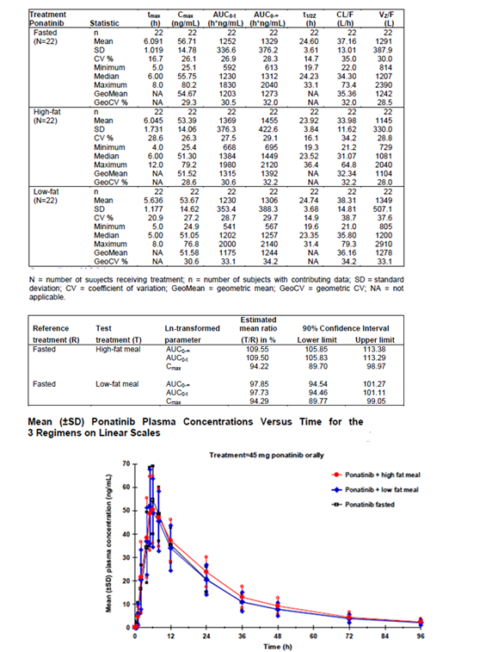

Dose proportionality
In a study in patients with advanced haematological malignancies, the steady state values for ponatinib C_{max} and AUC increased in a dose-proportional manner over the proposed dose range of 15 to 45 mg per day (Study 101; see Table 4).

Table 4: Study 101. Summary of PK data.

A: Ponatinib PK parameters in Cycle 1
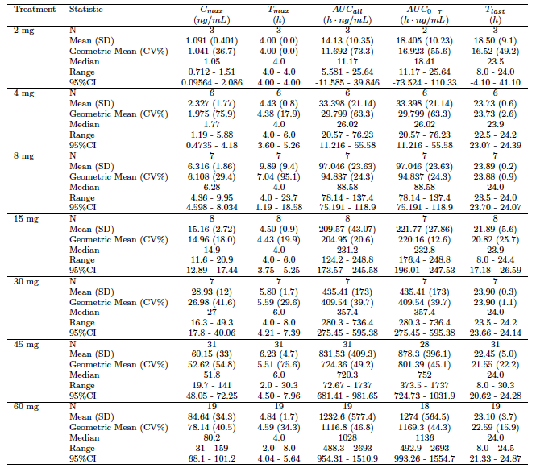
AUC_{all} calculated using all subjects data; AUC_{0-t} excludes subjects without data at 24 hrs;
T_{last} = time of last observation;

Table 4B: Ponatinib PK parameters in Cycle 2
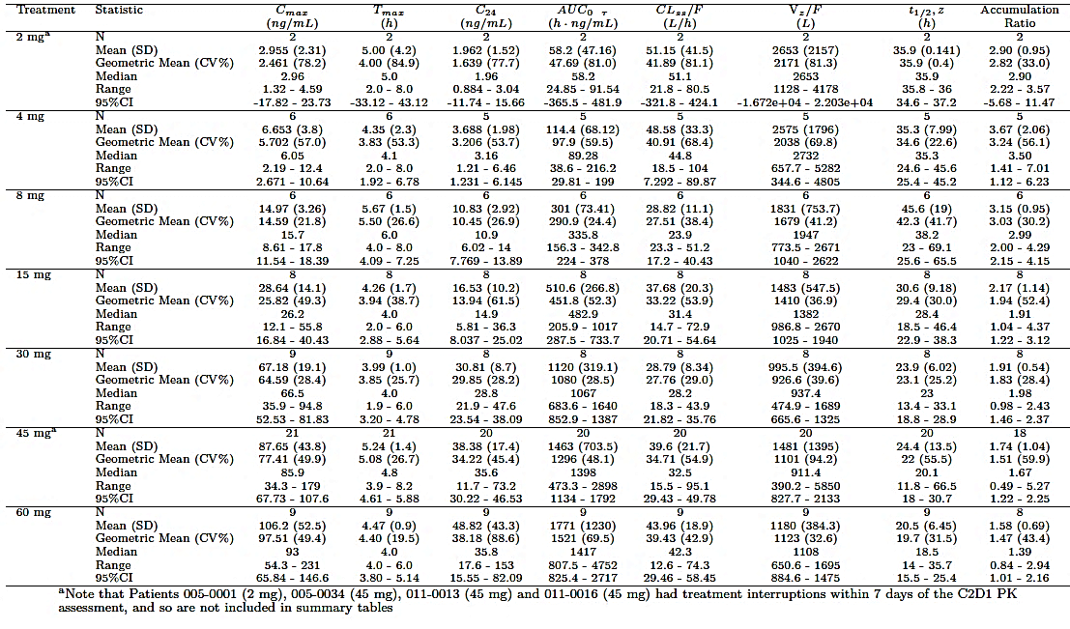

Bioavailability during multiple-dosing
In a study in patients with advanced haematological malignancies, repeated dosing resulted in increased values for ponatinib C_{max} and AUC. The accumulation ratios for dose levels between 15 and 45 mg per day were between 1.74 and 2.17 (Study 101; see Table 4).

Effect of administration timing
There were no data submitted on the effect of time of dosing. In the pivotal efficacy and safety study (201) subjects were instructed to take the drug at the same time each day.

Distribution

Volume of distribution
A study using intravenous administration of ponatinib has not been conducted and hence the true volume of distribution for the drug has not been established. At steady state in patients with haematological malignancies receiving 15-45 mg per day, the geometric mean values for apparent volume of distribution (Vz/F) were between 926.6 and 1410 L, suggesting extensive distribution to tissues (Study 101; see Table 4).

Plasma protein binding
According to a report of an in-vitro study (ARP 053), protein binding of ponatinib in human plasma was > 99.9% at all concentrations tested (100 – 3,000 ng/mL). The specific proteins were not identified.

Erythrocyte distribution
According to a report of an in-vitro study (ARP 053), the blood/plasma concentration ratio in human blood was 0.94 – 0.97 over the concentration range tested (120 – 3,000 ng/mL). This indicates that ponatinib was not preferentially distributed to either plasma or erythrocytes.

Tissue distribution
There were no clinical data relating to tissue distribution.

Metabolism
In a mass balance study in healthy volunteers (Study 104), approximately 5% of an orally administered dose of ponatinib was excreted in the urine. Unchanged ponatinib in the urine accounted for < 1% of the administered dose. These data indicated that the drug is predominantly metabolically cleared.

Sites of metabolism and mechanisms / enzyme systems involved
No specific clinical data were provided on sites of metabolism. It is assumed that the liver is likely to be the predominant site.
According to the Summary of Clinical Pharmacology, ponatinib is metabolised by numerous pathways, as shown in Table 5. The predominant metabolite in plasma (AP24600 or M14) is produced by amide hydrolysis.

Table 5: Ponatinib human biotransformation pathways
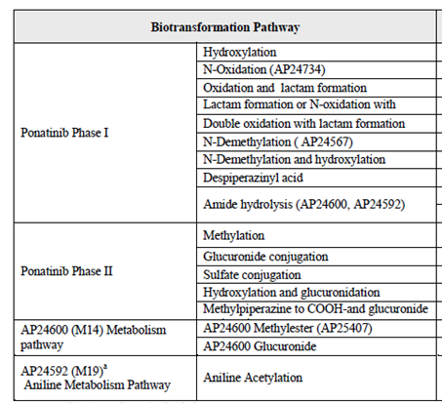
In an early in vitro study conducted with human liver microsomes and human hepatocytes (ARP258), it was reported that ponatinib was metabolized by CYP3A4. A subsequent interaction study (Study 103 – see below) with the CYP3A4 inhibitor ketoconazole confirmed a clinically significant role for metabolism by CYP3A4.
The clearance (CL) of ponatinib has not been defined, as there are no PK data following IV administration. The apparent clearance (CL/F) for ponatinib at steady state, when administered to patients at the recommended dose of 45 mg daily, was 34.71 L/hr (geometric mean). Geometric mean half-life was 22 hours (Study 101; see Table 4).

Metabolites identified in humans

Active metabolites
It appears from the documentation provided that none of the identified metabolites have significant activity.

Other metabolites
The main metabolite is AP24600 or M14, which accounts for 14.9% of drug-related material circulating in plasma. Other metabolites include AP24600 glucuronide or M15 (3.4%), AP24534 despiperazinyl acid or M23 (7.0%) and ponatinib glucuronide or M29 (6.0%).
Unchanged ponatinib accounted for 25.5% of drug-related material circulating in plasma.

Pharmacokinetics of metabolites
There was no data in module 5 of the submission concerning the PK of the main metabolite AP24600, apart from an in vitro study that showed that it is 93.5% protein bound in plasma. Some of the PK studies measured another metabolite (AP24567 or M42), which was initially thought to be a major metabolite on the basis of in vitro data. However, subsequent studies demonstrated that it is only a minor metabolite in vivo.

Excretion

Routes of excretion
A mass balance study in healthy volunteers demonstrated that the ponatinib and its metabolites are predominantly excreted in faeces (Study 104).

Renal clearance
In a mass balance study in healthy volunteers (Study 104), approximately 5% of an orally administered dose of ponatinib was excreted in the urine. Unchanged ponatinib in the urine accounted for < 1% of the administered dose. These data indicated that renal clearance of ponatinib is not significant.

Intra- and inter-individual variability of pharmacokinetics
Between-subject variability in PK parameters was high, with coefficients of variation (CV%) of approximately 50% for steady state C_{max} and AUC when ponatinib was administered at 45 mg per day.

Pharmacokinetics in other special populations

Pharmacokinetics in subjects with impaired hepatic function
No studies examining the effect of hepatic impairment on the PK of ponatinib. In the population PK analysis, markers of hepatic function (AST, ALT, bilirubin) were not found to be covariates with a significant effect on ponatinib PK. However, the studies that provided the data for the population PK analysis excluded subjects with significant hepatic dysfunction.
Comment: As ponatinib is drug that is metabolically cleared, the absence of data in subjects with hepatic impairment is considered a significant deficiency in the application. According to the Summary of Clinical Pharmacology, ‘a single dose safety and pharmacokinetic study of ponatinib in subjects with chronic hepatic impairment and in matched healthy adults is planned’.

Pharmacokinetics in subjects with impaired renal function
No studies examining the effect of renal impairment on the PK of ponatinib. In the population PK analysis, creatinine clearance was not found to be a covariate that had a significant effect on ponatinib PK. However, the studies that provided the data for the population PK analysis excluded subjects with significant renal impairment.
Comment: As ponatinib is drug that is metabolically cleared, the absence of data in subjects with renal impairment is not considered a significant deficiency in the application.

Pharmacokinetics according to age
In the population PK analysis increased age was found to be associated with decreased ponatinib clearance.

Pharmacokinetics related to genetic factors
In the population PK analysis, race was not found to be a covariate that had a significant effect on ponatinib PK.

Pharmacokinetic interactions

Pharmacokinetic interactions demonstrated in human studies
A study in human volunteers demonstrated that co-administration of ponatinib with the CYP3A4 inhibitor ketoconazole had a significant effect on systemic exposure to ponatinib, with AUC∞ increasing by 78% and C_{max} increasing by 47% (Study 103 – see Table 6AB).

Table 6A: Study 103. Summary of PK results
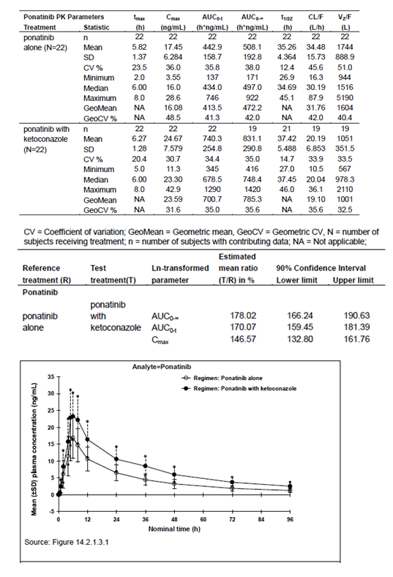

Table 6B: AP 24567 PK results are summarised below.
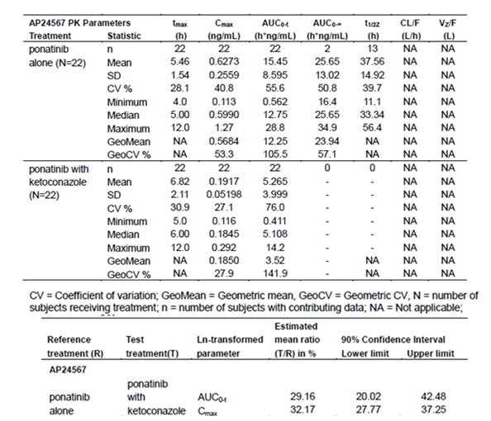

Clinical implications of in vitro findings
The following in vitro studies were included in Module 5 of the submission:
- ARP 267 examined the ability of ponatinib and its metabolite AP24600 to inhibit the activity of CYP450 enzymes (1A2, 2B6, 2C8, 2C9, 2C19, 2D6, and 3A4/5) in human liver microsomes. Both agents only inhibited these enzymes at concentrations well above their respective in vivo steady state C_{max} values. It was concluded that drug-drug interactions due to inhibition of CYP450 enzymes by ponatinib or AP24600 were highly unlikely.
- XT103117 examined the ability of ponatinib to induce CYP450 enzymes (1A2, 2B6 and 3A4/5) and the expression of MDR1 (PgP) mRNA levels in cultured human hepatocytes. At concentrations close to the in vivo steady state C_{max} (0.2 μM or 106 ng/mL), ponatinib did not induce either CYP450 enzymes of MDR1 mRNA expression. At higher concentrations (0.6 μM and above) ponatinib caused ‘slight’ induction of CYP enzymes.
- 11ARIAP5R1 investigated whether ponatinib is a substrate for, or inhibitor of, various membrane transporters. The drug was found to be an inhibitor of both P-glycoprotein and BRCP. It was also found to be an inhibitor of BSEP, but only at concentrations well in excess of the steady state C_{max} in humans. Ponatinib did not inhibit the transporter proteins OATP1B1, OATP1B3, OCT1, OCT2, OATP1 AND OATP3. The drug was not a substrate for OATP1B1, OATP1B3 or OCT1. Based on these data, ponatinib may have the potential to increase plasma concentrations of co-administered substrates of P-glycoprotein (for example, digoxin) or BCRP (for example, methotrexate).
In addition, the solubility of ponatinib is reduced at high pH. Drugs that increase gastric pH may therefore interfere with ponatinib absorption.

Evaluator’s overall conclusions on pharmacokinetics
In general, the pharmacokinetics of ponatinib have been adequately investigated. There are two significant deficiencies in the submitted PK data:
- The absolute bioavailability of ponatinib has not been defined; and
- There are no adequate data on the PK of ponatinib in subjects with hepatic impairment.

Pharmacodynamics
Only one of the submitted studies (Study 101) provided pharmacodynamic data. It examined the effect of ponatinib on levels of phosphorylated CRKL (pCRKL) in peripheral blood mononuclear cells of patients with CML or Ph+ALL. pCRKL is an adapter protein for BCR-ABL, and measurement of pCRKL levels can be used as a surrogate for measuring BCR-ABL activity in vivo.
A summary of the PD data from Study 101 is provided in (Table 7). The study demonstrated that ponatinib reduced pCRKL levels, consistent with inhibition of BCR-ABL activity.

Table 7: Study 101. Summary of PD data
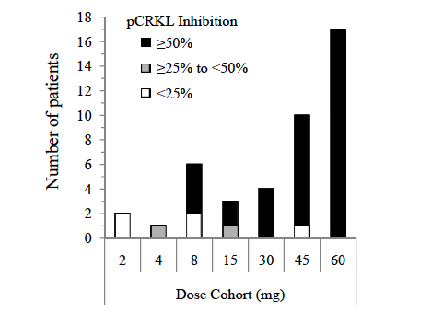

Dosage selection for the pivotal studies
The starting dose of 45 mg per day was selected because it was the maximum tolerated dose in the first in man study.

Clinical efficacy

Pivotal efficacy study – Study 201

Study design, objectives, locations and dates
Study 201 is a Phase II, single arm, open-label trial conducted in patients with CML or Ph+ ALL. Patients were enrolled into one of six cohorts depending on the nature of their disease and the presence or absence of the T315I mutation of BCR-ABL, as shown in the following table.

Table 8: Study design. Patient enrolment into one of six cohorts based on the nature of their disease and the presence or absence of the T315I mutation of BCR-ABL.
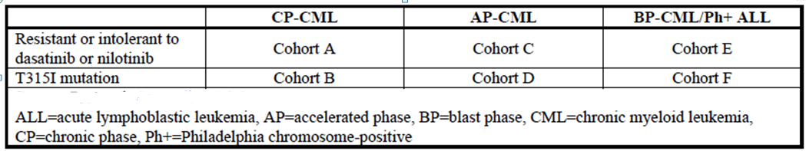
The primary objective of this study was to determine the efficacy of ponatinib in patients with CML in CP, AP, or BP or with Ph+ ALL who were either a) resistant or intolerant to either dasatinib or nilotinib, or b) had the T315I mutation. The secondary objectives of this study were to: 1) further characterize the anti-leukemic activity of ponatinib in these patients as evidenced by clinical responses, molecular responses, and clinical outcomes; 2) characterize the molecular genetic status of patients; and 3) examine the safety of ponatinib in these patients.
The study is being conducted in 68 centres in Australia, Belgium, Canada, France, Germany, Italy, South Korea, the United Kingdom, the United States, the Netherlands, Spain, and Sweden.
The first patient was enrolled on 21 September 2010. The study is ongoing, and the data cut-off date for inclusion in the submitted study report was 27 April 2012. The study report itself was dated 13 July 2012.

Inclusion and exclusion criteria
The definitions used for the different phases of CML are shown in Table 9.The inclusion criteria for the study are listed in Table 10, and the exclusion criteria are shown in Table 11.
Subjects could be enrolled in the study and commence treatment if they had a prior history of having the T315I mutation, without having previous exposure to dasatinib or nilotinib. All subjects were required to undergo mutation testing at baseline as part of the trial. If a subject with a prior history of a positive T315I mutation was found to have a negative mutation test after enrolment, the efficacy data generated by that subject was not included in the efficacy analyses.

Table 9: Study 201 - Definition of CML phases
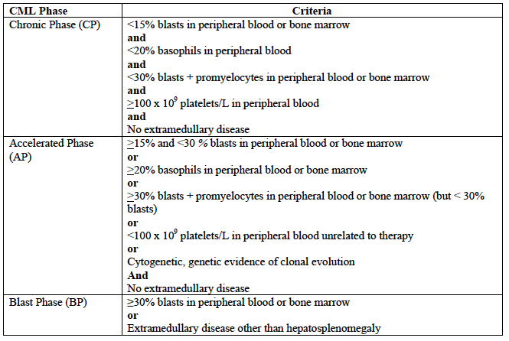
The required mutational analysis was performed at a single central laboratory in the United States, to ensure uniformity in the testing procedure, and standardized analysis and reporting of the results.

Table 10: Study 201 – Inclusion criteria
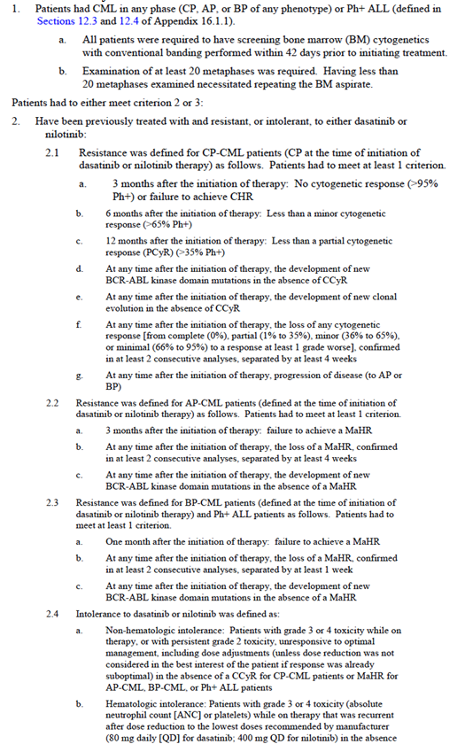

Table 11: Study 201 – Exclusion criteria
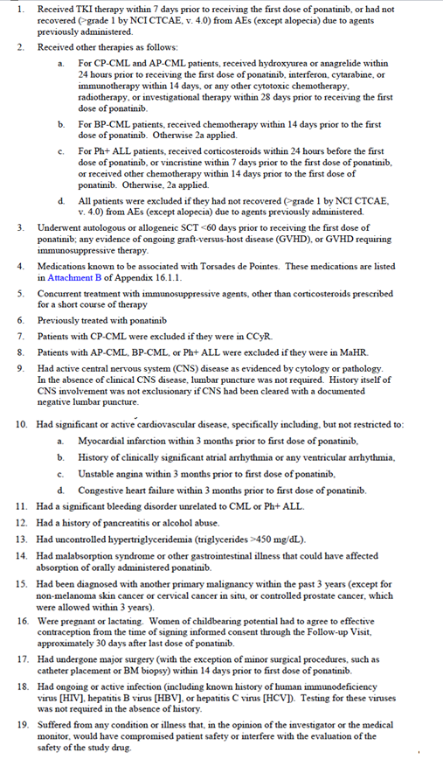

Study treatments
All patients were commenced on ponatinib 45 mg once daily. They were instructed to take the drug at the same time each day, with or without food, and not to have anything to eat or drink (other than water) for 2 hours afterwards.
In the event of toxicity, the dose could be reduced to 30 mg per day and then to 15 mg per day if necessary. If a patient continued to experience unacceptable toxicity at the 15 mg daily dose, discontinuation of the drug was recommended. The study used 45 and 15 mg tablets, with the same formulation as proposed for registration.
Treatment was continued until disease progression occurred, intolerance developed, consent was withdrawn or the investigator decided to withdraw the patient.
The following treatments were prohibited during the trial: other anticancer therapy, investigational drugs or devices, medications known to be associated with Torsades de Pointes, herbal preparations and elective surgery requiring inpatient care. Although not prohibited it was recommended that the following agents be avoided: potent inhibitors, inducers or substrates for CYP3A4 and drugs that prolong the QT interval.

Efficacy variables and outcomes
The main efficacy variables were:
- Cell counts in peripheral blood and bone marrow, and the presence or absence of extramedullary disease (for example, splenomegaly and hepatomegaly)
- The presence or absence of Ph+ve cells in metaphase in bone marrow
- The levels of BCR-ABL ribonucleic acid (RNA) transcripts relative to ABL RNA transcripts, in peripheral blood and bone marrow, as measured by quantitative reverse-transcriptase polymerase chain reaction (qRT-PCR).
The main efficacy outcomes were haematological, cytogenetic and molecular response rates. The definitions used for response are summarised in Table 12.

Table 12: Study 201 – Definitions of response
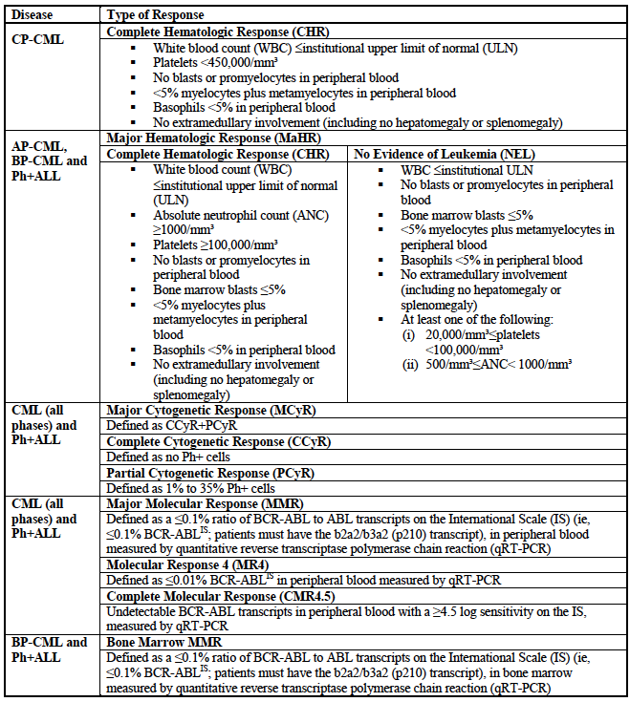
The primary efficacy outcome for patients with chronic phase CML (Cohorts A and B) was major cytogenetic response (MCyR) rate (that is, the proportion of patients who achieved either a complete or partial cytogenetic response [CCyR or PCyR]).
The primary efficacy outcome for patients in the other cohorts (C to F) was major haematological response (MaHR) rate (that is, the proportion of patients who achieved either complete haematological response [CHR] or no evidence of leukaemia [NEL]).
The secondary endpoints used in the study are shown in Table 13. The definitions used for disease progression (used for some of the secondary endpoints) are shown in Table 14.

Table 13: Study 201 – Secondary endpoints
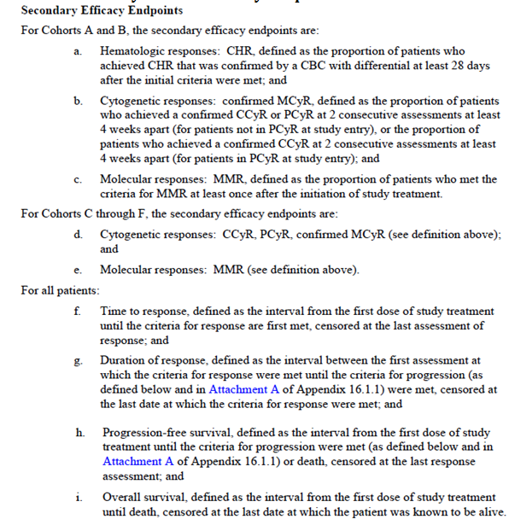

Table 14: Study 201 – Definitions for disease progression
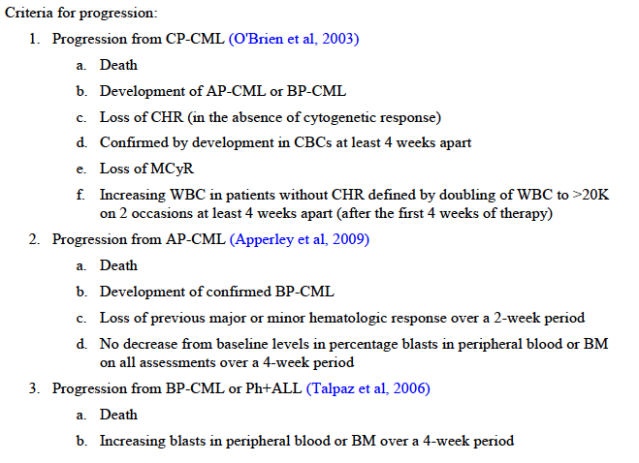
Comment: The endpoints chosen are standard for trials in CML/Ph+ALL, and were used in the trials submitted to the TGA for approval of other TKIs. The relevant EMA guideline currently adopted by the TGA ⁽⁴⁾ recommends the use of cytogenetic response rate as the appropriate primary efficacy outcome measure in patients with chronic phase CML. It suggests that it may also be the appropriate primary endpoint in accelerated phase and blast crisis, but recommends that regulatory advice be obtained from the EMA.
For subjects in Cohorts A and B complete blood counts (CBCs) were performed on Days 1, 8, 15, and 22 of cycle 1, days 1 and 15 of cycles 2 and 3, on day 1 of cycles 4 to 13, at the end of every 3 cycles to cycle 39 and after every 6 cycles. For subjects in Cohorts C to F, CBCs were performed on Days 1, 8, 15, and 22 of cycle 1, days 1 and 15 of cycles 2-26, then after every 3rd cycle until cycle 39 and then after every 6th cycle.
Bone marrow (BM) aspirate was required every 3 months for CP-CML patients through the end of Cycle 27; and at the end of Cycle 1, Cycle 2, and then every 2 months until Cycle 24 and at the end of Cycle 27 for AP-CML, BP-CML and Ph+ ALL patients. After 27 cycles, CP-CML patients who were not in CCyR continued to require a BM aspirate and cytogenetic assessment every 6 cycles. After 27 cycles, AP-CML, BP-CML, and Ph+ ALL patients who were not in CCyR continued to require a BM aspirate and cytogenetic assessment every 3 cycles until Cycle 39 and subsequently every 6 cycles.
Molecular response sampling (BCR-ABL transcript quantitation by PCR) was performed, for AP-CML, BP-CML and Ph+ ALL patients, at baseline, and at the end of cycle 2, at the end of even cycles 4-24, then at the end of every 3rd cycle until cycle 39 and then after every 6th cycle. For CP-CML patients it was performed at baseline, at the end of every 3rd cycle until cycle 39, and then after every 6th cycle.

Randomisation and blinding methods
Patients were not randomised in the study. Patients were allocated to a specific cohort based on their disease status. There was no blinding used in the trial.

Analysis populations
The Safety Population included all subjects who received at least one dose of the study drug.
The Treated Population also included all subjects who received at least one dose of the study drug. However, it excluded subjects who commenced in the trial on the basis of a prior history of a positive T315I mutation, but who were found to have a negative test at baseline.
The Per Protocol Cytogenetic Population included all patients in the treated population with a baseline cytogenetic assessment with at least 20 metaphases examined. Patients with <20 metaphases examined at baseline, CCyR at baseline, or missing baseline cytogenetic assessments were excluded.
The Per Protocol Hematologic Population included all patients in the treated population in Cohorts C to F with a baseline BM assessment for which the percentage of BM blasts was determinable. Patients with missing baseline bone marrow blasts or those with MaHR at baseline were excluded.

Sample size
For Cohort A, the null or ‘uninteresting’ MCyR rate was considered to be 20%, as some small published studies had suggested that this magnitude of response could be achieved using dasatinib in subjects who had failed nilotinib and vice-versa. A MCyR rate of 35% was considered as an alternative MCyR rate of interest. It was calculated that a sample size of 100 patients would provide at least 85% power to distinguish between a null response rate of 20% and the alternative rate of 35%, with an overall alpha level of 0.05.
For Cohort B, the null or ‘uninteresting’ MCyR rate was considered to be 10%, and a rate of 35% would be considered of interest. It was calculated that 60 patients would be needed to provide approximately 98% power to distinguish between a null response rate of 10% and an alternative response rate of 35%, with an overall alpha level of 0.05.
For Cohorts C to F, the null or uninteresting MaHR rate was set at 10% and the alternative rate of interest was set at 30%. It was calculated that 40 patients in each of these cohorts would provide 89% power to distinguish between these two rates.
Initially therefore a total of 320 subjects were planned to be enrolled.
During the conduct of the trial it became apparent that subjects were accruing more rapidly in those cohorts enrolling patients who were resistant or intolerant to dasatinib/nilotinib (Cohorts A, C and E) than in the cohorts enrolling patients with the T315I mutation (Cohorts B, D and F). Demonstration of efficacy in subjects with the T315I mutation was a primary objective of the study. In order to allow adequate recruitment to Cohorts B, D and F, the protocol was amended to allow a total sample size of 450 subjects.

Statistical methods
The response rate endpoints were to be analysed using a 2-sided exact 95% CI. Duration of response, time to response, progression-free survival and overall survival were to be analysed using the Kaplan-Meier method. Median duration of response with 95% CI were also to be calculated.

Participant flow
A total of 449 subjects were enrolled in the study and all these received at least one dose of ponatinib. All cohorts enrolled their planned sample sizes except for Cohort D (subjects with the T315I mutation in accelerated phase CML) in which only 18 of 40 planned subjects were accrued.
At the time of the data cut-off, 252 patients (56.1% of the total) remained on therapy, and median follow-up was 9.9 months (range: 0.1 month to 18.4 months).
Additional details are shown in Figure 1.
Figure 1: Participant flow
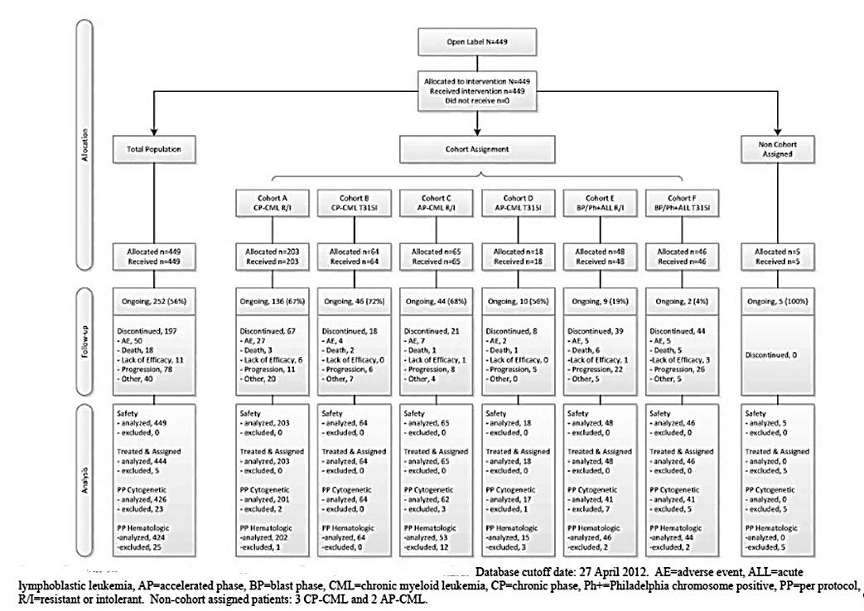

Major protocol violations/deviations
Major protocol deviations were defined as those involving inclusion or exclusion criteria or primary endpoint assessments. Those occurring in the trial are summarised in Table 15.

Table 15: Study 201 – Major protocol deviations
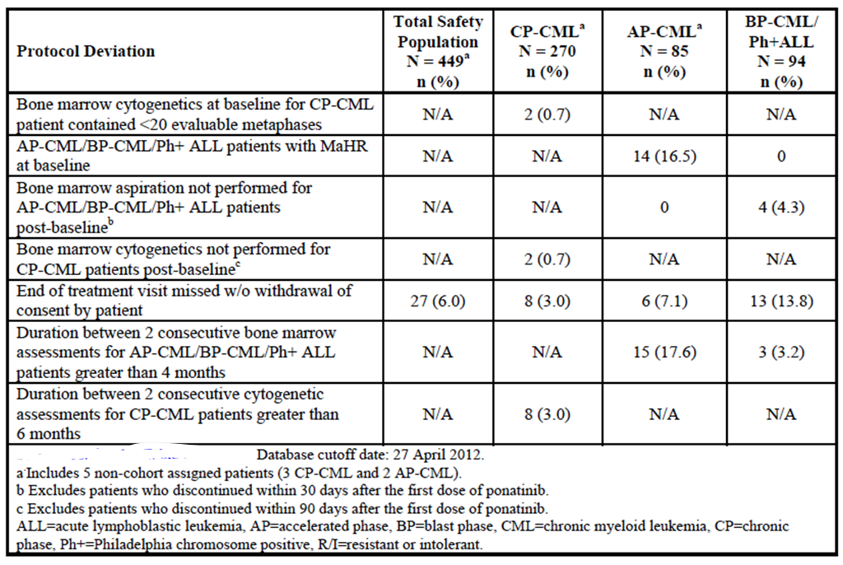
Comment: It is noted that 16.5% of the accelerated phase CML subjects enrolled met the criteria for major haematological response (MaHR) at baseline, and that achievement of MaHR was the primary endpoint of the study for this cohort. However, in the analysis of efficacy, these subjects were analysed as non-responders. The efficacy of the drug in accelerated phase CML may therefore have been underestimated (with respect to MaHR). The other violations are considered unlikely to have affected the outcome of the study.

Baseline data
Baseline demographic and disease characteristics are shown in Table 16. Prior treatment with TKIs is summarised in Table 17 and prior other anticancer treatments are summarised in Table 18.

Table 16: Study 201 – Baseline demographic data
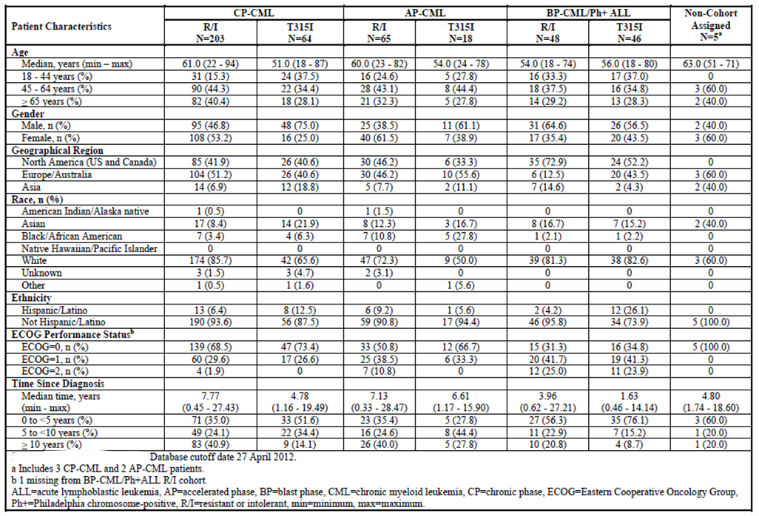

Table 17: Study 201 – Prior tyrosine kinase inhibitor (TKI) treatment
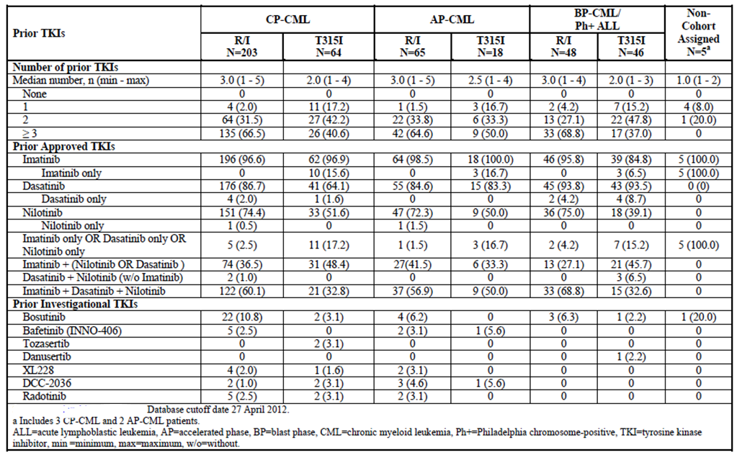

Table 18: Study 201 - Prior other cancer treatment
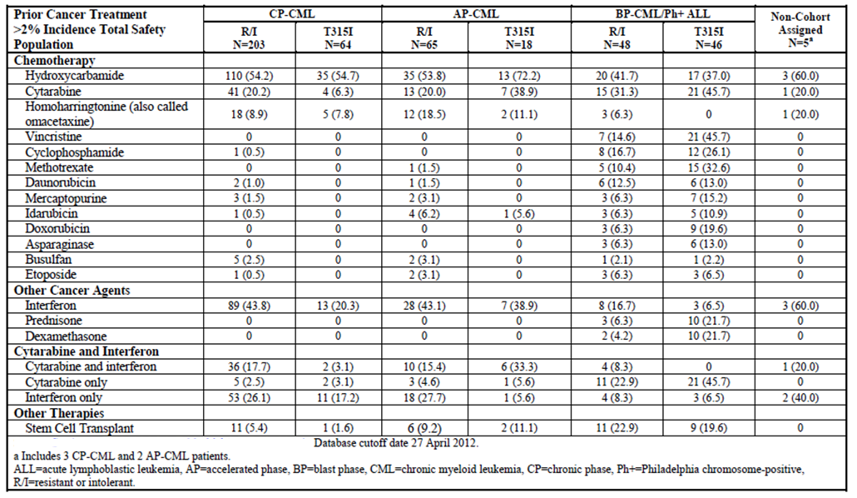
For the whole study population (n=449), the median number of previous TKIs was 3.0 (range 1-5). A total of 58.4% of the population had used 3 or more TKIs. Imatinib had been used by 95.8% of the population, dasatinib by 83.5% and nilotinib by 65.5%. The proportion of subjects that had used all three of the approved TKIs (imatinib and dasatinib and nilotinib) was 52.8%.
A total of 151 subjects (33.6%) had received prior treatment with interferon, and 22.7% had received cytarabine.
Comment: These data illustrate the fact that the population enrolled in the study was a heavily pre-treated one, with limited options for further treatment.
Table 19 shows the best response achieved with the most recent 2nd generation TKI (that is, dasatinib or nilotinib). A major cytogenetic response was achieved in approximately 23% of subjects with chronic phase CML, and in approximately 10 – 13% of subjects with more advanced CML or Ph+ALL.

Table 19: Study 201 – Best responses to most recent dasatinib or nilotinib
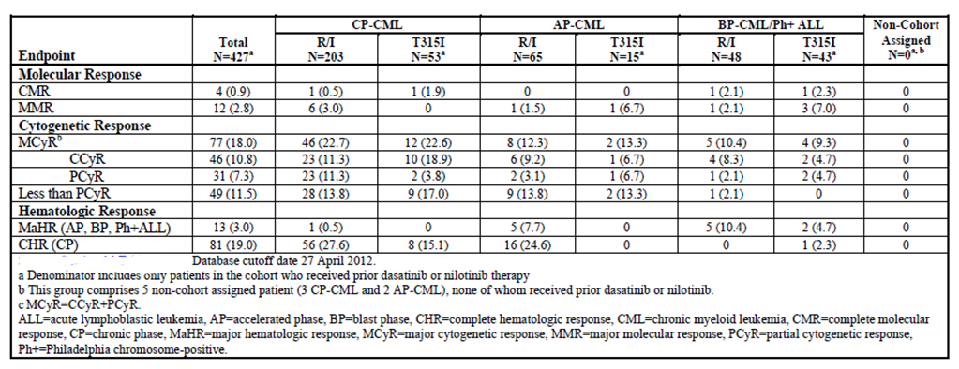
The baseline mutation status of subjects is shown in Table 20 and Table 21. For the total population (n=449), 198 subjects (44.1%) had no mutations detected. The most common mutation was T315I (28.5%) followed by F317L (8.0%), E255K (4.0%) and F359V (3.8%).

Table 20: Study 201 - Baseline mutation status – number of mutations per patient
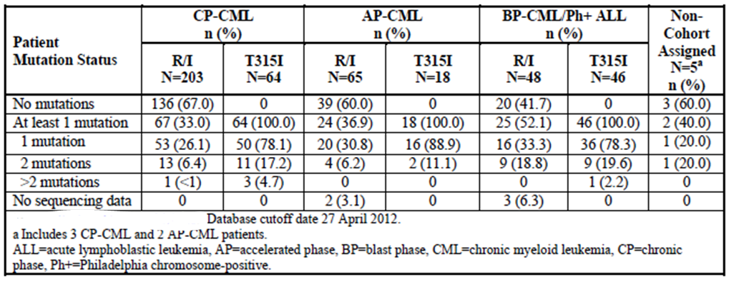

Table 21: Study 201 - Baseline mutation status – individual mutations occurring in at least 3 subjects
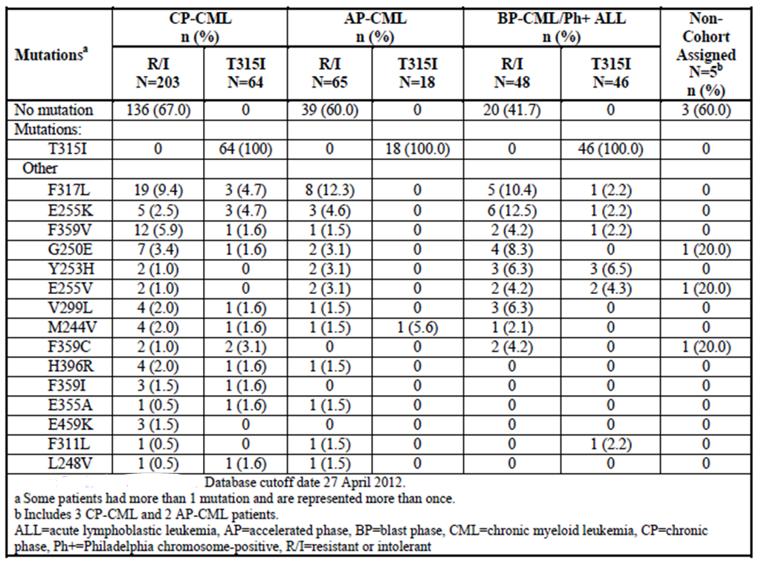

Results for the primary efficacy outcome
The results for the primary endpoints are summarised in Table 22.

Table 22: Study 201 – Efficacy results for primary endpoints
- Chronic phase CML (Cohorts A and B)
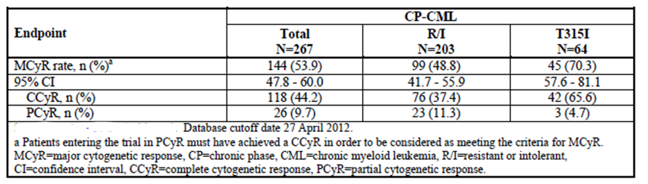
- Accelerated phase CML (Cohorts C and D)
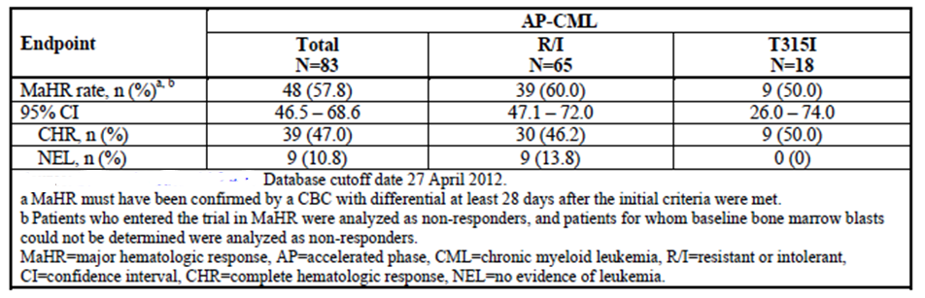
- Blast phase CML / Ph+ ALL (Cohorts E and F)
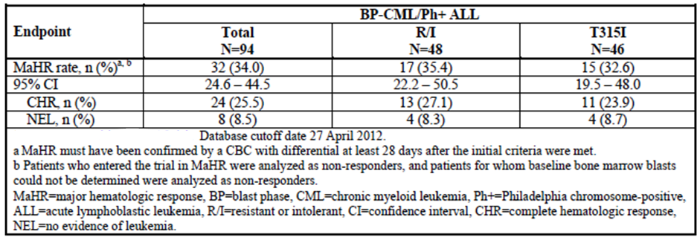
- Post-hoc analysis of BP-CML versus Ph+ALL subjects in Cohorts E and F
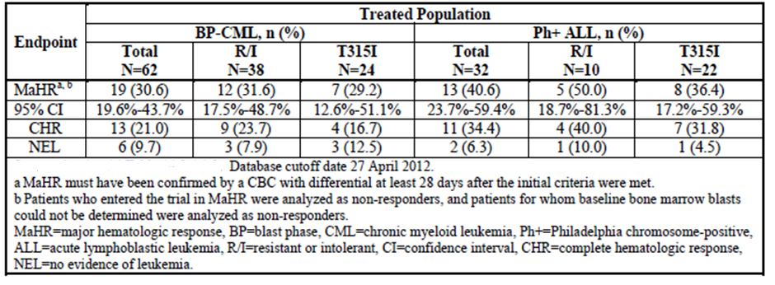

Chronic phase CML
For Cohort A the MCyR rate was 48.8% (95% CI: 41.7 – 55.9%). For Cohort B the MCyR rate was 70.3% (95% CI: 57.6 – 81.1%). In both cohorts the majority of the responses were complete (CCyR) rather than partial (PCyR). Per protocol analysis gave comparable results. A sensitivity analysis was also conducted for Cohort A, using only the first 100 patients enrolled (the original planned sample size). The results obtained were similar to those of the primary analysis.

Accelerated phase CML
For Cohort C the MaHR rate was 60.0% (95% CI: 47.1 – 72.0%). For Cohort D the MaHR rate was 50.0% (95% CI: 26.0 – 74.0%). In both cohorts the majority of the responses were complete haematological responses (CHR) rather than ‘no evidence of leukaemia’ (NEL). Per protocol analysis gave somewhat improved results (MaHR 0f 73.6% in Cohort C and 60.0% in Cohort D). A sensitivity analysis was conducted on the first 40 subjects enrolled into Cohort C, and the results were comparable to those obtained with the primary analysis.

Blast phase CML / Ph+ALL
For Cohort E the MaHR rate was 35.4% (95% CI: 22.2 – 50.5%). For Cohort F the MaHR rate was 32.6% (95% CI: 19.5 – 48.0%). In both cohorts the majority of the responses were again complete haematological responses (CHR) rather than ‘no evidence of leukaemia’ (NEL). Per protocol analysis gave similar results. Sensitivity analyses were conducted on the first 40 subjects enrolled into both Cohort E and Cohort F, and the results were comparable to those obtained with the primary analysis. A post-hoc comparison of results for the CML-BP and Ph+ALL subpopulations of Cohorts E and F suggested marginally better efficacy in the Ph+ALL subpopulation.
Comment: For each of the cohorts, the lower 95% CI for the response rate exceeded the ‘uninteresting’ rate specified in the sample size calculations. The response rates obtained were notably higher than those obtained with most recent 2nd generation agent (dasatinib or nilotinib). The duration of follow-up at the time of analysis was short - median 9.9 months (range: 0.1 month to 18.4 months) – and increased MCyR rates in the CP-CML population might be expected with longer follow-up. Overall these results provide evidence of substantial activity for the drug in a population of patients who were resistant to or intolerant of available therapies.

Results for other efficacy outcomes

Response rates
The results for secondary response rate endpoints are summarised in Table 23. Findings of note include the following:
- Over 90% of chronic phase CML patients achieved a complete haematological response
- Major cytogenetic responses were achieved in a significant proportion of patients with advanced and blast phase CML and Ph+ ALL. In particular 15/32 (46.9%) of subjects with Ph+ ALL achieved a MCyR
- The proportion of subjects who achieved a major molecular response was generally low (apart from those in Cohort B, where MMR rate was 50.0%). This may reflect the advanced nature of the disease as well as the short duration of follow-up.

Table 23: Study 201 – Efficacy results for secondary endpoints (response rates)
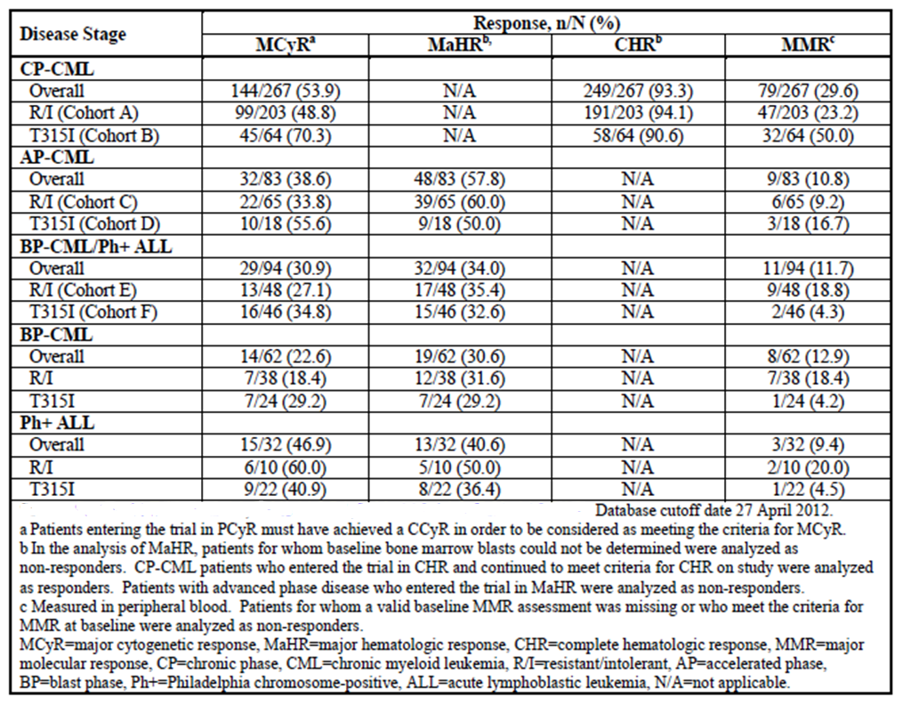

Duration of response
Data on duration of response (for the primary endpoints) are summarised in Table 24.

Table 24: Study 201 – Duration of response
 | Cohort A | Cohort B | Cohort C | Cohort D | Cohort E | Cohort F
 | CML-CP (R/I) | CML-CP (T315I) | CML-AP (R/I) | CML-AP (T315I) | CML-BP/Ph+ALL R/I | CML-BP/Ph+ALL T315I
N | 203 | 64 | 65 | 18 | 48 | 46
Type of response (primary endpoint) | MCyR | MCyR | MaHR | MaHR | MaHR | MaHR
No. of subjects with response (%) | 99 (48.8) | 45 (70.3) | 39 (60.0) | 9 (50.0) | 17 (35.4) | 15 (32.6)
No. of subjects with loss of response (%) | 5 (5.1) | 1 (2.2) | 17 (43.6) | 5 (55.6) | 7 (41.2) | 10 (66.7)
No. of subjects censored (%) | 94 (94.9) | 44 (97.8) | 22 (56.4) | 4 (44.4) | 10 (58.8) | 5 (33.3)
Median –days (95% CI) | NR | NR | 289.0 (211.0 – 538.0) | 174.0 (42.0 – N/A) | NR | 126.0 (70.0 – 143.0)
Range in days | 1 - 423 | 1 - 338 | 98 - 538 | 42 - 430 | 54 - 429 | 3- - 268
Probability of remaining in response at 6 months | 91.6% | 96.7% | 73.3% | 41.7% | 67.7% | 17.4
Probability of remaining in response at 12 months | 91.6% | - | 49.0% | 41.7% | 51.6% | N/A
NR = not reached. N/A = not available
Comment: Responses in chronic phase CML (Cohorts A and B) appeared durable. The median duration had not been reached and the Kaplan-Meier estimates for probability of remaining in response at 6 and 12 months were > 90%. The median duration of response in accelerated phase CML was 289.0 days (9.5 months) for Cohort C and 174.0 days (5.7 months) for Cohort D. Duration of response was shorter in blast phase CML/Ph+ALL with the median duration in Cohort F being 126.0 days (4.1 months).

Time to response
Among responders, the median (range) time to MCyR was 85 (56-334) days in Cohort A and 84 (49-333) days in Cohort B. The median times to complete haematological response (CHR) in these cohorts were 13 (1 – 166) and 10 (4-98) days respectively.
The median (range) times to MaHR in the other cohorts were:
- 21 (12-112) days in Cohort C
- 19 (14-176) days in Cohort D
- 28 (14-168) days in Cohort E
- 24 (11-57) days in Cohort F.

Progression-free survival (PFS)
For patients with chronic or accelerated phase CML, PFS data were immature with less than 50% of subjects having progressed or died. In Cohorts E and F, median PFS was 169 days (5.6 months) and 98 days (3.2 months) respectively (Table 25).

Table 25: Study 201 – Progression-free survival results
 | Cohort A | Cohort B | Cohort C | Cohort D | Cohort E | Cohort F
 | CML-CP (R/I) | CML-CP (T315I) | CML-AP (R/I) | CML-AP (T315I) | CML-BP/Ph+ALL R/I | CML-BP/Ph+ALL T315I
N | 203 | 64 | 65 | 18 | 48 | 46
No. of subjects with events (%) | 28 (13.8) | 7 (10.9) | 24 (36.9) | 6 (33.3) | 27 (56.3) | 33 (71.7)
No. of subjects censored (%) | 175 (86.2) | 57 (89.1) | 41 (63.1) | 12 (66.7) | 21 (43.8) | 13 (28.3)
Median PFS –days (95% CI) | NA (422 – NA) | NA (NA – NA) | 559.0 (306-559) | NA (188 – NA) | 169.0 (82-252) | 98.0 (58-154)

Overall survival (OS)
For patients with chronic or accelerated phase CML, OS data were immature with less than 50% of subjects having died. In Cohorts E and F, median OS was 210 days (6.9 months) and 201 days (6.6 months) respectively (Table 26).

Table 26: Study 201 – Overall survival results
 | Cohort A | Cohort B | Cohort C | Cohort D | Cohort E | Cohort F
 | CML-CP R/I | CML-CP T315I | CML-AP R/I | CML-AP T315I | CML-BP/Ph+ALL R/I | CML-BP/Ph+ALL T315I
N | 203 | 64 | 65 | 18 | 48 | 46
No. of subjects with events (%) | 12 (5.9) | 5 (7.8) | 8 (12.3) | 4 (22.2) | 31 (64.6) | 29 (63.0)
No. of subjects censored (%) | 191 (94.1) | 59 (92.2) | 57 (87.7) | 14 (77.8) | 17 (35.4) | 17 (37.0)
Median OS –days (95% CI) | NA (NA – NA) | NA (NA – NA) | NA (NA – NA) | NA (282 – NA) | 219.0 (120-380) | 201.0 (151-280)

Subgroup analyses
The study report presented analyses of response rates according to the following baseline factors: the extent of prior TKI use; resistance versus intolerance to prior TKIs; BCR-ABL mutation status; age at baseline; and time since diagnosis. Findings of the analyses included the following:
- Response rates tended to decline with increasing number of prior TKIs
- Response rates were similar in patients who were resistant to prior dasatinib/nilotinib and those who were intolerant of the drugs
- Among subjects with chronic phase CML, cytogenetic response rates were significantly higher among subjects who had the T315I mutation (with no other mutation) compared to other mutation subgroups (see Table 27). However the veracity of this finding was questioned by a subsequent analysis (see below)
- Among subjects with chronic phase CML, response rates tended to decline with increasing age
- Response rates tended to decline with longer time since diagnosis.

Table 27: Study 201 - Response rates by baseline mutation status
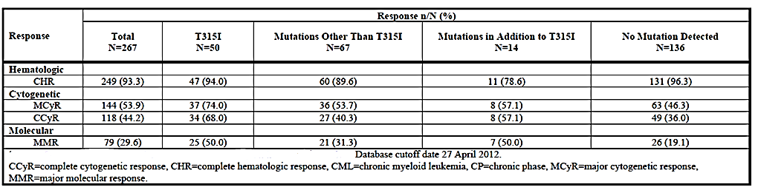

Other analyses
The sponsor conducted a post hoc multivariate logistic regression analysis (Report no ARP307) to explore the effect of dose intensity and several baseline prognostic factors (age, time since diagnosis, number of prior TKIs, T315I mutation status, baseline neutrophil and platelet counts and weight) on efficacy and safety outcomes. The main efficacy findings of this analysis were:
- For patients with chronic phase CML, the probability of achieving a MCyR after 12 months significantly increased (p < 0.0001) with increasing dose intensity (as measured by average daily dose) and with decreasing age (p=0.0458). Contrary to the original subgroup analysis (see above) T315I mutation status was not a significant predictor of efficacy, after adjustment for dose intensity and other factors
- For patients with advanced/blast phase CML or Ph+ALL, the probability of achieving a MaHR at 6 months increased significantly with increasing dose intensity (p < 0.0001) and with higher baseline platelet count, an indicator of baseline disease severity (p= 0.0046).

Supportive efficacy study – Study 101
Study 101 is the trial in which ponatinib was first administered to humans.

Study design, objectives, locations and dates
The study is a Phase 1, open, dose-escalation trial with a conventional ‘3+3’ design, conducted in subjects with advanced haematological malignancies, including subjects with CML and Ph+ ALL.
The primary objective of the study was to determine the maximum tolerated dose (MTD) or a recommended dose of oral ponatinib. The secondary objectives were to:
- Examine the safety of ponatinib
- Describe the anti-leukemic activity of ponatinib
- Examine the pharmacokinetics (PK) of ponatinib
- Examine pharmacodynamic (PD) activity of ponatinib in CML and Ph+ ALL patients
- Describe potential pharmacogenomic markers of ponatinib anti-leukemic activity.
The PK results for the study are summarised in Table 4, and the PD results in Table 7.
The study was conducted in five centres in the USA. It was commenced in June 2008 and was ongoing at the time the study report 4was written. The data cut-off dates for the study report were 6 January 2012 for study visits and 23 March 2012 for data. The report itself was dated June 2012.

Inclusion and exclusion criteria
The inclusion criteria are listed in Table 5 and the exclusion criteria in Table 6.

Study treatments
All patients were treated with ponatinib. There were no control groups or reference therapies. Successive cohorts of patients were treated with escalating doses of the drug. The study followed a conventional ‘3+3’ where 3 patients were initially treated in each dose cohort. If dose limiting toxicities (DLTs) were observed, additional patients would be treated at the same dose, or dose escalation would be stopped. If no DLTs were experienced, the next cohort of three patients would be treated at a higher dose. The definitions for DLTs and the dose escalation regimen are shown in Table 28 and Table 29, respectively.

Table 28: Study 101 - Definitions of dose-limiting toxicities (DLT)
The following AEs were considered to be DLTs that counted towards the determination of the MTD. Toxicity grades were defined in the NCI CTCAE V 3.0:
- Grade ≥3 non-hematologic toxicity lasting >3 days despite optimal supportive care, with the exception of self-limiting or medically controllable toxicities (for example, , nausea, vomiting, fatigue, electrolyte disturbances, hypersensitivity reactions), but excluding alopecia.
- Missed doses: >25% of planned ponatinib doses over 28 days due to AEs in the first cycle.
- Febrile neutropenia (the occurrence of an absolute neutrophil count (ANC) <500/μL concurrently with a temperature elevation of >101ºF), when neutropenia was not related to underlying acute leukaemia as defined below.
- Hematologic toxicity: Different hematologic DLT definitions are used for patients with ‘chronic’ diseases (for example, CLL) and those with ‘acute’ diseases (for example, , AML, ALL, and all phases of CML)
  - Chronic Leukaemias (CLL, MM):
  - Hematologic DLT for chronic leukaemias was Grade 4 cytopaenia if baseline platelet count was ≥75,000/μL and the neutrophil count was ≥2000/μL. For patients entering the study with lower platelet or neutrophil counts, a DLT was the persistence of either platelet counts or neutrophil counts <75% of the baseline values through Day 28;
  - Acute Leukaemias (ALL, AML, CML, and Ph+ ALL):
  - Hematologic DLT was the occurrence of a Grade 4 cytopaenia >28 days not related to underlying disease according to the investigator. Bone marrow examination must have demonstrated <5% cellularity.

Table 29: Study 101 - Dose escalation guidelines
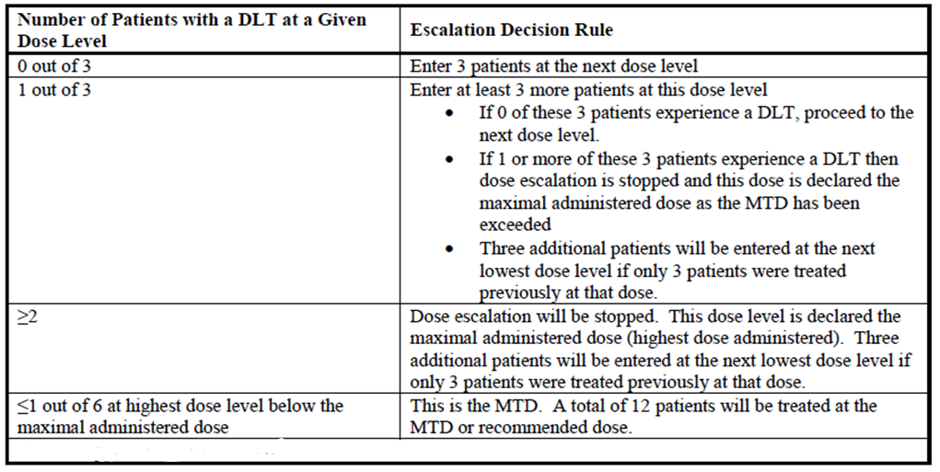
Intrapatient dose escalation could also occur. Patients in a lower dose cohort were allowed to increase their dose to a higher established dose provided they had tolerated at least 1 cycle of the lower dose without a DLT and the proposed next dose did not exceed the maximum tolerated dose (MTD). Safety findings from intrapatient dose escalation were not used for determination of the MTD.
Ponatinib was administered once daily on a continuous regimen. Each 28-day period was referred to as a ‘cycle’ but there were no drug holidays between cycles. Treatment could be continued indefinitely as long as the drug was tolerated and disease progression did not occur. The drug was to be administered approximately 2 hours after a light meal and patients were instructed not to eat or drink anything other than water for 2 hours afterwards.
The initial dose level chosen was 2mg, based on preclinical findings.
Treatments prohibited during the trial were other anticancer treatments (although leukopheresis, hydroxyurea and anagrelide were permitted for acute stabilisation), immunosuppressants (other than corticosteroids which had been prescribed at a stable dose prior to study drug), herbal preparations, drugs known to prolong the QT interval and colony-stimulating factors (in Cycle 1).

Efficacy variables and outcomes
Examination of efficacy was a secondary objective of this study. The main efficacy variables were:
- Cell counts in peripheral blood and bone marrow, and the presence or absence of extramedullary disease (for example, splenomegaly and hepatomegaly)
- The presence or absence of cytogenetically abnormal cells (for example, Ph+ve cells) in metaphase in bone marrow
- For CML and Ph+ ALL, the levels of BCR-ABL ribonucleic acid (RNA) transcripts relative to ABL RNA transcripts, in buffy-coat blood cells, as measured by quantitative reverse-transcriptase polymerase chain reaction (qRT-PCR).
No particular endpoint was designated as a primary efficacy endpoint. The efficacy endpoints only refer to subjects with CML, Ph+ve ALL or AML. Although subjects with other haematological malignancies could be enrolled in the study, they were not analysed for efficacy. The sponsor is not seeking approval for use of the product in AML, and hence the review in this report of the efficacy data from this study will focus on the subpopulation of subjects with CML or Ph+ ALL.
Complete blood counts (CBC) were performed on Days 1, 3, 5, 8, 10, 12, 15, 17, 19 and 22 of cycle 1, Days 1, 8, 15 and 22 of cycle 2, Days 1, 8, and 15 of cycle 3 and days 1 and 15 of subsequent cycles.
Bone marrow aspirate with or without biopsy, and with cytogenetics for Ph+ patients, was recommended at the completion of cycle 3 and every 3 months according to standard monitoring schedules. Standard care was also to be followed for other diseases. Patients on study for ≥ 24 months must have had bone marrow assessments performed at 6-month intervals (more frequent was acceptable if clinically indicated).
Molecular response sampling (BCR-ABL transcript quantitation by PCR) was performed at baseline, at the beginning of Cycle 3, and at subsequent odd-numbered cycles to Cycle 9. Beginning at Cycle 9, molecular sampling was required at 3-month intervals thereafter.

Randomisation and blinding methods
There was no randomisation in the study, as there were no reference therapies or comparator groups, and subjects were assigned to their dose level only after a lower dose had been shown to be not excessively toxic. There was also no blinding of study treatment.

Analysis populations
The safety evaluation population included all patients who received at least 1 dose of study treatment.
The DLT-evaluable population included those patients who received sufficient study drug exposure during Cycle 1 so as to enable an adequate evaluation of the tolerability of the dose level (in terms of DLTs). An adequate exposure during Cycle 1 was defined as having received≥75% of planned study drug doses during Cycle 1, exclusive of doses missed due to treatment related toxicity.
The efficacy population included all patients in the safety population with diagnoses of CML, Ph+ ALL, or AML.

Sample size
No formal sample size calculations were performed. Sample size was determined by clinical rather than statistical considerations. Approximately 100 patients were planned to participate.

Statistical methods
Descriptive statistics were used to analyse the efficacy data.

Participant flow
The participant flow for the study is shown in Figure 2. A total of 81 subjects were enrolled in 10 cohorts. At the time of data cut-off, 33 subjects (40.7%) were ongoing in the study.
Figure 2: Study 101 – Participant Flow
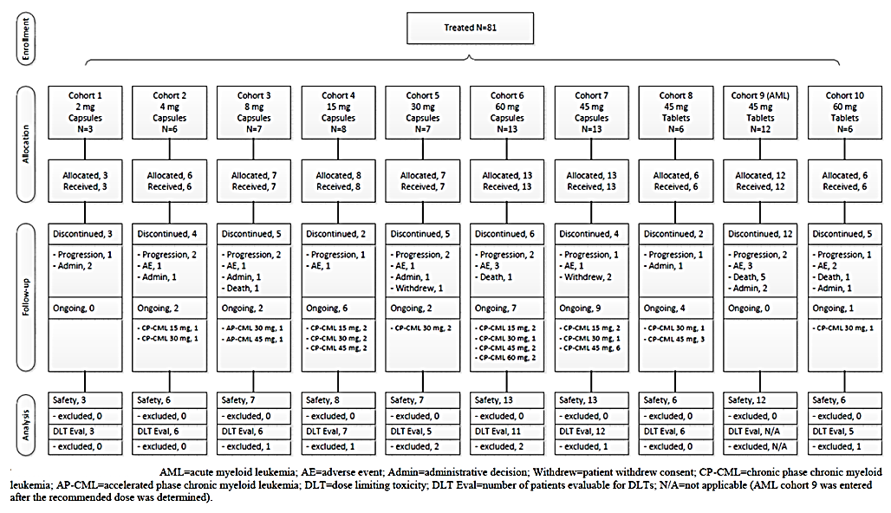

Major protocol violations/deviations
Most protocol violations were minor (missed laboratory assessments and other evaluations, tests performed out of study window). Four patients commenced ponatinib less than 14 days after ceasing other investigational agents and one patient less than 90 days after stem cell transplantation. Two subjects had accidental overdose of the drug.
Comment: The protocol violations are considered unlikely to have affected interpretation of the efficacy data.

Baseline data
The diagnoses of subjects at baseline are shown in Table 30.

Table 30: Study 101 – Diagnosis at baseline
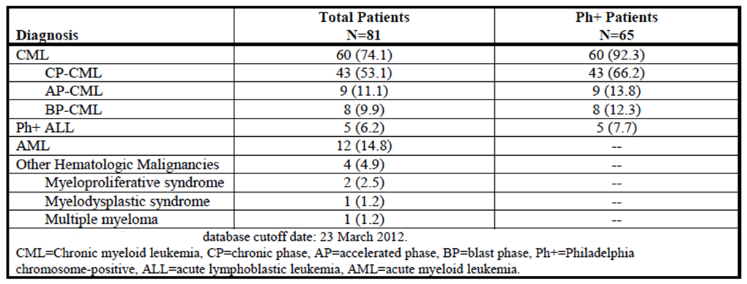
Of the 81 subjects, 60 had CML, 5 had Ph+ ALL and 12 had AML. The baseline demographics for the 65 subjects with CML/Ph+ ALL are shown in Table 31. Prior treatments received in the CML/Ph+ ALL subpopulation are shown in Table 32. Consistent with the inclusion criteria, the patient population was a heavily pre-treated one. Most patients (61/65; 93.8%) had already been treated with at least 2 TKIs, and 41 subjects (63.1%) had received at least 3 TKIs.

Table 31: Study 101 - Demographics at baseline (CML/Ph+ ALL subpopulation)
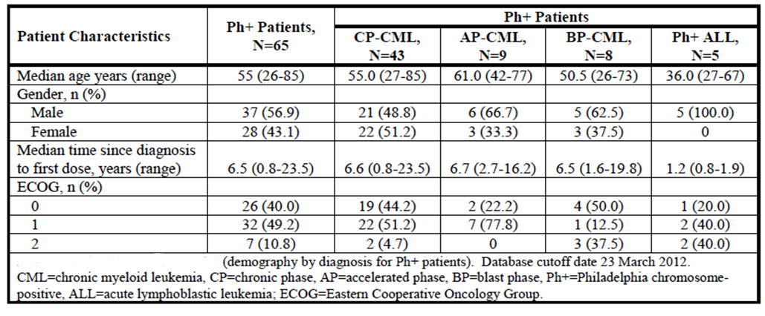

Table 32: Study 101 - Prior treatments (CML/Ph+ ALL subpopulation)
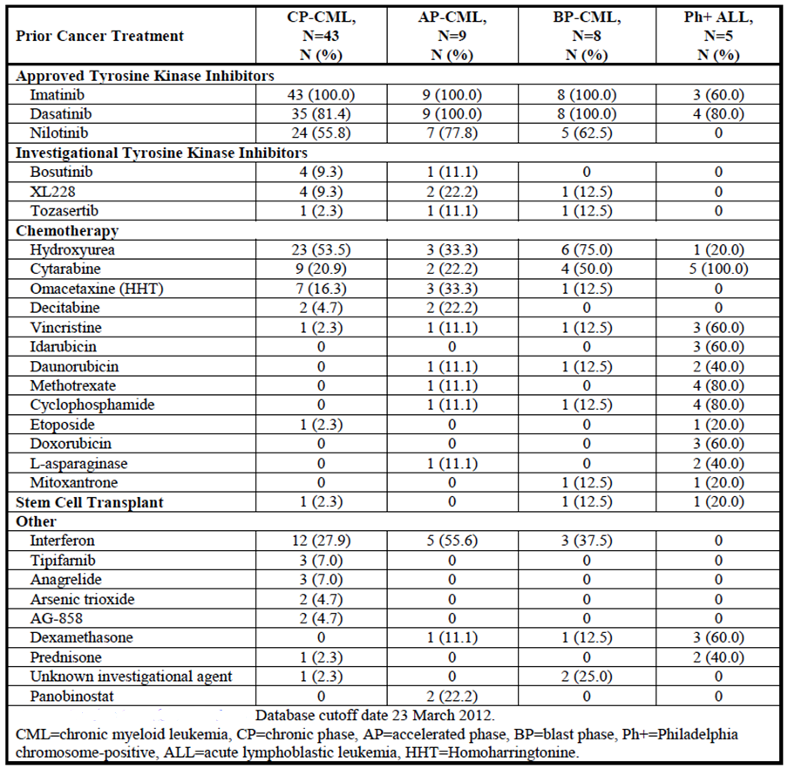
The reasons for discontinuation of prior dasatinib or nilotinib are shown in Table 33. Most subjects discontinued these drugs due to disease progression or lack of response, and approximately 20% due to intolerance. A proportion of patients also discontinued on the grounds that they were scheduled to receive another treatment (for example, entering a clinical trial). Details of BCR-ABL mutation status at baseline are shown in Table 34. A total of 19 subjects (29.2%) had the T315I mutation.

Table 33: Study 101 - Reasons for discontinuation of prior dasatinib/ nilotinib (CML/Ph+ ALL subpopulation)
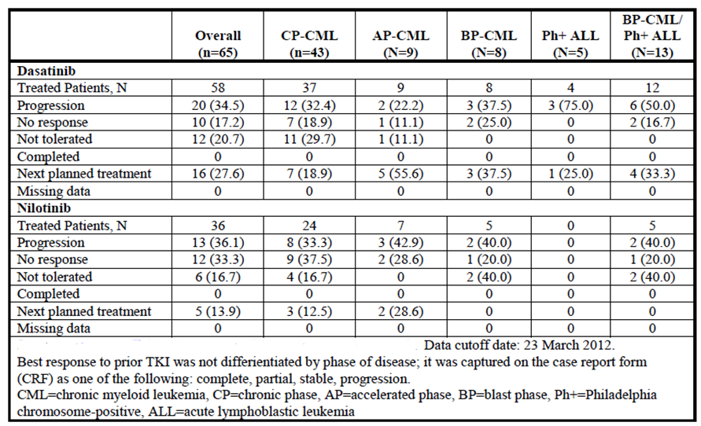

Table 34: Study 101 - BCR-ABL mutation status at study entry (CML/Ph+ ALL subpopulation)
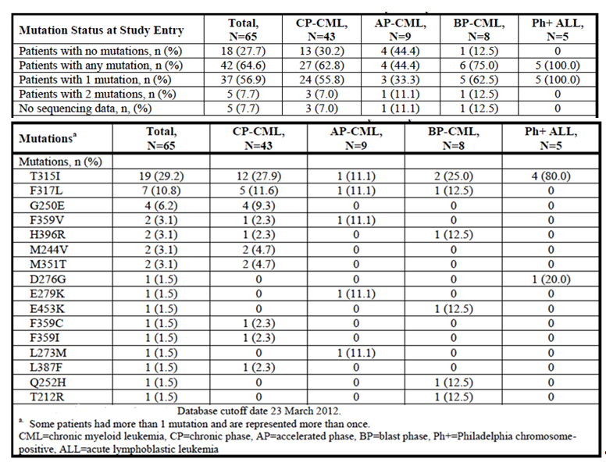

Results for the efficacy outcomes
At the time of analysis, the median duration of follow-up for CML/Ph+ALL patients was 84.4 weeks or 19.4 months (range 2.1 to 164.4 weeks). Overall efficacy results are shown in Table 35.

Table 35: Study 101 - Overall efficacy results (CML/Ph+ ALL subpopulation)
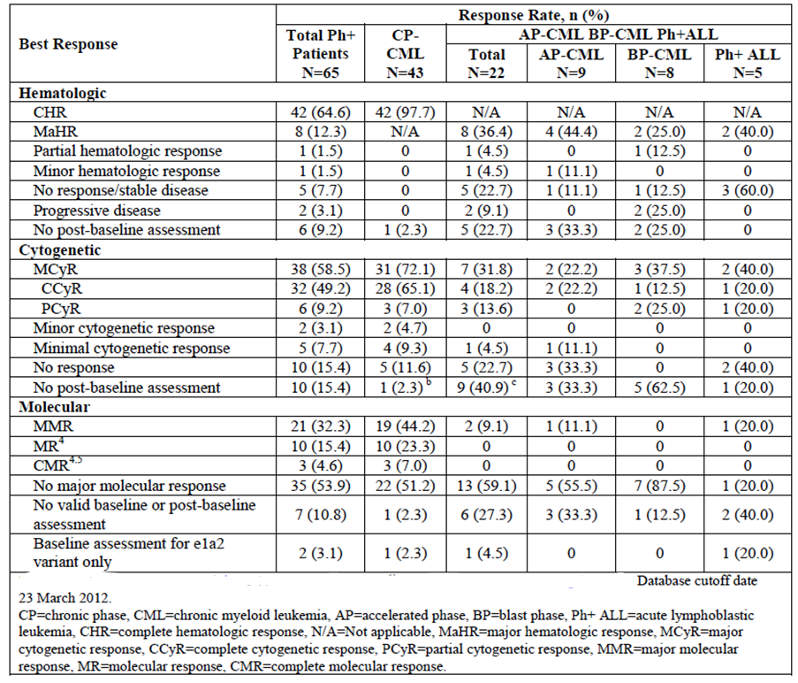

Chronic phase CML (CP-CML)
More detailed results for subjects with CP-CML are shown in Table 36. 97.7% of these subjects either maintained or achieved a complete haematological response (CHR), 65.1% achieved or maintained a complete cytogenetic response (CCyR) and 44.2 % achieved a major molecular response (MMR).

Table 36: Study 101 – Efficacy results for CP-CML subpopulation
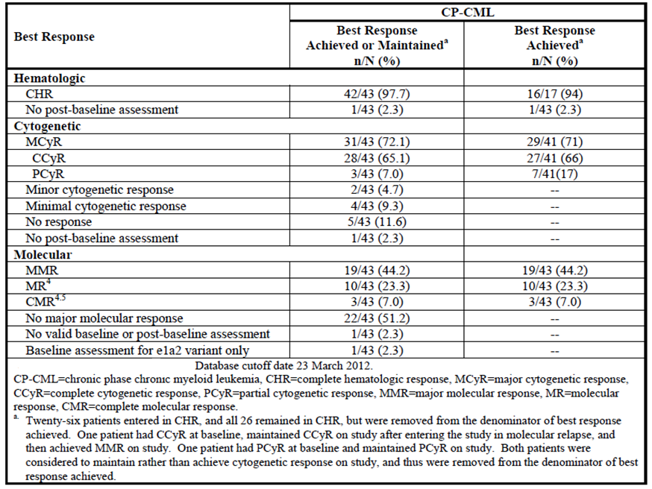
Response to therapy improved with longer duration of treatment. For example, major cytogenetic response rate was 45.2% after 3 months of treatment and 66.7% after 12 months. All response rates were higher in patients with recently diagnosed disease (<5 years duration) compared to those with longer time periods since initial diagnosis. Response rates were somewhat higher in subjects with the T315I mutation, than in subjects with other mutations (Table 37).

Table 37: Study 101 - Efficacy results for CP-CML subpopulation – by baseline mutation status
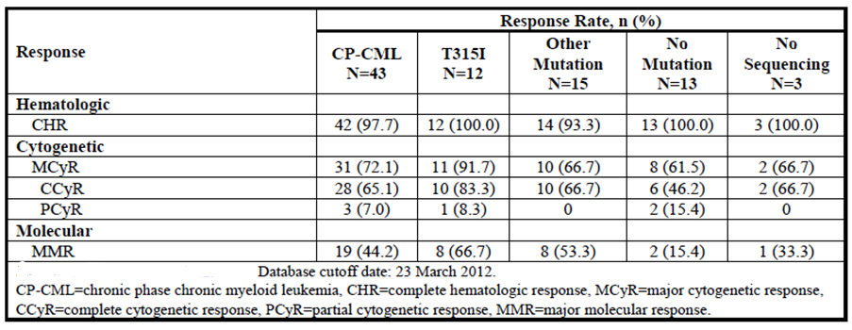
The median time to MCyR was 12.3 weeks (range: 3.1 to 156 weeks) and the median duration of MCyR had not been reached. Median time to MMR was 113 days (range: 54 to 682), and the duration of MMR ranged from 16 to >129 weeks (median not yet reached).

Advanced phase Ph+ leukaemias
More detailed results for subjects with advanced phase Ph+ leukaemias are shown in Table 38. The numbers of patients in each of the three types of leukaemias (AP-CML, BP-CML and Ph+ALL) were small (n = 9, 8 and 5 respectively).

Table 38: Study 101 - Efficacy results for advanced phase Ph+ leukaemias
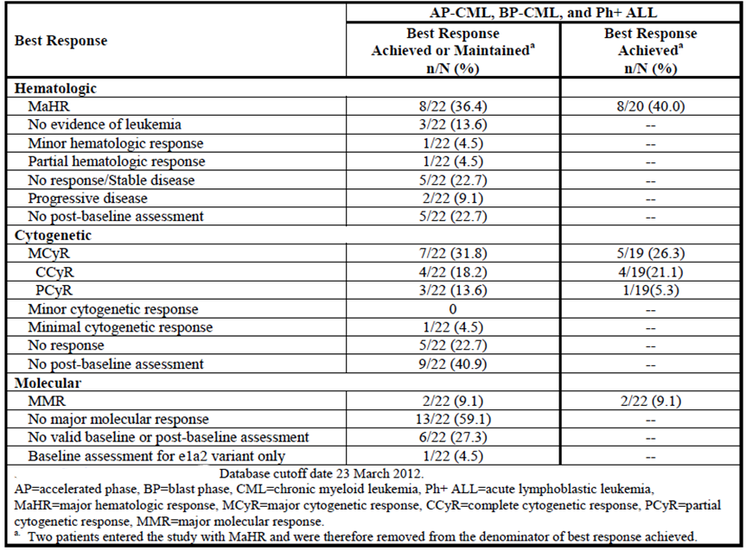
Median duration of MaHR was 15.7 weeks (range 3.6 to 64.0). The median time to MCyR was 72 weeks (range: 2 to 112 weeks) and the median duration of MCyR had not been reached. Only 2 of the 22 subjects achieved an MMR. One subject with AP-CML had an MMR of 8 weeks duration, and one subject with Ph+ALL had an MMR of 4 weeks duration.

Other analyses
The sponsor conducted a post hoc analysis (Report no ARP291) to explore the relationship between systemic exposure to ponatinib, as measured by dose intensity (average daily dose) or average daily AUC, and several baseline prognostic factors (age, time since diagnosis, number of prior TKIs, baseline neutrophil and platelet counts) on efficacy and safety outcomes. The analysis was described as exploratory. The main efficacy finding of this analysis was that efficacy was improved with increased AUC, such that:
- For patients with chronic phase CML, the probability of achieving a MCyR was increased by 40% with an increase in daily AUC of 400 ng/mL*hr.
- For patients with advanced/blast phase CML or Ph+ALL, the probability of achieving a MaHR was increased by 57% with an increase in daily AUC of 400 ng/mL*hr.

Analyses performed across trials (pooled analyses and meta-analyses)
There were no pooled analyses or meta-analyses include in the submission.

Evaluator’s conclusions on clinical efficacy
The sponsor has provided efficacy data from two open-label, non-comparative studies. The patients included in these studies were heavily pre-treated with currently registered TKIs. The studies used standard endpoints for determination of efficacy in CML and Ph+ve ALL.
For patients in chronic phase CML, a major cytogenetic response was achieved in 53.9% in Study 201 and 72.1% in Study 101. The higher response rate in Study 101 may reflect longer duration of follow up. The responses appeared durable, with median duration of response not being reached in either study.
For patients in accelerated phase CML, a major haematological response was achieved in 57.8% in Study 201. Responses were less durable, with median durations of response being 5.7 – 9.5 months.
Efficacy was less impressive in subjects in blast phase CML and Ph+ acute lymphocytic leukaemia, with rate of MaHR being approximately 30-40% and with responses being short-lived (median of 4.1 months in Study 201).
The most notable findings from these studies are that efficacy has been demonstrated in:
- Subjects for whom currently available TKIs have failed; and
- Subjects who harbour the T315I mutation in BCR-ABL, which is associated with resistance to currently available TKIs.
Overall, the data are considered adequate to establish the efficacy of ponatinib.

Clinical safety

Studies providing evaluable safety data
The following studies provided evaluable safety data:

Pivotal efficacy study (Study 201)
In the pivotal efficacy study, the following safety data were collected:
- General adverse events (AEs) were assessed at every visit throughout the study
- Physical examination, including measurement of vital signs, occurred at regular intervals throughout the trial
- Laboratory tests, including the following were performed at regular intervals
  - Haematology - total white blood cell (WBC) count, haemoglobin, haematocrit, platelet count, absolute neutrophil count (ANC) and WBC differential reported individually for each cell type including immature cells such as metamyelocytes, promyelocytes, and blasts, when present
  - Biochemistry – sodium, potassium, chloride, bicarbonate (or total carbon dioxide [CO2]), blood urea nitrogen (BUN, or urea), glucose, albumin, creatinine, total bilirubin (direct and indirect), alanine aminotransferase (AST [SGOT]), aspartate aminotransferase (ALT [SGPT]), alkaline phosphatase, magnesium, phosphorous, calcium, amylase, and lipase.
- ECGs were collected at baseline, the beginning of cycle 2 and the end of cycle 3
- Echocardiograms were performed at baseline and at the end of cycle 3.

Supportive efficacy study (Study 101)
In the supportive efficacy study, the following safety data were collected:
- General adverse events (AEs) were assessed at every visit throughout the study
- Physical examination, including measurement of vital signs, occurred at regular intervals throughout the trial
- Laboratory tests, including the following were performed at regular intervals
  - Haematology - total white blood count (WBC), haemoglobin, haematocrit, platelet count, and white blood cell differential (including blasts)
  - Biochemistry – sodium, potassium, chloride, bicarbonate (or total CO₂), blood urea nitrogen, phosphorus, albumin, creatinine, total bilirubin (direct and indirect), AST, ALT, alkaline phosphatase, calcium, amylase lipase and triglycerides
  - Coagulation parameters – prothrombin time and partial thromboplastin time
  - Thyroid stimulating hormone (TSH)
  - Urinalysis
  - Cardiac troponins.
- ECGs were collected at regular intervals. A subgroup of patients underwent more frequent ECGs to examine the effects of ponatinib on the QT interval
- Echocardiograms were performed at regular intervals.

Pivotal studies that assessed safety as a primary outcome
There were no studies in the submission designed to assess safety as a primary outcome.

Clinical pharmacology studies
The three clinical pharmacology studies (Studies -102, -103 and -104) provided very limited data on safety as they all involved the administration of single doses of ponatinib to healthy volunteers.

Pooled safety database
In the submission, the sponsor presented analyses of safety based on pooled data from studies -101 and -201. The pooled safety data has been used in this report for the purposes of assessing safety.
There were three reports presented for the pooled safety database:
- The Summary of Clinical Safety which included safety data collected up to the data cut-off dates for the two studies (23 March 2012 for Study 101 and 27 April 2012 for Study 201).
- A ‘120-day update’ which included safety data collected up to 23 July 2012.
- A further update provided in response to the FDA safety concerns, which included data collected up to 3 September 2013. This update focussed on vascular adverse events, but also included some data on cardiac failure, ocular toxicities and neuropathy.

Pivotal studies that assessed safety as a primary outcome
Not applicable.

Patient exposure
In the five submitted clinical studies, a total of 530 patients and 53 healthy volunteers received at least one dose of ponatinib (Table 39). Of the 530 patients, 514 had CML or Ph+ALL (the proposed indication) and 16 subjects (all in Study 101) had other haematological malignancies. The pooled safety database included all 530 patients.

Table 39: Exposure to ponatinib in clinical studies.
 | Healthy volunteers | Patients
Clinical Pharmacology studies 102  103  104 | 24  23  6 | -  -  -
Efficacy studies  101  201 | -  - | 81  449
TOTALS | 53 | 530
A summary of the extent of exposure (at the time of the 120-day update) and according to dose and duration is shown in Table 40. The median duration of treatment was 323 days (10.6 months). A total of 349 subjects had been treated for at least 6 months and 185 subjects for 12 months. A total of 51.5% of subjects had required dose reduction, with the median daily dose being 36.5 mg, as opposed to the starting daily dose of 45 mg.

Table 40: Pooled safety data - Overall extent of exposure (from 120 day safety update)
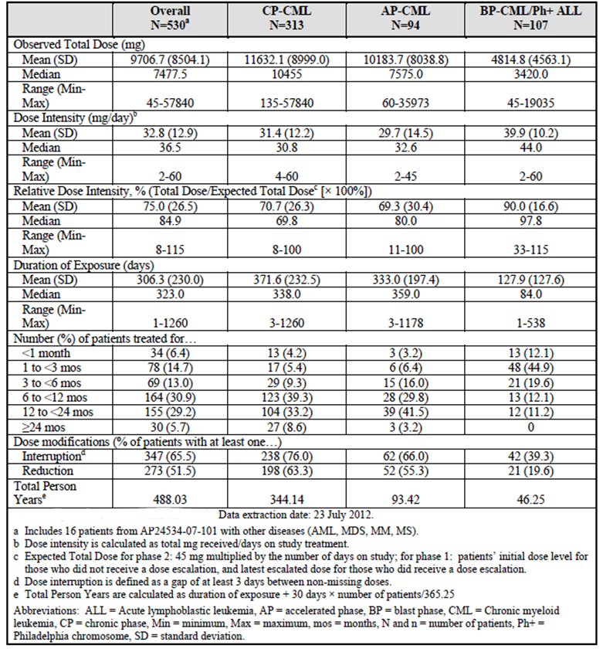

Adverse events
A summary of the overall incidence of adverse events (AEs) occurring in the pooled safety database (at the time of the 120-day update) is shown in Table 41.

Table 41: Pooled safety data – Overall incidence of adverse events (from 120 day safety update)
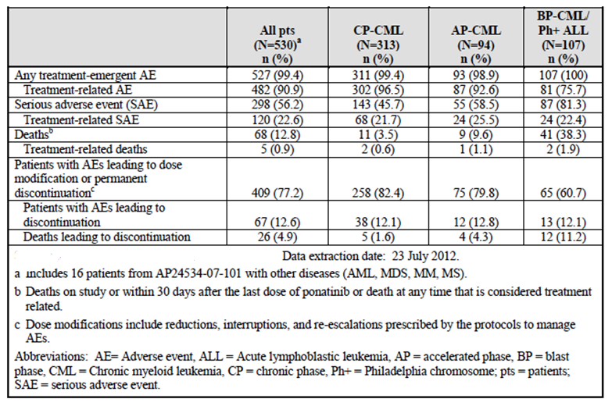
Comment: Subjects enrolled in the two studies had advanced, treatment-resistant disease and hence a high incidence of AEs might be expected. However, there was high incidence of AEs that the investigators believed were related to treatment, the overall incidence being 90.9%.

All adverse events (irrespective of relationship to study treatment)
The overall incidence of any AE was high (99.4% of subjects). Events ≥ Grade 3 in severity occurred in 82.8% of subjects. The common AEs observed (that is, those occurring in more than 10% of subjects) are shown in Table 42. This table is taken from the 120-day safety update.

Table 42: Pooled safety data – Common AEs (from 120 day safety update)
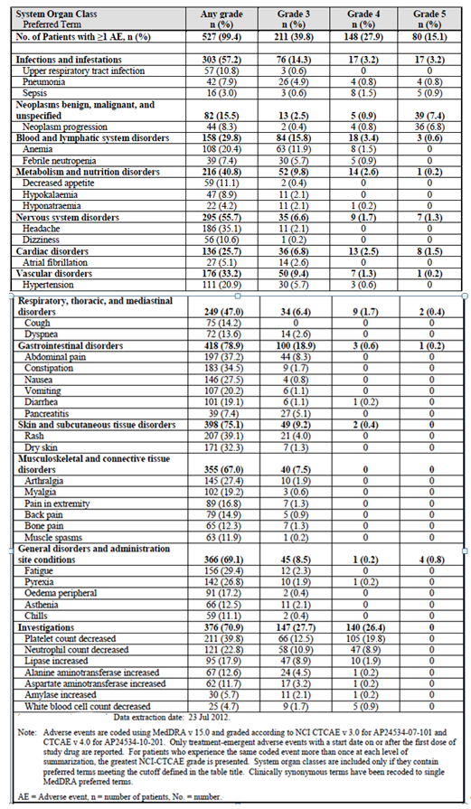
Comment: AEs suggestive of myelosuppression were common (grade ≥ 3 thrombocytopaenia 33.3%; grade ≥ 3 neutropaenia 19.8%; grade ≥ 3 anaemia 13.4%; febrile neutropaenia 7.4%). AEs suggestive of pancreatic toxicity were also notable (increased lipase 17.9%; pancreatitis 7.4%, increased amylase 5.7%). Dermatological toxicity was also common with rash occurring in 39.1% of subjects and dry skin in 32.3%, with most events being < Grade 3 in severity. Gastrointestinal events (abdominal pain, constipation, nausea, vomiting, diarrhoea, decreased appetite) were also very common but were generally < Grade 3 in severity. Similarly, musculoskeletal disorders were very common, but mostly < Grade 3 in severity. Possible hepatotoxicity was indicated by grade ≥ 3 increases in ALT occurring in 4.7% of subjects and grade ≥ 3 increases in AST in 3.4%. Hypertension was recorded as an AE for 20.9% of subjects, with 6.3% being grade ≥ 3. Peripheral oedema occurred in 17.2% of subjects.
Many of these AES have previously been described with other BCR-ABL TKIs (myelosuppression, skin and gastrointestinal toxicity, hepatotoxicity, fluid retention).

Treatment-related adverse events (adverse drug reactions)
The incidence of treatment-related AEs at the time of the 120-day safety update was 90.9%. The common treatment-related AEs observed (that is, those occurring in more than 5% of subjects) are shown in Table 43. This table is taken from the SCS. The 120-day safety update did not provide an updated tabulation of treatment-related AEs.

Table 43: Pooled safety data – Treatment-related AEs (from Summary of Clinical Safety)
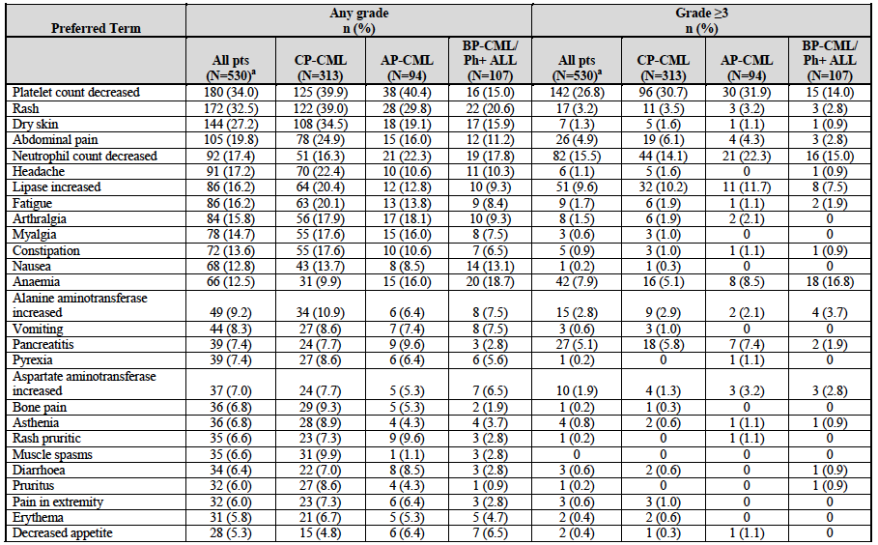
Comment: The pattern of AEs in this analysis is similar to that obtained in the analysis of all AEs.

Deaths and other serious adverse events

Deaths
An analysis was presented of all deaths that occurred either a) within 30 days of the last dose of ponatinib or b) more than 30 days since the last dose, but considered to be related to the drug. At the time of the 120-day update, a total of 68 such deaths had occurred. These are summarised in Table 44. Of the 68 deaths, 41 occurred in subjects with advanced disease (blast phase CML or Ph+ ALL) and a further 7 occurred in subjects with malignancies other than CML/Ph+ve ALL (from Study 101). The most common causes of death were events associated with disease progression or infection.

Table 44: Pooled safety data – Deaths - within 30 days of last ponatinib or any treatment-related (from 120-day safety update)
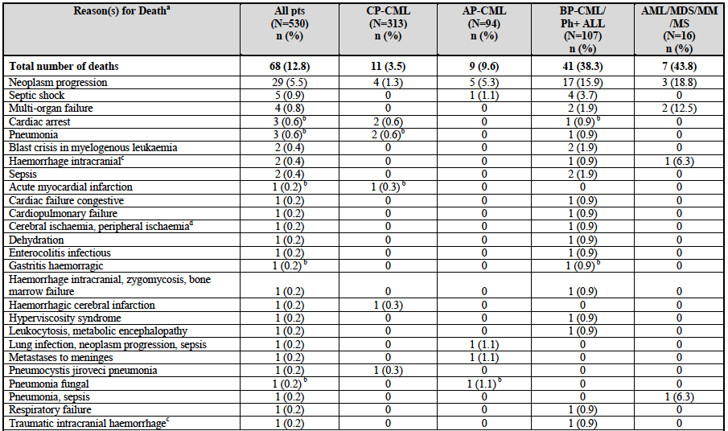
Of the 68 deaths, only 5 were considered by the treating investigator to be at least possibly related to ponatinib:
- A [information redacted] male patient with chronic phase CML died after developing pancytopaenia (with a hypocellular marrow), sepsis and pneumonia, 41 days after ceasing ponatinib. He also had a pulmonary embolus. Ponatinib was thought to have caused the pancytopaenia.
- A [information redacted] male patient with chronic phase CML and a past history of ischaemic heart disease developed chest pain and went into cardiac arrest. An angiogram revealed a 100% blockage of the left anterior descending artery. The patient could not be resuscitated. He had been taking ponatinib for approximately 10 months.
- A [information redacted] patient with accelerated phase CML had been enrolled with cytopaenias at baseline (Hb 112 g/L; WBC 7.4; ANC 3.4; platelets 73). After 7 months treatment with ponatinib he was noted to have developed severe pancytopaenia (Hb 83; WBC 0.7; ANC 0.0; platelets 5). He subsequently developed fungal pneumonia and died.
- A [information redacted] patient with blast phase CML developed thrombocytopaenia (platelets = 3) and anaemia (Hb 44) after 1 month of ponatinib treatment. He subsequently developed pancytopaenia and died from gastrointestinal haemorrhage.
- An [information redacted] patient with Ph+ ALL developed diarrhoea, abdominal cramps and dehydration 7 days after commencing ponatinib. After 48 hours the patient had a cardiac arrest at home.

Other Serious AEs
A serious AE (SAE) was defined as an AE which:
- Results in death
- Is life-threatening (places the patient at immediate risk of death)
- Causes a permanent, persistent, or significant disability
- Requires inpatient hospitalization or prolongation of existing hospitalization
- Causes a congenital anomaly or birth defect
- In the opinion of the investigator, is an important medical event, that is, requires a medical or surgical intervention to prevent a life-threatening situation, hospitalization, or death
- Is a diagnosis of a new cancer
- Is associated with an overdose.
The incidence of SAEs at the time of the 120-day update was 56.2%. SAEs were more common in patients with advanced disease (CP-CML: 45.7%; AP-CML: 58.5%; BP-CML/Ph+ ALL: 81.3%). The incidence of treatment-related SAEs at the time of the 120-day update was 22.6%. A tabulation of all SAEs occurring in ≥1% of patients (or any Grade 5 SAE) is shown in Table 45.

Table 45: Pooled safety data – Serious AEs (from 120 day safety update)
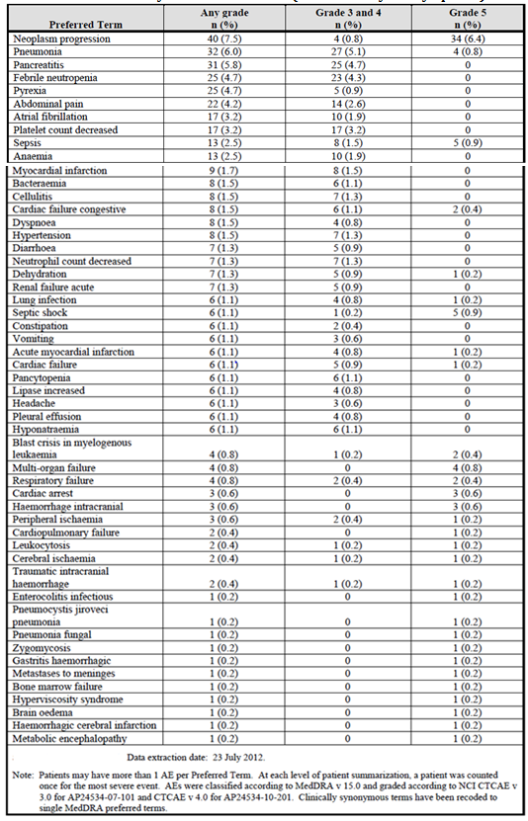
Comment: Many of the SAEs listed are consistent with disease progression (for example, neoplasm progression, blast crisis, leucocytosis). There were also multiple infectious SAEs (pneumonia, sepsis, bacteraemia etc.) that may have been secondary to the disease or to myelosuppression caused by the drug.
Consistent with the analyses above of all AEs and treatment-related AEs, the following toxicities were prominent:
- Myelosuppression (febrile neutropaenia, decreased platelet count, anaemia, decreased neutrophil count etc.);
- Gastrointestinal SAEs (abdominal pain, diarrhoea, dehydration, constipation, vomiting).
Of note, pancreatic toxicity was common – pancreatitis: 5.8% (Grade 3/4: 5.1%).
The tabulation of SAEs also highlights events suggestive of cardiovascular toxicity:
- Myocardial infarction (9 events), acute myocardial infarction (6); cardiac arrest (3);
- Peripheral ischaemia (2 events), cerebral ischaemia (2);
- Congestive cardiac failure (8 events), cardiac failure (6), cardiopulmonary failure (2);
- Atrial fibrillation (17 events);
- Hypertension (8 events).
There were also a number of SAEs of a haemorrhagic nature:
Intracranial haemorrhage (3 events), traumatic intracranial haemorrhage (2), haemorrhagic cerebral infarction (1);
Haemorrhagic gastritis (1 event).

Discontinuation due to adverse events
The incidence of AEs leading to treatment discontinuation at the time of the 120-day safety update was 17.9%. This figure includes some patients who discontinued due to disease progression. If only AEs considered to be treatment-related are included the discontinuation rate was 8.3%.
Individual AEs leading to discontinuation in at least 2 subjects (or a single patient if treatment-related) are shown in Table 46.

Table 46: Pooled safety data – AEs leading to treatment discontinuation (from 120 day safety update)
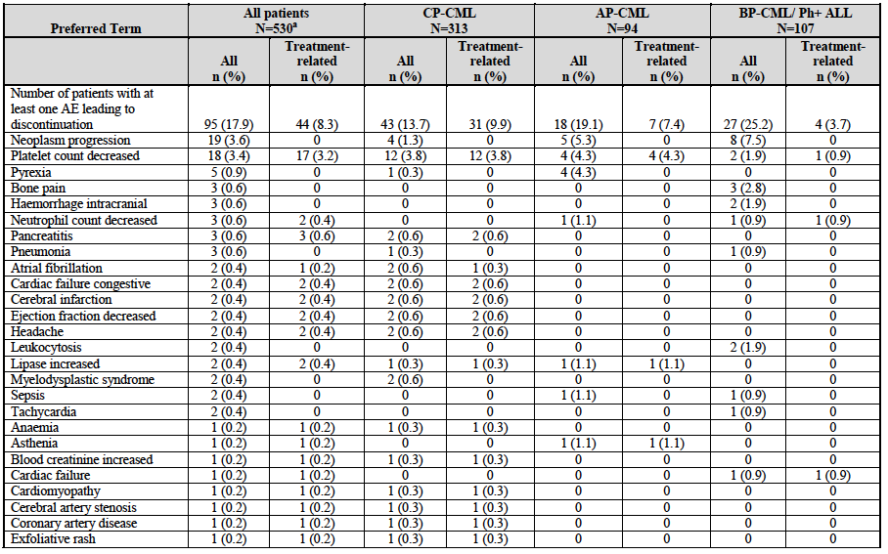
Comment: Despite a high incidence of AEs (99.4%), treatment-related AEs (90.9%) and SAEs (56.2%), the incidence of AEs leading to discontinuation was comparatively low. This suggests that the toxicities produced by the drug could be managed in most patients (for example, with dose reductions, drug interruptions and supportive therapies).
Myelosuppression events were the most common leading to discontinuation (decreased platelet count, decreased neutrophil count, anaemia). Pancreatitis led to discontinuation in 3 subjects and increased lipase in a further 2 subjects.
Cardiovascular events led to discontinuation in a notable number of patients, although numbers for each individual event were low:
- Cerebral infarction (2 events), cerebral artery stenosis (1), coronary artery disease (1).
- Congestive cardiac failure (2 events), ejection fraction decreased (2), cardiac failure (1), cardiomyopathy (1).
- Atrial fibrillation (2 events).
Most of these events were considered related to the drug.
It is also notable that gastrointestinal, dermatological, musculoskeletal and hypertensive AEs rarely led to discontinuation.

Adverse events of special interest
In the original Summary of Clinical Safety (and in the 120-day update), the sponsor had identified a number of AEs as being of special interest, based on their association with other BCR-ABL TKIs or with CML/Ph+ ALL. These were:
- Myelosuppression
- Infections
- Bleeding events
- Pancreatic events
- Hepatic events
- Cardiac Events
- Ischaemic vascular events
- Oedema and fluid retention events
- Skin and subcutaneous tissue disorders
Following approval in the United States, the FDA became concerned about a high incidence of vascular events associated with the drug, and temporarily withdrew it from the market. In response to these concerns, the sponsor provided the TGA with updated safety data (mainly on vascular events but also on cardiac failure, ocular events and neuropathy) with a cut-off date of 3 September 2013.

Vascular events

Study 201
The updated safety information (data cut-off 3 September 2013) provided updated data on vascular events from Study 201 only.
  - All vascular events
The overall incidence of vascular events is summarised in Table 47. A total of 20.3% of subjects had experienced at least one vascular AE, and 13.8% had experienced at least one serious vascular AE.
Comment: The product information documents for the other Bcr-Abl TKIs registered in Australia all list vascular adverse drug reactions (that is, treatment-related vascular AEs). They are described as being uncommon (incidence 0.1% to 1.0%) or rare (incidence < 0.1%). The incidence of treatment-related vascular AEs with ponatinib was 9.4%, suggesting that the frequency of such events is notably higher with this drug.

Table 47: Study 201 – Overall incidences of vascular AEs (Arterial and Venous)
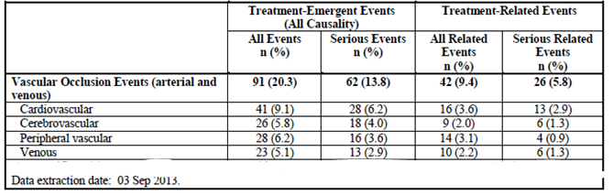
  - Arterial vascular AEs
A total of 77/449 (17.1%) subjects experienced at least one arterial AE. Of these 53/449 (11.8%) experienced a serious arterial AE. The individual AEs are listed in Table 48.

Table 48: Study 201 – Arterial vascular AEs (safety update cut-off 3 September 2013). Treatment-emergent thrombotic/ischaemic adverse events by severity (N=449). Sorted by descending frequency. Safety population.
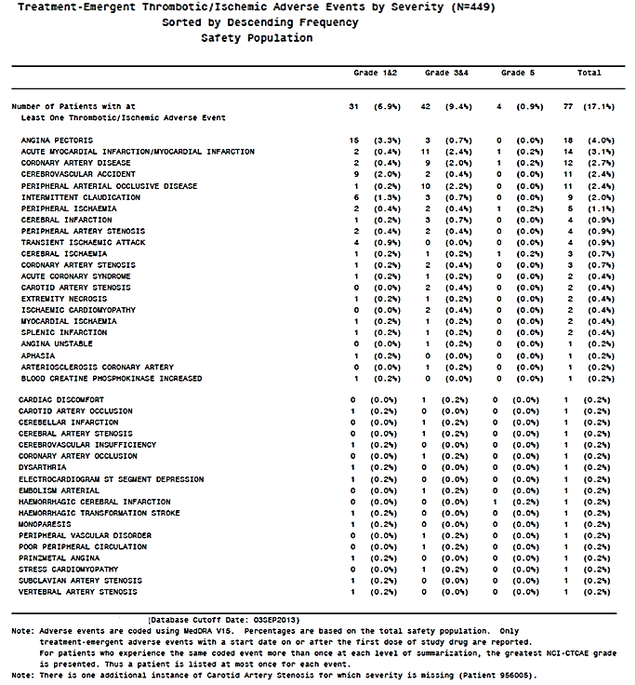
Comment: It should be noted that patients with recent myocardial infarction or unstable angina were excluded from Study 201.
There are some discrepancies between incidence figures quoted in the updated safety report and those in the US prescribing information ⁽⁷⁾, which was approved on 20 December 2013:
- All arterial AEs: 77/449 (17.1%) vs. 91/449 (20%) in US PI
- Cardiac arterial AEs: 41/449 (9.1%) vs. 55/449 (12%) in US PI
- Cerebrovascular arterial AEs: 26/449 (5.8%) vs. 27/449 (6%) in US PI
- Peripheral arterial AEs: 28/449 (6.2%) vs. 36/449 (8%) in US PI.
The sponsor provided a copy of a communication with the EMA (dated 31 October 2013) addressing differences between the FDA and sponsor analyses. It stated that the FDA had not provided the sponsor with details of their incidence calculations. However, the FDA had appeared to use a broader set of AE terms than the sponsor for inclusion in their analysis (for example, Cardiac arrest, Cardio-respiratory arrest, Chest discomfort, Clumsiness, Electrocardiogram T Wave Abnormal, Encephalopathy, etc.).
The sponsor presented various analyses of the subjects who had experienced arterial vascular AEs. The incidence of arterial AEs in subjects with no pre-existing risk factors for ischaemia at baseline was 6.4%. The incidence rose to 12.0% in subjects with 1 risk factor, and to 26.1% in subjects with 2 or more risk factors. The incidence of arterial AEs was notably elevated in subjects with diabetes (40.4%) and in subjects with a history of ischaemic heart disease 36.8%).

Table 49: Study 201 – Incidence of arterial vascular AEs in subgroups
 | N | Arterial AE | Serious Arterial AE
Total population | 449 | 77 (17.1%) | 53 (11.8%)
Individual baseline risk factors
Hypertension | 239 | 60 (25.1%) | 44 (18.4%)
Hypercholesterolaemia | 246 | 53 (21.5%) | 37 (15.0%)
Diabetes | 57 | 23 (40.4%) | 16 (28.1%)
Obesity | 109 | 21 (19.3%) | 14 (12.8%)
Combined baseline risk factors
0 risk factors | 109 | 7 (6.4%) | 5 (4.6%)
1 risk factor | 133 | 16 (12.0%) | 9 (6.7%)
≥ 2 risk factors | 207 | 54 (26.1%) | 39 (18.8%)
History of cardiac disease
Any cardiac disease | 174 | 40 (23.0%) | 26 (14.9%)
Ischaemic heart disease | 57 | 21 (36.8%) | 17 (29.8%)
- Myocardial infarction | 18 | 10 (55.5%) | 8 (44.4%)
- Coronary artery disease | 33 | 15 (45.5%) | 14 (42.4%)
- Coronary revascularisation | 14 | 8 (57.1%) | 6 (42.9%)
- Other ischaemic heart disease | 15 | 4 (26.6%) | 2 (13.3%)
Other cardiac disease | 148 | 29 (19.6%) | 17 (11.5%)
Multivariate analyses were conducted to examine the relationship between arterial AEs and various covariates. Results are summarised in Table 50 (arterial AEs) and Table 51 (serious arterial AEs). Arterial AEs were strongly associated with higher dose intensity (as measured by the average dose up to the date of the event), increasing age, a medical history of diabetes and a medical history of ischaemia.

Table 50: Study 201 – Multivariate and Univariate Logistic Regression Analysis – Arterial AEs
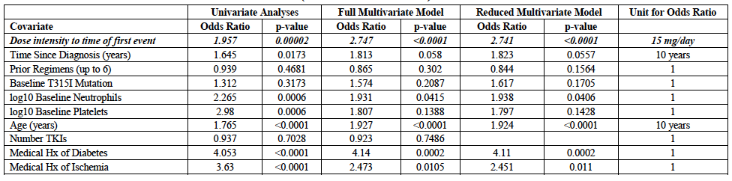

Table 51: Study 201 - Multivariate and Univariate Logistic Regression Analysis – Serious Arterial AEs
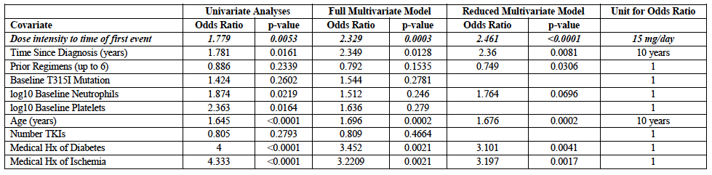
Comment: The demonstration of a relationship between increasing dose of ponatinib and an increasing incidence of arterial AEs supports the conclusion that the drug has a causative role in their development.
A separate multivariate analysis demonstrated that increasing dose intensity was also associated with increasing efficacy (in terms of achievement of a MCyR) in subjects with chronic phase CML.
Data were presented on CP-CML subjects who had achieved a MCyR and who subsequently had a dose reduction:
- There were 44 subjects who achieved a MCyR while taking 45 mg per day, and had a subsequent dose reduction. All 44 subjects (100%) maintained the MCyR.
- There were 20 subjects who achieved a MCyR while taking 30 mg per day and had a subsequent dose reduction. A total of 18 subjects (90%) maintained the MCyR.
Comment: On the basis of these data, the sponsor suggests that dose reduction in subjects who have achieved a response might reduce the risk of arterial AEs. A recommendation along these lines has been included in the US prescribing information, but does not appear in the draft Australian PI.
The updated safety report states that a preliminary analysis of the subgroup of patients who were using aspirin at baseline did not suggest a benefit. The report also presented data demonstrating that subjects who experienced an arterial AE had comparable survival to those subjects who did not experience such an event.
  - Venous vascular AEs
A total of 5.1% of subjects experienced at least one venous vascular AE. The update report did not include any further analyses of these events.

Study 101
The updated safety information (with a cut-off of 3 September 2013) did not provide any information on the incidence of vascular events in Study 101. Both the Summary of Clinical Safety and the 120-day Safety Update had provided tabulations of vascular events in the combined population of subjects from 101 and 201 (n=530), but it was not possible to dissect out those that had occurred in 101.
Comment: In the US PI it is stated that the incidence of vascular occlusive events among subjects with CML/Ph+ve ALL in Study 101 was 48% (31/65), which is considerably higher than that reported by the sponsor for Study 201 (20.3%). The higher incidence in Study 101 may be due to a longer duration of treatment in that study. The sponsor should be requested to provide updated safety data from Study 101, and comment on the higher incidence of vascular AEs.

Myelosuppression
Adverse events related to bone marrow suppression occurred in 56% of subjects in the pooled safety database, with 47.7% of subjects developing Grade 3 or 4 events. Platelets and neutrophils were the cell lines most commonly affected (see Table 52). Myelosuppression events typically occurred during the first three months of treatment and were more common in subjects with advanced disease.

Table 52: Pooled safety data – Myelosuppression AEs (from 120 day safety update)
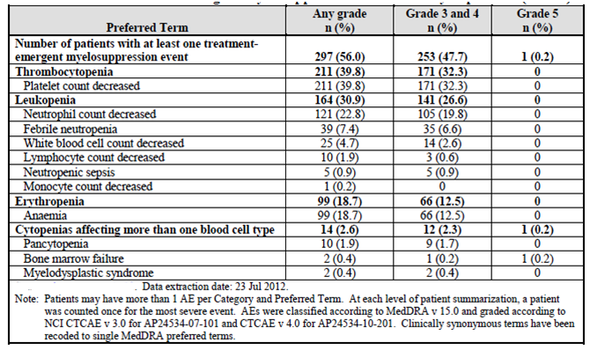

Infections
Infection AEs were reported in 57% of subjects in the pooled safety database, and serious infections were reported in 19.4% of subjects. Serious infections that occurred in more than 1 subject are listed in Table 53. They were mainly bacterial infections. Opportunistic infections occurred in 1.3% of subjects.

Table 53: Pooled safety data – Serious infectious AEs (from 120 day safety update)
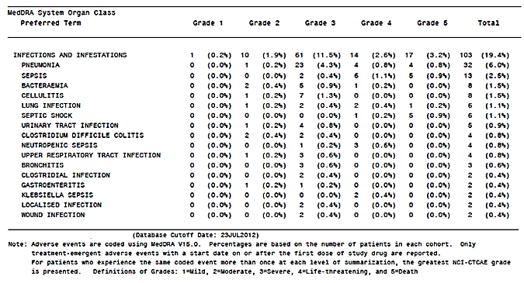

Bleeding events
Bleeding events were reported in 25.8% of subjects. Events occurring in more than 1 subject are listed in Table 54. The most common AEs were epistaxis, petechiae, ecchymosis and contusion. Most bleeding events were grade 1 or 2 in severity. However, there were 7 fatal bleeding events. One subject died from haemorrhagic gastritis with a platelet count of 2, and this death was considered possibly related to ponatinib. The other six deaths were due to intracranial haemorrhage (4); subdural haemorrhage (1) or haemorrhagic cerebral infarction (1) and none were considered related to the drug. Platelet counts in these subjects were between 11 and 216 x 10⁹/L at the time of the events.

Table 54: Pooled safety data – Bleeding AEs (from 120 day safety update)
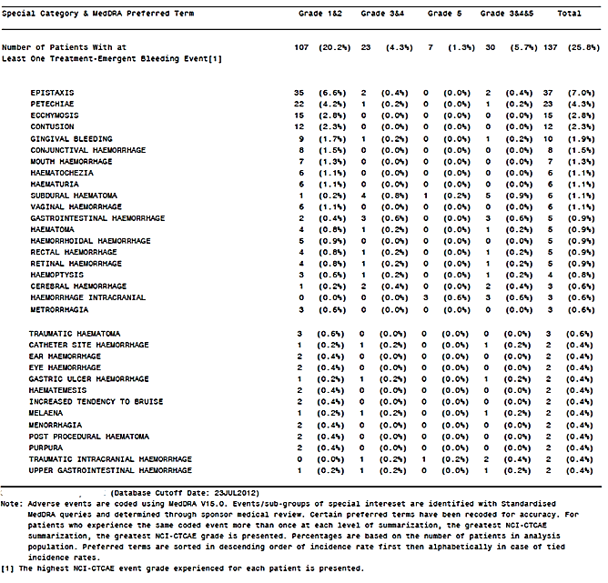

Pancreatic events
Pancreatic toxicity was the most common dose-limiting toxicity observed in the first-in-man study (Study 101). Evidence of pancreatic toxicity was also observed in the Phase I studies in healthy volunteers. A total of 25.3% of subjects in the pooled safety database experienced a pancreatic AE (Table 55). The most common event was an elevation of lipase (17.9%).

Table 55: Pooled safety data – Pancreatic AEs (from 120 day safety update)
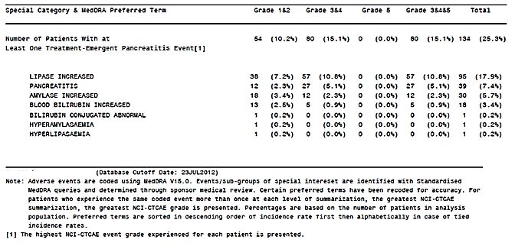
In 7.4% of subjects a diagnosis of pancreatitis was made with 5.1% of subjects having Grade 3 or 4. An SAE of pancreatitis occurred in 5.8% of trial subjects. However, only 5 trial subjects (0.9%) discontinued therapy because of pancreatic events. The remaining subjects were able to continue treatment after dose interruption (or reduction). The onset of the first episode of pancreatitis was usually rapid with 72% occurring within 30 days of drug commencement.

Hepatic events
Hepatic AEs were common, occurring in 27.2% of subjects in the pooled safety database (Table 56). A total of 10.2% experienced Grade 3 or 4 events and hepatic SAEs occurred in 6 subjects (1.1%). Only 2 subjects (0.4%) had treatment discontinued due to hepatic AEs. There were no fatal hepatic AEs and no reports of liver failure in the pooled safety analysis.

Table 56: A - Pooled safety data – Hepatic AEs (from 120 day safety update)
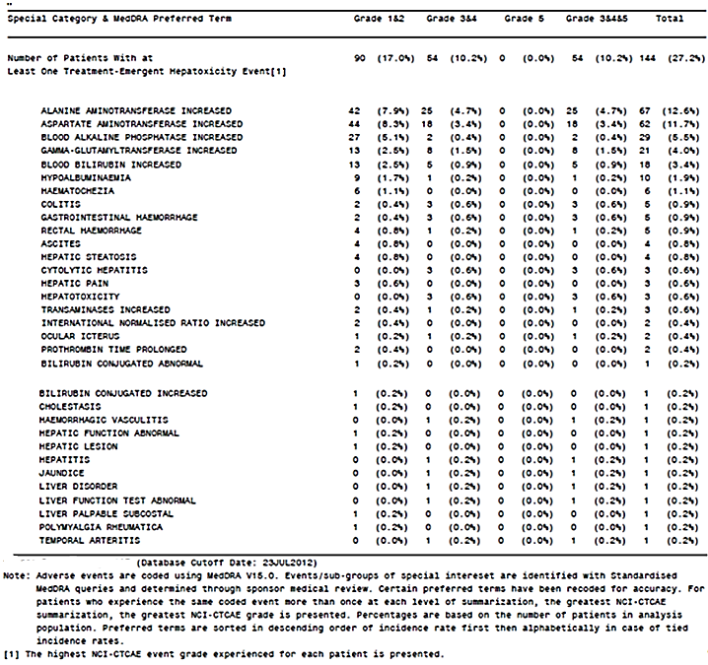
The sponsor presented an analysis of liver function testing looking for cases that met the criteria for Hy’s Law (that is, cases predictive of an association between the drug and serious drug induced liver injury [DILI]). LFT abnormalities are summarised in Table 57. There were 2 cases that potentially met the Hy’s law criteria:
- A [information redacted] patient received 45 mg daily for 54 days, for the treatment of blast phase CML in Study 201. Her LFTs were normal during treatment and the drug was ceased due to progressive disease. Three days after ceasing the drug her LFTs became abnormal - ALT 710 U/L (NR: 4 - 45), AST 810 U/L (NR: 7 - 36), total bilirubin 46 μmol/L (NR: 3 to 19), and ALP 72 U/L (NR: 31-103). She died 2 days later due to progressive disease and multiorgan failure.
- A [Information redacted] patient with accelerated phase CML was treated with 45 mg per day in Study 201. On day 15 his LFTs were noted to be abnormal - ALT 181 U/L (NR: 7-56), AST 227 U/L (NR: 15-46), ALP 137 U/L (NR: 38-126), and total bilirubin 63 μmol/L (NR: 0- 17). However, treatment was continued and the LFTs normalised. The patient remained on treatment for 20 cycles with normal LFTs.

Table 57: Pooled safety data – Liver function testing- (from 120 day safety update)
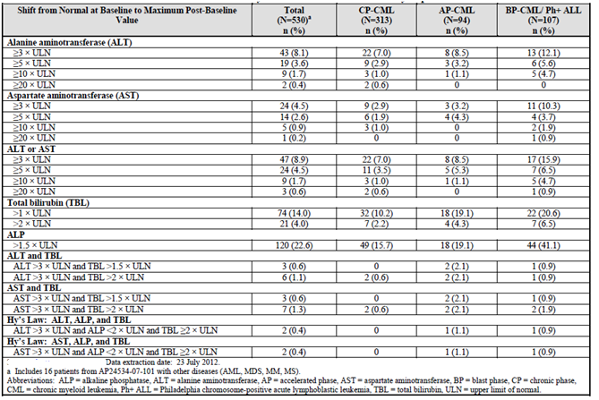
Comment: Neither of these cases suggests that the drug has the potential to be associated with severe DILI. An alternative explanation is available for the abnormal LFTs in the first patient (progressive disease with developing multiorgan failure). In the other subject the abnormal LFTs resolved despite ongoing treatment.
In the 120-day safety update, the sponsor mentions another potential Hy’s law case, which occurred in an ongoing Phase I/IIstudy in Japanese subjects. The patient developed markedly abnormal LFTs after 3 days of ponatinib and died one week later. The sponsor should be asked for further details of this case, and any other potential Hy’s law cases or cases of liver failure that have occurred. It is noted that the US PI refers to three cases of fatal hepatic failure.

Cardiac events
Cardiac AEs occurring in the pooled safety database are summarised in Table 58.

Table 58: Pooled safety data – Cardiac AEs- (from 120 day safety update)
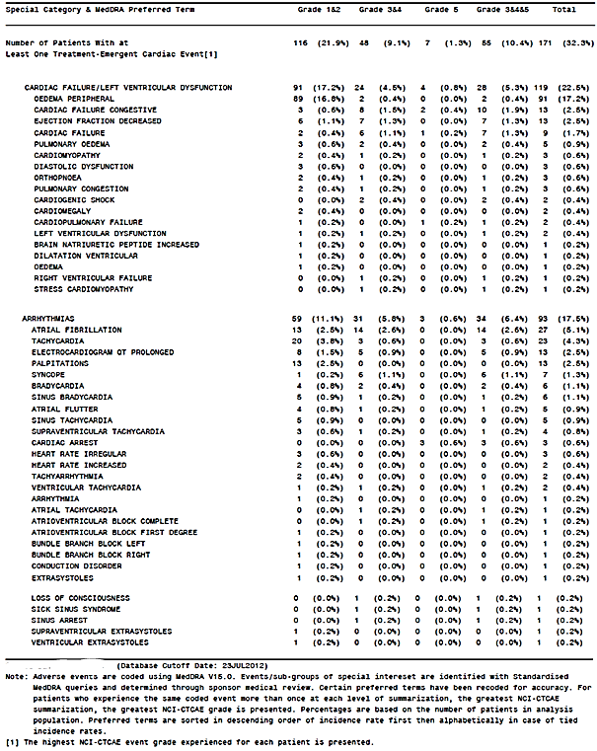

Heart failure/left ventricular dysfunction
Cardiac failure and left ventricular dysfunction are known adverse effects of other Bcr-Abl TKIs. With ponatinib, AEs suggestive of cardiac failure occurred in 22.5% of subjects. However, the most common event was peripheral oedema (17.2%), which with other Bcr-Abl TKIs is a common AE not due to cardiac impairment (see below). The incidence of ‘congestive cardiac failure (CCF)’ was 2.5% and ‘cardiac failure’ was 1.7%.
Serious cardiac failure events were reported in 4.3% of subjects. Discontinuation due to the events of CCF, decreased ejection fraction, cardiac failure or cardiomyopathy occurred in 6 subjects (1.1%).
In the safety update to 3 September 2013, the incidence of serious cardiac failure events in Study 201 was 5%.

Arrhythmias
5.1% of subjects developed atrial fibrillation, including 2.6% with Grade 3 or 4. Most patients with AF were elderly and had multiple cardiovascular risk factors. Bradycardia and sinus bradycardia occurred in 1.1% of subjects. Other specific arrhythmias occurred in < 1.0% of subjects.

QT prolongation
In Study 101, subjects in the 30 mg, 45 mg and 60 mg cohorts had ECGs collected at the following time points:
- Cycle 1, Day 1, pre-dose (in triplicate)
- Cycle 1, Day 15, pre-dose (single tracing)
- Cycle 2, Day 1, predose and at 2, 4 and 6 hours post-dose (in triplicate).
In the lower dose cohorts (2 mg, 4 mg, 8 mg and 15 mg) only single ECGs were collected at these time points.
The results for QT interval using the Fridericia correction (QTcF) and the Bazett’s correction (QTcB), for the 30, 45 and 60 mg cohorts, are shown in Figure 3. There was no apparent increase in QTc with increasing dose.
Figure 3: Study 101 - Effects on QTc interval
a) QTcF
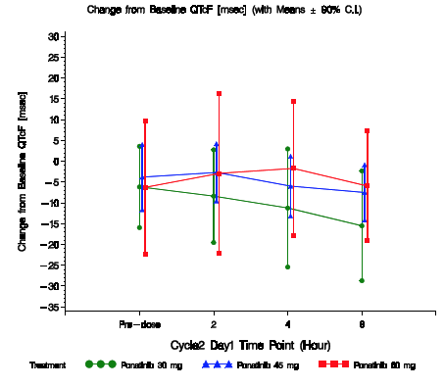
b) QTcB
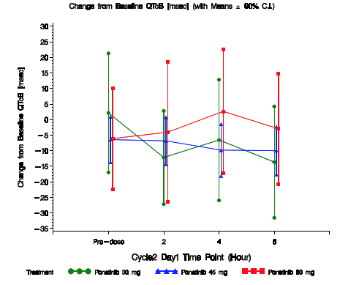
A PK/PD analysis was also undertaken to examine the relationship between QTcF interval and plasma ponatinib concentration, from paired plasma samples taken across all the dose cohorts. Results are summarised in Figure 4. No relationship was apparent.
Figure 4: Study 101 –QTcF change from baseline versus ponatinib plasma concentration (PK-PD analyses).
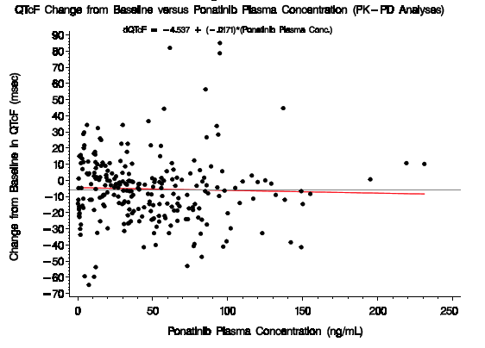
Comment: The TGA has adopted an EMA/ICH guideline that sets out the requirements for an appropriate clinical study (a ‘thorough’ QT study) to exclude an effect on QT interval (8). The design of Study 101 did not comply with these requirements (for example, there were no placebo or positive control groups and effects on ECG were not measured throughout the dose interval). An effect of ponatinib on the QT interval has not therefore been excluded by these data.
In the pooled safety database a total of 13 subjects (2.5%) had adverse events of QT prolongation reported. Seven of these subjects were in Study 101. In only one of the six was the event considered serious, a 66-year old female who was noted to have QT prolongation on ECG approximately 2 weeks after commencing ponatinib 4mg per day. The longest documented QT interval in this subject was 512 ms. The other 6 cases occurred in Study 201. Five of these subjects had a negative rechallenge or the event resolved despite continued dosing. In the other subject, QT prolongation was noted one week after the drug had been discontinued.
Three subjects had a sudden cardiac death. One occurred in an 80-year old man with recent diarrhoea and severe dehydration, one in the setting of an acute myocardial infarction and another and the third in a subject who had ceased ponatinib two weeks previously. One subject with ischaemic heart disease had an episode of ventricular tachycardia (10 beats). No episodes of ventricular fibrillation or torsades de pointes were reported. Three subjects had syncopal episodes that could be explained by other pathology (sepsis, advanced progressive disease, over-diuresis). None of these subjects had QT prolongation reported.
One subject in Study 101 who received an accidental overdose of 540 mg of ponatinib was noted to have a prolonged QT interval (uncorrected) of 520 ms at 2 hours. This reduced to 480 ms and then 400 ms on the following 2 days.
Comment: The above adverse events do not provide any clear evidence for a clinically significant effect of ponatinib on QT prolongation. It should be noted that both clinical studies excluded at-risk subjects (those with a prolonged QT at baseline, those taking other drugs known to have an effect on QT interval and those in cardiac failure).

Oedema and fluid retention events
Fluid retention is a common adverse event associated with other Bcr-Abl TKIs, and it was commonly observed in the ponatinib clinical studies, with 26.4% of subjects experiencing such an event (Table 59). Serious fluid retention AEs were reported in 2.6% of subjects. Only two subjects (0.4%) had to discontinue ponatinib due to fluid retention events (1 pericardial effusion and 1 due to pleural effusion).

Table 59: Pooled safety data – Fluid retention AEs- (from 120 day safety update)
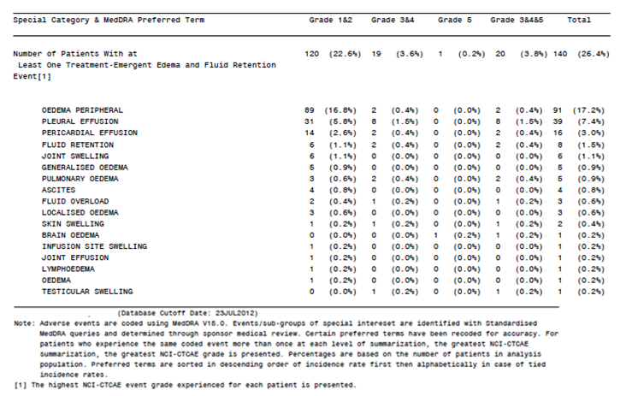

Skin and subcutaneous tissue disorders
Dermatological AEs were very common, occurring in 75.1% of subjects. Those events occurring in more than 1 subject each are listed in Table 60. The most common individual AE terms were ‘rash’ (39.1%) and dry skin (32.3%). Most of the events were of grade 1 or 2 severity, with Grade 3 or 4 events occurring in 9.6% of subjects. Serious skin events occurred in 2.8% of subjects and only 3 subjects (0.6%) discontinued due to skin AEs. There were no reports of serious skin toxicity such as Stevens Johnson syndrome or toxic epidermal necrolysis.

Table 60: Pooled safety data – Skin and Subcutaneous tissue AEs - (from 120 day safety update)
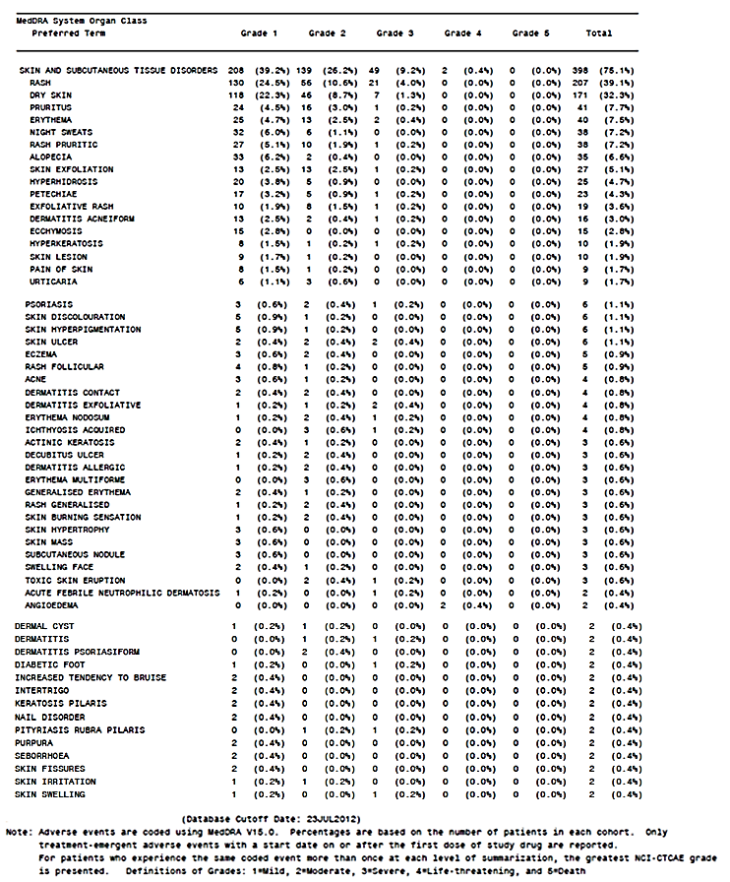

Neuropathy
The safety update up to 3 September 2103 provided an analysis of peripheral and cranial neuropathy AEs (from Study 201 only). The overall incidence of any neuropathy AE was 14.5%. Grade 2 or 3 events occurred in 5.6%. There were no Grade 4 or 5 events. The incidence of neuropathy events considered to be treatment-related was 6.0%. These are shown in Table 61.

Table 61: Study 201 – Neuropathy adverse events (treatment-related).
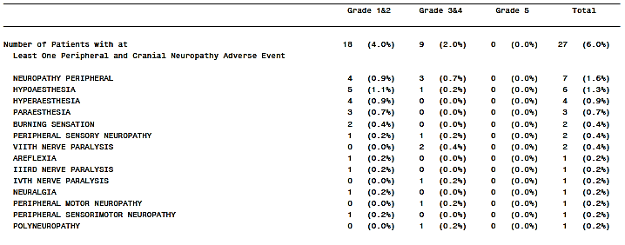

Ocular toxicities
The safety update up to 3 September 2103 also provided a very brief summary of ocular AEs. It stated that retinal toxicities including macular oedema, retinal vein occlusion, and retinal haemorrhage have occurred in 3% of patients. Serious ocular AEs that were considered related to ponatinib were cystoid macula oedema (1 case) and retinal vein thrombosis (1 case).

Laboratory tests
In general the incidence figure for a laboratory abnormality was higher than the incidence figure for the corresponding abnormality reported as an adverse event. For example the incidence of thrombocytopaenia on laboratory testing was 63.8% (Table 62), whereas the incidence of thrombocytopaenia reported as an adverse event was only 39.8%, indicating that not all laboratory abnormalities were reported as adverse events.

Table 62: Pooled safety data - Newly occurring or worsening laboratory values - (from 120 day safety update)
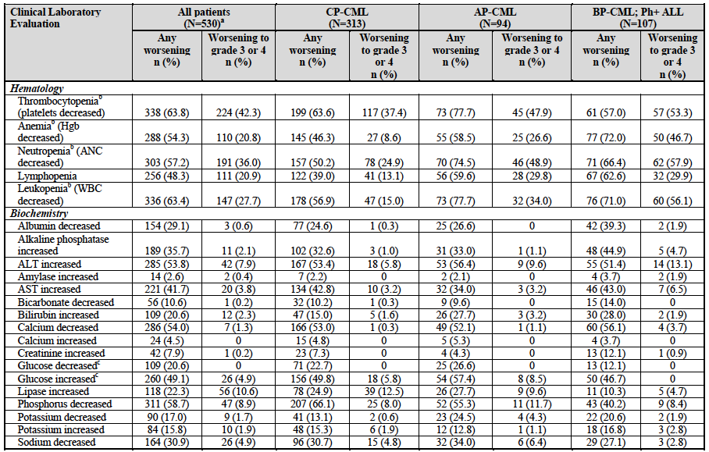

Liver function
Abnormal LFTs were frequently observed in subjects treated with ponatinib. In the pooled safety database there were no cases that met the criteria for Hy’s Law. However, the US prescribing information refers to cases of liver failure and further information on this issue should be sought from the sponsor.

Kidney function
The incidence of elevated creatinine was 7.9% in the pooled safety database. Only one of these subjects (0.2%) developed Grade 3 or 4 elevation of creatinine.

Other clinical chemistry
Other noteworthy abnormalities in clinical chemistry included:
- Hypophosphataemia (58.7%; Grade 3/4 - 8.9%). Reduced phosphate is a known AE associated with imatinib and nilotinib
- Hypocalcaemia (54.0%; Grade 3/4 – 1.3%)
- Elevated serum lipase (22.3%; Grade 3/4 – 10.6%), consistent with the reported AEs of pancreatic toxicity.

Haematology
Cytopaenias were very common on laboratory testing, consistent with the adverse event reporting.
Testing of coagulation parameters was planned in Study 101. The results of such testing could not be located in the submission. The sponsor should be asked to comment.

Other laboratory tests
Testing of TSH and cardiac troponins was planned in Study 101. The results of such testing could not be located in the submission. The sponsor should be asked to comment. Hypothyroidism has been reported with other Bcr-Abl TKIs.

Urinalysis
Urinalysis was performed in Study 101 only. 46.9% of subjects had at least one instance of urine protein being worse than at baseline. A total of 12.3% of subjects had a worst post-baseline level of 100mg/dL or greater. No other urinalysis parameters were reported.

Electrocardiograph
Data regarding the effects of ponatinib on QT interval have been discussed above.
In Study 101, subjects in the 30 mg, 45 mg and 60 mg cohorts had ECGs collected at frequent time points. The ECG changes observed in these patients are summarised in Table 63. No consistent clinically significant changes were observed.

Table 63: Study 101 – ECG changes
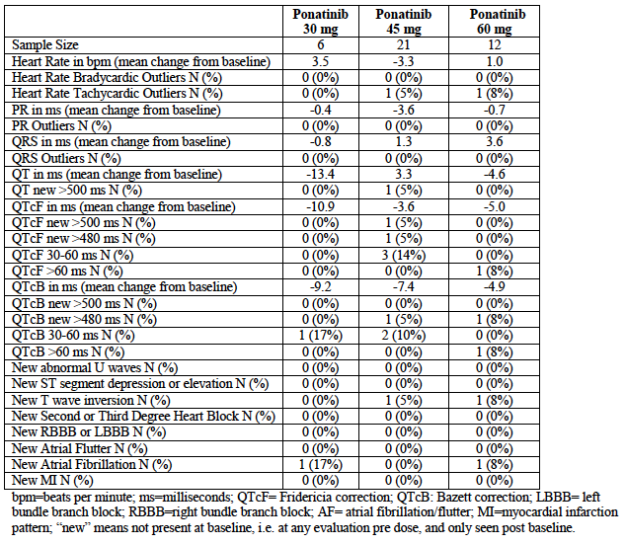

Echocardiography
Shifts in ejection fraction as determined by echocardiography are summarised in Table 64. A decrease in LVEF of ≥ 20% occurred in 5.1% of subjects.

Table 64: Pooled safety data – Shifts in ejection fraction - (from 120 day safety update)
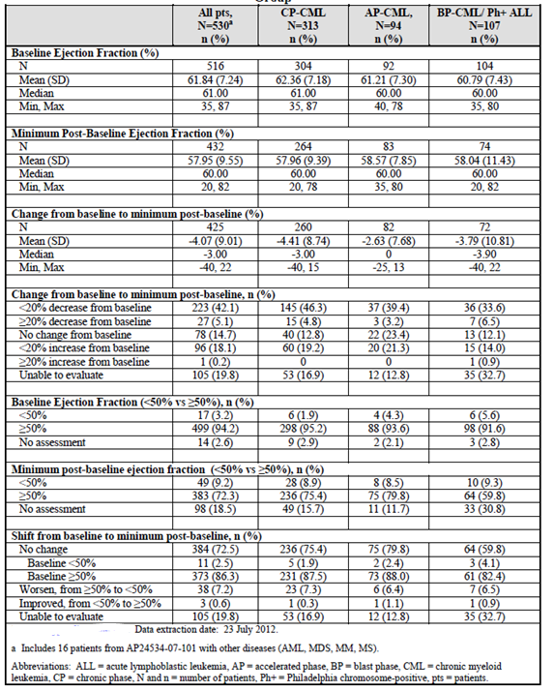

Vital signs
Hypertension was a commonly reported AE. Shifts in blood pressure are summarised in Table 65. There was no clinically significant change in mean pulse rate on ECG in Study 101.

Table 65: Pooled safety data – Shifts in blood pressure - (from 120 day safety update)
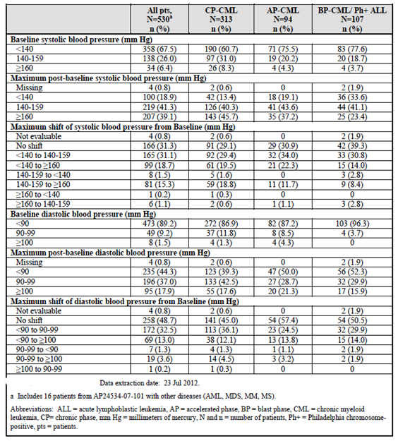

Dose-limiting toxicity/maximum tolerated dose (Study 101)
The primary objective of Study 101 was to determine the maximum tolerated dose (MTD) and dose-limiting toxicities (DLT) of ponatinib. Doses tested were between 2 and 60 mg daily. MTD was defined as the highest dose at which <2 of at least 3 evaluable patients experienced a DLT.
At 45 mg/day, one of 18 subjects developed a DLT. At the next highest dose (60 mg/day), six of 16 subjects developed DLT events (See Table 66). The MTD was determined to be 45 mg per day.

Table 66: Study 101 - Maximum tolerated dose
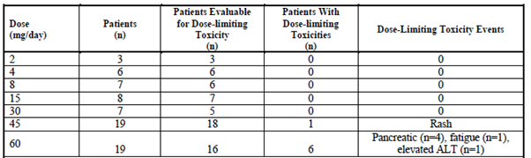
The most common DLT observed was pancreatic toxicity (4 subjects) – see Table 67.

Table 67: Study 101 – Dose limiting toxicities
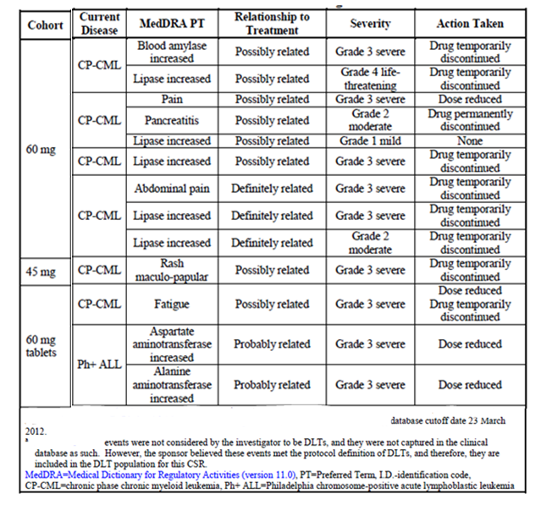
*Patient numbers have been removed from this table.

Other analyses

Study 201
The sponsor conducted a post hoc multivariate logistic regression analysis (Report no ARP307) to explore the effect of dose intensity and several baseline prognostic factors (age, time since diagnosis, number of prior TKIs, T315I mutation status, baseline neutrophil and platelet counts and weight) on efficacy and safety outcomes. There were 9 safety events examined: pancreatitis, increased lipase, increased ALT, increased AST, rash, neutropaenia, thrombocytopaenia, arthralgia and hypertriglyceridaemia. The main safety findings of this analysis were:
- higher dose intensity was significantly associated with a higher probability of all the events except hypertriglyceridaemia
- increased age was associated with an increased probability of raised lipase. There was no increase in the probability of the other events (including pancreatitis)
- presence of the T315I mutation was significantly associated with a reduced risk of neutropaenia and thrombocytopaenia.

Study 101
The sponsor conducted a post hoc analysis (Report no ARP291) to explore the relationship between systemic exposure to ponatinib, as measured by dose intensity (average daily dose) or average daily AUC, and several baseline prognostic factors (age, time since diagnosis, number of prior TKIs, baseline neutrophil and platelet counts) on efficacy and safety outcomes. The analysis was described as exploratory. There were 9 safety events examined: pancreatitis, increased lipase, increased ALT, increased AST, rash, neutropaenia, thrombocytopaenia, arthralgia and hypertriglyceridaemia. The main safety finding of this analysis was that higher systemic exposure (as measured by dose intensity and/or AUC) was significantly associated with a higher probability of pancreatitis, increased lipase and neutropaenia.
The efficacy findings of this analysis were summarised in section 11.3 of this report.

Post-marketing experience
The sponsor included two Periodic Adverse Drug Experience Reports (PADERs). Each covered a 3-month period after the initial US approval in December 2012.
- PADER #1 covered the period 14 December 2012 to 14 March 2013.
- PADER #2 covered the period 15 March 2013 to 14 June 2013.
In the PADER #1 there were 44 reports of serious adverse events. These reports originated from ongoing clinical trials, compassionate use programs and post-marketing surveillance. The pattern of adverse events was consistent with that seen in the pooled safety data from studies 101 and 201. There were several arterial vascular events (myocardial infarction, acute coronary syndrome, cerebral infarction, cerebrovascular accident, peripheral vascular disease) and venous vascular events (renal vein thrombosis, jugular vein thrombosis, retinal vein thrombosis). Other AEs that were reported were neuropathies, abnormal LFTs, abnormal pancreatic enzymes, skin disorders. There was one report of a fatal drug-induced fulminant hepatitis, which appears to be the same case referred to above.
In the PADER #2 there were 120 reports of serious adverse events. The pattern of these events was again generally consistent with that seen in the pooled safety analysis. There were multiple reports arterial and venous vascular AEs, and several reports of neuropathy events, pancreatitis, abnormal LFTs, hypertension, bleeding events, arrhythmias (mainly atrial fibrillation /flutter or tachycardia), fluid retention events, infections and cytopaenias. There were 10 cases of renal impairment/failure. Four of these subjects had plausible alternative aetiologies.

Safety issues with the potential for major regulatory impact

Liver toxicity
The two clinical studies submitted did not suggest that ponatinib would be likely to produce severe drug-induced liver injury (DILI). However it appears that at least one case of severe DILI has been reported from another study and the sponsor should be requested to provide further information on this issue.

Haematological toxicity
Myelosuppression is a very common toxicity of ponatinib. Myelosuppression events reported with the drug in the pooled safety database included 10 cases of pancytopaenia and two cases of bone marrow failure.

Serious skin reactions
At the time of the cut-off for the 120-day safety update, there were no reports of serious skin toxicity such as Stevens Johnson syndrome or toxic epidermal necrolysis.

Cardiovascular safety
Vascular adverse events are a major toxicity associated with ponatinib .The cardiac safety of ponatinib has been discussed previously in this report (Adverse events, Cardiac events).

Unwanted immunological events
‘Drug hypersensitivity’ was reported in 3 subjects (0.6%) in the pooled safety database. Two of these events were grade 1 in severity and the other was Grade 3. There was also one report of a grade 1 ‘hypersensitivity’. There was also 1 report of serious graft versus host disease. There were no other serious AEs of an immunological nature. These data suggest that serious immunological events due to ponatinib are uncommon.

Evaluator’s overall conclusions on clinical safety
The safety profile of ponatinib has many similarities to other Bcr-Abl TKIs. The following toxicities observed with ponatinib have previously been associated with this class of drugs:
- Myelosuppression and infections
- Bleeding events
- Pancreatic toxicity
- Hepatotoxicity
- Cardiac failure and reduced LVEF
- Fluid retention events
- Hypertension
- Dermatological toxicity
- Gastrointestinal toxicity.
Also, QT prolongation due to ponatinib has not been excluded.
Compared to other agents in the class, ponatinib is associated with a high incidence of vascular adverse events, especially arterial (ischaemic) events. Subjects with pre-existing risk factors for ischaemia are particularly at risk of ischaemic events.
The overall toxicity of the drug is significant, with a high proportion of patients experiencing serious adverse events and Grade 3 or 4 adverse events. Approximately 1% of patients died due to adverse events that were considered related to ponatinib. Despite the high incidence of adverse events, the incidence of discontinuation of ponatinib due to adverse events was comparatively low. This suggests that the toxicities produced by the drug could be managed in most patients (for example, with dose reductions, drug interruptions and supportive therapies).
There are some outstanding questions regarding the incidence of vascular events and the possibility that the drug may be associated with severe drug-induced liver injury.

First round benefit-risk assessment

First round assessment of benefits
The benefits of ponatinib in the proposed usage are:
- The induction of a major cytogenetic response in a substantial proportion of treated subjects (53.9% in chronic phase, 38.6% in accelerated phase, 22.6% in blast phase and 46.9% in Ph+ALL).
- The induction of a major haematological response in a substantial proportion of subjects with advanced disease (57.8% in accelerated phase, 30.6% in blast phase and 40.6% in Ph+ALL).
The responses obtained appear to be durable, especially in chronic and accelerated phase disease. It is of particular importance that these benefits have been demonstrated in a population of subjects who:
  - Have exhausted the currently available options for treatment with a BCR-ABL TKI; or
- Have the T315I mutation in BCR-ABL, which is known to confer resistance to currently available BCR-ABL TKIs.
As the efficacy data come from two non-comparative studies, it is not possible to conclude that the drug is associated with any benefits in terms of survival or progression-free survival. Effects on quality of life were not studied.

First round assessment of risks
The risks of ponatinib in the proposed usage are:
- A risk of significant toxicity, with serious AEs occurring in 56.2% of subjects (treatment-related 22.6%), Grade 3 or 4 adverse events occurring 67.7% and treatment related deaths occurring in approximately 1% of subjects.
The pattern of toxicity is generally consistent with that with other drugs in the same class. However, ponatinib is associated with a notably increased risk of vascular adverse events. It also appears that the drug may be associated with a risk of severe drug-induced liver injury.
Despite a high incidence of adverse events, the incidence of discontinuation due to adverse events was modest (17.9%; treatment-related 8.3%), suggesting that the toxicity of the drug was manageable in most patients.

First round assessment of benefit-risk balance
The safety concerns associated with ponatinib are significant. In particular, the high incidence of vascular events suggests that the drug may be more toxic than currently available BCR-ABL TKIs. On the other hand, the drug has substantial efficacy and the proposed population is effectively one in which the other BCR-ABL TKIs cannot be used.
Alternative treatments for those subjects who have failed dasatinib or nilotinib, or those who have the T315I mutation are limited.
- Allogeneic stem cell transplantation (ASCT) would be a suitable treatment in some patients. However it is a procedure associated with significant morbidity and mortality, and it is not possible to conclude that it would produce more favourable outcomes than ponatinib. In patients eligible for ASCT, drug treatment has been shown to produce better survival outcomes than ASCT, at least in the first-line setting (9). ASCT is considered to be the treatment of choice for patients with blast phase or accelerated phase disease (10,11). In heavily pre-treated patients such as those enrolled in the submitted studies, the possibility of performing ASCT is likely to have already been considered. It is noted that approximately 20% of blast phase subjects and 10% of accelerated phase patients in Study 201 had already undergone stem cell transplant. ASCT would not be an option for many patients because of co-morbidity or lack of a suitable donor.
- Prior to the introduction of BCR-ABL TKIs, interferon-based therapy was considered to be the most effective treatment for chronic phase CML. However, in a randomised controlled trial of the interferon-based therapy versus imatinib in the first-line setting, the MCyR rate with interferon was 22.1% (compared with 85.2% in the imatinib arm) (12). In Study 201 the MCyR rate with ponatinib in chronic phase CML was 53.9%. It therefore seems likely that ponatinib would be more effective than interferon. Interferon therapy is also associated with significant toxicity.
- Other agents such as omacetaxine (homoharringtonine) and the BCR-ABL TKI bosutinib have shown efficacy in subjects who have failed prior BCR-ABL TKI therapy. However, these agents are not registered in Australia.
Given the lack of available treatment options for the proposed population, and the seriousness of the conditions being treated, it is considered that the benefits of ponatinib outweigh the risks associated with its use. The benefit-risk balance of ponatinib, given the proposed usage, is therefore considered favourable.
As the drug is intended for the treatment of a life-threatening condition, for which the available treatment options are limited, the data deficiencies in the submission (absolute bioavailability study, PK study in hepatic impairment) should not preclude approval.
The proposed indication should be revised, as discussed below.

First round recommendation regarding authorisation
Subject to the provision of additional safety data (as per section Clinical questions below), it is recommended that the application be approved.

Clinical questions

General
- According to its website, the EMA has raised a series of questions regarding ponatinib (see http://www.ema.europa.eu/docs/en_GB/document_library/Referrals_document/Iclusig_20/Procedure_started/WC500157072.pdf), with a response due by 3 March 2014. Please provide a copy of these responses.

Pharmacokinetics
- Please provide an update on the progress of the planned study in subjects with hepatic impairment.

Pharmacodynamics
No questions submitted.

Efficacy
No questions submitted.

Safety
- The addendum to the clinical overview (data cut-off 3 September 2013) only provided updated data on vascular adverse events from Study 201. It is noted that the US prescribing information indicates that the incidence of vascular AEs in Study 101 was 48%, which is much higher than that reported for Study 201. Please provide updated data on vascular AEs from Study 101.
- The 120-day safety update refers to a case of fatal hepatic failure, meeting the criteria for Hy’s law, which occurred in a Phase I/II study in Japanese subjects. Please provide further details of this case. It is also noted that the U.S. prescribing information refers to two other cases of fatal hepatic failure. Please provide details of these cases. Please advise whether any other cases meeting Hy’s law criteria, or cases of hepatic failure, have been observed.
- In Study 101, testing of coagulation parameters, cardiac troponins and TSH were planned. Analyses of the results of these parameters could not be located in the submission. Please comment.
- Please provide the available safety data from the discontinued EPIC study.

Second round evaluation of clinical data submitted in response to questions
The sponsor’s response to the above questions was dated 13 June 2014. The issues covered are summarised as follows:

PK in hepatic failure
The sponsor provided the results of the study of ponatinib pharmacokinetics in hepatic impairment (Study 109). The study did not suggest that systemic exposure to ponatinib increases with increasing levels of hepatic impairment, and that therefore dosage adjustment was not required.

Revised population PK analysis
The sponsor also provided a revised population PK analysis, incorporating data from three new studies. Findings were broadly consistent with those of the original population PK analysis. Results are summarised in Table 68.

Table 68: Population PK study (2014): Summary
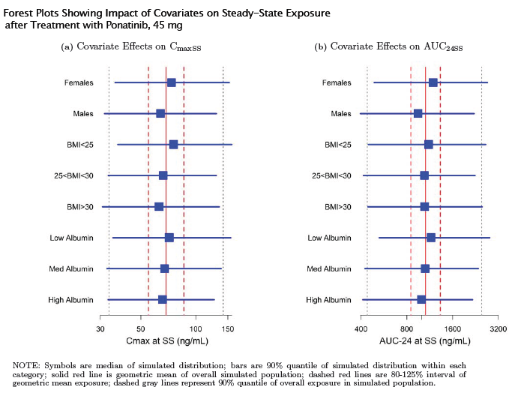

Efficacy data
The sponsor’s response included brief updated details on efficacy results from studies 101 and 102. The date of data cut-off was 6 January 2014. Results for response rates are summarised in Table 69. With longer follow-up there was some slight improvement in response rates.

Table 69: Studies 101 and 201 – Updated efficacy data
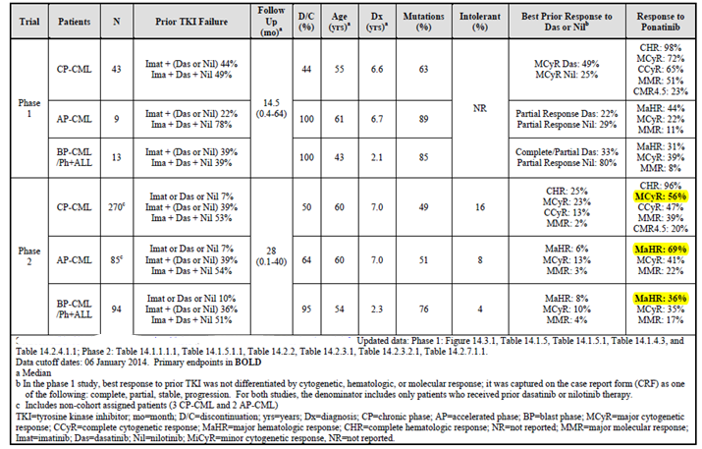

Safety findings from the EPIC study
The EPIC study (aka Study AP24534-12-301) was a Phase III, randomised, open-label trial with two parallel groups. Subjects with newly diagnosed CML in chronic phase were randomised (1:1) to receive either ponatinib 45 mg or imatinib 400 mg once daily. The 400 mg dose for imatinib is the approved dose for initial treatment of chronic phase CML. Randomisation was stratified by Sokal risk score (low versus intermediate versus high).
The study commenced in August 2012 and was prematurely terminated in October 2013 due to the concerns that had arisen regarding vascular AEs with ponatinib. Although terminated prematurely, the study is the only one available that provides comparative safety data against an approved agent. The sponsor provided a summary of the safety data generated in the study. The full study report was not submitted.
At the time of study discontinuation, a total of 307 subjects had been randomised, 155 to ponatinib and 152 to imatinib. The safety population consisted of all subjects who had received at least one dose of study drug (n = 153 for ponatinib and n = 150 for imatinib). Demographic and baseline disease characteristics were comparable for the two study arms. Duration of exposure was short, with median duration being 114 days in the ponatinib arm and 140 days in the imatinib arm. Only 23.6% of ponatinib subjects and 31.4% of imatinib subjects had received at least 6 months of treatment.
The overall incidence of adverse events etc. observed in the study is shown in Table 70.

Table 70: EPIC Study – Overall incidence of AEs
 | Ponatinib (n = 153) | Imatinib (n = 150)
Any AE | 94 % | 93 %
- Treatment-related AEs | 90 % | 87 %
Grade ≥ 3 AEs | 59 % | 27 %
Serious AEs | 30 % | 9 %
- Treatment-related serious AEs | 22 % | 3 %
Deaths | 1 | 2
- Treatment-related deaths | 0 | 0
Withdrawals due to AEs | 10 % | 2 %
Comment: These data suggest that ponatinib is a more toxic agent than imatinib with a notably higher incidence of grade ≥ 3 AEs (59% versus 27%), serious AEs (30% versus 9%) and withdrawals due to AEs (10% versus 2%).

Adverse events
Common AEs (that is, those occurring in > 10% of subjects) are listed in Table 71. Ponatinib was associated with a higher incidence of:
- Dermatological toxicity – rash (36.6% versus 16.7%), dry skin (17.0% versus 3.3%), alopecia (11.1% versus 5.3%), pruritus (11.1% versus 7.3%)
- Hypertension (17.0% versus 3.3%)
- Headache (32.0% versus 12.7%)
- Thrombocytopaenia (22.9% versus 12.0%)
- Pancreatic toxicity – elevated lipase (26.8% versus 7.3%); elevated amylase (9.8% versus 0.7%)
- Abnormal LFTs – elevated ALT (11.8% versus 1.3%); elevated AST (10.5% versus 4.0%)
- Some GIT toxicities – abdominal pain (34.6% versus 10.0%); constipation (26.1% versus 2.0%).
Imatinib was associated with a higher incidence of oedema, nausea, vomiting, diarrhoea and muscle spasms. Analysis of treatment-related common AEs gave a similar pattern.

Table 71: EPIC Study – Common adverse events. Treatment-emergent adverse events occurring in >10% of patients. Sorted by descending frequency of ponatinib group. Safety population N=303
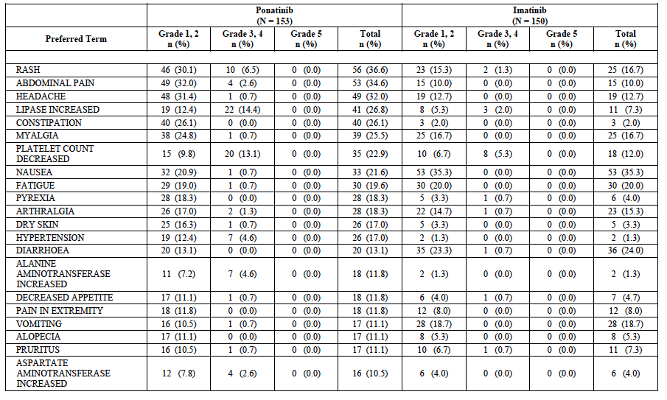

Deaths
There were three deaths that occurred within 3 days of the last dose of study drug. None were related to the study drugs.
- A [Information redacted] patient receiving ponatinib developed pneumonia and died of respiratory failure nine days later. No details were provided as to whether the patient had any evidence of myelosuppression.
- A [Information redacted] patient receiving imatinib was hospitalised with shortness of breath. A CT scan showed ‘bilateral ground glass appearance’. She was diagnosed with pneumonia, pulmonary oedema and pulmonary fibrosis. No information was provided regarding any myelosuppression.
- A [information redacted] patient receiving imatinib developed a pathological fracture of her C2 vertebra and was found to have a chloroma and paraspinal abscess. She subsequently had a cardiac arrest while in hospital and developed hypoxic-ischaemic encephalopathy and died two days later.

Serious AEs
SAEs that occurred in at least 2 subjects are listed in Table 72. Notably, there were 5 cases of pancreatitis in the ponatinib arm and none in the imatinib arm. Serious events of decreased platelet count, atrial fibrillation, acute myocardial infarction and cardiac failure were also increased in the ponatinib arm.

Table 72: EPIC study – Serious adverse events. Treatment-emergent serious adverse events by preferred term (≥2% of patients by descending frequency) and severity: Safety population.
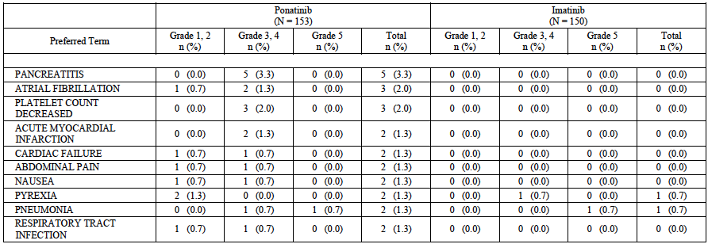

Withdrawals due to AEs
There were 15 patients in the ponatinib arm who had AEs that led to discontinuation, compared to 3 in the imatinib arm. AEs leading to discontinuation in more than one patient in the ponatinib arm were decreased platelet count (4), abdominal pain (3), abnormal LFTs (2) and rash (2). All other AEs leading to discontinuation occurred in a single patient each.

Laboratory abnormalities
Worsening of laboratory parameters is summarised in Table 73. Thrombocytopaenia was more frequent with ponatinib. However, other cytopaenias were more common in the imatinib arm. Elevations of lipase and amylase were more common with ponatinib, consistent with the increased incidence of pancreatitis. Elevations of transaminases were also more common with ponatinib. Decreased phosphate was notably more common in the imatinib arm.

Table 73: EPIC study – Laboratory abnormalities. Shifts in laboratory values from baseline to worst value post-baseline. CTCAE grades; Safety population N=303
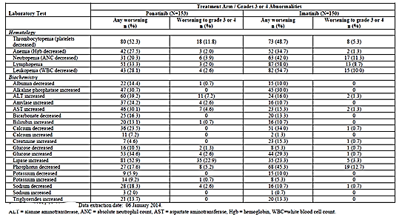

AEs of special interest

Vascular AEs
Vascular AEs occurring in the study are summarised in Table 74. The incidence of such events was slightly increased in the ponatinib arm (8.5% versus 6.0%). Serious vascular AEs were also increased with ponatinib (4.6% versus 0.7%).

Table 74: EPIC study – Vascular AEs
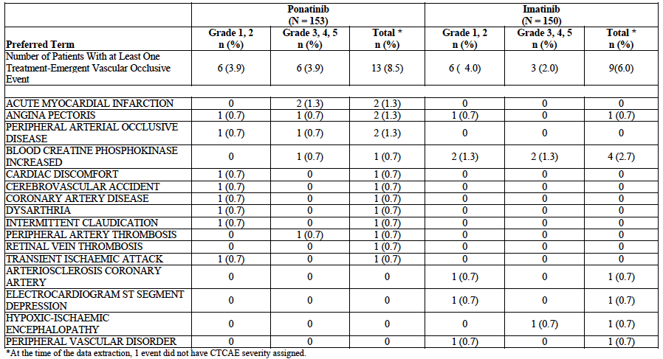
Comment: Due to the very short duration of treatment, these data are likely to underestimate of the true incidence of vascular events. The incidence of vascular AEs with ponatinib in this study (8.5%) was much lower than in studies 101 and 102 (35% and 22.5% - see below).

Myelosuppression
AEs relating to myelosuppression occurred in 28% of subjects on ponatinib and 22% of subjects on imatinib. As described above, thrombocytopaenia was more common with ponatinib and other cytopaenias were more common with imatinib.

Infections
The incidence of infections was comparable in the two arms – 28% with ponatinib and 29% with imatinib. Grade 3 or 4 infections were more common with ponatinib (5% versus 2%).

Bleeding events
The incidence of bleeding events was lower in the ponatinib arm (7.2% versus 12.0%).

Pancreatic events
Pancreatitis was reported in 5.2% off subjects on ponatinib. There were no cases with imatinib. As described above, elevations of lipase and amylase were also notably more frequent with ponatinib.

Hepatic events
Hepatic adverse events were more common with ponatinib (17% versus 8%). As described above, elevations of transaminases on laboratory testing were also notably more frequent with ponatinib. There were no cases of hepatotoxicity meeting Hy’s Law criteria.

Heart failure
There were 4 patients with cardiac failure in the ponatinib arm and 1 in the imatinib arm. LVEF was monitored using echocardiography. Abnormalities of LVEF occurred with comparable frequency in the two arms.
Comment: Cardiac failure is a known adverse effect of imatinib. The findings suggest that ponatinib may have comparable effects.

QT prolongation
The incidence of QT prolongation on ECG was comparable in the two treatment groups. Increases in QTcF of 30 msec or more occurred in 4.6% of ponatinib-treated subjects and 4.7% of imatinib-treated subjects. Increases of 60 msec or more occurred in 0.7% and 1.3% of subjects respectively. No subject developed a QTcF of > 500 msec.
Comment: QT prolongation is not a recognised adverse effect of imatinib. The comparable effects on QT interval observed in this study therefore provide some reassurance regarding the potential of ponatinib to prolong the QT interval.

Fluid retention events
Events indicative of fluid retention occurred more frequently in the imatinib arm (20% versus 12%).

Dermatological toxicity
Skin events occurred in 61% of ponatinib subjects compared to 37% of imatinib subjects. Grade 3 or 4 events occurred in 10% versus 2% respectively.

Ocular toxicity
Eye disorders occurred in 38% of ponatinib subjects compared with 18% of imatinib subjects. The most common events with ponatinib were dry eye (6%) and blurred vision (4%). Most events were grade 1 or 2 in severity. Grade 3 or 4 events occurred in 1 ponatinib subject (eye pain) and 2 imatinib subjects (vitreous haemorrhage for both).

Hypertension
The incidence of hypertension reported as an AE was higher in the ponatinib arm (17.0% versus 1.3%). Clinic measurements of blood pressure also demonstrated a hypertensive effect of ponatinib. The proportion of patients with a systolic blood pressure measurement ≥ 160 mmHg was 15.7% for ponatinib and 4.0% for imatinib. The proportion of patients with a diastolic blood pressure measurement ≥ 100 mmHg was 7.2% for ponatinib and 2.0% for imatinib.
Comment: Overall, the safety data from this study are useful in defining the short-term toxicity of ponatinib. The comparator imatinib is a marketed agent from the same class, with a well-defined safety profile. The data indicate that overall, ponatinib is a more toxic agent than imatinib. It is clearly associated with a higher risk of hypertension, pancreatic toxicity, hepatic toxicity, and skin and eye toxicity. The data also suggest that it is associated with more serious vascular events and Grade 3 or 4 thrombocytopaenia. Ponatinib appears to be associated with a comparable incidence of heart failure, although duration of follow-up was short.
The study did not identify any new safety issues.

Vascular AEs
In response to a question raised by the EMA, the sponsor provided updated data on vascular AEs occurring in clinical trials and in the post-market setting. The date of data cut-off for this analysis was 6 January 2014. An expanded set of MedDRA event terms was used (Table 75). The EMA had asked that information from pathology reports be included, however the sponsor replied that such data were not collected.

Table 75: MedDRA event terms for vascular events
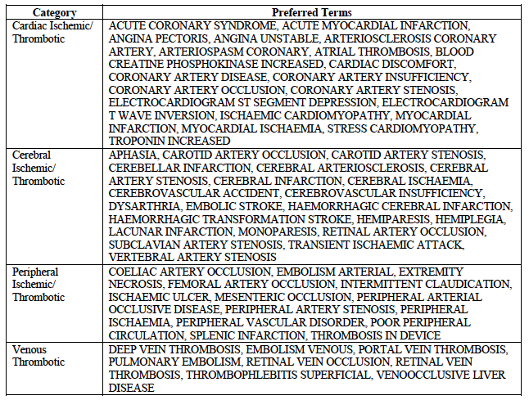

Vascular AEs in Study 201
As of 6 January 2014, 172/449 subjects (38%) remained in the study. The overall incidence of vascular AEs is shown in Table 76. A total of 101/449 subjects (22.5%) had experienced at least one vascular occlusive adverse event, and in 72/449 (16.0%) at least one of these events had been considered serious. Individual AEs occurring in more than one patient are shown in Table 77.

Table 76: Study 201 - Vascular AEs - Overall incidence (data cut-off 6 January 2014)
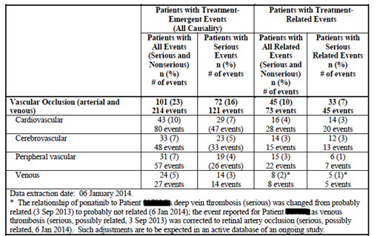

Table 77: Study 201 – Vascular AEs – Individual event terms (data cut-off 6 January 2014) Details of patients with vascular occlusion events in AP24534-10-201 (N=449). 6 January 2014 Data. Events occurring in ≥2% patients.
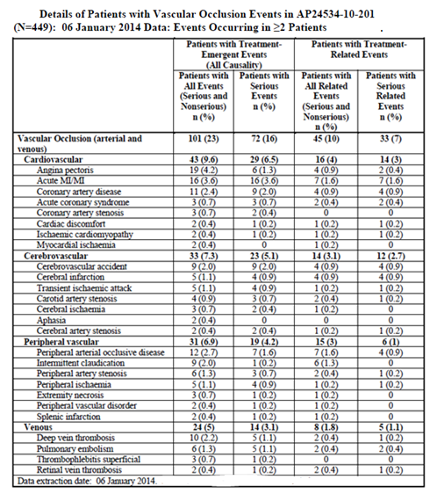
The sponsor updated the analysis of the effect of various risk factors on the incidence of arterial vascular events. The conclusions remained the same. Another analysis examined the incidence of vascular AEs according to disease stage. Vascular events occurred more frequently in subjects with advanced stage disease, and this effect was particularly noticeable for venous thrombotic events (Table 78). Updated data were also presented demonstrating that subjects who experienced an arterial AE had comparable survival and PFS to those subjects who did not experience such an event.

Table 78: Study 201 - Vascular AEs - Incidence according to disease stage. Exposure adjusted incidence rate (number of patients with events per 100 patient-years) of treatment emergent vascular occlusive events by disease group.
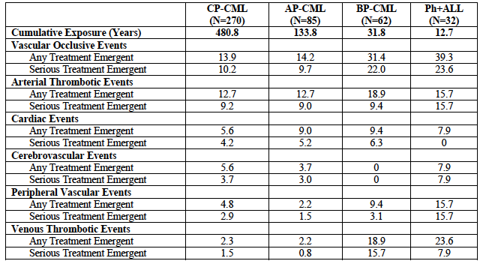

Vascular AEs in Study 101
As of 6 January 2014, 24/81 subjects (30%) remained in the study. The overall incidence of vascular AEs is summarised in Table 79 and details of the individual AEs are summarised in Table 80.

Table 79: Study 101 – Vascular AEs - Overall incidence (data cut-off 6 January 2014)
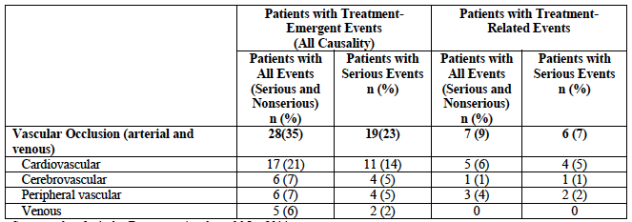

Table 80: Study 101 – Vascular AEs – Individual event terms (data cut-off 6 January 2014). Details of patients with vascular occlusion in AP24534-10-201. 6 January 2014 Data. Events occurring in ≥2% patients or Any serious
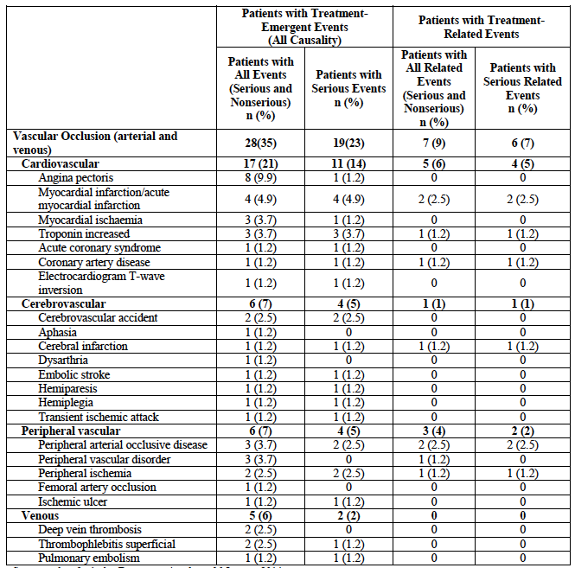
Comment: The overall incidence of vascular AEs was 35%, which is notably higher than that in the pivotal study (22.5%). The difference was due to a higher incidence of cardiovascular events (21% versus 10%). The incidence of cerebrovascular, peripheral vascular and venous events was comparable in the two studies. The incidence of vascular serious AEs was 23%.
The FDA had determined that the incidence of vascular AEs in Study 101 was 48%. The FDA had not explained to the sponsor how this figure was derived. However, the sponsor believes that the figure was based on the subpopulation of patients with CML/Ph+ ALL (n=65) rather than the entire population (n=81), and that the following AE terms were included in the FDA analysis (but not in the sponsor analysis) - Arteritis, Cardiac arrest, Cardio-respiratory arrest, Chest discomfort, Clumsiness, Electrocardiogram T Wave Abnormal, Encephalopathy, Haemorrhagic Vasculitis, Non-cardiac chest pain, Peripheral Coldness, Phlebitis, Raynaud’s Phenomenon, Renal Artery Stenosis, Vasculitis, Visceral Arterial Ischaemia.

Vascular AEs in other studies
The safety findings of the EPIC study are reviewed above. Ponatinib was associated with a higher incidence of vascular AEs (8.5% versus 6.0%) and serious vascular AEs (4.6% versus 0.7%) compared to imatinib.
A Phase II study of ponatinib (AP24534-12-202) in subjects with gastrointestinal stromal tumour (GIST) is being conducted. A total of 35 patients have been enrolled. One serious vascular AE has been reported (myocardial ischaemia) as of 6 January 2014. No information was provided on non-serious vascular AEs.
A Phase I/II study in Japanese subjects (AP24534-11-106) is also being conducted. A total of 35 subjects have been enrolled. Three subjects experienced serious vascular AEs (1 brain stem infarction and 2 myocardial infarction). No information was provided on non-serious vascular AEs.

Pooled analysis of vascular AEs from all clinical trials
In response to an EMA question the sponsor conducted a pooled analysis of vascular AEs occurring in clinical trials. The date of data cut-off was 6 January 2014. Results for overall incidence of all vascular AEs (that is, serious and non-serious) are shown in Table 81.

Table 81: Pooled analysis of vascular AEs (data cut-off 6 January 2014)
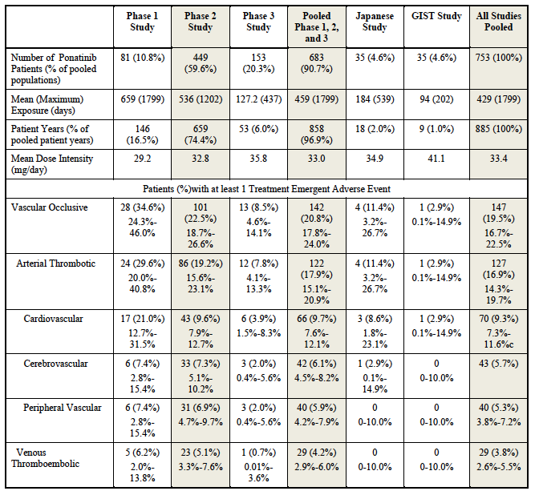
Comment: Incidence of vascular AEs varied across the studies from 2.9% to 34.6%. Studies with low incidence were of shorter duration. Accurate estimates of incidence are more likely to be obtained from studies 101 and 201, rather than the pooled analysis.

Use of agents to prevent vascular AEs
In a follow-up question the EMA asked the sponsor to discuss the effect of medicines used to prevent vascular AEs (aspirin, statins, anti-hypertensives), based on the findings of Study 201. The sponsor conducted various analyses. In a univariate analysis, use of these medications at baseline, or prior to an AE, was associated with an increased risk of experiencing an arterial vascular AE. Subjects who had been prescribed these agents at baseline would be expected to have a higher risk of a vascular event. In multivariate analyses, there was still an increased risk, but this was no longer statistically significant (Table 82). In none of the analyses was the use of these medications associated with a reduced risk of experiencing a an arterial AE. The sponsor therefore concluded that ‘...detailed recommendations regarding the use of concomitant medications to reduce cardiovascular risks cannot be made at this stage’.

Table 82: Study 201 - Use of medicines prior to arterial AEs. Summary of results of multivariate and univariate logistic analyses. Including medications prior to arterial thrombotic events in AP24534-10-201
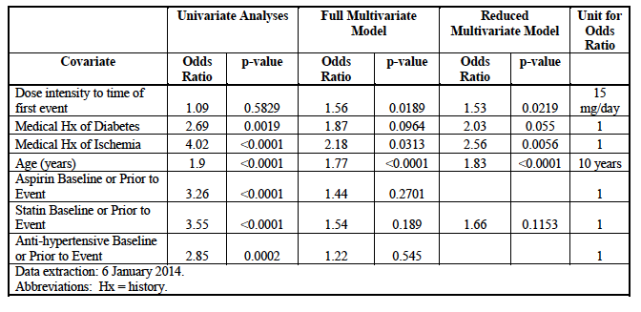

Vascular AEs in expanded access and post-market settings
The sponsor estimated that total exposure in the post-market setting (USA and Europe) to be 285.3 patient-years. Also, approximately 1300 subjects received the drug through compassionate use/expanded access programs. A total of 68 subjects reported 102 serious vascular AEs. The pattern of events was consistent with those observed in the clinical studies. The most commonly reported events were myocardial infarction (18 cases), CVA (10), pulmonary embolus (10) and TIA (8).

Potential mechanisms leading to vascular AEs
In response to a question from the EMA the sponsor produced a discussion on the potential mechanisms for ponatinib vascular toxicity. Points made included the following:
- Significant vascular toxicity was not observed in preclinical toxicology and safety pharmacology studies. An in vitro study did not demonstrate an effect on platelet aggregation.
- Compared to other BCR-ABL TKIs, ponatinib inhibits an additional set of kinases, including members of the vascular endothelial growth factor receptor (VEGFR) family.
- The sponsor hypothesized that the primary mechanism of ponatinib vascular toxicity is that the drug is an inhibitor of endothelial survival or proliferation.
- The available clinical evidence was not consistent with a ponatinib-induced vasculitis causing the observed toxicities. However, CRP will be measured in future clinical trials.
- The major metabolites of ponatinib are less pharmacologically active than the parent molecule and individual metabolites did not account for a major proportion of drug-related material. Therefore, it was unlikely that metabolites would be responsible for the observed toxicity.
A series of preclinical studies is being planned to explore the mechanisms involved.

Heart failure
In response to a question from the EMA, the sponsor provided updated data on heart failure AEs occurring in clinical trials and in the post-market setting. The date for data cut-off was 6 January 2014. Search terms used in the analysis were the following:
- Right ventricular failure
- Cardiac failure
- Cardiac failure congestive
- Pulmonary oedema
- Cardiogenic shock
- Left ventricular dysfunction
- Ejection fraction decreased
- Cardiopulmonary failure
- Right ventricular dysfunction
- Ventricular dysfunction.
Comment: Search terms such as ‘oedema’ and ‘peripheral oedema’ were deliberately not included, as these events are known to occur with BCR-ABL inhibitors in the absence of cardiac failure.

Heart failure AEs in Study 201
The overall incidence of heart failure AEs in the pivotal study was 8.0% and 5.1% of subjects had a serious heart failure AE (Table 83). Those patients who experienced a heart failure event (n=37) were more likely to have had risk factors at baseline (hypertension, hypercholesterolaemia, diabetes, a past history of cardiac disease, age > 65 years) than those subjects who did not experience such an event (n=412).

Table 83: Study 201 - Heart failure AEs
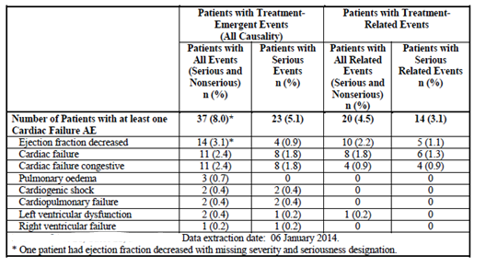
In the 37 patients, there were a total of 49 heart failure AEs. Of these, 29 (59%) were reported to have resolved. Four patients died due to heart failure AEs, however none of these deaths were considered related to ponatinib by the investigators.
Of the 37 patients, 23 (62%) also experienced a vascular occlusive AE, and in 16 (43%), the vascular event occurred immediately prior to, or concurrently with, the cardiac failure events. All of these were coronary events and 10 of them were myocardial infarctions. Of the 14 subjects who did not experience a vascular occlusive AE.

Heart failure events in Study 101
A total of 7/81 subjects (8.6%) in the Phase I study developed a total of 8 heart failure AEs and 3/81 (3.7%) had a serious heart failure AE. Reported AEs were congestive cardiac failure (3 subjects), pulmonary oedema (2), left ventricular dysfunction (2) and ejection fraction decreased (1). Two of the 7 subjects also had vascular occlusion AEs and in one of these subjects pulmonary oedema developed soon after the vascular AE (cardiac ischaemia).

Heart failure events in other studies
In the EPIC study, there were 4 patients (2.6%) with heart failure events in the ponatinib arm and 1 subject (0.7%) in the imatinib arm. Heart failure SAEs occurred in 2 subjects (1.3%) and 1 subject (0.7%) respectively. None of the heart failure events were preceded by a vascular event.
In the Phase II GIST study, 1 of 35 subjects (2.9%) developed a heart failure AE – right ventricular dysfunction that was considered serious.
In the Phase I/II Japanese study, 1 of 35 subjects (2.9%) developed a heart failure AE – pulmonary oedema that was considered serious.

Heart failure AEs in expanded access and post-market settings
A total of 33 heart failure AEs had been reported in 28 patients. The events were cardiac failure congestive (15), pulmonary oedema (6), ejection fraction decreased (4), cardiac failure (4), cardiac failure acute (1), cardiogenic shock (1), left ventricular dysfunction (1), and right ventricular dysfunction (1). All were considered serious.
Comment: The data suggest that heart failure arises in approximately 8% of subjects treated with ponatinib. In many, but not all, cases the heart failure is preceded by a cardiac ischaemic event such as myocardial infarction. The sponsor is now proposing to include a specific precautionary statement in the PI on the issue of heart failure.

Hepatic failure
Two cases potentially met Hy’s Law criteria for severe drug-induced liver injury (DILI). The sponsor provided details on 2 other patients – one who developed hepatic toxicity that met Hy’s Law criteria and another who was diagnosed as having acute hepatic failure:
- [Information redacted]: A [information redacted] female received ponatinib for Ph+ALL in a Phase I/II study that has not been submitted. At screening she was noted to have ‘cardiac disorders’ (unspecified) and a LVEF of only 28%. She was also being treated with anti-failure therapy. She was commenced on 30 mg per day. On day 4 she was diagnosed as having acute renal failure (creatinine = 185 μmol/L), disseminated intravascular coagulation (with increased FDPs and INR) and hepatic failure (AST 145 times ULN; ALT 65 times ULN; bilirubin 2 times ULN and alkaline phosphatase 1.2 times ULN). LFT results over time are shown graphically in Figure 5. The drug was discontinued on day 4 and the patient died 6 days later due to hepatic failure. According to the 120-day safety update ‘liver necropsy’ was pending. The result was not provided. The sponsor considered that the liver failure might have been due to congestive heart failure.
Figure 5: [information redacted] – Liver function tests
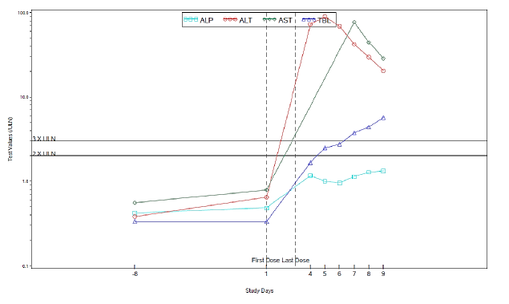
Comment: The brief case narrative did not describe any clinical symptoms or signs of cardiac failure in the patient and it appears somewhat unlikely that her pre-existing CCF would cause such a sudden and dramatic deterioration of hepatic function. The onset of hepatic impairment following the commencement of ponatinib is therefore suspicious of severe DILI.
- [Information redacted]: A [Information redacted] patient received ponatinib for the treatment of Ph+ALL as part of an expanded access program. She was commenced on 45 mg per day. She received the drug for only 14 days, and then was diagnosed with Grade 4 acute liver failure ‘due to multiple causes including disease progression and linezolid administration’. The patient died on the same day. Cause of death was stated to be progressive disease and acute liver failure. No autopsy was performed. The investigator did not consider the liver failure to be related to the study drug.
Comment: Very little detail was provided on this case, and it is therefore difficult to assess causality.
The sponsor stated that no other cases meeting Hy’s Law criteria or cases of hepatic failure have been reported up to 6 January 2014. The sponsor also clarified that the 3 cases referred to in the FDA prescribing information were subjects [information redacted] described above.
Comment: The case of subject [information redacted] is sufficiently concerning as to warrant a warning in the product information regarding the potential for severe DILI with ponatinib. The sponsor has agreed in principle to include text along these lines.

Coagulation parameters, cardiac troponins and TSH in Study 101

Coagulation parameters
In their response, the sponsor confirmed that testing of coagulation parameters was not performed in Study 101.

Cardiac troponins
Brief information was provided on the results of testing of cardiac troponins in Study 101. A total of 14/81 subjects (17%) had at least one value above the ULN at some stage during the study. Of these, 3 had elevated levels at baseline. Levels returned to normal despite ongoing treatment in 8 of the 14 subjects. No information was provided on whether the elevated readings coincided with cardiac or other clinical events.
Comment: The clinical significance of the raised troponin levels cannot be determined on the information provided.

TSH
Results of TSH testing in Study 101 are summarised in Table 84. A total of 49 subjects had both baseline and post-baseline values. Of these, 12 subjects (24.5%) had shifts from low or normal TSH to high TSH. Actual values were not provided but the report stated: ‘No patient had TSH levels that would have been consistent with overt hypothyroidism’.

Table 84: Study 101 – TSH testing
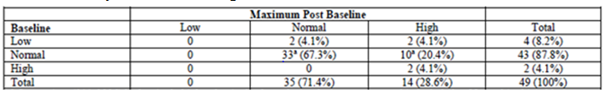ªOne patient had a single high value in database due to data entry error and is included as ‘Nomal’ in this table. Four of 81 patients in the study (5%) had adverse event reports of hypothyroidism. All of these were Grade 1 or 2 in severity, and three were considered to be unrelated to ponatinib. The investigator for the fourth case was considered it to be possibly related. Based on these data, the sponsor elected not to collect data on TSH in the pivotal Study 201.

Dosing considerations
The EMA requested that the sponsor provide an analysis of PK-PD relationships for both efficacy and safety based on clinical and preclinical data, and a justification for the proposed initial dose and any proposed dose modifications, based on this analysis.
The sponsor presented arguments as to why preclinical data (for example, minimum effective concentration determined in vitro) were not helpful in deciding upon appropriate dose. In particular, preclinical data on the activity of ponatinib against non-mutated BCR-ABL, or BCR-ABL with a specific mutation were not relevant, as most patients with treatment-resistant CML/Ph+ALL did not have an identifiable mutation and have poorly understood mechanisms of resistance, independent of BCR-ABL, which have not been the subject of preclinical studies.

Clinical data

Study 101
For Study 101, a previous analysis (Report no ARP291) had demonstrated a relationship between increasing AUC and increasing probability of achieving a MCyR. Relationships between increasing AUC or dose intensity and some adverse events (pancreatitis, increased lipase and neutropaenia) had also been demonstrated.
Examination of efficacy data from Study 101 (in patients with chronic phase CML) also suggested increasing efficacy with increasing dose up to 45 mg (Table 85).

Table 85: Study 101 - Efficacy in CP-CML by starting dose
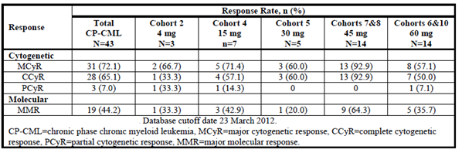
The sponsor performed a new multivariate analysis to examine the relationship between the occurrence of arterial thrombotic events and a) the average dose intensity up to the time of the arterial event and b) the measured average daily AUC. Results for the dose intensity analysis are shown in Table 86. A significant relationship was demonstrated between dose intensity and the occurrence of arterial thrombotic events. This relationship is shown graphically Figure 6. Baseline neutrophil count (a measure of disease severity) and increasing age were also related to risk of arterial thrombotic events. Results for the average AUC analysis are shown in Figure 7 and Table 87. A relationship was demonstrated between AUC and the occurrence of arterial thrombotic events. In this analysis, the time since diagnosis and number of prior TKIs were also related to the risk of arterial thrombotic events. The AUC analysis was repeated using updated estimates of AUC from the revised population PK model and similar results were obtained.

Table 86: Study 101 – Arterial AEs - Multivariate analysis using dose intensity. Summary of results of multivariate and univariate logistic regression analyses of arterial thrombotic events. Average dose intensity.
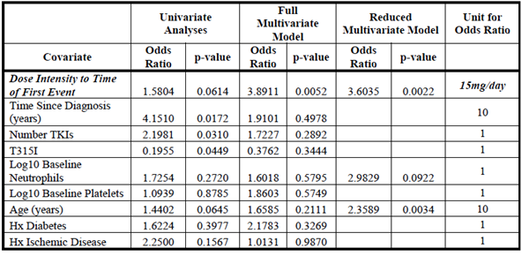
Figure 6: Study 101 - Dose intensity versus arterial thrombotic events. Arterial thrombotic event CML/ALL 534-101 (reduced model) Npt=61
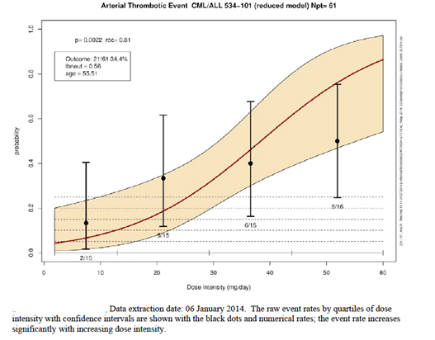

Table 87: Study 101 – Arterial AEs - Multivariate analysis using average daily AUC. Summary of results of multivariate and univariate logistic regression Analyses of Arterial thrombotic events. Average AUC
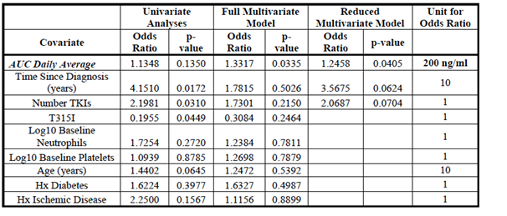
Figure 7: Study 101 – Average daily AUC versus arterial thrombotic events Arterial thrombotic event CML/ALL 534-101 (reduced model) Npt=61
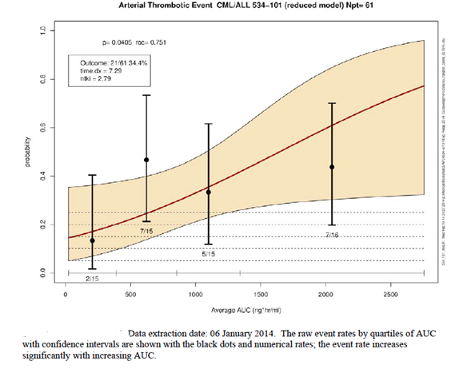
The only pharmacodynamic variable examined in Study 101 was CRKL inhibition. Effects on this endpoint were seen with doses as low as 8 mg per day. However, the sponsor argued that this endpoint could not be used to determine the appropriate clinical dose, as there was no evidence that it was predictive of a clinically relevant efficacy outcome. A PK/PD analysis using this endpoint was therefore not performed.

Study 201
No PK data were collected in Study 201. A previous analysis (Report no ARP307) had demonstrated a relationship between increasing dose intensity and increasing probability of achieving a MCyR or MHR. A relationship between increasing dose intensity and several adverse events had also been demonstrated.
A new multivariate analysis was conducted to examine the relationship between dose intensity (and several other covariates) and the risk of arterial thrombotic events. Results of this analysis are summarised in Table 88. It demonstrated a significant relationship between dose intensity and the risk of an arterial thrombotic event. This is illustrated graphically in Figure 8. The analysis also demonstrated a significant relationship between several other covariates (history of diabetes, history of ischaemia, increasing age, baseline neutrophil count, time since diagnosis and number of prior regimens) and the risk of an arterial thrombotic event.

Table 88: Study 201 – Arterial AEs - Multivariate analysis using dose intensity
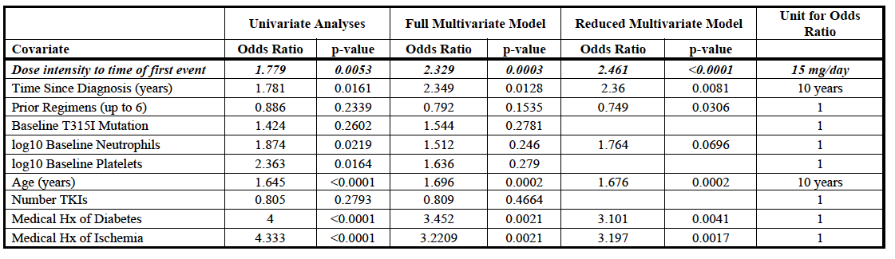
Figure 8: Study 201 - Dose intensity versus arterial thrombotic events. Arterial thrombotic events All 534-201 (reduced model) Npt=441
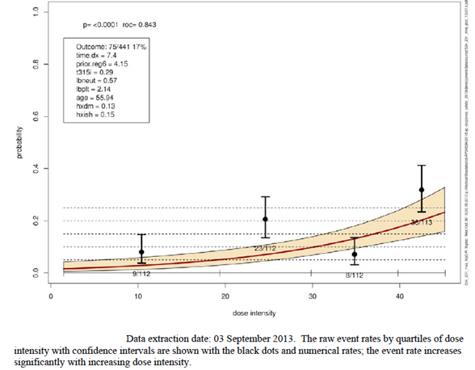

EPIC study
In this study, PK data were only collected in a subset of patients and only for determination of ponatinib steady state trough concentrations after Cycles 1, 2, 3, 6, 9 and 12. For efficacy variables such as major molecular response (MMR), there was a trend toward higher trough ponatinib concentrations among patients who achieved a response, compared to those who did not achieve a response. Among patients with PK data, only two subjects experienced a vascular occlusive event. Trough concentrations (n=4) in these two patients were all higher than the median trough concentration observed for subjects who did not experience a vascular event (Figure 9).
Figure 9: EPIC study – Trough concentrations versus vascular occlusive events. Plot of trough concentrations in patients wih and without Vascular occlusive events: Study AP24534-12-301
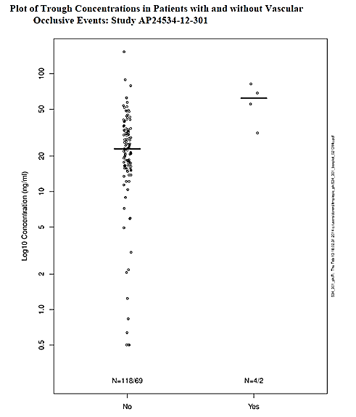

Pooled data
The sponsor provided a new analysis (Report No ARP452) that examined the relationship between ponatinib dose intensity and an expanded set of adverse events, using pooled data from studies 101, 201 and the EPIC study. A total of 17 adverse terms were analysed. For each AE term, a multivariate analysis was conducted using dose intensity and 7 other covariates - medical history of diabetes prior to study entry (yes/no), medical history of ischemic disease prior to study entry (yes/no), age at study entry (in years), log baseline platelet count, log baseline neutrophil count, number of prior TKIs and time since diagnosis at study entry (in years).
An overall summary of these analyses is shown in Table 89. A relationship with dose intensity was demonstrated for most of the 17 AE terms.

Table 89: Pooled safety data –AEs - Multivariate analyses using dose intensity. Overall summary of primary logistic regression results from reduced multivariate model in pooled population (N=67)
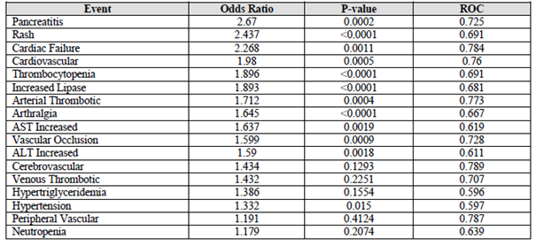

Starting dose
Based on the analyses of the clinical data, the sponsor proposed to retain the 45 mg starting dose.
Comment: The data indicate that the efficacy of ponatinib increases with increasing dose. The use of the 45 mg dose (the MTD) as the starting dose maximises the chance of achieving a response. The sponsor argues that this is important in patients with treatment-resistant disease who have exhausted available therapies where ‘the most important threat to the safety of these patients is the lack of responsiveness of their malignancy to therapy’. The 45 mg starting dose was used in the pivotal study and there is therefore a lack of data supporting a lower starting dose. The efficacy data from Study 101 also suggest that starting doses below 45 mg may have reduced efficacy. The sponsor’s proposal to retain the 45 mg starting dose is therefore considered acceptable.
In its response to the EMA, the sponsor has indicated that it will be conducting a new Phase II study examining starting doses of 15, 30 and 45 mg per day in subjects with refractory CP-CML. A study report is not expected until June 2019.

Discontinuation in the absence of a response
The sponsor proposes to include a recommendation in the PI that therapy be discontinued if a response has not been observed after three months. In the pivotal study, the median time to a haematological response was less than 30 days in all disease subgroups, and for patients with CP-CML, the median time to MCyR was 84-85 days.
Comment: Haematological responses were achieved as late as 176 days in the pivotal study. However, given the toxicity of the drug and the increasing risk of adverse events with continuing exposure, the risk-benefit of the drug is unlikely to be favourable in this subgroup of patients. The actual wording of the PI recommendation is to ‘consider’ discontinuation. The proposed recommendation is therefore acceptable.

Dose reduction after achievement of a response

CP-CML patients
The sponsor proposes that a dose reduction be considered for CP-CML subjects once they have achieved a MCyR. The clinical data described above indicate that the risk of adverse events, including arterial thrombotic events, is decreased with lower dose intensity and lower AUC. Hence it would be reasonable to expect an improved safety profile following dose reduction.
Updated data were provided on those patients with CP-CML who achieved a MCyR and subsequently had a dose reduction (due to adverse events). These data are summarised in Table 90. Of 59 subjects who achieved a MCyR while taking 45 mg per day, 100% maintained their response after dose reduction. Of 29 subjects who achieved a MCyR while taking 30 mg per day, 97% maintained their response after dose reduction. Duration of dose reduction did not affect maintenance of response. Also, response was maintained with dose reduction to either 15 mg or 30 mg.

Table 90: Maintenance of MCyR after dose reduction – CP-CML patients
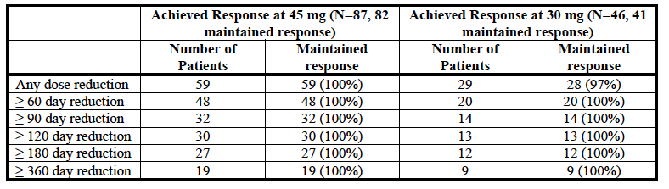

Advanced disease patients
The sponsor is not proposing a dose reduction for patients with advanced disease (AP-CML, BP-CML or Ph+ALL) who achieve a response. Updated data on those patients with advanced disease who achieved a MaHR and subsequently had a dose reduction are summarised in Table 91. Loss of response after dose reduction was common among these subjects. The sponsor also argues that duration of therapy with ponatinib in advanced disease subjects is shorter than that in CP-CML subjects and that therefore the risk of events such as vascular AEs is reduced.
Comment: The sponsor’s justifications regarding dose reduction are acceptable. For CP-CML subjects who achieve a MCyR, a specific new dose should be specified. The data would support a reduction to 15 mg per day.

Table 91: Maintenance of MaHR after dose reduction – Advanced disease patients
- Accelerated phase CML patients
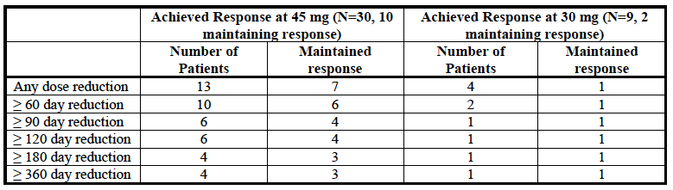
- Blast phase CML patients
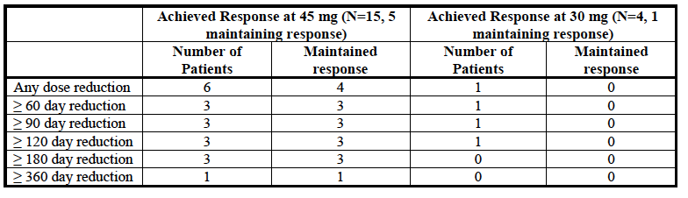
- Ph+ ALL patients
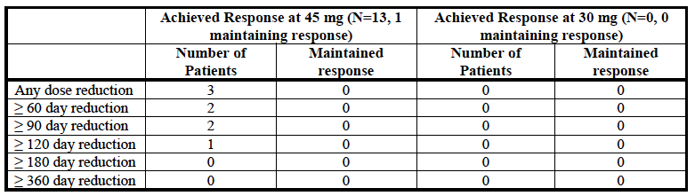

Other data

Pooled analysis of safety data
A revised pooled analysis of safety data was included in Module 2 of the sponsor’s response. It pooled data from Studies 101, 102 and the EPIC study, with the date for data cut-off being 6 January 2014. The analysis included 683 subjects treated with ponatinib and 150 treated with imatinib. The findings of the pooled analysis were consistent with the findings in the individual studies, and with the previous pooled analysis.
The inclusion of longer-term data from Studies 101 and 102 would have increased the incidence of AEs with ponatinib compared with the original pooled analysis, but the inclusion of the short-term data from the EPIC study would have decreased the incidence. In general, the incidence of specific individual AEs was comparable to that seen in the previous pooled analysis. It is likely therefore that the pooled analysis underestimates the incidence of AEs with long term therapy.
There was one additional death possibly related to ponatinib:
- A [information redacted] patient with accelerated phase CML (in Study 101) received doses of up to 30 mg per day for approximately 4 years. During this time, peripheral ischaemia was reported as an AE on four occasions, but resolved each time. The patient presented with abdominal pain, cramping, diarrhoea and vomiting. She had surgery for ‘gastrointestinal necrosis’ and died the day after presentation. The stated cause of death was intestinal ischaemia.

New interactions studies
Module 2 also included brief descriptions of two new interaction studies. Study reports for these trials have not been submitted.
- Study 107 was a single dose crossover study in healthy volunteers that examined the effect of the CYP450 inducer rifampicin on the PK of ponatinib. Co-administration of rifampicin resulted in a reduction in ponatinib AUC of approximately 60% and a reduction in ponatinib Cmax of 42%.
- Study 108 was a single dose study in healthy volunteers that examined the effect of lansoprazole on the PK of ponatinib. Co-administration of lansoprazole resulted in a 25% decrease in ponatinib Cmax but only a 6-8% decrease in ponatinib AUC.
Comment: The findings of the rifampicin study are clinically significant and it would be desirable to include a precautionary statement in the PI regarding co-administration of ponatinib with CYP450 inducers, even though the study has not been evaluated.

Use in pregnancy
Three cases were reported of patients who became pregnant while their partner was receiving ponatinib. One subject had a normal ultrasound at 7 weeks gestation but subsequently miscarried. No adverse outcomes were noted for the other two patients.

Overdose
Module 2 described 7 cases of overdose. Apart from the single case of QT prolongation), no novel toxicities were reported.

Comparison with bosutinib
The responses to the EMA included a comparison of efficacy and safety results achieved with ponatinib with those achieved with bosutinib. Bosutinib is another BCR-ABL TKI that has recently been registered in Australia for ‘the treatment of chronic, accelerated or blast phase Philadelphia chromosome-positive (Ph+) chronic myeloid leukaemia (CML) in adult patients previously treated with two or more tyrosine kinase inhibitors’. The EMA had flagged the possibility of amending the approved ponatinib indication in Europe to require that patients without the T315I mutation should have failed bosutinib.
Comment: The two agents have not been compared in a head-to-head study. The comparison is based on cross-trial comparisons. Bosutinib is not registered for subjects with the T315I mutation or those with Ph+ALL.
Points made by the sponsor included the following:
- In subjects who have failed a BCR-ABL TKI, reported response rates with ponatinib are higher than those with bosutinib (see Table 92 and Table 93);
- Although there were no notable differences between the two drugs for PFS and OS, MCyR and CCyR are both held to be surrogates for survival in refractory disease, and it is therefore likely that ponatinib will eventually demonstrate superior survival.
- Duration of treatment for ponatinib-treated subjects is longer than that for bosutinib-treated subjects (for example, in the pivotal studies, median durations of treatment were 28 months and 8.3 months respectively). It is therefore likely that the incidence of AEs will be higher with ponatinib than with bosutinib.
- Bosutinib is approved for use in the 3rd line setting. Common AEs observed with bosutinib and ponatinib in the 3rd line setting are summarised in Table 94 and Table 95 respectively. Incidence figures are higher with ponatinib, but the pattern of AEs is comparable with the two drugs.
- In the 3rd line setting, a greater proportion of subjects discontinue bosutinib than ponatinib, especially for reasons of inadequate efficacy.

Table 92: Efficacy parameters - Ponatinib versus Bosutinib – CP-CML
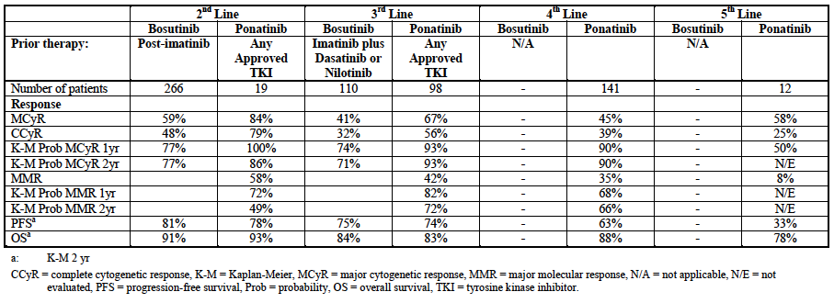

Table 93: Efficacy parameters - Ponatinib versus Bosutinib – Advanced disease
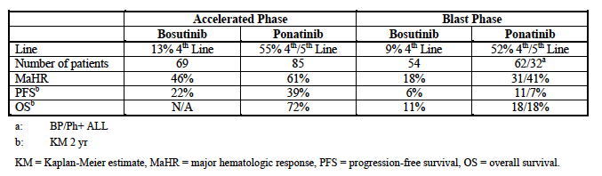

Table 94: Bosutinib – Common AEs (in the third-line setting)
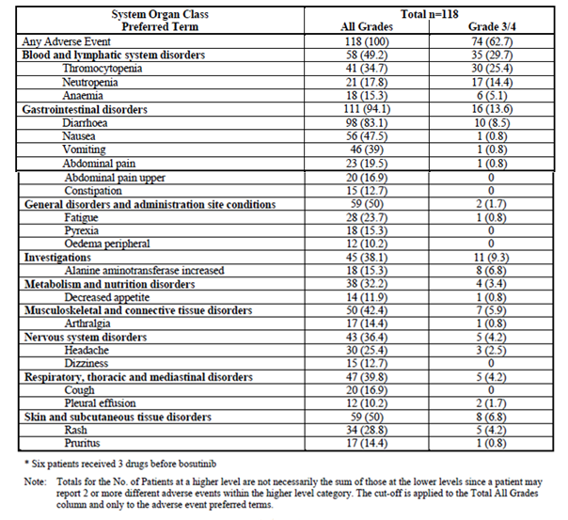

Table 95: Ponatinib – Common AEs (in the third-line setting)
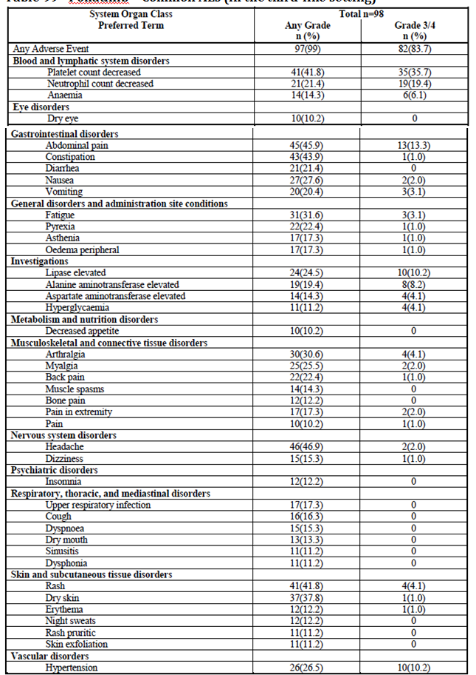
Comment: The data suggest that ponatinib is more likely to be effective than bosutinib in the 3rd line setting. In the absence of a study that compares the two drugs directly, it is impossible to conclude that the benefit-risk profile of bosutinib is superior to that of ponatinib. The evidence is therefore inadequate to require failure of bosutinib treatment prior to commencing ponatinib.

Second round benefit-risk assessment

Second round assessment of benefits
No significant new clinical information on efficacy was submitted in response to questions. Accordingly, the benefits of ponatinib are unchanged from those identified in the first round assessment of benefits.

Second round assessment of risks
The responses to clinical questions have clarified that hepatic failure and heart failure are additional risks associated with ponatinib. In addition, the responses have provided further detail on the risk of vascular adverse events.

Second round assessment of benefit-risk balance
Given the proposed patient population and the lack of available alternatives, the risk-benefit balance of ponatinib for the revised indication is still considered favourable.

Second round recommendation regarding authorisation
It is recommended that the application be approved.

References
- Deininger MWN, Goldman JN and Melo JV. The molecular biology of chronic myeloid leukaemia. Blood; 2000 November; 96(10): 3343-3356.
- Quintas-Cardama A and Cortes J. Molecular biology of bcr-abl1-positive chronic myeloid leukaemia. Blood; 2009 February; 113(8): 1619-1630.
- European Medicines Agency. Guideline on the Evaluation of Anticancer Medicinal Products in Man (CPMP/EWP/205/95/Rev.3/Corr.); 2005. Available from: http://www.tga.gov.au/pdf/euguide/ewp020595enrev3.pdf
- European Medicines Agency. Appendix 2 To The Guideline On The Evaluation of Anticancer Medicinal Products In Man: Confirmatory studies in Haematological Malignancies (EMA/CHMP/EWP/520088/2008); 2010. Available from: http://www.tga.gov.au/pdf/euguide/chmp52008808enfin.pdf
- Food and Drug Administration. Drug Safety Communication. 20 December 2013. Available from: http://www.fda.gov/Drugs/DrugSafety/ucm379554.htm
- European Medicines Agency. Further review of Iclusig started. 6 December 2012. Available from: http://www.ema.europa.eu/ema/index.jsp?curl=pages/medicines/human/referrals/Iclusig/human_referral_prac_000033.jsp&mid=WC0b01ac05805c516f
- Food and Drug Administration. Ponatinib Prescribing Information (approved 20 December 2013). Available from: http://www.accessdata.fda.gov/drugsatfda_docs/label/2013/203469s007s008lbl.pdf
- European Medicines Agency. Note for Guidance on Clinical Evaluation of QT/QTc Interval Prolongation and Proarrhythmic Potential for Non-Antiarrhythmic Drugs (CHMP/ICH/2/04); 2005. Available from: http://www.tga.gov.au/pdf/euguide/ich000204entga.pdf
- Hehlmann R, Berger U, Pfirrmann M et al. Drug treatment is superior to allografting as first-line therapy in chronic myeloid leukemia. Blood; 2007; 109 (11): 4686-4692.
- Gratwohl A and Heim D. Current role of stem cell transplantation in chronic myeloid leukaemia. Best Pract Res Clin Haematol. 2009 September; 22 (3): 431-43.
- Benyamini N and Rowe JM. Is there a role for allogeneic transplantation in chronic myeloid leukemia? Expert Rev Hematol. 2013 December; 6(6): 759-65.
- O’Brien SG, Guilhot F, Larson RA, et al. Imatinib Compared with Interferon and Low-Dose Cytarabine for Newly Diagnosed Chronic-Phase Chronic Myeloid Leukemia. N Engl J Med; 2003; (348): 994-1004.

Therapeutic Goods Administration
PO Box 100 Woden ACT 2606 Australia
Email: info@tga.gov.au Phone: 1800 020 653 Fax: 02 6232 8605
https://www.tga.gov.au

