|  |
| --- |
| **June 2013** |

|  |
| --- |
| Australian Public Assessment Report for progesterone |
| Proprietary Product Name: Endometrin Pessaries |
| Sponsor: Ferring Pharmaceuticals Pty Ltd |

About the Therapeutic Goods Administration (TGA)

* The Therapeutic Goods Administration (TGA) is part of the Australian Government Department of Health and Ageing, and is responsible for regulating medicines and medical devices.
* TGA administers the *Therapeutic Goods Act 1989* (the Act), applying a risk management approach designed to ensure therapeutic goods supplied in Australia meet acceptable standards of quality, safety and efficacy (performance), when necessary.
* The work of the TGA is based on applying scientific and clinical expertise to decision-making, to ensure that the benefits to consumers outweigh any risks associated with the use of medicines and medical devices.
* The TGA relies on the public, healthcare professionals and industry to report problems with medicines or medical devices. TGA investigates reports received by it to determine any necessary regulatory action.
* To report a problem with a medicine or medical device, please see the information on the TGA website <<http://www.tga.gov.au>>.

About AusPARs

* An Australian Public Assessment Record (AusPAR) provides information about the evaluation of a prescription medicine and the considerations that led the TGA to approve or not approve a prescription medicine submission.
* AusPARs are prepared and published by the TGA.
* An AusPAR is prepared for submissions that relate to new chemical entities, generic medicines, major variations, and extensions of indications.
* An AusPAR is a static document, in that it will provide information that relates to a submission at a particular point in time.
* A new AusPAR will be developed to reflect changes to indications and/or major variations to a prescription medicine subject to evaluation by the TGA.

Copyright

© Commonwealth of Australia 2013  
This work is copyright. You may reproduce the whole or part of this work in unaltered form for your own personal use or, if you are part of an organisation, for internal use within your organisation, but only if you or your organisation do not use the reproduction for any commercial purpose and retain this copyright notice and all disclaimer notices as part of that reproduction. Apart from rights to use as permitted by the *Copyright Act 1968* or allowed by this copyright notice, all other rights are reserved and you are not allowed to reproduce the whole or any part of this work in any way (electronic or otherwise) without first being given specific written permission from the Commonwealth to do so. Requests and inquiries concerning reproduction and rights are to be sent to the TGA Copyright Officer, Therapeutic Goods Administration, PO Box 100, Woden ACT 2606 or emailed to <[tga.copyright@tga.gov.au](mailto:tga.copyright@tga.gov.au)>.

Contents

I. Introduction to product submission 4

Submission details 4

Product background 4

Regulatory status 5

Product Information 6

II. Quality findings 6

Drug substance (active ingredient) 6

Biopharmaceutics 7

Quality summary and conclusions 7

III. Nonclinical findings 7

Introduction 7

Pharmacology 8

Pharmacokinetics 8

Toxicology 8

Nonclinical summary and conclusions 10

IV. Clinical findings 10

Introduction 10

Pharmacokinetics 11

Pharmacodynamics 13

Efficacy 13

Safety 15

Clinical summary and conclusions 15

List of questions 15

Final recommendation 16

V. Pharmacovigilance findings 16

Risk management plan 16

VI. Overall conclusion and risk/benefit assessment 18

Quality 18

Nonclinical 19

Clinical 19

Risk management plan 24

Risk-benefit analysis 24

Outcome 28

Attachment 1. Product Information 29

Attachment 2. Extract from the Clinical Evaluation Report 29

## I. Introduction to product submission

### Submission details

|  |  |  |
| --- | --- | --- |
| *Type of Submission:* | Major Variation (New Strength) | |
| *Decision*: | Approved | |
| *Date of Decision:* | 3 September 2012 | |
| *Active ingredient:* | Progesterone |
| *Product Name:* | Endometrin Pessaries |
| *Sponsor’s Name and Address:* | Ferring Pharmaceuticals Pty Ltd  PO Box 135  Pymble NSW 2073 |
| *Dose form:* | Vaginal tablet |
| *Strength:* | 100 mg |
| *Container:* | Blister pack |
| *Approved Therapeutic use:* | Endometrin Pessaries are indicated for luteal support as part of an Assisted Reproductive Technology (ART) treatment programme for infertile women. |
| *Route(s) of administration:* | Vaginal |
| *Dosage:* | 100 mg administered vaginally 2-3 times daily starting at oocyte retrieval and continuing for up to 10 weeks total duration (or 12 weeks gestation) |
| *ARTG Number:* | 189948 |

### Product background

This AusPAR describes an application by the sponsor, Ferring Pharmaceuticals Pty Ltd, to register a new dosage form of progesterone, Endometrin Pessaries 100 mg. The approved indication (from the draft Product Information [PI]) is:

*Endometrin is indicated for luteal support as part of an ART treatment programme for infertile women.*

The maximum recommended dosage proposed in the PI is three times daily (that is, 300 mg/day).

There are currently two locally (vaginal) acting progesterone preparations registered in Australia: Crinone pessaries 8% prolonged release vaginal gel (90 mg) (Merck Serono) and Orion progesterone pessaries 100 mg and 200 mg.

Crinone pessaries are registered for:

*“IVF (in vitro fertilisation) and ART where luteal phase support is indicated”.*

Orion progesterone pessaries are registered for:

*“Assisted reproductive technology treatment of infertile women with progesterone deficiency, requiring progesterone supplementation or replacement to support embryo implantation and maintain initial pregnancy”.*

This is a grandfathered product.

It is stated in the letter of application that Endometrin is currently registered in Canada, USA, the Netherlands, Sweden and the UK. The registered indication the US is

*“Endometrin is a progesterone indicated to support embryo implantation and early pregnancy by supplementation of corpus luteal function as part of an ART treatment program in infertile women”.*

Based on the public assessment report accessible on the US FDA (Food and Drug Administration) website, the data set submitted in US is identical to that submitted to the TGA.

A full data set was submitted. The submission did not include paediatric data.

### Regulatory status

Table 1 shows the international regulatory history of Endometrin Pessaries at the time of submission of this dossier.

Table 1: Summary of international regulatory status of Endometrin Pessaries approvals.

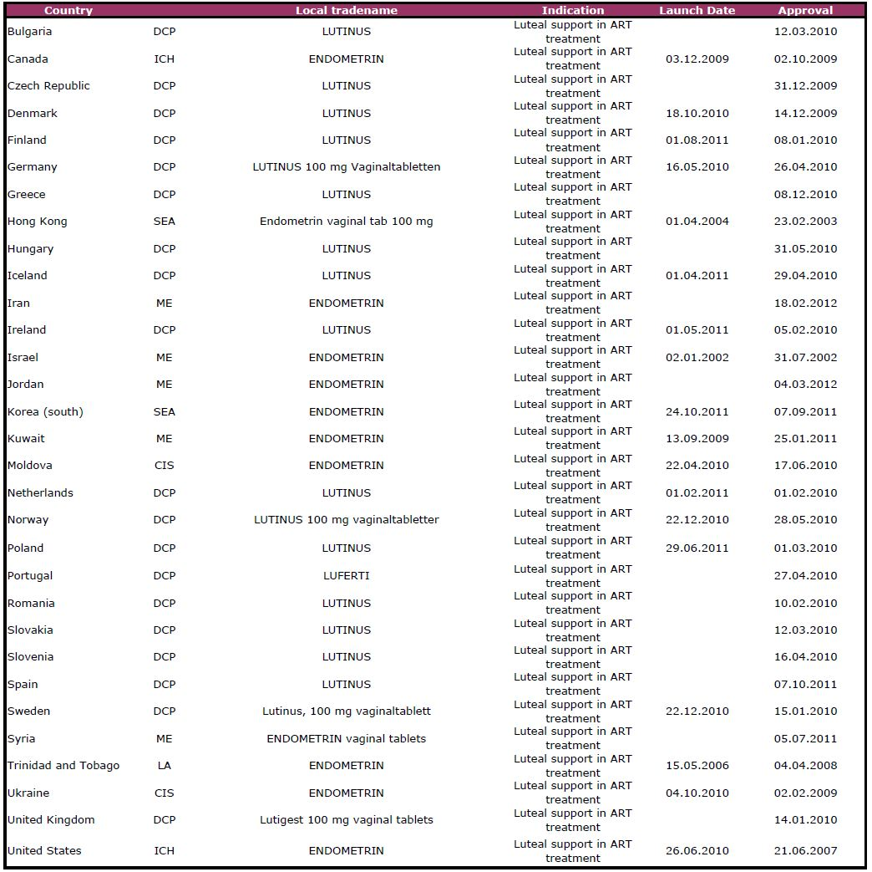

### Product Information

The approved PI current at the time this AusPAR was prepared can be found as Attachment 1.

## II. Quality findings

### Drug substance (active ingredient)

The micronised progesterone (Figure 1) is manufactured in the US.

* An EDQM (European Directorate for the Quality of Medicines & HealthCare) Certificate of Suitability was provided indicating compliance with the EP/BP (European Pharmacopoeia/British Pharmacopoeia) monograph for progesterone.
* The particle size distribution is adequately controlled.

Figure 1: Structure and chemical characteristics of progesterone.

|  |  |
| --- | --- |
| Figure 1: Structure and chemical characteristics of progesterone. | C21H30O2  Molecular Weight = 314.5  *Practically insoluble in water, freely soluble in ethanol, sparingly soluble in acetone and in fatty oils.* |

### Biopharmaceutics

#### Chemistry and quality control

The compressed pessary is manufactured in the US. The pessary is made by granulating micronised progesterone with water. The dried granulate is dry blended with the excipients, compressed and then packaged into blisters.

The control of the product is acceptable. Stability data has been provided to support a shelf life of 36 months when stored below 25°C.

The chemistry and quality control aspect of the draft PI and labels have been finalised to the satisfaction of the evaluator.

#### Bioanalytical methods

The immunoassay method used to quantify progesterone concentrations in human serum in clinical Study 2004-02 (Phase III) was adequately validated for the progesterone concentrations found for the study subjects.

During method validation, the immunoassay method used to quantify progesterone concentrations in human serum in Studies 2004-1 (Phase I/II) and 2005-08 (Phase I) had cross reactions with the steroids 5α pregnane-3,2-dione and pregnenolone. *This was brought to the attention of the clinical Delegate.* The immunoassay method was otherwise also adequately validated.

### Quality summary and conclusions

Approval of this submission is recommended with respect to chemistry and quality control.

It is recommended that the results of the clinical studies should be accepted if concentrations of 5α pregnane-3,2-dione and pregnenolone in human serum are not considered significant.

## III. Nonclinical findings

### Introduction

Ferring Pharmaceuticals Pty Ltd has submitted an application to register a new dosage form of progesterone: Endometrin vaginal tablets, containing 100 mg progesterone. The product is proposed for luteal support as part of an ART treatment programme for infertile women.

The nonclinical data comprised four new studies, investigating repeat dose toxicity/vaginal tolerance, dermal tolerance and antigenicity. These were all conducted according to GLP (Good Laboratory Practice) and used the clinical formulation (as uncompressed powder). Published papers were also provided as background information on progesterone.

### Pharmacology

The pharmacology of progesterone is well understood, and no pharmacology studies specific to this product were submitted. This is acceptable.

### Pharmacokinetics

Intravaginal administration of the clinically formulated powder in rabbits (as a paste like saline suspension) was associated with rapid absorption of progesterone (Tmax [time to reach peak plasma concentration following drug administration], 1-2 h), and peak and overall exposure levels (Cmax [peak plasma drug concentration] and AUC [area under the plasma concentration-time curve]) that were less than dose-proportional and which declined with repeat dosing (twice daily administration for two weeks). By comparison, absorption was slower in humans (Tmax, 18-24 h; but involving treatment with the compressed tablet) and an increase in AUC was seen between Day 1 and Day 5 (Study 2005-08). It is noted though that a significant reduction in the mean trough progesterone concentration was observed in with ongoing treatment in another clinical study (that is, between Days 9 and 10 with treatment at 100 mg BID [twice daily] in Study 2004-01).

### Toxicology

#### Repeat dose toxicity

The vaginal tolerance/repeat dose toxicity of Endometrin powder was assessed in 14 and 90 day studies in rabbits involving twice daily treatment (intravaginal administration). Group sizes and study duration were adequate. The highest dose level used (14.4 mg/kg progesterone BID) yielded a plasma Cmax for progesterone 1.4-2 times higher than, and an AUC0-24h that was comparable to, values observed in women treated with the maximum recommended human dose (100 mg Endometrin three times daily) for 5 days (Study 2005-08) (note: animal AUC0-24h derived by multiplying the reported AUC0-7h value by 2 to reflect twice daily dosing). For vaginal tolerance, animal:human exposure comparisons are best made with respect to mg/kg/day doses, with the highest dose tested in rabbits almost 5 times than in a 50 kg patient at the maximum recommended human dose.

Endometrin powder was well tolerated both locally and systemically. Vaginal irritation observed in animals treated with Endometrin was rated as minimal to mild, and was only marginally greater than that seen in control animals treated with saline only.

#### Genotoxicity

The sponsor provided four published papers on the genotoxicity of progesterone (dating from 1984-1998). These identified negative results for the compounds in assays for bacterial mutagenicity and for unscheduled DNA synthesis in vitro (rat hepatocytes), and a weakly positive result in an in vivo assay for clastogenicity (hepatocytes of rats treated at 100 mg/kg PO). The International Agency for Research on Cancer of the World Health Organisation[1] considered a more extensive set of publications (including one of the submitted papers), concluding:

*“Progesterone did not induce dominant lethal mutations in mice or chromosomal aberrations in rats treated in vivo. It did not induce chromosomal aberration or sister chromatid exchanges in cultured human cells, nor chromosomal aberrations or DNA strand breaks in rodent cells. Studies on transformation of rodent cells in vitro were inconclusive: a clearly positive result was obtained for rat embryo cells, a weakly positive result for mouse cells and a negative result for Syrian hamster embryo cells. Progesterone was not mutagenic to bacteria.”*

The finding that progesterone did not induce chromosomal aberrations in vivo in rats reported by the IARC applies to bone marrow cells. It should be noted that in vivo clastogenic activity by progesterone in the species was subsequently observed by Martelli and colleagues[2] in hepatocytes. Further published studies conducted since the time of the IARC review (retrieved independently by the evaluator) report that progesterone produced variable results in the L5178Y tk+/- mouse lymphoma cell assay[3] and did not produce DNA adducts in the liver of rats (treated at 100 mg/kg/day PO for 14 days).[4]

In summary, there is some evidence that progesterone may act as a weak genotoxin.

#### Reproductive toxicity

##### Pregnancy classification

The sponsor proposes Pregnancy Category A:

*“Drugs which have been taken by a large number of pregnant women and women of childbearing age without any proven increase in the frequency of malformations or other direct or indirect harmful effects on the foetus having been observed”.*

The risk of embryofoetal harm posed by progesterone in humans remains in question. A review article submitted by the sponsor[5] identifies the existence of “a minimal scientific database for evaluating safe use during pregnancy” for progesterone. In line with this, the proposed PI document states that “there is yet inconclusive data on the risk of congenital anomalies, including genital abnormalities in male and female infants, following intrauterine exposure during pregnancy”. The absence of robust clinical data supporting embryofoetal safety is at odds with the proposed placement in Pregnancy Category A. Given findings of virilisation of female foetuses and feminisation of male foetuses with progesterone in animals and the existence of concerns over malformations, hypospadias and female virilisation in humans with progesterone and other progestogens[6] placement in Pregnancy Category D is recommended instead. This category is for “drugs which have caused, are suspected to have caused or may be expected to cause, an increased incidence of human malformations or irreversible damage”.

##### Local tolerance and antigenicity

Endometrin powder was shown not to be a dermal irritant in rabbits nor act as a skin sensitiser in guinea pigs.

### Nonclinical summary and conclusions

* Ferring Pharmaceuticals Pty Ltd has submitted an application to register a new dosage form of progesterone: Endometrin vaginal tablets, containing 100 mg progesterone, for luteal support as part of an ART treatment programme for infertile women. The proposed dosing regimen is one tablet (100 mg) administered two or three times daily.
* The nonclinical submission comprised four new studies investigating repeat dose toxicity, vaginal and dermal tolerance and antigenicity of the proposed clinical formulation (all GLP compliant), as well as some published papers as background information on progesterone.
* Endometrin powder was well tolerated both systemically and locally in rabbits treated by intravaginal administration twice daily for up to 90 days at a dose almost 5 times the maximum recommended human dose (on a mg/kg basis for consideration of vaginal tolerance) and producing comparable exposure (plasma AUC; for consideration of systemic toxicity). The clinical formulation was also shown not to be a dermal irritant (rabbits) or skin sensitiser (guinea pigs).
* Published studies provide some evidence for genotoxic activity with progesterone. This is not pronounced however, and is seen with other steroid hormones. No significant genotoxic risk is considered likely to be posed in treated patients.
* There are no nonclinical objections to the registration of Endometrin for the proposed indication.
* The Pregnancy Category proposed by the sponsor (Category A) is not considered acceptable. The product should be assigned Pregnancy Category D instead, reflecting unresolved concerns that progesterone may cause embryofoetal malformations.

## IV. Clinical findings

### Introduction

The submission contained the following clinical information:

* Two clinical pharmacology studies, both of which provided pharmacokinetic data;
* One efficacy and safety study;
* Three periodic safety update reports (PSURs); and
* Literature references.

The ethical certification of all the studies submitted appears to be acceptable.

The GCP certification of all three studies submitted was deficient, in that it read as follows:

*“This trial was conducted in accordance with the ethical principles of Good Clinical Practice, according to the ICH Harmonised Tripartite Guideline.”*

As ICH’s principles of GCP cover scientific as well as ethical principles, the applicant's statement is inadequate for the purposes of GCP certification.

### Pharmacokinetics

The pharmacokinetics of the product − particularly relating to absorption − are not well understood.

The evaluator recommends that the pharmacokinetic results should not be accepted. If they are accepted, then the next paragraph below applies.

No data are available comparing vaginal absorption of similar doses of Endometrin and Crinone in the same study. However, serum progesterone concentration data for treatment with Endometrin 100 mg daily are available from Study 2004-01, and data for Crinone 90 mg daily from Study 2005-08. Pharmacokinetic parameters are summarised in Tables 1-2. Individual time versus concentration curves during multiple dosage are shown in Figures 2-3. These data suggest that Endometrin is absorbed to a lesser extent and less reliably than Crinone.

Table 1: PK parameters in each treatment group (Study 2004-01).

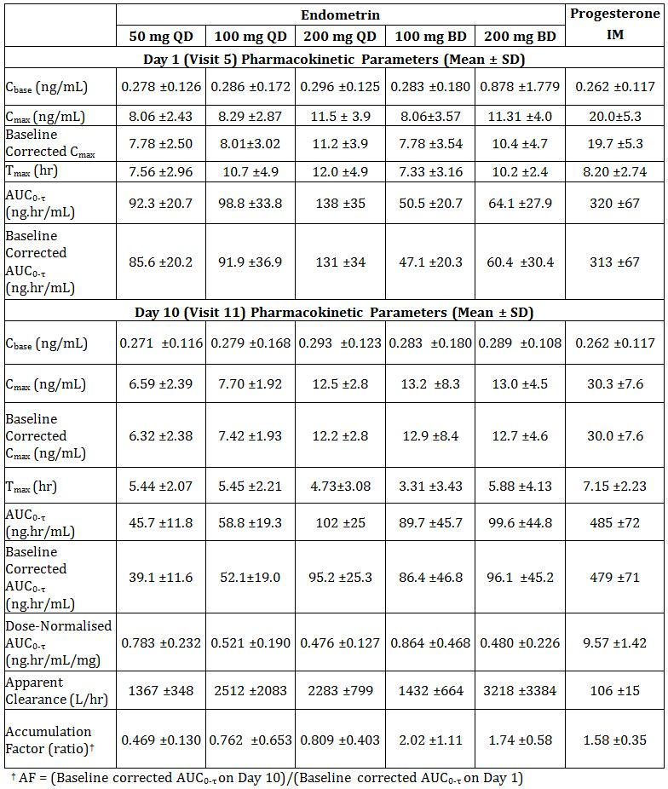

Table 2: Serum progesterone PK parameters (Study 2005-08).

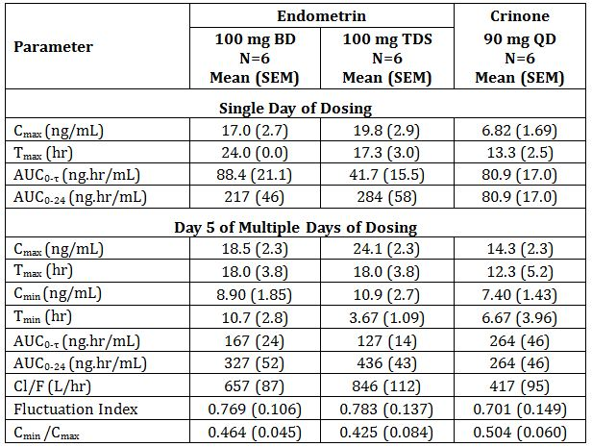

Figure 2: Individual progesterone concentrations during multiple dosing with Endometrin 100 mg daily (Study 2004-01).

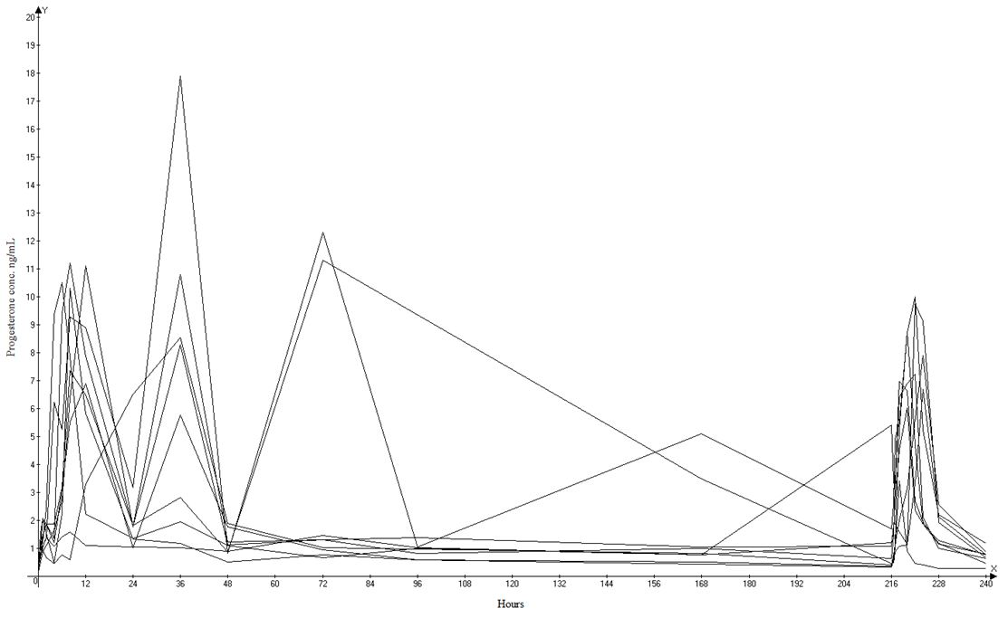

Figure 3: Individual progesterone concentrations during multiple dosing with Crinone 90 mg daily (Study 2005-08).

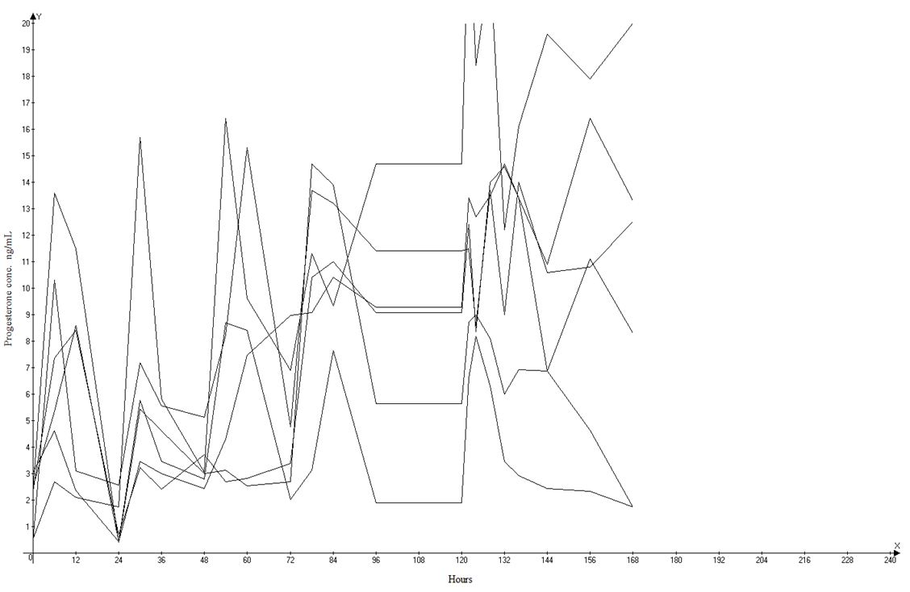

### Pharmacodynamics

The evaluator considers all the pharmacodynamic results non contributory, as it was not possible to distinguish the effects of the administered progesterone from those of the endogenous progesterone.

### Efficacy

Dose finding studies are lacking unless the one efficacy study, designed as a non inferiority study, can be regarded as a dose finding study, in which case it can hardly also have the status of a "pivotal" efficacy and safety study.

Note that the comparison was done against the minimum recommended dosage of Crinone (90 mg daily), whereas the *Dosage and administration* section of the approved PI for Crinone envisages 90 mg daily or twice daily (BID). The non inferiority criterion was not met for Endometrin 100 mg twice daily.

The non inferiority criterion was met for Endometrin 100 mg three times daily (TID), but the evaluator would like to make the following points which would call into question the external validity of Study 2004-02 in the comparative assessment of the two progesterone products:

* Whether the administered progesterone was necessary to the outcome. No placebo group was included in the study − presumably because it has been established that the luteal phase of all stimulated IVF cycles is abnormal.[7] Accurate information on the extent of the benefit to be gained by the use of progesterone for luteal support is not available. In a series reported by Sallam and colleagues,[8] among 192 women in whom ovulation was induced and who received no luteal support, 62.5% resulted in full term pregnancy. A recent Cochrane Review[9] estimated a Peto OR of 1.83 from seven studies with the following characteristics:

Comparison: progesterone versus placebo or no treatment.

Outcome: clinical pregnancy rate.

* Patients with special need. Older subgroups, or patients with early follicular phase FSH > 10 IU/mL, may have been at greater need for luteal support, but this can only be clarified by further study. As the trialists state:

*"These findings suggest that, for younger patients and patients with adequate ovarian reserve, Endometrin TID provides no greater clinical benefit than BID dosing. Older patients and patients with diminished ovarian reserve might require stronger luteal support and would benefit from Endometrin TID."*

The *Overview Addendum* seeks to mitigate the formal outcome of the non inferiority trial by a variety of retrospective analyses, concluding with:

*"In summary, the data presented support that Endometrin 100 mg BID and 100 mg TID are efficacious in women up to 40 years of age, and the efficacy of Endometrin 100 mg TID efficacy has been shown also in women older than 40 years. Therefore, the dosing recommendations proposed for women up to 40 years is Endometrin 100 mg administered vaginally BID or TID starting at oocyte retrieval and continuing for up to 10 weeks total duration (or 12 weeks of gestation). For patients older than 40 years, Endometrin 100 mg TID is recommended."*

The evaluator finds the *Overview Addendum* unconvincing, based as it is on retrospective data re analysis.

### Safety

Each day, subjects recorded on a Subject Diary Card the presence and severity of symptoms of genital bleeding, vaginal discharge, vaginal irritation/itching, and drowsiness and whether they had problems with sexual intercourse. No obvious pattern emerged, except with vaginal discharge, the results for which suggested the symptom was more pronounced in the Endometrin groups than in the Crinone group. It is not clear whether any of these reports of vaginal discharge might have represented partial loss of treatment product.

The adverse events and laboratory monitoring do not raise any matters of concern. There is a question relating to tolerance of Endometrin in comparison to Crinone (see paragraph above).

### Clinical summary and conclusions

#### First round benefit-risk assessment

##### First round assessment of benefits

In this evaluator’s opinion, the unsatisfactory pharmacokinetic basis for Endometrin militates against approval, in that it calls into question the external validity of the efficacy and safety study. The efficacy study showed that when administered at approximately double the dosage of Crinone, Endometrin failed the non inferiority test, and the results point to a requirement for further study of patients who may be at greater need of luteal support (on the basis of age or FSH [follicle stimulating hormone] level).

##### First round assessment of risks

The inadequacy of pharmacokinetic data on Endometrin is also of concern in relation to safety, as levels of the drug, and consequent pharmacodynamic effects, may be unpredictable. The tolerance in comparison to Crinone is also in question.

##### First round assessment of benefit-risk balance

Compared to Crinone, Endometrin needs to be given at higher dosage to achieve comparable efficacy. The pharmacokinetics of the Endometrin have not been adequately studied. In the absence of some compensating advantage, it appears to be an inferior product.

##### First round recommendation regarding authorisation

The application should not be approved.

### List of questions

#### Trial certification

The sponsor should be asked to review the GCP (Good Clinical Practice) certification of each of the studies submitted.

#### Drug product

To what extent were the products used in the studies identical to the product proposed for registration?

#### Pharmacokinetics

No questions.

#### Efficacy

No questions.

#### Safety

No questions.

### Final recommendation

#### Second round recommendation regarding authorisation

The applicant has answered all three questions. Answers 2 and 3 are critical to the quality aspects of the application as much as they relate to the observed results of the clinical studies. It is possible that Endometrin is not optimally formulated and is simply an inferior product to Crinone. Crinone was used in the non inferiority study at the lowest recommended dose (90 mg once daily) whereas Endometrin was used at a dose of 100 mg twice daily.

The first round evaluator noted, “No data are available comparing vaginal absorption of similar doses of Endometrin and Crinone in the same study.” That is, there is no basis for varying the first round conclusions.

## V. Pharmacovigilance findings

### Risk management plan

The sponsor submitted a Risk Management Plan (RMP) that was reviewed by the TGA’s Office of Product Review (OPR).

#### Safety specification

The sponsor provided a summary of Ongoing Safety Concerns, which are shown at Table 3.

Table 3: Ongoing Safety Concerns for Endometrin Pessaries.

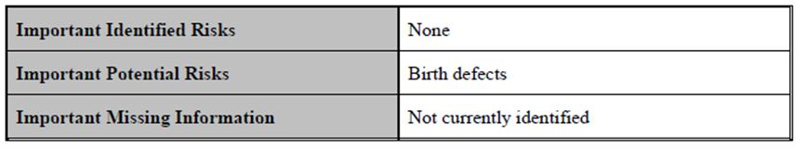

##### OPR reviewer comment:

Pursuant to the evaluation of the nonclinical and clinical aspects of the Safety Specifications, the above summary of the Ongoing Safety Concerns is considered acceptable.

#### Pharmacovigilance plan

##### Proposed pharmacovigilance activities

The sponsor state that routine pharmacovigilance activities, consistent with the published guidelines,[10] are proposed to monitor the specified Ongoing Safety Concern.

##### OPR reviewer’s summary in regard to the pharmacovigilance plan and appropriateness of milestones

There is no objection to the sponsor implementing only routine pharmacovigilance activities to monitor the Ongoing Safety Concern at this time.

#### Risk minimisation activities

##### Sponsor’s conclusion in regard to the need for risk minimisation activities

The sponsor has provided justification and concluded that routine risk minimisation activities are sufficient for the specified Ongoing Safety Concern.

##### OPR reviewer comment:

The sponsor’s justification and conclusions would appear to be reasonable, except that the sponsor has confused routine pharmacovigilance activities with routine risk minimisation activities. Consequently, the ‘Planned actions by safety concerns’ and ‘RMP by safety concern’ should be amended to reflect that the observed incidence of birth defects is reflected in the labelling (that is, routine risk minimisation), as stated in ‘Important potential risks’.

##### Potential for medication errors

The sponsor has not included this section in the submitted RMP. Nevertheless the sponsor’s correspondence, dated 2 May 2012, states the following:

*During the post marketing experience up till 19 March 2012 only a single medically confirmed case of medication error has been reported. This non serious case of incorrect route of administration was reported on 6 March 2012. The case concerns a 48 year female who inadvertently swallowed Endometrin tablet (100 mg) instead of inserting it vaginally. No other adverse event was reported in connection with this medication error and the patient continued the treatment with Endometrin vaginal tablet.*

*In addition, six non serious cases of medication error (short drug administration duration due to early expulsion of vaginal tablet (4), incorrect route of administration (1), and delay in start of prescribed therapy (1)) has been reported by different consumers from US. These cases were not medically confirmed and no other significant safety concern associated with medication error was reported.*

*Also, please find enclosed the fourth half yearly PSUR covering the time period 20 May 2011 to 19 Nov 2011.*

*For your further information, the labelling (for example, carton, instruction leaflet) state the following information to help avoid medication errors:*

*Carton:*

*NOT TO BE SWALLOWED.*

*Instruction leaflet:*

*Endometrin is to be placed directly into your vagina by the applicator provided.*

##### OPR reviewer comment:

The sponsor’s handling of this matter using routine pharmacovigilance and risk minimisation activities is considered satisfactory. Nevertheless this new information should be included in this section of the RMP when this document is next updated.

#### Summary of recommendations

The OPR provides these recommendations in the context that the submitted RMP is supportive to the application; the implementation of a RMP satisfactory to the TGA is imposed as a condition of registration; and the submitted EU-RMP is applicable without modification in Australia unless so qualified:

* The nonclinical aspects of the safety specifications in the RMP should be amended according to the recommendations of the nonclinical evaluator when this document is next updated.
* There is no objection to the sponsor implementing only routine pharmacovigilance activities to monitor the ongoing safety concern at this time.
* The sponsor’s justification and conclusion that routine risk minimisation activities for the specified Ongoing Safety Concern are sufficient would appear to be reasonable, except that the sponsor has confused routine pharmacovigilance activities with routine risk minimisation activities. Consequently, ‘Planned actions by safety concerns’ and ‘RMP by safety concern’ should be amended to reflect that the observed incidence of birth defects is reflected in the labelling (that is, routine risk minimisation), as stated in ‘Important potential risks’.
* The sponsor’s proposed application of routine risk minimisation activities would appear to be reasonable and therefore acceptable.
* The sponsor’s handling of the potential for medication errors using routine pharmacovigilance and risk minimisation activities is considered satisfactory. Nevertheless the related information provided in the sponsor’s correspondence, dated 2 May 2012, should be included in the RMP when this document is next updated.

## VI. Overall conclusion and risk/benefit assessment

The submission was summarised in the following Delegate’s overview and recommendations:

### Quality

All chemistry and quality control aspects have been resolved and the evaluator recommends approval of the product.

The evaluator notes that, “the immunoassay method used to quantify progesterone concentrations in human serum in clinical Studies 2004-1 (Phase I/II) and 2005-08 (Phase I) had cross reactions with the steroids 5α pregnane-3,2-dione and pregnenolone”.

The evaluator recommends that the results of the clinical studies should be accepted if concentrations of 5α pregnane-3,2-dione and pregnenolone in human serum are not considered significant. *The sponsor should submit, in its pre ACPM (Advisory Committee on Prescription Medicines) response, a summary (mean ± SD) of these results to assess this*.

This submission has not been considered by the PSC (Pharmaceutical Subcommittee).

### Nonclinical

The evaluator states that four new studies were submitted. These investigated repeat dose toxicity, vaginal and dermal tolerance, and antigenicity of the proposed clinical formulation. The studies were GLP compliant. Some published papers were also submitted.

The evaluator states that:

*“Endometrin powder was well tolerated both systemically and locally in rabbits treated by intravaginal administration twice daily for up to 90 days at a dose almost 5 times the maximum recommended human dose (on a mg/kg basis for consideration of vaginal tolerance) and producing comparable exposure (plasma AUC; for consideration of systemic toxicity). The clinical formulation was also shown not to be a dermal irritant (rabbits) or skin sensitiser (guinea pigs)”.*

No new concerns on genotoxicity are identified with the proposed route of administration.

The evaluator recommends approval from a nonclinical point of view.

### Clinical

There are two pharmacology studies (Studies 2004-01 and 2005-08) submitted.

#### Study 2004-01

This was a randomised open label parallel multiple dose pharmacokinetic and pharmacodynamic study. Healthy pre menopausal females aged 18-40 with a BMI (Body Mass Index) of 18-28 were eligible to enrol. The evaluator mentions that:

*“Eligibility for the Randomisation/Treatment Phase required subjects to have a serum progesterone concentration of ≤1 ng/mL and a TVU (transvaginal ultrasound) demonstrating an endometrial lining of ≥7 mm... Subjects were randomly assigned in sequential order to 1 of 5 different Endometrin treatment groups (50 mg QD [once daily], 100 mg QD, 200 mg QD, 100 mg BID, and 200 mg BID) and a reference group (Progesterone injection 50 mg QD)”.*

Regular blood samples were also taken.

##### Results

58 subjects were randomised; 48 in the Endometrin groups and 10 in the Progesterone IMI group. 57 subjects completed the study.

The pharmacokinetic results are included in the clinical evaluation report.

It is noted that in relation to the single dose pharmacokinetics, baseline values of serum progesterone were low (~0.25ng/mL) due to pre treatment with GnRH (gonadotropin releasing hormone) agonist: the exception was the 200 mg BID dose which had a baseline value of 0.878 ng/mL ± 1.779. Serum levels peaked 8-12 h after the dose. There was less than a dose proportional increase in Cmax and AUC for 100 mg and 200 mg dose. In relation the multidosing, the Cavg increased in a less than dose proportional manner.

The evaluator questions the validity of the pharmacokinetic results.

The issues are described under “Evaluator’s comments”. In essence, the evaluator’s concerns are as follows:

* The products used have not been described in detail, for the evaluator to identify the relationship to the “proposed formulation”.
* Explanation is sought regarding Figure 4 (below; Figure 1 in the clinical evaluation report) which shows mean trough levels of progesterone levels 12 h post dose was lower than the trough levels before earlier doses with 100 mg BID dose.
* Absorption kinetics were thought to be zero order, but could change with repeated administration. Pharmacokinetics was not strictly dose proportional, but the findings were confounded by random variability due to small sample size.

Figure 4: Mean trough progesterone concentrations during treatment (Study 2004-01).

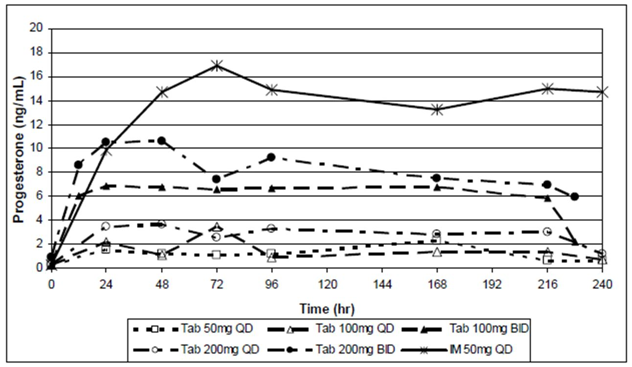

#### Study 2005-08

This was a randomised, open label parallel group single and multiple dose study. Healthy, pre menopausal females of 18-40 were eligible to enrol. Treatment details are described. The subjects (6 in each group) received Endometrin 100 mg BID, TID or Crinone 90 mg QD. The study involved a single dose phase (1 day) and a multiple dose phase (5 days) separated by a wash out of 7 days. There was no baseline correction for endogenous correction.

Both the BID and TID regimes resulted in steady state Cmax, Cavg and trough concentrations that were at or above the desired 10 ng/mL target concentration, with the TID showing higher concentration.

There were problems experienced with baseline progesterone values due to endogenous progesterone, as in Study 2004-01. The problem identified in the report is:

*“Although planned per protocol, baseline correction (by subtraction of the pretreatment progesterone) of the assayed progesterone concentrations was not incorporated into the pharmacokinetic analysis because (1) whatever residual endogenous progesterone production that did remain did not appear to contribute significantly to the observed values, and (2) in about [sic] several of the subjects pre-treatment progesterone concentrations were greater than concentrations observed during the treatment phase, suggesting the possibility that exogenous progesterone suppressed endogenous progesterone production."*

#### Study 2004-02: addendum

This was an open label, randomised parallel group pharmacokinetic study in IVF patients. At two centres where the original Study 2004-02 was conducted, randomised subjects were invited to partake in this addendum. A total of 7 subjects received Endometrium 100mg BD, 8 subjects 100mg TID, and 12 received Crinone 90 mg QD. The evaluator mentions that the issues were similar to the previous studies.

##### Pharmacodynamics

The evaluator dismisses the pharmacodynamic results as the studies have not identified endogenous progesterone.

However, it is noted that in Phase I Study 2004-01 secretory transformation of the endometrium (assessed by biopsy) and endometrial thickness (TVU) were also measured. There was some evidence of dose response in relation to endometrial transformation. In relation to thickness, results were non conclusive.

##### Efficacy

Study 2004-02 is the pivotal efficacy study. This was a multicentre randomised open label parallel group study conducted to determine the efficacy of Endometrin administered vaginally in women undergoing *in vitro* fertilisation. Subjects were stratified at baseline for age of subject and ovarian reserve. Treatment commenced with down regulation with GnRH agonist followed by ovarian stimulation; this was followed by hCG (human chorionic gonadotrophin) administration and oocyte retrieval.

Premenopausal females aged 18 to 42 with early follicular phase FSH ≤ 15 IU/L and oestradiol within normal limits were eligible to enrol. Details of the inclusion and exclusion criteria are listed.

Each subject was randomised and assigned to the study drug on the day of or day following oocyte retrieval. The following treatments were administered: Endometrin 100 mg BID, Endometrin 100 mg TID, or Crinone 8% gel QD. The subjects continued on the study drug for a total of 10 weeks.

There were five additional treatment period visits during the 10 week period. Pregnancy tests and TVU were scheduled at these times.

*The primary efficacy outcome* was ongoing pregnancy following one treatment cycle in the efficacy population. Ongoing pregnancy was defined as identification of foetal heart movement at approximately six weeks of gestation. Other efficacy endpoints were biochemical and clinical pregnancy (these are defined in the clinical evaluation report).

The evaluator mentions that in relation to sample size:

*“A sufficient number of subjects was sought to have at least 80% power to demonstrate the non inferiority of Endometrin versus Crinone in the pregnancy rate, using a two sided 95% confidence interval and a prespecified non inferiority margin of 10%. Based on these requirements, and assuming a Crinone pregnancy rate of 30%, a sample size of ≥ 330 evaluable subjects per treatment group would provide at least 80% power to demonstrate such non inferiority of Endometrin relative to Crinone”.*

The primary analysis was performed to determine whether ongoing pregnancy rate for each dose of Endometrin was non inferior to Crinone. Non inferiority was declared in the lower bound of the confidence interval was to exclude a difference greater than 10% in favour of the comparator.

###### Results

The baseline demographic characteristics are included in the clinical evaluation report. Mean age of the subjects were 33 years and BMI 25.

Subject disposition is shown in Table 4.

Table 4: Subject disposition.

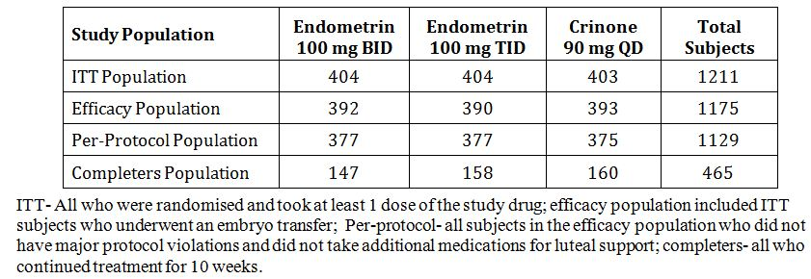

The primary efficacy results are shown below (extracted from the evaluation report).

Table 5: Primary efficacy results.

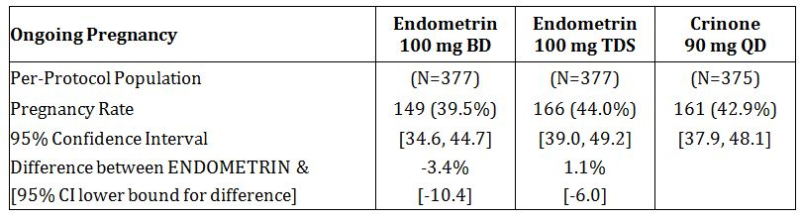

Non inferiority was shown with Endometrin 100 mg TID versus Crinone; this was not seen with 100 mg BID.

Other efficacy outcomes showed similar findings.

The evaluator mentions that the minimum dose of Crinone was used (90 mg/day), thus the efficacy of Endometrin was compared to the minimum dose of Crinone. (The approved PI states 90 mg once daily or twice daily and that most women will respond to Crinone once daily). Endometrin 100 mg BID did not, strictly, meet the ‘non inferiority’ criterion.

The evaluator discusses the lack of placebo arm in the study; there are published references that discuss studies where placebo is used as a comparator. The study does not provide information on patients with special need, that is, older subgroup or patients with early follicular phase FSH >10 IU /mL.

There was a post hoc analysis that showed that Endometrin 100 mg TID was efficacious in women older than 40 years. The evaluator states that this finding was “unconvincing” as it was based on retrospective data re analysis.

The FDA report states that the pregnancy rate in subgroups (<35, 35-37, 38-40) analysis was “not sufficiently powered to provide definitive statistical analysis”.

##### Safety

The pharmacokinetic studies included 76 subjects on Endometrin over a short time period and will not be considered further.

The Phase III Study 2004-02 had 808 subjects who had Endometrin included in the safety analysis.

The treatment related adverse events were similar in all three groups and was approximately 53%. There were no deaths reported. A total of 22 subjects had serious adverse events requiring hospitalisation; 14 subjects (3%) in 100 mg BID and 8 (2%) in 100 mg TID dosing. Of these, there were 13 cases of OHSS (ovarian hyperstimulation syndrome), 2 reports of ovarian torsion, and 1 report of ectopic pregnancy. There were three discontinuations: 2 OHSS and 1 ovarian torsion.

Overall, there were no undue safety concerns identified by the evaluator.

It is noted in the FDA assessment report that there were 7 babies with birth defects in each of the Endometrin groups; there were 2 in the Crinone group. It is also stated that the incidence in the Endometrin groups were similar to that reported in the general and ART population. There were also no trends identified.

##### Overall conclusion by the evaluator

The evaluator recommends against approval due to inadequate pharmacokinetic data. He also questions the external validity of the pivotal study due to this. In addition, it is stated that when Endometrin was administered “at approximately double the dosage of Crinone, Endometrin failed the non inferiority test, and the results point to a requirement for further study of patients who may be at greater need of luteal support (on the basis of age or FSH level)”.

##### The sponsor’s response

###### Responses to questions asked during the evaluation phase

The vaginal tablets used in the clinical studies are identical in relation to formulation and only differ in size.

The mean trough progesterone concentration for 100 mg BID dosage (Figure 4) required explanation: the evaluator states that the concentration at 228 h (supposedly 12 h after the last dose) had fallen to a level so much lower than the trough concentrations recorded before the earlier doses. The sponsor attributes this to “random variation associated with biological variability across subjects and intrinsic variability in the absorption of an immediate release dosage form...”. Thus, no robust explanation is offered.

###### Response to other issues raised in the clinical evaluation report

The sponsor has responded in detail to the criticisms of the evaluator in relation to the lack of good quality pharmacokinetic data. Of note:

* The sponsor maintains that the aim of the pharmacokinetic studies was to establish that Endometrium achieved a plasma level of 10 ng/mL (the level associated with luteal support). It was not intended to establish bioequivalence to Crinone, but to select the dose for Phase III studies.
* The sponsor discusses the difficulty of determining endogenous progesterone in such clinical trials. Methods used to determine the level of exogenous progesterone are subject to errors; there is also an increased variability due to the small number of subjects recruited in the studies. Despite these failings, the sponsor maintains that the mean plasma concentration in the non pregnant female in Study 2004-02 substudy on Day 16 (when endogenous progesterone would be minimal, were consistent with mean progesterone on Day 5 in Study 2005-08).
* It is stated that in both Studies 2005-08 and 2004-02 Endometrium TID provided the greatest level of progesterone support and Crinone the lowest.

### Risk management plan

This is enclosed. The evaluator is in agreement with the sponsor in relation to its proposal to undertake routine pharmacovigilance activities.

### Risk-benefit analysis

#### Delegate considerations

1. Pharmacokinetics: The data are inadequate. However, the sponsor’s response is acknowledged.
2. The Delegate is of the opinion that the pharmacokinetic deficiencies appear to be mitigated by the conduct of a large efficacy study that showed Endometrin TDS was non inferior to Crinone OD.
3. It is necessary, however, for the PI to reflect accurately the findings of the pharmacokinetic studies. In this context, the sponsor should include the variation seen in the pharmacokinetic data in relation to the single dose and multiple dose findings.
4. The issues with the efficacy study are that it was not powered to show non inferiority in the subgroups. This deficiency should be included in the PI. In this context, it was recommended by the FDA assessor that a Phase IV study be conducted to establish efficacy in those of the ages of 35-45 years. The sponsor should provide an update on this study, in its pre ACPM response.
5. The magnitude of absolute efficacy is not known in relation to progesterone treatment. The sponsor should justify the margin of non inferiority (10%) used in the efficacy study to establish non inferiority between treatments, in its pre ACPM response. There should be a statement in the PI relating to the margin chosen, that is, that absolute efficacy is not known as there have been no placebo controlled studies.
6. The statement in the PI that women over the age of 40 require TID regimen, appears not to be supported by data and should be removed.

I proposed to register Endometrin 100 mg vaginal tablets for luteal support as part of an ART treatment programme for infertile women.

The Committee’s advice is sought.

#### Response from sponsor

Ferring welcomes the opportunity to provide Sponsor Comments on the Delegate’s Summary and Proposed Action for consideration at the August 2012 ACPM meeting. Ferring is pleased that the Delegate proposes to register Endometrin Pessaries for luteal support as part of an ART treatment programme for infertile women. Ferring notes that the ACPM’s advice has been sought and that specific issues have not been identified. Therefore, this pre ACPM response addresses in turn each of the Delegate’s six comments. Other minor matters raised by the Delegate are addressed as an addendum to this response. Ferring also notes that the application had not been considered by the PSC as at 3 July. Should this submission be considered at the PSC meeting of 23 July 2012, we respectfully request that our letter of 19 June 2012 is tabled together with this pre ACPM response.

##### Delegate’s comments

###### 1. Pharmacokinetics

* The data are inadequate. However, the sponsor’s response is acknowledged.

Response

Ferring is pleased that the Delegate has acknowledged our comments on the pharmacokinetics evaluation. In summary, results from Studies 2004-01, 2005-08, and 2004-02 sub study indicate that Endometrin 100 mg BID or 100 mg TID should be effective to develop and maintain secretory endometrium and to provide luteal support of pregnancy throughout the first trimester. These studies support the doses selected in the pivotal clinical study of Endometrin and should not be excluded.

###### 2. Pharmacokinetic deficiencies mitigated by clinical data

* The Delegate is of the opinion that the pharmacokinetic deficiencies appear to be mitigated by the conduct of a large efficacy study that showed Endometrin TID was non inferior to CRINONE OD.

Response

Ferring is pleased that the Delegate appreciates the weight of the extensive Phase III data accompanying this submission. The Phase III study in this submission comprises the largest randomised controlled trial (N=1211) conducted for documenting non inferiority of a progesterone preparation for the luteal support indication. The study demonstrated that Endometrin 100 mg TID is non inferior in ongoing pregnancy rates to Crinone.

The patient population in this study was also pre stratified and randomised according to age (<35, 35-37, 38-40, 41-42 years) and serum FSH level. Women up to 35 years of age constituted 61% (N= 737) of the trial population and the majority had FSH <10 IU/L (N=1047/1193, 88%); these two subgroups had sufficient numbers of subjects to make meaningful comparisons. In both of these subgroups, the ongoing and clinical pregnancy rates for Crinone and Endometrin were at least 40% and the biochemical pregnancy rates were at least 50%. In the subgroup <35 years of age, the lower bounds of the 95% confidence interval for the difference in ongoing pregnancy rates demonstrated that both Endometrin regimens were non inferior to Crinone (Table 6).

Table 6: Ongoing biochemical and clinical pregnancy rates in subjects <35 years of age – ITT population.

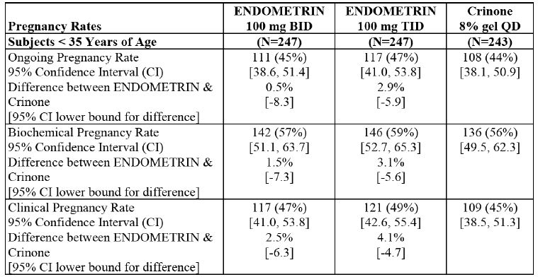

These findings suggest that for younger women and women with adequate ovarian reserve, Endometrin TID provides no greater clinical benefit that BID dosing. Older women appear to require stronger luteal support and would benefit from Endometrin TID doses.

###### 3. Variability in PK findings

* It is necessary, however, for the PI to reflect accurately the findings of the pharmacokinetic studies. In this context, the sponsor should include the variation seen in the pharmacokinetic data in relation to the single dose and multiple dose findings.

Response

Ferring has included information about variability in the pharmacokinetic studies in the PI. The information is in the form of a table taken from the US PI, as well as a clarifying statement in the preamble to the table.

###### 4. Sub group analysis

* The issues with the efficacy study are that it was not powered to show non inferiority in the subgroups. This deficiency should be included in the PI. In this context, it was recommended by the FDA assessor that a Phase IV study be conducted to establish efficacy in those of the ages of 35-45 years. The sponsor should provide an update on this study, in its pre ACPM response.

Response

Ferring acknowledges that the study was powered to demonstrate non-inferiority overall for the entire trial population, and not for each of the individual age groups. A sentence to this effect has been included in the PI.

However, as discussed above, Ferring maintains that compared to Crinone once daily, the pivotal efficacy study has shown non inferiority of TID dosing in all patients and noninferiority for both dosing regimens in patients <35 years and in patients with FSH <10 IU/L.

This conclusion was also reached by the US FDA and the Canadian HPB (Health Protection Branch) and is reflected in the approved PIs from these countries (refer approved US and Canadian PIs).

Regarding the status of the Phase IV study, Ferring notes that the recommendation of the FDA assessor was not included as a condition of approval in the US. It is important to note that in order to study adequately older women and to establish non inferiority for each of the age strata; it would require a much larger study than has already been undertaken. Each stratum would need to be powered to document non inferiority and, for example, it would require at least 400 women per group in women aged 41-42 given their low (11%) pregnancy rates. Therefore, Ferring is not able to undertake this study as it is methodologically not feasible. Moreover, to our knowledge, such a study is unprecedented in any ICH (International Conference on Harmonisation) region for any fertility product.

###### 5. Non inferiority margin

* The magnitude of absolute efficacy is not known in relation to progesterone treatment. The sponsor should justify the margin of non inferiority (10%) used in the efficacy study to establish non inferiority between treatments, in its pre ACPM response. There should be a statement in the PI relating to the margin chosen, that is, that absolute efficacy is not known as there have been no placebo controlled studies submitted.

Response

There are no guidelines specifying what would be an appropriate non inferiority limit when ongoing pregnancy rate is the primary endpoint. However, during the end of Phase II discussions with the FDA, this margin was agreed. A margin of -10% seems acceptable, as it corresponds to an absolute difference in point estimates between treatment groups of around 3% in ongoing pregnancy rate. Thus, the pre established non inferiority margin is considered appropriate for a clinical Phase III trial aiming at ruling out a clinically relevant difference between the experimental intervention and the approved active comparator. There is precedence for a non inferiority margin of -10% in clinical trials demonstrating the efficacy of gonadotrophins with respect to ongoing pregnancy (that is, the primary endpoint in the Endometrin Phase III trial). In Australia, this precedent includes one of the pivotal trials used for approval of the highly purified menotrophin Menopur. In the absence of placebo controlled trials for progesterone supplementation during the luteal phase, it seems appropriate to apply the non inferiority margins used in other trials having ongoing pregnancy as the primary endpoint.

Regarding the requested change to the PI, Ferring agrees to make the changes requested. However, in this context, Ferring notes that there are no placebo controlled studies cited in the PIs for Crinone or Orion Progesterone Pessaries.

###### 6. PI statement on women over 40

* The statement in the PI that women over the age of 40 require TID regime, appears not to be supported by data and should be removed.

Response

Ferring agrees that this statement is not supported by a prospective, randomised study in this patient population. Ferring will remove the specified passage from the PI as requested and proposes, as an alternative, the wording from the Canadian Product Monograph to reflect the submitted study findings. The wording is reproduced below:

*Endometrin administered into the vagina twice daily (BID) and three times daily (TID) dosing have both been shown to be efficacious. However specific populations may derive greater benefits from BID or TID dosing regimen and the clinician can tailor treatment to the patient. For women <35 years of age and those patients with adequate ovarian reserve, Endometrin BID would be the appropriate dose. For patients aged 35 and older and those with diminished ovarian reserve, TID dosing would be the preferred regimen. Serum progesterone levels may be measured 7 days post fertilisation and used to guide therapy.*

##### Risk management plan

The OPR evaluator recommended changes to the RMP at the next update. Ferring confirms that the Endometrin RMP will be amended to include the changes requested by the OPR evaluator. The next update of this document is scheduled to take place in August-September 2012.

##### Conclusion

The Phase III study in this submission comprises the largest randomised controlled trial (N=1211) conducted for documenting non inferiority of a progesterone preparation for the luteal support indication. The study demonstrated that Endometrin 100 mg TID is noninferior in ongoing pregnancy rates to Crinone. It is a matter of public record that neither of the two progesterone products currently registered in Australia (Crinone gel and Orion Progesterone Pessaries) is supported by such an extensive clinical data package.

The clinical efficacy of Endometrin has been evaluated using standard and well accepted clinical and laboratory procedures, including TVUs and serum pregnancy tests. Efficacy endpoints for the pivotal study, including ongoing pregnancy, biochemical pregnancy, and clinical pregnancy, have been used previously as endpoints for numerous studies both in Europe and the US to investigate progesterone supplementation or replacement in ART.

In the presence of this large Phase III study (N=1211) providing clinical outcome data on a clinically relevant parameter (that is, ongoing pregnancy), there should be less emphasis on extrapolating the clinical implications of systemic concentrations of progesterone in a subgroup of patients for a product of vaginal application in which serum levels may not directly reflect tissue levels.

Ferring maintains that, compared to Crinone once daily, the pivotal efficacy study has shown non inferiority for TID dosing in all patients and non inferiority for both regimens in patients <35 years and in patients with FSH <10 IU/L.

Endometrin is approved and marketed in all the relevant reference countries (US, Canada, Sweden, UK, Netherlands). Ferring maintains that Endometrin should be made available as an evidence based alternative treatment option for Australian IVF patients.

#### Advisory committee considerations

The ACPM, taking into account the submitted evidence of efficacy, safety and quality, agreed with the Delegate and considered this product to have an overall positive benefit-risk profile for the following indication:

*For luteal support as part of an Assisted Reproductive Technology (ART) treatment programme for infertile women currently approved for the vaginal gel and pessaries formulations.*

In making this recommendation, the ACPM noted the evidence from the studies submitted do not support a dosage regimen other than three times a day as this dosage is efficacious and safe. The study did not identify the women who would respond to the BID (twice daily) dosing regimen.

The ACPM agreed with the Delegate to the proposed amendments to the PI and Consumer Medicine Information (CMI).

The ACPM advised that the implementation by the sponsor of the recommendations outlined above to the satisfaction of the TGA, in addition to the evidence of efficacy and safety provided would support the safe and effective use of this product.

### Outcome

Based on a review of quality, safety and efficacy, TGA approved the registration of Endometrin Pessaries (progesterone) 100 mg tablets (vaginal administration). The approved indication reads as follows:

*Endometrin Pessaries are indicated for luteal support as part of an Assisted Reproductive Technology (ART) treatment programme for infertile women*

Specific conditions of registration applying to th**ese therapeutic goods:**

1. 1. Details of the distribution of the drug, including quantities and forms of products distributed and related batch numbers, should be supplied on request while the drug remains on the Australian Register of Therapeutic Goods.
2. 2. The implementation in Australia of the Endometrin Pessaries progesterone RMP version 1.0, dated 12 August 2011 (to be revised as specified in the sponsor’s correspondence dated 17 August 2012), included with submission 2011-02023-3-5, and any subsequent revisions, as agreed with the TGA and its OPR.

## Attachment 1. Product Information

The following Product Information was approved at the time this AusPAR was published. For the current Product Information please refer to the TGA website at <http://www.tga.gov.au/hp/information-medicines-pi.htm>.

## Attachment 2. Extract from the Clinical Evaluation Report

1. International Agency for Research on Cancer (1987) Genetic and related effects: an updating of selected IARC monographs from volumes 1 to 42. IARC Monographs on the Evaluation of Carcinogenic Risks to Humans. Suppl. 6, pp. 479-480. Geneva: World Health Organisation, International Agency for Research on Cancer.
2. Martelli A, *et al.* (1998) Induction of micronuclei and of enzyme-altered foci in the liver of female rats exposed to progesterone and three synthetic progestins. *Mutat. Res.* 419: 33-41.
3. Myhr BC and Caspary WJ. (1988) Evaluation of the L5178Y mouse lymphoma cell mutagenesis assay: intralaboratory results for sixty-three coded chemicals tested at Litton Bionetics, Inc. *Environ.* *Mol. Mutagen.* 12 (Suppl. 13): 103-194.
4. Feser W, *et al.* (1996) Formation of DNA-adducts by selected sex steroids in rat liver. *Hum. Exp. Toxicol.* 15: 556-562.
5. Golub MS, *et al.* (2006) “Natural” progesterone: information on fetal effects. *Birth Defects Res. B Dev. Reprod. Toxicol.* 77: 455-470.
6. Golub MS, *et al.* (2006) “Natural” progesterone: information on fetal effects. *Birth Defects Res. B Dev. Reprod. Toxicol.* 77: 455-470.
7. Fatemi HM, *et al.* (2007) An update of luteal phase support in stimulated IVF cycles. *Human Reproduction Update* 13: 581-590.
8. Sallam HM, *et al.* (1999) Reference values for the midluteal plasma progesterone concentration: evidence from human menopausal gonadotropin-stimulated pregnancy cycles. *Fertility and Sterility* 71: 711-714.
9. van der Linden M, *et al.* (2011) Luteal phase support for assisted reproduction cycles. *Cochrane Database of Systematic Reviews* Issue 10 Art. No. CD009154.
10. European Medicines Agency, “ICH Topic E 2 E Pharmacovigilance Planning (Pvp) Step 5: Note for Guidance on Planning Pharmacovigilance Activities (CPMP/ICH/5716/03)”, June 2005, Web, accessed 11 February 2012 <http://www.ema.europa.eu/docs/en_GB/document_library/ Scientific_guideline/2009/09/WC500002818.pdf>.