June 2017

Australian Public Assessment Report for Progesterone
  - Proprietary Product Name: Prometrium / Utrogestan
  - Sponsor: Besins Healthcare Australia Pty Ltd

About the Therapeutic Goods Administration (TGA)
- The Therapeutic Goods Administration (TGA) is part of the Australian Government Department of Health and is responsible for regulating medicines and medical devices.
- The TGA administers the Therapeutic Goods Act 1989 (the Act), applying a risk management approach designed to ensure therapeutic goods supplied in Australia meet acceptable standards of quality, safety and efficacy (performance) when necessary.
- The work of the TGA is based on applying scientific and clinical expertise to decision-making, to ensure that the benefits to consumers outweigh any risks associated with the use of medicines and medical devices.
- The TGA relies on the public, healthcare professionals and industry to report problems with medicines or medical devices. TGA investigates reports received by it to determine any necessary regulatory action.
- To report a problem with a medicine or medical device, please see the information on the TGA website <https://www.tga.gov.au>.
About AusPARs
- An Australian Public Assessment Report (AusPAR) provides information about the evaluation of a prescription medicine and the considerations that led the TGA to approve or not approve a prescription medicine submission.
- AusPARs are prepared and published by the TGA.
- An AusPAR is prepared for submissions that relate to new chemical entities, generic medicines, major variations and extensions of indications.
- An AusPAR is a static document; it provides information that relates to a submission at a particular point in time.
- A new AusPAR will be developed to reflect changes to indications and/or major variations to a prescription medicine subject to evaluation by the TGA.
Copyright
© Commonwealth of Australia 2017
This work is copyright. You may reproduce the whole or part of this work in unaltered form for your own personal use or, if you are part of an organisation, for internal use within your organisation, but only if you or your organisation do not use the reproduction for any commercial purpose and retain this copyright notice and all disclaimer notices as part of that reproduction. Apart from rights to use as permitted by the Copyright Act 1968 or allowed by this copyright notice, all other rights are reserved and you are not allowed to reproduce the whole or any part of this work in any way (electronic or otherwise) without first being given specific written permission from the Commonwealth to do so. Requests and inquiries concerning reproduction and rights are to be sent to the TGA Copyright Officer, Therapeutic Goods Administration, PO Box 100, Woden ACT 2606 or emailed to <tga.copyright@tga.gov.au>.

Contents
Common abbreviations 5
I. Introduction to product submission 6
Submission details 6
Product background 7
Regulatory status 9
Product information 10
II. Quality findings 10
Introduction 10
Drug substance (active ingredient) 10
Drug product 10
Biopharmaceutics 11
Quality summary and conclusions 13
III. Nonclinical findings 13
Introduction 13
Pharmacology 13
Pharmacokinetics 13
Toxicology 14
Nonclinical summary and conclusions 16
IV. Clinical findings 17
Introduction 17
Pharmacokinetics 19
Pharmacodynamics 19
Dosage selection for the pivotal studies 21
Efficacy 22
Safety 26
First round benefit-risk assessment 29
First round recommendation regarding authorisation 30
Clinical questions 30
V. Pharmacovigilance findings 30
Risk management plan 30
VI. Overall conclusion and risk/benefit assessment 35
Quality 35
Nonclinical 36
Clinical 37
Risk management plan 42
Risk-benefit analysis 42
Outcome 51
Attachments 1 and 2. Product Information 52
Attachment 3. Extract from the Clinical Evaluation Report 52

Common abbreviations
Abbreviation | Meaning
AE | adverse event
ART | assisted reproductive technology
ASA | Australian Specific Annex
AUC | area under the plasma drug concentration-time curve
AUC_{t1-t2} | area under the plasma drug concentration-time curve from t1 to t2
Cmax | maximum serum concentration of drug
CMI | Consumer Medicine Information
EMA | European Medicines Agency
FDA | Food and Drug Administration (US)
HRT | hormone replacement therapy
ICSI | intracytoplasmic sperm injection
IVF | in vitro fertilisation
LPS | luteal phase support
PD | pharmacodynamic(s)
PI | Product Information
PK | pharmacokinetic(s)
PO | per or (oral administration)
PV | per vagina/vaginal
RMP | Risk Management Plan
Tmax | Time taken to reach the maximum concentration (Cmax)

I. Introduction to product submission

Submission details
Type of submission: | Extension of indications
Decision: | Approved
Date of decision: | 28 April 2016
Date of entry onto ARTG | 20 June 2016
Active ingredient: | Progesterone
Product names: | Prometrium / Utrogestan
Sponsor’s name and address: | Besins Healthcare Australia Pty Ltd  1/495 Victoria Ave  Chatswood NSW 2067
Dose form: | Soft capsule
Strengths: | Prometrium 100 mg and 200 mg  Utrogestan 200 mg
Container: | PVC/AL Blister Pack
Pack sizes: | - Prometrium (100 mg and 200 mg strengths) will be contained in packs containing 14, 15, 28, 30, 56, 84 and 90 capsules.  - Utrogestan (200 mg strength) will be contained in packs containing 7, 14, 15, 21, 28, 30, 42, 45, 56, 84 and 90 capsules.
Approved therapeutic use: | Prometrium 100 mg and 200 mg soft capsules are indicated for:  - Treatment of menstrual irregularities  - In women with menstrual abnormalities or secondary amenorrhoea due to normogonadotrophic amenorrhoea (see dosage and administration)  - Hormone replacement therapy  - Hormone replacement therapy – adjunctive use with an oestrogen in postmenopausal women with an intact uterus  Utrogestan 200 mg soft vaginal capsules are indicated for:  - Luteal phase support  - Luteal Support of Assisted Reproductive Technology (ART) cycles
Routes of administration: | Prometrium 100 and 200 mg: oral (capsule)  Utrogestan 200 mg: intravaginal (capsule)
Dosage: | Prometrium 100 and 200 mg (oral):  - In women receiving oestrogen replacement therapy with intact uterus, the adjunctive use of progesterone at a dose of 200 mg daily at bedtime should be administered for twelve days in the last half of each therapeutic cycle (beginning on day 15 of the cycle and ending on day 26). Withdrawal bleeding may occur in the following week. Alternatively, 100 mg can be given at bedtime from day 1 to day 25 of each therapeutic cycle, withdrawal bleeding being less with this treatment schedule.  - In women with secondary amenorrhea, the treatment may be given as a single daily dose of 400 mg (2 capsules 200 mg) at bedtime for 10 days.  - The standard daily dosage regimen is 200 to 300 mg of progesterone taken in one or two doses (that is, 200 mg in the evening before retiring and another 100 mg in the morning, if needed). In menstrual irregularities due to ovulation disorders or anovulation, the treatment is administered over 10 days per menstrual cycle, usually from cycle days 17 to 26 inclusive.  Utrogestan 200 mg (intravaginal):  - In the Luteal Phase Support (LPS) in Controlled Ovarian Cycles:  - The recommended dosage is 600 mg/day, in three divided doses, from the day of embryo transfer until at least the 7th week of pregnancy and not later than the 12th week of pregnancy.
ARTG numbers: | 232818: Prometrium 100 mg  232823: Prometrium 200 mg  232824: Utrogestan 200 mg

Product background
This AusPAR describes the application by Besins Healthcare Australia Pty Ltd to extend the indications for progesterone (new formulation [micronised in a capsule] and new route of administration [oral]). The product also contains a novel excipient by the vaginal route (sunflower oil). Two different trade names have been proposed to differentiate the products for administration and indications. Two dose strengths 100 mg and 200 mg have been proposed for the oral capsule (proposed trade name: Prometrium 100/200) and one dose strength 200 mg has been proposed for the intravaginal capsule (proposed trade name: Utrogestan 200).
Progesterone is a naturally occurring steroid hormone which plays a pivotal role in the maintenance of pregnancy and the regulation of menstruation. In the menstrual cycle, it promotes maturation of the endometrial lining to allow implantation of a fertilised embryo, and is essential to maintain pregnancy. During pregnancy, progesterone is produced by the Corpus Luteum for 7-9 weeks before placental production is established. Falling progesterone levels, in the absence of a fertilised embryo, during the normal menstrual cycle lead to the onset of menstrual bleeding. Progesterone is likely to be a factor in maintaining uterine quiescence during pregnancy, and a reduction in levels may be one factor in the onset of labour.
Progesterone has a low oral bioavailability of about 7% due to extensive first-pass metabolism. The micronised formulation is intended to increase absorption of progesterone. The vaginal administration of Utrogestan significantly increases bioavailability by avoiding the entero-hepatic circulation.
The proposed oral capsules are to be used in the treatment of menstrual irregularities and as a hormone replacement therapy. The intravaginal capsules are indicated for luteal phase support and as a support during pregnancy.
The proposed maximum daily dose for the capsules taken orally is 400 mg. The maximum daily intravaginal dose is 600 mg.
Progesterone has previously been registered (in Australia) for use in several pessaries as well as a vaginal tablet and gel lube product. The current application is the first in Australia that proposes to include progesterone as an orally ingested capsule.
Current progesterone only products on the Australian Register of Therapeutic Goods (ARTG) are listed in Table 1.
Table 1: Current progesterone only products on the Australian Register of Therapeutic Goods (ARTG).
Drug | Formulation | Indications
Medroxyprogesterone acetate (Provera and Ralovera)* | tablet | Carcinoma  Endometriosis  Secondary amenorrhoea proven not due to pregnancy  Abnormal uterine bleeding in the absence of organic pathology  Adjunct to oestrogen therapy (as part of HRT)
Norethisterone* | 5 mg tablet | Dysfunctional uterine bleeding, primary and secondary amenorrhoea, premenstrual syndrome, delay of menstrual period, endometriosis, adjunct to oestrogen HRT
Progesterone Endometrin | 100 mg vaginal tablets | Luteal support as part of ART  300 mg/day as 100 mg tds
Progesterone Oripro | 25-200 mg pessary  (bullet shaped waxy mass) | ART treatment of infertile women with progesterone deficiency requiring progesterone supplementation or replacement to support embryo implantation and maintain initial pregnancy.  800 mg/day as 400 mg bd (twice daily)
Crinone 8% progesterone 90 mg (micronised) | prolonged release vaginal gel with polyethylene applicator | IVF and ART where luteal support is indicated  180 mg/day as 90 mg bd
*This is a synthetic progesterone.

Regulatory status
The international regulatory status at the time of submission is listed in Table 2.
Table 2: International regulatory status at the time of submission to TGA.
 | Formulation | Indication
US | Prometrium oral capsules | Prometrium capsules are indicated for use in the prevention of endometrial hyperplasia in nonhysterectomised postmenopausal women who are receiving conjugated estrogens tablets. They are also indicated for use in secondary amenorrhea.
Canada | Prometrium oral capsules | Prometrium is indicated for women with an intact uterus as an adjunct to postmenopausal estrogen replacement therapy to significantly reduce the risk of endometrial hyperplasia and carcinoma
UK | Oral Utrogestan capsules  Vaginal Utrogestan | Adjunctive use with estrogen in postmenopausal women with an intact uterus  Supplementation of the luteal phase during Assisted Reproductive Technology
NZ | Utrogestan capsules | Adjunctive use with estrogen in postmenopausal women with an intact uterus
This product was first registered in France in 1980. The US, Canadian and New Zealand Products use sunflower oil in place of Arachis (peanut) oil.
At time of submission to TGA, the sunflower oil preparation is registered in a number of countries including Algeria, Argentina, Armenia, Austria, Azerbaijan, Belarus, Belgium, Benin, Bosnia, Burkina Faso, Cameroon, Canada, Central African republic, Chad, Chile, Columbia, Costa Rica, Columbia, Cyprus, Denmark, Egypt, El Salvador, Finland, France, Gabon, Georgia, Germany, Guinea, Honduras, Hong Kong, Hungary, India, Iran, Iraq, Ireland, Israel, Italy, Jordan, Kazakhstan, Korea, Lebanon, Luxemburg, Madagascar, Mali, Malta, Mauritania, Moldova, Montenegro, Morocco, Myanmar, Netherlands, New Zealand, Nicaragua, Niger, Portugal, Ivory Coast, Romania, Russia, Saudi Arabia, Senegal, Serbia, South Africa, Spain, Sudan, Switzerland, Syria, Thailand, Togo, Trinidad, Tunisia, Ukraine, UK, Uruguay, Uzbekistan, and Venezuela.

Product information
The approved Product Information (PI) current at the time this AusPAR was prepared can be found as Attachment 1. For the most recent PI, please refer to the TGA website at <https://www.tga.gov.au/product-information-pi>.

II. Quality findings

Introduction
There are European Pharmacopoeia/British Pharmacopoeia (EP/BP) and US Pharmacopoeia (USP) monographs for progesterone. The drug substance used in the proposed drug products is the subject of a Certificate of Suitability. There are no directly applicable pharmacopoeial monographs for the drug product; however, there is a BP monograph for a progesterone injection and USP monographs for an injection, injection suspension, intrauterine contraceptive system and vaginal suppositories.

Drug substance (active ingredient)
Progesterone (structure shown in Figure 1) is a white crystalline powder that is insoluble in water, freely soluble in ethanol and sparingly soluble in acetone and in fatty oils. It exists in two polymorphic forms: Form A (melting point 126-131°C) and Form B (melting point 121°C). Form A is the one used in the proposed product.
Figure 1: Chemical structure of progesterone.
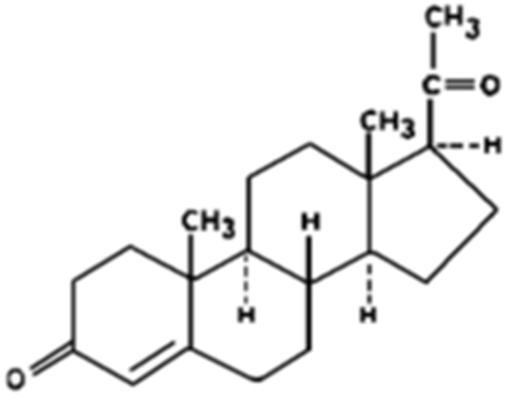
The drug substance used in this product is micronised to an acceptable specification limit. There is sufficient evidence to suggest that the particle size distribution of the manufactured batches of the drug substance will be consistent with the clinical batches.
The specifications for specified impurities are consistent with the current BP (2015)/Ph. Eur. (8.5) monograph and are acceptable. The manufacturing and quality control of the drug substance (including the drug substance specification) is acceptable. The proposed specification limits have been adequately justified.

Drug product
The proposed product is an immediate release soft capsule containing 100 mg or 200 mg of micronised progesterone and two other conventional pharmaceutical excipients including sunflower oil and soybean lecithin. The soft gelatin capsule shell composes of gelatin, glycerol and titanium dioxide.
Bioavailability studies were performed using primarily the formulation containing arachis (peanut) oil, which was the original proposed formulation. Following a recommendation in the clinical evaluation, the sponsor agreed to submit the product formulated with sunflower oil. A comparison of in vitro dissolution profiles was performed (Study #00RD40) to demonstrate bioequivalence of the arachis oil and sunflower oil formulations. A bridging bio-study 01272 was performed to demonstrate bioequivalence between (100 mg) formulation containing arachis oil and the formulation containing sunflower oil (see detail in ‘Biopharmaceutics’ section below).
The quality of the product is controlled by acceptable specification that includes tests and limits for Appearance, Identification, Assay, Uniformity of Dosage Units, Impurities, and microbial quality.
The analytical methods used to analyse the product were adequately described and validated.
The stability data supplied supported a shelf life of 36 months for the unopened product (in PVC/AL blister) when it is stored below 30°C, along with the statement ‘Do not refrigerate’.

Biopharmaceutics
Biopharmaceutical studies were provided as summarised below.
No absolute bioavailability study was provided and this has been adequately justified.
- Study Simon 1993 examined the oral bioavailability of the proposed capsules, formulated as proposed in arachis (peanut) oil. The major study concerning the oral use of the capsules comprised three parts as summarised below:
  - Food effect: This was a randomised three way open label cross over study in which 15 subjects (healthy postmenopausal females) received the proposed 200 mg capsules (Batch #13401: no details provided) under fed and fasted conditions and a placebo formulation. Dosing was for a 5 days and there was a 7 day washout between treatments.
Differences in AUC, Cmax and Tmax values between fasting and fed regimens were evaluated on Days 1 and 5 using a paired t-test. The Day 1 and Day 5 results appear to indicate that the extent of progesterone absorption is approximately doubled and the rate of absorption is approximately four times greater when the capsules are taken with food as compared to when they are taken under fasting conditions. No accumulation is observed after multiple dosing.
Note: under Dosage and Administration: The PI for Prometrium (oral) capsule states that the product should not be taken with food.
  - Dose proportionality: In an open, 3 way crossover study, 15 postmenopausal women undertook three dosing phases of 5 days each, as follows: Utrogestan (micronised progesterone: 100 mg, 200 mg or 300 mg; arachis oil formulation), administered to subjects in a fasting state once daily for a period of 5 days with a washout period of 7 days between treatments.
The pharmacokinetic parameters Cmax, Tmax and AUC0-t (AUC0-24 for Day 1 and AUC0-10 for Day 5) were calculated using non-compartmental methods from the plasma concentration profiles. The results showed that the AUC0-24 values increased approximately linearly with dose; there was no significant difference between the normalised results which was also consistent with linearity. A dose proportional increase in Cmax was obtained between doses of 100 and 200 mg. However, a larger than proportional increase was seen between the results for 200 mg and 300 mg.
  - Relative bioavailability: This was an open, 2 way crossover study in 15 postmenopausal women. The study consisted of two dosing phases of two days each, as follows: Utrogestan (micronised progesterone: 200 mg; arachis oil formulation), administered to subjects in a fasting state once daily for two days, and progesterone in oil, 50 mg (Rugby Company) administered by intramuscular injection once daily for two days. The phases were separated by a washout period of 7 days.
The results show that the oral bioavailability of progesterone compared with intramuscular injection is about 6-10%. The Tmax is significantly shorter after oral administration as compared with intramuscular administration of progesterone.
- Study 01272 compared progesterone formulated in sunflower oil (100 mg capsules) with progesterone formulated in arachis oil in a single centre, blinded, single dose, randomised, 2 way crossover study in healthy, postmenopausal female subjects under fasting conditions. The 90% confidence intervals for the test to reference ratios for Cmax, AUC0-t and AUC0-∞ for progesterone were within the bioequivalence acceptance criteria. Comparison of the median Tmax values for each formulation provided a p value of 0.8840, confirming that there was no difference between the results.
- Study Decourt (1998) compared bioavailability and progesterone metabolism after single vaginal or oral progesterone dosing. Plasma progesterone levels were compared following oral (200 mg) and vaginal administration of the proposed 200 mg capsules, as well as the 400 mg vaginal capsule. The results for Cmax and AUC for progesterone, following vaginal administration of 200 mg and 400 mg show an apparent saturation of absorption, or at least a nonlinearity between the 200 mg and 400 mg doses.
- Study Devroey (1994) compared the pharmacokinetic parameters after the administration of natural micronised progesterone by the oral or vaginal routes with the pharmacokinetic parameters of progesterone administered intramuscularly. A secondary objective was to correlate those PK data with the efficacy of progesterone in its target organ, the endometrium; this was done by the analysis of endometrial biopsies taken from the subjects in the four dosing groups.
  - It was seen that the intravaginal dosing provided reasonable stable plasma concentrations compared with oral dosing, and especially compared with those from IM dosing.
  - The results for Cmax and AUC for progesterone, following vaginal administration of 300 mg and 600 mg, showed an apparent saturation of absorption, or at least a nonlinearity between the two sets of data; this is consistent with the findings of Decourt (1998). The bioavailability of progesterone was greater following vaginal dosing compared with oral dosing; however, this did not reach the three fold increase recorded by Decourt (1998). Intramuscular dosing provided a significantly greater bioavailability of progesterone, based on AUC, compared with all three other dosing groups.
These results were brought to the attention of the clinical Delegate so that they could consider whether the proposed dosage and administration for Utrogestan 200 mg capsule is appropriate (based on the results which indicate a nonlinear pharmacokinetics between 200 mg and 300 mg doses and evidence that suggests an apparent saturation of absorption or a nonlinearity between 200 mg and 400 mg, and between 300 and 600 mg).

Quality summary and conclusions
Approval was not initially recommended with respect to chemistry and quality control, but all outstanding issue were later resolved and approval recommended from a chemistry and biopharmaceutics perspective.

III. Nonclinical findings

Introduction
All existing progesterone containing products registered in Australia are administered by the vaginal route (in the form of pessaries or gels) and are differently indicated. As such, this application represents an extension of indications and a new route of administration (per os [PO]; oral administration) for progesterone. The product also contains a novel excipient by the vaginal route, sunflower oil. The maximum recommended human dose of progesterone by the vaginal route (PV) with this product does not exceed that already approved (that is, 600 mg/day compared to 800 mg/day).
The nonclinical dossier contained nonclinical studies and published literature (hybrid submission) regarding the pharmacokinetics and toxicity of progesterone by the oral route, and on local (vaginal) tolerance. The proprietary studies were not performed according to Good Laboratory Practice (GLP), having been conducted prior to GLP implementation, but were mostly adequate.

Pharmacology
No nonclinical data were submitted to demonstrate the efficacy of orally or intravaginally administered progesterone for the proposed new indications. This is acceptable, and the efficacy assessment relied on clinical data only.

Pharmacokinetics
Low oral bioavailability (<8%) of non micronised progesterone was demonstrated in rabbits, attributable to extensive first pass metabolism and incomplete absorption from the GI tract. Micronisation and vaginal administration are both recognised to enhance absorption of progesterone; the sponsor also indicated that the inclusion of sunflower oil in the formulation enhances bioavailability. However, no nonclinical data directly comparing micronised and non micronised progesterone, exposure after PO and vaginal administration, or the effect of formulation were provided in the current submission.
Table 3: Single dose relative bioavailability.
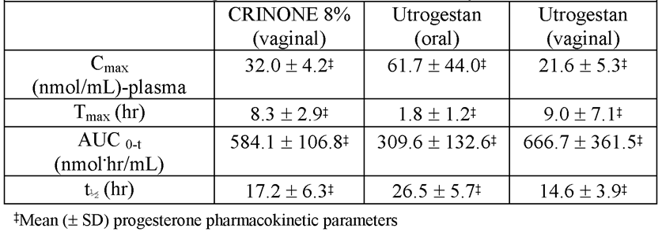
Clinical pharmacokinetic data compiled by the sponsor (see Table 4) show lower overall exposure (AUC), but higher/more variable peak plasma concentrations (Cmax) and more rapid absorption, with oral compared with vaginal administration.
Table 4: PK results of clinical studies included in the assessment of clinical pharmacology of Utrogestan.
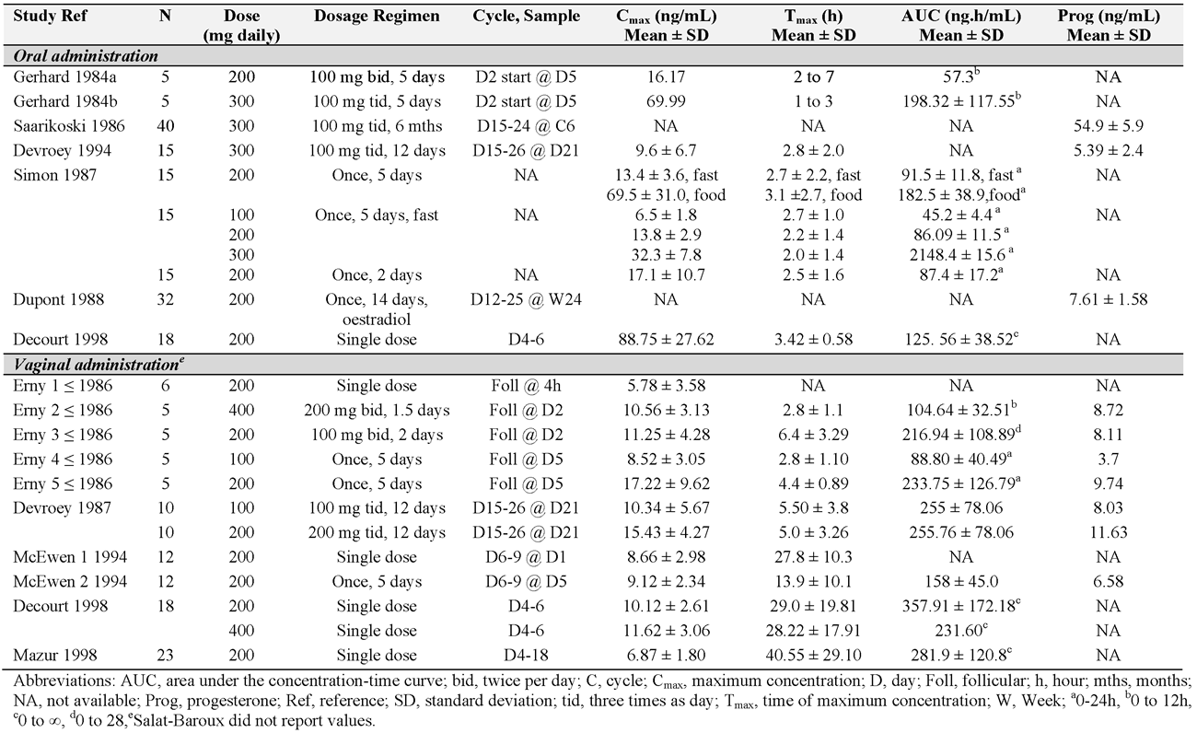
The approved Australian PI document for Crinone 8% vaginal gel (90 mg progesterone) also contains clinical data comparing the pharmacokinetics of orally and vaginally administered progesterone. In a study in healthy, postmenopausal women, single dose administration of a 100 mg Utrogestan capsule by the oral route yielded a plasma Cmax almost 3 times higher and a plasma AUC around half that associated with vaginal administration.

Toxicology
Supporting safety, overall systemic exposure to progesterone (plasma AUC) is not increased with this product cf. existing ones, based on consideration of the pharmacokinetic data described above and the maximum currently approved and proposed daily doses.
The novel aspects of Prometrium/Utrogestan give rise to the following toxicological concerns, which are explored in subsequent sections:
- potential for increased acute toxicity due to the higher plasma Cmax associated with oral dosing
- potential for local effects in the GI tract associated with the new route of administration (PO)
- local tolerance with vaginal administration, including with respect to the presence of sunflower oil, a novel excipient by this route.

Acute toxicity
The acute oral toxicity of micronised progesterone (administered as an emulsion in arachis oil) was investigated in rats. Clinical signs – comprising decreased activity, collapse, reduced respiration rate, coma, piloerection and tremor – were observed in females at doses ≥250 mg/kg and in males at ≥640 mg/kg. Maximum observed nonlethal doses were 320 mg/kg and 640 mg/kg in the respective sexes. Anaesthetic and sedative effects of high doses of progesterone (and other steroids) have long been recognised. Supporting clinical safety, no acute adverse effects were noted in female rats at 160 mg/kg PO, a dose that is 20 times higher than the maximum recommended PO dose proposed by the sponsor on a mg/kg basis, and 3.6 times higher on a mg/m² body surface area basis (assuming 50 kg patient body weight as a conservative measure).

Repeat dose toxicity
The repeat dose toxicity of micronised progesterone (administered in arachis oil) was investigated in studies of 3 months duration in rats and dogs. A pilot 4 week rat study, with limited examinations, was also submitted. The duration of the pivotal studies was adequate, and dose selection and group sizes were appropriate. Only female animals were used in the definitive studies, which is acceptable given the patient population.
Treatment at oral doses of up to 45 mg/kg/day in rats and 125 mg/kg/day in dogs produced no gross or microscopic lesions in gastrointestinal tissues. Supporting clinical safety, these doses are approximately 6 and 16 times higher than the maximum human oral dose of progesterone proposed here (on a mg/kg basis; assuming 50 kg patient body weight). Higher doses were associated with loss of hepatic structure and hepatic necrosis in rats (at 135 mg/kg; observed in 1/18 animals; relationship to treatment unclear) and inflammation of the mesenteric lymph nodes and inflammation with necrotic patches in the caecum in dogs (at 325 mg/kg; in 1/4 animals) (17-41 times the human dose on a mg/kg basis). Other findings in the studies – including changes in haematology and serum chemistry parameters and effects on reproductive tissues – are consistent with previous observations with the compound by other routes of administration.

Local tolerance
Utrogestan capsules, and placebo capsules formulated without progesterone, were shown to be well tolerated locally in rabbits in a study involving once daily intravaginal administration for 29 days. The Utrogestan formulation tested in the study was not specified in the report, but the sponsor notes that it is likely to be based on arachis oil rather than sunflower oil considering the date of the study and history of product development. The dose of progesterone (and oil) tested vaginally in rabbits in the study is roughly equivalent to the maximum recommended daily vaginal dose in patients (on a mg/kg basis; assuming 50 kg patient body weight).
No nonclinical data on the local tolerability of sunflower oil by the vaginal route were submitted. Local tolerance concerns are addressable from the clinical dataset and from overseas experience, however, so this is not considered to be a major deficiency.

Pregnancy category
The sponsor proposes placement of Prometrium and Utrogestan in Pregnancy Category A. This is consistent with the historical categorisation of a number of existing progesterone containing products. Placement of a drug in Pregnancy Category A is based on clinical evidence. Questions over the adequacy of the clinical data to support placement in Category A for progesterone are raised, though, given the statement in the review article by Golub (2006) (included in the dossier, but covering human and animal studies) that there is “a minimal scientific database for evaluating safe use (of exogenously administered progesterone) during pregnancy” and that existing human epidemiology data seem to cover safety only over certain periods of exposure. Animal and human data have raised potential concerns regarding genital abnormalities in offspring following intrauterine exposure to progestogens. In the absence of robust clinical data to allay such concerns, the Delegate should consider revision of progesterone to Pregnancy Category D. With regard to the categorisation, it should be borne in mind that such data needs to cover use in pregnancy more broadly than just as specifically indicated.

Nonclinical summary and conclusions
- The nonclinical dossier was provided as a hybrid literature based submission. The formulation of the product was revised during the course of the evaluation (from arachis oil based to sunflower oil based).
- No nonclinical data relating to efficacy in the proposed new indications were submitted. The efficacy assessment relies on clinical data only.
- Oral administration of (micronised) progesterone is associated with lower overall exposure (AUC) but higher peak plasma concentrations (Cmax) compared with vaginal administration.
- A single dose oral toxicity in rats identified sedative and other effects of progesterone at higher than therapeutic doses.
- Repeat dose toxicity studies by the oral route of up to 3 months duration were conducted in rats and dogs. With regard to potential local toxicity associated with the new route of administration, no treatment-related gross or microscopic lesions were observed in gastrointestinal tissues at doses up to ~6 (rats) and ~16 times higher (dogs) than the maximum oral dose proposed for use in patients. Systemic effects in the studies were consistent with those previously observed with the compound by other routes of administration.
- No remarkable vaginal irritancy was observed in female rabbits with repeat daily administration of Utrogestan capsules at a dose of progesterone roughly equivalent to the maximum recommended vaginal dose in patients (on a mg/kg basis). This study was conducted with progesterone formulated in arachis oil rather than in sunflower oil as proposed for the product to be marketed.
- No existing vaginal medicine registered in Australia contains sunflower oil. The sponsor provided no nonclinical data to support the local tolerability of this excipient by the vaginal route. Assessment of this aspect of safety must be based on clinical data only.
- There are no nonclinical objections to the registration of Prometrium, and none for Utrogestan provided that vaginal tolerability of a sunflower oil based formulation is adequately established from the clinical dataset.

IV. Clinical findings
A summary of the clinical findings is presented in this section. Further details of these clinical findings can be found in Attachment 2.

Introduction

Clinical rationale
Progesterone is a naturally occurring steroid hormone which plays a pivotal role in the maintenance of pregnancy and the regulation of menstruation. In the menstrual cycle, it promotes maturation of the endometrial lining to allow implantation of a fertilised embryo, and is essential to maintain pregnancy. During pregnancy progesterone is produced by the Corpus Luteum for 7-9 weeks before placental production is established. Falling progesterone levels, in the absence of a fertilised embryo, during the normal menstrual cycle lead to the onset of menstrual bleeding. Progesterone is likely to be a factor in maintaining uterine quiescence during pregnancy, and a reduction levels may be one factor in the onset of labour.
The first clinical rational for Utrogestan is to provide progesterone supplementation to women in whom natural production is absent or deficient in order to support implantation of embryos in assisted reproduction and maintain early pregnancy.
The first clinical rationale for Prometrium is to provide progesterone as part of Hormone Replacement Treatment in women with an intact uterus. This is recommended to reduce the potentially carcinogenic effect of unopposed oestrogen treatment on the uterus. The second clinical rationale is to provide progesterone production in women with irregular menstrual cycles or secondary amenorrhea. This promotes the development of endometrium typical of the luteal phase of the menstrual cycle which, when progesterone is withdrawn, leads to menstrual bleeding.
Progesterone has a low oral bioavailability of about 7% due to extensive first pass metabolism. The micronised formulation is intended to increase absorption of progesterone, and the vaginal administration of Utrogestan is to significantly increase bioavailability by avoiding entero-hepatic circulation.

Contents of the clinical dossier
The dossier contained 17 studies providing pharmacokinetic data and 5 providing pharmacodynamic data which the evaluator considered pivotal in those areas.
The dossier contained several company sponsored clinical efficacy studies supported by an extensive literature review which provided published references, clinical consensus statements and meta analyses regarding the use of progesterone. The sponsor divided these into pivotal studies, primary and secondary literature sources, and the evaluator considered these designations.

Hormone replacement therapy
The sponsor provided two evaluable safety and efficacy studies which the evaluator considered pivotal; Lorrain (1994) and Moyer (1987). Christiansen (1985) is considered a non-pivotal trial.
The sponsor provided supporting literature which the evaluator considered non-pivotal for reasons described in the evaluation of these trials in an attachment to this report.

Luteal phase support
The sponsor provided one study (Kleinstein (2002)) which the evaluator considers pivotal. A second study (Salat-Baroux (1988)) was submitted by the sponsor as pivotal but the evaluator considered it insufficient as pivotal evidence for reasons outlined in the description of this trial. It has been considered supportive. Six meta-analyses, Polyzos (2010), Liu (2012), Nosarka (2005), Van der Linden (2011, 2012), Glujovksy (2010) and Hill (2013) are considered supportive evidence.
Six further trials or clinical guidelines. These were considered by the evaluator.

Menstrual irregularities
The sponsor submitted one pivotal study (Simon (1988)) in support of this indication. A Cochrane review (Hickey (2012)) which found no useful studies was submitted as supportive evidence.

Paediatric data
The submission did not include paediatric data.

Good clinical practice
Clinical trials appear to have been conducted in accordance with GCP but this cannot be confirmed for published references.

Pharmacokinetics

Studies providing pharmacokinetic data
The dossier contained 17 studies which provided pharmacokinetics data.
Of particular relevance was Study 01272 2002: a randomised 2 way crossover trial which examined the pharmacokinetics of a single oral dose of Utrogestan 2 x 100mg capsules containing either sunflower oil or peanut oil as an excipient in 60 healthy postmenopausal women. This indicated that Utrogestan arachis oil was bioequivalent to Utrogestan sunflower oil with the ratios of the two AUCs being within 80-125%.

Summary of pharmacokinetics
Progesterone is 96-99% protein bound and metabolised in the liver to glucuronide metabolites which are excreted in the bile and urine. Tmax is 3-4 h with an elimination half-life of 12-18 h. Bioavailability is significantly increased for PV progesterone compared to PO progesterone due to reduced first pass metabolism (AUC 114.45 ng.h/mL versus 359.96 ng.h/mL for 200 mg oral and vaginal single doses, respectively). Bioavailability increases approximately linearly across the proposed dosage range but is more variable between subjects in PO than PV dosing. Food approximately doubles the AUC of progesterone compared to fasted subjects.
The sunflower and peanut oil presentations of Utrogestan are orally bioequivalent.
A single dose of Utrogestan PV was 50% more bioavailable than Crinone 8% progesterone cream administered PV (AUC ratio 146%; 90% CI 126.2-169.1%) when administered to healthy women. In this study an applicator was used to administer both medications.
There is evidence that progesterone is retained in the endometrium when administered PV for ART.

Evaluator’s conclusions on pharmacokinetics
Progesterone is a naturally occurring hormone for which the oral pharmacokinetics has been examined extensively. Drug interaction studies were not submitted and may be significant given the extensive hepatic metabolism of progesterone. Utrogestan per vagina/vaginal (PV) is not bioequivalent to Crinone 8% cream.

Pharmacodynamics

Studies providing pharmacodynamic data
Progesterone is a naturally occurring hormone and its pharmacodynamic effects are its normal biological actions. Endometrial morphology was assessed in 137 women in 4 studies: Saarikoksi (1986), Devroey (1994), Dupont (1991), and Foidart (1993). Hormone levels were measured in 77 women in 3 studies; Saarikoksi (1986), Dupont (1991) and Erny (1986).
Saarikoski (1986) was a parallel two arm study of 80 women randomised to receive progesterone 300 daily (n = 40) or noesthistrone 15 mg (n = 40) on Days 15-24 of 6 menstrual cycles. Subjects were women aged 33-59 with dysfunctional menstrual bleeding disorders. Endometrial biopsy was assessed at the end of the 3rd and 6th cycles.
Table 5: Histological status of endometrium after treatment with progesterone.
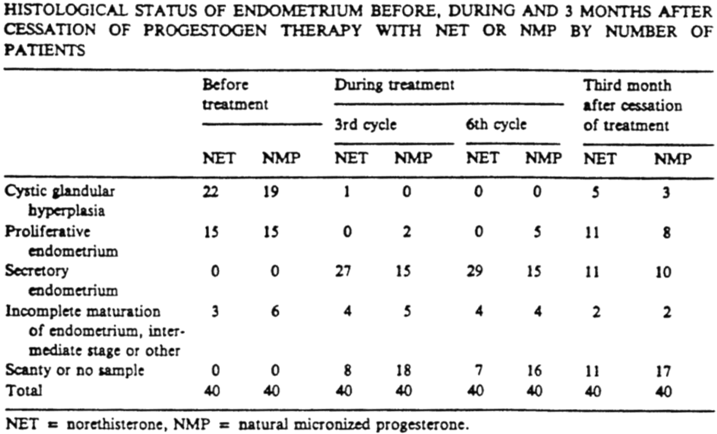
The majority of women receiving progesterone (NMP) moved from glandular hyperplasia on cycle 3 to secretory endometrium typical of the luteal phase of the menstrual cycle. Histological samples were only obtained in 33/40 subjects at Week 6.
Dupont (1991) was a parallel 4 arm study in 63 women equally randomised to receive percutaneous estradiol or oral estradiol +/- progesterone 200mg daily on Day 12-25 of six menstrual cycles (n = 15-16 each arm). The primary endpoint was relief of menopausal symptoms and half the subjects had undergone hysterectomy. In women with a uterus, endometrial biopsy was assessed before and after 6 cycles of treatment.
Table 6: Endometrial biopsy results after progesterone and oestrogen treatment.
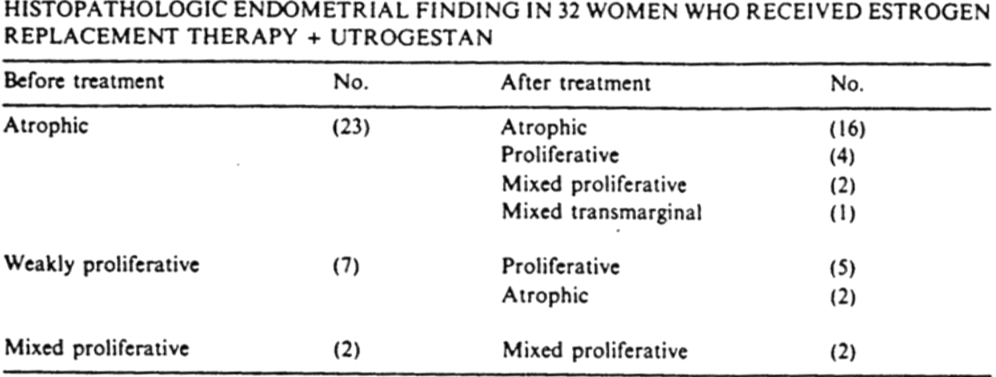
The majority of women receiving oestrogen plus progesterone retained an atrophic post-menopausal pattern, but 9/32 developed a degree of endometrial proliferation.
Foidart (1992) was a single arm study of 30 post-menopausal women to observe changes in endometrial histology following treatment with percutaneous estrodiol 2.5mg daily combined with 100mg progesterone from day 1 to day 25 of each cycle for 1 year. Endometrial histology was obtained before and after treatment. A total of 22 of the pre-treatment biopsies and 26 of the post-treatment biopsies provided sufficient tissue for examination. The pre-treatment biopsies all indicated atrophic endometrium, and none of the 26 post-treatment biopsies indicated secretory maturation or suggestion of endometrial proliferation.
Devroey (1994) was primarily a pharmacokinetic study in 46 women without ovaries who were randomised to four dosage schedules of progesterone while receiving concomitant oestrogen therapy. These were not independent treatment arms; 59 progesterone treatments were received by 46 women over different cycles. The report notes that biopsies were not obtained in all women but where they were ‘adequate endometrial morphology’ in all patients, but does not provide a tabulated or statistical analysis.
Erny (1986) examined the pharmacokinetics of two doses of 200 mg progesterone taken 24 h apart in 6 healthy volunteers. This study measured the levels of hormones as well as progesterone.

Evaluator’s conclusions on pharmacodynamics
The findings of the pharmacodynamic studies are unremarkable.

Dosage selection for the pivotal studies
There are no dedicated dosage selection trials. The dosages proposed for clinical treatment are included in the pharmacodynamic studies but there is no evidence that they are optimal, or the lowest dose which will achieve the desired therapeutic effect.

Efficacy

Indication 1: adjunctive use with an oestrogen in postmenopausal women with an intact uterus (for Hormone Replacement Therapy)

Studies providing efficacy data
Lorrain (1994): This was a one year single centred study in 40 healthy post-menopausal women randomised equally to receive sequential HRT for at least 13 consecutive cycles. Patients were enrolled in the study for up to 4 years.
Moyer (1987): This was an open label, uncontrolled, single centre study which enrolled 236 women taking oestrogen/progesterone HRT for a five year period between 1980 and 1987. The study methodology notes that it was ‘prospective’ for the period 1980-1986 and ‘retrospective’ for the period 1986-1987.
Christiansen (1985): This was a two year study which originally enrolled 57 post-menopausal women in a single centre double blind study comparing four arms of treatment; placebo, calcium 1000 mg o.d, estradiol gel (oestrogel) 3mg daily + calcium 1000mg o.d, or estradiol gel 3 mg alone o.d.

Conclusions
The evaluator noted that TGA has endorsed the EMA auspiced guidelines.
The efficacy of oestrogen as a symptomatic treatment for post-menopausal symptoms is not at issue in this evaluation, which deals with the efficacy of progesterone as a component of that therapy. The purpose of progesterone in combination HRT is to mitigate the long-term effects of unopposed oestrogen on the endometrium. The relevant efficacy endpoint is, therefore, endometrial ‘safety’.
Of relevance to this evaluation, the guidelines state that:
- Endometrial biopsy is the gold standard method for assessing endometrial safety.
- A minimum of one year therapy is required to assess endometrial safety.
- Biopsies should be assessed by two independent pathologists blinded to treatment and time of biopsy, with a third blinded pathologist to arbitrate disagreements in interpretation.
- For sequentially combined treatment, it is recommended that biopsies be obtained at a pre-specified time in the treatment cycle, at least 10 days after the start of progesterone administration.
- A new HRT should be comparable to, or better than, currently marketed HRTs with respect to endometrial safety. The decision on endometrial safety must be based on reliable data from a sufficient number of patients treated for a sufficient period of time.
The trials submitted by the sponsor do not meet this standard of data regarding endometrial safety.
Lorrain (1994) enrolled only 20 patients. While this allowed data to be collected on 393 ‘cycles’ of treatment, repeated sampling of safety in 20 women does not increase the sample size for safety evaluation because the findings of each cycle are not independent of each other. In any case, a significant number of women did not have sufficient tissue on biopsy for endometrial histology to be performed and the line listing indicates that sampling did not occur at a specified time in the treatment cycle. The system for arbitrating abnormal findings (3 patients with adenomatous hyperplasia) on endometrial biopsy was not standardised. These factors combined make Lorrain (1994) uninformative with respect to endometrial safety.
Moyer (1987) was a larger study but failed to obtain endometrial biopsies in the majority of patients, in whom endometrial safety was reported on the macroscopic appearance of the endometrium on hysteroscopy. This is not an acceptable means of assessing safety and makes Moyer (1987) uninformative with respect to endometrial safety.
Furness (2012) was a Cochrane review of the endometrial safety of HRT which concluded that progestogen therapy in combined sequential HRT regimens decreases the risk of endometrial hyperplasia. This analysis only included one trial which used progesterone in the sequential regimen proposed and thus it does not directly inform the safety of micronised progesterone.
The variety of supporting documentation in the form of clinical guidelines does not provide evaluable data for the purposes of assessing endometrial safety, although it provides a clinical consensus supporting the use of progestogens in HRT.

Indication 2: luteal phase support

Studies providing efficacy data
Kleinstein (2002): This was a randomised, open label, active treatment controlled study in 430 women receiving IVF or Intracytoplasmic Sperm Injection (ICSI) which occurred between 1999 and 2001. The study involved 17 centres in Germany. Enrolled women were randomly allocated to receive either Crinone 8% progesterone vaginal cream (n = 212) or Utrogestan 200 mg capsules (n = 218) for luteal phase support. The purpose of the study was to compare the rate of successful implantation of pregnancies at the 12th week of pregnancy.
Polyzos (2010): This is the published literature report of a meta-analysis of studies comparing the efficacy of different forms of vaginal progesterone for luteal support. The authors considered all randomised controlled trials in which any form of P4 was used for luteal support in IVF or ICSI. The analysis was performed on published reports of the included studies. Seven trials were selected for inclusion.
Liu (2012): This was a meta-analysis of six randomised controlled studies to examine the effect of the duration of progesterone treatment on pregnancy outcomes. In the majority of cases P4 is provided until 7-12th week of gestation. This analysis indicates that there may be no different in pregnancy rate between continuing P4 therapy and ceasing it on the day of a positive β-HCG test.
Nosarka (2005): This was a meta-analysis of published trials which examined whether luteal support with HCG or progesterone was effective at increasing rates of pregnancy compared to placebo. Six trials examined the effectiveness of progesterone compared to placebo, four of which used intramuscular injection of 17P and one of which used oral Dydrogesterone. The study which examined vaginal progesterone used 100mg BD vaginal pessaries.
Van der Linden (2011, 2012): This was a review by the Cochrane Collaboration examining the efficacy of several treatments for luteal support on pregnancy outcomes.
Glujovsky (2010): This was a Cochrane review of studies to examine the optimal regimen for preparing women undergoing transfer of frozen embryos or embryos from donor oocytes. The primary endpoint it examined was the rate of live births. A total of 22 randomised controlled studies were included, of which four compared progesterone routes of administration. Only one of these involved use of micronised vaginal progesterone. The review concluded that there was insufficient evidence to recommend any particular preparatory protocol with regard to live births.
Hill (2013): This was a meta-analysis of the effect of luteal phase support with progesterone following ovulation induction and intrauterine insemination (IUI).

Conclusions
The sponsor has provided a methodologically sound pivotal trial Kleinstein (2002) which establishes the equivalence of progesterone capsules to vaginal cream for luteal support of early treatment in assisted reproductive therapy to within a non-inferiority margin of 10%. The evaluator notes that the point estimate of effect for progesterone capsules are superior to cream in this analysis.
Salat-Baroux (1988) was submitted as a pivotal trial in support of luteal support of women with ovarian failure during oocyte donation. The report of this study does not allow the evaluator to assess the validity of this trial for the reasons outlined in the attachment.
The evaluator notes the limitations of interpreting published reports of meta-analyses discussed apply to the data submitted in support of this indication. However, the meta-analyses are better representative of the effect of vaginal progesterone (as opposed to progestogens generally) relevant to the proposed indication and presentation. This indicates the superiority of progesterone for luteal support over placebo.

Indication 3: treatment of menstrual irregularities

Studies providing efficacy data
Simon (1988): This was a randomised, double blind, placebo controlled study which examined the efficacy of Prometrium in the induction of withdrawal bleeding in 60 patients with secondary amenorrhea. Participants were randomised with equal probability to receive placebo (n = 21), 200 mg Prometrium daily (n = 19) or 300 mg Prometrium daily (n = 20) for 10 days. The primary efficacy endpoint was induction of withdrawal bleeding. The study was conducted at one obstetric centre in the US in 1988.
Hickey (2012): This is a Cochrane review examining the efficacy of progestogens with or without oestrogen in the management of irregular uterine bleeding associated with anovulation. This identified no randomised trials which compared progestogens with oestrogens, or progestogens with placebo in the management of irregular bleeding associated with anovulatory cycles. The authors concluded that there is a paucity of randomised studies which examine this issue, and that there is no consensus about which regimens are the most effective.

Conclusions
Little data has been submitted in support of this indication and the main finding of the Cochrane meta-analysis Hickey (2012) has been to demonstrate the paucity of this data in the literature. The evaluator notes that the Cochrane review did not identify the sponsor’s pivotal trial Simon (1988) as a relevant study for irregular uterine bleeding associated with anovulation.
Simon (1988) is a small study which established a statistically significant effect on withdrawal bleeding in a population with secondary amenorrhea. The main limitation of this data is that women were only treated for a single episode and the efficacy of ongoing treatment, whether this is in combination with other hormone therapy or as monotherapy, is not examined.

Safety

Studies providing safety data
Safety data was mainly available from the company sponsored studies which were provided as full study reports. These are:
- Hormone Replacement Therapy (oral): Lorrain (1994), Moyer (1987), Christiansen (1985)
- Luteal phase support (vaginal): Kleinstein (2002), Salat-Baroux (1988)
- Menstrual irregularities (oral): Simon (1988)
The meta-analyses submitted in support of these indications generally do not examine safety endpoints. The meta-analyses examining to Luteal Phase Support present data on miscarriage rates and immediate neonatal outcomes, but this is directly related to the therapeutic efficacy of the product and has been examined in that context.
Laboratory data is available from company sponsored studies only.
The sponsor submitted 6 additional systemic analyses addressing the safety of progesterone in Hormone Replacement Therapy which are described.
No company sponsored trial addressed safety as a primary outcome.
The sponsor submitted Post Marketing safety data covering the period 1998 to August 2013.

Patient exposure
The sponsor has noted that micronized progesterone has been clinically available worldwide for more than 50 years and clinical experience is extensive. Utrogestan was first marketed in France in 1980. The cumulative exposure to Utrogestan capsules from 2008 to 2011 is estimated to be 650,391 patient years for the 100 mg capsules, and 320,303 patient years for the 200 mg capsules.
Exposure in the sponsor initiated trials in this dossier is shown in Table 7.
Table 7: Patient exposure company initiated trials.
Trial | Indication | Treatment | Number of patients treated | Duration of treatment
Christiansen (1985) | HRT | Utrogestan 200 mg daily on days 14-28 of cycle | 29 | 1 year
Kleinstein (2002) | Luteal Support | Utrogestan 600 mg daily | 218 | 10 weeks
Lorrain (1994) | HRT | Utrogestan 200 mg on days 14-28 of cycle | 20 | 13 months
Simon (1988) | Menstrual irregularity | Utrogestan 200 mg and 300 mg daily | 39  (19 x 200 mg; 20 x 300 mg) | 10 days
Salat-Baroux (1988) | Luteal support | Up to 600mg daily | 22 | 60 days
Moyer (1987) | HRT | 200 mg or 300 mg daily on days 14-28 of cycle | 157  (131 x 200 mg; 26 x 300 mg) | >5 years

Safety issues with the potential for major regulatory impact
None reported in Periodic Safety Update Reports (PSURs).

Post marketing data
The sponsor provided 13 PSURs covering the period 1998-2011.
Serious AEs reported in the post marketing experience with Utrogestan/Prometrium are presented.

Evaluator’s conclusions on safety

HRT
The safety of progesterone for HRT indication is represented both in the efficacy data and safety studies submitted, since the main effect of progesterone is to provide ‘safety’ against endometrial complications of unopposed oestrogen therapy. As discussed above, the pivotal data submitted in Lorrain (1994) and Moyer (1987) is sufficiently methodologically flawed to prevent analysis of this endpoint. Furness (2012) is a meta-analysis which provides support for the effect of progestogens in reducing the rate of endometrial hyperplasia to placebo levels but is not statistically definitive for progesterone per se.
The evidence for side effects of progesterone itself, rather than of HRT, is entirely derived from post-marketing data. Given the long historical experience with progesterone the Evaluator feels this is likely to be indicative of the adverse events related to progesterone.
The analysis of the safety of progesterone as a component of HRT therefore relies entirely on the published meta-analyses indicating the historical experience of combination HRT; Marjoribanks (2012), Furness (2012), Greiser (2007), Liu (2012), Maclennan (2004). These indicate the slightly increased rate of breast cancer, heart disease, stroke and dementia found in long term studies.

Menstrual irregularities
There was no safety data for this indication, and so safety would depend on the duration of treatment. As a short term therapy for secondary amenorrhea the evaluator concludes that there is unlikely to be significant AEs not observed with similar doses administered in the long term for HRT.

Luteal phase support
As with support of pregnancy, the safety of progesterone in this indication relates to the mother and the child.
The pivotal studies did not report significant adverse effects of progesterone in mothers over the period of treatment in excess of those which are associated with pregnancy itself.
There was no long term paediatric data submitted to demonstrate the lack of long term effects of progesterone on development. The evaluator notes, however, that there considerable historical post-marketing oversight by regulatory agencies in comparable jurisdictions for this indication. The increased uterine exposure to progesterone from vaginal administration is relevant to paediatric safety, but is countered by evidence supporting increased efficacy for vaginal progesterone in luteal support compared to other routes of administration. Pharmacological luteal support is required where there is a luteal phase deficit for IVF to work, for example, placebo is not a viable option as an alternative.
The evaluator also notes that the general concern about potential allergy to peanut oil is significant for vaginal administration of progesterone (see below). Whether refined peanut oil is safe in general, the evaluator is of the view that even localised cervical inflammation may be relevant to pregnancy outcomes in women at low risk of conception. No evidence has been provided to support the safety of peanut oil in this indication.
Due to these concerns with peanut oil, the sponsor agreed that the final formulation will contain sunflower oil.

General: peanut oil
Prometrium and Utrogestan are marketed worldwide in presentations which are based on either peanut or sunflower oil.
The US, Canada, UK, France, Germany and Switzerland do not have a vaginal presentation containing peanut oil registered.
The sponsor has provided EMA regulatory guidance which does not apply to vaginal administration of peanut oil and, indeed, highlights the lack of conclusive safety of refined oils. The rate of oral reaction to peanut oil is not indicative of the significance of local reactions to the two indications proposed for vaginal progesterone.
The evaluator notes that the safety of peanut containing vaginal progesterone would be more plausibly supported by the sponsor had not women with an allergy to peanut not been excluded from pivotal clinical trials.
While a warning for people at risk of peanut allergy to avoid using Utrogestan may be appropriate if the risk could not be definitively removed, it is inappropriate when it is possible to engineer the risk out of the clinical environment. Since there is a sunflower oil based product marketed in many comparable jurisdictions, this should be the one supplied in Australia. This avoids the potential for the warning regarding allergy to be ineffectively communicated in the clinical setting, or AEs occurring in women whose local reactivity is not commensurate with their oral tolerance of peanut oil.
Due to these concerns with peanut oil, the sponsor agreed that the final formulation will contain sunflower oil.

First round benefit-risk assessment

HRT
The considerable historical experience with progestogen containing HRT, clinical consensus, and the large post-market oversight for this indication, suggest that progesterone is likely to be safe and effective as part of combination HRT. The evaluator notes the approval of this indication in the US, Canada and UK. The pivotal trials submitted in support of endometrial safety are, however, extremely poor and should not be relied upon. Balancing this, several large meta-analyses consistent with clinical consensus indicate that endometrial safety of combined HRT with progestogen is acceptable.

Luteal phase support
The efficacy of vaginal progesterone in luteal support is adequately demonstrated by the submitted data. The main risks are the lack of long term paediatric data and the probability of allergic reactions to the originally proposed peanut oil containing formulation. The latter is an unacceptable risk given that it can be avoided by marketing a closely related product.
- Due to these concerns with peanut oil, the sponsor agreed that the final formulation will contain sunflower oil.

Menstrual irregularities
Progesterone appears effective in the short term management of secondary amenorrhea. There is no safety data supporting this indication in the dossier, although there is some regulatory oversight of post-marketing experience in comparable jurisdictions. The risk of AEs is mitigated by the short term use of the product, and similarity to the dose proposed for intermittent HRT.

First round recommendation regarding authorisation
The evaluator recommended that:
- The proposed indication for HRT be approved with the wording changed to “Prometrium Capsules are indicated for use in the prevention of endometrial hyperplasia in non-hysterectomised postmenopausal women who are receiving conjugated estrogens tablets”. This recommendation is based on the understanding that the sponsor makes the changes to the PI as recommended.
- The proposed indication for Menstrual Irregularities be approved, with the wording of the Indication changed to “The management of secondary amenorrhea”. This recommendation is based on the understanding that the sponsor makes the changes to the PI as recommended.
- The evaluator recommends that both indications for vaginal use of peanut oil containing progesterone be rejected due to inadequate safety data to support this route of administration in the clinical settings proposed. Due to these concerns with peanut oil, the sponsor agreed that the final formulation will contain sunflower oil.
If the sponsor is minded to supply a sunflower oil containing formulation for vaginal administration, the evaluator feels that:
- The proposed indication for Luteal Support be approved, with the wording of the Indication changed to “Luteal Support of Assisted Reproductive Technology (ART) cycles”. This recommendation is based on the understanding that the sponsor make the changes to the PI recommended.
The sponsor responded to these recommendations by agreeing to submit the product formulated with sunflower oil and making some amendments to the PI.

Clinical questions
None

V. Pharmacovigilance findings

Risk management plan
The sponsor submitted a Risk Management Plan (RMP, version 2.0, dated 6 October 2014, Data Lock Point 6 October 2014) and Australian Specific Annex (ASA, version 1, dated 19 November 2014) which was reviewed by the RMP evaluator.

Safety specification
The sponsor provided a summary of ongoing safety concerns which are shown at Table 8.
Table 8: Ongoing safety concerns.
Important identified risks | Vaginal and oral route  Thromboembolic events, including deep vein thrombosis, pulmonary embolism  Oral route (for HRT)  Neoplasms: breast cancer
Important potential risks | Vaginal and oral route  Liver enzyme induction or inhibition with certain medications  Gravidic cholestasis, following use beyond the first trimester of pregnancy  Use in hepatic impairment
Missing information | Vaginal and oral route  Use in paediatric adolescents  Use in diabetic patients

RMP reviewer comment
The sponsor was requested to provide information on whether the additional indications sought in Australia, not considered by the EU RMP, warrant the inclusion of additional safety concerns.
The following safety concerns were requested to be added unless a compelling justification could be provided for their omission:
- ‘Inadvertent use in peanut-allergic individuals’;
- ‘Off-label use’; and
- ‘Depression/mood changes’.

Pharmacovigilance plan
Routine pharmacovigilance was proposed by the sponsor in the EU RMP and ASA to monitor the safety concerns attributed to progesterone. No additional pharmacovigilance activities were proposed.

RMP reviewer comment
There was considerable international post-market experience with this product and therefore the sponsor’s proposal to employ routine pharmacovigilance is acceptable at this time. Additional pharmacovigilance may be required should the clinical evaluator determine that there are additional risks requiring monitoring that are not addressed in the RMP.

Risk minimisation activities
The sponsor has concluded that only routine risk minimisation activities (that is, product labelling) are necessary to mitigate the risks associated with progesterone.

RMP reviewer comment
The sponsor’s proposal to employ routine risk minimisation activities is acceptable at this time.

Reconciliation of issues outlined in the RMP report
The following section summarises the first round evaluation of the RMP, the sponsor’s responses to issues raised by the TGA RMP reviewer, and the RMP reviewer’s evaluation of the sponsor’s responses.

Recommendation #1 in RMP evaluation report
Safety considerations may be raised by the nonclinical and clinical evaluators through the consolidated Section 31 request and/or the nonclinical and clinical evaluation reports respectively. It is important to ensure that the information provided in response to these includes a consideration of the relevance for the RMP, and any specific information needed to address this issue in the RMP. For any safety considerations so raised, the sponsor should provide information that is relevant and necessary to address the issue in the RMP.

Sponsor response
The company noted the RMP evaluator’s comments.

Evaluator’s comment
N/A

Recommendation #2 in RMP evaluation report
The current EU RMP safety specification appears to only consider safety information relating to the indications approved in the UK. As it relates to the proposed Australian indications the RMP should be representative of all indications sought in the application. Therefore, safety information relating to treatment of menstrual irregularities should be included in the safety specification of the EU RMP/ASA.

Sponsor response
The company acknowledged the evaluator’s comments and provided further update on this aspect during the evaluation.

Evaluator’s comment
The sponsor has not responded to this recommendation.

Recommendation #3 in RMP evaluation report
The sponsor was asked to provide information on whether the additional indications sought in Australia, not considered by the EU RMP, would warrant the inclusion of additional safety concerns.

Sponsor response
The sponsor advised that no additional safety concerns were warranted due to the inclusion of additional indications sought with this submission.

Evaluator’s comment
The clinical evaluator recommended the inclusion of additional safety concerns.

Recommendation #4 in RMP evaluation report
‘Inadvertent use in peanut-allergic individuals’ should be added as a safety concern unless a compelling justification can be provided for its omission.

Sponsor response
As the sponsor submitted a revised dossier for formulation containing sunflower oil, this safety concern noted in this question is no longer applicable.

Evaluator’s comment
This is acceptable from an RMP perspective.

Recommendation #5 in RMP evaluation report
‘Off-label use’ should be added as a safety concern unless a compelling justification can be provided for its omission.

Sponsor response
The sponsor acknowledged the evaluator’s comments and provided further update on this aspect during the evaluation.

Evaluator’s comment
The sponsor has not responded to this recommendation.

Recommendation #6 in RMP evaluation report
‘Depression/mood changes’ should be added as a safety concern unless a compelling justification can be provided for its omission.

Sponsor response
The sponsor acknowledged the evaluator’s comments and provided further update on this aspect during the evaluation.

Evaluator’s comment
The sponsor has not responded to this recommendation.

Recommendation #7 in RMP evaluation report
The sponsor should provide updated information regarding reports of medication error, especially those occurring in the post-market period. Such information should also be included in the RMP when it is next updated.

Sponsor response
The sponsor acknowledged the evaluator’s comments and provided further update on this aspect during the evaluation.

Evaluator’s comment
The sponsor has not responded to this recommendation.

Summary of recommendations
It is considered that the sponsor’s response to the TGA Section 31 request has not adequately addressed all of the issues identified in the RMP evaluation report.
There are outstanding issues.
There are additional recommendations.

Outstanding issues

RMP documentation
During the evaluation, the sponsor submitted a revised documentation accommodating the sunflower oil preparation (as opposed to the originally submitted peanut oil formulation). At that time, the RMP evaluator advised the sponsor of the following:
…an updated RMP/ASA should be submitted that appropriately includes information on the sunflower oil formulation as well as any specific risks relating to that formulation.
On 24 November 2015, the sponsor provided the following response:
The sponsor has taken this opportunity to revise the ASA to reflect the revisions to the indications section of Table 1 to match the changes proposed as part of the Section 31 response document submitted at the end of August 2015. Updated copy of the ASA is provided.
It is noted that the revised ASA is labelled with the same version number and date as the previous version. A revised RMP has not been provided. It is recommended that revised RMP documentation is provided to address the recommendations in this advice. Appropriate version control should also be applied to all RMP documents.

Outstanding issues from the RMP evaluation report
As the proposed formulation now does not contain peanut oil the RMP evaluation report recommendations regarding peanut allergy no longer apply. However, several recommendations were not responded to by the sponsor in their Section 31 response, and should be addressed (see below).
Specifically, the outstanding recommendations from the RMP evaluation report are:
- The current EU RMP safety specification appears to only consider safety information relating to the indications approved in the UK. As it relates to the proposed Australian indications, the RMP should be representative of all indications sought in the application. Therefore, safety information relating to the treatment of menstrual irregularities should be included in the safety specification of the EU RMP/ASA. Some epidemiological information has been included in the revised ASA but a consideration of specific risks for these indications as they relate to clinical studies/post-marketing experience has not been included.
- ‘Off-label use’ should be added as a safety concern unless a compelling justification can be provided for its omission.
- ‘Depression/mood changes’ should be added as a safety concern unless a compelling justification can be provided for its omission.
- The sponsor should provide updated information regarding reports of medication error, especially those occurring in the post-market period. Such information should also be included in the RMP when it is next updated.

Varied exposure as a result of liver enzyme induction/inhibition
The clinical evaluator has recommended qualifying the important potential risk relating to liver enzyme induction/inhibition to include that such an effect may potentiate the possibility of varied exposure to progesterone.

Comments on the safety specification of the RMP

Clinical evaluation report
The clinical evaluation report included the following comment relevant to the RMP:
Routine post-marketing surveillance is proposed by the sponsor. No post-marketing trials are proposed. This is acceptable for the indications proposed for marketing.
Please see the clinical evaluation reports for additional comments relating to this application. The clinical evaluator’s recommendations have been incorporated into the outstanding RMP issues described above.

Nonclinical evaluation report
The safety specification contained in the sponsor’s draft RMP (10/2014; Version 2.0) is considered to be acceptable from a nonclinical perspective.

Suggested wording for conditions of registration

RMP
Any changes to which the sponsor agreed become part of the risk management system, whether they are included in the currently available version of the RMP document, or not included, inadvertently or otherwise.

VI. Overall conclusion and risk/benefit assessment
The submission was summarised in the following Delegate’s overview and recommendations:

Quality
There were otherwise no objections by the chemistry delegate.
- The drug substance used is micronised to the acceptable specification limits. There was adequate data to suggest there will be consistent particle size between batches. Manufacturing and quality control were acceptable.
- Biopharmaceutics:
  - Simon (1993) examined the oral bioavailability of the proposed drug substance in peanut oil.
    - A randomised three way open label cross over study in fed and fasted healthy subjects demonstrated a significant food effect. The extent and rate of absorption is increased when progesterone is taken with food.
    - In an open labelled 3 way cross over study, 15 postmenopausal women took 100, 200 and 300mg doses over 5 days in a fasted state. There was a dose proportional increase in Cmax between doses of 100-200 mg, and a greater than proportional increase over 200 mg.
    - Relative bioavailability compared to intramuscular progesterone. The oral bioavailability was 6-10% that of intramuscular administration.
  - Study 01272 compared progesterone formulated in sunflower oil (100 mg capsules) with progesterone formulated in arachis oil in a single centre, blinded, single dose, randomised, 2 way crossover study in 60 healthy, postmenopausal female subjects under fasting conditions. The 90% confidence intervals for the test to reference ratios for Cmax, AUC0-t and AUC0-∞ for progesterone were within the bioequivalence acceptance criteria. Comparison of the median Tmax values for each formulation provided a p value of 0.8840, confirming that there was no difference between the results.
  - Study by Decourt (1998) compared bioavailability and progesterone metabolism after single vaginal or oral progesterone dosing. Plasma progesterone levels were compared following oral (200 mg) and vaginal administration of the proposed 200 mg capsules, as well as the 400 mg vaginal capsule. The results for Cmax and AUC for progesterone, following vaginal administration of 200 mg and 400 mg show an apparent saturation of absorption, or at least a non-linearity between the 200 mg and 400 mg doses.

Nonclinical
There were no non clinical objections to the submission
- Non nonclinical data related to efficacy was submitted.
- Single dose toxicity in rats identified sedative and other effects of progesterone at higher than therapeutic doses.
- Repeat dose toxicity studies by the oral route were performed in rats and dogs. No treatment related gross or microscopic lesions were observed in gastrointestinal tissues at doses of up to 6 times (rats) and 16 times (dogs) than the maximum oral dose proposed for use in patients. Systemic effects in the studies were consistent with those previously observed with the compound by other routes of administration.
- No remarkable vaginal irritancy was observed in female rabbits with repeat daily administration of Utrogestan capsules at a dose of progesterone roughly equivalent to the maximum vaginal dose in patients (on a mg/kg basis).
- No existing vaginal medicines contain sunflower oil.

Clinical

Pharmacology
Table 9: Single dose relative bioavailability.
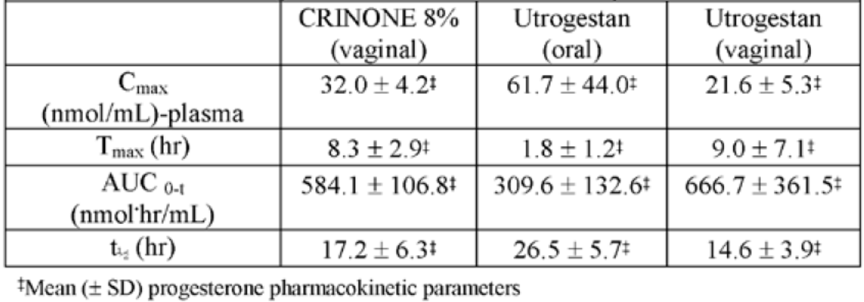
The dossier contained 17 PK studies, 5 PD studies, several sponsor initiated efficacy studies, and an extensive literature review.

Pharmacokinetics
The pivotal study was Study 01272 2002: a randomised 2-way cross over trial which examined the pharmacokinetics of a single oral dose of Utrogestan 2 x 100 mg capsules containing either sunflower oil or peanut oil as an excipient in 60 healthy post-menopausal women. This indicated that Utrogestan arachis oil was bioequivalent to utrogestan sunflower oil with the ratio of the two AUC being within 80-125%.

Summary of pharmacokinetics
Progesterone is 96-99% protein bound and metabolised in the liver to glucuronide metabolites which are excreted in the bile and urine. Tmax is 3-4 h with an elimination half-life of 12-18 h. Bioavailability is significantly increased for PV progesterone compared to PO progesterone due to reduced first pass metabolism (AUC 114.45 ng.h/mL versus 359.96 ng.h/mL for 200 mg oral and vaginal single doses, respectively). Bioavailability increases approximately linearly across the proposed dosage range but is more variable between subjects in PO than PV dosing. Food approximately doubles the AUC of progesterone compared to fasted subjects.
A single dose of Utrogestan PV was 50% more bioavailable than Crinone 8% progesterone cream administered PV (AUC ratio 146%; 90% CI 126.2-169.1%) when administered to healthy women.
There is evidence that progesterone is retained in the endometrium when administered PV for ART.

Efficacy
Studies using the proposed product are shown in Table 10.
Table 10: Studies using the proposed product.
Indication | Level of evidence | Results
HRT | Lorrain 1994  One year, single centre, randomised controlled trials (RCTs) in 40 post-menopausal women. All women received 17β estradiol 0.05 mg/day patches from day 1 to day 25. Treatment arm A received 10 mg Provera, treatment arm B received 100 mg Prometrium on days 14-25 each cycle. No hormone was received days 25-28. | Prometrium produced a higher rate of amenorrhoeic cycles (19.5% versus 3.4%) than Provera (p <0.01).  Prometrium was associated with statistically significant earlier onset of bleeding (23.1 versus 24.9 day of cycle), a lower intensity (9.6 versus 11.3) and lower number of days of bleeding (4.8 versus 6.0) than Provera (p <0.01).  The study reported ‘no significant abnormalities’ in the endometrial biopsies for either treatment group. Focal or adenomatous hyperplasia was reported for 3 patients receiving Utrogestan, but this was not confirmed by a second pathologist.
HRT | Moyer 1987  Open labelled, uncontrolled, single centre study of 236 women taking oestrogen/progesterone HRT. It was prospective from 1980-1986 and retrospective from 1986-1987.  Women received 1.5-3 mg of estradiol and 200-300mg of Prometrium depending on symptoms. | The main efficacy variable was estradiol level but other variables relevant to Prometrium were also measured.  27 women dropped out of the study, mainly as their initial symptoms resolved. Four women developed irregular bleeding. Tissue morphology after curettage demonstrated benign endometrial polyps in 3 and a submucosal leiomyoma in one. No patients had endometrial hyperplasia or carcinoma.  During the last 12 months of the study, 4/157 women had at least 2 periods or irregular withdrawal bleeding, 34/157 had regular cycle withdrawal bleeding, 119/157 had no withdrawal bleeding.  Endometrial evaluation was conducted in 153 women. Sufficient tissue for analysis was only obtained in 53 patients, and the remainder underwent hysteroscopy. In those women macroscopic atrophy throughout the endometrial cavity was observed. None of the biopsies indicated evidence of hyperplasia or carcinoma. Secretory maturation was variable, ranging from minimal to moderate in amount, moderate secretory maturation being observed in 78% of the highest dose group.
ART Luteal phase support | Kleinstein 2002  Randomised, open label, active treatment study of 340 women receiving IVF or ICSI between 1999 and 2001 in Germany. Women were randomised to Crinone 8% progesterone vaginal cream 90 mg bd (n = 212) and Utrogestan 200 mg capsules tds (n = 218). All women had successful transfer of 2-3 oocytes at the start of the trial. Treatment commenced on the first day of embryo transfer and continued until either a pregnancy test was negative, bleeding occurred in non-pregnant women, or the 12th week of pregnancy was reached. | The main efficacy variable was successful implantation of pregnancies at 12 weeks.  The sample size was selected to detect a 10% difference in the rate of pregnancy at 12 weeks with a power (beta) of 0.2 and significance level (alpha) of 0.05. This required 222 patients per arm, which is slightly higher than was recruited.  Pregnancy at 12 weeks was achieved in 28% (95% CI 22.1-34.4) of women treated with Utrogestan 200mg and 26.9% (95% CI 21.0-33.4) of women treated with Crinone 8%. This met the criteria for non-inferiority.
ART Luteal phase support | Polyzos 2010  This was a published literature report of a meta-analysis of studies comparing the efficacy of different forms of vaginal progesterone for luteal support. | 51.7% of the patients included in the meta-analysis were from a study which did not involve micronized progesterone capsules. A sub-analysis of those which did use capsules as a comparator indicates that the odds ratio of successful pregnancy in women receiving progesterone capsules was not statistically different from those receiving vaginal gel. The summary odds radio from all studies was 1.12 (95% CI 0.86-1.45), with a ratio <1 indicating superiority of vaginal capsules.
 | Van der Linden 2011, 2012  This was a review by the Cochrane Collaboration examining the efficacy of several treatments for luteal support for pregnancy outcomes. | The authors concluded that progesterone has a beneficial effect on pregnancy rate, ongoing pregnancy rate and live birth rate. There were no significant differences in routes of administration. There was a significant difference in favour of synthetic progesterone compared to micronized natural progesterone for the clinical pregnancy rate; OR 0.79 (95% CI 0.65-0.96) but this was not evident in the miscarriage rate, ongoing pregnancy rate or live birth rate.
 | Hill 2013  This was a meta-analysis of the effect of luteal phase support with progesterone following ovulation induction and intrauterine insemination (IUI). | 5 randomised studies were included which examined the effect of progesterone in 1271 women undergoing 1886 cycles of IUI, three of which included data on rates of live birth. A synthesis of these studies indicate a significantly greater proportion of live births OR 2.11 95% CI (1.21-3.67) and clinical pregnancies OR 1.47 95% CI (1.1-1.98) when progesterone is used for luteal support than when it is not. The evaluator notes only one of these studies (Kyrou [2010]) used Utrogestan as the progesterone, contributing 15.48% to the weight of the analysis of clinical pregnancy rates and not collecting live birth data.
Menstrual Irregularities | Simon 1988  This was a randomised, double blind, placebo controlled trial of Prometrium in the induction of withdrawal bleeding in 60 patients with secondary amenorrhoea. Women were >18 years, had secondary amenorrhoea at least 60 days, oestradiol levels >220 pmol/ml, FSH and LH pre-menopausal, serum progesterone <3.18nmol/L and testosterone <6.95nmol/L. Excluded those who were pregnant, lactating, hormone sensitive tumours or chronic illness. | Withdrawal bleeding occurred in 90% of the Prometrium 300 mg treated patients, and 57% of the Prometrium 200 mg treated patients compared to 29% of placebo treated patients. This was a significant difference compared to placebo for the Prometrium 300 mg dose (p <0.05) but not for the Prometrium 200 mg dose (p = 0.06).  Two Prometrium 200 mg treated patients who did not experience bleeding during the trial period, and one placebo treated patient had an onset of withdrawal bleeding at 20 and 21 days after treatment, respectively. If these patients are included, then the difference between Prometrium 200 mg and placebo is statistically significant.
Menstrual Irregularities | Hickey 2012  This is a Cochrane review examining the efficacy of progestogens with or without oestrogen in the management of irregular uterine bleeding associated with anovulation. | This identified no randomised trials which compared progestogens with oestrogens, or progestogens with placebo in the management of irregular bleeding associated with anovulatory cycles. The authors concluded that there is a paucity of randomised studies which examine this issue, and that there is no consensus about which regimens are the most effective.

Safety
The safety data was limited to company sponsored clinical trials, limited data from meta-analyses and 6 systematic reviews examining the safety of progesterone in HRT.
Furness (2012): This was a meta-analysis by the Cochrane collaboration to assess which HRT regimens are protective against endometrial hyperplasia and carcinoma. The review included 46 RCTs with a total of 39409 participants. The odds of developing endometrial hyperplasia after 3 years of oestrogen 0.625 mg/day + progesterone 200 mg/day on Days 1-12 were not significantly different to placebo (OR 2.78 95% CI 0.68-11.34).
Marjoribanks (2012): This was a meta-analysis by the Cochrane collaboration which examined the incidence of AEs in women taking HRT. The analysis included 23 studies with a total of 42830 participants; only 2 involved micronised progesterone. Combined continuous HRT significantly increased the risk of coronary events, venous thromboembolism (VTE), stroke, breast cancer, gallbladder disease, death from lung cancer, and dementia in women aged over 65 years.
Greiser (2007): This was a meta-analysis examining the potential association between HRT and ovarian cancer. No specific analysis was conducted for HRT regimens including micronised progesterone. The analysis indicated the risk of ovarian cancer was higher in women who received oestrogen or oestrogen/progesterone HRT.
Sare (2008): This was a meta-analysis of 31 RCTs involving 44113 to examine the association between HRT and arterial or vascular events. It concluded that HRT is associated with stroke, stroke severity and VTE but not coronary artery disease (CAD). It was not clear what progesterone regimen was being used.

Market exposure
Micronised progesterone has been clinically available for over 50 years. The cumulative exposure to Utrogestan capsules from 2008-2011 is estimated to be 650,391 patient years for the 100 mg capsules, and 320 303 patient years for the 200 mg capsules.
A summary of AEs reported in post market surveillance for the period 1 August 1998 to 14 July 2011 (approximately 13 years) reported the following AEs (by system): blood and lymphatic 12; cardiac disorders 15; congenital, familial and genetic 15 including 4 cases of hypospadias; eye disorders 30; gastrointestinal disorders 42 including 6 cases of nausea; asthenia 6; oedema 6; hepatobiliary 16; immune system 16 including anaphylaxis in 6 and hypersensitivity in 7; neoplasms 51 including 22 cases of breast cancer and 9 cases of endometrial cancer; nervous disorders 121 including 18 reports of dizziness, 7 of headache, 6 of loss of consciousness, 6 of paraesthesia, 18 syncope, 8 somnolence, 8 speech disorder; 22 skin disorders including 5 with pruritis; 30 vascular disorders including 11 cerebrovascular attacks (CVAs). It is difficult understand the true risk of these events without a better picture of the population exposed.

Clinical trials
The safety data available from the clinical trials submitted by the sponsor was limited. The AEs that were reported were consistent with the known safety profile for progesterone.

Clinical evaluator’s recommendation
The sponsor responded to the clinical evaluator’s recommendations (see above section: ‘First round recommendation regarding authorisation’) by changing the formulation to a sunflower oil formulation and making some amendments to the PI.

Risk management plan
Routine pharmacovigilance is appropriate. More information about use in pregnancy would be helpful, however this is a class effect and the practicalities and potential benefits of a registry is questionable. There are a number of ongoing studies in the use of progesterone in pregnancy.

Risk-benefit analysis

Summary of issues
- The initial formulation proposed was a peanut oil based formulation. In other countries, a sunflower oil based preparation was used. The sponsor was requested to amend the formulation to a sunflower oil based formulation. The sponsor agreed.
- Most of the clinical trials were done with a peanut oil based formulation. A pivotal bioequivalence study demonstrated bioequivalence between the peanut oil and sunflower oil preparation, thus it is reasonable to extrapolate the results of the clinical trials.
- The dossier submitted was a combination of sponsor initiated clinical trials and literature review.
- This is the first micronised progesterone for oral use on the ARTG.
- In Australia, other formulations of progesterone are registered for use in HRT, ART, and secondary amenorrhoea.

Delegate’s considerations
- The drug product and substance are acceptable.
- Use in ART and HRT based on use of other progesterone products and literature submitted are reasonable.
- Use in menstrual disturbance has some evidence and widely used in routine practice. Amendments to the PI around the wording of this indication are needed.
- The toxicology delegate has recommended Pregnancy Category D. However other micronised progesterone products on the ARTG (Endometrin and Crinone) are Pregnancy Category A. Pregnancy Category D would not be in keeping with the proposed indications for use in pregnancy for ART. Overseas, progesterone products used for ART are generally given an indication’ can be used in pregnancy’ where those not indicated for use in pregnancy are given a more cautious warning. The Delegate’s proposed wording for use in pregnancy is included. Does use in pregnancy need to be added to the summary of safety concerns as missing data?

Request for Advisory Committee on Prescription Medicines (ACPM) advice
- What is the most appropriate wording for the use in ‘secondary amenorrhoea’?
- What would you consider to be the most appropriate pregnancy category for these products? Is the wording around use in pregnancy appropriate?
- Do you have any comments about having two different product names and PIs for the same drug (but different indications)? Is this confusing or unsafe?
The committee is (also) requested to provide advice on any other issues that it thinks may be relevant to a decision on whether or not to approve this application.

Response from sponsor
The sponsor hereby submits its response to the TGA “Request for ACPM’s Advice” addressing the matters raised by the Delegate for ACPM consideration. The sponsor agrees with the Delegate’s assessment that there is no reason that the application for Prometrium and Utrogestan should not be approved for registration.
The sponsor respectfully requests the ACPM members to consider the discussions and the materials presented. The sponsor firmly believes that this information will assist the ACPM considering the summary of issues raised by the Delegate and provides information regarding the advice sought from the committee and will permit the committee to recommend approval for Prometrium and Utrogestan in HRT, ART, and menstrual irregularities.

International status
Besin’s progesterone soft capsules for oral administration were first approved on 15 January 1980 in France for the treatment of postmenopausal syndrome. Since then progesterone capsules have been approved, for oral and vaginal administration, in more than 80 countries. The safety of Besin’s progesterone capsules has been monitored through postmarketing surveillance and PSURs, with the latest PSUR addendum covering 2 August 2013 to 30 November 2014 being provided.

Clinical
The sponsor acknowledges the clinical evaluator’s first round evaluation comments and recommendations that application is suitable for approval for HRT, secondary amenorrhoea and ART indications if the sponsor supplies a sunflower-oil containing formulation. The sponsor highlights the following clinical evaluator comments and conclusions:
- The considerable historical experience with progestogen containing HRT, clinical consensus and the large post-market oversight for this indication, suggest that progesterone is likely to be safe and effective as part of combination HRT;
- Balancing the pivotal trials submitted in support of endometrial safety and several large meta-analyses consistent with clinical consensus indicate that endometrial safety of combined HRT with progestogen is acceptable;
- Progesterone appears effective in the short term management of secondary amenorrhea;
- The efficacy of vaginal progesterone in luteal support is adequately demonstrated by the submitted data.

Nonclinical
The sponsor acknowledges and agrees with the nonclinical evaluator’s conclusion and recommendation that there are no nonclinical objections to the registration of Prometrium or Utrogestan.
The nonclinical evaluator noted that no existing vaginal medicine registered in Australia contains sunflower oil adding that local tolerability of the sunflower oil based formulation should be adequately established from the clinical dataset.
The sponsor highlights to the committee that the sunflower oil formulation of the product has been approved and available globally for use in humans by both oral and vaginal routes of administration since 2005 without any known safety issues attributable to the sunflower oil. The sponsor has reviewed the long term post-marketing safety data and the number of patients exposed globally to the sunflower oil based product since approval and launch and has not identified any differences in safety signals or expected or unexpected AEs relating to the sunflower oil.
The sponsor draws the attention of the committee to the details of the recently submitted published study, the PROMISE trial by Coomarasamy (2015) which was conducted using the sunflower formulation 200 mg progesterone capsule at a higher dose than that recommended dosage for proposed vaginal indication. The AE profile from this study confirms a similar safety profile to earlier studies which used the peanut oil formulation progesterone capsule and demonstrates no new safety signals attributable to the sunflower oil component of the formulation.
The sponsor also notes there are several dermatological products currently included on the ARTG containing sunflower oil for topical use (AUST R 185837 and AUST R 212993) along with numerous nutraceuticals/cosmetics and food products including products sold as nappy cream containing sunflower oil available freely in Australia.

Quality
The sponsor acknowledges the evaluator’s and Delegate’s recommendation and comments that there are no objections to the approval of Utrogestan or Prometrium from a chemistry and biopharmaceutics perspective.
The sponsor notes and agrees with the evaluator’s comments following evaluation of the sunflower formulation dossier, that the bioavailability study (Study 01272) confirmed that the arachis (peanut) oil and sunflower oil formulations are bioequivalent and all pharmacokinetic and data generated on the arachis (peanut) oil formulation can be considered to be relevant to the sunflower oil formulation.
The evaluator noted minor biopharmaceutics issues which were raised with the clinical delegate regarding non-linearity observed (at higher doses). The sponsor highlights that these are not considered clinically relevant as progesterone blood levels are not correlated with clinical efficacy in the proposed indications. The sponsor therefore believes that the proposed dosage and administration for Utrogestan 200 mg capsule is appropriate based on clinical evidence.

Sponsor’s comments on delegate’s advice sought
- “Q1: What is the most appropriate wording for the use in ‘secondary amenorrhoea’?”
The sponsor made slight revision to the proposed wording for the indication taking into consideration suggested text from both TGA File Note dated 28 January 2016 and the Request for ACPM’s advice. The proposed indication is as follows:
In women with irregular menses or secondary amenorrhoea due to normogonadotrophic amenorrhoea (see dosage and administration)
The proposed PI was updated with proposed changes and is provided for consideration by TGA and the ACPM.
- “Q2: What would you consider to be the most appropriate pregnancy category for these products? Is the wording around pregnancy appropriate?”
The sponsor believes the historical categorisation of progesterone under pregnancy Category A is appropriate and agreed with the Delegate that a move to pregnancy Category D would not be in keeping with the proposed indication for use in pregnancy for ART.
The sponsor accepted the proposed revisions to the pregnancy statement included on the Prometrium PI as suggested by the delegate.
To further support the retention and appropriateness of the pregnancy category A, the sponsor drew the attention of the committee the recently published study, the PROMISE trial by Commarasamy (2015) submitted as part of the sponsor’s responses to evaluation. For convenience of the committee, a copy of the paper was provided as below.
The study was conducted using the sunflower oil formulation 200 mg progesterone capsules with a daily dose of 800 mg which is higher than the recommended dosage for the indications under consideration. Treatment was initiated from positive pregnancy test (and no later than 6 weeks gestation) and continued to 12 weeks of gestation compared to placebo with 404 patients randomised to receive progesterone and 432 randomised to receive placebo.
The study included as part of the assessment, AEs to both the patient and offspring. The frequency of AEs did not differ significantly between the progesterone group and the placebo group.
The PROMISE trial incurred only one SUSAR, namely development of a rash by a single participant for whom study medication was discontinued and antihistamines were prescribed. The event was reported to regulatory authorities as appropriate and the rash subsided within 48 hours. Otherwise, AEs were few in both arms of the trial and not in excess of expected complications of pregnancy among women with a history of RM. Based on these records (see Table 12 below), it would appear that progesterone in the form of Utrogestan vaginal 200 mg capsules at the dose level of 400 mg twice daily is a safe drug to use in early pregnancy.
The sponsor’s response is repeated here as provided in ACPM response.
The sponsor provided in support of the Pregnancy Category A claim a copy of recently published study, the PROMISE trial by Coomarasamy (2015). The study included as part of the assessment, AEs to both the patient and offspring. The frequency of AEs did not differ significantly between the progesterone group and the placebo group. This study was conducted using the sunflower formulation 200 mg progesterone capsules at a higher dose than that recommended dosage for the indications.
Women 18-39 years old at randomisation, with unexplained recurrent miscarriages (3 or more first trimester miscarriages) and spontaneous conception and pregnancy (as confirmed by urinary pregnancy tests) were randomised:
- To test the hypothesis that in women with a history of unexplained recurrent miscarriages, progesterone (two Utrogestan Vaginal 200 mg capsules, twice daily, dosage of 800 mg vaginal progesterone/day), started as soon as possible after a positive pregnancy test (and no later than 6 weeks gestation) and continued to 12 weeks of gestation, compared to placebo, increases live births beyond 24 completed weeks of pregnancy by at least 10%.
- To test the hypothesis that progesterone improves various pregnancy and neonatal outcomes (such as reduction in miscarriage rates and improvement in survival at 28 days of neonatal life).
- To test the hypothesis that progesterone, compared to placebo, does not incur serious adverse effects to the mother or the neonate (such as genital anomalies in the neonate).
In fact, vaginal progesterone taken from positive human chorionic gonadotropin (hCG) urinary pregnancy test (and no later than 6 weeks of gestation) until week 12 of pregnancy showed no significant treatment effect on live birth rate beyond 24 weeks.
In terms of the frequency of AEs, neonatal congenital anomalies (3.0% in P4 group versus 4.0% in placebo group), hypospadias (only 1 in each group) did not differ statistically significantly.

Birthweight and small for gestational age
Table 11 shows that among 260 babies born alive after at least 24 weeks of gestation to participants who were randomised to receive progesterone in the PROMISE trial, the mean birthweight was 3214 g (SD 707 g). Among 274 babies born to participants who were randomised to receive placebo, we observed a mean birthweight of 3329 g (SD 635 g). After adjustment for maternal height, weight (within the healthy range of BMI 18.5-30.0 kg/m²), ethnicity, parity and neonatal gender and gestational age at delivery,66 there were no significant differences between the mean birthweights of babies born in the different arms of the study. Among the 534 neonates from whom appropriate data were collected, 80 (15.0%) were small for gestational age. The rate observed in the progesterone group was 17.3% (45/260) and in the placebo group was 12.8% (35/274), giving a RR of 1.35 (95% CI 0.90 to 2.04), with a p-value of 0.14. Across the same cohort, 42 (7.9%) were very small for gestational age. The proportion observed in the progesterone group was 9.2% (24/260) and in the placebo group was 6.6% (18/274), giving a RR of 1.41 (95% CI 0.78 to 2.53), with a p-value of 0.26.
Table 11: Exploratory analyses in PROMISE trial.
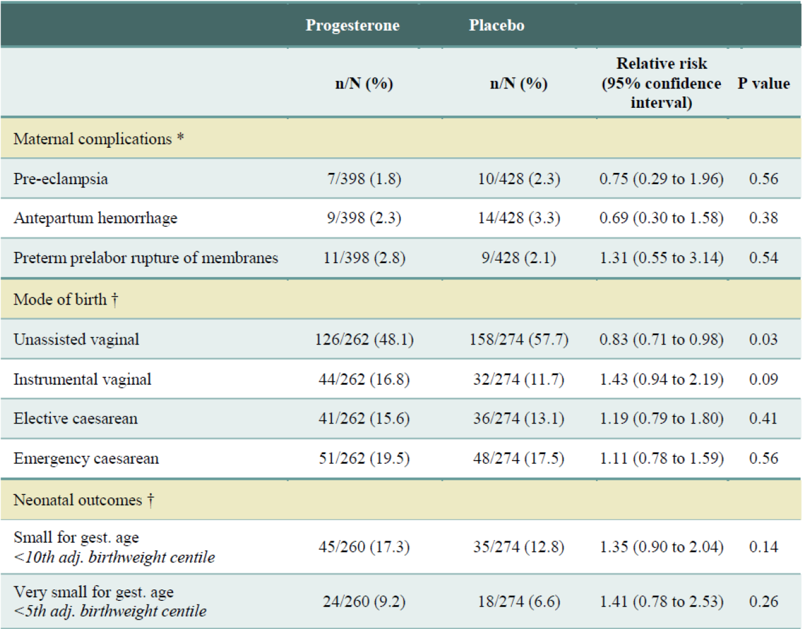
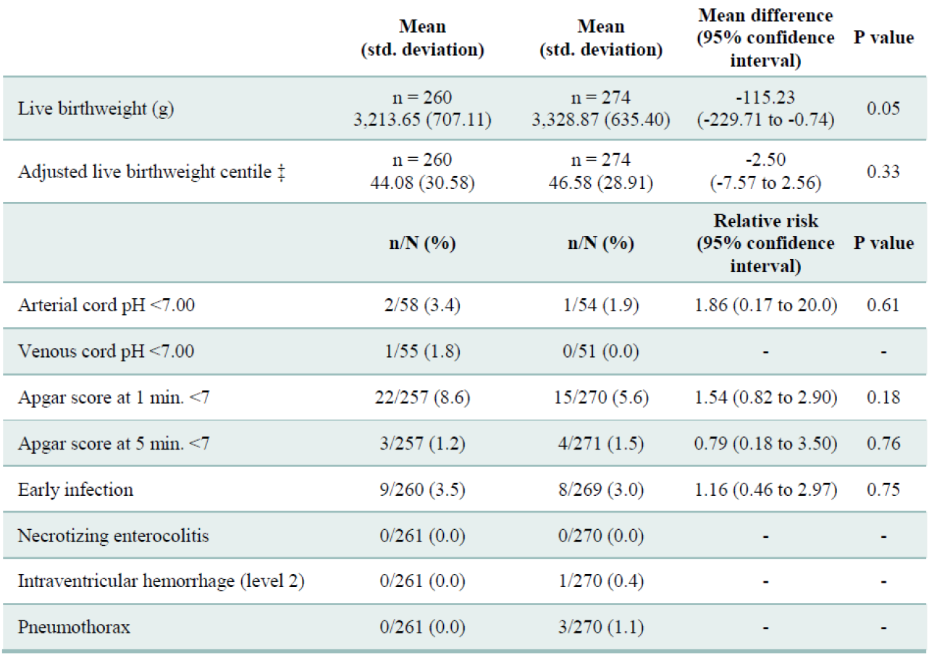
Table 11 (continued): Exploratory analyses in PROMISE trial.
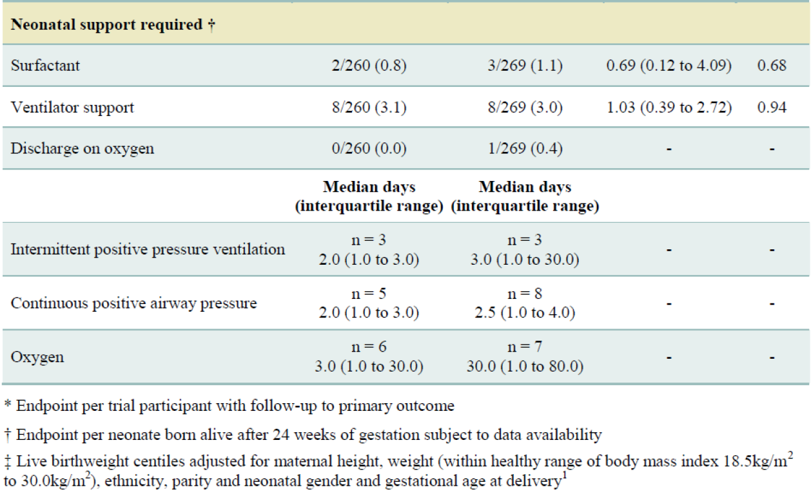

Neonatal outcomes
Other neonatal outcomes of babies born during the PROMISE trial, including arterial and venous cord pH measurements and APGAR scores are listed. Outcomes of clinical concern were rare, both overall and within each arm of the trial. Among the babies from whom neonatal data were immediately collected, the rate of arterial cord pH < 7 was 3.4% (2/58) in the progesterone group and 1.9% (1/54) in the placebo group, giving a RR of 1.86 (95% CI 0.17 to 20.0), with a p-value of 0.61. Among the same cohort, the proportion of babies with venous cord pH < 7 was 1.8% (1/55) in the progesterone group and 0.0% (0/51) in the placebo group. Among the live babies born to PROMISE participants receiving progesterone and from whom APGAR scores were collected, the rate of APGAR score < 7 at 1 minute was 8.6% (22/257). The rate of APGAR score < 7 at 1 minute observed in the placebo group was 5.6% (15/270), giving a RR of 1.54 (95% CI 0.82 to 2.90), with a p-value of 0.18. Among the live babies born to PROMISE participants receiving progesterone and from whom APGAR scores were collected, the rate of APGAR score < 7 at 5 minutes was 1.2% (3/257). The rate observed in the placebo group was 1.5% (4/271), giving a RR of 0.79 (95% CI 0.18 to 3.50), with a p-value of 0.76.

Neonatal complications
No significant differences were observed in the rates of early infection or other complications experienced between neonates born to PROMISE participants who received progesterone and neonates born to those who received placebo. In the progesterone group, 9 out of 260 (3.5%) babies from whom data were available acquired early infection, and no babies were diagnosed with necrotising enterocolitis, intraventraventricular haemorrhage (level 2) or pneumothorax. In the placebo group, 8 out of 269 (3.0%) babies from whom data were available acquired early infection, no babies (out of 270) were diagnosed with necrotising enterocolitis, 1 baby out of 270 (0.4%) was diagnosed with intraventraventricular haemorrhage (level 2) and 3 out of 270 babies (1.1%) suffered pneumothorax. When considering early infection, we observed a RR between the progesterone and placebo groups of 1.16 (95% CI 0.46 to 2.97), with a p-value of 0.75.

Serious adverse effects
The PROMISE trial incurred only one Suspected Unexpected Serious Drug Reaction (SUSAR), namely development of a rash by a single participant for whom study medication was discontinued and antihistamines were prescribed. The event was reported to regulatory authorities as appropriate and the rash subsided within 48 h. Otherwise, AEs were few in both arms of the trial and not in excess of expected complications of pregnancy among women with a history of RM. Based on these records (Table 12), it would appear that progesterone in the form of Utrogestan Vaginal 200 mg capsules at the dose level of 400 mg twice daily is a safe drug to use in early pregnancy.
Table 12: AEs in PROMISE trial.
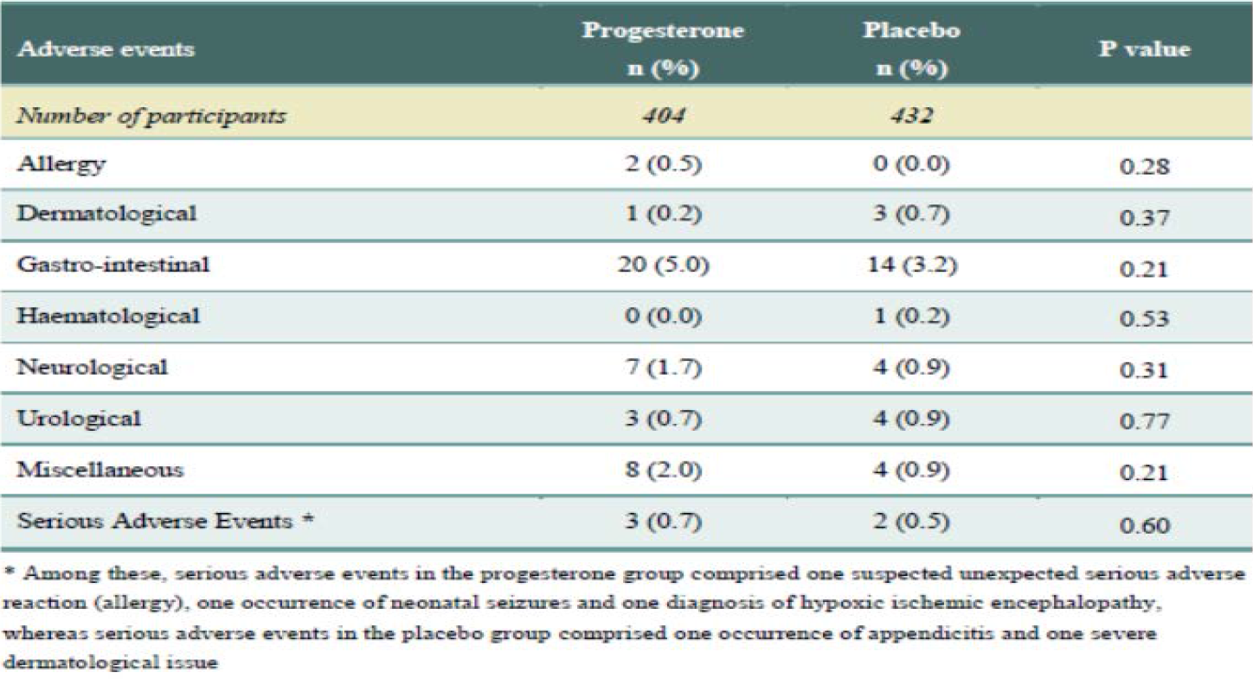
Moreover, in a very recent double blind, randomised, placebo controlled trial of vaginal progesterone (Utrogestan capsules) 200 mg daily taken from 22-24 to 34 weeks of gestation on pregnancy and infant outcomes in women at risk of preterm birth, Utrogestan capsules were not associated with any increase in composite neonatal adverse outcomes, and had no long-term harm on outcomes in children at 2 years of age.
Table 13: Primary outcomes for women entered in treatment phase of OPPTIMUM study and their babies.
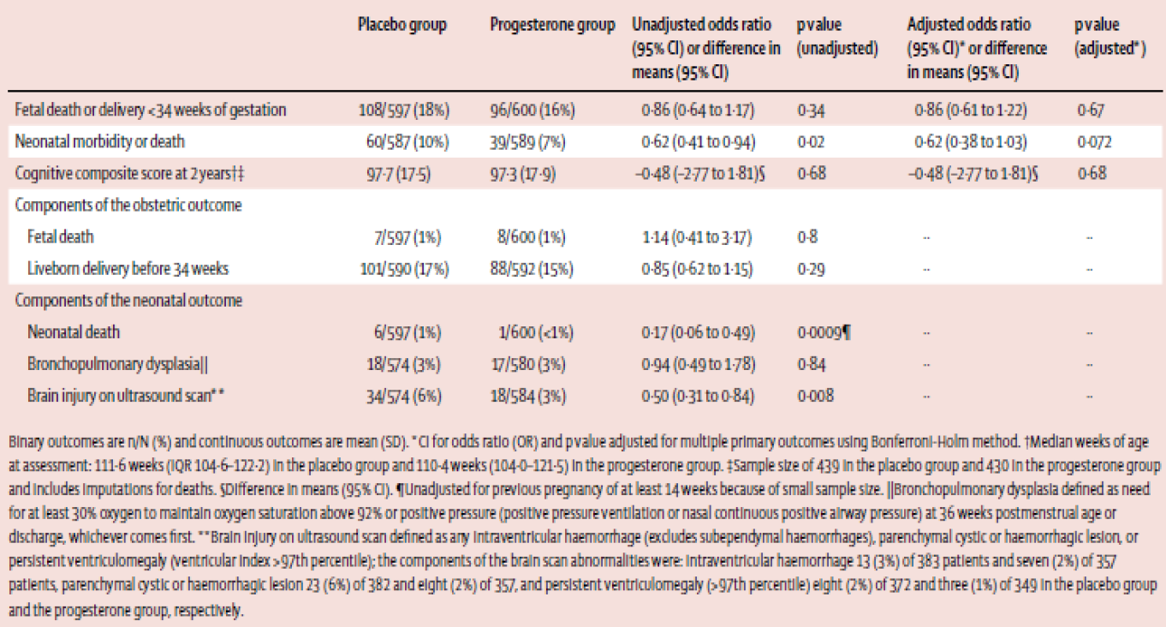
- “Q3: Do you have any comments about having two different product names and PIs for the same drug but different indications). Is this confusing or unsafe?”
[Response redacted from AusPAR at sponsor’s request.]

Advisory committee considerations
The ACPM, taking into account the submitted evidence of efficacy, safety and quality, agreed with the delegate and considered Prometrium containing 100 mg and 200 mg of progesterone and Utrogestan capsule 200 mg of progesterone to have an overall positive benefit-risk profile for the amended indication;
Prometrium 100 mg and 200 mg (given orally) is indicated for:
    - Treatment of menstrual abnormalities or secondary amenorrhoea due to normogonadotrophic amenorrhoea (see dosing and administration).
    - Hormone replacement therapy - adjunctive use with an oestrogen in postmenopausal women with an intact uterus
Utrogestan 200 mg (given vaginally)
    - Luteal support of assisted reproductive technology
In making this recommendation, the ACPM;
- was of the view that there were sufficient post-marketing data to support safety
- advised Pregnancy Category A was the most appropriate category for these products
- noted that the formulation of the products now contained sunflower oil instead of peanut oil, which was considered to be more appropriate.

Proposed conditions of registration
The ACPM agreed with the Delegate on the proposed conditions of registration.

Proposed Product Information (PI)/Consumer Medicine Information (CMI) amendments
The ACPM agreed with the Delegate to the proposed amendments to the PI and CMI and specifically advised on the inclusion of the following:
- the proposed dosage regimen for Utrogestan should recommend use from the day of embryo transfer up to 12 weeks to ensure that the placenta has taken over completely.

Specific advice
The ACPM advised the following in response to the Delegate’s specific questions on this submission:
- What is the most appropriate wording for the use in ‘secondary amenorrhoea’?
The ACPM advised that the following wording is the most appropriate to describe use in ‘secondary amenorrhoea: secondary amenorrhoea due normogonadatrophic amenorrhea.’
- What would you consider to be the most appropriate pregnancy category for these products? Is the wording around use in pregnancy appropriate?
The ACPM noted that synthetic progesterones are pregnancy Category C. However, the ACPM advised that pregnancy Category A is the most appropriate category for products containing natural progesterone, such as Prometrium and Utrogestan.
- Do you have any comments about having two different product names and PIs for the same drug (but different indications). Is this confusing or unsafe?
The ACPM, noting the indications were different, still found the two different product names potentially confusing. The ACPM suggested the following as an alternative: Prometrium Oral and Prometrium Vaginal.
The ACPM advised that implementation by the sponsor of the recommendations outlined above to the satisfaction of TGA, in addition to the evidence of efficacy and safety provided would support the safe and effective use of these products.

Outcome
Based on a review of quality, safety and efficacy, TGA approved the registration of Prometrium 100 (progesterone 100 mg) soft capsule blister pack, Prometrium 200 (progesterone 200 mg) soft capsule blister pack, and Utrogestan 200 (progesterone 200 mg) soft vaginal capsule blister pack for the following indications:
Prometrium 100 mg and 200 mg soft capsules are indicated for:
  - Treatment of menstrual irregularities
    - In women with menstrual abnormalities or secondary amenorrhoea due to normogonadotrophic amenorrhoea (see dosage and administration)
  - Hormone replacement therapy
    - Hormone replacement therapy – adjunctive use with an oestrogen in postmenopausal women with an intact uterus
Utrogestan 200 mg soft vaginal capsules are indicated for:
  - Luteal phase support
    - Luteal Support of Assisted Reproductive Technology (ART) cycles

Specific conditions of registration applying to these goods
- The Prometrium/Utrogestan progesterone (micronised) EU RMP, version 2.0, dated 6 October 2014 [data lock point (DLP) 6 October 2014] with an ASA version 2, dated 11 February 2016, and any subsequent revisions, as agreed with the TGA will be implemented in Australia.

Attachments 1 and 2. Product Information
The PI documents approved for Prometrium/Utrogestan at the time this AusPAR was published is at Attachment 1. For the most recent PI, please refer to the TGA website at <https://www.tga.gov.au/product-information-pi>.

Attachment 3. Extract from the Clinical Evaluation Report

Therapeutic Goods Administration
PO Box 100 Woden ACT 2606 Australia
Email: info@tga.gov.au Phone: 1800 020 653 Fax: 02 6232 8605
https://www.tga.gov.au

Simon JA, et al. The absorption of oral micronized progesterone: the effect of food, dose proportionality, and comparison with intramuscular progesterone. Fertil. Steril. 60: 26-33 (1993).
Protocol No. 98 U200 01/ C98-374, Comparison of bioavailability and progesterone metabolism after single oral or vaginal progesterone dosings. Study in 18 healthy childbearing potential female volunteers (1998).
Pharmacokinetic Study of micronized progesterone administered orally and vaginally and comparison with natural intramuscular progesterone. Correlation with endometrial morphology. Study of 80 treatment cycles of 46 ovarioprives women (1994).
Protocol No. 98 U200 01/ C98-374, Comparison of bioavailability and progesterone metabolism after single oral or vaginal progesterone dosings. Study in 18 healthy childbearing potential female volunteers (1998).
Protocol No. 98 U200 01/ C98-374, Comparison of bioavailability and progesterone metabolism after single oral or vaginal progesterone dosings. Study in 18 healthy childbearing potential female volunteers (1998).
Selye H. Anaesthetic effects of steroid hormones. Proc. Soc. Exp. Biol. 46: 116-121 (1941).
Pregnancy Category A: “Drugs which have been taken by a large number of pregnant women and women of childbearing age without any proven increase in the frequency of malformations or other direct or indirect harmful effects on the foetus having been observed.”
Golub MS, et al. “Natural” progesterone: information on fetal effects. Birth Defects Res. B Dev. Reprod. Toxicol. 77: 455-470 (2006).
Pregnancy Category D: “Drugs which have caused, are suspected to have caused or may be expected to cause, an increased incidence of human foetal malformations or irreversible damage. These drugs may also have adverse pharmacological effects. Accompanying texts should be consulted for further details.”
Efficacy, safety and tolerance of Utrogestan compared to medroxyprogesterone acetate in menopausal women receiving Estraderm (1994).
Prevention of endometrial hyperplasia by oral progesterone during long-term estradiol replacement. Influence of secretory changes and bleeding pattern (1987).
Percutaneous estradiol as prohylaxis in early post menopausal women (1985).
Efficacy and tolerability of UTROGEST 200 vaginal compared with CRINONE 8% for luteal phase support during assisted reproduction (2002).
Clinical experiment with natural micronized progesterone administered by the vaginal route with patients lacking ovaries (1988).
Polyzos NP, et al. Vaginal progesterone gel for luteal phase support in IVF/ICSI cycles: a meta-analysis. Fertil Steril. 94: 2083-7 (2010).
Liu XR, et al. The optimal duration of progesterone supplementation in pregnant women after IVF/ICSI: a meta-analysis. Reprod Biol Endocrinol. 10: 107 (2012).
Nosarka S, et al. Luteal Phase Support in in vitro Fertilization: Meta-Analysis of Randomized Trials. Gynecol Obstet Invest. 60: 67-74 (2005).
van der Linden M, et al. Luteal phase support for assisted reproduction cycles. Cochrane Database Syst Rev. 2011(10): CD009154.
van der Linden M, et al. Luteal phase support in assisted reproduction cycles. Hum Reprod Update. 18: 473 (2012).
Glujovsky D, et al. Endometrial preparation for women undergoing embryo transfer with frozen embryos or embryos derived from donor oocytes. Cochrane Database Syst Rev. 2010(1): CD006359.
Hill MJ, et al. Progesterone luteal support after ovulation induction and intrauterine insemination: a systematic review and metaanalysis. Fertil Steril. 100: 1373-80 (2013).
Internal Study Report. Percutaneous estradiol as prophylaxis in early post-menopausal women (1988).
Hickey M, et al. Progestogens with or without oestrogen for irregular uterine bleeding associated with anovulation. Cochrane Database Syst Rev. 2012(9): CD001895.
Sequential use of norethisterone and natural progesterone in premenopausal bleeding disorders (1986).
Pharmacokinetic Study of micronized progesterone administered orally and vaginally and comparison with natural intramuscular progesterone. Correlation with endometrial morphology. Study of 80 treatment cycles of 46 ovarioprives women (1994).
Dupont A, et al. Comparative endocrinological and clinical effects of percutaneous estradiol and oral conjugated estrogens as replacement therapy in menopausal women. Maturitas 13: 297-311 (1991).
Foidart J, et al. Endometrial tolerance of long-term combined hormone replacement therapy: analysis of the cell cycle. In: Hormone Replacement Therapy: Proceedings of a Special Symposium held at the 7th International Congress on Menopause, Stockholm (1993).
Sequential use of norethisterone and natural progesterone in premenopausal bleeding disorders (1986).
Dupont A, et al. Comparative endocrinological and clinical effects of percutaneous estradiol and oral conjugated estrogens as replacement therapy in menopausal women. Maturitas 13: 297-311 (1991).
Internal Study Report. Kinetic study on micronised progesterone administered via the vaginal route (1986).
Sequential use of norethisterone and natural progesterone in premenopausal bleeding disorders (1986).
Dupont A, et al. Comparative endocrinological and clinical effects of percutaneous estradiol and oral conjugated estrogens as replacement therapy in menopausal women. Maturitas 13: 297-311 (1991).
Endometrial tolerance of combined hormone replacement therapy with percutaneous estradiol and oral micronized progesterone in menopausal women – analysis of the cell cycle (1992).
Pharmacokinetic Study of micronized progesterone administered orally and vaginally and comparison with natural intramuscular progesterone. Correlation with endometrial morphology. Study of 80 treatment cycles of 46 ovarioprives women (1994).
Internal Study Report. Kinetic study on micronised progesterone administered via the vaginal route (1986).
Efficacy, safety and tolerance of Utrogestan compared to Medroxyprogesterone acetate in menopausal women receiving Estraderm (1994).
Prevention of endometrial hyperplasia by oral progesterone during long-term estradiol replacement. Influence of secretory changes and bleeding pattern (1987).
Percutaneous estradiol as prophylaxis in early post-menopausal women (1985).
European Medicines Agency, “Guideline on Clinical Investigation of Medicinal Products for Hormone Replacement Therapy of Oestrogen Deficiency Symptoms in Postmenopausal Women (EMEA/CHMP/021/97 Rev. 1)”, 13 October 2005.
European Medicines Agency, “Guideline on Clinical Investigation of Medicinal Products for Hormone Replacement Therapy of Oestrogen Deficiency Symptoms in Postmenopausal Women (EMEA/CHMP/021/97 Rev. 1)”, 13 October 2005.
Efficacy, safety and tolerance of Utrogestan compared to Medroxyprogesterone acetate in menopausal women receiving Estraderm (1994).
Efficacy, safety and tolerance of Utrogestan compared to Medroxyprogesterone acetate in menopausal women receiving Estraderm (1994).
Prevention of endometrial hyperplasia by oral progesterone during long-term estradiol replacement. Influence of secretory changes and bleeding pattern (1987).
Prevention of endometrial hyperplasia by oral progesterone during long-term estradiol replacement. Influence of secretory changes and bleeding pattern (1987).
Furness S, et al. Hormone therapy in postmenopausal women and risk of endometrial hyperplasia. Cochrane Database Syst Rev. 2012(8): CD000402.
Kleinstein J, et al. [Pharmacokinetic comparison of progesterone capsules with a progesterone gel after vaginal administration]. [Article in German] Arzneimittelforschung 52: 615-621 (2002).
Polyzos NP, et al. Vaginal progesterone gel for luteal phase support in IVF/ICSI cycles: a meta-analysis. Fertil Steril. 94: 2083-7 (2010).
Liu XR, et al. The optimal duration of progesterone supplementation in pregnant women after IVF/ICSI: a meta-analysis. Reprod Biol Endocrinol. 10: 107 (2012).
Nosarka S, et al. Luteal Phase Support in in vitro Fertilization: Meta-Analysis of Randomized Trials. Gynecol Obstet Invest. 60: 67-74 (2005).
van der Linden M, et al. Luteal phase support for assisted reproduction cycles. Cochrane Database Syst Rev. 2011(10): CD009154.
van der Linden M, et al. Luteal phase support in assisted reproduction cycles. Hum Reprod Update. 18: 473 (2012).
Glujovsky D, et al. Endometrial preparation for women undergoing embryo transfer with frozen embryos or embryos derived from donor oocytes. Cochrane Database Syst Rev. 2010(1): CD006359.
Hill MJ, et al. Progesterone luteal support after ovulation induction and intrauterine insemination: a systematic review and metaanalysis. Fertil Steril. 100: 1373-80 (2013).
Kleinstein J, et al. [Pharmacokinetic comparison of progesterone capsules with a progesterone gel after vaginal administration]. [Article in German] Arzneimittelforschung 52: 615-621 (2002).
Internal Study Report Salat-Baroux. Clinical experiment with natural micronized progesterone administered by the vaginal route with patients lacking ovaries (1988).
Internal Study Report Simon. Percutaneous estradiol as prophylaxis in early post-menopausal women (1988).
Hickey M, et al. Progestogens with or without oestrogen for irregular uterine bleeding associated with anovulation. Cochrane Database Syst Rev. 9: CD001895 (2012).
Hickey M, et al. Progestogens with or without oestrogen for irregular uterine bleeding associated with anovulation. Cochrane Database Syst Rev. 9: CD001895 (2012).
Internal Study Report Simon. Percutaneous estradiol as prophylaxis in early post-menopausal women (1988).
Internal Study Report Simon. Percutaneous estradiol as prophylaxis in early post-menopausal women (1988).
Efficacy, safety and tolerance of Utrogestan compared to medroxyprogesterone acetate in menopausal women receiving Estraderm (1994).
Prevention of endometrial hyperplasia by oral progesterone during long-term estradiol replacement. Influence of secretory changes and bleeding pattern (1987).
Percutaneous estradiol as prohylaxis in early post-menopausal women (1985).
Kleinstein J, et al. [Pharmacokinetic comparison of progesterone capsules with a progesterone gel after vaginal administration]. [Article in German] Arzneimittelforschung 52: 615-621 (2002).
Internal Study Report Salat-Baroux. Clinical experiment with natural micronized progesterone administered by the vaginal route with patients lacking ovaries (1988).
Internal Study Report Simon. Percutaneous estradiol as prophylaxis in early post-menopausal women (1988).
Percutaneous estradiol as prophylaxis in early post-menopausal women (1985).
Kleinstein J, et al. [Pharmacokinetic comparison of progesterone capsules with a progesterone gel after vaginal administration]. [Article in German] Arzneimittelforschung 52: 615-621 (2002)
Efficacy, safety and tolerance of Utrogestan compared to medroxyprogesterone acetate in menopausal women receiving Estraderm (1994).
Internal Study Report Simon. Percutaneous estradiol as prophylaxis in early post-menopausal women (1988).
Internal Study Report Salat-Baroux. Clinical experiment with natural micronized progesterone administered by the vaginal route with patients lacking ovaries (1988).
Prevention of endometrial hyperplasia by oral progesterone during long-term estradiol replacement. Influence of secretory changes and bleeding pattern (1987).
Efficacy, safety and tolerance of Utrogestan compared to medroxyprogesterone acetate in menopausal women receiving Estraderm (1994).
Prevention of endometrial hyperplasia by oral progesterone during long-term estradiol replacement. Influence of secretory changes and bleeding pattern (1987).
Furness S, et al. Hormone therapy in postmenopausal women and risk of endometrial hyperplasia. Cochrane Database Syst Rev. 2012(8): CD000402.
Marjoribanks J, et al. Long term hormone therapy for perimenopausal and postmenopausal women. Cochrane Database Syst Rev. 7: CD004143 (2012).
Furness S, et al. Hormone therapy in postmenopausal women and risk of endometrial hyperplasia. Cochrane Database Syst Rev. 2012(8): CD000402.
Greiser CM, et al. Menopausal hormone therapy and risk of ovarian cancer: systematic review and meta-analysis. Hum Reprod Update. 13: 453-463 (2007).
Liu XR, Mu HQ, Shi Q, Xiao XQ, Qi HB. The optimal duration of progesterone supplementation in pregnant women after IVF/ICSI: a meta-analysis. Reprod Biol Endocrinol. 10: 107 (2012).
Maclennan AH, et al. Oral oestrogen and combined oestrogen/progestogen therapy versus placebo for hot flushes. Cochrane Database Syst Rev. 2004(4): CD002978.
Due to these concerns with peanut oil, the sponsor agreed that the final formulation will contain sunflower oil.
In this section, PI/CMI discussions have been excluded as per TGA AusPAR policy.
It is noted that all RMP matters were finally addressed by the sponsor, hence the granting of approval. The final page of this AusPAR outlines the conditions of registration.
It is noted that all RMP matters were finally addressed by the sponsor, hence the granting of approval. The final page of this AusPAR outlines the conditions of registration.
It is noted that all RMP matters were finally addressed by the sponsor, hence the granting of approval. The final page of this AusPAR outlines the conditions of registration.
It is noted that all RMP matters were finally addressed by the sponsor, hence the granting of approval. The final page of this AusPAR outlines the conditions of registration.
It is noted that all RMP matters were finally addressed by the sponsor, hence the granting of approval. The final page of this AusPAR outlines the conditions of registration.
Simon JA, et al. The absorption of oral micronized progesterone: the effect of food, dose proportionality, and comparison with intramuscular progesterone. Fertil Steril. 60: 26-33 (1993).
Internal Study Report Decourt. Comparison of bioavailability and progesterone metabolism after single oral or vaginal progesterone dosings. Study in 18 healthy childbearing potential female volunteers. Protocol No. 98 U200 01 (1998).
Efficacy, safety and tolerance of Utrogestan compared to medroxyprogesterone acetate in menopausal women receiving Estraderm (1994).
Prevention of endometrial hyperplasia by oral progesterone during long-term estradiol replacement. Influence of secretory changes and bleeding pattern (1987).
Efficacy and tolerability of UTROGEST 200 vaginal compared with CRINONE 8% for luteal phase support during assisted reproduction (2002).
Polyzos NP, et al. Vaginal progesterone gel for luteal phase support in IVF/ICSI cycles: a meta-analysis. Fertil Steril. 94: 2083-7 (2010).
van der Linden M, et al. Luteal phase support for assisted reproduction cycles. Cochrane Database Syst Rev. 2011(10): CD009154.
van der Linden M, et al. Luteal phase support in assisted reproduction cycles. Hum Reprod Update. 18: 473 (2012).
Hill MJ, et al. Progesterone luteal support after ovulation induction and intrauterine insemination: a systematic review and metaanalysis. Fertil Steril. 100: 1373-80 (2013).
Kyrou D, et al. O-113 The effect of luteal support on pregnancy rates in normo-ovulatory patients stimulated with clomiphene citrate for IUI:a prospective randomized study. Hum Reprod. 25 (suppl_1): i44 - i47 (2010).
Internal Study Report Simon. Percutaneous estradiol as prophylaxis in early post-menopausal women (1988).
Hickey M, et al. Progestogens with or without oestrogen for irregular uterine bleeding associated with anovulation. Cochrane Database Syst Rev. 9: CD001895 (2012).
Furness S, et al. Hormone therapy in postmenopausal women and risk of endometrial hyperplasia. Cochrane Database Syst Rev. 2012(8): CD000402.
Marjoribanks J, et al. Long term hormone therapy for perimenopausal and postmenopausal women. Cochrane Database Syst Rev. 7: CD004143 (2012).
Greiser CM, et al. Menopausal hormone therapy and risk of ovarian cancer: systematic review and meta-analysis. Hum Reprod Update. 13: 453-463 (2007).
Sare GM, et al. Association between hormone replacement therapy and subsequent arterial and venous vascular events: a meta-analysis. Eur Heart J. 29: 2031-41 (2008).
Pregnancy Category D: “Drugs which have caused, are suspected to have caused or may be expected to cause, an increased incidence of human fetal malformations or irreversible damage. These drugs may also have adverse pharmacological effects. Accompanying texts should be consulted for further details.”
Pregnancy Category A: “Drugs which have been taken by a large number of pregnant women and women of childbearing age without any proven increase in the frequency of malformations or other direct or indirect harmful effects on the fetus having been observed.”
Verbatim response as submitted to TGA during the evaluation process.
Coomarasamy A, et al. A Randomized Trial of Progesterone in Women with Recurrent Miscarriages. N Engl J Med. 373: 2141-8 (2015).
Category A: Drugs which have been taken by a large number of pregnant women and women of childbearing age without any proven increase in the frequency of malformations or other direct or indirect harmful effects on the fetus having been observed.
Category D: Drugs which have caused, are suspected to have caused or may be expected to cause, an increased incidence of human fetal malformations or irreversible damage. These drugs may also have adverse pharmacological effects. Accompanying texts should be consulted for further details.
Coomarasamy A, et al. A Randomized Trial of Progesterone in Women with Recurrent Miscarriages. N Engl J Med. 373: 2141-8 (2015).
Coomarasamy A, et al. A Randomized Trial of Progesterone in Women with Recurrent Miscarriages. N Engl J Med. 373: 2141-8 (2015).
Norman JE, et al. Vaginal progesterone prophylaxis for preterm birth (the OPPTIMUM study): a multicentre, randomised, double-blind trial. Lancet 387: 2106-16 (2016).
Category A: “Drugs which have been taken by a large number of pregnant women and women of childbearing age without any proven increase in the frequency of malformations or other direct or indirect harmful effects on the fetus having been observed.”
Category C: “Drugs which, owing to their pharmacological effects, have caused or may be suspected of causing, harmful effects on the human fetus or neonate without causing malformations. These effects may be reversible. Accompanying texts should be consulted for further details.”
Category A: “Drugs which have been taken by a large number of pregnant women and women of childbearing age without any proven increase in the frequency of malformations or other direct or indirect harmful effects on the fetus having been observed.”

