|  |
| --- |
| AusPAR Attachment 2 |
| Extract from the Clinical Evaluation Report for Alpha1-proteinase inhibitor (Human) |
| Proprietary Product Name: Prolastin-C |
| Sponsor: Grifols Australia Pty Ltd |

|  |
| --- |
| **Date of first round report: 03 July 2015**  **Date of second round report: 20 November 2015** |

About the Therapeutic Goods Administration (TGA)

* The Therapeutic Goods Administration (TGA) is part of the Australian Government Department of Health, and is responsible for regulating medicines and medical devices.
* The TGA administers the *Therapeutic Goods Act 1989* (the Act), applying a risk management approach designed to ensure therapeutic goods supplied in Australia meet acceptable standards of quality, safety and efficacy (performance), when necessary.
* The work of the TGA is based on applying scientific and clinical expertise to decision-making, to ensure that the benefits to consumers outweigh any risks associated with the use of medicines and medical devices.
* The TGA relies on the public, healthcare professionals and industry to report problems with medicines or medical devices. TGA investigates reports received by it to determine any necessary regulatory action.
* To report a problem with a medicine or medical device, please see the information on the TGA website < <https://www.tga.gov.au>>.

About the Extract from the Clinical Evaluation Report

* This document provides a more detailed evaluation of the clinical findings, extracted from the Clinical Evaluation Report (CER) prepared by the TGA. This extract does not include sections from the CER regarding product documentation or post market activities.
* The words [Information redacted], where they appear in this document, indicate that confidential information has been deleted.
* For the most recent Product Information (PI), please refer to the TGA website < <https://www.tga.gov.au/product-information-pi>>.

Copyright

© Commonwealth of Australia 2017  
This work is copyright. You may reproduce the whole or part of this work in unaltered form for your own personal use or, if you are part of an organisation, for internal use within your organisation, but only if you or your organisation do not use the reproduction for any commercial purpose and retain this copyright notice and all disclaimer notices as part of that reproduction. Apart from rights to use as permitted by the *Copyright Act 1968* or allowed by this copyright notice, all other rights are reserved and you are not allowed to reproduce the whole or any part of this work in any way (electronic or otherwise) without first being given specific written permission from the Commonwealth to do so. Requests and inquiries concerning reproduction and rights are to be sent to the TGA Copyright Officer, Therapeutic Goods Administration, PO Box 100, Woden ACT 2606 or emailed to < [tga.copyright@tga.gov.au](mailto:tga.copyright@tga.gov.au)>.

Contents

List of abbreviations 5

1. Introduction 9

1.1. Drug class and therapeutic indication 9

1.2. Dosage and administration 9

2. Clinical rationale 9

3. Contents of the clinical dossier 9

3.1. Scope of the clinical dossier 9

3.2. Paediatric data 10

3.3. Good clinical practice 11

4. Pharmacokinetics 11

4.1. Studies providing pharmacokinetic data 11

4.2. Summary of pharmacokinetics 20

4.3. Evaluator’s overall conclusions on pharmacokinetics 21

5. Pharmacodynamics 21

5.1. Studies providing pharmacodynamic data 21

5.2. Evaluator’s overall conclusions on pharmacodynamics 24

6. Dosage selection for the pivotal studies 24

7. Clinical efficacy 24

7.1.1. Pivotal efficacy studies 24

7.2. Evaluator’s conclusions on clinical efficacy 36

8. Clinical safety 37

8.1. Studies providing evaluable safety data 37

8.2. Pivotal studies that assessed safety as a primary outcome 37

8.3. Patient exposure 39

8.4. Adverse events 40

8.5. Laboratory tests 44

8.6. Post-marketing experience 46

8.7. Evaluator’s overall conclusions on clinical safety 48

9. First round benefit-risk assessment 48

9.1. First round assessment of benefits 48

9.2. First round assessment of risks 49

9.3. First round assessment of benefit-risk balance 49

10. First round recommendation regarding authorisation 50

11. Clinical questions 50

12. Second round evaluation of clinical data submitted in response to questions 50

12.1.1. Response to Evaluator comments 50

13. Second round benefit-risk assessment 54

13.1. Second round assessment of benefits 54

13.2. Second round assessment of risks 54

13.3. Second round assessment of benefit-risk balance 54

14. Second round recommendation regarding authorisation 54

## List of abbreviations

| Abbreviations | Meaning |
| --- | --- |
| AAT or α1AT | alpha1-antitrypsin |
| AE | adverse event |
| ALB | Albumin |
| Alpha-1 MP | Alpha1-Proteinase Inhibitor (Human) Modified Process |
| Alpha-1 PI | Alpha1- Proteinase Inhibitor |
| ANOVA | analysis of variance |
| ALP | alkaline phosphatase |
| ALT | alanine aminotransferase |
| ANC | absolute neutrophil count |
| AST | aspartate aminotransferase |
| ATC | Anatomical Therapeutic Chemical |
| AUC | area under the curve |
| AUC0-7 days | AUC from Day 0 to Day7 |
| AUC0-last, wk8 | AUC from start of infusion to the last sampling time during Week 8 |
| AUC0-10days, wk16 | AUC from Day 0 to Day 10 during the 16-week double blind crossover phase |
| BILI | total bilirubin (serum concentration) |
| BMI | body mass index |
| BOR | best overall response |
| BSA | body surface area |
| ChAMP | Pharmacokinetic Comparability of Alpha-1 MP (11816) |
| CI | confidence interval |
| CL | clearance |
| Cmax | maximum concentration |
| CR | complete response |
| CRF | case report form |
| DLCO | pulmonary diffusing capacity for co |
| DOR | duration of response |
| ECG | electrocardiogram |
| ERV | expiratory reserve volume |
| EU | European Union |
| FDA | Food and Drug Administration |
| FEV1 | Change in forced expired volume in 1 second |
| FRC | functional residual capacity |
| GCP | Good clinical practice |
| GGT | gamma-glutamyl transpeptidase |
| GLP | Good laboratory practice |
| HR | hazard ratio |
| ICH | International Committee on Harmonisation |
| IEC | Independent Ethics Committee |
| IRB | Institutional Review Board |
| IRC | independent review committee |
| ITT | intent-to-treat |
| IVC | inspiratory vital capacity |
| IVRS | Interactive Voice Response System |
| LC/MS/MS | liquid chromatography/mass spectrometry/mass spectrometry |
| MedDRA | Medical Dictionary for Regulatory Activities |
| MCID | minimally clinical important difference |
| MRI | magnetic resonance imaging |
| MTD | maximum tolerated dose |
| NONMEM | Nonlinear Mixed Effects Model |
| ORR | objective response rate |
| OS | overall survival |
| PD | pharmacodynamic(s) |
| PFS | progression-free survival |
| PI | principal investigator |
| PK | pharmacokinetic(s) |
| PP | per protocol |
| QoL | quality of life |
| QTc | interval from beginning of qrs complex to end of the t wave; QT corrected |
| SCRQ | St George’s Respiratory Questionnaire |
| SAE | serious adverse event |
| SGOT | serum glutamic-oxaloacetic transaminase |
| SVC | slow vital capacity |
| SOC | system organ class |
| t½ | Terminal elimination half-life |
| TEAE | Treatment-emergent adverse event |
| TEAV | Treatment-emergent abnormal laboratory values |
| TLC | Total lung capacity |
| Tmax | time of maximum observed plasma concentration |
| KCO | transfer factor of carbon monoxide |
| ULN | upper limit of normal |
| VAS | visual analog scale |
| Vd | volume of distribution |
| Vss | volume of distribution at steady state |
| WHO | World Health Organization |

## Introduction

This is an application to register a new biological entity. The submission is a full submission with both literature based information and clinical trial data.

### Drug class and therapeutic indication

Prolastin is a plasma derived protein. It is a human alpha1-proteinase inhibitor.

*Prolastin-C is indicated for chronic augmentation therapy of individuals with congenital deficiency of alpha1-PI (alpha1-antitrypsin deficiency) with clinically demonstrable emphysema. The recommended dosage is 60 mg/kg of functional Prolastin-C administered weekly via intravenous delivery.*

### Dosage and administration

Prolastin-C is supplied as a composite pack in one single use carton containing:

* One glass vial of approximately 1000 mg alpha1-proteinase inhibitor (human) powder for reconstitution for injection in a 50 mL glass vial
* One glass vial of diluent, 20 mL of Sterile Water for Injection (WFI) USP
* One sterile filter needle
* One color-coded transfer needle.

## Clinical rationale

The clinical activity of Prolastin-C is related to the ability of the Alpha1-proteinase inhibitor (PI) molecule to inhibit tissue proteinases, especially neutrophil elastase. An excess of neutrophil elastase is an important etiologic agent in the development of the lung tissue damage observed in patients with panacinar emphysema due to congenital Alpha1-PI deficiency. The augmentation of Alpha1-PI in the lower lung of congenital Alpha1-PI deficient patients could thus potentially reduce panacinar damage. Thus to support intravenous Alpha1-PI therapy, first it has to be proven that intravenously administered Alpha1-PI penetrates to the lower lung and that it exerts its inhibitory action on elastase secreted by lung neutrophils (using activity assays in bronchoalveolar lavage fluid). Then it needs to be shown that the presence of Alpha1-PI in the lung is correlated with improvement in lung function, quality of life and survival. The submission presents data to show the first part of this hypothesis. Data on changes in imaging surrogates in one trial and other published manuscripts are used to examine the effect of Prolastin on lung function. There was no information on patient related endpoints such as quality of life or survival.

## Contents of the clinical dossier

### Scope of the clinical dossier

The submission contained the following clinical information;

* Three literature searches; two in Scopus and one in Cochrane database.
* Clinical study reports (Reports of human Pharmacokinetic studies, Patient pharmacokinetic and initial tolerability studies, Reports of human pharmacodynamic (PD) studies
* Study reports of controlled clinical studies (Study report number: 100533/EudraCT No: 0010/0251)
* Study reports of uncontrolled clinical studies
* Reports of post-marketing experience, literature references.
* Individual patient data pertaining to this study are stated to be available electronically, listing and narratives of adverse events, serious adverse events, discontinuations and deaths were provided.
  + STAMP: Safety and Tolerability of Alpha-1 MP: Study 11815; multi centre, open label trial to evaluate the safety and tolerability of Alpha-1 MP in subject with Alpha-antitrypsin (α1AT) deficiency.
  + ChAMP: Pharmacokinetic Comparability of Alpha-1 MP: Study 11816; multi centre, randomized, double blind, crossover trial to evaluate the pharmacokinetic comparability of Alpha- 1 MP to PROLASTIN in subjects with Alpha1-antitrypsin deficiency.
  + EXACTLE: The EXAcerbations and Computed Tomography scan as Lung Endpoints: Study 100533; multi-centre, randomized trial with IVPROLASTIN to evaluate frequency of exacerbations and progression of emphysema by means of multi-slice CT scans in patients with congenital Alpha-1- antitrypsin deficiency. Data from this study was pooled with similar data to examine effects of PROLASTIN on CT-guided change in lung function (published as Stockley 2010).

Administrative information including: medicine information documents, packaging and labelling, proposed Australian Product Information (PI) and package insert, proposed Australian Consumer Medicines Information (CMI), therapeutic goods and use of human embryos or human embryonic stem cells or materials derived from them, information about the experts, information about the expert nonclinical, information about the expert clinical, literature based submission documents, compliance with meetings and pre-submission processes (includes Drugs and plasma master file and certificates of suitability, GMP , individual patient data, overseas regulatory status, product information from Canada and the USA, Data set similarities and differences, paediatrics, information relating to pharmacovigilance, Risk Management Plan for Australia.

Also included were; Clinical Overview, Update Overview of Efficacy Literature References, Clinical Summary (Summary of biopharmaceutic studies and associated analytical methods, Summary of clinical pharmacology studies, Summary of efficacy and safety, Summary of clinical safety, Literature references, Synopsis of individual studies (ChAMP 11816 and STAMP 11815).

### Paediatric data

The submission did not include paediatric data and is not requesting use in a paediatric population. Specifically, the sponsor has not submitted data to the US Food and Drug Administration for any of the four paediatric age ranges for the use(s) in this application to TGA. There is no agreed Paediatric Investigation Plan (PIP) in Europe and no waiver to submit a PIP has been sought.

### Good clinical practice

All trials were stated to be in compliance with Good Clinical Practices and International Conference on Harmonisation recommendations, as well as applicable local, state, and federal regulations and guidelines regarding the conduct of clinical trials.

**Comment:** Actual complete documentation on some of the older studies was more difficult to locate, probably consistent with the date of that work. Informed consent was an inclusion criteria for the larger studies.

## Pharmacokinetics

### Studies providing pharmacokinetic data

The absence of biopharmaceutic and bioavailability data was justified by the sponsor because the active ingredient of Prolastin-C is a human plasma protein and it has not been modified during the manufacturing process. The bioavailability of the product and of the natural protein is the same.

A single PK study (ChAMP) was provided in addition to 4 PK published studies.

#### Phase III PK: 11816 ChAMP: Pharmacokinetic Comparability of Alpha-1 MP

##### Study design and location

This study was designed as a multi-center, randomised, double blind crossover trial to evaluate the pharmacokinetic (PK) comparability of Alpha-1 MP versus Prolastin in subjects with A1AT deficiency that had been receiving Prolastin therapy for at least 1 month prior to study entry. The study was conducted in six centers in the United States. 24 adult subjects were enrolled in the study, with 12 subjects randomised to each of the two treatment sequences and 24 eligible for the PK analysis.

The study consisted of three 8 week treatment periods including, an initial 8 week double blind treatment period, a second 8 week double blind treatment period (together comprising the 16 week double blind crossover treatment phase), and a third 8 week open label treatment phase.

##### Methodology

###### Assays

Two different assays were used in this study to measure plasma concentrations of Alpha1-Proteinase Inhibitor (Alpha1- PI).

* The functional activity (potency) assay measures the concentration of Alpha1-PI that is capable of inhibiting neutrophil elastase.
* The antigenic content assay measures the concentration of total Alpha1-PI protein that is both functional and non-functional in terms of its biological activity.

Both assays were applied to the analysis of each plasma sample, but the results of the functional activity assay were used to determine the primary PK endpoint.

###### 16 week cross over study

Study subjects were randomly assigned to receive either 60 mg/kg body weight of Alpha-1 MP or Prolastin determined by functional activity (potency) assay, weekly by IV infusion during the first 8 week treatment period. Following the last dose in the first 8 week treatment period, PK samples were drawn from subjects over 7 days, after which all subjects were then crossed over to the alternate treatment for the second 8 week treatment period. Following the last treatment in the second 8 week treatment period, subjects completed a final PK sampling time point 10 days post last dose. In addition, blood samples were drawn for a trough level before infusion at Weeks, 6, 7, and 8, and Weeks, 14, 15, and 16 and at 168 hours post infusion week 8 and 16.

###### Open label study

In the open label treatment phase that followed the crossover phase, all subjects received 60 mg/kg body weight of functional Alpha-1 MP for 8 weeks.

##### Inclusion criteria

1. Documented diagnosis of congenital Alpha1-antitrypsin deficiency with genotype being PiZZ, PiZ (null), Pi (null) (null), or “At-risk” alleles.
2. Documented Alpha1-Proteinase Inhibitor (Alpha1-PI) serum levels < 11 µM prior to receiving any augmentation.
3. Documented forced expiratory volume in the first second (FEV1) between 20% to 80% of predicted value. within last 6 months.
4. Must have been receiving augmentation therapy with plasma derived (human) Alpha1-PI (Prolastin) for at least 1 month prior to study entry.
5. Male or female, age ≥ 18 years.
6. Provided written informed consent prior to any study related procedures.

##### Pharmacokinetics

For PK analysis, citrated plasma samples were analyzed for both Alpha1-PI functional activity (potency) and antigenic content. The primary PK endpoint (AUC0-7 days) was determined per protocol by the results from the functional activity (potency) assay. The other key PK parameters were calculated using plasma Alpha1-PI concentration data obtained from both assays (potency and content).

##### Statistical methods

All analyses were conducted using SAS version 8.2 or higher. Three analysis populations were used:

* Intent-to-treat population (ITT): The ITT population was defined as all randomised subjects.
* Safety population: The safety population included all subjects who received any amount of study medication.
* Pharmacokinetic (PK) population: The PK population included all subjects who received study medication and had sufficient plasma concentration data of Alpha1-PI to facilitate the calculation of pharmacokinetic parameters. This was the primary population for the analysis of the primary PK endpoint.
* Safety data were assessed using descriptive summaries, or shift tables for changes in categorical variables such as laboratory data and vital signs.

##### Endpoints

The primary PK endpoint of AUC0-7 days was compared between Alpha-1-MP and Prolastin treatments by analysis of variance (ANOVA) based on the results from the Alpha1-PI potency assay. Other PK endpoints were summarized using descriptive statistics without inferential statistical analysis. Results from the antigenic content assay were used for exploratory analyses only and were summarized in the Safety section.

##### Results

###### Disposition

At baseline, a total of 24 subjects were randomised (ITT population) and received study medication (safety population): 12 of 24 (50%) subjects were randomized to the double blind Alpha‑1 MP/Prolastin and Prolastin/Alpha-1 MP crossover phase treatment sequences, respectively. All of the 24 randomized and treated subjects completed the double blind crossover phase and were valid for inclusion in the PK population. All of the 24 subjects then entered and completed the open label Alpha-1 MP phase (for additional safety assessments).

###### Demographics

The ITT/PK population comprised 24 (100%) White subjects of whom 58% were female and 42% were male, aged between 40 and 72 years. The mean age was 57.7 ± 8.0 years, and the mean body weight was 85.5 ± 17.7 kg. The mean baseline alpha1-PI concentration was 0.683 ± 0.147 mg/mL (potency, N = 22) and 0.829 ± 0.173 mg/mL (content, N = 22).

Demographics and baseline characteristics were generally comparable between treatment sequences, with the exception of gender: the Alpha-1 MP/Prolastin treatment sequence comprised 50% male and 50% female, whereas the Prolastin/Alpha-1 MP treatment sequence comprised 33% male and 67% female.

A diagnosis of congenital AAT deficiency was confirmed by the presence of the PiZZ genotype in 23 of 24 (95.8%) subjects, whereas one subject presented with the “at risk” allele SZ. The mean time since diagnosis of AAT deficiency was 8.89 ± 6.37 years in the ITT population and was comparable between treatment sequences. All of the 24 (100%) subjects in the ITT population had received prior alpha1-PI therapy. The mean pre-augmentation alpha1-PI plasma level was 5.11 ± 1.92 µM for subjects in the ITT population (range: 2.63 to 9.20 µM), in accordance with inclusion criterion 2.

###### Pharmacokinetics

Figure 1: Mean plasma Alpha1-PI post Alpha-1 MP or Prolastin (Potency Assay)

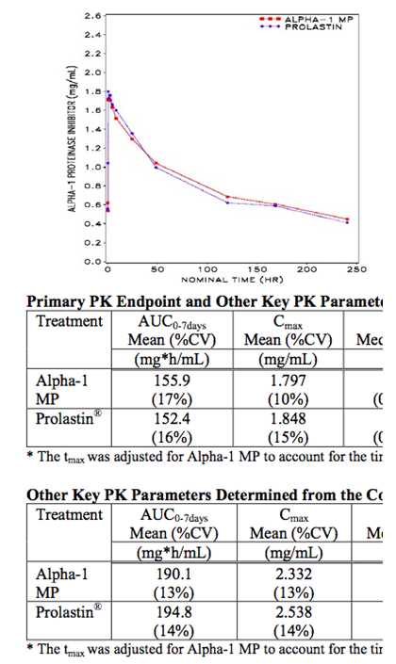

Figure 2: Mean plasma Alpha1-PI post Alpha-1 MP or Prolastin (Content Assay)

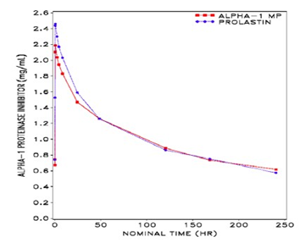

Primary PK Endpoint:The AUC0-7 days by the potency assay was 155.9 mg.h/mL for Alpha-1 MP and 152.4 mg.h/mL for Prolastin. ANOVA analysis showed that the geometric least-squares mean ratio, Alpha-1 MP versus Prolastin, for the primary PK endpoint, AUC0-7 days of Alpha1-PI by the potency assay, had a point estimate and 90% confidence interval of 1.03 and 0.97 to 1.09, respectively. The 90% CI falls within the limit of 0.80 to 1.25 that is “bioequivalent”. The point estimate and 90% confidence interval of the geometric least-squares mean ratio, Alpha-1 MP versus Prolastin, for AUC0-7 days by the content assay, were also calculated at 0.98 and 0.95 to 1.02, respectively.

#### Other PK references submitted in support of the application

Table 1: Five submitted references with PK data

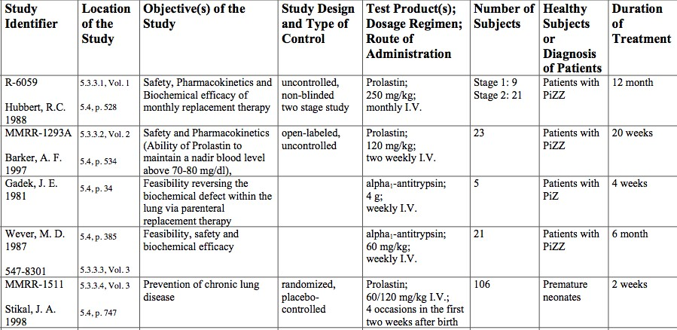

##### Hubbert 1998

**Comment:** Is the correct reference is HubbardRC, 1998[1]?

In this Study, 250 mg/kg of Prolastin were given at 28 day intervals. Nine patients were studied, 8 were Z null and 1 heterozygote, in an acute and a chronic study. Serum α1AT concentrations were on average 35 ± 10 mg/dL. Acute PK and safety was studied after one IV250 mg/kg dose; safety and initial PK and a chronic study to examine lung α1AT levels and anti-elastase defenses using bronchoalveolar lavage at 7, 14 and 28 d after infusion was undertaken.

In the acute study; five received doses of 30, 60 and 90 mg/kg and two groups of 3 each received 140 and 250 mg/kg. In the chronic study; subjects were given 250 mg/kg every 28 days.

After the single 250 mg/kg dose, serum α1AT concentrations remained above the 80 mg/dL level for 21 days and the concentration above the pre-infusion α1AT concentration for 28 days.

Examination of anti-neutrophil elastase capacity in the lung fluid (ELF) was also undertaken.

Figure 3: Relationship between serum anti-neutrophil elastase capacity and serum α1AT level

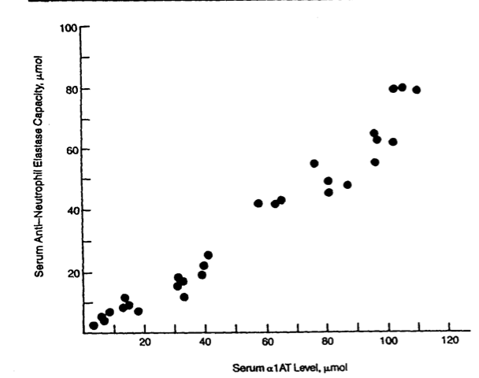

Further ELF levels were markedly elevated at 7, 14 and 28 days after each monthly infusion. Compared with pre-infusion ELF α1AT level of 0.33 µmol, ELF α1AT at 7 and 14 days post infusion were 5.89 and 3.87 µmol, both more than 10 fold higher than the pre-infusion ELF α1AT level. The ELF α1AT levels 28 days post infusion of 2.35 µmol were nearly 7 fold higher than the pre-infusion level and higher than the theoretical ‘threshold’ of 1.3µmol.

However it was noted that despite the increase in ELF α1AT, pulmonary status did not change. The infusion was well tolerated and no new AEs were noted in the chronic study of 12 months.

##### Barker-1997[2]

In this study, 23 patients with PiZ genotype were given 120 mg/kg IV infusion every 2 weeks. For most patients the infusion did not maintain a nadir concentration above 70 to 80 mg/dL. The serum α1AT and neutralizing elastase levels correlated but did not correlate with lung BAL α1AT nor neutralizing elastase levels (measured in 5 people).

Figure 4: Mean serum AAT levels after multiple doses of α1AT-C (120 mg/kg) administered every 2 weeks

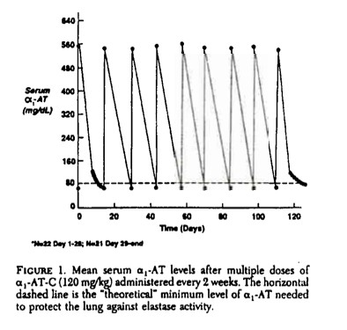

There was one discontinuation after the first infusion. 21 of the remaining 22 had AEs judged probably or possibly related to study drug. 11 out of 23 had respiratory problems; shortness of breath (SOB), increased cough, congestion, rhinitis, headache (10 out of 23) and fatigue (9 out of 23). One man had a number of ‘immune’ AEs after every infusion (chest tightness, muscle soreness, joint pain and increased SOB. One death of pneumonia 5 days occurred after infusion 3.

Despite the infusions, and the improvement in A1AT level, the FEV1 did not change and the FVC declined 0.17L.

##### Gadek-1981[3]

5 patients with PiZ received infusions of 4G weekly. There were no AEs. BAL showed that alpha antitrypsin crossed into the lungs in the functional form. The serum anti-elastase activity in the lung rose from 24% to 82% of normal control serum but prior to the next weekly infusion had dropped back to 35% and lung elastase activity rose from 15% of normal to 60 to 70% of normal after the second and fourth infusions.

Table 2: Summary of α1-Antitrypsin levels in serum and the lower respiratory tract of the study population treated with α1-Antitrypsin concentrate

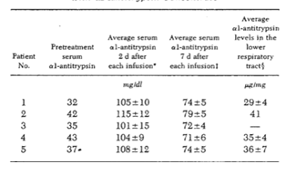

##### Wewers-1987[4]

This manuscript described a short term and long term PK project in 21 patients with PiZZ who received 60 mg/kg alpha proteinase inhibitor and 9 normal controls (PiMM).

###### Short term

Five patients; Pilot of 15 to 90 mg/kg over 5 days; to analyse number and time the concentrations were over 80 mg/dL; a figure taken from epidemiological studies (referenced in the manuscript) as a level above which the same risk of emphysema is conferred as background risk of developing emphysema.

**Comment:** there is a concern with the assumption it is known that there are examples of other surrogates artificially elevated by treatment that do not translate into assumed clinical outcomes. However I note this number of 80 mg/dL is widely accepted in the literature even accepting the limitations.

###### Chronic study

One month and 6 months. 21 patients received 60 mg/kg weekly.

Figure 5: Serum concentrations of serum α1AT and serum anti-neutrophil elastase activity during LT (up to 6 months) use in 21 patients

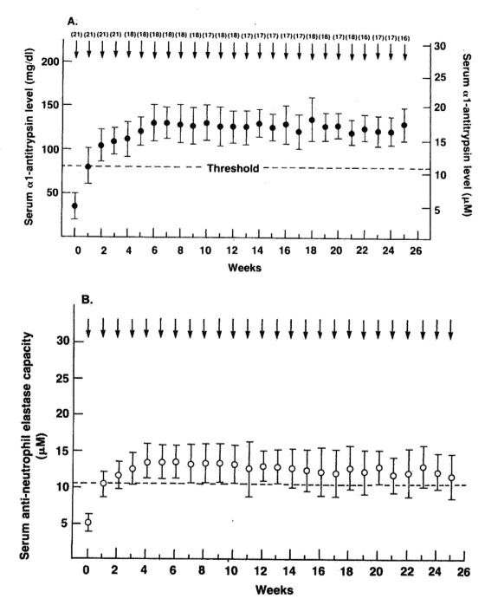

It can be seen that both appeared to increase in a parallel fashion.

Figure 6: Anti-neutrophil elastase capacity in epithelial lining fluid

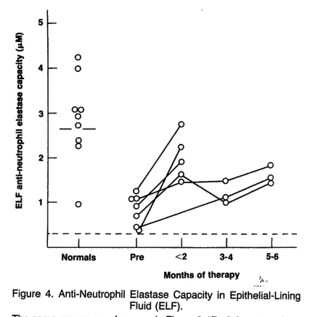

Overall there was a 4 fold increase in serum α1AT concentrations and a 2 fold increase in capacity of the lung to inhibit neutrophil elastase capacity over the 5 to 6months.

##### Stikal 1998

**Comment:** The evaluator was unable to find this reference on the CD or on pub med.

##### Stockley 2002

This was primarily a PD study; the 2002 paper was not able to be located on the CD, the presumed 2000 Stockley study is reviewed in the pharmacodynamics section (BAYX5747 200034 – PH 30567/1 Report 2001) and a Stockley 2010[5] study on surrogate efficacy is reviewed in the efficacy section.

### Summary of pharmacokinetics

The ChAMP study has shown that when administered at a dose of 60 mg/kg alpha1-PI per potency or functional activity assay, Alpha-1 MP has PK comparability to Prolastin based on the primary endpoint (AUC0-7 days of plasma alpha1-PI measured by potency or functional activity assay; 155.9 mg.h/mL for Alpha-1 MP and 152.4 mg.h/mL for Prolastin, point estimate and 90% confidence interval of 1.03 and 0.97 to 1.09, respectively). The point estimate and 90% confidence interval of the geometric least-squares mean ratio, Alpha-1 MP versus Prolastin, for AUC0-7 days by the content assay, were also calculated at 0.98 and 0.95 to 1.02, respectively.

Alpha-1 MP and Prolastin administered at the same dose of 60 mg/kg alpha1-PI per potency assay produced comparable mean trough concentrations of plasma alpha1-PI, 16.9 and 16.7 µM, respectively, as measured by the antigenic content assay.

The published literature showed some inconsistencies with this data. The Hubbard study supported the findings; here after a single 250 mg/kg dose, serum α1AT concentrations remained above the 80 mg/dL level for 21 days and the concentration above the pre-infusion α1AT concentration for 28 days. ELF levels were elevated at 7, 14 and 28 days after each monthly infusion. ELF α1AT was more than 10 fold higher than the pre-infusion ELF α1AT level. The ELF α1AT levels 28 days post infusion of 2.35 µmol were nearly 7 fold higher than the pre-infusion level and higher than the theoretical ‘threshold’ of 1.3µmol. The infusion was well tolerated and no new AEs were noted in the chronic study of 12 months. However it was noted that despite the increase in ELF α1AT, pulmonary status did not change.

In another study (Wevers),[6] there was a 4 fold increase in serum α1AT concentrations and a 2 fold increase in capacity of the lung to inhibit neutrophil elastase capacity over the 5 to 6 months with both serum concentrations of serum α1AT and serum anti-neutrophil elastase activity elevated during LT (up to 6 months) use in 21 patients.

However in another study (Barker),[7] 23 patients given 120 mg/kg IV infusion every 2 weeks did not maintain a nadir concentration above 70 to 80 mg/dL for most patients. The serum α1AT and neutralizing elastase levels correlated but did not correlate with lung BAL α1AT nor neutralizing elastase levels (measured in 5 people). AEs did occur; there was one discontinuation after the first infusion and almost all had AEs judged probably or possibly related to study drug. Further, despite the infusions, the FEV1 did not change and the FVC declined 0.17L.

### Evaluator’s overall conclusions on pharmacokinetics

Overall, infusion of Alpha-1 MP has bioequivalence in PK to Prolastin. At concentrations between 60 mg/kg weekly and 250 mg/kg monthly has shown PK concentrations above the ‘threshold’ of 80 mg/dL.

The PK data on earlier formulations of alpha1-MP protein is thus likely to apply the Prolastin-C formulation.

Pharmacokinetics for the 250 mg/kg dose monthly appears to have more effective PK than 120 mg every 2 weeks but similar results to 60 mg/kg weekly. This does not make clear sense based on standard PK assumptions, however the requested indication is for 60 mg/kg weekly and the PK data shows benefit in surrogate markers of disease activity with this dose. The lack of improvement in parameters known to be associated with quality of life and morbidity/mortality despite increased concentrations of protein in the serum and lung is noted.

## Pharmacodynamics

### Studies providing pharmacodynamic data

There were two studies with PD data; Gottleib 2000 and Stockley 2002.

Table 3: Studies providing pharmacokinetic data



#### Gottlieb 2000

Gottlieb, D.J., et al. “Short-term supplementation therapy does not affect elastin degradation in severe alpha1-antitrypsin deficiency”. The American-Italian AATD Study Group. *Am J Respir Crit Care Med*, 2000. 162(6): 2069-2072.

#### Study PH30125

Effect of Bay X5747 substitution therapy on connective tissue degradation in alpha1-antitrypsin (AAT) deficiency. Multicentre prospective, open, non-comparative study

Desmosine and isodesmosine are cross linked amino acids present only in mature elastin, and rarely excreted in urine when there is elastin degradation measurement of urinary DES has been shown to be an accurate measure of total body elastin degradation. It is elevated in healthy smokers cf. on smokers and in COPD compared with healthy and non-healthy smokers.

##### ***Design, dates***

Phase II, prospective, open label study undertaken between 1997 and 1998 in 7 centres.

##### Objectives

* To determine if urinary excretion of desmosine (DES) and isodesmosine (IDES) is elevated about the normal value in clinically stable patients with AAT deficiency.
* To determine if ATT supplementation therapy (BAY X 5747) reduces the rate of CT degradation in AAT deficient patients, as determined by reduced urinary excretion of these cross linked amino acids.
* To determine the time course of the reduction in CT degradation after ATT supplementation.
* To evaluate if the rate of CT degradation during AAT supplementation varies between peak and trough AAT levels.
* To determine if augmentation therapy with BAY X 5747 decreases urinary desmosine excretion in a sufficient amount to justify undertaking a larger study.

##### Methods

###### Population

12 people (8 men, 4 women) with a median age of 53 (35 to 76) years.

###### Main inclusions

Congenital AAT deficiency and evidence of lung disease (FEV1 < 80% predicted) and blood A1AT concentrations < 80 mg/dL.

###### Main exclusion

End stage COPD, inter-current infection, pregnant or nursing, hypersensitivity to products, contraindication to Hep B vaccine, treatment with another investigational drug 30 d prior to enrolment.

###### Drug

60 mg/kg administered weekly by IV infusion every week for 8 weeks (8 infusions).

###### Endpoint

Pharmacodynamic measures of A1AT and safety (adverse events, vitals, and laboratory data).

##### Results

Only one of the 12 was a nonsmoker, other 11 were past smokers. 11 had the phenotype PiZZ and one PiM like homozygote. For each patient, 14 urinary samples were drawn, 4 during the 4 weeks run in period and 10 samples (8 troughs and 2 peaks) during the 8 week therapy; these showed no difference over time in either the run in nor the treatment period.

Mean and media duration of exposure was 49 days (min-max 48 to 56). Patients were compliant.

Rate of elastin degradation measured by urinary DES was high the run in (12.78 ± 5.28) and did not change significantly meaningfully during the study. Units were not provided nor in the Boston University manuscript quoted below, in the Study. Boston had previously published non AAT deficient data for these cross linked amino acids desmosine (DES) and isodesmosine (IDES).

Table 4: Rate of elastin degradation in different groups

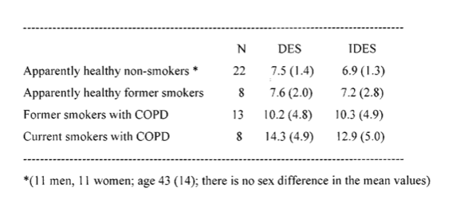

Results of ANOVA in all 12 trough measurements (4 run in and 8 on treatment) of the two cross linked amino acids showed no changes over time, even when adjusted for cotinine. In terms of the comparisons between peak and trough measurements, apart from one comparison of peak-trough mean between desmosine (adjusted for cotinine) there were no differences.

##### Safety results

One TEAE was reported of vaginitis, bronchitis, painful breast and pharyngitis. No AE effect on laboratory measurements or vital signs.

##### Conclusions

Using a biochemical assay or urinary excretion of DES, baseline levels of DES in this population group with AAT deficiency were very high; 8 weeks of IV AAT therapy did not change this. It raises issues as to whether the protective levels of AAT are insufficient or if elastin degradation is dependent on other pathways.

**Comment:** As noted in the manuscript/study report, the excretion of these two cross linked amino acids was not modified by Prolastin, even after adjustment for cotinine. Further, Prolastin appears to not be having an acute effect on these excretion parameters as evidenced by the lack of difference in peak and trough values.

#### Stockley 2002; BAYX5747 200034 – PH 30567/1 Report 2001

An open study to assess the short-term clinical effects of treatment with weekly administration of IV Prolastin in patients with A1AT deficiency.

**Comment:** This publication was unable to be found and it was wondered if the correct reference was Stockley 2010. The publication was also not found on the submission CD. Stockley 2000 was however found in the PD section – an open study to assess the biochemical and clinical effects of treatment with weekly IVProlastin in patients with A1AT deficiency and is likely that this is the correct PD study (BAYX5747 200034 – PH 30567/1 Report 2001) - this will be evaluated below; Stockley 2010 is evaluated under Section 7 – Efficacy.

##### Design, dates

A Phase II Open label prospective study, October 1998 to April 1999.

##### Objective

This study aimed to measure change (and time course) in A1AT, neutrophil elastase activity and inhibitory ability in sputum over the course of therapy Day 1 to 23). There were a variety of secondary endpoints also examining changes over the 4 weeks, in sputum volume, colour, IL8, MPO, secretory leucoproteinase inhibitor, LTB4 concentrations and serum A1AT, albumin, CRP concentrations and lung function parameters. Safety, laboratory, and vital parameters were measured.

##### Methods

Prolastin 60 mg/kg once a week for 4 weeks was given.

##### Results

Sputum and serum A1AT concentrations were statistically and clinically significantly raised after 4 weeks treatment with 60 mg/kg IV Prolastin. Trends towards reduction in sputum elastase, IL-8, LTB4, sputum elastase inhibitory capacity and MPO were seen but were not statistically significant. Sputum volume did not change after treatment and became more mucopurulent. There were no clinically significant changes in lung function, BORG Dyspnoea score or sputum bacteriology.

##### Safety

AEs included chills, arthralgia, no deaths nor SAEs. No laboratory or vital AEs were reported.

**Comment:** Although the A1AT concentration increased, there were no beneficial effects on PD parameters or BORG score seen. Infusion AEs were reported.

### Evaluator’s overall conclusions on pharmacodynamics

Study PH30125 showed that using a biochemical assay or urinary excretion of DES, baseline levels of DES in this population group with AAT deficiency were very high but that 8 weeks of IV AAT therapy did not change this. It raises issues as to whether the protective levels of AAT are insufficient or if elastin degradation is dependent on other pathways. It is likely that Prolastin is not having an acute effect on these excretion parameters as evidenced by the lack of difference in peak and trough values.

BAYX5747 200034 – PH 30567/1 Report 2001 similarly showed that although the A1AT concentration increased post infusion, that there were no beneficial effects on PD parameters or BORG score seen. Infusion AEs were reported.

## Dosage selection for the pivotal studies

The dosage selected for the single pivotal study is N/A as there was no pivotal study. PK data suggested the dosage requested in the indication of 60 mg/kg weekly is reasonable.

## Clinical efficacy

Indication 1 –Prolastin in patients with emphysema and A1AT deficiency.

Study 100533_EudraCT No. 0010-0251 was provided in two parts in the submission as a clinical efficacy study. (Sections 1 and A). Section A included published manuscripts, the major features of which have seen summarised below under “Other Efficacy Studies”. The remainder was Tables from the 00533/EudraCT No: 0010/0251 Study covered in Section 1.

Pivotal efficacy studies

Nil.

#### Other efficacy studies

##### 100533/EudraCT No: 0010/0251

This was a multi-centre, randomised trial with intravenous (IV) Prolastin to evaluate frequency of exacerbation and progression of emphysema by means of multi-slice compute tomography (CT) scans in patients with congenital alpha-1-antitrypsin deficiency.

###### *Design, dates*

Phase II, multicentre (UK, Denmark, Copenhagen, Sweden) randomised, placebo controlled, parallel group, double blind exploratory study designed to assess the utility of CT scans in measuring the progression of emphysema and the potential efficacy of functional Prolastin, administered weekly by IV infusion at 60 mg/kg, to subjects with progressive emphysema with severe A1AT deficiency from November 2003 to December 2006.

###### Objectives

The objective of this exploratory study was to assess the utility of CT scans in measuring progression of emphysema and the safety and potential efficacy of Prolastin. This was specified in the study protocol as follows:

* To evaluate the 15th percentile point of lung parenchyma tissue loss, calculated by analysis of CT lung histograms and exacerbations, as clinical endpoints for the progression of emphysema in subjects with A1AT deficiency
* To assess the potential efficacy of IV Prolastin versus placebo on lung density (measured by CT scan) and the frequency and other parameters of exacerbations in subjects with AAT deficiency.

###### Methodology

Number of subjects

The study population consisted of 77 randomised adult Caucasian men (n = 41) and women (n = 36) aged between 35 and 74 years (median: 56 years in the Prolastin group, 57 years in the placebo group). The subject disposition is displayed in the Table 5 below.

Table 5: Study 100533/EudraCT No: 0010/0251 subject disposition

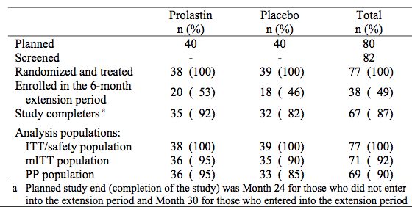

Subjects who met the inclusion and exclusion screening and baseline were randomised to receive IV Prolastin or placebo (1:1), weekly for 24 months. A total of 77 subjects were randomised and assessed after 1 month, 3 months, and then every 6 months up to 24 months. In addition, 38 subjects who were randomised between October 2003 and June 2004 were eligible and re- consented for an optional extension of 6 months of study drug treatment.

Diagnosis and main criteria for inclusion

* Subjects diagnosed with pulmonary emphysema due to severe congenital AAT deficiency of phenotype PiZ or other rare genotypes (but not MS, MZ or SZ), and with AAT serum levels < 11 µM. AAT status was to be confirmed by phenotyping and genotyping.
* Age ≥ 18 years
* Inspiratory capacity (vital capacity [VC], expiratory reserve volume [ERV]) ≥ 1.2 L and forced expired volume in 1 second (FEV1) < 80% of predicted value post bronchodilator
* FEV1/VC ≤ 70% of predicted value post-bronchodilator or transfer factor of carbon monoxide (KCO) ≤ 80% of predicted value post-bronchodilator
* History of at least one exacerbation in the past 2 years
* Subjects who had provided written informed consent prior to any study related procedures.
* Investigational Product details: Either Prolastin; Alpha1-proteinase inhibitor (alpha1-PI) or alpha1-antitrypsin (AAT) was given. Weekly IV infusion of 60 mg/kg body weight of functional Prolastin for 24 months and up to 30 months for those subjects who completed the optional extension treatment period.

###### Duration of treatment

24 months followed by an optional extension of 6 months additional treatment for the subset of subjects enrolled between October 2003 and June 2004.

###### Primary efficacy endpoint

* The primary efficacy endpoint was the progression rate of emphysema, determined by the change in lung density measured by annual CT scans of the whole lung (within 4 hours after application of a short-acting bronchodilator) over time. The lower 15th percentile of lung voxel densities for the whole lung (measured in Hounsfield units) was used as the effect variable. When available, Month 30 CT scans were used to evaluate the rate of progression of emphysema.

###### Secondary efficacy endpoints

* Change in lung density at each visit
* Frequency of exacerbations assessed by the investigator and recorded on the CRF
* Duration and severity of exacerbations as recorded on the CRF
* The deterioration of lung function as assessed by:
  + Change in forced expired volume in 1 second (FEV1)
  + Slow vital capacity (SVC)
  + Total lung capacity (TLC)
  + Inspiratory vital capacity (IVC)
  + Expiratory reserve volume (ERV)/Functional residual capacity (FRC)
  + Transfer factor of carbon monoxide (KCO)/Pulmonary diffusing capacity for CO (DLCO).
* Mortality: Number of subjects that died per treatment arm during the study.
* Quality of life: a disease specific instrument, the St. George’s Respiratory Questionnaire (SGRQ)

###### Safety

* Incidence of AEs
* Viral serology results
* Cotinine levels
* Concurrent medications required.

###### Statistical methods

The primary efficacy analysis based on TLC adjusted total lung density was tested for treatment difference (Prolastin versus placebo) by a slope analysis (random coefficient regression model) adjusted by study centre as a fixed effect. Similar slope analysis was repeated for unadjusted total lung density with logarithm of total lung volume as a time- variant covariate. Also, endpoint analyses of both TLC adjusted total lung density and unadjusted total lung density were tested for treatment difference by using an analysis of covariance (ANCOVA) with change from baseline as dependent variable and baseline value as a covariate. Similar slope analyses and endpoint analyses were repeated for lung function test variables and the SGRQ. Annual exacerbation incidence rate is tested for treatment difference by using ANOVA. The total number of exacerbations was analysed by a Poisson regression model with treatment, centre, percentage of predicted FEV1 and sex as fixed factors and the duration in the study as an offset variable. Also, time to first exacerbation was analysed by Kaplan-Meier method. Descriptive summary statistics were presented for safety data.

###### Results

The two treatment groups were comparable with regard to demographic and disease characteristics except gender at baseline. There were more men in the Prolastin than in the placebo group (66% versus 41%; p= 0.021; ANOVA).

The main analysis of the primary endpoint was the slope analysis of TLC adjusted 15th percentile of lung density (“sponge model”). The mean decline in lung density estimated from the slope for the Prolastin group was non significantly different; -1.384 ± 0.320 compared to -2.241 ± 0.333 for the placebo group, that is,Prolastin minus placebo was 0.857 ± 0.461, p = 0.068.

Table 6: Changes in TLC adjusted 15th percentile of lung density (g/L) from baseline to endpoint (mITT population) with exclusion of data at Months 3 and 21

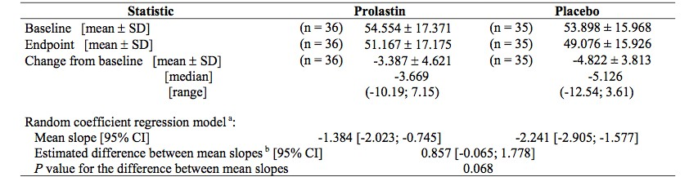

Change from baseline – endpoint analysis for 15th percentile lung density (mITT population)

At Month 24, the mean decrease in lung density was more pronounced in the placebo group (‑3.49 ± 6.36 g/L versus -1.35 ± 9.04 g/L in the Prolastin group). Comparison of the slopes of the decrease in lung density indicated a difference between Prolastin (mean slope: -0.70 ± 0.35) and placebo (mean slope: -1.34 ± 0.37) of 0.64g/L ± 0.51 (95% CI: -0.38 to 1.66; *p* = 0.214).

Table 7: Changes in mean lung density [g/L] from baseline to endpoint (mITT population)

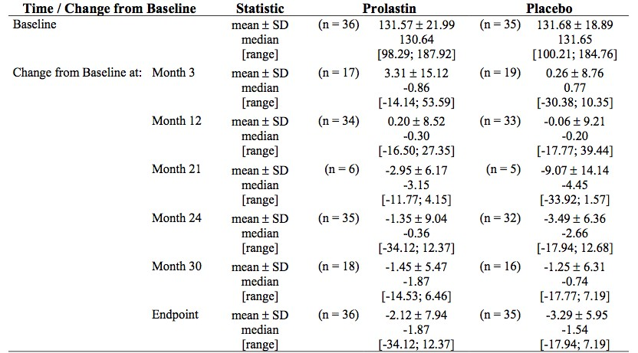

Endpoint analysis of TLC-adjusted 15th percentile of lung density

The mean decline in lung density estimated by endpoint analysis for the Prolastin group was: 3.202 compared to -4.798 for the placebo group (LS means). The estimated difference (Prolastin minus placebo) was 1.596 (95% confidence interval: -0.220 to 3.412), p= 0.084.

Endpoint analysis of unadjusted 15th percentile of lung density – covariance approach

The applied ANCOVA model demonstrated a treatment difference in the rate of lung density progression between the Prolastin and placebo groups of 1.472 (95% confidence interval: 0.009 to 2.935), p= 0.049.

###### Secondary endpoints and exploratory analyses related to CT scans

Changes in mean lung density

In both treatment groups, a mild trend towards a decrease in mean lung density was observed at Months 12 and Month 24, when compared to treatment, though it was numerically more in the placebo group (-3.49 ± 6.36 g/L versus -1.35 ± 9.04 g/L in the Prolastin group). Numerically greater decreases under Prolastin treatment were seen at Month 30 in the subgroup of subjects who entered into the extension period (-1.45 ± 5.47 g/L versus -1.25 ± 6.31 g/L in the placebo group).

Table 8: Changes in mean lung density [g/L] from baseline to endpoint (mITT population)

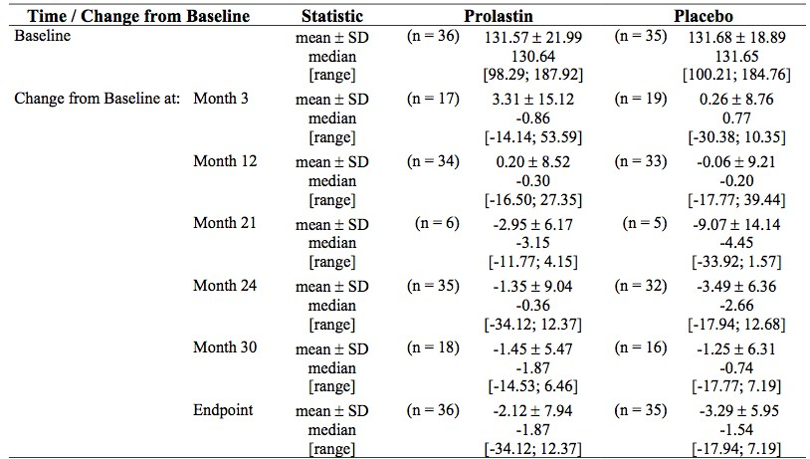

Changes in mean lung density using the random coefficient model; slope analysis

Mean values of mean lung density decreased from baseline to endpoint in both treatment groups. Comparison of the slopes of the decrease in lung density indicated a difference between Prolastin (mean slope: -0.70 ± 0.35) and placebo (mean slope: -1.34 ± 0.37) of 0.64 ± 0.51. The 95% confidence interval of the difference was -0.38 to 1.66, p = 0.214.

Analysis of lung sub-regions: Change in unadjusted lung density using slope analysis

Comparison of the slopes of the decrease in lung density in the basal third of the lung showed a difference between Prolastin (mean slope: -0.850 ± 0.2767) and placebo (mean slope: ‑1.747 ± 0.2880) of 0.897 ± 0.3994, 95% CI 0.100 to 1.694, p= 0.028. Comparison of the slopes of the decrease in lung density in the middle and apical thirds did not identify a significant difference.

Changes in lung weight using the random coefficient model – slope analysis

Mean values of lung weight decreased from baseline to endpoint in both treatment groups Comparison of the slopes of the decrease in lung weight indicated a difference between Prolastin (mean slope: -4.90 ± 2.65) and placebo (mean slope: -9.77 ± 2.75) of 4.87 ± 3.82, 95% CI -2.77 to 12.51, p = 0.207.

Changes in CT measured lung volume (L)

Mean values of lung volume remained nearly unchanged from baseline to endpoint in both treatment groups 95% CI (-0.002) was -0.075 to 0.071, p = 0.959.

Table 9: Changes in CT measured lung volume from baseline to endpoint-mITT population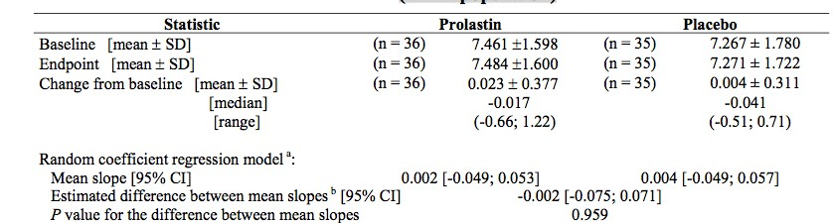

Changes in voxel index (-910 HU) using the random coefficient model – slope analysis

Mean values of voxel index (-910 HU) increased from baseline to endpoint in both treatment groups and indicated a non-significant difference between Prolastin (mean slope: 0.621 ± 0.232) and placebo (mean slope: 0.928 ± 0.242) of -0.307 ± 0.335. The 95% confidence interval of the difference was -0.978 to 0.363, p = 0.363.

Changes in voxel index (-950 HU) using the random coefficient model – slope analysis

Comparison of the slopes of the increase in voxel index (-950 HU) indicated a non-significant difference between Prolastin (mean slope: 0.762 ± 0.191) and placebo (mean slope: 1.033 ± 0.199) of -0.271 ± 0.276. The 95% confidence interval of the difference was -0.823 to 0.280, p = 0.329.

###### Results of exploratory methods incorporating volume adjustment methods

Method 1: Changes in TLC-adjusted lung density (mITT) (exploratory analysis including all data points); The ‘Sponge Model’

Comparison of the slopes of the decrease in TLC-adjusted 15th percentile of lung density indicated a non-significant difference between Prolastin (mean slope: -1.670 ± 0.3207) and placebo (mean slope: -2.309 ± 0.3326) of 0.639 ± 0.4620.

Method 2: Changes in unadjusted 15th percentile of lung density using the random coefficient model - slope analysis (exploratory analysis)

Comparison of the slopes of the decrease in 15th percentile of lung density indicated a difference between Prolastin (mean slope: -1.408 ± 0.253) and placebo (mean slope: -1.878 ± 0.263) of 0.470 ± 0.366. The 95% confidence interval of the difference was -0.262 to 1.201, p = 0.204.

###### Other secondary endpoints

Exacerbations

Data on exacerbations were defined as secondary efficacy parameters. An exacerbation was defined in the SAP as “any deterioration with new or worse major symptoms, or new minor symptoms, lasting for 2 days and needing an increase in their usual treatment, or the introduction of new treatment, or hospital admission.

Prolastin non-significantly shortened the duration of the exacerbation in the Prolastin group by about 10% compared to placebo group (18.9 ± 18.8 days versus 21.0 ± 19.9 days under placebo treatment; p = 0.181; ANOVA main effect model). There were significantly less severe exacerbations in the Prolastin group (6.7% versus13.5% under placebo treatment; p = 0.013; CMH test). The annual exacerbation rate was not significantly different (Prolastin treatment was 2.55 ± 2.14 and 2.19 ± 1.33 for the Placebo group; p = 0.265; ANOVA, main effect model).

None of the main parameter of lung function FEV1 nor KCO and DLCO showed any benefit of Prolastin. The speed of deterioration was not markedly different under Prolastin treatment when compared to placebo treatment (all p values > 0.1; random coefficient regression model). These results were consistent with other lung function parameter results (SVC, TLC, IVC, ERV, FRC and ERV/FRC). There was a large variability in all lung function parameters among the subjects in the two treatment groups both with regard to the absolute values and to their changes consistent with previous studies.

Quality of Life; SGRQ

Three component scores are calculated for the SGRQ:

* “Symptoms”: that is effect of respiratory symptoms, their frequency and severity.
* “Activity”: that is with activities that cause or are limited by breathlessness.
* “Impact”:that is social functioning and psychological disturbances resulting from airways disease.

An overall score was also calculated which summarises the impact of the disease on overall health status. Scores are expressed as a percentage of overall impairment where 100 represents worst possible health status and 0 indicates best possible health status. A 4 point change is the minimally clinical important difference (MCID) for this questionnaire. In this context -4 is a noticeable and clinically relevant improvement.

In both treatment groups the “activity” domain was on average the most affected domain at baseline (58.9 ± 21.6% in the Prolastin group and 63.5 ± 21.6% in the placebo group), while the lowest impairments were seen on average for the “impact” domain (30.0 ± 17.6% in the Prolastin group and 35.1 ± 18.1% in the placebo group.

Both marked individual improvements and deteriorations were observed in the scores for all domains under treatment in the two treatment groups. All of them were smaller than 1 point that is the values remained nearly unchanged during the study. Comparison of the mean slopes between the treatment groups resulted in p values ≥ 0.4 for all of the different percentage scores (random regression model.

Thus overall quality of life as determined with the percentage score of the SGRQ was unchanged. Neither one of the sub-scores or the overall percentage score changed to a marked extent in the two treatment groups. The median changes in the overall percentage score were less than the MCID.

**Comment:** Disease progression was demonstrated in both treatment groups using CT densitometry to assess emphysema severity. There was no difference in the primary endpoint between the two treatment groups. There was a treatment difference in the rate of lung density progression (unadjusted 15th percentile of lung density) between the Prolastin and placebo groups of 1.472 (95% confidence interval: 0.009 to 2.935), p = 0.049. But when adjusted for TLC this was no longer significant.

There was also a non-significant trend evident in the four analysis methods used for primary efficacy endpoint analysis perhaps suggesting a slight deceleration of lung density decline in the Prolastin group. In both treatment groups, a mild trend towards a decrease in lung density was observed at Months 12 and Month 24, when compared to baseline. At Month 24, the mean decrease was more pronounced in the placebo group (-3.49 ± 6.36 g/L versus -1.35 ± 9.04 g/L in the Prolastin group).

Comparison of the slopes of the decrease in lung density indicated a non-significant difference between Prolastin and placebo of 0.64 ± 0.51 (95% CI: -0.38 to 1.66; p= 0.214). Prolastin non significantly reduced duration and number of exacerbations and was associated with significantly less severe exacerbations (6.7% versus13.5% under placebo treatment; p= 0.013).

Neither the main parameter of lung function FEV1 nor the parameters of carbon monoxide transfer KCO and DLCO indicated any advantage of the Prolastin treatment. All of these parameters consistently reflected a deterioration of lung function. As to be expected, the speed of deterioration was not markedly different under Prolastin treatment when compared to placebo treatment (all pvalues > 0.1; random coefficient regression model). These results were further in accordance with the results referring to other lung function parameters (SVC, TLC, IVC, ERV, FRC and ERV/FRC). There was a large variability in all lung function parameters among the subjects in the two treatment groups both with regard to the absolute values and to their changes, which was in line with previous studies.

#### Submitted Manuscripts to support 100533/EudraCt No. 0010/0251/A

Manuscripts that were not directly relevant to the clinical section (for example, on method extraction and purification, the description of St George respiratory questionnaire, studies on prognosis with A1AT in the absence of an intervention, are not discussed). Other studies that initially appeared relevant were analysed – their brief comment appears in the Section below. A publication by Gadek and Crystal had a first page only.

##### Stockley 2010[8]

Stockley 2010 was a report on pooled data from two randomised, double blind, placebo controlled trials that had investigated the efficacy of IV alpha-1 antitrypsin (AAT) augmentation therapy on emphysema progression using CT densitometry. These two similar trials were the 2 centre Danish-Dutch study (n = 54) and the 3 centre EXAcerbations and CT scan as Lung Endpoints (EXACTLE) study (n = 65) discussed above. The PD endpoint of interest was the change in 15th percentile of lung density (PD15) measured by CT scan was obtained from both trials, a PD surrogate that was fairly well validated in radiologic manuscripts submitted by the sponsor.

###### Methods

In these studies all subjects had 1 CT scan at baseline and at least 1 CT scan after treatment. Densitometric data from 119 patients (AAT [Alfalastin or Prolastin], n = 60; placebo, n = 59) were analysed by a statistical/endpoint analysis method. To adjust for lung volume, volume correction was made by including the change in log transformed total lung volume as a covariate in the statistical model. The unadjusted significant finding in 100533/EudraCT No: 0010/0251 (lung density 15% percentile, p = 0.049 was used).

###### Results

Mean follow-up was approximately 2.5 years. The mean change in lung density from baseline to last CT scan was -4.082 g/L for AAT and -6.379 g/L for placebo with a treatment difference of 2.297 (95% CI, 0.669 to 3.926; p = 0.006). The corresponding annual declines were - 1.73 and ‑2.74 g/L/yr, respectively. Using pooled data there was a statistically significant reduction in the reduction in lung density over 2.5 years of 2.3 g/L in a combined AAT/Prolastin group.

**Comment:** The clinical significance of this pooled dataset is unclear as is the clinical significance of a difference in lung density of 1.01 g/L over 2.5 years was not discussed. Also the unadjusted CI and p value of the unadjusted 15% of lung density from 100533 was used.

##### Perez 2005[9]

This study was used as validation of as a method to test the hypothesis that computed tomography morphometry (CTM) can be used to track the changes in lung density in diffuse lung disease. Pulmonary alveolar proteinosis (PAP) was used as a model of diffuse lung disease.

###### Objectives

The present study was designed to test the hypothesis that quantitative CT can track the changes that occur in diffuse lung disease. The study was based on five patients with pulmonary alveolar proteinosis (PAP) who underwent bronchoalveolar lavage.

###### Methods

Pulmonary function was measured before and after each individual lung lavage, and the CT scans before and after lavage were used to compare total lung volume, airspace volume, lung weight, and regional lung inflation. The dry weight of proteinaceous material lavaged from the lung was measured and compared to the change in CT lung weight.

###### Results

All the patients showed improvements in dyspnoea, percentage of predicted diffusion capacity of the lung for carbon monoxide, and FVC. There was no change in CT measured total lung volume or airspace volume, but there was a reduction in lung weight following lavage (p = 0.001), which correlated with the dry weight of the lavage effluent (R2 = 0.73). Therefore, there was a shift in the regional lung inflation toward a more inflated lung with a corresponding increase in the mean lung inflation (p = 0.001).

###### Conclusions

These data show that quantitative CT can objectively track the changes in lung weight and airspace inflation produced by a standard intervention in PAP.

**Comment:** Although this method was used in this study of 5 patients in another lung disease, this method was then applied in other studies of clinically relevant endpoints with Prolastin such as EXactle.

##### Thurlbeck, W. 1983[10]

This was a very old reference to older forms of imaging in emphysema and thus relevance to the markers chosen in the clinical trials was not clear.

##### Hartley, 1994[11]

This manuscript discusses the validity of high resolution CT in interstitial lung disease, so is not directly relevant to this application.

##### Parr, D et al[12]

**Comment:** Year of publication not given but was entitled “Detection of emphysema progression in alpha 1-antitrypsin deficiency using CT densitometry; methodological advances (manuscript in submission format, p 96- of 2693 of 100533/EudraCT No: 0010/0251/A.

Computer tomography (CT) densitometry is a potential tool for detecting the progression of emphysema but the optimum methodology is uncertain.

###### Methods

Emphysema progression over a 2 year interval was assessed in 71 patients (alpha 1-antitrypsin deficiency with PiZ phenotype) with CT densitometry, using the 15th percentile point (Perc15) and voxel index (VI) -950 Hounsfield Units (HU) and -910 HU (VI -950 and -910) on whole lung, limited single slices, and apical, central and basal thirds. The relationship between whole lung densitometric progression (∆CT) and change in CT derived lung volume (∆CTVol) was characterised, and adjustment for lung volume using statistical modelling was evaluated.

###### Results

CT densitometric progression was statistically significant for all methods. The most accurate measure was obtained using a random coefficient model to adjust for lung volume and the greatest progression was detected by targeted sampling of the middle third of the lung.

###### Conclusion

Targeted sampling of the middle lung region using Perc15 appears to be the most robust measure of emphysema progression.

##### McElvaney 1996 [13]– is gene therapy in CF a realistic expectation?

**Comment:** Not relevant to this application.

##### Parr, D 2004[14]

FEV1 is fundamental to the diagnosis and staging of chronic obstructive pulmonary disease. In emphysema, airflow obstruction usually coexists with impairment of gas exchange, but discordance is not infrequent. The authors hypothesized that variations in the distribution of emphysema would be associated with functional differences and therefore account for discordant physiology. The study used quantitative computed tomography to assess emphysema severity and distribution in 119 subjects with A1-antitrypsin deficiency (PiZ phenotype) and grouped them according to distribution pattern. In the 102 subjects with emphysema, 65 had a predominantly basal pattern (“basal”), but 37 (36%) had greater involvement of the upper regions (“apical”). Subjects from each group were matched for total volume of emphysema and age, and matched pairs analysis was used to relate emphysema distribution to clinical phenotype. Basal distribution was associated with greater impairment of FEV1 (mean difference, 9.9% predicted; 95% confidence interval, 3.8 to 16.0; p = 0.002) but less impairment of gas exchange (PaO2 mean difference, 0.5 kPa, 0.03 to 0.1; p = 0.016) and alveolar–arterial oxygen gradient (mean difference, 0.7 kPa; 0.2 to 1.2; p = 0.007) than the apical distribution. Emphysema distribution correlated with physiologic discordance (r = 0.409, p = 0.001). The use of single physiologic parameters as a surrogate measure of emphysema severity may introduce systematic bias in the staging of subjects with emphysema.

**Comment:** This study showed that reliance on a single parameter to measure improvement in lung function is likely to be prone to bias.

##### Mueller, N. 1992

This manuscript focuses on the use of HRCT for the detection of emphysema therefore it is not relevant for this application.

##### Stoel, M 1999[15]

This manuscript focuses on the use of post processing techniques to account for confounders on CT measurement of change in lung density.

##### Lamers, R. 1998[16]

The aim of this study was to assess the reproducibility of quantitative, spirometrically gated computed tomographic (CT) lung densitometry at defined levels of inspiration in hospitalized patients. On two consecutive days, spirometrically gated CT sections were obtained from 20 hospitalized patients at 5 cm above and 5 cm below the carina, and at 90 and 10% of the vital capacity (VC). The mean, modal and median lung densities were calculated, the cut-off points of the frequency distribution of Hounsfield units (HU) defining the lowest and the highest 10th percentile, as well as the histogram full width at half maximum. The lung density parameters of corresponding CT sections of both studies were compared. Reproducibility was expressed as the standard deviation of the signed difference between the results of Day 1 and Day 2 divided by 2. Reproducibility data were correlated with results of airflow limitation.

At 90% VC, reproducibility was of the order of 3 to 14 HU in both lung zones. At 10% VC, reproducibility was worse by approximately a factor of three. No relationship was found between reproducibility and results of airflow limitation. In conclusion, objective measurement of lung density at spirometrically controlled levels of inspiration is a reproducible method in assessing pulmonary density. Reproducibility of lung density measurements is not influenced by severe respiratory insufficiency. The most reproducible computed tomographic lung density measurements can be obtained at 90% vital capacity.

**Comment:** this manuscript was useful for discussing a reproducible measurement of lung density.

##### Robinson, 1979[17]

Techniques discussed are not used in this submission.

##### Gierada, D. 2001[18]

To evaluate the repeatability of quantitative computed tomographic (CT) indexes of emphysema and the effect of spirometric gating of lung volume during CT in candidates for lung volume reduction surgery (LVRS). Initial and same day repeat routine inspiratory spiral chest CT studies were performed in 29 LVRS candidates (group 1, routine study vs repeat study). In a separate cohort of 29 LVRS candidates, spiral chest CT studies were performed both without and with spirometric gating by using a spirometer to trigger scanning at 90% of vital capacity (group 2, spirometric gating study). In each study, Pearson and intra-class correlation coefficients were calculated to determine the agreement between multiple pairs of whole-lung quantitative CT indexes of emphysema, and mean values were compared with two-tailed paired t tests.

RESULTS: Pearson and intra-class correlation coefficients were high for all quantitative CT indexes (all ≥ 0.92). No significant differences were found between mean values of quantitative CT indexes in group 1. Variation in quantitative CT results was small but more prominent in group 2 than in group 1. The variation in quantitative CT results was primarily related to differences in lung volume (r2 as great as 0.83). Repeatability of quantitative CT test results in LVRS candidates is high and thus unlikely to improve by using spirometric gating.

##### Hoffman and McLennan 1997[19]

This was a review on the relationship between pulmonary structure-function relationship and clinical outcomes. This does not offer any definitive evidenced based statements to guide the interpretation of the current submission.

##### Shaker SB, Acta Radiol 2004[20]

To determine how to adjust lung density measurements for the volume of the lung calculated from computed tomography (CT) scans in patients with emphysema. Fifty patients with emphysema underwent 3 CT scans at 2 week intervals. The scans were analysed with a software package that detected the lung in contiguous images and subsequently generated a histogram of the pixel attenuation values. The total lung volume (TLV), lung weight, percentile density (PD), and relative area of emphysema (RA) were calculated from this histogram. RA and PD are commonly applied measures of pulmonary emphysema derived from CT scans. These parameters are markedly influenced by changes in the level of inspiration. The variability of lung density due to within subject variation in TLV was explored by plotting TLV against PD and RA.

The coefficients for volume adjustment for PD were relatively stable over a wide range from the 10th to the 80th percentile, whereas for RA the coefficients showed large variability especially in the lower range, which is the most relevant for quantitation of pulmonary emphysema. Shaker concluded that volume adjustment is mandatory in repeated CT densitometry and is more robust for PD than for RA. Therefore, PD seems more suitable for monitoring the progression of emphysema.

**Comment:** This showed that percentile density, derived from the frequency histogram of the pixel attenuation values of the lung is more robust in repeated CT monitoring. Thus, the PD15 is defined as the cut-off density at which 15% of all pixels have lower densities.

#### 7.1.2.17. Stolk, J, 2001[21]

The aim of the present study was to assess the intra-individual variation of lung densities measured by MSCT of patients with emphysema. Ten patients with emphysema participated in a study in which MSCT was obtained on two occasions, approximately 2 weeks apart. Lung density was measured as the 15th percentile point and the relative area below 910 Hounsfield units (HU) by using Pulmo-LKEB software. The mean difference of the 15th percentile point was 1.29 - 3.2 HU, and that for the relative area below the 910 HU parameter was 1.02%-3.09%. Intra-class coefficients of variation were 0.96 (0.86 to 0.99) and 0.94(0.8 to 0.98), respectively (95% confidence interval). Stolk concluded that lung density parameters of emphysema derived by MSCT provide an opportunity for analysis of the treatment effects of new drugs on the progression of emphysema.

#### 7.1.2.18. McElvaney 1991[22]

This study showed that aerosol AIAT treatment for another disease (CF) suppressed neutrophil elastase in the respiratory epithelial lining fluid, and restored the ELF anti-neutrophil elastase capacity in 12 subjects with CF.

**Comment:** This is not directly relevant to this Submission however this is an interesting mode of delivery for a pulmonary drug, and the technology has certainly moved along since 1991.

#### Analyses performed across trials (pooled analyses and meta-analyses)

There were no efficacy pooled analyses or meta-analyses. Stockley 2010 pooled data from two CT studies.

### Evaluator’s conclusions on clinical efficacy

In the comparative study disease progression was demonstrated in both treatment groups using CT densitometry to assess emphysema severity. There was no difference in the primary endpoint.

There was a treatment difference in the rate of lung density progression (unadjusted 15th percentile of lung density) between the Prolastin and placebo groups of 1.472 (95% confidence interval: 0.009 to 2.935), p = 0.049. But when adjusted for TLC this was no longer significant. There was a non-significant trend evident in the four analysis methods used for primary efficacy endpoint analysis perhaps suggesting a slight deceleration of lung density decline in the Prolastin group.

Prolastin was associated with significantly less severe exacerbations but it did not have a significant effect on duration or number of exacerbations.

Prolastin did not have an effect on FEV1 nor KCO and DLCO indicated any advantage of the Prolastin treatment. All of these parameters consistently reflected a deterioration of lung function. As to be expected, the speed of deterioration was not markedly different under Prolastin treatment when compared to placebo treatment (all p values > 0.1; random coefficient regression model). These results were further in accordance with the results referring to other lung function parameters.

The interpretation of the pooled dataset (Stockley) is unclear as is the clinical significance of a difference in lung density of 1.01g/L over 2.5 years which not discussed.

Overall, Prolastin may have minor effects on lung decline; however these are likely to be small and clinically insignificant. There is no effect on quality of life.[23]

## Clinical safety

### Studies providing evaluable safety data

#### Pivotal efficacy studies

No pivotal efficacy studies were undertaken for this therapy.

#### Dose response and non-pivotal efficacy studies

##### Study 100533/EudraCT No. 0010/0251

Safety in this study (placebo versus Prolastin) was analysed as descriptive data. Overall the safety data obtained in this study were as expected from previous use of this product. There were no new safety concerns. Overall, nearly all subjects (97% of each group) experienced at least one TEAE. In most cases, the TEAE was of mild or moderate severity. No subject died. In both treatment groups, the most frequent TEAEs were “nasopharyngitis” (about 60%), “pneumonia” (about 30 to 40%), and “headache” (about 25%).

Twenty-nine percent of the patients of the Prolastin group and 39% of the placebo group experienced TEAEs which the investigators assessed as drug related, but there was no single type of drug related TEAEs which occurred at increased frequencies. One of the drug related TEAEs in the Prolastin groups was serious (psoriasis). Further evaluation ruled out a causal relationship between the study drugs and the event was rejected by the sponsor. All other SAEs were assessed by the investigators as unrelated to the study drugs. There were no withdrawals in the Prolastin group.

**Comment:** The evaluator believes psoriasis is a possible side effect of Prolastin and as such should be included in the RMP.

### Pivotal studies that assessed safety as a primary outcome

#### STAMP: Safety and Tolerability of Alpha-1 MP

STAMP was a Phase III, multi-centre (UK and US), open label trial to evaluate the safety and tolerability of Alpha‑1 MP in subjects with Alpha1-antitrypsin (AAT) deficiency (STAMP: Safety and Tolerability of Alpha-1 MP).

##### Dates

June 2006 to March 2007.

##### Objective

The objective of this clinical trial was to study the safety and tolerability of Alpha-1 MP administered weekly in adult A1AT deficient subjects over 20 weeks of therapy. The primary objective was to describe the nature and frequency of treatment emergent adverse events (TEAEs) with “treatment emergent” defined as any AE occurring during or after the start of the first study drug infusion.

##### Methodology

###### Subjects

Approximately 35 subjects were planned to be enrolled with a minimum of 15 subjects “naïve” who had never received previous Alpha1-PI augmentation therapy). All subjects were scheduled to receive open label weekly IV infusions of 60 mg/kg body weight of functional Alpha-1 MP for 20 weeks. For the 4 week period after the last open label Alpha-1 MP dose and prior to the final viral testing visit at Week 24, those subjects who were receiving prior augmentation therapy were given the option to restart weekly IV functional Prolastin augmentation therapy at 60 mg/kg body weight for 4 weeks (Prolastin subgroup).

A total of 44 subjects were screened, and 38 subjects were enrolled and treated with Alpha-1 MP; 19 of 38 (50%) subjects were naïve to previous Alpha1-PI augmentation therapy. Nineteen subjects who were receiving augmentation with Prolastin prior to entering the study (non-naïve) chose to continue their Prolastin augmentation therapy during the 4 week follow-up period (Weeks 21 to 24). One previously untreated subject was erroneously entered into the 4 week follow-up period and received commercial Prolastin augmentation therapy during the 4 week follow-up period (Weeks 21 to 24).

##### Diagnosis and main criteria for inclusion

* Documented diagnosis of congenital Alpha1-antitrypsin deficiency with genotype being PiZZ, PiZ (null), Pi (null) (null), or “At-risk” alleles.
* Documented Alpha1-Proteinase Inhibitor serum levels < 11 µM prior to receiving any augmentation therapy.
* Documented forced expiratory volume in the first second (FEV1) of between 20% to 80% predicted value within last 6 months.
* Male or female, age ≥ 18 years.
* Provided written informed consent prior to any study related procedures.

##### Duration of treatment

All subjects were scheduled to receive a total of 20 weeks of open label treatment with Alpha-1 MP (Weeks 1 to 20). After completion of the 20 weeks of open label treatment with Alpha-1 MP (Week 20), subjects who were receiving augmentation with Prolastin prior to entering the study were given the option to restart Prolastin augmentation therapy during the 4 week follow-up period (Weeks 21 to 24) prior to the final viral testing visit (Week 24).

##### Criteria for evaluation

###### Safety

* TEAEs, including exacerbations of pulmonary disease
* Vital signs (heart rate, blood pressure, temperature, respiration) taken just prior to initiation of infusion, 5 to 10minutes after initiation of infusion, and at the completion of infusion
* Laboratory data for haematology, chemistry, and urinalysis
* Viral testing for HIV, HBV, HCV and Parvovirus B19
* Laboratory testing for Alpha1-PI antibodies. Only subjects who tested positive for antibodies in a screening immunogenicity assay were subsequently tested for neutralizing antibodies against Alpha1-PI.

###### Efficacy and PK

N/A.

All analyses were conducted using SAS version 8.2 or higher. The safety population included all subjects who received any amount of study medication. This was the analysis population for the safety data. Safety data were assessed using descriptive summaries, or shift tables for changes in categorical variables such as laboratory data and changes from original value, pre-infusion and baseline vital signs.

##### Safety results

During Alpha-1 MP treatment, there were no observed safety concerns with respect to TEAEs and exacerbations of pulmonary disease.

### Patient exposure

#### STAMP

During the 20 week Alpha-1 MP treatment period, the mean duration of exposure was 19.00 ± 1.132 weeks (range 12.3 to 20.1 weeks; n = 38), the mean number of infusions was 19.8 ± 1.14 infusions (range 13 to 20 infusions; n = 38), and the mean total volume infused was 1791.17 ± 494.412 mL (range 910.5 to 3404.5 mL; n = 38). The total number of Alpha-1 MP infusions was 752. There were isolated interruptions of infusions in 10 subjects during the 20 week Alpha-1 MP treatment period.

#### Reasons for interruptions of infusions during Alpha-1 MP treatment (safety population)

The most common reason for the interruption of infusions was IV infiltration in three subjects. Two subjects had interruptions of infusions due to an AE. For one subject, Alpha-1 MP infusion was interrupted at Week 2 because of the TEAE of mild “hot flush”. The TEAE was considered by the investigator to be unlikely related to Alpha-1 MP and was resolved within 30 minutes. The Week 2 infusion was completed. A subject had Alpha-1 MP infusion interrupted at Week 10 because of discomfort in the cannulated arm, reported as the TEAE of mild “catheter site pain”. The TEAE was considered by the investigator to be unlikely related to Alpha-1 MP and was resolved within 20 minutes. The Week 10 infusion was completed. All infusions were completed after any interruption.

#### ChAMP and STAMP

Table 10: Number of subjects exposed to Alpha-1 MP and control (Prolastin)

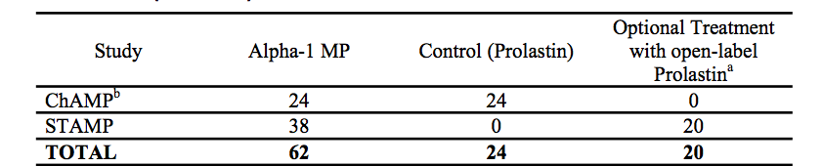

Table 11: Treatment exposure

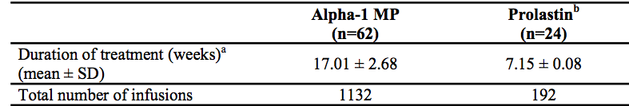

### Adverse events

#### All adverse events (irrespective of relationship to study treatment)

##### Safety study - STAMP

Two subjects had interruptions of infusions due to an AE (mild “hot flush” and mild “catheter site pain”). However, neither of these TEAEs was considered by the investigator to be related to Alpha‑1 MP, both were resolved within 20 to 30 minutes, and both infusions were completed after any interruption. No deaths occurred in this study. Two subjects experienced treatment emergent SAEs. One naive subject experienced moderate “pneumonia” and one the SAE of severe “rash”, which resolved following discontinuation of Alpha-1 MP treatment.

A total of 17 treatment emergent exacerbations of pulmonary disease were reported by 10 subjects. There were no clinically relevant differences in mean values or change from baseline at Week 20 of Alpha-1 MP treatment for haematology, clinical chemistry, and urinalysis parameters. For vital signs, there were no clinically relevant differences in mean values or changes from baseline for systolic blood pressure, diastolic blood pressure, heart rate, and respirations. One subject experienced mild “pyrexia” during Alpha-1 MP treatment. The AE was not considered to be related to Alpha-1 MP treatment and was resolved during the study.

**Comment:** the evaluator queries this and believes pyrexia and rash are likely to be possibly related to the protein infusion.

##### Other studies

###### ChAMP STUDY

Overall AEs and exacerbations of pulmonary disease were comparable between Alpha-1 MP and Prolastin treatments.

###### 100533

Two hundred and seventy-five TEAEs were experienced by 37 (97%) subjects under Prolastin treatment and 366 TEAEs were experienced by 38 (97%) subjects under placebo treatment. The highest incidence rates were seen for nasopharyngitis (63% in the Prolastin group versus 56% in the placebo group), followed by pneumonia (37% versus 28%) and headache (24% versus 26%). In general, the incidence rates of individual TEAEs were similar between treatment groups.

#### Treatment-related adverse events (adverse drug reactions)

##### Safety study; STAMP

###### Overall TEAE (Safety Population)

In this study, there were a total of 96 TEAEs experienced during 752 weekly Alpha-1 MP infusions, rate of 0.128 TEAEs per infusion. In subjects with TEAEs, a total of 64 TEAEs occurred in 15 (78.9%) naïve subjects, and 32 TEAEs were experienced by 11 (57.9%) non-naïve subjects. Except for the SAE of severe “rash” in one naïve subject, all TEAEs were mild or moderate in intensity, and the severity of TEAEs was comparable between naïve subjects and non-naïve subjects.

Although naïve subjects experienced a higher incidence of TEAEs compared with non-naïve subjects (64 TEAEs in naïve subjects versus 32 TEAEs in non-naïve subjects), this difference was mainly due to three naïve subjects having a higher incidence of TEAEs compared with other naïve and non-naïve subjects in the study. Further, the additional TEAEs in these three naïve subjects were either common disorders or typical of the subject population with respiratory disorders and thus were not suggestive of a significant safety concern for naïve subjects receiving new Alpha1-PI (Alpha-1 MP) treatment.

The most frequent TEAEs were “upper respiratory tract infection” and “nausea”. A total of 5 of 38 (13.2%) Alpha-1 MP subjects reported at least one drug related TEAE and there were 9 drug related TEAEs in total. These 9 drug related TEAEs were experienced during 752 weekly infusions, which is a rate of 0.012 drug related TEAEs per Alpha-1 MP infusion. Most drug related TEAEs to Alpha-1 MP were mild and all were resolved during the study.

One naïve subject experienced the drug related TEAE to Alpha-1 MP of severe “rash”, which was considered to be an SAE and the subject, was discontinued from the study. Three subjects experienced drug related TEAEs to Alpha-1 MP (“mild headache”, mild “hot flush”, “chills”, and mild “malaise” within 24 hours of a weekly Alpha-1 MP infusion.

Seventeen subjects experienced TEAEs to Alpha-1 MP within 24 hours of a weekly Alpha-1 MP infusion; the possible relationship of AEs to the time of Alpha-1 MP infusion was further explored.

A total of 17 treatment emergent exacerbations of pulmonary disease were reported by 10 subjects, and were comparable between naïve (five subjects with 10 exacerbations) and non-naïve (5 subjects with 7 exacerbations) subjects. Of the total of 17 exacerbations of pulmonary disease, 16 exacerbations were reported by subjects during treatment with Alpha-1 MP and one exacerbation was reported during the Prolastin treatment period (Week 21 to 24). No treatment emergent exacerbation of pulmonary disease was severe or considered to be an SAE. For the subset of subjects who received Prolastin treatment, there were no observed safety concerns with respect to TEAEs and exacerbations of pulmonary disease.

During Prolastin treatment, only one TEAE (“rales”) was experienced by one subject, and was not considered to be related to Prolastin treatment. One of 17 treatment emergent exacerbations of pulmonary disease was reported during Prolastin treatment.

##### Other studies

###### ChAMP

Treatment emergent AEs (TEAEs) were experienced by 11 of 24 (45.8%) and 9 of 24 (37.5%) subjects treated with Alpha-1 MP and Prolastin, respectively, in the double blind crossover phase, and by 11 of 24 (45.8%) subjects treated with Alpha-1 MP in the open label phase. Except for the two concurrently occurring SAEs in one subject under Prolastin therapy, all TEAEs were mild or moderate in intensity.

Thirty-six TEAEs were reported by 14 subjects in the combined Alpha-1 MP double blind crossover phase and open label phase of 380 infusions. This represents a rate of 0.095 TEAEs per infusion. Similarly, 2 drug related TEAEs occurred during 380 weekly Alpha-1 MP infusions representing a rate of 0.005 drug related TEAEs per Alpha-1 MP infusion, or approximately 1 drug related TEAE per 190 infusions or every 44 months.

The TEAEs of “upper respiratory tract infection, “urinary tract infection”, and “rales”, each in 2 (8.3%) subjects, were the most common TEAEs during Alpha-1 MP treatment. The AEs of “headache” and “arthralgia”, each in 2 (8.3%) subjects, were the most common TEAEs during Prolastin treatment.

A subject reported two mild drug related TEAEs of “pruritus” to Alpha-1 MP. No other TEAE was considered to be related to Alpha-1 MP and no TEAE was considered to be related to Prolastin.

###### Study PH 39567/1

AEs included chills, arthralgia. There were no deaths or SAEs. No abnormal laboratory or vital AEs were reported.

Table 12: Study PH 39567/1 treatment related treatment emergent adverse events

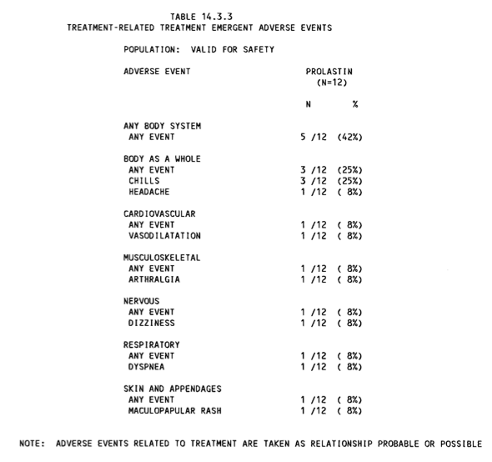

###### Study 30125

1 TEAE was reported of vaginitis, bronchitis, painful breast and pharyngitis. No abnormal AEs were reported for laboratory measurements or vital signs.

###### Study 100533

Table 13: Summary of treatment emergent adverse events (safety population)

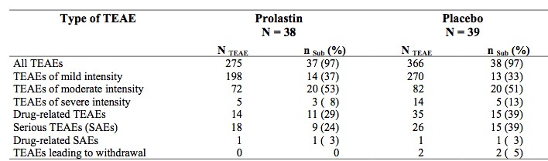

Table 14: Most frequent treatment emergent adverse events (cut-off point: 4 subjects or ≥ 10% in either treatment group; safety population)

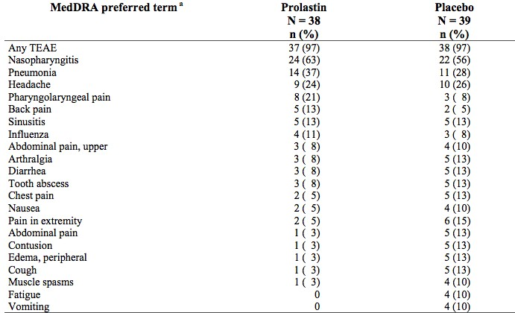

A total of two TEAEs were considered as drug related.

* Non-serious, but severe pulmonary hypertension in subject no. 2023 of the Prolastin group, which was first noted during a severe exacerbation, and which further worsened until the end of the study.
* Serious and severe psoriasis in a subject of the Prolastin group, which was unchanged at the end of the study.

**Comment:** as previously noted, psoriasis should be added to the RMP.

#### Deaths and other serious adverse events

##### Safety study

###### STAMP

Death

No deaths.

SAEs

There were two treatment emergent SAEs during treatment with Alpha-1 MP (skin “rash” and “pneumonia”) and one pre-treatment SAE occurred prior to study drug treatment (“pneumonia”). The subject with the skin rash was discontinued from the study; this resolved following discontinuation of Alpha-1 MP treatment. This skin rash was considered to be related to the Alpha‑1 MP treatment.

##### Other studies

###### ChAMP

Deaths

No deaths occurred in this study.

SAEs

A subject experienced two SAEs (severe “spinal osteoarthritis” and severe “cervical spinal stenosis”) after 8 weeks of Prolastin therapy. These SAEs were assessed as non-related to Prolastin and were considered by the investigator to be resolved with sequelae at the end of the study. No SAE was experienced by any other subject treated with Prolastin or by any subject treated with Alpha-1 MP.

A total of 10 exacerbations of pulmonary disease were reported by eight subjects, of which four occurred in the double blind crossover phase in each of the Prolastin and Alpha-1 MP treatment groups, and two occurred in the open label Alpha-1 MP phase. No exacerbation of pulmonary disease was considered to be an SAE.

###### Study 100553

Deaths

Nil

SAEs

Only 2 SAEs (one in each treatment group) were assessed by the investigators as drug related. One case of psoriasis occurred in the Prolastin group.

#### Discontinuation due to adverse events

##### Safety study

###### STAMP

As described above, a treatment-naïve subject was discontinued from the study because of the SAE of severe skin “rash”.

Two subjects had interruptions of infusions due to an AE (Week 2 because of mild “hot flush”, and at Week 10 because of discomfort in the cannulated arm, reported as the TEAE of mild “catheter site pain”). Neither of these TEAEs was considered by the investigator to be related to Alpha-1 MP, both were resolved within 20 to 30 minutes, and both infusions were completed without any further interruption.

**Comment:** Hot flush is possibly due to the infusion.

##### Other studies

###### ChAMP

No subject was discontinued from the study due to an AE and no subject had any interruption of infusions due to an AE at any time during the study.

### Laboratory tests

#### Liver function

##### Safety study

###### STAMP

1.5 x ULN for AST (SGOT) was the highest change at Week 20 after completion of the Alpha-1 MP treatment phase. No subject had an out of range result for ALT (SGPT) at Week 20 after completion of the Alpha-1 MP treatment phase. During Alpha-1 MP treatment, there was a treatment emergent shift from normal at baseline to high, for AST (SGOT) in 2 (5.3%) subjects at Week 20 but not exceeding 1.5 x ULN. During Alpha-1 MP treatment, shifts in clinical chemistry parameters that were reported as AEs were: “blood alkaline phosphatase increase” and “increase in lactate dehydrogenase” and “increase in AST (SGOT)”.

Table 15: TEAE shift from normal at baseline to high, for AST in two subjects

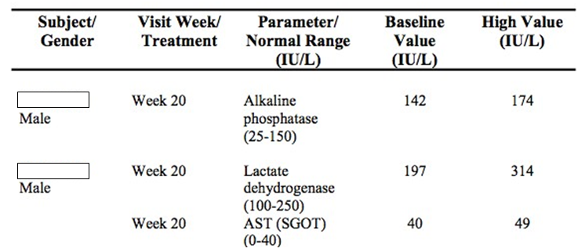

##### Kidney function

###### Safety study

No treatment emergent shifts from normal at baseline to out of range (low or high) at the Week 20 visit were observed for casts, epithelial cells, specific gravity, or urobilinogen. One subject had a reported AE of “Urinary Urgency” beginning on September 15, 2006. At his week 20 study visit on October 31, 2006, his urine pH was elevated to 8.0 (normal range 5.0 to 6.5) and the event was ongoing at study completion. This subject was treated with a drug for urgency; the investigator did not relate the TEAE to study drug. A subject reported a urinary tract infection from August 24, 2006 to August 31, 2006. The subject was treated was ciprofloxacin and the investigator did not attribute the TEAE to study drug.

#### Other studies

##### ChAMP

Laboratory assessments were comparable between Alpha-1 MP and Prolastin treatments. There were no clinically relevant differences in mean values, change from baseline, or treatment emergent shifts from normal to abnormally high or low values for haematology, clinical chemistry, and urinalysis parameters. No treatment emergent viral seroconversions occurred during the study for Hepatitis B, Hepatitis C, Human Immunodeficiency Virus, or Parvovirus B19 by serology or nucleic acid testing.

#### Other clinical chemistry

##### Safety study

Minor changes to clinical chemistry parameters, mean baseline and changes from baseline at the Week 20 visit were not deemed to be clinically relevant. There were isolated, treatment emergent shifts from normal at baseline to out of range (low or high) in individual clinical chemistry as discussed. No treatment emergent shifts from normal at baseline to out of range (low or high) at Week 20 were observed for albumin, ALT (SGPT), bilirubin, BUN, calcium, or creatinine.

##### Other studies

Nil abnormalities were reported.

#### Haematology

##### Safety study

For all haematology parameters, minor changes from baseline at the Week 20 visit were not assessed to be clinically relevant.

##### Other studies

Nil abnormalities were reported.

#### Vital signs

##### STAMP

Mean baseline and changes from baseline at all collection points were not deemed to be clinically relevant for systolic blood pressure, diastolic blood pressure, heart rate and respirations.

A subject experienced the AE of mild “pyrexia” during Alpha-1 MP treatment. The AE was considered unlikely to be related to Alpha-1 MP treatment and was resolved during the study.

**Comment:** The evaluator considers pyrexia is possibly related to treatment.

#### Viral serology and immunogenicity

##### Safety study

No treatment emergent viral seroconversions occurred during the study for Hepatitis B, Hepatitis C, Parvovirus B19 or Human Immunodeficiency Virus, by serology or nucleic acid testing.

##### Other studies

No treatment emergent viral seroconversions occurred during the study for Hepatitis B, Hepatitis C, Parvovirus B19 or Human Immunodeficiency Virus, by serology or nucleic acid testing. Although there have been no reports of antibodies to Alpha1-PI from previous clinical trials, the more sensitive screening ELISA utilized in the CHAMP and STAMP studies indicated a positive antibody response in four subjects. No detectable levels of neutralizing antibodies were seen in samples from these four subjects.

### **Post-marketing** experience

#### BAY X5747/0731

This was a Phase IV post-marketing study entitled A Study “Use of Prolastin HS as Substitution Therapy in Patients with Severe Deficiency of A1AT inhibitor and Progressive Pulmonary Emphysema”. Five patients aged 18 to 70; with congenital emphysema and FEV1 < 65% and alpha PI < 50 mg/dL were included. It was a non-controlled study and ran from 1989 to 1995.

##### Objective

To investigate evidence for efficacy of long term use of Prolastin HS in Patients with congenital alpha-1 PI deficiency and pulmonary emphysema with respect to retardation or stop of progression of emphysema and to investigate tolerability of Prolastin HS. 60 mg/kg/week were given for up to 2 years although in reality patients were treated from 60 to 72 months.

##### Efficacy

No conclusions concerning efficacy were able to be made as the study was only 5 patients and was not controlled.

##### Safety

In terms of safety, only 1 of 5 experienced 5 AEs between 36 and 66 months of treatment. These included cough, dyspnoea, and pain.

No SAEs or deaths were reported and nil patients discontinued therapy. There were no abnormalities in the laboratory or vital signs.

#### ICH PSUR

##### 1. January 2013 to December 2013

The International Birth Date for Prolastin/Prolastin-C is 2 December 1987, based on its first approval date in the U.S.A. A summary of the safety data for the Alpha1-Proteinase Inhibitor (Human) by Grifols Inc. and marketed under trade names of Prolastin and Prolastin-C, (mentioned in this report cumulatively as Alpha1-Proteinase Inhibitor (Human)) was provided based on adverse event reports received and assessed by the Global Drug Safety department at Grifols Inc. from worldwide sources from 1 January 2013 up to and including the Data Lock Point (DLP) of 31 December2013.

Grifols received a total of 32 initial and follow-up case reports for the review period, with calculated potential exposure of 4,948 patients/year. The aforementioned figures are consistent with an 8.7% increase in world-wide sales and a 43% decrease in reporting frequency when compared to the previous reporting interval. Of the 32 case reports received, 31 were initial case reports and 1 was a follow-up report.

During the reporting period, there were no reports for Alpha1-Proteinase Inhibitor involving drug interaction(s), overdose, drug misuse, drug abuse, pregnancy, or lactation. There were no cases reported for paediatric patients or organ-impaired patients. Case reports received for the elderly (n = 2) were reviewed and the safety profile was not dissimilar than that of other patient populations.

To date there have been no safety risk, potential or identified, that would alter the benefit-risk ratio for Prolastin or Prolastin-C; as such, there are thus no new risk minimisation activities.

##### January 2014 to December 2014

There were no completed clinical trials for Prolastin or Prolastin-C during this review period.

##### Ongoing clinical trials

During the review period, three clinical trials were ongoing for Prolastin-C as follows:

* Trial number GTi1201, a randomized, double blind, placebo controlled study to assess the efficacy and safety of two dose regimens (60 mg/kg and 120 mg/kg) of weekly intravenous Alpha1-Proteinase Inhibitor (Human) in subjects with pulmonary emphysema due to Alpha1‑Antitrypsin Deficiency, is a Phase III placebo controlled, double blind study that is being conducted in approximately 17 countries globally with a target subject accrual of 339. At the time of the DLP, there were 61 subjects enrolled in this study.
* Trial number GTI1302, a multicentre randomized, partial-blinded, placebo controlled study to evaluate the safety and efficacy of a human plasma derived Alpha1-Proteinase Inhibitor in subjects with new-onset type 1 diabetes mellitus, is a Phase II placebo controlled, partial blinded study that is being conducted in the USA with a target subject accrual of 75. At the time of the DLP, there were 22 subjects enrolled in this study.
* Trial number GTI1402, A multi-centre, randomized, double blind, crossover study to assess the safety and pharmacokinetics of liquid Alpha1-Proteinase Inhibitor (Human) compared to Prolastin-C in subjects with Alpha1-Antitrypsin Deficiency, is a Phase II/III placebo controlled, double blind study that is being conducted in the USA with a target subject accrual of 20. At the time of the DLP, there was 1 subject enrolled in this study.

#### Long-term follow-up

Long-term controlled clinical trials to evaluate the effect of chronic replacement therapy with Alpha1-Proteinase Inhibitor on the development of or progression of emphysema in patients with congenital alpha-1 antitrypsin deficiency have not been performed.

As a result of the active patient support programs, the MAH received 65 non-serious cases during the reporting period that potentially implicated Alpha-1. In the event that the case was deemed serious by either the reporter or Grifols, the case was appropriately expedited.

Only 3 cases met the criteria for seriousness and were appropriately reported.

During the reporting interval, no new signals were identified for Alpha-1 Proteinase Inhibitor (Human).

#### Summary of safety concerns

To date there have been no safety risk, potential or identified, that would alter the benefit-risk ratio for Prolastin or Prolastin-C.

### Evaluator’s overall conclusions on clinical safety

#### STAMP

Functional Alpha-1 MP administered at a dose of 60 mg/kg for 20 weeks was safe and well tolerated in naïve and non- naïve adult subjects with AAT deficiency. Overall, the AE profile of alpha1-PI as Alpha-1 MP in both naïve and non-naïve subjects was consistent with the known AE profile of alpha1-PI as Prolastin. There were no treatment emergent safety concerns with regard to clinical laboratory assessments including immunogenicity test results and vital signs, and there were no viral seroconversions for Hepatitis B, Hepatitis C, Human Immunodeficiency Virus, or Parvovirus B19.

Other studies show ‘immune’ like reactions such as rash, urticaria, chest tightness, which is well known to occur with this medicine, occurred infrequently. There were no new concerns in the studies and no new concerns highlighted by the PSUR.

## First round benefit-risk assessment

### First round assessment of benefits

The sponsor’s application in favour of registration is in the biochemical efficacy of augmentation therapy for the treatment of alpha-1 antitrypsin deficiency. These studies are found in Module 5. The literature review was provided to support clinical efficacy of alpha-1 PI as augmentation therapy in patients with severe alpha-1 antitrypsin deficiency and clinically evident emphysemas.

It is the opinion of the evaluator that Prolastin-C increases lung A1AT concentration. Further that Prolastin-C is effective on the inhibitory actions on lung elastase.

The literature review did not clearly demonstrate a benefit of biochemical improvement on clinical outcome.

The literature review did not clearly demonstrate a clear relationship of surrogate marker such as CT measurements to clinical outcomes in this patient group. Further the effects of Prolastin on clinically relevant surrogates of lung disease in this submission were not consistent. There was variable discussion in the literature provided regarding the most appropriate surrogate in lung imaging for this endpoint in this particular condition.

Thus the benefit of Prolastin-C in the proposed usage is thus to increase concentrations of lung A1AT concentrations and inhibitory effects of neutrophil elastase function.

There were two additional potential clinical efficacy benefits seen in the placebo controlled study. The applied ANCOVA model demonstrated a treatment difference in the rate of lung density progression between the Prolastin and placebo groups of 1.472 (95% CI: 0.009 to 2.935), p= 0.049. But note that when TLC adjusted this was not significant.

Further, one of the secondary endpoints, analysis of the lung sub-regions, was significantly different between the two groups. Here a significant change in unadjustedlung density using slope analysis was seen when comparing the decrease in lung density in the basal third of the lung; between Prolastin and placebo. Comparison of the slopes of the decrease in lung density in the middle and apical thirds did not identify a significant difference however. Further, the mean lung volume values remained nearly unchanged from baseline to endpoint in both treatment groups and were not significant.

There was no improvement in quality of life raising the issue of uncertainty in benefit.

Clinical trial data on clinical benefits of this drug including morbidity and mortality will be presented in the near future. SPARTA is one such Phase III study with comparative and clinical endpoint data. This is a three year randomised, placebo-controlled trial that is currently recruiting. It aims to assess the efficacy and safety of two separate doses of Prolastin-C (60 and 120 mg/kg) administered weekly over 3 years in patients aged 18 to 70 years with a diagnosis of A1AT deficiency and clinical evidence of pulmonary emphysema. The primary measure of efficacy is a change from baseline whole lung 15th percentile lung density (PD15). Secondary efficacy variables will be the evaluation of severe chronic obstructive pulmonary disease exacerbations and PD15 of the basal lung region using CT densitometry. The study will also examine the evidence for the justification of the surrogate endpoints.

Overall it is the evaluator’s opinion that the biochemical improvement noted with Prolastin has not been demonstrated to result in a clinically relevant translation of those results as may be seen with increased density of lung, improved lung capacity or improved quality of life.

### First round assessment of risks

Adverse events are reported with this therapy. These are relatively minor and uncommon and consist predominantly of allergic/urticarial symptoms. Psoriasis is a reported event, the incidence of which should be monitored.

The infusion has been used for 30 years.

### First round assessment of benefit-risk balance

Prolastin-C is accepted as being bioequivalent to Prolastin however data on clinical benefits (including quality of life) of this therapy is needed..

The benefits to date are in the improvement of the concentrations of A1AT, which per se are suggestive but not yet proven as improving patient outcomes. The latter has not been demonstrated in current data, in the literature review provided nor any such randomised controlled clinical trials.

There are minor side effects with the therapy and potential effects on quality of life regarding need (cost/time) for infusions.

This assessment is thus negative; predominantly because of the lack of documented clinical benefit (notwithstanding the biochemical benefit). The risk of assuming a clinical benefit from a biochemical benefit of Prolastin-C in the proposed usage is that increasing levels of protein may not be related to improved disease status that is the effect of alpha1- proteinase inhibitor therapy on pulmonary exacerbations, quality of life, morbidity and mortality (including the progression of emphysema in alpha1-antitrypsin deficiency). There are several reasons why this may be the case including a lack of knowledge around the disease process (for example other pathways or processes to damage respiratory tissue) or a need for concentrations to be consistently above a ‘threshold’ rather than just the Cmax.

## First round recommendation regarding authorisation

Reject because of lack of convincing evidence of efficacy on patient-relevant/patient-important endpoints. The safety is well understood and well characterised. The product (or its bioequivalent precursor, Prolastin) has been marketed in high-income countries with sophisticated systems for post-marketing surveillance (similar to those in Australia) for nearly 30 years. Recommend respiratory physician input.

## Clinical questions

1. What are the volumes of Prolastin-C used in Australia through the Special Access Schemes A and B program?
2. Please comment on the possible adverse event of psoriasis.
3. Please advise on the regulatory status in European Union, and in countries where the Application is under review (Chile, Turkey).
4. Please confirm when the Phase III studies currently underway (such as SPARTA) be reporting?
5. Are there any interim results available from SPARTA?

## Second round evaluation of clinical data submitted in response to questions

Response to Evaluator comments

Evaluator comment 1

*Hubbert 1998 (Table 1). Is the correct reference Hubbard RC, 1998?*

***Sponsor response:***

The correct reference is: Hubbard, R.C., et al., Biochemical efficacy and safety of monthly augmentation therapy for alpha 1-antitrypsin deficiency. JAMA, 1988. 260(9): p. 1259-64. This report was provided in the application.

***Evaluation of response:***

This reference was reviewed during the evaluation process.

##### Evaluator comment 2

*Stikal-1998 I was unable to find this reference on the CD or on pub med.*

***Sponsor response:***

The spelling error in the title of the reference. The correct reference is:

Stiskal, J.A., et al., alpha1-Proteinase inhibitor therapy for the prevention of chronic lung disease of prematurity: a randomized, controlled trial. *Pediatrics* 1998. 101(1 Pt 1): p. 89-94.

The results are also found in study report MMRR-1511.

***Evaluation of response:***

Accepted.

##### Evaluator comment 3

*Stockley-2002 This was primarily a PD study; the 2002 paper was not able to located on the CD, the presumed 2000 Stockley study is reviewed in Section 5 (BAYX5747 200034 –PH 30567/1 Report 2001)*

***Sponsor response:***

The correct reference is: Stockley, R.A., et al., The effect of augmentation therapy on bronchial inflammation in alpha1- antitrypsin deficiency. *Am J Respir Crit Care* Med, 2002. 165(11): p. 1494-8.

***Evaluation of response:***

The reviewer is correct that the corresponding study report is PH-30567. This was reviewed in Section 5.

##### Evaluator comment 4

*A publication by Gadek and Crystal had a first page only.*

***Sponsor response:***

A review of the Gadek and Crystal references on the CD copy of the application retained by Grifols Australia indicated that the entire articles were present in the submission.

***Evaluation of response:***

Apologies for this anomaly with the electronic identified in the CD copy provided to TGA.

##### Evaluator comment 5

*Parr, D et al Evaluator comment: Year of publication not given but was entitled “Detection of emphysema progression in alpha 1-antitrypsin deficiency using CT densitometry; methodological advances (manuscript in submission format, p 96- of 2693 of 100533/EudraCT No: 0010/0251/A.*

***Sponsor response:***

The published reference is: Parr DG, et al. Detection of emphysema progression in alpha 1-antitrypsin deficiency using CT densitometry: methodological advances. *Respir. Res* 2008; 9: 21 (online).

##### Evaluator comment 6

*100533 was evaluated in the CER Mueller, N. 1992. This manuscript focuses on the use of HRCT for the detection of emphysema therefore it is not relevant for this application.*

***Sponsor response:***

The correct reference is Mueller 1988. (This reference (as Muller et al 1988) is provided in section 16.1.12 of the clinical study report for study 100533.

***Evaluation of response:***

Study 100533 was referenced above in the Parr manuscript; it was reviewed during the evaluation.

##### Evaluator comment 7

*McElvaney 1991. This study showed that aerosol AIAT treatment for another disease (CF) suppressed neutrophil elastase in the respiratory epithelial lining fluid, and restored the ELF anti-neutrophil elastase capacity in 12 subjects with CF.*

***Sponsor response:***

The sponsor does not know which reference is referred to here.

***Evaluation of response:***

Lancet. 1991 Feb 16;337(8738):392-4. Aerosol alpha 1-antitrypsin treatment for cystic fibrosis[. McElvaney NG](http://www.ncbi.nlm.nih.gov/pubmed/?term=McElvaney%20NG%5BAuthor%5D&amp;cauthor=true&amp;cauthor_uid=1671425)1, [Hubbard RC,](http://www.ncbi.nlm.nih.gov/pubmed/?term=Hubbard%20RC%5BAuthor%5D&amp;cauthor=true&amp;cauthor_uid=1671425) [Birrer P,](http://www.ncbi.nlm.nih.gov/pubmed/?term=Birrer%20P%5BAuthor%5D&amp;cauthor=true&amp;cauthor_uid=1671425) [Chernick MS,](http://www.ncbi.nlm.nih.gov/pubmed/?term=Chernick%20MS%5BAuthor%5D&amp;cauthor=true&amp;cauthor_uid=1671425) [Caplan DB,](http://www.ncbi.nlm.nih.gov/pubmed/?term=Caplan%20DB%5BAuthor%5D&amp;cauthor=true&amp;cauthor_uid=1671425) [Frank MM,](http://www.ncbi.nlm.nih.gov/pubmed/?term=Frank%20MM%5BAuthor%5D&amp;cauthor=true&amp;cauthor_uid=1671425) [Crystal RG.](http://www.ncbi.nlm.nih.gov/pubmed/?term=Crystal%20RG%5BAuthor%5D&amp;cauthor=true&amp;cauthor_uid=1671425)

##### Evaluator comment 8

*Study 10253 - there is no study with this number.*

***Sponsor response:***

The sponsor assumes the intended reference is study 100533.

***Evaluation of response:***

This is correct.

Overall the evaluator was concerned that some pivotal references in the literature may have been missed. With the correction of the titles and confirmation of the references it appears all have been evaluated in Round 1, except the Gadek and Crystal manuscript.

#### Additional Expert Questions

##### Dr [Information redacted]

Dr [information redacted] states “unfortunately, robust data that would directly correlate lung density (as measured by CT densitometry) to patient-reported outcomes (symptom-based) do not exist. However, a growing body of evidence links the extent of emphysema (derived by CT-techniques) to mortality”. Some data were presented showing a relationship between CT volumes on outcomes; it is assumed that by increasing CT volumes (or slowing the decline) there will be a benefit on mortality.

CT morphology is stated to be the clinical marker most closely related to clinical endpoints.

Commenting on registry data, “In my point of view, the body of evidence is not suited to answer the question on symptom-based patient relevant endpoints. None of the present studies has been powered adequately to do so. Also, registry data (at least in the given quality, present at the moment) are most likely not suited to answer the question. However, based on the evidence about lung density and mortality, it may be assumed that a disease modifying effect (that is very likely) would result in a life-prolonging effect that certainly is important for patients. It is not suitable to apply the same strict rules about approval in a rare disease like AATD as in a frequent disease like COPD in general”

Adverse events are considered minor in clinical practice.

##### Dr [Information redacted]

To the question of whether the small treatment differences identified on lung CT clinically meaningful, Dr [information redacted] states “Yes. These studies indicated that loss of lung is reduced. This is direct evidence that AAT replacement therapy decrease the loss of lung tissue characteristic of alpha-1- antitrypsin deficiency.” It thus remains unclear if the expert believed this small numerical change was clinically relevant.

The totality of the data from registries and RCLs indicate that AAT replacement therapy decreases lung loss.

Therefore there appears to be a consistent belief that this therapy improves AAT concentrations; that CT volumes are better than FEV1 as a predictor of clinical endpoints, and that symptom-related data is not available. There is disagreement with the evaluator on the statements that the noted changes on CT are not clinically relevant however evidence to refute this was not given.

#### Responses to Clinical Questions

##### Question 1

*What are the volumes of Prolastin C used in Australia through the Special Access Schemes A and B program?*

***Sponsor response:***

A total of 488 vials of Prolastin-C alpha-1 proteinase inhibitor (human) 1000 mg have been supplied in Australia from 10th April 2014 until 30th July 2015 through the Category A Special Access Scheme. All product has been supplied to Professor [information redacted], Department of Respiratory Medicine at [information redacted], Western Australia

##### Question 2

*Please comment on the possible adverse event of psoriasis.*

***Sponsor response:***

In the EXACTLE study there was one case of psoriasis (1 out of 38) reported as an SAE. The subject developed a moderate psoriasis after her first weekly Prolastin infusion, which remained ongoing and became severe shortly after receiving the sixth weekly Prolastin infusion and was reported by the investigator as a drug related important medical event. However, the subject had a familial history of psoriasis and upon examination by a dermatologist it was found unlikely to have any relationship between the psoriasis and the study drug. Considering this information the sponsor unblinded the subject’s study drug treatment which revealed the subject was on Prolastin. Since psoriasis is not among the expected adverse events with Prolastin, this event was not reported to regulatory agencies.

The event of psoriasis was unchanged and ongoing at the end of the study, however since there is a strong genetic predisposition for the psoriasis, the sponsor did not assume a relationship between the psoriasis and the administration of Prolastin.

**Comment:** This is noted. The possibility remains that the immunological aspect of the protein infusion may have uncovered the psoriasis, due to the timing and the fact a protein was infused.

##### Question 3

*Please advise on the regulatory status in European Union, and in countries where the Application is under review (Chile, Turkey).*

***Sponsor response:***

Prolastin-C is not licensed in the European Union; however, Prolastin is licensed under the Mutual Recognition Procedure as of March 2006. In addition, Prolastin is licensed in Switzerland. Prolastin- C is licensed in the following countries: Argentina, Puerto Rico, Canada, Turkey, Chile, United States and Columbia.

##### Question 4

*Please confirm when the Phase III studies currently underway (such as SPARTA) be reporting?*

***Sponsor response:***

The expected completion data for the ongoing SPARTA study is 2022. There are no other ongoing Phase III studies.

##### Question 5

*Are there any interim results available from SPARTA?*

***Sponsor response:***

No interim results will be available from the SPARTA study.

## Second round benefit-risk assessment

### Second round assessment of benefits

The responses to questions were complete. There were no new matters arising or matters or error in the CER. A correction was made by the sponsor in regards to the expected adverse event of psoriasis with Prolastin, this event was reported to regulatory agencies. There were responses to errors and omissions which highlighted that all but one of the manuscripts had been evaluated.

There were also two expert reviews which whilst stating that low CT volumes correlated with mortality were not able to reference any study that showed that a gain of the amount seen in the pivotal study made a difference to outcome (there being a difference in a low concentration of an agent versus the benefit when the concentration of the agent increases with this therapy).

It is assumed the trial data from SPARTA will help in this regard however this will not be reporting until 2022.

After consideration of the responses to clinical questions, the benefits of Prolastin in the proposed usage are unchanged from the first round evaluation.

### Second round assessment of risks

No new clinical information was submitted in response to questions except the reported psoriasis was in a patient with a family history of this disease. The possibility of Prolastin precipitating the development of such an immunological event remains.

### Second round assessment of benefit-risk balance

The benefit-risk balance of Prolastin-C, given the proposed usage is unfavourable. It is noted that there is a single relatively high volume user of this drug via SAS in Australia.

## Second round recommendation regarding authorisation

Reject, based on unclear clinical benefit despite biochemical improvements.

|  |
| --- |
| Therapeutic Goods Administration |
| PO Box 100 Woden ACT 2606 Australia  Email: [info@tga.gov.au](mailto:info@tga.gov.au) Phone: 1800 020 653 Fax: 02 6232 8605  [**https://www.tga.gov.au**](https://www.tga.gov.au) |

1. Hubbard RC, Sellers S, Czerski D, Stephens L, Crystal RG. Biochemical efficacy and safety of monthly augmentation therapy for alpha 1-antitrypsin deficiency*. JAMA* 1988;260: 1259-1264.
2. Barker, AF et al 1997 Pharmacokinetic Study of a1-Antitrypsin Infusion in a1-Antitrypsin Deficiency. *Chest* 1997; 112: 607-613
3. Gadek JE et al 1981 Replacement therapy of alpha 1 antitrypsin deficiency. Reversal of protease-antiprotease imbalance within the alveolar structures of PiZ subjects. *J of Clin Investigation* 1981; 68: 1158-1165.
4. Wewers, MD et al 1987 Replacement therapy for Alpha1-antitrypsin deficiency associated with emphysema. *N Engl J Med* 1987; 316: 1055-1062.
5. Stockley RA et al 2010 Therapeutic efficacy of alpha-1 antitrypsin augmentation therapy on the loss of lung tissue: an integrated analysis of 2 randomised clinical trials using computed tomography densitometry. *Respiratory Research* 2010; 11:136
6. Wewers, MD et al 1987 Replacement therapy for Alpha1-antitrypsin deficiency associated with emphysema. *N Engl J Med* 1987; 316: 1055-1062
7. Barker AF et al 1997 Pharmacokinetic study of α1-Antitrypsin Deficiency. *Chest* 1997; 112: 607-613.
8. Stockley RA et al 2010 Therapeutic efficacy of alpha-1 antitrypsin augmentation therapy on the loss of lung tissue: an integrated analysis of 2 randomised clinical trials using computed tomography densitometry. *Respiratory Research* 2010; 11:136-144
9. Perez A et al 2005. Use of CT Morphometry To Detect Changes in Lung Weight and Gas Volume *CHEST* 2005; 128: 2471–2477
10. Thurlbeck WM et al (1983) Chronic Obstuctive Lung Disease. A comparison between clinical, roentgenologic, functional and morphologic criteria in chronic bronchitis, emphysema, asthma and bronchiectasis. *Medicine* 1983; 49: 81-145.
11. Hartley P G et al (1994) High –resolution CT-derived measures of lung density are valid indexes of interstitial lung disease *J Appl Physiol* 1994 ; 76: 271-277
12. Parr DG et al 2008 Detection of emphysema progression in alpha 1-antitrypsin deficiency using CT densitometry; Methodological advances *Respiratory Research* 2008; 9: 21-
13. McElvaney NG 1996 Is gene therapy in cystic fibrosis a realistic expectation? *Current Opinion in Pulmonary Medicine* 1996; 2: 466-471
14. Parr DG et al (2004) Pattern of Emphysema Distribution in α1-Antitrypsin Deficiency Influences Lung Function Impairment. *American Journal of Respiratory and Critical Care Medicine* 2004; 170: 1172-1178
15. Stoel BC et al (1999) Sources of error in lung densitometry with CT. *Investigative Radiology* 1999; 34: 303-309
16. Lamers RJS et al (1998). Reproducibility of spirometrically controlled CT lung densitometry in a clinical setting. *Eur Respir J* 1998; 11: 942–945
17. Robinson PJ and Kreel L. (1979) Pulmonary Tissue Attenuation with Computed Tomography: Comparison of Expiration Scans. *Journal of Computer Assisted Tomography* 1979; 3: 740-748
18. Gierada DS et al (2001) Repeatability of Quantitative CT Indexes of Emphysema in Patients Evaluated for Lung Volume Reduction Surgery*. Radiology* 2001; 220: 448-454
19. Hoffman EA and McLennan G (1997) Assessment of the Pulmonary Structure-Function Relationship and Clinical Outcomes Measures: Quantitative Volumetric CT of the Lung. *Acad Radiol* 1997; 4: 758-776
20. Shaker SB et al (2004) Volume Adjustment of Lung Density by Computed Tomography Scans in Patients with Emphysema. *ACTA Radiol 2004; 45: 417-423*
21. Stolk J et al (2001) Repeatability of Lung Density Measurements with Low-Dose Computed Tomography in Subjects with α-1-Antitrypsin Deficiency–Associated Emphysema*. Investigative Radiology* 2001; 36: 648–651
22. McElvaney NG et al (1991) Aerosol α-1-antitrypsin treatment for cystic fibrosis. *Lancet* 1991; 337; 392-394
23. The Delegate has made the following comment with regard to the efficacy “It is accepted that these efficacy results are subject to uncertainty. However, this is not unusual for rare diseases. Regulators (globally and in Australia) have set a precedent, for other medicines, of being more tolerant of uncertainty around efficacy for rare diseases.” (please see the AusPAR Delegate’s evaluation of sponsor’s post ACPM response)