December 2015

Australian Public Assessment Report for purified antigen fractions of inactivated split virion A/Indonesia/05/2005 (H5N1), AS03 adjuvanted
  - Proprietary Product Name: Prepandrix
  - Sponsor: GlaxoSmithKline Australia Pty Ltd

About the Therapeutic Goods Administration (TGA)
- The Therapeutic Goods Administration (TGA) is part of the Australian Government Department of Health and is responsible for regulating medicines and medical devices.
- The TGA administers the Therapeutic Goods Act 1989 (the Act), applying a risk management approach designed to ensure therapeutic goods supplied in Australia meet acceptable standards of quality, safety and efficacy (performance) when necessary.
- The work of the TGA is based on applying scientific and clinical expertise to decision-making, to ensure that the benefits to consumers outweigh any risks associated with the use of medicines and medical devices.
- The TGA relies on the public, healthcare professionals and industry to report problems with medicines or medical devices. TGA investigates reports received by it to determine any necessary regulatory action.
- To report a problem with a medicine or medical device, please see the information on the TGA website <https://www.tga.gov.au>.

About AusPARs
- An Australian Public Assessment Report (AusPAR) provides information about the evaluation of a prescription medicine and the considerations that led the TGA to approve or not approve a prescription medicine submission.
- AusPARs are prepared and published by the TGA.
- An AusPAR is prepared for submissions that relate to new chemical entities, generic medicines, major variations and extensions of indications.
- An AusPAR is a static document; it provides information that relates to a submission at a particular point in time.
- A new AusPAR will be developed to reflect changes to indications and/or major variations to a prescription medicine subject to evaluation by the TGA.
Copyright
© Commonwealth of Australia 2015
This work is copyright. You may reproduce the whole or part of this work in unaltered form for your own personal use or, if you are part of an organisation, for internal use within your organisation, but only if you or your organisation do not use the reproduction for any commercial purpose and retain this copyright notice and all disclaimer notices as part of that reproduction. Apart from rights to use as permitted by the Copyright Act 1968 or allowed by this copyright notice, all other rights are reserved and you are not allowed to reproduce the whole or any part of this work in any way (electronic or otherwise) without first being given specific written permission from the Commonwealth to do so. Requests and inquiries concerning reproduction and rights are to be sent to the TGA Copyright Officer, Therapeutic Goods Administration, PO Box 100, Woden ACT 2606 or emailed to <tga.copyright@tga.gov.au>.

Contents
About AusPARs ii
Common abbreviations 5
I. Introduction to product submission 6
Submission details 6
Product background 6
Regulatory status 7
II. Quality findings 8
Introduction (if applicable) 8
Drug substance (active ingredient) 8
Drug product 9
Biopharmaceutics 9
Quality summary and conclusions 9
III. Nonclinical findings 10
Introduction 10
Pharmacology 12
Pharmacokinetics 14
Toxicology 15
Nonclinical summary and conclusions 18
IV. Clinical findings 19
Introduction 19
Pharmacokinetics 21
Pharmacodynamics 21
Dosage selection for the pivotal studies 21
Efficacy 25
Safety 33
First round benefit-risk assessment 38
First round recommendation regarding authorisation 41
Clinical questions 41
Second round evaluation 42
Second round benefit-risk assessment 44
V. Pharmacovigilance findings 45
Risk management plan 45
VI. Overall conclusion and risk/benefit assessment 53
Introduction 53
Quality 54
Nonclinical 54
Clinical 54
Risk management plan 62
Risk-benefit analysis 62
Outcome 72
Attachment 1. Extract from the Clinical Evaluation Report 72

Common abbreviations
Abbreviation | Meaning
AE | adverse event
AESI | adverse event of special interest
AS03 | Adjuvant System 03
ASA | Australian Specific Annex
CMI | Consumer Medicine Information
EMA | European Medicines Agency
GD | gestational day
GMT | geometric mean titre
GSK | GlaxoSmithKline
HA | haemagglutinin
HI | hemagglutination inhibition
IM | intramuscular
ISS | Integrated Summaries of Safety
MAE | medically attended adverse event
NOCD | New Onset Chronic Disease
RMP | Risk Management Plan
RR | relative risk
PI | Product Information
pIMD | potentially immune mediated disease
SAE | serious adverse event
SCF | seroconversion factor
SCR | seroconversion rate
SPR | seroprotection rate
VRR | vaccine response rate

I. Introduction to product submission

Submission details
Type of submission: | New biological entity
Decision: | Withdrawn
Date of decision: | 3 September 2015
Active ingredient: | Purified antigen fractions of inactivated split virion A/Indonesia/05/2005 (H5N1), AS03 adjuvanted
Product name: | Prepandrix
Sponsor’s name and address: | GlaxoSmithKline Australia Pty Ltd  Level 4, 436 Johnston Street  Abbotsford VIC 3067
Dose form: | Antigen as suspension and adjuvant as emulsion in separate vials
Strength: | Potency is expressed as 3.75 μg haemagglutinin (HA) per dose
Container: | One carton of Prepandrix consists three packs, including one pack containing 50 vials each with 2.5 ml antigen suspension for 10 doses and two packs of 25 vials each with 2.5 ml adjuvant emulsion for 10 doses
Pack size: | As above
Route of administration: | Intramuscular Injection preferably into the deltoid muscle or anterolateral thigh (depending on the muscle mass)
Dosage: | Primary vaccination: Two doses of 0.5 mL of the reconstituted vaccine. The second dose is administered between 3 weeks - 12 months after the first dose

Product background
This AusPAR describes the application by GlaxoSmithKline Australia Pty Ltd to register a new pandemic influenza vaccine, Prepandrix (also known as Prepandremix during the application process and in this AusPAR). Prepandemrix is a split virion influenza vaccine against a strain of influenza with pandemic potential. It contains antigen equivalent to A/Indonesia/05/2005 PR8-IBCDC-RG2 (H5N1) 3.75 micrograms (µg) adjuvanted with the GlaxoSmithKline proprietary Adjuvant System 03 (AS03) adjuvant system per 0.5 ml dose. The vaccine is presented as an emulsion and suspension which need to be mixed prior to administration.
The proposed indication is:
Prophylaxis of influenza caused by the H5N1 strain with a pandemic potential. Prepandemrix should be used in accordance with official recommendations.
Prepandemrix consists of two containers: one multidose vial containing the antigen (suspension) and a second multidose vial containing the adjuvant (emulsion). The suspension is a colourless light opalescent liquid. The emulsion is a whitish to yellowish homogeneous (milky) liquid. The submission proposes registration of multidose vials as follows:
- 2.5 ml suspension in a vial (type I glass) for 10 doses with a stopper (butyl rubber); pack size of 50.
- 2.5 ml emulsion in a vial (type I glass) for 10 doses with a stopper (butyl rubber); pack size of 25 x 2.
Prepandemrix is intended to be used according to the same dosing as the currently registered Pandemrix H5N1 (AUST R 145924). That is:
Adults from the age of 18 years will receive two doses of 0.5 mL Prepandemrix, the first administered at an elected date, the second at least three weeks and up to twelve months after the first dose for maximum efficacy. Vaccination should be carried out by intramuscular injection preferably into the deltoid muscle or anterolateral thigh (depending on the muscle mass).

Regulatory status
The sponsor has two pre pandemic H5N1 vaccines, one produced at the Dresden (Germany) manufacturing facility (D-H5N1) and the other produced at the Quebec (Canada) manufacturing facility (Q-H5N1). Both are adjuvanted with AS03.
Prepandrix (D-H5N1) is proposed for Australia. Q-H1N1 is approved for the US and Canadian markets.
At the time of this submission, Prepandrix (D-H5N1) was approved in the EU in May 2008. The initial dossier was approved with the A/Vietnam strain, with a line extension to change the strain to A/Indonesia in August 2009. The approved indication is:
Active immunisation against H5N1 subtype influenza A virus.
This indication is based on immunogenicity data from healthy subjects from the age of 18 years onwards following administration of two doses of vaccine prepared in H5N1 subtype strains.
Prepandrix should be used in accordance with official guidance.
The vaccine has also been approved in Singapore (April 2009) with the following indications:
Active immunization against H5N1 subtype of Influenza A virus.
This indication is based on immunogenicity data from healthy subjects from the age of 18 years onwards following administration of two doses of vaccine prepared with H5N1 subtype strain.
Prepandrix should be used in accordance with official guidance.
It has also been approved in Switzerland (September 2009) with the following indications:
Active immunization against H5N1 subtype of Influenza A virus. This indication is based on immunogenicity data from healthy subjects from the age of 18 years onwards following administration of two doses of vaccine prepared with H5N1 subtype strain.
Prepandrix should be used in accordance with official guidance.
The sponsor stated that the dataset in the dossier was the same as that used to support registration overseas.
Q-H5N1 has been approved in Canada (February 2013) with the following indications:
Arepanrix H5N1 is indicated for active immunization against influenza caused by the H5N1 subtype virus contained in the vaccine. This indication is based on immunological data as the vaccine has not been evaluated in efficacy trials against influenza disease (see Part II, Clinical Trials). Arepanrix H5N1 should be used according to official guidance.
Q-H5N1 has also been approved in the US (November 2013) with the following indications:
Influenza A (H5N1) Virus Monovalent Vaccine, Adjuvanted is indicated for active immunization for the prevention of disease caused by the influenza A virus H5N1 subtype contained in the vaccine. Influenza A (H5N1) Virus Monovalent Vaccine, Adjuvanted is approved for use in persons 18 years of age and older at increased risk of exposure to the influenza A virus H5N1 subtype contained in the vaccine.

II. Quality findings

Introduction (if applicable)
Prepandemrix is a split virion influenza vaccine against a strain of influenza derived from a currently circulating highly pathogenic avian influenza that has the potential to cause a pandemic. It is intended to be used according to the same dosing as the currently registered Pandemrix H5N1 (AUST R 145924).

Drug substance (active ingredient)
The vaccine is based on the reassortant strain A/Indonesia/05/2005 (H5N1)/PR8-IBCDC-RG2, developed by CDC using reverse genetics. It combines the H5 and N1 segments to the PR8 strain backbone. The H5 has been engineered to delete the polybasic stretch of amino acids at the HA cleavage site, to avert the virulence of the original strain.
The specifications for the drug are in line with the European Pharmacopeia (EP) Monograph 0158 on split, inactivated influenza vaccines. Appropriate validation data have been submitted for determination of HA content, viral inactivation, and sodium deoxycholate content and data presented to demonstrate the removal of process related impurities.
Stability results are provided for three batches of Thiomersal free split inactivated H5N1 monobulks (produced in Dresden, Germany) following storage at +2°C to +8°C. Results show the HA content is stable over the 24 month period tested and all other tests are compliant with the specifications of that test. Stability results are also provided for up to 18 months of storage at +2°C to +8°C for H5N1 A/Indonesia monobulks and A/Vietnam H5N1 split monovalent bulks manufactured by the thiomersal containing process. All results are acceptable. The monobulks can be stored in Type I glass bottles or Flexible (Flexboy) bags. Stability data is provided to support this storage and all issues have been resolved. Other parameters such as sterility, endotoxin content and pH are included in the stability plan and acceptable data is provided on three commercial batches.
The sponsor has assigned a shelf life of 12 months for monovalent bulks stored in flexible bags at +2°C to +8°C.

Drug product
Each 0.5 ml vaccine dose contains 3.75 µg HA of inactivated split virion of A/Indonesia/05/2005 (H5N1)/PR8-IBCDC-RG2 adjuvanted with AS03. It also contains the excipients Polysorbate 80, Octoxynol 10, Thiomersal, Sodium chloride, Disodium hydrogen phosphate, Potassium dihydrogen phosphate, Potassium chloride and Magnesium chloride and may contain residues of egg, Gentamicin sulphate, Formaldehyde, Sucrose and Sodium deoxycholate.
Thiomersal is present as a preservative at a concentration of 10 µg/ml (5 µg per dose) in the final adjuvanted H5N1 vaccine. The antimicrobial efficacy of the preservative in the finished product has been assessed at the end of the proposed in use shelf life of 24 h at 25°C following extemporaneous mixing. The results of the preservative efficacy testing are provided to demonstrate that 10 µg/ml of thiomersal in AS03 adjuvanted H5N1 Flu vaccine is efficacious throughout the shelf life of the mixed vaccine. All release tests are carried out on the antigen and adjuvant preparation separately; no release testing is performed on the combination (as per published guidelines).
The specifications for ovalbumin and formaldehyde in the product are within EU pharmacopoeial limits. EP 0158 recommends <0.2g/L of free formaldehyde and 1 µg per human dose of ovalbumin in split virion inactivated Influenza vaccines.
Data from accelerated and real time stability studies on the H5N1 final container lots are provided to support a shelf life of 60 months at 2-8°C. Stability indicating parameter is the HA content measurement by SRD tested at each time point. Other parameters investigated are sterility, thiomersal content, endotoxin content, pH, description and protein content. The sponsor has assigned shelf life for the inactivated split virion A/Indonesia H5N1 antigen component of 60 months. This is supported by real time stability data generated at +2°C to +8°C on final containers lots of A/Indonesia derived from:
- thiomersal free monovalent bulk manufacturing process up to 60 months;
- thiomersal containing monovalent bulk manufacturing process up to 60 months.
The sponsor has clarified that the first commercial filling of H5N1 A/Indonesia antigen lots (derived from thiomersal containing monobulks) occurred at the site in Canada, for which stability data are available until 60 months. Subsequently, the manufacturing strategy was modified: (1) thiomersal was removed from monobulks manufacturing process and (2) the site in Canada was no longer maintained as a filling, labelling and pre-packaging site for this antigen component sourced in Dresden. Consequently, no commercial H5N1 A/Indonesia antigen lots derived from thiomersal containing monobulks were filled in Belgium and/or England and stability data are only available for lots filled in Canada.

Biopharmaceutics
Not relevant for this product because it is a vaccine.

Quality summary and conclusions
The administrative, product usage, chemical, pharmaceutical, microbiological and biopharmaceutic data (as applicable) submitted in support of this application have been evaluated in accordance with the Australian legislation, pharmacopoeial standards and relevant technical guidelines adopted by the TGA.
A number of quality and sterility issues requiring resolution before the product can be recommended for approval, were identified during the evaluation and were referred to the applicant for comment or resolution. The sponsor responded to the issues raised and the responses have been evaluated. Consistency of production has been demonstrated over the two manufacturing buildings.
Stability data provided to support the storage of the H5N1 Monovalent bulk in s71-2 bags has been generated on the Pandemic A/California H1N1v strain stored in 50L Flexboy bags. The sponsor was requested to provide storage/stability data for A/Indonesia H5N1 (the drug substance). The sponsor has responded that stability studies have been initiated recently with two A/Indonesia H5N1 drug substance batches (AFLSEDA887 and AFLSEDA888), to validate a shelf life extension of the drug substance in bags beyond 12 months. Six month data will be available in March 2015, 12 month data in September 2015. The sponsor was contacted to discuss the availability of the stability data for two A/Indonesia H5N1 drug substance batches (AFLSEDA887 and AFLSEDA888). The sponsor provided a stability report for H5N1 monobulk with 4 months of real time data in January 2015, and informed that the 12 month data will be available in September 2015.
The evaluator recommends that Prepandemrix purified antigen fractions of inactivated split virion A/Indonesia/05/2005 (H5N1)/PR8-IBCDC-RG2 (H5N1) vaccine should be approved.

III. Nonclinical findings

Introduction

General comments
The sponsor has applied to register a prepandemic split influenza vaccine, Prepandemrix, for prophylaxis of influenza caused by the H5N1 strain with pandemic potential in adults 18 years old and above. The vaccine strain is A/Indonesia/05/2005 (H5N1/PR8-IBCDC-RG2, a clade 2 representative). A previous submission was made to register a prepandemic vaccine based on an H5N1 clade 1 strain, A/Vietnam/1194/2004 NIBRG-14, a submission was also made to register the vaccine as a mock-up pandemic vaccine (Pandemrix), which was approved on 4 June 2008. Subsequent applications were made to extend Pandemrix use to the elderly. Both Prepandemrix and Pandemrix were approved by the EU in 2008 for use in adults, the Prepandemrix strain was changed to A/Indonesia/05/2005 in 2009.
The sponsor also manufactures a split seasonal trivalent influenza vaccine, Fluarix, which is registered in Australia. Prepandemrix monovalent bulk is manufactured by an identical process to Fluarix in Dresden. In accordance with the prepandemic and pandemic guidelines (below), additional toxicity testing was not performed with the A/Indonesia/05/2005 antigen for the current application.
The sponsor submitted previously evaluated nonclinical immunogenicity, ferret homologous and heterologous lethal challenge studies, repeat dose toxicity studies for the split H5N1/AS03 vaccine; genotoxicity studies for AS03 adjuvant; and a rat embryofetal and postnatal development study with split H5N1/AS03 and whole H5N1/Al vaccines and AS03 adjuvant. Immunogenicity, repeat dose toxicity and local tolerance studies were also submitted for seasonal trivalent influenza/AS03 vaccines. Studies of the mode of action of AS03 adjuvant were also previously evaluated for Arepanrix H1N1 vaccine. Safety studies were Good Laboratory Practice (GLP) compliant.
New studies in the current submission consisted of an integrated summary of the actions of AS03, a cardiovascular and respiratory study of AS03 in conscious dogs, and a study of preimplantation loss in rats (Table 1).
Table 1: New and previously evaluated nonclinical studies.
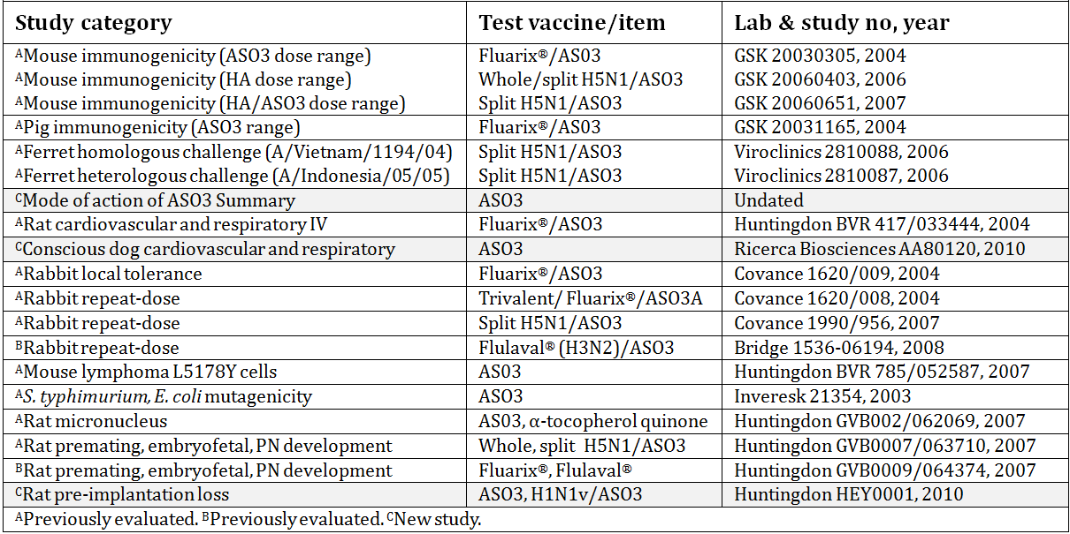
The previous submission from the sponsor to register Prepandemrix was withdrawn by the sponsor following a negative recommendation by the Advisory Committee on Prescription Medicines (ACPM). According to the sponsor’s application letter dated 5 February 2014, primarily over: (i) inadequate information on duration of immunity and no information on booster doses, and (ii) a considered unfavourable risk/benefit ratio based upon concerns about a potential safety signal in the elderly population (a higher number of New Onset Chronic Disease cases that was reported in Study H5N1-008 in adults > 60 years old, following administration of AS03 adjuvanted H5N1 vaccine when compared to Fluarix).
The AS03 adjuvant in Prepandemrix is composed of squalene, D,L-α-tocopherol (vitamin E) and polysorbate 80. AS03 adjuvant has previously been tested in humans in Fluarix, and a candidate malaria vaccine. In the initial application for Prepandemrix, data on the mechanisms of action of the adjuvant were limited to a demonstration that it induced pro-inflammatory cytokines in human peripheral blood mononuclear cellS (PBMCs) in vitro. However, numerous nonclinical studies on the mode of action of the AS03 adjuvant were subsequently submitted in an application to register the H1N1 pandemic split influenza (AS03 adjuvanted) vaccine, Arepanrix. The current submission contained a summary of the mode of action of AS03 with new and previously evaluated data. These data were published.

Vaccine guidelines
The European Medicines Agency (EMA) has issued guidelines for preclinical testing of vaccines, prepandemic vaccines, and new adjuvants in vaccines, which have been adopted by the TGA. During the course of this evaluation, a new consolidated draft guideline on influenza vaccines nonclinical and clinical module was issued by the EMA for consultation.

Submission quality
The submission consisted of several new and previously evaluated nonclinical studies. Overall, the nonclinical studies met the general requirements of the relevant EMA vaccine, prepandemic influenza vaccine and adjuvant nonclinical guidelines.

Pharmacology

Vaccine reference virus
The initial vaccine development was carried out with a vaccine containing purified antigen fractions of inactivated split virion A/Vietnam/1194/2004 NIBRG-14 (H5N1). However, based on geographical spread, epidemiology and the antigenic and genetic properties of H5N1 viruses isolated from humans during early 2007 (and WHO recommendations at that time), the sponsor decided to shift the strain used in production from A/Vietnam/1194/2004 (clade 1) to A/Indonesia/05/2005 (clade 2). Clade 2 viruses are still predominant in 2014.

Immunogenicity
Immunogenicity studies in primed mice and pigs demonstrated the capacity of the AS03 adjuvant to significantly increase HI and neutralising antibody titres, an increase in CD4 T cells was also seen in mice, and cross reactivity was seen between antibody and cell mediated responses in mice administered vaccine derived from A/Vietnam/1194/2004 and A/Indonesia/05/2005.

Ferret challenge studies
The primary pharmacology of Prepandemrix was evaluated in the previous Prepandemrix H5N1 evaluation report, and included lethal challenge studies in ferrets with heterologous and homologous H5N1 virus. The following conclusions were made by the evaluator:
In ferret lethal challenge studies with either the vaccine parent virus (A/Vietnam/1194/04 Clade 1) or a heterologous H5N1 virus (A/Indonesia/05/05, Clade 2), the split H5N1/AS03 vaccine did not prevent infection, but it reduced or prevented mortality and morbidity, and substantially reduced lung virus titres. The lowest vaccine dose of 0.6 μg HA combined with the human dose of AS03 adjuvant is ~2x and 15x human dose in mg/m², respectively, hence the studies provide limited evidence of efficacy.

Mechanisms of action of AS03 adjuvant
This was initially addressed by the sponsor in the previous Prepandemrix H5N1 submission and was followed with additional numerous studies in a submission to register the pandemic split influenza, AS03 adjuvanted Arepanrix H1N1 vaccine. The following assessment is based mainly on extracts from these previous evaluations.
The AS03 adjuvant serves as an antigen sparing measure, and to compensate for the low immunogenicity of H5N1 virus in naїve humans. AS03 adjuvant is an oil-in-water emulsion containing two biodegradable oils, squalene and d,l-α-tocopherol (vitamin E). The emulsion particles are 120-180 nm in size. Squalene occurs naturally in plants, animals and humans, and shark liver oil has been a major source for vaccines. Squalene is an intermediate metabolite in the synthesis of cholesterol in humans. It is the main component (by weight) of another adjuvant, “MF59” (Novartis), in the seasonal trivalent influenza vaccine Fluad, currently marketed in 12 European countries, and Focetria, a mock up pandemic influenza vaccine approved by the EMA.
Many older adults, regardless of their vaccination history, have low titers of naturally occurring antibodies that react with squalene. Squalene was implicated in the so-called Gulf War Syndrome, although it was not a component in vaccines administered to veterans. In a review of this implication, the WHO Global Advisory Committee on Vaccine Safety (6-7 June 2006) concluded that “... fears of squalene in vaccine inducing pathological anti squalene antibodies are unfounded”, but recommended careful post market follow-up to detect any vaccine related adverse events (AEs) in other age groups.
A series of studies investigated the actions of AS03 adjuvant. There was no detectable physicochemical interaction between antigen and adjuvant upon mixing, or intramuscular (IM) injection and transport to the draining lymph node in mice, that is, no antigen entrapment. In mice the adjuvant acted as an immunostimulant, increasing the number of antigen presenting cells (APCs), the proliferation of antigen expressing T cells, and the expression of co-stimulatory CD80, CD86 and CD40 molecules and pro-inflammatory cytokines (IL-6, IFN-γ, TNFα) by APCs (mainly macrophages and dendritic cells) in the draining lymph node. Serum levels of the pro inflammatory cytokines IL-6 and MCP-1 peaked within 10 h, and declined over the following 48h+ in mice. The induction of these pro inflammatory cytokines was not mediated by Toll like receptor 4 (TLR4) (MPL adjuvant is reportedly a TLR4 agonist). When H5N1 antigen and AS03 were injected in separate legs in mice, the pro inflammatory effects (elevated serum IL-6, MCP1) were preserved, but the adjuvant effect (HI response) was lost.
Measurement of Th1 cytokine (Fin) and Th2 cytokine (IL-5, IL-13) secretion from restimulated spleen cells in naïve mice immunised with ovalbumin antigen and AS03 indicated a mixed T helper (Th1/Th2) response.
The presence of α-tocopherol in AS03 adjuvant was shown to increase levels of pro inflammatory cytokines, and antibody responses, with no significant effects on antigen uptake or the expression of co-stimulatory molecules. A more balanced Th1/Th2 cytokine response was observed in the presence of α-tocopherol.
In conclusion, AS03 adjuvant primarily acts as an immunostimulant, with transient effects on multiple co-stimulatory molecules and pro inflammatory cytokines. Although AS03 does not act as an antigen depot, its action requires the antigen and adjuvant to be in proximity upon injection. The mode of action of AS03 is illustrated in Figure 1.
Figure 1: Mode of action of AS03 in the Prepandemrix H5N1 adjuvanted vaccine.
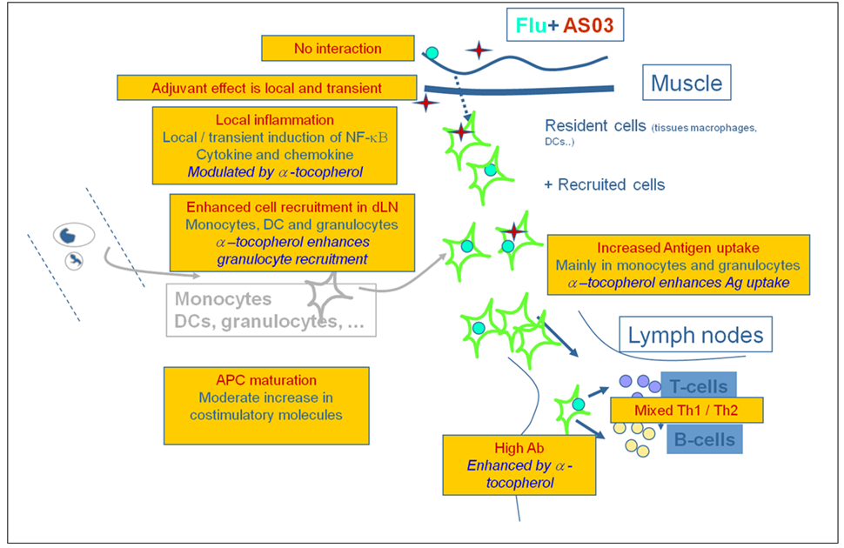

Safety pharmacology
A study in anaesthetised rats was previously evaluated for the Prepandemrix H5N1 submission. The following conclusions were drawn:
A safety pharmacology study in which anaesthetised rats were administered a split trivalent influenza (seasonal) vaccine adjuvanted with AS03 (3 μg HA/strain + 50 μL AS03) showed no significant cardiovascular or respiratory effects up to 2 h post dose after IM injection. The AS03 dose in rats was ~8x the human dose, adjusted for body surface area. CNS effects were not assessed in safety pharmacology studies, but pharmacodynamic and toxicity studies showed no indication of CNS effects.
The current submission contains a new safety pharmacology study investigating cardiovascular and respiratory effects of AS03 alone in conscious beagle dogs administered a full human dose (0.5 mL volume) of AS03 (~⁷x human dose on a mg/kg basis in a 10 kg dog). There was slight bodyweight loss in 2/4 dogs (~5% compared to ~2-3% gain in the other 2/4 AS03 treated dogs), associated with a slight decrease in food consumption. Given the relatively small total of 4 treated dogs, a relationship to treatment could not be excluded. A small but statistically significant increase (+ 0.5°C compared to pre-test) in body temperature was observed at 6 h post dose only. There were no relevant treatment related cardiovascular or respiratory findings up to 72 h post dose following the single IM injection.

Pharmacokinetics
No pharmacokinetic studies were conducted with the vaccine, in accordance with the relevant vaccine guidelines. The biodistribution of the AS03 adjuvant was previously investigated as recommended by the relevant vaccine guidelines.

Toxicology
Toxicity was assessed in the previous Prepandemrix H5N1 evaluation report. The following conclusions were drawn with regard to the repeat-dose toxicity studies:
Rabbits administered 4 consecutive fortnightly doses of the split H5N1/AS03 vaccine, containing 30 μg of H5 antigen and the human dose of AS03 adjuvant, had a transient inflammatory response to the adjuvant, but no other systemic effects. Local reactions to the split H5N1/AS03 vaccine were more marked than with a registered, seasonal trivalent influenza vaccine, due to the adjuvant. Most local effects resolved within 28 days. The toxicity studies were adequate, although the adjuvant was not fully tested in a second species, and individual components of the adjuvant were not tested, as recommended by the EMEA adjuvant guideline.

Narcolepsy
Epidemiological studies in several European countries including Sweden, Finland and the UK have reported that a monovalent pandemic influenza vaccine, Pandemrix H1N1 manufactured by the sponsor in Dresden, and used in an estimated 31 million Europeans during the 2009 H1N1 influenza pandemic, has been associated with narcolepsy in children aged approximately 5 to 20 years of age. Narcolepsy is a rare sleep disorder seen almost exclusively in individuals who are HLA DQB1*0602 allele carriers, which suggests that it might be an autoimmune disorder. In the under 20 years population the absolute attributable risk increase of narcolepsy was approximately 1.4 to 8 additional cases per 100,000 vaccinated individuals compared to background rates of 0.12 to 0.79 per 100,000 children/adolescents per year. The sponsor stated:
There is little doubt on a temporal association between receipt of Pandemrix H1N1 during the period of the pandemic and the occurrence of narcolepsy among children aged approximately 5 to 20 years old.
A review of this issue by the EMA concluded that a causal relationship was not established, and that further studies were required. Further EMA review concluded that the role of the vaccine antigen and its adjuvant on the association between Pandemrix antigen and narcolepsy remains unknown. The sponsor is conducting a study in Quebec Canada of the other GSK AS03 adjuvanted vaccine, Arepanrix H1N1, which was also used in the 2009 pandemic. No nonclinical studies were submitted in relation to narcolepsy. A clinical statement regarding the epidemiology data was proposed in the Precautions section of the Pandemrix PI, based on an approved statement for the registered Pandemrix H1N1.

Genotoxicity
The AS03 adjuvant was negative in previously evaluated, adequate in vitro and in vivo genotoxicity tests.

Carcinogenicity
No carcinogenicity studies were conducted, in accordance with the relevant vaccine guidelines.

Reproductive toxicity
A new reproductive toxicity study was performed with a pandemic AS03-adjuvanted H1N1v vaccine (Dresden, split inactivated influenza antigen [(A/California/7/2009)/AS03A]). Six daily IM injections (GD0-6) of the adjuvanted vaccine or the AS03 adjuvant alone (100 µL each, 1/5th human dose), administered to female rats during the early stage of pregnancy did not result in any statistically significant intergroup differences on pre implantation loss or on litter values in general (including implantations, resorptions [early, late and total], live embryos or pre/post implantation losses).
Mild maternal toxicity was also evident as reductions in maternal bodyweight gain/food consumption, and swelling at the injection site (which reversed at a greater rate in animals receiving AS03A alone compared with the group receiving H1N1/AS03). Both findings were more severe in the vaccine (AS03 adjuvanted) group. These findings were anticipated consequences of a daily IM injection for 6 days, a situation which would not occur clinically. Anti H1N1 antibodies were detected in all vaccine treated dams (that is, 100% seroconversion), but no anti H1N1 antibodies were detected in the AS03 only group or the control group.
Reproductive toxicity was also evaluated in the previous Prepandemrix H5N1 submission. The following is taken from the ‘Assessment’ section:
The prepandemic vaccine and adjuvant guidelines recommend animal reproductive toxicity studies. The sponsor conducted a rat embryofoetal and postnatal development study, in which females were administered 4 or 5 IM doses of the split H5N1/AS03 vaccine, containing 6 μg HA and 2/5 of the human dose of AS03 adjuvant, or whole H5N1/Al vaccine, or AS03 adjuvant only. The first dose was administered 30 days prior to mating, and the rest 6, 8, 11 and 15 days after mating (the vaccine or adjuvant were not administered during lactation). Half the rats were sacrificed on GD 20 for foetal examinations, and the remainder raised their pups to PND 25, and pup development was assessed. All vaccine treated dams, their foetuses and pups developed anti H5N1 antibodies, and increases in pup antibody levels between days 4 and 25 indicated antibody transfer in milk. There were no significant toxicological effects on the dams, or their foetuses or pups.

Australian pregnancy category
The sponsor has proposed an Australian pregnancy category of B2 for Prepandemrix. The embryofoetal and postnatal development studies did not show evidence of foetal damage. Testing in a single species is consistent with the draft EMA influenza vaccine guideline (not yet adopted by TGA) and the relevant FDA guideline (not adopted by TGA). Since the embryofoetal and postnatal development studies were conducted with AS03 adjuvanted A/Vietnam/1194/2004, Fluarix and Flulaval (H1N1, H3N2, B) and H1N1v derived vaccines, rather than the candidate A/Indonesia/05/2005 (H5N1)/AS03 vaccine, category B2 is more appropriate than category B1.

Local tolerance
Local tolerance was assessed in the previous Prepandemrix H5N1 evaluation report. The following conclusions were drawn:
The relevant guidelines recommend local tolerance studies for prepandemic and pandemic vaccines, and for new adjuvants with and without the proposed antigen. Local tolerance was investigated in both repeat-dose toxicity studies in rabbits, and a specific local tolerance study with a seasonal trivalent influenza/AS03 vaccine in rabbits. These studies had some limitations. In the repeat-dose toxicity study with the split H5N1/AS03 vaccine, the group treated with the adjuvanted vaccine was administered 0.5 mL in each leg, whereas the groups administered only AS03 adjuvant or H5N1 antigen were administered a single dose of 0.5 mL. In the rabbit local tolerance study with the seasonal trivalent influenza/AS03 vaccine, the antigen and adjuvant were injected into opposite thighs, at two dose sites, and the recovery period was only 4 days, whereas the 2 toxicity studies had 28-day recovery periods.
The studies showed that the presence of AS03 adjuvant in either the split H5N1 or seasonal influenza vaccine resulted in some erythema and/or oedema for up to 48 h, and increased incidences and severity of injection site fasciitis and perivascular cuffing, which had not fully resolved after 28 days. The severity of local reactions was unrelated to the dose of trivalent HA antigen, indicating that it was caused by the AS03 adjuvant. Local reactions to Fluarix seasonal trivalent influenza vaccine were comparable to saline controls.
The marked antigen sparing effect of AS03 adjuvant is offset by increased local reactivity in comparison with seasonal influenza vaccines, but some increase is acceptable for a vaccine for a potentially life-threatening infection.

Paediatric use
Adults from the age of 18 years are proposed to receive two doses of 0.5 mL Prepandemrix. Clinical experience in children is limited. No specific studies in juvenile animals were submitted. A small, but statistically significant body temperature increase was observed in dogs administered a single dose of AS03 adjuvant alone, which is consistent with the pro inflammatory properties of AS03. However, the relevance to humans is unclear given the small number of treated dogs, and the ~8x (mg/kg) human dose multiple.

Thiomersal
Thiomersal 10 µg/mL (5 µg per dose) is a constituent of the multidose vial as a preservative. Current intake limits for methylmercury are 3.3 µg/kg/week in an adult and 0.67 µg/kg/week in a pregnant woman (WHO), and 0.4 µg/kg/day (2.8 µg/kg/week) in a 70 kg adult (FDA).
The reduction, elimination or substitution of thiomersal (sodium ethyl mercury thiosalicylate) has been recommended for vaccines, however, the use of thiomersal as a preservative may be considered for a mutidose presentation.

Vaccine residuals
The vaccine residuals are formaldehyde, ovalbumin, sucrose and sodium deoxycholate. No toxicological concerns are raised by the potential residual amounts in the vaccine.

Nonclinical summary and conclusions

Summary
- The sponsor has applied to register a prepandemic monovalent, split virion, inactivated vaccine, Prepandemrix, for prophylaxis of influenza caused by the H5N1 strain with pandemic potential. The vaccine strain is A/Indonesia/05/2005/PR8-IBCDC-RG2 (H5N1 clade 2), prepared by reverse genetics, and is propagated in embryonated hen’s eggs. The vaccine contains AS03 oil-in-water adjuvant, the antigen and adjuvant is mixed prior to use. After mixing the vaccine should be used within 24 h. The multidose preparation (10 doses) also contains thiomersal 10 µg/mL (5 µg/dose). The treatment regimen is 2 consecutive 0.5 mL IM doses (3.75 μg HA) given at least 3 weeks and up to 12 months apart, in adults from the age of 18 years.
- The sponsor also manufactures a registered seasonal, split trivalent influenza vaccine, Fluarix, which is registered in Australia. Prepandemrix monovalent bulk H5N1 antigen is manufactured by an identical process to Fluarix in Dresden.
- A previous submission to register a prepandemic vaccine drived from the influenza H5N1 (clade 1) strain A/Vietnam/1194/2004/NIBRG-14 was withdrawn following a negative recommendation by the ACPM, mainly due to: (i) inadequate information on duration of immunity and no information on booster doses; and (ii) a considered unfavourable risk/benefit ratio based on concerns about a potential safety signal in the elderly population. However, an H5N1 pandemic vaccine, Pandemrix H5N1, was registered in 2008.
- However, the nonclinical data in the 2007 Prepandemrix H5N1 submission was considered sufficient to support registration of the influenza vaccine as a prepandemic and “mock-up” pandemic vaccine at an HA dose of 3.75 μg. Previously submitted nonclinical studies include immunogenicity studies in mice and pigs with AS03 adjuvanted seasonal influenza vaccines, lethal homologous and heterologous challenge studies with AS03 adjuvanted H5N1 vaccine in ferrets, a safety pharmacology study of AS03 adjuvanted seasonal influenza vaccine in rats, a repeat dose toxicity study with H5N1/AS03 vaccine in rabbits, genotoxicity studies with AS03 adjuvant, and an embryofoetal and postnatal development study with H5N1/AS03 vaccine in rats. Additional toxicity testing was not performed with vaccine derived from the A/Indonesia/05/ 2005 strain.
- New nonclinical studies submitted with this application consisted of an integrated summary of the mode of action of AS03 adjuvant, a safety pharmacology study of AS03 adjuvant in dogs, and a rat reproductive toxicity study with a pandemic H1N1v/AS03 vaccine (Dresden) investigating pre-implantation loss.
- AS03 adjuvant primarily acts as a stimulant of the innate immune response, with transient effects on multiple co-stimulatory molecules (CD40, CD80 and CD86), pro inflammatory cytokines (for example, IL-6), fibrinogen and neutrophils. Although AS03 does not act as an antigen depot, its action requires the antigen and adjuvant to be in proximity upon injection.
- The new safety pharmacology study in conscious dogs with AS03 alone showed no cardiovascular or respiratory effects up to 72 h after IM injection of the human dose. A slight, but significant increase in body temperature was evident at 6 h post dose only.
- The new GLP compliant rat reproductive toxicity study demonstrated that 6 daily IM injections on GD 0-6 of AS03 alone, or AS03 adjuvanted pandemic H1N1v vaccine (1/5th human dose) during the early stage of pregnancy had no effect on pre implantation loss.

Conclusions and recommendation
- A previous application was made to register the split H5N1 prepandemic vaccine (Prepandemrix) derived from the A/Vietnam/1194/2004 (clade 1) strain. The current application seeks to register the prepandemic vaccine derived from the A/Indonesia/05/2005/PR8-IBCDC-RG2 (H5N1, clade 2) strain, at an HA dose of 3.75 µg, for 2 doses, in adults.
- Nonclinical immunogenicity, AS03 adjuvant mechanisms of action, ferret lethal homologous and heterologous challenge, safety pharmacology, repeat dose toxicity, reproductive toxicity and genotoxicity studies were previously evaluated for Prepandemrix and Arepanrix vaccines, and were considered adequate for registration.
- New nonclinical studies in the current submission comprised additional studies on AS03 adjuvant mechanisms of action, a safety pharmacology study with AS03 adjuvant in conscious dogs, and a rat reproductive toxicity study investigating pre implantation loss. There were no new adverse toxicological findings. The nonclinical data are considered adequate to support registration.

IV. Clinical findings
A summary of the clinical findings is presented in this section. Further details of these clinical findings can be found in Attachment 1.

Introduction

Clinical rationale
There are two types of vaccines prepared for pandemic situations. The first is a pandemic “mock up” vaccine which in the event of an evolving influenza pandemic would be produced once the pandemic strain has been identified and technical data would be submitted as a variation. This vaccine Pandemrix is currently approved in Australia. The second vaccine, Prepandemrix, is a prepandemic vaccine that is produced prior to the onset of a pandemic. The vaccine contains a strain derived from a currently circulating highly pathogenic avian influenza that has the potential to cause a pandemic. The prepandemic vaccine could be used either before a pandemic is declared or during the early stages of a declared pandemic situation. The usage of these vaccines (for example, only in a pandemic period, or during pandemic alert period) would depend on the recommendations issued by individual governments and their Public Health Authorities. This prepandemic vaccine can be made available to governments for stockpiles.
Such a prepandemic vaccine needs to have the capacity induce cross reactivity among variants of the same influenza subtype virus in case the strain causing the pandemic is different to the one in the vaccine. The sponsor states that the H5N1 vaccine with the AS03 adjuvant is able to induce such cross reactivity. In addition, it is claimed that the adjuvant in the vaccine increases immunogenicity of the vaccine and thereby provides the potential to decrease the antigen content of the vaccine. This may result in increased vaccine supplies, which is necessary during a pandemic situation.

Guidance
The most relevant guidance documents for development of pandemic influenza vaccines are:
- Committee for Proprietary Medicinal Products (CHMP): Guideline on influenza vaccines prepared from viruses with the potential to cause a pandemic and intended for use outside the core dossier context (EMEA/CHMP/VWP/263499/2006)
- Committee for Proprietary Medicinal Products (CHMP): Guideline on dossier structure and content for pandemic influenza vaccine marketing authorisation application (EMEA/CPMP/VEG/4717/2003-Rev.1)
- Committee for Proprietary Medicinal Products (CPMP): Note for guidance on harmonisation for requirements for influenza vaccines (CPMP/BWP/214/96)
- Center for Biologics Evaluation and Research (CBER): Guidance for industry. Clinical data needed to support the licensure of Pandemic Influenza Vaccines. U.S. Department of Health and Human Services, Food and Drug Administration, Center for Biologics Evaluation and Research, May 2007.

Contents of the clinical dossier
The submission contained the following clinical information:
- 10 reports of bioanalytical methods.
- 18 clinical trials (presented in 54 clinical study reports) as follows:
  - H5N1-007 (dose-finding)*
  - H5N1-002 (Phase III adults and lot consistency) and extensions H5N1-030# and H5N1-038# (booster studies)
  - H5N1-010# (elderly adults) and extension H5N1-021
  - Paediatric studies: H5N1-009# and extensions H5N1-022# and H5N1-023# (3 to 9 years); H5N1-013 (6 m to <36 months with booster); and H5N1-032 (3 to 17 years with booster)
  - H5N1-008* (adult safety) and extension H5N1-011
  - H5N1-041 (formulation equivalence)
  - H5N1-012 and H5N1-015 (booster studies)
  - Q-Pan-001+ (vaccine formulation, antigen equivalence) and Q-Pan-009 (accelerated schedules)
Comment:
* Studies H5N1-007 and H5N1-008 were submitted in the original Prepandemrix dossier in 2007.
# Studies H5N1-010, the extension Studies H5N1-030 and H5N1-038, and the paediatric Studies H5N1-009, H5N1-022 and H5N1-023 were submitted in 2012 in the dossier for Pandemrix.
+ Study Q-Pan-001 was submitted in the Arepanrix submission.

Paediatric data
The submission included paediatric efficacy and safety data from three clinical trials (H5N1-009 with its additional phases H5N1-022 and H5N1-023 [3 to 9 years]; H5N1-013 [6 to <36 months]; and H5N1-032 [3 to 17 years]).

Good clinical practice
The sponsor stated for each clinical trial that it was conducted in accordance with Good Clinical Practice (GCP) guidelines as well as local ethical and regulatory requirements.

Pharmacokinetics
As mentioned in the Note for Guidance on Clinical Evaluation of New Vaccines, pharmacokinetic studies are generally not required for injectable vaccines as the kinetic properties of vaccines do not provide information useful for establishing adequate dosing recommendations. Pharmacokinetic studies were therefore not conducted.

Pharmacodynamics

Studies providing pharmacodynamic data
Pharmacodynamic evaluations were performed as part of the clinical efficacy studies and therefore results are discussed below. As efficacy can only be assessed in the event of the circulation of a pandemic strain of virus, the efficacy of the vaccine is based on surrogate immunogenicity markers.

Dosage selection for the pivotal studies
The selection of antigen dose and schedule were evaluated in D-Pan Study H5N1-007. This was a Phase I, observer blind, randomised, single centre study, with 400 adults enrolled aged between 18 and 60 years. It was designed to evaluate the reactogenicity and immunogenicity of one and two administrations of pandemic monovalent (H5N1) influenza vaccines (split virus formulation) administered at different antigen doses (3.8 µg, 7.5 µg, 15 µg and 30 µg HA) adjuvanted or not with AS03. The study was previously evaluated and was also included in the current dossier. Given its previous evaluation, the study design and results have been summarised here.
Subjects were randomised into parallel groups with vaccination on days 0 and 21 and blood sampling on days 0, 21, 42 and 180. The primary endpoint was the serum anti-HA antibody titre against the vaccine strain A/Vietnam/1194/2004 (H5N1).
The HI immune response against the H5N1 strain found that after the second dose (Day 42) all antigen groups using the adjuvanted formulation met the CHMP immunogenicity criteria, while only the highest antigen dose of the non adjuvanted groups met the criteria. At Day 42, seroconversion and seroprotection rates were both 83.3% in initially seronegative subjects who received 3.8 µg HA adjuvanted with AS03, with a seroconversion factor of 29.8. The results on SCR, SPR and SCF are shown in Figures 2-4.
Figure 2: Study H5N1-007: SCR for serum HI antibody at Days 21 and 42 (ATP immunogenicity cohort).
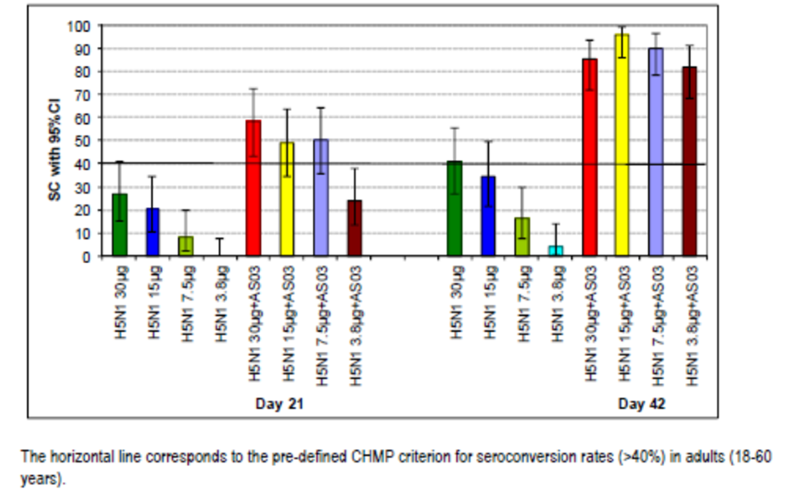
Figure 3: Study H5N1-007: SPR for serum HI antibody at Days 0, 21 and 42 (ATP immunogenicity cohort).
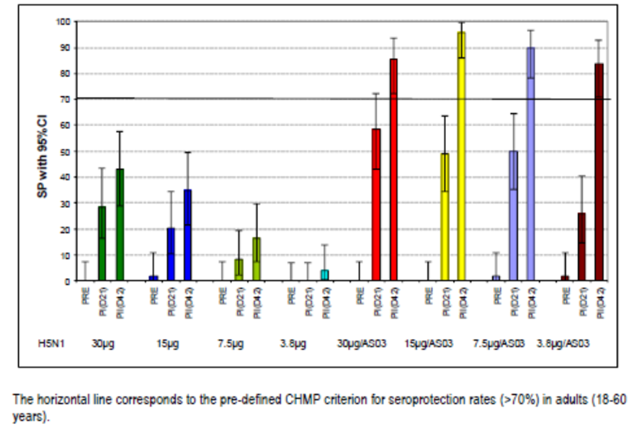
Figure 4: Study H5N1-007: SCF for serum HI antibody at Days 21 and 42 (ATP immunogenicity cohort).
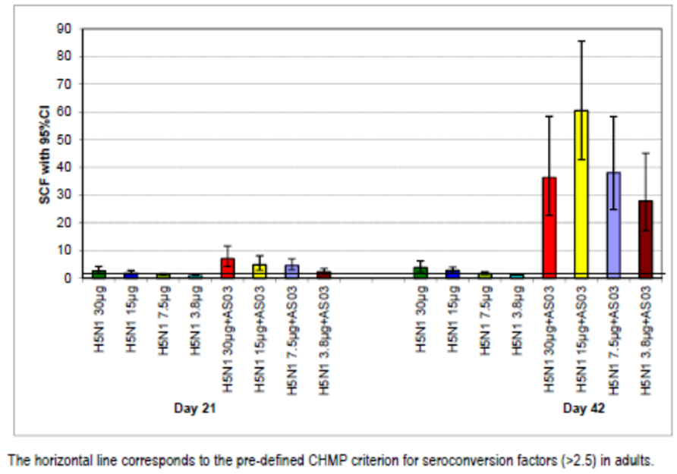
In annexed study reports, the seropositivity for anti HA antibodies to the vaccine strain at Day 180 remained high at 60-74.0% with adjuvanted vaccine and lower with non adjuvanted vaccine (10-45.8%). Seroprotection rates were 54-64% and 4.0-37.5% in the adjuvanted and non adjuvanted groups, respectively. The seroconversion factor at Day 180 was 2.9-4.5% in the adjvanted groups and 1.0-2.2% in the non adjuvanted groups.
The study demonstrated a clear benefit of AS03 adjuvanted formulation compared to non-adjuvanted formulation when assessing the GMTs of the HI antibody. This was seen across antigen doses (Figures 5 and 6).
Figure 5: Study H5N1-007: GMTs for serum HI antibody at Days 0, 21 and 42 (ATP immunogenicity cohort).
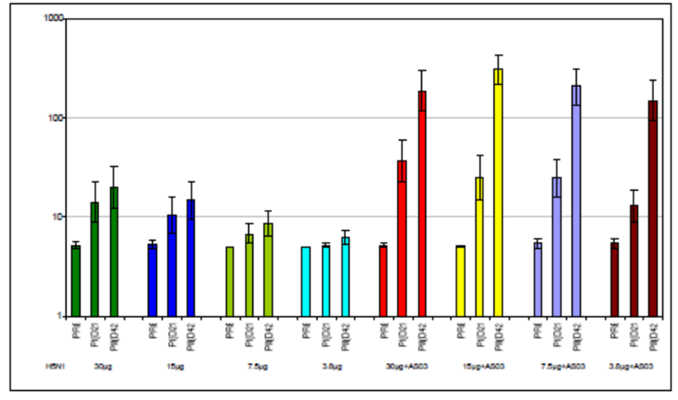
Figure 6: Study H5N1-007: “Adjuvantation” over “HA-dose effect” after the second dose (Day 42) (ATP immunogenicity cohort).
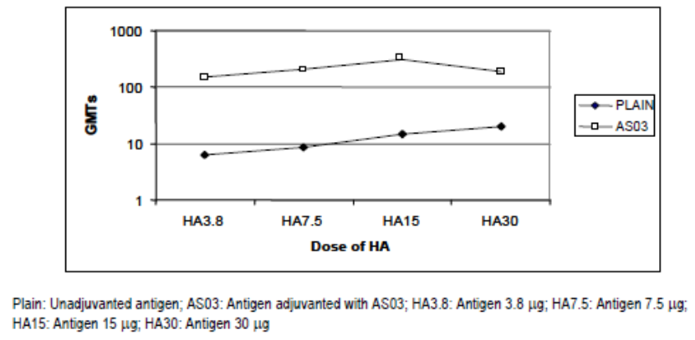
Cross reactive immunity was assessed by measuring anti HA antibody titres against an H5N1 heterologous strain (A/Indonesia/5/2005). For all non adjuvanted formulations, protective levels of antibodies were not reached at any time point (Days 21 or 42). In the adjuvanted vaccine groups, a significant increase in SPRs of 20-33% was observed between Days 0 and 42. The SCFs in the adjuvanted vaccine groups ranged from 1.0 to 1.2 after the first dose and from 2.0 to 2.8 after the second dose compared to no response in the non adjuvanted groups.
Neutralising antibody responses against vaccine strain H5N1 A/Vietnam/1194/2004 were induced with all adjuvanted formulations. In the lowest dose group (3.8 µg HA/AS03), all subjects except one were seropositive after the second dose, with a seroconversion rate of 85.7%. The NA response was notably higher after the second adjuvanted dose and only the adjuvanted vaccine elicited a heterologous NA response.
Comment: The study demonstrated a clear benefit of the adjuvanted compared to the non adjuvanted vaccine formulation across all parameters.
The results indicated the need for a 2 dose schedule.
The sponsor stated that considering the limited manufacturing capacities in the case of a pandemic, the formulation containing the minimum amount of antigen which fulfilled all three CHMP criteria would be selected for the adult population. Given this, the lower dose of 3.75 µg was selected.

Efficacy

Studies providing efficacy data
As the selected vaccine strain is not circulating in human populations, efficacy trials are unable to be carried out. Efficacy therefore is based on surrogate immunogenicity endpoints and these data are included in this section.
The clinical studies enrolled healthy subjects. The exclusion criteria for the adult studies were similar and are listed here:
- use of immunosuppressants, immune modifying or cytotoxic drugs (generally within 6 months and including ≥ 0.5mg/kg/day of corticosteroids);
- confirmed or suspected immunosuppressive or immunodeficient condition or autoimmune disease;
- allergy or hypersensitivity to any component of the vaccine, allergic disease or reactions which could be exacerbated by the vaccine;
- acute moderate or severe disease with or without axillary temperature ≥ 37.5 °C at time of vaccination;
- administration of immunoglobulins or blood products (generally within 3 months);
- prior vaccination with pandemic candidate vaccine or vaccine containing AS03;
- lactating or pregnant women, or women of childbearing potential without appropriate contraception;
In addition, in general the studies also excluded:
- vaccination between Day 0 and 51 with seasonal influenza vaccine;
- administration of licensed vaccines within 2 weeks for inactivated and 4 weeks for live vaccines;
- prior contact with H5N1 wild type virus;
- clinically significant disease on screening test/examination;
- serious chronic disease including pulmonary, cardiovascular, renal, neurological, psychiatric or metabolic disorder;
- chronic alcohol consumption or drug abuse;
- diagnosis or treatment of cancer within 3 years;
- receipt of analgesic or antipyretic medication on the day of vaccination.

Evaluator’s conclusions on efficacy
The dossier included 18 clinical trials, 16 carried out in Europe and Asia and the two Q-Pan studies were conducted in the US and Canada. Study duration ranged from 6 months up to 48 months (H5N1-002/-030/-038) and enrolled healthy adult volunteers (with well controlled diseases in H5N1-008 and -010). Two studies included adults >60 years (H5N1-010 and -008/-011). There were three paediatric studies, H5N1-013, H5N1-009 and H5N1-032, which enrolled children aged 6-35 months, 3-9 years and 3–17 years, respectively. Most of the adult subjects were Caucasians (range 85.0-100%), except for study H5N1-041 and H5N1-002 and its extensions where subjects were predominantly Asian. For the paediatric studies, H5N1-009 included Caucasians, and -013 and -032 mainly Asians.
All studies had a primary vaccination schedule of 0 and 21 days, except some groups in H5N1-012 and the paediatric Study H5N1-032, and Study Q-Pan-009 which assessed accelerated vaccination schedules. Booster vaccination was assessed in several studies: homologous booster in H5N1-012; heterologous booster in H5N1-015, -030, -038, -012 and the paediatric Studies H5N1-013 and -032.
The submitted Prepandrix vaccine contains the D-Pan antigen strain A/H5N1/Indonesia/5/2005 while the registered mock up pandemic vaccines contain D-Pan A/H5N1/Vietnam/1194/2004 or Q-Pan A/H5N1/Indonesia/5/2005. Immunological equivalence of the D-Pan and Q-Pan vaccines was demonstrated in study Q-Pan-001 and so the data were included in this submission. Apart from the different manufacturing sites of the vaccine antigen, there are differences in the vaccine with respect to excipients used in the formulation (Tween-80, Triton X-100 and Magnesium Chloride).
The composition of the H5N1 vaccines use in the clinical program are summarised in Appendix 1. The proposed vaccine contains adjuvant AS03A which was used in all studies apart from paediatric studies which used AS03B and some groups of Q-Pan-001. AS03A is the so called full dose and AS03B contains half of this dose. The proposed antigen dose is 3.75 µg. In general, the paediatric studies assessed half the adult dose.
All serology testing of HI antibody response and serum neutralisation was performed in GSK Biologicals’ central laboratory using standardised procedures which have been validated by the sponsor. The HI antibody titre was used as the main measure of the immunogenicity response to the vaccine. The use of this surrogate efficacy endpoint is accepted by EU and US guidelines.
The studies were well conducted and the overall rate of premature discontinuation was low at 1.5% (157/10208). The most frequent reasons were consent withdrawal, moved from study area and lost to follow-up.

Antigen dose
Antigen dose was based on Study H5N1-007 where it was demonstrated that in presence of the AS03 adjuvant, antigen content as low as 3.75 µg was sufficient to induce the immune response meeting all three CHMP criteria. This dose was selected as it was the lowest dose which still yielded high immunogenicity. No lower doses were assessed in Study 007. In children, there was a higher response with full (3.7 µg) HA dose in Study -009 however the half strength dose (1.9 µg) elicited a satisfactory immune response across the age groups in all three trials.

Adjuvant dose
Adjuvant dose selection was based on results from Study Q-Pan-001 which found that adjuvanted vaccine (both full and half strength) was superior to non-adjuvanted vaccine as determined by SCR and GMT at day 42. Post hoc analyses found the reduction of the AS03 adjuvant dose (full to half) had a modest effect on vaccine homologous virus immunogenicity in subjects 18 to 40 years old, but led to a significant reduction in GMT and proportion of subjects attaining reciprocal titres ≥40 (SPR) among subjects 41-64 years old. For this reason, the full dose was recommended. Study H5N1-007 provided supportive evidence for the benefit of the adjuvanted formulations.

Primary vaccination homologous response
The included studies provided strong evidence for the immunogenicity of a two dose primary vaccination course at days 0 and 21 (3.75 µg HA, AS03_{A} vaccine). All regulatory criteria (SCR, SPR and SCF) for HI homologous antibody response were met for adults, including those aged >60 years, at 21 days following the second vaccination (Table 2). The response was seen for the A/Indonesia and the A/Vietnam strains. Similarly, in children, the homologous response (A/Vietnam in -009 and A/Indonesia in -013 and -032) following a two dose priming course with the half strength vaccine met the adult regulatory criteria (Table 3).
Table 2: Studies H5N1-007, H5N1-002, H5N1-010, H5N1-041, H5N1-015 and Q-Pan-001: HI antibody responses against the homologous vaccine strain after two doses of H5N1 vaccine (3.75 µg HA) with or without AS03_{A} at Day 42 in adults (ATP immunogenicity cohort).
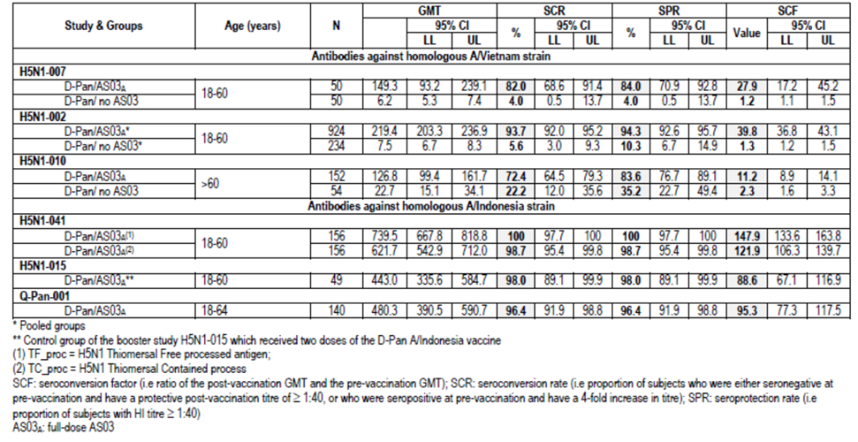
Table 3: Studies H5N1-009, H5N1-013 and H5N1-032: HI antibody responses against vaccine homologous strain after two doses of H5N1 vaccine at Day 42 in children (ATP immunogenicity cohort).
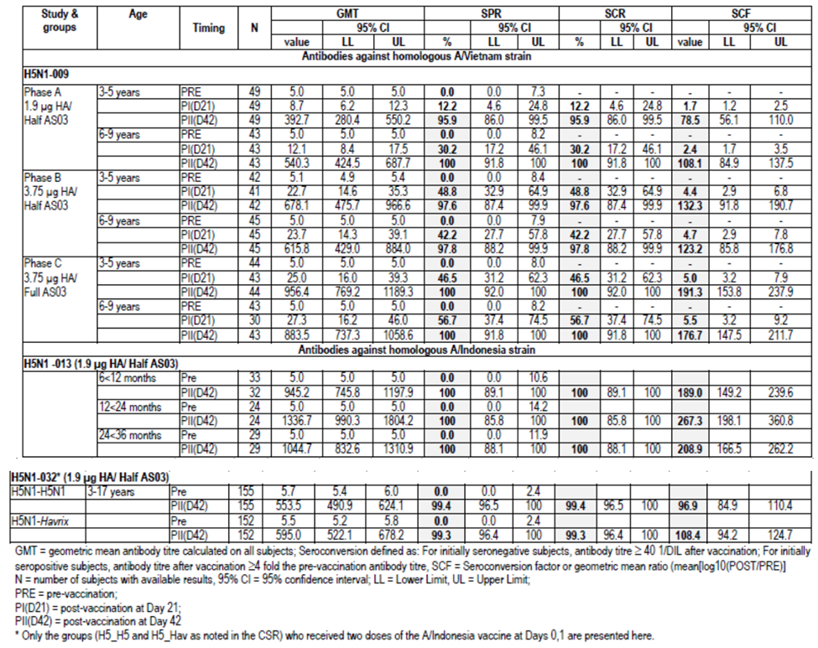
The homologous neutralising antibody response was high with adjuvanted vaccine, although the VRR in adults >60 years was notably less than those 18-60 years which may have been due to high baseline seropositivity in the elderly (93%)(Table 4). Children also demonstrated a strong homologous neutralising antibody response (Table 5).
Table 4: Studies H5N1-007, H5N1-002, H5N1-010, H5N1-015 and Q-Pan-001: Neutralising antibody responses against the homologous vaccine strain after two doses of H5N1 vaccine (3.75 µg HA) with or without AS03_{A} at Day 42 in adults (ATP immunogenicity cohort).
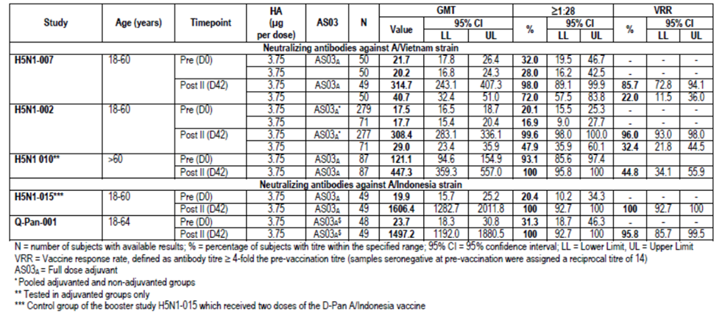
Table 5: Studies H5N1-009, H5N1-032, H5N1-013: Neutralising antibody responses against vaccine homologous strains at Day 42 (ATP immunogenicity cohort).
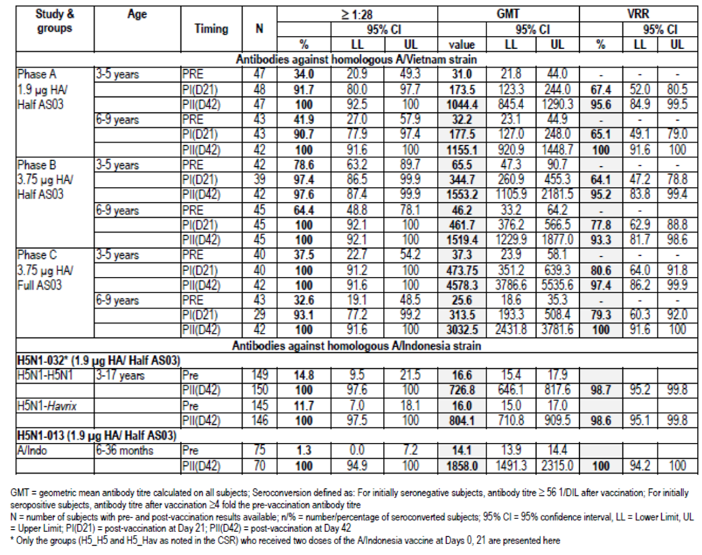

Primary vaccination heterologous response
The adjuvanted vaccine demonstrated cross reactive immunity to drifted strains although not all CHMP criteria were met on Day 42 following a 2 dose course (Table 6). The cross reactive immune response in children was high (Table 7). There was evidence of a heterologous neutralising antibody response with the adjuvanted vaccine in adults although results were more variable (Table 8). Children 3-9 years had a high heterologous NA response with a VRR of 95-97% and seropositivity of >95% after two doses of half strength adjuvanted vaccine (Day 42).
Table 6: Studies H5N1-007, H5N1-002, H5N1-010, H5N1-041, H5N1-015 and Q-Pan-001: HI antibody responses against the heterologous vaccine strain after two doses of H5N1 vaccine (3.75 µg HA) with or without AS03_{A} at Day 42 in adults (ATP immunogenicity cohort).
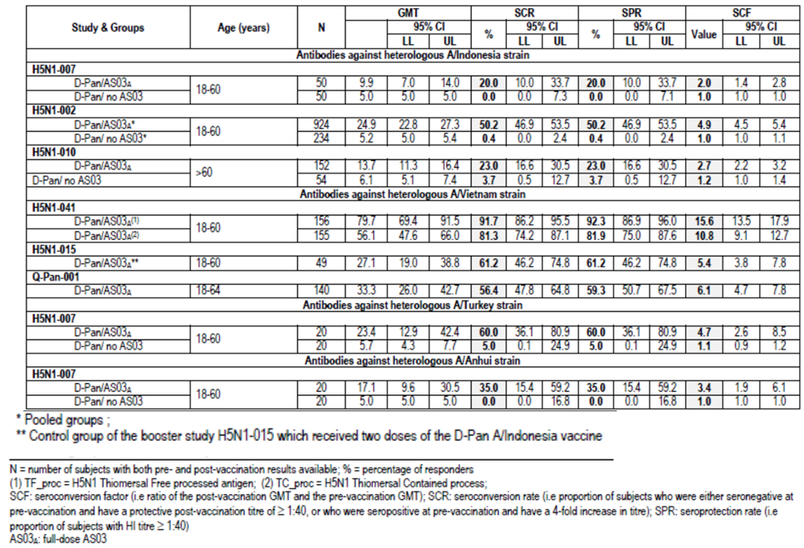
Table 7: Studies H5N1-009 and H5N1-032: HI antibody responses against the heterologous strain after two doses of H5N1 vaccine at Day 42 in children (ATP immunogenicity cohort).
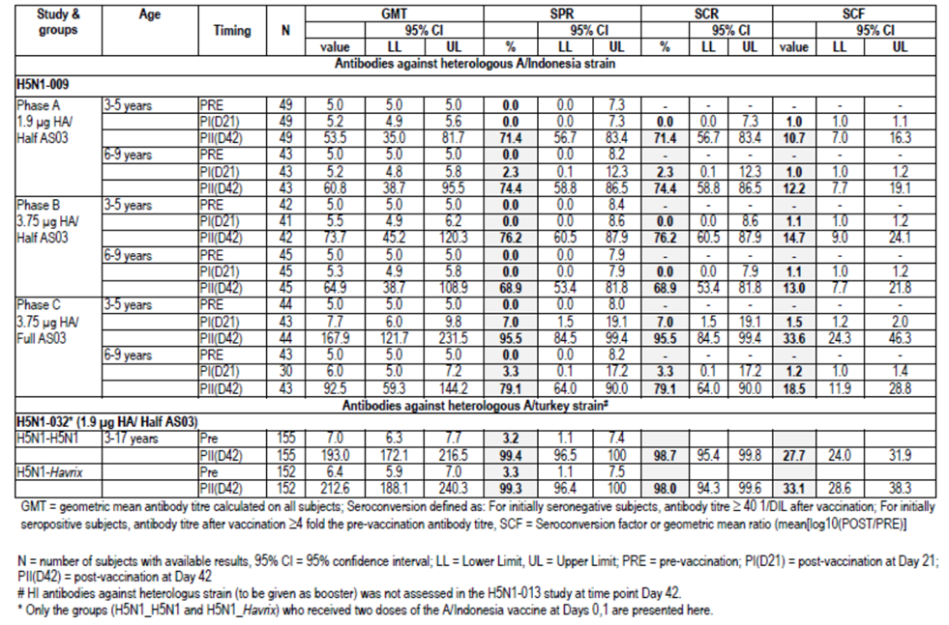
Table 8: Studies H5N1-007, H5N1-002, H5N1-010, H5N1-041, H5N1-015 and Q-Pan-001: Neutralising antibody responses against heterologous strains at Day 42 (ATP immunogenicity cohort).
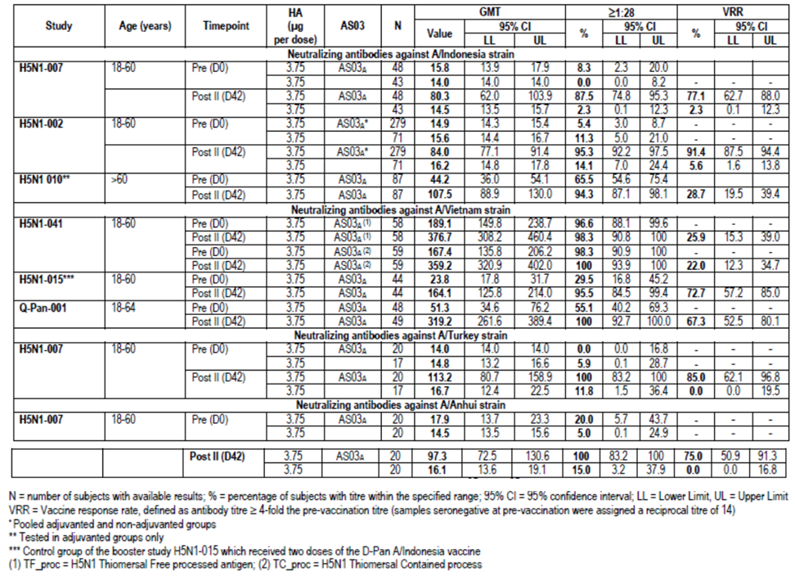

Vaccination schedule
Study Q-Pan-009 demonstrated that an accelerated schedule of 0 and 14 days led to an immune response that was satisfactory and could be employed if required. Shorter schedules of 0,7 days and two doses on day 0 resulted in lower responses. Study -012 found that an increased period of 0 and 6 months or 12 months led to a robust immune response.

Booster response
In adults, when given a booster dose of the same strain as the 2 dose primary vaccination course (A/Vietnam) at 6 or 12 months, the HI immune response met all CHMP criteria (Study H5N1-012). The response was notable by 7 days post vaccination. When the booster vaccination was a heterologous strain (A/Indonesia) to the priming course (A/Vietnam) the HI immune response against the booster strain also met CHMP criteria (day 21 post booster). This was the case if the priming course was one or two doses and the booster was at 6 or 12 months. These data were supported by NA response to the booster strain (H5N1-012). Heterologous booster vaccination was able to be given at 6, 12, 14 or even 36 months post a two dose priming course and induce a strong immune response meeting CHMP criteria (H5N1-030,-038 and -015) (Table 9).
Table 9: Studies H5N1-030, H5N1-038, H5N1-015: HI antibody responses against booster vaccine strain H5N1 A/Indonesia after two doses of primary vaccination with A/Vietnam (ATP immunogenicity cohort).
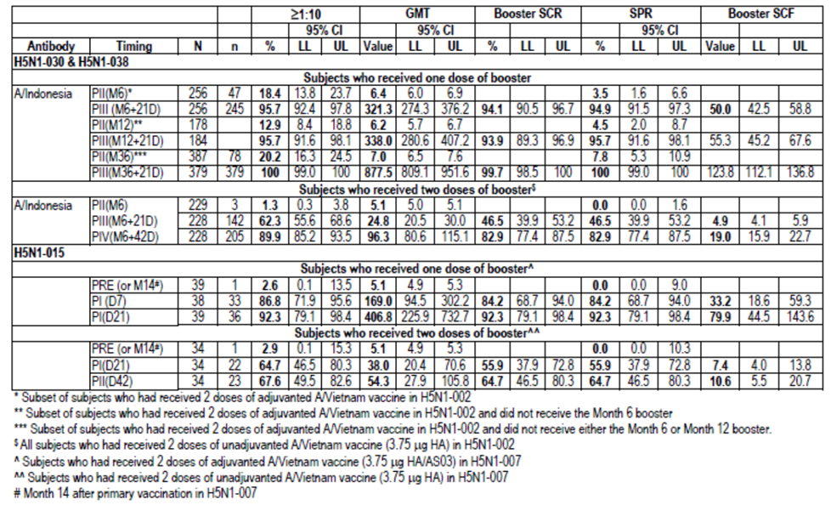
Heterologous booster was given at 6 months after the two dose primary vaccination course in the paediatric Studies H5N1-013 and -032. Study H5N1-032 found a superior booster response in 3-17 year olds primed with two doses of heterologous vaccine compared to those not primed. The HI antibody response to the booster strain 10 days after vaccination met all CHMP criteria in the 6 to 36 month old children in H5N1-013 (Table 10).
Table 10: Studies H5N1-032 and H5N1-013: HI antibody responses against booster vaccine strain 10 days after the booster dose (ATP immunogenicity cohort).
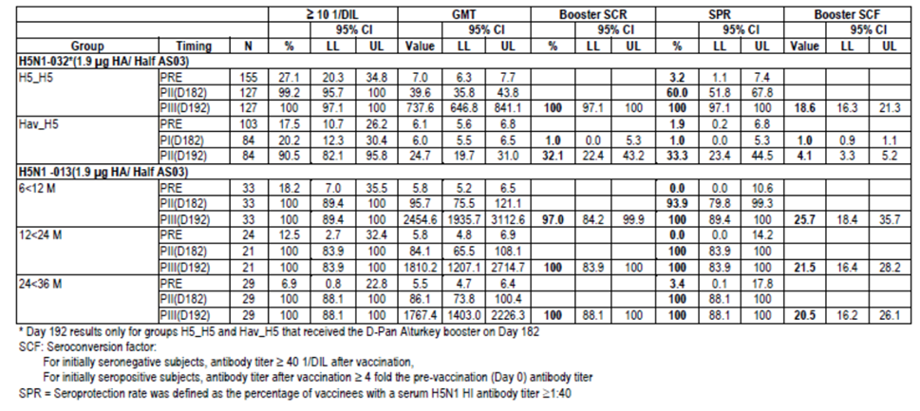

Persistence of immune response
Persistence of immune response up to 6 months following administration of two doses of D-Pan vaccine was assessed in all D-Pan studies. Data were available up to 36 months in adult subjects from H5N1-002 and its extension and up to 24 months in a subset of the elderly in H5N1-011 and the paediatric population of H5N1-009. In general, the GMTs were declining at 6 months although still above pre vaccination levels, the SCF met CHMP criteria at 6 months, then it and other immune measures waned (Table 11). HI antibody to heterologous strains also declined and did not meet regulatory criteria. Seropositivity to neutralising antibodies remained high to 24 months. Twelve months after booster vaccination, the immune response meet CHMP criteria and at 48 months after booster vaccination in H5N1-038, 64% of subjects were seropositive.
Table 11: Studies H5N1-007, H5N1-010, H5N1-041 and Q-Pan-001: Persistence of H1 antibody responses against vaccine strain (ATP persistence cohort).
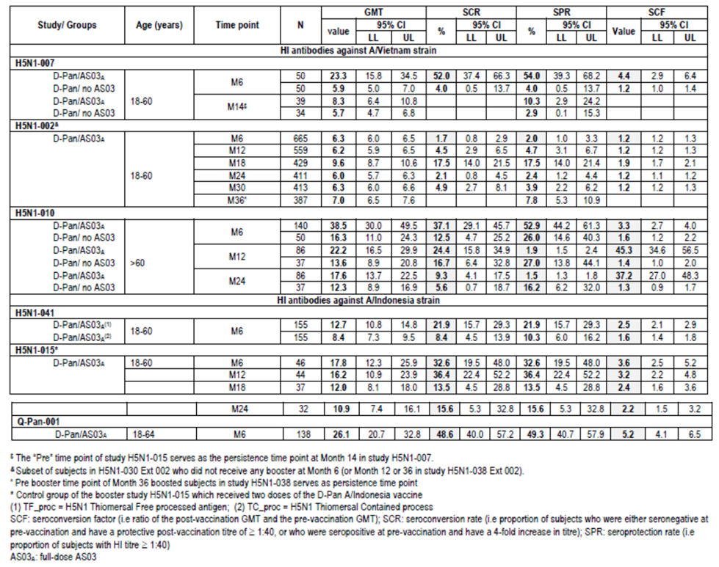
In children, HI immune response persistence at 6 months was greater in those who had received full dose vaccine compared to half strength particularly against the heterologous strain (H5N1-009); however neutralising antibody data in the half strength group were high (seropositivity 92-93% and VRR 95-100%). Data from Studies 013 and 032 found robust persistence to 6 months of HI antibody and neutralising antibody response for homologous and heterologous strains. This was also the case after booster vaccination.
Overall, the immunogenicity data from the clinical trials included in the dossier are accurately reflected.

Safety

Studies providing safety data
The following 14 studies provided evaluable safety data:
- Adult primary vaccination studies: H5N1-007, H5N1-008, H5N1-002, H5N1-010 (elderly adults), H5N1-041
- Adult booster studies: H5N1-012, H5N1-015, H5N1-030, H5N1-038
- Paediatric primary vaccination studies: H5N1-009 (3 to 9 years)
- Paediatric booster studies: H5N1-013 (6 to <36 months), H5N1-032 (3 to 17 years)
- Supportive studies: Q-Pan-001 and Q-Pan-009
The sponsor also submitted two Integrated Summaries of Safety (ISS) which included relevant data from adult trials. These were compiled at the request of the FDA. The first (2008) included eight studies performed with the AS03 adjuvanted Q-Pan and D-Pan H5N1 vaccines (six D-Pan studies: H5N1-007, H5N1-002/030, H5N1-008/011, H5N1-010/021, H5N1-012 and H5N1-015; two Q-Pan studies: Q-Pan-001 and Q-Pan-002). The second ISS (2011) included studies performed with the AS03 adjuvanted D-Pan and Q-Pan H5N1 vaccines, as well as studies conducted more recently with the D-Pan and Q-Pan H1N1 vaccines (total of 28 studies). The first ISS aimed to develop estimates of AEs and to examine for rarer events. The second ISS aimed to assess less common and more serious AEs, in particular medically attended events (MAEs), SAEs, and potential immune mediated diseases (pIMDs).
Comment: The ISSs were discussed in the Summary of Clinical Safety however the data were not included. A question has been raised on this.
Much of these safety data have been evaluated previously: Study H5N1-007 and -008 in the original Prepandemrix dossier (2008); Study Q-Pan-001, H5N1-007 -008, -002 and the first ISS (2008) in the Arepanrix H5N1 dossier (2011); and H5N1-010 and -009 in the Pandemrix dossier.

Patient exposure
In total, 16541 doses of AS03 adjuvanted H5N1 split influenza vaccine containing the Dresden-derived antigen have been administered as primary or booster vaccination to 8676 subjects in the evaluation of safety. Of these 16541 D-Pan vaccine doses, 6558 doses in 3687 subjects were of the proposed formulation (3.75 μg HA adjuvanted with AS03A).
The A/Indonesia/5/05 strain was used in the D-Pan studies H5N1-041, H5N1-013, H5N1-032 and in Q-Pan-001. All other studies had primary vaccination with A/Vietnam/1194/04. Booster vaccination strain was either A/Vietnam/1194/04 or A/Indonesia/5/05 in all studies except H5N1-013 and H5N1-032, where the booster strain was A/turkey/Turkey/01/2005.
In the two Q-Pan studies, 1336 doses of AS03 adjuvanted H5N1 vaccine have been administered as primary vaccination to 715 subjects. Of these 1336 doses, 838 doses in 464 subjects were of the registered formulation (3.75 μg HA adjuvanted with AS03A). The strain in both Q-Pan-001 and Q-Pan-009 was A/Indonesia/5/05.
For the paediatric studies, H5N1-009 there were 195, 196 and 201 doses given in the 3.8 µg HA /AS03A, 3.8µg HA/AS03B (half dose adjuvant) and 1.9 µg HA/AS03B groups, respectively. In Study H5N1-013, 113 subjects received a total of 333 doses of 1.9 μg AS03B D-Pan vaccine. Of these, 225 were priming doses containing half dose AS03-adjuvanted A/Indonesia/05/2005 antigen and 108 were boosters containing half-dose AS03-adjuvanted A/turkey/Turkey/01/2005 antigen. In study H5N1-032, 520 subjects received a total of 1,349 study doses (including doses of both D-Pan and Havrix) to Day 182, with 156 subjects receiving 468 doses of D-Pan 1.9 µg HA/AS03B vaccine for priming and boosting (group H5N1_H5N1).

Safety issues with the potential for major regulatory impact
In all phases of Study H5N1-009, a total of three potentially immune mediated diseases were observed: one case of autoimmune hepatitis in the H5N1 full/half adult dose group (Phase B) that appeared to be present pre vaccination; one case of unilateral uveitis in the H5N1 full adult dose group (Phase C); and one insulin dependent diabetes mellitus in the Fluarix control group (Phase B). No meaningful conclusions about a potential causal relationship between the H5N1 vaccine and immune mediated diseases can be drawn from the limited number of cases observed in Study H5N1-009 in children aged 3-9 years.

Post marketing experience
There were no post marketing data in the dossier for the H5N1 vaccine. The sponsor summarised post marketing surveillance data for the adjuvanted H1N1 pandemic influenza vaccine in the Clinical Overview. It was reported that approximately 31 and 59 million doses of Pandemrix H1N1 and Arepanrix H1N1, respectively, have been administered, including at least 9.5 million doses to children and 300,000 doses to pregnant women. The main risk reported from this surveillance is the risk of narcolepsy, particularly in adolescents (Table 12 and 13).
Comment: This risk has been included in the Precautions section of the draft PI.
Table 12: Post marketing H1N1 surveillance – summary of narcolepsy risk estimates in Europe, children.
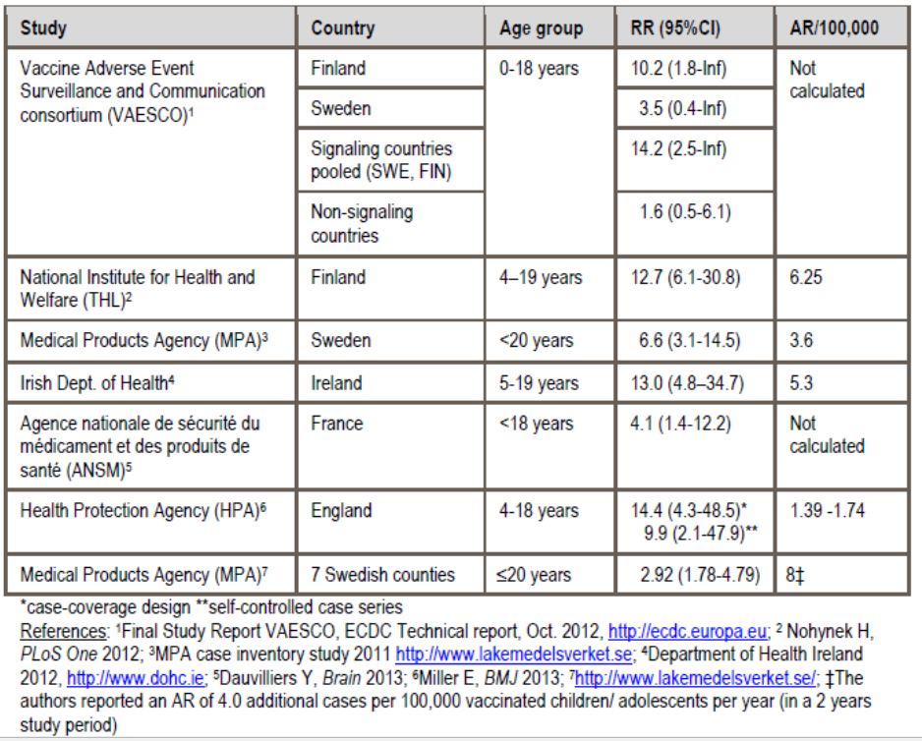
Table 13: Post marketing H1N1 surveillance – summary of narcolepsy risk estimates in Europe, adults.
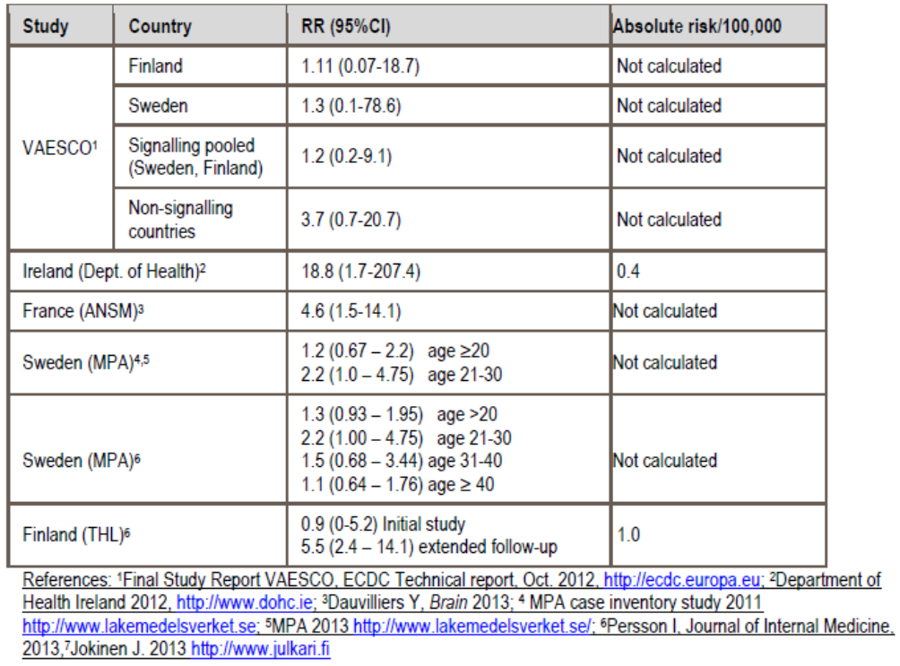
The RMP also discusses 25 reports of solid organ transplant rejection (and 2 reports of graft versus host disease post bone marrow transplantation). Of these cases, 8 had other risk factors involved (such as non compliance with immunosuppressive regimen, discontinuation of immunosuppressants, acute infection, cyclosporine nephropathy and prior rejection episodes), 2 had biopsies not revealing acute rejection and 4 cases had insufficient clinical information.

Evaluator’s conclusions on safety
In total, 16541 doses of AS03 adjuvanted H5N1 split influenza vaccine containing the Dresden-derived antigen have been administered as primary or booster vaccination to 8676 subjects in the evaluation of safety. Of these, 6558 doses in 3687 subjects were of the proposed formulation (3.75 μg HA adjuvanted with AS03A). In the paediatric subset, 300 children aged 3 to 9 years old received 592 D-Pan doses, 520 3-17 year olds received 728 priming and 156 booster doses and 113 6-<36 month olds received 225 priming doses and 108 booster doses.
The A/Indonesia/5/05 strain was used in the D-Pan studies H5N1-041, H5N1-013, H5N1-032 and in Q-Pan-001. All other studies had primary vaccination with A/Vietnam/1194/04. Booster vaccination strain was either A/Vietnam/1194/04 or A/Indonesia/5/05 in all studies except H5N1-013 and H5N1-032, where the booster strain was A/turkey/Turkey/01/2005.
In adults, there was increased reactogenicity with the adjuvanted formulation compared to the non adjuvanted formulation particularly pain, nonetheless the rate of grade 3 solicited local AEs was generally low. General solicited events of fatigue and headache were also more frequent with adjuvanted vaccine. Symptoms were generally mild to moderate in intensity and resolved within several days. Overall, rates of unsolicited AEs were unremarkable. Lymphadenopathy was reported with higher antigen dose and with adjuvanted vaccine. The risk however was low, non severe, and resolved.
There was a trend for higher rates of general symptoms such as mylagia, fatigue and headache following booster than priming doses but no notable findings on unsolicited AEs following booster vaccination.
In the elderly (>60 years) the double strength vaccine dose resulted in an increased risk of local and general solicited AEs.
In children 6 months to 17 years of age, reactogenicity was found to increase with each subsequent vaccine dose whether full or half strength. The full dose vaccine, compared to half dose vaccine, resulted in a higher rate of solicited local and general AEs. Fever, particularly that >39°C, was a notable risk particularly with the full dose vaccine and rates increased with subsequent doses. There were however no reports of febrile convulsions.
There were 13 deaths in the clinical program, none of which were classed as vaccine related. Of the 294 subjects with SAEs, there was one of pneumonia that was treatment related in an elderly subject; however, the event was 299 days post vaccination. Of the 19 paediatric subjects with an SAE there was one, autoimmune hepatitis, which was treatment related. The child however was reported to have elevated transaminases predating the first vaccination. Premature study discontinuation due to an AE was infrequent across all ages.
Where laboratory assessments were undertaken (>60 years olds in H5N1-010, 3-9 year olds in H5N1-009 and adults in Q-Pan 001) there were no notable findings.
There was little difference in the rate of solicited local and general AE and unsolicited AEs between the thiomersal containing and thiomersal free formulations of vaccine. The Q-Pan vaccine studies were not remarkably different to the D-Pan studies in terms of reactogenicity. The reactogenicity with an accelerated immunisation schedule was acceptable.
The relationship between the candidate vaccine and the onset of any new chronic disease or medically significant condition was assessed in detail in the integrated safety summaries. The ISS (2008) included eight completed adult trials evaluating either Q-Pan or D-Pan adjuvanted vaccines. The analysis did not reveal any unexpected safety findings and there was no strong evidence to support a causal relationship between the use of AS03 adjuvanted H5N1 vaccine (Q-Pan or D-Pan) and the incidence of AESI/pIMDs. Drawing definitive conclusions from the data were however not possible due to the limited number of events.
The second ISS (2011) included data from 22,000 subjects in 28 studies, with close to 20,000 in controlled studies, exposed to H5N1 or H1N1 vaccines. It was undertaken to assess the incidence of MAEs, SAEs, and detect rare AEs and in particular pIMDs associated with the adjuvanted vaccine. There were a number of limitations with this ISS including the lack of correction for multiplicity, the 3:1 randomisation limiting the control numbers, the lack of specific pIMD surveillance in the H5N1 studies which was present in the H1N1 studies and a high level of discordance on pIMD status between the investigator’s reports and the sponsor’s assessment. Nonetheless, no imbalance was seen in adjuvanted vaccine recipients compared to control product recipients for MAEs, grade 3 MAEs or SAEs. A higher RR of pIMDs of 1.69 (95% CI 0.81,4.11) in the combined H1N1+H5N1 group was due to an effect seen in the H5N1 group (RR = 6.85, 95% CI: 1.10, 283.6). While there were specific diagnoses (facial nerve paralysis/paresis, PMR/temporal arteritis, uveitis, UC and RA) with suggestions of higher risk there were no specific patterns evident and the evaluator accepts the sponsor’s arguments on the lack of consistency, specificity and lack of power to detect a biological gradient.
There were two paediatric cases of pIMD: autoimmune hepatitis (also an SAE) and uveitis. The first was assessed as predating vaccination and the second was non serious and resolved with treatment. The paediatric safety database however is relatively small and integrated data did not cover this age group.

First round benefit-risk assessment

First round assessment of benefits
The benefits of Prepandemrix, pandemic influenza vaccine (H5N1), in the proposed usage are:
- Demonstrated immunogenicity for the homologous vaccine strain which meets regulatory criteria for pandemic influenza vaccines. The response was consistent across clinical trials and age groups and achieved with a schedule of two doses 21 days apart.
- Ability of the vaccine to elicit both HI and neutralising antibody responses with notable cross-reactive immune response to drift variant strains.
- Anticipated benefit in the event of an influenza pandemic which could have significant public health impacts.
- Immunological equivalence (as measured by GMT ratio) of vaccine manufactured at the two facilities (Q-Pan and D-Pan).
- Ability to shorten primary vaccination schedule to 0 and 14 days if required without compromising immunogenicity.
- Strong booster response after single or dual dose priming. The booster can be a heterologous strain and is immunogenic when administered from 6 to 36 months after priming.
- Immunogenicity demonstrated in children from 6 months to 17 years of age.

First round assessment of risks
The risks of Prepandemrix, pandemic influenza vaccine (H5N1), in the proposed usage are:
- The actual degree of protection the vaccine may provide in the event of a future influenza pandemic is not able to be gauged from the available data.
- It is not known whether a lower antigen dose would be satisfactorily immunogenic.
- There is evidence that the immune response is waning by 6 to 12 months.
- Reactogenicity both local and general, which is higher than non adjuvanted vaccine and increases with subsequent doses. It is acknowledged that these events, which are well documented, are generally mild to moderate in severity and resolve.
- Notable risk of fever in the paediatric population.
- There are limited safety data in the paediatric population and the risk of pIMDs has not been established in this population.
- Possible increased risk of pIMDs in adults, although integrated safety data from 16,000 adults exposed to AS03 adjuvant have not identified any specific concerns.
- No data on pregnancy and lactation or on immunosuppressed subjects.
- Theoretical potential risks of narcolepsy in adolescents and of solid organ transplant rejection due to the post marketing signals with adjuvanted H1N1 vaccine.
- No data on co-administration with other vaccines.
- No long term safety data on the AS03 adjuvant.

First round assessment of benefit-risk balance
The clinical development program for Prepandemrix was extensive and well conducted. It assessed populations from infants of 6 months through to adults over 60 years, different primary vaccination schedules, differing booster intervals and booster response with homologous and heterologous vaccines to the primary course. Immunogenicity evaluations were thorough with assaying for both HI and neutralising antibodies.
The immune response to the D-Pan vaccine containing 3.75µg HA and adjuvanted with AS03_{A}, when given in the proposed priming regimen of two doses 21 days apart, was strong and met all CHMP immunogenicity criteria. While the addition of the adjuvant increased reactogenicity, these events were generally mild or moderate and were outweighed by the marked increased immunogenicity of the vaccine when it was included.
The proposed product contains the A/Indonesia strain compared to the A/Vietnam strain in the original dossier. The adult D-Pan primary vaccination studies were conducted with A/Vietnam, except study H5N1-041 which had the proposed A/Indonesia strain in a study which compared thiomersal containing and free formulations. It was therefore relevant to have an immune response in that study which met CHMP criteria. The immunological equivalence of the Q-Pan and D-Pan vaccines in study Q-Pan-001 and immunogenicity results meeting threshold criteria also provided supporting evidence as the vaccine in that study contained A/Indonesia strain.
The original Prepandemrix submission had two areas of concern which led to its rejection: lack of data on booster response and a possible safety signal of increased risk of NOCD in adults over 60 year of age in Study H5N1-008. Both issues have been addressed in this dossier which presents a far more thorough clinical development program than that evaluated in 2007. A number of booster studies assessing both homologous and heterologous booster to the priming strain have been conducted in adults and children and at different intervals from the priming course. All demonstrated a robust booster response for HI and neutralising antibodies to the booster strain as well as cross reactive response to heterologous strains.
Regarding the risk of NOCD, since the earlier evaluation the Sponsor has conducted further studies, including a study in adults >60 years, as well as compiling two integrated summaries of safety. The safety of the vaccine and adjuvant has now been assessed from a database of approximately 16,000 subjects who received AS03-adjuvanted H5N1 or H1N1 antigens, of who 9300 received H5N1 with AS03_{A}, together with about 6000 control subjects. The Sponsor stated that the size of this safety database provides 99.3% confidence that at least one instance of any AE occurring with a frequency of at least 0.05%. This analysis found an increased relative risk of pIMDs with the H5N1 adjuvanted vaccine (RR=6.8, 95% CI:1.1,283) compared to no increased risk with H1N1 (RR=1.0, 95% CI: 0.4,2.7). The pIMDs identified covered a broad range of diseases without any specific areas being identified. The evaluator agrees with the sponsor that the imbalance in person years of observation between the H5N1 and control groups may have contributed to the observed imbalance. It is concluded that while the data do not suggest a causal link the risk will still need to be closely monitored.
It has been noted in this evaluation, as well as one relating to Pandemrix, that while the standard dose (3.75 µg HA) vaccine in adults >60 years resulted in an immune response which met CHMP criteria it was less than that of a double dose vaccine. The safety profile as regards solicited local and general AEs after vaccination, however was better with the single dose. The European Summary of Product Characteristics (SmPC) for Prepandrix summarises HI antibody responses at day 42 based on age subgroups (61 to 70; 71-80, and > 80 years) and this shows that the H5N1 HI antibody response (SPR, SCR, SCF) in subjects aged >80 was greater in the double dose group (n=10) than in the single dose group (n=13). It also comments that “based on very limited data, adults aged >80 years may require a double dose of [the vaccine] ..... in order to achieve an immune response”. This recommendation is not included in the Australian PI which recommends a single dose vaccination regimen in adult adults aged 18 years and above, irrespective of age. These data appear to be from post hoc analyses as they were not available to the evaluator and the sponsor has been asked to clarify immunogenicity and dosing in the elderly population.
The paediatric clinical development covered children from 6 months to 17 years and demonstrated that two doses three weeks apart (using half the adult dose) was immunogenic with adult CHMP criteria being achieved. There was also strong booster response. It was found that the full adult dose led to increased reactogencity and, given the high rate of fevers with the adjuvanted vaccine, the benefit-risk balance is therefore in favour of the half strength dose. As there are no paediatric dosage instructions in the draft PI, the sponsor has been asked to clarify this issue.
With the number of children with grade 3 fever it was reassuring to find no reported cases of febrile convulsions, nonetheless the sponsor has been asked to confirm that this is the case. In addition, this risk of fever has not been adequately covered in the draft PI. The overall safety of the vaccine in the paediatric population has been based on relatively small numbers. There were two pIMDs identified, autoimmune hepatitis and uveitis, although the former was believed to predate vaccination and the latter resolved with treatment. There were no integrated data on the paediatric population presented and the sponsor should provide further information to justify the safety of the product in children.
Overall, it is not clear if the indication for the vaccine seeks to cover children as there is a lack of dosage instructions, inadequate coverage of paediatric clinical trial immunogenicity and safety data in the PI, a Consumer Medicine Information (CMI) which includes no instructions relating to children and inconsistencies in the RMP. These issues all need to be addressed before an assessment of benefit-risk in this population can be undertaken.
With regard to the indication, the current wording is Prophylaxis of influenza caused by the H5N1 strain with a pandemic potential. As there are no data to confirm prophylaxis of influenza, the evaluator believes preferable wording would be along the lines of that in the European SPC which states active immunisation against H5N1 subtype of Influenza A virus.
There are substantial public health risks of pandemic influenza and so there is a high need for immunogenic vaccines. Prepandemrix vaccine was found to be immunogenic with evidence of cross reactive antibodies at a relatively low antigen dose. There was some flexibility with priming dose schedule, a robust and rapid booster response, and manageable reactogenicity risks. Integrated safety data found an increased relative risk of pIMD with the adjuvanted H5N1 vaccine while detailed assessment did not appear to support any specific findings. The evaluator believes the causal risk is not sufficiently strong to outweigh the potential public health benefit of the vaccine. Nonetheless, it is a case where there will need to be ongoing vigilant safety monitoring and it will be essential that the sponsor has highly developed plans for the monitoring of the candidate vaccine in the event of a pandemic influenza outbreak.
In summary, the evaluator found that the benefit-risk balance of Prepandemrix given the proposed usage is favourable for adults subject to satisfactory responses to questions and comments below. The evaluator found that there were a number of issues still to be addressed regarding the paediatric population and so the benefit-risk balance in this group is currently unfavourable.

First round recommendation regarding authorisation
It is recommended that Prepandemrix pandemic H5N1 influenza vaccine (A/Indonesia/05/2005 3.75 µg adjuvanted with AS03) is authorised for use in adults. The recommendation is subject to:
- Addressing questions raised
- Rewording of the proposed indication
- Satisfactorily addressing changes to the PI and CMI
- Close post marketing safety monitoring.
It is not currently recommended that Prepandemrix is authorised for use in the paediatric population as issues raised need to be addressed by the sponsor and evaluated by the TGA.

Clinical questions

Pharmacokinetics
None.

Pharmacodynamics
None.

Efficacy
- The EU SPC for Prepandrix includes what appears to be a post-hoc immunogenicity analysis of study H5N1-010 by age subgroups. These data were not located in the clinical study report. The data point towards an improved immune response in subjects aged >80 years with the double dose vaccine regimen. From this there is a statement in the EU SPC dosage and administration section which suggests a double dose of vaccine may be necessary in this age group. Discuss these findings and whether or not the information is relevant in the Australian context.

Safety
- In the Summary of Clinical Safety it states that 6558 doses of D-Pan 3.75 µg HA adjuvanted with AS03A have been given to 3687 subjects (page 43) while in the Clinical Overview it states that these 6558 doses were given to 2804 subjects (Table 35). Please explain the difference and verify the number of subjects who have been exposed to the proposed vaccine.
- In the Summary of Clinical Safety, results of the two ISSs were discussed. Neither ISS had corresponding data located in the dossier. The first ISS (2008) has been previously evaluated, however the evaluator believes that the second ISS (2011) has not been previously evaluated and so the data should be submitted to the TGA.
- Given the risk of fever with the adjuvanted vaccine it was reassuring that no reports of febrile convulsions were identified in the three paediatric clinical trials. Could the Sponsor confirm that there have indeed been no cases of febrile convulsion or discuss any cases that may have occurred in infants, children or adolescents with the administration of the H5N1 vaccine.
- The safety of the vaccine in the paediatric population has been evaluated in the three clinical trials in the dossier. There is a however no broader integrated summary of safety in children, either for the H5N1 vaccine alone or for combined adjuvanted H5N1 and H1N1 vaccines. Discuss any integrated data on paediatric safety and post-marketing safety data including information on cases of pIMDs.

Second round evaluation
The sponsor submitted a response where they requested to change the trade name from Prepandemrix to Prepandrix, which is the approved name in Europe. Below is a summary of the sponsor’s responses to the questions followed by the evaluator’s comments.

Efficacy

Question 1
- The EU SPC for Prepandrix includes what appears to be a post-hoc immunogenicity analysis of study H5N1-010 by age subgroups. These data were not located in the clinical study report. The data point towards an improved immune response in subjects aged >80 years with the double dose vaccine regimen. From this there is a statement in the EU SPC dosage and administration section which suggests a double dose of vaccine may be necessary in this age group. Discuss these findings and whether or not the information is relevant in the Australian context.
Sponsor’s response
In Study H5N1-010, exploratory post hoc analysis was conducted in age subgroups (60-65, 66-70, 71-75, 76-80 and >80 years) at the request of the European Authorities. These data were included with the sponsor’s response to this question.
There were only 10 and 13 subjects aged >80 years who received single and double dose adjuvanted vaccine, respectively. There was a high rate of seropositivity for HI antibodies to A/Vietnam so the age-stratified analysis also assessed results by baseline serostatus. The baseline seropositivity rates to A/Vietnam increased with age (50-60% in the >80 year olds). No seropositivity was seen for HI antibodies against A/Indonesia.
Prevaccination GMTs for HI antibodies against A/Vietnam were low in all age groups (7.0-14.1). At Day 42 post vaccination, GMTs were found to be lower in subjects aged >80 years, particularly in those who received one dose of vaccine.
Seroprotection rates at Day 42 against A/Vietnam were >60% in all age groups whether they received single or double dose vaccine. When assessed by baseline serostatus, those who were seropositive had higher SPRs. In the seronegative subjects >80 years (n = 5), there was no seroprotection when only one vaccine dose was given. The SPR threshold was not met by any age group for HI antibodies against A/Indonesia.
A seroconversion rate of >30% against A/Vietnam was achieved in all age groups at day 42 whether a single or double dose was given. When assessed by baseline serostatus, again the 5 seronegative subjects aged over 80 years failed to demonstrate seroconversion. The SCR threshold for HI antibodies against A/Indonesia was met by all age groups when vaccinated with two doses but not when only one dose was given.
The seroconversion factor of >2.0 against A/Vietnam was achieved in all age groups at day 42 regardless of serostatus. The threshold of >2.0 was met against A/Indonesia in all age groups when two vaccine doses were given but not in the >80 year age group with only one dose (SCF 1.3, 95% CI: 1.0, 1.8).
The sponsor’s conclusion was:
All CHMP criteria are met for the HI response against the vaccine strain at Day 42, regardless of age, and for both the single and the double injection dose. The baseline serostatus of the subjects does not impact on the ability to meet the criteria, except for the oldest subjects (aged above 80 years), in case they were seronegative before vaccination and vaccinated with the 1x3.8AD formulation. In this latter group, for which it should nevertheless be noted that the sample size is very limited (n = 5), SCR and SPR criteria are not met, although SCF is met at Day 42. It was stated that the trend towards improved immunogenicity with a double dose has to be interpreted with caution.
The sponsor’s response to this question also covers Question 30 on the PI.

Evaluator’s comments
The sample size is very small on which to draw conclusions and the analysis post hoc. Nonetheless, the data are suggestive of an improved immune response in subjects aged >80 years with the double dose vaccine regimen. Therefore, it would appear prudent to include the same statement as in the European SmPC in the Dosage and Administration section of the PI.
Based on very limited data, adults aged >80 years may require a double dose of Prepandrix on an elected date and again after an interval of at least three weeks in order to achieve an immune response.

Safety

Question 2
- In the Summary of Clinical Safety it states that 6558 doses of D-Pan 3.75 µg HA adjuvanted with AS03A have been given to 3687 subjects (page 43) while in the Clinical Overview it states that these 6558 doses were given to 2804 subjects (Table 35). Please explain the difference and verify the number of subjects who have been exposed to the proposed vaccine.

Sponsor’s response
The sponsor agreed there was a mistake in Table 35. The correct number exposed subjects is 3687.

Evaluator’s comments
None.

Question 3
- In the Summary of Clinical Safety results of the two ISSs were discussed. Neither ISS had corresponding data located in the dossier. The first ISS (2008) has been previously evaluated, however the evaluator believes that the second ISS (2011) has not been previously evaluated and so the data should be submitted to the TGA.

Sponsor’s response
The sponsor submitted the second ISS of AS03 adjuvanted monovalent H5N1 and H1N1 vaccines in adults 18 years of age and older (dated September 2011).

Evaluator’s comments
The data in this ISS report are consistent with that presented in the submitted dossier and summarised.

Question 4
- Given the risk of fever with the adjuvanted vaccine it was reassuring that no reports of febrile convulsions were identified in the three paediatric clinical trials. Could the Sponsor confirm that there have indeed been no cases of febrile convulsion or discuss any cases that may have occurred in infants, children or adolescents with the administration of the H5N1 vaccine.

Sponsor’s response
The sponsor confirmed that no febrile convulsion cases were reported in H5N1-009 (3-9 year olds) and H5N1-032 (3-17 year olds). In H5N1-013, there was one “seizure – suspected” in a subject aged 18 months of age at 88 days post dose 2. The event was not an SAE and no treatment was given. Dose 3 of vaccine was not given due to this event.
There was one febrile convulsion (an SAE) in Q-Pan-021 (children 6 m to <18 years) in a 30 month old child at 11 days post first vaccine dose (H5N1/AS03). The child was hospitalised for 3 days and recovered. There was no history of fever in the 7 days post dose 1 or dose 2 of vaccine. A second case of a convulsion was reported in this study 212 days post vaccine dose 2. The event was medically attended. A third case of possible seizure occurred 134 days post dose 2 and one day prior to the onset of an upper respiratory tract infection (URTI).

Evaluator’s comments
The evaluator agrees with the sponsor that the timing of these events are not suggestive of a temporal relationship to vaccination.

Question 5
- The safety of the vaccine in the paediatric population has been evaluated in the three clinical trials in the dossier. There is a however no broader integrated summary of safety in children, either for the H5N1 vaccine alone or for combined adjuvanted H5N1 and H1N1 vaccines. Discuss any integrated data on paediatric safety and post marketing safety data including information on cases of pIMDs.

Sponsor’s response
There are no integrated safety data in children. Compared to H5N1 vaccine, H1N1 vaccine is noted to have a higher immunogenicity profile and the number of exposed children is greater (n = 5264). This could skew the safety data. Overall, the number of paediatric subjects is not sufficient to detect rare events. The response also stated:
Across the complete H5N1 paediatric clinical development program, there have been 4 case reports of a pIMD, three of them with the D-Pan H5N1 vaccine: one case reported Vitiligo and one case Uveitis. A third case reported autoimmune hepatitis in 3.5 year old female who received the first dose of DPan H5N1. The event was considered by the investigator to have a possible causal relationship to the vaccine. However, testing of serum samples collected before vaccination revealed abnormalities consistent with pre existing hepatic disease (elevated serum alanine aminotransferase and aspartate aminotransferase levels). In the paediatric QPan H5N1 development, there was one pIMD case reporting Alopecia. Overall no safety signal arose from the data.

Evaluator’s comments
It remains that pIMDs need to remain under close monitoring for the adjuvanted vaccines.

Second round benefit-risk assessment

Second round assessment of benefits
After consideration of the responses to clinical questions, the benefits of Prepandemrix/Prepandrix in the proposed usage are unchanged from those identified in Round 1.

Second round assessment of risks
After consideration of the responses to clinical questions, the risks of Prepandemrix/Prepandrix in the proposed usage are unchanged from those identified in Round 1.

Second round assessment of benefit-risk balance
The sponsor has submitted a thorough response to the questions asked after the first round evaluation. Comments on the PI have been satisfactorily addressed and resulted in substantial modifications to the document.
The major change in the second round evaluation is that the sponsor no longer proposes an indication which covers the paediatric population. Given this alteration, the evaluator recommends that it is made clear in the indication that the vaccine is for the active immunisation of adults only. In addition, a precaution relating to use in children should be included in the PI.
Submitted post hoc data analysis of the elderly study pointed towards possible reduced immunogenicity of the vaccine in those aged >80 years and improved response with double vaccine dose. While these analyses are post hoc and the subgroup sample size very small, the evaluator agrees with the EU’s decision to include a statement outlining these facts in the PI.
In summary, evaluator finds the benefit-risk balance for Prepandemrix/Prepandrix pandemic H5N1 influenza vaccine use in adults is favourable. This is subject to the remaining few questions relating to the PI being satisfactorily addressed.

Second round recommendation
It is recommended that Prepandemrix/Prepandrix, pandemic H5N1 influenza vaccine (A/Indonesia/05/2005 3.75 µg adjuvanted with AS03) is authorised for use in adults. The recommendation is subject to:
- Making the indication specific for adults.
- Finalising the PI
- Close post-marketing safety monitoring.

V. Pharmacovigilance findings

Risk management plan
The sponsor submitted an EU-Risk Management Plan (RMP) Version 11 (dated July 2013) with an Australian Specific Annex (ASA) dated 4 February 2014.

Safety specification
The sponsor provided a summary of ongoing safety concerns which are shown at Table 14.
Table 14: Ongoing safety concerns.
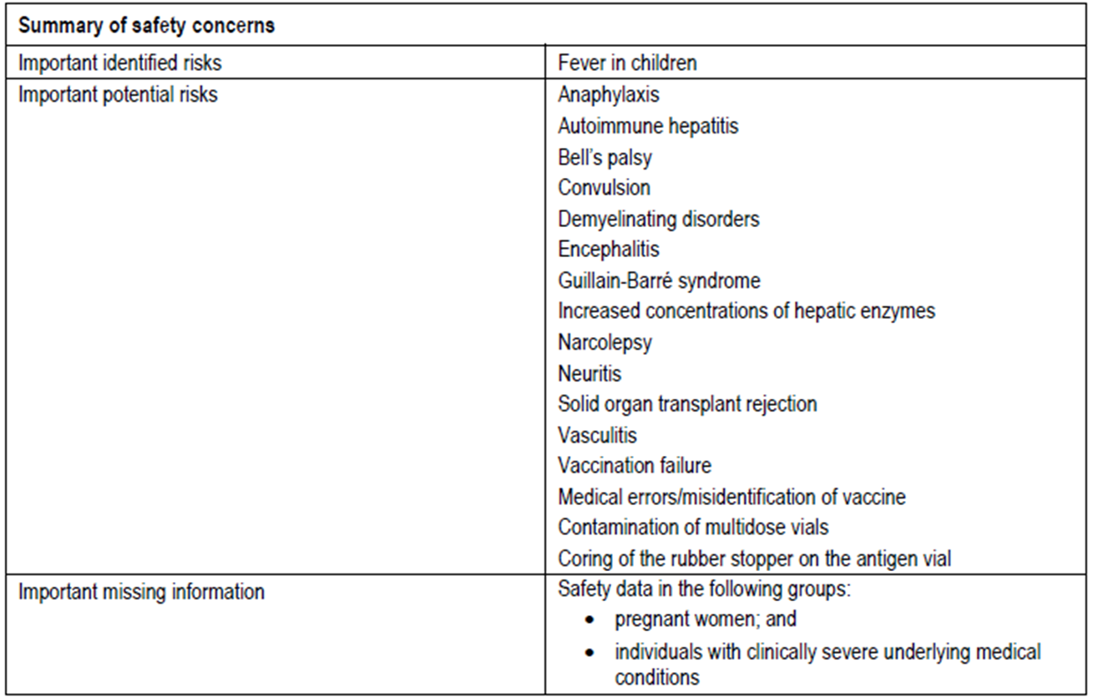

Reviewer comment
The ongoing safety concerns are identical to those previously accepted for Pandemrix H5N1 pandemic influenza vaccine. Notwithstanding the evaluation of the nonclinical and clinical aspects of the Safety Specification, the above summary of the Ongoing Safety Concerns is considered acceptable.

Pharmacovigilance plan
The proposed pharmacovigilance plan, based on the relevant European Union guideline that has been formally adopted in Australia, is almost identical to what was previously accepted for Pandemrix H5N1 pandemic influenza vaccine.
The ASA also states:
As a routine pharmacovigilance measure, all targeted follow up questionnaires referred to in the EU-RMP will be implemented in Australia.
and
GSK has committed to discuss with TGA the requirements of an Australian-specific postmarketing cohort study, should this vaccine be first used in Australia in a pandemic situation.
Details of the latter commitment are provided in the ASA under the heading ‘Commitment regarding TGA’s request for post marketing cohort study as detailed in the new RMP format’.
The ASA does not provide the details of the qualified person responsible for pharmacovigilance (PRP) within the sponsor company, who has been nominated as the person responsible for the implementation of the RMP activities within Australia.

Reviewer comment
The following statement in ‘Organisational Structure’ of the ASA should be updated to refer to the current ‘Australian requirements and recommendations for pharmacovigilance responsibilities of sponsors of medicines’ and acknowledge that the ‘Drug Safety and Evaluation Branch’ per se no longer exists within the TGA:
The Pharmacovigilance team is responsible for compliance with the appropriate regulatory guidelines: Australian Guideline for Pharmacovigilance Responsibilities of Sponsors of Registered Medicines Regulated by Drug Safety and Evaluation Branch
Section 2.4 ‘Other Pharmacovigilance Activities Referenced in the EU-RMP’ of the ASA should be corrected to make reference to Annex 7 of the EU-RMP version 11 dated July 2013, rather than “Annex 7 of the EU RMP v10 dated July 2013”. In addition, this section states in regard to the important potential risk: ‘Solid organ transplant rejection’: “(please note that a targeted follow up questionnaire for this newly added potential risk is currently in the process of being developed; final version to be submitted to TGA in February 2014).” However, this questionnaire was submitted to the TGA in the sponsor’s correspondence dated 5 March 2014 with an assurance that it would be included within the next version of the EU-RMP. As it does not appear to have been included in the EU-RMP version 11 dated July 2013, the sponsor should attach a copy of this questionnaire to an updated ASA.

Risk minimisation activities
The sponsor appears to have concluded that routine risk minimisation activities will be applied to all the specified ongoing safety concerns, except for the important potential risks: ‘Autoimmune hepatitis’, ‘Bell’s palsy’, ‘Demyelinating disorders’, ‘Increased concentrations of hepatic enzymes’ & ‘Solid organ transplant rejection’ for which no risk minimisation activities are proposed. Furthermore additional risk minimisation activities are proposed for the important potential risks: ‘Medical errors/misidentification of vaccine’, ‘Contamination of the multi-dose vials’ & ‘Coring of the rubber stopper on the antigen vial’ in the form of educational materials for healthcare professionals.

Reviewer comment
The sponsor’s conclusion remains similar to what was previously accepted for Pandemrix H5N1 pandemic influenza vaccine, and at this time continues to be acceptable.

Reconciliation of issues outlined in the RMP report
The following section summarises the first round evaluation of the RMP, the sponsor’s responses to issues raised, and the evaluation of the sponsor’s responses.

Recommendation #1 in RMP evaluation report
Safety considerations may be raised by the nonclinical and clinical evaluators through the consolidated Section 31 request and/or the nonclinical and clinical evaluation reports respectively. It is important to ensure that the information provided in response to these includes a consideration of the relevance for the RMP, and any specific information needed to address this issue in the RMP. For any safety considerations so raised, the sponsor should provide information that is relevant and necessary to address the issue in the RMP.

Sponsor response
The sponsor states it has considered the consolidated Section 31 request and the nonclinical and clinical evaluation reports and determined that no changes are required to the RMP.

Evaluator’s comment
This response would appear contrary to the CER statement: “The Safety Specification in the draft EU RMP Version 11 (dated 19 May 2013) and the Australian Specific Annex (dated 4 February 2014) are not entirely satisfactory and should be revised, …” (see Section 2: ‘Comments on the safety specification of the RMP’). Specifically, the following issues are outstanding:
- The proposed indications in the updated ASA have not been revised in accordance with the current version of the PI submitted with the sponsor’s correspondence dated 29 October 2014. The sponsor should correct this oversight in a revised ASA before this application is approved.
- Based on the clinical evaluation report, the important potential risks: ‘Uveitis’ & ‘Polymyalgia rheumatica/temporal arteritis’ should be included as new ongoing safety concerns. Consideration must be given as to what pharmacovigilance and risk minimisation activities will be proposed for these new ongoing safety concerns and only the ASA need be revised accordingly before this application is approved.
- The clinical evaluation report has stated that heightened safety surveillance in the paediatric population will be necessary as there are limited safety and immunogenicity data in this population. The proposed PI agrees that experience in children is limited and Table 2: ‘Specific safety concerns where the wording in the EU SmPC as a risk management measure differs in meaning to the Australian PI’ of the updated ASA states: “Prepandrix is not proposed for use in children in Australia.” Consequently the sponsor should include the missing information: ‘Safety data in the paediatric population’ as a new ongoing safety concern. Consideration must be given as to what pharmacovigilance and risk minimisation activities will be proposed for this new ongoing safety concern and only the ASA need be revised accordingly before this application is approved.

Recommendation #2 in RMP evaluation report
The following statement in Section 2.1.1: ‘Organisational Structure’ of the ASA should be updated to refer to the current ‘Australian requirements and recommendations for pharmacovigilance responsibilities of sponsors of medicines’ and acknowledge that the ‘Drug Safety and Evaluation Branch’ per se no longer exists within the TGA:
The Pharmacovigilance team is responsible for compliance with the appropriate regulatory guidelines: - Australian Guideline for Pharmacovigilance Responsibilities of Sponsors of Registered Medicines Regulated by Drug Safety and Evaluation Branch

Sponsor response
The ASA has been updated accordingly.

Evaluator’s comment
This is acceptable.

Recommendation #3 in RMP evaluation report
Section 2.4: ‘Other Pharmacovigilance Activities Referenced in the EU-RMP’ of the ASA should be corrected to make reference to Annex 7 of the EU-RMP version 11 dated July 2013, rather than “Annex 7 of the EU RMP v10 dated July 2013”. In addition this section states in regard to the important potential risk: ‘Solid organ transplant rejection’: “(please note that a targeted follow up questionnaire for this newly added potential risk is currently in the process of being developed; final version to be submitted to TGA in February 2014).” However, this questionnaire was submitted to the TGA in the sponsor’s correspondence dated 5 March 2014 with an assurance that it would be included within the next version of the EU-RMP. As it does not appear to have been included in the EU-RMP version 11 dated July 2013, the sponsor should attach a copy of this questionnaire to an updated ASA.

Sponsor response
The ASA has been updated accordingly. The reference to the EU-RMP has been corrected. The targeted follow up questionnaire for ‘Solid organ transplant rejection’ has been added to the ASA.

Evaluator’s comment
This is acceptable.

Recommendation #4 in RMP evaluation report
Table 2: ‘Specific safety concerns where the wording in the EU SmPC as a risk management measure differs in meaning to the Australian PI’ of the ASA should be amended to compare the actual content and wording of the EU SmPC and the proposed Australian PI for all of the specified ongoing safety concerns. The TGA can then validate the sponsor’s assertion that there are no material differences between the routine risk minimisation activities undertaken in Europe compared to Australia. Upon receipt of such information recommendations to the Delegate in regard to the proposed routine risk minimisation activities can then be made.

Sponsor response
The sponsor has stated: “The ASA has been updated accordingly.”

Evaluator’s comment
It appears the sponsor has only done so for ‘Use in the paediatric and elderly populations’. The RMP Questions and Answers (Version 1.3, October 2012) as found on the TGA website state: “The ASA should identify any differences between the EU-RMP and the local implementation of risk management activities, for example: any differences between the risk minimisation activities undertaken as reflected in the content of the EU SmPC and the proposed Australian PI, and the reasons for the difference.” Consequently, it is reiterated that the ASA should be revised to include a risk minimisation activities table detailing all planned risk minimisation measures in the Australian context and the EU-RMP context. This table should include a comparison of the actual content and wording of the EU SmPC and the proposed Australian PI and CMI for all of the specified ongoing safety concerns and missing information to identify and provide reasons for any observed differences, particularly where it appears the EU SmPC is more restrictive. Given the differences foreshadowed above between the summary of ongoing safety concerns for Australia and the EU, the ASA should be so revised before this application is approved.

Recommendation #5 in RMP evaluation report
The sponsor should provide a table summarising the pharmacovigilance and risk minimisation activities for all of the specified ongoing safety concerns proposed for Australia in the ASA.

Sponsor response
The sponsor states: “All of the concerns identified in the EU-RMP are relevant for patients in Australia and therefore all of the planned pharmacovigilance actions proposed in the EU-RMP will be implemented in Australia. Consequently, it is unnecessary to provide a separate ‘Summary of the Risk Management Plan in Australia’ in a revised ASA.”

Evaluator’s comment
Given the differences foreshadowed above between the summary of ongoing safety concerns for Australia and the EU, this response is considered unacceptable. Consequently, it is reiterated that the sponsor provide a table summarising the pharmacovigilance and risk minimisation activities for all of the specified ongoing safety concerns and missing information proposed for Australia in the ASA before this application is approved.

Summary of recommendations
It is considered that the sponsor’s response to the TGA Section 31 request has not adequately addressed all of the issues identified in the RMP evaluation report.

Outstanding issues

Issues in relation to the RMP
The sponsor was asked to respond to safety considerations raised by the nonclinical and clinical evaluators through the consolidated Section 31 request and/or the nonclinical and clinical evaluation reports, respectively, in the context of relevance to the RMP. The sponsor states it has considered the consolidated Section 31 request and the nonclinical and clinical evaluation reports and determined that no changes are required to the RMP. This would appear contrary to the CER statement: “The Safety Specification in the draft EU Risk Management Plan Version 11 (dated 19 May 2013) and the Australian Specific Annex (dated 4 February 2014) are not entirely satisfactory and should be revised, …” (see Section 2: ‘Comments on the safety specification of the RMP’). Specifically, the following issues are outstanding:
- The proposed indications in the updated ASA have not been revised in accordance with the current version of the PI submitted with the sponsor’s correspondence dated 29 October 2014. The sponsor should correct this oversight in a revised ASA before this application is approved.
- Based on the clinical evaluation report, the important potential risks: ‘Uveitis’ & ‘Polymyalgia rheumatica/temporal arteritis’ should be included as new ongoing safety concerns. Consideration must be given as to what pharmacovigilance and risk minimisation activities will be proposed for these new ongoing safety concerns and only the ASA need be revised accordingly before this application is approved.
- The clinical evaluation report has stated that heightened safety surveillance in the paediatric population will be necessary as there are limited safety and immunogenicity data in this population. The proposed PI agrees that experience in children is limited and Table 2: ‘Specific safety concerns where the wording in the EU SmPC as a risk management measure differs in meaning to the Australian PI’ of the updated ASA states: “Prepandrix is not proposed for use in children in Australia.” Consequently the sponsor should include the missing information: ‘Safety data in the paediatric population’ as a new ongoing safety concern. Consideration must be given as to what pharmacovigilance and risk minimisation activities will be proposed for this new ongoing safety concern and only the ASA need be revised accordingly before this application is approved.
The sponsor was asked to amend Table 2: ‘Specific safety concerns where the wording in the EU SmPC as a risk management measure differs in meaning to the Australian PI’ of the ASA to compare the actual content and wording of the EU SmPC and the proposed Australian PI for all of the specified ongoing safety concerns in order to validate the sponsor’s assertion that there are no material differences between the routine risk minimisation activities undertaken in Europe compared to Australia. The sponsor has stated: “The ASA has been updated accordingly.” However, it appears the sponsor has only done so for ‘Use in the paediatric and elderly populations’. The RMP Questions and Answers (Version 1.3, October 2012) as found on the TGA website state: “The ASA should identify any differences between the EU-RMP and the local implementation of risk management activities, for example: any differences between the risk minimisation activities undertaken as reflected in the content of the EU SmPC and the proposed Australian PI, and the reasons for the difference.” Consequently, it is reiterated that the ASA should be revised to include a risk minimisation activities table detailing all planned risk minimisation measures in the Australian context and the EU-RMP context. This table should include a comparison of the actual content and wording of the EU SmPC and the proposed Australian PI and CMI for all of the specified ongoing safety concerns and missing information to identify and provide reasons for any observed differences, particularly where it appears the EU SmPC is more restrictive. Given the differences foreshadowed above between the summary of ongoing safety concerns for Australia and the EU, the ASA should be so revised before this application is approved.
The sponsor was asked to provide a table summarising the pharmacovigilance and risk minimisation activities for all of the specified ongoing safety concerns proposed for Australia in the ASA. The sponsor states:
All of the concerns identified in the EU-RMP are relevant for patients in Australia and therefore all of the planned pharmacovigilance actions proposed in the EU-RMP will be implemented in Australia. Consequently, it is unnecessary to provide a separate ‘Summary of the Risk Management Plan in Australia’ in a revised ASA.
Given the differences foreshadowed above between the summary of ongoing safety concerns for Australia and the EU, this response is considered unacceptable. Consequently, it is reiterated that the sponsor provide a table summarising the pharmacovigilance and risk minimisation activities for all of the specified ongoing safety concerns and missing information proposed for Australia in the ASA before this application is approved.

Advice from the Advisory Committee on the Safety of Vaccines (ACSOV)
ACSOV advice was not sought.

Comments on the safety specification of the RMP

Clinical evaluation report
The paediatric clinical development covered children from 6 months to 17 years and demonstrated that two doses three weeks apart (using half the adult dose) was immunogenic with adult CHMP criteria being achieved. There was also strong booster response. It was found that the full adult dose led to increased reactogencity and, given the high rate of fevers with the adjuvanted vaccine, the benefit-risk balance is therefore in favour of the half strength dose. As there are no paediatric dosage instructions in the draft PI the Sponsor has been asked to clarify this issue.
With the number of children with grade 3 fever it was reassuring to find no reported cases of febrile convulsions, nonetheless the sponsor has been asked to confirm that this is the case. In addition, this risk of fever has not been adequately covered in the draft PI. The overall safety of the vaccine in the paediatric population has been based on relatively small numbers. There were two pIMDs identified, autoimmune hepatitis and uveitis, although the former was believed to predate vaccination and the latter resolved with treatment. There were no integrated data on the paediatric population presented and the sponsor should provide further information to justify the safety of the product in children.
Overall, it is not clear if the indication for the vaccine seeks to cover children as there is a lack of dosage instructions, inadequate coverage of paediatric clinical trial immunogenicity and safety data in the PI, a CMI which includes no instructions relating to children and inconsistencies in the RMP. These issues all need to be addressed before an assessment of benefit-risk in this population can be undertaken.
In summary, the evaluator finds that the benefit-risk balance of prepandemrix given the proposed usage, is favourable for adults subject to satisfactory responses to questions and comments. The evaluator finds that there are a number of issues still to be addressed regarding the paediatric population and so the benefit-risk balance in this group is currently unfavourable.
The Safety Specification in the draft EU RMP Version 11 (dated 19 May 2013) and the ASA (dated 4 February 2014) are not entirely satisfactory and should be revised, having regard to the comments below.
It is noted that there is a commitment to conducting post-marketing active safety surveillance using a pandemic cohort. Risk minimisation activities have addressed the risk of coring the rubber stopper of the antigen vial, medication errors and contamination of the multiple dose vials.
The sponsor concludes from the analysis of the 2011 ISS, that there is not good evidence for an increased risk of potentially immune mediated diseases with AS03 adjuvanted vaccines. Some pIMDs are listed in the safety specification and others are not. The evaluator recommends broader surveillance of such conditions, for example uveitis and polymyalgia rheumatica/temporal arteritis.
The issue of risk management in the paediatric population is not clear as the RMP states that there are no data in children less than 3 and 10 to 17 years which is clearly not the case. Given the smaller paediatric database, heightened safety surveillance in this population will be necessary.

Nonclinical evaluation report
Results and conclusions drawn from the nonclinical program for Prepandemrix detailed in the sponsor’s draft RMP (Section 1.1) are in general concordance with those of the nonclinical evaluator.

Suggested wording for conditions of registration

RMP
At this time no wording can be provided, as it is recommended that an acceptably revised ASA be submitted before this application is approved.

PSUR
Medicines Authorisation Branch to provide wording.

Key changes to RMP
In their response to Section 31 requests, the sponsor provided an updated ASA (dated 28 October 2014). Key changes from the versions evaluated at Round 1 are summarised below in Table 15.
Table 15: Key changes between RMPs.
ASA | Change of tradename from PREPANDEMRIX to PREPANDRIX.  Details in Section 2.2.1: ‘Database’ have been amended.  Section 2.2.2.2: ‘Pregnancy Reports’ has been included.  Corrections made to Section 2.4: ‘Other Pharmacovigilance Activities Referenced in the EU-RMP’ and the targeted follow up questionnaire for ‘Solid organ transplant rejection’ has been added as Attachment 1.  Details in Table 2: ‘Specific safety concerns where the wording in the EU SmPC as a risk management measure differs in meaning to the Australian PI’ have been amended.

VI. Overall conclusion and risk/benefit assessment
The submission was summarised in the following Delegate’s overview and recommendations:

Introduction
This is a submission for registration of a new vaccine Prepandrix – H5N1 monovalent, inactivated, split virion, vaccine containing 3.75 μg of HA surface antigen adjuvanted with the proprietary AS03 system. This is a resubmission, with new data, of an earlier rolling submission in 2007 which was withdrawn by the sponsor in 2008.
Initially, the proposed indication was
Prophylaxis of influenza caused by the H5N1 strain with a pandemic potential. Prepandrix should be used in accordance with official recommendations.
A revised indication, agreed by the sponsor following recommendation from the clinical evaluator, is
Active immunisation against H5N1 subtype of Influenza A virus. Prepandrix should be used in accordance with official recommendations.
There are no explicit recommendations for booster dose or for use in children, although the clinical trial experience for both situations is included in the Clinical Trials section of the PI. For children, the Dosage & Administration section also states that “experience in children is limited”.
The previous submission to register this vaccine for pre‐pandemic use, based on clade 1 strain A/Vietnam/1194/2004/NIBRG‐14, was withdrawn following negative recommendation from the Delegate and the ACPM. The reasons for rejection were inadequate data on duration of immunity/booster, and unfavourable risk/benefit due to a higher incidence of ‘New Onset Chronic Disease’ (7 reports; 1.8%) versus no reports (0.0%) in the control seasonal trivalent vaccine arm in elderly subjects in study 008 in the original dossier. At the same time and based on the same dataset, the product was approved as ‘mock‐up’ vaccine (Pandemrix H5N1 submission 2007/2842/2) and remains on the ARTG (AUST R 145924; also AREPANRIX H5N1; ARTG 166254).
As a regulatory mechanism in Europe and Australia, a ‘mock up’ vaccine is intended to be updated to an actual pandemic strain after identification and official declaration of an influenza pandemic, whereas a ‘pre‐pandemic vaccine’ based on a registered strain (highly pathogenic with potential to cause a pandemic) may be stockpiled and used in the prepandemic phase according to official guidelines.
Following the declaration of the 2009 H1N1 pandemic, Pandemrix H5N1 was updated and approved as Pandemrix H1N1 vaccine in 2010 (ARTG 174554). It was not used in Australia during the H1N1 pandemic but was used extensively in Europe (nearly 90 million doses). It is currently approved in Australia for use in adults above 20 years of age (following investigation of association with narcolepsy).
Both Pandemrix and Prepandrix were approved simultaneously by EMA in 2008 for use in adults. The Prepandrix vaccine strain has been updated in Europe to the A/Indonesia. A renewal of approval for a further period of 5 years was granted to Prepandrix in 2012 in Europe.
The H5N1/AS03 vaccine was approved in Canada (‘pandemic use’) and the USA (‘in persons 18 years of age and older at increased risk of exposure to the influenza A virus H5N1 subtype contained in the vaccine’) in 2013.

Quality
The antigen suspension and the adjuvant are supplied in separate containers and require mixing prior to use resulting in multidose vial with 10 doses. There are no outstanding issues. Approval is supported and batch release conditions of registration have been provided.

Nonclinical
The submission included new and the previously evaluated nonclinical studies. In accordance with the pre pandemic and pandemic vaccine guidelines, additional toxicity testing with the A/Indonesia/05/2005 antigen (updated from the initial A/Vietnam strain) was not required. New nonclinical studies included additional data on AS03 adjuvant. Registration is supported and recommendations for the product information (PI) have been provided. The toxicology data includes challenge study in ferrets (n = 6) which is also proposed for inclusion in the Clinical Trials section in the proposed PI as vaccine efficacy in humans has not been determined.

Clinical
The human clinical dataset is limited to immunogenicity studies. Vaccine efficacy studies were not possible as the incidence of H5N1 is limited and so far does not appear to involve independent human‐human airborne transmission. Most studies have been previously reviewed. The clinical evaluator supports approval.

Efficacy
Most studies were randomised, controlled, observer blinded trials. All studies examined immunogenicity endpoints using the CHMP criteria (SCR >40%, SPR >70%, SCF >2.5 fold) in adults for antibody response against the surface HA antigen for seasonal influenza. Immune response to heterologous vaccine strain and to neutralising antibodies were also was assessed. All studies used the vaccine product manufactured at Dresden (D‐Pan) except where specified Q‐Pan (Quebec site) in this report. The equivalence between D‐Pan and Q‐Pan has been established, although D‐Pan is intended for supply in Europe/Australia and Q‐Pan in USA/Canada.
Study 007 was a dose finding study in adults (18‐60 years age) and assessed 3.75, 7.5, 15 and 30μg doses of HA with or without AS03 given intramuscularly on 0 and 21 days (n = 400; 8 treatment arms with 50 subjects in each). The study was carried out using the A/Viet vaccine virus strain. Its extension Study 015 is new to this submission.
The 3 CHMP criteria were met only with adjuvanted formulation and only after 2 doses. The 15 μg was the most immunogenic dose. However, the lowest tested dose 3.75 μg (hereafter called 3.8 μg) adjuvanted with AS03 induced sufficient immune response (homologous anti HA antibodies on Day 42) to fulfil all 3 CHMP criteria. The results for the 3.8/AS03 arm are summarised in Table 16.
Table 16: Results for the 3.8/AS03 arm.
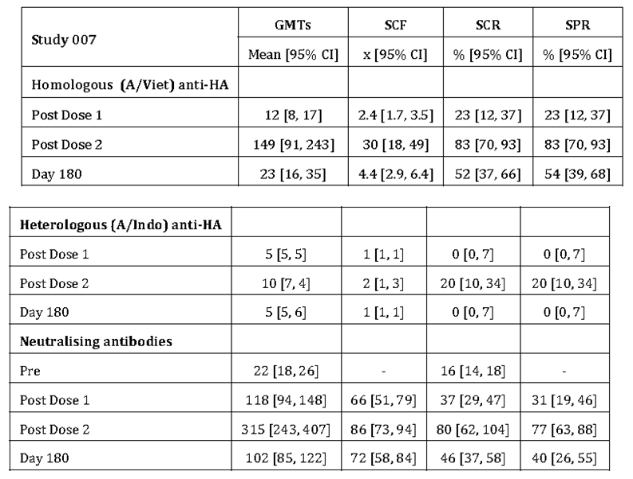
Loss of response was noted by Day 180. Neutralising antibodies and Cell Mediated Immune response was also reported (CD4 response; nil CD8 response).
The extension Study 015 (n = 350) was a booster in subjects primed with 2 doses approximately 14 months earlier in the Study 007. Subjects primed with non adjuvanted vaccine were given 2 booster doses of heterologous A/Indo (3.8/AS03) vaccine on days 0 and 21. Subjects previously primed with adjuvanted vaccine were given one heterologous booster. There was a control group of previously unprimed subjects who received two doses of adjuvanted vaccine. The anti HA immune response 21 days following a single booster dose of heterologous vaccine (A/Indonesia) to subjects previously primed with two adjuvanted doses (A/Vietnam) met the CHMP criteria as shown in Table 17.
Table 17: Anti HA immune response 21 days following a single booster dose of heterologous vaccine (A/Indonesia) to subjects previously primed with two adjuvanted doses (A/Vietnam).
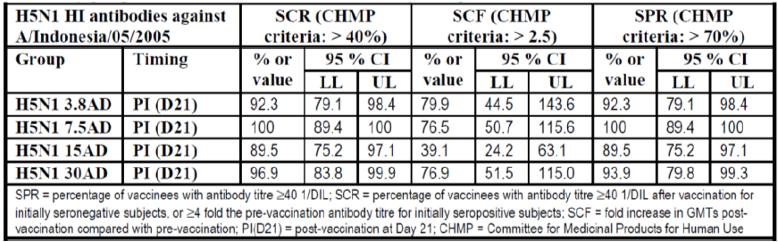
In 3.8/AS03 group the anti HA immune response against A/Vietnam was 87.2% [95%CI 72.6, 95.7], 42 fold [95%CI 25, 73] and 89.7% [95%CI 75.8, 97.1] for SCR, SCF and SPR, respectively. In this group, the pre‐booster neutralising antibody GMTs to A/Indo were 157 [95%CI 130, 191] and rose to 3708 [95%CI 2458, 5594] 21 days post booster.
Study 002 was the main study (n = 1206) examining the selected 3.8 μg dose in adults (18‐60 years old) using 0, 21 day schedule (A/Viet 3.8μg with and without AS03) with 12 months follow up. The study also examined lot to lot consistency. Pooled results for 3.8/AS03 group were as shown in Table 18.
Table 18: Pooled results for 3.8/AS03 group.
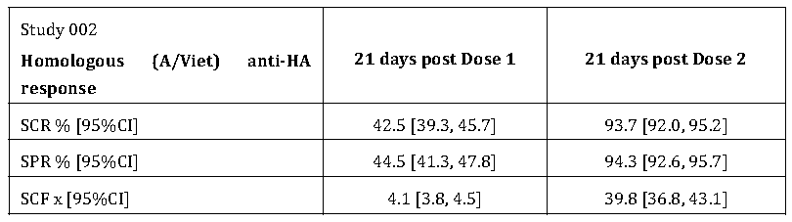
Non adjuvanted groups did not meet CHMP criteria. The results for the heterologous anti HA were as shown in Table 19 (pooled 3.8/AS03 group).
Table 19: Heterologous anti HA (pooled 3.8/AS03 group).
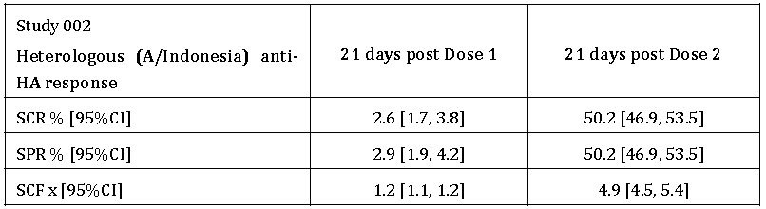
The neutralising antibodies response at 21 days post Dose 2 (Day 42) was as shown in Table 20 (pooled 3.8/AS03 group).
Table 20: Neutralising antibodies response at 21 days post Dose 2 (Day 42).
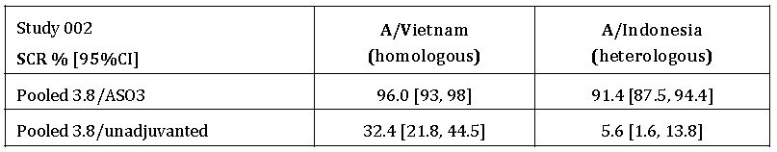
A subset of subjects from the adjuvanted groups was followed for persistence of immune response until Month 36. Only the SCF against A/Vietnam met the CHMP criteria at Month 6, declining thereafter until Month 36. None of the CHMP criteria were met against A/Indonesia strain from Month 6 onwards. A higher neutralising response (SCR) was observed until Month 12 against A/Vietnam (87.0%) and A/Indonesia (65.2%).
Its extension Study 030 introduced booster with heterologous vaccine strain (A/Indonesia/AS03) at 6 months in a subset (single booster in n = 265 previous 3.8/AS03 primed subjects; 2 booster doses (0, 21 days) in n = 236 in previous 3.8/non adjuvanted primed subjects and no booster control in n = 672 in previous 3.8/AS03 primed subjects).
A further extension Study 038 (n = 845) was in subjects who did not receive booster in study 030. They received a single booster (A/Indonesia/AS03) at 12 or 36 months after initial priming in Study 002. The studies showed that single heterologous booster vaccine at 6, 12 or 36 months in subjects primed with 2 (adjuvanted) doses lead to robust immune response which meets CHMP criteria for homologous and heterologous vaccine strains. Neutralising antibody data were supportive. The subjects without booster no longer met CHMP criteria against either homologous or heterologous strain at 12 or 18 months.
Study Q‐Pan 001 demonstrated equivalence of adjuvanted products manufactured in Quebec (Q‐Pan) and Dresden (D‐Pan). In addition, the study (n = 780 in 7 arms) demonstrated superior immune response (0 and 21 day doses with A/Indo strain) with 3.8μg antigen adjuvanted with full dose adjuvant compared to 3.8 μg adjuvanted with ½ dose adjuvant as well as compared to the non‐adjuvanted formulations. Adjuvantation with both full and half strength AS03 was superior to non adjuvanted formulation. Half strength AS03 had only a modest effect on homologous immune response in 18 to 40 years age group, but led to a significant reduction in GMTs and SPR% in 41‐64 years age group.
Study 008 (n = 5075) was a safety study in adults and elderly with 2 administrations on Days 0 and 21 of 15 μg/AS03 formulation (A/Viet) compared to Fluarix with 6 months follow up as extension study 011. The initial safety signal for ‘new onset of chronic disease’ was reported in this study in elderly > 60 years old.
Study 010 (n = 437) was in elderly subjects >60 years (mean age 70 years; range 61‐89) with extension Study 021 for long term persistence. Subjects received single (3.8 μg) or double (2 x 3.8 μg) dose of adjuvanted or unadjuvanted vaccine (A/Viet) on days 0 and 21. The elderly population was noted to have a high anti HA antibody positivity (38%) to A/Vietnam (2% for A/Indo) at baseline. The adjuvanted vaccine at either dose met all criteria after one dose for the homologous strain and after 2 doses for the heterologous strain (except for SPR). The double dose adjuvanted vaccine (7.5/AS03) resulted in a greater immune response than the single dose adjuvanted vaccine (3.5/AS03). The response of 2 doses of 3.8 μg adjuvanted vaccine 21 days apart was better than a double dose given on same day. In seronegative subjects 2 doses of vaccine were required for the immune response to meet CHMP criteria.
Paediatric studies in 3‐9 year old children (stratified for 3‐5 and 6‐9 age) included study 009 (½ dose antigen/½ dose adjuvant; n = 138), study 022 (full dose antigen/½ dose adjuvant; n = 134) and study 023 (full adult dose i.e. 3.8/AS03; n = 133). The study used the A/Viet vaccine strain. The 2 dose primary vaccinations on days 0 & 21 resulted in fulfilling regulatory requirements (SCR, SCF, SPR) against the homologous A/Viet strain and SCR and SCF against the heterologous (A/Indo) strain. Declining titres were noted with follow up to 24 months.
This submission included 2 new paediatric studies as follows.
Study 013 (n = 120) was in 6‐35 months old children (stratified age categories 6‐11 months, 12‐23 months, 24‐35 months; mean age 17 (SD 9) months) in which heterologous prime boost strategy was examined, consisting of 2 primary doses (½ adult dose) at 0 and 21 days of adjuvanted A/Indonesia followed by a single booster (½ adult dose) of adjuvanted A/Turkey at 6 months (Day 182). Overall results (all age strata) were as follows (ATP cohort for immunogenicity) in Table 21.
Table 21: Study 013 data (ATP cohort for immunogenicity).
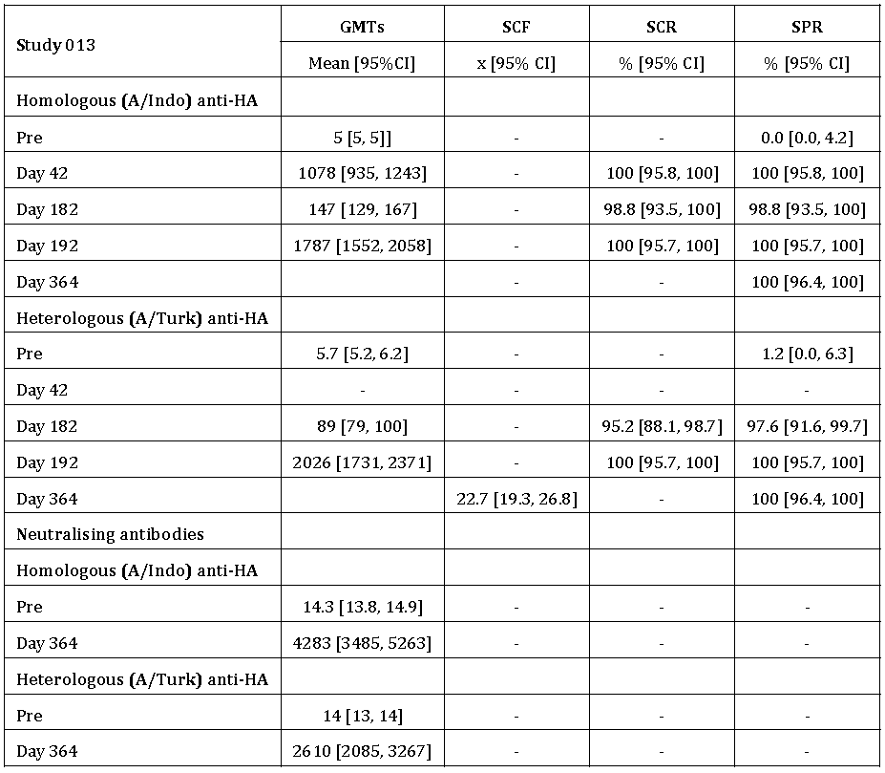
The results across the 3 age strata were generally consistent. The Day 21 (i.e. post dose 1) response appears not to have been reported.
Study 032 study (n = 520) was in 3‐17 years (mean age 9.5 (SD 4) years) old children (stratified age groups 3‐9 and 10‐17 years). A heterologous prime boost strategy was also adopted in this study, that is, 2 priming doses with ½ adult dose adjuvanted A/Indo followed by a single ½ adult dose booster at 6 months using adjuvanted A/Turk vaccine (hepatitis A vaccine control). Overall (that is, both age strata) results (total vaccinated Cohort) were as follows (results shown only for the group receiving 3 H5N1 doses) in Table 22.
Table 22: Study 032 data (ATP cohort for immunogenicity).
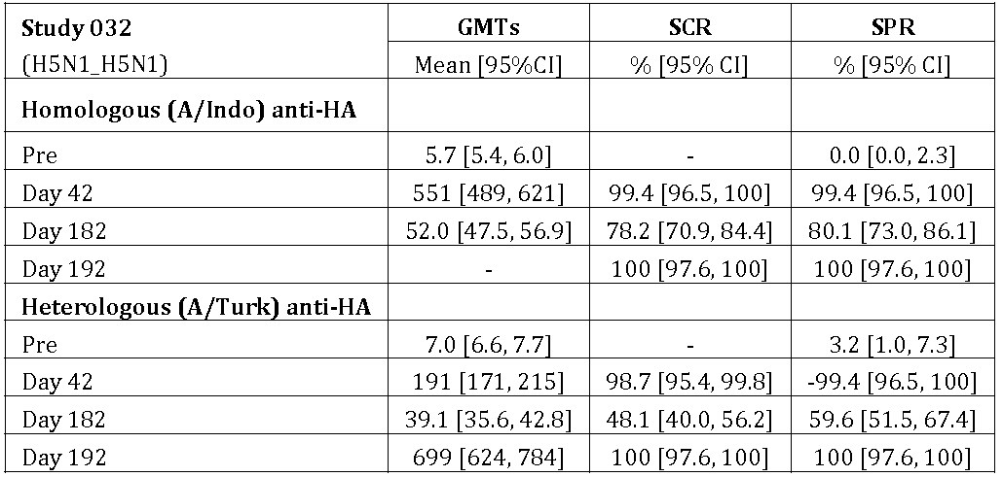
Three more studies were new to this submission (Studies Q‐Pan 009, 041 and 012).
Study Q‐Pan 009 (n = 312) was in adults (18‐60 years) conducted using 3.8/AS03 formulation (A/Indo) and compared 4 vaccination schedules, each consisting of 2 doses, that is, 0 and 21 day (Group A), 0 and 14 day (Group B), 0 and 7 day (Group C), and 2 doses on day 0 (Group D). The anti HA immune response was assessed 14 days post two doses in each schedule. The results, indicating efficacy of accelerated priming with 0, 14 dosing, were as follows in Table 23.
Table 23: Study 032 data (ATP cohort for immunogenicity).
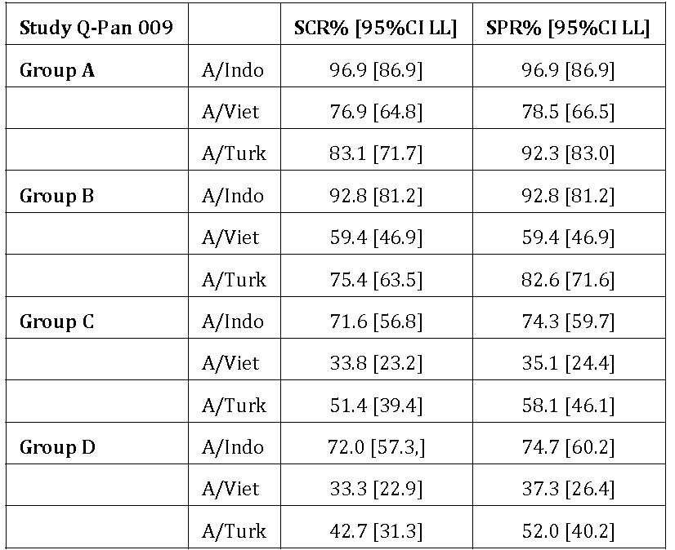
Study 012 was another prime boost study (n = 512) in adults (18‐60 years) for assessing primary vaccination with 1 or 2 dose of 3.8/AS03 and booster at 6 or 12 months such that the following 8 groups were compared:
- A/Viet at Day 0 and Month 6
- A/Viet at Day 0 and Month 12
- A/Viet at Day 0 and A/Indo at Month 6
- A/Viet at Day 0 and A/Indo at Month 12
- A/Viet at Days 0 & 21 and A/Viet at Month 6
- A/Viet at Days 0 & 21 and A/Viet at Month 12
- A/Viet at Days 0 & 21 and A/Indo at Month 6
- A/Viet at Days 0 & 21 and A/Indo at Month 12
The results indicated that after single priming dose and a 6 month booster with heterologous strain, the regulatory requirements were met against the booster strain. A heterologous strain booster administered at 12 months after one or two priming doses provided satisfactory immune response.
Study 041 (n = 320) was a non inferiority trial in adults for thiomersal containing vs. thiomersal free formulation using vaccination schedule of 2 doses at 0 and 21 days (A/Indo 3.8/AS03). At 21 days after dose 2, the GMT ratio was 1.20 (95%CI 1.01, 1.42) indicating non inferiority (UL <2.0) between the 2 formulation. Both formulations met regulatory requirements for homologous A/Indonesia and heterologous A/Vietnam strains after 2 priming doses.

Safety
The total experience is based on 9,082 study participants consisting of 7,010 (H5N1/AS03), 558 (H5N1/unadjuvanted) and 1,514 (placebo or active control trivalent seasonal influenza vaccine Fluarix or hepatitis A vaccine Havrix) subjects.
The exposure of subjects to H5N1 vaccine antigen consisted of 6,657 (A/Vietnam), 1,319 (A/Indonesia), 512 (both A/Vietnam and A/Indonesia), 373 (A/Turkey) and 269 (both A/Indonesia and A/Turkey) vaccines.
Individual study results were presented.
In adults, the most common solicited (any grade) local reactions (within 7 days of vaccination) with H5N1/AS03 vaccine versus placebo (saline) respectively were injection site pain (83% versus 20%), injection site swelling (10% versus 1%) and injection site erythema (9% versus 1%).
The most common solicited (any grade) general adverse reactions (within 7 days of vaccination) with H5N1/AS03 vaccine versus placebo (saline) respectively were myalgia (45% versus 21%), headache (35% versus 28%), fatigue (34% versus 23%), arthralgia (25% versus 12%), shivering (17% versus 10%), sweating (11% versus 7%) and fever (5% versus 3%). The unsolicited AEs were reported during the 21 day post vaccination period and included (H5N1/AS03 vaccine versus placebo (saline), respectively) injection site pruritus (1.8% versus 0.4%), dizziness (1.4% versus 0.7%), injection site warmth (1.3% versus 0.2%), injection site reaction (0.6% versus 0.2%), and rash (0.6% versus 0.3%).
Serious adverse events (SAEs) through to 42 days (that is, 21 days post Dose 2) were reported in 0.5% recipients of H5N1/AS03 compared to 0.3% recipients of placebo. In safety follow‐up of up to one year, SAEs were reported in 3.3% recipients of H5N1/AS03 compared to 4.1% recipients of placebo.
In the paediatric studies, 300 children aged 3 to 9 years old received 592 doses, 520 children aged 3‐17 year olds received 728 priming and 156 booster doses and 113 children aged 6 to <36 months received 225 priming doses and 108 booster doses. A summary of results for the 2 new paediatric studies is as follows:
In Study 013, there was an increase in incidence of local reactions following each dose of study vaccine. Local symptoms (solicited and unsolicited) were reported in 32%, 34%, and 52% children following Dose 1, Dose 2, and Dose 3 (booster) respectively. Grade 3 symptoms (local, general, solicited or unsolicited) were reported in 4.5%, 5.4% and 17.6% children following Dose 1, 2 and 3, respectively. Other effects included injection site pain (28.6%, 33.3%, 49.1%), local redness (3.6%, 5.4%, 16.7%), fever (12.5%, 32.4%, 50.0%), grade 3 fever (1.8%, 5.4% 10.2%) and antipyretics use (31.0%, 50.0%, 65.7%) following dose 1, 2 and 3 respectively. MAEs were reported in 63.0% children 6 < 12 months of age, 55.9% children 12 < 24 months of age and 60.2% children 24 < 36 months of age for follow up to Day 364. The most frequently reported events were upper respiratory tract infections (23.0%), cough (17.7%), rhinorrhoea (10.6%), pyrexia (7.1%) and nasopharyngitis (7.1%). From Day 0‐364, seven SAEs including asthma (n = 2), upper respiratory tract infection, gastroenteritis (rotavirus), wheezing, pneumonia and bronchiolitis were reported in 5 children 6 < 12 months of age. Eleven SAEs including viral gastroenteritis, lobar pneumonia, second degree burns, gastroenteritis, upper respiratory tract infection (n = 2), viral gastritis, diarrhoea, bronchiolitis and dehydration (n = 2) were reported for 4 children 12 < 24 months of age. No fatal events or pIMDs were reported.
In Study 032, at least one AE (solicited or unsolicited) was reported in 84.6%, 88.5%, 76.0% and 58.7% children in Groups H5N1_H5N1 (Group 1), H5N1_Havrix (Group 2), Havrix_H5N1 (Group 3) and Havrix_Havrix (Group 4) respectively in the 7 days post vaccination observation period. Overall, at least one unsolicited AE with a medically attended visit (up to Day 182) was reported 115 children (36.9%; 95%CI 31.5%, 42.5%) in the pooled H5N1 groups (H5N1_H5N1 and H5N1_Havrix) and 64 children (30.8%; 95%CI 24.6%, 37.5%) in the pooled control groups (Havrix_H5N1 and Havrix_Havrix).
Injection site pain was reported in 81.4%, 82.7%, 70.2% and 51.0% respectively in children in the 4 groups, respectively.
In Group 1, local pain was reported in 67.9%, 59.6% and 67.3% children following Dose 1, 2, and 3, respectively. In Group 1, in children under 6 years of age, there was an increase in frequency of reported fever following Dose 2 and especially after Dose 3 with 10.0% & 0% reporting fever ≥38.0°C and ≥39.0°C respectively following Dose 1, and 13.3% and 6.7% following Dose 2 and 30.0% and 3.3% following Dose 3.
The most commonly reported MAEs were URTI (20.2% in pooled H5N1 versus 13.9% in pooled control groups), nasopharyngitis (4.2% in pooled H5N1 versus 3.4% in pooled control groups) and rhinitis (2.9% in each pooled group).
From Day 0 up to the Day 364 visit, SAEs were reported in 4 children (2.6%) in H5N1_H5N1 group, one child in H5N1_Havrix group and none in Havrix_H5N1 and Havrix_Havrix groups. The reported SAEs included bronchitis, gastroenteritis, periorbital cellulitis, typhoid fever, open wound, and asthma. No fatal events or pIMDs were reported. Pregnancy was reported for 6 participants during the study period until Day 364 with birth to healthy live infants in four and ongoing pregnancy in the remaining 2 participants.

Integrated summaries of safety (ISS)
The sponsor has submitted 2 integrated summaries of safety. The integrated analyses did not cover paediatric age group. The first analysis (ISS‐1) was completed in 2008 and consisted of eight H5N1 studies.
An expanded second analysis (ISS‐2) was completed in 2011 which included H1N1 studies in addition to the H5N1 studies with at least 6 months of post vaccination follow up. ISS‐2 comprised of 28 studies (including 15 controlled trials) of which 14 were H5N1 only trials (including 8 controlled trials).
The analysis of interest was occurrence of potential immune‐mediated diseases (pIMDs) in recipients of the adjuvanted H5N1/AS03 vaccine.
Based on a list of 122 MedDRA preferred terms (PTs) for pIMDs, an overall total of 57 pIMDs were retrospectively identified (28 studies) in 56 subjects including 43 pIMDs in 42 subjects in controlled trials.
Among the 42 pIMDs (diagnosis withdrawn by investigator in one case) reported in controlled trials, a total of 31 pIMDs occurred in the AS03 adjuvanted H5N1 or H1N1 recipients compared with 11 pIMDs in the control group (non adjuvanted H5N1 or H1N1 or saline or trivalent influenza vaccine recipients) indicating a relative risk (RR) of 1.69 (95%CI 0.81, 3.81) as follows in Table 24.
Table 24: Relative risk of pIMDs.
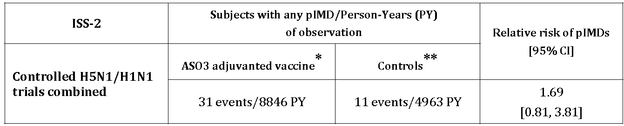
* AS03 adjuvanted H5N1 or H1N1 vaccine
** Controls = unadjuvanted H5N1 or H1N1 vaccine or placebo (saline) or seasonal trivalent influenza vaccine
Further stratified analysis of these data demonstrated that the treatment effect was entirely located in the AS03/H5N1 recipients (21/10,132) compared to the subjects in the control group (1/3164). The estimated RR was 6.85 (95%CI 1.10, 283.38).
There was no effect in AS03/H1N1 recipients (10/3193) compared to the subjects in the control (10/3197). The estimated RR was 1.00 (95%CI 0.37, 2.68).
Table 25: Subjects with any pIMD per PY.
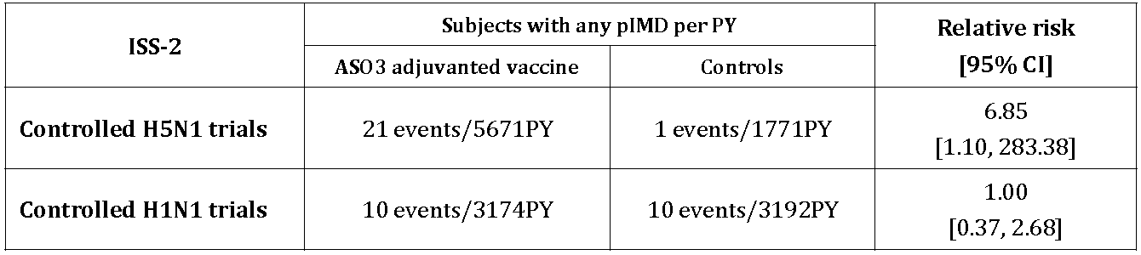
The ISS‐2 analysis was provided to the US and Canadian regulators prior to approval in 2013 and was provided to the EMA as part of RMP at the time of renewal of registration in 2012.

Risk management plan
The EU‐RMP (Version 11, dated July 2013) with an updated ASA (dated 28 October 2014) applies to this submission. ACSOV advice was not sought for this submission. The submission is subject to a final agreement with RMP evaluators for any outstanding issues with respect to the RMP/ASA.

Risk-benefit analysis

Delegate’s considerations
This was a resubmission, with new data, of a previous submission for Prepandemrix (H5N1/AS03) vaccine which was withdrawn in 2008 because of insufficient data on persistence of immunity/need for booster and a safety signal for ‘New Onset of Chronic Disease’.
The current dossier includes adequate data with respect to persistence of immunity and the use of booster in adults, including vaccine strain homologous and heterologous anti HA immune response and functional (neutralising) antibody response, to support the proposed use. Thus this deficiency is considered to have been adequately addressed in this dossier.
Note that vaccine efficacy has not been determined as the infection is not occurring in general population. The dossier is based on immunogenicity endpoints modelled on the current criteria for seasonal influenza.
Although, there are substantial data in children (> 6months age), there is lack of clarity on optimum dose, vaccination schedule and booster, as well as sufficient concern because of very high reactogenicity and long term safety based on adult data in ISS‐2, to preclude its use in children and adolescents at present. A separate submission in future dealing with these issues in a comprehensive manner will be more appropriate.
The issue of association with ‘New Onset of Chronic Disease’, which has since evolved into a list of 122 MedDRA Preferred Terms for potentially immune mediated diseases, remains unresolved.
The magnitude of RR estimated in ISS‐2, for pIMDs in association with the use of Prepandrix (H5N1/AS03) was 6.85 fold (95%CI 1.1, 283) in controlled clinical trials.
The sub‐analyses also demonstrated that the higher RR was not associated with the use of H1N1/AS03 (RR 1.0, 95%CI 0.37, 2.68).
The ISS‐2 was completed in 2011. The sponsor has confirmed that no additional data are available.
The sponsor provided detailed arguments about the limitations of the ISS‐2 analysis (including the sponsor’s slide presentation in a teleconference following completion of Round 2 evaluations and record of the meeting). These arguments include exploratory nature of the AEs disproportionality analysis, which was post hoc and did not take multiplicity into account. The analysis was intended for hypothesis generation and was necessarily biased towards identification of safety signal.
It is also argued that the comparator groups were not balanced (3 times more participants in H5N1/AS03 (n = 10,132) group than in the ‘no AS03’ control (3,164) group) which increased the likelihood of reported rare events in H5N1/AS03 group compared to controls. It is shown that balanced comparison such as that between AS03/H1N1 (n = 3193) and controls (n = 3197) indicated similar frequency of pIMDs in both groups (Table 26).
Table 26: Number of subjects included in the ISS‐2.
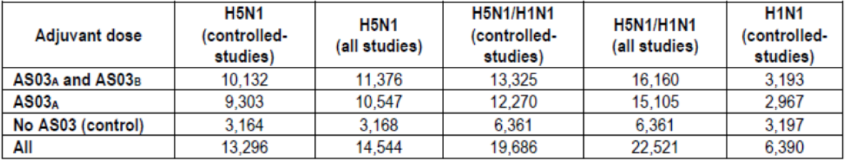
The sponsor has also sought to argue against imputation of study vaccine related causality for the reported pIMDs based on the WHO Global Advisory Committee on Vaccine Safety (GACVS) criteria in terms of consistency of effect, strength of association, temporality, specificity and biological plausibility.
Furthermore, a descriptive analysis of the reported pIMDs and an internal review (‘sensitivity analysis’) undertaken by the sponsor to validated the reported events led to a reduced incidence of 12 events in place of the reported 21 in H5N1/AS03 group and 0 in place of the reported single event in controls with undefined RR (slides 17‐18). The events of polymyalgia rheumatica and VIIth nerve palsy were the only events with occurrence of more than one. The sponsor has also noted that (letter of application) pIMDs were reported predominantly in females (24 of 31 subjects with reported pIMDs).
The Delegate is of the view that limitations such as post hoc analyses and multiplicity are not of relevance in assessment of safety in the case of a vaccine where the concern is a potential association with serious chronic adverse outcome such as immune related disease. This heightened concern for safety is further underscored where the baseline risk of disease is not known, clinical efficacy cannot be determined and the proposed use is in pre pandemic phase.
The imbalance in comparator groups is an important consideration. However, the magnitude of difference in incidence (21 events in 10,132 H5N1/AS03 subjects versus 1 endpoint in 3,164 controls) cannot be explained by the 3 fold imbalance in the number of subjects in the two groups.
In addition, the imbalance was not reflected in estimated RRs for MAEs, Grade 3 MAEs, SAEs and deaths based on the same dataset (Table 27).
Table 27: MAEs, Grade 3 MAEs, SAEs and deaths.
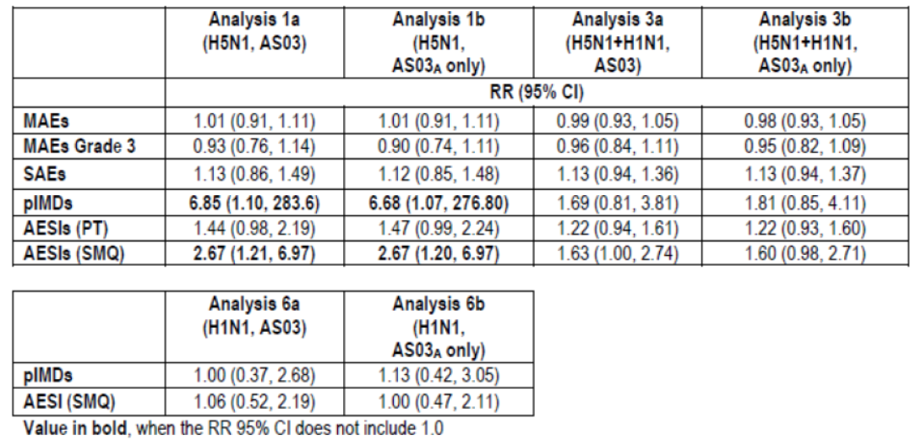
Furthermore, the residual imbalance in events persisted (12 pIMDs in H5N1/AS03 versus none in controls) even after a vigorous internal review was undertaken by the sponsor.
Regarding the WHO GACVS criteria, in my view none of the causality criteria can be adequately shown to indicate a lack of association/causality between H5N1/AS03 and pIMDs as asserted by the sponsor.
In fact, consistency (pooled data from 8 controlled trials), strength (RR ≈ 7), temporality (prospective, controlled, clinical trials), specificity and biological plausibility (potential immune related mechanism for all reported events) all favour consideration of existence of a potential association.

Proposed action
The Delegate is of the view that the RR estimate of pIMDs based on ISS‐2 is sufficiently robust, reliable and large to be of clinical concern so that the overall risk/benefit of the H5N1/AS03 vaccine (Prepandrix) for the proposed pre‐pandemic use is not favourable.
Although consideration may be given to a qualified indication (“Active immunisation against A/Indonesia/05/2005 (H5N1) subtype of Influenza A virus contained in the vaccine in persons 18 years of age and above at increased risk of exposure. This indication is based on immunogenicity data in healthy subjects. Prepandrix should be used in accordance with official recommendations”) along with inclusion of the ISS‐2 results in the PI, this approach does not control or modify the identified risk. Additional factors favouring registration include high mortality associated with H5N1 infection and the antigen sparing advantage of the vaccine (3.75 μg per 0.5mL dose) for an egg grown virus.
Submitted to the ACPM for advice.

Request for ACPM advice
The Delegate is seeking advice from the ACPM prior to proposing action regarding registration of this vaccine.
- Does the Committee agree that the estimate of relative risk of pIMDs (RR 6.85, 95%CI 1.1, 283) obtained in ISS‐2 is a valid safety signal and of sufficient clinical concern to preclude approval of Prepandrix for pre pandemic use?

Response from sponsor

Executive summary
There is substantial public health impact due to pandemic influenza and therefore there is a need for immunogenic vaccines, such as Prepandrix to protect people in the event of a pandemic threat or to protect people at increased risk of H5N1 infection.
Prepandrix (D-H5N1) was approved by the EMA on 14 May 2008. EMA has also approved the pandemic vaccine, Adjupanrix (D-H5N1) on 19 October 2009.
Health Canada and the FDA approved the sponsor’s Q-H5N1 pandemic vaccine, on 13 February 2013 and 22 November 2013 respectively, with flexibility in the label to use in a prepandemic setting if required by the Government. Of note, the US advisory committee (VRBPAC) voted 14-0 in favour of approval of the immunogenicity and safety of the vaccine.
Both Round 1 and 2 TGA clinical evaluation reports included the clinical evaluator recommending approval of Prepandrix; the revised indication being “Active immunisation of adults against H5N1 subtype of influenza A virus. Prepandrix should be used in accordance with official recommendations”. The TGA notified the sponsor on 4 March 2015 that the application would not be referred to ACPM for advice, however, a late request for ACPM advice was made on 18 March 2015 to address the risk associated with developing pIMDs with Prepandrix use.
The Delegate is restricting ACPM advice to this safety concern prior to making a decision on the registration of Prepandrix. No issue with efficacy data has been raised. The sponsor contends that Prepandrix should be registered based on the following:
- The extensive clinical data package has demonstrated the favourable quantitative and qualitative immunological responses supportive of the intended use of the vaccine;
- The clinical trial safety database of 22,521 subjects who received an AS03 adjuvanted H5N1 or H1N1 influenza or control vaccine could not establish a causal relationship between H5N1 adjuvanted vaccination and pIMDs;
- Statements on the risk of pIMDs have been added to the Australian PI for Health Care Professional awareness;
- A robust RMP is in place to manage the known and potential risks; and
- Supply of Prepandrix will be restricted for use either before a pandemic is declared, potentially including persons at risk of exposure to H5N1 virus through laboratory or field work, or in the early stages of a declared pandemic in accordance with official recommendations. Prepandrix will not be commercialised privately in Australia.
The Delegate noted that “Additional factors favouring registration [of Prepandrix] include high mortality associated with H5N1 infection and the antigen sparing advantage of the vaccine (3.75 μg per 0.5 mL dose) for an egg grown virus.”
A clinical opinion has been sought from a leading Australian vaccine expert with respect to the specific question on pIMDs raised by the Delegate and his opinion supports registration.
The sponsor’s viewpoint is that in a public health emergency, where an H5N1 pandemic is anticipated or there is an increased risk, the benefit-risk profile of vaccination with Prepandrix is favourable.

Regulatory history
The sponsor completed an Integrated Summary of Safety (ISS) in 2009 (ISS-1) and in 2011 (ISS-2) as exploratory analyses for hypothesis generation of rare AEs such as pIMDs that might be associated with vaccination; intentionally biased toward identifying safety signals.
ISS-1 included data from 12,917 subjects 18 years of age or older enrolled across 8 clinical studies, of which 9,873 subjects received either D-H5N1 or Q-H5N1. The analysis did not reveal any unexpected safety findings. There was a numerical imbalance for pIMDs associated with receipt of H5N1 vaccine though 95% CIs included 1.0; a causality analysis failed to support a causal relationship. ISS-1 was previously evaluated by the TGA for the Arepanrix licence (Q-H5N1, registered 22 February 2011).
ISS-2 included data from 22,521 subjects 18 years of age or older enrolled across 28 studies, with 16,160 subjects receiving adjuvanted H5N1 or H1N1 vaccine. The purpose of this analysis was to enlarge the adjuvanted pandemic vaccine dataset from the previous ISS-1 by also including data from the adjuvanted H1N1 vaccine programs. As for ISS-1, ISS-2 was an exploratory analysis seeking to identify potential safety signals and, as such, used composite endpoints (for example, pIMDs consisting of 122 MedDRA preferred terms) and has the limitation that statistical corrections for multiplicity were not applied. ISS-2 was included in the Prepandrix application.
EMA, Health Canada and FDA evaluated the ISS-2 data and have raised no major safety concerns in relation to pIMDs.
- EMA: In review of an annex to the Prepandrix EU-RMP version 10, the EMA concluded that “no signals of serious AEs or AEs of special interest/with potential immune-mediated causation have been confirmed for Prepandrix”. Prepandrix licence was subsequently renewed in 2012 for a period of 5 years in accordance with the standard renewal procedure.
- Health Canada: For registration of the Q-H5N1 pandemic vaccine, five of the nine questions raised by Health Canada concerned pIMDs with Health Canada concluding that: (a) the ISS-2 data is not adequately powered and must be interpreted with caution, and (b) a causal relationship is unlikely. Health Canada approved the vaccine on 13 February 2013.
- FDA: For registration of the Q-H5N1 pandemic vaccine, the FDAs advisory committee (VRBPAC) unanimously voted (14-0) in favour of approval for a label that allowed the use of the vaccine in a prepandemic setting if required by the Government (for example, population at risk like laboratory workers or those deployed to outbreak areas). FDA approved the vaccine on 22 November 2013.
The TGA clinical evaluator recommended approval of Prepandrix for use in adults in a pandemic situation subject to the finalisation of the PI to the satisfaction of the TGA noting that “... the benefit-risk balance for Prepandemrix/Prepandrix pandemic H5N1 influenza vaccine use in adults is favourable”. Two positive clinical evaluation reports were issued, neither of which highlighted any significant safety concerns to preclude registration of the vaccine.
The sponsor was informed that Prepandrix would not be referred to the ACPM. This decision was reversed following further deliberations by the Delegate, who raised concern on the apparent risk of pIMDs developing post vaccination which was based on the ISS-2 data set. Following a teleconference meeting between the TGA and the sponsor on 16 April 2015, in which the sponsor further clarified the ISS-2 data with respect to pIMDs and also shared the EMA, Health Canada and FDA feedback on ISS-2, the Delegate’s view was modified (GSK Presentation). The Delegate seeks advice from the ACPM, as to whether the risk associated with developing pIMDs is acceptable for a prophylactic vaccine. The Delegate has indicated that were the ACPM to deem the risk of pIMDs acceptable for a pre pandemic vaccine, they would align and recommend registration of Prepandrix.

Specific question raised by delegate for ACPM advice
- Does the Committee agree that the estimate of relative risk of pIMDs (RR 6.85, 95%CI 1.1, 283) obtained in ISS-2 is a valid safety signal and of sufficient clinical concern to preclude approval of Prepandrix for pre pandemic use?
The only outstanding issue remaining with the Prepandrix application is the risk of pIMDs with H5N1 containing vaccines. Specifically, the concern relates to the higher RR of pIMDs observed in ISS-2 in the H5N1 subgroup (RR = 6.85, 95% CI 1.10, 283.4).
The sponsor’s position is that the results of ISS-2 do not support a causal association between the use of AS03 adjuvanted H5N1 influenza vaccines and pIMDs, although small increases in the risk of such events cannot be ruled out. In the setting of an advancing pandemic where persons are at increased risk of exposure, with attendant morbidity, mortality, and economic and social disruption, the benefit-risk profile associated with vaccination is deemed acceptable.
The sponsor’s view is supported by the Clinical Evaluator: “Integrated safety data found an increased relative risk of pIMD with the adjuvanted H5N1 vaccine while detailed assessment did not appear to support any specific findings. The evaluator believes the causal risk is not sufficiently strong to outweigh the potential public health benefit of the vaccine.”
The opinion of a leading Australian vaccine expert, consultant general paediatrician, and medical head of immunisation services supports registration. This expert states:
I do not believe the relative risk of pIMDs RR 6.85, 95% CI 1.1, 283) obtained in ISS-2 is of sufficient clinical concern to preclude approval of Prepandrix for pre pandemic use.

Acceptable AE safety profile
In ISS-2, no differences were evident across the H5N1, or combined H5N1/H1N1 AS03 adjuvanted vaccine groups compared to control groups for MAEs, grade 3 MAEs, or SAEs which was acknowledged by the clinical evaluator. Of note, the total number of such events collected during the H5N1 clinical trials was much higher compared to pIMDs (for example, in controlled studies MAEs were reported by 1,865 subjects who received H5N1 vaccine and by 557 subjects who received control). For individual preferred terms reported less frequently, numerical imbalances in the analyses of MAEs and other events were detected as well, either towards the vaccine group or to the control group.
Even though the H5N1/H1N1 combined analysis as well as the separate H1N1 analysis showed no increased relative risk, a higher relative risk of pIMDs was observed in the H5N1-AS03 adjuvanted vaccines subgroup (RR 6.85; 95% CI: 1.1, 283.4) compared to the control group (see table below). Overall, the data supports the notion that imbalance allocation of subjects across groups (approximately 3 to 1) in H5N1 trials may have contributed to differences in RRs for rare events such as pIMDs (Table 28).
Table 28: Number of subjects reporting pIMDs and estimated RR.
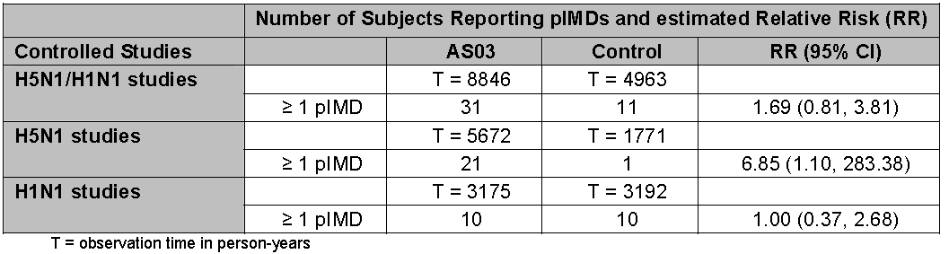
The pIMDs are a subset of AEs that include both autoimmune diseases and other inflammatory and/or neurologic disorders which may or may not have autoimmune etiologies. For the ISS-2, a total of 57 pIMDs were identified for 56 subjects (from controlled, uncontrolled and booster studies), of which 16 subjects were included from ISS-1, 15 additional subjects were identified from more recent H5N1 studies and 25 subjects with new pIMDs were from H1N1 studies.

Limitations of ISS-2
The sponsor re-iterates that the rationale behind ISS-2 was to maximise sensitivity for hypothesis generation and caution should be taken in interpreting the imbalances seen for the composite endpoint of pIMDs. Specifically the latter is addressed by the following:
Unbalanced subject allocation and duration of safety follow up in H5N1 studies: More subjects received the vaccine compared to controls. The follow up for H5N1 studies was 5,672 person-years for vaccine recipients versus 1,771 person years for control recipients. In contrast, for the majority of the H1N1 studies, the randomisation was 1:1 between vaccine and control recipients. The follow up for H1N1 studies was 3,175 person-years for vaccines versus 3,192 person years for control recipients. This results in an increased likelihood of capturing rare events in H5N1 groups relative to controls.
Composite vaccines: Data originated from 4 different vaccines, 4 influenza virus subtypes, 5 vaccine antigen dosages, 2 adjuvant dosages, and 4 control products.
Composite endpoint: pIMDs = 122 preferred terms encompassing diseases of different pathophysiological pathways (9 MedDRA system organ classes).
Evolution of methodology for collection and analyses of pIMDs: Prior to 2009, collection and analyses of pIMDs was not standardised. Investigators were requested to identify “New Onset Chronic Disease” which covered a much broader range of events including several non immune mediated AEs. For the purpose of these ISSs, a search of the clinical database for the 122 pIMD preferred terms was done retrospectively for the H5N1 studies without an opportunity to seek clarification from investigators. In contrast, for H1N1 studies, a standardised prospective method was agreed with FDA and applied.
Multiplicity was not considered for analyses of disproportionality: Each 95% CI of RR that excluded 1.0 was accepted as suggestive of a potential treatment effect without adjusting for the risk for false positive signals (for example, several MAEs were associated with receipt of control product).
Conservative approach for hypothesis (signal) generation: All pIMDs reported in the studies were included for the analyses. This included pIMD reports that were assessed as pre existing, occurred late, with a diagnosis later changed by the investigator, or attributable to another cause. Furthermore, a signal was considered present for RR with non overlapping 95% CIs; for such events causality assessments were conducted as set forth by Hill in 1965 and applied to vaccines in 2001 by the World Health Organization (WHO) Global Advisory Committee on Vaccine Safety (GACVS).

No causal relationship confirmed for the association of pIMDs with H5N1 adjuvanted vaccines
GSK contends that it is not possible to determine causality for the association of pIMDs with adjuvanted H5N1 vaccines given the number of subjects included in the vaccine development and the low incidence of such events. The WHO GACVS criteria for causality were applied as summarised below:
Consistency (a purported AE should be replicable in different localities, by different investigators, using different methods): The assessment of AEs, such as pIMDs, occur at incidence rates too low to be evaluated in individual clinical trials (facial palsy ~25 per 100,000; ulcerative colitis ~9 per 100,000) and thus do not allow for a comparison across multiple clinical trials and by different clinical investigators. This was the rationale for pooling several clinical trials into an ISS, which is exploratory in nature and seeks to identify potential safety signals. The pooled studies use different study design, different influenza pandemic antigens (origin as well as amount), different adjuvant strength, different controls and are conducted in different populations. Therefore, the small number of individual pIMDs precludes a robust assessment of consistency; the composite endpoint of all pIMDs occurred in only 56 subjects overall (42 subjects in controlled studies).
By increasing the size of the data set from ISS-1 (controlled H5N1 studies that included 7,224 vaccinees and 2,408 control subjects) to ISS-2 (size increased primarily through addition of data from H1N1 studies with n = 13,325 vaccinees plus 6,361 control subjects), there was a regression towards the mean from a RR of 4.67 for pIMDs in ISS-1 with numbers of subjects as the denominator (broad 95% CI of 0.71 to 196.08) to 1.69 (0.81, 3.81) with safety follow-up in person-years as the denominator.
Incidence rates of new onset pIMDs or worsening of pIMDs may have been unexpectedly low in the H5N1 study control groups based on the following: Rates reported were similar to background rates in the literature. ISS-1 rates among adjuvanted vaccine recipients were similar to rates in a historical control group of 11,721 subjects receiving licensed TIV or saline. The rates for H1N1 studies (315 per 100,000 person-years for vaccines and 313 per 100,000 person-years for H1N1 for control recipients) suggest that the rates in H5N1 vaccine recipients (370 per 100,000 person-years) may be appropriate while the rate among H5N1 study controls (56 per 100,000 person-years) was low.
Strength of the association (that is, the proposed association with the AE should be strong in magnitude with a dose response relationship): None of the calculated RRs for the 24 individual pIMDs identified among 122 monitored preferred terms in controlled studies suggested an increased risk (neither for H1N1+ H5N1 nor H5N1 alone). The ISS approach did not consider the statistical uncertainties introduced by multiplicity.
Temporal relation (there should be a clear temporal relationship between the AE and vaccine): All studies included in the ISSs were prospective clinical trials. The assessment of temporal relationship was done by assessing time to onset of events after vaccination. There was no consistency or distinctive patterns with respect to time to onset (varying from Day 0 to 2 years post vaccination) or clustering of reported events.
Specificity (an association with the AE should be distinctive, uniquely linked to the vaccine concerned): In ISS-1, the sponsor cited a historical cohort with similar rates of pIMDs as seen for H5N1. Rates observed were similar to reported background rates. pIMD is a composite endpoint encompassing events corresponding to 122 preferred terms of which 15 preferred terms (or groupings of preferred terms) were identified in H5N1 studies. Of note, 12 of 15 preferred terms (or groupings) identified occurred only once. Specificity of diagnosis as a post vaccination occurring event of immune-mediated pathogenesis was questionable for many specific individual diagnoses as discussed in the next section.
Biological plausibility (the association should be biologically coherent and consistent with the biology of the disease): The mechanisms of action for AS03 adjuvant do not support the plausibility of inducing autoimmune disease as there is no direct activation of T and B cells and unlike, Alum, AS03 does not promote cell necrosis minimising presence of self antigen. In addition, the different etiological/pathophysiological mechanisms among the observed pIMDs do not support one mechanism of action. Some are thought to be prominently antibody mediated (Hashimoto), others T cell mediated (rheumatoid arthritis) as well as others primarily non-immunologic (infectious causes for uveitis). This is line with our expert’s opinion:
The aetiology of these pIMD conditions is also highly variable, with some primarily antibody mediated and others believed to be T-cell mediated or even primarily non-immunologic.
The clinical evaluator accepts the sponsor’s position noting:
While there were specific diagnoses (facial nerve paralysis/paresis, PMR/temporal arteritis, uveitis, UC and RA) with suggestions of higher risk there were no specific patterns evident and the evaluator accepts the Sponsor’s arguments on the lack of consistency, specificity and lack of power to detect a biological gradient.
The sponsor contends that data from ISS-2 are insufficient to assess the likelihood of a causal relationship between H5N1 AS03 adjuvanted vaccine and pIMDs. For individual pIMDs, currently available data and available information do not support a causal association. To this point, the clinical evaluator has also stated there may be a
Possible increased risk of pIMDs in adults, although integrated safety data from 16,000 adults exposed to AS03 adjuvant have not identified any specific concerns.

Few cases of pIMDs with adjuvanted H5N1 vaccines
A GSK internal panel performed a further analysis of the 21 reported pIMDs in the H5N1 AS03 adjuvanted group. This review found that many case reports, although included in the analysis, did not fulfil the exposure-response criterion for a causal association (either the event did not constitute a pIMD (radiculitis likely to be a radiculopathy from spinal nerve compression for example), or the onset was prior to vaccination without worsening, or the onset was too rapid to be immune mediated, or there was another more likely cause for the event). Twelve subjects (out of 21 in the initial analyses) from the H5N1 group were retained and the corresponding RR was not calculable with a 95% CI: 0.89, 283 (INF). Of the 12 subjects, 8 subjects (case reports) came from the H5N1 group from the original analysis for ISS-1 and only 4 new cases were reported in ISS-2. Six of the 12 study subjects received D-Pan H5N1 with 2 subjects with polymyalgia rheumatic, and one subject each with facial paralysis, Basedow’s disease, uveitis, and scleroderma.

Robust risk management

1. Restricted distribution of Prepandrix
The supply of Prepandrix will be restricted for use either immediately before a pandemic is declared, potentially for use in persons at risk of exposure to H5N1 virus through laboratory or field work, or in the early stages of a declared pandemic, and used in accordance with recommendations issued by the Australian Government and Public Health Authorities, thus allowing the establishment of stockpiles for the Government. Prepandrix will not be commercialised privately thereby limiting access of the vaccine to the general public.

2. Ongoing safety monitoring of pIMDs
Through implementation of the EU-RMP (version 11) with an ASA (version 1.0), the sponsor commits to continue the monitoring of pIMDs. As per CHMP recommendations, a limited list of pIMDs is currently explicitly included within the list of potential risks in the EU-RMP (that is, autoimmune hepatitis, Bell’s palsy, preferred terms under demyelinating disorders, encephalitis, Guillain Barré syndrome, neuritis and vasculitis) in addition to narcolepsy. The sponsor commits to amend the listing of potential risks in the RMP to include all of the sponsor’s predefined pIMDs and monitor them by routine and enhanced pharmacovigilance in both pre pandemic and pandemic settings. The anticipated benefit of vaccination with Prepandrix during an H5N1 influenza pandemic, and the acceptable safety profile demonstrated in clinical trials, which continues to be monitored through the EU RMP, supports a positive benefit-risk profile.

Conclusion
Vaccines are recognised as the single most effective intervention for preventing influenza-associated morbidity and mortality during a pandemic. In view of the case fatality rate of over 50% following confirmed H5N1 infections, availability of Prepandrix (D-H5N1) for pre-pandemic use would address the public health need in a pre pandemic setting. The safety data should be assessed in its entirety, giving due consideration to the intended purpose of use, to protect people at increased risk of exposure and to provide protection in the period between the identification of a pandemic and the availability of a matched-strain pandemic vaccine, which is aligned with the US and Canadian approvals of a similar vaccine. The sponsor asserts that the clinical data submitted supports a favourable benefit-risk assessment for the registration of Prepandrix for use in adults.

Advisory committee considerations
The ACPM resolved to recommend to the Delegate that the evidence provided in the sponsor’s submission did not satisfactorily establish the safety and efficacy of Prepandrix (formerly Prepandemrix), emulsion and suspension for emulsion for injection, containing 3.75 μg of the new biological entity, pre pandemic influenza vaccine (split virion, inactivated, A/Indonesia/05/2005 PR8-IBCDC-RG2 (H5N1, Clade 2.1) and 0.25 mL AS03 adjuvant.
The ACPM taking into account the submitted evidence of pharmaceutical efficacy, safety and quality considered this product to have an overall negative benefit-risk profile in the proposed population for pre pandemic use.
In making this recommendation, the ACPM:
- Noted the sponsor’s arguments including that the product will only will be used in accordance with the official recommendations where the balance of risk and benefit would be different.
- Expressed concern that the safety signal noted in the earlier 2007 dossier had, if anything, become clearer based on the relative risk reported with larger dataset in the current dossier.
- Was of the view that there is a substantial safety signal and its use particularly in a healthy population would be unwarranted.

Specific advice
The ACPM advised the following in response to the Delegate’s specific questions on this submission:
- Does the Committee agree that the estimate of relative risk of pIMDs (RR 6.85, 95%CI 1.1, 283) obtained in ISS-2 is a valid safety signal and of sufficient clinical concern to preclude approval of Prepandrix for pre-pandemic use?
The ACPM advised there is clearly a safety signal; there were an unusual range of AEs including several AEs where the baseline rate would be very low and some AEs that appear related (for example, radiculitis, mononeuritis, uveitis, neuritis).
The Australian Health Management Plan for Pandemic Influenza (AHMPPI) notes that pre-pandemic vaccines would be prioritised to “individuals at greater risk, such as healthcare workers, or individuals at high risk of severe outcomes” in the early stages of a pandemic. It further notes that “Acceptability will depend on public perception of the impact of the pandemic and candidate vaccine safety”. Particularly in otherwise healthy “first responders”, the clear safety signals in the use of this product are a substantial risk.

Outcome
On 3 September 2015, GlaxoSmithKline Australia Pty Ltd wrote to the TGA asking for the application for Prepandrix (formerly Prepandemrix) to be withdrawn.

Attachment 1. Extract from the Clinical Evaluation Report

Therapeutic Goods Administration
PO Box 100 Woden ACT 2606 Australia
Email: info@tga.gov.au Phone: 1800 020 653 Fax: 02 6232 8605
https://www.tga.gov.au

European Medicines Agency, “Committee for Proprietary Medicinal Products (CPMP): Note for guidance on pharmaceutical and biological aspects of combined vaccines (CPMP/BWP/477/97)”, 23 July 1998.
Morel S, et al. Adjuvant System AS03 containing α-tocopherol modulates innate immune response and leads to improved adaptive immunity. Vaccine 29: 2461-73 (2011).
European Medicines Agency, “Committee for Proprietary Medicinal Products (CPMP): Note for guidance on preclinical pharmacological and toxicological testing of vaccines (CPMP/SWP/465/95)”, 17 December 1997.
European Medicines Agency, “Committee for Human Medicinal Products (CHMP): Guideline on influenza vaccines prepared from viruses with the potential to cause a pandemic and intended for use outside of the core dossier context (CHMP/VWP/263499/2006)”, 24 January 2007.
European Medicines Agency, “Committee for Medicinal Products for Human Use (CHMP): Guideline on adjuvants in vaccines for human use (CHMP/VEG/134716/2004)”, 20 January 2005.
European Medicines Agency, “Guideline on influenza vaccines: Non-clinical and clinical module (EMA/CHMP/VWP/457259/2014)”, 25 July 2014.
Del Giudice G, et al. Vaccines with the MF59 adjuvant do not stimulate antibody responses against squalene. Clin Vaccine Immunol. 13: 1010-3 (2006).
Miller E, et al. (2013) Risk of narcolepsy in children and young people receiving AS03 adjuvanted pandemic A/H1N1 2009 influenza vaccine: retrospective analysis. BMJ 346: f794 (2013).
European Medicines Agency, “European Medicines Agency reviews further data on narcolepsy and possible association with Pandemrix (EMA/CHMP/130422/2011)”, 18 February 2011.
European Medicines Agency, “European Medicines Agency reviews hypothesis on Pandemrix and development of narcolepsy (EMA/CHMP/676755/2012)”, 22 October 2012.
European Medicines Agency, “Guideline on influenza vaccines: Non-clinical and clinical module (EMA/CHMP/VWP/457259/2014)”, 25 July 2014.
US Food and Drug Administration, “CBER Considerations for Developmental Toxicity Studies for Preventive and Therapeutic Vaccines for Infectious Disease Indications”, 2006.
European Medicines Agency, “Committee for Proprietary Medicinal Products: Points to consider on the reduction, elimination or substitution of thiomersal vaccine (CPMP/BWP/2517/00),”26 April 2001.
European Medicines Agency, “EMEA public statement on thiomersal in vaccines for human use: recent evidence supports safety on thiomersal-containing vaccines (EMEA/CPMP/VEG/1194/04)”, 24 March 2004.
European Medicines Agency, “Committee for Medicinal Products for Human Use (CHMP): Guideline on the clinical evaluation of new vaccines (EMEA/CHMP/VWP/164653/2005)”, 18 October 2006.
European Medicines Agency, “CHMP Recommendations for the Pharmacovigilance Plan as Part of the Risk Management Plan to be Submitted with the Marketing Authorisation Application for a Pandemic Influenza Vaccine (EMEA/359381/2009)”, 25 September 2009.
GSK has two pre(pandemic) H5N1 vaccines, one produced at the Dresden (Germany) manufacturing facility (D-H5N1) and the other produced at the Quebec (Canada) manufacturing facility (Q-H5N1). Both are adjuvanted with Adjuvant System 03 (AS03).
GSK has two pre(pandemic) H5N1 vaccines, one produced at the Dresden (Germany) manufacturing facility (D-H5N1) and the other produced at the Quebec (Canada) manufacturing facility (Q-H5N1). Both are adjuvanted with Adjuvant System 03 (AS03).
GSK has two pre(pandemic) H5N1 vaccines, one produced at the Dresden (Germany) manufacturing facility (D-H5N1) and the other produced at the Quebec (Canada) manufacturing facility (Q-H5N1). Both are adjuvanted with Adjuvant System 03 (AS03).
Hill AB. The environment and disease: association or causation? Proc R Soc Med. 58: 295-300 (1965).
European Medicines Agency, “CHMP Recommendations for the Pharmacovigilance Plan as part of the Risk Management Plan to be submitted with the Marketing Authorisation Application for a Pandemic Influenza Vaccine (EMEA/359381/2009)”, 25 September 2009.

