|  |
| --- |
| **First round CER: August 2013**  **Second round CER: December 2013** |

|  |
| --- |
| AusPAR Attachment 2 |
| Extract from the Clinical Evaluation Report for radium (223Ra) dichloride |
| Proprietary Product Name: Xofigo |
| Sponsor: Bayer Australia Ltd |

About the Therapeutic Goods Administration (TGA)

* The Therapeutic Goods Administration (TGA) is part of the Australian Government Department of Health, and is responsible for regulating medicines and medical devices.
* The TGA administers the *Therapeutic Goods Act 1989* (the Act), applying a risk management approach designed to ensure therapeutic goods supplied in Australia meet acceptable standards of quality, safety and efficacy (performance), when necessary.
* The work of the TGA is based on applying scientific and clinical expertise to decision-making, to ensure that the benefits to consumers outweigh any risks associated with the use of medicines and medical devices.
* The TGA relies on the public, healthcare professionals and industry to report problems with medicines or medical devices. TGA investigates reports received by it to determine any necessary regulatory action.
* To report a problem with a medicine or medical device, please see the information on the TGA website <<http://www.tga.gov.au>>.

About the Extract from the Clinical Evaluation Report

* This document provides a more detailed evaluation of the clinical findings, extracted from the Clinical Evaluation Report (CER) prepared by the TGA. This extract does not include sections from the CER regarding product documentation or post market activities.
* The words [Information redacted] indicate confidential information has been deleted.
* For the most recent Product Information (PI), please refer to the TGA website <<http://www.tga.gov.au/hp/information-medicines-pi.htm>>.

Copyright

© Commonwealth of Australia 2014  
This work is copyright. You may reproduce the whole or part of this work in unaltered form for your own personal use or, if you are part of an organisation, for internal use within your organisation, but only if you or your organisation do not use the reproduction for any commercial purpose and retain this copyright notice and all disclaimer notices as part of that reproduction. Apart from rights to use as permitted by the *Copyright Act 1968* or allowed by this copyright notice, all other rights are reserved and you are not allowed to reproduce the whole or any part of this work in any way (electronic or otherwise) without first being given specific written permission from the Commonwealth to do so. Requests and inquiries concerning reproduction and rights are to be sent to the TGA Copyright Officer, Therapeutic Goods Administration, PO Box 100, Woden ACT 2606 or emailed to <[tga.copyright@tga.gov.au](mailto:tga.copyright@tga.gov.au)>.

Contents

List of abbreviations 5

1. Clinical rationale 9

2. Contents of the clinical dossier 10

2.1. Scope of the clinical dossier 10

2.2. Paediatric data 10

2.3. Good clinical practice 10

3. Pharmacokinetics 10

3.1. Studies providing pharmacokinetic data 10

3.2. Summary of pharmacokinetics 11

3.3. Evaluator’s overall conclusions on pharmacokinetics 15

4. Pharmacodynamics 15

4.1. Studies providing pharmacodynamic data 15

4.2. Summary of pharmacodynamics 16

4.3. Evaluator’s overall conclusions on pharmacodynamics 17

5. Dosage selection for the pivotal studies 17

5.1. Dose 18

5.2. Injection duration 18

5.3. Injection interval 18

5.4. Number of injections 18

6. Clinical efficacy 18

6.1. Pivotal efficacy studies 18

6.2. Other efficacy studies 35

6.3. Analyses performed across trials (pooled & meta analyses) 50

6.4. Evaluator’s conclusions on efficacy 50

7. Clinical safety 51

7.1. Studies providing safety data 51

7.2. Pivotal studies that assessed safety as a primary outcome 52

7.3. Patient exposure 52

7.4. Adverse events 53

7.5. Laboratory tests 61

7.6. Post-marketing experience 67

7.7. Safety issues with the potential for major regulatory impact 67

7.8. Other safety issues 68

7.9. Evaluator’s conclusions on safety 70

8. First round benefit-risk assessment 70

8.1. First round assessment of benefits 70

8.2. First round assessment of risks 71

8.3. First round assessment of benefit-risk balance 71

9. First round recommendation regarding authorisation 71

10. Clinical questions 71

11. Second round evaluation 71

12. Second round benefit-risk assessment 72

12.1. Second round assessment of benefits 72

12.2. Second round assessment of risks 72

12.3. Second round assessment of benefit-risk balance 72

13. Second round recommendation regarding authorisation 72

## List of abbreviations

| Abbreviation | Meaning |
| --- | --- |
| %ID/L | Percent of injected dose per litre |
| ADT | Androgen deprivation therapy |
| AE | Adverse event |
| ALARA | As low as reasonably achievable |
| ALP | Alkaline phosphatase |
| ALT | Alanine transaminase |
| AML | Acute myelogenous leukaemia |
| ANC | Absolute neutrophil count |
| ANCOVA | Analysis of covariance |
| AST | Aspartate transaminase |
| AUC | Area under the time-activity curve |
| BMI | Body Mass Index |
| BPI | Bone Pain Inventory |
| Bone-ALP/b-ALP | Bone-specific alkaline phosphatase |
| BSC/BSoC | Best standard of care |
| BUN | Blood urea nitrogen |
| BW | Body weight |
| CA | Cumulative activity |
| CAC | Cumulative activity concentration |
| CI | Confidence interval |
| Cmax | Intercept of the %ID/L with the ordinate the time of injection |
| CMH | Cochran-Mantel-Haenszel |
| CRPC | Castration resistant prostate cancer |
| CSR | Clinical study report |
| CT | Computed tomography |
| CTC | Common Toxicity Criteria |
| CTCAE | Common Terminology Criteria for Adverse Events |
| CYP | Cytochrome |
| DICOM | Digital Imaging and Communications in Medicine |
| DK | Decay correction factor |
| DLT | Dose-limiting toxicity |
| DNA | Deoxyribonucleic acid |
| EBRT | External beam radiotherapy |
| ECG | Electrocardiogram |
| ECOG | Eastern Cooperative Oncology Group |
| EOD | Extent of disease |
| EQ-5D | EuroQoL 5 dimension generic health index questionnaire |
| ESAS | Edmonton Symptom Assessment Score |
| ESMO | European Society of Medical Oncology |
| FACT-P | Functional Assessment of Cancer Therapy for Patients with Prostate Cancer |
| FDA | Food and Drug Administration (USA) |
| GCP | Good Clinical Practice |
| γGT | Gamma-glutamyltransferase |
| GIT | Gastrointestinal tract |
| GnRH | Gonadotrophin-releasing hormone |
| Gy | Gray |
| Hb | Haemoglobin |
| HR | Hazard ratio |
| HRQoL | Health related quality of life |
| HRPC | Hormone-refractory prostate cancer |
| ICH | International Conference on Harmonisation |
| ICRP | International Commission on Radiological Protection |
| ICTP | Type I collagen cross-linked C telopeptide |
| ID | Injected dose |
| ITT | Intention to treat |
| IVRS | Interactive Voice Response System |
| kBq | Kilobecquerel |
| LDH | Lactate dehydrogenase |
| LET | Linear energy transfer |
| LHRH | Luteinizing hormone releasing hormone |
| LS | Least squares |
| MBq | Megabecquerel |
| mCi | Milicurie |
| MDS | Myeloblastic syndrome |
| MIRD | Medical Imaging Radiation Dose |
| MRI | Magnetic resonance imaging |
| NCCN | National Comprehensive Cancer Network |
| NE | Not estimable |
| NHMRC | National Health and Medical Research Council |
| NTx | N-terminal cross-linking telopeptide of type I collagen |
| OLINDA | Organ level internal dose assessment |
| OS | Overall survival |
| PET | Positron emission tomography |
| PI | Product Information |
| PNP/PINP | Procollagen type I N propeptide |
| PK | Pharmacokinetics |
| PP | Per protocol |
| PR | PR interval in ECG |
| PSA | Prostate specific antigen |
| PT | Preferred Term |
| PTH | Parathyroid hormone |
| QRS | QRS interval in ECG |
| QoL | Quality of Life |
| QT | QT interval in ECG |
| QTc | Corrected QT interval (using Bazett’s correction) |
| QTcB | QT interval corrected for heart rate using Bazett’s correction, QTcB=QT/RR½ RR was calculated at the reciprocal of heart rate |
| RBE | Relative biological effectiveness |
| ROI | Region of interest |
| SAE | Serious adverse event |
| S-CTX-I | Serum C-terminal crosslinking telopeptide of type I collagen |
| SD | Standard deviation |
| SE | Standard Error |
| SI | Small intestine |
| SOC | System Organ Class |
| SRE | Skeletal related event |
| SUSAR | Suspected unexpected serious adverse reaction |
| T½ | Clearance half-life |
| TEAE | Treatment emergent adverse events |
| ULN | Upper limit of normal |
| VAS | Visual analogue scale |
| Vd | Apparent volume of distribution |
| WBC | White blood cell count |

## Clinical rationale

Prostate cancer is the most common non-cutaneous malignancy in men worldwide. The crude incidence rate is estimated at around 135 cases for every 100,000 men. Incidence rates increase sharply beyond the age of about 50 years, peaking at ≥75 years of age. Based on the growing and ageing population it is expected that by the year 2030, the burden of prostate cancer will increase to approximately 1.7 million new cases and half a million new deaths worldwide.

The most common site of metastases for advanced prostate cancer is the skeletal system which is involved in more than 90% of the CRPC patients. Indeed, prostate cancer is unique amongst solid tumours in that the greatest threat to a patient’s survival and quality of life is posed by bone metastases rather than visceral involvement.

Prostate cancer cells are stimulated by androgens, in particular testosterone. Conventional androgen deprivation therapy (ADT) in patients with bone metastases aims to reach castration levels of testosterone (ie ≤50 ng/mL or 1.7 nmol/L) which can be effective initially to control the metastases in the bone. However, the majority of patients soon become castration-resistant prostate cancer (CRPC) or the older term hormone-refractory prostate cancer (HRPC).

Early stages of CRPC with bone metastases are associated with substantial pain and with rising levels of prostate specific antigen (PSA) as seen in 35% and 90% of patients, respectively. The extent of PSA control after initial ADT affects prognosis. After 7 months of ADT, patients with PSA <0.2 ng/mL (undetectable) have a better prognosis than patients with PSA ≥4 ng/mL.

For a long time, CRPC was regarded as largely resistant to chemotherapy. Consequently, the traditional role of chemotherapy in advanced (ie metastatic) CRPC had been for palliative care without any survival benefit. However, since the finding that docetaxel in combination with prednisone improved survival in studies compared to mitoxantrone plus prednisone, docetaxel has been considered standard first line chemotherapeutic therapy for patients with CRPC. However, most patients receiving docetaxel relapse within the first year of treatment. Both the US (NCCN) and EU (ESMO) treatment guidelines recommend docetaxel once every 3 weeks and steroid regimen for the treatment of CRPC patients who are symptomatic, rapidly progressive or who have developed visceral metastases.

However, it has been found that treatment with docetaxel is commonly delayed or not administered at all in general clinical practice. This is generally due to the known toxicities of docetaxel as well the clinical status of patients: older age, more comorbidities and lower Gleason scores.

Newer anticancer agents (sipuleucel-T, cabazitaxel, abriaterone and enzalutamide) are available overseas but are only indicated in patients who have been previously treated with docetaxel. (Of these only cabazitaxel is available in Australia.).

Other treatments options for patients not receiving docetaxel are mitoxantrone as well as the traditional options of glucocorticoids and external beam radiation (EBRT) which can provide palliative benefit for patients with bone metastases who cannot tolerate docetaxel. Neither of these alternative options has demonstrated a statistically significant survival benefit in patients who do not receive docetaxel (for any reason).

Thus, there is currently no treatment available for docetaxel unsuitable CRPC patients with bone metastases that provides a clinically meaningful and statistically proven survival benefit. Radium-223, with its unique mode of action, being neither anti-hormonal nor chemotherapeutic, is considered to offer an alternative option to address the unmet medical need in CRPC patients with bone metastases.

## Contents of the clinical dossier

### Scope of the clinical dossier

The submission contained the following clinical information:

* 4 clinical pharmacology studies providing data on pharmacokinetics, biodistribution and dosimetry;
* 1 pivotal efficacy/safety studies; and
* 2 other efficacy/safety studies.

### Paediatric data

The submission did not include paediatric data. This is appropriate given the indication being sought.

### Good clinical practice

The clinical study reports state that the conduct of the clinical studies met all local legal and regulatory requirements and that all studies were conducted in accordance with the ethical principles that have their origin in the Declaration of Helsinki and the ICH guidelines. The protocols were reviewed by the appropriate ethics committees and all patients gave written informed consent prior to their participation in the studies.

## Pharmacokinetics

### Studies providing pharmacokinetic data

Table 1 shows the studies relating to each pharmacokinetic topic and the location of each study summary.

Table 1: Submitted pharmacokinetic studies.

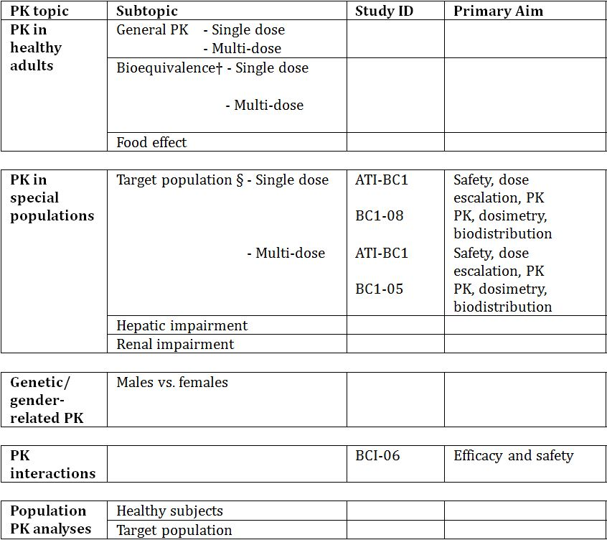

† Bioequivalence of different formulations.

§ Subjects who would be eligible to receive the drug if approved for the proposed indication.

None of the pharmacokinetic studies had deficiencies that excluded their results from consideration.

### Summary of pharmacokinetics

The information in the following summary is derived from conventional pharmacokinetic studies unless otherwise stated.

#### Physicochemical characteristics of the active substance

The drug substance is radium-223 chloride (223RaCl2), presented in aqueous solution. The molecular weight is 293.9. Information on the physicochemical properties of radium and radium compounds in the literature is limited since there are no stable radium isotopes. Radium chloride is considered to have the same properties as the other alkaline earth metal chlorides.

The drug substance solution is a radioactive, clear and colourless aqueous solution of radium-223 chloride with divalent carrier free radium-223 cations as the active moiety. Radium-223 is an alpha particle emitter (alpha emitter) with a physical half-life of 11.4 days. The drug substance solution has identical composition as the drug product with the exception of the radium-223 concentration.

The drug substance is presented in aqueous solution at pH 6.0-7.0. The concentration of radium-223 chloride in the drug solution is less than 16 ng/mL. The small amounts of radium will not affect the pH of the drug product as citrate is the determining factor.

Due to the radioactive properties and the very small amounts of radium-223 chloride present in the drug substance solution, the solubility has not been determined experimentally. Referring to the literature, the solubility of radium chloride in water is 24.5 g/100 g at 25°C.

#### Pharmacokinetics in healthy subjects

Not applicable.

#### Pharmacokinetics in the target population

##### Bioavailability

Since the drug product is given as an intravenous injection it is 100% bioavailable and no dissolution, relative bioavailability, or in-vitro-in-vivo correlation studies were conducted.

##### Influence of food

Since the drug product is given as an intravenous injection, no food effect study was conducted.

##### Distribution

Distribution and organ uptake of radium-223 was evaluated in two studies: BCI-05 and BCI-08.

Study BCI-05 was a phase 1 open label study in 6 CRPC patients to investigate the safety, biodistribution, radiation dosimetry and PK of two separate IV injections of radium-223 100 kBq/kg body weight (bw) for each injection at 6 week intervals.

Study BCI-08 was a phase 1 open label, ascending dose study conducted in 10 CRPC patients with skeletal metastases to evaluate the safety, PK, distribution and radiation dosimetry of radium-223 at doses of 50, 100, and 200 kBq/kg bw.

At 15 minutes post injection, about 20% of the injected activity remained in the blood. At 4 hours, about 4% of the injected activity remained in the blood, decreasing to less than 1% at 24 hours after the injection. The volume of distribution was higher than the blood volume indicating distribution to peripheral compartments.

Radium-223 is incorporated primarily into bone or is excreted into the intestine. In Study BCI-05 the level of activity in bone was determined to be in the range 44% to 77% of the administered activity at 4 hours post injection. In Study BCI-08 activity in the intestine was observed 10 minutes post injection.

No significant uptake was seen in other organs such as heart, liver, kidneys, urinary bladder, and spleen at 4 hours post injection (Study BCI-05).

##### Plasma protein binding

Based on the rapid decline in blood/plasma and fast disposition into bone and intestine, it was considered that any binding or radium-223 to plasma proteins has no relevant impact on the PK of radium-223 and so no specific studies of plasma protein binding were conducted.

##### Metabolism

Radium-223 is a divalent cation and an isotope which decays and is not metabolised.

##### Excretion

###### Routes and mechanisms of excretion

Faecal excretion is the major route of elimination from the body. There was high variability in gut transit rates across the population with one daily to up to once weekly bowel evacuation. In Study BCI-05 faecal excretion was determined by direct measurement of radioactivity in the faecal samples collected over 48 hours. In this study faecal excretion post injection at 24 hours was 2% (range 1%-13%) and at ~48 hours cumulative faecal excretion was 13% (range <1% to 34%).

Imaging data from Studies BCI-05 and BCI-08 allowed for an estimate of the amount of radioactivity in the different regions of the gastrointestinal tract (GIT). Once radium-223 is excreted into the GIT, it is excreted via the faecal route. Based on the % of injected activity at 24 hours in the GIT, it is estimated that at least about 50-60% of injected radium-223 will be excreted via the faecal route.

Studies BCI-05 and BCI-08 also collected information on the amount of radioactivity excreted in urine. In Study BCI-05 urine samples were collected over 48 hours and measured for total radioactivity. At ~48 hours cumulative urine excretion was 2% (range <1% to 5%) of injected radioactivity. In Study BCI-08 the urine concentrations were measured indirectly by comparing the data from the whole body count before the first void and after the first void post injection. It is estimated that approximately 5% radium-223 was excreted through urine in the first void, a mean of 2.4 hours after injection. Both studies concluded that urine excretion is a small component of the overall excretion of radium-223.

Whole body measurements at 7 days after injection indicate that a median of 76% of administered activity was excreted from the body (Study BCI-08). The rate of elimination of radium-223 from the GIT is influenced by the high variability of intestinal transit rates across the population, with one daily to once weekly bowel evacuation.

##### Linearity

Study ATI-BCI was a phase 1 dose escalation study conducted in 31 patients with skeletal metastases from breast or prostate cancer to evaluate the safety of radium-223 given in single doses from 46 to 250 kBq/kg bw. The AUC and Cmax values increased with increasing dose and the PK analysis demonstrated very similar PK characteristics for all 5 dose groups. The two higher doses indicated a slightly more than dose proportional increase but overall the rage of doses suggested a close to linear dose relationship.

##### Dosimetry

The absorbed radiation dose calculation was performed based on clinical biodistribution data from Study BCI-05. The calculations of absorbed doses were performed using OLINDA/FXM (Organ Level INternal Dose Assessment/EXponential Modelling), software based on the Medical Internal Radiation Dose (MIRD) algorithm, which is widely used for beta and gamma emitting radionucleotides. For radium-223, which is primarily an alpha-emitting radionucleotide, additional assumptions were made for the intestine, red marrow and bone/osteogenic cells to provide the best possible absorbed dose calculation for radium-223 dichloride, considering its observed biodistribution and the specific characteristics of radium-223 dichloride as an alpha particle emitter.

For an administered activity of 3.65 MBq (0.1 mCi) 50 kBq (0.00135 mCi/kg bw to a 73 kg adult), the calculated absorbed doses were:

* Bone (osteogenic cells) 4.2050 Gy (420.50 rad)
* Red marrow 0.5066 Gy (50.66 rad)
* Small intestine wall 0.0265 Gy (2.65 rad)
* Upper large intestine wall 0.1180 Gy (11.80 rad)
* Lower large intestine wall 0.1696 Gy (16.96 rad)

The estimated absorbed doses to both the red marrow and osteogenic cells are high and would be expected to result in bone marrow toxicity. The levels however, are likely to be overestimates due to simplified assumptions regarding the cellular geometry relative to the range and spatial distribution of alpha particle emissions.

The calculated dose for other organs was low:

* Heart wall 0.0064 Gy (0.63 rad)
* Lung 0.0003 Gy (0.03 rad)
* Liver 0.0109 Gy (1.09 rad)
* Kidneys 0.0117 Gy (1.17 rad)
* Urinary bladder wall 0.0147 Gy (1.47 rad)
* Testes 0.0003 Gy (0.03 rad)
* Spleen 0.0003 Gy (0.03 rad)

#### Pharmacokinetics in other special populations

##### Pharmacokinetics in subjects with impaired hepatic function

No pharmacokinetic studies in patients with hepatic impairment were conducted. It is not expected that hepatic impairment will affect the pharmacokinetics of radium-223 dichloride since radium-223 is a divalent cation, it is not metabolised and there is no evidence of hepatic-biliary excretion.

##### Pharmacokinetics in subjects with impaired renal function

No pharmacokinetic studies in patients with renal impairment were conducted. However, since excretion in urine is minimal (1-5% in 48 hours) and since the major route of elimination is via the faeces, it is not expected that renal impairment will affect the pharmacokinetics of radium-223 dichloride.

Subgroup analysis of safety and efficacy for normal and mild renal impairment groups was performed using data from the pivotal efficacy study (Study BCI-06). The majority of the patients in this study were in the normal (CLCR >80 mL/min) or mild (CLCR >50-80 mL/min) category of renal impairment. Less than 10% were in the moderate category and <1% in the severe category of renal impairment. Based on this subgroup analysis for overall survival as an efficacy parameter and treatment emergent adverse events (TEAE) as a safety parameter, mild renal impairment did not seem to have an effect on the safety and efficacy. The numbers for moderate and severe renal impairment were too small to draw any meaningful conclusions related to safety or efficacy.

##### Pharmacokinetics according to age

Safety and effectiveness of radium-223 dichloride has not been studied in children or adolescents below the age of 18 years of age. The disease does not exist in the paediatric population.

No separate PK studies have been conducted in young (<65 years) and elderly (>65 years) patients.

Subgroup analysis of safety and efficacy for different age subgroups (<65, 65-74, 75-84 and >85 years) was performed using data from the pivotal efficacy study (Study BCI-06). Based on this subgroup analysis for overall survival as an efficacy parameter and TEAE as a safety parameter, age did not seem to have an effect on the safety and efficacy.

##### Pharmacokinetics related to weight and body mass index (BMI)

Subgroup analysis of safety and efficacy for different weight categories (<80, 80-100 and >100 kg) and BMI categories (<30 and ≥30 kg/m2) was performed using data from the pivotal efficacy study (Study BCI-06). Based on this subgroup analysis for overall survival as an efficacy parameter and TEAE as a safety parameter, neither weight nor BMI appeared to have an effect on safety or efficacy.

##### Pharmacokinetics related to ethnicity

Radium-223 is a divalent cation and an isotope which decays and which is not metabolised by any enzyme. No impact on radium-223 is therefore expected by polymorphic enzymes, known to show differences in their activities between different ethnic groups. Absorption related differences are not applicable as the product is administered intravenously.

#### Pharmacokinetic interactions

No PK interaction studies have been conducted.

Radium-223 is a divalent cation for which there are no known metabolising pathways and no known cytochrome P450 (CYP) involvement. No pharmacokinetic interaction is expected with other drugs that are metabolised by CYP enzymes.

In the pivotal efficacy study (Study BCI-06) the patients took a range of concomitant medications. The overall safety data from the study did not implicate any concomitant medication as being more frequently associated with an AE. The range of concomitant medications included. ACE inhibitors, antidepressants, antiemetics, anti-inflammatory agents, anti-thrombotic agents, beta-blockers, beta-lactam antibacterials, calcium antagonists, corticosteroids, drugs affecting bone structure and mineralisation (eg zoledronic acid), drugs for peptic ulcers, drugs used for benign prostatic hypertrophy, diuretics, hormones (eg goserelin, leuprorelin), hypnotics and sedatives, laxatives, lipid modifying agents, opioids, analgesics, propulsives (eg metoclopramide), calcium channel blockers, antiandrogens and LHRH analogues.

### Evaluator’s overall conclusions on pharmacokinetics

The pharmacokinetic data has been obtained from three Phase I studies including a total of 47 patients. Due to the mechanism of action of 223RaCl2 as an alpha emitting radiopharmaceutical which may cause chromosomal damage, all clinical studies were conducted in cancer patients (prostate and breast). This is in accordance with the EU guideline on anticancer medicinal products.[1]

There were no pharmacokinetic studies performed in special populations. The information for these populations was obtained via subgroup analysis from the pivotal efficacy Study BCI-06.

The data from the single and multiple dose studies indicated close to but not exact dose proportionality. The pharmacokinetic studies support the dose and dose timing used in the efficacy studies.

## Pharmacodynamics

### Studies providing pharmacodynamic data

Table 2 shows the studies relating to each pharmacodynamic topic and the location of each study summary.

Table 2: Submitted pharmacodynamic studies.

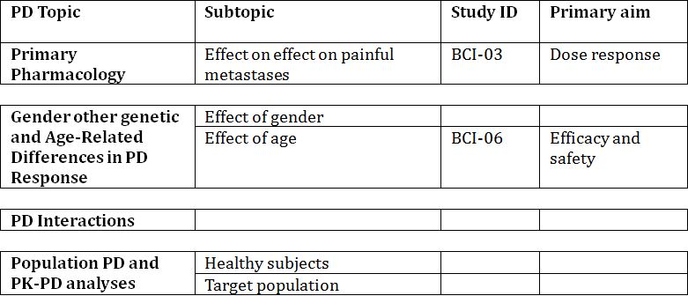

None of the pharmacodynamic studies had deficiencies that excluded their results from consideration.

### Summary of pharmacodynamics

The information in the following summary is derived from conventional pharmacodynamic studies in humans unless otherwise stated.

#### Mechanism of action

Radium-223 dichloride solution for injection is a targeted alpha particle emitter and represents a new generation of bone-seeking nuclides. Radium-223 selectively targets areas of increased bone turnover and accumulates by forming complexes with hydroxyapatite (50% of bone matrix). Alpha particle emission of radium-223 contributes 95.3% of its total radiation dose absorbed by bone; the fraction of energy emitted as beta particles is 3.6% and the fraction emitted as gamma radiation if 1.1%. The dense change of ionisation events produced by high linear energy transfer (LET) radiation causes simultaneous damage to both strands of cellular DNA, which translates into a potent effect in the areas of bone containing metastatic cancer cells. The short ionisation path length (less than 100 micrometres – less than about 10 cell diameters) of the alpha particles may reduce the effect on adjacent healthy tissue such as the bone marrow.

#### Pharmacodynamic effects

##### Primary pharmacodynamic effects

The primary pharmacodynamic effect of palliation of pain due to bone metastases was tested in one phase 2 study (Study BCI-03) and the efficacy and safety studies.

##### Dose response

The dose response was evaluated in two studies – Study BCI-03 for single dose against pain relief and Study BCI-04 for multiple doses against change in PSA and bone ALP.

Study BCI-03 was a randomised, double blind, multicentre, dose response Phase 2 study which assessed the palliative effect of 4 single individual dose levels of radium-223 in 100 patients with painful metastases secondary to prostate cancer. Each patient was randomised to receive a single IV injection of radium-223 at 5, 25, 50 or 100 kBq/kg bw. The treatment period was the single day of study drug administration followed by a 16 week post treatment period (at which point the study was unblinded) and a 24 month follow up period during which the patient could receive a second injection of radium-223 at a fixed dose of 50 kBq/kg bw at the investigator’s discretion.

The primary efficacy endpoint was the pain index, based on a combination of the change in diary pain rating (recorded by patients on a VAS) and the change in analgesic consumption, from baseline to Weeks 2, 4, 8, 12 and 16. A number of secondary endpoints related to pain were also measured.

The analysis of continuous and ordinal data was conducted using the Jonckheere-Terpstra test for trends in dose response.

The primary endpoint at 2 weeks post injection showed a significant dose response relationship following a single injection of radium-223 at increasing dose (5, 25, 50 and 100 kBq/kg bw), with trends towards a dose response at 4 and 8 weeks. The best pain response in terms of the pain index was observed in the highest dose group (100 kBq/kg bw) up to 8 weeks post injection.

Radium-223 was shown to reduce bone pain in patients with painful metastases secondary to prostate carcinoma with up to 70% of patients experiencing a pain palliating response at Weeks 4-8 in the highest dose group after a single injection of radium-223. Bone ALP levels also decreased with the most pronounced effect seen in the 2 highest dose groups. No difference in survival time was noted across the 4 doses of a single injection.

PSA is a protein produced by prostate cancer cells and is an established marker of disease management in prostate cancer. The PSA rises as the disease progresses. Bone ALP is a biochemical marker of bone formation turnover. An increase in ALP and specifically bone-ALP activity is of value in detecting osteoblastic metastases similar to those seen in prostate cancer. ALP and bone-ALP will rise as the disease progresses.

A dose response relationship was evaluated in the Phase 2 Study BCI-04 in which 122 patients were randomised to three doses of radium-223 (25, 50 or 80 kBq/kg bw) given at 6 week intervals. A statistically significant dose response relationship was shown, with an increasing proportion of PSA responders and bone-ALP responders with increasing dose. At the 25 kBq/kg dose, an increase in PSA was seen over a period of 24 weeks. At the 50 and 80 kBq/kg dose, this increase is less than seen at the 25 kBq/kg dose, indicating that the higher doses attenuate the PSA rise. At the 50 and 80 kBq/kg dose the PSA levels are almost the same suggesting that both doses have similar activity with respect to the effect on PSA.

At the 25 kBq/kg dose, a decrease in bone-ALP is seen over a period of 19 weeks. However, at the 50 and 80 kBq/kg dose, there is a significant decrease in bone-ALP as compared to that seen at the 25 kBq/kg dose, suggesting that the higher doses are affecting the bone metastases. At the 50 and 80 kBq/kg dose, the change in bone-ALP is almost identical, again suggesting that both doses have similar activity on bone-ALP.

### Evaluator’s overall conclusions on pharmacodynamics

Very little pharmacodynamic evaluation was done as the mechanism of action of radiopharmaceuticals is well known. The dose response to the single dose in the one study conducted demonstrated the dose response over the range examined for the response of pain as measured by the pain index and the secondary endpoints of pain relief, analgesic consumption and change in function interference.

The results of this study justify the dose selected for the pivotal studies.

## Dosage selection for the pivotal studies

During the clinical development program, 223Ra was studied as a single dose up to 250 kBq/kg body weight, and as repeated doses up to 240 kBq/kg body weight. The proposed dosing regimen of 50 kBq/kg body weight every 4 weeks for a total of 6 injections was based on the following.

### Dose

Throughout the dose range tested during the initial Phase I study (ATC-BCI) (single doses up to 250 kBq/kg body weight), no dose limiting toxicities were recorded and there was no gradient of risk across the doses up to 100 kBq/kg body weight in the Phase II studies (Studies BCI-02, BCI-03, and BCI-04).

In Study BCI-04, the two highest doses (50 and 80 kBq/kg body weight) demonstrated a greater effect on the PSA and bone alkaline phosphatase (ALP) as compared to the lowest dose level. The 50 kBq/kg body weight dose was not significantly different from the 80 kBq/kg dose in terms of response for PSA and bone ALP. Therefore, a dose of 50 kBq/kg body weight was considered to be a biologically effective dose.

### Injection duration

The protocol of the pivotal Phase III study (BCI-06) specified a “slow bolus” injection. This led to a low frequency (<0.5%) and intensity (≤ Grade 2) of injection site reactions. This proposed timing took into consideration avoidance of injection site reactions and radiation protection for the clinical personnel (ALARA principal: as low as reasonably achievable).

### Injection interval

Based on the nadir count of neutropenia seen in Study ATI-BCI between Day 15 and 20, the interval between injections was selected to be 4 weeks.

### Number of injections

The results of the Study BCI-02, conducted with 4 injections suggested a relationship between benefit and duration of treatment. In addition, the maximum single dose applied during Phase 1 did not lead to dose limiting toxicities. The findings led to the 6 injections used in the pivotal efficacy study (Study BCI-06).

## Clinical efficacy

### Pivotal efficacy studies

#### Study BCI-06

*“A Double Blind, Randomised, Multiple Dose, Phase III, Multicentre Study of Alpharadin[2] in the Treatment of Patients with Symptomatic Hormone Refractory Prostate Cancer with Skeletal Metastases”.*

A pre-planned interim analysis was conducted in October 2010 when 314 deaths had occurred. The Independent Data Monitoring Committee reviewed the data and recommended the study be stopped as the primary efficacy analysis of overall survival had crossed the pre-specified boundary for efficacy.

A clinical study report (CSR) was written at the time of the interim analysis. After the trial was stopped – the investigators were allowed to offer active treatment to those patients who had been randomised to placebo. A further CSR was written based on the updated cut-off date of 15 July 2011 including all data up to that date. The results described below do not include any cross over placebo patients.

##### Study design, objectives, locations and dates

This was a double blind, randomised, multiple dose, placebo controlled, international study conducted at 128 sites worldwide (Australia 13, Belgium 2, Brazil 8, Canada 4, Czech Republic 7, France 1, Germany 10, Hong Kong 4, Israel 4, Italy 5, Netherlands 3, Norway 8, Poland 8, Singapore 2, Slovakia 6, Spain 10, Sweden 8, UK 23, USA 2) from June 2008 until the trial was stopped prematurely in October 2011.

###### Primary objective

To compare, in subjects with symptomatic hormone refractory prostate cancer (HRPC) and skeletal metastases, the efficacy of best standard of care (BSoC) plus radium-223 versus BSoC plus placebo, with the primary efficacy endpoint being overall survival.

###### Secondary objectives:

* Time to occurrence of specified disease events
* Changes and time to progression in serum prostate specific antigen (PSA) and total alkaline phosphatase (ALP) concentrations
* Acute and long term safety profile
* Quality of life (QoL)
* Health Economics

The treatment period was defined as the time from first injection of study drug to 4 weeks after the last injection of study drug, normally 24 weeks. The follow up period was defined as the time from 4 weeks after the last administration of study drug until 3 years from first administration. Subjects were evaluated every 4 weeks of the treatment period and every 2 months until 1 year and thereafter every 4 months until 3 years from first administration.

##### Inclusion and exclusion criteria

The target population was subjects with progressive symptomatic HRPC, treated with BSoC with at least 2 skeletal metastases on bone scan and no known visceral metastases. Specifically, the target population included:

* Subjects who had received docetaxel
* Subjects who were not fit enough to receive docetaxel
* Subjects not willing to receive docetaxel
* Subjects for whom docetaxel was not available for other reasons

###### Inclusion criteria

* Histologically or cytologically confirmed adenocarcinoma of the prostate
* Known hormone refractory disease defined as
  + Castrate serum testosterone level: ≤ 50 ng/dL (1.7 nmol/L)
  + Bilateral orchiectomy or maintenance on androgen ablation therapy with a luteinising hormone-releasing hormone (LHRH) agonist or polyestradiol phosphate throughout the study
  + Serum PSA progression defined as 2 consecutive increases in PSA over a previous reference value, each measurement at least 1 week apart
* Serum PSA value ≥ 5 ng/mL (μg/L)
* Multiple skeletal metastases (≥ 2 hot spots) on bone scintigraphy within previous 12 weeks
* No intention to use cytotoxic chemotherapy within the next 6 months
* Either regular (not occasional) analgesic medication use for cancer-related bone pain or treatment with EBRT for bone pain within previous 12 weeks
* Age ≥ 18 years
* Eastern Cooperative Oncology Group Performance status (ECOG PS ): 0-2
* Life expectancy ≥ 6 months
* Laboratory requirements:
  + Absolute neutrophil count ≥ 1.5 × 109/L
  + Platelet count ≥ 100 ×109/L
  + Haemoglobin (Hb) ≥ 10.0 g/dL (100 g/L; 6.2 mmol/L)
  + Total bilirubin level ≤ 1.5 institutional upper limit of normal (ULN)
  + Aspartate transaminase and alanine transaminase ≤ 2.5 ULN
  + Creatinine ≤ 1.5 ULN
  + Albumin > 25 g/L
* Willing and able to comply with the protocol, including follow-up visits and examinations and must have been fully informed about the study and signed the informed consent form

###### Exclusion criteria

* Treatment with an investigational drug within previous 4 weeks, or planned during the treatment period
* Eligible for first course of docetaxel, ie, subjects who were fit enough, willing and where docetaxel is available
* Treatment with cytotoxic chemotherapy within previous 4 weeks, or planned during the treatment period, or failure to recover from AEs due to cytotoxic chemotherapy administered > 4 weeks earlier; however, ongoing neuropathy was permitted
* Prior hemibody external radiotherapy
* Systemic radiotherapy with strontium-89, samarium-153, rhenium-186 or rhenium-188 for the treatment of bony metastases within previous 24 weeks
* Prior treatment with radium-223
* Blood transfusion or erythropoietin stimulating agents within previous 4 weeks
* Other malignancy treated within the last 5 years (except non-melanoma skin cancer or low-grade superficial bladder cancer)
* History of visceral metastasis, or visceral metastases as assessed by abdominal/pelvic computed tomography (CT) or chest X-ray within previous 8 weeks
* Malignant lymphadenopathy exceeding 3 cm in short-axis diameter
* Imminent or established spinal cord compression based on clinical findings and/or magnetic resonance imaging (MRI)
* Any other serious illness or medical condition such as, but not limited to:
  + Any uncontrolled infection
  + Cardiac failure New York Heart Association III or IV
  + Crohn’s disease or ulcerative colitis
  + Bone marrow dysplasia
* Unmanageable faecal incontinence

##### Study treatments

The treatment regimen consisted of 6 slow bolus IV administrations of radium-223 (50 kBq/kg bw) or placebo (normal saline) each separated by an interval of 4 weeks.

The active study drug was a clear and colourless ready-to-use, aqueous solution of radium-223 chloride (223RaCl2) for IV administration, sterile and free from bacterial endotoxins. Radium-223 is an alpha-particle emitter with a physical half-life of 11.4 days. The product is isotonic containing sodium citrate in saline to physiological pH. The radioactive concentration at the reference date is 1,000 kBq/mL. The product has a pre-calibration of 14 days. When administered on a day other than the reference day, the volume was to be corrected according to the physical decay table supplied with each shipment. The product was supplied in 20 mL single dose glass vials, closed with rubber stoppers and aluminium seals. The volume per vial was 6 mL, corresponding to 6 MBq (6,000 kBq), at calibration day. It has a shelf life of 28 days from production day.

The study drugs were used in addition to the local centre “best standard of care” at the discretion of the investigator. “Best standard of care” was regarded as the routine standard of care at each centre, eg local external beam radiation therapy (EBRT), corticosteroids, antiandrogens, oestrogens (eg stilboestrol), estramustine or ketoconazole. If cytotoxic chemotherapy, other systemic radioisotopes or hemibody external radiotherapy treatments were considered as the BSoC to be given during the treatment period, further study drug had to be discontinued.

##### Efficacy variables and outcomes

The primary efficacy outcome was overall survival = time from date of randomisation to the date of death.

Secondary efficacy outcomes included:

* Time to total ALP progression
  + Total ALP progression was defined as:
    - In subjects with no total ALP decline from baseline as: ≥25% increase from the baseline value, at least 12 weeks from baseline
    - In subjects with an initial total ALP decline from baseline as ≥25% increase above the nadir value, which was confirmed by a second value obtained ≥3 weeks later
* Total ALP response defined as
  + Confirmed total ALP response: ≥30% reduction of the blood level, compared to the baseline value, confirmed by a second total ALP value approximately ≥4 weeks later
* Time to occurrence of first skeletal related events (SRE)
  + An SRE was the use of EBRT to relieve skeletal symptoms for the occurrence of new symptomatic pathological bone fractures (vertebral or non-vertebral) or the occurrence of spinal cord compression or a tumour related orthopaedic surgical intervention
* Total ALP normalisation defined as
  + The return of total ALP value to within normal range at 12 weeks in 2 consecutive measurements (at least 2 weeks apart) after start of treatment in subjects who have their total ALP above ULN at baseline
* Time to PSA progression
  + PSA progression was defined as:
    - In subjects with no PSA decline from baseline as ≥25% increase from the baseline value and an increase in absolute value of ≥2 ng/mL, at least 12 weeks from baseline
    - In subjects with an initial PSA decline from baseline as: ≥25% increase and an absolute increase of ≥2 ng/mL above their nadir value, which was confirmed by a second value obtained ≥3 weeks later
* Time to occurrence of first use of EBRT to relieve skeletal symptoms (related to SRE)
* Time to occurrence of first use of radio-isotopes to relieve skeletal symptoms
* Time to occurrence of first new symptomatic pathological bone fractures (vertebral and non-vertebral) (included for SRE)
* Time to occurrence of first tumour related orthopaedic surgical intervention (included for SRE)
* Time to occurrence of first spinal cord compression (included for SRE)
* Time to occurrence of first start of any other anti-cancer treatment
* Time to occurrence of first deterioration of ECOG PS by at least 2 points from baseline (includes death (score of 5) by definition)
* Changes in PSA
  + PSA response is defined as:
    - ≥30% reduction of the blood level, compared to baseline
    - ≥50% reduction of the blood level, compared to baseline
    - Confirmed PSA response: ≥50% reduction of the blood level, compared to the baseline value, confirmed by a second PSA value approximately 4 or more weeks later
  + The percentage change from baseline to 12 weeks, as well as the maximum decline in PSA that occurs at any point after treatment was reported for each subject using a waterfall plot
* Change in ALP
  + Total ALP response was defined as ≥50% reduction of the blood level, compared to baseline
  + Confirmed ALP response: ≥50% reduction of the blood level, compared to baseline value, confirmed by a second total ALP value approximately 4 or more weeks later
  + The percentages of change from baseline to 12 weeks, as well as the maximum decline in total ALP that occurs at any time point after treatment was reported for each subject using a waterfall plot

##### Randomisation and blinding methods

The subjects were randomised via an Interactive Voice Response System (IVRS), in a ratio of 2:1 to radium-223 or placebo, taking into account the following stratification factors:

* Total ALP < 220 U/L versus total ALP ≥ 220 U/L
* Current use of bisphosphonates: yes versus no
* Any prior use of docetaxel: yes versus no

Due to the nature of the drug, there were 2 study personnel (1 a backup) at the Nuclear Medicine Department at each site who were unblinded to the treatment arms assigned to subjects. The person performing the administration of the study drug was blinded to the treatment arm. In order to preserve the blind, the unblinded person at the site was responsible for filling the syringes and labelling them. Since the chloride and saline solutions were both clear, they could not be distinguished from each other visually.

##### Analysis populations

**Intent-to-treat (ITT) population**: defined as all randomised subjects, used for the analysis of the primary efficacy endpoint and all secondary efficacy and clinical benefit endpoints. Subjects were included in all ITT analyses according to the treatment to which they were randomised.

**Per-protocol (PP) population**: defined as all subjects in the ITT population who received at least 3 treatment cycles, and did not have any major protocol violations. The PP population was only used in the interim analysis.

**Safety population:** defined as all randomised subjects who had received at least 1 dose of study medication.

##### Sample size

The planned sample size was 900 patients with the final analysis to be conducted after 640 events had been observed. A pre-planned sample size re-estimation was completed, with the conclusion that the original sample size of 750 subjects would have provided a sufficient number of events for the original power of 80% to be maintained. However, the sample size of the study was increased due to an increase in statistical power from 80% to 90%.

A protocol planned interim analysis was to be conducted when approximately 50% (320 events) of the required events for final analysis had occurred. A total of 809 patients had been randomised into this study at the time of interim analysis data cut-off (14 October 2010) and 314 events had occurred. At the time of the updated analysis in July 2011, at total of 921 patients had been randomised.

##### Statistical methods

The null hypothesis for the comparison of the primary endpoint, overall survival, and also for the secondary efficacy endpoints, was that there was no difference between Radium-223 and placebo for that endpoint; the alternative hypothesis was that a difference exists. All tests were 2-sided. Superiority of radium-223 would be demonstrated only if the p-value from the appropriate 2-sided test was ≤ the Type I error, 0.05 with the radium-223 treatment group having better results. However, for the analysis of the primary efficacy endpoint, overall survival, the Lan-DeMets alpha-spending approach was applied with O’Brien-Fleming stopping boundaries to evaluate the difference in survival distributions.

For the analysis of the main secondary endpoints, a gatekeeping procedure was used to control for overall false positive rate (type I error rate). Each endpoint was tested at a 0.05 significance level.

All summary and analysis tables were presented by treatment group. Continuous variables were summarised using descriptive statistics (number of subjects with an observation (n), mean, SD, median, minimum and maximum) where n ≥2. Time to event variables were summarised using the Kaplan-Meier method to estimate the median, 25th and 75th percentiles, minimum and maximum and the 95% CI for the median time to event. Kaplan-Meier plots by treatment group were also generated for these data.

##### Participant flow

The overall participant disposition is provided at the time of the updated analysis (July 2011) (Table 3).

Table 3: Study BCI-06: Participant flow.

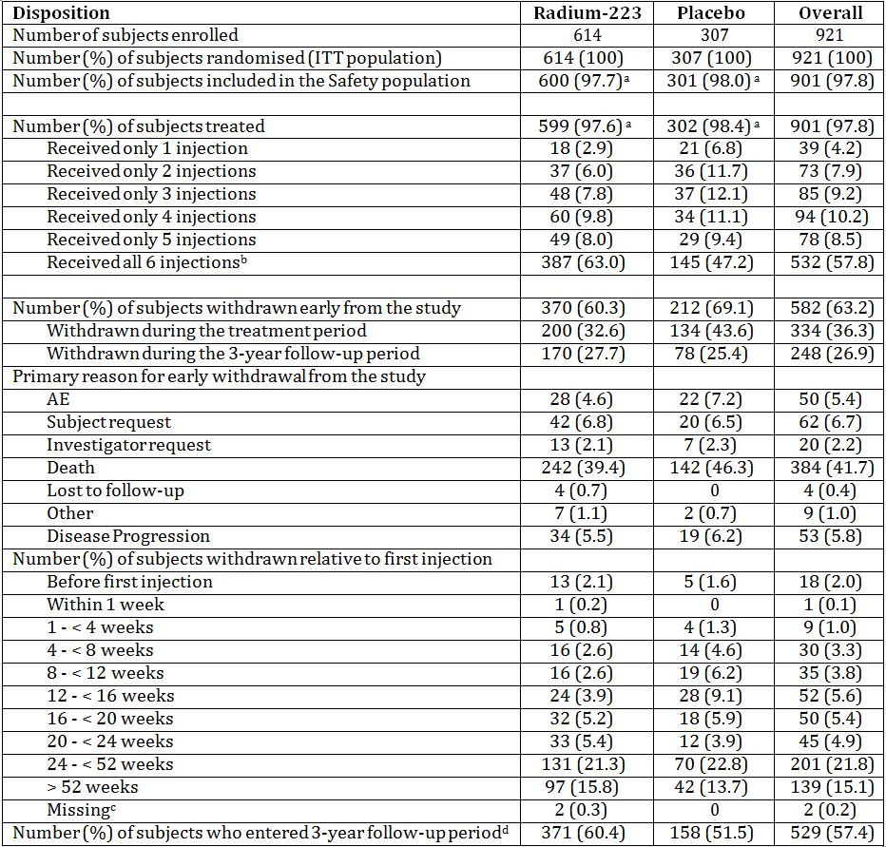

a. One subject was randomised to placebo but received radium-223 at Week 0. Hence, this subject is summarised as randomised in the ITT population (placebo group) and in the radium-223 group for the Safety population. In this summary this subject is counted as having received radium-223 in the Safety population row only.

b. Eight subjects received all 6 injections but were not included in the “completed all 6 injections” count because their Treatment Completion Page had not yet been received; 6 subjects in the radium-223 group and 2 subjects in the placebo group.

c. Two subjects received no treatment and had missing dates of withdrawal.

d. No subject had completed the 3-year follow-up period at the time of data cut-off.

Note: Percentages were calculated based on the number of subjects randomised in each treatment group and overall.

ITT = intent-to-treat.

##### Major protocol violations/deviations

There were no major protocol deviations which would affect the outcome of the study. The most common protocol violations were for subjects not having the required castrate serum testosterone levels ≤ 50 ng/dL (2.6%, 14/541 in the radium-223 group; 2.6%, 7/268 in the placebo group) and not showing the required serum PSA progression at the time of randomisation (3.1%, 17/541 in the radium-223 group; 2.6%, 7/268 in the placebo group).

##### Baseline data

Of the 921 patients enrolled at the end of the study, 47% were aged between 65 and 75 years and 94% were Caucasian. The full details of the baseline data are shown in Table 4.

Table 4: Study BCI-06: Baseline data.

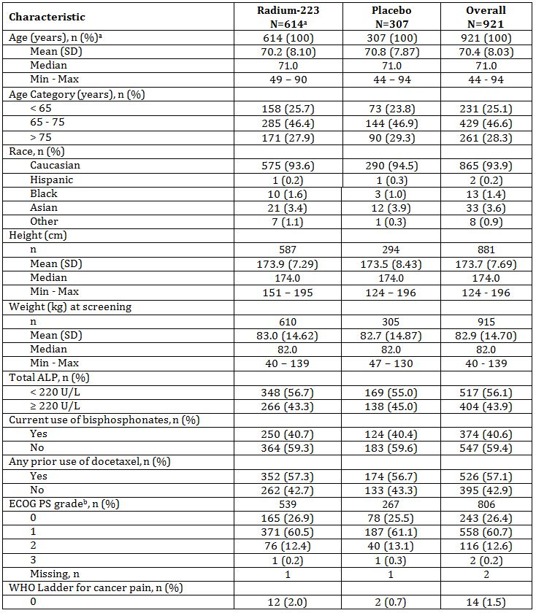

Table 4 (continued): Study BCI-06: Baseline data.

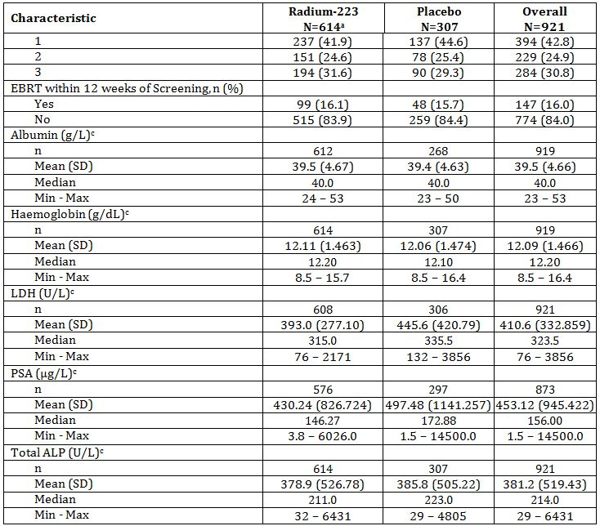

a. Total n was same for each characteristic unless listed otherwise.

b. Baseline was defined as the value recorded at Screening.

c. Baseline was defined as the value recorded at Week 0. If this value was missing, then the value recorded at Screening was used.

ALP = alkaline phosphatase; EBRT = external beam radiation therapy; ECOG = Eastern Cooperative Oncology Group;

ITT = Intent-to-Treat; LDH = lactate dehydrogenase; Max = maximum; Min = minimum; PS = performance status;

PSA = prostate specific antigen; SD = standard deviation; WHO = World Health Organisation.

##### Results for the primary efficacy outcome

The primary efficacy outcome was overall survival. In the interim analysis, the results show that treatment with radium-223 has a statistically significant and positive effect on overall survival (HR = 0.695, 95% CI 0.552-0.875; 2-sided p = 0.00185). Median overall survival was prolonged to 14.0 months (425.0 days) with radium-223 treatment compared to 11.2 months (340.0 days) with placebo (Table 5 and Figure 1).

Table 5: Study BCI-06: Overall survival primary - Interim analysis (months), ITT population.

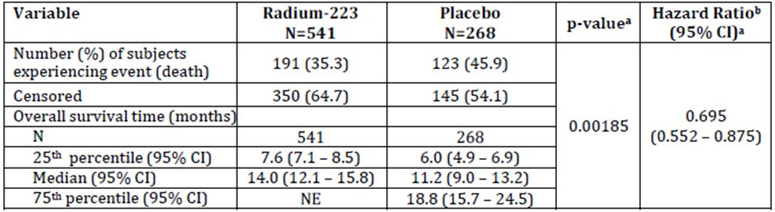

a. Taken from the log rank test stratified by total ALP, current use of bisphosphonates, and prior use of docetaxel.

b. The HR (radium-223:placebo) is from a Cox proportional hazards model adjusted for total ALP, current use of bisphosphonates, and prior use of docetaxel.

Note: Subjects who did not experience an event are censored at the last date known to be alive.

Note: Of the 314 subjects who died during the study, 12 died prior to taking study drug and are included in the ITT population.

CI = confidence interval; NE = not estimable.

Figure 1: Study BCI-06: Kaplan Meier curve for overall survival, interim analysis, ITT population.

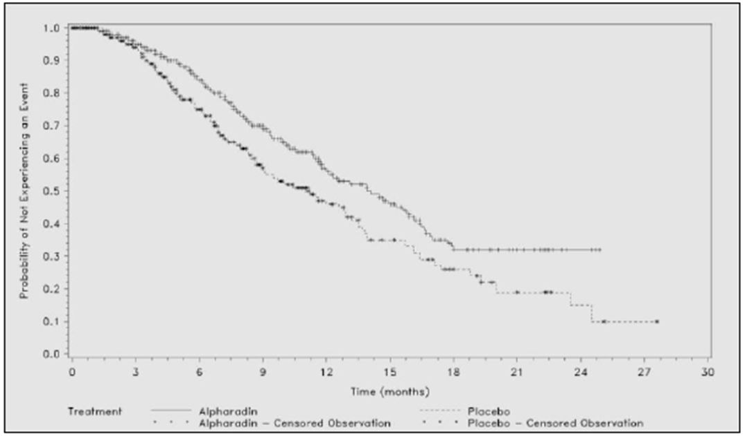

Alpharadin = radium-223

Similar results were seen in the PP population.

In the updated analysis, the results were similar (Tables 6-7 and Figures 2-3).

Table 6: Study BCI-06: Overall survival primary - Updated analysis (months), ITT population.

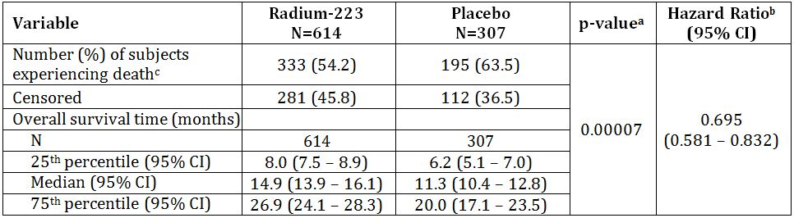

1. Taken from the log rank test stratified by total ALP, current use of bisphosphonates, and prior use of docetaxel. P value provided for descriptive purposes only.
2. The HR (radium-223:placebo) is from a Cox proportional hazards model adjusted for total ALP, current use of bisphosphonates, and prior use of docetaxel.
3. Of the 530 subjects who died before the data cut-off date, 12 subjects died prior to taking study drug and are included in the ITT population and 2 subjects died after they withdrew from the study but did not give consent to be followed up and are therefore not included in the survival analysis but are included in the ITT population.

Note: Subjects who did not experience an event are censored at the last date known to be alive.

CI = confidence interval.

Figure 2: Study BCI-06: Kaplan-Meier Curves: Overall Survival – Updated analysis.

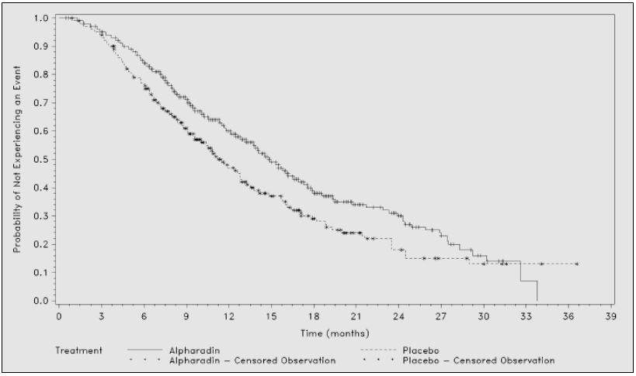

Alpharadin = radium-223

Table 7: Study BCI-06: Summary of overall survival by subgroup, ITT population.

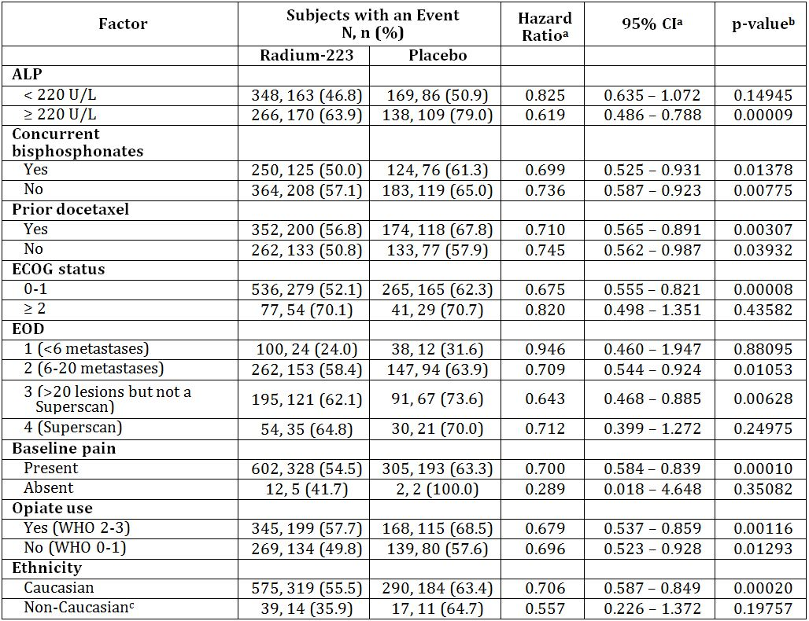

a. The HR (radium-223:placebo) is from a Cox proportional hazards model adjusted for total ALP, current use of bisphosphonates, and prior use of docetaxel.

b. Taken from the log rank test stratified by total ALP, current use of bisphosphonates, and prior use of docetaxel.

c. Defined as Hispanic, Black, Asian, and Other.

Note: Subjects who did not experience an event are censored at the last date known to be alive.

CI = confidence interval; ECOG = Eastern Cooperative Oncology Group; EOD = extent of disease.

Figure 3: Study BCI-06: Forest plot overall survival by subgroup, updated analysis, ITT population.

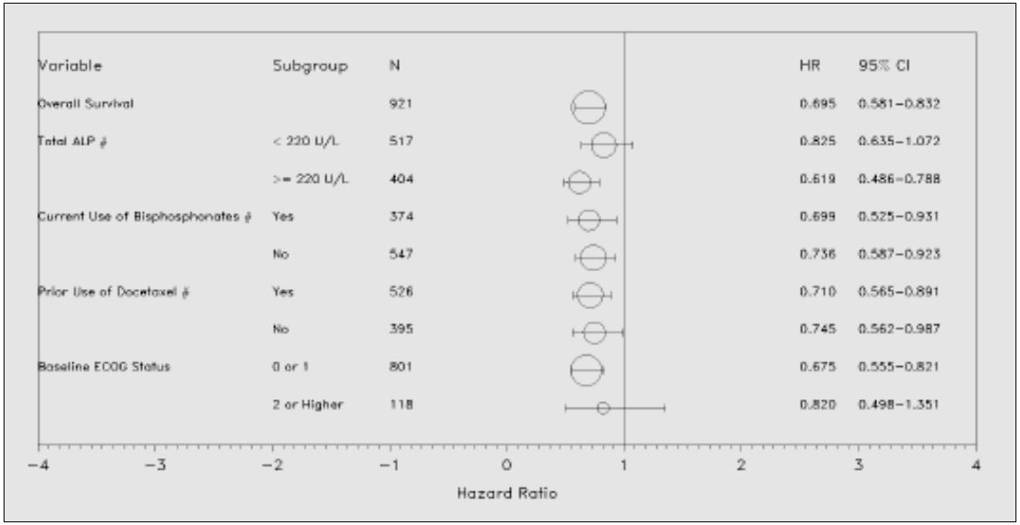

Note: Subjects who did not experience an event are censored at the last date known to be alive.

Note: The HR (radium-223:placebo) is from a Cox proportional hazards model (adjusted for total ALP, current use of bisphosphonates and prior use of docetaxel, except for subgroups marked with”#”)

Note: Size of circle represents relative value of N.

CI = confidence interval; ECOG = Eastern Cooperative Oncology Group; HR = hazard ratio

###### Overall survival adjusted for covariates

Covariate analyses of overall survival were carried out as a sensitivity analysis (Table 8). The following baseline variables were assessed for their prognostic effect on overall survival: albumin, Hb, LDH, ECOG PS, PSA, total ALP, and age. Total ALP, PSA and LDH had heavily skewed distributions so they were modelled using a log transformation. The covariates were assessed for any interaction with treatment: there were no significant treatment x covariate interactions. When assessed individually using the Cox proportional hazards model, each baseline covariate (albumin, total ALP, Hb, PSA, LDH, ECOG PS, and age) was statistically significantly associated with overall survival.

Table 8: Study BCI-06: Overall survival including baseline covariates, ITT population.

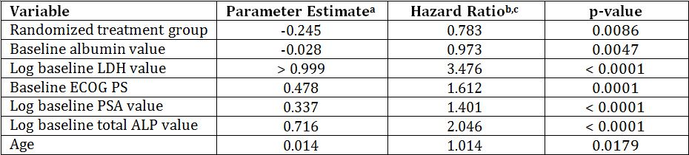

a. The parameter estimate refers to the increase in the log hazard for an increase of 1 (or 1 unit) in the value of the covariate.

b. The HR is from an adjusted Cox proportional hazards model. Due to the adjustments made for the effect of the other covariates, these HRs deviate from the HR of the primary endpoint (HR = 0.695).

c. Higher values (albumin) represent a lower risk of dying; all other values, the higher values, the higher the risk of dying.

Note: Subjects who did not experience an event are censored at the last date known to be alive.

Note: Covariates are baseline albumin, LDH, ECOG PS, PSA, total ALP, and age. Hb was not a significant factor when adjusting for all other covariates and was therefore removed from the final model.

ALP = alkaline phosphatase; ECOG PS = Eastern Cooperative Oncology Group Performance Status; HR = hazard ratio; LDH = lactate dehydrogenase; PSA = prostate specific antigen.

##### Results for other efficacy outcomes

###### Time to total ALP Progression

Treatment with radium-223 was superior to placebo in prolonging the time to total ALP progression (HR=0.167, 95%CI: 0.129-0.217; p=0.00001) (Table 9).

Table 9: Study BCI-06: Summary of subjects who experienced total ALP progression (months), ITT population.

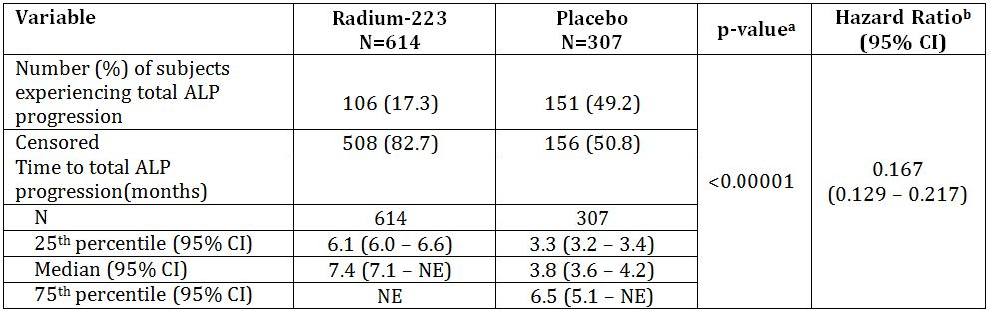

a. Taken from the log rank test stratified by total ALP, current use of bisphosphonates, and prior use of docetaxel

b. The HR (radium-223:placebo) is from a Cox proportional hazards model adjusted for total ALP, current use of bisphosphonates, and prior use of docetaxel

Note: Subjects who did not experience an event are censored at the last disease assessment date.

CI = confidence interval; HR = hazard ratio; NE = not estimable.

###### Total ALP response and total ALP normalisation

Higher proportions of patients who achieved either a ≥30% reduction in total ALP blood levels at Week 12 were reported in the radium-223 group (59.4% with ≥30% and 32.6% with ≥50% reduction). 34.0% (109/321) of patients in the radium-223 group achieved total ALP normalisation versus only 1.4% (2/140) of patients receiving placebo.

The difference between treatment groups in the percentage change in total ALP from baseline to Week 12 (radium-223 -32.2% and placebo +37.2%) and the maximum percentage decrease in total ALP from baseline up to Week 12 (radium-223 -38.9% and placebo -5.9%) was highly significant (both p <0.001).

Table 10: Study BCI-06: Summary of subjects who experienced total ALP responses at Week 12, ITT population.

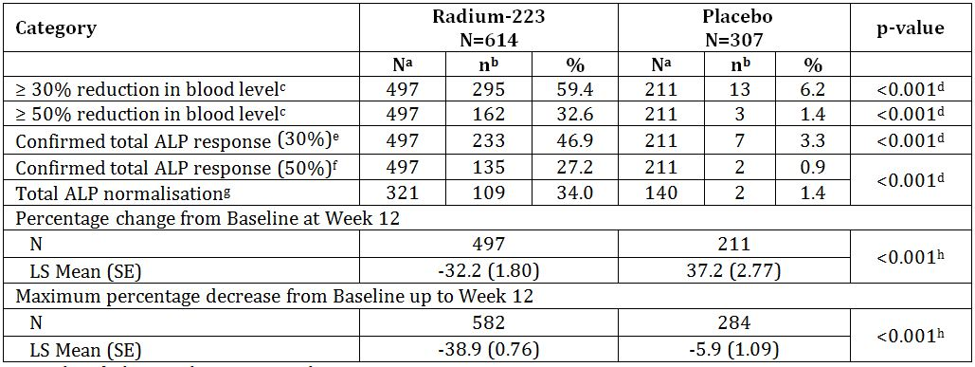

a. Number of subjects with non-missing values.

b. Number of subjects with reductions.

c. Compared to Baseline.

d. Taken from CMH analysis adjusting for the binary stratification factors, total ALP, current use of bisphosphonates, and prior use of docetaxel.

e. ≥ 30 % reduction of the blood level compared to the Baseline value, confirmed by a second total ALP value approximately ≥ 4 week later.

f. ≥ 50 % reduction of the blood level compared to the Baseline value, confirmed by a second total ALP value approximately ≥ 4 week later.

g. Defined as the return of total ALP value to within normal range at 12 weeks in 2 consecutive measurements (at least 2 weeks apart) after start of treatment in subjects who have their total ALP above ULN at baseline.

h. Taken from ANCOVA adjusting for the binary stratification factors, total ALP, current use of bisphosphonates, and prior use of docetaxel.

ALP = alkaline phosphatase; ANCOVA = analysis of covariance; CMH = Cochran-Mantel-Haenszel (test); LS = least square; SE = standard error; ULN = upper limit of normal.

Results at end of treatment were similar to results at Week 12 for the proportions of patients who achieved either a ≥30% or ≥50% reduction in ALP blood levels (radium-223 60.3% and 35.0%; placebo 4.5% and 1.7%). Total ALP progression at end of therapy was experienced by 49.2% of subjects in the placebo group compared to 17.3% of patients in the radium-223 group. The difference was statistically significant (p<0.001).

The results for both the percentage change from baseline at end of treatment and for the maximum percentage decrease from baseline during the 24 week treatment period reinforce the positive results in total ALP response and demonstrate a statistically significant difference for subjects treated with radium-223 versus placebo (p<0.001). In the radium-223 group, there was a 30.2% decrease compared to a 62.1% increase in the placebo group.

###### Skeletal related events (SRE)

The time to first SRE was statistically longer in the radium-223 group compared to placebo (median number of months = 15.6 for radium-223 versus 9.8 months for placebo; HR=0.658, 95%CI 0.522-0.830, p=0.00037) (Tables 11-12).

Table 11: Study BCI-06: Summary of subjects who experienced a skeletal related event (months), ITT population.

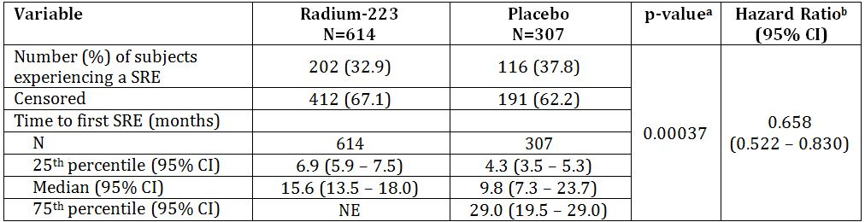

a. Taken from the log rank test stratified by total ALP, current use of bisphosphonates, and prior use of docetaxel.

b. The HR (radium-223:placebo) is from a Cox proportional hazards model adjusted for total ALP, current use of bisphosphonates, and prior use of docetaxel.

Note: Subjects who did not experience an event are censored at the last disease assessment date.

CI = confidence interval; HR = hazard ratio; NE = not estimable; SRE = skeletal related events.

Table 12: Study BCI-06: Component of first skeletal related event, ITT population.

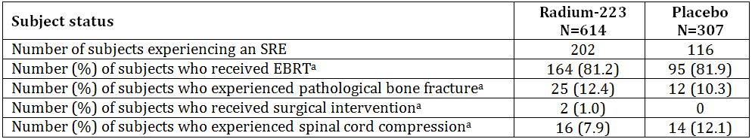

a. Percentages were calculated based on the number of subjects in each treatment group who experienced an SRE.

Note: Multiple SRE component events could have occurred on the same date so a subject may have been counted in more than 1 category. There were 5 subjects on radium-223 and 5 on placebo who had 2 component events on the SRE event date and therefore, the sum of frequencies for the components is 5 more than the SRE frequency in both treatment groups.

EBRT = external beam radiotherapy; SRE = skeletal related event.

A total of 52 subjects (5.2%, 32/614 radium-223; 6.5%, 20/307 placebo) experienced a new symptomatic pathological bone fracture (HR = 0.620, 95% CI 0.351 – 1.093, p = 0.09511).

There were too few surgical interventions (2.0%, 12/614 radium-223; 2.3%, 7/307 placebo) to determine a treatment effect, but the estimate of the HR was below unity (HR = 0.715, 95% CI 0.280-1.821, p = 0.47930).

For time to occurrence of first spinal cord compression, although there were relatively few events (4.1%, 25/614 radium-223; 6.8%, 21/307 placebo), radium-223 was associated with a significant reduction in overall risk of spinal cord compression (HR = 0.516, 95% CI 0.286-0.931, p = 0.02541).

###### PSA progression

Time to PSA progression was statistically significantly longer in the radium-223 group compared to placebo (HR=0.643, 95%CI 0.539-0.768; p<0.00001).

In most patients, in accordance with the Prostate Cancer Working Group2 Guidelines, PSA progression was assessed only from 12 weeks onwards, which resulted in some loss of data and sensitivity. A post hoc analysis of PSA progression from Day 1 removed this artefact, and showed an early treatment effect and a stronger HR; time to PSA progression was 2.4 months for radium-223 versus 2.1 months for placebo; HR=0.641, 95%CI 0.548-0.750, p<0.00001 (Table 13).

Table 13: Study BCI-06: Summary of subjects who experienced PSA progression (months), ITT population.

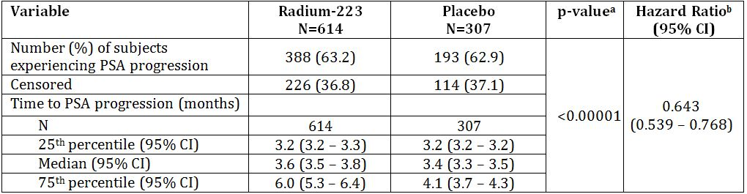

a. Taken from the log rank test stratified by total ALP, current use of bisphosphonates, and prior use of docetaxel.

b. The HR (radium-223:placebo) is from a Cox proportional hazards model adjusted for total ALP, current use of bisphosphonates, and prior use of docetaxel.

Note: Subjects who did not experience an event are censored at the last disease assessment date.

CI = confidence interval; PSA = prostate specific antigen

The proportion of patients who achieved either a ≥30% or ≥50% reduction in PSA blood levels at end of treatment (4 weeks post last injection) were 14.4% and 9.2% for subjects treated with radium-223 and 4.5% and 3.1% for patients treated with placebo (≥30% p<0.001 and ≥50% p=0.002); with 5.6% of patients in the radium-223 group achieving a confirmed PSA response compared to 1.4% of patients receiving placebo (p=0.005). The percentage change in PSA from baseline to end of treatment period and the maximum percentage decrease from baseline during the 24-week treatment period for PSA blood levels reached significance (p=0.001 and p<0.001, respectively) in favour of the treatment with radium-223.

###### PSA response (at week 12)

Higher proportions of subjects who achieved either a ≥ 30% or ≥ 50% reduction in PSA blood levels at Week 12 were observed for subjects treated with radium-223 compared with those treated with placebo (≥ 30% [16.4% radium-223 versus 6.2% placebo, p < 0.001] and ≥ 50% [7.7% radium-223 versus 4.3% placebo, p=0.106]). 5.7% of subjects in the radium-223 group achieved a confirmed PSA response versus only 1.9% of subjects receiving placebo (p=0.032). The maximum percentage decrease from baseline up to Week 12 in the PSA blood levels reached statistical significance (p = 0.004).

The proportion of subjects who achieved either a ≥ 30% or ≥ 50% reduction in PSA blood levels at end of treatment (4 weeks post last injection) were 14.4% and 9.2% for subjects treated with radium-223 and 4.5% and 3.1% for subjects treated with placebo (≥ 30% p<0.001 and ≥ 50% p=0.002). 5.6% of subjects in the radium-223 group achieved a confirmed PSA response versus only 1.4% of subjects receiving placebo (p=0.005). The percentage change in PSA from baseline at end of treatment and the maximum percentage decrease from baseline during the 24-week treatment period for PSA blood levels reached significance (p = 0.001 and p < 0.001, respectively) in favour of the treatment with radium-223.

###### Other secondary efficacy variables

Radium-223 was associated with a statistically significant delay in time to EBRT to relieve skeletal symptoms (HR=0.670, 95%CI 0.525-0.854; p=0.00117).

The mean number of months until the need for other cancer treatment was 16.2 in the radium-223 and 13.5 in the placebo group (HR=0.737, 95%CI 0.562-0.966; p=0.02670).

The median time to occurrence of first deterioration of ECOG PS by at least 2 points from baseline was 20.3 months for patients in the radium-223 group and 16.8 months for patients in the placebo group (HR=0.670, 95%CI 0.520=0.861; p=0.00168) (Table 14).

Table 14: Study BCI-06: Summary of first use of EBRT, other cancer treatment, and deterioration of ECOG PS (months), ITT population.

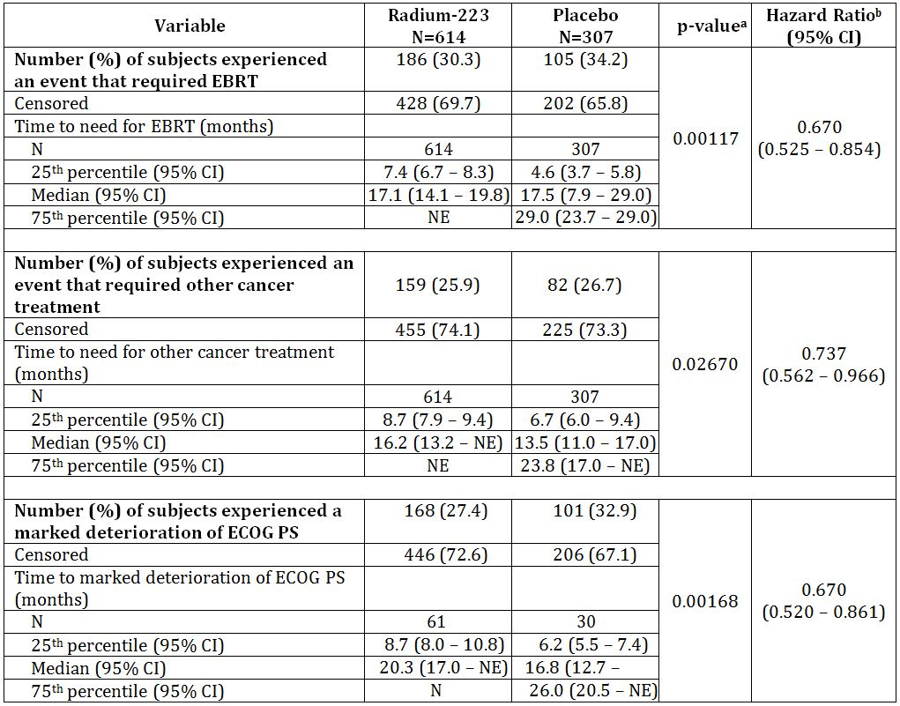

Radium-223 was associated with a statistically significant delay in the time to the use of radio-isotopes to relieve skeletal metastases (HR=0.292, 95%CI 0.125-0.678; p=0.00239).

###### Quality of life

The patient’s health related quality of life (HRQoL) was assessed through the use of two HRQoL instruments: the EuroQoL 5D (EQ-5D), which provides a generic assessment of health status, and the Functional Assessment of Cancer Therapy for Patients with Prostate Cancer (FACT-P Version 4), which is designed to assess the HRQoL of patients with prostate cancer. Both instruments have been validated. The EQ-5D also contains a 100-point visual analogue scale (VAS) that assesses self-reported health status on the day of completion (0=worst imaginable health status, 100=best imaginable health status).

All quality of life data were analysed using the ITT population.

The results of the primary QoL analysis showed that patients treated with radium-223 had significantly better HRQoL than patients with placebo. The mean decrease from baseline in the FACT-P total, EQ-5D utility index, the EQ-VAS self-reported health status scores were al significantly less for radium-223 treated patients than for placebo treated patients. When assessing patients over the whole trial period (on treatment visits plus follow up visits), similar results were seen, with radium-223 treated patients experiencing a smaller decrease from baseline than placebo treated patients (Table 15).

Table 15: Study BCI-06: Quality of Life results.

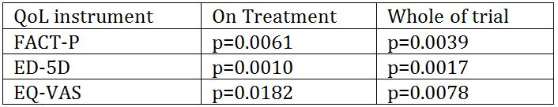

The secondary QoL analysis at week 16 (first on treatment visit) and week 24 (second on treatment visit) were similar.

The FACT-P PCS pain score is a sub-score of the FACT-P instrument which provides a measure of HRQoL related to pain and a higher score indicates lower pain. This sub-score has not been validated. Analysis of the FACT-P PCS pain score indicated significantly better pain scores for radium-223 patients than placebo patients at Week 16 (p<0.001) but not at Week 24 (p=0.077). Within the radium-223 group the mean pain score was significantly higher than baseline at both on treatment visits (week 16: p<0.001 and week 24: p=0.001).

### Other efficacy studies

#### Study BCI-02

*A Phase II Randomised, Placebo Controlled, Multicentre Study in Prostate Cancer Patients with Painful Bone Metastases to Evaluate the Efficacy of Repeated Radium-223 Injections*

##### Objectives

###### Primary objectives

* Time to occurrence of skeletal related events (SRE)
* Change in bone specific alkaline phosphatase (bone-ALP) levels

###### Secondary objectives

* Frequency of new SREs
* Proportions of subjects with a SRE
* Proportions of subjects with SRE at different time points
* Changes of biochemical markers of bone turnover
* Treatment response with regard to pain and analgesic use
* Quality of life and overall survival

##### Methodology

###### Design

Randomised, double blind, placebo controlled, multicentre study conducted at 11 centres in Sweden, Norway and the UK from February 2004 to May 2007.

###### Entry criteria

Confirmed adenocarcinoma of the prostate referred for palliative external beam radiotherapy (EBR) for painful skeletal metastases.

###### Treatments

Patients were randomised 1:1 to radium-223 at dose of 50 kBq/kg bw or placebo (saline) administered as slow IV infusion 4 times at intervals of 4 weeks.

All patients received a single/fractionated treatment of EBR followed within 7 days by the first injection of study medication. The treatment period was 12 weeks, during which four injections of study medication were given at 4 week intervals. Patients were then followed up for 24 months.

###### Data collection and analysis

Pain and markers of bone turnover were assessed at 6, 9, and 12 months after first injection. Clinical laboratory tests, adverse events and survival data were collected at each visit (6, 9, 12, 18 and 24 months).

The primary outcome parameters were time to occurrence of skeletal related events (SRE) and the relative change (%) in bone-ALP levels from baseline to 4 weeks after last injection.

SRE was defined as:

Group 1

* Neurological symptoms secondary to skeletal manifestations of prostate cancer
* New pathological fractures (vertebral and non-vertebral)
* Tumour related orthopaedic surgical intervention
* Subsequent EBR
* Use of radioisotopes to relieve new skeletal related symptoms

Group 2

* Increase in pain severity index during the last week
* Increase in analgesic consumption
* Use of chemotherapy due to skeletal disease progression
* Use of bisphosphonates due to skeletal pain and/or skeletal disease progression
* Use of corticosteroids due to skeletal pain, defined as doses aimed for pain palliation
* Use of hormones due to therapeutic intervention for progression in skeleton

##### Study participants

###### Enrolled

64 patients with 33 receiving radium-223 and 31 receiving placebo

###### Completed

31 completed 2 months and 13 completed 24 months

###### Analysed

ITT population = 64 patients; PP population = 58 patients

###### Baseline

The study population had a mean age of 72.3 years (range 57 to 88); BMI of 26.9 kg/m2 (range 18 to 38) and mean body weight 82.6 kg at entry (range 54 to 109). Prostate cancer had been diagnosed a mean of 5.12 years (range 0.2 to 23.1) and bony metastases a mean of 1.58 years (range 0.1 to 17.8 years) before study entry. The median extent of disease on entry to the study was category 2 (6 to 20 lesions on bone scan) and the mean pain severity index was 3.83 (of a maximum of 10). Overall, the two treatment groups were reasonably balanced for factors of prognostic significance.

##### Results

Results are given for the ITT and PP populations as reported in the clinical study report (CSR). Five subjects received fewer than two injections and were excluded from the PP Set. Most analysis was done on the PP population rather than the ITT.

###### Time to first SRE

The median time to first SRE was 16.0 weeks in the radium-223 group and 11.0 weeks in the placebo group. The difference was not statistically significant (p=0.2144).

Results were consistent when analysed for the PP population for SREs excluding pain and analgesia; for SREs for Group 1; for each individual category of SRE and after adjustment for selected covariates (Table 16 and Figure 4).

Table 16: Study BCI-02: Time to First SRE: ITT Analysis.

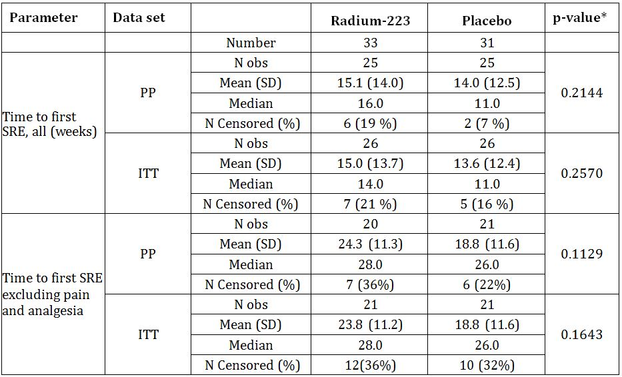

* Log rank test for difference between treatments (no other stratification)

PP=per protocol population; ITT=intent to treat population

Figure 4: Study BCI-02: Kaplan-Meier Curve: Time to First Skeletal-related Event – (ITT population).

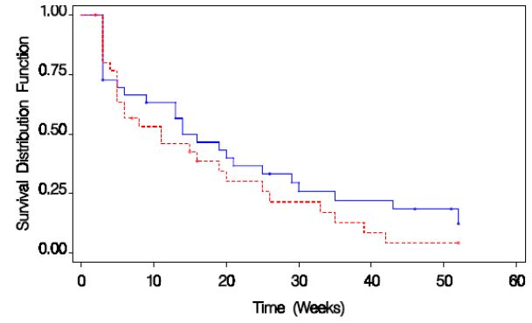

Y-axis: Proportion of subjects who have not yet experienced a SRE

Blue line: Radium-223 Group; Red line: Placebo Group

###### Change in bone-ALP

The median values for bone-ALP generally fell initially in the radium-223 group and remained stable or increased in the placebo group. The median relative change from baseline to 4 weeks after the last treatment was -66% in the radium-223 group and +9% in the placebo group for both the ITT and PP populations (p<0.001). Comparison of the time course of changes in bone-ALP shows that the relative change from baseline in the two treatment groups was statistically significantly different in all time points from 2 weeks after the first injection until Month 6 (Table 17 and Figure 5).

Table 17: Study BCI-02: Relative Change in Serum Bone-ALP, Baseline to 4 Weeks after last Injection (LOCF).

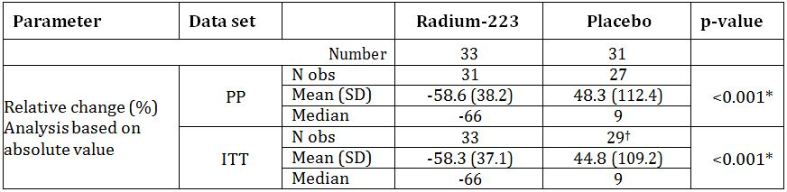

* Wilcoxon rank sum test stratified by centre/country

† Two subjects had only baseline data

LOCF=last observation carried forward

Figure 5: Study BCI-02: Percentage change in S-Bone ALP (Per Protocol population) Mean and 95% CI.

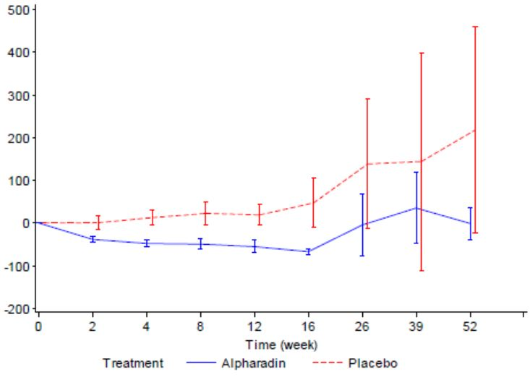

Alpharadin=radium-223

###### Number of SREs

In the ITT population, by Week 16, 17 of 33 subjects (52 %) in the radium-223 Group experienced a total of 35 SREs, compared with 18 of 31 (58 %) subjects who had 44 SREs in the Placebo Group. Excluding pain and analgesic consumption from the SRE definitions, 6 of 33 subjects (18 %) in the Radium-223 Group experienced a total of 9 SREs, compared with 11 of 31 (35 %) subjects in the Placebo Group who had 21 SREs. By Week 52, 26 subjects in each group (79 % and 84 %, respectively) had experienced at least one SRE (Table 18).

Table 18: Study BCI-02: Number of Individual SREs Reported by Category (PP Population).

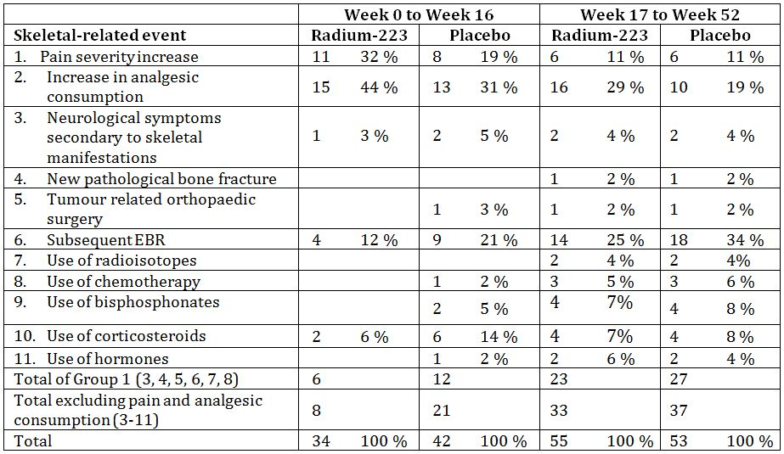

Note: proportions are expressed as percentage of total number of SREs in that treatment group; numbers reflect number of individual events, not subjects reporting each event

No events were reported in categories 4 or 7 at 16 weeks. Full details of SRE interpretation is given in Section 18.2 (page 104)

###### Changes of biochemical markers of bone turnover

Changes in serum PNP (procollagen-type I N propeptide) and total ALP generally paralleled the changes in bone-ALP in both treatment groups. PNP serum values were statistically significantly different between the treatment groups from Week 2 to Month 6, and total ALP were statistically significantly different between the treatment groups from Week 2 to Week 16.

Median percentage change in serum S-CTX-1 (serum C terminal cross linking telopeptide of type 1 collagen) showed a slight decrease following treatment with radium-223 compared with a slight decrease in the placebo group; values were statistically significantly different for Week 8 to Week 16. Serum ICTP (Type 1 collagen cross linked C telopeptide) was generally stable following treatment with radium-223 and showed an increase in the placebo group; values were statistically significantly different from Week 2 to Week 16 (Table 19).

Table 19: Study BCI-02: Relative Change in Serum Markers of Bone Formation and Resorption, Baseline to 4 weeks after Last Injection (Last Observation Carried Forward).

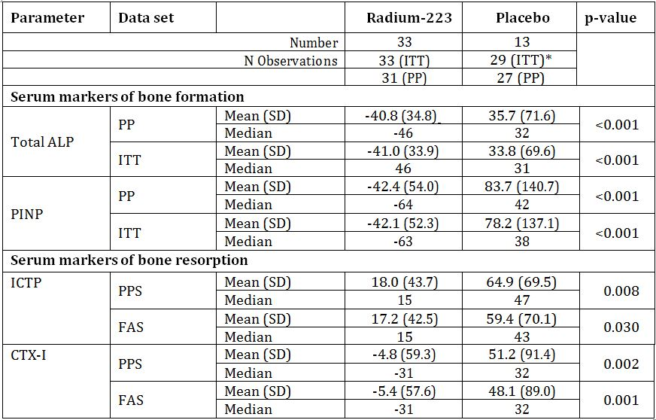

Statistical analysis used Wilcoxon rank sum test stratified by centre/country

* Only baseline blood samples were taken from two subjects (103 and 201)

###### PSA

After treatment, median values fell below baseline in the radium-223 Group from Week 2 to Month 6 and then increased. In the Placebo Group, they were higher than baseline at all time points. One subject (in the Placebo Group in the ITT but not included in the PP analysis set) had a PSA value that was not elevated above the ULN. The difference between the treatment groups was statistically significant from Week 8 including Week 16 (Figures 6-7 and Table 20).

Figure 6: Study BCI-02: PSA (ng/mL) (ITT) Mean and 95% CI.

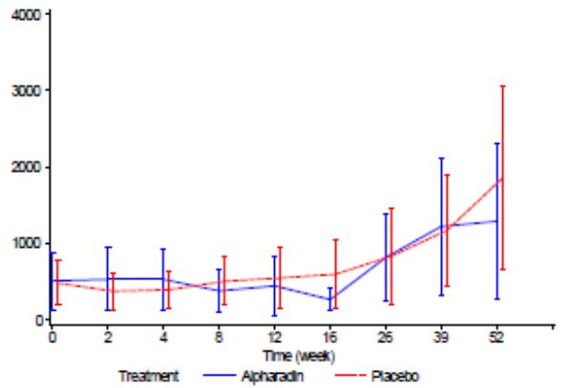

Table 20: Study BCI-02: Relative Change in Serum Markers of Bone Formation and Resorption, Baseline to 4 weeks after Last Injection (Last Observation Carried Forward).

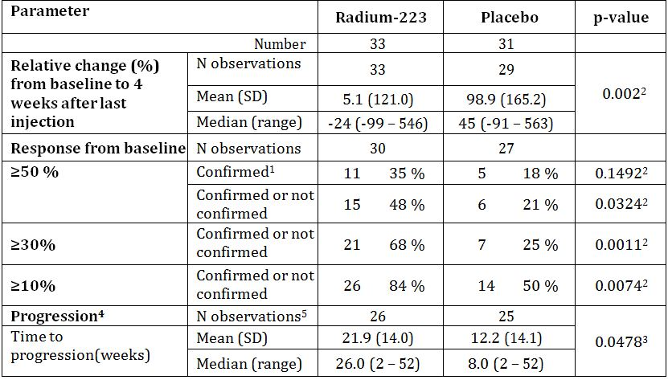

Figure 7: Study BCI-02: Kaplan-Meier Curve: Time to PSA Progression.

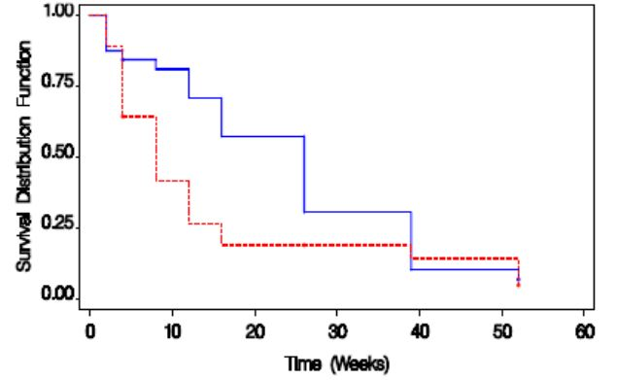

Y-axis: Proportion of subjects who have not yet had a progression; Blue line = Radium-223 Group; Red line = Placebo Group

###### Treatment response with regard to pain and analgesic use

Diary data on pain scores (Brief Pain Inventory), pain recorded during clinic visits and scores on the pain question in the Edmonton Symptom Assessment Score (ESAS) showed a tendency to improve in both groups, with no difference apparent between the groups.

###### Overall survival

At 12 months there was no statistically significant difference in survival between radium-223 and placebo. At 24 months, using the Cox Proportional Hazards model adjusting for the covariates, baseline values of haemoglobin, LDH, albumin, total ALP, PSA, ECOG and age, the hazard ratio for survival in the Per-Protocol Set was 2.249 (95 % CI: 1.175-4.31, p=0.014); for the ITT Set, it was 2.103 (95 % CI: 1.140-3.88, p=0.017) (Table 21 and Figure 8).

Table 21: Study BCI-02: Time to Death (weeks).

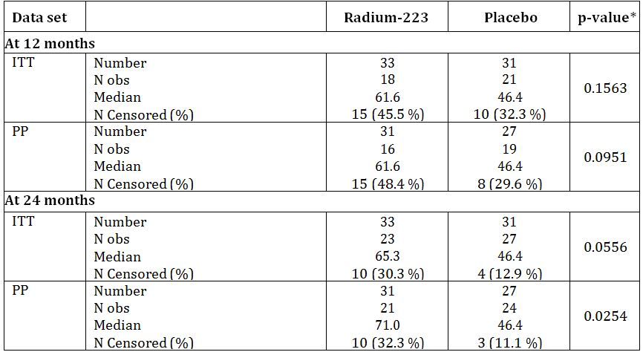

*Log rank test

Note: observations censored at 12 months or 24 months or at date of last contact if a later observation exists

Figure 8: Study BCI-02: Kaplan-Meier Curves – Survival to 12 months and 24 months.

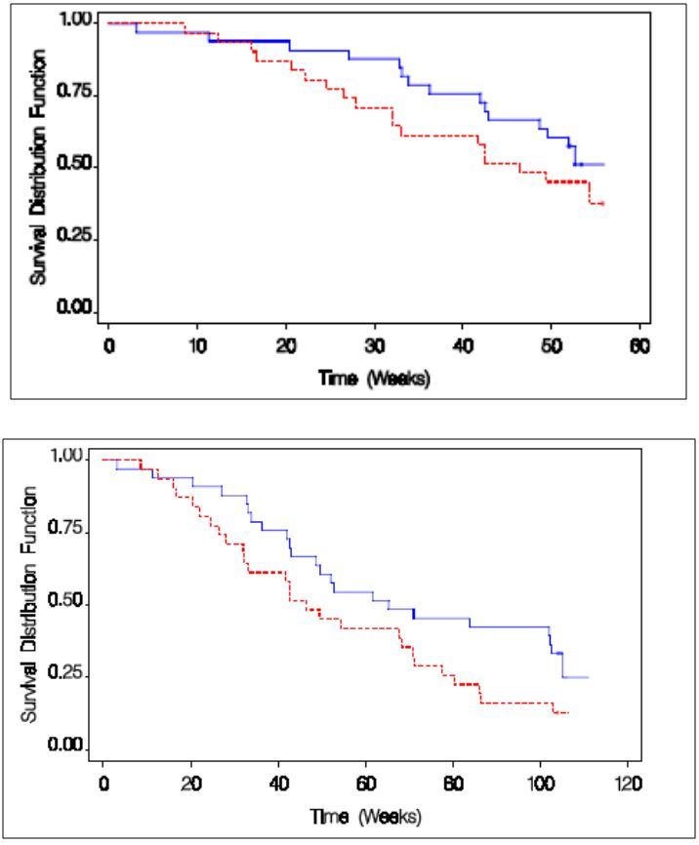

Y-axis: Proportion of subjects who have not yet had a progression; Blue line = Radium-223 Group; Red line = Placebo Group

Treatment with radium-223 was associated with an increase in median survival time to 71 weeks compared with 46 weeks in the Placebo Group (PP Set; p=0.0254). In the ITT Set, median survival in the radium-223 Group was 65 weeks compared with 46 weeks in the Placebo Group (p=0.0556). Using the Cox Proportional Hazards model adjusting for baseline values of prognostic variables, the hazard ratio for survival in the PP Set was 2.249 (95 % CI: 1.175-4.31, p=0.014); for the ITT Set, it was 2.103 (95 % CI: 1.140-3.88, p=0.017).

#### Study BCI-04

*A Double Blind, Randomised, Dose Finding, Repeat Dose, Phase II, Multicentre Study of Alpharadin for the Treatment of Patients with Hormone, Refractory Prostate Cancer and Skeletal Metastases*

##### Objectives

###### Primary objective

To compare the proportion of patients with hormone refractory prostate cancer and skeletal metastases showing a prostate specific antigen (PSA) response (PSA decrease ≥50% from baseline, confirmed three weeks later) on three different repeat dose regimens of radium-223.

###### Secondary objectives

* To compare the maximum percent decrease of PSA from baseline in patients on three different repeat dose regimens of Alpharadin
* To compare the effect on bone specific alkaline phosphatase (bone-ALP) of three dose regimens of Alpharadin
* To examine for correlation between bone-ALP and PSA
* To compare the effect on serum C-terminal cross-linking telopeptide of type 1 collagen (s-CTX-1) of three dose regimens of Alpharadin
* To examine for correlation between s-CTX-1 and PSA
* To determine the effect of these three repeat dose regimens of Alpharadin on time to skeletal related events
* To determine the effect of these three repeat dose regimens of Alpharadin on pain response, in patients with pain
* To determine the safety, tolerability and long term toxicity of these three repeat dose regimens
* Time to death

##### Methodology

###### Design

Randomised, double blind, parallel group, dose finding study conducted at 21 centres in the UK, the Czech Republic, France, Poland and Spain from May 2006 to December 2009.

The trial schema is shown in Figure 9.

Figure 9: Schema for Study BCI-04.

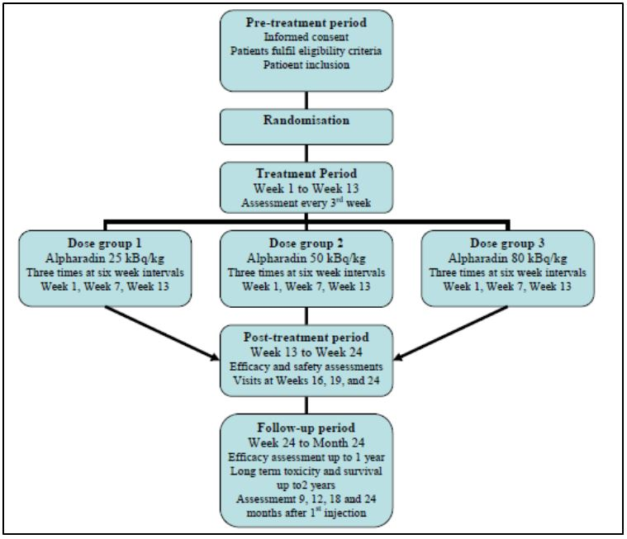

###### Inclusion criteria

Histologically or cytologically confirmed adenocarcinoma of the prostate; symptomatic or asymptomatic and hormone refractory with documented rising PSA and multifocal skeletal metastases confirmed by bone scintigraphy; life expectancy of at least 6 months; ECOG performance score ≤2.

###### Exclusion criteria

Chemo-, immunotherapy, or external radiotherapy within 4 weeks; more than one regimen of previous cytotoxic chemotherapy; received systemic radiotherapy with strontium-89, samarium-153, rhenium-186 or rhenium-188 for the treatment of bony metastases within the last year; recent change in bisphosphonates, antiandrogens, steroids or oestrogen therapy.

###### Treatments

Three IV infusions of radium-223 at intervals of 6 weeks. Patients were randomised to receive 25, 50 or 100 KBq/kg body weight. The required volume of radium-223 was calculated using the patient’s body weight, the dose level and a volume correction factor to correct for physical decay of radium-223.

###### Data collection and analysis

The primary endpoint was confirmed PSA response:

* Response = decrease from baseline of at least 50%
* Progression =
  + for patients with a response – the interval from the first day of treatment until the day the value increased by at least 50% from nadir to ≥5 ng/mL
  + for non-responders – the interval from the first day of treatment until the value had increased by at least 25% above the nadir to ≥5 ng/mL
* Confirmed response and confirmed progression = values to be confirmed by a second value obtained at least 3 weeks after the first

With the exception of survival, efficacy was analysed up to week 24 visit.

The primary outcome parameter was the proportion of patients in each dose group with a confirmed PSA response.

###### Secondary endpoints

* PSA: maximum relative decrease in PSA; change in PSA; time to confirmed PSA progression
* Bone-ALP: confirmed response; change in bone-ALP; time to confirmed bone-ALP progression
* s-CTX-I: confirmed response; change in s-CTX-I; time to confirmed s-CTX-I progression
* Time to first skeletal-related event (SRE); total number of SRE per patient
* Change in analgesic consumption, categorised as reduced, increased or stable using the World Health Organisation (WHO) pain ladder
* Pain index, based on change in Brief Pain Inventory (BPI) item 3 (average pain last week) and change in analgesic consumption; time to pain progression; BPI pain severity index; BPI functional interference index; BPI item 5 (pain relief); change in diary pain rating
* Survival: time to death, recorded up to 2 years from the first injection/Month 24 visit; where agreed to by the patient, this information was recorded after discontinuation from the study

###### Sample size

The true PSA response rates in the different dose groups were not known when the study was designed. Based on assumptions that the response rate in the highest dose group would be about 50% and in the lowest would be about 20%, a power of 80%, a significance level of 5%, and a one-sided test, the number of fully evaluable patients in each dose group would be 31. Assuming a 20% drop out rate from the per-protocol analysis set, 39 patients were required in each group, ie. 117 patients in total.

###### Study participants

Enrolled: 122 enrolled: 41 at 25 kBq/kg; 39 at 50 kBq/kg; 42 at 80 kBq/kg.

Completed: 96 completed treatment and post treatment period (to Week 24); 36 completed to Month 24.

Analysed: 122 analysed at month 24 in ITT population, 96 in PP population.

These are summarised in Figure 10.

Figure 10: Participants for Study BCI-04.

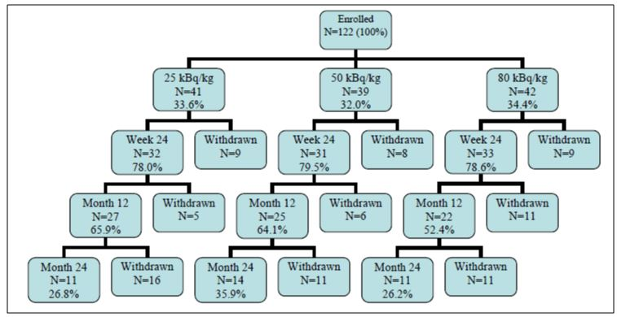

###### Baseline

40% of patients were from UK and remainder balanced at other centres. Patients in the 50 kBq/kg dose group were slightly younger (mean 66.8 years) and heavier (mean 86.1 kg) than those in the 25 kBq/kg and 80 kBq/kg dose groups (71.6 years, 81.0 kg and 69.4 years, 82.3 kg, respectively). However, body mass index was comparable across the three dose groups. Three patients were not Caucasian (one in the 80 kBq/kg dose group was Oriental-Asian; two in the 50 kBq/kg dose group were reported as ‘other’).

In general, there was no major difference between dose groups in past or current medical diagnosis or physical examination. At baseline, the median ECOG performance status was 1 in the 25 and 80 kBq/kg dose groups and 0 in the 50 kBq/kg dose group.

##### Results

###### Primary efficacy outcome

The primary efficacy variable was the proportion of patients in the PP Set with a confirmed PSA response, defined as a decrease in PSA levels from baseline of at least 50 % confirmed 3 weeks (at least 19 days) later (Table 22).

Table 22: Study BCI-04: Proportion Patients with Confirmed PSA Response.

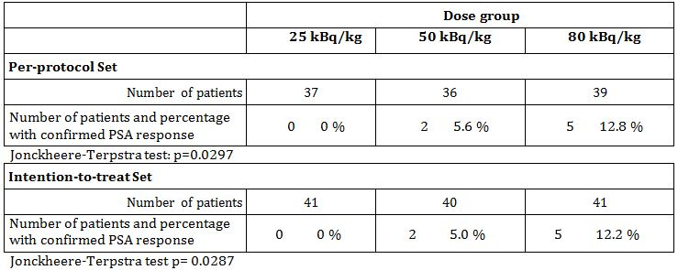

The Jonckheere-Terpstra test showed a statistically significant dose response in both the PP set (p=0.0297) and the ITT set (p=0.0290). Pair wise comparisons between adjacent dose groups was not statistically significant (p>0.05) and the difference in proportion of PSA responders between the lowest and highest dose group was also not significant (p=0.0548, Fisher’s exact test).

###### Secondary efficacy outcomes: PSA

There was a statistically significant dose response relation in time to confirmed PSA response (p=0.0205); the median time to confirmed PSA response could not be estimated due to low numbers of responders (Figure 11).

Figure 11: Study BCI-04: Kaplan Meier plot of time to confirmed PSA response.

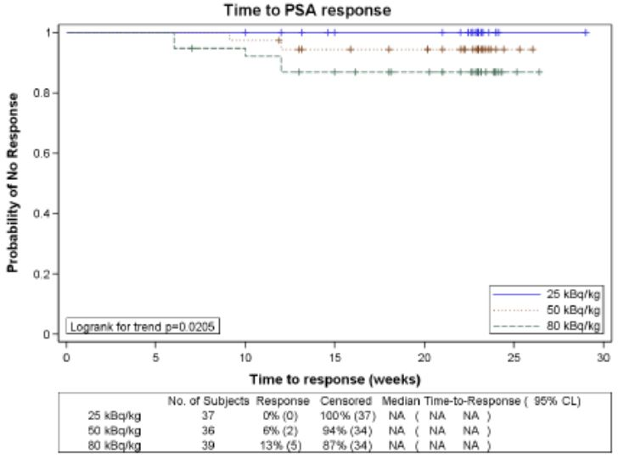

The mean PSA increased in all dose groups at all time points. The increases in 50kBq/kg and 80 kBq/kg dose groups were comparable and smaller than in the 25 kBq/kg dose groups. The test for dose response was not statistically significant at any time point (Week 10 p=0.075; Week 13 p=0.052; Week 16 p=-0.050 and Week 24 p=0.052.

The maximum relative decrease in PSA was comparable in the 50 kBq/kg and 80kBq/kg dose groups (mean 40.4% and 35.5%, respectively), both greater than in the 25 kBq/kg dose groups. The test for dose response was not statistically significant. The median time to the maximum decrease was 10 to 11.5 weeks in each treatment group with no statistically significant dose response.

###### Secondary efficacy outcomes: Bone-ALP

The Jonckheere-Terpstra test showed a statistically significant dose-response (p<0.0001) in the proportion of patients with a confirmed bone-ALP response. Pair-wise comparisons between the dose groups showed statistically significant differences in the proportion of patients with a confirmed bone-ALP response between the lowest and intermediate dose groups (p<0.0001; and the lowest and highest dose groups (p<0.0001; but not between the intermediate and highest dose groups (p=1.00; Fisher’s exact test) (Table 23).

Table 23: Study BCI-04: Proportion of Patients with confirmed bone-ALP response.

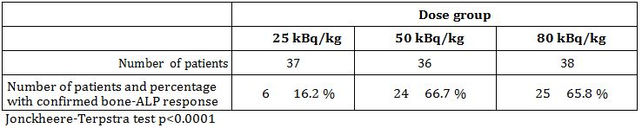

The median time to confirmed bone-ALP response could not be estimated in the 25 kBq/kg dose group and was 9 to 10 weeks in the 50 kBq/kg and 80 kBq/kg (p<0.0001 for dose response) (Figure 12).

Figure 12: Study BCI-04: Kaplan Meier plots of time to confirmed bone ALP response.

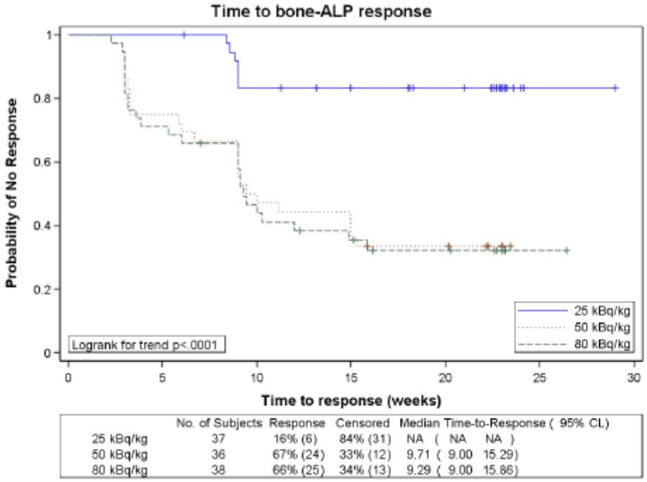

The median bone-ALP decreased in all dose groups at all time points, most especially in the 50 kBq/kg and 80 kBq/kg dose groups (p≤0.05 for dose response at all time points). After Week 16, the median percent decrease in bone-ALP declined compared with the preceding time point as median values began to increase back towards the baseline (Figure 13).

Figure 13: Study BCI-04: Median relative change from baseline in bone-ALP (PPS).

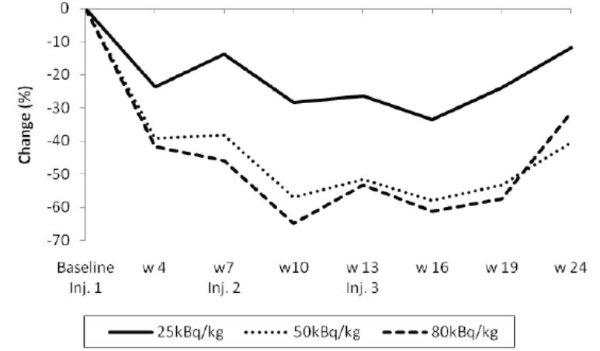

There was no statistical significant difference in the proportion of patients with confirmed bone-ALP progression or the time to confirmed progression.

###### Secondary efficacy outcomes: s-CTX-1

There was no dose related trend in the proportion of patients with a confirmed s-CTX-1 response, confirmed progression, or the time to confirmed response.

There were statistically significant dose response relationship in time to confirmed progression (12 weeks for the 25 kBq/kg dose group; not estimable for the 50 kBq/kg dose group; 18.3 weeks for the 80 kBq/kg dose group) and in the changes from baseline at Weeks 16 to 24.

Figure 14: Study BCI-06: Time to CTX-1 progression (PPS).

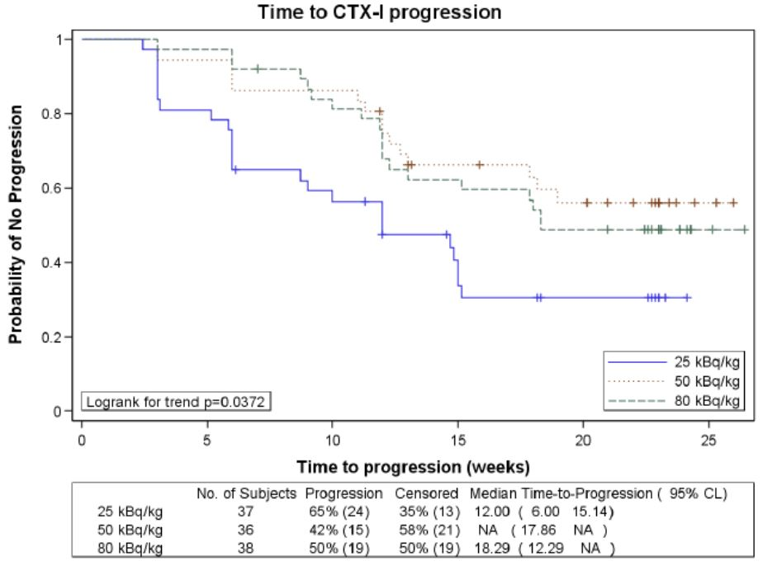

Figure 15: Study BCI-04: Median relative change from baseline in s-CTX-I (PPS).

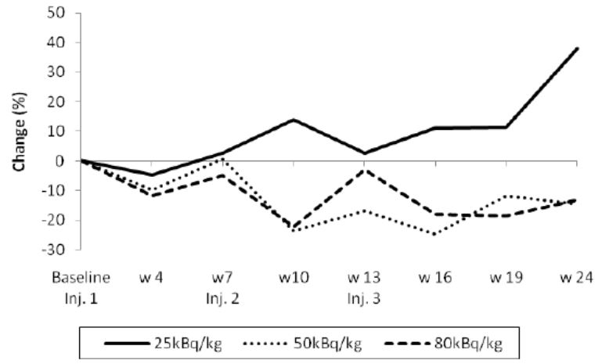

###### Secondary efficacy outcomes: correlations between PSA, bone-ALP and s-CTX-I

The strength of the associations between absolute values of PSA, bone-ALP and serum CTX-I were investigated using pairwise Spearman rank correlation coefficients calculated both pooled across all doses and separately for each dose group within each time point. There was a high degree of correlation between PSA and bone-ALP (pooled correlation coefficients in the range 0.382 to 0.462), bone-ALP and s-CTX-I (0.594 to 0.731) and PSA and s-CTX-I (0.258 to 0.398) in all dose groups and most time points.

###### Secondary efficacy outcomes: skeletal related events

In total 62 of 112 patients in the PP analysis set had at least one skeletal related event with a total of 71 events being reported (each type of event being counted only once per patient). The most frequent skeletal related events reported were increase in pain, increase in analgesic consumption and external radiotherapy. The proportion of patients reporting at least one event (41%, 50% and 44% in the 25 kBq/kg, 50 kBq/kg and 80 kBq/kg dose groups, respectively) and the number of events reported (20, 25 and 26, respectively) were comparable between dose groups.

###### Secondary efficacy outcomes: pain

Pain was assessed using the BPI form (a 12-item questionnaire). Items 1 to 3 are related to the severity of pain during the past week, and item 4 is related to pain severity at present time. Item 5 concerns assessment of pain relief provided from pain treatment or medication during the past 24 hours. Items 6 to 12 concern the effect of pain on the subject’s function over the previous week. Each item is rated on a scale from 0 to 10, where 0 was equal to no pain, no pain relief, or no function interference, and 10 was equal to pain as bad as you can imagine, complete pain relief or complete function interference, depending on the item.

The pain index was based on a combination of the score of BPI item 3 and the analgesic consumption for each patient. A high proportion of patients were missing pain index data – only available for 86 of 112 patients in the PP analysis set.

The initial pain response appeared slower in the 25 kBq/kg dose group than in the 50 kBq/kg and 80 kBq/kg groups. At Week 16 and Week 19, around half (50 to 60% of patients in each group) had a pain response. By Week 24, the percentage with a pain response had decreased to 44 to 52%. In total, 68%, 54% and 58% in the 25 kBq/kg, 50 kBq/kg and 80 kBq/kg dose groups respectively, experienced pain progression. The proportion with pain progression and the times to pain response and pain progression showed no statistically significant dose response relation.

Analysis of patients with pain at baseline showed that the medical diary pain score decreased from baseline in all dose groups and at most time point it did not demonstrate a statistically significant dose response relationship.

###### Secondary efficacy outcomes: survival

The median time to death was 548, 569 and 604 days, in the 25 kBq/kg, 50 kBq/kg and 80 kBq/kg, respectively. There was no significant differences between groups in the proportion of patients who died (p=0.31) or in the time to death (p=0.44).

### Analyses performed across trials (pooled & meta analyses)

This was not done by the sponsor as the pivotal trial gave a survival advantage on its own. Neither of the supportive studies used the same dose regimen as the pivotal study and so pooled analysis was not appropriate.

### Evaluator’s conclusions on efficacy

The pivotal study, which was appropriately terminated early, demonstrated a 3.6 month survival benefit to patients with castration resistant prostate cancer when treated with 223Ra. The study numbers are high and the survival benefit is supported by a suggestion of a survival advantage in the supportive study and related benefits on skeletal related events and pain relief and also on the surrogate markers of effect on bone ALP and PSA.

The supportive studies did not use the same dose regimen as the pivotal study. Study BCI-06 applied the proposed recommended dose of 50 kBq/kg body weight every 4 weeks for 6 cycles. Study BCI-02 assessed 50 kBq/kg body weight every 4 weeks for 4 cycles. The study showed a survival benefit for 223Ra in the per protocol (PP) population but not in the intention-to-treat (ITT) population.

The pivotal clinical study excluded patients with visceral metastases. This has been noted by the FDA in their approved indication which accurately reflects the patients who were included in the single pivotal study. The sponsor in the Clinical Overview comments that while patients with visceral metastases were excluded from the pivotal trial, these patients should not be excluded from the approved indication. They base this assertion on the fact that in prostate cancer in patients with both bone and visceral disease, bone disease is often dominant and the visceral lesions may be clinically inconsequential and that in these patients the bone disease determines clinical outcome, and therefore 223Ra is likely to be of benefit. While this may be true, it has not been proven and the sponsor still chose to exclude these patients from the studies. It is therefore recommended that the indication be changed to accurately reflect the patients in whom benefit has been proven, that is, CRPC patients with symptomatic bone metastases with no visceral metastases.

## Clinical safety

*Comment: The Summary of Clinical Safety was not reported as an integrated summary. The studies are summarised individually despite the exposure being reported by a number of safety pools.*

### Studies providing safety data

The following studies provided evaluable safety data.

#### Pivotal efficacy study

In the pivotal efficacy study, (Study BCI-06), the following safety data were collected:

* General adverse events (AEs) were assessed by collecting all AEs that may have been reported spontaneously by the subject or elicited through open (non leading) questioning during each visit and at the end of the AE follow up period. Any AEs that occurred after randomisation and within 12 weeks after last injection of study drug were reported, whether or not considered related to the study drug.
* AEs of particular interest, indicating long term toxicity, were assessed by recording the presence of any of the following diseases: acute myelogenous leukaemia (AML), myeloblastic syndrome (MDS), aplastic anaemia, and primary sarcomas of the bone or new primary cancer in other organs. During the follow up period patients were evaluated every 2 months for 6 months then every 4 months for 3 years.
* Laboratory tests, including haematology and clinical chemistry, were performed at baseline and at weeks 4, 8, 12, 16, 20, 24 and then every 2 months for 6 months and then every 4 months for 3 years.
* A standard 12 lead electrocardiogram (ECG) was performed at screening, 4 and 24 weeks after first study drug administration, and at treatment discontinuation if relevant. Results were recorded as normal or abnormal. The ECG was evaluated by the local investigator.
* An abbreviated physical examination consisting of general appearance, lungs, cardiovascular system and abdomen, and other physical findings was done at each hospital visit.

#### Pivotal studies that assessed safety as a primary outcome

Not applicable.

#### Dose-response and non-pivotal efficacy studies

The dose response and non pivotal efficacy studies provided safety data, as follows:

* Study BCI-02 provided data on AEs, haematology and clinical chemistry and an abbreviated physical examination.
* Study BCI-04 provided data on AEs, concomitant medications, physical examination, ECOG and clinical laboratory tests.

#### Clinical pharmacology studies

* Study ATI-BCI provided data on AEs, haematology and serum biochemistry, urinalysis and occurrence of AEs. Safety was assessed for 8 weeks after the single injection.
* Study BCI-03 provided data on AEs, change in clinical laboratory values including bone ALP and PSA and changes in abbreviated physical examination. During the 24 month follow up, AEs considered drug related and long term toxicities (such as AML, MDS, aplastic anaemia and primary sarcomas of the bone) were recorded.
* Study BCI-05 provided data on AEs changes in vital signs, ECG parameters, physical examination and changes in haematology and blood chemistry. Long term toxicity was collected for up to 12 months after the first injection.
* Study BCI-08 provided data on AEs, concomitant medication, physical examination, Karnofsky performance status, vital signs, 12 lead ECG, clinical laboratory tests, patient status (survival) and long term toxicities and bone marrow biopsy. Follow up was for 12 months after treatment.

### Pivotal studies that assessed safety as a primary outcome

Not applicable.

### Patient exposure

For the safety analysis the sponsor has used 3 data pools (Pool 2, 4 and 5) as shown in Tables 24 and 25.

Table 24: Exposure to 223Ra in clinical studies.

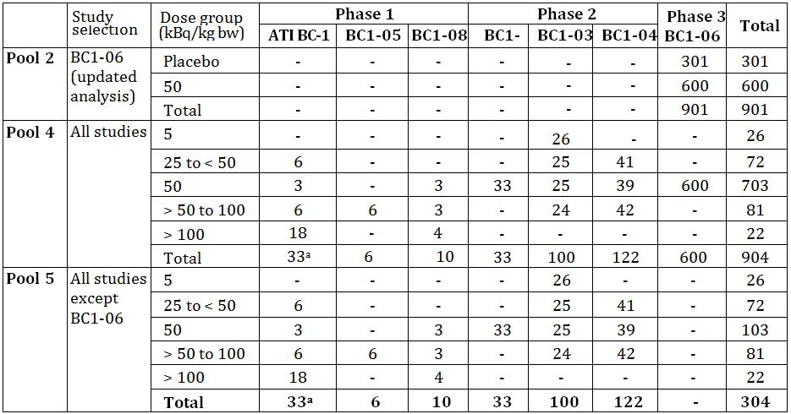

a. 2 patients in Study ATI-BC1 were treated twice during the study and were re-numbered for the second injection. Data from both the original injection and re-injection are summarised separately, thereby double counting these patients.

Table 25: Exposure to 223Ra in clinical studies according to exposure and number of injections.

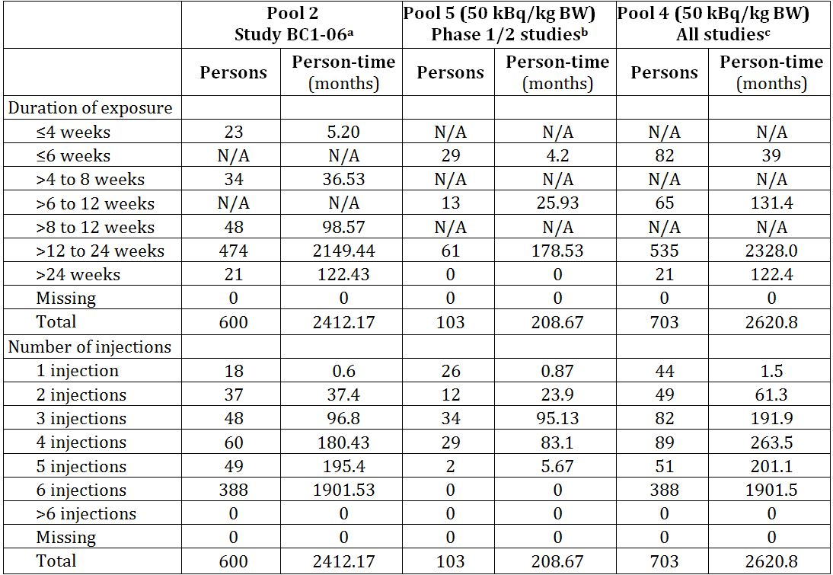

a. Safety data from the randomised, double-blind, placebo-controlled study BC1-06 (cycle length of 4 weeks).

b. Safety data from (50 kBq/kg data only) from phase 1/2 studies: ATI-BC-1 (n = 3), BC1-02 (n = 33), BC1-03 (n = 25), BC1-04 (n = 39), BC1-08 (n = 3)

c. Safety data (50 kBq/kg data only) from studies: ATI-BC-1 (n = 3), BC1-02 (n = 33), BC1-03 (n = 25), BC1-04 (n = 39), BC1-08 (n = 3), BC1-06 (n = 600)

N/A = Not available

Person Time for each patient is calculated as the date of the last injection of study treatment - date of the first injection + 1.

Total is the sum of person-time in months.

### Adverse events

#### All adverse events (irrespective of relationship to study treatment)

##### Pivotal study

A total of 93% (558/600) patients in the radium-223 group and 96.3% (290/301) in the placebo group reported treatment emergent adverse events (TEAEs). The rate of TEAEs for either treatment did not appear to increase with the number of injections given until after the last injection and 12 weeks, especially in the placebo group (between injection 1 and 2: radium-223 61.0%, placebo 60.1%; last injection at 6-12 weeks: radium-223 68.0%. placebo 73.6%).

The most commonly reported AEs (≥25% in either group) were bone pain, nausea, anaemia, fatigue, and diarrhoea. Diarrhoea, vomiting, thrombocytopenia, and neutropenia were reported more frequently in the radium-223 group and bone pain was reported more frequently in the placebo group (Table 26).

Table 26: Study BC1-06: Treatment-emergent adverse events.

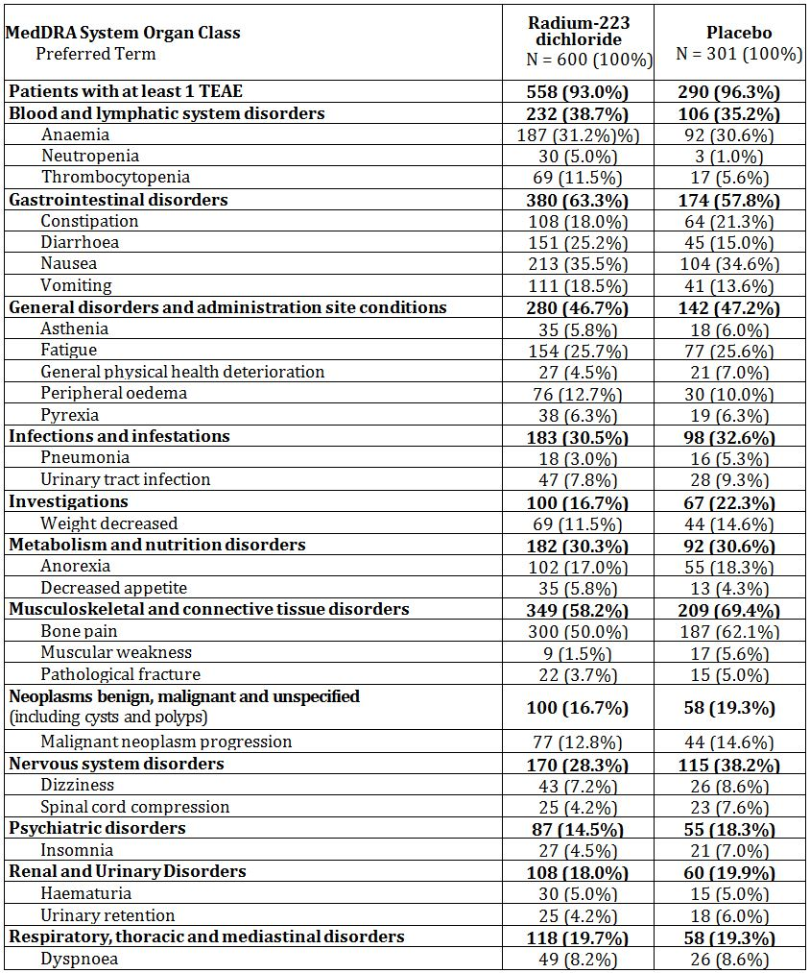

Entries recorded in ≥ 5% of patients in either treatment group.

Figures denote number (%) of patients, safety population, updated analysis.

Note: For each patient, multiple occurrences of the same event are counted once within a MedDRA SOC and PT.

MedDRA = Medical Dictionary of Regulatory Activities; SOC = system organ class; PT = preferred term; TEAE = treatment-emergent adverse event; N = number of patients; n = number of patients with event

##### Other studies

The sponsor has analysed safety of the patients in the pivotal studies compared to all studies and patients in the Phase 1 & 2 studies. The purpose of this was to determine whether there were differences between patients in the pivotal study (BCI-06) compared to the Phase 1 & 2 studies.

The incidence of Blood and Lymphatic System Disorders was slightly higher in Study BCI-06 than in the Phase 1 & 2 studies (Study BCI-06, 35.8% and Phase 1/2 studies, 13.6%). Further analysis suggested that one potential contributory factor to these differences could be the use of prior docetaxel in approximately 60% of patients in BCI-06. Another potential factor was the longer exposure to radium-223 dichloride and the longer follow up of the patients in Study BCI-06 compared to the patients in the phase 1 & 2 studies (where many patients only had a single dose and were followed for a shorter period of time).

The incidence of gastrointestinal disorders was nearly identical across the analysis sets including the important AEs of diarrhoea, nausea, and vomiting, suggesting that GI disorders will be the same regardless of the number of injections of radium-223 dichloride. Constipation was the only GIT with higher incidence in the Phase 1 & 2 studies for uncertain reasons.

#### Treatment-related adverse events (adverse drug reactions)

##### Pivotal study

Overall, patients with at least one related TEAE were higher in the radium-223 group (63.3%) compared with the placebo group (56.8%) (Table 27).

Table 27: Study BC1-06: Drug-related treatment-emergent adverse events occurring in ≥ 5% of patients in either treatment group.

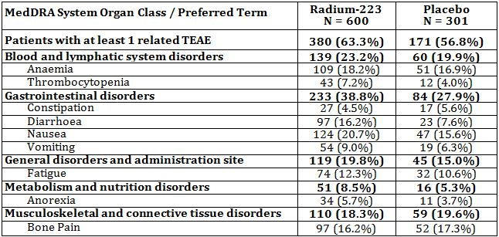

MedDRA 11.0 Figures denote number (%) of patients; safety population, updated database

MedDRA = Medical Dictionary of Regulatory Activities; SOC - system organ class; PT = preferred term; TEAE = treatment-emergent adverse event; N = number of patients; n = number of patients with event

The incidence of several haematological AEs was higher in the radium-223 group compared with placebo: thrombocytopenia, neutropenia, pancytopenia and leucopoenia. Differences (higher in placebo) were also seen in muscular weakness, spinal cord compression, and general physical heath deterioration. Dehydration was higher in the radium-223 group.

##### Other studies

###### Study BCI-02

The most frequently reported individual AEs considered related to treatment (reported by >5% of patients) were diarrhoea, nausea, vomiting, pyrexia, tumour flare and haemoglobin decreased.

###### Study BCI-04

The most frequent AEs considered related to study treatment were diarrhoea, nausea, asthenia and anaemia. The proportion of patients reporting nausea and anaemia appeared to be related to dose of radium-223. The majority of related AEs were CTC Grade 1 or 2; two were Grade 4 and 10 were Grade 3. Those considered Grade 3 or 4 were most frequently anaemia/haemoglobin decreased and platelet count decreased.

#### Deaths

##### Pivotal study – BCI-06

There were 518 deaths reported during the study (patients who received treatment or during the 3 years of follow up): 54.5% (327/600) in the radium-223 group and 63.5% (191/301) in the placebo group. Between 24 weeks (end of treatment) to <1 year of initiating treatment, a slightly smaller percentage of patients in the radium-223 group (22.2%) died than in the placebo group (25.6%); deaths during the 3 year follow-up period were balanced between the treatment groups.

The deaths were due to disease progression in 48.2% of patients in the radium-223 group and 49.5% in the placebo group. Most deaths in both groups were considered to be unrelated to study drug. The full details of the deaths are shown in Table 28.

Table 28: Study BCI-06: Summary of deaths (Safety population, updated database).

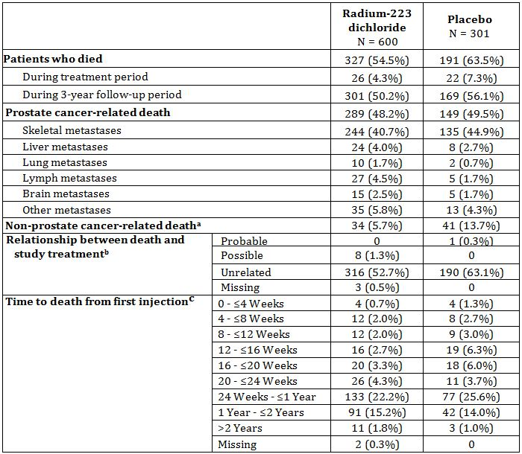

Figures denote number (%) of patients, safety population; updated database.

a. These were deaths that were not attributed to the patient’s prostate cancer such as myocardial infarction, respiratory failure, etc

b. According to the investigator’s judgment.

c. These data do not take into account the actual number of injections a patient received.

Note: Three patients from the radium-223 dichloride group were missing data regarding relationship to prostate cancer.

N = number of patients; n = number of patients with event

The majority of deaths were considered to be unrelated to study treatment; 316/327 of the radium-223 group and 190/191 of the placebo group.

Three subjects had a missing relationship between death and study treatment but subsequent queries confirmed that the investigator considered these deaths to be unrelated to study drug. The reason for death was prostate cancer for two of the subjects; one reason remains unknown because the subject was lost to follow up.

Table 29 lists the reasons for death in the 9 patients (8 radium-223 and 1 placebo) where the investigator considered the death to be possibly related to study medication.

Table 29: Study BCI-06: Summary of deaths considered to be related to study drug.

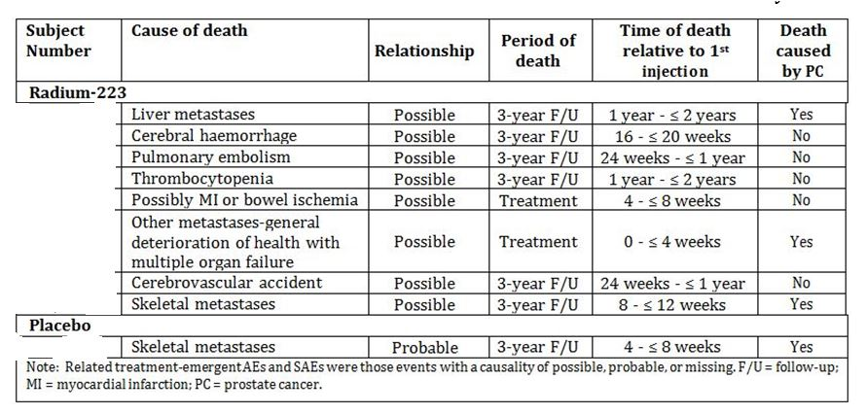

##### Other studies

###### BCI-02

From Week 0 to Month 12, there was a lower proportion of patients that died in the radium-223 group (14 of 33 patients [42%]) than in the placebo group (17 of 31 patients [55%]). The most frequent cause of death in the 12 months following the first injection was progression of metastatic prostate cancer, which occurred in 10 of 33 patients (30%) in the radium-223 group and 14 of 31 (45%) in the placebo group.

In the follow up period between 12 and 24 months post first injection, 9/19 patients (47%) died in the radium-223 group and 10/14 patients (71%) died in the placebo group. Similar to the first 12 month period the most frequent cause of death was progression of disease (Table 30).

Table 30: Overview of cause of death from first study drug injection to month 24 (full analysis set).

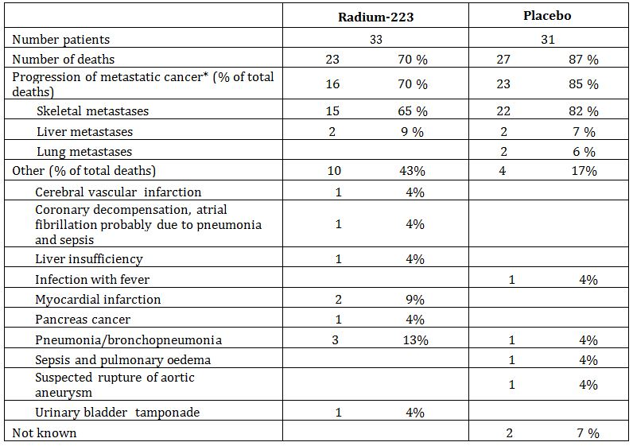

Patients may have had more than one cause of death, e.g., Progression of metastatic cancer and other. Thus, the number of causes of death exceeds the number of deaths,

* Two patients, one in radium-223 group and one in placebo group had evidence of progression of metastatic cancer documented, but kind of metastases not recorded in the CRF. All patients with liver and lung metastases also had skeletal metastases crossed as cause of death.

###### Study BCI-04

In total 83 deaths were reported in the study. Of these, 70 patients died within 24 months of drug administration, while 13 died more than 2 years after the first drug administration and after they had completed their 24 month visit. The cause of death was recorded for 79 patients (missing for 2) and the overwhelming majority, 73 (92%) of those with a reason recorded) died from progression of prostate cancer.

Six AEs with onset before Week 24 led to an outcome of death; 3 AEs in 3 patients treated with 25 kBq/kg (cardiac failure, disease progression and metastases to liver); 2 in 2 patients treated with 50 kBq/kg (metastatic squamous cell carcinoma and prostate cancer) and 1 in 1 patient treated with 80 kBq/kg (chest pain) (Table 31).

Table 31: Study BCI-04: reasons for death.

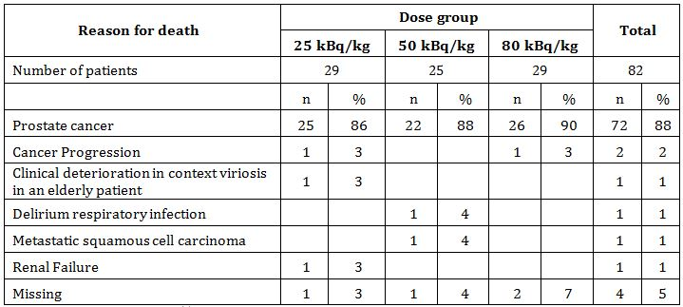

#### Other serious adverse events

##### Pivotal study (BCI-06)

Treatment-emergent serious adverse events (SAEs) by SOC and PT occurring in at least 1% of the patients by PT in either treatment group are summarised in Table 32.

Table 32: Study BCI-06: Serious Adverse Events.

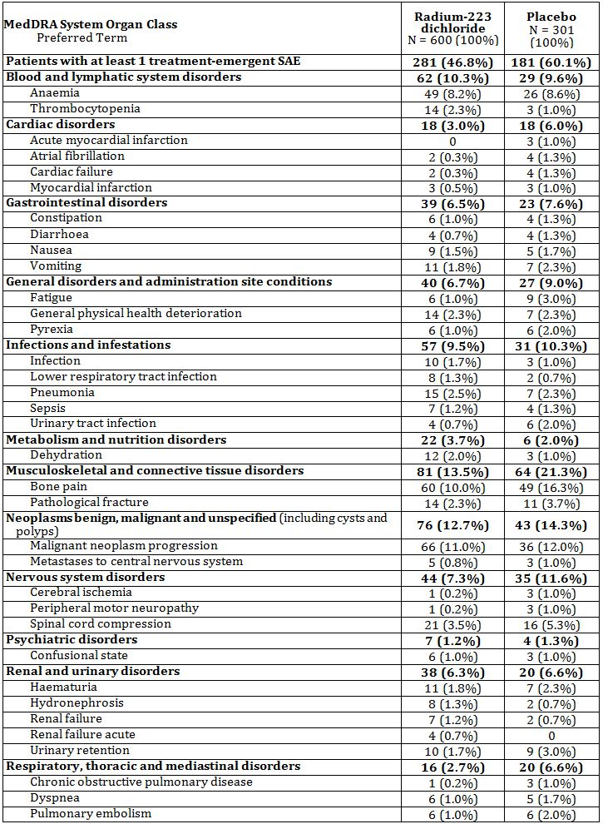

Entries recorded in ≥1% of patients in either treatment-emergent adverse events; figures denote number (%) of patients; safety population, updated database

Note: For each patient, multiple occurrences of the same event are counted once within a MedDRA SOC and PT.

Note: TEAEs with missing serious flags are regarded as serious.

MedDRA = Medical Dictionary of Regulatory Activities; SOC = system organ class; PT = preferred term; TEAE = treatment emergent adverse event; SAE = serious adverse event(s); N = number of patients; n = number of patients with event

Overall, treatment-emergent SAEs were experienced at a lower incidence rate (46.8%, 281/600) in the radium-223 group compared with patients in the placebo group (60.1%, 181/301). The most common (≥5% in either group) SAEs were consistent with the underlying disease such as bone pain, malignant neoplasm progression, anaemia and spinal cord compression.

All other SAEs occurred in <5% of patients. There were differences seen between the treatment groups for the following SAEs where the highest occurrence was in the radium 223 group: thrombocytopenia. The following events were reported more frequently in the placebo group: bone pain, fatigue, pathological fracture, and spinal cord compression.

##### Other studies

###### Study BCI-02

In the period between the first injection to 4 weeks after the last injection, 8 (24%) of 33 patients in the radium-223 group and 14 (45%) of 31 in the placebo group recorded SAEs. The events were considered to be related to the study drug in 3 (9%) of the 33 patients (thrombocytopenia, lumbago and spinal cord compression) and 1 (3%) of the patients in the radium-223 and placebo groups respectively.

Patients were monitored closely for any evidence of long-term toxicity. No cases of leukaemia, myelodysplastic syndrome, aplastic anaemia or primary bone cancer were reported. Two events occurred before the 12-month visit: rectal cancer and osteoporotic collapse of the mid-dorsal spine. In the Radium-223 Group, three new events were reported in 3 patients at the 18 and 24 month visits: superficial papillary transitional cell carcinoma of the bladder, cancer of pancreas and pulmonary embolism.

###### Study BCI-04

Overall, 29 (24%) of 122 patients experienced a total of 40 unique SAEs. The most frequently reported SAEs at the PT level were bone pain (6 events), anaemia, disease progression and prostate cancer (4 events each) and spinal cord compression (3 events). The majority of these events were considered related to the underlying disease.

A total of 8 treatment-related SAEs were reported: 2 events of anaemia in 1 patient in the 25-kBq/kg group; bone pain in 2 patients and prostate cancer in 1 patient in the 50 kBq/kg group; and bone pain in 1 patient, constipation in 1 patient, and muscular weakness in 1 patient in the 80-kBq/kg group. All were CTC AE grade 3 except the prostate cancer which was not graded.

#### Discontinuation due to adverse events

##### Pivotal study (BCI-06)

A total of 16.5% (99/600) patients in the radium-223 group and 20.6% (62/301) patients in the placebo group experienced at least 1 TEAEs that led to discontinuation of study treatment. The most common events, those reported by ≥1% of patients in either treatment group were anaemia, thrombocytopenia, bone pain, fatigue, general physical health deterioration, malignant neoplasm progression, spinal cord compression, and pyrexia (placebo only).

Several small differences in rates of treatment discontinuation were found between the treatment groups. Rates of discontinuation due to anaemia (14 [2.3%] in the radium-223 group and 3 [1%] in the placebo group) and general health deterioration (10 [1.7%] in the radium-223 group and 2 [0.7%] in the placebo group) were higher among radium-223 patients, whereas discontinuation due to fatigue (5 [0.8%] in the radium-223 group and 6 [2%] in the placebo group) and bone pain (5 [0.8%] in the radium-223 group and 7 [2.3%] in the placebo group) were higher in the placebo group.

##### Other studies

###### Study BCI-02

Two patients, one in each group, discontinued the study for an AE that did not have an outcome of death. The patient in the radium-223 group discontinued the study due to a confusional state. The patient in the placebo group discontinued the study after completing all 4 doses of study treatment due to progression of a chronic subdural hematoma.

###### Study BCI-04

Six patients withdrew from the study due to an AE: three patients in the 25 kBq/kg dose group, one in the 50 kBq/kg dose group, and two in the 80 kBq/kg dose group. The most frequent AE resulting in withdrawal from the study was progression of prostate cancer (3 of the 6 patients). In total, 5 of the 6 withdrawn patients completed the course of three radium-223 injections before withdrawal from the study; in only one patient did the AE result in discontinuation of radium-223.

### Laboratory tests

#### Liver function

##### Pivotal study

For ALT, AST and total bilirubin there were no trends in the changes in median values and no differences between the treatment groups.

##### Other studies

###### Study BCI-02

LDH, AST, ALT, γGT and bilirubin were measured. The results do not suggest any clinically relevant differences between the treatment groups.

###### Study BCI-04

LDH, AST, ALT, γGT and bilirubin were measured. There was a wide variation in individual values, but overall, the mean and median values were similar between the dose groups.

#### Kidney function

##### Pivotal study

For creatinine there were no trends in the changes in median values and no differences between the treatment groups.

##### Other studies

###### Study BCI-02

Creatinine and urea nitrogen were measured. No treatment related pattern of change was observed.

###### Study BCI-04

Creatinine was measured. There was a wide variation in individual values, but overall, the mean and median values were similar between the dose groups.

#### Other clinical chemistry

##### Pivotal study

For all other clinical chemistry parameters, the median values generally remained within the normal laboratory reference ranges during the treatment period and through follow up and showed general stability over time and between treatment groups. Occasional changes were transient and returned to normal by the end of treatment (4 weeks from the last injection).

##### Other studies

###### Study BCI-02

Values for sodium, potassium, chloride, phosphate, magnesium, calcium and albumin did not indicate any relevant differences between the radium-223 and placebo treatment groups.

###### Study BCI-04

There were no changes in biochemistry parameters that gave rise to any safety concern.

#### Haematology

##### Pivotal study

Median values were selected for evaluation since they were considered to be more robust than mean values in handling data where outlier values are not uncommon.

The median Hg values showed a modest drop over time in both treatment groups, slightly greater in the radium-223 group (-1.1 and -1.6 g/dL at week 24 and Follow-up 2, respectively, radium-223; -0.7 and -0.9 at Week 24 and Follow-up 2, respectively, placebo). However, data in the follow-up period should be interpreted with caution because of the attrition of patients in both groups, but also because of the number of patients that had received transfusions during the treatment and follow-up periods (Table 33 and Figure 16).

Table 33: Study BCI-06: haemoglobin: median changes from baseline, Week 24 and follow up visit at 40 weeks (Safety population, updated database).

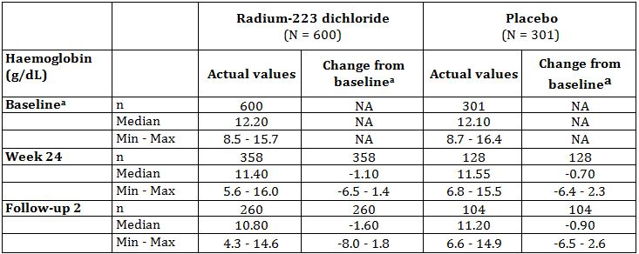

a. Baseline was defined as the value recorded at Week 0. If this value was missing, then the value at screening was used.

Note: Unscheduled laboratory findings are not included in the table.

Note: If > 1 assessment occurred at any visit, then the last valid (non-missing) value was included in the table.

Max = maximum; min = minimum; NA = not applicable.

Figure 16: Study BCI-06: Haemoglobin Box plots for over time - haemoglobin, Safety population.

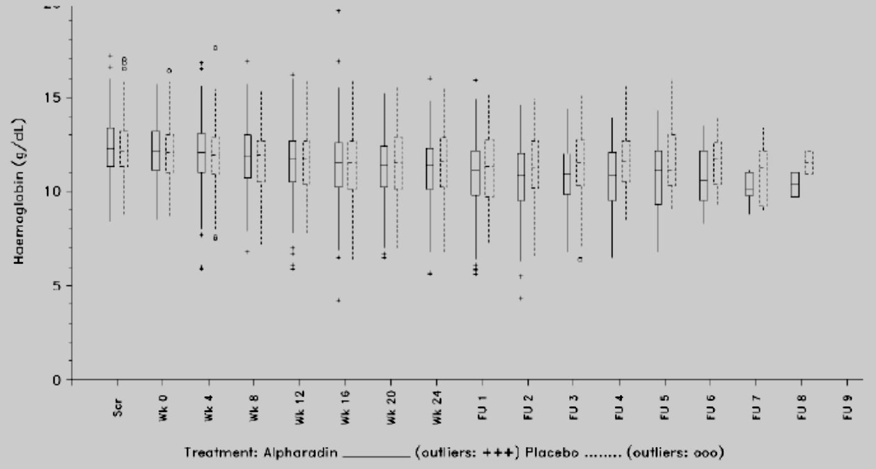

Note: The limits of the whiskers are the maximum and minimum values within limits of 1.5 quartile ranges above and below the upper and lower quartiles respectively.

Scr = Screening; FU = Follow-up; Alpharadin = radium-223

*Comment: This is as clear as figure can be made.*

Changes from baseline by severity were similar in the radium-223 and placebo treatment groups.

##### Other studies

###### Study BCI-02

A statistical analysis of the nadir values of haemoglobin observed over the 12-month follow-up showed no statistically significant differences in the groups.

###### Study BCI-04

The mean (and median) values of haemoglobin were similar in each dose group at baseline, but there was a wide variation in individual values. The median (and mean) Hb levels generally showed a decrease over time from baseline up to Month 24, with the decrease being slightly more pronounced in the highest dose group (80 kBq/kg), although it should be noted that data were only available for a small number of patients at the Month 24 visit. The changes from baseline to Month 24 were small.

#### White blood cells, neutrophils, lymphocytes

##### Pivotal study

Median values for WBCs and neutrophils, as well as lymphocytes, notably decreased from Baseline to Week 24 in the radium-223 group, recovering somewhat by follow-up visit at 40 weeks. Median values for lymphocytes fell below normal range (1.0×109/L) from treatment Week 16 onwards until follow-up visit (40 weeks) in the radium-223 group and then recovered to normal range (Table 34).

Table 34: Study BCI-06: White blood cells, neutrophils, lymphocytes.

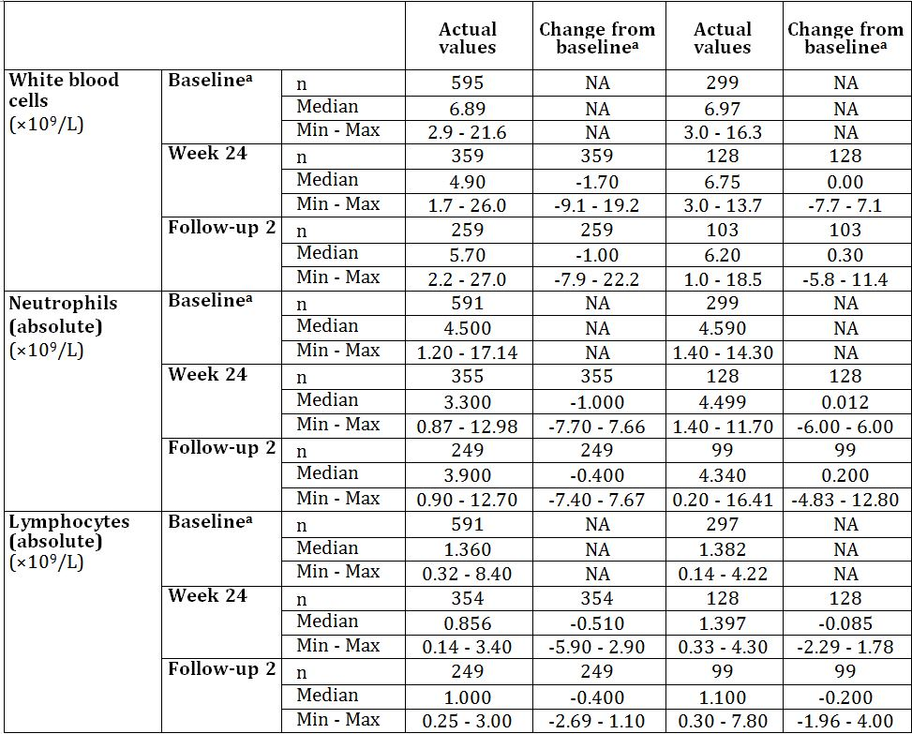

Median change from baseline in white blood cells, neutrophils, lymphocytes at Week 24 and follow up visit 2 (40 weeks from the first injection); Safety population, updated database

a Baseline was defined as the value recorded at Week 0. If this value was missing, the value at screening was used.

Note: Unscheduled laboratory findings are not included in the table.

Note: If >1 assessment occurred at any visit, then the last valid (non-missing) value was included in the table.

Max = maximum; min = minimum; N = number of patients; n = number of patients with valid data at evaluation; NA = not applicable.

Fewer patients in the radium-223 group than in the placebo group had WBC lower values within the normal range (64.5%, 378/586 radium-223; 89.5%, 256/286 placebo). There were 17/586 (2.9%) patients with Grade 3 and 1 patient with Grade 4 lower values in the radium-223 group and no patients in the placebo group with Grade 3 or 4 lower values for WBC.

The results for neutrophils paralleled the results for WBCs. Nine patients (9/584, 1.5%) had Grade 3 values and 3 patients (3/584, 0.5%) had Grade 4 low values in the radium-223 group; there were no Grade 3 or 4 low values in the placebo group.

A lower proportion of patients in the radium-223 group (168/584, 28.8%) than in the placebo group (129/284, 45.4%) maintained lymphocyte values in the normal range. Two patients in the radium-223 group and 1 patient in the placebo group had Grade 4 low lymphocyte levels.

##### Other studies

###### Study BCI-02

The baseline values for neutrophils were lower in the radium-223 group (median 4.1 x 109 / L) than in the placebo group (median 5.7 x 109 / L) and tended to decrease more after treatment with radium-223 than in the placebo group. The mean nadir values after baseline to the 16-week period were 2.78 x109/L in the radium-223 group and 3.74 x109/L in the placebo group (P=0.011, Wilcoxon rank sum test).

The total WBC counts paralleled those in neutrophils. Lymphocyte counts were similar in the two treatment groups at the end of the study.

###### Study BCI-04

The mean (and median) values of WBC, neutrophil and lymphocyte counts were similar in each dose group at baseline, but there was a wide variation in individual values. For total WBC, neutrophil, lymphocyte and platelet counts, the median (and mean) values were lower at Weeks 4, 10, and 16 (i.e. the first visits after each injection, compared with the values before the injection). The decreases over time were larger in the 50 and 80 kBq/kg dose groups than in the 25 kBq/kg dose group. After completion of the treatment period, values returned to close to baseline with no obvious differences between the dose groups.

#### Platelets

##### Pivotal study

Median platelet values in both the radium-223 and placebo groups showed modest drops throughout the treatment period; however median values remained above the lower limit of normal range of 150×109/L at both the Week 24 (end of treatment) and Follow-up 2 visits (Table 35).

Table 35: Study BCI-06: Median change from baseline in platelet values at week 24 and follow-up visit 2, Safety population.

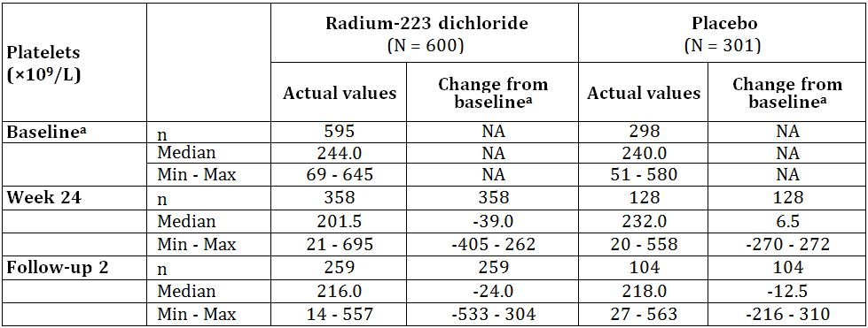

a. Baseline was defined as the value recorded at Week 0. If this value was missing, then the value at screening was used.

Note: Unscheduled laboratory findings are not included in the table.

Note: If > 1 assessment occurred at any visit, then the last valid (non-missing) value was included in the table.

Max = maximum; min = minimum; NA = not applicable.

Changes from baseline by severity were similar in the radium-223 and placebo treatment groups.

##### Other studies

###### Study BCI-02

There was no statistically significant difference between the groups in the nadir observed values for platelets from baseline to 16 weeks.

###### Study BCI-04

The mean (and median) values of platelet counts were similar in each dose group at baseline, but there was a wide variation in individual values.

#### Haematology by prior docetaxel use

Patients treated with prior docetaxel had an overall higher rate of haematological AEs than those who did not receive prior docetaxel. The overall incidence of haematological AEs (anaemia, neutropenia and thrombocytopenia) was higher in both the radium-223 and the placebo group, compared to those who did not receive prior docetaxel treatment. The incidence of significant (Grade 3 and 4) neutropenia was very low regardless of prior docetaxel treatment. Moreover, no cases of febrile neutropenia occurred in patients who had received prior docetaxel in the study: the only 2 cases occurred in non-docetaxel recipients (1 in each treatment group). Overall there was no increased incidence of infection with neutropenia and haemorrhage with thrombocytopenia in radium-223 treated group versus those treated with placebo.

#### Haematology by prior external beam radiation therapy

For the placebo group, incidence rates for anaemia, neutropenia and thrombocytopenia were lower in the EBRT group compared to the group who did not receive prior EBRT. For the radium-223 group, the incidence of thrombocytopenia was higher in patients who received prior EBRT than for those who did not (12.9% than in 8.8%, respectively). The rates for anaemia and neutropenia were similar between the previous exposure and non-exposure group for radium-223 dichloride.

#### Electrocardiograph

##### Pivotal study

A sub study of the pivotal efficacy study (Study BCI-06) was performed to evaluate the potential for QTc interval prolongation of radium-223. A total of 29 patients participated in the sub study, 21 received radium-223 and 8 received placebo. PR interval, QRS interval, heart rate, QT interval, QTc intervals and morphological abnormalities were assessed. The time difference between the drug and the placebo group for the QTcF interval was evaluated as the primary endpoint.

There was no evidence that intravenous injection of radium-223 at a dose of 50 kBq/kg bw significantly prolongs the QTc interval. No clinically meaningful changes were observed in other ECG variables. No morphologic wave form changes were found with administration of radium-223. No trend indicating any cardiac toxicity was identified in the analysis of the 12 lead ECGs obtained following administration of radium-223.

##### Other studies

No ECG data were collected in Studies BCI-02 or BCI-04.

#### Physical finding and vital signs

##### Pivotal study

Overall, there were either no changes observed or the changes were of no clinical importance. Clinically significant changes were predominantly observed in the patients’ general appearance during the course of the study which was attributed to the progression of disease.

##### Other studies

###### Study BCI-02

The changes reported most frequently in physical examination up to Week 16 were the amount of pain and the occurrence of oedema of the lower limbs. These are expected consequences of the underlying disease and there was no clear difference between the treatment groups.

###### Study BCI-04

There was no notable difference between the dose groups in terms of number of patients with a clinically significant change in physical examination or vital signs from last observation at any time point.

#### Safety of cytotoxic chemotherapy following radium-223

The proportion of patients treated with chemotherapy after completing study drug was 93/614 (15%) in the radium-223 group and 54/307 (18%) in the placebo group. Overall the most common chemotherapeutic agents administered after study drug treatment were docetaxel (n = 105), mitoxantrone (n = 23), and cyclophosphamide (n = 19). Median time to chemotherapy after study drug was 15.5 days longer in the radium-223 group compared with placebo (80.0 days vs. 64.5 days, respectively). Median duration of chemotherapy administered after study drug was 120 days (17.1 weeks) in the radium-223 group versus 112.5 days (16.1 weeks) in the placebo group.

In patients receiving chemotherapy after the last dose of study drug (n=147), no major differences between the treatment groups were seen in median values of haemoglobin, neutrophils, and platelets from baseline to Month 32.

Based on the limited sample size of this post hoc analysis, chemotherapy may be safely administered after radium-223 dichloride. Patients receiving chemotherapy after radium-223 had similar haematologic safety profiles as patients receiving chemotherapy after placebo.

#### ECOG (and/or Karnofsky) performance

##### Pivotal study

The median time to occurrence of first deterioration of ECOG performance status by at least 2 points from baseline was 20.3 months for subjects in the radium-223 group and 16.8 months for subjects in the placebo group (HR = 0.670, 95% CI 0.520 – 0.861; p = 0.00168).

##### Other studies

###### Study BCI-02

The median change from baseline of ECOG performance score was 0.9 in the radium-223 group and 1.0 in the placebo group (not statistically significant).

###### Study BCI-04

There was no consistent trend between the dose groups in ECOG status.

### Post-marketing experience

No post marketing information is presented in the submitted dossier as the product is not yet approved in any market at the time the submission.

### Safety issues with the potential for major regulatory impact

#### Liver toxicity

Safety and efficacy of radium-223 has not been studied in patients with hepatic impairment. Since radium-223 is neither metabolised by the liver nor eliminated via the bile, hepatic impairment is not expected to affect the PK of radium-223. No dose adjustment is considered necessary in patients with hepatic impairment.

#### Haematological toxicity

Haematologic TEAEs are shown in Table 36.

Table 36: Haematologic TEAEs using MEDRA term grouping (50 kBq/kg pool).

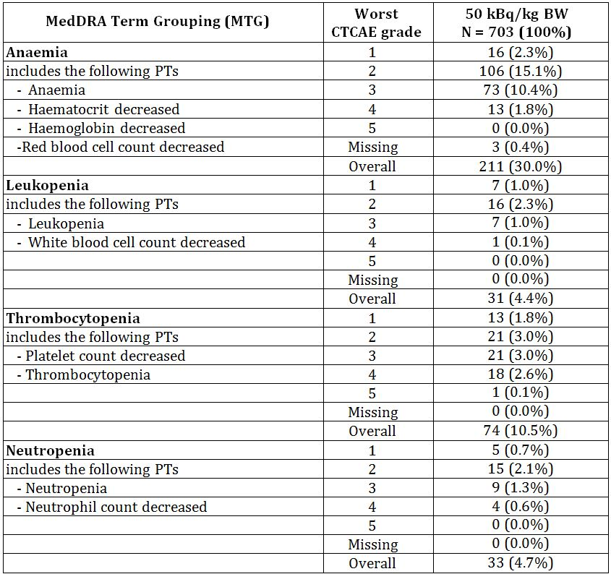

a. Safety data (50 kBq/kg data only) from studies: ATI-BC-1 (n=3), BC1-02 (n=33), BC1-03 (n=25), BC1-04 (n=39), BC1-08 (n=3), BC1-06 (n=600)

This table contains counts of patients. If a patient experienced more than one episode of an adverse event (AE), the patient is counted only once within a PT and for the episode with the maximum intensity. If a patient experienced more than one AE within a SOC, the patient is counted once for each PT and once for the SOC. The denominator for percentages is the number of patients in the Safety Analysis Set.

MedDRA Dictionary Version 14.1 was used for coding. CTCAE Version 3 was used for severity grading.

### Other safety issues

#### Long term toxicity – new primary malignancy

Potential new primary malignancies occurred in Studies BCI-06, BCI-02 and BCI-04. The Sponsor does not consider any of the cases as attributable to radium-223.

In the pivotal study (BCI-06), new primary malignancies were assessed by reviewing all AEs reported (Table 37). Specific diseases were assessed including AML, MDS, aplastic anaemia, primary bone cancer or primary cancer in other organs. These malignancies were selected based on the mode of action of radium-223 dichloride radiation on bone marrow and particularly on bone. Radiation induced osteosarcoma occurs in approximately 1% of patients who have been treated with greater than 25 Gy total doses. The time to onset of secondary osteosarcoma averages approximately 10 to 15 years after radiation exposure, but may occur 3 years to several decades after treatment. Follow up in Study BCI-06 was defined as from 4 weeks after the last study drug administration until 3 years from first study drug administration. No cases of osteosarcoma were reported in this study or in any other clinical study with radium-223 to date.

Table 37: New primary malignancies in all studies.

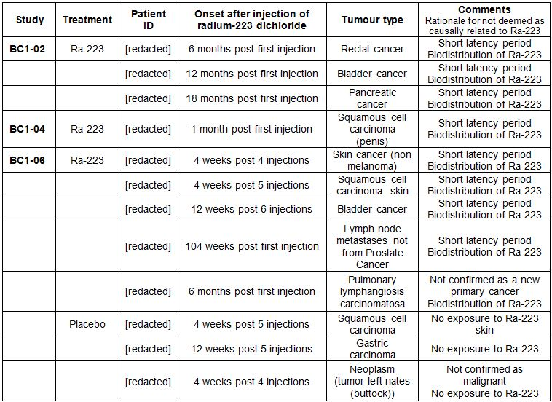

Aplastic anaemia was reported in 1 patient in each treatment group in Study BCI-06. There was 1 SAE of aplastic anaemia (confirmed by biopsy) diagnosed 1 year after last treatment with radium-223. The event was confounded by prior systemic radionuclide (Samarium), external radiotherapy, and chemotherapy (docetaxel). (Information on this case was received after the cut-off date for the updated analysis and so is included in the Summary of Clinical Safety but not in the study report). A case of aplastic anaemia (not confirmed by biopsy) in a patient in the placebo group who had received previous docetaxel chemotherapy was diagnosed 31 weeks after the last injection.

#### Injection site reactions

Injection site reactions (erythema, pain and swelling) are to be expected with any drug with an intravenous route of administration. In the pivotal efficacy Study BCI-06, injection site reactions (including erythema, pain and swelling) were reported in 1.2% of patients treated with radium-223 dichloride. All events were ≤ Grade 2. Results were similar in the supporting studies and the clinical pharmacology studies.

#### Safety related to drug-drug interactions and other interactions

No clinical interaction studies have been conducted. Concomitant chemotherapy with radium-223 may have additive effects on bone marrow suppression. Safety and efficacy of concomitant chemotherapy with radium-223 dichloride have not been established. See also section 8.5.11 for discussion of patients who received chemotherapy after radium-223 in the pivotal efficacy study.

#### Eye disorders

Retinal detachment was seen in dogs in the preclinical studies. No case of retinal detachment was reported in any of the clinical trials.

#### Osteonecrosis

Zoledronic acid treatment and some of the newer therapies that inhibit bone resorption (eg denosumab) are associated with osteonecrosis of the jaw (ONJ). In Study BCI-06, the incidence of osteonecrosis was 0.67% (4/600 patients) in the radium-223 group and 0.33% (1/301 patients) in the placebo group. No cases of osteonecrosis were reported in any other study. All patients with ONJ were exposed to prior or concomitant zoledronic acid and prior chemotherapy. In one case in Study BCI-06, the diagnosis of ONJ may be questioned as the event resolved following tooth extraction. As tooth extraction is often a trigger for ONJ the mandibular necrosis (term used by the investigator) might refer to a dental process other than ONJ.

Given that ONJ have been reported to occur in about 1% of patient treated with zoledronic acid for bone metastases, the data does not suggest a causal involvement of radium-223 in ONJ.

### Evaluator’s conclusions on safety

The safety is based largely on the large patient numbers in the pivotal clinical study (BCI-06). 600 patients received 223Ra. This large patient population means the upper limit of the 95% confidence interval (CI) of an undetected AE is not higher than 3/904 (0.3%).

While almost all patients reported at least one AE, this is to be expected from the patient population. In the randomised pivotal efficacy study (BCI-06), the AE rate was lower in the 223Ra group compared to placebo.

As expected for a radiopharmaceutical excreted by the gut, the most frequent AEs were gastrointestinal and bone marrow suppression. The gastrointestinal (GI) events were diarrhoea, nausea and vomiting but most were primarily Grade 1 or 2. The bone marrow suppression, thrombocytopenia and leucopoenia were mostly Grade 1 or 2 but higher grade events were also observed. Of note, the higher frequencies of thrombocytopenia, neutropenia and lymphopenia did not result in an increased rate of haemorrhages or infections.

There were isolated reports of second primary malignancies following treatment with 223RaCl2. However, a reasonable causal relationship to 223Ra cannot be established in the cases, mainly due to the short time after injection of the drug. Nevertheless, secondary malignancies including AML, MDS and sarcomas of the bone are a potential risk based on the known carcinogenic effect of radiation. As the latency of radiation induced malignancies is long, the studies were not really long enough to demonstrate these but the impact on the target patient population which has a reduced life expectancy is most likely limited.

## First round benefit-risk assessment

### First round assessment of benefits

The benefits of 223Ra in the proposed usage are:

* Prolonged survival seen in the pivotal efficacy study (BCI-06). The patients treated with 223Ra had a statistically significant and clinically meaningful (3.6 months) increased survival compared to placebo treated patients;
* A survival benefit was also suggested in the supporting study BCI-02 where a statistically significant improvement in survival was seen in the PP analysis set;
* In both studies assessing skeletal related events (SREs) (Studies BCI-06 and BCI-02), 223Ra reduced the incidence of SREs and delayed the onset of SREs. It also delayed the onset and reduced the incidence of the individual components of SREs, especially spinal cord compression and EBRT, which are both of particular clinical relevance;
* In the pivotal efficacy Study BCI-06, pain was reported as an adverse event for fewer patients in the 223Ra group compared to placebo. This was supported by the favourable results for time to EBRT for pain relief and for time to analgesic use;
* The results for the surrogate markers bone ALP and PSA were favourable to 223Ra; and
* Results from all studies are consistent.

### First round assessment of risks

The risks of 223Ra in the proposed usage are:

* Adverse events were observed in almost all patients, most frequent AEs were gastrointestinal (diarrhoea, nausea and vomiting);
* Moderate bone marrow suppression particularly thrombocytopenia, neutropenia and lymphopaenia but not associated with increased rates of haemorrhage and infection;
* Bone marrow suppression is greater in patients who have received prior docetaxel therapy;
* Injection site reactions of erythema, pain and swelling were observed in small number of patients;
* Isolated reports of second primary malignancies following treatment, however causal relationship is not established due to short time to onset of new malignancy; and
* Risk of secondary malignancies of AML, MDS and sarcoma of bone could not be excluded due to long latency of these tumours and short duration of the trials

### First round assessment of benefit-risk balance

The benefit-risk balance of 223Ra, given the proposed usage, is favourable.

## First round recommendation regarding authorisation

Based on the clinical data submitted, it is recommended that the application be approved.

## Clinical questions

The sponsor should be asked to clarify the discrepancy between the formulation of the product in the Application Form and that described in Module 2.7.1.1.

## Second round evaluation

*Q: The sponsor should be asked to clarify the discrepancy between the formulation of the product in the Application Form and that described in Module 2.7.1.1.*

The sponsor has clarified that the formulation in Module 2.7.1.1 refers to the drug substance solution in which calcium is declared and the application form represents the drug product formulation. A justification was provided by the sponsor for the discrepancy.

It is noted that this question was also raised by the Chemistry and Quality evaluator and a response to their question was provided and accepted by the Chemistry and Quality evaluator.

From a clinical perspective, it is accepted that the formulation used in the clinical studies is the same as that proposed for marketing.

## Second round benefit-risk assessment

### Second round assessment of benefits

No new clinical information was submitted in response to questions. Accordingly, the risks of 223Ra are unchanged from those identified in the first round.

### Second round assessment of risks

No new clinical information was submitted in response to questions. Accordingly, the risks of 223Ra are unchanged from those identified in the first round.

### Second round assessment of benefit-risk balance

The benefit-risk balance of 223Ra, given the proposed usage, is favourable.

## Second round recommendation regarding authorisation

Based on the clinical data submitted, it is recommended that the application be approved.

1. European Medicines Agency, “Guideline on the evaluation of anticancer medicinal products in man (EMA/CHMP/205/95)”, 13 December 2012.
2. Alpharadin is the previous, and now obsolete, trade name for radium-223.