First round 17 September 2015
Second round 11 February 2016

AusPAR Attachment 2

Extract from the Clinical Evaluation Report for Ranolazine
  - Proprietary Product Name: Ranexa
  - Sponsor: A Menarini Australia Pty Ltd

About the Therapeutic Goods Administration (TGA)
- The Therapeutic Goods Administration (TGA) is part of the Australian Government Department of Health, and is responsible for regulating medicines and medical devices.
- The TGA administers the Therapeutic Goods Act 1989 (the Act), applying a risk management approach designed to ensure therapeutic goods supplied in Australia meet acceptable standards of quality, safety and efficacy (performance), when necessary.
- The work of the TGA is based on applying scientific and clinical expertise to decision-making, to ensure that the benefits to consumers outweigh any risks associated with the use of medicines and medical devices.
- The TGA relies on the public, healthcare professionals and industry to report problems with medicines or medical devices. TGA investigates reports received by it to determine any necessary regulatory action.
- To report a problem with a medicine or medical device, please see the information on the TGA website <https://www.tga.gov.au>.
About the Extract from the Clinical Evaluation Report
- This document provides a more detailed evaluation of the clinical findings, extracted from the Clinical Evaluation Report (CER) prepared by the TGA. This extract does not include sections from the CER regarding product documentation or post market activities.
- The words [Information redacted], where they appear in this document, indicate that confidential information has been deleted.
- For the most recent Product Information (PI), please refer to the TGA website < https://www.tga.gov.au/product-information-pi> .
Copyright
© Commonwealth of Australia 2018
This work is copyright. You may reproduce the whole or part of this work in unaltered form for your own personal use or, if you are part of an organisation, for internal use within your organisation, but only if you or your organisation do not use the reproduction for any commercial purpose and retain this copyright notice and all disclaimer notices as part of that reproduction. Apart from rights to use as permitted by the Copyright Act 1968 or allowed by this copyright notice, all other rights are reserved and you are not allowed to reproduce the whole or any part of this work in any way (electronic or otherwise) without first being given specific written permission from the Commonwealth to do so. Requests and inquiries concerning reproduction and rights are to be sent to the TGA Copyright Officer, Therapeutic Goods Administration, PO Box 100, Woden ACT 2606 or emailed to < tga.copyright@tga.gov.au> .

Contents
List of abbreviations 5
1. Introduction 14
2. Clinical rationale 14
2.1. Australian regulatory history 15
3. Contents of the clinical dossier 15
3.1. Scope of the clinical dossier 15
3.2. Paediatric data 16
3.3. Good clinical practice 16
4. Pharmacokinetics 16
4.1. Studies providing pharmacokinetic data 16
4.2. Summary of pharmacokinetics 17
4.3. Evaluator’s overall conclusions on pharmacokinetics 36
5. Pharmacodynamics 38
5.1. Studies providing pharmacodynamic data 38
5.2. Summary of pharmacodynamics 38
5.3. Evaluator’s overall conclusions on pharmacodynamics 48
6. Dosage selection for the pivotal studies 50
6.1. Dose response studies with ranolazine IR 50
6.2. Dose selection for Phase III studies 54
7. Clinical efficacy 55
7.1. Treatment of chronic angina 56
7.2. Treatment of intermittent claudication 78
7.3. Newly submitted studies 79
7.4. Evaluator’s conclusions on clinical efficacy for chronic angina 82
8. Clinical safety 86
8.1. Studies providing evaluable safety data 86
8.2. Patient exposure 86
8.1. Pivotal studies that assessed safety as a primary outcome 88
8.2. Adverse events 88
8.3. Laboratory tests 95
8.4. Post-marketing experience 99
8.5. Safety issues with the potential for major regulatory impact 100
8.6. Other safety issues 102
8.7. Evaluator’s overall conclusions on clinical safety 103
9. First round benefit-risk assessment 105
9.1. First round assessment of benefits 105
9.2. First round assessment of risks 106
9.3. First round assessment of benefit-risk balance 106
10. First round recommendation regarding authorisation 108
11. Clinical questions 108
11.1. Pharmacokinetics 108
11.2. Pharmacodynamics 108
11.3. Efficacy 109
11.4. Safety 109
12. Second round evaluation of clinical data submitted in response to questions 109
13. Clinical Questions 109
13.1. Pharmacodynamics 109
13.2. Efficacy 111
13.3. Safety 112
14. Second round benefit-risk assessment 114
14.1. Second round assessment of benefits 114
14.2. Second round assessment of risks 114
14.3. Second round assessment of benefit-risk balance 114
15. Second round recommendation regarding authorisation 114
16. References 115

List of abbreviations
Abbreviation | Meaning
(C_{max}-C_{min})/ | Cav Index of fluctuation
± dP/dt | Rate of change in (+) contraction and/or (-) relaxation
5-HT | Serotonin
A/NC | All/Near Completers
ABI | Ankle-Brachial Index
ACE | Angiotensin converting enzyme
ACS | Acute coronary syndrome
ACTH | Adrenocorticotrophic hormone
ADME | Absorption, Distribution, Metabolism, and Excretion
ADP | Adenosine diphosphate
ADR | Adverse drug reaction
AE | Adverse event
AF | Atrial fibrillation
AIC | Akaike information criterion
ALT | Alanine aminotransferase
ANCOVA | Analysis of covariance
ANOVA | Analysis of variance
AP | Action potential
APD | Action potential duration
AST | Aspartate aminotransferase
AUC | Area under the plasma concentration-time curve over one dosing interval
AUC_{0-inf} | Area under the plasma concentration-time curve from time 0 to infinity
AUC_{0-t} | Area under the plasma concentration-time curve from time 0 to last measurable time-point
AUC‏τ | Area under the plasma concentration versus time curve over the dosing interval
AV | Atrioventricular
BBs | Beta blockers
BCL | Basic cycle length
BD | Twice daily
BE | Bioequivalence
BMI | Body mass index
BP | Blood pressure
bpm | Beats per minute
BUN | Blood urea nitrogen
CABG | Coronary artery bypass graft
CAD | Coronary artery disease
cAMP | Cyclic adenosine monophosphate
Cav | Average concentration during the dose interval
CCBs | Calcium channel blockers
CCS | Canadian Cardiovascular Society
CCSC | Canadian Cardiovascular Society Class
CEC | Clinical Events Committee
Cest | Estimated plasma concentration
CHF | Congestive heart failure
CHMP | Committee for Medicinal Products for Human Use
CI | Confidence interval
CL | Systemic clearance
CL/F | Oral clearance
CLcr | Creatinine clearance
CLp | Plasma clearance
CLss | Steady state clearance
C_{max} | Maximum plasma concentration
C_{max,est} | Maximum estimated plasma concentration
C_{max},_{ss} | steady-state C_{max}
CMH | Cochran-Mantel-Haenszel
C_{min} | minimum plasma concentration
CNS | Central nervous system
Cobs | Measured (observed) plasma concentration
COPD | Chronic obstructive pulmonary disease
COSTART | Coding Symbols for a Thesaurus of Adverse Reaction Terms
CPET | cardiopulmonary exercise test
CPK | Creatinine phosphokinase
CRF | Case report form
CSR | Clinical study report
Css | Steady state plasma concentration
CV | Cardiovascular
CV | coefficient of variation
CV% | Coefficient of variation
CVT | CV Therapeutics, Inc.
CYP | Cytochrome P450
DBP | Diastolic blood pressure
DBP | Diastolic blood pressure
DDI | Drug-drug interaction
DMA 2,6 | Dimethylaniline, or 2,6-xylidine
DSM | DSM Pharmaceuticals
DT | Deceleration time
EAD | Early after depolarization
EC50 or 90 | Estimated concentration of drug for 50 or 90%, respectively, of the maximum response
ECG | Electrocardiogram
EFF | Efficacy evaluable population
EM | Extensive metaboliser
ER | Extended-release
ETT | Exercise treadmill (tolerance) testing
EU | European Union
FAS | Full analysis set
GEE | General estimating equations
GFR | Glomerular filtration rate
GI | Gastrointestinal
h | Hour/s
HbA1c | Haemoglobin A1c
HDL | High density lipoprotein
hERG | Human ether-à-go-go-related gene encoding pore-forming protein representing α-subunits of the human potassium channel responsible for IKr
HFpEF | Heart failure with preserved ejection fraction
HMG-CoA | 3-hydroxy-3-methylglutaryl-coenzyme A
HPLC | High performance liquid chromatography
HR | Heart rate
IC50 | 50% inhibitory concentration (measurement of relative potency of inhibition)
ICa | Inward calcium current through L-type calcium channels
IhERG | Current flowing through protein encoded by hERG
IK | Total delayed rectifier potassium current
IK1 | Inward rectifier potassium current
IKr | Rapid delayed rectifier potassium current
IKs | Slow delayed rectifier potassium current
IKVx | Delayed rectifier potassium current
INa | Sodium channel current
INa-Ca | Sodium-calcium exchange current
IR | Immediate-release
ISD | Integrated Safety Database
ISD | Integrated Safety Database
ITT | Intent-to-treat
IV | Intravenous
K+ | Potassium ion
KA | Absorption rate constant
KM | Michaelis-Menten Constant, concentration corresponding to one-half the maximum elimination rate KvLQT1 Gene encoding pore-forming protein representing α-subunits of the human potassium channel responsible for IKs
LAD | Left anterior descending (coronary artery)
LAN | Long-acting nitrate
LC/MS/MS | Liquid chromatography with mass spectrometry detection
LDL | Low density lipoprotein
LFT | Liver function tests
LOCF | Last observation carried forward
LQT | Long QT syndrome
LQT3 | Long QT syndrome type-3
LS | Least squares
LV | Left ventricular
LV IVRT | Left ventricular isovolumic relaxation time
LVDP | Left ventricular developed pressure
LVEDP | LV end-diastolic pressure
LVEF | LV ejection fraction
LVESP | LV end-systolic pressure
LVOT | LV outflow tract
LVP | Left ventricular pressure
LVSP | Left ventricular systolic pressure
MAP | Monophasic action potential
MAPD | Monophasic action potential duration
MDCK | Madin-Darby canine kidney cells
MDR | Multi-drug resistance
MedDRA | Medical Dictionary for Regulatory Activities
METs | Metabolic Equivalent of Task
MI | Myocardial infarction
min | Minute/s
mm Hg | Millimeters of mercury
MVO₂ | Myocardial oxygen consumption
NMR | Nuclear magnetic resonance
NPA | National Prescription Audit
NYHA | New York Heart Association
OBS | Observed
PAP | Pulmonary artery pressure
PCI | Percutaneous coronary intervention
PCWP | Pulmonary capillary wedge pressure
PD | Pharmacodynamic
P-gp | P-glycoprotein
PI | Product information
PK | Pharmacokinetic
PM | Poor metaboliser
po | Per os (orally)
PR | Prolonged-release
PSUR | Periodic safety update report
PTCA | Percutaneous transluminal coronary angioplasty
PT_{max} | Maximum prothrombin time
PVC | Premature ventricular contraction
q12h | Every 12 hours
qd | Once daily
QD | Once daily
QOL | Quality of life
QRS ECG | Interval from the onset of ventricular depolarization through its conclusion
QT ECG | Interval measured from the beginning of the QRS to the end of the T wave
QTc | QT interval corrected for heart rate
QTcB | QT interval using Bazett correction for heart rate (QT/RR0.5)
QTcF | QT interval using Fridericia correction for heart rate (QT/RR⅓)
Radio-HPLC | High performance liquid chromatography with radioactivity detection
RAN | Ranolazine
RBCs | Red blood cells
RER | Respiratory exchange ratio - the difference between resting and exercise RER from baseline to Day 14
RMP | Resting membrane potential
RPP | Rate pressure product
RR ECG | Interval between consecutive R waves on the ECG
RS43285 | Ranolazine
RV | Right ventricular
SAE | Serious adverse event
SAQ | Seattle Angina Questionnaire
SBP | Systolic blood pressure
SD | Standard deviation
SE | Standard error
SOC | System Organ Class
SR | Sustained-release
t½ | Terminal elimination half life
T2DM | Type 2 diabetes mellitus
TdP | Torsades de pointes
TEAE | Treatment-emergent adverse event
TDS | Three times a day
TIMI | Thrombolysis in Myocardial Ischemia
T_{max} | Time to reach the maximum plasma concentration
T_{max} | PTTime to reach maximum prothrombin time
ULN | Upper limit of normal
V/F | Apparent volume of distribution
Vc | Volume of distribution of the central compartment
Vdβ | Volume of distribution
VE/VCO₂ | Ventilation/carbon dioxide production ratio - the change from baseline in the difference between resting and exercise values for VE/VCO₂ at Day 14
VF | Ventricular fibrillation
VLDL | Very low density lipoprotein
Vmax | Maximal upstroke velocity
Vmax | Maximal upstroke velocity
VO₂ | Maximal oxygen uptake
vs | Versus
VT | Ventricular tachycardia
ΔKPQ | Deletion mutation in the sodium channel gene (deletion of 3 amino acids: lysine, proline, and glutamine)
λz | Terminal elimination rate constant

Introduction
This is a submission to register a new chemical entity ranolazine (Ranexa) 375 mg, 500 mg and 750 mg prolonged release tablets for the symptomatic treatment of patients with stable angina pectoris.
Comment: This application is a resubmission. The previous submission number was PM-2009-03573-3-3 and the sponsor was Gilead Sciences Pty Ltd. The clinical evaluation report for that dossier was dated 14 April 2011.
Ranolazine is a novel small molecule of a new pharmacological class which is believed to have its anti-ischaemic and anti-anginal effects via inhibition of the late sodium current in cardiac cells with a resultant reduction of intracellular sodium and intracellular calcium overload.
The proposed indication is:
Ranexa is indicated in adults as add-on therapy for the symptomatic treatment of patients with stable angina pectoris who are inadequately controlled or intolerant to first-line anti-anginal therapies (such as beta-blockers and/or calcium antagonists).
Comment: In the previous application the sponsor proposed the following indication:
Ranexa is indicated for the treatment of chronic angina.
This submission proposed registration of ranolazine film coated, prolonged release (PR) tablets for oral administration. The strengths are:
- 375 mg tablet: pale blue debossed with “CVT 375” or “375” on one side
- 500 mg tablet: light orange debossed with “CVT 500” or “500” on one side
- 750 mg tablet: pale green debossed with “CVT 750” or “750” on one side
Comment: The sponsor stated that although reference is made to the 1,000 mg strength in the dossier, they do not intend to apply for this strength for the Australian market. In the previous application the sponsor sought the registration of ranolazine 500 mg and 1,000 mg extended release tablets. The sponsor has changed the terminology from extended release (ER) to prolonged release (PR).

Clinical rationale
The sponsor states that ranolazine exerts its anti-anginal and anti-ischemic effects by inhibition of the late sodium current (late INa) in cardiac cells. This reduces intracellular sodium accumulation and consequently decreases intracellular Ca²⁺ overload. Therefore ranolazine acts to reduce these intracellular ionic imbalances during ischemia. Reduction in cellular Ca²⁺ overload is expected to reduce myocardial stiffness, oxygen consumption, and adenosine triphosphate (ATP) utilisation, and to improve blood flow to the microvasculature. It is claimed that the effects of ranolazine do not depend upon reductions in heart rate (HR), or blood pressure (BP), or upon vasodilation.
The rationale given in the Clinical Overview for a new anti-anginal agent was:
“Despite additional drugs and/or revascularization many patients remain symptomatic and/or have poor exercise performance. Thus, there are a substantial number of patients for whom the currently available agents are sub-optimal in so far as they are contraindicated or do not alleviate symptoms or produce unacceptable side effects. Ranolazine is an anti-anginal drug that offers a treatment option with a novel non-hemodynamic mechanism of action”.

Australian regulatory history
The clinical development programme for ranolazine commenced in 1985 with initial studies of intravenous (IV) and immediate release (IR) formulations. In order to maintain an effective plasma concentration, an extended release (ER) formulation was developed. It appears the development of ranolazine was ceased in about 1994. In 1996, [Information redacted] acquired the rights to ranolazine and continued development of ranolazine ER in chronic angina pectoris. [Information redacted] was then acquired by Gilead Sciences in 2009. The sponsor stated that due to changes in commercial agreement the product license was transferred to A Menarini International Operations Luxembourg SA (date of transfer was not stated). Gilead is the marketing authorisation holder in the US and Israel and Menarini is responsible for Europe and other non-European countries.
In 2009, Gilead Sciences submitted an application to register ranolazine (PM-2009-03573-3-3). The application sought the registration of 500 mg and 1,000 mg extended release tablets and the proposed indication was for the treatment of chronic angina. The clinical evaluation report found that the benefit-risk balance is negative for the use of ranolazine as first-line, monotherapy treatment and its use should be restricted to add-on therapy. In addition, it was recommended that the 750 mg BD dose be made available and questioned the safety of the 1,000 mg dose in populations at risk of increased exposure. This application was subsequently withdrawn. The sponsor stated the reason for withdrawal was “Unable to provide a full and complete response in the timeframe required, in relation to the impurity method and method validation”.
This dossier is a resubmission which is applying for different ranolazine PR strengths (375, 500 and 750 mg tablets) and a different indication in chronic angina (add-on or second line therapy).

Contents of the clinical dossier

Scope of the clinical dossier
The submission contained the following clinical information, much of which had been previously submitted in the dossier PM-2009-03573-3-3:
The efficacy and safety studies were:
- 15 bioavailability studies (2 new)
- 1 in-vitro in-vivo correlation
- 18 bioanalytical reports (1 new)
- 45 PK studies (6 new)
- 15 PD or PK/PD studies (1 new - GS-US-270-0101)
- 1 population PK study (CVT303.019-C)
- 15 controlled clinical studies pertinent to claimed indication (CL5836, CVT3031, CVT3033, CVT3036, CVT3037, RAN012, RAN015, RAN020, RAN054, RAN072, RAN080, RAN1490, RAN1514, RAN1789, RAN2240) (all previously submitted)
- 8 uncontrolled clinical studies (7 previously submitted - CVT3024, CV3032, CVT3034, CVT3114, RAN081, RAN1515, RAN2074; and 1 new - CVT3041)
- 3 reports using pooled data (CVT0204, CVT303009, CVT- QTC final) (all previously submitted)
- 17 Periodic Safety Update Reports and 2 Bridging Reports (all new)
- 4 other clinical studies in different indications (2 in intermittent claudication - RAN2302, RAN2320 previously submitted; and 2 new - CVT3113, GS-US-259-0107)
- literature references.

Paediatric data
The submission did not include paediatric data.

Good clinical practice
The clinical development of ranolazine occurred over an extended period with dose ranging studies commencing in the late 1980s and the Phase III Study CVT3036 being completed in 2007. Early studies predated the introduction of ICH GCP guidelines. Latter studies were stated to be undertaken in accordance with ICH GCP.

Pharmacokinetics

Studies providing pharmacokinetic data
Summaries of the PK studies were provided. Table 1 shows the newly submitted studies relating to each PK topic and the location of each study summary. The previous submission contained: 13 bioavailability studies; 1 in vitro/in vivo correlation; 17 bioanalytical reports, 39 PK studies and 14 PD or PK/PD studies.

Table 1: Newly submitted pharmacokinetic studies
PK topic | Subtopic | Study ID | Primary aim of the study
PKs in healthy adults | Single dose PKs | CVT-301-22 | BE of 500 mg PR tablets manufactured by Patheon compared with 500 mg PR tablets by DSM
PKs in healthy adults | Single dose PKs | CVT-301-23 | PK characteristics of four prototype formulations of RAN PR 1,000 mg QD tablets compared to 1,000 mg PR BD formulation
PK interactions | Metoprolol | CVT-301-24 | Effect of RAN ER 750 mg BD at steady-state on the PK parameters of metoprolol
PK interactions | Dronedarone | GS-US-291-0101 | Interaction between RAN (375 or 500 mg BD) co-administered with dronedarone (400 mg BD) in subjects with AF
PK interactions | Dronedarone | GS-US-291-0112 | Effect of steady-state dronedarone on the steady-state PK of RAN in healthy adult male subjects.
PK interactions | Metformin | GS-US-259-0113 | Effect of steady-state RAN 1,000 mg BD on the steady-state PK of metformin in subjects with T2DM
PK interactions | Metformin | GS-US-259-0143 | Effect of steady-state RAN 500 mg BD on the steady-state PK of metformin in subjects with T2DM
PK interactions | Atorvastatin | GS-US-259-0115 | Effect of steady-state RAN on the steady-state PKs of atorvastatin in healthy adult subjects
PK in special populations | Heart failure | GS-US-270-0101 | Effect of RAN, compared to placebo, on diastolic function in patients with HFpEF.
None of the PK studies had deficiencies that excluded their results from consideration.

Summary of pharmacokinetics
The information in the following summary is derived from conventional PK studies unless otherwise stated.
Comment: As a great number of the PK/PD trials included with this submission have been previously evaluated as part of Submission PM-2009-03573-3-3, the following discussion will primarily focus on those trials that have not been previously evaluated, which include: Studies CVT-301-22, CVT-301-23, CVT-301-24, GS-US-291-0101, GS-US-291-0112, GS-US-259-0113, GS-US-259-0143, GS-US-259-0115 and GS-US-270-0101. In addition, the evaluator has included the relevant sections from the previous submission under the heading of “Previously submitted data” so that the current submission incorporates all of the available data regarding ranolazine. However, it should be noted that as the pro forma requirements for Submission PM-2009-03573-3-3 differed from the current submission any relevant tables from the earlier submission will be included.

Physicochemical characteristics of the active substance
The following information is derived from the sponsor’s summaries.
Chemical name: (± )-N-(2,6-dimethylphenyl)4-[2-hydroxy-3-(2-methoxyphenoxy)propyl] piperazineacetamide.
Empirical formula: C₂₄H₃₃N₃O₄
Molecular weight: 427.54
CAS number: 95635-55-5
Structural formula:
Figure 1: Structural formula of ranolazine
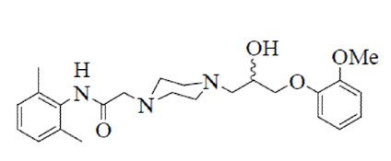
Description: Ranolazine is a white to off-white solid powder. Ranolazine is soluble in dichloromethane and methanol; sparingly soluble in tetrahydrofuran, ethanol, acetonitrile, and acetone; slightly soluble in ethyl acetate, isopropanol, toluene, and ethyl ether; and very slightly soluble in water. The partition coefficient was determined using three different ratios of octanol:water.

Pharmacokinetics in healthy subjects

Plasma concentration analysis
A number of validated high performance liquid chromatography methods, which utilised tandem mass spectrometry detection (LC/MS/MS) were used to identify the plasma levels of RAN and co-administered drugs in the studies that had not been previously submitted. The sensitivity of each of these assays was provided.

Statistical methods
In general, PK parameters were derived using non-compartmental methods based on individual plasma concentration time profiles.

Absorption

Sites and mechanisms of absorption
Ranexa is an orally administered film coated, PR tablet that is to be administered twice daily at dosage strengths of 375 mg, 500 mg and 750 mg. Following a single 500 mg oral dose of the formulation proposed for marketing under fasting conditions the T_{max} occurred at 4.8 hours following dosing.
Previously submitted data:
Following a single dose of the proposed commercial tablet of 500 mg RAN PR the C_{max}, AUC_{0-inf}, T_{max} and t½were 736 ng/mL, 7869 ng.h/mL, 6 hours and 6.7 hours, respectively (CVT 301-15). At steady-state, following 6 days dosing with 500 mg RAN PR BD the C_{max}, AUC₀₋₁₂, T_{max} and t½ were 1770 ng/mL, 13700 ng.h/mL, 3.85 hours and 6.82 hours, respectively.

Bioavailability

Absolute bioavailability
No new studies examined the bioavailability of RAN PR.
Previously submitted data:
Two double blind, placebo controlled studies (RAN009 and RAN019 CL 5754) examined the dose proportionality and relative bioavailability of oral doses of 10, 20 and 30 mg RAN IR compared to 9.5 mg IV and 40, 80 and 120 mg of RAN compared to 200 µg.kg⁻¹ IV, respectively. In both studies dose proportional PKs were observed and the relative bioavailability was 50% compared to the 9.5 mg IV dose and 35% compared to the 200 µg.kg⁻¹ IV dose. These studies did not evaluate the bioavailability of the proposed PR formulation.

Bioavailability relative to an oral solution or micronised suspension
No new studies examined the relative bioavailability of RAN PR.

Bioequivalence of clinical trial and market formulations

Study CVT-301-22
Study CVT-301-22 evaluated the bioequivalence (BE) of 500 mg PR tablets manufactured by a second supplier [information redacted] against RAN PR 500 mg tablets manufactured by [information redacted] (the primary supplier) following single oral doses to fasted, healthy, adult males. The results indicated that the ratios of the LS means for the C_{max} and AUC_{0-inf} (90% CI) of the second supplier [information redacted] manufactured RAN compared to the primary supplier [information redacted] manufactured drug were 1.04 (0.951 to 1.133) and 0.99 (0.948 to 1.041), respectively. As the 90% CI values for both C_{max} and AUC lie entirely within the bioequivalence interval 0.80 to 1.25, this indicates that the second supplier and second supplier produced RAN are BE.
Previously submitted data:
During the RAN development program, three supply chains [information redacted] were used in the manufacture of RAN tablets. Study CVT 3031 (MARISA) evaluated tablets manufactured by supply chain 1, and Study CVT 3033 (CARISA) evaluated tablets manufactured by supply chain 2. Tablets used in the 375 mg and 500 mg primary stability studies and in the ERICA (CVT 3037) and MERLIN-TIMI 36 (CVT 3036) studies were manufactured by supply chain3 (proposed commercial supply chain). A bioequivalence (BE) Study, CVT 301-15, was conducted to examine the bioequivalence of the tablets from all three suppliers (see below). An additional BE Study (CVT 301-18) was conducted to bridge a higher strength tablet (1,000 mg) to the lower strength tablet (500 mg) (see below).
A randomised, double blind, two way crossover Study (RAN0102) compared the PKs of 500 mg RAN SR (free base) with that of 342 mg RAN IR in 6 healthy male subjects, aged 20 to 38 years. Dosing was separated by a 72 hour wash out and venous blood samples were collected for up to 30 hours post dosing. The SR formulation demonstrated a sustained release profile, with a reduced C_{max}, a prolonged T_{max} and higher dose corrected trough plasma levels compared to the IR formulation, whereas, the mean relative availability was similar for both formulations.

Study CVT 3013
Study CVT 3013 examined the bioequivalence of two 500 mg tablets of RAN PR manufactured at a supply chain 1 site (reference tablet, Treatment A), compared to two 500 mg tablets of RAN PR manufactured at supply chain 2 and 3 site (test tablet, Treatment B, proposed commercial formulation). In addition, the bioequivalence of one 750 mg tablet of RAN PR manufactured at a supply chain 1 site (reference tablet, Treatment C), was compared to two 375 mg tablets of RAN PR manufactured at supply chain 2 and 3 site (test tablet, Treatment D). Thirty-four normal healthy males, aged 18 to 45 years, participated in this open label, randomised, four period, single dose, crossover study. During each treatment period blood samples for the determination of RAN levels were taken up to 48 hours following dosing and there was a one week wash out between each treatment. Following oral administration of treatment A and B, the mean AUC_{0-t} and AUC_{0-inf} for the test treatment (Treatment B) were approximately 110% of the mean value of the reference treatment (A) and the 90% confidence values were within the level of bioequivalence. By contrast, C_{max} was 33% higher for the test compared to the reference treatments suggesting that the two formulations were not bioequivalent for C_{max} (90% CI: 118, 147%). Similarly, test treatment D was bioequivalent to reference treatment C for AUC, whereas, bioequivalence was not demonstrated for C_{max} (90% CI: 110, 152).
The bioequivalence of three formulations of 500 mg RAN SR tablets were examined, under fasted conditions, in a randomised, six period, replicate design, crossover Study CVT 301-15 conducted in 36 healthy male subjects, aged 19 to 43 years. Blood samples were taken up to 36 hours after dosing and there was at least a 4 day wash out between doses. The results suggest that test formulation B (to be marketed, manufactured by [information redacted] and used in the Primary Stability studies and Study CVT 3037) and reference formulation A (representative of the CARISA trial, CVT 3033, manufactured by [information redacted]) were bioequivalent in respect to C_{max} and AUC. Similarly, formulations B and C (representative of the MARISSA trial, CVT 3031, manufactured by [information redacted]) were also bioequivalent as were formulations A and C.
The bioequivalence of three new formulations of RAN extended-release (ER) 1,000 mg tablets: Formulation 1 (Treatment B), Formulation 2 (Treatment C) and Formulation 3 (Treatment D) compared to two RAN ER 500 mg tablets (Reference material, Treatment A, to be marketed formulation) following single oral doses was examined in single centre, randomised, open label, replicate design, crossover Study (CVT 301-18) in 44 healthy males, aged 18 to 45 years. Subjects were randomly assigned to one of four treatment sequences and received single oral doses of 1,000 mg of RAN ER fasted on 8 separate occasions (Periods 1 to 8), with subjects receiving each formulation twice. Blood samples were taken up to 48 hours following dosing and there was a washout of at least 4 days between doses. The PK parameters for the four treatment groups separated by 1st (Periods 1 to 4: A1, B1, C1, D1) or 2nd administration in (Periods 5 to 8: A2, B2, C2, D2) as well as for both administrations combined (A, B, C, D) were provided. The C_{max} occurred, on average, 5 to 6 hours following dosing and the t½ was approximately 5 hours for all the formulations. As the t½ of the IR formulation ranges from 1.5 to 3 hours, the results demonstrate a prolonged absorption phase for the ER formulations. The ratios of the least squares means of Treatment B to Reference were 102.2, 100.0 and 100.0 for C_{max}, AUC_{0-inf}, and AUC_{0-t}, respectively. The 96.7% confidence limits for C_{max}, AUC_{0-inf}, and AUC_{0-t} were: 93.7–111.5, 93.3–107.2, and 93.2–107.4, respectively. Similar results were observed for Treatments C and D. The ratios of the least squares means of Treatment C to Reference were 106.1, 104.3 and 104.8 for C_{max}, AUC_{0-inf}, and AUC_{0-t}, respectively. The 96.7% confidence limits for C_{max}, AUC_{0-inf}, and AUC_{0-t} were: 97.2–115.7, 97.3–111.8, and 97.6–112.5, respectively. The ratios of the least squares means of Treatment D to Reference were 96.1, 97.8 and 97.5 for C_{max}, AUC_{0-inf}, and AUC_{0-t}, respectively and the 96.7% confidence limits for C_{max}, AUC_{0-inf}, and AUC_{0-t} were: 88.1–104.8, 91.3–104.9, and 90.8–104.7, respectively. Therefore, Test formulations 1, 2 and 3 were bioequivalent to the Reference formulation in terms of both C_{max} and AUC.
The PKs of single doses of 500 mg RAN oral solution (Treatment A) and four formulations (Treatments B to E) of 500 mg RAN SR tablets, each with different dissolution properties, in the fasted state, were examined in a single centre, single dose, randomised, open label, 5 period Study (CVT 301-14) in 16 healthy subjects (4 female), aged 20 to 56 years. Blood samples were taken for up to 48 hours following dosing and there was a wash out of at least 4 days between treatments. The T_{max}for the oral solution (Treatment A) occurred at 0.62 hours compared with 5.3 to 6.6 hours for the other formulations. C_{max} was 3,783 ng/mL for the oral solution, whereas, it ranged from 451 to 966 ng/mL for the SR formulations. The AUC_{0-t} values were similar for Treatments B, D (proposed commercial formulation) and E (ranging from 8,025 to 8,397 ng.h/mL), whereas, for Treatment C exposure was approximately 24% - 28% lower (AUC_{0-t} = 6377 ng.h/mL). Comparison of the geometric means of AUC_{0-t} for the tablets verses the oral solution, indicate that exposure following Treatments B, D and E was approximately 64% to 68% compared to the oral solution, whereas absorption of RAN following Treatment C was less than 50% compared to the oral solution. Therefore, Formulation C was less bioavailable than the proposed commercial formulation (D).

Bioequivalence of different dosage forms and strengths
The sponsor has applied for a waiver of bioequivalence studies for the 375 mg and 750 mg tablet formulations proposed for marketing stating the following:
“The proposed commercial 500 mg and 1,000 mg tablets have been demonstrated to be bioequivalent to tablets used in the Phase III clinical trials. An assessment of bioequivalence of the 375 mg and 750 mg tablets are considered not necessary as these products are sufficiently similar to the 500 mg and 1,000 mg tablets in terms of composition, dissolution specifications and in vitro dissolution profile.”
In addition, in Section 3.5.1 (Summary of Biopharmaceutical Studies) entitled “Waiver from Bioequivalence Studies for 375 mg and 750 mg Tablets” the sponsor states the following:
“Based on the following considerations, an in vivo BE determination of the lower strength tablets (375 mg and 750 mg) is not deemed necessary because an in vivo BE determination has been obtained for a higher strength tablet (500 mg and 1,000 mg):
- The lower strength tablets are proportionally identical in composition to the higher strength tablets (that is 375 mg compared to 500 mg, and 750 mg compared to 1,000 mg)
- In vitro dissolution data are similar in 3 media between the lower and higher strength tablets (that is 375 mg compared to 500 mg, and 750 mg compared to 1,000 mg)”
Comment: Based on a review of the data associated with these statements the evaluator believes that the application for a biowaiver is valid for both the 375 mg and 750 mg dose strengths according to the TGA’s Guidance 15 entitled Biopharmaceutic studies. However, it should be noted that it appears to be common practice when requesting a biowaiver to compare lower dose strengths to the highest intended commercial dose strength, which in this case is the 750 mg dose strength. As the 1,000 mg tablet dose strength does not form part of the current submission, it possibly could be argued that for the highest dose in the current application (that is 750 mg) at least, the data regarding the 1,000 mg dose is not relevant and therefore a biowaiver should not be granted for the 750 mg dose.

Study CVT-301-23
Study CVT-301-23 investigated the PK characteristics for each of four prototype formulations of RAN PR 1,000 mg QD tablets (Treatments B, C, D and E) compared to a 1,000 mg PR formulation intended for BD dosing (Reference Treatment A) following single oral doses to fasted, healthy, adult males. Compared to Reference Treatment A, the prototype formulations tested in Treatments B, D, and E had lower C_{max} and AUC values, with relative BA values ranging from 0.69 to 0.89, whereas, Treatment C had a lower C_{max}, an increased AUC with higher variability and a relative BA of 1.02. Based on these findings the sponsor concluded that none of the 4 prototype formulations exhibited PK characteristics that were deemed suitable for once-daily dosing.

Bioequivalence to relevant registered products
Not applicable.

Influence of food
No new studies examined the influence of food on ranolazine PK.
Previously submitted data:
An open, balanced, randomised two-way cross over Study, RAN0113, was conducted in 12 healthy male subjects, aged 21 to 38 years, to assess the PK profile of multiple oral doses of 500 mg RAN SR, administered twice daily for three days and as a single dose on Day 4 given with food or following an overnight fast. There was a six day washout between each dosing period. Blood samples were obtained up to 5 hours following the morning dose on Days 1 to 3. An additional (trough sample) was taken on Day1, 12 hours following the morning dose. On Day 4, blood samples were taken pre-dose and up to 48 hours following dosing. On Day 4, administration of RAN with food had no significant effect on the pharmacokinetics of RAN (C_{max}, T_{max} or AUC) compared to when RAN was administered in the fasted state. One subject was discontinued from the study as he displayed PR prolongation 6 hours following dosing (increase 96 msec) on Day 2 and this was accompanied by higher levels of RAN (5 hour dose levels were 2,070 and 3,040 ng/mL, respectively) than that seen in the other subjects (corresponding mean 5 hour levels: 427 ± 230 and 984 ± 534).
The effect of food on a single dose of 1,000 mg RAN PR was examined in an open label, randomised, single dose, two period, cross over Study (CVT 3014) in 20 healthy males subjects, aged 19 to 58 years. There was a wash out period of 6 days between dosing. Blood samples were collected pre-dose and up to 48 hours following dosing. There was no significant difference between the AUC_{0-inf} of RAN SR in the fed and fasted state. Although, there was wide variation in the T_{max} (obs) and C_{max} (obs) there was no significant difference between these values in the fed and fasted state.

Dose proportionality
No new studies examined dose proportionality following dosing with ranolazine.
Previously submitted data:
The single dose and steady state PKs of RAN SR at doses of 500, 1,000 and 1,500 mg was examined in an open label, randomised, multi dose, three way crossover Study (CVT 3015) in 14 healthy male subjects (13 completed), aged 20 to 76 years. Blood samples were obtained pre-dose and up to 24 hours post-dosing on Day 1, pre-dose Days 2 to 5 and up to 48 hours post-dosing on Day 6 for the determination of RAN PK following a single dose and at steady state. Following the first dose, BD dosing was initiated. Following a single dose C_{max} was 1,080, 1,960 and 2,720 ng/mL for the 500, 1,000 and 1,500 mg doses, respectively, and AUC_{0-inf} was 9,620, 21,100 and 33,800 ng.h/mL, respectively. The results indicate that following single doses RAN exposure increased dose proportionality.
The PK profile of single oral doses of RAN PR at 500, 750, 1,000, 1,250, 1,500, 1,750 and 2,000 mg were examined in a four way (Group 1) or three way (Groups 2 and 3) single ascending dose crossover design Study (RAN 0112) in 3 groups of 8 healthy male subjects (only seven subjects received the 1,000 mg dose), aged 19 to 40 years. Group 1 received 500, 750, 1,000 mg RAN SR or placebo. Groups 2 and 3 received 1,250 and 1,750 mg RAN SR or placebo and 1,500 and 2,000 mg RAN SR or placebo, respectively. Blood samples were taken up to 48 hours following dosing. T_{max} ranged from 4.25 to 6.12 hours for all 7 concentrations. C_{max} and AUC_{0-30h} increased approximately dose proportionally between 500 and 1,500 mg. However, at doses of 2,000 mg both C_{max} and AUC decreased compared to the 1,750 mg dose, possibly suggesting that at this dose absorbance is reaching saturation.

Bioavailability during multiple-dosing
No new studies examined the bioavailability of ranolazine following multiple doses.
Previously submitted data:
Steady state RAN plasma concentrations were generally achieved within 6 days of dosing. The steady-state C_{max} was 1,770, 3,830 and 6,220 ng/mL for the 500, 1000 and 1,500 mg doses, respectively and AUC_{0-inf} was 13,700, 32,900 and 56,100 ng.h/mL, respectively. Data analysis indicates that there was a modest departure from dose proportionality in C_{max} and AUC at steady state. The larger values of AUC_{0–12}at steady state, compared to AUC_{0–inf} after a single dose, indicate that there is a decrease in oral clearance with the RAN plasma concentration.

Effect of administration timing
No new studies examined the effect of administration timing.

Distribution
No new studies examined RAN distribution.
Previously submitted data:
Following oral administration of ^{[14}C^{]-}RAN total radioactivity was widely distributed to tissues and organs in rats. Total radioactivity was eliminated at a similar rate from most tissues and plasma. Radioactivity bound to ocular melanin following a single oral administration of ^{[14}C^{]-}RAN, a phenomenon that reversed over time with a t½ of approximately 8 to 23 days. The plasma protein binding of ^{[14}C^{]-}RAN was both moderate and similar in all species. In humans, the binding of ^{[14}C^{]-}RAN to human α-1 acid glycoprotein was saturated at higher concentrations. Compared to RAN, the binding of the RS-88390, CVT-4786, and RS-89289 metabolites to human plasma was slightly higher, whereas the binding of RS-94287 was much lower. There were no studies on distribution in pregnant or lactating animals or humans. The absence of these data is addressed in the proposed labelling. The total protein binding for RAN is 61 to 64% over the concentration range 250 to 10,000 ng/mL.

Metabolism
Previously submitted data:
The major phase 1 RAN metabolites are RS-88390 (CVT-2514), RS-89289 (CVT-2537), RS-88640 (CVT 2512) and RS-94287 (CVT-2738) and the major phase 2 metabolite is CVT-4786.
In vitro studies:
In human liver microsomes, RAN metabolism was inhibited by known inhibitors of CYP3A (Study CL 6906). Study CVT303.009-N identified that in the presence of antiserum to CYP3A4 and CYP2D6, the rate of disappearance of RAN decreased by 69.6% and 17.1%, respectively, whereas in the presence of 50 µM troleandomycin (CYP3A4 inhibitor) and 10 µM quinidine (CYP2D6 inhibitor), 86.6% and 13.7% of the RAN metabolism was inhibited, respectively.
The potential inhibitory effects of RAN and its two major metabolites, RS-88390 and RS-94287, on the activity of hepatic cytochrome P450 CYP3A4 and CYP2D6 was investigated in Study CVT303.020-N. Overall, RAN and RS-88390 inhibited CYP3A4 activity in vitro, whereas RS-94287 did not. The amounts and mechanism of this inhibition varied with the model substrate used. Testosterone 6β-hydroxylation and midazolam 1’-hydroxylation were inhibited via a competitive mode whereas nifedipine oxidation was inhibited via a complex mixed mode mechanism that could not be clearly defined. By contrast, CYP2D6 activity was not significantly affected.
These data suggest that CYP3A4 plays a major role in the overall metabolism of RAN in vitro, whereas CYP2D6 plays a more minor role. Therefore the metabolism of RAN may be affected if co-administered with inhibitors of CYP3A4. In addition, RAN and RS-88390 inhibited CYP3A4 activity, therefore, they may also affect the metabolism of other drugs that are primarily metabolised by this isoenzyme.
In vivo studies:
A single radiolabel led dose of 500 mg ^{[14}C^{]-}RAN was administered to four healthy volunteers in Study CVT 3019 to investigate the metabolic profile of RAN. More than 100 metabolites were identified in urine samples and further 48 in plasma samples. As many as 14 primary metabolic pathways for RAN were identified. Peak concentrations of RAN and most of the primary metabolites were reached within 1 hour of dosing. Approximately 73% of dose was recovered in urine, however, only 4.5% of the radioactivity recovered, or 3% of the dose, was excreted in urine as unchanged RAN.

Interconversion between enantiomers
No new studies examined interconversion between ranolazine enantiomers.
Previously submitted data:
Ranolazine is a racemate that consists of a 1:1 ratio of (R) and (S) enantiomers.
A double blind, randomised, 3 way, cross over Study (RAN090) investigated the interconversion and the PK of the (-) and (+) isomers following a single oral dose of either 200 mg or 400 mg RAN IR in 14 healthy male subjects, aged 19 to 33. The PK of the (+) R RAN were similar when administered as the racemate or as a separate enantiomer, whereas for the (-) S enantiomer there were statistically significant differences between administration as the racemate and as separate enantiomer for the C_{max}, AUC and oral clearance. There was no evidence of interconversion of the enantiomers.

Sites of metabolism and mechanisms / enzyme systems involved
No new studies examined the sites of ranolazine metabolism.

Non-renal clearance
No new studies examined non-renal clearance of ranolazine.

Metabolites identified in humans

Active metabolites
Three RAN metabolites (GS-448200, GS-448119 and GS-342105) were identified in healthy human plasma following 5 days dosing with 750 mg RAN q12h. The activity of the various metabolites of RAN remains to be elucidated; however a 2009 study indicated that the GS-342105 (CVT-2738) metabolite, at least, may have some anti-ischaemic effects.
Previously submitted data:
On the whole, the PK and in particular the PD of the metabolites has not been fully characterised.
In addition to examining dose proportionality (see below) Study CVT 3015 examined the PK of the three major metabolites of RAN, CVT-2512 (RS-88640), CVT-2514 (RS-88390) and CVT-2738 (RS-94287), present at concentrations greater than 10%. An additional analysis of eight further metabolites was also carried out (CVT303.006-C). The AUC_{0–12}of CVT-2512 (RS-88640) was on average, up to 15% of the corresponding RAN AUC and increased less than proportionally with both dose and AUC_{0–12}for RAN. Absolute exposure to CVT-2514 (RS-88390) increased slightly less than proportionally with dose and relative to RAN AUC_{0–12}a decrease from on average 41% at 500 mg BD to 23% at 1,500 mg was observed. AUC_{0–12}for CVT-2738 (RS-94287) increased more than proportionally with dose, but proportionally with RAN AUC₀₋₁₂, and was on average approximately 30% of the estimates for RAN at all three dose levels. As seen for RAN, the t½ of all three metabolites appeared to lengthen slightly with increasing RAN dose. Of the other metabolites, CVT-4786 had the highest AUC_{0–12}and C_{max} values and RS-89983 the lowest values following all doses. The t½ ranged from a low of 5.80 hours (RS-89961) to a high of 17.5 hours (RS-89289) following all doses. Five of the metabolites showed approximately dose proportional increases in AUC_{0–12}and C_{max} with little or no change in half-life. However, RS-89961, RS-88597 and RS-88772/88835 showed a larger than proportional increase in AUC₀₋₁₂ and C_{max} especially at the highest dose level. RS-88597 and RS-88772/88835 also showed a trend of increasing t½ with dose. Further studies of the PK of the metabolites are included in the following sections, e.g. hepatic and renal impairment, and the results of the analysis for these studies is summarised in Table 2.

Table 2: CVT3015 Summary of the major metabolite PK data
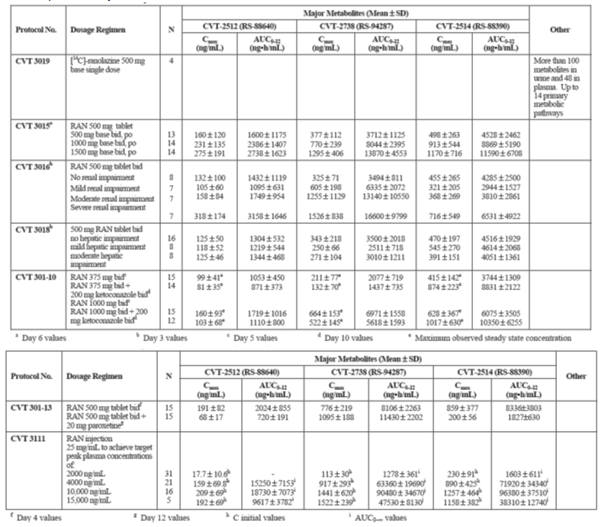

Other metabolites
See above.

Pharmacokinetics of metabolites
Following 5 days of dosing with 750 mg RAN q12h in healthy males, the C_{max} and AUC_{τ} values for GS-448200 were 590 ng/mL and 5,844 ng.h/mL, respectively; for GS-448119 were 122 ng/mL and 1,310 ng.h/mL, respectively; and for GS-342105 were 421 ng/mL and 4,417 ng.h/mL, respectively (Table 3). The corresponding metabolite ratios (that is AUC_{τ} of each metabolite divided by AUC_{τ} of RAN) for the three metabolites were 0.48, 0.12 and 0.31, respectively.

Table 3: Study GS-US-291-0112: PK parameters for ranolazine and its metabolites (PK analysis set)
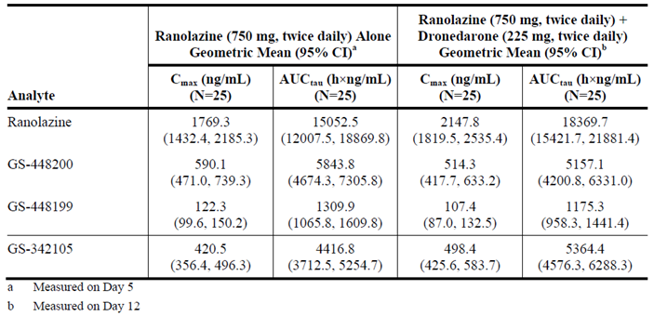

Consequences of genetic polymorphism
No new data.
Previously submitted data:
Study CVT 301-19 evaluated whether subjects with the CYP2D6 poor metaboliser genotype had more pronounced increases in RAN concentrations than subjects with the extensive metaboliser genotype when given the CYP3A4 inhibitor diltiazem. This open label, multiple dose, cross over study was conducted in 12 subjects with poor metaboliser genotype and 21 subjects with the extensive metaboliser genotype. The subjects were aged 19 to 34 years and 3 were female. They received oral RAN extended release (ER) at the following doses and times: 500 mg BD starting on Day 1 until the morning of Day 4; 1,000 mg BD, starting the evening of Day 4 through the morning of Day 8; and 500 mg BD starting the evening of Day 8 through the morning of Day 15. Subjects also received an oral dose of diltiazem at the following doses and times: 90 mg the evening of Day 8 and the morning of Day 9; 180 mg BD the evening of Day 9 through the morning of Day 15. The results indicate that when adding diltiazem 180 mg BD at steady state to RAN 500 mg BD at steady state, RAN AUC_{0–12}increased by an estimated 2.11 fold in poor metabolisers and 2.42 fold in extensive metabolisers. The corresponding increases for C_{max} were 1.86 fold in poor metabolisers and 2.20 fold in extensive metabolisers.
Although, diltiazem caused numerically more pronounced increases in AUC_{0–12}and C_{max} in extensive metabolisers than poor metabolisers, the differences in the increases were not statistically significant. When RAN 500 mg BD was given in combination with diltiazem 180 mg BD, poor metabolisers had a 1.41 fold higher RAN AUC_{0–12}and a 1.32 fold higher C_{max} as compared to the extensive metabolisers. When the RAN dose was increased from 500 mg BD to 1,000 mg BD, both poor metabolisers and extensive metabolisers had more than proportional increases in AUC_{0–12}and C_{max}, but the degree of disproportionality was less pronounced in poor metabolisers. Following the increase in dose, the poor metaboliser/extensive metaboliser ratio decreased from 1.62 fold to 1.25 fold for AUC_{0–12}, and from 1.56 fold to 1.14 fold for C_{max}. This indicates that saturation in first-pass metabolism and/or systemic elimination occurs in both genotypes, but to a lesser extent in poor metabolisers, resulting in a smaller difference in RAN concentrations between poor metabolisers and extensive metabolisers at the higher RAN dose. Following the addition of diltiazem the results indicate that there were smaller increases in AUC_{0–12}and C_{max} in poor metabolisers than in extensive metabolisers after the addition of diltiazem. The mean difference between poor metabolisers and extensive metabolisers in RAN exposure at steady state for RAN 500 mg BD + diltiazem 180 mg BD was 41% for AUC_{0–12}and 32% for C_{max}.

Excretion
Following a single oral dose of 500 mg RAN to healthy males the t½ was 6.4 hours and the elimination constant was 0.1 h⁻¹.
Previously submitted data:
Following a single oral dose of 500 mg ^{[14C]-}RAN to 4 healthy subjects (Study CVT 3019) the mean total recovery of radioactivity was 97.6% (range 96% to 99%) at 168 hours following drug administration. The major route of elimination was via the urine accounting for a mean of 73.1% (range 69.7% to 75.2%) of the total administered dose, whereas, elimination of total radioactivity via the faeces accounted for 24.5% (range of 23.5% to 26.3%). Within 48 hours, the majority of the dose was recovered (82.9%, range 73 to 91.6%) from all subjects.

Routes and mechanisms of excretion
No new information.

Mass balance studies
No new information.

Renal clearance
No new information.

Intra- and inter-individual variability of PKs
No new information.
Previously submitted data:
Population PK Study CVT303.019-C, examined intra- and inter-individual variability in data from 12 PK/PD studies. Inter-subject variability was high and estimated, respectively, at CV = 23.1%, 106%, 97.1%, and 54.7% for the absorption rate constant (KA), Michaelis-Menten constant (KM), apparent volume of distribution (V/F) and apparent oral clearance (CL/F) parameters, respectively. Although, KA was independent of food intake, it was 39% (35 to 43%) higher for the DSM formulation and mildly decreased with age. Variability in RAN clearance was primarily affected by weight, age and renal function as characterised by creatinine clearance. Variability in RAN V/F was affected by weight, age, renal function and NYHA Class.

Pharmacokinetics in the target population
No new information.
Previously submitted data:

Single dose
The PK profile of RAN in angina patients after a single dose of RAN PR was not specifically evaluated in any study.

Multiple dose
Two of the Phase III safety and efficacy studies, CVT 3031 and CVT 3033, included RAN plasma concentration measurements. Study CVT 3031 included 168 patients, who were treated for one week with RAN PR at 500, 1000, or 1,500 mg BD, or placebo, in a four period crossover design. Blood samples were taken immediately before, that is, 12 hours after the prior dose, and 4 hours after the last dose at the end of each treatment period. Study CVT 3033 included 497 patients, who were treated with RAN PR 750 mg BD, 1,000 mg BD, or placebo for 12 weeks in a parallel group design, provided plasma samples. Samples were taken 4 and 12 hours after dose intake after 2 and 12 weeks of treatment. In addition, a 12 hour sample was taken after 6 weeks of treatment and 2 days after completion of the 12 week dosing period. Half of the patients receiving active treatment during the first 12 weeks were randomized to placebo during the additional 2 days while the other half continued active treatment. The small number of samples generated from the trials was not optimal for individual PK modelling, therefore, a population PK model was developed (CVT303.019-C) to help describe the PK of RAN PR in healthy subjects and in patients with angina in an attempt to identify predictors of exposure to RAN and identify any sub-populations with altered PK. The typical population PK parameters (95% CI) generated for the reference covariates (70 kg, 60 years, normal renal function, Syntex formulation tablets) were:
- apparent oral clearance (CL/F): 23.8 (22.3, 25.4) L/h;
- apparent maximum elimination rate (VMAX/F): 42.1 (38.5, 45.7) mg/h;
- Michaelis-Menten constant (KM): 1050 (839, 1260) ng/mL;
- apparent volume (V/F): 53.2 (43.5, 63.0) L;
- absorption rate of the transit compartment (KA0): 0.609 (0.568, 0.650) h⁻¹; and
- absorption rate constant (KA): 0.054 (0.051, 0.057) h⁻¹
Four covariates were identified that significantly affected the PKs of RAN, these were:
- Exposure for a 40 kg or a 120 kg patient was, respectively 41% higher or 27% lower than for a typical subject.
- NYHA Class III or IV increased exposure by 34%.
- Concomitant administration of diltiazem increased exposure by 38%.
- Exposure for subjects with calculated normalised creatinine clearance at points representing the various renal impairment categories (65, 40, 20, and 10 mL/min/1.73m²) was, respectively, 2% (mild), 19% (moderate), 48% (severe), and 84% (very severe) higher than for subjects with normal creatinine clearance. Renal function dependence in subjects with an estimated normalised creatinine clearance below 70 mL/min/1.73m², was described by a power function with the power parameter estimated at 0.246 (range 0.166 to 0.325).

Pharmacokinetics in other special populations

Pharmacokinetics in subjects with impaired hepatic function
No new information.
Previously submitted data:
The PK of RAN and its three major metabolites were examined in an open label multi dose Study (CVT 3018) in 8 subjects with mild (Child-Pugh Class A) and 8 subjects with moderate (Child-Pugh Class B) hepatic impairment compared to 16 matched healthy controls. Of the 32 subjects, aged 31 to 69 years that took part 10 were female. The subjects received a single loading dose of 875 mg RAN followed by BD doses of 500 mg PR RAN for a further 2 days. Blood samples were taken for PK analysis on Day 1 up to 12 hours post dosing, Day2 immediately before the 3rd (morning) and 4th (evening) doses and on Day 3, pre-dose and up to 48 hours post dose 5. The results for a further eight additional metabolites were reported in CVT303.006-C and combined data was provided. There was little difference in the PK of RAN between the healthy and the subjects with mild hepatic impairment. By contrast, there was a 1.69 and 1.35 fold increase in AUC and C_{max} of RAN, respectively, between the mildly and moderately impaired groups. The CVT-2512 (RS-88640)-to-RAN AUC₀₋₁₂ ratio on Day 3 was found to be 45% lower in the moderately impaired group compared to the healthy group; however, the difference was not statistically significant (p = 0.087). For CVT-2514 (RS-88390), the ratio was 51% lower in the moderately impaired compared to the healthy group (0.300 versus 0.609) and the difference was statistically significant (p = 0.041). CVT-2738 (RS-94287) showed lower AUC ratios in both the mild and moderate groups compared to healthy subjects. The average ratio for the healthy subjects was 0.367. In the mild impairment group, the ratio was 0.278 (p = 0.032) and for the moderate impairment group, the ratio was 0.200 (p = 0.0007). This finding is not surprising, given that all three major metabolites appear to be produced primarily in the liver.

Pharmacokinetics in subjects with impaired renal function
No new information.
Previously submitted data:
The PK of RAN and its three major metabolites, CVT-2512 (RS-88640), CVT-2514 (RS-88390) and CVT-2738 (RS-94287), were examined in an open label multi dose Study (CVT 3016) in 7 subjects each with mild (CLcr 51 to 80 mL/min), moderate (CLcr 30 to 50 mL/min) or severe (CLcr < 30 mL/min, but not requiring dialysis) renal impairment compared to 8 matched healthy controls. Of the 29 subjects, aged 28 to 75 years, who took part in the study, 8 were female and each subject received a single loading dose of 875 mg RAN followed by BD doses of 500 mg PR RAN for a further 2 days. A loading dose was given to ensure steady state was achieved by the end of the dosing period. Study CVT303.006.C examined the PKs of a further 8 metabolites and the results of both studies were provided. Mild renal impairment increased the C_{max} and AUC of RAN by 1.58 and 1.75 fold, respectively and these increases were maintained in subjects with moderate renal impairment and were further enhanced in subjects with severe renal impairment. The metabolite/RAN AUC_{0–12}ratios were not clearly related to creatinine clearance for CVT-2512 (RS-88640) and CVT-2514 (RS-88390).
However, there was a highly significant negative correlation (p < 0.001) between the AUC ratio of CVT-2738 (RS-94287) to RAN and both creatinine clearance and body weight. The predicted CVT-2738 (RS-94287)/RAN AUC ratios for a 70 kg individual with creatinine clearance values of 100 mL/min and 30mL/min were 0.375 and 1.07, respectively. Of the metabolites measured in this Study, CVT-2738 (RS-94287) kinetics showed the greatest dependency on renal function, while CVT-2514 (RS-88390), the O-demethylated metabolite, showed the least effect. The fact that CVT-2738 (RS-94287) is directly renally excreted, while CVT-2514 (RS-88390) is further glucuronidated and sulphated in the body, may have contributed to the difference in sensitivity of the kinetics of the two metabolites to impairment of renal function.
All of the minor metabolites (except for RS-89983) showed an increase in AUC_{0–12}and C_{max} as the degree of renal impairment increased. Metabolite CVT-4786 showed the largest increase in AUC_{0–12}(ratio of severe/none = 10.2), whereas, RS-88597 displayed the smallest increase (ratio of severe/none = 1.9). Some but not all of the metabolites showed a corresponding increase in t½ with the largest increase in t½ occurring for RS-101647 (ratio of severe/none = 5.8). Metabolites CVT-2537 (RS-89289) and CVT-4786 showed an approximate 5 fold increase in exposure relative to RAN when comparing patients with severe renal impairment and healthy controls. The minor metabolite, CVT-2537 (RS-89289), reached only 14 % exposure relative to RAN in the severe group. CVT-4786, on the other hand, was more abundant and reached plasma concentrations slightly exceeding those of RAN in the severe group. The total protein binding for CVT-2537 (RS-89289) and CVT-4786 is 73 to 79% over the plasma ranges 50 to 500 ng/mL and 300 to 7500 ng/mL, respectively. The total protein binding for RAN is 61 to 64% over the concentration range 250 to 10,000 ng/mL. CVT-4786 and CVT-2537 (RS-89289) have a low binding affinity for α1-, β1-, and β2-adrenergic receptors, opioid receptors, 5HT1a receptors, and L-type Ca²⁺ channels. They displayed no inhibition of IKr and only a weak inhibition of IKs. The effect on late sodium current (late INa) was minimal.
Population PK analysis (CVT 301.019-C), identified renal function dependence in subjects with an estimated normalised creatinine clearance below 70 mL/min/1.73m², and was described by a power function with the power parameter estimated at 0.246 (range 0.166 to 0.325). For subjects with creatinine clearance of 50, 30, and 10 mL/min/1.73m², apparent RAN clearance was estimated to be 8% (range: 5 to 10%), 19% (13 to 24%), and 38% (28 to 47%) lower than the clearance of subjects with normal renal function. Exposure for subjects with calculated normalised creatinine clearance at points representing the various renal impairment categories (65, 40, 20, and 10 mL/min/1.73m²) was, respectively, 2% (mild), 19% (moderate), 48% (severe), and 84% (very severe) higher than for subjects with normal creatinine clearance.
Comment: In the previous ranolazine submission the following question was asked regarding renal impairment: “Given ranolazine plasma levels increase in patients with renal impairment, please provide commentary on dose adjustment in this population.” This question has been addressed by the sponsor by the addition of the following text in the proposed PI:
“Renal impairment: In a study evaluating the influence of renal function on ranolazine pharmacokinetics, ranolazine AUC was on average 1.7 to 2 fold higher in subjects with mild, moderate, and severe renal impairment compared with subjects with normal renal function. There was a large inter-individual variability in AUC in subjects with renal impairment. The AUC of metabolites increased with decreased renal function. The AUC of one pharmacologically active ranolazine metabolite was 5 fold increased in patients with severe renal impairment.
In the population pharmacokinetic analysis, a 1.2 fold increase in ranolazine exposure was estimated in subjects with moderate impairment (creatinine clearance 40 mL/min CKD stage 3). In subjects with severe renal impairment (creatinine clearance 10 to 30 mL/min CKD stage 4), a 1.3 to 1.8 fold increase in ranolazine exposure was estimated.
The influence of dialysis on the pharmacokinetics of ranolazine has not been evaluated.”

Pharmacokinetics according to age
No new information.
Previously submitted data:
No studies specifically examined the effects of age, weight or race on the PK of RAN. However, population PK model Study, CVT303.012-C assessed the effect of old age and low body weight on the PK of RAN. Over the age and weight ranges observed in the dataset, RAN concentrations increased with decreasing weight and increasing age. However, the safety profile of RAN was not affected by weight, and although tolerability of RAN was slightly lower in the elderly population, no increase in life threatening events were observed with increasing age.

Pharmacokinetics related to genetic factors
No new information.

Pharmacokinetics in other special populations

Heart failure
Study GS-US-270-0101 examined the PK of RAN in subjects with heart failure following administration of a combination of IV bolus, infusion and oral tablet doses of ranolazine. Based on the concentration-time data, average values for C_{min}, C_{max}, and T_{max} were 1,610 ng/mL, 5,595 ng/mL, and 22 hours, respectively.
Previously submitted data:
Study RAN0103 compared the PK of 400 mg RAN IR in 6 healthy male and 6 female volunteers, aged 20 to 34 years. There were no statistically significant differences in C_{max} or AUC_{0–inf} at the 5% level according to ANOVA. The study report also included a calculation of oral clearance scaled by body weight, which showed a significant difference between genders (20.8 mL/min/kg and 13.1 mL/min/kg in females and males, respectively).

Congestive heart failure
The digoxin interaction Study CVT 3021 was conducted in 85 patients (26 female) with congestive heart failure (NYHA Class III and IV) who were aged 28 to 80 years. Patients were randomised to receive either digoxin or digoxin placebo for eight days then either RAN (750 mg PR BD) or RAN placebo was added to the treatment regimen for a further six days. The mean RAN concentration at steady state was 2,237 ng/mL at a dose of 750 mg BD in patients with congestive heart failure, corresponding to an oral RAN clearance of 27.9 L/hour. By contrast, in Study RAN011, in which healthy volunteers received the same dose of RAN PR, the mean concentration at steady state was 2,010 ng/mL corresponding to an oral clearance of 31.1 L/hour.
Two hundred and thirty eight patients with a diagnosis of CHF were included in the population PK Study CVT303.019-C. Subjects with CHF Class III or IV had apparent clearance 21% (range: 7 to 34%) lower than those with CHF Class I or II, or no CHF; therefore, RAN exposure is predicted to be 34% higher in a patient with NYHA Class III or IV compared to a patient without CHF.

Pharmacokinetic interactions

Pharmacokinetic interactions demonstrated in human studies

CYP2D6 substrate; Metoprolol
Study CVT-301-24 examined the effect of RAN PR 750 mg BD at steady-state on the PK parameters of the CYP2D6 substrate metoprolol tartrate (metoprolol IR) in healthy subjects. Co-administration of a single dose of metoprolol with RAN at steady state resulted in a 1.82 fold and 1.48 fold increase in metoprolol AUC_{0-inf} and C_{max}, respectively, compared to metoprolol monotherapy (Table 4). Conversely, a decrease in AUC_{0-inf} and C_{max} was observed for the metoprolol metabolite, alpha-hydroxymetoprolol (93.7% and 71.1% of monotherapy values, respectively). The effect of RAN on the metabolic ratio of AUC_{0-inf} metoprolol/AUC_{0-inf} alpha-hydroxymetoprolol was 1.98 fold.
Comment: In the previous ranolazine submission the sponsor was asked to provide the clinical study report for Study CVT301-24. This request has now been satisfied by the inclusion of the clinical study report in this dossier. The draft PI has included information about the interaction with metoprolol.

Table 4: Study CVT-301-24. Statistical analysis of pharmacokinetic parameters
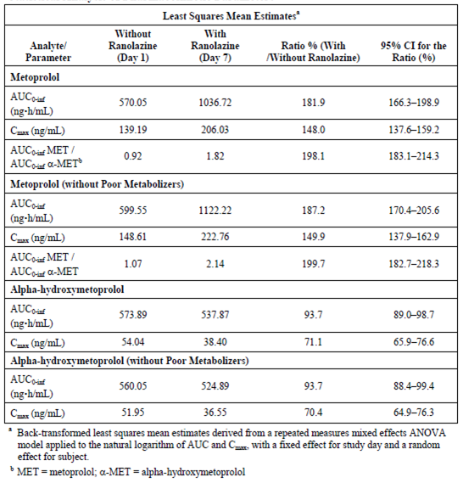

Dronedarone; healthy subjects
Study GS-US291-0112 examined the effect of steady state dronedarone (225 mg BD), on the steady-state PK of RAN (750 mg BD) in healthy adult males. Following co-administration of RAN with dronedarone, both C_{max} and AUC_{τ} values for RAN were 1.2 fold higher than values obtained following administration of RAN alone; the corresponding 90% CIs were (1.11, 1.33) for C_{max} and (1.12, 1.33) for AUC_{τ}. Similarly, C_{max} and AUC_{τ} values for dronedarone increased following co-administration of RAN with dronedarone compared to administration of dronedarone alone, with a 1.3 fold increase for both C_{max} and AUC_{τ}; corresponding 90% CIs were (1.19, 1.35) for C_{max} and (1.24, 1.37) for AUC_{τ}.

Dronedarone; subjects with AF
Study GS-US-291-0101 examined the potential effect of RAN PR at two dose levels (375 mg and 500 mg BD) on the PK parameters of dronedarone in subjects with atrial fibrillation who had received treatment with dronedarone (400 mg twice daily) for at least 4 weeks prior to screening. The steady-state mean dronedarone C_{max} and AUC₀₋₁₂ values following administration of dronedarone alone were 129 ng/mL and 894.5ng.h/mL, respectively. Following co-administration with steady-state RAN the steady-state C_{max} of dronedarone was similar (133.5 ng/mL), whereas the AUC₀₋₁₂ was approximately 1.09 fold higher (976.1 ng.h/mL).

Metformin
Study GS-US-259-0113 evaluated the effect of steady-state RAN (1,000 mg BD) on the steady-state PK of metformin (850 to 1,000 mg BD) in subjects with T2DM. The mean metformin C_{max},_{ss} (90% CI) and AUC_{τ} values were 1.53 fold (1.41, 1.66) and 1.79 fold (1.65, 1.95) higher, respectively, when metformin was administered in combination with RAN, compared to when metformin was administered alone.
Study GS-US-259-0143 examined the effect of steady-state RAN at the proposed clinical dose of 500 mg BD on the steady state PK of metformin (1,000 mg BD) in subjects with T2DM. Results indicated that the AUC_{τ} and C_{max} for metformin were 1.37 fold (90% CI: 1.26, 1.49) and 1.22 fold (90% CI: 1.13, 1.32) higher, respectively, when metformin was co-administered with RAN compared with metformin alone.

Atorvastatin
Study GS-US-259-0115 examined the effect of steady-state RAN (1,000 mg BD) on the steady-state PKs of atorvastatin (80 mg OD) in healthy adult subjects. The results indicated that the C_{max} and AUC_{τ} values for atorvastatin when administered with RAN were 1.4 fold (90% CI: 1.23, 1.62) and 1.3 fold higher (1.17, 1.46), respectively, than when atorvastatin was administered alone).
Previously submitted data

Ketoconazole
Study CVT 301-10 compared the PK of RAN PR when administered alone and when co-administered with ketoconazole under steady state conditions for both drugs. In Part A of the study, 21 healthy volunteers received RAN PR/placebo 375 mg twice daily for 5 days followed by RAN PR/placebo 375 mg twice daily co-administered with ketoconazole 200 mg twice daily for four days, followed by a single morning dose of both RAN PR/placebo 375 mg and ketoconazole 200 mg on Day 10. In Part B, the dose of RAN was increased to 1,000 mg twice daily. Fifty healthy subjects (25 female) took part in the study and were aged from 18 to 44 years. Co-administration of 200 mg BD ketoconazole significantly inhibited RAN metabolism, presumably metabolism via CYP3A4, resulting in 3.0 to 3.9 fold increases in the mean plasma concentrations of RAN, regardless of RAN dose.

Diltiazem
Study CVT 3012 examined the interaction between RAN and a range of doses of once daily modified release (MR) diltiazem. On Days 1 to 8, the healthy volunteers received either 180 mg, 240 mg or 360 mg diltiazem MR or placebo and on Days 4 to 8 they also received 2 x 500 mg RAN PR BD. Thirty four healthy male subjects, aged 19 to 40 years, took part in the study. On Day 8, co-administration of diltiazem MR significantly increased the RAN C_{max} and AUC_{0–12}values in a dose dependent manner with increases of 52 to 139% for AUC_{0–12}compared to placebo. The increases were approximately 50% higher after the initial RAN dose (Day 4) than following the dose on Day 8. Two earlier studies (RAN0121 and RAN068), which examined RAN SR and IR, respectively, also identified a significant interaction between RAN and diltiazem when co-administered, with significant increases in C_{max}, C_{min} and AUC, whereas the PK of diltiazem were not affected by the co-administration of RAN.

Simvastatin
Study CVT 3017 examined the interaction between RAN and simvastatin in an open label, multiple dose study. Eighteen healthy male subjects, aged 19 to 49 years, received a single dose of simvastatin 80 mg on Day 1 followed by further doses on Days 6 to 9. In addition, they received an initial dose of RAN on the morning of Day 3 followed by 1,000 mg BD up to and including the morning of Day 9. Plasma was analysed for RAN and HMG-CoA reductase inhibition and serum was analysed for simvastatin lactone and three of its metabolites (simvastatin acid, 6’exomethylene simvastatin and 3’ hydroxysimvastatin). A 50% to 100% increase in simvastatin exposure and HMG-CoA reductase inhibitor activity was observed when it was co-administered with RAN compared to simvastatin alone. A similar degree of interaction was also observed following 3 and 6 days of RAN dosing. By contrast, co-administration of simvastatin did not affect the systemic exposure to RAN during steady state conditions for both drugs, as the 90% CI ratio of means were within 80 to 125% BE range for both AUC and C_{max} for RAN.

Paroxetine
An open label, multiple dose study evaluated the effect of the potent CYP2D6 inhibitor, paroxetine, on the PK of RAN and its major metabolites in 15 healthy subjects (1 female), aged 18 to 60 years (CVT 301-13). Dextromethorphan phenotyping for CYP2D6 was carried out at baseline and when the healthy volunteers had received repeat doses of RAN PR (1,000 mg BD) to steady state (Day 4). Paroxetine (20 mg) was then added with multiple dosing to steady state for both drugs (Day 11), when dextromethorphan phenotyping was again repeated. Prior to dosing with RAN, 14 of 15 subjects were classified as extensive metabolisers of dextromethorphan, with a geometric mean dextromethorphan/dextrorphan ratio of 0.00674. On Day 4 of RAN dosing the geometric mean ratio had increased to 0.05674, indicating that a partial inhibition of CYP2D6 had occurred, but only one subject became a phenotypically poor metaboliser. After addition of paroxetine only two of the subjects remained extensive metabolisers, indicating that at this dose paroxetine is a potent inhibitor of CYP2D6. The geometric least squares mean values for RAN C_{max} and AUC were approximately 23% higher on Day 12 compared to Day 4, with the 90% CI for both parameters exceeding the upper limit of 125%, indicating a statistically significant drug interaction between RAN and paroxetine. Results for RAN metabolites are discussed in Section Metabolites (see above).

Rifampicin
The effect of co-administration of rifampicin, a potent inducer of CYP3A enzymes, on the PKs of RAN during steady-state conditions for both drugs was examined in an open label, multiple dose study conducted in 16 healthy subjects (7 female), aged 19 to 48 years (CVT 301-20). Subjects received RAN PR 1,000 mg BD from Day 1 to the morning of Day 12, and rifampicin 600 mg once daily from Day 5 to Day 12. Ranolazine PK parameters were determined on Day 4 and Day 12. Rifampicin caused a major reduction in RAN concentrations with values of AUC₀₋₁₂ and C_{max} on Day 12 that were, on average, 4.1% and 5.0%, respectively, of the Day 4 values; there was no significant change in T_{max}. The results indicate that RAN metabolism is greatly accelerated by rifampicin with a more than 20 fold increase in oral clearance.

Digoxin
The effect of RAN on the PKS of digoxin was examined in a double blind, randomised, placebo controlled, parallel study in 16 healthy male subjects aged 18 to 40 years (CVT 3011). Subjects were dosed to steady state on Days 1 to 14 with 0.125 mg digoxin once daily. From Day 7 onwards, RAN PR (1,000 mg BD) or placebo was co-administered. The mean C_{max}, C_{min} and AUC₀₋₂₄ values for digoxin were 1.45, 2.46 and 1.59 fold higher, respectively, when digoxin was co-administered with RAN compared to digoxin plus placebo. In spite of this increase, the co-administration of digoxin and RAN was well tolerated, and all digoxin plasma concentrations remained within therapeutic limits. These results were similar to the findings of an earlier Study (RAN0111), which examined RAN IR and digoxin.

Verapamil
Study the effect of verapamil on the PK of RAN was evaluated in an open label, multi dose study conducted in 15 healthy subjects (7 female) aged 19 to 47 years (CVT 301-11). Subjects were administered RAN PR (750 mg BD) to steady state (Day 3). Verapamil (120 mg TDS) was then added with multiple dosing to steady state for both drugs (Day 8). Co-administration of verapamil resulted in a 2 fold increase in mean C_{max} and a 2.25 fold increase in AUC_{0–12}of RAN.
Comment: Two further studies examined the interaction of RAN with cimetidine (RAN032) and warfarin (RAN0110), however, both studies used the IR formulation and have not been discussed here.

Population PK
A population PK analysis (CVT303.019-C) was conducted using data from 12 studies, eight Phase I studies (RAN0112, RAN0114, RAN0117, RAN0201, CVT 3013, CVT 3014, CVT 3015 and CVT 3016), and four Phase II or III studies (RAN2302, CVT 3021, CVT 3031 and CVT 3033), according to the CHMP draft guidance for population PK analyses. Data were analysed using nonlinear mixed effects modelling with the NONMEM software system, Version VI, Level 1.0 (ICON Development Solutions) with the PREDPP model library and NMTRAN subroutines. A covariate modelling approach emphasising parameter estimation rather than stepwise hypothesis testing was implemented for the population PK analysis. The RAN population PK database comprised 928 subjects/patients (746 males and 182 females) contributing a total of 10,954 RAN plasma concentrations. The age of individuals in the population ranged from 18 to 92 years, weights ranged from 40 to 152 kg, and calculated normalized creatinine clearance ranged from 4.4 to 150 mL/min/1.73m². Most of the subjects were Caucasian (93.9%). Distributions of all continuous covariates were similar in both sexes except that males were heavier. Normalised creatinine clearance was mildly correlated with weight (R = 0.25) and strongly and negatively correlated with age (R = −0.58). The results demonstrated that a one-compartment model with two-stage, first-order absorption and parallel linear and saturable elimination adequately described RAN concentration time data.
Typical population PK parameters (95% CI) given the reference covariates (70 kg, 60 years, normal renal function, Syntex formulation tablets) were:
- apparent oral clearance (CL/F): 23.8 (22.3, 25.4) L/h;
- apparent maximum elimination rate (VMAX/F): 42.1 (38.5, 45.7) mg/h;
- Michaelis-Menten constant (KM): 1050 (839, 1260) ng/mL;
- apparent volume (V/F): 53.2 (43.5, 63.0) L;
- absorption rate of the transit compartment (KA0): 0.609 (0.568, 0.650) h−1; and
- absorption rate constant (KA): 0.054 (0.051, 0.057) h−1.
Four factors were identified that increased RAN exposure: low body weight, renal impairment, NYHA Class III or IV, and concomitantly administered diltiazem or a similar CYP3A4 inhibitor.

Clinical implications of in vitro findings
No new information.
Previously submitted data:
Study CVT303.011-N examined the potential inhibitory effects of 39 commonly prescribed drugs on the metabolism of RAN using human liver microsomes. The two major metabolic routes of RAN, N-dealkylation at the N4 piperazine nitrogen to form RS-94287 and O-demethylation of the methoxyphenyl moiety to form RS-88390, mediated by CYP3A4 and CYP2D6, respectively, were used as marker reactions. For CYP3A4-mediated RS-94287 formation, IC50 values ranged from 0.283 µM to > 250 µM. Ketoconazole, a potent inhibitor of CYP3A4, was the most potent inhibitor with an IC50 value of 0.283 µM. Other drugs that showed IC50 values < 10 µM included ergocristine, terfenadine, ciclosporin, verapamil, diltiazem and troleandomycin. Drugs that exhibited IC50 values ranging from 10 to 25 µM included 17α-ethinyl estradiol, sildenafil, simvastatin, fluoxetine, erythromycin and atorvastatin lactone. Drugs that displayed a weak inhibitory effect (250 µM < IC50 > 25 µM) included amitriptyline, propranolol, clozapine, dextromethorphan, quinidine, nifedipine, lovastatin, cerivastatin, tamoxifen, cimetidine and dexamethasone. For CYP2D6-mediated formation of RS-88390 the drugs displayed IC50 values ranging from 0.079 to > 250 µM. Quinidine, a potent CYP2D6 inhibitor, exhibited the lowest IC50 (0.079 µM). Other drugs that displayed IC50 < 10 µM included fluoxetine, amitriptyline, clozapine and dextromethorphan. Drugs that exhibited IC50 ranging from 10 to 25 µM included metoprolol, propranolol, terfenadine, ketoconazole and 17α-ethinyl estradiol and drugs that weakly inhibited RS-88390 formation (250 µM < IC50 > 25 µM) included diltiazem, nifedipine, lovastatin, simvastatin, sildenafil, haloperidol, amiodarone, tamoxifen, omeprazole, verapamil, cimetidine and dexamethasone.
Study CVT303.018-N evaluated the interaction between RAN and HMG-CoA reductase inhibitors using isolated human liver microsomes. The effect of RAN on the inhibition of p-glycoprotein mediated transport of HMG-CoA reductase inhibitors across monolayers of Madin-Darby canine kidney cells with multi drug resistance (MDCK-MDR1) was also investigated. Ranolazine weakly inhibited cytochrome P450 dependent metabolism of HMG-CoA reductase inhibitors with inhibition constants > 20 µM. Ranolazine was also an inhibitor of the p-glycoprotein mediated transport of HMG-CoA reductase inhibitors, with an apparent IC50s of 5 µM. HMG-CoA reductase inhibitors across MDCK-MDR1 cell monolayers ranged from 39.5 (simvastatin) to 290.7 µM (fluvastatin).

Evaluator’s overall conclusions on pharmacokinetics

ADME
- Following a single 500 mg oral dose of the formulation proposed for marketing under fasting conditions the T_{max} occurred at 4.8 hours following dosing.
- The 500 mg tablet formulations of RAN PR manufactured at Patheon and DSM were bioequivalent.
- The sponsor has applied for a waiver of bioequivalence studies for the 375 mg and 750 mg tablet formulations proposed for marketing. This biowaiver is in part based upon the 1,000 mg dose strength, which is used to justify the absence of BE data regarding the 750 mg dose. As the 1,000 mg dose is not part of the current application the biowaiver regarding the 750 mg dose strength is therefore not valid.
- None of the four prototype 1,000 mg QD tablets tested had PK characteristics that were deemed suitable for once daily dosing.
- Three RAN metabolites (GS-448200, GS-448119 and GS-342105) were identified in healthy human plasma following 5 days dosing with 750 mg RAN q12h.
- The activity of the various metabolites of RAN remains to be elucidated.
- Following 5 days of dosing with 750 mg RAN q12h the metabolite ratios for GS-448200, GS-448119 and GS-342105 were 0.48, 0.12 and 0.31, respectively

Special populations
In patients with HF, RAN C_{min}, C_{max}, and T_{max} were 1610 ng/mL, 5595 ng/mL, and 22 hours, respectively.

Drug-drug interactions

DDI; metoprolol
Co-administration of a single dose of the CYP2D6-substrate metoprolol with RAN at steady state resulted in a 1.82 fold and 1.48 fold increase in metoprolol AUC_{0-inf} and C_{max}, respectively, compared to metoprolol monotherapy.

DDI; dronedarone

Healthy subjects
Following co-administration of RAN (750 mg BD) with dronedarone (225 mg BD) in healthy subjects, the C_{max} and AUC_{τ} values for RAN were 1.2 fold higher than values obtained following administration of RAN alone. Similarly, the dronedarone C_{max} and AUC values increased 1.3 fold when dronedarone was co-administered with RAN compared to when it was administered alone.

Subjects with AF
The steady-state dronedarone C_{max} values were similar following both co-administration with RAN (375 mg and 500 mg BD) and when dronedarone (400 mg BD) was administered alone, whereas, the AUC₀₋₁₂ was approximately 1.09 fold higher following co-administration.

DDI; metformin
- In subjects with T2DM, the mean metformin C_{max},_{ss} (90% CI) and AUC_{τ} values were 1.53 fold (1.41, 1.66) and 1.79 fold (1.65, 1.95) higher, respectively, when metformin (850 to 1,000 mg BD) was administered in combination with RAN (1,000 mg BD), compared to when metformin was administered alone.
- In subjects with T2DM, the AUC_{τ} and C_{max} for metformin were 1.37 fold (90% CI: 1.26, 1.49) and 1.22 fold (90% CI: 1.13, 1.32) higher, respectively, when metformin (1,000 mg BD) was co-administered with RAN (500 mg BD) compared with metformin alone.

DDI; atorvastatin
The C_{max} and AUC_{τ} values for atorvastatin (80 mg OD) when administered with RAN (1,000 mg BD) were 1.4 fold (90% CI: 1.23, 1.62) and 1.3 fold higher (1.17, 1.46), respectively, than when atorvastatin was administered alone.

Limitations of the PK studies
The activity of the various metabolites of RAN remains to be elucidated.

Summary of previously submitted PK data

Metabolic studies
- Results indicate that RAN is rapidly and extensively metabolised and that the major route of elimination is via metabolism followed by urinary excretion.
- The formation of CVT-2512 is dependent on both CYP2D6 and CYP3A4, whereas CVT-2514 is primarily dependent on CYP2D6.

Special populations
- Renal impairment is associated with decreased RAN total clearance, which is correlated with the degree of renal impairment (CVT 3016). For a decrease in creatinine clearance from 100 to 30 mL/min, the increase in RAN exposure is 1.84 fold, on average. Only 5 to 10% of the administered dose was excreted unchanged in urine across all degrees of renal function.
- When compared to matched healthy controls, mild hepatic impairment has no effect on RAN pharmacokinetics, whereas moderate impairment was associated with an increase in RAN exposure 1.76 fold, on average (CVT 3018).
- In population PK Study CVT 301.019-C, only four of the covariate factors examined (age, height, weight, sex, race, calculated creatinine clearance, disease stage and administration of concomitant medications) were identified that increased RAN exposure. These were low body weight, renal impairment, NYHA Class III or IV, and concomitantly administered diltiazem or a similar CYP3A4 inhibitor.
- Exposure for a 40 kg or a 120 kg patient was, respectively 41% higher or 27% lower than for a typical subject.
- NYHA Class III or IV increased exposure by 34%.
- Concomitant administration of diltiazem increased exposure by 38%.
- Exposure for subjects with calculated normalised creatinine clearance at points representing the various renal impairment categories (65, 40, 20, and 10 mL/min/1.73m²) was, respectively, 2% (mild), 19% (moderate), 48% (severe), and 84% (very severe) higher than for subjects with normal creatinine clearance.

Drug-drug interactions
- Ranolazine metabolism is increased by the potent CYP3A inducer, rifampicin (600 mg once daily), with a more than 20 fold increase in oral clearance (CVT 301-20).
- Ranolazine administration has only minor effects on the pharmacokinetics of simvastatin and its metabolites, and on the (R) and (S) enantiomers of warfarin, indicating lack of major inhibition of CYP2C9, CYP1A2, and CYP3A4.
- Metabolite exposures relative to RAN are decreased by inhibitors of CYP3A4 and CYP2D6.
- Verapamil increases RAN concentrations approximately 2 fold and RAN increases digoxin concentrations 1.4 to 1.6 fold during steady state conditions. The common mechanism is P-gp, as RAN is a substrate for p-glycoprotein.
- Ranolazine does not modify the effect of warfarin on indices of prothrombin time to a clinically meaningful extent.

Pharmacodynamics

Studies providing pharmacodynamic data
Both of the previously unevaluated studies that contain PD results, GS-US-270-0101 and GS-US-291-0101, also contain PK data; therefore, in an effort to reduce repetition they have been summarised and included in Table 1 of this report.
None of the pharmacodynamic studies had deficiencies that excluded their results from consideration.

Summary of pharmacodynamics
The information in the following summary is derived from conventional pharmacodynamic studies in humans unless otherwise stated.

Mechanism of action
Ranolazine, a piperazine derivative, is a novel anti-ischaemic drug for the treatment of angina. Although the mechanism via which it mediates its anti-anginal effects has not been fully elucidated, it is thought to differ from those induced by beta-blockers, calcium channel antagonists, nitrates, K-channel openers, and sinus node inhibitors which reduce myocardial oxygen demand via direct myocardial effects, indirectly by complex effects on haemodynamic determinants and in the case of calcium channel antagonists, nitrates, and K-channel openers possibly by improving blood flow and thus oxygen supply to the heart.
By contrast, some of the anti-anginal effects of RAN are thought to be mediated by inhibition of the late sodium current in cardiac cells, which results in a reduction of intracellular sodium accumulation and consequently decreases intracellular calcium overload, possibly resulting in an improvement in myocardial relaxation and decreased left ventricular diastolic stiffness. Clinical evidence of inhibition of the late sodium current by RAN is provided by a significant shortening of the QTc interval and an improvement in diastolic relaxation in an open label study of 5 patients with a long QT syndrome.

Pharmacodynamic effects

Primary pharmacodynamic effects

Patients with heart failure
Study GS-US-270-0101 examined the effectiveness of RAN, compared to placebo, to improve diastolic function in patients with heart failure with preserved ejection fraction (HFpEF). Improvement in diastolic function was evaluated by examining the change from baseline to 30 min from initiation of the first bolus of study drug (T = 30 min) in cardiac catheterisation haemodynamic parameters (of tau, LVEDP, and the minimum rate of LV pressure change [dP/dtmin]) at both resting and paced conditions and the change from baseline to Day 14 in the following: E/E′ ratio, assessed by TD echocardiography; maximal oxygen uptake (VO₂ max), assessed by CPET; and NT-pro-BNP. Patient treatment began on Day 1 with two loading bolus IV injections of RAN (92 mg/dose), administered 15 min apart (at T = 0 and T = 15 min); at T = 20 min, a continuous infusion of RAN (92 mg/h) was started and maintained for 24 hours. One hour prior to the end of the 24 hour infusion, patients were started on oral study drug (supplied as tablets and administered at a dose of 1,000 mg BD) that was continued until the end of the study (on Day 14).
LV haemodynamic and pressure measurements collected during cardiac catheterisation indicated that following treatment with RAN there were statistically significant decreases in resting LVEDP (−2.13 ± 3.961 mm Hg; p = 0.042), resting pulmonary capillary wedge pressure (PCWP; −2.08 ± 3.166 mm Hg; p = 0.044), and mean PAP under paced conditions (−1.76 ± 2.381 mm Hg; p = 0.016). By contrast, there were no significant effects on other haemodynamic parameters including relaxation kinetics. CPET measurements indicated that following 14 days treatment with oral RAN (1,000 mg BD), RER was significantly increased (0.09 ± 0.119; p = 0.025), and VE/VCO₂ (that is, the change from baseline in the difference between resting and exercise values for VE/VCO₂ at Day 14: −2 ± 7.2) was a significantly decreased (p = 0.034) compared to placebo (Table 5). In addition, the RAN treated group demonstrated a trend for numerically increased exercise duration of 55 seconds compared to 38 seconds for the placebo group (p = 0.866). There were no significant effects on ECG parameters or NT-pro-BNP.

Table 5: Study GS-US-270-0101: Changes from baseline in differences between resting and exercise CPET parameters at Day 14 (full analysis set)
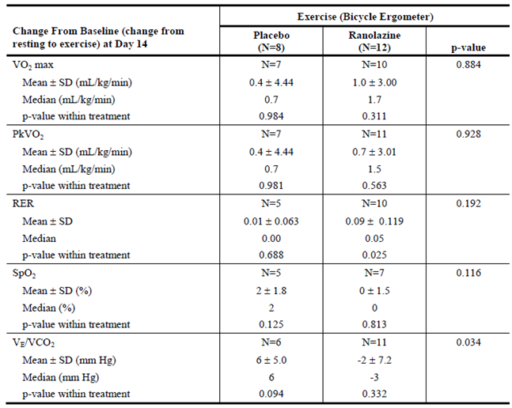
Previously submitted data:

Rate pressure product
The effect of RAN on RPP has been evaluated in three clinical studies of patients with angina (RAN080, CVT 3031 and CVT 3033).
A randomised, double blind, placebo controlled Study(RAN080) evaluated the effects of RAN IR 400 mg TDS versus the beta blocker atenolol 100 mg once daily in 158 patients (18 female) with chronic stable angina, aged 41 to 77 years. The following variables were monitored during a range of exercise tests: heart rate, blood pressure, time to onset of angina pectoris, time to 1 mm ST segment depression, maximal ST-segment depression, exercise duration and ST segment depression following 1 to 5 minutes of recovery. Compared to placebo, atenolol significantly increased the three key exercise parameters: time to onset of angina (in the evaluable data set: Δ = +45.1 seconds, 95% CI: 28 to 62.2 seconds, p < 0.001), time to 1 mm ST segment depression (+62.5 seconds, 95% CI: 42.3 to 82.7 seconds, p < 0.001) and exercise duration (+20.8 seconds, 95% CI: 5.4 – 36.2 seconds, p < 0.01), in association with a statistically significant reduction in End-Exercise RPP (Figure 2). Ranolazine IR also significantly increased the three key exercise parameters versus placebo to an equal or greater extent than atenolol: time to onset of angina (in the evaluable data set: Δ = +45.0 seconds, 95% CI: 28 – 62.2 seconds, p < 0.001), time to 1 mm ST segment depression (+51.9 seconds, 95% CI: 31.7 – 72.1 seconds, p < 0.001) and exercise duration (+33.7 seconds, 95% CI: 18.3 – 49.1 seconds, p < 0.01) (Table 6). However, End-Exercise RPP increased significantly on RAN compared with both placebo and atenolol. In the absence of an effect on coronary blood flow, these data possibly reflect an increase in myocardial oxygen efficiency due to RAN.
Figure 2: Rate pressure product during exercise testing of ranolazine versus atenolol in Study RAN080
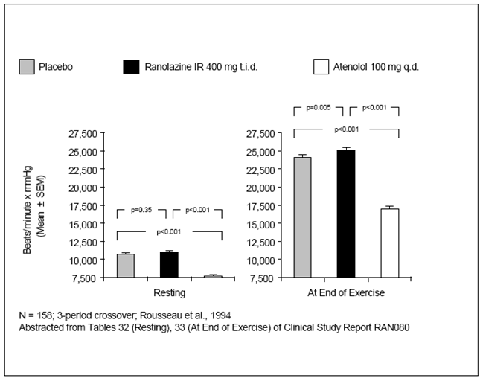

Table 6: Exercise and RPP Results one hour post dose in Study RAN080
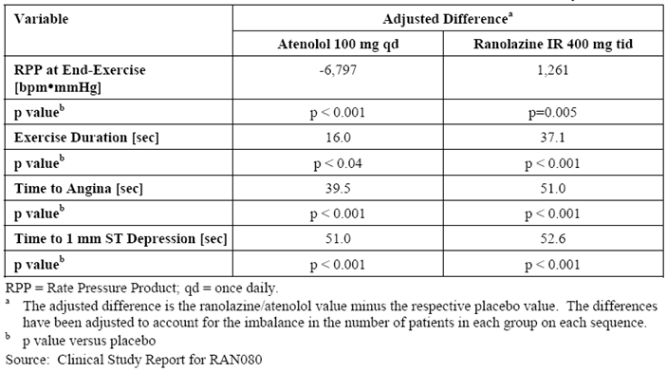
In Study CVT 3031, a double blind, randomised, placebo controlled, 4 period cross over study in 191 patients (51 female) with chronic stable angina, aged 39 to 85 years, following 500 mg RAN PR BD the efficacy variables, exercise duration, time to angina and time to 1-mm ST depression, increased significantly (p = 0.005 or lower) at both peak (29.3, 35.5 and 38.8 seconds, respectively) and trough (23.8, 27 and 27.6 seconds, respectively) compared to placebo. This was achieved in parallel with an increase in RPP at peak (43.3 seconds) and a minor decrease in RPP at trough (-107.2 seconds) compared to placebo.
In Study CVT 3033, a randomised, double blind, placebo controlled parallel group study in 823 patients (185 female), aged 36 to 92 years, with chronic angina receiving a single concomitant anti-anginal medication both doses of RAN SR (750 mg BD and 1,000 mg BD) showed statistically significant increases in exercise parameters (time to onset of angina, time to 1 mm ST-segment depression and maximum ST-segment depression), at both trough (12 hours post-dose) and peak levels (4 hours post) of plasma RAN, compared to placebo without significant decreases in RPP. In general, doses greater than 500 mg BD were associated with small but statistically significant decreases in End-Exercise RPP versus placebo. However, in comparable studies in patients with chronic angina, the increases in exercise performance observed with calcium channel blockers, and especially with beta-blockers, are generally associated with substantially larger decreases in End-Exercise RPP than what was observed at the higher RAN dose in studies CVT 3031 and CVT 3033.
Supporting the possibility that the small changes in RPP cannot fully account for the increases in exercise performance were the observations that the RAN effect on all three exercise efficacy parameters was greater at peak than at trough at all dose levels, with the exception of exercise duration on 1,000 mg BD in Study CVT 3033. In contrast, the pattern of the effects on End-Exercise RPP was reversed, with less reduction at peak than at trough as compared with placebo, with the exception of the changes at 1,500 mg BD in CVT 3031.
These studies indicate that statistically and clinically significant improvements in exercise performance can be achieved with RAN in the absence of effects on RPP. A reduction in RPP is seen at higher RAN doses but this reduction is smaller than that seen for calcium channel and beta-blockers.

Effect of ranolazine on the QT interval at high plasma concentrations
The effects of RAN on the QTc interval at target plasma RAN concentrations of 4,000, 10,000, and 15,000 ng/mL were assessed in a double blind, randomised, placebo controlled, 4 period, dose escalation Study (CVT 3111) in 36 healthy subjects (19 female), aged 21 to 42 years. These RAN concentrations represent drug exposure levels at the upper end of the therapeutic range, which are higher than normal therapeutic concentrations. An IV infusion of RAN was administered over 72 hours to healthy volunteers on three separate occasions in a forced titration design, in order to achieve both PK and PD steady state for RAN and its metabolites. Due to the development of adverse effects, including dizziness, nausea/vomiting, paraesthesia, diplopia, confusion, and occasionally vasovagal syncope, in the plasma concentration range 8,000 to 10,000 ng/mL the highest target concentration of 15,000 ng/mL could not be achieved. No delayed effect on QTc interval change in relation to attainment of steady state RAN was detected in this study indicating no temporal delay in the time course of effect on QTc versus the RAN plasma profile. Moreover, the QTc changes are most likely related to RAN and not its metabolites of which some have longer half-lives. The slope of the relationship between the plasma concentration of RAN and the change in QTc from baseline was on average 2.29 msec per 1,000 ng/mL (range of individual slopes 0.87 to 4.61 msec) when using the individually optimised correction formulae. There was no gender difference in the slope. No subject had increased QTc from baseline by more than 60 msec in any of the recorded ECGs, based on the median QT interval for each ECG. When the maximum QT interval was used, two subjects had increases from baseline of 60 to 80 msec in three ECGs (two measurements in Subject A [information redacted] and one measurement in Subject B [information redacted]). These more pronounced increases represent single observations among other data with lower increases at similar or higher RAN plasma concentrations in each of the two subjects. Subject A had 10 observations at higher concentrations with QTc increases ranging from 12 to 58 msec, and Subject A had three observations at higher concentrations with QTc increases ranging from 18 to 38 msec, raising the possibility that these QTc readings of > 60 msec were a chance finding.

PD in special populations

Effect of ranolazine on the QTc interval in patients with CHF (NYHA Class III/IV)
The effect of RAN on QTc interval in patients with severe congestive heart failure (NYHA Class III and IV) was examined in a double blind, randomised, placebo controlled, parallel group Study (CVT 3021) in 85 patients (26 female) with CHF, aged 28 to 80 years. Patients were exposed to RAN PR 750 mg BD or placebo for six days. RAN plasma concentrations up to approximately 9,000 ng/mL were observed in the study. The QTc interval increased with the plasma RAN concentration with a slope of 2.12 msec per 1,000 ng/mL based on the Fridericia’s correction factor. These results are comparable to those reported for patients who had stable angina, including angina patients with NYHA Class I and II (Studies CVT 3031 and CVT 3033).

Effect of ranolazine on the QTc interval in patients with hepatic impairment
Study CVT 3018 evaluated the effects of RAN on QTc in patients with mild (Child-Pugh Class A) or moderate (Child-Pugh Class B) hepatic impairment and in matched healthy subjects. Patients with hepatic impairment had a diagnosis of liver cirrhosis with durations ranging from 2 to 18 years. An initial dose of 875 mg RAN PR was followed by 500 mg BD for a total of 2½ days. Mean QTcF of 9 recordings collected from approximately 8 am to 8 pm, representing baseline (Day −1), across all subjects was 416.0 msec in controls, 439.5 msec in the mild hepatic impairment group, and 429.2 msec in the group with moderate hepatic impairment. At steady state (Day 3) for RAN PR 500 mg BD, mean QTcF was 414.4 msec, 443.0 msec, and 439.8 msec in the control, mild and moderate groups, respectively. Mean changes in QTcF from baseline to Day 3 were −1.6 msec in controls, +3.5 msec in the mild group, and +10.6 msec in the moderate group. The larger increase in QTcF in the group with moderate hepatic impairment compared to the mild group may in part be explained by higher RAN plasma concentrations, as the moderate group has a 76% higher AUC_{0–12}compared to that of both the mild and healthy groups, whereas, there was no difference in AUC₀₋₁₂ between the mild group and healthy controls on Day 3. The number of subjects with a mean QTcF > 450 msec on Day 3 was 0/16 in controls, 2/8 in the mild group, and 3/8 in the moderate group. Increases in mean QTcF by > 10 msec from baseline were observed in 2/16 control subjects, 2/8 subjects with mild impairment, and 4/8 of subjects with moderate impairment. Overall, following treatment with RAN the mean QTcF values were, on average, 25 to 29 msec higher in the hepatic impairment groups than in controls. QTcF values exceeding 480 msec were only observed in 2 subjects with moderate hepatic impairment.

Effect of ranolazine on the QTc interval in patients with renal impairment
Study CVT 3016 examined the effect of RAN on QTc in healthy subjects and in patients with mild, moderate or severe renal impairment. The PK results related to these studies are presented in the preceding section. Subjects received a loading dose of 875 mg RAN PR (500 + 375 mg tablets), followed by RAN PR500 mg administered every 12 hours for a total of 4 maintenance doses. Ranolazine had no effects on QTc in healthy or in renally impaired subjects. No major differences in other safety variables were observed.

Effect of ranolazine on the QTc interval in patients with LQT3 syndrome
The ability of RAN to shorten the QTc interval in 5 patients (1 female), aged 24 to 56 years, with LQT3 syndrome, who had QTc prolongation secondary to the ΔKPQ deletion in the SCN5A sodium channel gene was evaluated in the open label, exploratory Study CVT 3114. Subjects needed to have the confirmed genotype and QTc > 470msec. Four of five subjects were taken concomitant nadolol for LQT3. Intravenous RAN was administered for 8 hours (at a rate of 45 mg/h for the first 3 hours followed by 90 mg/h for the next 5 hours); the median total RAN dose received during both infusions was 585 mg. Plasma levels of RAN were measured at hourly intervals during the 8 hours infusion and at 10, 12, and 24 hours from the start of infusion. Over the first 3 hours of RAN administration, at a rate of 45 mg/hour, plasma concentrations progressively increased to a mean of 908 ± 125 ng/mL; with a subsequent increase in infusion rate to 90 mg/hour, administered over the next 5 hours, mean plasma concentrations further increased to a maximum of 2074 ± 445 ng/mL at 8 hours following the start of infusion. Once the infusion was terminated, plasma concentrations of RAN declined, with mean values of 823 and 346 ng/mL at 10 and 12 hours from the start of the infusion, respectively, and were below the quantitation limit in all patients by 24 hours. Following administration of RAN, QTc values showed a downward trend compared to matched baseline values (collected the day prior to dosing). Over the entire 8 hours RAN infusion period, the mean change in QTc was −26.3 ± 3.49 msec (p < 0.001) (Figure 3). Evaluation of the QTc response by dosing period indicated that QTc was shortened in a concentration-dependent manner. During the first 3 hours of treatment at an infusion rate of 45 mg/h the mean change from time matched baseline in QTc ranged from −6 to −20 msec. Over the next 5 hours of RAN infusion at a rate of 90 mg/hour, the mean change from baseline in time matched QTc values ranged from −22 to −42 msec. All mean QTc values obtained during the 90 mg/h infusion were statistically significantly lower (p ≤ 0.02 to p < 0.001) than baseline-matched values. Once the infusion was terminated, RAN plasma concentrations declined toward zero, and the change from baseline in QTc values returned to zero. The mean (± SD) correlation coefficient between QTc change from time matched baseline and RAN plasma concentration was −0.7 ± 0.22. Fitting an overall linear regression model to the QTc with effects for subject, RAN concentration and the interaction of RAN concentration with subject, the average slope of the QTc versus RAN plasma concentration was –24.1 msec per 1000 ng/mL (p = 0.008).
Figure 3: Study CVT 3114: Profile over time of plasma ranolazine concentrations and changes form time matched baseline QTc interval¹ in LQT3 subjects²
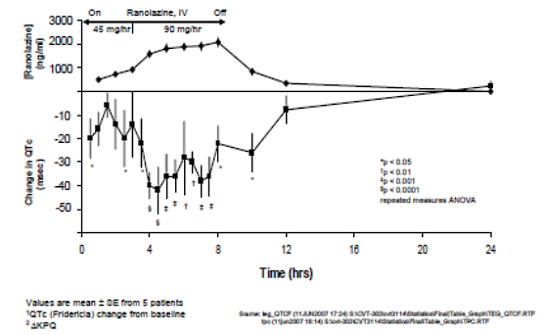
Ranolazine appeared to have little or no effect on PR or QRS intervals. Mean values were variable over the infusion period with no real observed trend. Over the infusion period, the PR interval showed a mean change from matched baseline values of 2.9 ± 2.19 msec (p = 0.19); during the first 3 hours of infusion, mean PR changes from time matched baseline values ranged from −3.3 to +10.0 msec, and during the next 5 hours, ranged from −3.3 to +10.0 msec, with no apparent correlation to plasma concentrations. Similarly, QRS values showed an overall (that is, over the 8 hour infusion period) mean change of −1.9 ± 1.07 msec (p = 0.08) compared to matched baseline values; during the first 3 hours of the infusion, mean changes ranged from −12.0 to +2.0 msec, and during the next 5 hours, ranged from −8.0 to +6.0 msec, again with no apparent correlation to plasma concentrations. These results indicate that RAN does not affect conduction velocity, unlike other drugs that are peak sodium inhibitors, such as flecainide. T wave amplitude remained similar to matched baseline values over the 8 hours RAN infusion period, with an overall mean change of 0.0 ± 0.01 mV. The mean T wave duration was generally lower than time matched baseline values during the RAN infusion, however, the mean values varied over time with no apparent correlation to plasma concentrations; the overall mean change in T wave duration was −13.8 ± 4.94 msec, reflecting an approximate 6% decline from baseline. Echocardiogram evaluation of LV diastolic function showed statistically significant (p < 0.05, single sample Student’s t-test) improvement in LV isovolumic relaxation time (LV IVRT), with a mean decrease of 16.8 msec, and early transmitral flow velocity, with a mean increase of 14.2 cm/sec (Table 7). An improvement was also observed in deceleration time (DT), with a mean decrease of 62.6 msec. Other echocardiogram parameters showed little effect on systolic function.

Table 7: Study CVT 3114: Echocardiograph resting left ventricular function
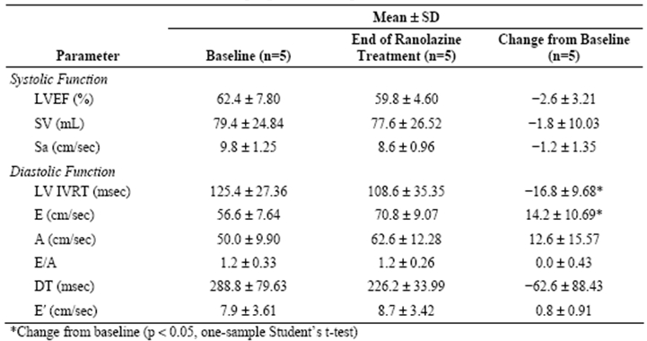
The sponsor states this pilot study provides some clinical evidence of RAN’s effect on the late sodium current channel and that its anti-ischaemic effects are achieved through improved diastolic relaxation and resultant improved coronary blood flow.

Secondary pharmacodynamic effects
Study GS-US-291-0101 examined the potential effect of RAN at two dose levels on the PK parameters of dronedarone. In addition, exploratory PD assessments, which included AF burden, number and duration of AF episodes, and ventricular rate during AF episodes based on Holter monitoring at baseline (dronedarone only) and on Days 2 to 7 (with the addition of RAN) were also undertaken. Among the 8 subjects studied, 3 subjects did not have any AF episodes, 4 subjects had AF burden approximately 100% and 1 subject had 26% AF burden for the duration of the study. Therefore, due to the small number of subjects in this study and the observed variability of the data, no meaningful interpretation of the data could be made.
Previously submitted data:

Cardiac function in patients with congestive heart failure
Two studies, RAN075 and CVT 3021, examined the effect of RAN on cardiac function in patients with congestive heart failure.
An open label, non-randomised Study (RAN075) assessed the effects of RAN on myocardial contractility and left ventricular pump function in 30 patients (6 female), aged 38 to 68 years, with mild to severe congestive heart failure with left ventricular ejection fractions ranging from 12% to 55%, aged 38 to 68 years. Ranolazine was administered as two intravenous bolus doses 10 minutes apart. Fifteen patients received the low dose (100 µg/kg + 100 µg/kg = 200 µg/kg) and 15 received the high dose (300 µg/kg + 200 µg/kg = 500 µg/kg). Plasma levels (mean ± SD) of the RAN dihydrochloride salt 10 minutes after the second bolus were 278 ± 65 ng/mL, corresponding to 237 ± 56 ng base/mL in the 200 µg/kg group, and 588 ± 342 ng/mL, corresponding to 502 ± 292 ng base/mL in the 500 µg/kg group. The original study report indicated that RAN had a negative inotropic effect. By contrast, no statistically significant changes in end-diastolic and end-systolic volumes, as well as in cardiac output or ejection fraction were identified. In an addendum to the report, the data were subsequently re-analysed with subset analyses classifying patients according to their baseline ejection fraction, baseline end-systolic volume, and baseline functional NYHA class. In each subset, the subgroup that had received the high dose of RAN was examined separately. No statistically significant effect of RAN on left ventricular pressure and volume, or ejection fraction, was observed in patients with baseline ejection fraction > 25%, or in patients with an end-systolic volume < 90mL/m², irrespective of RAN dose. The average pressure volume loops in patients with ejection fraction > 40% before and after RAN showed an almost complete superposition, indicating the absence of a cardio depressant effect of RAN. Patients with baseline ejection fraction < 25% demonstrated a slight rightward shift of the pressure-volume loops and an increase in end systolic volume by about 6% (at an end-systolic pressure of 130 mmHg), changes consistent with a slight depression of myocardial contractility. However, even in patients with severe heart failure, stroke volume and ejection fraction remained unchanged, and no significant increase in end-diastolic pressure was observed. In light of unchanged contractile function in a large subset of patients with ejection fraction > 25%, the small decrease in dP/dt noted in all subsets was assigned to changes in preload, after-load and/or heart rate reduction. The effect on pressure-volume loop data in patients with severe heart failure observed was attributed to the well-known hemodynamic effects of the contrast agent used in this study, which is known to adversely affect ventricular systolic performance.
In Study CVT3021 the effect of RAN administered in parallel with digoxin on ejection fraction and blood pressure was examined in patients with NYHA Class III and IV congestive heart failure. Following an 8-day digoxin or digoxin placebo run-in phase, patients were treated with RAN PR 750 mg BD or RAN placebo, and continued digoxin or digoxin placebo, for 6 days. The average RAN (free base) plasma concentration at steady state was 2237 ng/mL (range 577.4 to 7883). In one subgroup of patients treated with RAN and digoxin placebo (Group B, n = 15 to 17), the average left ventricular ejection fraction decreased from baseline by 1.7%, which was statistically significant but was not considered clinically meaningful. In the other treatment groups receiving active RAN, the average ejection fraction was unchanged or slightly increased. Mean changes in systolic blood pressure in RAN treated patients were small (−2 to −5 mm Hg) and comparable to those in placebo treated patients, thus suggesting lack of effect of RAN on cardiac after-load. No cardiac catheterisation was performed in this study, thus pressure volume loop data reflecting cardiac contractility are not available. The minor changes in ejection fraction together with minor changes in systolic blood pressure reflecting after-load suggest a major decrease in cardiac contractility is unlikely.

Time course of pharmacodynamic effects
Following a 30 min infusion in Study GS-US-270-0101, that is 60 min following the first bolus dose, RAN treated patients showed statistically significant decreases from baseline in resting LVEDP (−2.13 ± 3.961 mm Hg; p = 0.042) and resting PCWP (−2.08 ± 3.166 mm Hg; p = 0.044); which were not observed in the placebo treated group. This indicates that there was a rapid onset of RAN effects following bolus + IV dosing.

Relationship between drug concentration and pharmacodynamic effects
No new information.
Previously submitted data:
ECG and plasma concentration data from a total of 17 studies in healthy subjects and angina patients were pooled and analysed using a population approach. QTc was calculated from the QT and RR intervals using Fridericia’s correction formula. QTc increased linearly with the ranolazine plasma concentration with a slope of on average 2.4 msec per 1,000 ng/mL up to concentrations exceeding 10,000 ng/mL, which is approximately four times higher than the peak concentrations typically achieved at the maximum proposed dose of 1,000 mg BD. The slope was similar in healthy subjects and angina patients and unaffected by age, weight, gender, CHF NYHA Class I–IV, diabetes, race and drug formulation. At a dose of 1,000 mg BD the average increase in QTc at peak is approximately 5 msec. A special study in healthy volunteers (CVT 3111) was conducted to assess the effects of ranolazine on the QTc interval at plasma target plasma ranolazine concentrations of 4,000, 10,000, and 15,000 ng/mL, respectively, during a 72 hour IV infusion. The highest target concentration could not be achieved due to the emergence of dose limiting side effects. The slope of increase in QTc from baseline was on average 2.29 msec/1,000 ng/mL ranolazine concentration, that is, similar to the average slope in the population PK/PD evaluation including angina patients. In a pharmacokinetic study in patients with mild or moderate hepatic impairment and healthy controls, patients with hepatic impairment had an average increase in QTc versus the ranolazine plasma concentration which was greater than in any other population studied. The reasons for this increase in subjects with hepatic impairment are not known.

Genetic, gender and age related differences in pharmacodynamic response
No new information.

Pharmacodynamic interactions
No new information.
Previously submitted data:
The relationship between the plasma concentration of ranolazine and the QTc interval, when RAN was administered alone and when co-administered with ketoconazole, under steady state conditions of both drugs was examined in a double blind, randomised, multiple dose, parallel group Study (CVT 301-10) in 50 healthy subjects (25 female) aged 18 to 44. The study was conducted in two parts with a similar design, 375 mg RAN BD was administered in the first part and 1,000 mg BD in the second part. Due to a PK interaction where ketoconazole increased RAN concentrations by 3.0 to 3.9 fold, RAN concentrations up to approximately 10,000 ng/mL were achieved. The slope of RAN concentration versus change in QTc from baseline was, on average, 2.86 msec per 1,000 ng/mL (95% CI: 1.43 to 4.28 msec) when using the study specific correction formula QTc = QT/RR0.28. In an additional analysis of the effects on QTc in this study, individually optimised correction formulae were applied similar to that used for Study CVT 3111. In this analysis, prolongation of the optimally corrected QTc interval from baseline in the presence of RAN 1,000 mg BD and ketoconazole was found to be 23.09 msec (CI 16.25 to 29.94 msec) and, when corrected for the finding on placebo, the increase in optimally corrected QTc interval versus the corresponding change on placebo was 19.77 msec (95% CI: 11.08 to 28.45 msec). None of the individual QTc prolongations following the highest dose of RAN (1,000 mg BD) exceeded 40 msec and the threshold of 30 msec was only reached by four male subjects at the high dose of RAN.
Study RAN0110 examined the effect of RAN IR 400 mg TDS for 10 days on prothrombin time of 5 mg warfarin administered on Day 4 in healthy males. Warfarin prothrombin times were measured pre-dose and up to 168 and 144 hours, respectively, following warfarin dosing. There was a statistically significant increase in the maximum prothrombin time (PT_{max}) and the area under the prothrombin time curve up to 144 hours after the warfarin dose (AUC_{0-144PT}) (RAN0110, Table 8).

Table 8: Study RAN0110 Period 1 mean ± SD warfarin period 1 prothrombin time parameters (n = 6)
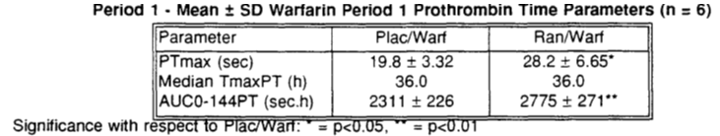
Comment: This suggests that a clinical interaction may occur between warfarin and ranolazine and therefore, patients who are administered these drugs concurrently should have their prothrombin times closely monitored.
A significant number of animal studies in the nonclinical module, including Cerep 951003, Cerep 951006 and 951009, CVT303.029-N, CVT303.064-P, CVT303.067-P, MDS 1011172, MDS1033853 and MDS 1011220 as well as published manuscripts indicate that RAN and its metabolites have µM affinity and functional activity at the alpha and beta adrenergic receptors, 5HT and opiate receptors in a wide range of animal species and may therefore interfere with or add to the effects of drugs that specifically target these receptors types, such as the beta-blocker metoprolol, in man.
For instance, Study CVT303.064-P provides evidence that RAN has functional β-adrenergic antagonistic activity in conscious rats, whereas, Study MDS1033853 identified that ranolazine inhibited neurogenic twitch in isolated guinea pig ileum (a serotonin 5-HT1A receptor mediated response) with an EC50 value of 5.3μM.
The sponsor also stated, in the response, that the animal studies suggest that “major metabolites CVT-2514 and CVT-2551, at concentrations that are likely to be achieved in humans, may exert moderate to weak β-adrenergic receptor antagonism”. In addition, as CVT-2514 occurs “in blood plasma at concentrations of ≥ 10%” RAN it would further suggests that the effect of RAN on beta adrenergic receptors may be even more pronounced. This issue maybe further exacerbated by the saturation kinetics of RAN relating to CYP3A4 and CYP2D6 as it would appear that RAN affects the metabolism and increases the exposure to drugs metabolised by these iso-enzymes.
Comment: The possibility that RAN, in part or wholly, acts through these other receptors (that is alpha and beta adrenergic receptors, 5HT and opiate receptors) has not been addressed in the PD studies conducted in man and it is not clear whether any contraindications exist between RAN and drugs that act at these receptors.
This issue was addressed in a response by the sponsor and due to the lack of effects seen in Phase II and III clinical development, it is accepted that no further information is required in the PI.

Evaluator’s overall conclusions on pharmacodynamics
- Ranolazine is a novel anti-ischaemic drug for the treatment of angina.
- The mechanism via which RAN mediates its anti-anginal effects has not been fully elucidated; however, it is thought to act by inhibiting late sodium current in cardiac cells.

Summary of newly submitted PD data
- In patients with heart failure who received two bolus doses + a 30 min infusion of RAN, there were statistically significant decreases in resting LVEDP (−2.13 ± 3.961 mm Hg; p = 0.042), resting PCWP (−2.08 ± 3.166 mm Hg; p = 0.044), and mean PAP under paced conditions (−1.76 ± 2.381 mm Hg; p = 0.016), which were not observed in placebo treated patients.
- Following 14 days treatment with oral RAN (1,000 mg BD), RER was significantly increased (0.09 ± 0.119; p = 0.025), and VE/VCO₂ (−2 ± 7.2) was a significantly decreased (p = 0.034) compared to placebo. By contrast, there were no significant effects on ECG parameters or NT-pro-BNP.
- There was a rapid onset of RAN effects following bolus + IV dosing in patients with AF.

Summary of previously submitted PD data
- In patients with chronic angina, RAN IR significantly increased three key exercise parameters versus placebo to an equal or greater extent than atenolol: time to onset of angina, time to 1 mm ST segment depression and exercise duration without any significant effects on the RPP.
- Doses of 500 mg and 1,000 mg ranolazine BD also significantly increased these three exercise parameters compared to placebo in patients with chronic angina.
- In general, doses greater than 500 mg BD RAN were associated with small but statistically significant decreases in End-Exercise RPP versus placebo.
- The effects of RAN on cardiac ventricular repolarisation characterised by increased T wave amplitude and prolongation of the QTc interval are dose- and plasma-concentration dependent.
- Clinical data in five patients with LQT syndrome provides evidence that RAN may act as an inhibitor of the late sodium current (INa).
- There is no evidence that RAN produces a clinically significant negative inotropic effect.
- There was no clinically meaningful effect on ejection fraction in Study CVT 3021, in which RAN plasma concentrations were 4 to 5 times higher than in Study RAN075.
- Four out of 50 subjects co-administered 1,000 mg RAN BD and ketoconazole experienced QTc prolongations of greater than the 30 msec threshold, therefore the co-administration of these drugs should be carefully monitored.
- There is evidence that suggests that the PT_{max} and AUC_{0-144PT} are significantly increased following the co-administration of warfarin and RAN. Therefore, patients who are co-administered these drugs must have their prothrombin times closely monitored.

Limitations of the new PD studies:
Little information is provided regarding the activity of the metabolites of RAN.
Comment: This was also an issue in the earlier submission (see below) and question regarding the functional activity of the metabolites has been included in this document.

Limitations of previously submitted PD studies
- No studies were conducted to examine the PD effects of RAN in the following groups: children below the age of 18 years, pregnant or breast feeding mothers, the ability to drive or operate machinery and different genders and racial groups.
- In addition, the PD effects of the major RAN metabolites are unknown and these warrant further investigation to determine whether they are pharmacologically active.
- No studies examined the effect of RAN on drugs that target alpha and beta adrenergic receptors, 5HT and opiate receptors.

Dosage selection for the pivotal studies
There were three main studies with ranolazine IR that contributed data on dose selection (RAN072, RAN080 and RAN1514). There was then one dose response study with ranolazine PR (CVT3031). These four studies were all evaluated in the prior dossier and the summaries from that clinical evaluation report are included here.
In addition, there were a number of other studies in the dossier assessing the IR formulation which did not provide useful dose response efficacy data (RAN1515, RAN020, RAN054, RAN1490, RAN1513 and RAN012).

Dose response studies with ranolazine IR

RAN072
RAN072 was a Phase II, randomised, single dose, placebo controlled, crossover study evaluating the safety, tolerability and anti-anginal efficacy of 4 oral doses (10 mg, 60 mg, 120 mg and 240 mg) of ranolazine IR in 106 subjects with symptomatic chronic stable angina (as demonstrated by at least 1 mm ST depression on a bicycle exercise test) despite treatment with a beta-blocker (atenolol or metoprolol) or calcium antagonist (diltiazem). Ranolazine plasma levels were also collected, though it is unclear at what time point. Exercise testing was at 2.5 to 3 hours post dose.
After a single dose of 240 mg ranolazine IR, the mean exercise duration increased 36.6 sec (p = 0.004) with a mean percentage increase of 13.1%. The exercise duration increase was greater in those on a background of beta-blockers (39.4 sec, p = 0.02) than on calcium antagonists (33.8 sec, p = 0.08). Exercise duration did not increase significantly with the 10 mg, 60 mg or 120 mg dose groups. The time to angina (excluding subjects with no angina) was not significantly different between doses. A statistically significant increase in the time to angina was only seen in the 240 mg dose group (mean increase 56.8 sec, p = 0.008) with no improvement in the lower dose groups. The time to 1 mm ST depression (excluding subjects not achieving this on both study days) increased in the 240 mg group only (mean increase 36.4 sec, p = 0.04). There was poor correlation between plasma ranolazine levels and exercise duration (Spearman correlation 0.16, p = 0.014) and the change in the summed ST depression (Spearman correlation 0.2, p = 0.07).
Comment: RAN072 found that in subjects with symptomatic angina, on a background of beta-blockers or calcium antagonists, after a single dose of ranolazine there were anti-anginal and anti-ischaemic effects only with a dose of 240 mg and not with lower doses.

RAN080
RAN080 was placebo controlled, double blind, crossover study evaluating the efficacy of ranolazine IR compared to atenolol in 158 subjects with chronic stable angina. After a single blind 1 week washout period, subjects entered the double blind phase. There was 3 way crossover between the treatments of placebo, ranolazine 400 mg three times a day (TDS) and atenolol 100 mg once daily, with each treatment lasting 1 week. The primary efficacy endpoint was time to angina on a bicycle or treadmill exercise test. Study medication was given just prior to exercise testing. Methods were outlined in. There were 117/158 (74.1%) subjects “evaluable”.
In the “evaluable” population, the mean difference in time to onset of angina between the ranolazine IR and placebo groups was 45.0 sec (95% CI: 28.0, 62.2, p < 0.001) and between atenolol and placebo was 45.1 sec (95% CI: 28.0, 62.2, p < 0.001), while there was no significant difference between ranolazine and atenolol (-0.1 sec, 95% CI: -17.2, 17.0, p = 0.99). These results were supported by the analysis of “all patients”. Treatment differences were not consistent between centres in both population groups analysed (evaluable p = 0.03, all patient p < 0.001). The mean exercise duration in the evaluable population also increased when treated with ranolazine (mean difference 33.7 sec) or atenolol (mean difference 20.8 sec) compared to placebo and there was no significant difference between ranolazine and atenolol (12.9 sec, 95% CI: -2.5, 28.3, p = 0.1). The time to 1 mm ST depression in the evaluable group was also significantly increased in the ranolazine and atenolol groups (mean difference 51.9 sec, 95% CI: 31.7, 72.1 and 62.5 sec 95% CI: 42.3, 82.7). While there was no significant difference between ranolazine and atenolol (p = 0.30), the time to 1 mm ST depression was less for ranolazine (mean difference -10.7, 95% CI: -30.9, 9.5). Results of the all patient analysis supported the evaluable population analysis. There was no significant correlation between plasma ranolazine concentration and time to angina onset, time to 1 mm ST depression or exercise duration.
Comment: RAN080 found that, at the time of peak plasma levels, ranolazine 400 mg TDS produced anti-anginal and anti-ischaemic effects that were similar to atenolol 100 mg once daily in patients with chronic stable angina.

RAN1514
RAN1514 was a Phase II, double blind, placebo controlled, crossover study which assessed three doses of ranolazine IR (400 mg BD, 267 mg TDS and 400 mg TDS) in subjects with chronic stable angina pectoris. After a washout, qualifying, single blind period, subjects entered a double blind, 5 week, treatment phase where each treatment was given for 1 week and one treatment repeated. Peak and trough ranolazine plasma levels were collected. The primary endpoint was time to angina onset at trough during an exercise treadmill test (ETT) with the modified Bruce protocol. To qualify, subjects needed to have a 1 minute or greater reduction in time to angina onset after withdrawal of one or more anti-anginal medications.
At trough, no statistically significant differences were found between the 3 ranolazine doses and placebo for time to angina onset, exercise duration, or time to 1 mm ST depression in both the “per protocol” and “all patient” analyses. At peak, no differences were found in the “per protocol” population for time to angina onset or exercise duration while the mean time to 1 mm ST depression was significantly increased in 3 dose groups (0.27 min, 0.44 min, 0.40 min for the 400mg BD, 267mg TDS and 400mg TDS groups respectively). At peak, in the “all patient” population, there was a significant increase in time to angina onset (mean difference 0.32 to 0.39 min, p = 0.01) and time to 1 mm ST depression (mean difference 0.28 to 0.41 min, p < 0.01) for all 3 ranolazine dose regimens, however exercise duration was not significantly increased (mean difference 0.17 to 0.20 min, p > 0.05). The range of mean plasma levels at peak were 1,576 to 2,492 ng/mL and at trough were 275 to 602 ng/mL. There was little correlation between ranolazine plasma levels and difference from placebo in any exercise parameter.
Comment: RAN1514 found that at daily doses of 800 mg (267 mg TDS or 400 mg BD) or 1,200 mg (400 mg TDS), ranolazine had anti-ischaemic activity (as measured by prolongation in the time to ST depression) at peak plasma concentration (1 hour post dose). Anti-anginal and anti-ischaemic activity was not found at trough when ranolazine was administered 2 or 3 times a day which suggested the need for a prolonged release formulation. Plasma levels below 602 ng/mL were not sufficient for anti-anginal activity and the threshold for activity appeared to be between 602 and 1,576 ng/mL.

CVT3031: Dose response study with ranolazine PR

Methods
CVT3031 was a double blind, randomised, placebo controlled, 4 period crossover study of ranolazine SR monotherapy in 191 patients with chronic stable angina. The study was conducted between 1,997 and 1,999 in the US, Canada, Poland and the Czech Republic.
After a single blind placebo run-in phase of 1 week, there was a 4 week double blind treatment phase and a 2 week follow up. Subjects were randomised to 1 of 4 treatment sequences and received treatment with ranolazine 500 mg BD, 1,000 mg BD, 1,500 mg BD and placebo BD for 1 week each in a randomised sequence order. Treatment was with ranolazine slow release (SR) 500 mg tablets or matching placebo. Medication was identical and in matching blister packs. Sublingual nitroglycerin tablets were provided and other anti-anginal medications were prohibited throughout the trial.

Study participants
Inclusion criteria were: ≥ 21 years; 3 month history of chronic stable angina; documented history of CAD (angiography with ≥ 60% stenosis in ≥ 1 artery, MI with enzyme change, or positive cardiac nuclear scan); response to at least one anti-anginal agent; women needed to be postmenopausal or have a negative pregnancy test and using contraception. Subjects also needed, on 2 qualifying ETTs, to have an exercise duration of 3 to 9 minutes with ≤ 20% and 60 seconds difference in time, cessation of ETT due to angina and the presence of 1 mm ST segment depression on both occasions.

Exclusion criteria
Exclusion criteria were: factors that may interfere with ECG interpretation or cause a false positive stress test; CHF class III or IV; significant valvular heart disease; unstable angina; cardiac arrhythmias; 2nd or 3rd degree AV block; QTc > 0.5 sec; requiring medication which could prolong QTc interval; requiring medication inducing or inhibiting cytochrome P450 3A4; digoxin; MI, CABG or PTCA within 2 months; acute myocarditis or pericarditis; hypertrophic cardiomyopathy; uncontrolled hypertension; SBP < 100 mmHg; chronic illness interfering with evaluation; and any clinically significant laboratory abnormality.

Outcomes, endpoints
Exercise treadmill tests (ETTs) used the Sheffield Modified Bruce Treadmill Exercise Protocol (Sheffield 1998). ETTs were performed at the start (after 48 hour washout of anti-anginal medication) and end of the 1 week single blind qualifying phase and then at the end of each week (during double blind treatment) prior to the final dose (trough) and 4 hours post dose (peak). The time to 1 mm ST segment depression and maximum ST segment depression during exercise from each ETT were measured at a central laboratory. Blood pressure (BP) and heart rate (HR) were monitored during the ETT.
The primary efficacy variable was the exercise duration at trough plasma concentration (12 hours post dose). Secondary variables included time to angina onset at trough and peak, time to 1 mm ST segment depression at trough and peak, maximum ST segment depression at trough and peak and exercise duration at peak concentration.

Statistical methods
The primary efficacy analysis used standard ANOVA for crossover study design. The model included effects for treatment, period, pooled site and patient nested with pooled site. Adjustment for multiple comparisons of ranolazine doses to placebo was via a 3 stage step down procedure. The primary analysis population was all randomised subjects with evaluable efficacy measurements at baseline and in at least 3 of 4 of the double blind periods; this evaluable population was termed “all/near completers” (A/NC). Analysis of the ITT and PP populations was also conducted. A supportive analysis using generalised estimating equations (GEE) methodology for linear models was also used to allow adjustment for more baseline variables (baseline ETT duration, age, gender, stroke and unstable angina history).
A sample size of 152 subjects provided 90% power to detect a mean difference of 25 seconds between active and placebo treatments assuming a 95 sec within patient standard deviation in exercise duration and significance level of 5%. Enrolment was set at 203 randomised subjects.

Results

Participant flow
There were 191 subjects randomised with 175 (91.6%) in the A/NC, 185 (96.9%) in the ITT and 135 (70.7%) in the PP populations. Placebo, ranolazine SR 500 mg, ranolazine SR 1,000 mg and ranolazine SR 1,500 mg was received by 94%, 95%, 94% and 98% of subjects, respectively. There were 23/191 (12%) subjects who prematurely discontinued with most due to an AE (15/191, 8%). The 1,500 mg dose resulted in a notably higher rate of premature withdrawal (13/187, 7%) than the other doses (1,000 mg: 1%, 500 mg: 3%, placebo: 2%).

Baseline data
Subjects randomised to each treatment sequence had similar demographics and 91% were Caucasian, 53% ≥ 65 years and 73% male. On medical history, 52% had an MI, 28% CABG, 32% PTCA, 24% were diabetic, and 7% had COPD or asthma. Cardiovascular history was similar between treatment sequences except for unstable angina within 2 months and history of stroke which were adjusted for in the GEE analysis.

Compliance
Over 95% of subjects were compliant as defined by taking between 67% and 125% of tablets.

Primary outcome
In the A/NC population, ETT (exercise) duration at trough was significantly improved compared to placebo by 45.9 sec (95% CI: 30.2, 61.7), 33.7 sec (95% CI: 18.1, 49.2) and 23.8 sec (95% CI: 8.2, 39.43) in the ranolazine SR BD 1,500 mg, 1,000 mg and 500 mg groups, respectively. These results are supported by the ITT and PP population analysis. There was no statistically significant interaction on the treatment effects by pooled site, period or carryover and baseline variables (in the model using GEE methodology) did not alter the results significantly.

Secondary Outcomes
For the A/NC population, at peak drug levels there was an improvement in ETT duration of 55.5 sec, 50.1 sec and 29.3 sec with ranolazine SR 1,500 mg, 1,000 mg and 500 mg, respectively, all of which were statistically significant. The results were confirmed on the ITT and PP analysis. For each dose, the ETT duration was greater than that seen at trough. An analysis of only the first period population of the study (45 to 49 subjects per group) found that exercise duration at trough was not statistically significantly improved while a significant improvement was generally seen at peak.
In the A/NC population, the time to angina onset at trough compared to placebo was 59.6 sec, 45.9 sec and 27.0 sec with ranolazine SR 1,500 mg, 1,000 mg and 500 mg, respectively. At peak, the time to angina onset was 68.5 sec. 56.4 sec and 35.5 sec for the 3 doses, respectively. All results at trough and peak were statistically significant (p ≤ 0.005). There was also a statistically significant (p < 0.001) improvement over placebo for all 3 doses in time to 1 mm ST segment depression at trough (64.6 sec, 44.5 sec, 27.6 sec, respectively) and peak (69.0 sec, 55.6 sec and 38.8 sec). At trough ranolazine levels, subjects on ranolazine 1,500 mg had a decrease in maximal ST segment depression compared to placebo (delta 0.18 mm, 95% CI: 0.1, 0.27, p < 0.001). This was similar for ranolazine 1,000 mg (delta 0.15mm, p < 0.001) but ranolazine 500 mg was similar to placebo (delta 0.05, p = 0.27).
The reason (“angina” or “not angina”) for stopping the ETT was assessed and it was found that at trough there was a decrease in stopping due to angina with increasing dose: placebo 72%, ranolazine 500 mg 67%, ranolazine 1,000 mg 60% and ranolazine 1,500 mg 57%.
Comment: CVT3031 found, that in subjects with chronic stable angina, one week treatment with monotherapy ranolazine SR, at doses of 500 mg BD, 1,000 mg BD and 1,500 mg BD, significantly improved exercise duration at trough and at peak levels.
There was an indication of a dose response with more improvement in exercise duration at higher doses and at peak compared to trough levels.
Results were supported by an improvement in time to angina onset at trough and peak.
Anti-ischaemic effect was seen in an improvement in time to 1 mm ST segment depression and decrease in maximal ST segment depression.
The 1,500 mg BD dose resulted in a notable increased rate of AEs leading to discontinuation.
The study had limitations as follows:
- Ideally, dose response studies in stable angina should be parallel group with at least 6 weeks treatment duration (EMA/CHMP 2006) rather than the crossover design with 1 week treatment periods.
- There should be a run in of at least 2 weeks to ensure disease stability, while here it was only 1 week.
- Subjects should be at least 6 months post revascularisation to rule out angina symptoms related to the procedure, rather than the 2 months listed in the exclusion criteria of this study.
- There were no washouts between periods and whilst there was no statistically significant interaction on assessment of carryover, the data from the first period found no improvement in exercise duration at trough. The sponsor claims this was a chance finding.
- For these reasons the data from this study can only be viewed as supportive and not pivotal (which was claimed by the sponsor).

Dose selection for Phase III studies
The sponsor stated that data from the ranolazine IR studies demonstrated a mean trough ranolazine plasma concentration of at least 800 ng/mL was required for efficacy and that a dose of 750 mg BD of the ranolazine PR tablet achieved this at peak and trough while 500 mg BD only achieved this at peak (data from PK Study RAN0114). Data from RAN1514 found that threshold for activity appeared to be between 602 and 1,576 ng/mL. Based on data from CVT3031, the sponsor expected 500 mg BD to be the minimum effective dose. The Phase III program also planned to assess 1,500 mg BD to cover a threefold increase in dose, however, due to the increase in AEs at 1,500 mg BD, this dose was not pursued.
In the Phase III program, Study CVT3033 assessed 750 mg BD and 1,000 mg BD while Study CVT3037 further assessed the 1,000 mg BD dose on top of amlodipine. In Study CVT3036, dosage was initiated with an IV infusion and followed by oral ranolazine PR dosages of 375, 500, 750 and 1,000 mg BD.

Clinical efficacy
There were 4 main Phase III studies of ranolazine PR in patients with chronic angina: CVT3031, CVT3033, CVT3036 and CVT3037 (Table 9). Study CVT3031 was a dose ranging crossover study assessing the ER formulation and is discussed with the other studies providing data on dose and dose regimen (RAN072, RAN080 and RAN1514) although these latter 3 trials assessed the IR formulation (Table 10).

Table 9: Description of ranolazine clinical studies providing key efficacy data
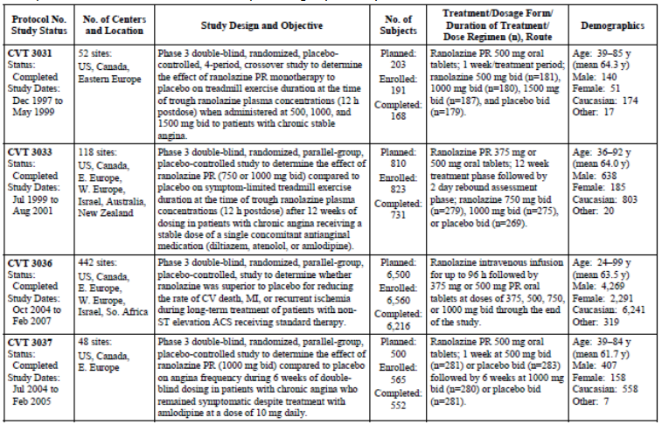

Table 10: Description of ranolazine clinical studies providing supportive efficacy data
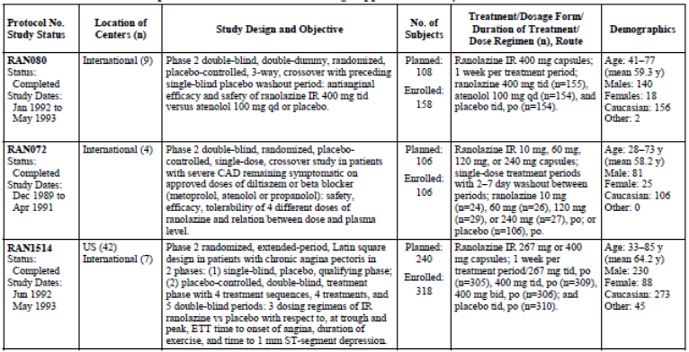
There were 8 further controlled Phase II studies (RAN015, RAN020, RAN054, RAN1490, RAN1513, RAN2240, RAN012 and RAN1789) which are briefly discussed and do not contribute significantly to the evaluation.
There were six open label, long term extension safety studies (CVT3034, CVT3032, CVT3024, RAN081, RAN1515 and RAN2074). There was one open label pilot study in subjects with long QT interval (CVT3114) discussed above in Section 5.
There were 3 pooled data reports, 2 reports related to QT interval (CVT303.009-C and CVT QTc Final) and one report was on modelling ranolazine concentration and treadmill exercise duration (CVT00204). These had all previously been submitted.
Studies RAN2303 and RAN2320 were in intermittent claudication and have been previously submitted. This indication is not being requested.
The newly submitted studies were:
- GS-US-250-0107 assessed effect of ranolazine when added to non-insulin anti-diabetic therapy.
- CVT3041 is an open label study which assessed the validity and reliability of the Women’s Ischaemia Symptom Questionnaire (WISQ).
- CVT3113 is a Phase I, controlled study which assessed the effects of IV ranolazine on atrial and ventricular conduction and refractoriness.
Comment: There were no new studies which provided additional pivotal efficacy data in chronic angina from what was evaluated previously.
Where studies were evaluated in the prior submission text has been extracted from the CER of that dossier. Additional comments have been included where relevant.

Treatment of chronic angina

Pivotal efficacy studies

Study CVT3033

Study design, objectives, locations and dates
Study CVT3033 (CARISA: Combination Assessment of ranolazine in Stable Angina) was a Phase III, double blind, randomised, placebo controlled, parallel group, add-on study of ranolazine SR in 823 subjects with chronic stable angina pectoris treated with a single anti-anginal agent (diltiazem, atenolol or amlodipine). The study was conducted between 1999 and 2001 at 118 sites in 15 countries (North America, Eastern Europe, UK, Australia and New Zealand).
The study’s primary objective was to assess the efficacy of 2 doses of ranolazine SR (750 mg BD and 1,000 mg BD) on treadmill exercise duration at trough plasma concentration after 12 weeks of treatment (and on a stable dose of a single concomitant anti-anginal medication; diltiazem 180 mg once a day, atenolol 50 mg once a day, or amlodipine 5 mg once a day).
There were 3 phases: a single blind, 1 to 2 week placebo qualifying phase; a double blind 12 week treatment phase; and a 2 day rebound assessment phase with 2 weeks of safety follow up. In the rebound phase subjects on placebo continued on placebo while ranolazine subjects were randomised in a 1:1 ratio to receive the same treatment or placebo. The study schematic is in Figure 4. There was centralised analysis of laboratory samples and for reading of the ECG data. Subjects completed diary cards for recording angina attacks and medication usage.
Figure 4: Study CVT3033; study design
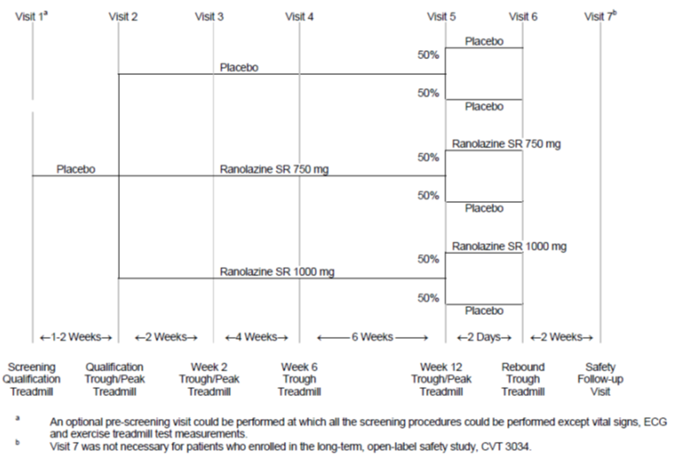

Inclusion and exclusion criteria
Inclusion criteria were: ≥ 21 years of age, at least a three month history of chronic, stable angina pectoris; diagnosis of coronary artery disease (as in CVT3031) with a minimum of 5 days treatment prior to visit 1 with one of diltiazem 180 mg once daily, atenolol 50 mg once daily or amlodipine 5 mg once daily. ETT qualifying criteria for the double blind treatment phase and exclusion criteria were the same as Study CVT3031, and again revascularisation (CABG or PTCA) exclusion was only if it occurred within the past 2 months.

Study treatments
Ranolazine SR 750 mg or 1,000 mg (or matching placebo) was given twice a day and diltiazem 180 mg once daily (once a day formulation), amlodipine 5 mg once daily or atenolol 50 mg once daily were given daily in the morning. The baseline anti-anginal medication was open label and any other anti-anginal medication (apart from sublingual nitroglycerin) was not allowed.

Efficacy variables and outcomes
The primary efficacy variable was the change from baseline in ETT duration at trough ranolazine concentration using the last observation carried forward (LOCF). ETTs were performed on treadmills prior to the morning dose (12 hours post dose) for trough and 4 hours post dose for peak ETT. The Modified Bruce Protocol was used.
Secondary efficacy variables included: change from baseline in exercise duration at peak; change from baseline in time to angina onset, time to 1 mm ST segment depression, maximum ST segment depression and reasons for stopping ETT at trough and at peak; angina frequency during 12 weeks; change from baseline in ETT duration at trough on ranolazine discontinuation.

Randomisation and blinding methods
Randomisation was stratified according to the background anti-anginal therapy and within stratum subjects were randomised to one of 6 treatment sequences. Blinding of ranolazine treatment was maintained by using matching placebo tablets.

Sample size
Assuming a standard deviation of 80 sec, the sample size of 462 evaluable patients gave the study a 90% power (α = 0.05) to detect a difference of 30 sec in ETT duration for each dose group compared to placebo. Allowing for 20% dropout, a sample size of 577 randomised patients was required. An interim sample size assessment was conducted to estimate the standard deviation of the primary variable after half the subjects (n = 231) had completed 12 weeks of treatment. This analysis found that an additional 186 subjects should be enrolled so the sample size was increased to 800.

Statistical methods and analysis populations
For the primary variable, and some of the secondary variables, the last post randomisation visit observation carried forward (LOCF) was used. For the primary endpoint, multiplicity was addressed using a two-stage, step-down procedure. No adjustment was made for secondary variables. The primary analysis used the intention to treat (ITT) population (all patients who took at least one dose of double blind medication and had at least one post-randomisation ETT at trough) using ANOVA as well as using non-parametric analysis and a repeated measures general estimating equations (GEE). Survival analysis, using the log rank test and Cox’s proportional hazards, was used for time to angina onset and time to 1 mm ST segment depression.

Participant flow
There were 823 randomised subjects with 43% on atenolol, 31% on amlodipine and 26% on diltiazem. There were 92/823 (11.2%) subjects who withdrew prematurely: 13.5%, 10.4% and 9.7% in the ranolazine 1,000 mg, ranolazine 750 mg and placebo groups respectively. Withdrawal due to an AE was higher in ranolazine treated subjects (8.7% in the 1,000 mg and 7.2% in the 750 mg group) compared to placebo treated (4.8%). The disposition of subjects is shown in Figure 5. The ITT population included 791 subjects (14 ranolazine 1,000 mg, 7 ranolazine 750 mg and 11 placebo subjects were excluded for having no ETT after the start of study medication). The efficacy evaluable population included 537 (65.2%) subjects, with the most common reason for exclusion being having ST segment depression of < 0.9 mm in the qualifying ETT (Table 11).
Figure 5: Study CVT3033. Patient disposition
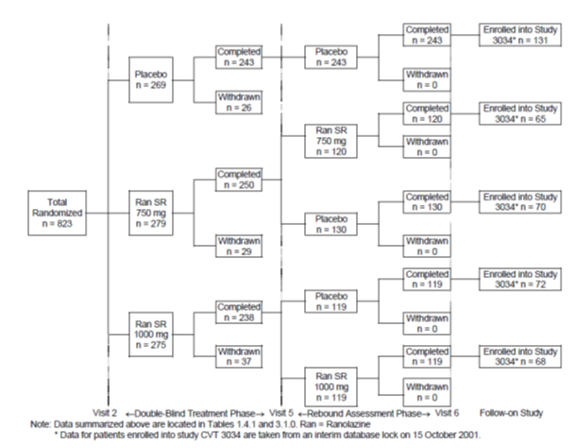

Table 11: Study CVT3033. Analysis populations by treatment, N (%)
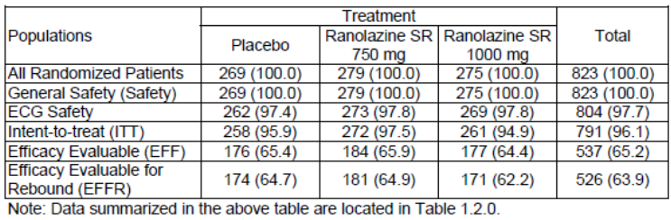

Major protocol violations/deviations
Two subjects from 1 centre in Romania were withdrawn due to protocol and GCP compliance concerns. Overall, there were 6/823 (0.8%) subjects who did not meet inclusion/exclusion criteria.
Overall compliance, as defined by having taken 67% to 125% of the expected dose, was noted in 98.4%, 98.5% and 95.8% of the placebo, ranolazine 750 mg, and ranolazine 1,000 mg groups, respectively.

Baseline data
There were no significant differences between treatment groups in demographic characteristics or cardiovascular history. Of the randomised subjects, 77.5% were male, with a mean age of 64.0 years (range: 36 to 92 years) and 97.6% were Caucasian. Cardiovascular history, other than CAD, included hypertension (64.0%), prior MI (57.6%), CHF (29.4%), unstable angina within 2 months (21.5%), prior CABG (17.6%) and prior PTCA (18.5%) and 23.0% of subjects had diabetes. Prior anti-anginal medication use was similar between groups as was concomitant medications during the study except for nervous system medications which were taken by 10.0% of the placebo group compared to 6.8% and 4.7% of the ranolazine groups. Twelve subjects were excluded from the evaluable population as they were taking a cytochrome P450 inhibitor or inducer.

Results for the primary efficacy outcome
After 12 weeks of treatment (ITT population with LOCF) in combination with another anti-anginal medication, there was a statistically significant improvement in ETT duration at trough for ranolazine 750 mg of 23.7 sec (95% CI: 2.3, 45.1 p = 0.03) and ranolazine 1,000 mg of 24.0 sec (95% CI: 2.4, 45.7 p = 0.03) (Table 12). The increase in ETT duration at trough was similar between the ranolazine dose groups (115.4 sec in the 750 mg and 115.8 sec in the 1,000 mg group) (Table 13). In the evaluable population, the ranolazine 1,000 mg group had a 32.5 sec (p = 0.016) increase in ETT duration compared to placebo while the difference for the ranolazine 750 mg group of 18.9 sec was not significant (p = 0.16). While the interaction between treatment and background therapy was not significant (p = 0.63), subjects taking ranolazine 1,000 mg with atenolol were noted to have a smaller improvement in ETT duration (mean difference was 7.5 sec compared to 20 to 40 sec in the other groups).

Table 12: Study CVT3033 Change from baseline in ETT duration (s) at trough levels of ranolazine at Week 12 (LOCF), comparison of treatment differences from ANCOVA: ITT population
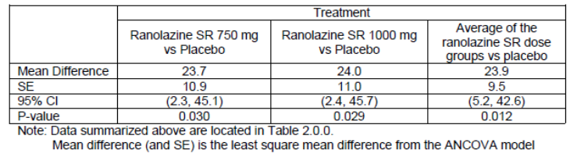

Table 13: Study CVT3033 Mean change from baseline in ETT duration(s) at trough levels of ranolazine. ITT population
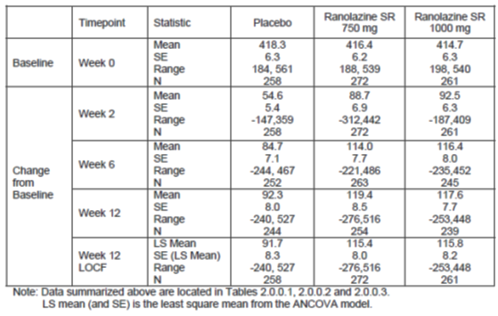

Results for other efficacy outcomes
The results for the ETT duration at trough analysed by GEE methodology were consistent with the primary analysis. A statistically significant difference in ETT duration at trough was seen after 2 and 6 weeks of treatment (Table 14). Subgroup analysis of ETT duration at trough found no significant differences for age (≥ 65 years) or diabetes. While no difference was statistically significant, subjects with CHF had more improvement in ETT duration with 1,000 mg than with 750 mg (mean difference 26.9 sec versus 2.1 sec). Women did not appear to respond to treatment (either at trough or peak) with mean difference from placebo in exercise duration at trough of -7.2 sec at 750 mg and 2.5 sec at 1,000 mg compared to 35.2 sec and 31.2 sec for males treated with the respective doses (Table 15).

Table 14: Study CVT3033 Change form baseline in ETT duration(s) at trough levels of ranolazine at Weeks 2, 6 and 12, comparison of treatment differences from ANCOVA (ITT Population)
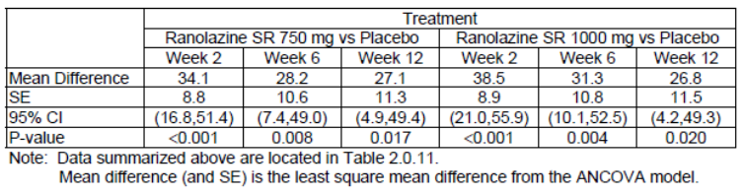

Table 15: Study CVT3033. Subgroup analysis by gender, ETT duration at trough, Week 12
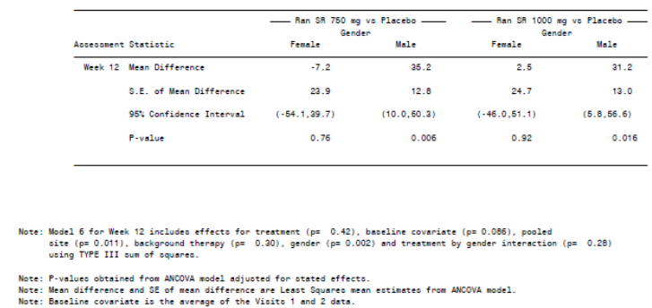
There was a statistically significant difference in ETT duration at peak for both ranolazine doses compared to placebo (750 mg: 34.0 sec, p = 0.001, 1,000 mg: 26.1 sec, p = 0.016) that was slightly greater than the difference seen at trough. The effect was most marked in subjects taking diltiazem with mean differences of 56.4 sec and 66.6 sec in the 2 ranolazine groups, respectively. A significant difference in ETT duration at peak was also seen at Week 2 in both dose groups.
The mean change from baseline in maximum ST segment depression at trough at Week 12 (LOCF) was 0.19mm, 0.38 mm and 0.23 mm for placebo, ranolazine 750 mg and ranolazine 1,000 mg groups respectively, with only ranolazine 750 mg being significantly different to placebo (p = 0.006). Results at peak levels were not significantly different to placebo.
The mean change from baseline in the time to angina onset at Week 12 (ITT with LOCF) at trough was 113.4 sec, 143.5 sec, and 139.7 sec and at peak was 91.3 sec, 128.8 sec and 129.7 sec in the placebo, ranolazine 750 mg and ranolazine 1,000 mg groups, respectively; all differences between ranolazine and placebo were statistically significant (p < 0.034). Survival analysis found the median time to angina onset at trough at Week 12 was 447 sec, 479 sec and 480 sec respectively (an increase of 32 sec for ranolazine treated over placebo treated subjects).
For time to 1 mm ST segment depression, the mean change from baseline at trough at Week 12 (ITT with LOCF) was 121.5 sec, 143.3 sec and 144.2 sec for placebo, ranolazine 750 mg and ranolazine 1,000 mg respectively. Neither difference (750 mg: 19.9 sec, p = 0.10 and 1,000 mg: 21.1 sec, p = 0.09) was statistically significant, while at peak the differences (40.8 sec and 34.5 sec) reached significance (p < 0.004).
At Week 12, the most common reason for stopping the ETT was angina and this was more frequent at trough than at peak (74.2%, 70.1% and 70.3% at trough and 68.4%, 57.4% and 57.4% at peak in the placebo, ranolazine 750 mg and ranolazine 1,000 mg groups, respectively). The mean number of angina episodes per week over the 12 weeks was 3.31, 2.47 and 2.13 for placebo, ranolazine 750 mg and ranolazine 1,000 mg, respectively, with the difference between active and placebo being statistically significant for both doses of ranolazine. Mean nitroglycerin use per week was also less in those on active treatment (3.14, 2.11 and 1.76 tablets/week in the placebo, ranolazine 750 mg and 1,000 mg groups, respectively).
At the evaluator’s request during the prior evaluation, the sponsor provided post-hoc analysis of data in terms of metabolic equivalent of task (METs). This showed that at Week 12 there was significant improvement at peak for both doses with a mean difference of 0.408 (95% CI: 0.164, 0.653, p = 0.001) and 0.286 (95% CI: 0.037, 0.534, p = 0.024) for the 750 mg and 1,000 mg dose groups, respectively. At trough, the results were similar between groups with a mean difference of 0.284 (95% CI: 0.040, 0.528) and 0.263 (95% CI: 0.016, 0.509) for the 750 mg and 1,000 mg groups, respectively.

Rebound effect
For subjects who had been on active treatment, the mean change from baseline in ETT duration at trough 2 days after ceasing treatment was similar to placebo, indicating no rebound effect, but was less than those remaining on active treatment, indicating that ranolazine effect is lost quickly. There was no statistically significant treatment difference in time to 1 mm ST segment depression or maximal ST segment depression. There was no evidence of rebound in time to angina onset, though there was a loss of effect in the 1,000 mg group (mean difference -42.8 sec, p = 0.025).
Comment: Study CVT3033 demonstrated a statistically significant increase in ETT duration at trough levels following 12 weeks treatment with ranolazine SR 750 mg BD and ranolazine SR 1,000 mg BD of 23.7 sec and 24.0 sec compared to placebo when given as add-on therapy to single anti-anginal treatment with diltiazem, atenolol or amlodipine, thus meeting the primary endpoint.
Significant improvements in the secondary endpoints of ETT duration at peak, time to angina onset at peak and trough, angina episodes and nitroglycerin use provided supportive evidence for the anti-anginal effect of ranolazine.
The anti-ischaemic effect as measured by time to 1 mm ST segment depression was only significantly different to placebo at peak and overall treatment effects were greater at peak compared to trough.
A response to ranolazine was evident after 2 weeks of treatment. Two days after ceasing treatment, there was no evidence of rebound, although treatment effect was rapidly lost.
The doses of 750 mg BD and 1,000 mg BD had similar efficacy (exercise duration: 23.7 versus 24.0 sec; time to onset of angina: 143.5 versus 139.7 sec; and time to 1 mm ST segment depression 143.3 and 144.2 sec for 750 and 1,000 mg, respectively) and dose response was not evident. This was confirmed in the post-hoc analysis of exercise capacity expressed in METs.
There were some differences in the different background therapies with a smaller improvement in ETT duration at trough for those on atenolol and a greater improvement for those on diltiazem at peak though overall the efficacy was seen across all background therapy groups.
While the efficacy of ranolazine was demonstrated in this add-on study, the background anti-anginal therapy had not been optimised prior to enrolment (doses given were: atenolol 50 mg once daily, amlodipine 5 mg once daily and diltiazem 180 mg once daily), so the add on effect of ranolazine on treatment with higher doses of these medication is unknown.
The moderately wide confidence intervals indicate a variability in response and there was no analysis of the proportion of subjects improving or deteriorating on treatment.
There was also a lack of effect noted in females at trough and insufficient data for analysis in non-Caucasian populations.

Study CVT3037

Study design, objectives, locations and dates
CVT3037 was a Phase III, double blind, randomised, placebo controlled, parallel group study of ranolazine extended release (ER) 1,000 mg BD in 565 subjects with chronic angina pectoris who remained symptomatic despite treatment with amlodipine 10 mg once daily. The primary objective was to assess efficacy on angina frequency during 6 weeks of treatment with secondary objectives assessing nitroglycerin consumption and quality of life.
The study was conducted at 3 centres in North America and 45 centres in Eastern Europe between 2004 and 2005.

Inclusion and exclusion criteria
For inclusion subjects were: ≥ 18 years; 3 month history of chronic angina; diagnosis of CAD (as CVT3033); at least 14 days of amlodipine 10 mg once daily; 14 days of stable dose of LAN (only LAN patch or isosorbide mononitrate) if applicable. To be eligible for randomisation patients must have had a weekly average of ≥ 3 angina attacks while receiving amlodipine (10 mg once daily) during the qualifying phase. Exclusion criteria were as per CVT3033 with the addition of: creatinine clearance < 30 mL/min; dialysis; orthostatic hypotension with LAN; and other anti-anginals (beta blockers, other calcium antagonists, other LANs).

Study treatments
During the pre-qualification period, subjects received 14 days treatment with amlodipine 10 mg once daily and discontinued other anti-anginals, except for long acting nitrates (LAN), within 5 days of screening. There was then a single blind, 2 week qualifying phase with placebo treatment on top of the amlodipine during which subjects need to have an average weekly rate of ≥ 3 angina attacks. This was followed by a randomised, double blind phase with one week on ranolazine ER 500 mg BD or placebo and then 6 weeks on ranolazine 1,000 mg BD or placebo. Amlodipine 10 mg once daily was continued for all subjects during the double blind phase (Figure 6). Angina frequency and nitroglycerin use was recorded by subjects in a diary. The Seattle Angina Questionnaire (SAQ) was also completed at screening, randomisation and completion.
Figure 6: Study 3037. Study design
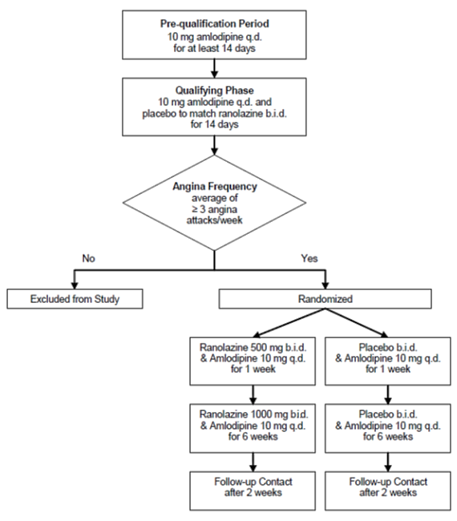

Efficacy variables and outcomes
The primary efficacy variable was the average weekly frequency of self-reported angina during the 6 week double blind treatment phase. Patients collected data in a diary. Other efficacy outcomes included the nitroglycerin consumption and the SAQ.

Randomisation and blinding methods
Blinding was via the use of matching placebo tablets and subjects were randomised in a 1:1 ratio via an IVRS.

Sample size
A sample size of 500 randomised subjects (450 at end of 6 weeks treatment, 225 per group) was required to give the study a 95% power to detect a reduction of 1.0 in the average weekly angina attack rate, assuming a mean placebo rate of 3.3 attacks per week.

Statistical methods and analysis populations
The primary analysis was the full analysis set (FAS) of subjects who had at least one dose of study medication and had any recorded angina in the double blind phase. A Cochran Mantel Haenszel test of rank-based scores, stratified by geographic region of the centres, was used. Mean test scores were not used due to some outlying data points and trimmed means were used. A change in the SAQ score from baseline was analysed by ANCOVA with effects for treatment, pool centre and baseline score.
Comment: The mean change from baseline in weekly angina attacks would be relevant to calculate.
There were 2 protocol amendments, with the main change being allowing the use of LANs if there was no orthostatic hypotension.

Participant flow
From 627 qualifying subjects, 565 were randomised (284 placebo and 281 ranolazine), 552 (98%) completed the double blind treatment phase and 13 (2%) prematurely discontinued (Figure 7). There were 558 (281 placebo and 227 ranolazine) subjects in the FAS.
Figure 7: Study CVT3037. Patient disposition
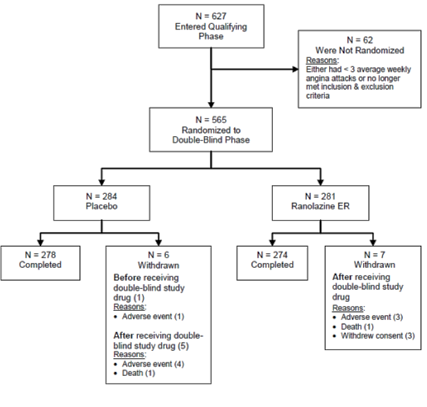

Major protocol violations/deviations
Protocol deviations were noted in 4% of placebo and 2% of ranolazine subjects. An analysis of treatment compliance was not provided in the CSR.

Baseline data
Patients had a mean age of 61.7 years (range 39 to 84), were predominantly male (72%), Caucasian (99%), and from Eastern Europe (97%), with 44% placebo and 46% ranolazine subjects taking LANs at baseline. All patients had a history of CAD and stable angina, 89% had hypertension, 80% at least one previous MI, 52% CHF, 35% unstable angina, 33% arrhythmias, 23% COPD and 19% diabetes. Treatment groups had no significant differences in baseline characteristics. Baseline angina attack rate (ranolazine: 5.53, placebo: 5.62) and nitroglycerin doses per week (ranolazine: 4.33, placebo: 4.91) were not significantly different between groups.

Results for the primary efficacy outcome
Over the 6 week treatment period, there was a significant reduction in the average weekly rate of angina attack in the ranolazine group compared to placebo (trimmed mean 2.82 versus 3.24, p = 0.028) (Table 16). From a baseline average weekly angina attacks of 5.53 the ranolazine treated group reduced to 2.82. It is of note that the placebo group also had a reduction in angina attack rate compared to baseline of 5.62 to 3.24.
Comment: The between group difference was less that one attack per week.

Table 16: Study CVT3037. Average weekly rate of angina attacks during the 6 week double blind treatment phase
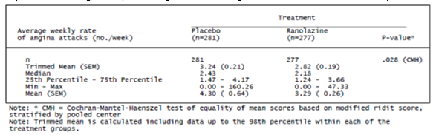

Results for other efficacy outcomes
The weekly consumption rate of nitroglycerin was significantly lower in the ranolazine group compared to placebo (trimmed mean 1.99 versus 2.63, p = 0.014). On the SAQ, only angina frequency was noted to be significantly improved compared to placebo, while no difference was found in the other 4 elements (Figure 8).
Figure 8: Study CVT3037. Change in SAQ dimension scores from baseline to study termination
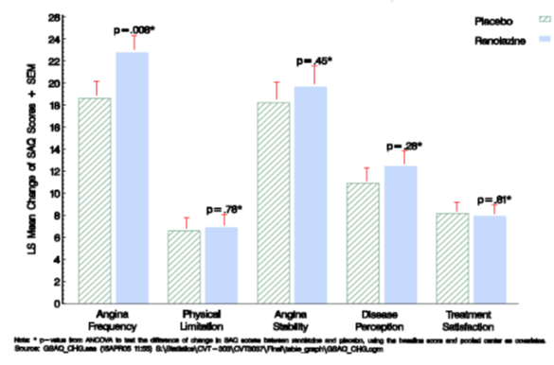
The reduction in angina attack rate was noted in subjects using LANs (ranolazine 2.91 versus placebo 3.33) and in non-users (2.74 versus 3.17) though these differences were not statistically significant, perhaps due to small sample sizes. The effect of ranolazine on angina attacks and nitroglycerin consumption was consistent across the subgroup analyses for age (± 65 years). For women, although the trimmed mean average weekly angina attack rate was lower in the ranolazine than placebo treated (2.59 versus 3.39) the median attack rate was similar (2.43 versus 2.38). In the ranolazine treated patients, the trimmed mean attack rate was lower in females than males (2.59 versus 2.91) (Table 17) as was the average weekly rate of nitroglycerin consumption (1.85 versus 2.04).

Table 17: Study CVT3037 Average weekly rate of angina attacks during the 6 week double blind treatment phase by sex
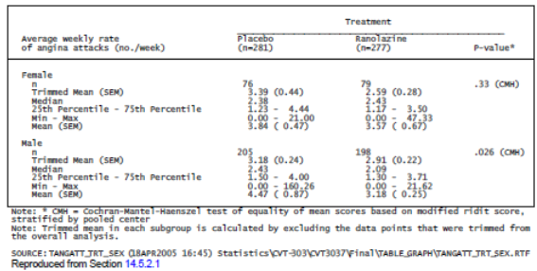
Comment: Study CVT3037 showed that during 6 weeks of treatment with ranolazine 1,000 mg BD there was a statistically significant lower number of angina attacks per week compared to placebo (2.82 versus 3.24) in patients with chronic angina who were symptomatic despite maximal dose of amlodipine (10 mg once daily) (and LAN in 45%).
There was an evident placebo response and the benefit over placebo was less than one angina attack per week.
The baseline average weekly rate of angina attacks by gender was not presented. It is therefore not possible to calculate the change from baseline to Week 6 in males and females and compare results. It is noted in the US PI there is a statement “In ERICA, where the primary endpoint was angina attack frequency, the mean reduction in weekly angina attacks was 0.3 for females and 1.3 for males”. The sponsor has been asked to present and discuss these data which indicate lower efficacy in females (as was also noted in CVT3033).
Data interpretation could have been improved if mean changes from baseline were assessed.
It is noted that the SAQ had not been validated for use in Eastern European countries.
The main outcomes were based on patient reports which may be subject to patient perception, however, the study was blinded and placebo controlled which would control for this potential bias.
The patient population was not on optimised anti-anginals (beta blockers, calcium antagonists) and therefore not ideally matching the proposed indicated population (“inadequately controlled angina”).
As treatment duration in this study was for 6 weeks duration, instead of the recommended 12 weeks, efficacy was not assessed from exercise based variables, and the anti-anginals not optimised for the included patient population, the evaluator believes this study provides supportive efficacy evidence only (rather than pivotal as claimed by the sponsor).

Study CVT3036

Study design, objectives, locations and dates
Study CVT3036, also known as the Metabolic Efficiency with ranolazine for less Ischaemia in Non-ST elevation acute coronary syndromes (MERLIN-TIMI 36) study, was a randomised double blind, parallel group, placebo controlled multinational study. The study was conducted between 2004 and 2007 at 442 sites in 17 countries in North America, Eastern Europe, Western Europe, Israel and South Africa.
The primary objective was to determine whether ranolazine was superior to placebo for reducing the rate of cardiovascular (CV) death, myocardial infarction (MI), or recurrent ischemia during long term treatment of patients with non-ST elevation acute coronary syndrome (ACS) receiving standard therapy. Secondary objectives included the assessment of major CV events with severe recurrent ischaemia; the rate of therapy failure (CV death, MI, recurrent ischaemia, positive Holter for ischaemia, hospitalisation for heart failure, early positive ETT) within 30 days and also long term; QOL using the SAQ; exercise duration on ETT at Month 8; and total ischaemia duration on Holter in first 72 hours.
After hospital discharge, subjects had visits at Day 14, Month 4 and the every 4 months until the end of the study. Subjects who discontinued treatment continued to be followed up until study end. Assessments included: continuous Holter monitor for 7 days from randomisation; ECGs at study visits post discharge; laboratory measurements including HbA1c; QOL questionnaire; ETT at Month 8 (or the final visit if this was before Month 8); and oral glucose tolerance test (OGTT) at the final visit.
The trial continued until at least 730 major CV events and 310 deaths from any cause were recorded. Holter data was analysed by a central laboratory. There was an independent Clinical Events Committee (CEC) of cardiologists which reviewed all primary and major secondary endpoints as well as hospitalisations for heart failure and documented arrhythmias. There was also an independent data safety monitoring board (DSMB) which reviewed data after 1000 patients were enrolled and after 10%, 25%, 50% and 75% of the anticipated major CV events were recorded.

Inclusion and exclusion criteria
The inclusion criteria were: ≥ 18 years; hospitalised with non-ST elevation ACS (chest discomfort or angina at rest for ≥ 10 minutes and consistent with myocardial ischemia); ischemic symptoms (≥ 5 minutes) at rest within 48 hours of enrolment; at least one risk indicator of: elevated (> ULN) cardiac troponin or CK-MB; ST depression ≥ 0.1 mV; diabetes mellitus (requiring therapy); and TIMI Risk Score for unstable angina/non-ST elevation MI ≥ 3.
Exclusion criteria were: persistent ST segment elevation ≥ 0.1 mV (≥ 1 mm) in 2 or more leads; revascularisation prior to randomisation; acute pulmonary oedema requiring intubation, cardiogenic shock, SBP < 90 mmHg; left bundle branch block or LVH with repolarisation abnormality that could interfere with Holter interpretation; inhibitors of cytochrome P450 3A4; agents prolonging the QT interval; requiring digoxin; significant hepatic disease; end stage renal disease requiring dialysis; life expectancy less than 12 months; pregnancy or women of child bearing potential not using birth control.

Study treatments
Subjects were randomised in a 1:1 ratio as soon as possible after hospital presentation and within 48 hours of symptoms. Treatment commenced with a ranolazine (or matched placebo) IV infusion with a 200 mg loading dose administered over 1 hour, then a maintenance infusion of 80 mg/h (or 40 mg/h for those with severe renal insufficiency, creatinine clearance < 30 mL/min) for 12 to 96 hours. The infusion rate could be titrated downward or discontinued if adverse events occurred (such as persistent QTc prolongation). Subjects managed with early invasive evaluation required at least 6 hours of IV infusion prior to angiography and at least 6 hours post percutaneous coronary intervention (PCI). Following infusion, subjects transitioned to oral ranolazine ER (or placebo) at a dose of 1,000 mg, 750 mg, 500 mg, or 375 mg BD based on final infusion rate of 80, 60, 40, 30 mg/h respectively. Dose adjustments were allowed for renal insufficiency or adverse events. Subjects were treated with other standard therapy as per local guidelines for the management of non-ST elevation ACS. Agents prolonging the QT interval were prohibited.

Efficacy variables and outcomes
The primary efficacy endpoint was a composite of CV death, MI or recurrent ischaemia. The major secondary endpoint was a composite of CV death, MI, or severe recurrent ischaemia (with this being ischaemia with ECG changes, leading to hospitalisation or revascularisation). Other secondary endpoints included: failure of therapy (CV death, MI, recurrent ischemia, positive Holter for ischaemia, hospitalisation for new/worsening heart failure or early positive ETT); composite of CV death, MI, severe recurrent ischaemia, or positive Holter for ischaemia at or before 30 days; angina frequency scale on SAQ; physical limitation scale on SAQ; duration of exercise on ETT at 8 months; and total duration of ischaemia on Holter between randomisation and 72 hours.

Randomisation and blinding methods
Randomisation was centralised using IVRS and was in a 1:1 ratio stratified by intended initial management strategy (early invasive or conservative). Blinding was maintained by using matching IV and oral placebo formulations.

Analysis populations
Efficacy analyses were undertaken on the ITT population of all randomised subjects.

Sample size
The sample size calculation assumed a rate of major CV events in the placebo group of 18% at one year and a 20% relative reduction in the active treatment group. The study required 730 major cardiovascular events and 310 deaths to detect a difference between the groups with a 90% power and 5% significance level. With an incidence of 22% at one year in the placebo group the study would have a power of 95% to detect a 20% risk reduction. Recruitment of 5500 patients, with a permitted increase to 6500, was selected to limit the length of the study. The sample size was re-estimated on blinded mortality data after 1000 subjects reached Month 4.

Statistical methods
The efficacy analysis was on the ITT population and based on CEC-adjudicated events. The primary efficacy variable was the time to first occurrence of any element of the composite of CV death, MI, or recurrent ischemia. Cox proportional hazards model was used for time to event variables, stratified by the intention for early invasive management. Relative risk estimates with 95% CI were calculated and cumulative incidences at various times post randomisation were estimated using Kaplan-Meier method. A single interim analysis was performed on the endpoint of CV death for assessing whether to terminate the trial early. This used a nominal p value of 0.001 for significance and the final analysis then used the nominal significance level of 0.049.
There were 2 protocol amendments which included PK and echocardiogram sub studies and the addition of the oral glucose tolerance test. The DSMB made no recommendations to terminate or modify the study.

Participant flow
A total of 6,560 (3,281 placebo and 3,279 ranolazine) subjects were randomised and included in the ITT analysis with 6,541 (99.7%) receiving at least one dose of study medication. There were 745 (23%) placebo and 925 (28%) ranolazine subjects who ceased treatment prematurely with the reason being consent withdrawal (12% placebo versus 14% ranolazine) and AEs (5% versus 9%). Nine subjects were lost to follow up and the mean duration of follow up was 347 and 346 days in the placebo and ranolazine groups, respectively.

Major protocol violations/deviations
Protocol deviations occurred in 95% of subjects in both groups and were mainly visits outside the scheduled window and < 1% of subjects in both groups had deviations relating to inclusion or exclusion criteria. Compliance with IV medication was monitored by hospital staff. During oral dosing, the median compliance was > 97% as defined by subjects receiving at least 80% of the scheduled dose.

Baseline data
Baseline characteristics were similar between groups, the mean age of 63.5 years (range 24 to 99 years) with 18% ≥ 75 years, 95% were Caucasian and 65% were male. Approximately 41% of subjects in each group were planned to have early invasive therapy. Medical history and risk factors were similar between groups and 73% had a TIMI risk score of ≥ 3, 34% had diabetes and 35% had ST segment depression of ≥ 1 mm. The proportion of patients with a history angina was 55% and 54% in the ranolazine and placebo groups, respectively. The study qualifying event was diagnosed as non-STE MI in 51% and unstable angina in 47% of subjects. Medication use pre-study and during the study was similar between groups.

Results for the primary efficacy outcome
The primary endpoint event (CV death, MI or recurrent ischaemia) occurred in 753 placebo and 695 ranolazine treated subjects with a non-significant relative risk (RR) of 0.92 (95% CI: 0.83, 1.02 p = 0.11) (Table 18). Exploratory analysis of subgroups was conducted and showed all RRs approaching unity. The primary endpoint was assessed in the 30 days post randomisation and more than 30 days after randomisation and no significant difference in relative risk was found.

Table 18: Study CVT3036 Primary efficacy analysis: time from randomisation to first occurrence of CV death, MI or recurrent ischemia
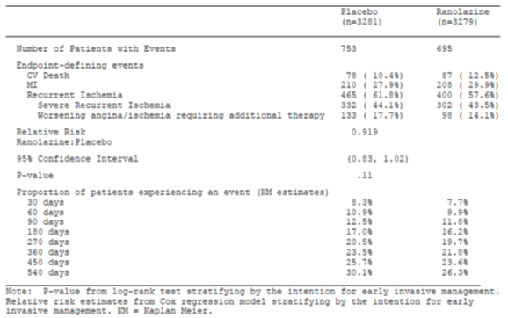

Results for other efficacy outcomes
For the secondary composite endpoint of CV death, MI or severe recurrent ischaemia, there were 625 placebo and 602 ranolazine subjects with a non-significant RR of 0.96 (95% CI: 0.86, 1.08, p = 0.50) (Table 19). Failure of therapy during long term treatment (CV death, MI, recurrent ischaemia, positive Holter ischaemia, heart failure hospitalisation, positive ETT) was not significantly different, RR = 0.94 (95% CI 0.87, 1.02, p = 0.50). In the 30 days post randomisation, 824 (25%) placebo and 757 (23%) ranolazine subjects experienced one of these therapy failure events, and while trending in favour of ranolazine, the result was non-significant (RR = 0.92, 95% CI: 0.84, 1.00, p = 0.055).

Table 19: Incidence of CV death, MI or severe recurrent ischemia
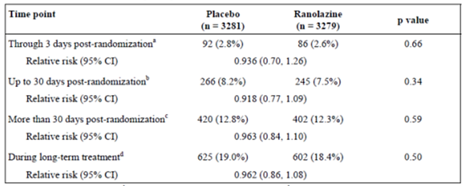
At 4 months post randomisation, an analysis of the SAQ showed a small significant improvement in the angina frequency scale (mean score 82.2 placebo versus 84.3 ranolazine, p < 0.001) but not in the physical limitation scale (p = 0.91). Post-hoc analysis of the 54% of subjects who had a history of chronic angina at enrolment found that this group of patients had a small statistically significant improved response on the SAQ for angina frequency, disease perception and treatment satisfaction at Month 4 and at final visit (Table 20).

Table 20: Study CVT3036 Seattle angina questionnaire results at Month 4 and the final visit in patients with a history of chromic angina at enrolment
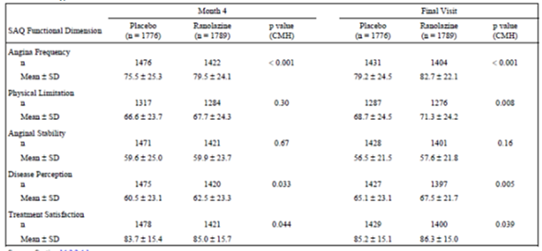
The estimated mean duration of exercise on ETT (combined data for treadmill and bicycle) at Month 8 (or final visit) was not significantly different between groups (542.8 sec placebo versus 550.0 sec ranolazine, p = 0.35), nor was the time to 1 mm ST segment depression or time to angina onset. A subgroup analysis of patients with a history of chronic angina at enrolment (1,776 placebo, 1,789 ranolazine) found a statistically significant improvement of 32 seconds (p = 0.002) in mean exercise duration in ranolazine treated subjects, however there was variation between treadmill and bicycle data (Table 21).

Table 21: Study CVT3036 Exercise performance at 8 months by history of angina at enrolment
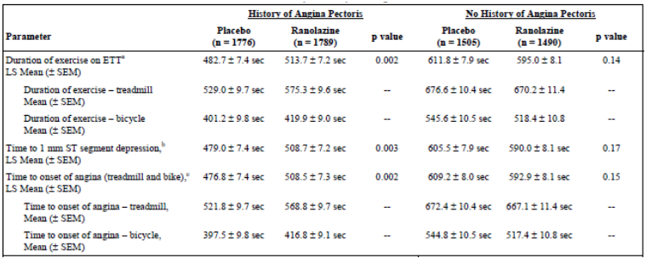
In the 72 hours post randomisation, 15.3% of the ranolazine and 16.4% or the placebo subjects had ischaemia on Holter (as defined by at least one episode of ST segment depression ≥ 1 mm lasting ≥ 1 minute with HR < 100 bpm) with no significant difference in the mean duration of ischaemia (28.1 min placebo versus 31.8 min ranolazine, p = 0.26). There was also no significant difference found through the 7 day Holter monitoring period.
There were no findings of note on the measurements of troponin, CK-MB and BNP during the 14 days following randomisation. At Month 4, there was a small statistically significant reduction in the need for additional anti-anginal medications (mean number 1.7 versus 1.6 medications placebo versus ranolazine, p = 0.002) and the time to initiation of additional anti-anginal medication was longer in the ranolazine group (RR = 0.76, 95% CI: 0.64, 0.90 p = 0.002).
While the composite endpoints were not altered and there was no difference individually for CV death or MI, the risk of recurrent ischaemia was significantly reduced for ranolazine treated subjects (494 placebo, 429 ranolazine) with a RR of 0.87 (95% CI: 0.76,0.98 p = 0.027). An exploratory subgroup analysis by gender found that women did not have less response to ranolazine on the ischaemia-related endpoints (Table 22) and the RR for time to first occurrence of recurrent ischaemia was 0.71 (95% CI: 0.57,0.88, p = 0.002).

Table 22: Study 3036. Subgroup analysis by gender (ITT analysis set)
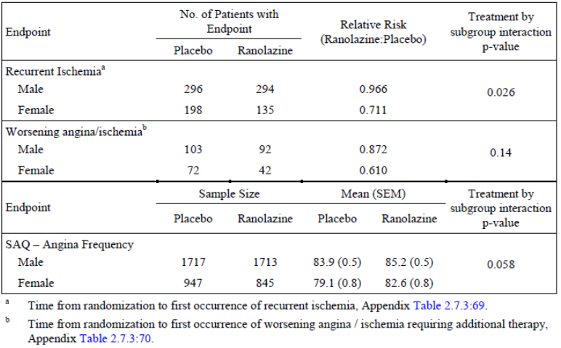
Comment: The study enrolled subjects with a moderate to high risk of CV events and non-ST elevation ACS with randomised treatment being given as add-on to standard therapy.
Approximately half (54%) the patients had a history of chronic angina.
The study failed to meet its primary objective. Ranolazine treatment (final visit dose was 1,000 mg BD in 83%) did not reduce the risk of the composite primary endpoint of CV death, MI or recurrent ischaemia compared to placebo treated patients and so results do not support the use of ranolazine in the treatment of ACS.
While there was no effect on CV death or MI individually, there was some evidence for reduction in recurrent ischaemia (defined as worsening angina or ischemia requiring additional therapy and severe recurrent ischemia, showing ECG changes, leading to hospitalisation, or prompting revascularisation). There was a small reduction in concomitant anti-anginal medication use and a small improvement in the angina frequency scores on the SAQ, although there was no improvement on the physical limitation score.
Subjects with history of chronic angina appeared to have better response to ranolazine treatment with a small improvement on the SAQ and in exercise duration on ETT. However these were post-hoc analyses, ETT findings were not reflected in the total population, and the ETTs were not standardised with variable results for the treadmill and bicycle exercise tests.
Data on exercise capacity expressed in METs could have helped with standardising ETT findings however the sponsor confirmed that such data were not available for this study.
Exploratory analyses found the response on ischaemia-related endpoints in women was not less that in men.
While the data from the study provide modest confirmation of efficacy they do provide reassuring safety information.

Other efficacy studies

Studies with IR formulation

RAN1515
RAN1515 was a double blind, randomised; placebo controlled, 3 way, crossover study evaluating the anti-anginal effect of 120 mg TDS and 180 mg TDS ranolazine IR in 12 patients with stable angina. It was conducted between 1986 and 1989. The primary endpoint was angina attack frequency, nitrate consumption and exercise tolerance on a treadmill after a 2 week treatment period. There was no statistically significant difference in the mean number of angina attacks per week (8.4, 9.8 and 8.9) nor in the mean number of GTN tablets consumed per week (3.9, 2.9, 3.2) in the placebo, 120mg TDS and 180 mg TDS ranolazine groups respectively. There was also no significant difference in the mean duration of the exercise test (347, 401 and 393 sec) or time to angina onset (290, 321 and 315 sec) at 1.5 hours in the 3 groups respectively. No significant differences were found in these variables at 8 hours post dosing.
Comment: In this study ranolazine IR 120 and 180 mg three times a day over 2 weeks of treatment did not demonstrate anti-anginal effects, however the study was small and only 12 of the anticipated 24 subjects were enrolled.

RAN020
RAN020 was a double blind, randomised, placebo controlled, 3 way, crossover study evaluating the anti-anginal effect of 60 mg TDS and 120 mg TDS ranolazine IR in 25 patients with stable angina. The study was conducted between 1987 and 1988 and had the same design and methodology as RAN1515. The frequency of angina attacks (mean difference of 1 attack or less per week) and GTN consumption was low and the difference was not tested statistically. There were no significant differences found in the time to angina onset, time to 1 mm ST depression or total exercise duration at 1.5 or 7.5 hours (± 30 minutes) post dosing between the treatment groups.
Comment: It was concluded that the low doses of ranolazine IR 60 mg TDS and 120 mg TDS did not demonstrate evidence of anti-anginal efficacy after 2 weeks of treatment.

RAN054
RAN054 was a double blind, randomised, placebo controlled, 3 way, crossover study evaluating the anti-anginal effect of 120 mg TDS and 240 mg TDS ranolazine IR in 144 patients with stable angina. The study was conducted between 1988 and 1990 and had similar methodology to previously discussed studies, with a single blind placebo run in phase and 3 randomised phases of 4 weeks duration. Exercise treadmill testing was completed at 1 and 7.5 hours post dose. This study had numerous methodological issues including: a change from modified Bruce to Bruce protocol during the study and inability to accurately state which protocol was used for which test; only 114 of 144 subjects completed the study; 24 completing subjects were excluded for non-compliance with study medication and 15 subjects were incorrectly randomised (> 20% difference in time to angina onset in run-in phase); exercise ECG data had a high degree of methodological variation and so was unable to be analysed accurately; diary card data was of poor quality and retrieval was incomplete; and there was significant variation in results between study centres.
Comment: As a result of issues with data integrity, no definitive conclusions can be made by the evaluator on the results of this study.

RAN1490
RAN1490 was a double blind, randomised, placebo controlled dose ranging study in subjects with chronic stable angina. Dosing was for 5 days and commenced at ranolazine IR 60 mg TDS and was to escalate to 90 mg, 120 mg and 240 mg TDS with ETT assessments. The study was conducted between 1988 and 1989 and anticipated to enrol 48 to 72 subjects. Due to poor recruitment the study was prematurely discontinued after 12 subjects were included.
Comment: The clinical study report only included a brief summary and due to this, and its premature termination, there were no relevant efficacy data available.

RAN1513
RAN1513 was a double blind, randomised placebo controlled parallel group study in 319 subjects with stable angina. The doses assessed were 30 mg TDS, 60 mg TDS and 120mg TDS ranolazine IR. Methods were provided. In the “all patient” analysis, after 4 weeks of treatment there were no significant treatment differences found between the 3 ranolazine groups and the placebo group in any of the key ETT variables (exercise duration, time to angina onset or time to 1 mm ST depression) at either peak or trough. There was also no significant differences between groups in the per protocol analysis.
Comment: This study did not demonstrate efficacy for the doses of 30 mg, 60 mg and 120 mg ranolazine IR three times a day.

RAN012
RAN012 was a single blind, placebo controlled, single group study evaluating the efficacy of 30 mg TDS and 60 mg TDS ranolazine IR over 2 week treatment periods in 16 subjects (12 completing) with stable angina. The study was conducted in 1986. ETTs were conducted at 1.5 and 7 hours post dose. Results suggested an improvement in exercise time and time to angina for both doses, but not in time to ST depression. The analysis was performed by the investigator and was not subject to quality assurance procedures.
Comment: The study was small, not randomised, single-blind and lacking adequate quality procedures. Due to all these factors, the evaluator draws no conclusions from the results.

Studies with IV formulation

RAN1789
RAN1789 was a Phase III double blind, placebo controlled, parallel group study evaluating the anti-ischaemic efficacy of intravenous (IV) ranolazine during controlled myocardial ischaemia in 95 patients undergoing elective PTCA. After successful PTCA, subjects with at least 0.1 mV ST segment deviation during a 60 second balloon occlusion received a single IV dose of ranolazine 700 µg/kg or placebo (infused over 10 minutes). The dose of ranolazine was altered after a protocol amendment from 420 to 700 µg/kg though it is unclear in the CSR how many subjects received each dose. The treatment groups were comparable at baseline with respect to demography and cardiovascular history. There were 89 subjects in the per protocol analysis and this found no statistically significant differences between the treatment groups in the change from baseline in the time to 0.1mV ST deviation (p = 0.26), maximum ST segment deviation (p = 0.54) or time to angina onset (p = 0.54). The results for the all patient analysis were also not statistically significant.
Comment: This study failed to demonstrate anti-ischaemic effects of IV ranolazine during controlled myocardial ischaemia.

Other controlled studies with SR formulation

RAN2240
RAN2240 was a double blind placebo controlled parallel group study assessing the efficacy of ranolazine SR 1,000 mg BD in prolonging the time to revascularisation in patients with refractory chronic stable angina. The trial was discontinued in 1994 due to low enrolment (n = 11) and no conclusions were reached.

Open label studies
The dossier included reports from 6 open label studies. Studies CVT3034, CVT3032 and CVT3024 assessed ranolazine ER in the dose range 500 to 1,000 mg BD. Studies RAN081, RAN1515 and RAN2074 assessed ranolazine IR. There were no efficacy measurements in these studies except for Study RAN081.

RAN081
RAN081 was a one year safety study conducted in 1992-1993 which had a one week, double blind, randomised, placebo controlled, parallel group withdrawal phase after one month of stable open label ranolazine IR treatment (120, 240 and 400 mg TDS). There were 135 subjects with chronic stable angina enrolled and 66 received ranolazine and 60 placebo during the withdrawal period, with 109 being evaluable. The primary endpoint was time to angina onset at peak and the adjusted mean difference was 53.8 sec (95% CI: 19.05, 88.68, p = 0.003). There was significant centre by treatment interaction (p = 0.001). There was no significant improvement in exercise duration found (mean 16.87 sec, 95% CI: -17.53, 51.27 p = 0.33).
Comment: The results of this study were inconsistent across study sites, there was reportedly a high background anti-anginal use, and both bicycle and treadmill tests were used. These factors, combined with the varying efficacy findings, lead the evaluator to conclude that the study does not provide useful efficacy data.

Treatment of intermittent claudication

RAN2302
RAN2302 was a Phase II, double blind, placebo controlled, parallel group pilot study assessing the safety and efficacy of ranolazine SR 1,000 mg BD in 45 patients with intermittent claudication. The study methods and design are summarised and were provided. After 4 weeks of treatment, there was a mean increase from baseline in exercise duration of 53.15 sec (SE ± 34.17) and 40.78 sec (SE ± 32.91) in the ranolazine and placebo groups, respectively, though neither was significant (p = 0.13 and p = 0.22). The difference between groups (12.37 sec) was not statistically significant (p = 0.80). Both the ranolazine and placebo groups had a significant improvement in time to onset of claudication (62.10 sec, p = 0.002, and 36.32 sec, p = 0.045, respectively) though the difference between groups (25.78 sec) was not significant (p = 0.32).
Comments: The large variability and small patient numbers resulted in this study having only marginal power to detect differences (9% for exercise duration and 21% for time to claudication onset).

RAN2320
RAN2320 was a Phase III, double blind, placebo controlled, parallel group study assessing the safety and efficacy of ranolazine SR 500 mg BD, 750 mg BD and 1,000 mg BD in patients with intermittent claudication. Treatment duration was to be 3 months with efficacy assessed on ETT exercise duration at trough. The study commenced in 1994 and, due to the discontinuation of the development program of ranolazine at this time, only 3 patients were randomised and had received double blind treatment for 1 to 2 weeks.
Comment: Due to the premature termination of this study after recruitment of three patients there were no efficacy results reported.
An indication for intermittent claudication is not being sought.

Newly submitted studies

GS-US-259-0107

Design and methods
GS-US-259-0107 was a Phase II randomised, double blind, placebo controlled, parallel group exploratory study to assess the metabolic effects of ranolazine when added to ongoing non-insulin anti-diabetic therapy in 80 subjects with type II diabetes mellitus (T2DM). It was conducted between June and November 2010 at 9 sites in the US. It was sponsored by Gilead Sciences.
An exploratory analysis of Study CVT3039 found a lowering of HbA1c and fasting glucose in subjects with hyperglycaemia. Therefore this study aimed to explore the impact of ranolazine on glucose haemostasis. The sponsor stated that the mechanism through which ranolazine alters glycaemia has not been determined.

Study objectives
The objectives of the study were, when adding ranolazine to ongoing non-insulin antidiabetic therapy in subjects with type 2 diabetes mellitus (T2DM): to explore the effect of ranolazine in lowering haemoglobin A1c (HbA1c) after 12 weeks of treatment; to explore the glucose-lowering effect of ranolazine on postprandial glucose levels using the mixed meal tolerance test (MMTT); and to explore the glucose-lowering effect of ranolazine on fasting serum glucose (FSG).
Eligible subjects were randomised via an IVRS in a 1:1 ratio to ranolazine ER 1,000 mg (2x 500 mg tablet) BD or matching placebo and treated for 12 weeks. Randomisation was stratified by baseline HbA1c (≤ 7.5%/> 7.5%) and one third of subjects were required to have HbA1c > 7.5%. Anti-diabetic medication continued and changes were not allowed. Subjects with fasting serum glucose (FSG) > 270 mg/dL (up to Week 6) or > 240 mg/dL (Week 6 to 12) were discontinued. Efficacy endpoints were not available during the study with the exception of glucose. PK measurements were taken at baseline, Week 2 and 12.

Inclusion exclusion criteria
The study included males and females, 18 to 75 years old, with T2DM currently on stable noninsulin anti-diabetic therapy in addition to diet and exercise, a body mass index (BMI) ≥ 25 kg/m² and ≤ 40 kg/m², and an HbA1c 7% to 11%.
Exclusion criteria were: type I DM; T2DM on insulin; history of ketoacidosis or ketosis prone diabetes; clinically significant diabetes complications; change in antidiabetic therapy in the past 2 months; history of severe hypoglycaemia; significant cardiovascular event in past 2 months; significant or uncontrolled hypertension; hospitalisation in past 2 months; major surgery in past 3 months; significant hepatic impairment; substance abuse or alcohol consumption > 2 standard drinks per day; weight change ± 5% in past 2 months; ranolazine treatment in past 3 months; significant change in cardiac medication in past 2 months; weight loss medication is past 2 months; use of CYP3A4 inhibitors or inducers; abnormal laboratory tests (FAD > 270 mg/dL, fasting serum C peptide < LLN, creatinine > 1.5 mg/dL, triglycerides > 500 mg/dL, haemoglobin < LLN, TSH outside normal range, ALT or AST > 2.5x ULN, ECG with clinically significant abnormalities); pregnant or breast feeding; and blood donation within 2 months.

Sample size and statistical methods
A sample of 60 patients gave the study 93% power to detect a -1.0% difference in the change from baseline in HbA1c (α = 0.05) assuming a standard deviation of 1.1%. Allowing for non-evaluable subjects a total sample of 80 was selected. Groups were compared using a Cochran Mantel Haenzel test and an ANOVA with LOCF. The primary efficacy endpoints were the change from baseline to Week 12 in HbA1c, in 2 hour post-prandial serum glucose and in FSG. This was analysed with ANCOVA and LOCF on the per protocol (PP) set with sensitivity analysis on the full analysis set (FAS).

Study participants:
There were 80 randomised subjects (41 and 39 in the placebo and ranolazine groups, respectively) with 30 (73% versus 74%) with HbA1c > 7.5%. The completion rate was 71% and 79% respectively and the most common reason in both groups was an AE (15% versus 13%). Two subjects were excluded from the PP population due to non-compliance with study drug. The groups were relatively well balanced on demographic and baseline characteristics. The mean age was 58 years, approximately 60% were male, mean BMI of 32 kg/m², about 40% had hypertension. The mean baseline HbA1c was 8.51% and 8.41% in the placebo and ranolazine groups, respectively. The rate of metformin use, alone or in combination, was 90% and 97%, respectively. The FAS included 79 or the 80 subjects while the PP set included 58 (68% and 77% of the placebo and ranolazine groups, respectively).

Results
In the PP population, after 12 weeks treatment, the LS mean change from baseline in HbA1c was -0.23 and -0.74 in the placebo and ranolazine groups, respectively. The LS mean difference was -0.53 (95% CI: -1.02, -0.03, p = 0.039). This significant result was confirmed on the sensitivity analysis of the FAS (LS mean difference of -0.53, p = 0.01).
At Week 12, in the PP population, the change from baseline in the 2 hour post-prandial glucose level was -13.2 and -16.4 mg/dL in the placebo and ranolazine groups, respectively. There was no significant difference between groups (LS mean difference of -3.2 mg/dL, 95% CI: -31.9, 25.4, p = 0.82). No significant difference was found on this variable in the FAS analysis. Similarly no significant difference was found between the placebo and ranolazine groups in the FSG levels. The mean change from baseline to Week 12 was 1.4 and -0.1 mg/dL, respectively, with a LS mean difference of -1.5 mg/dL (95% CI: -21.1, 18.1, p = 0.879).
On subgroup analysis, there was a greater reduction in HbA1c with ranolazine in subjects with baseline HbA1c > 7.5% (LS mean difference of -0.61% compared to -0.32%).
There were a number of exploratory efficacy endpoints including: change in 2 hour post prandial serum glucose at Week 2; change in total post prandial serum glucose AUC at Weeks 2 and 12; change in postprandial serum C peptide; change in post prandial serum insulin AUC at Week 2 and 12; change in FSG at Weeks 2, 4 and 6; change in fasting C peptide at Weeks 2, 4, 6 and 12; and change in fasting insulin at Week 2, 4, 6, and 12. No significant differences between treatment groups were noted on any of these comparisons.
Comment: This study demonstrated an effect of ranolazine ER 500 mg BD on HbA1c after 12 weeks of treatment (0.53% reduction over placebo) in subjects with T2DM. There was, however, no significant effect on serum glucose (fasting or 2 hour postprandial).
The sponsor has not made specific claims in the draft PI with respect to this study. The proposed wording in the PI, which the evaluator believes is satisfactory, is:
Ranexa produces small reductions in HbA1c in patients with diabetes, the clinical significance of which is unknown. Ranexa should not be considered a treatment for diabetes.

CVT3113

Design and methods
CVT 3113 was a Phase I, double blind, randomised, placebo controlled, sequential group, dose escalation study of ranolazine in patients with atrial arrhythmia undergoing invasive electrophysiologic (EP) diagnostic procedure/radiofrequency ablation. It was conducted between January and October 2007 at 5 sites in the USA. The primary objective was to assess the effects of IV ranolazine on atrial and ventricular conduction and refractoriness (via EP assessments) in patients undergoing a clinically indicated invasive electrophysiologic (EP) diagnostic procedure/ablation.
Comment: The sponsor stated the study was undertaken as it was believed that ranolazine could have had an effect on suppressing atrial fibrillation.
Patients were randomised to receive ranolazine or placebo in a 3:1 ratio (3 active: 1 placebo). Study medication was administered by IV infusion according to one of three dosing regimens designed to target ranolazine plasma concentrations of 500, 1500, or 3000 ng/mL (those on ranolazine). Subjects received a 25 minute IV loading dose of 30, 90 and 170 mg for cohorts 1, 2 and 3, respectively, to reach target plasma concentrations. They then received a maintenance infusion for 35 minutes or until EP assessments were completed. Baseline EP measurements were collected before study drug administration.
The study included male or female patients, been ≥ 18 years old; scheduled for or undergoing a clinically-indicated invasive EP diagnostic procedure or ablation that involved positioning of catheter electrodes in the right atrium, in the region of the bundle of His and in the right ventricle.
The study was exploratory and there was no sample size calculation and data analyses were descriptive. Analysis was conducted on the full analysis set (FAS).

Results
Fifty three patients were randomised, 48 treated with 15 receiving placebo and 33 ranolazine, (12, 11, and 10 in the low, moderate and high concentration regimens, respectively). Protocol deviations were high (70.7%) with 10.3% of patients not meeting eligibility criteria.
Ranolazine plasma concentrations were notably lower than those targets. The median value was 225, 746, and 1710 ng/mL at 30 minutes post-dose for the three ranolazine dose groups, respectively, when the target concentration was 500, 1500 and 3000 ng/mL, respectively.
Comment: The sponsor stated that “no procedural error was found to explain the cause of the unexpectedly low values”.
Overall, it was found that ranolazine IV had no effect on atrial refractoriness. There was a numerical trend toward lengthening of the atrial-His (AH) interval with increasing dose, however the results were not statistically different from placebo. There was also a small mean increase in the right ventricle effective refractory period (RVERP) (change from baseline at 30 minutes) with ranolazine compared to a decrease with placebo at a pacing cycle length of 350 msec. There were no other findings of note.
Comment: The study did not achieve the target ranolazine plasma concentrations after the loading and maintenance infusions of IV ranolazine.
In these subjects who had undergone cardiac catheterisation for an invasive EP procedure, ranolazine was found to have no effect on the EP parameters.

CVT3041
CVT3041 was a Phase IV, open label study which assessed the Women’s Ischaemia Symptom Questionnaire (WISQ) in 172 women with chronic angina treated with ranolazine ER. It was conducted between November 2007 and January 2011 at 30 centres in the US. The primary objective was to evaluate the validity, reliability, and responsiveness of the WISQ in women with chronic angina based on changes in patient-reported angina frequency and nitroglycerin (NTG) consumption before and following treatment with ranolazine. Secondary objectives were to compare the WISQ with SAQ and Duke Activity Status Index (DASI) scores.
The study was single arm and open label. There was a two week qualifying phase and then, for eligible subjects, a 4 week open label treatment phase where subjects received ranolazine ER 500 mg BD together with baseline anti-anginal medications. The study included women with chronic angina who were symptomatic despite treatment with at least one anti-anginal medication. Subjects reporting two or more angina attacks per week were eligible for the treatment phase. Questionnaires were self-administered at baseline and at the end of treatment.

Results
Of the 256 subjects screened, 172 were enrolled and 171 treated with 150 completed the study. The mean age of women was 64.6 years and 84% were Caucasian.
Using regression analyses, comparisons in the change from baseline in the WISQ total score and its subscales and the independent variables of angina frequency, NTG frequency and DASI score found low coefficients of determination (R2 ≤ 0.128) indicating poor relationships.
Comment: The study did not provide relevant efficacy data.
While inter-item correlations on the WISQ showed some reliability, the WISQ was not found to be a valid measurement tool in women with chronic angina. The dossier’s main efficacy studies did not use the WISQ.

Analyses performed across trials (pooled analyses and meta-analyses)
There were three study reports provided in this section.

CVT00204
CVT00204 was a population pharmacokinetic/pharmacodynamics analysis of ranolazine concentrations versus treadmill exercise duration in patients with stable angina enrolled into one of four studies (RAN080, RAN1514, CVT3031 or CVT3033). The final model predicted drug-related increase in exercise duration by on average 6.4 seconds for each 1,000 ng/mL ranolazine concentration in females, and 16.7 seconds for each 1,000 ng/mL in males. Age, weight, race, NYHA class I – II, CHF, diabetes, concomitant anti-anginal medication and drug formulation (IR or PR) did not affect the relationship.

CVT303009-C and CVT QTc Final
CVT303009-C and CVT QTc Final was a population PK/PD study which assessed the effects of ranolazine on QTc interval from pooled clinical trial data (16 studies). CVT QTc Final was the final report amendment where analysis was re-conducted removing data (31 observations) from placebo patients with measurable drug plasma concentrations. The analysis included 1,766 patients with 15,819 observations. Relationship between ranolazine concentration and QTcF was found to be linear with a dose-related prolongation of QTc interval of 2.4 msec per 1,000 ng/mL. Gender, age, race, diabetes, CHF, baseline HR and baseline QTc did not affect the relationship. The results are discussed in Sections 4 and 5 above.

Evaluator’s conclusions on clinical efficacy for chronic angina
Overall, 8,653 subjects from the 7 main controlled studies of ranolazine were included in the primary efficacy analyses (4,881 ranolazine and 4,582 placebo). The number of patients who received the varying doses of ranolazine PR in the four studies (CVT3031, CVT3033, CVT3036 and CVT3037) is shown in Table 23. All studies allowed concomitant anti-anginal medications except for CVT3031 which was the only study of ranolazine as monotherapy.

Table 23: Dosing information for studies CVT 3031, CVT 3033, CVT 3037 and CVT 3036
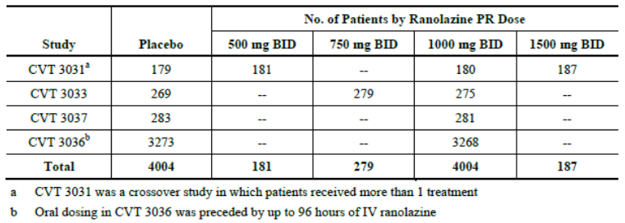
Early development work was with the IR formulation of ranolazine and noted anti-anginal and anti-ischaemic effects with 240 mg at peak (RAN072) and similar effects to atenolol 100 once daily with ranolazine IR 400 mg TDS at peak levels (RAN080). Study RAN1514 showed that ranolazine IR 800 mg (267 mg TDS or 400 mg BD) or 1,200 mg per day had positive effects at peak but not at trough. These results led to the development of the ER formulation. Other early studies in the dossier did not provide useful information on dose response or efficacy: RAN1515, RAN020 and RAN1513 had doses lower than 800 mg per day which were not effective; RAN054 and RAN012 did not provide data of sufficient robustness for interpretation; and RAN1490 was prematurely discontinued with no data included.
Study CVT3031 provided the main data on dose response with the proposed extended release formulation. This placebo controlled, crossover study found that 1 week of monotherapy with ranolazine SR, at doses of 500 mg BD, 1,000 mg BD and 1,500 mg BD, significantly improved exercise duration at trough and at peak levels in subjects (175 evaluable) with chronic stable angina. There was a dose response with more improvement in exercise duration at higher doses and at peak compared to trough levels. Results were supported by an improvement in time to angina onset and time to 1 mm ST segment depression at trough and peak. There was only a small increase in the difference in mean exercise duration compared to placebo for the 1,500 mg BD dose (55.5 sec) compared to the 1,000 mg BD dose (50.1 sec). In addition, the 1,500 mg dose had a disproportionate increase in AEs. Consequently, 1,000 mg BD was chosen as the maximal dose for further studies.
There were significant limitations with Study CVT3031: the design was crossover instead of parallel group, the treatment duration was 1 week rather than 6 weeks, the run-in period was shorter than recommended, and subjects could have been included too soon after revascularisation (only 2 months instead of the recommended 6 months). In addition, there were no washouts between periods and, whilst there was no statistically significant interaction on assessment of carryover, the data from the first period found no improvement in exercise duration at trough. The sponsor claims this was a chance finding. Whilst it is possible there is no true effect at trough, given positive data in CVT3033 discussed below, the evaluator agrees that the lack of a significant finding at trough in the first period could be a chance finding. The evaluator believes that given these findings, the crossover design, and the short treatment duration, Study CVT3031 can only be classed as in initial therapeutic study and not pivotal (as claimed by the sponsor). Furthermore, as CVT3031 was the only study of ranolazine monotherapy, the evidence provided is not adequate to support an indication for ranolazine as monotherapy treatment in chronic angina.
Study CVT3031 established ranolazine SR 1,000 mg BD as the maximum effective dose. The minimum effective dose was not clearly delineated in this study as 500 mg BD was effective although it did only increase exercise duration by 23.8 sec. Plasma ranolazine levels of 848 ng/mL resulted in a significant effect on exercise duration (Study CVT3031, 500 mg SR) while a level of 503 ng/mL (Study RAN072, 120mg IR) did not (Table 24). This association between ranolazine dose, peak and trough plasma levels and exercise duration was used by the sponsor to establish the minimum effective dose. It is unclear, however, whether a dose lower than 500 mg BD of the SR formulation would have given plasma levels sufficient for efficacy and such a dose was not assessed in the dose ranging studies.

Table 24: Association between ranolazine dose, trough, peak plasma levels, exercise duration in the ranolazine IR and PR studies demonstrating efficacy
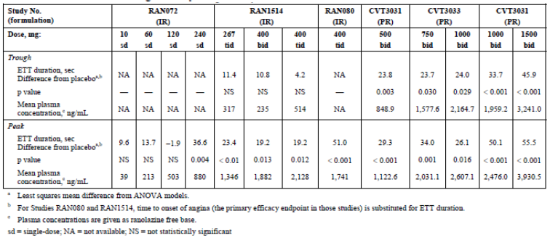
Study CVT3033 was the pivotal Phase III efficacy study in the dossier. It was a 12 week, placebo controlled, parallel group, add-on study of ranolazine SR (750 mg BD and 1,000 mg BD) in 791 subjects with chronic stable angina pectoris treated with a single anti-anginal agent (diltiazem 180 mg once daily, atenolol 50 mg once daily or amlodipine 5 mg once daily). The study design met EMA requirements for investigation of anti-anginal medicinal products in stable angina (EMA/CHMP 2006).
The anti-anginal effect of ranolazine was found for both doses with a statistically significant increase in ETT duration at trough levels with an improvement of about 24 seconds for both doses. The results were supported by statistically significant improvements in secondary endpoints of ETT duration at peak, time to angina onset at peak and trough, angina episodes and nitroglycerin use. Overall, treatment effects were greater at peak compared to trough and the anti-ischaemic effect, as measured by time to 1 mm ST segment depression, was only significantly different to placebo at peak. A response to ranolazine was evident after 2 weeks of treatment, there was no evidence of rebound and treatment effect had been lost two days after ceasing treatment.
While Study CVT3033 was positive, there was only a small improvement in exercise duration of 24 seconds. In addition, the doses of 750 mg BD and 1,000 mg BD had similar efficacy (exercise duration: 23.7 versus 24.0 sec; time to onset of angina: 143.5 versus 139.7 sec; and time to 1 mm ST segment depression 143.3 and 144.2 sec for 750 and 1,000 mg, respectively) and dose response was not evident. It was only on the secondary endpoints of angina episodes per week (750 mg 2.47 versus 1,000 mg: 2.13) and nitroglycerin use (2.11 versus 1.76) that some modest benefit of the higher dose was seen. Background therapies appeared to influence exercise duration with only a very small improvement in ETT duration at trough for those on atenolol (7.5 sec). While the efficacy of ranolazine was demonstrated in this add-on study, the background anti-anginal therapy had not been optimised prior to enrolment (doses given were: atenolol 50 mg once daily, amlodipine 5 mg once daily and diltiazem 180 mg once daily) so the add on effect of ranolazine on treatment with higher doses of these medications is unknown.
Study CVT3037 was a placebo controlled, parallel group study of ranolazine SR 1,000 mg BD in 565 patients with chronic angina who were symptomatic despite maximal dose of amlodipine (10 mg once daily) (and LAN in 45%). After 6 weeks of treatment, ranolazine 1,000 mg BD resulted in a statistically significant reduction in angina attacks per week compared to placebo (trimmed mean 2.82 versus 3.24) and less nitroglycerin use (1.99 versus 2.62). This benefit was modest with less than one angina attack per week reduction. There was no significant difference on 4 of 5 items on the SAQ as only angina frequency was reduced significantly. It is noted that the SAQ had not been validated for use in Eastern European countries (97% of study subjects) and the main outcomes were based on patient reports (diaries) which may be subject to patient perception, however, the study was blinded and placebo controlled which would control for this potential bias. The study duration was short (6 weeks), the primary efficacy endpoint was not an exercise-based variable as recommended (EMA 2006), and concomitant anti-anginal treatment had not been optimised so the patient population does not match the proposed target population. Therefore the evidence from this study is only considered supportive.
Study CVT3036 was a large cardiovascular outcome study which enrolled 6560 subjects with a moderate to high risk of CV events and non-ST elevation ACS. Ranolazine or placebo treatment was given as add-on to standard therapy and after an initial IV ranolazine infusion for up to 96 hours, oral ranolazine SR was continued at a dose of 1,000 mg BD (or 750 mg, 500 mg or 375 mg BD if adverse events or renal insufficiency). At the end of the study, 83% of ranolazine subjects remained on the 1,000 mg dose. The study did not meet its primary endpoint. Ranolazine treatment did not reduce the risk of the composite primary endpoint of CV death, MI or recurrent ischaemia compared to placebo over the entire study duration (RR = 0.92, 95% CI: 0.83, 1.02 p = 0.11) nor was there a significant effect in the early (30 days post randomisation) or later period.
While there was no effect on CV death or MI individually, there was some evidence for reduction in recurrent ischaemia (defined as worsening angina or ischemia requiring additional therapy and severe recurrent ischemia showing ECG changes, leading to hospitalisation, or prompting revascularisation) with a RR of 0.86 (95% CI: 0.76,0.98 p = 0.03). At Month 4, there was a small reduction in the mean number of concomitant anti-anginal medication used (1.7 placebo versus 1.6 ranolazine) and a small (though statistically significant) improvement in the angina frequency score on the SAQ. The clinical relevance of these small changes would be modest at best and there was no improvement on the physical limitation scale of the SAQ.
Subgroup analysis found subjects with a prior history of chronic angina (54%) had a better response to ranolazine treatment with a small improvement on the SAQ and in exercise duration on ETT (32 sec). It was noted, however, that these analyses were post-hoc and the ETTs were not standardised with variable results noted on the tests used. The evaluator concludes that Study CVT3036 did not support the use of ranolazine in the treatment of ACS though it did provide modest supportive anti-anginal efficacy data in chronic angina patients.
Overall, subgroup analysis for subjects with obstructive lung disease, CHF (NYHA class I and II) and diabetes found no significant differences compared to those without the disease. The effect in those aged 65 years or more was also not notably different to the younger age group. The efficacy of ranolazine in women was consistently less than in men however some efficacy was demonstrated in post-hoc subgroup analysis of ischaemia based endpoint in Study CVT3036. None of the studies provided sufficient data for analysis in non-Caucasian populations so no conclusions can be made about other racial groups.
None of the clinical trials with exercise based endpoints reported improvement in exercise capacity in terms of METs (metabolic equivalent of the task) which is the recommendation of the CHMP guideline (EMA/CHMP 2006). The use of METs would have assisted in providing a standard measure regardless of the protocol or test used and would have assisted in Study CVT3036 where there was variability in ETTs performed.
There was no new efficacy data submitted to support the proposed indication.
In the newly submitted studies, GS-US-259-0107 demonstrated an effect of ranolazine ER 500 mg BD on HbA1c after 12 weeks of treatment (0.53% reduction over placebo) in subjects with T2DM. There was however no significant effect on serum glucose (fasting or 2 hour postprandial). The sponsor has not made specific claims in the draft PI with respect to this study. The proposed wording in the PI, which the evaluator believes is satisfactory, is:
Ranexa produces small reductions in HbA1c in patients with diabetes, the clinical significance of which is unknown. Ranexa should not be considered a treatment for diabetes.
Study CVT3041 failed to find validity for the WISQ in women with chronic angina and Study CVT3113 found that in these subjects who had undergone cardiac catheterisation for an invasive EP procedure, ranolazine IV had no effect on the EP parameters and in particular no effect on atrial refractoriness.
The efficacy data in the dossier support treatment with concomitant anti-anginals although this had not always been optimised prior to randomisation. There are insufficient data on the use of ranolazine as monotherapy. Data indicate that the 750 mg BD dose is likely to be as efficacious as the 1,000 mg BD dose.
Efficacy was consistent across age subgroups. There were gender differences in ETT parameters with a notably lower effect in females. While there was a reduction with ranolazine in average weekly angina attacks and nitroglycerin consumption compared to placebo in females the sponsor has been requested to provide more information and include a comment in the PI relating to efficacy in females.

Clinical safety

Studies providing evaluable safety data
In the main efficacy studies, the following safety data were collected:
- General adverse events (AEs) were assessed by the investigator during treatment and for up to 21 days post treatment.
- Laboratory tests, including serum chemistry and haematology.
- Vital signs (BP and HR) and physical examination.
- 12 lead ECGs.
- Holter monitoring in CVT3036 (first 7 days and reviewed by a central laboratory) as well as in GS-US-291-0101, GS-US-291-0112 and CVT3114.
Safety data was based on patients who had received at least one dose of study medication.

Patient exposure
As of July 2012, the ranolazine clinical program has included 11,210 subjects (healthy, chronic angina, non-ST elevation ACS or type 2 diabetes mellitus) with 7,451 who have received ranolazine IV, IR or PR formulations. Safety data was presented from an integrated safety database (ISD) consisting of 71 trials completed by August 2006 (14 Phase II/III studies with IR or PR ranolazine, 5 uncontrolled open label studies, 49 Phase I and clinical pharmacology studies, plus studies CVT3024, CV301-18 and CVT301-20). Sixteen early pharmacology studies were not included due to limited exposure information. A further 14 studies were not integrated into the ISD (Table 25).
Comment: The cardiovascular outcome Study CVT3036 was not part of the ISD.

Table 25: Summary of clinical trials by ranolazine formulation
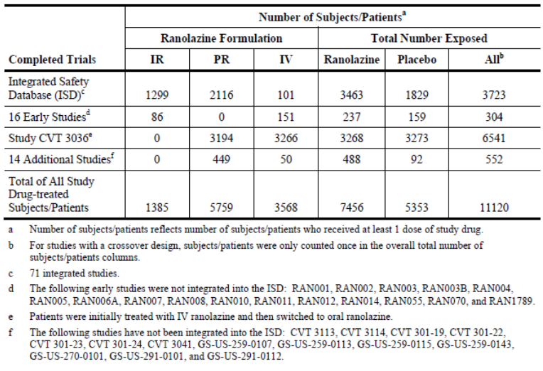
A subset of the ISD was the Phase II and III controlled angina studies trials with the PR formulation (studies CVT3033, CVT3037, CVT3031 and RAN2240). This included 1,030 patients treated with ranolazine PR and 738 with placebo. The Phase III Study CVT3036 in ACS, of whom 54% had a history of angina, included 3,268 ranolazine and 3,273 placebo treated subjects. These two populations provided the most relevant safety information. Long term safety data comes from three open label safety extension studies (CVT3024, CVT3032 and CVT3034).
The mean duration of exposure to ranolazine PR was 559 days with a total exposure was 3240 subject-years. In the controlled Phase II/III ranolazine PR subset of 1030 patients, the mean exposure duration was 61 days for ranolazine and 52 days for placebo. In Study CVT3036, the mean exposure (IV and oral dosing) was 279 and 297 days in the ranolazine and placebo groups, respectively (Table 26). In this study, the majority of patients (83% versus 89%) commenced on the 1,000 mg BD oral dose and this was the final dose in 83% and 89% of the ranolazine and placebo groups, respectively.
Of note, in the ISD, the mean exposure duration to ranolazine was 387 days while to placebo was 28 days.
Comment: Due to the differing exposure duration, comparison of AE rates between ranolazine and placebo in the ISD will be biased.

Table 26: Mean exposure in the Phase II/III PR controlled angina studies, their open label long term follow up studies ISD and Study CVT3036
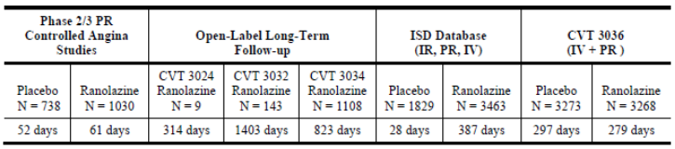
Demographics: In the Phase II/III controlled angina studies and CVT3036, most subjects were male (75% and 65%, respectively), aged < 75 years (90% and 82%) and Caucasian (97% and 95%). As expected in these patient populations, comorbidity was frequent, in particular previous MI (64% and 35%), hypertension (72% and 73%), congestive heart failure (34% and 17%) and diabetes (22% and 34%)(Table 27).

Table 27: Baseline characteristics; phase II/III PR controlled angina studies and CVT 3036*
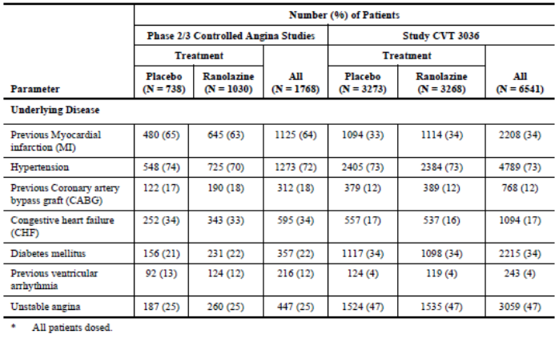

Pivotal studies that assessed safety as a primary outcome
There were no pivotal safety studies.

Adverse events

All adverse events (irrespective of relationship to study treatment)

Pivotal studies
An overview of AE rates in the ISD, Phase II/III controlled angina studies and CVT3036 is presented in Table 28.
In the Phase II/III controlled angina studies, AEs occurred at a higher rate in ranolazine treated subjects than placebo treated (38.3% versus 27.6%) especially constipation (7.2% versus 1.2%), dizziness (7.0% versus 1.8%), nausea (5.1% versus 0.8%) headache (3.0% versus 2.2%), asthenia (2.6% versus 0.4%) and peripheral oedema (2.5% versus 1.5%). Syncope was slightly more frequent (0.6% versus 0%) with most events (according to the sponsor) being orthostatic or vasovagal in origin rather than associated with arrhythmias.
Comment: The tables containing the safety data from the pooled Phase II/III controlled angina studies could not be located and a question has been raised.

Table 28: Overview of adverse events; ISD Phase II/III controlled angina studies populations and Study CVT 3036
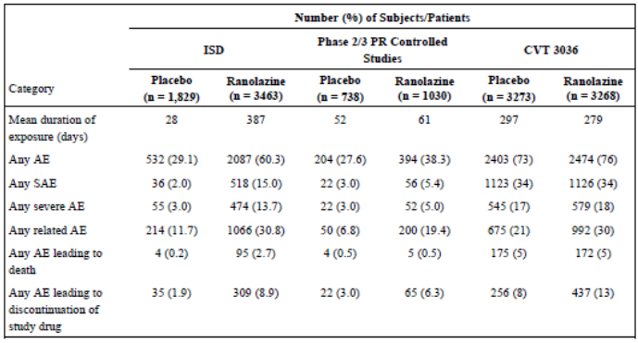
In Study CVT3036, 76% of ranolazine subjects and 73% placebo subjects had at least one AE with nausea (9% versus 6%), constipation (9% versus 3%), dizziness (13% versus 7%), asthenia (5% versus 3%), hypotension (5% versus 3%), vomiting (4% versus 3%), fatigue (4% versus 3%) and cough (4% versus 3%) being more common in ranolazine treated subjects. In this study, syncope occurred in 2% of subjects in both groups.
In the Phase II/III studies, mild, moderate and severe AEs occurred in (ranolazine versus placebo) 26.2% versus 18%, 19.1% versus 11.5% and 5.0% versus 3.0% of the subjects, respectively. The most frequent severe AEs in the ranolazine group were dizziness (0.6%), acute MI, angina pectoris, unstable angina, constipation, chest pain and headache (all 0.3%). In CVT3036, the rate of severe AEs was similar between groups (18% ranolazine versus 17% placebo).
The AE rate was slightly higher in subjects receiving 1,000 mg than 750 mg in Study CVT3033 (32.7% versus 31.2%), with more abdominal pain (2.5% versus 0.7%), asthenia (4.7% versus 1.8%), nausea (5.1% versus 3.2%) and dizziness (6.9% versus 3.6%) although there was less angina pectoris (2.9% versus 3.9%).
In doses up to 1,500 mg BD, AEs with a dose dependent incidence were constipation, dizziness, nausea and asthenia (Table 29).There was a notable increase in the rate of these AEs in the 1,500 mg BD compared to the 1,000 mg BD dose.

Table 29: Adverse events reported for ≥ 2% of patients by dose; Phase II/III PR controlled angina studies
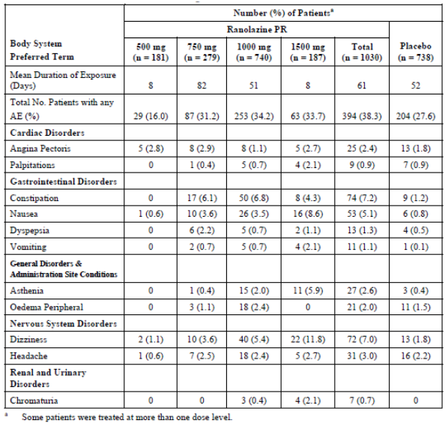

Other studies
In a PK study in healthy volunteers (CVT3111), IV ranolazine was given at doses targeting up to a plasma level of 15,000 ng/mL. As well as a high incidence of nausea, dizziness, headache, blurred vision and diplopia also occurred at elevated plasma levels (> 5,000 ng/mL) (Table 30).

Table 30: Study CVT 3111.Selected dose related adverse events by target ranolazine IV concentration
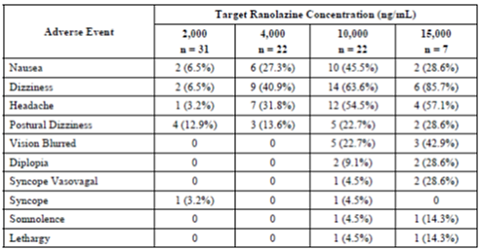
In Study CVT3023, a randomised, double blind, parallel group, dose escalating study in 37 chronic angina patients, different sequences of ranolazine PR 750 mg, 1,500 mg and 2250 mg BD doses were given over 3 treatment periods. Tolerability was measured by the number of patients who (1) experienced syncope, diplopia, somnolence, depressed level/loss of consciousness, confusion/ disorientation, symptomatic hypotension, dizziness, nausea, vomiting, or (2) had any severe adverse event, or (3) terminated from the study due to an adverse event. Doses of 1,500 and 2,250 mg BD were found to be intolerable (46% and 75% respectively).
In 45 patients with intermittent claudication (RAN2302), after 4 weeks of treatment with ranolazine SR 1,000 mg BD, the AE rate in the ranolazine group was 36.4% compared to 13.0% in the placebo group. The study had one withdrawal which was due to dizziness in a ranolazine treated patient.
In the open label long term studies (CVT3032 and CVT3034) there were 1,251 subjects on doses of 500 to 1,000 mg BD with a median treatment duration of 3.8 years (range 12 days to 8.0 years) in Study CVT3032 (n = 143) and 1.2 years (range 6 days to 6.3 years) in CVT3034 (n = 1108). AEs were consistent with the Phase II/III data and Study CVT3036 (Table 31). Syncope occurred in 4.9% of CVT 3032 patients and 1.4% of CVT 3034 patients. In Study CVT3034, AE rates did not appear to be influenced by concomitant anti-anginals and were reported in 73.9%, 75.5%, 72.3% and 46.1% of patients taking concomitant atenolol, diltiazem, 5 mg amlodipine and 10 mg amlodipine respectively.

Table 31: Most frequent AEs in long term open label studies
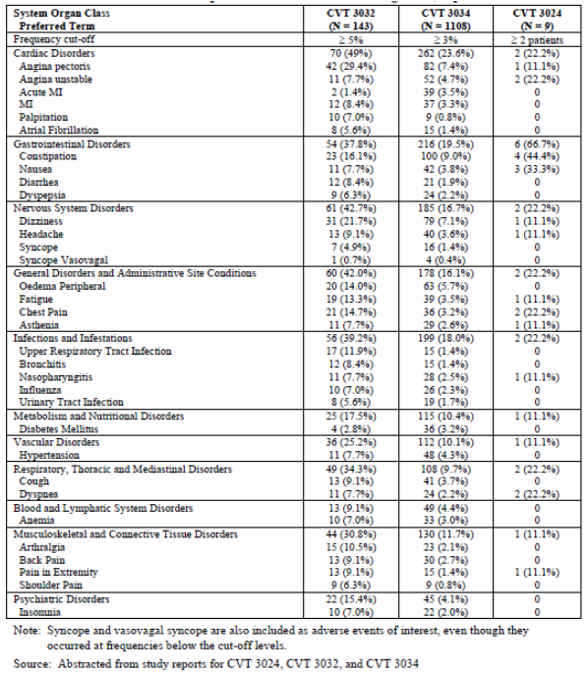

Treatment-related adverse events (adverse drug reactions)
The rate of treatment related AEs was notably higher in the ranolazine group in both the Phase II/III population (19.4% and 6.8%) and Study CVT3036 (30% versus 21%) (Table 28). The most frequent treatment related AEs were constipation, dizziness and nausea.

Deaths and other serious adverse events

Deaths
In the 102 clinical studies there were 458 deaths. The rate of death in the ISD was 2.7% versus 0.2% while the rate was the same in the ranolazine and placebo groups in the Phase II/III controlled studies (0.5%) (Table 5). There were no deaths in the 14 studies not included in the ISD.
Comment: Table 5 states there were 99 deaths in the ISD while the text in the Summary of Clinical Safety (section 2.1.5) states that the ISD included 107 deaths plus an additional 3 deaths were identified “through pharmacovigilance efforts”. The sponsor has been asked to clarify the discrepancies.
In Study CVT3036, where the cause of death was adjudicated by a CEC, there were 172/3268 (5.3%) ranolazine treated subjects and 175/3273 (5.3%) placebo treated subjects who died, with similar incidence of CV deaths (147 [4%] ranolazine versus 148 [5%] placebo) and no increased risk of mortality with a RR of 0.99 (95% CI: 0.80,1.22 p = 0.91). There was also no increased risk of sudden CV death (1.7% ranolazine versus 2.0% placebo; RR = 0.87, 95% CI: 0.61, 1.24 p = 0.43). There was no increased risk of death noted in any of the subgroups analysed (age, gender, race, diabetes, presenting syndrome, TIMI risk score, creatinine clearance, asthma, COPD, CHF, or actual early invasive management). There were similar numbers of non-cardiovascular deaths in Study CV3036 (25 versus 26).

SAEs
In the ISD, the rate of SAEs with ranolazine and placebo was 15.0% versus 2.0%. In the 14 studies not included in the ISD there were 12 patients treated with ranolazine who had and SAE (rates per study varied from 3.0% in CVT3113 to 25% [n = 3] in GS-US-270-0101). The rate of SAEs in the 16 early studies not in the ISD was 5.5% versus 3.8% in the ranolazine and placebo groups, respectively.
In the Phase II/III angina studies, ranolazine subjects had a higher rate of SAEs (5.4% versus 3.0%) over a mean duration of 61 days for ranolazine and 52 days for placebo. In Study CVT3036, the rate was similar (34% in both groups) over a mean duration of 279 and 297 days respectively (Table 28).
The most frequent SAEs in the Phase II/III population were unstable angina and angina pectoris. Cardiovascular disorders were the most frequent SAEs in CVT3036 (22% in both groups) and included unstable angina (8%), cardiac failure (4%), MI (4%), angina pectoris (4%), acute MI (3%) and ACS (2%)(Table 32). Arrhythmias occurred in 3% of subjects in both groups, including bradyarrhythmias (1% for both groups) and supraventricular tachycardia (SVT) (1% both groups). There were 2 cases of torsades de pointes ventricular tachycardia with one in each group. Syncope was slightly more frequent in ranolazine subjects (0.4% versus 0% in Phase II/III angina studies, and 1.0% versus 0.7% in Study CVT3036).
Comment: Syncope cases were reviewed (20 in the ISD and 34 in CVT3036) by the sponsor and it was stated that these were vasovagal or orthostatic in nature rather than associated with ventricular arrhythmias.

Table 32: Study CVT3036. Summary of SAEs with a frequency of ≥1% (all patients dosed)
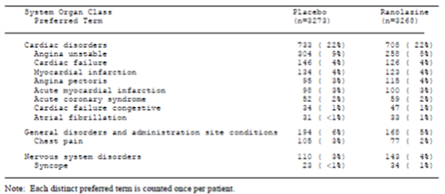
In CVT3113 (IV ranolazine) there was one patient who developed atrial fibrillation and tachycardia with a subsequent SAE of DVT.
In CVT3036, the number of the following laboratory related SAEs was slightly greater in the ranolazine compared to the placebo group: anaemia (n = 14 versus 10), iron deficiency anaemia (3 versus 0), pancytopenia (3 versus 0), blood creatinine increased (3 versus 0) and thrombocytopenia (2 versus 0).
Serious AEs which were considered drug-related by the investigators in CVT3036 occurred in 3% of ranolazine and 2% of placebo treated subjects and included syncope, dizziness and orthostatic hypotension.
Subgroup analysis in CVT3036 found no notable differences between groups except for a higher SAE incidence in subjects taking diltiazem or verapamil at any time during the study (53% ranolazine and 44% placebo).
The rate of SAEs in the long term studies was 60.8% in CVT3032 and 26.2% in CVT3034. The most frequent SAEs were angina pectoris, MI and unstable angina.
The rate of treatment-related SAEs in the Phase II/III angina studies was higher with ranolazine (1.2% versus 0.1%) with dizziness the most frequent event. Other events were syncope, bradycardia, ventricular fibrillation, orthostatic hypotension, unstable angina, headache with vertigo, and acute MI. In CVT3036, the rate of treatment-related SAEs was 3% versus 2% with nervous system and cardiovascular disorders the most frequent SOC involved. There was a higher rate in ranolazine treated patients of dizziness, orthostatic hypotension and syncope.

Discontinuation due to adverse events

Pivotal studies
Study discontinuation due to an AE was similar between groups (8.9% ranolazine versus 9.7% placebo) in the ISD, while it was higher in ranolazine treated subjects in the Phase II/III angina studies (6.3% versus 3.0%) and Study CVT3036 (13% versus 8%). The most frequent reason for discontinuation in Study CVT3036 was nausea (2% versus 0.8%), constipation (1% versus 0.1%), vomiting (0.7% versus 0.2%), dizziness (3% versus 1%) and headache (0.7% versus 0.5%) as well as cardiac disorders (2% each). In Study CVT3033, the discontinuation rate due to AEs was slightly higher with the 1,000 mg BD dose than 750 mg BD (9.1% versus 7.9%).

Other studies
In CVT301-19, AEs leading to treatment discontinuation included chest pain, headache, VT, PR > 0.22sec, QTc > 500 msec. In CVT3041, AEs leading discontinuation included nausea, chest pain, headache, stomach discomfort, dizziness. In CVT3113, there was a case of atrial fibrillation and atrial tachycardia. In GS-US-259-0107, the rate was similar between ranolazine and placebo (13% versus 15%) and the most frequent events in the ranolazine group were nausea and asthenia.
In the long term studies, the rate of AEs leading to discontinuation was 11.1% (1/9) in CVT3024, 37.1% (53/143) in CVT3032, and 8.1% (90/1108) in CVT3034. Cardiac events were the most frequent AEs (3.7% in CVT3034 and 14.7% in CVT3032), in particular MI and angina pectoris.

Laboratory tests

Liver function
There were no evident changes on liver function noted in the clinical development program.

Kidney function
Serum creatinine was noted to increase 0.1 mg/dL in the Phase II/III angina studies. This was also found in CVT3036 where 16% of ranolazine and 11% of placebo subjects had shifted from a normal creatinine at baseline to a high value at the final study visit.
Comment: The sponsor stated this is due to inhibition of tubular secretion of creatinine by ranolazine and is reversible on treatment cessation.

Other clinical chemistry
With short term treatment of up to 3 months in the Phase II/III angina studies, there was no change in plasma glucose, while diabetic patients in Study CVT3033 after 12 weeks of treatment had a reduction in HbA1c of 0.5% and 0.9% for those on ranolazine 750 mg BD and 1,000 mg BD, respectively. In Study CVT3036, reduction in HbA1c was seen over time that was less in non-diabetic than in diabetic subjects treated with ranolazine (placebo subtracted change of 0.18% versus 0.43% at Month 4) (Table 33). While the reduction in HbA1c at Month 4 was significantly different between ranolazine and placebo treated diabetics (p < 0.001), at Month 16 the placebo subtracted reduction in HbA1c had reduced to 0.24% (Figure 9). There was no relevant change in fasting glucose levels in diabetic patients in this study, though non-fasting levels showed a small reduction in glucose levels at Month 4 and 8 (Figure 10).

Table 33: Study CVT3036 Summary of HbA1c change from baseline values
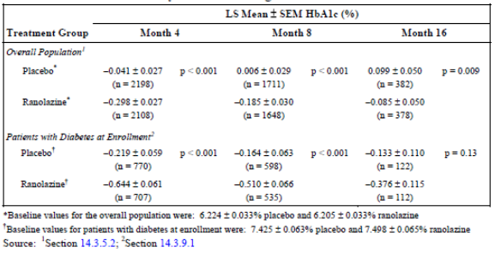
Figure 9: Study CVT3036 Change from baseline HbA1c in patients with diabetes
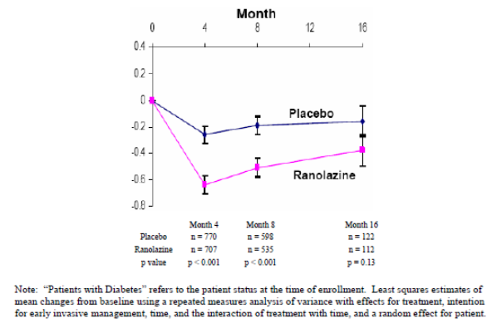
Figure 10: Study CVT3036. Plasma glucose (mg/dL) in patients who were diabetic at baseline
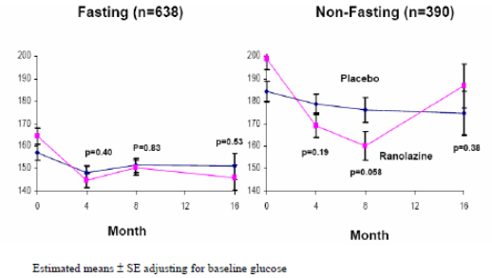
In Study GS-US-259-0107, where 80 patients with type 2 diabetes mellitus were treated with 12 weeks of ranolazine ER 500 mg BD, there was a statistically significant reduction in HbA1c over placebo of 0.53%. There was, however, no significant effect on serum glucose (fasting or 2 hour postprandial), C peptide or serum insulin.
Overall, there were no evident changes on electrolytes and urinalysis and no clinically meaningful changes in lipids.

Haematology
Small reductions in haemoglobin (-0.5 g/dL), haematocrit (-1.2%) and red cell count (-0.2 x 10⁶/µL) were seen in the Phase II/III angina studies though these were not dose dependent. In CVT3036, no clinically relevant changes in mean haemoglobin levels were noted; however, for subjects with normal haemoglobin at baseline, 19% of ranolazine and 14% of placebo subjects had shifted below normal at the final visit. Over short term ranolazine treatment, there was a small increase in eosinophils and a decrease in lymphocytes which did not continue with long term treatment. Eosinophils were not measured in CVT3036 and in this study no relevant changes in lymphocytes were noted.

Electrocardiograph

Pivotal studies
In the controlled Phase II/III angina studies there were small, dose dependent increases in PR, QRS, QT, QTcB, and QTcF intervals (Table 31). From studies CVT3031 and CVT3033, at doses up to 1,000 mg BD, the increase in QTcB (Bazett correction) was 2.1–4.6 msec, and QTcF (Fridericia’s correction) was 1.9–5.4 msec (Table 34). The prolongation of QT interval was particularly notable with the 1,500 mg BD dose.
In CVT3031, there was a reduction in T wave amplitude and increased frequency of notched T waves with increasing ranolazine dose. At peak the proportion of subjects with notched T waves was 2%, 1%, 3% and 6% in the placebo and ranolazine 500 mg, 1,000 mg and 1,500 mg BD groups, respectively.

Table 34: Summary of the mean change from baseline by dose in ECG parameters for the Phase II/III PR controlled angina studies
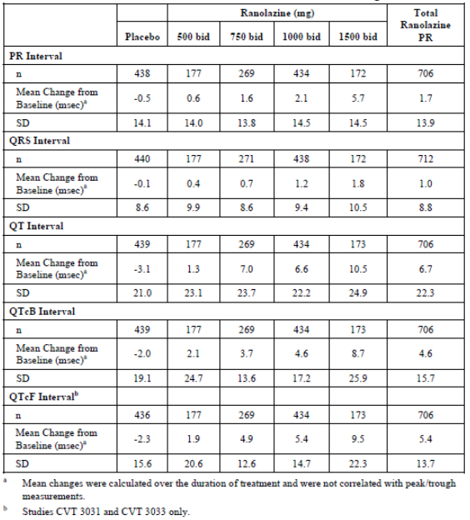

Other studies
In the Phase I Study CVT301-19 (open label study evaluating the effect of diltiazem 180 mg BD on the PK of ranolazine PR in healthy subjects with poor (PM) and extensive (EM) metaboliser genotype for CYP2D6) found that the poor and extensive metabolisers had similar increases in QTcF despite higher ranolazine levels in the PMs. There were two withdrawals due to QTcB > 500 msec although this prolongation was not confirmed by the central laboratory. There were also two subjects on ranolazine 1,000 mg BD + diltiazem 180 mg with asymptomatic VT on Holter monitoring (3 and 6 beats).
In Study CVT3114 where open label IV ranolazine was given to patients with long QT-3, there was a concentration dependent reduction in QTcF (mean change from baseline of -26 msec).
In GS-US-270-0101 where IV then oral ranolazine ER (1,000 mg BD) was given to patient with heart failure and preserved ejection fraction, there was one patient with increase QRS and no other clinically significant ECG findings.
Changes in T wave morphology (notching) have also been noted with ranolazine ER at doses of 1,500 mg and 2000 mg (RAN0201) and following IV ranolazine (CVT3111).
Further discussion is in Section 8 on cardiovascular safety.

Vital signs
Ranolazine does not appear to affect blood pressure (BP) or heart rate (HR) at doses up to 1,000 mg BD. In the Phase II/III angina studies, the mean change in systolic and diastolic BP compared to placebo was less than 3 mHg and for HR was less than 2 bpm. In CVT3037, when ranolazine was given together with amlodipine 10 mg once daily (and LAN for 45%), the mean reduction in systolic BP after 6 weeks treatment was < 3 mmHg and HR was ≤ 2 bpm. At Month 12 in CVT3036, the mean postural systolic BP decreased by approximately 2 to 3 mmHg, the mean diastolic BP decreased by < 1 mm Hg, and the mean HR increased by approximately 3 to 4 bpm.
In the 14 studies not included in the ISD, vital sign changes were not clinically meaningful. In the long term extension studies there was a trend for a small decrease in BP and HR
Comment: The uncontrolled nature of the long term studies makes result interpretation difficult.

Laboratory related AEs
In the ISD, laboratory-related AEs in ranolazine treated subjects (all formulations, n = 3,463) were anaemia (1.4%), increased blood creatinine (0.8%), increased blood glucose (1.0%), increased blood creatinine phosphokinase (0.5%), increased blood triglycerides (0.5%), increased blood urea (0.5%), hypercholesterolemia (0.5%), chromaturia (0.5%), and haematuria (0.5%).
Laboratory-related AEs leading to discontinuation of ranolazine treatment in 2 or more subjects included anaemia (n = 2) and abnormal LFT (n = 3). Laboratory-related SAEs included anaemia (3), haematuria (2), leukopenia (1), inappropriate antidiuretic hormone secretion (1), decreased haemoglobin (1), increase in creatinine and BUN (1), hyperkalaemia (1), hypoglycaemia (1), and hyponatremia (1).
In CVT3036, laboratory-related SAEs deemed related to ranolazine included worsening diabetes, uncontrolled diabetes, hyponatraemia, pancytopaenia, and anaemia with leukopaenia. SAEs occurring more frequently with ranolazine than placebo were anaemia (n = 14 versus 10), iron deficiency anaemia (n = 3 versus 0), pancytopaenia (n = 3 versus 0), increased creatinine (n = 3 versus 0), thrombocytopaenia (n = 2 versus 0) and inadequate diabetes control (n = 8 versus 4).

Post-marketing experience
Ranolazine was approved in the US in January 2006 and in the EU in July 2008. To 31 January 2012 the sponsor estimated the cumulative exposure to ranolazine was 562,408 patients in the US. Based on sales figures in the EU, it was estimated the cumulative exposure in the EU was 871,178 patient-months.
The sponsor stated that there have been 15 cumulative safety reviews to assess possible safety signals. These have covered pulmonary fibrosis, myasthenic syndrome, rhabdomyolysis and myalgia, dysuria and similar conditions, feeling drunk and similar neurologic events, ranolazine-tacrolimus drug-drug interaction, medication residue, QT prolongation and torsades de pointes, psychiatric disorders, renal failure and related disorders, nervous system disorders, drug interactions, angioedema, and rash and pruritus.
Following these reviews the actions taken included:
- Inclusion in the ranolazine CCDS of: dysuria and urinary retention, coordination abnormal, gait disturbance hallucination, confusional state, headache, syncope, tremor, paraesthesia, hypoesthesia, angioedema, rash and pruritus.
- Lowering the starting and maintenance dose of simvastatin when co-administered with ranolazine. Addition of text limiting the dose of simvastatin used concomitantly with ranolazine to 20 mg once daily.
- Addition of text regarding the potential need for dose adjustment of sensitive CYP3A4 substrates and CYP3A4 substrates with a narrow therapeutic range when co-administered with ranolazine. Examples of relevant sensitive CYP3A4 substrates and CYP3A4 substrates with a narrow therapeutic range to be included in the CCDS are simvastatin, lovastatin, cyclosporine, tacrolimus, and sirolimus.
Due to the risk of increased statin concentrations, the risk of skeletal muscle complaints was assessed. No increased risk was noted from clinical trial data. However, there were post-marketing reports of musculoskeletal AEs including rhabdomyolysis with a temporal association with ranolazine therapy. The risk was seen with simvastatin doses lower than 80 mg per day.
As of 7 July 2010 there were 10 spontaneous reports of torsades de pointes (TdP) polymorphic VT with estimated rates of 0.2 cases per 10,000 patients in the US and 0.1 per 10,000 patient months in the EU. Five of the cases were well documented cases and had alternative explanations. There was no proposed change to the CCDS proposed following this review.
Comment: As these data are 5 years old, an update on post-marketing TdP and VT reports is recommended.
The review of nervous system disorders found that dizziness, headache, syncope, tremor, paraesthesia and hypoesthesia should be included on the core data sheet, with insufficient evidence for myoclonus and involuntary muscle contractions. Based on the reviews there was no change to the CCDS for pulmonary fibrosis, myasthenic syndrome, medication residue in stool or ostomy bag. There was insufficient evidence available for the inclusion of psychiatric disorders. Ranolazine requires careful dose titration in patients with renal impairment and a maximum dose of 500 mg BD in patients with severe renal impairment. There were no further changes recommended relating to renal failure and related disorders. There were no additional drug interactions or new safety concerns associated with known drug interactions identified.
Comment: The dossier included PSURs which only covered up to 26 January 2013 (PSUR-mar-3). Current post-marketing data covering the next two years should be submitted for evaluation.

Safety issues with the potential for major regulatory impact

Cardiovascular safety
A population PK/PD analysis (CVT303) of 1,308 patients and healthy volunteers noted the slope of the population concentration-QTc relationship to be 2.4 msec per 1,000 ng/mL plasma ranolazine concentration. This analysis found that QTc prolongation was more marked in subjects with mild and moderate hepatic impairment compared to those with angina (change from baseline of 6.62 and 7.42msec/1,000ng/mL respectively versus. 2.4msec/1,000ng/mL).
Comment: These risks in mild to moderate liver impairment have been reflected in the contraindications and precautions sections of the draft PI (moderate to severe impairment being a contraindication and mild impairment a precaution with careful dose titration).
Data from Study CVT3036 was used to assess the relationship between QTcF and mortality using Cox regression. Baseline QTc was found to be a significant predictor of mortality with a RR of 0.5% (95% CI: 0.1-0.9%, p < 0.001) per 1 msec increase in baseline QTcF in the ranolazine group and 0.7% (95% CI: 0.4-1.1%) in the placebo group. There was no significant difference between the treatment groups (p = 0.36).
Symptomatic documented arrhythmias (those that led to prolonged hospitalisation or were documented by ECG) were adjudicated by the CEC in Study CVT3036 and there was no significant difference between groups (ranolazine 3.0% versus placebo 3.1%, p = 0.84). Subjects in CVT3036 also had 7 days of Holter monitoring from randomisation and ranolazine subjects had less clinically significant arrhythmias during this period (79.9% versus 87.4%, p < 0.001) including less VT ≥ 3 beats (52.1% versus 60.6%) and SVT (44.7% versus 54.9%) (Table 35). Further evaluation after unblinding found that there were fewer episodes of ventricular tachycardia lasting ≥ 8 beats (5.2% versus 8.3%) and this risk was less in the high risk groups of TIMI risk score 5-7, LV ejection fraction ≤ 40%, QTc ≥ 450 msec and prior heart failure (Table 36).

Table 35: Incidence and frequency of clinically significant arrhythmias during the 7 day continuous ECG (Holter) monitoring (CVT3036, all patients dosed)
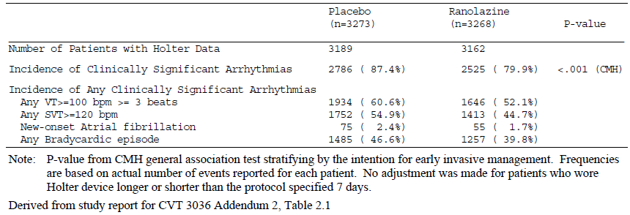

Table 36: Incidence of VT ≥ 8 beats and sudden cardiac death in selected high risk groups (CVT3036, all patients dosed)
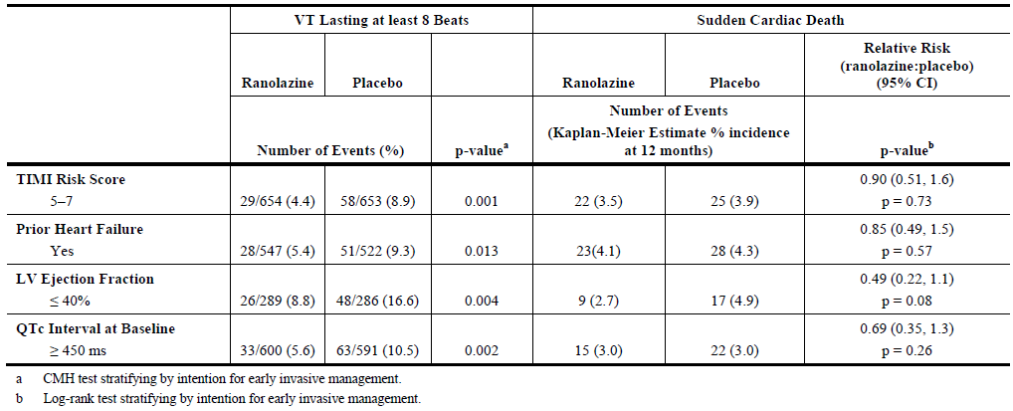
There were two cases of VT with appearance of TdP, one in each treatment group. As discussed, above, in post-marketing surveillance there were 10 cases of torsades de pointes or polymorphic VT to 7 July 2010 with the 5 well documented cases having alternative explanations such as concomitant us of other QT prolonging medications. Four cases did not have ECG findings consistent with TdP and one case had insufficient details.
Comment: The QTc effects of ranolazine are dose dependent. Reassuringly, in the clinical development program has found no associated increased risk of arrhythmias or mortality. The review of post-marketing data on VT/TdP should be updated.

Other safety issues

Safety in special populations

Age
In Study CVT3036, there was no increased risk of mortality or CV hospitalisation in subjects aged 65 to 74 or ≥ 75 years. AEs of constipation, nausea, hypotension and vomiting all increased with increasing age. Older subjects were also more likely to discontinue ranolazine due to an AE (as the primary or secondary reason): 10%, 16%, and 21% in the < 65 years, 65 to 74 years, and ≥ 75 years age group respectively. This increased risk in the elderly was confirmed in the Phase II/III angina safety analysis.

Gender
In Study CVT3036, there was no significant difference between men and women in major safety endpoints (time to death from any cause, time to death or any CV hospitalisation, or incidence of symptomatic documented arrhythmia). Overall, the rate of AEs was similar in CVT3036 for men (76% ranolazine, 73% placebo) and women (75% ranolazine and 73% placebo), while women treated with ranolazine had a higher rate of nausea (14% versus 7% men treated with ranolazine) and vomiting (6% versus 3%).

Race
Comment: The number of non-Caucasian subjects in the clinical program was too small for reliable analysis.

Diabetes
The risk of major safety endpoints in CVT3036 was not increased for diabetics (34% of the safety analysis set) compared to non-diabetics and the AE profile was similar. In Study GS-US-259-107, which assessed 12 weeks of ranolazine in patients with T2DM, the rate of AEs was not higher with ranolazine (48.7% versus 56.1%), nor was the rate of discontinuation due to an AE (13% versus 15%). Hypoglycaemia was slightly higher with ranolazine (10% versus 7%).

Patients with a potential for increased ranolazine plasma levels
Population PK analysis identified the presence of diltiazem, impaired renal function, NYHA class III and IV and low body weight as factors associated with increased plasma ranolazine levels.
For subjects with reduced renal function (creatinine clearance ≤ 60 mL/min, 701 placebo and 696 ranolazine patients) in Study CVT3036, ranolazine increased the risk of AEs (84% versus 76% placebo). Of note, there was a higher rate of dizziness (16% versus 6%), nausea (14% versus 7%), constipation (12% versus 4%), vomiting (9% versus 4%) and hypotension (8% versus 4%) in the ranolazine compared to the placebo groups. There were 52 ranolazine and 50 placebo subjects randomised with creatinine clearance ≤ 30 mL/min and these subjects received a lower dose of ranolazine (500 mg BD) and, despite this lower dose, the risk of AEs was slightly higher in these patients (90% ranolazine, versus 86% placebo). In particular in this group, ranolazine treatment compared to placebo resulted in higher rates of nausea (23% versus 10%), dizziness (15% versus 10%), hypotension (10% versus 2%), cardiac failure (25% versus 12%), dyspnoea (12% versus 6%) and myocardial infarction (13% versus 6%).
For subjects with a history of congestive cardiac failure (n = 537 ranolazine, 557 placebo), the AE incidence was similar (78% versus 75%), as it was for subjects (131 ranolazine, 137 placebo) with NYHA Class III or IV heart failure (83% versus 80%).
Subjects with body weight ≤ 60 kg (208 ranolazine, 233 placebo) had a higher incidence of AEs when treated with ranolazine (80% versus 72%) and in particular nausea (22% versus 7%) and vomiting (9% versus 3%).

Hepatic impairment
In CVT3036, the AE incidence was not higher in subjects with a baseline level of AST ≥ 2 times the ULN (107 ranolazine and 102 placebo subjects).
Comment: Significant hepatic impairment was an exclusion criteria in the clinical trials.

Other groups
Adverse events in CVT3036 were also assessed in the subgroups of qualifying event (non-STE MI or unstable angina), ST segment depression, TIMI score, history of asthma, and history of COPD and there were no notable findings. From the Phase II/III angina dataset, there were no additional safety concerns in the subgroups of patients with pre-existing reactive airway disease, CHF, and low blood pressure and/or low heart rate and/or prolonged AV conduction.
In patients with heart failure (GS-US-270-0101), overall AE rates were similar between ranolazine and placebo groups (83% versus 88%) although the risk of constipation was notably high (58% versus 0%).
Comment: The draft PI includes contraindications of moderate to severe hepatic impairment and severe renal impairment. At risk groups listed in the precautions also include mild hepatic impairment, mild to moderate renal impairment, elderly, low body weight (< 60 kg) and moderate to severe CHF.

Safety related to drug-drug interactions and other interactions
In CVT3036, 451 subjects used concomitant diltiazem or verapamil with 364 patients (177 placebo, 187 ranolazine) taking diltiazem and 93 (42 placebo, 51 ranolazine) verapamil. In this group, ranolazine resulted in a small increase in the incidence of AEs (87% ranolazine versus 81% placebo), especially dizziness (21% versus 8%). This compares to rates of 75% versus 73% in non-users. Study CVT301-19 assessed subjects with poor or extensive metaboliser genotypes for CYP2D6 who received diltiazem. Chest pain, application site erythema and paraesthesia were reported more frequently during the ranolazine and diltiazem treatment periods than during treatment with ranolazine alone.
In CVT3036, statin use was widespread (86% of subjects) with 47% of ranolazine subjects taking simvastatin and 39% taking atorvostatin. There were no safety signals of hepatobiliary, musculoskeletal or connective tissue disorders, or signal from laboratory assessments in these groups. This risk with concomitant statins has, however, has been noted from post-marketing data.

Evaluator’s overall conclusions on clinical safety
The ranolazine clinical program was large and included 11,120 subjects with 7,456 who have received ranolazine IV, IR or PR formulations. Data were presented from the integrated safety database (ISD), which consisted of 71 trials and including 3,463 ranolazine and 1,829 placebo subjects. The most relevant data comes from a subset of the ISD, termed Phase II/III angina studies, which contained 4 controlled, chronic angina studies with the PR formulation and 1,030 ranolazine ER and 738 placebo subjects. Safety data was also presented from the cardiovascular outcome study in non-ST elevation ACS, CVT3036, which included 3,268 ranolazine and 3,273 placebo treated subjects, of whom 54% had a history of chronic angina.
Exposure to ranolazine was from a dose of 10 mg to 2250 mg BD with a total exposure in the ISD of 3,669 patient-years and mean duration of 559 days. In the controlled Phase II/III angina dataset, the mean exposure was 61 days and in Study CVT3036 the mean exposure was 279 days. In CVT3036, while dose adjustment was allowed, 83% received 1,000 mg BD as their final dose. In the Phase II/III dataset ranolazine subjects were predominantly male (76%), Caucasian (96%), < 75 years old (89%), with a history of MI (63%) and hypertension (70%).
Ranolazine resulted in a higher rate of AEs than in placebo treated subjects (38.3% versus 27.6% from the Phase II/III dataset, and 76% versus 73% from CVT3036). Constipation, dizziness, nausea, headache, asthenia, vomiting, hypotension, fatigue were the main AEs which were more frequent with ranolazine. Syncope was also more frequent (0.6% versus 0%) in the Phase II/III dataset although it occurred at the same rate (2%) in CVT3036.
Ranolazine treated subjects had a higher rate of discontinuation due to AEs (6.3% versus 3.0% in Phase II/III dataset and 13% versus 8% in CVT3036). The most frequent AEs leading to discontinuation were nausea, constipation, vomiting, dizziness and headache. Discontinuation due to cardiac disorders was similar between groups.
Doses of ranolazine above 1,000 mg BD were not tolerated with a disproportionate increase in AEs with doses of 1,500 mg BD. The main AEs with a dose dependent incidence were constipation, dizziness, nausea and asthenia. The dose of 1,000 mg BD resulted in a small but noticeable increase in AEs and discontinuations due to AEs compared to the 750 mg dose. Following IV administration of ranolazine, withdrawal increased at plasma levels > 5,000 ng/mL and at high levels blurred vision, diplopia, vasovagal syncope, somnolence and lethargy were observed. Doses of 1,000 mg BD resulted in plasma levels of 2100 to 2600 ng/mL and 750 mg BD in levels of 1600 to 2000 ng/mL (Study CVT3033, Table 37). Consequently, ranolazine has a notably low safety margin.

Table 37: CVT3033 Ranolazine plasma concentrations (ng/mL) at Week 12 at trough and peak during the double blind phase: safety population
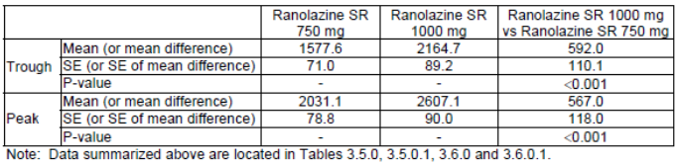
There were 3 open label safety studies which included 1251 subjects at doses of 500 to 1,000 mg BD, for a median duration of 1.2 years for the 1,108 subjects in Study CVT3024. AEs were consistent with the controlled study data.
Ranolazine treatment did not increase the risk of mortality (RR = 0.99 95% CI: 0.80, 1.22 p = 0.91) or of sudden cardiac death (RR = 0.87, 95% CI: 0.61, 1.24; p = 0.43) and this was consistent across subgroups. The incidence of SAEs was slightly higher in ranolazine treated subjects (5.4% versus 3.0%) in the Phase II/III dataset but similar in CVT3036 (34% for both groups). As would be expected in this patient population, the main SAEs in CVT3036 were cardiovascular and these occurred at a similar frequency between groups. SAEs of syncope were slightly more frequent in ranolazine subjects (0.4% versus 0% in Phase II/III angina studies, and 1.0% versus 0.7% in Study CVT3036), however in CVT3036 the incidence of arrhythmias was 3% in both groups.
Laboratory investigations found an increase in serum creatinine of 0.1 mg/dL in the Phase II/III studies and shift from normal to high creatinine in 16% of ranolazine subjects compared to 11% placebo in CVT3036. Ranolazine treatment resulted in a statistically significant reduction in HbA1c in diabetic patients of 0.43% (placebo subtracted) after 4 months of treatment and 0.24% after 8 months, together with a small reduction in non-fasting glucose levels in Study CVT3036. A reduction in HbA1c was also seen in CVT3033 and GS-US-259-0107. In this latter study, which assessed the metabolic effects more definitively in patients with T2DM, there was no effect on glucose levels. The fact that ranolazine is not a treatment for diabetes has been included in the draft PI.
Ranolazine did not affect heart rate or blood pressure in doses up to 1,000 mg BD. One of the major safety issues is the dose dependent increase in QTc. In the Phase II/III studies there was a 2 to 7 msec increase in QT interval at doses of 500-1,000 mg BD and the population concentration-QTc relationship was found to be 2.4 msec per 1,000 ng/mL plasma ranolazine concentration. There was a more marked prolongation in subjects with hepatic impairment. Despite this prolongation, there was no increased risk of mortality in CVT3036, no increase in symptomatic documented arrhythmias (ranolazine 3.0% versus placebo 3.1%, p = 0.84) and 7 days of Holter monitoring post-randomisation found a reduced risk of clinically significant arrhythmias (79.9% versus 87.4%, p < 0.001). This lower arrhythmia risk was maintained across high risk groups.
AE risk increased with increasing age and there was a higher discontinuation due to AEs, rising to 21%, in the elderly ≥ 75 years. Males and females had similar AE incidence apart from more nausea and vomiting in women. Subjects with a body weight under 60 kg also had an increased risk of AEs, particularly nausea and vomiting. Decreasing renal function resulted in increasing AEs and subjects in CVT3036 with creatinine clearance ≤ 30 mL/min were noted to have an increased risk of nausea, dizziness, hypotension, and more notably also of cardiac failure, dyspnoea and myocardial infarction. While AST ≥ 2 times the ULN did not increase AE incidence, significant hepatic impairment was an exclusion criteria from the trials. There were no evident safety concerns in other subgroups of CHF, presenting syndrome, ST segment depression, TIMI score, asthma, COPD, low blood pressure and/or low heart rate and/or prolonged AV conduction.
Taking concomitant diltiazem or verapamil mildly increased the risk of AEs, particularly of dizziness. Post-marketing data has found a risk of musculoskeletal AE and rhabdomyolysis with concomitant simvastatin use. The PI states that the dose of simvastatin used concomitantly with ranolazine should be limited to 20 mg once daily.
Ranolazine has been on the US market since 2006 and EU since mid-2008 and an estimated 560,000 patients have been exposed in the US. Post-marketing data review has resulted in the addition of dysuria, urinary retention, coordination abnormal, gait disturbance hallucination, confusional state, headache, syncope, tremor, paraesthesia, hypoesthesia, angioedema, rash and pruritus in the CCDS. Further risks have been highlighted regarding the need for dose adjustment of sensitive CYP3A4 substrates and CYP3A4 substrates with a narrow therapeutic range when co-administered with ranolazine. A review on the risk of TdP and VT to July 2010 found no additional risks necessitating change to the CCDS. As this review is 5 years old it should be updated.

First round benefit-risk assessment

First round assessment of benefits
The benefits of ranolazine in the proposed usage are:
- Anti-ischaemic and anti-anginal efficacy in stable angina as measured by exercise duration, reduction in angina attacks and nitroglycerin consumption. The benefit is modest with approximately 24 seconds improvement in exercise duration after 12 weeks of treatment with ranolazine 750 mg BD and reduction of less than one angina attack per week.
- Tolerance did not develop after 12 weeks of treatment and rebound in angina (as measured by exercise duration) was not observed on cessation of treatment.
- In chronic angina patients with acute coronary syndrome (non-ST segment elevation), a benefit on exercise duration and QOL was seen. However, ranolazine showed no benefit in improving cardiovascular outcomes in patients presenting with non-ST elevation acute coronary syndrome.
- Efficacy was consistent across age subgroups, while data in females is less convincing than in males.
- A large safety database with sufficient treatment duration and covering a broad patient population.
- A lack of haemodynamic effects.
- A lower risk of clinically significant arrhythmias on 7 days of Holter monitoring in non-ST elevation ACS patients.

First round assessment of risks
The risks of ranolazine in the proposed usage are:
- Frequent adverse events of constipation, nausea, dizziness, vomiting and headache.
- Dose dependent increase in risk of AEs. The 1,500 mg BD dose is poorly tolerated and at high exposure there was the risk of syncope, confusion, lethargy, hypotension, blurred vision and diplopia.
- A low safety margin between clinical doses (particularly 1,000 mg BD) and intolerable side effects.
- Dose dependent QTc interval prolongation which has been well characterised. Reassuringly, there was no increased risk of mortality, sudden death or arrhythmias. The QT prolongation risk increases in hepatic impairment.
- Complex pharmacokinetics with metabolism via CYP3A4 and CYP2D6.
- High risk of drug-drug interactions.
- Many factors leading to increased plasma ranolazine concentrations including renal impairment, hepatic impairment, low body weight, elderly, class III/IV CHF, concomitant CYP3A4 or P-gp inhibitors and poor metabolisers of CYP2D6.
- Efficacy and safety data in non-Caucasians were limited.
- Insufficient efficacy data for use as monotherapy.

First round assessment of benefit-risk balance
The aim of treatment in coronary artery disease is to improve prognosis through prevention of MI and death and to minimise or abolish symptoms through lifestyle changes, medications and revascularisation (ESC 2006). The typical agents used for symptomatic treatment in stable angina are nitrates, beta blockers and calcium channel blockers. The European Society of Cardiology recommends that dosing with one agent is optimised prior to initialising treatment with a second (ESC 2006). While numerous long standing therapies currently exist, the possibility of contraindications, side effects or insufficient efficacy means there is still a clinical place for newer anti-anginal therapies.
There are three classes of anti-ischaemic drugs commonly used in the management of angina pectoris: beta blockers, calcium channel blockers and nitrates. Beta blockers relieve symptoms by reducing both heart rate and contractility; calcium channel blockers improve symptoms by causing coronary and peripheral vasodilatation and reducing contractility while nitrates decrease myocardial oxygen demand via vasodilatation which is predominantly systemic.
Ranolazine is a novel small molecule of a new pharmacological class which is believed to have its anti-ischaemic and anti-anginal effects via inhibition of the late sodium current in cardiac cells with a resultant reduction of intracellular sodium and intracellular calcium overload. The calcium overload during myocardial ischaemia is said to contribute to impaired left ventricular relaxation and diastolic compliance and this leads to further reduction in myocardial perfusion. Ranolazine’s anti-anginal effects come from reducing these intracellular ionic imbalances during ischaemia. This mechanism of action is different from current anti-anginals which act through vasodilation or reductions in heart rate or blood pressure.
The clinical trial data in the dossier provided sufficient evidence of clinically relevant, albeit modest, efficacy to support treatment of chronic stable angina. The pivotal trial (CVT3033) met the guideline recommendations for investigation of a product in stable angina pectoris (EMA/CHMP 2006). Its primary endpoint of exercise capacity was positive, supported by secondary endpoints and also data from Study CVT3037 which assessed angina attacks and NTG consumption. In addition, although there was a lack of benefit in non-ST elevation ACS (no improvement in the primary outcome measure of CV death, MI or recurrent ischaemia), the post-hoc analysis of a subgroup of patients with chronic angina showed an ETT improvement similar to other studies and so provided valuable supportive evidence.
CVT3033 assessed ranolazine on top of atenolol, diltiazem or amlodipine, and in CVT3037 treatment was on top of amlodipine. Therefore data support the use of ranolazine as an add-on therapy in chronic angina. There is insufficient evidence for ranolazine’s use as monotherapy as this regimen was only used in one dose ranging, crossover trial of short duration (CVT3031). In contrast to the previous application, the sponsor now proposes an indication for patients “who are inadequately controlled or intolerant to first line anti-anginal therapies”. This is acceptable and is now in line with that approved in the EU.
The lack of haemodynamic effects is a noteworthy positive for the safety profile of ranolazine. On the other hand, ranolazine has a number of significant safety concerns. These include a dose dependent prolongation of the QT interval, complex pharmacokinetics, a high risk of drug-drug interactions, a low safety margin and many factors which lead to increased levels (such as renal impairment, hepatic impairment, low body weight and increased age).
While the cardiovascular outcome study was negative, for a drug which prolongs the QT interval it was reassuring that this large trial demonstrated no increased risk of sudden death or arrhythmias.
In the clinical setting, the target population is very likely to have comorbidities, be on multiple medications, or be more fragile than those included in the clinical trials. Consequently, there is a significant risk of adverse effects related to increased exposure and it will be essential that such risks are strategically managed.
As stated in the previous evaluation, it appears from Study CVT3036 that the 1,000 mg dose was tolerated. Nonetheless, this dose may not be safe in populations at risk of increased exposure, particularly outside the clinical trial setting. Given Study CVT3033 found similar efficacy with the 750 mg dose, with a lower AE rate compared to the 1,000 mg dose, it was concluded that 750 mg BD should be the next step in up-titration from 500 mg BD. The sponsor has since adopted this recommendation and limited the maximum dose at 750 mg BD. While it is acknowledged that the 375 mg BD dose may not be efficacious, to ensure cautious dose titration, starting with this lower dose is the prudent course of action and the evaluator agrees with these revised dosing proposals.
Dosing instructions, contraindications, precautions and drug-drug interactions need to be clearly provided and assessed. The evaluator therefore recommends that there is specific action taken, not only for medical professionals and pharmacists, but also for patients which clearly appraises them of all relevant details. In the EU there is a Patient Alert Card which informs patients about the main interactions, contraindications and precautions of ranolazine. The sponsor states that this is not proposed in Australia. The evaluator believes that this would be beneficial in our setting and so it, or something similar, should be implemented.
There is a clinical need for anti-anginal therapy for certain patients who may have ongoing symptoms despite optimised therapy or who may be intolerant to current treatments. Ranolazine is found to have positive efficacy data as an add-on therapy for chronic stable angina, however this comes with considerable safety risks. To a large extent these risks can be managed by lowering the starting dose, cautious dose titration, limiting the maximum recommended dose, excluding populations at high risk, clear labelling regarding other at risk patient groups and thorough education of doctors, pharmacists and patients. Given these facts, the novel mechanism of action and the clinical need, the evaluator finds the benefit-risk balance of ranolazine, given the proposed usage, is favourable. This recommendation is subject provision of further post-marketing data, including that relating to ventricular tachycardia and torsade de pointes, further clarification on efficacy in females and satisfactory responses to the other questions and comments.

First round recommendation regarding authorisation
It is recommended that ranolazine 375 mg, 500 mg and 750 mg prolonged release tablets are approved for the proposed indication:
Ranexa is indicated in adults as add-on therapy for the symptomatic treatment of patients with stable angina pectoris who are inadequately controlled or intolerant to first-line anti-anginal therapies (such as beta-blockers and/or calcium antagonists).
This recommendation is subject to:
- Satisfactory responses to the questions and comments including those relating to the draft PI and CMI.
- Assessment of up to date post-marketing pharmacovigilance data including a review of the risk of torsade de pointes and ventricular tachycardia.
- A risk management plan that is more proactive than routine pharmacovigilance and that includes specific information for doctors, pharmacists and patients on the contraindications, precautions and interactions of ranolazine.

Clinical questions

Pharmacokinetics
None.

Pharmacodynamics

Question 1
Can the sponsor please provide information on the functional activity of the RAN metabolites identified in human plasma?

Efficacy

Question 1
In CVT3037, the baseline average weekly rate of angina attacks by gender was not presented. It is therefore not possible calculate the change from baseline in males and females and compare results. It is noted in the US PI there is a statement “In ERICA, where the primary endpoint was angina attack frequency, the mean reduction in weekly angina attacks was 0.3 for females and 1.3 for males”. Please present and discuss these data which indicate lower efficacy in females (as was also found in CVT3033).

Safety

Question 1
Tables containing the pooled safety data from the Phase II/III controlled angina studies could not be located. These should be provided to verify the data presented in the Summary of Clinical Safety.

Question 2
Table 9 in the Summary of Clinical Safety states there were 99 deaths in the ISD while the text in the Summary of Clinical Safety states that the ISD included 107 deaths plus an additional 3 deaths were identified “through pharmacovigilance efforts”. Please clarify these discrepancies on the number of deaths in the key safety populations.

Question 3
The dossier included PSURs which covered up to 26 January 2013 (PSUR-mar-3). Post-marketing data covering the next two years should be submitted for evaluation. In addition, could the sponsor discuss if there have been any further recommendations for changes to the ranolazine CCDS following these more recent post marketing data reviews. If so, have they been included in the proposed PI and risk management plan?

Question 4
Post-marketing data reviews of spontaneous reports of torsade de pointes and VT were last undertaken in July 2010. Please provide an updated review of such cases and comment on whether there have been any resultant changes to the CCDS.

Second round evaluation of clinical data submitted in response to questions
The Sponsor submitted a response dated 23 December 2015 to the request for information. The questions, sponsor’s responses and evaluator’s comments have been summarised below.

Clinical Questions

Pharmacodynamics

Question 1
Can the sponsor please provide information on the functional activity of the RAN metabolites identified in human plasma?
Sponsor’s response:
The sponsor acknowledges the comment and confirms the following: In humans and laboratory animals, ranolazine originates tenths of metabolites, however the only metabolites that could potentially contribute to the in-vivo effects of ranolazine in humans are GS-448200 (or RS-88390 or CVT-2514) and GS-342105 (or RS-94287 or CVT-2738). In fact, in Study GS-US-291-0112, following 5 days of dosing with 750 mg ranolazine in healthy males, the C_{max} and AUC_{τ} values for GS-448200 were 590 ng/mL and 5844 ng.h/mL, respectively, and for GS-342105 were 421 ng/mL and 4417 ng.h/mL, respectively; therefore, the corresponding metabolite ratios (that is AUC_{τ} of each metabolite divided by AUC_{τ} of RAN) for the these metabolites were 0.48 and 0.31, respectively. Studies were conducted to characterise the binding and functional activity of ranolazine, its R- and S-enantiomers and 11 metabolites (with plasma AUC > 1% the AUC of ranolazine) on late Na⁺ currents (primary pharmacological effect of ranolazine) and on α1-, β1-, and β2-adrenergic receptors, the opioid and serotonin receptors, and L-type Ca²⁺ channels. Because the AUC of the most abundant ranolazine metabolite is approximately 30% to 40% that of parent drug, the metabolites were tested in these studies at a minimal concentration of 10 μM in order to exceed the expected plasma concentration range for the most abundant metabolite at therapeutic plasma levels of ranolazine.
As a result of these investigations, the functional activity of ranolazine enantiomers and its metabolites has been characterised only on late Na⁺ currents and β-adrenergic receptors:
- on late Na⁺ currents it was determined in the voltage clamp Study CVT303.063 in isolated left ventricular muscular myocardial canine cells. In this study, at the basic cycle length of 300 ms, the IC50 values of S- and R-ranolazine for blocking late Na⁺ currents were 5 and 8 μM, respectively. At 10 μM, the inhibition provided by S- and R-ranolazine were 48% and 58% of the control response, respectively, whereas the inhibitory effects of GS-448200 and GS-342105 were by 36% and 23%, respectively.
On the other hand GS-342105 does not inhibit hERG currents in Xenopus oocytes up to 100 μM and, at this concentration GS-448200 produced an inhibition of 40 to 50%, a value comparable with that of ranolazine (IC50 = 100 μM) (Study CVT303.040). Therefore, based on the lower human exposure and the lower potency of metabolites for inhibiting late Na⁺ currents as compared to ranolazine and the comparable activity on hERG currents, it is not expected that GS-448200 and GS-342105 contribute to the primary pharmacological effect of ranolazine, or that these metabolites are the main responsibles for the QT-prolonging properties of the drug.
- on β-adrenergic receptors this interaction has been investigated in rat left atria where ranolazine antagonises isoproterenol induced inotropic response (considered β1 adrenoreceptor mediated) with an IC50 value of 2.2 μM, whereas GS-448200 and GS-342105, both at 10 μM, inhibited this response by 16% and 0%, respectively, without showing any intrinsic activity (Study CVT303.066-P). It is worth noting that the Ki of ranolazine for the displacement of I¹²⁵-pindolol binding from β1-adrenoreceptors in rat ventricle membranes was 5.4 μM, whereas the Ki of 14 GS-448200 was higher (9.8 μM). GS-342105 was not active at 30 μM (0% inhibition of I¹²⁵-pindolol binding).
In conclusion, based on the in-vitro investigations it is not expected that GS-448200 and GS-342105 (or other metabolites) significantly contribute to the therapeutic or to the adverse effects of ranolazine.
Evaluation of the response:
In their response, the sponsor has identified two metabolites that may potentially contribute to the in-vivo effects of ranolazine (RAN) in humans: GS-448200 (or RS-88390 or CVT-2514) and GS-342105 (or RS-94287 or CVT-2738).
The Sponsor also states that as part of the development program studies were undertaken to examine the binding and functional activity of not only ranolazine but also 11 metabolites (with plasma AUC > 1% the AUC of ranolazine) on late Na⁺ currents (primary pharmacological effect of ranolazine) and on α1-, β1- and β2-adrenergic receptors, the opioid and serotonin receptors and L-type Ca2+ channels.
These studies identified that at a concentration of 10 μM (that is a concentration expected to exceed the plasma concentration range of the most abundant metabolite at therapeutic plasma levels of ranolazine), S- and R-ranolazine inhibited late Na⁺ currents in isolated left ventricular muscular myocardial canine cells by 48% and 58% of the control response, respectively, whereas the inhibitory effects of GS-448200 and GS-342105 were by 36% and 23%, respectively. Therefore, given the metabolite/parent ratios of GS-448200 and GS-342105 (that is 0.48 and 0.31, respectively) and the high dosage studied it is unlikely that these metabolites contribute significantly to the QT-prolonging effects of RAN.
Further studies identified that the IC50 (that is the concentration of the antagonist required to inhibit a response by 50%) for RAN for inhibiting β1-adrenoceptor mediated inotropic effects of isoprenaline in rat left atria was 2.2 μM. By contrast, at a concentration of 10 μM GS-448200 and GS-342105 inhibited this response by 16% and 0%, respectively, and neither metabolite displayed intrinsic activity for the β1-adrenoceptor.
Therefore, based on the findings presented the evaluator is satisfied with the Sponsor’s response that the two primary metabolites of RAN should not be considered functionally active in the clinical setting.

Efficacy

Question 1
In CVT3037, the baseline average weekly rate of angina attacks by gender was not presented. It is therefore not possible calculate the change from baseline in males and females and compare results. It is noted in the US PI there is a statement “In ERICA, where the primary endpoint was angina attack frequency, the mean reduction in weekly angina attacks was 0.3 for females and 1.3 for males”. Please present and discuss these data which indicate lower efficacy in females (as was also found in CVT3033).
Sponsor’s response:
The sponsor discussed a paper by Wenger NK et al (2007) which assessed data individually from four ranolazine studies (RAN080, MARISA, CARISA and ERICA). It reported that findings suggested the ETT in women was a less sensitive indicator of treatment efficacy than decreased angina frequency and nitroglycerin consumption, which were similar in women and men.
The sponsor also presented information from a paper by Mega JL et al (2010) which analysed data from women in the MERLIN-TIMI 36 study. This study included 2,291 female patients with acute coronary syndrome. The paper presented the clinical outcome data (CV death, MI, recurrent ischaemia) in men and women treated with ranolazine. While there were similar rates of CV death and MI in males and females, females had a lower rate of recurrent ischaemia (women: HR 0.71 [95% CI: 0.57,0.88] vs men: HR 0.97 [95% CI 0.83,1.14]). Nonetheless, the authors stated that considering the multiple tests being performed, the most prudent interpretation would suggest that the anti-ischemic effects of ranolazine are at least as beneficial in women as in men.
The sponsor concluded by stating that all the above considerations suggest that ranolazine is an efficacious antianginal in women with ischemic heart disease.
Evaluation of the response:
The sponsor did not present the requested data from males and females in the ERICA Study (CVT3037) and so did not answer the question. The evaluator maintains that data on the change from baseline in males and females are necessary to appropriately compare the results between these groups. The evaluator does not agree with Wenger’s conclusion that angina frequency and nitroglycerin consumption were similar in women and men as this analysis was based on a comparison of the rates post treatment rather than a comparison of the respective changes from baseline. It is acknowledged in that in the CV outcome study in patients with acute coronary syndrome (MERLIN TIMI 36) there was no evidence of reduced anti-ischaemic efficacy in women. It should also be noted that this study did not meet its primary endpoint and all further efficacy analyses can only be regarded as exploratory. It still remains that the data from studies CVT3037 and CVT3033 for the proposed population (stable angina) indicate that the efficacy (as assessed by the chosen study methods) may be less in females.
Given these factors, the evaluator recommends that the PI includes a statement that data from studies ERICA and CARISA indicate that efficacy was less in females compared to males (for example US label). A statement may also be included on the data from CVT3036 in the ACS population which found no reduction of effect on recurrent ischaemia in females compared to males.

Safety

Question 1
Tables containing the pooled safety data from the phase II/III controlled angina studies could not be located. These should be provided to verify the data presented in the Summary of Clinical Safety.
Sponsor’s response:
Tables were included in an appendix.
Evaluation of the response:
The data in the Summary of Clinical Safety correspond to the submitted tables.

Question 2
Table 9 in the Summary of Clinical Safety states there were 99 deaths in the ISD while the text in the Summary of Clinical Safety states that the ISD included 107 deaths plus an additional 3 deaths were identified “through pharmacovigilance efforts”. Please clarify these discrepancies on the number of deaths in the key safety populations.
Sponsor’s response:
The sponsor stated there have been 110 deaths in all 87 ranolazine studies and of these 107 are in the ISD and three others deaths are from studies RAN054, RAN1513 and RAN1789. Of these deaths, 99 occurred in the main studies (CVT3031, CVT3032, CVT3033, CVT3034 and CVT3037).
Evaluation of the response:
The explanation is satisfactory.

Question 3
The dossier included PSURs which covered up to 26 January 2013 (PSUR-mar-3). Post-marketing data covering the next two years should be submitted for evaluation. In addition, could the Sponsor discuss if there have been any further recommendations for changes to the ranolazine CCDS following these more recent post marketing data reviews. If so, have they been included in the proposed PI and risk management plan?
Sponsor’s response:
The sponsor submitted the PSUR (dated 8 April 2015) covering the period 27 January 2013 to 26 January 2015. This PSUR has been assessed by the EMA and as a consequence it was requested to add hyponatraemia as a new rare adverse effect. The EU PI was updated accordingly and the same update has been made on the draft Australian PI. The revised draft PI also includes an altered section on lactation due to new preclinical data.
Evaluation of the response:
The PI changes in relation to these clinical data are satisfactory. Other identified risks have been adequately covered in the draft PI.

Question 4
Post-marketing data reviews of spontaneous reports of torsade de pointes and VT were last undertaken in July 2010. Please provide an updated review of such cases and comment on whether there have been any resultant changes to the CCDS.
Sponsor’s response:
The sponsor stated the data were included in the last updated PSUR for the period 27 January 2013 to 26 January 2015. In this period there were 99 cases (with 109 events) identified using the SMQ of torsades de pointes/QT prolongation. Of these 71 cases did not have any information on QT prolongation or an arrhythmic event. For the remaining 28 cases, 17 were spontaneous (13 serious and 4 non-serious) and 11 from clinical trials. The 28 cases included the following PTs: QT prolongation (n = 9), QT prolongation with TdP (n = 5), torsades de pointes (n = 3), ventricular fibrillation (n = 4), ventricular tachycardia (n = 6), ventricular fibrillation and ventricular tachycardia (n = 1).Twenty cases had sufficient clinical details. With 11 cases (all serious and non-fatal) of QT prolongation and/or TdP all were associated with other factors which could have contributed to the event. There were 9 cases of VT/VF all of whom had pre-existing cardiovascular comorbidities.
The PSUR also reported from post-marketing experience that considering a cumulative exposure of 16,475,440 patient-months, the reporting rate for QT prolongation AESI (n = 102 in total) per 1,000 patient-month was 0.006. It was also reported that from the Study MEN-RAN-303-IMS.001 0.03% and 0.05% of patients taking ranolazine and other antiangina drugs had QT prolongation, respectively; however no patients in the ranolazine group had ventricular arrhythmias, whereas 0.05% of patients in the control group had ventricular arrhythmias.
Based on these data no changes to the CCDS were considered necessary.
Evaluation of the response:
While there was no specific review undertaken for the past 5 years, the most recent PSUR, which covered a two year period, did not report any increased safety risks above what is already documented in the draft PI.

Second round benefit-risk assessment

Second round assessment of benefits
After consideration of the responses to clinical questions, the benefits of ranolazine in the proposed usage are unchanged from those identified in the first round benefit-risk assessment.

Second round assessment of risks
After consideration of the responses to clinical questions, the risks of ranolazine in the proposed usage are unchanged from those identified in the first round benefit-risk assessment.

Second round assessment of benefit-risk balance
A more recent PSUR (covering the period of January 2013 to January 2015) was provided which included post-marketing data on torsade de pointes and ventricular tachycardia. These data did not indicate any risks above those already outlined in the draft PI.
Most comments on the draft PI have been satisfactorily addressed. There remain a few outstanding issues. The first relates to efficacy in women compared to men. The presented trial data in the proposed population of chronic angina pointed towards lower efficacy in women. It is acknowledged that there may be issues with the use of the ETT as an efficacy outcome measure in women and that the CV outcome Study CVT3036 provided data pointing towards no reduced benefit in females on the rate of recurrent ischaemia. Nonetheless, for reasons discussed in the evaluation of the sponsors response to issues raised, the evaluator has not seen sufficient evidence to refute the fact that women with chronic angina may not respond as well to ranolazine. This fact still needs inclusion in the draft PI.
Overall, the presented data have not altered the benefit-risk balance for ranolazine, given the proposed usage, which is favourable. This is subject to final changes being made to the draft PI and CMI. It is also still recommended that the risk management plan is more proactive than routine pharmacovigilance and that it includes specific information for doctors, pharmacists and patients on the contraindications, precautions and interactions of ranolazine

Second round recommendation regarding authorisation
It is recommended that ranolazine 375 mg, 500 mg and 750 mg prolonged release tablets are approved for the proposed indication:
Ranexa is indicated in adults as add-on therapy for the symptomatic treatment of patients with stable angina pectoris who are inadequately controlled or intolerant to first-line anti-anginal therapies (such as beta-blockers and/or calcium antagonists).
This recommendation is subject to:
- Satisfactory responses to the comments relating to the draft PI and CMI.
- A risk management plan that is more proactive than routine pharmacovigilance and that includes specific information for doctors, pharmacists and patients on the contraindications, precautions and interactions of ranolazine.

References
European Medicines Agency, CHMP (2006). Guideline on the clinical investigation of anti-anginal medicinal products in stable angina pectoris. CPMP/EWP/234/95/rev 1. 2006.
European Society of Cardiology (ESC) (2006). Guidelines on the management of stable angina pectoris. European Heart J.
Mega JL, et al. Clinical features and outcomes of women with unstable ischemic heart disease: observations from metabolic efficiency with ranolazine for less ischemia in non-ST-elevation acute coronary syndromes-thrombolysis in myocardial infarction 36 (MERLIN-TIMI 36). Circulation. 2010 Apr 27; 121(16):1809-17.
Wenger NK, Chaitman B, Vetrovec GW. Gender comparison of efficacy and safety of ranolazine for chronic angina pectoris in four randomized clinical trials. Am J Cardiol. 2007;99: 11–18.

Therapeutic Goods Administration
PO Box 100 Woden ACT 2606 Australia
Email: info@tga.gov.au Phone: 1800 020 653 Fax: 02 6232 8605
https://www.tga.gov.au

High fat breakfast, which consisted of: 2 eggs, 2 tablespoon of butter,2 strips of bacon, 2 slices of toast, 4 oz hashed brown potatoes and 8 oz whole milk
Yao Z. et al Synthesis of RAN metabolites and their anti-myocardial ischemia activities. Chem Pharm Bull (Tokyo). 2009; 57: 1218-1222.
Létienne R, et al Evidence that ranolazine behaves as a weak beta1- and beta2-adrenoceptor antagonist in the cat cardiovascular system. Naunyn Schmiedebergs Arch Pharmacol. 2001; 363: 464-471.
Evaluable patients needed to have had angina or 1 mm ST segment depression at baseline, completed all 3 double blind study periods, had angina during exercise testing, not had a major protocol deviation and been compliant with study medications.
“Per protocol” population included all evaluable subjects with time to angina on 2 ETTs during single blind period within 15% of each other, valid data from all 5 double blind periods, no change to background anti-anginal medication, compliance of at least 75%, and ETT measurements conducted within time window.
“All patient” population included all subjects with any data from the double blind phase.
The extended release (ER) formulation was the same as the sustained release (SR) formulation used in CVT3031 and CVT3033.The Sponsor altered the nomenclature.
The SAQ measures 5 dimensions relating to CAD: angina frequency; physical limitation; angina stability; disease perception and treatment satisfaction. These are scored and summed with higher scores indicating improved quality of life.
For angina attacks and nitroglycerin doses, the trimmed mean is provided (rather than the mean) which included data up to 98th percentile within each treatment group. The Sponsor stated this was done due to the presence of outliers and was added to the analysis plan prior to database lock after review of blinded data.
The TIMI risk score was calculated as the arithmetic sum of one point to each of the following variables: age ≥ 65 years; known CAD (prior MI, CABG, PCI or angiographic stenosis of ≥ 50%); 3 or more cardiac risk factors (diabetes mellitus, increased cholesterol, hypertension, family history); > 1 episode of ischemic discomfort at rest in the prior 24 h; chronic aspirin use in the 7 days preceding onset of symptoms; ST segment depression ≥ 0.05 mV (≥ 0.5 mm); and elevated cardiac troponin or CK-MB.
The DASI is a 12-item, self-administered questionnaire measuring functional ability and capacity that has been validated in CV disease.
As a comparison, in study CVT3033 1,000 mg BD oral resulted in mean plasma levels of 2,607 ng/mL at peak.
The primary endpoint of the study, “intolerability”, was the number of patients who experiences syncope, diplopia, somnolence, depressed levels of consciousness, confusion/disorientation, symptomatic hypotension, dizziness nausea, vomiting or any severe AE or terminated the study due to an AE.
This study included 3,712 ranolazine patients and a control group of 39,076 angina patients taking at least two anti-angina drugs. Results were extracted from the IMS primary care database. Most ranolazine patients were from Germany followed by the UK. The study was proposed at the time of product registration in Europe.

