This medicinal product is subject to additional monitoring in Australia. This will allow quick identification of new safety information. Healthcare professionals are asked to report any suspected adverse events at [www.tga.gov.au/reporting-problems](http://www.tga.gov.au/reporting-problems).

▼

# Australian Product Information – ULTOMIRIS® (RAVULIZUMAB RCH) CONCENTRATED SOLUTION FOR INTRAVENOUS INFUSION

**WARNING: SERIOUS MENINGOCOCCAL INFECTIONS**

**Life-threatening meningococcal infections/sepsis have occurred in patients treated with Ultomiris. Meningococcal infection may become rapidly life-threatening or fatal if not recognised and treated early (see *section 4.4 Special Warnings and Precautions for Use*).**

* **Refer to the most current edition of the Australian Immunisation Handbook for meningococcal vaccination guidelines.**
* **Immunise patients with meningococcal vaccines at least 2 weeks prior to administering the first dose of Ultomiris, unless the risks of delaying Ultomiris therapy outweigh the risk of developing a meningococcal infection (see *section 4.4 Special Warnings and Precautions for Use* for additional guidance on the management of the risk of meningococcal infection).**
* **Vaccination reduces, but does not eliminate, the risk of meningococcal infections. Monitor patients for early signs of meningococcal infections and evaluate immediately if infection is suspected.**

# Name of the medicine

Ravulizumab *rch*

# Qualitative and quantitative composition

Ultomiris is a formulation of ravulizumab *rch* which is a long-acting humanised monoclonal IgG2/4K antibody produced in Chinese hamster ovary (CHO) cell culture by recombinant DNA technology.

One vial contains 30 mL (300 mg) of ravulizumab *rch* (10 mg/mL).

*For the full list of excipients, see section 6.1 List of Excipients*.

# Pharmaceutical form

Concentrated solution for intravenous infusion.

Clear to translucent, slight whitish colour, pH 7.0 solution.

# Clinical particulars

## Therapeutic indications

Ultomiris is indicated for the treatment of adult patients with paroxysmal nocturnal haemoglobinuria (PNH).

## Dose and method of administration

### Dosage

*Adult patients with PNH*

The recommended dosing regimen for adult patients (≥ 18 years of age) with PNH consists of a loading dose followed by maintenance dosing, administered by intravenous infusion. The doses to be administered are based on the patient’s body weight, as shown in Table 1. Maintenance doses should be administered at a once every 8-week interval, starting 2 weeks after loading dose administration. Dosing schedule is allowed to vary by ± 7 days of the scheduled infusion day (except for the first maintenance dose of Ultomiris) but the subsequent dose should be administered according to the original schedule.

For patients switching from Soliris® (eculizumab *rmc*) to Ultomiris, the loading dose of Ultomiris should be administered 2 weeks after the last Soliris infusion, and then maintenance doses are administered once every 8 weeks, starting 2 weeks after loading dose administration, as shown in Table 1.

Table 1 Ultomiris Weight-Based Dosing Regimen

|  |  |  |
| --- | --- | --- |
| **Body Weight Range (kg)** | **Loading Dose (mg)** | **Maintenance Dose****(mg)** |
| ≥ 40 to < 60 | 2400 | 3000 |
| ≥ 60 to < 100 | 2700 | 3300 |
| ≥ 100 | 3000 | 3600 |

PNH is a chronic disease and treatment with Ultomiris is recommended to continue for the patient’s lifetime, see *section 4.4 Special Warnings and Precautions for Use; Monitoring Disease Manifestations after Ultomiris Discontinuation*.

### Preparation for Administration

Ultomiris must be diluted to a final concentration of 5 mg/mL. Aseptic technique must be used.

Prepare Ultomiris as follows:

* The number of vials to be diluted is determined based on the individual patient’s weight and the prescribed dose.
* Prior to dilution, the solution in the vials should be visually inspected; the solution should be free of any particulate matter or precipitation. Do not use if there is evidence of particulate matter or precipitation.
* The calculated volume of medicinal product is withdrawn from the appropriate number of vials and diluted in an infusion bag using 0.9% sodium chloride injection USP as diluent. Refer to the administration reference tables below.
* The product should be mixed gently. It should not be shaken.
* After dilution, the final concentration of the solution to be infused is 5 mg/mL.

Each vial of Ultomiris is intended for single use only.

Table 2 Loading Dose Administration Reference Table

|  |  |  |  |  |  |
| --- | --- | --- | --- | --- | --- |
| **Body Weight Range**  **(kg)a** | **Loading Dose**  **(mg)** | **Ultomiris Volume (mL)b** | **Volume of NaCl Diluentc (mL)** | **Total Volume (mL)** | **Minimum Infusion Duration**  **Minutes (hours)** |
| ≥ 40 to < 60 | 2400 | 240 | 240 | 480 | 114 (1.9) |
| ≥ 60 to < 100 | 2700 | 270 | 270 | 540 | 102 (1.7) |
| ≥ 100 | 3000 | 300 | 300 | 600 | 108 (1.8) |

aBody weight at time of treatment

bThe volume in each Ultomiris vial is 30 mL

cUltomiris should only be diluted using 0.9% sodium chloride injection USP

Table 3 Maintenance Dose Administration Reference Table

|  |  |  |  |  |  |
| --- | --- | --- | --- | --- | --- |
| **Body Weight Range**  **(kg)a** | **Maintenance Dose**  **(mg)** | **Ultomiris Volume (mL)b** | **Volume of NaCl Diluentc (mL)** | **Total Volume (mL)** | **Minimum Infusion Duration**  **Minutes (hours)** |
| ≥ 40 to < 60 | 3000 | 300 | 300 | 600 | 140 (2.33) |
| ≥ 60 to < 100 | 3300 | 330 | 330 | 660 | 120 (2.0) |
| ≥ 100 | 3600 | 360 | 360 | 720 | 132 (2.2) |

aBody weight at time of treatment

bThe volume in each Ultomiris vial is 30 mL

cUltomiris should only be diluted using 0.9% sodium chloride injection USP

### Administration

*Do not administer as an intravenous push or bolus injection.*

The prepared solution should be administered immediately following preparation. Refer to the administration reference tables above for minimum infusion duration. If the medicinal product is not used immediately after reconstitution, storage times must not exceed 24 hours at 2°C – 8°C or 6 hours at room temperature taking into account the expected infusion time. Infusion must be administered through a 0.2 µm filter.

### Special Populations

*Paediatric population:* The safety and efficacy of Ultomiris in children with PNH (<18 years) have not been established.

*Elderly (> 65 years old):* Ultomiris may be administered to patients with PNH aged 65 years and over. There is no evidence indicating any special precautions are required for treating an elderly population.

*Aplastic anaemia patients*: Ultomiris may be administered to patients with PNH treated with concomitant medications for aplastic anaemia (including immunosuppressive therapies). There is no evidence indicating any special precautions are required for treating patients with aplastic anaemia.

*Renal and Hepatic Impairment*: Studies have not been conducted to examine the effects of renal or hepatic impairment. There is no evidence that dose adjustments are required in patients with renal or hepatic impairment, see *section 5.1 Pharmacodynamic Properties*.

## Contraindications

Known hypersensitivity to ravulizumab *rch* or to any of the excipients listed in *section 6.1 List of Excipients*.

Do not initiate Ultomiris therapy in patients with unresolved *Neisseria meningitidis* infection, see *section 4.4. Special Warnings and Precautions for Use; Serious Meningococcal Infectio*n.

## Special warnings and precautions for use

### Serious Meningococcal Infection

Due to its mechanism of action, the use of Ultomiris increases the patient's susceptibility to meningococcal infection/sepsis *(Neisseria meningitidis)*. Meningococcal infection due to any serogroup may occur. To reduce this risk of infection, all patients must be vaccinated against meningococcal infections at least 2 weeks prior to administering the first dose of Ultomiris. Patients who initiate Ultomiris treatment less than 2 weeks after receiving a meningococcal vaccine must receive treatment with appropriate prophylactic antibiotics until 2 weeks after vaccination. Vaccines against serogroups A, C, Y, W135 and B where available, are recommended to reduce the risk of infection with the commonly pathogenic meningococcal serogroups. Patients must be vaccinated or revaccinated according to current medical guidelines for vaccination use.

Vaccination may not be sufficient to prevent meningococcal infection. Consideration should be given to official guidance on the appropriate use of antibacterial agents. Cases of life-threatening meningococcal infections/sepsis have been reported in patients treated with terminal complement inhibitors. All patients should be monitored for early signs of meningococcal infection and sepsis, evaluated immediately if infection is suspected, and treated with appropriate antibiotics. Patients should be informed of these signs and symptoms and steps should be taken to seek medical care immediately. Physicians should provide patients with a Patient Information Brochure and a Patient Safety Card.

### Immunisation

Vaccination may further activate complement. As a result, patients with complement-mediated diseases, including PNH, may experience increased signs and symptoms of their underlying disease, such as haemolysis. Therefore, patients should be closely monitored for disease symptoms after recommended vaccination.

### Other Systemic Infections

Ultomiris therapy should be administered with caution to patients with active systemic infections. Ultomiris blocks terminal complement activation; therefore, patients may have increased susceptibility to infections, especially infections caused by *Neisseria* species.

Patients should be provided with a Patient Information Brochure to increase their awareness of potential serious infections and their signs and symptoms.

### Infusion Reactions

Administration of Ultomiris may result in infusion reactions. In clinical trials, some patients with PNH experienced infusion reactions which were mild in severity and transient (e.g. lower back pain and drop in blood pressure). These reactions did not require discontinuation of Ultomiris.

### Immunogenicity

Treatment with any therapeutic protein may induce an immune response. In PNH patient studies (N = 261), only 1 (0.38%) treatment-emergent anti-drug antibody has been reported with Ultomiris. This anti-drug antibody was transient in nature with low titre and did not correlate with clinical response or adverse events.

### Monitoring Disease Manifestations After Ultomiris Discontinuation

PNH is a chronic disease and treatment with Ultomiris is recommended to continue for the patient’s lifetime.

If patients with PNH discontinue treatment with Ultomiris, they should be closely monitored for signs and symptoms of haemolysis, identified by elevated lactate dehydrogenase (LDH) along with sudden decrease in PNH clone size or haemoglobin, or re-appearance of symptoms such as fatigue, haemoglobinuria, abdominal pain, shortness of breath (dyspnoea), major adverse vascular event (including thrombosis), dysphagia, or erectile dysfunction. Any patient who discontinues Ultomiris should be monitored for at least 16 weeks to detect haemolysis and other reactions. If signs and symptoms of haemolysis occur after discontinuation, including elevated LDH, consider restarting treatment with Ultomiris.

### Use in the Elderly

Ultomiris may be administered to patients with PNH aged 65 years and over. There is no evidence indicating any special precautions are required for treating an elderly population.

### Paediatric Use

The safety and efficacy of Ultomiris in children with PNH (<18 years) have not been established.

### Effects on laboratory tests

*No data available.*

## Interactions with other medicines and other forms of interactions

No interaction studies have been performed.

## Fertility, pregnancy and lactation

### Effects on fertility

No studies on fertility have been conducted specifically with ravulizumab *rch*.

A study in mice with a surrogate terminal complement inhibitor (murine anti-C5) antibody identified no adverse effect on fertility of the treated females or males. Use of a surrogate molecule was required as ravulizumab *rch* does not recognise the form of the pharmacological target present in laboratory animal species.

### Use in Pregnancy – Category B2

No clinical data on exposed pregnancies are available.

No studies on embryofetal development have been conducted specifically with ravulizumab *rch*. A study in mice with a murine surrogate terminal complement inhibitory (anti-C5) antibody given during the period of organogenesis identified no clear treatment-related findings in fetuses of mice exposed to 60 mg/kg/week, but is of limited predictive value. When exposure to the murine antibody occurred from the time of implantation to the end of lactation, a slightly higher number of male offspring became moribund or died in the group given 60 mg/kg/week. The relevance to use of Ultomiris is unclear. Human IgG are known to cross the human placental barrier, and thus ravulizumab *rch* may potentially cause terminal complement inhibition in the fetal circulation.

Women of childbearing potential should use effective contraception methods during treatment and up to 8 months after treatment.

### Use in Lactation

It is unknown whether ravulizumab *rch* is excreted into human milk. Since many medicinal products and immunoglobulins are secreted into human milk, and because of the potential for serious adverse reactions in nursing infants, breast-feeding should be discontinued during treatment and up to 8 months after treatment.

## Effects on ability to drive and use machines

No studies on the effects on the ability to drive and use machines have been performed.

## Adverse effects (Undesirable effects)

Clinical Trial Experience

The data described below reflect exposure of 441 adult patients with PNH in Phase 3 studies who received Ultomiris (n = 222) or Soliris (n = 219) at the recommended dosing regimens with median treatment duration of 6 months for Ultomiris and 6 months for Soliris.

The most frequent adverse events (>10%) with Ultomiris were upper respiratory tract infection and headache. The most serious adverse reactions in patients in clinical trials were meningococcal infection and meningococcal sepsis.

Table 4 describes adverse events that occurred at a rate of 5% or more among patients treated with Ultomiris in PNH studies.

Serious adverse events were reported in 15 (6.8%) patients with PNH receiving Ultomiris. The serious adverse events in patients treated with Ultomiris included hyperthermia and pyrexia. No serious adverse events were reported in more than 1 patient treated with Ultomiris.

Table 4 Adverse Events Reported In 5% or More of Ultomiris Treated Patients in Complement Inhibitor Naïve and Soliris-Experienced Patients with PNH

|  |  |  |
| --- | --- | --- |
| **Body System**  Adverse Reaction | **Number of Patients** | |
| **Ultomiris**  **(N = 222)**  **n (%)** | **Soliris**  **(N = 219)**  **n (%)** |
| **Gastrointestinal disorders** | | |
| Diarrhoea | 19 (9) | 12 (5) |
| Nausea | 19 (9) | 19 (9) |
| Abdominal pain | 13 (6) | 16 (7) |
| **General disorders and administration site conditions** | | |
| Pyrexia | 15 (7) | 18 (8) |
| **Infections and infestations** | | |
| Upper respiratory tract infectiona | 86 (39) | 86 (39) |
| **Musculoskeletal and connective tissue disorders** | | |
| Pain in extremity | 14 (6) | 11 (5) |
| Arthralgia | 11 (5) | 12 (5) |
| **Nervous system disorders** | | |
| Headache | 71 (32) | 57 (26) |
| Dizziness | 12 (5) | 14 (6) |

aGrouped term includes: Nasopharyngitis, Upper respiratory tract infection, Oropharyngeal pain, Viral upper respiratory tract infection, Rhinitis, Respiratory tract infection, Rhinorrhoea, Pharyngitis, and Upper respiratory tract inflammation

### Description of selected adverse reactions

In all clinical studies, including PNH clinical trials, the most serious adverse reaction from Ultomiris was meningococcal infection/sepsis (see *section 4.4 Special Warnings and Precautions for Use*). Meningococcal infections in patients treated with Ultomiris presented as meningococcal sepsis. Patients should be informed of the signs and symptoms of meningococcal septicaemia and advised to seek medical care immediately.

### Reporting suspected adverse effects

*Reporting suspected adverse reactions after registration of the medicinal product is important. It allows continued monitoring of the benefit-risk balance of the medicinal product. Healthcare professionals are asked to report any suspected adverse reactions at* [*www.tga.gov.au/reporting-problems*](http://www.tga.gov.au/reporting-problems)*.*

## Overdose

No case of overdose has been reported to date.

*For information on the management of overdose, contact the Poisons Information Centre on 13 11 26 (Australia)*.

# Pharmacological properties

## Pharmacodynamic properties

Ravulizumab *rch* is a humanised monoclonal antibody (mAb) consisting of 2 identical 448 amino acid heavy chains and 2 identical 214 amino acid light chains and has a molecular weight of approximately 148kDa. The constant regions of ravulizumab *rch* include the human kappa light chain constant region, and the protein engineered "IgG2/4" heavy chain constant region.

The heavy chain CH1 domain, hinge region, and the first 5 amino acids of the CH2 domain match the human IgG2 amino acid sequence, residues 6 to 36 in the CH2 region (common to both human IgG2 and IgG4 amino acid sequences), while the remainder of the CH2 domain and the CH3 domain match the human IgG4 amino acid sequence. The heavy and light chain variable regions that form the human C5 binding site consist of human framework regions grafted to murine complementarity-determining regions.

### Mechanism of Action

Ravulizumab *rch* is a terminal complement inhibitor that specifically binds to the complement protein C5 with high affinity, thereby inhibiting its cleavage to C5a (the pro-inflammatory anaphylatoxin) and C5b (the initiating subunit of the terminal complement complex [C5b-9, also known as the membrane attack complex (MAC)]) and preventing the generation of the C5b-9 or MAC. By binding specifically to C5, ravulizumab *rch* antagonises terminal complement-mediated inflammation, cell activation, and cell lysis while preserving the early components of complement activation that are essential for opsonisation of microorganisms and clearance of immune complexes.

This mechanism of action provides the therapeutic rationale for the use of Ultomiris in PNH, in which uncontrolled complement activation is involved. In patients with PNH, complement-mediated intravascular haemolysis is blocked with Ultomiris treatment.

Ravulizumab *rch* was specifically engineered to dissociate from C5 and associate with human neonatal Fc receptor (FcRn) at pH 6.0 (while minimising the impact in binding to C5 in intravascular space where the normal pH is 7.4). As a result, dissociation of antibody:C5 complexes in the acidified environment of the early endosome after pinocytosis is increased. Therefore, free antibody is recycled from the early endosome back into the vascular compartment by FcRn, resulting in an extended ravulizumab *rch* terminal elimination half-life (see *section 5.2 Pharmacokinetic Properties*).

Ultomiris dosing has been optimised to achieve therapeutic steady state concentrations following the first dose, resulting in immediate onset of action and complete terminal complement inhibition by the end of infusion; ravulizumab *rch* half-life in serum yields prolonged pharmacologic activity, allowing dosing once every 8 weeks.

### Pharmacodynamic Effects

Following Ultomiris treatment in both complement-inhibitor naïve patients and Soliris-experienced patients with PNH in Phase 3 studies, immediate and complete inhibition of serum free C5 (concentration of < 0.5 µg/mL) was observed by the end of the first infusion and sustained throughout the entire 26-week treatment period (Figure 1 and Figure 2). In contrast, serum free C5 concentrations did not consistently remain < 0.5 µg/mL following Soliris treatment (Figure 1 and Figure 2).

Figure 1: Free C5 vs Time Profiles in Complement-Inhibitor Naïve Patients with PNH

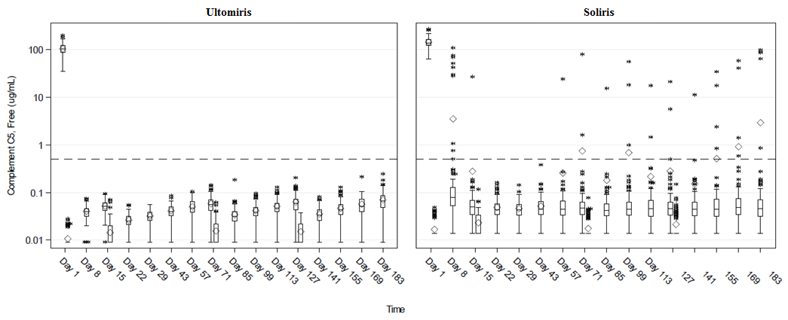

Figure 2: Free C5 vs Time Profiles in Soliris-Experienced Patients with PNH

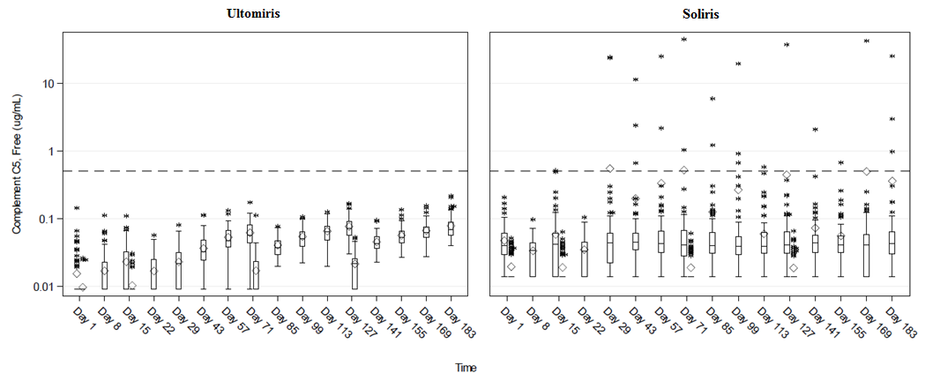

The extent and duration of the pharmacodynamic response in patients with PNH were exposure-dependent for Ultomiris. Free C5 levels of <0.5 µg/mL were correlated with maximal intravascular haemolysis control and complete terminal complement inhibition.

### Clinical trials

**Clinical efficacy**

The clinical development program was designed to determine whether Ultomiris is non-inferior to the current standard of care therapy, Soliris in adult patients with PNH regardless of previous treatment status while assessing potential beneficial effects of a longer dosing interval. The safety and efficacy of Ultomiris in patients with PNH were assessed in two distinct and complementary populations: a complement-inhibitor-naïve population of patients with active haemolysis to establish the magnitude of the efficacy response, and a population of patients stable on Soliris therapy that allowed the assessment of the maintenance of efficacy and safety in a population switching to Ultomiris.

Accordingly, two adequate and well controlled Phase 3 trials were conducted to cover each population:

* a Complement-Inhibitor Naïve Study in adult patients with PNH who were naïve to complement inhibitor treatment (ALXN1210-PNH-301),
* a Soliris-Experienced Study in patients with PNH who were clinically stable after having been treated with Soliris (eculizumab *rmc*) for at least the previous 6 months (ALXN1210-PNH-302).

Ultomiris was dosed in accordance with the recommended dosing described in *section 4.2 Dose and Method of Administration* (4 infusions of Ultomiris over 26 weeks) while Soliris was administered according to the approved dosing regimen of Soliris (15 infusions over 26 weeks) which was the standard-of-care for PNH at the time of studies.

Patients were vaccinated against meningococcal infection prior to, or at the time of initiating treatment with Ultomiris or Soliris, or received prophylactic treatment with appropriate antibiotics until 2 weeks after vaccination.

There were no noteworthy differences in the demographic or baseline characteristics between the Ultomiris and Soliris treatment groups in either of the Phase 3 studies. Twelve-month transfusion history was similar between Ultomiris and Soliris treatment groups within each of the Phase 3 studies.

### *ALXN1210-PNH-301 Study in complement-inhibitor naïve patients with PNH.*

The Complement-Inhibitor Naïve Study was a 26-week, multicentre, open-label, randomised, active-controlled, Phase 3 study conducted in 246 patients who were naïve to complement inhibitor treatment prior to study entry.

PNH medical history was similar between Ultomiris and Soliris treatment groups. The twelve-month transfusion history was similar between Ultomiris and Soliris treatment groups. More than 80% of patients in both treatment groups had a history of transfusion within 12 months of study entry. The majority of the Complement-Inhibitor Naïve Study population was highly haemolytic at baseline; 86.2% of enrolled patients presented with elevated LDH ≥ 3 x ULN, which is a direct measurement of intravascular haemolysis, in the setting of PNH. The median total RBC clone size was 33.75%, consistent with ongoing active haemolysis of PNH erythrocytes in a patient population with a large median granulocyte clone size (92.55%).

Table 5 presents the baseline characteristics of the PNH patients enrolled in the Complement-Inhibitor Naïve Study.

Table 5 Baseline characteristics in the Complement-Inhibitor Naïve Study

|  |  |  |  |
| --- | --- | --- | --- |
| **Parameter** | **Statistics** | **Ultomiris (N = 125)** | **Soliris (N = 121)** |
| Age (years) at PNH diagnosis | Mean (SD)  Median  Min, max | 37.9 (14.90)  34.0  15, 81 | 39.6 (16.65)  36.5  13, 82 |
| Age (years) at first infusion in study | Mean (SD)  Median  Min, max | 44.8 (15.16)  43.0  18, 83 | 46.2 (16.24)  45.0  18, 86 |
| Sex (n, %) | Male  Female | 65 (52.0)  60 (48.0) | 69 (57.0)  52 (43.0) |
| Pre-treatment LDH levels | Mean (SD) | 1633.5 (778.75) | 1578.3 (727.06) |
| Median | 1513.5 | 1445.0 |
| Number of patients with packed red blood cells (pRBC)/whole blood transfusions within 12 months prior to first dose | n (%) | 103 (82.4) | 100 (82.6) |
| pRBC/whole blood transfusions within 12 months prior to first dose | Total | 677 | 572 |
| Mean (SD) | 6.6 (6.04) | 5.7 (5.53) |
| Median | 4.0 | 3.0 |
| Units of pRBC/whole blood transfused within 12 months prior to first dose | Total | 925 | 861 |
| Mean (SD) | 9.0 (7.74) | 8.6 (7.90) |
| Median | 6.0 | 6.0 |
| Patients with any PNH conditions prior to informed consent | n (%) | 121 (96.8) | 120 (99.2) |
| Anaemia |  | 103 (82.4) | 105 (86.8) |
| Haematuria or haemoglobinuria |  | 81 (64.8) | 75 (62.0) |
| Aplastic anaemia |  | 41 (32.8) | 38 (31.4) |
| Renal failure |  | 19 (15.2) | 11 (9.1) |
| Myelodysplastic syndrome |  | 7 (5.6) | 6 (5.0) |
| Pregnancy complication |  | 3 (2.4) | 4 (3.3) |
| Othera |  | 27 (21.6) | 13 (10.7) |

a“Other” as specified on case report form included thrombocytopenia, chronic kidney disease, and pancytopenia, as well as a number of other conditions.

The co-primary endpoints were transfusion avoidance and haemolysis as directly measured by normalisation of LDH levels. Transfusion avoidance was considered as achieved only by the patients who did not receive a transfusion and did not meet the protocol specified guidelines for transfusion from baseline to Day 183. Key secondary endpoints included the percent change from baseline in LDH levels, change in quality of life (FACIT-Fatigue), the proportion of patients with breakthrough haemolysis and proportion of patients with stabilised haemoglobin.

In the Complement-Inhibitor Naïve Study, both co-primary endpoints, avoidance of pRBC transfusion per protocol-specified guidelines, and LDH normalisation from Day 29 to Day 183, met the primary objective and showed Ultomiris was statistically significant for non-inferiority compared to Soliris. Ultomiris also achieved statistically significant non-inferiority compared to Soliris for all 4 key secondary endpoints. Both co-primary endpoints and all key secondary endpoints favoured Ultomiris (Figure 3).

Figure 3: Analysis of Co-primary and Secondary Endpoints – Full Analysis Set (Complement-Inhibitor Naïve Study)

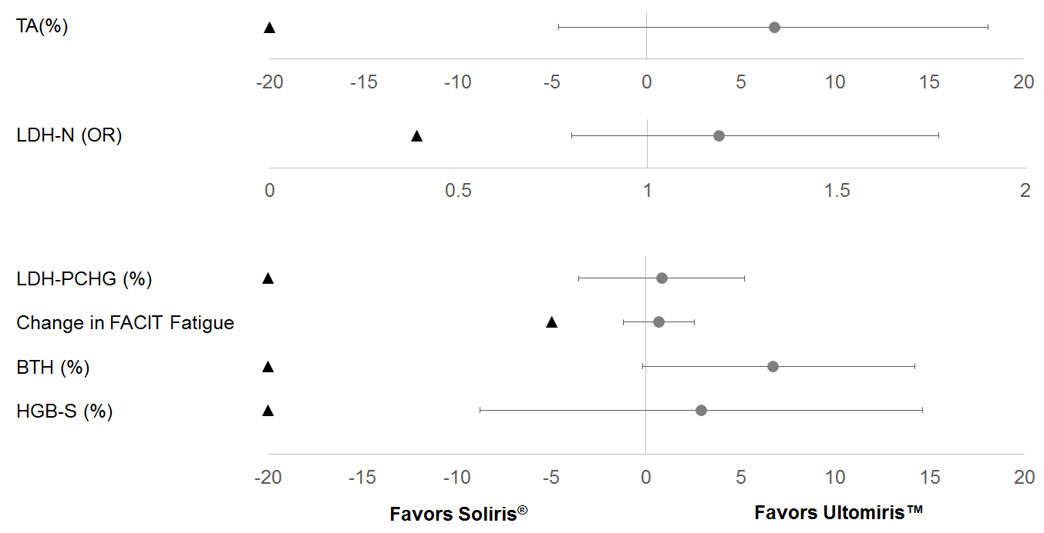

Note: The black triangle indicates the non-inferiority margins, and grey dots indicates point estimates

Note: TA = Transfusion Avoidance; LDH-N = LDH Normalisation; OR = Odds Ratio, LDH-PCHG = LDH Percent Change; FACIT = Functional Assessment of Chronic Illness Therapy; BTH = Breakthrough Haemolysis; HGB-S = Haemoglobin Stabilisation.

Transfusion avoidance through Day 183 was achieved by 73.6% of patients in the Ultomiris group compared to 66.1% in the Soliris group. The difference between the Ultomiris and Soliris treatment groups in the percentage of patients who avoided transfusion was 6.8% (95% CI: -4.66%, 18.14%). Total number of units transfused was also lower for the Ultomiris group (222 for Soliris vs 155 for Ultomiris). The adjusted prevalence of LDH normalisation (LDH levels ≤ 1 × ULN from Day 29 through Day 183) was 53.6% for the Ultomiris group and 49.4% for the Soliris group. The adjusted odds ratio for LDH normalisation for the comparison of Ultomiris to Soliris was 1.187 (95% CI: 0.796, 1.769). The median time to first LDH normalisation was 24 days for Ultomiris and 29 days for Soliris.

Mean percent change in LDH from baseline to Day 183 was -76.84% for the Ultomiris group and -76.02% for the Soliris group. The mean difference between treatment groups was -0.83% (95% CI: -5.21%, 3.56%).

Mean change in FACIT-Fatigue total score from baseline to Day 183 was 7.07 for the Ultomiris group and 6.40 for the Soliris group, with a 3-point improvement from baseline on this scale considered a clinically meaningful improvement. The mean difference between treatment groups was 0.67 (95% CI: -1.21, 2.55). Both treatment groups showed improvement in fatigue as measured by FACIT-Fatigue overtime. Improvement was numerically greater with Ultomiris than Soliris at all time points for FACIT-Fatigue.

Breakthrough haemolysis defined as at least one new or worsening symptom or sign of intravascular haemolysis in the presence of elevated LDH ≥ 2 × ULN, after prior LDH reduction to < 1.5 × ULN on therapy, was experienced by 4.0% of patients in the Ultomiris group and 10.7% of patients in the Soliris group. The difference between treatment groups was -6.7% (95% CI: -14.21%, 0.18%).

Haemoglobin stabilisation defined as an avoidance of a ≥2 g/dL decrease in haemoglobin level from baseline in the absence of transfusion through Day 183 was achieved by 68.0% of patients in the Ultomiris group and 64.5% of patients in the Soliris group. The difference between treatment groups was 2.9% (95% CI: -8.80%, 14.64%).

Because statistically significant non-inferiority was achieved for both co-primary and all 4 key secondary endpoints, superiority was assessed following the pre-specified hierarchical testing order that began with the breakthrough haemolysis endpoint. The treatment difference for breakthrough haemolysis (p = 0.0558) did not reach the pre-specified threshold for superiority (p < 0.05), and no further testing was conducted. The incidence of breakthrough haemolysis was more than 2-fold higher in the Soliris group (13 patients with 15 events) than in the Ultomiris group (5 patients with 5 events). Of the 15 breakthrough haemolysis events seen in the Soliris group, 7 were associated with elevated free C5 above 0.5 µg/mL. No patients in the Ultomiris group had elevations of free C5 levels above 0.5 µg/mL.

### *ALXN1210-PNH-302 Study in PNH patients previously treated with Soliris*

The Soliris-Experienced Study was a 26-week, multicentre, open-label, randomised, active-controlled Phase 3 study conducted in 195 patients with PNH who were clinically stable after having been treated with Soliris for at least the past 6 months.

PNH medical history was similar between Ultomiris and Soliris treatment groups. The twelve-month transfusion history was similar between Ultomiris and Soliris treatment groups and more than 87% of patients in both treatment groups had not received a transfusion within 12 months of study entry. Per study entry criteria, all patients presented with controlled haemolysis at baseline, consistent with a population under continuous treatment with Soliris. The mean total PNH RBC clone size was 60.05%, mean total PNH granulocyte clone size was 83.30%, and the mean total PNH monocyte clone size was 85.86%.

Table 6 presents the baseline characteristics of the PNH patients enrolled in the Soliris-Experienced Study.

Table 6 Baseline characteristics in the Soliris-Experienced Study

|  |  |  |  |
| --- | --- | --- | --- |
| **Parameter** | **Statistics** | **Ultomiris (N = 97)** | **Soliris (N = 98)** |
| Age (years) at PNH diagnosis | Mean (SD)  Median  Min, max | 34.1 (14.41)  32.0  6, 73 | 36.8 (14.14)  35.0  11, 74 |
| Age (years) at first infusion in study | Mean (SD)  Median  Min, max | 46.6 (14.41)  45.0  18, 79 | 48.8 (13.97)  49.0  23, 77 |
| Sex (n, %) | Male  Female | 50 (51.5)  47 (48.5) | 48 (49.0)  50 (51.0) |
| Pre-treatment LDH levels | Mean (SD) | 228.0 (48.71) | 235.2 (49.71) |
| Median | 224.0 | 234.0 |
| Number of patients with pRBC/whole blood transfusions within 12 months prior to first dose | n (%) | 13 (13.4) | 12 (12.2) |
| pRBC/whole blood transfusions within 12 months prior to first dose | Total | 64 | 30 |
| Mean (SD) | 4.9 (5.51) | 2.5 (2.32) |
| Median | 3.0 | 1.5 |
| Units of pRBC/whole blood transfused within 12 months prior to first dose | Total | 103 | 50 |
| Mean (SD) | 7.9 (8.78) | 4.2 (3.83) |
| Median | 4.0 | 2.5 |
| Patients with any PNH conditions prior to informed consent | n (%) | 90 (92.8) | 96 (98.0) |
| Anaemia |  | 64 (66.0) | 67 (68.4) |
| Haematuria or haemoglobinuria |  | 47 (48.5) | 48 (49.0) |
| Aplastic anaemia |  | 34 (35.1) | 39 (39.8) |
| Renal failure |  | 11 (11.3) | 7 (7.1) |
| Myelodysplastic syndrome |  | 3 (3.1) | 6 (6.1) |
| Pregnancy complication |  | 4 (4.1) | 9 (9.2) |
| Othera |  | 14 (14.4) | 14 (14.3) |

a“Other” category included neutropenia, renal dysfunction, and thrombocytopenia, as well as a number of other conditions.

The primary endpoint was haemolysis as measured by LDH percent change from baseline. Secondary endpoints included the proportion of patients with breakthrough haemolysis, quality-of-life (FACIT-Fatigue), transfusion avoidance (TA), and proportion of patients with stabilised haemoglobin.

In the Soliris-Experienced Study, the primary endpoint, Percent Change in LDH from baseline to Day 183, met the primary objective and showed Ultomiris was statistically significant for non-inferiority compared to Soliris. Ultomiris also achieved statistically significant non-inferiority compared to Soliris for all 4 key secondary endpoints. Both primary endpoints and all key secondary endpoints favoured Ultomiris (Figure 4).

Figure 4: Analysis of Primary and Secondary Endpoints – Full Analysis Set (Soliris Experienced Study)

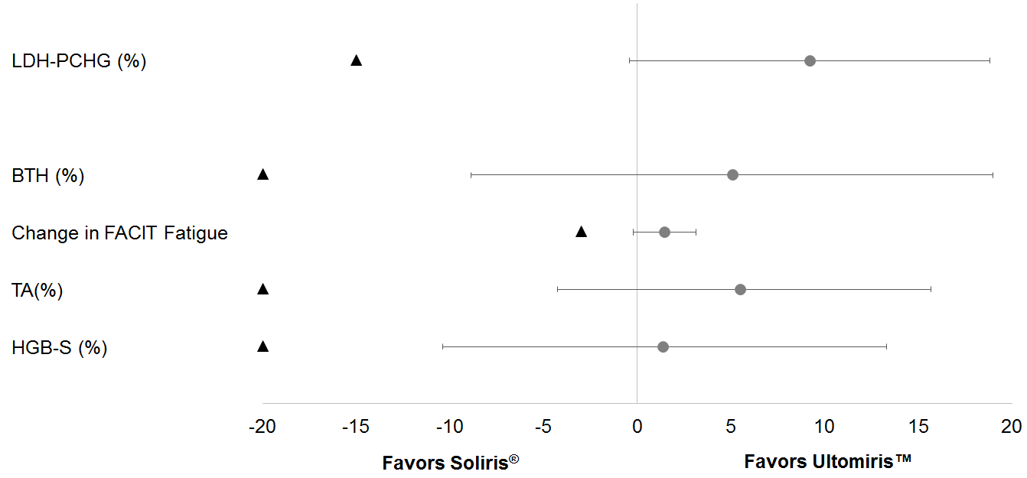

Note: The black triangle indicates the non-inferiority margins, and grey dot indicates point estimates.

Note: LDH-PCHG = Lactate Dehydrogenase (LDH) Percent Change; BTH = Breakthrough Haemolysis; TA = Transfusion Avoidance; HGB‑S = Haemoglobin Stabilisation.

Mean percent change in LDH from baseline to Day 183 showed a decrease of less than 1% (-0.82%) for the Ultomiris group and an increase of greater than 8% (+8.39%) for the Soliris group with a treatment difference (Ultomiris-Soliris) of -9.21% (95% CI: -18.84%, 0.42%).

Breakthrough haemolysis, using the same definition as the Complement-Inhibitor Naïve Study, was experienced by none of the patients in the Ultomiris group and 5 (5.1%) of the patients in the Soliris group. The difference between treatment groups was -5.1% (95% CI: -18.99%, 8.89%). The incidence of breakthrough haemolysis was higher in the Soliris group (7 events) than in the Ultomiris group (0 events). Of the 7 breakthrough haemolysis events seen in the Soliris group, 4 were associated with elevated free C5 above 0.5 µg/mL. There were no breakthrough haemolysis events in the Ultomiris group and no patients in the Ultomiris group had elevations of free C5 levels above 0.5 µg/mL.

Mean change in FACIT-Fatigue total score from baseline to Day 183 was 2.01 for the Ultomiris group and 0.54 for the Soliris group. The LS mean difference between treatment groups was 1.5 (95% CI: -0.2, 3.2). Both treatment groups showed improvement in fatigue as measured by FACIT-Fatigue over time; improvement was numerically greater with Ultomiris than Soliris at all time points for the FACIT-fatigue following Day 8.

Transfusion avoidance was achieved by 87.6% of patients on Ultomiris compared to 82.7% of patients on Soliris by week 26. The difference between the Ultomiris and Soliris treatment groups in the percentage of patients who avoided transfusion was 5.5% (95% CI: -4.27%, 15.68%).

Haemoglobin stabilisation through Day 183 was achieved by 76.3% of patients in the Ultomiris group and 75.5% of patients in the Soliris group. The difference between treatment groups was 1.4% (95% CI: -10.41%, 13.31%).

As statistically significant non-inferiority was achieved for the primary endpoint and all 4 key secondary endpoints, the pre-specified hierarchical order continued with superiority testing of percent change from baseline in LDH. The assessment of the treatment difference for superiority resulted in a p-value of 0.0583 which did not reach the pre-specified significance threshold for superiority (p < 0.05) and therefore no additional testing in the hierarchy was conducted.

Overall, treatment with Ultomiris in both complement-inhibitor naïve and Soliris-experienced patients was associated with clinically meaningful benefits across disease-relevant endpoints and reduction of the overall risk of breakthrough haemolysis through better C5 control and elimination of the risk of pharmacodynamic-associated breakthrough haemolysis.

## Pharmacokinetic properties

A linear, 2‑compartment PK model was developed that adequately described the observed ravulizumab *rch* PK following IV administration. The estimated mean (SD) clearance, central volume and terminal elimination half-life following multiple dosing of ravulizumab *rch* in all Phase 3 patients with PNH were 3.32 (0.94) mL/hr, 3.45 (0.65) L, and 49.7 (8.9) days, respectively. Steady state therapeutic concentrations are achieved immediately following the first dose of Ultomiris. In PNH patients, pharmacodynamic activity correlates directly with ravulizumab *rch* serum concentrations above the target exposure level results in free C5 levels < 0.5 µg/mL, achieving immediate, complete and sustained blockade of haemolytic activity in all PNH patients.

### Absorption

Because Ultomiris administration is via an IV infusion and the dosage form is a solution, 100% of the administered dose is considered bioavailable. The time to maximum observed concentration (tmax) is expected to be at the end of infusion (EOI) or soon after EOI. Over the studied dose and regimen range, ravulizumab *rch* exhibited dose proportional and time linear pharmacokinetics (PK).

### Distribution

The mean (standard deviation [SD]) volume of distribution at steady state for patients with PNH on the studied weight-based dose regimen was 5.35 (0.92) L.

### Metabolism and Excretion

As an immunoglobulin gamma (IgG) monoclonal antibody, ravulizumab *rch* is expected to be metabolised in the same manner as any endogenous IgG (degraded into small peptides and amino acids via catabolic pathways), and is subject to similar elimination. Ravulizumab *rch* contains only natural occurring amino acids and has no known active metabolites. The mean (SD) values for terminal elimination half-life and clearance of ravulizumab *rch* in patients with PNH are 49.7 (8.9) days and 0.00332 (0.000941) L/h, respectively.

Body weight was a significant covariate on the pharmacokinetics of ravulizumab *rch*.

### Special Populations

No formal trial of the effect of sex, race, age (elderly), hepatic or renal impairment on the pharmacokinetics of ravulizumab *rch* was conducted. However, based on population-PK assessment no impact of sex, age, race and hepatic or renal function on ravulizumab *rch* PK was identified in the studied healthy volunteer subjects and patients with PNH, and as a result, no dosing adjustment is considered necessary.

## Preclinical safety data

### Genotoxicity

No studies have been conducted to assess the genotoxic potential of ravulizumab *rch.*

### Carcinogenicity

No studies have been conducted to assess the carcinogenic potential of ravulizumab *rch.*

# Pharmaceutical particulars

## List of excipients

monobasic sodium phosphate

dibasic sodium phosphate

sodium chloride

polysorbate 80

Water for injections

This medicinal product contains 5 mmol sodium per vial. This should be taken into consideration by patients on a controlled sodium diet.

## Incompatibilities

In the absence of compatibility studies, this medicinal product must not be mixed with other medicinal products. Reconstitution and dilution should only use 0.9% sodium chloride, solution for injection as diluent.

## Shelf life

30 months.

## Special precautions for storage

Ultomiris vials must be stored under refrigerated conditions at 2°C – 8°C.

After dilution, the medicinal product should be used immediately. However, chemical and physical stability of the diluted product have been demonstrated for up to 24 hours at 2°C-8°C and up to 6 hours at room temperature.

Vials must not be frozen or shaken.

Keep the vial in the outer carton to protect from light.

## Nature and contents of container

Type I glass vial with a stopper and a seal.

Pack size of one vial.

## Special precautions for disposal

Product is for single use in one patient only. Discard any residue.

*In Australia, any unused medicine or waste material should be disposed of in accordance with local requirements.*

## Physicochemical properties

### Chemical structure

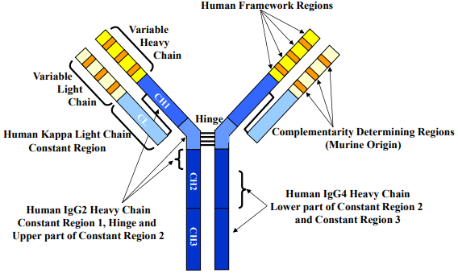

### CAS number

CAS registry number: 1803171-55-2

# Medicine schedule (Poisons Standard)

Schedule 4 – Prescription Only Medicine

# Sponsor

Alexion Pharmaceuticals Australasia Pty Ltd

Suite 401, Level 4, Building A

20 Rodborough Road

Frenchs Forest NSW 2086

Medical enquiries: 1800 788 189

# Date of first approval

17 OCT 2019