|  |
| --- |
| **Date of CER: November 2012** |

|  |
| --- |
| AusPAR Attachment 2 |
| Extract from the Clinical Evaluation Report for Regorafenib |
| Proprietary Product Name: Stivarga |
| Sponsor: Bayer Australia Ltd |

About the Therapeutic Goods Administration (TGA)

* The Therapeutic Goods Administration (TGA) is part of the Australian Government Department of Health, and is responsible for regulating medicines and medical devices.
* The TGA administers the *Therapeutic Goods Act 1989* (the Act), applying a risk management approach designed to ensure therapeutic goods supplied in Australia meet acceptable standards of quality, safety and efficacy (performance), when necessary.
* The work of the TGA is based on applying scientific and clinical expertise to decision-making, to ensure that the benefits to consumers outweigh any risks associated with the use of medicines and medical devices.
* The TGA relies on the public, healthcare professionals and industry to report problems with medicines or medical devices. TGA investigates reports received by it to determine any necessary regulatory action.
* To report a problem with a medicine or medical device, please see the information on the TGA website <<http://www.tga.gov.au>>.

About the Extract from the Clinical Evaluation Report

* This document provides a more detailed evaluation of the clinical findings, extracted from the Clinical Evaluation Report (CER) prepared by the TGA. This extract does not include sections from the CER regarding product documentation or post market activities.
* The words [Information redacted], where they appear in this document, indicate that confidential information has been deleted.
* For the most recent Product Information (PI), please refer to the TGA website <<http://www.tga.gov.au/hp/information-medicines-pi.htm>>.

Copyright

© Commonwealth of Australia 2014  
This work is copyright. You may reproduce the whole or part of this work in unaltered form for your own personal use or, if you are part of an organisation, for internal use within your organisation, but only if you or your organisation do not use the reproduction for any commercial purpose and retain this copyright notice and all disclaimer notices as part of that reproduction. Apart from rights to use as permitted by the *Copyright Act 1968* or allowed by this copyright notice, all other rights are reserved and you are not allowed to reproduce the whole or any part of this work in any way (electronic or otherwise) without first being given specific written permission from the Commonwealth to do so. Requests and inquiries concerning reproduction and rights are to be sent to the TGA Copyright Officer, Therapeutic Goods Administration, PO Box 100, Woden ACT 2606 or emailed to <[tga.copyright@tga.gov.au](mailto:tga.copyright@tga.gov.au)>.

Contents

List of abbreviations 4

1. Introduction 8

2. Clinical rationale 8

3. Contents of the clinical dossier 8

3.1. Scope of the clinical dossier 8

3.2. Paediatric data 11

3.3. Good clinical practice 11

4. Pharmacokinetics and pharmacodynamics 11

4.1. Studies providing pharmacokinetic and pharmacodynamic data 11

4.2. Pharmacokinetics 14

4.3. Biomarker evaluation 17

4.4. Exposure response relationship 17

4.5. Cardiovascular study 18

5. Dosage selection for the pivotal studies 19

6. Clinical efficacy 20

6.1. Pivotal study 14387 20

6.2. Supportive study 11650 29

7. Clinical safety 31

7.1. Studies providing evaluable safety data 31

7.2. Extent of exposure 34

7.3. Adverse events 35

7.4. Laboratory tests 41

7.5. Post marketing experience 42

8. First round benefit-risk assessment 42

8.1. First round assessment of benefits 42

8.2. First round assessment of risks 43

8.3. First round assessment of benefit/risk balance 43

9. First round recommendation regarding authorisation 43

10. Clinical questions 43

11. First round comments on clinical aspects of the safety specifications in the draft RMP 44

12. Second round evaluation of clinical data submitted in response to questions 44

## List of abbreviations

| Abbreviation | Meaning |
| --- | --- |
| 5-FU | 5-fluorouracil |
| AE | adverse event |
| ADR | adverse drug reaction |
| ALP | alkaline phosphatase |
| ALT | alanine aminotransferase |
| aPTT | adjusted partial thromboplastin time |
| AST | aspartate aminotransferase |
| ATC | anatomic Therapeutic Chemical Classification System |
| AUC | area under curve |
| BA | bioavailability |
| BCRP | Breast Cancer Resistance Protein |
| BMI | body mass index |
| BSC | best supportive care |
| BRAF | a serine/threonine kinase, member of the RAF kinase family |
| CCDS | company core data sheet |
| CHMP | Committee for medicinal products for Human Use |
| CI | confidence interval |
| c-KIT | mast/stem cell growth factor receptor (tyrosine kinase) |
| Cmax | maximum concentration |
| CNS | central nervous system |
| CP | co-precipitate |
| CR | complete response |
| CRC | colorectal cancer |
| CRF | case report form |
| CSR | clinical study report |
| CV | coefficient of variation |
| CTC | Common Toxicity Criteria |
| CTCAE | Common Terminology Criteria for AEs |
| DCR | disease control rate |
| DOR | duration of response |
| DILI | drug-induced liver injury |
| DMA | Danish Medicines Agency |
| DMC | Data Monitoring Committee |
| DOR | duration of response |
| ECG | electrocardiogram |
| ECOG | Eastern Cooperative Oncology Group |
| EGFR | epithelial growth factor receptor |
| eGRF | estimated glomerular filtration rate |
| EMA | European Medicines Agency |
| EORTC | European Organization for Research and Treatment of Cancer |
| ERK | extracellular signal-related kinase |
| EU | European Union |
| FDA | Food and Drug Administration |
| FGFR | fibroblast growth factor receptor |
| FOIB | Fluoropyrimidine, oxaliplatin, irinotecan, bevacizumab |
| FOIBE | Fluoropyrimidine, oxaliplatin, irinotecan, bevacizumab, anti-EGFR (epidermal growth factor receptor) antibody |
| FOLFIRI | FOLinic acid/ Fluorouracil/ IRInotecan |
| FOLFOX (mFOLFOX6) | FOLinic acid, Fluorouracil, and OXaliplatin (m = modified, the number 6 indicates this is the sixth variation of the regimen developed) |
| GCP | good clinical practice |
| GFR | glomerular filtration rate |
| GI | gastrointestinal |
| GIST | gastrointestinal stromal tumor |
| GLDH | glutamate dehydrogenase |
| GPV | Global Pharmacovigilance |
| HCC | hepatocellular carcinoma |
| HFSR | hand foot skin reaction |
| HR | hazard ratio |
| HRQoL | Health Related Quality of Life |
| ICH | International Conference on Harmonization |
| INR | international normalized ratio (prothrombin time expressed in relation to normal value) |
| IR | immediate release |
| ISS | Injury severity score scale |
| ITT | Intent to treat |
| i.v. | intravenous |
| IVRS | interactive voice response system |
| KM | Kaplan-Meier |
| KRAS | Kirsten rat sarcoma viral oncogene homolog (protein), member of the RAS family of GTPases (guanosine triphosphate hydrolases) |
| MEB | Medicines Evaluation Board (The Netherlands); |
| MedDRA | Medical Dictionary for Regulatory Activities |
| MEK | MAPK (mitogen-activated protein kinase)/ERK kinase |
| MPA | The Swedish Medical Products Agency |
| mg | milligram |
| n | number |
| od | once daily |
| OS | overall survival |
| PDGFR | platelet derived growth factor receptor |
| PFS | progression-free survival |
| po | per oral |
| PR | partial response |
| PS | performance status |
| PTT | partial thromboplastin time |
| RECIST | Response Evaluation Criteria for Solid Tumors |
| RET | a receptor tyrosine kinase |
| SAE | serious adverse event |
| SAF | safety analysis set |
| SD | stable disease |
| SOC | system organ class |
| TE | treatment-emergent |
| TEAE | treatment-emergent adverse event |
| TIE2 | angiopoietin receptor (a receptor tyrosine kinase) |
| ULN | upper limit of normal |
| VEGF | vascular endothelial growth factor |
| VEGFR | vascular endothelial growth factor receptor |

## Introduction

The distinct chemical entity regorafenib is for the proposed indication:

*for the treatment of patients with metastatic colon-rectal cancer irrespective of Kras mutational states who have been previously treated with or are not a suitable candidate for Fluoropyrimidine chemotherapy, an anti-VEGF therapy and if KRAS wild type an anti-EGFR therapy.*

regorafenib is an oral tumour deactivation agent that potentially blocks multiple protein kinases, including kinases involved in tumour angiogenesis (EGFR1-, 2-, 3-, TIE2), oncogenesis (KO, RET, RAFI, BRAF, BRAFV600E) and the tumour micro-environment (PDGFR, FGFR).

regorafenib is provided in a tablet formulation it is a 40mg tablet for oral administration. Proposed administration is 4 x 40mg tablets at the same time each day over a 3 week period, then one week off therapy in a cycle of 4 weeks.

## Clinical rationale

regorafenib is a multiple kinase tumour inhibitor involving tumour angiogenesis, oncogenesis and tumour microenvironment. Pre-clinical studies of regorafenib have demonstrated anti tumour activity in a broad spectrum of tumour models including colon-rectal cancer models.

The clinical development of regorafenib as a single agent was initiated in 2005 for patients with advanced solid tumours i.e.: study 11650 and progressed to phase 3 trial in patients with advanced cancers including CRC. The first indication was for treatment of patients with metastatic CRC irrespective of KRAS mutational status who have been previously treated with or not considered candidates for Fluoropyrimidine chemotherapy, an anti-VEGF therapy and if KRAS wild type an anti-EGFR therapy which is the subject of this application.

## Contents of the clinical dossier

### Scope of the clinical dossier

In this submission a total of 15 clinical trials are submitted including full reports and appropriate summaries in module 5. This is indicated in Table 1.

Table 1. Overview of Phase 1, 2 and 3 regorafenib studies with clinical study report.

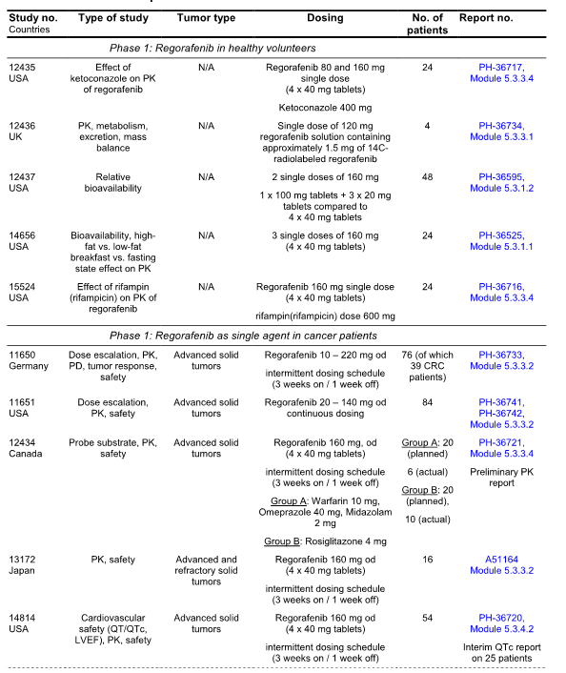

Table 1 continued. Overview of Phase 1, 2 and 3 regorafenib studies with clinical study report.

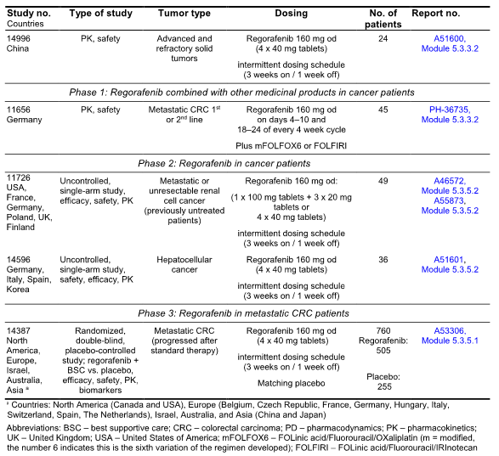

Phase 1 trials were conducted for regorafenib as a single agent and these include 5 in healthy volunteers and 6 in advanced cancer patients. The healthy volunteers studies were conducted using single doses of regorafenib and involving a total 124 patients in Europe and the USA addressing the relative bioavailability of the final tablet formulation (Study 12437), through to (Study 14656), balance metabolism profile (Study 12436) and the interaction of regorafenib and Ketoconazole (studies 12435 and 15524). All healthy volunteer studies are complete and final clinical report presented.

Phase 1, 2 studies in patients with advanced solid tumours included four studies with reports i.e.: 11650, 11651, 13172 and 14996. There are two ongoing studies 12434 with preliminary detailed report and 14814 an interim or QTc report. These reports from Europe, USA and Asia include a total of 269 patients.

In addition to the single agent trials a phase 1 combination trial in cancer patients has been completed i.e. Study 11656.

As of 30 March 2012, II phase 2 monotherapy studies i.e. Study 11726 and 14596 with the intermittent dosing schedule have been completed. One phase III study i.e. the pivotal clinical trial study 14378 has been undertaken in CRC patients who had previously been treated with or not considered candidates for Fluoropyrimidine based chemotherapy, anti-VEGF therapy and anti-EGFR Therapy in KRAS wild type. A total of 760 patients were entered into this multi-national double blind randomized study.

Module 1 includes product application letters, application form, draft, Australia Product Information and consumer medicine information, FDA approved product label.

Module 2, includes clinical overview, summary of clinical efficacy and summary of clinical safety as well as literature references.

### Paediatric data

Not applicable.

### Good clinical practice

All aspects of good clinical practice were observed in the studies.

## Pharmacokinetics and pharmacodynamics

### Studies providing pharmacokinetic and pharmacodynamic data

Fifteen studies provide clinical pharmacological data for regorafenib as indicated in Table 2. Studies were categorized as cancer patient studies and healthy volunteer studies and for that classified as dose escalation studies which served as the basis for dose selection, biopharmaceutical studies, metabolism (and interaction) studies, special population studies, and special studies e.g. Cardio-vascular study.

Table 2. Clinical pharmacology studies of regorafenib

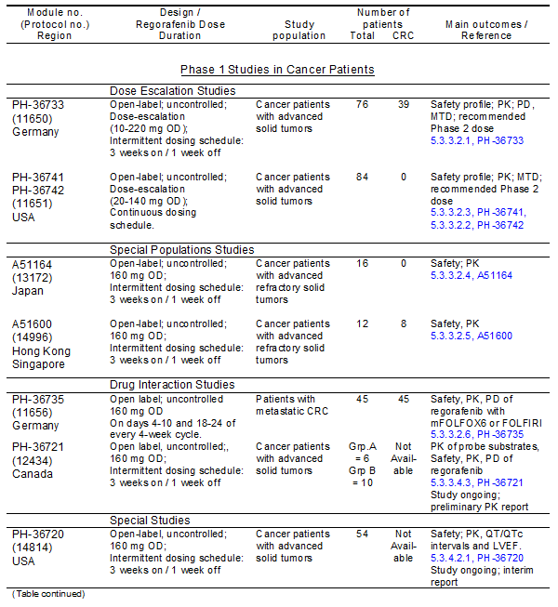

Table 2 continued. Clinical pharmacology studies of regorafenib

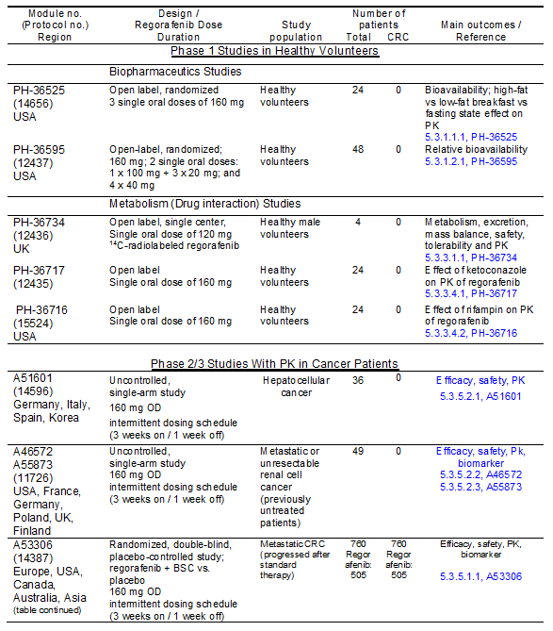

CRC – colorectal cancer; MTD = maximum tolerated dose; FOLFOX = chemotherapy regimen consisting of FOLinic acid/Fluorouracil/Oxaliplatin; FOLFORI = chemotherapy regimen consisting of FOLinic acid/Fluorouracil/IRinotecan

The Phase 1 studies in cancer patients were conducted with the intent of finding a safe and efficacious dose to take into further development phases. In Study 11650 the investigated intermittent treatment regimen consisted of 3 weeks (21 days), of dosing followed by a 1 week off dose period comprising a single treatment cycle. The starting dose was 10mg daily. In separate cohorts of patients the dose was escalated up to a dose of 220mg daily based on tolerability of the previous dose levels. This study also included evaluations of different formulations including oral solution versus tablet in subset of patients. Study 11651 daily doses of 20mg-140mg with no dose interruption between the 21 day cycle were investigated. Evaluation of safety, pharmacokinetics and anti-tumour data for these two trials led to the selection of 160mg every day for 3 weeks on and 1 week off as the treatment regimen to be evaluated in subsequent clinical trials.

The clinical dose regimen of 160mg daily 21 days on and 7 days off has been decided upon in studies of cancer patients including studies 14996, A51600, 13172 and A51164 and 14596 which included PK evaluations of this dose following single and multiple doses. Extrinsic and intrinsic factors on PK were assessed in sub-sets of patients in these studies. Additional studies conducted in cancer patients included a study determining the effect of regorafenib on ECG especially QT interval i.e. Study 14814 and a study investigating the effects of regorafenib and its metabolic substrates to identify potential drug interactions. Several single dose studies were conducted in healthy volunteers including a mass balance Study 12436, relative bioavailability of the final formulation Study 12437, food effects Study 14656 and interaction Studies examining the effects of a strong CYP inhibitor, Ketoconazole Study 12435 and CYP 3A4 inducer, Rifampin Study 15524.

To summarize this data, an evaluation and summary of the pharmacokinetics and metabolism of the 15 studies provided is given, together with a subsequent analysis of results across the studies, which include various data from the individual trials.

### Pharmacokinetics

regorafenib pharmacokinetics was evaluated following oral administration of single doses to healthy volunteers as well as single and multiple doses to cancer patients. Evaluation of the pharmacokinetics of regorafenib indicates metabolites of regorafenib M-2 and M-5 have demonstrated in-vitro pharmacologic activity similar to unchanged regorafenib. Therefore evaluation of the two metabolites is included in the PK studies.

Following oral administration of single doses of 160mg tablets to cancer patients regorafenib is absorbed relatively rapidly with a median Tmax ranging from approximately 3 to 4 hours with a mean Cmax of 2.5mg per litre. Plasma concentration time data showed multiple secondary post-Tmax absorption peaks suggesting enterohepatic recycling (Study 11650).

Steady state pharmacokinetics were evaluated following multiple dose administration of 160mg regorafenib administered tablets to cancer patients. At steady state the median Tmax: ss for regorafenib was 5 hours (range 0.6-8.8 hours). Mean steady state Cmax: ss and AUC0-24, ss values following dosing with 160mg were 3.9mg per litre and 58.3mg.hour per litre (study 11650). The accumulation of regorafenib at steady state was approximately 2 fold as expected considering the mean elimination half life of 20 to 30 hours.

Regorafenib pharmacokinetics exhibited a high inter-patient variability in exposures as demonstrated by a percent co-efficient of variation of approximately 43 percent for both AUC and Cmax at steady state. Intra-subject variability percentage CV was 32 to 34 percent for both Cmax, ss and AUC0-24. Regorafenib is 99.5 percent bound to plasma proteins over a therapeutically relevant concentration range. The active metabolites of M2 and M5 are also highly protein bound with mean fraction bound of 99.8 percent and 99.5 percent.

#### Relative bioavailability

The bioavailability of the oral regorafenib tablets for cancer patients is approximately 70 to 83 percent of the oral solution (Study 11650). The 40mg tablets of the final formulation were found to be bioequivalent to the previously studied tablets with respect to both AUC and Cmax (Study 12437).

#### Food effect

In healthy volunteers the bioavailability (AUC) of regorafenib was increased by approximately 48 percent when administered with a high fat breakfast and 36 percent when administered with a low fat breakfast as compared to dosing under fasting conditions. Corresponding increases in Cmax were 73 percent for high fat and 54 percent for low fat. The low fat breakfast resulted in a slightly increased AUC and Cmax of the metabolites while the high fat breakfast resulted in lower metabolite exposure relative to dosing under fasting conditions as indicated in Study 14656.

This data have resulted in the recommendation that regorafenib be dosed following a low fat light meal in order to maximize exposure to parent drug and active metabolites.

#### Dose proportionality

regorafenib pharmacokinetics was generally linear up to a dose of 160mg following a single dose and up to a dose of 60mg following multiple doses. At higher doses AUC increase with increasing dose although not in proportion to the dose while Cmax remained relatively constant. The accumulation from day 1 to day 21 observed with daily dosing of 160mg was consistent with linear pharmacokinetics i.e. Study 11650.

#### Metabolism

regorafenib undergoes extensive and complex metabolism including oxidation and glucuronidation leading to metabolites that can be reduced and or cleaved in the intestinal milieu result in enterohepatic cycling in vivo.

Following single dose administration in healthy volunteers the principal metabolite in plasma was M2. Plasma concentrations of metabolites M5 and the glucuronide M7 were much lower. Trace amounts of M1, M3, M4 and M8 were detected in plasma. Based on AUC0-144 values the mean relative contributions of each moiety to total plasma radio activity was 57 percent for parent drug, 29 percent for M2, 6 percent for M5 and 3 percent for M7. Multiple dose studies 11650 and Study 13172 indicated that M5 was a major metabolite at steady state due to its non-linear accumulation. M2 was also a major metabolite at steady state.

M2 and M5 have demonstrated in-vitro pharmacological activity similar to the parent compound. Upon multiple dosing with regorafenib these metabolites accumulated to a greater extent than regorafenib itself so that at steady state the plasma concentrations of parent drug and metabolites are similar.

Inter-subject variability in PK of metabolites M2 and M5 was greater than that of the parent drug. For M2 the percentage CV for AUC0-24,ss and Cmax, ss was approximately 70 to 80 percent and for M5 it was approximately 80 to 90 percent as in Study 11650.

#### Excretion

regorafenib was eliminated from plasma with a half life of 20 to 30 hours following a single oral dose. A very similar range of half life estimates 20 to 30 hours was found for metabolite M2. The elimination half life of M5 was slower averaging approximately 60 hours in individual values ranging from 40 to 100 hours as in Study 11650, Study 13172. Regorafenib is excreted in urine and faeces as unchanged drug and metabolites. Renal elimination of total radio activity following oral administration of a 120mg dose of C14 labelled regorafenib accounted for approximately 19 percent of dose while approximately 71 percent of the dose was recovered in faeces as unchanged drug and metabolites i.e. Study 12436. Urinary excretion of radioactivity was almost complete by 72 hours post-dose whereas excretion via faeces continued until 144 hours post-dose after which the rate of excretion exhibited a near plateau.

#### Effect of intrinsic factors

The relationship between regorafenib PK and the intrinsic factors such as age, gender, race, body weight, renal function as estimated by the glomerular filtration rate hepatic function and serum Bilirubin were evaluated based on a retrospective analysis of pooled PK data from patients involved in Phase I and II studies as well as from specific studies in which full plasma concentration time profiles were obtained.

There is no apparent relationship between regorafenib PK and age, gender or body weight. In Asian patients no differences in regorafenib AUC or Cmax were apparent when compared to Caucasian patients. A trend did show lower metabolite concentrations in Asians, but there was considerable variability.

Steady state exposure of regorafenib and its metabolites is comparable in patients with mild renal impairment and patients with normal renal function from Study 11650. Limited data from pooled Phase I and II studies indicated the range of exposure in patients with moderate renal impairment is comparable to that seen in patients with normal renal function. There is no apparent relationship between regorafenib PK and renal function. The PK of regorafenib has not been studied in patients with severe renal impairment or end stage renal disease.

Exposure of regorafenib and its metabolites is comparable in patients with mild hepatic impairment to patients with normal hepatic function i.e. Study 11651 and Study 14596. Limited data in patients with moderate hepatic impairment indicated similar exposure as compared to patients with normal hepatic function after a single 100mg dose regorafenib i.e. Study 11651. Based on data from pooled Phase I and II studies indicates no apparent relationship between regorafenib PK and total Bilirubin, indirect Bilirubin ALT, AST or alkaline phosphatase. PK of regorafenib has not been studied in patients with severe hepatic impairment.

#### Drug-drug interaction potential

##### In-vivo interaction data

###### Ketoconazole

Administration of ketoconazole (400mg for 18 days) a strong CYP 3A4 inhibitor with regorafenib at 160mg a day resulted in an increase in mean regorafenib exposure (AUC) of approximately 33 percent and a decrease in mean exposure of the active metabolites M2 and M5 of approximately 90 percent i.e. Study 12435. These results demonstrated a pronounced inhibitory effect of ketoconazole on the metabolite exposure of regorafenib while only a weak effect on the exposure of regorafenib. Overall CYP 3A4 inhibition does not markedly affect the pharmacokinetics of regorafenib most likely due to compensation of reduced phase I metabolism by glucuronidation.

###### Rifampin

Administration of rifampin (600mg for 9 days) a strong CYP 3A4 inducer with a single dose of regorafenib 160mg on day 7 resulted in a reduction in mean regorafenib exposure (AUC) of approximately 50 percent, a three to four fold increase in mean exposure of the active metabolite M5 and no change in exposure of the active metabolite M2 i.e. Study 15524. Other strong inducers for CYP 3A4 activity may also increase metabolism of regorafenib. Since reduction in plasma regorafenib concentrations may result in decreased efficacy strong inducers for CYP 3A4 should be avoided.

###### CYP probe substrates

An ongoing study of CYP probe substrates including warfarin, omeprazole, midazolam and rosiglitazone which are probe substrates of CYP 2C9, CYP 2C19, CYP 3A4 and CYP 2CA respectively has demonstrated from preliminary results in co-administration of warfarin with regorafenib resulted no change in AUC and an increase of about 25 percent in Cmax of warfarin as compared with warfarin alone. There was an increase of about 37 percent in AUC and an increase of about 25 percent in Cmax of 7 hydroxy warfarin. This preliminary data suggests that regorafenib has no inhibitory effect on the metabolism of warfarin.

Co-administration of midazolam with regorafenib resulted in a 24 percent increase in mean AUC. There was also a 41 percent increase in Cmax of midazolam with regorafenib when compared to midazolam alone. The variability was quite large seen in CV 40 to 100 percent and it is possible that the effect is not significant. There was an increase of about 30 percent in AUC and an increase of about 37 percent in Cmax for 1 hydroxy midazolam which is not consistent with inhibition of CYP3A4 by regorafenib.

Co-administration of rosiglitazone with regorafenib resulted in no change to the PK parameters for either rosiglitazone or its metabolite suggesting that regorafenib and its metabolites do not have an inhibitory effect on the metabolism of rosiglitazone.

###### Irinotecan

Statistically significant increases in AUC for irinotecan and its active metabolite SN38 were observed when irinotecan was given 5 days after treatment with regorafenib. There was a mean increase in AUC of 28 percent for Irinotecan and 44 percent increase for SN38. This effect was possibly due to the inhibition of glucuronidation of SN38 by regorafenib or its metabolites. i.e. Study 11656.

###### Other anti-cancer agents

regorafenib has no significant effect on PK of unbound platinum or 5FU when given with FOLFIRI and no effect on FU when given with an FOLFOX 6 i.e. Study 11656.

### Biomarker evaluation

Biomarker evaluations included evaluations of KRAS mutational status and plasma protein levels (VEGF and VEGFR2 and DCE,-MRI).

Preliminary data from phase III Study 14387 indicates that KRAS wild type and KRAS mutant subgroups respond comparably to regorafenib. Further analyses are to be conducted.

Data from the two clinical trials Study 11650 and Study 11726 have demonstrated increased levels of VEGF and decreased levels of VEGFR2 with regorafenib treatment. In Study 11726 a number of plasma proteins in addition to VEGF and VEGFR2 were found to be affected with regorafenib treatment some of which were linked to angiogenesis TIE1 and AING2 where as others have not but represent kinase receptors inhibited by regorafenib e.g. c KIT of proteins released following apoptotic cell death. These suggest antiangiogenesis may be one of the mechanisms by which regorafenib exerts anti-tumour activity.

### Exposure response relationship

The relationship between dose and response (toxicity, anti tumour activity) and between plasma Cmax, ss, AUC0-24 ss values and response i.e. inhibition of cellular proliferation, toxicity, anti tumour activity was examined in Phase I Studies 11650 and 11651 at different doses. The average Cmax, ss regorafenib, M2 and M5 with Study 11650 at a dose of 160mg every day was 3.9mg per litres, 3.3 and 2.9mg per litre respectively corresponding to 8077 nM and 6616 nM and 5982 nM well above the IC 50 of the indicated SA systems. Even considering protein binding the concentration of free regorafenib, M2 and M5 of 36 nM, 12 nM and 3 nM are respectively still within the IC 50 ranges. Assuming the equivalent potency for parent drug and metabolites is indicated in in-vitro testing the parent drug would still be the main factor in determining pharmacologic activity.

#### Dose – exposure versus toxicity

The two-dose escalation Studies 11650 and 11651 evaluated different doses and dose regimens for safety and tolerability. Study 11650 compared doses between 10 and 220mg on a 21 day on 7 days off regiment. Study 11651 compared 20 to 140mg after continuous dosing. In general there was no clear dose response in regard to safety.

In Study 11650 treatment emergent drug related adverse effects of at least grade 3 level were more frequent at doses of more than 120mg regorafenib administered on a 21 day intermittent cycle. Most frequent events were skin toxicity in particular the hand foot syndrome in 47 patients. In the 12 patients receiving 160mg regorafenib per day 3 experienced a treatment emergent adverse event during cycle 1 or cycle 2 leading to dose reduction, dose interruption or permanent discontinuation of the study drug. In the 12 patients receiving 220mg regorafenib per day 8 of the 12 patients experienced treatment emergent drug related adverse events occurring in cycles 1 or cycle 2 leading to dose reduction or dose interruption or permanent discontinuation. On this regimen a daily dose of 160mg was selected as the maximum dose. With the continuous dosing, 100mg per day was determined to be the maximum tolerated dose in Study 11651.

No relationship between AUC or Cmax for regorafenib metabolites M2 and M5 and selected indices of safety were found from the pooled analysis of Phase I patients treated with 160mg regorafenib per day on the intermittent schedule.

#### Dose – exposure versus anti-tumour activity

In Study 11650 different doses with the 21 days on and 7 days off regimen were evaluated for anti-tumour activity. The absolute and relative changes from baseline for plasma sVEGFR2 levels indicated overall decreases in systemic sVEGFR2 levels and point towards an effect of regorafenib treatment. This effect is especially obvious for doses greater than 60mg of regorafenib. Furthermore a dose response relationship across dose groups is assumed when comparing the geometric means of the ratios and the minimum to maximum ranges in individual groups. Exposure – response plots for the relative changes of sVEGFR2 point to an exposure – response relationship with an apparent low threshold of exposure (AUC0-24ss) to elicit an effect which is relatively stable across a wide range of exposures above the threshold.

DCE-MRI was performed to assess tumour blood flow – tumour vessel permeability in a subgroup of subjects. A decrease in the initial AUC up to 60 min for the gadolinium curve (iAUC 60) indicated decreased tumour blood flow. Effects on the iAUC 60 were more pronounced when the dose levels were greater than 120mg regorafenib. There was a decrease in iAUC 60 at steady state with increasing AUC0–24 ss and Cmax ss regorafenib or its metabolites.

Thirty five of 68 patients or 51 percent in Study 11650 who received at least 60mg of regorafenib daily administered on the intermittent cycle showed no tumour progression 1 to 345 days. There was a slight trend towards better response with increasing AUC0 – 24 ss Cmax, ss of regorafenib or its metabolites. There was no observable change in tumour size with increasing AUC0 – 24 and Cmax, ss regorafenib or its metabolites.

### Cardiovascular study

In a dedicated cardiovascular trial of advanced cancer patients i.e. Study 14814 the potential changes QT-QTc on ECG after at least one 21 day cycle regorafenib treatment of 160mg per day were compared to pre-treatment 24 hour average QT-QTc values. In addition left ventricular ejection fraction (LVEF) was to be assessed by MUGA scan at baseline and at least once under ongoing regorafenib treatment typically after a minimum of 2 cycle regorafenib treatment.

The primary variable was change in QTcF from the Tmax regorafenib from cycle 1 or 2, day 21 to the average of the baseline QT-QTc intervals collected over 24 hours on cycle 1, day minus 1 and corrected using Fridericias method for heart rate correction.

An interim analysis on QT-QTc intervals was completed on 25 patients that have been fully monitored and final validated baseline steady state ECG data. At the Tmax of regorafenib the mean changes from baseline in QTcB or QTcF were minus 1 and 2 milliseconds respectively. Results for the QTcB or QTcF maximal median change from baseline was 7 and 9 milliseconds respectively.

No patient had a QTcB or QTcF value greater than 500 milliseconds during the post treatment Holter monitoring visits.

Overall the results from this dedicated cardiovascular trial are in line with the preclinical safety pharmacology data indicating no ill effect on cardiac repolarization in vivo. The observed effects of regorafenib at Tmax on QTc intervals of the ECG were minimal and even with the most conservative evaluation, the maximal median change was modest and unlikely to be of clinical significance in the setting of cancer treatment.

#### Comment:

The pharmacological data from these 15 studies has determined the pharmacokinetic and pharmacodynamics profile of regorafenib. It clearly indicates that metabolism of regorafenib results in formation of two major metabolites M2 and M5 which have clinically significant activity. Furthermore metabolism principally occurs in the liver and excretion via the faeces. There is no evidence from this data that various intrinsic factors play a role in influencing pharmacologic metabolism of regorafenib. There is however some evidence that CYP3A4 inducers may increase the metabolism of regorafenib. This only appears to be a modest dose response to toxicity relationship which will need to be further evaluated. There is no evidence of significant cardiovascular toxicity associated with regorafenib from this data. The food effect evaluation clearly shows that dosing of regorafenib after a low fat or light meal maximizes exposure to parent drug as well as to the active metabolites.

## Dosage selection for the pivotal studies

Two early Phase 1 studies were conducted in cancer patients to define the best dose and dose regimen to be carried into Phase II – III clinical development. One study i.e. 11650 with a 3 week on 1 week off schedule and the other Study 11651 with a continuous dosing schedule were evaluated comparing safety and tolerability, pharmacokinetics, anti-tumour activity and the various potential advantages/disadvantages with respect to subsequent clinical use.

[In Study 11650, the maximum tolerated dose (MTD) of regorafenib was 160 mg daily on a treatment schedule of 3 weeks on 1 week off in repeated 28-day cycles.

In Study 11651, the MTD of regorafenib in the continuous dosing schedule was 100 mg daily.

The regorafenib 160 mg once daily in the treatment schedule 3 week on / 1 week off in repeating 28 day cycles was selected over the regorafenib 100 mg once daily in the continuous dosing schedule due to a number of considerations, including safety and tolerability.]

Safety and tolerability at the MTD doses were similar when comparing intermittent versus continuous dosing regimen. However for approximately the same potential toxicity a 20 percent higher total dose of regorafenib can be delivered in the intermittent schedule compared to the continuous. This may translate into greater tumour activity.

Intermittent dosing schedule provided an opportunity for patients to recover at least partially from toxicities such as skin, gastrointestinal effects. A potential down side of intermittent dosing schedule might be tumour flare up during the treatment break period. However the relatively robust disease control rate in patients treated with regorafenib at the intermittent dose schedule from Study 11650 suggests that this may not be a disadvantage in actual clinical use.

In the intermittent dosage schedule patients could receive regorafenib 160mg as compared to 100mg in the continuous dosing schedule thus would be exposed to a higher steady state AUC0‑24 and Cmax of regorafenib and its two pharmacologically active equally potent metabolites M2 and M5. The higher exposure during the dosing days in the 3 weeks on 1 week off schedule may prove advantageous with respect to anti-tumour activity for some tumours.

An intermittent dosing schedule may offer advantages in terms of combined ability with other agents which are dosed intermittently and decrease the chances of any possible PK drug to drug interactions.

Accordingly for the pivotal studies a dose schedule of 160mg taken for 3 weeks and 1 week break period on a 4 week schedule has been chosen.

## Clinical efficacy

Two clinical trials are provided in this submission to support efficacy for regorafenib in the proposed indication and these are indicated in Table 3.

Table 3. Overview of clinical studies to demonstrate efficacy of regorafenib in metastatic CRC

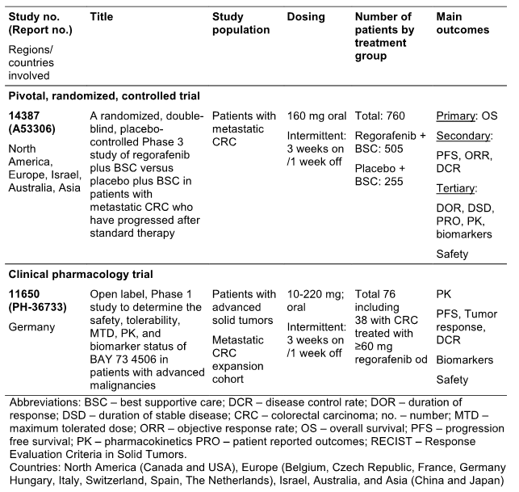

### Pivotal study 14387

#### Design

The pivotal study was study 14387 a randomized double blind placebo controlled Phase III study conducted in 15 countries. The study was initiated in April 2010 and involved a total of 760 patients who were randomly assigned on a 2 to 1 ratio to 1 of 2 treatment groups i.e. the experimental arm regorafenib 160mg per day for 3 weeks on and 1 week off together with best supportive care (BSC) and the comparative arm of matching placebo plus BSC.

Randomization was by prior treatment with vascular endothelial growth factor (VEGF) targeting drugs, time from diagnosis and liver metastases and geographical regions. Male and female patients of at least 18 years of age with metastatic colorectal cancer were included.

#### Objectives

The primary objective variable for this study was overall survival (OS). The secondary efficacy endpoints were progression free survival (PFS). Objective response rate (ORR) which was the percentage of patients with complete or partial response and disease control rate (DCR) which included the percentage of patients whose best response was CR or PR or stable disease excluding those patients with stable disease less than 6 weeks from randomisation. Tertiary end points of the study were duration of response (DOR) duration of stable disease (DUC), health related quality of life assessed by patient reported outcomes. Evaluation of disease response was based on the RECIST criteria.

Results presented in this trial are those of the second [pre-]planned interim analysis of overall survival with the date of cut off 21st July 2011. At this time the data monitoring committee considered that the primary efficacy end point had been achieved and therefore the study was unblinded and crossover for patients from the placebo group to the regorafenib group recommended.

#### Exclusion criteria

Major inclusion criteria for the study included age of at least 18 years: histological documentation of adenocarcinoma of the colon or rectum: metastatic colon-rectal cancer: progression during or within 3 months following the last administration of the standard therapies including Fluoropyrimidines, Oxaliplatin, Irinotecan, Bevacizumab and Cetuximab. Patients treated with Oxaliplatin in the adjuvant setting should have progressed during or within 6 months of completion of adjuvant therapies. Patients who progressed more than 6 months after completion of Oxaliplatin obtaining adjuvant treatment were to be treated with Oxaliplatin based therapy first to be eligible. Patients with an unknown KRAS status at screening must have received anti-EGFR treatment: measurable and non-measurable disease according to RECIST criteria: ECOG performance status of 1 or less: life expectancy of at least 3 months and adequate bone marrow, liver and renal function assessed within 7 days of starting the study treatment.

#### Analyses populations

A total of 760 patients, 505 in the regorafenib plus BSC group and 255 in the placebo plus BSC group were analysed and formed the intent to treat population (ITT). Of these 753 (500 in the regorafenib plus BSC group and 253 in the placebo group) received at least one dose of medication and were included in the safety analysis set (SAS). 5 patients in the regorafenib group and 2 patients in the placebo group did not receive the study drug and were not considered valid for the safety analysis.

The most common reason for treatment discontinuation during the treatment phase was disease progression in 75.1 percent of patients on regorafenib and 89.4 percent on placebo followed by adverse events not associated with clinical disease progression in 8.3 percent versus 2.7 percent.

#### Patient population

In total 540 patients or 71.1 percent had post-treatment survival follow up, 353 or 69 percent in the regorafenib group and 187 or 73.3 percent from the placebo group. During follow up death was the most common reason for discontinuation in 193 patients or 38.2 percent in the regorafenib group and 109 patients or 42.7 percent in the placebo group. As of the 21st July data cut off date a total of 61 patients or 52 or 10.3 percent of the regorafenib group and 9 or 3.5 percent in the placebo group were still receiving treatment.

#### Demographic and baseline characteristics

Demographic characteristics of the patient population are indicated Table 4.

Table 4. Baseline demographic characteristics of the patients in Study 14387 (ITT)

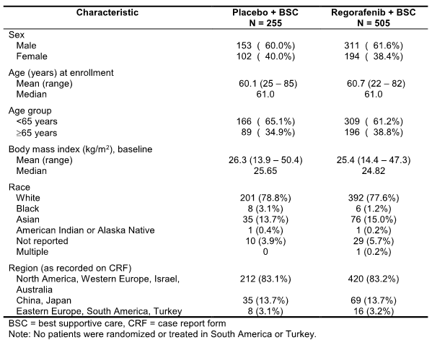

The majority of patients in the trial were male and had a mean age of 61 years. All patients were heavily pre-treated and the two arms of study were well balanced according to demographic characteristics.

Table 5 indicates the disease characteristics of the patients in the two studies.

Table 5. Baseline disease characteristics of the patients in Study 14387 (ITT)

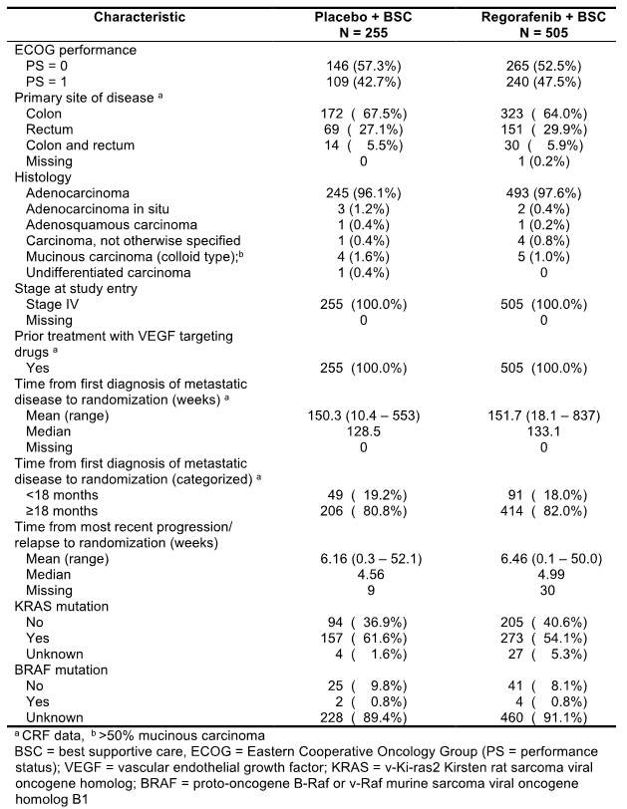

The vast majority of patients had colon cancer, ECOG status 01 and adenocarcinomas. All patients had stage 4 disease at study entry and prior treatment with VEGF target drugs. The two treatment groups were well balanced with the exception of ECOG performance status and KRAS mutational status. The ECOG status was 0 for most patients 52.5 percent of regorafenib group and 57.3 percent in the placebo group. Baseline information on KRAS mutations in tumours is available in 94.7 percent in the regorafenib group and 98.4 percent in the placebo group. KRAS mutations were reported in 54.1 percent of the in regorafenib group and 61.6 percent in the placebo group.

Regarding prior anti-cancer therapy for patients in the trial: All patients in both treatment groups had received at least 2 prior lines of systemic anti-cancer therapy. Approximately 50 percent of patients had 3 or fewer prior lines of treatment for metastatic disease and 50 percent 4 or more. Table 6 summarizes the prior anti-cancer therapies which were administered to the two treatment groups previous to entry onto trial and Table 7 indicates the prior anti-cancer drugs.

Table 6. Prior anti-cancer therapy in Study 14387 (ITT)

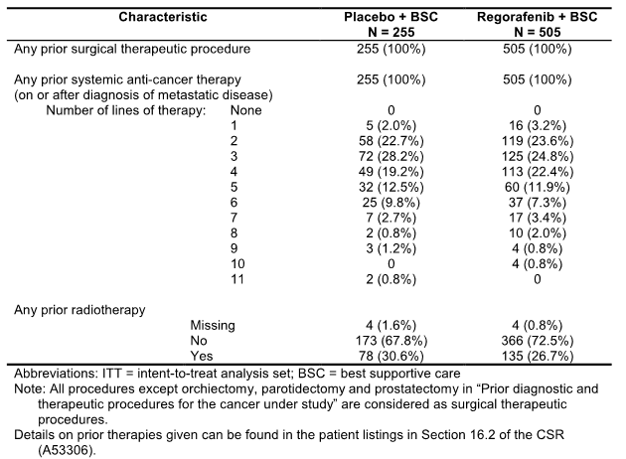

Table 7. Overall summary of patients by prior anti-cancer drugs (including anti-EGFR antibody) in Study 14387 (ITT)

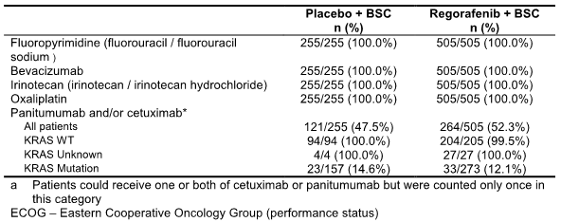

Of interest is the anti-cancer therapy administered during follow up for patients in the pivotal study and this is summarized in Table 8. Slightly more patients in the placebo group received follow up treatment and the most common agents including Pyrimidine analogues, monoclonal antibodies, folic acid derivatives and platinum compounds.

Table 8. Systemic anti-cancer therapy during follow-up (ITT)

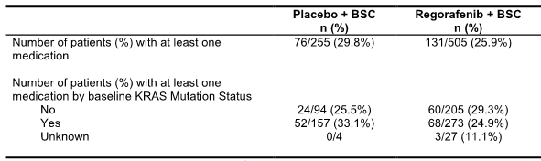

#### Statistical methods

In relation to statistical methods overall survival was compared between the two groups using stratified rank test stratified by the same factors as used for randomization. Hazard ratio for overall survival in the study was calculated using the Cox model stratified for the same factors. Kaplan-Meier estimates and curves were performed for overall survival.

#### Results

##### Overall survival

Considering the primary end point, at the database cut off date 432 death events or 74 percent of total deaths had occurred. Patients who are still alive at database cut off date were censored at the cut off date of 25 July 2011. Overall survival for the ITT population is given in Table 9. Kaplan-Meier curves for overall survival by treatment group is given in Figure 1.

Table 9. Overall survival in Study 14387 (primary analysis; ITT).

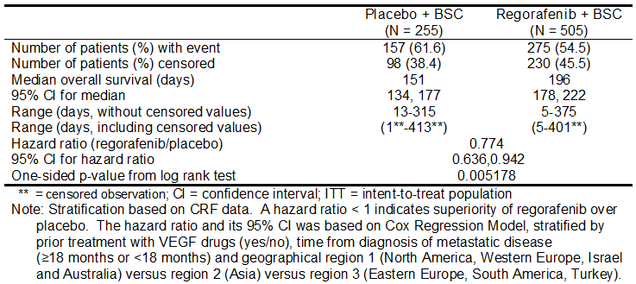

Figure 1. Kaplan-Meier curves of Overall survival in Study 14387 (ITT).

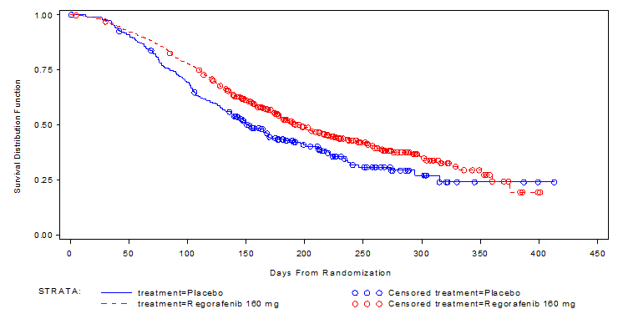

The total of 432 death events had occurred in 760 patients including 275 or 54.5 percent on regorafenib and 157 or 51.6 percent for placebo. The estimated hazard ratio risk of death of regorafenib versus placebo was 0.774 and 95 percent CI 0.636 – 0.942 representing a 22.6 percent reduction in hazard over placebo or a 29.2 percent increase in survival time over placebo. Stratified log rank test is a one sided P value of 0.005178. According to the prespecified efficacy boundary the one sided alpha value was 0.009279. Prolongation of overall survival for the regorafenib group is therefore statistically significant.

Median OS time was 196 days for patients randomized to regorafenib versus 151 days for patients randomized to placebo. The OS rates for this are higher in the regorafenib group than placebo at 3, 6, and 9 months after randomization and this is indicated in Table 10.

Table 10. Overall survival rates at Months 3, 6, 9 and 12 in Study 14387 (ITT).

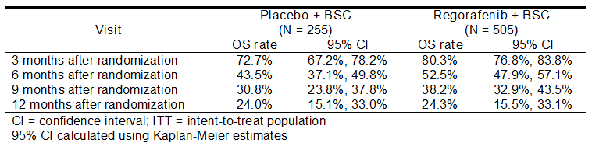

A sensitivity analysis of overall survival was undertaken and supportive of the primary analysis of overall survival showing statistical improvements in the regorafenib group.

Sub-group analysis evaluating overall survival by historical KRAS mutational status demonstrated that both KRAS sub-groups did better with regorafenib than placebo, as indicated in Table 11. This trend in favour of regorafenib appeared a little more marked in the wild type group compared to the mutational group but was not statistically significantly different.

Table 11. Overall survival and KRAS mutational status in Study 14387 (ITT).

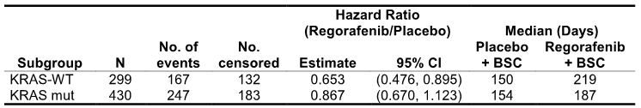

##### Progression-free survival

Review of disease progression data indicates that 85.1 percent of patients in the regorafenib group and 94.5 percent in the placebo group have experienced an event considered disease progression by date of cut off. The progression free survival result was consistent with the overall survival results and showed statistically significant: - longer PFS for the regorafenib group as indicated in Table 12. Hazard ratio was at 0.494 favouring the regorafenib patients which was significant 0.000001. Regorafenib patients had a median PFS of 59 days compared to 52 days for those receiving placebo. Kaplan-Meier curves for PFS by treatment are indicated in Figure 2.

Table 12. Progression-free survival in Study 14387 (ITT).

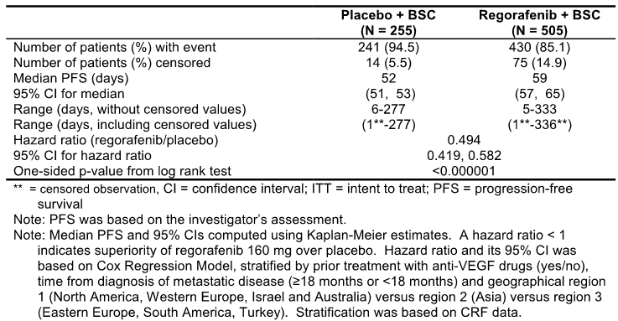

Figure 2. Kaplan-Meier curves of progression-free survival in Study 14387 (ITT).

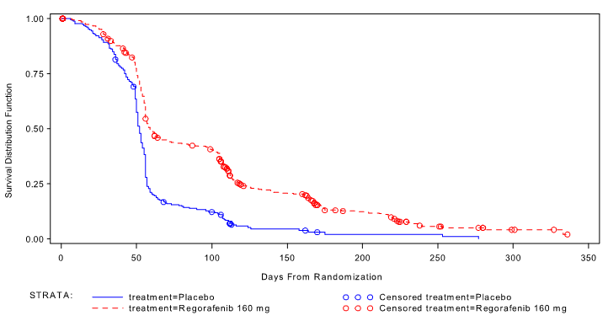

PFS rate was consistently higher in the regorafenib patients at 3, 6 and 9 months as indicated in Table 13. Sensitivity analysis again confirmed significant benefit in progression free survival for the regorafenib patients.

Table 13. Progression-free survival rates at Months 3, 6, 9 and 12 in Study 14387 (ITT).

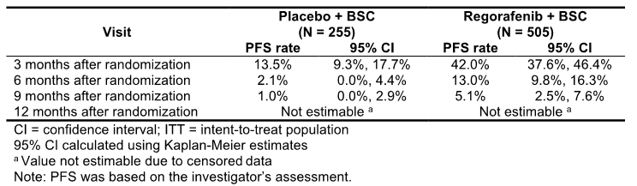

Sub-group analysis by historical KRAS mutational status for progression free survival was strongly in favour of regorafenib treated patients as indicated in Table 14.

Table 14. Progression-free survival and KRAS mutational status in Study 14387 (ITT).

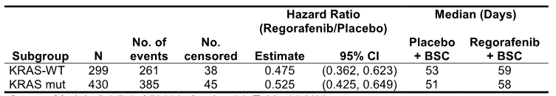

##### Objective tumor response rate

Review of objective responses revealed no complete responses while partial responses were observed in 5 patients in the regorafenib group and 1 in the placebo group. 216, regorafenib patients or 42.8 percent and 37 or 44.5[1] percent in the placebo group had stable disease. There were no significant differences between the two groups in relation to objective response rates with P value of 0.188432 but for DCR there was a difference of 25.94 percent which was statistically significant P less than 0.000001.

In relation to duration of response 5 patients in the regorafenib group and 1 patient in the placebo group achieved a PR but duration of response could not be estimated for regorafenib due to the small number of patients but was 68 days in the placebo group. Duration of stable disease was 60 days in the regorafenib group and 52 days in the placebo group.

##### Patient reported outcomes

In relation to patient reported outcomes in the pivotal trial HRQoL health utility values were measured using the EORTCQLQC3e and EQ-5D index respectively. Questionnaires were completed by the patient at baseline on the first day of each cycle, then every 3 months. Analyses of the questionnaires over these periods of time revealed that the treatment effect was similar for the regorafenib and placebo groups and the difference was not clinically meaningful.

In relation to the assessment utilizing the EQ-5 D index again the treatment effect was similar and differences were not clinically meaningful.

##### Subgroup analyses

Review of subpopulations within the pivotal study for assessment of overall survival and progression survival based on age, sex, ethnic group, baseline ECOG status, time from diagnosis primary sites of disease, geographic region, prior anti-VEGF therapy, prior anti-cancer drugs, number of prior treatment lines and KRAS mutation status. These subgroup analyses favoured the regorafenib group for both OS and PFS. This data was consistent with the overall results favouring the regorafenib group.

Figure 3. Forest plot of subgroup analysis of overall survival in study 14387 (ITT)

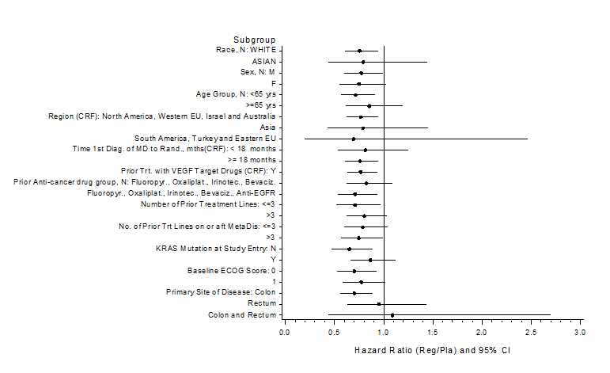

Figure 4. Forest plot of subgroup analysis of progression-free survival in study 14387 (ITT)

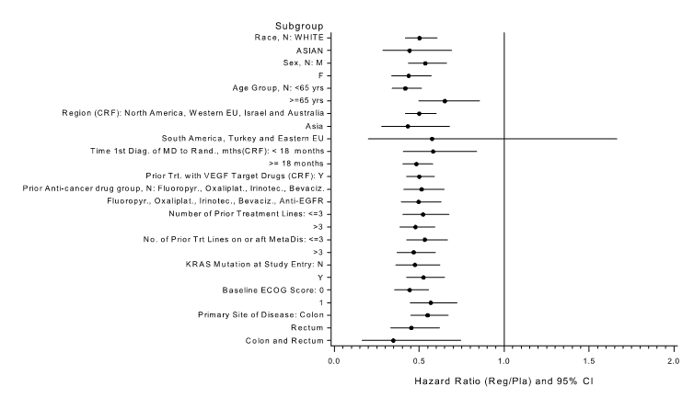

#### Comment:

This data involving a large heavily pretreated population of patients with CRC has shown a comprehensive benefit for regorafenib in terms of both overall survival and progression free survival. The primary end point benefit for overall survival of 22.6% reduction in hazard is clinically meaningful and a 29.2 percent improvement in overall survival confirmation of this. Similarly the progression free survival data adds weight to the significant benefits for overall survival.

Further indication of the value of regorafenib is indicated by the fact that patients irrespective of KRAS mutation status benefited and also with subgroup analyses confirming a benefit.

### Supportive study 11650

#### Design, objectives and patient population

A single supportive study is provided in this submission i.e. the Phase I Study 11650. This study was conducted in Germany as an open label single agent study assessing efficacy safety, PK, MTD recommended Phase II dose for regorafenib in patients with progressive solid tumours. Secondary objectives were to evaluate biomarkers status pharmacodynamics parameters and tumour response for patients treated with regorafenib. Dose escalation included regorafenib doses from 10 to 220mg per day given on an intermittent dosage schedule. At the end of the dosing escalation phase an expansion cohort of 23 patients with CRC was conducted at a dose level of 160mg per day of regorafenib.

The subgroup analyses of patients for CRC involved in the dose escalation phase included 15 patients and the CRC expansion cohort of 23 patients all of whom received doses of regorafenib of at least 60mg or greater.

Patients in the CRC 60mg regorafenib group received regorafenib on an intermittent 3 weeks on and 1 week off schedule with dose levels between 60 and 220mg per day. 26 of the 38 patients were treated with 160mg dose level. Duration of treatment ranged from 7 to 280 days with a median of 53 days.

#### Baseline demographics

Baseline demographic characteristics for the patients are indicated in Table 15. Baseline disease characteristics for the study are indicated in Table 16. KRAS mutations were analysed and 20 patients had KRAS mutations and 17 were wild type.

Table 15. Baseline demographic characteristics of the patients in Study 11650 CRC ≥ 60 mg regorafenib (SAF)

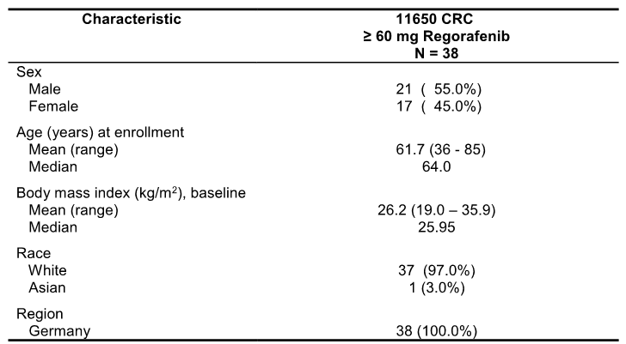

Table 16. Baseline disease characteristics of the patients in Study 11650 CRC ≥ 60 mg regorafenib (patients valid for efficacy)

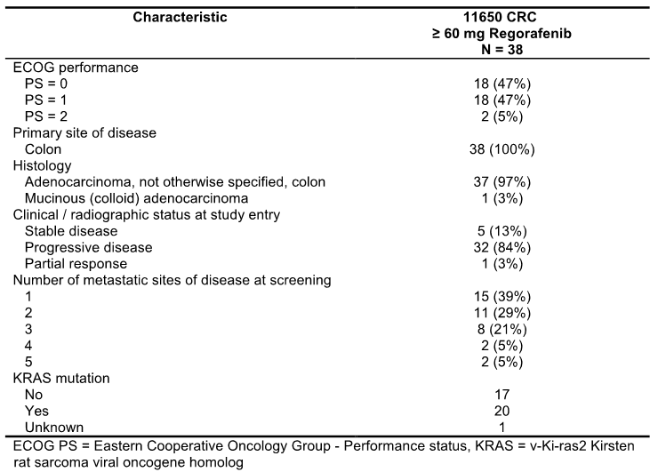

Prior anti-cancer therapy for the study is indicated in Table 17. The spectrum of drugs received is similar to that for the pivotal trial.

Table 17. Prior anti-cancer therapy for the CRC ≥ 60 mg regorafenib patients in Study 11650 (SAF)

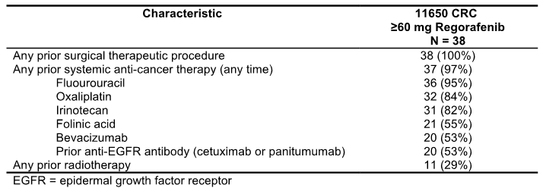

#### Analyses and results

Principal endpoints evaluated in the study were overall response rate, disease control rate and progression free survival. Overall survival was not estimated.

In relation to progression free survival in this study the median progression free survival for the 38 patients who received at least 60mg of regorafenib was 107 days with a range of 1 to 279 days. Data on the progression free survival of CRC patients receiving at least 60mg regorafenib including information about their tumour KRAS mutation status, and Kaplan-Meier curves showed no clear difference in progression free survival between the two KRAS groups.

In the study of the 38 patients who had received at least 60mg of regorafenib 27 were evaluable for response by “RECIST criteria”. There was a confirmed PR in one patient, stable disease in 19 patients for a DCR rate of 74 percent. A retrospective exploratory subgroup analysis was performed for PFS and KRAS mutation status which involved 20 patients with KRAS mutation and 17 who were wild type. It is noted there was no clear difference in PFS between in the patients with KRAS mutations and patients with wild type. This is recognized as a very small sample size.

#### Comment:

The data from this Phase I trial presents very limited information regarding the degree of modest efficacy for regorafenib in these heavily pretreated patients. This data cannot be really considered strongly supportive of the pivotal study because of the small number of patients and the nature of the Phase I trial together with the limited number of patients receiving 160mg of regorafenib therapy.

## Clinical safety

### Studies providing evaluable safety data

Safety data for this evaluation is based on the safety data derived for various Phase I, II, and III clinical studies and it is indicated in Table 18.

Table 18. Clinical development program: overview of clinical studies to demonstrate efficacy and/or safety of regorafenib

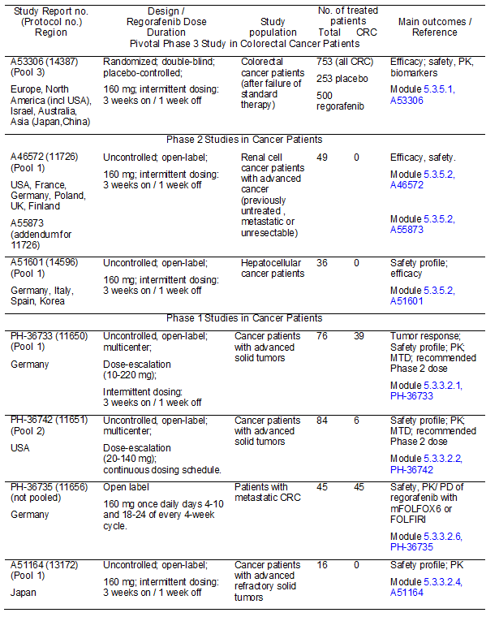

Table 18 continued. Clinical development program: overview of clinical studies to demonstrate efficacy and/or safety of regorafenib

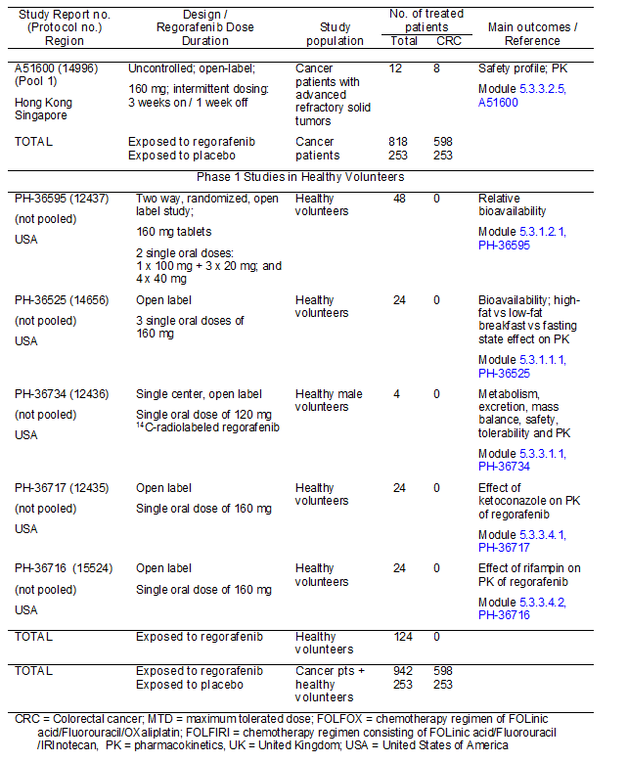

The main analyses are based on safety data pooled from completed company sponsored monotherapy trials in patients with cancer. This includes the pivotal study 14387 which forms pool III: Phase I study regorafenib administered continuously once daily Study 11651 as pool II and a pooled analysis of Phase I and II studies in cancer patients with intermittent dosing i.e. 3 weeks on 1 week off treatment forming pool I. A total of approximately 1145 cancer patients with all types of cancer have been treated with regorafenib of whom 621 were CRC patients.

Adverse events of pooled data were coded using the MedDRA recognized clinical dictionary and severity of adverse events categorized by NCI criteria. An overview of safety variables was provided.

### Extent of exposure

The extent of exposure in the various 3 pools is indicated in Table 19.

Table 19. Extent of exposure to regorafenib and placebo treatments in pools 1 to 3 (SAF)

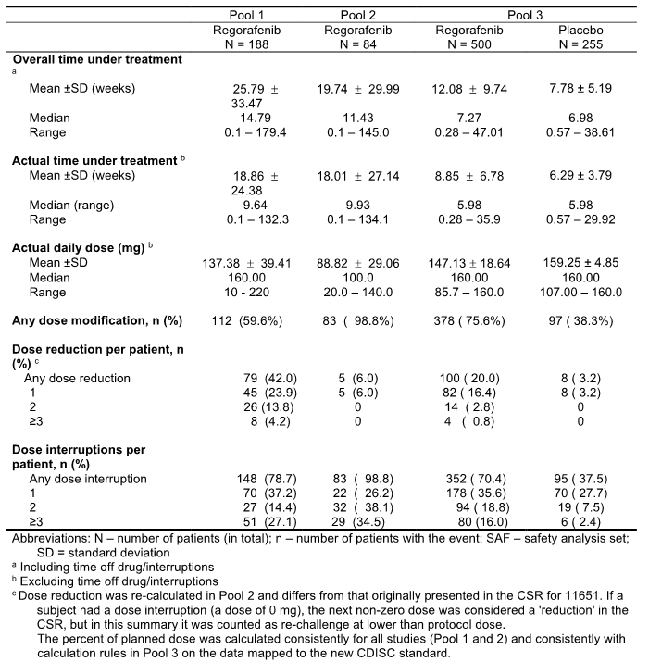

Pool I: A total of 188 patients with metastatic or unresectable solid tumours were exposed to single agent regorafenib on an intermittent dosage schedule consisting of Phase I and II uncontrolled studies. The starting dose of regorafenib was 160mg in these trials with exception of the dose escalation Study 11650 where 76 patients doses from 10mg with escalation to 220mg. The mean daily dose in pool 1 was 137.38mg with a median 160mg.

Pool II was a total of 84 patients with metastatic or unresectable solid tumours who received single agent regorafenib administered every day with continuous daily schedules with doses ranging from 10 to 140mg consisting of the uncontrolled Phase I Study 11651. The mean daily dose of Pool II was 88.82mg and median 100mg.

For Pool III there was a total of 500 patients with metastatic CRC exposed to single agent regorafenib 160mg per day with intermittent dosing schedule which was the pivotal study 14387. The mean regorafenib dose received for this study was 147mg with a planned dose of 160mg.

Demographic characteristics of the three Pools are indicated in Table 20.

Table 20. Demographic characteristics in pools 1 to 3 (pools 1 and 2: SAF; pool 3: ITT)

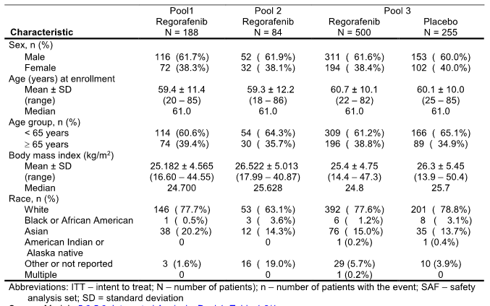

### Adverse events

The overall incidence of treatment emergent adverse events was similar in pools I to III ranging from 96.4 percent to 99.6 percent. An overall summary of treatment emergent adverse events, deaths, serious adverse events, grading of events, events leading to permanent discontinuation in pools 1 to 3 is indicated in Table 21.

Table 21. Overview of treatment-emergent AEs (SAF)

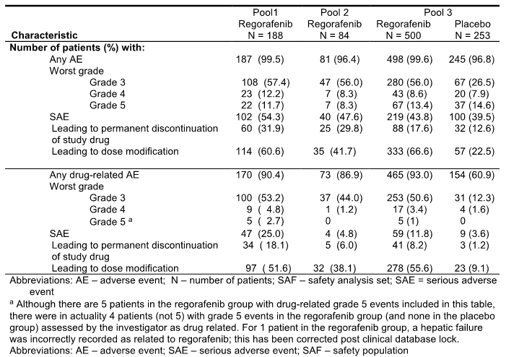

The majority of these adverse events reported were grade 1 to 2. Patients treated with regorafenib there is a high incidence i.e. 87 to 93 percent of drug related adverse events primarily grades 1 to 2. Grade 3 to 5 events were reported at similar rates between the regorafenib treated patients in the pool. Grade 3 events occurred in 56 percent of patients in pools II and III and 57.4 percent in pool I. There is no significant difference in the incidence of grade 4 adverse events ranging from 8.3 to 20.2 percent in regorafenib treated patients in pools I to III and for a minority of these patients the adverse events were related to regorafenib treatment. Grade 5 adverse events are reported at a slightly higher incidence in the placebo group i.e. 14.6 percent compared with the patients treated with regorafenib in any of the pools 8.3 to 11.7 percent. Most of the patients with grade 5 events were not related to regorafenib treatment.

#### Serious adverse events

The highest incidence of serious adverse events was reported in 54.3 percent of the patients in pool I with approximately half of the patients experiencing drug related serious adverse events i.e. 25 percent of the patients. In pool II serious adverse events were reported for 47.6 percent of patients but only approximately one tenth of them or 4.8 percent were related to study drug. In pool III serious adverse events were reported in a similar rate in the regorafenib i.e. 43.8 percent and placebo 39.5 percent group. For most of the patients experiencing serious adverse events in pool III the events were not related to treatment with drug related serious adverse events being 11.8 percent versus 3.6 percent favouring the placebo patients.

#### Adverse events leading to discontinuation

In pool III the proportion of patients that discontinued treatment due to drug related adverse events was 8.2 percent. The proportion of patients who discontinued treatment reported for pool 2 was 6 percent and pool I 18.1 percent mainly driven by the discontinuation rate in the first human study 11650.

#### Treatment emergent adverse events

Overall the pattern of common adverse events reported was very similar in all three pools with the highest incidence of common adverse events being during the first two treatment cycles of regorafenib. The incidence of treatment emergent adverse events with at least a 10 percent incidence for the three pools is shown in the dossier. In pool III the most common adverse events were appetite, palmar-plantar erythrodysesthesia syndrome, diarrhea, fatigue, decreased weight, Hypertension, dysphonia, pyrexia, asthenia, constipation, nausea and rash. The incidence of common adverse events for the other two pools were fairly similar to that as for pool III.

#### Drug related treatment emergent adverse events

In relation to drug related treatment emergent adverse events similar trends can be seen in the incidence in pools I to III with palmar-plantar erythrodysesthesia syndrome, fatigue, Hypertension and diarrhoea among the most common. Table 22 presents drug related treatment adverse events in at least 10 percent of patients across the three pools. The majority of these adverse events were grades 1 and 2.

Table 22. Incidence of drug-related MedDRA-coded AEs in Pools 1 to 3 (reported in at least 10% of regorafenib-treated patients in Pool 3, SAF)

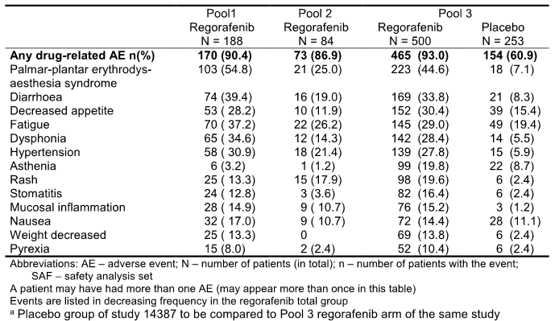

Reviewing the grade 3 adverse events again there were similar incidence across the three pools ranging from 56 to 57.4 percent and the pattern of these was also similar with the palmar-plantar erythrodysesthesia syndrome followed by fatigue and Hypertension the most common. In pool III the incidence of palmar-plantar erythrodysesthesia was 16.6 percent with all cases assessed by the investigations as drug related, grade 3 fatigue in 9 percent and diarrhoea in 8.2 percent and Hypertension in 7.6 percent.

In relation to grade 4 treatment emergent adverse events there were no major differences in the incidence across the three pools being 12.2, 8.3 and 8.6 percent. Relationship to regorafenib treatment was 4.8 versus, 1.2 and 3.4 percent respectively. In pool III the most common grade 4 adverse events were lipase increase in 1.2 percent followed by general physical health deterioration 0.8 percent for the regorafenib group.

In relation to grade 5 treatment adverse events in pool III the incidence leading to death was similar between the two treatment groups of 13.4 percent for regorafenib versus 14.6 percent for placebo patients. The most common grade 5 events in both treatment groups was general physical health deterioration in 5.4 percent and 6.3 percent, multi-organ failure 1.2 percent and 1.6 percent, hepatic failure 1.2 percent versus 0.4 percent, dyspnoea 0.8 percent versus 0.4 percent, pneumonia 0.4 percent each, hepatic function abnormal 0.4 percent each, respiratory failure 0.4 percent each. In total 5 grade 5 adverse events were considered treatment related and all were in the regorafenib group with 2 the same patient being haemorrhage GI and haemorrhage GU, sudden death in 0.2 percent and pulmonary haemorrhage in 0.2 percent and 1 cerebro-vascular accident 0.2 percent.

In relation to the treatment emergent serious adverse events the highest incidence was reported in pool I in 54.3 percent with approximately half of these patients experiencing drug related serious adverse event at 25 percent. The incidence was lower in pool II at 47.6 percent with only 4.8 percent having drug related serious adverse events 1 where in the pool III 43.8 percent regorafenib patients compared to 39.5 percent for placebo group and most of these serious adverse events were not related to treatment being 11.8 percent versus 3.6 percent respectively.

The nature of these serious adverse events occurring in at least 2 percent of patients on regorafenib for the three pools is indicated in Table 23. Pyrexia and abdominal pain were amongst the most common in all pools and the events that were drug related were noted only in a minority of these patients.

Table 23. Most common MedDRA-coded SAEs in Pools 1 to 3 (reported in at least 2% of regorafenib-treated patients in any Pool, SAF)

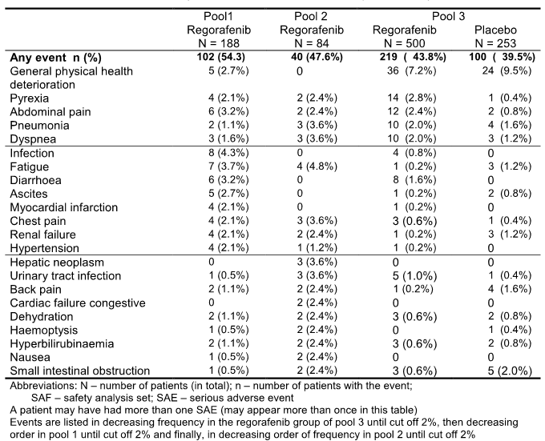

#### Deaths

In relation to deaths across the three pools there was a total of 138 deaths reported during treatment up to 30 days post treatment. The majority of these deaths i.e. 111 were associated with clinical disease progression. There were 13 deaths due to adverse events not associated with clinical disease progression or from toxicity due to study treatment all in pool I, 3 deaths due to an unknown cause and 2 deaths due to an adverse event associated with clinical progression.

It is to be noted that across the three pools of the 772 patients treated with regorafenib 97 deaths were reported for which 78 were due to clinical disease progression and 19 not associated with clinical progression. 9 of these were considered to be drug related. In relation to the 1145 regorafenib treated patients in completed and ongoing trials as of 31 December 2011 there were 16 drug related deaths, 9 in the pools I to III and 7 in the ongoing study. Three of these were due to cardiac arrest, 2 to haemorrhage GI and pulmonary: 1 sudden death, 1 brain ictus: 1 pulmonary embolus: 1 haemaptyris: 1 haematoma: 1 large intestine perforation: 1 acute hepatic failure: 1 deep vein thrombosis: 1 renal failure: 1 bowel perforation: 1 intestinal perforation.

#### Permanent discontinuation and dose reduction due to adverse events

The nature of adverse events leading to permanent discontinuation was similar to those associated with the incidence of grade 3 to 5 toxicities.

The incidence and nature of adverse events leading to treatment dose reduction reflect the overall spectrum of adverse events already reported. Similarly the incidence and nature of dose interruptions due to adverse events for the three pools are as previously reported.

#### Adverse events of specific interest

Reviewing adverse events of specific interest and concentrating on the pivotal data from pool III:

##### Cardiac events

In relation to cardiac safety it is to be noted cardiac ischaemia – cardiac infarction events are known to be a class effect of drugs blocking VEGF signaling. It is noted that in pool III there was a small increase in risk for myocardial ischaemia – infarction during regorafenib treatment which is reported in 6 or 1.2 percent of patients 3 with and 3 without the cardio-vascular risk factors compared to 1 patient with cardio-vascular risk factors in the placebo group.

For cardiac arrhythmias all reported events were of low severity with the incidence of grade 3 events 0.6 percent in the regorafenib group of pool III compared to 1.8 percent in pool I and none in pool II. There were no grade 4 or 5 events in any of the pools. The incidence is generally higher in patients with cardio-vascular risk or history of ischaemic heart disease. Atrial Fibrillation was the most common event. There was a higher incidence of Atrial Fibrillation in the regorafenib group at 1.2 percent in pool III compared to 0 in placebo. There was also more patients with a history of supra-ventricular arrhythmias in the regorafenib group at 5 percent compared to placebo in 2.5 percent. Investigators however considered these to be not drug related except in one case.

There was no evidence of an increased risk of congestive heart failure observed for patients receiving regorafenib in pool III and similarly ECG evaluations showed no significant trends over time. There were no increases in the mean QTc intervals of the ECG seen over time in the pooled data. A small number of cases of ECG QT prolonged 0.6 percent in pool III and 2.4 percent in pool I have been reported but the majority were non-serious and there were no reports of Torsades Depointes.

##### Renal toxicity

In relation to renal safety this is of interest because proteinuria is known to be a class effect of drugs blocking VEGF signalling. In the Phase III study the overall incidence of proteinuria by laboratory evaluation for the regorafenib group was 59 percent compared to 34.1 percent for placebo with the vast majority of grade 1 and 2 in severity. The incidence of grade 3 proteinuria by laboratory evaluation was similar at 0.4 percent for both groups. There were no grade 4 events. Proteinuria was the most common adverse event across the pools and reported at an incidence of 7.4 percent for patients on regorafenib. Again most were grade 1 to 2 events with 1.6 percent of patients on regorafenib having proteinuria as grade 3. There were no grade 4 events. There was no indication of proteinuria resulted in acute renal failure. There was no evidence of detrimental effect of regorafenib on the estimated glomerular filtration rate including in subgroups evaluated. The mean changes from baseline to the end of treatment favoured regorafenib at 8.25 versus placebo at -3.7.

##### Hepatic toxicity

In relation to hepatic events hepatotoxicity had been reported in patients treated with multi-targeted Tyrosine kinase inhibitors and was identified as an important adverse reaction in regorafenib clinical trials. The most common hepatobilary disorders were hyperbilirubinemia, disturbed hepatic function, hepatic pain and hepatic failure. In pool III regorafenib treatment led to AST and ALT increase in 45.2 percent and 65 percent of patients respectively and with toxicity mostly grades 1 to 2. The incidence of hyperbilirubinemia was higher in the regorafenib group at 13 percent compared to placebo 6.7 percent.

Further review of the disturbances in hepatic function in pool III indicated that an assessment of severe drug induced liver injury according to standard definitions indicated there were three cases of severe drug induced liver injury. In addition there were five cases of significant transaminase increase not fulfilling severe liver injury criteria. In these cases there were no clinical manifestations of liver dysfunction reported and all but one patient recovered upon drug discontinuation.

##### Haemorrhage

In relation to haemorrhage which was described as a class adverse effect of VEGF pathway inhibitors, haemorrhage was quite commonly reported as an adverse event but most events were grade 1 and 2 and most often epistaxis. Within the phase III study regorafenib treated patients experienced haemorrhage in 21.4 percent compared to placebo at 7.5 percent and was grade 5 in 0.8 percent. It is noted in pool III the regorafenib treated patients had a higher incidence of decreased platelets and increased INR values compared to patients in the placebo group but these laboratory abnormalities were low grade in the vast majority of patients. Current data would suggest that the increased risk of haemorrhage is most likely a vascular effect on the endothelium.

##### Dermatological toxicity

Cutaneous adverse reactions are very common in patients treated with multi-targeted kinase inhibitors, and were very common in the regorafenib patients. In all three pools the overall incidence of skin and subcutaneous tissue disorder was high in 72 percent to 74 percent of patients with the most common event being palmar-plantar, erythrodysesthesia syndrome followed by rash. There was no indication that regorafenib causes severe necrolytic skin reactions. In general these studies demonstrated that the incidence of skin and subcutaneous disorders was mild to moderate in severity and managed adequately with dose interruption or dose reduction.

##### Thromboembolism

In relation to thromboembolic events in all three pools there was a very low frequency or embolism in regorafenib treated patients in pool III being 0.8 percent, pool II 2.4 percent and pool I 1.1 percent and various other venous thromboembolic events in pool III 1.2 percent, pool II 2.4 percent and pool I 0.5 percent. In pool III the frequency of pulmonary embolism in the placebo group was similar to that of regorafenib being 1.2 percent versus 0.8 percent as well as for other venous thromboembolic events being 0.8 percent for the placebo group and 1.2 percent in the regorafenib group. There was no evidence of an increase of incidence of arterial thromboembolic events across the three pools.

##### Hypertension

Hypertension is a class adverse event related to VEGF pathway blockage. This occurred quite commonly in all pools being noted in approximately 30 percent of patients. In pool III the incidence of Hypertension was higher in the regorafenib treated patients at 30.8 percent compared to placebo at 7.9 percent. Most patients had grade 1 to 2 events though grade 3 events were reported in 7.6 percent of the regorafenib patients. There were no grade 4 events. One of the patients in the regorafenib group had Hypertension reported as a serious adverse event. In the subgroup analysis there was in general a higher incidence of Hypertension in Asian patients at 54.1 percent compared to Caucasian at 26.5 percent for regorafenib patients in pool III. The incidence of grade 3 events was similar for the two subgroups 7.7 percent in Asians and 9.5 percent in Caucasians.

Across all pools there was only one patient who experienced a Hypertensive crisis reported as a serious adverse event.

##### Gastrointestinal toxicity

Diarrhoea and mucositis were very common across all pools and the incidence was significantly higher in the regorafenib group compared to placebo. Diarrhoea was reported of the 42.8 percent in regorafenib group and 17.4 percent in the placebo in pool III and 48.4 percent and 29.8 percent of patients in pools I and II respectively.

##### Pancreatitis

In relation to pancreatitis in pools I and II there were single cases of pancreatitis reported. In the phase III trial there was one patient with pancreatitis in both treatment groups. This was despite increases in lipase of 26 percent for regorafenib treated patients, increases in amylase in 25.5 percent regorafenib treated patients most of which were grade 1 and 2.

Available safety data suggested a possible increase in the risk of GI perforation and fistula for regorafenib treated patients. In the phase III placebo controlled trial of regorafenib the incidence of GI fistula was low and similar between regorafenib in 0.8 percent and placebo at 0.4 percent and there were no cases of GI perforation in the regorafenib arm compared to 1 case in the placebo arm.

##### Wound healing impairment

Wound healing complications are described as a class adverse effect of VEGF pathway inhibitors. In pool I there was three cases reported of wound healing difficulties two of which were grade 1 and 1 grade 4. In the phase III trial 2 patients had wound healing impaired in the placebo group and none in the regorafenib group.

##### Potential complications due to hypophosphatemia

Hypophosphatemia is an adverse event of interest because the incidence is significantly higher in the regorafenib group compared to placebo. In the phase III study the incidence of hypophosphatemia was reported in 57.4 percent of patients receiving regorafenib compared to placebo 11.1 percent. Hypophosphatemia was one of the most common grade 3 chemical abnormalities with a much higher incidence in the regorafenib group at 30.5 percent compared to 3.6 percent in the placebo group. It is to be noted that the occurrence of hypophosphatemia was not associated with a higher incidence of potential complications such as heart failure, musculo-skeletal or CNS events.

##### Infections and infestations

In relation to infections and infestations the overall incidence in pool III was 30.8 percent in the regorafenib group compared to 17 percent in the placebo group. Most were grade 1 and 2 in severity and accounted for the difference between the 2 treatment groups as the incidence was lower in the placebo group. The incidence of grade 5 events was similar at 0.8 percent in the placebo group and 0.6 percent in the regorafenib patients and none of these was drug related. Overall the data for the three pools indicates an increased incidence of infections in regorafenib treated patients, but the incidence are generally of low severity affecting a variety of organ systems with a preponderance of mucosal infections which may be associated with drug related mucosal inflammation. There is no evidence of an increased risk of clinically severe infection events with regorafenib treatment.

#### Subgroup analysis

It is worth noting that in subgroup analyses age did not appear to have an influence on the incidence and severity of adverse effects.

### Laboratory tests

Reviewing the laboratory evaluations across the three pools it is to be noted with the haematology and coagulation parameters that mean changes from baseline were modest and most patients had low grade events. In relation to thyroid function results these showed a rise in thyrotropin (TSH) and fall in free T3 indicating possible Hypothyroidism. Most of these abnormalities were either only biochemical or the Hypothyroidism was sub-clinical however the rate of Hypothyroidism as an adverse event was 4.2 percent in pool III 13.1 percent in pool II and 6.9 percent in pool I indicating a potential association with regorafenib requiring appropriate assessment.

In relation to other clinical chemistry measurements apart from the changes already discussed in general terms various electrolyte and metabolic abnormalities were seen and the vast majority of these were grade 1 and 2. Mean changes from baseline values in selective chemical laboratory parameters for pool III are shown in the dossier. Clinically these abnormalities had no major impact as evidenced by the low dose modification and treatment discontinuation rate of less than 3 percent due to such abnormalities.

### Post marketing experience

It is to be noted that there is no post-marketing experience in relation to regorafenib as this agent has not been marketed in any country to date.

#### Comment

The data presented in this section clearly indicates that there is a significant incidence of toxicities in association with regorafenib administration. Adverse events were noted in 95 percent of all patients receiving this therapy. Although the majority were mild to moderate in severity a proportion were grade 3 and higher. The most common adverse events noted included palmar-plantar erythrodysesthesia syndrome, diarrhea, fatigue, dysphonia, decreased appetite, Hypertension and nausea. The most common grade 3 events were Hypertension, fatigue, diarrhea, palmar-plantar erythrodysesthesia syndrome, pain in the extremity, abdominal pain hyperbilirubinemia, hypophosphatemia and increased transaminases.

In terms of significant toxicities is to be noted that there was a definite risk associated with a potential for severe drug induced liver injury, haemorrhage, myocardiac ischaemia/infarction, arterial Hypertension and Hypertensive crisis, and palmar-plantar erythrodysesthesia syndrome. Also to be assessed carefully is the potential for GI perforation and fistula.

These adverse events are in general terms consistent with the mechanism of action of regorafenib and the adverse event profiles associated with other Tyrosine kinase inhibitors. These adverse events while requiring careful monitoring are in general terms managed adequately with early intervention and in the appropriate circumstances with prophylactic treatment.

## First round benefit-risk assessment

### First round assessment of benefits

Data from the pivotal study 14387 is the principal determinant of evidence of benefit in relation to regorafenib for the proposed indication. Data from this study a multi-national randomised placebo controlled Phase III trial involving 760 patients who were randomized on a 2 to 1 basis to regorafenib plus best supportive care versus placebo plus best supportive care showed a statistically significant HR of 0.774, P = 0.005178 benefit in overall survival of patients treated with regorafenib. This represents an improvement in overall survival of 29 percent for regorafenib treated patients with a median increase of 6.4 versus 5 months which corresponds to a 23 percent reduction in hazard over placebo. This represents a clinically significant improvement in outcome for patients who have otherwise failed all standard therapies as no evidence based therapy has been available up to the present clearly demonstrating a prolongation of overall survival as has occurred in this trial.

Progression free survival data were consistent with the overall survival results with an estimated HR of 0.494 with a P less than 0.000001 which represents a 50.6 percent reduction hazard of regorafenib compared to placebo.

Sensitivity and subgroup analyses confirmed the benefit for regorafenib in this pivotal trial both in terms of overall survival and progression free survival.

### First round assessment of risks

The data presented in this evaluation clearly demonstrates a quite high incidence of adverse effects associated with regorafenib treatment. More than 95 percent of patients experienced at least one treatment emergent adverse event. While the majority of these were grade 1 and 2, nearly 50 percent were however, grade 3 or greater in severity. The most frequent of these included palmar-plantar erythrodysesthesia, diarrhea, fatigue, dysphonia, decreased appetite, Hypertension and nausea. The majority of these adverse events could be managed either prophylactically or with adequate intervention.

Nevertheless results reveal a definite incidence of more severe complications requiring careful monitoring in particular those related to hepatotoxicity, myocardial ischaemia/infarction, GI perforation and fistula. These require relevant monitoring as well as early intervention.

While accepting the fact that there is a definite toxicity profile for regorafenib it is commensurate with that observed with other Tyrosine kinase inhibitors which are generally adequately managed with appropriate monitoring and early intervention.

### First round assessment of benefit/risk balance

The data from this evaluation has shown an impressive evidence of benefit from the pivotal trial in relation to overall survival improvement and progression free survival improvement in this heavily pre-treated patient population with metastatic colorectal carcinoma. Nevertheless this is off set to some extent by the significant toxicity profile associated with regorafenib although in general terms the vast majority of these adverse events would be adequately managed in modern oncology settings.

Accordingly I consider that the balance favours the benefit of regorafenib for the treatment of patients with metastatic colorectal cancer irrespective of KRAS mutational status who have previously been treated with and are not considered candidates for Fluoropyrimidine-based chemotherapy, an anti-VEGF therapy and with KRAS wild type an anti-EGFR therapy.

## First round recommendation regarding authorisation

This evaluator considers that as discussed above the benefit/risk balance favours approval of regorafenib for the proposed indication namely treatment of patients with metastatic colorectal cancer irrespective of KRAS mutational status who have been previously treated with or not considered candidates for Fluoropyrimidine-base chemotherapy, an anti-VEGF therapy and in KRAS wild type an anti-EGFR therapy.

## Clinical questions

This evaluator has no outstanding questions.

## First round comments on clinical aspects of the safety specifications in the draft RMP

The safety specification in the draft risk management plan is satisfactory.

## Second round evaluation of clinical data submitted in response to questions

Not applicable.

1. Erratum: correct value is 14.5% (37 of 255 patients)