|  |
| --- |
| **April 2019** |

|  |
| --- |
| Australian Public Assessment Report for Regorafenib |
| Proprietary Product Name: Stivarga |
| Sponsor: Bayer Australia Pty Ltd |

About the Therapeutic Goods Administration (TGA)

* The Therapeutic Goods Administration (TGA) is part of the Australian Government Department of Health and is responsible for regulating medicines and medical devices.
* The TGA administers the *Therapeutic Goods Act 1989* (the Act), applying a risk management approach designed to ensure therapeutic goods supplied in Australia meet acceptable standards of quality, safety and efficacy (performance) when necessary.
* The work of the TGA is based on applying scientific and clinical expertise to decision-making, to ensure that the benefits to consumers outweigh any risks associated with the use of medicines and medical devices.
* The TGA relies on the public, healthcare professionals and industry to report problems with medicines or medical devices. TGA investigates reports received by it to determine any necessary regulatory action.
* To report a problem with a medicine or medical device, please see the information on the TGA website <<https://www.tga.gov.au>>.

About AusPARs

* An Australian Public Assessment Report (AusPAR) provides information about the evaluation of a prescription medicine and the considerations that led the TGA to approve or not approve a prescription medicine submission.
* AusPARs are prepared and published by the TGA.
* An AusPAR is prepared for submissions that relate to new chemical entities, generic medicines, major variations and extensions of indications.
* An AusPAR is a static document; it provides information that relates to a submission at a particular point in time.
* A new AusPAR will be developed to reflect changes to indications and/or major variations to a prescription medicine subject to evaluation by the TGA.

Copyright

© Commonwealth of Australia 2019  
This work is copyright. You may reproduce the whole or part of this work in unaltered form for your own personal use or, if you are part of an organisation, for internal use within your organisation, but only if you or your organisation do not use the reproduction for any commercial purpose and retain this copyright notice and all disclaimer notices as part of that reproduction. Apart from rights to use as permitted by the *Copyright Act 1968* or allowed by this copyright notice, all other rights are reserved and you are not allowed to reproduce the whole or any part of this work in any way (electronic or otherwise) without first being given specific written permission from the Commonwealth to do so. Requests and inquiries concerning reproduction and rights are to be sent to the TGA Copyright Officer, Therapeutic Goods Administration, PO Box 100, Woden ACT 2606 or emailed to <[tga.copyright@tga.gov.au](mailto:tga.copyright@tga.gov.au)>.

Contents

Common abbreviations 4

I. Introduction to product submission 8

Submission details 8

Product background 8

Regulatory status 11

Product Information 12

II. Registration time line 12

III. Quality findings 13

Drug substance (active ingredient) 13

Drug product 13

IV. Nonclinical findings 13

V. Clinical findings 14

Introduction 14

Pharmacokinetics 15

Pharmacodynamics 17

Dosage selection for the pivotal studies 18

Efficacy 18

Safety 20

First round benefit-risk assessment 36

Clinical questions 37

Second round evaluation 37

Second round benefit-risk assessment 39

VI. Pharmacovigilance findings 40

VII. Overall conclusion and risk/benefit assessment 40

Quality 40

Nonclinical 40

Clinical 40

Risk management plan 48

Risk-benefit analysis 49

Outcome 51

Attachment 1. Product Information 51

## Common abbreviations

|  |  |
| --- | --- |
| Abbreviation | Meaning |
| ≥ | Greater than or equal to |
| ≤ | Less than or equal to |
| < | Less than |
| > | Greater than |
| AASLD | American Association for the Study of Liver Diseases |
| AE | Adverse event |
| AFP | Alpha-fetoprotein |
| ALB0 | Plasma albumin at baseline |
| ALT | Alanine aminotransferase |
| ANC | Absolute neutrophil count |
| ALP | Alkaline phosphatase |
| AST | Aspartate aminotransferase |
| AUC | Area under the plasma concentration-time curve |
| BCLC | Barcelona Clinic Liver Cancer |
| BCRP | Breast cancer resistant protein |
| BMI | Body mass index |
| BP | Blood pressure |
| BSC | Best supportive care |
| Cav,md,p | Average concentration over 24 h after multiple doses( 21 daily doses) of 160 mg for parent |
| Cav,md,tot | Average concentration over 24h after multiple doses (21 daily doses) of 160 mg for the sum of parent and the pharmacological active metabolites M-2 and M-5 |
| CI | Confidence interval |
| Cmax | Maximum drug concentration in plasma after single dose administration |
| CR | Complete response |
| CRC | Colorectal cancer |
| DBP | Diastolic blood pressure |
| DCR | Disease control rate |
| ECG | Electrocardiogram |
| ECOG | Eastern Cooperative Oncology Group |
| ECOG-PS | Eastern Cooperative Oncology Group Performance Status |
| EU | European Union |
| FDA | Food and Drug Administration |
| FGFR | Fibroblast growth-factor receptor |
| GCP | Good Clinical Practice |
| GIST | Gastrointestinal stromal tumour |
| Hb | Haemoglobin |
| HB0 | Haemoglobin at baseline |
| HCC | Hepatocellular carcinoma |
| HFSR | Hand-foot skin reaction |
| HR | Hazard ratio |
| INR | International normalised ratio |
| ITT | Intent-to-treat |
| L | Litre |
| MAPK | Mitogen activated protein kinase |
| mCRC | Metastatic colorectal cancer |
| mg | Milligram |
| mL | Millilitre |
| mRECIST | Modified Response Evaluation Criteria in Solid Tumours for Hepatocellular Carcinoma |
| NCI-CTCAE | National Cancer Institute Common Terminology Criteria for adverse events |
| NSCLC | Non-small cell lung cancer |
| OD | Once daily |
| ORR | Objective tumour response rate |
| OS | Overall survival |
| PD | Pharmacodynamic |
| PDGF | Platelet-derived growth factor |
| PFS | Progression free survival |
| P-gp | P-glycoprotein |
| PI | Product Information |
| PK | Pharmacokinetics |
| PPES | Palmar-plantar erythrodysaesthesia syndrome |
| PPT | Partial Thromboplastin Time |
| PR | Partial Response |
| PT | Preferred term |
| QD | Once daily |
| QoL | Quality of Life |
| RECIST | Response Evaluation Criteria in Solid Tumours |
| RECIST v1.1 | Response Evaluation Criteria in Solid Tumours, Version 1.1 |
| ROW | Rest of the world |
| SAE | Serious adverse event |
| SAF | Safety analysis set |
| SBP | Systolic blood pressure |
| SD | Stable Disease |
| SMQ | Standardised MedDRA queries |
| SOC | System Organ Class |
| SRI | Severe renal impairment |
| TACE | Trans-arterial chemoembolisation |
| TEAE | Treatment-emergent adverse event |
| TID | *Ter in die* (three times daily) |
| Tmax | Time to reach peak drug concentration in plasma after single (first) dose |
| TTP | Time to progression |
| U | Unit |
| ULN | Upper limit of normal |
| USA | United States of America |
| VEGF | Vascular endothelial growth factor |
| VEGFR | Vascular endothelial growth factor receptor |
| μg | Microgram |

## I. Introduction to product submission

### Submission details

|  |  |
| --- | --- |
| *Type of submission:* | Extension of indications |
| *Decision*: | Approved |
| *Date of decision:* | 18 December 2017 |
| *Date of entry onto ARTG:* | 21 December 2017 |
| *ARTG number:* | 200553 |
| *Black Triangle Scheme* | No |
| *Active ingredient:* | Regorafenib |
| *Product name:* | Stivarga |
| *Sponsor’s name and address:* | Bayer Australia Pty Ltd  875 Pacific Highway Pymble NSW 2073 |
| *Dose form:* | Tablet |
| *Strength:* | 40 mg |
| *Container:* | Bottle |
| *Pack sizes:* | 28, 28 (starter pack) and 84 (3 bottles of 28) tablets |
| *Approved therapeutic use:* | *Stivarga is indicated for the treatment of patients with hepatocellular carcinoma (HCC) who have been previously treated with sorafenib.* |
| *Route of administration:* | Oral (PO) |
| *Dosage:* | The recommended daily dose is 160 mg and contains 2.427 mmol (equivalent to 55.8 mg) of sodium per daily dose. Take four Stivarga (40 mg) tablets daily at the same time each day for three weeks on therapy (21 days) followed by one week off therapy (7 days) to comprise a cycle of four weeks (28 days). |

### Product background

This AusPAR describes the submission to extend the indication of Stivarga (regorafenib) to include the treatment of patients with hepatocellular carcinoma (HCC) who have been previously treated with one systemic therapy as follows:

*Stivarga is indicated for the treatment of patients with hepatocellular carcinoma (HCC) who have been previously treated with sorafenib.*

The sponsor has also proposed updates the Product Information (PI) with changes in the Pharmacokinetics, Clinical Trials, Precautions, Interactions with other medicines and Adverse Effects sections to include results from several clinical studies as follows:

* include the results from a drug-drug interaction between regorafenib and neomycin (Study 16675, Report PH-38212)
* update the information on renal impaired patients (CSR Study 16653)
* include the results from a study on breast cancer resistance protein (BCRP) and P‑glycoprotein substrates (CSR Study 16674)
* include information on CONSIGN study data (CSR Study 15967).

The CONSIGN study was a prospective, open-label, single-arm, multicentre, Phase IIIB study conducted in patients with metastatic colorectal cancer whose disease had progressed after treatment with standard therapies to confirm the safety of Stivarga in a large cohort of patients (n = 2872).

The sponsor has proposed the following dosage regimen:

Four regorafenib 40 mg tablets daily (that is, 160 mg daily) at the same time each day for 3 weeks on therapy (21 days) followed by 1 week off therapy (7 days) to comprise a cycle of 4 weeks (28 days).

Regorafenib is an oral anti-tumour agent that acts as a multi-kinase inhibitor. It blocks multiple protein kinases including kinases involved in tumour angiogenesis (vascular endothelial growth factor receptor (VEGFR)-1, -2, -3, TIE2 (an [angiopoietin receptor](https://en.wikipedia.org/wiki/Angiopoietin_receptor))), oncogenesis (KIT,[1] RET,[2] rapidly accelerated fibro sarcoma (RAF-1), BRAF[3]), metastasis (VEGFR3, platelet-derived growth factor (PDGFR), fibroblast growth-factor receptor (FGFR)) and tumour immunity (colony stimulating factor 1 receptor (CSF1R)). Regorafenib shares a similar chemical structure, mechanism of action and toxicities with sorafenib, which was first approved in Australia for first line systemic treatment of advanced, unresectable hepatocellular carcinoma (HCC) in 2007.

#### Information on the condition being treated

HCC is the third leading cause of cancer related death. It is currently the tumour with the second highest increase in global incidence and with the highest increase in death rates over the last 10 years. HCC usually occurs in the setting of liver cirrhosis secondary to chronic infections with hepatitis B virus or hepatitis C virus, alcohol consumption, non-alcoholic steatohepatitis, or diabetes. The incidence of HCC varies geographically largely due to variations in the incidences of hepatitis B and C infection, with the majority of the cases (> 80%) occurring in sub-Saharan Africa and eastern Asia.

At present, sorafenib,[4] a multi kinase inhibitor, is the only drug approved for systemic first line treatment of advanced, unresectable HCC. Currently, there is no second line treatment approved for HCC patients whose disease has progressed under first line treatment. According to the sponsor, all recent global Phase III trials investigating the use of drugs (brivanib, everolimus and ramucirumab)[5] in second line systemic treatment of patients with advanced HCC who had progressed during sorafenib treatment have failed to demonstrate a statistically significant life-prolonging effect. Based on the placebo arm data from these trials, it is estimated that patients with disease progression under sorafenib treatment have a median life expectancy of about 7 to 8 months if left untreated. The sponsor noted that in some countries, loco-regional treatments such as resection or trans‑arterial chemoembolisation (TACE) are used for patients with advanced or metastatic HCC, but remarked that this practice is inconsistent with evidence based guidelines, because these loco-regional treatments have not been shown in prospective, well designed clinical trials to have a life prolonging effect in HCC patients with advanced or metastatic disease.

Individual treatment decisions depend on the stage of the patient’s disease and not on its aetiology. A proposed treatment algorithm for HCC is outlined in Figure 1.[6] In most patients with HCC, the disease is diagnosed at advanced stages, when curative treatments (including resection, liver transplantation, and ablation) are no longer suitable (circled in red). Median survival at diagnosis is estimated to be six to twenty months. Lenvatinib is included in the algorithm but is not currently approved or available in Australia for HCC.

Figure 1: Treatment algorithm for hepatocellular carcinoma6

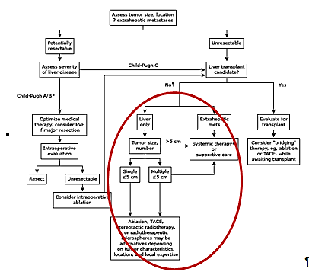

PVE: portal vein embolisation; TACE: transcatheter arterial chemoembolisation.* Suitability of patients with Child-Pugh B cirrhosis for surgical resection is highly controversial. If not a liver transplantation candidate because disease is outside transplant (Milan) criteria, down staging therapy (ablation, TACE) could be considered, followed by reassessment for liver transplantation. Δ Systemic therapy options include participation in a clinical trial (preferred), sorafenib, lenvatinib, or cytotoxic chemotherapy.

Sorafenib is subsidised by the Australian Pharmaceutical Benefits Scheme (PBS) for the initial treatment of advanced Barcelona clinic liver cancer (BCLC) Stage C HCC, subject to the conditions:

* the treatment must be the sole PBS-subsidised therapy for this condition, and
* the patient must have a World Health Organization (WHO) Performance status[7] of 2 or less; and
* The patient must have Child-Pugh Class A[8] hepatic impairment.

Sorafenib is also subsidised by the PBS for the continuing treatment of BCLC Stage C HCC, subject to the conditions:

* the treatment must be the sole PBS-subsidised therapy for this condition; and
* the patient must have previously been treated with PBS-subsidised sorafenib; and
* the patient must not have progressive disease.

The currently approved indication for Stivarga in Australia is:

*Stivarga is indicated for the treatment of patients with metastatic colorectal cancer (CRC) who have been previously treated with fluoropyrimidine-, oxaliplatin- and irinotecan-based chemotherapy, an anti-VEGF therapy, and, if RAS wild type, an anti-EGFR therapy.*

*Stivarga is indicated for the treatment of patients with unresectable or metastatic gastrointestinal stromal tumours (GIST) who progressed on or are intolerant to prior treatment with imatinib and sunitinib[9]*

### Regulatory status

Stivarga was first registered on 29 November 2013 by the TGA for the following indication:

*Treatment of patients with metastatic colorectal cancer (CRC) who have been previously treated with fluoropyrimidine-, oxaliplatin- and irinotecan-based chemotherapy, an anti-VEGF therapy, and, if KRAS wild type, an anti-EGFR therapy*.

An application to extend the indication to include the treatment of patients with unresectable or metastatic gastrointestinal stromal tumours (GIST) was approved by the TGA in March 2015.

The recommended dosage of Stivarga for currently approved indications and for the proposed indication in HCC is 160 mg daily at the same time each day for three weeks of therapy, followed by one week off therapy, to comprise a four week cycle.

Stivarga was granted orphan status for the second line treatment of HCC in July 2016.

#### International regulatory status

The United States Food and Drug Administration (FDA) have approved both regorafenib (April 2017) and nivolumab (September 2017) as second line therapy for HCC. The European Union (EU) approved regorafenib as second line therapy for HCC in September 2017 (Table 1).

Table 1: International regulatory status

|  |  |  |
| --- | --- | --- |
| Country/ region | Date of submission | Indication approved |
| USA (FDA) | 31 October 2016 | Treatment of patients with hepatocellular carcinoma (HCC) who have been previously treated with sorafenib (April 2017) |
| EU | 3 November 2016 | As monotherapy for the treatment of adult patients with hepatocellular carcinoma (HCC) who have been previously treated with sorafenib (September 2017) |

### Product Information

The Product Information (PI) approved with the submission which is described in this AusPAR can be found as Attachment 1. For the most recent PI, please refer to the TGA website at <<https://www.tga.gov.au/product-information-pi>>.

## II. Registration time line

The following table captures the key steps and dates for this application and which are detailed and discussed in this AusPAR.

Table 2: Registration timeline

|  |  |
| --- | --- |
| Description | Date |
| Submission dossier accepted and first round evaluation commenced | 28 February 2017 |
| First round evaluation completed | 31 July 2017 |
| Sponsor provides responses on questions raised in first round evaluation | 31 August 2017 |
| Second round evaluation completed | 29 September 2017 |
| Delegate’s Overall benefit-risk assessment and request for Advisory Committee advice | 25 October 2017 |
| Sponsor’s pre-Advisory Committee response | Not applicable |
| Advisory Committee meeting | Not applicable |
| Registration decision (Outcome) | 18 December 2017 |
| Completion of administrative activities and registration on ARTG | 21 December 2017 |
| Number of working days from submission dossier acceptance to registration decision* | 179 |

*Statutory timeframe for standard applications is 255 working days

## III. Quality findings

There was no requirement for a quality evaluation in a submission of this type.

### Drug substance (active ingredient)

Regorafenib (as monohydrate) is 4-[4-({[4-chloro-3-(trifluoromethyl)phenyl]carbamoyl}amino)-3-fluorophenoxy]-*N* methylpyridine-2-carboxamide monohydrate. The structural formula of regorafenib is shown in Figure 2 below.

Figure 2: Chemical structure of regorafenib

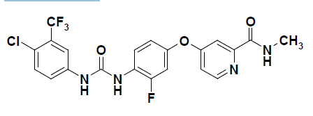

Molecular formula: C21H15ClF4N4O3 CAS number: 755037-03-7

### Drug product

Stivarga is presented as light pink, oval tablets each containing 40 mg regorafenib (as 41.49 mg regorafenib monohydrate). The tablets are marked with ‘BAYER’ on one side and ‘40’ on the other side. The tablets have the following excipients croscarmellose sodium, magnesium stearate, microcrystalline cellulose, povidone, silica colloidal anhydrous, iron oxide red, iron oxide yellow, lecithin, macrogol 3350, polyvinyl alcohol, purified talc and titanium dioxide.

## IV. Nonclinical findings

There was no requirement for a full nonclinical evaluation in a submission of this type. The sponsor proposed to update the nonclinical sections of the current PI. Additional statements based on nonclinical data were proposed for inclusion in the *Pharmacodynamic effects*section under *Pharmacology*.

There were no nonclinical objections to the proposed extension of indication and the revised PI document is considered to be acceptable from a nonclinical perspective.

## V. Clinical findings

A summary of the clinical findings is presented in this section.

### Introduction

#### Clinical rationale

There are no current effective and proven therapies available for patients with advanced HCC who experience disease progression during treatment with sorafenib. This therefore represents an unmet medical need in view of an untreated life expectancy of approximately 7 to 8 months. The sponsor is therefore seeking to address this unmet medical need with the proposed use of Stivarga as second line systemic treatment in these patients.

#### Formulation development

No change is proposed from the currently available formulation.

#### Evaluator’s commentary on the background information

Evaluation of the background information did not raise any concerns. The clinical rationale is sound.

#### Contents of the clinical dossier

##### Scope of the clinical dossier

The submission contained the following clinical information:

* The present submission contains 6 new pharmacokinetic (PK)/pharmacodynamic (PD) studies. One of these studies was undertaken in healthy subjects, whereas, the remaining 5 were undertaken in patients with cancer. In addition, the submission contains one population PK (popPK) analysis as well as 2 PK/PD analyses, which examine the relationship between regorafenib exposure and efficacy outcomes.
* 1 pivotal efficacy/safety study (Study 15982 (also called the RESORCE trial))
* 2 other efficacy/safety studies (Study report PH-37288 (addendum 2 to previously evaluated Study A51601/14596; HCC patients) and Study15967 (also called the CONSIGN trial; safety study in mCRC patients))
* Integrated Summary of Safety

In this evaluation report, Study 15982 (RESORCE) will be evaluated as the pivotal efficacy/ safety study and Study PH-37288 will be evaluated as supportive study. Study 15967 (CONSIGN) was an open-label, single-arm, multi-centre, Phase IIIb study conducted in patients with mCRC and is included in this submission to support the safety of Stivarga in a large cohort of patients (N = 2872), and it will therefore be evaluated in the safety section of this report as providing supportive safety data.

#### Paediatric data

This submission does not include paediatric data. The sponsor is not using data in this submission to support the use of Stivarga in a paediatric population. The sponsor has also stated that Stivarga has waiver from having to present a Paediatric Investigation Plan in Europe and from having to submit a Paediatric Assessment in the USA.

#### Good clinical practice

The clinical studies reviewed in this evaluation were in compliance with the relevant EU guideline.[10]

#### Evaluator’s commentary on the clinical dossier

Evaluation of the scope of the clinical dossier did not raise any concerns.

### Pharmacokinetics

#### Studies providing pharmacokinetic data

The submitted PK studies are described in Table 3 below.

Table 3: Submitted pharmacokinetic studies

|  |  |  |  |
| --- | --- | --- | --- |
| PK topic | Subtopic | Study ID | * |
| PK interaction in healthy adults | Neomycin | PH-38212 | Effect of neomycin on the PK of regorafenib |
| PK in Target population*§* | Severe renal impairment | PH-38801 | PKs of regorafenib and its 2 pharmacologically active to measure amount of drug excreted in urine in cancer subjects with severe renal impairment |
| Japanese | PH-37596 | PKs of regorafenib 160 mg QD administered orally as a single agent in Japanese patients with advanced solid tumours |
| Chinese | PH-37270 | PKs of regorafenib administered orally as a single agent in Chinese patients with advanced solid tumours |
| Population PK analyses | Target population | R-11104 | Analysis of regorafenib PKs in HCC patients from the RESORCE study who progressed on sorafenib based on a previously developed popPK model |
| PK interactions in Target population | Digoxin and rosuvastatin | PH-38823 | Potential for a DDI between regorafenib and M-2 and M-5 with digoxin (P-gp-substrate) and rosuvastatin (BCRP-substrate) |

* Indicates the primary PK aim of the study. § Subjects who would be eligible to receive the drug if approved for the proposed indication. QD= Once daily

#### Evaluator’s conclusions on pharmacokinetics

Following a single oral administration of 160 mg regorafenib to healthy Caucasian males, the median time to peak plasma concentration (Tmax) values for regorafenib and its two active metabolites M-2 and M- 5 were 3.98 h, 4.00 h and 36 h, respectively.

PopPK analysis indicated that Cav,md,p;[11] and Cav,md,tot,[12] values were similar in patients with HCC and CRC and slightly lower in GIST patients.

Following a single 160 mg dose, regorafenib the area under the plasma concentration versus time curve from time 0 to the last time point (AUC(0-tlast)), peak plasma concentration (Cmax) and Tmax values were similar in cancer subjects with severe renal impairment (SRI) and cancer subjects with normal or mildly impaired renal function. For the M-2 and M-5 metabolites the AUC(0-tlast) values were approximately 30% and 55% lower in the SRI group.

Following a single, oral, 160 mg dose of regorafenib to Japanese or Chinese subjects with advanced solid tumours, the median Tmax values for regorafenib and M-2 were similarly (3 to 4 h), whereas, M5 Tmax was 24 h in the Japanese and 48 h in the Chinese group. The geometric mean AUC(0-24) values for regorafenib, M-2, and M-5 in Japanese subjects were 16.4 mg h/L, 3.70 mg h/L and 0.38 mg h/L, respectively, whereas, in Chinese subjects AUC(0-24) values were 1.45 fold, 3.65 fold and 3.9 fold higher, respectively, than in the Japanese group.

Following multiple doses of 160 mg once daily (QD), in Japanese subjects with solid tumours, the Tmax values for regorafenib and M-2 were similar (4 h), whereas, Tmax for M-5 was 36 h, whereas, the mean AUC(0-24) values for regorafenib, M-2, and M-5 were 2.1, 5.2 and 37.3 fold higher, respectively, following multiple doses than following a single dose. The linearity factor, dividing AUC(0-24) after multiple dosing by AUC after single dose, was 1.0 for regorafenib, 2.4 for M-2 and 4.0.

Following multiple administrations of a range of regorafenib doses QD (80 mg, 120 mg and 160 mg) to Chinese subjects with advanced solid tumours, regorafenib exposure increased with increasing dose from 80 mg to 160 mg, though non-proportionally, and appeared to reach a plateau at 160 mg dose. Plasma exposure of M-5 (and to a lesser extent M-2) increased with dose in a more than proportional manner.

Consistent with previous reports, popPK analyses in patients with HCC can be characterised by first order absorption followed by a two compartmental disposition. M‑2 and M-5 are also formed in a concentration-dependent, non-linear, manner and follow a two-compartmental disposition.

For Cav,md,p, a number of significant covariates were identified, including: volunteer health; gender; age; haemoglobin at baseline (Hb0); Plasma albumin at baseline (ALB0) and Body mass index (BMI). For Cav,md,tot, the covariates were similar and included volunteer health, gender, age, Hb0, alanine aminotransferase at baseline (ALT0) and weight. The following covariates were found to have no significant (p < 0.05) impact on regorafenib exposure: estimated glomerular filtration rate, total plasma protein, haematocrit, total bilirubin and the liver enzymes aspartate aminotransferase (AST) and alkaline phosphatase (ALP) as well as the covariate ethnic group RACE3 (Asian and non-Asian), whereas, the covariates of ethnic group (RACE), co-treatment with inducers or inhibitors of cytochrome P450 (CYP) isozyme CYP3A4 and co-treatment with inducers or inhibitors of UDP-glucuronosyltransferase 1A9 (UGT1A9) were not included in the analysis as these categories contained < 15 % of the subjects.

The individual impact of the significant covariates on exposure was generally low (< 5%); however, Cav,md,p and Cav,md,tot values were 46% and 41% lower, respectively, in young healthy male volunteers than in cancer patients, whereas, Cav,md,p and Cav,md,tot values were 9.3% and 29% higher, respectively, in female than in male subjects.

There was little to no difference in mean regorafenib AUC, Cmax and half-life (t1/2) values (< 10% decrease) when a single dose of 160 mg regorafenib was administered with and without neomycin 1 g three times a day (TID) to healthy subjects. By contrast, M-2 and M‑5 AUC values were decreased by 77% and more than 80%, respectively, in the presence of neomycin

Following the administration of a single dose of 0.5 mg digoxin, the presence of regorafenib 160 mg QD had little to no effect on the Cmax, AUC(0-24) and Tmax values for digoxin in patients with cancer. By contrast, following a single dose of 5 mg rosuvastatin, the presence of regorafenib 160 mg QD significantly increased rosuvastatin Cmax and AUC values by 4.6 and 3.8 fold, respectively, compared to when rosuvastatin was administered alone.

##### Limitations of the PK studies

No dedicated PK studies were undertaken that specifically examined the PKs of regorafenib in patients with HCC.

### Pharmacodynamics

#### Studies providing pharmacodynamic data

The submitted PD studies are described in Table 4 below.

Table 4: Submitted pharmacodynamic studies

|  |  |  |  |
| --- | --- | --- | --- |
| PD Topic | Subtopic | Study ID | * |
| Primary Pharmacology | Effect on tumour response | PH-38094 | Addendum to Report PH-36742 concerning 6 patients with adenocarcinoma or HCC who remained on treatment after the cut-off date. |
| PK/PD analysis | Exposure-efficacy | PH-39209 | Examine the relationship between exposure to regorafenib, M-2 and M-5 with relevant efficacy and safety data in patients with HCC |
| PH-39309 | Examine the relationship between exposure of regorafenib, M-2 and M-5 and OS taking the possible effect of predefined baseline covariates into consideration |

* Indicates the primary PD aim of the study. OS = Overall survival.

Several other new studies also examined tumour response; however, as these studies also contained new PK data they have been included in Table 3 above.

#### Evaluator’s conclusions on pharmacodynamics

Regorafenib is a novel bi-aryl urea that targets kinases involved in tumour-cell proliferation/survival and in tumour vasculature.

In a population of 6 cancer patients, including 4 diagnosed with HCC, who underwent long term treatment with regorafenib 160 mg QD, 3 subjects had partial response (PR) and 1 subject had stable disease (SD) as best response.

Based on PK/PD analyses of data from patients with HCC, there were no significant relationships between regorafenib, M-2 and/or M-5 exposure and efficacy or safety outcomes.

##### Limitations of PD studies

Little information is provided regarding the PD effects of regorafenib in patients with HCC.

### Dosage selection for the pivotal studies

Dose selection for regorafenib in the pivotal Phase III study, the RESORCE trial, was based on Phase I, II and III data for the mCRC and GIST indications as well as the Phase II study in HCC patients, Study 14596 (previously evaluated by TGA). Based on the results in 2 dose escalation studies in patients with different types of cancer, Study 11650 (once daily dosing for 3 weeks of every 4 week cycle (3 weeks on / 1 week off)) and Study 11651 (continuous treatment regimens), the dosing regimen of regorafenib 160 mg once daily for 3 weeks of every 4 week cycle was chosen over the continuous dosing regimen of regorafenib 100 mg once daily for subsequent clinical development of regorafenib for the indications of mCRC and GIST (already currently approved) as well as for the proposed indication of HCC.

#### Evaluator’s conclusions on dose finding for the pivotal studies

The rationale for the dose selection and dosing regimen for the pivotal Phase III trial was considered to be sound.

### Efficacy

#### Studies providing efficacy data

Support for the efficacy of regorafenib for the proposed indication is based on the results of a single Phase III, randomised, placebo controlled, double blind study (Study 15982 (the RESORCE trial)). Supportive data is provided by an addendum 2 report of a Phase II open-labelled, uncontrolled study (Report PH-37288 of Study 14596/A51601). The sponsor has presented the results of these 2 studies separately and no integrated summary of efficacy is submitted. This is considered acceptable as these 2 studies have different study designs.

#### Evaluator’s conclusions on efficacy

Overall, the study design, inclusion and exclusion criteria, and study endpoints of the pivotal Phase III study (RESORCE trial) were appropriate and in line with the recommendations of the TGA adopted EU guidelines on the evaluation of anticancer medicinal products in man. The primary efficacy endpoint allowed assessment of the effect of regorafenib on survival time while secondary efficacy endpoints allowed assessment of the effect on disease progression free survival (PFS) time, time to disease progression and rate of radiological responses (complete response, partial response, stable disease). Baseline demographic and disease characteristics were comparable between treatment groups, and were generally consistent with the target patient population.

Analysis of the primary efficacy endpoint showed that there was a statistically significant reduced risk of death of 37% with regorafenib compared with placebo (Hazard ratio (HR) of 0.627; 95% confidence interval (CI): 0.500, 0.785; p = 0.000020). The median overall survival (OS) time was 10.6 months (95% CI: 9.1, 12.1 months) with regorafenib versus 7.8 months (95% CI: 6.3, 8.8 months) with placebo. Analysis of secondary endpoint of PFS showed that there was a statistically significant reduced risk of disease progression or death of 55% with regorafenib compared with placebo (HR of 0.455; 95% CI: 0.371, 0.558; p < 0.000001). The median PFS time was 3.1 months (95% CI: 2.8, 4.2) with regorafenib versus 1.5 months (95% CI: 1.4, 1.6) with placebo. There was also a statistically significant reduced risk of time to progression (TTP) of 56% with regorafenib compared with placebo (HR of 0.442; 95% CI: 0.358, 0.545; p < 0.000001). The median TTP was 3.2 months (95% CI: 2.9, 4.2) with regorafenib versus 1.5 months (95% CI: 1.4, 1.6) with placebo. Subgroup analyses of OS, PFS and TTP were supportive of consistent benefit for regorafenib over placebo across the subgroups assessed.

The percentage of all randomised subjects with complete response or partial response (objective tumour response rate) was higher with regorafenib than with placebo (10.6% versus 4.1% (mRECIST criteria)). The proportion of all treated patients whose best response was complete response, partial response or stable disease (disease control rate) was also higher with regorafenib than with placebo (65.2% versus 36.1% (mRECIST criteria)). Overall, the percentages of subjects with complete response, partial response and stable disease were higher in the regorafenib group compared to the placebo group (mRECIST criteria: complete response 0.5% versus 0%; partial response 10.0% versus 4.1%; stable disease 54.4% versus 32.0%).

Results of the single arm, open label Phase II Study PH-37288 were generally supportive of the results of the RESORCE trial. Median OS time was 13.8 months. Median TTP was 4.3 months. Objective tumour response rate was 2.8% and DCR was 72.2%. The percentage of subjects with complete response, partial response and stable disease were 0%, 2.8% and 69.4%, respectively.

The support for the efficacy claims in HCC is based exclusively on patients who had previously been treated with sorafenib, the only currently approved first line systemic treatment for HCC. However, the proposed indication is for the ‘*treatment of patients with HCC who have been previously treated with one systemic therapy*’ and therefore does not restrict the first line systemic treatment to sorafenib. The sponsor has submitted justification for this broader indication, which is mainly based on considerations of the anticipated impact of potential alternative first line treatments on the efficacy and safety of second line regorafenib. The parts relevant to efficacy will be discussed here, while those pertaining to safety will be discussed later under *Safety*.

As sorafenib is the only currently approved first line systemic treatment for HCC, and is the current global standard of care for HCC patients who have failed, or are not candidates for, curative and/or loco-regional treatments, this precluded the RESORCE study from enrolling HCC patients who had been previously treated with any first line systemic treatment other than sorafenib. Based on currently ongoing Phase III trials on pharmacological first line treatment of HCC, the sponsor considered two different potential future treatment sequence scenarios for the use of second line regorafenib: (i) prior first line treatment with kinase inhibitors with a similar mechanism of action as sorafenib;[13] or (ii) prior first line treatment with non-kinase inhibitor agents such as immune checkpoint inhibitors.[14]

Looking at the anticipated impact on regorafenib’s efficacy of the use of prior first line treatment with a kinase inhibitor, the sponsor cited the sequential use of multi-kinase inhibitors in renal cell cancer, thyroid cancer and GIST as evidence that, despite previous concerns about cross-resistance, sequential use of multi-kinase inhibitors with partially overlapping but distinct kinase inhibitor profiles is associated with clinical benefit and prolongation of survival. For instance, in renal cell cancer, sequential use of several multi-kinase inhibitors such as sorafenib, sunitinib or axitinib has become standard of care. In GIST, sunitinib was approved for treatment of GIST patients after progression on imatinib therapy, based on results showing clinical benefit. The sponsor also cited the positive efficacy findings of RESORCE trial as providing consistent evidence on the clinical benefit of multi-kinase inhibitor sequence treatments in the various tumour types.

With regards to the anticipated impact on regorafenib’s efficacy of the use of prior first line treatment with immunological checkpoint inhibitors, the sponsor reasoned that given their different modes of action, it would be reasonable to assume that in patients failing treatment with immunological checkpoint inhibitors (for example, PD-1 inhibitors), subsequent multi-kinase inhibitors should still be efficacious as they target proteins involved in signalling pathways not known to be directly affected by the immunological checkpoint inhibitors (such as angiogenesis and tumour proliferation). The sponsor cited studies in renal cell cancer showing clinical efficacy when multi-kinase inhibitors were used in patients who had previously received a PD-1 inhibitor treatment.

Overall, the justification for the proposed indication text of not restricting the first line systemic treatment to sorafenib is reasonable, with regards to the anticipated impact of potential alternative first line treatments on the efficacy of second line regorafenib.

### Safety

#### Studies providing safety data

The safety analyses in support of the HCC indication are based on data in three data pools from 15 completed (final or interim clean database available) company sponsored monotherapy trials in subjects with cancer in any indication (Table 5). Pool 1 (Overall Pool) comprises integrated safety data from all subjects exposed to regorafenib monotherapy in uncontrolled or controlled Phase I to Phase III studies (this includes data from subjects randomised to placebo after their cross-over to regorafenib following unblinding). In total, 4518 regorafenib treated subjects are included in this pool, of which 2864 (63.4%) subjects were from one study, Study 15967 (CONSIGN trial), an open labelled, multinational, single arm Phase IIIb study of regorafenib in subjects with metastatic CRC who had progressed after all approved standard therapy. Pool 2 comprises safety data from the pivotal Phase III HCC Study 15982 (RESORCE trial). Pool 3 (placebo controlled pool) comprises integrated safety data (regorafenib versus placebo) from 4 randomised, double blind, placebo controlled Phase III studies (Study 14387 [CORRECT trial; CRC patients], Study 14874 (GRID; GIST patients), Study 15808 (CONCUR trial; CRC patients) and Study 15982 (RESORCE trial; HCC patients)) (only data from the blinded study phases are included). In total, 1142 regorafenib treated subjects and 580 placebo subjects are included in this pool which comprises CRC, GIST and HCC subjects.

Table 5: Overview of clinical studies to support the safety of regorafenib in subjects with hepatocellular carcinoma

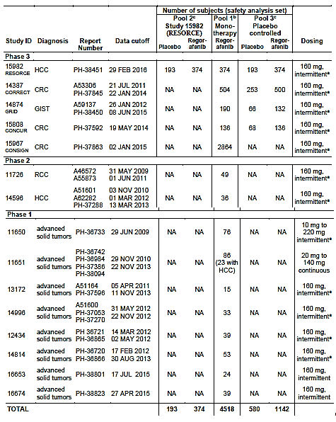

The studies in the integrated analyses have been previously evaluated by TGA in prior submissions except for Study RESORCE (pivotal Phase III study for HCC; Pool 2), Study  CONSIGN (part of Pool 1) and Study PH-37288 (addendum 2 of Study 14596; N = 36; part of Pool 1). Studies RESORCE and PH-37288 have been described in the Efficacy section above. In this evaluation report, safety data in the pivotal Phase III study (RESORCE) will be evaluated as providing primary safety data for the current HCC indication, with data in Pools 1 and 3 evaluated as providing supporting safety data. The safety data of individual Studies CONSIGN and PH-37288 were also evaluated separately for the purpose of this submission, and results were found to be consistent with the safety findings in the pivotal study and pooled analyses, and did not raise any additional safety concerns.

#### Patient exposure

In Study 15982 (RESORCE trial), the median duration of study treatment (including dose interruptions) was longer in the regorafenib group (15.6 weeks) than in the placebo group (8.4 weeks) (Table 6). In the regorafenib group, the mean daily dose (standard deviation) was 144.1 mg (21.3 mg); median daily dose was 159.3 mg, with approximately half of the subjects (49.2%) receiving 160 mg/day. In the placebo group, the mean daily dose (standard deviation) was 157.4 mg (10.3 mg); median daily dose was 160.0 mg. The majority of subjects (88.6%) received 160 mg/day.

Table 6: Extent of exposure to treatment; Safety Pools 1, 2 and 3

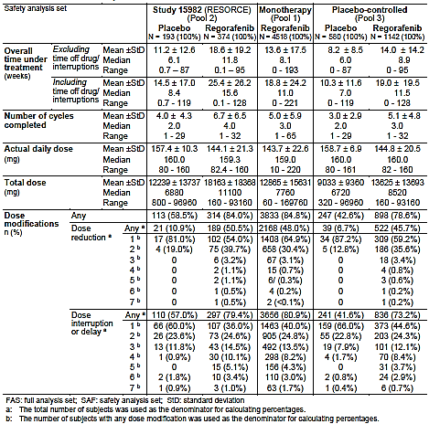

In Pool 1, the median duration of regorafenib treatment was 11.0 weeks, with a median daily dose of 159.0 mg. In Pool 2, the median duration of study treatment was 11.5 weeks in the pooled regorafenib group and 7.0 weeks in the pooled placebo group. In the pooled regorafenib group, the median daily dose was 160.0 mg.

Overall, the study drug exposure is adequate to assess the safety profile of regorafenib.

#### Safety issues with the potential for major regulatory impact

##### Liver function and liver toxicity

###### Pivotal and/or main efficacy study (RESORCE trial)

Treatment emergent adverse events (TEAEs) in the System Organ Class (SOC) of ‘hepatobiliary disorders’ were reported in a similar percentage of subjects in both treatment groups (14.7% in the regorafenib group versus 16.1% in the placebo group) (Table 7). In the regorafenib group, the most commonly reported TEAEs were hyperbilirubinaemia (3.7% versus 1.6% in the placebo group), hepatic failure (2.4% versus 4.7%) and jaundice (2.1% versus 1.6%).

Table 7: Frequent hepatobiliary TEAEs in Safety Pools 1, 2 and 3

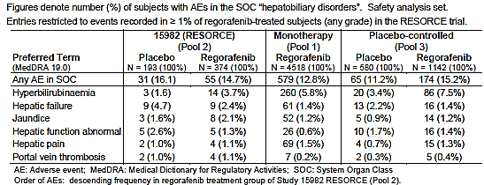

In the RESORCE trial, the TEAEs of interest were those of ‘hepatic failure’, and drug-related serious adverse events (SAEs) of Medical Dictionary for Regulatory Activities (MedDRA) SOC ‘hepatobiliary disorders’ Grades 4 and 5. Overall, the incidence of hepatic failure was lower in the regorafenib group than in the placebo group (2.4% versus 4.7%). There were two drug related Grade 4 hepatobiliary disorders events in the regorafenib group (hyperbilirubinaemia and hepatic failure), and none in the placebo group. There were two drug related Grade 5 hepatobiliary disorders event in the placebo group (both hepatic failure) and none in the regorafenib group.

Analyses of liver function tests (LFT) showed that incidences were higher in the regorafenib group compared to the placebo group for AST increased (92.7% versus 84.3%), alanine aminotransferase (ALT) increased (70.4% versus 58.6%), ALP increased (78.8% versus 72.9%) and blood bilirubin increased (78.2% versus 54.5%) (Table 8). Most of these increases were of a Grade 1 or 2 severity. There were no Grade 5 abnormalities in LFT. Worst Grade 3 or 4 LFT parameters which had higher incidence in the regorafenib group compared to placebo group were Grade 3 ALT increased (5.7% versus 4.7%), Grade 3 blood bilirubin increased (12.9% versus 11.0%), Grade 4 gammaglutamyl transferase (GGT) increased (3.5% versus 2.7%) and Grade 4 ALT increased (0.5% versus 0%) (Table 9).

Table 8: All grades (worst Grade 1 to 4) haematological and biochemical toxicities after start of treatment in ≥ 30% of subjects in any treatment group by CTCAE (SAF) in Safety Pools 1, 2 and 3

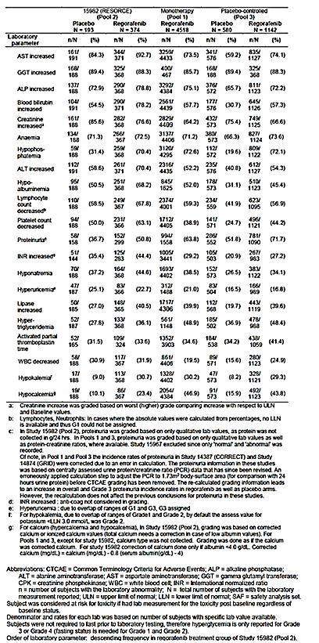

Table 9: Incidence of worst Grade 3 or 4 haematological and biochemical abnormalities in at least 2 regorafenib treated subjects during the double blind treatment period, Study 15982 in Pool 2 SAF

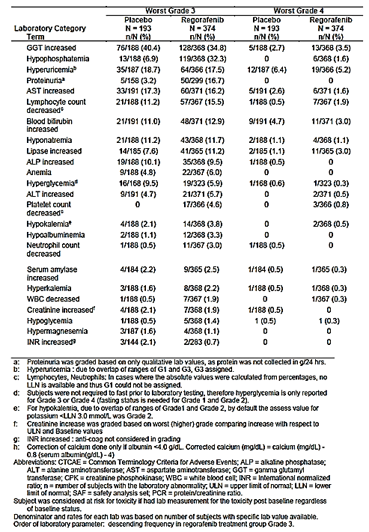

###### Other studies

* Pool 1

TEAEs in the SOC of ‘hepatobiliary disorders’ were reported in 12.8% (579/4518) of the regorafenib treated subjects. The most commonly reported TEAEs were hyperbilirubinaemia (5.8%), hepatic pain (1.5%), and hepatic failure (1.4%)(Table 7). Analyses of liver function tests showed that incidences of AST increased, ALT increased, ALP increased, GGT increased and blood bilirubin increased were 73.5%, 52.2%, 75.1%, 85.7% and 57.7%, respectively (Table 8).

* Pool 3

Incidence of TEAEs in the SOC of ‘hepatobiliary disorders’ were higher in the pooled regorafenib group compared to the pooled placebo group (15.2% versus 11.2%) (Table 7). In the pooled regorafenib group, the most commonly reported TEAEs were hyperbilirubinaemia (7.5% versus 3.4% in the placebo group), hepatic failure (1.4% versus 2.2%) and hepatic function abnormal (1.4% versus 1.7%).

Analyses of liver function tests showed that incidences were higher in the pooled regorafenib group compared to the pooled placebo group for AST increased (74.1% versus 59.2%), ALT increased (54.3% versus 70.4%), ALP increased (72.2% versus 65.7%), and blood bilirubin increased (57.3% versus 30.7%) (Table 8).Most of these increases were of Grade 1 or 2 severity. There were no Grade 5 abnormalities in LFT. Worst Grade 3 or 4 LFT parameters which had higher incidence in the regorafenib group compared to placebo group were Grade 3 ALT increased (5.5% versus 3.3%), Grade 3 AST increased (9.2% versus 8.3%), Grade 3 blood bilirubin increased (9.5% versus 6.6%), Grade 4 GGT increased (3.5% versus 2.7%) and Grade 4 ALT increased (0.5% versus 0.2%) (Table 10).

Table 10: Incidence of worst Grade 3 or 4 haematological and biochemical abnormalities in at least 1% of regorafenib treated subjects, placebo controlled studies in Pool 3 SAF

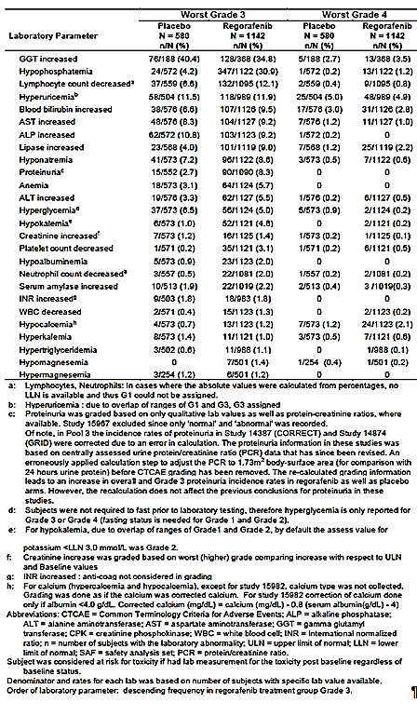

##### Other clinical chemistry

###### Pivotal and/or main efficacy study (RESORCE)

Evaluation of other laboratory chemistry parameters showed results consistent with the known safety profile of regorafenib and did not trigger any additional safety concerns. The most commonly occurring laboratory chemistry parameter abnormalities were in the liver function test parameters. The most commonly reported worst Grade 3 chemistry abnormalities in the regorafenib group were GGT increased (34.8% with regorafenib versus 40.4% with placebo) and hypophosphatemia (32.3% versus 6.9%) (Table 9). The only Grade 4 clinical chemistry abnormality reported in ≥ 5% of regorafenib treated subjects was hyperuricaemia (5.2% with regorafenib versus 6.4% with placebo).

###### Other studies

* Pool 1

Evaluation of other laboratory chemistry parameters showed results consistent with the known safety profile of regorafenib and did not trigger any additional safety concerns.

* Pool 3

Evaluation of other laboratory chemistry parameters showed results consistent with the known safety profile of regorafenib and did not trigger any additional safety concerns. The most commonly occurring laboratory chemistry parameter abnormalities were in the liver function test parameters as described in Table 9. The most commonly reported worst Grade 3 chemistry abnormalities in the regorafenib group were GGT increased (34.8% versus 40.4% with placebo) and hypophosphatemia (30.9% versus 4.2%) (Table 10). There was no worst Grade 4 clinical chemistry abnormalities reported in ≥ 5% of regorafenib treated subjects. The most commonly reported Grade 4 chemistry abnormality in the regorafenib group was hyperuricaemia (4.9% versus 5.0% in the placebo group).

##### Haematology

###### Pivotal and/or main efficacy study (RESORCE)

Evaluation of haematological parameters showed results consistent with the known safety profile of regorafenib and did not trigger any additional safety concerns. The most common worst Grade 3 haematology abnormality was decreased lymphocytes (15.5% with regorafenib versus 11.2% with placebo). The most frequent Grade 4 haematology abnormality was also decreased lymphocytes (1.6% versus 0.5%) (Table 9).

###### Other studies

* Pool 1

Evaluation of haematological parameters showed results consistent with the known safety profile of regorafenib and did not trigger any additional safety concerns.

* Pool 3

Evaluation of haematological parameters showed results consistent with the known safety profile of regorafenib and did not trigger any additional safety concerns. The most common worst Grade 3 haematology abnormality was decreased lymphocytes (12.1% with regorafenib versus 6.6% with placebo). The most frequent Grade 4 haematology abnormality was also decreased lymphocytes (0.8% versus 0.4%) (Table 10).

##### Vital signs

###### Pivotal and/or main efficacy study (RESORCE)

Evaluation of vital signs showed results consistent with the known safety profile of regorafenib and did not trigger any additional safety concerns. Hypertension is a known adverse effect of regorafenib as described in the currently approved PI. The incidence of TEAE of hypertension was 30.7% in the regorafenib group and 6.2% in the placebo group**.** Most of these were of severity Grade 1 or 2. The incidence of Grade 3 hypertension was 14.7% in the regorafenib group (versus 4.7% in the placebo group). There was no Grade 4 or 5 TEAEs of hypertension in either group. Analyses of blood pressure measurements during treatment showed thatchanges in mean blood pressure values over time from baseline to Cycle 3 were generally small in magnitude and did not show any clinically relevant differences between the regorafenib and placebo groups (Table 11).

Table 11: Mean values for systolic and diastolic blood pressure (SAF) in Safety Pools 1, 2 and 3

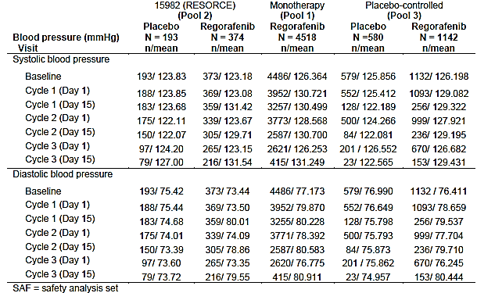

###### Other studies

* Pool 1

Evaluation of vital signs showed results consistent with the known safety profile of regorafenib and did not trigger any additional safety concerns.

* Pool 3

Evaluation of vital signs showed results consistent with the known safety profile of regorafenib and did not trigger any additional safety concerns.

##### Cardiovascular safety

Evaluation of cardiovascular safety showed results consistent with the known safety profile of regorafenib and did not trigger any additional safety concerns. As described in the currently approved PI, regorafenib is known to be associated with an increased incidence of myocardial ischaemia and infarction. The currently approved PI includes precautionary advice that patients with a history of ischaemic heart disease should be monitored for clinical signs and symptoms of myocardial ischaemia, and that in patients who develop new or acute onset cardiac ischaemia and/or infarction, interruption of regorafenib is recommended until resolution.

In the RESORCE study (Pool 2), the incidence of adverse events (AEs) in the SOC of cardiac disorders was 7.2% in the regorafenib group and 4.7% in the placebo group (Table 12). The incidence in Pool 1 (regorafenib group only) was 7.1%, and in Pool 3, it was 8.1% in the regorafenib group and 4.5% in the placebo group. The most common AE in the regorafenib group within the SOC of cardiac disorders in the RESORCE study was atrial fibrillation (1.3% with regorafenib versus 0% with placebo). The most common AE in the regorafenib group within the SOC of cardiac disorders in Pools 1 and 3 was tachycardia (Pool 1: 1.3% of regorafenib subjects; Pool 3: 1.5% with regorafenib versus 0.7% with placebo).

Table 12: Adverse events in the SOC of cardiac disorders in ≥ 1% subjects in any regorafenib group by MedDRA PT (SAF) in Safety Pools 1, 2 and 3

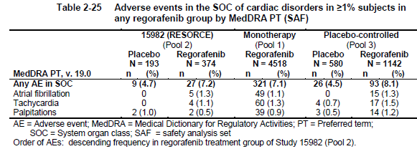

The incidence of SAE in the SOC of cardiac disorders was low in all treatment groups and similar among the 3 pools (regorafenib: 1.8% to 2.2%; placebo: 0.5% to 0.7%) (Table 13). The most common SAEs in the regorafenib groups of all 3 pools were acute coronary syndrome (RESORCE: 0.8% with regorafenib versus 0% with placebo; Pool 1: 0.3%; Pool 3: 0.4% versus 0%) and atrial fibrillation (RESORCE: 0.5% with regorafenib versus 0% with placebo; Pool 1: 0.4%; Pool 3: 0.4% versus 0%).

Table 13: Serious adverse events in the SOC of cardiac disorders (SAF) Safety Pools 1, 2 and 3

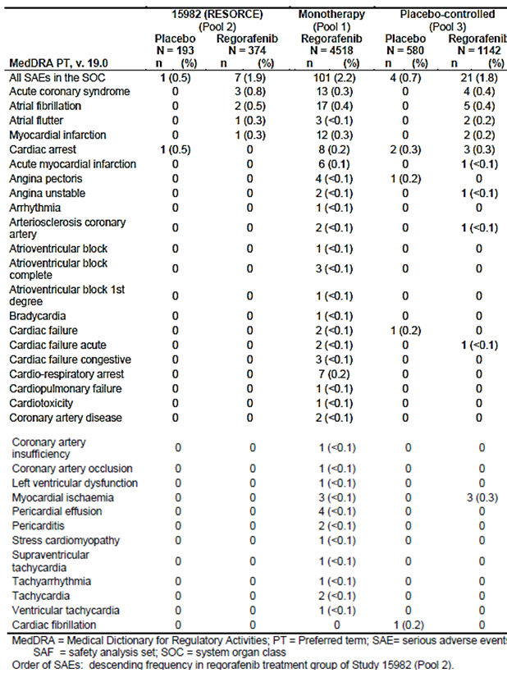

##### Serious skin reactions

The overall frequency of SAEs in the SOC of skin and subcutaneous disorders was low in all 3 pools (RESORCE: 0.8% with regorafenib versus 0% with placebo; Pool 1: 1.4%; Pool 3: 1.3% versus 0.3%). Three SAEs in the SOC of skin and subcutaneous disorders were reported in RESORCE study, all in the regorafenib group (blister, PPES, and skin ulcer).

##### Other safety parameters

###### Pivotal and/or main efficacy study (RESORCE)

Adverse events of interest in the RESORCE trial included bleeding/haemorrhage TEAEs Grade ≥ 3. Results showed that incidences of bleeding/haemorrhage Grade ≥ 3 events were low. Overall the incidence of worst Grade 3 or higher bleeding events (Standardised MedDRA Query (SMQ) haemorrhages) was lower in the regorafenib group compared with the placebo group (5.6% versus 7.8%). The incidence of worst Grade 3 or higher drug related bleeding events (Standardised MedDRA Queries (SMQs) haemorrhages) was low in both treatment groups (1.6% in the regorafenib group versus 0% in the placebo group).

#### Other safety issues

##### Safety in special populations

Overall, analyses of AE incidences by age group (< 65 and ≥ 65 years) showed no notable clinically relevant differences in the AE safety profile between age groups. In the RESORCE study, PPES was more frequent (≥ 10%) in subjects <65 years compared with those ≥ 65 years (56.9% versus 45.3%)(Table 14). Hypertension and decreased appetite were more frequent (≥ 10%) in subjects ≥ 65 years compared to those < 65 years (hypertension: 36.3% versus 25.6%; decreased appetite: 37.4% versus 24.6%). Results in Pools 1 and 3 were consistent with those in RESORCE study, showing that PPES was more often in subjects below 65 years than in subjects of 65 years or older, while hypertension and decreased appetite were more frequent in subjects ≥ 65 years (Table 15).

Table 14: Most common (> 10% overall in regorafenib treatment group) treatment-emergent adverse events by MedDRA PT, by age in Study 15982 Pool 2 SAF

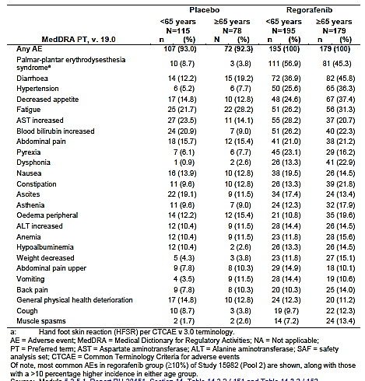

Table 15: Selected AEs by age category in Pool 1 and Pool 3 SAF

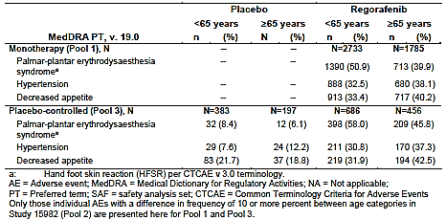

#### Safety related to drug-drug interactions and other interactions

##### Healthy subjects

Study PH-38212examined the potential for a drug-drug interaction (DDI)between neomycin and regorafenib in healthy subjects. The safety analysis indicated that AEs were more frequent when the two drugs were co-administered than when regorafenib was administered alone. In particular, gastro-intestinal disorders were not encountered during treatment with regorafenib only but affected > 80% of subjects when neomycin was added to the treatment; however, more AEs were considered related to the neomycin component of treatment than to regorafenib.

##### Patients with cancer

Study PH-38823 examined the interactions between regorafenib and the P-glycoprotein (P‑gp) substrate digoxin and regorafenib and the BCRP substrate rosuvastatin in patients with locally advanced or metastatic solid tumours. Overall, the incidence of drug-related TEAEs was similar in patients that were co-administered regorafenib and digoxin (87.0%) or regorafenib and rosuvastatin (89.5%) (Table 16). However, the incidence of drug-related TEAEs that resulted in a modification of regorafenib dose was slightly higher (approximately 12%) in the rosuvastatin co-administered group (68.4%) than in the digoxin group (56.5%).

Table 16: Study PH-38823 Overview of TEAEs; Safety analysis set, N = 42

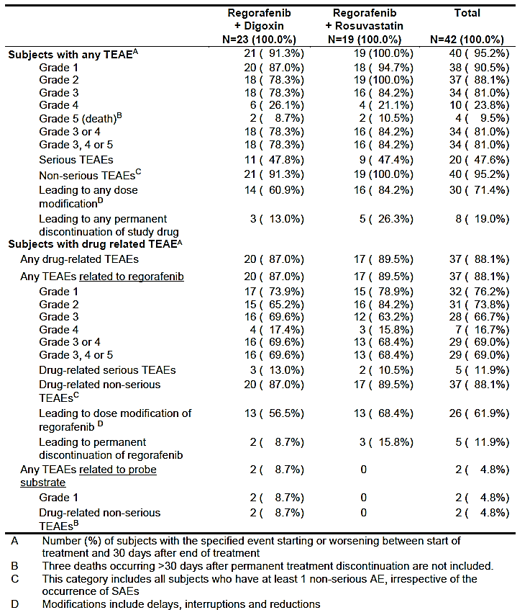

#### Postmarketing data

The sponsor has presented SAEs in the post-marketing setting (as of 1 July 2016) and these were consistent with the known safety profile of regorafenib. No new safety signal for regorafenib has been observed based on the received post-marketing reports.

#### Evaluator’s conclusions on safety

Overall, safety results in the pivotal Phase III study (RESORCE) showed results consistent with the known safety profile of regorafenib. The incidence of all-causality TEAEs was slightly higher with regorafenib compared to placebo (100.0% versus 92.7%) while the incidence of treatment related TEAEs was higher with regorafenib compared to placebo (92.5% versus 51.8%). The most commonly reported treatment related TEAEs with regorafenib group were palmar-plantar erythrodysaesthesia syndrome (PPES) (50.8% with regorafenib versus 5.7% with placebo), diarrhoea (33.4% versus 9.3%), decreased appetite (23.5% versus 5.7%) and hypertension (23.0% versus 4.7%). These are all known adverse drug reactions of regorafenib. The majority of these most commonly reported treatment related TEAEs in the regorafenib group were of severity worst Grade 1 (mild) or 2 (moderate). There was no Grade 4 (life-threatening and/or disabling) PPES, diarrhoea, decreased appetite or hypertension reported in either treatment group. Incidences of Grade 3 (severe) PPES, diarrhoea, decreased appetite and hypertension in the regorafenib group (versus placebo group) were 12.3% (versus 0.5%), 2.4% (versus 0%), 2.7% (versus 0%) and 12.8% (versus 3.1%), respectively.

The incidence of deaths during treatment and up to 30 days post-permanent treatment discontinuation was lower with regorafenib compared to placebo (13.4% versus 19.7%), and in both treatment groups, the most frequently recorded reason was associated with disease progression. The incidences of all-causality SAEs were similar between the regorafenib and placebo groups (44.4% versus 46.6%). The overall incidence of treatment related SAE was higher with regorafenib compared to placebo (10.4% versus 2.6%), but incidences were generally low across each SAE, with the most commonly reported treatment related SAEs with regorafenib being general physical health deterioration (1.3% versus 0.5% with placebo) and hepatic encephalopathy (1.3% versus 0.5%).

Safety results from Safety Pool 1, which looked at safety data from 4518 subjects with different types of cancer (including 8.5% [374/4518] with HCC, 4.2% [190/4518] with GIST and 77.6% [3504/4518] with CRC) exposed to regorafenib monotherapy in uncontrolled or controlled Phase I to Phase III studies, were consistent with the results of RESORCE and with the known safety profile of regorafenib. Safety results from safety Pool 3, which looked at integrated safety data of 1142 regorafenib treated subjects and 580 placebo subjects (among regorafenib treated subjects, 32.7% [374/1142] had HCC, 11.6% [132/1142] had GIST and 55.7% [636/1142] had CRC) from 4 randomised, double blind, placebo controlled Phase III studies, were also consistent with the results of RESORCE and with the known safety profile of regorafenib.

With regards to the boxed warning in the PI regarding hepatoxicity of regorafenib, the safety results did not raise concerns of increased hepatotoxicity in HCC patients treated with regorafenib, compared to patients with other cancers. Across the safety pools, TEAEs in the SOC of ‘hepatobiliary disorders’ were reported in 12.8% to 15.2% of regorafenib treated patients, and the most commonly reported TEAE in this SOC was hyperbilirubinemia (3.7% to 7.5%) (Table 7). In HCC patients treated with regorafenib (Study RESORCE), the incidence of hepatic failure was lower in the regorafenib group than in the placebo group (2.4% versus 4.7%). The incidence of drug-related SAEs of MedDRA SOC ‘hepatobiliary disorders’ Grades 4 and 5 with regorafenib was also low (two drug related Grade 4 hepatobiliary disorders events [hyperbilirubinaemia and hepatic failure] versus none in the placebo group; no incidence of drug related Grade 5 hepatobiliary disorders event versus two events in the placebo group [both hepatic failure]).

Incidences of raised liver function test parameters were higher regorafenib treated HCC patients in RESORCE compared to regorafenib treated patients the integrated analyses in safety pools 1 and 3 (AST increased: 92.7% in RESORCE versus 73.5% in Pool 1 versus 74.1% in Pool 3; ALT increased: 70.4% versus 52.2% versus 54.3%; blood bilirubin increased: 78.2% versus 57.7% versus 57.3%) (Table 8). However, this is expected given that RESORCE targeted a study population with advanced HCC. In the HCC patients (RESORCE), most of these increases were of Grade 1 or 2 severity. There were no Grade 5 abnormalities in liver function test. Incidence of worst Grade 3 AST increased was higher in the regorafenib treated HCC patients in RESORCE compared to those in Pool 3 (16.2% versus 9.2%), but was found to be comparable with the placebo group in RESORCE (16.2% versus 17.3%) (Tables 9 and 10). Incidence of worst Grade 3 bilirubin increased was also higher in the regorafenib treated HCC patients in RESORCE compared to those in Pool 3 (12.9% versus 9.5%), but was comparable with the placebo group in RESORCE (12.9% versus 11.0%). Incidence of worst Grade 3 ALT increased was comparable between the regorafenib treated HCC patients in RESORCE and those in Pool 3 (5.7% versus 5.5%), and also comparable with the placebo group in RESORCE (5.7% versus 4.7%). Incidences of worst Grade 4 AST increased, ALT increased and bilirubin increased in the regorafenib treated HCC patients in RESORCE were low (1.6%, 0.5% and 3.0%, respectively; versus 2.6%, 0% and 4.7%, respectively, in the placebo group).

The pivotal study (RESORCE) submitted to support the use of regorafenib in HCC is based exclusively on patients who had previously been treated with sorafenib. However, the proposed indication is for the ‘*treatment of patients with HCC who have been previously treated with one systemic therapy*’ and therefore does not restrict the first line systemic treatment to sorafenib. The sponsor has submitted justification for this broader indication, which is mainly based on considerations of the anticipated impact of potential alternative first line treatments on the efficacy and safety of second line regorafenib. The parts relevant to efficacy have been discussed above and those pertaining to safety will be discussed here.

Based on currently ongoing Phase III trials on pharmacological first line treatment of HCC, the sponsor considered two potential candidates which might become additional treatment options in the first line setting for unresectable HCC within the next years: lenvatinib (a multi-kinase inhibitor [MKI]) and nivolumab (a PD-1 inhibitor [belonging to the class of immune checkpoint inhibitors]). Looking at the anticipated impact on regorafenib’s safety of the use of prior first line treatment with lenvatinib, the sponsor noted that as a MKI, the mode of action of lenvatinib is overall in line with that of sorafenib mode of action and that there are no current scientific data to indicate that the prior use of a MKI will significantly impact safety profile of subsequently applied MKI. In addition, taking into account that second line therapy in unresectable HCC will be started within a few weeks after discontinuation of prior first line therapy, it is unlikely that a significant amount of lenvatinib (mean terminal exponential half-life: approximately 28 hours ) will be still traceable at the onset of regorafenib treatment. Therefore, the risk of any potential additive effect concerning regorafenib induced toxicities is anticipated to be low. The sponsor noted that there are overlapping side effect profiles between the lenvatinib and regorafenib[15], but that the most common toxicities associated with lenvatinib usually occur early during the course of treatment. Therefore, overlapping toxicities with potential subsequent treatment with regorafenib seem rather unlikely. The sponsor also cited that in GIST regorafenib has been proven and established as an efficacious and safe standard treatment option following prior treatment with kinase inhibitors imatinib and sunitinib.

With regards to the anticipated impact on regorafenib’s efficacy of the use of prior first line treatment with nivolumab, the sponsor acknowledged that immune-related adverse reactions reported for nivolumab (pneumonitis, colitis, hepatitis, nephritis, endocrinopathies [that is, hypothyroidism] and rash) might also occur months after discontinuation of nivolumab, and hence there is a potential risk of overlapping toxicities with second line regorafenib. However, the sponsor cited current published data indicating that there is no significant influence of prior PD-1 inhibitor treatment on the toxicity profile of subsequently applied kinase inhibitors. In addition, timely detection of such potential immune-related events is supported by the monitoring recommendations (including frequent liver function tests and recurrent thyroid function tests) already outlined in the current regorafenib label.

Overall, the justification for the proposed indication text of not restricting the first line systemic treatment to sorafenib is reasonable, with regards to the anticipated impact of potential alternative first line treatments on the safety of second line regorafenib. It is noted that although lenvatinib and nivolumab are current contenders to replace sorafenib as first line treatment in advanced HCC, the broader based indication text will not preclude the use of regorafenib after first line treatment with agents other than lenvatinib or nivolumab, should these other agents be developed in the future as first line treatment for advanced HCC. These other agents could have different safety profiles as well as drug half-lives, and therefore the safety reasoning for lenvatinib and nivolumab could not be entirely applied to all first line systemic therapy. However, taking into consideration the unmet medical need for a second line treatment in advanced HCC (there being no other current pharmacological option for second line treatment), and the potential cost to patients of delays in treatment while awaiting clinical trials to establish safety of regorafenib with each new first line treatment developed, the broader based indication text is considered acceptable. In addition, it is anticipated that drug half-live and safety profile of any new first line treatment developed will be available in their respective product label, and potential safety issues could be mitigated by the treating physician’s careful assessment of the individual characteristics of the prior first line treatment and appropriate monitoring of safety signals. Ongoing pharmacovigilance activities could also monitor for new safety signals.

### First round benefit-risk assessment

#### First round assessment of benefits

The first round benefit assessment is given in Table 17 below.

Table 17: First round assessment of benefits

| **Indication** | |
| --- | --- |
| **Benefits** | **Strengths and Uncertainties** |
| Potential benefit is in the treatment of patients with advanced HCC who had previously failed first line treatment. There are no current second line pharmacological treatments available for patients with advanced HCC who experience disease progression during first line treatment, and this therefore represents an unmet medical need. | Overall, the data submitted by the sponsor for this application is supportive of the use of regorafenib in the treatment of patients with advanced HCC who had previously failed first line treatment. Results from the pivotal Phase III study (RESORCE) showed a consistent benefit of regorafenib over placebo across the main efficacy endpoints. There was a statistically significant reduced risk of death of 37% with regorafenib compared with placebo. The median OS time was 10.6 months (95% CI: 9.1, 12.1 months) with regorafenib versus 7.8 months (95% CI: 6.3, 8.8 months) with placebo. There was also a statistically significant reduced risk of time to disease progression of 56% with regorafenib compared with placebo (median TTP was 3.2 months [95% CI: 2.9, 4.2] with regorafenib versus 1.5 months (95% CI: 1.4, 1.6) with placebo). In terms of radiological tumour responses, 10.6% of patients had complete response or partial response compared with 4.1% with placebo, while 65.2% of patients had complete response, partial response or stable disease compared with 36.1% with placebo.  Previous clinical trials showed that in the placebo-arms, HCC patients with disease progression under sorafenib treatment have a median survival time of about 7 to 8 months if left untreated. In the pivotal trial in this submission (RESORCE), the results in the placebo group is consistent with these previous findings, showing a median survival time of 7.8 months.  The clinical significance of a treatment effect of an increase in median survival time from 7.8 months (untreated) to 10.6 months (with regorafenib) is unclear, but given the nature of the disease under treatment (advanced HCC), it is anticipated that this is an issue that is best considered and weighed at the level of an individual patient with his/her treating physician. |

#### First round assessment of risks

Overall, safety data submitted showed results consistent with the known safety profile of regorafenib and did not raise additional safety concerns. In the pivotal study (Study RESORCE), the most commonly reported treatment related TEAEs with regorafenib were PPES (50.8%), diarrhoea (33.4%), decreased appetite (23.5%) and hypertension (23.0%), and these are all known adverse drug reactions of regorafenib. Safety results also did not raise concerns of increased hepatotoxicity in HCC patients treated with regorafenib, compared to patients with other cancers.

#### First round assessment of benefit-risk balance

Overall, the benefit-risk balance for the use of regorafenib for the treatment of patients with HCC who have been previously treated with one systemic therapy is favourable. Results showed an increase in median survival time from 7.8 months (untreated) to 10.6 months with regorafenib. The clinical significance of this when weighed against the potential adverse effects is best addressed at the level of an individual patient with his/her treating physician. It is noted that, despite the adverse drug reactions, results in the pivotal study (Study RESORCE) of patient-reported outcomes in terms of health-related quality of life showed no statistically significant and clinically meaningful differences between regorafenib and placebo.

#### First round recommendation regarding authorisation

Approval of regorafenib is recommended for the following extended indication:

*Treatment of patients with HCC who have been previously treated with one systemic therapy.*

### Clinical questions

No questions were raised.

### Second round evaluation

The first round clinical and nonclinical evaluators had no questions for the sponsor. The sponsor submitted additional documents following the first round evaluation to support a request to make additional amendments to the PI and Consumer Medicine Information (CMI) documents and to the EU RMP (version 5.2) and ASA (version 3.1). The changes were requested on the basis of ‘data corrections or additions identified’ during inspections of clinical sites in China and Taiwan, and after a request from the Japan Ministry of Health, Labour and Welfare to conduct repeat source data verification activities in ten Chinese sites of the RESORCE trial. On review of the updated PI and CMI documents the second round evaluator has recommended additional changes to be considered by the Delegate.

The changes to the PI with respect to the data corrections and additions in the RESORCE study and the justification for the changes were reviewed. The data updates have resulted in minimal changes to values cited in the PI, with no major change in overall assessment of efficacy or safety.

The sponsor has requested that additional efficacy data arising from Study 15967 (CONSIGN) is included in the PI. Study 15967 is an open labelled, multinational, multi-centre, single arm Phase IIIb study of regorafenib in subjects (adults ≥ 18 years of age) with metastatic CRC who had progressed after all approved standard therapy. The study was considered primarily a safety study and the single efficacy outcome was an estimate of PFS (in the absence of a matched control group). The median Kaplan-Meier estimated PFS was 81 days (95% CI 79 to 83 days, range 0 to 861 days). These results do not tangibly affect the efficacy data reported in the pivotal Phase III trial already included. It is the opinion of the evaluator that there is no requirement to include the additional data.

The submitted PI document refers to hepatotoxicity and/or impaired hepatic function in several sections including a warning statement, under Pharmacology, under Precautions (‘Hepatotoxicity’ and ‘Patients with hepatic impairment’ separately), under Adverse Effects, and under Dosage and Administration, with cross-references between various sections of the PI.

The evaluator has noted the information provided by the sponsor and noted comments from the first round evaluation:

* There have been no specific PK studies in patients with HCC although population PK studies using a previously described model indicate that the exposure of regorafenib and its metabolites M-2 and M-5 is comparable in patients with Child-Pugh A hepatic impairment and patients with normal hepatic function.
* PK, efficacy and safety data are limited for patients with Child-Pugh B hepatic impairment and regorafenib has not been studied in patients with Child-Pugh C hepatic impairment
* PK/PD Study PH-39309 indicated that patients with HCC in both the placebo and regorafenib group with AST/ALT levels > 3 times the upper limit of normal (ULN) had an increased risk for an OS event than patients with AST/ALT between 1.5and 3 times the ULN.
* Hepatotoxicity events were infrequent in the RESORCE study but the patients enrolled in the RESORCE study had only mildly disturbed baseline liver function.
* Increasing LFT (predominantly Grade I or Grade 2) in the RESORCE study was more frequent in the regorafenib group compared to the placebo group.
* The first round evaluator was of the opinion that the safety results did not raise concerns of increased hepatotoxicity in HCC patients treated with regorafenib compared to patients with other cancers.
* The PI document recommends permanent discontinuation of regorafenib in the event of ‘*severe and persistent hepatotoxicity’*.
* The warning statement in the PI recommends that regorafenib dose should be interrupted or modified if signs of liver injury emerge, depending upon severity and persistence.

While acknowledging that regorafenib is addressing an unmet medical need for second line therapy of patients with HCC, it is unlikely that it will be the only agent addressing this need in the future. In the absence of safety data for use in patients with severe hepatic impairment, it is the opinion of this evaluator that regorafenib should not be used in these patients.

The sponsor has requested that the indication for regorafenib in HCC is *‘for the treatment of patients with hepatocellular carcinoma (HCC) who have been previously treated with one systemic therapy*’.

The evaluator has noted the information provided by the sponsor to support a broad indication for use after first line systemic therapy (focused on the multi-kinase inhibitor lenvatinib and the checkpoint inhibitor nivolumab) and noted comments from the first round evaluation:

* The support for the efficacy claims in HCC is based exclusively on patients who had previously been treated with sorafenib, the only currently approved first line systemic treatment for HCC.
* Sequential use of multi-kinase inhibitors in renal cell cancer, thyroid cancer and GIST has not identified any adverse effects on safety or efficacy.
* The positive efficacy findings reported in the RESORCE study using regorafenib after sorafenib support the case that there is clinical benefit of sequential multi-kinase inhibitor treatments in HCC.
* There are no current scientific data to indicate that the prior use of a MKI will significantly impact the safety profile of a subsequently applied multi-kinase inhibitor.
* Overlapping toxicities of the multi-kinase inhibitor lenvatinib with potential subsequent treatment with regorafenib seem ‘*rather unlikely’*.
* There is a potential risk of overlapping toxicities of nivolumab with second line regorafenib although current published data indicating that there is no significant influence of prior PD-1 inhibitor treatment on the toxicity profile of subsequently applied kinase inhibitors.
* The safety reasoning for lenvatinib and nivolumab could not be entirely applied to all first line systemic therapy.

It is the opinion of this evaluator that while at present sorafenib is the only approved first line therapy for HCC; it is highly likely that in the future treatments other than MKIs and anti-PD-1 monoclonal antibodies and other checkpoint inhibitors with unknown safety concerns may be developed. The indication should therefore be restricted to ‘*for the treatment of patients with hepatocellular carcinoma (HCC) who have been previously treated with sorafenib’*.

### Second round benefit-risk assessment

#### Second round assessment of benefits

After consideration of the additional submitted data, the benefits of regorafenib in patients with hepatocellular carcinoma previously treated with sorafenib are unchanged from those identified in the first round evaluation.

#### Second round assessment of risks

After consideration of the additional submitted data, the risks of regorafenib in patients with hepatocellular carcinoma previously treated with sorafenib should include the following:

* The risks of regorafenib in patients with hepatocellular carcinoma treated with alternative first line systemic therapies are not clear.
* The risks of regorafenib in patients with Child-Pugh C hepatic impairment are not clear.

#### Second round assessment of benefit-risk balance

The benefit-risk balance of regorafenib in patients with hepatocellular carcinoma previously treated with sorafenib, with mild or moderate hepatic impairment, is favourable.

#### Second round recommendation regarding authorisation

Approval of regorafenib is recommended for the treatment of patients with HCC who have been previously treated with sorafenib and who have mild or moderate hepatic impairment.

## VI. Pharmacovigilance findings

The TGA granted a waiver from the requirement for a Risk Management Plan for this application.

## VII. Overall conclusion and risk/benefit assessment

The submission was summarised in the following Delegate’s overview and recommendations:

### Quality

There was no requirement for a quality evaluation in a submission of this type.

### Nonclinical

No additional nonclinical data was required for the extension of indication. The nonclinical evaluator reviewed the proposed updates to the PI and considered them acceptable from a nonclinical perspective.

### Clinical

#### Pharmacodynamics and pharmacokinetics

The sponsor provided six PK and PD studies to support proposed changes to the PI and/or the extension of indication for treatment of hepatocellular cancer. Only one population PK analyses included in the submission was directly relevant to the patients with HCC (Study R-11104). The analysis applied a population PK model developed using 14 earlier studies of regorafenib to estimate the PK of regorafenib in patients with HCC who had progressed on sorafenib. The estimated nominal exposure to regorafenib (over 24 hours) after 21 days of dosing was similar in patients with HCC and CRC (3039 ng/mL and 2957 ng/mL, respectively) but approximately 20% lower in GIST patients (2473 ng/mL), whereas the estimated nominal exposure to regorafenib and its two active metabolites combined was similar across the three groups.

No new information was provided regarding the effects of hepatic impairment on the PK of regorafenib. The sponsor indicated that there is limited PK data for patients with moderate (Child-Pugh B) hepatic impairment and no PK data for patients with severe (Child-Pugh C) hepatic impairment. All patients in the RESORCE study had mild (Child‑Pugh A) hepatic impairment at screening. At the last measurement prior to the first dose of treatment 188 patients (97.4%) in the placebo group and 373 (98.7%) in the regorafenib group had mild hepatic impairment, and at the end of treatment 79 (62.2%) placebo and 118 (55.7%) regorafenib patients had mild hepatic impairment. Thirty-five patients (27.6%) in the placebo and 67 patients (31.6%) in the regorafenib patients had progressed to moderate hepatic impairment at the end of treatment.

#### Efficacy

Table 18 provides a summary of the submitted efficacy studies.

Table 18: Summary of efficacy studies

|  |  |  |
| --- | --- | --- |
| Study | RESORCE | PH-37288 |
| Patients | Patients ≥ 18 years of age with advanced HCC that cannot benefit from treatments of established efficacy with higher priority such as resection, local ablation, chemoembolisation or systemic sorafenib. Patients must have tolerated treatment with sorafenib, but experienced radiologically defined disease progression while on sorafenib. | Patients ≥ 18 years of age with advanced HCC who have failed prior treatment with sorafenib. Eligible patients should have BCLC stage A, B or C HCC that cannot benefit from treatments of established efficacy with higher priority (such as resection, liver transplantation, local ablation, chemoembolisation, or systemic sorafenib). |
| Intervention | Regorafenib 160mg daily in a cycle of three weeks on, one week off, plus best supportive care (BSC). | Regorafenib 160mg daily in a cycle of three weeks on, one week off, plus BSC. |
| Comparator | Placebo to match dose schedule, plus BSC. | None, single arm open label study. |
| Primary endpoint | OS | Safety |
| Other endpoints | Time to Progression (TTP, mRECIST criteria)  Progression free Survival (PFS, mRECIST criteria)  Objective response rate (ORR, mRECIST criteria)  Disease control rate (DCR, mRECIST criteria)  Median duration of response (CR + PR)  Median duration of stable disease in patients who did not achieve CR or PR  Health-related quality of life (QOL) | Median OS  Median TTP  ORR  DCR |

##### Study report PH-38451 (RESORCE, STUDY 15982)

The RESORCE study was a multi-centre, randomised, double blind, placebo controlled, Phase III study evaluating the efficacy and safety of regorafenib in participants with advanced HCC who had progressed on sorafenib treatment. The primary efficacy endpoint was OS. Secondary efficacy endpoints included PFS, TTP, objective response rate (ORR) and DCR.

Participants were enrolled in 152 centres across 21 countries and were randomised in a 2:1 ratio to receive either regorafenib or placebo. Randomisation was stratified by geographical region (Asia versus the rest of the world (ROW)), ECOG performance status at baseline (0 versus 1), alpha-fetoprotein (AFP) levels (< 400 ng/mL versus ≥ 400 ng/mL), extra-hepatic disease (presence versus absence) and macrovascular invasion (presence versus absence).

In addition to the regorafenib or placebo treatment, the participants received best supportive care (BSC). Participants continued on treatment until one of the following main events was observed: progressive disease as defined by modified Response Evaluation Criteria in Solid Tumours for Hepatocellular Carcinoma (mRECIST); clinical progression (defined as worsening of the ECOG PSscore ≥ 3 or symptomatic deterioration including increase in liver function tests; death due to any cause; unacceptable toxicity; participant withdrew consent; treating physician determined that discontinuation of treatment was in the participant’s best interest. The study start date (first patient, first visit) was 14 May 2013 and end date (last patient, last visit) was 29 February 2016.

The inclusion and exclusion criteria were in line with recommendations for the study population in the TGA adopted EU guideline on the evaluation of anticancer medicinal products in man (Table 19).

Table 19: Inclusion and exclusion criteria

|  |  |
| --- | --- |
| Inclusion criteria | Exclusion criteria |
| Liver function status Child-Pugh Class A.  Local or loco-regional therapy of intrahepatic tumour lesions (for example, surgery, radiation therapy, hepatic arterial embolisation, chemo-embolisation, radiofrequency ablation, percutaneous ethanol injection, or cryoablation) must have been completed ≥ 4 weeks before first dose of study medication.  ECOG-PS of 0 or 1.  Adequate bone marrow, liver and renal function as assessed by laboratory tests conducted within 7 days before randomisation:  Haemoglobin > 8.5 g/dL  Absolute neutrophil count (ANC) ≥ 1500/mm3  Platelet count ≥ 60,000/mm3  Total bilirubin ≤ 2 mg/dL. Mildly elevated total bilirubin (< 6 mg/dL) was allowed if Gilbert’s syndrome was documented.  ALT and AST ≤ 5 x upper limit of normal (ULN)  Prothrombin (PT)-international normalised ratio (INR) ratio < 2.3 x ULN and partial thromboplastin time (PTT) < 1.5 x ULN. Subjects who were therapeutically anti-coagulated with an agent such as warfarin or heparin were allowed to participate provided that no prior evidence of underlying abnormality in this parameter existed.  Serum creatinine ≤ 1.5 x ULN  Lipase ≤ 2 X ULN  Glomerular filtration rate (GFR) ≥ 30 mL/min/1.73 m2  At least one uni-dimensional measurable lesion by computed tomography (CT) scan or magnetic resonance imaging (MRI) according to RECIST 1.1, and mRECIST for HCC. Tumour lesions situated in a previously irradiated area, or in an area subjected to other loco-regional therapy, may have been considered measurable if there had been demonstrated progression in the lesion.  Life expectancy of at least 3 months.  Women of childbearing potential and men must have agreed to use adequate contraception. Adequate contraception was defined in the study as any medically recommended method (or combination of methods) as per standard of care. | Prior liver transplantation or candidates for liver transplantation.  Subjects who had received sole intrahepatic intra-arterial chemotherapy, without lipiodol or embolising agents.  Prior treatment with regorafenib. Subjects permanently withdrawn from study participation were not allowed to re-enter the study.  Prior and/or concomitant treatment within a clinical study other than with sorafenib during or within 4 weeks of randomisation.  Sorafenib treatment within 2 weeks of randomisation.  Subjects with large oesophageal varices at risk of bleeding that were not being treated with conventional medical intervention: beta blockers or endoscopic treatment.  Prior systemic treatment for HCC, except sorafenib.  Permanent discontinuation of prior sorafenib therapy due to sorafenib related toxicity.  Permanent discontinuation of prior sorafenib therapy due to any cause more than 10 weeks prior to randomisation.  Past or concurrent history of neoplasm other than HCC, except for in situ carcinoma of the cervix, uteri, and/or non-melanoma skin cancer and superficial bladder tumours (Ta [Non-invasive tumour], Carcinoma in situ [Tis] and T1 [Tumour invades lamina propria]). Any cancer curatively treated > 3 years prior to study entry was permitted*.*  Known history or symptomatic metastatic brain or meningeal tumours (head CT or MRI at screening to confirm the absence of central nervous system [CNS] disease if the subject had symptoms suggestive or consistent with CNS disease).  Major surgical procedure or significant traumatic injury within 28 days before randomisation.  Congestive heart failure New York Heart Association (NYHA) ≥ Class 2.  Unstable angina (angina symptoms at rest, new-onset angina that is, within the last 3 months) or myocardial infarction (MI) within the past 6 months before randomisation.  Cardiac arrhythmias requiring anti-arrhythmic therapy (beta blockers or digoxin were permitted).  Uncontrolled hypertension (systolic blood pressure (SBP) > 150 mmHg or diastolic blood pressure (DBP) > 90 mmHg despite optimal medical management).  Phaeochromocytoma.  Uncontrolled ascites (defined as not easily controlled with diuretic or paracentesis treatment).  Pleural effusion or ascites that caused respiratory compromise (National Cancer Institute [NCI]-common terminology criteria for adverse events [CTCAE] Grade ≥ 2 dyspnoea).  Persistent proteinuria of NCI-CTCAE Grade 3 or higher. Urine dipstick result of 3+ was allowed if protein excretion (estimated by urine protein/creatinine ratio on a random urine sample) was < 3.5 g/24 hours.  Ongoing infection > Grade 2 according to NCI-CTCAE grading. Hepatitis B was allowed if no active replication was present. Hepatitis C was allowed if no antiviral treatment was required.  Clinically significant bleeding NCI-CTCAE Grade 3 or higher within 30 days before randomisation.  Arterial or venous thrombotic or embolic events such as cerebrovascular accident (including transient ischemic attacks), deep vein thrombosis or pulmonary embolism within 6 months before the start of study medication.  Unresolved toxicity higher than NCI-CTCAE Grade 1 (excluding alopecia or anaemia) attributed to any prior therapy/procedure.  Any illness or medical condition that was unstable or could have jeopardised the safety of the subject and his/her compliance in the study.  Known history of human immunodeficiency virus (HIV) infection.  Seizure disorder requiring medication.  History of organ allograft.  Non-healing wound, ulcer, or bone fracture.  Renal failure requiring haemo- or peritoneal dialysis.  Substance abuse, medical, psychological or social conditions that could have interfered with the subject’s participation in the study or evaluation of the study results.  Known hypersensitivity to any of the study drugs, study drug classes, or excipients in the formulation.  Subject unable to swallow oral medications.  Interstitial lung disease with ongoing signs and symptoms at the time of screening.  Any malabsorption condition.  Breast feeding.  Pregnancy.  Close affiliation with the investigational site; for example a close relative of the investigator, dependent person (for example, employee or student of the investigational site that would have had access to study records and electronic case report form [eCRF] data). |

The baseline demographic and disease characteristics were comparable between treatment groups, and were generally consistent with the target patient population. The majority of patients in each treatment group were male (88.1% and 87.9% in the placebo and regorafenib groups, respectively) and Asian (40.2% and 41.2%, respectively) or White (35.1% and 36.4%, respectively). The mean (standard deviation) age was 61.1 (11.6) and 61.8 (12.4) years, respectively. The most common contribution to the aetiology of HCC was hepatitis B in both groups (37.6% versus 37.7%). The majority of participants in both groups had BCLC stage C disease at study entry (88.7% versus 85.8%).

A total of 573 patients (379 in the regorafenib group versus 194 in the placebo group) were randomised, of whom 567 (99%) (374 (98.7%) versus 193 (99.5%)) started study treatment. At the data cut-off date for this submission, study treatment was ongoing in 75 (13.1%) patients (65 in the regorafenib group and 10 in the placebo group, Figure 3).

Figure 3: Patient disposition in RESORCE study

Patient disposition in RESORCE study
A total of 573 patients (379 in the regorafenib group versus 194 in the placebo group) were randomised, of whom 567 (99%) (374 [98.7%] versus 193 [99.5%]) started study treatment. At the data cut-off date for this submission, study treatment was ongoing in 75 (13.1%) patients (65 in the regorafenib group and 10 in the placebo group

The median time on treatment including time off drug/interruptions for patients treated with regorafenib was 15.6 weeks (range 0.1 to 128 weeks), compared to 8.4 weeks (0.7 to 119 weeks) in the placebo group. Actual time under treatment (excluding time off drug/interruptions) was 11.8 (0.1 to 94.7) weeks in the regorafenib treated patients and 6.1 (0.7 to 86.6) weeks in the placebo treated patients.

The median follow-up time at data cut-off in the regorafenib treated group was 228 days or 32.6 weeks (range 9 to 987 days) and in the placebo group was 172.5 days or 24.6 weeks (range 12 to 946 days).

At data cut-off, a total of 373 pre-defined events had occurred, 233 events (61.5%) in the regorafenib group and 140 events (72.2%) in the placebo group. A treatment effect with respect to OS was seen with a hazard ratio (HR) of 0.627 (95% CI: 0.500, 0.785) favouring regorafenib. The median OS was 10.6 months (95% CI: 9.1, 12.1 months) in the regorafenib group compared with 7.8 months (95% CI: 6.3, 8.8 months) in the placebo group. Sensitivity analyses on OS yielded similar results (analysis using stratified RAVE data.[16] (HR 0.661, p = 0.000155); un-stratified analysis (HR 0.673, p = 0.000107)). These and other efficacy results are summarised in Table 20 below.

Table 20: RESORCE efficacy outcomes

|  |  |  |  |
| --- | --- | --- | --- |
|  | Regorafenib | Placebo | HR (95% CI), p |
| Median OS (95% CI) months | 10.6 (9.1, 12.1) | 7.8 (6.3, 8.8) | 0.627 (0.500, 0.785), p = 0.00002 |
| Median TTP (95% CI) months | 3.2 (2.9, 4.2) | 1.5 (1.4, 1.6) | 0.442 (0.358, 0.545), p < 0.000001 |
| Median PFS (95% CI) months | 3.1 (2.8, 4.2) | 1.5 (1.4, 1.6) | 0.455 (0.371, 0.558), p < 0.000001 |
| ORR (CR, PR) % (n) | 10.6 (40) | 4.1 (8) |  |
| DCR (CR, PR, SD) % (n) | 65.2 (247) | 36.1 (70) |  |
| Median duration of response (CR + PR), (95% CI) days | 106 (57,138) | 81 (57, cannot be estimated) |  |
| Median duration of stable disease (in patients who did not achieve CR, PR) (95% CI) days | 168 (132, 171) | 93 (86, 127) |  |
| Health-related QOL | No statistically significant or clinically meaningful differences between regorafenib and placebo groups | |  |

Sub-group analysis for OS and PFS generally demonstrated a consistent benefit for regorafenib over placebo across all subgroups assessed (age, gender, region, baseline ECOG-PS, baseline AFP, baseline Child-Pugh status (A5 versus A6), presence of extra-hepatic disease, macrovascular invasion at baseline, aetiology). Secondary efficacy endpoints including PFS, TTP, ORR, and DCR all significantly favoured regorafenib over placebo.

##### Study report PH-37288 (addendum 2 to Study 14596/A51601)

Study 14596 was a multicentre,[17] uncontrolled, open label Phase II safety study primarily designed to evaluate the safety of regorafenib after failure of sorafenib therapy, defined as radiological progression, in patients with HCC. The study was evaluated in a previous submission. The secondary objective was to assess efficacy, as measured by TTP, ORR, DCR and OS. The report in this submission included cumulative data for an additional period of approximately 29 months (data cut-off date 13 March 2013).

The study enrolled male and female patients ≥ 18 years of age with histological or cytological confirmation of HCC or non-invasive diagnosis of HCC as per American Association for the Study of Liver Diseases (AASLD) criteria, and who had failed prior treatment with sorafenib. Eligible patients had BCLC Stage A, B or C disease that could not benefit from treatments of established efficacy with higher priority (such as resection, liver transplantation, local ablation, chemoembolisation, or systemic sorafenib), Child‑Pugh A hepatic impairment and ECOG-PS of 0 or 1.

A total of 56 subjects were enrolled and 36 were treated with regorafenib. The majority of subjects were male (88.9%) and White (72.2%) with a mean age of 59.6 (±11.1) years. The most common contribution to the aetiology of HCC was hepatitis B and C (38.9% and 36.1%, respectively). The majority of subjects had BCLC stage C (advanced stage) disease at study entry (88.9%).

The efficacy results of Study PH-37288 supported the results of the RESORCE study. Median OS was 13.8 months (range 1.4 to 28.9 months) and median TTP was 4.3 months. The ORR was 2.8% and the DCR was 72.2%. The percentage of participants with CR, PR and SD were 0%, 2.8% and 69.4%, respectively.

#### Safety

The main safety data for regorafenib in patients with HCC is derived from the pivotal RESORCE study. The results of the Phase II study in 36 participants with HCC (Study 14596) were considered supportive and briefly reported. A Phase I study including 23 participants with HCC (Study 1165) was included in the overall pooled safety data.

Across all of the submitted data, safety results were generally consistent with the known safety profile of regorafenib. In the RESORCE study the incidence of all-causality TEAEs was slightly higher with regorafenib compared to placebo (100.0% versus 92.7%) and the incidence of treatment related TEAEs was higher with regorafenib compared to placebo (92.5% versus 51.8%). The most commonly reported treatment related TEAEs in the regorafenib group were hand-foot skin reaction (HFSR)/PPES (50.8% with regorafenib versus 5.7% with placebo), diarrhoea (33.4% versus 9.3%), decreased appetite (23.5% versus 5.7%) and hypertension (23.0% versus 4.7%). The majority of these most commonly reported treatment related TEAEs in the regorafenib group were of Grade 1 (mild) or 2 (moderate) severity. There were no reports of Grade 4 (life-threatening and/or disabling) HFSR/PPES, diarrhoea, decreased appetite or hypertension in either treatment group. Incidences of Grade 3 (severe) HFSR/PPES, diarrhoea, decreased appetite and hypertension in the regorafenib group (versus placebo group) were 12.3% (versus 0.5%), 2.4% (versus 0%), 2.7% (versus 0%) and 12.8% (versus 3.1%), respectively. Treatment emergent increases in bilirubin, AST and ALT were reported in 78.2%, 92.7% and 70.4% respectively of samples of blood from patients with HCC treated with regorafenib and 54.5%, 84.3% and 58.6% of samples from patients treated with placebo; only 7.7% of bilirubinaemia reports and 7.0% of reports of elevated transaminases in the regorafenib group, and 9.3% of bilirubinaemia reports and 11.4% of elevated transaminases in the placebo group, were reported as adverse drug reactions.

The updated safety data from pooled Phase III trials including RESORCE recorded that more patients treated with regorafenib (31.6%) reported infections and infestations (including chest infections, urinary tract infections and bacteraemia) than patients treated with placebo (17.24%). The sponsor included a new precautionary warning section on infections in the PI. The sponsor also submitted safety data from an open labelled, multi-centre single arm Phase IIIb study of regorafenib in 2864 patients with mCRC after failure of approved standard therapies, the safety results of which were also consistent with the documented safety profile of regorafenib.

### Risk management plan

#### Summary of safety concerns

The updated summary of safety concerns (Table 21) presented in the amended Risk Management Plan (RMP) includes the new important identified risk of infection and also refers to missing information for safety in severe hepatic impairment and safety in HCC patients who experienced sorafenib-related toxicity.

Table 21: Updated summary of safety concerns

|  |  |
| --- | --- |
| **Important identified risks** | Severe drug-induced liver injury  Cardiac ischemic events  Hypertension and hypertensive crisis  Haemorrhage  Hand-foot skin reaction  Posterior reversible encephalopathy syndrome  Gastrointestinal perforation and fistulae  Stevens-Johnson syndrome/Toxic epidermal necrolysis  Infection |
| **Important potential risks** | Wound healing complications  Interstitial lung disease  Atrial fibrillation  Reproductive and developmental toxicity  Thrombotic microangiopathies |
| **Missing information** | Safety in severe hepatic impairment  Safety in children  Safety in patients with a cardiac history  Activity in biomarker-defined tumour types  Safety in HCC patients who discontinued prior sorafenib therapy due to sorafenib-related toxicity |

#### Risk mitigation strategies and pharmacovigilance

The sponsor proposes to continue with routine risk mitigation strategies that include advisory statements in the PI. Similarly, routine pharmacovigilance strategies will be maintained. An additional observational safety study (Study 19244 (REFINE)) is planned to evaluate the safety of regorafenib in patients with unresectable HCC who had previously discontinued sorafenib due to sorafenib related toxicity. The EU Committee for Medicinal Products for Human Use (CHMP) has recommended that the sponsor submit retrospective exploratory genetic biomarker analyses to identify whether the response to regorafenib may be predictable based on biomarkers.

### Risk-benefit analysis

#### Delegate’s considerations

OS in HCC patients who had previously tolerated treatment with sorafenib but had experienced disease progression, and were subsequently treated with regorafenib and best supportive care, is extended by almost three months compared to patients treated with placebo and best supportive care. Patient reported outcomes are not significantly different between the two groups. The efficacy outcomes of the Phase II single arm study are consistent with the pivotal Phase III study. The observed improvement in OS and PFS in those patients treated with regorafenib appears to be essentially driven by patients experiencing disease stabilisation under treatment. Reports of complete remission and partial remission were low in both regorafenib and placebo arms of the pivotal study, but stable disease was a more common outcome in patients in the regorafenib arm than patients in the placebo arm.

The toxicity profile in the patients with HCC treated with regorafenib was essentially similar to toxicities experienced by patients with mCRC and GIST, with only the additional important identified risk of infection being recognised in an analysis of all pooled Phase III studies of regorafenib. Overall, the benefit-risk balance of regorafenib as second line therapy in patients with HCC who have tolerated sorafenib but experienced progressive disease is positive. There is currently insufficient data to assess whether patients with underlying hepatic impairment as a result of HCC are likely to experience more severe hepatotoxicity if treated with regorafenib. Use in this subset of patients should be closely monitored.

#### Conditions of registration

Standard conditions about implementing the RMP will apply.

#### Product information

The following amendments to the product information are considered acceptable:

* Inclusion of the results from a drug-drug interaction between regorafenib and neomycin (Study 16675, report PH-38212)
* Updates to information on use in patients with renal impairment (Study CSR 16653)
* Inclusion of results from a study on BCRP and P-glycoprotein substrates (rosuvastatin and digoxin respectively, Study CSR 16674)
* Inclusion of safety and efficacy data from RESORCE study and updated Study 14596
* Inclusion of updated safety data from the CONSIGN study
* Minor spelling corrections

#### Summary of issues

Regorafenib is known to have hepatotoxic effects. Only those patients with HCC with mild (Child-Pugh A) hepatic impairment at screening were enrolled in the pivotal efficacy and safety trial (RESORCE) or in the supporting single arm study. Hepatic function as indicated by elevations in liver function tests (bilirubin, AST and ALT) deteriorated throughout the trial period in patients in both the regorafenib and placebo arms of the pivotal study. The contribution of regorafenib to this deterioration, as opposed to disease progression, is not clear. The pharmacokinetics of regorafenib in patients with impaired hepatic function have not been directly assessed, although population pharmacokinetic studies based on a model developed during earlier studies indicate that PK is unlikely to be affected by mild hepatic impairment, and limited data (6 patients with Child-Pugh B impairment) suggest that moderate hepatic impairment may also not affect the PK of regorafenib. The risks associated with the limited data beyond Child-Pugh A will be mitigated by statements in the PI.

The TGA’s clinical evaluator recommended approval following the second round review of questions that were put to the sponsor.

There are no remaining regulatory or clinical matters.

#### Pre Advisory Committee on Medicines proposed action

The Delegate had no reason to say, at this time, that Stivarga should not be approved for extension of indication.

#### Response from sponsor

Not applicable.

#### Advisory Committee Considerations[18]

The Delegate did not refer this application to the Advisory Committee on Prescription Medicines (ACM) for advice.

### Outcome

Based on a review of quality, safety and efficacy, TGA approved the registration of Stivarga regorafenib 40 mg tablet bottle (AUST R 200553) for the new indication:

*Stivarga is indicated for the treatment of patients with hepatocellular carcinoma (HCC) who have been previously treated with sorafenib.*

#### Specific conditions of registration applying to these goods

The Stivarga (regorafenib) EU Risk Management Plan (RMP), version 5.2, dated 19 June 2017, (data lock point 26 September 2016) with Australian Specific Annex, version 3.1, dated August 2017, and any subsequent revisions, as agreed with the TGA will be implemented in Australia.

## Attachment 1. Product Information

The PI for Stivarga approved with the submission which is described in this AusPAR is at Attachment 1. For the most recent PI, please refer to the TGA website at <<https://www.tga.gov.au/product-information-pi>>.

|  |
| --- |
| Therapeutic Goods Administration |
| PO Box 100 Woden ACT 2606 Australia  Email: [info@tga.gov.au](mailto:info@tga.gov.au) Phone: 1800 020 653 Fax: 02 6232 8605  [**https://www.tga.gov.au**](https://www.tga.gov.au) |

1. KIT is a receptor tyrosine kinase.
2. RET stands for ‘rearranged during [transfection](https://en.wikipedia.org/wiki/Transfection)’ as the [DNA sequence](https://en.wikipedia.org/wiki/DNA_sequence) of this [gene](https://en.wikipedia.org/wiki/Gene) was originally found to be rearranged within a [3T3 fibroblast](https://en.wikipedia.org/wiki/3T3_cells) cell line following its transfection with DNA taken from human [lymphoma](https://en.wikipedia.org/wiki/Lymphoma) cells. The RET proto-oncogene [encodes](https://en.wikipedia.org/wiki/Genetic_code) a [receptor tyrosine kinase](https://en.wikipedia.org/wiki/Receptor_tyrosine_kinase) for members of the [glial cell line-derived neurotrophic factor (GDNF) family](https://en.wikipedia.org/wiki/GDNF_family_of_ligands) of extracellular [signalling molecules](https://en.wikipedia.org/wiki/Signal_transduction#Signalling_molecules).
3. BRAF is a human gene that encodes a protein called B-Raf.
4. Sorafenib is currently registered in Australia under proprietary name of Nexavar and is approved for the indication of treatment of advanced HCC (Australian PI for sorafenib, April 2014)
5. In Australia, everolimus (Afinitor) and ramucirumab (Cyramza) are currently registered, but are not approved for the treatment of advanced HCC (Australian PI for everolimus, October 2015; Australian PI for ramucirumab, October 2015)
6. Abdalla EK, Stuart KE. Overview of treatment approaches for hepatocellular cancer. UpToDate.com, last updated Dec 13, 2016, viewed Oct 3, 2017
7. WHO performance scale: The World Health Organisation (WHO) designed the scale which has categories from 0 to 4 as follows:

   0 - fully active and more or less as you were before your illness

   1 - cannot carry out heavy physical work, but can do anything else

   2 - up and about more than half the day; you can look after yourself, but are not well enough to work

   3 - in bed or sitting in a chair for more than half the day; you need some help in looking after yourself

   4 - in bed or a chair all the time and need a lot of looking after
8. The Child-Pugh score is used to assess the prognosis of chronic liver disease. The score employs five clinical measures of liver disease. Each measure is scored 1-3, with 3 indicating most severe derangement.
9. Australian Product Information, Stivarga, November 2016
10. CPMP/ICH/135/95 Note for Guidance on Good Clinical Practice
11. Average concentration over 24 h after multiple doses( 21 daily doses) of 160 mg for parent
12. Average concentration over 24 h after multiple doses (21 daily doses) of 160 mg for the sum of parent and the pharmacological active metabolites M-2 and M-5
13. According to the sponsor, the multikinase inhibitor lenvatinib is currently being tested against sorafenib in a Phase III trial in HCC patients who have not received prior systemic therapy. If the results for this study (expected in 2017) are positive, lenvatinib could emerge as new or co-standard of care for first-line treatment of HCC.
14. According to the sponsor, immunological checkpoint inhibitors such as nivolumab (a PD-1 inhibitor [programmed cell death protein-1 inhibitor]) are currently in clinical trials for first-line HCC.
15. Most frequently reported ADRs with lenvatinib include hypertension, diarrhoea, decreased appetite, weight decreased, fatigue, nausea, proteinuria, stomatitis, vomiting, dysphonia, headache, and PPES
16. The data collection tool for this study was a validated electronic data capture system called Medidata RAVE (RAVE). The primary stratified analyses for the efficacy endpoints were based on the stratification data collected in the IVRS at the time of randomisation. Since differences could have occurred between the values of the stratification variables entered by the investigator at the time of randomisation (that is, IVRS data) and those collected on the CRF (that is, RAVE data), stratification information entered in CRF (RAVE) were used for sensitivity analyses.
17. 13 sites: Germany and Italy (5 sites each), South Korea (2 sites), Spain (1 site)
18. The ACM provides independent medical and scientific advice to the Minister for Health and the Therapeutic Goods Administration (TGA) on issues relating to the safety, quality and efficacy of medicines supplied in Australia including issues relating to pre-market and post-market functions for medicines.

    The Committee is established under Regulation 35 of the Therapeutic Goods Regulations 1990. Members are appointed by the Minister. The ACM was established in January 2017 replacing Advisory Committee on Prescription Medicines (ACPM) which was formed in January 2010. ACM encompass pre and post-market advice for medicines, following the consolidation of the previous functions of the Advisory Committee on Prescription Medicines (ACPM), the Advisory Committee on the Safety of Medicines (ACSOM) and the Advisory Committee on Non-Prescription Medicines (ACNM). Membership comprises of professionals with specific scientific, medical or clinical expertise, as well as appropriate consumer health issues relating to medicines.