|  |
| --- |
| **First round report: December 2016**  **Second round report: March 2017** |

|  |
| --- |
| AusPAR Attachment 2 |
| Extract from the Clinical Evaluation Report for Reslizumab |
| Proprietary Product Name: Cinqair / Cinqaero |
| Sponsor: Teva Pharma Australia Pty Ltd |

About the Therapeutic Goods Administration (TGA)

* The Therapeutic Goods Administration (TGA) is part of the Australian Government Department of Health, and is responsible for regulating medicines and medical devices.
* The TGA administers the *Therapeutic Goods Act 1989* (the Act), applying a risk management approach designed to ensure therapeutic goods supplied in Australia meet acceptable standards of quality, safety and efficacy (performance), when necessary.
* The work of the TGA is based on applying scientific and clinical expertise to decision-making, to ensure that the benefits to consumers outweigh any risks associated with the use of medicines and medical devices.
* The TGA relies on the public, healthcare professionals and industry to report problems with medicines or medical devices. TGA investigates reports received by it to determine any necessary regulatory action.
* To report a problem with a medicine or medical device, please see the information on the TGA website < <https://www.tga.gov.au>>.

About the Extract from the Clinical Evaluation Report

* This document provides a more detailed evaluation of the clinical findings, extracted from the Clinical Evaluation Report (CER) prepared by the TGA. This extract does not include sections from the CER regarding product documentation or post market activities.
* The words [Information redacted], where they appear in this document, indicate that confidential information has been deleted.
* For the most recent Product Information (PI), please refer to the TGA website < <https://www.tga.gov.au/product-information-pi>>.

Copyright

© Commonwealth of Australia 2018  
This work is copyright. You may reproduce the whole or part of this work in unaltered form for your own personal use or, if you are part of an organisation, for internal use within your organisation, but only if you or your organisation do not use the reproduction for any commercial purpose and retain this copyright notice and all disclaimer notices as part of that reproduction. Apart from rights to use as permitted by the *Copyright Act 1968* or allowed by this copyright notice, all other rights are reserved and you are not allowed to reproduce the whole or any part of this work in any way (electronic or otherwise) without first being given specific written permission from the Commonwealth to do so. Requests and inquiries concerning reproduction and rights are to be sent to the TGA Copyright Officer, Therapeutic Goods Administration, PO Box 100, Woden ACT 2606 or emailed to < [tga.copyright@tga.gov.au](mailto:tga.copyright@tga.gov.au)>.

Contents

List of abbreviations 4

1. Introduction 9

1.1. Drug class and therapeutic indication 9

1.2. Dosage forms and strengths 9

1.3. Dosage and administration 9

2. Clinical rationale 9

2.1. Information on the condition being treated 9

2.2. Current treatment options 10

2.3. Clinical rationale 10

2.1. Formulation 10

3. Contents of the clinical dossier 11

3.1. Scope of the clinical dossier 11

3.2. Paediatric data 11

3.3. Good clinical practice 12

3.4. Evaluator’s commentary on the clinical dossier 12

4. Pharmacokinetics 12

4.1. Studies providing pharmacokinetic information 12

4.1. Physicochemical characteristics of the active substance 13

4.2. Evaluator’s overall summary and conclusions on pharmacokinetics 13

5. Pharmacodynamics 14

5.1. Evaluator’s overall summary and conclusions on pharmacodynamics 14

6. Dosage selection for the pivotal studies 15

6.1. Phase II dose finding studies 15

6.2. Phase III pivotal studies investigating more than one dose regimen 15

6.3. Evaluator’s summary and conclusions on dose finding for the pivotal studies 16

7. Clinical efficacy 16

7.1. Studies providing evaluable efficacy data 16

7.1. Pivotal or main efficacy studies 18

7.2. Other efficacy studies 56

7.3. Evaluator’s conclusions on clinical efficacy 57

8. Clinical safety 58

8.1. Studies providing evaluable safety data 58

8.2. Patient exposure 59

8.3. Adverse events 61

8.4. Evaluation of issues with possible regulatory impact 71

8.5. Other Studies 78

8.6. Other safety issues 81

8.7. Post marketing experience 83

8.8. Evaluator’s overall conclusions on clinical safety 83

9. First round benefit-risk assessment 84

9.1. First round assessment of benefits 84

9.2. First round assessment of risks 85

9.3. First round assessment of benefit-risk balance 86

10. First round recommendation regarding authorisation 86

11. Clinical questions 86

11.1. Pharmacokinetics 86

11.2. Pharmacodynamics 86

11.3. Efficacy 87

11.4. Safety 87

12. Second round evaluation of clinical data submitted in response to questions 87

12.1. Minor errors of fact 87

12.2. Efficacy 87

12.3. Safety 90

13. Second round benefit-risk assessment 94

13.1. Second round assessment of benefits 94

13.2. Second round assessment of risks 94

13.3. Second round assessment of benefit-risk balance 94

14. Second round recommendation regarding authorisation 94

## List of abbreviations

| Abbreviation | Meaning |
| --- | --- |
| ACQ | Asthma Control Questionnaire |
| ADA | Anti-drug antibody |
| ADR | Adverse drug reaction |
| ANCOVA | Analysis of covariance |
| anti-IgE | Anti-immunoglobulin E (omalizumab) |
| anti-IL-5 mAb | Anti-human interleukin-5 monoclonal antibody |
| AQLQ | Asthma Quality of Life Questionnaire |
| AST | Aspartate aminotransferase |
| ASUI | Asthma Symptom Utility Index |
| BAL | Bronchoalveolar lavage |
| BGTD | Biologics and Genetic Therapies Directorate |
| βHCG | Beta-human chorionic gonadotrophin |
| CAE | Clinical asthma exacerbation |
| CDRs | Complementarity determining regions |
| CHMP | Committee for Medicinal Products for Human Use |
| CI | Confidence interval |
| CMI | Consumer Medicine Information |
| CPK | Creatine phosphokinase |
| CPRD | Clinical Practice Research Datalink |
| CRF | Case report form |
| ECG | Electrocardiogram |
| EE | Eosinophilic oesophagitis |
| eGFR | Estimated glomerular filtration rate |
| ELISA | Enzyme-linked immunosorbent assay |
| EMA | European Medicines Agency |
| ER | Emergency room |
| FAS | Full analysis dataset |
| FDA | Food and Drug Administration |
| FEF25%-75% | Forced expiratory flow during the middle half of the forced vital capacity |
| FEV1 | Forced expiratory volume in 1 second |
| FVC | Fforced vital capacity |
| GCP | Good Clinical Practice(s) |
| GINA | Global Initiative for Asthma |
| GLM | generalized linear model |
| HLGT | High-level group terms |
| HLT | High-level term |
| ICS | Inhaled corticosteroid |
| IgG4/k | Immunoglobulin-G4-kappa |
| IL-5 | Interleukin-5 |
| IRT | Interactive Response Technology |
| ISE | Integrated Summary of Efficacy |
| ISS | Integrated Summary of Safety |
| ISI | Integrated Summary of Immunogenicity |
| ITT | Intent to treat |
| iv | Intravenous |
| LABA | Long acting beta-agonist |
| LAMA | Long acting muscarinic antagonist |
| LS | Least squares |
| LTRA | Leukotriene receptor antagonist |
| mAb | Monoclonal antibody |
| MedDRA | Medical Dictionary for Regulatory Activities |
| MMRM | Mixed effect model for repeated measures |
| NB | Negative binomial |
| NIH | National Institute of Health |
| OCS | Oral corticosteroid |
| PEFR | Peak expiratory flow rate |
| PFT | Pulmonary function tests |
| PI | Product Information |
| PIP | Paediatric investigation plan |
| PCS | Potentially clinically significant |
| PD | Pharmacodynamic |
| PK | Pharmacokinetic |
| % predicted FEV1 | Actual FEV1 divided by standard predicted FEV1 times 100% |
| PopPK | Population pharmacokinetic |
| PP | Per protocol |
| PT | Preferred Term |
| RMP | Risk Management Plan |
| RR | Rate ratio |
| SABA | Short acting beta-agonist |
| SCE | Summary of Clinical Efficacy |
| SCS | Summary of Clinical Safety |
| SEER | Surveillance, epidemiology, and end results |
| SIR | Standardised incidence ratio |
| SmPC | Summary of Product Characteristics |
| SD | standard deviation |
| SE | Standard error |
| SOC | system organ class |
| Teva | Teva Branded Pharmaceutical Products R & D, Inc. |
| ULN | upper limit of normal |
| URTI | upper respiratory tract infection |
| US | United States |
| WBC | white blood cell |

## Introduction

This is a submission to register Cinqair/Cinqaero reslizumab as a New Chemical Entity (NCE).

### Drug class and therapeutic indication

Reslizumab is a humanised anti-human interleukin 5 monoclonal antibody (anti-IL-5 mAb) of the immunoglobulin-G4-kappa (IgG4/k) isotope, produced in mouse myeloma cells (NS0) by recombinant DNA technology. Reslizumab works by binding to interleukin-5 (IL-5), thereby preventing binding of IL-5 to the IL-5 receptor and consequently reduces circulating and tissue eosinophils.

The sponsor’s proposed indication:

*‘Reslizumab is indicated as add on treatment in adult patients with severe eosinophilic asthma’.*

### Dosage forms and strengths

Concentrated solution for intravenous infusion, vial, 100 mg/10 mL.

### Dosage and administration

The recommended dose of Cinqair, based on body weight, is 3.0 mg/kg, given once every 4 weeks as an intravenous infusion. Cinqair is intended for long term treatment. A decision to continue Cinqair therapy should be made at least annually based on disease severity and level of exacerbation control.

## Clinical rationale

### Information on the condition being treated

Asthma is a common, heterogeneous disease characterised by inflammation and clinically defined by respiratory symptoms such as shortness of breath, coughing, wheezing, and chest tightness together with variable expiratory airflow limitation. In addition, asthma is often characterised by airway hyper-responsiveness to direct or indirect stimuli (Global Initiative for Asthma (GINA) 2014).

Many factors can influence the development of asthma or trigger asthma-related symptoms, including those related to the individual patient and factors related to the environment surrounding the patient with asthma (Bacharier et al 2008, Ege et al 2011, GINA 2014, Vijverberg et al 2011).

Eosinophilic asthma has emerged as a distinctive asthma phenotype (Walford and Doherty 2014, Wenzel et al 1999, Wenzel 2012). Eosinophilic asthma is associated with tissue and sputum eosinophilia, thickening of the basement membrane zone, and often by corticosteroid responsiveness (Berry at al 2007, Fahy 2009). Eosinophilic asthma has been associated with the key pathophysiological and clinical features of asthma, including airway remodelling with associated persistent airflow limitation and poor clinical control with risk of asthma exacerbation (Balzar et al 2005, Green et al 2002, Jatakanon et al 2000, Petsky et al 2012, Robinson 1995, Saglani et al 2007, ten Brinke et al 2001, Wenzel et al 1999). Inhaled corticosteroids (ICS) reduce the number of airways eosinophils, but despite treatment, airway eosinophilia may still persist. Recent large epidemiological surveys indicate that elevated blood eosinophil levels are an independent risk factor for future asthma exacerbations (Malinovschi et al 2013, Tran et al 2014, Zeiger et al 2014), and this observation has been incorporated into the most recent expert asthma guidance (GINA 2015).

### Current treatment options

For moderate to severe asthma patients who remain inadequately controlled on medium-to-high dose ICS plus a long acting beta-agonist (LABA), there are few therapeutic alternatives beyond add on treatment with oral corticosteroids (OCSs) and/or (for patients with perennial allergies) anti-immunoglobulin E (anti-IgE). Adverse effects of prolonged high dose inhaled or systemic corticosteroid use are well known and include, among others, infection, adrenal suppression, cataract formation, osteoporosis, and aggravation of diabetes.

From the already authorised asthma treatments, omalizumab, a recombinant humanised monoclonal antibody (mAb) (IgG1) is recommended for use in GINA Step 5 (add on treatment for allergic asthma), but only a small proportion of patients with severe asthma are appropriate candidates for its use based on specific weight and IgE levels in addition to a positive test for a perennial allergen. Anti-IgE has demonstrated modest efficacy on asthma exacerbations in patients with allergic asthma, with small and highly variable effects on lung function (Busse et al 2001, Hanania et al 2011, Humbert et al 2005, Solér et al 2001). Thus, there is a substantial unmet need for patients who are inadequately controlled by current standard of care therapy.

The anti-IL-5 antibody mepolizumab (Nucala) was authorised in the U.S.in November 2015 as add on maintenance treatment for patients with severe asthma aged 12 years and older and with an eosinophilic phenotype. Mepolizumab was authorised in the European Union in December 2015 as add on treatment for severe refractory eosinophilic asthma in adults and in Australia in February 2016 as add on treatment for severe refractory eosinophilic asthma in patients aged 12 years and over.

### Clinical rationale

Cinqair/Cinqaero (reslizumab) 100 mg/10 mL is indicated as add on treatment in adult patients with severe eosinophilic asthma. Reslizumab is a humanised anti-IL-5-mAb of the IgG4/k isotype, developed to reduce exacerbations, relieve symptoms and improve lung function in adult patients with asthma and elevated blood eosinophils who are inadequately controlled on inhaled corticosteroids. Reslizumab works by binding to IL-5 and inhibiting its binding to the receptor complex expressed on the eosinophil surface, thereby inhibiting IL-5 which is a key cytokine responsible for the differentiation, maturation, recruitment and activation of human eosinophils.

Reslizumab specifically addresses an unmet medical need for an effective, targeted, and well tolerated therapy for patients with asthma and elevated blood eosinophils who continue to be substantially impacted by their disease, despite use of an ICS-based controller regimen.

### Formulation

#### Formulation development

Throughout pre-clinical, Phases I-III clinical, and the proposed commercial drug product process, the reslizumab solution for infusion drug product formulation (10 mg/mL reslizumab in a 20 mM sodium acetate, 7% sucrose, pH 5.5 buffer) has been essentially unchanged. There were, however, numerous changes to the drug substance manufacturing process (that is fermentation process, fermentation scale, purification process, etcetera), the drug product manufacturing process (that is container closure, etcetera.) and both the drug substance and drug product sites involved.

Commercial manufacturing of the 100 mg/vial drug product will utilize BPS as the manufacturer and the same drug product formulation and container closure system used for Phase III studies.

The reslizumab Solution for Infusion formulation has been shown to be robust in terms of the variations in protein concentration of 9 to 11 mg/mL, sodium acetate concentration of 15 to 25 mM, sucrose concentration of 6% to 8%, and pH of 5-6.

Photostability studies performed for the drug product suggest that light exposure be minimised for the reslizumab drug substance also in order to preserve biochemical quality.

## Contents of the clinical dossier

### Scope of the clinical dossier

The submission contained the following clinical information:

* Pharmacokinetic (PK) studies: Four studies that provided PK data
  + I96-350
  + C38072/1102
  + C38072/1107
  + P01942.
* Pharmacodynamic (PD) studies: Two studies that provided PD data
  + C38072/1102
  + C38072/1107
* Population pharmacokinetic (PopPK) studies: One PopPK analyses; CP-11-006 PopPK
* Safety and efficacy studies:
  + Main; Five efficacy and safety studies primary to the indication of eosinophilic asthma
    - Study C38072/3081; dose finding study
    - Study C8072/3082; pivotal study
    - Study C8072/3083; pivotal study,
    - Study C8072/3084; study unselected for blood eosinophils
    - Study C8072/3085; long term study
  + Supportive: Three efficacy/safety studies supporting the indication of eosinophilic asthma
    - Study I96-350
    - Study P00290
    - Study Res-5-0010
  + Two Phase I studies in healthy volunteers supporting safety
    - Study C38072/1102
    - Study C38072/1107.
  + Four studies in other patient populations (EE, hypereosinophilic syndrome, eosinophilic gastroenteritis, and nasal polyposis).
* An Integrated Summary of Efficacy (ISE), Integrated Summary of Safety (ISS) and Integrated Summary of Immunogenicity (ISI).

### Paediatric data

Cinqair is not indicated for use in paediatric patients less than 18 years of age. The safety and effectiveness in paediatric asthma patients (aged 17 years and younger) have not been established.

The development program has enrolled a limited number of adolescents. This limits the interpretation of the safety data.

Cinqair was evaluated in 39 patients aged 12 to less than 18 years with asthma in two 52 week exacerbation studies and one 16 week lung function study. In the exacerbation studies, patients were required to have at least 1 asthma exacerbation requiring systemic corticosteroid use in the year prior to study entry. In these studies, the asthma exacerbation rate was higher in adolescent patients treated with Cinqair than placebo (Cinqair n = 14, rate 2.86, 95% CI (1.02 to 8.09) and placebo n = 11, rate 1.37, 95% CI (0.57 to 3.28): rate ratio 2.09, 95% CI (0.82 to 5.36)).

The sponsor submitted a Paediatric Study Plan to the US FDA in August 2014. The agreed paediatric study plan included a deferral of studies for the population of pre-schoolers (0 through 5 years of age) and children (6 through 11 years of age). The need for any additional studies in the preschool population (0 through 6 years) will be determined later. The paediatric study requirement for ages 0 to 11 years was waived because there is evidence strongly suggesting that the drug product would be ineffective in this paediatric group. Reslizumab was not found to be effective in children 12 to 17 years of age.

The EMA has given the decision on the agreement of a Paediatric Investigation Plan (PIP) and the granting of a deferral and waiver (birth to less than 6 years of age) in January 2015. The agreed completion of all the studies and trials included in the PIP is March 2020.

### Good clinical practice

The clinical program was conducted in full accordance with the Good Clinical Practice (GCP): Consolidated Guideline (approved by the International Conference on Harmonisation), applicable national and local laws and regulations, and relevant Health Authority Guidance for Industry, including the European Directive for Clinical Trials.

### Evaluator’s commentary on the clinical dossier

The clinical dossier was comprehensive.

## Pharmacokinetics

### Studies providing pharmacokinetic information

| Study ID Duration | Primary objective | Design | Dose of reslizumab | Healthy volunteers or patients | Number Male/Female enrolled Age range |
| --- | --- | --- | --- | --- | --- |
| I96-350  Single dose | Safety, PK | Phase-1  R, DB  Rising single-dose | 0.03 mg/kg  0.10 mg.kg  0.30 mg/kg  1.0 mg/kg | Asthma, severe | 32 treated  31 completed  M and F  20-65 years |
| C38072/1102  20 weeks | Safety, PK, PD | Phase-1  R, OL | 0.3 mg/kg  1.0 mg/kg  2.0 mg/kg  3.0 mg/kg  Every 4 weeks | Healthy volunteers  Japanese and non-Japanese | 100 treated  82 completed  M and F  20-45 years |
| C38072/1107  Single dose | Safety, PK, PD | Phase-1  R, OL | 220 mg iv  220 mg SC | Healthy volunteers  Japanese and non-Japanese | 75 treated  70 completed  M and F  18-45 years |
| P01942  Single dose | Safety, PK | Phase-1  R, evaluator blinded | 1.0 mg/kg  3.0 mg/kg | Nasal polyposis | 24 treated  24 completed  M and F  18-63 years |

### Physicochemical characteristics of the active substance

The following information is derived from the sponsor’s summaries.

Reslizumab is a humanised anti-IL-5 mAb of the IgG4/к isotype, which contains the complementarity determining regions (CDRs) (that is, antigen-binding regions) of the original rat antihuman antibody 39D10 grafted onto a human framework.

Reslizumab has a theoretical molecular mass of 147 kDa for the antibody with two C-terminally clipped lysine residues and two G1F glycans.

### Evaluator’s overall summary and conclusions on pharmacokinetics

The following summary was adapted from:

EMA. Assessment Report. Cinqaero, Reslizumab. Procedure No. EMEA/H/C/003912/0000, 23 June 2016. Available at: http://www.ema.europa.eu/docs/en_GB/document_library/EPAR_-_Public_assessment_report/human/003912/WC500212252.pdf

FDA Clinical Review of Reslizumab. Available at: http://www.fda.gov/downloads/drugs/developmentapprovalprocess/developmentresources/ucm499687.pdf)

Peak serum concentrations occur at the end of the infusion. They decline in a biphasic manner.

The mean observed accumulation ratio of reslizumab following multiple doses of administration ranged from 1.5 to 1.9 fold. This is in line with the elimination half-life of about 24 days and dosing every 28 days.

PK was dose proportional (linear) across the dose range of 0.3 mg/kg to 3.0 mg/kg.

The volume of distribution of reslizumab is approximately 5 L, suggesting minimal distribution to the extravascular tissues. This is similar to other monoclonal antibodies.

Reslizumab clearance is approximately 7 mL/hour. Similar to other monoclonal antibodies, reslizumab is degraded by enzymatic proteolysis into small peptides and amino acids.

Because reslizumab binds to a soluble target, it is not expected to go through a target mediated clearance.

The PopPK analysis did not show any effect of renal or hepatic impairment on the PK of reslizumab (only data points for mild renal or hepatic impairment were available). Renal or hepatic impairment is not expected to have an effect on the PK of reslizumab: it has a molecular mass of 147 kDa and therefore is not excreted in the urine; it is cleared by catabolism and not by the liver. There were insufficient data to confirm a lack of effect of moderate/severe renal or hepatic impairment on PK.

The PopPK analysis did not show any material difference in the PK of reslizumab by age (adults < 65 years versus 65 + years) or gender.

No data for children were submitted. PopPK data suggest a slightly lower exposure when adolescents are dosed at 3.0 mg/kg.

At a fixed dose, patients with higher body weight have more rapid elimination; however, weight-based dosing (3.0 mg/kg) provides similar exposure across patients with different body weights.

## Pharmacodynamics

### Evaluator’s overall summary and conclusions on pharmacodynamics

#### Mechanism of action

Reslizumab is a humanised monoclonal antibody (IgG4/k) against the human IL-5. Reslizumab binds specifically to IL-5 and interferes with IL-5 binding to its cell-surface receptor. IL-5 is a key cytokine responsible for the differentiation, maturation, recruitment and activation of human eosinophils. Reslizumab binds human IL-5 with picomolar affinity blocking its biological function, thereby reducing the survival and activity of eosinophils.

#### Pharmacodynamic effects

##### Effect on sputum eosinophils

The effect of reslizumab in patients with asthma and elevated sputum eosinophil counts (at least 3%) was evaluated in a 15 week, Phase II, randomised, double blind, placebo controlled clinical study with reslizumab 3.0 mg/kg. Sputum eosinophils were measured in a subset of 38 adult patients at the end of therapy. In this study, the percentage of sputum eosinophils was reduced from a mean baseline value of 17.4% (SD: 15.9%) by 82% at the end of therapy in the reslizumab group.

##### Effect on blood eosinophils

In clinical studies with reslizumab 3.0 mg/kg, decreases in blood eosinophil counts were seen following the first dose and maintained through 52 weeks of treatment with no signs of tachyphylaxis. In pooled data, mean eosinophil counts were 655 μL-1 (n = 476) and 654 μL-1 (n = 477) for the placebo and reslizumab treatment groups at Baseline and were 514 μL-1 (n = 405) and 61 μL-1 (n = 407) at Week 52. Eosinophils began to return towards baseline in those reslizumab patients completing a 90-day follow-up assessment (394 μL-1, n = 36). Decreases in blood eosinophils were related to reslizumab levels.

The reduction in blood eosinophil counts by reslizumab in anti-reslizumab antibody positive patients was not different from patients who were anti-reslizumab antibody negative.

(From the FDA Clinical Review. Available at: <http://www.fda.gov/downloads/drugs/developmentapprovalprocess/developmentresources/ucm499687.pdf>):

‘Reslizumab binds to IL-5 and interferes with its binding to its cell-surface receptors. IL-5 is a cytokine responsible for the differentiation, maturation, recruitment, and activation of human eosinophils. IL-5 plays a key role in the pathophysiology of eosinophilic inflammation in the lung in patients with asthma. Reslizumab has been shown in vitro to exhibit a binding affinity (Kd) for human IL-5 of 81 pM as measured by BIAcore; the IC50 for inhibition of IL-5 receptor binding and blocking the proliferation of an IL-5-sensitive cell line was 0.5 nM and 45 nM, respectively.

In clinical studies with reslizumab 3.0 mg/kg, decreases in blood eosinophil counts were seen following the first dose and maintained through 52 weeks of treatment. Mean blood eosinophil counts were 624/μL (n = 244) and 696/μL (n = 245) for the placebo and reslizumab treatment groups at Baseline, respectively, and were 496/μL (n = 211) and 55/μL (n = 212) at the Week 52 visit. Decreases in blood eosinophils were related to reslizumab serum levels. The reduction in blood eosinophil counts by reslizumab in anti-reslizumab antibody positive patients was not different from patients who were anti-reslizumab- antibody negative. Treatment emergent anti-reslizumab antibody appeared not to interfere with the reduction effect on blood eosinophil counts by reslizumab.

Data collected from a clinical study in healthy subjects at a dose of 3.0 mg/kg indicate that reslizumab does not prolong the QT interval and there is no apparent correlation between reslizumab concentration and QT intervals.’

## Dosage selection for the pivotal studies

### Phase II dose finding studies

Study P00290 was a Phase II, multicentre, randomised, evaluator-blind, placebo controlled, parallel group study in 211 patients (at least 18 years of age) with severe, persistent asthma of at least 1 year duration. The objectives were to evaluate the clinical efficacy, safety, tolerability, and immunogenicity of reslizumab in patients with moderate and severe persistent asthma over12 weeks. Patients received one of 3 treatments: Reslizumab 0.3 mg/kg, Reslizumab 1.0 mg/kg or matching placebo. No significant differences were noted for the comparison of 0.3 mg/kg or 1.0 mg/kg reslizumab versus placebo for any of the efficacy parameters evaluated.

### Phase III pivotal studies investigating more than one dose regimen

Study C38072/3081 was the only study in the intended asthma population to evaluate multiple doses. This study evaluated the efficacy of 2 doses of reslizumab: the proposed IV dose (3.0 mg/kg) and an IV dose one log lower (0.3 mg/kg), both administered every 4 weeks over 16 weeks. Results for the primary endpoint; change from Baseline in FEV1 over 16 weeks, demonstrated statistically significant improvement at both dose levels, with a larger treatment effect observed for the higher dose (0.160 L versus 0.115 L). Both dose levels of reslizumab produced overall improvements in patient reported measures of asthma control such as ACQ, and again the magnitude of the improvement was larger for the higher dose (-0.36 versus ‑0.24). Reslizumab 3.0 mg/kg, but not 0.3 mg/kg, also improved AQLQ and FVC.

There were 3 limitations to the dose-ranging for this study. Firstly, it studied only 2 doses (0.3 mg and 3.0 mg/kg). Secondly, it is well understood that most asthma control drugs, for example, corticosteroids, show a dose separation for efficacy at a about a 2 fold increase. But here, the doses tested were 0.3 mg and 3.0 mg/kg, so a 10 fold increase. Thirdly, it is important to note that reslizumab development program essentially was conducted concurrently. Therefore, the results from Study C38072/3081 were not used to inform dose selection for the reslizumab program. The concurrent conduct of the pivotal studies has implications beyond dose-ranging. For example, the results from Study C38072/3084, which took patients at all eosinophil levels, could not be used to inform patient selection. The simultaneous conduct also meant that it was not feasible to adjust safety monitoring as safety signals emerged.

### Evaluator’s summary and conclusions on dose finding for the pivotal studies

Study C38072/3081 was the only study in the intended asthma population to perform dose finding. However, it included only 2 doses, at a10 fold difference. Data from Study C38072/3081 could not meaningfully inform Phase III dose selection, because all Phase III trials were initiated before Study C38072/3081 was completed.

The sponsor’s rationale for choosing the higher dose is that improvement in AQLQ (assessed only at Week 16 and endpoint in this study, p = 0.0241), FVC (p = 0.0174) and FEF 25% to 75% (p = 0.0552) were observed only for the reslizumab 3.0 mg/kg dose. Hence, the sponsor considered that dosing of reslizumab at 0.3 mg/kg was less effective in treating the small airways where asthma pathology predominantly resides.

The paucity of dose finding data is a limitation of the reslizumab program, particularly in light of the need to weigh potential benefit with the risks observed. The 0.3 mg/kg dose of reslizumab showed a statistically significant evidence of efficacy for FEV1 in Study C38072/3081. It is unknown whether a lower dose may have demonstrated a more favourable benefit-risk profile.

## Clinical efficacy

### Studies providing evaluable efficacy data

Studies C38072/3081, C38072/3082, C38072/3083, C38072/3084 and C38072/3085 provided evaluable efficacy data.

Study C38072/3081 was a dose finding study; Studies C38072/3082 and C38072/3083 were the pivotal studies; Study C38072/3084 was a study in moderate to severe asthma patients unselected for blood eosinophil levels; Study C38072/3085 was an open label extension study (long term study).

Table 1: Synopsis of studies within the clinical development program for reslizumab

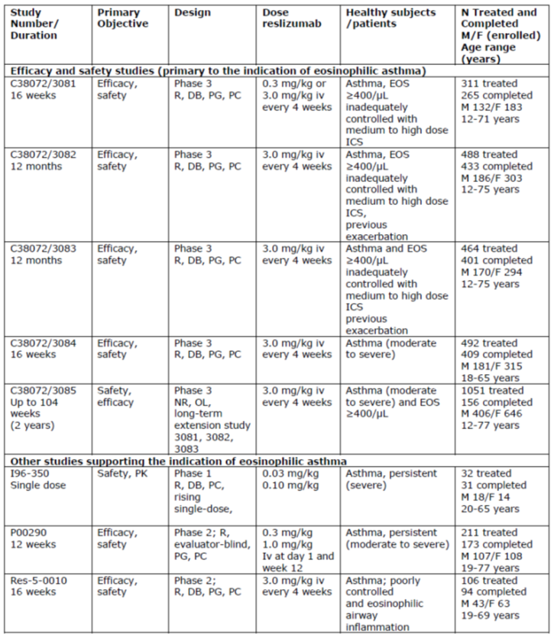

Table 1 (continued): Synopsis of studies within the clinical development program for reslizumab

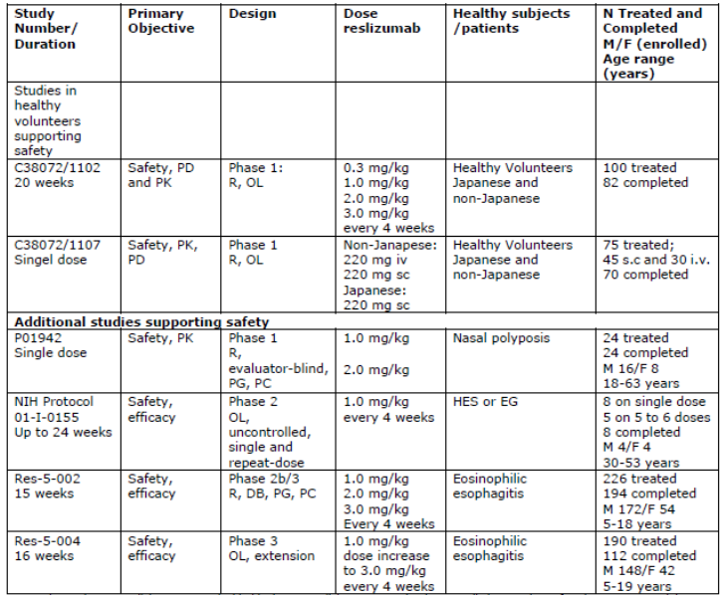

R = randomised; PG = parallel group; DB = double blind, PC = placebo controlled; OL = open label; M = male; F = female; EOS = eosinophils; NIH = National Institute of Health

### Pivotal or main efficacy studies

#### Study C38072/3081

##### Study design, objectives, locations and dates

This was a Phase III, multi-centre, randomised, double blind, placebo controlled, parallel group study to evaluate the efficacy and safety of reslizumab in patients with eosinophilic asthma. It was conducted at 68 centres in 12 countries (Israel and countries in America and Europe) between February 2011 and September 2013. The primary objective was to determine whether reslizumab 0.3 or 3.0 mg/kg IV once every 4 weeks for a total of 4 doses (16 weeks) is more effective than placebo in improving lung function in patients aged 12 years to 75 years with asthma with an eosinophilic phenotype (eosinophils ≥ 400/μL), as assessed by the overall change from Baseline in forced expiratory volume in 1 second (FEV1) over a 16 week treatment period. The study schematic is shown in Figure 1. A total of 315 patients were enrolled and the efficacy and safety analysis set included 311 (99%) patients. Eligible patients underwent baseline evaluations. Clinic visits were conducted at Weeks 4, 8, 12, 16 (or at early withdrawal, the end of treatment visit), and at the end of study visit, 90 (± 7) days after the end of treatment or early withdrawal, if not enrolled into the open label, long term Study C38072/3085. Throughout the study, the safety and tolerability of reslizumab was assessed by evaluating adverse events, clinical laboratory test results, vital signs measurements, 12-lead ECG findings, physical examination findings (including body weight), and concomitant medication usage.

###### Trial design

Figure 1: Study C38072/3081 schema

Figure 1: C38072/3081 schema
Screening (assesment) 2-4 weeks
Baseline assessment and randomisation:
12 week double blind treatment period reslizumab at 0.3 mg/kg every 4 weeks
12 week  double blind treatment period reslizumab at 3.0 mg/kg every 4 weeks
12 week  double blind treatment period placebo every 4 weeks

16 week end of treatment early withdrawal list
90 day (plus or minus 7) follow up visit (end of study



##### Inclusion and exclusion criteria

###### Main inclusion criteria

* 12 through 75 years of age
* previous diagnosis of asthma
* blood eosinophil count of at least 400/μL.
* Asthma Control Questionnaire (ACQ) score of at least 1.5
* airway reversibility of at least 12% to beta-agonist administration
* fluticasone at a dosage of at least 440 μg daily (or equivalent) that is at least a medium dose of fluticasone
* baseline asthma therapy regimens (including but not limited to ICS, leukotriene receptor antagonists (LTRA), 5-lipoxygenase inhibitors, cromolyn) must be stable for 30 days before screening, and continue without dosage changes throughout the study
* female patients must be surgically sterile, 2 years postmenopausal, or must have a negative pregnancy test βHCG at screening (serum) and baseline (urine)
* female patients of childbearing potential must use a medically accepted method of contraception and must agree to continue use of this method for the duration of the study and for 30 days after the end of treatment visit
* The patient is in reasonable health as judged by the investigator, and as determined by a medical history, medical examination, ECG evaluation, serum chemistry, haematology, urinalysis and serology.

###### Main exclusion criteria

* clinically meaningful comorbidity
* known hypereosinophilic syndrome
* another lung disorder/condition (for example, chronic obstructive pulmonary disease, pulmonary fibrosis, lung cancer, Churg-Strauss syndrome, allergic bronchopulmonary aspergillosis)
* current smoker
* use of systemic immunosuppressive, or immunomodulating agents (anti-IgE monoclonal antibody, methotrexate, cyclosporin, interferon-α, or anti-tumour necrosis factor monoclonal antibody) within 6 months prior to study entry
* currently using systemic corticosteroids (includes use of oral corticosteroids)
* aggravating factors that are inadequately controlled for example., gastroesophageal reflux disease
* previous treatment with anti-IL-5 monoclonal antibody (for example., mepolizumab)
* immunodeficiency (human immunodeficiency, acquired immunodeficiency syndrome, or congenital immunodeficiency)
* presence of or suspected active parasitic infestation or infection
* live attenuated vaccine within the 12 week period before study entry
* history of allergic reactions to or hypersensitivity to any component of the study drug.

##### Study treatments

Patients were administered reslizumab at a dosage of 0.3 mg/kg or 3.0 mg/kg or placebo intravenously at Baseline and once every 4 weeks over 16 weeks (4 doses in total). Baseline body weight was to have been used to determine dose throughout the study; therefore, rate and duration of infusion may have varied from patient to patient.

##### Efficacy variables and outcomes

The primary efficacy variable was the overall change from Baseline in FEV1 over 16 weeks of treatment.

Change from Baseline to Weeks 4, 8, 12, 16, and endpoint was measured for the following secondary efficacy variables:

* Asthma Control Questionnaire (ACQ) score
* Asthma Quality of Life Questionnaire (AQLQ) score from Baseline to Week 16 and endpoint
* lung function as measured by FVC
* lung function as measured by FEF 25% to 75%
* Asthma Symptom Utility Index (ASUI) score
* Short acting beta-agonist (SABA) use
* blood eosinophil count
* lung function as measured by % predicted FEV1

The ACQ is a 7 item validated instrument that measures asthma control (Juniper et al 1999). Six questions are self-assessments; the seventh item, completed by a member of the study staff, is the result of the patient’s FEV1 measurement. Each item has 7 possible answers on a scale of 0 to 6, and the total score is the mean of all responses. A higher score is an indication of poorer asthma control.

##### Randomisation and blinding methods

Eligible patients were randomly assigned in a 1:1:1 ratio via the Interactive Response Technology (IRT) to receive an infusion with reslizumab at 0.3 mg/kg, reslizumab at 3.0 mg/kg, or placebo every 4 weeks for 12 weeks. Patients and investigators remained blinded to treatment assignment during the study. Randomisation was stratified according to the occurrence of previous asthma exacerbations within the past 12 months (yes or no) and age (12 to 17 years or 18 years of age or older) at Baseline. To maintain the blinding in this 3 group study, each patient was to receive a specific volume of study drug (including active or placebo) on the basis of the patient’s body weight.

* reslizumab at 0.3 mg/kg: 0.03 mL/kg active drug (0.3 mg/kg drug) and 0.3 mL/kg placebo
* reslizumab at 3.0 mg/kg: 0.3 mL/kg active drug (3.0 mg/kg drug) and 0.03 mL/kg placebo
* placebo: 0.3 mL/kg placebo and 0.03 mL/kg placebo.

##### Analysis populations

The ITT population included all randomised patients who received at least one dose of study medication. The PP population included all patients in the ITT set who did not have pre-defined major protocol violations.

##### Sample size

The primary efficacy variable was the overall change from Baseline in FEV1. With 4 FEV1 monthly post baseline measurements in this study, the effect size was estimated to be 0.47. The effect size reflected an anticipated greater variability in the FEV1 change as the result of broader geographic enrolment than initially planned. A total of 300 patients (100 per group) would provide at least 90% power in this study to detect a difference between a reslizumab dose and placebo using a 2-sided t-test and by a mixed effect model for repeated measures (MMRM) simulation at the significance level 0.05. This sample size estimation assumed an equal effect size for both reslizumab doses. A hierarchical testing procedure was used to control the Type I error for the 2 comparisons using the primary efficacy variable.

##### Statistical methods

The primary variable was analysed using a MMRM with independent variables of treatment, visit, treatment by visit interaction, asthma exacerbations within the past 12 months (yes or no), baseline age (12 to 17 years or ≥ 18 years), sex, height and baseline FEV1. An unstructured covariance matrix was used for the within patient correlation modelling. The primary analysis was based on the full analysis dataset (FAS), including all randomised patients who were treated with at least one dose of study drug. The overall treatment effect for each reslizumab dose was compared to placebo using a 2-sided t test at the significance level of 0.05. A hierarchical testing procedure, in the order of reslizumab 3.0 mg/kg first and 0.3 mg/kg second, was used to control the Type I error rate for the two comparisons of reslizumab to placebo. To assess the robustness of the primary MMRM analysis, a sensitivity analysis was performed using the Multiple Imputation procedure.

Testing of the secondary variables was performed at 0.05 alpha level. No adjustment for multiplicity was applied, thus p-values are nominal.

##### Participant flow

A total of 315 subjects were enrolled in Study C38072/3081, and all but 4 subjects received at least one dose of study drug. Fifty (15.9%) discontinued from the study prematurely (Table 2). The most common reason for discontinuation from study drug treatment was adverse events, occurring in 17 (5%) subjects. Patient disposition for each study is shown below in Table 2.

Table 2: Patient Disposition (All Patients) in Study C38072/3081

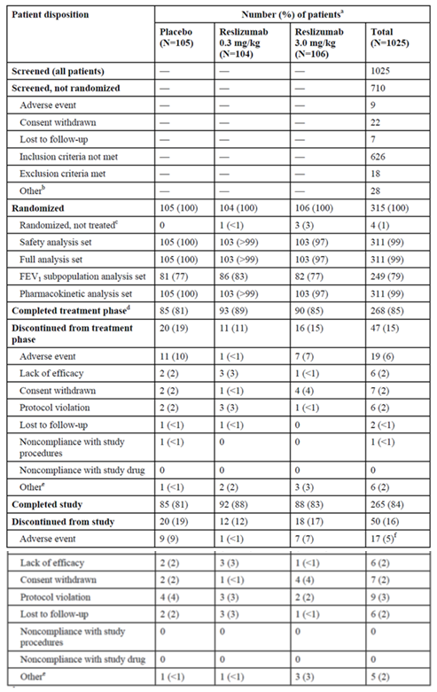Source: Study C38072/3081 Report Table 8 a. Percentages are based on the number of patients randomised

##### Major protocol violations/deviations

The most common types of violations were inclusion/exclusion screening violations (ACQ not ≥ 1.5), ‘GCP guidelines’ (wrong version of consent signed), ‘study drug’ (non-use of filter for the IV set-up), and ‘excluded concomitant medication’ (use of systemic corticosteroid). See Table 3.

A total of 65/315 (21%) patients randomly assigned to a treatment group had a protocol violation and 53 of these 65 patients (82%) were approved to continue in the study. In each case, the violations were reviewed and discussed among the medical monitors. A total of 11 of the 315 patients (3.5%) were discontinued from the study at the decision of the medical monitors due to protocol violations, 4 patients in the placebo treatment group, 3 patients in the 0.3 mg/kg reslizumab treatment group, and 4 patients in the 3.0 mg/kg reslizumab treatment group. The most frequent protocol violation leading to withdrawal was taking an excluded concomitant medication.

Table 3: StudyC38072/3081 Protocol violations (Randomised Patients)

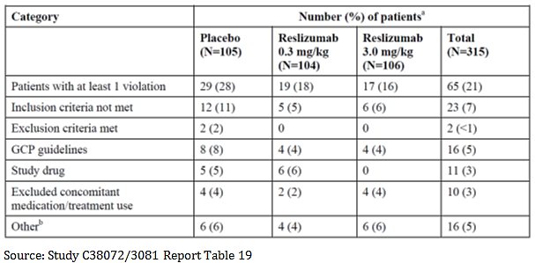

##### Baseline data

Selected demographic features for all randomised patients are shown in Table 4. In Study C38072/3081, subject demographics and baseline characteristics were generally balanced among the 3 treatment groups. The majority of subjects were female, White and of non-Hispanic or non-Latino ethnicity. The median age was 45 years with 15 (5%) subjects less than 18 years old. Most patients (78%) used a LABA in addition to ICS.

Table 4: Study C38072/3081 demographics

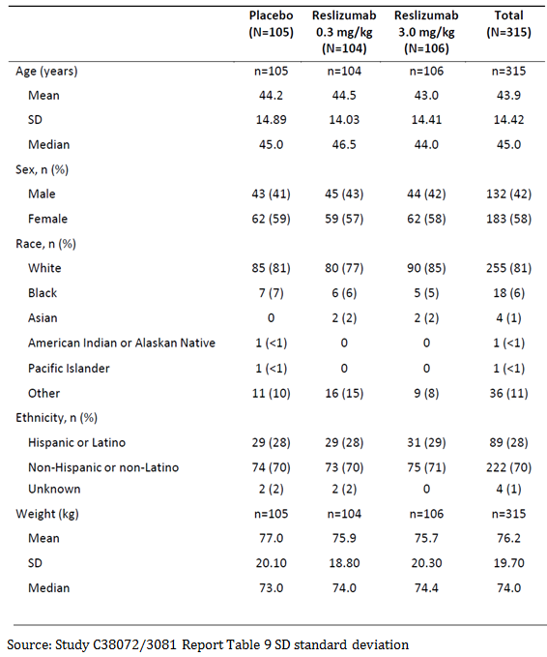

Table 5: Study C38072/3081 disease characteristics

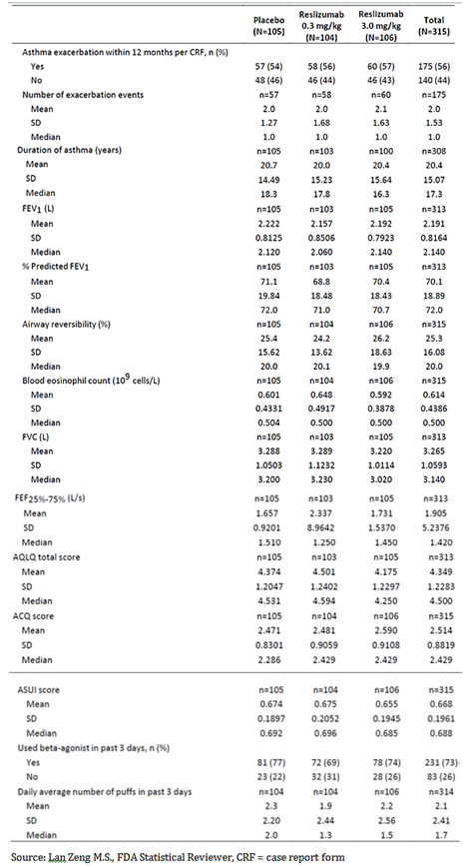

The overall randomised population means for percent predicted FEV1, ASUI score, AQLQ score, and ACQ score indicative of a population with inadequately controlled, moderate to severe asthma (Table 5).

##### Results for the primary efficacy outcome

The primary efficacy endpoint of this study was the overall change from Baseline in FEV1 over 16 weeks. Significant improvements in FEV1 were seen for patients in both reslizumab treatment groups compared with patients in the placebo treatment group; the overall change from Baseline in FEV1 was 0.126, 0.242, and 0.286 L for patients in the placebo, reslizumab 0.3 mg/kg, and reslizumab 3.0 mg/kg treatment groups, respectively. The overall treatment effect was larger for patients in the reslizumab 3.0 mg/kg treatment group (treatment difference = 0.160 L, p = 0.0018) than for patients in the reslizumab 0.3 mg/kg treatment group (treatment difference = 0.115 L, p = 0.02).

Results from sensitivity analyses that included all FEV1 measurements without exclusions for concomitant medication were consistent with the primary analyses. Likewise, the statistically significant improvement in FEV1 was supported for the reslizumab 3.0 mg/kg group with other measures of pulmonary function, including FVC, FEF25%-75%, and % predicted FEV1. No treatment effect on FVC and FEF25%-75% was observed for patients in the reslizumab 0.3 mg/kg treatment group.

Figure 2: Mean change from Baseline (± standard error) in FEV1 to each visit and endpoint, Study C38072/3081

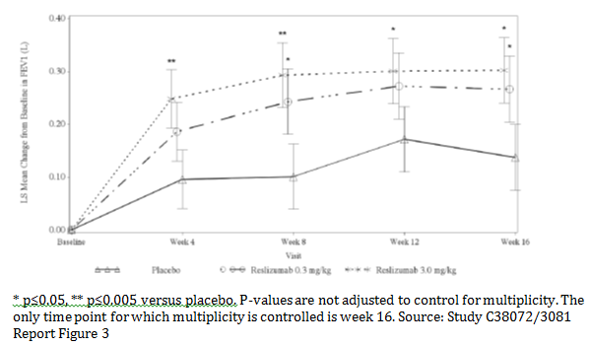

##### Results for other efficacy outcomes

Improvements in ACQ and AQLQ scores, decreases in frequency of SABA use, and decreases in blood eosinophils were seen for patients in the reslizumab treatment groups. Except for asthma symptom score and SABA use, the changes from Baseline in each of these endpoints were more consistent and larger for the reslizumab 3.0 mg/kg treatment group compared with the reslizumab 0.3 mg/kg treatment group. None of these comparisons was controlled for multiplicity; hence, p-values were nominal.

The adolescent subgroup (n = 15) was deemed too small to inform a meaningful analysis of efficacy.

Table 6: Secondary endpoints in Study C38072/3081 (Full Analysis Set with all measurements included)

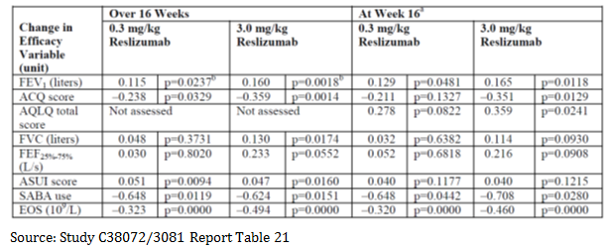

* 1. As noted in the Statistical Analysis Plan, the primary efficacy variable for this study is the overall change from Baseline in FEV1 over the 16 week treatment period. The change from Baseline in FEV1 at 16 weeks is also presented in this table to satisfy a health authority request.
  2. Primary analysis.

Note: The Full Analysis Set, by definition, censured those data that were preceded by usage within 7 days of a limited subset of medications that could significantly confound interpretation of the efficacy parameters. These medications included 1) oral or systemic corticosteroids or 2) the addition of a LABA or a long acting muscarinic-antagonist (LAMA) if not taken at Baseline, and affected 76 observations among 2 patients during a single clinic visit. This had no effect on overall results based on sensitivity analyses that considered all data.

#### Study ID – Pivotal Studies C38072/3082 and C38072/3083.

##### Study design, objectives, locations and dates

Studies C38072/3082 and C38072/3083 were conducted concurrently with each other and with Study C38072/3081. As noted earlier, this timeline precluded use of dose-ranging data from Study C38072/3081 to inform dose selection for Studies C38072/3082 and C38072/3083. Since Studies C38072/3082 and C38072/3083 were nearly identical, their design and results will be described together with any pertinent differences noted. Both studies were titled ‘A 12 month, double blind, placebo controlled, parallel group study to evaluate the efficacy and safety of reslizumab (3.0 mg/kg) in the reduction of clinical asthma exacerbations in patients (12-75 Years of Age) With Eosinophilic Asthma.’

Studies C38072/3082 and C38072/3083 were Phase III, multicentre, randomised, double blind, placebo controlled, parallel group studies to evaluate the efficacy, safety, and immunogenicity of treatment with reslizumab, at a dosage of 3.0 mg/kg administered IV once every 4 weeks relative to Baseline, in asthma patients (12 through 75 years of age) with an eosinophilic phenotype. The studies consisted of a 2 to 4 week screening period and a 52 week treatment period, including a final evaluation at Week 52 (end of treatment visit; 4 weeks after the final infusion at Week 48). After the end of treatment visit, patients enrolled in an available open label, long term study (Study C38072/3085) or returned for an assessment 90 (± 7) days after their end of treatment visit. Study C38072/3082 was conducted at 102 centres in 17 countries (countries in America, Europe and the Asia-Pacific region) between April 2011 and March 2014. Study C38072/3083 was conducted at 82 study centres in 15 countries between March 2011 and April 2014.

Figure 3: Studies C38072/3082 and C38072/3083 schema

Figure 3: Studies C38072/3082 and C38072/3083 schema
Screeniong assesments 2 to 4 weeks
Baseline assessmnts and randomisation
52-week double blind treatment period reslizumab 3.0 mg/kg every 4 weeks realtive to baseline
52 week double blind treatment period placebo every 4 weeks relative to baseline
52 week end of treatment of early withdrawal visit
90 day follow up visit
(if not enterinf the open-label study after the end of treatment visit)

##### Inclusion and exclusion criteria

###### Main inclusion criteria

* 12 to 75 years of age
* prior diagnosis of asthma
* at least 1 asthma exacerbation in the past 12 months requiring treatment with a systemic corticosteroid
* a blood eosinophil count of at least 400/μL
* an ACQ score of at least 1.5 at screening and baseline
* airway reversibility of at least 12% after short acting beta agonist administration
* fluticasone at a dosage of at least 440 μg daily (or equivalent)
* female patients must be surgically sterile, 2 years postmenopausal, or must have a negative pregnancy test βHCG at screening (serum) and baseline (urine)
* female patients of childbearing potential must use a medically accepted method of contraception and must agree to continue use of this method for the duration of the study and for 30 days after the end of treatment visit
* the patient is in reasonable health as judged by the investigator, and as determined by a medical history, medical examination, ECG evaluation, serum chemistry, haematology and urinalysis.

###### Main exclusion criteria

* exacerbation during or within 4 weeks before screening period (could be rescreened once only)
* known hypereosinophilic syndrome
* another lung disorder (for example., chronic obstructive pulmonary disease, pulmonary fibrosis, or lung cancer, Churg-Strauss syndrome, allergic bronchopulmonary aspergillosis)
* current smoker
* use of systemic immunosuppressive, or immunomodulating agents (anti-IgE monoclonal antibody, methotrexate, cyclosporin, interferon-α, or anti-tumour necrosis factor monoclonal antibody) within 6 months prior to study entry
* aggravating factors that are inadequately controlled for example, gastroesophageal reflux disease
* previous treatment with anti-IL-5 monoclonal antibody (for example, mepolizumab)
* immunodeficiency (human immunodeficiency, acquired immunodeficiency syndrome, or congenital immunodeficiency)
* active parasitic infection within 6 months prior to screening
* exposure to water-born parasites within 6 weeks prior to screening
* diarrhoeal illness of undetermined aetiology within 3 months prior to screening
* live attenuated vaccine within the 12 week period before study entry
* history of allergic reactions to or hypersensitivity to any component of the study drug
* infection requiring hospitalisation for at least 24 hours, or IV or oral antibiotics within 4 weeks prior to screening or during the screening period.

##### Study treatments

Reslizumab was provided as a sterile solution for infusion presented as 100 mg (10 mL) per vial, formulated at 10 mg/mL in sodium acetate, sucrose. Placebo was provided as a sterile solution for infusion presented as 10 mL per vial, formulated in sodium acetate, sucrose, and was used in a manner identical to that of reslizumab. Patients were administered reslizumab intravenously over 15 to 30 minutes at a dosage of 3.0 mg/kg or placebo at Baseline and once every 4 weeks relative to Baseline over 48 weeks.

##### Efficacy variables and outcomes

###### Primary

Frequency of asthma exacerbations per patient during the 52 week treatment period.

An event was described as an exacerbation if the patient met at least one of the 2 criteria listed below, corroborated with at least one other measurement to indicate the worsening of clinical signs and symptoms of asthma:

1. use of systemic (oral, iv, or intramuscular), or an increase in the use of inhaled corticosteroid treatment, for 3 or more days. (For patients already being treated with systemic or inhaled corticosteroids, the dose of corticosteroids will need to be increased 2 or more fold for at least 3 or more days.)

and/or

1. asthma-related emergency treatment including at least one of the following:
   * an unscheduled visit to the physician’s office for nebulizer treatment or other urgent
   * treatment to prevent worsening of asthma symptoms
   * a visit to the emergency room for asthma related treatment
   * asthma-related hospitalisation

The above criteria need to be corroborated with at least one other measurement to indicate worsening in clinical signs and symptoms of asthma as follows:

* decrease in FEV1 by 20% or more from Baseline
* decrease in Peak Expiratory Flow Rate (PEFR) by 30% or more from Baseline on 2
* consecutive days
* worsening of symptoms or other clinical signs per physician evaluation of the event

###### Secondary

1. FEV1: change from Baseline to Week 16
2. FEV1: overall change from Baseline over 16 weeks
3. AQLQ: change from Baseline to Week 16
4. ACQ: overall change from Baseline over 16 weeks
5. Time to first clinical asthma exacerbation (CAE)
6. ASUI: overall change from Baseline over 16 weeks
7. SABA use: overall change from Baseline over 16 weeks
8. Blood eosinophils: overall change from Baseline over 16 weeks and 52 weeks

##### Randomisation and blinding methods

Patients were randomly assigned in a double blind fashion to reslizumab or matching placebo (1:1 ratio) via IRT at the baseline visit. In order to maintain the blinding, each patient received a specific volume of reslizumab or placebo solution determined by the patient’s body weight. Randomisation was stratified by oral corticosteroid use (yes or no) at study enrolment and by region (U.S. or other).

##### Analysis population

The ITT population included all randomised patients who received at least one dose of study medication. The PP population included all patients in the ITT set who did not have pre-defined major protocol violations.

##### Sample size

A total of 460 patients, 230 patients per group, provided approximately 90% power at the significance level 0.05 to detect a 33% reduction in CAE rate by reslizumab as compared with placebo. This power estimate was based on computer simulations with data generated from the negative binomial (NB) distributions. If the actual CAE rate was higher than the assumption, the sample size would provide a higher power to detect the same treatment effect. This estimate took into account a maximum 10% false positive rate for the blood eosinophil test at enrolment and a 5% dropout rate in both groups.

For the Study C38072/3082, 480 patients (240 patients per treatment group) were planned to be enrolled. For the Study C38072/3083, 460 patients (230 patients per treatment group) were planned to be enrolled.

##### Statistical methods

###### Analysis sets

Randomised set

All patients who were randomly assigned to a treatment group at enrolment, regardless of whether or not a patient received any study drug. The set of randomised patients was used for all study population summaries and efficacy analyses unless otherwise noted.

Safety analysis set

All patients who received at least 1 dose of study drug. The safety analysis set was used for all safety analyses unless otherwise noted.

Full analysis set (FAS)

Includes all randomised patients who were treated with at least 1 dose of study drug.

Data from assessments of pulmonary function, SABA use, and the ACQ, AQLQ, and ASUI at a scheduled visit were excluded from the FAS if the assessments were preceded by usage within 7 days of a limited subset of medications that could significantly confound interpretation of the efficacy parameters at the visit. These medications included the addition of a LABA, a long acting muscarinic antagonist (LAMA), or an oral or systemic corticosteroid, if not taken at Baseline. If taken at Baseline, an increase in a chronic, maintenance dose of the oral or systemic corticosteroid was included.

The FEV1 subpopulation analysis set

Includes all patients in the FAS with % predicted FEV1 ≤ 85% at Baseline.

##### Statistical analyses

###### Primary endpoint; Frequency of clinical asthma exacerbations

Clinical asthma exacerbations that occurred between the completion of the first dose of study drug and 2 weeks after the end of treatment (Week 52 or early withdrawal visit) were counted towards the CAEs for analysis. The frequency of CAEs was analysed using the generalised linear model (GLM) for data from the negative binomial distributions that is commonly referred to as the negative binomial (NB) regression model. The primary NB model included the treatment group and randomisation stratification factors (baseline usage of oral corticosteroid (yes or no) and geographical region (U.S. or other)) as model factors and the logarithm of follow up time excluding the summed duration of CAE events as an offset variable. This offset variable adjusted the CAE rate for total duration of patient exposure to study drug when not experiencing a CAE. The ratio of CAE rate between the treatment groups and its 95% confidence interval (CI) were estimated from the NB model. Treatment effect was tested using the likelihood based Chi-square test at the 0.05 significance level. The primary analysis of CAEs was based on the adjudicated data.

Sensitivity analyses for primary endpoint

A low dropout rate in this study was anticipated (< 5%) because all patients maintained their background therapies throughout the study. The primary analysis model was unbiased if the missing data mechanism appeared to be random. To assess the robustness of the primary analysis model, a sensitivity analysis was performed using a multiple imputation procedure for missing data (Little and Rubin 2002). This analysis imputed values for CAE and exposure for patients who withdrew early from treatment.

Secondary analyses of the primary efficacy variable

Secondary analyses of the primary efficacy variable included the frequency of CAEs requiring courses of systemic corticosteroids (oral or parenteral) prescribed for 3 or more days. The frequency of asthma exacerbations resulting in hospitalisation or a visit to the emergency room was also analysed. These variables were analysed similarly to the primary efficacy variable.

###### Secondary and other efficacy variable analyses

Secondary endpoints were analysed using a MMRM with treatment group, visit, treatment and visit interaction, and stratification factors as fixed effects and patient as a random effect. Covariates for baseline values were also included in the model; for pulmonary function test analyses, covariates for height and sex were included as well.

The Kaplan-Meier method was used to estimate and compare the distributions of time to CAE between reslizumab and placebo. The hazard ratio and p-value were estimated using the stratified Cox regression model.

Analysis of the change from Baseline to endpoint in pulmonary function tests was performed using an analysis of covariance (ANCOVA) model with fixed effects for treatment, oral corticosteroids use at enrolment (yes or no), region (U.S. or other), sex, and covariates for height and baseline value. Analysis of the change in AQLQ score from Baseline to endpoint was performed using the same ANCOVA model as for pulmonary function tests with the exception of inclusion of sex and height in the model. The stratified Cochran-Mantel-Haenszel test was used to analyse the proportion of patients achieving at least a 0.5 reduction from Baseline in ACQ score and the proportion of patients achieving at least a 0.5 improvement from Baseline in AQLQ score.

###### Multiple comparisons and multiplicity

A pre-specified, fixed sequence multiple testing procedure was implemented to test the primary and secondary efficacy variables while controlling the overall Type I error rate at 0.05. At the point where p > 0.05, no further comparisons were interpreted inferentially.

Results of testing the frequency of CAEs specifically requiring systemic corticosteroids could be interpreted inferentially at an alpha level of 0.05 provided that results of all tests for secondary variables were significant.

No multiplicity adjustments were made for other efficacy variable and exploratory efficacy variable analyses.

##### Participant flow

Most randomised patients completed the studies (86% to 89%)(Table 7). Reasons for withdrawal were comparable between treatment groups; the main reason being withdrawal of consent. Withdrawal due to adverse events was low (2% to 4%).

Table 7: Patient disposition by treatment group (Studies C38072/3082 and C38072/3083, all patients)

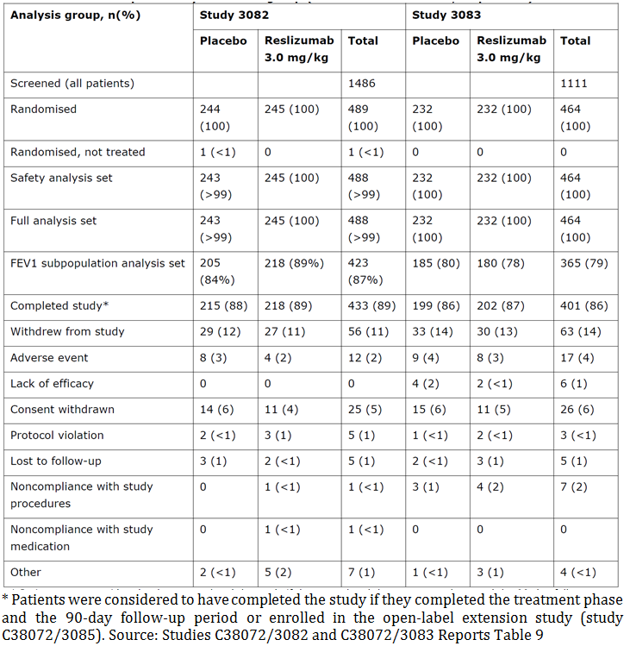

##### Major protocol violations/deviations

Table 8: Studies C38072/3082 and C38072/3083 protocol violations

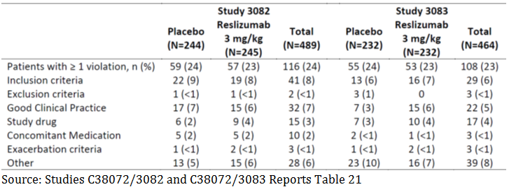

The most common inclusion or exclusion criterion violations were an ACQ score less than 1.5 at the screening and/or baseline visits and a change in the patient’s baseline asthma therapy regimen. The most common GCP violations were some physical exam categories not documented, signing of the wrong version of the informed consent form and reporting of a serious adverse event to the sponsor more than 24 hours after the investigator became aware of the event and/or reporting of a serious adverse event to the ethics committee after the reporting period mandated by local regulations.

##### Baseline data

Selected demographic features for all randomised patients are shown in Table 9 below. Within each study, subject demographics and baseline characteristics generally were balanced among the 2 treatment groups. The majority of subjects were female, White and of non-Hispanic or non-Latino ethnicity. Aboriginals were not mentioned in both studies. The median age was 48 years in both studies.

The number of adolescents and elderly included is limited (about 5%). Only few patients were included in the age group 12 to 17 years (n = 11 on placebo and n = 14 on reslizumab) which precludes a meaningful interpretation and adolescents are currently not included in the indication. The number of elderly patients was limited (≥ 65 years: n = 77) as can be expected for an asthmatic population.

At least 82% of randomised patients in either treatment group used LABAs at Baseline, either separately with ICS or in combination with ICSs. 22% of patients used LTRAs at Baseline. 15% of randomised patients in either treatment group used OCSs at Baseline.

Approximately 25% of patients were using high dose ICS with a LABA, and approximately 40% of patients on an ICS without a LABA were on a high dose of an ICS formulation based on GINA 2014 categories.

The overall randomised population means for percent predicted FEV1, ASUI score, AQLQ score, and ACQ score are indicative of a not well controlled, moderate to severe asthma population.

Table 9: Studies C38072/3082 and C38072/3083 demographics

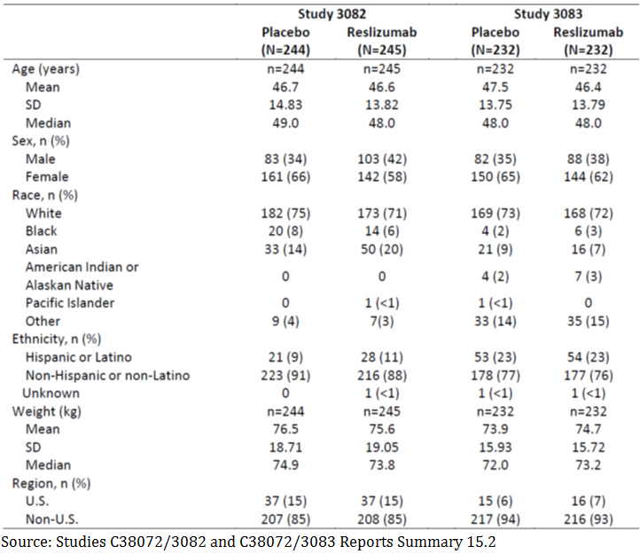

##### Results for the primary efficacy outcome

The primary efficacy assessment for both studies was based on the frequency of asthma exacerbations for each patient during the 52 week treatment period. Results are shown in Table 10. Compared to placebo, the mean rate of asthma exacerbation was statistically significantly reduced among patients administered reslizumab in both studies. The point estimate for exacerbation rate ranged from 0.86 to 0.90 per year in reslizumab treated patients versus 1.80 to 2.11 per year in placebo patients. The overall reduction was 54% (RR: 0.46, 95% CI 0.37, 0.58) for the total population based on the integrated data from Studies C38072/3082 and C38072/3083. The proportion of patients who did not experience an asthma exacerbation during the entire treatment period was higher in the reslizumab group (63% and 75%) compared with the placebo group (46% and 55%), in Studies C38072/3082 and C38072/3083, respectively.

Table 10: Studies C38072/3082 and C38072/3083 asthma exacerbation rates

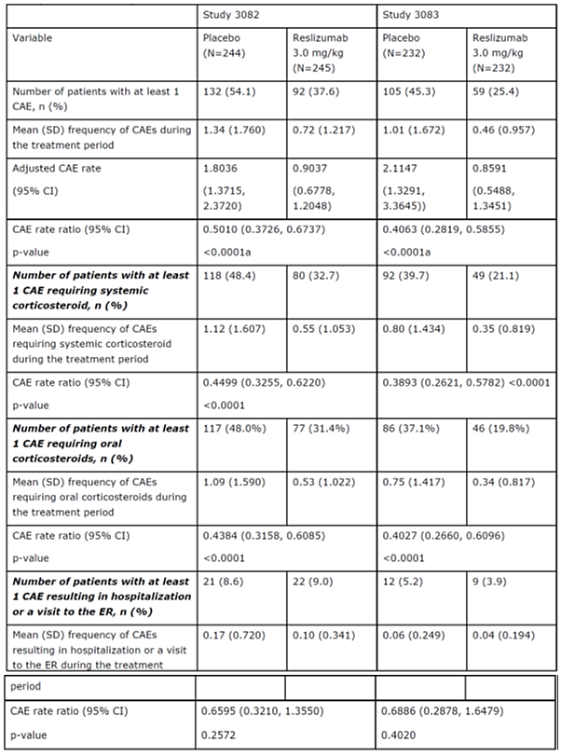

a) This treatment group comparison was controlled for Type I error. Notes: The CAEs counted were those that occurred between the completion of the first dose of study drug and 2 weeks after the end of treatment/early withdrawal visit. Adjusted CAE rates and CIs, CAE rate ratios and CIs, and p-values were based on NB regression model adjusted for stratification factors (baseline usage of OCS (yes or no) and geographical region (US or other)). Source: Studies C38072/3082 and C38072/3083 Reports Table 27

###### Subgroups

The frequency of CAEs over 52 weeks in the Integrated 52 Week Population was analysed by age group, sex, race, geographical region, anti-drug antibody (ADA) results, OCS use at Baseline, LABA use at Baseline, and LTRA use at Baseline.

Age

The reslizumab versus placebo CAE rate ratio for patients aged 12 to 17 years was 2.09, suggesting that reslizumab did not reduce the frequency of CAEs over the 52 week treatment period in this age group. The small number of patients in this youngest age group (3% of the Integrated 52 Week Population), however, limits conclusions that can be drawn from these data.

Gender

Similar rates of CAEs were seen in men and women over the 52 week treatment period; the rate of CAE events in reslizumab 3.0 mg/kg treated men and women was 53% and 54% lower, respectively, compared with placebo treated men and women.

Race

A treatment effect was observed in White patients (CAE rate ratio = 0.41) and Asian patients (CAE rate ratio = 0.32). The reslizumab versus placebo CAE rate ratio in Black patients and patients of other races was 1.20 and 0.96, respectively, suggesting that reslizumab did not reduce the rate of CAEs in patients in these race groups. This result was not considered indicative of a lack of effect in Black patients or patients of other races, but rather, of limited power to detect CAEs due to small number patients in each subgroup; 5% of patients in the Integrated 52 Week Population were Black, and 10% of patients in the Integrated 52 Week Population were other races.

Geographical region

The rate of CAEs in reslizumab 3.0 mg/kg treated patients was lower compared with placebo treated patients in Europe (CAE rate ratio = 0.29) and other regions (CAE rate ratio = 0.49). The reslizumab versus placebo CAE rate ratio in patients in the U.S. was 1.13, suggesting that reslizumab did not reduce the rate of CAEs in patients in enrolled in this geographic region. However, the background exacerbation rate in patients in the U.S. was lower than expected (CAE rate = 0.83) limiting the ability to detect an effect on exacerbations, and the number of patients enrolled in the U.S. was relatively small (11% of the Integrated 52 Week Population).

ADA results

A total of 23 patients (5%) out of the 477 patients in the Integrated 52 Week Population who received reslizumab 3.0 mg/kg had a positive post-baseline ADA status result. It is not possible to interpret the effect of the development of ADAs on efficacy (that is, frequency of CAEs over 52 weeks) given the small number of patients with positive ADA results.

OCS use at baseline

The rates of CAEs in reslizumab 3.0 mg/kg treated patients were reduced by 68% in patients with baseline OCS use and 50% in patients without OCS use compared with placebo treated patients.

LABA use at baseline

A treatment effect of similar magnitude to the overall population was seen in patients with baseline LABA use and patients without baseline LABA use; the reslizumab versus placebo CAE rate ratio in patients with baseline LABA use was 0.45 (that is, a 55% rate reduction compared with the placebo treatment group), and the CAE rate ratio in patients without baseline LABA use was 0.51 (that is, a 49% rate reduction compared with the placebo treatment group).

LTRA use at baseline

The treatment effect was larger in patients who were using an LTRA at Baseline (69% versus 42%). The more pronounced effect of reslizumab in the presence of a concomitant LTRA may indicate that it is a marker of asthma severity (that is, a patient who is using multiple controller concomitant medications) or possibly a marker of patients with asthma with allergic rhinosinusitis/nasal polyposis (where LTRAs may also be used).

##### Results for other efficacy outcomes

Efficacy was seen at the first time point (Week 4 for FEV1, ACQ and ASUI; Week 16 for AQLQ) and sustained over time. No significant effect was seen on use of short acting beta-agonist therapy over 16 weeks. Treatment effects on FEV1 increase were observed at the first observation period of 4 weeks and were sustained throughout the study. There was a statistically significant improvement compared to placebo; the treatment difference was 0.126 L and 0.093 L, respectively. Statistical significant improvements were also seen for other measures of asthma control based on the overall score (AQLQ, ACQ and ASUI). At the same time, the proportion of responders (minimal of ≥ 0.5 point improvement ACQ or AQLQ) was increased compared to placebo. For instance, the proportion of ACQ responders in the reslizumab 3.0 mg/kg and placebo groups was 77% and 64% (p = 0.0022) at Week 52, respectively in Study C38072/3082. Corresponding data for Study C38072/3083 were 81% and 62% (p = < 0.0001) at Week 52 in the reslizumab and placebo group, respectively. These outcome changes are clinically significant.

Table 11: Secondary efficacy endpoints by treatment group (Integrated 52 week population, randomised set)

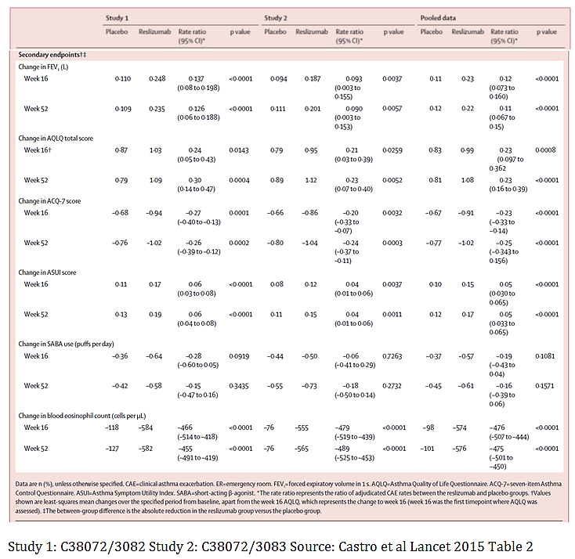

###### Subgroups

Overall change from Baseline in FEV1 and change from Baseline in FEV1 at 52 weeks in the Integrated 52 Week Population were analysed by age group, sex, race, geographical region, ADA result, OCS use at Baseline, LABA use at Baseline, and LTRA use at Baseline.

Of note, although the rate of CAEs in patients aged 12 to 17 years was not reduced with reslizumab treatment, lung function improvements with reslizumab treatment were evident in this subgroup, indicating that this subgroup was reslizumab responsive.

Although the rate of CAEs in Black patients and patients of other races was not reduced with reslizumab treatment, lung function improvements with reslizumab treatment were evident in both of these subgroups, indicating that these subgroups were reslizumab responsive.

Although the rate of CAEs in patients enrolled in the U.S. was not reduced with reslizumab treatment, patients enrolled in the U.S. did demonstrate the expected lung function improvements with reslizumab treatment, indicating that this subgroup was reslizumab responsive.

#### Study C38072/3084; Moderate to severe asthma, unselected for blood eosinophil levels

##### Study design, objectives, locations and dates

This was a Phase III, multi-centre, randomised, double blind, placebo controlled study to evaluate the efficacy of reslizumab in patients with moderate to severe asthma. Patients were unselected for blood eosinophil level. It was conducted at 103 centres in in the U.S. between February 2012 and August 2013. The primary objective was to characterise the efficacy of reslizumab treatment, at a dosage of 3.0 mg/kg every 4 weeks for a total of 4 doses, in improving pulmonary function in relation to baseline blood eosinophil levels in patients with moderate to severe asthma, as assessed by the change from Baseline to Week 16 in forced expiratory volume in 1 second (FEV1).

The study schematic is shown in Figure 4. A total of 496 patients were randomised and analysed for efficacy and safety. Eligible patients underwent baseline evaluations. Clinic visits were conducted at Weeks 4, 8, 12, 16 (the end-of treatment visit) or at early withdrawal, and approximately 12 weeks after the end-of treatment visit or at early withdrawal. Throughout the study, the safety and tolerability of reslizumab was assessed by evaluating adverse events, clinical laboratory test results, vital signs measurements, 12 lead ECG findings, physical examination findings and concomitant medication usage. Anti-reslizumab antibody assessment was obtained for evaluation of immunogenicity at specified time points throughout the study.

Figure 4: Study C38072/3084 schema

Figure 4: C38072/3084 schema
Screening (assessment)
Baseline ( assessment and randomization)
16 week double blind treatment period reslizumab at 3.0 mg/kg once every 4 weeks
16 week double blind treatment period placebo once every 4 weeks
end of treatment visit at week 16 (ie 4 weeks plus or minus 7 days after last dose of study drug early withdrawal visit
12 week  plus or minus 7 days  follow up visit (end of study)

##### Inclusion and exclusion criteria

###### Main inclusion criteria

* 18 through 65 years of age
* diagnosis of asthma
* ACQ score of at least 1.5
* airway reversibility of at least 12% to beta-agonist
* fluticasone at a dosage of at least 440 μg daily (or equivalent)
* baseline asthma therapy regimens (including, but not limited to, ICS, LTRA, 5-lipoxygenase inhibitors, cromolyn) must have been stable for 30 days before screening and were expected to continue without dosage changes throughout study
* female patients must have been surgically sterile, 2 years postmenopausal, or must have had a negative βHCG result for a pregnancy test at screening (serum) and baseline (urine)
* female patients of childbearing potential must have used a medically accepted method of contraception
* the patient is in reasonable health as judged by the investigator, and as determined by a medical history, medical examination, ECG evaluation, serum chemistry, haematology, urinalysis, and serology.

###### Main exclusion criteria

* clinically meaningful comorbidity
* known hypereosinophilic syndrome
* another lung disorder (for example., chronic obstructive pulmonary disease, pulmonary fibrosis or lung cancer, Churg-Strauss syndrome, allergic bronchopulmonary aspergillosis)
* current smoker
* use of systemic immunosuppressive, or immunomodulating agents (anti-IgE mAb, methotrexate, cyclosporin, interferon-α, or anti-tumour necrosis factor mAb) within 6 months prior to study entry
* currently using systemic corticosteroids (includes use of oral corticosteroids)
* aggravating factors that are inadequately controlled for example., gastroesophageal reflux disease
* previous treatment with anti-IL-5 mAb (for example., mepolizumab)
* immunodeficiency (human immunodeficiency, acquired immunodeficiency syndrome, or congenital immunodeficiency)
* presence of or suspected active parasitic infestation/ infection
* live attenuated vaccine within the 12 week period before study entry
* history of allergic reactions or hypersensitivity to any component of the study drug.

##### Study treatments

Patients were administered reslizumab at a dosage of 3.0 mg/kg or placebo intravenously at Baseline and once every 4 weeks over 16 weeks (4 doses in total). Baseline body weight was to have been used to determine dose throughout the study; therefore, rate and duration of infusion may have varied from patient to patient.

##### Efficacy variables and outcomes

###### Primary

FEV1: change from Baseline to Week 16

###### Key Secondary

* FEV1: change from Baseline over 16 weeks
* ACQ: change from Baseline over 16 weeks

###### Other Secondary

* ACQ: change from Baseline to the planned time points or endpoint
* FEV1, % predicted FEV1, FVC, and FEF25%-75%: change from Baseline to the planned time points or endpoint
* SABA: change from Baseline to the planned time points or endpoint
* Blood eosinophil count: change from Baseline (measured at screening) to the planned time points or endpoint.

##### Randomisation and blinding methods

Eligible patients were randomly assigned (1:4) via IRT in a double blind fashion to receive an infusion of placebo or reslizumab (3.0 mg/kg) every 4 weeks for 12 weeks. Patients and investigators remained blinded to treatment assignment during the study. Blinding to eosinophil counts during the study was maintained. Randomisation was stratified according to the occurrence of previous asthma exacerbations within the past 12 months (yes or no). An asthma exacerbation was defined by 1 of the following:

1. a reduction in FEV1 of 20% or greater
2. a hospitalisation because of asthma
3. emergency treatment because of asthma, or
4. use of prednisone or systemic corticosteroids for 3 days or more.

##### Analysis populations

The ITT population included all randomised patients who received at least one dose of study medication. The PP population included all patients in the ITT set who did not have pre-defined major protocol violations.

##### Sample size

A total of 400 patients in the reslizumab treatment group would be required to provide 90% power to detect a regression slope b ≥ 0.195, assuming SDx of ≥ 0.25 and SDe of ≤ 0.30 using the t-test with a 0.05 2-sided significance level. A 4:1 randomisation ratio, was used to minimise exposure to placebo while providing a sizeable placebo treatment group that was likely to cover the full spectrum of baseline blood eosinophil levels. Therefore, approximately 500 patients were to be randomly assigned to treatment, with 400 in the reslizumab treatment group and 100 in the placebo treatment group.

**Comment:** In Study Res-5-0010, which was conducted in patients with asthma and sputum eosinophils of 3% or more at enrolment, the SD for baseline blood eosinophil level (SDx) was estimated as 0.20, and the SD for the random error in change in FEV1 at Week 16 (SDe) was estimated as 0.24. In another asthma study (Study CP00290) that did not require a specific eosinophil level for enrolment, SDx was estimated as 0.25; SDe could not be referenced, because the reslizumab dosage and administration schedule in Study P00290 were different from those in this study.

##### Statistical methods

The analysis for the primary endpoint was a linear regression model to test the treatment by baseline blood eosinophil count interaction. The dependent variable was defined as change from Baseline in FEV1 at Week 16. Factors in the model were treatment, blood eosinophil count at Baseline, and treatment by eosinophil count interaction. Interaction was tested at the 0.10 level using the full analysis set including all randomised patients who received at least one dose of study drug.

For key secondary endpoints, a MMRM was planned. The dependent variable was defined as FEV1 or ACQ change from Baseline over 16 weeks. Factors included in the model were treatment, visit, and treatment by visit interaction, asthma exacerbation in the previous 12 months (yes or no), sex, height, and respective baseline value.

For both primary and key secondary endpoints, summary statistics were also provided by treatment group and baseline eosinophils category (≥ 0.4 x 109/L, < 0.4 x 109/L, ≥ 0.3 x 109/L, < 0.3 x 109/L, ≥ 0.2 x 109/L, < 0.2 x 109/L, ≥ 0.1 x 109/L, and < 0.1 x 109/L). Analysis of other secondary endpoints was performed using the same mixed model for repeated measures as that for key secondary endpoint.

A fixed sequence step-down multiple testing procedure was implemented to test the primary and key secondary variables. If the resulting 2-sided p-value for the primary comparison was significant at level 0.10, then the procedure continued to test sequentially key secondary variables in the order specified (FEV1 followed by ACQ) at the alpha level 0.05. If the key secondary variables were significant, then the secondary analysis of the primary variable (by baseline eosinophils category ≥ 0.4 x 109/L) was performed at significance level of 0.10 and interpreted inferentially.

##### Participant flow

In the study 496 patients with moderate to severe asthma were randomly assigned (398 patients in the 3.0 mg/kg reslizumab treatment group and 98 patients in the placebo treatment group); 492 (> 99%) patients received at least 1 dose of study drug and were included in the safety analysis set and evaluable for safety (4 patients withdrew before taking any study drug); 492 (> 99%) patients were included in the FAS and evaluable for efficacy; and 409 (82%) patients completed the study. 74 (15%) subjects stopped study medication early and 87 (18%) discontinued from the study prematurely. The most common reason for discontinuation from study drug treatment was adverse events, occurring in 44 (9%) subjects. Patient disposition for Study C38072/3084 is shown in Table 12.

Figure 5: Study C38072/3084 disposition

Figure 5: Study C38072/3084 disposition
869 patients screened
358 screened but not enrolled/randomised
496 (100%) patients enrolled randomized:
Placebo 98 (97 evaluable for safety and efficacy FEV1 subpopulation 91
rezlizumab 398 395 evaluable for safety and efficicay
FEV1 subpopulation 346



Table 12: Disposition of patients

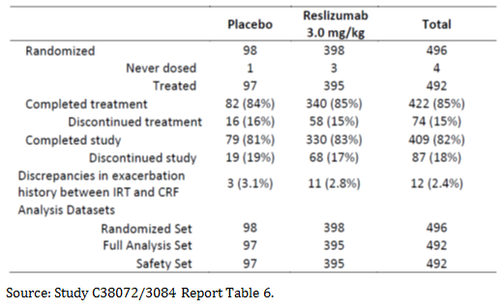

##### Major protocol violations/deviations

A total of 21 patients discontinued from the study due to protocol violations, 6 (6%) patients in the placebo treatment group and 15 (4%) patients in the reslizumab group. The most frequent protocol violations leading to discontinuation was taking an excluded medication.

The incidence of protocol violations that did not lead to discontinuation was comparable for the placebo (20 out of 26, 77%) and the reslizumab treatment group (67 out of 81, 83%).

Table 13: Protocol violations

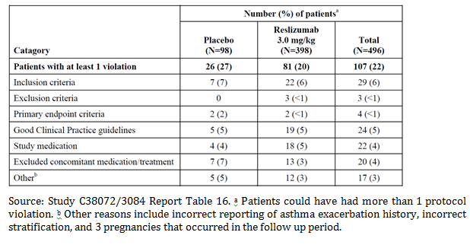

##### Baseline data

Selected demographic features for all randomised patients are shown in Table 14. In Study C38072/3084, subject demographics and baseline characteristics were generally balanced between the 2 treatment groups. The majority of subjects were female, White, and of non-Hispanic or non-Latino ethnicity. The mean age was 44.9 years old.

The overall, randomised population means for ACQ score (2.559; normal range < 0.75 well controlled, 0.76 to 1.4 indeterminate, ≥ 1.5 not well controlled) and % predicted FEV1 (66.7%) are indicative of a population with inadequately controlled, moderate to severe asthma. The mean baseline blood eosinophil counts were 0.277 x 109/L and 0.281 x 109/l for placebo and reslizumab groups respectively.

Table 14: Study C38072/3084 demographics

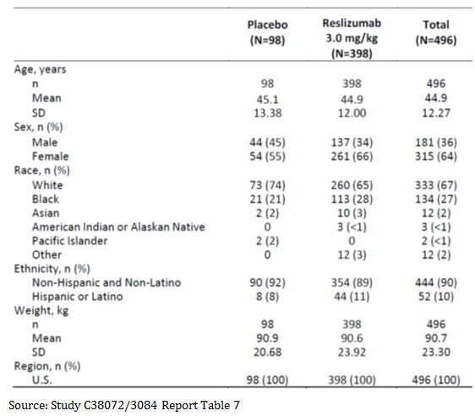

##### Results for the primary efficacy outcome

The primary efficacy analysis, a linear regression model, did not show a significant interaction between baseline blood eosinophil count and change in FEV1 at Week 16. The slope difference (active –placebo) was 0.3007 (p-value = 0.2407) if measurements taken with 7 days of use of confounding medication (for example. oral or systemic corticosteroids or addition of LABA or LAMA if not taken at Baseline) were excluded or 0.3082 (p-value = 0.2291) otherwise.

Table 15: Summary of significant test for change from Baseline at Week 16 in FEV1;sensitivity analysis (all measurements included). Full Analysis Set

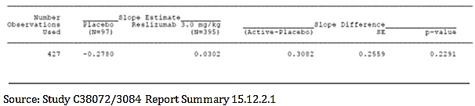

##### Results for other efficacy outcomes

There is no meaningful treatment effect for the overall population and for patients with a baseline eosinophil count < 400/μL. Reslizumab treatment effect is more evident in patients with a baseline eosinophil level ≥ 400/μL where larger treatment differences at Week 16 were observed for FVC (0.175 L), ACQ score (-0.490 U), and SABA use (-0.708 inhalation/day). However, none of these differences was statistically significant.

Interpretation of results in the ≥ 400 cells/μL group is limited due to the small sample size. In addition, the study was not designed to test this group of patients: only 20% of the Study C38072/3084 population had a blood eosinophil count of ≥ 400 cells/μL at randomisation.

Table 16: Study C38072/3084 summary of secondary endpoints (FAS with all measurements included)

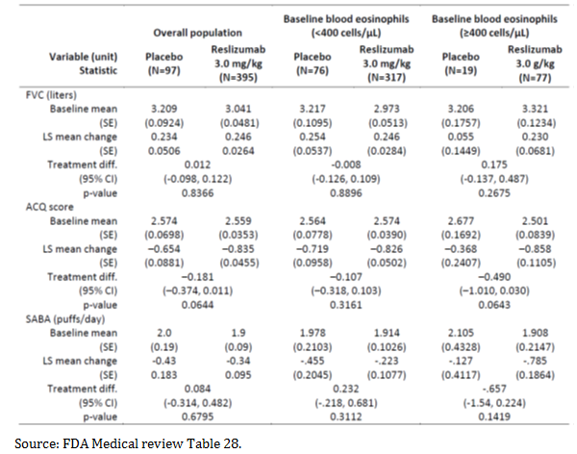

#### Study ID – Long Term Study C38072/3085

##### Study design, objectives, locations and dates

Patients included in Study C38072/3085 (an open label extension study) had completed Study C38072/3081, C38072/3082 or C38072/3083 or received at least 2 doses of study drug in Study C38072/3081. The primary objective was to obtain long term safety data (up to 24 months). The secondary objective was to study the long term efficacy of reslizumab based on change from Baseline in pulmonary function tests (PFT) (FEV1, % predicted FEV1, FVC, FEF 25%-75%) and other measures of asthma control (SABA use, ASUI, ACQ and AQLQ). In addition, blood eosinophils were assessed. Patients were expected to participate in this study for up to 27 months. The study was conducted at 201 centres in 30 countries between June 2011 and January 2014 (study termination date).

This study was terminated in January 2014 based on an enrolment that substantially exceeded the original planned sample size and the sponsor’s conclusion that the primary study objective, in terms of open label safety events for patient exposure to an investigational product with an unconfirmed benefit/risk profile, would have been substantially met at that time. The decision to terminate the study was not due to any new or emerging safety concerns. At the time of the 1 September 2014 data cut-off, Study C38072/3085 was still ongoing in several countries, pending institution of expanded access to the drug through compassionate use and other mechanisms, as locally applicable.

##### Inclusion and exclusion criteria

###### Main inclusion criteria

* 12 to 75 years of age
* prior diagnosis of asthma
* completed treatment in a previous double blind asthma exacerbation study (Studies C38072/3082 and C38072/3083) or received at least 2 doses of study drug treatment in a pulmonary function study (Study C38072/3081).

##### Study treatments

Reslizumab was provided as a sterile solution for infusion presented as 100 mg (10 mL) per vial, formulated at 10 mg/mL in sodium acetate, sucrose. Patients were administered reslizumab intravenously over 15 to 30 minutes at a dosage of 3.0 mg/kg at Baseline and once every 4 weeks relative to Baseline for up to 24 months.

##### Efficacy variables and outcomes

This study was primarily a safety study; however, the long term efficacy of reslizumab treatment was evaluated during the study with the following efficacy variables:

* change from Baseline in PFT results as measured by FEV1, predicted FEV1, FVC and FEF 25%-75% every 4 weeks for 16 weeks, at 24 weeks, and every 12 weeks thereafter until end of treatment visit or early termination
* change from Baseline in SABA use every 4 weeks for 16 weeks, at 24 weeks, and every 12 weeks thereafter until end of treatment visit or early termination
* change from Baseline in ASUI every 4 weeks for 16 weeks, at 24 weeks, and every 12 weeks thereafter until end of treatment visit or early termination
* change from Baseline in ACQ score every 4 weeks for 16 weeks, at 24 weeks ,and every 12 weeks thereafter until end of treatment visit or early termination
* change from Baseline in AQLQ score every 24 weeks until end of treatment visit or early termination

##### Randomisation and blinding methods

This was a multicentre, open label study; all patients received reslizumab 3.0 mg/kg. There was no randomisation and no blinding in this study.

##### Analysis populations

To be eligible for enrolment in the study, a patient must have completed treatment in 1 of the feeder CAE studies or have received at least 2 doses of study drug, continued to meet the applicable criteria, and, in the opinion of the investigator, was in need of continued treatment for eosinophilic asthma.

##### Sample size

The sample size was determined by the number of patients rolled over from the 3 double blind, placebo controlled, Phase III studies of reslizumab in eosinophilic asthma.

##### Statistical methods

###### Analysis sets

The set of enrolled patients includes all patients who were enrolled, regardless of whether or not a patient received any study drug in Study C38072/3085.

The safety analysis set includes all patients who received at least 1 dose of reslizumab in this study.

Efficacy analyses (safety analysis set): Summaries are presented by double blind treatment group (placebo and reslizumab) and for all patients (that is, total). All analyses are descriptive; no inferential statistics were planned or conducted.

Percent predicted lung function values were transcribed directly from the lung function report to the case report form (CRF), without any calculation by Teva. Summary statistics of actual values and changes from Baseline to scheduled visits and endpoint of PFTs, including n, mean, SD, SE, median, minimum, and maximum, are provided by double blind treatment group and for all patients at each visit and endpoint.

The number of patients who used SABA therapy in the 3 days before the scheduled visit was summarised using descriptive statistics. For the purpose of summaries, an average daily usage was evaluated by dividing the total number of puffs recorded over 3 days by 3. Summary statistics of actual values and changes from Baseline to scheduled visits and to endpoint in average daily usage included n, mean, SD, SE, median, minimum, and maximum and are provided by double blind treatment group and for all patients.

###### ASUI, ACQ and AQLQ

Summary statistics of actual values and changes from Baseline to scheduled visits and to endpoint, including n, mean, SD, SE, median, minimum, and maximum, are provided by double blind treatment group and for all patients at each visit and endpoint.

##### Participant flow

A total of 1,052 patients with eosinophilic asthma at 201 centres in 30 countries were enrolled in this study. Of the 1052 patients enrolled, 1051 (> 99%) patients received at least 1 dose of reslizumab in Study C38072/3085 and were evaluated for safety. One (< 1%) patient withdrew before taking any study drug. Four hundred and eighty (46%) patients received reslizumab for the first time in Study C38072/3085, having previously received placebo in Studies C38072/3081, C38072/3082, or C38072/3083. A total of 50 (5%) patients completed the study (that is the 104 week treatment period and the 90 day follow-up period). A total of 1,002 (95%) patients in this open label study discontinued the study prior to completion. This included 896 (85%) patients who did not complete the treatment/study due to early termination of the open label study by the sponsor. The second most frequent reason for discontinuation was withdrawal of consent (6%).

Figure 6: Study C38072/3085 disposition

Figure 6: Study C38072/3085 disposition
A total of 1,052 patients with eosinophilic asthma at 201 centres in 30 countries were enrolled in this study. Of the 1052 patients enrolled, 1051 (> 99%) patients received at least 1 dose of reslizumab in Study C38072/3085 and were evaluated for safety. One (< 1%) patient withdrew before taking any study drug. Four hundred and eighty (46%) patients received reslizumab for the first time in Study C38072/3085, having previously received placebo in studies C38072/3081, C38072/3082, or C38072/3083. A total of 50 (5%) patients completed the study (that is the 104 week treatment period and the 90- day follow-up period). A total of 1,002 (95%) patients in this open label study discontinued the study prior to completion. This included eight hundred ninety-six (85%) patients who did not complete the treatment/study due to early termination of the open label study by the sponsor. The second most frequent reason for discontinuation was withdrawal of consent (6%).

Table 17: Patient disposition in the open label study (All Patients)

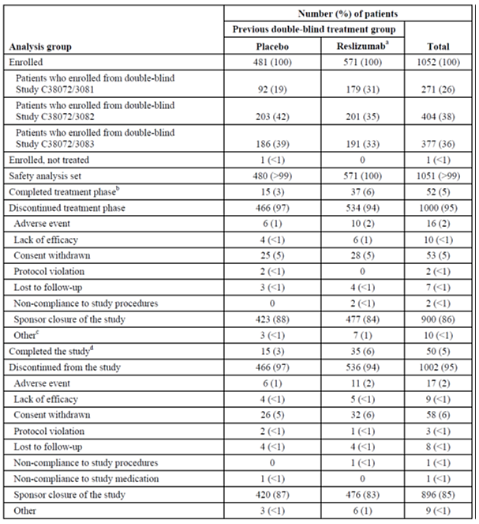

Source: Study C38072/3085 Report Table 6. a) The reslizumab column included patients who previously received 0.3 or 3.0 mg/kg, dependent on the specific study they were previously enrolled; b) Treatment up to 104 weeks was considered completion of treatment. c Other reasons for withdrawal from the treatment phase of the study. d Patients are considered to have completed the study if they completed the treatment phase (up to 104 weeks) and completed the 90-day follow-up period.

Note: The denominator for calculating percentages is the number of enrolled patients.

##### Major protocol violations/deviations

A total of 50 (5%) patients had 1 or more protocol violations (Table 18). Of the 50 patients with protocol violations, 1 (< 1%) met an exclusion criterion, 9 (< 1%) did not meet GCP guidelines, 38 (4%) were not administered study medication as per protocol, and 2 (< 1%) took an excluded concomitant medication/treatment. The frequency of protocol violations within each violation category was not markedly different between reslizumab naïve and reslizumab experienced groups. Three patients were withdrawn from the study due to a protocol violation.

Table 18: Protocol violations during the open label study (Enrolled Patients)

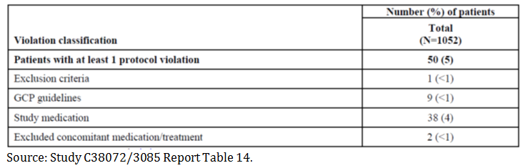

##### Baseline data

Overall, the mean age of patients in the study was 47.2 years. 61% of patients in the study were female, 77% White, and 19% Hispanic or Latino. Demographic characteristics at entry into the open label study are presented by previous double blind treatment group and total enrolled population in Table 19. There were no clear differences in demographic characteristics between the reslizumab naïve group and the reslizumab experienced group, with the exception of a greater percentage of female patients included in the study.

Table 19: Study C38072/3085 baseline demographics

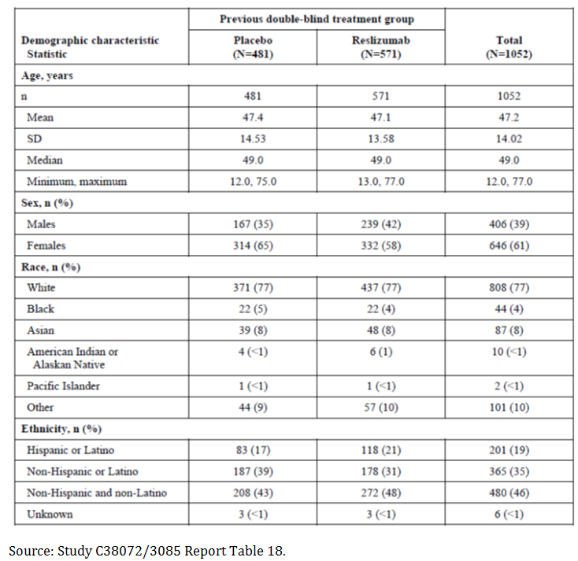

##### Results for the primary efficacy outcome

Baseline mean FEV1 and % predicted FEV1 values were lower in the reslizumab naïve group versus the reslizumab experienced group (2.095 and 2.285 L, 70.695% and 75.116%, respectively). Patients in the reslizumab experienced group maintained their mean baseline FEV1 and % predicted FEV1 through the treatment period endpoint, which was similar to the baseline value. A trend towards improving FEV1 and % FEV1 values was observed in newly exposed reslizumab naïve patients, which was apparent by the Week 4 visit and consistent with the expected reslizumab treatment effect observed in placebo controlled feeder studies.

Baseline mean FVC and FEF 25%-75% values were lower in the reslizumab naïve group versus the reslizumab experienced group (3.163 and 3.366 L, 1.464 and 1.634 L/sec, respectively). Patients in the reslizumab experienced group maintained their baseline FVC and FEF 25%-75% through the treatment period endpoint, which was similar to the baseline value. A trend towards improving FVC and FEF 25%-75% values was observed in newly exposed reslizumab naïve patients, which was apparent by the Week 4 visit and was consistent with the expected reslizumab treatment effect observed in placebo controlled feeder studies.

##### Results for other efficacy outcomes

Baseline mean daily SABA use was slightly higher in the reslizumab naïve group versus the reslizumab experienced group (2.2 versus 1.9 puffs, respectively). SABA use in reslizumab experienced patients was generally stable over time with small improvements observed for reslizumab naïve patients.

Baseline mean ASUI scores were lower in the reslizumab naïve group versus the reslizumab experienced group (0.788 and 0.839, respectively). Patients in the reslizumab experienced group maintained their baseline ASUI score through the treatment period endpoint, which was similar to the baseline value. A trend towards improving ASUI score was observed in newly exposed reslizumab naïve patients, which was apparent by the Week 4 visit and consistent with the expected reslizumab treatment effect observed in placebo controlled feeder studies.

Baseline mean ACQ scores were higher in the reslizumab naïve group versus the reslizumab experienced group (1.821 and 1.456, respectively). Patients in the reslizumab experienced group maintained their baseline ACQ scores through the treatment period endpoint, which was similar to the baseline value. A trend towards improving ACQ score was observed in newly exposed reslizumab naïve patients, which was apparent by the Week 4 visit and consistent with the expected reslizumab treatment effect observed in placebo controlled feeder studies.

Baseline mean AQLQ scores were lower in the reslizumab naïve group versus the reslizumab experienced group (5.156 and 5.491, respectively). Patients in the reslizumab experienced group maintained their baseline AQLQ score through the treatment period endpoint, which was similar to the baseline value. A trend towards improving AQLQ score was observed in newly exposed reslizumab naïve patients, which was apparent at the Week 24 visit (first on-treatment observation for this measure) and consistent with the expected reslizumab treatment effect observed in placebo controlled feeder studies.

### Other efficacy studies

#### Study Res-5-0010

Study Res-5-0010 was a Phase II, multicentre, randomised, double blind, placebo controlled, parallel group study in 106 patients (aged 18 through 75 years) with asthma and sputum eosinophils ≥ 3%. The primary objective was to demonstrate the ability of IV reslizumab treatment to improve asthma control, as assessed by the change from Baseline in ACQ score at Week 15. Study drug (3.0 mg/kg of reslizumab or placebo) was administered at Baseline and every 4 weeks (± 7 days) at each visit for a total of 4 doses during the double blind treatment period of the study. A numerically greater improvement in asthma control, as measured by ACQ score, with reslizumab treatment compared with placebo treatment was observed, although the difference between treatment groups was not significant. Consistent significant improvements in other parameters of asthma control and pulmonary function were observed in this study. The results of this study suggest that patients with poorly controlled, active eosinophilic asthma who received reslizumab at 3.0 mg/kg every 4 weeks (4 doses) had improvement in parameters of asthma control and pulmonary function.

#### Study P00290 (dose finding study)

Study P00290 was a Phase II, multicentre, randomised, evaluator blind, placebo controlled, parallel group study in 211 patients (at least 18 years of age) with severe, persistent asthma of at least 1 year duration. The objectives were to evaluate the clinical efficacy, safety, tolerability, and immunogenicity of reslizumab in patients with moderate and severe persistent asthma over 12 weeks. Patients received one of 3 treatments: Reslizumab 0.3 mg/kg, Reslizumab 1.0 mg/kg or matching placebo. No significant differences were noted for the comparison of 0.3 mg/kg or 1.0 mg/kg reslizumab versus placebo for any of the efficacy parameters evaluated.

#### Study NIH protocol O1-I-0155

NIH Protocol O1-I-0155 was a Phase II, open label, uncontrolled, single and repeat dose study in patients with hypereosinophilic syndrome or eosinophilic gastroenteritis. Idiopathic hypereosinophilic syndrome is a rare disorder characterised by eosinophilia (> 1500 eosinophils/μL for at least 6 months) of unknown aetiology that results in eosinophil mediated end organ damage.

The objectives were to evaluate the safety and efficacy of reslizumab in patients with hypereosinophilic syndrome or eosinophilic gastroenteritis. Five of the six subjects (3 eosinophilic gastroenteritis and 2 hypereosinophilic syndrome subjects) who demonstrated a reduction in eosinophilia and evidence of clinical improvement in response to a single dose of reslizumab received 5 to 6 additional doses of reslizumab (1.0 mg/kg) administered monthly. Both hypereosinophilic syndrome subjects responded to the second dose of reslizumab with a rapid decrease in eosinophil levels and improvement of clinical symptoms. However, the magnitude and the duration of the improvement in symptoms and eosinophilia lessened with each subsequent dose.

#### Study res-5-0002

Res-5-0002 was a Phase IIb/III, randomised, double blind, placebo controlled, parallel group study to evaluate the efficacy, safety, and tolerability of reslizumab in 226 patients with EE over 15 weeks.

#### Study res-5-0004

Res-5-0004 was a Phase III, open label extension study to evaluate the efficacy, safety, and tolerability of reslizumab in 190 patients with EE who completed Study Res-5-0002. Extended treatment with reslizumab maintained the beneficial effects on peak oesophageal eosinophil counts and symptom assessments observed in the 4 month placebo controlled, double blind study.

### Evaluator’s conclusions on clinical efficacy

In summary, the results of the studies comprising the clinical efficacy program provide evidence for the efficacy of iv reslizumab 3.0 mg/kg administered once every 4 weeks for the treatment asthma in adult patients with elevated eosinophils who are not well controlled by medium to high dose ICS (440 μg/day fluticasone propionate or equivalent) and who mostly (82 to 87%) used a second controller medication (that is patients already on ICS-based standard of care therapy).

Reslizumab treatment resulted in statistically significant reduced exacerbations, relieved asthma symptoms, and improved lung function in the patient population. These outcome changes were clinically significant. Most patients were severe eosinophilic asthma patients (GINA 4/5) for which limited other treatment options exist. The endpoints comply with the adopted European Union guidelines.

No statistical significant effect was shown for CAE based on an emergency visit or hospitalisation. This may suggest that reslizumab treatment was effective in reducing moderate exacerbations but not severe exacerbations.

The population was representative of the Australian asthma population.

Data in the elderly (≥ 65 years: n = 32) in the Studies C38072/3082 and C38072/3083 were limited. The adolescent population was small (n = 14) and subgroup analyses of the primary endpoint did not show results in this population. Adolescents are excluded from the indication.

Subgroup analyses of the primary endpoint did not show a significant improvement for Black patients and patients of other races and patients enrolled in the U.S. The treatment effect was larger in patients who were using an LTRA at Baseline (69% versus 42%). This may indicate that it is a marker of asthma severity (that is, a patient who is using multiple controller concomitant medications) or possibly a marker of patients with asthma with allergic rhinosinusitis/nasal polyposis (where LTRAs may also be used).

No data are currently available on the possibility to reduce concomitant controller medication like OCS.

The open label extension Study (C38072/3085) in patients previously treated with reslizumab as part of one of the Phase III safety and efficacy studies in eosinophilic asthma resulted in maintained asthma control (as assessed by FEV1 and other lung function parameters, ACQ, ASUI, and AQLQ) as a group. There was a trend towards improving asthma control in the group of patients previously treated with placebo as part of one of the Phase III safety and efficacy feeder studies and who received open label reslizumab 3.0 mg/kg during this extension study.

## Clinical safety

### Studies providing evaluable safety data

The evaluation of safety includes 14 studies that were conducted with reslizumab treatment.

Apart from Study NIH 01-I-0155, all studies were integrated into 6 cohorts in the ISS. The exclusion of these patients is considered acceptable, because the number of patients in Study NIH 01-I-0155 was low, that is 8 patients, and the investigated dose is lower than the recommended dose that is, 1.0 mg/kg. Cohorts 3, 4, and 6 were presented as the primary focus of the safety evaluation.

* Cohort 3 (N = 1861): This cohort included all exposed patients from placebo controlled asthma Studies Res-5-0010, C38072/3081, C38072/3082, C38072/3083, and C38072/3084, where patients received at least 1 dose of study drug up to 52 weeks.
* Cohort 4 (N = 1611): This cohort included all reslizumab treated patients from Cohort 3, plus the data from the open label extension Study C38072/3085 as of 1 September 2014 (N = 1596; continuously exposed to 3.0 mg/kg). Cohort 4 is supportive for long term safety as it included also open label Study C38072/3085.
* Cohort 6 (N = 2187): This cohort included all exposed patients and healthy subjects in sponsored reslizumab studies (any dose, any regimen) except Study NIH 01-I-0155. It is intended to help capture rare events.

This overview will emphasise on the safety data presented in Cohort 3, considering these data as the main data.

#### Pivotal studies that assessed safety as the sole primary outcome

C38072/3085: The primary objective of this study was to obtain long term safety data (up to 24 months) in adolescent and adult patients with moderate to severe eosinophilic asthma. The secondary objective was to study the long term efficacy of reslizumab based on change from Baseline in pulmonary function tests (FEV1, % predicted FEV1, FVC, FEF 25%-75%) and other measures of asthma control.

#### Pivotal and/or main efficacy studies

In the pivotal efficacy Studies C38072/3081, C38072/3082, C38072/3083, C38072/3084 and C38072/3085, the following safety and tolerability data were collected:

* adverse events were coded using the Medical Dictionary for Regulatory Activities (MedDRA) and summarised by Preferred Term (PT), System Organ Class (SOC) and treatment group.
* clinical laboratory tests (serum chemistry, haematology, urinalysis)
* vital signs measurements
* 12-lead ECGs (StudiesC38072/3081, C38072/3082, C38072/3083, C38072/3084)
* physical examinations (including body weight)
* concomitant medication usage.

##### Other efficacy studies

Studies Res-5-0010, P00290 and I96-350 supporting the indication of eosinophilic asthma provided evaluable safety data. Studies Res-5-0002 and Res-5-0004 in patients with EE provided evaluable safety data. Study P01942 in patients with severe nasal polyposis provided evaluable safety data. Studies C38072/1102 and C38072/1107 in healthy Japanese and non-Japanese subjects provided evaluable safety data.

##### Studies with evaluable safety data: dose finding and pharmacology

Study C38072/3081 provided safety data. The results support that the 3.0 mg/kg reslizumab dose provides the optimal benefit to risk ratio relative to the 0.3 mg/kg reslizumab dose.

##### Studies evaluable for safety only

Not applicable.

### Patient exposure

A total of 2,195 patients or healthy subjects have been exposed to at least 1 dose of reslizumab in these studies. Considering all studies (except for NIH 01-I-0155) in the reslizumab clinical development program, 1,189 patients were treated for at least 6 months, 922 patients were treated for greater than 12 months, 371 patients were treated for greater than 24 months, and 64 patients were treated for greater than 36 months. The maximum exposure in the program was 1,340 days (44 months). Healthy subjects and patients with asthma, EE, nasal polyposis, eosinophilic gastroenteritis, or hypereosinophilic syndrome were included in these studies.

Analyses will focus primarily on one cohort that is Cohort 3, as this is the largest placebo controlled cohort of pooled data that utilised the proposed dose (3.0 mg/kg) and regimen (every 4 weeks) for up to 52 weeks. Displays of this cohort analyses presented will provide a comparison between placebo and reslizumab 3.0 mg/kg. This cohort (N = 1861) included all asthma patients who received at least 1 dose of study drug in controlled studies through 52 weeks. The treatment groups summarised in Table 20 include placebo and all reslizumab (0.3 mg/kg + 3.0 mg/kg). The total patient-years exposure was 613 patient-years for the 1,028 patients treated with reslizumab 3.0 mg/kg and 517 patient-years for the 730 patients in the placebo group. The mean duration of treatment was 218 days (range: 1 to 512 days) for patients treated with reslizumab 3.0 mg/kg and was 259 days (range: 14 to 473 days) for patients in the placebo group.

Patients in Cohort 3 were exposed to up to 13 infusions during the course of study treatment. Of the 1,028 patients treated with reslizumab 3.0 mg/kg, a total of 438 patients (43%) were treated for at least 6 months (equating to 7 infusions), and 389 (38%) were treated for greater than or equal to 12 months (equating to 13 infusions). Of the 730 patients in the placebo group, a total of 436 patients (60%) were treated for at least 6 months (equating to 7 infusions), and 388 (53%) were treated for greater than or equal to 12 months (equating to 13 infusions). Greater than 98% of reslizumab 3.0 mg/kg and placebo patients received a complete infusion.

Table 20: Study drug exposure in controlled trials, safety population, Cohort 3

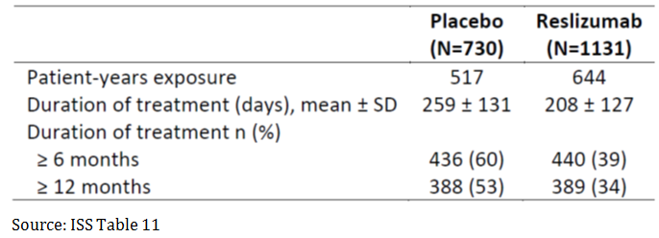

Extension, open label Study C38072/3085, was intended to obtain additional safety data for reslizumab 3.0 mg/kg for up to 24 months. It has been prematurely terminated with the rationale that the primary study objective had been sufficiently met that the enrolment had substantially exceeded the original planned sample size and the primary study objective, in terms of open label safety events for patient exposure to an investigational product with an unconfirmed benefit/risk profile, would have been substantially met at that time. In spite of the vast number of discontinuations due to early termination of Study C38072/3085 a sufficient number of data is available for the purpose of assessing long term safety in the complete clinical package. From that point of view there is no objection against the early termination. Cohort 4 included all reslizumab treated patients from Cohort 3, plus the data from the open label extension Study C38072/3085 as of 1 September 2014.

Study drug exposure for randomised patients in the reslizumab treatment groups in the Safety Analysis Set for Cohort 4, without reslizumab 0.3 mg/kg treated patients included, is presented in Table 21. The total patient-years exposure for these 1596 patients treated with 3.0 mg/kg reslizumab was 1,593 patient-years. The mean duration of treatment for these patients was 365 days (range: 1 to 1,012 days).

Patients in Cohort 4 were exposed to up to 36 complete infusions during the course of study treatment. The total number of complete infusions (defined as at least 75% of planned dose) for 3.0 mg/kg reslizumab treated patients in Cohort 4 was 20,219. Of the 1,596 patients: a total of 994 patients (62%) were treated for at least 6 months (equating to 7 infusions); 743 (47%) were treated for greater than or equal to 12 months (equating to 13 infusions); 213 (13%) of these patients were treated for greater than or equal to 24 months (equating to 26 infusions). Greater than 95% of these patients received a complete infusion.

Table 21: Study drug exposure-safety analysis set Cohort 4 (without reslizumab 0.3 mg/kg treated Patients)

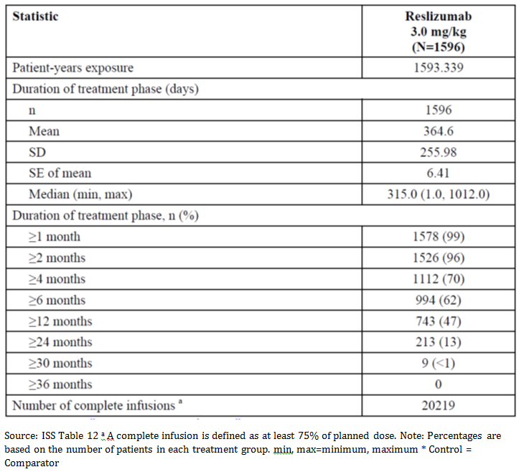

### Adverse events

#### All adverse events (irrespective of relationship to study treatment)

##### Integrated safety analyses

The overall pattern of adverse events by frequency, severity, and relationship to study drug was similar between the placebo and reslizumab 3.0 mg/kg treatment groups. There were no meaningful differences in the all combined reslizumab group (which includes the 0.3 mg/kg dose group) when compared between the 2 reslizumab doses. Cohort 3 contains the most robust collection of placebo controlled data available for the analysis of the reslizumab 3.0 mg/kg dose. Overall, the adverse event profile of the drug compares favourably to that of placebo with all events occurring at a similar or lower rate for reslizumab versus placebo treatment.

Cohort 4 extends the 3.0 mg/kg dose and every-4 week regimen beyond 52 weeks (via inclusion of the open label extension Study C38072/3085) and will serve to help confirm the consistency of the safety profile in the longer term. As appropriate for Cohort 4, data are presented for all reslizumab treated patients along with the reslizumab 3.0 mg/kg treated patients. Serious adverse events and events of clinical interest will be analysed using Cohort 3 and Cohort 4. Cohort 6 will be utilised to screen for rare events reported in the reslizumab clinical development program.

##### Pivotal and/or main efficacy studies

In Cohort 3, a total of 690 (67%) of the 1,028 patients in the reslizumab 3.0 mg/kg group and 589 (81%) of the 730 patients in the placebo group reported at least 1 adverse event during the course of the individual study periods. Of these events, 70 (7%) were considered severe in the reslizumab 3.0 mg/kg group compared to 76 (10%) in the placebo group.

In Cohort 3, no deaths were reported in the reslizumab 3.0 mg/kg group, whereas 1 death was reported in the placebo group (Study C38072/3082). The patient was a 26 year old male. The death was most probably due to accidental combined drug intoxication with fentanyl and diphenhydramine. The death was assessed as not related to study drug treatment.

A total of 65 (6%) of the 1,028 patients in the reslizumab 3.0 mg/kg group and 66 (9%) of the 730 patients in the placebo group reported at least 1 serious adverse event. Of these serious adverse events, 5 (< 1%) in the reslizumab 3.0 mg/kg group and 1 (< 1%) in the placebo group were assessed as treatment related by the investigator and/or sponsor. A total of 88 patients were withdrawn from the study because of the occurrence of adverse events that began or worsened after taking study drug treatment: 48 (5%) patients who received reslizumab 3.0 mg/kg and 40 (5%) patients who received placebo.

Table 22: Adverse events by system organ class and treatment group (Cohort 3; Studies Res-5-0010, C38072/3081, C38072/3082, C38072/3083, and C38072/3084, Safety Analysis Set)

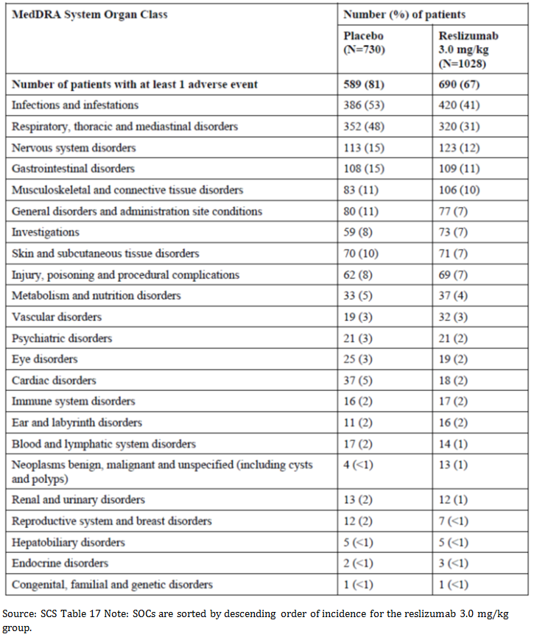

The frequency of adverse events by SOC in Cohort 4 was slightly higher than was observed in Cohort 3 for the reslizumab treated groups given the increased length of observation and length of exposure, yet when comparing the events rates (which weighs in the duration of exposure), the same magnitude of increase was not seen. Moreover, the order of frequently occurring SOCs was consistent with what was seen in Cohort 3. A total of 1,188 (74%) of the 1,611 patients in this reslizumab treated cohort reported at least 1 adverse event during the course of the individual study periods. When the adverse events that were reported on 0.3 mg/kg were excluded, a total of 1,172 (73%) of the 1,596 patients with continuous exposure to reslizumab 3.0 mg/kg reported at least 1 adverse event during the course of the individual study periods in this cohort. The most frequently occurring SOCs (reported in > 15% of patients) in the reslizumab treated group were Infections and Infestations (792 (50%, event rate = 123.45) patients in Cohort 4 compared with 420 (41%, event rate = 129.95) reslizumab 3.0 mg/kg patients in Cohort 3), Respiratory, Thoracic and Mediastinal Disorders (628 (39%, event rate = 95.52) patients in Cohort 4 compared with 320 (31%, event rate = 108.24) reslizumab 3.0 mg/kg patients in Cohort 3), and Nervous System Disorders (245 (15%, event rate = 26.23) patients in Cohort 4 compared with 123 (12%, event rate = 31.84) reslizumab 3.0 mg/kg patients in Cohort 3).

The overall most common adverse events by PT reported were asthma, nasopharyngitis, upper respiratory tract infection (URTI), headache, and sinusitis, which would be expected of an asthma population. The frequencies within these PTs were generally consistent across the controlled asthma cohorts in reslizumab treated patients and showed a similar distribution to the patients who received placebo; although asthma exacerbations occurred at higher rates in placebo treated patients compared to reslizumab.

Overall, severe adverse events did not occur at a high incidence in either group (70 (7%)) and 76 (10%) patients in the reslizumab 3.0 mg/kg and placebo groups, respectively). Moderate adverse events occurred more frequently in the placebo group than in the reslizumab 3.0 mg/kg group (368 (36%) patients in the reslizumab 3.0 mg/kg group and 369 (51%) patients in the placebo group), while mild events were more frequent in the reslizumab 3.0 mg/kg group than in the placebo group (252 (25%) patients in the reslizumab 3.0 mg/kg group and 144 (20%) patients in the placebo group).

Table 23: Adverse events (at least 2%) in descending order in the reslizumab 3.0 mg/kg treatment group by preferred term and treatment group (Cohort 3; Studies Res‑5‑0010, 3081, 3082, 3083, and 3084, Safety Analysis Set)

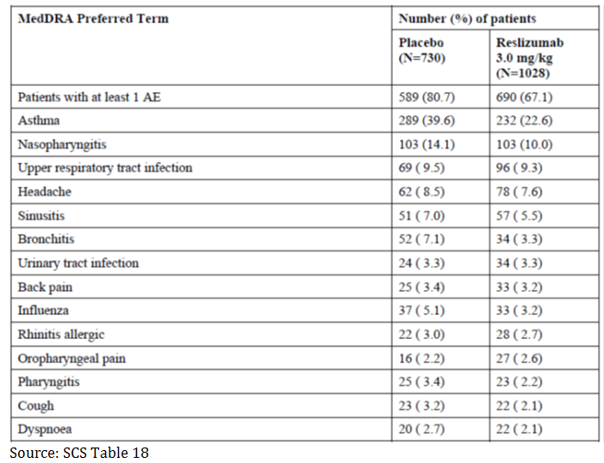

Five relevant cases of anaphylaxis in the reslizumab group (< 1%) and no cases in the placebo group were observed. Three out of the 5 anaphylactic reactions (that is 3 out of 1,028 patients treated with reslizumab) were reported as treatment related serious adverse events, had a temporal link to infusion, were assessed as related to reslizumab, and resulted in discontinuation of reslizumab treatment. These reactions were observed during or shortly after completion of the reslizumab infusion and were reported as early as the second dose of reslizumab. They were fully resolved with standard treatment with no residual effect. Manifestations included skin or mucosal involvement, dyspnoea, wheezing, gastrointestinal symptoms and chills.

Two cases occurred on the second infusion, and 1 case occurred on the eleventh infusion. The 2 other anaphylactic reactions concerned other reasons; were not temporally linked to reslizumab infusion, were associated to pre-known food allergy and immunotherapy, and did not result in discontinuation of reslizumab.

All cases were observed in ADA-negative female patients (2 of whom had medical history of hypersensitivity/anaphylaxis).

There were no other related cases of anaphylaxis reported for the reslizumab 3.0 mg/kg dose in any other Cohort.

In the EE studies (Studies Res-5-0002 and Res-5-0004), there were 6 reslizumab treated patients and 1 placebo treated patient who experienced an anaphylactic reaction. All were related to previously known food allergies.

#### Treatment related adverse events (adverse drug reactions)

##### Integrated safety analyses

Analysis of treatment related adverse events resulted in a low number of events overall, and the proportion of events in the reslizumab treated and placebo groups were similar. The vast majority of adverse events reported in the contributing clinical studies were not treatment related. Very few events occurred in ≥ 5 patients (< 1%) in the reslizumab 3.0 mg/kg group.

Adverse events were analysed to assess when events occurred with time points of within the first 24 hours after infusion, by time category during treatment (by month) and during the follow-up period (during the 90 days after end of treatment).

Patients who received at least 1 dose of study drug in controlled Studies Res-5-0010, C38072/3081, C38072/3082, C38072/3083, and C38072/3084 (Cohort 3, Safety Analysis Set) comprised the population analysed to identify adverse drug reactions (ADRs) for reslizumab.

##### Pivotal and/or main efficacy studies

Adverse events considered by the investigator to be treatment related were reported for 122 (12%) of the 1,028 patients in the reslizumab 3.0 mg/kg group and 95 (13%) of the 730 patients in the placebo group. As shown in Table 24, the most frequent treatment related adverse events in Cohort 3 were headache, asthma, nausea, fatigue, and increased blood creatine phosphokinase (CPK).

Table 24: Treatment related adverse events (at least 3 patients in any treatment group) by preferred term and treatment group (Cohort 3; Studies Res-5- 0010, C38072/3081, C38072/3082, C38072/3083, and C38072/3084, Safety Analysis Set)

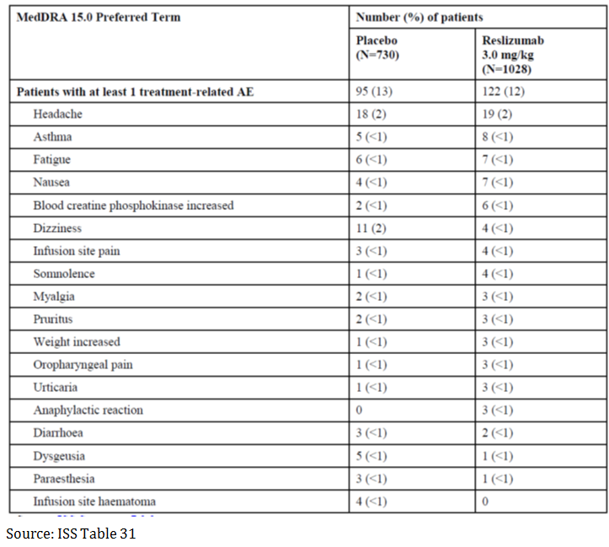

Of these treatment related events, 7 (< 1%) were considered severe in the reslizumab 3.0 mg/kg group, and 1 (< 1%) was considered severe in the placebo group. Severe treatment related adverse events reported in the reslizumab 3.0 mg/kg group included 1 case each of headache, migraine, anaphylactic reaction, osteoarthritis, lung adenocarcinoma, asthma, and dermatitis. 1 report of diarrhoea as a severe treatment related adverse event occurred in the placebo group.

Anaphylactic reaction was the only common treatment related adverse event that occurred in a higher incidence in the reslizumab 3.0 mg/kg group (3 patients (< 1%)) than in the placebo group (0 patients).

In Cohort 3, the most common PTs for adverse events occurring within 24 hours after an infusion occurred at a similar rate between the reslizumab 3.0 mg/kg and placebo groups. In Cohort 4, a total of 553 (34%) of the 1,611 patients in the reslizumab treatment group reported at least 1 adverse event occurring up to 24 hours after infusion. This is similar to what was observed in the reslizumab 3.0 mg/kg treated patients in Cohort 3 (30%) and in the placebo patients in Cohort 3 (39%). The type of adverse events and general incidence was similar to the reslizumab 3.0 mg/kg treatment group in Cohort 3. Asthma was reported in 137 (9%) of the 1596 patients in the reslizumab treatment group in Cohort 4. The next most common PTs were headache (46 (3%) patients), urinary tract infection (29 (2%) patients), URTI (26 (2%) patients), nasopharyngitis (19 (1%) patients), sinusitis (18 (1%) patients), increased blood CPK (18 (1%) patients), and rhinitis allergic (18 (1%) patients).

Adverse event incidence was reviewed by time period in order to assess for trends over time. Time categories were groups by blocks of months (for example, 0 to < 1, 1 to < 4, etcetera). There were no notable variations observed between the patient populations. In Cohort 3, the higher incidence of adverse events reported in the placebo group was sustained at all time points. Minor fluctuations in adverse event rate frequency were consistent between the 2 groups, and were similar to the trends in data for the other Cohorts examined.

Analysis of adverse events during the follow-up period was performed (except in Study Res‑5‑0010), where the follow-up period was defined as after the treatment phase completion or discontinuation date to last observation. The most common SOCs in each of the cohorts (Cohorts 3 and 4 with the exception of Study Res-5-0010) analysed were Infections and Infestations, Respiratory, Thoracic and Mediastinal Disorders, Musculoskeletal and Connective Tissue Disorders, Gastrointestinal Disorders, and Injury, Poisoning and Procedural Complications. While the overall frequencies were lower due to the relatively short duration of follow-up, within these SOCs, the adverse events within the reslizumab treated group showed a similar distribution to the patients who received placebo as analysed for Cohort 3. Analysis of adverse events by MedDRA SOC and PT in the primary populations of interest did not identify any trends of concern.

As would be expected given the SOCs of highest frequency, the adverse events most commonly reported were generally from the SOCs of Infections and Infestations and Respiratory, Thoracic and Mediastinal Disorders. The most common PTs occurring in all patient populations during the follow-up period were asthma, URTI, nasopharyngitis, bronchitis, sinusitis, influenza, and urinary tract infection. Generally, the frequencies within these PTs were consistent with what was observed in reslizumab treated groups and showed a similar distribution to the patients who received placebo in Cohort 3. The pattern and frequency of adverse events during follow-up for patients previously treated with reslizumab was similar to that of patients previously treated with placebo, indicating that asthma symptoms did not relapse during the short-term follow-up period (90 days).

Additional analyses of selected adverse events (by PT) were conducted and are described in the ADRs. ADRs are presented in Table 25.

Table 25: Adverse drug reactions

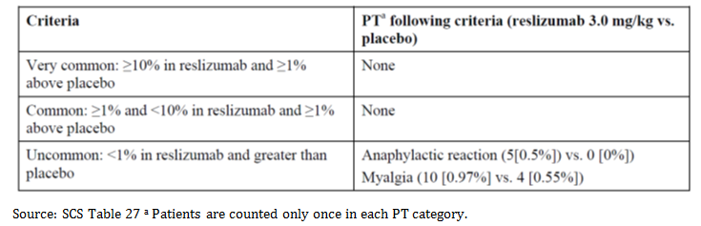

The sponsor’s medical evaluation identified 2 ADRs as follows:

* anaphylactic reaction: 3 cases (0.19%) with a temporal link to infusion assessed as related to reslizumab and considered as an ADR
* myalgia

#### Deaths and other serious adverse events

##### Integrated safety analyses

An analysis of deaths in all reslizumab-exposed patients (Cohort 6 includes all reslizumab studies, except Study NIH 01-I-0155, irrespective of baseline disease or inclusion of healthy subjects) was performed.

##### Pivotal and/or main efficacy studies

###### Deaths

There were 3 deaths during the Study C38072/3085: 1 patient due to progressive anal cancer; 1 patient due to haemoptysis, aspiration pneumonia, and cardio-respiratory arrest; and 1 patient who died at home and cardiac arrest was reported as the cause of death. All these events were not considered related to the study drug.

Additionally, 1 death occurred in Study C38072/3082 in the placebo group. The patient from Study C38072/3082 was a 26 year old male in the placebo group. The death occurred on day 56 of treatment, 1 month after the second placebo infusion, most probably due to accidental combined drug intoxication. The death was assessed as not related to study drug treatment by the investigator.

No deaths occurred in any treatment groups in the other studies.

###### Serious adverse events

Serious adverse events were generally infrequent, and no apparent trends were observed between the reslizumab treated patients and their placebo comparators. The most common PT in all groups in all cohorts was asthma. As would be expected given the SOCs of highest frequency, the adverse events most commonly reported were generally from the SOCs of Respiratory and Thoracic and Mediastinal Disorders and Infections and Infestations. Anaphylactic reactions from the Immune System Disorders SOC were observed in 4 reslizumab treated patients in Cohort 3.

In Cohort 3, a total of 65 (6%) of the 1028 patients in the reslizumab 3.0 mg/kg group and 66 (9%) of the 730 patients in the placebo group reported at least 1 serious adverse event during the course of the individual study periods. The most frequently occurring SOCs (reported in >3 patients in the reslizumab 3.0 mg/kg group) were Respiratory, Thoracic, and Mediastinal Disorders; Infections and Infestations; Injury, Poisoning, and Procedural Complications; Immune System Disorders; and General Disorders and Administration Site Conditions.

Asthma was the most common serious adverse event reported. Serious adverse events that were reported by more than 1 patient in the reslizumab group and were not reported in the placebo group included chest pain (4 (< 1%) patients in PT of chest pain, non-cardiac pain, and musculoskeletal chest pain), anaphylaxis reactions (4 (< 1%) patients), and falls (2 (< 1%) patients).

Treatment related serious adverse events of anaphylactic reactions were reported by 3 patients in the reslizumab 3.0 mg/kg group. One event each of osteoarthritis and lung adenocarcinoma was reported in the reslizumab 3.0 mg/kg group. The only treatment related serious adverse event reported for placebo patients was 1 case of erysipelas.

Table 26: Serious adverse events (> 1 patient in any treatment group) by system organ class, preferred term, and treatment group (Cohort 3; Studies Res-5-0010, C38072/3081, C38072/3082, C38072/3083, and C38072/3084, Safety Analysis Set)

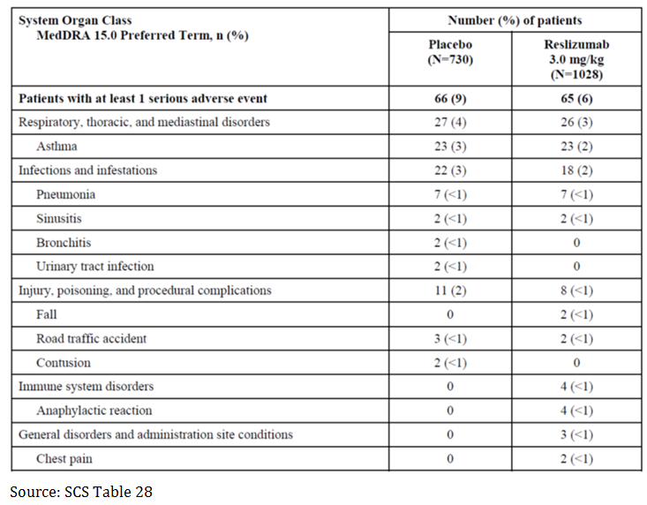

In Cohort 4, the overall serious adverse event rate was slightly higher (137 (9%)) than what was observed in Cohort 3 reslizumab 3.0 mg/kg patients (6%) and the same as Cohort 3 placebo patients (9%). Asthma was reported in 38 (2%) of the 1,611 patients in the reslizumab treatment group. The next most common PTs (reported in ≥ 3 patients in the reslizumab treatment group) were pneumonia (8 (< 1%) patients), anaphylactic reaction (4 (< 1%) patients), chest pain (3 (< 1%) patients), breast cancer (3 (< 1%) patients), and sinusitis (3 (< 1%) patients).

The increase in overall serious adverse event incidence compared to Cohort 3 is likely attributable to the longer period of adverse event reporting as well as an increased number of unique serious adverse events within the Neoplasms Benign, Malignant, and Unspecified SOC and a more diversified array of events observed in the Respiratory, Thoracic and Mediastinal Disorders SOC. The slight increase in overall incidence of serious adverse event is a result of the accumulation of diverse, low-frequency events over time. No patterns were evident in this cohort that would impact the safety profile of reslizumab.

In Cohort 4 (removing the patients treated with reslizumab 0.3 mg/kg), the same total of 137 (9%) of the 1,596 patients in the reslizumab treatment group reported at least 1 serious adverse event during the course of the individual study periods.

#### Discontinuations due to adverse events

##### Integrated safety analyses

Adverse events leading to discontinuation generally were well-balanced between the treatment and placebo arm. Adverse events leading to discontinuation occurred in a similar frequency in Cohort 4 (65 (4%) of the 1611 reslizumab treated patients) compared with Cohort 3 (reslizumab 3.0 mg/kg and placebo, 5% each). The most common PT in all groups in all cohorts was asthma. Notable imbalances in adverse events leading to discontinuation included anaphylaxis (3 patients in the reslizumab group in Cohort 3 (2 of which were assessed as related to reslizumab) versus 0 in the placebo group), and increased blood CPK (one reslizumab patient in Cohort 3 versus no placebo patients). There was no imbalance in discontinuations due to musculoskeletal disorders.

Table 27: Adverse events leading to discontinuation, by system organ class (Cohort 3)

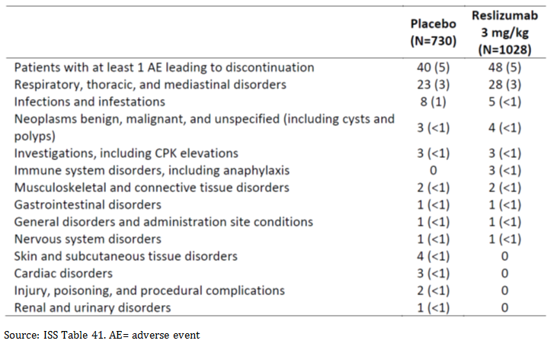

### Issues with possible regulatory impact

#### Liver function and liver toxicity

##### Integrated safety analyses

A higher percentage of patients treated with reslizumab had liver enzyme levels that shifted from normal to elevated over the course of the study, but these appear to be minor as shifts above the pre-specified potentially clinically significant threshold were balanced for placebo and reslizumab arms. There were no patients who fulfilled the criteria for Hy’s law.

Table 28: Liver function shift table (%); Cohort 3 (not including Study Res-5-0010)

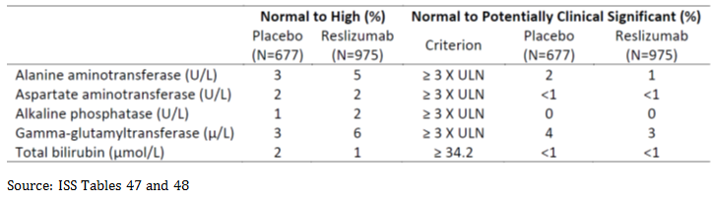

#### Renal function and renal toxicity

##### Integrated safety analyses

In the placebo controlled asthma studies through 52 weeks (Cohort 3), shifts in serum chemistry variable values (sodium, potassium, chloride, blood urea nitrogen, creatinine) from the normal range at Baseline to outside the normal range occurred infrequently, were similar in each treatment group, and were generally not considered to be clinically meaningful. Shifts in blood urea nitrogen and creatinine above the pre-specified potentially clinically significant threshold were balanced for placebo and reslizumab arms.

#### Other clinical chemistry

##### Musculoskeletal and creatine phosphokinase abnormalities

###### Integrated safety analyses

Reslizumab exposure was associated with a slightly higher frequency of transient, mild to moderate myalgia events compared with placebo (0.97% vs 0.55%) and myalgia has been classified as an ADR. One patient each was discontinued for myalgia in the reslizumab and placebo groups. The aetiology of muscle complaints related to reslizumab is unclear.

A clinically significant imbalance in CPK elevations was observed. Potentially clinically significant abnormalities in CPK occurred more frequently in the reslizumab 3.0 mg/kg group for overall and for CPK elevation greater than 5 times and 10 times the ULN.

CPK elevations were observed for:

* Blood CPK increased was reported as an adverse event in 20 (1.9%) patients on reslizumab 3.0 mg/kg versus 12 (1.6%) patients on placebo.
* CPK elevation greater than 5 times the ULN per laboratory data occurred in 25 (2.4%) patients on reslizumab 3.0 mg/kg versus 10 (1.4%) patients on placebo.
* CPK elevation greater than 10 times the ULN per laboratory data occurred in 8 (0.78%) patients on reslizumab 3.0 mg/kg versus 3 (0.41%) patients on placebo.

However, these were generally transient and asymptomatic and there is no evidence of treatment related myopathy, rhabdomyolysis, or myositis. Moreover, in the shift to elevated CPK analysis there was no meaningful difference between treatment groups.

Specific adverse events (PT) of interest were reviewed over time category and treatment group. There was no evidence of time-dependency on adverse events of CPK elevation. For Cohort 3, the PT of blood CPK increased was reported more frequently in the 3.0 mg/kg reslizumab treatment group than in the placebo group. Increased CPK was reported in < 1% of placebo patients in the 1 to < 4 months, 6 to < 12 months, and 12 to < 18 months’ time categories. In the reslizumab 3.0 mg/kg group, increased CPK was reported in < 1% of patients in the 0 to < 1 month, 4 to < 6 months, and 6 to < 12 months’ time categories. The 1 to < 4 months’ time category had the highest incidence of increased CPK (1%). There were no reported increased CPK during the 12 to < 18 months’ time category in the reslizumab 3.0 mg/kg group.

For Cohort 4, adverse events by time category had additional time categories (18 to < 24, 24 to < 30, and ≥ 30 months) compared with the analysis of Cohort 3. The PT of blood CPK increased was reported in < 1% of patients at each time category through 6 to < 12 months, with the peak occurring at the 1 to < 4 months’ time category (0.879 event rate per 100 patient-years in all reslizumab treated patients). CPK was not obtained in Study C38072/3085, and no increase in CPK is shown in the later time categories.

##### Haematology and haematological toxicity

###### Integrated safety analyses

In general, no clinically meaningful differences were observed between the treatment groups in the number (%) of patients with potentially clinically important haematology abnormalities, the types of abnormalities, and the time points at which abnormalities were reported. The eosinophil count was the only exception, accounting for the vast majority of potentially clinically important abnormal haematology values (388 (58%) patients in the placebo group and 97 (10%) patients in the reslizumab 3.0 mg/kg group).

Decreased eosinophil counts were seen in the reslizumab treated groups; however, this is an expected pharmacologic effect. The reduction in eosinophils also resulted in a corresponding reduction in total white blood cell count in the reslizumab arm.

At the follow-up (90 days after the end of treatment visit or approximately 120 days after the last dose of reslizumab), the reslizumab 3.0 mg/kg group had a mean eosinophil count of 0.2 x 109/L (median 0.1 x 109/L) compared to 0.4 x 109/L (median 0.3 x 109/L) in the placebo group, indicative of a return of eosinophils towards baseline after cessation of reslizumab.

##### Other laboratory tests - Urinalysis

###### Integrated safety analyses

In the placebo controlled asthma studies through 52 weeks (Cohort 3), there were no clinically meaningful abnormalities found on urinalysis. There were no meaningful trends in mean changes from Baseline for any urinalysis variables.

#### Electrocardiograph findings and cardiovascular safety

##### Integrated safety analyses

ECGS were assessed at screening, and Weeks 24, 36 and 52 (or early withdrawal visit) in Studies C38072/3082 and C38072/3083. They were assessed at screening and Week 16 for studies C38072/3081 and C38072/3084. ECGs were not assessed in Study C38072/3085. ECGs were assessed by the investigator as either normal or abnormal; abnormal ECGs were further assessed for clinical significance. Overall, ECG data were available for 677 placebo patients and 975 reslizumab patients. A review of shifts from normal to abnormal and mean change from Baseline in heart rate, PR, QRS, QT, QTc, and RR intervals showed no major treatment related imbalances. None of the shifts in the reslizumab treated patients were considered by the investigator to be clinically meaningful.

No dedicated QT trials were performed. In general, monoclonal antibodies are not associated with QT prolongation. Thorough QT studies generally are not required for these clinical development programs.

#### Vital signs and clinical examination findings

##### Integrated safety analyses

The following vital signs measurements were evaluated in the Cohort 3 patient population: pulse, systolic blood pressure, diastolic blood pressure, respiratory rate, body temperature, weight and height.

There was no evidence of any trends in changes from Baseline to endpoint (with and without follow-up) in pulse or systolic and diastolic blood pressure values after treatment with reslizumab 3.0 mg/kg, and no apparent trends when compared to the placebo group.

The incidence of potentially clinically significant (PCS) abnormal vital signs values was similar between the reslizumab treated (192 (19%) patients) and placebo groups (160 (22%) patients). PCS low body temperature was the most common PCS value with the largest difference between the 2 groups with a slightly higher incidence in placebo (128 (18%) patients) compared to reslizumab 3.0 mg/kg patients (135 (13%)).

Analysis of vital sign shifts relative to baseline tended to reduce the frequency of PCS values compared with those observed PCS value during the treatment period. No adverse trends were observed.

Body temperature was the measure that had the greatest frequency of changes from a baseline high PCS/normal value to a low PCS value (28 (3%) and 26 (4%) patients in the reslizumab 3.0 mg/kg and placebo groups, respectively). As the incidences of low body temperature between treatment groups were balanced and not associated with any specific adversity, they are not considered to be clinically meaningful.

No other shifts occurred in ≥ 1% of patients in either group at endpoint.

#### Immunogenicity and immunological events

##### Integrated safety analyses

The screening antibody assay has a sensitivity of 22 ng/ml, which is adequate to detect IgG.

For healthy volunteer Studies C38072/1102 and C38072/1107, serum samples were analysed for anti-drug IgG antibodies using a validated homogeneous solution based bridging enzyme linked immunosorbent assay (ELISA). A similar method with an additional confirmatory step to resolve IL-5 interference in asthma patient samples was used for anti-drug antibody analysis in the Phase III Studies C38072/3081, C38072/3082, C38072/3083, C38072/3084, and C38072/3085. Alternative methodologies were used for Studies I96-350, P00290, P01942, and Res-5-0010.

Immunogenicity as measured by the assay was low, with approximately 5% of patients developing at least one positive anti-drug IgG antibody during the treatment period. ADA responses were generally low titre and transient. The adverse event profile was similar in ADA positive to that for negative patients. There was no association of a positive anti-drug IgG antibody response with anaphylaxis or hypersensitivity reactions to reslizumab, nor was there any indication of adverse events related to an immune complex disorder (for example. renal dysfunction, rash) in the clinical studies conducted.

Given the low percentage of anti-drug IgG antibody positive patients, low titre and low risk for immunogenicity-related clinical consequences; reslizumab is considered as a safe therapy, from immunogenicity perspective, for asthma patients with elevated blood eosinophils.

###### Angioedema

No meaningful differences from placebo were observed in the incidence of angioedema in patients treated with reslizumab 3.0 mg/kg. In Cohort 3, the incidence in the reslizumab 3.0 mg/kg group (22 (2%) patients) was similar to the incidence in the placebo group (22 (3%) patients) as well as in the all reslizumab group (23 (2%) patients). A similar incidence as the placebo of Cohort 3 was seen in the other cohorts analysed (Cohort 4, 48 (3%) patients; Cohort 4 excluding reslizumab 0.3 mg/kg patients, 47 (3%) patients; the sub-cohort of patients with exposure to reslizumab greater than 12 months, 29 (4%) patients).

###### Hypersensitivity

Beyond the 3 anaphylactic reactions described above as ADRs, the frequency of hypersensitivity and potential hypersensitivity reaction was similar between the placebo and reslizumab groups. These reactions were not associated with a positive ADA response and did not result in discontinuation of study drug treatment.

#### Serious skin reactions - Infusion reactions and administration site reactions

##### Integrated safety analyses

No meaningful differences from placebo were observed in the incidence of infusion reactions in patients treated with reslizumab 3.0 mg/kg.

Under the HLT of non-site specific procedural complications, procedural pain (4 (< 1%) patients in the placebo group and 8 (< 1%) patients in reslizumab group) and infusion-related reaction (1 (< 1%) patient in each group, both presented as chills) were the most commonly reported PT. Of these events, one was considered related to treatment (1°infusion-related reaction in the reslizumab group that was mild in intensity) yet did not result in treatment discontinuation.

The incidence of administration site reactions (HLGT) was similar between the reslizumab 3.0 mg/kg (21 (2%) patients) and placebo (16 (2%) patients) groups in Cohort 3. None were severe in intensity, serious, or resulted in discontinuation of treatment. PT that were reported only in the reslizumab group were mass (1 (< 1%) patient), haemorrhage (1 (< 1%) patient), and extravasation (4 (< 1%) patients).

#### Infections

##### Integrated safety analyses

Forty five percent of patients in Cohort 3 had at least 1 adverse event reported under the SOC of Infections and Infestations and the Microbiology and Serology Investigation HLGT. A higher incidence of events indicative of infection was reported in the placebo treatment group (53%, event rate 161.79 per 100 patient-years) compared with the reslizumab 3.0 mg/kg treatment group (41%, event rate 129.95 per 100 patient-years). The specific types of infections and incidence were generally similar across treatment groups. A similar incidence of infections was reported in all reslizumab treated patients in Cohort 4 (50%, event rate 123.594 per 100 patient-years). The most commonly reported events in Cohort 4 indicative of infection were nasopharyngitis (14%), URTI (12%), sinusitis (7%), and bronchitis (6%). These are the same adverse events indicative of infection most frequently reported in Cohort 3, in both reslizumab and placebo treated patients. Overall, the events reported are consistent with what is expected in a patient population with an underlying condition of asthma.

The Phase III studies were conducted in regions where helminthic parasite infections are prevalent, including South and Central America, Africa, and Asia. There were no helminthic parasitic infections reported or difference between treatment groups with adverse events that could be associated with gastrointestinal helminthic infections.

#### Malignancies

##### Integrated safety analyses

In literature, it is suggested that eosinophils possibly play immunomodulatory role in some tumours. Therefore, agents lowering peripheral blood and tissue eosinophils could potentially have indirect effects on tumour biology. There is no definitive biological evidence that neutralisation of IL-5 or reduction of eosinophil number or function is associated with malignancy. In the non-clinical studies, there was no evidence of a mutagenic or carcinogenic effect of reslizumab.

For reslizumab itself, in the entire clinical program, a total of 24 patients were diagnosed with malignancy: 3 placebo treated patients and 21 reslizumab treated patients (6 patients in placebo controlled studies and 15 patients in the open label extension Study C38072/3085).

In the placebo controlled studies, malignancy was reported in 6 of 1028 (< 1%) patients in the reslizumab 3.0 mg/kg treatment group and 2 of 730 (< 1%) patients in the placebo treatment group. There was no malignancy in the reslizumab 0.3 mg/kg treatment group.

An additional 13 patients reported malignant neoplasm during the open label extension Study C38072/3085 by 01 September 2014 cut-off date for data integration, thus overall, there were 22 events of malignancy in 19 patients on reslizumab in Cohort 4. Two additional malignancy cases were not included in Table 29 that is 1 ovarian epithelial cancer and 1 borderline ovarian neoplasm from the ongoing Study C38072/3085, which were reported after 1 September 2014.

The most commonly reported malignancies in reslizumab treated patients were skin cancers, reported by 8 patients (5 patients with non melanoma skin cancer and 3 patients with localised cutaneous malignant melanoma). There were 13 non skin cancers reported; 8 of these were of the most common tissue types of cancer in the general adult population (that is lung, breast, prostate, and colon). The remaining 5 malignancies included 1 anal cancer, 1 diffuse large B-cell lymphoma and 1 plasmacytoma.

These observed malignancies in the reslizumab clinical development program presented a diverse range of common tissue types that would be expected in a primarily adult population.

Table 29: Adverse events of malignant neoplasm by preferred term and treatment group (Cohort 4; Studies Res-5-0010, C38072/3081, C38072/3082, C38072/3083, C38072/3084, and C38072/3085, Safety Analysis Set)

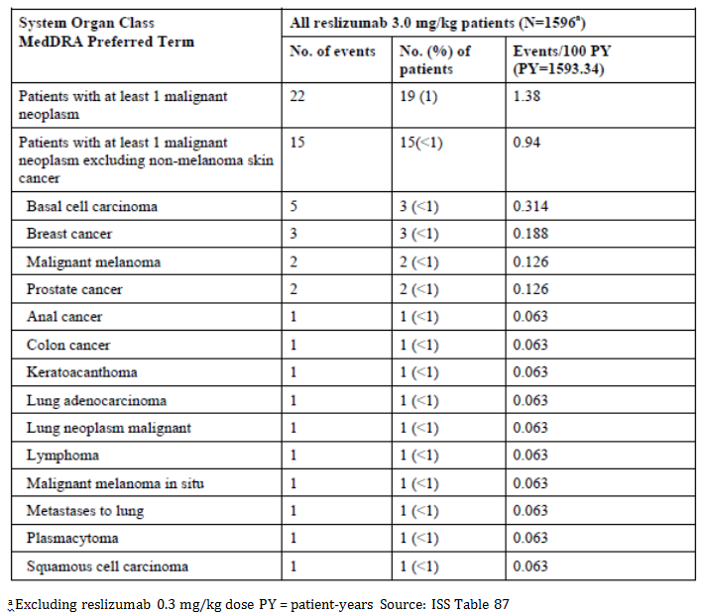

Overall, the incidence of malignancy was higher in the reslizumab group compared to placebo in controlled studies (0.6% vs. 0.3%), as well as in a comparison of malignancy rates in the reslizumab program versus what has been observed in the National Cancer Institute’s Surveillance, Epidemiology, and End Results (SEER) Program database (not statistically significant). However, 4 of the 19 reslizumab treated patients had a previous medical history of malignancy, 2 of whom had a reoccurrence of their previous malignancy. One case of colon cancer had a diagnosis of familial adenomatous polyposis, a predisposing risk factor for development of colon cancer.

No malignancies occurred in children or adolescent patients in any reslizumab study. There were no clusters of specific types of malignancies that would suggest an immunosuppressive mechanism.

Most of the malignancies in Cohort 4 were diagnosed within less than a year after starting reslizumab treatment, and there were no malignancies diagnosed after 2 years of reslizumab treatment.

Table 30: Incidence of malignant tumours by interval of time to first malignancy occurrence (including non-melanoma skin cancer) Safety Analysis Set Cohort 4

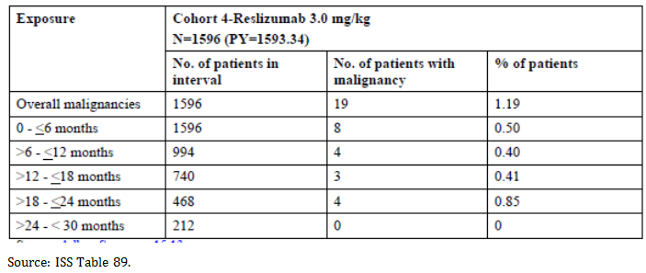

In conclusion, the results of the reslizumab clinical study program did not demonstrate an association between reslizumab treatment and the risk of malignancy and suggest that a causal relationship between reslizumab treatment and malignancy is unlikely.

### Other Studies

#### Other asthma studies

##### Study P00290

Treatment emergent adverse events were reported by 85% of subjects in both the 0.3 mg/kg and placebo treatment groups and by 93% of subjects in the 1.0 mg/kg treatment group. Overall, the most common adverse event was URTI, reported by 39%, 37%, and 53% of subjects in the 0.3 mg/kg, 1.0 mg/kg, and placebo treatment groups, respectively. Other common adverse events included headache, musculoskeletal pain, and pharyngitis. The nature and occurrence of these adverse events did not raise any specific safety concerns.

Overall, the most common treatment related adverse events were injection site reaction (4% to 9%) and headache (4% to 9%). No treatment related adverse event was reported by more than 9% of subjects.

##### Study I96-350

In Study I96-350 (an uncontrolled study with 24 patients treated with various single doses of reslizumab), the most common adverse event overall was headache, reported by 15 subjects. Other common adverse events included asthma aggravated (14 subjects), pharyngitis (9 subjects), and URTI (9 subjects). The nature and incidence of these adverse events did not raise any specific safety concerns.

Most adverse events were categorised by the investigator as unrelated to treatment. Overall, the most common treatment related adverse events were headache (6 subjects), asthma aggravated (4 subjects), and fatigue (4 subjects).

#### Eosinophilic oesophagitis

##### Study res-5-0002

A total of 180 (79.6%) patients experienced at least 1 adverse event: 43 (78.2%) patients in the 1.0 mg/kg reslizumab group, 43 (75.4%) patients in the 2.0 mg/kg reslizumab group, 47 (82.5%) patients in the 3.0 mg/kg reslizumab group, and 47 (82.5%) patients in the placebo group.

Headache occurred in 8 (14.5%), 6 (10.5%), and 12 (21.1%) patients in the 1.0, 2.0, and 3.0 mg/kg reslizumab groups, respectively, and in 7 (12.3%) patients in the placebo group. Cough occurred in 5 (9.1%), 6 (10.5%), and 6 (10.5%) patients in the 1.0, 2.0, and 3.0 mg/kg reslizumab groups, respectively, and in 6 (10.5%) patients in the placebo group. URTI occurred in 5 (9.1%), 4 (7.0%), and 6 (10.5%) patients in the 1.0, 2.0, and 3.0 mg/kg reslizumab groups, respectively, and in 5 (8.8%) patients in the placebo group. Nasal congestion occurred in 7 (12.7%), 3 (5.3%), and 4 (7.0%) patients in the 1.0, 2.0, and 3.0 mg/kg reslizumab groups, respectively, and in 8 (14.0%) patients in the placebo group.

Anaphylactic reactions were reported by 3 patients: 2 patients in the 3.0 mg/kg reslizumab treatment group and 1 patient in the placebo treatment group. These events were attributed by the investigator to the consumption of food to which the patients were known to be allergic and not related to the study drug.

Most adverse events in all treatment groups were mild or moderate: 40 (72.7%), 41 (71.9%), and 47 (82.5%) patients in the 1.0, 2.0, and 3.0 mg/kg reslizumab treatment groups, respectively, and 45 (79.0%) patients in the placebo treatment group. There were no patients in the study who experienced life-threatening adverse events. The frequency of severe adverse events was low and similar across all 4 treatment groups: 3 (5.5%), 2 (3.5%), and 0 patients in the 1.0, 2.0, 3.0 mg/kg reslizumab treatment groups, respectively, and 2 (3.5%) patients in the placebo treatment group. The severe adverse events included abdominal pain (1 patient in the placebo group and 1 patient in the 1.0 mg/kg reslizumab treatment group), lower abdominal pain (1 patient in the 1.0 mg/kg reslizumab treatment group), arthralgia (1 patient in the 1.0 mg/kg reslizumab treatment group), vomiting (1 patient in the 2.0 mg/kg reslizumab treatment group), gastroenteritis (1 patient in the 2.0 mg/kg reslizumab treatment group), chest pain (1 patient in the placebo treatment group), and syncope (1 patient in the placebo treatment group).

Most adverse events were not treatment related. Overall, 49 (21.7%) patients experienced treatment related adverse events. The overall incidence of treatment -related adverse events in the reslizumab treatment groups was comparable with that in the placebo treatment group. Treatment related adverse events were experienced by 12 (21.8%), 11 (19.3%), and 13 (22.8%) patients in the 1.0, 2.0, and 3.0 mg/kg reslizumab treatment groups, respectively, and 13 (22.8%) patients in the placebo treatment group. The profiles for the most commonly reported study treatment related adverse events were similar across the 4 treatment groups. The most frequently occurring treatment related adverse events in the reslizumab treatment groups were headache, fatigue, and nausea.

Overall, reslizumab was well tolerated. The number of treatment related adverse events was low and similar to that seen with placebo treatment.

##### Study res-5-0004

Most (65%) patients received treatment with study drug for more than 24 months. Over the course of this long term study, at least 1 adverse event was reported by almost all (93%) patients. In general, a higher percentage of patients who received reslizumab at 3.0 mg/kg (88%) had adverse events compared with patients who received only 1.0 mg/kg (73%); however, the higher rate at the 3.0 mg/kg dose is confounded because the Investigators had the discretion to increase the dose in patients who were not responding to lower doses. The patients treated at the higher dose were likely sicker and therefore would have had a greater propensity for experiencing adverse events. Events that occurred more frequently in patients who received 3.0 mg/kg included pyrexia, seasonal allergy, food allergy, sinusitis, nasopharyngitis, pain in extremity, arthralgia, dizziness, and insomnia.

The most frequently occurring adverse events were pharyngolaryngeal pain (53 (28%) patients), headache (50 (26%) patients), URTI (45 (24%) patients), and nasopharyngitis (40 (21%) patients). The frequency of adverse events was similar between the 2 age groups (5 to 11 and 12 to 19 years of age). Most adverse events were mild or moderate in severity.

Most adverse events that occurred during the study were considered not treatment related by the investigator. Treatment related adverse events were reported for 63 (33%) patients during the study. The most frequently occurring treatment related adverse events were crystal urine present and urinary casts (9 (5%) patients each), headache (8 (4%) patients), and abdominal pain (7 (4%) patients). Treatment related adverse events occurred with a similar frequency in the 2 age groups.

Anaphylactic reactions were reported by 4 (5%) patients. These events were considered by the investigator due to consumption of food to which the patients was known to be allergic or to allergy shots and not related to the study drug.

In conclusion, long term, monthly IV administration of reslizumab to paediatric patients with EE was well tolerated at a dose range of 1.0 to 3.0 mg/kg.

#### Nasal polyposis

##### Study P01942

23 of the 24 patients (96%) reported at least 1 treatment emergent adverse event (1.0 mg/kg, 8 out of 8 patients; 3.0 mg/kg, 7 out of 8 patients; and placebo, 8 out of 8 patients). The most frequently experienced adverse event among all groups was URTI (1.0 mg/kg, 5 patients; 3.0 mg/kg, 5 patients; and placebo, 4 patients). Examination of the other adverse events did not reveal any major differences between the treatment groups. No dose-related trends were apparent.

Severe treatment emergent adverse events were reported for 2 patients in the 1.0 mg/kg group and in 4 patients in the placebo group. Two of the 4 patients in the placebo group underwent a surgical or medical procedure to treat their nasal polyps. A third placebo patient experienced a severe non-productive cough and the remaining placebo patient had severe abdominal pain and constipation. One patient in the 1.0 mg/kg group experienced severe arthralgia, back pain, sinusitis, and bronchitis (all were reported as unlikely related to reslizumab by the investigator). The other patient in the 1.0 mg/kg group experienced a life-threatening adverse event of tachycardia along with severe hypochromic anaemia; neither event was considered by the investigator to be related to reslizumab.

Adverse events considered by the investigator to be probably or possibly related to treatment were reported by 4 patients in each the 1.0 mg/kg and 3.0 mg/kg groups and in 2 patients in the placebo group. The most frequently experienced treatment related adverse event was URTI (1.0 mg/kg, 1 patient; 3.0 mg/kg, 3 patients; and placebo, 1 patient).

#### Healthy subjects

##### Study C38072/1102

No deaths were reported. There were 2 serious adverse events reported for 1 subject who received 3.0 mg/kg of reslizumab. Subject 003021 experienced a severe head injury and mild scalp laceration which were considered not related to study drug. The event occurred during the follow-up period (22 days after last infusion). Both events fully resolved.

##### Study C38072/1107

There were no deaths or serious adverse events reported.

### Other safety issues

#### Safety in special populations

The sponsor has performed safety analyses in following subpopulations: age, gender, race, post-baseline ADA status, baseline eosinophil count, geographic region and medication at Baseline.

##### Age

The sponsor has provided safety data for following age categories: 12 to 17 years age group, 18 to 64 years age group and 65 years and older age group. Only adult patients up to 75 years of age were allowed to be included.

In both 18 to 64 years age group and 65 years and older groups, lower incidences of overall adverse events were reported in reslizumab (50% to 68%) compared to placebo treated patients (80% to 86%).

Overall, the adverse events (PT) reported were comparable across age groups. The most frequently reported adverse events across age ranges were asthma (18% to 42% in reslizumab 3.0 mg/kg and 31% to 57% in placebo), nasopharyngitis (10% to 26% in reslizumab 3.0 mg/kg and 13% to 31% in placebo), sinusitis (2% to 16% in reslizumab 3.0 mg/kg and 6%to 18% in placebo), and headache (2% to 11% in reslizumab 3.0 mg/kg and 6% to 13% in placebo).

In patients > 65 years of age, the PT of rhinitis allergic was more frequently reported in the reslizumab 3.0 mg/kg group (4(9%)) versus the placebo group (1(2%)), whereas most of the other adverse events were reported at a higher incidence on placebo treatment.

Experience in paediatric patients is limited. The data did not indicate a difference in the safety profile of reslizumab in paediatric patients compared with that in adult patients.

Furthermore, a review of adverse events reported at a higher frequency in the older age group did not reveal any significant differences between reslizumab- and placebo treated patients.

##### Gender

There were more female patients (1,103 (62%)) included than male patients 708 (38%). In general, reported adverse events showed the same pattern as in the overall population. Anaphylactic reactions were reported for 5 (1%) female patients in the reslizumab 3.0 mg/kg group with no cases reported in male or placebo patients. This might be explained by the larger number of females enrolled in the clinical trials and the potential for females to be at higher risk for allergic reactions (Chen 2008).

##### Race

Of the overall population, 1357 (73%) were White, 212 (11%) were Black, 138 (7%) were Asian, and 154 (9%) were ‘other’ race. In general, the adverse event profile was similar across races.

However, in contrast with the lower incidences of adverse events of reslizumab 3.0 mg/kg in the White and Black race categories (58% to 67%) compared with placebo (75% to 82%), a similar incidence of adverse events was observed in Asian patients and those with a race category of ‘other’ (76% to 79% in reslizumab 3.0 mg/kg and 77% to 79% in placebo). The differences in these incidences between reslizumab- and placebo treated patients in different race subgroups were most likely due to a smaller number of patients in the latter 2 race subgroups.

Same differences were seen between races for reporting adverse events in the SOCs; Black patients reported adverse events at higher frequency in the reslizumab 3.0 mg/kg group compared to the placebo group for example. in gastrointestinal disorders SOC (13% reslizumab 3.0 mg/kg and 11% placebo), while in Asian patients this appeared in the metabolism and nutrition disorders SOC (11% reslizumab 3.0 mg/kg and 5% placebo).

##### Post-baseline ADA status

The incidence of adverse events was similar across ADA-positive (52 (64%) patients) and negative (697 (66%)) patients and treatment groups, ranging from 64% to 67%. The most frequently occurring SOC (reported in > 20% of ADA positive and negative patients) were infections and infestations and respiratory, thoracic and mediastinal disorders. Of note, there were no reported events in ADA positive patients in the immune system disorders SOC. There were no reports of anaphylaxis, hypersensitivity reactions, or myalgia as adverse events in ADA positive patients.

##### Baseline eosinophil count

The incidence of adverse events was lower in the reslizumab 3.0 mg/kg group (56% to 60% reslizumab 3.0 mg/kg and 69% to 71% placebo), irrespective of baseline eosinophil count. The adverse events (PT) reported were comparable across baseline eosinophil count subgroups and treatment groups.

##### Geographic region

Of the overall population, 741 (40%) were from the United States, 497 (26.7%) were from Europe, and 520 (28%) were from other regions. In general, the adverse event profile was similar across geographic regions studied in the reslizumab clinical development program. Within each geographic region, the type and incidence of adverse events were similar between reslizumab and placebo treated patients. The incidence of adverse events was lower in the reslizumab 3.0 mg/kg group (58% to 82%) compared to the placebo group (77% to 84%) for all geographic regions. Patients from countries other than the U.S. and Europe had a smaller difference in incidence of adverse events compared to placebo. Across all geographic regions, the most frequently occurring SOCs (reported in ≥ 20% of patients in any treatment group and geographic region) were infections and infestations; respiratory, thoracic and mediastinal disorders; and nervous system disorders. The most frequently reported adverse events across geographic regions were asthma, nasopharyngitis, headache, and sinusitis.

##### Baseline concomitant medications

Overall, the adverse event profile between reslizumab- and placebo treated patients was similar across the baseline concomitant medications analysed. Use of OCS, LABA, and LTRA did not have a marked effect on the incidence and type of adverse events reported between reslizumab and placebo treatment groups.

In the analyses of adverse events by baseline concomitant asthma medications a higher incidence of pneumonia was seen in the reslizumab treated patients compared to placebo (7% versus 1%) in the OCS at Baseline group. The differences have been explained by the comorbidity.

#### Safety related to drug-drug interactions and other interactions

There is currently no evidence in the literature discussing drug-drug interactions associated with IL-5 or anti-IL-5 antibodies and there are no data to suggest that IL-5 is involved in the regulation of enzymes or pathways responsible for drug metabolism. No formal clinical drug interaction studies have been performed with reslizumab. In vitro data indicate that IL-5 and reslizumab are unlikely to affect CYP1A2, 3A4 or 2B6 activity. Based on the characteristics of reslizumab, drug-drug interactions are not expected.

Results of PopPK analysis confirm that concomitant use of either leukotriene antagonists or systemic corticosteroids does not affect the pharmacokinetics of reslizumab.

Since clearance of reslizumab is believed to occur via enzymatic proteolysis, renal or hepatic impairment is considered unlikely to affect systemic exposure to reslizumab. Overall, the type of adverse events reported in patients treated with reslizumab by baseline renal function was comparable to the overall population and to placebo, suggesting no meaningful influence of renal dysfunction on the safety profile of IV reslizumab 3.0 mg/kg. Overall, the type of adverse events reported in patients treated with reslizumab by baseline hepatic function was comparable with that in the overall population and in those treated with placebo, and suggests that Baseline liver function would not meaningfully influence the safety profile of iv reslizumab 3.0 mg/kg.

Reslizumab has not been studied in patients concurrently taking immunosuppressant medicinal products other than OCS; therefore, the safety and efficacy profile of reslizumab in these patients is unknown.

Reslizumab has not been studied in patients receiving live vaccines. No data are available on the secondary transmission of infection from persons receiving live vaccines to patients receiving reslizumab or the response to new immunisations in patients receiving reslizumab.

There are no adequate and well-controlled studies in pregnant women. There is no clinical data on reslizumab and lactation.

### Post marketing experience

No post marketing data are available.

### Evaluator’s overall conclusions on clinical safety

The overall extent of exposure in the safety database with respect to the number of patients and duration of treatment is adequate. The overall pattern of adverse events by frequency, severity, and relationship to study drug was similar between the placebo and reslizumab 3.0 mg/kg treatment groups. The most commonly reported adverse events were symptoms attributed to asthma, which were consistently lower in the reslizumab treatment group. The incidence of severe adverse events as well as the incidence of treatment related adverse events was low and comparable. Severe treatment related adverse events were < 1% in both groups.

Anaphylaxis occurred in 5 cases in the reslizumab group (< 1%) of which 3 treatment related. This information is adequately reflected in the PI and as an important identified risk in the Risk Management Plan (RMP).

The incidence of myalgia was slightly increased in reslizumab treated patients versus placebo treated patients (0.97% versus 0.55%, respectively); there was 1 discontinuation for myalgia from each of the treatment groups. There was no apparent relationship between changes in CPK and exposure to reslizumab. There was no event of related myositis or myopathy (for example., rhabdomyolysis) in the iv reslizumab program.

There were no deaths related to reslizumab.

Reslizumab is an immunomodulator, and thus malignancy is a safety issue of special concern. A higher incidence of malignancies in patients in the reslizumab group during the placebo controlled phase and the possibly higher frequency compared with the SEER and to the Clinical Practice Research Datalink (CPRD) was observed. The sponsor considered that a drug-related causality is unlikely based on the preponderance of common tissue types without a clustering of a particular tumour type or atypical tumours, and the similar malignancy rates in both treatment groups in the placebo controlled trials after excluding malignancies that were diagnosed within less than 6 months of reslizumab treatment and the results of the comparisons with the SEER and CPRD. However, malignancy will be continued to be monitored and evaluated via routine pharmacovigilance and will be considered as an adverse event of special interest in future clinical studies.

## First round benefit-risk assessment

### First round assessment of benefits

Table 31: First round assessment of benefits

| Indication | |
| --- | --- |
| Benefits | Strengths and Uncertainties |
| * Demonstrated a consistent reduction in asthma exacerbations compared to placebo in studies. The proportion of patients with at least one CAE decreased from 54% to 38% and from 45% to 25% in Studies C38072/ 3082 and C38072/3083, respectively (pooled data: 50% to 32%) that is for 100 patients treated with reslizumab for 1 year, one could expect to prevent 18 CAE. The reslizumab versus placebo CAE rate ratio was 0.50 (95% CI: 0.37, 0.67; Study C38072/3082) and 0.41 (95% CI: 0.28, 0.59; Study C38072/ 3083), corresponding to a 50% to 59% reduction in CAE events per patient year. Overall, reslizumab treatment demonstrated a clinically meaningful effect in the reduction of CAE. * Demonstrated a statistically significant and clinically relevant improvement in lung function based on FEV1. The treatment difference in LS mean change from Baseline over 16 weeks with placebo was 0.137 L (95%CI: 0.08, 0.198) and 0.093 L (95% CI: 0.003, 0.155) for Studies C38072/3082 and C38072/3083, respectively. A treatment effect was observed at the first observation period of 4 weeks and sustained throughout the study. * Statistically significant and clinically relevant improvements were also seen in asthma symptoms and quality of life, and accompanied by a reduction in blood eosinophils. | **Strengths:**   * Long-term data up to 2 years supports maintenance of effect based on lung function and asthma symptoms (Study C38072/3085). Immunogenicity rates were low.   **Uncertainties:**   * It is unknown whether the beneficial effects on exacerbation rate and lung function observed in a patient population that were mostly GINA 4/5 are also relevant to GINA 3. In these patients, other treatment options include the addition of a LABA or an increase in ICS dose. The clinical data did not provide a direct comparison between the benefits of reslizumab added to moderate dose ICS versus moderate dose ICS with LABA or high dose ICS. * No statistical significant effect was shown for CAE based on an emergency visit or hospitalisation. This may suggest that reslizumab treatment was effective in reducing moderate exacerbations but not severe exacerbations. * When reslizumab treatment is ceased, it is uncertain what happens with the asthma control. |

### First round assessment of risks

Table 32: First round assessment of risks

|  |  |
| --- | --- |
| Risks | Strengths and Uncertainties |
| * Anaphylaxis occurred in 5 cases in the reslizumab group (< 1%) of which 3 were treatment related. Administration site reactions occurred at the same frequency of 2% in the reslizumab and placebo treated group. This information is adequately reflected in the PI and as an important identified risk in the RMP. * Malignancies: The number of malignancies was higher in the reslizumab treated group (n = 6) compared to placebo (n = 2) in the first year of follow-up. An additional 15 patients reported malignant neoplasm during the open label study. This information is adequately reflected in the PI. * Myalgia occurred at a greater frequency in reslizumab 3.0 mg/kg treated patients compared to placebo (n = 10, 0.97% versus n = 4; 0.55%). In general, these events were mild, transient, and did not recur with continuing reslizumab treatment. There was 1 discontinuation for myalgia in each group. * Data in elderly (≥ 65 years: n = 32) in the Studies C38072/3082 and C38072/3083 were limited. The adolescent population was small (n = 14) and subgroup analyses of the primary endpoint did not show results in this population. Adolescents are excluded from the indication. However the lack of efficacy observed may be that the study was not powered sufficiently to detect a difference. Further studies in children and adolescents would be warranted. | **Uncertainties:**   * A comparison of reslizumab malignancy rates with general population databases and asthma patients’ database (SEER and CPRD respectively) demonstrated a higher (but not statistically significant) rate in the reslizumab studies. This rate appeared to normalise after excluding patients with malignancy within 6 months of a minimum reslizumab exposure of 6 months. Whether reslizumab is associated with an increased risk of malignancies can neither be concluded nor excluded as the numbers are low. * No information is available on the use of reslizumab in patients concomitantly taking immunosuppressants and the impact on the safety profile. This information is also reflected in the PI. * Patients with parasitic (helminth) infections were excluded from the studies. As eosinophils are possibly involved in the response to helminth infections, adequate warning is included in the PI and this information is included as an important identified risk in the RMP. * No data are currently available on the possibility to reduce concomitant controller medication like OCS. * No data are currently available in its use in patients with renal or hepatic failure. * No formal clinical drug interaction studies have been performed with reslizumab. * There is very limited data in its use in pregnant women. |

### First round assessment of benefit-risk balance

The benefit-risk balance of reslizumab for the proposed usage is favourable although a more defined population (that is patients on medium to high dose ICS plus another controller) should be considered.

The patient population studied were mostly GINA 4/5 (80%), that is on treatment with inhaled ICS plus another treatment. The efficacy in GINA 3 patients is uncertain, and for this subgroup of patients other treatments are available. LABAs and LTRAs have been available for many years and therefore safety is better established.

There are questions about the most appropriate treatment regime. A minimal number of doses were studied. Clearly, 3.0 mg/kg was more efficacious than 1.0 mg/kg or 0.3 mg/kg but it is unknown if 1.5 mg/kg, 2.0 mg/kg or 2.5 mg/kg for example, would be more efficacious. The duration of treatment is also not clearly established. It appears efficacy reaches a peak at a month and then stabilises. There is no recommendation as to whether patients then need to remain on treatment to receive benefits or could be weaned off treatment and the benefits preserved. If long term treatment is needed, there remain questions as to the safety of reslizumab over 5, 10 and 20 years and whether there is a change in immunogenicity or the development of treatment resistance over that time.

The risks associated with reslizumab therapy are considered low in view of the safety profile discussed earlier on. The main concern is about the safety imbalance in malignancies. This will require monitoring post market.

Overall, the observed reduction in asthma exacerbations and improvement in lung function which is supported by other parameters of asthma control outweighs the risks of reslizumab in patients with severe eosinophilic asthma (GINA 4/5).

## First round recommendation regarding authorisation

At this stage, the clinical evaluator has no major concerns against approving reslizumab for registration however, would recommend a revised indication:

Reslizumab is indicated as

*an add on maintenance treatment in adult patients with severe eosinophilic asthma with a blood eosinophil count of ≥ 400 cells/µL who are inadequately controlled on medium-to-high dose inhaled corticosteroids in combination with at least another controller.*

This recommendation is subject to a satisfactory response to the questions and amendments to the PI.

## Clinical questions

### Pharmacokinetics

No questions.

### Pharmacodynamics

No questions.

### Efficacy

1. The justification for the use of eosinophil count of ≥ 400 cells/µL is noted. However this differs from the eosinophil count used to define eosinophilic asthma and treat with mepolizumab of ≥ 150 cells/µL at initiation and ≥ 300 cells/µL for ongoing therapy. Please comment.
2. Study C38072/3081: The rate and duration of infusion was said to vary from patient to patient as baseline body weight was used to determine the dose. What was the rate of the infusion that is protocol?
3. Study C38072/3081: The effect size was estimated to be 0.47. How was this derived? Please comment on this in relation to the observed effect on FEV1 in the clinical trials.
4. What was the placebo used in the clinical trials?
5. What is the recommended duration of treatment? Is there any data as to what happens when treatment is ceased?

### Safety

1. Please comment on the exclusion of patients with previous parasitic (helminth) infections. Were other patients screened for helminth infections prior to commencing the trial? Did the study population include patients from rural areas and lower socioeconomic status who are more at risk of helminth infections? This is of particular relevance in the Australian population which include Indigenous Australians and those from rural/remote areas.
2. Is there any data about its use in patients with heart failure, renal failure, and liver failure? Can we be certain of safety in these patients?
3. The low rate of ADA is noted. Please describe how sensitive the screening antibody assay is.

## Second round evaluation of clinical data submitted in response to questions

### Minor errors of fact

The sponsor’s comments for Study C38072/3084 are noted.

### Efficacy

1. *The justification for the use of eosinophil count of ≥ 400 cells/µL is noted. However this differs from the eosinophil count used to define eosinophilic asthma and treat with mepolizumab of ≥ 150 cells/µL at initiation and ≥ 300 cells/µL for ongoing therapy. Please comment.*

*Sponsor response:*

The sponsor’s response has been summarised.

The basis for the eosinophil count threshold of ≥ 400 cells/μL was derived from unselected asthma patients using 2 external datasets (Farooqui et al 2009, van Veen et al 2009), where both blood and sputum eosinophil values were available from the same patient. The goal was to exclude patients unlikely to have active eosinophilic airway inflammation and those who may not benefit from a drug targeting eosinophils. A blood eosinophil value of ≥ 400 cells/μL had a high specificity for the presence of sputum eosinophils ≥ 3% (Table 33). Recent published data are supportive of this threshold; a blood eosinophil count cut off of 450 cells/μL could predict airway eosinophilia in patients with severe asthma receiving high levels of treatment, whereas low counts (for example, eosinophil count of 150 cells/µL) were not useful for predicting sputum eosinophilia (Fowler et al 2015).

Table 33: Sensitivity and specificity of blood eosinophil counts of 400 cells/μL for predicting airway eosinophilia defined as at least 3% sputum eosinophils

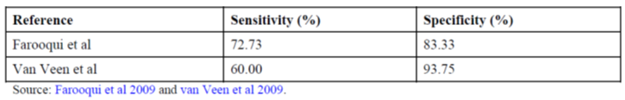

The patient population with blood eosinophil counts ≥ 400 cells/μL is expected to experience the greatest clinical improvement from reslizumab therapy. We expect that patients with eosinophilic asthma who require daily maintenance corticosteroid therapy and have a blood eosinophil count < 400 cells/µL may also benefit from reslizumab. Therefore, the treating physician should use their discretion as to whether or not a patient has the eosinophilic asthma phenotype and is an appropriate candidate for reslizumab treatment.

*Evaluator comment:*

The response is acceptable.

1. *Study C38072/3081: The rate and duration of infusion was said to vary from patient to patient as baseline body weight was used to determine the dose. What was the rate of the infusion that is protocol?*

*Sponsor response:*

The protocol for Study C38072/3081 specified that the study drug was to be added to and mixed with sterile saline prior to infusion and administered to the patient via IV infusion line. More detailed information was provided in the Pharmacy Manual for Study C38072/3081 and specified that study drug was to be administered as an intravenous piggyback infusion. Sites were instructed that the study drug was to be withdrawn from individual vials and the entire contents of the syringe was to be dispensed into an intravenous bag containing 50-mL sterile 0.9% sodium chloride for injection (or similar volume). The study drug was infused (piggybacked) via standard medication port and administered over a 15 to 30 minute time period depending on the total volume to be infused. No specific rate of infusion was specified in the protocol and was instead left to the discretion of the investigator.

*Evaluator comment:*

The response is acceptable.

1. *Study C38072/3081: The effect size was estimated to be 0.47. How was this derived? Please comment on this in relation to the observed effect on FEV1 in the clinical trials.*

*Sponsor response:*

In a previously completed Phase II study (Study Res-5-0010), 53 patients were treated with reslizumab 3.0 mg/kg every 4 weeks for 12 weeks and another 53 received placebo. The mean ± standard deviation change in FEV1 during the course of treatment with reslizumab 3.0 mg/kg was 204 ± 334 mL. This value was estimated from a mixed model for repeated measures (MMRM) adjusting for age, sex, height, and baseline FEV1 score. With 4 monthly post baseline FEV1 measurements in Study C38072/3081, the effect size was estimated to be 0.6. (Note: The value of 0.6 represented the standardised effect size (= 204 out of 334)). A total of 180 patients (60 per group) were expected to provide at least 85% power in this study to detect a difference between reslizumab and placebo using a 2-sided t-test and an MMRM simulation at α = 0.05. The sample size calculation assumed an equal effect size for both reslizumab doses.

Amendment 4 to the protocol of Study C38072/3081 (29 February 2012) increased the number of patients planned for enrolment from approximately 180 to approximately 300 (100 per group), to achieve 90% power for the primary efficacy variable instead of the originally proposed 85% power (2-sided t-test and an MMRM simulation at α = 0.05). In addition, greater variability in the FEV1 change from Baseline was anticipated as the result of a geographic enrolment broader than that which was initially planned. As a result, the assumed standard deviation was increased by approximately 100 mL and the standardised effect size for reslizumab 3.0 mg/kg was estimated to be 0.47 ( = 204/434).

The analysis of the primary efficacy variable in Study C38072/3081, overall change from Baseline in FEV1 over 16 weeks of treatment (obtained from the MMRM estimation), showed significant improvement (increase) in FEV1 for patients in both reslizumab treatment groups compared with placebo (115 mL and 160 mL in the 0.3 mg/kg and 3.0 mg/kg reslizumab treatment groups, respectively), which was less than the 204 mL increase assumed originally.

*Evaluator comment:*

The response is acceptable.

1. *What was the placebo used in the clinical trials?*

*Sponsor response:*

Placebo was provided as a sterile solution for infusion presented as 10 mL per vial, formulated in 20 mM sodium acetate, 7% sucrose, pH 5.5 buffer. This is identical to the reslizumab treatment formulation, but without reslizumab.

*Evaluator comment:*

The response is acceptable.

1. *What is the recommended duration of treatment? Is there any data as to what happens when treatment is ceased?*

*Sponsor response:*

Reslizumab is intended for the long term treatment of patients with severe eosinophilic asthma. Patients who received reslizumab experienced a reduction in the rate of clinical asthma exacerbations over 52 weeks and improvement in lung function, asthma control, asthma symptoms, and quality of life as compared to placebo. These improvements were evident at the first measured time point (4 or 16 weeks) and were sustained throughout the 52 week treatment period (Table 34).

Patients randomised to reslizumab in a previous placebo controlled study, who went on to participate in the open label extension study (Study C38072/3085) received 3 mg/kg reslizumab intravenously every 4 weeks for up to 36 months. For patients previously randomised to reslizumab, the improvements in lung function and patient reported outcomes gained during the placebo controlled studies were maintained over the extended open label treatment period. There was no indication of tachyphylaxis during continuous treatment for up to 36 months. Additionally, the safety data in the open label extension study indicate that treatment with reslizumab at an intravenous dose of 3 mg/kg every 4 weeks for up to 36 months was generally safe and well tolerated in patients with eosinophilic asthma. The safety and immunogenicity profile was similar irrespective of prior treatment with reslizumab or placebo during the previous 16 or 52 week double blind treatment period.

The persistence of clinical efficacy after cessation of reslizumab dosing has not been specifically evaluated in the Phase III studies in patients with asthma and elevated blood eosinophils. Patients in the Phase III studies were followed for 90 days after the end of the treatment period (4 months after the last dose of study drug). The recrudescence of blood eosinophil counts at the 90 day follow-up visit indicates that the clinical effects of reslizumab would be expected to wane gradually after the last dose, and the patient’s asthma would, over time, return to the pre-treatment state (5.3.5.3 Integrated Summary of Efficacy, Section 6.1). These findings are consistent with the prolonged half-life of reslizumab (3 to 4 weeks) and the known exposure response relationship.

Table 34: Summary of treatment effects of reslizumab during placebo-controlled clinical studies second round benefit-risk assessment

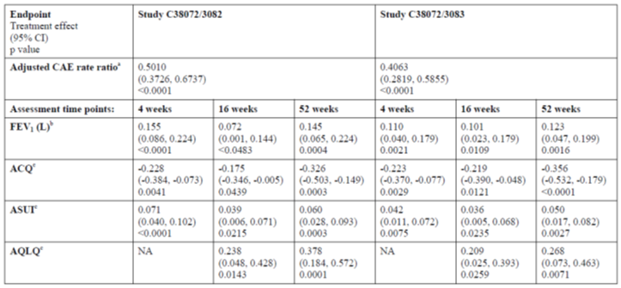

*Evaluator comment:*

The response is acceptable.

### Safety

1. *Please comment on the exclusion of patients with previous parasitic (helminth) infections. Were other patients screened for helminth infections prior to commencing the trial? Did the study population include patients from rural areas and lower socioeconomic status who are more at risk of helminth infections? This is of particular relevance in the Australian population which include Indigenous Australians and those from rural/remote areas.*

*Sponsor response:*

Eosinophils may be involved in the immunological response to some helminthic infections. In Phase III clinical studies, patients with recent parasitic infections, as defined by their medical history, were excluded from participation in the reslizumab clinical studies.

No screening tests for the presence of helminthic infections were specifically mandated by the protocol for patients participating in reslizumab clinical studies.

The majority of reslizumab clinical studies were conducted globally. The primary integrated safety cohort, that is, Cohort 3 (N = 1,861), included all asthma patients who received at least 1 dose of study drug in controlled studies up to 52 weeks (Study C38072/3081, Study C38072/3082, Study C38072/3083, Study C38072/3084, and Study Res-5-0010). In Cohort 3, 392 patients (219 in the reslizumab group and 173 in the placebo group) were from regions where helminthic parasites are known to be endemic including South America (Argentina, Brazil, Colombia, Chile, and Peru), Mexico, Africa (South Africa), and Asia (Malaysia, Philippines, Thailand, Taiwan, Province of China, and Republic of Korea). In Cohort 3, there were a total of 23 patients from Australia, 14 placebo treated and 9 reslizumab treated patients (ISS Ad Hoc Summary 27).

In the entire clinical program (including early stage studies in which parasitic infection was not a protocol specified exclusion criterion), there were no reports of helminthic infections. Adverse events that could be associated with helminthic infections (that is, low haemoglobin, eosinophilia, elevated liver function tests, or gastrointestinal infections and disorders) were similarly represented in the placebo- and reslizumab treated patients (5.3.5.3 Integrated Summary of Safety, Section 7.1.3).

Socioeconomic information was not collected in reslizumab clinical studies.

*Evaluator comment:*

The response is acceptable.

1. *Is there any data about its use in patients with heart failure, renal failure, and liver failure? Can we be certain of safety in these patients?*

*Sponsor response:*

The sponsor’s response has been summarised.

No formal studies of reslizumab have been conducted in patients with heart failure, renal failure, or liver failure. Patients with a clinically meaningful comorbidity that would interfere with the study schedule or procedures or compromise their safety were excluded from reslizumab clinical studies. However, a review of the medical history reports reveals that the primary integrated safety set (Cohort 3) included patients with cardiac, hepatobiliary, as well as renal and urinary disorders at Baseline with a similar incidence occurring in both treatment groups (Table 35).

Table 35: Number (%) of patients with a medical history of cardiac, hepatobiliary, or renal and urinary disorders by system organ class and treatment group (Cohort 3)

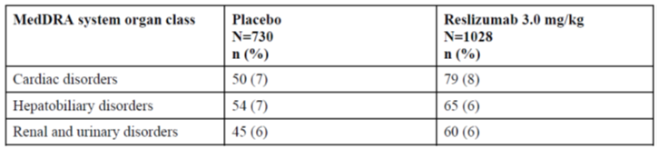

The sponsor explains that reslizumab is a large molecule; thus, cardiotoxicity resulting from direct human ether-à-go-go related gene (hERG) channel blockade is generally not a concern. In the clinical program, there has been no evidence of increased electrocardiogram (ECG) abnormalities or QTc prolongation with reslizumab treatment. Overall, the incidence of individual cardiovascular events (preferred terms) reported in patients treated with reslizumab was low (< 1%), and the incidence of each event type was similar or lower for reslizumab treated patients than for placebo treated patients (Table 36).

Table 36: Number (%) of patients with reported cardiovascular events in reslizumab clinical studies

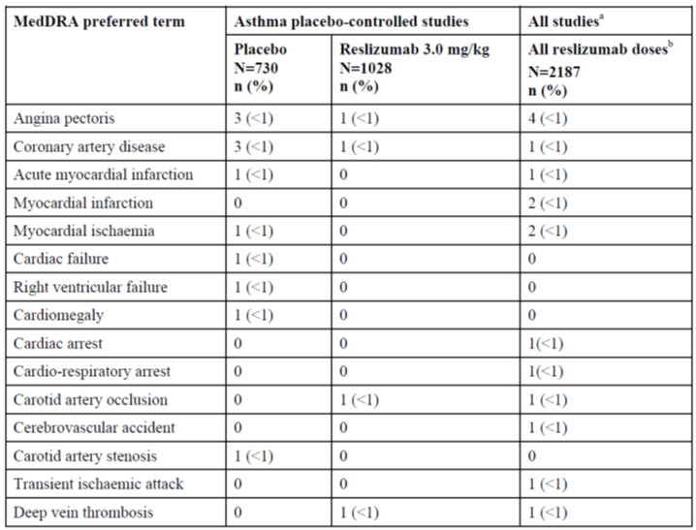

Similar to other monoclonal antibodies, reslizumab is believed to be degraded by enzymatic proteolysis into small peptides and amino acids. Given the proposed clearance mechanism of reslizumab, renal or hepatic impairment is unlikely to affect systemic exposure to reslizumab.

Adverse event data were reviewed for the subsets of patients with impaired renal function at Baseline (as defined in Table 37). The analysis of adverse events showed that the type of adverse events reported in patients treated with reslizumab was comparable among the baseline renal function categories as well as to those treated with placebo (ISS Ad Hoc Summary 9.1). These observations suggest no meaningful influence of mild to moderate renal dysfunction on the safety profile of intravenous reslizumab 3.0 mg/kg (5.3.5.3 Integrated Summary of Safety, Section 7.4.1, Adverse Events by Baseline Renal Function).

Additionally, integrated safety data from the entire treated population, regardless of baseline renal function, was reviewed for the emergence of kidney-associated adverse events, serum indicators of impaired renal function, and changes in urinalysis parameters during the study. This review did not suggest an effect of reslizumab on renal function. The overall incidence of adverse events in the renal and urinary disorders system organ class was similar for placebo- and reslizumab treated patients (13 (2%) placebo versus 12 (1%) reslizumab 3.0 mg/kg). Moreover, reslizumab was not associated with changes in laboratory analyses including serum creatinine, serum urea, or urinalysis (5.3.5.3 Integrated Summary of Safety, Section 5.1 and Section 5.3).

Table 37: Renal function categories used in population pharmacokinetic and adverse event analyses

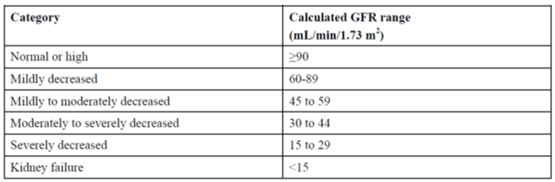

The entire treated population, regardless of baseline liver function test results, were reviewed for the emergence of liver-associated adverse events and abnormal liver function test results during the study. This review of integrated safety data did not suggest an effect of reslizumab on hepatic function. The overall incidence of adverse events in the hepatobiliary disorders system organ class was similar for placebo and reslizumab treated patients (5 (< 1%) placebo versus 5 (< 1%) reslizumab 3.0 mg/kg). Reslizumab was not associated with changes in laboratory analyses including transaminase and bilirubin (5.3.5.3 Integrated Summary of Safety, Section 5.1).

Table 38: Liver function classification used in the population pharmacokinetic analysis

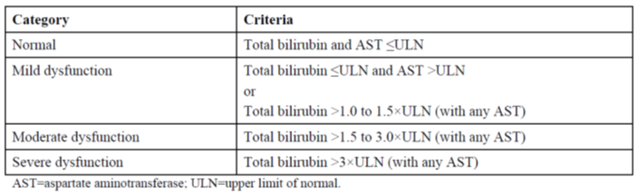

The safety profile of reslizumab in the subset population of patients with renal or hepatic disorders at Baseline was consistent with that of the overall population. Overall, the sponsor does not consider patients with cardiac, renal, or hepatic failure to be at undue risk as a result of reslizumab treatment.

*Evaluator comment:*

The response is acceptable.

1. *The low rate of ADA is noted. Please describe how sensitive the screening antibody assay is.*

*Sponsor response:*

The method used for antidrug antibody (ADA) assessment in all Phase III reslizumab clinical studies in patients with asthma was a homogeneous bridging enzyme-linked immunosorbent assay (ELISA) that employed the labelled drug as both capture and detection reagent. This assay employs a tiered assay testing strategy, with an adequate level of drug tolerance, and includes a step to eliminate interference due to IL-5. The platform provides sensitive and specific detection of ADAs of all immunoglobulin subtypes. In the Phase III clinical studies, a patient was classified as having a treatment emergent ADA response if a sample tested positive at any post dose time point but not at the predose time point or if the post dose ADA titre increased by 4 fold or greater from a positive baseline ADA sample. The screening assay sensitivity is 22 ng/mL, a sensitivity that is consistent with regulatory agency expectations and industry standards.

*Evaluator comment:*

The response is acceptable.

## Second round benefit-risk assessment

### Second round assessment of benefits

The second round assessment of benefits of reslizumab is unchanged as a result of the sponsor’s responses including the clarification of the chosen eosinophil count threshold of ≥ 400 cells/μL and the inclusion of a more defined population (that is patients on medium-to-high dose ICS plus another controller) in the indication.

### Second round assessment of risks

The sponsor has clarified concerns regarding immunogenicity. However, the duration of therapy and long term efficacy and safety beyond 36 months remain unknown.

### Second round assessment of benefit-risk balance

Overall, the benefit-risk balance of reslizumab for the sponsor’s proposed revised indication is favourable.

## Second round recommendation regarding authorisation

At this stage, the clinical evaluator has no major concerns against approving reslizumab for registration for the sponsor’s proposed revised indication:

*‘Cinqair is indicated as add on therapy in adult patients with severe eosinophilic asthma inadequately controlled despite medium-to-high dose inhaled corticosteroids in combination with at least another controller (see CLINICAL TRIALS).’*

This recommendation is subject to a satisfactory response to the amendments to the PI.

## References

Bacharier LB et al. Diagnosis and treatment of asthma in childhood: a PRACTALL consensus report. *Allergy* 2008; 63: 5-34.

Balzar S, et al. Increased TGF-beta2 in severe asthma with eosinophilia. *J Allergy Clin Immunol* 2005; 115: 110-117.

Berry M, et al. Pathological features and inhaled corticosteroid response of eosinophilic and non-eosinophilic asthma. *Thorax* 2007; 62: 1043-1049.

Busse Wet al. Omalizumab, anti-IgE recombinant humanized monoclonal antibody, for the treatment of severe allergic asthma. *J Allergy Clin Immunol* 2001; 108: 184-190.

Chen W, et al. Gender difference, sex hormones, and immediate type hypersensitivity reactions. *Allergy* 2008; 63: 1418-1427.

Ege MJ, et al. Exposure to environmental microorganisms and childhood asthma. *N Engl J Med* 2011; 364: 701-709.

Fahy JV. Eosinophilic and neutrophilic inflammation in asthma: insights from clinical studies. *Proc Am Thorac Soc* 2009; 6: 256-259.

Farooqui N, et al. Blood eosinophils as markers of inflammation in asthma [abstract]. *Ann Allergy Asthma Immunol* 2009; 103(Suppl 3): A56-A57.

Fowler SJ, et al. High blood eosinophil counts predict sputum eosinophilia in patients with severe asthma. *J Allergy Clin Immunol.* 2015; 135: 822-824.e2.

GINA 2015 Global Initiative for Asthma (GINA) REPORT, 2015. The Global Strategy for Asthma Management and Prevention. http://www.ginasthma.org/

GINA 2014. Global Initiative for Asthma (GINA) REPORT, 2014. The Global Strategy for Asthma Management and Prevention. http://www.ginasthma.org/

Green RH, et al. Asthma exacerbations and sputum eosinophil counts: a randomised controlled trial. *Lancet* 2002; 360: 1715-1721.

Hanania NA, et al. Omalizumab in severe allergic asthma inadequately controlled with standard therapy: a randomized trial. *Ann Intern Med* 2011; 154: 573-582.

Humbert M, et al. Benefits of omalizumab as add-on therapy in patients with severe persistent asthma who are inadequately controlled despite best available therapy (GINA 2002 step 4 treatment): INNOVATE. *Allergy* 2005; 60: 309-316.

Jatakanon A, et al. Changes in sputum eosinophils predict loss of asthma control. *Am J Respir Crit Care Med* 2000; 161: 64-72.

Juniper EF, et al. Development and validation of a questionnaire to measure asthma control. *Eur Respir J* 1999; 14: 902-907.

Little RJA and Rubin DB. Statistical analysis with missing data. 2nd ed. Hoboken NJ: Wiley, 2002.

Malinovschi A, et al. Exhaled nitric oxide levels and blood eosinophil counts independently associate with wheeze and asthma events in National Health and Nutrition Examination Survey subjects. *J Allergy Clin Immunol* 2013; 132: 821-827.

Petsky HL, et al. A systematic review and meta-analysis: tailoring asthma treatment on eosinophilic markers (exhaled nitric oxide or sputum eosinophils). *Thorax* 2012; 67: 199-208.

Robinson DS. Eosinophils and asthma. What do measurements tell us? *Clin Exp Allergy* 1995 25: 795-798.

Saglani S, et al. Early detection of airway wall remodeling and eosinophilic inflammation in preschool wheezers. *Am J Respir Crit Care Med* 2007; 176:858-864.

Solér M, et al. The anti-IgE antibody omalizumab reduces exacerbations and steroid requirement in allergic asthmatics. *Eur Respir J* 2001; 18: 254-261. Erratum in: Eur Respir J 2001; 18: 739-740.

ten Brinke A, et al. Factors associated with persistent airflow limitation in severe asthma. *Am J Respir Crit Care Med* 2001; 164: 744-748.

Tran TN, et al. High blood eosiniphil count is associated with more frequent asthma attack in asthma patients. *Ann Allergy Asthma Immunol* 2014; 113: 19-24.

van Veen IH, et al Consistency of sputum eosiniphilia in difficult-to-treat asthma: A 5-year follow-up study. *J Allergy Clin Immunol* 2009; 124: 615-617.

Vijverberg SJ, et al. Biomarkers of therapy responsiveness in asthma: pitfalls and promises. *Clin Exp Allergy* 2011; 41: 615-629

Walford HH, and Doherty TA. Diagnosis and management of eosinophilic asthma: a US perspective. J Asthma Allergy 2014;7: 53-65.

Wenzel SE. Asthma phenotypes: the evolution from clinical to molecular approaches. *Nat Med* 2012; 18: 716-725.

Wenzel SE, et al. Evidence that severe asthma can be divided pathologically into two inflammatory subtypes with distinct physiologic and clinical characteristics. *Am J Respir Crit Care Med* 1999; 160: 1001-1008.

Zeiger RS, et al. Real-time asthma outreach reduces excessive short-acting beta2-agonist use: a randomized study. *J Allergy Clin Immunol Pract* 2014; 2: 445-456.

|  |
| --- |
| Therapeutic Goods Administration |
| PO Box 100 Woden ACT 2606 Australia  Email: [info@tga.gov.au](mailto:info@tga.gov.au) Phone: 1800 020 653 Fax: 02 6232 8605  [**https://www.tga.gov.au**](https://www.tga.gov.au) |