PRODUCT INFORMATION

CINQAIR® (reslizumab)

# NAME OF THE MEDICINE

CINQAIR® (reslizumab) concentrated solution for intravenous infusion following dilution.

CAS number: 241473-69-8

# DESCRIPTION

Reslizumab is a humanized anti-human interleukin 5 monoclonal antibody (anti IL-5 mAb) of the immunoglobulin-G4-kappa (IgG4/k) isotope, produced in mouse myeloma cells (NS0) by recombinant DNA technology. Reslizumab works by binding to IL-5, thereby preventing binding of IL-5 to the IL-5 receptor and consequently reduces circulating and tissue eosinophils.

The theoretical molecular weight for reslizumab is 147 kDa. The reslizumab antibody is comprised of 2 heavy chains (433 amino acids in each heavy chain) and 2 light chains (214 amino acids in each light chain).

Each single-use vial of CINQAIR contains a sterile aqueous concentrated solution for dilution before infusion of reslizumab 10 mg/mL.

Each 10 mL single-use vial contains the equivalent of 100 mg reslizumab. Each 10 mL single-use vial also contains 2.45 mg/mL sodium acetate trihydrate, 0.12 mg/mL acetic acid, 70 mg/mL sucrose and water for injections q.s. 10 mL.

# PHARMACOLOGY

## Pharmacodynamics

Pharmacotherapeutic group: Drugs for obstructive airway diseases, other systemic drugs for obstructive airway diseases; ATC code: R03DX08.

### Mechanism of action

Reslizumab is a humanized monoclonal antibody (IgG4, kappa) against the human interleukin-5 (IL-5). Reslizumab binds specifically to IL-5 and interferes with IL-5 binding to its cell-surface receptor.  IL-5 is a key cytokine responsible for the differentiation, maturation, recruitment and activation of human eosinophils.  Reslizumab binds human IL-5 with picomolar affinity blocking its biological function, thereby reducing the survival and activity of eosinophils.

### Pharmacodynamic effects

Effect on sputum eosinophils

The effect of reslizumab in patients with asthma and elevated sputum eosinophil counts (at least 3%) was evaluated in a 15‑week, phase 2, randomised, double‑blind, placebo‑controlled clinical study with reslizumab 3 mg/kg. Sputum eosinophils were measured in a subset of 38 adult patients at the end of therapy. In this study, the percentage of sputum eosinophils was reduced from a mean baseline value of 17.4% (standard deviation: 15.9%) by 82% at the end of therapy in the reslizumab group.

Effect on blood eosinophils

In clinical Studies I and II with reslizumab 3 mg/kg, decreases in blood eosinophil counts were seen following the first dose and maintained through 52 weeks of treatment with no signs of tachyphylaxis. In pooled data, mean eosinophil counts were 655 µL-1 (n=476) and 654 µL-1 (n=477) for the placebo and reslizumab treatment groups at baseline and were 514 µL-1 (n=405) and 61 µL-1 (n=407) at week 52. Eosinophils began to return towards baseline in those reslizumab patients completing a 90‑day follow‑up assessment (394 µL-1, n=36). Decreases in blood eosinophils were related to reslizumab levels.

The reduction in blood eosinophil counts by reslizumab in anti‑reslizumab antibody‑positive patients was not different from patients who were anti‑reslizumab antibody‑negative.

## Pharmacokinetics

### Absorption

The pharmacokinetic characteristics of reslizumab are similar in healthy adults and in adolescents and adults with asthma. Inter-individual variability in peak and overall exposure is approximately 20-30%.

Peak serum concentrations of 80 µg/mL are typically observed at the end of the infusion. Serum reslizumab concentrations generally decline from peak in a biphasic manner. Following multiple doses, serum concentrations of reslizumab accumulate approximately 1.5 to 1.9-fold. No apparent deviation from dose-proportional reslizumab pharmacokinetics was noted over the dose range of 0.3 mg/kg to 3.0 mg/kg. Inter-individual variability in peak and overall exposure is approximately 20-30%.

Based on population pharmacokinetic [pop-PK] analysis, systemic exposure to reslizumab appears to be unaffected by circulating anti‑drug antibodies.

### Distribution

Reslizumab has a volume of distribution of approximately 5 L, suggesting minimal distribution to the extravascular tissues.

### Metabolism

Similar to other monoclonal antibodies, reslizumab is believed to be degraded by enzymatic proteolysis into small peptides and amino acids. As reslizumab binds to a soluble target, linear non-target-mediated clearance is expected.

### Excretion

Reslizumab clearance is approximately 7 mL/hour. Reslizumab has a long half-life of approximately 24 days.

## Special Patient Populations

The population pharmacokinetics of reslizumab were analysed to evaluate the effects of demographic characteristics. Limited data suggest that no dose adjustments are necessary for race or gender.

### Elderly Patients

Based on the similar reslizumab exposure observed in patients older than 65 years of age as compared to patients 18 to <65 years of age, no dose adjustment is recommended.

There are limited data available on the use of reslizumab in patients older than 75 years of age.

### Hepatic Impairment

Reslizumab has not been studied in patients with hepatic impairment. No direct effect of hepatic function on the pharmacokinetics of reslizumab is expected because antibodies are principally cleared by catabolism. In a pop-PK analysis, patients were classified by baseline liver function levels. Most patients had normal liver function tests (n=766, approximately 95%) or mildly increased liver function tests (either, in the first case, total bilirubin above the upper limit of normal [ULN] but less than or equal to 1.5 times the ULN or, in the second case, aspartate aminotransferase greater than the ULN and total bilirubin less than or equal to the ULN; n=35, approximately 4%) at baseline. No significant difference in the pharmacokinetics of reslizumab was observed across these groups.

### Renal Impairment

Reslizumab is an antibody with a molecular mass of 147 kDaltons and is therefore not expected to be excreted in urine. Most patients in the population pharmacokinetic analysis had normal renal function (estimated glomerular filtration rate [eGFR]) greater than or equal to 90 mL/min/1.73 m2; n=294, approximately 37%), mild renal impairment (eGFR 60-89 mL/min/1.73 m2; n=446, approximately 56%), or moderate renal impairment (eGFR 30-59 mL/min/1.73 m2; n=63, approximately 8%) at baseline. No noteworthy differences in the pharmacokinetics of reslizumab were observed across these renal function groups. Reslizumab has not been studied in patients with severe renal impairment or end stage renal disease.

# CLINICAL TRIALS

## Overview of clinical efficacy

The efficacy of CINQAIR in eosinophilic asthma (blood eosinophils ≥400 µL-1) was evaluated in three randomised, double‑blind, placebo‑controlled studies (Studies I to III) from 16 to 52 weeks’ duration involving 1268 patients with moderate to severe asthma inadequately controlled on medium to high‑dose inhaled corticosteroids (ICS; at least 440 µg of fluticasone propionate daily or equivalent) with or without other controllers; prior stable allergen immunotherapy was allowed.

Studies I and II were 52‑week, randomised, placebo‑controlled studies in patients who had at least one asthma exacerbation requiring systemic corticosteroid use over the past twelve months. Maintenance oral corticosteroids (OCS; up to 10 mg per day prednisone equivalent) were allowed. The patients received either 13 doses of placebo or CINQAIR 3 mg/kg administered once every 4 weeks.

Study III was a 16‑week, randomised, placebo‑controlled study. There was no prior asthma exacerbation requirement for this study. Maintenance OCS was not allowed. The patients received either four doses of placebo or CINQAIR 0.3 mg/kg or 3 mg/kg administered once every 4 weeks.

0B**Table 1 Demographics and baseline characteristics of asthma studies I-III**

|  |  |  |  |
| --- | --- | --- | --- |
| **Demographic or baseline characteristic** | **Study I**  **(n=489)** | **Study II**  **(n=464)** | **Study III**  **(n=315)** |
| **Demographics** |  |  |  |
| Age, mean in years | 46.65 | 46.97 | 43.89 |
| Asthma duration, mean in years | 19.28 | 18.41 | 20.35 |
| **Pulmonary function tests** |  |  |  |
| Pre-bronchodilator FEV1a, mean % predicted | 64.31 | 69.21 | 70.14 |
| **Eosinophil counts** |  |  |  |
| Baseline mean blood eosinophil count, µL-1 | 660 | 649 | 614 |
| **Exacerbation history** |  |  |  |
| Mean number of exacerbations in previous year | 1.99 | 1.94 | 2.03 |
| **Proportions of patients in GINA steps 4 and 5c** |  |  |  |
| GINA 4, % | 68 | 70 | 79 |
| GINA 5, % | 13 | 9 | <1 |
| **Patients with refractory asthmad** |  |  |  |
| % | 34 | 31 | NAb |
| a FEV1=forced expiratory volume in 1 second b NA=not available  c The GINA classification is based on the Global Initiative for Asthma (GINA) definition:  GINA step 4 patients received medium to high dose ICS plus another controller.  GINA step 5 patients received in addition, as an add‑on, maintenance OCS.  d The percentage of patients with refractory asthma (based on the American Thoracic Society (ATS)/European Respiratory Society (ERS) 2000 workshop definition for refractory asthma) from Studies I and II was analysed post hoc. | | | |

## Studies I and II

The primary efficacy measure for both Studies I and II was the frequency of asthma exacerbations for each patient during the 52‑week treatment period. In both studies, an asthma exacerbation was defined as a worsening of asthma that required the following medical intervention:

1. Use of systemic corticosteroids or an increase in the use of ICS treatment for 3 or more days, and/or
2. Asthma‑related emergency treatment including at least one of the following: an unscheduled visit to their healthcare professional for nebuliser treatment or other urgent treatment to prevent worsening of asthma symptoms; a visit to the emergency room for asthma‑related treatment; or asthma‑related hospitalisation.

## Overall population

In Studies I and II, patients receiving CINQAIR 3 mg/kg had significant reductions in asthma exacerbations (50% and 59%, respectively) compared to placebo (Table 2). The overall reduction was 54%.

1B**Table 2 Frequency of asthma exacerbations during the 52-week treatment period - Studies I and II, integrated data (Studies I and II) for the overall population and subgroup GINA 4 and 5**

|  |  |  |  |  |  |
| --- | --- | --- | --- | --- | --- |
|  | **Treatment arms (n)** | | **Asthma exacerbation ratea** | **% reduction** | |
| **Data by study** |  | |  |  | |
| **Study I** | CINQAIR 3 mg/kg (n=245) | | 0.90 | 50% (p<0.0001) | |
| Placebo (n=244) | | 1.80 |
| **Study II** | CINQAIR 3 mg/kg (n=232) | | 0.86 | 59% (p<0.0001) | |
| Placebo (n=232) | | 2.12 |
| **Integrated Studies I and II** | | | | | |
| **Overall population** | CINQAIR 3 mg/kg  (n=477) | 0.84 | | | 54% (p<0.0001) |
| Placebo (n=476 | 1.81 | | |
| **Subgroup GINA 4 and 5** | CINQAIR 3 mg/kg  (n=383)  95% CIb | 0.85  (0.64, 1.12) | | | 56% |
| Placebo  (n=380)  95% CI | 1.95  (1.50, 2.53) | | |
| a Rate adjusted for stratification factors (baseline usage of OCS and geographical region).  b CI = Confidence Interval | | | | | |

A subgroup analysis of patients in Studies I and II using OCS at baseline demonstrated substantial improvements in asthma exacerbations (rate ratio reslizumab 3 mg/kg relative to placebo 0.28, 95% CI 0.15, 0.52) and in lung function (0.237 L, 95% CI 0.068, 0.407).

The proportion of patients who did not experience an asthma exacerbation during the 52‑week treatment period was higher in the CINQAIR 3 mg/kg group (62% and 75%) compared with the placebo group (46% and 55%), in Studies I and II, respectively.

## Patients with severe eosinophilic asthma

In Studies I and II, severe eosinophilic asthma is defined as any patients falling into GINA steps 4 and 5 (medium to high‑dose ICS plus another controller, with or without maintenance OCS) with a blood eosinophil count of ≥400 µL-1 at start of treatment. A cohort of 763 patients within studies I and II met this criterion. In integrated studies I and II, patients receiving CINQAIR 3 mg/kg had significant reductions in exacerbations (56% for subgroup GINA 4 and 5) compared to placebo.

The effect of CINQAIR 3 mg/kg administered once every 4 weeks on secondary endpoints, including FEV1, Asthma Quality of Life Questionnaire (AQLQ), Asthma Control Questionnaire (ACQ), and Asthma Symptom Utility Index (ASUI) further supports the efficacy of CINQAIR 3 mg/kg compared to placebo (Table 3). Meaningful clinical improvements in FEV1 and ACQ were observed as early as 4 weeks (AQLQ at 16 weeks) following the first dose of CINQAIR and sustained through week 52.

Results for FEV1, ACQ and AQLQ are shown in Table 3 below for the overall population, and subgroup GINA 4 and 5.

2B**Table 3 Treatment difference in mean change from baseline for selected secondary efficacy variables – Integrated data (Studies I and II) for the overall population and subgroup GINA 4 and 5**

|  |  |  |  |  |  |  |  |  |
| --- | --- | --- | --- | --- | --- | --- | --- | --- |
|  | **Overall population** | | | | **Subgroup GINA 4 and 5** | | | |
| **Efficacy Variablea** | **Over 16 weeks** | | **Over 52 weeks** | | **Over 16 weeks** | | **Over 52 weeks** | |
| **FEV1 (mL)** |  |  |  |  |  |  |  |  |
| Mean diff  (95% CIb) (p‑value) | 117 (73, 160) (p<0.0001) | | 110 (66, 154) (p<0.0001) | | 143 (94, 192) | | 129 (80, 179) | |
| **ACQ** |  |  |  |  |  |  |  |  |
| Mean diff  (95% CI) (p‑value) | -0.232 (-0.325, -0.139) | | -0.250 (-0.343, -0.156) | | -0.321 (-0.424, -0.218) | | -0.330 (-0.433, -0.266) | |
| **AQLQ** |  |  |  |  |  |  |  |  |
| Mean diff (95% CI) (p‑value) | 0.226 (0.094, 0.395) (p<0.0001) | | 0.272 (0.155, 0.388) (p=0.0001) | | 0.295 (0.151, 0.438) | | 0.346 (0.219, 0.473) | |
| a The values represent the treatment difference between placebo and CINQAIR 3 mg/kg based on adjusted means over the specified time period for each treatment group, except for the change to week 16 for AQLQ, which was the first timepoint where AQLQ was assessed.  b CI = Confidence Interval | | | | | | | | |

Improvements in FEV1 were observed at 4 weeks following the first dose of CINQAIR for Studies I and II (Figure 1). Improvements as early as 4 weeks were also observed for ACQ (Figure 2).

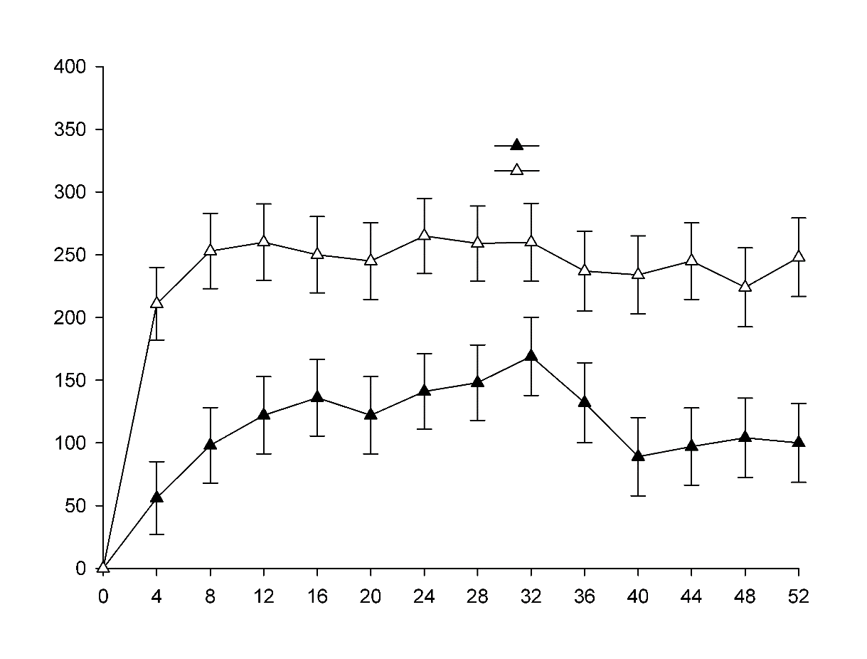

Week

Mean change from baseline in FEV1 (mL)

Placebo

CINQAIR 3 mg/kg

3B**Figure 1 Mean change from baseline in FEV1 to each visit in subgroup GINA 4 and 5 (integrated studies I and II)**

All values represent adjusted means for the treatment difference from baseline (± standard error) over the specified time period for subgroup GINA 4 and 5 of integrated Studies I and II.

Week

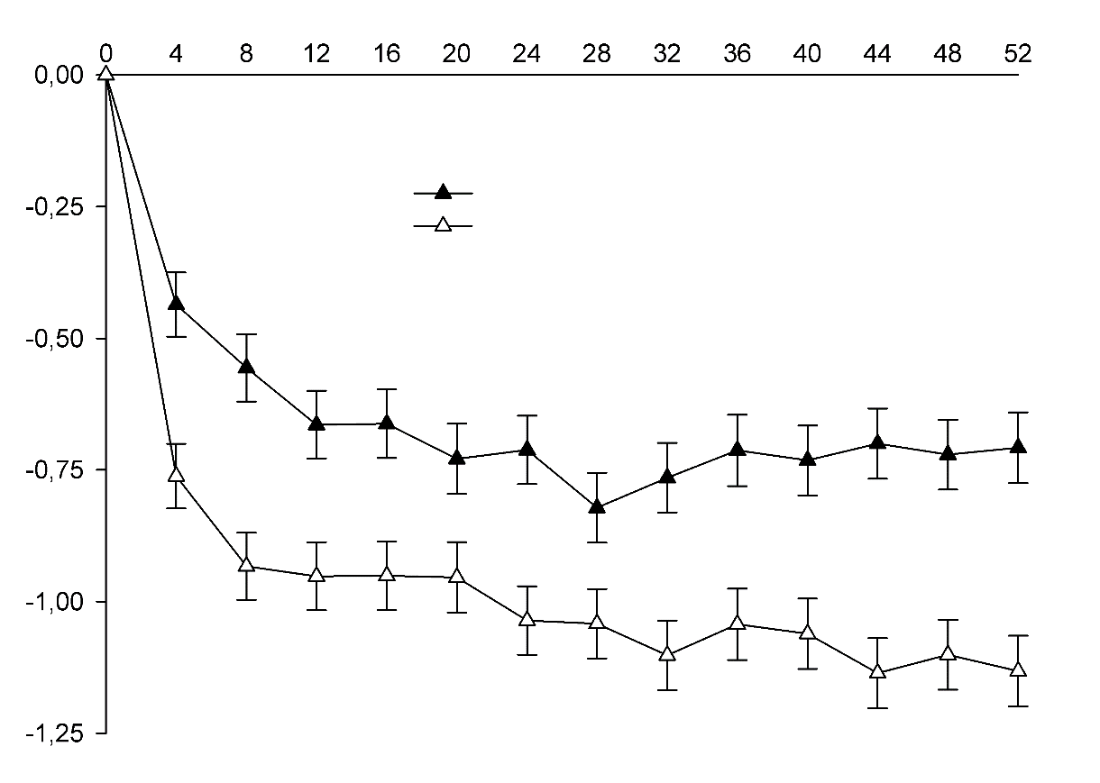

ACQ score

Placebo

CINQAIR 3 mg/kg

4B**Figure 2 Mean change from baseline in ACQ to each visit in subgroup GINA 4 and 5 (integrated Studies I and II)**

All values represent adjusted means for the treatment difference from baseline (± standard error) over the specified time period for subgroup GINA 4 and 5 of integrated Studies I and II.

## Study III

The primary endpoint was the change from baseline over 16 weeks in FEV1. In Study III, patients receiving CINQAIR 3 mg/kg had significantly higher increases in FEV1 from baseline compared to placebo (160 mL, p=0.0018). Improvements were noted in FEV1 at 4 weeks following the first dose of CINQAIR.

## Immunogenicity

In phase 3 placebo‑controlled studies with a duration of 16 to 52 weeks, low‑titre, frequently transient anti‑reslizumab antibodies were detected in 53 out of 983 asthma patients (5%) receiving reslizumab at 3 mg/kg. In an open‑label phase 3 extension study, low‑titre, frequently transient anti‑reslizumab antibodies were detected in 49 out of 1,014 asthma patients (5%) who received 3 mg/kg reslizumab for up to 36 months. Systemic exposure to reslizumab appears to be unaffected by anti‑reslizumab antibodies. The antibodies had no impact on clinical pharmacodynamics, efficacy or safety.

# INDICATIONS

CINQAIR is indicated as add-on therapy in adult patients with severe eosinophilic asthma (blood eosinophil count ≥400cells/µL) (see **CLINICAL TRIALS**).

# CONTRAINDICATIONS

Hypersensitivity to reslizumab or to any of the excipients (see **DESCRIPTION**).

# PRECAUTIONS

CINQAIR should not be used to treat acute asthma exacerbations.

Asthma-related symptoms of exacerbations may occur during treatment. Patients should be instructed to seek medical advice if their asthma remains uncontrolled or worsens after initiation of treatment.

**Reduction of Corticosteroid Dosage**

No clinical studies have been conducted to assess the reduction of maintenance corticosteroid dosages following administration of CINQAIR. Do not discontinue systemic or inhaled corticosteroid therapy abruptly upon initiation of therapy with CINQAIR. Reductions in corticosteroid dose, if appropriate, should be gradual and performed under the supervision of a physician. Reduction in corticosteroid dose may be associated with systemic withdrawal symptoms and/or unmask conditions previously suppressed by systemic corticosteroid therapy.

## Hypersensitivity and administration-related reactions

Acute systemic reactions, including anaphylactic reactions, have been reported in association with CINQAIR (see **ADVERSE EFFECTS**). These adverse reactions were observed during or within 20 minutes after completion of CINQAIR infusion. Patients should be monitored during and for an appropriate time after administration of CINQAIR. If an anaphylactic reaction occurs, administration of CINQAIR should be stopped immediately and appropriate medical treatment should be provided; CINQAIR must be discontinued permanently.

## Malignancy

The impact of lowering eosinophils with an anti-IL5 active substance, such as reslizumab, on the development of malignancies is not known. In placebo controlled clinical trials, 6/1028 (0.6%) of patients receiving 3mg/kg CINQAIR had at least 1 malignant neoplasm reported compared to 2/730 (0.3%) patients in the placebo group. The observed malignancies in CINQAIR treated patients were diverse in nature and without clustering of any particular tissue type. The majority of malignancies were diagnosed within less than 6 months of exposure to CINQAIR.

## Parasitic (helminth) Infections

Eosinophils may be involved in the immunological response to some helminth infections. Patients with pre-existing helminth infections should be treated before starting CINQAIR therapy. If patients become infected whilst being treated with CINQAIR and do not respond to anti-helminth treatment temporary discontinuation of CINQAIR should be considered.

## Effects on Fertility

There are no fertility data in humans. Available non-clinical data do not suggest an effect on fertility.

Administration of reslizumab to mice at intravenous doses up to 50 mg/kg, yielding approximately 4 times the human AUC at the recommended maximum dose of 3 mg/kg had no effect on male or female fertility.

## Use in Pregnancy (Category B1)

There are limited data from the use of CINQAIR in pregnant women. No adverse effects on embryofetal development were observed in mice and rabbits given reslizumab at intravenous doses up to 50 mg/kg, yielding approximately 4 times the systemic exposure (serum AUC) obtained in patients at the maximum recommended human dose of 3 mg/kg. As a precautionary measure, the use of CINQAIR should be avoided during pregnancy. Reslizumab has a long half-life of approximately 24 days (see **PHARMACOLOGY; Excretion**), which should be taken into consideration.

## Use in Lactation

It is unknown whether reslizumab is excreted in human milk. Excretion of reslizumab in milk has been shown in mice.

A decision should be made whether to discontinue breast-feeding or discontinue CINQAIR, taking into account the importance of breast-feeding to the infant and the importance of the drug to the mother.

## Use in the Paediatric Population

CINQAIR is not indicated for use in paediatric patients less than 18 years of age. The safety and effectiveness in pediatric asthma patients (aged 17 years and younger) have not been established.

CINQAIR was evaluated in 39 patients aged 12 to less than 18 years with asthma in two   
52-week exacerbation studies and one 16-week lung function study. In the exacerbation studies, patients were required to have at least 1 asthma exacerbation requiring systemic corticosteroid use in the year prior to study entry*.* In these studies, the asthma exacerbation rate was higher in adolescent patients treated with CINQAIR than placebo (CINQAIR n=14, rate 2.86, 95% CI [1.02 to 8.09] and placebo n=11, rate 1.37, 95% CI [0.57 to 3.28]: rate ratio 2.09, 95% CI [0.82 to 5.36]).

## Use in the Elderly

There are limited data available on the use of CINQAIR in patients older than 75 years of age. Based on the similar reslizumab exposure observed in patients older than 65 years of age as compared to patients 18 to <65 years of age, no dose adjustment is recommended.

## Genotoxicity

Reslizumab was negative in assays for bacterial mutagenicity and for clastogenicity *in vitro* (chromosomal aberrations in human lymphocytes).

## Carcinogenicity

Reslizumab was shown to not be carcinogenic in a 6-month study in transgenic (rasH2) mice, involving intravenous administration at doses up to 516 mg/kg every two weeks (yielding ~150 times the systemic exposure in patients receiving the maximum recommended human dose of 3 mg/kg every four weeks).

## Effect on Ability to Drive and Operate Machinery

CINQAIR has no or negligible effect on the ability to drive and use machines.

# INTERACTIONS WITH OTHER MEDICINES

No formal clinical drug interaction studies have been performed with CINQAIR. *In vitro* experiments with cultured human hepatocytes showed that reslizumab did not affect CYP1A2, 3A4 or 2B6 expression. Based on the characteristics of reslizumab, drug‑drug interactions are not expected. Results of population pharmacokinetic analysis confirm that concomitant use of either leukotriene antagonists or systemic corticosteroids does not affect the pharmacokinetics of reslizumab (see **PHARMACOLOGY; Pharmacokinetics**).

CINQAIR has not been studied in patients concurrently taking immunosuppressant medicinal products other than oral corticosteroids (OCS) or immunomodulating products including mepolizumab or omalizumab; therefore, the safety and efficacy profile of CINQAIR in these patients is unknown.

CINQAIR has not been studied in patients receiving live vaccines. No data are available on the secondary transmission of infection from persons receiving live vaccines to patients receiving CINQAIR or the response to new immunisations in patients receiving CINQAIR.

# ADVERSE EFFECTS

Summary of the safety profile

The most frequently reported adverse reaction during treatment was increased blood creatinine phosphokinase, which occurred in approximately 2% of patients. Anaphylactic reaction occurred in less than 1% of patients.

During controlled clinical studies, the proportion of patients who discontinued due to any adverse event was 5% for both the CINQAIR 3 mg/kg and placebo groups (see **CLINICAL TRIALS**).

Tabulated list of adverse reactions

Overall, 2,195 subjects received at least one dose of CINQAIR. Of these subjects, 1,006 asthma patients were exposed for at least 6 months, 759 exposed for at least 1 year and 237 exposed for longer than 2 years (up to 3 years). The following adverse reactions have been reported with CINQAIR during placebo‑controlled asthma studies for up to 52 weeks of treatment with a 3 mg/kg dose given intravenously (1,028 patients). Adverse reactions are listed below in Table 4 by system organ class and frequency (frequencies are defined as: very common (≥1/10), common (≥1/100 to <1/10), uncommon (≥ 1/1,000 to <1/100), rare (≥1/10,000 to <1/1,000), very rare (<1/10,000), not known (cannot be estimated from the available data).

5B**Table 4 Adverse reactions**

|  |  |  |
| --- | --- | --- |
| **System organ class** | **Frequency** | **Adverse reaction** |
| *Immune system disorders* | Uncommon | Anaphylactic reaction* |
| *Musculoskeletal and connective tissue disorders* | Uncommon | Myalgia* |
| *Investigations* | Common | Blood creatine phosphokinase increased* |
| *See subsection “Description of selected adverse reactions” | | |

Description of selected adverse reactions

*Anaphylactic reaction*

The serious adverse reaction of anaphylactic reaction was reported and considered related to CINQAIR in 3 patients (0.19%) during placebo-controlled and open-label asthma studies. These reactions were observed during or within 20 minutes after completion of CINQAIR infusion and were reported as early as the second dose of CINQAIR. They were fully resolved with standard treatment with no residual effect. Manifestations included skin or mucosal involvement, dyspnoea, wheezing, gastrointestinal symptoms and chills. These cases resulted in the discontinuation of treatment. Due to an overlap in signs and symptoms, it was not possible to distinguish between an anaphylactic reaction, another hypersensitivity reaction or an infusion‑related reaction in all cases.

*Myalgia*

Myalgia was reported in 0.97% of patients (10 out of 1,028) in the 3 mg/kg CINQAIR group of the placebo‑controlled asthma studies compared with 0.55% of patients (4 out of 730) in the placebo group.

*Blood creatine phosphokinase increased*

Blood creatine phosphokinase elevations were transient and asymptomatic, and did not lead to treatment discontinuation.

*Malignancies*

The impact of lowering eosinophils with an anti-IL 5 active substance, such as reslizumab, on the development of malignancies is not known. Malignancies have been reported in clinical trials (see **PRECAUTIONS**).

Paediatric population

Experience in paediatric patients is limited. The data do not indicate a difference in the safety profile of CINQAIR in paediatric patients compared with that of adult patients (see **PRECAUTIONS**).

# DOSAGE AND ADMINISTRATION

The recommended dose of CINQAIR, based on body weight, is 3.0 mg/kg, given once every four weeks. CINQAIR is intended for long-term treatment.

A decision to continue CINQAIR therapy should be made at least annually based on disease severity and level of exacerbation control.

CINQAIR should be prescribed by a medical practitioner in consultation with a specialist respiratory physician, experienced in the diagnosis and treatment of severe asthma.

Product is for single use in one patient only. Discard any residue.

## Missed Doses

If an infusion of CINQAIR is missed on the planned date, dosing should resume as soon as possible on the indicated dose and regimen. A double dose must not be administered to make up for the missed dose.

## Preparation instructions – Use Aseptic Technique

1. Remove CINQAIR from the refrigerator. Do not shake the vial.
2. The medicinal product should be inspected visually before use. The concentrate is clear to slightly hazy opalescent, colourless to slightly yellow. Proteinaceous particles may be present in the concentrate that appear as translucent to white, amorphous particles, some of which may have a fibrous nature. This is not unusual for proteinaceous solutions. The concentrate must not be used if coloured (except slightly yellow) or if foreign particles are present.
3. A suitable injection syringe should be used to withdraw the calculated volume of the concentrate from the vial(s). The volume (in mL) required is calculated based on the body weight (in kg) of the patient:

***0.3 x body weight*****(in kg)**

e.g. a volume of 18 mL (180 mg) will be necessary for a body weight of 60 kg (0.3 x 60 kg = 18 mL).

1. Slowly dispense the content of the syringe into an infusion bag containing 50 mL of sodium chloride 9 mg/mL (0.9%) solution for infusion. Gently invert the bag to mix the solution. This medicinal product must not be mixed with other medicinal products except sodium chloride 9 mg/mL (0.9%) solution for infusion.
2. The concentrate does not contain any preservatives. Any remaining unused concentrate in the vial(s) must be discarded.
3. It is recommended that the solution for infusion be administered immediately after preparation. Solutions of CINQAIR diluted in sodium chloride 9 mg/mL (0.9%) solution for infusion may be stored refrigerated at 2°C – 8°C or not above 25°C, protected from light for up to 16 hours.
4. CINQAIR is compatible with polyvinylchloride (PVC) or polyolefin (PO) infusion bags.

## Administration instructions

CINQAIR is for intravenous infusion only. It must not be administered by subcutaneous, intramuscular or oral routes.

1. CINQAIR should be administered by a healthcare professional prepared to manage hypersensivity reactions including anaphylaxis. The patient has to be observed over the duration of the infusion and for an appropriate period of time afterwards. Patients should be instructed in how to recognise symptoms of serious allergic reactions.
2. If refrigerated, allow the solution for infusion to reach room temperature (15°C – 25°C).
3. The solution for infusion should be infused intravenously over a 20 – 50‑minute period. Infusion time may vary depending on the total volume to be infused.
4. The solution for infusion should not be infused concomitantly in the same intravenous line with other medicinal products. No physical or biochemical compatibility studies have been conducted to evaluate the co‑administration of reslizumab with other medicinal products.
5. An infusion set with an in‑line, sterile, non‑pyrogenic, low‑protein‑binding filter (pore size of 0.2 µm) should be used for infusion. CINQAIR is compatible with polyethersulfone (PES), polyvinylidene fluoride (PVDF), nylon, cellulose acetate (CA) low protein binding in‑line infusion filters.
6. Upon completion of the infusion, flush the infusion set with sterile sodium chloride 0.9 mg/mL (0.9%) solution for infusion to ensure that all of the CINQAIR solution for infusion has been administered.
7. In order to improve the traceability, the trade name and batch number of the administered medicinal product should be clearly recorded in the patient file.

# OVERDOSAGE

The highest single dose of CINQAIR administered intravenously was reported at 12.1 mg/kg and had no clinical consequences for the patient.

There is no specific treatment for overdose with CINQAIR. In case of overdose, it is recommended that the patient be monitored for any signs or symptoms of adverse effects and given appropriate symptomatic treatment.

For information on the management of overdose, contact the Poison Information Centre on 131126 (Australia).

# PRESENTATION AND STORAGE CONDITIONS

## Storage

Unopened vial

Store in a refrigerator at 2°C – 8°C. Do not freeze. Store in original packing to protect from light until use.

Diluted solution

Chemical and physical in‑use stability has been demonstrated at 2°C – 8°C and at 25°C in sodium chloride 0.9% solution for infusion for up to 16 hours when protected from light.

## Nature and Contents of Container

CINQAIR (reslizumab) 100 mg/10 mL concentrated solution vial.

CINQAIR is a clear to slightly hazy opaque, colourless to slightly yellow sterile solution, presented in a 10 mL type I glass vial with FluroTec® coated butyl rubber stopper and aluminium crimp seal with royal blue plastic flip-off cap.

# NAME AND ADDRESS OF THE SPONSOR

Teva Pharma Australia Pty Ltd  
Level 2, 37 Epping Road  
Macquarie Park NSW 2113

# POISON SCHEDULE OF THE MEDICINE

Schedule 4 – Prescription Only Medicine

# DATE OF FIRST INCLUSION IN THE AUSTRALIAN REGISTER OF THERAPEUTIC GOODS (ARTG)

25/07/2017