|  |
| --- |
| **October 2013** |

|  |
| --- |
| Australian Public Assessment Report for Retigabine |
| Proprietary Product Name: Trobalt |
| Sponsor: GlaxoSmithKline Australia Pty Ltd |

About the Therapeutic Goods Administration (TGA)

* The Therapeutic Goods Administration (TGA) is part of the Australian Government Department of Health and is responsible for regulating medicines and medical devices.
* The TGA administers the *Therapeutic Goods Act 1989* (the Act), applying a risk management approach designed to ensure therapeutic goods supplied in Australia meet acceptable standards of quality, safety and efficacy (performance), when necessary.
* The work of the TGA is based on applying scientific and clinical expertise to decision-making, to ensure that the benefits to consumers outweigh any risks associated with the use of medicines and medical devices.
* The TGA relies on the public, healthcare professionals and industry to report problems with medicines or medical devices. TGA investigates reports received by it to determine any necessary regulatory action.
* To report a problem with a medicine or medical device, please see the information on the TGA website <<http://www.tga.gov.au>>.

About AusPARs

* An Australian Public Assessment Record (AusPAR) provides information about the evaluation of a prescription medicine and the considerations that led the TGA to approve or not approve a prescription medicine submission.
* AusPARs are prepared and published by the TGA.
* An AusPAR is prepared for submissions that relate to new chemical entities, generic medicines, major variations, and extensions of indications.
* An AusPAR is a static document, in that it will provide information that relates to a submission at a particular point in time.
* A new AusPAR will be developed to reflect changes to indications and/or major variations to a prescription medicine subject to evaluation by the TGA.

**Copyright**© Commonwealth of Australia 2013

This work is copyright. You may reproduce the whole or part of this work in unaltered form for your own personal use or, if you are part of an organisation, for internal use within your organisation, but only if you or your organisation do not use the reproduction for any commercial purpose and retain this copyright notice and all disclaimer notices as part of that reproduction. Apart from rights to use as permitted by the *Copyright Act 1968* or allowed by this copyright notice, all other rights are reserved and you are not allowed to reproduce the whole or any part of this work in any way (electronic or otherwise) without first being given specific written permission from the Commonwealth to do so. Requests and inquiries concerning reproduction and rights are to be sent to the TGA Copyright Officer, Therapeutic Goods Administration, PO Box 100, Woden ACT 2606 or emailed to <[tga.copyright@tga.gov.au](mailto:tga.copyright@tga.gov.au)>.

Contents

I. Introduction to product submission 5

Submission details 5

Product background 5

Regulatory status 6

Product Information 8

II. Quality findings 8

Drug substance (active ingredient) 8

Drug product 9

Biopharmaceutics 10

Advisory committee considerations 10

Quality summary and conclusions 11

III. Nonclinical findings 11

Introduction 11

Pharmacology 11

Pharmacokinetics 18

Toxicology 20

Nonclinical summary and conclusions 28

IV. Clinical findings 31

Introduction 31

Pharmacokinetics 31

Pharmacodynamics 32

Efficacy 32

Safety 34

List of questions 35

Clinical summary and conclusions 36

V. Pharmacovigilance findings 39

Risk management plan 39

VI. Overall conclusion and risk/benefit assessment 45

Quality 45

Nonclinical 45

Clinical 46

Risk management plan 51

Risk-benefit analysis 51

Outcome 60

Attachment 1. Product Information 60

Attachment 2. Extract from the Clinical Evaluation Report 60

## I. Introduction to product submission

### Submission details

|  |  |  |
| --- | --- | --- |
| *Type of submission:* | New Chemical Entity | |
| *Decision*: | Approved | |
| *Date of decision:* | 27 June 2013 | |
| *Active ingredient:* | Retigabine |
| *Product name:* | Trobalt |
| *Sponsor’s name and address:* | GlaxoSmithKline Australia Pty Ltd  Level 4, 436 Johnston Street  Abbotsford VIC 3067 |
| *Dose form:* | Film coated tablets |
| *Strengths:* | 50 mg, 100 mg, 200 mg, 300 mg and 400 mg |
| *Containers:* | PVC/PVDC/Al blister packs |
| *Pack sizes:* | * 21, 84 and 168 tablets for the 50 mg and 100 mg tablets * 84 and 168 tablets for the 200 mg, 300 mg and 400 mg tablets * Treatment initiation pack containing 21 x 50 mg tablets and 42 x 100 mg tablets |
| *Approved therapeutic use:* | Adjunctive treatment of drug resistant partial onset seizures with or without secondary generalisation, in patients with epilepsy where other appropriate drug combinations have proved inadequate or have not been tolerated. |
| *Route of administration:* | Oral |
| *Dosage:* | Starting dose is 100 mg three times per day, up to a maximum dose of 1200 mg per day. |
| *ARTG numbers:* | AUST R 195150, AUST R 195151, AUST R 195152, AUST R 195153, AUST R 195154, AUST R 195155 |

### Product background

This AusPAR describes an application by the sponsor, GlaxoSmithKline Australia Pty Ltd, to register a new chemical entity, retigabine (Trobalt), for the following indication:

*“Adjunctive treatment of partial onset seizures with or without secondary generalisation in adults aged 18 years and above with epilepsy.”*

Epilepsy is characterized by seizures, which are episodes of abnormal, synchronous neuronal firing, usually accompanied by a reduction in awareness or by focal neurological symptoms. Seizures are usually classified into focal (“partial”) seizures, which begin in one part of the brain, or primary generalised seizures, which involve the whole brain network from the onset of the seizure. Focal seizures may spread, eventually involving the whole brain as the seizure progresses and these are known as secondarily generalised seizures. Focal seizures are the most common form of seizures, though the seizures may spread so rapidly that the initial focal phase is not clinically apparent.

Antiepileptic drugs (AEDs) can often reduce the frequency and severity of seizures, producing lasting seizure free intervals in some patients, but up to 30% of patients with epilepsy are resistant to drug treatment and continue to have frequent seizures despite treatment. Most existing anticonvulsants work by inhibiting sodium channels, by enhancing or mimicking the inhibition mediated by endogenous gamma amino butyric acid (GABA), or by inhibiting the release of excitatory neurotransmitters. Inhibiting voltage gated calcium channels can also be useful for some seizure types.

Retigabine has a primary pharmacological activity that differs from established AEDs: it enhances the potassium (K+) current mediated by the Kv7 subfamily of voltage gated potassium (KCNQ) channels, predominantly KCNQ2 and KCNQ3, but also KCNQ4 and KCNQ5. Kv7 potassium channels are expressed in neurons, which is the target tissue for retigabine, but also in other excitable cells.

KCNQ2, KCNQ3 and KCNQ5 are the dominant forms expressed in neural tissues, but these channels are also expressed in the urinary bladder (all forms, but predominantly KCNQ3), intestine (KCNQ3 in combination with KCNQ1) and skeletal muscles (KCNQ5). KCNQ4 is mainly expressed in the cardiovascular and auditory systems. The expression of these potassium channels in these tissues suggests that retigabine might also cause bladder inhibition, modify gut motility or, most importantly, interfere with cardiac excitability.

### Regulatory status

The registration status[1] of Trobalt is shown in Table 1. No regulatory applications for retigabine have been withdrawn, deferred or rejected worldwide.

Table 1: Trobalt approvals with indications in other countries.[2]

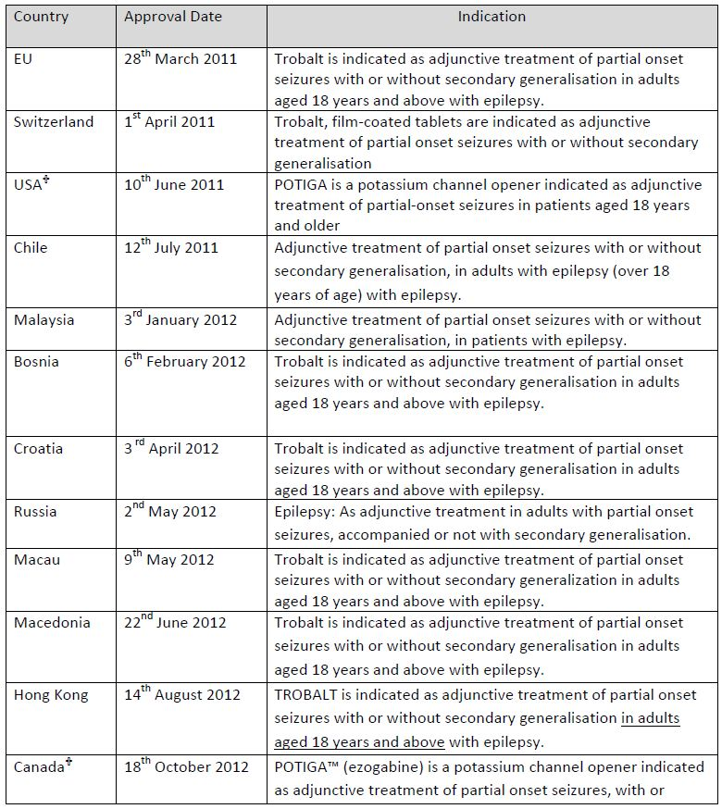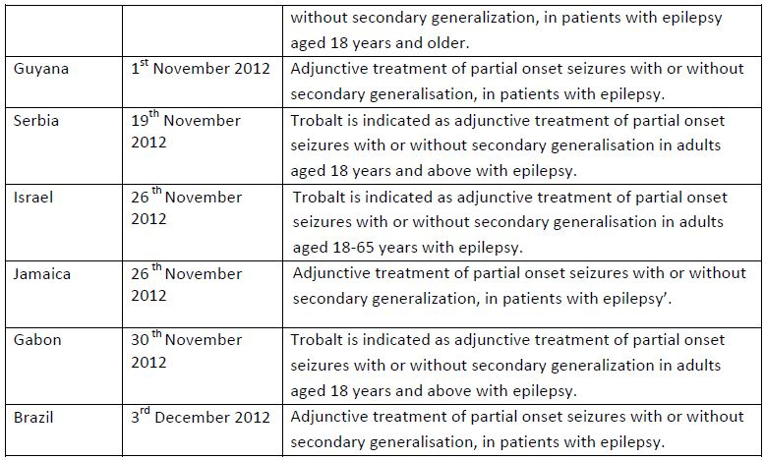

† The US and Canada use the United States Adopted Name (USAN), ezogabine. The International Nonproprietary Name (INN), retigabine, is used in the rest of the world.

### Product Information

The approved Product Information (PI) current at the time this AusPAR was prepared can be found as Attachment 1.

## II. Quality findings

The product is to be marketed in PVC/PVDC/Al blisters in a carton with 21, 84 and 168 tablets for the 50 mg and 100 mg tablet strengths, and 84 and 168 tablets for the 200 mg, 300 mg and 400 mg tablet strengths. Treatment initiation packs containing 21 x 50 mg tablets and 42 x 100 mg tablets are also proposed.

The proposed shelf life for the unopened product is 18 months; “store below 25°C”. The recommended maximum starting oral dose of retigabine is 100 mg three times daily, up to a maximum dose of 1200 mg per day.

### Drug substance (active ingredient)

Retigabine has the chemical structure shown in Figure 1.

Figure 1: Chemical structure of retigabine.

|  |  |
| --- | --- |
| Chemical structure of retigabine | N-[2-Amino-4-(4-fluorobenzylamino)-phenyl]carbamic acid ethyl ester  C16H18FN3O2  MW 303.3 |

There is a very wide range of AEDs, but retigabine does not show a close structural relationship to them. (It was derived as an analogue of flupirtine, a non opiod analgesic registered overseas, which had detected antiepileptic activity.)

The drug is crystalline (melting point 142°C). Polymorphs are known: ‘Form A’ is used and controlled (X-ray diffraction).

Retigabine is weakly basic (pKa 3.7) but not formulated as a salt. It is practically insoluble in water (50 μg/mL), although much more soluble in strong acid (for example, 400 mg in ~25 mL acid), as expected for an aniline. (At pH 2.9 the solubility is 0.4 mg/mL, at pH 1.8 it is 4 mg/mL, and at pH 1.6 it is 16 mg/mL.)

Retigabine is a Class 2 (high permeability, low solubility) Biopharmaceutics Classification System drug. Partition coefficient data are show in Figure 2.

Figure 2: Relationship between retigabine solubility (closed circles) and partition coefficient (open triangles) and pH.

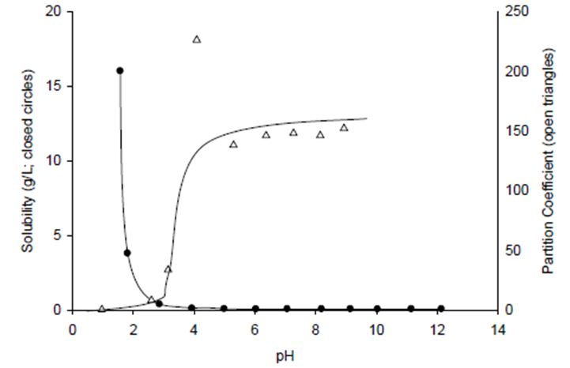

Retigabine is not hygroscopic and is not susceptible to hydrolytic degradation. Water content is not controlled.

The drug substance contains an electron rich benzene ring (a protected, reduced diiminoquinone). This is likely to be susceptible to various oxidation reactions, and the stress stability data show very poor mass balance with peroxide (3% for 24 h) giving significant degradation (→ 40% assay decline) but very limited quantified impurities (maximum 0.43%; total 3.1%). **Thus the chromatographic methods are not stability indicating**. The sponsor claims that:

***“****most of the degradation products formed in hydrogen peroxide eluted from the HPLC column during analysis; TLC chromatograms of waste effluent, the original stressed sample, and acetone extracts of HPLC packing material after multiple injections of the stressed sample showed nothing was left on the column and that the TLC chromatograms of the waste and original sample were essentially the same.”*

It is suggested that the test for related substances should be reviewed, and stress data with shorter peroxide exposures (for example, leading to ~5% assay loss) should also be investigated.

The company has provided revised, signed dated drug substance specifications, which also include revised expression of the limit for residual methanol (3000 ppm) and particle size specifications (discussed below). This is acceptable.

### Drug product

Particle size is controlled by wet milling and ripening step of crystallised Form A drug. The drug is wet milled as a slurry until D50 ≤ 35 μm, then ‘ripened’ at 30 to 37°C to minimise fine particles.

There appears to be some correlation between drug particle size (D50 and D90) and *in vitro* tablet dissolution. The sponsor claims that there is no correlation between D10 and tablet dissolution rate.

**The clinical evaluator notes that the drug has a narrow therapeutic index** and is concerned about some reports of cardiac arrhythmia (asystole or ventricular tachycardia) healthy subjects within 3 h of receiving a single 900 mg retigabine dose (below the maximum recommended total daily dose). **The clinical evaluator suggests that minimisation of pharmacokinetic variability is important, particularly reducing variations that could increase the maximum plasma drug concentration (Cmax): control of the drug particle size might be important in this context.**

Immediate release, film coated tablets in a wide range of strengths are proposed: 50, 100, 200, 300 and 400 mg. These are all made from a common granulate using conventional excipients (which are unlikely to react with the nucleophilic drug). The five strengths are distinguished by tablet markings, colour and/or shape. The proposed tablets are not scored.

Blister packs of 21 tablets (for 50 and 100 mg only), and 84 tablets or 168 tablets are proposed, as well as an initiation pack of 50 mg (21 tablets) + 100 mg (42 tablets).

The requested finalised product specification at release and expiry has been provided. This is acceptable.

As requested, the sponsor has:

* reduced the expiry limit for unspecified impurities in the finished product to No More Than (NMT) 0.16% and this is included in the submitted revised expiry specifications.
* proposed tighter control on particle size, based on the API used in pivotal clinical batches. A D10 limit was proposed and the D50 range was tightened. The new limits (D10 No Less Than [NLT] 13 µm, D50 45-80 µm, D90 NMT 265 µm) are adequately justified based on clinical trial results.
* provided data to justify non inclusion of microbial limits testing at release and has proposed acceptable at expiry, as required for regulatory testing.

All these changes were considered acceptable.

### Biopharmaceutics

Retigabine is taken orally in three divided doses each day, with or without food. “The tablets should be swallowed whole, and not chewed, crushed or divided.” Doses are titrated.

Retigabine is rapidly absorbed and extensively metabolised. There is some metabolite activity. Excretion is chiefly renal. Pharmacokinetics are claimed to be linear. The absolute bioavailability of oral solution and capsule formulations (2 x 100 mg) has been measured (both solution and capsules ~60%, with bioavailability of capsules versus oral solution ~100%).

Eleven bioavailability/bioequivalence studies were included in the submission. Some have been evaluated and some summarised. Almost all the bioavailability studies used doses significantly lower than the apparently optimal effective dose (600 to 1200 mg/day).

### Advisory committee considerations

* The Pharmaceutical Subcommittee (PSC) endorsed all the issues raised by the TGA in relation to pharmaceutic and biopharmaceutic aspects of the submission to register Trobalt film coated tablets containing 50 mg, 100 mg, 200 mg, 300 mg and 400 mg of retigabine. In particular, the PSC supported the questions on the chromatographic methods, control of particle size of the drug substance, test for tablet uniformity using mass variation, related substances, proposed batch release and expiry limits, tablet dissolution and limits.
* The PSC shared the TGA’s concerns about the observed pharmacokinetic variability in view of the fact that the drug has a narrow therapeutic index.
* The PSC noted that the pharmacokinetic analyses provided had not been formally reviewed. Model control streams and data were only provided in printable form which would prevent any evaluation or testing of the model by a reviewer. The PSC agreed that covariate analysis would have been helpful in establishing dosing protocol.
* The dosing guidelines are rather empirical as:
  + They are effectively the same for all “Special Populations” requiring a dose adjustment;
  + No formal supportive evidence of the dosing recommendations appeared to be given for the categories of renal/hepatic impairment or age.

### Quality summary and conclusions

Responses to all questions raised by the pharmaceutical chemistry evaluator are considered acceptable and no further quality issues remain.

There was no objection to the registration of the proposed retigabine film coated 50 mg, 100 mg, 200 mg, 300 mg and 400 mg tablets from a pharmaceutical chemistry perspective.

## III. Nonclinical findings

### Introduction

The sponsor has presented a comprehensive dossier of experiments performed by reputable laboratories. The pivotal toxicological studies were performed to Good Laboratory Practice (GLP) standard. However, the exposure levels at no observed adverse effect level (NOAEL) in the toxicity studies were below those anticipated in clinical use at the maximum recommended dose. Higher exposure levels might have been achievable by dosing the animals two or three times per day.

### Pharmacology

#### Primary pharmacology

The proposed mechanism of anticonvulsant action for retigabine involves activation of members of the KCNQ (Kv7) class of voltage gated potassium channels, which are believed to play a role in controlling neuronal excitability. Thus, retigabine represents a new class of antiepileptic agent, as current therapies are believed to act via potentiation of GABAergic neurotransmission, inhibition of glutamate mediated excitatory neurotransmission, or inhibition of voltage gated sodium and/or calcium channels. Retigabine, originally synthesised as a flupirtine analogue, is now thought to share its mechanism of action with that drug, which has been registered in Germany, Italy, Poland, Russia and Brazil for over 20 years as a non opioid analgesic.

The KCNQ (Kv7) gene family (KCNQ1-5) encodes five channel subunits. Four individual KCNQ subunits are thought to be required to combine to form a functional potassium channel (Kv7.1- Kv7.5). All five known KCNQ proteins can form homomeric channels in vitro and the formation of heteromers seems to be restricted to certain combinations. Tissues in which these proteins are expressed are given in Table 2.

Table 2: KCNQ channel expression and role in disease (from Jentsch et al.[3]).

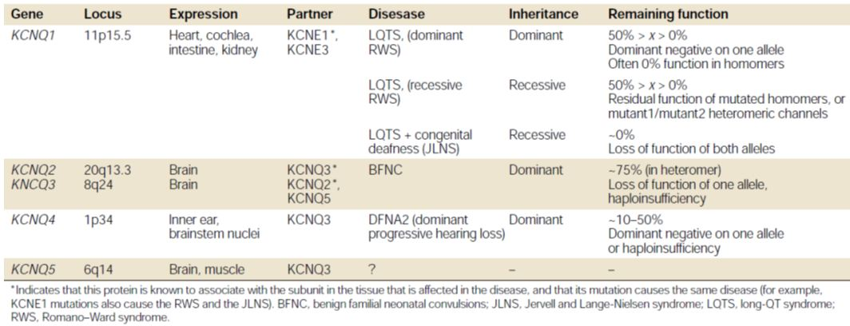

KCNQ1 subunits are predominantly expressed in the heart and vasculature, cochlea, intestine and kidney.[4] KCNQ subunits 2-5 are predominantly expressed in the nervous system,[5] although they have also been localised to vascular smooth muscle,[6] and a study by the sponsor demonstrated expression of KCNQ1, KCNQ3, and KCNQ5 subunits in rat urinary bladder smooth muscle cells. In addition, a functional study indicates that (as yet unidentified) KCNQ subunits are expressed in gall bladder smooth muscle. KCNQ5 also shows widespread expression in the CNS, often co localised with KCNQ2 and 3.

The KCNQ2 and KCNQ3 channel proteins underlie the neuronal “M-current”, a non inactivating potassium current that is slowly activated by depolarisation and inhibited by muscarinic stimulation.[7] This current has since been found in many central and peripheral neurones and is modulated by a number of receptor types. In addition, a variety of second messengers have been implicated in its regulation. The modulation of neuronal M-currents has pronounced effects on neuronal excitability, because M-currents are the only sustained current in the range of action potential initiation.[8] By virtue of their slow activation and inactivation kinetics, they are able to act as a brake for repetitive action potential firing, and reduce neuronal responsiveness to synaptic input.

The sponsor is proposing that retigabine suppresses neuronal hyperexcitability by positive modulation of KCNQ2/3 channels. In support of this hypothesis, mutations in KCNQ2 and 3 have been identified in families with benign familial neonatal convulsions (BFNC), a neonatal form of epilepsy, which is associated with a 25% reduction in M-current amplitude. Thus, relatively small modulations of the activity of KCNQ2/3 currents by pharmacological agents such as retigabine could potentially influence neuronal activity in pathological conditions such as epilepsy.

#### Retigabine actions on KCNQ channels *in vitro*

A number of literature and sponsor studies have clearly shown that retigabine is an activator or positive modulator of the human KCNQ2-5 potassium channels expressed in a range of vector cells,[9] with EC50 (half maximal effective concentration) values in the micromolar range. In contrast, higher concentrations of retigabine inhibit currents mediated by KCNQ1 subunits (IC50 [half maximal inhibitory concentration] = 100 μM). The reported order of potency for retigabine effects on KCNQ mediated currents by expressed subunits was KCNQ3 > KCNQ2/3 > KCNQ2 > KCNQ4.[10] These studies showed that the activation of potassium currents carried by human homomeric KCNQ2 or KCNQ3 channels, or KCNQ2/3 channel heteromers was increased or augmented in the presence of retigabine, and this activity was confirmed with native M-currents in neuronal cells. It has been proposed that retigabine binds to the open conformation of the KCNQ channel in a hydrophobic pocket formed between the S5 and S6 transmembrane domains, with the Trp236 residue being essential for retigabine binding. The lack of retigabine activation of currents mediated by KCNQ1 subunits is likely due to their lacking the Trp236 residue.[11]

#### Non KCNQ effects of retigabine

The anticonvulsant activity of retigabine may also involve potentiation of GABAergic inhibitory neurotransmission, although results have been somewhat contradictory. Retigabine (1-10 μM) enhanced GABA mediated currents in primary cortical neurones from fetal rats *in vitro*, and (at 10-50 μM) dose dependently enhanced monosynaptically evoked inhibitory currents mediated by GABAA activation.[12] However, sponsor studies indicated that retigabine does not appear to interact directly with the GABAA, GABAB, or benzodiazepine receptor binding sites, and did not show agonist, antagonist, or modulatory activity on GABAA α3β3γ2 subunits expressed in HEK293 cells. Retigabine may instead interact with the steroid binding site, since, in the former study, the potentiating effects of GABAergic currents by retigabine and 5-alpha-dihydroprogesterone were not additive. In addition, an allosteric interaction between retigabine and GABA at the picrotoxin site has been demonstrated.[13]

Other reported actions of retigabine *in vitro* include reductions in depolarisation induced increases in neuronal intracellular calcium concentration, prevention of stimulation by the pro convulsant 4AP of de novo synthesis of glutamate, aspartate and GABA (while increasing their de novo synthesis in the absence of 4AP) and lowering of brain concentrations of glutamate and glutamine, while GABA transaminase activity was reduced.[14] These effects are likely to be mediated by the actions of retigabine on KCNQ2 and KCNQ3 channel subunits.[15] Inhibition of voltage gated sodium and calcium channels was also reported, but these effects are not anticipated to be relevant clinically, since they were only relatively modest even at supra therapeutic retigabine concentrations of 10-100 μM.

#### Anticonvulsant efficacy *in vitro* and *in vivo*

Studies from the sponsor and from the literature have shown that retigabine has anticonvulsant activity in a range of animal models both *in vitro* and *in vivo*. *In vivo* animal models of epilepsy tested included partial or focal seizure models and generalised seizure models. Among the models that are considered to be predictive of complex partial seizures, retigabine was active in the amygdala kindling model in rats at doses producing near clinical plasma concentrations of the test article. Endpoints for anticonvulsant activity in this model included increased threshold for induction of after discharges and reductions in seizure severity and duration, or on the duration of seizure related behavioural change and after discharge duration. In addition, the development of amygdala kindled seizures was retarded, which may be indicative of suppression of epileptogenesis. Retigabine also showed activity against fully kindled hippocampal seizures and against focal seizures induced by corneal kindling or penicillin in rats. Animal models for generalised seizures included tonic extensor seizures induced by maximal electroshock in mice and rats. The threshold for seizure induction was increased by retigabine dosing. Retigabine was also active against seizures induced in mice and rats by subcutaneous (SC) injections of pentylenetetrazol or picrotoxin or intracerebroventricular administration of N-methyl-D-aspartate (NMDA), but was inactive against seizures induced by SC administration of bicuculline or strychnine. Retigabine was effective in a number of genetic seizure models, including audiogenic seizures in the Frings mouse model of reflex epilepsy. However, retigabine had no effect in a genetic model for absence epilepsy. A 14 day repeat dose study in mice showed that the anticonvulsant activity of retigabine was relatively consistent with repeated dosing, suggesting a lack of tolerance to retigabine. The study also showed no evidence of withdrawal associated hyperexcitability. Similarly, the efficacy of retigabine against maximal electroshock induced seizures in mice did not significantly reduce over five days of multiple oral dosing. The N-acetyl metabolite of retigabine (NAMR) also showed some anticonvulsant activity in mice against electrically and chemically induced seizures, but, the spectrum of activity and potency were both lower than that of retigabine. NAMR is not expected to contribute significantly to the pharmacological activity of retigabine.

Based on an understanding of its primary pharmacological activity, retigabine’s potential for side effects and toxicity is likely to be related at least in part to “off target” action on KCNQ channels.

#### Secondary pharmacodynamics and safety pharmacology

In secondary pharmacodynamic screening studies, retigabine was a weak inhibitor of monoamine oxidase-B and the OATP1B1 organic ion transporter (IC50 = 2.8 and 2.8 μM, respectively). Inhibition of these proteins may be clinically relevant for individuals taking high doses of retigabine.

#### Central Nervous System

Retigabine had multiple effects on the CNS in secondary and safety pharmacology studies. Like flupirtine, retigabine was shown to be active in a number of models testing for antinociceptive activity, including the hotplate assay in mice, the tail flick test in rats, and late phase neuropathic type pain induced in rats by plantar injection of formalin, but this activity was seen only at relatively high doses. Similar findings have been reported in the scientific literature, where retigabine exhibited variable effects in acute pain models, but appeared to be more consistently active in models of chronic neuropathic pain, visceral pain, musculoskeletal pain and hyperalgesia.[16] Activation of KCNQ channels appeared to underlie retigabine’s effect in chronic neuropathic pain. Retigabine showed evidence of neuroprotective activity in some tests, promoting increased hippocampal neuronal survival in Mongolian gerbils following transient forebrain ischaemia, and preventing ischaemia or electroconvulsive shock induced impairment of learning in rats. The data from these studies are generally supportive of a lack of adverse effects of retigabine on learning and memory. There is some suggestion that retigabine may reduce the formation of reactive oxygen species, which could underlie its neuroprotective activity.[17] In common with a number of other anticonvulsant drugs, retigabine exhibited anxiolytic activity in the mouse zero maze test and in the marble burying model.[18] Evidence was provided to indicate that the anxiolytic activity in the marble burying model was mediated by an action on KCNQ channels.

CNS effects of retigabine in safety pharmacology studies in rodents included sedation, tremor, flat body posture, muscle relaxation or ataxia, reduced exploratory behaviour or reduced motility, hyperexcitability, depressed breathing, reduced body temperature and clonic seizures. These effects largely occurred at doses above those required for anticonvulsant activity; the ED50 for retigabine hydrochloride causing motor impairment in the rotarod test in mice was 79 mg/kg PO (per os [oral administration]), while behavioural changes in the modified Irwin test were reported in mice at doses >10 mg/kg IP (intraperitoneal) or >30 mg/kg PO, and in rats at doses ≥3 mg/kg IP or >10 mg/kg PO. Hyperexcitability and clonic seizures were only observed in rats given retigabine hydrochloride at relatively high doses of 30 mg/kg IP, but were not observed in rats at a dose of 100 mg/kg PO, or in mice at doses up to 30 mg/kg IP or 100 mg/kg PO. In one of the primary pharmacology anticonvulsant screening studies with retigabine hydrochloride, the Protective Index was calculated in a range of models as the ratio of the median TD50 (toxic dose) to the ED50. This value was greater than unity in all models except for SC pentylenetetrazol induced seizures in rats (PI = 0.7). The ratio of CNS toxic doses to effective anticonvulsant doses was shown to be comparable to other AEDs. Based on these results, there may be some potential for mildly impaired CNS activity with retigabine at higher clinical doses.

Based on the results of *in vitro* studies demonstrating KCNQ4 channel localisation in the inner ear,[19] and the activity of retigabine on this subtype of KCNQ channel,[20] perturbations of inner ear function might be anticipated with high doses of retigabine, but these have not been assessed in the nonclinical studies.

#### Cardiovascular system

Evidence was provided for a lack of clinically relevant interaction between retigabine and ion channels involved in the cardiac action potential. Retigabine inhibited hERG currents (responsible for the rapid delayed rectifier current, IKR, a target for drugs known to prolong the QT interval) only at relatively high concentrations (IC50 = 59-100 μM). Such IC50 values for hERG channels are ~60-100 times the maximum anticipated unbound concentration of retigabine at the proposed Maximum Recommended Human Dose (MRHD) of 1200 mg. The NAMR metabolite showed even less activity towards hERG currents than its parent (46% inhibition of hERG currents at a concentration of 1000 μM or ~500 times higher than the maximum anticipated unbound concentration of retigabine).

The cardiac IKS channel, formed by co assembled KCNQ1 and KCNE1 subunits, is another potential target for adverse cardiac effects.[21] Retigabine showed inhibitory activity on currents mediated by KCNQ1 subunits (IC50 = 100 μM)[22] and did not activate KCNQ1/KCNE1 currents, with only minimal IKS inhibition of 5.7% at a retigabine concentration of 25 μM. High concentrations of retigabine inhibited currents through human recombinant voltage dependent sodium channels (Nav1.5) and voltage dependent potassium channels (Kv1.5), with IC50 for both currents > 50 μM, while activity at voltage dependent calcium currents (Cav1.2) was slightly greater (IC50 = 20 μM, or 20 times the maximum anticipated unbound retigabine concentration in plasma).

Thus, electrophysiological studies on expressed recombinant ion channels underlying the human cardiac action potential showed an interaction of currents implicated in prolongation of the QT interval of the cardiac action potential associated with plasma retigabine concentrations approximately 60-100 times the maximum anticipated unbound therapeutic concentration, with NAMR showing a lower potential for interaction with hERG currents compared with the parent compound. Inhibition of cardiac voltage dependent calcium channels was associated with retigabine concentrations approximately 20 times the maximum anticipated unbound retigabine concentration in plasma at the highest proposed clinical dose of 1200 mg.

A slightly greater sensitivity of IKR to retigabine was observed in cat ventricular myocytes (14% inhibition at a concentration of 10 μM), but the combined effect of slight IKR inhibition with suppression of L-type calcium currents by 18% resulted in a net shortening of the cardiac action potential duration (APD95) by 15%, arguing against any tendency towards prolongation of the QT interval. The metabolite NAMR showed similar effects to the parent compound. Retigabine had no effect on the QRS or QT interval in the isolated Langendorff perfused guinea pig heart model at concentrations up to 30 μM, but produced a 17% inhibition of the latter at a concentration of 100 μM (approximately 100 times the maximum anticipated unbound plasma concentration).

No changes were observed in the ECG (electrocardiograph) parameters of beagle dogs given oral doses of 5-8 mg/kg/day for 7 days, but the study did not include analysis of plasma retigabine concentrations. An estimate of the concentrations and AUC (area under the plasma concentration-time curve) values can be derived from a 13 week oral repeat dose toxicity study in dogs, in which mean plasma Cmax value in males and females at the HD (High Dose) level of 38.3 mg/kg/day was 1076 ng/mL, and the mean AUC0-24 h was 10878 ng h/mL. The latter values are approximately 0.7 and 0.4 times the maximum anticipated clinical Cmax and AUC values, respectively. Thus, the levels of exposure achieved in the cardiovascular safety study in dogs are insufficient to support the cardiovascular safety of retigabine. A lack of ECG effects was reported in other retigabine and NAMR repeat dose toxicity studies in dogs, although the relative exposure levels were also inadequate to support the clinical cardiovascular safety of retigabine (see below).

Dose independent reductions in mean heart rate (18-42%) were reported. However, there were no dose dependent haemodynamic effects in anaesthetised dogs following intraduodenal administration of retigabine at doses up to 100 mg/kg, and only minimal respiratory effects were observed, including a slight increase in airway resistance and a decline in compliance.

Retigabine is anticipated to exert activity on non target KCNQ2-5 channels, including those located on vascular smooth muscle (see above). Retigabine produced relaxation of mouse mesenteric and rat gracilis arteries by activation of KCNQ currents, and relaxed carotid, femoral and mesenteric artery precontracted with phenylephrine.[23] KCNQ2, 3, and 5 channels are also expressed on aortic baroreceptors,[24] and retigabine was found to shift their pressure response curve so that higher aortic pressures were required for baroreceptor activation. A hypotensive effect of retigabine hydrochloride was reported in pigs and in beagle dogs given retigabine at doses ≥ 5 mg/kg PO. Based on these results, effects on blood pressure and its regulation might be anticipated clinically, although the clinical data suggest that any effects are negligible.

In summary, the cardiovascular safety data do not raise any major concerns regarding the cardiovascular profile of retigabine. A potential for hypotensive effects might be anticipated, although this does not appear to have been confirmed in the clinical studies. The *in vitro* data are not predictive of any notable effects on QT interval. However, some caution is required when interpreting the *in vivo* cardiovascular safety studies in dogs, given the lack of associated toxicokinetic data, together with the relatively low levels of exposure to retigabine in the repeat dose toxicity studies.

#### Renal and gastrointestinal effects

Consistent with its expected activity towards non target KCNQ2-5 channels, studies with rodent models showed that retigabine hyperpolarised bladder smooth muscle cells through activation of an outward potassium current, and inhibited contractile responses. Retigabine was also shown to reduce bladder contractility and inhibit micturition in hyper reflexic and hypertrophic bladder models in female rats.[25] This action is likely to underlie the effects of retigabine on the urinary system of mice, rats, and dogs in the repeat dose toxicity studies (see below).

Retigabine had no effect on gastrointestinal transit time in the mouse.

#### Pharmacodynamic drug interactions

Combinations of retigabine with carbamazepine, valproate, and lamotrigine showed additive to synergistic anticonvulsant action against electroshock induced seizures in mice or rats. There was no apparent evidence of neurotoxicity with any of the combinations. The ability of retigabine to interact with anaesthetic and other CNS active agents was also evaluated. Retigabine showed a variable, dose independent potentiating effect on hexobarbitone sleep time in mice, and weakly potentiated the effects of ethanol. Of the four anaesthetics investigated, retigabine did not influence halothane or methohexitone induced sleep times in rats, but an increase in respiratory depression was reported. Propofol induced sleep time was weakly affected (increased 1.5 fold, from approximately 8 minutes to 12 minutes), while thiopentone induced sleep time was dose dependently increased by up to 14 fold (from approximately 4 to 53 minutes).

### Pharmacokinetics

The plasma kinetics of retigabine and its major human metabolite NAMR were examined after single oral dosing in mice, rats, rabbits, dogs, pigs and monkeys, and after single intravenous (IV) doses in rats, dogs and monkeys. Toxicokinetic data were also generated in the toxicology studies, including in pregnant rats and rabbits. Absorption was rapid, with maximum plasma concentrations of retigabine occurring approximately 1 h after oral dosing (3-5 h in monkeys). This finding is in agreement with the results of flux studies in Caco-2 cultures, which indicated that intestinal absorption was a passive process and would not be expected to be a limiting factor in retigabine uptake. No consistent sex differences were noted, except in the mouse where dose normalised exposure values for males were ~2 fold higher than in females. The absolute oral bioavailability in the rat and dog was ~60%, but was much lower in the pig and monkey. Plasma clearance was similar among species (~10-30 mL/min/kg). Plasma half life (t1/2) values for oral retigabine ranged from ~2-3.5 h in rats to ~3-10 h in dogs (compared with 8 h for humans). An apparent volume of distribution of 1.9 L/kg in rats suggests that retigabine is well distributed in “deep” compartments of the body. Repeat dose studies of up to 18 months duration in rats and one year in dogs suggested that exposure increases were usually less than dose proportional and only modestly influenced (approximate doubling) by the length of the dosing period.

Retigabine concentrations in rat brain were approximately double those in plasma following oral dosing with [14C]retigabine, and there was a lower relative exposure of the rat brain to retigabine metabolites compared with plasma, suggesting decreased passage across the blood-brain barrier compared with the parent compound. Retigabine showed reversible binding to plasma protein that was comparable in various species (~80-85% binding) and independent of drug concentration. NAMR showed lower plasma protein binding at ~50-60%.

The tissue distribution of radioactivity following oral administration of [14C]retigabine to non pigmented rats was widespread, with the highest concentrations of radioactivity being recovered in the gastrointestinal tract, muscle, liver, fat and blood. Radioactivity was eliminated rapidly from all tissues over 48-72 h, with no tissue sequestration apparent.

Following oral administration of [14C]retigabine, retigabine and its metabolites readily crossed the placenta of pregnant rats, and the milk of lactating rats was shown to predominantly contain the rat specific retigabine metabolite, 5-acetamido-2-oxo-2,3-dihydro-1H-benzimidazole. Its presence in milk at concentrations approximately 20-40 times greater than that of unchanged retigabine suggests either that it is actively transported into milk, or that it is formed in mammary tissue in this species. The implications for humans are uncertain.

Retigabine metabolism was studied *in vitro* and *in vivo* in mice, rats, dogs, rabbits, monkeys, and humans. The predominant metabolic pathways in all species are Phase II processes involving hydrolysis/N-acetylation (to form NAMR), and N2 and N4-glucuronidation of retigabine and NAMR. The structural location for N-glucuronidation varied somewhat among species, since the dog appeared to lack the pathway for N4-glucuronidation. However, in common with humans, the N2-glucuronide was the predominant metabolite in the dog. The human UDP-glucuronosyltransferase (UGT) isozymes responsible for retigabine glucuronidation *in vitro* were UGTs 1A1, 1A3, 1A4 and 1A9. Quantitatively, UGT1A1 and UGT1A4 were relatively more important for retigabine glucuronidation in humans. In the rat, glucuronidation by UGT1A1 was the most important pathway. The N-glucoside of retigabine was a minor metabolite in humans, monkey and dog.

There was no formation of NAMR in the dog, and very little in the cynomolgus monkey, since these species are deficient in N-acetyl transferase. NAMR was also a relatively minor metabolite in the mouse. To overcome this deficiency, repeat dose toxicity studies were performed with NAMR in the dog (and also in rats).

The genotoxic impurity ZP3, which could theoretically be formed by decarbamylation of retigabine, was not observed as a metabolite in any species. In common with humans, the N-glucoside metabolite of retigabine was observed in mouse, dog, and monkey as a minor metabolite, but was not detected in rat or rabbit. There was no evidence of direct oxidative metabolism of retigabine in any species, although some minor rat metabolites may represent secondary oxidative products of the desfluorobenzyl metabolite of retigabine. In contrast to all other species, a complex profile of over 20 predominantly acetylated metabolites or degradants was observed in the urine of rats and, as noted above, one of these was detected at high concentration in the milk of lactating rats.

Biliary excretion of retigabine or its metabolites was directly demonstrated in rats, and indirect evidence for this was provided in rats and dogs, since the majority of radioactivity was excreted in the faeces following IV administration of [14C]retigabine in these species. In healthy male humans and in beagle dogs, plasma concentrations of retigabine and its N4-glucuronide appeared to decline in parallel in a constant ratio, which may result from their enterohepatic circulation and glucuronidation/deglucuronidation reactions. Faecal excretion of retigabine and its metabolites accounted for approximately 50-60% of the administered dose in rats and dogs, with the urinary route accounting for 40-50%. In humans, the renal route is the predominant route of excretion, with 84% of a radioactive dose recovered in urine, and unchanged urinary retigabine accounting for 36% of the administered dose.

Overall, the combination of species selected for the pivotal repeat dose toxicity studies with retigabine and NAMR should be adequate for evaluating possible toxic effects of retigabine in humans.

#### Pharmacokinetic drug interactions

Retigabine is neither a substrate nor an inhibitor of P-gp mediated transport, although NAMR dose dependently inhibited P-gp mediated transport of digoxin. Based on the results of *in vitro* studies using human CYP isoenzymes, retigabine is not expected to inhibit drug metabolism mediated by CYP isozymes 1A2, 2A6, 2C8, 2C9, 2E1, 2C19, 2D6, or 3A4/5, and is not a substrate for any CYP isozyme. Rats treated with retigabine, at up to 82.5 mg/kg/day for seven days, showed no evidence for hepatic induction of CYP1A, 2B2, 2E1, or N-acetyltransferase activity. Similarly, neither retigabine nor NAMR showed potential for induction of CYP1A2 or CYP3A4/5 activity. However, retigabine showed moderate potential for induction of its own UGT mediated metabolism (comparable to that of phenobarbitone), and may therefore also increase the glucuronidation of other co administered drugs. Several other AEDs (for example, lamotrigine) are cleared by glucuronidation or are known to inhibit (for example, valproate) or induce glucuronidation (for example, phenobarbitone, phenytoin, and carbamazepine). Since retigabine and NAMR are cleared by glucuronidation, there is therefore the potential for altered clearance of retigabine if co administered with such agents, or for retigabine to affect other drugs cleared by glucuronidation. However, it is noted that such interactions have not been observed clinically according to statements in the PI. As noted above, high doses of retigabine could potentially inhibit monoamine oxidase-B and the OATP1B1 organic ion transporter.

### Toxicology

#### Acute toxicity

The studies presented examined the acute toxicity, following both IV and PO administration, of the dihydrochloride and the free base forms of retigabine, using mice and rats. A single study examined the effect of PO administration of free base to miniature pigs. The two forms of the test article induced similar clinical signs following both IV and PO administration to mice and rats. The maximum non lethal dose of the free base form was 215 mg/kg for mice, ~100 mg/kg for rats, and >90 mg/kg for pigs. In rats, retigabine was markedly more lethal following IV compared with PO administration. These results suggest that retigabine is of moderate toxicity (that is, LD50 [Lethal Dose 50%] of 50-500 mg/kg PO).

#### Repeat dose toxicity

These studies were performed with mice (three strains), rats (two strains), dogs, and cynomolgus monkeys given daily PO doses of retigabine for up to three, six, and 12 months, and ten days, respectively. The duration of the studies, the species used (rodent and non rodent), the group sizes, etcetera, were consistent with the relevant EMA (European Medicines Agency) guideline.[26] The pivotal acute and repeat dose toxicity studies were performed to GLP standards.

##### Relative exposure

Relative exposure to RTG and NAMR in repeat dose toxicity and carcinogenicity studies with RTG is shown in Table 3.

Table 3: Relative exposure to RTG and NAMR in repeat dose toxicity and carcinogenicity studies with RTG.

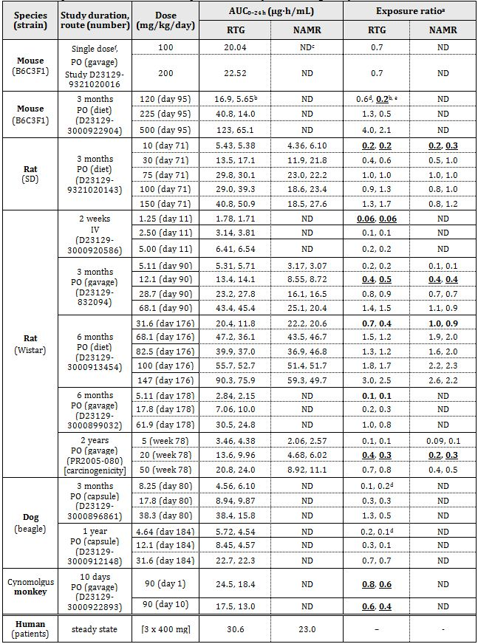

Tabulated values refer to total (that is, bound plus unbound) plasma concentrations of analytes; a. animal:human plasma AUC0-24 h; b. ♂, ♀ values, respectively; c. ND = not determined; d. NOAEL was less than LD (Low Dose); e. bolded and underlined figures are exposure ratios at NOAEL; f. doses correspond to HD level in mouse micronucleus assay.

Plasma exposure ratios were calculated using the human plasma total AUC0-24 h value of 30.59 µg h/mL, apparently derived by multiplying by three the mean AUC0-8 h value from Clinical Study 302 (in which patients received retigabine at 400 mg TID [three times daily], that is, 1200 mg/day). The clinical Cmax at this dose level is 1.52 µg/mL (~5.0 μM); allowing for 80% plasma protein binding, the unbound drug concentration at Cmax is ~300 ng/mL or 1.0 μM. As shown in the table above, relative exposures at the NOAEL for repeat-dose toxicity studies were well below unity for mice and rats, irrespective of whether the drug was given orally (gavage or diet) or IV. NOAEL doses were not established for the canine experiments, but it appeared that the relative exposures at canine NOAELs would be less than 0.1. Results from a 10 day study using cynomolgus monkeys were interpreted as indicating a relative exposure of 0.4-0.8 at the NOAEL dose. However, the identification of the NOAEL dose, in the latter study, is questionable because of the limited scope of the experimental data obtained (only clinical signs and body weight changes were monitored). The proposed clinical dosing regime is for retigabine to be taken TID, while animals were dosed QD (once daily) in the toxicity studies. Higher exposure levels might have been achieved in the nonclinical studies if the dosing interval had been lower.

Plasma levels of NAMR were determined for several of the retigabine repeat dose toxicity studies in rats. Exposure ratios for NAMR were calculated relative to the human AUC0-24 h value of 22.97 µg h/mL (Cmax = 1.027 µg/mL; given 45% is plasma protein bound, this corresponds to an unbound NAMR concentration of 565 ng/mL or 2.0 μM). Rat exposure to NAMR, following dosing with retigabine, was generally comparable or slightly lower than retigabine exposure (see Table 3). This suggests that differences in exposure to NAMR cannot account for the greater susceptibility of rats to the toxic effects of retigabine dosing compared with humans.

Toxicity studies were performed using rats and dogs subjected to repeat dosing with NAMR. Exposure ratios were calculated using the animal AUC0-24 h values and the human AUC0-24 h value for NAMR of 22970 ng h/mL. Comparison of the exposure ratios at the NOAEL suggested that rats, and probably also dogs, are more sensitive to induction of toxic effects by retigabine than by NAMR, although both compounds are presumably contributing to the toxic effects induced by retigabine dosing (note that, unlike rats, dogs do not metabolise retigabine to NAMR).

Table 4: Relative exposure to NAMR in repeat dose toxicity studies with NAMR.

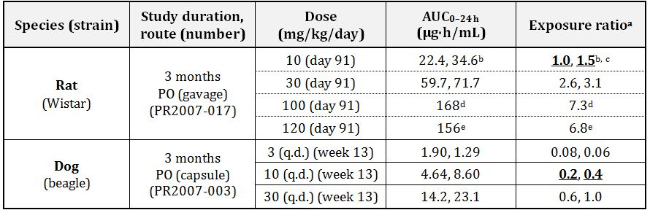

Tabulated values refer to total (that is, bound plus unbound) plasma concentrations of analytes; a. animal:human plasma AUC0-24 h; b. ♂, ♀ values, respectively; c. bolded and underlined figures are exposure ratios at NOAEL; d. ♀ value (that is,. no ♂ value at this dose); e. ♂ value (that is, no ♀ value at this dose);.

##### Major toxicities

The primary targets for retigabine induced changes showed some species dependent differences, but included the CNS, the renal and urinary system, the liver, and the thyroid. Toxic effects were generally comparable between the sexes for rats, dogs, and monkeys. In mice, however, toxic effects occurred at lower doses and showed higher incidence and severity in male animals. This difference correlated with higher systemic exposure to the test article in male mice.

CNS related clinical signs, such as hypokinesia, ataxia, and cool to the touch were seen at subclinical exposure levels in all tested species. They reflect sedative activity of the test article and are an exaggerated pharmacological effect. Other CNS related clinical signs, seen in some or all tested species, such as convulsions, decreased muscle tone, salivation, tremors, dyspnea, and vomitus presumably reflect off target drug activity at high doses. These clinical signs ceased or reversed following cessation of test article dosing.

A prominent effect of retigabine dosing in mice (and, to a lesser extent, in rats) was apparent urinary stasis leading to distension of the bladder, kidney pelvis, ureters, and urethra. The epithelium of the murine urinary bladder showed hyperplasia and an increase in the frequency of S-phase cells that peaked within days of the commencement of retigabine dosing. Hyperplasia was associated with urinary precipitate that contained retigabine but not its glucuronide metabolite. It was suggested that urinary stasis, in the acidic environment of the bladder, facilitated the dissociation of the retigabine glucuronic acid excretion product, leading to drug precipitation and potential obstruction of urine flow, as well as interaction between precipitate and epithelium leading to hyperplasia and inflammation. Mice also showed increased blood urea levels (a likely secondary effect of increased renal hydrostatic pressure), and retigabine induced deaths were attributed to uraemia. Renal and urinary system effects of retigabine were of decreasing significance in rats and dogs, respectively, compared with mice. The clinical relevance of retigabine’s adverse effects on the urinary system of rodents is unclear, particularly given the significant differences in neuronal control of urination between lower and higher mammals.[27] Nevertheless, it is interesting that retigabine has also been shown to induce adverse urinary system effects in some patients, and the potential for urinary retention is referred to in the PI.

In addition to the above noted adverse renal effects of retigabine, male rats showed increases in levels of hyaline droplets in the kidney following retigabine dosing. Chemicals producing this effect are thought to bind to α2u-globulin and induce a conformational change making the protein more resistant to lysosomal proteases in the epithelium of the proximal tubule.[28] This change in the balance between protein reabsorption and its degradation can lead to nephropathy and renal tubule tumours. However, this α2u-globulin dependent response to some xenobiotics is thought to be unique to the male rat.[29]

Thyroid follicular cell hypertrophy/hyperplasia was seen in both mice and rats (but not dogs) at retigabine exposure levels comparable with those expected in humans given the recommended dose. Follicular cell hypertrophy was often associated with an increase in blood thyroxine (T4) levels and a reduction in the density of thyroid colloid. It was suggested by the sponsor that these effects derive from induction by retigabine of UGT activity in liver, resulting in increased glucuronidation (a major metabolic route for both thyroxine and triiodothyronine)[30] and degradation of thyroxine. It is unlikely that retigabine induced compensatory hypertrophy of the thyroid would occur in humans. This is because the plasma half life of thyroxine in rodents is considerably shorter than in humans (t1/2 = 12-24 h for rats compared to 5-9 days for humans).[31] Hence, rodent thyroxine levels are more susceptible to significant change following an increase in the rate of degradation.

Centrilobular hypertrophy of the liver, often accompanied by increased liver weight and increases in the levels of serum markers of possible liver/bile duct injury (alanine aminotransferase, alkaline phosphatase, and γ-glutamyl transferase), was seen in mice and rats dosed at approximately clinical exposure levels of retigabine for one to six months. However, there was no direct evidence for hepatotoxicity, and the liver changes were reversed after a drug free recovery period. It was therefore concluded that retigabine dosing was inducing adaptive changes in the rodent liver.

Retigabine dosing of dogs, at significantly lower than clinical exposure levels, induced changes in liver tissue underlying the gall bladder, including focal fibrosis/fibroplasia, mononuclear inflammatory cell infiltration, and pigment deposition in macrophages (see below). The fibrotic tissue appeared to have replaced a few cell layers of hepatocytes. These effects were not reversed during a drug free recovery period. The localised nature of these lesions suggested this was an indirect effect caused by gall bladder distension, due to smooth muscle relaxation, leading to the compression of adjoining liver regions. Consistent with such suggestions, ultrasound monitoring showed a marked increase in gall bladder volume and a decrease in bile flow within days of commencement of retigabine dosing of dogs. In addition to the possible induction of liver lesions, the effects of retigabine dosing on the canine gall bladder are of potential concern for human therapy, as prolonged stasis of bile in the human gall bladder has been linked to an increased risk of gall stone formation.[32] However, clinical studies have shown no effect of retigabine treatment on gall bladder volume in humans, and the potential for adverse effects on the gall bladder are not referred to in the PI.

Retigabine dosing of rats and dogs resulted in the appearance of a brown pigment in macrophages of spleen and liver, respectively. This pigment was likely composed of haemosiderin in the spleen and bile pigment and haemosiderin in the liver. In the liver, the increased pigment may reflect the leakage of red blood cells into tissues as a consequence of retigabine induced inflammation/necrosis. Following a drug free recovery period, these lesions reversed in rats, but not in dogs. Their relevance to human treatment is unclear.

Repeat dose toxicity of NAMR was examined using rats and dogs. The histopathological findings for rat showed overlap with the results from retigabine dosing, with NAMR shown to induce centrilobular hypertrophy of the liver and thyroid follicular cell hypertrophy. This is not unexpected, since NAMR is formed in the rat following dosing with retigabine. However, dogs showed unique toxicities in the repeat dose studies with NAMR, including granulocytic hyperplasia in bone marrow and extramedullary haematopoiesis in the spleen and liver. These toxicities were seen at near clinical exposure levels, although their relevance to human treatment is unclear.

##### Genotoxicity

Ames assay testing of the dihydrochloride salt form of retigabine suggested that it is weakly mutagenic. However, the free base of retigabine was Ames assay negative. The mutagenic activity of the dihydrochloride salt form (synthesised from p-nitroaniline via a nine step process) appeared to be associated with impurities, as retigabine dihydrochloride derived from free base (prepared using a three step process from 4-fluorobenzaldehyde and 2-nitro-1,4-phenylenediamine) was not mutagenic in the Ames assay. Retigabine base was also shown to be non mutagenic at the hypoxanthine-guanine phosphoribosyltransferase (HPRT) locus of mammalian Chinese hamster ovary (CHO) cells in *in vitro* testing.

Short term incubation (3-4 h) of phytohaemagglutinin stimulated human peripheral blood lymphocytes with retigabine (both with and without metabolic activation) had no effect on the incidence of cells with structural chromosomal aberrations. However, longer incubations (20-24 h), with retigabine concentrations greater than 50 μg/mL in the absence of metabolic activation produced a significant increase in the frequency of cells with structural aberrations, consisting predominantly of chromatid and chromosome breaks. However, two types of experiment suggested that retigabine may lack significant clastogenic activity under *in vivo* conditions. First, single doses of retigabine that produced significant signs of toxicity in mice were negative for the induction of micronucleated polychromatic erythrocytes. Second, hepatocytes from rats given a single dose of retigabine that produced significant signs of systemic toxicity showed no evidence for induction of unscheduled DNA synthesis (that is, DNA repair response). The negative results in the two *in vivo* assays have a greater weight than the *in vitro* clastogenicity assay in the overall genotoxicity assessment.

NAMR was shown to be non mutagenic in the Ames assay, but at high (possibly cytotoxic) concentrations was positive for the induction of structural chromosomal aberrations in CHO cells in both the presence and absence of metabolic activation.

##### Carcinogenicity

A conventional carcinogenicity study was not considered feasible in mice due to urinary bladder toxicity, and a neonatal mouse model was substituted. The neonatal mouse model is suggested in published guidelines[33] as an acceptable alternative to a standard long term rodent carcinogenicity study, and is considered to be a sensitive model for the detection of genotoxic carcinogens.[34] CD-1 mice of both sexes given an oral dose of retigabine on Post Natal Days (PNDs) 8 and 15 were maintained for approximately one year, and then examined for neoplasms. The only notable observation was the incidence of bronchioalveolar carcinoma in males (0/50, 0/28, 0/25 and 2/25 [8%] for control, LD, MD [Mid Dose] and HD, respectively). The corresponding incidences of combined bronchioalveolar adenoma and/or carcinoma were 2/50 (4%), 1/28 (3.6%), 2/25 (8%) and 3/25 (12%). The bronchioalveolar carcinoma incidence of 8% for HD males exceeds the historical control incidence for the neonatal mouse assay of 1.4%.[35] It is noted that higher control incidences of bronchioalveolar carcinoma have been reported in conventional long term (18-24 months) carcinogenicity studies in male CD-1 mice: mean 6-7%, range 2-20%,[36] and mean 7.4%, range 1.4-26.0%.[37] The neonatal mouse carcinogenicity study was not accompanied by toxicokinetic data, but based on exposure levels associated with similar doses of retigabine given to adult mice the exposures achieved in this study are likely to have been subclinical. Unfortunately, the limitations of the available data do not permit a definitive conclusion to be made on whether the apparent increase in bronchioalveolar carcinoma in HD males is treatment related, but equally the finding cannot be dismissed.[38] (It is possible that genotoxic impurities may have been present in the retigabine batch used in this assay, which could have contributed to this effect).

In a standard long term rodent carcinogenicity study, Wistar rats of both sexes received a daily oral dose of retigabine for two years. There was no evidence from either sex for carcinogenic activity by retigabine in rats. The rat carcinogenicity study used a HD giving an exposure level less than that anticipated for humans (Table 4), and exposure in the neonatal mouse study was trivial (albeit in a system with a potentially higher target cell population). The problem with these studies is a reflection of the fact that the animal models used by the sponsor are considerably more susceptible to toxic effects of the test article than are humans. The shortcomings of the carcinogenicity studies place added emphasis on the dependability of the genotoxicity results.

There was evidence, from both mouse and rat experiments, for the induction by retigabine (at clinically relevant exposure levels) of inflammation and epithelial hyperplasia in the urinary bladder. Mouse experiments also demonstrated the presence of retigabine containing precipitates in the urinary bladder. Although there was no suggestion from carcinogenicity experiments for the induction of bladder tumours in mice and rats by retigabine, these experiments used exposure levels considerably lower than those which produced bladder irritation in the toxicity studies, and the maximal duration of dosing in the mouse was only 13 weeks. Urinary retention has been reported in humans during clinical studies (see PI), and if sufficiently prolonged then the induction of urinary bladder tumours in such patients is a theoretical concern.

##### Reproductive toxicity

Radioactivity was readily detected in foetuses following oral administration of [14C]retigabine to pregnant rats, suggesting that retigabine and/or its metabolites readily cross the placenta. Radioactivity was also found in milk of lactating rats following oral administration of [14C]retigabine. Milk radioactivity was largely associated with a retigabine metabolite, 5-acetamido-2-oxo-2,3-dihydro-1H-benzimidazole (M7). This metabolite, which is a minor urinary metabolite in the rat, has not been identified in any other species. Its presence in milk at concentrations approximately 20-40 times greater than that of unchanged retigabine suggests either that it is actively transported into milk or that it is formed in mammary tissue in this species. The implications for humans are uncertain.

Reproductive toxicity studies used standard species (rat and rabbit) and appropriate group sizes, timing, and duration of treatment. Most of the studies were conducted to GLP standards. As shown in Table 5, relative exposures for retigabine and NAMR at the maternal or embryofoetal NOAEL were well below unity for both rats and rabbits. The use of higher dose levels to achieve supra clinical exposure levels was precluded by maternal neurotoxicity and reduced body weight gain. Higher exposure levels might have been achievable if the dosing frequency had been increased, and this would have been relatively easy given the limited duration of dosing.

Table 5: Relative exposure to retigabine and NAMR.

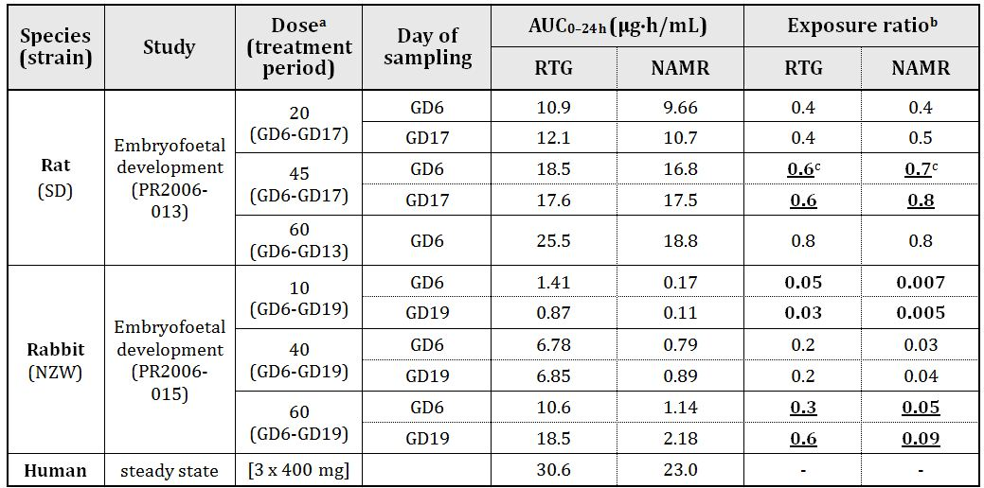

Tabulated values refer to total (bound + unbound) plasma concentrations of analytes; a. mg/kg/day by PO (gavage); b. animal:human plasma AUC0-24 h; c. bolded and underlined figures are exposure ratios at NOAEL (maternal) and NOAEL (embryofoetal); if different, bolded = NOAEL (maternal) and bolded and underlined = NOAEL (embryofoetal).

Studies using rats showed no effects of repeat dosing with retigabine on male or female mating and fertility parameters. Likewise, repeat dosing of pregnant rats or rabbits with retigabine had no effect on reproduction data (for example, implantation sites, resorptions, live foetuses) or the incidence of foetal variations and malformations. The doses used in these studies were, however, limited by the resulting prostration and extreme lethargy of dams leading to a marked decrease in food consumption.

Pre and postnatal effects of retigabine dosing were examined in one study using rats dosed from Gestational Day 6 (GD6) to PND20. Likely test article related effects, for dams dosed at a level that produced a significant decrease (~30%) in maternal weight gain and evidence of maternal neurotoxicity, included an increase (4%) in gestation length (presumably associated with an increase in the fraction of litters with a dead pup) and an increase in the fraction of pups dying postpartum. These test article exposed pups showed a lower weight at birth and at Week 12. There was no effect of dosing on age at sexual maturation, memory, motor activity, swimming capability, oestrous cycling, mating performance, or fertility, but a slight delay in attainment of an auditory startle response was observed. No toxicokinetic data were generated in this study, but based on the toxicokinetic data from embryofoetal toxicity studies the exposures achieved were lower than those anticipated for clinical use of retigabine at the MRHD.

There was no evidence that retigabine was acting as a teratogen at the relatively low exposure levels achieved in these studies. Teratogenic or other adverse effects on human fetuses cannot, however, be excluded at clinical exposure levels. The results of repeat dose toxicity studies in mice and rats indicate that juvenile animals are more sensitive to the pharmacological and toxicological effects of retigabine.

##### Pregnancy classification

The sponsor has proposed Pregnancy Category B3. Based on the data presented, this category is appropriate.

##### Immunotoxicity/local tolerance

Retigabine showed no potential for induction of anaphylaxis in the passive cutaneous and active systemic tests in guinea pigs, and was negative in a cutaneous sensitisation (Buehler) test in the same species.

##### Dependence

Retigabine was tested for potential to induce physical dependence in a 45 day rat study and in a rat reinforcement study in which rats were trained to self administer cocaine. Based on the results of these studies, retigabine is not predicted to have a significant potential for clinical dependence or abuse.

##### Impurities

Three drug product impurities gave positive results in Ames assay testing: ZP3 (GSK2252833A), GSK2259791A, and GSK2297881A. Another impurity (des-fluorobenzyl-retigabine; GSK2252834A) gave a positive Ames assay result at high concentration, against one bacterial strain, and in one test; however, it was negative in subsequent tests. ZP3 gave negative results in the rodent bone marrow micronucleus assay.

The levels of these potentially genotoxic impurities in the drug product are controlled to below the ICH Threshold of Toxicological Concern of 1.5 µg/day.[39] This is acceptable.

##### Paediatric use

Studies with juvenile rats, although partly confounded by vehicle effects, suggested that these animals may be considerably more sensitive to retigabine than their more mature counterparts. Hence, paediatric use of retigabine may be associated with increased toxicity. It is noted that the current application is for dosing in adults only.

##### Photosafety

Retigabine absorbs light in the UVB region (290-320 nm), but showed no evidence of photosensitisation of 3T3 fibroblast cells in the neutral red assay at concentrations of 622.6 μg/mL.

##### Effects on laboratory tests

Retigabine was shown to interfere with clinical laboratory assays of serum bilirubin, resulting in modest increases (of up to 0.1 mg/dL) in apparent total or direct bilirubin at clinically relevant concentrations of up to 2 µg/mL. A similar interference with urinary bilirubin determinations would be anticipated.

### Nonclinical summary and conclusions

#### Summary

* The nonclinical studies presented are of good quality and have been performed by reputable laboratories. The pivotal toxicological studies were performed to GLP standard. However, the systemic exposures achieved at the NOAEL in the toxicity studies were lower than clinical levels reflecting the greater sensitivity of the animal models to the toxic effects of retigabine.
* Retigabine was shown to possess anticonvulsant activity in a broad range of in vitro and *in vivo* animal models of epilepsy. The mechanism of action is novel, being mediated primarily through enhancement of a class of neuronal potassium channels known as KCNQ or Kv7 channels, which control subthreshold neuronal excitability. In addition, augmentation of GABA mediated currents may also contribute to retigabine’s anticonvulsant activity.
* The main concern from safety pharmacology studies is the ability of retigabine to interact with non target KCNQ channels. Retigabine produced relaxation of vascular, urinary bladder, and gall bladder smooth muscle cells, and reduced aortic baroreceptor responses to raised arterial pressure. It therefore has the potential to induce hypotension and to inhibit the emptying of the urinary and gall bladders. *In vitro* data suggested that retigabine may interact with KCNQ channels in the inner ear, but this was not addressed in *in vivo* animal studies. *In vitro* studies showed no potential for prolongation of the QT interval by retigabine. However, *in vivo* cardiovascular safety data in dogs are inadequate.
* Pharmacodynamic drug interaction data indicated that retigabine showed additive to synergistic anticonvulsant activity with carbamazepine, valproate, and lamotrigine against maximal electroshock induced seizures in mice or rats, with no apparent evidence of neurotoxic interactions. Retigabine has potential to interact with anaesthetic agents, since it increased thiopentone induced sleep time in rats up to 14 fold, and weakly increased propofol induced sleep times. Although retigabine did not influence halothane or methohexitone induced sleep times, an increase in respiratory depression was reported. A weak potentiation of ethanol effects was also seen.
* Pharmacokinetic studies, performed in multiple animal species, including those used in the primary pharmacology and pivotal toxicology studies, showed that orally administered retigabine is absorbed rapidly and extensively from the gastrointestinal tract, and is bound with moderate affinity by plasma proteins (~80% in all species). Metabolism of retigabine occurred predominantly by glucuronidation, either of the parent compound or following N-hydrolysis and acetylation to N-acetyl retigabine (NAMR), although this metabolite was not formed in the dog. There was no evidence for oxidative metabolism via CYP enzymes, and retigabine neither inhibited nor induced CYP activity. Overall, the pharmacokinetic studies confirmed the suitability of the animal species used in the pharmacodynamic and pivotal toxicology studies.
* Retigabine showed potential for interaction with drugs that affect or are substrates for UDP-glucuronosyltransferase activity in nonclinical studies. In vitro studies indicated that retigabine may inhibit monoamine oxidase-B and the OATP1B1 organic ion transporter at high doses, but this was not investigated further. While retigabine is not a substrate for P-gp and did not inhibit the activity of this transport protein, NAMR was inhibitory, and may inhibit renal clearance of digoxin.
* Target organs for toxicity in repeat dose studies included the CNS, kidney and urinary bladder, liver, and thyroid. Toxic effects were generally comparable between the sexes for rats, dogs, and monkeys, although male mice showed more severe effects than females, owing to a relatively higher level of systemic exposure to the test article. NAMR appeared less effective than the parent compound at inducing toxicity in both rats and dogs, although both compounds are presumably contributing to the toxic effects induced by retigabine dosing (in species other than dogs).
* CNS related effects of retigabine included sedation, convulsions, decreased muscle tone, salivation, and dyspnoea.
* Renal and urinary effects were prominent in mice and were presumably due to the pharmacological activity of retigabine mediating relaxation of urinary bladder detrusor smooth muscle, leading to urinary stasis. This in turn resulted in urinary precipitate (containing retigabine) that irritated the epithelium, leading to hyperplasia and inflammation. These effects were less prominent in rats and dogs. The possibility of urinary retention associated with clinical use of retigabine is referred to in the Product Information under “Precautions”.
* Fibrosis/fibroplasia and inflammation were seen in areas of the liver adjacent to the gall bladder wall following retigabine dosing of dogs. These outcomes were apparently a consequence of retigabine induced relaxation of gall bladder smooth muscle (mediated by KCNQ potassium channel activation), resulting in an increase in gall bladder volume. This is proposed to result in compression of adjoining liver regions, accompanied by cell death, and a decrease in bile flow. This appears to be of limited clinical relevance, since the Risk Management Plan (RMP) reports that there was no effect of retigabine on gall bladder volume, and gall bladder effects are not referred to in the PI.
* Both mice and rats (but not dogs) showed thyroid follicular cell hypertrophy/hyperplasia, which was attributed to the induction by retigabine of UGTs in liver, resulting in increased glucuronidation and degradation of thyroxine, and compensatory hypertrophy of the thyroid. It was considered unlikely that this would occur in humans, because of the longer plasma half life of human compared with rodent thyroxine.
* Retigabine and NAMR gave negative results in mutagenicity assays, but both compounds gave positive results (albeit at potentially cytotoxic concentrations) in *in vitro* chromosomal aberration assays. Under *in vivo* conditions, retigabine gave negative results in the mouse bone marrow micronucleus assay, a rat bone marrow chromosomal aberration assay, and the rat hepatocyte unscheduled DNA synthesis assay.
* A possible increase in bronchioalveolar carcinoma was observed in male mice. Carcinogenicity testing in rats was negative. The retigabine and NAMR exposure levels in these studies were considerably lower than both clinical exposure and the levels producing bladder irritation in rodent repeat dose studies (relative exposure at the HD for the rat study was 0.4-0.8).
* Retigabine and its metabolites readily crossed the placenta of pregnant rats. Retigabine was also excreted in the milk of lactating rats. High concentrations of 5-acetamido-2-oxo-2,3-dihydro-1H-benzimidazole in milk suggests that this rat specific metabolite is either selectively taken up or formed in mammary tissue in this species, but the relevance to humans is unknown. Reproductive toxicity studies, performed using rats and rabbits, showed no adverse effects of repeat dosing with retigabine on fertility or embryofoetal development. Increased pre and postnatal mortality, decreased body weight gain and delayed reflex development were observed in the offspring of rats dosed orally with retigabine throughout pregnancy and lactation. However, teratogenic or other effects on human foetuses cannot be excluded because the animal studies were performed at less than clinical exposure levels (maximal exposure ratios for retigabine in both species were ~0.6).
* Retigabine showed no immunogenic potential based on cutaneous sensitisation, passive cutaneous anaphylaxis, and active systemic anaphylaxis tests in guinea pigs.
* No potential for physical dependence or abuse of retigabine was evident based on studies in rats.

#### Conclusions and recommendation

* The primary pharmacology studies supported retigabine’s anticonvulsant activity in a broad range of *in vitro* and *in vivo* animal models of epilepsy.
* The nonclinical studies present some concerns regarding approval of retigabine for human use. These concerns derive from both identified (see below) and possible unidentified toxicity risks. The latter concern is related to the considerably subclinical exposure levels for retigabine and its major metabolite, NAMR, at the NOAEL in the repeat dose toxicity studies in animals, reflecting the greater susceptibility to retigabine induced toxic effects of the animal models compared with humans.
* Safety pharmacology studies raised concern about the ability of retigabine to interact with non target KCNQ channels on smooth muscle cells in the urinary and gall bladders. Repeat dose toxicity studies supported this concern by demonstrating toxic effects related to the urinary and gall bladders in animals. Urinary stasis (and in particular exacerbation of any pre existing urinary retention) and hypomotility of the gall bladder may be of concern for human therapy.[40]
* Retigabine exposure levels in the carcinogenicity studies in rats and neonatal mice were likely to be well below clinical. Although the overall genotoxicity assessment for retigabine and its major metabolite, NAMR, was negative, there was some evidence of weak carcinogenicity in the mouse assay.
* Retigabine exposure levels in the reproductive toxicity studies in rabbits and rats were considerably lower than clinical. Hence, teratogenic or other effects on human foetuses cannot be excluded based on only limited adverse foetal or reproductive effects in these studies. Category B3, as suggested by the sponsor, is appropriate.
* Nonclinical data suggested a potential for interaction between retigabine and drugs that affect or are substrates for UGT, and with substrates of monoamine oxidase-B and the OATP1B1 organic ion transporter (IC50 = 2.8 and 2.8 μM, respectively), although the former appears not to be clinically relevant according to statements made in the PI.
* Several genotoxic impurities can potentially occur in retigabine drug product. It is important that these chemicals remain controlled to below the Threshold of Toxicological Concern, as is proposed by the sponsor.
* The nonclinical concerns are adequately addressed in the RMP and the PI (when the suggested amendments are incorporated), and do not preclude registration of retigabine.

## IV. Clinical findings

A summary of the clinical findings is presented in this section. Further details of these clinical findings can be found in Attachment 2.

### Introduction

The submission contained the following clinical information:

* 21 clinical pharmacology studies, including 18 that provided pharmacokinetic data and 3 that provided pharmacodynamic data. The pivotal efficacy studies also collected pharmacokinetic data;
* population pharmacokinetic analyses;
* 3 pivotal efficacy/safety studies; and
* 8 other efficacy/safety studies.

### Pharmacokinetics

#### Studies providing pharmacokinetic data

None of the pharmacokinetic studies had deficiencies that excluded their results from consideration. However, the drug interaction studies should be interpreted with caution because the lamotrigine interaction study (3065A1-109) used a subclinical dose of lamotrigine. The ‘Multiple AEDs’ study (3065A1-202) did not use standardised treatments – subjects entered the study on whatever AED regimen their clinicians had chosen previously – and this study had low numbers in many treatment groups.

#### Evaluator’s overall conclusions on pharmacokinetics

The pharmacokinetics of retigabine have been satisfactorily characterised, and are well described in the proposed PI sheet. It has an oral bioavailability of ~60%, is metabolised to range of partially active metabolites in the liver, and is ultimately eliminated by the kidneys with a half life of 6-10 h, making it necessary to administer in three divided doses per day.

Consumption with food delays absorption and increases Cmax by ~38%. Clearance is significantly compromised in the setting of moderate to severe hepatic or renal impairment. Clearance is also proportional to body surface area. There is moderate variability between subjects, but gender, race and age do not make a significant difference to the pharmacokinetics of retigabine after accounting for body size. Pharmacokinetic interactions with other anticonvulsant drugs and the oral contraceptive pill appear minimal, but existing interaction studies are only partially adequate and did not use full therapeutic doses.

There is *in vitro* evidence that the N-acetyl metabolite of retigabine (NAMR) inhibits P-glycoprotein mediated transport of digoxin, so retigabine at therapeutic doses might increase digoxin serum concentrations. No clinical study has been performed to investigate this.

### Pharmacodynamics

#### Evaluator’s overall conclusions on pharmacodynamics

No primary pharmacodynamic studies have been performed. The sponsor has provided some evidence that retigabine has limited abuse potential, but only in the sense that recreational drug users found some of its sedative effects likeable. The sponsor has also assessed the effect of retigabine on the QT interval, finding a mild prolonging effect discussed in more detail in the ‘Safety’ section.

### Efficacy

#### Pivotal efficacy studies

The sponsor designated three studies as pivotal: a Phase IIb study (Study 205) and two similar Phase III studies (Studies 301 and 302). All were randomised, double blind, placebo controlled studies of the efficacy of retigabine as adjunctive therapy in refractory partial epilepsy. Study 205 assessed three active doses (600 mg/day, 900 mg/day, and 1200 mg/day); Study 301 assessed retigabine at 1200 mg/day, and Study 302 assessed retigabine at 600 mg/day and 900 mg/day. All studies used a forced titration schedule, and the double blind treatment phase was divided into a titration phase and a maintenance phase.

Two outcome variables were evaluated in all three studies, based on differing recommendations in the US and EU regulatory settings:

* percent change in seizure frequency (in line with US requirements)
* the responder rate, or percentage of patients with a ≥ 50% reduction in seizure frequency (in line with EU requirements).

Studies 301 and 302 employed similar methodologies, apart from the different doses and the longer titration period required to reach 1200 mg/day, and they are appropriately considered together. They both used the same two primary endpoints: percent change in seizure frequency, and responder rate.

Study 205 had slightly different entry criteria to the Phase III studies, a single primary endpoint (percentage change in seizure frequency), and a shorter maintenance phase. It therefore needs to be considered separately.

#### Evaluator’s conclusions on clinical efficacy

The sponsor has provided convincing evidence that retigabine has some efficacy as an anticonvulsant when used as adjunctive therapy in refractory patients, and that it differs significantly from placebo, as summarised in Table 6 (from the proposed PI).

Table 6: Summary of percentage changes in 28 day total partial seizure frequency and responder rates (‘double blind’ population is used for % change and ‘maintenance‘ population used for responder rates).

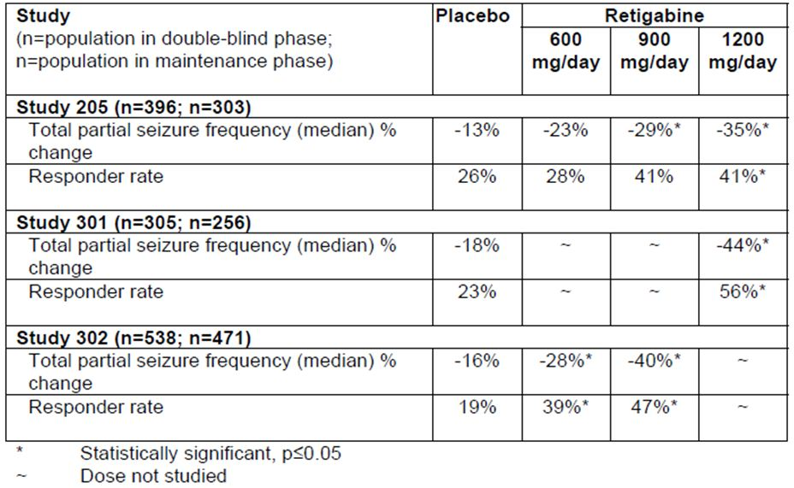

In clinical terms, the magnitude of the benefit appears modest, with a reduction in seizures of about 29-44% overall for the two highest dose groups (900 mg/day and 1200 mg/day), compared to a reduction with placebo of 13-18%. For the highest dose group (1200 mg/day), the attributable reduction in seizure frequency was 22% (13-35%) in Study 205, and 26% (18-44%) in Study 301. Patients are likely to welcome this reduction if it can be achieved with minimal side effects, but the size of the benefit is small enough that even a few side effects could offset it.

A reduction in seizure frequency of at least 50% (a “response”) is likely to be considered more worthwhile by most patients and clinicians. At the lowest recommended dose of 600 mg/day, the responder rate was similar to placebo in the Phase II Study 205 (retigabine 28% versus placebo 26%) but it was significantly superior in the Phase III Study 302 (retigabine 39% versus placebo 19%). At higher doses (900mg/d and 1200mg/d), the responder rates were more consistent (41% for either dose in Study 205, 47% for 900mg/d in Study 302, and 56% for 1200mg/d in Study 301), and these responder rates were significantly superior to placebo in both pivotal studies. Sensitivity analyses showed that, even if withdrawing patients were considered non responders, the superiority of active treatment was still significant.

For the highest dose group, the attributable response rate – the proportion of patients who responded to active treatment over and above the placebo response rate – was 15% in Study 205 (26-41%), and 33% in Study 301 (23-56%). This implies that between 3-7 patients need to be treated with retigabine to achieve one attributable response. However, the placebo response rate was 26% in Study 205 and 23% in Study 301; this implies that for every 4 patients treated, 1 patient will show a response that would have been obtained with placebo.

A range of secondary endpoints and subgroup analyses showed that these findings were robust, but these additional analyses did not change the overall impression that retigabine offers only moderate efficacy as an adjunctive agent. Seizure freedom was significantly more likely with HD retigabine, but was nonetheless rare. In the maintenance phase of Study 301, seizure freedom was achieved in 7.6% of retigabine 1200 mg/day recipients, compared to 1.5% of placebo recipients (p=0.027).

It seems likely that retigabine would have better efficacy in a less refractory population, but its efficacy in that setting remains untested. It also remains unknown whether retigabine compares favourably to other second line or third line AEDs in the adjunctive setting, and whether it has reasonable efficacy as a monotherapy agent.

### Safety

#### Studies providing evaluable safety data

The following studies provided evaluable safety data:

* 32 completed Phase I studies;
* 5 completed Phase II studies;
* 2 completed Phase III studies;
* 6 long term, open label extension studies (2 of which are ongoing; VRX-RET-E22-303 and VRX-RET-E22-304) in adults with partial onset seizures;
* an ongoing compassionate use program in epilepsy (D-23129-3227);
* 1 completed study in post herpetic neuralgia (VRX-RET-E22-NP201); and
* 1 completed study in bipolar disorder and (D-23129/8040).

#### Evaluator’s overall conclusions on clinical safety

The safety of retigabine can be considered under the headings of tolerability and risk of serious harm. The tolerability of retigabine appears to be poor, relative to many other anticonvulsants, but this is probably acceptable for patients who have poorly controlled epilepsy and are prepared to risk nuisance side effects for better seizure control. Of more concern is the risk of serious harm due to cardiac arrhythmia. This risk remains poorly characterised; it is probably acceptable in low risk patients using the drug exactly as intended, but the therapeutic window is narrow and single doses of 900 mg (within the intended daily dose range) are known to be dangerous.

##### Tolerability

The main tolerability issues are related to the inhibitory action of retigabine on the CNS, and include dizziness, somnolence, fatigue, confusional state, vertigo, tremor and abnormal coordination, all of which occurred in >10% of recipients at the highest dose level, with a clear excess relative to placebo. Dizziness was reported in 23.2% of retigabine recipients overall, and in 32.4% at the highest dose of 1200 mg/day, compared to only 8.9% of placebo recipients. As a group, “nervous system disorder” adverse events (AEs) were reported in 60.3% of retigabine recipients, compared to 43.1% of placebo recipients, but this does not include some CNS AEs that were attributed to other organ systems (eye and psychiatric disorders, for instance). In the HD group (1200 mg/day), “nervous system” AEs occurred in 73.4% of subjects, an absolute excess of >30% compared to placebo. There was an increased risk of psychotic symptoms, particular post ictal psychosis.

Non CNS tolerability issues consist of a dose related risk of constipation, urinary retention and nausea.

Retigabine was associated with a dose related increase in the risk of combined urological and renal AEs, with an approximately 2 fold increased risk of urological events in the highest dose group, relative to placebo. The incidence of urinary tract infection (UTI) appeared to be increased at higher doses, but was not increased by retigabine overall. This is difficult to interpret because placebo patients had more seizures, which might have prompted clinicians to look for an infective trigger, leading to ascertainment bias. Bladder ultrasounds showed only a mild increase in mean post void residual volumes.

Retigabine was also associated with a mean weight gain of 2.2kg by week 18 (2.7 kg in the highest dose group). Approximately 17% of retigabine recipients experienced weight gain of potential clinical concern (PCC) by Week 18, with the highest risk at 1200 mg/day (19.1%). In the pooled Phase II/III population the risk was higher (26%).

Retigabine treatment was associated with a mild increase in abnormal liver function tests but clinically significant hepatic disease was not observed.

There did not appear to be a significant withdrawal syndrome when retigabine was tapered or ceased abruptly, but the general advice to withdraw anticonvulsants slowly should also apply to retigabine.

##### Cardiac risk

The most important safety concern related to retigabine is the observation that 2 of 6 healthy volunteers exposed to a single oral dose of 900 mg experienced a substantial cardiac arrhythmia within 3 h: non sustained, asymptomatic ventricular tachycardia in one patient and cardiac arrest due to asystole in another patient. Both survived without sequelae, but this high incidence of arrhythmia (33%) is alarming, particularly given that the dose was only 2.25 times the recommended dose, and was less than the maximum recommended total daily dose. It might be expected that older patients or patients with underlying heart disease would suffer worse outcomes at this dose, and it is possible that dosing mishaps or pharmacokinetic variability could lead to subjects experiencing similar drug levels at 400mg TID as these subjects experienced with 900mg.

Retigabine was shown to have a mild prolonging effect on the QT interval of healthy subjects (mean prolongation of 6.7 msec in “completers”, with the upper end of the 90% confidence intervals reaching 12.6 msec), and it should not be combined with antiarhythmic drugs, or drugs known to effect the QT interval. It should also be avoided in subjects with heart disease or hypokalaemia. Warnings in the PI related to this should be strengthened. The QT effect does not appear to account for the incidence of serious arrhythmias at 900mg.

In a study of post herpetic neuralgia, atrial fibrillation was observed in older subjects receiving retigabine and no subjects receiving placebo, but it remains unclear if this represents a causal relationship.

Retigabine did not increase the risk of sudden unexplained death in epilepsy, and in fact reduced it relative to placebo, which potentially offsets some of the concerns about cardiac risk. Also, arrhythmias overall were not more common in retigabine recipients in the pivotal epilepsy studies. Although this is partially reassuring, subjects with significant heart disease were excluded from the pivotal studies and the close monitoring associated with trial conditions may have reduced the risk of dosing mistakes. The weight of evidence suggests that caution is appropriate.

### List of questions

#### Pharmacokinetics

Two different bioequivalence studies assessing the Market Image tablet obtained differing results, and it was suggested that particle size of the Clinical Trial tablet differed in the two studies. Is particle size in the final Market Image tablet stable and, if so, is it equivalent to that used in the pivotal studies? How does it compare to the formulation used in the clinical Study VRX-RET-E22-108? (This is not a clinical question, but the clinical data suggest a narrow therapeutic index for retigabine highlighting the need to avoid pharmacokinetic variation, particularly variations that could increase Cmax.)

The PI proposes a 3 h gap between a catch up dose (following a forgotten dose) and the next scheduled dose of retigabine. Prior to finalising the PI, the sponsor should supply a detailed justification of the appropriateness of this interval, taking into account the food effect, interindividual variability, the effects of repeat dosing, and the uncertainty of the proarrhythmic potential of retigabine between single doses of 400 mg and 900 mg. The proposed minimum interval should be increased if necessary.

#### Pharmacodynamics

None.

#### Efficacy

None.

#### Safety

Substantial questions remain about the cardiac safety of retigabine, but these cannot be answered at the current time, on the available evidence. A condition of registration should be that the sponsor should commit to perform studies characterising the proarrhythmic potential of retigabine at doses greater than 400 mg, and the sponsor should also guarantee that post marketing surveillance will be directed at clarifying this issue.

The sponsor should also answer: how many subjects have been exposed to single doses of 900 mg or higher?

### Clinical summary and conclusions

#### First round benefit-risk assessment

##### First round assessment of benefits

The benefits of retigabine in the proposed usage (adjunctive anticonvulsive therapy in adults) are:

* At the highest proposed dose (1200 mg/day), retigabine would be expected to produce a seizure reduction of 35-44%, including a reduction of 13-18% that would have been achieved with placebo alone, implying an attributable reduction in seizure frequency of 22-26%
* At the highest proposed dose, the attributable response rate would be expected to be in the range 15-33% (15% derived from Study 205: retigabine response 41% versus placebo 26%; 33% derived from Study 301: retigabine 56% versus placebo 23%). This implies that between 3-7 patients need to be treated with retigabine to achieve one attributable response.
* Some efficacy is also achievable at lower doses, including 900 mg/day and 600 mg/day.
* Sudden unexplained death in epilepsy (SUDEP) might be reduced by retigabine when used as directed in subjects without heart disease.

##### First round assessment of risks

The risks of retigabine in the proposed usage are:

* Poor CNS tolerability, with a range of symptoms including dizziness, somnolence, fatigue, confusional state, vertigo, tremor and abnormal coordination. The incidence of these appeared to be higher than for many other anticonvulsants, and there was a clear dose trend with the incidence being worse for 1200 mg/day. Dizziness was reported in 32.4% of subjects at 1200 mg/day, compared to 8.9% of placebo recipients, an attributable rate of 23.5% (which does not even include some additional cases reported as “vertigo”). “Nervous system” AEs occurred in 73.4% of subjects receiving 1200 mg/day, an absolute excess of >30% compared to placebo. The risk of psychosis was increased, particularly post ictal psychosis.
* A range of other side effects including an increased risk of urological symptoms, possibly mediated by impaired bladder emptying, weight gain, abnormalities of liver function tests
* Overall, approximately one patient in four (24.5%) withdrew from pivotal studies because of AEs, and there was a clear dose trend from the placebo group (10.5% withdrawing due to AEs) through to the highest retigabine dose group (1200 mg/day, 31.3% withdrawing due to AEs). Outside the context of a clinical study, the dropout rate due to AEs would be expected to be even higher, and this would be expected to degrade the achievable response rate. That is, a proportion of subjects who could have achieved a 50% reduction in seizures would be expected not to tolerate the drug.
* The drug appears to have a narrow therapeutic window, with a proarrhythmic effect demonstrated for single doses of 900 mg, which is less than the upper range of the recommended daily dose range (1200 mg/day). At this dose, 2 of 6 healthy volunteers had a major ventricular arrhythmia (self terminating ventricular tachycardia in one subject and cardiac arrest with asystole in another). This proarrhythmic effect has not been clearly acknowledged by the sponsor, and has not been explored in any detailed study. A proarrhythmic effect was not observed in the pivotal studies, but patients with significant heart disease were excluded, very few older patients were studied, and the maximum single dose was 400 mg. The cardiac risk would be expected to be higher in subjects with heart disease, increased age, electrolyte disturbances, or altered pharmacokinetics.
* The drug has moderate inter-individual variability in Cmax, so that some patients exposed to single doses of 400 mg might achieve drug levels more typical of higher doses, approaching the poorly characterised level at which a proarrhythmic effect might appear. Repeat dosing with 400 mg would be expected to achieve higher levels than single doses of 400 mg. This effect would be enhanced if the patient had a small body size, renal or hepatic impairment, or shortened the dose interval for any reason. The PI suggests a dose interval as short as 3 h in the event of catching up after a forgotten dose. In some individuals with poor clearance or small volumes of distribution, two doses of 400 mg separated by 3 h could produce similar levels as a single dose of 900 mg in healthy volunteers, particularly if the first dose was taken with food, which delays absorption. Furthermore, if any patient or doctor mistakenly interpreted the total daily dose as a once daily dose, patients could be exposed to 1200 mg as a single dose, exceeding the 900 mg dose that is known to be dangerous.
* The drug has a mild QT prolonging effect.

##### First round assessment of benefit-risk balance

The benefit-risk balance retigabine, given the proposed usage as adjunctive therapy, is borderline. Somewhere between 3 and 7 patients would need to receive the highest dose of the drug to achieve one attributable “response” (50% seizure reduction), and an even higher number would need to be treated to achieve a well tolerated response. Many patients receiving the highest dose would be expected to show poor CNS tolerability (at least 30% more than placebo). Although such patients are likely to cease therapy with no lasting sequelae, about 1 in 4 will show an apparent response that would have been achieved with placebo. Such subjects are at risk of continuing the drug for months or years without major benefit, possibly putting up with side effects because they believe their original response was due to the drug. (This situation already arises with existing anticonvulsants, and represents one of the challenges of managing epilepsy, but the tolerability profile of retigabine seems worse than for many other anticonvulsants.)

Of most concern, all exposed subjects would be at some risk of cardiac arrhythmias because of the narrow therapeutic index of retigabine, though the magnitude of this risk is unclear and this risk has not been explored by the sponsor. The risk would be expected to be higher in older subjects, those with heart disease, those with increased pharmacokinetic susceptibility, or those exposed to dosing errors (particularly the administration of the total daily dose as a single daily dose).

Against this risk, the incidence of SUDEP was reduced in retigabine recipients, compared to placebo recipients, implying that careful use of the drug in a screened population might lower the risk of sudden death.

The benefits and risks of retigabine are not likely to be homogenous across the entire target population. Clinicians who use retigabine with appropriate caution should be able to identify some patients who have a favourable benefit-risk balance. Patients with poorly controlled refractory epilepsy, for instance, who had failed to respond to other anticonvulsants and whose quality of life was poor and whose risk of SUDEP or status epilepticus was high, would be expected to find the risks of retigabine treatment worthwhile, particularly if their treating clinician was vigilant about withdrawing the drug if it did not produce lasting benefit. Subjects with milder epilepsy who had not yet tried other adjunctive agents and subjects with cardiac risk factors would be better to avoid the drug.

If made sufficiently aware of the narrow therapeutic index, prescribing clinicians should be able to take appropriate care to select suitable patients, to avoid dosing errors and to adjust the dose in those with pharmacokinetic susceptibility.

#### First round recommendation regarding authorisation

Retigabine should be approved for use in adult patients with refractory epilepsy, provided that appropriate changes are made to the PI.

Retigabine should not be used in subjects with heart disease.

The sponsor should provide education to physicians and patient advocacy groups about the risks of retigabine, including the need to adjust the dose in the setting of low body weight, renal impairment or liver impairment.

Retigabine should only be used by neurologists, or other clinicians who have been educated about its risks.

Retigabine should only be used by patients (or their guardians) who have consented to use the drug despite its narrow therapeutic index, and who illustrate awareness of the difference between a total daily dose and a single daily dose.

The PI proposes a 3 h gap between a catch up dose (following a forgotten dose) and the next scheduled dose. Prior to finalising the PI, the sponsor should supply a detailed justification of the appropriateness of this interval, taking into account the food effect, inter-individual variability, the effects of repeat dosing, and the uncertainty of the proarrhythmic potential of retigabine between single doses of 400 mg and 900 mg. The proposed minimum interval should be increased if necessary.

Rigorous post marketing surveillance for sudden death and cardiac arrhythmia should be conducted.

Further studies should be performed to establish the proarrhythmic potential of retigabine beyond single doses of 400 mg. These studies should be conducted in appropriate facilities with the capacity to provide immediate resuscitation and advanced life support.

## V. Pharmacovigilance findings

### Risk management plan

The sponsor submitted a Risk Management Plan which was reviewed by the TGA’s Office of Product Review (OPR).

#### Safety specification

The sponsor provided a summary of Ongoing Safety Concerns which are shown at Table 7.

Table 7: Ongoing safety concerns for Trobalt.

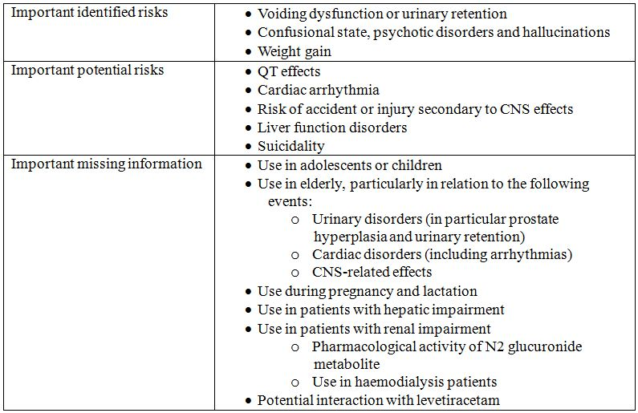

##### OPR reviewer’s comment

Notwithstanding the evaluation of the nonclinical and clinical aspects of the Safety Specification, the Ongoing Safety Concerns are consistent with those outlined in the EU submission and are acceptable.

#### Pharmacovigilance plan

##### Proposed pharmacovigilance activities

Tables 8-10 show a summary of the pharmacovigilance plan detailed by the sponsor in the RMP.

Table 8: Pharmacovigilance plan for ‘important identified risks’ detailed by the sponsor in the Trobalt RMP.

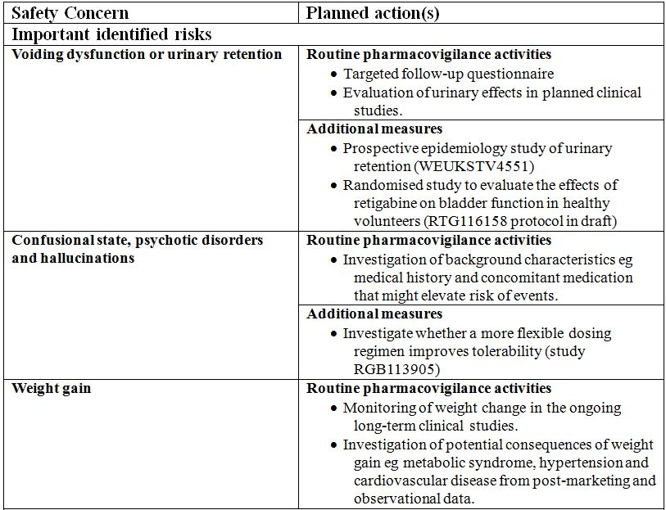

Table 9: Pharmacovigilance plan for ‘important potential risks’ detailed by the sponsor in the Trobalt RMP.

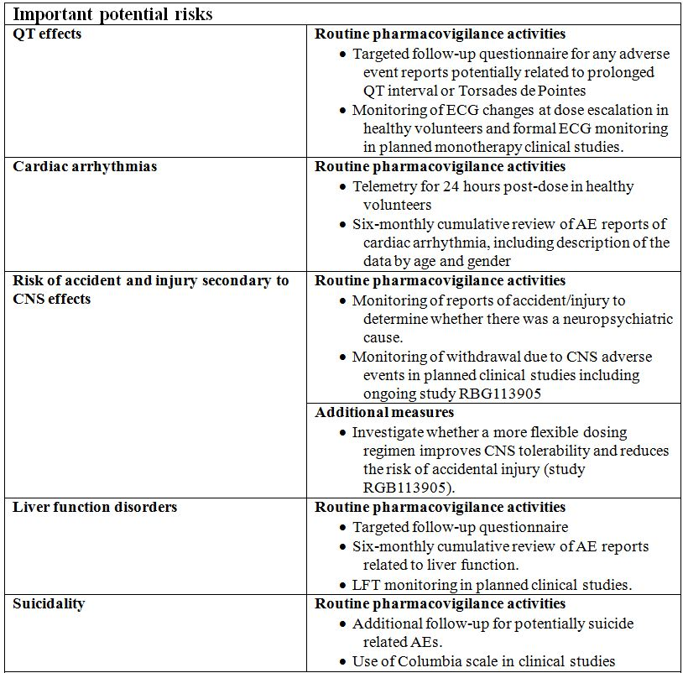

Table 10: Pharmacovigilance plan for ‘important missing information’ detailed by the sponsor in the Trobalt RMP.

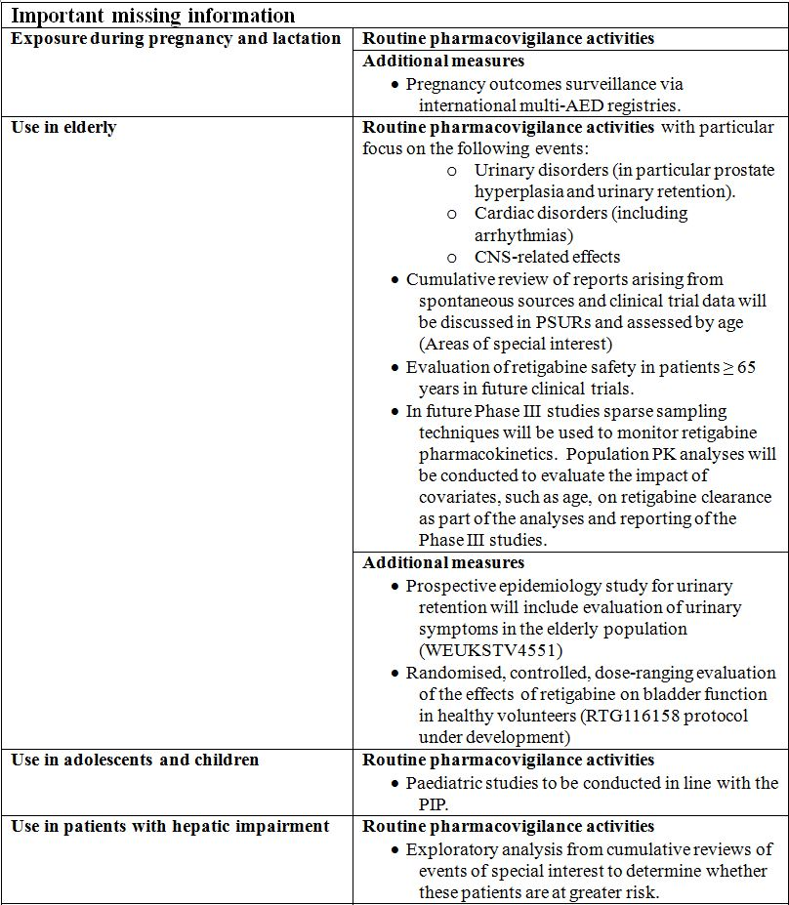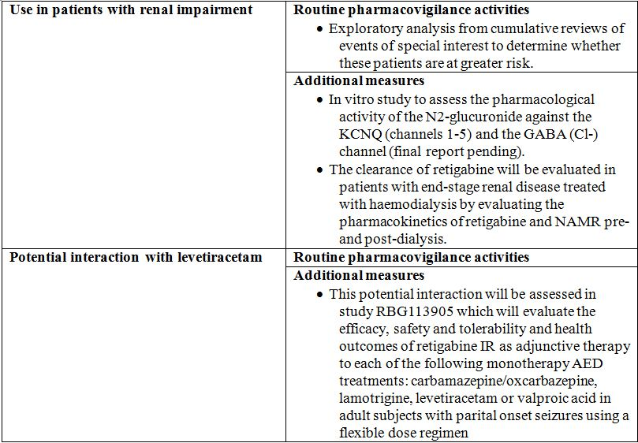

##### OPR reviewer’s comments in regard to the pharmacovigilance plan (PP) and the appropriateness of milestones

Targeted follow up questionnaires as part of routine pharmacovigilance are proposed for the important identified risk ‘voiding dysfunction and urinary retention’ and important potential risks ‘QT effects’, ‘Liver function disorders’ and ‘suicidality’. Copies of the questionnaires have been provided in the RMP and these are considered to be appropriate for their stated purpose.

According to the RMP and Australian specific annex the following studies are ongoing:

* WEUKSTV4551: A post marketing surveillance study to monitor the risk of urinary retention in retigabine users.
* RGB113905: An open label flexible dose study of retigabine immediate release as adjunctive therapy to specified monotherapy anti epileptic treatments in adults with partial onset seizures.
* Chan Test study number – 110330.HTN: Multi platform study (FastPatch and FLIPR) effects of two test articles on ion channels expressed in mammalian cells – final study report pending.
* RTG115214: An open label, single dose, fixed sequence, two treatment period study to assess the effect of haemodialysis on the pharmacokinetics of retigabine and the n-acetyl metabolite of retigabine (NAMR) planned date for submission of final data 2Q 2012.

As the above studies are ongoing and not part of the planned pharmacovigilance activities their protocols have not been evaluated in detail for purposes of this report. It is expected that results of these studies will be reported to the TGA once available and appropriately communicated in Periodic Safety Update Reports (PSURs).

According to the RMP the following paediatric studies are planned:

* RTG113284: An open label, multiple dose study to evaluate the pharmacokinetics, safety and tolerability of ezogabine/retigabine as adjunctive treatment in subjects aged from 12 years to less than 18 years with partial onset seizures or Lennox-Gastaut syndrome – planned date for submission of final data 1Q 2013.
* RTG113388: A long term, open label safety extension study of retigabine/ezogabine in paediatric subjects with partial onset seizures (>12 years old) and subjects with Lennox-Gastaut Syndrome (>12 years old) – planned date for submission of final data 2Q 2021.

In the Australian specific annex the sponsor states that the paediatric studies are unlikely to be applicable to Australia as the proposed indication is for adults only. As these studies do not relate to the proposed Australian indication the associated protocols have not been evaluated in detail for the purposes of this report however it is expected that results would be communicated to the TGA and included in PSURs.

According to the RMP the following study is also planned:

* RTG116158: Randomised, controlled, dose ranging evaluation of the effects of retigabine on bladder function in healthy volunteers – planned date for submission of final data 2Q 2015.

Although Australian patients are not to be included in this study the sponsor states that results of this trial will be applicable to Australia as they will assist in understanding the mechanism of the effects of retigabine on bladder function. This is acceptable. The protocol for this study has been provided and it is considered to be acceptable for the purposes of pharmacovigilance.

Monitoring of anti epileptic drug pregnancy registries is proposed as additional pharmacovigilance for important missing information ‘exposure during pregnancy and lactation’. The sponsor plans on monitoring the International Registry for Anti-epileptics in Pregnancy (EURAP) which includes Australian patients. The findings will be reported in the PSURs and this is acceptable.

According to the RMP, for the important potential risk ‘cardiac arrhythmias’ “telemetry for 24 hours post dose in healthy volunteers” is proposed as a planned routine pharmacovigilance activity. It is uncertain whether the proposed telemetry is part of a study or not. The sponsor is requested to provide more detail on this proposed pharmacovigilance activity including when and how it will take place and how the findings will be reported to the TGA.

Six monthly cumulative reviews of AE reports related to the important potential risks ‘cardiac arrhythmias’ and ‘liver function disorders’ are planned as part of routine pharmacovigilance. The sponsor should confirm how results of these reviews will be reported to the TGA.

#### Risk minimisation activities

##### Sponsor’s conclusion in regard to the need for risk minimisation activities

The sponsor has concluded that product labelling as routine risk minimisation is sufficient for all specified risks except for the important identified risks ‘voiding dysfunction or urinary retention’ and ‘confusional state, psychotic disorders and hallucinations’ and the important potential risk ‘QT effects’ which will be subject to an additional risk minimisation activity. A “Physician’s Guide” is proposed as risk minimisation for these safety concerns.

##### OPR reviewer comment:

*Section 3.1 Summary of Safety Concerns and Planned Actions* does not contain information on the important missing information ‘potential interaction with levetiracetam’, however it would appear from *Section 5 Summary of the EU Risk Management Plan* that no risk minimisation activities are proposed.

#### Summary of recommendations

The OPR provides these recommendations in the context that the submitted RMP is supportive to the application; the implementation of a RMP satisfactory to the TGA is imposed as a condition of registration; the submitted EU-RMP is applicable without modification in Australia unless so qualified; and the draft PI and Consumer Medicine Information (CMI) documents should NOT be revised until the Delegate’s Overview has been received:

* Safety considerations may be raised by the nonclinical and clinical evaluators through the consolidated Section 31 request and/or the Nonclinical and Clinical Evaluation Reports respectively. It is important to ensure that the information provided in response to these include a consideration of the relevance for the RMP, and any specific information needed to address this issue in the RMP. For any safety considerations so raised, please provide information that is relevant and necessary to address the issue in the RMP.
* Targeted follow up questionnaires as part of routine pharmacovigilance are proposed for the important identified risk ‘voiding dysfunction and urinary retention’ and important potential risks ‘QT effects’, ‘Liver function disorders’ and ‘suicidality’. Copies of these questionnaires have been provided in the RMP and these are appropriate. The sponsor should confirm that the questionnaires will be used in Australia.
* Monitoring of anti epileptic drug pregnancy registries is proposed as additional pharmacovigilance for important missing information ‘exposure during pregnancy and lactation’. The sponsor specifies monitoring of the International Registry for Anti-epileptics in Pregnancy (EURAP) which includes Australian patients. It is recommended that pregnancy related AEs are given special attention in PSURs.
* According to the RMP, for the important potential risk ‘cardiac arrhythmias’ “telemetry for 24 hours post dose in healthy volunteers” is proposed as a planned pharmacovigilance activity. It is uncertain whether this activity will be undertaken as part of a study or not. The sponsor is requested to provide more detail on this proposed pharmacovigilance activity including when and how it will take place and how the findings will be reported to the TGA.
* The sponsor’s approach to medication errors seems reasonable however the summary of medication errors does not appear to have been updated since the last version of the RMP. It is recommended that the sponsor update the RMP to report medication errors since the last version update.
* The evaluator considers that performing a baseline ECG in high risk patients prior to treatment confers a degree of safety with respect to the risk of QT prolongation. Depending on the clinical evaluator’s interpretation of the risk of QT prolongation with retigabine it is recommended that consideration should be made for strengthening the PI statement to include a recommendation for ECG monitoring in high risk groups similar to the EU Summary of Product Characteristics (SmPC).
* The sponsor should provide comment on how ECG advice will be handled in the Australian version of the physician’s guide given the copy provided specifically advises that an ECG should be recorded at baseline and at reaching maintenance dose in high risk patients. It is considered that the advice in the PI should align with that given in the Physician’s Guide so as not to confuse prescribers
* The sponsor should confirm in Section 31 responses how the physician’s guide will be distributed in Australia. Additionally, it is recommended that the approved PI should be distributed with the Physician’s Guide.
* The sponsor is requested to confirm if surveys of the physician guide’s effectiveness have already been conducted in the countries outlined and if so the results should be provided.
* It is recommended that the sponsor align the statement regarding use in pregnancy in the PI to that of the SmPC or provide compelling justification for its omission.
* It is considered that there remains only limited data for the safety profile of elderly patients receiving retigabine treatment for epilepsy. Depending on the clinical evaluator’s interpretation of the associated risk inclusion of a precaution for use in the elderly (such as that in the SmPC - above) would appear to be prudent.
* Use of retigabine as an adjunctive treatment implies concomitant treatment with other AEDs including levetiracetam. Therefore, it is recommended that a statement in the PI is included that appropriately communicates the lack of safety and efficacy data for this combination or a compelling justification for its omission should be provided.
* No contraindications are currently listed in the proposed PI. It is recommended that the following contraindication is added (as found in the EU SmPC): “Hypersensitivity to the active substance or to any of the excipients” or a compelling justification should be made for its exclusion.

## VI. Overall conclusion and risk/benefit assessment

The submission was summarised in the following Delegate’s overview and recommendations:

### Quality

There is no objection to the registration of the proposed retigabine film coated 50 mg, 100 mg, 200 mg, 300 mg and 400 mg tablets from a pharmaceutical chemistry perspective.

The evaluator has noted that the provided Good Manufacturing Practice (GMP) clearances for the proposed overseas manufacturing sites are current to at least February 2013. Any approval after this time will first require evidence of updated GMP clearance.

The submission was sent to the PSC of the Advisory Committee on Prescription Medicines (ACPM) for consideration at the September 2012 meeting (147th meeting). The PSC endorsed all the issues raised by the TGA in relation to pharmaceutic and biopharmaceutic aspects of the submission. In particular, the PSC supported the questions on the chromatographic methods, control of particle size of the drug substance, test for tablet uniformity using mass variation, related substances, proposed batch release and expiry limits, tablet dissolution test and limits.

The PSC shared the TGA’s concerns about the observed pharmacokinetic variability in view of the fact that the drug has a narrow therapeutic index.

The drug substance is a synthetic aniline derivative and is achiral. Five anhydrous/non solvated crystalline solid state polymorphic forms have been identified and the manufacturing process was optimised to produce the desired most stable Form A. The structure was well characterised.

Absolute bioavailability is approximately 60% from both an oral solution and the IR capsule formulations. Median time to reach peak plasma concentration (tmax) is approximately 0.5 h and half life values were 7.2-9.4 h for the oral dosage forms and an IV infusion of 50 mg retigabine over 15 minutes.

### Nonclinical

The nonclinical evaluator has stated that the nonclinical studies present some concerns regarding approval of retigabine for human use. These concerns derive from both identified and possible unidentified toxicity risks.

The systemic exposures achieved in the toxicity studies were lower than the clinical levels because animals were more sensitive to the toxic effects of retigabine. These included:

* the CNS related effects of sedation, convulsions, decreased muscle tone, salivation, and dyspnoea;
* renal and urinary effects presumed to be mediated by relaxation of urinary bladder detrusor smooth muscle, leading to urinary stasis and resultant urinary precipitate (containing retigabine) that irritated the epithelium, leading to hyperplasia and inflammation;
* hepatic fibrosis/fibroplasia and inflammation adjacent to the gall bladder wall; and
* thyroid follicular cell hypertrophy/hyperplasia.

The main concern from nonclinical safety pharmacology studies is the ability of retigabine to interact with non target KCNQ channels. Retigabine produced relaxation of vascular, urinary bladder, and gall bladder smooth muscle cells, and reduced aortic baroreceptor responses to raised arterial pressure. It therefore has the potential to induce hypotension and to inhibit the emptying of the urinary and gall bladders. *In vitro* data suggested that retigabine may interact with KCNQ channels in the inner ear, but this was not addressed in *in vivo* animal studies. *In vitro* studies showed no potential for prolongation of the QT interval by retigabine. However, *in vivo* cardiovascular safety data in dogs are inadequate.

There was no evidence for oxidative metabolism via CYP enzymes, and retigabine neither inhibited nor induced CYP activity. Retigabine is not a substrate for P-gp and did not inhibit the activity of this transport protein; however, its N-acetyl metabolite NAMR was inhibitory, and may inhibit renal clearance of digoxin.

Increased pre and postnatal mortality, decreased body weight gain and delayed reflex development were observed in the offspring of rats dosed orally with retigabine throughout pregnancy and lactation. Teratogenic or other effects on human foetuses cannot, be excluded because the animal studies were performed at less than clinical exposure levels (maximal exposure ratios for retigabine in both species were ~0.6).

Retigabine exposure levels in the carcinogenicity studies in rats and neonatal mice were likely to be well below clinical exposures. Although the overall genotoxicity assessment for retigabine and its major metabolite NAMR was negative, there was some evidence of weak carcinogenicity in the mouse assay.

### Clinical

#### Pharmacology

Absolute bioavailability of retigabine after oral administration is approximately 60% with no evidence of varying bioavailability with continued use. Cmax is reached in 2-3 h and half life is around 6-10 h.

A high fat breakfast did not affect the extent of oral absorption (AUC) of retigabine, but did result in a 38% higher Cmax. Median tmax for plasma retigabine was 2.5 h under fed conditions and 1.75 h under fasted conditions, indicating an approximate delay of 45 minutes attributable to food.

Dose proportionality from a single oral dose was demonstrated within the range of 25 to 600 mg and a population pharmacokinetic analysis showed that the systemic exposure to retigabine was linear over the therapeutic dose range of 600 to 1200 mg /day. The apparent volume of distribution at steady state (Vss) of retigabine is 2-3 L/Kg, consistent with moderate binding to tissues. Retigabine is ~80% bound to plasma protein, predominantly albumin over the concentration range of 0.1 to 2 μg/mL.

Retigabine is metabolised by formation of NAMR and through N-glucuronidation of both retigabine and NAMR. Following metabolic conversion to NAMR or glucuronides, subsequent clearance is predominantly renal (84%). NAMR is the major active metabolite and is much less active than the parent compound. The pharmacokinetics of retigabine and NAMR are broadly similar, the tmax of NAMR is reached about an hour later than the parent compound, the half life is similar and the Cmax is approximately half that of retigabine.

The effects of genetic polymorphism of different genotypes for UGT1A1 (subjects with and without Gilbert’s syndrome) and N-acetyltransferase (NAT2, fast and slow acetylators) were assessed in Study 3065A1-115.

NAMR concentrations were slightly elevated in subjects with both Gilbert’s syndrome and fast NAT2 acetylator genotype. The effects were minor compared to inter individual variability, and no retigabine dose adjustments are required on the basis of UGT1A1 or NAT2 genotype. For patients with moderate renal impairment (creatinine clearance [CrCl] <50 mL/min), a 50% reduction in the initial and maintenance dose is recommended. Due to the lack of assessment of effect, the clinical evaluator has recommended retigabine not be given to patients requiring dialysis, though the sponsor has proposed a 50% dose reduction. A 50% initial dose reduction and a maximum daily dose of 900 mg is recommended for patients aged >65 years. There was an approximate 2 fold increase in clearance (from around 20 L/h to 40 L/h) over the range of body sizes assessed in the population pharmacokinetic analysis and on that basis the clinical evaluator has recommended that the PI include an explicit recommendation to adjust dose for body weight given the narrow therapeutic index of this drug.

There were no clinically significant effects of retigabine on the pharmacokinetics of other AEDs, with the exception of lamotrigine where retigabine co administration was associated with a 20% decrease in lamotrigine trough concentrations. Co administration of carbamezepine (600-2400 mg/day) and phenytoin (120-600 mg/day) with retigabine increased clearance of oral retigabine by approximately 27% and 36%, respectively. Sodium valproate, an inhibitor of glucuronidation, did not significantly affect the pharmacokinetics of retigabine as assessed in the population pharmacokinetic analysis; however, the effect was not assessed in a separate pharmacokinetic interaction study. Lamotrigine, a substrate for Glucuronidation appears not to have a major effect on the pharmacokinetics of retigabine; however, the population pharmacokinetic data and an interaction study showed inconsistent minor effects.

Co administration of retigabine with the oral contraceptive pill increased the AUC of retigabine to ~116% of the AUC observed with monotherapy. Changes to the AUCs of norethisterone and ethinyl estradiol associated with co administration with retigabine were not clinically significant. *In vitro* evidence suggests that NAMR inhibits P-glycoprotein mediated transport of digoxin, so retigabine at therapeutic doses may increase digoxin serum concentrations.

Retigabine has some potential for abuse in that it causes sedation. The abuse potential study (VRX-RET-E22-108) showed that single doses of 900 mg were unsafe, leading to serious cardiac arrhythmias in 2 of 6 subjects (asystole and ventricular tachycardia). The clinical evaluator noted that a higher Cmax would be likely to be associated with a higher incidence of peak dose CNS and proarrhythmic side effects and requested the sponsor comment on this issue.

#### Efficacy

Studies 301 and 302 were pivotal. A Phase II study that included an 8 week maintenance treatment period has been included in the combined efficacy analyses by the sponsor; however, as that study was primarily a dose finding study and did not assess efficacy of retigabine at the maintenance dose for the minimum 12 week period recommended in the guideline, it will not be discussed further here.

The pivotal Phase III studies were multinational, randomised, double blind, and placebo controlled. Both studies had a forced titration schedule (over 4 weeks in Study 302 and 6 weeks in Study 301), and a 12 week maintenance phase. They both used two primary efficacy endpoints – the percentage change in 28 day partial seizure frequency and the proportion of patients with a ≥ 50% reduction in seizure frequency, that is, the responder rate. The main difference between the pivotal studies was the dose of retigabine tested: 1200 mg/day in Study 301, and 600 mg/day or 900 mg/day in Study 302.

Major inclusion criteria were: partial (focal) epilepsy, with or without secondarily generalised seizures; diagnosis of epilepsy for at least 2 years; aged over 18 years; could be taking from 1 to 3 other AEDs; and had at least four seizures per 28 days during the 8 week prospective baseline period. Subjects were not permitted to take vigabatrin or felbamate. During the titration period, doses of retigabine were increased by 150 mg daily each week until the target dose was reached. Primary efficacy assessments were made during the 12 week maintenance period. Two efficacy analyses were performed: an ITT analysis of all randomised subjects who received at least 1 dose of study drug (ITT double blind population) and an ITT analysis of all subjects entering the maintenance period (ITT maintenance population). Subjects who were withdrawn during the maintenance period were considered as non responders. The maintenance ITT analyses did not include subjects who were withdrawn during the titration period.

The ITT double blind population in the two studies comprised 831 subjects with 326 receiving placebo, 151 receiving 1200 mg retigabine daily, 179 receiving retigabine 600 mg daily and 175 receiving retigabine 900 mg daily in addition to their usual AEDs. There was an imbalance in the proportion of subjects receiving 3 AEDs at baseline (40.1% given placebo group compared with 27.5% given retigabine 1200 mg/day) in Study 301. There was a milder imbalance for the same variable in Study 302, where the placebo group (29.1%) and the retigabine 600 mg/day group (30.9%) had a higher proportion of subjects on 3 AEDs than the retigabine 900 mg/day group (24.7%).

In Study 301, the median percent reduction in seizure frequency was 44% for the retigabine 1200 mg/day group compared with 18% in the corresponding placebo group; this was an attributable reduction in seizures of 26% over and above the placebo response. For the retigabine 900 mg/day and 600 mg/day groups in Study 302, the reductions were somewhat less at 40% and 28%, respectively, compared with a 16% reduction observed with placebo. All comparisons with placebo were statistically significant (p<0.001 for 1200 mg/day and 900 mg/day, p=0.002 for 600 mg/day).

Responder rates were presented for the maintenance phase population with sensitivity analyses that included the ITT double blind population. The maintenance phase population for analysis comprised 747 subjects: 301 given placebo; 158 given retigabine 600 mg/day; 149 given retigabine 900 mg/day; and 119 given retigabine 1200 mg/day. There was a statistically significant benefit over placebo for responder rates (maintenance phase population) in both pivotal studies (p<0.001 for all comparisons with placebo, using Fisher’s exact test) for the ITT double blind population. A positive dose-response relationship was demonstrated for doses up to 1200 mg/day. At this dose, 56% of subjects experienced a ≥ 50% seizure reduction compared to a response rate of 23% in the corresponding placebo group. The response rate at lower doses was also clinically meaningful: 39% and 47% for the 600 mg/day and 900 mg/day doses, respectively, compared to 19% for the corresponding placebo group. Sensitivity analyses show similar outcomes for responder rates for the ITT double blind population in these pivotal studies. Results for secondary endpoints were broadly consistent with the primary endpoints.

Longer term efficacy was assessed only in uncontrolled studies. Studies 303 and 304 were uncontrolled, open label extension studies to the placebo controlled, double blind Studies 301 and 302, respectively. A total of 181/224 (81%) patients who completed Study 301 and 375/409 (92%) who completed Study 302 were enrolled into open label extension studies. The target retigabine dose was 1200 mg/day for Study 303 and 900 mg/day for Study 304, but the investigator could modify the dose of retigabine or other AEDs to optimise patient response and tolerance. These studies were ongoing at the time of submission. The median time on open label treatment was 357 days in Study 303, and 275 days in Study 304 in the interim results included in the submission.

The percent change in seizure frequency, relative to the baseline of the original studies was -56.5% for Study 303 and -53.4% for Study 304. Slightly better reductions were observed for patients with at least 12 months of treatment, but this could reflect withdrawal bias. As noted by the clinical evaluator, these observations provide only weak evidence of persistent efficacy but at least they do not show a definite decline in efficacy with continued treatment.

The sponsor’s pooled efficacy analysis included the dose finding Phase II study with the two pivotal studies. That analysis showed a significant benefit from retigabine regardless of the presence or absence of simple partial, complex partial or secondarily generalised seizures, age, gender, race, and number of concomitant AEDs.

#### Safety

A total of 2,365 subjects were exposed to retigabine, including 1,365 in Phase II and III epilepsy studies. A total of 150 individuals have received retigabine in Phase II or III studies for > 12 months. An integrated safety analysis that pooled results from the three studies nominated as pivotal by the sponsor, that is, Studies 205, 301 and 302 (n=1240) was included in the submission. Emphasis has been given to that analysis here because those studies assessed the intended patient population and proposed dose regimen had a similar duration of assessment and included placebo arms for comparisons. Safety in the open extension studies and in the full Phase II/III study population was considered separately.

Dizziness was the most common individual adverse drug reaction (ADR) reported in 23.2% of retigabine recipients overall compared with 8.9% in placebo recipients. A total of 32.4% of subjects reported dizziness at the highest dose of 1200 mg/day. Other common CNS side effects were: somnolence, headache, fatigue, confusional state, vertigo, tremor, and abnormal coordination. All these events were reported in >10% of recipients at the highest dose level with a clear excess relative to placebo. Diplopia occurred in ~7% of retigabine recipients without a clear dose trend but was 1.6% in placebo recipients. Most other CNS adverse events listed in that table are consistent with CNS inhibitory effects of retigabine at higher doses. Those effects are common with AEDs but the incidence with retigabine appears high. The incidence of UTIs and constipation increased with increasing doses of retigabine affecting 8% and 5%, respectively, of subjects given retigabine 1200 mg/day compared with 4.7% and 1.4%, respectively, of subjects given placebo. This may be due to the effect of retigabine on potassium channels in bladder and gut neurons.

In the integrated safety analysis, serious adverse events (SAEs) were slightly more common in the retigabine group than the placebo group (8.6% versus 5.9%). Psychosis was the only individual SAE reported more frequently with retigabine. There were 6 cases reported with 5 in the 1200 mg/day group and 1 in the 900 mg/day group, compared with none in the 600 mg/day group or in the placebo group. In the full Phase II and III study population, there were 11/1365 (0.8%) cases of psychotic disorder reported among recipients of any dose of retigabine.

In the integrated safety analysis population there were 5 deaths: 3 in the placebo group (3/427, 0.7%) and 2 in the pooled retigabine group (2/813, 0.2%). Of the 2 retigabine deaths, one subject was taking 600 mg/day and the other 1200 mg/day. One of the deaths was of a subjects taking placebo. One of the deaths in patients taking retigabine was attributed to SUDEP, a condition that would be expected to reduce in incidence with an effective anticonvulsant.

This rate of death is within expected bounds for this population and is equivalent to 24.0 deaths per 1000 patient years on placebo versus 9.5 deaths per 1000 patient years on retigabine. In the overall retigabine population there were 13 deaths in 1821 patient years (7.1 per 1000 patient years).

Of retigabine recipients in the integrated safety analysis, 24.5% withdrew due to AEs, and there was a clear dose trend from the placebo group (10.5% withdrawing due to AEs) through to the highest retigabine dose group (1200 mg/day, 31.3% withdrawing due to AEs). This suggests that retigabine has a relatively high rate of intolerance relative to many other anticonvulsants. The most common TEAEs leading to discontinuation were dizziness (5.7%), confusional state (3.9%), somnolence (3.4%), and fatigue (3.3%).

Abnormalities of liver function, electrolytes and haematology were not frequent. Individual AEs reported in ≥ 1% of retigabine recipients were: abnormal urinalysis, haematuria, leukopaenia, hypercholesterolaemia, and elevated gamma glutamyltransferase. In the pivotal trial population, increased hepatic enzymes were reported in 1.4% of placebo recipients, compared to 3.0% of retigabine recipients. There was an apparent dose trend with 2.1%, 3.3% and 3.5% of retigabine recipients exhibiting elevated enzymes in the 600 mg/day, 900 mg/day and 1200 mg/day dose groups, respectively. In the pivotal trial population, increased hepatic enzymes were reported in 1.4% of placebo recipients compared to 3.0% of retigabine recipients. There was an apparent dose trend with 2.1%, 3.3% and 3.5% of retigabine recipients exhibiting elevated enzymes in the 600 mg/day, 900 mg/day and 1200 mg/day dose groups, respectively. There was no evidence of direct renal toxicity from retigabine. There was no clear evidence of haematological abnormalities associated with retigabine and few subjects had haematological abnormalities.

An analysis of mean weights across all treatment groups (rather than just subjects who reported weight gain as an AE) shows that retigabine treatment was associated with a weight gain of 2.2 kg by Week 18. There was a clear dose trend, with the highest dose group showing a mean gain of 2.7 kg. Approximately 17% of retigabine recipients experienced weight gain of potential clinical concern, defined as a weight gain of ≥ 7% from baseline by Week 18, with the highest risk at 1200 mg/day (19.1%).

Overall AEs related to renal or urinary problems were slightly more common in retigabine recipients (17.0%) than placebo recipients (12.9%). The difference relative to placebo was more marked in the highest dose group where 25.1% of subjects had a renal/urinary event. This rate is nearly double that of placebo recipients. The excess in the HD group was largely accounted for by urinary tract infections, dysuria, urinary hesitation, chromaturia, abnormal urine analysis, and abnormal residual urine volume. Some of these events including UTIs, hesitation and abnormal residual urine volume could be due to an inhibitory effect on bladder emptying.

The incidence of AEs related to psychosis was increased in retigabine recipients (3.9%) compared to placebo recipients (0.7%) and there was a clear dose trend. The events were classified as SAEs in 8/813 subjects and led to discontinuation in 15 cases (~2%). In most subjects the psychosis appeared in the first few weeks of treatment during the titration phase.

There was one suicide attempt and one episode of suicidal ideation in retigabine recipients (2/813) compared with two reports of suicidal ideation in placebo recipients (2/413). No firm conclusions can be drawn from such low numbers.

Only 8 subjects aged 65 years or older were included in pivotal studies and 7 of these had an AE. Somnolence occurred in 4 of 8 subjects; dizziness in 3 of 8 subjects; and fatigue, tremor, abnormal coordination, UTI, gait disturbance and constipation were reported in 2 subjects each.

In this population, urinary retention was reported in 3 retigabine recipients (4.9%) compared to only 1 placebo recipient (3.6%). Studies in herpetic neuralgia also suggest a possible increase in the incidence of atrial fibrillation in patients aged ≥65 years.

With dose tapering as applied in the clinical studies, there was no clear indication of withdrawal effects due to retigabine.

The major safety issue for retigabine appears to be cardiac safety. Study VRX-RET-E22-108 was designed to assess abuse potential. In that study, 2 of 6 healthy subjects receiving 900 mg retigabine as a single dose had a potentially fatal cardiac arrhythmia (asystole in one subject and asymptomatic ventricular tachycardia in another). Both events resolved without specific treatment. In the pivotal studies retigabine was given in divided doses and the dose was titrated upwards. The incidence of ECG related and cardiac AEs in those studies was not excessive with active treatment compared to placebo, and the incidence of sudden death was lower with active treatment. Subjects enrolled in those studies had been screened and those with significant heart disease were excluded.

Following completion of the clinical evaluation report, the sponsor advised of additional safety issues of discolouration of the nails, skin and mucosal surfaces and an isolated case of retinal pigmentation.

### Risk management plan

Version 6 of the RMP for retigabine was considered acceptable by the RMP evaluator. It was noted that in this, the most recent available version of the RMP the provision of titration packs as an additional risk minimisation activity had been removed.

The RMP evaluator recommended the following:

* Implement Trobalt (retigabine) EU RMP Version 6.0 (Data Lock Point 28 March 2012) including Australian specific Annex version 2.0 (October 2010), and any future updates as a condition of registration.

PSUR:

* Post marketing reports are to be provided in line with the current published list of EU reference dates and frequency until the period covered by such reports is not less than three years from the date of this approval letter. The reports are to meet the requirements in accordance with ICH E2C (R2) guideline on Periodic Benefit-Risk Evaluation Reports and Module VII of the EMA Guideline on Good Pharmacovigilance (GPV) Practices relating to PSURs.[41] Submission of the report must be within the 70 days of the data lock point for PSURs covering intervals up to and including 12 months and within 90 days of the data lock point for PSURs covering intervals in excess of 12 months. The submission may be made up of two PSURs each covering six months.

It is noted that the European Medicines Agency (EMA) lists the following PSUR reference dates for retigabine:

EU Approval Date: 28 March 2011

PSUR Submission Frequency: 1 year

Data Lock Point: 28 March 2014

### Risk-benefit analysis

#### Delegate considerations

The clinical development program was well designed and appropriate clinical studies have been performed. The major issues for retigabine are limited tolerability and cardiovascular safety. It appears that strict adherence to a titration schedule and a divided dose schedule will be required to manage the cardiovascular risk.

The benefit-risk issues for retigabine have been well summarised in the clinical evaluation report. The clinical evaluator considers the benefit-risk balance for retigabine given the proposed usage as adjunctive therapy is borderline and has suggested some patients in whom the benefit-risk balance would be favourable.

Between 3 and 7 patients would need to receive the highest dose of retigabine to achieve one attributable “response” (50% seizure reduction) and even more patients would need to be treated to achieve a well tolerated response. Many patients receiving the highest dose would be expected to show poor CNS tolerability (at least 30% more than placebo). Although such patients are likely to cease therapy with no lasting sequelae, about 1 in 4 will show an apparent response that would have been achieved with placebo. Such subjects are at risk of continuing the drug for months or years without major benefit possibly putting up with side effects because they believe their original response was due retigabine. This situation also arises with existing anticonvulsants and represents one of the challenges of managing epilepsy but the tolerability profile of retigabine seems worse than for many other anticonvulsants.

The clinical evaluator considered that patients with poorly controlled refractory epilepsy who had failed to respond to other anticonvulsants and whose quality of life was poor and whose risk of SUDEP or status epilepticus was high would be expected to find the risks of retigabine treatment worthwhile. This is particularly so if their treating clinician was vigilant about withdrawing the drug if it did not produce lasting benefit. Subjects with milder epilepsy who had not yet tried other adjunctive agents and subjects with cardiac risk factors would be better to avoid the drug.

The sponsor responded to the concerns regarding cardiac safety expressed in the clinical evaluation report in the Appendix 4 to the responses to Section 31 questions. The narratives for the two serious cardiovascular ADRs are in Attachment 1 to this Request for Advice. The clinical questions to the sponsor relating to those events and the responses are in Attachment 2.

The clinical evaluator was concerned that patients who miss a dose of retigabine may have rises in plasma retigabine sufficient to cause a significant risk of a cardiac arrhythmia. He recommended there be no catch up dose if patients delayed taking a dose for more than 5 h. The sponsor responded to the effect that missing a dose completely would place patients at an increased risk of fitting due to low plasma concentration of retigabine. PK modelling was submitted to support a predicted mean increase in plasma retigabine Cmax of ~18% if a missed dose was taken 3 h prior to the next due dose. The sponsor noted that this increase is similar to that seen in the food studies.

The sponsor recommends that a patient should take the forgotten dose as soon as it is realised that a dose has been missed. The minimal interval of 3 h prior to taking the next scheduled dose is recommended by the sponsor because it is anticipated that with chronic dosing there will be limited increases in the retigabine mean Cmax. The sponsor considered that this proposed dose catch up also needs to be balanced with the need to return to the usual schedule as quickly as possible. An individual patient’s clinical response, particularly their ability to tolerate CNS related AEs would also need to be considered.

The clinical evaluator had recommended that a condition of registration should be that the sponsor commits to perform studies characterising the proarrhythmic potential of retigabine at doses greater than 400 mg and the sponsor should also guarantee that post marketing surveillance will be directed at clarifying this issue. The sponsor does not consider this is necessary and has provided a response (to Question 2). The sponsor stated that:

*overall review of AE and ECG data (HR [Hazard Ratio] and QTc intervals) from the Phase II/III clinical trial program support the conclusion that retigabine does not demonstrate a major effect on cardiac rhythm/conduction. This opinion is supported by a number of independent cardiology reviews that have been conducted during the development program.*

The Delegate is concerned that the proarrhythmic potential of retigabine may not be related to its QT prolongation effect but rather to some other unidentified effect and that it is more likely to occur with first dosing and where the first dose is over 600 mg. The sponsor has agreed to add a requirement for ECG assessment at baseline and on reaching maintenance dose levels.

The clinical evaluator also suggested quite stringent requirements to inform potential prescribers of the cardiac risk associated with retigabine. The sponsor has not accepted that the risk is of the same magnitude as that considered by the clinical evaluator.

**The general advice of the ACPM is requested. The ACPM is also requested to provide advice on the following specific issues:**

* Does the ACPM agree with the clinical evaluator that the following statement should be included in a Black-Box warning and in the *Contraindications* and *Dosage and Administration* sections of the PI?

*In a study in healthy volunteers, cardiac arrhythmia (asystole or ventricular tachycardia) occurred in two of six subjects (33%) within 3 h of receiving a single 900 mg retigabine dose. The arrhythmias spontaneously resolved, and both volunteers recovered without sequelae. Note that this dose is less than the maximum recommended total daily dose of retigabine.*

* Does the ACPM consider that there should be a revised dose regimen for patients weighing <60 kg due to the risk of cardiac arrhythmias associated with retigabine? If so, what revision is recommended?
* Given the cardiac safety concerns associated with retigabine is it appropriate to restrict the indication such that retigabine could be considered for adjuvant treatment only in those patients who were inadequately controlled or intolerant of at least 2 other AEDs?
* It is appropriate that treatment be initiated only by a neurologist?

Given the cardiac safety issue, the Delegate has not proposed further amendments to the draft PI submitted with the Section 31 response dated 29 October 2012. This document may be finalised after the advice of the ACPM has been received.

#### Response from sponsor

The sponsor is seeking TGA approval of Trobalt (retigabine) for adjunctive treatment of partial onset seizures with or without secondary generalisation in adults aged 18 years and above with epilepsy.

Retigabine has a unique pharmacological profile not shared by current AEDs and offers an important adjunctive therapeutic option for patients not adequately treated with available AEDs. Retigabine has nearly two years of marketing experience in the EU (approved March 2011) and is also approved in a number of other countries including the US, Canada and Switzerland. The recommendations for use are generally consistent across the various approved labels, in particular as they relate to cardiac safety.

In support of this application, the sponsor has submitted data which demonstrates substantial evidence of the efficacy of retigabine for the proposed use. The safety of retigabine is demonstrated in data derived from the entire nonclinical and clinical development program and nearly two years’ worth of post marketing experience:

* In the retigabine clinical development program, the most common AEs were those relating to the CNS which is typical of AEDs in general.
* The cardiovascular safety profile of retigabine has been carefully evaluated in both nonclinical and clinical studies during development. The two serious arrhythmias observed in the abuse liability study, after single high dose of retigabine, appear to be the results of the subjects’ retigabine naïve status and individual factors, and are not predictive of risk of arrhythmias during the chronic treatment of patients with partial onset seizures.
* The small QT interval prolongation effect seen in the Thorough QT study is not anticipated to be clinically significant in the partial onset seizure patient population, except in those at the highest risk (for example, patients with heart disease on significant QT prolonging drugs).
* No clinically significant QT prolongation requiring intervention or case of torsade de pointes was recorded within the clinical trial program.
* GSK believes that a Black-Box warning or contraindication is not justified labelling in this instance. Retigabine’s potential cardiovascular risk for QT prolongation can be mitigated through appropriate labelling in the proposed PI including dose titration (and requirement, in patients at high risk, for ECG assessment at baseline and on reaching maintenance dose levels) and post marketing risk minimisation activities.
* This labelling approach is supported by a number of independent cardiology experts who have conducted detailed reviews of the retigabine cardiovascular data.

##### Response to points raised by Delegate for ACPM’s advice

###### Delegate comment 1 - relating to proposal for Black-Box Warning/Contraindication

The sponsor does not agree with the evaluation of the data by the Delegate and the clinical evaluator that the cardiovascular safety profile of retigabine warrants the adoption of this labelling.

The proposed PI for retigabine already includes wording within the *Precautions* section directing prescribers to use caution with patients at high risk of prolonged QT interval, and we believe this is commensurate with the anticipated risk. The issue of cardiac arrhythmia raised in the two cases from the abuse potential study (VRXRET-E22-108) does not necessitate a Black-Box Warning, which is a labelling tool that has been applied by TGA to a relatively small number of drugs where the clinical importance or severity of the event is considered to have critical impact on patient welfare. A Black-Box warning would suggest a level of risk that is not consistent with the sponsor’s cumulative experience from nonclinical and clinical studies as well as nearly two years of marketing experience with retigabine.

A Thorough QT study (VRX-RET-E22-103) in healthy volunteers demonstrated a slight (7 msec) and transient (1, 2 and 3 h post dose) prolongation of cardiac repolarisation. AE and ECG data from the Integrated Clinical Pharmacology and Phase II/III clinical trial databases and studies does not indicate major effects of retigabine on cardiac rhythm/conduction. No case of torsade de pointes was reported in clinical trials.

The potential effect of retigabine to cause QTc interval prolongation is small and not expected to have clinical significance except in patients at highest risk. The proposed PI for retigabine includes a caution within the Precautions section commensurate with the anticipated risk. This position is supported by agencies such as the EMA, US Food and Drug Administration (FDA) and Health Canada who have reviewed the same data and agreed with the RMP proposed for Trobalt.

Summary of nonclinical information

Retigabine activates a family of neuronal potassium channels, KCNQ2-5, but its efficacy in epilepsy is due to selective enhancement of K+ currents through ion channels formed from KCNQ2 and KCNQ3 subunits.

There is limited activity at KCNQ4 and KCNQ5 (EC50 values of ~5.2 µM and ~6.4 µM, respectively; relative to a mean free fraction Cmax value of ~1 µM at the highest clinical dose of 1200 mg/day). Although KCNQ4 is expressed in the human[42] and rat[43] heart expression appears low in human heart and mutations in KCNQ4 are associated with nonsydromic hearing impairment but not with cardiac arrhythmias.[44]

Retigabine does not activate the cardiac channel, KCNQ1, but is a very weak inhibitor. Inhibitory activity at KCNQ1 was observed at retigabine concentrations significantly greater than those required for clinical activity in epilepsy (~100 fold relative to maximal clinical mean free fraction Cmax).

Similarly, in a series of *in vitro* electrophysiologic studies using recombinant human cardiac ion channels (including hERG, Nav1.5, Kv1.5, and Cav1.2) and in *in vitro* assays using feline myocytes and canine Purkinje fibres, there were adequate margins for inhibitory effects of retigabine relative to clinical exposure. Of note, margins were ≥60 fold for effects on the repolarising channels of the heart (hERG and KCNQ1) known to cause action potential depolarisation and QTc prolongation.

In addition, all [14C]retigabine derived material showed rapid elimination from the heart in a single dose tissue distribution rat study.

These data are supported by the absence of proarrhythmic effects in nonclinical *in vivo* studies in dogs at systemic exposures up to (and, in some animals, slightly exceeding) the mean Cmax value at the highest clinical dose (1200 mg/day). Further dose escalation in the dog was precluded by dose limiting toxicity.

Summary of clinical information

In the retigabine pivotal clinical trials, cardiac events were overall infrequent in the epilepsy population. All events related to cardiac rhythm/conduction abnormalities were reported with similar frequency between placebo and combined retigabine treatment groups (4% and 5%, respectively). In addition, no clear dose relationship or apparent trend in time to onset was observed. Events were reported by 5%, 6% and 3% of patients in the 600, 900 and 1200 mg/day groups, respectively. There is no consistency of pattern to the reported events to indicate or suggest a direct pharmacologic cause or effect. No clinically significant QT prolongation was seen. In particular, no patients treated with retigabine experienced a QT interval of greater than 480 msec or reported AEs related to QT prolongation. No case of torsade de pointes was recorded. PR interval prolongation has not been observed in humans at therapeutic doses.

With regard to SUDEP, the incidence of sudden death was lower with active treatment compared with placebo.

In the Integrated Clinical Pharmacology Program (n = 687), few cardiac AEs were reported. Any cardiac event was reported in 24 subjects (3.5%) with palpitations accounting for most of these (20 subjects (2.9%)). Three subjects (0.4%) reported ventricular extrasystoles and 2 reported extrasystoles (0.3%). There were also single reports of bradycardia, cardiac discomfort, and tachycardia. Two subjects were withdrawn from the clinical pharmacology studies because of arrhythmia AEs: one subject in Study 3065 A1 107 had two separate 3 beat runs of ventricular tachycardia on Day 9 at 400 mg (200 mg BD) and on Day 16 at 800 mg (400 mg BD); another subject in Study 3065 A1 102 was withdrawn for the presence of ventricular extrasystole (PVC) while receiving the dose of 300 mg.

A number of independent cardiology experts have reviewed the cardiac data during the development program. The principal cardiology consultant for the Thorough QT study concluded:

*“A small effect on cardiac repolarization which cannot be excluded in this trial if real was at all time points less than moxifloxacin and hence should not have important clinical significance except in those patients that are at the highest risk (for example, patients with heart disease on significant QT prolonging drugs)”.*

It is noteworthy that in the two multiple dose clinical pharmacology studies (VRX-RET-E22-103 and RTG115216) in which the subjects were up titrated to the maximum dose of 1200 mg (400 mg TID), no AE of cardiac arrhythmia was reported. Overall, the incidence of cardiac AEs in the clinical pharmacology studies appears in line with the data reported in the clinical trial program.

A review of AE and ECG data (HR and QTc intervals) from the Integrated Clinical Pharmacology and Phase II/III clinical trial databases does not indicate that retigabine demonstrates major effects on cardiac rhythm/conduction or on cardiovascular safety in epilepsy patients.

An expert cardiology consultant states:

*“...although retigabine may have a very small QT prolonging effect, it is devoid of any proarrhythmic potential”.*

Based on the findings from the Thorough QT study (VRX-RET-E22-103), caution should be exercised when retigabine is prescribed with medicinal products known to increase QT interval and high risk patient groups, such as those with congenital long QT syndrome, congestive heart failure, ventricular hypertrophy, hypokalaemia or hypomagnesaemia and in patients initiating treatment who are 65 years of age and above.

In the abuse potential study (VRX-RET-E22-108), two subjects experienced cardiac SAEs after a single 900 mg retigabine dose. Both events resolved spontaneously. There is no consistent pattern in these two cases to suggest a common mechanism that might be linked to retigabine:

The first of these two subjects experienced a transient asystole while in a semi recumbent position. Differential diagnoses include neurocardiogenic or vasovagal syncope. Factors which could have contributed to this episode include:

* Subject being a recreational polydrug (marijuana, mushrooms and MDMA) user;
* Presence of marked bradycardia before the retigabine 900 mg dosing, with documented ECG episodes of sinus bradycardia (down to 44 beats/min) at rest; and
* Study procedures: consumption of a high number of tablets, fasting status and prolonged rest position in at early time after dosing.

Retigabine plasma concentration at the time of the event was not measured. The only available concentration data in this subject showed a low plasma concentration at 1.5 h post dose (226 ng/mL) before the episode of asystole occurred. However, the extrapolation of retigabine Cmax based on the previous retigabine dose of 300 mg and 600 mg predicted a Cmax of 1325, is in line with the other subjects participating in the study.

The second of these two subjects had transient asymptomatic ventricular tachycardia, which was not polymorphic or associated with QT prolongation. There was a significant history of recreational drug use which included marijuana and cocaine, and a family history of arrhythmia.

When a single dose of 900 mg is given to retigabine naive subjects, the mean Cmax achieved was lower than mean Cmax following repeat dosing of retigabine 1200 mg (400 mg TID). However, with a single oral dose of 900 mg, the increase in retigabine plasma concentration from 0 to Cmax was higher than the increase from Cmin to Cmax during retigabine treatment at steady state. Consequently, a contributory effect of a single dose of retigabine cannot be completely excluded in naive subjects, particularly those with predisposing factors (that is, marked bradycardia in the case of the first subject noted above). The importance of the individual factors is also highlighted by the different physiopathology of the two episodes of arrhythmia that cannot be explained by a direct action of retigabine on heart KCNQ channels. However, when used in accordance with the dosing recommendations, the implications for the patient with partial onset seizures starting treatment with retigabine appear to be limited for the following reasons:

* Treatment is initiated at a dose of 300 mg/day (100 mg TID) that is up titrated at weekly interval by 150 mg (50 mg TID added) to an initial maintenance dose of 600 mg day (200 mg TID). Further up titrations will be driven by clinical response and individual tolerability.
* At treatment initiation, the prescribed tablets strength will be 50 mg and 100 mg. The erroneous consumption of 9 (100 mg) to 18 (50 mg) tablets all together, appears to be unlikely.
* At steady state, the retigabine plasma fluctuations associated with the TID regimen are not associated with effects on cardiac rhythm, as indicated by the low rate of AEs relating to cardiac arrhythmias in the clinical pharmacology repeat dose studies and in the epilepsy clinical trials at the highest dose of 1200 mg (400 mg TID).

More recently, an eminent professor of clinical cardiology noted, regarding the arrhythmias seen during the clinical program:

*“...none was described as a polymorphic ventricular tachycardia or torsade de pointes. ECG intervals, including the QT interval, showed no significant change and no significant ECG morphology change was documented”.*

The professor also noted:

*“QT lengthening is unlikely to be a major clinical issue except in patients with predisposing or coexisting QT related conditions. Therefore, the proposed labelling for Retigabine, which acknowledges and informs of this risk is entirely appropriate”.*

Thus, the proposed wording in the PI, in relation to the QT interval warning, is adequate to describe the proarrhythmic potential of retigabine. The professor concluded that they “do not believe that any further precaution is necessary”. This same position has been accepted by regulatory authorities in the EU, the US, and Canada.

Furthermore, spontaneous AE reports are consistent with findings from the clinical development program. The most recent PSUR (dated 7 November 2012), submitted with this response, continues to support a favourable cardiovascular safety profile for retigabine therapy.

In summary, the sponsor does not believe that the inclusion of an additional statement in a Black-Box warning, contraindication or in the *Dosage and Administration* sections of the PI is appropriate. The small potential cardiovascular risk can be mitigated by the current proposed labelling. This position is consistent with the approved labelling in the EU, the US, Canada and other international markets in which the product is currently registered.

###### Delegate comment 2 – relating to dosage revision for patients <60kg

The sponsor believes that a revised dose regimen for patients weighing <60 kg is unwarranted since medical practice is to titrate to effect on an individual patient basis. As described above, review of data on the proarrhythmic potential of retigabine from both *in vitro* and *in vivo* nonclinical studies, along with a detailed review of the controlled clinical studies by the sponsor, a number of independent experts and other regulatory agencies support the view that the cardiac safety profile can be managed with the proposed labelling, without dose revision per body weight. In addition, the dosing schedule includes a period of up titration where a patient’s dose is adjusted according to their individual response.

The sponsor believes that the current plan to carefully monitor cardiac arrhythmia events in the post marketing setting is appropriate and these will be described in PSURs. The sponsor will continue to monitor these events through routine and enhanced pharmacovigilance.

###### Delegate comment 3 – relating to the indication

The cardiac safety concerns are addressed in the discussions above. The proposed indication is adjunctive treatment of partial onset seizures with or without secondary generalisation in adults aged 18 years and above with epilepsy. The data support this indication, and the indication proposed for Australia is the same as in the EU and in other international markets (for example, Brazil, Malaysia, Iceland, Norway, Russia, and Switzerland). The sponsor does not believe it is appropriate to include a restriction to the indication based on the cardiac safety profile which, when used as recommended and as used in the PCTs, did not indicate a significant safety concern.

###### Delegate comment 4 – relating to treatment initiation

The sponsor considers this approach is unnecessary. While it is most likely that patients requiring adjunctive treatment for epilepsy will be under the care of a neurologist, it is possible that in some circumstances, particularly in rural settings, a neurologist may not be available and the nearest neurologist could be a long drive away. In this case, the care of this group of patients may be taken up by an internist or other local practitioner. In such situations, it should be deemed appropriate that adjunctive treatment of partial onset seizures with retigabine could be initiated by non neurologists.

##### Benefit-risk assessment – conclusion

* Uncontrolled epilepsy presents a significant burden to patients in terms of increased morbidity and mortality.[45] Retigabine is the first neuronal potassium channel (KCNQ) opener developed for the treatment of epilepsy and would broaden the possibilities for treatment for the approximately 30% of patients who are resistant to currently approved pharmacologic agents.[46]
* The results from randomised, double blind, placebo-controlled trials, supported by data from Phase II and long term open label studies have provided substantial evidence of effectiveness for retigabine for adjunctive treatment of partial onset seizures in adult patients who had failed treatment with previous AEDs. The pivotal Phase III studies together (Study 205, Study 301 and Study 302) showed evidence of a dose related increase in efficacy across the dose range (600 to 1200 mg/day).
* An evaluation of the safety of retigabine takes into consideration the data derived from the entire nonclinical and clinical development program. In the clinical program, the most common AEs associated with retigabine treatment were dizziness, somnolence and fatigue, similar to many of the recently marketed AEDs.
* The small QT interval prolongation effect seen in the Thorough QT study is not anticipated to be clinically significant in this patient population, except in those at the highest risk (for example, patients with heart disease on significant QT prolonging drugs).
* This potential cardiovascular risk can be mitigated by appropriate labelling as currently proposed in the PI, including appropriate dose titration (and requirement, in patients at high risk, for ECG assessment at baseline and on reaching maintenance dose levels), monitoring, and prompt intervention. Therefore, a Black-Box warning or contraindication is unwarranted.
* Retigabine has been shown to be an effective treatment option, with an acceptable safety profile in the adjunctive treatment of partial onset seizures in adults. Indeed, the positive benefit-risk evaluation based on assessment of the entire clinical development program enabled approval for this indication in the EU (March 2011), USA (June 2011), Canada (October 2012) and other markets.
* The recommendations for use are generally consistent across the various approved labels, in particular as they relate to cardiac safety. The regulatory approvals in the EU, US and Canada, followed considerable interrogation of similar issues which have been raised by the TGA.
* No new significant safety concerns have arisen for retigabine from post marketing sources in the countries where it has been approved.
* The known safety profile of retigabine is adequately described in the proposed labelling. Additionally, educational material is proposed for healthcare providers and patients/caregivers, to provide information on the key risks associated with the use of retigabine and to facilitate discussion between the healthcare provider and the patient/caregiver, prior to retigabine being prescribed.

#### Advisory Committee considerations

The ACPM, taking into account the submitted evidence of efficacy, safety and quality, considered these products to have an overall positive benefit-risk profile for the indication:

*Adjunctive treatment of partial onset seizures with or without secondary generalisation in adults aged 18 years and above with epilepsy whose seizures have not been adequately controlled on at least two other AEDs.*

The ACPM advised that although the evidence of possible cardiac adverse events warrants robust post marketing surveillance, there is no necessity at this point for a Black-Box warning on cardiac arrhythmias.

##### Proposed PI/CMI amendments

The ACPM agreed with the Delegate to the proposed amendments to the PI and CMI and specifically advised on the inclusion of the following:

* A statement in the *Precautions and Adverse Reactions* section of the PI (to be reflected in the CMI) to more accurately reflect the cardiac effects (including QT prolongation) of retigabine that is at least as clear as the EU statement.
* A statement in the *Precautions and Adverse Reactions* section of the PI (to be reflected in the CMI) to provide information on the UTI effects of retigabine.
* A statement in the *Dosage and Administration* section of the PI to provide for a dose adjustment for lower body weight below 60 kg.
* A statement in the *Dosage and Administration* section of the PI (reflected in the CMI) to more accurately reflect the lack of data on use in renal insufficiency.
* A statement in the *Contraindications* section of the PI (reflected in the CMI) to ensure use in dialysis patients is prevented.

##### Proposed conditions of registration

The ACPM agreed with the Delegate on the proposed conditions of registration and specifically advised on the inclusion of the following:

* Targeted post market pharmacovigilance, specifically in the areas of cardiac arrhythmias, pigmentation of the skin and CNS effects such as confusion.

The ACPM advised that the implementation by the sponsor of the recommendations outlined above to the satisfaction of the TGA, in addition to the evidence of efficacy and safety provided would support the safe and effective use of these products.

### Outcome

Based on a review of quality, safety and efficacy, TGA approved the registration of Trobalt tablets containing retigabine 50 mg, 100 mg, 200 mg, 300 mg and 400 mg. The approved indication reads as follows:

*Trobalt is indicated for the adjunctive treatment of drug resistant partial onset seizures with or without secondary generalisation, in patients with epilepsy where other drug combinations have proved inadequate or have not been tolerated.*

#### Specific conditions of registration applying to these therapeutic goods

1. The implementation in Australia of the Trobalt (retigabine) EU RMP Version 6.0 (Data Lock Point 28 March 2012), including Australian Specific Annex version 5.0 (26 June 2013), and any subsequent revisions, as agreed with the TGA and its OPR.

## Attachment 1. Product Information

The Product Information approved at the time this AusPAR was published is at Attachment 1. For the most recent Product Information please refer to the TGA website at <<http://www.tga.gov.au/hp/information-medicines-pi.htm>>.

## Attachment 2. Extract from the Clinical Evaluation Report

1. As of 13 March 2013.
2. Sponsor comment: “The EU indication is approved as of 1 July 2013 with the following wording: Trobalt is indicated as adjunctive treatment of drug-resistant partial onset seizures with or without secondary generalisation in patients aged 18 years or older with epilepsy, where other appropriate drug combinations have proved inadequate or have not been tolerated.”
3. Jentsch TJ. (2000) Neuronal KCNQ potassium channels: physiology and role in disease. Nat Rev Neurosci. 1: 21-30.
4. Jentsch TJ. (2000) Neuronal KCNQ potassium channels: physiology and role in disease. Nat Rev Neurosci. 1: 21-30; Yeung SY, et al. (2007) Molecular expression and pharmacological identification of a role for K(v)7 channels in murine vascular reactivity. Br J Pharmacol. 151: 758-770.
5. Wickenden AD, et al. (2000) Retigabine, a novel anti-convulsant, enhances activation of KCNQ2/Q3 potassium channels. Mol Pharmacol. 58: 591-600; Brown DA, Passmore GM. (2009) Neural KCNQ (Kv7) channels. Br J Pharmacol. 156: 1185-1195.
6. Yeung SY, et al. (2007) Molecular expression and pharmacological identification of a role for K(v)7 channels in murine vascular reactivity. Br J Pharmacol. 151: 758-770.
7. Wang HS, et al. (1998) KCNQ2 and KCNQ3 potassium channel subunits: molecular correlates of the M-channel. Science 282: 1890-1893.
8. Jentsch TJ. (2000) Neuronal KCNQ potassium channels: physiology and role in disease. Nat Rev Neurosci. 1: 21-30.
9. Wickenden AD, et al. (2000) Retigabine, a novel anti-convulsant, enhances activation of KCNQ2/Q3 potassium channels. Mol Pharmacol. 58: 591-600; Main MJ, et al. (2000) Modulation of KCNQ2/3 potassium channels by the novel anticonvulsant retigabine. Mol Pharmacol. 58: 253-262; Schenzer A, et al. (2005) Molecular determinants of KCNQ (Kv7) K+ channel sensitivity to the anticonvulsant retigabine. J Neurosci. 25: 5051-5060.
10. Tatulian L, et al. (2001) Activation of expressed KCNQ potassium currents and native neuronal M-type potassium currents by the anti-convulsant drug retigabine. J Neurosci. 21: 5535-5545.
11. Schenzer A, et al. (2005) Molecular determinants of KCNQ (Kv7) K+ channel sensitivity to the anticonvulsant retigabine. J Neurosci. 25: 5051-5060; Wuttke TV, et al. (2005) The new anticonvulsant retigabine favors voltage-dependent opening of the Kv7.2 (KCNQ2) channel by binding to its activation gate. Mol Pharmacol. 67: 1009-1017.
12. Otto JF, et al. (2002) Effects of the anticonvulsant retigabine on cultured cortical neurons: changes in electroresponsive properties and synaptic transmission. Mol Pharmacol. 61: 921-927.
13. van Rijn CM, Willems-van Bree E. (2003) Synergy between retigabine and GABA in modulating the convulsant site of the GABAA receptor complex. Eur J Pharmacol. 464: 95-100.
14. Sills GJ, et al. (2000) A neurochemical study of the novel antiepileptic drug retigabine in mouse brain. Pharmacol Res. 42: 553-537.
15. Martire M, et al. (2004) M channels containing KCNQ2 subunits modulate norepinephrine, aspartate, and GABA release from hippocampal nerve terminals. J Neurosci. 24: 592-597.
16. Hirano K, et al. (2007) Kv7.2-7.5 voltage-gated potassium channel (KCNQ2-5) opener, retigabine, reduces capsaicin-induced visceral pain in mice. Neurosci Lett. 413: 159-162; Dost R, et al. (2004) The anti-hyperalgesic activity of retigabine is mediated by KCNQ potassium channel activation. Naunyn Schmiedebergs Arch Pharmacol. 369: 382-390; Nielsen AN, et al. (2004) Pharmacological characterisation of acid-induced muscle allodynia in rats. Eur J Pharmacol. 487: 93-103; Blackburn-Munro G, Jensen BS. (2003) The anticonvulsant retigabine attenuates nociceptive behaviours in rat models of persistent and neuropathic pain. Eur J Pharmacol. 460: 109-116.
17. Boscia F, et al. (2006) Retigabine and flupirtine exert neuroprotective actions in organotypic hippocampal cultures. Neuropharmacology 51: 283-294; Seyfried J, et al. (2000) Flupirtine and retigabine prevent L-glutamate toxicity in rat pheochromocytoma PC 12 cells. Eur J Pharmacol. 400: 155-166;
18. Korsgaard MP, et al. (20005) Anxiolytic effects of Maxipost (BMS-204352) and retigabine via activation of neuronal Kv7 channels. J Pharmacol Exp Ther. 314: 282-92.
19. Jentsch TJ. (2000) Neuronal KCNQ potassium channels: physiology and role in disease. Nat Rev Neurosci. 1: 21-30.
20. Tatulian L, et al. (2001) Activation of expressed KCNQ potassium currents and native neuronal M-type potassium currents by the anti-convulsant drug retigabine. J Neurosci. 21: 5535-5545.
21. Osteen JD, et al. (2010) KCNE1 alters the voltage sensor movements necessary to open the KCNQ1 channel gate. Proc Natl Acad Sci USA. 107: 22710-22715.
22. Tatulian L, et al. (2001) Activation of expressed KCNQ potassium currents and native neuronal M-type potassium currents by the anti-convulsant drug retigabine. J Neurosci. 21: 5535-5545; Wuttke TV, et al. (2005) The new anticonvulsant retigabine favors voltage-dependent opening of the Kv7.2 (KCNQ2) channel by binding to its activation gate. Mol Pharmacol. 67: 1009-1017.
23. Yeung SY, et al. (2007) Molecular expression and pharmacological identification of a role for K(v)7 channels in murine vascular reactivity. Br J Pharmacol. 151: 758-770.
24. Wladyka CL, et al. (2008) The KCNQ/M-current modulates arterial baroreceptor function at the sensory terminal in rats. J Physiol. 586: 795-802.
25. Streng T, et al. (2004) Urodynamic effects of the K+ channel (KCNQ) opener retigabine in freely moving, conscious rats. J Urol. 172: 2054-2058.
26. European Medicines Agency, “Committee for Human Medicinal Products (CHMP): Guideline on repeated dose toxicity (CPMP/SWP/1042/99 Rev 1)”, 18 March 2010, Web, accessed 5 August 2013 <www.ema.europa.eu/docs/en_GB/document_library/Scientific_guideline/2010/03/ WC500079536.pdf>.
27. Blok BF, Holstege G. (1999) The central control of micturition and continence: implications for urology. BJU Int. 83 Suppl 2: 1-6.
28. Hard GC, et al. (1993) Hazard evaluation of chemicals that cause accumulation of alpha 2u-globulin, hyaline droplet nephropathy, and tubule neoplasia in the kidneys of male rats. Environ Health Perspect. 99: 313-349.
29. Hard GC, et al. (1993) Hazard evaluation of chemicals that cause accumulation of alpha 2u-globulin, hyaline droplet nephropathy, and tubule neoplasia in the kidneys of male rats. Environ Health Perspect. 99: 313-349.
30. Yamanaka H, et al. (2007) Glucuronidation of thyroxine in human liver, jejunum, and kidney microsomes. Drug Metab Dispos. 35: 1642-1648.
31. Harvey PW, Rush KC, Cockburn A (eds.) (1999) in Endocrine and Hormonal Toxicology. John Wiley and Sons, p. 43.
32. Stolk MF, et al. (1995) Effect of octreotide on fasting gall bladder emptying, antroduodenal motility, and motilin release in acromegaly. Gut 36: 755-760.
33. European Medicines Agency, “ICH Topic S1B, Carcinogenicity: Testing for Carcinogenicity of Pharmaceuticals, Step 5; Note for Guidance on Carcinogenicity: Testing for Carcinogenicity of Pharmaceuticals (CPMP/ICH/299/95)”, March 1998, Web, accessed 5 August 2013 <www.ema.europa.eu/docs/en_GB/document_library/Scientific_guideline/2009/09/WC500002735.pdf >.
34. McClain RM, et al. (2001) Neonatal mouse model: review of methods and results. Toxicol Pathol. 29 Suppl: 128-137.
35. McClain RM, et al. (2001) Neonatal mouse model: review of methods and results. Toxicol Pathol. 29 Suppl: 128-137.
36. Baldrick P, Reeve L. (2007) Carcinogenicity evaluation: comparison of tumor data from dual control groups in the CD-1 mouse. Toxicol Pathol. 35: 562-569.
37. Giknis MLA, Clifford CB. (2005) Spontaneous neoplastic lesions in the Crl:CD-1 (ICR) Mouse in control groups from 18 month to 2 year studies. Charles River Laboratories, Wilmington, Massachusetts.
38. The PI for retigabine in the US includes reference to this finding.
39. European Medicines Agency, “Committee for Medicinal Products for Human Use (CHMP): Guideline on the Limits of Genotoxic Impurities (CPMP/SWP/5199/02)”, 28 June 2006, Web, accessed 5 August 2013 <www.ema.europa.eu/docs/en_GB/document_library/ Scientific_guideline/2009/09/WC500002903.pdf>.
40. Sponsor comment: “There was no effect of retigabine on gall bladder volume in humans.”
41. European Medicines Agency, “Guideline on good pharmacovigilance practices (GVP): Module VII – Periodic safety update report (Rev 1) (EMA/816292/2011 Rev 1*)”, 19 April 2013, Web, accessed 5 August 2013 <www.ema.europa.eu/docs/en_GB/document_library/Scientific_guideline/2012/ 06/WC500129136.pdf>.
42. Kubisch C, et al. (1999) KCNQ4, a novel potassium channel expressed in sensory outer hair cells, is mutated in dominant deafness. Cell 96: 437-446.
43. Passmore GM, et al. (2003) KCNQ/M currents in sensory neurons: significance for pain therapy. J Neurosci. 23: 7227-7236.
44. Kubisch C, et al. (1999) KCNQ4, a novel potassium channel expressed in sensory outer hair cells, is mutated in dominant deafness. Cell 96: 437-446; Coucke PJ, et al. (1999) Mutations in the KCNQ4 gene are responsible for autosomal dominant deafness in four DFNA2 families. Hum Mol Genet. 8: 1321-1328; Jentsch TJ. (2000) Neuronal KCNQ potassium channels: physiology and role in disease. Nat Rev Neurosci. 1: 21-30.
45. Tomson T, et al. (2005) Sudden unexpected death in epilepsy: a review of incidence and risk factors. Epilepsia 46 Suppl 11: 54-61.
46. Löscher W. (1998) New visions in the pharmacology of anticonvulsion. Eur J Pharmacol. 342: 1-13; Elger CE, Schmidt D. (2008) Modern management of epilepsy: a practical approach. Epilepsy Behav. 12: 501-539;.