First Round CER report: 18 July 2014

AusPAR Attachment 2

Extract from the Clinical Evaluation Report for rifaximin
  - Proprietary Product Name: Xifaxan
  - Sponsor: Norgine Pty Ltd

About the Therapeutic Goods Administration (TGA)
- The Therapeutic Goods Administration (TGA) is part of the Australian Government Department of Health, and is responsible for regulating medicines and medical devices.
- The TGA administers the Therapeutic Goods Act 1989 (the Act), applying a risk management approach designed to ensure therapeutic goods supplied in Australia meet acceptable standards of quality, safety and efficacy (performance), when necessary.
- The work of the TGA is based on applying scientific and clinical expertise to decision-making, to ensure that the benefits to consumers outweigh any risks associated with the use of medicines and medical devices.
- The TGA relies on the public, healthcare professionals and industry to report problems with medicines or medical devices. TGA investigates reports received by it to determine any necessary regulatory action.
- To report a problem with a medicine or medical device, please see the information on the TGA website <https://www.tga.gov.au>.
About the Extract from the Clinical Evaluation Report
- This document provides a more detailed evaluation of the clinical findings, extracted from the Clinical Evaluation Report (CER) prepared by the TGA. This extract does not include sections from the CER regarding product documentation or post market activities.
- The words [Information redacted], where they appear in this document, indicate that confidential information has been deleted.
- For the most recent Product Information (PI), please refer to the TGA website <https://www.tga.gov.au/product-information-pi>.
Copyright
© Commonwealth of Australia 2015
This work is copyright. You may reproduce the whole or part of this work in unaltered form for your own personal use or, if you are part of an organisation, for internal use within your organisation, but only if you or your organisation do not use the reproduction for any commercial purpose and retain this copyright notice and all disclaimer notices as part of that reproduction. Apart from rights to use as permitted by the Copyright Act 1968 or allowed by this copyright notice, all other rights are reserved and you are not allowed to reproduce the whole or any part of this work in any way (electronic or otherwise) without first being given specific written permission from the Commonwealth to do so. Requests and inquiries concerning reproduction and rights are to be sent to the TGA Copyright Officer, Therapeutic Goods Administration, PO Box 100, Woden ACT 2606 or emailed to <tga.copyright@tga.gov.au>.

Contents
List of abbreviations 5
1. Background 6
1.1. Submission type 6
1.2. Drug class and therapeutic indication 6
1.3. Dosage forms and strengths 6
1.4. Dosage and administration 6
2. Clinical rationale 7
3. Contents of the clinical dossier 7
3.1. Scope of the clinical dossier 7
3.2. Paediatric data 8
3.3. Good clinical practice 8
4. Pharmacokinetics 8
4.1. Studies providing pharmacokinetic data 8
4.2. Summary of pharmacokinetics 8
4.3. Evaluator’s overall conclusions on pharmacokinetics 8
5. Pharmacodynamics 8
5.1. Studies providing pharmacodynamic data 8
5.2. Evaluator’s overall conclusions on pharmacodynamics 10
6. Dosage selection for the pivotal studies 11
7. Clinical efficacy 12
7.1. For the treatment of travellers' diarrhoea 12
8. Clinical safety 46
8.1. Studies providing evaluable safety data 46
8.2. Pivotal studies that assessed safety as a primary outcome 46
8.3. Patient exposure 46
8.4. Adverse events 47
8.5. Laboratory tests 52
8.6. Post-marketing experience 52
8.7. Evaluator’s overall conclusions on clinical safety 52
9. First round benefit-risk assessment 53
9.1. First round assessment of benefits 53
9.2. First round assessment of risks 53
9.3. First round assessment of benefit-risk balance 54
10. First round recommendation regarding authorisation 54
11. References 54

List of abbreviations
Abbreviation | Meaning
ALT | Alanine transaminase
AST | Aspartate transaminase
b.i.d. | Twice daily
BP | Blood pressure
CI | Confidence interval
Cipro | ciprofloxacin
CSR | Clinical Study Report
EAEC | enteroaggregative Escherichia coli
EMA | European Medicines Agency
ETEC | enterotoxigenic Escherichia coli
FDA | Food and Drug Administration
GCP | Good Clinical Practice
MIC | Minimal inhibitory concentration
ms | Millisecond
PI | Product Information
SD | Standard Deviation
SEM | Standard Error of the Mean
SOC | System Organ Class
t.i.d. | Thrice daily
TLUS | time to last unformed stool

Background

Submission type
This is a submission to extend the indications of rifaximin.

Drug class and therapeutic indication
Rifaximin is a non-aminoglycoside, semi-synthetic, non-systemic antibiotic derived from rifamycin.
Rifaximin acts by binding to the beta-subunit of bacterial DNA-dependent RNA polymerase, resulting in inhibition of bacterial RNA synthesis. According to the sponsor, rifaximin has a broad antimicrobial spectrum against most of the gram-positive and gram-negative, aerobic and anaerobic bacteria responsible for intestinal infections. Due to very low absorption from the gastrointestinal tract, rifaximin is locally-acting in the intestinal lumen and is not clinically effective against invasive pathogens, although these bacteria are susceptible to rifaximin in-vitro.
Rifaximin 550mg tablet (AUSR R 183411) was approved in Australia in 2011 for the prevention of recurrence of hepatic encephalopathy. The sponsor is seeking to register rifaximin 200mg tablet for the indication of:
Treatment of adult patients with travellers' diarrhoea caused by non-invasive enteric bacteria.

Dosage forms and strengths
The following dosage forms and strengths are currently registered: Xifaxan 550mg as oval biconvex pink film-coated tablets.
The submission proposes registration of the following dosage forms and strengths: Xifaxan 200mg as circular, biconvex, pink film-coated tablets. According to the sponsor, the formulation of the rifaximin 200mg tablets is a direct scale of the 550mg tablet, and uses the same sources of active drug substance and the same finished product manufacturer as the 550mg tablet.

Dosage and administration
The currently approved dosage regimen for the prevention of recurrence of hepatic encephalopathy is one Xifaxan 550mg tablet taken orally twice a day, with or without food.
The proposed dose for the new indication of treatment of travellers’ diarrhoea is one Xifaxan 200mg tablet taken orally three times a day for 3 days, with or without food.

Clinical rationale
According to the sponsor, the chemical development programme of rifaximin began in the early 1980s, when the originator company (Alfa Wassermann SpA) was looking for a non-absorbable derivative of rifamycin with the same broad-spectrum activity as rifampicin to develop in the treatment of gastrointestinal disease due to external bacteria (infective diarrhoea) or resident bacteria (such as hepatic encephalopathy). Rifaximin was the compound selected for clinical development due to the broad antibacterial spectrum it demonstrated in-vitro and its lack of absorption found in non-clinical studies.
The rationale for a non-absorbable drug aimed at treating intestinal diseases due to external bacteria and at managing diseases due to resident bacteria was for reasons of safety (lack of systemic effect) and microbiological resistance (unlike systemically-acting antimicrobial agents, a non-absorbed drug would not select resistant bacteria outside its site of action). The sponsor was of the opinion that the optimal antibacterial treatment targeted against bacteria confined to the gastrointestinal lumen should be non-absorbable antibiotics with a broad bactericidal spectrum, which reach the bacteria located in the intestinal tract, while being poorly or negligibly absorbed into the systemic circulation. According to the sponsor, while there are currently a number of non–absorbable antibiotics available which act against either gram-positive or gram-negative bacteria, rifaximin is the only non-absorbable antibiotic that acts against the main aerobic and anaerobic gram-positive and gram-negative bacteria, and has no other use outside the gastrointestinal tract.
Traveller’s diarrhoea (acute infectious diarrhoea associated with travel to developing tropical regions by residents of industrialised countries) affects 100 million people worldwide each year.
The 2 most common pathogens are enterotoxigenic Escherichia (E.) coli (ETEC) and enteroaggregative E. coli (EAEC), while invasive bacterial pathogens such as Shighella spp., Salmonella spp. and Campylobacter (C.) jejuni account for about 15% of cases. The sponsor acknowledged that travellers’ diarrhoea is a self-limiting disease in healthy adults, but is of the opinion that there is a need for pharmacological treatment options as travellers are often unwilling to wait for spontaneous improvement due to a busy travel schedule or require fast relief in order to make the most of their time abroad. Although quinolones are usually the antibiotics of choice in travellers’ diarrhoea, they are often ineffective against Campylobacter, and in addition, as quinolones are also indicated in diseases such as urinary and respiratory tract infections, their use in the treatment of diarrhoea could select resistant bacterial strains in these sites.

Contents of the clinical dossier

Scope of the clinical dossier
The submission contained the following clinical information:
- 19 clinical pharmacology studies, including 11 that provided pharmacokinetic (PK) data.
- 4 pivotal efficacy/safety studies (ESID0201, ESID9802, ESID9701 and ESID9601; Study ESID9601 was a pilot, dose-finding study).
- 18 other efficacy/safety studies (7 controlled studies, and 11 uncontrolled studies).
- 8 studies evaluating rifaximin paediatric formulation, 21 microbiology studies, 54 studies relating to other indications, Integrated Summary of Efficacy, Integrated Summary of Safety
The clinical pharmacology studies and some of the microbiology studies have been previously submitted and evaluated in application PM-2011-00501-3-1. In addition, some of the microbiology studies are related to other indications and not pertaining to the proposed indication of treatment of travellers’ diarrhoea. In this evaluation report, as per the TGA Statement of Requirement to the clinical evaluator, focus will be placed only on studies that provide evidence to support the proposed indication (i.e. treatment of travellers’ diarrhoea) and the statements in the proposed PI. In addition, as per the TGA Statement of Requirement to the clinical evaluator, studies previously submitted and evaluated in application PM-2011-00501-3-1, studies relating to indications other than the currently proposed one, and studies conducted with different formulations other than the currently proposed one, will not be evaluated.

Paediatric data
The submission included paediatric efficacy/safety data (8 clinical studies evaluating efficacy and safety in paediatric population using rifaximin paediatric formulation). In this submission, the sponsor is not proposing the use of rifaximin in a paediatric population or the registration of the paediatric formulation. As per the TGA Statement of Requirement to the clinical evaluator, these studies will not be evaluated for the purpose of this submission.

Good clinical practice
The 4 pivotal clinical studies reviewed in this evaluation were in compliance with CPMP/ICH/135/95 Note for Guidance on Good Clinical Practice.

Pharmacokinetics

Studies providing pharmacokinetic data
All PK studies submitted for this application have been evaluated previously in application PM-2011-00501-3-1. A comparison of the currently approved Australian PI for rifaximin and the proposed PI showed that all statements included in the “Pharmacology” section of the proposed PI are present in the currently approved PI. The sponsor is not proposing to include any new clinical pharmacology information in the new PI.

Summary of pharmacokinetics
Not applicable.

Evaluator’s overall conclusions on pharmacokinetics
Not applicable.

Pharmacodynamics

Studies providing pharmacodynamic data
Several in-vitro studies evaluated the antimicrobial activity of rifaximin against pathogenic bacterial strains isolated from faecal samples obtained from patients with diarrhoea in various developing countries. The rifaximin MIC50, MIC90, and MIC ranges for pathogens from these studies are summarised in Table 1. With regards to the interpretation of the MIC in relation to the clinical dose of rifaximin, the sponsor had stated that PK studies had shown that faecal concentrations of rifaximin measured one day after a 3-day rifaximin 400mg b.i.d. dosing regimen yielded a mean concentration of about 8000μg rifaximin/g faeces (range 777 – 15503 μg/g), equivalent to 8000μg rifaximin/mL.
Table 1: Summary of MIC₅₀, MIC₉₀, and MIC ranges of rifaximin for travellers’ diarrhoea clinical isolates.
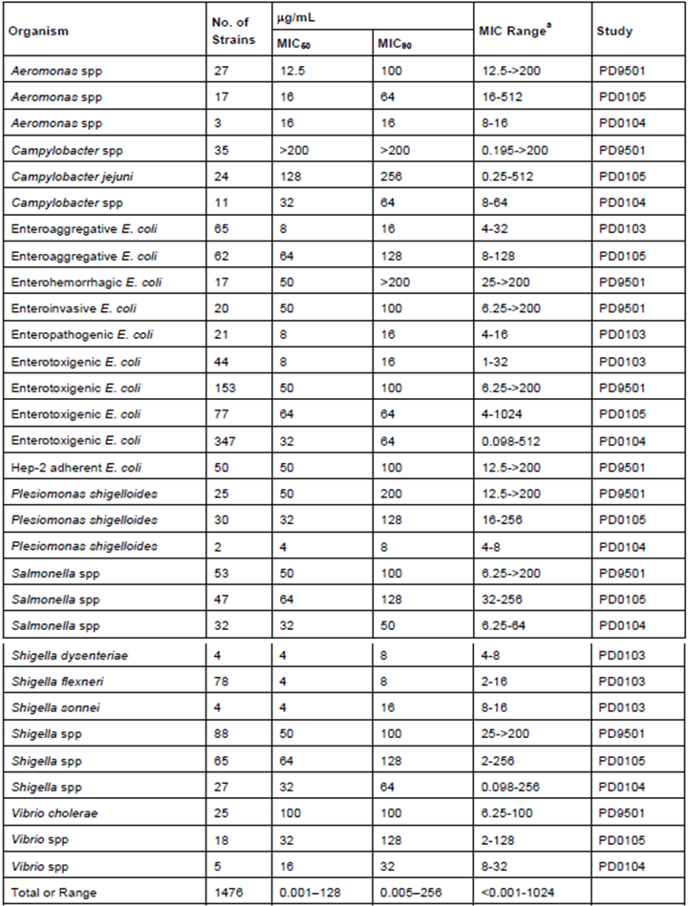
Two in-vitro studies compared the activity of rifaximin to that of standard antimicrobial agents against pathogens causing travellers’ diarrhoea. In one study (PD0103), the antimicrobial activity of rifaximin against pathogenic bacteria was compared with that of 7 standard antimicrobial agents. Results showed that rifaximin had a MIC50 of between 4 and 8 μg/mL and MIC90 of between 4 and 16 μg/mL for all pathogen strains except Yersinia (Y.) Enterocolitica and Campylobacter (C.) jejuni. The rifaximin MIC50 and MIC90 for Y. Enterocolitica were 64 and 128 μg/mL, respectively, while those for C. jejuni were 256 and 512 μg/mL, respectively. Overall, the activity of rifaximin was considered comparable to that of the other 7 antimicrobial agents for all enteropathogens tested except for C. jejuni (rifaximin MIC90 of 512 μg/mL). In the other study (PD0101), the antimicrobial activity of rifaximin against pathogenic bacteria was compared with that of 10 standard antimicrobial agents. Results showed that rifaximin inhibited 90% of the 284 bacterial enteropathogens causing traveller’s diarrhoea at 32μg/mL, which was 250 times lower than the mean rifaximin concentration found in stool in PK studies after a 3-day rifaximin 400mg b.i.d. dosing regimen (8000μg rifaximin/mL). Of the 10 other standard antimicrobial agents tested, ciprofloxacin, levofloxacin, ceftriaxone, and azithromycin demonstrated good in-vitro activity against the enteropathogens tested, but the more traditional antimicrobials such as ampicillin, trimethoprim, and trimethoprim/sulphamethoxazole (TMP/SMX) showed high levels and high frequencies of resistance. Amdinocillin, nalidixic acid, and doxycycline showed moderate activity.
An in-vitro study (PD0106) was conducted to assess enterococcal resistance to rifaximin and cross-resistance to rifampin using faecal isolates obtained from clinical study ESID9802 in patients treated for 3 days with rifaximin for traveller’s diarrhoea (study treatments: rifaximin 600mg/day [200mg t.i.d.; 9 subjects], rifaximin 1200mg/day [400mg t.i.d.; 10 subjects] or placebo [8 subjects]). Overall, 27 coliforms were identified biochemically as E. coli, the most common pathogen responsible for travellers’ diarrhoea. For both rifaximin and rifampin, the MIC values obtained against the Day 0 (pre-treatment) and Day 3 (end of treatment) isolates were similar, showing that resistance to rifaximin or cross-resistance to rifampin did not occur in enterococcus or E. coli following the 3-day duration of treatment with rifaximin.
An important consideration in the clinical use of rifaximin is the potential development of Mycobacterium (M.) tuberculosis cross–resistance to rifampin after administration of rifaximin to treat gastrointestinal infections in patients harbouring strains of M. tuberculosis. An in-vitro study (PD9702) was conducted to evaluate the possible development of cross–resistance to rifampin after incubation of M. tuberculosis strains with rifaximin. Five M. tuberculosis strains (3 pulmonary and 2 renal) isolated from man were incubated in-vitro with ascending concentrations of rifaximin comparable to, or much greater than, those observed systemically after oral treatment (6, 20, 90, 270ng/ml). The MICs of rifaximin and rifampin before and after incubation with rifaximin were identical, showing that no resistant Mycobacteria were selected.
The effect of rifaximin on normal intestinal flora in healthy volunteers was investigated in study PD8601. Ten healthy volunteers were administered 400 mg rifaximin b.i.d. for 5 days and gram-positive and gram-negative aerobic and anaerobic normal faecal bacteria were examined for resistance to rifaximin by broth and agar dilution methods. Approximately 30%-90% of the isolated strains developed resistance to rifaximin after 5 days of treatment. However, resistant strains disappeared rapidly from the intestinal flora when treatment was discontinued, more rapidly in aerobic strains and more slowly in anaerobic bacteria. Three months after the end of treatment no resistant strains could be detected in the faeces.

Evaluator’s overall conclusions on pharmacodynamics
Results from the microbiological studies showed that rifaximin had antimicrobial activity against enteropathogens causing travellers’ diarrhoea, with MIC50 and MIC90 levels within the expected mean rifaximin faecal concentration after a 3-day rifaximin 400mg b.i.d. dosing regimen. Although the proposed dose for the new indication in this submission is that of rifaximin 200mg t.i.d. (i.e. 600mg/day) for 3 days and not 400mg b.i.d., the dosing regimen from which rifaximin faecal concentration was measured of 400mg b.i.d. for 3 days (i.e. 800mg/day) was close to the proposed dosing regimen. In addition, the MIC90 level was found to be 250 times lower than the mean rifaximin faecal concentration based on this dosing regimen of 400mg b.i.d. It is considered acceptable to use the mean rifaximin faecal concentration after a 3-day rifaximin 400mg b.i.d. dosing regimen as an indication that the rifaximin MIC90 levels for the enteropathogens causing traveller’s diarrhoea would be within the expected mean rifaximin faecal concentration after the recommended therapeutic dose.
Resistance studies results suggested that resistance to rifaximin or cross-resistance to rifampin did not occur in enterococcus or E. coli following a 3-day duration of treatment with rifaximin (600mg/day and 1200mg/day). Resistant strains of normal intestinal flora developed after a 5-day treatment regimen with rifaximin (800mg/day), but the effect was transient and the resistant strains disappeared rapidly from the intestinal flora when treatment was discontinued.
It is noted that the sponsor has included in the proposed PI, under the section of “Precautions” a statement that “If symptoms have not resolved after 3 days of treatment, or recur shortly afterwards, a second course of XIFAXAN should not be administered”. It has also been indicated in the “Dosage and administration” section of the proposed PI that “XIFAXAN should not be used for more than 3 days even if symptoms continue. A second course of treatment must not be taken”. This is considered appropriate, with regards to the microbiological results submitted.

Dosage selection for the pivotal studies
In this submission, 4 clinical studies were submitted as pivotal studies (studies ESID0201, ESID9802, ESID9701 and ESID9601). Of these studies, study ESID9601 (study design and results are presented and discussed in Section 7.1.1.4) was the first pilot, proof-of-efficacy, Phase II dose-finding study for the use of rifaximin in traveller’s diarrhoea, and was initiated in 1996 in Mexico. The standard treatment for traveller’s diarrhoea at that time was trimethoprim/ sulphamethoxazole (TMP/SMX), and 3 doses of rifaximin (200mg t.id., 400mg t.i.d. and 600mg t.i.d.) were compared against TMP/SMX in this study. The results indicated that rifaximin 200mg t.i.d. was effective and well-tolerated in patients with traveller’s diarrhoea. This study also showed that the higher doses of rifaximin (400mg t.i.d. and 600mg t.i.d.) were well-tolerated, but did not achieve substantial additional efficacy compared to rifaximin 200mg t.i.d.
According to the sponsor, after completion of this Phase II study, ciprofloxacin became the new standard treatment for traveller’s diarrhoea, and hence a Phase III study was initiated in 1997 in Mexico and Jamaica comparing rifaximin with ciprofloxacin (study ESID9701). As the previous study ESID9601 testing rifaximin 600mg/day (200mg t.i.d.), 1200mg/day (400mg t.i.d.) and 1800mg/day (600mg t.i.d.) showed that there was no clearly superior dose of rifaximin in terms of efficacy, an intermediate dose of 800mg/day rifaximin was chosen to be tested in this study. A twice-a-day regimen (i.e. 400mg b.i.d.) was chosen in order to conform to the double-blind/ double-dummy study design (the active control ciprofloxacin was dosed at 500mg b.i.d.) and to ensure good subject acceptance and compliance. Rifaximin 400mg b.i.d. was shown to be as efficacious as ciprofloxacin in reducing the duration of traveller’s diarrhoea.
Following this study and after preliminary scientific consultationwith the FDA, a Phase III placebo-controlled study was initiated in 1998 in Mexico, Kenya and Guatemala evaluating 2 doses of rifaximin (200mg t.i.d. and 400mg t.i.d.) (ESID9802) These doses were chosen in order to compare results with the first pilot dose-finding study (ESID9601). In addition, given the high rate of gastrointestinal motility of patients with travellers’ diarrhoea, administration three times a day was considered preferable to twice daily. Study results showed that both doses of rifaximin were more effective than placebo with comparable efficacy shown between the 2 rifaximin doses.
Following further consultation with the FDA, a second Phase III placebo-controlled and active controlled study was performed in 2002 comparing rifaximin 200mg t.i.d. to placebo and to ciprofloxacin (study ESID0201). According to the sponsor, the daily rifaximin dose of 200mg t.i.d. had been specifically requested by the FDA in its 25 October 2002 Approvable Letter as the dose to be used in a confirmatory second Phase III trial. This study involved centres in India in order to evaluate more cases of diarrhoea due to invasive bacteria (Campylobacter spp., Shigella spp. and Salmonella spp.) as too few cases had been evaluated in the previous study to be able to draw any definite conclusions about the efficacy of rifaximin against these bacteria.

Clinical efficacy
Four pivotal efficacy studies were submitted. Three of these were Phase III, randomised, multi-centre, double-blind studies of 3-day treatment regimens of rifaximin in adult patients with travellers’ diarrhoea (study ESID0201 compared rifaximin [200mg t.i.d.] with placebo and ciprofloxacin [500mg b.i.d.]; study ESID9802 compared 2 doses of rifaximin [200mg t.i.d. and 400mg t.i.d.] with placebo; study ESID9701 compared rifaximin [400mg b.i.d.] with ciprofloxacin [500mg b.i.d.]). One study (ESID9601) was a Phase II, randomised, multi-centre, double-blind study of 5-day treatment regimens of rifaximin in adult patients with travellers’ diarrhoea, comparing rifaximin (200mg t.i.d., 400mg t.i.d. or 600mg t.i.d.) with TMP/SMX (160mg TMP/800mg SMX b.i.d.).
In this evaluation report, study ESID0201, comparing the efficacy of the proposed clinical dose regimen of rifaximin 200mg t.i.d. for 3 days against placebo, will be considered the main pivotal study to be evaluated, and will be presented first. Study ESID9802 will be evaluated with regards to further supporting data for the proposed clinical dose of rifaximin 200mg t.i.d. Study ESID9701 will be evaluated with regards to additional data comparing rifaximin to ciprofloxacin, and study ESID9601 will be evaluated as a dose-finding study to support the dose of rifamixin tested in study ESID0201.

For the treatment of travellers' diarrhoea

Pivotal efficacy studies

Study ESID0201

Study design, objectives, locations and dates
Study ESID0201 was a randomised, double-blind, multi-centre, placebo- and active-controlled study comparing rifaximin with placebo and with ciprofloxacin (Cipro) in the treatment of travellers' diarrhoea due to enteropathogenic organisms. The primary objective was to assess the safety and efficacy of rifaximin compared to placebo in the treatment of travellers' diarrhoea due to enteropathogenic organisms. Study ESID0201 was a multi-centre study where subjects were enrolled in a total of 7 study sites across 4 countries: 3 sites in Mexico, 2 sites in India, and 1 each in Guatemala and Peru. The study start date (first subject enrolled) was 10 July 2002. The study completion date (last subject completed) was 14 May 2003.
Eligible subjects were randomly assigned to 1 of 3 treatment groups (rifaximin, placebo, or Cipro in a 2:1:1 ratio) to be treated with study medication for 3 days. For 5 days following randomisation, subjects recorded in daily diaries the date, time and consistency of each stool and documented symptoms of diarrhoeal syndrome (abdominal pain or cramps, excessive gas/flatulence, nausea, vomiting, fever [ ≥ 100°F or ≥ 37.8°C], faecal urgency, blood and/or mucus in the stool, or tenesmus). Stool samples were collected from each subject at pre-treatment, 24 hours after the first dose of study medication (Day 2), and post-treatment between Days 3 and 5 (24 to 48 hours after last dose of study medication). Microbiological evaluations were performed on each stool sample to identify pathogens (Figure 1).
Figure 1: Study Scheme, ESID0201.
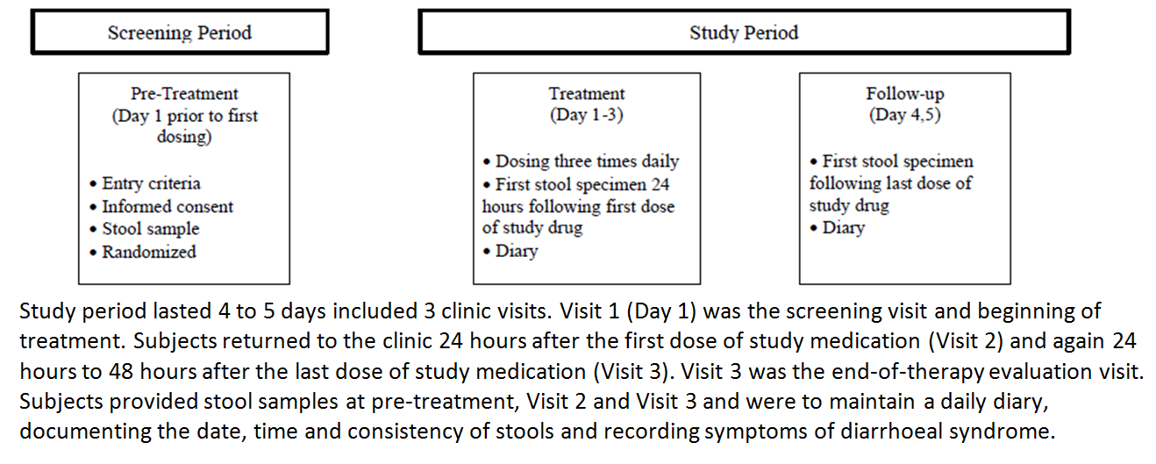

Inclusion and exclusion criteria
Subjects enrolled in the study were adult ( ≥ 18 years of age) male or female non-indigenous travellers who were affected by acute diarrhoea in which 3 or more unformed stools were passed within the 24 hours preceding randomisation, and where the duration of diarrhoea was no more than 72 hours. Eligible subject had to have at least 1 qualifying signs or symptoms of diarrhoeal syndrome: abdominal pain or cramps, excessive gas/flatulence, nausea, vomiting, fever ( ≥ 100°F or ≥ 37.8°C), faecal urgency, blood and/or mucus in the stool, or tenesmus.
Subjects with moderate or severe dehydration (fluid loss of 6 - 10%) were excluded. Subjects who had taken any antimicrobial agents with an expected activity against enteric bacterial pathogens within the 7 days preceding randomisation, or had more than 2 doses of a symptomatic anti diarrhoeal compound (antimotility agents [e.g. loperamide hydrochloride], absorbent agents [e.g. cholestyramine], and antisecretory agents [e.g. bismuth subsalicylate]) within the 8 hours preceding randomisation, were also excluded.
A full list of inclusion and exclusion criteria is presented below:

Inclusion criteria
A Subject was eligible for inclusion in this study only if all of the following criteria applied.
- Had signed an IRB- or IEC-approved, written informed consent prior to any study-related activities
- Was male or female, 18 years of age or older
- Was non-indigenous and able to read and understand English
- Had at least 3 unformed stools within the 24 hours preceding randomization
- Provided a pre-treatment stool specimen that was verified to be unformed
- Had 1 or more of the following qualifying signs or symptoms of diarrheal syndrome: abdominal pain or cramps, excessive gas/flatulence, nausea, vomiting, fever (≥ 100° F or ≥ 37.8° C), fecal urgency, blood and/or mucus in the stool, or tenesmus
- If female, was eligible to enter and participate in this study if she was of:
- Non–childbearing potential (i.e., physiologically incapable of becoming pregnant, including any female who was post-menopausal, defined for purposes of this study as 1 year without menses); or
- Childbearing potential, had a negative urine pregnancy test at screening, and agreed to 1 of the following:
- Double-barrier method of contraception for at least 2 weeks prior to study drug administration and throughout the 3 – day treatment phase and 2 – day follow-up
- Oral birth control pills administered for at least 2 monthly cycles prior to study drug administration
- Progesterone-implanted rods (NORPLANT) inserted for at least 1 month prior to the study drug administration but not beyond the third successive year following insertion; certain lot numbers specified in the protocol might not have delivered effective ongoing contraception and required the use of a back-up non-hormonal method of contraception
- An IUD, inserted by a qualified clinician, with published data showing that the lowest expected failure rate was less than 1% per year (not all IUDs meet this criterion)
- Medroxyprogesterone acetate (DEPO-PROVERA) administered for a minimum of 1 month prior to study drug administration and administered for 1 month following study completion
- Complete abstinence from intercourse for at least 2 weeks prior to study drug administration and throughout the 3 – day treatment phase and 2 – day follow-up
- Sterilization (via hysterectomy or bilateral tubal ligation)
- Partner(s) had undergone vasectomy
- Was willing and able to comply with all study procedure

Exclusion criteria
A subject was not eligible for inclusion in this study if any of the following criteria applied.
- Acute diarrhoea for more than 72 hours
- Moderate or severe dehydration (fluid loss of 6 – 10%) as demonstrated by:
  - Restless, drowsy, or comatose mentation assessment
  - Rapid to very rapid pulse
  - Deep to very deep and rapid respiration
  - Low to very low or undetectable blood pressure
  - Slow or very slow retraction of the skin
  - Sunken or very sunken eyes
  - Hoarse or inaudible voice
  - Scant or no urine production
- Females who were pregnant or breastfeeding during the course of the study
- Active, uncontrolled, and/or clinically significant diseases or disorders of the heart, lung, kidney, gastrointestinal tract (other than travellers’ diarrhoea). And/or central nervous system
- Administration of the following:
  - Any antimicrobial agents with an expected activity against bacterial pathogens within the 7 days preceding randomization
  - More than 2 doses of a symptomatic antidiarrheal compound such as antimotility agents (e.g., loperamide hydrochloride), absorbent agents (e.g., cholestyramine), and antisecretory agents (e.g., bismuth subsalicylate) within the 8 hours preceding randomization
  - Any nonsteroidal anti-inflammatory drug (NSAID) such as aspirin or ibuprofen (Advil) or any fever-reducing agent such as acetaminophen (Tylenol) or paracetamol within the 2 hours preceding randomization
  - Use of theophylline within the 7 days preceding randomization
Note: Antimalarial prophylactic treatment (e.g., chloroquine, proguanil, mefloquinr, atovaquone) was permitted prior to and during the study.
- Hypersensitivity or allergy to the study drugs
- Participation in an investigational drug study within the 30 days prior to randomization
Evaluator’s Comments: The inclusion and exclusion criteria were appropriate and consistent with the TGA-adopted EMA guideline on the evaluation of medicinal products indicated for treatment of bacterial infections. The study definition of travellers’ diarrhoea is consistent with clinical diagnosis.

Study treatments
Eligible subjects were randomly assigned to 1 of 3 treatment groups (rifaximin 200mg t.i.d., placebo, or Cipro 500mg b.i.d. in a 2:1:1 ratio). Treatment duration was 3 days. Study drugs consisted of encapsulated rifaximin tablets, placebo capsules and encapsulated Cipro tablets, and all study drugs were identical in appearance. Subjects were dosed according to the regimen as shown in Table 2.
Table 2: Treatments Administered, Study ESID0201.
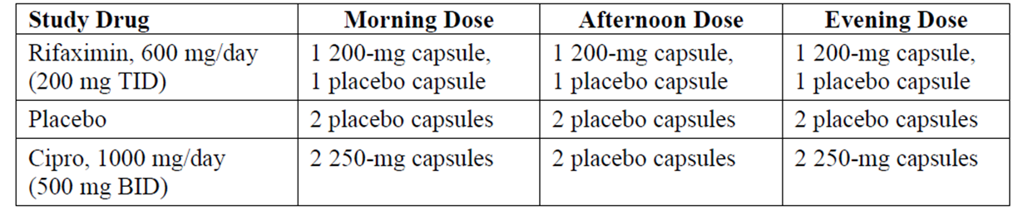
Evaluator’s Comments: The study dose selection is appropriate. The dose selection for rifaximin has been previously discussed in this evaluation report. Ciprofloxacin 500mg b.i.d. is the clinical therapeutic dose used in the treatment of infectious diarrhoeal disease.
The double-blind study design involving placebo as well as an active control is appropriate for this study. A placebo-control group is appropriate as travellers’ diarrhoea is generally a self-limiting illness, and hence the primary proof of the efficacy of rifaximin would be based upon comparison to placebo treatment. The choice of active control of ciprofloxacin is appropriate as it is a currently approved drug in Australia for the indication of treatment of infectious diarrhoeal disease. The approved recommended dose for this indication is 500mg b.i.d. for a duration of 5 days. The sponsor had stated that the 3-day treatment duration used in this study was based upon the standard of practice in treating infectious diarrhoea in a travellers’ population. The sponsor had acknowledged that this duration of treatment for ciprofloxacin constituted off-label use of ciprofloxacin for the treatment of infectious diarrhoea, but was of the opinion that this treatment group could provide a useful positive control to validate study findings (i.e. demonstrating a separation of efficacy results with a known active control from placebo under double-blind conditions).

Efficacy variables and outcomes
The primary efficacy endpoint was time to last unformed stool, after which wellness was declared (TLUS). The primary efficacy outcome was the TLUS for rifaximin compared to placebo.
Secondary efficacy endpoints included the number of unformed (i.e. watery or soft) stools passed per time interval; the proportion of subjects with improvement in diarrhoeal syndrome per time interval; the proportion of subjects achieving wellness (clinical cure); the proportion of subjects who failed treatment; the proportion of subjects with persistence of clinical symptoms; the proportion of subjects with microbiologic eradication.
Efficacy measures relating to symptoms or stools were derived from information recorded in the subject diary. Microbiologic evaluations were performed on stool samples to identify bacterial pathogens.
Evaluator’s Comments: The primary and secondary endpoints are appropriate. Overall, the study primary and secondary endpoints allowed evaluations of clinical (rapidity of return to normal formed stools and the resolution of symptoms) and microbiological effects. The sponsor had given the rationale that the primary endpoint was clinical rather than microbiological, as microbiological eradication does not necessarily correlate to clinical improvement with antibacterial therapy.

Randomisation and blinding methods
Subjects were randomised in a 2:1:1 ratio to receive rifaximin (200mg t.i.d.), placebo, or Cipro (500mg b.i.d.). The randomisation schedule for treatment allocation was generated from a seed number and program written with SAS software prepared by ICON Clinical Research. Subjects were randomly assigned consecutive treatment numbers using an allocation ratio of 2:1:1 for the 3 treatment groups (rifaximin, placebo, or Cipro). Study drug was shipped in a block of 16 treatment cards. At the Screening Visit, the study subject was assigned the lowest number in the treatment number block assigned to the centre. Once a treatment number had been assigned, it could not be re-assigned to another study subject.
The study was double-blind. Regardless of treatment group assigned, all subjects received medication packaged in identical blister cards with 2 capsules per well and 3 wells per day for 3 days. Each study drug card was labelled with a 3-part tear-off label. The detachable part of the label contained identical information to that affixed to the box. The concealed section of the label, which was attached to the detachable portion of the label, contained product identification and lot number. When the study drug was dispensed to the subject, the detachable portion of the label was removed and affixed to the Study Drug Label page of the Case Report Form (CRF).

Analysis populations
There were 5 analysis population sets in the study. The Intent-to-Treat (ITT) population was defined as all subjects randomised to treatment. The Efficacy Evaluable (EE) population was defined as subjects who met the inclusion/exclusion criteria, took at least 2 days of study medications as prescribed, completed the daily diaries for at least 2 days, and did not take any prohibited medications that could have impacted clinical outcome. The Modified Intent-to-Treat (MITT) population consisted of all ITT subjects with positive pre-treatment stool samples and a post-treatment sample (positive or negative). The Modified Efficacy Evaluable (MEE) population consisted of subjects with positive pre-treatment stool samples and a post-treatment sample (positive or negative), who met the inclusion/exclusion criteria, took at least 2 days of study medications as prescribed, and did not take any prohibited medications that could have impacted microbiological outcome. The safety population was defined as subjects who were randomised to treatment, received at least 1 dose of study medication and provided at least 1 post-baseline safety assessment.
The ITT data set was the primary population for efficacy analyses. The baseline and efficacy analyses (primary and secondary) were also performed for the EE population. Microbiological efficacy endpoints were assessed for the MITT and MEE populations. Safety analyses were performed for the safety population.
Evaluator’s Comments: The definitions of the analysis populations and the efficacy analyses on the ITT population are in keeping with the TGA-adopted ICH E 9 Statistical Principles for Clinical Trials.

Sample size
The sample size was calculated based on comparing the treatment groups, rifaximin versus placebo, with respect to TLUS. A 2-sided confidence interval (CI) for the hazard ratio for this endpoint was to be calculated. If the lower bound of the 2-sided 95% CI for the hazard ratio was greater than 1, it could be concluded that rifaximin was superior to placebo. The sample size was calculated based on the hazard ratio noted in a previous study (RFID9801) which compared the efficacy of 600mg/day rifaximin (125 subjects) versus placebo (129 subjects), and gave an estimated hazard ratio for comparing TLUS of rifaximin to placebo of 1.78 (97.5% CI: 1.26 – 2.50). Assuming a similar hazard ratio and TLUS distribution, it was estimated that a sample size of 400 subjects (200 subjects in the rifaximin arm, 100 subjects in the placebo arm and 100 subjects in the Cipro arm) in the current study would have over 90% power to demonstrate the superiority of rifaximin to placebo.
A secondary efficacy outcome was the comparison of rifaximin to Cipro with respect to TLUS. Rifaximin was to be considered non-inferior to Cipro if the 1-sided 97.5% confidence limit of the relative hazard of rifaximin compared to Cipro was greater than 0.50. Based on data from a previous study (RFID9701) comparing rifaximin 400mg b.i.d. (93 subjects) and Cipro 500mg b.i.d. (94 subjects), a sample size of 400 subjects in the current study had over 90% power to demonstrate the non-inferiority of rifaximin to Cipro.

Statistical methods
The primary efficacy endpoint analysis was the comparison of TLUS between rifaximin and placebo, using the Cox proportional hazards model (Wald statistic), with a 2-sided test at a significance level of 0.05 (α = 0.05). If the lower bound of the 2-sided 95% CI for the hazard ratio comparing rifaximin to placebo was greater than 1, it could be concluded that rifaximin was superior to placebo. Subjects who had no unformed stools after the start of study treatment were defined as having a TLUS of 0 hours. Subjects for whom TLUS could not be calculated because they were terminated early due to treatment failure or who completed the study (120 hours) without demonstrating wellness were censored as having a TLUS of 120 hours. Subjects who terminated early for reasons other than treatment failure (e.g. adverse event, subject request) were noted as having a censored TLUS as of the time of the last available information on unformed stools.
Cipro was also compared to placebo with respect to TLUS using the Cox proportional hazards model (Wald statistic), with a 2-sided test at a significance level of 0.05 (α = 0.05). In addition, rifaximin was compared to Cipro with respect to TLUS (secondary efficacy outcome), using the Cox proportional hazards model (Wald statistic), with a 1-sided test at a significance level of 0.025 (α = 0.025). Rifaximin was to be considered non-inferior to Cipro if the lower limit of the 97.5% CI (one-sided) of the relative risk of rifaximin to Cipro exceeded 0.50. Other secondary efficacy endpoints were compared using repeated measures ANOVA (number of unformed stools passed per time intervals of interest) or Cochran-Mantel-Haenszel (CMH) test stratified by centre (all other secondary endpoints). All comparisons of the treatment groups for the secondary endpoints were performed using 2-sided tests at a 0.05 level of significance. No adjustments for multiplicity were made.

Participant flow
A total of 399 subjects were enrolled and randomised: 197 to the rifaximin group, 101 to the placebo group, and 101 to the Cipro group. A total of 355 subjects completed the study (177 [89.8%], 84 [83.2%] and 94 [93.1%] in the rifaximin, placebo and Cipro groups, respectively) (Figure 2).
Figure 2: Disposition of Subjects, Study ESID0201.
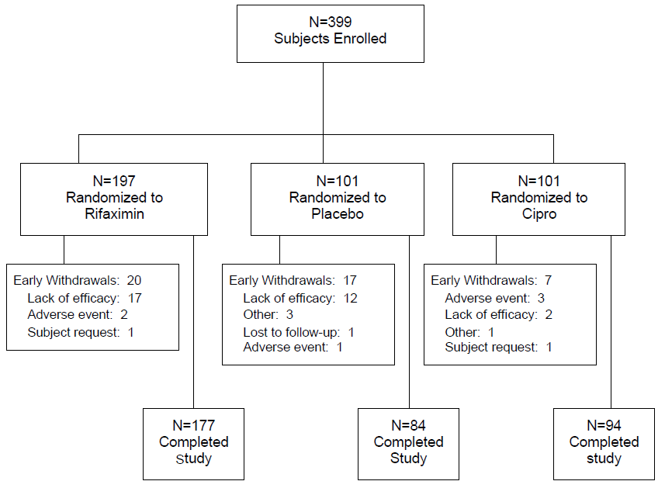
No statistically significant differences were observed among the treatment groups in the percentages of subjects included in the EE, MITT, or MEE populations, based on a chi-square test.
Evaluator’s Comments: The most frequent reason for early study withdrawal in the rifaximin group was for lack of efficacy (8.6%; 17/197). This was comparable with the incidence of early study withdrawal due to lack of efficacy in the placebo group (11.9%; 12/101) but higher than that seen in the Cipro group (2.0%; 2/101). The sponsor had provided additional analysis of subjects who prematurely discontinued the study due to lack of efficacy. Results showed that the majority of the subjects in the rifaximin treatment group who prematurely discontinued due to lack of efficacy were culture-positive at baseline for inflammatory/invasive pathogens (70.6%; 12/17), primarily C. jejuni. Both subjects (100%; 2/2) in the Cipro treatment group who prematurely discontinued due to lack of efficacy were also culture-positive for C. jejuni. Among placebo-treated subjects who prematurely discontinued due to lack of efficacy, no specific trend was apparent for pathogens identified at baseline. A look through the baseline disease characteristics of the study population showed that there was a higher proportion of subjects in the rifaximin group who were culture-positive at baseline for inflammatory/invasive pathogens (23.4%; 46/197) compared to in the Cipro group (12.9%; 13/101).

Major protocol violations/deviations
Frequency of protocol violations was similar across treatment groups (7.6%, 9.9% and 6.9% in the rifaximin, placebo, and Cipro groups, respectively).
One centre (Centre #101, Goa, India) was found not to have completed the diary cards as specified in the protocol. This centre enrolled 117 subjects (29.3% of total number of enrolled study subjects). A substantial amount of diary card data was missing from this centre, which affected the calculation of TLUS in all 3 treatment groups and resulted in a prolongation of TLUS across all treatment groups as wellness could not be assumed during the days when diary data was missing. Results from this centre showed no difference in efficacy between Cipro (a known active control) and placebo with regards to median TLUS, and all treatment groups showed essentially the same median TLUS (approximately 70 hours). The impact of this centre was assessed in the sensitivity analyses of the primary efficacy variable (TLUS).
Treatment compliance was measured by the amount of returned study medication. Each subject was provided 1 blister package on Day 1 (Visit 1) that contained treatment for 3 days. Subjects were instructed to return the study drug blister cards at the end of treatment (Day 4, Visit 3). The investigator confirmed the level of individual compliance based on the amount of returned drug. The majority of subjects (93%, 90% and 95% in the rifaximin, placebo and cipro groups, respectively) were at least 70% compliant with the treatment regimen. The majority of subjects (86%, 81% and 85%, respectively) made at least one entry on the diary card on 4 or 5 days.

Baseline data
Baseline demographic characteristics were comparable among treatment groups in the ITT population. No statistically significant differences were observed among the treatment groups in age, sex, race, or weight. The majority of subjects in each treatment group were White (84.3%, 82.2% and 79.2% in the rifaximin, placebo and Cipro groups, respectively) and approximately half were male (50.3%, 55.4% and 51.5%, respectively). The mean (standard deviation [SD]) age was 32.5 (13.33), 33.4 (14.09) and 34.2 (14.36) years, respectively. Baseline mean weight was similar between treatment groups (mean [SD] weight of 70.46 [14.889], 71.09 [15.283], and 69.57 [13.489] kg, respectively). Baseline demographic characteristics were also comparable among treatment groups in the EE, MITT, MEE and safety populations and no statistically significant differences were observed among the treatment groups in age, sex, race, or weight in these analysis populations.
Baseline disease characteristics were also generally comparable among treatment groups in all analysis populations. In the ITT population, the median number of unformed stools in the 24-hour period before randomisation was 6.0 in all 3 treatment groups. The most common pathogens identified in each treatment group were diarrhoeagenic E. coli (37.6%, 37.6% and 45.5% in the rifaximin, placebo and Cipro groups, respectively), followed by inflammatory/invasive pathogens (23.4%, 18.8% and 12.9%, respectively).
Evaluator’s Comments: Overall, the baseline demographic and disease characteristics were comparable among treatment groups. The study population was generally representative of the target population of patients with travellers’ diarrhoea.

Results for the primary efficacy outcome
Primary efficacy analysis showed that the median TLUS in the rifaximin group was statistically significantly shorter than that in the placebo group (32.0 hours vs. 65.5 hours in the placebo group, p = 0.0014; Figure 3). The risk ratio from the Cox model (without treatment-by-centre interaction) was greater than 1 (1.6275; 95% CI of 1.2071 - 2.1943), indicating greater improvement in the rifaximin group versus the placebo group. Results from the Cox model with treatment-by-centre interaction yielded similar results.
Figure 3: Time to Last Unformed Stool (All Centres): ITT Population, Study ESID0201.
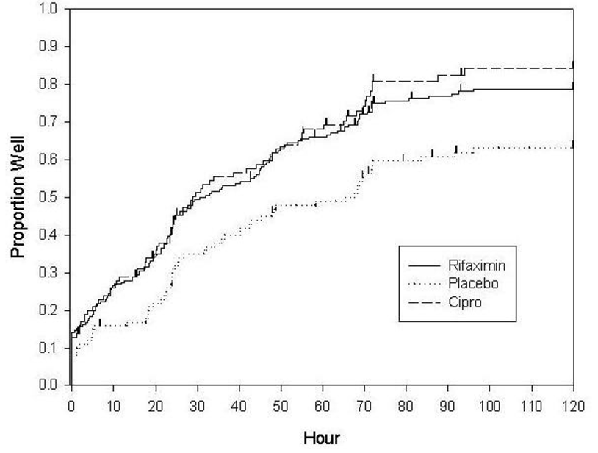

Other efficacy outcomes

Other analyses on the primary efficacy endpoint (TLUS)
Results of the analyses of the endpoint of TLUS in the Cipro group compared to placebo group provided support to the validity of the study results, showing statistically significantly shorter median TLUS in the Cipro group (known active control) compared to placebo group under blinded conditions (median TLUS of 28.8 hours in the Cipro group vs. 65.5 hours in the placebo group, p = 0.0003). The risk ratio from the Cox model without treatment by-centre interaction was greater than 1 (1.8887; 95% CI of 1.3437-2.6548), indicating greater improvement in the Cipro group versus the placebo group. Results from the Cox model with treatment-by-centre interaction yielded similar results.
The median TLUS in the rifaximin (32.0 hours) and Cipro (28.8 hours) groups was comparable. Analysis results showed that the risk ratio (rifaximin/Cipro; Cox model without treatment-by-centre interaction) was 0.8782 with a lower limit of the 97.5% CI of the risk ratio (one-sided) of 0.6683.
Results of the analysis of TLUS in the EE population were similar to those in the ITT population. There was a statistically significantly shorter median TLUS in the rifaximin group (30.6 hours) compared to the placebo group (48.3 hours, p = 0.0048; Cox model without treatment-by-centre interaction). Median TLUS was also statistically significantly shorter in the Cipro group compared with the placebo group (28.4 vs. 48.3 hours, p = 0.0005; Cox model without treatment-by-centre interaction) and similar in the rifaximin and Cipro groups (30.6 and 28.4 hours, respectively).
In the ITT population, statistically significant treatment-by-centre interactions were observed in the analysis of TLUS comparing rifaximin and placebo (p = 0.0809) and Cipro and placebo (p = 0.0761). No statistically significant treatment-by- centre interaction was observed in the analysis of TLUS comparing rifaximin and Cipro (p = 0.9201). Results across analysis centres showed risk ratios comparing rifaximin to placebo for the endpoint of median TLUS of > 1, although the lower bound of the 2-sided 95% CI for the hazard ratio was > 1 only for the centre in Calcutta.
Sensitivity analyses on the primary efficacy endpoint excluding data from Centre 101 yielded similar results to the primary efficacy outcome. The median TLUS was 24.3 hours, 47.9 hours and 23.6 hours in the rifaximin, placebo and Cipro groups, respectively; rifaximin vs. placebo: p = 0.0004; Cipro vs. placebo: p < 0.0001).
Subgroup analyses of median TLUS were performed for ITT subjects with faecal leukocyte-positive illness, faecal leukocyte-negative illness, inflammatory/invasive pathogens, diarrhoeagenic E. coli without evidence of inflammatory/invasive pathogens, other agents without evidence of inflammatory/ invasive pathogens or diarrhoeagenic E. coli, agent-specific illness (i.e. at least 1 enteric pathogen in the pre-treatment stool sample had been identified), and agent-negative illness. Results showed that median TLUS was numerically shorter in the rifaximin group compared to the placebo group for all subgroups in which TLUS could be calculated (Table 3) with statistically significant differences in favour of rifaximin for subjects with faecal leukocyte-positive illness (p = 0.0011), subjects with diarrhoeagenic E. coli but without evidence of inflammatory/ invasive pathogens (p = 0.0476), and subjects with agent-negative illness (p = 0.0024). It was noted that clinical efficacy (in terms of median TLUS) for subjects with inflammatory/invasive pathogens was poor in all treatment groups in this study. In this subgroup of subjects, more than half of the subjects in the rifaximin group failed to achieve wellness and therefore median TLUS could not be calculated, while median TLUS in the placebo and Cipro groups were 67.5 and 65 hours, respectively.
Table 3: Subgroup Analysis for Time to Last Unformed Stool: ITT Population, Study ESID0201.
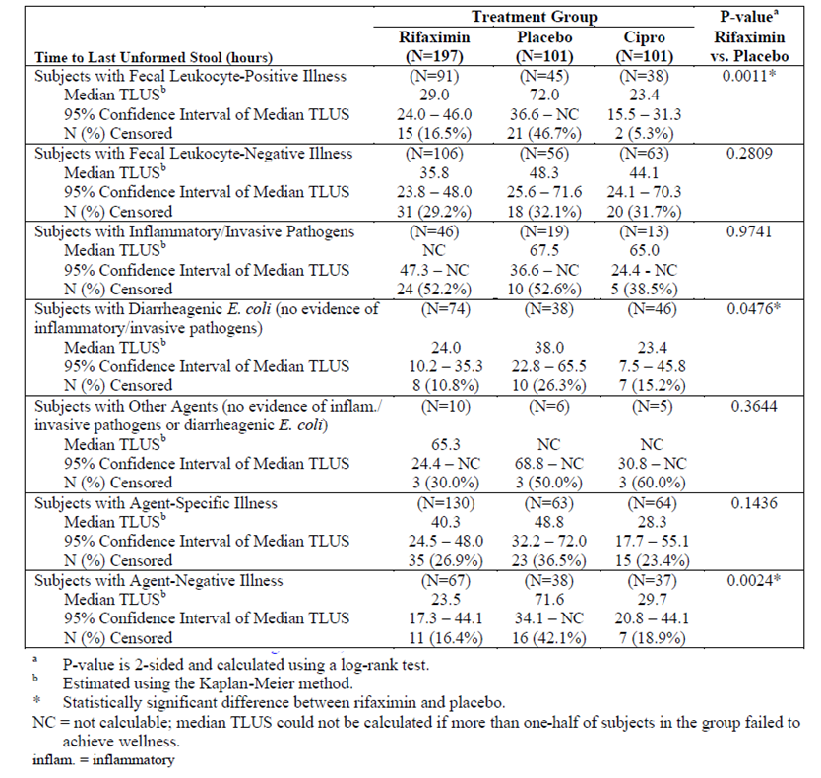

Microbiological analyses
Microbiological efficacy endpoints were assessed for the MITT population, with supportive analyses done for the MEE population. In the MITT population at Visit 3, there was no statistically significant difference in the proportion of subjects with an overall microbiological response of eradication between the rifaximin group and the placebo group (61.6% vs. 51.7%; p = 0.1952). There was a statistically significantly greater proportion of subjects in the Cipro group than in the placebo group with an overall microbiological response of eradication (80.7% vs. 51.7%, p = 0.0008). Microbiological eradication response at Visit 3 in the MEE population was similar to that in the MITT population (rifaximin vs. placebo: 63.1% vs. 51.7%, p = 0.1411; Cipro vs. placebo: 83.3% vs. 51.7%, p = 0.0003).
The correlation of microbiological results with clinical results was investigated by evaluating microbiological eradication in subjects achieving wellness. Results showed that in all 3 treatment groups, the majority of subjects achieving wellness had an overall microbiological response of eradication at Visit 3. In addition, in all 3 treatment groups, subjects achieving wellness had shorter median TLUS compared to subjects not achieving wellness, regardless of microbiological response. Median TLUS for subjects achieving wellness was similar for subjects with microbiological eradication or persistence in the rifaximin (23.4 hours vs. 25.8 hours) and placebo (28.0 hours vs. 23.8 hours) groups, while in the Cipro group the median TLUS for subjects with microbiological eradication was about double that of subjects with microbiological persistence (20.6 hours vs. 10.4 hours). Overall, these analyses results suggested that although rifaximin-treated subjects who achieved wellness showed high pathogen eradication rates, the median TLUS was similar among these rifaximin-treated subjects achieving wellness, regardless of whether pathogens were eradicated or persisted.
Results suggested that rifaximin had greater clinical and microbiological efficacy in subjects with diarrhoeagenic E. coli compared to subjects with inflammatory/invasive pathogens (C. jejuni, salmonella, shigella). Among rifaximin-treated subjects culture-positive for diarrhoeagenic E. coli, clinical wellness was achieved in 84.5% (82/97) of subjects and microbiological eradication was reported in 77.3% (75/97) of subjects. Among rifaximin-treated subjects culture-positive for inflammatory/invasive pathogens, clinical wellness was achieved in 42.5% (17/40) of subjects and microbiological eradication was reported in 52.5% (21/40) of subjects. The median TLUS in the ITT population was 24.0 hours in rifaximin-treated subjects with diarrhoeagenic E. coli, while the median TLUS could not be calculated in rifaximin-treated subjects with inflammatory/invasive pathogens as more than half of these subjects failed to achieve wellness.

Efficacy analyses excluding subjects with fever and/or blood in stool at baseline
As rifaximin is an unabsorbed anti-infective agent, it would not be medically appropriate to use it in patients exhibiting clinical signs and symptoms that could indicate the potential for systemic complications (e.g. patients with inflammatory/invasive pathogens), in whom systemic antibiotics may be more appropriate. The sponsor did additional analyses using logistic regression methods to identify the demographic and baseline disease characteristics significantly associated with the presence of inflammatory/invasive pathogens at baseline. Results showed that inflammatory/ invasive pathogens were found to correlate with indicators of more severe diarrhoea. Statistically significant factors in the final regression model included gross blood in stool at baseline (p = 0.0041), occult blood in stool at baseline (p = 0.0005), and ≥ 8 unformed stools in the 24 hours preceding treatment (p = 0.0033). Fever at baseline was also associated with the presence of inflammatory/invasive pathogens, although it was not statistically significant after adjusting for other significant covariates (p = 0.10). However, the sponsor was of the opinion that clinical experience would suggest that subjects with inflammatory/invasive pathogens (e.g. Campylobacter, Salmonella or Shigella) would invariably have fever.
The sponsor performed efficacy analyses looking at the proportion of treatment failures in the ITT population compared to that in the population excluding subjects with these signs and symptoms suggesting potential for systemic complications. Results showed that in the overall ITT population, the proportion of treatment failures in the rifaximin group was about double that in the Cipro group (14.7% versus 6.9%). When subjects with fever and/or blood in the stool at baseline were excluded, the proportion of treatment failures in the rifaximin and Cipro groups were comparable (8.6% versus 7.7%). Results also showed that excluding subjects with ≥ 8 unformed stools at baseline, in addition to those with fever and/or blood in the stool, did not greatly affect the proportion of treatment failures in any treatment group compared to not adding this exclusion criterion. The sponsor provided the rationale that this was due, in part, to the finding that excluding subjects with fever and/or blood in the stool had also removed those subjects having the highest stool frequency at baseline. The sponsor therefore concluded that the restricted population to be explored for labelling guidance was the population of subjects with fever and/or blood in the stool.
Efficacy analyses in this restricted population showed that when subjects with these signs and symptoms of more severe disease (i.e. fever and/or blood in the stool at baseline) were excluded, the clinical efficacy of rifaximin and Cipro was comparable (median TLUS: 23.3 hours and 27.4 hours, respectively; proportion achieving wellness: 87.1% and 80.0%, respectively). Results of the analyses of the secondary efficacy endpoints in this restricted study population will be presented in the next section together with the presentation of the secondary efficacy endpoints results in the overall ITT population.

Other secondary efficacy endpoints
The number of unformed stools passed per time interval in the ITT population is presented in Table 4. Overall there was a statistically significantly smaller number of unformed stools passed after the first dose of study medication with rifaximin compared to placebo (p = 0.0002), and with Cipro compared to placebo (p < 0.0001). The difference in the number of unformed stools between the rifaximin and Cipro groups was statistically significant (in favour of Cipro; p < 0.0001). Results in the study population excluding ITT subjects with fever and/or blood in the stool at baseline yielded similar results (Table 4), except that there was no statistically significant difference in the number of unformed stools between the rifaximin and Cipro groups (p = 0.4113).

Table 4: Number of Unformed Stools Per Time Interval (i) ITT Population (ii) ITT Subjects Without Fever and/or Blood in the Stool at Baseline, Study ESID0201.
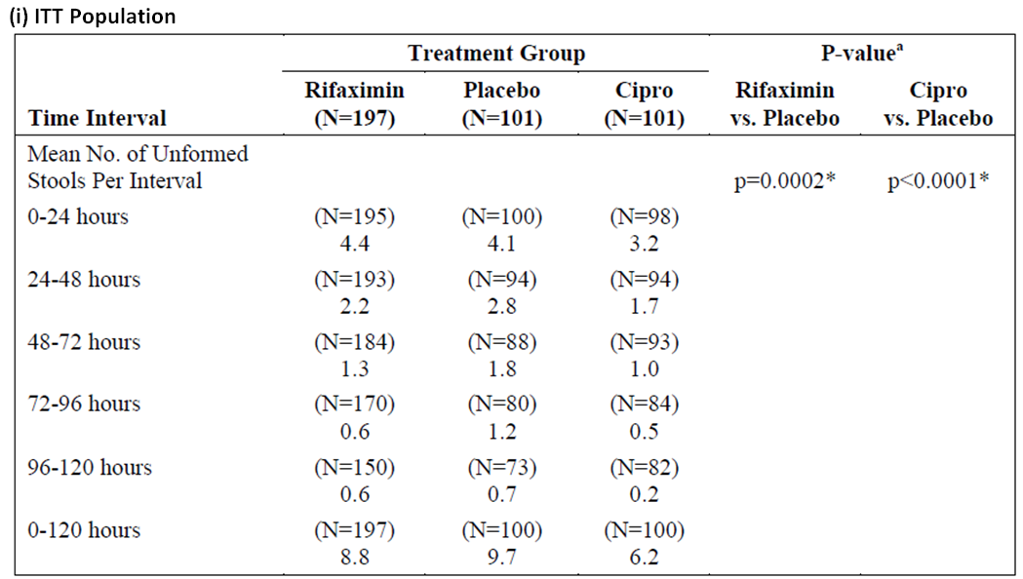
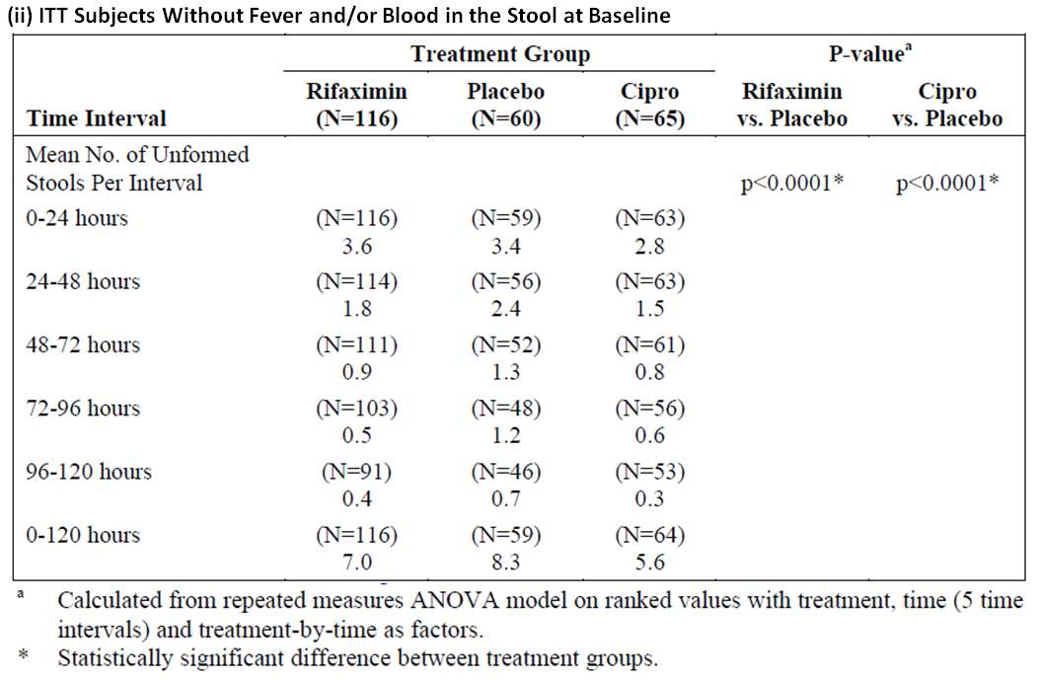
A higher proportion of the rifaximin group than the placebo group showed improvement in diarrhoeal syndrome during each of the first 4 time intervals, with statistically significant differences between the 2 groups (in favour of rifaximin) during the 48 to 72-hour interval (p = 0.0346) and the 72 to 96-hour interval (p = 0.0250). Results in the study population excluding ITT subjects with fever and/or blood in the stool at baseline yielded generally similar results, showing a higher proportion of subjects in the rifaximin group than the placebo group with improvement in diarrhoeal syndrome during each of the first 4 time intervals.
The proportion of subjects achieving wellness (clinical cure) in the ITT population is presented in Table 5. There was a statistically significantly higher proportion of subjects achieving wellness with rifaximin compared to placebo (76.6% vs. 61.4%, p = 0.0039), and with Cipro compared to placebo (78.2% vs. 61.4%, p = 0.0070). The difference in the proportion of subjects achieving wellness between the rifaximin and Cipro groups was not statistically significant (76.6% vs. 78.2%, p = 0.7388). Results in the study population excluding ITT subjects with fever and/or blood in the stool at baseline showed that the proportions of subjects achieving wellness were similar to the overall ITT population for the placebo and Cipro groups and about 10% higher than the overall ITT population for the rifaximin group (Table 5). In this restricted population, there was a statistically significantly higher proportion of subjects achieving wellness with rifaximin compared to placebo (87.1% vs. 61.7%, p < 0.0001), and with Cipro compared to placebo (80.0% vs. 61.7%, p = 0.0163). The difference in the proportion of subjects achieving wellness between the rifaximin and Cipro groups was not statistically significant (87.1% vs. 80.0%, p = 0.3058).
Table 5: Wellness (i) ITT Population (ii) ITT Subjects Without Fever and/or Blood in the Stool at Baseline, Study ESID0201.
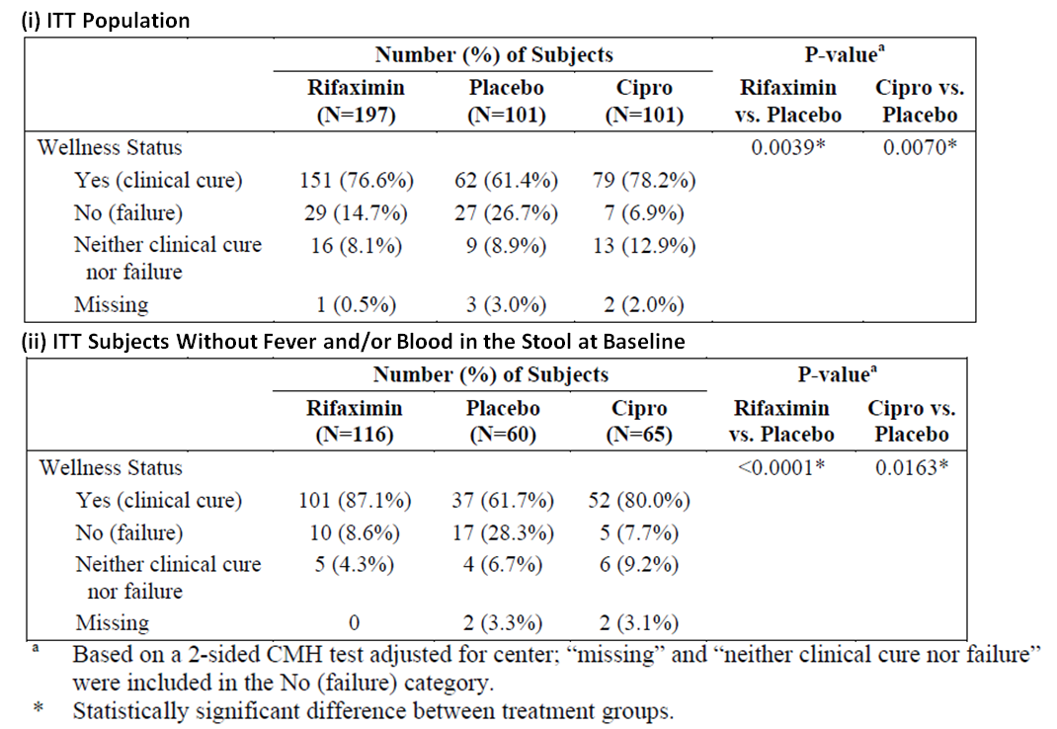
The proportion of subjects with treatment failure in the ITT population is presented in Table 6. There was a statistically significantly lower proportion of subjects with treatment failure with rifaximin compared to placebo (14.7% vs. 26.7%, p = 0.0115), and with Cipro compared to placebo (6.9% vs. 26.7%, p = 0.0002). The difference in the proportion of subjects with treatment failure between the rifaximin and Cipro groups was statistically significant (14.7% vs. 6.9%, p = 0.0483). Results in the study population excluding ITT subjects with fever and/or blood in the stool at baseline showed that the proportions of subjects failing treatment were similar to the overall ITT population for the placebo and Cipro groups and were less than the overall ITT population for the rifaximin group (Table 6). In this restricted population, there was a statistically significantly lower proportion of subjects with treatment failure with rifaximin compared to placebo (8.6% vs. 28.3%, p = 0.0004), and with Cipro compared to placebo (7.7% vs. 28.3%, p = 0.00035). The difference in the proportion of subjects with treatment failure between the rifaximin and Cipro groups was not statistically significant (8.6% vs. 7.7%, p = 0.6742) in this restricted study population.
Table 6: Treatment Failure (i) ITT Population (ii) ITT Subjects Without Fever and/or Blood in the Stool at Baseline, Study ESID0201.
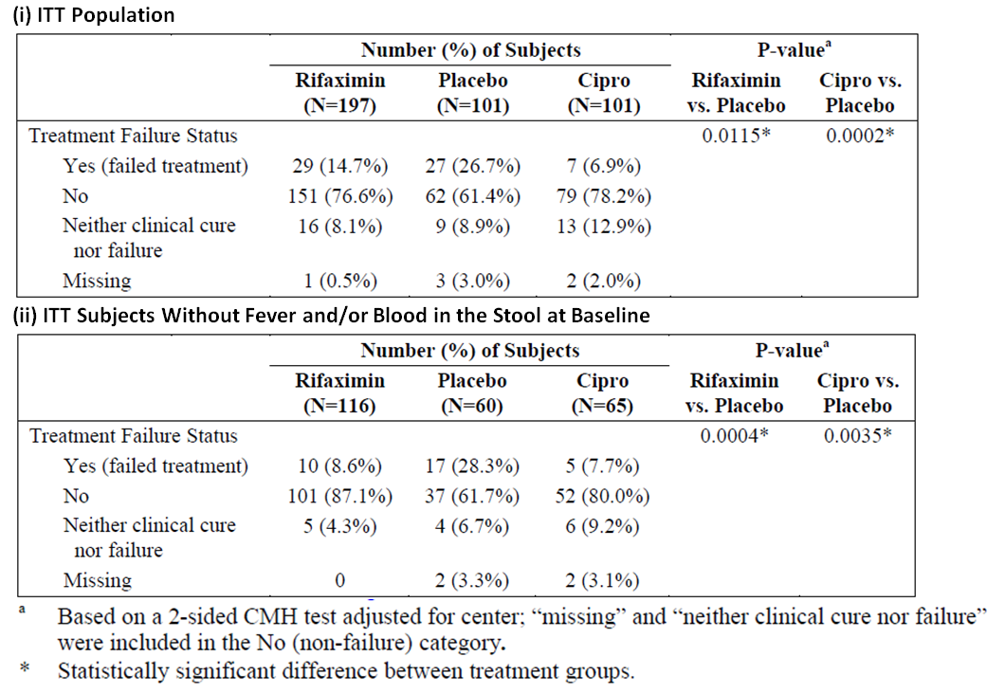
Examining the proportion of subjects with persistence of clinical symptoms by time interval for the ITT population, results showed that the difference between rifaximin and placebo, and between Cipro and placebo, were mostly not statistically significant. Results in the study population excluding ITT subjects with fever and/or blood in the stool at baseline yielded generally similar results.

Study ESID9802

Study design, objectives, locations and dates
Study ESID9802 was a randomised, double-blind, multi-centre, parallel, comparative, placebo-controlled study comparing 2 doses of rifaximin (200mg t.i.d. [600mg/day] and 400mg t.i.d. [1200mg/day]) versus placebo in the treatment of bacterial infectious diarrhoea in travellers. The primary objective was to assess the safety and efficacy of rifaximin as compared to placebo in the treatment of infectious diarrhoea in travellers.
Study ESID9802 was a multi-centre study where subjects were enrolled in a total of 3 study sites across 3 countries: 1 site each in Mexico, Kenya and Guatemala. The study start date (first subject enrolled) was 14 May 1999. The study completion date (last subject completed) was 30 July 2000.
Eligible subjects were randomly assigned in a 1:1:1 ratio to 1 of 3 treatment groups (rifaximin 200mg t.i.d., rifaximin 400mg t.i.d., or placebo) and were treated with study medication for 3 days. For 5 days following randomisation, subjects recorded in daily diaries the date, time and consistency of each stool and documented symptoms of enteric infection. Stool samples were collected from each subject at pre-treatment and post-treatment (first stool specimen following last dose of study drug).

Inclusion and exclusion criteria
Inclusion and exclusion criteria were generally the same as those for Study ESID0201 (see Section 7.1.1.1.2) except that study ESID9802 recruited subjects ≥ 16 years of age instead of ≥ 18 years of age. A full list of inclusion and exclusion criteria is presented below.

Inclusion criteria
Eligible subjects included adult, nonindigenous travellers affected by acute diarrhoea defined by the passage of at least three unformed stools in a 24-hour period. A subject meeting all of the following criteria was eligible for inclusion in the study:
- IRB- or IEC-approved, written informed consent appropriately witnessed, signed, and dated. For subjects under the age of 18, written informed consent was to be obtained from the subjects legal guardian
- Male or female subject at least 16 yaers of age. Subjects less than 18 years of age could be enrolled provided that (1) IRB / IEC granted approval and (2) parent or legal guardian signed the informed consent
- At least three unformed stools recorded within the 24 hours preceding randomisation
- At least one of the signs and symptoms of enteric infection, as described in Section 9.1
- The ability and willingness to comply with all study procedures
Stools were classified as formed (retains shape), soft (assumes shape of container), or watery (can be poured). Both soft and watery stools were considered to be unformed and abnormal.

Exclusion criteria
Subjects meeting any of the following criteria at the time of enrolment were ineligible to participate in the study:
- Inability or unwillingness to provide informed consent
- Acute diarrhoea for more than 72 hours (prior to randomisation and initiation of study treatment)
- One or more of the following clinical findings suggesting moderate or severe dehydration:
  - Fluid loss ≥ 6%
  - Restless, drowsy, or comatose mentation assessment
  - Rapid to very rapid pulse
  - Deep to very deep and rapid respiration
  - Low to very low or undetectable blood pressure
  - Slow or very slow retraction of the skin
  - Sunken or very sunken eyes
  - Hoarse or inaudible voice
  - Scant or no urine production
- For fecund females, any one of the following:
  - Pregnancy
  - Breast feeding required during the course of the study
  - If sexually active, unable or unwilling to use adequate contraception (eg. Hormonal treatments, double-barrier protection) during the study; if hormonal treatment was being used for birth control, then it must have been used for at least 2 months prior t treatment; partner’s vasectomy and abstinence were to be considered acceptable methods of birth control
- Active, uncontrolled, or clinically significant diseases or disorders of the heart, lung, kidney, GI tract (other than infectious diarrhoea in travellers), or central nervous system
- Administration of any of the following (note: antimalarial prophylactic treatment, including doxycycline, was permitted prior to and during the study):
  - Within 7 days preceding randomisation, and antimicrobial agents with an expected activity against enteric bacterial pathogens
  - Within 8 hours preceding randomisation, more than two doses of a symptomatic antidiarrheal compound such as antimotility agents, absorbent agents, and antisecretory agents
  - Within 2 hours preceding randomisation, any symptomatic drug such as aspirin or ibuprofen (Advil). Acetaminophen (Tylenol) or paracetamol were considered acceptable
- Hypersensitivity or allergy to the active principals under study
- Previous treatment under this protocol or other clinical trials involving rifaximin
- Participation in an investigational drug study within the 30 days prior to randomisation
Note: Signs and symptoms of enteric infection: abdominal pain or cramps, excessive gas/flatulence, nausea, vomiting, fever (≥100°F or ≥ 37.8°C), faecal urgency, dysentery (passage of bloody stool), or tenesmus.

Study treatments
Eligible subjects were randomly assigned in a 1:1:1 ratio to 1 of 3 treatment groups (rifaximin 200mg t.i.d., rifaximin 400mg t.i.d., or placebo). Treatment duration was 3 days. Subjects were dosed according to the regimen as shown in Table 7.
Table 7: Treatment regimens, Study ESID9802.
Placebo group | Two placebo tablets, TID
600-mg group TID | One 200-mg rifaximin tablet = one placebo tablet
1200-mg group | Two 200-mg rifaximin tablets, TID
Evaluator’s Comments: The study dose selection for rifaximin is appropriate and has been previously discussed in Section 6 of this evaluation report. The double-blind study design comparing rifaximin against placebo is appropriate. A placebo-control group is appropriate as travellers’ diarrhoea is generally a self-limiting illness, and hence the primary proof of the efficacy of rifaximin would be based upon comparison to placebo treatment.

Efficacy variables and outcomes
Primary and secondary endpoints were the same as those for study ESID0201 (see Section 7.1.1.1.4). The definitions used for efficacy assessments were also the same as for study ESID0201.

Randomisation and blinding methods
Subjects were randomised in a 1:1:1 ratio to receive rifaximin 200mg t.i.d., rifaximin 400mg t.i.d. or placebo. Subjects were assigned to treatment groups according to a randomisation code generated for each site by STATPROBE, Inc. The code allowed for a random, equal (1:1:1) distribution of the 3 treatment groups among the 360 anticipated subjects, allowing for up to 180 subjects per site. A randomised block design was used with block size of six within each site. For each group of 6 subjects at a site, 2 were randomised to receive treatment with placebo, 2 to receive 600mg of rifaximin daily, and 2 to receive 1200mg of rifaximin daily. At each site, subjects eligible to enter the study were sequentially assigned an identification number. A blister card with study drug, labelled with the corresponding subject number, was then dispensed to the subject.
The study was double-blind. The study medication for each subject was packaged in a standard blister card containing three blister wells per day for a total of nine wells per packet. Each blister well contained two tablets (rifaximin, placebo, or a combination thereof).

Analysis populations
There were 3 analysis population sets in the study. The Intent-to-Treat (ITT) population was defined as all subjects randomised to treatment. The Efficacy Evaluable (EE) population was defined as subjects who met the inclusion/exclusion criteria, took at least three doses of study medication in the first 2 days of treatment, and completed the daily diaries (that is, at least one entry in the diary) for at least the first 2 days of treatment. The safety population consisted of all randomised subjects who received at least one dose of study medication. The ITT data set was the primary population for efficacy analyses.

Sample size
The sample size was calculated based on comparing the treatment groups with respect to TLUS.
The null hypothesis of interest was: H0: Pa(t) = Pb(t) versus the alternative: H1: Pa(t) ≠ Pb(t), where Pa(t) was the probability of passing the last unformed stool by time t for either the 600 or 1200mg rifaximin group, and Pb(t) was the same probability for the placebo group. The sample size was calculated based on the assumption that the best rifaximin response rate for TLUS within the first 72 hours (3 days) would be 80% compared to a 50% placebo response rate. Time to last unformed stool was assumed to have an exponential distribution. These assumptions translated to hazard rates of 0.022 for rifaximin and 0.11 for placebo and to median times to last unformed stool of 31 hours for rifaximin and 62 hours for placebo. In addition, the sample size was derived assuming a 0.025 level of significance for comparing each of the rifaximin group to placebo (overall level of significance 0.05 for two pairwise comparisons), and an equal number of subjects required for each group. Based on these assumptions, it was estimated that a sample size of 78 subjects per group was needed for power of 0.80, and 86 subjects per group for power of 0.90. If approximately 10% of the subjects enrolled withdrew prior to Day 2, then a sample size of 120 subjects per group was calculated to be needed to ensure an adequate number of subjects in the efficacy-evaluable population to have at least 80% power for the difference of interest. The sample size of 120 per group was also selected to ensure an adequate number of subjects to satisfy safety requirements for regulatory submission.

Statistical methods
For the primary efficacy endpoint analysis, TLUS was summarised using Kaplan-Meier methods and proportional hazards models to evaluate the effect of treatment after adjusting for other covariates. Subjects meeting the criteria for wellness immediately after the start of the study and prior to passing any unformed stools were defined to have a TLUS of 0 hours. The distribution of TLUS was summarised using Kaplan-Meier estimates. Subjects for whom TLUS could not be calculated due to early termination for treatment failure, including subjects who received rescue medications, were assigned a TLUS value censored at 120 hours, representing the worst possible value of TLUS in the 5-day observation period. Subjects for whom TLUS could not be calculated because of early termination for other reasons, or because of study completion without wellness being declared, were assigned a censored TLUS at the time of the last available information on unformed stools.

Participant flow
A total of 380 subjects were enrolled and randomised: 129 to the placebo group, 125 to the rifaximin 600mg (i.e. 200mg t.i.d.) group, and 126 to the rifaximin 1200mg (i.e. 400mg t.i.d.) group. A total of 344 subjects completed the study (110 [85.3%], 115 [92.0%] and 119 [94.4%] in the placebo, rifaximin 600mg, and rifaximin 1200mg groups, respectively) (Figure 4).
Figure 4: Disposition of Subjects, Study ESID9802.
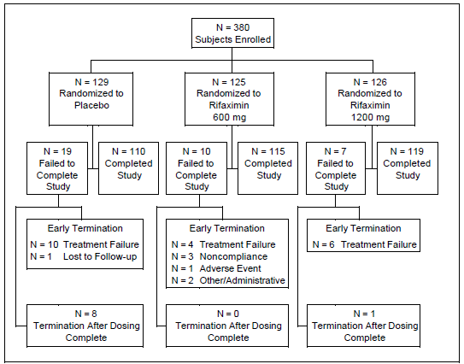

Major protocol violations/deviations
Frequency of protocol violations was similar across treatment groups (14.7%, 16.8% and 15.9% in the placebo, rifaximin 600mg, and rifaximin 1200mg groups, respectively).
Treatment compliance was measured by subject-log of self-administered study drug dosing. This included writing the date and time of dosing on the peel-off labels of the blister card and affixing completed labels to the appropriate diary card. Diary cards were reviewed by the investigator for treatment compliance. In addition, subjects were to return study drug blister cards at the end of treatment, and investigators confirmed the level of individual compliance based on the amount of returned drug. Overall, seven or more doses were taken by 120 (93%) subjects in the placebo group, 118 (94%) in the rifaximin 600mg group, and 120 (95%) in the rifaximin 1200mg group.

Baseline data
Baseline demographic characteristics were comparable among treatment groups in the ITT population. The majority of subjects in each treatment group were White (86.8%, 83.2% and 84.1% in the placebo, rifaximin 600mg, and rifaximin 1200mg groups, respectively) and approximately half were male (51.2%, 54.4% and 48.4%, respectively). The mean (Standard Error of the Mean [SEM]) age was 28.3 (0.9), 29.0 (1.1) and 29.0 (1.0) years, respectively. Baseline mean weight was similar between treatment groups (mean [SEM] weight of 70.8 [1.2], 70.3 [1.3], and 70.6 [1.3] kg, respectively). Baseline demographic characteristics were also comparable among treatment groups in the EE population.
Baseline disease characteristics were comparable among treatment groups in the ITT and EE analysis populations. In the ITT population, the median number of unformed stools in the 24-hour period before randomisation was 5.0 in all 3 treatment groups.
Evaluator’s Comments: Overall, the baseline demographic and disease characteristics were comparable among treatment groups. The study population was generally representative of the target population of patients with travellers’ diarrhoea.

Results for the primary efficacy outcome
Primary efficacy analysis showed that the median TLUS in the rifaximin 600mg and 1200mg groups were 32.5 and 32.9 hours, respectively, compared with 60.0 hours in the placebo group (p = 0.0001 for both rifaximin 600mg vs. placebo, and rifaximin 1200mg vs. placebo; Table 8 and Figure 5). The hazard ratios were greater than 1 for both rifaximin groups vs. placebo (rifaximin 600mg vs. placebo: 1.81 [95% CI of 1.41 - 2.33]; rifaximin 1200mg vs. placebo: 1.34 [95% CI of 1.18 - 1.51]) indicating greater improvement in the rifaximin groups versus the placebo group.
Table 8: Distribution of Time to Last Unformed Stool (ITT Population), Study ESID9802.
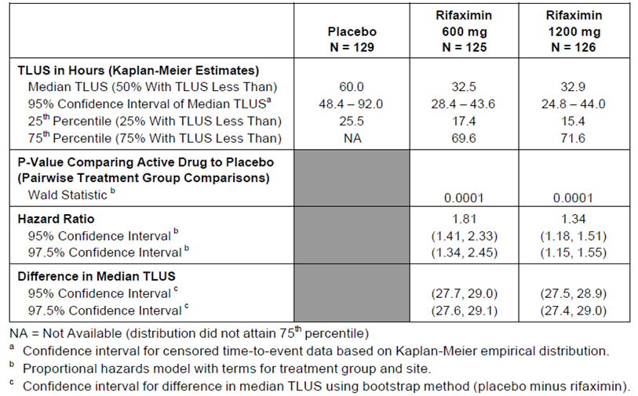
Figure 5: Probability of Time to Last Unformed Stool (TLUS) for ITT Population, Study ESID9802.
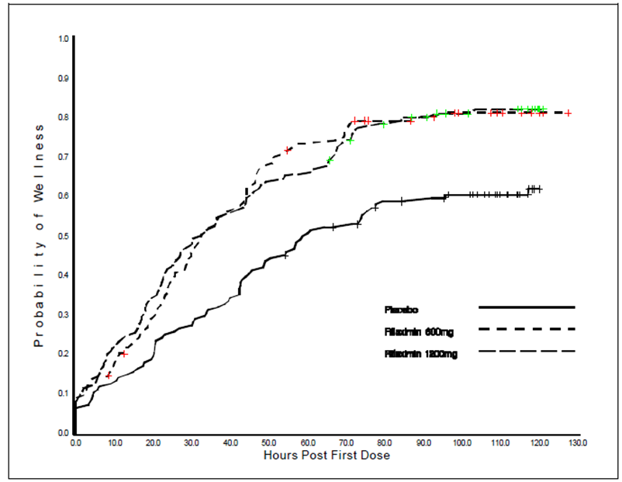

Results for other efficacy outcomes

Other analyses on the primary efficacy endpoint (TLUS)
Results of the analysis of TLUS for the EE population were similar to those in the ITT population. The median TLUS in the rifaximin 600mg and 1200mg groups were 32.5 and 29.2 hours, respectively, compared with 57.0 hours in the placebo group (p = 0.0001 for both rifaximin 600mg vs. placebo, and rifaximin 1200mg vs. placebo). The hazard ratios were greater than 1 for both rifaximin groups vs. placebo (rifaximin 600mg vs. placebo: 1.81 [95% CI of 1.40 - 2.34]; rifaximin 1200mg vs. placebo: 1.38 [95%CI of 1.21 - 1.57]) indicating greater improvement in the rifaximin groups versus the placebo group.
Subgroup analyses of TLUS were performed for ITT subjects with absence or presence of parasitic infection in the pre-treatment stool culture, and for ITT subjects with faecal leukocyte-positive or leukocyte-negative illness. Results showed that for subjects without parasitic infection, median TLUS in the rifaximin 600mg and 1200mg groups were 32.2 and 28.5 hours, respectively, compared with 60.0 hours in the placebo group (p = 0.0005 for rifaximin 600mg vs. placebo; p = 0.002 for rifaximin 1200mg vs. placebo). For subjects with a parasitic infection, median TLUS values in the rifaximin treatment groups were higher compared to those without parasitic infection, but were lower for each rifaximin group versus placebo. For subjects with parasitic infection, median TLUS in the rifaximin 600mg and 1200mg groups were 37.3 and 43.8 hours, respectively, compared with 60.8 hours in the placebo group (p = 0.033 for rifaximin 600mg vs. placebo; p = 0.123 for rifaximin 1200mg vs. placebo). For subjects with leukocyte-negative illness, median TLUS median TLUS in the rifaximin 600mg and 1200mg groups were 32.5 and 30.1 hours, respectively, compared with 57.0 hours in the placebo group (p = 0.0004 for rifaximin 600mg vs. placebo; p = 0.003 for rifaximin 1200mg vs. placebo). For subjects with leukocyte-positive illness, median TLUS values in the rifaximin treatment groups were higher compared to those with leukocyte-negative illness (median TLUS in the rifaximin 600mg and 1200mg groups were 45.1 and 36.7 hours, respectively). Response in the placebo group was insufficient to attain a median TLUS.

Secondary efficacy endpoints
The number of unformed stools passed per time interval in the ITT population is presented in Table 9. Over the time of the five 24-hour intervals, the profile for each treatment group showed declining mean number of unformed stools passed. The mean number of unformed stools was lower in both rifaximin groups relative to the placebo group across all time intervals. Pairwise comparisons of each rifaximin group versus placebo were statistically significant (p = 0.0001 for both rifaximin 600mg vs. placebo, and rifaximin 1200mg vs. placebo).
Table 9: Analysis of Number of Unformed Stools Per Time Interval (ITT Population), Study ESID9802.
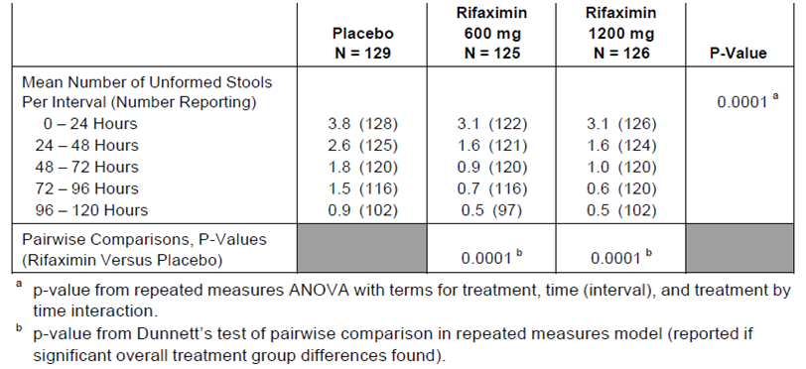
Improvement in diarrhoeal syndrome per time interval in the ITT population is presented in Table 10. Results showed a statistically significantly higher proportion of subjects with improvement in diarrhoeal syndrome in the rifaximin 600mg group versus the placebo group in the 24 – 48 hour interval (87.1% vs.72.9%, p = 0.007) and in the 48 – 72 hour intervals (91.3% vs. 78.8%, p = 0.008). In the same time intervals, the proportion of subjects with improvement in diarrhoeal syndrome in the rifaximin 1200mg group was also numerically higher than in the placebo group, but the difference was not statistically significant (24 – 48 hour interval: 78.3% vs. 72.9%, p = 0.327; 48 – 72 hour interval: 87.9% vs. 78.8%, p = 0.062).
Table 10: Improvement in Diarrhoeal Syndrome (ITT Population), Study ESID9802.
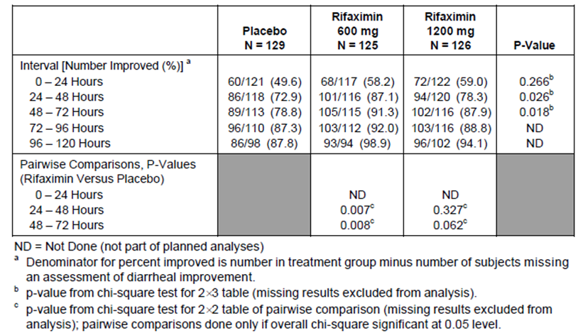
The proportion of subjects achieving wellness (clinical cure) in the ITT population is presented in Table 11. There was a statistically significantly higher proportion of subjects achieving wellness with rifaximin 600mg compared to placebo (79.2% vs. 60.5%, p = 0.001), and with rifaximin 1200mg compared to placebo (81.0% vs. 60.5%, p = 0.001).
Table 11: Wellness (ITT Population), Study ESID9802.
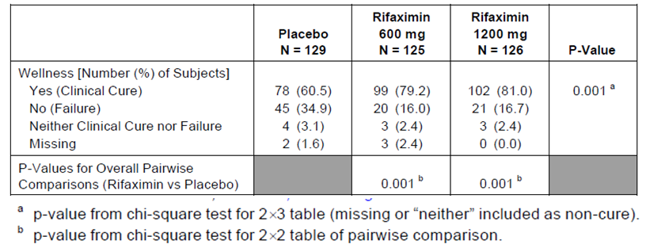
The proportion of subjects with treatment failure in the ITT population is presented in Table 12. There was a statistically significantly lower proportion of subjects with treatment failure with rifaximin 600mg compared to placebo (16.0% vs. 34.9%, p = 0.001), and with rifaximin 1200mg compared to placebo (16.7% vs. 34.9%, p = 0.001).
Table 12: Treatment Failure (ITT Population), Study ESID9802.
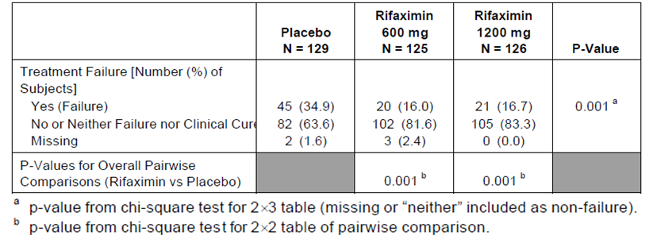
The proportion of subjects with persistence of clinical symptoms by time interval for the ITT population is presented. Results showed that there were no statistically significant differences across treatment groups.
The proportion of subjects with microbiological cure (defined as a post-treatment culture that was negative for the pre-treatment etiologic pathogen) is presented in Table 13. Results showed that among subjects with a pathogen or pathogens at pre-treatment the proportion of subjects with microbiological cure was similar in all 3 treatment groups (68.6%% and 56.7% in the rifaximin 600mg and 1200mg groups, respectively, compared with 67.2% in the placebo group).
Table 13: Overall Microbiologic Response (ITT Population), Study ESID9802.
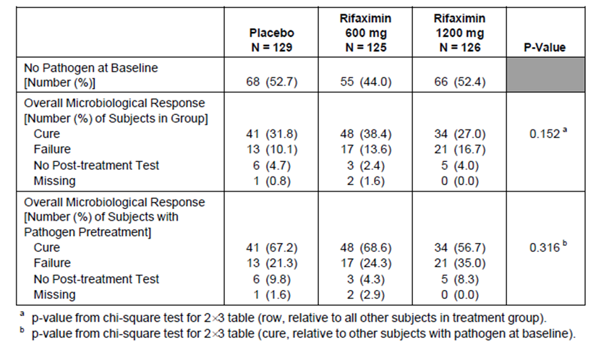

Study ESID9701
Study ESID9701 was a randomised, double-blind, double-dummy study comparing a 3-day regimen of 800mg/day of rifaximin (400mg b.i.d.) against a standard 3-day regimen of 1000mg/day of ciprofloxacin (500mg b.i.d.) in the treatment of travellers’ diarrhoea. The objectives of this study were to compare the clinical efficacy (based on TLUS), microbiological outcome (i.e. eradication of the causative organism), and relative safety and tolerability of rifaximin with a standard regimen of ciprofloxacin. Study ESID9701 was a 2-centre study: 1 site each in Mexico and Jamaica. The study period was from June 1997 to September 1998.
Eligible subjects were randomly assigned in a 1:1 ratio to 1 of 2 treatment regimens: two tablets of rifaximin 200mg and one tablet of ciprofloxacin placebo, twice daily for 3 days; or two tablets of rifaximin placebo and one tablet of ciprofloxacin 500mg, twice daily for 3 days. Study duration was 5 days, including the 3 days of study treatment, followed by a post-treatment evaluation between 48 and 72 hours after the last dose of the study medication was taken. Subjects maintained a daily diary for the duration of participation from which the effectiveness and safety of treatment were evaluated. The study dose of rifaximin 800mg/day was chosen as results from a previous dose-finding Phase II study (ESID9601) testing rifaximin 600mg/day (200mg t.i.d.), 1200mg/day (400mg t.i.d.) and 1800mg/day (600mg t.i.d.) showed that there was no clearly superior dose of rifaximin in terms of efficacy, and hence an intermediate dose of 800mg/day rifaximin was chosen to be tested in this study. A twice-a-day regimen (i.e. 400mg b.i.d.) was chosen in order to conform with the double-blind/ double-dummy design and to ensure good subject acceptance and compliance.
Inclusion and exclusion criteria were the same as those for study ESID0201 (see Section 7.1.1.1.2), as were the primary and secondary endpoints (see Section 7.1.1.1.4). The definitions used for efficacy assessments were also the same as for study ESID0201 and has been previously presented. The objective of the analysis of the primary endpoint of TLUS was to demonstrate that the time to last unformed stool for rifaximin was equivalent to that for ciprofloxacin. An equivalence procedure for survival-type data was used for the primary analysis. Based on historical data, the probability of passing the last unformed stool by the end of the first 24 hours for ciprofloxacin was 0.62. If the probability of passing the last unformed stool by the end of the first 24 hours for rifaximin was 0.41 or less, this was considered to be unacceptable. As TLUS was assumed to have an exponential distribution, these probabilities translated to hazard rates of 0.022 for rifaximin and 0.040 for ciprofloxacin, corresponding to a hazard ratio of 0.55 (i.e. rifaximin was to be considered at least equivalent to ciprofloxacin in terms of TLUS if hazard ratio was > 0.55).
A total of 187 subjects were enrolled and randomised: 93 to the rifaximin group and 94 to ciprofloxacin group. A total of 182 subjects completed the study (92 [98.9%] and 90 [95.7%] in the rifaximin and Cipro groups, respectively) (Figure 6). Frequency of protocol violations was similar between treatment groups (31.2% and 35.1% in the rifaximin and Cipro groups, respectively).
Figure 6: Disposition of Subjects, Study ESID9701.
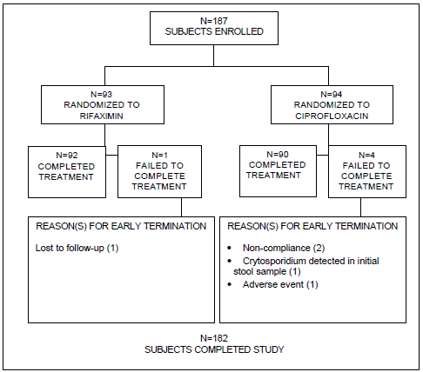
Baseline demographic characteristics were comparable between treatment groups. The majority of subjects in each treatment group were White (81.7% and 78.7% in the rifaximin and Cipro groups, respectively) and approximately half were male (41.9% and 45.7%, respectively). The mean (SD) age was 26.3 (9.5) and 25.6 (9.2) years, respectively. Baseline disease characteristics were also generally comparable between treatment groups. In the ITT population, the median number of unformed stools in the 24-hour period before randomisation was 5.0 in both treatment groups.
The primary efficacy analysis showed that the median TLUS for the ITT population was 25.7hours for rifaximin and 25.0 hours for ciprofloxacin. The estimated hazard ratio for comparing rifaximin to ciprofloxacin was 0.82 (95% CI of 0.60 – 1.11), showing that rifaximin was equivalent to ciprofloxacin in terms of TLUS by rejecting the null hypothesis that the hazard ratio for comparing rifaximin to ciprofloxacin was less than or equal to 0.55. The Kaplan-Meier estimates of the probability of TLUS are presented in Figure 7.
Figure 7: Primary Efficacy Variable, TLUS – ITT Population, Study ESID9701.
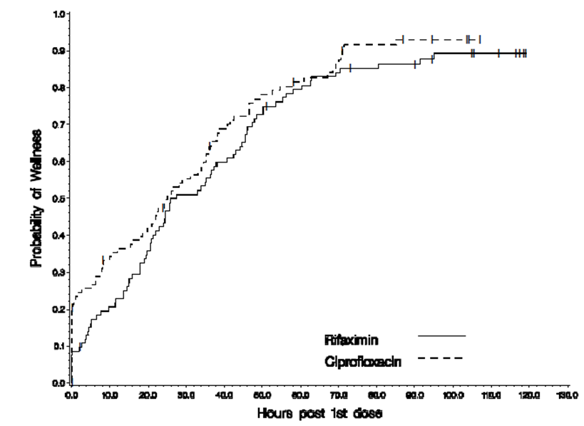
Overall, analyses of the secondary efficacy endpoints showed that there were no statistically significant differences between treatment groups for the secondary efficacy endpoints except for the incidence of nausea over 24 - 48 hours and 48 - 72 hours intervals (statistically significantly lower in the rifaximin group compared to the Cipro group), and the incidence of tenesmus over 0 - 24 hours (statistically significantly higher in the rifaximin group compared to the Cipro group).
The number of unformed stools passed per time interval in the ITT population is presented. The mean number of unformed stools decreased with time for each treatment group, but the difference between treatment groups was not statistically significant. Improvement in diarrhoeal syndrome per time interval in the ITT population is presented. Improvement in the diarrhoeal syndrome was noted for 58.1% and 63.1% of subjects in the rifaximin and Cipro groups, respectively (p = 0.419), during the 0 - 24 hour interval and for 82.8% and 85.1% of subjects in the rifaximin and Cipro groups, respectively (p = 0.667), during the 24-48 hour interval. The proportion of subjects achieving wellness (clinical cure) in the ITT population was 87.1% (81/93) and 88.3% (83/94) in the rifaximin and Cipro groups, respectively (p = 0.803). The proportion of subjects with treatment failure in the ITT population was 9.7% (9/93) and 5.7% (5/94) in the rifaximin and Cipro groups, respectively (p = 0.258).
Analyses of the proportion of subjects with persistence of clinical symptoms by time interval showed no statistically significant differences between treatment groups, except for the symptoms of nausea and tenesmus. The incidence of nausea was lower in the rifaximin group than the ciprofloxacin group during each time interval, with statistically significant differences for the 24 - 48 hour (18.3% with rifaximin vs. 34.0% with Cipro, p = 0.012) and 48 - 72 hour intervals (9.7% with rifaximin vs. 23.4% with Cipro, p = 0.009). The incidence of tenesmus was statistically significantly higher in the rifaximin group than in the ciprofloxacin group during the 0 - 24 hour interval (37.6% with rifaximin vs. 21.3% with Cipro, p = 0.016), but there were no significant differences between the treatment groups during the 24 - 48 hour and 48 - 72 hour intervals.
The proportion of subjects with microbiological cure (defined as a post-treatment culture that was negative for the pre-treatment etiologic pathogen) is presented. Results showed that among subjects with a pathogen or pathogens at pre-treatment the proportion of subjects with microbiological cure was 32.3% and 41.5% in the rifaximin and Cipro groups, respectively (p = 0.441).

Study ESID9601
Study ESID9601 was a Phase II, randomised, double-blind, double-dummy, parallel, dose-response study comparing 3 dose regimens of rifaximin (200mg t.i.d., 400mg t.i.d. and 600mg t.i.d.) against a standard regimen of Trimethoprim/Sulfamethoxazole (TMP/SMX; 160/800mg b.i.d.) in the treatment of travellers’ diarrhoea. The objectives of this study were to compare the activity of 3 dose regimens of rifaximin to one another in order to determine the most effective dose for the treatment of travellers' diarrhoea, to assess the effectiveness of the 3 rifaximin dose regimens for eradication of causative organisms, to assess the relative safety and tolerability of the 3 rifaximin dose regimens, and to compare the rifaximin treatments to a standard treatment regimen of TMP/SMX for the treatment of travellers' diarrhoea. Study ESID9601 was conducted across 3 centres in Mexico. The study start date (first subject enrolled) was 26 June 1996. The study completion date (last subject completed) was 15 October 1996.
Eligible subjects were randomly assigned in a 1:1:1:1 ratio to 1 of 4 treatment groups: rifaximin 200mg t.i.d. (“rifaximin low dose”), rifaximin 400mg t.i.d. (“rifaximin mid dose”), rifaximin 600mg t.i.d. (“rifaximin high dose”), and TMP/SMX 160/800mg b.i.d. Subjects in the rifaximin 200mg t.i.d. group received 1 tablet of rifaximin 200mg + 2 tablets of matching rifaximin placebo t.i.d., plus 1 tablet of matching TMP/SMX placebo b.i.d.; subjects in the rifaximin 400mg t.i.d. group received 2 tablets of rifaximin 200mg + 1 tablet of matching rifaximin placebo t.i.d., plus 1 tablet of matching TMP/SMX placebo b.i.d.; subjects in the rifaximin 600mg t.i.d. group received 3 tablets of rifaximin 200mg t.i.d., plus 1 tablet of matching TMP/SMX placebo b.i.d.; subjects in the TMP/SMX b.i.d. group received 3 tablets of rifaximin placebo t.i.d., plus 1 tablet of TMP/SMX 160mg/800mg b.i.d. Each treatment duration was 5 days. A post-treatment evaluation was done within 48 to 72 hours after discontinuing treatment (day 7 or 8 after initiation of therapy). Subjects maintained a daily diary for the duration of participation from which the effectiveness and safety of treatment were evaluated. According to the sponsor, the lower rifaximin dose of 200mg t.i.d. was chosen as it had been tested in man in the same or similar indication, and had been shown to be sufficiently effective and safe. The middle and higher rifaximin doses were chosen in order to maintain a double-dummy design while taking into consideration that rifaximin was to be marketed as 200mg tablet formulation. The active control of TMP/SMX was chosen as that was the standard treatment for travellers’ diarrhoea at that time.
Subjects were male or female adults aged over 18 years with acute diarrhoea, whose pre-treatment stool sample was defined as “unformed stools”. Study inclusion and exclusion criteria were presented below:

Inclusion criteria
- Patients of both sexes, aged over 18 years
- Patients with acute diarrhoea, whose pre-treatment stool sample has been defined as “unformed stools”

Exclusion criteria
- Pregnancy or breast feeding; active heart, lung, kidney or intestinal disease; seizure disorder.
- Administration in the last eight hours before enrolment into the trial, of more than two doses of a symptomatic antidiarrheal compound; and/or, in the last two hours, or any number of doses of a symptomatic drug.
- Administration, within the past week, of an antimicrobial agent with an expected activity against enteric bacterial pathogens.
Efficacy endpoints were similar to those for study ESID0201 (see Section 7.1.1.1.4). The definitions used for efficacy assessments were also the same as for study ESID0201 and has been previously presented.
A total of 76 subjects were enrolled and randomised: 19 to each of the 4 treatment groups. A total of 72 subjects completed the study (18 in each of the rifaximin groups, and 17 in the TMP/SMX group) (Figure 8).
Figure 8: Disposition of Subjects, Study ESID9601.
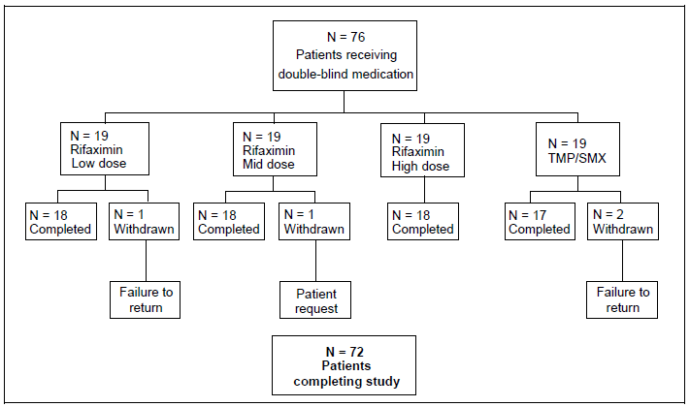
Baseline demographic characteristics were generally comparable among treatment groups. The majority of subjects in each treatment group were White (70.6%, 94.4%, 94.1% and 93.8% in the rifaximin low, mid and high dose, and TMP/SMX groups, respectively). The median age was 21.0 years in each of the rifaximin group, and 23.0 years in the TMP/SMX group. Baseline disease characteristics were also generally comparable among treatment groups. The median number of unformed stools in the 24-hour period before randomisation was 5.5 in the rifaximin low-dose group, and 5.0 in the other treatment groups.
Efficacy analyses showed that the median TLUS was 26.25, 40.50, 35.00 and 47.00 hours in the rifaximin low, mid and high dose, and TMP/SMX groups, respectively. Among the rifaximin groups, the mean and median TLUS were lowest for the rifaximin low-dose group, and there was no obvious dose-dependent trend.
The median number of unformed stools passed during five days observation was 4.0, 5.5, 5.0, and 5.0 in the rifaximin low, mid and high dose, and TMP/SMX groups, respectively. By the end of 24 hours of treatment improvement in the diarrhoeal syndrome was noted for 55.6%, 44.4%, 52.6% and 58.8% of subjects in the rifaximin low, mid and high dose, and TMP/SMX groups, respectively. By the end of 48 hours of treatment improvement in the diarrhoeal syndrome was noted for 83.3%, 77.8%, 89.5% and 76.5% of subjects, respectively. The proportion of subjects with treatment failure was 11%, 0%, 21% and 29% in the rifaximin low, mid and high dose, and TMP/SMX groups, respectively. Among the rifaximin groups, there were no obvious dose-dependent trends in these efficacy endpoints. Among subjects with a pathogen or pathogens at pre-treatment, the proportion of subjects with microbiological cure was 100%, 60%, 50% and 100% in the rifaximin low, mid and high dose, and TMP/SMX groups, respectively.

Other efficacy studies
The sponsor submitted 18 other studies, performed between 1982 and 2008, to provide supportive data to the results of the 4 pivotal studies. Overall, in these studies, a total of 541 patients were recruited. Out of these 18 studies, 3 studies were for the indication of treatment of clostridium difficile-associated diarrhoea (studies ESID9001, ESID0701 and ESID0901), 2 studies were for the indication of treatment of intestinal parasites in HIV patients (studies ESID9702 and ESID9901), 2 studies were for the indications of treatment of Helicobacter pylori-associated gastritis (studies ESID9703 and ESID9302), and 1 study tested an oral suspension formulation of rifaximin for use via naso-gastric tube in seriously ill patients. As per the TGA Statement of Requirement to the clinical evaluator, these 8 studies (which tested indications other than the currently proposed one or were conducted with different formulations other than the currently proposed one) will not be evaluated for the purpose of this submission.
Preliminary studies (1982-1984; studies ESID8201, ESID8202, ESID8301 and ESID8401) assessed the efficacy and safety of rifaximin 100mg tablet formulation in 105 patients with acute bacterial diarrhoea, with treatment duration ranging from 2 to 7 days. Studies ESID8201 and ESID8202 were uncontrolled studies. Studies ESID8301 and ESID8401 were controlled studies (ESID8301: active control of neomycin; ESID8401: placebo-controlled). Results across these studies showed that stool frequency and consistency normalised in approximately 3 days (range 1 - 4) in patients treated with rifaximin, and was about half the time taken by patients receiving placebo (p < 0.05; study ESID8401) and comparable to neomycin (study ESID8301).
Clinical symptoms improved by the third day of treatment with rifaximin and by Day 5 with placebo (study ESID8401). In study ESID8401, 86% of pathogens identified in stool at baseline were eradicated by rifaximin compared with 52% of strains with placebo. In study ESID8301, rifaximin eradicated pathogens in 70% of patients compared to 60% patients treated with neomycin. In the uncontrolled studies, 25 - 50% of baseline pathogens were eradicated with rifaximin. The 2 uncontrolled, pilot studies assessed 3 doses of rifaximin: 400mg/day (100mg q.i.d.), 600mg/day (200mg t.i.d.) and 800mg/day (200mg q.i.d.). Both studies concluded that the higher doses were more efficacious (600 - 800mg/day), although the number of patients per group was very small. The 2 controlled studies tested rifaximin 600 - 800mg/day.
Two open, uncontrolled studies in 1983 investigated rifaximin 600 – 1200mg/day in a total of 42 patients with acute infectious diarrhoea (studies ESID8304 and ESID8306; using rifaximin 200mg tablet formulation), with treatment duration ranging from 3 to 7 days. Results showed that with rifaximin, the frequency of diarrhoeal stools normalised in all patients between Days 2 - 3, stool consistency normalised between Days 2 - 4 and other clinical symptoms of diarrhoeal syndrome improved within 2 - 3 days. All patients achieved clinical cure and the resolution of symptoms. Faecal cultures demonstrated the eradication of pathogens by rifaximin in 23 - 80% of the patients at the end of the studies.
Subsequent controlled studies with rifaximin 200mg tablet formulation (studies ESID8801 [placebo-controlled], ESID8302 [active-controlled with neomycin + nalidixic acid], ESID9301 and ESID8402 [both active-controlled with neomycin]) tested the efficacy of rifaximin dose regimens of 200mg t.i.d. and 200mg q.i.d., with treatment durations ranging from 4 to 10 days. The primary endpoints in these studies were the normalisation of stool frequency and consistency. Symptoms associated with acute diarrhoea (e.g. abdominal pain/cramps, nausea, vomiting bloating, faecal urgency, fever and excess gas/flatulence) were also assessed. Results in study ESID 8801 (placebo-controlled; rifaximin 200mg t.i.d.; elderly study population [mean± SD age of 73±7 years]) showed that stool consistency and frequency, as well as clinical symptoms, started to improve on the second day of treatment with rifaximin, and normalised between Days 4 - 5, compared with Days 6 - 7 in the patients who received placebo. Results from studies ESID8302, ESID9301 and ESID8402, which compared rifaximin against neomycin (neomycin+nalidixic acid in study ESID8302) showed that stool frequency and consistency, as well as clinical symptoms significantly improved on the first or second day of treatment with rifaximin and normalised by Day 4 or 5. Efficacy was comparable to neomycin, and superior to neomycin+nalidixic acid.

Analyses performed across trials (pooled analyses and meta-analyses)
The sponsor had provided pooled pathogen eradication rates from 3 of the 4 submitted pivotal studies, ESID9601, ESID9701 and ESID9802 (Table 14). Results showed that the organisms identified pre-treatment were consistent with those known to cause bacterial diarrhoea in travellers. The most common pathogen identified was E. coli (64.2% and 71.1% in the pooled rifaximin and pooled control groups, respectively). At the end of the studies, E coli strains had been eradicated in 75% of patients in the pooled rifaximin group and 85.7% of patients in the pooled control group. In the pivotal study ESID0201, the microbiological eradication rate for diarrhoeagenic E Coli in the MITT population was 74.7% in the rifaximin group compared to 69.8% in the placebo group (p = 0.5344), and 95.6% in the Cipro group (Cipro vs. placebo: p = 0.0015).
Table 14: Pooled Pathogen Eradication Rates from Studies ESID9601, ESID9701 and ESID9802.
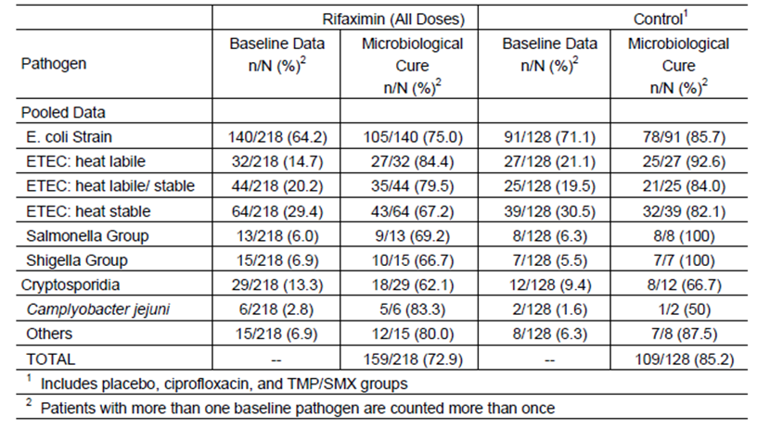
Analyses of the overall incidence of microbiological eradication across all pathogens showed that in study ESID0201, the proportion of subjects in the MITT population with an overall microbiological response of eradication was 61.6% in the rifaximin group compared with 51.7% in the placebo group (p = 0.1952), and 80.7% in the Cipro group (Cipro vs. placebo: p = 0.0008). Results in study ESID9802 showed that among subjects with a pathogen or pathogens at pre-treatment the proportion of subjects with microbiological cure was similar in all 3 treatment groups (68.6% and 56.7% in the rifaximin 600mg and 1200mg groups, respectively, compared with 67.2% in the placebo group). In study ESID9701, the incidence was 32.3% and 41.5% in the rifaximin and Cipro groups, respectively (p = 0.441), while in study ESID9601, it was 100%, 60%, 50% and 100% in the rifaximin low, mid and high dose, and TMP/SMX groups, respectively.
In analyses looking at correlation between microbiologic and clinical outcome (in terms of TLUS), the sponsor had provided pooled data from 3 of the 4 submitted pivotal studies (ESID9601, ESID9701 and ESID9802). These analyses were done as microbiological eradication is not necessarily correlated to clinical improvement in travellers’ diarrhoea. Results showed that the median TLUS was similar for rifaximin-treated patients with enterotoxigenic E. coli (ETEC) eradication and those who failed to eradicate pre-treatment ETEC strains (30.75 vs. 32.50 hours, p = 0.530). In study ESID0201, analyses of the correlation of microbiological results with clinical results yielded similar findings, showing that median TLUS was similar among rifaximin-treated subjects achieving wellness, regardless of whether pathogens were eradicated or persisted (23.4 vs. 25.8 hours).
Diarrhoeagenic E. coli and prototypic invasive pathogens cause diarrhoea through different mechanisms of infection and are known to produce different forms of diarrhoea. Patients infected with more invasive organisms generally present with signs or symptoms of dysentery syndrome, including blood, mucus or leukocytes in stool, and fever. Pooled data from 3 of the 4 submitted pivotal studies (ESID9601, ESID9701 and ESID9802) were retrospectively examined to look at efficacy in patients presenting with signs of dysentery. In this pooled subgroup of patients, efficacy of rifaximin was found to be comparable with that of ciprofloxacin (median TLUS of 36.08 hours vs. 25.00 hours) and of TMP/SMX (median TLUS of 33.75 hours) and better than placebo (median TLUS of 70.53 hours).
However, the number of invasive bacteria isolated in these 3 studies, performed in Central America and Central Eastern Africa, was too low and to have a clear picture of the activity of rifaximin on invasive bacteria, so the fourth study (ESID0201) was performed involving 2 centres in India, where the incidence of travellers’ diarrhoea due to invasive bacteria was higher. Results in study ESID0201 suggested that rifaximin had greater clinical and microbiologic efficacy in subjects with diarrhoeagenic E. coli compared to subjects with inflammatory/invasive pathogens (campylobacter jejuni, salmonella, shigella). Among subjects culture-positive for diarrhoeagenic E. coli, clinical wellness was achieved in 84.5% (82/97) of subjects and microbiological eradication was reported in 77.3% (75/97) of subjects. Among subjects culture-positive for inflammatory/invasive pathogens, clinical wellness was achieved in 42.5% (17/40) of subjects and microbiological eradication was reported in 52.5% (21/40) of subjects. The median TLUS in the ITT population was 24.0 hours in rifaximin-treated subjects with diarrhoeagenic E. coli, while the median TLUS could not be calculated in rifaximin-treated subjects with inflammatory/invasive pathogens as more than half of these subjects failed to achieve wellness. Clinical efficacy (in terms of median TLUS) for subjects with inflammatory/ invasive pathogens was poor in all treatment groups in this study. In this subgroup of subjects, more than half of the subjects in the rifaximin group failed to achieve wellness (and therefore median TLUS could not be calculated), while median TLUS in the placebo and Cipro groups were 67.5 and 65 hours, respectively.

Evaluator’s conclusions on clinical efficacy for the treatment of adult patients with travellers' diarrhoea caused by non-invasive enteric bacteria
Overall, the study design, study inclusion and exclusion criteria, and study endpoints of the pivotal studies were appropriate. The study primary and secondary endpoints allowed evaluations of clinical (rapidity of return to normal formed stools and the resolution of symptoms) and microbiological effects. Baseline demographic and disease characteristics were comparable among treatment groups in each study, and were consistent with the target patient population.
Primary efficacy analysis in study ESID0201 showed that the median TLUS with rifaximin 200mg t.i.d. treatment for 3 days was statistically significantly shorter than that with placebo (32.0 hours vs. 65.5 hours, p = 0.0014). This was supported by the primary efficacy analysis results in study ESID9802 which also showed that the median TLUS with rifaximin 200mg t.i.d. for 3 days was statistically significantly shorter than that with placebo (32.5 hours vs. 60.0 hours, p = 0.0001). Median TLUS with rifaximin in studies ESID9701 and ESID9601 were consistent with these results (median TLUS of 25.7hours for rifaximin 400mg b.i.d. for 3 days [study ESID9701] and 26.25hours for rifaximin 200mg t.i.d. for 5 days [study ESID9601]).
In terms of clinical symptoms, results in study ESID0201 showed that there was a statistically significantly smaller number of unformed stools passed after the first dose of study medication with rifaximin compared to placebo (p = 0.0002). Over the entire study period (0 to 120 hours), the mean number of unformed stools passed was 8.8 with rifaximin, compared with 9.7 with placebo. A statistically significantly higher proportion of subjects in the rifaximin group than the placebo group showed improvement in diarrhoeal syndrome during the 48 to 72-hour interval (89.1% vs. 79.5%, p = 0.0346) and the 72 to 96-hour interval (92.9% vs. 83.8%, p = 0.0250). There was a statistically significantly higher proportion of subjects achieving wellness with rifaximin compared to placebo (76.6% vs. 61.4%, p = 0.0039), and a statistically significantly lower proportion of subjects with treatment failure with rifaximin compared to placebo (14.7% vs. 26.7%, p = 0.0115). These results were supported by those in study ESID9802, showing that overall, there was a statistically significantly smaller number of unformed stools with rifaximin 200mg t.i.d. compared to placebo (p = 0.0001). A statistically significantly higher proportion of subjects had improvement in diarrhoeal syndrome in the rifaximin 200mg t.i.d. group versus the placebo group in the 24 – 48 hour interval (87.1% vs.72.9%, p = 0.007) and in the 48 – 72 hour intervals (91.3% vs. 78.8%, p = 0.008). There was a statistically significantly higher proportion of subjects achieving wellness with rifaximin 200mg t.i.d. compared to placebo (79.2% vs. 60.5%, p = 0.001), and a statistically significantly lower proportion of subjects with treatment failure with rifaximin 200mg t.i.d. compared to placebo (16.0% vs. 34.9%, p = 0.001).
With regards to dose selection, results supported the choice of rifaximin 200mg t.i.d. dose regimen. Initial preliminary uncontrolled, pilot studies (ESID8201 and ESID8202) assessed 3 doses of rifaximin: 400mg/day (100mg q.i.d.), 600mg/day (200mg t.i.d.) and 800mg/day (200mg q.i.d.), and both studies concluded that the higher doses were more efficacious (600 - 800mg/day). Subsequent preliminary controlled studies (ESID8301 [active-controlled; neomycin] and ESID8401 [placebo-controlled]) tested rifaximin 600 - 800mg/day and showed that stool frequency and consistency normalised in approximately 3 days in patients treated with rifaximin, and was about half the time taken by patients receiving placebo (p < 0.05; study ESID8401) and comparable to neomycin (study ESID8301). Efficacy results in the dose-finding study ESID9601 showed that there was no obvious dose-dependent trend over the rifaximin dose ranges tested (200mg t.i.d., 400mg t.i.d. and 600mg t.i.d.) and efficacy results were generally comparable with TMP/SMX. The median TLUS was 26.25, 40.50 and 35.00 in the rifaximin low, mid and high dose groups, respectively (vs. 47.00 hours in the TMP/SMX group), and the median number of unformed stools passed during the five days’ observation was 4.0, 5.5 and 5.0, respectively (vs. 5.0 in the TMP/SMX group). Improvement in diarrhoeal syndrome was noted for 55.6%, 44.4% and 52.6% of subjects, respectively (vs. 58.8% in the TMP/SMX group) by the end of 24 hours of treatment, and for 83.3%, 77.8% and 89.5%, respectively (vs. 76.5% in the TMP/SMX group) by the end of 48 hours of treatment. The proportion of subjects with treatment failure was 11%, 0% and 21%, respectively (vs. 29% in the TMP/SMX group). These results were supported by those of study ESID9802 comparing rifaximin 200mg t.i.d. and 400mg t.i.d. against placebo. Results showed that the median TLUS in the rifaximin 200mg t.i.d. and 400mg t.i.d. groups were comparable (32.5 and 32.9 hours, respectively, vs. 60.0 hours with placebo; p = 0.0001 for both rifaximin 200mg t.i.d. vs. placebo, and rifaximin 400mg t.i.d. vs. placebo). The mean number of unformed stools passed per time interval was comparable between the 2 rifaximin doses, as was the proportion of subjects with improvement in diarrhoeal syndrome across time intervals. The proportion of subjects achieving wellness was comparable between the rifaximin 200mg t.i.d. and 400mg t.i.d. groups (79.2% and 81%, respectively, vs. 60.5% with placebo; p = 0.001 for both rifaximin 200mg t.i.d. vs. placebo, and rifaximin 400mg t.i.d. vs. placebo), as was the proportion of subjects with treatment failure (16.0% and 16.7%, respectively, vs. 34.9% with placebo; p = 0.001 for both rifaximin 200mg t.i.d. vs. placebo, and rifaximin 400mg t.i.d. vs. placebo).
Comparison of rifaximin with standard treatment for travellers’ diarrhoea (ciprofloxacin) showed that results were generally comparable between the 2 treatments. In study ESID0201, the median TLUS in the rifaximin 200mg t.i.d. (32.0 hours) and ciprofloxacin 500mg b.i.d. (28.8 hours) groups was comparable. There was no statistically significant difference in the proportion of subjects achieving wellness between the rifaximin and ciprofloxacin groups (76.6% vs. 78.2%, p = 0.7388). However, a statistically significantly smaller number of unformed stools were passed after the first dose of study medication with ciprofloxacin compared to rifaximin (p < 0.0001). Over the entire study period (0 to 120 hours), the mean number of unformed stools passed was 6.2 with ciprofloxacin, compared with 8.8 with rifaximin. The proportion of ITT subjects with improvement in diarrhoeal syndrome was also numerically higher in the ciprofloxacin group compared to rifaximin group across time intervals. There was a statistically significantly lower proportion of subjects with treatment failure with ciprofloxacin compared to rifaximin (6.9% vs. 14.7%, p = 0.0483). However, additional efficacy analyses showed that when subjects with signs and symptoms suggestive of inflammatory/invasive pathogens (i.e. fever and/or blood in the stool at baseline) were excluded, efficacy analyses between rifaximin and ciprofloxacin became comparable across more efficacy endpoints (median TLUS: 23.3 hours with rifaximin vs. 27.4 hours with ciprofloxacin; proportion of subjects achieving wellness: 87.1% vs. 80.0%, p = 0.3058; proportion of subjects with treatment failure: 8.6% vs. 7.7%, p = 0.6742). In addition, there was no statistically significant difference in the number of unformed stools between the rifaximin and Cipro groups in this restricted population (p = 0.4113). Over the entire study period (0 to 120 hours), the mean number of unformed stools passed was 7.0 with rifaximin, compared with 5.6 with ciprofloxacin.
Results in study ESID9701 comparing rifaximin 400mg b.i.d. with ciprofloxacin 500mg b.i.d. also showed comparable results between the 2 treatments. The median TLUS were comparable (25.7hours for rifaximin vs. 25.0 hours for ciprofloxacin). There was no statistically significant difference in the proportion of subjects with improvement in diarrhoeal syndrome between the rifaximin and Cipro groups during the 0 - 24 hour interval (58.1% vs. 63.1%, p = 0.419) and during the 24 - 48 hour interval (82.8% vs. 85.1%, p = 0.667). The proportion of subjects achieving wellness was comparable between the rifaximin and Cipro groups (87.1% vs. 88.3%, p = 0.803), as was the proportion of subjects with treatment failure (9.7% vs. 5.7%, p = 0.258).
Efficacy analyses in terms of microbiological eradication showed that the proportion of subjects with microbiological eradication across all pathogens was comparable between 3-day regimen of rifaximin 200mg t.i.d. and placebo (study ESID0201: 61.6% with rifaximin vs. 51.7% with placebo, p = 0.1952 [80.7% with ciprofloxacin; ciprofloxacin vs. placebo: p = 0.0008]; study ESID9802: 68.6% with rifaximin vs. 67.2% with placebo). By pathogen, the microbiological eradication rate for diarrhoeagenic E Coli in the MITT population in study ESID0201 was also comparable between 3-day regimen of rifaximin 200mg t.i.d. and placebo (74.7% with rifaximin group vs. 69.8% with placebo, p = 0.5344; 95.6% with ciprofloxacin [ciprofloxacin vs. placebo: p = 0.0015]). Pathogen eradication rates for E.coli from pooled studies ESID9601, ESID9701 and ESID9802 was 75% of patients in the pooled rifaximin group (85.7% in the pooled control group [placebo as well as active controls]). However, it is clinically recognised that microbiological eradication is not necessarily correlated to clinical improvement in travellers’ diarrhoea. Analyses looking at correlation between microbiologic and clinical outcome generally supported this. In study ESID0201, median TLUS was similar among rifaximin-treated subjects achieving wellness, regardless of whether pathogens were eradicated or persisted (23.4 vs. 25.8 hours). Pooled data from studies ESID9601, ESID9701 and ESID9802 also showed that median TLUS was similar for rifaximin-treated patients with enterotoxigenic E. coli (ETEC) eradication and those who failed to eradicate pre-treatment ETEC strains (30.75 vs. 32.50 hours, p = 0.530).
Microbiological analyses results also suggested that rifaximin had greater clinical and microbiologic efficacy in subjects with diarrhoeagenic E. coli compared to subjects with inflammatory/invasive pathogens (campylobacter jejuni, salmonella, shigella). In study ESID0201, among subjects culture-positive for diarrhoeagenic E. coli, clinical wellness was achieved in 84.5% of subjects and microbiological eradication was reported in 77.3% of subjects. Among subjects culture-positive for inflammatory/invasive pathogens, clinical wellness was achieved in 42.5% of subjects and microbiological eradication was reported in 52.5% of subjects. The median TLUS in the ITT population was 24.0 hours in rifaximin-treated subjects with diarrhoeagenic E. coli while the median TLUS could not be calculated in rifaximin-treated subjects with inflammatory/invasive pathogens as more than half of these subjects failed to achieve wellness.
It is noted that the proposed indication for the submission is for the “treatment of adult patients with travellers' diarrhoea caused by non-invasive enteric bacteria”. In addition, the sponsor has included in the proposed PI, under the section of “Precautions” a statement that “Clinical data have shown that rifaximin is not effective in the treatment of travellers’ diarrhoea caused by invasive enteric pathogens such as Campylobacter spp, Salmonella spp and Shigella spp, which typically produce dysentery-like diarrhoea characterised by fever, blood in the stool and high stool frequency”. This is considered appropriate with regards to the efficacy results submitted.

Clinical safety

Studies providing evaluable safety data
The following studies provided evaluable safety data:

Pivotal efficacy studies (studies ESID0201, ESID9802, ESID9701 and ESID9601)
In the pivotal efficacy studies, the following safety data were collected:
- General adverse events (AEs) were assessed by the investigator obtaining and recording all AEs at each scheduled visit.
- Laboratory tests performed included haematology and urinalysis. Studies ESID9802 and ESID9601 also assessed clinical chemistry (alanine aminotransferase [ALT], aspartate aminotransferase [AST], blood urea nitrogen [BUN], and creatinine).

Pivotal studies that assessed safety as a primary outcome
Not applicable.

Dose-response and non-pivotal efficacy studies
The sponsor submitted 18 supporting efficacy/safety studies, as described in Section 7.1.2 of this evaluation report. The safety data of the studies relevant to this submission were evaluated and did not raise any safety concerns.

Other studies evaluable for safety only
Not applicable.

Pivotal studies that assessed safety as a primary outcome
Not applicable.

Patient exposure
In study ESID0201, the mean number of days on study drug across the treatment groups was 3.6 and exposure ranged from 1 to 5 days. Overall, 73.9% of patients in the rifaximin group had an exposure of ≥ 4 days. In Study ESID9802, between 79% and 85% of subjects in each treatment group (placebo, rifaximin 600mg/day and rifaximin 1200mg/day) received all 9 doses. Exposure data was not presented in the clinical study report (CSR) for study ESID9701, but compliance data showed that out of the 18 tablets that each subject should have taken over the 3-day treatment duration, the mean(SD) number of tablets taken was 17.7 (1.7) and 17.6 (2.2) in the rifaximin and Cipro groups, respectively. In study ESID9601, patients treated with rifaximin were exposed to treatment for an average of 4.98±0.4 days and 5.92g of active substance each, that is, a total exposure of 328.7g in 274 patient-days of treatment. These data are compounded from a total exposure of 56.6g in 95 patient-days at the dose of 600mg/day, of 107.2g in 90 patient-days at the dose of 1200mg/day, and of 160g in 89 patient-days at the dose of 1800mg/day. The patients treated with TMP/SMX have been exposed to treatment for an average of 4.83±0.8 days and 9.2g of active substance each, that is, a total exposure of 156.7 g in 82 patient-days.
Evaluator’s Comments: Overall, the study drug exposure is adequate to assess the safety profile of rifaximin.

Adverse events

All adverse events (irrespective of relationship to study treatment)

Pivotal studies
In study ESID0201, the percentages of subjects with any AEs were comparable among treatment groups (26.6%, 25.0% and 24.0% in the rifamixin 200mg t.i.d., placebo and Cipro 500mg b.i.d. groups, respectively). AEs that occurred in ≥ 2% of subjects in any treatment group are presented in Table 15. The most commonly reported AE by preferred term in the rifaximin group was headache (8.0% with rifaximin vs. 9.0% and 5.0% in the placebo and Cipro groups, respectively) and constipation (4.0% vs. 5.0% and 8.0%, respectively). Most adverse events were mild or moderate in intensity. The incidence of AEs of severe intensity was low and comparable across all treatment groups (2.5% [5/199], 3.0% [3/100] and 3.0% [3/100] in the rifamixin, placebo and Cipro groups, respectively) (Table 16).
Table 15: Frequently Reported (≥2% of Subjects in a Treatment Group) Treatment-Emergent Adverse Events: Safety Population, Study ESID0201.
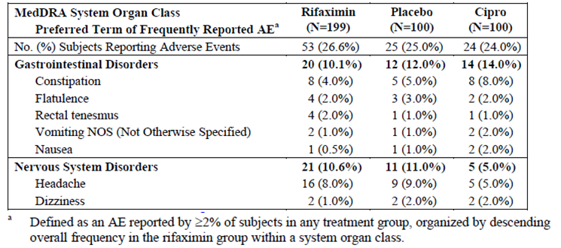
Table 16: Incidence of Severe Adverse Events: Safety Population, Study ESID0201.
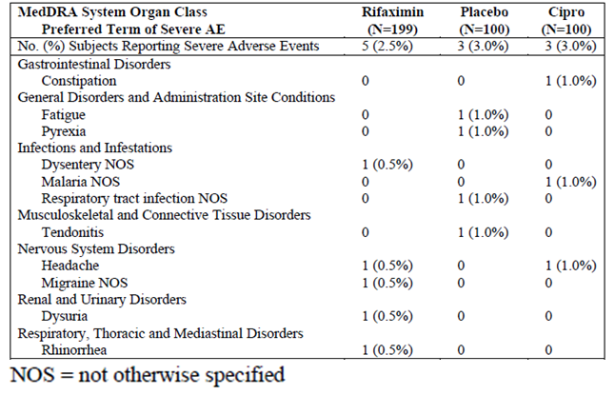
In study ESID9802, the percentages of subjects with any AEs were comparable among treatment groups (75.2%, 71.8% and 74.6% in the placebo, rifaximin 600mg [200mg t.i.d.] and rifaximin 1200mg [400mg t.i.d.] groups, respectively). AEs that occurred in > 3% of subjects in any treatment group are presented in Table 17. The most commonly reported AE by preferred term in the rifaximin groups was flatulence (25.8% and 28.6% in the rifaximin 600mg and 1200mg groups, respectively, vs. 32.6% in the placebo group), abdominal pain not otherwise specified (NOS) (16.9% and 22.2%, respectively, vs. 17.8% in the placebo group) and headache (12.0% and 17.5%, respectively, vs. 9.3% in the placebo group). For all but one AE preferred term (fatigue), incidence rates were similar among treatment groups and differences in rates by treatment group did not attain the nominal level of statistical significance (p < 0.05). Fatigue was reported for four subjects in the rifaximin 1200mg group versus none in the other groups (p = 0.023). The incidence of AEs of severe intensity was comparable across all treatment groups (19.4%, 15.3% and 19.0% in the placebo, rifaximin 600mg and rifaximin 1200mg groups, respectively). For the AE by preferred term of headache, the incidence of severe headache was low in the rifaximin groups (0.8% [1/124] and 1.6% [2/126] in the rifaximin 600mg and rifaximin 1200mg groups, respectively, vs. 1.6% [2/129] in the placebo group).
Table 17: Frequently Reported Adverse Events (Safety Population), Study ESID9802.
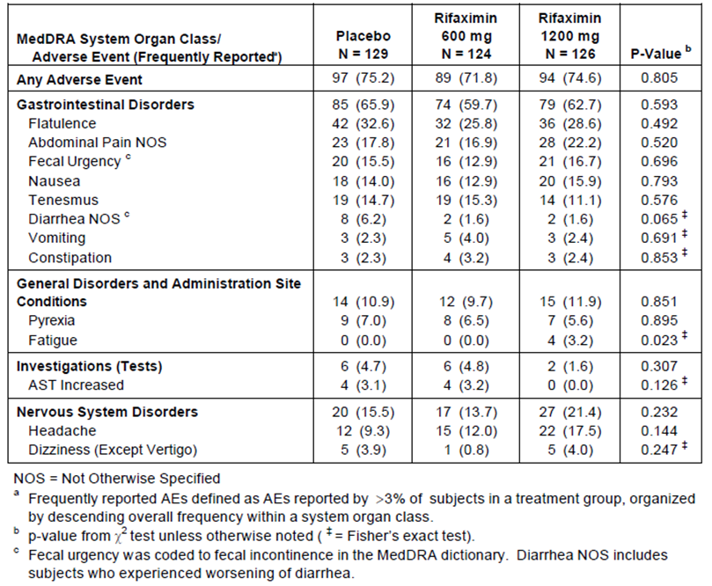
In study ESID9701, the percentages of subjects with any AEs were comparable between treatment groups (33.3% and 36.2% in the rifaximin [400mg b.i.d.] and Cipro [500mg b.i.d.] groups, respectively). AEs that occurred in at least 5 subjects overall are presented in Table 18. The most commonly reported AE by preferred term in the rifaximin group was headache (10.8% vs. 12.8% in the Cipro group) and constipation (6.5% vs. 2.1%). There were no significant differences between the treatment groups with respect to the incidence of AEs classified according to body system and preferred term (P ≥ 0.169).
Table 18: Incidence of Adverse Events for ITT Population, Study ESID9701.
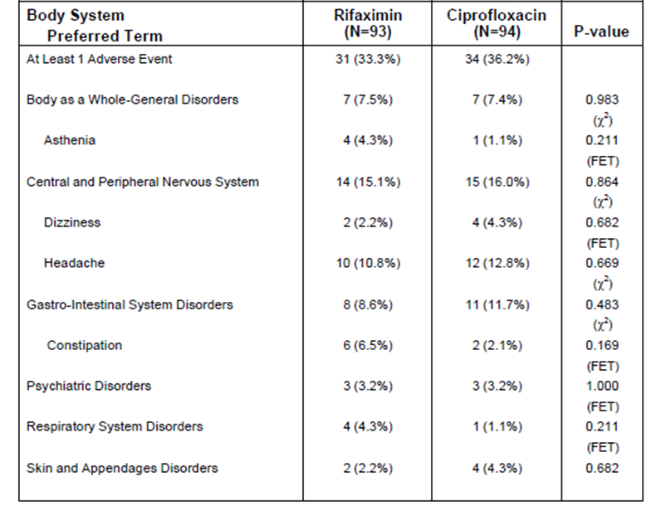
In study ESID9601, the percentages of subjects with any AEs were comparable among treatment groups (57.9% [11/19], 57.9% [11/19], 42.1% [8/19] and 57.9% [11/19] in the low rifaximin [200mg t.i.d.], mid rifaximin [400mg t.i.d.], high rifaximin [600mg t.i.d.] and TMP/SMX 160/800mg b.i.d. group, respectively). The most commonly reported AE by preferred term in the low rifaximin group was constipation (26.3% [5/19], 0%, 5.3% [1/19] and 26.3% [5/19] in the low rifaximin, mid rifaximin, high rifaximin and TMP/SMX group, respectively). The most commonly reported AE by preferred term in the mid rifaximin group was fatigue (10.5% [2/19], 26.3% [5/19], 5.3% [1/19] and 5.3% [1/19] in the low rifaximin, mid rifaximin, high rifaximin and TMP/SMX group, respectively). The most commonly reported AE by preferred term in the high rifaximin group was upper respiratory infection (15.8% [3/19], 5.3% [1/19], 21.1% [4/19] and 0% in the low rifaximin, mid rifaximin, high rifaximin and TMP/SMX group, respectively).
The sponsor has provided safety analyses based on pooled data from studies ESID0201 and ESID9802, comparing rifaximin 200mg t.i.d. with placebo. Results showed that the percentages of subjects with any AEs were comparable between the pooled rifaximin 200mg t.i.d. and pooled placebo groups (44.4% vs. 53.5%, p = 0.9521). The most commonly reported AE by preferred term in the pooled rifaximin group was flatulence (11.3% with rifaximin vs. 19.7% with placebo, p = 0.2263) and headache (9.7% vs. 9.2%, p = 0.7103). The majority of these AEs were reported to be mild or moderate in intensity. The proportion of subjects experiencing severe AEs was higher in the pooled placebo group (12.7%) compared with the pooled rifaximin group (7.5%). The most commonly reported severe AE by system organ class (SOC) in the pooled rifaximin group was in the SOC of gastrointestinal disorders (5.0% with rifaximin vs. 8.8% with placebo). The most commonly reported severe AE by preferred term in the pooled rifaximin group was abdominal pain NOS (1.6% with rifaximin vs. 3.1% with placebo) and flatulence (1.3% vs. 3.9%). The incidence of severe headache was low (0.6% with rifaximin vs. 0.9% with placebo).

Treatment-related adverse events (adverse drug reactions)

Pivotal studies
In study ESID0201, the percentages of subjects with any treatment-related AEs were comparable among treatment groups (10.6%, 10.0% and 14.0% in the rifamixin, placebo and Cipro groups, respectively). The most commonly reported treatment-related AE by preferred term in the rifaximin group was constipation (3.5% vs. 3.0% and 7.0% in the placebo and Cipro groups, respectively) and headache (3.5% vs. 3.0% and 2.0%, respectively).
In study ESID9802, the percentages of subjects with any treatment-related AEs were comparable among treatment groups (69.8%, 59.7% and 69.8% in the placebo, rifaximin 600mg and rifaximin 1200mg groups, respectively). The most commonly reported treatment-related AEs by preferred term in the rifaximin groups were flatulence (24.2% and 28.6% in the rifaximin 600mg and 1200mg groups, respectively, vs. 32.6% in the placebo group), abdominal pain NOS (15.3% and 20.6%, respectively, vs. 16.3% in the placebo group) and nausea (11.3% and 15.1%, respectively, vs. 14.0% in the placebo group). Treatment-related headache was reported in 8.1% and 15.1% of subjects in the rifaximin 600mg and 1200mg groups, respectively, compared with 7.8% in the placebo group.
In study ESID9701, the percentages of subjects with any treatment-related AEs were comparable between treatment groups (10.8% in the rifaximin group vs. 16.0% in the Cipro group, p = 0.296). A summary of treatment-related AEs by SOC or preferred term was not presented in the CSR, but a look through the individual patient data listing showed that the most commonly reported treatment-related AE by preferred term in the rifaximin group was headache (2.2% [2/93] vs. 3.2% [3/94] in the Cipro group).
Treatment-related AEs were not analysed or presented in the CSR for study ESID9601.
Analyses on pooled data from studies ESID0201 and ESID9802, comparing rifaximin 200mg t.i.d. with placebo, showed that there was no statistically significant difference in the percentages of subjects with any treatment-related AEs between the pooled rifaximin and pooled placebo groups (29.7% vs. 43.9%, p = 0.2365). The most commonly reported treatment-related AE by preferred term in the pooled rifaximin group was flatulence (9.7% with rifaximin vs. 19.3% with placebo, p = 0.1034) and headache (5.3% vs. 5.7%, p = 0.8100).

Deaths and other serious adverse events

Pivotal studies
There were no deaths reported in studies ESID0201, ESID9802, ESID9701 and ESID9601.
In study ESID0201, the percentage of subjects with any serious adverse events (SAEs) was comparable among treatment groups (0.5% [1/199], 1.0% [1/100] and 0% in the rifamixin, placebo and Cipro groups, respectively). Two subjects (1 rifaximin, 1 placebo) experienced 3 SAEs. None of these SAEs were considered to be treatment-related. In study ESID9802, only 1 patient (in placebo group) reported an SAE (severe diarrhoea). In study ESID9701, no SAEs were reported. SAEs were not analysed or presented in the CSR for study ESID9601.

Discontinuation due to adverse events

Pivotal studies
In study ESID0201, the percentage of subjects with any AEs leading to discontinuation of study drug was comparable among treatment groups (2.0%, 2.0% and 3.0% in the rifamixin, placebo and Cipro groups, respectively). No AEs leading to discontinuation of study drug (preferred term) was reported by > 1 subject each.
In study ESID9802, only 1 patient (in rifaximin 600mg group) reported an AE leading to discontinuation of study drug. Patient was a [information redacted] who received full study treatment on Day 1. After taking 3 doses, the patient began to have severe loss of taste and moderate feeling of malaise with lack of appetite. The patient stopped the study medication without informing the study physician because he attributed the events to the study medication and also because the diarrhoeal symptoms had improved. The patient subsequently recovered from these AEs. In study ESID9701, only 1 patient (in Cipro group) reported an AE leading to discontinuation of study drug (rash; considered possibly related to study drug). In study ESID9601, no AEs leading to discontinuation of study drug were reported.

Laboratory tests

Haematology, blood chemistry and urinalysis

Pivotal studies
In studies ESID0201 and ESID9701, haematology and urinalysis results did not raise any safety concerns. In studies ESID9802 and ESID9601, haematology, clinical chemistry and urinalysis results did not raise any safety concerns.

Post-marketing experience
The sponsor had provided 3 periodic safety update reports (PSURs) covering the periods 23 April 1985 (date of first international authorisation of rifaximin) to 31 May 2011, 29 November 2012 to 29 May 2013, and 30 May 2013 to 29 November 2013. These PSUR did not lead to significant safety concerns.

Evaluator’s overall conclusions on clinical safety
Overall, safety results did not raise any major safety concerns and are consistent with known safety profile of rifaximin. Safety results of rifaximin submitted in this application are consistent with those reported in the currently approved Australian PI for rifaximin. Results in the pivotal studies were generally comparable between rifaximin and placebo. In study ESID0201, the percentages of subjects with any AEs (26.6% with rifaximin 200mg t.i.d. vs. 25.0% with placebo), treatment-related AEs (10.6% vs. 10.0%), SAEs (0.5% vs. 1.0%), and AEs leading to discontinuation of study drug (2.0% vs. 2.0%) were comparable between the rifaximin and placebo groups. This was supported by results in study ESID9802, showing that the percentage of subjects with any AEs was 71.8% with rifaximin 200mg t.i.d. vs. 75.2% with placebo, and the percentage of subjects with any treatment-related AEs was 59.7% with rifaximin 200mg t.i.d. vs. 69.8% with placebo. No subject in the rifaximin 200mg t.i.d. group reported any SAE, compared with 1 in the placebo group. One subject in the rifaximin 200mg t.i.d. group reported an AE leading to discontinuation of study drug, compared with none in the placebo group.
Comparison of rifaximin with standard treatment for travellers’ diarrhoea (ciprofloxacin) showed that safety results in the pivotal studies were generally comparable between the 2 treatments. In study ESID0201, the percentages of subjects with any AEs (26.6% with rifaximin 200mg t.i.d. vs. 24.0% with ciprofloxacin 500mg b.i.d.), treatment-related AEs (10.6% vs. 14.0%), SAEs (0.5% vs. 0%), and AEs leading to discontinuation of study drug (2.0% vs. 3.0%) were comparable between the rifaximin and ciprofloxacin groups. This was supported by results in study ESID9701 comparing rifaximin 400mg b.i.d. with ciprofloxacin 500mg b.i.d., showing that the percentage of subjects with any AEs was 33.3% with rifaximin vs. 36.2% with ciprofloxacin, and the percentage of subjects with any treatment-related AEs was 10.8% with rifaximin vs. 16.0% with ciprofloxacin (p = 0.296). No subjects in either group reported any SAEs. No subject in the rifaximin group reported any AE leading to discontinuation of study drug compared with 1 in the ciprofloxacin group.
Safety results submitted in this application are consistent with known safety profile of rifaximin. Analyses on pooled data from studies ESID0201 and ESID9802, comparing rifaximin 200mg t.i.d. with placebo, showed that the most commonly reported treatment-related AE by preferred term in the pooled rifaximin group was flatulence (9.7% with rifaximin vs. 19.3% with placebo, p = 0.1034) and headache (5.3% vs. 5.7%, p = 0.8100).

First round benefit-risk assessment

First round assessment of benefits
The benefits of rifaximin in the proposed usage for treatment of adult patients with travellers' diarrhoea caused by non-invasive enteric bacteria are:
- Broad spectrum antibiotic that acts locally in the gastrointestinal lumen with minimal systemic absorption is of clinical benefit.
Although travellers’ diarrhoea is generally a self-limiting disease in healthy adults, pharmacological treatments which shorten the duration of illness and reduce morbidity can have economic and social benefits. When antibiotics are used in the treatment of diarrhoea, quinolones such as ciprofloxacin are usually the antibiotics of choice. However, the use of systemic antibiotics could increase the risk of systemic adverse effects as well as antibiotic resistance. Hence, the availability of a broad-spectrum antibiotic that acts locally in the gastrointestinal lumen with minimal systemic absorption is of clinical benefit.
Efficacy results supported the efficacy of a 3-day regimen of rifaximin 200mg t.i.d. over placebo in terms of rapidity of return to normal formed stools and the improvement of symptoms.
- there was a statistically significantly shorter median TLUS with rifaximin 200mg t.i.d. treatment for 3 days compared with placebo (study ESID0201: 32.0 hours vs. 65.5 hours, p = 0.0014; study ESID9802: 32.5 hours vs. 60.0 hours, p = 0.0001).
- there was a statistically significantly smaller number of unformed stools passed after the first dose of study medication with rifaximin compared to placebo in both study ESID0201 (p = 0.0002) and study ESID9802 (p = 0.0001).
- in study ESID0201, a statistically significantly higher proportion of subjects in the rifaximin group than the placebo group showed improvement in diarrhoeal syndrome during the 48 to 72-hour interval (89.1% vs. 79.5%, p = 0.0346) and the 72 to 96-hour interval (92.9% vs. 83.8%, p = 0.0250). In study ESID9802, a statistically significantly higher proportion of subjects had improvement in diarrhoeal syndrome in the rifaximin 200mg t.i.d. group versus the placebo group in the 24 – 48 hour interval (87.1% vs.72.9%, p = 0.007) and in the 48 – 72 hour intervals (91.3% vs. 78.8%, p = 0.008).
- there was a statistically significantly higher proportion of subjects achieving wellness with rifaximin compared to placebo (study ESID0201: 76.6% vs. 61.4%, p = 0.0039; study ESID9802: 79.2% vs. 60.5%, p = 0.001), and a statistically significantly lower proportion of subjects with treatment failure with rifaximin compared to placebo (study ESID0201: 14.7% vs. 26.7%, p = 0.0115; study ESID9802: 16.0% vs. 34.9%, p = 0.001).
In addition, the minimal systemic absorption of rifaximin has contributed to a largely benign safety profile.

First round assessment of risks
The risks of rifaximin in the proposed usage are:
- Gastrointestinal symptoms e.g. flatulence, constipation
- Headache
Overall, safety results did not raise any major safety concerns and are consistent with known safety profile of rifaximin. Safety results of rifaximin submitted in this application are consistent with those reported in the currently approved Australian PI for rifaximin. In addition, results in the pivotal studies were generally comparable between rifaximin and placebo.
Analyses on pooled data from studies ESID0201 and ESID9802, comparing rifaximin 200mg t.i.d. with placebo, showed that the most commonly reported treatment-related AE by preferred term in the pooled rifaximin 200mg t.i.d. group was flatulence (9.7% with rifaximin vs. 19.3% with placebo, p = 0.1034) and headache (5.3% vs. 5.7%, p = 0.8100). Overall, the AEs (all-causality) of flatulence and headache were of mostly of mild or moderate in intensity. Severe flatulence was reported in 1.3% of subjects in the pooled rifaximin group (vs. 3.9% in pooled placebo group), while severe headache was reported in 0.6% in the pooled rifaximin group (vs. 0.9% in pooled placebo group).

First round assessment of benefit-risk balance
The benefit-risk balance of rifaximin, given the proposed usage, is favourable.
Efficacy results supported the efficacy of 3-day regimen of rifaximin 200mg t.i.d. over placebo in terms of rapidity of return to normal formed stools (median TLUS of 32 to 33 hours with rifaximin compared with 60 to 66 hours with placebo p ≤ 0.0014) as well as the improvement of symptoms (statistically significantly smaller number of unformed stools passed; statistically significantly higher proportion of subjects with improvement in diarrhoeal syndrome; statistically significantly higher proportion of subjects achieving wellness; statistically significantly lower proportion of subjects with treatment failure).
Overall, safety results did not raise any major safety concerns, were generally comparable between rifaximin and placebo, and are consistent with known safety profile of rifaximin.

First round recommendation regarding authorisation
It is recommended that the application to extend the indications of rifaximin for the use of rifaximin 200mg tablets for the treatment of adult patients with travellers' diarrhoea caused by non-invasive enteric bacteria, be approved. This is subject to satisfactory response to the queries raise.

References
DuPont HL, Ericsson CD. Prevention and treatment of traveller’s diarrhea. N Engl J Med. 328:1821-7, 1993.
DuPont HL, et al. General guidelines for the evaluation of new anti-infective drugs for the treatment of gastrointestinal infection – evaluation of new anti-infective drugs for the treatment of acute infectious diarrhea. Clin Infect Dis. 15 (Suppl. 1):5228-35, 1992.
European Medicines Agency, Guideline on the evaluation of medicinal products indicated for treatment of bacterial infections. 15 December 2011.
ICH Efficacy Guidelines. E9: Statistical Principles for Clinical Trials. September 1998. http://www.emea.europa.eu/docs/en_GB/document_library/Scientific_guideline/2009/09/WC500002928.pdf (assessed 20th March 2014)
Lawler JV, Wallace MR. Diagnosis and Treatment of Bacterial Diarrhea. Curr Gastroenterol Rep. 5:287-94, 2003.

Therapeutic Goods Administration
PO Box 100 Woden ACT 2606 Australia
Email: info@tga.gov.au Phone: 1800 020 653 Fax: 02 6232 8605
https://www.tga.gov.au

The pre- and post-treatment MIC90 for coliforms growing on rifaximin- or rifampicin-containing agar was 64 mg/L, in all 3 treatment groups (rifaximin 200 mg t.i.d., 400 t.i.d. or placebo).
European Medicines Agency, Guideline on the evaluation of medicinal products indicated for treatment of bacterial infections. 15 December 2011.
Australian Product Information, Ciprofloxacin, May 2012.
Centres with fewer than 5 ITT subjects per treatment group were pooled with the geographically nearest centre in order to create analysis centres of sufficient size for the statistical analysis of potential centre effects and treatment-by-centre interactions.

