This medicinal product is subject to additional monitoring in Australia. This will allow quick identification of new safety information. Healthcare professionals are asked to report any suspected adverse events at [www.tga.gov.au/reporting-problems](http://www.tga.gov.au/reporting-problems).

▼

# Australian Product Information – QINLOCK™ (ripretinib) TABLETS

# Name of the medicine

Ripretinib

# Qualitative and quantitative composition

Each QINLOCK tablet contains 50 mg of ripretinib.

Ripretinib is a white to off-white crystalline solid. Ripretinib is a lipophilic, weak base compound, practically insoluble in aqueous media.

Excipients with known effect: lactose.

For the full list of excipients, see Section 6.1 List of Excipients.

# Pharmaceutical form

QINLOCK tablets are white to off-white oval shaped tablets debossed with 'DC1' on one side.

# Clinical particulars

## Therapeutic indications

QINLOCK is a kinase inhibitor indicated for the treatment of adult patients with advanced gastrointestinal stromal tumours (GIST) who have received prior treatment with 3 or more kinase inhibitors, including imatinib.

## Dose and method of administration

### Dosage

The recommended dosage of QINLOCK is 150 mg (three 50 mg tablets) orally once daily with or without food until disease progression or unacceptable toxicity.

Instruct patients to swallow tablets whole.

Advise patients to take QINLOCK at the same time each day.

Advise patients to take a missed dose if less than 8 hours have passed since the missed scheduled dose.

Advise patients not to take an additional dose if vomiting occurs after taking QINLOCK and to continue with their next scheduled dose.

### Dose modification guidelines

The recommended dose reduction for adverse reactions is:

* QINLOCK 100 mg orally once daily.

Permanently discontinue QINLOCK in patients who are unable to tolerate 100 mg orally once daily.

The recommended dosage modifications of QINLOCK for adverse reactions are provided in Table 1.

Interrupt dosing or reduce dose for toxicities. See for dose modification guidelines.

**Table 1: Recommended Dose Modifications for QINLOCK**

| **Adverse Reaction** | **Severitya** | **Dosage Modifications** |
| --- | --- | --- |
| Palmar-Plantar Erythrodysaesthesia Syndrome [PPES]) [see Section 4.4 Special Warnings and Precautions for Use] | Grade 2 | * Withhold QINLOCK until Grade ≤1 or baseline. If recovered within 7 days, resume QINLOCK at same dose; otherwise resume at reduced dose. * Consider re‑escalating QINLOCK if maintained at Grade ≤1 or baseline for at least 28 days. * If PPES recurs, withhold QINLOCK until Grade ≤1 or baseline and then resume QINLOCK at a reduced dose regardless of time to improvement. |
| Grade 3 | * Withhold QINLOCK for at least 7 days or until Grade ≤1 or baseline (maximum 28 days). Resume QINLOCK at a reduced dose. * Consider re-escalating QINLOCK if maintained at Grade ≤1 or baseline for at least 28 days. |
| Hypertension [see Section 4.4 Special Warnings and Precautions for Use] | Grade 3 | * If symptomatic, withhold QINLOCK until symptoms have resolved and blood pressure is controlled. * If blood pressure is controlled to Grade ≤1 or baseline, resume QINLOCK at the same dose; otherwise, resume QINLOCK at reduced dose. * If Grade 3 hypertension recurs, withhold QINLOCK until symptoms have resolved and blood pressure is controlled. Resume QINLOCK at a reduced dose. |
| Grade 4  Life-threatening consequences (e.g., malignant hypertension, transient or permanent neurologic deficit, hypertensive crisis) | Permanently discontinue QINLOCK. |
| Left Ventricular Systolic Dysfunction [see Section 4.4 Special Warnings and Precautions for Use] | Grade 3 or 4 | Permanently discontinue QINLOCK. |
| Arthralgia or Myalgia | Grade 2 | * Withhold QINLOCK until Grade ≤1 or baseline. If recovered within 7 days, resume QINLOCK at same dose; otherwise resume QINLOCK at reduced dose. * Consider re-escalating QINLOCK if maintained at Grade ≤1 or baseline for at least 28 days. * If arthralgia or myalgia recurs, withhold QINLOCK until Grade ≤1 or baseline and then resume QINLOCK at a reduced dose regardless of time to improvement. |
| Grade 3 | * Withhold QINLOCK for at least 7 days or until Grade ≤1 or baseline (maximum of 28 days). Resume QINLOCK at a reduced dose. * Consider re-escalating QINLOCK if maintained at Grade ≤1 or baseline for at least 28 days. |
| Other adverse reactions | Grade 3 or 4 | * Withhold QINLOCK until Grade ≤1 or baseline (maximum 28 days), and then resume QINLOCK at a reduced dose; otherwise permanently discontinue. * Consider re‑escalating QINLOCK if no recurrence of the adverse reaction for at least 28 days. * If Grade 3 or 4 recurs, permanently discontinue QINLOCK. |
| 1. Graded per National Cancer Institute Common Terminology Criteria for Adverse Events (NCI CTCAE v4.03). | | |

***Paediatrics***

The safety and effectiveness of QINLOCK in paediatric patients have not been established.

***Patients with renal impairment***

No dose adjustment is recommended for patients with mild and moderate renal impairment [creatinine clearance (CLCr 30 to 89 mL/min estimated by Cockcroft-Gault)]. The pharmacokinetics and safety of QINLOCK in patients with severe renal impairment (ClCr 15 to 29 mL/min estimated by Cockcroft-Gault) have not been studied.

***Patients with hepatic impairment***

No dose adjustment is recommended in patients with mild hepatic impairment (total bilirubin ≤ 1 x ULN and AST > 1 x ULN, or total bilirubin 1.0 to 1.5 x ULN and AST any). The pharmacokinetics and safety of QINLOCK in patients with moderate to severe hepatic impairment (total bilirubin >1.5 × ULN, AST any) have not been studied.

## Contraindications

Use of QINLOCK is contraindicated in patients with hypersensitivity to ripretinib or to any other component of QINLOCK tablets.

## Special warnings and precautions for use

### Palmar-Plantar Erythrodysaesthesia Syndrome

In the double-blind period of a randomised, placebo-controlled phase 3 trial (INVICTUS), Grade 1-2 palmar-plantar erythrodysaesthesia syndrome (PPES) occurred in 21% of the 85 patients who received QINLOCK [see Section 4.8 Adverse Effects (Undesirable Effects)]. PPES led to dose discontinuation in 1.2% of patients, dose interruption in 2.4% of patients, and dose reduction in 1.2% of patients.

Based on severity, withhold QINLOCK and then resume at same or reduced dose [see Section 4.2 Dosage and Administration].

### New Primary Cutaneous Malignancies

In INVICTUS, cutaneous squamous cell carcinoma (cuSCC) occurred in 4.7% of the 85 patients who received QINLOCK, with a median time to event of 4.6 months (range: 3.8 to 6 months). In the pooled safety population, cuSCC and keratoacanthoma occurred in 7% and 1.9% of 351 patients, respectively.

In INVICTUS, melanoma occurred in 2.4% of the 85 of patients who received QINLOCK. In the pooled safety population, melanoma occurred in 0.9% of 351 patients.

Perform dermatologic evaluations when initiating QINLOCK and routinely during treatment. Manage suspicious skin lesions with excision and dermatopathologic evaluation. Continue QINLOCK at the same dose.

### Hypertension

In INVICTUS, Grade 1-3 hypertension occurred in 14% of the 85 patients who received QINLOCK, including Grade 3 hypertension in 7% [see Section 4.8 Adverse Effects (Undesirable Effects)].

Do not initiate QINLOCK in patients with uncontrolled hypertension. Adequately control blood pressure prior to initiating QINLOCK. Monitor blood pressure as clinically indicated during treatment with QINLOCK, and initiate or adjust antihypertensive therapy as appropriate.

Based on severity, withhold QINLOCK and then resume at same or reduced dose or permanently discontinue [see Section 4.2 Dosage and Administration].

### Cardiac Dysfunction

In INVICTUS, cardiac failure occurred in 1.2% of the 85 patients who received QINLOCK. In the pooled safety population, cardiac dysfunction (including cardiac failure, acute left ventricular failure, diastolic dysfunction, and ventricular hypertrophy) occurred in 1.7% of 351 patients, including Grade 3 adverse reactions in 1.1%.

In INVICTUS, Grade 3 decreased ejection fraction occurred in 2.6% of the 77 patients who received QINLOCK and who had a baseline and at least one post-baseline echocardiogram. In the pooled safety population, Grade 3 decreased ejection fraction occurred in 3.4% of the 263 patients in the pooled safety population who received QINLOCK and who had a baseline and at least one post-baseline echocardiogram.

In INVICTUS, cardiac dysfunction led to dose discontinuation in 1.2% of the 85 patients who received QINLOCK. The safety of QINLOCK has not been assessed in patients with a baseline ejection fraction below 50%.

Assess ejection fraction by echocardiogram or MUGA scan prior to initiating QINLOCK and during treatment, as clinically indicated. Permanently discontinue QINLOCK for Grade 3 or 4 left ventricular systolic dysfunction [see Section 4.2 Dosage and Administration].

### Use in the elderly

Of the 85 patients in INVICTUS who received QINLOCK 150 mg orally once daily, 24% were between 65 to 74 years of age and 9% were 75 years of age or older. Clinical studies of QINLOCK did not include sufficient numbers of patients aged 65 and older to determine whether they respond differently from younger patients.

### Paediatric use

The safety and effectiveness of QINLOCK in paediatric patients have not been established.

### Effects on laboratory tests

See Section 4.8 Adverse effects (Undesirable effects).

## Interactions with other medicines and other forms of interactions

**Effect of other medications on QINLOCK**

Since both ripretinib and its active metabolite are mainly cleared by CYP3A, plasma concentrations of ripretinib and the active metabolite DP-5439 are expected to be increased by CYP3A inhibitors and decreased by CYP3A inducers.

**Effect of Strong CYP3A Inhibitors:** Coadministration of itraconazole (a strong CYP3A inhibitor) increased ripretinib Cmax by 36% and AUC∞ by 99%. Strong CYP3A inhibitors should be used with caution and patients should be monitored.

Ripretinib and its active metabolite DP-5439 are substrates of P-gp (MDR1) and BCRP, as indicated by *in vitro* studies. P-gp inhibitors may increase plasma concentrations of ripretinib and its active metabolite DP-5439.

**Effect of Acid-Reducing Agents**: Coadministration of pantoprazole (a proton pump inhibitor) did not affect exposure to ripretinib.

**Effect of QINLOCK on other medications**

Ripretinib and DP-5439 are inhibitors of CYP2C8. Ripretinib is expected to increase clinical exposures of drugs that are predominantly cleared by CYP2C8.

## Fertility, pregnancy and lactation

### Effects on fertility

Based on findings from animal studies, QINLOCK may impair fertility in males of reproductive potential. Decreased testis and epididymis weights, as well as atrophy of the testes and degeneration of the seminiferous epithelium were observed in male rats at exposure levels (AUC) similar to the human exposure at 150 mg once daily.

### Use in pregnancy

**Category D**

There are no clinical data on the use of QINLOCK in pregnant women to inform a drug‑associated risk of major birth defects and miscarriage.

Based on findings from animal studies, QINLOCK can cause embryo-fetal harm when administered to a pregnant woman. QINLOCK should not be used during pregnancy.

QINLOCK should not be used during pregnancy. In an embryo-fetal development study in which pregnant rats were administered daily doses of ripretinib during organogenesis, ripretinib was given from gestational days 6 through 18 at doses 1, 5, or 20 mg/kg/day. Dose-related malformations primarily associated with the cardiovascular and skeletal systems were observed at a dose of 20 mg/kg/day (approximately 0.4 times the human exposure at 150 mg once daily).

An increased incidence of anatomic variations, indicative of developmental toxicity, also occurred at 20 mg/kg/day. Variations included malpositioned carotid and subclavian artery origins, malpositioned subclavian artery, absent or elongated innominate artery, misshapen and nodulated ribs; bipartite, incompletely ossified, or unossified vertebral centra, small or misshapen vertebral arches, and reductions in ossified forelimb and hindlimb phalanges, hindlimb metatarsals, and caudal vertebrae were also observed at 20 mg/kg/day.

Verify the pregnancy status of females of reproductive potential prior to initiating QINLOCK . Advise female patients of reproductive potential to use effective contraception during treatment and for at least 1 week after the final dose. Advise male patients with female partners of reproductive potential to use effective contraception during treatment and for at least 1 week after the final dose.

### Use in lactation

There are no data regarding the presence of ripretinib or its metabolites in human milk or their effects on the breastfed infant or on milk production. Because of the potential for adverse reactions in breastfed infants, advise women not to breastfeed during treatment with ripretinib and for at least 1 week after the final dose.

## Effects on ability to drive and use machines

No data available.

## Adverse effects (Undesirable effects)

### Summary of the safety profile

In the Phase 3 double-blind, randomised (2:1), placebo-controlled trial (INVICTUS), 129 study participants with a diagnosis of advanced GIST were randomised to QINLOCK (n=85) or placebo (n=44) [see Section 5.1 Clinical trials]. The data described in this section reflect the safety population (n=128) who had received at least one dose of QINLOCK (n=85) or placebo (n=43). One study participant who was randomised to the placebo arm did not receive placebo. The safety results from the double-blind treatment period of INVICTUS are described below.

The most common adverse events (≥20%) observed in patients treated with QINLOCK (all grades) were alopecia, fatigue, nausea, abdominal pain, constipation, myalgia, diarrhea, decreased appetite, palmar-plantar erythrodysaesthesia syndrome (PPES)~~,~~ and vomiting. The most common Grade 3 or 4 laboratory abnormalities were increased lipase and decreased phosphate.

### Tabulated list of adverse events

Table 2 summarizes the most frequently reported treatment-emergent adverse events (TEAEs) in ≥10% of patients with advanced GIST who received QINLOCK in the double-blind treatment period of INVICTUS.

**Table 2: Treatment-Emergent Adverse Events (TEAEs) Reported in ≥10% of Patients Who Received QINLOCK with a Difference Between Arms of >5% Compared to Placebo in INVICTUS**

|  |  |  |  |  |
| --- | --- | --- | --- | --- |
| **Treatment-Emergent Adverse Events** | **QINLOCK (N=85)** | | **Placebo  (N=43)** | |
| **Grades 1-4** | **Grades 3-4** | **Grades 1-4** | **Grades 3-4** |
| **Skin and subcutaneous tissue** | | | | |
| Alopecia | 52 | 0 | 4.7 | 0 |
| Palmar-plantar erythrodysaesthesia syndrome | 21 | 0 | 0 | 0 |
| Dry skin | 13 | 0 | 7 | 0 |
| Pruritus | 11 | 0 | 4.7 | 0 |
| **General** | | | | |
| Fatigue | 42 | 3.5 | 23 | 2.3 |
| Peripheral edema | 17 | 1.2 | 7 | 0 |
| Asthenia | 13 | 1.2 | 14 | 4.7 |
| **Gastrointestinal** | | | | |
| Nausea | 39 | 3.5 | 12 | 0 |
| Abdominal pain | 36 | 7 | 30 | 4.7 |
| Constipation | 34 | 1.2 | 19 | 0 |
| Diarrhea | 28 | 1.2 | 14 | 2.3 |
| Vomiting | 21 | 3.5 | 7 | 0 |
| Stomatitis | 11 | 0 | 0 | 0 |
| **Musculoskeletal and connective tissue** | | | | |
| Myalgia | 32 | 1.2 | 12 | 0 |
| Arthralgia | 18 | 0 | 4.7 | 0 |
| Muscle spasms | 15 | 0 | 4.7 | 0 |
| **Metabolism and nutrition** | | | | |
| Decreased appetite | 27 | 1.2 | 21 | 2.3 |
| **Investigations** | | | | |
| Decreased weight | 19 | 0 | 12 | 0 |
| **Nervous system** | | | | |
| Headache | 19 | 0 | 4.7 | 0 |
| **Vascular** | | | | |
| Hypertension | 14 | 7 | 4.7 | 0 |
| **Respiratory, thoracic and mediastinal** | | | | |
| Dyspnea | 13 | 0 | 0 | 0 |

Table 3 summarises the most frequently reported treatment-emergent laboratory abnormalities in ≥10% of patients with advanced GIST who received QINLOCK in the double-blind treatment period of INVICTUS.

**Table 3: Laboratory Abnormalities Reported in ≥10% of Patients Who Received QINLOCK in the Double-Blind Treatment Period of INVICTUSa**

|  |  |  |  |  |
| --- | --- | --- | --- | --- |
| **Laboratory Abnormality** | **QINLOCKa (N=85)** | | **Placeboa  (N=43)** | |
| **Grades 1-4** | **Grades 3-4b** | **Grades 1-4** | **Grades 3-4** |
| **Hematology** | | | | |
| Increased activated partial thromboplastin time | 35 | 0 | 9 | 0 |
| Increased INR | 21 | 3.8 | 15 | 0 |
| Decreased neutrophil count | 10 | 0 | 2.5 | 0 |
| **Chemistry** | | | | |
| Increased lipase | 32 | 7 | 13 | 8 |
| Decreased phosphate | 26 | 4.9 | 2.5 | 0 |
| Increased triglycerides | 26 | 2.4 | 23 | 0 |
| Decreased calcium | 23 | 0 | 8 | 0 |
| Increased blood bilirubin | 22 | 0 | 5 | 2.5 |
| Increased CPK | 21 | 1.2 | 10 | 0 |
| Decreased sodium | 17 | 2.4 | 10 | 2.5 |
| Increased creatinine | 16 | 0 | 18 | 0 |
| Increased serum amylase | 13 | 1.2 | 5 | 0 |
| Increased ALT | 12 | 1.2 | 5 | 0 |
| CPK=creatine phosphokinase; INR=international normalized ratio; AST=aspartate aminotransferase; ALT=alanine aminotransferase   1. The denominator used to calculate the rate varied from 82 to 83 for QINLOCK and 34 to 40 for placebo based on the number of patients with a baseline value and at least one post-treatment value. 2. Only includes Grade 3 laboratory abnormalities. | | | | |

|  |  |  |
| --- | --- | --- |
| **Table 4: Dose Interruptions, Dose Reductions, and Treatment Discontinuations due to Adverse Reactions** | | |
| **Event** | **QINLOCK (N=85)**  % | **Placebo  (N=43)**  % |
| Dose interruption | 23.5 | 20.9 |
| Dose reduction | 7.1 | 2.3 |
| Treatment discontinuation | 8.2 | 11.6 |

### Reporting suspected adverse effects

Reporting suspected adverse reactions after registration of the medicinal product is important. It allows continued monitoring of the benefit-risk balance of the medicinal product. Healthcare professionals are asked to report any suspected adverse reactions at [www.tga.gov.au/reporting-problems](http://www.tga.gov.au/reporting-problems).

## Overdose

There is no known specific antidote for QINLOCK overdose. In the event of suspected overdose, interrupt QINLOCK, undertake general supportive measures, and observe until clinical stabilisation.

For information on the management of overdose, contact the Poisons Information Centre on 13 11 26 (Australia).

# Pharmacological properties

## Pharmacodynamic properties

### Mechanism of action

Ripretinib is a switch-control tyrosine kinase inhibitor with a dual mechanism of action. Ripretinib binds to both the switch pocket and the activation loop to lock the kinase in the inactive state, preventing downstream signalling and cell proliferation. This dual mechanism of action provides broad inhibition of KIT and PDGFRA kinase activity, including wild type and multiple primary and secondary mutations. Ripretinib also inhibits other kinases *in vitro*, such as PDGFRB, TIE2, VEGFR2, and BRAF.

***Cardiac Electrophysiology***

Following treatment with QINLOCK 150 mg once daily, no clinically meaningful QT interval prolongation was observed.

### Clinical trials

The efficacy of QINLOCK was evaluated in INVICTUS, an international, multi-centre, randomised (2:1), double-blind, placebo-controlled trial. Eligible patients had unresectable, locally advanced or metastatic gastrointestinal stromal tumour (GIST) and had received prior treatment with imatinib, sunitinib, and regorafenib. Randomization was stratified by prior lines of therapy (3 versus ≥4) and Eastern Cooperative Oncology Group (ECOG) performance status (0 versus 1 or 2). Patients received QINLOCK 150 mg or placebo orally once daily until disease progression or unacceptable toxicity. Tumour response assessments were performed every 28 days through for the first 4 months and then every 56 days thereafter.

The major efficacy outcome measure was progression-free survival (PFS) based on disease assessment by blinded independent central review (BICR) using modified RECIST 1.1 criteria, in which lymph nodes and bone lesions were not target lesions and a progressively growing new tumour nodule within a pre-existing tumour mass must meet specific criteria to be considered unequivocal evidence of progression. Additional efficacy outcome measures included objective response rate (ORR) by BICR and overall survival (OS). Patients randomised to receive placebo could be treated with QINLOCK at the time of disease progression.

A total of 129 patients were randomised, 85 to QINLOCK and 44 to placebo.

Patient characteristics of the intent-to-treat (ITT) population in INVICTUS were median age of 60 years (range: 29 to 83 years), with 39% aged ≥65 years; 57% were male; 75% were White; and 92% had an ECOG performance status of 0 or 1. Sixty-three percent (63%) of patients received 3 prior therapies and 37% received 4 or more prior therapies. Sixty-six percent (66%) of patients randomised to placebo switched to QINLOCK after disease progression.

Efficacy results from INVICTUS are summarised in Table 5.

**Table 5. Efficacy Results of INVICTUS**

|  | **QINLOCK (N=85)** | **Placebo (N=44)** |
| --- | --- | --- |
| **Progression-Free Survival (PFS)a** | | |
| Number of events (%) | 51 (60) | 37 (84) |
| Progressive disease | 46 (54) | 32 (73) |
| Deaths | 5 (6) | 5 (11) |
| Median PFS (months) (95% CI) | 6.3 (4.6, 6.9) | 1.0 (0.9, 1.7) |
| Hazard ratio (95% CI)b | 0.15 (0.09, 0.25) | |
| p~~-~~valuec | < 0.0001 | |
| **Overall Response Rate (ORR)a** | | |
| OverallResponse Rate (%) | 9 | 0 |
| (95%, CI) | (4.2, 18) | (0, 8) |
| p-valued | 0.0504 | |
| **Overall Survival (OS)e** | | |
| Number of Deaths, N (%) | 26 (31) | 26 (59) |
| Median OS (months) (95% CI)~~e~~ | 15.1 (12.3, 15.1) | 6.6 (4.1, 11.6) |
| Hazard Ratio (95% CI)c | 0.36 (0.21, 0.62) | |
| BICR=Blinded Independent Central Review; CI=Confidence Interval Assessed per BICR  Hazard ratio is based on Cox proportional hazards regression model. This model includes treatment and randomisation stratification factors as fixed factors.   1. p-value is based on 2-sided stratified Log Rank test. 2. Based on Fisher’s exact test. The p-value is not statistically significant. 3. Not evaluated for statistical significance as a result of the sequential testing procedure for the secondary endpoints of ORR and OS. | | |

**Figure 1: Kaplan-Meier Curve of Progression-Free Survival in INVICTUS**

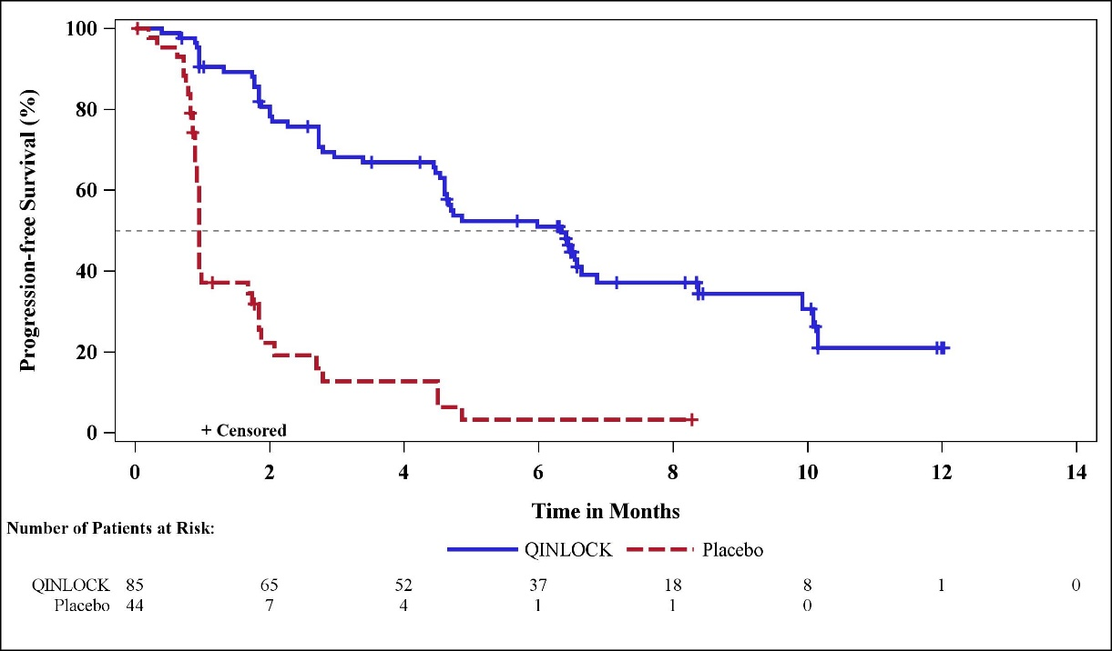

**Figure 2: Kaplan-Meier Curve of Overall Survival in INVICTUS**

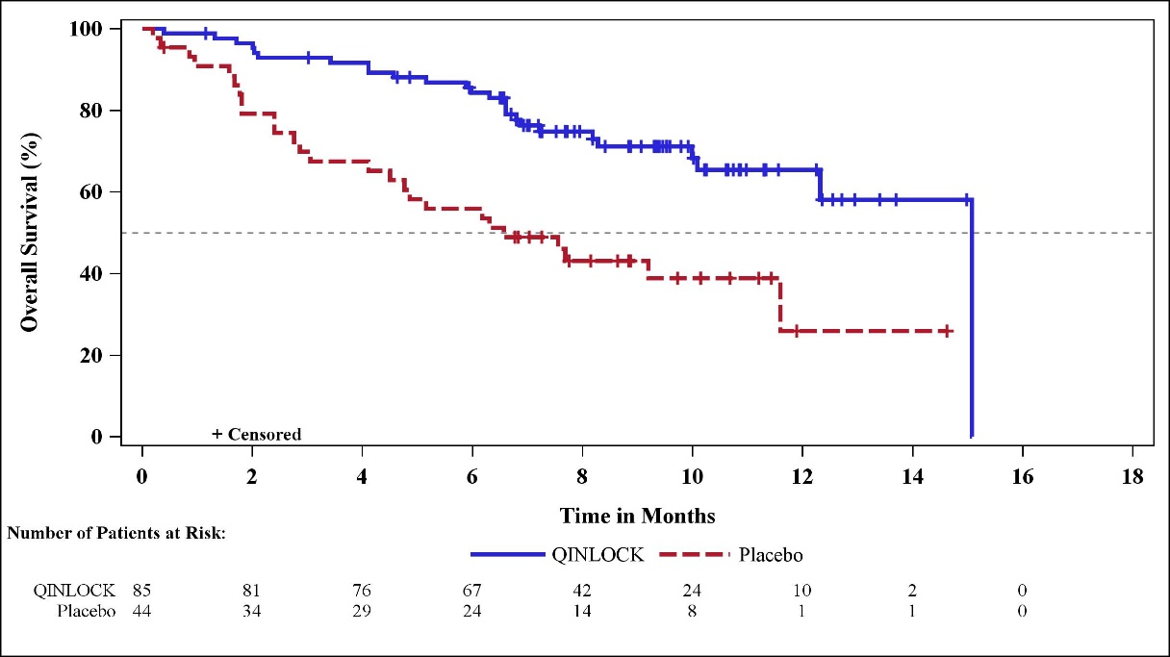

## Pharmacokinetic properties

### Absorption

Ripretinib reaches peak plasma concentrations at 4 hours after a single oral dose of 150 mg ripretinib (given as three tablets each containing 50 mg). The steady state AUC0-12h observed in patients at 150 mg is 5678 ng•h/mL. Steady state is achieved by approximately Day 15. Administration with a high-fat meal increased ripretinib AUC0-24 and Cmax by 30% and 22%, respectively. DP-5439 AUC0-24 and Cmax were higher by 47% and 66%, respectively.

### Distribution

Both ripretinib and its active metabolite DP-5439 bind to plasma proteins at ≥ 99%. The apparent volume of distribution (Vss/F) is approximately 307 L.

### Metabolism

Ripretinib was metabolised *in vitro*. CYP3A4/5 is the major metaboliser of ripretinib and its active metabolite, DP-5439, while CYP2C8 and CYP2D6 are only minor metabolisers.

### Excretion

Following oral administration of ripretinib 150 mg once daily, the mean apparent oral clearance (CL/F) of ripretinib at steady-state is 15.3 L/hr and the mean plasma elimination half-life is 14.8 hours

In preclinical species, 14C-labeled ripretinib dosed to Sprague-Dawley rats (oral) and beagle dogs (intravenous [iv]), resulted in greater than 87% of the radioactive dose being excreted in faeces and 1.8% or less in the urine.

PK analyses obtained from urine and faeces samples in 10 healthy volunteers showed that systemic elimination of ripretinib was not primarily attributed to the kidney. Through 1 week (168 hours) after a single oral administration of 50 mg ripretinib (given alone), 0.02% of the ripretinib dose was excreted as ripretinib in urine and 34.2% of the ripretinib dose was excreted as ripretinib in faeces.

### Pharmacokinetics in special patient populations

Population pharmacokinetic analyses of demographic data indicate that no clinically meaningful differences in the pharmacokinetics of ripretinib were observed based on age (19 to 87 years), sex, race (White, Black, and Asian), body weight (39 to 138 kg), tumour type (GIST or other solid tumour), prior gastrectomy, mild to moderate renal impairment (CLCr 30 to < 90 mL/min estimated by Cockcroft-Gault) and mild hepatic impairment (total bilirubin ≤ULN and AST >ULN or total bilirubin 1 to 1.5 × ULN and AST any). The effects of severe renal impairment (CLCr 15 to 29 mL/min) or moderate to severe hepatic impairment (total bilirubin >1.5 × ULN, AST any) on the pharmacokinetics of ripretinib have not been studied.

## Preclinical safety data

### Genotoxicity

Ripretinib was not mutagenic in an *in vitro* bacterial reverse mutation (Ames) assay or in clastogenic an *in vivo* rat bone marrow micronucleus assay. Ripretinib was weakly positive in an *in vitro* clastogenicity assay in human lymphocytes without metabolic activation. Ripretinib’s active metabolite (DP-5439) was not mutagenic in an *in vitro* bacterial reverse mutation test or clastogenic in an *in vitro* chromosomal aberration assay in isolated human lymphocytes. Ripretinib is not expected to pose a genotoxic risk.

### Carcinogenicity

Carcinogenicity studies have not been conducted with ripretinib.

# Pharmaceutical particulars

## List of excipients

Each QINLOCK tablet contains the following inactive ingredients:

* crospovidone;
* hypromellose acetate succinate;
* lactose monohydrate;
* magnesium stearate;
* microcrystalline cellulose;
* silicon dioxide.

## Incompatibilities

No incompatibilities have been identified.

## Shelf life

In Australia, information on the shelf life can be found on the public summary of the Australian Register of Therapeutic Goods (ARTG). The expiry date can be found on the packaging.

## Special precautions for storage

Store below 25°C. Protect from light.

## Nature and contents of container

QINLOCK 50 mg tablets are packaged with silica gel desiccant into white high-density polyethylene (HDPE) bottles. The bottles are closed with polypropylene child resistant closures with a polyethylene-faced induction heat seal liner. Each HDPE bottle contains 90 tablets.

## Special precautions for disposal

In Australia, any unused medicine or waste material should be disposed of by taking to your local pharmacy.

## Physicochemical properties

### Chemical structure

The chemical structure of ripretinib is shown below:

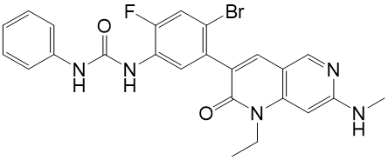

Chemical name: 1-(4-bromo-5-[1-ethyl-7-(methylamino)-2-oxo-1,2-dihydro-1,6-naphthyridin-3-yl]-2-fluorophenyl)-3-phenylurea

Molecular Formula: C24H21BrFN5O2

Molecular Weight: 510.36 g/mol

### CAS number

1442472-39-0

# MEDICINE SCHEDULE (POISONS STANDARD)

S4 – Prescription Only Medicine

# Sponsor

TudorRose Consulting Pty Ltd

3 Grandview Avenue

Point Cook

VIC 3030

Australia

Phone: 0418 314 763

Email: info@tudorroseconsulting.com.au

# Date of first approval

13 July 2020

# Date of revision

Not applicable.