|  |
| --- |
| **March 2019** |

|  |
| --- |
| Australian Public Assessment Report for Rufinamide |
| Proprietary Product Name: Inovelon |
| Sponsor: Eisai Australia Pty. Ltd. |

About the Therapeutic Goods Administration (TGA)

* The Therapeutic Goods Administration (TGA) is part of the Australian Government Department of Health and is responsible for regulating medicines and medical devices.
* The TGA administers the *Therapeutic Goods Act 1989* (the Act), applying a risk management approach designed to ensure therapeutic goods supplied in Australia meet acceptable standards of quality, safety and efficacy (performance) when necessary.
* The work of the TGA is based on applying scientific and clinical expertise to decision-making, to ensure that the benefits to consumers outweigh any risks associated with the use of medicines and medical devices.
* The TGA relies on the public, healthcare professionals and industry to report problems with medicines or medical devices. TGA investigates reports received by it to determine any necessary regulatory action.
* To report a problem with a medicine or medical device, please see the information on the TGA website <<https://www.tga.gov.au>>.

About AusPARs

* An Australian Public Assessment Report (AusPAR) provides information about the evaluation of a prescription medicine and the considerations that led the TGA to approve or not approve a prescription medicine submission.
* AusPARs are prepared and published by the TGA.
* An AusPAR is prepared for submissions that relate to new chemical entities, generic medicines, major variations and extensions of indications.
* An AusPAR is a static document; it provides information that relates to a submission at a particular point in time.
* A new AusPAR will be developed to reflect changes to indications and/or major variations to a prescription medicine subject to evaluation by the TGA.

Copyright

© Commonwealth of Australia 2019  
This work is copyright. You may reproduce the whole or part of this work in unaltered form for your own personal use or, if you are part of an organisation, for internal use within your organisation, but only if you or your organisation do not use the reproduction for any commercial purpose and retain this copyright notice and all disclaimer notices as part of that reproduction. Apart from rights to use as permitted by the *Copyright Act 1968* or allowed by this copyright notice, all other rights are reserved and you are not allowed to reproduce the whole or any part of this work in any way (electronic or otherwise) without first being given specific written permission from the Commonwealth to do so. Requests and inquiries concerning reproduction and rights are to be sent to the TGA Copyright Officer, Therapeutic Goods Administration, PO Box 100, Woden ACT 2606 or emailed to <[tga.copyright@tga.gov.au](mailto:tga.copyright@tga.gov.au)>.

Contents

Common abbreviations 5

I. Introduction to product submission 7

Submission details 7

Product background 7

Regulatory status 8

Product Information 9

II. Registration time line 10

III. Quality findings 10

Introduction 10

Drug substance (active ingredient) 11

Drug product 11

Biopharmaceutics 12

Quality summary and conclusions 12

IV. Nonclinical findings 13

Introduction 13

Pharmacology 14

Pharmacokinetics 15

Toxicology 16

Nonclinical summary and conclusions 22

V. Clinical findings 24

Introduction 24

Pharmacokinetics 27

Pharmacodynamics 29

Dosage selection for the pivotal studies 29

Efficacy 30

Safety 32

First round benefit-risk assessment 40

First round recommendation regarding authorisation 41

Clinical questions and second round evaluation 41

Second round benefit-risk assessment 43

VI. Pharmacovigilance findings 43

Risk management plan 43

VII. Overall conclusion and risk/benefit assessment 45

Background 45

Quality 46

Nonclinical 46

Clinical 47

Risk management plan 63

Risk-benefit analysis 63

Outcome 71

Attachment 1. Product Information 71

## Common abbreviations

|  |  |
| --- | --- |
| Abbreviation | Meaning |
| ALP | Alkaline phosphatase |
| ALT | Alanine aminotransferase |
| AST | Aspartate transaminase |
| AUC | Area under the plasma concentration-time curve |
| AUC0–72h | Area under the plasma concentration-time curve from time of administration until 72 hours post-dose |
| Cmax | Maximum plasma concentration |
| CNS | Central nervous system |
| CSF tablets | Clinical Service Form tablets |
| CYP | Cytochrome P450 |
| ECG | Electrocardiograph/electrocardiogram |
| EMA | European medicines agency |
| FDA | Food and Drug Administration (USA) |
| FMI tablets | Final Market Image tablets |
| GLP | Good Laboratory Practice |
| hERG | Human ether-à-go-go-related gene |
| ICH | International Conference on Harmonisation |
| IV | Intravenous |
| LGS | Lennox-Gastaut syndrome |
| Nav | Voltage-gated sodium channel |
| NNT | Number needed to treat |
| NOAEL | No observed adverse effect level |
| NOEL | No observed effect level |
| P-gp | P-glycoprotein |
| PK | Pharmacokinetic(s) |
| PO | Per os (oral (gavage)) |
| tmax | Time of maximum plasma concentration |
| UGT | Uridine 5'-diphospho-glucuronosyltransferase |

## I. Introduction to product submission

### Submission details

|  |  |
| --- | --- |
| Type of submission: | New chemical entity |
| Decision: | Approved |
| Date of decision: | 22 June 2018 |
| Date of entry onto ARTG: | 27 June 2018 |
| ARTG numbers: | 287523, 287524, and 287537 |
| Black Triangle Scheme | Yes  This product will remain in the scheme for 5 years, starting on the date the product is first supplied in Australia. |

|  |  |
| --- | --- |
| Active ingredient: | Rufinamide |
| Product name: | Inovelon |
| Sponsor’s name and address: | Eisai Australia Pty. Ltd.  Level 2/437 St Kilda Rd  Melbourne VIC 3004 |
| Dose form: | Tablet, film coated |
| Strengths: | 100 mg, 200 mg and 400 mg tablet |
| Container: | Blister pack |
| Pack sizes: | 10, 30, 50, 60, 100 tablet |
| Approved therapeutic use: | *Inovelon is indicated as adjunctive therapy in the treatment of seizures associated with Lennox-Gastaut syndrome in patients 4 years of age and older* |
| Route of administration: | Oral |
| Dosage: | Inovelon should be taken twice daily in two equally divided doses, one in the morning and one in the evening. For further instructions on dosage refer to the prescribing information |

### Product background

This AusPAR describes the application by Eisai Australia Pty. Ltd. (the sponsor) to register Inovelon rufinamide for the following indication:

###### Inovelon is indicated as adjunctive therapy in the treatment of seizures associated with Lennox-Gastaut syndrome in patients 1 year of age and older.

Rufinamide is a novel antiepileptic drug, with a structure different to currently registered anti-epileptic drugs. The proposed mechanism of action for rufinamide is modulation of the activity of sodium channels, prolonging their inactive state. This would be expected to reduce the rate at which epileptogenic neurons can fire action potentials, and therefore have an anticonvulsant effect.

Lennox-Gastaut syndrome is a rare and severe childhood epilepsy syndrome, which usually appears in children between the ages of 1 and 8 years, but lasts into adulthood, and it has a significant morbidity and mortality. Subjects often have tonic‑atonic seizures, with sudden full-body stiffening or sudden loss of muscle tone, leading to falls (‘drop attacks’), which often result in injuries.

The disease responds only partially to existing anti-epileptic drugs, and affected subjects typically receive multiple anti-epileptic drugs, often at high doses, in the attempt to reduce the number of seizures and prevent injuries. The high medication load often adds to the underlying cognitive impairment, and may cause sedation, ataxia and other features of inhibition of the central nervous system (CNS).

Most patients end up on a combination of currently registered anti-epileptic drugs, and continue to have seizures despite this.

Rufinamide has been used currently in Australia under the TGA’s Special Access Scheme.[1]

### Regulatory status

At the time the TGA considered this application; a similar application had been approved /rejected in (country, date) was under consideration in the countries as shown in Table 1.

Table 1: International regulatory status

|  |  |  |
| --- | --- | --- |
| Country/ Region Trade-name | Status Date | Indications |
| Europe; centralised procedure  Inovelon | Approved  Tablet: 29 January 2005  Oral suspension: 23 September 2010 | Rufinamide is indicated as adjunctive therapy in the treatment of seizures associated with Lennox-Gastaut syndrome in patients 4 years of age and older |
| Not approved(1)  2016 | Rufinamide is indicated as adjunctive therapy in the treatment of seizures associated with Lennox-Gastaut syndrome in patients 1 year of age and older |
| USA  Banzel | Approved  Tablet: 17 November 2005  Oral suspension: 30 April 2010 | Rufinamide is indicated as adjunctive therapy in the treatment of seizures associated with Lennox-Gastaut syndrome in patients 4 years of age and older |
| Approved  20 February 2015 | Rufinamide is indicated as adjunctive therapy in the treatment of seizures associated with Lennox-Gastaut syndrome in patients 1 year of age and older |
| Switzerland  Inovelon | Approved  Tablet: 28 June 2007  Oral suspension: 31 August 2010 | Rufinamide is indicated as adjunctive therapy in the treatment of seizures associated with Lennox-Gastaut syndrome in patients 4 years of age and older |
| Pending | Rufinamide is indicated as adjunctive therapy in the treatment of seizures associated with Lennox-Gastaut syndrome in patients 1 year of age and older |
| Canada  Banzel | Approved  Tablet: 5 July 2010  Oral suspension: 14 July 2011 | Rufinamide is indicated as adjunctive therapy in the treatment of seizures associated with Lennox-Gastaut syndrome in patients 4 years of age and older |
| Pending | Rufinamide is indicated as adjunctive therapy in the treatment of seizures associated with Lennox-Gastaut syndrome in patients 1 year of age and older |
| Singapore  Inovelon | Approved  Tablet: 30 September 2015 | Rufinamide is indicated as adjunctive therapy in the treatment of seizures associated with Lennox-Gastaut syndrome in patients 4 years of age and older |

(1) The Committee for Medicinal Products for Human Use (CHMP) considered that the data available at this point in time were not sufficient to extend the use of Inovelon to children aged 1 to 4 years. However, the CHMP considered that including the data obtained in these children in the Inovelon Product Information could help the healthcare professionals who manage them.

### Product Information

The Product Information (PI) approved with the submission which is described in this AusPAR can be found as Attachment 1. For the most recent PI, please refer to the TGA website at <<https://www.tga.gov.au/product-information-pi>>.

## II. Registration time line

The following table captures the key steps and dates for this application and which are detailed and discussed in this AusPAR.

Table 2 Timeline for Submission PM-2017-01037-1-1

|  |  |
| --- | --- |
| Description | Date |
| Designation (Orphan) | 30 August 2016 |
| Submission dossier accepted and first round evaluation commenced | 28 April 2017 |
| First round evaluation completed | 6 December 2017 |
| Sponsor provides responses on questions raised in first round evaluation | 22 December 2017 |
| Second round evaluation completed | 2 March 2018 |
| Delegate’s Overall benefit-risk assessment and request for Advisory Committee advice | 5 March 2018 |
| Sponsor’s pre-Advisory Committee response | 13 March 2018 |
| Advisory Committee meeting | 6 April 2018 |
| Registration decision (Outcome) | 22 June 2018 |
| Completion of administrative activities and registration on ARTG | 27 June 2018 |
| Number of working days from submission dossier acceptance to registration decision* | 240 |

*Statutory timeframe for standard applications is 255 working days

Evaluations included under Quality findings and Nonclinical findings incorporate both the first and second round evaluations.

## III. Quality findings

### Introduction

Rufinamide is a non-chiral compound and is not hygroscopic. It is a neutral compound and does not dissociate within the pH range 1 to 10. It appears as a fine white powder consisting of needle shaped crystals which aggregate and are ‘fluffy’ in nature.

Figure 1: Rufinamide chemical structure

Figure 1:  Rufinamide chemical structure

It is soluble in different organic solvents; however it is insoluble in aqueous solution across the pH ranges. There are four known polymorphic forms in the literature (Form A, A’, B and C). Form A is the thermodynamically stable form and was produced by the proposed manufacturing process.

There is a United State Pharmacopeia (USP) monograph for the drug substance rufinamide and rufinamide tablets but not rufinamide oral suspension.

### Drug substance (active ingredient)

Rufinamideis white to yellow crystalline powder and is consistently manufactured as polymorphic Form A (modification A). The drug substance specification includes appropriate tests and limits, in particular:

1. individual and average bulk density and
2. particle size distribution in terms of D50 and D90.

The drug substance specification for rufinamide is controlled for compliance with all parameters of the USP monograph, plus additional in-house parameters.

### Drug product

#### Tablets

The stability data supports the proposed shelf-life of 48 months stored below 30°C, when packaged in OPA/Al/PVC-Al;[2] blister pack.

The film coated tablets 100 mg, 200 mg and 400 mg tablets are all pink colours, oval shaped with score lines on both sides. Each strength is differentiated by different engravings on the tablet and tablet sizes. All strengths are to be packaged in OPA/Al/PVC‑Al blisters, in pack sizes of 10, 30, 50, 60 and 100 tablets (all strengths).

All tablets strengths have been formulated using conventional excipients and are dose proportional. The dissolution profiles were similar for crushed and intact tablets (100 mg and 400 mg strength), as well as half tablet and intact tablets.

#### Oral suspension[3]

Rufinamide oral suspension 40 mg/mL has an orange flavour and appears as an opaque, practically white and slightly thixotropic. Upon shaking, the suspension pours easily and smoothly without lumps.

The stability data supports the proposed shelf-life of 36 months stored below 30°C.

The in-use stability data supports to the proposed 90 days usage.

### Biopharmaceutics

No absolute bioavailability study was conducted in humans due to the solubility of rufinamide in aqueous solutions, preventing safe intravenous (IV) administration.

#### Study E2080-E044-003

The oral suspensions manufactured with three different homogenisation speeds are all bioequivalent with regards to peak plasma levels (Cmax), area under the curve (AUC), AUC from dosing/time zero to 72 h (AUC0‑72h) and AUC from dosing/time zero to infinity (AUC0-inf) falling within the 90% CI of 80 to 125%.

The 90% CI for Cmax, AUC0-72h and AUC0-inf of the oral suspension versus 400 mg tablets are within the acceptance criteria of 80 to 125% and conclude bioequivalence between the two proposed dosage forms.

#### Study CRUF331 0102

The reported results indicate that the tested formulations of the 400 mg tablet and 40 mg/mL (400 mg dose) oral suspension are bioequivalent under fed conditions with respect to Cmax, AUC0-t, AUC0-inf.

In a single dose under fed condition, Cmax is slightly lower in the oral suspension than the film-coated tablets; however, the 90% CI for Cmax is still within 80 to 125%.

### Quality summary and conclusions

However, given that the sponsor proposed to withdraw the oral suspension, the remaining three outstanding issues are considered minor (relate to the sponsor’s oversight of revising the drug substance specification).

Once these minor issues are resolved, approval for registration of rufinamide film coated tablet 100 mg, 200 mg and 400 mg tablets can be recommended.

The results from the biostudies above indicate that:

* The final market image tablets (proposed formulation) had higher Cmax and AUC, and are not bioequivalent to Clinical Service Form (CSF) tablets (earlier formulation) under fed condition. This will not be an issue because Final Market Image (FMI) tablets were used in the pivotal clinical studies.
* The FMI tablets have 56% higher Cmax and 34 to 36% higher AUC in fed state compared to the fasted state, confirming the criterion that rufinamide tablet must be taken with food.

## IV. Nonclinical findings

### Introduction

Studies of the pharmacology and toxicology of rufinamide were commenced by Ciba-Geigy Corporation in the 1980s and, following a merger with Sandoz, continued under Novartis and Eisai Company Ltd.

Almost all the sponsor’s studies reviewed in this assessment pre-date initial US Food and Drug Administration (FDA) approval for clinical use of rufinamide in 2008. During the subsequent years there have been significant advances in our understanding of the pharmacology/toxicology of anti-convulsants such as rufinamide. Accordingly, this report presents an assessment of both the studies submitted by the sponsor and some more recent, relevant data from the scientific literature.

Rufinamide is often described as being structurally unrelated to other anti-convulsants. Nevertheless, comparison with lamotrigine, another FDA approved therapy for seizures associated with Lennox-Gastaut syndrome, indicates areas of structural similarity.

#### Background

The sponsor has applied to register a new chemical entity, rufinamide (Inovelon). The drug is to be used as adjunctive therapy in the treatment of seizures associated with Lennox-Gastaut syndrome in patients 1 year of age and older. The sponsor suggests four possible dosing regimens involving oral administration of tablets or drug suspension twice daily:

* Children (not taking valproate, ≥ 1 year old, and weighing < 30 kg): starting dose of 10 mg/kg a day (equivalent to 0.25 mL/kg a day of suspension), taken in two doses; may be increased by 10 mg/kg (0.25 mL/kg of suspension) at intervals of two days, to a daily dose of no more than 1000 mg (25 mL of suspension).
* Children (taking valproate, ≥ 1 year old, and weighing < 30 kg): starting dose of 10 mg/kg a day (0.25 mL/kg a day of suspension), taken in two doses; may be increased by 10 mg/kg (0.25 mL/kg of suspension) at intervals of two days, to a maximum recommended dose of 600 mg (15 mL) a day.
* Adults, adolescents, and children weighing 30 kg or more (not taking valproate): starting dose of 20 mg/kg a day (0.5 mL/kg of suspension) taken in two doses; may be increased by 20 mg/kg (0.5 mL/kg of suspension) at intervals of two days, to a maximum daily dose of 3200 mg, depending upon weight.
* Adults, adolescents, and children weighing 30 kg or more (taking valproate): starting dose of 20 mg/kg a day (0.5 mL/kg of suspension) taken in two doses; may be increased by 20 mg/kg (0.5 mL/kg of suspension) at intervals of two days, to a maximum daily dose of 2400 mg, depending upon weight.

Dosing with rufinamide is continued for as long as necessary (that is, potentially for life).[4]

### Pharmacology

#### Primary pharmacology

Voltage-gated sodium channels (Nav) are responsible for the initiation and propagation of action potentials in nerve, muscle, and neuroendocrine cells. Nine genes encode α subunits for distinct human Nav channel isoforms (Nav1.1 to Nav1.9). These Nav isoforms show different biophysical properties and different patterns of tissue expression. In vitro studies using cells expressing different Nav isoforms have shown that 100 µM rufinamide has an inhibitory effect on Nav1.1 activation (producing a depolarising shift of ~8 mV) and also has inhibitory activity towards Nav1.4 (expressed by skeletal and cardiac muscle) and Nav1.7 (expressed by the peripheral nervous system). Such results suggest that the actions of rufinamide towards Nav channels are complex and not limited to one isoform. Nevertheless, the effect of rufinamide on Nav1.1 channels is probably particularly significant given the central role that these channels perform in propagating and regulating signals in the central nervous system, as indicated by the ability of various Nav1.1 mutants to induce hyperexcitability and seizures. Interaction with an inactivated Nav channel state, resulting in inhibition of the persistent sodium current and dampening of neuron excitability, is consistent with the proposed indication for rufinamide.

In vivo studies from the literature and performed by the sponsor have demonstrated anti-convulsant activity by rufinamide in mouse, rat, cat, and monkey models. Such results were obtained at dose levels similar to or lower than for other anti-convulsants and support the proposed indication for rufinamide.

#### Secondary pharmacology

Rufinamide at 10 µM (note, however, that the therapeutic range for treatment of epileptic seizures in humans can extend to higher concentrations) showed no significant interaction in radio-ligand binding assays with α1- and α2 -adrenergic receptors, 5-hydroxy-tryptamine-1 (5-HT1) and 5-HT2 receptors, and histamine and muscarinic acetylcholine receptors. Interaction was observed, however, at β-adrenergic receptor sites (36% inhibition at 10 µM rufinamide). Testing of rufinamide (10 and 100 µM) for agonist and antagonist activity at the human metabotropic glutamate receptors showed no clear effects on metabolic glutamate receptor-1 (mGluR1), mGluR2, and mGluR4 receptors, although inhibition was observed at mGluR5 receptors. It is unclear whether any of these findings are of clinical significance.

A study of the effect of rufinamide on the human ether-a-go-go gene (hERG) current was inconclusive because of inhibition by the vehicle. However, there were no effects of rufinamide dosing on electrocardiogram (ECG) parameters in dogs and cynomolgus monkeys and no effects on responses of juvenile dogs in various neurological tests.

Potential central nervous system (CNS) effects of a single, oral dose of rufinamide were tested using mice (dosed at up to 300 mg/kg) and cynomolgus monkeys (given up to 200 mg/kg). Neither species showed sustained behavioural changes after dosing, although after the high dose both species showed mild CNS depression (reduced locomotor activity), which is consistent with the proposed mechanism of action of rufinamide. Mice showed no effects over the tested dose range on body temperature, motor coordination, or duration of hexabarbitone induced sleep.

A small increase in blood glucose concentration after dosing rats at 100 mg/kg is unlikely to be of clinical significance.

### Pharmacokinetics

Following oral administration to adult humans, rufinamide is absorbed relatively slowly (tmax = 4 to 6 hours);[5] with a bioavailability of ≤ 85 %, a medium volume of distribution (0.8 L/kg at maximum daily dose of 3200 mg), and has a relatively short plasma elimination half-life of 6 to 10 h. Exposure (expressed as either Cmax or AUC), at steady state or after single doses, increased in a less than dose proportional manner, and this was thought to reflect reduced absorption at higher doses. Pharmacokinetic studies in mice, rats, dogs, cynomolgus monkeys, and baboons produced results that were broadly similar to those found for humans.

Distribution studies using mice and rats dosed intravenous or oral with [14C]‑rufinamide showed an even distribution of radioactivity between tissues, rapid and reversible crossing of the blood-brain barrier, and no unexpected accumulation of radioactivity in particular tissues.

Animal and human sera showed low binding of rufinamide (approximately 30% for human sera), with most binding attributable to albumin.

Rufinamide is metabolised in the liver, primarily by carboxylesterase-1 mediated hydrolysis, to an inactive carboxylic acid derivative CGP47292. Rufinamide does not appear to undergo significant metabolism by cytochrome P450 enzymes. CGP47292 is the main metabolite in the urine of mice, rats, dogs, baboons, rabbits, and humans and is the predominant form of rufinamide excretion. There is also excretion of a glucuronide conjugate of CGP47292. Systemic exposure to metabolites is low.

There were differences in rufinamide metabolism between humans and the animal species examined. Rodent studies indicated the production of 2,6-difluorobenzoic acid and bile from rodents, dogs, and monkeys showed the presence of a derivative of a rufinamide-glutathione conjugate that is apparently not produced by humans. The latter metabolite was found to be of toxicological significance. Accordingly, there are caveats associated with the extrapolation of rufinamide toxicology data from animals to humans.

Mass balance studies, using oral (PO) dosing with [14C]-rufinamide, were conducted in rats and baboons. Results for rats were similar to humans with excretion of radioactivity predominantly via urine, whereas faecal excretion was more prominent for baboons.

#### Pharmacokinetic drug interactions

In vitro studies suggested that rufinamide is neither a competitive nor a mechanism based inhibitor of the major human cytochrome P450 (CYP) enzymes and should not inhibit the metabolism of other drugs that are CYP substrates at clinical concentrations. Studies using in vitro incubation of human hepatocytes with rufinamide or repeat dosing of mice and rats suggested that rufinamide is a weak inducer of CYP, uridine 5'-diphospho-glucuronosyltransferase (UGT), and glutathione S-transferase activities.

Rufinamide has been found to interact with various anti-convulsant drugs. Such interactions are usually assumed to reflect the induction of CYP3A4 and/or UGT mediated metabolism. Valproate, however, has been shown to significantly increase the plasma concentration of rufinamide, and this action has been ascribed to inhibition of carboxylesterase-1.

There have been no reports of drugs used to treat non-epilepsy disorders having an effect on the pharmacokinetics of rufinamide. [6],[7] However, rufinamide has been shown to affect the pharmacokinetics of oral contraceptives and triazolam.

Rufinamide showed very high permeability across cell monolayers in vitro, making it difficult to determine whether it is a substrate for transporters. A study in the literature has suggested that rufinamide is not a substrate of human P-glycoprotein (P-gp).

### Toxicology

#### Acute toxicity

Studies were performed with mice, rats, and dogs given a single oral dose of rufinamide and observed for 14 days. Mice showed no deaths after doses up to 5000 mg/kg, whilst one of three rats died after dosing at 5000 mg/kg. Both rodent species showed clinical signs suggestive of CNS inhibition following dosing. A dog showed slight trembling after dosing at 600 mg/kg, whilst dosing at 2000 mg/kg resulted in emesis.

These results suggest that single oral doses of rufinamide are of very low toxicity.

#### Repeat dose toxicity

These studies used mice, rats, dogs, and monkeys that received a daily dose of rufinamide via the clinical route (although note that mice were dosed via food, rats via gavage or food, dogs via capsule, and monkeys via gavage). All the studies shown in Table 3 were conducted in compliance with Good Laboratory Practice (GLP) standards by different laboratories of Ciba-Geigy Corporation.

#### Relative exposure

The relative exposures achieved in all four species were low and limited by decreased weight gain or weight loss. For all the studies listed in Table 3, the no observed adverse effect level (NOAEL) was ≤ low dose level (that is, exposure ratio at NOAEL of ≤ 1).

Table 3: Relative exposure in repeat-dose toxicity and carcinogenicity studies

|  |  |  |  |  |  |  |  |
| --- | --- | --- | --- | --- | --- | --- | --- |
| **Species** | **Study duration [Study no.]** | **Route** | **Dose (mg/kg/ day)** | **AUC0–24 h^ (µg∙h/mL)** | | **Exposure ratio#** | |
| Male | Female | Male | Female |
| Mouse  (CD-1) | 13 weeks [92‑6060] | PO (food) | 60 | 68 | 62 | 0.22 | 0.20 |
| 200 | 309 | 311 | 1.0 | 1.0 |
| 600 | 925 | 761 | 3.1 | 2.5 |
| 2 years [carcinogenicity; 92-6045] | PO (food) | 40 | 66.2 | ND | 0.22 | ND |
| 120 | 231 | ND | 0.76 | ND |
| 400 | 407 | 688 | 1.3 | 2.3 |
| Rat  (Tif:RAI  (3 months) and SD (others)) | 3 months [87‑6090] | PO (gavage) | 60 | ND | ND | ND | ND |
| 200 | ND | ND | ND | ND |
| 600 | ND | ND | ND | ND |
| 26/52 weeks [90-6147] | PO (food) | 20 | 317 | 275 | 1.0 | 0.91 |
| 60 | ND | ND | ND | ND |
| 200 | 1468 | 1457 | 4.8 | 4.8 |
| ~2 years [carcinogenicity; 92-6046] | PO (food) | 20 | 274 | 164 | 0.9 | 0.5 |
| 60 | 697 | 640 | 2.3 | 2.1 |
| 200 | 1339 | 1399 | 4.4 | 4.6 |
| Dog  (beagle) | 3 months [87-6091] | PO (capsule) | 60 | 450 | 507 | 1.5 | 1.7 |
| 200 | 747 | 802 | 2.5 | 2.6 |
| 600 | 1000 | 1109 | 3.3 | 3.7 |
| 26/52 weeks [89-6305] | PO (capsule) | 20 | 175 | 84 | 0.58 | 0.28 |
| 60 | ND | ND | ND | ND |
| 200 | 236 | 852 | 0.78 | 2.8 |
| Monkey  (cynomolgus) | 13 weeks [92-6094] | PO (gavage) | 35 | 321 | 261 | 1.1 | 0.86 |
| 100 | 577 | 523 | 1.9 | 1.7 |
| 300 | 940 | 789 | 3.1 | 2.6 |
| 6/12 months [93-6082] | PO (gavage) | 20 | 252 | 240 | 0.83 | 0.79 |
| 60 | 402 | 545 | 1.3 | 1.8 |
| 200 | 759 | 728 | 2.5 | 2.4 |
| Human  epilepsy patients, 3 to 12 years old | steady state [EMFFR2004/014/01 (2005)] | PO | 41–50 | 303 | | – | |

# = animal: human plasma AUC0–24 h; ^ = data are for the last sampling occasion; ND = not determined

The studies used an appropriate range of animal species, dosed at appropriate frequency and for appropriate times, used appropriate dose ranges, used appropriate group sizes, examined appropriate endpoints, and examined the reversibility of findings.

#### Major toxicities

For all four species examined, rufinamide dose related findings occurred predominantly in the liver. The rodent and dog studies also indicated kidney as a site of dose related effects.

Effects on mice were examined in a 13 week study with dosing at 60 mg/kg/day (exposure ratio approximately 0.2), 200 mg/kg/day (exposure ratio approximately 1), or 600 mg/kg/day (exposure ratio ~2.5 to 3) and in a 2 year carcinogenicity study with dosing at 40 mg/kg/day (exposure ratio approximately 0.2), 120 mg/kg/day (exposure ratio approximately 0.8), or 400 mg/kg/day (exposure ratio approximately 1.3 to 2.3). The low dose was the NOAEL for the 13 week study, with increases in aspartate transaminase (AST)/alanine aminotransferase (ALT) and alkaline phosphatase (ALP), indicative of hepatotoxicity, found at the mid-dose and/or high dose groups. Liver changes found at necropsy of 13 week animals included centrilobular hepatocellular hypertrophy, single cell necrosis, and periportal pigment deposition. Leukocytic infiltration of liver was also found in high dose animals from the carcinogenicity study. Centrilobular hepatocellular hypertrophy was also noted for rats dosed at 200 mg/kg/day for 26 weeks (exposure ratio approximately 5) or at 60 or 200 mg/kg/day for 52 weeks. Hepatic effects, including bile plugs, pigment deposits in hepatocytes, perivasculitis (presumably a response to bile deposits), and increases in circulating levels of liver enzymes, were also a feature of the dog studies. These changes showed only partial reversibility during a 4 week recovery period after 52 weeks of dosing. Gallstones were found in 3 of 5 high dose monkeys after 6 months of dosing and in 2 of 7 high dose monkeys after 12 months of dosing in the 6 and 12 months study. High dose animals also showed increases in circulating levels of liver enzymes. These changes largely/wholly reversed after a 4 week recovery period.

The significance for humans of the liver changes found in all four animal species is questionable as similar increases in circulating levels of liver enzymes were not found during clinical trials of rufinamide. In addition, MS/NMR (mass spectra/nuclear magnetic resonance) analysis of crystals collected from the gallbladders of cynomolgus monkeys used in the 13 week study showed that the major component was an insoluble metabolite of rufinamide formed by hydroxylation and glutathione substitution of a fluorine followed by degradation of the glutathione. This metabolite was also detected in rat and dog bile, but not in human bile. Accordingly, it was concluded that humans are not at risk of rufinamide induced gallstone formation due to their failure to produce this metabolite.

Dosing-related renal/urinary tract changes were found in the mouse 2 year carcinogenicity study (primarily in males) and included hydronephrosis (mid-dose and high dose groups) and focal fibrosis, chronic nephropathy, and dilatation of the ureters and urinary bladder (high dose group). Hydronephrosis could be the result of urinary tract plugs, however, no evidence for such was found at necropsy in most animals. Rats of both sexes from the 2 year carcinogenicity study showed dose dependent increases in the incidences of both pelvic mineralisation in the kidney and pelvic epithelial hyperplasia in the kidney. It seemed likely that the hyperplasia could be a consequence of chronic irritation produced by mineralisation. The significant background incidences of these findings suggested that rufinamide dosing is amplifying an age dependent phenomenon in rats. There were also renal findings in the 3 month dog study with high dose males showing lesions such as tubular homogenous cytoplasm and tubular cytoplasmic inclusions. The toxicological significance of these different renal findings and their relevance to clinical use are questionable.

Possible effects of rufinamide dosing on ECG parameters were examined in the dog 3 month and 26 and 52 weeks studies and in the cynomolgus monkey 13 week study. No significant effects were found at any of the doses used in these studies.

#### Genotoxicity

A standard group of International Committee for Harmonisation (ICH) compliant studies was performed. The in vitro mutagenicity of rufinamide was tested, with and without metabolic activation, in standard bacterial, auxotrophy reversion assays, and in cultures of Chinese hamster V79 cells selected for induction of 6-thioguanine resistance (hypoxanthine-guanine phosphoribosyl transferase (Hgprt) mutation), at levels up to 5,000 µg/plate and 400 µg/mL, respectively. In both assays, rufinamide showed no evidence for mutagenicity. The potential clastogenicity of rufinamide was tested both in vitro, by incubation (in the presence or absence of metabolic activation) at up to 250 µg/mL (which produced significant suppression of mitotic activity) with the Chinese hamster ovary cell line CCL61, and in vivo, by examining the frequency of micronucleated polychromatic erythrocytes in rats following dosing with rufinamide up to the maximum tolerated dose. Neither study suggested that rufinamide is capable of inducing chromosomal aberrations.

These results suggest that rufinamide is not of genotoxic concern.

#### Carcinogenicity

Two year, dietary dosing studies were performed with mice and rats. The exposure ratios achieved in these studies were modest (up to 2 to 4 fold in mice and rats, respectively; see Table 3), and limited by effects on body weight. In other respects, these studies were consistent with relevant guidelines.

The mouse carcinogenicity study indicated increases in the incidences of osteoma (both sexes) and of hepatocellular adenoma (both sexes) and carcinoma (males) in the high dose groups as cf. controls. The osteomas were correlated with the induction of murine oncogenic viruses and were, accordingly, considered irrelevant to the clinical safety of rufinamide. While the sponsor considered the hepatic tumour findings to be linked to the induction of hepatocellular hypertrophy, the evaluator considers that induction of inflammation is a more likely cause. The absence of clinical liver findings and the lack of hepatic tumour findings in the rat carcinogenicity study suggest that hepato‑carcinogenicity is unlikely to be a concern for human use.

Male rats showed a rufinamide dosing-related increase in the incidence of thyroid follicular adenomas. This tumour is produced by an effect on the pituitary-thyroid axis and is a well-known, rat specific phenomenon of no relevance to clinical use. No other tumour types showed treatment related induction in the rat carcinogenicity study.

#### Reproductive toxicity

The effects of rufinamide dosing on reproductive parameters were examined using mice, rats, and rabbits. The pivotal studies were Good Laboratory Practice (GLP) compliant and their design was consistent with ICH/EMA (European Medicines Agency) guidelines.

Toxicokinetic data were only provided for the rabbit embryofoetal development study. Approximate exposure values for the mouse and rat reproductive toxicity studies were calculated based on extrapolation of toxicokinetic data from the mouse and rat carcinogenicity studies (see footer of Table 4 for further details). These approximate values are shown bracketed in Table 4. Comparison of NOAEL values for maternal and foetal toxicity (discussed below) with exposure ratios at those doses suggests moderate to high sensitivity of rats and rabbits to rufinamide dosing. Mice, however, were less sensitive to induction of maternal and foetal toxicity.

Table 4: Relative exposure in reproductive toxicity studies

|  |  |  |  |  |
| --- | --- | --- | --- | --- |
| **Species** | **Study [Study no.]** | **Dose (mg/kg/day)** | **AUC0–24 h (µg∙h/mL)** | **Exposure ratio#** |
| Mouse (CD-1) | Pre-/Postnatal development [93069] | 50 | (61.8)a | (0.20) |
| 150 | (190)a | (0.63) |
| 500 | (772)a | (2.5) |
| Rat (Sprague Dawley) | Fertility and early embryonic development [901316] | 20 | (91.4)b | (0.30) |
| 60 | (327)b | (1.1) |
| 200 | (937)b | (3.1) |
| 600 | (2810)b | (9.3) |
| Rat (Tif:RAI) | Embryofoetal development [876147] | 20 | (91.4)b | (0.30) |
| 100 | (546)b | (1.8) |
| 300 | (1405)b | (4.6) |
| Rat (Wistar Hannover) | Pre-/Postnatal development [997078] | 5 | (22.8)b | (0.08) |
| 30 | (137)b | (0.45) |
| 150 | (703)b | (2.3) |
| Rabbit (NewZealand white) | Embryofoetal development [901317] | 30 | 72.6 | 0.24 |
| 200 | 430 | 1.4 |
| 1000 | 934 | 3.1 |
| Human, epilepsy patients, 3 to 12 years old | steady state [EMFFR2004/014/01 (2005)] | 41–50 | 303 | – |

# = animal: human plasma AUC0–24 h; a extrapolated from values for mouse carcinogenicity Study 92‑6045) after 26 weeks of dietary dosing of male CD-1 mice; bextrapolated from values for rat carcinogenicity Study 92-6046 after 12 weeks of dietary dosing of female Sprague Dawley rats.

Placental transfer was shown to occur rapidly in pregnant rats and rabbits orally dosed with [14C]-rufinamide. Radioactivity was found to distribute relatively evenly throughout the foetuses of both species (including foetal brain), although concentrations in the foetus were somewhat lower (about half in rabbit) than those in the dam. Both the rat and rabbit studies showed that radioactivity was found in the mammary glands of pregnant animals. This suggests that radioactivity would be found in milk, although this possibility was not tested experimentally.

Effects on fertility were examined using rats of both sexes dosed at up to 600 mg/kg/day. High dose females showed a reduced fertility index and high dose males showed a significant decrease in spermatozoa counts. Based on decreased weight gain for both sexes at doses ≥ 60 mg/kg/day and decreases in implants and live embryos at ≥ 200 mg/kg/day, the indicated NOAEL doses for parental rats and for rat early embryonic development were 20 mg/kg/day (exposure ratio approximately 0.3) and 60 mg/kg/day (exposure ratio approximately 1), respectively. Male and female genital organ histopathology was examined in the rat 26 and 52 week repeat dose toxicity study and no adverse effects on those organs were noted after dosing at exposure ratios up to approximately 5.

Embryofoetal development studies were performed with rats and rabbits. Foetuses from pregnant rats dosed at 20, 100, or 300 mg/kg/day (exposure ratio approximately 4.6) showed no evidence of teratogenicity. An increased incidence of skeletal anomalies and variants in the mid-dose and high dose groups was attributed to the decreased foetal body weight found in these groups. Dams showed decreased weight gain at all doses, suggesting an NOAEL of < 20 mg/kg/day (exposure ratio < 0.3), and the skeletal effects on fetuses suggested an NOAEL of 20 mg/kg/day (exposure ratio approximately 0.3). Results for pregnant rabbits dosed at 30, 200, or 1000 mg/kg/day (exposure ratio approximately 3) also provided no evidence for teratogenic activity by rufinamide; although there were abortions at the high dose associated with weight loss and decreased eating. The results suggested an NOAEL for rabbit maternal and embryofetal effects of 200 mg/kg/day (exposure ratio of 1.4).

Effects of rufinamide on pre- and post- natal development were studied using mice and rats. Mice dosed at 50, 150, or 500 mg/kg/day from gestation Day 15 till post-natal Day 20 showed no adverse effects on maternal or pup parameters, suggesting an NOAEL for both maternal and pup toxicity of ≥ 500 mg/kg/day (exposure ratio approximately 2.5). Similarly, rats were dosed at 5, 30, or 150 mg/kg/day from gestation Day 6 till post-natal Day 20. Negative effects were found on pup survival in the mid-dose and high dose groups and high dose dams showed reduced weight gain. This suggested NOAELs for dams of 30 mg/kg/day (exposure ratio approximately 0.5) and for pups of 5 mg/kg/day (exposure ratio approximately 0.1). There were no effects of rufinamide dosing on the timing of developmental landmarks or learning and memory in rat pups.

##### Pregnancy classification

The sponsor has proposed Pregnancy Category D;[8] for rufinamide. The US FDA has placed rufinamide in Category C.[9]

The findings in rats and rabbits provide no evidence for rufinamide having teratogenic activity. Effects on fetuses appeared to be associated with maternal toxicity. Nevertheless, it is evident that exposure ratios at NOAEL doses for rat and rabbit maternal and embryofoetal toxicity are around or less than unity.

It is suggested that Pregnancy Category B3;[10] is more appropriate for rufinamide.

#### Local tolerance

Application of rufinamide to rabbit skin produced no irritant effect up to 72 hours later.

#### Antigenicity

Guinea pigs, given intradermal and epidermal exposure to rufinamide, showed no evidence for induction of skin hypersensitivity when challenged with rufinamide two weeks later.

#### Immunogenicity

No studies focussed on this area were presented. This is acceptable as repeat dose toxicity studies provided no consistent evidence for effects on the immune system.

#### Metabolites

Major rufinamide metabolites were shown to lack anticonvulsant activity in an electroshock assay using mice or rats.

#### Paediatric use

Rufinamide is proposed for paediatric use. In support of such use, the effects of dosing juvenile rats and dogs were examined.

Rats were dosed orally with rufinamide at 0, 15, 50, or 150 mg/kg/day from post-natal Day 7 for 10 weeks. The findings, which occurred mainly at the high dose, included reduced weight gain, centrilobular hepatocellular hypertrophy, and pituitary cytoplasmic vacuolation. The NOAEL was 15 mg/kg/day, which represented an exposure ratio of approximately 0.5 compared with epileptic children (see Table 5). The findings and NOAEL doses in juvenile and adult rats were therefore comparable.

Two juvenile dog studies were performed. In the first, animals of around 4 months of age were dosed orally for 13 weeks at 0, 1, 5, or 200 mg/kg/day and, in the second study, animals of 6 weeks of age were dosed orally for 14 weeks at 0, 20, 60, or 200 mg/kg/day. Consistent findings in higher dose individuals from both studies were elevated ALT levels and microscopic liver findings including pigment deposits in bile canaliculi, hepatocytes, and Kupffer cells, and inflammatory cell infiltration around bile ducts and blood vessels. The NOAELs for these studies were 5 and < 20 mg/kg/day. At 5 mg/kg/day, the exposure was less than a tenth of the maximum clinical exposure (see Table 5). The estimated NOAEL doses for these studies are consistent with those determined for adult dogs. Likewise, the findings of elevated ALT and biliary thrombi were consistent with observations from adult dogs. Tests performed in the second dog study, on animals treated at up to double clinical exposure, showed no effects of dosing on neural development or on responses in various neurological tests.

The conclusion from both the rat and dog studies was that there was no indication of additional toxicity in juvenile as compared with adult animals.

Table 5: Relative exposure in juvenile animal studies

|  |  |  |  |  |  |  |
| --- | --- | --- | --- | --- | --- | --- |
| **Species** | **Study no.** | **Dose (mg/kg/ day)** | **AUC0–24 h (µg∙h/mL)** | | **Exposure ratio#** | |
| Male | Female | Male | Female |
| Rat (SD) | 998010 | 15 | 153 | 140 | 0.50 | 0.46 |
| 50 | 452 | 441 | 1.5 | 1.5 |
| 150 | 811 | 953 | 2.7 | 3.1 |
| Dog (beagle) | 95-6043 | 1 | 4.7 | 4.8 | 0.02 | 0.02 |
| 5 | 13.9 | 25.0 | 0.05 | 0.08 |
| 901629 | 20 | 130 | 150 | 0.43 | 0.50 |
| 60 | 363 | 339 | 1.2 | 1.1 |
| 200 | 648 | 670 | 2.1 | 2.2 |
| Human, epilepsy patients, 3 to12 years old | steady state [EMFFR2004/014/01 (2005)] | 41–50 | 303 | | – | |

### Nonclinical summary and conclusions

* The submitted nonclinical dossier was in accordance with the relevant ICH guideline for the nonclinical assessment of pharmaceuticals. The overall quality of the nonclinical dossier was high. All pivotal safety related studies were GLP compliant.
* Rufinamide (100 µM) has been shown to inhibit the voltage-gated sodium channel Nav1.1 and also has inhibitory activity towards Nav 1.4 and Nav 1.7. The effect of rufinamide on Nav 1.1 channels is probably particularly significant given the central role that these channels perform in propagating and regulating signals in the CNS, as indicated by the ability of various Nav 1.1 mutants to induce hyperexcitability and seizures. Interaction with an inactivated Nav channel state, resulting in inhibition of the persistent sodium current and dampening of neuron excitability, is consistent with the proposed indication for rufinamide.
* Radioligand binding assays with rufinamide at 10 µM showed no significant interaction with a wide array of receptors except for β-adrenergic receptors and mGluR5 receptors. It is unclear whether any of these findings are of clinical significance.
* CNS safety pharmacology studies in mice and cynomolgus monkeys showed reduced locomotor activity at around 200 to 300 mg/kg, consistent with the proposed mechanism of action of rufinamide. Mice showed no effects of dosing on body temperature, motor coordination, or duration of hexabarbitone induced sleep. A study of the effect of rufinamide on the hERG K+ channel tail current was inconclusive because of inhibition by the vehicle. However, there were no effects of long-term rufinamide dosing on ECG parameters in dogs and cynomolgus monkeys dosed at exposure ratios of around 3 for three months or longer.
* Pharmacokinetic studies in mice, rats, dogs, cynomolgus monkeys, and baboons produced results that were broadly similar to those found for humans: relatively slow absorption and high bioavailability (tmax = 4 to 6 hours; absolute bioavailability (F) ≤ 85%), medium volume of distribution (0.8 L/kg), plasma elimination half-life of 6 to 10 hours, and a less than dose-proportional increase in exposure. Plasma protein binding of rufinamide was low (approximately 30% for human sera), with most binding attributable to albumin. Tissue distribution of rufinamide was wide and even, with rapid and reversible crossing of the blood-brain barrier, and no unexpected accumulation of drug in particular tissues.
* Rufinamide is metabolised in the liver, primarily by hydrolysis mediated by carboxylesterase-1, to an inactive carboxylic acid derivative CGP47292. Rufinamide does not appear to undergo significant metabolism by CYP enzymes. CGP47292 is the main metabolite in the urine of mice, rats, dogs, baboons, rabbits, and humans and is the predominant form of rufinamide excretion. There is also excretion of a glucuronide conjugate of CGP47292. After oral dosing with radiolabelled rufinamide, rats were similar to humans with excretion of radioactivity predominantly via urine, whereas faecal excretion was more prominent for baboons.
* Studies with mice, rats, and dogs suggested that rufinamide has very low acute oral toxicity.
* Repeat-dose toxicity studies by the oral route were conducted in mice (up to 2 years), rats (2 years), dogs (1 year) and cynomolgus monkeys (1 year). Maximum exposures (AUC) achieved were low and were limited by decreased weight gain or weight loss. The relative exposures for all four species at the NOAEL were ≤ 1. For all species, treatment related findings occurred predominantly in the liver. The rodent and dog studies also indicated kidney as a target organ. The liver toxicity produced by rufinamide dosing appeared to be primarily related to the formation of deposits in hepatocytes and bile due to the formation of an insoluble metabolite of rufinamide. This metabolite was detected in rat, dog, and monkey bile, but not in human bile, suggesting that humans are not at risk of rufinamide induced gallstone formation due to their failure to produce this metabolite. The significance for humans of the hepatotoxicity found in all four animal species is also questionable as similar increases in circulating levels of liver enzymes were not found during clinical trials of rufinamide.
* Rufinamide was not mutagenic in bacterial or mammalian cell assays or clastogenic in vitro (Chinese hamster cells) or in vivo (rat micronucleus test). Mice and rats were used in 2 year oral carcinogenicity studies. Mice showed dosing related increases in the incidences of osteoma and of hepatocellular adenoma and carcinoma, whilst male rats showed a dose related increase in the incidence of thyroid follicular adenomas. None of these findings were considered to be of relevance to clinical use.
* Rats exposed to higher than clinical concentrations of rufinamide showed decreased fertility. Embryofoetal development studies performed with rats and rabbits dosed at up to ~ 3 to 4 times the clinical AUC showed no evidence of teratogenicity but did show an increased incidence of skeletal anomalies and variants associated with maternal toxicity and lower foetal body weight. Effects of rufinamide dosing on pre- and post-natal development were studied in mice and rats. There were no adverse effects on mice dams or pups at relative exposure up to 2.5 times that anticipated clinically. Rats showed negative effects on weight gain of dams and pup survival at much lower doses, although there were no effects of rufinamide dosing on the timing of developmental landmarks or learning and memory in rat pups.
* Repeat dose toxicity studies by the oral route using juvenile rats and dogs showed no indication of additional toxicity in juvenile as compared with adult animals.
* One impurity in the drug substance has not been adequately qualified for potential genotoxicity.

#### Conclusions and recommendations

* There are no major deficiencies in the sponsor’s studies.
* The primary pharmacology studies support the proposed indication for rufinamide.
* Secondary pharmacodynamics studies identified moderate binding of rufinamide to β‑adrenergic and mGluR5 receptors, the clinical relevance of which is unclear.
* Mild toxicity in the liver was observed in juvenile as well as in adult animals at exposure levels lower than or similar to those reached in patients. Reversibility of all findings was demonstrated after cessation of treatment. Liver and kidney effects in animal repeat-dose toxicity studies were likely species-specific with little clinical relevance.
* Rufinamide is not considered to pose a genotoxic or carcinogenic risk.
* Rats exposed to clinical concentrations of rufinamide and above showed decreased fertility. Rufinamide was not teratogenic in rat or rabbit embryofetal development studies. Accordingly, Pregnancy Category B39 is considered more appropriate for rufinamide than the sponsor’s suggestion of Category D7.
* The sponsor needs to submit either QSAR data or appropriately conducted genotoxicity assays in order to qualify one of the synthetic impurities. The sponsor believes that this impurity can be qualified based on post-market clinical data.
* There are no nonclinical objections to registration as long as the impurity qualification issue is resolved to the satisfaction of the evaluator and the Delegate.
* The nonclinical evaluator also made recommendations for changes to the PI but these are beyond the scope of the AusPAR.

## V. Clinical findings

### Introduction

#### Clinical rationale

Lennox-Gastaut syndrome is a rare and severe childhood epilepsy syndrome, which usually appears in children between the ages of 1 and 8 years (especially between 3 and 5 years), but lasts into adulthood. It is usually at least partially refractory to most anti-epileptic drugs, with significant ongoing seizures despite treatment, and it has a significant morbidity and mortality. Subjects often have tonic-atonic seizures, with sudden full-body stiffening or sudden loss of muscle tone, leading to falls (‘drop attacks’), which often result in injuries. There is no single unequivocal diagnostic feature, but it is usually diagnosed on a combination of clinical and electroencephalogram (EEG) features. About a third of subjects with an eventual diagnosis of Lennox-Gastaut syndrome have a history of infantile spasms.[11] Some authors suggest the following diagnostic triad:[12]

* The presence of multiple seizure types, typically tonic-atonic seizures and atypical absences, but also tonic-clonic, myoclonic, and partial seizures.
* The presence of generalized discharges with slow spike-and-wave complexes in the EEG.
* The presence of mental retardation or a learning disability.

The learning disability in Lennox-Gastaut syndrome is multifactorial. It is often static, but intellectual impairment may worsen over years because of frequent seizures, frequent head trauma and cognitive side effects of anti-epileptic drugs. Many seizures may be ‘subclinical’, a situation in which cognitive activity is frequently interrupted by seizure events that carers may not detect, but which would be discernible on EEG.

The cause of Lennox-Gastaut syndrome is variable: it represents a common endpoint for a range of pathological processes. In many cases, it is considered ‘symptomatic’ (meaning secondary), and an identifiable underlying pathology can be identified, such as tuberous sclerosis, hereditary metabolic diseases, encephalitis, hypoxic brain injury, other birth injuries, and lesions of the frontal lobe. In a minority of cases, the Lennox-Gastaut syndrome is idiopathic, with no apparent underlying structural problem or history of brain injury.

The disease responds only partially to existing anti-epileptic drugs, and affected subjects typically receive multiple anti-epileptic drugs, often at high doses, in the attempt to reduce the number of seizures and prevent injuries. The high medication load often adds to the underlying cognitive impairment, and may cause sedation, ataxia and other features of inhibition of the CNS.

Prognosis in the condition is poor. As the sponsor notes, seizure freedom is achieved only rarely: in 13.7% of the patients reported by Ohtahara et al., (1976);[13] in 6.7% of those reported by Gastaut et al., (1973);[14] and in none of a cohort of cryptogenic cases followed up for > 15 years.[15]

Many older drugs, including valproate, have been used without specific studies showing efficacy in Lennox-Gastaut syndrome. For drugs that have been assessed in the Lennox-Gastaut syndrome population, superiority over placebo is often modest, as shown in the table below provided by the sponsor.

Table 6: Percentage change of tonic-atonic seizures or drop attacks in randomised Lennox-Gastaut syndrome trials[16] ,[17],[18]

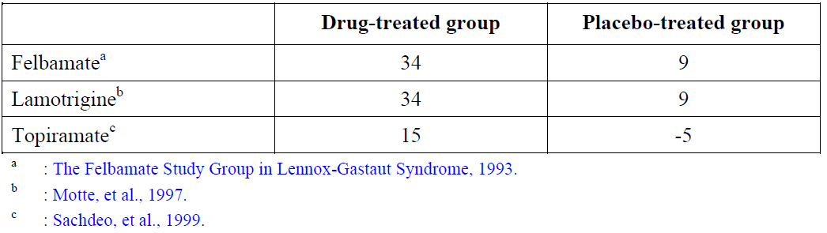

Non-drug treatments for Lennox-Gastaut syndrome are usually only partially effective: these include ketogenic diets, vagal nerve stimulation, and (very rarely) corpus callosotomy.[19] Most patients end up on a combination of currently registered anti-epileptic drugs, and continue to have seizures despite this.

Rufinamide showed some promise in animal models of epilepsy, and has been tried in a number of seizure types. There is evidence of modest anticonvulsant efficacy in subjects with partial seizures, but the results were better in the single major Lennox-Gastaut syndrome study (designated as pivotal for the current submission).

There is no a priori reason to suspect that efficacy in this condition would be superior to efficacy in other epilepsy syndromes. On the other hand, subjects with Lennox-Gastaut syndrome typically have such severe epilepsy that there is a high unmet clinical need for new agents with even partial efficacy in this condition.

The submitted studies, including the pivotal Lennox-Gastaut syndrome study, have predominantly assessed rufinamide as adjunctive therapy, which is a reflection of the fact that most subjects with a diagnosis of Lennox-Gastaut syndrome are already on anti-epileptic drugs. Typically, in Lennox-Gastaut syndrome and other refractory epilepsy syndromes, new drugs are added to the existing regimen and, where possible, previous drugs are withdrawn.

##### Formulation development

Early studies with rufinamide were performed with tablets at initial strengths of 50, 100 and 200 mg, referred to as the Clinical Service Form (CSF). These tablets were used in the original clinical studies in healthy subjects and in three efficacy and safety studies in patients at total daily doses of up to 3200 mg. When higher tablet strength was needed, the Final Market Image (FMI) tablets were produced in strengths of 100, 200, and 400 mg.

The FMI tablets, produced at strengths of 100, 200 and 400 mg, were used in most of the remaining clinical pharmacology studies and in clinical and efficacy studies in patients with epilepsy, but a Japanese formulation (100 and 200 mg film coated tablets) was developed and evaluated in 5 studies in Japan, including studies in healthy subjects and in patients with epilepsy.

After the initial registration in Europe and the US, a child-friendly oral suspension was developed (100 mg per 2.5 mL), which can be administered by a graduated oral syringe. The oral suspension was compared to a marketed tablet formulation in a relative bioavailability study (Study 003), and a randomised, open label, 3 way, crossover study, which compared the relative bioavailability of the rufinamide solution to the marketed tablets (CRUF331 0102), finding no important differences.

#### Guidance

The study program for rufinamide reflects guidance from various national and international regulatory bodies.

The single pivotal study in Lennox-Gastaut syndrome incorporated regulatory advice and recommendations and the guideline CPMP/EWP/566/98; Revision 1: Note for Guidance on clinical investigation of medicinal products in the treatment of epileptic disorders. To fulfil the FDA and EMA paediatric investigation programme requirements, Study 303 was conducted.

#### Contents of the clinical dossier

##### Scope of the clinical dossier

The submission contained the following clinical information:

* 18 clinical pharmacology studies, including 16 that provided pharmacokinetic data and 2 that provided pharmacodynamic data.
* Population pharmacokinetic analyses.
* 1 pivotal efficacy study.
* 17 supportive studies, including one Japanese study in Lennox-Gastaut syndrome subjects, resembling the pivotal study, and a study in very young Lennox-Gastaut syndrome subjects (aged 1 to < 4 years), plus several studies in partial seizures, which are only of indirect relevance to the proposed usage in Lennox-Gastaut syndrome.

#### Paediatric data

The submission included paediatric pharmacokinetic, efficacy and safety data, with the principal study recruiting subjects aged 4 years to 30 years, and an additional study recruiting subjects from 1 year to < 4 years.

#### Good clinical practice (GCP)

According to the sponsor, all studies initiated after 1995 were conducted in accordance with GCP principles, and all studies from January 1997 onwards were conducted in compliance with ICH E6 guidelines on GCP. Studies prior to 1995 appeared to comply broadly with GCP principles.

### Pharmacokinetics

The Table 7 lists the submitted pharmacology studies and shows which formulation was assessed. Some of the clinical efficacy studies also collected samples for pharmacokinetic assessment, but in some cases collection or documentation was not sufficient to allow pharmacokinetics determination.

Table 7: Studies providing pharmacokinetic data

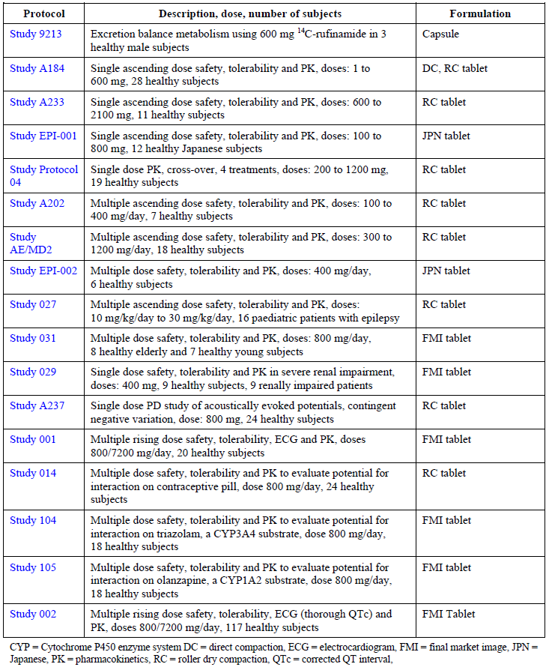

#### Evaluator’s conclusions on pharmacokinetics

Rufinamide has relatively simple pharmacokinetics. It is well absorbed, but it shows a less than dose proportional exposure pattern, probably because of impaired absorption at higher doses. It is eliminated through metabolism to an inactive compound, and this is renally excreted. Maximum plasma levels are reached approximately 6 hours after administration and the plasma elimination half-life is approximately 6 to 10 hours in healthy subjects and in patients with epilepsy. This makes it appropriate to administer the drug twice daily. The multi-dose pharmacokinetics of rufinamide does not show significant differences from the profile predicted from single dose administration.

Exposure to rufinamide is not significantly altered by renal impairment. Studies in subjects with hepatic impairment have not been performed, but it is not expected that major pharmacokinetic changes will occur in the presence of mild and moderate hepatic impairment; rufinamide should be avoided in subjects with severe hepatic impairment.

Variation between and within subjects is moderate. Rufinamide is susceptible to a food effect: food increases the bioavailability of rufinamide by approximately 34% (AUC) and the peak plasma concentration by 56%.

Rufinamide has only mild potential for drug-drug pharmacokinetics interactions, but rufinamide levels were increased by concurrent administration with valproate.

The pharmacokinetics of rufinamide in children resembles that in healthy adults. Children have lower clearance of rufinamide, but this is related to body size. A population pharmacokinetic analysis in subjects ranging from 1 year to 17 years showed that rufinamide kinetics were not significantly affected by age after body weight was taken into consideration. Studies in new-born infants or infants and toddlers under 1 year of age have not been conducted, and use in this age group is not recommended.

### Pharmacodynamics

#### Studies providing pharmacodynamic data

Only two pharmacodynamic studies were submitted: an exploratory EEG study that showed some EEG changes of unclear significance, and a study screening for QT prolongation[20] effects that found significant QT shortening.

#### Evaluator’s conclusions on pharmacodynamics

No direct pharmacodynamic studies were presented assessing the effect of rufinamide on seizure formation in humans.

Rufinamide was shown to have effects on non-epileptic aspects of the EEGs of healthy volunteers, but the clinical significance of this is completely unknown.

Rufinamide causes QT shortening, which poses a theoretical risk of causing arrhythmias; it should therefore be avoided in subjects with short QT intervals at baseline.

The sponsor has produced some idealised models of the relationship between rufinamide concentrations and efficacy, but the model is likely to contain many built in assumptions that cannot be directly tested. In general, the extent of uncertainty surrounding the models’ predictions was unclear, and scatter plots of actual efficacy results in individual patients versus model predictions showed a poor correlation. In the evaluator’s opinion these models do not add substantially to a direct consideration of the efficacy study on which they are based.

### Dosage selection for the pivotal studies

Dose selection for the pivotal study (Study 022) was largely based on results of supportive studies in partial epilepsy, including Studies AE/PT2 and AE/ET1.

Study AE/PT2 was an early Phase II, double blind, placebo controlled, weekly rising dose study in 50 patients with epilepsy who were taking one or two concomitant anti-epileptic drugs. During the double blind treatment phase, subjects received escalating doses of rufinamide, up to 1600 mg/day. The study showed that rufinamide significantly reduced the seizure frequency ratio and had a superior 25% and 50% responder rate relative to placebo.

Study AE/ET1 was a randomised, double blind, placebo controlled, parallel group, Phase II dose ranging study in 647 patients with inadequately controlled partial seizures taking one to three concomitant anti-epileptic drugs. Subjects received placebo or rufinamide at four different doses (rufinamide 200, 400, 800, or 1600 mg/day). A significant linear trend of dose-response was demonstrated for rufinamide doses between 400 and 1600 mg/day (p = 0.003). The seizure frequency ratio (monthly double blind seizure frequency divided by monthly baseline seizure frequency) was significantly lower for the rufinamide 400, 800, and 1600 mg/day treatment groups than for the placebo group (p ≤ 0.0274 for comparison of each dose and placebo).

### Efficacy

#### Studies providing efficacy data

Pivotal study: Study 022 in Lennox-Gastaut syndrome

Supportive studies with high relevance to proposed Lennox-Gastaut syndrome indication:

* Long term open label extension (Study 022E)
* Double blind study in Japanese Lennox-Gastaut syndrome subjects (Study 304)
* Open label study of cognitive tolerability in younger Lennox-Gastaut syndrome subjects (Study 303).

Studies with an acceptable design, performed for indications other than Lennox-Gastaut syndrome:

* Double blind, placebo controlled adjunctive therapy studies in adults with partial seizures (Studies AE/ET1, 021A)
* Double blind, placebo controlled adjunctive therapy in adolescents and adults with refractory partial seizures (Study 301)
* Double blind, controlled study of short term monotherapy in partial seizures (Study 038)
* Double blind, placebo controlled adjunctive therapy study in children with partial seizures (Study 021P)
* Double blind, placebo controlled adjunctive therapy study in primary generalized epilepsy (Study 018)
* Double blind, placebo controlled adjunctive therapy study in subjects with mixed seizure types (Study AE/PT2).

#### Evaluator’s conclusions on efficacy

##### Conclusion for Study 022

The entire submission rests very heavily on the results of the placebo controlled pivotal study, Study 022, which was performed predominantly in paediatric subjects, (subjects aged 4 to 37 years; mean age 14), who had refractory Lennox-Gastaut syndrome and ongoing seizures despite 1 to 2 anti-epileptic drugs. Adjunctive therapy with rufinamide was moderately effective, despite the refractory nature of the Lennox-Gastaut syndrome. Significant superiority was achieved for all three primary efficacy variables, and for both prospective co-primary endpoints, and the differences appeared clinically worthwhile.

For the first primary efficacy variable (change in total seizure frequency), which was also one of the two co-primary endpoints, the reduction in total seizure frequency, compared to baseline, was 32.7% in rufinamide recipients but only 11.7% in placebo recipients (p = 0.0015 by Wilcoxon rank-sum test). The attributable reduction in seizure frequency was about 21% (32.7% to 11.7%)

For the second primary efficacy variable (change in tonic-atonic seizure frequency), which was half of the second co-primary endpoint, the results were also positive. The frequency of tonic-atonic seizures decreased by a median of 42.5% in the rufinamide group, but increased marginally, by a median of 1.4%, in the placebo group (p < 0.0001 by Wilcoxon rank-sum test). For this variable, the attributable reduction in seizure frequency was similar to the observed reduction, about 40%, which represents a worthwhile clinical result given that this seizure type is often refractory to treatment.

For the third primary efficacy variable (the seizure severity subscale of the Global Evaluation), which constituted the second half of the second co-primary endpoint, the results were also significantly positive (p = 0.0041 by Wilcoxon rank-sum test). An improvement in seizure severity (a rating of + 1, + 2 or + 3) was observed in 39 (53.4%) of the 73 rufinamide recipients, compared to 19 (30.6%) of the 62 placebo recipients, indicating a number needed to treat (NNT) of approximately 5 for an attributable improvement. An open label extension of Study 022 showed no evidence of waning efficacy for up to 3 years, but it is difficult to interpret without a control group.

Study 304 had a broadly similar design to the pivotal study (Study 022), in that it was a Phase III, placebo controlled, multicentre, randomised, parallel group, double blind, comparative study assessing rufinamide (up to 3200 mg/day, roughly equivalent to 45 mg/kg/day) as adjunctive therapy in subjects 4 to 30 years of age with inadequately controlled Lennox-Gastaut syndrome. The double blind treatment phase was 84 days. In this study, the median percent reduction in tonic-atonic seizure frequency was 24.20% in the rufinamide group and 3.25% in the placebo group (p = 0.003, Wilcoxon’s rank-sum test). The estimated between group difference was 26.65% by the Hodges-Lehmann method.

Five positive studies in partial seizures (and some other seizures types) provide additional support, as summarised in Table 8 below. Because these studies were not performed in subjects with Lennox-Gastaut syndrome, this evidence has only marginal relevance to the current submission, but it increases the external validity of the Lennox-Gastaut syndrome studies.

Table 8: Summary of primary and supportive efficacy studies, with evaluator comment

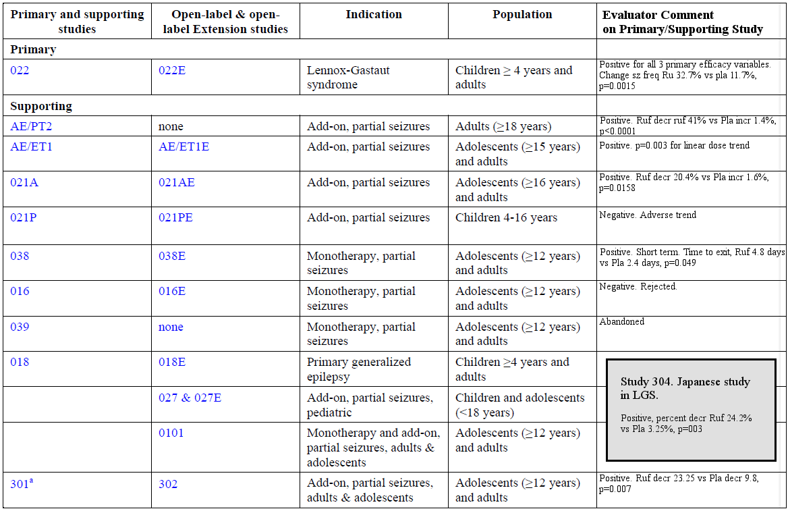

Efficacy in subjects aged 1 to 4 years has not been directly demonstrated. A supportive study in this age group (Study 303) had a focus on cognitive safety, lacked a well-defined control therapy, and was not powered for seizure endpoints, which were considered secondary. As an efficacy study, it is rejected, though it provides some useful safety data.

### Safety

#### Studies providing safety data

The Summary of Clinical Safety (SCS) for rufinamide was based on:

* the pivotal double blind, placebo controlled study in patients with Lennox-Gastaut syndrome (Study 022);
* eight controlled studies in patients with epilepsy other than Lennox-Gastaut syndrome;
* two open label studies in patients with epilepsy; and
* two controlled pharmacokinetic studies in patients with epilepsy.

Eight of these studies had open label extensions, which provided non-controlled safety data. The sponsor also presented data from a study in diabetic neuropathy (61 rufinamide recipients), 21 biopharmaceutical/pharmacokinetic studies performed in healthy volunteers, and 4 studies performed in Japan (for which only translated study reports are available).

The most relevant safety data comes from the pivotal efficacy study, Study 022, but this study only contributed 74 rufinamide recipients to the overall pool of safety data. Across all treated patients with epilepsy (excluding the Japanese studies), 1978 rufinamide recipients produced safety data, with contributions from each study tabulated below. This report, concentrates on two data pools: the pivotal study data and the data collected from the main pool of patients with epilepsy (which excluded the Japanese studies, which were conducted separately and only available in translation).

Table 9: Number of patients in each analysis population, by study

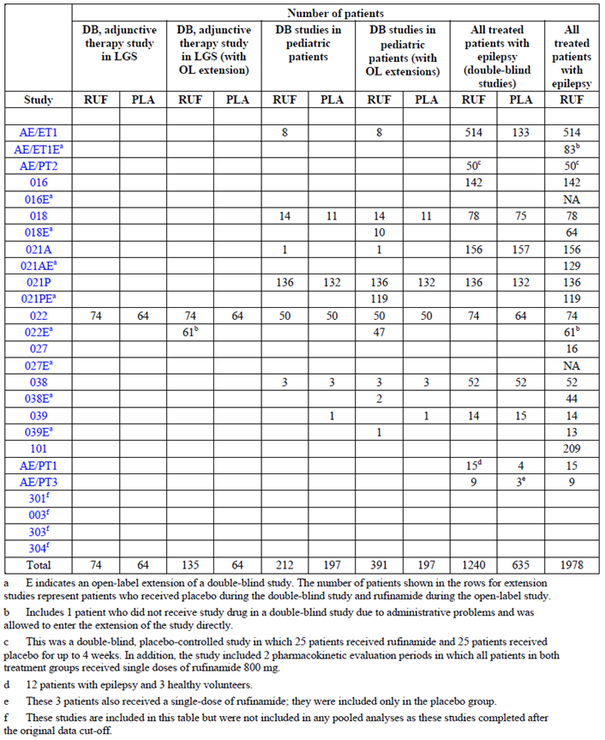

In the pivotal efficacy studies, the following safety data were collected:

* General adverse events (AEs) were assessed by interviews and examinations at regular scheduled visits and unscheduled hospital admissions
* Subjects had ECGs performed at baseline and at frequent intervals during the study
* Laboratory tests, including blood taken for population pharmacokinetic (popPK) modelling, as well as standard clinical chemistry and haematology, were performed at regular intervals.

#### Patient exposure

Exposure in the pivotal study, Study 022, is summarised Table 10. Total exposure in this study was 16.04 patient-years in the rufinamide group and 14.19 patient-years in the placebo group. When the open label extension is included, total exposure increases markedly, to 166.6 patient-years; median duration of exposure was 14.3 months and median dose was 45.71 mg/kg/day (mean 44.62 mg/kg/day).

Table 10: Duration of exposure to rufinamide by median dose (Study 022)

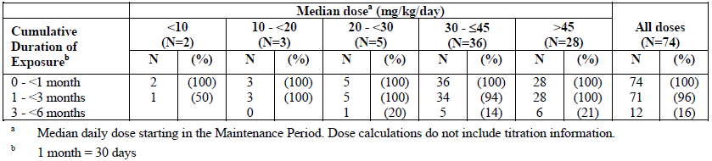

Table 11: Duration of exposure to rufinamide by median dose (Study 022E)

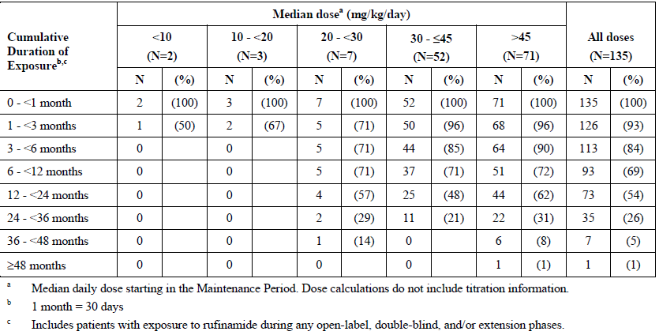

Exposure in the larger pool of epilepsy studies is summarised in the tables below. Total exposure to rufinamide in this data pool was 2552.96 patient-years, with a median daily dose of 1600 mg/day (mean 1700.32 mg/day), and the maximum daily dose was 2000 mg/day (median) 2084.98 mg/day (mean).

Table 12: Duration of exposure to rufinamide by median daily dose and weight (All treated patients with epilepsy)

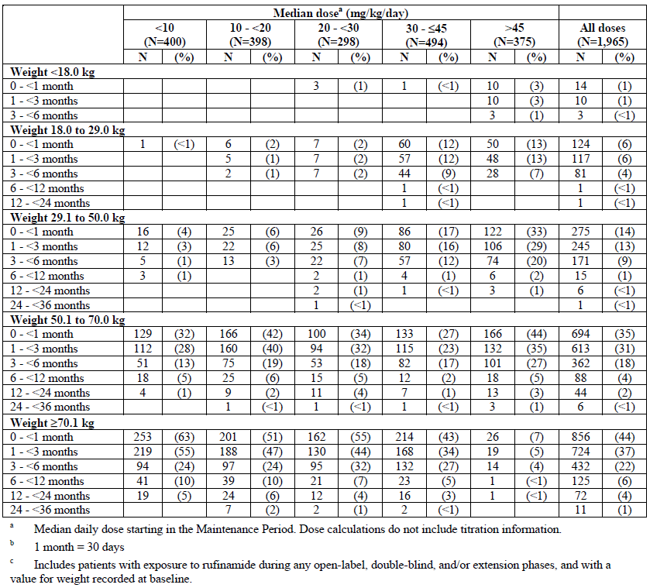

Table 13: Duration of exposure by median dose in (All treated patients with epilepsy)

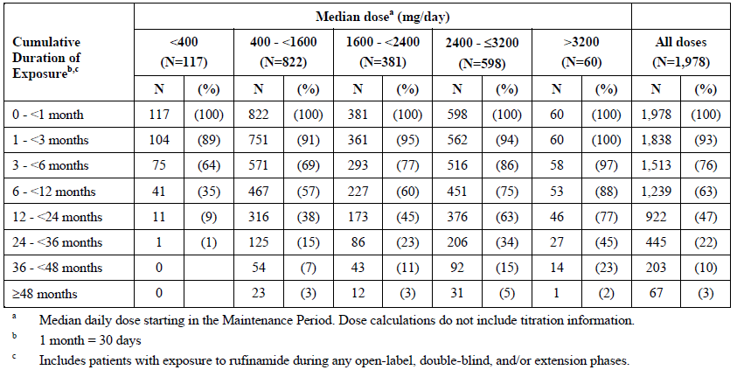

Study 303, which was an efficacy and tolerability study in young children, will be considered separately. In this study, 37 subjects were randomised: 25 to rufinamide and 12 to any other anti-epileptic drug.

In healthy volunteer studies, 188 subjects received rufinamide for 1 to 14 days (median, 3 days), in 11 studies. Doses ranged from 400 to 1600 mg/day (median, 400 mg/day). This short term exposure adds relatively little to the overall assessment of safety, so only key findings in this pool are mentioned in this report.

#### Safety issues with the potential for major regulatory impact

##### Liver toxicity

Although isolated cases of abnormal liver function tests occurred, only one or two cases occurred in which patients had a value for either AST or ALT that was 2 or 3 times the upper limit of normal (ULN) and a value for bilirubin that was 1.5 times the ULN, and it appeared plausible that rufinamide played a causal role. In another case, liver function tests normalised despite continued rufinamide use.

Overall, the potential for rufinamide to cause serious hepatic toxicity appears low.

##### Haematological toxicity

Isolated cases of abnormal haematology values occurred in subjects exposed to rufinamide, and in placebo recipients, with no overall concerning patterns to suggest a major haematological risk. In occasional cases, serious haematological AEs occurred and a causal role of rufinamide appeared plausible, but the risk appears to be low.

##### Serious skin reactions

Across the entire pool of subjects with epilepsy, rash occurred with a similar incidence in rufinamide recipients (3.1%) and placebo recipients (3.3%). None of the 1,978 patients experienced erythema multiforme, Stevens-Johnson syndrome, or toxic epidermal necrolysis. In the pivotal study, rash was clearly more common in rufinamide recipients: adverse events (AEs) characterised under skin and subcutaneous tissue disorders occurred in 17.6% of rufinamide recipients, compared to 4.7% of placebo recipients; the individual AE ‘Rash’ occurred in 6.8% and 1.6%, respectively.

Overall, although rash appears to be attributable to rufinamide in some subjects, especially in the paediatric setting, the incidence of severe reactions appears to be low.

Table 14: Number (%) of patients with rash (All treated patients with epilepsy, double blind studies)

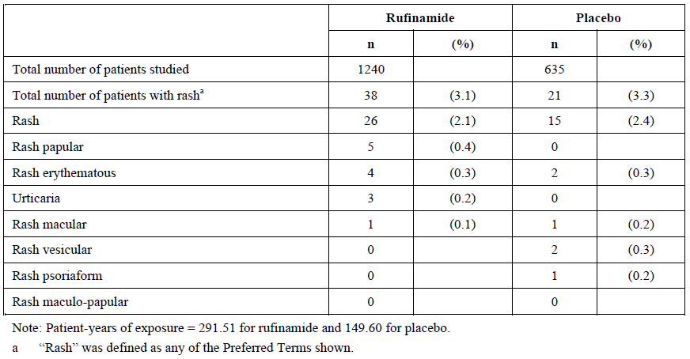

##### Cardiovascular safety

In the clinical trial program, cardiovascular events and AEs related to the ECG were not more common in rufinamide recipients than placebo recipients.

Rufinamide has been shown to cause QT shortening, which is of uncertain clinical significance. It may pose a risk of arrhythmias, but this is predominantly a theoretical concern; it is QT prolongation that is known to pose a clear risk of arrhythmias. It would be appropriate to avoid rufinamide in subjects with a personal or family history of short QT syndrome.

##### Unwanted immunological events

The risk of hypersensitivity with rufinamide appears to be low, and dependent on which dataset is considered. According to the sponsor’s risk management plan: ‘*In double blind clinical studies, hypersensitivity as an event term had an incidence of 0.3% in the rufinamide group compared to 1.3% in the placebo group*. *This incidence was also lower than placebo in the Lennox-Gastaut syndrome double blind population, with 0% of the rufinamide group, and 1.6% of the placebo group reporting this event*.’

Across the trial experience of rufinamide, 3 patients had an SAE coded as hypersensitivity and 4 patients (1 of those 3, plus 3 more) discontinued due to hypersensitivity.

After a review of patient narratives, the sponsor suspects that 5 patients (2 with serious adverse events coded as hypersensitivity and 3 others with serious adverse events coded as pyrexia or rash) might have suffered an anti-epileptic drug hypersensitivity syndrome (defined as a combination of fever, rash, and any evidence of internal organ involvement).

In all of the cases thought to represent hypersensitivity, the reaction appeared during the first 4 weeks of treatment, and all patients were children.

#### Other safety issues

##### Safety in special populations

Rufinamide had a broadly similar AE profile in children and adults, but vomiting and rash had a particularly clear excess in rufinamide recipients in the paediatric studies. Hypersensitivity reactions were only observed in children.

The number of elderly patients recruited to rufinamide studies was small, so safety in elderly subjects has not been well characterised. There are no particular reasons to expect that safety is a major concern in the elderly, but caution should be used when introducing any anti-epileptic drug in elderly subjects, because of the relatively high risk of falls or cognitive difficulties.

Rufinamide clearance is not significantly affected by renal impairment, and safety in this group would be expected to be comparable to healthy patients.

The pharmacokinetics and safety of rufinamide has not been assessed in subjects with severe hepatic dysfunction, and it should be avoided in this group.

Because it causes somnolence and ataxia, rufinamide should be used with caution in subjects with cognitive impairment and in those with a high risk of falls, but this is true of any anti-epileptic drug. This includes subjects with intellectual impairment and motor disability, which may be common in Lennox-Gastaut syndrome subjects. Rufinamide does not appear to pose a higher risk of these problems than other anti-epileptic drugs that might be considered in the Lennox-Gastaut syndrome population, and the major fall risk in Lennox-Gastaut syndrome subjects comes from seizures, which are significantly reduced by rufinamide.

Rufinamide has not been assessed in pregnancy. Preclinical studies revealed no teratogenic effect, but fetotoxicity was observed, with reductions in fetal growth and survival, and some stillbirths secondary to maternal toxicity. Rufinamide should be avoided during pregnancy (Pregnancy Category D).7

##### Reduced appetite

Rufinamide causes an increased incidence of vomiting and reduced appetite in children, and this was particularly evident in the pivotal Lennox-Gastaut syndrome study. For AEs coded as ‘anorexia’, there was no excess with rufinamide.

In the pooled double blind studies, the event of ‘decreased appetite’ was seen in 2.1% of the rufinamide group, compared to 0.8% of the placebo group. In the Lennox-Gastaut syndrome population, the incidence was much higher in the rufinamide group (9.5%) than the placebo group (4.7%). Two of the events were considered severe.

In the pooled population from all double blind clinical studies, the incidence of ‘anorexia’ was only marginally higher in the rufinamide group (2.7%) than the placebo (2.5%) group. In the Lennox-Gastaut syndrome population, the incidence of ‘anorexia’ was lower in the rufinamide (6.8%) group than placebo (7.8%). All ‘anorexia’ events were mild or moderate in severity.

##### Infection

According to the risk management plan, infection was identified as a potential risk on the basis of preclinical studies.

The clinical evidence suggests that rufinamide does not appear to increase the risk of infection. In the Lennox-Gastaut syndrome pivotal study, there was a minor excess of AEs codes as infections or infestations (rufinamide 43.2% versus placebo 34.4%) but there was almost no difference in the pooled paediatric double blind studies (37.7% versus 37.1%, respectively) and in the overall double blind population, infection appeared more common with placebo (22.6% versus 26.9%).

##### Status epilepticus

In the pivotal study (Study 022), status epilepticus was observed in 3 rufinamide recipients but no placebo recipients. A difference in status epilepticus incidence of 4.1% versus 0% would raise substantial concerns if it were maintained in a very large cohort, but in the pivotal study data, this difference is only based on 3 patients.

Across all paediatric studies, including open label extensions, status epilepticus was observed as an SAE in 8 subjects (2%). It is unclear whether the lower incidence in this pool reflects a different risk for Lennox-Gastaut syndrome subjects compared to other paediatric patients with epilepsy or a more accurate assessment of the risk because it is based on a larger pool of subjects.

According to the sponsor’s risk management plan, status epilepticus during the pooled double blind studies had an incidence of 0.9% (11 events) in the rufinamide group compared to 0% in the placebo group. In a refractory epileptic population, status epilepticus is reasonably common, so an incidence of 0% in the placebo group appears low. (A precise estimate of the expected incidence of status epilepticus is not possible, because it varies according to the population being studied. The sponsor’s risk management plan notes *‘Status epilepticus is very frequent in patients with Lennox-Gastaut syndrome, and may occur in more than 60% of patients’.[21]* By itself, then, the 0.9% incidence of status epilepticus in rufinamide subjects is not alarming, but the difference relative to the placebo group appears marked, and suggests that the excess incidence in the rufinamide group may reflect a heightened risk of status epilepticus. The sponsor did not provide a statistical analysis of the difference, but estimates suggest that it is nominally significant (within the considerable limitations of a post hoc comparison). Using the number of patients in the total pool of double blind epilepsy studies (rufinamide = 1240, and placebo = 635), and the reported incidence of 11 events for the rufinamide group and zero for placebo, an online Fisher’s exact test calculator suggests that the difference is significant, with p = 0.02. This statistical result should be interpreted with caution, however, because it is based on a post hoc observation and it has not been corrected for multiplicity.

Table 15: Incidence of status epilepticus in pooled double blind studies

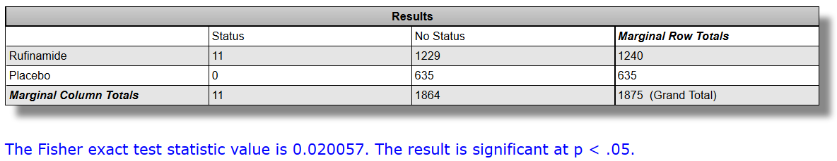

During open label studies, there were additional events, but it is difficult to interpret the observed incidence in the absence of a control group. The overall incidence of status epilepticus as an AE was 1.4% (27 events) in all patients who had received at least one dose of rufinamide, and it was classified as an SAE in 1.0% (20 reports).

#### Post-marketing data

No information provided.

#### Evaluator’s conclusions on safety

Rufinamide is associated with an increased incidence of vomiting, reduced appetite, somnolence and other CNS inhibitory side effects (including ataxia and diplopia) and, in children, rash was more common with rufinamide than with placebo.

Its use has been associated with hypersensitivity reactions in children, but the incidence appears low and, depending on the definition of hypersensitivity, the rate may be similar with rufinamide and placebo.

Rufinamide does not appear to be associated with a significant risk of hepatotoxicity, renal toxicity, haematological problems, or serious skin reactions.

Status epilepticus was reported in some Lennox-Gastaut syndrome subjects exposed to rufinamide, but no placebo recipients.

Rufinamide shortens the QT interval of the ECG; the significance of this is uncertain.

Rufinamide does not appear to increase the risk of infection.

The proposed registration of the oral suspension does not pose substantial risks compared to the tablet that has been used in most of the clinical studies. Also, extension of the target population to include subjects in the age group 1 to < 4 years does not appear to pose substantial new risks. Study 303 assessed rufinamide oral solution in subjects 1 to < 4 years of age, and the observed AEs were consistent with the previously observed safety profile in the pivotal Lennox-Gastaut syndrome study of subjects aged 4 to < 12 years.

As a group, anticonvulsants have been associated with an increased risk of suicidal ideation. Although there is no specific evidence that rufinamide causes an increase in suicidal ideation, the prescribing information carries an appropriate warning about this issue.

There is currently not enough information available to determine whether rufinamide has adverse effects on cognitive development. Although somnolence and other CNS sedative side effects might be expected to interfere with learning, seizures also interfere with cognitive function, and rufinamide has shown a clear reduction in seizures in the target population. The issue of potential cognitive effects of rufinamide has not been adequately addressed by any study (including Study 303, which was ostensibly designed to assess cognitive effects but was, instead, underpowered and without a well-defined control group).

Overall, the safety of rufinamide appears to be acceptable. Most of the issues identified in the clinical study program affect tolerability rather than posing serious safety concerns. There are residual concerns about the potential effects of rufinamide on cognitive development, but this is also true of other anti-epileptic drugs used to treat Lennox-Gastaut syndrome.

### First round benefit-risk assessment

#### First round assessment of benefits

The benefits of rufinamide in the proposed usage in subjects with Lennox-Gastaut syndrome are:

* Rufinamide reduces total seizure frequency significantly more than placebo (-35.8% on rufinamide versus ‑1.6% on placebo, p = 0.0006)
* Rufinamide reduces tonic-atonic seizure frequency significantly more than placebo (‑42.9% on rufinamide versus 2.2% on placebo, p = 0.0002)
* Rufinamide was associated with better scores for the seizure severity rating at the end of the double-blind treatment of the pivotal study (much or very much improved in 32.2% for rufinamide versus 14.5% for placebo, p = 0.0041).
* Rufinamide was associated with a significantly higher response rate (tonic-atonic seizures < 50% of baseline) in the pivotal study (rufinamide 42.5% versus placebo 16.7%; p = 0.0020). The attributable response rate was therefore about 25.8% (42.5% to 16.7%), suggesting that about 4 patients would need to be treated to observe one extra response.
* Rufinamide offers a new therapeutic option in a condition for which no entirely satisfactory treatment exists

#### First round assessment of risks

The risks of rufinamide in the proposed usage are:

* Rufinamide may cause CNS inhibitory side effects, including somnolence and ataxia.
* Rufinamide may cause nausea and vomiting.
* Rufinamide may cause rash.
* Rufinamide may occasionally cause hypersensitivity reactions.
* Rufinamide has been associated with an apparent increase in status epilepticus in one study of Lennox-Gastaut syndrome subjects, but it is unclear if this is an ongoing risk in the wider Lennox-Gastaut syndrome population.
* Rufinamide shortens the QT interval of the ECG.
* The effect of rufinamide on long-term cognitive development has not been adequately characterised, but this is likely to be true of all anti-epileptic drugs currently used for treatment of Lennox-Gastaut syndrome.
* Rufinamide may cause pharmacokinetic changes in other drugs, including warfarin, digoxin and the oral contraceptive.

#### First round assessment of benefit-risk balance

The benefit-risk balance of rufinamide, given the proposed usage, is favourable.

### First round recommendation regarding authorisation

Rufinamide should be approved for use for the indication:

‘*for adjunctive therapy in the treatment of seizures associated with Lennox-Gastaut syndrome in patients 1 year of age and older*.’

It would also be reasonable to restrict rufinamide to patients aged 4 years and older, given that the pivotal study excluded patients aged < 4 years and there is no data showing efficacy in this age group.

Whether it is appropriate to approve rufinamide in Lennox-Gastaut syndrome subjects aged 1 year to < 4 years is largely a matter of subjective opinion: the US has allowed registration in very young children, on the basis of the pivotal study in older children (4 years and older) and minimal safety data in very young children. The EU, by contrast, rejected use in very young children. The clinical evaluator has taken a position similar to that taken in the US, largely because there is no reason to suspect that efficacy differs substantially in the younger age group, efficacy in the older children was demonstrated robustly, and the current treatment options for Lennox-Gastaut syndrome in very young subjects are limited.

### Clinical questions and second round evaluation

The questions are presented with the sponsor’s response and evaluation of the response presented beneath each question.

#### Questions 1 to 4

*Questions 1 to4 were related to the location of information in the dossier.*

##### Sponsor’s response

The sponsor has now provided links to the data.

##### Evaluator comment

The pharmacokinetics data have now been incorporated into the corresponding study synopses. The new data raise no significant new issues

#### Question 5

*Rufinamide is described in the prescribing information as having a bitter taste. What steps were taken to ensure that a blinding in the major efficacy studies was preserved despite a bitter taste of the active treatment?*

##### Sponsor’s response

The sponsor states: *‘While the drug substance presents a mild bitter taste, the combination of the excipients in the oral suspension, mostly sweeteners and orange flavouring, mask the bitter taste making it undistinguishable from the placebo formulation.’*

##### Evaluator’s comment

Unblinding due to bitterness of the active ingredient is unlikely to have been a major methodological problem in the submitted studies, because of the addition of other flavours. It would have been appropriate to confirm this, with a quantitative assessment of the extent of unblinding.

#### Question 6

*Was the adequacy of blinding (and the incidence of accidental unblinding due to tell-tale side effects) assessed in any efficacy study?*

##### Sponsor’s response

The sponsor states: ‘*There were no reports of accidental unblinding in the efficacy studies. There were no adverse events that were specific to rufinamide. All adverse events occurred in both rufinamide and placebo arms, albeit at differing frequencies.’*

##### Evaluator’s comment

The sponsor has not explicitly answered the question, but it appears that no formal attempt was made to ask subjects and carers whether they thought that they had received active treatment.

Relying on volunteered reports of accidental unblinding is not an adequate assessment of unblinding, because unblinding is not always explicit or absolute; whether a subject is unblinded or not is not always a binary matter. Patients and carers are unlikely to report a suspicion that they have received active treatment, and would generally be unable to tell whether their suspicions of receiving active treatment were stronger than experienced by other subjects. Similarly, clinicians are unlikely to have interrogated patients on this issue, unless the study design mandated it.

As noted in the first round clinical evaluation report, rufinamide is associated with a number of side effects that would be expected to provide strong clues to its presence. The fact that potential tell-tale AEs occurred in both treatment groups does not guarantee that all or even most patients were ignorant of their treatment assignment, particularly because the timing of AEs in relation to dosing may provide strong clues that an active substance has been consumed. If patients experienced tell-tale AEs at different frequencies in the different treatment groups, or with different timing or intensity, then the number of patients assuming they were on active treatment could have been substantially unequal across treatment groups. This, in turn, could have affected perceptions and reporting of seizures.

The fact that the active treatment has a bitter taste compounds this problem, and there is no firm evidence backing up the sponsor’s claim that the bitterness was adequately masked by other flavours; it remains an untested assertion.

By failing to ask subjects what treatment they thought they had received, the sponsor has made it impossible to determine the extent to which unintentional unblinding was a methodological problem. This represents a substantial flaw in the submitted studies, but it is not considered sufficiently serious that the conclusions need to be rejected.

### Second round benefit-risk assessment

The new data submitted in response to clinical questions does not significantly alter the benefit-risk balance for rufinamide.

Rufinamide should be approved for use:

‘*for adjunctive therapy in the treatment of seizures associated with Lennox-Gastaut syndrome in patients 1 year of age and older*.’

As noted in the first round clinical evaluation, it would also be reasonable to restrict rufinamide to patients aged 4 years and older, given that the pivotal study excluded patients aged < 4 years and there is no data showing efficacy in this age group.

## VI. Pharmacovigilance findings

### Risk management plan

The sponsor has submitted EU-Risk Management Plan version 9 (date 4 February 2016; data lock point (DLP) 15 January 2016) and Australian Specific Annexe (ASA) version 1.0 (date March 2017) in support of this application.

Along with responses to questions the sponsor provided an updated ASA version 1.1 (date November 2017).

Table 16 summarises the sponsor’s summary of safety concerns, along with routine and additions pharmacovigilance and risk minimisation activities.

Table 16: Summary of Safety Concerns; pharmacovigilance and risk minimisation strategies

|  |  |  |  |  |  |
| --- | --- | --- | --- | --- | --- |
| **Summary of safety concerns** | | **Pharmacovigilance** | | **Risk Minimisation** | |
| Routine | Additional | Routine | Additional |
| **Important identified risks** | Status Epilepticus | ✓ | – | ✓ | – |
| Rash and Hypersensitivity | ✓ | – | ✓ | – |
| Decreased Appetite and Weight Loss | ✓ | – | ✓ | – |
| Coordination Abnormal (Ataxia) | ✓ | – | ✓ | – |
| Somnolence | ✓ | – | ✓ | – |
| Dizziness / Vertigo | ✓ | – | ✓ | – |
| Diplopia and Blurred Vision | ✓ | – | ✓ | – |
| Vomiting | ✓ | – | ✓ | – |
| **Important potential risks** | Pregnancy and Associated Birth Defects | ✓ | ✓ | ✓ | – |
| Haematological Dyscrasias including Myelofibrosis | ✓ | – | – | – |
| Infections | ✓ | – | ✓ | – |
| Developmental and Maturation Impairment in Children and Adolescents | ✓ | – | – | – |
| Adverse Effects on Cognition | ✓ | – | – | – |
| Shortened QT interval on ECG | ✓ | – | ✓ | – |
| Suicide | ✓ | – | ✓ | – |
| Worsening of seizures and changes in seizure type including withdrawal seizures | ✓ | – | ✓ | – |
| Medication errors, especially those associated with the oral suspension formula | ✓ | – | – | – |
| **Missing information** | Elderly population | ✓ | – | ✓ | – |
| Concomitant medications | ✓ | – | ✓ | – |
| Hepatic Impairment | ✓ | – | ✓ | – |

* Additional pharmacovigilance activity comprises of a pregnancy registry that will be maintained by EURAP (European and International Registry of Anti-epileptic drugs in Pregnancy).
* Only routine risk minimisation activities are proposed for most of the safety concerns. As shown in Table 16 there are no risk minimisation measures proposed for four Important Potential Risks.

#### Summary of RMP evaluation[22]

The sponsor is proposing routine pharmacovigilance activities for all safety concerns. Additional pharmacovigilance activity includes the pregnancy registry maintained by European and International Registry of Anti-epileptic drugs in Pregnancy (EURAP) which monitors the risk of fetal malformations following intake of anti-epileptic drugs. Though the ASA states the information in this register will be relevant to Australia, it is not clear whether Australian patients will be included in EURAP. The sponsor should clarify whether Australian patients will be registered in EURAP.

According to the ASA, Eisai Australia maintains a local register of pregnancy reports for all marketed products. The sponsor should append any pregnancy follow-up forms used in Australia to the ASA.

#### New and outstanding recommendations from second round evaluation

There are no changes to the safety specification.

#### Proposed wording for conditions of registration

Any changes to which the sponsor has agreed should be included in a revised RMP and ASA. However, irrespective of whether or not they are included in the currently available version of the RMP document, the agreed changes become part of the risk management system.

The suggested wording is:

Implement EU-RMP (version 9, date 4 February 2016, data lock point 15 January 2016) with Australian Specific Annex (version 1.1, date November 2017) and any future updates as a condition of registration.

## VII. Overall conclusion and risk/benefit assessment

The submission was summarised in the following Delegate’s overview and recommendations:

### Background

The sponsor has applied to register a new chemical entity, rufinamide (Inovelon). Inovelon is proposed to be used as adjunctive therapy in the treatment of seizures associated with Lennox Gastaut syndrome in patients 1 year of age and older.

Rufinamide is a novel antiepileptic drug (AED), with a chemical structure substantially different to currently registered AEDs. It is a triazole (carboxamide) derivative. Like many other AEDs, it modulates the activity of sodium channels, prolonging their inactive state. It has been used currently in Australia under the special access scheme.

The proposed mechanism of action for rufinamide, derived from in vitro studies, is modulation of the activity of sodium channels, prolonging their inactive state. This would be expected to reduce the rate at which epileptogenic neurons can fire action potentials, and therefore have an anticonvulsant effect; many other anticonvulsants are presumed to act, at least in part, by inhibiting sodium channels. Rufinamide has been shown to have anticonvulsant activity in a range of animal models of epilepsy.

No clinical studies have been submitted clarifying the mechanism of action of Rufinamide.

#### Overseas Regulatory Status

Rufinamide tablets were first approved in the EU via the Centralised Procedure in the European Commission decision dated 16 January 2007 for use as adjunctive therapy in the treatment of seizures associated with Lennox-Gastaut syndrome in patients 4 years of age and older.

In the US, on 14 November 2008, rufinamide tablets and on 3 March 2011 rufinamide oral solutions received approval for adjunctive treatment of seizures associated with Lennox-Gastaut syndrome in paediatric patients 1 years of age and older and in adults.

The tablet formulations were first launched in the EU in May 2007 as Inovelon (100 mg, 200 mg, and 400 mg formulations) and in the US in November 2008 as Banzel (200 mg and 400 mg formulations). To date, rufinamide tablets are approved in 40 countries.

Most approvals have been in the age group above 4 years of age, with the exception of the US, which has approved rufinamide for an indication identical to that proposed in the current submission. Use in children aged 1 year to < 4 years has been rejected in the EU, on the grounds of inadequate characterisation in this age group, and the approval process is pending in Canada and Switzerland.

#### Guidelines

The TGA adopted EU guideline of direct relevance for this submission is:

* CHMP/EWP/566/98 Rev.2/Corr. Guideline on clinical investigation of medicinal products in the treatment of epileptic disorders.

### Quality

From a pharmaceutical chemistry perspective, there are several issues that remained outstanding. However, given that the sponsor proposed to withdraw the oral suspension, the remaining three outstanding issues are considered minor (relate to the sponsor’s oversight of revising the drug substance specification).

Once these minor issues are resolved, approval for registration of rufinamide film coated tablet 100 mg, 200 mg and 400 mg tablets can be recommended from a pharmaceutical chemistry perspective.

### Nonclinical

The evaluator found no major objections to the registration of rufinamide for patients with seizures associated with Lennox-Gastaut syndrome.

The primary pharmacology studies support the proposed indication for rufinamide. Secondary pharmacodynamics studies identified moderate binding of rufinamide to β‑adrenergic and mGluR5 receptors, the clinical relevance of which is unclear. Mild toxicity in the liver was observed in juvenile as well as in adult animals at exposure levels lower than or similar to those reached in patients. Reversibility of all findings was demonstrated after cessation of treatment. Liver and kidney effects in animal repeat-dose toxicity studies were likely species-specific with little clinical relevance.

Rufinamide is not considered to pose a genotoxic or carcinogenic risk. Rats exposed to clinical concentrations of rufinamide and above showed decreased fertility. Rufinamide was not teratogenic in rat or rabbit embryofetal development studies.

Accordingly, Pregnancy Category B39 is considered more appropriate for rufinamide than the sponsor’s suggestion of Category D7.

The sponsor needs to submit either quantitative-structure activity relationship data or appropriately conducted genotoxicity assays in order to qualify one of the synthetic impurities. The sponsor believes that this impurity can be qualified based on post-market clinical data, an issue that should be commented upon by the clinical evaluator.

There are no nonclinical objections to registration as long as the impurity qualification issue is resolved to the satisfaction of the evaluator and Delegate.

### Clinical

#### Scope of the clinical dossier

The clinical dossier included the following data:

* 8 clinical pharmacology studies, including
  + 16 that provided pharmacokinetic data and
  + 2 that provided pharmacodynamic data.
* Population pharmacokinetic analyses
* 1 pivotal efficacy study
* 17 supportive studies, including one Japanese study in Lennox-Gastaut syndrome subjects, resembling the pivotal study, and a study in very young Lennox-Gastaut subjects (aged 1 to < 4 years), plus several studies in partial seizures, which are only of indirect relevance to the proposed usage in Lennox-Gastaut syndrome.

#### Paediatric data

The submission included paediatric pharmacokinetic (24 patients aged 1 to 3 years, 40 patients aged 4 to 11 years, and 21 patients aged 12 to 17 years), efficacy and safety data, with the principal study recruiting subjects aged 4 years to 30 years, and an additional study recruiting subjects from 1 year to < 4 years.

#### Pharmacokinetics

Rufinamide has relatively simple pharmacokinetics and is well absorbed, but it shows a non-linear dose exposure pattern probably because of impaired absorption at higher doses. It is eliminated through metabolism to an inactive compound, and this is excreted through kidney. Cmax is reached in approximately 6 hours and the plasma elimination half-life is approximately 6 to 10 hours in healthy subjects and in patients with epilepsy. This makes it appropriate to administer the drug twice daily.

Exposure to rufinamide is not significantly altered by renal impairment. Studies in subjects with hepatic impairment have not been performed. Variation between and within subjects is moderate. Rufinamide is susceptible to a food effect: food increases the bioavailability (AUC) of rufinamide by approximately 34% and the peak plasma concentration by 56%.

Rufinamide has only mild potential for drug-drug pharmacokinetic (PK) interactions, but rufinamide levels were increased by concurrent administration with valproate. Valproate concentrations were associated with reduced rufinamide clearance, which resulted in increased predicted rufinamide concentrations of 55 to 70% in children, 23 to 26% in adolescents and < 16% in adults. The mechanisms of this interaction were not clear, but valproate inhibits the hepatic metabolism of many drugs. It would have been appropriate to perform a specific drug interaction study with valproate and rufinamide as commented by the clinical evaluator, but this was not done. The PI contains appropriate warnings about the need for rufinamide dose reduction in patients already receiving valproate.

The pharmacokinetics of rufinamide in children resembles that in healthy adults. Population pharmacokinetics (PopPK) analysis based on 115 subjects including 85 paediatric subjects (24 patients aged 1 to 3 years, 40 patients aged 4 to 11 years, and 21 patients aged 12 to 17 years), indicated that rufinamide pharmacokinetics was not significantly affected by young age, after body weight was taken into consideration.. Studies in new-born infants or infants and toddlers under 1 year of age have not been conducted, and use in this age group is not recommended.

#### Pharmacodynamics

No direct pharmacodynamics studies were presented assessing the effect of rufinamide on seizure formation in humans. Rufinamide causes QT shortening, which poses a theoretical risk of causing arrhythmias; it should therefore be avoided in subjects with short QT intervals at baseline. Pharmacodynamic models described in the dossier by the sponsor do not add substantially to a direct consideration of the efficacy study in which they are based.

#### Efficacy

The sponsor submitted 19 efficacy studies, which were performed after the original European submission, but it does include two bioavailability studies not considered relevant for efficacy. Many of the submitted studies had only indirect relevance to the proposed indication (Lennox-Gastaut syndrome), as they assessed efficacy in other epilepsy syndromes.

##### Pivotal efficacy study; Study 022

Study 022 (n = 138) was a Phase III, multi-centre, double blind, placebo controlled, randomised, parallel group study of Rufinamide, used as adjunctive therapy in patients with inadequately controlled seizures associated with Lennox-Gastaut syndrome. The study consisted of a prospective 28 day Baseline Phase to establish baseline seizure frequency and an 84 day double blind phase during which patients received either Rufinamide or placebo.

###### Objective

To evaluate the safety and efficacy of rufinamide relative to placebo as adjunctive therapy in patients (aged 4 to 30 years) with inadequately controlled seizures associated with Lennox-Gastaut syndrome.

Subjects were eligible if they had a confirmed diagnosis of Lennox-Gastaut syndrome and an inadequate response to 1to 3 anti-epileptic drugs such as valproate, lamotrigine and topiramate.

Seizure frequency over the 84 day double blind phase was compared with the baseline phase and a global evaluation of response was recorded at the end of the study.

Subjects were randomised with equal probability to placebo or oral rufinamide, with doses adjusted according to weight, starting at 10 mg/kg/day and titrating over one to two weeks to approximately 45 mg/kg/day (as shown in Table 17).

Table 17: Recommended dose titration schedule by weight

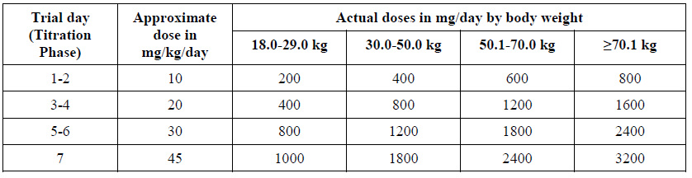

###### Primary endpoint

The primary endpoint for the study was a complex co-primary endpoint based on the three primary efficacy variables. The protocol specified that rufinamide would be considered effective if:

* The percent reduction in total seizure frequency per 28 days in the double blind phase relative to the baseline phase was significantly greater (p < 0.025; two-sided) for rufinamide than placebo (primary endpoint 1); or

Both of the following were true (primary endpoint 2):

* The percent reduction in tonic-atonic seizure frequency per 28 days in the double blind phase relative to the baseline phase was significantly greater (p < 0.025, two‑sided) for rufinamide than placebo.
* The seizure severity rating from the global evaluation of the patient’s condition was significantly greater (p < 0.025, two-sided) for rufinamide than placebo.

###### Major secondary efficacy variables

These included:

1. The response to treatment (the proportion experiencing at least a 50% reduction in tonic-atonic seizure frequency during the double blind phase relative to the baseline phase).
2. The percent change in the frequency per 28 days for seizure subtypes other than tonic-atonic seizures; and
3. The global evaluation of the patient’s condition, which was the sum of five 7 point assessments performed by the parent or guardian at the end of the double blind phase.

Demographic data from the study is well documented in Table 18. Of the 139 patients randomised, 138 received at least one dose of study medication (rufinamide, n = 74; placebo, n = 64).

The groups were reasonably well matched, the two groups had a somewhat different baseline seizure frequency, but as seizure frequencies were expressed as a percentage, this baseline difference is unlikely to have made a big difference in the overall efficacy analysis. Combined seizure designation of tonic-atonic seizures (the sum of tonic and atonic seizures) was equally represented in the two groups. The distribution of the number of concomitant anti-epileptic drugs (one, two or three) was also acceptably matched.

Table 18: Demographic and baseline characteristics (All treated patients), Study 022

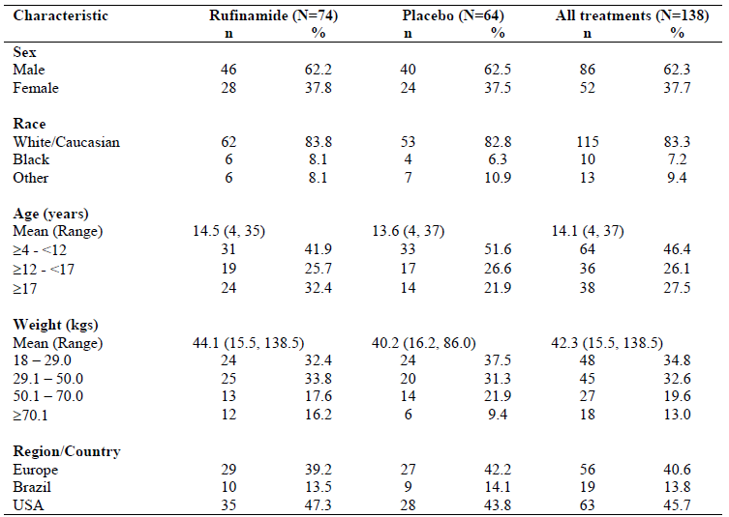

The most common concomitant anti-epileptic drugs were valproate, lamotrigine and topiramate, with similar usage in the two treatment groups.

###### Results

For the first primary efficacy variable (change in total seizure frequency), which was also one of two co-primary endpoints, the results were strongly in favour of rufinamide. The reduction in total seizure frequency, compared to baseline, was 32.7% in rufinamide recipients but only 11.7% in placebo recipients (p = 0.0015 by Wilcoxon rank-sum test). This endpoint, by itself, renders the study positive by its prospective efficacy criteria. The attributable reduction in seizure frequency was about 21% (32.7% to 11.7%), which is a modest but clinically worthwhile effect.

The robustness of these results was confirmed with exploratory analyses using an ANCOVA model on ranks, with treatment and region as factors and baseline total seizure frequency as a covariate (p = 0.0026). This approach provides some reassurance that the unequal baseline seizure frequency did not play an important role. In the ANCOVA model, rufinamide remained significantly superior even after adjusting for the number of anti-epileptic drugs used at baseline (p = 0.0021).

Change in tonic-atonic seizure frequency, constituted half of the second co-primary endpoint. The results for this endpoint were also clearly positive. The frequency of tonic-atonic seizures decreased by a median of 42.5% in the rufinamide group, but increased marginally, by a median of 1.4%, in the placebo group (p < 0.0001 by Wilcoxon rank-sum test). Similar to first primary efficacy variable, robustness of these results was confirmed with exploratory analyses using an ANCOVA model.

The seizure severity subscale of the global evaluation (third primary efficacy variable), was again significantly positive (p = 0.0041 by Wilcoxon rank-sum test). An improvement in seizure severity was observed in 53.4% compared to 30.6% of the placebo recipients. The proportion with an attributable improvement was therefore approximately 22.8% (53.4% to 30.6%), which broadly implies that 5 patients would need to be treated with rufinamide to observe one attributable improvement in seizure frequency.

The other efficacy variables were also largely in favour of rufinamide. Broadly similar effects were seen when response was defined in terms of the total seizure frequency rather than the tonic-atonic seizure frequency: responses (at least 50% improvement in seizure frequency) were observed in an additional 20% of subjects when they received rufinamide, compared to placebo (31.10% versus 10.9%).

For other seizure types, most of the differences were in favour of rufinamide, and these occasionally reached significance, as the analysis was underpowered.

###### Subgroup analysis

None of the subgroup (total seizure frequency, total tonic-atonic seizure frequency, age, sex, weight, number of concomitant anti-epileptic drugs, and type of concomitant anti-epileptic drugs) suggested that the efficacy of rufinamide was limited to any particular subgroup. When analysed according to individual types of concomitant anti-epileptic drug, the benefit appeared broadly consistent regardless of which anti-epileptic drugs were present at baseline, with significant superiority of rufinamide demonstrated for patients who received topiramate (p = 0.0059) or valproate (p = 0.0019) as one of their concomitant anti-epileptic drugs, and a trend for those who received lamotrigine (p = 0.0675). There was no suggestion that rufinamide is particularly prone to causing a paradoxical increase in seizures.

Across the duration of the study, the improvement in seizure frequency observed in the rufinamide group was stable or improved, whereas the placebo group showed smaller improvements that were not sustained over multiple visits.

##### Study 022E

Study 022E was an open label extension of Study 022. Subjects completing the parent study were invited to enter an open label phase if the treating investigator thought they might benefit from rufinamide; the group studied was therefore enriched for patients who had shown good tolerability or good responsiveness to rufinamide. Of the 139 subjects randomised in the parent study, 124 entered the extension.

The study had two periods:

* Double blind conversion period: Patients who were on placebo were titrated to an appropriate dose of rufinamide over 14 days while the patients on rufinamide remained on rufinamide.
* Open label period: The daily dose at the end of the conversion period was continued, but it could be modified between 10 to 45 mg/kg/day in two or three divided doses at the investigator's discretion.

Efficacy analysis was based on the percentage reduction in total seizure frequency and the responder rate. No formal statistical hypothesis testing was possible in the absence of a control group.

The median percent reductions in total seizure frequency across the cohorts ranged from 54.4% to 67.8% at Month 9, and from 42.8% to 55.0% at Month 12. The median percent reductions in tonic-atonic seizure frequency ranged from 64.6% to 72.4% at Month 9, and from 57.9% to 61.1% at Month 12.

###### Clinical evaluator’sconclusion

This study showed no evidence of a major decline in efficacy with continued treatment, and instead suggested that treatment responses were reasonably stable, but no firm conclusions can be drawn because of the study’s open label and uncontrolled design. A high proportion of subjects discontinued, including a 41% who withdrew because of an unsatisfactory therapeutic response.

##### Study 304

Study 304 (evaluable n = 58), similar in design to pivotal Study 022 was a Phase III, placebo controlled, multicentre, randomised, parallel group, double blind, comparative study assessing rufinamide (up to 3200 mg/day, roughly equivalent to 45 mg/kg/day) as adjunctive therapy in Japanese subjects 4 to 30 years of age with inadequately controlled Lennox-Gastaut syndrome.

The primary endpoint was percent change in tonic-atonic seizure frequency and secondary endpoints were 50% responder rate in tonic-atonic seizure frequency; percent change in the total seizure frequency and percent change in the frequency of seizures other than tonic-atonic seizures; and Clinical Global Impression of Change (CGIC).

The median percent reduction in tonic-atonic seizure frequency was 24.20% in the rufinamide group and 3.25% in the placebo group (p = 0.003). A trend to superiority of rufinamide group was also suggested for the key secondary variable. For the percent change in the total seizure frequency, the median percentage reduction was 32.9% for the rufinamide group, compared to only 3.05% in the placebo group (p < 0.001).

For seizures other than tonic-atonic seizures, the percent change in the frequency showed significant decreases in the rufinamide group relative to the placebo group for three seizure types: partial seizures, myoclonic seizures, and tonic seizures (p = 0.025, p = 0.021, and p = 0.031, respectively, Wilcoxon’s rank-sum test). The CGIC significantly favoured rufinamide.

##### Study 303

The main contribution of this study to the overall submission is that it was the only study to include very young patents (1 year to less than 4 years), and therefore was considered in some detail by the clinical evaluator.

It was a small (n = 37) international, randomised, open label, active controlled, Phase III study of Lennox-Gastaut syndrome subjects, in which adjunctive rufinamide was compared with a single adjunctive anti-epileptic drug of the investigator’s choice. The primary efficacy variable was unrelated to seizures: the Child Behaviour Checklist (CBCL) Total Problems score. An analysis of the effects of rufinamide on seizure frequency was not a part of any major objective or endpoint, and seizure frequency was only assessed as an exploratory endpoint.

The study was designed to satisfy the demands of regulatory authorities, as explained by the sponsor in the study synopsis:

‘*This study was conducted to fulfil [sic] the United States Food and Drug Administration (FDA) Written Request (WR) and the European Medicines Agency (EMA) Paediatric Investigation Plan (PIP). FDA requested a 6-month study to evaluate pharmacokinetic (pharmacokinetics) and safety objectives in this age population, while the EMA requested a 2-year study for the primary evaluation of cognitive development and behavioural effects in a pediatric population 1 to less than 4 years of age*.’

The test treatment was oral rufinamide at doses up to 45 mg/kg/day, administered in two divided doses as oral suspension (40 mg/mL). Rufinamide was initially administered at 10 mg/kg/day and increased in 10 mg/kg/day increments every 3 days to 40 mg/kg/day, and then increased by 5 mg/kg/day to the target maintenance level of 45 mg/kg/day.

The reference therapy, ‘any other anti-epileptic drug’, was any approved anti-epileptic drug of the investigator’s choice, with the dose chosen according to investigator's usual practice. This design made interpretation of the results impossible due to reference drug was also used in rufinamide arms.

To increase the number of subjects exposed to rufinamide, subjects were randomised to rufinamide or to any other approved anti-epileptic drug in a 2:1 ratio. Of the 37 subjects randomised into the study, 25 subjects were randomized to rufinamide and 12 to ‘any other anti-epileptic drug’. All randomised subjects received at least 1 dose of study drug. Given that the groups were so small, matching was not expected to be close but it was broadly acceptable.

At Week 106, the median change in CBCL, for rufinamide, was zero, and the mean was close to zero (-0.3), from a baseline median and mean of 54.5 and 56.6, respectively. The only conclusion to be drawn from the above result is that rufinamide, titrated to avoid cognitive side effects, might have broadly similar cognitive effects as a mix of different anti-epileptic drugs, also titrated to avoid cognitive side effects. The study did not establish this with any robustness, and the study design does not allow an assessment of the relative trade-off between cognitive side effects and efficacy against seizures, for rufinamide or any of the control anti-epileptic drugs. Overall, nothing can be concluded from these results, and it cannot be inferred that rufinamide has no harmful effects on cognitive or language development.

##### Additional studies

Five positive studies in partial seizures (and some other seizures types) provide additional support but as these studies were not performed in subjects with Lennox-Gastaut syndrome, this evidence has only marginal relevance to the current submission. But it does increases the external validity of the Lennox-Gastaut syndrome studies.

#### Safety

The sponsor’s summary of clinical safety (SCS) for rufinamide was based on the pivotal double blind, placebo controlled study in patients with Lennox-Gastaut syndrome (Study 022);

* eight controlled studies in patients with epilepsy other than Lennox-Gastaut syndrome;
* two open-label studies in patients with epilepsy;
* two controlled pharmacokinetic (pharmacokinetics) studies in patients with epilepsy.

Eight of these studies had open label extensions, which provided non-controlled safety data. The sponsor also presented data from a study in diabetic neuropathy (61 rufinamide recipients), 21 biopharmaceutical/pharmacokinetics studies performed in healthy volunteers, and four studies performed in Japan (for which only translated study reports are available).

The most relevant safety data comes from the pivotal efficacy study, Study 022, but this study only contributed 74 rufinamide recipients to the overall pool of safety data. Across all treated patients with epilepsy (excluding the Japanese studies), 1978 rufinamide recipients produced safety data. Clinical evaluator evaluated safety similar to the sponsor’s SCS by dividing them into two data pools: the pivotal study data and the data collected from the main pool of patients with epilepsy (which excluded the Japanese studies, which were conducted separately and only available in translation).

##### Exposure

Total exposure in the Study 022 was 16.04 patient-years in the rufinamide group and 14.19 patient-years in the placebo group. When the open-label extension is included, total exposure increases markedly, to 166.6 patient-years; median duration of exposure was 14.3 months and median dose was 45.71 mg/kg/day (mean 44.62 mg/kg/day).

Total exposure to rufinamide in main data pool of patients with epilepsy was 2552.96 patient-years, with a median daily dose of 1600 mg/day (mean 1700.32 mg/day), and the maximum daily dose was 2000 mg/day (median) 2084.98 mg/day (mean).

##### Adverse events

In two of the three placebo controlled data pools, the AE rate was very similar in rufinamide and placebo recipients. For paediatric patients in double blind studies, the incidence of AEs was higher in rufinamide recipients (83.5%) than placebo recipients (74.6%). Considering the nature of AEs, within the pivotal study (Table 19), there was a moderate excess of AEs in rufinamide recipients for the following organ classes: infections and infestations, nervous system disorders, skin and subcutaneous disorders.

Table19: Number (%) of patients with adverse events by SOC (pivotal Study 022)

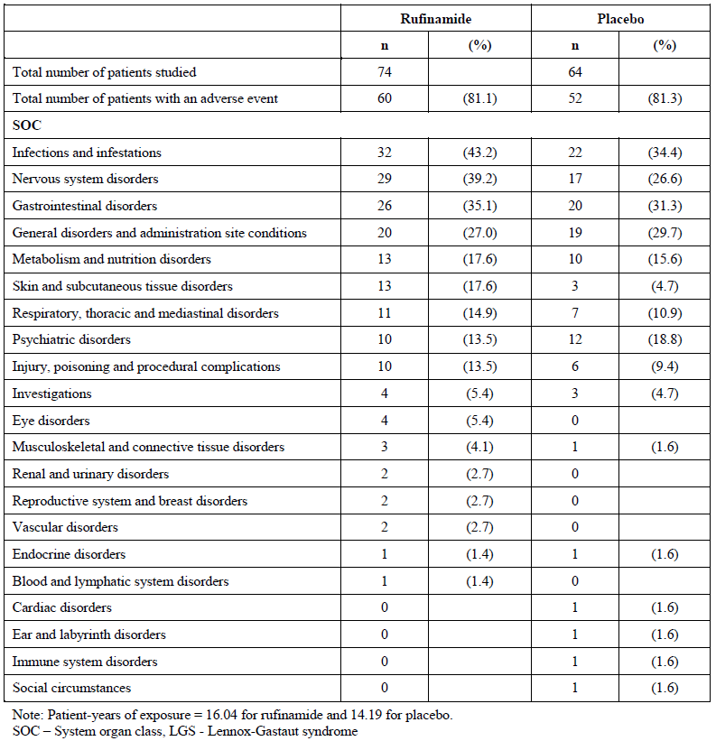

Broadly similar findings were obtained in the overall pool of paediatric double blind studies (Table 20), but there was a clearer excess of gastrointestinal disorders in the larger pool. This excess of gastrointestinal was not seen in the pool of all patients with epilepsy in double blind studies (Table 21), but an excess of nervous system disorders was common to all three placebo controlled data pools. Overall, the total incidence of AEs was reasonably reassuring.

Table 20: Number (%) of patients with adverse events by SOC (double blind studies in paediatric patients)

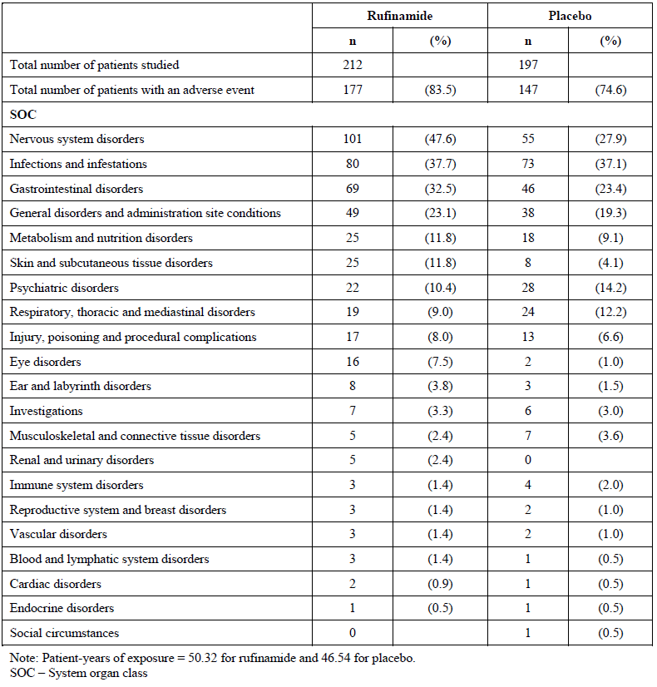

Table 21: Number (%) of patients with adverse events by SOC (All treated patients with epilepsy, double blind studies)

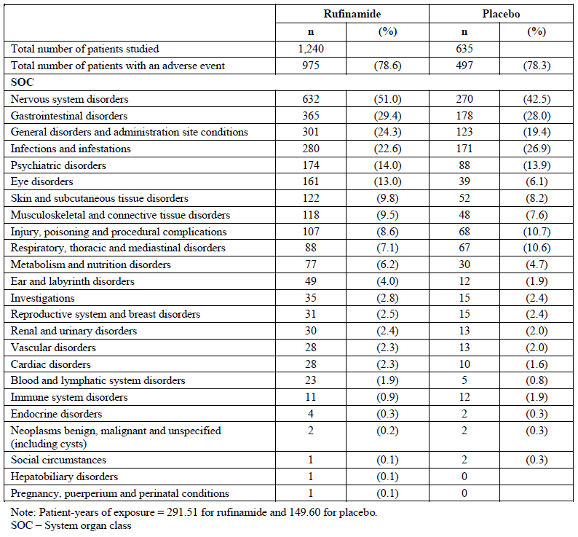

An analysis of individual AEs in Study 022 (Table 22) shows an excess of somnolence, vomiting, decreased appetite, nasopharyngitis, rash, ataxia, epistaxis, nystagmus and status epilepticus. In pooled paediatric double blind studies, somnolence and vomiting remained common, with an excess in rufinamide recipients, but upper respiratory tract infections were more common with placebo.

Table 22: Number (%) of patients with adverse events by Preferred Term with incidence in rufinamide group 3% or more higher than in placebo group (Study 022)

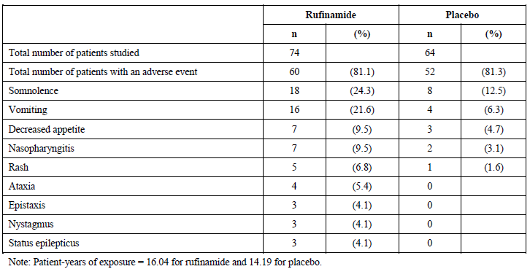

Considering AEs with an incidence at least 3% higher in the rufinamide group (Table 23), the pattern of AEs was similar to that observed in the pivotal study, with an excess of CNS sedative side effects, gastrointestinal intolerance, and headache. When the pool included adults (Table 24), vomiting was no longer excessive in rufinamide recipients but CNS sedative side effects and headache remained.

Table 23: Number (%) of patients with adverse events by Preferred Term with incidence in rufinamide group 3% or more higher than in placebo group (double blind studies in paediatric patients)

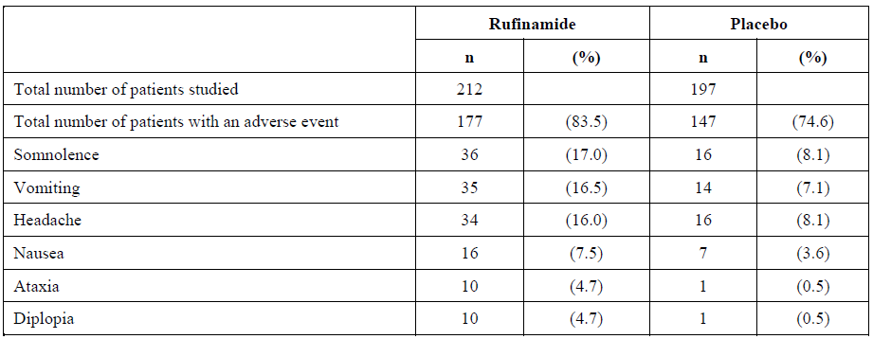

Table 24: Number (%) of patients with adverse events by Preferred Term with incidence in rufinamide group 3% or more higher than in placebo group (All treated patients with epilepsy, double blind studies)

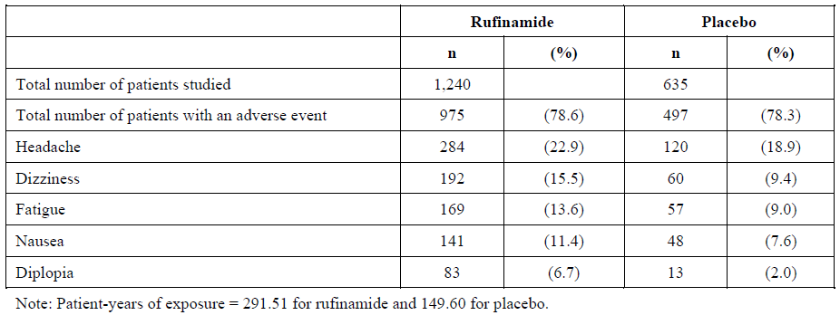

In the pool of all treated patients with epilepsy, the pattern was similar. There was no consistent pattern to suggest that the common AEs were dose related. To some extent, a dose related pattern could have been disguised by appropriate titration.

In the pivotal study (Study 022), 41 (55.4%) patients in the rufinamide group and 28 (43.8%) patients in the placebo group had at least one AE the investigator suspected of being drug-related. The most common drug-related AE was somnolence, reported in both groups (rufinamide 24.3%; placebo 12.5%). There was a clear excess in the rufinamide group of drug-related vomiting (rufinamide 10.8%, placebo 1.6%), decreased appetite (9.5% versus 3.1%), and ataxia (5.4% versus 0.0%).

Overall, assessments of causality were consistent with the patterns of excess already noted in the incidence of specific AEs.

##### Serious adverse events (SAE)

Serious AEs (SAE) were uncommon in the pivotal study, occurring in 3 (4.1%) of rufinamide recipients and 2 (3.1%) if placebo recipients. A couple of the SAEs (vomiting, fatigue) were consistent with the overall AE profile. In the open label extension, 22 (16.3%) patients experienced 31 SAEs (a rate of SAE of 13.21 per 100 patient-years). The most frequently reported serious adverse events were pneumonia (6 patients) and vomiting.

The fact that status epilepticus occurred as an SAE in 2 rufinamide recipients but no placebo recipients suggests that rufinamide may increase the risk of status epilepticus; the proposed PI carries a warning of this. Across all paediatric studies, including open-label extensions, status epilepticus was observed as an SAE in 8 subjects.

##### Death

No deaths occurred in the pivotal study, Study 022. During the open label extension, 1 (0.7%) of 135 patients died; this patient had received rufinamide for more than 1 year and the cause of death was said to be cardiorespiratory arrest. A direct causal relationship with rufinamide seems unlikely.

A total of 22 (18 who received rufinamide and 4 who received placebo) died during the clinical studies or within 30 days after receiving the last dose of study drug (Table 25). The excess in rufinamide recipients largely reflects increased exposure to rufinamide, and includes 16 deaths on long-term open-label extensions. Deaths during double blind treatment were more common with placebo (rufinamide 2, placebo 4).

Table 25: Patients who died in rufinamide studies

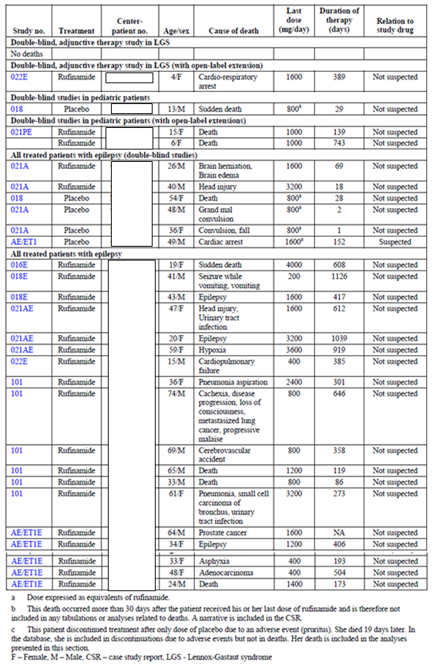

##### Laboratory results

###### Hepatic

Across all double blind studies, there was no substantial difference between rufinamide and placebo on liver function tests. Increases in hepatobiliary parameters occurred in up to 3.4% of the rufinamide treated patients and up to 6.0% of the placebo treated patients. Overall, the potential for rufinamide to cause serious hepatic toxicity appears low.

###### Renal

No evidence of renal toxicity associated with rufinamide across the database.

###### Haematology

No clinically significant findings.

##### ECG

No significant findings apart from QT shortening, which is of uncertain clinical significance. The proposed PI carries appropriate warnings about this risk.

##### Hypersensitivity

Appropriate wording around hypersensitivity is rightly included in the proposed PI even though the risk appears low.

##### Post-marketing data

According to the sponsor, rufinamide 100 mg, 200 mg, and 400 mg tablets have been approved in over 40 countries, and rufinamide 40 mg/mL oral suspension has been approved in 34 countries. Based on sales data, and the mean daily dose for rufinamide (considered to be 1400 mg by the World Health Organization), it is estimated that from first product launch in November 2008, through to December 2016, there have been > 36 million patient-days of exposure.

Overall, the post-marketing safety profile has been consistent with the pattern of AEs observed in the submitted studies, with the most frequently reported AEs being seizure, decreased appetite, vomiting, rash, decreased weight, and nausea.

A review of the table provided by sponsors raises no new safety concerns, with only isolated instances of most AEs, and many reports of events already known to be part of the AE profile for rufinamide.

Rufinamide had a broadly similar AE profile in children and adults, but vomiting and rash had a particularly clear excess in rufinamide recipients in the paediatric studies. No data specific on patients aged 1 to 4 were submitted.

##### RMP evaluation

There are no objections to approval by the RMP evaluator. Routine risk minimisation measures are considered adequate to minimise the potential risks. The messages in the PI are same or of similar intent to those in the SmPC. The sponsor should include text in the PI to state that it is encouraged to register pregnant patients on the Australian Pregnancy Register for Women on Antiepileptic Medication with Epilepsy and Allied Conditions by calling 1800 069 722.

In ‘How much to take’ section of the CMI, the volume of oral suspension corresponding to the recommended dose in milligrams of rufinamide has not been provided for all doses mentioned in this section. For example, in the subsection of ‘Children ≥ 1 year old weighing < 30 kg (taking valproate)’ the volume corresponding to 600 mg of Inovelon has not been included. The volume of the corresponding dose of oral suspension should be included in all relevant instances in ‘How much to take’ section of the CMI. (This request was dropped due to sponsor withdrawal of oral suspension).

There are no changes to the risk minimisation plan in the updated ASA.

##### Discussion

Rufinamide has relatively simple pharmacokinetics and is well absorbed, but it shows a non-linear dose exposure pattern. Renal impairment has no significant impact on rufinamide exposure. The sponsor has not performed any studies in patients with hepatic impairment. Even though major pharmacokinetics changes are unlikely, careful dose titration should be recommended when treating patients with mild to moderate hepatic impairment and use in patients with severe hepatic impairment be avoided. There are no significant drug-drug interactions apart from concurrent use of valproate but it is addressed with appropriate wording in the PI.

Modelling submitted instead of clinical studies to explain the pharmacodynamics was beyond the scope of clinical evaluation. QT shortening observed poses a theoretical risk of causing arrhythmias; it should therefore be avoided in subjects with short QT intervals at baseline.

###### Aged 4 years and above

Study 202 is key to this submission as it was performed predominantly in paediatric patients (subjects aged 4 to 37 years; mean age 14), who had refractory Lennox-Gastaut syndrome and ongoing seizures despite 1 or 2 anti-epileptic drugs. The use of three primary efficacy variables potentially raises problems with multiplicity, but all three efficacy variables achieved significance, so concerns about multiplicity were academic. As suggested by the clinical evaluator adjunctive therapy with rufinamide was moderately effective, despite the refractory nature of the Lennox-Gastaut syndrome. Significant superiority was achieved for all three primary efficacy variables, and for both prospective co-primary endpoints, and the differences appeared clinically worthwhile. Change in total seizure frequency compared to baseline, was 32.7% in rufinamide recipients but only 11.7% in placebo recipients (p = 0.0015, attributable reduction = 21%). The frequency of tonic-atonic seizures which is often refractory decreased by a median of 42.5% in the rufinamide group, but increased marginally, by a median of 1.4%, in the placebo group (p < 0.0001, attributable reduction = 40%).

Extension study of patient from Study 022 showed no evidence of a major decline in efficacy up to 3 years with continued treatment but open label and uncontrolled design precludes us to derive firm conclusions.

Study 304 which resembled the pivotal study in terms of its target population was positive, and broadly consistent with the pivotal study. The median percent reduction in tonic-atonic seizure frequency was 24.20% in the rufinamide group and 3.25% in the placebo group. The superior decrease in seizure frequency with rufinamide was significant (p = 0.003); group difference was estimated to be 26.65%. There was only a trend to superiority of rufinamide group for the key secondary variable (tonic-atonic seizures frequency).

Even though some positive studies submitted were not performed in subjects with Lennox-Gastaut syndrome, it increased the external validity of the Lennox-Gastaut syndrome studies and provided additional safety data.

Rufinamide is associated with an increased incidence of vomiting, reduced appetite, somnolence and other CNS inhibitory side effects (including ataxia and diplopia). In the pivotal study, rash was clearly more common in rufinamide recipients: AEs characterised under skin and subcutaneous tissue disorders occurred in 17.6% of rufinamide recipients, compared to 4.7% of placebo recipients; the individual AE ‘Rash’ occurred in 6.8% and 1.6%, respectively. Rash was more common with rufinamide than with placebo in children but the incidence of severe reactions appears to be low. Rufinamide does not appear to be associated with a significant risk of hepatotoxicity, renal toxicity, haematological problems, or serious skin reactions. Rufinamide does not appear to increase the risk of infection.

Status epilepticus was reported in some Lennox-Gastaut syndrome subjects exposed to rufinamide, but no placebo recipients. Also rufinamide shortens QT interval which is of uncertain significance. The PI contains appropriate warnings about both these issues.

The proposed registration of the oral suspension does not pose substantial risks compared to the tablet that has been used in most of the clinical studies. However outstanding issues associated with the quality aspects of the oral suspension,[23] which were not able to be addressed within the scheduled registration timeline due to delays in receipt of the quality evaluation reports, the sponsor withdrew the oral suspension during the evaluation process to ensure the original registration timeline was maintained.

As a group, anticonvulsants have been associated with an increased risk of suicidal ideation. Although there is no specific evidence in the dossier that rufinamide causes an increase in suicidal ideation, the PI carries an appropriate warning about this issue.

There is currently not enough information available to determine whether rufinamide has adverse effects on cognitive development. Although somnolence and other CNS sedative side effects might be expected to interfere with learning, seizures also interfere with cognitive function, and rufinamide has shown a clear reduction in seizures in the target population.

###### Age group 1 to < 4 years

Efficacy in subjects aged 1 to 4 years has not been directly demonstrated in this submission. A FDA requested supportive study in this age group (Study 303) had a focus on cognitive safety, lacked a well-defined control therapy, and was not powered for seizure endpoints, which were considered secondary. However, given that Lennox-Gastaut syndrome disease expression is similar in younger and older children, extrapolation of efficacy from patients aged > 4 years can be accepted in principle.

Population pharmacokinetics analysis submitted which also includes pharmacokinetics data from Study 303, the pharmacokinetics of rufinamide was dose independent and was not significantly affected by age.

Extension of the target population to include subjects in the age group 1 to < 4 years does not appear to pose substantial new risks. Study 303 assessed rufinamide oral suspension in subjects 1 to < 4 years of age, and the observed AEs were consistent with the previously observed safety profile in the pivotal Lennox-Gastaut syndrome study of subjects aged 4 to < 12 years.

The issue of potential cognitive effects of rufinamide has not been adequately addressed by any study including Study 303.

Overall, the safety of rufinamide appears to be acceptable. Most of the issues identified in the clinical study program affect tolerability rather than posing serious safety concerns. There are residual concerns about the potential effects of rufinamide on cognitive development, but this is also true of other anti-epileptic drugs used to treat Lennox-Gastaut syndrome.

###### Toxicology

The nonclinical evaluator has concluded that both the impurities CGP33037 and CGP51057 were not adequately tested for mutagenicity. CGP33037 can be treated as a Class 4 non-mutagenic impurity (see ICH M7, p6) without further assessment. But CGP51057 has an esterified side chain in place of the amide in the parent molecule, and the genotoxic significance of this requires either testing (in isolated form) in appropriately conducted genotoxicity assays or expert assessment with QSAR data. The sponsor needs to provide results from either of the tests mentioned above in addition to the post marketing data analysis to resolve the validity of CGP51057.

#### Clinical evaluator’s recommendation

The clinical evaluator has recommended approval for patients suffering from seizures associated with Lennox Gastaut syndrome. The evaluator provided the following recommendation regarding authorisation:

Rufinamide should be approved for use;

’*for adjunctive therapy in the treatment of seizures associated with Lennox Gastaut syndrome in patients 1 year of age and older*.’

It would also be reasonable to restrict rufinamide to patients aged 4 years and older, given that the pivotal study excluded patients aged < 4 years and there is no data showing efficacy in this age group.

Whether it is appropriate to approve rufinamide in LGS subjects aged 1 year to < 4 years is largely a matter of subjective opinion: the US has allowed registration in very young children, on the basis of the pivotal study in older children (4 years and older) and minimal safety data in very young children. The EU, by contrast, rejected use in very young children. The current clinical evaluator has taken a position similar to that taken in the US, largely because there is no reason to suspect that efficacy differs substantially in the younger age group, efficacy in the older children was demonstrated robustly, and the current treatment options for Lennox-Gastaut syndrome in very young subjects are limited.

### Risk management plan

There are no objections to approval by the RMP evaluator. Routine risk minimisation measures are considered adequate to minimise the potential risks. The messages in the prescribing information are the same or of similar intent to those in the Summary of product characteristics (EU SmPC). The sponsor should include text in the prescribing information to state that it is encouraged to register pregnant patients on the Australian Pregnancy Register for Women on Antiepileptic Medication with Epilepsy and Allied Conditions.

There are no changes to the risk minimisation plan in the updated ASA.

### Risk-benefit analysis

Overall, the benefit-risk balance for the use of rufinamide as an adjunctive therapy in the treatment of seizures associated with Lennox-Gastaut syndrome in patients 1 year of age and older seems favourable, but the final approval will be subjected to:

* Resolving issues arising from ACM deliberations.
* Resolving quality and nonclinical outstanding issues.
* Satisfactory negotiation of the PI and RMP.

#### Delegate’s considerations

The Delegate overall supports the clinical evaluator in recommending approval of rufinamide

‘*for adjunctive therapy in the treatment of seizures associated with Lennox-Gastaut syndrome in patients 1 year of age and older*.’

Even though the benefit-risk balance of rufinamide, given the proposed usage, is favourable, there is no data showing efficacy in patients aged 1 to < 4 years.

There is no reason to suspect that efficacy differs substantially in the younger age group, efficacy in the older children was demonstrated robustly, and the current treatment options for Lennox-Gastaut syndrome in very young subjects are limited. In addition rufinamide oral solution in subjects 1 to < 4 years of age, and the observed AEs were consistent with the observed safety profile in the pivotal Lennox-Gastaut syndrome study of subjects aged 4 to < 12 years.

There is some pharmacokinetics data in children aged 1 to 4 years and population pharmacokinetics analysis based on 115 subjects including 85 paediatric subjects (24 patients aged 1 to 3 years, 40 patients aged 4 to 11 years, and 21 patients aged 12 to 17 years), indicating that rufinamide pharmacokinetics was not significantly affected by young age, after body weight was taken into consideration.

Should the indication be restricted to patients aged 4 and above or should it be aged 1 and above on the basis of popPK and Study 303?

#### Proposed action

The Delegate had no reason to say, at this time, that the application for rufinamide tablets 100 mg, 200 mg, 400 mg should not be approved for registration.

The final approval will be subject to

* Resolving issues arising from Advisory Committee on Medicines (ACM) deliberations,
* Resolving quality and nonclinical outstanding issues,
* Satisfactory negotiation of the Product Information and Risk Management Plan.

#### Request for ACM advice

The committee is requested to provide advice on the following specific issues:

1. Does the Committee consider there is sufficient evidence and/or justification to support extrapolation of the data in patients aged 4 years and older to the patients aged 1 to < 4 years?
2. What are the Committee’s views on the comparability of the safety profiles between aged 1 to < 4 years and aged 4 years and older?

The committee is (also) requested to provide advice on any other issues that it thinks may be relevant to a decision on whether or not to approve this application.

#### Response from Sponsor

The sponsor agrees with the Delegate’s preliminary assessment where they state ‘*overall, the benefit-risk balance for the use of Inovelon as an adjunctive therapy in the treatment of seizures associated with Lennox-Gastaut syndrome in patients 1 year of age and older seems favourable*.’ The sponsor also agrees with the majority of the Delegate’s summary of the submission in their Request for ACM Advice.

The sponsor would like to take this opportunity to expand on some of the points made in the request for advice.

##### Paediatric indication questions

Question 1:

*Does the Committee consider there is sufficient evidence and/or justification to support extrapolation of the data in patients aged 4 years and older to the patients aged 1 to < 4 years?*

Question 2:

*What are the Committee’s views on the comparability of the safety profiles between aged 1 to < 4 years and aged 4 years and older?*

As summarised by the Delegate, rufinamide has Orphan Drug Designation in Australia, the EU, US, Japan and South Korea for the treatment of Lennox-Gastaut Syndrome. The EU definition for orphan status is no more than 5 out of 10,000 sufferers. Inovelon is registered in over 40 countries for the treatment of Lennox-Gastaut Syndrome. It was first registered in 2007 and was approved for use in patients over 4 years of age.

As part of the registration in the EU, a paediatric investigation plan (PIP) was agreed, which included development of an oral suspension formulation and investigation into the 1 to 4 years age group. As part of the registration in the US, the sponsor received a Written Request (WR) for development of the drug in the 1 to 4 years age group. It is important to provide the background to the development of the paediatric indication extension as this will help to understand the study design of the 303 study.

The design of the 303 study was constrained by differing requests required from the WR of the FDA and the PIP as agreed with the EMA. The FDA specifically requested a pharmacokinetic and safety trial to support approval of Inovelon in children aged from 1 to less than 4 years of age. The FDA believed that an additional trial to establish seizure effectiveness of Inovelon in this age group was not necessary as the efficacy demonstrated in the older paediatric population can be extrapolated to the younger patients as the disorder is physiologically similar in the younger age group. The EMA requested a 2 year study for the primary evaluation of cognitive development and behavioural effects in a paediatric population 1 to less than 4 years of age as part of the PIP measures.

Study 303 was conducted to fulfil the requirements of both the WR and the PIP. Due to these differing agency requirements, data from the core part of this study, which is summarized in the interim clinical study report (16 Jun 2011 to 28 Feb 2014), was used to fulfil the short term pharmacokinetics and safety requirements of the WR from the FDA.

The indication extension application was approved by FDA on 12 Feb 2015. The extension phase of Study 303 provides additional data to fulfil the long term safety and efficacy objectives required by the PIP. Study 303 was completed with last patient last visit recorded on 02 Nov 2015. Once the study was completed, the indication extension was submitted to the EMA on 10 February 2016.

In addition there was difficulty recruiting very young subjects into a clinical study. The original 303 study design planned 75 subjects with inadequately controlled Lennox-Gastaut syndrome to be randomized in a 2:1 ratio to receive either Inovelon or any approved anti-epileptic drug of the investigator’s choice as an add-on to the subject’s existing regimen of 1 to 3 anti-epileptic drugs. The 2:1 randomization ratio was selected to meet requests from different health authorities: the FDA initially asked that 50 subjects be treated with Inovelon, while the EMA Paediatric Committee requested 25 controls in addition to the 50 subjects treated with Inovelon. However, as the diagnosis of Lennox-Gastaut syndrome is difficult to establish before 3 years of age, and the disease is rare, recruitment was slower than anticipated and this enrolment target proved difficult. The Paediatric Committee agreed with a proposal to reduce the number of subjects so that enrolment could be reached. The final protocol for Study 303 included 37 subjects in a 2:1 ratio.

In the EU, according to the legislation prepared to support PIPs, once a PIP is complete and information regarding the paediatric investigation is approved in the Summary of Product Characteristics (SmPC), the sponsor is entitled to an extension of marketing exclusivity. Due to Study 303 taking longer than expected due to slow recruitment, there was an urgency to register paediatric information in the SmPC in order to obtain the exclusivity extension. In agreement with the EMA, rather than delay the submission with several rounds of questions, the indication extension was withdrawn and clinical information regarding Study 303 was included in Section 5.1 of the SmPC. This meant that the sponsor obtained an exclusivity extension under the paediatric legislation. The paediatric indication extension application was resubmitted to the EMA on 30 August 2017, and is currently under assessment.

As agreed by the clinical evaluator and the Delegate, the sponsor believes that the efficacy for the use of Inovelon in the adjunctive treatment of seizures associated with Lennox-Gastaut syndrome has been demonstrated in patients 4 years of age and older in Study 022. The exploratory seizure efficacy data from Study 303 showed that subjects treated with rufinamide were similar to subjects in the any-other-anti-epileptic drug treatment group in terms of percent change in seizure frequency and worsening of seizures during the study. Although caution is warranted in data interpretation due to the small sample size, there is no new pertinent efficacy information in Study 303 that would change assessment of the seizure efficacy of Inovelon in the paediatric population. Hence the benefit of efficacy would be expected to extend to younger children, supporting the proposed label including the lower age range.

On the basis of the available evidence, this conclusion is supported with comparable efficacy, PK and safety outcomes from three different studies: Study 303, 304 and 022.

Study 303, ‘*An open label, 2 year evaluation of the safety, pharmacokinetics and cognitive/behavioural effects of rufinamide as add-on treatment for control of seizures associated with Lennox-Gastaut Syndrome*’, included subjects from 1 to less than 4 years old and compared rufinamide to any other approved add-on anti-epileptic drug of the investigator’s choice.

Study 304, ‘*A Placebo Controlled, Double Blind, Comparative Study of E2080 in Subjects with Lennox-Gastaut Syndrome*,’ was a multi-center, randomized, double blind, placebo controlled, parallel group, comparative study to evaluate the efficacy, safety and tolerability, and PK of rufinamide compared with placebo in Japanese subjects with Lennox-Gastaut syndrome. This study, which included subjects from 4 to 30 years old, was conducted for approval of rufinamide in Japan, and subsequently was filed in the EU as per Article 46 requirements.

The primary basis for approval of rufinamide for Lennox-Gastaut syndrome in the US and EU was the results from Study 022, a ‘*Multi-center, Randomized, Double blind, Placebo controlled, Parallel Trial Comparing the Safety and Efficacy of Rufinamide As Adjunctive Therapy Relative to Placebo in Subjects With Inadequately Controlled Lennox-Gastaut Syndrome.*’ This multinational Phase III study included subjects from 4 to 30 years old with inadequately controlled seizures associated with Lennox-Gastaut syndrome.

In a scatter plot of observed rufinamide concentration versus time after dosing, the actual measured steady state rufinamide concentration data from Study 303 (subjects from 1 to less than 4 years old) were examined in the context of data from Studies 022 and 304 (in Lennox-Gastaut syndrome subjects 4 years old and above) Figure 2.

Figure 2: Individual observed rufinamide concentration versus time after dose by study in subjects with Lennox-Gastaut syndrome

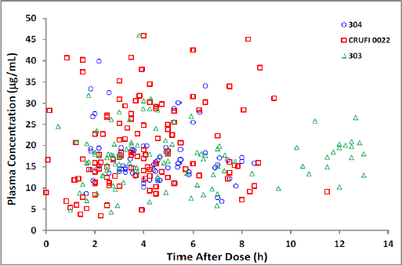

As is evident, the observed concentration data from Studies 022 and 304 in subjects with Lennox-Gastaut syndrome 4 years old and above are very comparable (almost superimposable) with the observed concentration data from Study 303 in subjects with Lennox-Gastaut syndrome from 1 to less than 4 years old around the therapeutic dose of 45 mg/kg within the dosing interval of 12 hours. This graphical presentation of the data is very compelling, even without a formal pharmacokinetic modelling, in supporting the conclusion that observed exposures at steady state in Lennox-Gastaut syndrome subjects from 1 to less than 4 years old (Study 303) are very comparable to those in Lennox-Gastaut syndrome subjects 4 years old and above from Studies 022 and 304.

For Study 303, the overall incidence of treatment emergent AEs (TEAEs) was similar between the Inovelon group and the ‘any other anti-epileptic drug’ group. A comparison of Study 303 TEAEs to those in the 4 to less than 12 year old age group from Study 022 and Study 304 does not suggest any difference in type or frequency when Inovelon is administered in the younger age group (1 to less than 4 years of age).

The findings of the safety evaluation for Study 303 in subjects 1 to less than 4 years of age were consistent with the known safety profile of Inovelon in paediatric subjects 4 to less than 12 years of age with Lennox-Gastaut syndrome. Inovelon was safe and well tolerated when administered to subjects 1 to less than 4 years of age. The safety data in Study 303 were consistent with that previously reported for Inovelon. As such, Inovelon provides a well-tolerated treatment option for use as adjunctive therapy for patients 1 year and older with Lennox-Gastaut syndrome. From our post marketing safety data the distribution of the events reported from post marketing sources in this age group is consistent with the relative use of these products in children age ≥ 4 years and known safety profiles of these products.

The results from Study 303 and the population pharmacokinetic analysis support the benefits and risks of Inovelon as adjunctive therapy for the treatment of seizures associated with Lennox-Gastaut syndrome in patients aged 1 year and older. The efficacy of Inovelon has been demonstrated in patients 4 years of age and older, and Study 303 provides support for extrapolating this efficacy benefit to children 1 to less than 4 years of age. In Study 303, the pharmacokinetics and safety profile of Inovelon in subjects 1 to less than 4 years of age were similar to those in older children. The pharmacokinetics of Inovelon was dose independent and was not significantly affected by age. Inovelon exposures in patients aged 1 to less than 2 years of age and 2 to less than 4 years of age were comparable.

The sponsor believes that no further studies in the paediatric population are warranted. As the diagnosis of Lennox-Gastaut syndrome is difficult to establish before 3 years of age, and the disease is rare, it is difficult to conduct paediatric studies in subjects with Lennox-Gastaut syndrome in the 1 to 4 year age group. However, there have been reports of off-label use due to the approval in Lennox-Gastaut syndrome in older children and the availability of safety data in younger children from publications of the 303 study. In addition, off label use could occur due to the approval of the younger age group in the US. Eisai believes due to the nature of Lennox-Gastaut syndrome and the severity of symptoms, physicians are likely to prescribe any treatment available, regardless of age restrictions and thus off label use is likely if the indication is restricted to patients 4 years and older.

Furthermore, results already exist to allow the determination of the dose, and the population pharmacokinetic data of Inovelon in Lennox-Gastaut syndrome shows that the milligrams per kilogram dosing proposed in the prescribing information can be extrapolated for small children. The tablets are able to be crushed for dosing in any patients who have difficulty or are unable to swallow. The sponsor believes that the efficacy and safety data provided in our application support the approval of Inovelon for the adjunctive treatment of seizures associated with Lennox-Gastaut Syndrome in patients 1 year and older. As such the sponsor believes that approval of the indication for patients 1 year and older is warranted.

##### Oral suspension

As outlined by the Delegate, the sponsor acknowledges the outstanding manufacturing issues for the oral suspension formulation.21. In the interest of maintaining the original submission schedule and avoiding a mutual clock stop, the sponsor confirms the withdrawal of this formulation from the registration application. The PI contains information regarding crushing the tablets for administration to patients unable or who have difficulty swallowing, and therefore these patients are still able to receive treatment with Inovelon. Reference to the oral suspension has been removed from the proposed PI and the amended versions are included with this response.

##### Genotoxic impurities

CGP51057 has an esterified side chain in place of the amide in the parent molecule, and the genotoxic significance of this requires either testing (in isolated form) in appropriately conducted genotoxicity assays or expert assessment with QSAR data**.**

CGP51057 can react with amine compounds under certain chemical conditions (redacted). To evaluate whether this molecule has any DNA reactive nature in physiological conditions (37°C, pH 7.4), an expert assessment was conducted and described below.

Cyclic carboxylic acid esters (for example, lactone compounds) are known for their potential mutagenicity. However, non-cyclic carboxylic acid esters have no mutagenicity due to deactivation by hydrolysis.

From structural similarity assessment and chemistry point of view, CGP51057 was compared to methyl benzoate (CAS No. 93-58-3).

Figure 3: Chemical structure of CGP1057and methyl benzoate

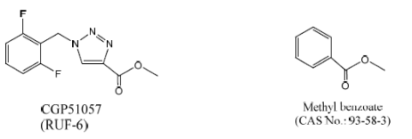

Methyl benzoate and CGP51057 both have the same esterified side chain fragment. Additionally, both compounds have a bulky 5 or 6-membered ring which reduces the reactivity due to the steric hindrance. Methyl benzoate is a non-mutagenic compound as Ames negative results are available from several databases (for example, NTP (National Toxicology Program of the US National Institute of Health)). Chemically, the electrophilicity (and therefore the DNA reactivity) of CGP51057 is lower than that of methyl benzoate due to the difference of functional groups (triazole versus benzene).

Based on the expert assessment above, CGP51057 is therefore not expected to have any mutagenicity activity.

The sponsor has conducted genotoxicity assessment for CGP33037 and CGP51057 using the in- silico QSAR tool DEREK. This analysis found that CGP33037 and CGP51057 are non- genotoxic impurities.

The DEREK analysis performed on CGP51057 supports the above conclusion.

Given this information, and the extensive post marketing experience, the sponsor does not believe further analysis is required.

##### Drug substance specification

The finished product manufacturer for the tablets has initiated a change control to amend the drug substance specifications. This will be finalised by the end of March and a copy of the revised specifications will be provided to the TGA as soon as this is received.

#### Advisory Committee Considerations[24]

The ACM taking into account the submitted evidence of efficacy, safety and quality, agreed with the Delegate and considered Inovelon film coated tablets containing 100 mg, 200 mg, 400 mg of rufinamide to have an overall positive benefit-risk profile for the Delegate’s amended indication:

*for adjunctive therapy in the treatment of seizures associated with Lennox-Gastaut syndrome in patients 4 years of age and older.*

(the sponsor’s initial application indication was for adjunctive therapy in the treatment of seizures associated with Lennox-Gastaut syndrome in patients 1 year of age and older)*.*

In providing this advice, the ACM noted that:

* there was insufficient safety and efficacy data for the 1 to 4 years age group.
* drug-drug interactions with rufinamide were not outlined in sufficient detail in the PI.
* without an oral suspension of rufinamide (which was withdrawn from the application), expanding the target age range to children between 1 to 4 years of age was inappropriate.

#### Proposed conditions of registration

The ACM agreed with the Delegate on the proposed conditions of registration and advised on the inclusion of the following:

* Subject to satisfactory implementation of the Risk Management Plan most recently negotiated by the TGA
* Negotiation of the Product Information and Consumer Medicine Information to the satisfaction of the TGA.

#### Proposed Product Information (PI)/ Consumer Medicine Information (CMI) amendments

The ACM agreed with the delegate to the proposed amendments to the PI and CMI and specifically advised on the inclusion of the following:

* A statement in the ‘interactions with other medicines’ sections of the PI that expounds the potential interactions rufinamide has with commonly co-administered drugs.

#### Specific advice

The ACM having considered the evaluations and the Delegate’s overview, as well as the sponsor’s response to these documents, advised the following:

1. ***Does the Committee consider there is sufficient evidence and/or justification to support extrapolation of the data in patients aged 4 years and older to the patients aged 1 to < 4 years?***

The ACM acknowledged that, for patients aged 1 to 4 years, it is difficult to obtain high quality data; there are few options for achieving seizure control to prevent physical injury.

Nevertheless, the ACM concluded that there was insufficient grounds to extend the prescription of rufinamide to patients aged 1 to < 4 years.

1. ***What are the Committee’s views on the comparability of the safety profiles between aged 1 to < 4 years and aged 4 years and older?***

Overall, the ACM regarded the safety profiles for rufinamide in children aged between 1 to 4 years and those aged > 4 years to be comparable, although acknowledged that the safety data for the younger age group was limited and of poor quality.

The ACM advised that implementation by the sponsor of the recommendations outlined above to the satisfaction of the TGA, in addition to the evidence of efficacy and safety provided would support the safe and effective use of this product.

#### Post ACM negotiations

An extension of indication to include the age group of 1 year or older was not approved by the EMA. On 12 June 2018 during the PI negotiations, which included amendments for consistency with the currently approved European SmPC, the sponsor agreed to the restriction in patient group from the proposed ‘1 year of age and older’ to ‘4 years of age and older’.

### Outcome

Based on a review of quality, safety and efficacy, TGA approved the registration of Inovelon rufinamide 100 mg, 200 mg and 400 mg film-coated tablets for oral dosing twice daily in two equally divided doses, one in the morning and one in the evening (refer to the prescribing information for details), indicated for:

*Inovelon is indicated as adjunctive therapy in the treatment of seizures associated with Lennox-Gastaut syndrome in patients 4 years of age and older.*

#### Specific conditions of registration applying to these goods

* Inovelon (rufinamide) is to be included in the Black Triangle Scheme. The PI and CMI for Inovelon must include the black triangle symbol and mandatory accompanying text for five years, which starts from the date that the sponsor notifies the TGA of supply of the product.
* The Inovelon EU-Risk Management Plan (EU-RMP) (version 9, date 4 February 2016, data lock point 15 January 2016), with Australian Specific Annex (version 1.1, date November 2017) included with submission PM-2017-01037-1-1, and any subsequent revisions as agreed with the TGA will be implemented in Australia. An obligatory component of risk management plans is routine pharmacovigilance. Routine pharmacovigilance includes the submission of Periodic Safety Update Reports.

The sponsor withdrew their submission for Inovelon rufinamide 400 mg/mL oral suspension on 13 March 2018 before a decision had been made by the TGA.

## Attachment 1. Product Information

The PI for Inovelon approved with the submission which is described in this AusPAR is at Attachment 1. For the most recent PI, please refer to the TGA website at <<https://www.tga.gov.au/product-information-pi>>.

|  |
| --- |
| Therapeutic Goods Administration |
| PO Box 100 Woden ACT 2606 Australia  Email: [info@tga.gov.au](mailto:info@tga.gov.au) Phone: 1800 020 653 Fax: 02 6232 8605  [**https://www.tga.gov.au**](https://www.tga.gov.au) |

1. The TGAs Special Access Scheme (SAS) provides healthcare professionals with access to unapproved therapeutic goods for patients. The SAS is intended for exceptional clinical circumstances. Therapeutic goods entered in the ARTG have been evaluated by TGA for quality, safety, efficacy and performance. Therefore it is expected that all available treatment options included in the ARTG have been considered prior to making an application or notification under the SAS to access an unapproved therapeutic good. For more information see: https://www.tga.gov.au/form/special-access-scheme
2. OPA/Al/PVC – oriented polyamide/aluminium/polyvinyl chloride
3. The sponsor withdrew the oral suspension during the evaluation process.
4. Gaitatzis A. and Sander J.W. (2013). The long-term safety of antiepileptic drugs. *CNS Drugs*, 27: 435–455
5. tmax = time of maximum plasma concentration
6. Patsalos P.N. (2013a) Drug interactions with the newer antiepileptic drugs (AEDs)–Part 1: Pharmacokinetic and pharmacodynamic interactions between AEDs. *Clinical Pharmacokinetics*, 52: 927–966
7. Patsalos P.N. (2013b) Drug interactions with the newer antiepileptic drugs (AEDs)–Part 2: Pharmacokinetic and pharmacodynamic interactions between AEDs and drugs used to treat non-epilepsy disorders. *Clinical Pharmacokinetics*, 52: 1045–1061
8. Australian Category D: ‘*Drugs which have caused, are suspected to have caused or may be expected to cause, an increased incidence of human fetal malformations or irreversible damage. These drugs may also have adverse pharmacological effects. Accompanying texts should be consulted for further details*.’
9. US FDA Category C: ‘*Animal reproduction studies have shown an adverse effect on the fetus and there are no adequate and well-controlled studies in humans, but potential benefits may warrant use of the drug in pregnant women despite potential risks*’.

   Note that the Australian categorisation system differens from the US FDA system. The categorisation of medicines for use in pregnancy in the Australian system does not follow a hierarchical structure.
10. Australian Category B3: ‘*Drugs which have been taken by only a limited number of pregnant women and women of childbearing age, without an increase in the frequency of malformation or other direct or indirect harmful effects on the human fetus having been observed. Studies in animals have shown evidence of an increased occurrence of fetal damage, the significance of which is considered uncertain in humans*.’
11. Aicardi J. Myoclonic epilepsies of infancy and childhood. *Adv Neurol.* 1986;43:11-31
12. Dulac O, N’Guyen TN. The Lennox-Gastaut syndrome. *Epilepsia* 1993;34(Suppl 7):S7-17
13. Ohtahara S, et al. Prognosis of the Lennox syndrome-. Long-term clinical and electroencephalographic follow-up study, especially with special reference to relationship with the West syndrome*. Folia Psychiatr Neurol Jpn* 1976; 30: 275–287
14. Gastaut H, et al. Évolution clinique et prognostic du syndrome de Lennox-Gastaut. In: Lugaresi E, Pazzaglia P, Tassinari C, eds. Evolution and Prognosis of Epilepsies. Bologna: : Aulo Gaggi; 1973:133–154
15. Loubier D. Le syndrome de Lennox-Gastaut: modalités évolutives (Thèse Médecine). Marseille, 1974
16. Felbamate Study Group in Lennox-Gastaut SyndromeEfficacy of felbamate in childhood epileptic encephalopathy (Lennox-Gastaut syndrome).*N Engl J Med*. 1993; 328: 29-33
17. Motte J, et al. Lamotrigine for Generalised Seizures associated with The Lennox-Gastaut Syndrome .*New England Journal of Medicine*. 1997; 337: 1807-1812
18. Sachdeo RC, et al Double-Blind, Randomised Trial of Topiramate in Lennox-Gastaut Syndrome. Topiramate YL Study Group. *Neurology*. 1999; 52: 1882-1887
19. Schmidt D and Bourgeois B. A Risk Benefit Assessment of Therapies for Lennox-Gastaut Syndrome *Drug Safety*. 2000; 22: 467-477
20. QT interval: a measure of the time between the start of the Q wave and the end of the T wave in the heart's electrical cycle. A prolonged QT interval is a risk factor for ventricular tachyarrhythmias and sudden death.
21. Shorvon SD. Status epilepticus: its clinical features and treatment in children and adults. Cambridge, UK: Cambridge University Press; 1994
22. *Routine risk minimisation* activities may be limited to ensuring that suitable warnings are included in the product information or by careful use of labelling and packaging.

    *Routine pharmacovigilance* practices involve the following activities:

    All suspected adverse reactions that are reported to the personnel of the company are collected and collated in an accessible manner;

    Reporting to regulatory authorities;

    Continuous monitoring of the safety profiles of approved products including signal detection and updating of labelling;

    Submission of PSURs;

    Meeting other local regulatory agency requirements.
23. Clarification: the outstanding issues included provision of test methods, their validation and revision of some drug substance specifications.
24. The ACM provides independent medical and scientific advice to the Minister for Health and the Therapeutic Goods Administration (TGA) on issues relating to the safety, quality and efficacy of medicines supplied in Australia including issues relating to pre-market and post-market functions for medicines.

    The Committee is established under Regulation 35 of the Therapeutic Goods Regulations 1990. Members are appointed by the Minister. The ACM was established in January 2017 replacing Advisory Committee on Prescription Medicines (ACPM) which was formed in January 2010. ACM encompass pre and post-market advice for medicines, following the consolidation of the previous functions of the Advisory Committee on Prescription Medicines (ACPM), the Advisory Committee on the Safety of Medicines (ACSOM) and the Advisory Committee on Non-Prescription Medicines (ACNM). Membership comprises of professionals with specific scientific, medical or clinical expertise, as well as appropriate consumer health issues relating to medicines.