|  |
| --- |
| First round report: 10 June 2016  Second round report: 13 October 2016 |

|  |
| --- |
| AusPAR Attachment 1 |
| Extract from the Clinical Evaluation Report for Sarilumab (rch) |
| Proprietary Product Name: Kevzara, Ilsidex |
| Sponsor: Sanofi-Aventis Pty Ltd |

About the Therapeutic Goods Administration (TGA)

* The Therapeutic Goods Administration (TGA) is part of the Australian Government Department of Health, and is responsible for regulating medicines and medical devices.
* The TGA administers the *Therapeutic Goods Act 1989* (the Act), applying a risk management approach designed to ensure therapeutic goods supplied in Australia meet acceptable standards of quality, safety and efficacy (performance), when necessary.
* The work of the TGA is based on applying scientific and clinical expertise to decision-making, to ensure that the benefits to consumers outweigh any risks associated with the use of medicines and medical devices.
* The TGA relies on the public, healthcare professionals and industry to report problems with medicines or medical devices. TGA investigates reports received by it to determine any necessary regulatory action.
* To report a problem with a medicine or medical device, please see the information on the TGA website <<https://www.tga.gov.au>>.

About the Extract from the Clinical Evaluation Report

* This document provides a more detailed evaluation of the clinical findings, extracted from the Clinical Evaluation Report (CER) prepared by the TGA. This extract does not include sections from the CER regarding product documentation or post market activities.
* The words [Information redacted], where they appear in this document, indicate that confidential information has been deleted.
* For the most recent Product Information (PI), please refer to the TGA website <<https://www.tga.gov.au/product-information-pi>>.

Copyright

© Commonwealth of Australia 2018  
This work is copyright. You may reproduce the whole or part of this work in unaltered form for your own personal use or, if you are part of an organisation, for internal use within your organisation, but only if you or your organisation do not use the reproduction for any commercial purpose and retain this copyright notice and all disclaimer notices as part of that reproduction. Apart from rights to use as permitted by the *Copyright Act 1968* or allowed by this copyright notice, all other rights are reserved and you are not allowed to reproduce the whole or any part of this work in any way (electronic or otherwise) without first being given specific written permission from the Commonwealth to do so. Requests and inquiries concerning reproduction and rights are to be sent to the TGA Copyright Officer, Therapeutic Goods Administration, PO Box 100, Woden ACT 2606 or emailed to < [tga.copyright@tga.gov.au](mailto:tga.copyright@tga.gov.au)> .

Contents

List of abbreviations 5

1. Introduction 8

1.1. Dosage forms and strengths 8

1.2. Dosage and administration 8

2. Clinical rationale 9

2.1. Formulation 9

3. Contents of the clinical dossier 10

3.1. Scope of the clinical dossier 10

3.2. Paediatric data 11

3.3. Good clinical practice 11

4. Pharmacokinetics 11

4.1. Studies providing pharmacokinetic data 11

4.2. Summary of pharmacokinetics 13

4.3. Pharmacokinetics in the target population 14

4.4. Pharmacokinetics in other special populations 19

4.5. Pharmacokinetic interactions 20

4.6. Evaluator’s overall conclusions on pharmacokinetics 21

5. Pharmacodynamics 22

5.1. Studies providing pharmacodynamic data 22

5.2. Summary of pharmacodynamics 22

5.3. Pharmacodynamic interactions 27

5.4. Evaluator’s overall conclusions on pharmacodynamics 27

6. Dosage selection for the pivotal studies 28

7. Clinical efficacy 29

7.1. Pivotal efficacy studies 29

7.2. Other efficacy studies 62

7.3. Analyses performed across trials (pooled analyses and meta-analyses) 72

7.4. Evaluator’s conclusions on clinical efficacy 76

8. Clinical safety 79

8.1. Studies providing evaluable safety data 79

8.2. Pivotal studies that assessed safety as a primary outcome 80

8.3. Patient exposure 80

8.4. Adverse events 85

8.5. Laboratory tests 95

8.6. Post-marketing experience 110

8.7. Safety issues with the potential for major regulatory impact 110

8.8. Other safety issues 111

8.9. Evaluator’s overall conclusions on clinical safety 112

9. First round benefit-risk assessment 114

9.1. First round assessment of benefits 114

9.2. First round assessment of risks 114

9.3. First round assessment of benefit-risk balance 115

10. First round recommendation regarding authorisation 116

11. Clinical questions 117

11.1. Pharmacokinetics 117

11.2. Pharmacodynamics 117

11.3. Efficacy 117

11.4. Safety 118

12. Second round evaluation of clinical data submitted in response to questions 118

12.1. Question 1 118

12.2. Question 2 120

12.3. Question 3 121

12.4. Question 4 122

12.5. Question 5 124

13. Second round benefit-risk assessment 125

13.1. Second round assessment of benefits 125

13.2. Second round assessment of risks 126

13.3. Second round assessment of benefit-risk balance 126

14. Second round recommendation regarding authorisation 126

15. References 127

## List of abbreviations

| Abbreviation | Meaning |
| --- | --- |
| ACR | American College of Rheumatology |
| ADA | Anti-drug antibody |
| AE | Adverse event |
| AID | Auto-injector device |
| AUC | Area under concentration-time curve over the dosing interval |
| BMI | Body mass index |
| CCP | Cyclic citrullinated peptide |
| CDAI | Clinical Disease Activity Index |
| CI | Confidence interval |
| Cmax | Maximum serum drug concentration |
| CrCL | Creatinine clearance |
| CRP | C-reactive protein |
| CS | Corticosteroids |
| CTCAE | Common Terminology Criteria for Adverse Events |
| CV | Coefficient of variation |
| DAS | Disease Activity Score |
| DMARD | Disease modifying anti-rheumatic drug |
| ELISA | Enzyme-Linked Immunosorbent Assay |
| ESR | Erythrocyte sedimentation ratio |
| EULAR | European League Against Rheumatism |
| GCP | Good Clinical Practice |
| HAQ-DI | Health Assessment Questionnaire – Disability Index |
| IL | Interleukin |
| ITT | Intention-to-treat |
| IV | Intravenous |
| IVRS | Interactive Voice Response System |
| LEF | Leflunomide |
| LLOQ | Lower limit of quantification |
| MTX | Methotrexate |
| NSAID | Non-steroidal anti-inflammatory drug |
| PD | Pharmacodynamic |
| PFS | Pre-filled syringe |
| PK | Pharmacokinetic |
| PT | Preferred Term |
| PY | Patient years |
| QOL | Quality of-life |
| qw | Once a week (dosing interval) |
| q2w | Once every 2 weeks (dosing interval) |
| RA | Rheumatoid arthritis |
| RF | Rheumatoid factor |
| SAE | Serious adverse event |
| SAR | Sarilumab |
| SC | Subcutaneous |
| SDAI | Simplified Disease Activity Index |
| SD | Standard deviation |
| sIL-6R | Soluble IL-6 receptor |
| SOC | System Organ Class |
| SSZ | Sulfasalazine |
| TB | Tuberculosis |
| TEAE | Treatment emergent adverse event |
| TNF | Tumour necrosis factor |
| ULN | Upper limit of normal |

## Introduction

This is a full submission requesting the registration of new chemical entity in Australia, sarilumab (SAR), which is a monoclonal antibody blocking the activity of interleukin (IL)-6. The sponsor application letter is dated 6 January 2016. The development program for SAR has been guided by the European Medicines Agency (EMA) and the United States (US) Food and Drug Administration (FDA) requirements.

The submission contains a very large amount of clinical data including 2 pivotal Phase III trials (Part B of Study EFC11072 and Study EFC10832) conducted over 24 to 52 weeks, which evaluated the efficacy and safety of SAR for the treatment of active RA despite prior treatment with conventional DMARD therapy and/or anti-TNF drugs. Supporting efficacy and safety data is provided by a dose finding Phase II study (Part A of Study EFC11072) as well as 1 long term, open label extension trial (Study LTS11210), which included subjects who had continued SAR treatment after involvement in the preceding studies. Additional supporting data is provided by another 3 Phase III trials (Studies SFY13370, MSC12665 and EFC 11574) and 9 clinical pharmacology studies (8 of which have been conducted in adult patients with RA). As SAR has not been approved for use anywhere in the world at present, no post-marketing experience is available.

SAR is an immunosuppressant medication (the ATC code is yet to be assigned). It is a recombinant human monoclonal antibody, which binds with high affinity to the alpha subunit complex of the pro-inflammatory cytokine, IL-6, thereby neutralising its biological effects.

The proposed treatment indication in this application is:

‘*Kevzara in combination with non-biologic Disease-Modifying Anti-Rheumatic Drugs (DMARDs) is indicated for the treatment of moderate to severe Rheumatoid Arthritis in adult patients who have had an inadequate response or intolerance to one or more DMARDs*’.

The sponsor is requesting an indication for combination use only (that is SAR with concurrent, non-biological DMARDs) in this submission, which is narrower than that initially proposed in the pre-submission planning documents. The applicant initially requested SAR monotherapy use in adult patients with active RA, as well as the proposed combination treatment option, but has withdrawn the monotherapy use request at this stage. The sponsor is considering another separate submission in Australia in 2017 for monotherapy use, pending the results of an additional trial.

### Dosage forms and strengths

The submission proposes registration of the following dosage forms and strengths: 150 mg/1.14 mL and 200 mg/1.14 mL solution for injection (presented in pre-filled syringes).

### Dosage and administration

The proposed dose of SAR is 200 mg, once every 2 weeks (q2w), given by subcutaneous (SC) injection.

It is recommended that the dose of SAR be reduced from 200 mg every fortnight to 150 mg every 2 weeks for the management of neutropaenia, thrombocytopaenia or elevated liver enzyme tests.

## Clinical rationale

Rheumatoid arthritis (RA) is a chronic inflammatory autoimmune disease characterised by polyarticular inflammatory synovitis, which is associated with cartilage breakdown, bony erosion and ultimately loss of function of the affected joints. Systemic involvement may also occur, and there is an increased risk of atherosclerosis and lymphoma over time, particularly if the condition is insufficiently controlled. The over-production of pro-inflammatory cytokines such as tumour necrosis factor (TNF) and IL-6 in the joints and sera of patients with RA are important mediators in the disease pathogenesis primarily via activation of T lymphocytes, but also through effects on B lymphocytes. IL-6 can activate hepatocytes to produce acute phase reactants, such as C-reactive protein (CRP). SAR is a recombinant humanised monoclonal antibody that binds specifically to, and inhibits signalling mediated by both soluble and membrane bound IL-6 receptors. As such, SAR treatment inhibits the pro-inflammatory functions of IL-6 at both the intra-articular and systemic level.

RA is a heterogeneous condition in terms of clinical presentation, natural history and drug responsiveness. Published evidence and current guidelines for the treatment of RA emphasise the importance of achieving clinical remission, or at least low disease activity, as both of these states are associated with a favourable long term prognosis. Conventional synthetic DMARDs (in particular, methotrexate (MTX)), alone or in combination with each other, are the initial recommended treatments for RA. Observational studies and meta-analyses of DMARD treatment efficacy and tolerability demonstrate highly variable outcomes to single and combination DMARD therapy over time. In 10 year follow-up studies, 25% of patients with RA had to discontinue conventional DMARD treatment due to insufficient therapeutic benefit and 20% discontinued treatment due to adverse effects. Biological DMARDs, either as add-on or single drug therapy, is the next recommended line of therapy in active RA after conventional synthetic DMARD failure or intolerability. While anti-TNF drugs and cytokine modulators such as abatacept have been shown to demonstrate significant efficacy in treating active RA, a substantial proportion of patients are not achieving meaningful American College of Rheumatology (ACR) responses. Based on the current literature for anti-TNF therapies, ACR20 response rates range from 50 to 65% and ACR50 response rates are 35 to 50%. In Australia, an alternative biological therapy (tocilizumab) targeting IL-6 signalling is already approved for use in RA. Tocilizumab was first approved in Australia in May 2009 for the treatment of moderate to severe active RA in adult patients. In October 2010, the treatment indication was extended to include inhibition of the progression of joint damage, as measured by X-ray, when given in combination with MTX. In October 2011 and February 2014 (respectively), the indication for tocilizumab was further extended to include systemic, and thereafter, polyarticular juvenile idiopathic arthritis in patients aged 2 years and older. In this submission, the sponsor claims for there is an unmet need for additional therapies for active, treatment refractory RA in adult patients. In particular, SAR is a monoclonal antibody therapy that has a different mechanism of action to conventional DMARDs and the most commonly used biological DMARDs, anti-TNF drugs.

### Formulation

#### Formulation development

SAR is derived from a Chinese hamster ovary cell line suspension engineered to express the substance. Three production processes were involved in the clinical development program for SAR. The initial clinical formulation (known as C1P1F1) was used in the Phase I clinical studies. To achieve the larger quantities of drug needed for later phase clinical trials, the second production process resulted in the production of a high concentration liquid formulation (C1P2F2), which was used in the dose ranging Phase II trial, as well as part of the long term safety study. The third production change further increased drug production (that is scale-up), plus reduced the viscosity of the concentrated drug substance.

This drug product, known as C2P1F3, was used in the pivotal Phase III studies and is the planned ‘to-be-marketed’ drug. Another formulation (C1P2F3) was produced as a possible alternative to the C2P1F3 drug product, but was not used in the Phase III studies.

The safety and pharmacokinetic (PK) comparability of the C2P1F3 drug product used in the Phase III studies with the C1P2F2 drug formulation used in the Phase II dose ranging trial (Part B of Study EFC11072) were evaluated in Study TDU11373 conducted in healthy subjects and also in Study PKM12058, which was conducted in patients with RA. In addition, Study EFC11072 had a seamless Phase II-III study design in which patients in Part A (Phase II) received the C1P2F2 drug product, and patients in Part B (Phase III) received the C2P1F3 drug product. Furthermore, the safety and PK comparability for SAR administered using an auto-injector device (AID) or a pre-filled syringe (PFS) was evaluated in Study MSC12665.

## Contents of the clinical dossier

### Scope of the clinical dossier

The clinical dosser documented a full clinical development program of pharmacology, efficacy and safety studies for SAR in adult patients with RA and contained the following clinical information:

* 9 clinical pharmacology studies, including 8 that provided pharmacokinetic (PK) data and 1 that provided pharmacodynamic (PD) data.
* 4 population pharmacokinetic analyses of pooled RA patient data (POH0428, POH0455, POH0429 and POH0446).
* 2 pivotal efficacy/safety studies (Part B of Study EFC11072 and Study EFC10832).
* 1 dose finding study (Part A of Study EFC11072).
* 5 other efficacy/safety studies were considered as part of this submission including Studies LTS11210 (an ongoing, long term safety study), SFY13370 (safety calibrator trial of SAR versus tocilizumab), EFC11574 (Phase III trial of SAR + MTX versus etanercept + MTX in adult patients with RA who had an inadequate response to 4 months of adalimumab + MTX; study was prematurely ceased), MSC12665 (study supporting use of auto-injector device) and ACT11575 (Phase II trial of SAR + MTX versus golimumab + MTX in adult patients with RA; study was prematurely ceased).
* No pooled analyses or meta-analyses of efficacy were provided, but integrated summaries of efficacy and safety across the pivotal trials were included (examining for outcome consistency and subgroup factors).
* Study EFC13752 (an open label immunogenicity and safety trial of SAR in adult patients with active RA) was included in the sponsor submission, but not considered by the evaluator as the current application is for SAR therapy in combination with non-biologic DMARD.
* 3 ongoing Phase III studies (Studies EFC14059, LTS13618 and PDY14191) in Japanese subjects and for the purpose of supporting registration in Japan have provided interim serious adverse event (SAE) data only in this submission.

Clinical Overview, Summary of Clinical Efficacy, Summary of Clinical Safety, Summary of Biopharmaceutical Studies and associated Analytical Methods, Summary of Clinical Pharmacology Studies and literature references (n = 118).

### Paediatric data

The submission did not include paediatric data. However, a paediatric development program for SAR is ongoing, and the sponsor intends to submit an application to support use in children upon completion of the clinical development program around June 2022.

### Good clinical practice

All of the studies in the SAR clinical development program were conducted in accordance with the principles of Good Clinical Practice (GCP) and compliance with ethical requirements was met.

## Pharmacokinetics

### Studies providing pharmacokinetic data

The pharmacokinetics (PK) of SAR has been well characterised from the PK data collected from 53 healthy subjects involved in 1 Phase I study; 241 adult patients with RA enrolled in 8 Phase I studies and 2671 patients with RA involved in 7 Phase II/III studies of SAR treatment. This dataset includes a total of 1770 patients with RA who have received any dose of SAR. Regarding the 2 proposed commercial doses of SAR, the PK dataset includes 631 patients who have received SAR 150 mg therapy and 682 subjects treated with SAR 200 mg every 2 weeks for up to 52 weeks. Table 1 displays a summary of the clinical studies in humans relating to each pharmacokinetic (PK) topic. None of the PK studies had deficiencies that excluded their results from consideration.

In addition to the observed data, the sponsor has conducted 4 pre-specified population PK and population PK/PD analyses using pooled data from Phase I, II and III studies. Table 2 summarises the population PK/PD analyses that have been conducted with SAR and included in this submission. None of the population PK/PD analyses had deficiencies that excluded their results from consideration.

Table 1: Summary of submitted clinical pharmacology studies (PK and PD) with sarilumab

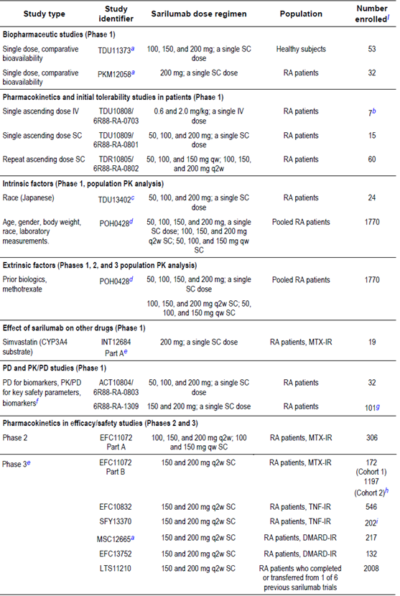

Table 1: (continued) Summary of submitted Clinical Pharmacology Studies (PK and PD) with sarilumab

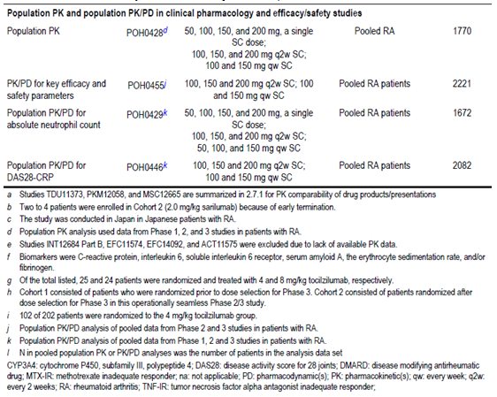

### Summary of pharmacokinetics

The information in the following summary is derived from conventional PK studies in humans (unless otherwise stated) with supporting information derived from the sponsor’s summaries.

#### Physicochemical characteristics of the active substance

SAR is a humanised monoclonal antibody of the IgG1/kappa isotype, comprised of 2 disulphide linked heavy chains linked by disulphide bonds to a light chain segment. The drug binds with high affinity to both soluble and membrane bound IL-6 receptors, and has been shown to inhibit the IL-6 (a pro-inflammatory cytokine IL-6) mediated signalling through these receptors. IL-6 receptors are expressed on a variety of cell types within the body. The variable domains of the heavy and light chains combine to form the IL-6 receptor binding site within the antibody. SAR has an approximate molecular weight of 144 kDa. It is produced by recombinant technology in Chinese Hamster Ovary cell suspension culture medium.

#### Pharmacokinetics in healthy subjects

Only 1 study with SAR has been conducted in healthy subjects and its primary aim was to determine bioequivalence. Study TDU11373 was a randomized, double blind, single SC dose, parallel design study of SAR at different concentrations, doses and formulations (C2F3, C1F2 and C1F3) in 53 healthy male subjects. It was conducted in 2 centres in the USA in 2010. Each subject received a single dose of SAR (either 100 mg, 150 mg or 200 mg dose presented at a concentration of 100mg/mL, 150 mg/mL or 175 mg/mL) and was involved for 5 to 8 weeks in total, including a screening period, 2 day stay at the institution and a 5 week follow-up period. Blood samples for the determination of serum SAR concentrations were collected pre-dose, and on Days 1, 2, 3, 4, 5, 7, 9, 11, 14, 21 and at the end of study visit (Days 35-38). Serum concentrations of functional and bound SAR were determined using a validated enzyme-linked immunosorbent assay (ELISA) with the lower limit of quantification (LLOQ) being 294 and 662 ng/mL, respectively.

In healthy volunteers following a single SC dose of 100 mg SAR, the mean Cmax and AUClast were 7700 ng/mL and 108,000 ng.h/mL respectively. The median Tmax occurred 72 hours after dosing and the mean half-life was 49.5 hours. SAR exposure after administration of the C2F3 or C1F3 formulation was similar to that of C1F2 drug product. When administered at a dose of 100 mg (100 mg/mL x 1.00 mL), the geometric mean ratios of C2F3 versus C1F2 and C1F3 versus C1F2 were 0.91 (95% CI 0.55, 1.51) and 0.90 (95% CI 0.54, 1.50) for Cmax, respectively; and 0.86 (95% CI 0.43, 1.71) and 0.94 (95% CI 0.47, 1.89) for AUClast, respectively.

Study TDU11373 concluded that after a single 100 mg SC dose of SAR in healthy male subjects, there was no difference in the local tolerability, safety and PK profiles of the new SAR C2F3 and C1F3 formulations proposed for use in the Phase III clinical studies compared with the C1F2 product used in the Phase II program.

### Pharmacokinetics in the target population

Before assessing the PK data in target population, the following outlines the key methodology issues involved in the PK analyses. Concentrations of functional SAR (that is SAR with 1 or 2 sites available to bind the target) were measured in all of the PK studies. In addition, serum concentrations of bound SAR (that is SAR with 1 or 2 sites bound to the target) were measured in the early Phase I studies and Study EFC11072 (both parts). Both the functional and bound SAR assays include measurement of SAR that is bound to 1 IL-6R (receptor) molecule. This overlap in single bound SAR forms between assays precluded the simple addition of functional and bound concentrations to achieve a serum total concentration of SAR. Based on consistent results from both assays in early clinical studies, measurement of concentrations of bound SAR was not continued in the later stage clinical studies (that is after Study EFC11072 Part B/Cohort 1). Functional SAR levels are believed to be the pharmacologically active form of the drug. Therefore, this report primarily includes the PK of functional SAR, but the complete PK dataset did contain some information about bound SAR concentrations, when available, as supportive information. The concentration of functional SAR in serum was quantified with validated ELISA that had sensitivity adequate for assessment of the PK of SAR as well as reasonable within- and between-run accuracy (≥ 84%) and precision (± 15%). The LLOQ for functional SAR was 0.294 or 0.313 mg/L in undiluted serum in 2 validated assays. An intensive blood sampling schedule for SAR was undertaken in the Phase I studies (except for Studies TDR10805/6R88-RA-0802 and INT12684) to allow for non-compartmental PK analysis. All of the Phase II and III studies included assessment of serum SAR concentrations using sparse sampling, which was utilised to develop population PK models.

The pivotal population PK analysis of SAR in this submission was Study POH0428, which collated data from 1,770 adult subjects with active RA involved in 7 Phase I studies, 1 Phase II study and 4 Phase III studies. The analysis in Study POH0428 was pre-specified and covered various RA patient populations including subjects with active RA who were inadequate responders to MTX and subjects who were inadequate responders to or were intolerant of anti-TNF drugs. At the data cut-off date for the population PK analysis (31 October 2014), data was available from 2 completed Phase III studies (Studies EFC11072 Part B and SFY13370); partial data was available for 2 ongoing open label Phase III studies (Studies EFC13752 and MSC12665) and 2 ongoing open label Phase I studies (Studies INT12684 and 6R88-RA-1309). For the studies that were ongoing at that time, data from all enrolled patients who had ≥ 1 post-treatment blood sample were included in the population PK analysis. Patients in the pooled population PK dataset had received SAR by SC injection, as either a single dose or repeated qw (every week) or q2w (every 2 weeks), mainly in combination with MTX (90%) or in combination with other non-biologic DMARD therapy. Two-compartment PK models were tested with linear absorption and a non-linear saturable elimination pathway, using either Michaelis-Menten or receptor ligand binding kinetics, representing target mediated drug disposition. The influence of selected demographic factors, laboratory parameters, disease baseline characteristics, anti-drug antibody (ADA) status and concomitant use of MTX on the PK of SAR were investigated in the final, population PK model. Exposure parameters for SAR (Cmax and AUC0-14 days) were estimated from the final population PK model.

#### Absorption

SAR is well absorbed after a single SC dose administration in patients with RA, with the maximum serum concentration of functional SAR achieved at a median Tmax of 2 to 4 days, with no apparent dose effect.

#### Bioavailability and dose proportionality

The bioavailability for SAR after SC injection is estimated to be 80% using the population PK Study POH0428. Regarding dose proportionality, functional SAR exposure increases in a greater than dose proportional manner in patients with RA, due to an appreciable contribution by non-linear clearance to the total drug clearance in the therapeutic dose range. After a single SC dose of SAR in the Phase I studies, the mean AUClast value increased by 38 to 72 times over a 4 fold increase in dose over the range of 50 to 200 mg; refer to Table 2. All of the SAR clinical pharmacology studies listed in Table 2 used the same validated assay for determining serum functional SAR concentrations. The development of the validated drug concentration assays for SAR was part of the pre-clinical study program. The ELISA assay used in the Phase I studies for determining the serum functional SAR concentration had a calibration curve ranging from 5.88 to 200 ng/mL, whereas the calibration curve for the PK analysis in the Phase II-III studies ranged from 6.25 to 400 ng/mL.

In studies 6R88-RA-1309 and MSC12665, a 1.33 fold increase in dose over the therapeutic dose range of 150 to 200 mg resulted in 1.5- to 1.6 fold increase in the mean AUClast of functional SAR. After repeated SC doses of SAR in the Phase II-III studies, the mean steady state trough serum concentrations (Ctrough) of SAR increased by 2.1 to 3.1 fold and AUC0-14 days increased by 2.0 fold with only a 1.33 fold increase in SAR dose from 150 to 200 mg q2w; refer to Table 3. This is consistent with the estimate of a 2.6 fold increase of Ctrough and a 2.0 fold increase of AUC0-14 days over the same dose range, based on post-hoc predicted steady state PK parameters from the population PK analysis (Study POH0428).

Table 2: Pharmacokinetic parameters of serum functional SAR after a single SC dose

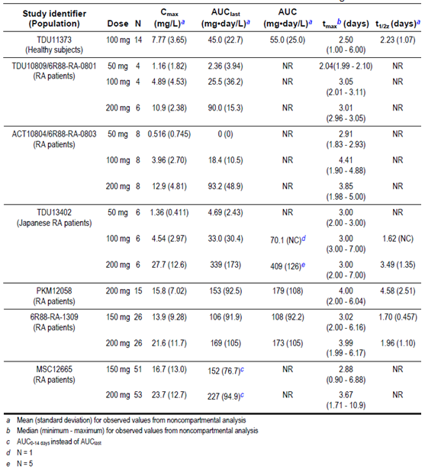

Table 3: Pharmacokinetic parameters of serum functional SAR after repeat SC doses

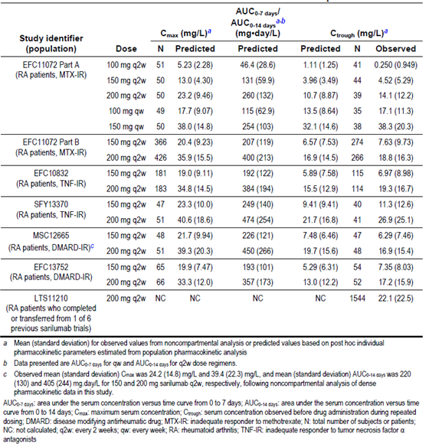

#### Distribution

The apparent volume of distribution of SAR at steady state after intravenous administration in Study TDU10808/6R88-RA-0703 was 0.030 and 0.036 L/kg (approximately 2.1 to 2.5 L in a 70 kg subject) at 0.6 and 2.0 mg/kg, respectively, based on the observed data in 6 patients with RA (2 received 2.0 mg/kg and 4 received 0.2 mg/kg) after a single dose administration.

The population PK Study POH0428 estimated the apparent central volume of distribution of SAR to be 2.08 L with an apparent peripheral volume of distribution of 5.23 L, resulting in a total volume of distribution of 7.31 L. This low value suggests that the distribution of SAR is primarily limited to the circulatory system, which is a characteristic finding in monoclonal antibodies.

#### Metabolism

No specific in vitro or in vivo metabolism studies have been conducted with SAR. As a therapeutic protein, SAR is considered to be metabolised by the same catabolic pathways as endogenous proteins, which are typically broken down into small peptides and amino acids via proteolysis.

#### Excretion and steady state parameters

Overall, SAR exhibits non-linear PK characteristics with 2 distinct processes for elimination. There is a slow, linear and non-saturable elimination phase at higher serum concentrations, when target binding is at or near saturation; and a fast, nonlinear, target mediated elimination phase at lower serum concentrations. The fast elimination process is presumably a result of internalisation via endocytosis of target bound SAR.

In the intravenous administration Study TDU10808/6R88-RA-0703, an increase in SAR dose from 0.6 to 2.0 mg/kg resulted in a decrease in clearance of serum functional SAR by approximately 2 fold, from 0.0121 to 0.00596 L/kg, leading to the observed concentration dependent mean terminal half-lives of 1.8-4.5 days. In several of the Phase I studies (for example TDU10809/6R88-RA-0801), the observed half-life was 1.62 to 4.58 days after a single SC administration of SAR 50 to 200 mg.

The population PK analyses also supported the biphasic elimination of SAR estimating an initial elimination half-life of 8 to 10 days and a terminal half-life of 2 to 4 days at steady state after 150 or 200 mg q2w SC doses (Study POH0428). Serum SAR concentrations after the last steady state dose were measurable up to a median time of 28 days for the 150 mg dose and up to 43 days after the 200 mg q2w dose. Based on Study POH0428, target mediated clearance represents a large portion of total clearance, while linear clearance represents only 7 to 26% of total drug clearance at 150 mg q2w dose and 22 to 40% of total clearance at the 200 mg q2w dose.

In the Phase III studies, the mean trough serum concentrations of functional SAR indicated that steady state was reached between weeks 12 and 24 after repeated SC q2w administration of SAR 150 to 200 mg therapy. The time to steady state in a typical patient, estimated from population PK Study POH0428 was 14 to 16 weeks for AUC0-14 days and 18 to 20 weeks for Ctrough. The accumulation ratios were determined to be 2.3 and 2.5 for AUC0-14 days and 2.6 and 3.0 for Ctrough after SAR 150 mg q2w and 200 mg q2w dosing regimens, respectively; refer to Table 4.

Table 4: Pharmacokinetic parameters of serum functional SAR after first and repeat SC doses

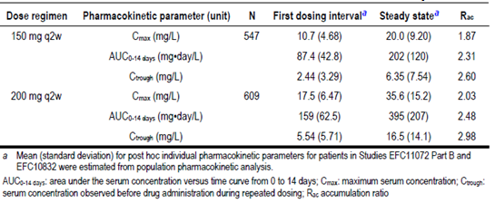

#### Intra- and inter-individual variability of pharmacokinetics

SAR exhibits moderate to high PK variability in patients with RA. The observed total variability (Coefficient of Variation or CV) after a single SC dose of SAR (50 to 200 mg dose range) was 30.2 to 55.8% for Cmax, 50.9 to 92.2% for AUClast and 30.9 to 75.1% for AUC (Table 5). The observed CV in steady state trough serum concentrations after repeated SC doses of SAR was also > 90%. Moreover, the population PK Study POH0428 showed large inter-individual variability in the functional SAR drug clearance (CV of 63.4%) and moderate intra-individual variability (CV of 39.5 to 55.4%). At steady state, the total variability was 42.7 to 46.0% for Cmax, 52.4 to 59.4% for AUC0-14 days and 85.5 to 119% for Ctrough levels. The potential effects of several intrinsic and extrinsic sources of variability on the PK of functional SAR were evaluated via population PK analysis and/or cross study comparisons (refer to section 4.2.4 of this report). However, these covariate factors failed to explain the majority of CV.

### Pharmacokinetics in other special populations

#### Pharmacokinetics in subjects with impaired hepatic function

The sponsor has not conducted any formal hepatic impairment study with SAR. This is a common feature of submissions like SAR because monoclonal antibody therapies are not cleared through the liver and are primarily eliminated via proteolytic catabolism in endothelial cells, which are distributed throughout the body. Furthermore, the population PK Study POH0428 did not identify any correlation between serum SAR concentration and liver function test values (serum AST, ALT or total bilirubin levels).

#### Pharmacokinetics in subjects with impaired renal function

The sponsor has not conducted any formal renal impairment study with SAR. The majority of patients with RA in the population PK dataset had either normal renal function (n = 1225, 69%) or mild renal impairment (n = 471 subjects, 27%). A small number of patients had moderate renal impairment (n = 74 subjects, 4% overall) and severe renal impairment (creatinine clearance (CrCL) < 30 mL/min) was an exclusion criterion for all Phase III studies. Although CrCL (based on the Cockcroft-Gault formula normalised by BSA) was a statistically significant covariate for clearance in the population PK analysis, the impact of CrCL on clearance did not translate into an appreciable effect on functional SAR exposure (AUC0-14 days) at steady state. After SAR 150 and 200 mg q2w doses, there were only 7% and 5% respective decreases in drug exposure for a typical patient with CrCL of 120 mL/min (the 75th percentile in the population PK dataset) and 8% and 4% respective increases for a typical patient with CrCL of 83 mL/min (the 25th percentile) compared to a typical patient with CrCL of 100 mL/min (the median value in the population PK dataset).

#### Pharmacokinetics according to age

No relationship between functional SAR exposure and age was observed in patients with RA in any of the clinical studies. The population PK Study POH0428, which included data from patients aged between 18 and 87 years (14% of patients in the dataset were > 65 years) did not identify age as a significant covariate factor influencing the PK of SAR. The proposed PI does not recommend any dose adjustment for elderly patients.

#### Pharmacokinetics related to genetic factors

Study POH0428 examined the effect of ethnicity on serum SAR concentration using data from 1,554 Caucasian subjects (88% of the population PK dataset), 105 Asian patients (6%), 60 African American subjects (3%) and 51 patients of ‘other races’ (3%). Ethnicity was not a significant covariate influencing functional SAR PK. In Study TDU13402, a single SC dose of 50 mg, 100 mg or 200 mg of SAR was administered to 24 Japanese patients with RA. The study reported higher functional SAR exposure in Japanese patients compared with Caucasian subjects, when compared across the different studies. The sponsor states that this finding is likely to be explained by differences in body weight between Japanese patients (mean weight of 56.5 kg) in Study TDU13402 and Caucasian patients in the other studies (mean weight of 76.5 to 78.2 kg). The sponsor has not proposed any dose adjustment according to ethnicity in the PI.

#### Pharmacokinetics according to subject body weight and gender

Individual studies suggested a trend toward lower functional serum SAR concentrations in subjects with a body weight > 90 to 100 kg. In agreement with the observed data, the population PK Study POH0428 identified body weight as significant covariate influencing apparent linear and non-linear drug clearance with a reduced drug exposure (AUC0-14 days) in individuals with higher body weights. After repeated 150 mg and 200 mg q2w doses of SAR, there were 23% and 20% respective decreases for a typical patient weighing 83 kg (the 75th percentile in the population PK dataset) and 25% and 20% respective increases for a typical patient weighing 62 kg (the 25th percentile) compared to a typical patient weighing 71 kg (the median weight). The impact of body weight is greater at the extremes of the range (the 5th to 95th percentiles in the population PK dataset), as evidenced by 46% and 45% respective decreases for a typical patient weighing 106 kg (the 95th percentile) and 75% and 57% respective increases for a typical patient weighing 50 kg (the 5th percentile), when compared to a typical patient weighing 71 kg (the median weight). Body weight had a greater effect on steady state SAR exposure at the 150 mg q2w dose versus the 200 mg q2w regimen. This finding is consistent with the impact of body weight on non-linear drug clearance, which is predominant at lower drug concentrations. Table 5 provides a summary of the impact of body weight upon functional serum SAR concentration at steady state. The effect of body weight on PK is consistent with clinical efficacy data, which showed a numerically lower rate of ACR20 response at Week 24 (primary clinical efficacy endpoint) for patients weighing ≥ 100 kg treated with SAR 150 mg q2w when compared to placebo. However, no consistent effect of high subject weight was seen for any of the other co-primary or secondary clinical efficacy endpoints.

Table 5: Functional sarilumab steady state exposure by body weight category in Study POH0428

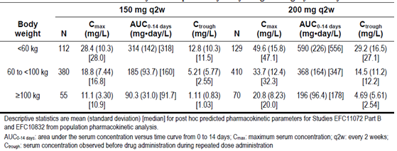

The population PK Study POH0428 collected functional serum SAR concentration data from a total of 304 male and 1,466 female patients with RA and identified gender as a potentially significant covariate impacting upon apparent linear drug clearance. However, the effect of gender was minimal and translated into 12% and 14% lower SAR steady state exposures (AUC0‑14 days) after repeated 150 and 200 mg q2w administrations, respectively, for a typical male patient, as compared to a typical female patient. The sponsor is not proposing any dose adjustments because of gender.

### Pharmacokinetic interactions

#### Pharmacokinetic interactions demonstrated in human studies

SAR was not anticipated to interact directly with cytochrome P450 (CYP) enzymes, but CYP enzymes are down regulated by inflammatory cytokines such as IL-6. Hence, inhibitors of IL-6 may restore CYP activity to that of the non-inflammatory state, leading to increased metabolism of CYP substrates. IL-6 reduces mRNA expression for several CYP450 isoenzymes including CYP1A2, CYP2B6, CYP2C9, CYP2C19, CYP2D6 and CYP3A4. CYP3A4 expression has been shown to be reversed by another anti-IL-6 therapy (tocilizumab) at clinically relevant concentrations both in vitro and in vivo (Dickmann et al, 2011). Because of this knowledge, a specific PK study to assess the effect of SAR on simvastatin, a sensitive CYP3A4 substrate, was conducted in patients with RA. Study INT12684 was an open label, 2-treatment, single sequence, 2 period trial to evaluate the effects of a single 200 mg SC injection of SAR on the PK of a single 40 mg oral dose of simvastatin. On Day 1 of Period 1, 19 patients received 40 mg oral simvastatin. In Period 2, they received SAR 200 mg by SC injection on Day 1 followed by 40 mg oral simvastatin under fed conditions on Day 8. Blood samples for PK analysis of simvastatin and simvastatin acid were collected pre-dose and 0.5, 1.0, 1.5, 2.0, 4.0, 6.0, 8.0, 10.0, 12.0 and 24.0 hours post-dose on Day 1 of Period 1 and on Day 8 of Period 2. Plasma concentrations of simvastatin and simvastatin acid were determined using a validated liquid chromatography-tandem mass spectrometry method. Non-compartmental PK parameters (Cmax, Tmax, AUClast, AUC and half-life) were determined for simvastatin and simvastatin acid. Geometric mean ratios for (simvastatin + SAR/simvastatin alone) for Cmax, AUClast and AUC, as well as their 90% confidence intervals (CIs) were determined for both analytes. Administration of a single SC dose of 200 mg SAR with a single oral dose of 40 mg simvastatin to patients with RA resulted in reduced exposure to simvastatin (45% reduction) and simvastatin acid (36% reduction), which is similar to the findings with tocilizumab (a 57% decrease in simvastatin exposure). A cross study comparison of the effect of concomitant administration of MTX with SAR versus a SAR monotherapy treatment population in Study EFC13752 showed considerable overlap in functional serum SAR concentrations across the studies, suggesting that there is no significant effect of MTX on the PK of SAR. In addition, the population PK Study POH0428 had serum SAR concentration data from 1,619 patients with RA, who had received concurrent MTX (91% of the total dataset) and did not identify MTX as a significant covariate influencing functional SAR PK. Moreover, the same population PK study found that prior biologic treatment exposure for RA did not have an effect on the PK of functional SAR concentrations.

The occurrence (transient and persistent) and type (neutralising or not) of testing positive for anti-drug antibodies (ADA) was tested throughout the Phase I-III clinical study program for SAR. For more details on the ADA data refer to sections 8.5.8 and 8.7.5 of this report. Patients who received SAR with concomitant MTX in the Phase III studies had a lower incidence of ADA than patients who received SAR without MTX in the monotherapy population of Study EFC13752. The overall incidence of positive ADA status with SAR 150 q2w therapy was 24.6% and for 200 mg q2w treatment was 18.2%. There was a considerable overlap in the serum SAR trough concentrations of ADA positive and negative patients, although mean concentrations were generally lower in ADA positive patients versus ADA negative patients. Consistent with this observation, ADA status was identified as a significant covariate impacting linear clearance in the population PK Study POH0428. Patients with ADA positive status exhibited 24 to 28% lower SAR exposure (AUC0-14 days) than patients who were ADA negative. Additionally, SAR exposure in neutralising antibody positive patients was lower than in negative patients (by 49 to 59%, based on post-hoc exposure data from the population PK analysis. Among the ADA positive patients, SAR exposure in patients with a persistent ADA response was lower by 32 to 41% than in patients with transient ADA response. In the integrated safety dataset, no clear impact on the rate of treatment discontinuation due to a lack or loss of efficacy was observed in patients who were ADA positive (using the Phase III studies dataset).

### Evaluator’s overall conclusions on pharmacokinetics

The PK of SAR in adult patients with active RA has been well characterised in the studies included in this submission. SAR exhibits non-linear PK with target mediated drug disposition. It is well absorbed after SC administration (Tmax of 2 to 4 days and estimated bioavailability of 80%), exhibits a low apparent volume of distribution (7.3 L) and undergoes elimination by parallel linear and non-linear pathways. At higher serum concentrations, elimination is predominantly through the linear, non-saturable proteolytic pathway and at a lower drug concentration; the non-linear saturable target-mediated elimination pathway predominates. The elimination pathways result in an initial half-life of 8 to 10 days and a terminal concentration dependent half-life of 2 to 4 days. After the last steady state doses of SAR 150 q2w and 200 mg q2w therapy, the median times to non-detectable drug concentrations are 28 and 43 days, respectively. SAR exposure increases in a greater than dose proportional manner. The main source of intrinsic PK variability identified in patients using population PK analysis is body weight, with an increase in weight resulting in reduced drug exposure. No other demographic characteristics (age, ethnicity or gender) have a significant effect on the PK of SAR. There is no data in patients with severe renal or hepatic impairment. The concomitant administration of low dose oral MTX has no effect on the PK of SAR, nor does prior biologic DMARD treatment. However, exposure of simvastatin (a sensitive CYP3A4 substrate) decreases by 45% when co-administered with a single SC dose of SAR 200 mg. This finding is consistent with inhibition of IL-6 signalling resulting in restoration of CYP activity, leading to increased metabolism of drugs that are CYP substrates. The effect of SAR on CYP enzymes may be clinically relevant for a CYP substrate with a narrow therapeutic index.

Positive ADA status has a significant impact on the PK of SAR resulting in a 24 to 28% lower drug exposure when compared to ADA negative patients. If patients exhibit a persistently positive response to ADA then drug exposure is even lower (by 32 to 41%) than in patients with transient positive ADA response. SAR concentrations of neutralising antibody positive patients appeared to be even lower versus neutralising antibody negative patients (by 49 to 59%).

## Pharmacodynamics

### Studies providing pharmacodynamic data

The ability of SAR to bind and capture circulating IL-6 has been formally validated in several clinical studies involving adult patients with active RA. The PD effect of SAR has been primarily assessed by the measurement of several serum inflammatory markers and serum sIL-6R (soluble IL-6 receptor). Total sIL-6R can be regarded as a biomarker for SAR and is indicative of target engagement. Total sIL-6R is defined as free IL-6R plus IL-6R complexed with SAR after drug exposure.

In this submission, the sponsor has presented pharmacodynamic (PD) data collected in 5 Phase I studies (Studies TDU10808/6R88-RA-0703, TDU10809/6R88-RA-0801, TDR10805/6R88-RA-0802, ACT10804/6R88-RA-0803 and 6R88-RA-1309), 1 Phase II study (Study EFC11072 Part A) and 2 Phase III studies (Part B of Study EFC11072 and Study EFC10832). The PD dataset is supported by 3 population PK/PD analyses (Studies POH0455, POH0429 and POH0446), which modelled data from various clinical trials to cover a broad range of dosing regimens in adult patients with active RA. A summary of the studies providing PD data is included in Table 1. None of the PD studies had deficiencies that excluded their results from consideration.

### Summary of pharmacodynamics

The information in the following summary is derived from conventional PD studies in humans unless otherwise stated.

#### Mechanism of action

SAR is a recombinant human immunoglobulin isotype G1 (IgG1) monoclonal antibody that binds with high affinity to the alpha subunit of the IL-6 receptor. Both soluble (sIL-6R) and membrane bound forms of the IL-6 receptor are inhibited and IL-6 mediated signalling is impeded. IL-6 stimulates various cellular processes including proliferation, differentiation, survival and apoptosis and it is responsible for activating hepatocytes to release acute phase reactants such as C-reactive protein (CRP) and serum Amyloid A (SAA). The main clinical safety concerns based on the mechanism of action of SAR plus the knowledge and experience with an alternative anti-IL-6 drug (tocilizumab) are neutropaenia and raised serum lipid profiles.

#### Pharmacodynamic effects

##### Primary pharmacodynamic effects

Through blockade of the IL-6/IL-6R interaction, SAR is expected to reduce or normalise elevated levels of acute phase reactants (including CRP, SAA and fibrinogen) seen in patients with active RA. The measurement of erythrocyte sedimentation rate (ESR) is an indirect index of these proteins and is similarly affected. For many patients with active RA, there are elevated levels of IL-6 in the serum and joint synovium. Hence, the primary PD effects of SAR are considered to be directly related to the efficacy of the drug in RA. Serum inflammatory markers such as CRP and ESR form an important element of assessing clinical disease activity and are often incorporated into clinical measures such as the DAS28 score.

Blood samples for the measurement of levels of IL-6, sIL-6R, SAA and/or fibrinogen were collected in 5 of the Phase I studies (Studies TDU10808/6R88-RA-0703, TDU10809/6R88-RA-0801, TDR10805/6R88-RA-0802, ACT10804/6R88-RA-0803 and 6R88-RA-1309), 1 Phase II study (Study EFC11072 Part A) and 1 Phase III study (Study EFC11072 Part B). Blood samples for the measurement of ESR were collected in 3 Phase I studies (Studies TDU10809/6R88-RA-0801, TDR10805/6R88-RA-0802 and ACT10804/6R88-RA-0803). Blood samples for high sensitivity assays of CRP were collected in all studies. PD biomarker data was summarised by descriptive statistics by treatment or by dose group. Assays were developed and validated for measuring the concentrations of total and free sIL-6R (amount that is pharmacologically available).

In the Phase II study (Part A of Study EFC11072), a dose dependent decrease in CRP levels was observed following repeated qw (100 and 150 mg) and q2w (100, 150, and 200 mg) regimens. The suppression of CRP was slightly greater and occurred earlier (by Week 2) with SAR 200 mg q2w treatment versus SAR 150 mg q2w, but further reductions in CRP levels were not apparent between 200 mg q2w, and the 100 and 150 mg qw regimens; refer to Figure 1. Overall, this data supported the selection of the SAR 150 mg q2w and 200 mg q2w doses for investigation in the Phase III studies.

Figure 1: Serum CRP concentrations following repeat doses of SAR in Part A of Study EFC11072

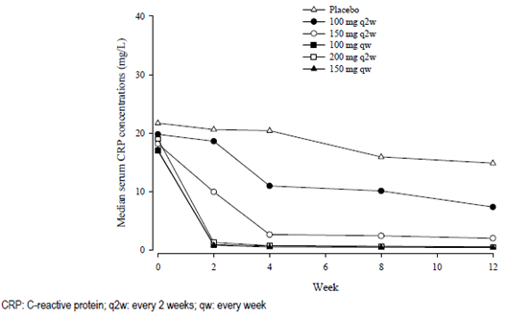

In the pivotal Phase III studies, CRP levels decreased to within the normal range (< 10 mg/L) and SAA levels were < 20 mg/L when the trough concentration of SAR was above 1 mg/L. The combined Phase III trial dataset shows that a higher percentage of patients treated with SC SAR 200 mg q2w had SAR trough concentrations above 1 mg/L by Week 24 (86%) than patients treated with SC SAR 150 mg q2w (61%). The sponsor considers this finding as a pivotal piece of evidence in justifying the proposed posology of 200 mg q2w.

In the Phase II study (Part A of EFC11072), free sIL-6R, representing the amount of target that is pharmacologically available, was measured in the serum following qw (100 and 150 mg) and q2w (100, 150, and 200 mg) dosing. All doses except for SAR 100 mg q2w produced a reduction in free sIL-6R; refer to Figure 2. The decrease in free sIL-6R at SAR 150 mg q2w was slightly less than at the 200 mg q2w dose, which appeared to plateau presumably because of target saturation. Although the largest decrease in free sIL-6R was observed with SAR150 mg qw dosing, the difference between the 200 mg q2w and the 100 mg qw groups was marginal. The decrease in free sIL-6R was accompanied by a corresponding increase in total sIL-6R, the vast majority being in the form of the biologically inert bound complex. When SAR is in excess of free IL-6R the target is saturated and any newly formed IL-6R is expected to be immediately complexed. With the elimination of the IL-6R-SAR complex being slower than its formation, the concentration of total IL-6R is expected to plateau. Thus, measurement of total sIL-6R serves as a direct and useful marker of target saturation. Consistent with the observations of free sIL-6R levels, measurements of total sIL-6R also indicated that target was near saturation after repeated administration of SAR 200 mg q2w therapy. In addition, when the SAR dose increased from 150 to 200 mg q2w, the increase in the concentrations of bound SAR (completely bound plus partially bound drug) was almost in proportion to dose, while functional SAR (completely free plus partially free drug) continued to increase in a greater than dose proportional manner, which further pointed toward a near saturation of the target by the 200 mg q2w dose. The sponsor asserts that these observations support the selection of the 150 and 200 mg q2w dose regimens for the Phase III studies, and justify the proposed commercial posology of 200 mg q2w as the most effective dose.

Figure 2: Serum concentrations of free sIL-6R following repeat SAR dosing in Part A of Study EFC11072

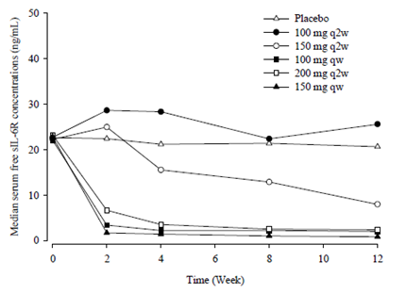

#### Secondary pharmacodynamic effects

The predicted adverse effects of SAR on neutrophil counts (decreases), raised serum transaminases (mainly, ALT) and increased serum LDL cholesterol levels in patients with RA will be discussed in section 5.2.4 of this report. In the Phase III studies as well as the population PD Study POH0455, all of the safety outcomes were recorded at a greater frequency with an increase in serum SAR concentrations (dose proportionality), and the effect appeared to reach a plateau in the lower concentration observed with SAR 150 mg q2w therapy, apart for the incidence and severity of neutropaenia. Decreases in neutrophil count from Baseline were predicted to be greater for SAR 200 mg q2w therapy (39%) than for SAR 150 mg q2w (31%), but there was only a small increased risk of severe neutropaenia (neutrophil count < 1.0 x 109/L) in patients at the median concentration for SAR 200 mg q2w when compared to patients at the median concentration for 150 mg q2w, with an even smaller increase in risk beyond the 200 mg q2w median concentration and an overall decreasing risk over time.

The effect of SAR on immunogenicity (that is formation of anti-drug antibodies) will be discussed in sections 8.5.5 and 8.7.5 of this report.

#### Time course of pharmacodynamic effects

Following a single SC dose of SAR in Study TDU10809/6R88-RA-0801, there was a trend toward a dose dependent decrease in CRP level until Day 3 (with 100 mg dose) and until Day 8 (with SAR 50 and 200 mg doses) with a return to baseline by Day 29. Similarly, the ESR showed a dose dependent trend toward decrease until Day 8 (100 and 200 mg) and until Day 15 (50 mg), with a return to near baseline by Day 29. There was a dose dependent decrease in fibrinogen levels until Day 4 (50 mg) and Day 8 (100 and 200 mg), with a return to baseline by Day 22. SAA levels decreased until Day 4 (100 and 200 mg) and Day 8 (50 mg, the largest decrease). Transient increases in IL-6 levels were also observed in all SAR treatment groups in this study. A similar time course of PD effects with respect to acute phase reactants was seen in Study TDR10805/6R88-RA-0802, which was a repeat ascending dose trial (50, 100 and 150 mg qw; and 100, 150 and 200 mgq2w) in 60 patients with RA. CRP and SAA levels were highly variable and difficult to interpret in the single ascending dose IV Study TDU10808/6R88-RA-0703, which only evaluated 7 subjects with RA (4 received IV SAR 0.2 mg/kg and 2 received IV SAR 2.0 mg/kg).

In the open label, single dose Study 6R88-RA-1309 (n = 306 patients with RA), which assessed the PD of IL-6 blockade with SC SAR 150 and 200 mg, and IV tocilizumab with background MTX, both doses of SAR and tocilizumab therapy generated an immediate decrease in the neutrophil count and CRP level, and an increase in IL-6 and total sIL-6R concentrations, with similar onsets of effect during the first week. CRP levels were reduced to normal as early as 4 days after treatment initiation. Nadirs and times to nadir for the neutrophil count, CRP level, IL-6 peak level and time to IL-6 peak level were comparable across the 3 treatment groups. With SAR the peak level for total sIL-6R was lower, and the time to peak level for total sIL-6R was faster with SAR than with tocilizumab.

In the Phase II study (Part A of EFC11072), free sIL-6R and CRP concentrations in serum decreased markedly by Week 2, in a dose dependent manner with SAR therapy. Conversely, serum IL-6 and total sIL-6R concentrations increased markedly by Week 2 in a SAR dose dependent manner. Both of the Phase III studies also showed a consistent, dose dependent decrease in CRP levels evident by Week 2.

With respect to the time course of neutropaenia, the population PD Study POH0455 reports that neutrophil counts decrease to a nadir between 3 and 4 days, and thereafter slowly recover in most patients with drug cessation within the proposed second weekly dosing interval.

#### Relationship between drug concentration and pharmacodynamic effects

The relationship between serum SAR concentrations and PD biomarkers and/or key clinical endpoints (efficacy and safety) was explored in the Phase I study (Study 6R88-RA-1309) and also in the dose ranging Phase II study (Part A of Study EFC11072). Subsequent analyses of data pooled from several studies (including both pivotal Phase III studies), using empirical and semi-mechanistic PK/PD models, provided support for the relationship between SAR concentration and PD effects. The sponsor interprets this data to justify the proposed dose regimen for SAR. There is no clear relationship between IL-6 levels and trough SAR concentrations. However, CRP and SAA levels decreased to within the normal range when the trough concentration of SAR was above 1 mg/L. The combined Phase III dataset shows that a higher percentage of patients treated with SC SAR 200 mg q2w had SAR trough concentrations above 1 mg/L by Week 24 (86%) than patients treated with SC SAR 150 mg q2w (61%). This did not result in a numerically different rate of ACR20 response (primary efficacy endpoint) between the 2 SAR dose groups, but the sponsor asserts that some other secondary clinical efficacy endpoints (such as ACR50 and ACR70 response) as well as X-ray outcomes were better in the higher SAR dose group. Further detail about the clinical efficacy data will be discussed in section 7 of this report.

In the Phase II study (Part A of Study EFC11072), a correlation between the neutrophil count reduction at Week 12 and the mean trough concentration of functional SAR was apparent; refer to Figure 3. There was a trend toward greater reduction in neutrophil count with increasing trough SAR concentration. However, the effect appeared to reach a plateau by 200 mg q2w.

Figure 3: Neutrophil count versus serum trough SAR concentration at Week 12 in Part A of Study EFC11072

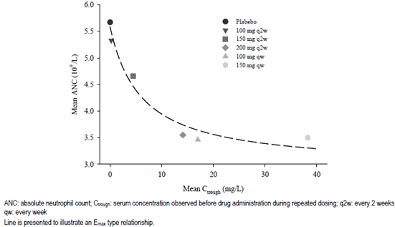

The relationship between the percentage change from Baseline in neutrophil count and trough serum concentration of functional SAR was well described by an Emax model in Study POH0455.

There was a trend toward greater change from Baseline in the neutrophil count with increasing functional SAR trough serum concentration, when compared with the placebo group. However, the effect reached a plateau over the observed concentration range in Phase II and III studies. The model predicted a 41% decrease from placebo for SAR 200 mg q2w, which was close to the observed neutrophil count decrease of 38% from placebo for the SAR 200 mg q2w group. The same model also predicted a small increased risk of severe neutropaenia (neutrophil count < 1.0 x 109/L) in patients treated with SAR 200 mg q2w when compared with patients treated with 150 mg q2w, with a smaller increase in risk beyond the 200 mg q2w median concentration range and a decreasing risk over time.

The Emax model in Study POH0455 also predicted the percentage change from Baseline in the LDL level and trough serum SAR concentration. The lipid raising effect of SAR reached a plateau around the median concentration for SAR 150 mg q2w therapy, with no further effect at the median serum concentration for SAR 200 mg q2w treatment. Study POH0455 also predicted a small trend towards greater change from Baseline in serum ALT in SAR treated patients when compared to patients treated with placebo as SAR trough serum concentrations increased, but the effect reached a plateau in the concentration range for both doses of SAR observed in the Phase III studies.

#### Genetic, gender and age related differences in pharmacodynamic response

None of the covariates tested within the population PD models had a relevant effect on the PD response to SAR, including age, gender and subject body weight.

### Pharmacodynamic interactions

SAR is not anticipated to interact directly with or modulate the expression of CYP enzymes, but such enzymes are down regulated by inflammation, including cytokines such as IL-6. Hence, IL‑6 inhibitors may restore CYP activity to that of the non-inflammatory state, leading to the increased metabolism of CYP substrates. IL-6 can reduce mRNA expression for several CYP450 isoenzymes including CYP1A2, CYP2B6, CYP2C9, CYP2C19, CYP2D6 and CYP3A4. CYP3A4 has been shown to be reversed by another anti-IL-6 therapy (tocilizumab) at clinically relevant concentrations in vivo.

The submission did not contain any information about the potential effect of SAR upon the generation of protective antibody titres following vaccination (including non-live vaccines such as influenza).

### Evaluator’s overall conclusions on pharmacodynamics

In this submission, the PD properties of SAR when used in adult patients aged > 18 years with active RA was assessed from data collected in 5 Phase I studies, 3 Phase II/III trials and 3 population PKPD analyses. The studies involved > 2,000 patients who received SAR by SC injection across a broad dose range (from a single dose of 50 mg to 150 mg qw). In the pivotal Phase III study (Part B of EFC11072), drug exposure for up to 52 weeks of therapy has been evaluated. The sponsor has appropriately nominated mean changes in serum total IL-6R and sIL-6R levels as the primary PD markers of interest for SAR. Mean or median serum changes in serum inflammatory markers (CRP, SAA, fibrinogen and ESR) were evaluated as the secondary PD biomarkers of relevance. Expectedly for the mechanism of action of SAR, the pivotal and supporting studies demonstrated a rapid and dramatic decrease in serum CRP within 2 to 4 days of first drug administration. The median time to nadir CRP levels is 7 days. Other acute phase reactants such as SAA and fibrinogen levels follow a similar time course of effect. CRP levels return to near normal 15 to 30 days after last drug administration. With repeat SAR dosing by SC administration, CRP levels reach steady state by Week 24 and remain at the same level up to Week 52 of therapy. The mean values for free sIL-6R decreased rapidly (2 weeks) following SC administration of SAR and remained constant thereafter for extended periods of follow-up (at least 24 to 52 weeks).

Reductions in free sIL-6R, CRP and other PD biomarkers, all correlated with SAR exposure and were accompanied by efficacy improvements. Over the 153 fold concentration range following qw (100 and 150 mg qw) and q2w (100, 150, and 200 mg q2w) dose regimens in the Phase II study, the effect on free sIL-6R and CRP levels, and efficacy endpoints (ACR20, ACR50, and ACR70 scores and the DAS28-CRP) was apparent only at drug concentrations achieved with doses of 150 mg q2w or above. A plateau was reached for all endpoints at the SAR concentration for the 200 mg q2w dose, with further increase in exposure by as much 2.7 fold (150 mg qw) providing no significant incremental change in response. The Phase II study also showed a greater reduction in neutrophil counts with increasing SAR up to 200 mg q2w. The PK/PD analyses supported the conclusion from the dose response relationships that the 150 and 200 mg q2w doses were appropriate for the Phase III program. In the Phase III studies, both 150 and 200 mg q2w doses showed near maximal suppression of serum CRP levels, but there was potentially more rebound toward baseline near the end of the dosing interval for the SAR 150 mg q2w dose than for the 200 mg q2w dose, suggesting that suppression of IL-6 signalling may be more complete with SAR 200 mg q2w therapy. In the pivotal Phase III studies, CRP levels decreased to within the normal range (< 10 mg/L) and SAA levels were < 20 mg/L when the trough concentration of SAR was above 1 mg/L. The combined Phase III trial dataset shows that a higher percentage of patients treated with SC SAR 200 mg q2w had SAR trough concentrations above 1 mg/L by Week 24 (86%) than patients treated with SC SAR 150 mg q2w (61%). The sponsor considers this finding as a pivotal piece of evidence in justifying the proposed posology of 200 mg q2w.

The PK/PD relationships for safety endpoints (neutropaenia, elevated serum ALT values and raised LDL levels) showed a higher rate of adverse effects with an increasing SAR concentration, but the effect reached a plateau at the lower concentration range observed with SAR 150 mg q2w therapy, apart from neutropaenia. Mean decreases in the neutrophil count from Baseline were predicted to be greater for SAR 200 mg q2w therapy versus SAR 150 mg q2w dosing (39% versus 31%), and there was also a small increased risk of severe neutropaenia (that is neutrophil count < 1.0 x 109/L) occurring in patients at the median concentration for SAR 200 mg q2w therapy when compared to the median concentration with SAR 150 mg q2w treatment.

## Dosage selection for the pivotal studies

Dose selection for the Phase III clinical study program started with interpretation of the PK and PD data from single and multiple dose studies in adult patients with active RA taking concomitant MTX. This data informed the dose selections and regimens of SAR (to be used concomitantly with MTX) to be investigated in the double blind, placebo-controlled Phase II trial (Part A of Study EFC11072).

The selected doses and regimens of SAR in that dose finding study were those considered to have the potential to suppress PD markers, such as CRP, SAA and fibrinogen, throughout the dosing interval.

Part A of Study EFC11072 was a 12 week, 6 arm, dose ranging study intended to select the 2 dose regimens of SAR for further evaluation in the Phase III program. In Part A, subjects were randomly assigned in a ratio of 1:1:1:1:1:1 to receive either placebo injections once weekly (qw), SAR 100 mg qw, SAR 150 mg qw, SAR 100 mg once every 2 weeks (q2w), SAR 150 mg q2w or SAR 200mg q2w. The maximum duration of study involvement for each individual patient was 22 weeks (up to 4 weeks of screening, followed by 12 weeks for study treatment and 6 weeks of follow-up after their last injection). The complete set of efficacy results reported in Part A of Study EFC11072 is detailed in section 7.1 of this report. Patients from Part A of Study EFC11072 did not participate in Part B of the trial. However, subjects who completed Part A were eligible to enter an open label, long term extension study (LTS11210).

The dose regimens of SAR investigated in both of the pivotal Phase III trials (Part B of Study EFC11072 and EFC10832) were selected on the results obtained during the Phase I and II programs. Clinical efficacy results from Part A of Study EFC11072 concluded that 4 doses of SAR (150 mg q2w, 200 mg q2w, 100 mg qw and 150 mg qw) showed efficacy in the adult RA patient population. There was no clear dose response relationship for the incidence of treatment emergent adverse events (TEAE) and serious adverse events (SAEs) were infrequent in all treatment groups. The lowest SAR dose with efficacy (150 mg q2w) and a second dose regimen (200 mg q2w) were chosen for evaluation in the pivotal Phase III trials based on the benefit-risk ratio analysis. In addition, the sponsor states that from the perspective of patient convenience, a less frequent injection schedule is preferred (once every 2 weeks versus once weekly).

Both of the pivotal Phase III trials were placebo (placebo) controlled for the first 12 to 16 weeks. However, 35 to 39% of placebo treated patients (versus 13 to 14% of SAR treated subjects) were transferred to rescue therapy with SAR before Week 24 because of insufficient clinical response. In addition to placebo or SAR injections, all patients in both trials received concurrent non-biological DMARD (> 90% of which was weekly low dose oral MTX). The mean and median doses of concomitant background treatment with conventional DMARD therapy (predominately MTX) was consistent with contemporary clinical practice in Australia. However, recent expert opinion concludes that such prior therapy reflects sub-optimal practice before the commencement of biologic therapy in patients with active RA (Duran et al, 2016). In particular, the maximal concurrent dose of MTX should be used in the comparator arm of all biologic therapy trials (up to 25 mg/week, by the SC route if dose > 15 mg/week for MTX) as sub-optimal MTX dose in the comparator arm may bias efficacy results in favour of biological agents. Moreover, low dose oral corticosteroid (prednisone > 10 mg/day) and NSAID use was recorded in approximately two-thirds of all patients (equally dispersed among the treatment arms) in the 2 pivotal SAR studies, which reflects appropriate concomitant drug use in individuals with active RA, and is consistent with prescribing patterns in Australia.

## Clinical efficacy

Proposed treatment indication of:

‘*Sarilumab in combination with non-biologic DMARDs is indicated for the treatment of moderate to severe Rheumatoid Arthritis in adult patients who have had an inadequate response or intolerance to one or more DMARDs*’.

### Pivotal efficacy studies

There were 2 pivotal Phase III trials (Part B of Study EFC11072 and Study EFC10832) in support of the application for the treatment of RA with SAR. Both of the Phase III studies were of similar design; randomised, double blind, parallel group, placebo controlled trials in adult patients with active RA. Both of the Phase III trials examined the effect of SAR 150 mg and 200 mg injections given by SC injection every 2 weeks when added to non-biologic DMARD therapy (mostly, weekly low dose oral MTX). The main difference between the 2 pivotal Phase III studies was the recruitment of subjects with a preceding inadequate response to MTX in Study EFC11072 versus subjects who were inadequate responders or intolerant of anti-TNF therapy in Study EFC10832.

#### Study EFC11072 - Part B

##### Study design, objectives, locations and dates

The primary objectives of Part B of Study EFC11072 were to demonstrate that the efficacy of SAR therapy when added to MTX was superior to placebo (placebo) injections and continued MTX in:

* Reducing the symptoms and signs of active RA at 24 weeks
* Improving physical functioning at 16 weeks, and
* Slowing the progression of structural damage (joint damage seen on plain X-ray).

Study EFC11072 had an operationally seamless design that used a Phase II strategy to select the relevant dose regimens of SAR (Part A, dose ranging), followed by a Phase III design to test the selected SAR dose regimens (Part B, pivotal), without interruption of patient recruitment and maintenance of the double blind. The US Food and Drug Administration (FDA) and European Medicines Agency (EMA) agreed upon the design of Study EFC11072.

Part A of Study EFC11072 was a 12 week, 6 arm, dose ranging study intended to select the 2 dose regimens of SAR for further evaluation in the Phase III program. The efficacy results (that is reduction in signs and symptoms of RA) of Part A are presented in this report. In Part A, subjects were randomly assigned in an equal ratio to receive either placebo injections once weekly (qw), SAR 100 mg qw, SAR 150 mg qw, SAR 100 mg once every 2 weeks (q2w), SAR 150 mg q2w or SAR 200mg q2w. The maximum duration of study involvement for each individual patient was 22 weeks (up to 4 weeks of screening, followed by 12 weeks for study treatment and 6 weeks of follow-up after their last injection). Patients from Part A of Study EFC11072 did not participate in Part B of the trial. However, subjects who completed Part A were eligible to enter an open label, long term extension study, Study LTS11210.

Part B of Study EFC11072 was a 52 week, 6 arm study with 2 cohorts, intended to confirm the efficacy and safety of the 2 SAR dose regimens (150 mg q2w and 200 mg q2w) selected from Part A. Patient enrolment in Part B commenced after the last subject was randomised into Part A, without waiting for the dose selection based on the results of Part A. Hence, subjects enrolled in Cohort 1 of Part B were randomly assigned in an equal ratio (identical to Part A) to receive either placebo injections qw, SAR 100mg qw, SAR 150 mg qw, SAR 100 mg q2w, SAR 150 mg q2w or SAR 200 mg q2w; refer to Figure 4. Once the results from Part A were known and the doses for further evaluation in Part B were selected, patients in Cohort 1 of Part B who were receiving the final selected doses of SAR (subsequently identified to be 150 mg q2w or 200 mg q2w) or placebo injections continued on the same allocated treatment regimen. Patients receiving the ‘non-selected’ SAR dose groups in Cohort 1 were discontinued from Study EFC11072 and could enter the open label, long term extension Study LTS11210.

Figure 4: Study Design of Cohort 1, Part B of Study EFC11072

Study Design of Cohort 1, Part B of Study EFC11072
a 52 week, 6 arm study with 2 cohorts, intended to confirm the efficacy and safety of the 2 SAR dose regimens (150 mg q2w and 200 mg q2w) selected from Part A. Patient enrolment in Part B commenced after the last subject was randomised into Part A, without waiting for the dose selection based on the results of Part A. Hence, subjects enrolled in Cohort 1 of Part B were randomly assigned in an equal ratio (identical to Part A) to receive either placebo injections qw, SAR 100mg qw, SAR 150 mg qw, SAR 100 mg q2w, SAR 150 mg q2w or SAR 200 mg q2w; refer to Figure 4. Once the results from Part A were known and the doses for further evaluation in Part B were selected, patients in Cohort 1 of Part B who were receiving the final selected doses of SAR (subsequently identified to be 150 mg q2w or 200 mg q2w) or placebo injections continued on the same allocated treatment regimen. Patients receiving the “non-selected” SAR dose groups in Cohort 1 were discontinued from Study EFC11072 and could enter the open label, long term extension Study LTS11210.

Patients for Cohort 2 of Part B were recruited after dose selection results were available from Part A and were randomly assigned in a ratio of 1:1:1 to receive either placebo injections q2w, SAR 150 mg q2w or SAR 200 mg q2w; refer to Figure 5.

Figure 5: Study Design of Cohort 2, Part B of Study EFC11072

Study Design of Cohort 2, Part B of Study EFC11072
Patients for Cohort 2 of Part B were recruited after dose selection results were available from Part A and were randomly assigned in a ratio of 1:1:1 to receive either placebo injections q2w, SAR 150 mg q2w or SAR 200 mg q2w; 

The design of Part B of Study EFC11072 allowed for early escape to rescue treatment for all patients demonstrating insufficient improvement. This is appropriate for ethical reasons. From Week 16 onwards, enrolled patients with a lack of efficacy, defined as < 20% improvement from Baseline in swollen joint count (SJC) or tender joint count (TJC) for 2 consecutive visits, or any other clear lack of efficacy based on investigator judgement, could be transferred to rescue therapy with open label SAR injections at the highest approved dose at the time of transfer into the rescue treatment arm. Open label SAR therapy was administered at 150 mg qw until the site was approved to enrol patients into Cohort 2. Once approval was received, patients were switched to SAR 200 mg q2w. These patients were to continue in the trial according to the planned visit schedule. Patients that were not rescued were discontinued from Study EFC11072.

The maximum duration of involvement in Study EFC11072 for each individual patient was 62 weeks (up to 4 weeks for screening, followed by 52 weeks for treatment and 6 weeks of follow-up after their last injection). All patients who completed Part B of Study EFC11072 were eligible to enter Study LTS11210.

In this submission, the pivotal clinical efficacy data up to Week 52 has been included for Study EFC11072. In Part B of the trial, clinical efficacy and safety assessments were performed at Baseline; Weeks 2 and 4; every 4 weeks until Week 28; and thereafter every 8 weeks until Week 52 (that is Weeks 36, 44 and 52). Part B of Study EFC11072 also collected radiographic data at Baseline, as well as Weeks 24 and 52 in support of the claim to reduce the rate of progression of joint damage.

Part B of Study EFC11072 was conducted at 199 investigator sites in 30 countries in Europe, North and South America, Asia as well as Australia, New Zealand and South Africa. The first patient was enrolled in March 2011 and the last patient completed follow-up in October 2013. A total of 7 protocol amendments were implemented in Part B of Study EFC11072. The first 2 amendments were instituted before the recruitment of any patients and the other 5 amendments occurred after. Protocol amendments 3 to 7 contained many important changes outlined below.

In amendment 3 (dated 4 April, 2011) the following significant changes occurred:

* Modification of the pre-requisite and maintenance MTX dose from 10 to 25 mg/week to 6 to 25 mg/week for patients recruited into the study from countries in Asia (Taiwan, South Korea, Malaysia, Philippines, Thailand and India)
* Reduction in the qualifying C-reactive protein level from > 10 mg/L at the screening visit to > 6 mg/L at the screening visit
* Deletion of the exclusion criterion regarding subject weight parameters at Baseline ‘weight < 50 kg for men < 45 kg for women or > 110 kg for both genders’, and
* Addition of exclusion criterion regarding patients with latex hypersensitivity.

In protocol amendment 4 (dated 4 November, 2011) the following changes were implemented:

* Addition of extra blood test monitoring for haematology and liver function tests to occur every 2 weeks for the initial 12 weeks
* Modification of the exclusion criterion specifying the exclusion of all patients with latent or active tuberculosis, and/or a history of invasive opportunistic infections
* Modification of exclusion criterion to increase screening platelet count requirement from < 100 x 109/L to < 150 x 109/L,
* Addition of severe hypercholesterolemia (> 350 mg/dL, 9.1 mmol/L) or hypertriglyceridemia (> 500 mg/dL, 5.6 mmol/L) at screening or baseline as an exclusion criterion, and
* Addition to exclusion criterion of patients with a history of inflammatory bowel disease or severe diverticulitis or previous gastrointestinal perforation.

Protocol amendment 6 (dated 29 October, 2012) was introduced after feedback initially received from the EMA (and later supported by the FDA) regarding the potential claims of improvement in physical function and reduction of structural damage with SAR. To justify the 2 treatment claims (in addition to improving the symptoms and signs of RA), the sponsor was asked to convert the HAQ-DI and mTSS outcome measures from secondary to co-primary efficacy endpoints. This resulted in a substantial revision to the statistical analysis plan and hierarchical order of efficacy outcome testing to align the modifications with the study objectives and endpoints.

Protocol amendment 7 (dated 8 October, 2013) was introduced after additional feedback received from the FDA, which asked the sponsor to re-define the primary endpoint based on the HAQ-DI. The HAQ-DI remained a co-primary endpoint, but the statistical methodology was altered. The original approach was to calculate the mean change from Baseline in HAQ-DI score at Week 52. However, the FDA requested the sponsor to change this calculation to the mean change from Baseline to Week 16 in the HAQ-DI. Furthermore, an additional secondary efficacy outcome was added at the request of the FDA. The FDA has developed a new draft guideline for industry regarding drug development in RA which recommends including the endpoint of ‘Boolean-based ACR/EULAR remission at Weeks 24 and 52’.

##### Inclusion and exclusion criteria

To be eligible for inclusion, patients had to be at least 18 years of age and < 75 years of age with a diagnosis of RA according to the 1987 American College of Rheumatology (ACR) criteria for RA (functional classes I-III) for at least 3 months. Subjects had to have active disease at Baseline as evidenced by ≥ 8 tender joints (out of a possible 68), ≥ 6 swollen joints (out of a possible 66) and high sensitivity CRP reading > 6 mg/L (prior to protocol amendment 3, CRP > 10 mg/L was required). In addition, all subjects were required to have at least 1 of the following 3 features for qualification into Part B of Study EFC11072: at least 1 documented bone erosion on plain X-ray (using local site reader), or positive serology for anti-Cyclic Citrullinated Peptide (anti-CCP) antibodies, or positive serology for RF (Rheumatoid Factor).

The eligibility criteria for Part B of Study EFC11072 required subjects to have active RA despite current treatment with MTX for a minimum of12 weeks prior to randomisation. Furthermore, subjects were required to be on a stable dose of MTX 10 to 25 mg/week for a minimum of 6 weeks prior to the screening visit, except for patients recruited within Asia (Taiwan, South Korea, Malaysia, Philippines, Thailand and India) who were allowed a prior MTX dose of 6-25 mg/week for a minimum of 6 weeks prior to screening.

Concomitant treatment with MTX (up to 25 mg/week) was required in Part B of Study EFC11072 if the dose and route of administration had been stable for at least 6 weeks prior to randomisation. Patients taking DMARDs other than MTX were required to cease such therapy for at least 4 weeks prior to screening (or 12 weeks if taking leflunomide (LEF) and it was not removed by cholestyramine washout). The concomitant use of oral corticosteroids (CS) was permitted for subjects taking stable doses (prednisone (or equivalent) < 10 mg/day) for at least 4 weeks prior to screening. Low potency topical CS was allowed as background therapy for steroid responsive skin conditions such as psoriasis or eczema. Concomitant NSAID was also permitted, provided subjects were on a stable dose for at least 4 weeks prior to randomisation. Study EFC11072 Part B allowed patients with a history of prior biologic DMARD exposure for RA to be included, as long as such therapy had not been given within 3 months of randomisation. However, a past history of non-response to biological DMARD therapy was an exclusion criterion.

There were a large number (n = 39) of exclusion criteria for Part B of Study EFC11072. Co-morbid conditions were an exclusion criterion based on the investigator decision as to their clinical significance (including cardiac, pulmonary, neurologic, psychiatric and any major uncontrolled disease). A past history of substance abuse within the last 5 years, infection requiring treatment within 4 weeks of screening, non-healing or infected skin ulcers, history of latex allergy, any surgery within 4 weeks of screening or anticipated during the study, and a history of recurrent herpes zoster infection or articular infection were to be excluded. A history of malignancy within 5 years (except for excised basal and squamous cell skin cancers, or cervical carcinoma in situ successfully treated by surgery) was also an exclusion criterion. In the initial protocol, a subject weight at Baseline of < 50 kg for men and < 45 kg for women or > 110 kg for both genders was an exclusion. This criterion was subsequently removed with protocol amendment 3. With the implementation of protocol amendment 4, patients with a history of inflammatory bowel disease or severe diverticulitis or previous gastrointestinal perforation were excluded. Regarding vaccination, any live vaccine administered 3 months prior to randomisation (or 12 months prior for BCG vaccination) was an exclusion criterion.

Subjects were screened for Hepatitis B and C, HIV as well as latent Tuberculosis (TB) at Baseline. The screening for latent TB involved either skin testing with PPD (removed with protocol amendment 4) or QuantiFERON TB-Gold testing. Subjects with active TB or a history of reactivated latent TB were excluded. All patients were required to have a chest X-ray within 12 weeks prior to screening.

Subjects with any significant laboratory abnormalities at screening were also excluded. These included serum transaminases > 1.5 x Upper Limit Normal (ULN), total serum bilirubin > ULN (prior to protocol amendment 4, bilirubin value > 1.5 x ULN was an exclusion), creatinine clearance < 30 mL/min, total white blood cell count < 3.0 x 109/L, neutrophil cell count < 2.0 x 109/L, platelet count < 150 x 109/L, haemoglobin < 8.5 g/dL, serum cholesterol > 9.1 mmol/L, serum triglyceride > 5.6 mmol/L and HbA1c > 9.0%.

##### Study treatments

All patients in Study EFC11072 (both cohorts) received investigational study medication (SAR or placebo) by subcutaneous (SC) injection at alternating sites of the anterior abdomen (divided into quarters). Each dose administration required a single injection of 1.14 mL (regardless of SAR dose). Investigator site staff gave the first injection of study treatment and trained the subject on self-administration. On days when the patient had a study visit, site staff administered injections following clinic procedures and blood collection. For doses not given at the study site, either the patient, carer or designated site staff administered study medication.

In Cohort 1 of Part B, subjects received their injections every 7 days. For patients randomised to the 3 arms of Cohort 1 that were allocated to receive SAR therapy q2w, alternating injections of SAR and placebo were administered to maintain the blind. After dose selection from Part A was available, patients in Cohort 1 who were in the selected dose groups were able to take their injectable study medication every 14 days (q2w) once ethics and regulatory approvals were obtained. The change in injection frequency for patients transitioning from Cohort 1 to Cohort 2 of Part B may have had a potential effect on the background rate of injection site reaction (ISR), but should not have influenced efficacy results. Cohort 1 used glass vials of study medication until pre-filled syringes became available.

For patients in Cohort 2 of Part B, injectable study medication (presented in pre-filled syringes) was to be taken every 14 days (q2w) with a time window of ± 3 days. For patients who received rescue treatment, SAR was administered at the highest available dose at the time of transfer into the rescue treatment arm, which was 150 mg qw prior to the availability of dose selection results from Part A and 200 mg q2w after dose selection results became available.

All patients were required to continue taking MTX during Study EFC11072 at the same weekly dose and route they received prior to enrolment. The dose of MTX could be reduced during the trial for safety related reasons. Concurrent folic acid was recommended according to local guidelines. The concomitant use of stable, pre-existing treatment with oral CS and NSAID was also permitted.

##### Efficacy variables and outcomes

The main efficacy variables were:

* American College of Rheumatology (ACR) response criteria (individual components (n = 7); composite ACR20, ACR50, and ACR70 response; and the ACRn response measure)
* Various other validated composite measures of disease activity and response in RA such as the Disease Activity Score 28 (DAS28) score, Clinical Disease Activity Index (CDAI) and the Simplified Disease Activity Index (SDAI)
* Radiographic evaluations of joint damage progression using the van der Heijde modified Total Sharp Score (mTSS); and
* Quality-of-Life (QOL) outcomes such as the Short-Form Health Survey (SF-36) and FACIT‑Fatigue questionnaire.

There were 3 co-primary endpoints in Part B of Study EFC11072: (1) the proportion of patients who achieved an ACR20 response at Week 24, (2) the mean change from Baseline to Week 16 in the HAQ-DI score and (3) the mean change from Baseline to Week 52 in the mTSS.

A patient was defined as achieving an ACR20 response if the following was fulfilled:

* A decrease of at least 20% in the number of tender joints (n = 68)
* A decrease of at least 20% in the number of swollen joints (n = 66), and
* At least a 20% improvement in 3 of the following 5 criteria: patient assessment of pain on 100mm VAS; patient global assessment of disease status (100 mm VAS); physician global assessment of disease status (100 mm VAS); Health Assessment Questionnaire –Disability Index (HAQ-DI) and serum inflammatory concentration (CRP was used in Study EFC11072).

The ACR20 response rate is a validated composite endpoint recommended in the guideline ‘Points to Consider on Clinical Investigation of Medicinal Products other than NSAIDs for treatment of Rheumatoid Arthritis’ (CPMP/EWP/556/95 rev 1/Final). The ACR20 response is considered to be the minimal clinically important threshold for determining response to an intervention in adult patients with RA.

The HAQ-DI is a patient reported questionnaire used to provide an assessment of the impact of the disease and its treatment on physical function. It is a validated method for measuring disability in inflammatory arthritis with a range of 0 to 3 (with a higher score indicating more functional impairment). The tool assesses the degree of difficulty experienced by the individual in 8 domains of daily living activities using 20 questions. The domains include dressing and grooming, arising, eating, walking, hygiene, reach, grip and common daily activities, with each domain (activity) consisting of 2 or 3 items. For each question, the level of difficulty is scored from 0 to 3 with 0 = ‘without any difficulty’, 1 = ‘with some difficulty’, 2 = ‘with much difficulty’ and 3 = ‘unable to do’. If the maximum score equals 0 or 1, but a device related to that activity was used or help from another person was provided for the activity, then the activity score is increased to 2. However, if the activity score was already 2 and a device related to that activity was used or help from another person was provided, the score for that activity remains 2. A total score of between 0 and 3 is obtained from the mean of each activity. A change from Baseline in the HAQ-DI of at least -0.22 units has been specifically defined for RA in peer reviewed literature to be the smallest measurable reduction that is clinically significant.

The mTSS (assessed using the van der Heijde 1999 modification of the Total Sharp Scoring system) is a validated composite X-ray scoring system used to quantify structural joint damage due to RA. The mTSS is the sum of the joint space narrowing (JSN) score plus the erosion score (ES) and has a range of 0 to 448. A higher score represents greater structural damage. The JSN score has a range of 0 to 168 and is derived from evaluating 30 joints in the hands and 12 joints in the feet, each of which are scored from 0 (no damage) to 4. The ES has a range of 0 to280 and is derived from assessing 32 hand joints and 12 joints in the feet. Each joint is scored 0 (no damage) to 5, except the metatarsophalangeal joints of the feet, which are scored 0 to 10.

All enrolled subjects in Part B of Study EFC11072 were required to have plain X-rays taken of both hands and both feet (a single posterio-anterior view of each hand, and a single dorso‑plantar view of each foot) at Baseline, Week 24 and the end of study visit (that is Week 52 or upon early withdrawal). There was to be a window of at least 3 months between X-ray assessments. X-ray images of both hands and feet were obtained using a standardised technique, digitised and assessed by 2 experienced central readers, who were blinded to the treatment group, X-ray sequence and clinical status of the subject. The statistical analysis used the mean score from the 2 readers for all analyses.

Although the mTSS is the appropriate radiological scoring method, the minimum time point in which it is assessed is crucial to deciding the validity of a drug’s claim to inhibition of the rate of structural progression of RA. The relevant EU regulatory guideline states that for agents claiming to prevent structural joint damage, it is recommended to demonstrate radiological differences of the hands and forefeet on the basis of before and after treatment comparisons taken not less than 1 year apart, but ideally 2 years, using full randomization and pre-agreed criteria.

The key secondary endpoint in Part B of Study EFC11072 was the proportion of patients who achieved Major Clinical Response (MCR), defined as an ACR70 response maintained for at least 24 consecutive weeks during the first 52 week study period.

The other secondary efficacy endpoints (reported at Weeks 24 and 52) included:

* Mean decrease in disease activity as measured by DAS28-CRP score;
* Proportion of patients achieving ACR50 and ACR70 response;
* Mean decrease from Baseline in the CDAI – Week 24 only;
* QOL outcomes using the SF-36 survey and FACIT-Fatigue scale; and the
* Proportion of subjects with no radiographic progression (defined as a change from Baseline of mTSS of < 0) at Week 52.

The DAS28 score is a complex mathematical calculation of the 28 joint tender and swollen joint counts, ESR or CRP, and an optional general health assessment (100 mm VAS). The DAS28 score is a validated continuous scale ranging from 0 to 9.4. The level of RA disease activity can be interpreted as low if the DAS28 score is ≤ 3.2, moderate if between 3.2 and 5.1, or high if > 5.1. A DAS28 score of < 2.6 corresponds to clinical remission.

The ACR50 and ACR70 response criteria use the same data components as the ACR20, but at a corresponding higher level of response.

The SDAI is another composite disease activity score in RA, which incorporates patient, physician and laboratory values. It derives a single score on a continuous scale ranging from 0 to 86. It is the sum of the 28 swollen joint count, 28 tender joint count, patient and investigator global assessments of disease activity on a 100 mm VAS and CRP in mg/dL (that is 5 variables in total). A lower score indicates lower disease activity. The CDAI is a modification of the SDAI without the laboratory parameter of CRP to allow for immediate clinical assessment (that is 4 variables in total). It has a score range of 0 to 76.

The SF-36 questionnaire (version 2) consists of 36 questions relating to QOL grouped into 8 subscales (physical function, role physical, bodily pain, general health, vitality, social functioning, role emotional, and mental health). Each scale is directly transformed into a 0 to 100 scale with a lower score indicating greater impairment or disability. The 8 subscales can also be used to derive 2 component summary measures (both with a range of 0 to 100): physical component summary (PCS) and mental component summary (MCS).

The Functional Assessment of Chronic Illness Therapy (FACIT) - Fatigue scale is a 13 item instrument designed to assess fatigue and tiredness, and their impact on daily activities and functioning. It was originally developed to measure fatigue in adult patients with cancer, but its content has demonstrated good reliability and validity in numerous chronic health conditions including RA. The instrument includes items (7 day recall period) such as tiredness, weakness, listlessness, lack of energy, and the impact of these feelings on daily functioning (for example sleeping and social activities). Each of 13 questions is rated on a 4 point Likert scale. In Study EFC11072, the FACIT-Fatigue endpoint was considered to be clinically meaningful if the LS mean difference between each of the SAR dose groups versus placebo was statistically significant, and the within group change from Baseline reached the group mean level of the minimal clinically important difference of 3 points.

Other efficacy outcomes in Part B of Study EFC11072 (reported at Weeks 24 and 52) included:

* Proportion of subjects achieving DAS28-CRP remission
* Mean change from Baseline in the individual components of the ACR response criteria
* Mean change from Baseline in the Numeric index of the ACR response (ACRn)
* Mean change from Baseline in the SDAI (Week 24 only)
* Boolean-based ACR/EULAR remission
* Mean percentage improvement in WPAI (Weeks 12 and 52); and the
* Mean percentage improvement in Sleep.

The ACRn is defined as the average change from Baseline in the following 3 variables: (i) the percentage change from Baseline in the number of tender joints, (ii) the percentage change from Baseline in the number of swollen joints, and (iii) the median of the percentage change from Baseline for the other 5 ACR response criteria: patient’s global assessment of disease activity, physician’s global assessment of disease activity, patient’s assessment of pain, HAQ-DI and CRP. The ACRn appears be more sensitive than the ACR20 criteria in detecting small improvements, particularly those that may occur early on in treatment. Furthermore, ACRn is a continuous outcome measure that is different from the ACR20/50/70 response criteria, which are categorical endpoints. By measuring the mean (or median) change in ACRn, this measure provides an assessment of the magnitude of benefit for a typical patient, which is complementary information to the categorical ACR response criteria. For example, a population with an ACRn value of 38 means that the typical patient in that cohort has achieved a 38% improvement in RA by clinical measures.

Boolean-based ACR/EULAR remission is defined as when a patient satisfies all the following 4 criteria at a given time point: TJC and SJC (based on the assessment of 28 joints) ≤ 1, CRP ≤ 10 mg/L and patient global VAS ≤ 10 mm.

The Work Productivity and Activity Impairment (WPAI) scale is a 6 item questionnaire which measures the percent of work time missed, percent of impairment while working, overall percent of work impairment and the percent activity impairment due to RA. The scale expresses an impairment percentage with higher numbers indicating greater impairment and decreased productivity.

Sleep was assessed by a 100 mm VAS with subjects asked to rate how much of a problem sleep has been for them in the past week where 0 = ‘not a problem’ and 100 = ‘a major problem.’

##### Randomisation and blinding methods

In Part B of Study EFC11072, patients were randomised into treatment groups with the use of a centralised, computerised interactive voice response system (IVRS) and stratified according to prior biologic therapy use (yes/no) and region. Subjects eligible to receive rescue treatment after Week 16 due to lack of efficacy were not re-randomised.

To protect the double blind design of Part B of Study EFC11072, SAR and placebo injections were supplied in matching pre-filled syringes in identical kits. Independent joint evaluators not involved with any other aspects of the studies quantified joint disease involvement, and X-rays were scored by readers who were blinded to subject treatment and X-ray film sequence.

Two patients in the placebo group accidentally had their blind broken by the site investigators and both subjects discontinued as per the protocol. Both subjects were included in the efficacy and safety analyses. In addition, 32 subjects (4 in the placebo group, 13 in the SAR 150 mg arm and 15 in the SAR 200 mg group) had their blind broken for regulatory purposes. All of the 32 subjects experienced SAEs and were either discontinued as a result of the unblinding or excluded from any analyses. Furthermore, 14 subjects had their CRP data incorrectly provided to site investigators, which may have resulted in potential unblinding.

##### Analysis populations

The primary analysis population for efficacy endpoints in Part B of Study EFC11072 was the Intention-To-Treat (ITT) cohort, which consisted of all 1197 patients randomised into Cohort 2 of Part B (that is after the implementation of the final SAR dose selection for evaluation). The safety and PK analysis populations consisted of 1,282 subjects randomised into both cohort sections of Part B.

Three randomised patients (1 patient allocated to the SAR 200 mg group and 2 patients in the SAR 150 mg arm) did not receive any study treatment in Part B. All 3 subjects were included in the efficacy population analysis, but not the safety population. In addition, 3 patients randomised to SAR 200 mg in Cohort 2 received a single dose of SAR 150 mg and were analysed in the 150 mg group for the safety assessment. Two patients randomised to SAR 150 mg in Cohort 2 received a single dose of SAR 200 mg in error, but were analysed in the SAR 150 mg group for the safety analysis. One subject randomised to placebo received a single dose of SAR 200 mg and was analysed in this arm for the safety assessment.

##### Sample size

The sample size calculation for Part B of Study EFC11072 was based on the primary radiographic endpoint (that is change from Baseline to Week 52 in mTSS). A requirement for 372 subjects in each of the 3 treatment groups was estimated based on an alpha level of 0.025 to address multiplicity across the 2 SAR dose regimens being investigated in this trial, 90% statistical power, a mean change in mTSS from Baseline to Week 52 of 1.10 for placebo and 0.35 for SAR therapy (with an associated standard deviation (SD) of 2.6) and a missing value rate of 15%. The assumed mean changes in the mTSS and SD are based on the results of an alternative anti-IL-6 drug (tocilizumab) pivotal Phase III trial data in adult patients with active RA (LITHE Study; Fleischmann et al, 2013).

Regarding the clinical efficacy endpoints investigated in Part B of Study EFC11072, a sample size of 372 subjects per treatment group provides > 99% power for the rate of ACR20 response at Week 24. Using the tocilizumab dataset (LITHE Study, 2013), the 24 week ACR20 response rates were estimated to be 27% in the placebo group and 51% in the SAR treatment arms (alpha level of 0.025 to address multiplicity across the 2 active dose groups with a 2 sided, chi-square test). The sample size of 372 subjects per treatment group provides 98% power for the mean change from Baseline to Week 16 in the HAQ-DI score. Using data with tocilizumab (Emery et al, 2008), the treatment related difference at 16 weeks in the mean HAQ-DI score was estimated to be 0.3 (SD 0.79; alpha level of 0.025 to address multiplicity across the 2 active dose groups with a 2 sided t-test; and a missing data rate of 30%).

The key secondary efficacy endpoint in Part B of Study EFC11072 was the proportion of patients who achieved MCR at Week 52. In the LITHE study (Fleischmann et al, 2013), the rate of MCR at Week 52 was 4% in the tocilizumab 4 mg/kg group and 6.5% in the tocilizumab 8 mg/kg arm versus 0.5% in the control group. If the same rates of MCR for active treatment were observed in Part B of Study EFC11072, then the sample size provides 76% and 97% power, respectively (alpha level of 0.025 to address multiplicity across the 2 active dose groups with a 2 sided, chi-square test).

##### Statistical methods

The co-primary efficacy outcome of the ACR20 response rate at Week 24 was analysed using the 2 sided Cochran-Mantel-Haenszel (CMH) test stratified by prior biologic use and region. Separate pair wise comparisons of the response rate between each dose of SAR versus placebo were calculated. Testing each SAR dose separately against placebo also derived the CMH estimate of the Odds Ratio (OR) and the corresponding 95% confidence intervals (CI). In the primary statistical analysis, patients were considered non-responders if there were insufficient data to determine the ACR20 response status, if they received rescue medication, or if they discontinued study treatment.

For the co-primary endpoint of the mean change from Baseline to Week 16 in the HAQ-DI score, analysis using a Mixed Model for Repeated Measures (MMRM) was employed. The model included treatment, stratification factors, visit and treatment by visit interaction as fixed effects and baseline as a covariate. Measurements collected from patients after they received rescue medication or discontinued study treatments were not included in this analysis.

For the third co-primary endpoint of the mean change from Baseline to Week 52 in the van de Heijde mTSS, an analysis using a rank based analysis of covariance (ANCOVA) model adjusted for baseline, prior biologic use and region. A linear extrapolation method was used to impute missing or post rescue treatment mTSS results.

Sensitivity analyses using alternate methods of handling missing post-baseline data (such as the Last Observation Carried Forward (LOCF) approach) were performed to support the robustness of the primary analyses. Both Phase III studies had secondary endpoints to further evaluate the effects of SAR on the signs and symptoms of RA, physical function, structural progression and health-related QOL. The binary secondary efficacy variables of ACR50 and ACR70 response and various measures of remission were analysed using the same CMH test as the ACR20 variable. The same method used for HAQ-DI analysis was used for the continuous secondary efficacy endpoints (for example ACRn). To adjust for multiplicity and to control the overall Type I error rate at 0.05, a hierarchical testing procedure was implemented for the co-primary endpoints and for pre-specified secondary endpoints using α = 0.025 within each SAR dose regimen.

##### Participant flow

A total of 2,978 subjects were screened for involvement in Study EFC11072 (both cohorts) and 1,609 patients (54.0%) were recorded as screen failures. Screen failures were mainly due to insufficient disease severity to meet the inclusion criterion (22.6% of 1609) and due to meeting the exclusion criterion related to tuberculosis (19.3% of 1609).

A total of 1,369 patients were randomised into Part B of Study EFC11072: 172 subjects into Cohort 1 and 1197 patients in Cohort 2; refer to Figure 6. Of the 172 patients randomised into Cohort 1, 88 were allocated to the selected dose groups of SAR therapy and placebo evaluated in Cohort 2. A total of 27 patients (30.7% of 88) in the selected dose groups of Cohort 1 switched to rescue treatment, 45 patients (51.1% of 88) completed the treatment phase of the study and 16 patients (18.2% of 88) permanently discontinued during the double blind treatment period.

Figure 6: Patient disposition in Cohorts 1 and 2 of Part B of Study EFC11072

Patient disposition in Cohorts 1 and 2 of Part B of Study EFC11072
A total of 1,369 patients were randomised into Part B of Study EFC11072: 172 subjects into Cohort 1 and 1197 patients in Cohort 2; refer to Figure 6. Of the 172 patients randomised into Cohort 1, 88 were allocated to the selected dose groups of SAR therapy and placebo evaluated in Cohort 2. A total of 27 patients (30.7% of 88) in the selected dose groups of Cohort 1 switched to rescue treatment, 45 patients (51.1% of 88) completed the treatment phase of the study and 16 patients (18.2% of 88) permanently discontinued during the double blind treatment period.

Of the 1,197 subjects randomised into Cohort 2/Part B of Study EFC11072, 3 patients did not receive any study treatment (1 patient was allocated to the SAR 200 mg group and 2 patients were in the SAR 150 mg arm). All 3 patients were included in the efficacy population analysis, but not the safety population.

In Cohort 2, 16.8% (201/1197) of patients discontinued during the double blind treatment period and did not take rescue therapy. A greater proportion of SAR treated patients (18.3% (73/400) in the 150 mg group and 20.6% (82/399) in the 200 mg arm) discontinued compared to placebo patients (11.6%; 46/398), mainly due to adverse events (10.7% overall).

In Cohort 2 of Study EFC11072, 21.5% (257/1197) of patients switched to open label rescue treatment with SAR between Weeks 16 and 52. The majority of rescue therapy subjects (13.0% in total; 156/1197) were randomised into the placebo arm at Baseline. A total of 41 patients discontinued treatment during the rescue phase, mainly due to AEs.

Double blind treatment without the need for rescue therapy up to Week 52 was completed by 61.5% (736/1197) of patients. The 52 week completion rate was higher in the SAR treatment groups (67.5% (270/400) in the 150 mg group and 67.7% (270/399) in the 200 mg arm) compared to the placebo arm (49.2%; 196/398).

##### Major protocol violations/deviations

A total of 35 patients (2.9% of 1197) in Cohort 2 of Study EFC11072 were recorded as having an important protocol deviation that had the potential to impact on the efficacy analyses. This included 15 patients (3.8% of 398) in the placebo group and 20 patients in the SAR treatment arms (8 subjects (2.0%) in the 150 mg dose group and 12 patients (3.0%) in the 200 mg dose arm). A total of 29 patients (equally spread across the 3 treatment groups) did not meet the trial entry criteria (for example baseline CRP < 6 mg/L or seronegative RA with no bony erosions) and were recorded as significant protocol deviations. Four patients (2 in the placebo group and 2 in the SAR 200 mg dose arm) did not receive MTX for at least 12 weeks prior to randomisation and 2 subjects (both in the SAR 200 mg dose group) were recorded as receiving oral CS > 10 mg/day within 4 weeks prior to randomisation. None of the data from these patients was excluded from the efficacy analyses as the primary analyses are based on the ITT population as defined in the statistical plan.

A total of 23 patients (7 in the placebo group and 8 subjects in each SAR dose arm; 2.0% in each group) in Cohort 2 of Study EFC11072 had randomisation or study drug allocation irregularities. Furthermore, 47 patients (15 patients (3.8%) in the placebo group, 14 subjects (3.5%) in the SAR 150 mg dose arm and 18 patients (4.5%) in the SAR 200 mg group) were recorded as having ‘other important protocol deviations’. The majority of the ‘other important protocol deviations’ reflected inadequate safety screening procedures, including subjects having a PPD test performed prior to signed consent (13 patients), and having a medical history or screening laboratory test fulfilling exclusion criterion (11 patients). However, 6 of the subjects (1 in the placebo group with neutropaenia, 2 subjects in the SAR 150 mg arm with elevated serum transaminases and 3 patients in the SAR 200 mg group; 2 with elevated serum transaminases and 1 with severe thrombocytopaenia (platelet count < 50 x 109/L) with abnormal baseline laboratory tests requiring exclusion, continued their allocated study treatment during the trial. Two patients had positive screening tests for hepatitis B virus core antibody. One subject discontinued SAR 150 mg therapy after receiving one dose due to this finding. The other patient received SAR 200 mg injections during the trial and completed the study treatment period with an AE of thrombocytopaenia recorded during the study. Liver function tests remained within normal ranges during the trial.

##### Baseline data

The randomised population for Cohort 2 and the selected doses of therapy (SAR and placebo arms) in Cohort 1 was comprised of 1,285 patients. However, the primary efficacy analysis of Part B of Study EFC11072 was conducted using the Cohort 2 data only (n = 1,197 subjects). The baseline population data for Cohort 2 alone versus Cohort 2 plus selected dose groups in Cohort 1 are highly similar. In this report, the baseline characteristics for the Cohort 2 alone dataset will be presented as this was used for the primary efficacy analysis.

The 3 treatment groups in Cohort 2 were well balanced with respect to demographic characteristics. Overall, subjects had a median age of 52 years (range: 18 to 75 years) with a small percentage of elderly subjects (10.9%; 131/1197). The majority of recruited subjects were female (81.6%; 977/1197) and have Caucasian ethnicity (86.1%; 1031/1197). The overall median BMI was 27.3 kg/m2, with almost one third of subjects (32.5%; 387/1197) being obese at Baseline (that is BMI > 30 kg/m2). By geographic region, the largest percentage of patients came from Eastern Europe and Asia (that is Region 3: 42.4%; 508/1197) followed by South America and Mexico (that is Region 2: 38.8%; 465/1197). Region 1 included patients from Western Europe, North America, Australia and New Zealand, and contributed 18.7% (224/1197) of subjects into Cohort 2/Part B of Study EFC11072.

The treatment groups were similar with respect to baseline RA disease characteristics. The mean duration of RA for all subjects was 9.04 years (median 7.09 years, range: 0.3 to 44.7 years). Most patients were recorded as having functional class II RA at Baseline (67.3%; 805/1197). Expectedly, the majority of patients were seropositive for RA at Baseline (84.7% (1009/1197) were positive for rheumatoid factor and 86.8% (1036/1197) were positive for anti-CCP antibodies). It was unclear what proportion of subjects met the inclusion criterion of; at least 1 radiographic erosion present at Baseline.

In terms of RA disease activity at Baseline, the mean numbers of tender and swollen joints were similar for the placebo (26.8 and 16.7, respectively), SAR 150mg (27.2 and 16.6, respectively) and SAR 200 mg groups (26.5 and 16.75, respectively); refer to Table 6. All 3 treatment groups recorded mean DAS28-CRP scores that were high at Baseline (5.93 to 5.97). The median HAQ-DI score was slightly lower in the placebo arm (1.69) compared to the 2 SAR treatment groups (1.75). The mean CRP for subjects in the placebo arm was lower at 20.46 mg/L compared to the 2 SAR treatment groups (22.19 to 22.53 mg/L). Overall, the clinical measures of baseline disease activity are consistent with severely active RA. The mean (and median) baseline mTSS were similar in the placebo and SAR 200 mg treatment groups (48.01 (24.08) and 46.34 (23.50), respectively) but somewhat higher and indicating more X-ray damage at Baseline in the SAR 150 mg arm at 54.67 (median of 29.75).

Table 6: Baseline activity of rheumatoid arthritis in Cohort 2/Part B of Study EFC11072

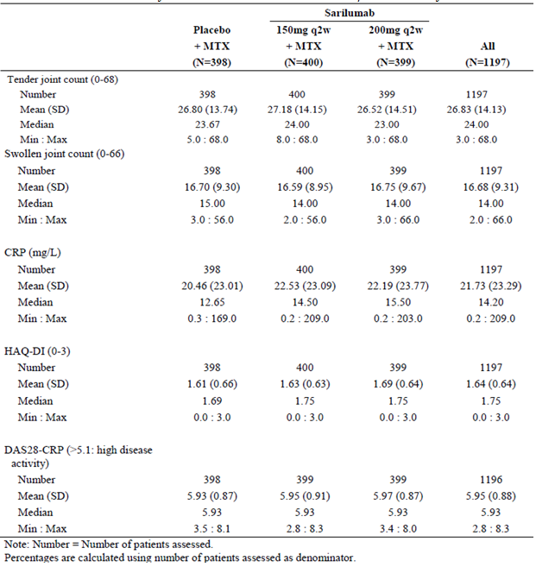

As per the study protocol, all but 4 patients (2 randomised to the SAR 150 mg group and 1 subject in each of the other 2 treatment arms) were treated with a stable dose of MTX prior to and during Part B of Study EFC11072 (n = 1,285 subjects). The submitted data for concomitant therapies presented the combined information for Cohort 2 and final selected doses of treatment from Cohort 1. The baseline mean MTX dose was similar across the treatment groups ranging from 15.3 to 15.60 mg/week (median weekly MTX dose of 15 mg in all 3 treatment groups). The submission did not contain about the duration of preceding MTX use. All 3 treatment groups had high rates of folic acid administration (97.7 to 99.3%) during the study.

At baseline, the majority of subjects in each treatment group had received prior treatment with systemic CS: 61.9% (265/428) patients in the placebo group, 65.3% (283/430) of subjects in the SAR 150 mg arm and 64.6% (276/427) of patients in the SAR 200 mg group. During Part B of the trial, 62.1% (266/428) of patients in the placebo arm, 67.0% (288/430) of subjects in the SAR 150 mg arm and 64.2% (274/427) of patients in the SAR 200 mg group received treatment with systemic CS, nearly all as oral preparations. At baseline, 68.0% (291/428) of patients in the placebo group, 67.0% (288/430) of subjects in the SAR 150 mg arm and 67.2% (287/427) of patients in the SAR 200 mg group were treated with NSAID. During the study, 71.7% (307/428) of patients in the placebo group, 70.5% (303/430) of subjects in the SAR 150 mg arm and 69.6% (297/427) of patients in the SAR 200 mg group were treated with NSAID.

In total, 293 patients had a prior history of receiving biologic drugs for RA: 23.6% (101/428) in the placebo group, 23.0% (99/430) in the SAR 150 mg arm and 21.8% (93/427) in the SAR 200 mg group. The clinical study report for Part B of Study EFC11072 did not specify the number of prior biological therapies (single or multiple) in biologic experienced subjects and the reasons for their prior discontinuation (for example lack of efficacy, side-effects or loss of access to the drug). The 3 most commonly used prior biologic drugs were tocilizumab (5.4%; 69/1285), golimumab (3.8%; 49/1285) and etanercept (3.3%; 42/1285). Smaller proportions of subjects had previously taken other anti-TNF drugs (adalimumab, infliximab and certolizumab), abatacept (2.4%; 31/1285), rituximab (1.3%; 16/1285) and anakinra (1 placebo subject and 3 patients in the SAR 200 mg group).

The incidence of relevant co-morbid conditions was similar in the 3 treatment groups. Regarding risk factors for cardiovascular disease, a past history of hypertension was recorded in 29.6% of all subjects (381/1285), 6.3% (81/1285) reported hyperlipidaemia, 2.4% (31/1285) recorded diabetes mellitus and 2.6% (34/1285) had an established history of coronary artery disease. During Part B of Study EFC11072, 7.9% (34/428) of patients in the placebo group, 9.5% (41/430) of subjects in the SAR 150 mg arm and 8.0% (34/427) of patients in the SAR 200 mg group were treated with concomitant lipid lowering therapy, mostly statin drugs. The use of new concomitant lipid lowering therapy during the trial (that is no such drug intake at Baseline) was higher in the 2 SAR treatment groups at 3.0% (13/427 to 430) compared with the control arm (0.7%; 3/428).

##### Results for the primary efficacy outcome

###### ACR20 response rate at Week 24

The proportion of patients achieving an ACR20 response at Week 24 was statistically higher in those treated with SAR (58.0% (232/400) in the 150 mg group and 66.4% (265/399) in the 200 mg arm) compared to patients treated with placebo (33.4%; 133/398) with p-values < 0.0001 in favour of both SAR doses compared with placebo. The Odds Ratio (OR) of achieving an ACR20 response at 24 weeks was 2.773 (95% CI 2.077, 3.703) for SAR 150 mg therapy versus placebo, and 3.975 (95% CI 2.957, 5.344) for SAR 200 mg treatment versus placebo.

In Part B of Study EFC11072, patients could receive rescue treatment after Week 16 if non‑responders. In the primary analysis, patients were considered as non-responders for all time points after they started rescue medication or discontinued study treatment. A total of 257 patients (156 in the placebo group, 55 in the SAR 150 mg arm and 46 in the SAR 200 mg group) were rescued.

Sensitivity analysis for the rate of ACR20 response at Week 24 using the LOCF method for handling of missing data demonstrated results similar to those reported in the primary analysis. The proportion of patients achieving an ACR20 response at Week 24 was higher in patients treated with SAR (64.0% (256/400) for the 150 mg dose group and 71.4% (285/399) for the 200 mg arm) compared to subjects treated in the placebo group (32.7%; 142/398; p-value < 0.0001 for both comparisons of SAR versus placebo).

An analysis of the proportion of patients achieving ACR20 response at Week 24 was also conducted for population subgroups based on gender, race, region, age group (< 65 years, > 65 years), baseline weight (< 50 kg, 50 to 100 kg, > 100 kg), BMI (< 25, 25 to 30, > 30 kg/m2), prior biologic use (yes, no), RF status (positive/negative), anti-CCP antibody status (positive/negative), baseline CRP (< 15 mg/L, > 15 mg/L), duration of RA (< 3 years, > 3 years), number of prior DMARD drugs (1, > 2), and smoking history (yes, no). The subgroup interaction analysis for the anti-CCP antibody subgroup (anti-CCP antibody positive versus negative patients) showed a 13.5 to 16.3% lower rate of ACR20 response in anti-CCP antibody negative patients versus anti-CCP positive patients (nominal p-value = 0.001). However, no evidence of a treatment related interaction was observed for other subgroups (p > 0.05).

###### HAQ-DI score at Week 16

The mean change from Baseline to Week 16 in the HAQ-DI score was statistically greater in patients treated with SAR (-0.54 for the 150 mg group and -0.58 for the 200 mg arm) than in subjects treated with placebo (-0.30); refer to Table 7. The results for both individual doses of SAR compared to placebo demonstrated a statistically significant difference (p < 0.0001) in improvement of physical function in favour of both SAR.

Table 7: Change from Baseline to Week 16 in HAQ-DI Score in Cohort 2 of Study EFC11072

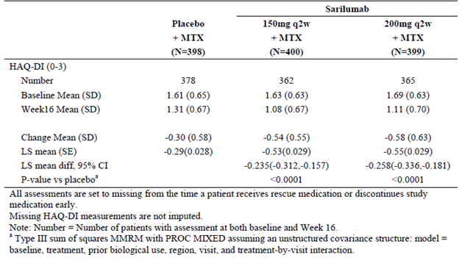

Sensitivity analysis of the mean change from Baseline in the HAQ-DI score at Week 16 using the LOCF method for handling of missing data showed results similar to those observed in the primary analysis. The LS mean change from Baseline in the HAQ-DI score at Week 16 was greater in patients treated with SAR (-0.50 for the 150 mg group and -0.52 for the 200 mg arm) compared to -0.28 in the placebo group (p-value < 0.0001 for both doses of SAR versus placebo).

The subgroup interaction analyses for the anti-CCP antibody and RF subgroups (anti-CCP antibody positive versus negative; and RF positive versus negative patients) showed a lower mean HAQ-DI response in seronegative patients (nominal p-value = 0.0028 for anti-CCP antibody status and nominal p-value = 0.0417 for RF status). The LS mean change from Baseline in the HAQ-DI score at Week 16 was 0.25 units lower for seronegative versus seropositive patients treated with SAR 150 mg and 0.12 units lower for seronegative versus seropositive subjects treated with 200 mg. No evidence of interaction was observed for other population subgroups (nominal p-values > 0.05).

###### Van der Heijde modified Total Sharp Score at Week 52

At Week 52, smaller increases from Baseline in the mTSS were observed in subjects treated with SAR (0.90 for the 150 mg group and 0.25 for the 200 mg arm) than in patients treated with placebo (2.78), indicating relative inhibition of progression of structural damage with SAR treatment; refer to Table 8. The differences compared with placebo were statistically significant (p-value < 0.0001) in favour of both SAR doses. No pair wise statistical testing between the 2 SAR dose groups was performed in this trial. Although the mean mTSS change from Baseline to Week 52 was numerically lower in the SAR 200 mg versus SAR 150 mg group (0.25 versus 0.90), the interquartile median change in both SAR treatment groups was identical at 0 (with 95% CIs overlapping 0).

Table 8: Change from Baseline in modified Total Sharp Score at Week 52 in Cohort 2 of EFC11072

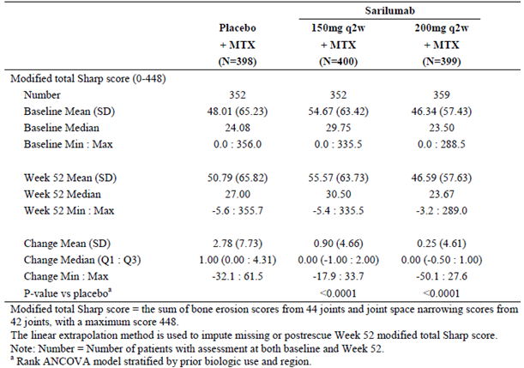

To evaluate the impact of patients with no post-baseline X-ray data, 5 sensitivity analyses were performed to demonstrate the robustness of the primary radiographic analysis. With sensitivity analyses using approaches 1 (mean rank imputation), 2 (LOCF), 4 (observed cases) and 5 (linear extrapolation including post-treatment discontinuation and rescue data), both doses of SAR therapy were statistically superior (p < 0.0001) to placebo for the mean change from Baseline to Week 52 in mean mTSS. When the third sensitivity approach (observed cases excluding post treatment discontinuation or rescue data) was applied to the dataset there was a statistically significant result for both SAR doses (p = 0.0010 for SAR 150 mg versus and p < 0.0001 for SAR 200 mg versus placebo).

The subgroup interaction analysis revealed that smoking history (that is self-reported current or former smoker versus no smoking history) was associated with increased radiographic progression (nominal p-value = 0.0386). No evidence of interaction was observed for other population subgroups (nominal p-values > 0.05).

##### Results for other efficacy outcomes

###### Major clinical response at Week 52

The main secondary efficacy endpoint of Part B of Study EFC11072 was MCR, which is defined as achieving and maintaining an ACR70 response for at least 24 consecutive weeks during the 52 week trial period. A higher proportion of patients in the SAR treatment groups achieved MCR (12.8% (51/400) in the 150 mg group and 14.8% (59/399) in the 200 mg arm) compared to placebo (3.0%; 12/398), and the differences between each SAR group and placebo were statistically significant (p < 0.0001). The OR of achieving an MCR was 4.661 (95% CI 2.451, 8.863) for SAR 150 mg therapy versus placebo, and 5.565 (95% CI 2.946, 10.515) for SAR 200 mg treatment versus placebo.

###### Other Secondary Efficacy Endpoints

Table 9 shows the results for the pre-specified hierarchy of primary and secondary efficacy endpoints including various assessments of clinical response and QOL. According to the pre‑specified order of analysis, the results were statistically significant in favour of both doses of SAR versus placebo for each efficacy endpoint up to and including the PCS of SF-36 at Week 52 (all values in bold in Table 9 are statistically in favour of SAR versus placebo).

Table 9: Summary of primary and secondary efficacy endpoint results in Part B of EFC11072

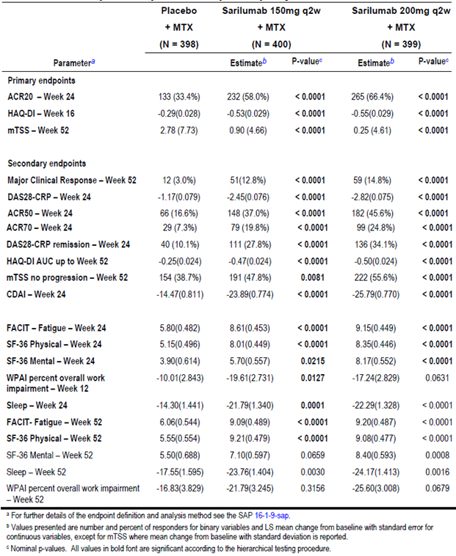

(a) DAS28-CRP; Week 24 and 52

At baseline, all 3 treatment groups had similar DAS28-CRP values ranging from 5.87 to 5.97 indicating severely active RA. During Part 2 of Study EFC11072, all treatment groups showed a mean decrease in DAS28-CRP score from Baseline indicating improvement in RA disease activity. At Week 24, the LS mean change from Baseline in DAS28-CRP score was -1.17 for the placebo group, -2.45 for SAR 150 mg and -2.82 for SAR 200 mg therapy (p < 0.0001 for both doses of SAR versus placebo). At Week 52, the LS mean change from Baseline in DAS28-CRP score was ‑1.36 for the placebo group, -2.78 for SAR 150 mg and -2.95 for SAR 200 mg therapy (p < 0.0001 for both doses of SAR versus placebo).

A statistically higher proportion of patients in the SAR treatment groups achieved DAS28-CRP remission (that is DAS28-CRP score < 2.6) at Week 24 (27.8% (111/400) in the 150 mg group and 34.1% (136/399) in the 200 mg arm) compared to placebo (10.1%; 40/398; p < 0.0001 for the difference between each SAR group and placebo). At Week 52, a higher proportion of patients in the SAR treatment groups achieved DAS28-CRP remission (31.0% (124/400) in the 150 mg group and 34.1% (136/399) in the 200 mg arm) compared to placebo (8.5%; 34/398), and the differences between each SAR group and placebo were statistically significant (p < 0.0001).

(b) ACR50 and ACR70 response rates and individual ACR components; Week 24 and 52

A statistically higher proportion of patients in the SAR treatment groups achieved ACR50 response at 24 weeks (37.0% (148/400) in the 150 mg group and 45.6% (182/399) in the 200 mg arm) compared to placebo (16.6%; 66/398; p < 0.0001 for the difference between each SAR group and placebo). At Week 52, a higher proportion of patients in the SAR treatment groups achieved ACR50 response (40.0% (160/400) in the 150 mg group and 42.9% (171/399) in the 200 mg arm) compared to placebo (18.1%; 72/398), and the differences between each SAR group and placebo were statistically significant (p < 0.0001).

A statistically higher proportion of patients in the SAR treatment groups achieved ACR70 response at 24 weeks (19.8% (79/400) in the 150 mg group and 24.8% (99/399) in the 200 mg arm) compared to placebo (7.3%; 29/398; p < 0.0001 for the difference between each SAR group and placebo). At Week 52, a higher proportion of patients in the SAR treatment groups achieved ACR70 response (24.8% (99/400) in the 150 mg group and 26.8% (107/399) in the 200 mg arm) compared to placebo (9.0%; 36/398), and the differences between each SAR group and placebo were statistically significant (p < 0.0001).

There are 7 components comprising the ACR response criteria. At both Weeks 24 and 52, both doses of SAR were statistically superior to placebo for each of the 7 variables. This observation is supportive of the validity of the primary efficacy results regarding higher ACR20 response rates with either dose of SAR therapy versus placebo.

The ACRn is the average score derived from improvement in the following 3 variables: percentage improvement in the tender joint count, percentage improvement in the swollen joint count and the median improvement score of the 5 remaining ACR components. An increase in the ACRn score represents clinical improvement. All treatment groups showed an increase in ACRn in Study EFC11072. At Week 24, the LS mean change from Baseline in ACRn was 6.13 for the placebo group, 34.2 for SAR 150 mg and 42.45 for SAR 200 mg therapy (nominal p‑value < 0.0001 for both doses of SAR versus placebo). At Week 52, the LS mean change from Baseline in ACRn was 12.0 for the placebo group, 43.8 for SAR 150 mg and 48.2 for SAR 200 mg therapy (nominal p-value < 0.0001 for both doses of SAR versus placebo).

(c) HAQ-DI AUC up to Week 52

The LS mean change from Baseline to Week 52 in the standardised AUC for the HAQ-DI score was numerically greater in patients treated with SAR (-0.47 for 150 mg and -0.50 for 200 mg dose) than for subjects in the placebo group (-0.25). The differences between each dose of SAR and placebo were statistically significant (p < 0.0001).

(d) Secondary radiographic outcomes; Week 52

At Week 52, a greater proportion of patients in the SAR treatment groups showed no progression from Baseline in mTSS (47.8% (191/400) in the 150 mg group and 55.6% (222/399) in the 200 mg arm) compared to placebo (38.7%; 154/398). The rates of no X-ray progression between each SAR group versus placebo were statistically significant (p = 0.0081 for SAR 150 mg versus placebo and p < 0.0001 for SAR 200 mg versus placebo). The OR of demonstrating no X-ray progression was 1.453 (95% CI 1.095, 1.926) for SAR 150 mg therapy versus placebo, and 2.001 (95% CI 1.506, 2.660) for SAR 200 mg treatment versus placebo. This result supports the robustness of the primary radiographic endpoint demonstrating that SAR therapy is associated with significantly less radiographic progression of structural damage than MTX alone (control arm), which is a clinically relevant observation.

The ES and JSN scores are the 2 components of the mTSS. The ES has a range of 0 to 280 and is derived from assessing 32 hand joints and 12 joints in the feet. Each joint is scored from 0 (no damage) to 5, except for the metatarsophalangeal joints of the feet, which are scored 0 to 10. An increase in the ES represents radiographic progression. At Week 52, smaller increases from Baseline in the ES were observed in patients treated with SAR than those in the placebo arm (p < 0.0001 for both doses of SAR versus placebo). At Week 52, the mean increases from Baseline in the ES were 1.46 units for the placebo group (baseline mean ES 22.0; n = 352), 0.42 units for SAR 150 mg therapy (baseline mean ES 24.4; n = 352) and 0.05 units for the SAR 200 mg group (baseline mean ES 19.1; n = 359). At Week 52, the proportion of patients who had no progression in ES was higher in the SAR treatment groups (54.8% (219/400) in the 150 mg group and 62.2% (248/399) in the 200 mg arm) compared to placebo (43.5%; 173/398). The rates of no ES progression between each SAR group versus placebo were statistically significant (p = 0.0013 for SAR 150 mg versus placebo and p < 0.0001 for SAR 200 mg versus placebo).

The JSN score has a range of 0 to 168 and is derived from evaluating 30 joints in the hands and 12 joints in the feet, each of which are scored from 0 (no damage) to 4. An increase in the JSN score represents radiographic progression. At Week 52, smaller increases from Baseline in the JSN score were observed in patients treated with SAR than subjects in the placebo arm (p = 0.0005 for SAR 150 mg versus placebo and p < 0.0001 for SAR 200 mg versus placebo). At Week 52, the mean increases from Baseline in the JSN scores were 1.32 units for the placebo group (baseline mean ES 25.8; n = 352), 0.47 units for SAR 150 mg therapy (baseline mean ES 30.4; n = 352) and 0.20 units for the SAR 200 mg group (baseline mean ES 26.7; n = 359). At Week 52, the proportion of patients who had no progression in JSN score was higher in SAR treatment groups (61.8% (247/400) in the 150 mg group and 70.4% (281/399) in the 200 mg arm) compared to placebo (55.3%; 220/398). The rates of no JSN progression between each SAR group and placebo were statistically significant for SAR 200 mg versus placebo (p < 0.0001), but not for SAR 150 mg versus placebo (p = 0.0619).

(e) Simplified Disease Activity Index (SDAI); Week 24

Baseline SDAI values were similar across the 3 treatment groups ranging from 41.2 to 42.7. All 3 arms showed a decrease from Baseline in SDAI. At Week 24, the LS mean change from Baseline in SDAI was -14.4 for the placebo group, -25.3 for the SAR 150 mg arm and -27.5 for the SAR 200 mg dose group. At 52 weeks, the LS mean change from Baseline in SDAI was -17.1 for the placebo group, -28.2 for the SAR 150 mg arm and -28.95 for the SAR 200 mg group. At Weeks 24 and 52, the difference in mean SDAI from Baseline was statistically greater in both SAR treatment groups compared with placebo (nominal p-values < 0.0001).

Furthermore, the proportion of patients achieving SDAI remission (that is SDAI ≤ 3.3) was numerically higher in SAR treated patients when compared with placebo at Weeks 24 and 52 (Week 24; 4.8% for placebo, 10.3% for SAR 150 mg and 13.0% for SAR 200 mg; and at Week 52; 4.0% for placebo, 15.0% for SAR 150 mg therapy and 18.5% for SAR 200 mg treatment).

(f) Clinical Disease Activity Index (CDAI); Week 24

Baseline CDAI values were similar across the 3 treatment groups in Part B of Study EFC11072 ranging from 40.34 to 40.39. All treatment arms showed a mean decrease from Baseline in CDAI. At Week 24, the LS mean change in CDAI was -14.5 for the placebo group, -23.9 for the SAR 150 mg arm and -25.8 for the SAR 200 mg dose group. At Week 24, the differences between each of the SAR dose groups and placebo were statistically significant (p-values < 0.0001). At Week 52, the LS mean change in CDAI was -17.5 for the placebo group, -27.0 for the SAR 150 mg arm and -27.25 for the SAR 200 mg group. At 52 weeks, the LS mean change in CDAI was statistically greater in both SAR groups compared to placebo (nominal p-values < 0.0001).

In addition, the proportion of patients achieving CDAI remission (that is CDAI ≤ 2.8) was higher in SAR treated patients versus placebo at both Weeks 24 and 52 (Week 24; 5.0% for placebo, 10.3% for SAR 150 mg and 13.8% for SAR 200 mg; and at Week 52; 4.8% for placebo, 14.8% for SAR 150 mg and 18.0% for SAR 200 mg therapy). The nominal p-value for testing the difference in the incidence of achieving CDAI remission between each of the SAR groups and placebo was p < 0.001 at Weeks 24 and 52.

(g) Boolean-based ACR/EULAR remission; Weeks 24 and 52

The proportion of patients achieving Boolean-based ACR/EULAR remission at Weeks 24 and 52 was numerically higher in patients treated with SAR (150 mg; 6.5% at Week 24 and 10.5% at Week 52; 200 mg; 10.5% at Week 24 and 14.0% at Week 52) compared with placebo treated patients (3.8% at Week 24 and 3.0% at Week 52). At Week 24, the nominal p-values for testing the difference in Boolean-based ACR/EULAR response between each of the SAR treatment groups and placebo were p = 0.09 for SAR 150 mg versus placebo, and p = 0.0002 for SAR 200 mg versus placebo. At Week 52, the nominal p-values were p < 0.0001 for both comparisons between SAR and placebo.

(h) Quality of Life Outcomes; Week 24 and 52

At Weeks 24 and 52, both doses of SAR demonstrated statistically significant differences (improvement) in the SF-36 PCS scores compared to placebo (all p-values < 0.0001). At Week 24, both doses of SAR were statistically better than placebo for the mean differences (improvement) from Baseline in the SF-36 MCS scores, but this was observed at Week 52 for the SAR 150 mg dose group versus placebo. The SAR 200 mg dose arm showed a statistically significant improvement compared to placebo at Week 52 for the mean change from Baseline in the SF-36 PCS score.

At Weeks 24 and 52, both SAR treatment groups demonstrated statistically significant differences compared to placebo for the mean change from Baseline in FACIT-Fatigue scores (all p‑values< 0.0001). Similarly, at Weeks 24 and 52, both SAR treatment groups demonstrated statistically significant differences compared to placebo for the mean change from Baseline in sleep VAS (all p-values < 0.003).

At Week 12, both SAR treatment groups (-19.6% for SAR 150 mg and -17.24% for SAR 200 mg) showed less overall work impairment due to RA compared to placebo (-10.1%). The difference in WPAI percentage of overall work impairment was statistically significant between SAR 150 mg and placebo (p = 0.0127), but the difference in WPAI percentage of overall work impairment was not statistically significant between the SAR 200 mg arm and placebo (p = 0.0631). At Week 52, the difference in WPAI percentage of overall work impairment due to RA was not statistically significant for either SAR (-21.8% for SAR 150 mg and -25.6% for 200 mg) compared to placebo (‑16.83%).

#### Study EFC10832

##### Study design, objectives, locations and dates

Study EFC10832 was a 3 arm, randomised, double blind, parallel group, placebo controlled Phase III trial of 24 weeks duration in patients with active RA who were inadequate responders to or intolerant of anti-TNF therapy. Subjects were randomised in equal ratio to receive SC injections of SAR 150 mg q2w, SAR 200 mg q2w or placebo q2w. The maximum duration of participation in Study EFC10832 for each individual patient was 34 weeks (up to 4 weeks for screening, followed by 24 weeks for treatment and 6 weeks for follow-up following the last injection). All patients who completed Study EFC10832 were eligible to enter Study LTS11210. No interim analysis was performed in this trial. In Study EFC10832, clinical efficacy and safety assessments were performed at Baseline; every 2 weeks until Week 12; and thereafter every 4 weeks until Week 24. No joint radiographic data was collected in this trial.

From Week 12 onwards, Study EFC10832 allowed for early escape to rescue treatment for all patients demonstrating lack of efficacy, which is ethically appropriate. Lack of efficacy was defined as < 20% improvement from Baseline in SJC or TJC for 2 assessments that were at least 4 weeks apart. Rescue therapy subjects were offered open label SAR injections as part of Study LTS11210.

The primary objectives of Study EFC10832 were to demonstrate that SAR when added to non‑biologic DMARD therapy was effective in reducing the symptoms and signs at Week 24 and improving physical function at Week 12 in adult patients with active RA who were inadequate responders to or intolerant of anti-TNF therapy.

Study EFC10832 was conducted at 240 investigator sites in 27 countries in Europe, North and South America, Asia as well as Australia, New Zealand and Israel. The first patient was enrolled in October 2012 and the last patient completed follow-up in March 2015.

A total of 3 protocol amendments were implemented in Study EFC10832. The first amendment was implemented before the enrolment of any patients and notably added 2 new exclusion criteria at screening relating to the presence of interstitial lung disease and a lower threshold for the determination of significant thrombocytopaenia (platelet count < 100 x 109/L) at Baseline. The second protocol amendment clarified details regarding the dosages of concurrent non‑biological DMARD therapy, treatment of dyslipidaemia and the handling of subjects for temporary or permanent treatment discontinuation. In the third protocol amendment the sponsor converted the HAQ-DI efficacy outcome from a secondary to co-primary efficacy endpoint, which required revision of the statistical analysis plan. Furthermore, the sponsor changed the calculation of the HAQ-DI endpoint as the mean change from Baseline to Week 12. These changes are highly similar to what occurred with protocol amendments 6 and 7 in Part B of Study EFC11072.

##### Inclusion and exclusion criteria

To be eligible for inclusion in Study EFC10832, patients had to be at least 18 years of age with a diagnosis of RA for at least 6 months according to the 2010 ACR/EULAR classification criteria. Subjects were required to be of ACR Class I-III functional status based on the 1991 revised criteria. Subjects had to have active disease at Baseline as evidenced by ≥ 8 tender (out of a possible 68), ≥ 6 swollen joints (out of a possible 66) and a high sensitivity CRP reading > 8 mg/L.

The eligibility criteria for Study EFC10832 required subjects to have active RA despite current treatment with 1 or more non-biologic DMARD drugs for a minimum of 12 weeks prior to randomisation and at a stable dose for a minimum of 6 weeks. The non-biologic DMARD options for eligibility specified the following pre-requisite doses: MTX 10 to 25 mg/week (oral or intramuscular), LEF 10 to 20 mg/daily, SSZ 1000 to 3000 mg/daily and/or HCQ 200 to 400 mg daily.

All subjects were required to have failed or be intolerant of at least one anti-TNF drug. Anti-TNF failure was defined as patients with an inadequate response for at least 3 consecutive months. Intolerance to anti-TNF was defined as a need for treatment discontinuation from therapy. It was a requirement that anti-TNF therapies were ceased at least 42 days prior to randomisation (at least 28 days prior to randomisation for preceding etanercept therapy). Prior treatment with abatacept, anakinra and rituximab was permitted if an appropriate washout period had ensued. However, any prior history of exposure to tocilizumab or a Janus kinase inhibitor therapy was an exclusion event.

Concomitant treatment with non-biological DMARD therapy (for example MTX 10 to 25 mg/week) was required in Study EFC10832 if the dose and route of administration had been stable for at least 6 weeks prior to randomisation. The concomitant use of oral corticosteroids (CS) was permitted for subjects taking stable doses (prednisone (or equivalent) < 10 mg/day) for at least 4 weeks prior to screening. Parenteral or intra-articular CS injections within 4 weeks of randomisation were an exclusion criterion. Concomitant NSAID was also permitted, provided subjects were on a stable dose for at least 4 weeks prior to randomisation.

There were a large number (n = 39) of exclusion criteria in Study EFC10832. Co-morbid conditions were an exclusion criterion based on the investigator decision as to their clinical significance (including cardiac, pulmonary, neurologic, psychiatric and any major uncontrolled disease). A past history of substance abuse within the last 5 years, infection requiring treatment within 4 weeks of screening, non-healing or previously infected skin ulcers, any surgery within 4 weeks of screening or anticipated during the study, and a history of active or recurrent herpes zoster infection or articular infection were to be excluded. A history of malignancy within 5 years (except for excised basal and squamous cell skin cancers, or cervical carcinoma in situ successfully treated by surgery) was also an exclusion criterion.

Other significant disease associated exclusion criteria included history of inflammatory bowel disease, severe diverticulitis, previous gastrointestinal perforation, interstitial lung disease, past severe systemic manifestations of RA such as Felty’s syndrome or vasculitis, and history of any invasive opportunistic infection. New treatment with or a dose adjustment of any medication for dyslipidaemia within 6 weeks of randomisation was also an exclusion criterion.

Subjects were screened for Hepatitis B and C, HIV as well as TB at Baseline. The screening for latent TB involved either skin testing with PPD (removed with protocol amendment 4) or QuantiFERON TB-Gold testing. Subjects with active TB or a history of reactivated latent TB were excluded. All patients were required to have a chest X-ray within 12 weeks prior to screening. Regarding vaccination, any live vaccine administered 3 months prior to randomisation (or 12 months prior for BCG vaccination) was an exclusion criterion.

Subjects with any significant laboratory abnormalities at screening were also excluded. These included serum transaminases > 1.5 x ULN, total serum bilirubin > ULN (unless documented Gilbert’s disease), creatinine clearance < 30 mL/minute, total white blood cell count < 3.0 x 109/L, neutrophil cell count < 2.0 x 109/L, platelet count < 100 x 109/L, haemoglobin < 8.5 g/dL, serum cholesterol > 9.1 mmol/L, serum triglyceride > 5.6 mmol/L and HbA1c > 9.0% at the screening visit.

##### Study treatments

All patients in Study EFC10832 received investigational study medication (SAR or placebo) by SC injection at alternating sites of the anterior abdomen (divided into quarters). Each dose administration required a single injection of 1.14 mL (regardless of SAR dose). Investigator site staff gave the first injection of study treatment and trained the subject or carer on self‑administration. Subjects or their carer were encouraged to administer all doses of study medication. In Study EFC10832, all subjects received their injections of study medication every 14 days (q2w) with a time window of ± 3 days.

All patients were required to continue taking stable non-biologic DMARD therapy during Study EFC10832 at the same dose and route they received prior to enrolment. The dose of non‑biological DMARD could be reduced during the trial for safety or tolerability related reasons. The concomitant use of stable, pre-existing treatment with oral CS and NSAID was also permitted. Non-investigational medicinal products (including non-biological DMARD drugs) were not provided by the sponsor and were dispensed according to local practice.

##### Efficacy variables and outcomes

The co-primary efficacy outcomes in Study EFC10832 were the rate of ACR20 response at Week 24 and the mean change from Baseline to Week 12 in the HAQ-DI score.

The secondary efficacy endpoints (reported at Week 24) included:

* Mean decrease in disease activity as measured by DAS28-CRP score
* Proportion of patients achieving ACR50 and ACR70 response
* Proportion of subjects achieving DAS28-CRP scores of < 2.6 (that is clinical remission)
* Mean decrease from Baseline in the CDAI
* Mean decrease from Baseline in HAQ-DI score; and
* QOL outcomes using the SF-36 survey and FACIT-Fatigue scale.

Other efficacy outcomes in Study EFC10832 (reported at Week 24) included:

* Mean change from Baseline in the individual components of the ACR response criteria
* Mean change from Baseline in ACRn
* Mean change from Baseline in the SDAI
* Boolean-based ACR/EULAR remission; and
* Mean percentage improvement in patient reported outcomes such as duration of morning stiffness, WPS (Work Productivity Survey), RAID (RA Impact of Disease) and EQ-5D-3L.

The WPS is a validated questionnaire that evaluates productivity limitations within work and home associated with RA over the previous month. The RA Impact of Disease (RAID) score is a composite measure of the impact of RA on patients that takes into account 7 domains: pain, functional disability, fatigue, physical and emotional well-being, quality of sleep, and coping evaluated as continuous variables from 0 (best) to 10 (worst). The EQ-5D-3L comprises 5 questions on mobility, self-care, pain, usual activities, and psychological status with 3 possible answers for each item (1 = no problem, 2 = moderate problems, 3 = severe problems). The 5 dimensional 3 level systems are converted into a single index utility score.

##### Randomisation and blinding methods

In Study EFC10832, patients were randomised into treatment groups with the use of a centralised, computerised interactive voice response system and stratified according to number of prior anti-TNF drugs used (1 versus > 1) and region. Subjects eligible to receive rescue treatment after Week 12 due to lack of efficacy were not re-randomised.

To protect the double blind design of Study EFC10832, the sponsor provided SAR and placebo therapy in matching glass prefilled syringes in identical kits. Independent joint evaluators not involved with any other aspect of the trial were used to quantify joint disease involvement. As per the protocol, no patients in Study EFC10832 had their blinding broken by site investigators. Three subjects (1 in each treatment group) had their treatment blinding broken for regulatory purposes. These subjects experienced SAEs and were discontinued as a result.

##### Analysis populations

The primary efficacy analysis was performed using the ITT population, which consisted of all randomised patients. All patients were analysed for efficacy outcomes according to the treatment to which they were randomised, but not necessarily received.

##### Sample size

The sample size determination was based on the mean change from Baseline in the HAQ-DI score at 24 weeks (initial protocol). The following assumptions were made in this calculation: mean changes of -0.05 and -0.35 in the placebo and SAR groups, respectively; common SD of 0.79 and a 2 group t-test of equal means at a two-sided alpha = 0.025 level with 90% power. Based on the above assumptions, 174 patients per treatment group were required (total cohort of 522 patients). The assumed mean changes and SD in the HAQ-DI scores are based on the results from the tocilizumab trial program.

The study protocol for EFC10832 was amended to change the timing of the HAQ-DI primary endpoint from 24 weeks to 12 weeks. Using the sample size of 174 per group, the study power was calculated based on the available data from Part B of Study EFC11072, which had a SD of 0.52 and a treatment difference of 0.2 in the low dose SAR group versus placebo and a treatment difference of 0.28 in the high dose SAR arm at Week 12. Using these assumptions, the statistical power for the mean change from Baseline to Week 12 in the HAQ-DI score was 90% for the low dose SAR group and > 90% for the high dose SAR arm.

For the co-primary endpoint of ACR20 response at Week 24, the above sample size provided 99% power. The following assumptions were made in this calculation: ACR20 response rates at Week 24 of 20% in the placebo group versus 50% in the SAR treatment and a two sided chi-square test with an alpha of 0.025 to address the multiplicity across the 2 active dose regimens.

##### Statistical methods

The co-primary endpoint of ACR20 response rate at Week 24 was analysed using the 2 sided, CMH test stratified by region and number of prior anti-TNF drugs to compare each dose regimen of SAR with placebo. The CMH estimate of the OR and the corresponding 95% CI were derived by testing each SAR group against placebo. Patients with insufficient data or missing ACR components (for example they transferred into Study LTS11210 for rescue SAR therapy or discontinued study treatment) were considered as non-responders for all time points thereafter. In a sensitivity analysis, ACR component data (minimum of 5 available variables) collected after treatment discontinuation was imputed using the LOCF method.

For the co-primary outcome of the mean change from Baseline to Week 12 in the HAQ-DI score, an analysis with MMRM using SAS PROC MIXED was conducted with baseline covariate factors and treatment, region, number of prior anti-TNF drugs and visit. In the primary statistical analysis, data collected on or before Week 12 were used. Data collected after treatment discontinuation or rescue was set to missing. No imputation was performed. A multiplicity adjustment approach was used to control the overall Type-1 error rate at 0.05 for the 2 co‑primary endpoints across the dose regimens. Sensitivity analyses using different methods for handling of missing data such as the LOCF method and multiple imputations were also explored.

Study EFC10832 was to be declared successful if any dose regimen of SAR versus placebo achieves statistical significance for the rate of ACR20 response at Week 24. A hierarchical testing procedure was used for the multiple endpoints at α = 0.025 (simple Bonferroni adjustment) for each dose regimen separately. The rate of ACR20 response at Week 24 was first ranked in the hierarchical order and the mean change from Baseline in HAQ-DI at Week 12 was second.

The binary secondary efficacy variables of ACR50 and ACR70 response and various measures of remission were analysed using the same CMH test as the ACR20 variable. The same method used for HAQ-DI analysis was used for the continuous secondary efficacy endpoints (for example ACRn). For the secondary efficacy endpoints, each selected dose of SAR was tested versus placebo in a pre-specified hierarchical order of testing controlling for multiplicity.

##### Participant flow

Of the 1,224 patients that were screened for participation in Study EFC10832, 678 subjects (55.4%) were recorded as screen failures. One patient was not randomised but mistakenly received one dose of SAR 200 mg during the screening period without incident. Screen failures were mainly due to insufficient RA activity at Baseline (53% of 678) or due to meeting the exclusion criterion related to tuberculosis (21% of 678).

A total of 546 patients were randomised and treated within Study EFC10832: 181 subjects into the control and SAR 150 mg groups and 184 patients into the SAR 200 mg arm; refer to Table 10. The 24 week completion rate without the need for rescue therapy was higher in the two SAR treatment groups (69.1% (125/181) in the 150 mg group and 72.3% (133/184) in the 200 mg arm) compared to the placebo arm (55.8%; 101/181). However, there was also a higher rate of discontinuation without uptake of rescue therapy in SAR treated patients (17.1% (33/181) in the 150 mg group and 13.6% (25/184) in the 200 mg arm) compared to placebo subjects (9.4%; 17/181), mainly due to adverse events (9.9% (18/181) in the 150 mg group and 9.2% (17/184) in the 200 mg arm). In Study EFC10832, more patients in the placebo arm (34.8%; 63/181) switched to open label rescue treatment with SAR in Study LTS11210 due to a lack of efficacy (compared with 13.8% (25/181) in the 150 mg group and 14.1% (26/184) in the 200 mg arm).

Table 10: Participant Flow in Study EFC10832

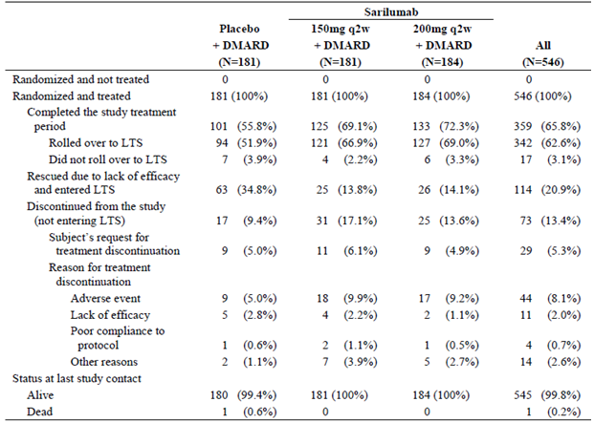

##### Major protocol violations/deviations

A total of 6 patients (1.1% of 546) were recorded as having important protocol deviations that had the potential to impact their efficacy results. The 6 affected subjects included 1 subject in the placebo arm (0.6% of 181), 3 patients (1.7% of 181) in the SAR 150 mg group and 2 patients (1.1% of 184) in the SAR 200 mg group. None of the data from these patients was excluded from the primary efficacy analysis. Two patients (1 in each SAR treatment group) had no past history of anti-TNF therapy failure, but had previously demonstrated an inadequate response to abatacept. Another subject in the SAR 150 mg dose arm had not taken the pre-requisite duration of prior non-biological DMARD at a stable dose. One patient in each treatment group did not meet the requirement for prior anti-TNF failure or intolerance.

Randomisation errors (all related to errors of stratification, mainly for single versus multiple prior anti-TNF exposure) affected 33 subjects in total: 6 subjects (3.3% of 181) in the placebo group, 12 patients (6.6% of 181) in the SAR 150 mg arm and 15 subjects (8.2% of 184) in the SAR 200 mg group.

##### Baseline data

Demographic characteristics at Baseline were well balanced and comparable among all treatment groups. Subjects recruited into Study EFC10832 had a median age of 54 years (range: 19 to 88 years) with one sixth of all subjects (16.5%; 90/546) aged at least 65 years at Baseline. The majority of recruited subjects were female (81.9%; 447/596) and have Caucasian ethnicity (71.1%; 388/596). The overall median BMI was 28.2 kg/m2, with more than one third of subjects (37.7%; 206/596) being obese at Baseline (that is BMI > 30 kg/m2). By geographic region, the largest percentage of patients came from Western countries (that is Region 1: 42.7%; 233/596) followed by South America and Mexico (that is Region 2: 40.7%; 222/596). Region 1 consisted of countries in Western Europe, Israel, Australia, New Zealand and North America. Region 3 (rest of the world) included patients from Eastern Europe, South Korea and Taiwan, and these countries contributed 16.7% (69/596) of subjects into Study EFC10832. A small proportion of enrolled subjects were current smokers (12.6%; 69/596), which is a factor associated with a diminished response to treatment in RA. Just over one fifth of all recruited patients (21.1%; 126/596) consumed alcohol on a regular basis at screening, which may be a risk factor for certain types of AEs such as abnormal liver function tests.

The treatment groups were similar with respect to baseline RA disease characteristics. The mean duration of RA for all subjects was 12.1 years (median 9.9 years, range: 0.6 to 54.0 years). Most patients were recorded as having functional class II RA at Baseline (57.7%; 315/596). Expectedly, the majority of patients were seropositive for RA at Baseline (75.5% (409/596) were positive for rheumatoid factor and 78.1% (422/596) were positive for anti-CCP antibodies).

In terms of RA disease activity at Baseline, the mean numbers of tender and swollen joints were similar for the placebo (29.4 and 20.2, respectively), SAR 150 mg (27.7 and 19.6, respectively) and SAR 200 mg groups (29.6 and 20.0, respectively); refer to Table 11.

Table 11: Baseline activity of rheumatoid arthritis in Study EFC10832

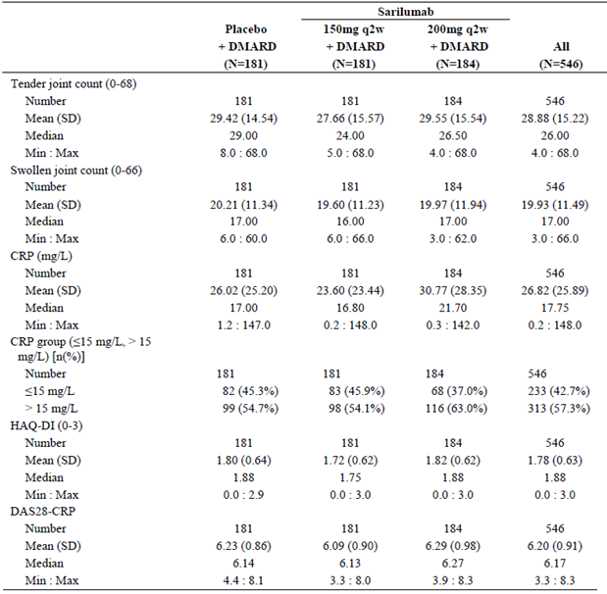

All 3 treatment groups recorded mean DAS28-CRP scores that were very high at Baseline (6.09 to 6.23). The median HAQ-DI score was slightly lower in the SAR 150 mg arm (1.72) compared to the placebo (1.80) and SAR 200 mg treatment groups (1.82). The mean CRP for subjects in the SAR 150 mg arm was lower at 23.60 mg/L compared to the placebo (26.02 mg/L) and the SAR 200 mg treatment groups (30.77 mg/L). More than half of all subjects in each of the treatment groups had baseline readings > 15 mg/L, but this was particularly prevalent in the SAR 200 mg group (63.0% versus 54.1 to 54.7% in the 2 other arms). Overall, the measures of baseline disease activity are consistent with severely active RA.

Per protocol, patients were to be treated with a stable dose of 1 or more conventional synthetic DMARD drugs (MTX, SSZ, LEF, or HCQ; with the exception of the simultaneous use of LEF and MTX) during Study EFC10832. The percentage of patients who received concomitant medications (DMARD, NSAID and low dose oral CS) in Study EFC10832 was similar across the treatment groups; refer to Table 12.

Table 12: Concomitant non-biologic DMARD, Folic Acid, NSAID and corticosteroid use ongoing at the Time of the first dose of Injectable Study Medication in Study EFC10832

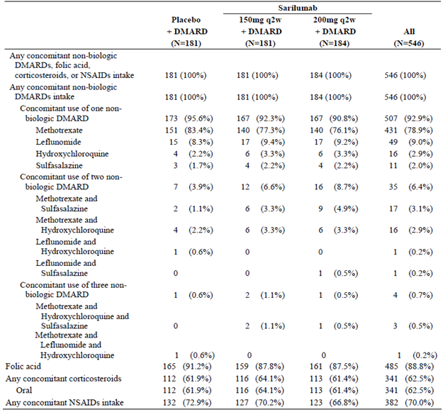

At the initiation of injectable trial medication in Study EFC10832, the majority of subjects in each of the 3 treatment groups were taking a single concurrent, non-biologic DMARD (92.9%; 507/546), which most frequently was low dose weekly MTX (78.9%; 431/546). A small proportion of subjects in each treatment arm were taking 2 conventional DMARD drugs (6.4%; 35/546), which was observed at a slightly higher frequency in the 2 SAR treatment groups (8.7% (16/184) in the 200 mg dose arm and 6.6% (12/181) in the 150 mg group) versus the control arm (3.9%; 7/181). The baseline and concomitant mean MTX dose was similar across the treatment groups ranging from 15.9 to 16.3 mg/week (median weekly MTX dose of 15 mg in all 3 treatment groups). However, the submission did not provide information about the duration of preceding MTX use. Folic acid was used according to local guidelines and the majority of subjects in each treatment group took this therapy during the study (87.5 to 91.2%). Other conventional DMARD therapies were used at the recommended doses in subjects who received such therapies. The median daily dose of LEF was 20 mg in each of the 3 treatment groups (n = 17 to 18 subjects in each group), 2000 mg for SSZ in the placebo (n = 5) and SAR 200 mg arms (n = 15) and 1000 mg in the SAR 150 mg group (n = 12 subjects), and 300 to 400 mg for HCQ (n = 10-14 subjects in each treatment group).

At baseline and during the trial, 72.9% (132/181) of patients in the placebo group, 70.2% (127/181) of subjects in the SAR 150 mg arm and 66.8% (123/184) of patients in the SAR 200 mg group were treated with NSAID. Furthermore, more than 60% of patients (61.4 to 64.1%) in each treatment group were treated with oral CS during Study EFC10832.

At baseline, 92.3% of subjects (504/546) recorded an inadequate response to their last anti‑TNF therapy and 7.0% of patients (38/546) were considered intolerant of their last prior anti-TNF therapy by the site investigator. Of the 4 patients listed as having most recently failed anti-TNF therapy due to other reasons, 3 were due to cost and 1 subject had drug access difficulty. However, all 4 of those subjects had either previously failed another anti-TNF due to inadequate response (3 patients) or intolerance (1 patient). Two patients had no past history of anti-TNF therapy failure, but had previously demonstrated an inadequate response to abatacept. These 2 patients were incorrectly randomised into Study EFC10832 and were documented as major protocol deviations. At a similar incidence among the 3 treatment groups, three quarters of all subjects had a history of only 1 prior anti-TNF therapy (76.8%; 418/546) versus > 1 prior anti-TNF drug exposure (23.2%; 126/546). In descending frequency of use, the most commonly used prior anti-TNF drugs were etanercept (34.4%; 188/546), adalimumab (30.6%; 167/546), infliximab (18.1%; 99/546), golimumab (14.1%; 77/546) and certolizumab (9.3%; 51/546).

The incidence of relevant co-morbid conditions was similar in the 3 treatment groups. Regarding risk factors for cardiovascular disease, a past history of hypertension was recorded in 37.2% of all subjects (203/546), 15.0% (82/546) reported hyperlipidaemia, 9.2% (50/546) recorded diabetes mellitus and 3.1% (17/546) had an established history of coronary artery disease. Past history of depression was recorded in 9.2% of patients (50/546). At baseline in Study EFC10832, 12.7% (23/181) of patients in the placebo group, 16.0% (29/181) of subjects in the SAR 150 mg arm and 13.0% (24/184) of patients in the SAR 200 mg group were treated with concomitant lipid lowering therapy, mostly statin drugs. The use of new concomitant lipid lowering therapy during the trial was higher in the 2 SAR treatment groups at (6.6% (12/181) in the SAR 150 mg group and 4.3% (8/184) in the SAR 200 mg arm) compared with the placebo group (1.7%; 3/181).

##### Results for the primary efficacy outcome

###### ACR20 response rate at Week 24

The proportion of patients achieving an ACR20 response at Week 24 was statistically higher in the SAR treatment groups (55.8% (101/181) in the 150 mg arm and 60.9% (112/184) in the 200 mg group) compared to patients treated with placebo injections (33.7%; 61/181) with p‑values < 0.0001 in favour of both doses of SAR compared with placebo. The OR of achieving an ACR20 response at 24 weeks was 2.711 (95% CI 1.730, 4.247) for SAR 150 mg therapy versus placebo, and 3.284 (95% CI 2.108, 5.115) for SAR 200 mg treatment versus placebo.

A sensitivity analysis of the incidence of ACR20 response at Week 24 using the LOCF method for handling of missing data (for all 7 ACR components) demonstrated a finding similar to that of the primary analysis, with the proportion of patients achieving an ACR 20 response at Week 24 being significantly higher in patients treated with SAR compared to placebo.

Subgroup analysis of the rate of ACR20 response at Week 24 examining the potential effect of gender, race, region and seropositivity did not reveal any clinically relevant interactions. However, a higher rate of ACR20 response to placebo therapy was observed in non-Caucasian subjects (49.1%; 28/57) and Region 2 (47.3%; 35/74), which are inter-related subgroups. This led to a smaller treatment related difference between placebo and SAR in these categories, although ACR20 responses to both doses of SAR were still numerically higher than placebo in these subgroups.

###### HAQ-DI score at Week 12

The mean change from Baseline to Week 12 in the HAQ-DI score was statistically greater in patients treated with SAR (-0.50 for the SAR 150 mg (p = 0.0007 versus placebo) and -0.49 for SAR 200 mg therapy (p = 0.004 versus placebo)) than that observed in the placebo arm (-0.29); refer to Table 13.

Table 13: Change from Baseline to Week 12 in HAQ-DI Score in Study EFC10832

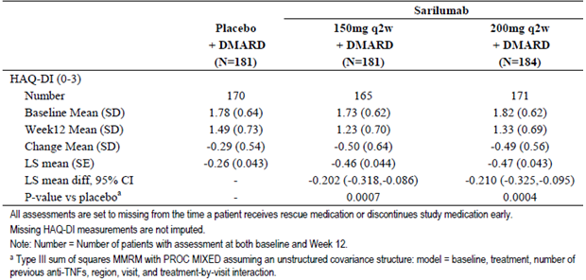

Sensitivity analyses of the mean change from Baseline to Week 12 in the HAQ-DI score using the LOCF method for handling of missing data and multiple imputations showed results consistent with the primary analysis.

Regarding the subgroup analyses, gender was observed as a potentially significant variable. Female subjects showed a higher treatment related mean HAQ-DI response compared to a small effect in males due to a high placebo response. Although there was no treatment by region interaction (p = 0.9407), a higher placebo response was observed in Region 2 compared to Regions 1 and 2.

For the analysis of clinically meaningful HAQ-DI response, 2 different definitions of response were used: > 0.3 and > 0.22 units of improvement from Baseline. At Week 12, there was no difference between the 2 SAR dose groups and placebo for the rate of HAQ-DI response using the > 0.22 threshold. However, using an improvement of > 0.3 units as the definition, both SAR doses recorded numerically higher rates of HAQ-DI response (51.1% for SAR 200 mg (nominal p = 0.0025 versus placebo) and 47.0% for SAR 150 mg (nominal p = 0.0297)) compared to placebo (35.9%).

##### Results for other efficacy outcomes

As summarised in Table 14, each dose of SAR was tested versus placebo for the hierarchical order of primary and secondary efficacy endpoints in Study EFC10832. According to the pre-specified order of analysis, the results were statistically significant in favour of both doses of SAR versus placebo for each efficacy endpoint up to and including the PCS of SF-36 at Week 24 (all values in bold in Table 16 are statistically in favour of SAR versus placebo at 0.025 level using simple Bonferroni adjustment).

Table 14: Summary of Primary and Secondary Efficacy Endpoint Results in Study EFC10832

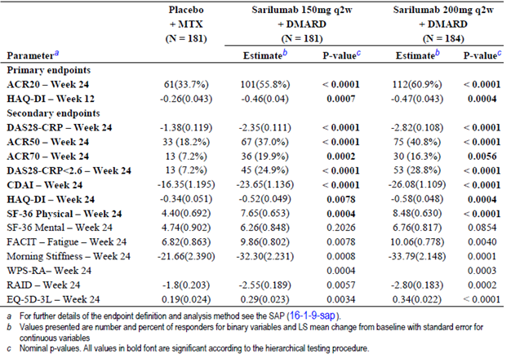

###### (a) DAS28-CRP; Week 24

At baseline, all 3 treatment groups had similar DAS28-CRP values ranging from 6.09 to 6.29 indicating severely active RA. During Study EFC10832, all treatment groups showed a mean decrease in DAS28-CRP score from Baseline indicating improvement in RA disease activity. At Week 24, the LS mean change from Baseline in DAS28-CRP score was -1.38 for the placebo group, ‑2.35 for SAR 150 mg and -2.82 for SAR 200 mg therapy (p < 0.0001 for both doses of SAR versus placebo).

A statistically higher proportion of patients in the SAR treatment groups achieved DAS28-CRP remission (that is DAS28-CRP score < 2.6) at Week 24 (24.9% (45/181) in the 150 mg group and 28.8% (53/184) in the 200 mg arm) compared to placebo (7.2%; 13/181; p < 0.0001 for the difference between each SAR group and placebo).

###### (b) ACR50 and ACR70 response rates and individual ACR components; Week 24

A statistically higher proportion of patients in the SAR treatment groups achieved ACR50 response at 24 weeks (37.0% (67/181) in the 150 mg group and 40.8% (75/184) in the 200 mg arm) compared to placebo (18.2%; 33/181; p < 0.0001 for the difference between each SAR group and placebo).

A statistically higher proportion of patients in the SAR treatment groups achieved ACR70 response at 24 weeks (19.9% (36/181) in the 150 mg group and 16.3% (30/184) in the 200 mg arm) compared to placebo (7.2%; 13/181; p < 0.006 for the difference between each SAR group and placebo).

At Week 24, all 7 ACR components showed a statistically greater improvement with both doses of SAR versus placebo, which is supportive of the validity of the primary efficacy results regarding higher ACR20 response rates with either dose of SAR therapy versus placebo.

At Week 24, all 3 treatment groups showed an increase (improvement) from Baseline in ACRn. At Week 24, the mean percentage increase from Baseline in ACRn was 28.37% for the placebo group, 46.55% for SAR 150 mg and 46.04% for SAR 200 mg therapy (nominal p-value < 0.0001 for both doses of SAR versus placebo).

###### (c) SDAI and CDAI; Week 24

Baseline SDAI values were similar across the 3 treatment groups ranging from 44.9 to 47.2. All 3 arms showed a decrease from Baseline in SDAI. At Week 24, the LS mean change from Baseline in SDAI was -24.5 for the placebo group, -28.5 for the SAR 150 mg arm and -33.4 for the SAR 200 mg dose group. The difference in mean SDAI from Baseline to Week 24 was statistically greater in both SAR treatment groups compared with placebo (nominal p-values < 0.0001). Furthermore, the proportion of patients achieving SDAI remission (that is SDAI ≤ 3.3) at Week 24 was numerically higher in SAR treated patients (9.9% (18/181) for SAR 150 mg and 8.7% (16/184) for SAR 200 mg) when compared with placebo (2.8%; 5/181). The nominal p-value for SAR 150 mg versus placebo was 0.0044 and for SAR 200 mg versus placebo was 0.0146.

Baseline CDAI values were similar across the 3 treatment groups in Part B of Study EFC11072 ranging from 41.6 to 44.1. All treatment arms showed a mean decrease (improvement) from Baseline in CDAI. At Week 24, the LS mean change in CDAI was -23.9 for the placebo group, -27.1 for the SAR 150 mg arm and -30.4 for the SAR 200 mg dose group. The differences between each of the SAR dose groups and placebo were statistically significant (p-values < 0.0001). In addition, the proportion of patients achieving CDAI remission (that is CDAI ≤ 2.8) at 24 weeks was higher in SAR treated patients (9.4% (17/181) for SAR 150 mg and 8.2% (15/184) for SAR 200 mg) versus placebo (5.0%; 9/181), however the nominal p-values for testing the difference in the incidence of achieving CDAI remission between each of the SAR groups and placebo were not significant (p = 0.0971 for SAR 150 mg versus placebo and p = 0.2134 for SAR 200 mg versus placebo).

###### (d) HAQ-DI at Week 24

The LS mean change from Baseline to Week 24 in the HAQ-DI score was numerically greater in patients treated with SAR (-0.52 for 150 mg and -0.58 for 200 mg dose) than for subjects in the placebo group (-0.34). The differences between each dose of SAR and placebo were statistically significant (p = 0.0078 for SAR 150 mg versus placebo and p = 0.0004 for SAR 200 mg versus placebo).

At Week 24 the proportion of patients who were HAQ-DI responders using an improvement of > 0.22 units was higher in both SAR treatment groups (47.5% for SAR 150 mg (nominal p = 0.013747) and 56.0% for 200 mg (p < 0.0001)) than in the placebo arm (35.4%). At Week 24 the proportion of patients who were HAQ-DI responders using an improvement of > 0.3 units was higher in both SAR groups (43.1% for 150 mg (nominal p = 0.0165) and 47.3% for 200 mg (nominal p = 0.0014)) than in the placebo arm (31.5%).

###### (e) Boolean-based ACR/EULAR remission; Week 24

The proportion of patients achieving Boolean-based ACR/EULAR remission at Week 24 was numerically higher in patients treated with SAR (5.5% for SAR 150 mg and 6.0% for SAR 200 mg) compared with placebo treated patients (2.8%). The nominal p-values for testing the difference in Boolean-based ACR/EULAR response between each of the SAR treatment groups and placebo were p> 0.025.

###### (h) Quality of Life and Economic Outcomes; Week 24

The last statistically significant efficacy endpoint in the testing hierarchy was the PCS of SF-36 at Week 24 for both SAR dose groups versus placebo. Significance is not claimed for those parameters lower in the testing hierarchy; that is, for the MCS of SF-36, FACIT-Fatigue, duration of morning stiffness, WPS-RA, RAID and EQ-5D-3L.

At Week 24, the differences in SF-36 PCS scores were statistically higher (that is improved) for both SAR treatment groups compared with placebo (p < 0.0004 for SAR 150 mg and p < 0.0001 for SAR 200 mg versus placebo). At Week 24, the LS mean increase from Baseline in the SF-36 PCS scores were 7.65 points for SAR 150 mg (from a baseline mean of 30.28 (n = 123)) and 8.48 points for SAR 200 mg (from a baseline mean of 29.36 (n = 134)) compared with the placebo group (4.40 point improvement from a baseline mean of 29.73 (n = 99)).

The differences in SF-36 MCS scores at Week 24 for both SAR treatment groups compared to placebo did not reach statistical significance (p = 0.2026 for SAR 150 mg and p = 0.0854 for SAR 200 mg versus placebo). At Week 24, the LS mean increase from Baseline in the SF-36 MCS scores were 6.26 points for SAR 150 mg (from a baseline mean of 38.60 (n = 123)) and 6.76 points for SAR 200 mg (from a baseline mean of 39.08 (n = 134)) compared with the placebo group (4.74 point improvement from a baseline mean of 38.52 (n = 99)).

The sponsor does not claim statistical significance in favour of SAR therapy versus placebo for the remainder of the QOL and health economic endpoints because the statistical testing hierarchy was broken prior to these parameters being explored. Nonetheless, the remainder of the QOL outcomes (FACIT-Fatigue score, duration of morning stiffness, WPS-RA score and RAID score) as well as the health economic observation (EQ-5D-3L score) were numerically higher in both SAR treatment groups compared with placebo and demonstrated nominal p-values in favour of SAR treatment.

### Other efficacy studies

#### Part A of Study EFC11072

##### Study design, objectives, locations, dates and treatments

The 2 primary objectives of this trial were to demonstrate that SAR when added to MTX was effective for the reduction of symptoms and signs of active RA at 12 weeks, and to define the optimal dose regimen of SAR for future clinical studies. Part A of Study EFC11072 was a 12 week, 6 arm, dose ranging study intended to select the 2 dose regimens of SAR for further evaluation in the Phase III RA program. Subjects were randomly assigned in an equal ratio to receive either placebo injections once weekly (qw), SAR 100 mg qw, SAR 150 mg qw, SAR 100 mg once every 2 weeks (q2w), SAR 150 mg q2w or SAR 200mg q2w. The maximum duration of study involvement for each individual patient was 22 weeks (up to 4 weeks of screening, followed by 12 weeks for study treatment and 6 weeks of follow-up after their last injection). Patients from Part A of Study EFC11072 did not participate in Part B of the trial. However, subjects who completed Part A were eligible to enter an open label, long term extension study (LTS11210). Part A of Study EFC11072 was conducted at 102 investigator sites in 19 countries in Europe, North and South America, Korea, Australia and South Africa. The first patient was enrolled in March 2010 and the last patient completed follow-up in May 2011.

##### Eligibility criteria

To be eligible for inclusion, patients had to be between 18 and 75 years of age with a diagnosis of RA for at least 3 months. Subjects had to have active disease at Baseline as evidenced by ≥ 8 tender joints (out of a possible 68), ≥ 6 swollen joints (out of a possible 66) and high sensitivity CRP reading > 10 mg/L despite continuous treatment with MTX 10 to 25 mg/week for at least 12 weeks (stable dose for at least 6 weeks prior to screening). A past history of non-response to anti-TNF or any other biologic therapy for RA was an exclusion criterion. Concurrent use of low dose CS (prednisone < 10 mg/day) or NSAID, if stable for at least 4 weeks prior to screening, was permissible.

##### Efficacy variables and statistical considerations

The primary efficacy endpoint was the proportion of patients in each treatment arm who achieved ACR20 response at Week 12. The primary analysis compared each SAR dose group to placebo with a CMH test, corrected for multiplicity by Hommel’s procedure.

The secondary efficacy outcomes in Part A of Study EFC11072 (all reported at Week 12) included: ACR50 and ACR70 response rates, mean change from Baseline in each of the 7 ACR components, mean change from Baseline in DAS28-CRP score, rates of DAS28-CRP remission, rates of EULAR response and mean ACRn. The categorical secondary efficacy variables such as ACR50 response were analysed in the same manner as the primary efficacy endpoint. For the continuous efficacy variables such as the mean change from Baseline in DAS28-CRP score, an ANCOVA model was used.

All efficacy analyses were conducted using the ITT patient population consisting of all patients who had been randomised to treatment through the central IVRS. At randomisation, subjects were stratified according to prior biologic therapy use (yes/no) and region. Part A of Study EFC11072 had a double blind design.

Using a 2 sided test with α = 0.01, the sample size calculation estimated 50 patients per patient group was required to provide 80% power to detect a treatment related difference of 35% in the Week 12 ACR20 response rate between any dose of SAR (estimated to be 75% in at least 1 SAR dose arm) and placebo (estimated to be 40%).

##### Participant flow and significant protocol deviations

A total of 737 subjects were screened for involvement in Part A of Study EFC11072 and 431 patients (58.5%) were recorded as screen failures. The reasons for screen failure were not provided. A total of 306 patients were randomly assigned to 1 of 6 treatment groups: placebo (52 subjects), SAR 100 mg q2w (51 patients), SAR 150 mg q2w (51 subjects), SAR 100 mg qw (50 patients), SAR 200 mg q2w (52 subjects) and SAR 150 mg qw (50 patients). Of the 306 randomised subjects, 1 patient (randomised to the SAR 200 mg q2w group) did not receive study treatment. Patient disposition for each treatment group is presented in Table 15. Overall, 35 patients (32 in SAR treatment groups and 3 in the placebo arm) did not complete the 12 week study treatment period because of either AEs (n = 24), lack of efficacy (n = 7) or other reasons (n = 4). The 7 patients who discontinued due of lack of efficacy were distributed across the majority of treatment groups (1.9 to 4.0%), except for the SAR 100 mg qw group, which had no patients who discontinued because of lack of efficacy. A total of 243 patients (79.4% of 306) completing Part A of Study EFC11072 entered into the long term Study LTS11210. The percentages of patients who entered Study LTS11210 were comparable across all 6 treatment groups.

Table 15: Patient disposition in Part A of Study EFC11072

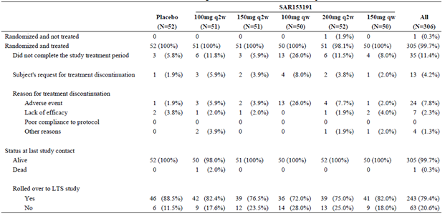

In total, 13 patients (3 in each SAR treatment groups except the 200 mg q2w arm, and 1 in the placebo group) were recorded as having important protocol violations with the potential to affect the efficacy analyses of the ITT population. Of these 13 patients, 4 in the SAR treatment groups had drug compliance issues (that is they received < 80% of study treatment), 5 patients had an increase in MTX dose during the 6 weeks prior to screening, 2 patients had an increase in MTX dose during the study, and 3 patients (including the 1 placebo randomised subject) did not meet the requirement of having moderately to severely active RA at Baseline.

##### Baseline patient data

The 6 treatment groups were balanced with respect to demographic features. The randomised population of 306 patients had a mean age of 52.2 years (median of 54.0 years; range: 19 to 74 years). The majority of patients were female (79.4%; 243/306) and Caucasian (93.8%; 287/306). The overall median BMI for enrolled patients was 27.65 kg/m2 (range: 17.5 to 51.6 kg/m2) and more than one third of subjects (35.3%; 107/306) being obese at Baseline (that is BMI > 30 kg/m2). By geographic region, the largest percentage of patients came from developing countries (that is Region 3: 43.1%; 132/306) followed by western developed countries (30.7%; 94/306) and South America (that is Region 2: 26.1%; 80/306). Almost one third of all subjects (31.4%; 96/306) reported a positive smoking history (current or former) at Baseline, and regular alcohol consumption was recorded in 22.4% (68/306).

The treatment groups were similar with respect to baseline RA disease characteristics. The mean duration of RA for all subjects was 7.81 years (median 5.15 years, range: 0.3 to 43.3 years). Most patients were recorded as having functional class II RA at Baseline (70.3%; 215/306). Expectedly, the majority of patients were seropositive for RA at Baseline (79.7% (243/306) were positive for rheumatoid factor and 82.0% (105/306) were positive for anti-CCP antibodies).

In terms of RA disease activity at Baseline, the mean numbers of tender (ranging from 25.4 to 30.3) and swollen joints (ranging from 16.3 to 19.5) were similar across the 6 treatment groups. All 6 treatment groups recorded mean DAS28-CRP scores that were very high at Baseline (6.05 to 6.28) and the median HAQ-DI score across the enrolled population was 1.60. The mean CRP for recruited subjects was high at 27.8 mg/L (median of 19.2 mg/L). Overall, the measures of baseline disease activity are consistent with severely active RA. Patients in the lowest dose SAR group (100 mg q2w) generally had disease activity markers that reflected higher activity than the other 5 treatment groups, which were otherwise evenly matched at Baseline.

Almost one quarter of all subjects (24.5%; 75/306) had a history of prior biologic therapy for RA, which was equally spread across the 6 treatment groups. The clinical study report did not specify the number of prior biologic therapies (single or multiple) and the reasons for discontinuation. Excluding MTX, the vast majority of subjects (92.8%; 284/306) had not taken any other conventional DMARD drugs, which is surprising given the duration and severity of RA in the enrolled cohort. Fifteen subjects (4.9% of 306) had taken 1 conventional DMARD in addition to MTX, and 7 patients (2.3% of 306) had taken 2 conventional DMARD drugs (excluding MTX). All randomised patients took concomitant MTX (per oral in all but 6 SAR treated patients) during the trial, but the dose of preceding and concomitant MTX therapy were not available in the clinical study report. More than 94% of subjects in each treatment group received concurrent folic acid. Oral CS use ranged from 25.0% (13/52) of patients in the placebo group to 42.0% (21/50) of subjects in the SAR 100 mg qw treatment arm.

##### Primary efficacy results

When adjusted for multiplicity, a statistically higher rate of ACR20 response at Week 12 was demonstrated in the SAR 150 mg qw group (72.0%; 36/50) compared to placebo (46.2%; 24/52; Hommel adjusted p-value = 0.0203). Statistically significant ACR20 responses (after multiplicity adjustment) were not demonstrated in any of the other SAR dose groups compared to placebo, although a trend towards treatment effect was seen in the 150 mg q2w, 100 mg qw and 200 mg q2w SAR treatment arms, as demonstrated by the ACR20 response rates of 66.7% (34/51), 62.0% (31/50), and 65.4% (34/52), respectively; refer to Table 16. Two sensitivity analyses of the rate of ACR20 response at Week 12 using the LOCF method in 2 different ways to handle missing data showed near identical results to that observed in the primary analysis. Based on the results of the ACR20 response rate, SAR 100 mg q2w therapy was determined to be the no effect dose and SAR 150 mg qw treatment was considered the maximally effective dose, which is an appropriate interpretation.

Table 16: ACR20 Response rates at Week 12 in the ITT Population of Part A of Study EFC11072

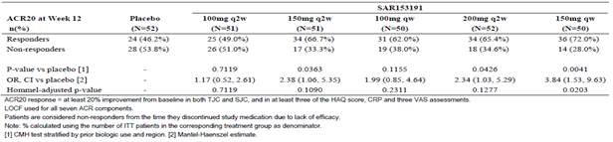

##### Secondary Efficacy Results

For all of the secondary efficacy endpoints, a p-value< 0.01 was considered statistically significant for any SAR dose group versus placebo after applying post-hoc adjustment for multiplicity.

The proportion of patients who achieved ACR50 response at Week 12 was statistically significant in 2 of the 5 SAR treatment groups (100 mg qw and 200 mg q2w); refer to Table 17.

Table 17: ACR50 Response rates at Week 12 in Part A of Study EFC11072 (ITT Cohort)

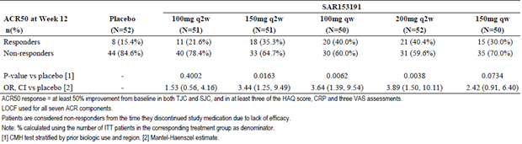

The analysis of the ACR70 response rates at Week 12 was statistically significant in only the SAR 200 mg q2w dose group versus placebo, although there was a trend for improved ACR 70 response rates in the remaining SAR treatment arms, with the exception of the 100 mg q2w dose group; refer to Table 18.

Table 18: ACR70 Response rates at Week 12 in Part A of Study EFC11072 (ITT Cohort)

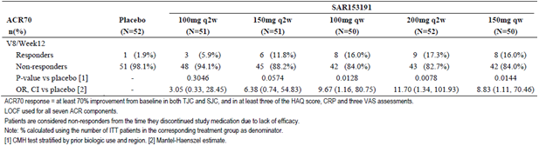

In Part A of Study EFC11072, all treatment groups (including the placebo arm) showed a mean decrease from Baseline (improvement) in the DAS28-CRP score (mean baseline scores ranged from 6.0-6.3 in the 6 groups). All SAR treatment groups except the 100 mg q2w dose arm showed a statistically significant (p < 0.0001) mean decrease from Baseline in the DAS28-CRP score compared to placebo. At 12 weeks, the LS mean decrease from Baseline in DAS28-CRP was ‑1.15 for the placebo group, -1.44 for SAR 100 mg qw, -2.30 for SAR 150 mg q2w, -2.40 for SAR 100 mg qw, -2.48 for SAR 200 mg q2w and -2.52 for SAR 150 mg qw. As summarised in Table 19, the rates of DAS28-CRP remission increased with the dose of SAR, but only reached statistical significance in the SAR 200 mg q2w (26.0%; 13/50) and the SAR 150 mg qw (30.0%; 15/50) groups compared to the placebo arm (3.8%; 2/52; p = 0.0018 and 0.0005, respectively).

Table 19: Rates of DAS28-CRP Remission at Week 12 in Part A of Study EFC11072 (ITT Cohort)

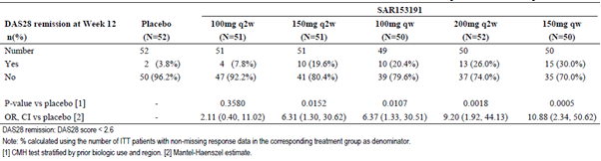

At 12 weeks, the rates of achieving good EULAR response (defined as patients with an improvement from Baseline in DAS28-CRP score of > 1.2 and a current DAS28-CRP score of < 3.2) was statistically higher in each of the SAR arms versus placebo, except for the lowest dose of SAR therapy (100 mg q2w). The good EULAR response rates at 12 weeks were 7.7% (4/52) for the placebo arm, 17.6% (9/51) for SAR 100 q2w, 33.3% (17/51) for SAR 150 mg q2w, 36.7% (18/49) for SAR 100 mg qw, 42.0% (21/50) for SAR 200 mg q2w and 42.0% (21/50) for SAR 150 mg qw.

All SAR treatment groups except the 100 mg q2w dose arm showed a statistically significant (p < 0.004) mean decrease from Baseline in ACRn compared to placebo. At 12 weeks, the LS mean decrease from Baseline in ACRn was 4.8 for the placebo group, 11.7 for SAR 100 mg qw, 30.1 for SAR 150 mg q2w, 30.0 for SAR 100 mg qw, 33.5 for SAR 200 mg q2w and 32.9 for SAR 150 mg qw.

#### Study LTS11210

##### Study design, objectives, locations, dates and treatments

Study LTS11210 is an ongoing, open label, long term (up to 5 years) extension study in adult patients with RA who completed involvement in 5 forerunner trials. The patients participating in this trial have been enrolled from the preceding studies with the following characteristics at initial entry: inadequate response to MTX (Study EFC11072), inadequate response to or intolerance of anti-TNF drugs (Studies EFC10832 and SFY13370, inadequate response to up to 2 anti-TNF therapies (Study ACT11575) and inadequate response to or intolerant of non-biologic DMARD (Study EFC13752). In Study LTS11210 subjects were allowed to continue their concomitant medication as per the initial trial. Study EFC13752 was a SAR monotherapy trial, which continued into LTS11210, so the results of that patient cohort will not be considered in this evaluation, as it is inconsistent with the sponsor proposed combination treatment indication in this submission. Subjects enrolling into Study LTS11210 may have been exposed to SAR for 12 weeks if they initially participated in Part A of Study EFC11072 and Study ACT11575; between 12 and 52 weeks if initially randomised into Part B of Study EFC11072 and Study EFC10832; and for 24 weeks if initially involved in Study SFY13370.

The primary objective of Study LTS11210 is to evaluate the long term safety of SAR, but persistence of efficacy response is a secondary objective of the trial. The trial was conducted at 334 sites in 40 countries. Study LTS11210 enrolled its first patient in June 2010 and the extraction date of the last patient information included in the submitted interim report is April 2015.

A total of 8 protocol amendments were implemented, none of which affected the integrity of the results. The amendments contained clarifications about eligibility criteria, safety assessments, recommendations for temporary and permanent treatment discontinuations and changes consistent with the protocol amendments already outlined for the preceding qualification trials.

##### Efficacy variables and statistical considerations

The main efficacy endpoints reported in Study LTS11210 are: (1) the proportion of patients maintaining clinical response (ACR20, ACR50 and ACR70 response as well as DAS28-CRP remission) and (2) radiographic endpoints such as the mean change from Baseline in mTSS at Week 100 and the percentage of SAR treated subjects with no X-ray progression.

Clinical endpoint data was presented for Week 24, 48, 96, 114, 192 and 216 (where Week 0 is considered the baseline visit in Study LTS11210). The X-ray data presented thus far in Study LTS11210 summarises 2 years of data in total (1 year from Part B of Study EFC11072 and 1 year from Study LTS11210). A specific X-ray review was performed for this interim report during which X-rays from Part B of Study EFC11072 as well as new (Week 48) X-rays from Study LTS11210 were read for all eligible patients. The X-ray data for Study LTS11210 is currently limited to Week 48 because many of the subjects enrolled into this long term trial from Part B of Study EFC11072 have not reached Week 96 time point at the data cut-off date.

All clinical efficacy endpoint analyses were conducted using the treated population consisting of 1,910 patients who have received treatment with SAR in conjunction with conventional DMARD therapy (as per the sponsor proposed indication wording in this application). The radiographic analysis cohort consisted of patients who completed Part B of Study EFC11072 and rolled over into the long term extension trial. All efficacy analyses in Study LTS11210 are descriptive in nature with no statistical adjustments being performed. No sample size calculation was performed but it was expected that approximately 2,000 patients in total (that is approximately 80% of completing participants from the preceding trials) would be enrolled into the long term extension phase.

##### Participant flow and significant protocol deviations

Of the 1,914 subjects who enrolled in Study LTS11210, 1910 patients (99.8%) received combination treatment with SAR and conventional DMARD therapy in Study LTS11210. The majority of enrolling subjects in Study LTS11210 had initially participated in Cohort2/Part B of Study EFC11072 (47.2%; 901/1914). The enrolment contribution from other preceding trials is: 23.8% (456/1914) of subjects rolled over from Study EFC10832, 12.7% (243/1914) of patients rolled over from Part A of Study EFC11072, 8.8% (168/1914) of subjects rolled over from Study SFY13370, 7.3% (139/1914) of patients rolled over from Cohort 1/Part B of Study EFC11072 and 0.4% (7/1914) of subject rolled over from Study ACT11575. At enrolment into Study LTS11210, approximately two thirds of all subjects (63.8%; 1218/1910) were receiving either SAR 150 mg q2w (26.1%; 498/1910) or SAR 200 mg q2w therapy (37.7%; 720/1910). The other subjects were receiving SAR at non-selected dose (10.4%; 199/1910), placebo (20.8%; 397/1910) or tocilizumab or golimumab (5.0%; 96/1910).

At the data extraction cut-off date, 23.0% (440/1910) of enrolled subjects in Study LTS11210 had ceased treatment. The main reasons for discontinuation were AEs (14.3%; 274/1910), ‘other reasons’ (5.5%; 106/1910), lack of efficacy (2.2%; 42/1910) and poor compliance with study protocol (0.9%; 18/1910). Approximately 15% of all withdrawing patients enrolled in Study LTS11210 had discontinued treatment by Week 48, and 25% of subjects had discontinued by Week 96. No patients in Study LTS11210 had significant protocol deviations that may have affected the efficacy analyses.

##### Baseline patient data

Patients enrolling into Study LTS11210 had similar baseline characteristics to the preceding trial cohorts. Subjects had a mean age of 52.1 years (range: 19 to 88 years) and were predominately female (81.1%; 1552/1914) and Caucasian (85.7%; 1641/1914). The median BMI was 26.92 kg/m2 (range: 19.8 to 47.7 kg/m2). By geographic region, the highest proportion of subjects came from South America (37.2%; 712/1914) followed by Eastern Europe and Asia (Region 3: 36.7%; 702/1914) and western countries (26.1%; 500/1914). More than one quarter of enrolled subjects were either current (14.0%; 268/1914) or former smokers (14.2%; 271/1914), and 22.2% (425/1914) consumed alcohol at least on a monthly basis.

The mean duration of RA at Baseline was 9.74 years (range: 0.3 to 54.0 years) and most was seropositive at Baseline (82.1% (1565/1914) for RF and 84.7% (1596/1914) for anti-CCP antibodies). Almost half (48.0%; 918/1914) had a history of biologic DMARD exposure. At the time of enrolment into Study LTS11210, 99.0% (1894/1914) of patients were taking concomitant non-biologic DMARD therapy, which was frequently MTX monotherapy (92.2%; 1764/1914). Other concomitant non-biologic DMARD use at entry included LEF monotherapy (2.8%; 54/1914), MTX combined with other non-biologic DMARD (2.4%; 45/1914), HCQ monotherapy (0.9%; 17/1914) and SSZ monotherapy (0.6%; 11/1914). The median weekly MTX dose at Baseline in Study LTS11210 was 15 mg (mean of 15.63 mg/week). During the long term follow-up trial, more than half of all subjects (59.4%; 1136/1914) were continuing to take low dose oral CS and most were still receiving NSAID (70.4%; 1347/1914).

##### Clinical efficacy results

Between Weeks 24 and 216, the proportion of patients obtaining ACR20 response was 83 to 90%, achieving ACR50 response was 60 to 70%, obtaining ACR70 response was 39 to 50% and achieving DAS28-CRP remission was 51 to 62%; refer to Table 20. The rates of ACR response and remission were sustained and stable between Weeks 24 to 216 after an initial increase in clinical response rates between Weeks 0 to 24, which reflects the contribution from patients who initiated SAR at Week 0 in Study LTS11210 (20.8% of subjects switched from placebo to SAR at enrolment).

Table 20: Percentage of patients with clinical response in Study LTS11210

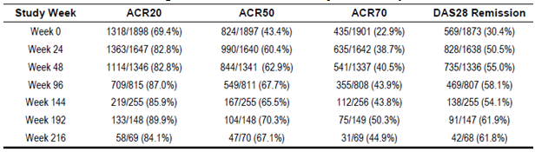

###### Radiographic results

X-ray data in Study LTS11210 was only collected from subjects who entered into the long term trial from Study EFC11072. A total of 860 patients who initiated study treatment in Study EFC11072 had X-ray data collected at Baseline in Study EFC11072, and 865 of these subjects had X-ray data analysed at Week 0 (baseline) in Study LTS11210. Of these subjects, 848 had X-ray data collected at Baseline of Study EFC11072, and Weeks 0 and 48 of Study LTS11210 (that is all 3 sequential X-rays over 100 weeks of treatment).

At Week 0 in Study LTS11210 (that is after 1 year of treatment in Study EFC11072), the mean mTSS had increased by 1.05 units relative to the baseline of the initial trial in the combined SAR treatment cohort; refer to Table 21. At Week 100 (after 52 weeks of treatment in Study EFC11072 and 48 weeks of treatment in Study LTS11210), the mean mTSS had increased by 1.34 units from the original baseline.

The radiographic cohort was also analysed for the proportion of subjects showing no progression from original baseline (that is mTSS of < 0) to Week 52, and between Weeks 52 and 100. The rate of non-progression at Week 0 of Study LTS11210 (that is Week 52 of Study EFC11072) was 51.9% (461/889). There was minimal change between Weeks 0 and 48 of Study LTS11210 for the proportion of subjects showing no X-ray progression at Week 100 (51.2%; 455/889) versus Week 52 (51.9%). Furthermore, analyses of the mean ES and JSN scores over the 2 treatment periods (baseline to Week 52, and Week 52 to 100) show no significant mean change after 1 year of SAR.

Overall, the above results indicate that SAR has a sustained effect on the prevention of X-ray progression over 2 years of treatment follow-up in adult patients with active RA and at high risk of X-ray progression (that is seropositive RA with high disease activity at Baseline).

Table 21: Change from Baseline in mTSS for Patients from Part B of Study EFC11072 continuing with open label Sarilumab in Study LTS11210

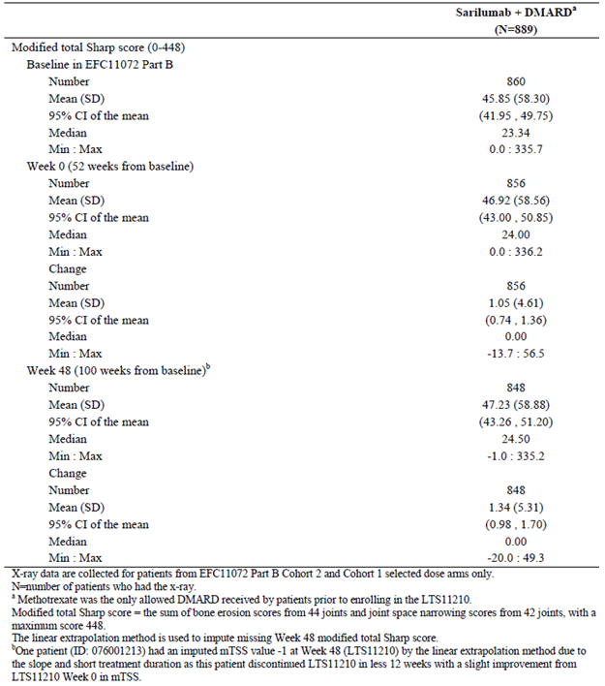

#### Study SFY13370

Study SFY13370 was a randomised, double blind, double dummy trial which primarily aimed to assess the safety and tolerability of SAR and tocilizumab (another anti-IL-6 therapy) in adult patients with active RA who were inadequate responders to or intolerant of anti-TNF drugs. The rates of ACR20, ACR50, ACR70 and DAS28-CRP response at Week 24 were collected as exploratory efficacy outcomes. The study was conducted in 68 centres in North and South America, as well as Europe between March 2013 and October 2014. A total of 202 patients were randomised in a 1:1:2 ratio to receive SC injections of SAR 150 mg q2w (n = 49 subjects), SAR 200 mg q2w (n = 51 patients) or intravenous infusion of tocilizumab every 4 weeks starting at 4 mg/kg followed by an increase to 8 mg/kg, if needed, based on clinical response (as assessed by the site investigator), with each biologic therapy added to non-biological background DMARD treatment (typically MTX). The Australian approved RA treatment regimen for tocilizumab is 8 mg/kg IV every 4 weeks. In Study SFY13370, 60.8% (62/102) of tocilizumab treated subjects had a dose increase from 4 mg/kg to 8 mg/kg during the trial, including 42.4% (42/99) of patients who had their dose incremented upwards at Week 4.

Patient disposition in Study SFY13370 is presented in Table 22. Overall, 27 (13.4%) discontinued from the trial, with 19 (9.4%) being due to AEs. There was a higher rate of discontinuation due to AEs in both of the SAR groups compared to tocilizumab.

Table 22: Participant flow in Study SFY13370 and reasons for discontinuation

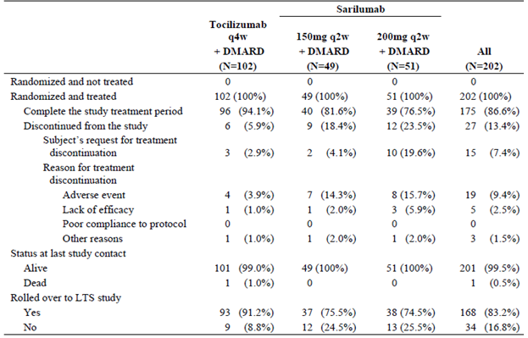

Table 23 summarises the clinical response rates at Week 24 in Study SFY13370. Although this study was not designed to evaluate the comparative efficacy of SAR and tocilizumab, the rates of ACR20 response (using the primary statistical approach where discontinued patients were imputed as non-responders) were numerically lower in both SAR treatment groups compared to tocilizumab. The proportion of patients achieving an ACR20 response at Week 24 was similar in patients treated with SAR (63.3% for the 150 mg q2w group and 68.6% for the 200 mg q2w arm), but lower than that observed for patients treated with tocilizumab (75.5%).

Table 23: Clinical response rates at Week 24 in Study SFY13374

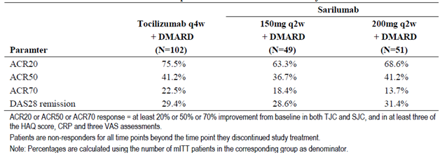

In order to evaluate the impact of the higher discontinuation rate in the SAR treatment groups compared to tocilizumab, an alternative approach was developed as a sensitivity analysis. In this sensitivity analysis, missing data were imputed using the LOCF approach. In this analysis, the proportion of patients achieving an ACR20 response at Week 24 appeared to be similar in the 3 groups (75.5% for SAR 150 mg q2w, 74.5% for SAR 200 mg q2w and 75.5% for tocilizumab q4w group). The response rates of ACR50, ACR70 and DAS remission (using the primary statistical approach) showed similar results for the 3 treatment groups for each of the efficacy endpoints.

### Analyses performed across trials (pooled analyses and meta-analyses)

The submission does not contain a pooled analysis or meta-analysis of the efficacy data, but the sponsor has provided a comparison of the study populations and efficacy results across the two pivotal studies (Part B of EFC11072 and EFC10832).

Demographic characteristics of enrolled subjects were well-balanced between the two trials, except for race and region. There were a higher proportion of Caucasian patients in Study EFC11072 (86%) versus EFC10832 (71%), which can be explained by the different countries participating in the 2 studies. Baseline disease characteristics were also well balanced within each trial. Patients randomised into both studies had moderately to severely active RA. The mean baseline values of CRP were high in both trials (> 20 mg/L in each treatment arm), as well as the mean number of tender and swollen joints per subject. In both studies, the majority of patients were seropositive for RF and anti-CCP antibodies. Patients in Study EFC10832 had a longer duration of disease and more severe disease, as shown by the greater proportion of patients who were functional class III and the higher joint counts, CRP, HAQ-DI, DAS-CRP, and CDAI values at Baseline. These differences are to be expected, as patients in Study EFC10832 had already failed at least 1 anti-TNF drug. Patients in EFC11072 Part B were more likely to be seropositive for either RF or anti-CCP antibodies, which was expected as these were part of the entry criteria for that particular trial. While all patients in Study EFC10832 had received at least 1 prior anti-TNF drug, 27.4% of patients in Part B of Study EFC11072 had previously been treated with biologic DMARD. This observation is due to the differences in the entry criteria for the studies. Concomitant medications for RA were well-balanced within each study. All enrolled patients in Part B of Study EFC11072 were taking concomitant MTX at randomisation (mean dose 15.5 mg/week), as this was a requirement for entry into the trial. The majority of patients in Study EFC10832 were also taking concomitant MTX at randomisation (86% in total; mean weekly dose of 16 mg). In both studies, about two-thirds of all patients were taking concomitant low dose oral CS and/or NSAID, as expected in patients with active RA.

In both pivotal studies, both dose regimens of SAR (150 mg q2w and 200 mg q2w), administered concomitantly with non-biological DMARD (mainly MTX), improved the signs and symptoms of RA and improved physical functioning in patients who were inadequate responders to MTX and/or anti-TNF therapy. The effects were robust based on the consistency of results of the primary and sensitivity analyses as well as that of the analyses of secondary efficacy endpoints. Within each dose group, the magnitude of the treatment effect was generally similar in both MTX and anti-TNF inadequate responder patient populations; refer to Table 24. Both regimens of SAR, administered with concomitant MTX, inhibited radiographic progression in Part B of Study EFC11072.

Table 24: Primary efficacy endpoint results in both pivotal Phase III studies + key secondary efficacy endpoint result for Part B of Study EFC11072

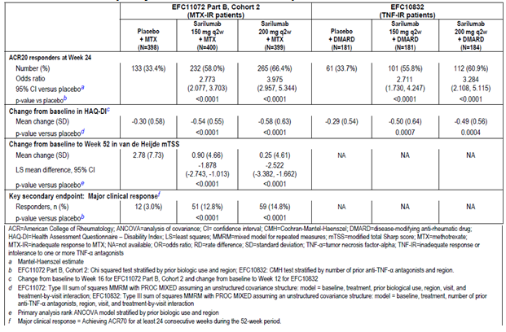

A significant limitation of the current dataset in relation to determining the lowest, most clinically effective dose regimen of SAR is that both of the Phase III, placebo controlled studies was only designed to compare each of the 2 SAR dose regimens to placebo. Efficacy result comparisons between the 2 SAR doses were not subject to pre-specified statistical testing. Nonetheless, the sponsor asserts that the efficacy data presented in this submission consistently shows a numeric superiority for SAR 200 mg q2w over SAR 150 mg q2w therapy, particularly for the higher levels of ACR response (ACR50 and ACR70) and radiographic outcomes. However, as demonstrated in Table 25, the rates of ACR50 and ACR70 response at Weeks 12, 24 and 52 for both doses of SAR are numerically similar with overlapping 95% CIs for the treatment related difference (versus placebo) in response rates.

Table 25: ACR response rates at Week 12, 24 and 52 in both pivotal Phase III Studies

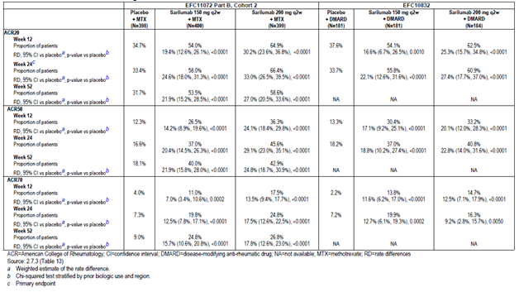

The findings from the subgroup analyses of the pooled Phase III study cohort were consistent with those reported for the individual Phase III trial datasets. The only new finding from the subgroup analysis of the pooled Phase III dataset was that patients treated with SAR 150 mg q2w who weighed ≥ 100 kg had the lowest rate of ACR20 response at 24 weeks (40.0%; 24/60), which was not statistically better than placebo treated subjects (35.9% (23/64); OR of 1.213 (95% CI 0.558, 2.639) for SAR 150 mg versus placebo in subjects weighing > 100 kg). Patients treated with SAR 150 mg q2w who were seronegative for RF and/or anti-CCP antibodies also did not demonstrate a statistically higher rate of ACR20 response at 24 weeks versus placebo (41-45% ACR20 response rate for each subgroup).

The effects of dose increase were assessed for the subset of patients who received SAR 200 mg q2w, as either rescue for inadequate response in the initial studies (EFC11072 or EFC10832) or following entry into Study LTS11210. The efficacy results in this cohort are confounded as the treatment effect is not based on the population as randomised, but rather includes a mixture of patients who responded to therapy in the initial studies and those were non-responders. The analysis is also limited by self-selection of patients who chose to participate in the open label extension trial. The efficacy analyses are based on the last visit on or before receiving open label SAR200 mg therapy, and then the rate of ACR20 response and mean change from Baseline in the HAQ-DI score at 12 and 24 weeks after the SAR dose increase (Table 26 for Study EFC11072 and Table 27 for Study EFC10832). In the subset of patients who increased SAR dose from 150 mg to 200 mg q2w, there was an improved response over time, but all treatment groups in both studies showed an improved response over time.

Table 26: ACR20 response rate and mean change from Baseline in HAQ-DI 12 and 24 Weeks after SAR dose increase to 200 mg q2w (for Study EFC11072 rescue patients and those who continued into Study LTS11210)

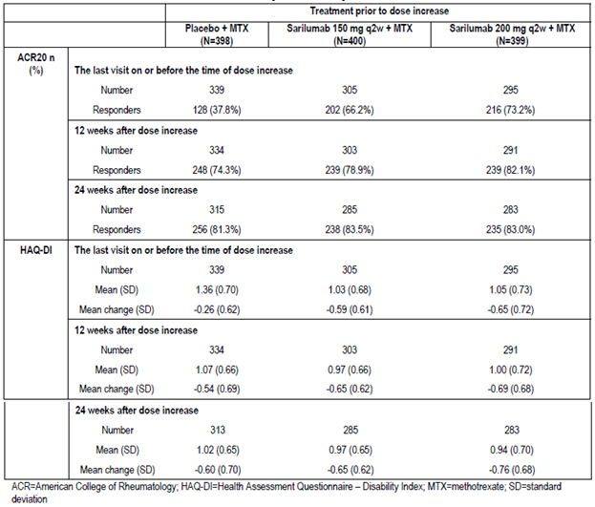

Table 27: ACR20 response rate and mean change from Baseline in HAQ-DI 12 and 24 Weeks after SAR dose increase to 200 mg q2w (for Study EFC10832 rescue patients and those who continued into Study LTS11210)

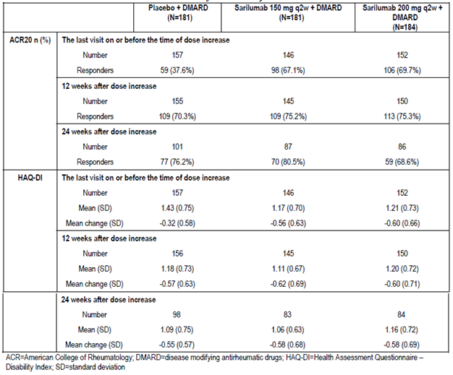

The effects of decreasing the SAR dose were assessed for those patients who received SAR 200 mg q2w in Study LTS11210 and who switched to SAR 150 mg q2w due to certain laboratory abnormalities (neutropaenia, thrombocytopaenia and abnormal liver function tests). This analysis is limited by self-selection of patients who chose to participate in the open label extension study. It includes patients who decreased dose for different reasons and at different time points throughout the course of Study LTS11210. The ACR20 response and mean change from Baseline in the HAQ-DI score were summarised for these patients at the last visit on or before the dose decrease, and then again at 12 and 24 weeks after the SAR dose decrease. Within the limitations of this analysis, the Week 12 and 24 results after having decreased the dose of SAR from 200 mg q2w to 150 mg q2w in Study LTS11210 did not show any apparent decrease of effect on the improvement of signs and symptoms of RA (ACR20 response rate) and physical functioning (mean change form baseline in HAQ-DI score).

### Evaluator’s conclusions on clinical efficacy

Evaluator’s conclusions on clinical efficacy for the proposed treatment indication of ‘Sarilumab in combination with non-biologic DMARDs is indicated for the treatment of moderate to severe Rheumatoid Arthritis in adult patients who have had an inadequate response or intolerance to one or more DMARDs’.

In support of the proposal for SAR to be granted a treatment indication in active RA in conjunction with non-biologic DMARD drugs, this submission contains two pivotal Phase III studies (Part B of Study EFC11072 and EFC10832) of similar design, as well as one supportive Phase II trial (Part A of Study EFC11072) and a long term, open label extension trial (Study LTS11210). The pivotal efficacy studies were of 24 to 52 weeks duration and enrolled a total of 1,743 patients for efficacy analysis. A total of 306 patients were enrolled in the dose finding Phase II trial of up to 22 weeks duration, and the ongoing, long term, open label study (with up to 5 years of treatment follow-up planned) has enrolled 1,914 subjects, and thus far followed these subjects for 2 to 4 years.

Both of the Phase III studies were randomised, double blinded and placebo-controlled in design and enrolled adult patients with a confirmed diagnosis of RA according to the appropriate classification criteria. Subjects were required to have moderate to severe disease activity at Baseline with the tender joint count being ≥ 8 and the swollen joint count being ≥ 6 and CRP being > 6 to 10 mg/L, despite at least 3 to 6 months of treatment with non-biologic DMARD drugs (typically MTX monotherapy) and/or stable doses of NSAID and/or low dose CS. The Phase III studies were of similar design with the main difference being the recruitment of subjects with a history of inadequate response or intolerance to anti-TNF drugs into Study EFC10832 versus subjects with a preceding inadequate response to MTX in Part B of Study EFC11072. Both of the Phase III trials examined the effect of 2 doses of SAR (150 mg and 200 mg injections, given every 2 weeks by SC injection) compared to placebo injections plus continued background therapy with oral, non-biologic DMARD.

The baseline demographic and disease related characteristics of patients in both of the Phase III trials are similar to those in the anticipated Australian patient cohort, and therefore generalisation of these results to the Australian context is expected. The majority of patients were female, of Caucasian ethnicity, and within the expected age range of 25 to 65 years. Approximately one-fifth of all recruited subjects were current smokers, which is a factor associated with diminished response to treatment. However, there are some caveats to the generalisability of the treatment population. For example, both studies excluded patients who were at a significant risk of infection (particularly, tuberculosis) or malignancy, or who had various abnormal laboratory results at Baseline (for example abnormal haematology, liver function tests or lipid parameters). In addition, a history of inflammatory bowel disease, severe diverticulitis and previous gastrointestinal perforation were exclusion criteria. At randomisation, patients were stratified on the basis of whether they were anti-TNF naïve or anti-TNF experienced. As per protocol, all 546 patients recruited into Study EFC10832 had a history of anti-TNF exposure (92.3% inadequate response) and 27.4% (328/1197) of all subjects recruited into Part B of Study EFC11072 had a history of anti-TNF exposure.

Studies EFC11072 Part B (Cohort 2) and EFC10832 shared 2 co-primary endpoints: the proportion of patients who achieved an ACR20 response at Week 24 and the mean change from Baseline in the HAQ-DI score (at Week 16 in Part B of Study EFC11072 (Cohort 2) and at Week 12 in Study EFC10832). The mean change from Baseline in the mTSS at Week 52 was the third co-primary endpoint in Study EFC11072 (Part B, Cohort 2). The key secondary efficacy endpoint in Study EFC11072 (Part B, Cohort 2) was the proportion of patients who achieved a major clinical response (defined as ACR70 response maintained for at least 24 consecutive weeks during the 52 week trial period). In both pivotal studies, various secondary endpoints were evaluated to further describe the clinical response (such as the rates of ACR50 and ACR70 response), improvements in physical function and to explore the impact of SAR upon health related QOL. The ACR response criteria are a composite of clinical (tender and swollen joint counts), biochemical (CRP) and subjective assessments (pain, physician global and patient global) determining response to therapy in patients with RA. Recent evidence supports the use of the ACR composite criteria as the preferred measure of accurately determining response in RA with other measures such as SDAI, CDAI and Boolean criteria being also valuable (Smolen et al, 2016). Evidence using DAS28 criteria may not be as reliable and should only be used in supporting the other measures.

This submission is seeking an indication in active RA and is consistent with the relevant TGA adopted regulatory guideline: EU guideline CPMP/EWP/556/95 rev1 ‘Points to Consider on Clinical Investigation of Medicinal Products other than NSAIDs for the Treatment of Rheumatoid Arthritis’ (effective 29 January 2007). Both of the Phase III trials included patients who had previously been exposed to anti-TNF drugs, and also those who were anti-TNF naïve (Part B of Study EFC11072 only). For both Phase III studies, the choice of efficacy endpoints and statistical analysis were appropriately performed; and strategies to maintain blinding and randomisation procedures were suitable.

In Part B of Study EFC11072, where SAR 150 mg and 200 mg injections, given every 2 weeks by SC injection were compared with placebo injections plus concurrent non-biological DMARD, and the 3 co-primary efficacy endpoints showed a statistically superior response with both doses of SAR therapy versus placebo. Overall, 58.0% (232/400) of patients treated with SAR 150 mg every 2 weeks and 66.4% (265/399) of subjects treated with SAR 200 mg injections achieved an ACR20 response at 24 weeks versus 33.4% (133/398) of patients in the placebo group. The mean change from Baseline to Week 16 in the HAQ-DI score was also statistically greater in patients treated with SAR (-0.54 for the 150 mg group and -0.58 for the 200 mg arm) than in subjects treated with placebo (-0.30). At Week 52, smaller increases from Baseline in the mTSS were observed in subjects treated with SAR (0.90 for the 150 mg group and 0.25 for the 200 mg arm) than in patients treated with placebo (2.78), indicating relative inhibition of progression of structural damage with SAR treatment. The key secondary efficacy endpoint of Part B of Study EFC11072 was MCR, which is defined as achieving and maintaining an ACR70 response for at least 24 consecutive weeks during the 52 week trial period. A higher proportion of patients in the SAR treatment groups achieved MCR (12.8% (51/400) in the 150 mg group and 14.8% (59/399) in the 200 mg arm) compared to placebo (3.0%; 12/398). Many secondary efficacy measures of clinical relevance such as rates of higher level ACR (50 and 70) as well as CDAI response at 24 weeks, as well as the mean change from Baseline in the HAQ-DI score confirmed that SAR is effective in treating the symptoms and signs of active RA as well improving physical functioning. Improvements in health related QOL were also beneficially attained with SAR therapy.

In Study EFC10832 (where anti-TNF experienced subjects were enrolled), both doses of SAR showed statistically significant benefit over placebo treatment for the rate of ACR20 response at Week 24 and the mean change from Baseline to Week 12 in the HAQ-DI score. Many of the ranked secondary endpoints in the hierarchical testing strategy (which controlled for multiplicity of testing with adjusted p-values) supported the benefit of both doses of SAR over placebo at Week 24.

Neither of the pivotal Phase III studies were designed or powered to evaluate for potentially significant differences in clinical response between the two SAR dose regimens. This is major deficiency of the current submission, particularly because the sponsor is requesting registration of the higher dose regimen for the majority of patients.

The Phase III study data also shows that SAR 150 mg and 200 mg therapy given by SC injection every 2 weeks is effective in treating anti-TNF naïve as well as anti-TNF experienced patients. In the pooled subgroup analyses, high subject weight at Baseline (> 100 kg) appeared to be associated with significantly lower ACR20 response rates for SAR 150 mg treatment, which were not statistically better than placebo+DMARD therapy.

The clinical efficacy data available up to Week 216 in the long term extension Study LTS11210 shows that the majority of responding patients appear to maintain their treatment related benefit with continued SAR therapy. In addition, for placebo patients who switched to SAR at Week 12 to 24, the rate of ACR responses recorded over time in the open label trial were similar to those achieved in the originally treated SAR cohort.

The supporting Phase II trial (Part A of Study EFC11072) showed that treatment with SAR 150 mg/week was superior to placebo for the rate of ACR20 response at Week 12 (72.0% (36/50) for SAR versus 46.2% (24/52) for placebo). Statistically significant ACR20 response rates were not demonstrated in any of the other SAR dose groups compared to placebo, although there was a trend towards treatment effect with 4 other SAR dose regimens (including 150 mg q2w and 200 mg q2w).

Overall, the data in this submission supports the efficacy of SAR therapy in combination with non-biological DMARD (particularly, weekly low dose oral MTX) for the treatment of RA in those with moderate to severely active disease at Baseline. The dataset demonstrates that SAR is effective in both anti-TNF naïve and anti-TNF experienced subjects. The magnitude of clinical response with SAR is similar to that observed in the pivotal studies, which supported the registration of biologic therapies in RA.

The posology of SAR is an issue of difference with the sponsor submission. SAR 150 mg by SC injection (given every2 weeks) appears to be the lowest, most clinically effective dosing regimen in adult patients with RA. The sponsor requested dose of SAR therapy for most patients (200 mg q2w) has not demonstrated clinically meaningful superiority for efficacy outcomes over SAR 150 mg q2w.

## Clinical safety

### Studies providing evaluable safety data

#### Pivotal efficacy studies

In the pivotal efficacy studies (Part B of EFC11072 and EFC10832), the following safety data was collected:

* Adverse Events (AEs) in general were assessed by completion of the AE case report form (CRF) and physical examination performed every 2 weeks until Week 12, and then every 4 weeks between Weeks 12 and 28, and then every 8 weeks thereafter.
* AEs of particular interest, including hypersensitivity reactions (particularly, anaphylaxis), infections (overall and serious), malignancy, gastrointestinal perforation and diverticulitis, major adverse cardiovascular events (MACE), lupus-like syndrome and demyelinating disorders were assessed by CRF and physical examination as per the schedule for general AE evaluation.
* Laboratory tests, including haematology, clinical chemistry and urinalysis were performed at Baseline, weekly for the first 4 weeks, every 4 weeks until Week 32 and then every 8 weeks thereafter. A fasting lipid profile was collected at Baseline, every 4 weeks until Week 12 and then at Weeks 24, 36 and 52. Episodes of neutropaenia, thrombocytopaenia and abnormalities of liver function tests (particularly, elevated serum transaminases) were an AE of special interest as this was an identified risk with SAR.
* Screening tests for tuberculosis (Chest X-ray and QuantiFERON Gold testing; or PPD skin testing in countries without QuantiFeron Gold testing) were taken at Baseline, but not routinely collected thereafter.
* Vital signs such as blood pressure, heart rate, temperature and subject weight were performed at each scheduled study visit.
* ECG was taken at Baseline and at the end of study visit (Week 24 to 52).
* Urine pregnancy testing was performed at Baseline and every 4 weeks thereafter in women of reproductive age.
* Serum for anti-drug antibodies (ADA) to SAR were collected at Baseline and Weeks 4, 12, 24 and 52 in Study EFC11072; and at Baseline and Weeks 2, 4, 12 and 24 in Study EFC10832.

AEs were summarised by the MedDRA classification using system organ class (SOC) and preferred term (PT) nomenclature.

#### Pivotal studies that assessed safety as a primary outcome

Not applicable.

#### Dose response and non-pivotal efficacy studies

The following dose response and non-pivotal efficacy/safety studies provided safety data:

* Part A of Study EFC11072 (dose finding trial) provided safety data regarding overall AEs, AEs of special interest (for example injection site reactions), blood parameters (haematology and liver function tests), physical examination and anti-drug antibodies.
* Study LTS11210, which is the ongoing, long term extension trial of SAR therapy in adult patients with RA provided AE data up to Week 216 of therapy.
* Study SFY13370 was a randomised, double blind safety calibrator trial which assessed the safety and tolerability of SAR versus tocilizumab over 24 weeks.

#### Other studies evaluable for safety only

* Study MSC12665 has provided usability and tolerability data on SC SAR therapy administered by auto-injector device or prefilled syringe.
* Study ACT11575 (prematurely ceased Phase II trial with 16 enrolled subjects) contributed 7 SAR treated patients into the long term study LTS11210.
* Study EFC11574 (prematurely ceased Phase III trial with 43 enrolled subjects) contributed 16 SAR treated patients into the long term study LTS11210.
* 9 clinical pharmacology studies provided safety data regarding overall AEs, AEs of special interest (for example injection site reactions), blood parameters (haematology and liver function tests), physical examination and anti-drug antibodies.

A total of 9 Phase I clinical pharmacology studies have been conducted with SAR. One study (TDU11373) was conducted in healthy subjects and the remaining studies were conducted in adult patients with RA. Of the 8 studies conducted in patients with RA, in 1 single dose study (TDU10808/6R88-RA-0703) SAR was administered intravenously and in the remaining trials, SAR was administered by SC injection. Of the 7 studies in which SAR was given SC, 1 was a repeat dose study (TDR10805/6R88-RA-0802) and all the other trials were single dose studies. The key AE data for the clinical pharmacology studies will be summarily presented in the overall AE section of this report.

### Pivotal studies that assessed safety as a primary outcome

This section is not applicable as no study in the RA clinical development program for SAR has assessed safety as the primary outcome.

### Patient exposure

The primary safety database supporting this submission consists of 3 completed (EFC11072, EFC10832 and SFY13370) and 2 terminated (ACT11575 and EFC11574) Phase II and III trials. Studies ACT11575 and EFC11574 were terminated early due to delays in their starting and the impact on the overall SAR development timeline rather than any identified safety concerns with SAR. Patients in Studies EFC11072, EFC10832, EFC13752, SFY13370 and ACT11575 were able to enrol into an open label, uncontrolled extension study (LTS11210), which is ongoing. Patients in Studies EFC11072 and EFC10832 could initiate rescue therapy with open label SAR (initially 150 mg qw before Phase III dose selection and thereafter 200 mg q2w. The submission contains another ongoing study (MSC12665), which is evaluating the usability of auto-injector device (AID) and pre-filled syringe (PFS) in adult patients with active RA who are candidates for open label SAR therapy.

A total of 2,887 patients have received at least 1 dose of SAR + non-biologic DMARD therapy in the Phase II and III RA clinical development program, providing 4338.9 patient years (PY) of cumulative drug exposure. At the commercially proposed SAR dose of 200 mg q2w, approximately 1,200 patients have received at least 48 weeks of drug exposure. At both doses of SAR (200 mg q2w and 150 mg q2w), over 1650 patients have received at least 48 weeks of drug exposure. In the placebo controlled population, 661 patients have received SAR 200 mg q2w + DMARD for a total exposure of 425.5 PY, 660 patients have received SAR 150 mg q2w + DMARD for a total exposure of 425.8 PY and 661 subjects have received placebo injections + DMARD for a total of 373.1 PY. The duration of double blind treatment was longer in the 2 SAR treatment groups due to the higher proportion of placebo subjects switching to open label rescue treatment with SAR.

#### Part B of Study EFC11072

The safety population of 1282 patients in the pivotal Study EFC11072 Part B consisted of all subjects who participated in Cohort 2 (n = 1197) and those who received the final selected doses of SAR enrolled in Cohort 1 (n = 88 subjects). Of the 1282 subjects, 427 received study treatment in the placebo group, 431 in the SAR 150 mg arm and 424 patients in the SAR 200 mg group. Six patients had dosing errors and were analysed in the SAR 150 mg group, which was the actual treatment received.

The mean duration of double blind treatment in Part B of Study EFC11072 was 251.4 days in the placebo group and 291.9 days in both SAR arms. The duration of double blind treatment was longer in the SAR treatment groups due to the higher proportion of placebo patients switching to open label rescue treatment. During the double blind treatment period, the cumulative exposure in terms of patient years was 293.9 for the placebo group, 344.5 for the SAR 150 mg arm and 338.9 for the SAR 200 mg group – refer to Table 28. The majority of patients (> 70%) in each SAR treatment group were exposed to study medication for > 36 weeks. Some patients were exposed to study treatment for > 52 weeks, with the maximum exposure being up to 58 weeks. The main reason for prolongation of the treatment period was temporary discontinuation of study medication, mainly due to AEs.

Table 28: Exposure to study medication in Part B of Study EFC11072; Primary Safety Cohort

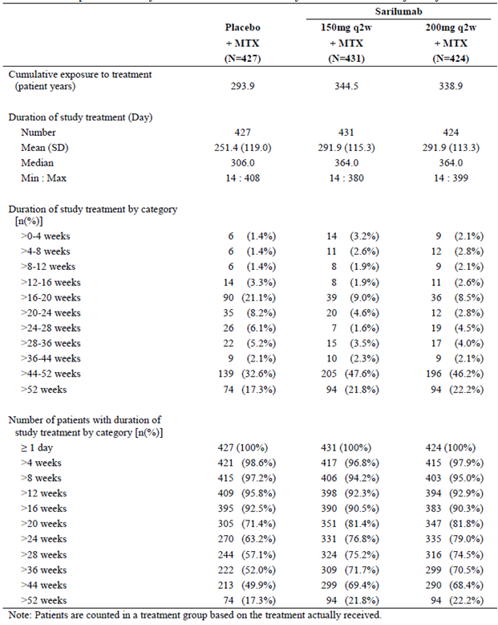

#### Study EFC10832

As summarised in Table 29, the cumulative exposure to double blind treatment in Study EFC10832 was greater in the two SAR treatment groups than in the placebo arm. This was due to the higher proportion of placebo randomised patients leaving the trial due to an inadequate response and entering Study LTS11210 in order to receive rescue therapy with SAR. However, the median duration of treatment was similar across the placebo and SAR treatment groups in Study EFC10832.

Table 29: Exposure to study medication in Study EFC10832; Primary Safety Cohort

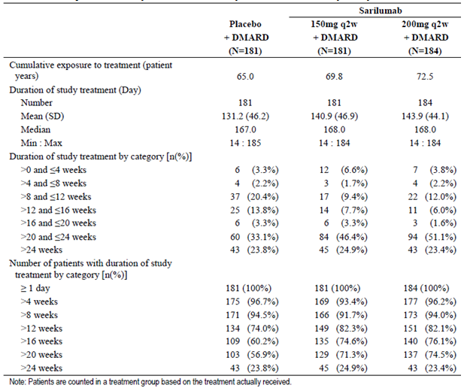

#### Part A of Study EFC11072

In the safety population of 305 subjects, the mean duration of study treatment across the groups ranged from 73.0 (100 mg qw) to 82.7 days (150 mg q2w), refer to Table 30. The median duration of treatment exposure was 84.0 days for all treatment groups. The cumulative exposure to treatment among treatment groups ranged from 10.0 (100 mg qw) to 11.8 (150 mg q2w) patient years. The majority (> 80%) of patients in each treatment group were exposed to study medication for > 8 weeks, with 6-20% of subjects being exposed for > 12 weeks (maximum exposure 14 weeks).

Table 30: Exposure to study medication in Part A of Study EFC11072

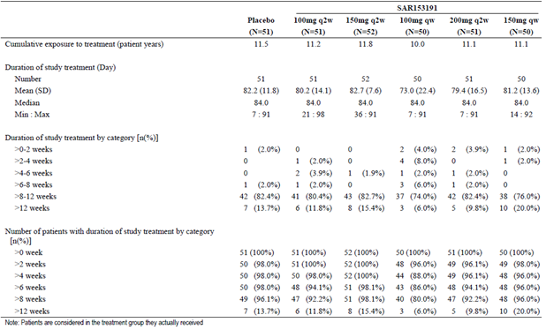

#### Long term safety population

The SAR + non-biologic DMARD long term safety population consists of all patients who received any dose of SAR in Studies EFC11072 (both Part A and B), EFC10832, SFY13370, EFC11574, MSC12665 and LTS11210. Safety data for this population includes any AEs during SAR exposure, including during the placebo-controlled period. The duration of SAR treatment is up to 5 years. The long term safety population allows for characterisation of the long term safety profile of SAR in combination with non-biologic DMARD therapy, as well as the identification of uncommon AEs and AEs with longer latency periods such as malignancy and major adverse cardiovascular events (MACE).

The total exposure in the SAR therapy + non-biologic DMARD long term safety population to any dose of SAR was 2,887 patients for 4,338.9 PY, with 1,546 patients exposed for > 48 weeks, 1,020 patients exposed for > 96 weeks and 624 patients exposed for > 144 weeks. Long term exposure to the lower SAR dose of 150 mg q2w is limited in numbers by protocol design and patients were required to receive the highest SAR dose in the ongoing open label extension study LTS11210. In the LTS11210 study, patients were allowed to reduce their dose of SAR to 150 mg q2w for protocol-defined laboratory abnormalities (neutrophil count between 0.5 and 1.0 x 109/L, platelet count between 50 and 100 x 109/L or serum ALT between 3 and 5 x ULN), providing additional exposure in the SAR 150 mg q2w dose group. Based on exposure at any time during SAR treatment, a total of 2,157 patients have received 200 mg q2w therapy for a total of 2,912.4 PY of exposure and 1,542 patients have received 150 mg q2w therapy for a total of 1,148.0 PY of exposure.

#### Clinical Pharmacology Studies

A total of 263 subjects have been exposed to SAR therapy in the nine Phase I studies. The majority of SAR exposed subjects (n = 216) received single doses only (47 subjects received repeat dosing). Regarding exposure to the 2 selected SAR doses, a total of 44 subjects (16 of which was repeat dose exposure) have received 150 mg SC injections and 112 patients (7 of which was repeat dose exposure) have received 200 mg SC injections.

### Adverse events

#### All adverse events (irrespective of relationship to study treatment)

##### Pivotal studies

###### Part B of Study EFC11072

During the double blind treatment period of Part B of Study EFC11072, a higher overall incidence of TEAE was observed in the SAR treatment groups (74.5% (321/431) in the SAR 150 mg arm and 78.1% (331/424) in the SAR 200 mg group) compared with the placebo arm (61.6%; 263/427).

Infection was the most frequently reported type of TEAE in each of the 3 treatment groups, occurring at a slightly higher incidence in the SAR treatment groups (40.1% (173/431) in the SAR 150 mg arm and 39.6% (168/424) in the SAR 200 mg group) compared with the placebo arm (31.1%; 133/427). Within the SOC of infection, the following types of infection by Preferred Term (PT) had an increase in incidence of 1 to 5% in both SAR treatment groups compared to the placebo arm: upper respiratory tract infection (8.4 to 8.7% for SAR versus 5.6% for placebo), urinary tract infection (5.1 to 5.4% for SAR versus 3.7% for placebo), nasopharyngitis (5.2 to 5.8% for SAR versus 4.2% for placebo) and oral herpes (1.9 to 2.1% for SAR versus 0 for placebo). Other types of infection (by PT) such as bronchitis, influenza, pharyngitis and sinusitis occurred at similar frequencies among the 3 treatment groups.

There was also a higher incidence of TEAEs (difference of ≥ 5%) in both SAR treatment groups versus placebo in the SOC of blood and lymphatic system disorders (primarily due to neutropaenia), general disorders and administration site conditions (mostly due to injection site reactions of localised erythema, pruritus and rash) and abnormal investigation results (mainly due to raised serum transaminases).

Based on the expected safety profile of SAR and other biologic drugs (including tocilizumab, which is another anti-IL-6 therapy) used in adult patients with active RA, there is a list of AEs of special interest which include serious and opportunistic infection, various abnormalities on blood tests (neutropaenia, thrombocytopaenia, raised serum transaminases and lipid profiles), gastrointestinal conditions (such as perforation and diverticulitis), malignancy, anaphylaxis, autoimmunity and demyelinating disorders. Table 31 provides a summary of number and exposure adjusted frequency of those AEs of special interest in Part B of Study EFC11072. The details of the individual categories of AEs of special interest will be covered later in the safety section of this report.

Table 31: Adverse events of special interest by number and exposure in Part B of Study EFC11072

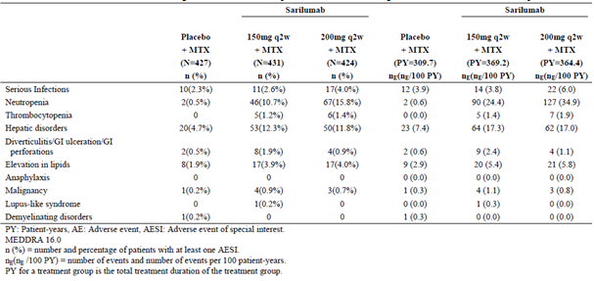

Unexpectedly, a slightly higher incidence of depression in both SAR groups compared to placebo was observed. Depression was reported for 6 patients in each SAR treatment group and 1 patient in the placebo arm. However, overall TEAEs in the SOC of psychiatric disorders were balanced between the 3 treatment groups. At baseline, a history of depression was reported for 29 (6.8%) patients in the placebo group, 18 (4.2%) subjects in the SAR 150 mg arm and 25 (5.9%) patients in the SAR 200 mg group. In Part B of Study EFC11072, 7 patients had both a medical history and a reported TEAE of depression (2 were in the SAR 150 mg group and 5 were in the SAR 200 mg arm). Of the 13 patients with investigator-reported AEs of depression, 10 patients had non-serious rated AEs (1 in the placebo group, 5 in the SAR 150 mg arm and 4 in the SAR 200 mg group). Eleven patients, all in SAR groups, initiated treatment with anti-depressant medication and 8 recovered during the trial. Depression was assessed to be of mild intensity in 5 patients, moderate intensity in 7 patients and severe intensity in 1 patient. Depression led to permanent withdrawal of treatment in 2 patients, both in the SAR treatment groups.

###### Study EFC10832

During the double blind treatment period of Study EFC10832, a higher overall incidence of TEAE was observed in the 2 SAR treatment groups (65.7% (119/181) in the SAR 150 mg arm and 65.2% (120/184) in the SAR 200 mg group) compared with the placebo arm (49.7%; 90/181).

Infection was the most frequently reported type of TEAE in each of the 3 treatment groups, occurring at a similar frequency across the 3 treatment groups: 26.5% (48/181) in the placebo group, 22.1% (40/811) in the SAR 150 mg arm and 30.4% (56/184) in the SAR 200 mg group. Within the SOC of infection, the following types of infection by Preferred Term (PT) were most frequently noted: urinary tract infection (6.6% incidence in the placebo group, 3.3% in the SAR 150 mg arm and 7.1% in the SAR 200 mg group), nasopharyngitis (5.0% in the placebo group, 6.1% in the SAR 150 mg arm and 3.8% in the SAR 200 mg group), pharyngitis (1.7% in the placebo group, 1.1% in the SAR 150 mg arm and 3.3% in the SAR 200 mg group) and upper respiratory tract infection (3.3% for placebo and SAR 200 mg versus 2.2% for SAR 150 mg). Other types of infection (by PT) were only recorded in SAR treated subjects. These AEs included 3 cases of oral herpes (all in SAR 200 mg treated subjects), 5 cases of pneumonia (2 in the SAR 150 mg group and 3 in the SAR 200 mg arm) and 2 cases of fungal skin infection (both in the SAR 200 mg dose group).

The following types of TEAEs had > 2% higher incidence in the SAR treated groups (both doses) compared to placebo: neutropaenia, elevation of serum lipids, injection site reactions (in particular, erythema and pruritus) and elevation of serum transaminases. Neutropaenia was recorded in 12.7% (23/181) of patients in the SAR 150 mg group and 12.5% (23/184) of subjects in the SAR 200 mg arm compared with 1.1% (2/181) of patients in the placebo arm. There were also 5 cases of leucopaenia reported in SAR treated subjects (2 in the 150 mg dose group and 3 in the 200 mg arm versus 0 in the placebo group). Moreover, 6 cases of thrombocytopaenia (5 in the SAR 200 mg group and 1 case in the SAR 150 mg arm versus 0 in the placebo group) were identified. Elevations of serum lipid parameters were reported in 11.6% (21/181) of patients in the SAR 150 mg group and 8.2% (15/184) of subjects in the SAR 200 mg arm compared with 1.7% (3/181) of patients in the placebo arm. Injection site reactions were reported in 8.8% (16/181) of patients in the SAR 150 mg group and 8.2% (15/184) of subjects in the SAR 200 mg arm compared with 1.1% (2/181) of patients in the placebo arm. The majority of injection site reactions were localised events of erythema (18 AEs across the 2 SAR treatment groups versus 0 in the placebo arm) and pruritus (9 AEs across the 2 SAR treatment groups versus 0 in the placebo arm). Elevations of serum transaminases were reported in 5.0% (9/181) of patients in the SAR 150 mg group and 11.4% (21/184) of subjects in the SAR 200 mg arm compared with 1.1% (2/181) of patients in the placebo arm.

Two types of TEAEs (anaemia and aggravation of RA) by PT had > 2% higher incidence in the placebo arm compared to SAR treated subjects (both dose groups). Both of these AEs probably reflect lower rates of underlying RA disease control.

##### Other studies

###### Part A of Study EFC11072

The proportion of patients among the 6 treatment groups who experienced TEAEs ranged from 43.1% (22/51) in the SAR 100 mg q2w group to 72.0% (36/50) in the SAR 100 mg qw group. Although there was no clear dose response for AEs in the SAR treatment groups, the placebo arm had a relatively rate of AEs (47.1%; 24/51). For the 2 proposed commercial doses of SAR, the incidence of AEs in this trial were 53.8% (28/52) in the SAR 150 mg q2w group and 64.7% (33/51) in the SAR 200 mg q2w arm. Infections (mainly non-serious infections involving the upper respiratory and urinary tracts) were the most common type of AE in both SAR and placebo treated subjects. The incidence rate varied in the active arms from 11.8% (100 mg q2w) to 26.0% (100 mg qw) versus an incidence rate of 13.7% in the placebo group. Abnormal investigation results (neutropaenia, elevated serum transaminases and raised serum total cholesterol) were also more frequently observed in the SAR versus placebo treatment groups. Detail about these treatment related differences for investigations are covered in section 8.5 of this report. Injection site reactions (of various types) were also more common in the SAR treatment groups ranging from approximately 4% in the 3 lowest dose SAR groups (100 mg qw, 150 mg q2w and 100 mg qw) to 6.0% (3/50) in the SAR 150 mg qw group and 9.8% (5/51) in the SAR 200 mg q2w arm versus 2.0% (1/51) in the placebo group.

###### Long term Safety Population

An overview of TEAEs in the long term safety population based on incidence and exposure-adjusted incidence is provided in Table 32. A higher incidence of TEAEs was seen with SAR 200 mg versus 150 mg therapy, but when the raw incidence of TEAEs was adjusted for drug exposure, the incident rate was slightly higher in the lower SAR dose cohort. In addition, the incidence of TEAEs with both doses of SAR remained fairly constant over time (analysed by 6 to 12 month intervals up to Week 216).

Table 32: Overview of adverse event profile by incidence (Raw and Exposure Adjusted) in the Long term Safety Population

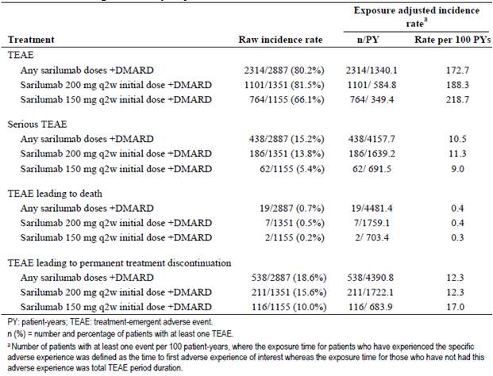

###### Clinical Pharmacology Studies

The safety observations from the Phase I studies were generally consistent with inhibition of IL‑6. However, the safety findings from 2 of those early phase studies were significant to change the direction of the SAR clinical development program.

In Study TDU11373, which enrolled 53 healthy adult volunteers to receive single SC doses of SAR 100 mg, 150 mg or 200 mg, 51% (27/53) developed Grade 3 or 4 neutropaenia. A similar incidence of neutropaenia was observed across the 3 SAR doses, however, the incidence of Grade 4 (severe) neutropaenia was lower in the 100 mg arm (14.6%; 6/41) compared with the 200 mg dose group (30.0%; 3/10). Among the 27 subjects with Grade 3 or 4 neutropaenia, 6 (22.2%) experienced infection during the 35 day study period. Four subjects developed infections (1 tooth abscess, 2 pharyngitis and 1 bronchitis) concomitant with neutropaenia, and for another 2 subjects upper respiratory tract infection occurred after their neutropaenia had resolved to > 2.0 x 109/L. Among the 26 subjects who did not experience Grade 3 or 4 neutropaenia, 3 (11.5%) had reported an infection (1 rhinitis, 1 pharyngitis and 1 gastroenteritis), all of whom had normal neutrophil counts. All infections were mild and resolved during the study. Apart from neutropaenia, all other types of TEAEs were relatively infrequent with the next most common TEAE being headache. A total of 8 subjects (15%) reported mild injection site reactions. There were no elevations in serum transaminases or increases above predefined thresholds for total cholesterol (7.74 mmol/L) or triglycerides (4.6 mmol/L).

In Study TDU10808/6R88-RA-0703 (single ascending dose study), 2 patients were enrolled in the 2 mg/kg IV cohort and 4 were included in the 0.6 mg/kg dosing arm. One patient in the SAR 2 mg/kg group experienced Grade 4 neutropaenia (0.40 x109/L) within 24 hours of drug administration. Following review of the available safety data and due to the fact that the SAR development program intended to utilise SC administration, the sponsor decided to suspend to terminate the study.

###### Study MSC12665

This was an open label, 4 arm, parallel group study of 12 weeks duration conducted in 57 centres in Europe, North and South America and South Africa, which aimed to assess the usability of SAR 150-200 mg q2w therapy given by SC injection presented as an auto-injector device (AID) or prefilled syringe (PFS). The study randomised and treated a total of 217 patients with moderate to severe active RA of at 12 weeks duration despite stable dose non-biologic DMARD therapy for at least 6 weeks prior to screening. The majority of subjects (92.6%; 201/217) completed the 12 week assessment period. Overall, 16 subjects (7.4%) discontinued, mainly due to AEs. The primary endpoint was the number of validated product associated technical failures and the secondary outcomes of relevance including the number and type of product associated complaints and patient satisfaction.

For the primary analysis, there were no product technical failures with the AID. There was one product technical complaint that was verified as a patient-use error resulting in failed drug delivery. The AID was replaced and the patient received their scheduled dose of SAR therapy. At the end of the 12 weeks, the majority of patients were either satisfied to very satisfied with the AID and very to extremely confident using the same type of AID as the one used in this study (98% and 91%, respectively). The majority patients (88%) thought the AID was very easy to use, and 98% thought the injection time was either normal, short or very short. In addition, the incidence and type of AEs seen in Study MSC12665 were consistent with the known safety profile of SAR.

#### Treatment-related adverse events (adverse drug reactions)

##### Pivotal studies

###### Part B of Study EFC11072

During the double blind treatment period of Part B of Study EFC11072 (only Cohort 2 data available), a higher overall incidence of treatment related AEs were observed in the 2 SAR treatment groups (38.7% (155/401) in the SAR 150 mg arm and 47.5% (188/396) in the SAR 200 mg group) compared with the placebo arm (24.4%; 97/397). The profile of AEs considered to be related to study treatment was similar to that observed for all TEAEs. The difference in the overall incidence of treatment related AEs between each of the SAR dose groups and also when compared to placebo is explained by several types of AEs. There was a significantly increased frequency of treatment related neutropaenia in the 2 SAR groups (8.2% (33/401) in the SAR 150 mg arm and 12.4% (49/396) in the SAR 200 mg group) compared to the placebo arm (0.3%; 1/397). There were also 4 cases (1.0%) of thrombocytopaenia identified in each of the SAR treatment groups (versus 0 cases in the placebo arm). Treatment related abnormalities of liver function tests were also more common in the 2 SAR treatment groups (7.2% (29/401) in the SAR 150 mg arm and 10.1% (40/396) in the SAR 200 mg group) compared to the placebo arm (3.8%; 15/397).

There was a slightly higher rate of treatment related infection in the SAR 150 mg group (13.2%; 53/401) compared to the SAR 200 mg arm (11.9%; 47/396) and placebo group (11.1%; 44/397). Regarding individual types of infection, there were small differences between the treatment groups for the incidence of upper respiratory tract infection (6.2% in the SAR 150 mg group versus 4.3 to 4.8% in the SAR 200 mg and placebo arms), lower respiratory tract infection (3.0% in the SAR 200 mg group versus 0.7 to 1.0% in the SAR 150 mg and placebo arms), urinary tract infection (2.2% in the SAR 150 mg group versus 0.5 to 1.3% in the SAR 200 mg and placebo arms) and herpes infection (1.2% in the SAR 150 mg group and 1.0% in the SAR 200 mg arm versus 0.5% in the placebo group, including 2 cases of herpes zoster infection in each of the 3 treatment groups). Treatment related lipid disorders were also slightly more frequent in the 2 SAR treatment groups (3.0% (12/401) in the SAR 150 mg arm and 1.5% (6/396) in the SAR 200 mg group) compared to the placebo arm (0.8%; 3/397).

Treatment related injection site reaction were more common in the 2 SAR treatment groups (8.0% (32/401) in the SAR 150 mg arm and 9.8% (39/396) in the SAR 200 mg group) compared to the placebo arm (1.3%; 5/397). Regarding individual types of injection site reactions, localised erythema and pruritus were the main types of AEs to explain this treatment related difference. Apart from the rate of treatment related neutropaenia and abnormalities of liver function tests, no clear dose response relationship for SAR was seen for individual types of AEs by SOC and/or PT nomenclature.

###### Study EFC10832

During the double blind treatment period of Study EFC10832, a higher overall incidence of treatment related AEs were observed in the 2 SAR treatment groups (33.7% (61/181) in the SAR 150 mg arm and 39.1% (72/184) in the SAR 200 mg group) compared with the placebo arm (16.6%; 30/181). The profile of AEs considered to be related to study treatment was similar to that observed for all TEAEs. The difference in the overall incidence of treatment related AEs between each of the SAR dose groups and also when compared to placebo is explained by several types of AEs. There was a higher rate of treatment related infection in the SAR 200 mg group (10.3%; 19/184) compared to the SAR 150 mg arm (5.0%; 9/181) and placebo group (6.6%; 12/181). Regarding individual types of infection, there were small differences between the treatment groups for the incidence of upper respiratory tract infection (for example 4.3% in the SAR 200 mg group versus 2.2 to 2.8% in the SAR 150 mg and placebo arms) and herpes zoster infection (for example 2 cases in the SAR 200 mg group versus 1 case in the placebo arm and 0 cases in the SAR 150 mg group), which explained the result. There was a significantly increased frequency of treatment related neutropaenia in the 2 SAR groups (9.9% (18/181) in the SAR 150 mg arm and 11.4% (21/184) in the SAR 200 mg group) compared to the placebo arm (0.6%; 1/181). There were also 3 cases (1.6% of 184 subjects) of thrombocytopaenia identified in the SAR 200 mg group (versus 0 in the other 2 arms). Treatment related lipid disorders were also more frequent in the 2 SAR treatment groups (6.1% (11/181) in the SAR 150 mg arm and 3.8% (7/184) in the SAR 200 mg group) compared to the placebo arm (1.1%; 2/181). Treatment related injection site reaction were more common in the 2 SAR treatment groups (6.6% (12/181) in the SAR 150 mg arm and 6.0% (11/184) in the SAR 200 mg group) compared to the placebo arm (1.1%; 2/181). Regarding individual types of injection site reactions, localised erythema and pruritus were the main types of AEs to explain this treatment related difference. Treatment related abnormalities of liver function tests were also more common in the 2 SAR treatment groups (2.8% (5/181) in the SAR 150 mg arm and 5.4% (10/184) in the SAR 200 mg group) compared to the placebo arm (0.6%; 1/181). Apart from the overall rate of treatment related infections and abnormalities of liver function tests, no clear dose response relationship for SAR was seen for individual types of AEs by SOC and/or PT nomenclature.

##### Other studies

###### Part A of Study EFC11072

About 25% of all TEAEs were considered to be treatment related in each of the 6 treatment groups. However, the pattern of attribution was very different for the SAR versus placebo groups. In the placebo arm, the majority of treatment related AEs were either infectious or accidental medication overdose errors. For the 5 SAR treatment groups, treatment related AEs were mainly accounted for by the abnormal investigation results (mainly, neutropaenia and elevated serum ALT) followed by infectious AEs and injection site reactions. The submission contained a 50 page table of data for this issue, which was poorly presented.

#### Deaths and other serious adverse events

##### Pivotal studies

###### Part B of Study EFC11072

Seven deaths occurred during Part B of Study EFC11072, 5 of which occurred during the double blind treatment period (2 each in the placebo and SAR 150 mg groups and 1 in the SAR 200 mg arm) and 2 patients died during the open label, rescue treatment period (1 in the placebo group and the other in the SAR 200 mg arm). Two SAR treated patients died of cardiovascular events during the double blind treatment. A 56 year old female receiving SAR 150 mg q2w therapy died of acute pulmonary oedema on study Day 21. There was no preceding history of cardiovascular disease, but autopsy revealed chronic ischaemic heart disease. A 59 year-old male receiving SAR 200 mg q2w treatment died due to a suspected cerebrovascular accident on study Day 107. He had a history of hypertension. A 71 year old male who received SAR 150 mg q2w, died 13 days after undergoing surgery for a perforated duodenal ulcer on study Day 360. He had a history of gastro-oesophageal reflux disease and coronary artery disease. Two subjects in the control group died in the double blind treatment group of suicide (Day 213) and post-operative complications following surgery for acute appendicitis (Day 277). Both deaths in the open label, rescue treatment period were related to malignancy (pancreatic adenocarcinoma and metastatic bronchial carcinoma). An additional subject (previously treated with SAR 200 mg q2w) developed pneumonia 56 days after their last injection of SAR (that is 41 days after the end of study visit), which resulted in the patient’s death 99 days after their last dose of SAR. This death was assessed as being not related to study medication by the site investigator.

In Part B of Study EFC11072, the incidences of treatment emergent SAEs were higher in the SAR treatment groups (8.8% (38/431) in the SAR 150 mg group and 11.3% (48/424) in the SAR 200 mg arm) compared with the placebo group (5.4%; 23/427).

Most types of SAEs affected < 3 individuals; however, there were some SAE types that affected multiple subjects with potential treatment related differences. The most common type of SAE by SOC was infection, which affected 2.6% (11/431) of SAR 150 mg treated subjects and 4.0% (17/424) of SAR 200 mg treated subjects compared to 2.3% (10/427) of placebo treated subjects. There were 2 cases of pneumonia in each SAR treatment group and 1 case in the control arm. Various types of skin and soft tissue infections (for example erysipelas and cellulitis) were recorded in similar numbers of placebo and SAR 200 mg treated subjects (4 cases in each group). There was also 1 case of osteomyelitis in a subject who received SAR 150 mg therapy and a patient receiving treatment with SAR 200 mg injections developed necrotising fasciitis. Urinary, ear and gastrointestinal infections were equally dispersed among the 3 treatment groups.

A total of 8 patients (3 in each SAR group and 2 in the placebo arm) developed gastrointestinal SAEs, including 1 case of duodenal ulcer perforation in a patient treated with SAR 150 mg. There were no other cases of gastrointestinal perforation in the trial. A total of 9 patients developed cardiac SAEs (4 in the placebo group, 2 treated with SAR 150 mg and 3 in the SAR 200 mg arm). One patient in each SAR treatment group experienced malignant melanoma and 1 subject in the placebo arm of Part B of Study F2312 developed squamous cell carcinoma of the skin. Three cases of breast cancer (2 in the SAR 150 mg group and 1 in the SAR 200 mg arm) were reported. Two patients in the placebo arm had reports of meningioma. Seven SAR treated subjects (3 in the 150 mg dose group and 4 in the 200 mg dose arm versus 0 in the control group) recorded neutropaenia as SAE. In addition, there was 1 SAE case of thrombocytopaenia recorded in each SAR treatment group. Elevated serum transaminases were recorded as SAEs in 5 SAR treated subjects (3 in the 150 mg dose group and 2 in the 200 mg arm) compared to no such reports in the control group.

###### Study EFC10832

There was only 1 death in this trial, which occurred in a patient enrolled in the placebo group. The subject died of injuries sustained in a road traffic accident in which she was a passenger.

A higher incidence of SAEs was observed in the SAR 200 mg q2w group (5.4%; 10/184) compared to the 2 other treatment arms (3.3% (6/181) in both the placebo and SAR 150 mg q2w groups). The most frequently reported type of SAE by SOC was infection affecting 2 subjects in the placebo group (1 case of cellulitis and 1 case of bronchitis), 1 patient in the SAR 150 mg arm (cellulitis complicated by osteomyelitis) and 2 subjects in the SAR 200 mg group (1 case each of cellulitis and pneumonia).

Three subjects (1 in each treatment group) in Study EFC10832 reported malignancy. A placebo treated subject 71 year-old female) was identified as having ureteric cancer on Day 105. A 65 year-old woman in the SAR 150 mg group was diagnosed with renal cell carcinoma on study Day 10. A 53 year-old female treated with SAR 200 mg had a squamous cell carcinoma excised from her nose on Day 13.

Three SAR treated subjects (1 in the 150 mg dose group and 2 in the 200 mg dose arm versus 0 in the control group) recorded neutropaenia as SAE. In addition, there was 1 SAE case of increased serum transaminases recorded as an SAE in a patient who received SAR 200 mg therapy. One patient in the SAR 200 mg group experienced acute myocardial infarction and 2 SAR treated subjects (1 in each dose arm) recorded venous thromboembolism. One patient in the SAR 150 mg group developed haemorrhage from a gastric ulcer.

##### Other studies

###### Part A of Study EFC11072

A 67 year old male in the SAR 100 mg q2w group died on study Day 18 of cerebrovascular accident and acute respiratory distress syndrome, which was considered to be possible treatment related. During treatment, 9 patients recorded SAEs (including the above unexpected death). Of the remaining 8 patients who had SAEs, 2 occurred in patients in the placebo group (3.9% of 51), 3 patients in the SAR 100 mg q2w treatment group (5.9% of 51) and 3 patients in the SAR 100 mg qw arm (6.0% of 50). One of the SAEs was considered to be treatment related. A patient (42 year old female) in the SAR 100 mg qw treatment group experienced a systemic hypersensitivity reaction 70 minutes after receiving her first dose of SAR which was characterised by erythema on her arms, chest and face. There was no cardiorespiratory compromise and the SAE recovered within hours after treatment with anti-histamines (intravenous and oral) as well as intravenous CS. The patient withdrew from the trial as a consequence. Two of the other SAEs were malignancies affecting a patient in the placebo group (squamous cell carcinoma of the cheek) and another subject in the SAR 100 mg q2w arm (plasmacytoma). Neither malignancy was considered to be treatment related. Three patients experienced worsening of musculoskeletal symptoms, 1 subject had severe neutropaenia and another patient experienced alcoholic pancreatitis.

###### Long term safety population

The exposure adjusted incidence rate of death with SAR + DMARD in the long term safety population is 0.4 deaths per 100 PY (95% CI 0.26, 0.66), which is within expectations for the matched treatment population. As of 29 April 2015, a total of 25 deaths have been reported in the long term safety population, including 3 non-cardiovascular related deaths in placebo treated subjects, 1 death related to septic shock in a subject receiving tocilizumab in Study SFY13370 and 21 deaths in patients who received combination SAR and DMARD therapy. Another 2 deaths in subjects receiving SAR + DMARD therapy have been reported after the data cut-off date of 29 April, 2015. There is also 1 additional mortality in a patient who received SAR monotherapy. The rates and causes of death reported with SAR are consistent with what would be expected in an RA patient population with underlying co-morbid disease conditions. The mortality rate in patients with RA is 2.7 deaths/100 patient years (95% CI: 2.2, 3.3), with the most frequent causes of death being MACE, malignancy and infection. Of the 21 deaths with SAR + DMARD in the long term safety population, 7 were related to MACE (including 5 cardiac, 1 stroke and 1 pulmonary embolus), 12 were not due to MACE related events (including 6 infections and 3 malignancy related deaths), 2 were of undetermined cause (including 1 additional cancer case) and 1 was not adjudicated (occurred in the Phase II study; stroke and adult respiratory distress syndrome). The exposure-adjusted rate of death with SAR + DMARD treatment did not increase over time in the long term safety population (up to month 54).

In the long term safety population, the exposure adjusted incident rate of SAEs appears to be slightly higher in the SAR 200 mg (11.3 SAEs/100 PY) versus 150 mg group (9.0 SAEs/100 PY), and the incidence of SAEs with both doses of SAR remains constant over time (analysed by 6 month periods up to 52 months). The difference between the 2 SAR dose groups is primarily explained by rate differences in the SOC of infection (4.3 SAEs/100 PY in SAR 200 mg q2w versus 3.1 SAEs/100 PY in SAR 150 mg q2w). The most frequent types of SAEs by PT were pneumonia (27 (0.9%) patients), RA (21 (0.7%) patients), osteoarthritis (20 (0.7%) patients) and neutropaenia (16 (0.6%) patients). Pneumonia occurred at a slightly higher incident rate with SAR 200 mg (0.6/100 PY) versus 150 mg therapy (0.3/100 PY). However, the incidence of neutropaenia is higher in the lower SAR dose group (0.7 versus 0.4/100 PY). In the long term safety population, 2 patients (both receiving SAR 200 mg q2w) have reported the SAE of pancytopaenia. In both cases, pancytopaenia was of acute onset and occurred 12 to 16 months after initiation of SAR. One patient was subsequently diagnosed with non-specific inflammatory bowel disease (requiring treatment) and the other had vitamin B12 deficiency as a potential confounding aetiology. Another patient in Study LTS11210 recorded persistent severe neutropaenia during most of their SAR therapy and had a reported SAE of bone marrow failure, based on bone marrow biopsy conducted 22 months after initiation of SAR. Bone marrow histology was suggestive of bone marrow hypoplasia but the amount of hematopoietic tissue available was limited. SAR and MTX were discontinued and the neutropaenia improved. Given the limited amount of hematopoietic tissue available from bone marrow biopsy, no conclusive assessment regarding bone marrow failure was feasible. Six patients reported pancreatitis in the long term safety population, but only 1 was considered to be possibly related to SAR.

#### Discontinuation due to adverse events

##### Pivotal studies

###### Part B of Study EFC11072

In this safety population, the incidence of subjects permanently discontinuing from study medication due to AEs was higher in the 2 SAR treatment groups (12.5% (54/431) in the SAR 150 mg arm and 13.9% (59/424) in the SAR 200 mg group) compared with the placebo arm (4.7%; 20/427).

The 3 most frequently reported types of AEs by SOC leading to treatment discontinuation were:

* Infections; affecting 1.4% (6/427) of subjects in the placebo group, 3.2% (14/431) of patients in the SAR 150 mg arm and 3.1% (13/424) of subjects in the SAR 200 mg group;
* Blood and lymphatic system disorders; affecting 0.2% (1/427) of subjects in the placebo group, 2.6% (11/431) of patients in the SAR 150 mg arm and 3.1% (13/424) in the SAR 200 mg group; and
* Abnormal investigation results; affecting 0.2% (1/427) of subjects in the placebo group, 2.3% (10/431) of patients in the SAR 150 mg arm and 2.8% (12/424) of subjects in the SAR 200 mg group.

Regarding the specific types of infection that led to treatment discontinuation, there were 2 cases of herpes zoster in each of the 3 treatment groups (6 events in total), 3 cases of oral herpes (2 in the SAR 150 mg group and 1 in the SAR 200 mg arm) and 2 cases of pneumonia (1 in each SAR treatment group). The remainder of infection related AEs leading to study discontinuation were single types of AEs although it is worth noting that 2 additional SAR 150 mg treated subjects developed herpes infections resulting in treatment discontinuation (1 case each of herpes zoster ophthalmic and genital herpes).

The withdrawals due to blood disorders were principally accounted for by neutropaenia (9 cases in each SAR treatment group) followed by thrombocytopaenia (2 cases in the SAR 200 mg group and 1 case in the SAR 150 mg arm). No cases of treatment discontinuation due to either neutropaenia or thrombocytopaenia were observed in the placebo group.

Withdrawing cases due to abnormal investigation results were mainly accounted for by increased serum transaminases, which affected 10 individuals in the SAR 150 mg group, 11 subjects in the SAR 200 mg arm and 1 patient in the placebo arm.

###### Study EFC10832

In Study EFC10832, a higher incidence of TEAEs leading to permanent treatment discontinuation was observed in the 2 SAR treatment groups compared to the control arm. A total of 39 subjects prematurely discontinued from this trial due to AEs. The number and frequency of AEs leading to treatment discontinuation were 4.4% (8/181) in the placebo group, 7.7% (14/181) in the SAR 150 mg arm and 9.2% (17/184) in the SAR 200 mg group. The 2 most common types of AEs leading to discontinuation were infections (affecting 5 subjects in each SAR treatment group (2.8%) and 1 patient (0.6%) in the placebo arm) and blood disorders (affecting 5 subjects in each SAR treatment group (2.8%) and 1 patient (0.6%) in the placebo arm).

Regarding the specific types of infection that led to treatment discontinuation, there were 3 cases of cellulitis (2 in the SAR 150 mg group and 1 case in the SAR 200 mg arm), 2 cases of herpes zoster (1 in the placebo group and 1 in the SAR 200 mg arm) and 2 cases of pneumonia (1 in each SAR treatment group). The remainder of infection related AEs leading to study discontinuation were single types of AEs such as breast abscess, sialoadenitis, sinusitis and infected bites.

The withdrawals due to blood disorders were principally accounted for by neutropaenia (5 cases in the SAR 150 mg treatment group, 3 in the SAR 200 mg arm and 1 in the placebo group) and 1 case of thrombocytopaenia in a patient treated in the SAR 200 mg group. Four patients (2 in the SAR 200 mg group and 1 each in the other 2 arms) ceased involvement in Study EFC10832 due to abnormalities of liver function tests.

##### Other studies

###### Part A of Study EFC11072

A total of 28 patients experienced AEs that led to permanent treatment discontinuation, 6 of which were classified as SAEs. There was considerable variability across the treatment groups for the incidence of AEs that led to discontinuation. In the placebo and SAR 150 mg q2w treatment groups the discontinuation rate was low and comparable at 3.9% (2/51) and 3.8% (2/52), respectively. The frequency of cessation was 7.8% (4/51) in both the SAR 100 mg q2w and 200 mg q2w, and 6.0% (3/50) in the SAR 150 mg qw arm. However, in the SAR 100 mg qw treatment arm 13 subjects (26.0% of 50) withdrew because of AEs. Six of these 13 patients stopped treatment because of neutropaenia (4 of which were Grade 4 neutropaenia and 2 were Grade 3). Overall, neutropaenia was the AE resulting in the highest incidence of permanent treatment discontinuation affecting 7 patients in total (1 additional patient in the SAR 200 mg q2w group developed Grade 3 neutropaenia). The incidence of infections leading to permanent treatment discontinuation was low. There was 1 patient in the SAR 100 mg qw group who withdrew after experiencing urinary tract infection and 1 patient in the SAR 150 mg q2w arm withdrew because of herpes zoster infection involving the face.

###### Long term safety population

The exposure-adjusted discontinuation rate did not increase in the long term safety population. BY SOC, infection was the most common cause of treatment discontinuation affecting 3.9% (174/2887) of individuals at a rate of 3.9 AEs per 100 PY. By PT, neutropaenia (3.0%; 86/2887; 1.9 events per 100 PY), increased serum ALT (2.6%; 73/2887; 1.7 events per 100 PY) and herpes zoster infection (1.0%; 29/2887; 0.6 events per 100 PY) remained the most frequent types of AEs leading to permanent discontinuation from SAR therapy. The highest incidence of drug cessation due to AEs occurred during the first 48 weeks of SAR therapy and was 14% overall. After the initial 48 weeks of therapy, the average rate of treatment discontinuation per 48-week period was stable at 5%.

### Laboratory tests

#### Liver function

##### Pivotal studies

###### Part B of Study EFC11072

During the double blind period of this trial, mean increases from Baseline were observed in serum transaminases (ALT and AST) as well as serum total bilirubin for both doses of SAR compared with placebo. The mean values of ALT, AST and total bilirubin remained within the normal range for all 3 treatment groups. However, from a baseline mean value of 20 to 22 U/L for serum transaminases, both doses of SAR increased serum ALT by 40 to 45% (versus no change with placebo) and both doses of SAR increased serum AST by 25% (versus no change with placebo). From a baseline mean of 6.65 µmol/L, serum total bilirubin increased to 10.6 µmol/L in the SAR 200 mg group and increased to 9.8 µmol/L in the SAR 150 mg arm versus no change from Baseline in the control group (placebo+DMARD).

A greater percentage of subjects treated with SAR recorded elevations of serum transaminases compared to the control arm, refer to Table 33. The incidence of raised serum ALT was 44.5% (192/431) in the SAR 150 mg group, 53.8% (228/424) in the SAR 200 mg arm and 32.8% (140/427) in the placebo group. The incidence of raised serum AST was 40.1% (173/431) in the SAR 150 mg group, 41.3% (175/424) in the SAR 200 mg arm and 19.4% (83/427) in the placebo group. Increases in serum transaminases were mostly mild (that is > 1 to 3 x ULN), but the incidence of moderate serum transaminases elevations (that is > 3 to 5 x ULN) was also higher in the SAR treatment groups versus placebo (irrespective of the SAR dose; 150 mg versus 200 mg q2w). One patient (62 year old male) in the SAR 150 mg group developed a concurrent increase in serum ALT/AST > 10 x ULN and total bilirubin > 5 x ULN on study Day 275 (7 days after last dose of SAR), which was attributed to toxic hepatitis from recent exposure to sulfuric and hydrochloric acid. Liver function tests and serum bilirubin normalised within 3 weeks, but SAR was permanently discontinued.

A total of 84 patients (9 in the placebo group, 41 in the SAR 150 mg arm and 34 in the SAR 200 mg group) experienced ALT > 3 x ULN. The majority of these subjects developed an increase in ALT within 3 months of commencing study treatment. For almost half (39 patients; 7 in the placebo group, 19 in the SAR 150 mg arm and 13 in the SAR 200 mg group) the raised ALT reading normalised while continuing study treatment and for another 17 subjects, liver function test abnormalities resolved following permanent cessation of study medication. The same pattern of outcomes was observed for the 17 SAR treated subjects (10 in the 150 mg dose group and 7 in the 200 mg arm) who developed AST > 3 x ULN. There was also a higher incidence of SAR treated patients (3.5% (15/431) in the SAR 150 mg group and 2.8% (12/424) in the SAR 200 mg arm) experiencing an increase in total bilirubin > 1.5 x ULN compared to placebo (0 subjects).

Table 33: Number and incidence of abnormal liver function tests in Part B of Study EFC11072

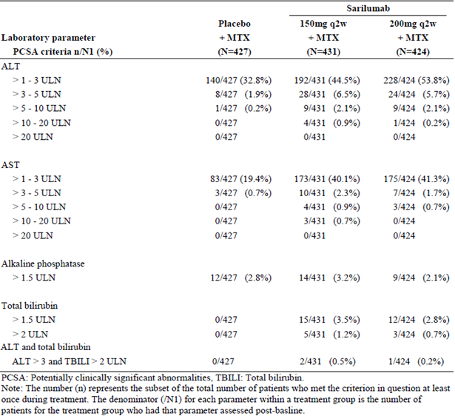

###### Study EFC10832

During the 24 week double blind period of Study EFC10832, mean increases from Baseline were observed in serum transaminases (ALT and AST) as well as serum total bilirubin for both doses of SAR compared with placebo. The mean values of ALT, AST and total bilirubin remained within the normal range for all 3 treatment groups. However, from a baseline mean value of 20 to 21 U/L for serum transaminases, both doses of SAR increased serum ALT by approximately 40% (versus no change with placebo) and both doses of SAR increased serum AST by approximately 25% (versus no change with placebo). From a baseline mean of 6.5 µmol/L, serum total bilirubin increased to 11.0 µmol/L in the SAR 200 mg group and increased to 9.0 µmol/L in the SAR 150 mg arm versus no change from Baseline in the control group (placebo+DMARD).

As summarised in Table 34, there was a higher incidence of raised serum ALT and AST values observed in the SAR treatment groups compared to placebo, with no clear dose relationship for effect. The incidence of raised serum ALT was 27.8% (50/180) in the SAR 150 mg group, 28.0% (51/182) in the SAR 200 mg arm and 18.2% (33/181) in the placebo group. The incidence of raised serum AST was 17.8% (32/180) in the SAR 150 mg group, 19.2% (35/182) in the SAR 200 mg arm and 12.2% (22/181) in the placebo group. Increases in serum transaminases were mostly mild (that is > 1 to 3 x ULN), but the incidence of moderate serum transaminases elevations (that is > 3 to 5 x ULN) was also higher in the SAR treatment groups (particularly for the higher SAR dose of 200 mg q2w) versus placebo.

Table 34: Number and incidence of abnormal liver function tests in Study EFC10832

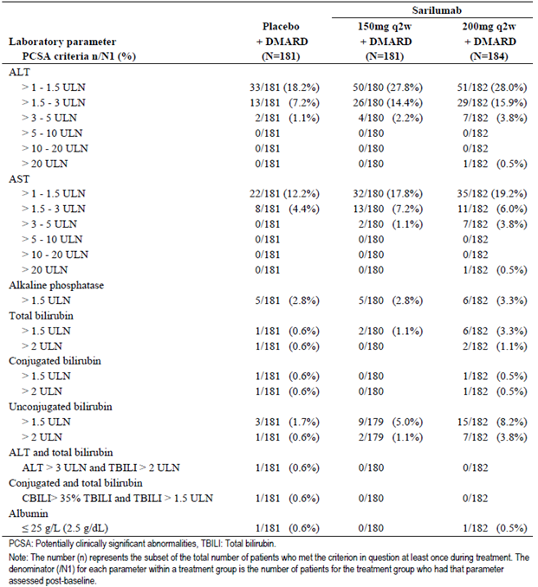

One patient (77 year old female) in the SAR 200 mg group (plus concomitant oral MTX 15  mg/week) experienced an increase in serum ALT > 20 x ULN on study Day 116. All prior liver function tests were normal and investigation (imaging and viral serology) was unrevealing as to aetiology. SAR therapy was permanently discontinued and MTX was temporarily interrupted. A total of 14 patients (2 in the placebo group, 4 in the SAR 150 mg arm and 8 in the SAR 200 mg group) experienced ALT > 3 x ULN. Six patients (1 in the placebo group, 3 in the SAR 150 mg arm and 2 in the SAR 200 mg group) had their initial episode of ALT > 3 x ULN within 14 days after their last dose of study medication. The remaining 8 patients reinitiated study medication after the initial episode of increased serum ALT and half of them could be reinitiated within the specified dosing interval (≤ 17 days from prior dose). The same pattern of outcomes was observed for the 9 SAR treated subjects (2 in the 150 mg dose group and 7 in the 200 mg arm) who developed AST > 3 x ULN. There was a higher incidence of SAR treated patients (5.0% (9/179) in the SAR 150 mg group and 8.2% (15/182) in the SAR 200 mg arm) experiencing an increase in unconjugated bilirubin > 1.5 x ULN compared to placebo (1.7%; 3/181).

##### Other studies

###### Part A of Study EFC11072

Eleven patients developed abnormalities of liver function tests, all of which were increased serum transaminases, particularly raised ALT. The incidence of increased liver function tests ranged from 3.9% (in the SAR 200 mg q2w group) to 6.0% (for the SAR 150 mg q2w arm). No subjects in the placebo or lowest dose SAR group (100 mg qw) recorded abnormal liver function tests during the trial. Three patients discontinued from the study because of increased ALT. All cases were reversible and no cases met the criteria of ALT > 3 x ULN with concomitant total bilirubin > 2 x ULN.

###### Long term safety population

As expected, the incidence of abnormal liver function tests was numerically higher in the long term safety population, but the overall pattern of abnormal liver function tests were consistent with what was seen in the placebo controlled populations with the majority of elevations being ALT > 1 to 3 x ULN. The onset of the ALT > 3 x ULN was most prevalent within the first 6 months of administration with no trend of increasing occurrence over time. There was a numerically higher incidence of raised serum ALT values in the SAR 200 mg q2w dose group (27.7%; 373/1345) compared to the SAR 150 mg q2w arm (23.4%; 269/1151), but with similar incidences in both dose groups for the occurrence of ALT > 5 x ULN (1.0 to 2.0%), refer to Table 35. In the long term safety population, 6 patients recorded serum ALT values > 3 x ULN in conjunction with total serum bilirubin > 2 x ULN. All of the patients had other plausible explanations for the elevations (for example biliary pancreatitis, suspected bile duct stone, recent hepatic abscess and cholelithiasis). Therefore, these cases did not fulfil criteria for Hy’s law. In the long term safety population, 10 patients on SAR had serum ALT values > 10 x ULN, of which 3 patients had total bilirubin > 2 x ULN (including 3 of the above mentioned subjects). Of the remaining 7 patients, 2 patients were diagnosed with cholelithiasis and 1 patient was diagnosed with endocarditis. In the remaining 4 patients the aetiology was not determined.

As per protocol, SAR was to be discontinued in the case of ALT > 5 x ULN or in case of ALT > 3 x ULN and concomitant total serum bilirubin > 2 x ULN (unless the patient had documented Gilbert’s disease). If ALT was ≥ 3 x ULN and ≤ 5 x ULN and bilirubin ≤ 2 x ULN, SAR was to be temporarily withheld and could be re-initiated once the ALT value was < 3 x ULN. Of the 254 patients on any dose of SAR who had an ALT reading > 3 x ULN, 132 (52%) patients normalised on-treatment (that is at least 1 ALT value was normal within ≤ 17 days after last dose of SAR), 57 (22%) patients normalised after discontinuation of SAR and 65 (26%) patients had not normalised as of the last available reading. In the 65 patients who had not normalised, 28 (43%) patients were still enrolled in a study and receiving ongoing SAR therapy. Of the patients who had permanently discontinued SAR but normalisation was not documented, the median time of the ALT last value from their last dose of SAR was 43 days. In the majority of these patients, the last measured ALT value was < 3 x ULN (that is reducing over time).

Table 35: Number and incidence of abnormal liver function tests in long term Safety Population

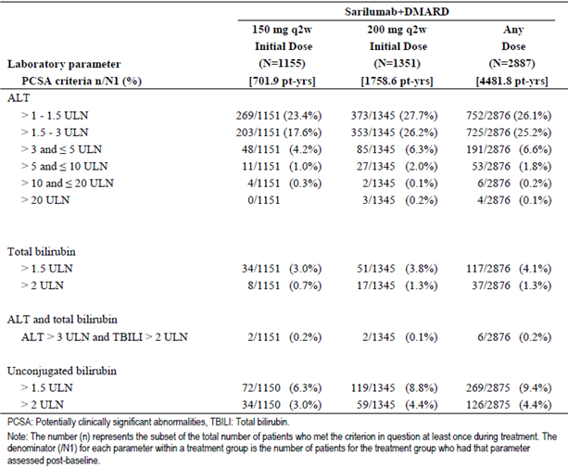

#### Kidney function

##### Pivotal studies

###### Part B of Study EFC11072

The proportion of patients with ≥ 30% change from Baseline in serum creatinine was higher in the SAR treatment groups (14.2% (61/431) in the SAR 150 mg arm and 13.7% (58/424) in the SAR 200 mg group) compared to the placebo arm (9.1%; 39/427). There were no clinically relevant differences between the 3 treatment groups for changes (increase) in blood urea nitrogen. However, patients in the SAR treatment groups also had a higher percentage of subjects (21.2% (91/429) in the SAR 150 mg arm and 21.6% (91/422) in the SAR 200 mg group) with raised serum urate readings (> 408 µmol/L or 6.86 mg/dL) compared to the placebo arm (14.1%; 60/427).

###### Study EFC10832

Over 24 weeks of treatment, there were small and similar mean increases (approximately 10%) from Baseline in serum creatinine and blood urea nitrogen with both doses of SAR, but no significant mean change from Baseline in kidney function in the control group.

The proportion of patients with ≥ 30% change from Baseline in serum creatinine was 11.0% (20/181) in the placebo group, 13.9% (25/181) in the SAR 150 mg arm and 18.1% (33/184) in the SAR 200 mg group. The majority of these abnormal readings were transient but in 4 of these patients (2 in the placebo group and 2 in the SAR 200 mg arm) there was ≥ 30% change from Baseline in serum creatinine for at least 2 scheduled assessments. One patient in the placebo group was diagnosed with urothelial carcinoma and the other patient had urinary tract infection. Diagnostic evaluation or potential aetiology was not reported in either of the SAR treated patients (both were > 70 years of age with a history of hypertension), who had both completed the study.

##### Other studies

###### Part A of Study EFC11072 and Long term Safety Population

No clinically relevant changes were observed for renal function. In the long term safety population, 10 patients reported an AE of renal failure and/or impairment, all of which were not treatment related. This includes 7 cases of acute renal impairment due to dehydration from either sepsis and/or hyperglycaemia. However, in Study SFY13370, a small but similar increase from Baseline in serum creatinine was observed with both SAR and tocilizumab.

#### Other clinical chemistry

##### Pivotal studies

###### Studies EFC11072 (Part B) and EFC10832

There were no notable differences related to electrolyte and glucose readings (mean and the percentage of individual abnormal results) between the 3 treatment groups.

##### Other studies

###### Part A of Study EFC11072 and Long term Safety Population

No clinically relevant changes were observed for clinical chemistry.

#### Haematology

##### Pivotal studies

###### Part B of Study EFC11072

At 52 weeks, there was a dose dependent mean decrease from Baseline in the neutrophil cell count observed in both SAR groups (-1.97 x 109/L for SAR 150 mg and -2.68 x 109/L for SAR 200 mg) compared to placebo (no significant change; baseline mean neutrophil cell count of 6.0 x 109/L across the 3 treatment groups). There were no clinically relevant changes in other white blood cell types, including lymphocytes.

Neutropaenia was recorded in a higher percentage of SAR treated subjects (10.7% (46/431) in the SAR 150 mg group and 15.8% (67/424) in the SAR 200 mg arm) compared to the placebo group (0.5%; 2/427). The majority of neutropaenia was rated as non-serious. Patients with a neutrophil count below the LLN did not have a higher incidence of infection compared with those patients with normal absolute neutrophil count. Neutropaenia was one of the most frequently reported AEs, but only 8 neutropaenia AEs (3 patients in the SAR 150 mg group and 5 subjects in the SAR 200 mg arm) were rated as SAEs. There was no case of neutropaenia resulting in hospitalisation. Approximately half of all subjects identified with neutropaenia continued with study medication. However, a significant number of other subjects prematurely discontinued as a result of neutropaenia (9 patients (2.1%) in the SAR 150 mg group and 10 subjects (2.4%) in the SAR 200 mg arm versus no patient in the placebo group). With treatment discontinuation the majority of cases resolved, however, some subjects had persistent neutropaenia at their last assessment following drug cessation.

In Part B of Study EFC11072, the mean baseline platelet count was 340 to 350 x 109/L for the 3 treatment groups. At 52 weeks, a mean decrease to 241 to 248 x 109/L was seen in the SAR treatment arms and to 319 x 109/L for the placebo group. Nine SAR treated patients (4 in the 150 mg dose group (0.9% of 431) and 5 in the 200 mg arm (1.2% of 423)) developed significant thrombocytopaenia (platelet count < 100 x 109/L) versus no subjects in the placebo arm. For 8 of the 9 subjects, the platelet count reduction had a nadir in the 50 to 100 x 109/L range, but 1 patient had a platelet count of < 25 x 109/L. Three subjects permanently discontinued treatment because of thrombocytopaenia, and for 4 of the patients continuing SAR, thrombocytopaenia was an isolated and transient finding.

###### Study EFC10832

Over 24 weeks, mean decreases from Baseline in the total white blood cell count were observed in both SAR groups (-1.66 x 109/L for SAR 150 mg and -2.39 x 109/L for SAR 200 mg), secondary to mean decreases in the neutrophil count, compared to placebo (no significant change; baseline mean total white cell count of 8.5 to 9.0 x 109/L across the 3 treatment groups). There were no clinically relevant changes in other white blood cell types, including lymphocytes.

As summarised in Table 36, a higher incidence of Grade 1-3 neutropaenia was observed in the SAR 200 mg group (8.7 to 16.4%) than in the SAR 150 mg arm (5.5 to 14.4%) and the placebo group (0.6 to 2.8%). The incidence of Grade 4 neutropaenia was comparable between the SAR treatment groups (1.1 to 2.2%). Patients with a neutrophil count below the LLN did not have a higher incidence of infection compared with those patients with normal absolute neutrophil count. Neutropaenia was one of the most frequently reported AEs, but only 3 neutropaenia AEs (1 patient in the SAR 150 mg group and 2 subjects in the SAR 200 mg arm) were rated as SAEs. There was no case of neutropaenia resulting in hospitalisation. Approximately half of all subjects identified with neutropaenia continued with study medication. However, a significant number of other subjects prematurely discontinued as a result of neutropaenia (5 patients in the SAR 150 mg group, 4 subjects in the SAR 200 mg arm and 1 patient in the placebo group). Some subjects had persistent neutropaenia at their last assessment and enrolled into Study LTS11210 (2.2% (4/184) in the SAR 200 mg group, 1.7% (3/181) in the SAR 150 mg arm and 0.6% (1/181) in the placebo group).

Table 36: Number and percentage of subjects with neutropaenia (by Grade) in Study EFC10832

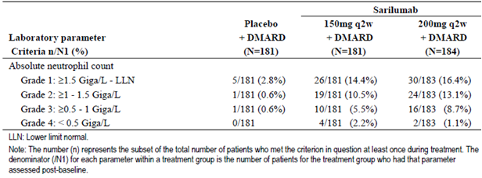

In Study EFC10832, the mean baseline platelet count was 325 x 109/L for the SAR 150 mg group and 350 x 109/L for the SAR 200 mg and placebo groups. At 24 weeks, a mean decrease to 240 to 250 x 109/L was seen in the SAR treatment arms and to 325 x 109/L for the placebo group. Six patients in the SAR 200 mg group developed significant thrombocytopaenia (platelet count < 100 x 109/L) versus no subjects in the other 2 treatment groups. For 5 of the 6 subjects, the platelet count reduction had a nadir in the 50 to 100 x 109/L range, but 1 patient had a platelet count nadir of 7 x 109/L on Day 31, which was 189 x 109/L the following day, suggesting laboratory error.

##### Other studies

###### Part A of Study EFC11072

A total of 24 patients recorded neutropaenia: 10 patients (19.6% of 51) in the SAR 200 mg q2w group, 7 subjects (14.0% of 50) in the SAR 100 mg qw arm, 6 patients (12.0% of 50) in the SAR 150 mg qw group and 1 subject (1.9% of 52) in the SAR 150 mg q2w arm. No subjects in the placebo and lowest dose SAR groups developed neutropaenia. Of the affected cases, 1 case of asymptomatic Grade 4 neutropaenia was reported as a medically important SAE. No cases of thrombocytopaenia (platelet count < 100 x 109/L) were observed in this trial.

###### Long term safety population

As expected with the longer observation periods, the incidence of neutropaenia (any Grade) was numerically higher in the long term safety population affecting 15.5% (179/1153) of patients who received SAR 150 mg q2w therapy and 19.8% (267/1346) of subjects given SAR 200 mg q2w. The incidence of severe neutropaenia< 1.0 x 109/L was also numerically higher in patients taking SAR 200 mg q2w (9.7%; 131/1346) versus SAR 150 mg q2w (5.9%; 68/1153) in the long term safety population. The exposure adjusted rate of neutropaenia appeared to reduce over time as seen in a Kaplan-Meier plot for time to onset of neutropaenia< 1.0 x 109/L 6 month intervals which shows the highest frequency occurs in the first 6 months of treatment and the event rate decreases over time (up to 216 months).

In the long term studies protocol, SAR was to be permanently discontinued in case of Grade 4 neutropaenia (neutrophil count < 0.5 x 109/L) or Grade 3 neutropaenia with associated infection (neutrophil count > 0.5 and < 1.0 x 109/L. In the setting of Grade 3 neutropaenia without associated infection, administration of SAR was to be temporarily withheld and re-initiated after the neutrophil count was ≥ 1.0 x 109/L (that is Grade 2 neutropaenia). Of the 322 patients on any dose of SAR in the long term safety population who had an neutropaenia< 1.0 x 109/L, 67% (215 patients) normalised on-treatment (that is at least one neutrophil count was normal within ≤ 17 days after last dose of SAR), 23% (75 patients) normalised after discontinuation of SAR and 10% (32 patients) had not normalised as of the last available assessment. In the 32 patients who had not normalised, half (17 patients) were still enrolled in the studies and receiving SAR therapy. Of the 15 patients who had permanently discontinued SAR therapy but neutrophil count normalisation was not documented, the median time of the last value was 20 days from their last SAR dose.

In the long term safety population (with any dose of SAR therapy), a total of 57 patients (2.0% of 2,878) were observed to develop platelet count < 100 x 109/L. There was a numerically higher incidence of thrombocytopaenia observed in the SAR 200 mg q2w group (2.2%; 30/1,345) than in the SAR 150 mg q2w treated cohort (0.7%; 8/1,153). The time to onset of platelet count < 100 x 109/L was most prevalent within the first 6 months with no trend of increasing event rate over time.

A total of 5 patients (all treated with SAR 200 mg q2w therapy) developed severe persistent thrombocytopaenia (platelet count < 50 x 109/L) in the long term safety population, but other potential aetiological factors may have also been involved in each of those cases. SAR was to be discontinued if platelet count < 50 x 109/L or < 100 x 109/L with evidence of bleeding. If the platelet count was 50 to 100 x 109/L with no evidence of bleeding, SAR therapy was to be temporarily withheld and re-initiated once platelet count > 100 x 109/L. Of the 57 patients on any dose of SAR who had a platelet count < 100 Giga/L, 58% (33 patients) normalised on treatment (that is at least one platelet count was normal within ≤ 17 days after last dose of SAR), 21% (12 patients) normalised after ceasing SAR and 21% (12 patients) had not normalised as of the last available assessment.

#### Lipid profile

##### Pivotal studies

###### Part B of Study EFC11072

Compared with placebo, mean increases from Baseline in lipid profiles were observed in the SAR treatment groups, but overall they remained within the normal range. At 52 weeks, there was a mean increase in LDL of 0.36 to 0.43 mmol/L, in HDL of 0.01-0.04 mmol/L and serum triglycerides of 0.33 to 0.34 mmol/L in the SAR groups versus in the placebo arm, there was a mean increase in LDL of 0.02 mmol/L, and a mean decrease in both HDL of 0.001 mmol/L and triglycerides of 0.03 mmol/L.

During the study, a higher incidence of raised lipid results observed in the SAR treatment groups compared to placebo, with no clear dose relationship for effect. The incidence of raised lipid values was 3.9% (17/431) in the SAR 150 mg group, 4.0% (17/424) in the SAR 200 mg arm and 1.9% (8/427) in the placebo group. The majority of cases of abnormal lipid profiles were explained by elevations in serum triglycerides: 1.6% (7/431) in the SAR 150 mg group and 1.7% (7/424) in the SAR 200 mg arm versus 0.5% (2/427) in the placebo group. No subjects had elevations of serum triglycerides that were associated with pancreatitis. During the trial, lipid lowering therapy was initiated in 3.0% (13/431) of patients in the SAR 150 mg group and 3.1% (13/424) of subjects in the SAR 200 mg arm versus 3 patients in the placebo group (0.7% of 427).

###### Study EFC10832

In Study EFC10832, the baseline mean value of LDL was 2.80 mmol/L and for triglyceride was 1.65 mmol/L. At 24 weeks, mean increases in serum LDL (to 3.2-3.3 mmol/L) and triglyceride levels (to 2.0 mmol/L in the SAR 150 mg group and 1.70 in the SAR 200 mg arm) were observed in the SAR groups compared to placebo (no significant change from Baseline). All 3 treatment groups showed a mean increase in HDL from Baseline (1.52 mmol/L), with a higher increase observed in the 2 SAR groups (1.60 mmol/l) compared to the placebo arm (no change).

There was a higher incidence of raised lipid results observed in the SAR treatment groups compared to placebo, with no clear dose relationship for effect. The incidence of raised lipid values was 11.6% (21/181) in the SAR 150 mg group, 8.2% (15/184) in the SAR 200 mg arm and 2.8% (5/181) in the placebo group. The majority of cases of abnormal lipid profiles were explained by elevations in serum triglycerides: 7.2% (13/181) in the SAR 150 mg group and 3.3% (6/184) in the SAR 200 mg arm versus 1.7% (3/181) in the placebo group. No subjects had elevations of serum triglycerides that were associated with pancreatitis. During the trial, statin therapy was initiated in 3.9% (7/181) of patients in the SAR 150 mg group and 4.3% (8/184) of subjects in the SAR 200 mg arm. No patient in the placebo group initiated statin therapy during the study.

##### Other studies

###### Part A of Study EFC11072

In this study, the mean changes from Baseline for serum total cholesterol were greater in the SAR groups compared with placebo. Lipid changes became evident at Week 4 and remained stable thereafter. At Week 12, the mean change from Baseline was 3.1 mmol/L, 23.4 mmol/L, 20.15 mmol/L, 21.8 mmol/L, 26.4 mmol/L and 31.2 mmol/L for the placebo, SAR 100 mg q2w, SAR 150 mg q2w, SAR 100 mg qw, SAR 200 q2w and SAR 150 mg qw treatment groups, respectively. The incidence of potentially significant abnormalities for total cholesterol and LDL cholesterol were more frequent in SAR treated subjects (dose independent) than for placebo patients.

###### Long term safety population

In the long term safety population, elevations in lipid parameters remained consistent with what was observed in the placebo-controlled populations. A total of 119 patients (4.1%) in the long term safety population had a serum triglyceride value > 5.6 mmol/L, none of which resulted in clinical AEs of pancreatitis. Increases in lipid profiles were observed at Week 4 for LDL, triglycerides and HDL, and the changes remained stable thereafter. At Week 4, the mean LDL increased by approximately 14 mg/dL, mean triglyceride levels increased by approximately 23 mg/dL and mean HDL values rose by approximately 3 mg/dL.

#### Electrocardiograph

##### Pivotal studies

###### Studies EFC11072 (Part B) and EFC10832

There were no notable differences between the 3 treatment groups related to ECG parameters (mean and the percentage of individual abnormal results).

##### Other studies

###### Part A of Study EFC11072 and long term safety population

No clinically relevant changes were observed for ECG parameters.

#### Vital signs

##### Pivotal studies

###### Part B of Study EFC11072

There were no significant mean changes from Baseline in blood pressure measurements in any of the treatment groups over the course of the trial. However, the percentage of patients with increased systolic blood pressure changes (that is > 160 mmHg, and an increase from Baseline of > 20 mmHg) was higher in the SAR groups (5.6% (24/431) in the SAR 150 mg group and 5.2% (22/423) in the SAR 200 mg arm) compared to the placebo arm (3.5%; 15/426). The same finding was observed for the proportion of subjects in each treatment group with increases from Baseline in diastolic blood pressure readings.

The percentage of subjects with an increase in weight of ≥ 5% from Baseline was higher in the SAR treatment groups (32.7% (141/431) in the SAR 150 mg group and 34.2% (145/424) in the SAR 200 mg arm) compared to the placebo group (15.0%; 64/427).

###### Study EFC10832

The incidence of patients with orthostatic systolic blood pressure changes (that is ≤ 20 mmHg decrease from Baseline) was increased in the SAR groups (7.8% (14/180) in the SAR 150 mg group and 8.8% (16/182) in the SAR 200 mg arm) compared to the placebo arm (3.9%; 7/180). None of the patients with orthostatic blood pressure changes reported associated clinical symptoms.

The percentage of subjects with an increase in weight of ≥ 5% from Baseline was higher in the SAR treatment groups (11.2% (20/179) in the SAR 150 mg group and 19.8% (36/182) in the SAR 200 mg arm) compared to the placebo group (8.9%; 16/180).

##### Other studies

###### Part A of Study EFC11072 and long term safety population

No clinically relevant changes were observed for vital signs, including blood pressure and changes from Baseline in subject weight.

#### Immunogenicity

Immunogenicity findings (that is detection of anti-drug antibodies (ADA)) are highly dependent on the sensitivity and specificity of assays, among other factors including sample handling, timing of sample collection and concomitant medications. Immunogenicity was evaluated throughout the SAR clinical program and a validated ADA assay was used to assess immunogenicity in all clinical studies except for 4 of the Phase I studies. A brief description of ADA assays is provided. Initially, a non-validated electro chemiluminescence based bridging assay was developed to detect ADA in human serum samples. The non-validated assay was used to assess samples from the early Phase I clinical studies (TDU10808/6R88-RA-0703, TDU10809/6R88-RA-0801, ACT10804/6R88-RA-0803 and TDU10805/6R88-RA-0802). This method was a non-quantitative, titre-based immunoassay using a MesoScale Discovery instrument which involved potentially 3 different tiers of evaluation of a sample. The assay cut points were generated using naïve human serum samples from healthy subjects. Subsequently, the non-validated method was modified to address assay interferences identified during the analysis of samples from these early Phase I studies. The validated method used in the subsequent trials (including the Phase II-III program) had appropriate cut-off values and assay sensitivity.

##### Pivotal studies

###### Part B of Study EFC11072

The incidence of patients with any positive ADA assay result (that is having at least 1 positive sample) during the study was 5.9% (25/427) in the placebo group, 22.6% (97/430) in the SAR 150 mg arm and 16.0% (68/424) in the SAR 200 mg group. The frequency of new positive ADA assay results during the treatment period (that is ADA negative at Baseline and becoming ADA positive on treatment or ADA positive at Baseline with at least a 4 fold increase in ADA titre on treatment) was 4.2% (18/427) in the placebo group, 19.8% (85/430) in the SAR 150 mg arm and 14.6% (62/424) in the SAR 200 mg group, refer to Table 37. The presence of neutralising anti-drug antibodies was low at 0.2% (1/427) in the placebo group, 3.5% (15/430) in the SAR 150 mg arm and 2.4% (10/424) in the SAR 200 mg group. A persistent positive ADA assay result (that is at least 2 consecutive post-baseline samples were positive or the last post-baseline sample collected was positive) was observed in 2.3% (10/427) of patients in the placebo group, 7.9% (34/430) of subjects in the SAR 150 mg arm and 6.1% (26/424) of patients in the SAR 200 mg group. In addition, patients were grouped by ADA status (positive or negative), regardless of treatment group, for assessment of lack or loss of efficacy (for example switch to open label rescue treatment after achieving ACR50 response) and treatment emergent hypersensitivity (local and systemic reactions). The rates of the above efficacy and safety outcomes were similar for SAR treated subjects regardless of their ADA status (albeit small patient numbers in subgroups).

Table 37: Summary of Anti-Drug Antibody (ADA) Results in Part B of Study EFC11072

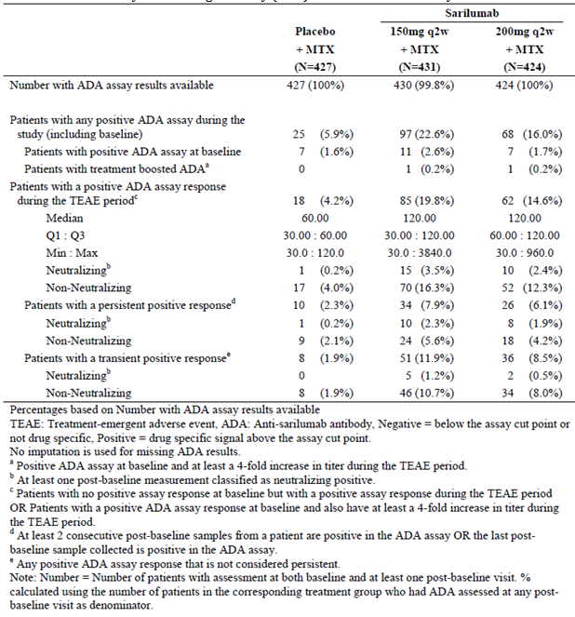

###### Study EFC10832

The incidence of patients who tested ADA positive during Study EFC10832 was higher in the SAR 150 mg group (18.3%; 33/180) compared to the SAR 200 mg arm (12.1%; 22/182) and placebo group (1.7%; 3/180), refer to Table 38. The majority of ADA positive patients had a transient response. The median ADA titre was 30 in all 3 treatment groups for the subset of patients that became ADA positive during the study. Seven patients (5 in the SAR 150 mg group and 2 in the SAR 200 mg arm) developed neutralising ADA. One of those patients discontinued prematurely due to lack of efficacy (last SAR dose given on Day 72). This subject had neutralising ADA identified on Day 30 (titre 120) and Day 86 (titre of 240). This patient’s serum SAR concentrations were all below the LLOQ (312.5 ng/mL) from pre-dose to Day 86, indicating that the serum SAR concentration was not detectable before and after he had developed neutralising ADA. Testing positive for non-neutralising ADA was not associated with a lower likelihood of achieving satisfactory clinical response. None of the patients with neutralising ADA experienced a hypersensitivity reaction. However, 2 other ADA positive (non-neutralising) subjects experienced skin hypersensitivity AEs (3.6% of 55), which is less frequent than the ADA negative cohort (6.2%; 19/307) and similar to placebo (3.9%; 7/181).

Table 38: Summary of Anti-Drug Antibody (ADA) Results in Study EFC10832

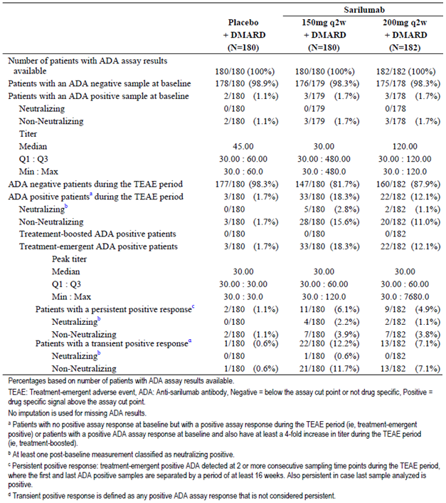

##### Other studies

###### Part A of Study EFC11072

Five patients (2 each in the SAR 100 mg qw and 150 mg q2w groups, and 1 in the SAR 200 mg q2w arm) had positive ADA responses at Baseline in this trial, which may be due to pre-existing immunoreactivity (such as pre-existing or natural antibodies). Over the course of the study, the incidence of ADA positivity appeared to be inversely related to the dose of SAR, that is, the higher the SAR dose, the lower the incidence of ADA. No subject in the placebo group developed ADA. The incidences of positive ADA for each SAR dose group at Week 12 was 42.9% (18/42) in the SAR 100 mg qw group, 18.4% (9/49) in the SAR 150 mg q2w arm, 9.5% (4/42) in the SAR 100 mg qw group, 6.4% (3/47) in the SAR 200 mg q2w arm and 2.1% (1/47) in the SAR 150 mg qw group. Over 90% of subjects who tested ADA positive did so by Week 4 and then maintained the result. There was no correlation between ADA positivity and safety parameters, apart from a slightly higher incidence of local injection site reactions in ADA positive (7.0%; 4/57) versus ADA negative (5.7%; 11/194) subjects.

###### Long term safety population

In the long term safety population, the overall rate of ADA positivity in any SAR dose group was 16.3% (417/2555) with a median titre of 30, refer to Table 39. Most patients had transient ADA responses (11.7%; 300/2555), but 4.5% of all subjects (114/2555) had persistent treatment emergent positive ADA response. Among the persistent treatment emergent positive ADA response subjects, 1.2% (31/2555) exhibited ADA with neutralising qualities.

Table 39: Summary of Anti-Drug Antibody (ADA) Results in the Long term Safety Population

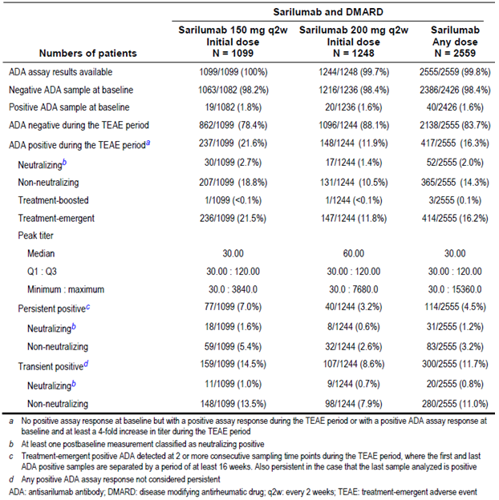

#### Autoimmunity and hypersensitivity

##### Pivotal studies

###### Part B of Study EFC11072

Approximately half of all patients in each of the 3 treatment group were ANA negative at Baseline. The incidence of patients who became newly ANA positive during the study (that is baseline negative ANA result) was similar in the 3 treatment groups: 50.0% (94/188) in the placebo group, 49.4% (88/178) in the SAR 150 mg arm and 47.7% (92/193) in the SAR 200 mg group. Two patients had a positive anti-ds-DNA antibody post-baseline, including 1 patient in the placebo group who discontinued due to leucocytoclastic vasculitis and another patient in the SAR 200 mg arm that recorded AEs of gastritis, increased serum transaminases, upper respiratory infection and cystitis, all of which were not suggestive of an autoimmune disorder. Skin biopsy proven cutaneous lupus was reported on study Day 300 in a patient treated with SAR 150 mg therapy, who had a new positive ANA result of low titre (1:40).

During the double blind treatment phase, a higher incidence of hypersensitivity reactions was observed in the SAR groups (6.7% (29/431) in the SAR 150 mg group and 7.8% (33/424) in the SAR 200 mg arm) compared to the placebo arm (4.7%; 20/427). One patient (46 year old female treated with SAR 200 mg injections) developed an immediate post-injection reaction on study Day 358 (that is last dose of SAR), which was recorded as an SAE. The post-injection reaction was characterised by pallor, a feeling of generalised weakness, increased blood pressure and tachycardia lasting 10 minutes before spontaneous resolution. Nearly all of the other hypersensitivity AEs were skin reactions (of mild or moderate severity) with no case of anaphylaxis during the study. Seven patients (1 in the placebo group, and 3 in each SAR arm) had hypersensitivity AEs that resulted in permanent treatment discontinuation. During the open label rescue period, another 9 patients (3.2%) experienced hypersensitivity AEs and 2 of those subjects (0.7%) ceased SAR treatment because of those events.

###### Study EFC10832

A higher percentage of subjects in the placebo group (35.3%; 18/181) developed a new positive ANA result post-baseline compared to patients in the SAR treatment groups (22.6% (14/181) in the SAR 150 mg arm and 25.0% (14/184) in the SAR 200 mg group). No patient tested positive for anti-ds-DNA antibodies during the study and no cases of lupus-like disease were reported.

A higher incidence of hypersensitivity reactions was observed in both SAR groups (5.5% (10/181) in the SAR 150 mg group and 6.0% (11/184) in the SAR 200 mg arm) compared to the placebo arm (3.9%; 7/181). None of the AEs were reported as SAEs. Nearly all of the reports were skin reactions with no case of anaphylaxis during the study. No hypersensitivity reaction was assessed by the investigator as being severe in intensity. A total of 8 patients (3 in the placebo and SAR 150 mg groups, and 2 in the SAR 200 mg arm) had a hypersensitivity AE assessed as moderate in intensity. The remaining hypersensitivity reactions were assessed by the investigator as being mild in intensity.

One patient in the SAR 200 mg group had hypersensitivity AE that resulted in permanent treatment discontinuation. This patient experienced pruritus of the limb (arm) on Day 15, on the same day SAR was administered, and recovered the next day without any specific treatment. On study Day 45 (that is 2 days after the last dose of SAR), the patient experienced generalised rash, pruritus and trembling and was administered intravenous anti-histamine medication. The patient recovered on study Day 61. The patient was ADA positive on study Days 15 and 48, but ADA negative on study Day 29.

##### Other studies

###### Part A of Study EFC11072

No cases of anaphylaxis were reported in this study. However, there were 2 cases of hypersensitivity, 1 in each of the SAR 100 mg qw and SAR 200 mg q2w treatment groups, which was recorded on Day 1 (that is 70 minutes after the first injection of SAR). No cases of lupus-like syndrome were reported during the course of the study and no subjects experienced seroconversion from a negative to a positive anti-ds-DNA result.

###### Long term safety population

There were 4 cases of serious hypersensitivity AEs in the long term population (0.1%), including 1 case in each of the proposed SAR doses in this submission (150 mg q2w and 200 mg q2w).

### Post-marketing experience

At the time of submission, SAR has not been registered anywhere in the world for use in RA. Hence, the sponsor has not provided any post-marketing dataset.

### Safety issues with the potential for major regulatory impact

#### Liver toxicity

SAR therapy is associated with an increased frequency of elevated serum transaminases compared to placebo in the first 12 to 24 weeks of therapy. There appears to be a consistent dose related relationship between raised serum ALT and/or AST values with SAR therapy. However, the abnormalities of liver function often resolved with continued SAR treatment and no cases meet the clinical criteria for Hy’s law. Further details regarding abnormal liver function tests are presented in section 8.5.1 of this report.

#### Haematological Toxicity

Drug related neutropaenia is an identified safety risk with anti-IL-6 therapy. Based on central laboratory analyses in the Phase III trials, the incidence of neutropaenia is up to 16% in the first 24 weeks of therapy and the frequency was higher with the higher dose of SAR treatment (200 mg q2w therapy). Over the extended treatment follow-up period, the annual incidence of grade 2 or higher neutropaenia appears to plateau and largely resolve with SAR dose reduction to 150 mg q2w therapy. Further details regarding neutropaenia are presented in section 8.5.4 of this report.

#### Risk of Serious and Opportunistic Infection

SAR therapy is associated with a potential increased risk of infection, including herpes zoster infection and latent tuberculosis. Meticulous screening for tuberculosis was an entry requirement of all the Phase II and III studies in this submission. No patient in the Phase II-III trials developed reactivation of latent tuberculosis. Herpetic infections were reported at a low but increased frequency in both pivotal studies with SAR treatment, and the observation was not dose dependent. Furthermore, the overall rate of infection related SAEs was higher in SAR treated subjects versus placebo patients.

#### Cardiovascular Safety and Elevation of Lipid Profiles

Patients with RA are known to be at an increased risk of MACE. A total of 28 MACE events in 26 patients have been recorded in the RA trials included in this submission. There were 10 cases were non-fatal myocardial infarction and 7 reports of non-fatal stroke (equally dispersed among the SAR dose groups). Seven MACE related deaths were adjudicated to have occurred. The overall rate of MACE is low at 0.6 per 100 PY, which is within expectations for the target population.

#### Unwanted immunological events

The rate and consequences of developing anti-SAR antibodies has already been discussed in sections 8.5.5 and 4.2.3 of this report. However, the development of ADA does not appear to be clearly associated with loss or lack of efficacy, nor the occurrence of AEs (any specific type or overall incidence). Nonetheless, there is increased plasma clearance of SAR in the presence of ADA, which requires ongoing pharmacovigilance, particularly for the loss of efficacy outcomes.

In this submission, no subjects developed clinical consequences consistent with systemic autoimmune disease (such as systemic lupus erythematosus) or major neurologic disorders.

### Other safety issues

#### Safety in special populations

Subgroup analyses of the long term SAR safety population have revealed potential risk factors for some specific types of AEs. There is a higher incidence of neutrophil cell count < 1.0 x 109/L in subjects with a lower baseline neutrophil count (< 6.0 x 109/L) and in those weighing < 60 kg. The incidence of neutropaenia in those with a baseline count < 6.0 x 109/L is 8.6% (32/370) for SAR 150 mg q2w + DMARD therapy (versus 2.8% (8/289) if baseline > 6.0 x 109/L) and 13.2% (46/348) for SAR 200 mg q2w + DMARD (versus 4.8% (15/313) if baseline > 6.0 x 109/L). The incidence of neutropaenia in those weighing < 60 kg is 14.4% (31/215) for SAR 150 mg q2w + DMARD therapy (versus 5.0% if weighing > 60 kg) and 16.7% (44/264) for SAR 200 mg q2w + DMARD (versus 7.5% if weighing > 60 kg). A higher incidence of ALT > 3 x ULN was seen in patients whose baseline ALT was > ULN, those with a duration of RA < 3 years, patients enrolled in South America centres and in subjects with no prior biologic exposure. A higher frequency of serious infection was observed in patients on SAR whose weight was > 100 kg or receiving weekly MTX dose > 20 mg. CS use, which has been shown to be associated with an increase in infections in RA, was included in the analyses, and only a small difference was observed in any SAR dose group in the long term safety population between patients who were on baseline CS and those who were not (5.9% versus 4.8%). Elderly patients (age > 65 years) are at an increased risk of infection (overall and serious) regardless of therapy (placebo or any SAR dose).

In the long term safety population, 9 patients became pregnant and 1 male patient’s partner became pregnant. Of the 9 patients who became pregnant 4 subjects experienced spontaneous miscarriage (all of which occurred during the first trimester; 2 of whom had a prior history of spontaneous or unspecified abortion), 3 patients delivered healthy children and the other 2 subjects had an estimated date of delivery after the data cut-off date of this submission. Similarly, the patient’s partner who became pregnant had an estimated date of delivery after the data cut-off date.

There is no available information on the safety of SAR in the setting of live vaccines, and with self-administration of medication.[1]

#### Safety related to drug-drug interactions and other interactions

Although SAR is not anticipated to interact directly with P450 CYP enzymes, CYP enzymes are down regulated by infection and inflammation, including IL-6. Hence, inhibitors of IL-6 may restore CYP expression and activity to a non-disease state, leading to the increased metabolism of CYP substrates. Several CYP450 enzymes including CYP1A2, CYP2B6, CYP2C9, CYP2C19, CYP2D6 and CYP3A4 have been shown to be affected by another anti IL-6 therapy (tocilizumab). Because of this, a specific clinical pharmacology study to assess the effect of SAR on simvastatin, a sensitive CYP3A4 substrate, was conducted in patients with RA (Study INT12684). Exposure of simvastatin decreased by 45% when administered to patients with RA as a single 40 mg oral dose, 1 week after a single 200 mg SC dose of SAR. These reductions in the exposure of simvastatin suggest that SAR may reverse IL-6 mediated suppression of CYP3A4 activity in patients with active RA, as is consistent with a similar study with tocilizumab administration (57% decrease in simvastatin exposure). The effect of SAR on CYP enzymes may be clinically relevant for a CYP substrate with narrow therapeutic index. Upon initiation or discontinuation of SAR in patients being treated with these types of drugs, therapeutic monitoring of effects (for example for warfarin) or drug concentration (for example for theophylline) should be performed, and the individual dose may need to be adjusted. The draft PI contains specific information regarding the effect of SAR therapy on CYP enzymes and how this may potentially result in drug interactions. In addition, the sponsor recommends caution should be exercised when SAR is co-administered with CYP3A4 substrates such as the oral contraceptive pill or statin therapy as there may be a reduction in exposure which may reduce their effectiveness.

### Evaluator’s overall conclusions on clinical safety

In this submission, the total clinical safety dataset for the use of SAR (any dose) in adult patients with active RA consists of 4,339 PY of drug exposure with 1,546 patients receiving treatment for > 48 weeks, 1,020 subjects receiving therapy for > 96 weeks and 624 patients exposed for > 144 weeks. In terms of the SAR doses being requested for approval in this submission, 660 patients have received 150 mg q2w therapy (425.8 PY of exposure) and 661 patients have received 200 mg q2w treatment (425.5 PY of exposure) in the placebo controlled population (versus 661 patients in the control arms; 373.1 PY of exposure). In the pivotal Phase III study (Part B of Study EFC11072), the median duration of exposure to SAR was 364 days. In the Phase III RA program, SAR therapy was given by SC injection either at a dose of 150 mg or 200 mg every 2 weeks. Both of the proposed doses in RA (150 mg and 200 mg) had more than 600 subjects exposed to SAR for at least 6 months. More than 95% of patients in the RA dataset received concurrent MTX, more than 70% were taking concomitant NSAID, and approximately half were taking concurrent low dose oral CS. Overall, there is a sufficient volume of data to make a meaningful assessment of SAR safety for up to 100 weeks of treatment in the newly proposed treatment indication of active RA.

Compared to placebo, a higher incidence of overall AEs, SAEs and AEs resulting in permanent treatment discontinuation were observed in SAR treatment groups, with some of the AE types occurring at a higher incidence in the higher dose SAR treatment cohort (200 mg q2w versus 150 mg q2w). Mortality rates were similar between SAR and placebo therapy in short term treatment follow-up.

Infection was the most common AE recognised with SAR and these occurred at a higher frequency in the SAR treatment groups versus control during the true placebo-controlled treatment periods (12 to 16 weeks for both pivotal trials). The majority of infections were mild in severity, self-limiting, and were predominately either URTI, urinary tract infection or nasopharyngitis. The use of concurrent MTX or prior exposure to anti-TNF therapies did not appear to increase the overall risk of AEs, including infection related AEs. However, subject weight > 100 kg was associated with a higher incidence of overall and infection related AEs. In the integrated placebo controlled population, the exposure adjusted rate of serious infection is 5.5 events per 100 PY (95% CI 3.30, 7.82) in the SAR 200 mg q2w treated patients, 3.6 events per 100 PY (95% CI 2.08, 5.90) in the SAR 150 mg q2w subjects and 3.9 events per 100 PY (95% CI 2.20, 6.47) in the control group. In the SAR + DMARD long term safety population, the exposure adjusted event rate is slightly lower than that observed in the placebo controlled population at 4.3 events per 100 PY (95% CI 3.35, 5.35) in the SAR 200 mg q2w group, which remains higher than that in the SAR 150 mg q2w dose group (3.1 events per 100 PY; 95% CI 1.96, 4.75). No patients developed reactivation of latent tuberculosis in the SAR clinical study program. However, there was an increased risk of oral herpes virus infections with SAR versus placebo. This finding may be expected given the role of IL-6 in protective immunity. A SAR dose effect was also observed for the risk of herpes zoster infection. The majority of herpetic infections were rated as mild or moderate in severity, responded to standard treatment and did not result in permanent discontinuation from SAR.

Hypersensitivity reactions were an uncommon type of AE reported at a slightly higher incidence in patients receiving SAR (with no dose response relationship) compared to placebo therapy. Most hypersensitivity AEs were non-specific reports of rash, which were rated as mild in severity, resolved without specific intervention and did not result in discontinuation from SAR. Only 4 potential systemic hypersensitivity reactions were reported with SAR in the total RA safety dataset. Discontinuations due to AEs occurred at a higher frequency in SAR versus placebo treated subjects.

A total of 25 deaths (22 in SAR treated subjects) have been reported in patients with RA in the long term safety population, including 7 MACE related deaths. The rate of malignancies in the RA dataset is within expectations of the treatment population and the types of cancer observed did not identify any specific safety signals with SAR. However, longer periods of treatment follow-up are required to inform about this potential safety concern.

Neutropaenia is a recognised safety concern with anti-IL-6 therapy and the issue was identified with SAR in the RA treatment studies. In the short term period (first 16 weeks) of both pivotal Phase III studies, the overall incidence of neutropaenia was higher in both SAR treatment groups compared with placebo. The approximate overall incidences of neutropaenia were 10.0 to 16.0% for SAR (with a dose response relationship observed for 150 mg and 200 mg therapy) versus 1.0% for placebo. There were several cases of grade 3 or 4 neutropaenia observed in both SAR treatment groups and over the long term follow-up period of the Phase III studies, the incidence of neutropaenia was up to 20% with SAR. The majority of neutropenic episodes were transient and not associated with infection related AEs. There were also several cases of significant thrombocytopaenia observed in patients treated with SAR.

The total safety dataset also identified 2 other abnormalities of laboratory values which occurred at a numerically higher frequency in the SAR treatment cohorts compared with placebo. Elevations in hepatic transaminases and dyslipidaemia have been associated with SAR versus placebo. Again, both of these abnormalities appear to display a dose response relationship with SAR. In general, patients who developed increases in liver function tests had changes of mild-moderate severity which were transient in nature and without associated clinical sequelae.

The incidence of RA subjects developing new anti-drug antibodies to SAR is low at < 10% at 52 weeks in the pivotal Phase III trial and their clinical relevance for safety outcomes is yet to be defined with no discernible link to the risk of infection, or injection related reactions.

In summary, the safety data indicates that SAR has an acceptable overall safety profile up to 52 weeks of therapy in the treatment of adult patients with moderately to severely active RA. There is limited long term safety data in the current submission to assess the risk of some types of AEs such as malignancy and MACE, which will require additional longitudinal safety follow-up. From the clinical evaluator’s assessment of the safety dataset, there are some significant safety concerns with SAR therapy including the risk of infection, opportunistic infection (mainly oral herpes viral and zoster infection), hypersensitivity reactions, neutropaenia, thrombocytopaenia, abnormal liver function tests and dyslipidaemia. These safety concerns are consistent with the known profile of anti-IL-6 therapy in adult patients with RA. Significant pharmacovigilance will be required if approval is granted for registration of SAR for the treatment of RA. This would include vigilance for opportunistic infections, MACE and malignancy (particularly, non-melanoma skin cancers).

## First round benefit-risk assessment

### First round assessment of benefits

The benefits of SAR in adult patients with moderately to severely active RA in the proposed usage (200 mg, once every 2 weeks, given by SC injection; or 150 mg every 2 weeks if certain laboratory abnormalities) are:

* Improvement in the signs and symptoms of RA (as per the ACR clinical response criteria), which appear to be maintained to at least 52 weeks of treatment.
* Improvement in physical functioning (as evidenced by treatment related improvements in the HAQ-DI scale).
* SAR therapy is associated with a statistically lower rate of structural disease progression at 52 and 100 weeks of treatment as measured by serial plain X-rays of the peripheral joints affected by RA.
* Concurrent use of non-biologic DMARD drugs (mainly, weekly low dose oral MTX) with SAR was presented in the current submission and the efficacy outcomes with SAR monotherapy are not available at present.
* In the population of subjects enrolled into Study EFC10832 (that is inadequate response or intolerance of previous anti-TNF therapy), a statistically higher rate of ACR20 response at 24 weeks and improvement in HAQ-DI score at 16 weeks was demonstrated with both doses of SAR versus placebo injection + oral DMARD therapy.
* The benefits demonstrated with SAR versus placebo extend to various patient subgroups (age, gender, race, region and baseline disease severity) although being seronegative for RA was associated with lower ACR response rates.
* SAR therapy improves various health related quality of life outcomes.
* Convenient dosing schedule (once every 2 weeks) using a convenient mode of administration (SC injection via prefilled syringe).

### First round assessment of risks

The risks of SAR in the proposed usage include:

* Increased incidence of overall infection compared to placebo, which are usually minor in severity (in particular, urinary tract infection and URTI), but there is also an increased risk of serious infection with SAR.
* Increased risk of pneumonia and various types of herpes infection (oral and zoster) with SAR 200 mg q2w therapy.
* Increased risk of drug induced neutropaenia and thrombocytopaenia compared to placebo.
* Risk of precipitation of gastrointestinal perforation and aggravation of diverticulitis.
* Increased frequency of raised serum transaminases and atherogenic serum lipid profiles compared to placebo.
* Potential increased risk of malignancy and MACE requiring long term surveillance; not evident in the current short to medium term safety dataset.
* Higher rates of injection site reactions with SAR versus placebo injections, which are usually non-severe in nature and rarely lead to permanent treatment discontinuation.
* Increased rates of permanent treatment discontinuation with SAR versus control treatment (placebo injections + oral DMARD) due to a combination of infections and abnormal investigation results.
* Live vaccines cannot be given concurrently with SAR.
* SAR has not been studied in patients < 18 years of age, in subjects with significant organ dysfunction (including renal, hepatic or cardiac failure), those at risk of reactivated latent tuberculosis (requiring meticulous screening at Baseline) and in pregnant or lactating women.

### First round assessment of benefit-risk balance

The overall benefit-risk balance of SAR in combination with non-biologic DMARD (mainly, weekly low dose oral MTX) in adult patients with moderately to severely active RA, who have had an inadequate response to 1 or more DMARDs, is favourable. Although there are several biologic therapies approved for the treatment of RA, including an alternative drug targeting IL-6 inhibition (tocilizumab), a significant proportion of patients still do not achieve optimal or adequate efficacy when one considers clinically meaningful measures of improvement, such as the rates of ACR20 and ACR50 response. Other limitations to currently available therapies in Australia include diminished efficacy over time and drug related safety concerns such as opportunistic infection (including TB), malignancy (for example lymphoma) and various laboratory test abnormalities (for example abnormal liver function tests and cytopaenia). Thus, there remains a significant unmet need for new drugs with unique mechanisms that can provide a rapid onset of effect, as well as improved and sustained symptom improvement and a safety profile that allows for long term use.

SAR is a fully human IgG1 monoclonal antibody that selectively binds to both soluble and membrane bound IL-6 receptors, thereby neutralising the effects of the pro-inflammatory cytokine, IL-6. IL-6 is a naturally occurring cytokine that is involved in normal inflammatory and immune responses, but the cytokine also plays a key role in the pathogenesis of RA. In this submission, SAR has been evaluated in a large clinical program, which complied with CHMP guidelines for evaluation of treatment in RA. The clinical studies have evaluated an adequate number of subjects in the target patient population and demonstrated that SAR is an effective in the treatment of active RA. For most patients with RA, the minimum most effective dose of SAR therapy is 150 mg q2w by SC injection, however, the sponsor is proposing 200 mg q2w as the primary commercial dose because it shows numerically higher efficacy for ACR50 and ACR70 responses and questionably superior inhibition of X-ray progression, but none of this clinical data has been subject to pre-specified statistical testing. Nonetheless, the superior efficacy of SAR versus placebo (in conjunction with non-biologic DMARD, mainly MTX) was consistent in most patient subgroups. Subjects with a body weight > 100 kg appeared to have better clinical response to the higher dose of SAR (200 mg injections) but the sponsor has not requested a dose modification in this patient subgroup.

The safety profile of SAR observed in the clinical study program is consistent with that known for tocilizumab, based on the anticipated effects of IL-6 inhibition, including an increased risk of infection and changes in certain laboratory parameters, in particular, decreases in neutrophil count and increases in hepatic transaminases and serum lipids. SAR is a monoclonal antibody given by SC injection, thus the occurrence of ADA was also expected. The risk profile of SAR is based on a total of 1220 SAR-treated patients with RA involved in the 2 pivotal Phase III studies, as well as additional safety information collected from approximately 3000 patients treated with any dose of SAR.

In the RA trials, there was an increased incidence in overall infections in the 2 SAR dose groups compared to placebo, with a slightly increased frequency of infection with the highest dose of SAR (200 mg therapy). The majority of reported infections were mild or moderate, upper respiratory tract and urinary infections. Herpes related infections were also more frequent with SAR (in a possible dose dependent relationship) compared to placebo. However, very few serious opportunistic infections were reported with SAR.

Neutropaenia was much more frequently observed with SAR than placebo, but most cases were of mild severity (CTCAE Grade 1 or 2), transient and reversible. More severe neutropaenia (CTCAE Grade 3 or 4) was also more frequently observed with SAR, but were rarely associated with serious infection. There was also an increased incidence of mild-moderate hepatic transaminase elevations and dyslipidaemia with SAR versus placebo, which was not clearly dose related.

Malignancy represents a theoretical risk with any immunosuppressive therapy, but there is no evidence that SAR confers an increased risk for malignancy in the current dataset of medium term drug exposure. In the submitted trials, SAR treatment was associated with a higher incidence of injection site reactions compared to placebo, but these were generally mild, localised and self-limiting. Importantly, there were only a handful of cases of serious hypersensitivity reactions and no cases of anaphylaxis were recorded.

The laboratory changes associated with SAR are typical for IL-6 inhibition, including decreases in neutrophil and platelet count, and increases in serum transaminases and lipids. These were observed more frequently for SAR treatment groups compared to placebo. Significant changes in laboratory parameters associated with SAR were managed by dose modification from 200 mg q2w to 150 mg q2w. The submission contained a subset of patients who experienced dose modification for the above problems and no clinical consequences of SAR dose reduction were observed. Changes in abnormal laboratory results generally stabilised after 4 weeks. Furthermore, the sponsor is proposing routine laboratory monitoring to consist of neutrophil count, platelet count, liver function tests and lipid profile within 4 to 8 weeks of initiating SAR therapy, and then every 3 months thereafter (6 months for lipid profile).

## First round recommendation regarding authorisation

The clinical evaluator recommends acceptance of the sponsor’s request for the registration of SAR for the treatment of moderately to severely active RA in adult patients who have failed to respond to or are intolerant of 1 or more DMARD drugs (including prior anti-TNF therapy). The treatment indication reflects the populations studied in the submitted trials. The proposed wording also includes specification that SAR treatment should only be used in combination with non-biological DMARDs, which is consistent with the submitted dataset. The current submission provides robust evidence that SAR is effective in improving the symptoms and signs of active RA as well as physical functioning, and potentially slowing the progression of structural joint damage.

However, the clinical evaluator does not agree with the sponsor proposed posology for SAR therapy, which recommends 200 mg q2w as the regimen for the majority of patients, and the dose of SAR can be reduced to 150 mg q2w for the management of neutropaenia, thrombocytopaenia and elevated liver enzyme tests. The clinical evaluator recommends the posology of SAR be 150 mg q2w for all patients as the totality of the clinical dataset indicates that this is the lowest, most clinically effective regimen.

Regarding justification for the proposed SAR posology, 2 dose regimens (SAR 150 mg q2w and SAR 200 mg q2w by SC injection) were selected for investigation in the 2 Phase III studies. Both doses achieved similar ACR20 response rates at 24 weeks of therapy. The sponsor states that the SAR 200 mg dose had numerically higher ACR50 and ACR70 response rates at 24 weeks, but these findings has not been subject to pre-specified statistical testing nor were the studies powered for such an analysis. The sponsor asserts that a higher percentage of patients receiving 200 mg versus 150 mg SAR therapy obtain serum SAR concentrations at the end of the dosing interval which equate with clinical response. Furthermore, analyses of the PD data (mainly CRP results) suggest that suppression of IL-6 signalling was more complete at the end of the dosing interval in patients treated with SAR 200 mg q2w versus 150 mg q2w. The sponsor proposes that while SAR 150 mg q2w therapy may be sufficient for managing the signs and symptoms of RA, pharmacology data indicates more effective suppression of IL-6 signalling throughout the dosing interval is obtained with SAR 200 mg q2w. The sponsor also hypothesises that more complete suppression of IL-6 may lead to greater inhibition of structural progression of the disease, as well as greater improvements in other clinical endpoints. However, the pharmacology data has not been supported by the appropriate supporting analysis of the clinical efficacy data showing superiority of SAR 200 mg q2w over 150 mg q2w.

Should approval of the sponsor’s proposed registration of SAR for the treatment of active RA be granted, the clinical evaluator also recommended that approval be subject to:

* Satisfactory response to the clinical questions below;
* Regular periodic safety update reports; and
* When available, the sponsor provides the TGA with the final clinical study report for the long term Study LTS11210.

## Clinical questions

### Pharmacokinetics

No questions.

### Pharmacodynamics

No questions.

### Efficacy

#### Question 1

In both of the pivotal Phase III studies (Part B of Studies EFC11072 and EFC10832), the control treatment arm used concomitant methotrexate in 95 to 100% of participants at a median weekly dose of 15 mg (and usually administered per oral). Recent expert opinion has identified suboptimal methotrexate therapy (dose and route of administration) as a source of biasing findings in favour of biologic therapies in RA clinical trials.[2] Could the sponsor comment on the adequacy of therapy in the control arms of both pivotal studies as a potential source of efficacy bias?

#### Question 2

In Cohort 2/Part B of Study EFC11072, could the sponsor provide data for each of the treatment groups on the percentage of subjects who met the inclusion criteria of at least 1 radiographic erosion on X-ray at Baseline (by local investigators at screening), and the rates of concordance with central reading?

#### Question 3

In the proposed posology, sarilumab 200 mg every 2 weeks (q2w) by subcutaneous injection is requested and a down titration to 150 mg q2w is recommended in the setting of certain blood test abnormalities. Using the clinical dataset, could the sponsor justify the proposed posology of 200 mg q2w as the lowest, most clinically effective regimen given the primary clinical endpoint of ACR20 response at 24 weeks in both pivotal studies was similar with both sarilumab doses (200 mg q2w and 150 mg q2w) and no statistical analysis for any clinical efficacy endpoints between the 2 sarilumab dose regimens have been provided to justify the clinical superiority of the higher dose?

#### Question 4

In Part B of Study EFC11072, patients in the sarilumab 150 mg q2w dose group had slightly higher mean and median modified Total Sharp Scores (mTSS) than the other 2 treatment arms at Baseline. At Week 52, both doses of sarilumab showed a statistically significant smaller mean increase from Baseline in mTSS versus placebo.

* 1. Could the sponsor comment on the clinical relevance of the magnitude of treatment related difference at 52 weeks between both doses of sarilumab and placebo?
  2. The mean change from Baseline to Week 52 in TSS was numerically lower in the 200 mg q2w dose group (0.25 sharp units) compared to the 150 mg q2w arm (0.90 sharp units), however, the interquartile median change was highly similar (0.00 sharp units) between the 2 sarilumab dose groups. Does the totality of the radiographic data indicate that the higher doses of sarilumab (200 mg q2w) is more efficacious than the lower dose regimen (150 mg q2w) and if so, please provide supporting statistical analysis?

### Safety

#### Question 5

In the 2 pivotal Phase III trials (Studies EFC11072 and EFC10832), subcutaneous administration of study treatment could occur at either the investigator centre or home, depending on the study visit schedule.

* 1. Could the sponsor clarify the proportion of subjects who self-administered study treatment and the number of occasions in which self-administration occurred in each pivotal study?
  2. Could the sponsor clarify if there was any difference in the incidence and type of adverse events with home-based versus centre-based administration of study medication?

## Second round evaluation of clinical data submitted in response to questions

### Question 1

*In both of the pivotal Phase III studies (Part B of Studies EFC11072 and EFC10832), the control treatment arm used concomitant methotrexate in 95 to 100% of participants at a median weekly dose of 15 mg (and usually administered per oral). Recent expert opinion has identified suboptimal methotrexate therapy (dose and route of administration) as a source of biasing findings in favour of biologic therapies in RA clinical trials.2 Could the sponsor comment on the adequacy of therapy in the control arms of both pivotal studies as a potential source of efficacy bias?*

*Sponsor response:*

In the response, the sponsor states that the primary treatment comparison examined in the Phase III SAR studies was between SAR and placebo injections with patients being maintained on background conventional DMARD therapy (usually MTX). In addition, Study EFC11072 enrolled patients who failed MTX (that is second line treatment population) and Study EFC10832 recruited subjects who had failed anti-TNF therapy and at least 1 non-biologic DMARD (that is third line treatment population). During both of the Phase III SAR studies, background MTX was continued at doses similarly balanced across the treatment arms, hence no bias favouring SAR over placebo should ensue.

In the response, the sponsor has also included several post-hoc subgroup analyses of patients on MTX doses above or below the median dose of 15 mg/week (displayed in Tables 9-16 (Table 10 displayed below)) for various efficacy response outcomes such as rate of ACR20 response, and the mean changes from Baseline in HAQ-DI, DAS28-CRP and mTSS. The sponsor asserts that for all efficacy outcomes, treatment differences observed between SAR and placebo are consistent regardless of MTX dose. Furthermore, the sponsor asserts that administering higher doses of MTX (> 15 mg/week) in conjunction with SAR did not appear to provide additional benefit.

The sponsor also states that the SAR clinical trial program is different in design to the studies referenced in the systematic review article.

Table 10: Incidence of ACR20 response at Week 24 by MTX dose subgroup - pooled data of EFC11072 and EFC10832

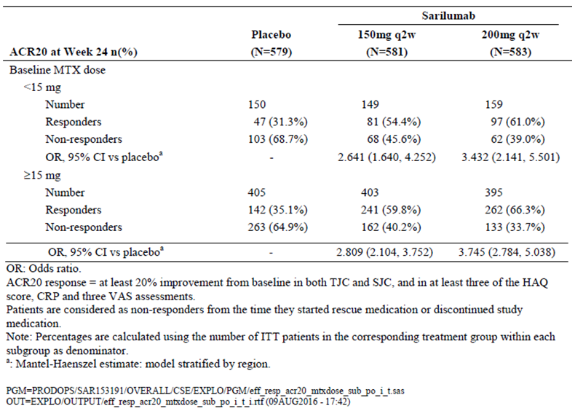

*Evaluator comment:*

The sponsor is incorrect in proposing that higher (versus lower) concurrent doses of MTX, given as monotherapy or in conjunction with SAR (either dose) do not result in better efficacy responses. As displayed in Table 10 above, the rates of ACR20 response are consistently 4 to 5% higher (that is NNT of 20 to 25) in each of the treatment groups when considered by baseline (and presumably, concurrent background) MTX dose. For the primary clinical efficacy outcome of the rate of ACR20 response at 24 weeks using the combined Phase III dataset, the placebo group response was 31.3% (47/150) in the low dose MTX subgroup versus 35.1% (142/405) in high dose subgroup; 54.4% (81/149) in the SAR 150 mg with low dose MTX versus 59.8% (241/403) in the SAR 150 mg plus high dose MTX, and 61.0% (97/159) in the SAR 200 mg + low dose MTX versus 66.3% (262/395) in the SAR 200 mg plus high dose MTX subgroup. The ACR20 response data in the Phase III SAR studies confirms the established knowledge that there is a dose response effect for MTX in RA and therefore for it to be an appropriate comparator, the maximum dose (up to 25 to 30 mg/week) should be used in subjects who require and tolerate it. Response to MTX in a proportion of subjects is only achieved when the maximum dose and route of administration are used. There are established drug exposure limitations of oral MTX at weekly doses exceeding 15 mg, which may be overcome by switching to SC administration. The control arms of both Phase III SAR studies did not receive maximal standard comparator treatment with MTX as their pre-existing regimens, for which they recorded inadequate response at Baseline, were continued during the trials.

Both the Phase III SAR studies reported had screening failure rates exceeding 50% and from the limited data available in the submission it appears that at least half of all screen failures were due to insufficient RA disease activity at Baseline. In both of the Phase III SAR studies, the baseline median weekly dose of MTX was 15 mg (across all treatment groups). However, it is clear from the literature that a significant proportion of RA subjects being treated with MTX require higher doses of MTX (up to 25 to 30 mg/week) to achieve sufficient response. Although the sponsor has not specifically provided the data, it would appear that a proportion of recruited patients in both Phase III studies may have potentially received sub-optimal preceding therapy with MTX, and if so, this would have potentially reduced the eligible patient population or increased the screening failure rate due to insufficient disease activity. The observation of high screening failure rates in both Phase III SAR studies and potential sub-optimal preceding treatment reduces the generalisability (external validity) of the SAR trial results. This is a significant limitation of the current SAR dataset.

The sponsor is also incorrect in stating that the SAR clinical trial program is different in design to the studies referenced in the systematic review by Duran et al.2 After implementing the search strategy, the systematic review identified 13 suitable articles to be included (all were referenced). Of these, 3 studied adalimumab; 2 each examined infliximab, etanercept and tocilizumab; and the other trials studied golimumab, abatacept, rituximab and tofacitinib. In 10 of the 13 included studies, there were treatment comparisons made between biologic and conventional DMARD therapy versus MTX. Furthermore, the majority of the included studies enrolled adult subjects with active established RA who had recorded inadequate response to prior DMARD (typically MTX). The characteristics of the majority of the studies included in the systematic review demonstrate similar features in terms of enrolment criteria and design to that observed in the pivotal Phase III SAR studies.

### Question 2

*In Cohort 2/Part B of Study EFC11072, could the sponsor provide data for each of the treatment groups on the percentage of subjects who met the inclusion criteria of at least 1 radiographic erosion on X-ray at Baseline (by local investigators at screening), and the rates of concordance with central reading?*

*Sponsor response*:

In the response, the sponsor states that 98% of all enrolled subjects (no actual patient number given) in this trial had at least one radiographic joint erosion at Baseline as documented by the central reader. The sponsor has not provided information by treatment group on rates of X-ray damage (number affected and measures magnitude for example the proportion of subjects with > 3 erosions at Baseline) other than mean and median mTSS for each treatment group in Cohort 2/Part B of Study EFC11072. Furthermore, the sponsor states that the study did not collect information on the evaluation of X-rays at local sites, and therefore cannot comment on the rates of concordance between central and local X-ray reading.

*Evaluator comment:*

Nearly all subjects enrolled into Cohort 2/Part B of Study EFC11072 had central reader determined evidence of X-ray damage at Baseline (that is, at least 1 joint erosion). In addition, the mean (and median) baseline mTSS in Cohort 2/Part B of Study EFC11072 were very high by peer published standards in all 3 treatment groups being 48.01 (24.08) sharp units in the placebo group, and 46.34 (23.50) sharp units in the SAR 200 mg treatment arm, and even higher (indicating more established X-ray damage at Baseline) in the SAR 150 mg arm at 54.67 (median of 29.75). In the pivotal registration trials of biological therapies (for example tocilizumab) in the last 10 years, the mean baseline mTSS is usually much lower ranging from 15 to 30 sharp units (Kremer et al, 2011). Some of the strongest predictors of future X-ray damage are established joint damage, positive serology for autoantibodies (RF and anti-CCP) and high baseline CRP values. The recruited population into Cohort2/Part B of Study EFC11072 were at high risk of further X-ray progression (that is many were autoantibody positive with joint erosions at Baseline and established (long duration) RA). These characteristics would be expected to enrich the treatment response dataset to show a beneficial effect with the addition of SAR to MTX as patients had already declared themselves as inadequate responders to MTX to gain entry into the study. In addition, the generalisability (or external validity) of the results of Cohort2/Part B of Study EFC11072 to the majority of patients with RA being treated in Australia (in particular, much lower rates and burden of established joint damage with definitive treatment commenced at an earlier stage of the condition) is limited.

### Question 3

*In the proposed posology, sarilumab 200 mg every 2 weeks (q2w) by subcutaneous injection is requested and a down-titration to 150 mg q2w is recommended in the setting of certain blood test abnormalities. Using the clinical dataset, could the sponsor justify the proposed posology of 200 mg q2w as the lowest, most clinically effective regimen given the primary clinical endpoint of ACR20 response at 24 weeks in both pivotal studies was similar with both sarilumab doses (200 mg q2w and 150 mg q2w) and no statistical analysis for any clinical efficacy endpoints between the 2 sarilumab dose regimens have been provided to justify the clinical superiority of the higher dose?*

*Sponsor response:*

In the response, the sponsor states that the recommendation for the 200 mg q2w dose is based on the totality of the clinical data, including the analyses for ACR20 response and radiographic outcome (median change from Baseline in mTSS). The X-ray data will be considered in question 4 of the second round evaluation.

In the response to Question 3, the sponsor has provided post hoc statistical analyses to explore the potential differences between the 2 SAR doses (150 mg and 200 mg) in terms of clinical response. The sponsor reports that in Study EFC11072, the SAR 200 mg dose regimen was statistically superior to the 150 mg dose at Week 24 for the rate of ACR20 response (66.4% versus 58.0% respectively, with a nominal p-value of 0.0138 without adjustment for multiplicity). However, a post hoc analysis of Study EFC10832 showed a slightly higher numerically rate of ACR20 response with SAR 200 mg versus SAR 150 mg, but this difference did not achieve statistical significance. A post hoc comparison of pooled data from both pivotal studies suggested a potential benefit from the SAR 200 mg dose (64.7%; 377/583) versus the SAR 150 mg dose (57.3%; 333/581). The nominal p-value from this analysis was 0.0087. The difference in ACR20 response rates at Week 24 between the 2 SAR doses was 7.4% (95% CI 1.9%, 12.9%). Using the pooled dataset, the sponsor calculates the Number Needed to Treat (NNT) for achieving ACR20 response wit SAR 200 mg q2w therapy versus SAR 150 mg q2w at 24 weeks of therapy as being 13.5 (95% CI 7.8, 52.6).

Furthermore, the sponsor states that the higher SAR dose of 200 mg q2w achieves a slightly higher rate of ACR20 response at Week 12 versus the SAR 150 mg q2w regimen, which is supported by nominal p-values (derived from post hoc analyses) in favour of the higher SAR dose regimen.

*Evaluator comment:*

In claiming clinical superiority with the higher SAR (200 mg q2w) versus the lower SAR dose regimen (150 mg q2w) on the basis of several post hoc analyses, the data does not meet the standard of scientific rigour of a robust claim of true observation. The FDA position on the use of the post hoc statistical analyses in clinical studies, report that such analyses increase the risk of approving new drugs (and regimens) that have no net beneficial effect, and should only be used to justify a labelling recommendation that warns of a negative effect for specified patient subgroups. Post hoc analyses are known to have several limitations including not being consistent with the randomisation model of statistical inference, potentially inflating the Type I error level and not accounting for multiplicity. Therefore, the observations derived from post‑hoc analyses should be considered as hypothesis generating for future apriori evaluation, but do not meet the standard for determining a scientifically robust conclusion. Hence, the sponsor response outlined above is not considered to be of sufficient scientific standard to justify the registration of the SAR 200 mg q2w dose regimen as the minimal, most clinically effective regimen based on the ACR20 response data observed in the 2 pivotal studies. In addition, although the sponsor calculates a NNT of 13.5 for the SAR 200 mg versus 150 mg dose for the rate of ACR20 response at 24 weeks, there is no estimate of the Number Needed to Harm (NNH) in this submission or response. The observed safety dataset shows a numerically higher rate of certain AEs with the SAR 200 mg dose regimen versus SAR 150 mg q2w therapy, particularly regarding the incidence of serious infection (including herpes zoster infection) and neutropaenia. Although the evaluator was unable to precisely estimate the NNH for SAR 200 mg versus 150 mg therapy, it would be a relevant calculation that would offset to some degree (if not completely) the sponsor reported difference in NNT between the 2 SAR dose regimens proposed for registration.

Hence, on the basis of the totality of the dataset, the evaluator recommends that the SAR 150 mg q2w posology be registered for use in adult patients with active RA. Currently, there is insufficiently robust clinical efficacy differences offset by a potential increase in significant harm to support the registration of the SAR 200 mg q2w regimen as the minimal, most clinically effective and safe posology.

### Question 4

*In Part B of Study EFC11072, patients in the sarilumab 150 mg q2w dose group had slightly higher mean and median modified Total Sharp Scores (mTSS) than the other 2 treatment arms at Baseline. At Week 52, both doses of sarilumab showed a statistically significant smaller mean increase from Baseline in mTSS versus placebo.*

* 1. *Could the sponsor comment on the clinical relevance of the magnitude of treatment related difference at 52 weeks between both doses of sarilumab and placebo?*
  2. *The mean change from Baseline to Week 52 in TSS was numerically lower in the 200 mg q2w dose group (0.25 sharp units) compared to the 150 mg q2w arm (0.90 sharp units), however, the interquartile median change was highly similar (0.00 sharp units) between the 2 sarilumab dose groups. Does the totality of the radiographic data indicate that the higher doses of sarilumab (200 mg q2w) is more efficacious than the lower dose regimen (150 mg q2w) and if so, please provide supporting statistical analysis?*

*Sponsor response:*

In response to (a), the sponsor reports that epidemiologic data has associated lower rates of joint replacement surgery and disability to the availability and implementation of aggressive DMARD therapy, particularly in those with early disease. Furthermore, radiographic progression has been associated with disability in the longer term. The sponsor also acknowledges that there is no convincing relationship between radiographic progression and clinical outcomes, and that no minimally important clinical difference in X-ray scores has been defined. Nonetheless, the sponsor considers that the assessment of the percentage of patients with no X-ray progression provides the most clinically relevant outcome.

In response to (b), the sponsor has provided several post hoc evaluations of the X-ray data to explore the potential for a dose response with SAR (150 mg q2w versus 200 mg q2w). Analyses were performed for the mean change from Baseline in mTSS, percentage of patients with no progression defined as change of ≤ 0 from Baseline where both readers agreed on the result, and the percentage of patients with no progression defined as change of ≤ 0.5 from Baseline (where only 1 reader considered that there was no progression). The SAR 200 mg dose was statistically superior to the 150 mg dose for the no progression endpoints, but not for the mean change from Baseline to Week 52 in mTSS. At Week 52 in Study EFC11072, 55.6% (222/399) of patients treated with SAR 200 mg showed no X-ray progression (change from Baseline in mTSS of < 0), which was statistically superior by post hoc analysis to patients treated with SAR 150 mg (47.8% (191/400); nominal p-value of 0.0255. The treatment related difference for this outcome was 7.8% (95% CI 1.0%, 14.7%). The sponsor provided a calculation of the NNT to prevent structural progression and estimated that the difference in the rates of structural progression at Week 52 in patients treated with SAR 200 mg q2w versus SAR 150 mg q2w was 12.8 (95% CI 6.8, 100). In addition, the sponsor asserts that the X-ray differences between the two SAR doses remained evident in the extension phase. At Week 100, the rate of no X-ray progression (change from Baseline of < 0.5) was 80.5% in patients treated continuously with SAR 200 mg q2w versus 68.7% for subjects initially treated with SAR 150 mg q2w therapy. In conclusion, the sponsor states that the SAR 200 mg q2w regimen is superior to SAR 150 mg q2w treatment in the prevention of structural damage.

*Evaluator comment:*

Regarding (a), the evaluator concurred with the sponsor that there is no clear relationship between structural X-ray progression and clinical outcomes, and the minimally clinically important difference in X-ray scores has not been defined. In general, there is a paucity of published evidence on this topic, but the most relevant and recent publication by Welsing et al (2006) estimated the threshold for minimal clinically important X-ray progression of joint damage using its longitudinal relation with functional disability. The analysis concluded that for a typical patient in their cohort (age at diagnosis of 55 years, some baseline X-ray damage and an expected disease duration of 30 years), a constant progression of 6 sharp points per year led to an increase of about 0.2 on the HAQ-DI score, solely related to damage, over the disease course. At Week 52 in Study EFC11072, smaller mean and median increases from Baseline in the mTSS were observed in subjects treated with SAR (mean increase of 0.90 for the 150 mg group and mean increase of 0.25 for the 200 mg arm) than in patients treated with placebo (mean increase from Baseline of 2.78). The observed differences between SAR (either dose) and placebo were statistically significant (p-value < 0.0001). No apriori pair wise statistical testing between the two SAR dose groups was performed. Although the mean mTSS change from Baseline to Week 52 in Study EFC11072 was numerically lower and statistically significant with both doses of SAR versus placebo, the clinical relevance of those mean and median changes in mTSS are unknown but appear to be of insignificant.

There is no evidence to support the sponsor proposal that the proportion of subjects with no X‑ray progression is the most clinically relevant outcome in assessing a claim of X-ray benefit in RA. The quoted references supporting this proposal are clinical guideline recommendations from the RACGP (2009)[3] and Australian Rheumatology Association (2011)[4] regarding the principles of management of RA in Australia. They do not make a statement regarding the appropriate X-ray outcome in patients with RA and have been inappropriately quoted by the sponsor in the response.

Regarding (b), the sponsor has provided several post hoc analyses of the X-ray data to claim the superiority of the higher SAR dose regimen (200 mg q2w) versus SAR 150 mg q2w therapy. As per evaluator comments in Question 3, post hoc analyses of the X-ray dataset does not meet the scientific standards of making such a claim, particularly in view of the significant potential limitations of post hoc analyses. In addition, although the sponsor calculates a NNT of 12.8 for the SAR 200 mg versus 150 mg dose for the rate of no structural progression at 52 weeks, there is no NNH estimate in this submission or response. The observed safety dataset shows a numerically higher rate of certain AEs with the SAR 200 mg dose regimen versus SAR 150 mg q2w therapy, particularly regarding the incidence of serious infection (including herpes zoster infection) and neutropaenia. Although the evaluator was unable to precisely estimate the NNH for SAR 200 mg versus 150 mg therapy, it would be a relevant calculation that would offset to same degree the sponsor reported difference in NNT between the 2 SAR dose regimens proposed for registration.

Hence, on the basis of the totality of the dataset, the evaluator recommends that the SAR 150 mg q2w posology be registered for use in adult patients with active RA. Currently, there is insufficiently robust clinical efficacy differences offset by a potential increase in significant harm to support the registration of the SAR 200 mg q2w regimen as the minimal, most clinically effective and safe posology.

### Question 5

*In the 2 pivotal Phase III trials (Studies EFC11072 and EFC10832), subcutaneous administration of study treatment could occur at either the investigator centre or home, depending on the study visit schedule.*

* 1. *Could the sponsor clarify the proportion of subjects who self-administered study treatment and the number of occasions in which self-administration occurred in each pivotal study?*
  2. *Could the sponsor clarify if there was any difference in the incidence and type of adverse events with home-based versus centre-based administration of study medication?*

*Sponsor response:*

In response to (a), the sponsor has provided a pooled analysis of subjects in the two pivotal studies showing that just more than half (51.7%) of all injections were performed by either the patient or a non-professional caregiver at home, 43.4% of all injections were administered by study site staff and 4.9% of all injections were performed by a professional caregiver at home. Study drug administration practices were similar across the 3 treatment groups in the pooled cohort.

In response to (b), the sponsor has provided an analysis of the incidence and type of AEs based on whether the subjects had > 50% of their injections administered by a health care professional (n = 827 subjects) versus those who received > 50% of their injections by a non-professional (n = 913 subjects). The overall incidence of treatment emergent AEs was comparable in the professional and non-professional drug administration groups, as were the most common types of AEs (such as infections and abnormal investigation results). However, 2 types of injections site reactions were reported at a higher incidence in the non-professional administration versus professional injection group. Across the treatment groups, injection site erythema (5.5% (50/913) versus 2.7% (22/827)) and injection site pruritus (2.7% (25/913) versus 1.0% (8/827)) were recorded at a slightly higher frequency in the non-professional administration subgroup versus the professional injection cohort.

*Evaluator comment:*

The observed pattern of study drug injections by performer (study site staff, professional caregiver and patient or non-professional person at home) is within expectations for Phase III clinical trials of RA treatment. In addition, the total volume of the at home and patient or non‑professional drug administration dataset is of sufficient volume to assess what is likely to occur in the Australian clinical setting if registration of SAR is approved. The incidence and type of AEs is comparable between the two drug administration groups (professional versus non‑professional injectors) for maintenance therapy apart from a slightly higher frequency of minor injection site reactions (erythema and pruritus) which is unlikely to be of clinical significance (for example resulting in permanent discontinuation from drug, or requiring additional medical input or care).

The approved PI (Dosage and Administration section) for subcutaneous administration of tocilizumab (an alternative anti-IL-6 therapy) specifies that the first injection must be performed under the supervision of a healthcare professional in a healthcare setting able to manage serious immediate hypersensitivity reactions. There is no such comment in the proposed PI for SAR. The pivotal studies in this submission initiated SAR in healthcare settings and the first injection was usually performed by a healthcare professional. In addition, cases of potential systemic hypersensitivity reactions have been reported with SAR in the total RA dataset. the evaluator recommends the sponsor amend the PI to specify the setting in which initiation and maintenance therapy can be conducted, and given the submitted dataset, SAR therapy should only be initiated in a supervised healthcare setting (similar to that specified with subcutaneous administration of tocilizumab). The proposed PI for SAR otherwise contains appropriate information about home based therapy apart from not specifying the anatomical sites of SC administration (for example abdomen, thigh and upper arm).

## Second round benefit-risk assessment

### Second round assessment of benefits

After consideration of the responses to the clinical questions, the benefits of SAR for the treatment of adult patients with active RA in the proposed usage are similar to those identified in the first round assessment of benefits. The Phase III studies are well conducted trials, which demonstrate a robust and clinically meaningful efficacy benefit with SAR versus placebo for improving the symptoms and signs of active RA as well as improving physical function in a second or third line treatment population (that is after failure to adequately respond to 1 or more DMARDs, including biologic therapy) when combined with MTX. Study EFC11072 was able to demonstrate a statistically significant benefit with both doses of SAR versus placebo for the inhibition of joint structural progression as determined by sequential plain X-rays of peripheral joints, but the clinical relevance of this observation is unclear. Regarding the proposed dosing regimen, the clinical efficacy data (in particular, the rate of ACR20 response and X-ray outcomes) does not support the higher posology of 200 mg q2w (versus 150 mg q2w) as the minimal, clinically effective regimen. Because of the limitations of post hoc analyses, the efficacy response data provided in the response to questions does not support a robust scientific claim of additional benefit with the higher dose versus lower dose regimen. On the current dataset, the evaluator recommends that the lower dose SAR regimen (150 mg q2w) be solely considered for registration.

### Second round assessment of risks

After consideration of the responses to the clinical questions (principally, question 5), the risks of SAR are unchanged from those identified in the first round. The observed pattern of study drug injections by performer (study site staff, professional caregiver and patient or non‑professional person at home) shows a comparable incidence and type of AEs between the 2 drug administration groups (professional versus non-professional injectors) apart from a slightly higher frequency of minor injection site reactions (erythema and pruritus), which is unlikely to be of clinical significance and impact upon the overall benefit: risk assessment.

### Second round assessment of benefit-risk balance

After consideration of the responses to the clinical questions, there is no change to the opinion expressed in the first round. The overall benefit-risk balance of SAR injections in the proposed treatment indication of active RA in adult patients is favourable. Clinically relevant, robust efficacy (with respect to improving the symptoms and signs of RA, as well as physical function) has been observed with SAR in combination with MTX. Patients recruited into the Phase III studies were inadequate responders to conventional and/or biologic DMARD therapy. Unfavourable effects consistent with the expected profile of an anti-IL-6 therapy have been observed with SAR, including serious infections and cases of neutropaenia.

## Second round recommendation regarding authorisation

The evaluator recommends acceptance of the sponsor’s request for the registration of SAR for the treatment of moderately to severely active RA in adult patients who have failed to respond to or are intolerant of 1 or more DMARD drugs (including prior anti-TNF therapy). The treatment indication reflects the populations studied in the submitted trials. The proposed wording also includes specification that SAR treatment should only be used in combination with non-biological DMARDs, which is consistent with the submitted dataset. Based on the data available, SAR in combination with MTX is effective and demonstrates a comparable and an acceptable safety profile to other biologic therapies (including an alternative anti-IL-6 therapy, tocilizumab) in the management of active RA in adult patients. However, on the balance of scientific evidence, the sponsor proposed posology for SAR is insufficiently acceptable. The sponsor proposed posology for SAR therapy recommends 200 mg q2w as the regimen for the majority of patients, and the dose of SAR can be reduced to 150 mg q2w for the management of neutropaenia, thrombocytopaenia and elevated liver enzyme tests. The evaluator recommends the posology of SAR be 150 mg q2w for all patients as the totality of the clinical dataset indicates that this is the lowest, most clinically effective regimen with an acceptable safety profile.

Should approval of the sponsor’s proposed registration of SAR for the treatment of active RA be granted, the evaluator also recommends that approval be subject to regular periodic safety update reports and when available, the sponsor provides the TGA with the final clinical study report for the long term Study LTS11210.

## References

Aletaha D, et al. 2010 rheumatoid arthritis classification criteria: an American College of Rheumatology/European League Against Rheumatism collaborative initiative. *Ann Rheum Dis* 2010; 69:1580–1588.

Aletaha D, et al. Acute phase reactants add little to composite disease activity indices for rheumatoid arthritis: validation of a clinical activity score. *Arthritis Res Ther* 2005; 7: R796-806.

Arnett FC, et al. The American Rheumatism Association 1987 revised criteria for the classification of rheumatoid arthritis. *Arthritis Rheum* 1988; 31: 315-324.

Bombardier C, et al. The relationship between joint damage and functional disability in rheumatoid arthritis: a systematic review. *Ann Rheum Dis* 2012; 71: 836-44.

Dadoun S, et al. Mortality in rheumatoid arthritis over the last fifty years: systematic review and meta-analysis. *Joint Bone Spine* 2013; 80: 29-33.

Dickmann LJ, et al. Effects of interleukin-6 (IL-6) and an anti-IL-6 monoclonal antibody on drug-metabolising enzymes in human hepatocyte culture. *Drug Metab Dispos* 2011; 39: 1415-22.

Duran J, et al. Methotrexate dosage as a source of bias in biological trials in rheumatoid arthritis: a systematic review. *Ann Rheum Dis* 2016; doi: 10.1136/annrheumdis-2016-209383.

Emery P, et al. IL-6 receptor inhibition with tocilizumab improves treatment outcomes in patients with rheumatoid arthritis refractory to anti-tumour necrosis factor biologicals: results from a 24 week multicentre randomised placebo-controlled trial. *Ann Rheum Dis* 2008; 67: 1516-1523.

Felson DT, et al. American College of Rheumatology/European League against Rheumatism provisional definition of remission in rheumatoid arthritis for clinical trials. *Ann Rheum Dis* 2011; 70: 404-13.

Fleischmann RM, et al. Tocilizumab inhibits structural damage and improves physical function in patients with rheumatoid arthritis and inadequate responses to methotrexate: LITHE study 2 year results. *J Rheumatol* 2013; 40: 113-126.

Kremer JM, et al. Tocilizumab inhibits structural joint damage in rheumatoid arthritis patients with inadequate responses to methotrexate: Results from the double blind treatment phase of a randomized placebo-controlled trial of tocilizumab safety and prevention of structural joint damage at one year. *Arthritis Rheum* 2011; 63: 609-21.

Smolen JS, , et al. Clinical trials of new drugs for the treatment of rheumatoid arthritis: focus on early disease. *Ann Rheum Dis* 2016; doi: 10.1136/annrheumdis-2016-209429.

Smolen JS, et al. EULAR recommendations for the management of rheumatoid arthritis with synthetic and biological disease-modifying antirheumatic drugs: 2013 update. *Ann Rheum Dis* 2014; 73: 492-509.

Welsing P, et al. Minimal Clinically Important Difference in Radiological Progression of Joint Damage. A Definition Based on Patient Perspective. *J Rheumatol* 2006; 33: 501-507.

|  |
| --- |
| Therapeutic Goods Administration |
| PO Box 100 Woden ACT 2606 Australia  Email: [info@tga.gov.au](mailto:info@tga.gov.au) Phone: 1800 020 653 Fax: 02 6232 8605  [**https://www.tga.gov.au**](https://www.tga.gov.au) |

1. The sponsor subsequently provided information on the safety of sarilumab with self-administration of medication Please see Section 12; Question 5.
2. Duran J, et al. Methotrexate dosage as a source of bias in biological trials in rheumatoid arthritis: a systematic review. Ann Rheum Dis 2016.
3. The Royal Australian College of General Practitioners. Clinical guideline for the diagnosis and management of early rheumatoid arthritis. August 2009.
4. Australian Rheumatology Association. Recommendations for the use of biologic agents for the treatment of rhematic diseases: Revised 6 January 2011.