This medicinal product is subject to additional monitoring in Australia. This will allow quick identification of new safety information. Healthcare professionals are asked to report any suspected adverse events at <https://www.tga.gov.au/reporting-problems>.

▼

**AUSTRALIAN PRODUCT INFORMATION**

**Enspryng® (satralizumab)**

# NAME OF THE MEDICINE

Satralizumab

# QUALITATIVE AND QUANTITATIVE COMPOSITION

Each pre-filled syringe (PFS) contains 120 mg of satralizumab in 1 mL.

For the full list of excipients, see section 6.1 List of excipients.

# PHARMACEUTICAL FORM

Solution for injection.

Colourless to slightly yellow liquid.

# CLINICAL PARTICULARS

## THERAPEUTIC INDICATIONS

Enspryng is indicated as monotherapy or in combination with immunosuppressive therapy (IST) for the treatment of adults with neuromyelitis optica spectrum disorders (NMOSD) who have an anti-aquaporin 4 antibody (AQP4)-IgG (also termed NMO-IgG) positive status.

## DOSE AND METHOD OF ADMINISTRATION

Treatment should be initiated under the supervision of a physician experienced in the treatment of NMOSD.

Enspryng is not intended for the acute treatment of an NMOSD relapse.

In order to prevent medication errors, it is important to check the PFS label to ensure that the drug being administered is Enspryng.

### Dosage

**For subcutaneous use only.**

Enspryng may be used as monotherapy or in combination with IST such as oral corticosteroids (OCs), azathioprine (AZA, or mycophenolate mofetil (MMF) (see section 5.1).

#### Loading dose

The recommended loading dose of Enspryng is 120 mg by subcutaneous injection (SC) every 2 weeks (first dose at week 0, second dose at week 2 and third dose at week 4) for the first three administrations.

#### Maintenance dose

The recommended maintenance dose is 120 mg SC every 4 weeks.

### Duration of treatment

Enspryng is intended for long-term treatment.

### Delayed or missed dose

If a dose of Enspryng is missed, for any reason other than increases in liver enzymes, it should be administered as described in Table 1.

**Table 1: Recommended dose for delayed or missed doses**

|  |  |
| --- | --- |
| **Last dose administered** | **Recommended dosage for delayed or missed doses** |
| Less than 8 weeks during the maintenance period or missed a loading dose | Administer 120 mg SC as soon as possible, and do not wait until the next planned dose.  **Maintenance period**  After the delayed or missed dose is administered, reset the dose schedule to every 4 weeks.  **Loading period**  If the second loading dose is delayed or missed, administer as soon as possible and administer the third and final loading dose 2 weeks later.  If the third loading dose is delayed or missed, administer as soon as possible and administer the 1st maintenance dose 4 weeks later. |
| 8 weeks to less than 12 weeks | 120 mg SC at 0* and 2 weeks, followed by 120 mg every 4 weeks. |
| 12 weeks or longer | 120 mg SC at 0*, 2, and 4 weeks followed by 120 mg every 4 weeks. |

* “0 weeks” refers to time of the first administration after the missed dose.

### Dosage Modifications

#### Liver enzyme abnormalities

If the alanine aminotransferase (ALT) or aspartate transaminase (AST) elevation is >5x Upper Limit of Normal (ULN) and associated with any bilirubin elevation, treatment with Enspryng must be discontinued, and re-initiation is not recommended.

If the ALT or AST elevation is >5x ULN and **not associated with any bilirubin elevation**, treatment with Enspryng should be discontinued. Treatment with Enspryng can be restarted at a dose of 120 mg SC injection every 4 weeks, when the ALT or AST level has returned to the normal range and following a benefit-risk assessment of the patient. If treatment is restarted, the liver parameters must be closely monitored, and **if any subsequent increase in ALT/AST and/or bilirubin is observed**, Enspryng must be discontinued, and re-initiation is not recommended.

**Table 2: Recommended dose for restart of treatment after liver transaminase elevation**

|  |  |
| --- | --- |
| **Last dose administered** | **Recommended dose for restart of treatment** |
| Less than 12 weeks | Restart at a dose of 120 mg SC every 4 weeks. |
| 12 weeks or longer | Restart at a dose of 120 mg SC at Weeks 0*, 2, and 4, followed by 120 mg every 4 weeks. |

* “0 weeks” refers to time of the first administration after the missed dose.

#### Neutropenia

If the neutrophil count is below 1.0 x109/L and confirmed by repeat testing, Enspryng should be interrupted until the neutrophil count is >1.0 x109/L.

### Special populations

#### Paediatric Populations

The safety and efficacy of Enspryng in children and adolescents aged < 18 years of age have not been established.

#### Elderly

No dose adjustment of Enspryng is required in patients ≥ 65 years of age (see section 5.2).

#### Renal impairment

The safety and efficacy of Enspryng have not been formally studied in patients with moderate to severe renal impairment. No dose adjustment is necessary in patients with mild renal impairment (see section 5.2).

#### Hepatic impairment

The safety and efficacy of Enspryng have not been studied in patients with hepatic impairment (see section 5.2).

### Method of Administration

Enspryng 120 mg is administered by SC injection using a single-dose PFS. Enspryng must be administered as a SC injection. The total content (1 mL) of the PFS should be administered.

The recommended injection sites are the abdomen and thigh. Injection sites should be rotated and injections should never be given into moles, scars, or areas where the skin is tender, bruised, red, hard, or not intact.

#### Precautions to be taken before handling or administering the medicine

The first injection must be performed under the supervision of a physician experienced in the treatment of NMOSD.

An adult patient/caregiver may administer all other doses of Enspryng at home if the treating

physician determines that it is appropriate and the adult patient or caregiver can perform the injection technique.

Patients or caregivers should seek immediate medical attention if the patient develops symptoms of serious allergic reactions and should check with their Health Care Professional to confirm whether treatment with Enspryng can be continued or not.

Parenteral drug products should be inspected visually for particulate matter and discoloration prior to administration. Enspryng solution should be clear and colourless to slightly yellow. Do not use Enspryng if the solution is cloudy, discoloured or contains particles, or if any part of the prefilled syringe appears to be damaged.

## CONTRAINDICATIONS

Enspryng is contraindicated in patients with known hypersensitivity to satralizumab, Chinese hamster ovary cell proteins or any of the excipients listed in section 6.1.

## 4.4 SPECIAL WARNINGS AND PRECAUTIONS FOR USE

### General

In order to improve traceability of biological medicinal products, the trade name and the batch number of the administered product should be clearly recorded.

### Infections

Delay Enspryng administration in patients with an active infection until the infection is controlled.

If a patient develops a serious infection, administration of Enspryng should be interrupted until the infection is controlled. Physicians should exercise caution when considering the use of Enspryng in patients with a history of recurring or chronic infection, or with underlying conditions (e.g. diverticulitis, diabetes) which may predispose patients to infections.

Vigilance for the timely detection of serious infection is recommended for patients receiving immunosuppressive agents, such as Enspryng, as signs and symptoms of acute inflammation may be lessened, due to suppression of the acute phase reaction. The effects of satralizumab on C-reactive protein (CRP), neutrophils and signs and symptoms of infection should be considered when evaluating a patient for a potential infection. Patients/caregivers should be instructed to contact a physician immediately when any symptoms suggesting infection appear, in order to assure rapid evaluation and appropriate treatment.

### Vaccinations

Live or live-attenuated vaccines should not be given concurrently with Enspryng as clinical safety has not been established. The interval between live vaccinations and initiation of Enspryng therapy should be in accordance with current vaccination guidelines regarding immunomodulatory/immunosuppressive agents.

No data are available on the effects of vaccination in patients receiving Enspryng. It is recommended that all patients are brought up to date with all immunisations in agreement with current immunisation guidelines prior to initiating Enspryng therapy.

### Neutrophil count

Decreases in neutrophil counts have occurred following treatment with Enspryng (see section 5.1; Clinical Trials).

Neutrophil counts should be monitored 4 to 8 weeks after the start of therapy and thereafter as clinically indicated. For recommended dose interruption, see section 4.2; Dose modification.

### Injection site and hypersensitivity reaction

In clinical trials, mild to moderate local and systemic injection-related reactions were more common in patients taking Enspryng. Advise patients to seek medical attention if they experience serious or severe allergic reactions to Enspryng. If an anaphylactic or serious hypersensitivity reaction occurs, Enspryng should be discontinued.

### Use in the Elderly

The safety and efficacy of Enspryng in geriatric patients >74 years of age have not been studied.

### Paediatric use

The safety and efficacy of Enspryng in children and adolescents aged < 18 years of age have not been established.

### Effects on laboratory tests

#### Elevated Liver Enzymes

Mild and moderate elevations of liver transaminases have been observed with Enspryng treatment. Most elevations were below 5x ULN and not treatment-limiting and resolved while continuing treatment with Enspryng (see section 4.8).

ALT and AST levels should be monitored every 4 weeks for the first 3 months of treatment, followed by every 3 months for one year, thereafter as clinically indicated.

For recommended dose modifications based on transaminases see section 4.2.

## 4.5 INTERACTIONS WITH OTHER MEDICINES AND OTHER FORMS OF INTERACTIONS

No drug-drug interaction studies have been performed.

Population pharmacokinetic (PK) analyses did not detect any effect of AZA, OCs or MMF on the clearance of Enspryng.

The potential for treatment with Enspryng to reduce exposure to concomitant medications metabolised by CYP450 isozymes via blockade of IL-6 signalling has been explored using physiologically based pharmacokinetic (PBPK) modelling approaches.

This indicates that suppression of IL-6 signalling by treatment with Enspryng from the low baseline levels seen in the phase III studies will have only a minor impact on exposure of a range of probe CYP450 substrates (≤15% increase in AUC for all substrates of CYPs 1A2, 3A4, 2D6, 2C19). This indicates that the risk of drug interaction is low, however caution should be exercised when Enspryng is administered or discontinued in patients also receiving CYP450 substrates with a narrow therapeutic index (e.g. warfarin, carbamazepine, phenytoin & theophylline). Dose adjustments may be required.

### Vaccinations

Avoid use of live or live attenuated vaccines during treatment with Enspryng (see section 4.4).

## 4.6 FERTILITY, PREGNANCY AND LACTATION

### Effects on Fertility

No clinical data are available on the effect of Enspryng on human fertility. Studies in cynomolgus monkeys showed no effects on reproductive organs, sperm parameters or menstrual cycling at subcutaneous doses up to 50 mg/kg/week (AUC exposure at least 100-fold higher than in human patients receiving Enspryng 120 mg every 4 weeks).

Women of childbearing potential must use effective contraception during and up to 3 months after treatment with Enspryng.

### Use in pregnancy

### Category C

There are no data from the use of Enspryng in pregnant women. Pre- and postnatal treatment with up to 50 mg/kg/week satralizumab subcutaneously to pregnant monkeys did not elicit any adverse effects on fetal development, pregnancy outcome or infant survival and development including learning ability. AUC exposures were almost 100-fold higher than in human patients receiving Enspryng 120 mg every 4 weeks. However, placental transfer of satralizumab is likely and a slight impairment of T-cell dependent antibody responses were seen in infant monkeys that had been exposed to satralizumab during the gestational period.

Enspryng is not recommended during pregnancy unless the potential benefit for the mother outweighs the potential risk to the fetus.

### Use in lactation

It is unknown whether Enspryng is excreted in human breast milk or absorbed systemically after ingestion. However, because IgGs are excreted in human milk. Breast-feeding is not recommended during treatment with Enspryng unless the potential benefit for the mother outweighs the potential risk to the fetus.

Transfer of satralizumab into the milk of lactating monkeys has been observed, though concentrations of satralizumab in breast milk were very low (<0.9% of the corresponding maternal plasma levels).

## 4.7 EFFECTS ON ABILITY TO DRIVE AND USE MACHINES

No studies on the effects on the ability to drive and use machines have been performed. Enspryng has no or negligible influence on the ability to drive and use machines.

## 4.8 ADVERSE EFFECTS (UNDESIRABLE EFFECTS)

#### Summary of the safety profile

The safety of Enspryng as monotherapy or in combination with IST was evaluated based on data from two phase III randomised, multicenter, double-blind, placebo-controlled clinical trials (BN40898 and BN40900), which includes 63 patients exposed to Enspryng monotherapy and 41 patients exposed to Enspryng in combination with IST (see section 5.1). In the double-blind controlled period, patient median exposure to satralizumab was approximately 2 years in both studies BN40900 and BN40898 each. The median exposure to placebo was approximately 1 year.

The most frequently reported adverse drug reactions (ADRs) were headache, arthralgia and injection-related reactions.

#### Tabulated summary of adverse drug reactions from clinical trials

Table 3 summarises the ADRs that have been reported in association with the use of Enspryng as monotherapy or in combination with IST in clinical trials. Patients in the Enspryng groups in both clinical studies had longer treatment period than those in the placebo (or placebo in combination with IST) groups, ADRs were evaluated during 194 patient-years (PY) in the Enspryng groups and 100 PY in the placebo groups.

Adverse reactions from clinical trials (Table 3a and Table 3b) are listed by MedDRA system organ class. The corresponding frequency category for each adverse reaction is based on the following convention: very common (≥1/10), common (≥1/100 to <1/10), uncommon (≥1/1,000 to <1/100), rare (≥1/10,000 to <1/1000), very rare (<1/10,000).

**Table 3a: Summary of adverse reaction occurring more commonly in patients treated with Enspryng in combination with immunosuppressive therapy than in the control group*: BN40898**

|  |  |  |  |  |  |
| --- | --- | --- | --- | --- | --- |
| **System organ class** | **Number of Patients n**  **(%)** | | **Rate of AE /100PY** | | **Frequency**  **Category** |
| **Placebo**  **n=42** | **Enspryng**  **n=41** | **Placebo**  **(PY=59.5)** | **Enspryng**  **(PY=78.5)** |
| **Nervous system disorders** | | | | | |
| Headache | 4 (9.5%) | 10 (24.4%) | 10.1 | 28.0 | Very common |
| Migraine | 0 | 0 | 0 | 0 | N/A |
| **Injury, poisoning and procedural complications** | | | | | |
| Injection-related reactions | 2 (4.8%) | 5 (12.2%) | 3.4 | 21.7 | Very common |
| **Musculoskeletal and connective tissue disorders** | | | | | |
| Arthralgia | 0 | 4 (9.8%) | 0 | 5.1 | Common |
| Musculoskeletal stiffness | 0 | 1 (2.4%) | 0 | 1.3 | Common |
| **Skin and subcutaneous tissue disorders** | | | | | |
| Rash | 2 (4.8%) | 0 | 3.4 | 0 | N/A |
| Pruritus | 1 (2.4%) | 0 | 1.7 | 0 | N/A |
| **Psychiatric disorders** | | | | | |
| Insomnia | 0 | 1 (2.4%) | 0 | 1.3 | Common |
| **General disorders and administration site conditions** | | | | | |
| Oedema peripheral | 0 | 1 (2.4%) | 0 | 1.3 | Common |
| **Respiratory, thoracic and mediastinal disorders** | | | | | |
| Rhinitis allergic | 0 | 2 (4.9%) | 0 | 2.6 | Common |
| **Blood and lymphatic system disorders** | | | | | |
| Hypofibrinogenemia | 0 | 1 (2.4%) | 0 | 1.3 | Common |
| **Investigations** | | | | | |
| White blood cell count decreased | 4 (9.5%) | 7 (17.1%) | 21.85 | 14.01 | Very common |
| Blood bilirubin increased | 0 | 1 (2.4%) | 0 | 11.46 | Common |

* Defined based on medical review of all AEs which were ≥ 2% higher proportion of patients and ≥ 2 events/100 PY higher in the Enspryng than in the control group in pooled BN40898 and BN40900 data

AE = adverse events; PY = patient years

**Table 3b: Summary of adverse reaction occurring more commonly in patients treated with Enspryng monotherapy than in the control group*: BN40900**

|  |  |  |  |  |  |
| --- | --- | --- | --- | --- | --- |
| **System organ class** | **Number of Patients n**  **(%)** | | **Rate of AE /100PY** | | **Frequency**  **Category** |
| **Placebo**  **n=32** | **Enspryng**  **n=63** | **Placebo**  **(PY=40.6)** | **Enspryng**  **(PY=115.21)** |
| **Nervous system disorders** | | | | | |
| Headache | 4 (12.5%) | 10 (15.9%) | 12.3 | 11.3 | Very common |
| Migraine | 0 | 4 (6.3%) | 0 | 3.5 | Common |
| **Injury, poisoning and procedural complications** | | | | | |
| Injection-related reactions | 5 (15.6%) | 8 (12.7%) | 17.3 | 13.9 | Very common |
| **Musculoskeletal and connective tissue disorders** | | | | | |
| Arthralgia | 1 (3.1%) | 10 (15.9%) | 2.5 | 8.7 | Very common |
| Musculoskeletal stiffness | 0 | 4 (6.3%) | 0 | 3.5 | Common |
| **Skin and subcutaneous tissue disorders** | | | | | |
| Rash | 1 (3.1%) | 9 (14.3%) | 4.9 | 12.2 | Very common |
| Pruritus | 0 | 6 (9.5%) | 0 | 6.9 | Common |
| **Psychiatric disorders** | | | | | |
| Insomnia | 1 (3.1%) | 5 (7.9%) | 2.5 | 4.3 | Common |
| **General disorders and administration site conditions** | | | | | |
| Oedema peripheral | 0 | 4 (6.3%) | 0 | 3.5 | Common |
| **Respiratory, thoracic and mediastinal disorders** | | | | | |
| Rhinitis allergic | 0 | 2 (3.2%) | 0 | 1.7 | Common |
| **Blood and lymphatic system disorders** | | | | | |
| Hypofibrinogenemia | 0 | 2 (3.2%) | 0 | 1.7 | Common |
| **Investigations** | | | | | |
| White blood cell count decreased | 0 | 7 (11.1%) | 0 | 9.55 | Very common |
| Blood bilirubin increased | 0 | 1 (1.6%) | 0 | 0.87 | Common |

* Defined based on medical review of all AEs which were ≥ 2% higher proportion of patients and ≥ 2 events/100 PY higher in the Enspryng than in the control group in pooled BN40898 and BN40900 data

AE = adverse events; PY = patient years

### Description of selected adverse reactions

#### Injection-related reactions

Injection-related reactions reported in patients treated with Enspryng as monotherapy or in combination with IST were predominantly mild to moderate, and most occurred within 24 hours after injections. The most commonly reported systemic symptoms were diarrhoea and headache. The most commonly reported local injection site reactions were flushing, erythema, pruritus, rash and pain. None of the injection related reactions required dose interruption or discontinuation.

#### Infections

In the Enspryng monotherapy study, the rate of infections was lower in patients treated with Enspryng (99.8 events/100 PY [95% CI: 82.4, 119.8]) compared with patients receiving placebo (162.6 events/100 PY [95% CI: 125.8, 206.9]). The rate of serious infections was 5.2 events/100 PY (95% CI: 1.9, 11.3) in patients treated with Enspryng compared with 9.9 events/100 PY (95% CI: 2.7, 25.2) in patients receiving placebo.

In patients treated with Enspryng in combination with IST, the rate of infections was 132.5 events/100 PY (95% CI: 108.2, 160.5) compared with 149.6 events/100 PY (95% CI: 120.1, 184.1) in patients receiving placebo in combination with IST; the rate of serious infections was 2.6 events/100 PY (95% CI: 0.3, 9.2) compared with 5.0 events/100 PY (95% CI: 1.0, 14.7) in patients receiving placebo in combination with IST.

#### Body weight increase

In the double-blinded treatment period, body weight increase ≥15% from baseline were observed in 3.8% of patients treated with Enspryng (monotherapy or in combination with IST) as compared with 2.7% of patients receiving placebo (or placebo plus IST).

#### Paediatrics

The safety of Enspryng has been studied in a limited number of paediatric patients’ ≥12 years of age. Safety results were consistent with those in adults.

#### Laboratory Abnormalities

##### Neutrophils

In the double-blinded treatment period, decreased neutrophils were observed in 31.7% of patients treated with Enspryng (monotherapy or in combination with IST) compared with 21.6% of patients receiving placebo (or placebo plus IST). The majority of neutrophil decreases were transient or intermittent.

Of the patients in the Enspryng group, 9.6% had neutrophils below 1 x 109/L compared with 5.4% in placebo or placebo plus IST groups. These neutrophil levels were not temporally associated with any serious infections.

##### Platelets count

In the double-blinded treatment period, decreases in platelet counts occurred in 24% of patients on Enspryng (monotherapy or in combination with IST) compared with 9.5% of patients receiving placebo or placebo plus IST. The decreased platelet counts were not associated with bleeding events.

The majority of the decreased platelets were transient and not below 75× 109/L. None of the

patients had a decrease in platelet count to ≤50 × 109/L.

##### Liver enzymes

In the double-blinded treatment period, elevations in ALT or AST occurred in 27.9 % and 18.3% of patients treated with Enspryng (monotherapy or in combination with IST) respectively, compared with 12.2% and 13.5% of patients receiving placebo or placebo plus IST. The majority of the elevations were below 3x ULN, were transient and resolved without interruption of Enspryng.

Elevations in ALT or AST >3x ULN occurred in 2.9% and 1.9% of patients treated with

Enspryng (monotherapy or in combination with IST) respectively, and were not associated with increases in total bilirubin.

Elevation of ALT above 5x ULN were observed 4 weeks after initiation of therapy in one patient receiving Enspryng in combination with IST; normalising after discontinuation of Enspryng (see sections 4.2 and 4.4).

##### Lipid parameters

In the double-blinded treatment period, 10.6% of patients receiving Enspryng (monotherapy or in combination with IST) experienced elevations in total cholesterol above 7.75 mmol/L as compared with 1.4% of patients receiving placebo (or placebo plus IST); 20.2% of patients receiving Enspryng experienced elevations in triglycerides above 3.42 mmol/L as compared with 10.8% of patients receiving placebo. The elevations in lipid parameters did not require dose interruption.

#### Fibrinogen

Decreased fibrinogen is a known effect of Enspryng related to its mechanism of action. In the double-blinded treatment period of clinical trials, 71.2% of Enspryng-treated patients and 20.3% of patients receiving placebo had downward shifts from baseline fibrinogen levels. There were no bleeding events among patients with decreased fibrinogen levels.

### Reporting of suspected adverse reactions

Reporting suspected adverse reactions after registration of the medicinal product is important. It allows continued monitoring of the benefit-risk balance of the medicinal product. Healthcare professionals are asked to report any suspected adverse reactions at [www.tga.gov.au/reporting-problems](http://www.tga.gov.au/reporting-problems).

## 4.9 OVERDOSE

There is no experience with overdose in human clinical trials. A single dose of up to 240 mg Enspryng was administered subcutaneously to healthy adult volunteers in a Phase I study and no serious or severe adverse events were observed in the study.

In the event of an overdose, the patient should be closely supervised, treated symptomatically, and supportive measures instituted as required.

For information on the management of overdose, contact the Poisons Information Centre on 13 11 26 (Australia).

# PHARMACOLOGICAL PROPERTIES

## 5.1 PHARMACODYNAMIC PROPERTIES

Pharmacotherapeutic group: Immunosuppressants, Interleukin inhibitors; ATC code: L04AC19.

### Mechanism of Action

Satralizumab is a humanised IgG2 monoclonal antibody (mAb) that binds to soluble and membrane-bound human IL-6 receptor (IL-6R) and thereby prevents IL-6 downstream signalling through these receptors.

IL-6 is a pleiotropic cytokine produced by a variety of cell types and is involved in diverse processes such as B-cell activation, differentiation of B-cells to plasmablasts and production of autoantibodies, Th17-cell activation and differentiation, T-regulatory cell inhibition, and changes in blood-brain barrier permeability. IL-6 levels are increased in cerebrospinal fluid and serum of patients with NMO and NMOSD during periods of disease activity. Some IL-6 functions have been implicated in the pathogenesis of NMO and NMOSD, including production of pathological autoantibodies against Aquaporin-4 (AQP4), a water channel protein mainly expressed by astrocytes in the central nervous system (CNS).

### Pharmacodynamic effect

In clinical studies with satralizumab in NMO and NMOSD, decreases in C-reactive protein (CRP), fibrinogen and complement (C3, C4 and CH50) were observed.

### Clinical trials

The efficacy and safety of Enspryng was evaluated in two pivotal phase III clinical trials (BN40898 and BN40900) in patients with a diagnosis of AQP4-IgG seropositive or seronegative NMO (Wingerchuck 2006 criteria), or with a diagnosis of AQP4-IgG seropositive NMOSD (Wingerchuk 2007 criteria). In retrospect, these patients also met the latest criteria proposed by the international panel for NMO diagnosis. The effect of Enspryng was studied in adult (studies BN40898 and BN40900) and adolescent (aged ≥ 12 to < 18 years) patients (study BN40898). The inclusion of AQP4-IgG seronegative adult NMO patients was limited to approximately 30% in both studies in order for the study population to reflect the real-world NMO patient population.

The primary efficacy measure in both studies was protocol-defined relapses (PDR), based on a prespecified worsening in the Expanded Disability Status Scale (EDSS) and Functional System Score (FSS) and confirmed by an independent Clinical Endpoint Committee (CEC). The primary endpoint analysis was time to first CEC-confirmed PDR with EDSS/FSS assessment performed within 7 days after symptoms were reported by the patient (adjudicated relapse).

#### Study BN40898 (also known as SA-307JG or SAkuraSky)

Study BN40898 was a randomised, multicentre, double-blind, placebo-controlled clinical trial to evaluate the effect of Enspryng in combination with stable IST (OCs up to 15 mg/day [prednisolone equivalent], AZA up to 3 mg/kg/day or MMF up to 3000 mg/day; adolescents received a combination of AZA and OCs or MMF and OCs). The study included 83 AQP4-IgG seropositive and seronegative patients (including 7 adolescents). Patients received the first 3 single doses of Enspryng 120 mg or matching placebo by SC injection in the abdominal or femoral region every 2 weeks for the first 4 weeks and once every 4 weeks thereafter.

Study design and baseline characteristics of the study population are presented in Table 4.

The study was event-driven and the double-blind study period for efficacy evaluation ended when a total of 26 adjudicated relapses were observed. Patients who experienced a CEC-confirmed PDR or received rescue therapy for a relapse during the double-blind period or completed the double-blind period could enter the open-label extension period where all patients received open-label treatment with Enspryng.

**Table 4: Study design and baseline characteristics for Study BN40898**

|  |  |  |
| --- | --- | --- |
| **Study Name** | **Study BN40898 (n=83)** | |
| **Study Design** | | |
| Study population | Adolescent and adult patients with NMO or NMOSD, treated with stable IST  Age 12-74 years, ≥ 2 relapses in the last 2 years prior screening (with at least one relapse in the 12 months prior to screening), EDSS of 0 to 6.5 | |
| Study duration for efficacy  evaluation | Event-driven (26 CEC confirmed protocol-defined relapses)  Median follow-up time: Enspryng 100 weeks, placebo 74  weeks | |
| Treatment groups, in 1:1  randomisation | Group A: Enspryng 120 mg SC  Group B: placebo | |
| **Baseline characteristics** | **Enspryng + IST (n=41)** | **Placebo + IST (n=42)** |
| Diagnosis, n (%):  NMO  NMOSD | 33 (80.5)  8 (19.5) | 28 (66.7)  14 (33.3) |
| AQP4-IgG seropositive status, n (%) | 27 (65.9) | 28 (66.7) |
| Mean Age in years (SD)  (Min-Max) | 40.8 (16.1)  (13 – 73) | 43.4 (12.0)  (14 – 65) |
| Adolescents (≥12 to <18 years), n (%) | 4 (9.8) | 3 (7.1) |
| Gender distribution,  n (%) male/ n (%) female | 4 (9.8) / 37 (90.2) | 2 (4.8) / 40 (95.2) |
| Immunosuppressive therapy (IST),  n (%):  Oral corticosteroids (OCs)  Azathioprine (AZA)  Mycophenolate mofetil (MMF)  AZA + OCs*  MMF + OCs* | 17 (41.5)  16 (39.0)  4 (9.8)  3 (7.3)  1 (2.4) | 20 (47.6)  13 (31.0)  8 (19.0)  0  1 (2.4) |

* Combination allowed for adolescent patients

#### Study BN40900 (also known as SA-309JG or SAkuraStar)

Study BN40900 was a randomised, multicentre, double-blind, placebo-controlled clinical trial to evaluate the effect of Enspryng monotherapy compared to placebo. The study included 95 AQP4-IgG seropositive and seronegative adult patients. Patients received the first 3 single doses of Enspryng 120 mg or matching placebo by SC injection in the abdominal or femoral region every 2 weeks for the first 4 weeks and once every 4 weeks thereafter.

Study design and baseline characteristics of the study population are presented in Table 5.

The double-blind study period for efficacy evaluation ended 1.5 years after the date of randomisation of the last enrolled patient. Patients who experienced a CEC-confirmed PDR during the double-blind period or completed the double-blind period could enter the open-label extension period where all patients received open-label treatment with Enspryng.

**Table 5: Study design and baseline characteristics for Study BN40900**

|  |  |  |
| --- | --- | --- |
| **Study Name** | **Study BN40900 (n=95)** | |
| **Study Design** | | |
| Study population | Adult patients with NMO or NMOSD  Age 18-74 years, ≥ 1 relapse or first attack in last 12 months prior to screening, EDSS of 0 to 6.5. Patients either received prior relapse prevention treatment for NMOSD or were treatment naïve. | |
| Study duration for efficacy  evaluation | Event-driven (44 CEC confirmed protocol-defined relapses, or 1.5 years after the date of randomisation of the last patient enrolled, whichever comes first)  Median follow-up time: Enspryng 95.4 weeks, placebo 60.5 weeks | |
| Treatment groups, in 2:1  randomisation | Monotherapy:  Group A: Enspryng 120 mg SC  Group B: placebo | |
| **Baseline characteristics** | **Enspryng (n=63)** | **Placebo (n=32)** |
| Diagnosis, n (%):  NMO  NMOSD | 47 (74.6)  16 (25.4) | 24 (75.0)  8 (25.0) |
| AQP4-IgG seropositive status, n (%) | 41 (65.1) | 23 (71.9) |
| Mean Age in years (SD)  (Min-Max) | 45.3 (12.0)  (21 – 70) | 40.5 (10.5)  (20 – 56) |
| Gender distribution,  n (%) male/ n (%) female | 17 (27.0) / 46 (73.0) | 1 (3.1) / 31 (96.9) |

##### Primary efficacy

###### Double-blind period

Treatment with Enspryng resulted in a statistically significant 62% reduction in the risk of

experiencing an adjudicated relapse (Hazard ratio [HR] [95% CI]: 0.38 [0.16, 0.88]; p [log rank] = 0.0184) when administered in combination with stable IST (study BN40898) and 55% reduction in the risk of adjudicated relapse (HR [95% CI]: 0.45 [0.23, 0.89]; p [log rank] = 0.0184) when used as monotherapy (study BN40900), when compared to placebo.

At 48 weeks, 88.9% and 76.1% of Enspryng-treated patients (66.0% and 61.9% of placebo-treated patients) remained adjudicated relapse-free when used in combination with IST or as monotherapy, respectively. At 96 weeks 77.6% and 72.1% of Enspryng-treated patients (58.7% and 51.2% of placebo-treated patients) remained adjudicated relapse -free when used in combination with IST or as monotherapy, respectively. When data from the two studies were pooled, Enspryng treatment resulted in a 58% reduction in risk of adjudicated relapse compared to placebo (HR [95% CI]: 0.42 [0.25-0.71]; p [log rank] = 0.0008) (see Table 6, Figure 1, Figure 2).

The strongest subgroup effect was observed in AQP4-IgG seropositive patients. In AQP4-IgG seropositive patients the relative risk of experiencing an adjudicated relapse in Study BN40898 was reduced by 79% (HR [95% CI]: 0.21 [0.06-0.75]), in Study BN40900 by 74% (HR [95% CI]: 0.26 [0.11-0.63]). At 48 weeks, 91.5% and 82.9% of Enspryng-treated AQP4-IgG seropositive patients (59.9% and 54.4% of placebo-treated AQP4-IgG seropositive patients) remained adjudicated relapse-free when used in combination with IST or as monotherapy, respectively. At 96 weeks 91.5% and 76.5% of Enspryng-treated AQP4-IgG seropositive patients (53.3% and 41.1% of placebo-treated AQP4-IgG seropositive patients) remained adjudicated relapse-free when used in combination with IST or as monotherapy, respectively. When data across studies BN40898 and BN40900 were pooled, treatment with Enspryng with or without IST led to an overall risk reduction of 75% (HR [95% CI]; 0.25 (0.12-0.50]) in AQP4-IgG seropositive patients (see Table 4, Figure 3, Figure 4). Differences in the time to first adjudicated relapse in AQP4-IgG seronegative patients between those patients receiving Enspryng with or without IST and those receiving placebo with or without IST were not significant (BN40898 and BN40900 pooled: HR [95% CI]: 0.97 [0.41-2.33]).

**Table 6: Key efficacy endpoints from Studies BN40898 and BN40900**

|  |  |  |  |  |
| --- | --- | --- | --- | --- |
|  | **BN40898** | | **BN40900** | |
| **Enspryng**  **+ IST (n=41)** | **Placebo**  **+ IST (n=42)** | **Enspryng**  **(n=63)** | **Placebo**  **(n=32)** |
| **Primary endpoint** | | | | |
| Risk Reduction  (Individual Studies)  Risk Reduction  (Pooled Analysis) | 62%  (HR: 0.38; 95% CI: 0.16, 0.88;  p=0.0184) | | 55%  (HR:0.45; 95% CI: 0.23, 0.89;  p=0.0184) | |
| 58%  (HR: 0.42; 95% CI: 0.25, 0.71; p=0.0008) | | | |
| Proportion of adjudicated relapse-free patients at 48 weeks | 88.9%  (95% CI: 72.81, 95.70) | 66.0%  (95% CI: 47.65, 79.25) | 76.1%  (95% CI: 63.55, 84.86) | 61.9%  (95% CI: 42.66, 76.26) |
| Proportion of adjudicated relapse-free patients at 96 weeks | 77.6%  (95% CI: 58.08, 88.82) | 58.7%  (95% CI: 39.85, 73.43) | 72.1%  (95% CI: 58.91, 81.75) | 51.2%  (95% CI: 32.36, 67.23) |
| **Subgroup Analysis of Primary Endpoint (AQP4-IgG seropositive patients)** | | | | |
| Number of AQP4-IgG seropositive patients (n) | 27 | 28 | 41 | 23 |
| Risk Reduction  (Individual Studies) | 79%  (HR: 0.21; 95% CI: 0.06, 0.75;  p= 0.0086) | | 74%  (HR: 0.26; 95% CI: 0.11, 0.63;  p= 0.0014) | |
| Risk Reduction  (Pooled Analysis) | 75%  (HR: 0.25; 95% CI: 0.12, 0.50; p <0.0001) | | | |
| Proportion of adjudicated relapse-free patients at 48 weeks | 91.5%  (95% CI: 69.64, 97.83) | 59.9%  (95% CI: 36.25, 77.25) | 82.9%  (95% CI: 67.49, 91.47) | 55.4%  (95% CI: 32.96, 73.08) |
| Proportion of adjudicated relapse-free patients at 96 weeks | 91.5%  (95% CI: 69.64, 97.83) | 53.3%  (95% CI: 29.34, 72.38) | 76.5%  (95% CI: 59.22, 87.21) | 41.1%  (95% CI: 20.76, 60.41) |

**Figure 1: Study BN40898 - Time to first adjudicated relapse during the double-blind period (ITT population)**

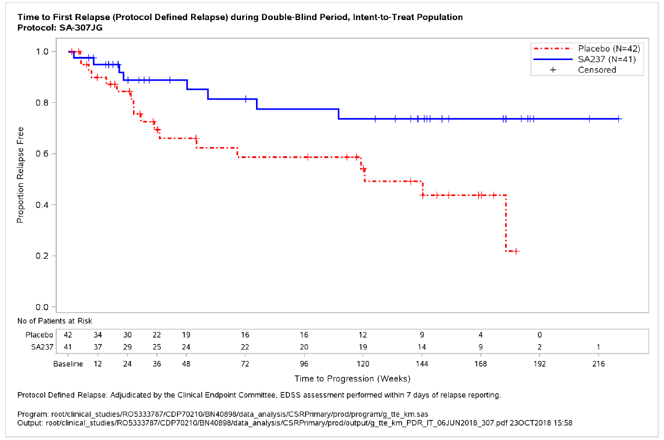

**Figure 2: Study BN40900 - Time to first adjudicated relapse during the double-blind period (ITT population)**

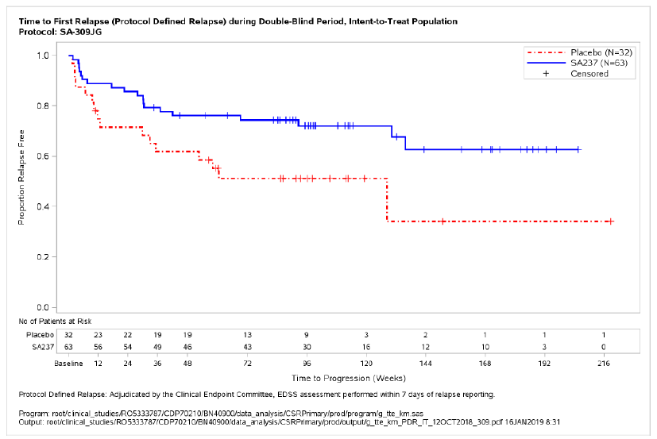

**Figure 3: Study BN40898 - Time to first adjudicated relapse during the double-blind period in AQP4-IgG seropositive patients**

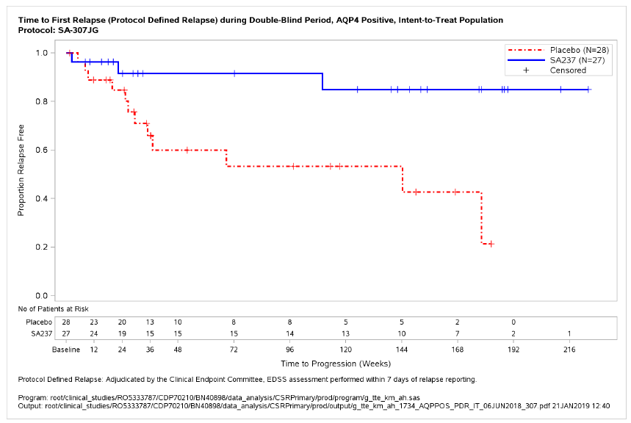

**Figure 4: Study BN40900 - Time to first adjudicated relapse during the double-blind period in AQP4-IgG seropositive patients**

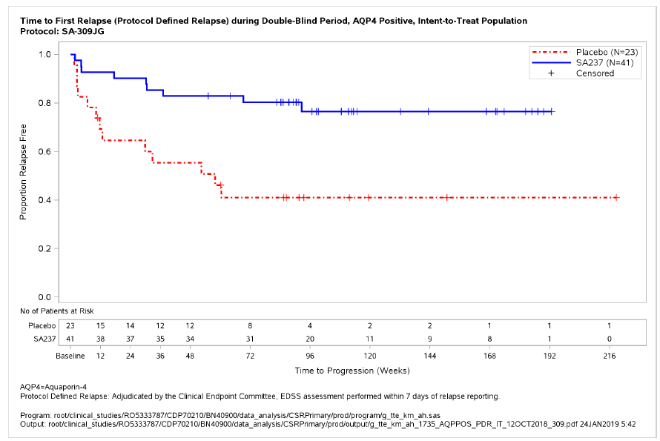

Treatment with Enspryng reduced the annualised rate of adjudicated relapses (ARR) by 74% in Study BN40898 and 73% in Study BN40900 compared to treatment with placebo (Table 7). The relative reduction in ARR in the AQP4-IgG seropositive subgroup was 88% and 90% in Studies BN40898 and BN40900 respectively.

**Table 7: Annualised adjudicated relapse rate during the double-blind period using negative binomial regression model**

|  |  |  |  |  |  |  |
| --- | --- | --- | --- | --- | --- | --- |
|  | **BN40898** | | **BN40900** | | **Pooled** | |
| **Placebo** | **Enspryng** | **Placebo** | **Enspryng** | **Placebo** | **Enspryng** |
| **ITT** | **n=42** | **n=41** | **n=32** | **n=63** | **n=74** | **n=104** |
| Number of patients with relapse | 18 | 8 | 16 | 19 | 34 | 27 |
| Adjusted annualised relapse rate | 0.538 | 0.141 | 2.005 | 0.551 | 1.090 | 0.294 |
| Relative ARR reduction (Rate ratio) | 74% (RR: 0.261, 95% CI: 0.087,0.787; p=0.0175) | | 73% (RR: 0.275; (95% CI: 0.071,1.069; p=0.0668) | | 73% (RR: 0.270; 95% CI: 0.112,0.653; p=0.0050) | |
| **Subgroup:**  **AQP4-IgG Seropositive** | **n=28** | **n=27** | **n=23** | **n=41** | **n=51** | **n=68** |
| Number of patients with relapse | 12 | 3 | 13 | 9 | 25 | 12 |
| Adjusted annualised relapse rate | 0.520 | 0.063 | 2.853 | 0.275 | 1.339 | 0.136 |
| Relative ARR reduction (Rate ratio) | 88% (RR: 0.122, 95% CI: 0.027,0.546; p=0.0039) | | 90% (RR: 0.096, 95% CI: 0.020,0.473; p= 0.0086) | | 90% (RR: 0.102; 95%CI: 0.034,0.301; p=0.0002) | |

As compared to placebo-treated patients, the need for rescue therapy (e.g. corticosteroids, intravenous immunoglobulin, and/or apheresis [including plasmapheresis or plasma exchange]) was reduced in Enspryng-treated patients by 51% in Study BN40898 and by 55% in Study BN40900 (ITT population). In the AQP4-IgG seropositive subgroup, Enspryng treatment reduced the need for rescue therapy by 61% and 74% in Studies BN40898 and BN40900, respectively (Table 8).

**Table 8: Use of rescue therapy in patients with any relapse during the double-blind period**

|  |  |  |  |  |  |  |
| --- | --- | --- | --- | --- | --- | --- |
|  | **BN40898** | | **BN40900** | | **Pooled** | |
| **Placebo** | **Enspryng** | **Placebo** | **Enspryng** | **Placebo** | **Enspryng** |
| **ITT** | **n=42** | **n=41** | **n=32** | **n=63** | **n=74** | **n=104** |
| Patients with rescue therapy | 26 (61.90%) | 18 (43.90%) | 17 (53.13%) | 21 (33.33%) | 43 (58.11%) | 39 (37.50%) |
| Risk reduction  (Odds Ratio) | 51% (OR: 0.4915; 95% CI:  0.2065, 1.1698, p=0.1084) | | 55% (OR: 0.4509; 95% CI: 0.1916, 1.0612; p=0.0682) | | 54% (OR: 0.4649; 95% CI: 0.2517, 0.8589; p=0.0145) | |
| **Subgroup: AQP4-IgG seropositive** | **n=28** | **n=27** | **n=23** | **n=41** | **n=51** | **n=68** |
| Patients with rescue therapy | 18 (64.29%) | 11 (40.74%) | 14 (60.87%) | 13 (31.71%) | 32 (62.75%) | 24 (35.29%) |
| Risk Reduction  (Odds Ratio) | 61% (OR: 0.3930; 95% CI: 0.1343, 1.1502 p=0.0883) | | 74% (OR: 0.2617; 95% CI: 0.0862, 0.7943; p=0.0180) | | 66% (OR: 0.3430; 95% CI: 0.1614, 0.7289; p=0.0054) | |

Treatment with Enspryng reduced the risk of experiencing a severe relapse defined as an EDSS increase ≥2 points from the previous EDSS assessment by 84% in study BN40898 and by 74% in study BN40900 compared to treatment with placebo (Table 9). The relative reduction in severe relapses in AQP4-IgG seropositive patients was 85% and 79% in studies BN40898 and BN40900, respectively.

**Table 9: Time to first severe adjudicated relapse during the double-blind period**

|  |  |  |  |  |  |  |
| --- | --- | --- | --- | --- | --- | --- |
|  | **BN40898** | | **BN40900** | | **Pooled** | |
| **Placebo** | **Enspryng** | **Placebo** | **Enspryng** | **Placebo** | **Enspryng** |
| **ITT** | **n=41** | **n=41** | **n=32** | **n=63** | **n=73** | **n=104** |
| Patients with an event | 6 (14.6%) | 1 (2.4%) | 6 (18.8%) | 4 (6.3%) | 12 (16.4%) | 5 (4.8%) |
| Risk reduction | 84% (HR: 0.16; 95% CI: 0.02, 1.33; p=0.0522) | | 74% (HR: 0.26; 95% CI: 0.07, 0.93, p=0.0265) | | 79% (HR: 0.21, 95% CI: 0.07, 0.61, p=0.0018) | |
| **Subgroup:**  **AQP4-IgG seropositive** | **n=27** | **n=27** | **n=23** | **n=41** | **n=50** | **n=68** |
| Patients with an event | 6 (22.2%) | 1 (3.7%) | 5 (21.7%) | 3 (7.3%) | 11 (22.0%) | 4 (5.9%) |
| Risk reduction | 85% (HR: 0.15; 95% CI: 0.02, 1.25;, p=0.0441) | | 79% (HR: 0.21; 95% CI: 0.05, 0.91; p=0.0231) | | 82% (HR: 0.18; 95% CI: 0.06, 0.58; p=0.0015) | |

###### Open-Label Extension (Note: Generally regarded as providing lower level of efficacy evidence)

Analyses of longer-term data including the OLE period (based on relapse treated with rescue therapy) showed that 57% and 71% of patients treated with Enspryng remained relapse-free after 120 weeks of treatment, when Enspryng was administered as add-on therapy or as monotherapy, respectively.

In the AQP4-IgG seropositive population, 58% and 73% of patients remained relapse free after 120 weeks of treatment with Enspryng administered as add-on therapy or as monotherapy, respectively.

**Figure 5: Study BN40898 - Time to first relapse (treated clinical relapse) during double-blind and open-label period**

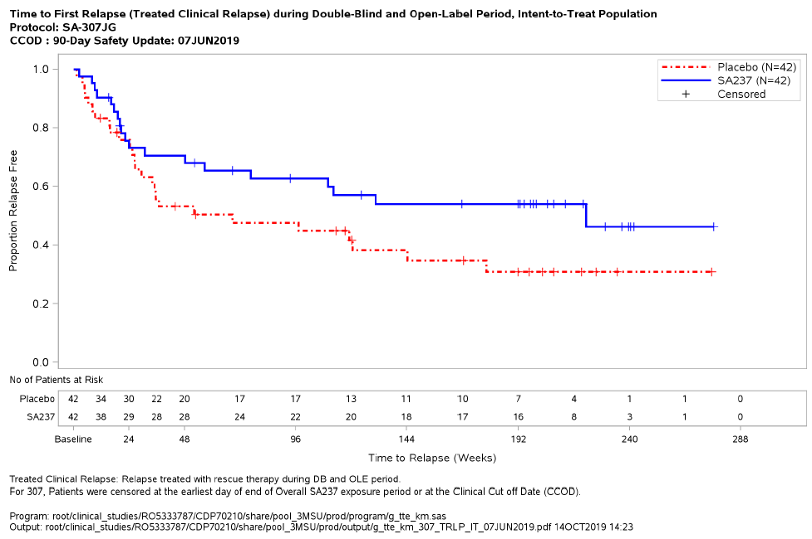

**Figure 6: Study BN40900 - Time to first relapse (treated clinical relapse) during double-blind and open-label period**

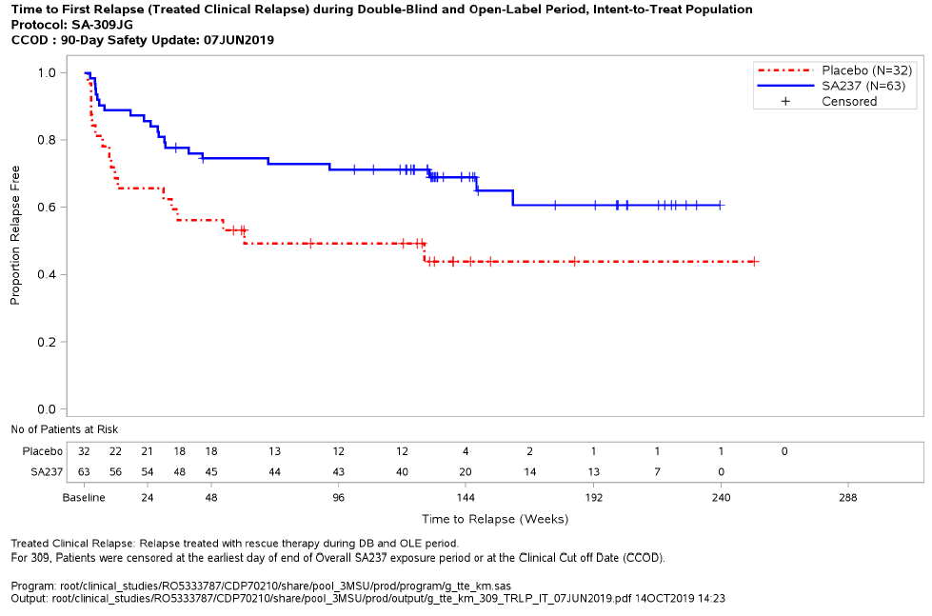

**Figure 7: Study BN40898 - Time to first relapse (treated clinical relapse) during double-blind and open-label period in AQP4-IgG seropositive patients**

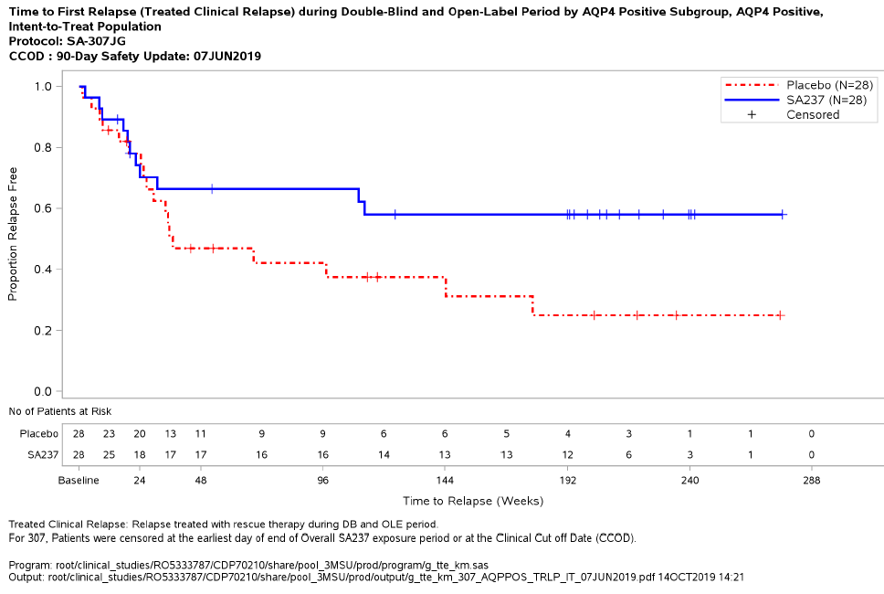

**Figure 8: Study BN40900 - Time to first relapse (treated clinical relapse) during double-blind and open-label period in AQP4-IgG seropositive patients**

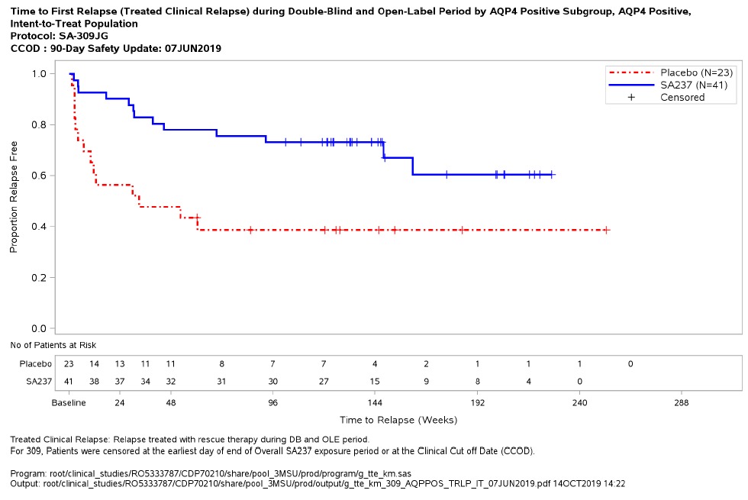

### Immunogenicity

In phase III studies BN40898 (combination with IST) and BN40900 (monotherapy), anti-drug-antibodies (ADAs) were observed in 41% and 71% of patients receiving Enspryng in the double-blind period, respectively. The ability of these ADAs to neutralise satralizumab binding is unknown.

Exposure was lower in ADA positive patients, however there was no impact of ADAs on safety and no clear impact on efficacy nor pharmacodynamic markers indicative of target engagement.

Treatment with satralizumab led to a similar reduction in the risk of experiencing an adjudicated relapse in patients in the Phase 3 studies despite different ADA rates between those studies.

Patients with higher bodyweight and lower exposure were more likely to develop ADAs (irrespective of background treatment with IST), however treatment effect was comparable in all bodyweight groups when used either in combination with IST or as monotherapy. The recommended dose is appropriate for individuals of all bodyweights, and neither dose interruption nor modification is warranted in those patients who develop ADAs.

### Paediatric population

In study BN40898, there were 7 adolescent patients enrolled. Their mean age was 15.4 years and themedian body weight was 79.6 kg. The majority were female (n=6). Four patients were White, 2 wereBlack/African American, and 1 was Asian. Three (42.9%) adolescent patients were AQP4-IgGseropositive at screening (2 in the placebo group and 1 in the Enspryng group). During the double**-**blindperiod, 1 of 3 adolescents in the placebo group and 1 of 4 adolescents in the Enspryng groupexperienced an adjudicated relapse. **Due to the small sample size, the hazard ratio for the primary endpoint of time to first adjudicated relapse in this subgroup was not calculated.**

## 5.2 PHARMACOKINETIC PROPERTIES

The pharmacokinetics of Enspryng have been characterised both in Japanese and Caucasian healthy volunteers, and in NMO and NMOSD patients. The pharmacokinetics in NMO and NMOSD patients using the recommended dose were characterised using population PK analysis methods based on a database of 154 patients.

The concentration-time course of Enspryng in patients with NMO or NMOSD was accurately

described by a two-compartment population PK model with parallel linear and target mediated (Michaelis-Menten) elimination and first-order SC absorption. Enspryng clearance and volume parameters allometrically scaled by body weight (through power function with the fixed power coefficient of 0.75 and 1 for clearance and volume parameters, respectively). Bodyweight was shown to be a significant covariate, with clearance and central volume of distribution (Vc) for patients weighing 123 kg (97.5th percentile of the weight distribution) increased by 71.3% and 105%, respectively, compared to a 60 kg patient. However, as treatment effect was comparable in all bodyweight groups, despite an apparent association between higher bodyweight and development of ADAs, no dose adjustment is required in heavier bodyweight patients (see section 5.1 Immunogenicity).

Pseudo-steady state pharmacokinetics were achieved after the loading period (8 weeks) for Cmin, Cmax and AUC as follows (mean (±SD): Cmin: 19.7 (12.2) mcg/mL, Cmax: 31.5 (14.9) mcg/mL and AUC: 737 (386) mcg.mL/day. Pharmacokinetics were not impacted by background immunotherapy (see section 4.5).

### Absorption

The absorption rate constant of Enspryng was 0.251 one/day (95% CI: 0.216 - 0.285) equating to an absorption half-life of around 3 days at the recommended dose (see section 4.2). The bioavailability was high (85.4%; 95% CI: 79.5 - 95.3).

### Distribution

Satralizumab undergoes biphasic distribution. The central volume of distribution was 3.46 L (95% CI: 3.05 - 3.87), the peripheral volume of distribution was 2.07 L (95% CI: 1.67 - 2.47). The inter-compartmental clearance was 0.336 L/day (95% CI: 0.253 - 0.419).

**Metabolism**

The metabolism of satralizumab has not been directly studied, as monoclonal antibodies are principally cleared by catabolism.

**Excretion**

The total clearance of satralizumab is concentration-dependent. Linear clearance (accounting for approximately half of the total clearance at steady state using the recommended dose in NMO and NMOSD patients) is estimated to be 0.0601 L/day (95% CI: 0.0513 - 0.0689). Using the recommended dosing regimen, the associated t1/2 based on total clearance is approximately 30 days (ranging between 22-37 days throughout the dosing interval) based on data pooled from the phase 3 studies.

### Special populations

Population pharmacokinetic analyses in adult patients with NMO or NMOSD showed that age, gender, and race did not meaningfully influence the pharmacokinetics of satralizumab. Although body weight influenced the pharmacokinetics of satralizumab, no dose adjustments are recommended for any of these demographics.

#### Paediatric population

Data obtained in 8 adolescent patients (13-17 years) who received the adult dosing regimen show that population PK parameters for satralizumab are not significantly different from those in the adult population.

#### Elderly

No dedicated studies have been conducted to investigate the PK of satralizumab in patients ≥ 65 years, however patients with NMO or NMOSD between 65 and 74 years were included in the BN40898 and BN40900 clinical studies.

Population PK analyses based on data from these patients showed that age did not affect the PK of satralizumab.

#### Renal impairment

No formal study of the effect of renal impairment on the PK of satralizumab has been conducted. However, patients with mild renal impairment (creatinine clearance < 80 mL/min and ≥ 50 mL/min) were included in the BN40898 and BN40900 clinical studies. As anticipated based on the known mechanisms of clearance for satralizumab, the PK in these patients was not impacted and therefore no dose adjustment is required.

#### Hepatic impairment

No formal study of the effect of hepatic impairment on the PK of satralizumab has been conducted.

## 5.3 PRECLINICAL SAFETY DATA

### Genotoxity

No studies have been performed to establish the mutagenic genotoxic potential of satralizumab. Antibodies are not expected to cause effects on DNA.

### Carconogenicity

No rodent carcinogenicity studies have been performed. Proliferating lesions were not observed in cynomolgus monkeys administered weekly subcutaneous doses of satralizumab at 50 mg/kg for 6 months (AUC exposure at least 100-fold higher than in human patients receiving Enspryng 120 mg every 4 weeks).

# PHARMACEUTICAL PARTICULARS

## 6.1 LIST OF EXCIPIENTS

Histidine, aspartic acid, arginine, poloxamer 188, water for injections

## 6.2 INCOMPATIBILITIES

In the absence of compatibility studies, this medicine must not be mixed with other medicines.

## 6.3 SHELF LIFE

24 months

## 6.4 SPECIAL PRECAUTIONS FOR STORAGE

Store at 2°C – 8°C in a refrigerator until ready to use. Do not freeze. Do not use the syringe if it has been frozen. Always keep the syringe dry.

Do not shake.

Keep the PFS in the outer carton in order to protect from light and moisture.

Enspryng, if unopened and kept in the outer carton, can be removed from and returned to the

refrigerator, if necessary. If stored at room temperature, the total combined time out of refrigeration should not exceed 8 days at a temperature that does not exceed 30°C.

## 6.5 NATURE AND CONTENTS OF CONTAINER

1 mL solution in a PFS (polymer) with a staked-in, stainless steel needle, fitted with a chlorinated butyl rubber-polypropylene rigid needle shield and sealed with a chlorinated butyl rubber plunger stopper. The PFS is labelled and assembled with a needle safety device (NSD), plunger rod, and extended finger flanges (EFF).

Pack size of 1 PFS.

## 6.6 SPECIAL PRECAUTIONS FOR DISPOSAL AND OTHER HANDLING

Enspryng is supplied in a single-dose PFS assembled with a needle safety device. After removing the carton from the refrigerator, open the sealed carton and carefully lift the PFS out of the carton by holding the barrel. It is important to let the PFS reach room temperature by waiting for 30 minutes before initiating the administration process.

Do not use the medicine if the liquid is cloudy, discoloured, has visible particles in it or if any part of the PFS appears to be damaged.

After removing the cap, the injection must be started within 5 minutes, to prevent the medicine from drying out and blocking the needle. If the pre-filled syringe is not used within 5 minutes of removing the cap, you must dispose of it in a puncture resistant container and use a new pre-filled syringe.

Enspryng is for single use in one patient only. Discard any residue.

In Australia, any unused medicine or waste material should be disposed of by taking to your local pharmacy.

## 6.7 PHYSIOCHEMICAL PROPERTIES

**Chemical structure**

Enspryng is a recombinant humanised immunoglobulin G2 (IgG2) monoclonal antibody against the human interleukin-6 receptor (IL-6R), produced in Chinese hamster ovary cells by recombinant DNA technology (including a pH-dependent binding technology). Each light chain and heavy chain consists of 214 and 443 amino acids, respectively. Satralizumab is a glycoprotein with an approximate molecular weight of 143 kDa.

**CAS number:**

1535963‑91‑7

# MEDICINE SCHEDULE (POISONS STANDARD)

Prescription Only Medicine

# SPONSOR

Roche Products Pty Limited

ABN 70 000 132 865

Level 8, 30 – 34 Hickson Road

Sydney NSW 2000

AUSTRALIA

Medical enquiries: 1800 233 950

# DATE OF FIRST APPROVAL

17 November 2020

# DATE OF REVISION

17 November 2020

### Summary table of changes

|  |  |
| --- | --- |
| **Section Changed** | **Summary of new information** |
| All | Initial PI for Enspryng |