|  |
| --- |
| **Date of CER: September 2012** |

|  |
| --- |
| AusPAR Attachment 2 |
| Extract from the Clinical Evaluation Report for Saxagliptin / metformin hydrochloride |
| Proprietary Product Name: Kombiglyze |
| Sponsor: Bristol-Myers Squibb Australia Pty Ltd |

About the Therapeutic Goods Administration (TGA)

* The Therapeutic Goods Administration (TGA) is part of the Australian Government Department of Health and is responsible for regulating medicines and medical devices.
* The TGA administers the *Therapeutic Goods Act 1989* (the Act), applying a risk management approach designed to ensure therapeutic goods supplied in Australia meet acceptable standards of quality, safety and efficacy (performance), when necessary.
* The work of the TGA is based on applying scientific and clinical expertise to decision-making, to ensure that the benefits to consumers outweigh any risks associated with the use of medicines and medical devices.
* The TGA relies on the public, healthcare professionals and industry to report problems with medicines or medical devices. TGA investigates reports received by it to determine any necessary regulatory action.
* To report a problem with a medicine or medical device, please see the information on the TGA website <<http://www.tga.gov.au>>.

About the Extract from the Clinical Evaluation Report

* This document provides a more detailed evaluation of the clinical findings, extracted from the Clinical Evaluation Report (CER) prepared by the TGA. This extract does not include sections from the CER regarding product documentation or post market activities.
* The words [Information redacted], where they appear in this document, indicate that confidential information has been deleted.
* For the most recent Product Information (PI), please refer to the TGA website <<http://www.tga.gov.au/hp/information-medicines-pi.htm>>.

**Copyright**© Commonwealth of Australia 2013  
This work is copyright. You may reproduce the whole or part of this work in unaltered form for your own personal use or, if you are part of an organisation, for internal use within your organisation, but only if you or your organisation do not use the reproduction for any commercial purpose and retain this copyright notice and all disclaimer notices as part of that reproduction. Apart from rights to use as permitted by the *Copyright Act 1968* or allowed by this copyright notice, all other rights are reserved and you are not allowed to reproduce the whole or any part of this work in any way (electronic or otherwise) without first being given specific written permission from the Commonwealth to do so. Requests and inquiries concerning reproduction and rights are to be sent to the TGA Copyright Officer, Therapeutic Goods Administration, PO Box 100, Woden ACT 2606 or emailed to <[tga.copyright@tga.gov.au](mailto:tga.copyright@tga.gov.au)>.

Contents

List of abbreviations 5

1. Clinical rationale 7

2. Contents of the clinical dossier 7

2.1. Scope of the clinical dossier 7

2.2. Paediatric data 7

2.3. Good clinical practice 8

3. Pharmacokinetics 8

3.1. Studies providing pharmacokinetic data 8

4. Pharmacodynamics 8

4.1. Summary of pharmacokinetics 8

4.2. Evaluator’s overall conclusions on pharmacokinetics 11

4.3. Studies providing pharmacodynamic data 11

4.4. Summary of pharmacodynamics 12

4.5. Evaluator’s overall conclusions on pharmacodynamics 14

5. Dosage selection for the pivotal studies 14

6. Clinical efficacy 14

6.1. Pivotal efficacy studies 15

6.2. Other efficacy studies 24

6.3. Analyses performed across trials (pooled & meta analyses) 35

6.4. Evaluator’s conclusions on clinical efficacy 35

7. Clinical safety 37

7.1. Studies providing evaluable safety data 38

7.2. Pivotal studies that assessed safety as a primary outcome 39

7.3. Patient exposure 39

7.4. Adverse events 40

7.5. Laboratory tests 42

7.6. Post-marketing experience 43

7.7. Other safety issues 43

7.8. Evaluator’s overall conclusions on clinical safety 44

8. First round benefit-risk assessment 44

8.1. First round assessment of benefits 44

8.2. First round assessment of risks 44

8.3. First round assessment of benefit-risk balance 45

9. First round recommendation regarding authorisation 45

10. Clinical questions 45

10.1. Pharmacokinetics 45

10.2. Pharmacodynamics 45

10.3. Efficacy 45

10.4. Safety 46

11. References 46

## List of abbreviations

| **Abbreviation** | **Meaning** |
| --- | --- |
| ACPM | Australian Committee for Prescription Medicines |
| AE | adverse event |
| ANCOVA | analysis of covariance |
| ANOVA | analysis of variance |
| AUC | area under curve |
| AUEC | area under effect curve |
| AZ | AstraZeneca |
| BMI | body mass index |
| BMS | Bristol-Myers Squibb |
| CER | clinical evaluation report |
| CGMS | continuous glucose monitoring system |
| CI | confidence interval |
| Cmax | maximum concentration |
| CMI | Consumer Medicine Information |
| DPP-4 | dipeptidyl peptidase 4 |
| EE | ethynylestradiol |
| EMA/EMEA | European Medicines Agency |
| EU | European Union |
| FDC | fixed dosage combination |
| FPG | fasting plasma glucose |
| GIP | glucose-dependent inhibitory peptide |
| GLP-1 | glucagon-like peptide 1 |
| HbA1c | haemoglobin A1C |
| Imax | maximum inhibition |
| IR | immediate release |
| ITT | intention-to-treat |
| IVRS | interactive voice response system |
| LOCF | last observation carried forward |
| LT | long-term |
| MTDDI | mean total daily dose of insulin |
| MWG | mean weighted glucose |
| NGM | norgestimate |
| PD | pharmacodynamic |
| PI | Product Information |
| PK | pharmacokinetic |
| QD | per day |
| RMP | Risk Management Plan |
| SAE | serious adverse event |
| SBGM | self blood glucose monitoring |
| SCS | Summary of Clinical Safety |
| SD | standard deviation |
| SE | standard error |
| SI | Systeme Internationale |
| SOC | system organ class |
| ST | short-term |
| Tmax | time to maximum concentration |
| T2DM | type 2 diabetes mellitus |
| URI | upper respiratory infection |
| UTI | urinary tract infection |
| XR | extended release |

## Clinical rationale

Saxagliptin is an inhibitor of DPP-4, the enzymatic activity of which includes as substrates the incretin hormones glucagon-like peptide 1 (GLP-1) and glucose-dependent inhibitory peptide (GIP). Levels of these incretins are therefore increased following administration of saxagliptin, which thus lowers blood glucose by enhancing insulin response to feeding. This mode of action of saxagliptin is complementary to that of metformin and dual combination therapy with these two component substances which make up the Kombiglyze FDC is now approved in Australia for T2DM, both as “add on” treatment with saxagliptin, and as initial combination therapy.

The sponsor proposes the FDC as a more convenient means of administering this dual combination therapy in any circumstance in which the combination is indicated.

It should be noted that the proposed FDC is a combination of saxagliptin and immediate release metformin (metformin IR), and is therefore designed to be given twice daily. While metformin IR is still used in Australia, extended release formulations (metformin XR), given once daily usually with the evening meal, have come into widespread use and the two should not be confused. The sponsor has marketed a once daily FDC containing extended release metformin, Kombiglyze XR, in the US.

## Contents of the clinical dossier

### Scope of the clinical dossier

The dossier is well presented. It is extensive and relies heavily on data which has previously been submitted to TGA to support the use of saxagliptin in combination with metformin, but does include some newly submitted studies to support this dual combination therapy. It does not include any efficacy/safety studies using the FDC product itself. Studies involving administration of the FDC are restricted to those conducted in healthy subjects to establish bioequivalence of the product with its component substances saxagliptin and metformin administered as separate tablets. Pharmacodynamic data are also included to provide justification for the novel twice daily saxagliptin dosing regimen as outlined above. While the application letter and summary documents do not identify any component of the dossier as pivotal, the study providing this pharmacodynamic data (CV181152) is regarded as such by this evaluation as the single obvious change imposed by use of the Kombiglyze FDC is the change in saxagliptin dosing from once to twice daily.

The submission contained the following clinical information:

* 6 clinical pharmacology studies, including 5 that provide pharmacokinetic data and 1 that provides pharmacodynamic data;
* 1 efficacy/safety study (CV181057) regarded by this evaluation as pivotal, as it supports the only aspect of saxagliptin/metformin dual combination therapy included in the application which is not yet approved, that of use together with insulin;
* 7 other efficacy/safety studies.

### Paediatric data

The submission did not include paediatric data. The sponsor notes that a waiver has been granted by the regulatory authorities in the US and Europe for subjects under 10 years old. No studies below this age are currently planned. Prospective randomised studies of saxagliptin monotherapy and add on to metformin have been enrolling subjects since 2011.

### Good clinical practice

All of the studies reviewed in this evaluation comply with the established requirements for good clinical practice (CPMP/ICH/135/95).

## Pharmacokinetics

### Studies providing pharmacokinetic data

Table 1 shows the studies relating to each pharmacokinetic topic and the location of each study summary.

Table 1: Submitted pharmacokinetic studies.

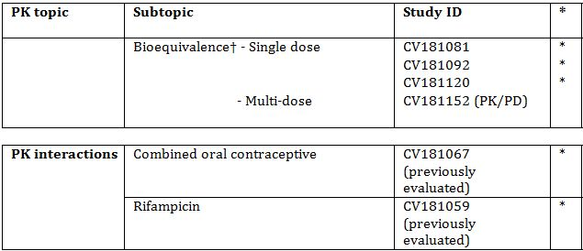

* Indicates the primary aim of the study.

None of the pharmacokinetic studies had deficiencies that excluded their results from consideration.

## Pharmacodynamics

### Summary of pharmacokinetics

The following summary is derived solely from the studies listed in Table 1 and addresses the PK issues arising from the combination of saxagliptin and metformin in the FDC which is the subject of the application. The individual PK profile of the two component substances is well identified from the evaluation of previous submissions to TGA regarding their existing registered uses. The objective of the included PK studies was to demonstrate bioequivalence between the FDC formulations and corresponding doses of saxagliptin and metformin administered together as separate products, with particular attention to the FDC being equivalent, dose for dose, with current Australian registered products.

#### Pharmacokinetics in healthy subjects

##### Bioequivalence of clinical trial and market formulations

There have been no clinical trials in which the FDC has been administered to the target population of T2DM patients. The application certifies that the product used in bioequivalence studies CV181081 and CV181092 was identical with the product for marketing except for the printing on the outside of the tablet.

##### Bioequivalence to relevant registered products

Studies CV181081 and CV181092 were conducted to establish bioequivalence of the FDC with tablets containing the same doses of saxagliptin and metformin coadministered. CV181081 studied the 2.5 mg saxagliptin/500 mg metformin combination and CV181092 the 5 mg/1000 mg combination. There is close concordance between the exposure data for the FDC and reference products in terms of Cmax and AUC, with difference in the point estimates for total exposure (AUC) varying by no more than 2-4% from the reference products for either component substance of the FDC, whether administered fasting or with a meal. The variance figures of the data were well within the limits for bioequivalence.

The 2.5 mg saxagliptin tablet used in these studies is not registered in Australia, but its PK properties were evaluated for TGA in respect of submission PM-2010-03800-3, the evaluation report concluding that there was sufficient evidence of bioequivalence with the Australian marketed 5 mg tablet.

Likewise, the 500 mg and 1000 mg metformin tablets used as comparators in studies CV181081 and CV181092 were the Glucophage brand marketed by BMS in the US. Study CV181120 was conducted to demonstrate bioequivalence of these tablets with the same doses of metformin IR given as the product Diabex marketed in Australia by Alphapharm. The results clearly demonstrate bioequivalence between the two products.

##### Influence of food

As noted above, studies CV181081 and CV181092 involved administration of the FDC and comparator products both fasting and after a standard non-high-fat meal. The studies were designed to look for any difference between the two products in either of these situations, rather than to evaluate the food effect itself, and this was not statistically analysed. Visual inspection of the data shows that for saxagliptin, there was a 10-15% increase in absorption as reflected both by Cmax and AUC when administered with a meal. These findings are consistent with the slight increase in absorption of saxagliptin with food reported in the evaluation report of the original submission PM 2008-03469-3-5, although in that case Cmax was not increased, only AUC. The difference might be attributable to a high-fat meal having been used in those studies.

With respect to metformin, the data from studies CV181081 and CV181092 show that in the fed state there was a reduction in Cmax both for the 500 mg and 1000 mg doses and a possible slight reduction in total exposure (AUC) at the 1000 mg dose level, although again the effect was not statistically analysed. For both component drugs, the food effect appears identical for both the FDC and reference preparations.

##### Dose proportionality

The submission includes no specific studies of dose proportionality, which is not an issue for the saxagliptin component of the FDC as a standard dose of 2.5 mg twice daily is used in all dosage forms. Nevertheless, some relevant data is found in studies CV181081 and CV181092. Mean saxagliptin exposure as measured by AUC(0-T) was 48.16 ng.h/mL in the fed state with the 2.5 mg/500 mg dose form and 46.57 ng.h/mL with the 2.5 mg/1000 mg form, close to the 1:1 ratio which would be expected. For metformin, the corresponding mean AUC(0-T) values were, in the fed state, 7376 and 11,997 ng.h/mL, an exposure ratio of 1.63 for the 2:1 dosing ratio in favour of the 2.5 mg/1000 mg dosage. The corresponding ratio for metformin in treatment C in these two studies, in which the combination therapy was administered as separate tablets, was 1.71. This lack of dose proportionality with increasing dose of metformin has been observed previously in single dose studies. The figures quoted above suggest that the proportion of metformin dose absorbed from the FDC is similar, at both 500 mg and 1000 mg dose levels, to that absorbed from the separately administered metformin tablets used in the bioequivalence studies.

##### Effect of administration timing

The issue of timing of administration of saxagliptin is of critical importance to the evaluation of this FDC product, as its use involves a change from the existing approved dosage of saxagliptin (Onglyza), 5 mg once daily in the morning in dual combination with metformin (in any dosage form), to a regimen of 2.5 mg twice daily in fixed combination with metformin either 500 mg, 850 mg or 1000 mg twice daily. Study CV181152 is pivotal in providing both PK and PD data in relation to this change. In a 2 period crossover design, healthy subjects were given a 7-day course of 5 mg once daily in the morning (treatment A), and 2.5 mg twice daily (treatment B), in random order. The ratio (90% CI) of total exposure as measured by AUC(0-24h) for treatment B versus A was 104.1 (101.1-107.2)%, indicating a slightly but not significantly higher exposure with the twice-daily regimen, and meeting pre-established criteria for bioequivalence of the two treatments. Not surprisingly, the time-concentration curves for the two treatments were quite different (Figure 1).

Figure 1: Time-concentration curves for the two treatments (open squares: once daily treatment; closed squares: twice daily).

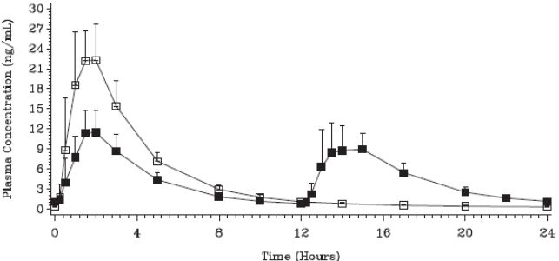

The possibility that this difference in diurnal distribution of exposure to saxagliptin might result in a clinically important difference in the expression of its pharmacodynamic action, either overall or in the form of a time-of-day effect, is discussed below.

##### Metabolites identified in humans

###### Active metabolites

BMS-510849 is a hydroxylated form of saxagliptin which contributes substantially to its metabolic activity.

##### Pharmacokinetics of metabolites

PK parameters of BMS-510849 were measured in bioequivalence studies CV181081 and CV181092. Cmax, Tmax, AUC(0-T) and AUC(INF) were closely similar between the FDC and the reference treatment of coadministered saxagliptin and metformin, in both fasted and fed state.

#### Pharmacokinetics in the target population

No specific studies are included. A population PK study was conducted in the course of study D1680C00001, but is the subject of a separate report; some isolated PK measurements were also obtained in for safety assessments.

#### Pharmacokinetic interactions

##### Pharmacokinetic interactions demonstrated in human studies

Study CV181067 was an open-label, randomized, 2-way crossover study conducted in healthy female subjects to assess the effect of saxagliptin on the pharmacokinetics of the components – ethinylestradiol (EE) and norgestimate (NGM) – of the oral contraceptive preparation Ortho-Cyclen. It was concluded that there was no effect of saxagliptin on the pharmacokinetics of EE, the most common component of oral contraceptive preparations available in Australia and the component of the tested oral contraceptive preparation more likely on theoretical grounds to be so affected. The progestogenic component of the tested preparation (NGM) is not registered in Australia where many combined oral contraceptive preparations contain the closely related substance levonorgestrel. The evaluation concluded that an effect on norgestrel was unlikely but if anything would be to increase rather than decrease exposure, which would tend to be protective of contraceptive efficacy.

Study CV181059 was a non-randomised, open-label, single sequence study the primary objective of which was to assess the effect of rifampicin on the single dose pharmacokinetics of saxagliptin when the two drugs were coadministered to healthy subjects. Secondary objectives were assessment of the effect of rifampicin on the pharmacokinetics of saxagliptin's metabolically active metabolite BMS-510849, and assessment of the safety and tolerability of the single 5 mg saxagliptin dose in the presence and absence of rifampicin in these subjects. It was concluded that, as an inducer of CYP 3A4, rifampicin significantly reduced levels of saxagliptin, an effect partly compensated for by an increase in its active metabolite, but associated with some reduction in duration of pharmacodynamic response as assessed by DPP-4 inhibition. The evaluation concluded that whether this effect was "unlikely to be of clinical consequence", as claimed by the sponsor, was uncertain.

### Evaluator’s overall conclusions on pharmacokinetics

The bioequivalence studies show robust evidence of close equivalence between the applicant FDC product and its component substances saxagliptin and metformin administered together as separate tablets. Study CV181120 bridges these findings to products which are registered in Australia. Overall, these findings are strongly supportive of the product as being equivalent to dual combination of saxagliptin and metformin administered separately in a twice-daily regimen. Study CV181152 shows that daily exposure to saxagliptin is unaffected by the change from a once-daily to twice-daily administration regimen but leaves open the question as to whether its pharmacodynamic action, and hence its efficacy, might be altered as a result of the marked change in diurnal distribution of saxagliptin exposure seen with the twice-daily regimen as shown above (Figure 1).

The food effect described above appears to be of no clinical significance, applies to the two component drugs whether administered separately or in combination, and is therefore not critical to the evaluation of the FDC. Likewise, the PK interactions with respect to saxagliptin are noted, are described in the draft PI, but are not specific to the FDC.

### Studies providing pharmacodynamic data

Table 2 shows the studies relating to pharmacodynamic topics and the location of each study summary.

Table 2: Submitted pharmacodynamic studies.

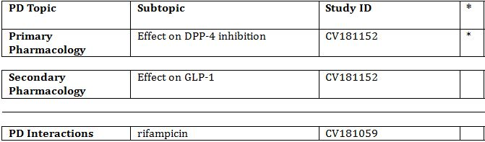

* Indicates the primary aim of the study.

None of the above studies had deficiencies that excluded their results from consideration.

### Summary of pharmacodynamics

The information in the following summary is derived from a single conventional pharmacodynamic human study, CV181152 which is of particular importance to the evaluation of the saxagliptin component of the FDC in relation to the timing of administration. The PD interaction between saxagliptin and rifampicin has been referred to above and is not specific to the FDC. There are no pharmacodynamic data in relation to the metformin component.

#### Mechanism of action

The well-established complementary mechanisms of action of the two component drugs saxagliptin and metformin have been briefly summarised above.

#### Pharmacodynamic effects (saxagliptin component)

##### Primary pharmacodynamic effect

Inhibition of DPP-4 enzyme activity was assessed in study CV181152. Healthy adults were given each of two treatments for seven days, in random order: saxagliptin 5 mg once daily in the morning (treatment A), and saxagliptin 2.5 mg twice daily (treatment B). All doses were given with meals. Plasma DPP-4 activity was measured each day before dosing and then at time intervals after dosing, for PD assessment, on Day 7. At baseline (Day 1), mean (SD) DPP-4 activity was 9.89 (1.80) u/L for treatment A and 10.13 (1.87) for treatment B. Activity fell rapidly in both groups, but more so for the twice-daily treatment group in which there was a mean pre-dose activity of 2.53 (0.54) u/L on Day 2, which did not change significantly thereafter, whereas steady state mean activity levels between 3.74 and 3.79 u/L were not achieved in the once-daily treatment group until Day 4.

Following dosing on Day 7, maximum % inhibition (Imax) was 81-82% in both groups. The mean value for integrated inhibition over the 24 hour dosing interval, expressed as the area under the effect curve (AUEC) for this interval, was 1740%.h for treatment A and 1838%.h for treatment B. In treatment B, the AUEC values were similar following the morning and evening doses at 907 and 931%.h respectively. The statistical analysis for between treatment difference of this parameter is shown in table 9; for treatment B versus A, the ratio of geometric means (90% CI) was 105.7 (102.2-109.2) %. For Imax, this estimate was 100.0 (98.7-101.4) %.

##### Secondary pharmacodynamic effects

These are enhancement of prandial GLP-1 secretion and, consequently, insulin secretion. GLP-1 response was measured after each of the three meals pre-study and on study day 7 and calculated as the AUEC for the 3 hours after each meal, totalled for the day. Both treatments resulted in some 25% increase in response with the ratio of geometric means between the treatments B/A being 100.6 (92.3-109.6) %.

#### Time course of pharmacodynamic effects

The above data shows that the PD effects of the once and twice-daily treatment regimens are very similar as measured by integrated analysis over the relevant dosing interval. However, as discussed above, it is important to establish that these do not vary by time of day in view of the quite marked difference between the treatment groups in the diurnal pattern of PK exposure to saxagliptin. The diurnal distribution of DPP-4 inhibition is shown in Figure 2. The twice-daily regimen is shown in the closed squares.

Figure 2: Diurnal distribution of DPP-4 inhibition (open squares: once daily treatment; closed squares: twice daily).

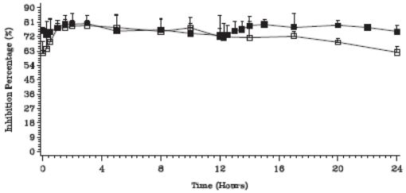

It is evident that for the once-daily regimen, DPP-4 inhibition declines towards the end of the 24 hour period. Trough values for percent inhibition of DPP-4 are as follows: for the once daily regimen, the mean (SD) % inhibition at 24 hours was 62.2 (3.8), and for the twice-daily regimen 72.8 (4.2) at 12 hours and 75.2 (3.9) at 24 hours. The effect of this would be that at the time of starting breakfast, when the first dose of the day is taken, pre-meal DPP-4 inhibition would be slightly greater with the twice-daily regimen, leading to the possibility of a greater enhancement of GLP-1 secretion after breakfast - which could result in improved post-prandial glycaemia at that time, or possibly hypoglycaemia. Although the post-prandial GLP-1 data were not compared statistically by mealtime, some insight into this possibility is obtained from the graphic displays shown in Figure 3. The mean GLP-1 response to meals is shown prior to saxagliptin (open squares) and at steady state on Day 7 (closed squares), with breakfast, lunch and dinner in the upper, middle and lower panels respectively. The response to saxagliptin 5 mg in the morning (treatment A) is shown in the left panel and to 2.5 mg twice daily (treatment B) in the right panel.

Figure 3: Mean GLP-1 response to meals is shown prior to saxagliptin (open squares) and at steady state on day 7 (closed squares).

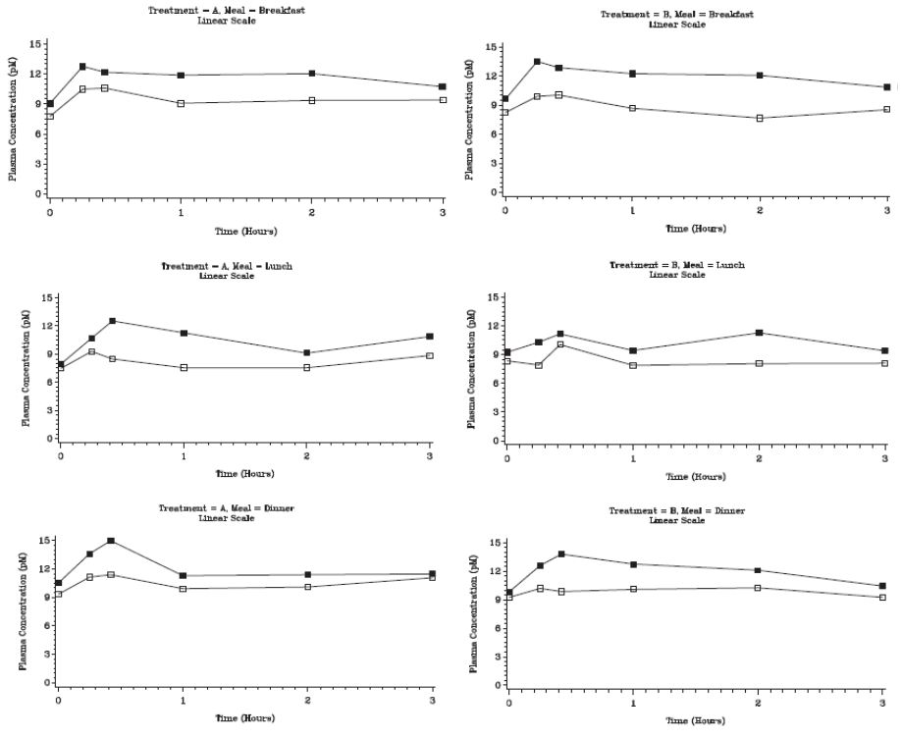

Enhancement of GLP-1 response is seen at each meal time with both treatment regimens. Within the limits of visual inspection of the data, there does appear to be a greater response with breakfast in the twice-daily treatment group, and with lunch in the once-daily treatment group. This is what might be expected as a result of the differential between the treatments of diurnal distribution of the degree of DPP-4 inhibition, as discussed in the previous paragraph. Without detailed statistical analysis, it is not possible to reach a conclusion as to whether this is a definite effect.

While this was a small study, it was rigorously conducted and the findings are well demonstrated. Although demonstrated in healthy adults, it is reasonable to extrapolate this comparison of the once and twice-daily regimens to the therapeutic situation in T2DM.

#### Relationship between drug concentration and pharmacodynamic effects

This has not been formally assessed in the application, but the PK and PD data reviewed in relation to time of administration of the drug in the previous sections of this report suggest a close pharmacokinetic/pharmacodynamic correlation.

### Evaluator’s overall conclusions on pharmacodynamics

The pharmacodynamic response to the saxagliptin component of the FDC is not altered, in healthy adults, by the change from once-daily 5 mg administration in the morning to the 2.5 mg twice daily dosing of the FDC product. No similar study has been conducted in the target population (T2DM patients), but it is not felt likely that findings in relation to timing of these responses would be any different from those in healthy adults. Response as measured by total DPP-4 inhibition and resultant enhancement of GLP-1 secretion over the 24 hour dosing interval is unchanged. There is subtle evidence, statistically unconfirmed and not claimed by the sponsor, that DPP-4 inhibition is more reliably maintained over 24 hours with the twice-daily regimen. This does not appear to be of a degree which would impact significantly on the therapeutic use of the product; if anything, such effect would most likely be beneficial, although there is no specific evidence on this point, as the application does not contain a study which directly compares glycaemic efficacy of the once and twice-daily treatment regimens.

## Dosage selection for the pivotal studies

No efficacy or safety studies have been conducted using the applicant product FDC. However, as noted below, study CV181080 is regarded by this evaluation as pivotal because it employs saxagliptin and metformin doses which correspond with those used in the Kombiglyze formulation.

## Clinical efficacy

The claimed indication for the Kombiglyze FDC is:

*as an adjunct to diet and exercise to improve glycemic control in adults with type 2 diabetes mellitus when treatment with both saxagliptin and metformin is appropriate.*

Of the efficacy/safety studies included with the application, none strictly fits the definition of a pivotal study as none was conducted using the applicant product Kombiglyze. The efficacy studies submitted bear upon various aspects of the therapeutic use of saxagliptin and metformin in dual combination therapy as separate formulations. Of these eight studies, together with their long-term extensions and SI unit-compliant versions constituting a total of 14 reports altogether, the one most critical to the application is Study CV181080, in which a twice-daily dose of saxagliptin was employed. This has therefore been included as a pivotal efficacy study for the purpose of this report together with the long-term extension of study CV 181057 which was previously evaluated in the CER for application PM 2011-01174-3-5 as the pivotal study with reference use of insulin with saxagliptin, with or without metformin.

Throughout this evaluation, the reader should note that references to data contained in the study reports refer to the SI compliant versions in cases where these have been provided.

### Pivotal efficacy studies

#### Study CV 181080

##### Study design, objectives, locations and dates

This was a study of the addition of saxagliptin 2.5 mg twice daily in T2DM patients who had failed metformin monotherapy. It was conducted between May 2009 and February 2010 as a multicentre, randomised, double-blind, placebo-controlled, parallel group trial at 43 sites; 25 in the US, 9 in Germany, 5 in Hungary and 4 in Puerto Rico.

The period of active or placebo treatment was 12 weeks.

##### Inclusion and exclusion criteria

Adult males and females aged between 18 and 78 years were eligible for inclusion who had inadequately controlled T2DM (HbA1c ≥7.0% and ≤10.0% despite diet, exercise and twice-daily monotherapy with metformin totalling ≥1500 mg daily. Other requirements were a fasting C-peptide of ≥0.34 nmol/mL, to exclude type I diabetes, and BMI <45 kg/m2.

##### Study treatments

Saxagliptin 2.5 mg tablets (batch number 6D12066), or matching placebo, were administered twice daily with meals during the 12 week double-blind placebo-controlled phase.

Commercially obtained open-labelled metformin IR was administered twice daily to both groups throughout the two-week run-in phase and 12 week double-blind phase of the study. Throughout the study, subjects continued the metformin dose which they were taking prior to enrolment.

*Comment: the specific products used as treatments in this study are not registered in Australia. Nevertheless the study is regarded as pivotal by this evaluation as it is the only conducted efficacy study with treatments corresponding to the recommended dosage of the applicant FDC product which contains saxagliptin 2.5 mg together with metformin titrated to individual tolerance and given twice daily.*

##### Efficacy variables and outcomes

The efficacy variables were HbA1c and fasting plasma glucose (FPG).

The primary efficacy outcome was the change in HbA1c from baseline to Week 12, compared between the saxagliptin and placebo groups.

Other efficacy outcomes included:

* comparison between the groups of change from baseline to Week 12 in FPG.
* the proportion of subjects achieving a predefined HbA1c target of <7.0%.
* the proportion of subjects achieving a predefined HbA1c target of <6.5%.

*Comment: the two HbA1c values selected match target values recommended by expert groups, the American Diabetes Association and the American Society of Clinical Endocrinologists.*

##### Randomisation and blinding methods

Randomisation and treatment allocation was controlled by an interactive voice response system (IVRS), with the randomisation schedules kept by BMS. At screening, each subject was assigned a unique number by the IVRS and following the lead-in period, those eligible for the double-blind treatment period were randomly assigned in blocks of 4 (to prevent maldistribution of subjects from sites providing small numbers) to either saxagliptin or placebo treatment, on a 1:1 basis. Subjects were dispensed either saxagliptin or identical matching placebo tablets, the assignment of medication being controlled by the IVRS according to the subject’s identification number.

##### Analysis populations

As shown below (Figure 4), the full set of randomised subjects totalled 160 (74 saxagliptin, 86 placebo). This also constituted the Randomised Subjects Data Set and the Treated Subjects Set. A subset defined as evaluable subjects (excluding those with relevant protocol deviations, specifically poor compliance) totalled 157. As there were only three exclusions, the Randomised Subjects Data Set was used for the efficacy analyses. This set appears to meet the definition of an ITT population.

Figure 4: Participant flow for study CV 181080.

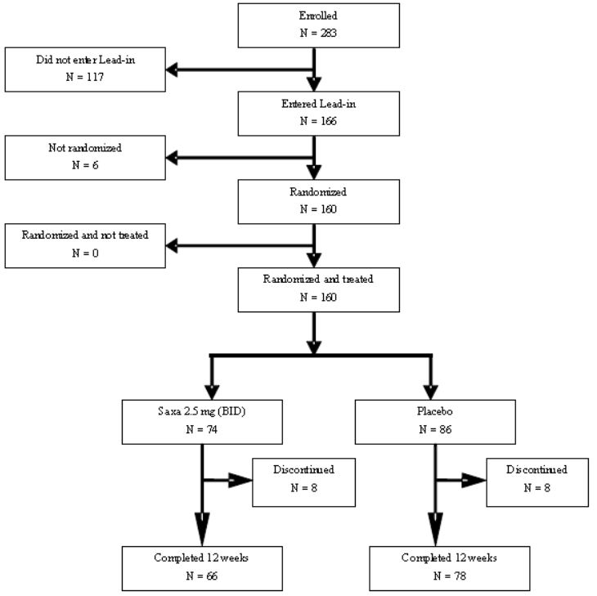

Compliance was defined as taking 80% to 120% of prescribed medication. All but three subjects, one in the saxagliptin and two in the placebo treated groups, met this definition.

The demographic characteristics of the population of 160 subjects used for the data analyses was as follows: mean age 55.4 years (24-77), 53% male, 90% white, mean BMI 33.1 (19.9-44.9). Mean duration of diabetes was 6.0 years. 20.3% of saxagliptin and 12.8% of placebo subjects had a duration of T2DM of ≤1.5 years.

##### Sample size

Sample size was calculated to provide 90% power based on a projected difference in mean HbA1c between the treatment groups of 0.6%, a standard deviation (SD) of 1.1%, and 5% of subjects being unevaluable due to missing data. A sample size of 152 subjects in a 1:1 ratio to receive saxagliptin 2.5 mg or placebo twice daily (76 per group) satisfied these power calculations. Of 283 subjects enrolled, 160 were randomised, 74 to saxagliptin and 86 to placebo. The study report attributes this imbalance, which does not seem sufficient to invalidate the statistical analysis, to the randomisation process which involved only a small number of subjects at some sites.

##### Statistical methods

The primary analysis of the change in HbA1c from baseline to Week 12, comparing the saxagliptin plus metformin group with the saxagliptin plus placebo group, was performed using an analysis of covariance model (ANCOVA) for mean change from baseline to Week 12 or last observation carried forward (LOCF) in the double-blind period. Similar statistical methodology was employed for the comparison of FPG. For the other secondary endpoints involving the proportion of subjects reaching HbA1c targets, response rates and 95% confidence intervals (CI) for the comparison of saxagliptin and placebo were calculated with a statistical package, StatXact version 5.0.

##### Participant flow

The disposition of subjects is shown in Figure 4.

##### Major protocol violations/deviations

These were only 4 subjects in number; 3 subjects with poor compliance, as already noted, and 1 subject who received an additional hypoglycaemic drug (glibenclamide) during the study.

##### Baseline data

The following baseline diabetes characteristics are worthy of comment.

Mean duration of diabetes was similar in the two groups at 5.81 years in the saxagliptin and 6.17 years in the placebo groups. There was however some maldistribution at the extremes, with 20.3% of the saxagliptin group having disease duration of 1.5 years or less compared with 12.8% in the placebo group, whereas 18.6% of placebo patients had disease duration of 10 years or more, compared with 13.5% in the saxagliptin group.

Mean baseline HbA1c was identical between the groups at 7.92%. The range of values was 6.5-10.1% for the saxagliptin group and 6.7-9.8% for the placebo group, indicating that a few subjects met the criterion of HbA1c >7.0% at screening but had fallen below by the start of the double-blind period either as a result of improvement in control or analytical variation. An identical 58.1% of subjects in each group had HbA1c <8.0% at baseline. Baseline C-peptide were similar between the two groups, as was the baseline metformin dose which showed an overall mean value of 1882 mg daily with a median value of 2000 mg (range 1500-3000).

*Comment: these data confirm that the subjects were metformin failures in the sense that they were all on large doses, presumably the maximum tolerated; however the level of inadequate control was in the majority relatively mild.*

##### Results for the primary efficacy outcome

The results for HbA1c at Week 12, the end of the double-blind study period, are shown in Table 3.

Table 3: Results for HbA1c at week 12.

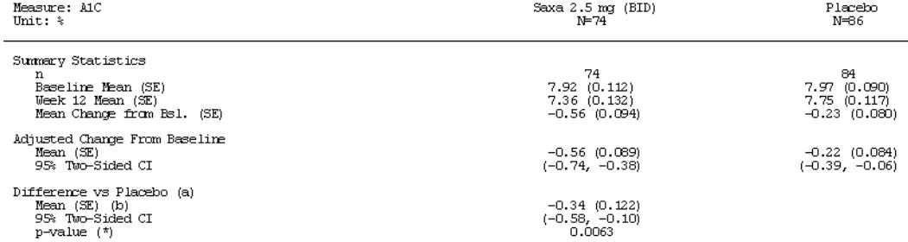

The key finding is the efficacy gain of 0.34% in HbA1c attributable to the combination therapy.

##### Results for other efficacy outcomes

The following results for fasting plasma glucose at Week 12 and for the proportion of subjects meeting predefined HbA1c targets are shown in Table 4.

Table 4: Fasting plasma glucose at week 12.

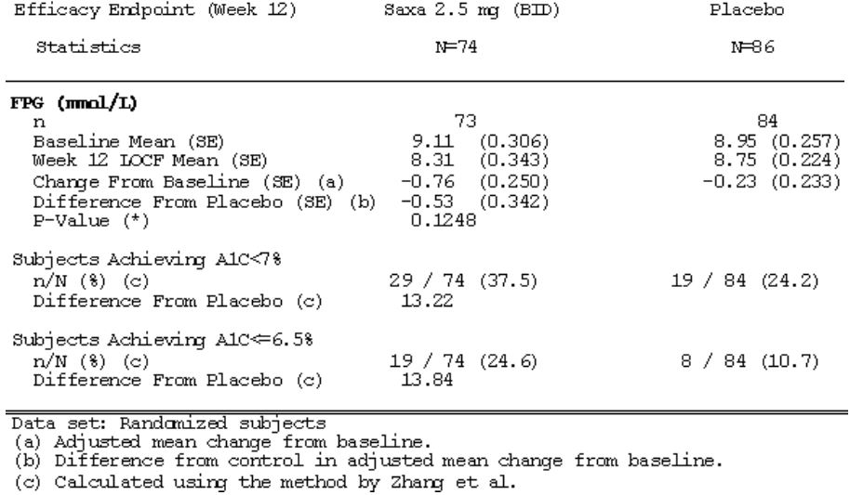

The difference in FPG change from baseline between the saxagliptin and placebo groups of 0.53 mmol/L fails to meet statistical significance. The proportion of subjects achieving the 7% and 6.5% HbA1c targets at Week 12 was greater in the saxagliptin versus placebo groups in each case, but this was not subjected to statistical analysis.

*Comment: the inclusion criteria for this study contain a very wide definition of inadequate control, permitting the inclusion of subjects with HbA1c values as low as 7.0%. As already noted above, the majority had a baseline HbA1c <8.0%, and a few subjects started the double-blind period with a value of <7.0%. This has two potential effects: it places a limit on the degree of HbA1c reduction which can be achieved, but at the same time makes it easier for subject to achieve the predefined HbA1c targets. The degree of HbA1c reduction achieved, at 0.34%, is at the lower end of what would be regarded as a clinically beneficial.*

*The maldistribution between the test and reference groups is a potential confounding factor. As noted above, there was a higher proportion of subjects with shorter duration of diabetes in the saxagliptin treated group; these would tend to have better preserved beta cell function and thus be better responders to enhancement of GLP-1 response. This factor does not diminish the significance of the difference between the active and placebo treated groups, but may have influenced the quantum of change in HbA1c. The size of this effect is impossible to estimate but is not likely to have been great.*

*The study may also have been limited by its relatively short duration of 12 weeks, which is barely sufficient for HbA1c to fully reflect the effect of a treatment change, even assuming that the improvement in plasma glucose occurred immediately upon institution of the test treatment. A graphic display shows a fall in FPG between 8 and 12 weeks, although this did occur in both the saxagliptin and placebo groups.*

*Despite its limitations, this study demonstrates, with addition of saxagliptin to metformin, a modest improvement in glycaemic control of a degree similar to that found in other studies of saxagliptin, while employing a dosage regimen of saxagliptin and metformin identical with that used in the applicant FDC product.*

#### Study CV181057

This study of saxagliptin as add-on therapy to insulin had a short-term (24 week) and long-term (52 week) phase. It was previously evaluated as the pivotal study in the CER for application PM 2011-01174-3-5, at a time when only the 24 week data were available. *The focus of the following section of this report is the 52 week data and how it compares with the 24 week data.* All of the features to do with the design, implementation and statistical analysis of the study remain unchanged and are only described briefly in the relevant sections below; in some cases this information has been adapted from, or referenced to, the CER.

##### Study design, objectives, locations and dates

CV181057 was a multi-centre, randomised, parallel-group, double-blind, placebo-controlled study to assess the effect of the addition of saxagliptin to subjects with T2DM with inadequate control on insulin, with or without metformin. The major design features of the study are in Figure 5.

Figure 5: Design of study CV181057.

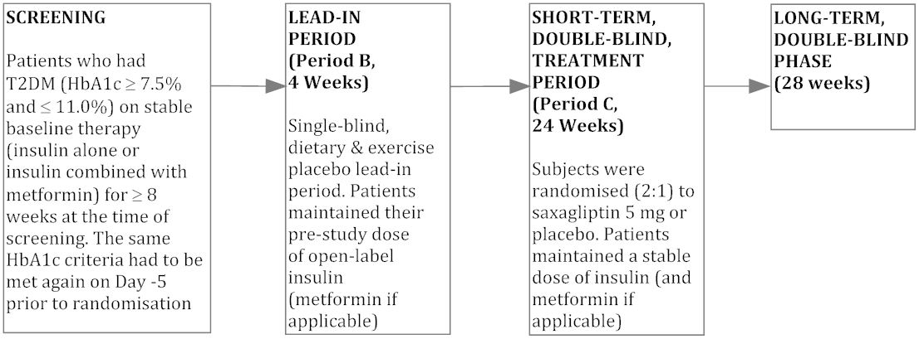

The efficacy objective of the study was to assess the effects of saxagliptin and placebo at various time points and after 52 weeks of oral administration of double-blind therapy for the following parameters:

* Glycemic control (HbA1c)
* Mean total daily dose of insulin (MTDDI).
* Body mass index (BMI) and body weight.

The study was conducted between November 2008 and November 2010 (report date November 2011) at 72 centres in 10 countries as detailed in the original CER.

##### Inclusion and exclusion criteria

Included were male and female subjects with T2DM, aged between 18 and 78 years, who had inadequate glycaemic control as defined above (Figure 5) and were on a stable dose of insulin. Full inclusion/exclusion criteria were standard for studies of this nature and are documented in the original CER.

An important point is that most recruited subjects were, as might be expected from usual practice, taking metformin as well as insulin. Recruitment of such subjects was limited to 75% of total, to enable inclusion of a cohort taking insulin alone in both the saxagliptin and placebo groups once randomised.

##### Study treatments

These are described in detail in the CER for application PM 2011-01174-3-5. The essential points to consider, as seen by this evaluator, are as follows:

* In the 4 week lead-in period, subjects were maintained on the same dose of insulin, and metformin if they were taking it, as was being administered at the time of recruitment. Importantly, they were seen frequently during this period, given instruction on diet and exercise, and issued with home glucose meters.
* In the 24 week short-term double-blind period, at the beginning of which subjects had been randomised to either saxagliptin 5 mg daily or placebo, these same doses of insulin + metformin were continued, referred to as the "stable" insulin regimen, unless the subject required rescue.
* Rescue was undertaken during the short-term period if the subject displayed a level of glycaemia which exceeded predefined limits, or despite advice had increased the dose of insulin by more than 20% (see CER for application PM 2011-01174-3-5 for details). “Rescue” consisted of the investigator commencing and continuing to adjust insulin, or introducing different types of insulin including short acting preparations, according to ADA or other therapeutic guidelines applying at the site, with the aim of optimising glycaemic control. This is referred to in the study report and the previous CER as the “flexible” insulin regimen.
* During the long-term period, all subjects were switched to the flexible insulin regimen as described above. Clearly, this introduces the possibility of insulin dosage being a confounding factor in assessing the effect on HbA1c of saxagliptin versus placebo. There is little information about the types of insulin and nature of adjustments employed by the investigators during this flexible regimen. Insulin is listed amongst concomitant medications used (by definition) in 100% of subjects. Lispro insulin, a short acting preparation, is listed as used by 21 saxagliptin and 7 placebo subjects, and detemir, an intermediate acting preparation, by 8 and 0 subjects, respectively. In the remaining 91.1% of saxagliptin and 95.4% of placebo subjects it is simply referred to generically as insulin.

##### Efficacy variables and outcomes

As indicated above, the main efficacy variables were:

* HbA1c
* Mean total daily dose of insulin
* Body weight (BMI)

The primary efficacy outcome was the change from baseline in HbA1c after 52 weeks of double-blind treatment in the saxagliptin compared with placebo group.

Other efficacy outcomes included changes in the other variables described above, particularly the MTDDI.

##### Randomisation and blinding methods

Subjects were randomly assigned to saxagliptin or placebo in a 2:1 ratio. Full details are contained in the CER for application PM 2011-01174-3-5.

##### Analysis populations

Analyses were carried out on the Randomised Subjects Data Set, which consisted of all randomised subjects who had taken at least one dose of double-blood medication. It was not necessary to conduct analyses on unevaluable subjects set as the number of subjects with significant protocol deviations in either treatment group was insufficient to affect the conclusions.

##### Sample size

The number of subjects randomised (saxagliptin, n = 304; placebo, n = 151) was based on adequate power calculations as described in the CER for application PM 2011-01174-3-5.

##### Statistical methods

Again, these are described in the original evaluation report. Particular note is taken of the provisions for sequential testing undertaken to control the type I error rate within each treatment group at the p=0.05 level which might determine whether statistical tests could be performed to compare secondary endpoints between the treatment groups.

##### Participant flow

Participant flow is shown in Figure 6.

Figure 6: Participant flow for study CV181057.

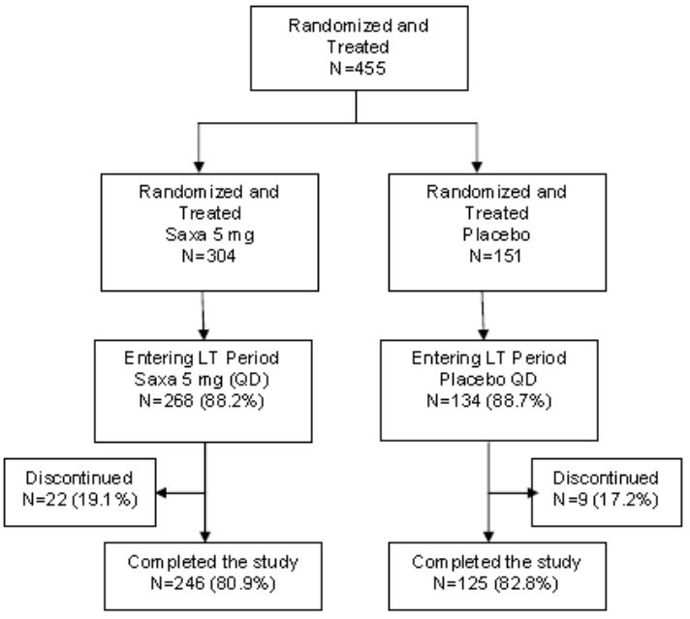

Discontinuations in the long-term period were evenly distributed between the two groups and were most commonly due to withdrawal of consent, poor compliance or adverse events. Withdrawals due to protocol violations are described in the following section. There was one death, in the saxagliptin group, due to intestinal infarction in a patient with widespread vascular disease.

##### Major protocol violations/deviations

As indicated in the original CER, protocol deviations in the short term treatment period were minimal. Deviations in the long-term period which caused discontinuation occurred in 3 (1%) of saxagliptin and 3 (2%) of placebo patients, and involved metformin compliance in 2 subjects, elevation of serum creatinine beyond the prescribed limit in 2 subjects (1 in each group), and treatment with CYP 3A4 inhibitors or induces in 2 subjects.

##### Baseline data

These are fully documented in the CER for application PM 2011-01174-3-5. Demographic variables including age, gender and body weight were evenly distributed between the treatment groups. There was a slight overall preponderance of females. Baseline diabetes characteristics were not different between treatment groups. MTDDI was 53.6 units in the saxagliptin and 55.3 units in the placebo group.

##### Results for the primary efficacy outcome

Adjusted mean change in HbA1c (LOCF) for the saxagliptin versus placebo groups at the end of the long-term period of study, after 52 weeks, are shown in Table 5.

Table 5: Adjusted mean change in HbA1c (LOCF) for the saxagliptin versus placebo groups at the end of the long-term period.

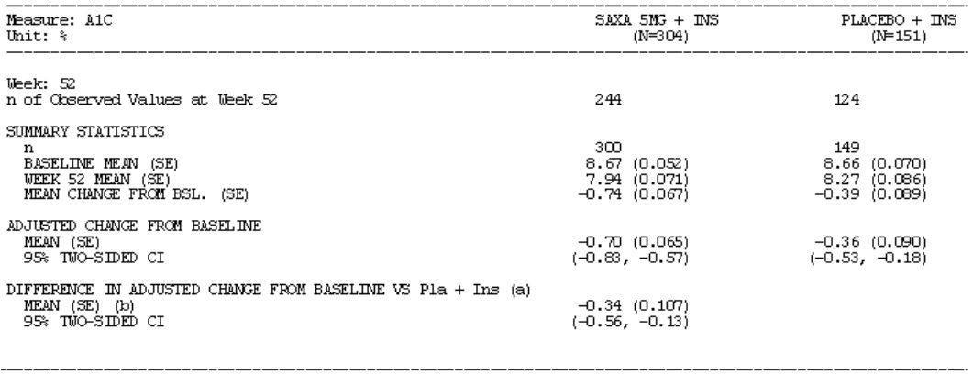

**The between-treatment difference (“HbA1c gain”) at 52 weeks**, therefore, expressed as mean (95% CI) **is 0.34 (0.56, 0.13)%**. The equivalent figure at 24 weeks, taken from the same table, was 0.36 (0.53, 0.18)%: this differs slightly from the figure of 0.41 (0.59, 0.24)% quoted in the original CER, taken from the corresponding table in the short-term study report. On review of these tables, it is noted that the data in the short-term report is based on the same data set of randomised subjects (300 saxagliptin, 149 placebo) as that for the 24 week data in the long-term report, but that in the latter the 24 week between-treatment difference of 0.36% is based on a different value of n for observed values (266 saxagliptin, 130 placebo). This difference is explained in the study report; the efficacy analyses in the short-term + long-term treatment period were generated based on randomized subjects regardless of insulin dose. In the short-term report, the efficacy analyses included only results prior to rescue.

HbA1c change from baseline (LOCF) as illustrated in Figure 7.

Figure 7: Stratification of HbA1c change by metformin use.

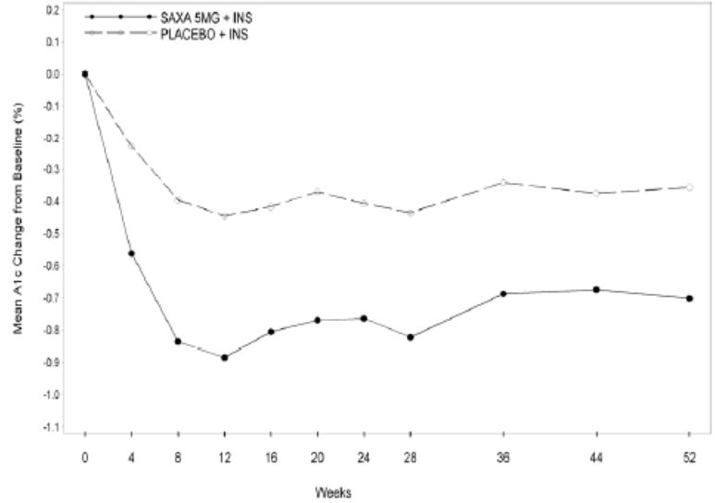

Results for adjusted mean changes from baseline in A1C at Week 52 were similar in subjects with and without metformin use at baseline. Among subjects with metformin use at baseline, the difference in change from baseline between saxagliptin and placebo at Week 52, expressed as mean (95% CI) was -0.37% (0.59, -0.15) based on a repeated measures analysis and -0.35% (-0.60, -0.10) based on a LOCF analysis.

Among subjects with no metformin use at baseline, the difference in the adjusted mean change from baseline at Week 52 (saxagliptin versus placebo) was -0.36% (-0.69, -0.04) based on a repeated measures analysis and -0.33% (-0.71, 0.05) based on a LOCF analysis.

##### Results for other efficacy outcomes

The changes from baseline in mean total daily insulin dose are shown in Figure 8.

Figure 8: Mean total daily insulin dose (MTDDI).

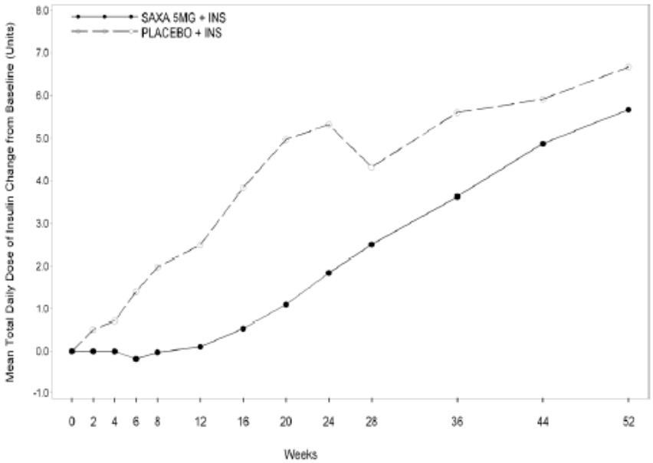

These changes in insulin dose are very small: the figures on the vertical axis contain a decimal point. The early rise in MTDDI in the placebo group reflects the higher proportion, in that group, of subjects requiring rescue in the short-term period. In the long-term period, note that upward adjustments of insulin dose were still being made in the last weeks of the study, if anything more actively in the saxagliptin group.

###### Change in body weight

On average, subjects gained a small amount of weight during the study. At Week 52, by LOCF analysis, the change from baseline expressed as mean (95% CI) was 0.77 (0.34, 1.19) kg in the saxagliptin group compared with 0.43 (-0.15, 1.02) kg in the placebo group; the between-group difference of 0.3 (-0.33, 1.03) kg was not significant.

**The overall efficacy results** for the entire 52 week study are summarised by the sponsor as follows:

* Treatment with saxagliptin added to insulin or to insulin in combination with metformin produced results consistent with a sustained treatment effect on glycaemic control through Week 52 compared to placebo.
* This treatment effect of saxagliptin was consistent between subjects receiving insulin alone at baseline, and those receiving insulin with metformin.
* Increases from baseline in mean total daily dose of insulin were seen in both treatment groups through Week 52, with a numerically smaller increase in the saxagliptin group.
* Both treatment groups experienced similar small increases in body weight.

To these observations, the clinical evaluator would add the following:

* The most significant change in glycaemic control in either treatment group occurred during the first 12 weeks of the short-term treatment period (Figure 7). As there was no medication change in the placebo group during this period, the improvement must be attributed to the lifestyle and education measures implemented during the lead-in phase of the study.
* The sponsor's conclusion above that there was a numerically smaller increase in insulin dose in the saxagliptin group does not take into account the fact that the direction of these changes differed between the short-term and long-term phases of the study. At Week 24, MTDDI had increased by 1.84 units in the saxagliptin and 5.32 units in the placebo group, whereas at week 52 these increases from baseline were 5.67 units and 6.67 units, respectively. The greater increase in the placebo group up to Week 24 is at least partly attributable to the higher proportion of subjects who were rescued and switched to the flexible insulin regimen during the short-term period. Between Week 24 and 52, the data shown above indicate that MTDDI increased by 3.83 units in the saxagliptin group compared with 1.35 units in the placebo group; the increase in insulin dose during the long-term period, when all subjects were on the same treatment regimen, was actually larger, rather than smaller, in the saxagliptin group. While these changes were not and are presumably incapable of being tested statistically, the trend is clearly evident in the graphic display of the insulin dose data shown above (Figure 8). This difference is of crucial importance in interpreting the difference in glycaemic control achieved between the saxagliptin and placebo groups during the long-term period. In view of the double-blind, placebo-controlled nature of the study, it is difficult to attribute the difference in insulin adjustment between the groups to other than random factors. Nevertheless, if at least some of the saxagliptin treated subjects were receiving more active insulin adjustment, this is a confounding factor in attributing treatment effect to saxagliptin.
* As a parallel observation, comparison of the time course of change in HbA1c and insulin dose data shows that from week 12 onwards, HbA1c trends upwards in the saxagliptin treated group (Figure 7) despite a progressive increase in insulin dose (Figure 8).

### Other efficacy studies

The first three of these remaining efficacy studies have been evaluated previously but have long-term extensions which require comment.

#### Study CV181014

In the CER for the original application PM-2008-03469-3-5 for registration of saxagliptin (Onglyza), CV181014 was evaluated as the pivotal study for efficacy of saxagliptin as add-on to existing therapy with metformin. It was a multi-centre, randomised, double-blind, placebo-controlled trial conducted at 152 international sites, 115 of which were in North America. Inclusion criteria required a stable metformin dose at entry, between 1500 and 2550 mg daily, along with inadequate glycaemic control at baseline, defined as HbA1c between 7.0 and 10.0% inclusive. 743 subjects were randomised and treated in 1:1:1:1 ratio with saxagliptin 2.5 mg, 5 mg, 10 mg or placebo. The findings of the study have been published (see References).

After 24 weeks double-blind therapy, adjusted mean change from baseline in HbA1c, by LOCF analysis, was -0.59%, -0 .69% and -0.58% for the 2.5, 5 and 10 mg saxagliptin groups respectively, compared with +0.13% for the placebo group. Saxagliptin therapy, coadministered with metformin, was not shown to affect body weight in this study.

PD data showed relatively greater decrease in fasting glucagon in subjects treated with saxagliptin compared with placebo, along with statistically significant increases in post-prandial but not fasting insulin. These changes are consistent with the known PD effects of DPP-4 inhibitors.

The CER for PM-2008-03469-3-5 reports on long-term follow-up for the four treatment groups up to 102 weeks. At that time, the mean change from baseline in HbA1c was -0.30%, -0.40% and -0.2%, respectively, for the three saxagliptin dosage groups compared with +0.32% for placebo. While the difference between the saxagliptin and placebo groups of approximately 0.7% remains significant and clinically useful, the evaluation report comments that it was during the first 12 weeks that saxagliptin produced a difference in HbA1c, after which the saxagliptin and placebo curves rose broadly in parallel. The described pattern strongly resembles that noted in study CV181057, as described above (Figure 7).

The long-term plus short-term final report for this study is included with this application; with a completion date of February 2010, it extends the study for two years from the cut-off date quoted in the original CER of January 2008. The report contains efficacy data for a further 12 months (to 154 weeks), and safety data to a total of 206 weeks.

For subjects not maintaining glycaemic control, rescue therapy in the form of pioglitazone 15 mg daily was added. The thresholds for institution of rescue therapy are shown in Table 6.

Table 6: Thresholds for institution of rescue therapy.

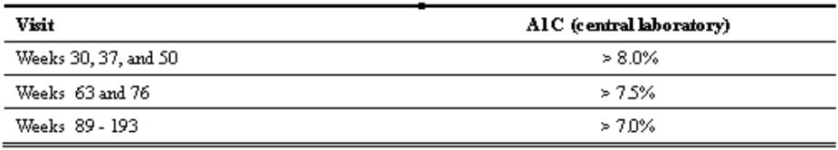

These thresholds are quite conservative particularly in the latter phases of the study, consistent with good clinical practice. The result of this is a very high proportion of discontinuation, largely due to rescue; by the end of the study, this was 71.4%, 61.3% and 66.9% in the 2.5 mg, 5 mg and 10 mg saxagliptin groups, and 74.3% in the placebo group. From the original number of 179-192 subjects randomised to each of the four groups, the numbers observable for efficacy (HbA1c) in these four treatment groups were 21, 28, 30 and 9 subjects, respectively. As the study report acknowledges, this small proportion of continuing non-rescued subjects limits the ability of the study to reach conclusions on long-term efficacy. Within these limits, what was shown was a difference from placebo in HbA1c change from baseline expressed as mean (SE) of 0.45 (0.24)% for the 2.5 mg dose, 0.51 (0.23)% for the 5 mg dose, and 0.25 (0.23)% for 10 mg. The variances, and the numbers involved, do not permit statistical conclusions. A graphic display of the data illustrates continuation of the trend described above for the 102 week data.

The remainder of the long-term efficacy data, related to changes in plasma glucose, does not add meaningfully to the HbA1c data summarised above. The safety and tolerability data is discussed below in the Safety section.

#### Study CV181038

This study was also evaluated as part of the original application for registration of saxagliptin in Australia. It was a randomised, five-arm, parallel group, double-blind, placebo-controlled multicentre trial of saxagliptin monotherapy conducted on drug naive T2DM subjects with inadequate glycaemic control defined as in study CV181014. The five treatment arms employed, as well as placebo, four dosage regimens for saxagliptin: 5 mg in the morning, 5 mg in the evening (before dinner), 2.5 mg in the morning, and 2.5 mg in the morning with possible titration to 5 mg.

A total of 365 subjects were randomised and treated, and 272 completed the 24 week short-term period without rescue; rescue therapy in this study consisted of metformin, which appears to be the reason for its inclusion in this application. Criteria for rescue were similar to those for study CV 181014 (Table 6), except that the criterion of HbA1c >7.0% was not applied, this study not being of the same length. At Week 24, mean HbA1c fell in all the saxagliptin treatment arms by 0.35-0.45% more than placebo, with the greatest fall occurring in the 2.5 mg morning dosage group. No data appears to have been provided regarding the outcome in those rescued with metformin during the short-term period. The short-term period was followed by a further 52 week long-term period, entered by 311 subjects. The interim data for this were evaluated in the CER for the original application PM-2008-03469-3-5.

A total of 311 subjects entered this long-term period, of which 231 completed it, 147 without being rescued. Eligibility was complex:

*“Subjects were eligible to enter the long-term treatment period via either of the following:*

1. *Subjects who completed all visits and did not meet hyperglycemia rescue criteria in the short-term treatment period. Subjects assigned to receive saxagliptin in the short-term period were allowed to titrate saxagliptin in the long-term period to a maximum dose of 10 mg. Subjects who received placebo in the short-term period received placebo and blinded metformin 500 mg in the long-term period. Titration of blinded metformin was not allowed.*
2. *Subjects who met hyperglycemia rescue criteria during the short-term period. These subjects remained on the same treatment assigned in the short-term period throughout the long-term period, but received open-label metformin in addition to blinded study medication. Titration of blinded study medication was not allowed; however, titration of open-label metformin was permitted, to a maximum dose of 2000 mg/day, during the long-term period should the investigator have deemed it necessary to obtain glycemic control.”*

The study population accordingly consisted of a complex mixture of subjects on either saxagliptin, metformin, or a combination of both, with some subjects being allowed titration of one or the other drug, and others not.

The analysis plan makes it clear that, for rescued subjects, any data for analysis of efficacy only included observations prior to the institution of rescue therapy.

The Rescued Subjects Data Set was used for extent of exposure to rescue medication during the long-term period.

For the primary efficacy parameter of change in HbA1c from baseline, the results by LOCF analysis are presented in Figure 9.

Figure 9: Mean change in HbA1c from baseline to week 76.

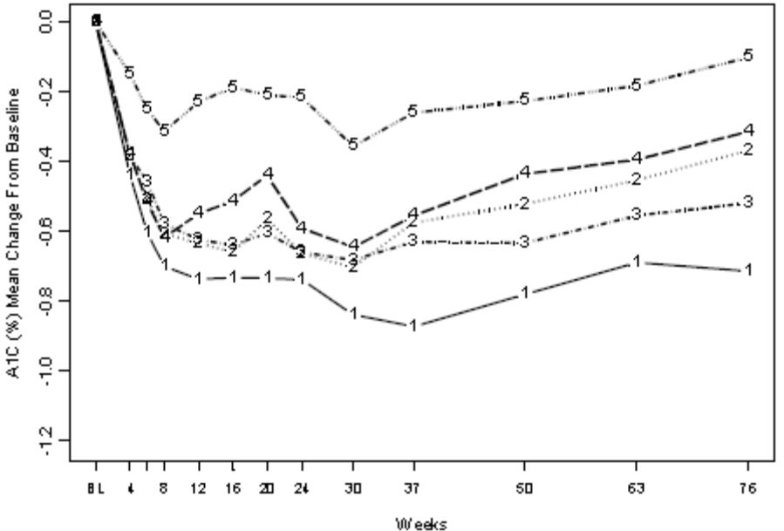

1 = 2.5 mg morning; 2 = 5 mg morning; 3 = 2.5 mg morning, titratable to 5 mg; 4= 5 mg evening; 5 = placebo.

As for the short-term period, the largest difference from placebo is in the 2.5 mg morning dosage group. Interpretation of the data is made difficult by the large proportions of discontinuations and rescue. By 76 weeks, the number of observations per group had diminished to 24-34 by comparison with 49-54 at 24 weeks and 71-74 at baseline.

Within its considerable limitations, the long-term period of this study confirms maintenance of efficacy of saxagliptin monotherapy for a period of 12 months beyond the initial 24 week study.

No efficacy data are presented for the subset of subjects who received metformin as rescue therapy in addition to randomised saxagliptin. The study therefore does not contribute to the assessment of efficacy of combination therapy for the purpose of this evaluation. Exposure data for both drugs are however included in the submission’s safety analysis.

#### Study CV181039

This study of treatment naive T2DM subjects with inadequate glycemic control (HbA1c ≥ 8.0% and ≤12.0%) has been previously evaluated for the TGA in the CER for the original saxagliptin (Onglyza) application as the pivotal study supporting initial combination therapy with saxagliptin and metformin. The recommendation of the CER that this indication be accepted was subsequently approved by ACPM. It is therefore highly relevant to the current application as this is one of the indications in which the FDC, if approved, will be used. It was a Phase 3, randomized, 4-arm, parallel group, double-blind, active controlled, multi-centre study; following screening and a diet, exercise and placebo lead-in period, subjects were randomized (1:1:1:1) to either saxagliptin 5 mg + metformin IR 500 mg, saxagliptin 10 mg + metformin IR 500 mg, saxagliptin 10 mg + placebo, or metformin IR 500 mg + placebo. During the first 5 weeks of the 24 week short-term period, subjects receiving metformin (or matching placebo) had the dose of this titrated up to 2000 mg daily according to tolerance and pre-specified blood glucose targets.

A collection of glycaemic parameters was nominated by the study as the primary efficacy parameter, but the original CER first mentions the adjusted mean change from baseline in HbA1c which is the primary efficacy parameter in other studies reviewed in this evaluation report. Mean change from baseline by LOCF analysis at week 24 was -2.53% for saxagliptin 5 mg/metformin, -2.49% for saxagliptin 10 mg/metformin, -1.69% for saxagliptin 10 mg/placebo and -1.99% for metformin/placebo. For the purpose of this application, there is no matching saxagliptin monotherapy control arm for the combination dose proposed for the FDC (saxagliptin 5 mg/metformin). However, it is noted that the 5 mg and 10 mg doses of saxagliptin were equally efficacious in combination with metformin, and that both were superior to either monotherapy drug given alone, despite the saxagliptin alone arm being at the 10 mg level.

The quantum of HbA1c improvement, exceeding 2%, is impressive but needs to be seen in the light of the fact that there was no control arm to allow for improved compliance with lifestyle measures which is very likely to have occurred under trial conditions.

The original CER noted that subgroup analysis showed greater HbA1c reductions with increasing baseline HbA1c level, supportive of the use of the combination as initial pharmacotherapy for T2DM patients with high baseline HbA1c, as allowed by the current TGA approved indication for use of saxagliptin with metformin in dual combination.

The original CER did review the long-term phase of the study but at that time it was incomplete, with a cut-off date of 6 February 2008. The long-term phase reviewed for this evaluation states a completion date of 9 December 2008 and includes complete date of the 12 month extension with final observations at week 76.

This was a large study in which 1306 patients were randomised. Gender balance was almost even. Mean age was 52 years, range 19-77, and BMI 30.2 (15.4-41.5); 76% of subjects were white, and 16.3% Asian. About one quarter each of the subjects came from the US or the Russian Federation, with the remainder spread across four continents altogether. Distribution of these demographic factors was quite even between the treatment groups. Study completion was achieved by between 62.4-71.6% of subjects, with the higher proportions of completion being in the combination therapy groups.

The statistical analysis procedures were similar to those for other studies in the application, with efficacy data only being included up until the last observation prior to rescue therapy when this was used.

Rescue therapy was instituted with pioglitazone 15 mg, titrated up to 45 mg daily where indicated and permissible. Glycaemic criteria for rescue were again similar to those employed in the other studies in the section (Table 6). By Week 76, institution of rescue therapy, or discontinuation for lack of efficacy, had been necessary less frequently in the combination therapy groups at 23.1% for saxagliptin 5 mg/metformin and 26.0% for saxagliptin 10 mg plus metformin, by comparison with monotherapy in which this had occurred in 47.2% (saxagliptin 10 mg) and 34.1% (metformin).

The adjusted mean HbA1c change from baseline at Week 76 was as follows: -2.31% for saxagliptin 5 mg/metformin, -2.33% for saxagliptin 10 mg/metformin, -1.55% for saxagliptin 10 mg, and -1.79% for metformin. These data show a remarkably similar internal relationship to the 24 week data shown above, and have all retreated towards baseline by approximately 0.2%. For the saxagliptin 5 mg/metformin combination, difference from 10 mg saxagliptin monotherapy, with 95% CI, was -0.76 (-0.96, -0.56)% and from metformin monotherapy, -0.52 (-0.71, -0.33)%.

The slight deterioration in efficacy in all treatment groups between Week 24 and Week 26 may be related to the weight changes occurring throughout the study. The conclusions in the synopsis refer to “a small numerical decrease from baseline at most time points in mean body weight”. A similar statement is made in the conclusions of the body of the report. This is not what really happened, as illustrated in Figure 10.

Figure 10: Adjusted mean HbA1c change from baseline to week 76.

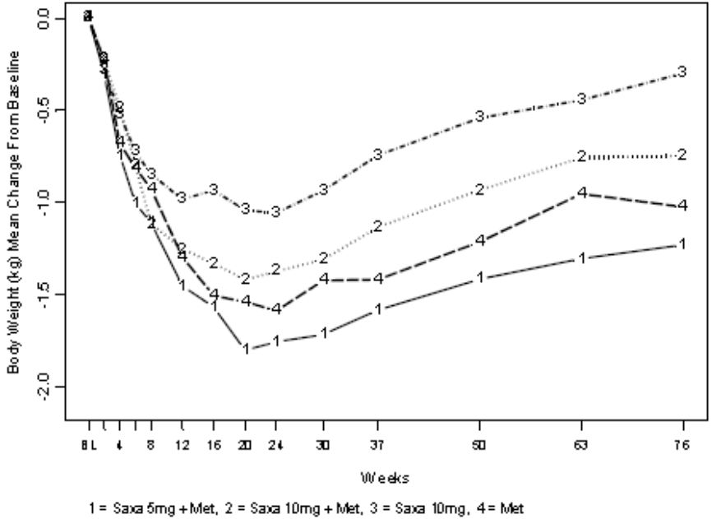

Clearly, there is a rapid fall in weight in the early weeks of the study. Even in the absence of a placebo group, it is difficult to regard this as a medication effect and it is almost certainly due to the increased attention the subjects will have had in this early phase; furthermore, this initial weight reduction probably accounts for a proportion of the evidently excellent HbA1c response (>2% reduction) seen in the combination therapy groups. Subsequently, between Week 24 and 76, there is an *increase* in weight, rather than a decrease, in all treatment groups. The pattern is depressingly familiar to any clinician involved in the treatment of T2DM and would contribute to the failure of therapy which occurred in a proportion of subjects during this long-term phase.

*Comment: the long-term extension phase of this study shows a much more sustained response than that for monotherapy study CV 181014. The proportion of discontinuations is much less, with over three quarters of the subjects given saxagliptin 5 mg/metformin as initial combination therapy maintaining a glycaemic response after 76 weeks treatment similar to that obtained at 24 weeks.*

**The remaining efficacy studies in this section are, like study CV181080, newly submitted data.**

#### Study CV181066

This short-term (4 week) study was conducted to evaluate the efficacy of saxagliptin 5 mg as add-on therapy to metformin XR. The medication regimens employed differ from the applicant FDC regimen; the saxagliptin was given in the evening coadministered with metformin XR which is itself usually given with the evening meal, and the metformin is not the IR form used in the FDC and the other efficacy studies supporting this application. It is presumed that the study forms part of the supporting data for the sponsor's preparation Kombiglyze XR, which is marketed in the US.

**The study design** was a randomised, two-arm, parallel, double-blind, placebo-controlled multicentre trial undertaken in subjects with T2DM who had inadequate glycaemic control (screening HbA1c ≥ 7% and ≤ 10%) while on a stable dose of metformin IR or XR ≥ 1500 mg (but not >2550 mg of the IR or >2000 mg of the XR formulation) per day as monotherapy for at least 8 weeks. The study was undertaken at 24 sites; 11 in the US, 4 in Israel, 3 in Sweden, 2 in Mexico, and 1 each in Puerto Rico, Argentina, Italy and the Philippines. The protocol was complex and required the capacity for 24 hour clinical monitoring and blood sampling at each site.

**Inclusion/exclusion criteria:** in addition to the above glycaemic and prestudy therapy requirements, subjects were to be of either gender aged from 18 to 77 inclusive. Recruitment of females included standard procedures to avoid pregnancy exposure. A BMI of <40 kg/m2 and fasting C-peptide of >1.0 ng/mL at the screening visit were also required.

**Participant flow:** following screening, subjects entered a 4-week dietary and exercise lead-in phase during which those taking metformin IR were switched to the nearest equivalent dose of metformin XR once daily, maximum 2000 mg. During the subsequent 4 week double-blind phase, the subjects continued on this stable dose of metformin XR together with either saxagliptin 5 mg or matching placebo, administered with the evening meal. 93 subjects were randomised and treated, 46 with saxagliptin 5 mg/metformin and 47 with placebo/metformin. All completed the study except for one discontinuation in each group.

**Protocol for data collection:** at Day -28, eligible subjects entered the single-blind dietary and exercise lead-in period, during which they were given a glucometer and instructed to monitor fasting glucose daily. If at any time during this period fasting glucose was >15 mmol/L, confirmed by a laboratory measurement, or self blood glucose monitoring (SBGM) was not performed consistently, the subject was discontinued. At Day -7, screening HbA1c to determine eligibility was performed. At Day -2, a continuous glucose monitoring system (CGMS) was inserted: these systems are now in widespread use and involve the insertion, using a narrow bore cannula, of a flexible sensor which transmits a signal to a monitoring device which is able to provide a virtually continuous read-out of interstitial glucose concentration for a period of up to several days. On the following day (Day -1), the subject was "domiciled" - admitted to the research facility – for 24 hour blood glucose monitoring undertaken both by CGMS and by periodic blood sampling and laboratory measurement. The subject was then randomised, using standard and acceptable procedures, to one of the treatment arms mentioned in the previous paragraph. This treatment continued for 28 days. On Day 26, a second CGMS was inserted and on Day 27 a further “domiciled” 24 hour blood glucose monitoring period undertaken.

**Efficacy measurements and objectives:** consistent with the short duration of the study and the parameters studied, these were principally based on measurements of blood glucose. The **primary efficacy objective** was to compare after 4 weeks of oral administration of double-blind treatment, the change from baseline in 24-hour mean weighted glucose (MWG) achieved with saxagliptin 5 mg versus placebo as add-on treatment to a stable dose of metformin XR ≥ 1500 mg/day. The parameter MWG (the dimensions of which are mmol/L, or mg/dL in the original report) was estimated by calculating the AUC for plasma glucose for the full 24 hours and dividing by 24. Glucose measurements were collected before and at a variety of intervals after each meal and at 3 further intervals during the night, so the term “weighted” indicates that the parameter, while an integrated measurement for the entire day, is most heavily influenced by post-prandial glucose.

**Secondary objectives** included measurement of the change from baseline to Day 28 in the following parameters: 4 hr mean weighted post-prandial glucose, and a single measurement at 2 hr, both after the evening meal; change from baseline to Day 28 in mean daily glucose, calculated from a seven-point SBGM profile collected by subjects for the three days prior to the 24 hour sampling; and change from baseline to week Day 28 in FPG.

**Tertiary objectives** included the change from baseline to Day 28 in HbA1c; changes from baseline to Day 28 in a variety of time and plasma glucose defined parameters using the CGMS data; changes in post-prandial insulin, C-peptide and glucagon; and changes from baseline to Day 28 in 24-hour urinary isoprostane excretion, the rationale for measuring which is not discussed in the study report.

**Statistical analysis** employed standard and acceptable methodology based on ANCOVA with appropriate adjustments for type I error in view of the multiple endpoints.

**Efficacy results:** the comparison between the saxagliptin and placebo groups for the primary efficacy parameter is shown in Table 7.

Table 7: Mean weighted glucose (MWG) at 24 h comparing saxagliptin and placebo groups.

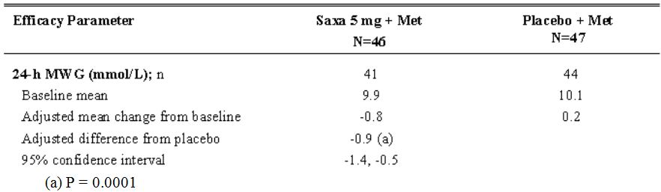

The **secondary efficacy parameters** all showed a similar trend, with a placebo-controlled fall from baseline approximating 10-15% of the baseline value, with significance values (saxagliptin + metformin versus placebo + metformin) of p between 0.001 and 0.0001. Consistent with the mechanism of action of saxagliptin, there was a trend for these changes to be more marked for the post-prandial measurements. Adjusted for placebo, the 4 hour post-prandial measurement fell by 1.7 from a baseline of 11.8 mmol/L (14.4%), and the 2 hour by 2.0 from baseline of 13.2 mmol/L (15.2%), whereas the equivalent falls in mean daily glucose and 2-day average fasting glucose were 10.1% and 9.6% respectively (evaluator calculations). The quantum of these changes is clinically useful.

The **tertiary efficacy parameters** showed little change: HbA1c fell from baseline of 8.1% to 7.9% in the placebo and 7.7% in the saxagliptin groups after four weeks, which is of course premature to measure a change in this parameter. No significant between-group differences were demonstrated in the measurements of insulin or glucagon secretion or urinary isoprostane excretion. The compiled results of CGMS for the saxagliptin versus placebo groups are shown in Figure 11.

Figure 11: Mean glucose levels across 24 h comparing saxagliptin and placebo groups.

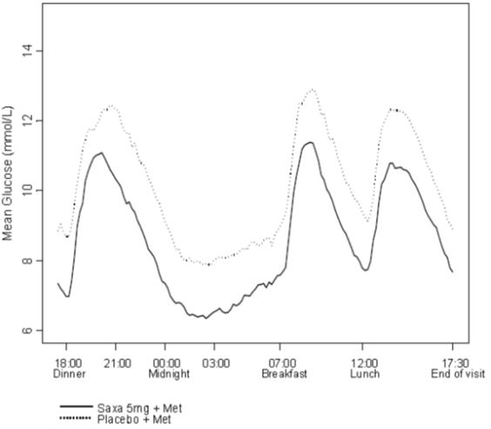

These CGMS data show an overall reduction of interstitial glucose approximating 1 mmol/L in the saxagliptin group, but no trend towards a specific reduction in post-prandial levels as was suggested (although not demonstrated with statistical significance) by the plasma glucose measurements.

#### Study D1680C00001 (CV181054)

This study compares, in T2DM patients failed on metformin monotherapy, the efficacy and safety of saxagliptin/metformin dual combination therapy with the combination of a sulphonylurea (glipizide) and metformin. Its key finding was that the glycaemic control achieved was similar between the two regimens, but with a much reduced incidence of hypoglycaemia in the saxagliptin/metformin group. Although not conducted using the applicant FDC, the study is of some importance in defining the role of the combination in the treatment algorithm for T2DM patients who fail on metformin monotherapy.

**The study was well-designed,** employing a randomised, parallel group, double-blind format incorporating a double dummy design to ensure blinding despite the fact that the protocol demanded titration of the glipizide dosage but not the saxagliptin dosage, consistent with the standard clinical use of these two drugs. There was no placebo group. The study was conducted between December 2007 and August 2010 at 130 centres, most of which were evenly spread across 8 European countries including the UK, with small numbers of sites in India, South Korea and Vietnam. The international coordinating investigator was [information redacted].

**Objectives and efficacy parameters**: the **primary objective** was to assess whether the change from baseline in HbA1c with saxagliptin/metformin was non-inferior to that observed with glipizide/metformin, after 52 weeks of double-blind therapy. **Secondary objectives** selected for special attention included the proportion of subjects experiencing hypoglycaemia, relative changes in body weight between the treatment groups, and durability from Week 24 to 52 of the HbA1c effect observed at Week 24.

Other secondary objectives included changes in parameters relating to insulin and glucagon secretion, and proportions of subjects achieving specified glycaemic targets. A population **pharmacokinetic analysis** was carried out during this study but the results are described as being the subject of a separate report.

**Treatments:** following two-week enrolment and single-blind placebo lead-in periods, eligible subjects were entered into the 52 week double-blind controlled treatment period and randomised to receive either saxagliptin 5 mg together with titratable, glipizide-matching placebo tablets; or saxagliptin-matching placebo tablets together with titratable 5 mg glipizide tablets. All subjects continued their previous tolerated metformin dose which was to be continued unchanged throughout the study. Saxagliptin or matching placebo was taken once daily in the morning; glipizide or matching placebo once or twice daily depending on titration; and metformin 2 to 3 times daily depending on the dosage.

The final titrated dose of glipizide was quite high; just over half (50.5%) of these subjects were on the maximum dose of 20 mg daily; 16.7% were on 15 mg, 11.6% on 10 mg, 19.5% on 5 mg and 1.6% on none.

Rescue therapy was not undertaken, but the criteria for discontinuation due to loss of glycaemic control became, appropriately for clinical care, increasingly stringent with progress of the study. The thresholds were HbA1c >8.0% at Weeks 30 and 39, >7.5% at Weeks 52, 65 and 78, and >7.0% at Week 91.

**Study population:** enrolment specified T2DM patients of either gender ≥18 years of age with inadequate glycemic control defined as HbA1c >6.5% and ≤10.0% while on treatment with metformin alone at stable doses of 1500 mg or higher per day for at least 8 weeks prior to enrollment. It is noted at page 76 of the study report that enrollment of subjects having HbA1c >6.5% to <7.0% was stopped once the cohort of randomised subjects having HbA1c <7.0 % was approximately 25% and the lower bound of HbA1c for enrollment was then set at HbA1c ≥7.0% for the remainder of the study. Of the 858 randomised and treated subjects, 52% were male and 83% white. Mean age was 57.6 (25-83) years, and body weight 88.7 (43-178) kilograms. 54% of the study population were obese as defined by BMI ≥30 kg/m2.

*Comment: the lower bound for enrolment of >6.5% defining "inadequate glycaemic control" may seem surprising but was a deliberate decision as outlined on page 75 of the study report, so as to include subjects with a variety of levels of glycaemia and in recognition of the tighter levels of control recommended by some expert groups.*

**Results:** comparison between the test and reference groups of the **primary efficacy parameter**, change in HbA1c from baseline to Week 52, is shown in Table 8.

Table 8: Change in HbA1c from baseline to week 52.

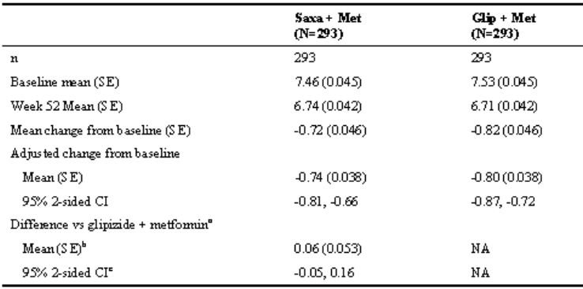

Noninferiority between the test and reference groups is shown. Statistical analysis was carried out using ANCOVA with a prespecified noninferiority margin of 0.35% for the HbA1c comparison. However it is noted that the above comparison is calculated on the per protocol analysis set (293 subjects per group), in which there has been a considerable drop out due principally to the discontinuation criteria listed above. The study report states that the conclusions were confirmed on the full analysis set, and a tabulation of this is found at page 1498 in which the same calculation, using LOCF, is done on this set (426 subjects per group). The mean change from baseline was less in each group, -0.57% for the saxagliptin and -0.66% for the glipizide groups, with a mean (95% CI) between group difference of 0.09 (-0.02, 0.20)%.

Markedly and statistically significantly **less hypoglycaemia** occurred in the saxagliptin/metformin group, as shown in Table 9 for the safety analysis set (all randomised and treated subjects).

Table 9: Hypoglycemic events.

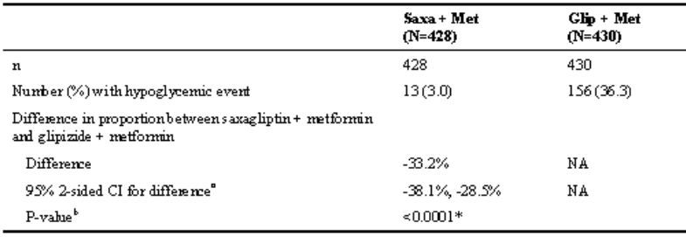

At Week 52, **body weight** had fallen on average 1.1 kg in the saxagliptin/metformin group, and risen by the same amount in the glipizide/metformin group, a between treatment difference expressed as mean (95% CI) of 2.2 (2.7, 1.7) kg (p<0.0001).

**HbA1c was shown to rise more slowly between Week 24 and Week 52** of the study in the saxagliptin/metformin group. Although the absolute changes are quite small (0.001% per week, compared with 0.004% per week in the glipizide/metformin group), this does support a greater durability of response with the saxagliptin/metformin combination. This finding might appear in conflict with the results of the primary efficacy parameter which showed the HbA1c changes at 52 weeks to be closely similar between the two groups. The explanation is that the initial fall in HbA1c, although not statistically tested, was greater in the glipizide group.

Changes in the other secondary parameters showed no remarkable between-group differences and statistical analyses are not provided.

#### Study D1680C00002 (CV181056)

Also conducted on failed metformin T2DM patients, this was an 18-week, international, multicenter, randomized, parallel-group, double-blind, active-controlled study which evaluated the efficacy and safety of saxagliptin in combination with metformin in comparison with sitagliptin in combination with metformin. Noninferiority of saxagliptin with regard to sitagliptin in this therapeutic setting was demonstrated.

Although it does not employ the applicant FDC formulation, this study is relevant to the submission in providing a within-class comparison with another DPP-4/metformin combination therapy for which a FDC formulation has been approved for use in Australia. It was carried out between April 2008 and March 2009 at 99 international sites evenly divided between Argentina, Belgium, Denmark, France, Italy, Mexico, Norway, South Africa and Sweden (coordinating investigator was [information redacted]).

The **study design** took inadequately controlled T2DM patients receiving metformin in a dosage of ≥1500 mg daily and randomised them to saxagliptin 5 mg daily or sitagliptin 100 mg daily. These are the approved doses for the use of these drugs in Australia. The **primary efficacy objective** was to demonstrate noninferiority between the two treatment regimens. A variety of **secondary objectives** relating to changes in parameters of insulin and glucagon secretion, and proportions of subjects achieving specified therapeutic targets, similar to those used in other studies in this application, are also listed.

**Included subjects** were T2DM patients of either gender ≥18 years of age with inadequate glycemic control defined as HbA1c >6.5% and ≤10.0%, having been on metformin as specified above for a minimum of 8 weeks. Of 822 subjects who ended the lead-in period, 403 were randomised to saxagliptin/metformin and 398 to sitagliptin/metformin and took at least one dose of study medication. These numbers of subjects comprised the **randomised analysis set** and also the **safety analysis set** (51% female, 66% white, mean age 58 (22-87) years, mean body weight 85.6 kg (range 39-158). In the **full analysis set (FAS)**, who had at least one efficacy assessment before and after treatment, the numbers of subjects were 400 and 395 respectively; the **per protocol analysis set (PPS)**, who completed the 18 weeks of double-blind treatment with no significant protocol deviations, included 334 and 343 subjects respectively (total 677).

**Statistical analysis** was carried out with an ANCOVA model using the treatment group as a fixed effect and baseline as a covariate, with a noninferiority limit on the change in HbA1c from baseline to Week 18 of 0.3%.

**Results:** statistical analysis of the comparison between the test and reference groups, conducted on the PPS, is shown in Table 10. The mean change in HbA1c from baseline is clinically significant for each treatment group at 0.52% and 0.62% respectively and the comparison of these changes demonstrates noninferiority with an upper limit of the 95% CI for the difference between the treatments of 0.20%.

Table 10: Statistical analysis of the comparison between the test and reference groups, conducted on the per protocol analysis set.

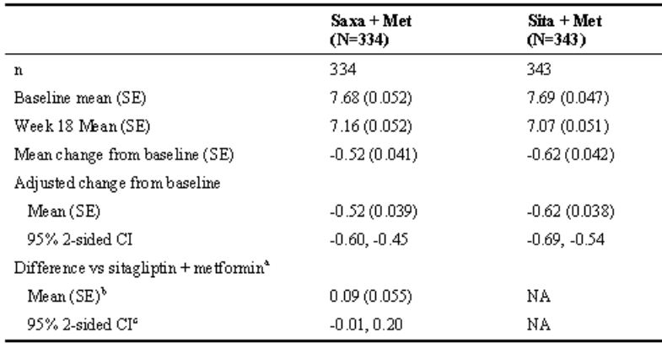

A more robust finding is to demonstrate such noninferiority on the intention-to-treat population (ITT), the definition for which is most closely met in this case by the FAS. The mean change in HbA1c from baseline shows a greater difference between the groups, at -0.42% for saxagliptin/metformin and -0.59% for sitagliptin/metformin, but the mean (95% CI) of the difference still falls within the noninferiority limit at 0.17 (0.06, 0.28)%.

With regard to the secondary objectives, the sitagliptin/metformin group did show a larger mean change from baseline of 0.90 mmol/L in FPG by comparison with the saxagliptin/metformin (0.60 mmol/L), the mean difference (95% CI) being 0.30 (0.08, 0.53) mmol/L. It is not clear whether this was statistically tested; no noninferiority limit appears to have been specified. The other secondary parameters relating to beta cell function showed changes consistent with the known PD action of saxagliptin and sitagliptin and were comparable between the groups.

### Analyses performed across trials (pooled & meta analyses)

None provided.

### Evaluator’s conclusions on clinical efficacy

The full proposed indication is

*"as an adjunct to diet and exercise to improve glycemic control in adults with type 2 diabetes mellitus when treatment with both saxagliptin and metformin is appropriate".*

Accordingly, conclusions to be drawn about the efficacy of the saxagliptin/metformin FDC must comply with the primacy of lifestyle measures (diet and exercise) in any treatment algorithm for T2DM.

There are two aspects to be considered. First, and certainly the main brief of this evaluation, is the question of whether Kombiglyze is efficacious as a substitute for saxagliptin and metformin co-administered as separate products whenever their use is appropriate; most obviously, when the patient is already being effectively treated with both drugs. This latter situation is what meets the definition of a *substitution indication* in the relevant EMA/TGA guideline (CHMP/EWP/240/95 Rev. 1). A secondary consideration is the range of circumstances when this dual combination therapy, in the form of the FDC Kombiglyze, is appropriate.

The first of these issues is addressed by the pharmacokinetic and pharmacodynamic data summarised in the clinical evaluation report. The bioequivalence studies are sufficient to justify the substitution indication, along with the PD data in Study CV 181152 which shows that the twice-daily dosing of saxagliptin implicit in the use of the product should not affect its efficacy. This is further supported by Study CV 181080, as summarised above, which also used a twice-daily dose of saxagliptin as opposed to the once daily dose approved for saxagliptin given alone. The use of such data for justification of a FDC is compliant with the relevant TGA guideline (CHMP/EWP/240/95 Rev. 1). It is therefore concluded that *Kombiglyze is an effective substitution product for saxagliptin and metformin in combination when the combined use of these two drugs is indicated*.

The guideline on determining efficacy of FDC (CHMP/EWP/240/95 Rev. 1) draws a distinction between the situation of on the one hand substituting the use of the FDC for the separately administered products when the use of the two together, either as add on or initial combination therapy, is justified by clinical evidence; and on the other, substituting the use of the FDC in the situation where the specific patient is already receiving the two drugs, which as mentioned above is the definition of a substitution indication in the guideline. The evidence submitted with this application would support efficacy in either of these situations, and it is therefore felt that the phrasing of the indication as *"…when treatment with both saxagliptin and metformin is appropriate"* is acceptable.

The second issue, that of when the product should be used within the spectrum of management options available for T2DM, has a number of potential options:

* Add on combination, that is, the use of the FDC when a patient is already taking metformin and the criteria for addition of saxagliptin are met: this is covered by the existing approved indication for saxagliptin (Onglyza).
* The use of the FDC as initial pharmacotherapy when lifestyle measures have failed: again, this is covered by the existing indication for saxagliptin which allows initial combination therapy in appropriate circumstances, the example given being “high initial glycosylated hemoglobin (HbA1c) levels and poor prospects for response to monotherapy”. The supportive efficacy/safety studies summarised above give further support for the use of the FDC as initial dual combination therapy as well as for add on combination.
* Use of the product in combination with other oral therapies, for example, sulphonylureas or thiazolidinediones: the sponsor’s letter makes it clear that such use (‘triple oral therapy’) is not part of the application.
* Use of the product in combination with insulin: this is the only area of the application in which there is some uncertainty regarding efficacy. As indicated above, the ACPM has recommended rejection of an application for the use of saxagliptin (Onglyza) in combination with insulin, from which it would follow that use of the FDC with insulin would be contraindicated. However, one of the reasons for ACPM rejecting the application was the absence of clinical data beyond 24 weeks of use in its pivotal Study CV 181057. The current submission for the FDC includes the long term extension report for this study. As outlined above, the 52 week data do indicate maintenance of benefit from saxagliptin versus placebo with no sign of the quantum of benefit diminishing between 24 and 52 weeks. The evidence of efficacy is similar whether or not metformin was also being given. Overall, the conclusion of this evaluation is that there is evidence of benefit from a combination of saxagliptin and metformin given together with insulin, but that the degree of effect is relatively small (0.37% change in HbA1c), and the robustness of the finding is not compelling in view of the possibility that insulin adjustment may have been more intensive in the saxagliptin than the placebo group. It should also be noted that Study CV181057 is the single pivotal study supporting this indication.
* Finally, a point of importance with regard to all of the above options is that the data submitted with this and previous related applications is only supportive of the addition of saxagliptin to existing metformin therapy; and of the addition of saxagliptin, with or without metformin, to existing insulin therapy. There are no studies supporting the addition of metformin, or commencement of the FDC, in patients who fail on saxagliptin monotherapy, although that would be a most unlikely therapeutic proposition. A more plausible scenario, likely to be considered by clinicians, would be that of adding insulin in patients who fail on saxagliptin with or without metformin, or in the context of this application, on the FDC. This use is not supported by the data. The wording of the proposed indication as “…when treatment with both saxagliptin and metformin is appropriate” must take account of this hierarchy of treatment combinations. In practical terms, this means that a patient on the combination of saxagliptin and metformin who develops failure of glycaemic control and is being considered for insulin therapy should cease saxagliptin before insulin is introduced. Should glycaemic failure persist despite insulin, reintroduction of saxagliptin could then be considered on the basis of the submitted evidence.

It is concluded that efficacy of saxagliptin and metformin in the form of Kombiglyze is confirmed in those therapeutic situations for which approved indications already exist. With regard to use with insulin, efficacy of the combination of saxagliptin and metformin as add on therapy is demonstrated, but the level of evidence for this is marginal in the context of the relevant guideline for basing conclusions regarding efficacy on a single pivotal study (CPMP/EWP/2330/99).

## Clinical safety

No studies of efficacy and safety have been conducted using the applicant FDC product. Consistent with the TGA/EMEA guideline regarding development of fixed combination medicinal products (CHMP/EWP/240/95 Rev. 1), the sponsor has provided extensive safety information available from studies it has carried out on its saxagliptin product (Onglya) alone and in combination with metformin. Most of this safety data, including that which applies to use with metformin and a smaller amount applying to use with insulin (study CV181057), has already been evaluated for TGA in the CERs for applications PM 2008-03469-3-5, PM-2010-03800-3, and PM 2011-01174-3-5. Newly submitted studies providing safety data, together with long-term extensions of previously evaluated studies, are listed in the following section and the findings summarised below.

The safety profile of metformin has been well-established in previous submissions to TGA.

As discussed earlier in this report, most proposed uses of Kombiglyze meet, or closely meet, the definition of a substitution indication, in which case consideration or "bridging" of the existing evaluated safety data on dual combination therapy with saxagliptin and metformin, as listed above, is compliant with the requirements of the relevant TGA guideline on FDC. Safety aspects of the use of saxagliptin and metformin in combination with insulin have been specifically reviewed in the evaluation of PM 2011-01174-3-5 and can likewise be applied to the proposed use of Kombiglyze together with insulin, should this be considered for approval.

Section 6.6 of the guideline does recommend that, when abridging available safety data of this type in support of a FDC, particular consideration should be given to the following points:

* *Degree of knowledge of the active substances in the indication claimed.* This is felt to be adequately covered by existing safety information.
* *Proposed dosing schedule.* This is clearly an issue for this application, as discussed above, and is the reason for this evaluation classifying studies CV 181152 and CV 181080 as pivotal. Relevant safety aspects are discussed below.
* *Potential for PK and/or PD interactions leading to safety concerns.* The CER for application PM 2008-03469-3-5 reviewed studies which excluded significant PK interaction between saxagliptin and metformin in either direction. In view of this, and of their separate and complementary mechanisms of action, this is not felt to be an issue.
* *Recommendation regarding special populations.* Use in the renally impaired population was considered in regard to PM-2010-03800-3; metformin, or the FDC, is in any case contraindicated with moderate or severe renal impairment. Paediatric use is at this stage not been considered

The approach of this section will be to integrate the existing evaluated data with the relatively small amount of new data relating to the saxagliptin/metformin combination in the submission, and to focus on aspects specific to the FDC as opposed to the dual combination as such. A detailed review of all of the original safety data relating to saxagliptin and metformin is considered unnecessary and beyond the scope of this evaluation.

The Summary of Clinical Safety (SCS) is well-prepared and objective. Unlike that presented for the original submission for saxagliptin PM 2008-03469-3-5, however, it takes the approach of presenting the data from the individual studies separately; there is no integrated summary or pooling of data from the various studies, so there are no tables of such suitable for reproduction in this report. For ease of reporting, some summary sections of the SCS are reproduced and referred to as such in following sections of this evaluation.

### Studies providing evaluable safety data

Safety data was contained in the following studies not previously evaluated for TGA:

#### Pivotal efficacy studies

Study CV 181080 randomised 160 subjects, already on metformin, 74 of whom received saxagliptin 2.5 mg twice daily. The importance of this study with regard to safety is that it is the only population in the submission treated with this dosing schedule for saxagliptin, which is the same as is used in the FDC.

Study CV 181057 has already been evaluated but its long-term extension is pivotal to the application for use with insulin which is implicit in this submission, and therefore requires review for safety. Of 455 subjects originally randomised, 304 received saxagliptin 5 mg daily and of these, 268 entered and 246 completed the long-term 24-52 week period.

Although not an efficacy study, PD study CV181152, which is regarded by this evaluation as pivotal to the application, provided a limited amount of safety data following administration of 5 mg daily doses of saxagliptin to 16 healthy subjects over 2 periods of 7 days.

#### Pivotal studies that assessed safety as a primary outcome

No such studies are included in the application.

#### Other efficacy studies

Other studies not previously evaluated for TGA provided safety data, as follows:

* Study CV 181066 provided data on 93 metformin failure subjects, 46 of whom were randomised to saxagliptin 5 mg daily in the evening. 45 completed 4 weeks treatment exposure.
* Study D1680C00001 provided data on 858 metformin failure subjects, 428 of whom were randomised to saxagliptin 5 mg daily and 293 completed 52 weeks treatment exposure. This was an active controlled study and the other 430 subjects (293 completed) were exposed to glipizide in addition to the metformin.
* Study D1680C00002 also provided data on metformin failure subjects, 801 in total, of whom 400 were randomised to saxagliptin 5 mg daily and 334 completed 18 weeks treatment, control arm subjects receiving sitagliptin 100 mg daily in addition to metformin.

Long-term extensions to the following studies previously evaluated for application submission PM 2008-03469-3-5 also provide additional safety data: CV 181014 (saxagliptin added to existing metformin therapy); CV 18038 (saxagliptin monotherapy); and CV 181039 (saxagliptin and metformin as dual initial therapy).

### Pivotal studies that assessed safety as a primary outcome

No relevant study included.

### Patient exposure

In the clinical pharmacology studies described in this report, exposure to the FDC or its component substances was limited to healthy subjects. In study CV181081, 24 subjects received 2 doses of the 2.5 mg/500 mg FDC as proposed for marketing, and 2 doses of 2.5 mg saxagliptin and 500 mg metformin administered separately. In study CV181092, a further 24 subjects received similar doses except that the metformin dose was 1000 mg in each instance. In study CV181120, 28 subjects received two doses of 500 mg and two doses of 1000 mg metformin and different formulations. PD study CV181152 involved the administration of 5 mg daily doses of saxagliptin to 16 subjects over 2 periods of 7 days

Exposure in the eight Phase 3 studies of clinical efficacy and safety occurred in segments of the target T2DM population who were either treatment naive (2 studies), already taking metformin (5 studies), or already taking insulin with or without metformin (1 study). Details of exposure in these studies is shown in Table 11.

Table 11: Details of the eight phase 3 studies of clinical efficacy and safety.

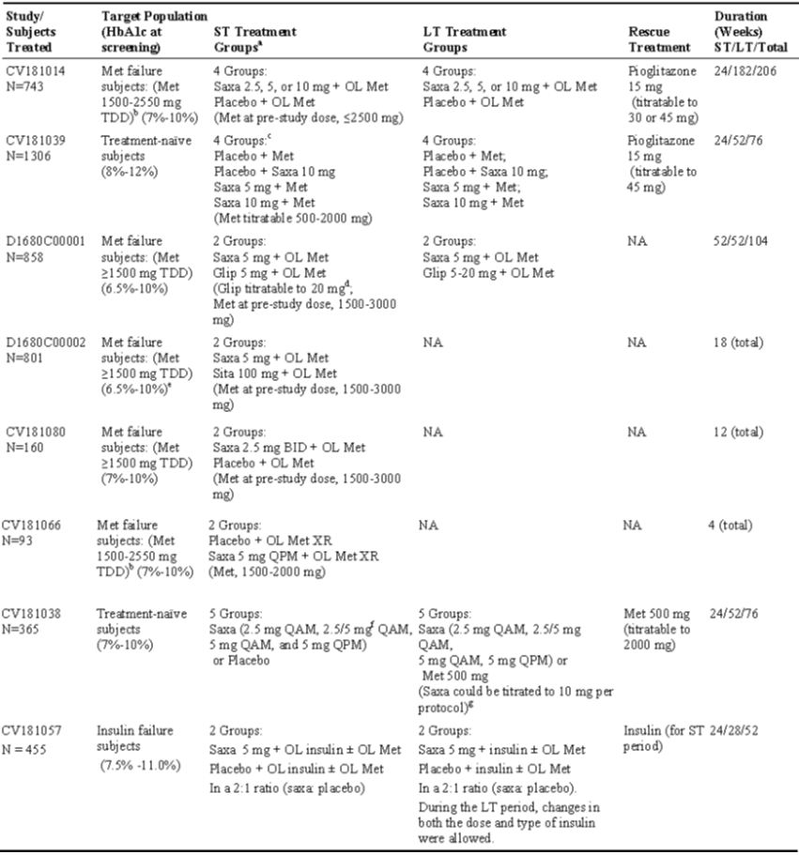

### Adverse events

In the following sections, no distinction is drawn between AE occurring in pivotal as opposed to other studies.

#### All adverse events (irrespective of relationship to study treatment)

Throughout the Phase 3 studies there was a background incidence of non-specific AE with no apparent relationship to study treatment or with any particular relationship to system organ class (SOC).

The following were AEs with an incidence rate of ≥5% for saxagliptin-treated subjects overall and greater than the incidence rate in subjects in control/comparator groups:

* influenza, nasopharyngitis, upper respiratory tract infection (URI), urinary tract infection (UTI), bronchitis, sinusitis, arthralgia, nausea, vomiting, headache, peripheral edema, hypertension, and anaemia in study CV181014;
* headache, nasopharyngitis, and hypertension in study CV181039;
* nasopharyngitis, URI, and diarrhoea in study D1680C00001;
* UTI in study D1680C00002;
* no specific AEs met the above reporting criteria in study CV181080;
* no specific AEs met the above reporting criteria in study CV181066;
* URI, diarrhoea, nasopharyngitis, and pain in extremity in study CV181038 (saxagliptin overall);
* bronchitis and headache in study CV181057.

Except in study CV181038, the incidence rates of GI-related AEs (mostly diarrhoea) were similarly distributed in saxagliptin-treated and control subjects in studies CV181014, CV181039, D1680C00001, D1680C00002, CV181080, and CV181066. The incidence of gastrointestinal complaints may reflect the fact that many of the subjects in the studies were already taking metformin, which commonly causes such symptoms. No subject was started on metformin in any of the Phase 3 studies.

#### Treatment-related adverse events (adverse drug reactions)

DPP-4 inhibitors including saxagliptin have the potential for off-target effects related to their mechanism of action. The background to this is comprehensively reviewed in the CER of the original Onglyza application. AEs potentially related to such effects include lymphopenia, thrombocytopenia, specific skin disorders, hypersensitivity, pancreatitis, infections and localised oedema, and these were identified as “adverse events of special interest” for which monitoring was undertaken during the Phase 3 studies. Additional AE of specific interest are cardiovascular events, because of the frequency of occurrence of this in T2DM, and hypoglycaemic events.

**Hypoglycaemia** was an AE of particular interest to this evaluation. It is claimed by the sponsor, and supported by most studies of DPP-4 inhibitors, that this class of drugs is not liable to cause hypoglycaemia because its mechanism of action is to promote insulin secretion after feeding rather than in the fasting state. Nevertheless, because of the possibility raised above that the change from once daily to twice daily saxagliptin administration imposed by the FDC dosing schedule might result in a time of day effect on glycaemic efficacy, the incidence of hypoglycaemia in the studies is seen to be of importance, particularly where saxagliptin as coadministered with other hypoglycaemic agents, including the possibility of use with insulin.

Assessment particularly of mild hypoglycaemia is made difficult by the way it is reported in the studies, variously as “hypoglycaemia” or “confirmed hypoglycaemia”; the latter is defined as a reported event with a finger stick glucose 50 mg/dL (2.8 mmol /L) and associated symptoms. In some of the studies, the tabulation of “hypoglycaemic events” is clearly a mixture of some which were unrelated to hypoglycaemia, and others which were (e.g. with finger stick measurements of 55 mg/dL). The significant findings were as follows:

* Incidence of total, as opposed to confirmed, hypoglycaemia was not tabulated for all of the studies but was possibly more common in study CV181080, in which saxagliptin was given 2.5 mg twice daily; incidence was 5.4% for the saxagliptin/metformin group by comparison with 1.2% for placebo/metformin. By comparison, reported hypoglycaemic events for the saxagliptin/metformin groups in studies D1680C0001 and D1680C0002 was 3.5% and 3.2% respectively. Confirmed hypoglycaemia, however, did not occur in any of the saxagliptin treated subjects in study CV181080. All of the unconfirmed events occurred within the first 6 weeks of the study. There is no comment about their having occurred at any particular time of the day.
* The incidence of confirmed hypoglycaemia was low, around 1%, in all of the studies in which saxagliptin as coadministered with metformin. In study CV181014, it did occur more commonly in the saxagliptin subjects (8/564, 1.4%) than with placebo (1/179, 0.6%), although there was no difference in incidence between the saxagliptin dosage groups ranging from 2.5-10 mg daily.
* In monotherapy study CV181038, 2/74 of saxagliptin subjects experienced confirmed hypoglycaemia, 1 with morning and 1 with evening administration, compared with 1/74 placebo subjects.
* By contrast with the above, in study D1680C00001 which compared saxagliptin with glipizide, the proportion of subjects with hypoglycemic events was markedly less at 3.5% for the saxagliptin/metformin group compared with 38.4% for the glipizide/metformin group. Compared with no subjects in the saxagliptin/metformin group, 9.1% of subjects in the glipizide/metformin group had AEs of confirmed hypoglycemia and 1.4% of subjects discontinued because of an AE of hypoglycemia.
* During use with insulin (study CV181057), reported hypoglycemic events were as expected relatively common but were comparable in the saxagliptin group (22.7%) and in the placebo group (26.5%). Confirmed hypoglycemic events were slightly higher in the saxagliptin group (7.6%) compared with the placebo group (6.6%).

**Skin disorders**: Skin-related AEs were slightly more frequent in saxagliptin-treated subjects than in control or comparator groups in studies CV181014 and CV181038. Few skin-related AEs were reported in studies D1680C00001, D1680C00002, CV181080, and CV181066.

**Infections**: The incidence rates of infection-related AEs were similar in saxagliptin treated and control subjects in studies CV181014 and CV181039 and higher in saxagliptin-treated subjects in studies CV181038 and CV181066. The incidence rates of infection-related AEs were similar for the saxagliptin and glipizide groups in study D1680C00001, and for the saxagliptin and sitagliptin groups in study D1680C00002. The rate of infection was lower for saxagliptin twice daily compared with placebo in study CV181080 and lower in the saxagliptin group compared to the placebo group in study CV181057. Most of the infection-related AEs were mild or moderate in intensity across all of the Phase 3 studies.

**Lymphopenia**: The frequency of AEs of lymphopenia was numerically higher in the saxagliptin groups compared with control in studies CV181014, CV181039 and CV181057. In study CV181038, the incidence of lymphopenia was low in all treatment groups; the incidence in the saxagliptin 5 mg once daily in the evening dosage group was similar to that with placebo. There were no AEs of lymphopenia in saxagliptin-treated subjects in studies D1680C00002, CV181080, and CV181066. The frequency of AEs of lymphopenia was numerically higher in the glipizide group compared to the saxagliptin group in study D1680C00001.

**Pancreatitis**: the sponsor has conducted a review of the clinical study database which found that the overall frequency of AEs of pancreatitis was low and balanced between saxagliptin and comparator groups. It suggests that a finding for saxagliptin-associated pancreatitis has not been identified.

**Hypersensitivity reactions**: the sponsor notes in the SCS for this submission that in the original saxagliptin SCS, hypersensitivity reactions were assessed and analysed retrospectively, based on pooled safety data. In this submission, studies CV181014, D1680C00001, CV181080 and CV181057 prospectively included hypersensitivity in the statistical analysis plan. In study CV181014, the proportion of subjects who had hypersensitivity AEs was higher for saxagliptin treated subjects (2.8%) than for subjects in the placebo group (0.6%). In Study D1680C00001, hypersensitivity AEs were reported in 1 subject in the saxagliptin/metformin group (SAE of hypersensitivity) and 3 subjects in the glipizide/metformin group (an AE of drug hypersensitivity to Ciproxin, and SAEs of laryngeal edema and hypersensitivity). In study CV181080, no AEs of hypersensitivity were reported during the double-blind treatment period. In Study CV181057, hypersensitivity AEs were reported in 3 (1.0%) subjects in the saxagliptin group (allergy symptoms and urticaria) and 1 (0.7%) subject in the placebo group (urticaria).

*Comment: if hypersensitivity reactions are associated with saxagliptin, they are very uncommon. Note that the only incident of severity in these data occurred in the glipizide/metformin group.*

With regard to other identified AEs of special interest, the Phase 3 studies in this application did not reveal any significant incidence of **thrombocytopenia** or **localised oedema**. Additionally, the incidence of **fractures** was assessed and there were either no incidents or a similar incidence in the saxagliptin and comparator groups, with the single exception of study D1680C0001, in which AEs of fracture were experienced by 11 (2.6%) subjects in the saxagliptin/metformin group by comparison with 3 (2.7%) in the glipizide/metformin group.

#### Deaths and other serious adverse events

The SCS reports 15 deaths among 3088 saxagliptin-treated subjects and an almost identical incidence of 9 deaths among 1693 control-treated subjects in the Phase 3 studies submitted with the application. There were no deaths in studies D1680C00002, CV181066, and CV181080. Likewise, the frequency of serious AEs (SAEs) was similar in the saxagliptin and control/active comparator groups. Although no formal actuarial comparison is available, the incidence of death is not surprising in the target population studied, and the individual narratives do not suggest any relationship with study treatments.

#### Discontinuation due to adverse events

The SCS reports that the frequencies of AE leading to discontinuation were similar between saxagliptin and comparator groups in the various studies, with no particular SOC of AE dominating. Perusal of the discontinuation reports in the individual studies supports this conclusion.

### Laboratory tests

#### Liver function

No drug-related signals related to liver function were detected in the Phase 3 studies.

#### Kidney function

No evidence of adverse effects on renal function was observed. Normal renal function was an important prerequisite for the clinical studies in which metformin was being used, as this is contraindicated in the presence of moderate or severe renal impairment.

#### Other clinical chemistry

No trends of significance were observed.

#### Haematology

Lymphocyte counts were carefully monitored, as a 5% reduction in lymphocyte count had been observed in the original saxagliptin submission and was found by the original CER to be a definite finding and probably related to the minor increase in infections.

With long-term administration of saxagliptin (up to Week 206), the decrease from baseline in mean absolute lymphocyte count seen in the saxagliptin 5 mg and 10 mg groups compared with controls was non-progressive over time and mean lymphocyte counts remained within the normal range.

* In studies CV181038 and CV181039, treatment with saxagliptin for up to 76 weeks had no clinically relevant effect on lymphocyte counts. Mean absolute lymphocyte counts remained within the normal range in all treatment groups throughout the ST + LT treatment period.
* In study CV181014, at Week 50 and beyond, there was a small decrease in mean absolute lymphocyte count in all treatment groups, including the placebo group. The magnitude of decrease from baseline was highest in the saxagliptin 10 mg group while the 2.5 mg and 5 mg groups were similar to placebo.
* In study D1680C00001, there was no clear difference between saxagliptin + metformin and glipizide + metformin for the change from baseline in mean lymphocyte count at 104 weeks.
* In study D1680C00002, there was no clear difference between saxagliptin + metformin and sitagliptin + metformin for the change from baseline in mean lymphocyte count at 18 weeks.
* In study CV181080, there was no clear difference between saxagliptin twice daily + metformin and placebo + metformin for the change from baseline in mean lymphocyte count at 12 weeks.
* In study CV181057, saxagliptin had no clinically relevant effect on lymphocyte count during the ST + LT treatment period.

*Comment: the above summary is accurate, despite the lack of definition of the terms "clear" or "clinically relevant" difference. Apart from persistence of the difference observed between placebo and saxagliptin in study CV 181039, the differences between the active and control groups in the various studies were very small, and in CV181057 absolute lymphocyte count at week 52 was numerically higher in the saxagliptin group.*

There was no discernible effect on other haematological parameters, including platelets.

### Post-marketing experience

The FDC itself is yet to be marketed. The sponsor reports that post-marketing experience with saxagliptin has included voluntarily reported adverse reactions reflecting hypersensitivity including anaphylaxis, angioedema, rash and urticaria. This is a recognised phenomenon and is reflected in the list of AEs of special interest discussed above.

### Other safety issues

#### Safety in special populations

The target population of T2DM patients includes many older people, and subjects up to the age of 77 years were appropriately included in the study populations, which were also gender balanced and representative of a variety of ethnic groups although not particularly those which make up the Australian population. The SCS reports that analyses of AEs based on subgroups defined by categories of age, gender, and race during the short and long-term periods of studies CV181014, CV181039, and CV181038 did not reveal any new safety findings. The incidence of AEs in these subgroups was similar across the saxagliptin and comparator treatment groups in studies D1680C00001 and D1680C00002.

### Evaluator’s overall conclusions on clinical safety

The profile of adverse events related to immunological function including hypersensitivity reactions, minor infections and effects on lymphocyte count, collectively a class effect of DPP-4 inhibitors, remains evident in this submission but there is no evidence of an increase in incidence or severity of these phenomena with longer term administration of saxagliptin, up to 4 years in one study, or of the appearance of any qualitatively different adverse effects. There appear to be no safety issues specific to the combination of saxagliptin with metformin. Hypoglycaemia is not a safety issue of concern for the saxagliptin/metformin combination either on its own or when used in combination with insulin, and is clearly less common with the saxagliptin/metformin combination than with the alternative commonly used dual combination of sulphonylurea and metformin.

## First round benefit-risk assessment

The sponsor's global RMP; an addendum is also included indicating that no risk management activities relating to the FDC are proposed specifically for Australia.

In the following discussion, distinction is drawn between the benefits and risks of dual combination saxagliptin/metformin therapy, and of the fixed combination tablet itself. The former have already been assessed and taken into account in the existing approval of this dual combination therapy except that the issue of use with insulin, at least from the point of view of this evaluation, remains unresolved.

### First round assessment of benefits

**Dual combination therapy** with saxagliptin and metformin has been shown in previous submissions to be beneficial, as assessed by improvements in HbA1c, in the management of T2DM either in the setting of add on therapy or initial combination therapy. Evidence of this benefit is reinforced in the present submission, although remaining restricted to HbA1c improvement as opposed to long term clinical outcomes. Benefit of the combination therapy when used together with insulin is also demonstrated, but both the quantum of benefit obtained and the level of supporting evidence are of lesser degree.

**The FDC tablet** is proposed, as stated in the letter of application, as a “convenient alternative” to separate administration of saxagliptin and metformin. This is a plausible proposition, but not supported by any evidence of clinical benefit. The suggestion that compliance is improved by use of the FDC is hypothetical rather than proven. It does involve a twice daily dosing schedule, whereas each component drug taken separately is available as a once daily preparation, although at different times of the day with existing recommendations (saxagliptin in the morning, metformin XR in the evening). The postulated benefit with regard to compliance therefore appears marginal. There might be a financial cost benefit to the consumer in a single preparation, depending on funding and subsidy arrangements.

### First round assessment of risks

The risks of dual combination therapy with saxagliptin and metformin in the proposed usage consist of the adverse effect profile of the two drugs added together. As metformin is used as initial pharmacotherapy for virtually all T2DM patients unless contraindicated or not tolerated, its risk profile is not a determining factor in this equation. With regard to saxagliptin, the class effect of adverse effects as described remains a consideration.

No specific risks are seen to apply to the fixed dosage combination tablet.

### First round assessment of benefit-risk balance

The benefit-risk balance of dual combination therapy with saxagliptin and metformin, either in the setting of adding saxagliptin to existing metformin therapy, or as initial combination therapy, is favourable.

The benefit-risk balance of dual combination therapy with saxagliptin and metformin given together with insulin is not favourable on current evidence; the possibility that the demonstrated level of benefit could be obtained by intensification of insulin therapy, without exposing the patient to the inherent risks associated with saxagliptin as a DPP-4 inhibitor, has not been excluded.

The benefit-risk balance of the FDC tablet as a form of giving this therapy is neutral to slightly favourable, and the above conclusions can therefore be applied to its use.

## First round recommendation regarding authorisation

It is recommended that **the application for all three dosage forms of the saxagliptin and metformin FDC (Kombiglyze) be approved**. This recommendation applies only to the existing approved indications for use of saxagliptin with metformin, and does not extend to use of the product with insulin.

It should be noted that none of the data reviewed by this evaluation included the proposed 2.5 mg saxagliptin/850 mg metformin tablets, or doses of 850 mg metformin. Application for a biowaiver for this strength is included in the biopharmaceutical summary. While assessment of the pharmaceutical data is beyond the expertise of this evaluator, the application appears reasonable and only involves changes in the metformin dosage, which is among the range commonly employed in clinical practice at present. Inclusion of the three strengths improves the capacity for metformin dosage titration using the FDC.

With regard to the question of use with insulin, it should be noted that this evaluation has only considered use of dual combination therapy with saxagliptin and metformin together with insulin. No data regarding use of saxagliptin alone with insulin has been reviewed. It is acknowledged that either of these indications could be reconsidered with further supporting evidence.

## Clinical questions

### Pharmacokinetics

No questions.

### Pharmacodynamics

No questions.

### Efficacy

No questions.

### Safety

No questions.

## References

1. TGA clinical evaluation report for submission PM-2010-03800-3, 15 June 2011.
2. TGA clinical evaluation report for submission PM-2008-03469-3-5, 29 July 2009.
3. TGA first and second round clinical evaluation reports for submission PM 2011-01174-3-5, 12 October 2011 and 1 May 2012.
4. DeFronzo RA, et al. (2009) The efficacy and safety of saxagliptin when added to metformin therapy in patients with inadequately controlled type 2 diabetes with metformin alone. Diabetes Care 32: 1649-1655.
5. EMEA guideline on clinical development of fixed combination medicinal products, CHMP/EWP/240/95 Rev. 1, 19 February 2009.
6. EMEA points to consider on application with one pivotal study, CPMP/EWP/2330/99, 31 May 2001.