|  |
| --- |
| **October 2013** |

|  |
| --- |
| Australian Public Assessment Report for Saxagliptin / metformin hydrochloride |
| Proprietary Product Name: Kombiglyze |
| Sponsor: Bristol-Myers Squibb Australia Pty Ltd |

About the Therapeutic Goods Administration (TGA)

* The Therapeutic Goods Administration (TGA) is part of the Australian Government Department of Health and is responsible for regulating medicines and medical devices.
* The TGA administers the *Therapeutic Goods Act 1989* (the Act), applying a risk management approach designed to ensure therapeutic goods supplied in Australia meet acceptable standards of quality, safety and efficacy (performance), when necessary.
* The work of the TGA is based on applying scientific and clinical expertise to decision-making, to ensure that the benefits to consumers outweigh any risks associated with the use of medicines and medical devices.
* The TGA relies on the public, healthcare professionals and industry to report problems with medicines or medical devices. TGA investigates reports received by it to determine any necessary regulatory action.
* To report a problem with a medicine or medical device, please see the information on the TGA website <<http://www.tga.gov.au>>.

About AusPARs

* An Australian Public Assessment Record (AusPAR) provides information about the evaluation of a prescription medicine and the considerations that led the TGA to approve or not approve a prescription medicine submission.
* AusPARs are prepared and published by the TGA.
* An AusPAR is prepared for submissions that relate to new chemical entities, generic medicines, major variations, and extensions of indications.
* An AusPAR is a static document, in that it will provide information that relates to a submission at a particular point in time.
* A new AusPAR will be developed to reflect changes to indications and/or major variations to a prescription medicine subject to evaluation by the TGA.

**Copyright**© Commonwealth of Australia 2013

This work is copyright. You may reproduce the whole or part of this work in unaltered form for your own personal use or, if you are part of an organisation, for internal use within your organisation, but only if you or your organisation do not use the reproduction for any commercial purpose and retain this copyright notice and all disclaimer notices as part of that reproduction. Apart from rights to use as permitted by the *Copyright Act 1968* or allowed by this copyright notice, all other rights are reserved and you are not allowed to reproduce the whole or any part of this work in any way (electronic or otherwise) without first being given specific written permission from the Commonwealth to do so. Requests and inquiries concerning reproduction and rights are to be sent to the TGA Copyright Officer, Therapeutic Goods Administration, PO Box 100, Woden ACT 2606 or emailed to <[tga.copyright@tga.gov.au](mailto:tga.copyright@tga.gov.au)>.

Contents

I. Introduction to product submission 5

Submission details 5

Product background 5

Regulatory status 6

Product Information 8

II. Quality findings 8

Drug substance (active ingredient) 8

Drug product 8

Biopharmaceutics 9

Advisory committee considerations 10

Quality summary and conclusions 10

III. Nonclinical findings 10

Introduction 10

Pharmacology 10

Pharmacokinetics 11

Toxicology 11

Nonclinical summary and conclusions 14

IV. Clinical findings 15

Introduction 15

Pharmacokinetics 15

Pharmacodynamics 16

Efficacy 16

Safety 19

List of questions 19

Clinical summary and conclusions 19

V. Pharmacovigilance findings 21

Risk management plan 21

VI. Overall conclusion and risk/benefit assessment 26

Quality 26

Nonclinical 26

Clinical 27

Risk management plan 28

Risk-benefit analysis 28

Outcome 35

Attachment 1. Product Information 35

Attachment 2. Extract from the Clinical Evaluation Report 35

## I. Introduction to product submission

### Submission details

|  |  |  |
| --- | --- | --- |
| *Type of submission:* | New fixed dose combination | |
| *Decision*: | Approved | |
| *Date of decision:* | 1 May 2013 | |
| *Active ingredients:* | Saxagliptin / metformin hydrochloride |
| *Product name:* | Kombiglyze |
| *Sponsor’s name and address:* | Bristol-Myers Squibb Australia Pty Ltd  Level 2, 4 Nexus Court  Mulgrave VIC 3170 |
| *Dose form:* | Film coated tablets |
| *Strengths:* | Saxagliptin[1]/metformin hydrochloride  2.5/500 mg, 2.5/850 mg and 2.5/1000 mg |
| *Containers:* | Blisters (PA/Al/PVC/Al) |
| *Pack sizes:* | Blister packs containing 14 and 56 tablets |
| *Approved therapeutic use:* | Kombiglyze is indicated as an adjunct to diet and exercise to improve glycaemic control in adults with type 2 diabetes mellitus when treatment with both saxagliptin and metformin is appropriate. |
| *Route of administration:* | Oral |
| *Dosage:* | Twice daily with meals, so as to yield a total daily dose of 5 mg saxagliptin |
| *ARTG numbers:* | AUST R 196044 (2.5/1000 mg), AUST R 196045 (2.5/500 mg), AUST R 196046 (2.5/850 mg) |

### Product background

This AusPAR describes an application by the sponsor, Bristol-Myers Squibb Australia Pty Ltd, to register a new fixed dose combination (FDC) film coated oral tablets containing immediate release saxagliptin/metformin hydrochloride in three strengths 2.5/500, 2.5/850 and 2.5/1000 mg. The proposed indication for Kombiglyze is

*as an adjunct to diet and exercise to improve glycaemic control in adults with type 2 diabetes mellitus when treatment with both saxagliptin and metformin is appropriate.*

Kombiglyze is for twice daily administration to yield a total daily dose of 5 mg saxagliptin,the same as that approved for saxagliptin mono product although the latter is approved for once daily administration. The appropriate FDC strength is selected to achieve the correct metformin dose for an individual patient. For patients inadequately controlled on a maximum tolerated dose of metformin monotherapy, various strength(s) of FDC can be selected to achieve a metformin 1000-2000 mg daily dose range. For patients switching from co administration of saxagliptin and metformin, Kombiglyze is to be initiated at the doses already being taken. For patients taking Kombiglyze as initial combination therapy, the recommendation is for an initial dose of 2.5/500 mg twice daily with subsequent titration to 2.5/850 mg or 2.5/1000 mg as required.

Saxagliptin is a dipeptidyl peptidase-4 (DPP-4) inhibitor and metformin is a biguanide. Both are approved for the treatment of type 2 diabetes mellitus (T2DM).

### Regulatory status

Saxagliptin is currently approved in Australia both as add on and as initial combination therapy. As add on therapy it is approved for use with metformin, a sulfonylurea, or a thiazolidinedione (dual combination). As initial therapy, it is approved for use with metformin (dual therapy). As add on therapy it is also approved for use with basal or premixed insulin with (triple therapy) or without metformin (dual therapy). It has not been investigated in clinical situations where bolus/basal insulin regimens are used.

Table 1 shows the list of countries in which a similar Kombiglyze application has been submitted at the time of the current application.

Table 1: Submission and approval status – Kombiglyze (saxagliptin/metformin).

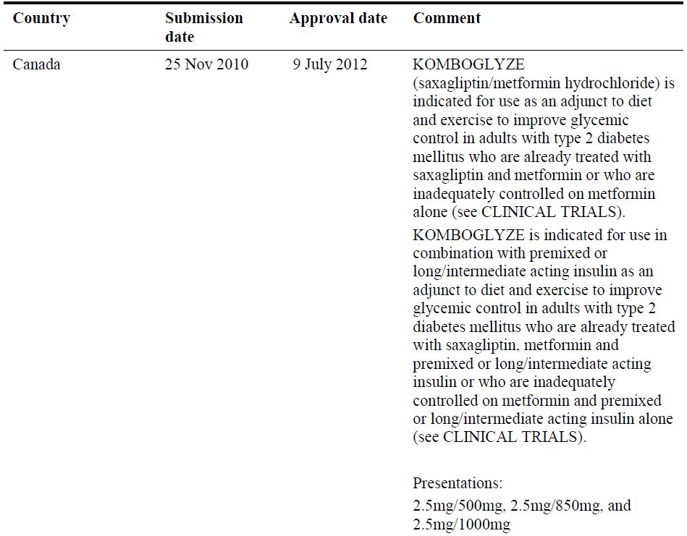

Table 1 (continued): Submission and approval status – Kombiglyze (saxagliptin/metformin).

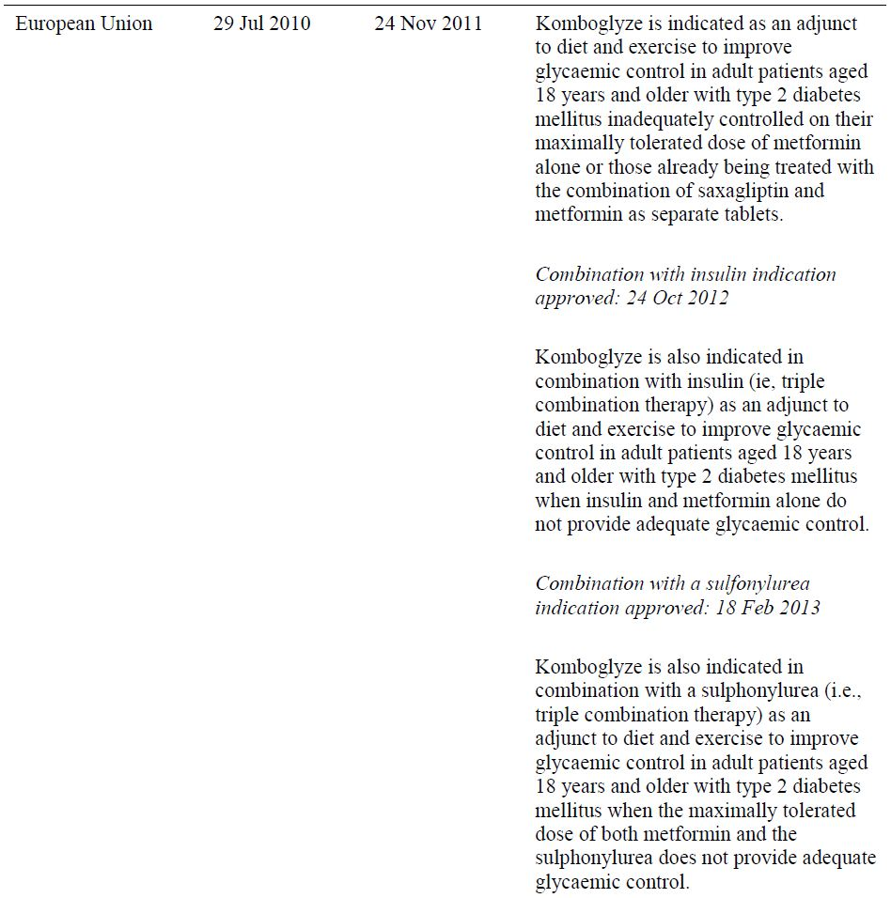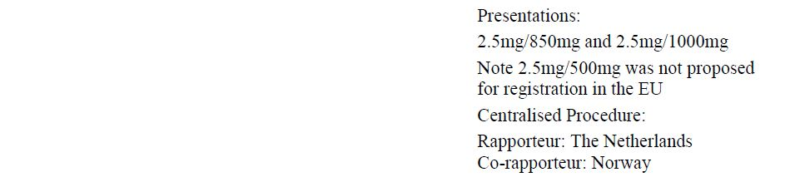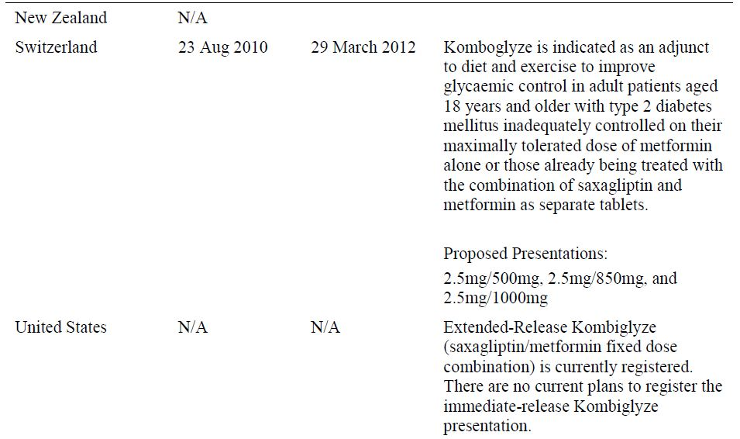

### Product Information

The approved Product Information (PI) current at the time this AusPAR was prepared can be found as Attachment 1.

## II. Quality findings

### Drug substance (active ingredient)

#### Saxagliptin

The saxagliptin is isolated as the monohydrate (Figure 1). It is manufactured by chemical synthesis and has four chiral centres. Only one polymorph is known. The aqueous solubility of the drug substance is pH dependent and ranges from freely soluble (pH 0.7-6.6), though soluble (pH 6.7-7.7) to sparingly soluble (pH 7.8 and above). According to the Biopharmaceutical Classification System (BCS), saxagliptin is considered highly soluble. However, due to its low permeability (75% is absorbed and the oral systemic bioavailability in only ~ 50% compared to intravenous administration), it is classified as BCS Class 3.

Figure 1: Structure of saxagliptin.

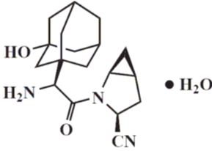

The saxagliptin monohydrate used in the proposed products is manufactured and controlled in the same manner as the saxagliptin monohydrate used in the registered ‘Onglyza’ tablets.

#### Metformin hydrochloride

Metformin hydrochloride (Figure 2) is a white/off white powder that is freely soluble in water. It has no chiral centres and no polymorphic forms of the drug substance are known. It is added to the tablets as a pre mix with 0.5% magnesium stearate.

Figure 2: Structure of metformin hydrochloride.

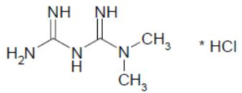

The chemistry and manufacturing control of the metformin hydrochloride and the pre mix are covered by a drug master file and are acceptable.

### Drug product

The proposed tablets are produced as unscored, film coated, immediate release products in which the strengths are distinguished by their differing colours, sizes and markings.

Similar to the ‘Onglyza’ tablets, Kombiglyze tablets contain a core and an active coat containing the saxagliptin. However, in this case the core is not inert but contains metformin hydrochloride.

The specifications of the tablets include tests and limits that adequately control the appearance and assays at release and at expiry for saxagliptin and metformin hydrochloride. The expiry limits for degradants comply with International Conference on Harmonisation (ICH) guidance and associated monographs and, where necessary, tighter release limits have been set to allow for changes on storage. In addition, dissolution studies of saxagliptin and metformin hydrochloride were submitted

Stability data was provided to support a shelf life of 24 months when stored below 25°C. No additional storage conditions are required.

### Biopharmaceutics

The pivotal clinical efficacy studies were performed with monotherapy tablets given concomitantly. As such bioequivalence data showing equivalence of the proposed FDC tablets to the monotherapies given concomitantly are required.

The 2.5 mg saxagliptin monotherapy tablet is not registered in Australia (only a 5 mg tablet is registered, and this is taken daily as opposed to twice daily for the FDC tablets). Therefore, data linking the two strengths is required.

The monotherapy metformin tablets used in the clinical and bioavailability studies were not those registered in Australia (US Glucophage was used). A study linking the tablets used and the Australia tablets is required.

Finally, studies determining whether there are any pharmacokinetic interactions between saxagliptin and metformin are required.

* Study CV181081 compared the proposed **2.5/500** FDC tablets to the relevant monotherapy tablets used in the clinical studies given concomitantly. The results showed bioequivalence of both saxagliptin and metformin under both fasting and fed (standard breakfast) conditions.
  + However, although the study did not calculate food effect, the clinical Delegate was asked to note the changes observed with food are not the same as those cited in the PI and it should be considered if the figures in the PI require amending.
* Study CV181092 compared the proposed **2.5/1000** FDC tablets to the relevant monotherapy tablets used in the clinical studies given concomitantly. The results showed bioequivalence of both saxagliptin and metformin under both fasting and fed (standard breakfast) conditions.
  + Similar to Study CV181081, although the study did not calculate food effect, the clinical Delegate was asked to note the changes observed with food are not the same as those cited in the PI and it should be considered if the figures in the PI require amending.
* Study CV181152 compared the 2.5 mg saxagliptin tablets used in the clinical efficacy and bioequivalence studies to a 5 mg saxagliptin tablets that was similar, apart from film coat and printing, to the 5 mg Onglyza tablet registered. This was a multiple dose study with the 2.5 mg tablets given twice daily and the 5 mg tablet given daily. This study was accepted as relevant and the results showed bioequivalence of AUC0-24 (area under the plasma concentration-time curve in the first 24 h) for both saxagliptin and 5-hydroxysaxagliptin (the major metabolite of saxagliptin).
* Study CV181120 compared the 500 mg and 1000 mg US Glucophage metformin hydrochloride tablets used in the clinical efficacy and bioequivalence studies to the 500 mg and 1000 mg Diabex metformin hydrochloride tablets marketed in Australia by Alphapharm Pty Ltd under fed conditions. The results showed bioequivalence of both strengths.
* The above studies all used appropriately validated test methods to determine the levels of the analytes in plasma.
* A justification was provided for not performing a bioequivalence study comparing the proposed **2.5/850** FDC to the relevant monotherapy tablets used in the clinical studies given concomitantly. The chemistry and quality aspects of this justification were acceptable with all strengths having similar dissolution profiles at pH 2, 4.5 and 6.8.
* Finally, the company referred to Study CV181017 which was provided in the submission to register the Onglyza 5 mg tablets. This investigated the pharmacokinetic interactions between saxagliptin and metformin and concluded there “is no clinically meaning drug interaction”.

### Advisory committee considerations

Given there were no biopharmaceutical issues during evaluation, this application was not referred to the Pharmaceutical Sub Committee for consideration.

### Quality summary and conclusions

Registration is recommended with respect to chemistry and quality control.

With respect to biopharmaceutics, appropriate studies were provided and the only issue was whether the statements in the PI on the effect of food might require some amendment.

## III. Nonclinical findings

### Introduction

Bristol-Myers Squibb Australia Pty Ltd has applied to register Kombiglyze, a new FDC of the anti hyperglycaemic agents consisting of saxagliptin and metformin hydrochloride (immediate release), for the treatment of T2DM in adults. Saxagliptin (as Onglyza) is currently approved for use in free combination with metformin for a similar indication. Three strengths of tablets are proposed: 2.5/500, 2.5/850 and 2.5/1000 mg saxagliptin/metformin hydrochloride, with one tablet to be taken twice daily. The maximum daily doses of saxagliptin (5 mg) and metformin hydrochloride (2000 mg) provided by Kombiglyze are currently approved for the individual components. While metformin hydrochloride is currently registered for twice daily dosing, saxagliptin is only registered as a once daily treatment. This is unlikely to alter the toxicology assessment of saxagliptin made previously (see *Toxicology*, below).

The nonclinical submission contained studies investigating the single dose toxicity, repeat dose toxicity and embryofoetal toxicity of the combination. All studies included supportive toxicokinetic data. The pivotal repeat dose toxicity and reproductive toxicity studies were conducted under Good Laboratory Practice (GLP) conditions.

### Pharmacology

No nonclinical efficacy studies with the proposed combination had been conducted.

### Pharmacokinetics

No obvious pharmacokinetic interaction between saxagliptin and metformin was apparent in studies in dogs or pregnant rabbits. In pregnant rats, the plasma AUC for saxagliptin’s active metabolite (BMS‑510849 [= 5-hydroxy saxagliptin]; was approximately 2 fold less potent than its parent)and was increased by ~50% with co administration of metformin. The peak plasma levels for saxagliptin and BMS‑510849 were reduced (by 70 and 46%, respectively). Metformin kinetics were unaffected and the saxagliptin AUC was not significantly altered in the above species. For humans, the current approved PI document for Onglyza states that co administration of a single dose of saxagliptin (100 mg) and metformin (1000 mg) did not alter the pharmacokinetics of metformin or the AUC for saxagliptin but did reduce the saxagliptin Cmax (peak plasma drug concentration) by 21%. The Summary of Clinical Pharmacology contained in the original saxagliptin application additionally notes that the pharmacokinetics of BMS‑510849 were unaltered with co administration of metformin.

### Toxicology

#### Acute toxicity

A single dose oral toxicity study in dogs revealed gastrointestinal effects manifested by unformed faeces containing mucous and/or blood at higher doses with saxagliptin and metformin alone or in combination (≥5 mg/kg saxagliptin; ≥10 mg/kg metformin). Such faecal effects have been reported previously for each agent, and the effect did not appear to be exacerbated with the combination. No deaths occurred. The study was not conducted according to GLP (but was adequately documented and conducted in an established laboratory), employed a post dose observation period far shorter than recommended (24 h compared with 14 days in the relevant guideline [3BS1a]) and the animals were not subjected to necropsy (recommended for all animals). These deficiencies are compensated for by the pivotal repeat dose toxicity study.

##### Repeat-dose toxicity

A 3 month repeat dose study with the combination was conducted in dogs. A 2 week pilot study (non GLP and with no necropsy) was also conducted in the species. The duration of the pivotal study and the use of a single species are consistent with the relevant EU guideline.[2] The dog is considered to be an acceptable species based on pharmacokinetic considerations and it had been used for the pivotal non rodent repeat dose toxicity study for saxagliptin conducted previously. While the route (oral administration [PO]) was used the proposed clinical dosing regimen (twice daily) was not. The animals were dosed once daily instead. This is not expected to alter the interpretation of the results as the clinical dosing regimen of 2.5 mg twice daily (BID) saxagliptin was reported to be bioequivalent to 5 mg/day in terms of plasma AUC (Study CV181152), and once daily animal dosing with metformin has been used to support twice daily clinical dosing. The saxagliptin/metformin dose ratios used in the studies in dogs (1:4-1:20) differ markedly from those proposed clinically (1:200-1:400).[3] Given the dominant contribution of metformin to toxicity, and to more closely match the saxagliptin:metformin exposure ratio in humans, some such deviation is warranted, although probably not to such a great extent. Parallel groups receiving only a single agent were included in the studies.

##### Relative exposure

Exposure ratios for saxagliptin, its active metabolite and metformin (calculated as animal: human plasma AUC) achieved in the pivotal 3 month study are shown in Table 2. No human AUC values following twice daily dosing with 2.5/1000 mg saxagliptin/metformin hydrochloride FDC tablets appear to have been provided. Data for the individual components administered once daily had been used for the calculations on the basis of bioequivalence (between once daily [QD] and twice daily [BID] dosing at the same daily dose) and the absence of pharmacokinetic interactions between the pair (as reported in the Product Information for Onglyza). High multiples of exposure to saxagliptin and its active metabolite but not metformin were obtained at the maximum doses tested.

Table 2: Relative exposure in the pivotal repeat-dose toxicity study.

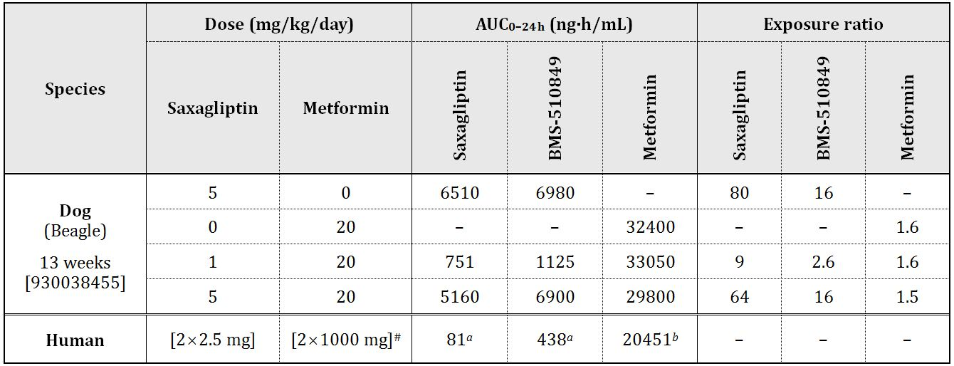

# expressed in terms of metformin hydrochloride (other doses are expressed in terms of saxagliptin or metformin base)  
*a* data obtained in Clinical Study CV181002 with administration at 5 mg QD  14 days  
*b* Timmins P, et al. (2005) Steady-state pharmacokinetics of a novel extended-release metformin formulation. *Clin. Pharmacokinet.* 44: 721-729. (While a value of 20544 ng·h/mL is reported for 1000 mg BID administration of the immediate release form, a lower - but essentially equivalent - value for 2000 mg QD administration of the extended release form has been used as a conservative measure.)

##### Major findings

Treatment related findings in the pivotal study were limited to inhibition of body weight gain (attributed to metformin) and various clinical signs, comprising faecal changes (soft/liquid/red and presence of mucoid material; across all groups), clear eye discharge (attributed to saxagliptin), salivation and sporadic/transient tremors/shivers (attributed to metformin). The combination produced no novel or exacerbated toxicity with one exception. Co administration of 5 mg/kg/day saxagliptin with metformin (20 mg/kg/day) was seen to increase the incidence of tremors/shivers. The finding was not associated with hypoglycaemia and occurred at a low incidence (1-4 observations/dog over 3 months). It was attributed to a behavioural change rather than a neurological effect. At 1 mg/kg/day (relative exposure, 9), co administration of saxagliptin had no effect on the incidence of metformin induced tremors/shivers.

#### Reproductive toxicity

Embryofoetal development studies were conducted with the combination in rats and rabbits (Table 3). Parallel single agent control groups were not included in an initial rat study, but were in a second study in the species and in the rabbit study. As in the general toxicity studies, the clinical dose ratios were not used. Animal:human exposure ratios are tabulated below. High multiples of the human AUC were achieved for saxagliptin in both species, and for the active metabolite of saxagliptin in rabbits. Exposure multiples for BMS-510849 and metformin were more modest in rats, and exposure to metformin was roughly equivalent to the anticipated maximum clinical level in rabbits.

Table 3: Relative exposure in embryofoetal development studies.

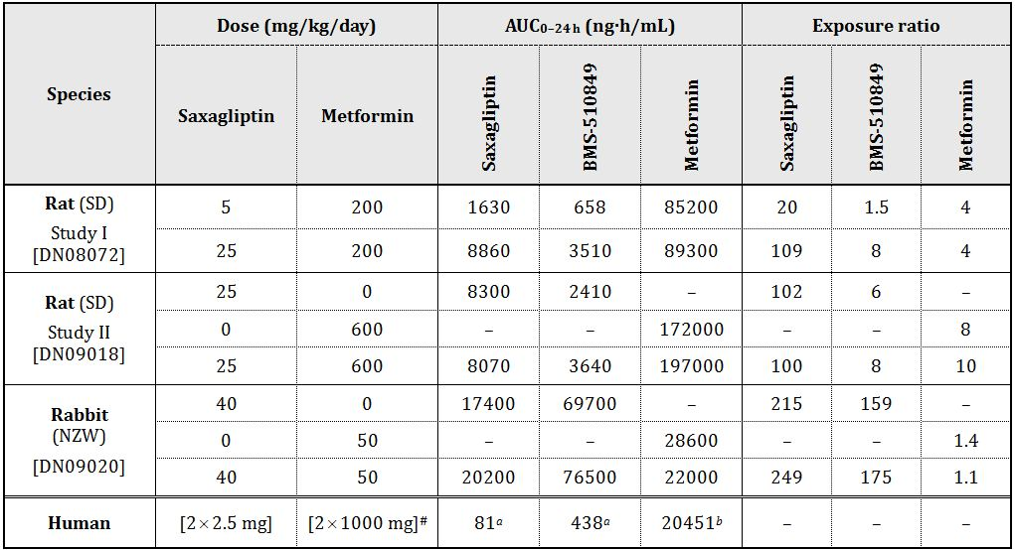

# expressed in terms of metformin hydrochloride (other doses are expressed in terms of saxagliptin or metformin base)  
*a* data obtained in Clinical Study CV181002 with administration at 5 mg QD  14 days   
*b* Timmins P, et al. (2005) Steady-state pharmacokinetics of a novel extended-release metformin formulation. *Clin. Pharmacokinet.* 44: 721-729. (While a value of 20544 ng·h/mL is reported for 1000 mg BID administration of the immediate release form, a lower - but essentially equivalent - value for 2000 mg QD administration of the extended release form has been used as a conservative measure.)

Two foetuses in rats treated at 25/200 mg/kg/day saxagliptin/metformin displayed craniorachischisis in an initial embryofoetal development study. However, the cases were from a single litter. The observed incidence for all animals was within the historical control range for the laboratory and the finding was not confirmed in a subsequent study in rats (involving treatment at 25/600 mg/kg/day saxagliptin/metformin). Other findings in the initial rat study, a low incidences of digital malformations (ectrodactyly and brachydactyly), absent renal papilla(e) in kidneys, and forelimb flexure [again affecting single litters] were also not confirmed in the second study conducted in rats despite greater exposure to saxagliptin and metformin and the use of larger numbers of animals per group. Embryofoetal findings in the second study in rats were limited to an increase in the incidence of wavy ribs with treatment at 25/600 mg/kg/day saxagliptin/metformin (3.3%) and with metformin alone at 600 mg/kg/day (2.0%) which exceeded the historical control range (≤1.4%). This occurred in the context of maternal toxicity (significant suppression of maternal body weight gain).

In rabbits, administration of 40/50 mg/kg/day saxagliptin/metformin was poorly tolerated, resulting in death, moribundity and abortion in 12/30 dams. In contrast, there was only a single death among dams treated with the same dose of metformin alone, and none with saxagliptin alone. Similarly, maternal bodyweight gain was unaffected in the single agent groups but was markedly suppressed with combination treatment (although not in those combination animals that survived to scheduled termination). While metformin induced lactic acidosis may have contributed to the deaths, the increase in toxicity apparent in the combination group was not associated with increased exposure to metformin. No adverse effects on embryofoetal development were noted for saxagliptin or metformin alone, but treatment with the two drugs in combination was associated with a significant reduction in mean foetal weight (7% lower compared with controls), cases of incompletely ossified pubis and an increased incidence of incomplete ossification of the hyoid.

##### Pregnancy classification

The sponsor has proposed Category C. This matches the current pregnancy category for metformin (as well as other existing combinations of metformin with a DPP‑4 inhibitor; saxagliptin itself is B3) and is considered appropriate.

#### Paediatric use

Kombiglyze is not proposed for paediatric use and no specific studies in juvenile animals were submitted.

### Nonclinical summary and conclusions

* The nonclinical submission contained studies investigating the single dose toxicity, repeat dose toxicity and embryofoetal toxicity of the combination. No nonclinical efficacy studies with the proposed combination have been conducted.
* Toxicokinetic data obtained in dogs, pregnant rats and pregnant rabbits showed a pharmacokinetic interaction between saxagliptin and metformin in the rat only with an increase in the plasma AUC for the active metabolite (BMS-510849 by ~50%) of saxagliptin and decreases in the Cmax for saxagliptin and its active metabolite. In humans, the pharmacokinetic interaction between saxagliptin and metformin is reported to be limited to a reduction in the saxagliptin Cmax (by 21%).
* In the pivotal repeat dose toxicity study, co treatment with saxagliptin and metformin for 90 days in dogs produced no novel or exacerbated toxicity compared to the single agents except for an increase in the incidence of tremors/shivers (observed at 5/20 mg/kg/day saxagliptin/metformin). This finding is considered to reflect a behavioural change in the animals rather than a neurological effect, and not to be associated with hypoglycaemia. The incidence of metformin induced tremors/shivers was unaffected with co administration of saxagliptin at 1 mg/kg/day (yielding 9 times the human AUC).
* Treatment with the combination was associated with an increase in the incidence of wavy ribs in the foetuses of treated rats (the finding occurring in conjunction with significant suppression of maternal body weight gain). In rabbits, the combination was poorly tolerated in comparison with the single agents, causing death, moribundity and abortion; mean foetal weight was reduced and ossification of the pubis and hyoid was impaired. No treatment related teratogenicity was observed in either species.
* There are no nonclinical objections to the registration of Kombiglyze.[4] Amendments to the PI were also recommended.. The Nonclinical Safety Specification of the Risk Management Plan (RMP) should be amended as directed.

## IV. Clinical findings

A summary of the clinical findings is presented in this section. Further details of these clinical findings can be found in Attachment 2.

### Introduction

The dossier is well presented. It is extensive and relies heavily on data which has previously been submitted to TGA to support the use of saxagliptin in combination with metformin, but does include some newly submitted studies to support this dual combination therapy. It does not include any efficacy/safety studies using the FDC product itself. Studies involving administration of the FDC are restricted to those conducted in healthy subjects to establish bioequivalence of the product with its component substances saxagliptin and metformin administered as separate tablets. Pharmacodynamic data are also included to provide justification for the novel twice daily saxagliptin dosing regimen as outlined above. While the application letter and summary documents do not identify any component of the dossier as pivotal, the study providing this pharmacodynamic data (CV181152) is regarded as such by this evaluation as the single obvious change imposed by use of the Kombiglyze FDC is the change in saxagliptin dosing from once to twice daily.

The submission contained the following clinical information:

* 6 clinical pharmacology studies, including 5 that provide pharmacokinetic data and 1 that provides pharmacodynamic data;
* 1 efficacy/safety study (CV181057) regarded by this evaluation as pivotal, as it supports the only aspect of saxagliptin/metformin dual combination therapy included in the application which is not yet approved, that of use together with insulin;
* 7 other efficacy/safety studies.

### Pharmacokinetics

#### Evaluator’s overall conclusions on pharmacokinetics

The bioequivalence studies show robust evidence of close equivalence between the applicant FDC product and its component substances saxagliptin and metformin administered together as separate tablets. Study CV181120 bridges these findings to products which are registered in Australia. Overall, these findings are strongly supportive of the product as being equivalent to dual combination of saxagliptin and metformin administered separately in a twice daily regimen. Study CV181152 shows that daily exposure to saxagliptin is unaffected by the change from a once daily to twice daily administration regimen but leaves open the question as to whether its pharmacodynamic action, and hence its efficacy, might be altered as a result of the marked change in diurnal distribution of saxagliptin exposure seen with the twice daily regimen (Figure 4).

Figure 4: Time-concentration curves for the two treatments (open squares: once daily treatment; closed squares: twice daily).

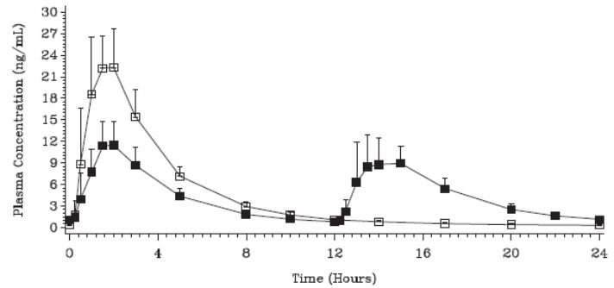

The food effect appears to be of no clinical significance, applies to the two component drugs whether administered separately or in combination, and is therefore not critical to the evaluation of the FDC. Likewise, the pharmacokinetic interactions with respect to saxagliptin are noted, are described in the draft PI, but are not specific to the FDC.

### Pharmacodynamics

#### Evaluator’s overall conclusions on pharmacodynamics

The pharmacodynamic response to the saxagliptin component of the FDC is not altered, in healthy adults, by the change from once daily 5 mg administration in the morning to the 2.5 mg twice daily dosing of the FDC product. No similar study has been conducted in the target population (T2DM patients), but it is not felt likely that findings in relation to timing of these responses would be any different from those in healthy adults. Response as measured by total DPP-4 inhibition and resultant enhancement of GLP-1 secretion over the 24 h dosing interval is unchanged. There is subtle evidence, statistically unconfirmed and not claimed by the sponsor, that DPP-4 inhibition is more reliably maintained over 24 h with the twice daily regimen. This does not appear to be of a degree which would impact significantly on the therapeutic use of the product; if anything, such effect would most likely be beneficial, although there is no specific evidence on this point, as the application does not contain a study which directly compares glycaemic efficacy of the once and twice daily treatment regimens.

### Efficacy

The claimed indication for the Kombiglyze FDC is:

*as an adjunct to diet and exercise to improve glycemic control in adults with type 2 diabetes mellitus when treatment with both saxagliptin and metformin is appropriate.*

Of the efficacy/safety studies included with the application, none strictly fits the definition of a pivotal study as none was conducted using the applicant product Kombiglyze. The efficacy studies submitted bear upon various aspects of the therapeutic use of saxagliptin and metformin in dual combination therapy as separate formulations. Of these eight studies, together with their long term extensions and International System of Units (SI) compliant versions constituting a total of 14 reports altogether, the one most critical to the application is Study CV 181080, in which a twice daily dose of saxagliptin was employed. This has therefore been included as a pivotal efficacy study for the purpose of this report together with the long term extension of Study CV 181057 which was previously evaluated in the clinical evaluation report as the pivotal study with reference use of insulin with saxagliptin, with or without metformin.

#### Evaluator’s conclusions on clinical efficacy for the proposed indication

The full proposed indication is

*"as an adjunct to diet and exercise to improve glycemic control in adults with type 2 diabetes mellitus when treatment with both saxagliptin and metformin is appropriate".*

Accordingly, conclusions to be drawn about the efficacy of the saxagliptin/metformin FDC must comply with the primacy of lifestyle measures (diet and exercise) in any treatment algorithm for T2DM.

There are two aspects to be considered. First, and certainly the main brief of this evaluation, is the question of whether Kombiglyze is efficacious as a substitute for saxagliptin and metformin coadministered as separate products whenever their use is appropriate; most obviously this is when the patient is already being effectively treated with both drugs. This latter situation is what meets the definition of a *substitution indication* in the relevant EMA/TGA guideline.[5] A secondary consideration is the range of circumstances when this dual combination therapy, in the form of the FDC Kombiglyze, is appropriate.

The first of these issues is addressed by the pharmacokinetic and pharmacodynamic data summarised in the clinical evaluation report. The bioequivalence studies are sufficient to justify the substitution indication, along with the PD data in Study CV 181152 which shows that the twice-daily dosing of saxagliptin implicit in the use of the product should not affect its efficacy. This is further supported by Study CV 181080, as summarised above, which also used a twice-daily dose of saxagliptin as opposed to the once daily dose approved for saxagliptin given alone. The use of such data for justification of a FDC is compliant with the relevant TGA guideline.[6] It is therefore concluded that *Kombiglyze is an effective substitution product for saxagliptin and metformin in combination when the combined use of these two drugs is indicated*.

The guideline on determining efficacy of FDC[7] draws a distinction between the situation of, on the one hand, substituting the use of the FDC for the separately administered products when the use of the two together, either as add on or initial combination therapy, is justified by clinical evidence; and on the other, substituting the use of the FDC in the situation where the specific patient is already receiving the two drugs, which as mentioned above is the definition of a substitution indication in the guideline. The evidence submitted with this application would support efficacy in either of these situations, and it is therefore felt that the phrasing of the indication as *"…when treatment with both saxagliptin and metformin is appropriate"* is acceptable.

The second issue, that of when the product should be used within the spectrum of management options available for T2DM, has a number of potential options:

* Add on combination, that is, the use of the FDC when a patient is already taking metformin and the criteria for addition of saxagliptin are met: this is covered by the existing approved indication for saxagliptin (Onglyza).
* The use of the FDC as initial pharmacotherapy when lifestyle measures have failed: again, this is covered by the existing indication for saxagliptin which allows initial combination therapy in appropriate circumstances, the example given being "high initial glycosylated hemoglobin (HbA1c) levels and poor prospects for response to monotherapy". The supportive efficacy/safety studies summarised above give further support for the use of the FDC as initial dual combination therapy as well as for add on combination.
* Use of the product in combination with other oral therapies, for example, sulphonylureas or thiazolidinediones. The sponsor’s letter makes it clear that such use (‘triple oral therapy’) is not part of the application.
* Use of the product in combination with insulin. This is the only area of the application in which there is some uncertainty regarding efficacy. As indicated above, the Advisory Committee on Prescription Medicines (ACPM) has recommended rejection of an application for the use of saxagliptin (Onglyza) in combination with insulin, from which it would follow that use of the FDC with insulin would be contraindicated. However, one of the reasons for ACPM rejecting the application was the absence of clinical data beyond 24 weeks of use in its pivotal Study CV 181057. The current submission for the FDC includes the long term extension report for this study. As outlined above, the 52 week data do indicate maintenance of benefit from saxagliptin versus placebo with no sign of the quantum of benefit diminishing between 24 and 52 weeks. The evidence of efficacy is similar whether or not metformin was also being given. Overall, the conclusion of this evaluation is that there is evidence of benefit from a combination of saxagliptin and metformin given together with insulin, but that the degree of effect is relatively small (0.37% change in HbA1c), and the robustness of the finding is not compelling in view of the possibility that insulin adjustment may have been more intensive in the saxagliptin than the placebo group. It should also be noted that Study CV181057 is the single pivotal study supporting this indication.
* Finally, a point of importance with regard to all of the above options is that the data submitted with this and previous related applications is only supportive of the addition of saxagliptin to existing metformin therapy; and of the addition of saxagliptin, with or without metformin, to existing insulin therapy. There are no studies supporting the addition of metformin, or commencement of the FDC, in patients who fail on saxagliptin monotherapy, although that would be a most unlikely therapeutic proposition. A more plausible scenario, likely to be considered by clinicians, would be that of adding insulin in patients who fail on saxagliptin with or without metformin, or in the context of this application, on the FDC. This use is not supported by the data. The wording of the proposed indication as "…when treatment with both saxagliptin and metformin is appropriate" must take account of this hierarchy of treatment combinations. In practical terms, this means that a patient on the combination of saxagliptin and metformin who develops failure of glycaemic control and is being considered for insulin therapy should cease saxagliptin before insulin is introduced. Should glycaemic failure persist despite insulin, reintroduction of saxagliptin could then be considered on the basis of the submitted evidence.

It is concluded that efficacy of saxagliptin and metformin in the form of Kombiglyze is confirmed in those therapeutic situations for which approved indications already exist. With regard to use with insulin, efficacy of the combination of saxagliptin and metformin as add on therapy is demonstrated, but the level of evidence for this is marginal in the context of the relevant guideline for basing conclusions regarding efficacy on a single pivotal study.[8]

### Safety

#### Evaluator’s overall conclusions on clinical safety

The profile of adverse events related to immunological function including hypersensitivity reactions, minor infections and effects on lymphocyte count, collectively a class effect of DPP-4 inhibitors, remains evident in this submission but there is no evidence of an increase in incidence or severity of these phenomena with longer term administration of saxagliptin, up to 4 years in one study, or of the appearance of any qualitatively different adverse effects. There appear to be no safety issues specific to the combination of saxagliptin with metformin. Hypoglycaemia is not a safety issue of concern for the saxagliptin/metformin combination either on its own or when used in combination with insulin, and is clearly less common with the saxagliptin/metformin combination than with the alternative commonly used dual combination of sulphonylurea and metformin.

### List of questions

No questions.

### Clinical summary and conclusions

#### First round benefit-risk assessment

The sponsor's global RMP; an addendum is also included indicating that no risk management activities relating to the FDC are proposed specifically for Australia.

In the following discussion, distinction is drawn between the benefits and risks of dual combination saxagliptin/metformin therapy, and of the fixed combination tablet itself. The former have already been assessed and taken into account in the existing approval of this dual combination therapy except that the issue of use with insulin, at least from the point of view of this evaluation, remains unresolved.

##### First round assessment of benefits

**Dual combination therapy** with saxagliptin and metformin has been shown in previous submissions to be beneficial, as assessed by improvements in HbA1c, in the management of T2DM either in the setting of add on therapy or initial combination therapy. Evidence of this benefit is reinforced in the present submission, although remaining restricted to HbA1c improvement as opposed to long term clinical outcomes. Benefit of the combination therapy when used together with insulin is also demonstrated, but both the quantum of benefit obtained and the level of supporting evidence are of lesser degree.

**The FDC tablet** is proposed, as stated in the letter of application, as a “convenient alternative” to separate administration of saxagliptin and metformin. This is a plausible proposition, but not supported by any evidence of clinical benefit. The suggestion that compliance is improved by use of the FDC is hypothetical rather than proven. It does involve a twice daily dosing schedule, whereas each component drug taken separately is available as a once daily preparation, although at different times of the day with existing recommendations (saxagliptin in the morning, metformin XR in the evening). The postulated benefit with regard to compliance therefore appears marginal. There might be a financial cost benefit to the consumer in a single preparation, depending on funding and subsidy arrangements.

##### First round assessment of risks

The risks of dual combination therapy with saxagliptin and metformin in the proposed usage consist of the adverse effect profile of the two drugs added together. As metformin is used as initial pharmacotherapy for virtually all T2DM patients unless contraindicated or not tolerated, its risk profile is not a determining factor in this equation. With regard to saxagliptin, the class effect of adverse effects as described remains a consideration.

No specific risks are seen to apply to the fixed dosage combination tablet.

##### First round assessment of benefit-risk balance

The benefit-risk balance of dual combination therapy with saxagliptin and metformin, either in the setting of adding saxagliptin to existing metformin therapy, or as initial combination therapy, is favourable.

The benefit-risk balance of dual combination therapy with saxagliptin and metformin given together with insulin is not favourable on current evidence; the possibility that the demonstrated level of benefit could be obtained by intensification of insulin therapy, without exposing the patient to the inherent risks associated with saxagliptin as a DPP-4 inhibitor, has not been excluded.

The benefit-risk balance of the FDC tablet as a form of giving this therapy is neutral to slightly favourable, and the above conclusions can therefore be applied to its use.

#### First round recommendation regarding authorisation

It is recommended that **the application for all three dosage forms of the saxagliptin and metformin FDC (Kombiglyze) be approved**. This recommendation applies only to the existing approved indications for use of saxagliptin with metformin, and does not extend to use of the product with insulin.

It should be noted that none of the data reviewed by this evaluation included the proposed 2.5 mg saxagliptin/850 mg metformin tablets, or doses of 850 mg metformin. Application for a biowaiver for this strength is included in the biopharmaceutical summary. While assessment of the pharmaceutical data is beyond the expertise of this evaluator, the application appears reasonable and only involves changes in the metformin dosage, which is among the range commonly employed in clinical practice at present. Inclusion of the three strengths improves the capacity for metformin dosage titration using the FDC.

With regard to the question of use with insulin, it should be noted that this evaluation has only considered use of dual combination therapy with saxagliptin and metformin together with insulin. No data regarding use of saxagliptin alone with insulin has been reviewed. It is acknowledged that either of these indications could be reconsidered with further supporting evidence.

## V. Pharmacovigilance findings

### Risk management plan

The sponsor submitted a Risk Management Plan (RMP) which was reviewed by the TGA’s Office of Product Review (OPR).

Table 4 shows a summary of the Kombiglyze RMP.

Table 4: Summary of Kombiglyze RMP.

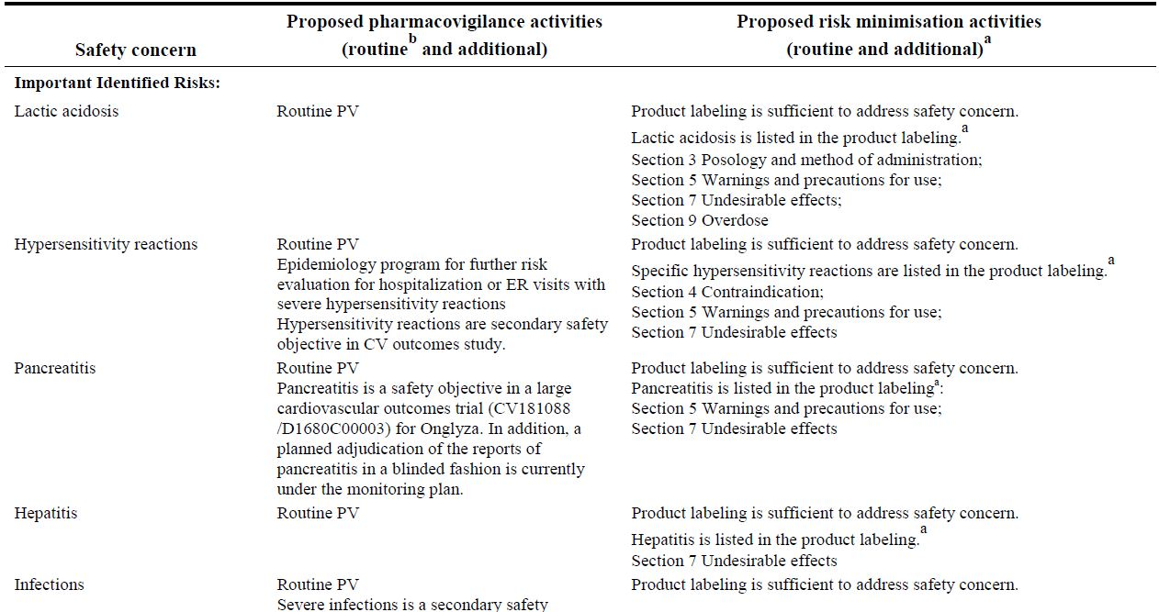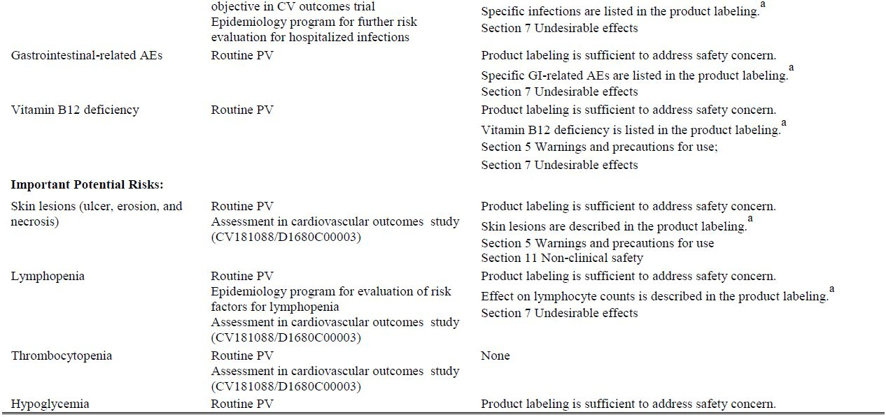Table 4 (continued): Summary of Kombiglyze RMP.

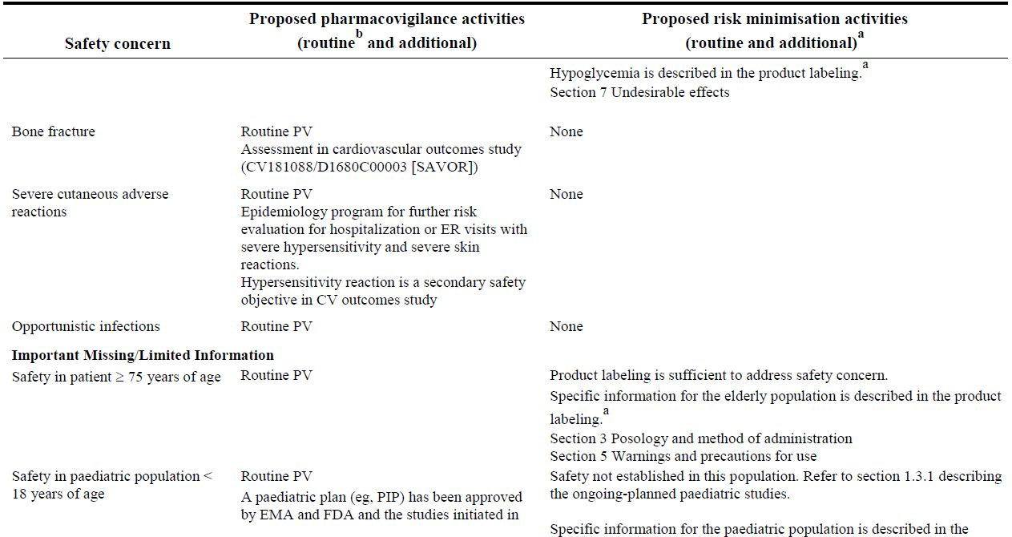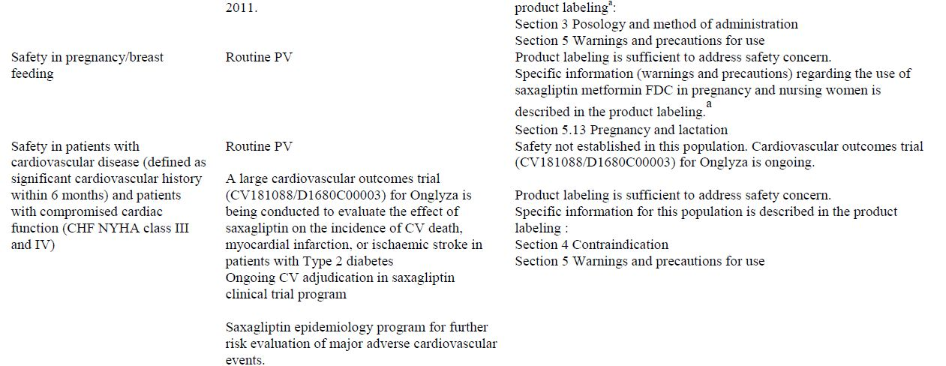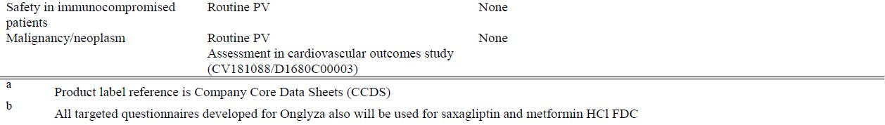

Table 5 summarises the TGA’s evaluation of the RMP and the sponsor’s responses to the issues raised by the OPR.

Table 5: Reconciliation of issues outlined in the Kombiglyze RMP evaluation report.

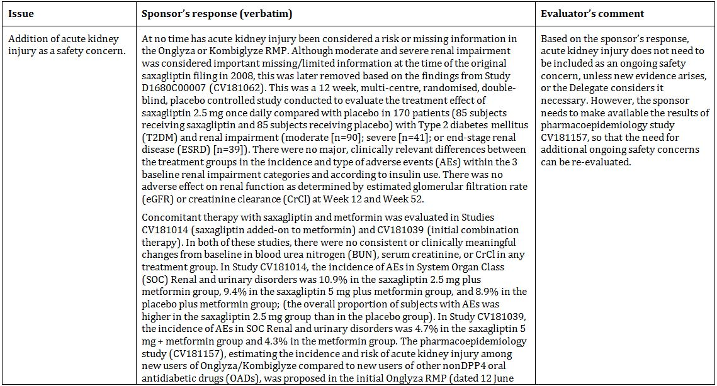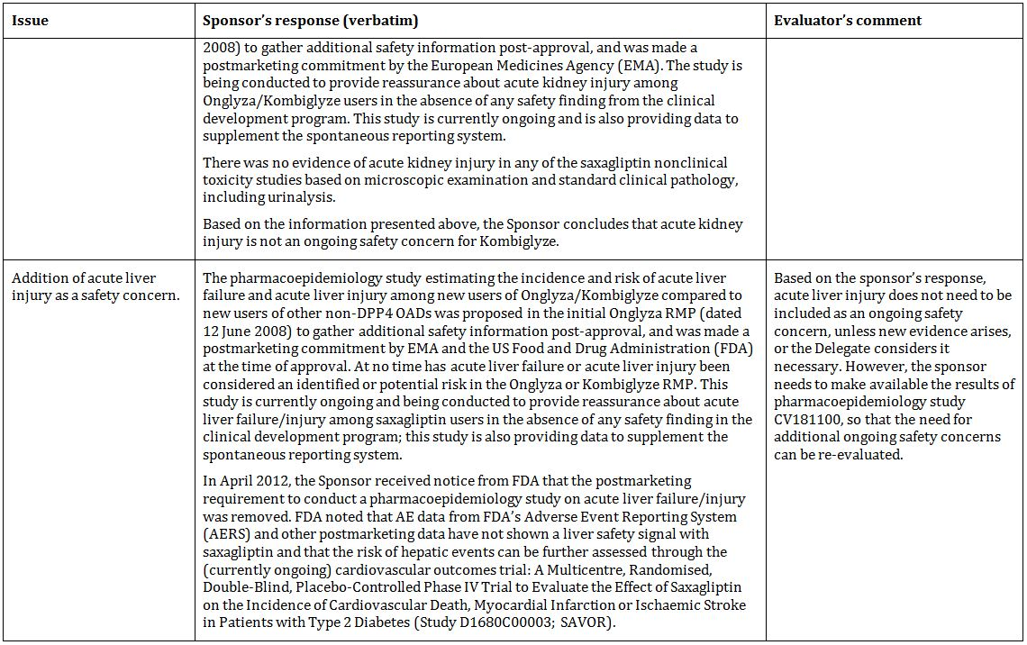Table 5 (continued): Reconciliation of issues outlined in the Kombiglyze RMP evaluation report.

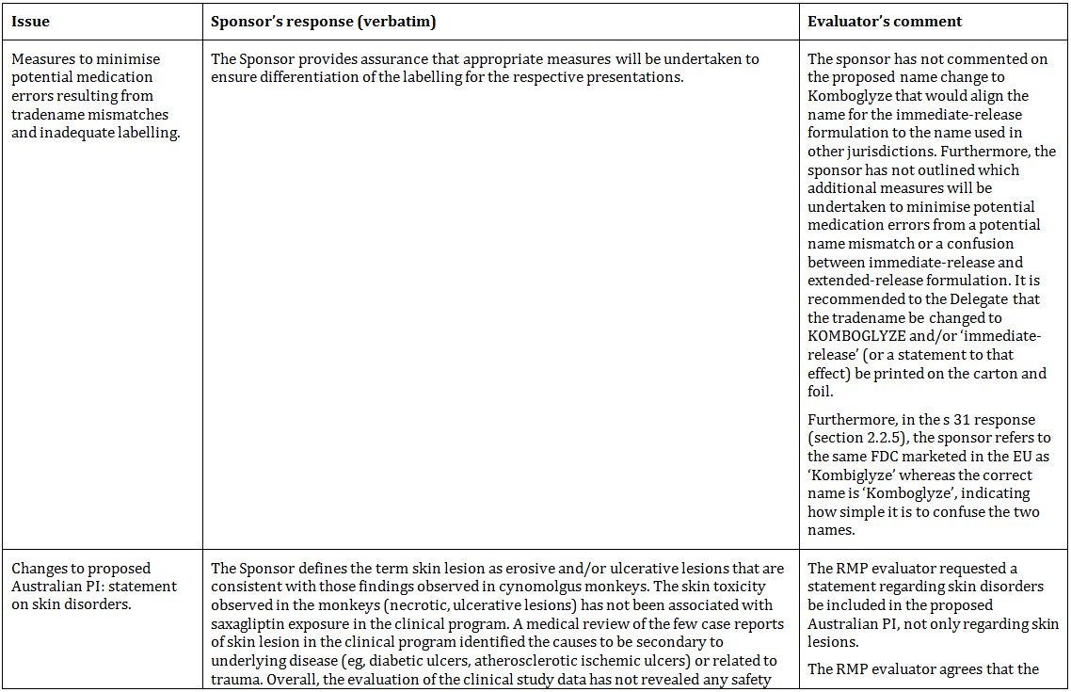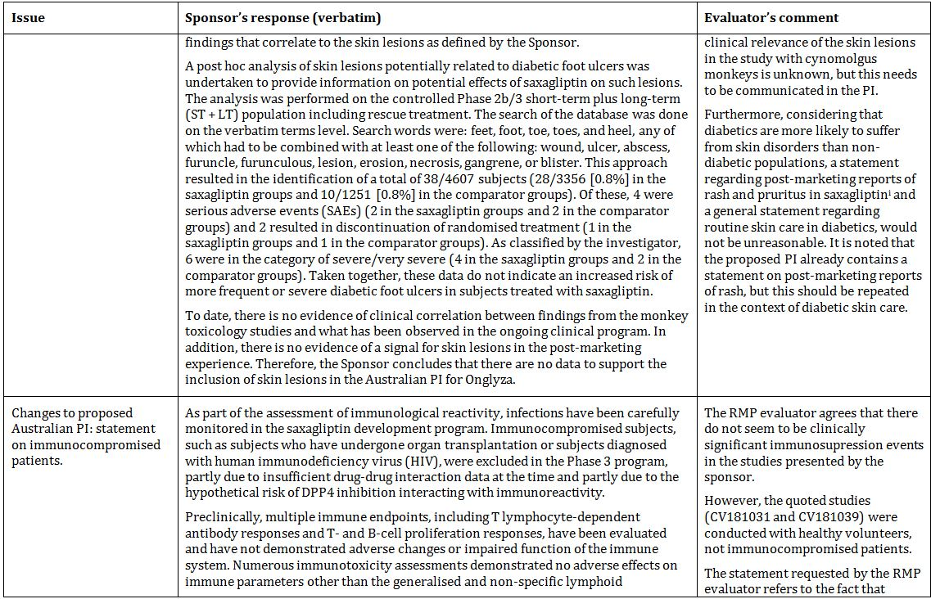Table 5 (continued): Reconciliation of issues outlined in the Kombiglyze RMP evaluation report.

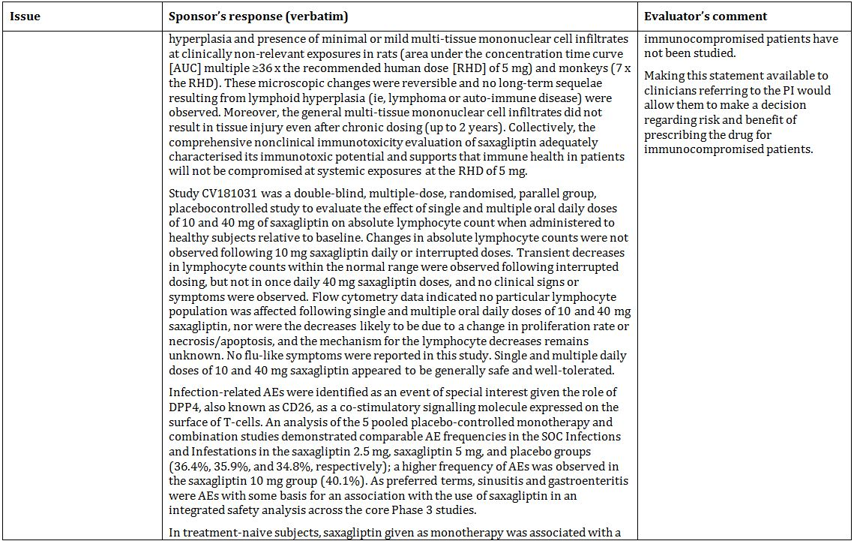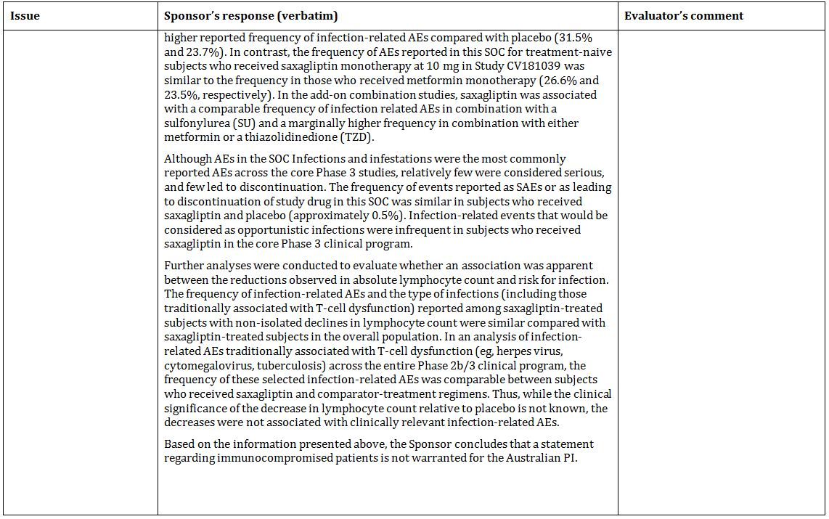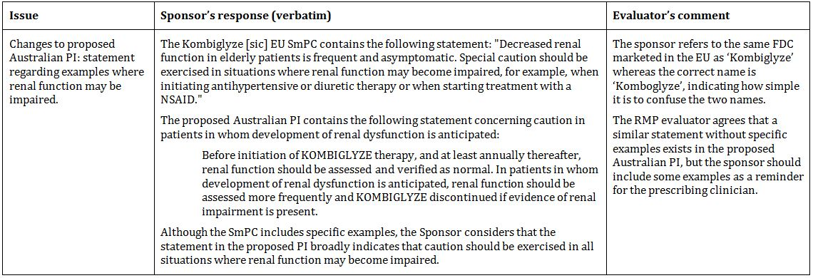

#### Suggested wording for conditions of registration

##### RMP

Implement EU-RMP Version 2 (dated 8 December 2011), and Australian Risk Minimisation Activities (dated 26 March 2012),[9] and any future updates as a condition of registration.

##### Periodic Safety Update Reports (PSURs)

Post marketing reports are to be provided in line with the current published list of EU reference dates and frequency until the period covered by such reports is not less than three years from the date of this approval letter. The reports are to meet the requirements in accordance with ICH E2C (R2) guideline on Periodic Benefit-Risk Evaluation Reports and Module VII of the EMA Guideline on Good Pharmacovigilance (GPV) Practices relating to PSURs. Submission of the report must be within the 70 days of the data lock point for PSURs covering intervals up to and including 12 months and within 90 days of the data lock point for PSURs covering intervals in excess of 12 months. The submission may be made up of two PSURs each covering six months.

## VI. Overall conclusion and risk/benefit assessment

The submission was summarised in the following Delegate’s overview and recommendations:

### Quality

The two active substances are not mixed together within the tablet. Kombiglyze tablets consist of an inner metformin core which is covered by an active coating of saxagliptin. The manufacturing details are considered satisfactory.

* In Australia, the saxagliptin 5 mg tablet is registered. The 2.5 mg saxagliptin tablet used in clinical studies is not registered in here.
* The metformin tablets used in clinical and bioavailability studies were the US registered product.

Appropriate bioequivalence studies linking the study drugs with the Australia registered products were provided and are considered satisfactory.

The company referred to an earlier Study CV 181017 in the submission to register saxagliptin (Onglyza) 5 mg tablets to establish lack of clinically meaningful drug interactions between these two active agents.

This submission of FDC was not referred to the Pharmaceutical Subcommittee. The PCE recommends registration with respect to chemistry and quality control.

### Nonclinical

The toxicology dossier included studies single dose toxicity, repeat dose and embryofoetal toxicity studies using the combination.

Data obtained in dogs, pregnant rats and pregnant rabbits showed pharmacokinetic interaction between saxagliptin and metformin in rats – an increase in plasma AUC for the active metabolite of saxagliptin (BMS-510849) and decrease in Cmax. The evaluators comment that in humans, the pharmacokinetic interaction between saxagliptin and metformin is limited to a reduction in the saxagliptin Cmax.

In repeat dose toxicity study, co administration of saxagliptin and metformin for 90 days in dogs produced no novel or exacerbated toxicity compared to single agents except for an increase in the incidence of tremors/shivers (observed at 5/20 mg/kg/day saxagliptin/metformin). This finding was considered a behavioural effect rather than a neurological effect or manifestation of hypoglycaemia.

Treatment with the combination was associated with an increase in incidence of wavy ribs in foetuses of treated rats. The finding occurred in conjunction with significant suppression of maternal body weight gain.

In pregnant rabbits, the combination was poorly tolerated in comparison with the single agents causing death, moribund state and abortion. Mean foetal weight was reduced and ossification of the pubis and hyoid was impaired.

No treatment related teratogenicity was observed in either species (rat, rabbit).

The nonclinical evaluators were further contacted in relation to the effect seen in pregnant rabbits and report species related sensitivity to metformin not relevant to human use.

Both saxagliptin and metformin combined use is currently approved. Consequently, there are no nonclinical objections to the registration of Kombiglyze.

### Clinical

The clinical dossier consisted of 5 pharmacokinetic, 1 pharmacodynamic, and 8 efficacy studies. The clinical efficacy studies were performed with free combination of mono agents given concomitantly.

#### Efficacy

The use of metformin/saxagliptin co administration is supported based on previously evaluated studies (Study 181014 as add on therapy and Study 181039 as initial therapy). Both uses are currently approved in Australia. In addition, longer term efficacy data are now available. However, note that these studies do not involve 2.5 mg saxagliptin twice daily dosing.

The dossier also included active controlled studies (Study 181054 comparing metformin/saxagliptin use against metformin/glipizide sulfonylurea [longer term data available; this study is being included in the PI] and Study 181056 comparing metformin/saxagliptin against metformin/sitagliptin in an 18 weeks study).

The Study 181057 investigated saxagliptin use with basal insulin and included 52 weeks. The use with basal insulin (with or without metformin) is now approved in Australia. This is therefore no longer regarded as an issue.

The treatment effect generally observed with respect to the primary outcome (HbA1C) with the use of metformin/saxagliptin combination was modest but sustained and clinically meaningful.

Study 181038 of saxagliptin use in naïve patients with metformin as rescue medication and Study 181066 using sustained release metformin and saxagliptin 5 mg are only marginally relevant to this submission.

This brings to attention Study 181080. This small (n = 160), short (12 weeks), double blind study can be considered pivotal to this submission as this was the only study in which 2.5 mg twice daily saxagliptin dosing was investigated. Metformin was also given twice daily. The 12 week results were as shown in Table 6.

Table 6: 12 week results from study 181080.

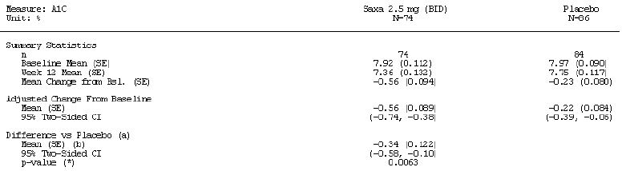

The results of this study along with the pharmacodynamic Study 181152 support the use of 2.5 mg twice daily dose of saxagliptin as opposed to 5 mg once daily dosing approved for the saxagliptin mono product.

#### Safety

There appear to be no safety issues specific to the metformin/saxagliptin combination. Please also see the RMP evaluation and comments below.

### Risk management plan

The OPR recommends approval subject to adoption of the RMP. The evaluation noted acute renal and liver injury as of ongoing safety concern. Based on evaluation of sponsor’s response to the RMP evaluation, the provision of Studies CV181157 and CV181100 as post marketing condition of registration is supported in respect of these identified risks.

The RMP evaluators also recommend that ‘immediate release’ be printed on the carton and foil to avoid medication errors. This is supported.

The recommendations with respect to PI are also supported.

The ‘Dosage and Administration’ section should include a statement that the drug should be taken with meals. This is also supported.

### Risk-benefit analysis

#### Delegate considerations

##### Conclusion

Overall, the data package supports registration of Kombiglyze fixed dose combination tablets in the three strengths (saxagliptin/metformin 2.5/500, 2.5/850 and 2.5/1000 mg) for the indication:

*“As an adjunct to diet and exercise to improve glycaemic control in adults with type 2 diabetes mellitus when treatment with both saxagliptin and metformin is appropriate.”*

The proposed doing instructions are also supported.

The sponsor is also asked to provide updated PI (using initial PI included at the time of submission as the base document) incorporating all recommendations from various evaluation areas of the TGA or annotated comments where a recommendation is not implemented.

Furthermore, in clinical trials section immediately following the statement that Kombiglyze has not been studied in clinical trials, a description of the Study 181080 should be included noting that the use of 2.5 mg saxagliptin dosing is limited this study and that twice daily and once daily dosing have not been directly compared in an efficacy study.

It is also recommended that results of the bioequivalence studies in tabular format be included in the Pharmacokinetic section of the PI.

The source of metformin pharmacokinetic data in children and adolescents on page 8 of the proposed PI is not clear and is not relevant to this FDC and should be removed.

The sponsor is also requested to include a Consumer Medicine Information (CMI) in its pre ACPM response.

##### Request for ACPM advice

In addition to the advice on overall adequacy of the data package and advice on any issue on which the ACPM may wish to comment, the ACPM was asked advice with respect to the following:

* The indication as proposed above is consistent with the current approval of saxagliptin mono product and as well as the additional data in the present submission.

Does the ACPM consider it appropriate that an explicit statement be included that use in a wider spectrum, that is, triple combination (except basal insulin/metformin/saxagliptin) is not intended?

* With respect to use with intermediate or long acting (basal) insulin or premixed insulin, the approval for saxagliptin mono product includes a qualifying statement with the indication that use with short acting insulin (bolus:basal regimen) was not studied. For the FDC this information is included in the clinical trials section within the description of the relevant clinical trial.

Does the ACPM consider this as sufficient risk control strategy in relation to this aspect of use?

* The use of this FDC involves a change from the existing approved dosage of saxagliptin (Onglyza) 5mg once daily in the morning in dual combination with metformin (in any dosage form) to a regimen of 2.5 mg twice daily in fixed combination with metformin (500, 850 or 1000 mg twice daily). In healthy adults, the pharmacodynamic (study CV181152) response to saxagliptin was not altered by change from once daily 5 mg dosing in the morning to 2.5 mg twice daily dosing of the FDC. This is further supported by a 12 week, placebo controlled, clinical efficacy study (181080). Note the submission did not include a study directly comparing once (5 mg) and twice daily (2.5 mg) treatment regimens. In terms of clinical management, it is expected that lower dose 2.5 mg combination with a range of metformin doses will be found useful.

The ACPM is requested to provide advice on the clinical rationale and the adequacy of data supporting the use of 2.5 mg twice daily dosing of saxagliptin in fixed combination with metformin as opposed to 5 mg once daily dosing approved for the mono product.

The sponsor is also asked to inform whether any clinical efficacy studies comparing once and twice daily saxagliptin dosing have been performed. If available, these will need review before decision and finalisation of this submission.

* As discussed in the clinical evaluation report, the data support addition of saxagliptin to existing metformin therapy and saxagliptin (with or without metformin) to existing basal insulin. Initial use of saxagliptin as a single agent is not approved. A clinical scenario may be that of starting insulin in patients who fail on this FDC. This would not be supported by the data in this submission implying that FDC should be ceased before insulin is introduced. In the event of insufficient control on insulin, the FDC may be reintroduced. This issue of hierarchy of treatment is common to submissions of anti diabetic agents and the general approach is that such instructions be left to the relevant clinical management guidelines.

The ACPM is requested to provide advice regarding instruction for hierarchy of treatment in the PI.

* The RMP evaluators have raised the issue of medication errors and recommended alternative name or addition of immediate release on the product label (carton and foil). The latter recommendation is supported. Note that a submission to register fixed dose combination of immediate release saxagliptin (5 mg) with sustained release metformin (500, 850, 1000 mg) is currently under review.

#### Response from Sponsor

##### Introduction

The sponsor acknowledges the recommendation of the clinical evaluator and the Delegate that the submission package supports registration of the Kombiglyze FDC as an adjunct to diet and exercise to improve glycaemic control in adults with T2DM when treatment with both saxagliptin and metformin is appropriate. The sponsor also noted the endorsement of the OPR for a satisfactory RMP submitted with this application. The sponsor sought to take the opportunity to provide additional comments in relation to the Delegate’s specific request for ACPM advice.

##### Appropriate utilisation of the FDC (requests 1 and 2)

The Delegate noted that the proposed indication is consistent with the current approval of the saxagliptin mono product as well as the additional data in the present submission. With respect to the question as to whether it would be appropriate to include an explicit statement that use in a wider spectrum is not intended, the sponsor considers that the proposed Kombiglyze PI provides adequate guidance to the prescriber regarding the suitable use of the FDC of saxagliptin and metformin. The proposed PI summarises data from clinical trials supporting the proposed use consistent with the approved saxagliptin mono product PI while excluding data from clinical trials where the FDC is not suitable for use, such as saxagliptin as add on therapy to a sulfonylurea (SU) or a thiazolidinedione. Furthermore, given the lack of approval for combination use of saxaglipitin as triple therapy with another anti diabetic medication such as a SU, the sponsor believes it unlikely that physicians unfamiliar with saxagliptin and its combined use with metformin would use the FDC in combination with another anti diabetic medication.

The Delegate noted the PI for the saxagliptin mono product includes a qualifying statement with the indication that use with short acting insulin (bolus:basal regimen) was not studied and that this information is included in the Clinical Trials section of the PI for the Kombiglyze FDC. With respect to the Delegate’s comment whether this action provides sufficient risk control in relation to this aspect of use, the sponsor proposes that the ‘Dosage and Administration’ section of the PI for the FDC be amended to contain specific dosing instructions for patients with inadequate glycaemic control obtained with premixed or basal insulin with metformin and also to include the following statement:

*“Kombiglyze has not been studied in a regimen combining intermediate or long-acting insulin with mealtime bolus doses of short acting insulin (basal:bolus regimens), and its efficacy in this context has not been established.”*

The sponsor considers that these revisions to the ‘Dosage and Administration’ section, along with the addition of the summary of add on combination therapy with insulin (with or without metformin) in the Clinical Trials section of the PI, provide sufficient risk control to ensure the appropriate use of the FDC with insulin (that is, premixed and basal insulin).

The ‘Dosage and Administration’ section of the PI will also include dosing instructions for the FDC in all approved indications for concomitant administration of saxagliptin and metformin. Consequently, the sponsor considers that the PI is appropriate and requires no additional statements to prevent use of the FDC in a wider setting than intended. A copy of the amended PI is included as part of the pre ACPM response.

##### Saxagliptin 2.5 mg BID versus 5 mg QD dosing (request 3)

The Delegate requested that the sponsor identify any clinical efficacy studies comparing the saxagliptin 2.5 mg BID and 5 mg QD dosing regimens. The sponsor confirms that there are no head to head clinical efficacy studies comparing these two dosing regimens but believes Study CV181152 to be an acceptable alternative.

The sponsor undertook the formal bioequivalence Study CV181152 to confirm the comparability of the saxagliptin 2.5 mg BID and 5 mg QD regimens. Pharmacokinetic results confirmed that the daily steady-state exposure (AUC0-24) of saxagliptin after administration of 2.5 mg BID was bioequivalent to that after administration of the 5 mg QD dose. Additionally, pharmacodynamic results showed that inhibition of DPP-4 activity by the 2.5 mg BID saxagliptin dose was equivalent to that of the 5 mg QD saxagliptin dose, resulting in equivalent elevations of post prandial plasma intact glucagon like peptide-1 (iGLP-1) activity for both regimens. The effects of 2.5 mg BID and 5 mg QD on DPP-4 and iGLP-1 activity were comparable. Results for inhibition of DPP-4 activity are reproduced in Figure 5.

Figure 5: Percentage of DPP4 inhibition over time.

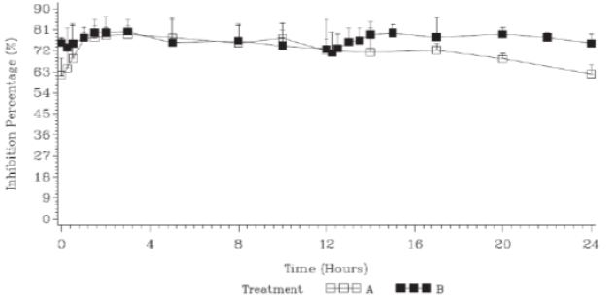

BID twice daily; DPP4 dipeptidyl peptidase 4; QD once daily.

Treatment A: 5 mg saxagliptin tablet administered QD for 7 days.

Treatment B: 2.5 mg saxagliptin tablet administered BID for 7 days.

The percentage of DPP4 inhibition was determined over 24 hours after drug administration on the morning of Day 7.

The findings of the TGA’s clinical evaluation report support Study CV181152 in demonstrating the equivalence of saxagliptin 5 mg QD + metformin to saxagliptin 2.5 mg BID + metformin, stating

*“The pharmacodynamic response to the saxagliptin component of the FDC is not altered, in healthy adults, by the change from once daily 5 mg administration in the morning to the 2.5 mg twice daily dosing of the FDC product”*

and that

*“Response as measured by total DPP-4 inhibition and resultant enhancement of GLP-1 secretion over the 24 hour dosing interval is unchanged”.*

Concerning the transferability of the results from healthy adults examined in Study CV181152 to the target patient population, the clinical evaluation report states

*“Although demonstrated in healthy adults, it is reasonable to extrapolate this comparison of the once and twice daily regimens to the therapeutic situation in T2DM”.*

The results from Study CV181152 are supported by the results of Study CV181080, which achieved its primary objective of demonstrating that the 2.5 mg BID regimen of saxagliptin produced a statistically significant reduction in HbA1c compared to placebo. This result was noted by the clinical evaluator who states that

*“the submission provides adequate evidence (Study 080) that there is an additional effect compared to metformin alone, in terms of reduction of HbA1c”.*

While the magnitude of the placebo response was higher than anticipated, the change from baseline in HbA1c in Study CV181080 (-0.56%) was similar to that at Week 12 in other randomised controlled trials with saxagliptin as add-on to metformin (-0.74 in Study CV181014 [dose ranging trial], -0.61 in Study D1680C00001 [head to head versus glipizide trial], and -0.46 in Study D1680C00002 [head to head versus sitagliptin trial]. Furthermore, treatment with saxagliptin 2.5 mg BID was also clinically relevant, as the percentage of individuals achieving an HbA1c <7% in Study CV181080 (39%) was similar to that in Studies CV81014, Study D1680C00001, and Study D1680C00002 (33% to 44%).

The sponsor considers that the results of Study CV181152, supported by the results of Study CV181080, provide evidence that there will be no difference in clinical practice between the efficacy and safety of saxagliptin 2.5 mg BID + metformin compared to saxagliptin 5 mg QD + metformin.

##### Hierarchy of treatment (request 4)

The Delegate noted the issue of hierarchy of treatment is common to submissions of anti diabetic agents and the general approach is that such instructions be left to the relevant clinical management guidelines. The sponsor believes that there are two aspects that need be considered in relation to the Delegate’s request.

###### PI versus clinical guidelines

The sponsor has concerns that the introduction of specific instructions included in the Kombiglyze PI may cause confusion should the provided information be contrary to clinical guidelines. Clinical management guidelines are developed over time and evolve as experience with a disease state and therapeutic options are evaluated and assessed with the benefit of experience gained outside the context of a clinical trial setting. Any specific instructions regarding the hierarchy of treatment in the Kombiglyze PI could become obsolete and even contrary to best clinical practice. Consequently, the sponsor considers that the information provided in the ‘Clinical Trials’ and ‘Dosage and Administration’ sections of the Kombiglyze PI is adequate for ensuring the safe and appropriate use of the FDC in combination with insulin.

###### Clinical trial design versus clinical practice

The Delegate suggested that the design of the trial conducted using saxagliptin and metformin with insulin does not necessarily support the addition of insulin to the treatment regimen in patients having insufficient control with the FDC alone. However, the design of the trial assessing the use with insulin is in compliance with EU guidance currently adopted by TGA. This guideline[10] states:

*“Regarding* ***combination with insulin****, efficacy on glycaemic control should be documented vs placebo, ie. insulin alone. Studies should be carried out in patients already treated with insulin for a time sufficient ensure that HbA1c levels are stable before the test drug is added to insulin (ie. at least 2-3 months). The insulin dose will be maintained unchanged as far as possible during the double blind period (unless necessary for safety reasons), and the efficacy will primarily be evaluated on the evolution of HbA1c.”*

The guideline further states that

*“A comparative evaluation versus the combination of insulin plus an oral antidiabetic currently licensed in this indication may be required.”*

The sponsor agrees that in a strict interpretation of the study design guidance for the investigation to determine the efficacy and safety of saxagliptin and metformin in combination with insulin, the use of the FDC as add on to insulin is problematic given usual clinical practice/hierarchy of treatment. However, in recognition of the difficulties in conducting trials of other agents in patients requiring insulin, the current (but not TGA adopted) EU guideline[11] proposes a trial design consistent with Study CV181057 conducted by the sponsor and which is considered appropriate for supporting an indication of ‘combination with insulin’. In view of the current TGA adopted EU guideline and the approach described in the revised document (although not yet adopted by TGA), the sponsor considers that a general ‘in combination’ indication is supported by the trial conducted. Consequently, the trial conducted would appear to address the Delegate’s concern regarding the hierarchy for utilisation of the FDC with insulin, and therefore specific clinical guidance need not be set out in the PI document.

*“Combination therapy of glucose lowering agents with insulin may occur in different clinical situations and patient populations. Most frequently, insulin therapy is introduced in patients inadequately controlled on other glucose lowering agents. In this case, some or all of the previous agents may be discontinued and insulin is initiated. Less frequently, patients already receiving insulin may benefit from adding another glucose lowering agent. Reasons for such consideration may be frequent and especially severe hypoglycaemic events preventing the desired level of glycaemic control or insulin induced weight gain in already obese patients. Overall, the most frequently used combination is insulin plus metformin.*

*Even though a study in which insulin is initiated in patients not reaching glycaemic control with the test agent (alone or in combination with another glucose lowering agent, most likely metformin) would reflect the most common clinical scenario, it is not expected to provide relevant data on the effect of the test drug in this setting. However, relevant safety information on the combined use of the test agent and insulin may be gained from such a study and may be reflected in the PI.*

*For appropriate evaluation of both safety and efficacy of the test compound in combination with insulin, the test agent should be added in patients with type 2 diabetes inadequately controlled on a reasonable dose of insulin as single therapy or in combination with another glucose lowering agent, typically metformin or both, if stratified. Treatment groups should be balanced with respect to insulin regimens (for* *example, basal only versus basal bolus regimen). In order to support a general claim “combination therapy with insulin”, the study population should represent a wide range of BMI and include a substantial percentage of patients with long diabetes duration (for example ≥ 10 year) and elderly patients to adequately reflect the whole target population.”*

The sponsor considers that the information provided in the ‘Clinical Trials’ and ‘Dosage and Administration’ sections of the Kombiglyze PI is adequate for ensuring the safe and appropriate use of the FDC in combination with insulin.

##### Amendments to carton labels (request 5)

The Delegate noted that RMP evaluators raised the issue of medication errors and recommended an alternative name or the addition of ‘immediate release’ on the product label. The sponsor considers that the potential for medication errors is minimal; therefore, the addition of a proposed trade name or ‘immediate release’ to the product label (carton and foil) is not necessary. The RMP evaluator also raised concerns of potential confusion with the product proposed for registration in Australia with products registered in other jurisdictions (Komboglyze in Europe and Canada, Kombiglyze XR in the US). The sponsor considers the probability of any such errors to be extremely low, and the trade name proposed is suitable for use when considered in the context of the trade names of other products registered for use in Australia.

The sponsor also considers the request for the inclusion of ‘immediate release’ on the carton to be inconsistent with the TGA requirements outlined in Therapeutic Goods Order No. 69 “General requirements for labels for medicines” (TGO 69) (April 2009) and the “Best practice guideline on prescription medicine labelling” (January 2011). The TGO 69 requirement for the labelling of products is to include the ‘name of the dosage form’ as a word or words denoting the usual name of the dosage form, in this instance ‘tablets’ as per the Australian Approved Names List. Differentiation of dosage forms is usually reserved for tablets that exhibit certain characteristic such as dispersible, enteric coated, modified release formulations using the appropriate term from the Australian Approved Names List. However, there is no Australian approved term for ‘immediate release’ tablets other than tablets.

The sponsor acknowledges that an application is currently under review by TGA for a modified release formulation of saxagliptin and metformin with the currently proposed trade name of Kombiglyze XR. Given that the Kombiglyze XR application is under review, the sponsor believes that the proposal to include ‘immediate release’ on the label has the potential to cause confusion in the absence of a modified release formulation, as per the usual practice of TGA to differentiate by use of a term such as ‘modified release’ as described above.

##### Conclusion

The sponsor notes the recommendations of the Clinical Evaluator and Delegate that the submission supports registration of the proposed FDC of saxagliptin and metformin, and considers that the proposed Indication and PI provide appropriate guidance to ensure the safe and appropriate use of Kombiglyze.

#### Advisory Committee considerations

The ACPM, taking into account the submitted evidence of efficacy, safety and quality, agreed with the Delegate and considered these products to have an overall positive benefit-risk profile for the indication as proposed:

*As an adjunct to diet and exercise to improve glycaemic control in adults with type 2 diabetes mellitus when treatment with both saxagliptin and metformin is appropriate.*

The proposed dosing instructions are also supported.

##### Proposed amendments to the PI/CMI

The ACPM agreed with the Delegate to the proposed amendments to the PI and CMI and specifically advised on the inclusion of the following:

* a statement in the ‘Precautions’ and ‘Contraindications’ section of the PI clarify the renal function contraindication which is not in line with Australian Prescriber advice, standard clinical practice, or international guidelines.

The ACPM advised that the implementation by the sponsor of the recommendations outlined above to the satisfaction of the TGA, in addition to the evidence of efficacy and safety provided would support the safe and effective use of these products.

### Outcome

Based on a review of quality, safety and efficacy, TGA approved the registration of:

* **Kombiglyze 2.5/1000** saxagliptin (as hydrochloride)/metformin hydrochloride 2.5 mg/1000 mg immediate-release film-coated tablet blister
* **Kombiglyze 2.5/500** saxagliptin (as hydrochloride)/metformin hydrochloride 2.5 mg/500 mg immediate-release film-coated tablet blister
* **Kombiglyze 2.5/850** saxagliptin (as hydrochloride)/metformin hydrochloride 2.5 mg/850 mg immediate-release film-coated tablet blister

indicated for:

*Kombiglyze is indicated as an adjunct to diet and exercise to improve glycaemic control in adults with type 2 diabetes mellitus when treatment with both saxagliptin and metformin is appropriate.*

#### Specific conditions of registration applying to these therapeutic goods

1. The implementation in Australia of the Kombiglyze (saxagliptin/metformin) 2.5 mg/500 mg, 2.5 mg/850 mg and 2.5 mg/1000 mg tablets RMP, identified as EU-RMP Version 2 (dated 8 December 2011) and Australian Risk Management Activities (dated 26 March 2012), and any subsequent revisions as agreed with the TGA and its OPR.

## Attachment 1. Product Information

The Product Information approved at the time this AusPAR was published is at Attachment 1. For the most recent Product Information please refer to the TGA website at <<http://www.tga.gov.au/hp/information-medicines-pi.htm>>.

## Attachment 2. Extract from the Clinical Evaluation Report

1. Saxagliptin is present as saxagliptin hydrochloride which is formed in situ.
2. European Medicines Agency, “Committee for Medicinal Products for Human Use (CHMP): Guideline on the Non-Clinical Development of Fixed Combinations of Medicinal Products (CHMP/EMEA/CHMP/SWP/258498/2005)”, 13 October 2005, Web, accessed 10 September 2013 <www.ema.europa.eu/docs/en_GB/document_library/Scientific_guideline/2009/10/WC500003975.pdf>.
3. Note also that the metformin doses are in terms of base for animals and the hydrochloride salt for humans.
4. Kombiglyze has the following Use in pregnancy statement in the PI: Category C. There are no adequate and well-controlled studies of Kombiglyze XR or its individual components in pregnant women. Because animal reproduction studies are not always predictive of human response, Kombiglyze XR, like other antidiabetic medications, should be used during pregnancy only if clearly needed. Refer to PI (Attachment 1) for further details.
5. European Medicines Agency, “Committee for Medicinal Products for Human Use (CHMP): Guideline on Clinical Development of Fixed Combination Medicinal Products (CHMP/EWP/240/95 Rev. 1)”, 19 February 2009, Web, accessed 10 September 2013 <www.ema.europa.eu/docs/en_GB/ document_library/Scientific_guideline/2009/09/WC500003686.pdf>.
6. European Medicines Agency, “Committee for Medicinal Products for Human Use (CHMP): Guideline on Clinical Development of Fixed Combination Medicinal Products (CHMP/EWP/240/95 Rev. 1)”, 19 February 2009, Web, accessed 10 September 2013 <www.ema.europa.eu/docs/en_GB/ document_library/Scientific_guideline/2009/09/WC500003686.pdf>.
7. European Medicines Agency, “Committee for Medicinal Products for Human Use (CHMP): Guideline on Clinical Development of Fixed Combination Medicinal Products (CHMP/EWP/240/95 Rev. 1)”, 19 February 2009, Web, accessed 10 September 2013 <www.ema.europa.eu/docs/en_GB/ document_library/Scientific_guideline/2009/09/WC500003686.pdf>.
8. European Medicines Agency, “Committee for Proprietary Medicinal Products (CPMP): Points to Consider on Application with 1. Meta-Analyses; 2. One Pivotal Study (CPMP/EWP/2330/99)”, 31 May 2001, Web, accessed 10 September 2013 <www.ema.europa.eu/docs/en_GB/ document_library/Scientific_guideline/2009/09/WC500003657.pdf>.
9. The Australian Risk Minimisation Activities state that risk minimisation activities for Saxagliptin and Metformin HCl FDC will be conducted in accordance with the Global RMP and that there are no additional risk minimisation activities specific for Australia.
10. European Medicines Agency, “Committee for Proprietary Medicinal Products (CPMP): Note for Guidance on Clinical Investigation of Medicinal Products in the Treatment of Diabetes Mellitus (CPMP/EWP/1080/00)”, 30 May 2002, Web, accessed 10 September 2013 <www.ema.europa.eu/ docs/en_GB/document_library/Scientific_guideline/2009/09/WC500003262.pdf>.
11. European Medicines Agency, “Committee for Medicinal Products for Human Use (CHMP): Guideline on clinical investigation of medicinal products in the treatment or prevention of diabetes mellitus (CPMP/EWP/1080/00 Rev. 1)”, 14 May 2012, Web, accessed 10 September 2013 <www.ema.europa.eu/docs/en_GB/document_library/Scientific_guideline/2012/06/WC500129256.pdf>.