|  |
| --- |
| **First round report: 5 October 2016**  **Second round report: 8 December 2016** |

|  |
| --- |
| AusPAR Attachment 2 |
| Extract from the Clinical Evaluation Report for Sebelipase alfa |
| Proprietary Product Name: Kanuma |
| Sponsor: Alexion Pharmaceuticals Australia Pty Ltd |

About the Therapeutic Goods Administration (TGA)

* The Therapeutic Goods Administration (TGA) is part of the Australian Government Department of Health, and is responsible for regulating medicines and medical devices.
* The TGA administers the *Therapeutic Goods Act 1989* (the Act), applying a risk management approach designed to ensure therapeutic goods supplied in Australia meet acceptable standards of quality, safety and efficacy (performance), when necessary.
* The work of the TGA is based on applying scientific and clinical expertise to decision-making, to ensure that the benefits to consumers outweigh any risks associated with the use of medicines and medical devices.
* The TGA relies on the public, healthcare professionals and industry to report problems with medicines or medical devices. TGA investigates reports received by it to determine any necessary regulatory action.
* To report a problem with a medicine or medical device, please see the information on the TGA website < <https://www.tga.gov.au>>.

About the Extract from the Clinical Evaluation Report

* This document provides a more detailed evaluation of the clinical findings, extracted from the Clinical Evaluation Report (CER) prepared by the TGA. This extract does not include sections from the CER regarding product documentation or post market activities.
* The words [Information redacted], where they appear in this document, indicate that confidential information has been deleted.
* For the most recent Product Information (PI), please refer to the TGA website <<https://www.tga.gov.au/product-information-pi>>.

Copyright

© Commonwealth of Australia 2018  
This work is copyright. You may reproduce the whole or part of this work in unaltered form for your own personal use or, if you are part of an organisation, for internal use within your organisation, but only if you or your organisation do not use the reproduction for any commercial purpose and retain this copyright notice and all disclaimer notices as part of that reproduction. Apart from rights to use as permitted by the *Copyright Act 1968* or allowed by this copyright notice, all other rights are reserved and you are not allowed to reproduce the whole or any part of this work in any way (electronic or otherwise) without first being given specific written permission from the Commonwealth to do so. Requests and inquiries concerning reproduction and rights are to be sent to the TGA Copyright Officer, Therapeutic Goods Administration, PO Box 100, Woden ACT 2606 or emailed to < [tga.copyright@tga.gov.au](mailto:tga.copyright@tga.gov.au)> .

Contents

List of abbreviations 5

1. Introduction 9

1.1. Submission type 9

1.2. Drug class and therapeutic indication 9

1.3. Dosage forms and strengths 9

1.4. Dosage and administration 9

1.5. Information on the condition being treated 10

1.6. Current treatment options 10

2. Clinical rationale 11

2.1. Formulation development 11

2.2. Evaluator’s commentary on the background information 12

3. Contents of the clinical dossier 12

3.1. Scope of the clinical dossier 12

3.2. Paediatric data 13

3.3. Good clinical practice 13

3.4. Evaluator’s commentary on the clinical dossier 13

4. Pharmacokinetics 13

4.1. Studies providing pharmacokinetic information 13

4.2. Summary of pharmacokinetics 14

4.3. Evaluator’s overall conclusions on pharmacokinetics 19

5. Pharmacodynamics 20

5.1. Studies providing pharmacodynamic information 20

5.2. Summary of pharmacodynamics 21

5.3. Evaluator’s overall conclusions on pharmacodynamics 25

6. Dosage selection for the pivotal studies 25

6.1. Pharmacokinetics and pharmacodynamics: dose finding studies 25

6.2. Phase II dose finding studies 26

6.3. Phase III pivotal studies investigating more than one dose regimen 27

6.4. Evaluator’s conclusions on dose finding for the pivotal studies 29

7. Clinical efficacy 29

7.1. Studies providing evaluable efficacy data 29

7.2. Pivotal or main efficacy studies 29

7.3. Other efficacy studies 61

7.4. Analyses performed across trials: pooled and meta-analyses 81

7.5. Evaluator’s conclusions on clinical efficacy 81

8. Clinical safety 82

8.1. Studies providing evaluable safety data 82

8.2. Studies that assessed safety as the sole primary outcome 86

8.3. Patient exposure 86

8.4. Adverse events 90

8.5. Treatment related adverse events (adverse drug reactions) 98

8.6. Deaths and other serious adverse events 99

8.7. Discontinuations due to adverse events 101

8.8. Evaluation of issues with possible regulatory impact 101

8.9. Other safety issues 111

8.10. Post marketing experience 112

8.11. Evaluator’s overall conclusions on clinical safety 113

9. First round benefit-risk assessment 114

9.1. First round assessment of benefits 114

9.2. First round assessment of risks 114

9.3. First round assessment of benefit-risk balance 115

10. First round recommendation regarding authorisation 117

11. Clinical questions 117

11.1. Clinical questions 117

11.2. Pharmacokinetics 117

11.3. Pharmacodynamics 118

11.4. Efficacy 118

11.5. Safety 118

12. Second round evaluation of clinical data submitted in response to questions 118

13. Second round benefit-risk assessment 118

13.1. Second round assessment of benefits 118

13.2. Second round assessment of risks 119

13.3. Second round assessment of benefit-risk balance 119

14. Second round recommendation regarding authorisation 119

15. References 119

## List of abbreviations

| Abbreviation | Meaning |
| --- | --- |
| AE | Adverse event |
| ALT/SGPT | Alanine aminotransferase |
| AST/SGOT | Aspartate aminotransferase |
| ATC | Anatomical Therapeutic Classification |
| AUC | Area under the concentration-time curve |
| AUC(cum) | Area under the concentration time curve cumulative |
| AUC(ss) | Area under the concentration time curve at steady state |
| AUC(0-last) | Area under the concentration-time curve from the start of the infusion to the time of the last quantifiable concentration |
| AUC(0-∞) | Area under the concentration-time curve from the start of the infusion extrapolated to infinite time |
| AUDIT | Alcohol Use Disorder Identification Test |
| BLQ | Below the limit of quantification |
| BMI | Body Mass Index |
| BMT | Bone marrow transplant |
| CDC | Centres for Disease Control and Prevention |
| CL | Total body clearance |
| CLDQ | Chronic Liver Disease Questionnaire |
| Cmax | Maximum observed serum concentration |
| CS | Clinically significant |
| DD | Drug Dictionary |
| DNA | Deoxyribonucleic acid |
| ECG | Electrocardiogram |
| eCRF | Electronic Case Report Form |
| ERT | Enzyme replacement therapy |
| ESR | Erythrocyte sedimentation rate |
| FACIT-Fatigue | Functional Assessment of Chronic Illness Therapy-Fatigue |
| GGT | Gamma glutamyl transferase |
| GI | Gastrointestinal |
| hCG | Human chorionic gonadotropin |
| HDL | High density lipoprotein |
| hsCRP | High sensitivity C-reactive protein |
| IEC | Independent Ethics Committee |
| IMP | Investigational medicinal product |
| INR | International normalised ratio |
| IRB | Institutional Review Board |
| IRR | Infusion related reaction |
| IV | Intravenous |
| λz | Apparent terminal rate constant |
| LAL | Lysosomal acid lipase |
| LAL-D | Lysosomal acid lipase deficiency |
| LDL | Low density lipoprotein |
| LLN | Lower limit of normal |
| LSD | Lysosomal storage disorder |
| MCS | Mental Component Summary |
| MedDRA | Medical Dictionary for Regulatory Activities |
| MMR | Macrophage mannose receptor |
| NAFLD | Non-alcoholic fatty liver disease |
| NASH | Non-alcoholic steatohepatitis |
| NCS | Not clinically significant |
| PBMC | Peripheral blood mononuclear cells |
| PCS | Physical Component Summary |
| PD | Pharmacodynamics |
| PK | Pharmacokinetics |
| PP | Per protocol |
| PT | Prothrombin time |
| PT | Preferred term |
| PTT | Partial thromboplastin time |
| QC | Quality control |
| qw | Once weekly |
| qow | Every other week |
| rhLAL | Recombinant human lysosomal acid lipase |
| SAE | Serious adverse event |
| SAP | Statistical Analysis Plan |
| SD | Standard deviation |
| SF-36v2 | 36-item Short-Form (version 2) |
| SOC | System Organ Class |
| t½ | Apparent terminal half life |
| TEAE | Treatment emergent adverse event |
| Tmax | Time to maximum observed serum concentration |
| ULN | Upper limit of normal |
| UK | United Kingdom |
| URTI | Upper respiratory tract infection |
| US | United States |
| Vss | Volume of distribution at Steady State |
| Vz | Volume of distribution |
| WHO | World Health Organization |

## Introduction

### Submission type

This is an application to register a new biological entity and orphan drug Kanuma (sebelipase alfa) for long term enzyme replacement therapy (ERT) in patients of all ages with lysosomal acid lipase deficiency (LAL-D).

### Drug class and therapeutic indication

Sebelipase alfa (drug development name SBC-102) is a first-in-class recombinant human lysosomal acid lipase. ATC Code (proposed): A16AB14 (Other alimentary tract and metabolism products, enzymes).

The proposed indication is:

*Kanuma (sebelipase alfa) is indicated for long term enzyme replacement therapy (ERT) in patients of all ages with lysosomal acid lipase deficiency (LAL-D).*

### Dosage forms and strengths

Kanuma is supplied as a single use vial containing 20 mg of sebelipase alfa (2 mg/mL) with the following excipients; sodium citrate, citric acid monohydrate, albumin and water for injections.

### Dosage and administration

The following information on ‘dosage and administration’ was provided in the proposed PI:

‘It is important to initiate treatment as early as possible. Kanuma is for intravenous use only. The total volume of the infusion should be administered over approximately 2 hours. Infusion over 1 hour may be considered after patient tolerability is established. The infusion period may be extended in the event of dose escalation. For instructions on the preventive measures and monitoring of hypersensitivity reactions, see Precautions: Hypersensitivity reactions, including anaphylaxis.

Recommended Dose:

Infants (< 6 months of age) presenting with LAL-D

The recommended starting dose in infants < 6 months of age presenting with rapidly progressive LAL-D is 1 mg/kg administered as an IV infusion once weekly. Dose escalation to 3 mg/kg once weekly should be considered based on clinical response.

Children and adults presenting with LAL-D

The recommended dose in children and adults presenting with LAL-D is 1 mg/kg administered fortnightly as an IV infusion.

Method of Administration:

Dilute Kanuma with 0.9% sodium chloride solution for infusion using aseptic technique.

The diluted solution should be administered to patients using a low-protein binding infusion set equipped with an in-line, low-protein binding 0.2 µm filter with a surface area of greater than 4.5cm2 as available, in order to avoid filter occlusion.

Preparation of the Kanuma infusion

* + Determine the number of vials to be diluted for infusion based on the patient’s weight and prescribed dose.
  + Dilute the total calculated dose with 0.9% sodium chloride solution for infusion. See Table 1 for recommended infusion volumes by weight range.

Table 1: Recommended infusion volumes (1 mg/kg dose)

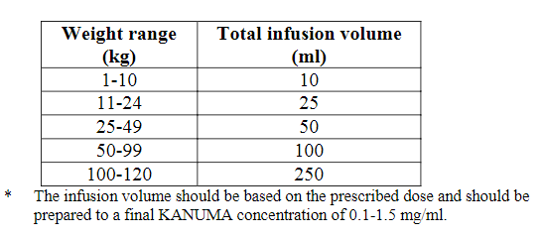

* + Mix gently. Do not shake the vials or the prepared infusion.
  + Product is for single use in one patient only. Discard any unused portion left in the vial, as the product contains no preservatives.
  + No dosing adjustment is recommended in patients with renal or hepatic impairment based on current knowledge of the pharmacokinetics and pharmacodynamics of sebelipase alfa. Safety and efficacy data in patients > 18 years old are limited.

### Information on the condition being treated

LAL Deficiency is a very rare, serious and life threatening lysosomal storage disorder caused by mutations affecting a single gene. It is associated with significant morbidity and mortality affecting individuals from infancy through to adulthood. LAL-D presenting in infants is a medical emergency with rapid disease progression over a period of weeks that is typically fatal within the first 6 months of life.

LAL-D is an autosomal recessive lysosomal storage disorder characterised by a genetic defect resulting in a marked decrease or loss in activity of the lysosomal acid lipase (LAL) enzyme. Deficient LAL enzyme activity results in progressive complications due to the lysosomal accumulation of cholesteryl esters and triglycerides in multiple organs, including the liver, spleen, intestine and the walls of blood vessels. The resulting lipid accumulation in the liver leads to hepatomegaly, increased hepatic fat content, transaminase elevation signalling chronic liver injury, and progression to fibrosis, cirrhosis, and complications of end stage liver disease. In the spleen, LAL deficiency results in splenomegaly, anaemia and thrombocytopenia. Lipid accumulation in the intestinal wall leads to malabsorption and growth failure. In parallel, dyslipidaemia due to impaired degradation of lysosomal lipid is common with elevated low-density lipoprotein cholesterol (LDL-c) and triglycerides, and reduced high-density lipoprotein cholesterol (HDL-c). In addition to liver disease, patients with LAL-D experience increased risk for cardiovascular disease and accelerated atherosclerosis.

### Current treatment options

Current treatment options for patients with LAL Deficiency are limited to supportive therapies, including nutritional support, blood transfusions and albumin in an attempt to mitigate some of the effects of this rapidly fatal disease (Study LAL-1-NH01). Although some temporary stabilisation of the clinical condition has been described, these interventions do not appear to substantially modify the outcome in affected patients (Hoeg, 1984; Meyers, 1985). With few exceptions, success has not been achieved using haematopoietic stem cell transplantation (HSCT) in infants due to its limited use and/or association with high mortality due to the condition of the infants at the time of diagnosis and the rapidly progressive nature of the disease. Additionally, HSCT carries its own inherent risks, including graft-versus-host disease and does not fully address all aspects of the disease as it only replaces haematopoietic cells and therefore cannot resolve hepatic or other complications of the enzyme deficiency (Krivit, 2000; Stein, 2007; Tolar, 2009; Yanir, 2013). In the natural history Study LAL-1-NH01, median survival was noted to be longer for patients who received HSCT (and/or liver transplant) compared to those who did not; however, survival is still quite poor with median age at death of 8.6 months.

Treatment for children or adults presenting with LAL Deficiency is limited to liver transplant as liver function deteriorates, and attempts to manage dyslipidaemia through diet and the use of lipid lowering medications (LLMs). There is limited information in the medical literature on the long term outcomes of liver transplantation in patients with LAL Deficiency (Ferry, 1991; Krivit, 1992; Kale, 1995; Hansen, 2008). In addition to the important risks associated with transplantation itself, and the required concomitant immunosuppression post-transplant, liver transplant does not fully address the root cause of disease since other cells and tissues, including cells of haematopoietic lineage which will repopulate the transplanted liver, will remain enzyme deficient in transplanted patients; hence, other disease complications may persist even if transplants are successful.

## Clinical rationale

Sebelipase alfa is the first ERT to be developed for LAL Deficiency and treatment with sebelipase alfa is intended to directly address the root cause of disease by replacement of the missing or deficient enzyme resulting in reduction of the accumulated substrates and restoration of normal lipid metabolism.

Sebelipase alfa binds to cell surface receptors via glycans expressed on the protein and is subsequently internalised into lysosomes. It catalyses the lysosomal hydrolysis of cholesteryl esters and triglycerides to free cholesterol, glycerol and free fatty acids. Replacement of LAL enzyme activity would potentially lead to reductions in liver fat content and transaminases, enable metabolism of cholesteryl esters and triglycerides in the lysosome, leading to reductions in LDL-c, non-HDL-c, and triglycerides, and increases in HDL-c. As a result of substrate reduction in the intestine, treatment with proposed sebelipase alfa could also lead to an improvement in growth. Enzyme replacement therapy in patients with LAL Deficiency is a rational approach given the demonstrated medical value and long term safety of ERTs for other lysosomal storage disorders (LSDs), including Gaucher disease, Pompe disease, Fabry disease, and the mucopolysaccharidoses.

### Formulation development

Sebelipase alfa is a recombinant human lysosomal acid lipase (rhLAL) produced by recombinant DNA technology and purified from the egg white of genetically engineered chickens (transgenic *Gallus*). Purified sebelipase alfa is a monomeric glycoprotein containing 6 N-linked glycosylation sites with a molecular weight of approximately 55 kDa.

Sebelipase alfa is supplied as a clear to slightly opalescent, colourless to slightly coloured liquid, in sterile vials containing approximately 10.5 mL (including 5% overfill) of a buffered solution of sebelipase alfa at a concentration of 2 mg/mL. Each single use vial of sebelipase alfa contains 2 mg/mL rhLAL, 13.7 mg/mL trisodium citrate dihydrate, 1.57 mg/mL citric acid monohydrate, and 10 mg/mL human serum albumin. No preservatives are added. For administration, sebelipase alfa is diluted in 0.9% sodium chloride Injection to a final infusion volume determined by the dose to be administered and not exceeding 300 mL.

The sebelipase alfa formulation used in clinical trials is the formulation proposed for marketing and no biopharmaceutic bridging studies were required. Some changes were made to the drug substance manufacturing process during development;[1] but no significant changes have been made to the overall process since initiation of pivotal clinical trials.

### Evaluator’s commentary on the background information

There is lack of any effective and safe treatment that directly addresses the root cause of LAL deficiency and current treatment options are limited to supportive therapies. The clinical rationale for use of sebelipase alfa for long term ERT of LAL-deficiency is valid and acceptable.

## Contents of the clinical dossier

### Scope of the clinical dossier

Clinical pharmacology studies:

* Study LAL-CL01: A Phase I/II open-label multicentre study to evaluate the safety, tolerability and pharmacokinetics of SBC-102 in adult patients with liver dysfunction due to lysosomal acid lipase deficiency.
* Population pharmacokinetics and pharmacokinetic pharmacodynamic graphical evaluation of sebelipase alfa (SBC-102) for subjects with lysosomal acid lipase deficiency.

Pivotal controlled efficacy/safety studies:

* Study LAL-CL02: A Phase III, multicentre, randomised, placebo-controlled study of SBC-102 in patients with lysosomal acid lipase deficiency (ARISE (Acid Lipase Replacement Investigating Safety and Efficacy)).

Uncontrolled efficacy/ safety studies:

* Study LAL-CL03: A Phase III, open label, multicentre, dose escalation study to evaluate the safety, tolerability, efficacy, pharmacokinetics, and pharmacodynamics of SBC-102 in children with growth failure due to lysosomal acid lipase deficiency
* Study LAL-CL04: An open label multicentre extension study to evaluate the long-term safety, tolerability, and efficacy of sebelipase alfa in adult subjects with liver dysfunction due to lysosomal acid lipase deficiency who previously received treatment in Study LAL-CL01.
* An Integrated analysis of safety.

Other reports:

* Study LAL-1-NH01: An observational, multinational, multicentre natural history study of patients diagnosed with LAL Deficiency presenting in infancy (historically called Wolman disease or LAL Deficiency/Wolman phenotype).
* Study LAL-2-NH01: An observational, multinational, multicentre study of the clinical characteristics and disease progression of patients with lysosomal acid lipase deficiency/cholesterol ester storage disease phenotype using data from the clinical charts of a sufficient number of children and adults presenting with LAL deficiency.

Recently initiated studies (only study protocols were provided in the submitted dossier):

* Study LAL-CL06: An open label, multicentre study to evaluate the safety and efficacy of SBC‑102 (United States adopted name: sebelipase alfa) in a broad population of subjects with Lysosomal Acid Lipase Deficiency (LAL Deficiency).[2]
* LAL-CL08: A Phase II, open label, multicentre, repeat dose, study of sebelipase alfa in infants with rapidly progressive LAL Deficiency.

Literature references.

Clinical overview, Summaries of Clinical pharmacology, Clinical Efficacy and Clinical Safety.

### Paediatric data

Fifty six of 84 patients (67%) who received sebelipase alfa during clinical studies (Studies LAL‑CL01/LAL-CL04, LAL-CL02 and LAL-CL03) were in the paediatric and adolescent age range (1 month up to 18 years).

### Good clinical practice

All studies have been conducted in accordance with International Conference on Harmonisation (ICH) and Good Clinical Practice (GCP) consolidated guidelines and the ethical principles of the Declaration of Helsinki.

### Evaluator’s commentary on the clinical dossier

The clinical dossier was satisfactory and well-presented. The clinical development programme for sebelipase alfa focused on providing evidence of safety and efficacy across the full spectrum of patients with LAL Deficiency. The pivotal Study LAL-CL02 evaluated efficacy and safety based on improvements in multiple disease related abnormalities in children and adults where a placebo controlled study was feasible. The other important Study LAL-CL03 evaluated the impact on survival in infants where a placebo controlled study would not be clinically or ethically acceptable because of the rapid progression and early mortality associated with this presentation of the disease. Other studies provided supportive evidence of PKs, PDs, efficacy and safety (Studies LAL-CL01/LAL-CL04; natural history Studies LAL-1-NH01/LAL-2-NH01 and ongoing Studies LAL-CL06/LAL-CL08).

## Pharmacokinetics

### Studies providing pharmacokinetic information

Due to the rare nature of the disease being treated, there were no studies in healthy subjects. Hence, all discussion in Section 4 below relates to PK findings in patients with LAL deficiency.

Table 2: Submitted pharmacokinetic studies

|  |  |  |
| --- | --- | --- |
| PK topic | Subtopic | Study ID |
| PK in healthy adults | None |  |
| PK in special populations | Target population § Single dose | None |
| Multidose | LAL-CL01 |
| Hepatic impairment | LAL-CL01 |
| Renal impairment | None. |
| Neonates/infants/children/adolescents (limited information in patients > 18 years of age) | Study LAL-CL03 (infants) |
| Elderly | None |
| Other special population | None |
| Genetic/gender related PK | Males versus females |  |
| Other genetic variable |  |
| PK interactions |  | None |
| Population PK analyses | Healthy subjects | None |
| Target population | SYN201301 |

* Indicates the primary PK aim of the study. § Subjects who would be eligible to receive the drug if approved for the proposed indication.

### Summary of pharmacokinetics

#### Physicochemical characteristics of the active substance

Sebelipase alfa is a recombinant human lysosomal acid lipase (rhLAL) produced by recombinant DNA technology and purified from the egg white of genetically engineered chickens (transgenic *Gallus*). Purified sebelipase alfa is a monomeric glycoprotein containing 6 N-linked glycosylation sites with a molecular weight of approximately 55 kDa.

Figure 1: Structure of sebelipase alfa

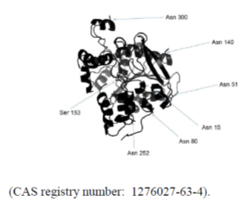

#### Pharmacokinetics in healthy subjects

Not applicable.

#### Pharmacokinetics in the target population

Study LAL-CL01 was the first clinical study of SBC-102, a recombinant human lysosomal acid lipase (rhLAL; sebelipase alfa), in patients with late onset LAL Deficiency. This Phase I/II study was designed to provide initial data on the safety, tolerability, and pharmacokinetics (PK) of SBC‑102 following a 4 week regimen of once weekly (qw) IV infusions of SBC-102 at doses of 0.35 mg/kg, 1 mg/kg and 3 mg/kg in adult patients with liver dysfunction due to late onset LAL deficiency. The study also investigated the pharmacodynamics (PD) of SBC-102 in this patient population, and the overall health of these patients relative to reference populations. A summary of this study was provided.

The doses for this study were chosen to cover the anticipated therapeutic dose range for SBC‑102, and all doses were within the safety margin indicated by the nonclinical toxicology results. A dose of 0.35 mg/kg was selected as the starting dose because this was the minimally effective dose in a highly relevant nonclinical model of LAL deficiency.[3] The dose was increased in approximately 3 fold increments, to 1 mg/kg and then to a top dose of 3 mg/kg, to allow assessment of safety and tolerability over an approximately 9 fold dose range. In the rat model of LAL Deficiency, the PD effects of SBC-102 were broadly comparable at the 2 highest qw doses evaluated, 3 mg/kg and 5 mg/kg. Thus, it was not anticipated that doses greater than 3 mg/kg qw would be required in humans.

There was a reasonably dose-proportional increase in exposure from 0.35 mg·kg-1 to 1 mg·kg-1 based on median values for AUC(0-last), AUC(0-∞) and Cmax after both the first (Day 0) and fourth (Day 21) infusions of SBC-102. A greater than dose-proportional increase in exposure was observed from 1 mg/kg to 3 mg/kg. This 3 fold increase in dose resulted in an approximate 10 fold increase in exposure based on the median for AUC and Cmax. This observation was consistent after both the first and fourth infusions of SBC-102.

Following IV infusion over 2 hours, SBC-102 was rapidly eliminated from the systemic circulation. Within each dose cohort, t½ was reasonably consistent after the first and fourth infusions of SBC-102. Across dose cohorts, t½ was longer for the 0.35 mg/kg dose compared with the other 2 doses. At Day 21, the respective median values at 0.35 mg/kg, 1 mg/kg and 3 mg/kg were 0.78 hours, 0.11 hours, and 0.13 hours, respectively (Figures 2, 3 and 4).

Figure 2: Mean SBC-102 serum concentration-time profile following a dose of 0.35 mg/kg via a 2 hour infusion

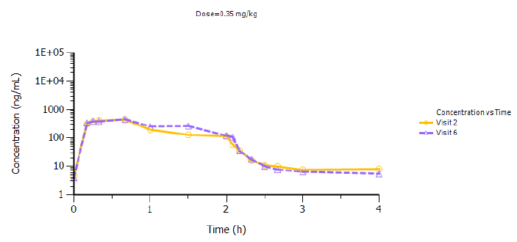

Figure 3: Mean SBC-102 serum concentration-time profile following a dose of 1 mg/kg via a 2 hour infusion

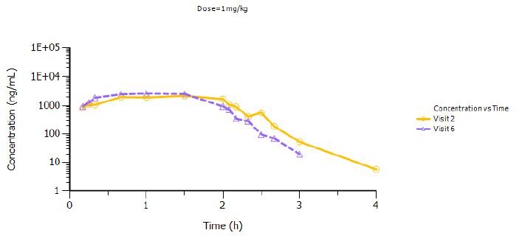

Figure 4: Mean SBC-102 serum concentration-time profile following a dose of 3 mg/kg via a 2 hour infusion

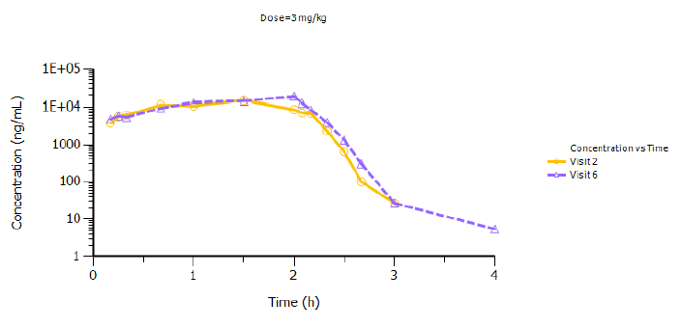

There was a small, though pharmacokinetically unimportant and dose independent, increase in AUC from Day 0 to Day 21, with no evidence of accumulation in the pre-infusion sample at Day 21. The mean increase in AUC(0-last) was 13.4%, 16.9% and 13.6%, at SBC-102 doses of 0.35, 1 and 3 mg/kg, respectively.

Serum clearance of SBC-102 was similar at doses of 0.35 mg/kg and 1 mg/kg, with median values ranging from 541.22 to 916.17 mL/h/kg, and was around 4 to 5 fold lower at the 3 mg/kg dose.

The apparent volume of distribution (Vz) decreased with increasing dose. The estimated median Vz was higher at 0.35 mg/kg compared with the other dose cohorts. A marked decrease in Vz was also apparent between Day 0 and Day 21 for the 0.35 mg/kg and 1 mg/kg dose cohorts, with respective decreases of 47% and 54%.

PK assessments were also conducted in the Phase II open label, long term Study LAL-CL04 in 8 adult subjects with liver dysfunction due to LAL deficiency who had previously received treatment in Study LAL-CL01.[4]

Sebelipase alfa serum concentrations increased rapidly during the first 15 to 20 minutes of the 2 hour infusion, with a slower increase thereafter that appeared to be more pronounced with the 3 mg/kg cohort. The median Tmax was generally longer with the higher dose, ranging across time points from 0.50 to 1.50 hours in the 1 mg/kg dose and from 1.50 to 2.17 hours in the 3 mg/kg dose. Thereafter, sebelipase alfa was rapidly eliminated from the systemic circulation. Within each dose, the median t½ was consistent at Weeks 24, 52, and 104, and ranged between 0.15 and 0.26 hours in the 1 mg/kg dose and 0.11 and 0.21 hours in the 3 mg/kg dose. Serum exposure to sebelipase alfa increased in a more than dose proportional manner (approximately 15 fold) over the 3 fold increase in dose from 1 to 3 mg/kg. This was consistent with findings from in vitro studies, suggesting that either receptor binding or serum clearance mechanisms for sebelipase alfa may become saturated between these two dose levels. Although there was evidence for saturation of CL in relation to post-infusion PK parameters with increasing dose, there was no evidence for drug accumulation with either the 1 or 3 mg/kg doses, based on the absence of evidence for increases in pre-infusion concentrations of sebelipase alfa (0 ng/mL in all subjects) and the overall lack of increasing median values for AUC0-last, AUC0-inf, and Cmax that were measured over time. The 30% to 45% decreases in these parameters observed between Weeks 52 and 104 in the 1 mg/kg dose are within the range of variability observed for these parameters across the LAL-CL01 and LAL-CL04 Study duration. For example, the median AUC0‑last at Day 0 in the 1 mg/kg dose in LAL-CL01 was 1091 ng.hr/mL, which was comparable to the value of 1108 ng.hr/mL at Week 104 in this dose in Study LAL-CL04. Similarly, the CL of sebelipase alfa was relatively consistent across the 104 week duration of both studies. Thus, there was no overall trend for change over time in the exposure to sebelipase alfa.

#### Pharmacokinetics in special populations

##### Pharmacokinetics in subjects with impaired hepatic function

Sebelipase alfa is expected to be metabolically degraded through peptide hydrolysis and impaired liver function is not expected to affect the pharmacokinetics of sebelipase alfa. There is a lack of data in patients with severe hepatic impairment.

##### Pharmacokinetics in subjects with impaired renal function

Renal elimination of sebelipase alfa is considered a minor pathway for clearance. There is a lack of data in patients with renal impairment.

##### Pharmacokinetics according to age

Infants (< 6 months of age): In LAL-CL03, sebelipase alfa was eliminated from the systemic circulation with a median t½ of 0.1 hr (range: 0.1 to 0.2) at the 3 mg/kg per week dose (n = 4). The difference in exposures to sebelipase alfa between the once weekly 0.35 mg/kg and 3 mg/kg groups was more than dose proportional, with an 8.6 fold increase in dose resulting in a 9.6 fold increase in exposure for AUC and a 10.0 fold increase for Cmax.

There is limited information on PKs in patients > 18 years of age. There is no information on PKs of sebelipase alfa in elderly patients.

##### Pharmacokinetics related to genetic factors

No data.

##### Pharmacokinetics in other special population / with other population characteristic

Not evaluated.

#### Population pharmacokinetics

##### PopPK analysis

Based upon serum concentration data obtained from 79 adults, children, and infants in Studies LAL-CL01, LAL-CL04, LAL-CL02 and LAL-CL03, using either sparse or rich sampling, a population PK model was developed to describe the concentration-time data for sebelipase alfa from all 4 clinical studies (Studies LAL-CL01, CL04, CL03 and CL02). PK of sebelipase alfa was described by a 1 compartment disposition model with a dual input model to allow for variability in infusion rate due to the flush. Sebelipase alfa showed linearity in doses of 0.35 to 1 mg/kg, and nonlinearity observed at a dose of 3 mg/kg. CL in the linear dose range, and therefore, exposure, was affected by body surface area (BSA). As BSA was highly correlated with age, exposure therefore varied across subject age. Summary statistics of exposure variables for all subjects in Studies LAL-CL02 and LAL-CL03 suggested that there was no evidence of sebelipase alfa accumulation over time, with similar values of CL, Vc, t½, Tmax, Cmax, and AUC observed at Week 0 and Week 22 by dose.

Covariate analysis of the population PK model indicated that body surface area (BSA) had the most significant effect on the variability in exposure to sebelipase alfa. The identified effect of BSA on sebelipase alfa CL approximated an allometric relationship with body weight, as BSA approximates a lean body weight relationship with weight. Hence, this finding supports a body weight based dosing approach for sebelipase alfa patients with normal body weight. Furthermore, BSA correlated well with age and body weight over a relatively broad range. Given the relatively small potential benefit of BSA based dosing versus body weight based dosing in terms of drug exposure, body weight based dosing, which is common to all current ERTs, is more convenient and, importantly, less susceptible to potential dose calculation errors than BSA based dosing. It is also an appropriate approach for accommodating much of the normal variation in body size. Due to the body weight based dose regimen, and the nonlinear relationship between body weight and CL revealed during development of the population PK model, area under the concentration-time curve at Study-Study (AUCss) were observed with increasing age and size resulting in proportionately higher exposures in larger or older subjects compared with smaller or younger subjects. While PK data suggest that body weight based dosing of overweight or obese patients may produce proportionately higher exposures, given the favourable safety profile of sebelipase alfa across all dose administered, the advantages described above for body weight based dosing outweigh the risks of potentially overdosing overweight or obese patients.

#### Pharmacokinetic interactions

Drug interaction studies have not been performed with sebelipase alfa.

#### Clinical implications of in vitro findings

Not applicable.

### Evaluator’s overall conclusions on pharmacokinetics

In the Phase I/II Study LAL-CL01, SBC-102 serum concentrations increased rapidly during the first 10 to 15 minutes of the 2 hour infusion, with a further slower increase thereafter. Median Tmax ranged from 0.67 to 1.80 hours, and appeared to increase with increasing dose. At the end of infusion, serum concentrations fell rapidly for the 1 and 3 mg/kg dose (mean t½ = 0.111 to 0.166 hours). This fall was less rapid for the 0.35 mg/kg dose (mean t½ = 1.825 at Day 0 and 0.966 at Day 21). Decreases in the mean clearance were noted in the 3 mg·kg-1 dose cohort relative to the other dose cohorts at both Day 0 and Day 21.

SBC-102 serum concentrations were reasonably dose proportional over the 3 fold increase in dose from 0.35 mg/kg to 1 mg/kg based on median values for AUC and Cmax in this limited study population. Concentrations increased in a greater than dose proportional manner (approximately 10 fold) over the 3 fold increase in dose from 1 mg/kg to 3 mg/kg, which suggests that either binding or serum clearance mechanisms for SBC-102 may become saturated between 1 mg/kg to 3 mg/kg.

Decreases in Vz of SBC-102 were noted with increasing dose and after multiple dosing within the 0.35 mg/kg and 1 mg/kg dose cohort. In both these cohorts, the reduction in Vz between Day 0 and Day 21 did not alter the subject’s rank order with respect to the parameter value. This suggests that the variability in Vz may reflect inter-individual differences in a saturable distribution process (binding or uptake) of SBC-102. The appearance of saturation is more likely with increasing magnitude of dose and dosing duration. It would be expected that changes in Vz would lead to differences in half-life between Day 0 and Day 21, but half-life was time and dose independent with exception of the 0.35 mg/kg dose group. The longer half-life noted following the 0.35 mg/kg dose is consistent with the higher volume of distribution relative to clearance for this dose in comparison with other doses (1 mg/kg and 3 mg/kg).

The PK of sebelipase alfa was described by a 1-compartment disposition model with a dual input model to allow for variability in infusion rate due to the flush. Sebelipase alfa showed linearity in doses of 0.35 to 1 mg/kg, and nonlinearity observed at a dose of 3 mg/kg. CL in the linear dose range, and therefore, exposure, was affected by BSA. As BSA was highly correlated with age, exposure therefore varied across subject age. Summary statistics of exposure variables for all subjects in Studies LAL-CL02 and LAL-CL03 suggested that there was no evidence of sebelipase alfa accumulation over time, with similar values of CL, Vc, t½, Tmax, Cmax, and AUC observed at Week 0 and Week 22 by dose.

During the covariate analysis of the population pharmacokinetics model for sebelipase alfa, age, body weight, and sex were not found to have a significant influence on CL and Vc of sebelipase alfa. Sebelipase alfa has not been investigated in patients 2 to 4 years of age. There is limited information on PKs in patients > 18 years of age.

There is limited information on the impact of anti-drug antibodies on sebelipase alfa pharmacokinetics.

Sebelipase alfa is expected to be metabolically degraded through peptide hydrolysis. Hence, impaired liver function is not expected to affect the pharmacokinetics of sebelipase alfa. There is a lack of data in patients with severe hepatic impairment. Renal elimination of sebelipase alfa is considered a minor pathway for clearance. There is a lack of data in patients with renal impairment. No dosing adjustment is recommended in patients with renal or hepatic impairment based on current knowledge of the pharmacokinetics and pharmacodynamics of sebelipase alfa.

Overall, sebelipase alfa demonstrates PK characteristics consistent with other ERTs whose uptake and biodistribution are mediated by mannose and mannose 6-phosphate receptor-dependent mechanisms (Stahl, 1978). The PK properties are predictable, with no changes associated with long term dosing through to 104 weeks. In Study LAL-CL01, the absence of anti-sebelipase alfa antibodies in adults with extended dosing precludes evaluation of effect of antibody formation on the PK profile of sebelipase alfa.

The PK aspects of the proposed PI are satisfactory.

## Pharmacodynamics

### Studies providing pharmacodynamic information

Table 3: Submitted pharmacodynamic studies

| PD Topic | Subtopic | Study ID |
| --- | --- | --- |
| Primary pharmacology | Effect on PD parameter; liver enzymes | LAL-CL01 |
| Effect on PD parameter; serum lipids | LAL-CL01 |
| Secondary pharmacology | Development of anti-drug antibodies |  |
| Gender other genetic and age related differences in PD response | No data |  |
| PD interactions | No data |  |
| Population PD and PK‑PD analyses | Healthy subjects | None |
| Target population | SYN201301 |

### Summary of pharmacodynamics

#### Mechanism of action

Sebelipase alfa binds to cell surface receptors via glycans expressed on the protein and is subsequently internalized into lysosomes. It catalyses the lysosomal hydrolysis of cholesteryl esters and triglycerides to free cholesterol, glycerol and free fatty acids. Replacement of LAL enzyme activity leads to reductions in liver fat content and transaminases, and enables metabolism of cholesteryl esters and triglycerides in the lysosome, leading to reductions in LDL‑c, non-HDL-c, and triglycerides, and increases in HDL-c. Improvement in growth occurs as a result of substrate reduction in the intestine.

#### Pharmacodynamic effects

##### Primary pharmacodynamic effects

The effects on serum lipids, hepatic transaminases and liver fat content were evaluated in the Phase I/II Study LAL-CL01 involving 8 subjects with LAL deficiency. Details of the PD results observed in this study were provided.

Observed changes in hepatic transaminases and serum lipids provided evidence of SBC-102 biological activity at all doses (0.35, 1 and 3 mg/kg) evaluated in this study.

ALT and AST decreased rapidly following initiation of SBC-102 treatment in all 3 dose cohorts. Eight of the 9 subjects had reduced transaminase levels within 1 to 2 weeks of treatment initiation. After 4 qw infusions, the mean decreases from Baseline in ALT and AST in the overall study population were 38.7 U/l (41.1%) and 18.2 U/l (31.8%), respectively. There was no evidence of dose-dependence in the time to onset or magnitude of effect. Importantly, transaminases had normalized in all 6 subjects with baseline ALT levels > ULN and in 4 of 6 subjects with baseline AST levels > ULN. In addition to providing evidence of SBC-102 biological activity, the reductions in hepatic transaminases observed in this study provide supportive evidence that substrate reduction alleviates the hepatic abnormalities associated with LAL deficiency.[5]

Elevations in total cholesterol, triglycerides, and LDL were also observed in all 3 dose cohorts during the study treatment period (Day 1 to Day 28). Abnormal lipids are mobilized from the lysosomes in affected tissues which is consistent with the mechanism of action of SBC-102. The increases in total cholesterol, LDL and triglycerides were more pronounced at a dose of 3 mg/kg, with 2 of the 3 subjects in this dose cohort having the greatest observed increases in these serum lipids. Although no meaningful changes were noted in HDL levels during treatment with SBC-102, all 3 subjects in Cohort 3 showed > 25% increases in HDL during the post treatment follow-up period between Day 28 and Day 52, a trend that was not apparent at a dose of 1 mg/kg (data were not available for the 0.35 mg/kg dose cohort). The increases in HDL were not unexpected given the previously described relationship between decreased LAL activity and impaired expression of ATP binding cassette transporter A1 (ABCA-1), a critical mediator in the regulation of reverse cholesterol transport and serum HDL levels (Bowden et al., 2011). The distinct lipid profile observed in Cohort 3, with the greater increases in total cholesterol, triglycerides, and LDL during the study treatment period and the > 25% increases in HDL at Day 52, suggests a dose-dependent effect of SBC-102 on serum lipids.

Observed changes in hepatic transaminases and serum lipids provided evidence of SBC-102 biological activity at all doses (0.35, 1 and 3 mg/kg) evaluated in this study. This study provided initial evidence to support the hypothesis that SBC-102 therapy will improve LAL Deficiency related dyslipidaemia. With time, ERT with SBC-102 is expected to restore normal lipid metabolism as the abnormal lipid accumulations are cleared. For 5 of the 6 subjects with post treatment follow-up data, total cholesterol, triglycerides, and LDL at Day 52 were actually lower than those at Baseline, suggestive of an early improvement in dyslipidaemia as a result of the clearance of some accumulated intracellular lipid during the 4 week treatment period. The increases in HDL at Day 52 in the 3 mg/kg dose cohort also support an early improvement in dyslipidaemia with SBC-102 therapy. Reversal of the SBC-102 treatment effect on ALT, AST, total cholesterol, triglycerides, and LDL was observed during the post treatment follow-up period of this study. Reversibility was consistently observed in all subjects who had demonstrated a response to treatment and had post treatment data, supporting the utility of these laboratory parameters as markers of SBC-102 biological activity.

The pivotal Phase II/III Studies LA-CL02 and LAL-CL03 involved a larger number of subjects and helped further characterise the time course and magnitude of the effect of SBC-102 on hepatic transaminases and serum lipids, including the potential for long term beneficial effects on dyslipidaemia, and the correlation of these changes with improvement in other clinical manifestations of LAL Deficiency.

##### Secondary pharmacodynamic effects; development of anti-drug antibodies

###### Study LAL-CL03 in infants with LAL Deficiency

All 6 subjects with available data at screening tested negative for serum anti-drug antibodies (ADAs). Screening data were unavailable for the one subject who initiated treatment under ATU and for 2 infants who died during the initial weeks of therapy. Post treatment immunogenicity data were available for 7 subjects (data were unavailable for the 2 subjects who died prior to the first post treatment ADA assessment). Of these 7 subjects, 4 (57%) were ADA positive during at least one assessment, defined as having a positive screening enzyme-linked immunosorbent assay (ELISA) that was confirmed by depletion ELISA. In these 4 subjects, ADA positivity was first detected at Week 5, Week 8, or Week 59 (for the subject initiating treatment under the ATU). At the time of initial ADA positivity, 3 subjects were receiving a dose of 1 mg/kg qw, and 1 subject was receiving a dose of 3 mg/kg qw. Persistence of ADA positivity (that is, positivity at more than one visit) was observed in 3 subjects; the other subject had a single ADA positive result at Week 8 and thereafter tested negative. All 3 of the ADA positive subjects who had multiple positive ADA assessments showed decreases from maximum titre with continued dosing, and 2 of these subjects had a negative ADA result at their last assessment prior to data cut-off. Based on Kaplan-Meier analyses;[6] the probability of being ADA negative was 1.00 at Week 2, 0.83 at Week 6, and 0.50 at Week 10 and the probability of maximum titre not yet being achieved was 0.83 at Week 10, 0.63 at Week 40, and 0.31 at Week 80.

All 4 ADA positive subjects were tested for the presence of neutralising antibodies that inhibited LAL enzyme activity, and 2 (50%) subjects tested positive for these neutralising antibodies. In these 2 subjects, inhibition of LAL enzyme activity was detected concurrent with the first report of ADA positivity. One subject had a comparatively low level of inhibition (18.9%) when first tested at Week 5, and thereafter had a high inhibition of enzyme activity (range = 70.9% to 90.3%). The other subject had a high level of inhibition of enzyme activity when first tested at Week 8 (83.2%) and continued to have a high level of inhibition through Week 48 (range = 82.1% to 89.8%); the subject was ADA negative at the last assessment, and thus neutralising antibody activity was not evaluated for this time point.

Two ADA positive subjects were also tested for the presence of neutralising antibodies that inhibited the cellular uptake of LAL. Both subjects tested positive for these neutralising antibodies at all time points tested: one subject tested positive at Week 72, and the other subject tested positive at unscheduled assessments at approximately Week 23 and Week 25. As both of these subjects were also known to be positive for antibodies that inhibited LAL enzyme activity, the positive results for inhibition of LAL cellular uptake, which measures enzyme activity as the readout following uptake, must be interpreted with caution given the potential for a false positive result.

A medical review of the clinical response data for the 4 subjects who tested positive for ADAs suggested that the presence of neutralising antibodies in one infant could be a contributing factor in the continued suboptimal rate of growth in this subject. However, other clinical outcome measures in this subject do not appear to have been affected by the development of ADAs. Serum transaminases remained within normal range for the majority of the period when ADAs and neutralising antibody were present. While a transient elevation in transaminases was observed at the last 3 scheduled assessments and could potentially be related to alterations in the biodistribution and/or in vivo activity of sebelipase alfa in the presence of ADA, other medical complications such as serious viral infection, which showed a temporal relationship to the transaminase elevation, may also be causal factors. The other 3 subjects testing positive for ADAs, one of whom also developed neutralising antibodies, showed no evidence of a potential loss of response in any clinical outcome measures coincident with the development of ADAs.

###### Studies LAL-CL01/ LAL-CL04 and LAL-CL02 in Children and Adults with LAL Deficiency)

All samples from the 9 subjects in Study LAL-CL01 were negative for ADAs and all samples from 7 of 8 subjects in Study LAL-CL04 were negative for ADAs. One subject in Study LAL-CL04 had one result that was above the pre-determined positivity cut-off for ADAs. This finding occurred at a single isolated assessment at Week 4, and did not coincide with any notable change in serum transaminases, serum lipids, or markers of macrophage activation.

In Study LAL-CL02, 35 of 36 subjects in the sebelipase alfa group were evaluated for the development of antibodies specific to sebelipase alfa, one subject stopped treatment after the second infusion and did not have a post Baseline assessment. Five (14%) of these subjects had at least 1 positive ADA test during the double blind treatment period; none of these 5 subjects developed neutralising antibodies that inhibited LAL enzyme activity, and 1 subject[7] developed neutralising antibodies that inhibited cellular uptake of LAL; In general, ADA titres were low and unsustained. Three subjects were positive at only a single time point during the double blind period, and 2 subjects were positive at multiple time points during the double blind period.[8] None of the 5 subjects with positive ADA titres at any time during the double blind period continued to be ADA positive at their last time point prior to the data cut-off. No subject in the placebo group had positive ADA titres during the double blind period. As of the data cut‑off, no subject in the placebo/sebelipase alfa group had a positive ADA test after initiating sebelipase alfa in the open label period through Week 20, the last time point assessed prior to data cut-off. Based on the results of a Kaplan-Meier analysis, the estimated probability of developing ADA was low (≤ 14%) at any time during the double blind treatment period after exposure to sebelipase alfa and during the open label period.

Review of efficacy results among the 5 ADA positive subjects in the sebelipase alfa group showed that all 5 experienced a decrease from Baseline to the last time point in the double blind period in ALT and AST, with 2 (40%) and 1 (20%) experiencing normalisation in ALT and AST, respectively, at that time point. Decreases from Baseline to the last time point in the double blind period in LDL-c and non-HDL-c were seen in all 5 subjects, with mean percent decreases of ‑45% and ‑40%, respectively, as was an increase from Baseline to the last time point in the double blind period in HDL-c of 10%. Only a small percent change from Baseline to the last time point in the double blind period in triglycerides of ‑2% was seen among these 5 subjects. Reductions from Baseline to the last time point in the double blind period in liver fat content of ‑49% and in liver volume of ‑4% were seen among the 5 ADA positive subjects in the sebelipase alfa group. Only 2 of these 5 subjects had liver histopathology assessed at Baseline and the last time point in the double blind period, with both subjects experiencing improvement. Overall, efficacy of sebelipase alfa was not affected in the ADA positive subjects. The subject testing positive for neutralising antibodies to cellular uptake, showed no evidence of either a reduced response relative to the clinical efficacy seen in the broad population or clear evidence of a loss of response over time.

#### Time course of pharmacodynamic effects

In clinical trials, after initiation of dosing with sebelipase alfa, breakdown of accumulated lysosomal lipid led to initial increases in LDL-c and triglycerides within the first 2 to 4 weeks of treatment. In general, following increases in LDL-c and triglycerides, these parameters decreased to below pre-treatment values within 8 weeks of treatment with sebelipase alfa.

In all patients with elevated alanine aminotransferase (ALT) values at Baseline (82 of 84 patients in clinical trials), reductions in ALT values were observed, generally within 2 weeks after initiation of treatment with sebelipase alfa. Reversal of the SBC-102 treatment effect on ALT, AST, total cholesterol, triglycerides, and LDL was observed during the post treatment follow-up period of this study. Reversibility was consistently observed in all subjects who had demonstrated a response to treatment and had post treatment data, supporting the utility of these laboratory parameters as markers of SBC-102 biological activity.

#### Relationship between drug concentration and pharmacodynamic effects

Exposure response analyses demonstrated a positive response to treatment with sebelipase alfa in terms of ALT, serum lipids, and liver fat content. The strongest exposure response relationships for all efficacy endpoints were observed with sebelipase alfa cumulative area under the plasma concentration-time curve (AUCcum), specifically AUCcum in Study LAL-CL02 (where subjects were treated with 1 mg/kg sebelipase alfa qow). No relationships were found between the occurrence of infusion associated reactions (IARs) and AUCcum, or between the occurrence of IARs and sebelipase alfa dose or rate of infusion.

The PK-PD analysis results demonstrate consistent PD effects across multiple PD parameters over time with sebelipase alfa treatment. The strongest exposure response relationships for all PD measures were observed with AUCcum. No relationships were found between infusion associated adverse events and dose, rate of infusion, AUCcum, or age.

#### Genetic, gender and age related differences in pharmacodynamic response

Not evaluated.

#### Pharmacodynamic interactions

Not evaluated.

### Evaluator’s overall conclusions on pharmacodynamics

Sebelipase alfa binds to cell surface receptors via glycans expressed on the protein and is subsequently internalised into lysosomes. It catalyses the lysosomal hydrolysis of cholesteryl esters and triglycerides to free cholesterol, glycerol and free fatty acids. Replacement of LAL enzyme activity leads to reductions in liver fat content and transaminases, and enables metabolism of cholesteryl esters and triglycerides in the lysosome, leading to reductions in LDL‑c, non-HDL-c, and triglycerides, and increases in HDL-c. Improvement in growth occurs as a result of substrate reduction in the intestine.

In clinical trials, after initiation of dosing with sebelipase alfa, breakdown of accumulated lysosomal lipid led to initial increases in LDL-c and triglycerides within the first 2 to 4 weeks of treatment. In general, following increases in LDL-c and triglycerides, these parameters decreased to below pre-treatment values within 8 weeks of treatment with sebelipase alfa.

In all patients with elevated alanine aminotransferase (ALT) values at Baseline (82 of 84 patients in clinical trials), reductions in ALT values were observed, generally within 2 weeks after initiation of treatment with sebelipase alfa. Treatment interruption resulted in increases in LDL-c and ALT values and decreases in HDL-c.

Though there is a risk of immunogenicity with any ERT, the overall rate of immunogenicity in studies with sebelipase alfa appears low. Subjects who tested positive for ADAs were evaluated for sebelipase alfa neutralising antibodies by measuring LAL enzyme activity and the cellular uptake of LAL. The population PK analysis of sebelipase alfa revealed no relevant effect of ADA positivity on the exposure to sebelipase alfa. The incidence of ADA positivity was higher in infants compared with children and adults. No evidence of any impact of ADAs on efficacy parameters was observed in children or adults, and although some potential impact on efficacy was observed in one infant positive for ADAs, the contribution of the ADA to the relative slowing of weight gain in this infant was not definitively established (as there were multiple concurrent confounding medical factors that also could impact weight gain and growth).

## Dosage selection for the pivotal studies

### Pharmacokinetics and pharmacodynamics: dose finding studies

LAL-CL01 was the first study investigating sebelipase alfa in human subjects. The doses of sebelipase alfa investigated in the Phase I/II PK-PD Study LAL-CL01 were anticipated to be safe and well tolerated in the absence of prior human data based upon the following non-clinical data:

* The IMP has an amino acid sequence identical to the natural enzyme with no engineering of enhancements in biological activity. Knowledge of the biochemistry of LAL Deficiency and the mode of action of SBC-102 did not raise concerns for unexpected toxicity in humans.
* There were no meaningful toxicological findings in 4 week repeated dose toxicology studies in the Sprague-Dawley rat and cynomolgus monkey at doses up to 50 mg/kg.
* Based on the human equivalent doses in rats (8.1 mg/kg) and monkeys (16.1 mg/kg), the starting dose in the current study (0.35 mg/kg) represented a 23.1 to 46.0 fold safety margin, while the proposed top dose (3 mg/kg) represented a 2.7 to 5.4 fold safety margin. Additionally, the qw administration of SBC-102 for 6 months was well tolerated in the cynomolgus monkey at the high dose level of 30 mg/kg (human equivalent dose = 9.7 mg/kg).
* In a 4 week study using a nonclinical model of LAL Deficiency, the minimum effective dose of sebelipase alfa was 0.35 mg/kg qw, and the PD effects were generally comparable to those observed at a dose of 1 mg/kg qow; suggesting that a qow dose of less than 1 mg/kg would have a decreased probability of demonstrating efficacy.
* In a nonclinical model of LAL Deficiency, the PD effects of sebelipase alfa were broadly comparable at the 2 highest qw dosing regimens (3 mg/kg qw and 5 mg/kg qw) and the 2 highest qow dosing regimens (3 mg/kg qow and 5 mg/kg qow) studied. These data indicated that 3 mg/kg would be a maximally effective dose with both qw and qow administration.
* In a nonclinical model of LAL Deficiency, dose response analysis demonstrated that good reductions in substrate in the liver and spleen (organs where substrate accumulation and pathology are most prominent in children and adults with LAL Deficiency) could be achieved with doses ≥ 1 mg/kg qow.
* In general, for LSDs, the enzymatic activities and mechanisms for lysosomal targeting are conserved across species. Toxicological studies of this class of therapy consistently demonstrate low systemic toxicity (Andrews and O’Callaghan, 2008).

In the Phase I/II Study LAL-CL01, adults were treated with 0.35, 1, and 3 mg/kg sebelipase alfa administered qw for 4 weeks. Subjects, who participated in the ongoing extension Study LAL‑CL04, repeated these 4 qw doses at 0.35, 1, and 3 mg/kg and then transitioned to a qow dosing regimen (1 or 3 mg/kg). Given the requirement for long term dosing, reducing the frequency of infusions to qow was considered desirable to reduce the burden of treatment on subjects with LAL deficiency.

All 3 doses (0.35, 1, and 3 mg/kg) of sebelipase alfa administered for 4 weeks with qw dosing in Study LAL-CL01 were shown to be biologically active, as evidenced by decreases in ALT and AST and increases in serum lipids (total cholesterol, triglycerides, and LDL-c). These improvements in liver biochemical parameters and serum lipids were observed within 2 and 4 weeks, respectively, and were reversible following discontinuation of sebelipase alfa therapy. Though the effects on serum lipids appeared more pronounced in the 3 mg/kg dose cohort, evidence is not conclusive as only 3 subjects received 3 mg/kg sebelipase alfa; furthermore, effects on ALT and AST appeared to be independent of dose.

When sebelipase alfa treatment was discontinued in Study LAL-CL01, the initial PD response to treatment was reversed until treatment was recommenced in Study LAL-CL04, demonstrating the importance of continued sebelipase alfa treatment for maintaining efficacy in terms of correcting dyslipidaemia and maintaining normal liver function. The time course of the reversibility of the PD response after ceasing treatment in Study LAL-CL01 supported consideration of either qw or qow dosing, and improvements in dyslipidaemia and liver function were maintained when subjects were switched from qw to qow dosing in Study LAL‑CL04. During the initial 4 weeks of qw dosing in Study LAL-CL04, the improvements on serum biochemical markers observed in Study LAL-CL01 were replicated. These improvements were maintained following the switch from a qw to qow dosing regimen at doses of 1 and 3 mg/kg qow. Furthermore, the reductions in markers of liver injury were accompanied by statistically significant improvements in the dyslipidaemia within 12 weeks of initiating treatment. Effects on both serum transaminases and lipids were maintained through to 104 weeks, providing the first long term assessment of efficacy of sebelipase alfa. There was no obvious dose response relationship between dose cohorts with respect to changes in liver volumes and hepatic proton density fat fraction, or transaminases and additional data are required to characterise any dose response relationship on lipid profile.

### Phase II dose finding studies

Refer to section 6.1 above (results of Study LAL-CL01/LAL-CL04).

### Phase III pivotal studies investigating more than one dose regimen

In Study LAL-CL02, adults and children were treated with sebelipase alfa at a dose of 1 mg/kg qow or placebo in a 20 week double blind period, after which all subjects were treated with sebelipase alfa at a dose of 1 mg/kg qow in an ongoing open label period.

Sebelipase alfa administered using a 1 mg/kg qow dose regimen was more effective than placebo in improving a broad range of disease related abnormalities, including normalisation of serum transaminases (ALT and AST), improvement in dyslipidaemia (reductions in LDL-c, non-HDL-c, and triglycerides, and increases in HDL-c), and reduction in liver fat content/ liver volume during the 20 week double blind treatment period. During the open label treatment period, these improvements were maintained in the subjects treated with sebelipase alfa during the double blind period, and a similar pattern of response was observed in subjects switched from placebo to 1 mg/kg qow sebelipase alfa.

As per study protocol, from Week 0 to Week 22, study drug infusions were administered at an infusion rate between 50 mL/hr and 150 mL/hr, depending on the subject’s weight, and were completed in approximately 2 hours. Beginning at Week 24, infusions were administered over approximately 1 hour. However, if the infusion was not well tolerated, the infusion rate may have been decreased to the previously tolerated infusion rate. Overall, as of the data cut-off, 40 subjects, 21 in the sebelipase alfa group and 19 in the placebo/sebelipase alfa group, received at least 1 sebelipase infusion at an increased infusion rate over approximately 1 hour during the open label period. The maximum number of infusions administered at an increased infusion rate over approximately 1 hour in the open label period was 21 in one subject in the sebelipase alfa group. One subject in the placebo/sebelipase alfa group, who was receiving pre-medication with an antihistamine (cetirizine hydrochloride) prior to each study drug administration per standard of care at the study centre, experienced an IAR (mild urticaria) after the second sebelipase alfa infusion at Week 2 (Week 24 overall in the study), which was the first infusion given at the faster rate of 100 mL/hr (her first sebelipase alfa infusion was given at a rate of 50 mL/hr.). The infusion rate was lowered from 100 mL/hr to 50 mL/hr and the infusion was completed. Study drug, along with pre-medication, was continued, and no recurrence of this event was seen with 4 subsequent administrations of sebelipase alfa at an infusion rate of 100 mL/hr. No other subject experienced an IAR after receiving their sebelipase alfa infusions over approximately 1 hour in the open label treatment period.

In Study LAL-CL03, infants with rapidly progressive disease were initially treated with sebelipase alfa at a dose of 0.35 mg/kg qw for at least 2 infusions, then escalated to 1 mg/kg qw, and then to 3 mg/kg qw based on clinical response. Subjects could have been further escalated to 5 mg/kg qw if continued persistence of abnormalities associated with LAL Deficiency was seen (in context of potential immunogenicity), as was the case in 1 subject.

Of the 9 subjects treated in Study LAL-CL03, 8 initiated treatment with sebelipase alfa at a dose of 0.35 mg/kg qw. Six of these 8 subjects subsequently escalated to a dose of 1 mg/kg qw at Week 2 (3rd infusion), per protocol; the other 2 subjects died after receiving a single infusion of sebelipase alfa. One of the 9 subjects who initially received emergency therapy with sebelipase alfa under an Authorisation Temporaire d'Utilisation (ATU);[9] received a lower starting dose of sebelipase alfa with a more gradual initial dose escalation. A total of 7 subjects were administered a dose of 1 mg/kg qw in this study. One of these subjects died after 2 infusions at a dose of 1 mg/kg. The other 6 subjects were dose escalated to 3 mg/kg due to a suboptimal response in one or more clinical measures. One of these 6 subjects was subsequently dose escalated to 5 mg/kg due to a continued suboptimal response associated with presence of neutralising antibodies. As of the data cut-off for this report, no subject had received a dose reduction due to poor tolerability.[10]

Three of the 6 subjects were dose escalated to 3 mg/kg within the first 3 months of treatment after meeting protocol defined criteria for an early suboptimal response. The other 3 subjects showed a satisfactory (and sustained) initial therapeutic response at a dose of 1 mg/kg, but required a dose escalation to 3 mg/kg after meeting a distinct set of criteria for late suboptimal response.[11] For 5 of the 6 subjects, the primary reason for dose escalation to 3 mg/kg qw was a failure to demonstrate adequate improvement in WFA. All but one of these subjects has demonstrated consistent and sustained further improvements in growth/weight for age and related parameters since escalating to a dose of 3 mg/kg. One subject was dose escalated to 3 mg/kg qw based on the persistence of enlarged abdominal mesenteric lymph nodes, a protocol defined criterion for suboptimal response. All of the subjects did demonstrate improvements in other key clinical manifestations of LAL Deficiency while receiving infusions at a dose of 1 mg/kg, including improvements in liver and haematological abnormalities. None of the subjects met the early suboptimal response criteria based on ALT or albumin levels or a requirement for blood or platelet transfusions.

A statistical analysis of the dose response relationship in infants was not performed, as all but one subject was allocated to the same starting dose, and all subjects receiving more than 4 infusions of sebelipase alfa were sequentially dose escalated to 1 mg/kg and eventually 3 mg/kg. The timing of dose escalation to 1 mg/kg was similar for all subjects, having been undertaken after 2 infusions in accordance with the protocol or, for the subject initially treated under ATU, after 4 infusions. However, the timing of dose escalation to 3 mg/kg was guided by the observed therapeutic response and varied by subject. Improvements in liver biochemical parameters were rapid and were already evident at Week 1 when all subjects were receiving a dose ≤ 0.35 mg/kg qw, whereas WFA improved more slowly and required a higher dose of 3 mg/kg in some subjects to achieve an optimal response within an acceptable time period. Although the PK of sebelipase alfa appears to be more than dose proportional above 1 mg/kg, the clinical experience in Study LAL-CL03 provides evidence that the additional benefits of treatment at these higher doses in infants presenting with rapidly progressive disease can be achieved with no obvious change in the benefit risk profile.

As per study protocol, study drug infusions were administered at an infusion rate of 5 mL/hr for the 0.35 and 1 mg/kg doses, and 10 mL/hr for the 3 mg/kg dose. Infusions depended on the subject's weight and were administered over 2 hours, with the rate not to exceed 4 mL/kg/hr. Overall, 4 of the 9 subjects experienced IARs. All IARs were successfully managed by infusion interruption, infusion rate reduction, conventional treatment with antipyretics (that is, paracetamol or ibuprofen), antihistamines (for example, hydroxyzine HCl, chlorphenamine, desloratidine, dexchlorpheniramine), corticosteroids, and/or other supportive treatment (that is, oxygen therapy, IV sodium chloride, or glucose).

As of the data cut-off for Study LAL-CL03, only 1 subject on long term treatment (defined as treatment ≥ 96 weeks) has received sebelipase alfa infusions on a qow regimen. This subject received 122 weeks of qw infusions, including 31 weeks of qw infusions at a dose of 3 mg/kg, before being transitioned to qow dosing of 3 mg/kg at Week 122. After receiving 17 infusions at a dose of 3 mg/kg qow over 33 weeks, the subject was switched back to a qw regimen when ALT and AST increased on the qow regimen; both transaminase levels improved (decreased) within 6 weeks (by Week 161, the first assessment after the switch back to qw dosing at Week 155) once the subject reverted to qw dosing. Transient increases in serum total cholesterol, triglycerides, and LDL-c were also observed in association with the switch to qow dosing. Overall, these findings suggest that a qw dosing regimen may be needed to maintain disease control in infants presenting with rapidly progressive LAL Deficiency.

### Evaluator’s conclusions on dose finding for the pivotal studies

Results of the Phase I/II Study LAL-CL01 in adults with LAL-deficiency provided adequate evidence to support testing the following doses of sebelipase alfa in the two pivotal studies:

* Study LAL-CL02 in adults and children with LAL-D: 1 mg/kg every other week dose administered by IV infusion (over 2 hours with option to reduce infusion duration to 1 hour if tolerated.
* Study LAL-CL03 in infants with LAL-D: 1 mg/kg every week with option to increase dose to 3 mg/kg for infants who present with rapidly progressive disease administered by IV infusion (over 2 hours). It is important to note that the option to reduce infusion duration to 1 hour was not evaluated in infants.

## Clinical efficacy

### Studies providing evaluable efficacy data

* Study LAL-CL02: A pivotal, Phase III, multicentre, randomised, placebo controlled study of SBC-102 in patients with Lysosomal Acid Lipase Deficiency (ARISE (Acid Lipase Replacement investigating safety and efficacy)).
* Study LAL-CL03: A, Phase II/III, open label, multicentre, dose escalation study to evaluate the safety, tolerability, efficacy, pharmacokinetics, and pharmacodynamics of SBC-102 in children with growth failure due to lysosomal acid lipase deficiency
* Study LAL-CL04: A Phase II, open label multicentre extension study to evaluate the long term safety, tolerability, and efficacy of sebelipase alfa in adult subjects with liver dysfunction due to lysosomal acid lipase deficiency who previously received treatment in Study LAL-CL01.

### Pivotal or main efficacy studies

#### Study LAL-CL02

##### Study design, objectives, locations and dates

This was a pivotal, Phase III, multicentre, randomised, placebo controlled study of SBC-102 in patients with Lysosomal acid lipase deficiency (ARISE (Acid Lipase Replacement investigating safety and efficacy)). The primary objective was to demonstrate efficacy of sebelipase alfa relative to placebo, based on normalisation of alanine aminotransferase (ALT) in patients with lysosomal acid lipase (LAL) deficiency. The secondary objective was to demonstrate the efficacy of sebelipase alfa, relative to placebo, based on the following parameters:

* Decrease in low-density lipoprotein cholesterol (LDL-c);
* Decrease in non-high density lipoprotein cholesterol (non-HDL-c);
* Normalisation of aspartate aminotransferase (AST);
* Decrease in triglycerides (TG);
* Increase in high-density lipoprotein cholesterol (HDL-c);
* Decrease in liver fat content and liver volume as assessed by magnetic resonance imaging (MRI) (in the subset of subjects for whom imaging was performed);
* Improvement in hepatic histology (in the subset of subjects for whom liver biopsy was performed, as determined by blinded central review);

Other secondary objectives were to evaluate the safety, tolerability, and immunogenicity of sebelipase alfa therapy and to further characterise the pharmacokinetics (PK) of sebelipase alfa. The study was conducted from 22 January 2013 to 30 May 2014 (end of double blind period) at 55 centres in 17 countries: Australia; Europe (Croatia, Czech Republic, France, Germany, Greece, Italy, Poland, Russia, Spain, United Kingdom); Middle East (Turkey); North America (United States and Canada); and South America (Argentina), as well as Japan and Mexico. The open label period is ongoing.

The study consisted of a screening period of up to 6 weeks, a 20 week double blind treatment period, an open label period of up to 130 weeks, and a follow-up phone call at least 4 weeks after the last dose of study drug. Subjects in the placebo group could crossover to receive sebelipase alfa upon entry into the open label period. Subjects were randomised to treatment following completion of all screening assessments and confirmation of study eligibility. Randomisation was stratified by the following parameters: age at randomisation (< 12 years, ≥ 12 years); average screening ALT level (< 3 x ULN, ≥ 3 x ULN); and use of lipid lowering medications (LLM) (yes, no). Efficacy and safety assessments were performed at regular intervals throughout the study. In addition, the PKs of sebelipase alfa and effects on health related quality of life (HRQOL) were characterised at selected time points. Blood and urine samples also were collected for an additional analysis of potential disease related biomarkers in this population.

##### Inclusion and exclusion criteria

The main inclusion criteria were: age > 4 years of age on date of informed consent; deficiency of lysosomal acid lipase (LAL) enzyme activity confirmed by dried blood spot (DBS) testing at screening, based on the definition of deficiency provided by the central laboratory performing the assay; ALT ≥ 1.5 x the upper limit of normal (ULN) (based on the age and gender specific normal ranges of the central laboratory performing the assay) on 2 consecutive screening ALT measurements obtained at least 1 week apart; If receiving LLM, subject was receiving a stable dose of the medication for at least 6 weeks prior to randomisation and was willing to remain on a stable dose for at least the first 32 weeks of treatment in the study; If receiving medications for the treatment of non-alcoholic fatty liver disease (NAFLD) (for example, glitazones, high dose vitamin E, metformin, ursodeoxycholic acid (UDCA)), subject was receiving a stable dose for at least 16 weeks prior to randomisation and was willing to remain on a stable dose for at least the first 32 weeks of treatment in the study; female subject of childbearing potential, subject who had a negative serum pregnancy test at screening, not breastfeeding and agreed to use a medically acceptable method of preventing conception from the screening visit until 4 weeks after the last dose of study drug.

The main exclusion criteria were: severe hepatic dysfunction (Child-Pugh Class C); other medical conditions or comorbidities that, in the opinion of the Investigator, would have interfered with study compliance or data interpretation, including but not restricted to severe intercurrent illness, known causes of active liver disease other than LAL deficiency (for example, chronic viral hepatitis, autoimmune hepatitis, alcoholic liver disease, or physician concerns about excess alcohol consumption), human immunodeficiency virus (HIV), poorly controlled diabetes, or cancers other than non-melanoma skin cancer; previous haematopoietic or liver transplant procedure; received treatment with high dose corticosteroids (acute or chronic) within 26 weeks prior to randomisation (but subjects receiving maintenance therapy with low-dose oral, intranasal, topical, or inhaled corticosteroids were considered eligible for the study.); participated in a study employing an investigational medicinal product (IMP) within 4 weeks prior to randomisation; known hypersensitivity to eggs.

##### Study treatments

During the double blind period, subjects either received sebelipase alfa 1 mg/kg or matched placebo (buffered solution identical in composition to the formulation buffer for sebelipase alfa) via IV infusion every other week (qow). All subjects were to receive a maximum of 11 infusions over the 20 week double blind period. No dose modifications were permitted during the double blind treatment period. From Week 0 to Week 22, study drug infusions were administered at an infusion rate between 50 mL/hr and 150 mL/hr, depending on the subject’s weight, and were completed in approximately 2 hours. Subjects who demonstrated evidence of significant clinical progression on blinded study drug were permitted to discontinue from the double blind treatment period and transition to open label treatment with sebelipase alfa at a dose of 1 mg/kg qow. The subject's treatment assignment was not to be unblinded in the event of such transition, except in the event of a medical emergency.

During the open label period (beginning at Week 22), all subjects in the study received qow IV infusions of sebelipase alfa at a dose of 1 mg/kg, irrespective of their treatment allocation during the double blind treatment period. Beginning at Week 24, subjects received sebelipase alfa infusions over approximately 1 hour. However, if the infusion was not well tolerated, the infusion rate could be decreased to the previously tolerated infusion rate. A subject may have received a total of up to 64 infusions over the maximum 130 week open label period. A dose increase to 3 mg/kg qow was permitted in the event of an inadequate clinical response, and a dose reduction to 0.35 mg/kg qow was permitted in the event of poor tolerability. All dose adjustments were made at the discretion of the Investigator in consultation with the sponsor.

A subject who could not tolerate study treatment, despite a dose reduction to 0.35 mg/kg qow (open label period only) and measures taken to manage any infusion associated reactions (IARs), was discontinued from the study. The duration of each subject’s treatment was expected to be at least 78 weeks, and subjects may continue to receive treatment in the study for up to 150 weeks. Subjects, who were on a stable dosing regimen of an LLM, UDCA, metformin, glitazones, or vitamin E at the time of screening,[12] were to remain on the dosing regimen for at least 32 weeks of treatment in the study. Dose adjustments or discontinuation of these medications occurred only when there was a clear medical reason and were preapproved by the sponsor.

##### Efficacy variables and outcomes

Efficacy was assessed by measurement of serum transaminases and serum lipids; assessment of liver and spleen volume and fat content (by abdominal MRI at screening, Week 20, 42 and 52, then every 48 weeks through study completion); and liver histopathology (liver biopsy;[13] at screening, Week 20 and optional at Week 52). Anthropometric data were collected;[14] and markers of macrophage activation, including serum ferritin and serum chitotriosidase were measured.[15]

The primary efficacy outcome measure was the proportion of subjects who achieved ALT normalisation (that is, ALT below the age and gender specific ULN provided by the central laboratory performing the assay) at the last visit in the double blind treatment period.

The secondary efficacy outcome measures included the following changes (improvement or normalisation rates, as applicable) from Baseline to the end of the double blind treatment period (Week 20):

1. relative reduction in LDL-c;
2. relative reduction in non-HDL-c;
3. the proportion of subjects with an abnormal baseline AST (that is, > ULN) who achieved AST normalisation, based on age- and gender specific normal ranges provided by the central laboratory performing this assay;
4. relative reduction in triglycerides;
5. relative increase in HDL-c; and, in the subset of subjects for whom the assessments were performed,
6. relative reduction in liver fat content;
7. the proportion of subjects who showed improvement in liver histopathology; and
8. relative reduction in liver volume.

Supportive efficacy outcome measures included the following changes (or normalisation, as applicable) from Baseline to the end of the double blind treatment period (Week 20):

1. proportion of subjects with abnormal baseline gamma glutamyltransferase (GGT) (that is, > ULN) who achieved normalisation based on age- and gender specific normal ranges provided by the central laboratory performing this assay
2. absolute reductions in ALT, AST, and GGT;
3. relative reduction in spleen volume and fat content;
4. z-scores and percentiles for weight-for-age (WFA), and stature-for-age (SFA) (based on Centres for Disease Control and Prevention (CDC) child growth standards) in subjects ≤ 18 years of age on the date of informed consent; and
5. absolute reductions in serum ferritin and serum chitotriosidase.

During the open label period, durability of clinical response in subjects originally randomised to sebelipase alfa and treatment response in subjects originally randomised to placebo were investigated for efficacy endpoints similar to those described above. The effect of anti-drug antibodies (ADAs) on the efficacy of sebelipase alfa also was explored. Exploratory HRQOL measures;[16] included changes from Baseline in scores for the Functional Assessment of Chronic Illness Therapy-Fatigue (FACIT-Fatigue) scale, Chronic Liver Disease Questionnaire (CLDQ), and/or Paediatric Quality of Life Inventory (PedsQL) Generic Core Scales, as appropriate to the age of the subject.[17]

##### Randomisation and blinding methods

Subjects who were determined to be eligible for the study were randomised to treatment prior to the first infusion of study drug at Day 0 (Week 0). Subjects were stratified into one of 8 strata based on age at randomisation (< 12 years, ≥ 12 years), the average of the 2 screening ALT measurements (< 3 x ULN, ≥ 3 x ULN), and use of LLM at Baseline (yes, no).[18] Within each stratum, subjects were randomised via an interactive voice response system (IVRS) or interactive web response system (IWRS) in a 1:1 ratio to sebelipase alfa 1 mg/kg or placebo via IV infusion qow.

The subjects (and their parents or legal guardians), Investigators, and all sponsor personnel (except those required to report assigned study medication to regulatory authorities in the case of suspected unexpected serious adverse reactions (SUSARs)) and designees involved in the conduct of the clinical study were blinded to the identity of the study infusions.

Although the primary and key secondary efficacy endpoints in this study were objective and unlikely to be affected by unblinding, adequate precautions were taken to ensure the integrity of the study blind in order to minimise any potential impact on interpretation of other efficacy and safety assessments.[19]

##### Analysis populations

The Consented Subject Set (Consented Set) comprised of all subjects who signed informed consent. The FAS comprised subjects in the Consented Set who, in addition, were randomised and received at least 1 dose of sebelipase alfa or placebo. The FAS was a modified intention-to-treat (ITT) dataset. The Pharmacokinetic Set (PK Set) comprised subjects in the FAS who were randomised to sebelipase alfa, received at least 1 dose of sebelipase alfa, and had sufficient data for analyses of the PK profile following at least 1 infusion.

The Per Protocol Set (PP Set) comprised subjects in the FAS who, in addition:

1. received at least 9 complete infusions of study drug during the double blind treatment period;
2. had measurements of ALT at both baseline and Week 20;
3. had Week 20 assessments within 12 to 21 days of the preceding (Week 18) infusion;
4. did not change their LLM; and
5. did not have any other major protocol deviation that would affect interpretation of results for serum transaminases or serum lipids.

Analyses of data from the open label period were based on the Extension Analysis Set (EAS), comprised of subjects in the Consented Set who, in addition, were randomised to treatment and received at least 1 dose (or any portion of a dose) of sebelipase alfa. For subjects who were originally randomised to sebelipase alfa and received at least 1 dose of sebelipase alfa (SA/SA), all assessments from both the double blind and the open label period were included in the EAS. This included subjects who were dosed in the double blind phase with sebelipase alfa, but did not initiate open label sebelipase alfa. For subjects who were originally randomised to placebo and received at least 1 dose of sebelipase alfa in the open label period (PBO/SA), only assessments from the open label period were included in the EAS.

##### Sample size

Assuming that 71% of subjects randomised to sebelipase alfa and 17% of subjects randomised to placebo achieved the primary efficacy endpoint, a sample size of 50 randomised subjects (approximately 25 subjects per treatment group) provided 97% power to detect a statistically significant difference between sebelipase alfa and placebo, using Fisher’s exact test at α = 0.05. These normalisation rate estimates were obtained from a prior study of sebelipase alfa in a similar patient population. If the primary analysis was statistically significant (α = 0.05), secondary endpoints were to be tested sequentially. This sample size provided over 97% power to detect a statistically significant difference between sebelipase alfa and placebo for the primary endpoint (ALT normalisation) using Fisher’s exact test at α = 0.05, and provided over 90% power to detect statistically significant differences between sebelipase alfa and placebo for reduction in LDL-c, reduction in non-HDL-c, normalisation of AST and reduction in TG, according to the assumptions provided in Table 4.

A post hoc power calculation was performed based on the observed ALT normalisation rate at the last time point in the double blind period seen in this study (31% versus 6.7% in the SA and placebo groups, respectively) and the actual power was 63% (at significance level of 0.05, and using Fisher’s exact test) for the .sample size of 36 and 30 subjects in the SA and placebo groups, respectively, However, for AST normalisation (42% versus 3% in the SA and placebo groups, respectively), the actual power was 96%.

Table 4: Study LAL-CL02 Conditional and cumulative power estimates for primary and secondary efficacy endpoints

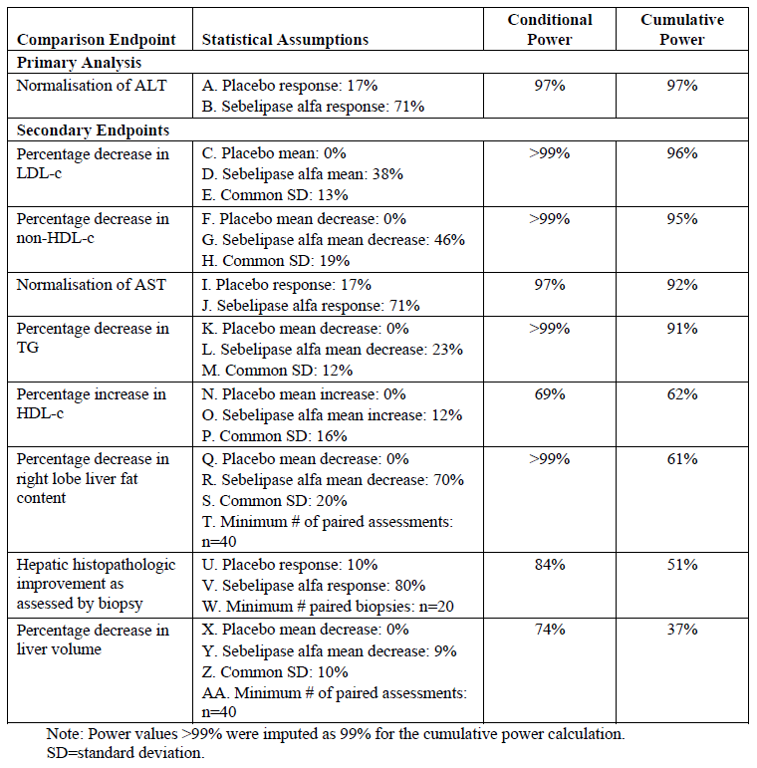

##### Statistical methods

All formal statistical conclusions were drawn from data collected in the double blind treatment period, and all statistical type I error was spent on the hypothesis tests performed on these data efficacy analyses were performed for the FAS. The primary efficacy analysis was the proportion of subjects in each treatment group who met the primary endpoint, defined as the subject’s final ALT value during the double blind period being < ULN provided by the central laboratory, compared using Fisher’s exact test at α = 0.05. If the primary analysis of the primary endpoint was statistically significant at α = 0.05, then statistical hypothesis tests were performed in a fixed sequence such that if any test was statistically significant, then the next statistical hypothesis in the sequence was tested at α = 0.05. If at any point in the sequence a particular hypothesis was not statistically significant at α = 0.05, then formal statistical hypothesis testing stopped, and none of the remaining tests were considered statistically significant. Longitudinal changes in anthropometric data were summarised using z-scores and percentiles for WFA and SFA, determined from the publically available CDC growth curves for subject’s ≤ 18 years of age. Baseline age normalised percentiles for height also were summarised in subjects > 18 years of age.

Health related quality of life measures were summarised for the FAS. For each HRQOL instrument, changes from Baseline in the overall score, scale scores, and summary scores, as applicable, were summarised for each time point overall and by treatment group.

###### Subgroup Analyses

Results were summarised by subgroup if each treatment group by subgroup combination had at least 5 subjects. Efficacy was explored in subgroups by age (< 12 years, ≥ 12 years to < 18 years, ≥ 18 years), gender, race, body mass index (BMI)[20] baseline indicators of liver function (for example, liver fat content), baseline serum lipids,[21] average screening ALT level (< 3 x ULN, ≥ 3 x ULN) and baseline use of LLM (yes/ no). These subgroup analyses were considered supportive rather than confirmatory.

Analyses using data from the open label period available at the time of data cut-off for this report were presented. These cumulative analyses, referred to as the extension analyses, were also considered supportive.

##### Participant flow

Of the 86 subjects screened at 41 centres in 16 countries, 20 were screen failures and a total of 66 subjects in 15 countries were enrolled in the study over a 9-month period between March and December 2013. Of 66 subjects enrolled in the double blind treatment period, 36 were randomly assigned to sebelipase alfa and 30 were randomly assigned to placebo. No significant differences were seen between the SA and placebo groups with regard to the proportions of subjects included in each stratum based on age at randomisation, average screening ALT and use of LLM (see Table 5, below). All 66 (100%) subjects received at least 1 study drug infusion and thus were included in the FAS. Furthermore, 63 (95%) of 66 subjects, including 94% (34 of 36) and 97% (29 of 30) in the SA and placebo groups, respectively, were included in the PP Set. All but 1 subject in the SA group (65 of 66 subjects; 98%) completed the double blind treatment period and continued in the open label period. As of the data cut-off date for the CSR (30 May 2014), 65 subjects had completed and 1 had discontinued from the double blind period of the study. Furthermore, 65 subjects, 35 in the sebelipase alfa group and 30 in the placebo group, had entered the open label period and continued/started treatment with sebelipase alfa.

Table 5: Study LAL-CL02 Randomisation strata (FAS)

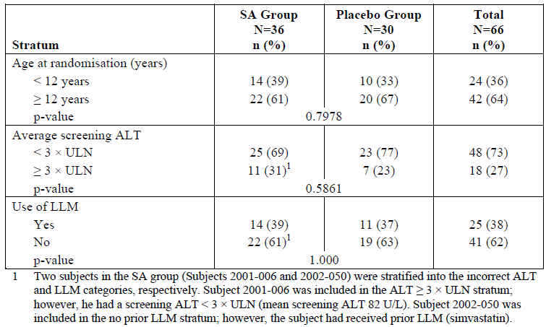

##### Major protocol violations/deviations

Protocol deviations considered to potentially affect data analyses (that is, important protocol deviations) were identified for 7 (11%) of 66 subjects overall, including 5 (14%) of 36 subjects in the SA group and 2 (7%) of 30 subjects in the placebo group. Deviations that warranted exclusion from the PP Set were seen in 2 (3%) of 66 subjects, 1 (3%) of 36 subjects in the SA group and 1 (3%) of 30 subjects in the placebo group Both these were excluded from the PP Set due to a deviation in the time window between Weeks 18 and 20; one additional subject in the SA group was excluded from the PP Set due to receiving < 9 study drug infusions (however, this was not considered a protocol deviation.). For the remaining 5 (8%) subjects, 4 (11%) of 36 subjects in the SA group and 1 (3%) of 30 subjects in the placebo group, the deviations did not warrant exclusion from the PP set. No subject was withdrawn from the study because of protocol deviations.

##### Baseline data

Overall, the subject population was relatively young (mean and median age at randomisation The SA and placebo groups were well balanced with regard to demographic with no statistically significant difference between groups. 16.1 years and 13.0 years, respectively). Of the 66subjects, 36% were < 12 years of age; 35% were between 12 and < 18 years of age; and 29% were ≥ 18 years of age at randomisation. Most (83%) subjects were White with equal number of males and females (50% each). Overall, 39% of subjects had received at least 1 prior LLM. At baseline, 39% of subjects overall were receiving LLM, including 42% and 37% of subjects in the SA and placebo groups, respectively.

**Comment:** It is important to note that there was a lower proportion of subjects aged 12 to 18 years (25% versus 47%, respectively) and a higher proportion of subjects aged ≥ 18 years (36% versus 20%, respectively) in the SA group compared with the placebo group. However, when age was categorised by < 12 years versus ≥ 12 years, the proportions of subjects in each category was similar in each treatment group.

All 66 subjects had a confirmed diagnosis of LAL Deficiency, based on DBS LAL enzyme testing, at Baseline. Overall, the method of historical LAL Deficiency diagnosis was measurement of enzyme activity for most (43 of 66; 65%) subjects, including 64% (23 of 36) and 67% (20 of 30) of subjects in the SA and placebo groups, respectively. The median age at onset of the first LAL Deficiency related abnormalities was 4 years overall, with a similar median age at onset of 5 and 4 years in the SA and placebo groups, respectively. The most frequent presenting abnormality was elevated transaminases (47% of subjects in both the SA and placebo groups). Hypercholesterolemia was the presenting abnormality in 17% (6 of 36) and 7% (2 of 30) of subjects in the SA and placebo groups, respectively. Disease presentation involving abnormalities other than elevated transaminases or hypercholesterolemia were present in 36% (13 of 36) and 47% (14 of 30), respectively. In the SA group, these other manifestations that were the first to present included hepatomegaly (7 subjects), hepatosplenomegaly and diarrhoea (2 subject each), and microvesicular steatosis, hypertriglyceridemia, and abdominal pain (1 subject each). Two of these subjects with hepatomegaly had concurrent symptoms (1 also had jaundice, diarrhoea, and vomiting noted and another had failure to thrive). In the placebo group, other manifestations that were the first to present included hepatomegaly (8 subjects) and hyperlipidaemia, hepatitis, diarrhoea, and splenomegaly (1 subject each) (see Table 6, below).

Table 6: Study LAL-CL02 LAL deficiency diagnosis and history overall and by treatment group (FAS, double blind treatment period)

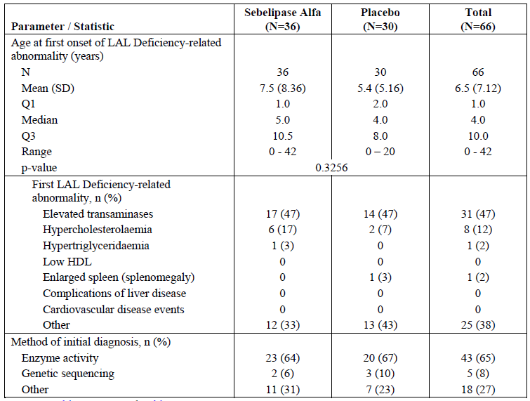

Genetic sequencing was reported as the method of historical diagnosis in 8% (5 of 66) of subjects overall, including 6% (2 of 36) and 10% (3 of 30) of subjects in the SA and placebo groups, respectively. Genetic testing showed that overall, 85% of subjects had at least one copy of the previously described c.849G> A common exon 8 splice junction mutation (32% homozygotes, 53% heterozygotes); Overall, the proportions of subjects who were homozygous or heterozygous for the common variant were similar in each age category (< 12 versus ≥ 12 years) (see Table 7, below).

Table 7: Study LAL-CL02 LIPA gene analysis, overall and by age, overall and by treatment group (FAS, double blind period)

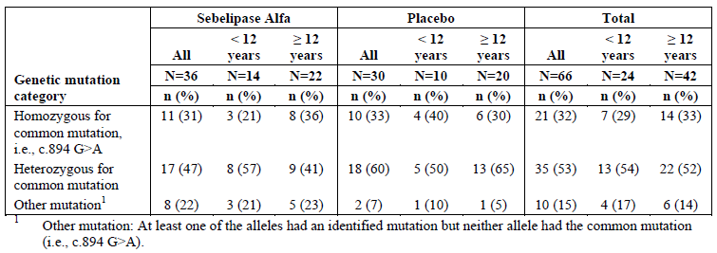

Overall, the most common hepatic conditions that were reported in the medical history as ongoing at Baseline were hepatomegaly (58%; 38 of 66); transaminases increased (38% 25 of 66), hyper-transaminasaemia (12%; 8 of 55); hepatic steatosis and hepatosplenomegaly (11%; 7 of 66); and hyperbilirubinaemia (9%; 6 of 66). All 66 subjects had an elevated ALT (that is, ALT > 43 U/L) at Baseline, in accordance with the inclusion criteria, and all but 4 also had an elevated AST (that is, AST > 43 U/L) at Baseline (see Table 8, below). Medically important chronic liver disease was identified in 29 (44%) such subjects (18 female and 11 male; mean and median age of subjects was 14 and 12 years, with a range of 4 to 41 years). Ten of these subjects had cirrhosis based on baseline liver biopsy and only 4 of these had documented cirrhosis or portal hypertension in their medical history.

Table 8: Study LAL-CL02 Concurrent hepatic disorders, overall and by treatment group (FAS, double blind treatment period)

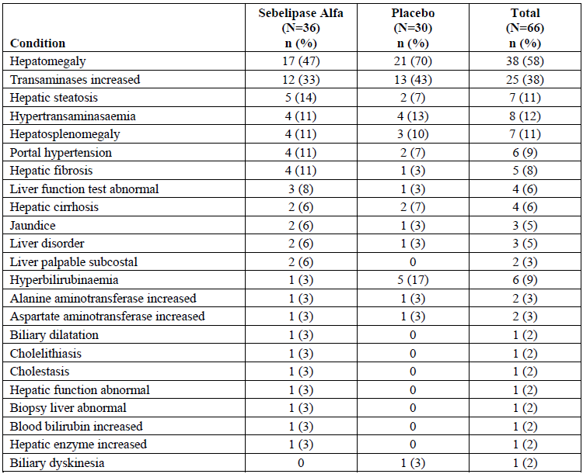

All subjects had an ALT > 1.5 x ULN at Baseline; mean baseline ALT values were 105.1 U/L and 99.0 U/L in the SA and placebo groups, respectively. All but 1 subject in the placebo group had elevated AST values at Baseline; mean AST values were 86.6 U/L and 78.2 U/L in the SA and placebo groups, respectively. The mean GGT was similar in the SA group and placebo group at Baseline (52.4 and 52.0 U/L, respectively); 36% of subjects in the SA group and 40% of subjects in the placebo group had elevated baseline GGT levels.

Baseline assessments of lipids demonstrated marked dyslipidaemia. In general, a greater degree of dyslipidaemia was seen at Baseline in the placebo group than in the SA group. Mean LDL-c values were 189.9 mg/dL (4.9 mmol/L) and 229.5 mg/dL (5.9 mmol/L) in the SA and placebo groups, respectively. Overall, more than half (58%) of subjects had LDL-c values in the very high range (> 190 mg/dL). Hypertriglyceridemia, defined as TG levels ≥ 200 mg/dL, was seen in 21% of subjects. Mean HDL-c values were 32.4 mg/dL (0.8 mmol/L) and 33.4 mg/dL (0.9 mmol/L) in the SA and placebo groups, respectively. Statistically significant differences between groups were seen with regard to cholesterol and non-HDL-c at Baseline, with higher mean values seen in the placebo group than in the SA group. In the SA and placebo groups, mean baseline cholesterol values were 252.5 mg/dL (6.53 mmol/L) and 296.7 mg/dL (7.67 mmol/L), respectively (p = 0.0341), and mean baseline non-HDL-c values were 220.5 mg/dL (5.7 mmol/L) and 263.8 mg/dL (6.8 mmol/L), respectively (p = 0.0341).

Baseline liver pathology was available in 32 subjects in the FAS, including 19 subjects in the SA group and 13 subjects in the placebo group and all (100%) subjects with baseline biopsies had evidence of fibrosis. A total of 5 (26%) of 19 subjects in the SA group and 5 (38%) of 13 subjects in the placebo group with biopsy data available for analysis had Ishak fibrosis scores of 5 or 6, indicating either early or incomplete cirrhosis or probable or definite cirrhosis, respectively.

Multi-echo gradient-echo (MEGE) assessment of liver fat content was available in 35 subjects in the SA group and 26 subjects in the placebo group and was 8.5% at Baseline with similar mean liver fat content of 8.75% and 8.16% in the SA and placebo groups, respectively. Liver volume assessments by MRI were available in 36 subjects in the SA group and 28 subjects in the placebo group; the mean baseline liver volume was 1.46 multiples of normal (MN) overall, with similar mean liver volumes of 1.44 and 1.50 MN in the SA and placebo groups, respectively. No relationship was seen between liver fat content and liver volume at Baseline, as indicated by a correlation coefficient of 0.01 in the SA group and 0.04 in the placebo group. The mean spleen fat content, as assessed by MEGE, was 1.41%, with similar mean spleen fat content of 1.46% and 1.34% in the SA and placebo groups, respectively. Mean spleen volume, as assessed by MRI, was 3.32 MN, with similar mean spleen volumes of 3.37 MN (range 0.67 to 16.18 MN) and 3.26 MN (range 1.88 to 6.67 MN) in the SA and placebo groups, respectively Platelet counts appeared lower in subjects with higher baseline spleen volumes (see Table 9, below).

Table 9: Study LAL-CL02 Liver and spleen volume and fat content at Baseline (subjects in the FAS with assessment performed, double blind treatment period)

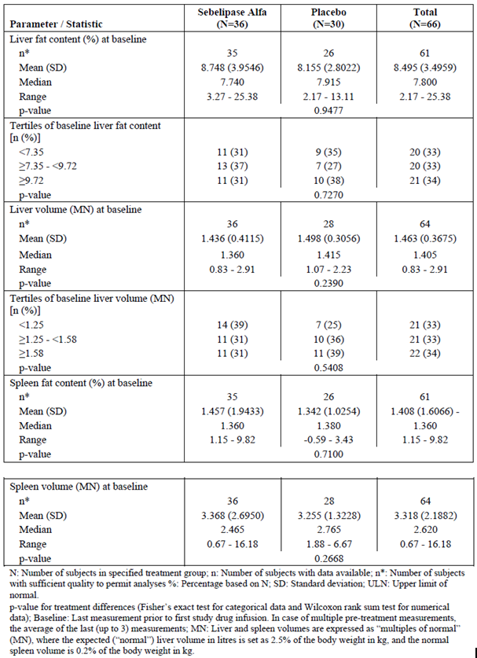

Overall, 39% (26 of 66 subjects) had received at least 1 prior LLM, with 36% (24 of 66) previously receiving a statin, 12% (8 of 66) previously receiving a non-statin, and 9% (6 of 66) previously receiving both a statin and non-statin. A history of statin use, either alone or in combination, was more common in the SA group than in the placebo group, with 42% (15 of 36) and 30% (9 of 30) of subjects, respectively, previously receiving a statin alone and 14% (5 of 36) and 3% (1 of 30) of subjects, respectively, previously receiving a statin in combination.

Review of LLM use by age showed that overall, of the 26 subjects receiving LLM at Baseline, 15% (4 subjects) were aged < 12 years and 42% each were aged ≥ 12 to < 18 years or ≥ 18years. Thus, of the 26 subjects receiving LLM at Baseline, 85% (22 subjects) were aged ≥ 12 years and 15% were aged < 12 years. Overall, the most common type of prior LLM was HMG CoA reductase inhibitors (that is, statins) (23 of 66; 35%). Other types of LLM were less common, with 6% (4 of 66) previously receiving ‘other’ lipid modifying agents; 5% (3 of 66) previously receiving bile acid sequestrants; and 2% (1 of 66) each previously receiving fibrates and HMG CoA reductase inhibitors in combination with ezetimibe. NAFLD medication;[22] use was less common, with 5% (3 of 66) of subjects overall, including 6% (2 of 36) and 3% (1 of 30) of subjects in the SA and placebo groups, respectively, receiving such medication at Baseline.

From Week 0 to Week 52, all infusions were administered at the study centre and compliance with study drug was good. All but 2 subjects (64 of 66 subjects; 97%) received all 11 study drug infusions as planned during the double blind period; 1 subject in the SA group withdrew from the double blind period of the study on Day 15 after receiving 2 study drug infusions due to an AE (infusion related reaction with associated symptomology. Furthermore, 1 study drug infusion was not completed for 3 (5%) of 66 subjects, all in the SA group.

##### Results for the primary efficacy outcome

A statistically significant greater proportion of subjects in the SA group than in the placebo group achieved normalisation in ALT by the last time point in the double blind period, (31% versus 7%, p = 0.0271) (see Table 10, below). All subjects in the SA group demonstrated a decrease in ALT; the mean decrease in ALT in the SA group was ‑57.9 U/L representing a 53% mean reduction from Baseline. In contrast, the decrease from Baseline to the last time point in the double blind period in the placebo group was ‑6.7 U/L (6% mean reduction from Baseline). In contrast to ALT normalisation over a broad range of baseline ALT levels in the SA group (52 to 166 U/L), normalisation was only seen in the 2 subjects in the placebo group (50 and 53 U/L).

Table 10: Study LAL-CL02 Summary of primary and secondary efficacy endpoints, including fixed sequence test results, by treatment group (FAS, double blind treatment period)

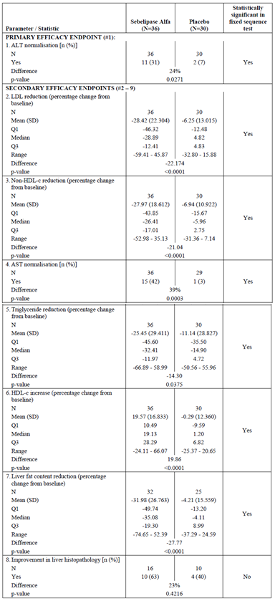

Table 10 (continued): Study LAL-CL02 Summary of primary and secondary efficacy endpoints, including fixed sequence test results, by treatment group (FAS, double blind treatment period)

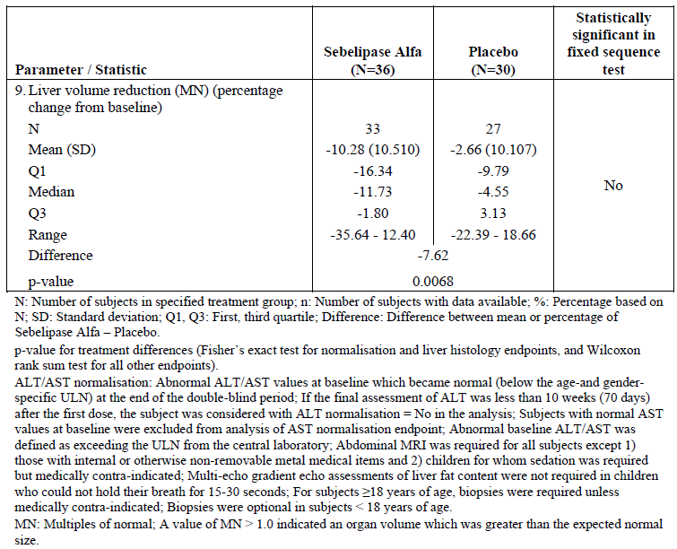

Review of normalisation in ALT by study visit showed that in the SA group, normalisation had occurred by Week 2 (the first time point assessed post baseline), in a small proportion of subjects (2 of 35 subjects; 6%), with a statistically significant proportion of subjects relative to placebo having normalisation in ALT by Week 6 (12 of 35 subjects; 34%) and at all time points thereafter. From Week 6 through the last time point, the proportion of subjects with normalisation in ALT remained relatively consistent, ranging from 29% to 41% (a difference of 4 subjects) over time. Across time points in the double blind period, 6% (2 of 35), 21% (7 of 33), 34% (12 of 35), 29% (10 of 35), 41% (14 of 34), 40% (14 of 35), 29% (10 of 34), and 31% (11 of 36) subjects had normalisation in ALT at Weeks 2, 4, 6, 10, 14, 18, and 20 and at the last time point in the double blind period, respectively. In contrast, ≤ 7% of subjects in the placebo group had ALT normalisation at any time point (see Figure 5, below).

Figure 5: Study LAL-CL02 Proportions of subjects with ALT Normalisation over time by treatment group (FAS, double blind treatment period)

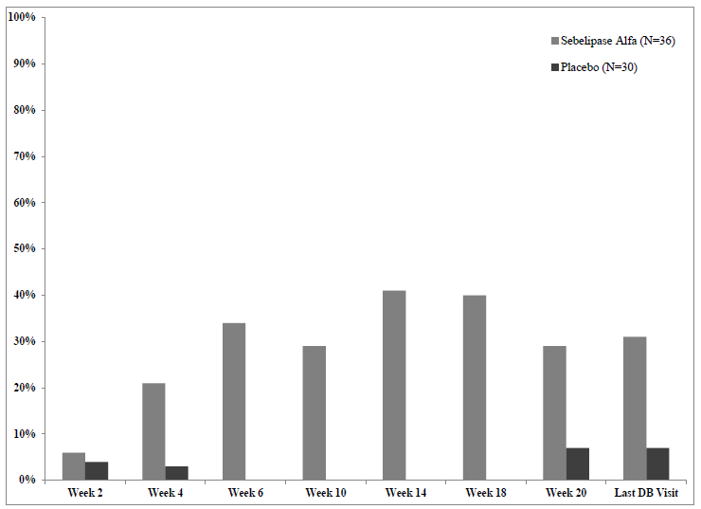

##### Results for other efficacy outcomes

###### *Secondary endpoints*

A summary of secondary efficacy results was provided in Table 10 (above).

A statistically significantly greater mean change from Baseline in LDL-c was seen in the SA group than in the placebo group (‑28.42% versus -6.25%, diff = ‑22.17% p < 0.0001). Overall, 13 (42%) of 36 subjects in the SA group achieved an LDL-c of < 130 mg/dL (3.36 mmol/L) compared to only 2 (7%) of 30 subjects in the placebo group. Of the 13 subjects in the SA group with LDL levels < 130 mg/dL (3.36 mmol/L) at the end of the double blind period, 7 were receiving LLM. Seven subjects in the SA group had LDL-c levels > 190 mg/dL (4.91 mmol/L) at the end of the double blind period and 6 of these 7 were not receiving concomitant LLM. In the placebo group, 17 subjects had LDL-c levels > 190 mg/dL at the end of the double blind period, of which 13 were not receiving LLM. A statistically significantly greater mean reduction in non-HDL-c was seen in the SA group than in the placebo group (‑27.97% versus ‑6.94%, diff = ‑21.04% p < 0.0001).

A statistically significantly greater proportion of subjects in the SA group than in the placebo group experienced normalisation in AST by the last time point in the double blind period (42% versus 3%, diff = ‑39% difference, p = 0.0003). The mean decrease in AST in the SA group was ‑41.9 U/L, representing a mean percent decrease from Baseline to the last time point in the double blind period of ‑44% compared with ‑7% decrease in the placebo group. Similar to findings for ALT, AST normalisation was seen over a broad range of baseline AST levels in the SA group (41 to 149 U/L), whereas AST normalisation in the placebo group was only seen in 2 subjects with low baseline AST levels (of 61 and 39 U/L). Across time points in the double blind period, 15% (5/34), 34% (11/32), 22% (7/32), 26% (9/35), 41% (13/32), 32% (11/34), 42%(14/33), and 42% (15/36) at Weeks 2, 4, 6, 10, 14, 18, and 20 and at the last time point in the double blind period, respectively. In contrast, ≤ 10% of subjects in the placebo group had AST normalisation at any time point. Statistically significant difference from placebo was observed from Week 4 onwards. At the last time point in the double blind period, 83% (30 of 36) of subjects in the SA group and 43% (13 of 30) of subjects in the placebo group had AST values < 60 U/L, and 44% (16 of 36) of subjects in the SA group and 7% (2 of 30) of subjects in the placebo group had AST values < 40 U/L.

Of the 36 subjects in the SA group, 7 (19%) achieved both ALT and AST normalisation during the double blind period. No subject in the placebo group achieved both ALT and AST normalisation.

A statistically significantly greater mean reduction from Baseline to the last time point in the double blind period in TG was seen in **t**he SA group compared with the placebo group (‑25.45% versus ‑11.14%, diff = ‑14.30, p = 0.0375). Six subjects in the SA group had TG values > 200 mg/dL (2.26 mmol/L) at Baseline (mean TG value among these 6 subjects was 247 mg/dL, (2.79 mmol/L) range 207 to 307 mg/dL (2.34 to 3.47mmol/L)). Among these subjects, the mean decrease from Baseline to the last time point in the double blind period was -42% (range of ‑26% to ‑64%) with 2 of these subjects having a mean decrease of > 50%. In the placebo group, there were also 6 subjects with baseline TG values > 200 mg/dL (2.26 mmol/L) (mean = 271 mg/dL (3.06 mmol/L) range 226 to 361 mg/dL(2.55 to 4.08 mmol/L)). Although a reduction from Baseline in TG was seen among these 6 subjects in the placebo group, with a mean percent reduction from Baseline to the last time point in the double blind period of ‑29% (range ‑12% to ‑37%), this was less marked than the change seen in the SA group.

A statistically significantly greater mean increase from Baseline to the last time point in the double blind period in HDL-c was seen in the SA group compared with the placebo group (19.57% versus ‑0.29%, diff = 19.86% p < 0.0001). Of the 31 subjects in the SA group who had a baseline HDL-c value ≤ 40 mg/dL (1.03 mmol/L), 7 (23%) achieved an HDL-c value > 40 at the last time point in the double blind period. Of the 24 subjects in the placebo group who had a baseline HDL-c value ≤ 40 mg/dL, 3 (13%) achieved an HDL-c value > 40mg/dl at the last time point in the double blind period.

A statistically significantly greater mean percent decrease from Baseline to the last time point in the double blind period in liver fat content was seen in the SA group compared with the placebo group (‑31.98% versus ‑4.21%, diff = ‑27.77%, p < 0.0001).

A greater proportion of subjects in the SA group (10/16, 63%) compared with the placebo group (4/10, 40%) experienced improvement in liver histology[23] (steatosis by morphometry) from Baseline to the last time point in the double blind period, as determined by central blinded read. However, this 23% difference between groups in favour of SA was not statistically significant. (p = 0.4216). All but 1 subject in the SA group included in this analysis (14 of 15 subjects; 93%) either had no change or improvement from Baseline in steatosis, compared with 5 (50%) of 10 subjects in the placebo group. A greater proportion of subjects in the placebo group (5 of 10 subjects; 50%) than in the SA group (1 of 16 subjects; 6%), experienced worsening from Baseline to the last time point during the double blind period in steatosis; a ‑44% difference between groups in favour of sebelipase alfa (p = 0.0184) (Table 10, above). Because the between-group difference for hepatic steatosis by morphometry did not reach statistical significance, the SAP did not allow formal statistical testing of the remaining secondary endpoint, liver volume as assessed by MRI

A greater mean percent decrease from Baseline in liver volume was seen in the SA group than in the placebo group at the last time point in the double blind treatment period (‑10.28% versus 2.66%).

These efficacy results were robust as results in FAS were also confirmed in the PP Set.

###### *Other efficacy results*

Exploratory analysis of ALT normalisation

An exploratory analysis of ALT using a recently used definition of improvement in ALT (Lavine, 2011; Dohil, 2011) was performed in which improvement was defined as a decrease in ALT to ≤ 40 U/L or a > 50% reduction from Baseline in ALT. Across time points in the double blind period, 37% (13/35), 46% (15/ 33), 63% (22/ 35), 63% (22/35), 68% (23/ 34), 74% (26 / 35), 68% (23/ 34), and 67% (24/36) subjects had improvement in ALT using this alternate definition at Weeks 2, 4, 6, 10, 14, 18, and 20 and at the last time point in the double blind period, respectively. In contrast, ≤ 14% of subjects in the placebo group had ALT improvement, as defined using this alternative definition, at any time point. The difference between the SA and placebo groups using this definition of improvement was statistically significant at each time point assessed in the double blind period (p ≤ 0.0120).

ALT/AST normalisation in the open label period

Review of data in the open label period through Week 36 (< 5 subjects in the placebo/SA group had data available > Week 14) revealed a sustained effect of sebelipase alfa on ALT normalisation over a longer duration of treatment. The proportions of subjects in the SA group with ALT normalisation were 41% (13 of 32), 46% (12/26), 36% (8/22), 42% (8/19), 44% (7/16), and 44% (4/9) at Weeks 22, 24, 26, 28, 32 and 36, respectively. Among subjects in the placebo group in the double blind period who switched to sebelipase alfa in the open label period (that is, the placebo/SA group), 22% (6/27) had achieved ALT normalisation by Week 2, with 22% (4/18), 21% (3/14), 25% (3/ 12), and 44% (4/9) achieving ALT normalisation at Weeks 4, 6, 10 and 14, respectively (Figure 6). Review of data in the open label period through Week 36 revealed a sustained effect of sebelipase alfa on AST normalisation over a longer duration of treatment. The proportions of subjects in the SA group with AST normalisation were 58% (18/31), 62% (16 of 26), 41% (9 of 22), 58% (11 of 19), 53% (8 of 15), and 67% (6 of 9) at Weeks 22, 24, 26, 28, 32, and 36, respectively. Among subjects in the placebo/SA group, by Week 2, with 15% (4 of 27) 33% (6 of 18), 43% (6 of 14), 58% (7 of 12), and 38% (3 of 8) had achieved AST normalisation at Weeks 2, 4, 6, 10 and 14, respectively.

Figure 6: Study LAL-CL02. Proportions of subjects with ALT normalisation over time by treatment group (EAS, open label period)

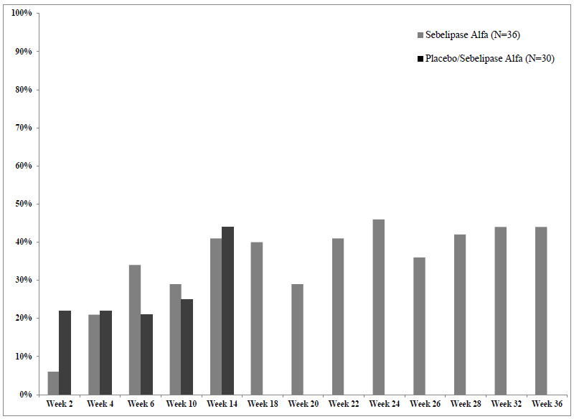

Changes in GGT, ALP, bilirubin

A statistically significant (p ≤ 0.0002) decrease from Baseline in GGT was seen in the SA group relative to the placebo group, with lower mean GGT values in the SA group than in the placebo group at all time points assessed post baseline, with the exception of Week 2 (Figure 7). The proportion of subjects with a GGT value > ULN at Baseline who achieved a GGT value ≤ ULN at the last time point in the double blind period was statistically significantly (p = 0.0112) higher in the SA group (62%, 8/13) compared with placebo (8%, 1/12). Review of GGT in the open label period in the SA group revealed sustained decreases in mean GGT over time through Week 36 that were consistent with those seen during the double blind period. In the placebo/SA group, the mean percent decreases from Baseline in GGT seen were consistent with those seen in the SA group after initiation of sebelipase alfa.

Figure 7: Study LAL-CL02. Mean (± SE) GGT values over time through the last visit in the double blind period, by treatment group (FAS, double blind treatment period)

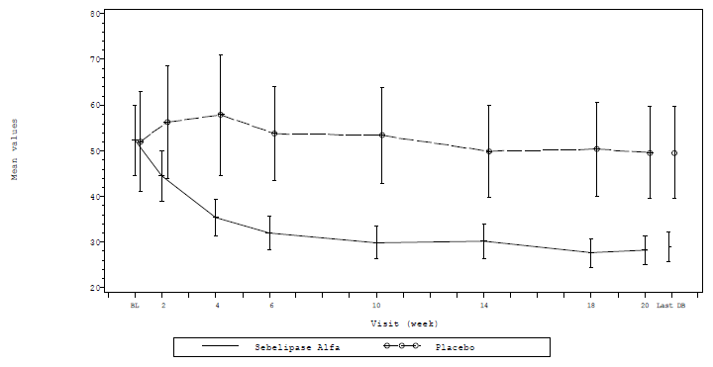

The mean change in mean ALP values from Baseline to the last visit in the double blind period in the SA group (255.7 to 214 U/L; ‑16%) was not statistically significant relative to placebo (268.5 to 251.6 U/L;‑5%). Small, non-clinically relevant changes from Baseline in mean albumin were seen during the double blind period with no statistically significant difference between sebelipase alfa and placebo groups with regard to change from Baseline. Findings in the open label period were consistent with those observed during the double blind period. Total bilirubin values were generally similar in the SA and placebo groups at Baseline (18.0 and 19.0 µmol/L, respectively). A significantly greater mean percent decrease from Baseline in total bilirubin was seen in the SA group than in the placebo group at Week 4 (‑21% versus 2%, respectively), with the difference between groups of ‑22% being statistically significant (p = 0.0051). Greater mean percent decreases from Baseline in total bilirubin were seen in the SA group than in the placebo group at all time points in the double blind period thereafter; however, the difference between groups was not significant, with the exception of Week 18.

Mean indirect bilirubin was 15.1 µmol/L and 16.4 µmol/L in the SA and placebo groups, respectively, at Baseline. Mean indirect bilirubin values were lower in the SA group than in the placebo group at all post baseline time points assessed. The change from Baseline in indirect bilirubin in the SA group relative to the placebo group was statistically significant at Week 4, and at time points at or after Week 14. Direct bilirubin values were generally similar in the SA and placebo groups at Baseline and at all post baseline time points assessed in the double blind period; no statistically significant change from Baseline in direct bilirubin was seen in the SA group relative to placebo, with the exception of Week 18, at which time point the mean percent change from Baseline in direct bilirubin was ‑7% in the SA group and 2% in the placebo group (p = 0.0446).

Coagulation parameters

Of the 11 subjects with 2 or more abnormal clotting tests (PT, PTT, and/or INR) at Baseline, 4 were in the SA group and 7 were in the placebo group. With the exception of a marked improvement in INR and PT in 1 subject in the SA group, no other clinically meaningful changes over time were observed between baseline and last DB visit for PT, PTT and INR in either the SA or placebo group.

Supportive analysis of lipids

Mean baseline LDL-c values were 189.9 and 229.5 mg/dL (4.9 and 5.9 mmol/L) in the SA and placebo groups, respectively. In the SA group, mean increases from Baseline in LDL-c were seen at Weeks 2 and 4, with a maximum increase of 18% seen at Week 2; this increase was statistically significant relative to placebo (p = 0.0008). However, at Week 6 and all time points thereafter, decreases from Baseline in LDL-c were seen in the SA group relative to the placebo group, with the decreases being statistically significant by Week 10. A maximum mean decrease from Baseline in LDL-c of 31% was seen at Week 18 (p < 0.0001). At the last visit in the double blind period, mean LDL-c values were 138.8 mg/dL and 213.3 mg/dL (3.6 mmol/L and 5.5 mmol/L) in the SA and placebo groups, respectively, representing mean percent decreases from Baseline of ‑29% versus ‑6%, respectively (p < 0.0001) (Figures 8 and 9). Importantly, reductions in LDL-c were seen in subjects in the SA group regardless of LLM use, with the reduction from Baseline to the last time point in the double blind period in LDL-c being statistically significantly greater in the SA group than in the placebo group in both subjects receiving LLM (difference between groups ‑27.1%; p = 0.0013) and not receiving LLM (difference between groups ‑18.2%; p = 0.0018). An exploratory analysis was performed to determine the proportion of subjects achieving an LDL-c value < 130 mg/dL during the double blind period among those subjects had baseline LDL-c values above 130 mg/dL. No subject achieved an LDL-c < 130 mg/dL at Week 2, consistent with the increase in LDL-c seen after initiation of therapy. Over time points thereafter, 16% (5 of 31), 23% (7 of 31), 26% (8 of 31), 42% (13 of 31), 33% (10 of 30), 42% (13 of 31), and 41% (13 of 32) of subjects in the SA group achieved an LDL-c < 130 mg/dL at Weeks 4, 6, 10, 14, 18, and 20 and at the last time point in the double blind period. In the placebo group, ≤ 7% of subjects had an LDL-c < 130 mg/dL at any time point in the double blind period. The difference between groups was statistically significant in favour of sebelipase alfa by Week 14 and remained statistically significant at Weeks 18 and 20 and at the last time point in the double blind period (p ≤ 0.0211). An exploratory analysis showed a weak relationship between change from Baseline in LDL-c to the last time point in the double blind period and baseline LDL-c, in the SA group (correlation coefficient 0.24) and no relationship in the placebo group (correlation coefficient ‑0.19). During the open label period, continued improvement in LDL-c levels was seen in the SA group, with a maximum mean percent decrease from Baseline of ‑44% seen at Week 36. In the placebo/SA group, a pattern similar to that seen in the SA group in the double blind period was seen, with an initial transient increase in mean LDL-c and then decreasing mean levels over time thereafter, with a maximum mean percent decrease of ‑25% seen at Week 14, the last time point assessed in the open label period for the placebo/SA group (Figures 8 and 9).

Figure 8: Mean Percent Change from Baseline in LDL-c Values over Time, by Treatment Group (FAS, Double-blind Treatment Period)

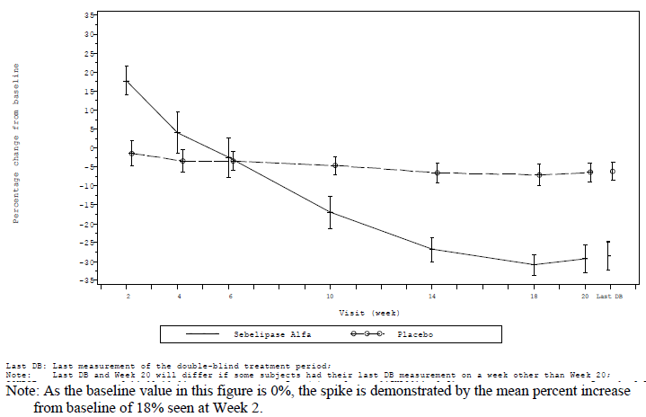

Figure 9: Mean Percent Change from Baseline in LDL-c Values over Time, by Treatment Group (EAS, Open-label period)

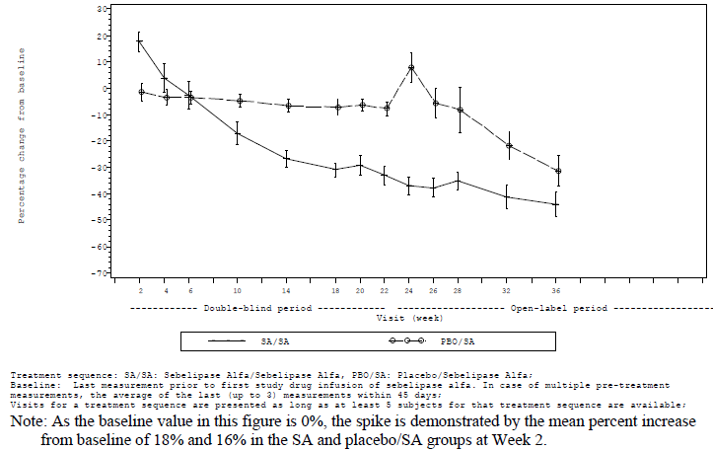

Similar findings were observed for non-HDL-c values with initial increase in the SA group followed by significant reductions from Week 6 onwards**.** During the open label period, continued improvement in non-HDL-c levels was seen in the SA group, with a maximum mean decrease from Baseline of -41% seen at Week 36. In the placebo/SA group, a pattern similar to that seen in the SA group in the double blind period was seen, with an initial transient increase in mean non-HDL-c and then decreasing mean levels over time thereafter, with a maximum mean percent decrease of ‑39% seen at Week 20

Similar findings were observed for change from Baseline in TG levels during double blind and open label treatment periods (Figures 10 and 11).

Figure 10: Mean percent change from Baseline in triglyceride values over time, by treatment group (FAS, double-blind treatment period)

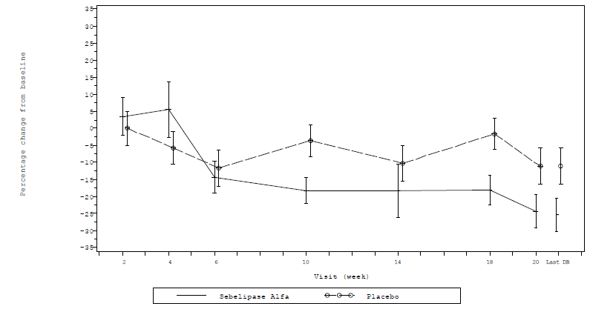

Figure 11: Mean percent change from Baseline in triglyceride values over time, by treatment group (EAS, Open-label period)

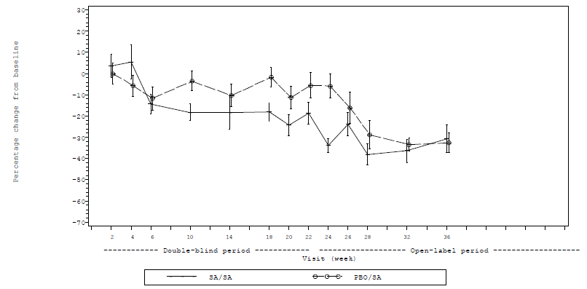

Mean baseline HDL-c values were 32.4 and 33.4 mg/dL (0.83 and 0.86 mmol/L) in the SA and placebo groups, respectively. In the SA group, a mean decrease from Baseline in HDL-c of -2% was seen at Week 2, but this decrease was not statistically significant relative to placebo. Increases from Baseline in HDL-c were seen by Week 4 and at all time points thereafter, with the mean percent increase from Baseline being statistically significant in the SA group relative to the placebo group by Week 6 and at all subsequent time points during the double blind period thereafter (Figure 12). During the open label period, sustained improvement in HDL-c levels was seen in the SA group, with a maximum mean percent increase from Baseline of 26% (actual value 40.5 mg/dL (1.0 mmol/L)) seen at Week 24. In the placebo/SA group, a pattern similar to that seen in the SA group during the double blind period was seen, with little change from Baseline seen at Week 2 and then increases from Baseline in HDL-c seen thereafter.

Figure 12: Study LAL-CL02 Mean percent change from Baseline in HDL-c values over time by treatment group (FAS double blind treatment period)

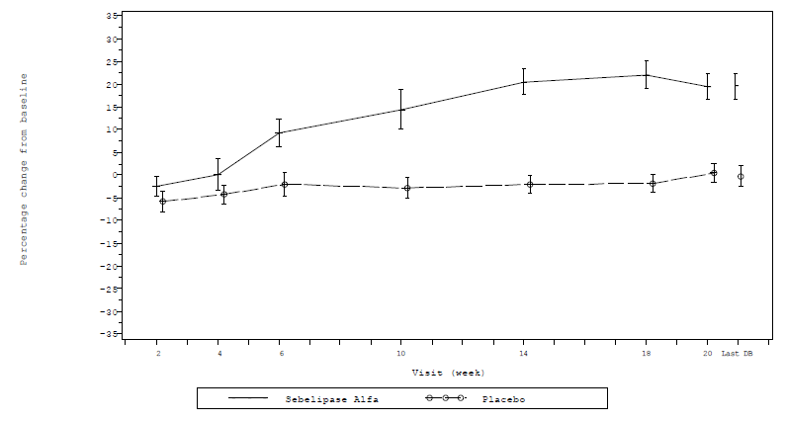

Apolipoproteins and lipid particles[24]

Compared with placebo, the SA group showed statistically significant greater increase in ApoA1 (diff from placebo 11.7%, p = 0.0004) and reduction in ApoB (diff from placebo 23.7%, p < 0.0001). The mean LDL-P (LDL-particle) number showed statistically significantly greater reduction increase in the SA group compared with placebo (diff = 28%, p < 0.0001). IDL-P also showed greater reduction in the SA group compared with placebo although the difference was not statistically significant. Compared with placebo, the SA group showed statistically significant greater increase in HDL-P (diff from placebo 32%, p < 0.0001).

The ApoA1, ApoB, and lipoprotein particle analysis by NMR in patients with LAL Deficiency provided additional insights into the impact of the disease on lipid metabolism and the effects of sebelipase alfa. These data demonstrated that the high LDL-c and low HDL-c levels in patients with LAL Deficiency are accompanied by increased LDL particle numbers and decreased HDL particle numbers and, that treatment with SA results in improvements in lipid metabolism, as demonstrated by clinically meaningful improvements in lipid particles, ApoA1, and ApoB.

As of the cut-off for this report, < 5 subjects in each treatment group had lipid particle measurements during the open label period and these results were not presented in the CSR.

Supportive analysis of liver fat content

A total of 57 subjects, 32 in the SA group and 25 in the placebo group had MRI assessment of liver fat content at Baseline and at the last time point in the double blind period.

In the SA group, a strong correlation was seen between baseline liver fat content and decrease from Baseline to the last time point in the double blind period in liver fat content, with greater reduction in subjects with higher baseline fat content (correlation coefficient ‑0.55; p = 0.0010) and this relationship was observed in the subset of subjects with and without biopsy-proven cirrhosis; there was weak correlation in the placebo group. An exploratory analysis was performed to determine the relationship between change from Baseline in ALT versus liver fat content, as determined by MRI, at the last time point in the double blind period. Findings revealed that there was a concordance of effect in that the majority of the SA treated subjects showed a reduction in both ALT and fat fraction in contrast to the findings in the placebo subjects. Findings were similar when this analysis was performed using liver fat content as determined by biopsy.

Supportive analysis of spleen volume and fat fraction

Spleen volume measurements based on MRI were available at Baseline and the last time point in the double blind period in 60 (91%) of the 66 subjects in the FAS. There was statistically significantly greater mean absolute reduction from Baseline to the last time point in the double blind period in spleen volume in the SA group compared with placebo group (‑0.357 MN versus 0.184 MN, diff = ‑0.541 MN, p = 0.0004). However, the mean absolute decrease from Baseline in spleen fat content was not statistically significant (‑0.379% versus 0.036, diff = ‑0.415%, p = 0.2068).

Anthropometric measurements

Review of change from Baseline to Week 20 in weight revealed small mean increases from Baseline in both the SA and placebo groups (1.5 kg and 1.9 kg, respectively). Similarly, small mean increases from Baseline to Week 20 in height were seen in both the SA and placebo groups (2.6 cm and 2.5 cm, respectively). During the open label period, a mean increase from Baseline in weight of 2.8 kg was seen in the SA group at Week 36, a value generally consistent with that seen during the double blind period. The mean increase from Baseline in weight was 1.8 kg in the placebo/SA group at Week 14, which also was generally consistent with the mean change seen in the SA group at the same time point during the double blind period. With regard to height, the number of subjects with available data is small beyond Week 14, and thus it was not possible to make meaningful comparisons of summary statistics between the groups. Six subjects in the SA group and 1 subject in the placebo group showed an increase in height centile of more than 5%. Two subjects in the SA group showed an increase in height centile of more than 10%. Interpretation of effect of treatment on height or weight was limited by lack of longer duration of follow-up.

###### Subgroup analysis

Age

The efficacy of sebelipase alfa relative to placebo in all age categories was generally greater in subjects aged ≥ 12 years compared to those aged < 12 years. The proportion of SA treated subjects who experienced ALT normalisation was 21% (3 of 14), 11% (1 of 9) and 54% (7 of 13) among those aged < 12 years, 12 to < 18 years and ≥ 18 years, respectively. Review of secondary endpoints by age showed that, in general, a nominally greater effect of sebelipase alfa was seen in subjects aged ≥ 12 years compared to those aged< 12 years, as evidenced by greater reductions from Baseline in LDL-c, non-HDL-c, and liver fat content, and greater increases in HDL-c and higher rates of AST normalisation and improvement in liver histology. However, interpretation was limited by the small numbers of subjects in each age category.

Gender

Overall, results in male and female subjects being generally consistent with those seen in the SA group as a whole.

Race and ethnicity

Results in White and non-White subjects were generally consistent with those seen in the SA group as a whole, with the exception that the mean percent change in liver fat content was notably higher in non-White subjects (‑42.7%; n = 8) than in White subjects (‑28.4%; n = 24) although interpretation was limited by three times higher number of White subjects. Results in Hispanic/Latino and non-Hispanic/Latino subjects were generally consistent with those seen in the SA group as a whole, with the exception that Hispanic/Latino subjects had a greater mean percent increase in HDL-c than non- Hispanic/Latino subjects (30.3% (n = 6) versus 17.4% (n = 30), respectively) although interpretation was limited the 5 times higher number of non‑Hispanic/Latino subjects.

Baseline liver volume

Results of these analyses by baseline liver volume (< 1.25 MN; ≥ 1.25 to < 1.58 MN; and ≥ 1.58 MN), with a relatively small number of subjects in each subgroup, revealed generally consistent effects of sebelipase alfa regardless of baseline liver volume although interpretation was limited by the small number of subjects in each subgroup (Table 11).

Table 11: Study LAL-CL02 Summary of primary and secondary efficacy endpoints by treatment group and baseline liver volume (FAS, double blind treatment period)

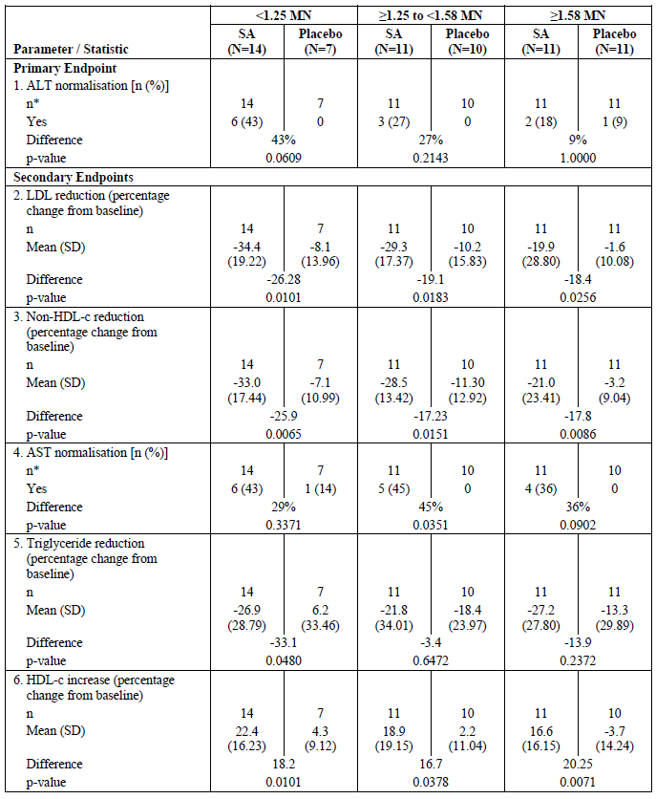

Table 11 continued: Study LAL-CL02 Summary of primary and secondary efficacy endpoints by treatment group and baseline liver volume (FAS, double blind treatment period)

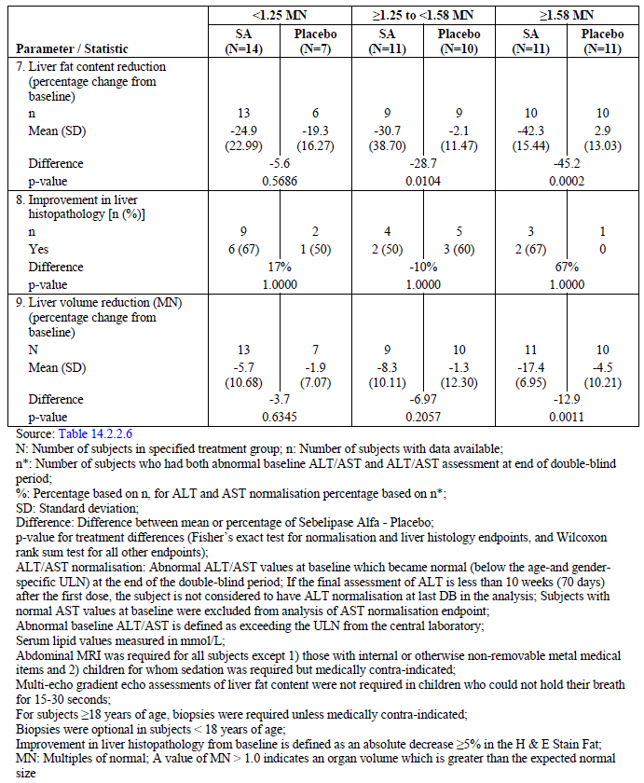

Baseline ALT levels

Although ALT normalisation rates were lower in the subjects with higher baseline ALT levels, the nature of this analysis and the number of subjects available for analysis with ALT values ≥ 3 x ULN, precludes drawing any conclusions on the relevance of this difference. Results for other efficacy endpoints among subjects with baseline ALT values < 3 x ULN and those with baseline ALT values ≥ 3 x ULN were generally similar. The mean percent reduction in from Baseline to the last time point in the double blind period in LDL-c, non-HDL-c, and liver fat content was statistically significantly greater in the SA group than in the placebo group regardless of baseline ALT level (either < 3 or ≥ 3 x ULN).

Baseline LDL-c levels

Greater mean percent reductions from Baseline to the last visit in the double blind period in LDL-c, non-HDL-c, and TG were seen in subjects in the SA group with baseline LDL-c levels < 190 mg/dL (4.9mmol/L) compared to those with baseline levels ≥ 190 mg/dL. Decreases in liver volume in the SA group were also greater in subjects with baseline LDL-c levels < 190 mg/dL (‑11% versus ‑4.1%). It is important to note that of the 38 subjects with baseline LDL-c levels ≥ 190 mg/dL, most (29; 76%) were not receiving LLM. In contrast, subjects with baseline LDL-c levels ≥ 190 mg/dL compared to those with baseline levels < 190 mg/dL had a greater mean percent reduction from Baseline to the last visit in the double blind period in liver fat content (38.5% versus 25.5%) and a greater increase in HDL-c level (22.0% versus 17.1%)**.**

Baseline LLM use

Review of baseline disease characteristics among subjects receiving LLM and not receiving LLM at Baseline showed that mean LDL-c was lower while HDL-c was higher, yet still abnormal, in subjects receiving LLM compared to those who were not. A greater effect of sebelipase alfa over the period from Baseline to the last visit in the double blind period was seen among subjects receiving LLM compared to those who were not with regard to normalisation in ALT (47% versus 19%, respectively); mean percent reduction in LDL-c (36.7% versus 22.5%, respectively); mean percent reduction in non-HDL-c (35.4% versus 22.7%, respectively); AST normalisation (53% versus 33%, respectively); mean percent reduction in TG (28.9% versus 23.0%, respectively); and mean percent increase in HDL-c (23.7% versus 16.6%, respectively). In contrast, results for liver fat content demonstrated a greater response in the subgroup of subjects not receiving LLM compared to those who were, with a mean percent reduction in liver fat content of 36.6% versus 26.0%. The mean percent reduction from Baseline in liver volume was similar between subgroups.

Baseline cirrhosis

Review of the primary efficacy endpoint, ALT normalisation, and planned secondary endpoints among the subjects in the SA group with fibrosis versus the SA group overall showed that results were generally consistent with the SA group as a whole. Although the number of subjects with biopsy evidence of cirrhosis was small, the effects of sebelipase alfa in this subpopulation (n = 5) appeared similar to those without cirrhosis for most efficacy measures. Importantly decreases in ALT, AST and GGT, LDL-c, and non HDL-c were seen irrespective of cirrhosis status.

Mutation status

The impact of mutation status on baseline parameters of disease activity was explored in 3 groups.

* Group 1: Homozygous for the c.849G> A common exon 8 splice junction mutation (n = 21)
* Group 2: Confirmed or presumed compound heterozygous for c.849G> A common exon 8 splice junction mutation (n = 35)
* Group 3: Other mutations (n = 10)

Baseline serum transaminases were higher in Group 3 in subjects who did not have at least one copy of the c.849G> A common exon 8 splice junction mutation compared to Groups 1 or 2. No differences or trends were observed between the groups for LDL-c, non HDL-c, TG, or HDL-c. Baseline liver biopsies were available in 52% (11/21); 43% (15/35) and 60% (6/10) in Groups 1 to 3 respectively. Cirrhosis defined as Ishak score equal to or greater than 5 was found in 9% (1/11), 33% (5/15) and 67% (4/6) of Groups 1 to 3 respectively. Sebelipase alfa was effective regardless of genetic mutation category. Although the number of subjects in each genetic mutation category was small, efficacy results were generally similar in each category, although a higher proportion of subjects in Group 1 experienced AST normalisation at the last visit in the double blind period than in either Groups 2 or 3 (64% versus 29% and 38%, respectively). Furthermore, the degree of liver fat content reduction was higher in Group 3 than in either Groups 1 or 2 (‑51.5% versus ‑16.7% and ‑30.7%, respectively). The liver volume reduction also appeared greater in Group 3 than in either Groups 1 or 2; however, only 2 subjects in Group 3 had this assessment performed.

###### Additional supportive endpoints

Mean serum chitotriosidase levels were similar in the SA and placebo groups at Baseline (8.1 U/mL and 7.2 U/mL, respectively); mean changes from Baseline to the last visit in the double blind period were statistically significantly greater in the SA group compared with placebo (‑2.4 U/mL versus 0.3 U/mL; diff = ‑2.7 U/mL, p = 0.0158).

Ferritin is an acute phase reactant that is elevated in patients with macrophage activation (Moore, 2013). Mean serum ferritin levels were 72.1 µg/L and 78.9 µg/L in the SA and placebo groups, respectively, at Baseline. The mean reduction from Baseline was marginally greater in the SA group compared with placebo (‑30.9 versus ‑28.5 µg/L, p = 0.0489).

There was no obvious treatment effect on FACIT-Fatigue, CLDQ and PedsQL in subjects with lower values.

##### Evaluator commentary

This was a well-conducted, pivotal Phase III, randomised, double blind (20 week), placebo controlled study in 66 patients (children and adults) with LAL deficiency with majority of patients being < 18 years old (71%). The study was conducted in a broad age range of subjects at different stages of disease progression including subjects with histologically confirmed cirrhosis and different genotypes.

The primary efficacy endpoint in this study was rate of ALT normalisation at the last time point in the 20 week double blind period. Serum ALT reflects damage to liver cells, liver injury, and underlying liver disease and sustained reductions in ALT have been used historically as primary or secondary endpoints in clinical studies of other liver diseases including viral hepatitis and autoimmune hepatitis. In contrast to other potential measures of efficacy for sebelipase alfa including liver histopathologic improvement, ALT can be assessed in a broad population including young children and repeat measurement was considered likely to be acceptable in the context of a placebo controlled clinical study in all participating centres. Preclinical[25] data and results of a retrospective case review Study LAL-2-NH01 showed that LAL-D is consistently associated with elevated serum transaminases. The secondary endpoint assessments included improvement or normalisation rates from Baseline to end of DB period in LDL-c, non-HDL-c, TGs, HDL-c, AST, liver fat content and liver volume and liver histopathology. Lipid abnormalities and the associated risk of accelerated atherosclerosis and cardiovascular complications are important clinical outcomes contributing to morbidity and mortality in the broader LAL Deficiency patient population. However, due to low prevalence of disease, it would have been very difficult to study large number of subjects which would be required to show any effect on clinical outcomes. Overall, the primary and secondary efficacy endpoints in this study were appropriate as these included clinically relevant biochemical markers of liver cell injury and disturbed lipid metabolism in addition to measures of liver fat content and organ volume representing relevant and sufficiently sensitive endpoints for the assessment of treatment efficacy in LAL deficiency which is a multisystem disease.

The rate of disease progression in LAL Deficiency is more heterogeneous in children and adults which precluded designing or conducting a study of the size and duration that would be required to directly assess the impact of ERT on clinical events associated with progressive liver disease (for example, decompensated cirrhosis or liver-related mortality) or CVD (for example, cardiac-related mortality) particularly in the context of the rarity of this disease. Thus, the design of the pivotal Study LAL-CL02 in children and adults was appropriate.

Treatment with sebelipase alfa 1 mg/kg qow was statistically significantly more effective than placebo in improving a broad range of disease related abnormalities, including normalisation of serum transaminases (ALT and AST), improvement in dyslipidaemia (reductions in LDL-c, non-HDL-c, and TG, and increases in HDL-c) and reduction in liver fat content as assessed by MRI. Furthermore, sebelipase alfa treatment produced clear reductions in MRI-estimated liver volume during the 20 week double blind treatment period. Treatment with sebelipase alfa was accompanied by short-term increases in total cholesterol, non-HDL-c, LDL-c, and TG with maximal increases at Week 2 (statistically significantly greater than placebo) in total cholesterol, non-HDL-c, and LDL-c which was consistent with mobilisation of accumulated lysosomal lipids. However, statistically significant mean percent decreases in these parameters with sebelipase alfa relative to placebo were seen by Week 10.

In subjects who received sebelipase alfa during the double blind period, reductions in ALT and AST levels during the first 20 weeks of treatment were maintained and further improvements were seen in lipid parameters including LDL-c and HDL-c levels during the subsequent open label period. Placebo treated subjects had persistently elevated serum transaminase and serum lipid levels during double blind period of the study, but initiation of treatment with sebelipase alfa at 1 mg/kg qow in subjects who transitioned from placebo, during the open label period, produced rapid improvements in ALT and AST levels and in lipid parameters including LDL-c and HDL-c levels. Furthermore, age, gender, race/ethnicity, baseline ALT/ LDL-c, liver volume, fat content or genetic mutation status did not have any significant effect on the efficacy of SA although interpretation was limited by small sample sizes in some of the subgroups.

Overall, the results of this pivotal study in children and adults with LAL deficiency provided robust evidence for the benefits of ERT with sebelipase alfa 1 mg/kg every other week dose administered by IV infusion (over 2 hours with option to reduce infusion duration to 1 hour if tolerated) across a broad range of disease abnormalities including favourable effects on a number of medically important biochemical abnormalities of serious liver disease and severe dyslipidaemia.

### Other efficacy studies

#### Study LAL-CL03

##### Study design, objectives, methodology

This was a Phase II/III, open label, repeat dose, intra subject dose escalation study to evaluate the safety, tolerability, efficacy, pharmacokinetics and pharmacodynamics of SBC-102 in children with growth failure due to LAL deficiency. The study consisted of a screening period of up to 3 weeks, a treatment period of up to 4 years, and a follow-up visit at least 30 days after the last dose of investigational medicinal product (IMP). The primary objective of the study was to evaluate the effect of sebelipase alfa (SBC-102) therapy on survival at 12 months of age. The secondary objectives were to evaluate the safety/ tolerability, effect on survival, on growth parameters, on hepatomegaly, splenomegaly, and liver function on haematological parameters and PKs of sebelipase alfa (by IV infusion) in children with growth failure due to LAL deficiency. The study was conducted at 12 centres (9 primary centres in the UK, United States (US), France, Turkey, Saudi Arabia, Taiwan, Italy, and Egypt, and 3 qualified local medical centres in the UK, France, and Ireland (where subjects who were medically stable could be transferred for long term treatment) from 4 May 2011 to 10 June 2014 (data cut-off).

##### Inclusion/exclusion criteria

Male and female subjects with a confirmed diagnosis of LAL Deficiency who met protocol defined criteria for growth failure within the first 6 months of life (or had other clinical evidence of rapid disease progression requiring urgent medical intervention) were eligible to participate in this study. Subjects who were > 24 months of age or who had received a transplant (haematopoietic stem cell transplant (HSCT) or liver) or any pre-transplant conditioning regimen were excluded.

##### Study treatment

All eligible subjects[26] initiated weekly IV infusions with sebelipase alfa at a starting dose of 0.35 mg/kg weekly (qw), and were escalated to a dose of 1 mg/kg qw once acceptable safety and tolerability had been demonstrated during at least 2 infusions at the dose of 0.35 mg/kg. Subjects who had a suboptimal clinical response after receiving at least 4 infusions at a dose of 1 mg/kg could be considered for a further dose escalation to 3 mg/kg qw, provided the preceding infusions showed acceptable safety and tolerability. Subjects on long term treatment (at least 96 weeks) who had been on a stable dose of sebelipase alfa for at least 24 weeks could be considered for a reduction in infusion frequency to every-other-week (qow) infusions of sebelipase alfa. Such subjects received sebelipase alfa at the same dose (per infusion) that they had been receiving on their stable qw dosing schedule. Any subject receiving qow dosing who subsequently met criteria for a suboptimal clinical response was to either revert to his/her stable qw dosing schedule or, if applicable, escalate in dose from 1 mg/kg qow to 3 mg/kg qow. Dose reductions were permitted in the event of poor tolerability. A protocol amendment allowed for increase in dose to 5 mg/kg qw in subjects showing suboptimal clinical response to 3 mg/kg qw due to emerging data that some subjects were developing antibodies to sebelipase alfa (which may impact efficacy). The duration of each subject’s treatment in the study was expected to be at least 18 months, and subjects could continue to receive treatment in the study for up to up to 4 years.

##### Efficacy endpoints

The primary efficacy endpoint was the proportion of subjects in the Primary Efficacy Set (PES) surviving to 12 months of age.

Secondary efficacy endpoints included:

* 1. the proportion of subjects surviving at 18 and 24 months of age;
  2. median age at death;
  3. changes from Baseline in percentiles and/or Z-scores for weight-for-age (WFA), weight-for-length or height (WFL/WFH), length or height-for-Age (LFA/HFA), head circumference-for-age (HCFA), and mid-upper arm circumference-for-age (MUACFA);
  4. dichotomous growth status indicators of underweight, wasting, and stunting;
  5. changes from Baseline in alanine aminotransferase (ALT), aspartate aminotransferase (AST), and serum ferritin; and
  6. normalisation of haemoglobin levels without requirement for blood transfusion.

##### Sample size and statistical methods

Sample size was based on feasibility, and took into account the rarity of the disease. Supportive sample size calculations indicated that the planned enrolment of at least 8 subjects who were ≤ 8 months of age on the date of their first infusion (and therefore eligible for the primary efficacy analysis), would be adequate to facilitate a comparison of survival with a historical control group of untreated infants with growth failure due to LAL Deficiency (Study LAL‑1‑NH01).

The Full Analysis Set (FAS) and the Primary Efficacy Analysis Set (PES) were identical, both including the 9 enrolled subjects who received any amount of sebelipase alfa (FAS), all of whom were also ≤ 8 months of age on the date of their first infusion of sebelipase alfa (PES). The Per Protocol Set (PPS) included the 7 subjects in the PES who received at least 4 complete infusions of sebelipase alfa.

##### Patient disposition and baseline data

Eleven subjects were screened, 2 of whom died during screening. The other 9 subjects were enrolled and treated in the study. As of the data cut-off, 6 subjects continue to receive treatment in the study and 3 subjects were terminated early due to death prior to 12 months of age. The study population was 56% male and 44% female. Of the 6 subjects for whom race data were available, 4 were White, 1 was Black, and 1 was Asian. Median age at initiation of treatment with sebelipase alfa was 3.0 months (range = 1.1 to 5.8 months).

All subjects had confirmed LAL Deficiency based on LAL enzyme activity measured in peripheral blood mononuclear cells (PBMC, range = 5.1 to 69 µmol/g/hr, LLN = 350 µmol/g/hr) and/or in a reconstituted dried blood spot (DBS) assayed at the central lab (range = 0.004 to 0.018 nmol/punch; affected range = 0 to 0.016 nmol/punch) or a local lab (< 0.02 nmol/punch; lower limit of normal (LLN) = 0.50 nmol/punch)[27]. All 6 subjects tested also had *LIPA* mutations, including 3 subjects with documented causative mutations that are known to be pathogenic. Initial signs and symptoms of LAL Deficiency reported for all subjects included hepatosplenomegaly, abdominal distension, vomiting, diarrhoea, adrenal calcification, and failure to thrive; other frequent medical history findings were ascites (4 subjects), anaemia (6 subjects), and thrombocytopenia (3 subjects). Three subjects had medical history findings suggestive of multiple organ dysfunction syndrome (MODS), all of whom died within the first 1 to 4 weeks of treatment. During the brief period between consent and initiation of treatment, 4 (44%) subjects received one or more transfusions of red blood cells, plasma, and/or platelets, and 2 (22%) subjects received transfusions of albumin and/or a blood plasma replacement.

Eight subjects had confirmed growth failure within the first 6 months of life, with 7 having a decrease in weight across at least 2 major centiles since birth. One other subject had other evidence of rapidly progressive disease requiring urgent medical intervention, including marked abdominal distension since 8 weeks of age; a medical history of ascites, vomiting, and diarrhoea; and massive hepatosplenomegaly, anaemia, hypoalbuminaemia, and elevated AST and lactate dehydrogenase (LDH) at screening. Median WFA percentile decreased from 81.33% at birth to 3.08% at the baseline assessment approximately 1 to 6 months later in the 8 subjects with available data. Marked abnormalities in liver biochemical parameters were observed at Baseline in all subjects: AST was elevated in all 9 subjects (median = 125 U/L; range = 71 to 716 U/L) and ALT was elevated in 7 subjects (median = 145 U/L; range = 16 to 297 U/L). Elevations in gamma glutamyltransferase (GGT), total bilirubin, and alkaline phosphatase were reported in 4, 3, and 2 subjects, respectively. Serum albumin (median = 29 g/L), haemoglobin (median = 93.0 g/L), and platelet counts (median = 173 x 109/L) were also abnormal in 4 to 6 subjects each. Hepatomegaly and/or splenomegaly were evident on baseline physical examination in all 8 subjects with available data.

All 9 (100%) subjects received one or more concomitant medication, most commonly paracetamol (8 subjects), pneumococcal vaccine (6 subjects), third generation cephalosporins (6 subjects), vitamin K (6 subjects), antibiotics (5 subjects), beta-lactamase resistant penicillins (5 subjects), glycopeptide antibacterials (5 subjects), other aminoglycosides (5 subjects), potassium (5 subjects) Eight (89%) of the 9 subjects received one or more concomitant procedure or therapy, most commonly central venous catheterisation (5 subjects) All subjects continued to receive nutritional supplements during the study. Of the 6 surviving subjects, 2 subjects were able to reduce their need for other enteral/parenteral supplements during treatment and the other 4 subjects were essentially stable.

##### Primary Efficacy results

For the PES (n = 9), the proportion (exact 95% CI) of subjects surviving to 12 months of age was 67% (29.93%, 92.51%). For the PPS (which included 7 subjects who received at least 4 sebelipase alfa infusions), the proportion of subjects surviving to 12months was 86% (95% CI = 42.13%, 99.64%). In a separate natural history Study LAL-1-NH01, survival was evaluated for 35 patients who presented with LAL Deficiency in infancy. A subpopulation of 21 infants had growth failure within the first 6 months of life based on objective criteria similar to those used in Study LAL-CL03 and, like the subjects in LAL-CL03, had not received prior HSCT or liver transplant. In this subpopulation of untreated infants with early growth failure, the proportion (exact 95% CI) of patients surviving to 12 months of age, determined using the same methodology as in LAL-CL03 (Clopper-Pearson) was 0% (0%, 16.11%) (Figures 13 and 14). Compared with this historical control, sebelipase alfa treatment provides a clinically meaningful improvement in survival in infants with LAL Deficiency.

Figure 13: Kaplan-Meier plot of survival from birth to 12 months of age for sebelipase alfa treated subjects in LAL-CL03 (PES) versus untreated patients in LAL-1-NH01 (patients with early growth failure only)

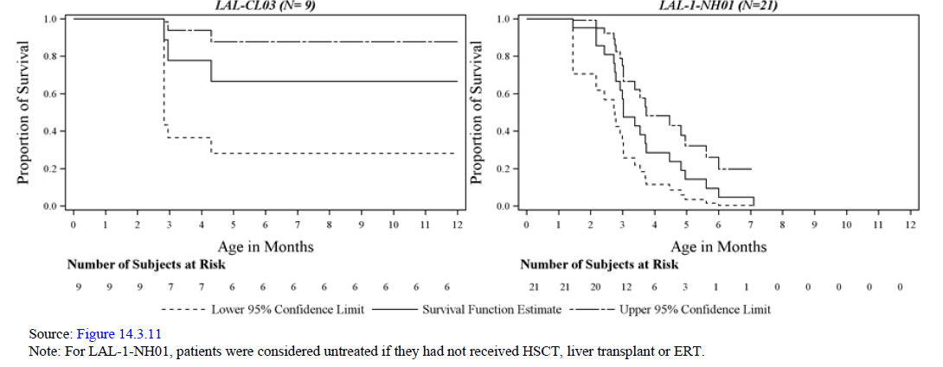

Figure 14: Kaplan-Meier plot of survival from birth to 12 months of age for sebelipase alfa treated subjects in LAL-CL03 (PES) versus untreated patients in LAL-1-NH01

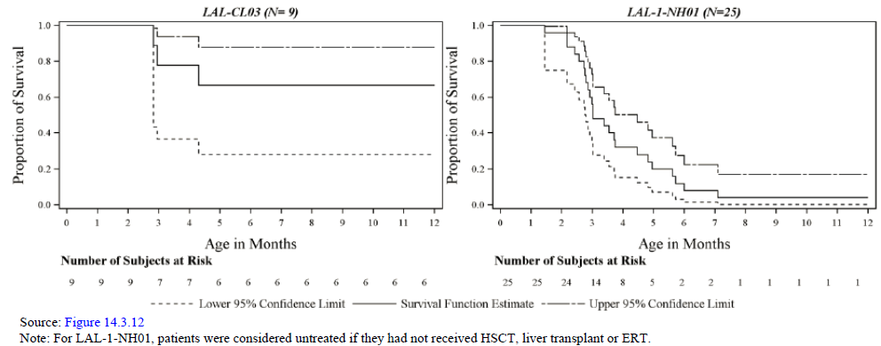

##### Other efficacy results

The ages of the surviving subjects at their last available assessment were 12.0, 15.7, 15.8, 20.4, 25.1, and 42.2 months, and thus the proportion of subjects in the PES surviving to 18 and 24 months of age were 33% (3 of 9 subjects) and 22% (2 of 9 subjects) (Table 12).

Three (33.3%) of the 9 subjects in the PES died prior to the data cut-off for this report (10 June 2014), after having received between 1 and 4 infusions of sebelipase alfa. Median (range) age at death in these 3 subjects was 2.9 months (2.8 to 4.3 months). Cause of death was hepatic failure [information redacted], peritoneal haemorrhage [information redacted], or cardiac arrest [information redacted], respectively, and was assessed as unrelated to study drug.

Table 12: Study LAL-CL03. Proportion of subjects surviving to 18, 24, 30 and 36 months of age, primary efficacy set

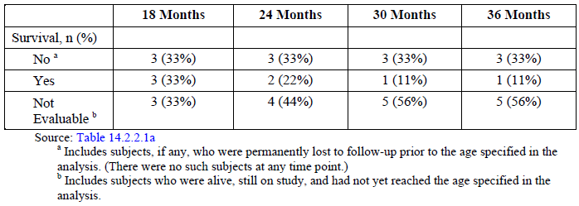

###### Anthropometric measurements

Birth WFA percentiles ranged from 1.13% to 86.43%, with 2 subjects having low WFA percentiles (1.13% and 20.05%), and 6 other subjects having WFA between 53.98% and 86.43% (baseline data were unavailable for 1 subject). Growth deceleration from birth to the baseline assessment in Study LAL-CL03 was observed for all 8 (100%) subjects and at Baseline, the median WFA percentile was 3.08% (n = 8), with individual WFA percentiles ranging from 0% to 11.51% in the 7 subjects with confirmed growth failure, and a WFA percentile of 77.04% in the 1 subject without confirmed growth failure. All 6 subjects who survived beyond Week 4 had increases in WFA percentile during treatment with sebelipase alfa. Three of these subjects achieved WFA near or above the 25th centile and 1 subject achieved WFA above the 90th centile. The 1 subject without confirmed growth failure at enrolment continued to have a WFA above the 75th centile at the data cut-off, after having an initial decline prior to escalating to the 3 mg/kg dose. One subject with the lowest WFA percentile at birth had increases in WFA but remained under the 10th centile with intermittent periods of slower weight gain throughout therapy. Mean WFA percentile initially decreased from Baseline (12.74%) through Week 2 (9.46%), but thereafter showed consistent and marked improvement over time, increasing from 12.41% at Week 4 (n = 6) to 29.83% at Week 48 (n = 4). beyond Month 12, data were limited (Table 13).

Table 13: Study LAL-CL03. Observed values and changes from Baseline in weight for age z-scores and percentiles. Primary efficacy set

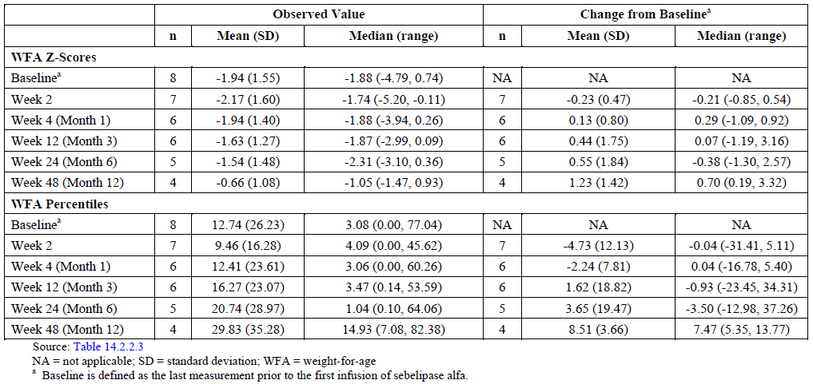

At baseline, the median LFA percentile was 1.80% for the 8 subjects with available data. Four subjects had LFA percentile scores < 1.0% at Baseline, and the other 4 subjects had LFA percentiles of 3.29%, 17.88%, 59.87%, and 80.78%, respectively, with the highest LFA percentile reported for the subject without confirmed growth failure at enrolment Three of the 6 subjects who survived beyond Week 4 had LFA/HFA percentiles that fluctuated over time but showed an overall improvement during treatment with sebelipase alfa: Two other surviving subjects [information redacted] had an initial decrease in LFA percentile on treatment after which LFA returned back to approximately baseline level. One other subject without confirmed growth failure [information redacted] had an LFA percentile of 80.78% at Baseline that remained stable through Week 36 (87.08%) but appeared to decrease slightly thereafter and was 61.41% at the last assessment at Week 60. Mean LFA/HFA percentile initially decreased from Baseline (20.30%, n = 8) through Week 2 (17.11%, n = 7), and thereafter showed an increasing trend over time, with mean percentile scores increasing from 17.53% at Week 4 (n = 6) to 25.23% at Week 48 (n = 4) (Table 14). Data for Mid-Upper Arm Circumference-for-Age (MUCFA), Head Circumference-for- Age (HCFA), BMI-for-Age (BMIFA), and Weight-for-Length (or Height)WFL/WFH, while more limited, supported the trends observed for WFA and LFA.

Table 14: Study LAL-CL-03. Observed values and changes form baseline in length (or height) for age z-scores and percentiles. Primary efficacy set

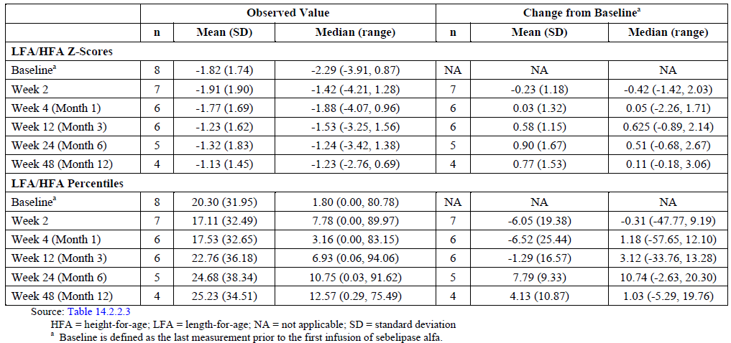

At baseline, the percentages of subjects meeting the definition for underweight, stunting, and wasting based on anthropometric indicators were 50%, 25%, and 25%, respectively. By Week 48 (Month 12), only 1 (25%) of the 4 subjects with available data met criteria for stunting, and no subject met criteria for underweight or wasting.

Overall, growth improvements were observed for all 6 surviving subjects. For WFA percentile, a key measure of growth in this study, 1 subject improved across 2 major centiles, 2 subjects improved across 3 major centiles, 1 subject improved across 4 major centiles, and 1 subject improved across 5 major centiles from Baseline through the last assessment prior to data cut-off. Data for other growth parameters (LFA, MUACFA, HCFA, BMIFA, and WFL) supported the trends observed for WFA.

###### Effects on liver biochemical parameters

At baseline, individual ALT levels ranged from 16.0 to 297.0 U/L (median = 145.0 U/L) for the 9 subjects in the PES, and were above the ULN in 7 (77.8%) subjects. Baseline ALT levels in the 2 subjects who died after the first infusion of sebelipase alfa were 145 U/L [information redacted] and 185 U/L. ALT levels decreased rapidly following initiation of treatment with sebelipase alfa. Reductions in ALT were already evident at Week 1 Median percentage changes from Baseline at Week 1 and Week 4 were ‑31.3%, and ‑66.00%, respectively. Median ALT levels were fairly stable from Week 4 through Week 60, the last assessment for which data were available for more than 1 subject, although a few subjects had fluctuations in ALT over time**.** Of the 6 subjects surviving beyond Week 4, 4 subjects had abnormal ALT levels (> ULN) at Baseline. Normalisation of ALT was observed for all 4 of these subjects during treatment with sebelipase alfa. Two of these subjects achieved normal ALT levels by Week 1, and maintained normal ALT levels through the last assessment prior to the data cut-off. The other 2 subjects initially achieved normal ALT levels at Week 4 and Week 6, respectively, and while ALT continued to be normal to near normal at most subsequent assessments, these subjects each had a further transient elevation in serum transaminases (ALT and AST) shortly prior to the data cut-off. Similar to reduction in ALT levels, AST levels also decreased rapidly following initiation of treatment with sebelipase alfa with reductions apparent as early as Week 1.All 6 subjects who survived beyond Week 4 had abnormal AST levels (> ULN) at Baseline. Normalisation of AST was observed for 4 of these subjects, beginning at Week 1 or Week 5 of treatment with sebelipase alfa. Three of these 4 subjects continued to have normal AST through the data cut-off. The other subject had normal to near normal AST levels with the exception of a single markedly elevated result at Week 24 (89 U/L). At baseline, GGT levels ranged from 14.0 to 1000.0 U/L (median = 46.5 U/L), and were above the ULN in 4 (50.0%) of the 8 subjects with available data. Baseline GGT levels were normal in the 2 subjects who died after the first infusion of sebelipase alfa GGT levels decreased markedly over the first 3 months of treatment with sebelipase alfa, with median reductions from Baseline of ‑6.0 U/L at Week 4 (n = 5) and ‑40.0 U/L at Week 12 (n = 5). Thereafter, GGT was fairly stable through Week 60, at which time the median reduction from Baseline was ‑34.0 U/L (n = 3). Total bilirubin levels at Baseline ranged from 3.0 to 464.0 µmol/L (median = 29.0 µmol/L) in the 8 subjects with available data, and were above the ULN in 3 (37.5%) of these subjects. Total bilirubin levels decreased following initiation of treatment with sebelipase alfa, with a median percentage reduction from Baseline of ‑1.5 µmol/L (range = -34.2 to 0 µmol/L) already apparent by Week 4 (n = 4). Median total bilirubin levels showed further gradual decreases over the next couple months, and were stable thereafter. Direct and/or indirect bilirubin data were available for a subset of subjects. Direct bilirubin was markedly abnormal for the 3 subjects who died One subject surviving beyond Week 4 [information redacted] also had an elevated direct bilirubin level at Baseline (32.5 µmol/L), which normalised by Week 6 of treatment (3.42 µmol/L) and remained normal through the last available assessment (1.71 µmol/L); a similar reduction in indirect bilirubin was observed for this subject. No other relevant trends were observed in direct or indirect bilirubin. Alkaline phosphatase levels at Baseline ranged from 94.0 to 977.0 U/L (median = 186.0 U/L, n = 9), and were above the ULN in 2 (22%) of the 9 subjects. Baseline levels of alkaline phosphatase were normal for the 2 subjects who died. No consistent trends in median or mean alkaline phosphatase levels were observed during treatment with sebelipase alfa. Baseline albumin levels ranged from 12.8 to 40.0 g/L (median = 29.0 g/L, n = 9), and were below the LLN in 4 (44%) of the 9 subjects. Three surviving subjects had low albumin at Baseline, and each of these subjects had an increase in serum albumin during treatment with sebelipase alfa and achieved normal serum albumin by Week 1, Week 4 and Week 16, respectively.

###### Hepatosplenomegaly

Improvement in hepatosplenomegaly was observed with sebelipase alfa treatment. On physical examination, improvement in liver and spleen size (that is, distance below the costal margin) was observed for all 6 subjects with a palpable liver at Baseline (decreases from Baseline ranging from 1.5 to 10 cm at the last assessment) and all 5 subjects who had a palpable spleen at Baseline (decreases from Baseline ranging from 2.5 to 8 cm). A non-palpable liver and spleen were reported for 2 subjects and 5 subjects, respectively, by the last assessment. On abdominal imaging (ultrasound and MRI), improvement in spleen size was observed for all 5 subjects with baseline and post baseline data, and 4 of these subjects also had an improvement in liver size. After the initial improvement, liver and spleen sizes were stable or continued to decrease over time, with the exception of 1 subject who had a worsening splenomegaly that was temporally associated with a switch to qow dosing.

###### Haematological effects

Median baseline haemoglobin was 93.0 g/L (n = 9), and 6 (66.6%) of the 9 subjects had a low haemoglobin level at Baseline. Five subjects achieved transfusion free haemoglobin normalisation (TFHN)[28] of at least 4 weeks prior to the data cut-off for this report. These 5 subjects represent 55.6% of the 9 subjects in the PES and 83.3% of the 6 subjects in the PES who received treatment with sebelipase alfa for at least 4 weeks and could therefore be assessed for short-term TFHN. Based on a Kaplan-Meier analysis, the estimated median time (95% CI) to achieve short-term TFHN for the PES was 4.6 months (0.2 months, not estimable) For the 6 subjects in the PES surviving beyond Week 4, baseline platelet counts were normal in 4 subjects, low in 1 subject (54 x 109/L), and high in 1 subject (563 x 109/L). The one subject with a low platelet count at Baseline had a marked increase in platelets during treatment and achieved a normal platelet count by Week 3 (162 x 109/L), which remained normal with the exception of borderline low results at the last 2 assessments at Week 20 (133 x 109/L) and Week 24 (147 x 109/L). In the other 5 subjects, platelet counts fluctuated over time with an increasing trend apparent in 4 subjects and a decreasing trend within normal range in 1 subject [information redacted]. Platelet counts generally remained normal to near normal in these subjects, with the exception of the subject who already had an elevated platelet count at Baseline. Median and mean platelet counts also showed an increasing trend, particularly over the initial 4 weeks of treatment (Table 15).

Table 15: Study LAL-CL03. Platelet count observed values and changes from Baseline: primary efficacy set

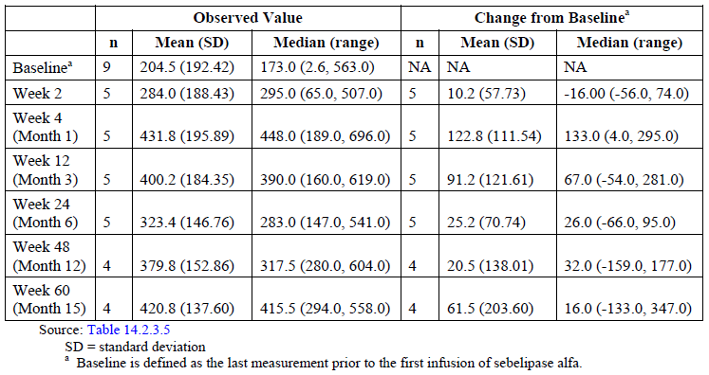

###### Effects on serum lipids

Hypertriglyceridemia was the most common baseline lipid abnormality, with elevated baseline levels observed in 4 of the 6 subjects. All 4 subjects had decreases in serum triglycerides following initiation of sebelipase alfa, and achieved a normal serum TG level, although levels continued to fluctuate over time and were intermittently elevated. Two other surviving subjects had increasing serum triglyceride levels on treatment.

LDL levels decreased in 5 of the 6 surviving subjects during treatment, and normalised in the 2 subjects who had an elevated LDL at Baseline or the first available assessment. One other surviving subject showed an increasing trend in LDL level on treatment, intermittently shifting from normal to abnormal. In the 3 subjects who had data at Baseline and the first 2 weeks of treatment, a transient small elevation in LDL occurred at Week 1, consistent with the mechanism of action of sebelipase alfa. Total cholesterol decreased and normalised in the 2 subjects with elevated baseline levels, and fluctuated between high and normal values in 1 other subject who had an elevated total cholesterol at the first available assessment. Total cholesterol levels in the other subjects were normal or low at Baseline and remained so at all or most assessments on treatment. HDL levels were low in all 6 surviving subjects at Baseline or first assessment, and increased in 5 of these subjects on treatment. Two subjects achieved intermittent normal HDL levels on treatment.

###### Effects on serum ferritin

Serum ferritin decreased rapidly on treatment in all 6 surviving subjects. The median reduction in serum ferritin was ‑122.0 µg/L by Week 1 (n = 4) and ‑269.3 µg/L by Week 6. Ferritin levels normalised in all 4 subjects who had an elevated baseline level; time to normalisation ranged from approximately 1 week to 13 weeks.

**Comment:** Elevations in serum ferritin are consistent with macrophage activation syndrome, a form of HLH that has recently been recognised in the differential diagnosis of LAL Deficiency in infancy (Taurisano, 2014). In critically ill patients, hyperferritinaemia is associated with the severity of the underlying disease, which is consistent with the severe disease profile of the subjects enrolled in this study and especially those with marked elevations of ferritin (Rosário, 2013). The results from this study indicate that sebelipase alfa was effective controlling ferritin levels and the associated inflammatory environment.

###### Effect on diet

Two of the 6 surviving subjects were able to reduce their need for enteral/ parenteral supplements during treatment with sebelipase alfa. Both subjects were receiving TPN/PPN for an extended period during the initial months of therapy, and were able to discontinue routine use of TPN/PPN by Day 250 or Day 59. One of the subjects also discontinued regular use of enteral supplements (Liquigen, complete amino acids) and is now receiving small amount of low-fat solid food. The other 4 surviving subjects were essentially stable with respect to food intake throughout treatment with sebelipase alfa.

###### Development milestones

Development milestones were primarily normal for those subjects who were on treatment with sebelipase alfa for 24 weeks or longer. No subject tested as abnormal in any skill area at any time point, and ‘suspect’ test results were reported in only a few instances in gross motor and language skills. At Week 24, language, fine motor adaptive, and personal social skills were normal in 4 of the 5 subjects and gross motor skills were normal in 2 of the 5 subjects. Data appeared similar at later time points, although much more limited.

##### Overall Comments

* This was the only study which evaluated the effect of sebelipase alfa in infants with LAL deficiency showing evidence of growth failure. This group of patients with LAL deficiency represents a subgroup with serious complications and high mortality and morbidity risks. Subjects in the current study presented with signs and/or symptoms and were diagnosed with LAL Deficiency between birth and 5.8 months of age. Overall, the baseline disease characteristics in this study population, including medical history, laboratory evaluations, and concomitant supportive therapies, indicate that these infants presented with immediately life threatening multi systemic disease. Furthermore, these baseline characteristics were consistent with those reported among the patients in natural history Study LAL-1-NH01, supporting the comparison of survival data and outcomes between these 2 populations. Hence the study design and primary efficacy endpoint of survival was appropriate.
* Dyslipidaemia is common in patients with LAL Deficiency and has been associated with accelerated atherosclerosis, which may become more apparent in children and adults as the disease develops in the absence of treatment. While lipid abnormalities and the associated risk of accelerated atherosclerosis and cardiovascular complications are important clinical outcomes contributing to morbidity and mortality in the broader LAL Deficiency patient population, for infants, early death continues to be largely due to severe failure to thrive and/or rapidly progressive liver disease in the absence of a treatment such as ERT that addresses the root cause of the disease.
* Sebelipase alfa improves survival in subjects presenting with LAL Deficiency in infancy, with 67% (exact 95% CI = 29.93%, 92.51%) of sebelipase alfa-treated subjects surviving to 12 months of age compared with 0% (0, 16.11%) of untreated patients in a historical control group. Sebelipase alfa produced clinically meaningful improvements in multi systemic and life threatening manifestations of LAL Deficiency presenting in infancy, including improvements in growth (WFA percentile), biochemical markers of liver injury, hepatosplenomegaly, haematological abnormalities such as anaemia and thrombocytopenia, serum ferritin and lipid profile. Initiation of sebelipase alfa at doses up to 1 mg/kg qw (by IV infusion over 2 hours) resulted in improvements in ALT and AST levels and weight gain within the first several weeks of treatment. Dose adjustment to 3 mg/kg qw was associated with additional improvements in some parameters including weight gain, lymphadenopathy, and serum albumin. These results suggested that disease stabilisation and improvement in some disease related abnormalities is achieved with a dose of 1 mg/kg qw but higher doses of sebelipase alfa may be required to achieve an optimal response for some clinical outcome measures. It is important to note that the option to reduce infusion duration to 1 hour was not evaluated in infants.

#### Study LAL-CL04

This was an open label, Phase II, multicentre extension study in adult subjects with liver dysfunction due to LAL Deficiency who previously received treatment in the Phase I/II, repeat dose, dose escalation Study LAL-CL01. The study was conducted at 11 sites in USA, UK, France, Canada and the Czech Republic from 12 December 2011 to 5 February 2014. The primary objective was to evaluate the long term safety and tolerability of Sebelipase Alfa in adult subjects with liver dysfunction due to LAL Deficiency. The secondary objectives were to evaluate the long term efficacy, repeat dose PKs and effect on PD biomarkers of sebelipase alfa. After completing all follow-up assessments for Study LAL-CL01 (and no sooner than 4 weeks after the last dose in that study), eligible subjects initiated treatment in the extension study[29] at a once weekly (qw) dose of sebelipase alfa equivalent to the doses administered in Study LAL‑CL01 (that is, 0.35 mg/kg qw, 1 mg/kg qw, or 3 mg/kg qw for 4 weeks). After the 4th weekly infusion, all subjects moved to an every other week (qow) dosing regimen of 1 or 3 mg/kg (Figure 15). Subsequent dose modifications may have been considered for individual subjects based on observed safety and tolerability and/or clinical response[30] to treatment after Week 12. This is an ongoing study and the CSR provided in this submission includes data up to 05 February 2014, a date at which 7 of the 8 subjects enrolled had completed the Week 104 visit.

Figure 15: Study LAL-CL04. Study flow diagram

Figure 15: Study LAL-CL04. Study flow diagram
After completing all follow-up assessments for Study LAL-CL01 (and no sooner than 4 weeks after the last dose in that study), eligible subjects initiated treatment in the extension study  at a once weekly (qw) dose of sebelipase alfa equivalent to the doses administered in Study LAL CL01 (that is, 0.35 mg/kg qw, 1 mg/kg qw, or 3 mg/kg qw for 4 weeks). After the 4th weekly infusion, all subjects moved to an every other week (qow) dosing regimen of 1 or 3 mg/kg (Figure 15). Subsequent dose modifications may have been considered for individual subjects based on observed safety and tolerability and/or clinical response

Efficacy measures included change and/or percent change in liver and spleen volumes (by MRI) and liver and spleen fat content by multi-echo gradient-echo (MEGE) MRI and 1H-magnetic resonance spectroscopy (1H-MRS) (if available). An assessment of hepatic histopathology was also conducted in those subjects who agreed to an optional liver biopsy. The effect of ADAs on the efficacy of sebelipase alfa was also to be explored.

Overall, 8 of the 9 subjects who completed LAL-CL01 were treated in LAL-CL04.All subjects were White, 75% were male with mean age of 30.3 years. All subjects except one were non-obese (that is, body mass index (BMI) < 30.0 kg/m2). The age of subjects at the time of diagnosis of LAL Deficiency was variable (range 4 to 42 years). The time between diagnosis and enrolment in LAL-CL04 ranged from 2 to 36 years. Medical history findings were consistent with those expected in this patient population as 6 subjects had a medical history of hepatomegaly and/or splenomegaly and 1 subject had prior biopsy evidence of hepatic fibrosis. All 8 (100%) subjects had a medical history of dyslipidaemia, 6 (75%) also had a history of cardiovascular conditions; 3, 2 and 2 subjects had a medical history of elevated transaminases, elevated bilirubin and diarrhoea, respectively. Six (75%) subjects were receiving treatment with lipid modifying therapies, including statins (5 subjects (63%)), ezetimibe (1 subject (13%)), and other medications (2 subjects (25%)). There were 219 protocol deviations[31] and all were minor and not considered to affect the validity or interpretation of the study results.

##### Results

###### Liver Volume and Fat Content[32]

At the LAL-CL04 baseline the mean liver volume was 1.045 ± 0.13 multiples of normal (MN) and mean absolute decreases in liver volume (MN) from LAL-CL04 baseline were ‑0.096 (n = 8), ‑0.092 (n = 7), -0.096 (n = 7) and -0.177 (n = 5) at Week 10 or 12, Week 24, Week 52 and Week 104, respectively (Table 16). Reductions in liver fat content[33] were seen within 10/12 weeks of initiation of treatment in LAL-CL04 with further improvements through the last available time point. Mean percentage decreases in liver fat content from LAL-CL04 Baseline of 30% (n = 5), 15% (n = 4), 37% (n = 4), and 39% (n = 2) were observed at Week 10 or 12, Week 24, Week 52, and Week 104, respectively (Table 17). Summaries of the spleen fat content were not created as the low values made the data difficult to interpret. However, reductions were observed over time in 5 subjects where baseline data were available, Pathology reports of post treatment liver biopsy assessments were available in only 2 subjects limiting interpretation. However, there appeared to be a marked reduction in fat content and fibrosis in both of these subjects following sebelipase alfa treatment.

Table 16: Study LAL-CL04. Change over time in liver volumes (MN) from LAL-CL04 baseline assessed by MRI by visit FAS

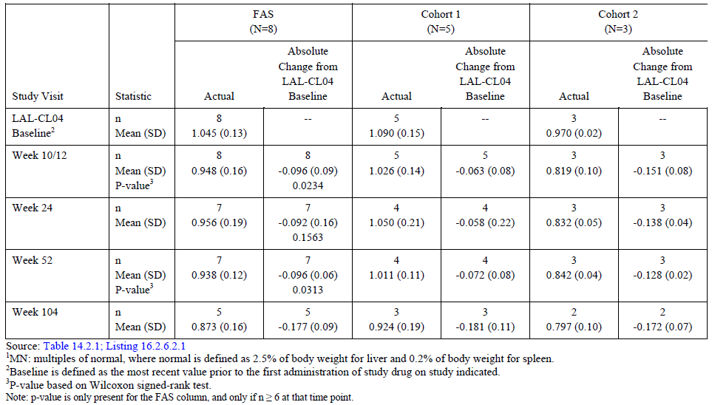

Table 17: Study LAL-CL04. Change over time in liver fat content from LAL-CL04 baseline by multi echo gradient echo MRI FAS

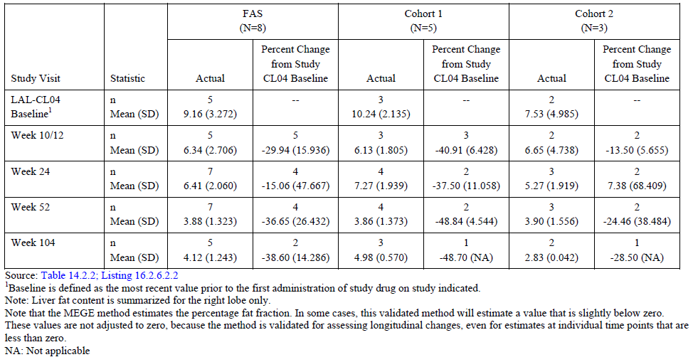

###### Liver parameters

Both mean ALT and AST were increased at the LAL-CL04 baseline relative to the end of treatment value in LAL-CL01. Re-initiation of treatment in LAL-CL04 produced a rapid decline in ALT and AST. The improvements in ALT and AST were maintained after the transition from qw to qow dosing. A transient increase in mean AST was noted at Week 25 and means for both ALT and AST were within the normal range from Week 32 through Week 104. Six of 8 (75%) subjects had ALT > ULN at the LAL-CL01 baseline, 5 of 8 (63%) subjects had an ALT > ULN at the LAL-CL04 baseline, and all normalised on treatment. No subject had an ALT value > ULN after Week 25. Five of 8 (63%) subjects had an AST > ULN at LAL-CL01 baseline, 4 of 8 (50%) subjects had an AST > ULN at the LAL-CL04 baseline, and all but 1 of the 6 (87%) subjects with available values normalised at Week 104 (Table 18). Reductions in GGT and ALP were observed; mean decrease from Baseline to Week 104 was observed for both GGT (from 54 to 23 U/L) and ALP (91 to 66 U/L). With the exception of one subject total bilirubin levels were within the normal range and remained stable over time through Week 104.Albumin levels remained in the normal range in all subjects.

Table 18: Study LAL-CL04. Number (%) of subjects with transaminases > ULN

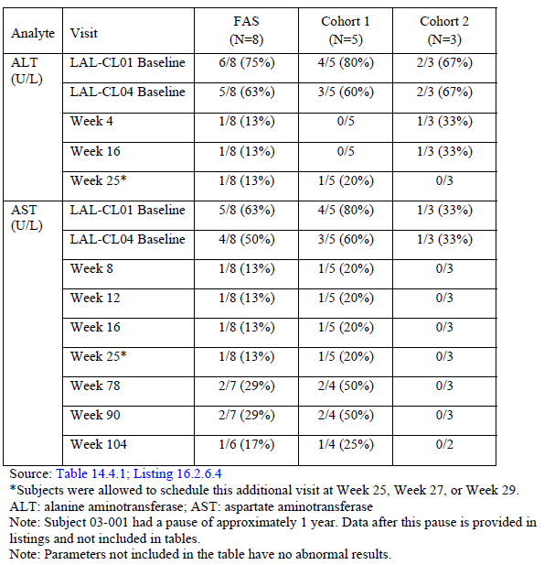

###### Serum lipids

Increases in LDL cholesterol and triglycerides were seen after 4 weekly infusions of sebelipase alfa in LAL-CL01 which rapidly reversed following discontinuation of therapy. Consistent with mobilisation of pathological accumulations of lipids, increases in total and LDL cholesterol were also observed at Week 4 in LAL-CL04. No AEs were associated with these transient increases in lipids. As expected with continued treatment with sebelipase alfa, the mean LDL and triglycerides decreased to below original baseline levels at Week 12 and remained so through Week 104 on the qow dosing regimens. Over time, decreases were observed in LDL, total cholesterol, and triglycerides. Mean HDL increased by 9 mg/dL (0.24 mmol/L; p = 0.0156; 29%) at Week 52 and by 5 mg/dL (0.13 mmol/L; p = 0.1250; 18%) at Week 104. At the LAL-CL01 baseline only 25% (2 of 8) of subjects had LDL levels < 00 mg/dL (< 2.59 mmol/L) compared to 71% (5 of 7) at Week 104 and 29% (2 of 7) of subjects with available LDL levels had an LDL level ≤ 40 mg/dL (≤ 1.03 mmol/L) at Week 104. The effects of sebelipase alfa on the lipid profile were seen in subjects treated with LLM and those without (Table 19). All 7 subjects who received the full set of infusions through Week 104 showed decreases from their original LAL-CL01 Baseline values in total cholesterol and LDL, as did one subject who paused therapy between Weeks 40 and 88. In addition, most had increases in HDL and decreases in TGs.

Table 19: Study LAL-CL04. By subject change from LAL-CL01 and LAL-CL04 baseline for serum lipids in LAL-CL04

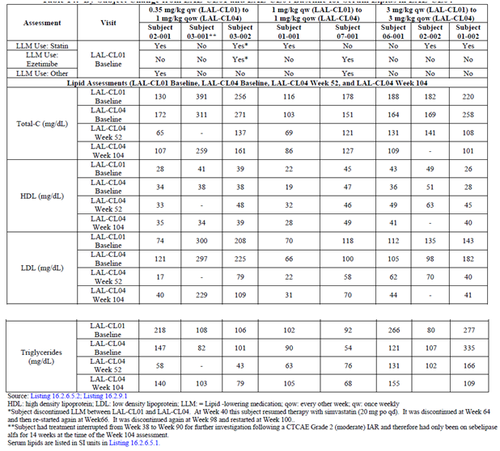

###### Serum ferritin and high sensitivity C-Reactive protein

Mean serum ferritin decreased from LAL-CL01 baseline to Week 104 (227 µg/ L to 139 µg/L, p = 0.0313). Mean high sensitivity C-reactive protein (hs-CRP) also showed slight reduction from LAL-CL01 baseline to Week 104 (0.23 mg/dL (2.3 mg/L) to 0.11 mg/dL (1.1 mg/L), p = 0.1563). No clinically meaningful trends were apparent over time in any of the QOL measures (FACIT-Fatigue scale and CLDQ).

**Comment:** Results from Study LAL-CL04 showed that the previously observed early benefits of enzyme replacement with sebelipase alfa reported in Study LAL-CL01 can be achieved with qow dosing and continue through Week 104 with sustained normalisation of transaminases, sustained improvements in serum lipids, and reduction in fat fraction in the liver in adult subjects with LAL Deficiency.

#### Studies LAL-1-NH01 and LAL-2-NH01

##### LAL-1-NH01

Study LAL-1-NH01 was a was a multinational, multicentre natural history study of 35 patients diagnosed with LAL Deficiency presenting in infancy (historically called Wolman disease or LAL Deficiency/Wolman phenotype). Details of the study design, objectives, methodology, demographics, disease characteristics and results including liver, lipid, anthropometric parameters and survival were provided.

The major findings of the retrospective, natural history Study LAL-1-NH01 were:

* Survival was poor, irrespective of treatment, with a median age at death of 3.71 months and a K-M estimate for probability of survival past 12 months of 0.114 (95% CI = 0.009, 0.220) for all eligible patients in this study (Table 20, Figures 16, 17 and 18).
* Survival was particularly poor in 21 of the 26 patients with early growth failure who were untreated. K-M analyses estimated zero probability of survival past 12 months of age, and none of these patients survived beyond 8 months of age. Thus, the presence of early growth failure appears to be predictive of the most severe and rapidly progressive presentation of LAL Deficiency.
* Despite the consistently poor outcome, there was some variability in the nature, onset, and severity of clinical manifestations among the patients in this study, supporting the current scientific understanding of LAL Deficiency as a disease spectrum.
* In addition to growth failure, hepatic injury, as evidenced by elevated transaminases, was also common. There was evidence early in life of liver fibrosis and cirrhosis in association with liver steatosis. Rapidly progressive liver disease was also seen and was likely an important contributor to early mortality.
* Disease progression was rapid for a majority of patients, with a median of 1.1 months from symptom onset to diagnosis and 0.673 months from diagnosis to death.

Table 20: Study LAL-01-NH01 Summary statistics for age at death

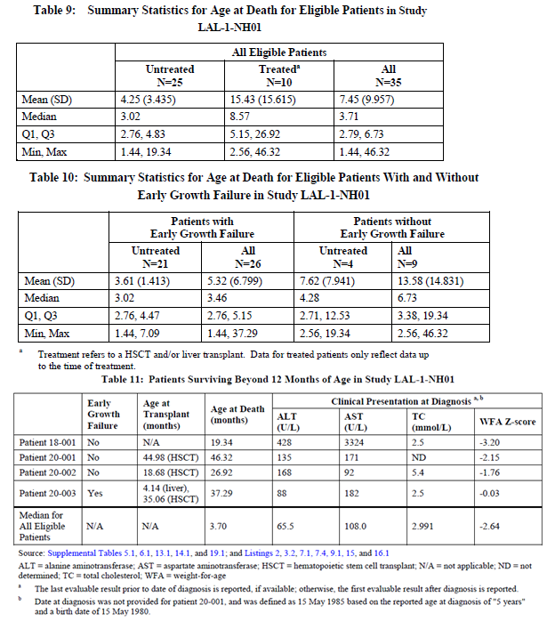treatment refers to a HSCT and or liver transplant. data for treated patients only reflect data up to the time of treatment.

Figure 16: Study LAL-01-NAH01 Kaplan-Meier Plot of Time from Birth to Death - All Eligible Patients

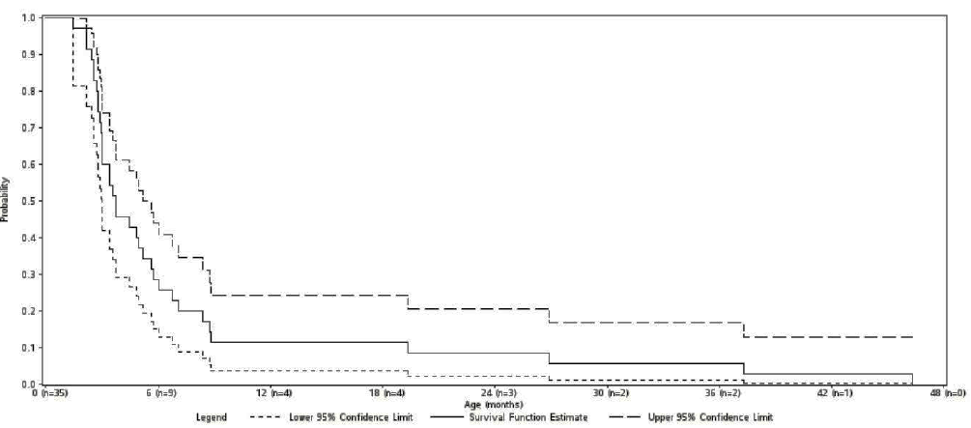

Figure 17: Kaplan-Meier plot of time from birth to death - eligible patients who were untreated (did not receive a hematopoietic stem cell transplant, liver transplant or ERT)

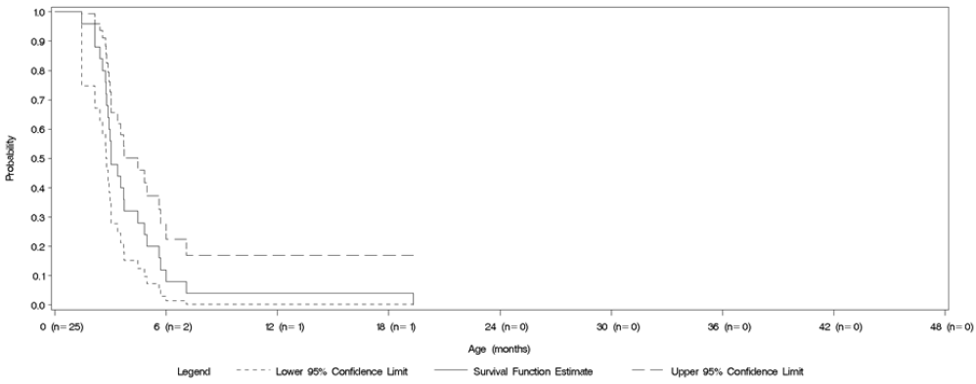

Figure 18: Kaplan-Meier plot of time from birth to death for eligible patients with early growth failure

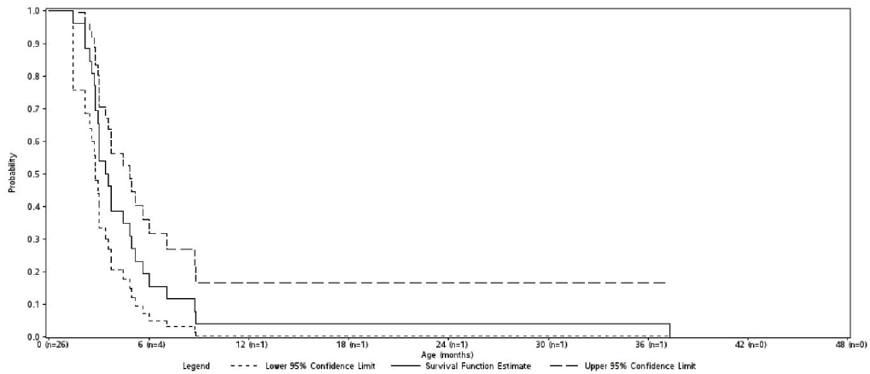

Study LAL-01-NH01 provided the first systematic evaluation of the natural history of LAL deficiency in infants based on retrospective data collected and summarized for 35 eligible patients with a confirmed diagnosis of LAL Deficiency prior to 2 years of age. Patients were enrolled at 18 centres in 6 countries, based on eligibility criteria that were defined to ensure enrolment of the broadest possible population in order to fully characterize the clinical presentation in infants across its entire spectrum.

The data from this study largely confirm previously published findings that LAL Deficiency in infants is characterized by severe growth failure and progressive liver disease that lead to mortality within the first year of life in a majority of patients, irrespective of any treatments (for example, HSCT) or supportive interventions.

The study also characterised the presentation and progression of LAL Deficiency in a subgroup of patients who had early growth failure within the first 6 months of life, and did not receive HSCT or ERT. This subgroup was identified using growth failure criteria that closely mirror the eligibility criteria for Study LAL-CL03 and served as a relevant historical control to support interpretation of data for patients receiving ERT (sebelipase alfa) in LAL-CL03.

##### LAL-02-NH01

LAL-02-NH01 was an observational, multicentre study using data from the clinical charts of 48 children and adults presenting with LAL Deficiency and represents the largest case review of subjects with LAL Deficiency, and is the first that combined both retrospective and prospective data collection. The study design, endpoints and results were provided. Overall, data were collected from the 48 subjects with a confirmed diagnosis of LAL Deficiency and prospective data were generated in a subset of 24 of these subjects. Overall, the study data confirms previously published findings that LAL deficiency is predominantly a paediatric disease that primarily targets the liver, causing progressive hepatic dysfunction that often leads to liver failure and the need for palliative transplant procedure. Other main results from this study were as follows:

* Persistently elevated serum transaminases and lipids is a consistent feature supporting the utility of these markers as relevant endpoints for assessment of therapeutic interventions.
* Despite the clinical heterogeneity, there is a fairly unique hepatic histology, characterized by diffuse microvesicular steatosis frequently accompanied by fibrosis and cirrhosis. Unlike non-alcoholic steatohepatitis and alcoholic liver disease, steatosis in subjects with LAL deficiency appears to persist even throughout the end-stage hepatic dysfunction and is frequently found in explanted livers during transplantation.
* There is a high rate of liver disease progressing to end-stage, requiring liver transplant in young children, adolescents, and adults.
* Intervention with LLM and/or DI has limited effectiveness in normalizing markers of disease activity, such as serum lipids or hepatic transaminases.

#### Evaluator commentary: other efficacy studies

Although interpretation of results from the ‘other efficacy studies’ discussed above was limited by their open label, uncontrolled study design, results from Study LAL-CL03 provided valuable information regarding efficacy and safety of sebelipase alfa in treatment of infants with growth failure which is a subgroup with poor prognosis due to high risk of mortality and morbidity. Study LAL-CL04 provided evidence for long term efficacy of ERT with sebelipase alfa in adults with LAL-D.

### Analyses performed across trials: pooled and meta-analyses

Formal pooled analyses of efficacy were not performed but some summaries were provided in Module 2.7.3 to enable cross-study comparisons.

### Evaluator’s conclusions on clinical efficacy

LAL Deficiency is a very rare, serious and life threatening lysosomal storage disorder caused by mutations affecting a single gene. It is associated with significant morbidity and mortality affecting individuals from infancy through to adulthood. LAL-D presenting in infants is a medical emergency with rapid disease progression over a period of weeks that is typically fatal within the first 6 months of life. Current treatment options only include supportive therapies and there are no approved treatments addressing the root cause of the disease.

The main evidence for efficacy of sebelipase alfa was provided by the well-conducted, Phase III, double blind, placebo controlled Study LAL-CL02 involving 66 patients with LAL-D (children and adults, with 71% aged > 18 years). The study was conducted in a broad range of subjects at different stages of disease progression including subjects with histologically confirmed cirrhosis and different genotypes. LAL-CL03 was the only study which evaluated the effect of sebelipase alfa in 9 infants with growth failure. This group of patients with LAL deficiency represents subgroup with serious complications and high mortality and morbidity risks. Overall, subjects enrolled in these 2 main studies were representative of the target patient population for the proposed indication.

In pivotal Study LAL-CL02, ERT with sebelipase alfa 1 mg/kg every other week (administered by IV infusion over 2 hours with option to reduce infusion duration to 1 hour if tolerated) during the 20 week double blind treatment period resulted in clinically meaningful reductions in ongoing liver cell injury, as evidenced by statistically significant improvements in the primary endpoint of ALT normalisation over placebo, with marked decreases in ALT and AST levels. Reductions in liver cell injury were accompanied by clinically relevant reductions in other markers of liver dysfunction, including GGT and bilirubin. Sebelipase alfa also improved LAL Deficiency related dyslipidaemia, with clinically meaningful and statistically significant reductions in LDL-c accompanied by statistically significant decreases in TG, increases in HDL-c, and favourable changes in other abnormalities associated with increased risk of ASCVD. Sebelipase alfa produced statistically significant decreases in liver fat fractions assessed by MEGE MRI and reductions in liver and spleen volume reflecting reductions in lysosomal lipid accumulation, which is directly related to LAL enzyme deficiency which is the root cause of the disease. Clinical endpoints such as cardiovascular morbidity/ mortality or effects on liver histopathology would have required larger sample size with longer double blind treatment periods which was not possible due to the low prevalence and variable disease progression associated with this multisystem disorder. During the open label treatment period, these improvements were maintained in the subjects treated with sebelipase alfa during the double blind period, and a similar pattern of response was observed in subjects switched from placebo to 1 mg/kg qow sebelipase alfa.

In Study LAL-CL03, 9 infants with LAL-D and growth failure were treated with sebelipase alfa (1 mg/kg every week with option to increase dose to 3 mg/kg for infants who present with rapidly progressive disease administered by IV infusion over 2 hours). These infants presented with immediately life threatening multi systemic disease and their baseline characteristics were consistent with those reported among the patients in natural history Study LAL-1-NH01, supporting the comparison of survival data and outcomes between these 2 populations. Hence the study design and primary efficacy endpoint of survival was appropriate. Efficacy of sebelipase alfa was demonstrated in this subgroup of patients with poor prognosis with 67% (95% CI = 29.93%, 92.51%) of sebelipase alfa-treated subjects surviving to 12 months of age compared with 0% (0, 16.11%) of untreated patients in a historical control group. Sebelipase alfa also produced clinically meaningful improvements in growth (WFA percentile), biochemical markers of liver injury, hepatosplenomegaly, haematological abnormalities such as anaemia and thrombocytopenia, and lipid profile.

Results from Study LAL-CL04 showed that the previously observed early benefits of enzyme replacement with sebelipase alfa that were reported in LAL-CL01 can be achieved with qow dosing and continue through Week 104 with sustained normalisation of transaminases, sustained improvements on serum lipids, and reduction in fat fraction in the liver in adult subjects with LAL Deficiency.

Overall, there was adequate evidence to support efficacy of sebelipase alfa for long term enzyme replacement therapy (ERT) in patients of all ages with lysosomal acid lipase deficiency (LAL-D).

The efficacy sections of the proposed PI are satisfactory.

## Clinical safety

### Studies providing evaluable safety data

Six clinical studies have been initiated to evaluate sebelipase alfa treatment in infants, children, and adults with LAL Deficiency. (Studies LAL-CL03 and LAL-CL08 in infants, Studies LAL-CL02 and LAL-CL06 included children and adults, and Studies LAL-CL01 and LAL-CL04 included adults only) An initial comprehensive integrated safety analysis (hereafter the Integrated Safety Analysis)[34] and an updated integrated safety analysis of relevant new safety information (hereafter the D120 Safety Update)[35] were conducted (Table 21). The D120 Safety Update was based on a dynamic database rather than on a cleaned, locked database. The pooling of data for the integrated analyses supporting this application was restricted to subjects who were administered at least 1 dose (partial or complete) of sebelipase alfa in the 4 fully enrolled studies included in the Integrated Safety Analysis (Pooled Safety Set) and the 4 fully enrolled studies and 2 additional ongoing studies included in the D120 Safety Update (Updated Pooled Safety Set), Adverse events for both the Pooled Safety Set and the Updated Pooled Safety Set were coded using the Medical Dictionary for Regulatory Activities (MedDRA), Version 17.0.

Pooled safety assessment was conducted to determine if any safety signals would be revealed that were not otherwise evident in the individual clinical studies but these exploratory analyses across the entire enrolled subject population was limited due to differences in the rate of disease progression, frequency of intercurrent illness and requirements for invasive procedures for disease management. Furthermore, management of patients during the treatment period with the study drug varied across subject populations from infants with rapidly progressive disease, who are frequently hospitalised due to more severe symptoms, to children and adults, whose progression to serious complications is more variable.

Safety information was also available for 3 patients who received sebelipase alfa treatment under a compassionate use protocol. Data from the 2 observational, non-interventional studies (LAL-1-NH01 and LAL-2-NH01) were not included in the pooled safety set and only used as reference to historical controls in comparison to patients treated with sebelipase alfa.

Table 21: Completed and ongoing studies with sebelipase alfa included in pooled safety set and/or the updated pooled safety set

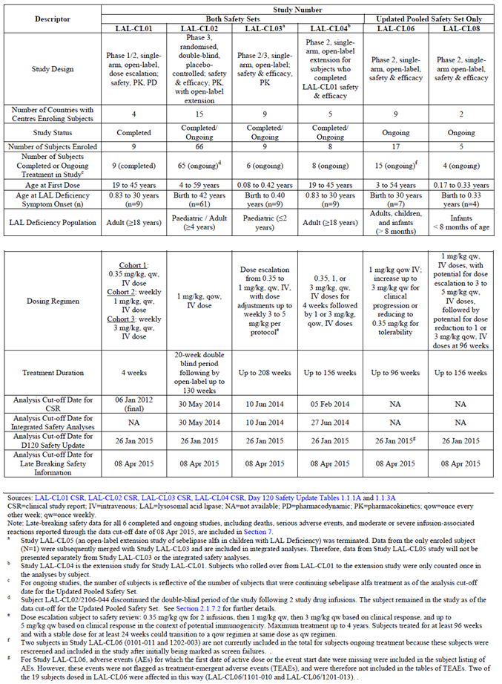

Table 22 provides the parameters examined in the overall and subgroup summaries of results for the Integrated Safety Analyses and the D120 Safety Update.

Table 22: Analyses and subgroups for the sebelipase alfa pooled safety set and updated pooled safety set

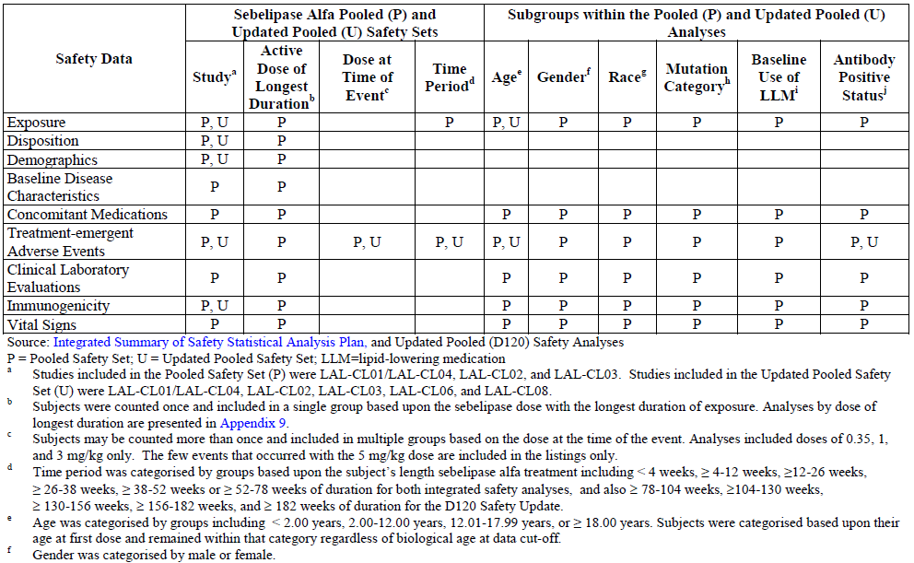

#### Pivotal studies that assessed safety as the sole primary outcome

None.

#### Pivotal and/or main efficacy studies

##### LAL-CL02

An ongoing Phase III multicentre, multinational, randomised placebo- controlled study of sebelipase alfa in 66 children and adults with LAL Deficiency. Safety endpoints included the incidence of AEs, SAEs and IARs; changes from Baseline in 12-lead ECGs[36] and clinical laboratory tests[37] (haematology, serum chemistry (including lipid panel), and urinalysis); changes in vital signs[38] during and post-infusion; physical examination[39] findings; use of concomitant medications/therapies; and characterisation of ADAs including proportion antibody positive, time to antibody positivity, ADA titre by time point, peak ADA titre, and time to peak ADA titre. The effect of ADAs on the safety of sebelipase alfa also was explored, in particular, the relationship between ADA positive subjects and the incidence of IARs. An independent safety committee (SC) appointed by the sponsor provided additional oversight of subject safety in this study through periodic and ad-hoc reviews of safety data.

#### Other studies

##### Other efficacy studies

###### LAL-CL03

An ongoing Phase II/III multicentre, multinational, single arm, open label, repeat dose, dose escalation study of sebelipase alfa in 9 infants with documented growth failure or other clinical evidence of a rapidly progressive course of LAL Deficiency prior to the age of 6 months.

###### LAL-CL04

An ongoing Phase I/II, open label, extension study in 9 adults who previously received 4 doses of sebelipase alfa in Study LAL-CL01 to assess the long term safety, tolerability, and efficacy of sebelipase alfa at 2 dose levels (1 and 3 mg/kg every other week (qow)).

##### Studies with evaluable safety data: dose finding and pharmacology

###### LAL-CL01

A completed multinational, first-in-human, Phase I/II open label dose escalation study in 9 adults with liver dysfunction due to LAL Deficiency.to assess the safety, tolerability, PK and PDs of 3 dose levels of sebelipase alfa (0.35 mg/kg, 1 mg/kg, and 3 mg/kg).

##### Studies evaluable for safety only

None.

### Studies that assessed safety as the sole primary outcome

Not applicable.

### Patient exposure

In the Integrated safety database across 4 studies, a total of 84 subjects with LAL Deficiency have received treatment with sebelipase alfa, including 9 infants, 47 children, and 28 adults.

Across the 6 studies included in the D120 safety update, 106 subjects with LAL Deficiency have received treatment with sebelipase alfa, including 14 infants, 57 children, and 35 adults.

Table 23 provides the summary of sebelipase alfa exposure by study and overall within each dosing regimen for the Pooled Safety Set. Overall, majority of subjects (71/84 (84.5%)), mainly from Study LAL-CL02 received sebelipase alfa 1 mg/kg qow. The median duration of exposure was 5.13 months (range of 0.03 to 29.14 months) and the longest duration of exposure was in the 3 mg/kg qow dosing regimen administered largely to subjects from Study LAL‑CL01/LAL‑CL04, wherein 3 subjects received a median of 27.17 months of treatment (range of 23.95 to 27.56 months), while one subject in Study LAL-CL03 received 3 mg/kg qow for 7.59 months. The median durations of exposure in the 0.35 mg/kg qw and 5 mg/kg qw dosing regimens were low (0.46 and 1.61 months, respectively).

Table 23: Duration of study drug exposure in the pooled safety set overall and by study

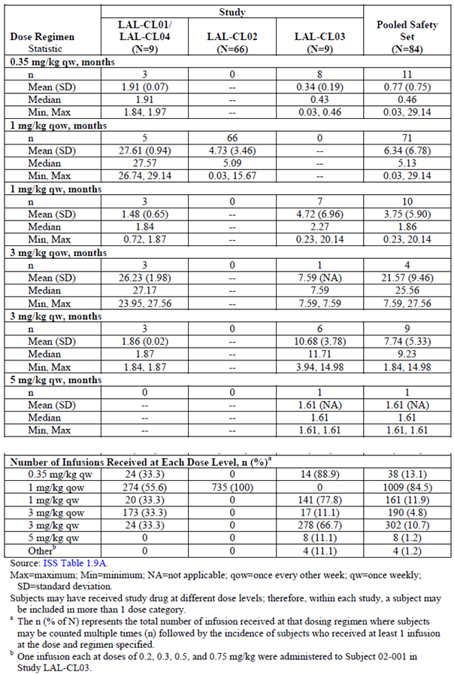

The greatest number of sebelipase alfa infusions (1,009) was administered using the 1 mg/kg qow dosing regimen, which corresponded to the longer duration of treatment at that dose level. There were 302, 190 and 161 infusions administered using the 3 mg/kg qw, 3 mg/kg qow, and 1 mg/kg qw dosing regimens, respectively. Few infusions were administered using the 0.35 mg/kg qw or 5 mg/kg qw dosing regimens (38 and 8 infusions, respectively).

Similar trends were observed in terms of sebelipase alfa exposure by study and overall within each dosing regimen for the Updated Pooled Safety set (Table 24).

**Table 24: Duration of sebelipase alfa exposure in the updated pooled safety set overall and by study**

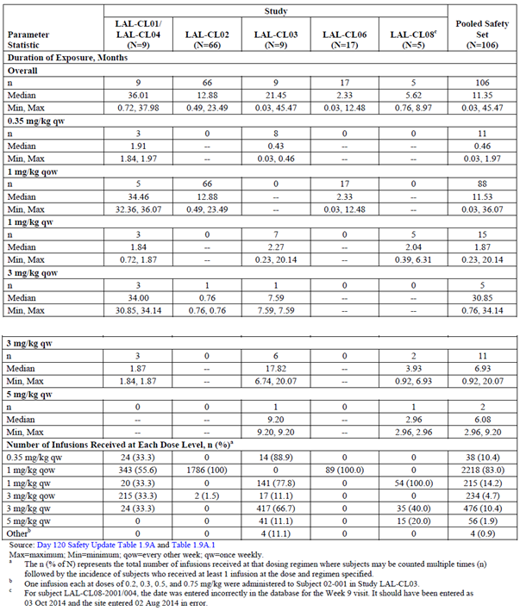

Of the 84 subjects treated with sebelipase alfa in the Pooled Safety Set, 9 were < 2 years of age, 24 were 2 to 12 years of age, 23 were 12.01 to 17.99 years of age, and 28 were ≥ 18 years of age at time of first dose[40]. For subjects < 2 years of age (all infants from Study LAL-CL03), the longest median treatment duration was in the 3 mg/kg qw dose (11.71 months)[41] and a total of 295 infusions were administered. For subjects 2 to 12 years of age (all children from Study LAL‑CL02), the median treatment duration was 5.16 months; all subjects in this category were treated using the 1 mg/kg qow dosing regimen and a total of 295 infusions were administered. For subjects 12.01 to 17.99 years of age (all children from Study LAL-CL02), the median treatment duration was 3.25 months; all subjects in this category were treated using the 1 mg/kg qow dosing regimen and a total of 204 infusions were administered. For subjects ≥ 18 years of age (included adults from Studies LAL-CL02 and LAL-CL01/LAL-CL04), the longest median treatment durations were in the 1 mg/kg qow and 3 mg/kg qow dosing regimens (5.75 and 27.17 months, respectively). The long term exposure to 3 mg/kg qow was obtained from the long term extension Study (LAL-CL04) which included subjects ≥ 18 years of age at the time of study entry. Cumulatively, 683 infusions were administered using these dosing regimens.

Of the 84 subjects treated with sebelipase alfa in the Pooled Safety Set, 44 were male and 40 were female. Between genders, median treatment durations within each treatment regimen were relatively similar with the following exceptions: In the 3 mg/kg qw dosing regimen, median treatment duration was greater in female subjects (11.43 months) compared to male subjects (6.59 months); In the 3 mg/kg qow dosing regimen, median treatment duration was greater in male subjects (27.17 months) compared to female subjects (23.95 months).

In the Pooled Safety Set, majority of subjects were White (81.0% (68/84)). Two subjects were of Japanese descent (2.4% (2/84)) and 10 were Hispanic (11.9% (10/84)). With respect to mutation category, the majority of subjects were heterozygous common (51.2% (43/84)) as compared to homozygous common (26.2% (22/84)) or having an ‘Other’ mutation (22.6% (19/84)). For the Pooled Safety Set, the median age (range) at onset of LAL Deficiency symptoms was 4.58 (0.00 to 42.42) years and the median age (range) at first dose was 13.63 (0.08 to 59.25) years. The majority were (47/84 (56.0%)) paediatric subjects at the age of first dose; 24/84 (28.6%) were in the 2.00 to 12.00 years age group and 23/84 (27.4%) were in the 12.01 to 17.99 years age group. The remaining subjects were categorised as adults ≥ 18 years of age (28/84 (33.3%)) or infants < 2 years of age (9/84 (10.7%)) at first dose. Similar demographics and baseline disease characteristics were observed in the D120 Safety Update set.

Overall, the most commonly used concomitant medications included pain relievers/antipyretics (for example, paracetamol and ibuprofen) and LLMs (for example, simvastatin, atorvastatin, cholestyramine). Other concomitant medications of note included vitamin K and heparin (Study LAL-CL03), and ursodeoxycholic acid (Study LAL-CL01/CL04 and Study LAL-CL02). Of the 84 subjects treated with sebelipase alfa in the Pooled Safety Set, 35 were using at least 1 LLM at Baseline, and 49 were not using an LLM at Baseline. Between the LLM dosing categories, median treatment durations and the numbers of infusions were similar with the following exceptions:

* Median treatment duration for subjects treated using the 3 mg/kg qow dosing regimen was greater in subjects who were using LLMs at Baseline (25.56 months) compared with subjects who were not using LLMs at baseline (17.58 months)
* Median treatment duration for subjects using the 3 mg kg qw dosing regimen was greater in subjects who were not using LLMs at Baseline (9.23 months) compared with subjects who were using LLMs at baseline (6.93 months)
* number of infusions administered using the 1 mg/kg qw dosing regimen was substantially greater in subjects who were not using LLMs at baseline (127) compared with subjects who were using LLMs at Baseline (34).

In the Pooled Safety Set, 84 subjects received sebelipase alfa treatment and 79/84 (94.0%) were actively continuing sebelipase alfa treatment as of the data cut-off. Three subjects (3/84 (3.6%)) died while on-treatment during Study LAL-CL03. One subject discontinued from treatment in the double blind period of Study LAL-CL02 but remained in the study and was later successfully rechallenged and 1 subject from Study LAL-CL01 did not continue treatment in extension Study LAL-CL04. In the Updated Pooled Safety Set, 106 subjects received sebelipase alfa treatment, and 98 subjects (92.5%) were actively continuing sebelipase alfa treatment as of the data cut-off date. A total of 5 subjects died while on-treatment, including 3 infants in Study LAL-CL03 who died prior to the data cut-off for the Pooled Safety Set and a further 2 infants, one each in Study LAL-CL03 and Study LAL-CL08, who died prior to the data cut-off for the Updated Pooled Safety Set. Except for these 5 deaths, no subjects terminated a study early (Table 25).

Table 25: Summary of subject disposition in the updated pooled safety set, by study and overall

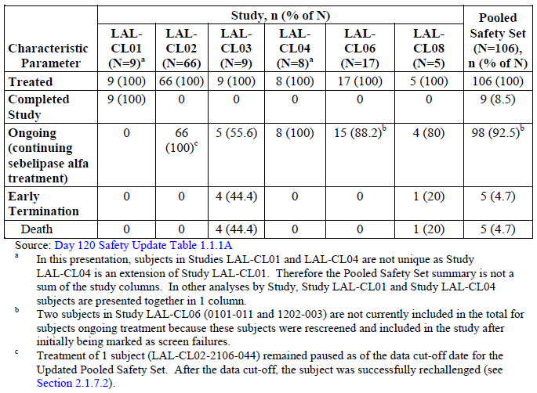

### Adverse events

Adverse events for both the Pooled Safety Set and the Updated Pooled Safety Set were coded using the Medical Dictionary for Regulatory Activities (MedDRA), Version 17.0.

#### All adverse events (irrespective of relationship to study treatment)

##### Integrated safety analyses

###### Pooled safety set

Overall, 79.8% (67/84) of sebelipase alfa treated subjects in the Pooled Safety Set reported a TEAE. No major differences were observed regarding the timing of onset of events, including related TEAEs, from the start of infusion to within 4 or 24 hours after the end of infusion for subjects in the Pooled Safety Set. The majority of subjects reported TEAEs that were considered by the Investigator as not related to sebelipase alfa treatment (related TEAEs, 19/84 (22.6%)) and mild or moderate in severity (35/67 (41.7%) and 18/67 (21.4%), respectively); 14/84 (16.7%) subjects experienced severe TEAEs. Majority of subjects in the Pooled Safety Set were receiving the 1 mg/kg dose (61/79 (77.2%)) at the time of any TEAE. For infants and adults in the 3 mg/kg dose group (8/84 (9.5%)) at the time of any TEAE, there was a higher incidence of SAEs, IARs, and treatment related TEAEs as compared to the 1 mg/kg dose group. Subjects in the 3 mg/kg dose group also experienced a higher incidence of TEAEs (related or not) within 4 and 24 hours from the end of infusion. These results may have been due to predominance of infants with the more rapidly progressive disease (6/9 (66.7%)) in the 3 mg/kg dose group. The small number of subjects in the 0.35 mg/kg (2/84 (2.3%)) dose group precluded meaningful comparisons of this group with the other dose groups. More than half the subjects in the Pooled Safety Set (59/84 (70.2%)) received treatment with sebelipase alfa for at least 26 weeks and incidence of TEAEs in these patients was similar to that of the Pooled Safety Set (43/59 (72.9%)). The incidence of treatment emergent SAEs, IARs, and related TEAEs decreased steadily over time relative to length of sebelipase alfa treatment. Analysis of pooled data beyond 78 weeks should be interpreted with caution given the limited number of subjects in this category, most of whom were either infants in Study LAL-CL03 or adults in Study LAL-CL04.

The incidence of TEAEs occurred most frequently in the SOCs of Gastrointestinal Disorders (41/84 (48.8%)), Infections and Infestations (37/84 (44.0%)) and Respiratory, Thoracic and Mediastinal Disorders (33/84 (39.3%)). Across studies, the most frequently occurring TEAEs (≥ 10% of subjects in the Pooled Safety Set) were diarrhoea (23/84 (27.4%)), headache (18/84 (21.4%)), nasopharyngitis (14/84 (16.7%)), cough (13/84 (15.5%)), pyrexia (13/84 (15.5%)), vomiting (13/84 (15.5%)), rhinitis (11/84 (13.1%)), upper respiratory tract infection (11/84 (13.1%)), abdominal pain (10/84 (11.9%)), nausea (10/84 (11.9%)), abdominal pain upper (9/84 (10.7%)) and oropharyngeal pain (9/84 (10.7%)).

###### Updated pooled safety set

Overall, the cumulative TEAE data for the Updated Pooled Safety Set were consistent with the TEAE data reported for the Pooled Safety Set. Overall, 84.0% of sebelipase alfa-treated subjects reported a TEAE (only 29.2% of subjects reported treatment related AEs) there were no major differences in the timing of onset of TEAEs, including related TEAEs, from the start of infusion to within 4 hours of, or 24 hours after the end of infusion, and the majority of subjects reported TEAEs that were mild or moderate in severity (33.0% of subjects for each category), with severe TEAEs reported by 19 subjects (17.9%). The most frequently occurring TEAEs in the Updated Pooled Safety Set (≥ 10% of subjects) by PT were diarrhoea (28.3%), pyrexia (24.5%), headache (23.6%), nasopharyngitis (22.6%), cough (21.7%), vomiting (17.9%), rhinitis (17.0%), upper respiratory tract infection (16.0%), abdominal pain (15.1%), nausea (12.3%), oropharyngeal pain (12.3%), rhinorrhoea (11.3%), abdominal pain upper (10.4%) and gastroenteritis (10.4%). These TEAEs were also among the most frequently occurring TEAEs in the Pooled Safety Set (≥ 10% of subjects), with the exception of Rhinorrhoea and Gastroenteritis, which were reported by 7.1% and 4.8% of subjects, respectively, in the Pooled Safety Set. Compared with children and adults from Studies LAL-CL01/LAL-CL04, LAL-CL02, and LAL-CL06, infants from Studies LAL-CL03 and LAL-CL08 had notably higher frequencies of TEAEs in the SOCs of Blood and Lymphatic System Disorders, Cardiac Disorders, Investigations, Metabolism and Nutrition Disorders, and Skin and Subcutaneous Disorders. However, the numbers of subjects in the infant studies are low, so comparisons across studies must be interpreted with caution (Table 26).

Table 26: Incidence of common treatment emergent adverse events (occurring in ≥ 4 subjects by preferred term) regardless of causality in the updated pooled safety set, by study and overall

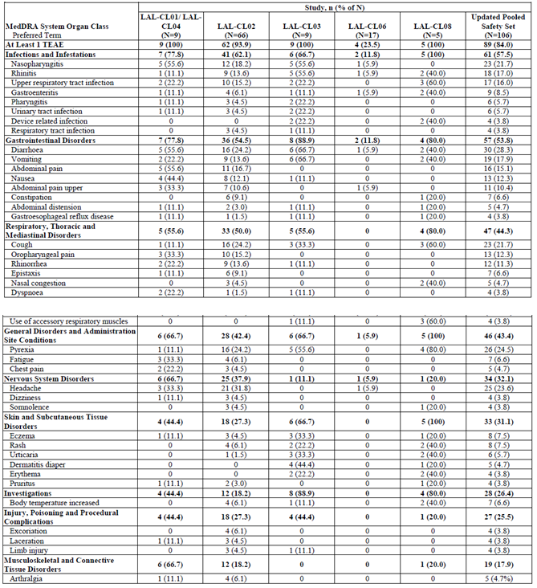

Table 26 continued: Incidence of common treatment emergent adverse events (occurring in ≥ 4 subjects by preferred term) regardless of causality in the updated pooled safety set, by study and overall

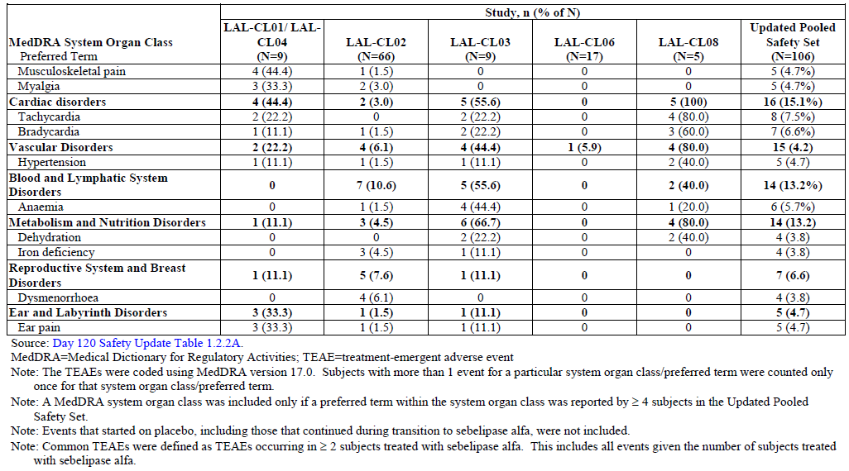

Subjects in the 3 mg/kg dose group (comprising infants from Study LAL-CL03 and adults from Study LAL-CL01/LAL-CL04) experienced a higher incidence of common TEAEs as compared to the other dose groups and the Pooled Safety Set in the SOCs of gastrointestinal disorders and infections and infestations (8/9 (88.9%) each), investigations and skin and subcutaneous disorders (7/9 (77.8%) each), and respiratory, thoracic and mediastinal disorders (6/9 (66.7%)) (Table 27). The most frequently reported TEAEs in the 3 mg/kg dose group as compared to the other dose groups and the Pooled Safety Set included vomiting (6/9 (66.7%)), cough (4/9 (44.4%)), diarrhoea (4/9 (44.4%)), pyrexia (4/9 (44.4%)), and rhinitis (4/9 (44.4%)). With the exception of diarrhoea, which was reported at a similar incidence in infants in Study LAL-CL03 and adults in Study LAL-CL01/LAL-CL04, the other most commonly reported TEAEs were more frequently reported in infants than adults in this dose group. The distribution of very common (≥ 10% of subjects) TEAEs among the dose groups was similar to the incidence for common TEAEs with the 3 mg/kg dose group reporting the highest incidence of very common TEAEs Overall, the occurrence of TEAEs remained relatively consistent across treatment periods through at least 130 weeks of treatment, and ranged from 41/84 (48.8%) subjects through < 4 weeks of treatment to 17/21 (81.0%) subjects through < 52 weeks of treatment. Only 10 subjects received treatment for at least 78 weeks (infants from Study LAL‑CL03 and adults from Study LAL-CL01/CL04), and the small numbers of subjects included in each of the subsequent time periods prevented meaningful comparisons of these time periods to the earlier time periods. In the Pooled Safety Set, 35/84 (41.7%) subjects reported at least 1 TEAE during and ≤ 4 hours after the end of infusion. The incidence of TEAEs during and ≤ 4 hours after the end of infusion was greatest in the SOCs of gastrointestinal disorders (12/84 (14.3%)), general disorders and administration site conditions (10/84 (11.9%)), and Skin and Subcutaneous Disorders (8/84 (9.5%)). The most frequently (≥ 4 subjects in the Pooled Safety Set) reported TEAEs during and ≤ 4 hours after the end of infusion were Pyrexia (5/84 (6.0%)), Headache (4/84 (4.8%)), and Nausea, Vomiting, and Cough (4/84 (4.8%) each). For adults in Study LAL-CL01/LAL-CL04, the most frequently (≥ 30% of subjects) reported TEAE during and ≤ 4 hours after the end of infusion was abdominal pain (3/9 (33.3%)). For infants in Study LAL‑CL03, the most frequently (≥ 30% of subjects) reported TEAEs during and ≤ 4 hours after the end of infusion were anaemia (3/9 (33.3%)), vomiting (3/9 (33.3%)), and pyrexia (3/9 (33.3%)). During the double blind period of Study LAL-CL02, a total of 15/36 (44.4%) subjects in the sebelipase alfa group and 9/30 (30.0%) subjects in the placebo group experienced at least 1 TEAE during and ≤ 4 hours after the end of infusion; the incidence rates by preferred term were similar between treatment groups.

Table 27: Incidence of common treatment emergent adverse events regardless of causality in the pooled safety set, by dose at time of event and overall

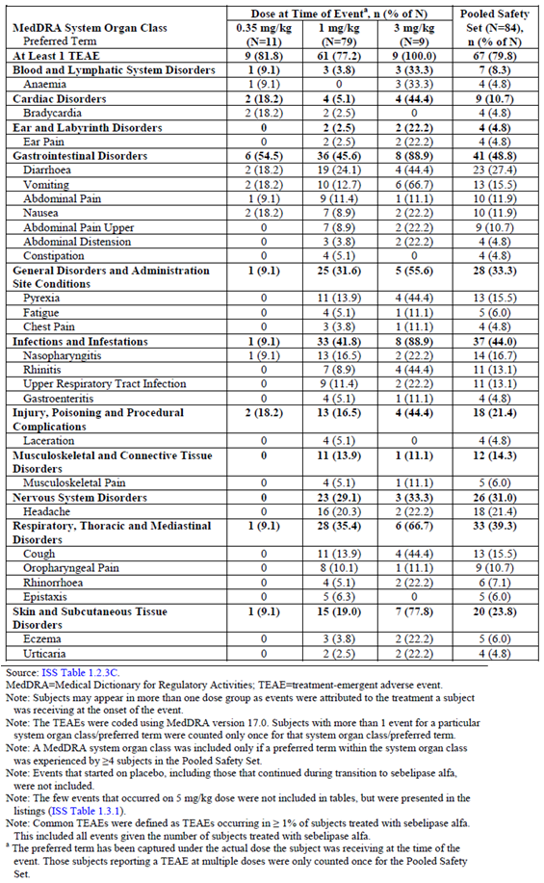

Of the total number of subjects who reported at least 1 TEAE in the Pooled Safety Set (67/84 (79.8%)), the majority reported TEAEs that were mild (35/84 (41.7%)) or moderate (18/84 (21.4%)) in severity (Table 28). Similarly, of the total number of subjects who reported at least 1 treatment related TEAE in the Pooled Safety Set (19/84 (22.6%)), the majority reported treatment related TEAEs that were mild (8/84 (9.5%)) or moderate (7/84 (21.4%)) in severity. A total of 14 subjects reported at least 1 severe TEAE (14/84 (16.7%)), of which 4 subjects reported at least 1 severe treatment related TEAE (4/84 (4.8%)). Severe TEAEs occurred more frequently in the SOCs of gastrointestinal disorders (5/84 (6.0%)) and infections and infestations (4/84 (4.8%)). The most frequently occurring severe TEAE (≥4 subjects) was Diarrhoea, which was assessed as unrelated to treatment; all other severe TEAEs were reported by only 1 subject in the Pooled Safety Set (1/84 (1.2%)) No severe TEAE by MedDRA PT was reported by more than one subject; severe, related events reported by subjects included chest discomfort, infusion related reaction, body temperature increased, hypercholesterolemia, dizziness, anxiety, laryngeal oedema, rash, hyperaemia and pallor. Infants in Study LAL-CL03 tended to have a higher incidence of severe TEAEs (8/9 (88.9%)) as compared to the other studies.

Table 28: Incidence of treatment emergent adverse events by severity in the pooled safety set by study and overall

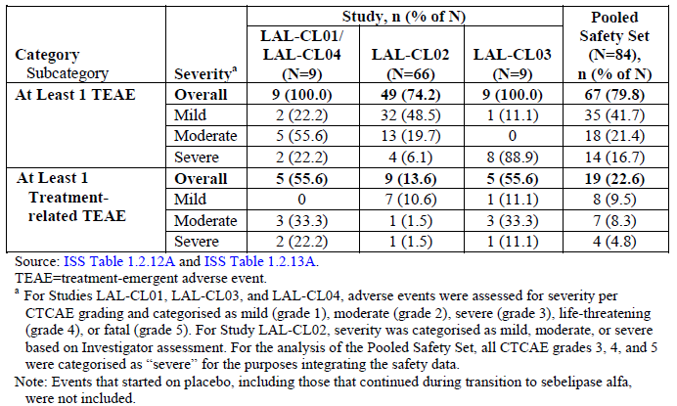

#### AEs by SOC

Listing of AEs by organ system or syndrome were provided.

##### Infections and infestations

Five of 84 subjects in the Pooled Safety Set (5/84 (6.0%)) experienced events related to use of a catheter or central line including catheter site rash, catheter site pain, catheter site infection, device related infection, and device related sepsis. Additionally, one of these 5 subjects also reported a TEAE of Staphylococcal bacteraemia and one other subject reported a TEAE of Staphylococcal sepsis. All of the events were assessed as unlikely related or not related and varied in intensity.

##### Central nervous system

Eighteen of 84 subjects in the Pooled Safety Set (18/84 (21.4%)) reported headache while receiving treatment with sebelipase alfa including 33.3% (3/9) of subjects in Study LAL-CL01/ LAL-CL04 and 22.7% (15/66) of subjects in Study LAL-CL02. Headache was among the most common TEAEs reported by sebelipase alfa-treated subjects in the double blind period (10/36 (27.7%)) compared to Placebo treated subjects (6/30 (20.0%)). All occurrences of these events in children and adults were mild and unrelated to study drug.

##### Respiratory, thoracic, mediastinal

Nine of 84 subjects in the Pooled Safety Set reported Oropharyngeal pain including 22.2% (2/9) subjects in Study LAL-CL01/LAL-CL04 and 10.7% (7/66) subjects in Study LAL-CL02. Oropharyngeal pain was among one of the most common TEAEs reported by sebelipase alfa-treated subjects (6/36 (16.7%)) as compared to Placebo treated subjects (1/30 (3.3%)) in Study LAL-CL02 (double blind period). The PT of Oropharyngeal pain was coded from the verbatim term of ‘sore throat’ in all cases. In Study LAL-CL02, all subjects who reported Oropharyngeal pain were ≤ 12 years of age.

#### Pivotal and/or main efficacy Study (LAL-CL02)

Overall, 89% of subjects, 86% (31/36) in the SA group and 93% (28/30) in the placebo group, experienced at least 1 TEAE during the double blind treatment period. The most common (that is, incidence ≥ 10%) TEAEs reported among the 36 subjects in the sebelipase alfa group during the double blind period were headache (10/36 (28%)), pyrexia (7/36 (19%)), diarrhoea (6/36 (17%)), oropharyngeal pain (6/36 (17%)), upper respiratory infection (6/36 (17%)), epistaxis (4/36 (11%)) and nasopharyngitis (4/36 (11%)). Of these events, those with a notably higher incidence (≥ 5% difference) in the sebelipase alfa group than in the placebo group were headache (10/36 (28%) versus 6/30 (20%)) and oropharyngeal pain (6/36 (17%) versus 1/30 (3%)), respectively.

Most TEAEs during the double blind period were assessed by the Investigator as mild to moderate in intensity; 8% and 3% of subjects in the SA and placebo groups, respectively, experienced at least 1 severe TEAE. In the SA group, severe TEAEs included an infusion related reaction, also considered an SAE, in which severe anxiety, chest discomfort, dyspnoea, laryngeal oedema, nausea, rash, and body temperature increased occurred in 1 subject, with these events considered to represent an IAR. The only other severe TEAEs in the SA group was a case of non-serious sinusitis and procedural pain (after liver biopsy) (both unrelated to study medication). In the placebo group, the only severe TEAE was a road traffic accident, an SAE, which was unrelated to study drug.

Overall, among the 66 subjects exposed to sebelipase alfa in this study, either in the double blind period and/or the open label period, 4 (6%) experienced an IAR. The IAR was mild and non-serious for 3 of these 4 subjects, with all 3 receiving subsequent infusions of sebelipase alfa, 1 with and 2 without premedication, without IAR recurrence. For the remaining subject, who experienced IARs after both the first and second study drug infusions, and was pre-medicated prior to the second study drug infusion, the IAR after the second study drug infusion was considered severe and serious.

The safety profile of sebelipase alfa during the open label period was consistent with that seen during the double blind treatment period.

#### Other studies

For adults in Study LAL-CL01/LAL-CL04, there was a greater incidence of pain-related TEAEs (≥ 30% of subjects) including abdominal pain (5/9 (55.6%)), musculoskeletal pain (4/9 (44.4%)), abdominal pain upper (3/9 (33.3%)), ear pain (3/9 (33.3%)), back pain (3/9 (33.3%)), myalgia (3/9 (33.3%)) and headache (3/9 (33.3%)). The number of subjects with TEAEs was similar during the 4 weeks of qw dosing and the first 4 weeks of qow dosing (LAL‑CL04). For infants in Study LAL-CL03, there was a greater incidence of TEAEs including diarrhoea (6/9 (66.7%)), vomiting (6/9 (66.7%)), pyrexia (5/9 (55.6%)), rhinitis (5/9 (55.6%)) and anaemia (4/9 (44.4%)).

### Treatment related adverse events (adverse drug reactions)

#### Integrated safety analyses

##### Pooled Safety Set

In the Pooled Safety Set, the proportion of subjects who experienced at least one treatment related TEAE was 22.6% (19/84). Incidence of treatment related TEAEs occurred more frequently (≥ 10% of subjects) in the SOCs of gastrointestinal disorders (11/84 (13.1%)) and general disorders and administration site conditions (9/84 (10.7%)). The most frequently occurring treatment- related TEAEs (≥ 3 subjects in the Pooled Safety Set) included abdominal pain, nausea, vomiting, pyrexia and urticaria (3/84 (3.6%) for each PT). For adults in Study LAL‑CL01/LAL-CL04, there was a greater incidence of treatment related gastrointestinal TEAEs including abdominal pain (3/9 (33.3%)) and Nausea (2/9 (22.2%)). For infants in Study LAL-CL03, there was a greater incidence of treatment related TEAEs including vomiting, pyrexia, and urticaria (3/9 (33.3%) for each PT). Children and adults in Study LAL-CL02 reported similar TEAEs, but at a relatively lower incidence (≤ 2 of subjects).

##### Updated pooled safety set

For the Updated Pooled Safety Set, the proportion of subjects who reported at least 1 treatment related TEAE was 29.2% and the most frequently reported (≥ 10% of subjects) treatment related TEAEs were in the SOCs of gastrointestinal disorders and general disorders and administration site conditions, consistent with results for the Pooled Safety Set. The most frequently reported treatment related TEAEs (≥ 3 subjects) by PT were urticaria (6 subjects), diarrhoea (5 subjects), tachycardia, pyrexia, vomiting, nausea, abdominal pain (4 subjects each) and fatigue (3 subjects). For adults and children in Studies LAL-CL01/LAL-CL04, LAL-CL02, and LAL-CL06, the only treatment related TEAEs reported in ≥ 3 subjects were abdominal pain (4 subjects), diarrhoea (4 subjects), nausea (4 subjects) and fatigue (3 subjects). For infants in Studies LAL-CL03 and LAL-CL08, treatment related TEAEs reported in ≥ 3 subjects included tachycardia (4 subjects), urticaria (4 subjects), vomiting (3 subjects) and pyrexia (3 subjects), all of which occurred with a greater incidence in infants compared with children and adults.

Of the subjects who experienced at least 1 treatment related TEAE in the Pooled Safety Set, a higher proportion of infants in Study LAL-CL03 and adults in Study LAL-CL01/ LAL-CL04 in the 3 mg/kg dose (5/9 (62.5%)) groups experienced related TEAEs as compared to the 0.35 mg/kg dose (2/11 (18.2%)) and 1 mg/kg dose (17/79 (21.5%)) groups, although interpretation was limited by the limited number of subjects, the varying duration of treatment at various doses, and the preponderance of infants. Subjects in all dose groups experienced treatment related gastrointestinal events including abdominal pain, nausea, vomiting and diarrhoea more frequently than other TEAEs. Overall, the incidence of treatment related TEAEs decreased steadily over time relative to length of sebelipase alfa treatment. The proportions of subjects with TEAEs in the SOCs of gastrointestinal disorders, general disorders and administration site conditions, and skin and subcutaneous tissue disorders decreased over time. The proportion of subjects with PTs of diarrhoea, vomiting and abdominal pain also decreased over time. There was an increase in the incidence of TEAEs in subjects receiving treatment for ≥ 26 weeks in the SOCs of Infections and Infestations and Nervous System Disorders; the incidence of events in these SOCs decreased steadily over time thereafter. This observation may be due to the fact that the majority of subjects receiving treatment for ≥ 26 weeks were infants from Study LAL-CL03 with more rapidly progressive disease and greater occurrence of TEAEs.

In the Pooled Safety Set, a total of 12/84 (14.3%) subjects reported at least 1 related TEAE during and ≤ 4 hours after the end of infusion. The incidence of TEAEs during and ≤ 4 hours after the end of infusion was greatest in the SOCs of gastrointestinal disorders and general disorders and administration site conditions (6/84 (7.1%) each). The only PT reported by more than 2 subjects during and ≤ 4 hours after the end of infusion was pyrexia (3/84 (3.6%)).

Across studies, related TEAEs that occurred during and ≤ 4 hours after the end of infusion were consistent with those that were identified in the hypersensitivity standardised MedDRA queries (SMQs).

##### Pivotal and/or main efficacy study (LAL-CL02)

Overall, 17% of subjects (14% and 20% in the SA and placebo groups, respectively) experienced at least 1 study drug related TEAE during the double blind treatment period. No particular study drug related TEAE occurred in > 1 subject in the SA group.

##### Other studies

For adults in Study LAL-CL01/LAL-CL04, there was a greater incidence of treatment related gastrointestinal TEAEs including abdominal pain (3/9 (33.3%)) and nausea (2/9 (22.2%)). For infants in Study LAL-CL03, there was a greater incidence of treatment related TEAEs including vomiting, pyrexia, and urticaria (3/9 (33.3%) for each PT).

For infants in Studies LAL-CL03 and LAL-CL08, treatment related TEAEs reported in ≥ 3 subjects included tachycardia (4 subjects), urticaria (4 subjects), vomiting (3 subjects), and pyrexia (3 subjects), all of which occurred with a greater incidence in infants compared with children and adults.

### Deaths and other serious adverse events

#### Integrated safety analyses

##### Deaths

Five deaths have been reported in the sebelipase alfa clinical programme and one additional death has been reported for a subject in the Compassionate Use Programme who had fatal events of asystole and progressive liver failure. All 6 deaths occurred in infants (≤ 2 years of age) with rapidly progressive disease, and all deaths were assessed by the Investigator as unrelated or unlikely related to sebelipase alfa treatment. Three deaths had been reported as of the data cut-off dates for the Pooled Safety Set, all in subjects enrolled in Study LAL-CL03. An additional 3 deaths were reported though the data cut-off date for the Updated Pooled Safety Set, one each in Study LAL-CL03, Study LAL-CL08 and the Compassionate Use Programme. No additional subjects have died as of the cut-off date for late-breaking information (8 April 2015).

##### SAEs:

In the pooled safety set, a total of 36 treatment emergent SAEs occurred (regardless of causality) in 12/84 (14.3%) subjects in the sebelipase alfa clinical studies combined through the data cut-off date; 31/36 (86.1%) of these SAEs has occurred in infants from Study LAL‑CL03; 31/36 (86.1%) of these SAEs has occurred in infants from Study LAL-CL03. For the Pooled Safety Set, there were no SOCs in which ≥ 10% of subjects reported an SAE, and there was no PT reported for ≥ 10% of subjects. Serious adverse events reported for 2 or more subjects in the Pooled Safety Set included Pyrexia, Catheter site infection, and Device related infection (2/84 (2.4%) for each PT). All of these events were reported in infants in Study LAL-CL03. The majority of SAEs were assessed by the Investigator as severe in intensity, including the 3 events leading to death; all other events were considered resolved/recovered. The majority of SAEs were assessed by the Investigator as unrelated to study drug; 2 subjects experienced 5 SAEs that were considered by the Investigators as related to treatment.

In the Updated pooled safety set, a total of 64 serious TEAEs were reported for a total of 19 (17.9%) subjects, including 7 new subjects with SAEs in the Updated Pooled Safety Set. Four (3.8%) subjects (including 2 new subjects) had serious TEAEs that were considered at least possibly related to sebelipase alfa by the Investigator; 16 (15.1%) subjects reported IARs, including 6 new subjects with IARs in the Updated Pooled Safety Set; 27 of the 28 new serious TEAEs occurred in infants (Studies LAL-CL03 and LAL-CL08), consistent with the trend previously observed in the Pooled Safety Set. Of the 28 new serious TEAEs, approximately half (15 serious TEAEs) were assessed by the Investigator as moderate in intensity, 12 were assessed as severe, and 1 was assessed as mild. This differs from the Pooled Safety Set, where the majority of serious TEAEs were assessed by the Investigator as severe in intensity. Two of the 12 new severe serious TEAEs, led to death, both in infants. Of the remaining 10 new severe serious TEAEs, eight were considered recovered/resolved as of the data cut-off for Updated Pooled Safety Set, one severe serious TEAE of Sepsis in Study LAL-CL03 was ongoing at time of death (but was not the cause of death), and 1 severe serious TEAE of Haemophagocytic lymphohistiocytosis in a subject in Study LAL-CL08 is ongoing.

Of the subjects who experienced at least 1 treatment emergent SAE in the Pooled Safety Set, a higher proportion of subjects in the 3 mg/kg dose (5/9 (55.6%)) group (including 4 infants in Study LAL-CL03 and one adult in Study LAL-CL01/LAL-CL04 in the experienced treatment emergent SAEs as compared to the 0.35 mg/kg dose (2/11 (18.2%)) and 1 mg/kg dose (9/79 (11.4%)) groups and the Pooled Safety Set. Subjects in the 3 mg/kg dose group, which comprised mostly of the infants in Study LAL-CL03, experienced more treatment emergent SAEs as compared to the other groups in the SOCs of Infections and Infestations (4/9 (44.4%)), metabolism and nutrition disorders (2/9 (22.2%)), and vascular disorders (2/9 (22.2%)). The incidence of treatment emergent SAEs decreased steadily over time relative to length of sebelipase alfa treatment. The incidence of treatment emergent SAEs in the SOC of infections and infestations increased up to 26 weeks of treatment and decreased thereafter. The 3 fatal treatment emergent SAEs (assessed by the Investigators as not related or unlikely related) in the Pooled Safety Set occurred within 4 weeks of initiating treatment with sebelipase alfa. An additional 3 fatal treatment emergent SAEs were reported in the Updated Pooled Safety Set and Compassionate Use, of which 2 occurred within 4 weeks of initiating treatment with sebelipase alfa and 1 occurred after 9 months of treatment.

From the data cut-off date for the Updated Pooled Safety Set (26 January 2015) through the late breaking period (08 April 2015), 33 additional SAEs or moderate or severe IARs have been reported in 11 subjects; there have been no deaths and no subject has discontinued participation from any ongoing studies due to a TEAE.

##### Pivotal and/or main efficacy study (LAL-CL02)

No deaths occurred in this study. The incidence of SAEs in the double blind period was low, with 5% of subjects overall, including 6% and 3% of subjects in the SA and placebo groups, respectively, experiencing an SAE. No particular SAE was reported in > 1 subject. SAEs reported among SA treated subjects in the double blind period included gastritis and infusion related reaction (each 3%). The only SAE reported among the 30 Placebo treated subjects in the double blind period was road traffic accident (3%). One (3%) subject in the placebo/SA group experienced an SAE during the open label period (mild gastroenteritis), with the event considered unrelated to study drug.

##### Other studies

Majority of the SAEs (31/36, 86.1%) reported in the pooled safety set occurred in infants in Study LAL-CL03.

There were no SAEs reported in Study LAL-CL01 and only 1 subject reported a SAE of cholecystitis (unrelated to study treatment) in LAL-CL04.

### Discontinuations due to adverse events

#### Integrated safety analyses

In both the pooled safety set and D120 safety update, no subject experienced a TEAE that led to withdrawal from the study (other than the 5 deaths in clinical studies, no subject terminated a study early).

#### Pivotal and/or main efficacy Study (LAL-CL02)

No study drug related SAEs or TEAEs leading to study drug discontinuation were seen in the either the SA or placebo/SA groups during the open label period.

#### Other studies

There were no withdrawals due to AEs in the other efficacy studies.

### Evaluation of issues with possible regulatory impact

#### Liver function and liver toxicity

##### Integrated safety analyses

Liver parameters, including ALT, AST, GGT, ALP, and TBil, decreased from Baseline to the last assessment. In an analysis by study, reductions in ALT, AST, GGT, ALP, and TBil were apparent across all studies (Tables 29 and 30). In a few subjects, individual TBil values remained very high at the last assessment and a further medical review indicated that these high TBil values occurred in the context of worsening disease, including a subject in Study LAL-CL03 who died early in the course of treatment (TBil = 443 and 419 µmol/L at Baseline and at last assessment, respectively) and a subject who had evidence of liver decompensation and required an urgent liver transplant in Study LAL-CL01/LAL-CL04 (TBil = 25.1 and 129.3 µmol/L, respectively). Direct bilirubin showed minimal changes from Baseline to the last assessment in Study LAL-CL01/LAL-CL04 and Study LAL-CL02, and increased from Baseline (27 µmol/L) to the last assessment (71 µmol/L) in Study LAL-CL03. The analysis of DBil in Study LAL-CL03 was based on available data for only 3 subjects, 2 of whom died early in the course of treatment and had marked increases in DBil shortly prior to death; the other subject had a decrease in DBil from Baseline to the last assessment.

In the Pooled Safety Set overall, 1 subject (1/84; 1%) each had at least 1 ALT[42], AST[43], or GGT[44] value > 5 x ULN that was at least twice the highest pre-treatment value.

Table 29: Changes from Baseline to last assessment for select chemistry parameters, pooled safety set

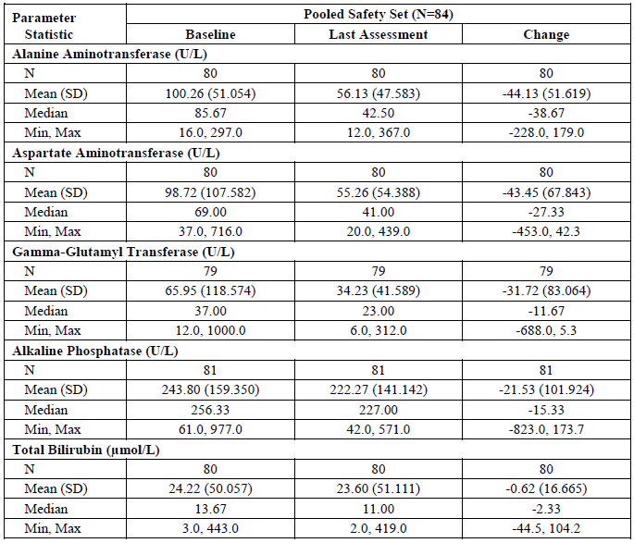

Table 29 continued: Changes from Baseline to last assessment for select chemistry parameters, pooled safety set

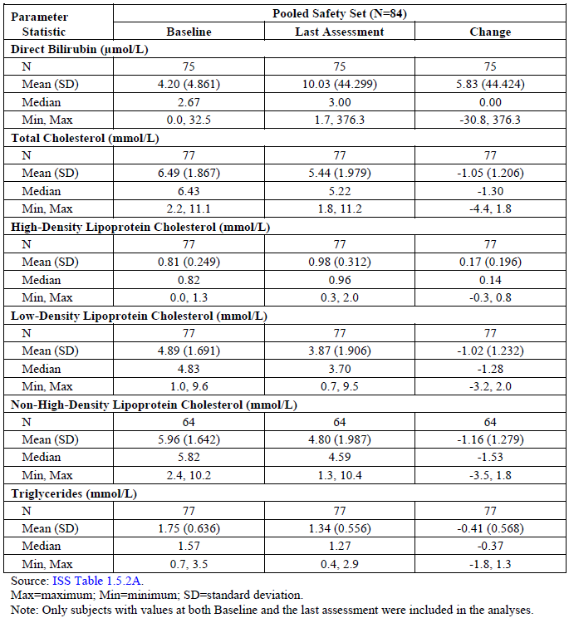

Table 30: Changes from Baseline to last assessment for select chemistry parameters, by study

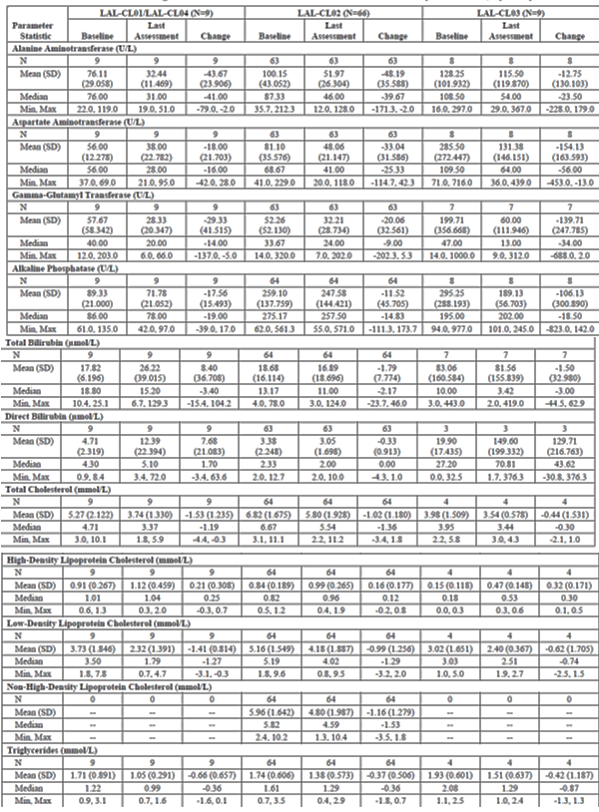

##### Pivotal and/or main efficacy studies

Refer section 8.5.1.1 above.

##### Other studies

Refer section 8.5.1.1 above.

#### Renal function and renal toxicity

##### Integrated safety analyses

No specific trends were observed regarding renal function in the pooled safety sets.

##### Main/pivotal studies that assessed safety as the sole primary outcome

Not applicable.

##### Pivotal and/or main efficacy studies

In Study LAL-CL02, no specific trends were observed regarding renal function.

##### Other studies

No specific trends were observed regarding renal function in the other open label, uncontrolled studies (LAL-CL03; LAL-CL01/LAL-CL04).

#### Other clinical chemistry

##### Integrated safety analyses

A transient increase in serum lipids (LDL-C, triglycerides, total cholesterol, and/or non-HDL cholesterol) was noted following initiation of sebelipase alfa therapy. From baseline to the last assessment, total cholesterol, LDL-C and triglyceride values decreased and HDL-C values increased for subjects in the Pooled Safety Set (Tables 29 and 30). All of these changes were consistent with an improvement in underlying disease and did not represent a safety concern for sebelipase alfa. Median total cholesterol, LDL-C, and triglyceride levels decreased from Baseline to the last assessment across all studies. Increases in median HDL-C were noted from Baseline to last assessment in all studies, and were most pronounced in Study LAL-CL03 (median increase = 0.30 mmol/L) and Study LAL-CL01/LAL-CL04 (median increase = 0.25 mmol/L). These results are consistent with the known mechanism of sebelipase alfa and are also influenced by the varying clinical presentation in subjects with LAL Deficiency enrolled across the studies. No definitive associations were noted in the analysis of changes from Baseline in chemistry parameters by various subgroups (according to age, gender, race or baseline LLM use). No subject met the criteria for total cholesterol > 10.36 mmol/L (> 400 mg/dL) with at least a 50% increase from the baseline value for 2 consecutive assessments, or triglycerides > 9.04 mmol/L (> 800 mg/dL) at any assessment.

##### Pivotal and/or main efficacy studies

Refer to section 8.5.3.1 above.

##### Other studies

Refer to section 8.5.3.1 above.

#### Haematology and haematological toxicity

##### Integrated safety analyses

Overall, mean values for RBC count, haemoglobin, haematocrit, and platelet count increased from Baseline to the last assessment for subjects in the Pooled Safety Set (Table 31). An analysis by study indicated that these increases in RBC count, haemoglobin, haematocrit, and platelet count were influenced by the more pronounced haematological changes observed for infants in Study LAL-CL03. Several haematology parameters, including haemoglobin, haematocrit, RBCs and platelet count, showed more pronounced changes from Baseline to the last assessment for subjects in the < 2.00 years group compared with other age groups. All subjects in the < 2.00 year age group were enrolled in Study LAL-CL03 and many of the subjects in this study were receiving packed RBC and/or platelet concentrates as part of their supportive care. Most of the shifts in haematology parameters noted for the Pooled Safety Set were consistent with improvements in underlying disease, and did not represent a safety concern. Overall, most of the subjects who had clinically meaningful shifts in haematology parameters from Baseline to the last assessment were from Study LAL-CL02, which was not unexpected given the substantially greater number of subjects in this study (N = 66) compared with the other 2 studies (N = 9 for both studies).

Table 31: Changes from Baseline to last assessment for select haematology parameters, pooled safety set

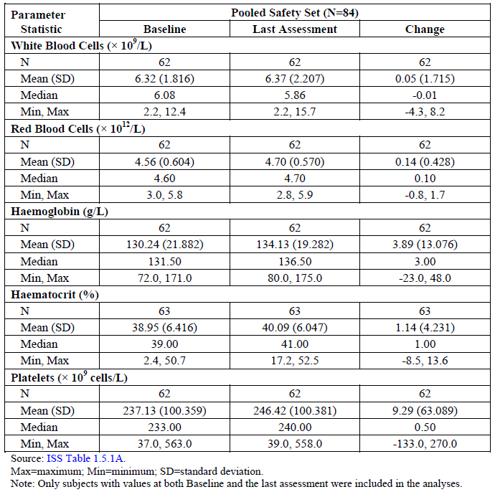

For subjects in the Pooled Safety Set, median prothrombin times at the last assessment (12.70 sec) were similar to the median value observed at Baseline (12.80 sec). Median INR values and aPTT also remained virtually unchanged from Baseline to the last assessment. Median changes in prothrombin time and INR were not remarkably different across studies. The median change in aPTT was greater in Study LAL-CL03 (increase of 5.80 sec) compared with Study LAL-CL01/ LAL-CL04 (increase of 0.80 sec) and Study LAL-CL02 (decrease of 0.10 sec). The increase in aPTT in Study LAL-CL03 was primarily driven by 1 subject who had an aPTT that was very low at Baseline (10.2 sec; LLN = 23 sec)[45]. Interpretation of results was confounded by small number of patients and data and the fact that infants were known to have coagulopathies that required treatment with fresh frozen plasma.

##### Pivotal and/or main efficacy studies

In Study LAL-CL02 there were no clinically meaningful mean changes over time in any standard haematology parameters, and no apparent trend between sebelipase alfa-treated subjects and placebo subjects during the 20 week double blind period based on examination of changes from Baseline to each study time point.

##### Other studies

Refer to Section 8.5.4.1 above.

#### Other laboratory tests

Not applicable.

#### Electrocardiograph findings and cardiovascular safety

##### Integrated safety analyses

Across all studies, no clinically relevant trends in ECG findings were apparent over time.

##### Main/pivotal studies that assessed safety as the sole primary outcome

Not applicable.

##### Pivotal and/or main efficacy studies

In Study LAL-CL02, no clinically meaningful differences between the SA and placebo groups were noted in any ECG parameters in the double blind period.

##### Other studies

Refer to section 8.5.6.1 above.

#### Vital signs and clinical examination findings

Across sebelipase alfa clinical studies, vital signs were measured just before, during, and immediately following each study drug infusion. Vital signs abnormalities assessed by the Investigator as clinically significant may have been reported by the Investigator as TEAEs. Potentially clinically meaningful changes in select vital sign parameters were identified for further medical review using the criteria described in Table 32.

Table 32: Criteria for clinically meaningful changes in vital signs

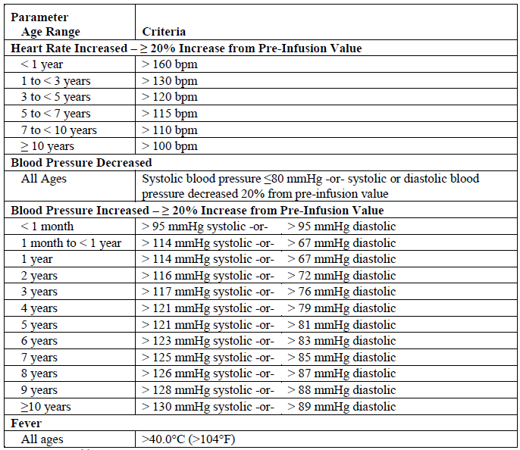

##### Integrated safety analyses

Integration of data across studies did not reveal new information regarding the effect of sebelipase alfa on any vital sign parameter. The occurrence of potentially clinically meaningful changes in vital sign parameters were not influenced by differences in age, gender, race, mutation category, or Baseline use of LLMs.

##### Pivotal and/or main efficacy studies

For children and adults in Study LAL-CL02, one-fourth (9/36; 25%) of sebelipase alfa treated subjects had an elevated body temperature/pyrexia as some point during the 20 week double blind treatment period, with a similar incidence seen among Placebo treated subjects (7/30; 23%). Pyrexia/body temperature increased was considered to be treatment related for 1/36 (3%) subject in the sebelipase alfa group, with this event considered to be an IAR, and 3/30 (10%) subjects in the placebo group, with the event considered to be an IAR for 2 of these 3 subjects. All cases of body temperature increased/pyrexia were assessed by the Investigator to be mild or moderate in intensity, with the exception of 1 severe event in the sebelipase alfa group. No apparent trend was seen with regard to change from Baseline in other vital sign parameters (BP, heart rate, respiratory rate) with no clinically meaningful differences from placebo.

##### ***O***ther studies

For infants in Study LAL-CL03, there was some variability in BP measurements noted, but elevations in BP were not consistently observed for all subjects or for a given subject across a majority of study infusions, and did not appear to be related to the dose of sebelipase alfa. Individual changes in body temperature were reported as TEAEs of pyrexia, hyperthermia, or increased body temperature in 6 of 9 subjects. Many of these events were further characterised as IARs, and those that were not characterised as IARs were considered unrelated to treatment. Two subjects had transient increases in heart rate that were reported as IARs of tachycardia. No TEAEs related to changes in respiratory rate were reported for any subject.

For adults in Study LAL-CL01/LAL-CL04, no TEAEs related to changes in vital signs were reported for any subject. There were no clinically relevant tendencies in systolic or diastolic BP, heart rate, respiratory rate, or body temperature, either in association with sebelipase alfa infusions or over the course of the study.

#### Immunogenicity and immunological events

##### Integrated safety analyses

###### Immunogenicity

Serum antibodies that bind to rhLAL were detected using an enzyme-linked immunosorbent assay (ELISA) screening assay and confirmed for specificity using a confirmatory ELISA. A subject was considered to be positive for ADAs at a given time point if he/she had a positive result on both the screening and confirmatory ELISAs. Antibody titre was determined for all ADA positive subjects by serial dilution, beginning at a minimum required dilution (MRD) of 1:20.

Overall, 10 subjects in the Pooled Safety Set (N = 84) tested positive for ADAs during at least 1 assessment. Of the 84 subjects in the Pooled Safety Set, 81 subjects had ADA testing at Baseline and 65 subjects had ADA testing for at least one time point after initiation of treatment with sebelipase alfa (7 subjects in Study LAL-CL03, 49 subjects in Study LAL-CL02, and 9 subjects in Study LAL-CL01/LAL-CL04). For the 10 ADA positive subjects in the Pooled Safety Set, the median time to first ADA positive result was 57 days (range 29 to 418 days). Maximum titres ranged from < 1/20 to 1/1142. The median time to these maximum titres was 84.5 days (range 29 to 677 days). Of the 10 ADA positive subjects, six (6/10 (60.0%)) who tested positive for ADAs at more than one time point through the data cut-off for the Pooled Safety Set, a higher proportion of infants from Study LAL-CL03 were ADA positive at more than one time point (3/7 (42.9%); all subjects < 2 years of age) compared to children and adults from Studies LAL‑CL02 and LAL-CL01/LAL-CL04 (3/58 (5.2%).[46] The likelihood of the infants to develop ADAs over the course of treatment may have been affected by the fact that infants received higher doses of sebelipase alfa as well as more frequent dosing compared to the dosing regimens of the children and adults. In addition, the impact of mutation status cannot be excluded as 70% (7/10) of ADA positive subjects were categorised as ‘Other’ mutation status as compared to 30% (3/10) of ADA positive subjects who were categorised as heterozygous common mutation. In the Updated Pooled Safety Set, 12 subjects tested positive for ADAs during at least 1 assessment including 2 new subjects who tested positive for ADAs after the data cut‑off for the Pooled Safety Set (1 subject in Study LAL-CL02 who tested positive during the open label period, and 1 subject in Study LAL-CL08). Table 33 summarises TEAEs by ADA status and overall for subjects in the Pooled Safety Set and for the Updated Pooled Safety Set. No ADA positive subject died, discontinued study drug, or withdrew from a study due to TEAEs through the data cut-off for the Updated Pooled Safety Set.

There was a marked difference in the proportion of infants in the ADA positive group (40.0%) compared with the ADA negative group (6.8%) and this, together with the limited number of ADA positive subjects overall (N = 10) and fluctuations in ADA positivity in these subjects over time, precluded any meaningful conclusions regarding effects on laboratory parameters by ADA status.

Table 33: Overview of treatment emergent adverse events in the pooled safety set and updated pooled safety set by antibody status and overall

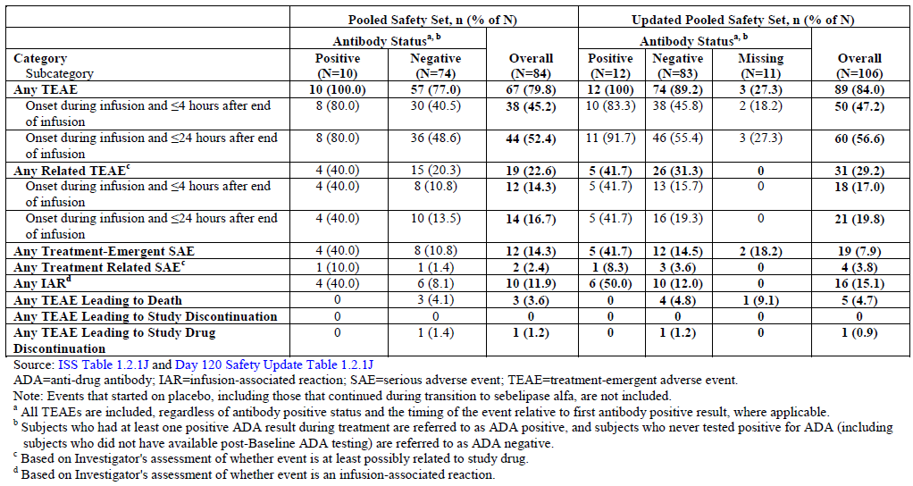

###### Hypersensitivity reactions

In the Pooled Safety Set, a total of 16/84 (19.0%) subjects, including 5/9 (56.0%) infants and 11/75 (15.0%) children and adults, were reported to have experienced signs and symptoms either consistent with or potentially related to a hypersensitivity reaction. All these potential hypersensitivity reactions were mild or moderate in severity with the exception of severe TEAEs in 3 subjects.

In the Updated Pooled Safety Set, a total of 21/106 (19.8%) subjects, including 9/14 infants (64.3%) and 12/92 children and adults (13.0%), experienced signs and symptoms either consistent with or potentially related to a hypersensitivity reaction**.** The Updated Pooled Safety Set included 5 new subjects with potential hypersensitivity reactions. All new potential hypersensitivity reactions were mild or moderate in severity, with the exception of severe hypersensitivity reactions occurring in 2 subjects.

No clear relationship between the presence of ADAs and hypersensitivity reactions was apparent. Furthermore, the TEAE profile seen among ADA positive subjects was consistent with that in the study population as a whole (that is, Pooled Safety Set), and no ADA positive subject experienced a severe TEAE, SAE, or TEAE that led to study drug discontinuation.

Three subjects experienced signs and symptoms consistent with an anaphylactic reaction:

* In Study LAL-CL02, a subject experienced an anaphylactic reaction during open label treatment with sebelipase alfa 1 mg/kg qow. Treatment has been paused pending further evaluation.
* In Study LAL-CL08, an infant experienced signs and symptoms of anaphylaxis, 15 mins from start of the 6th infusion at 1 mg/kg once weekly. All symptoms resolved on discontinuation of treatment and this subject continues on treatment in the study with no further reports of IARs.
* In Study LAL-CL06, a subject experienced an SAE of anaphylactic reaction on study Day 86 (seventh infusion) after 90 minutes of infusion of 1 mg/kg qow sebelipase alfa. The subject continues in the study, receiving sebelipase alfa infusions under a desensitization protocol.

Due to the low level of immunogenicity found in the clinical studies of sebelipase alfa, immunogenicity was not considered in the exposure response analyses of efficacy endpoints or safety endpoints (occurrence of IARs). The population PK analysis of sebelipase alfa revealed no relevant effect of ADA positivity on the exposure to sebelipase alfa. In Study LAL-CL02 (in children and adults) and Study LAL-CL04 (in adults), there were no relevant effects of ADAs on the clinical efficacy and safety findings. In Study LAL-CL03 (in infants), however, some potential impact on efficacy was observed in one infant positive for ADAs.

##### Pivotal and/or main efficacy studies

In Study LAL-CL02, 5 (8%) 66 subjects exposed to sebelipase alfa were determined to be ADA positive at some point during the study with 1 additional subject reported as ADA positive in the Updated Pooled Safety Set. Among these ADA positive subjects, ADA titres were low and decreased to undetectable levels by the last time point assessed, and no subject developed neutralising antibodies at any time. The TEAE profile seen among ADA positive subjects was consistent with that in the study population as a whole, and no ADA positive subject experienced a severe TEAE, SAE, or TEAE leading to study drug discontinuation. One of 5 ADA positive subjects experienced a single IAR (mild oedema). No reduction in efficacy of sebelipase alfa was seen among ADA positive subjects.

**Comment:** It is important to note that the low number of ADA positive subjects in the study overall, and the low number of ADA positive subjects experiencing individual TEAEs (with no particular TEAE experienced by > 3 such subjects in the Pooled Safety Set), precluded any meaningful comparison of the incidence of TEAEs in ADA positive versus ADA negative subjects in this study.

##### Other studies

In Study LAL-CL03, a total of 4 subjects developed ADAs, all prior to the data cut-off for the Pooled Safety Set, representing 44.4% (4/9) of the total number of subjects in the study and 57.1% (4/7) of the subjects for whom ADA testing was performed post- baseline. As of the data cut-off for the Updated Pooled Safety Set, all 4 subjects had tested positive for ADAs at more than one time point.

#### Serious skin reactions

None.

### Other safety issues

#### Safety in special populations

##### Effect of age

A greater proportion of subjects < 2.00 years of age reported certain TEAEs compared to the other age groups in the Pooled Safety Set, most notably, anaemia, pyrexia and rhinitis. Subjects 2 to 12 years of age predominantly reported cough and oropharyngeal pain. Adults (aged > 18 years) were more likely to report AEs such as musculoskeletal pain, back pain, myalgia, abdominal pain, headache, dizziness and paraesthesia. Overall, by age group, there were more TEAEs with onset during or < 4 hours after end of infusion, related TEAEs, serious TEAEs, and TEAEs with an outcome of death in subjects < 2 years of age group; these findings are consistent with rapidly progressive disease as observed in the infants in this age group. Overall, findings for TEAEs by age in the Updated Pooled Safety Set were consistent with the findings in the Pooled Safety Set. The most frequently reported TEAEs for subjects < 2 years of age were pyrexia (9 subjects), diarrhoea and vomiting (8 subjects each). The most frequently reported TEAEs for subjects 2 to 12 years of age were headache (13 subjects), cough (9 subjects) and the most frequently reported TEAEs for subjects > 12 to < 18 years of age were diarrhoea (8 subjects) and pyrexia (7 subjects). In adults (≥ 18 years of age), the most frequently reported TEAEs were nasopharyngitis (10 subjects), diarrhoea (9 subjects) and abdominal pain (8 subjects). Given the greater ability of adults to communicate pain symptoms compared to infants and young children, it was not unexpected that the proportion of subjects who reported events such as musculoskeletal pain, back pain, myalgia and abdominal pain was higher in subjects in the ≥ 18 years of age group compared with the other age groups. There was a higher frequency of TEAEs with onset during or ≤4 hours after the end of infusion, related TEAEs, serious TEAEs, and TEAEs with an outcome of death in subjects < 2 years of age group which were consistent with rapidly progressive disease as observed in this age group.

##### Gender and race

A review of individual TEAE terms reported in the Pooled Safety Set by gender did not reveal a clinically meaningful difference in the AE profile of sebelipase alfa between males and females. Interpretation of results by race were limited due to small number of Non-White subjects (n = 16) compared with White subjects (n = 68).

##### Use in pregnancy/ lactation

Sebelipase alfa has not been studied in pregnant or lactating women. Studies in rats and rabbits have not shown sebelipase alfa related adverse clinical signs were observed, and there was no evidence of fetotoxicity or teratogenicity.

##### Overdose, drug abuse, withdrawal/ rebound

In clinical studies, doses up to 5 mg/kg qw were used. There has been no known occurrence of a subject receiving an overdose of sebelipase alfa, not otherwise specified per protocol, in completed or ongoing clinical studies as of the data cut-off date. There have been no reports of subject abuse or dependence on sebelipase alfa. As sebelipase alfa is not pharmacologically or structurally related to drugs known to have abuse potential, drug abuse with sebelipase alfa is unlikely.

No formal studies for withdrawal or rebound effects associated with sebelipase alfa treatment have been conducted. However, subjects in Study LAL-CL04 had discontinued sebelipase alfa treatment upon completion of Study LAL-CL01; all subjects were successfully reintroduced to treatment with no clinically meaningful changes in their safety profiles in Study LAL-CL04 relative to their initial exposure in Study LAL-CL01. Given that LAL Deficiency is a chronic and debilitating disease, lifelong treatment is anticipated and the clinical benefits of treatment likely outweigh any risk of withdrawal or rebound.

#### Safety related to drug-drug interactions and other interactions

No formal drug-drug interaction studies with sebelipase alfa treatment have been conducted. Sebelipase alfa is an unlikely candidate for cytochrome P450 mediated interactions based on its structure and PK properties.

### Post marketing experience

Sebelipase alfa received marketing approval in the European Union and the United States on 28 August 2015 and 8 December 2015, respectively. The sponsor has stated that no new safety concerns associated with sebelipase alfa administration have been identified to date based on cumulative safety data received in the post-marketing setting. However, no PSURs were provided for evaluation in the submitted dossier.

### Evaluator’s overall conclusions on clinical safety

An integrated analysis of the safety data was conducted to assess any safety signals not otherwise previously reported from analyses performed in the individual studies. The integrated analysis was performed using safety data from open label studies (Studies LAL‑CL01/ LAL-CL04 and LAL-CL03) and a single randomised placebo controlled clinical trial (Study LAL-CL02). Interpretation of results from this integrated safety analysis was limited by the marked differences in the rate of LAL deficiency disease progression, comorbidities and frequency of inter current illness in infants relative to the children and adults. Infants (10.7% of the Pooled Safety Set (9/84)) were already substantially clinically compromised at the start of sebelipase alfa treatment with important co-morbidities in addition to risks of serious complications related to the to rapidly progressive liver, haematological, and malabsorption. Children and adults (89.2% of the Pooled Safety Set (75/84)) had more variable progression to serious complications and presented with less comorbidities at the start of sebelipase alfa treatment. In addition, infants were treated for longer treatment periods at the 3 mg/kg qw dosing regimens as compared to other sebelipase alfa dosing regimens including the 3 mg/kg qow dosing regimen which primarily included adults.

When administered at doses up to 3 mg/kg qow in children and adults and up to 3 mg/kg qw in infants, the safety profile of sebelipase alfa was considered to be favourable. Dose increases up to 5 mg/kg qw in 2 infants, based on clinical response, did not substantially alter the safety profile. The majority of TEAEs were non-serious, mild or moderate in severity, and reported as unrelated to treatment with sebelipase alfa. The use of LLMs by subjects who received sebelipase alfa did not appear to impact the safety profile of sebelipase alfa. The most common AEs in patients with rapidly progressive disease presenting within the first 6 months of life (≥ 30%) were diarrhoea, vomiting, fever, rhinitis, anaemia, cough, nasopharyngitis, and urticaria. Common AEs in the paediatric and adult patients (≥ 8%) included headache, fever, oropharyngeal pain, nasopharyngitis, asthenia, constipation, and nausea.

In clinical trials, 3 of 106 (3%) patients treated with Kanuma experienced signs and symptoms consistent with anaphylaxis. These patients experienced reactions during infusion with signs and symptoms including chest discomfort, conjunctival injection, dyspnoea, generalized and itchy rash, hyperaemia, swelling of eyelids, rhinorrhoea, severe respiratory distress, tachycardia, tachypnoea, and urticaria. Anaphylaxis has occurred as early as the sixth infusion and as late as 1 year after treatment initiation. Signs and symptoms suggestive of a hypersensitivity reaction were identified in 21/106 (20%) subjects who received sebelipase alfa, including 9/14 (64%) infants and 12/92 (13%) children and adults (based on the Updated Pooled Safety Set). These events occurred most often during or within 4 hours of the infusion. Although a small number of subjects experienced severe reactions, no subject permanently discontinued treatment with sebelipase alfa due to a possible hypersensitivity reaction. Hypersensitivity reactions were successfully managed by temporarily interrupting the infusion, reducing the infusion rate, and administration of antipyretics, antihistamines and corticosteroids.

Twelve subjects in the Updated Pooled Safety Set tested positive for ADAs during the course of treatment with sebelipase alfa. A higher proportion of infants tested positive for ADAs at more than one time point compared to children and adults most likely due to fact that infants received higher doses of sebelipase alfa and more frequent dosing as compared to dosing regimens for the children and adults. A possible relationship of mutation status on the formation of ADAs could not be excluded as the majority of ADA positive subjects were categorised as ‘Other’ mutation. No apparent impact of ADA development on hypersensitivity reactions, including anaphylaxis, was identified.

The safety aspects of the proposed PI are satisfactory.

## First round benefit-risk assessment

### First round assessment of benefits

Table 34: First round assessment of benefits

| **Benefits** | **Strengths and Uncertainties** |
| --- | --- |
| In children and adults with LAL deficiency, sebelipase alfa was significantly more effective than placebo in normalisation of serum transaminases, correction of multiple dyslipidaemia parameters and reduction in hepatic fat content. | Survival or effect on clinical endpoints was not evaluated. However, efficacy was shown across multiple endpoints representing important clinical abnormalities in children and adults with LAL Deficiency. |
| Evidence of efficacy in terms of improved survival and positive clinically meaningful effects on the multi systemic manifestations of LAL Deficiency shown in open label, uncontrolled study involving 9 infants with growth failure due to LAL deficiency. | Due to the more progressive and serious nature of the disease in infants and due to low prevalence, a placebo controlled study was not justified or possible in infants. |
| ERT with sebelipase alfa addresses the root cause of the disease. Currently available treatment options only include supportive therapies. | Sebelipase alfa replaces the missing or deficient enzyme leading to statistically significant and clinically meaningful reductions of the accumulated substrates and restoration of lipid metabolism |
| Favourable safety profile. | Majority of TEAEs were non-serious, mild or moderate in severity, and reported as unrelated to treatment with sebelipase alfa. |

### First round assessment of risks

Table 35: first round assessment of risks

| **Risks** | **Strengths and Uncertainties** |
| --- | --- |
| Risk of hypersensitivity including anaphylaxis. | Signs and symptoms suggestive of a hypersensitivity reaction were identified in 21/106 (20%) subjects who received sebelipase alfa, including 9/14 (64%) infants and 12/92 (13%) children and adults. These events occurred most often during or within 4 hours of the infusion. No subject permanently discontinued treatment with sebelipase alfa due to a possible hypersensitivity reaction. Hypersensitivity reactions were successfully managed by temporarily interrupting the infusion, reducing the infusion rate, and administration of antipyretics and antihistamines with occasional use of corticosteroids |
| Development of anti-drug antibodies (ADA) | A higher proportion of infants tested positive for ADAs at more than one time point compared to children and adults most likely due to fact that infants received higher doses of sebelipase alfa and more frequent dosing as compared to dosing regimens for the children and adults. No apparent impact of ADA development on hypersensitivity reactions, including anaphylaxis, was identified. |

### First round assessment of benefit-risk balance

The clinical development programme for sebelipase alfa was designed to provide evidence of safety and efficacy across the full spectrum of patients with LAL Deficiency. Six clinical studies have been initiated to evaluate sebelipase alfa treatment in infants, children, and adults with LAL Deficiency. Across the 4 studies submitted in the current dossier (LAL-CL02, LAL-CL03, LAL-CL01, LAL-CL04), a total of 84 subjects with LAL Deficiency, including 9 infants, 47 children and 28 adults, have received treatment with sebelipase alfa as of the data cut-offs for reporting the primary analyses of PK, PD, efficacy, and safety, and a total of 106 subjects (14 infants and 92 children and adults) have received sebelipase alfa as of the data cut-off for an updated safety analysis (which also included some data from the ongoing studies (LAL-CL06 and LAL-CL08). In addition, the sponsor has completed a natural history Study (LAL-01-NH01) in infants which provides a historical control for interpretation of the results of the interventional study in infants and an observational Study (LAL-02-NH01) in children and adults which provides additional insights into the abnormalities associated with this disease across a broader population.

The pivotal development strategy included 2 studies focused on developing evidence of safety and efficacy in the target patient population. The first was a randomised, double blind, placebo controlled Study LAL-CL02, evaluating improvements in multiple clinically important disease related abnormalities in children and adults where the rate of disease progression is more variable. In this study, treatment with sebelipase alfa at proposed dose of 1 mg/kg qow was significantly more effective than placebo across multiple endpoints representing important clinical abnormalities in children and adults with LAL Deficiency, including improvements over placebo in normalisation of serum transaminases, correction of multiple dyslipidaemia parameters, and reduction in hepatic fat content. Furthermore, the efficacy of sebelipase alfa was observed across subgroups based on demographic and baseline characteristics. During the open label treatment period, these improvements were maintained in the subjects treated with sebelipase alfa during the double blind period, and a similar pattern of response was observed in subjects switched from placebo to 1 mg/kg qow sebelipase alfa with sustained normalisation of transaminases, further reduction in fat fraction in the liver and further reductions in total cholesterol, LDL-c, and triglycerides, with increases in HDL-c.

The second Study (LAL-CL03) was based on demonstrating a survival benefit in infants with the most rapidly progressive presentation of this disease where a placebo- controlled study would not be clinically or ethically acceptable. Use of the historical control was justified in the study in infants presenting with rapidly progressive disease given the reliably poor outcome in these patients. Infants with rapidly progressive LAL Deficiency who received treatment with sebelipase alfa demonstrated prolonged survival compared with an untreated historical control group. Survival was accompanied by substantial and rapid improvements in liver disease parameters, growth, and haematological abnormalities.

While it is recognised that majority of endpoints used in these 2 main studies were surrogate endpoints, some of these assessments are used in clinical practice to monitor liver injury and the effectiveness of therapies in reducing cardiovascular risk. The consistent and substantial effects of sebelipase alfa treatment on these assessments, including reduction and normalisation of transaminase levels, improvements in multiple lipid parameters suggest that patients would likely be at reduced risk of important clinical events associated with disease progression that would occur in the absence of effective intervention. Clinical endpoints such as cardiovascular morbidity/ mortality or effects on liver histopathology would have required larger sample size with longer double blind treatment periods which was not possible due to the low prevalence and variable disease progression associated with this multisystem disorder.

The 2 study populations that contributed main evidence for safety of sebelipase alfa were from Study LAL-CL03, with a small number of critically ill infants with the most rapidly progressive disease, and controlled Study LAL-CL02, which allowed for a more thorough evaluation due to a larger sample size and the use of a placebo group. The safety and tolerability profile of sebelipase alfa was considered to be favourable when administered at the recommended doses of 1 mg/kg qow in children and adults and 1 to 3 mg/kg qw in infants. The most commonly reported types of AEs were gastrointestinal disturbances, headache, pyrexia/body temperature increases, and upper respiratory signs and symptoms. The majority of TEAEs were non-serious, mild or moderate in severity, and reported as unrelated to treatment with sebelipase alfa. To date, there does not appear to be any apparent cumulative toxicity based on review of TEAE incidence over time on treatment. Review of the safety data across subgroups based on demographic and baseline characteristics did not reveal any group for which the risk of treatment would outweigh the benefits. The use of LLMs by subjects receiving sebelipase alfa does not appear to impact the safety profile of sebelipase alfa.

The safety profile in infants with the most rapidly progressive form of LAL Deficiency was consistent with their more severe underlying condition and comorbidities. Not unexpectedly, SAEs were more frequent among infants in Study LAL-CL03 (8 of 9 subjects, 89%) compared to children and adults in Study LAL-CL02 (4 of 75 subjects, 5%). The most common types of SAEs were infections, primarily catheter site or device-related infections in infants; these types of infections occurred early in treatment likely due to the compromised study of these subjects at study entry. There were no safety signals for sebelipase alfa treatment based on review of haematology, clinical chemistry, vital signs, or ECG parameters.

Infusion associated reactions are relatively common for protein containing medicinal products which are administered parentally. Overall, 19.8% of subjects treated with sebelipase alfa were determined to have experienced signs and symptoms that could be consistent with or related to hypersensitivity reactions. These events were observed more frequently in infants (64.3%) than in children and adults (13.0%). The majority of the events occurred during or within 4 hours of the completion of the infusion and were mild in severity. Although a small number of subjects experienced severe reactions, no subject has permanently discontinued treatment with sebelipase alfa due to a possible hypersensitivity reaction. Hypersensitivity reactions, including anaphylaxis, have been observed with other ERTs, including those used to treat Gaucher disease and mucopolysaccharidoses. The proposed prescribing information for sebelipase alfa includes appropriate warnings and precautions for hypersensitivity reactions, including anaphylaxis, specifically to stop the infusion and initiate appropriate medical treatment if a severe reaction is observed.

Overall, higher proportion of infants (4/7, 57%) were positive for sebelipase alfa antibodies during at least one assessment compared children and adults (6/58, 10%). Median time to first ADA positive result was approximately 2 months. All of these subjects were able to continue treatment without interruption, although the long-term implications regarding effect of ADAs on the efficacy of sebelipase alfa is not known at this stage. No clear relationship between the presence of ADAs and IARs or the overall TEAE profile was apparent.

Clinical studies did not include elderly subjects and excluded subjects with known egg allergies, and the risks of treatment with sebelipase alfa versus the potential benefits should be carefully considered in these patients.

Treatment with sebelipase alfa in infants has been shown to prolong survival in this very ill and vulnerable patient population; the improvement in survival was accompanied by substantial and rapid improvements in hepatic disease, growth, and haematological abnormalities. In children and adults, treatment with sebelipase alfa led to statistically significant and clinically meaningful improvements in serum transaminase levels, correction of dyslipidaemia, and reduction in hepatic fat content. These results demonstrate that sebelipase alfa is effectively addressing the root cause of disease across the full spectrum of patients affected with LAL Deficiency. Importantly, the safety and tolerability profile of sebelipase alfa is consistent with expectations and was favourable when administered at proposed doses up to 3 mg/kg qow in children and adults and doses up to 5 mg/kg qw in infants.

Currently, there are no safe or effective therapies for this serious and life threatening disease. Statins and other lipid modifying agents have been used in attempts to affect abnormal blood lipid levels, but dyslipidaemia is persistent in many patients despite use of these drugs, and liver disease progresses despite their use. In the context of approvals of drugs developed for other rare genetic lipid disorders, regulatory authorities have stated that in the absence of cardiovascular outcomes data, decisions to approve novel LDL-lowering therapies are not only influenced by the direction and magnitude of drug-induced changes in LDL-c, but also by the effects of the drug on other lipid parameters and markers of cardiometabolic risk, as well as evidence for off-target toxicity. Sebelipase alfa meets these criteria and the potential for off-target toxicity is limited. HSCT and liver transplant have also been utilised in attempts to mitigate the effects of LAL Deficiency, but these both have significant limitations and are associated with independent toxicities. No therapy has been shown to be safe or effective for the treatment of infants with rapidly progressive LAL deficiency. HSCT has been used experimentally in infants but has a high morbidity and mortality.

Sebelipase alfa provides a major advance in the treatment of this serious and life threatening disease through direct replacement of the missing or deficient enzyme. Overall, the benefit-risk assessment for sebelipase alfa is favourable for its proposed use as lifelong ERT in infants, children and adults with LAL Deficiency.

## First round recommendation regarding authorisation

It is recommended that Kanuma (sebelipase alfa) be approved for the following proposed indication:

*Kanuma (sebelipase alfa) is indicated for long-term enzyme replacement therapy (ERT) in patients of all ages with lysosomal acid lipase deficiency (LAL-D).*

The approval is subject to incorporation of suggested changes to the proposed PI and satisfactory response to clinical questions in section 12.

## Clinical questions

### Clinical questions

### Pharmacokinetics

None.

### Pharmacodynamics

None.

### Efficacy

The CSR for pivotal Study LAL-CL02 mentions the following on page 214:

‘An exploratory analysis was performed to determine the proportion of subjects achieving an LDL-c value < 130 mg/dL during the double blind period among those subjects had baseline LDL-c values above 130 mg/dL. No subject achieved an LDL-c < 130 mg/dL at Week 2, consistent with the increase in LDL-c seen after initiation of therapy. Over time points thereafter, 16% (5 of 31), 23% (7 of 31), 26% (8 of 31), 42% (13 of 31), 33% (10 of 30), 42% (13 of 31), and 41% (13 of 32) of subjects in the SA group achieved an LDL-c < 130 mg/dL at Weeks 4, 6, 10, 14, 18, and 20 and at the last time point in the double blind period. In the placebo group, ≤ 7% of subjects had an LDL‑c < 130 mg/dL at any time point in the double blind period. The difference between groups was statistically significant in favour of sebelipase alfa by Week 14 and remained statistically significant at Weeks 18 and 20 and at the last time point in the double blind period (p ≤ 0.0211) (Table 14.2.3.5).’

However, the Table 14.2.3.5 referenced above not be located in the submitted dossier and the sponsors are requested to provide this.

### Safety

None.

## Second round evaluation of clinical data submitted in response to questions

There was only one efficacy question.

*Sponsor’s response:*

Alexion confirm that Table 14.2.3.5 was provided in the submitted dossier, in Module 5.3.5.1 LAL-CL02 Tables, Listings and Figures, on pages 11224-11226, it also appears to be hyperlinked from the above provided text from the CSR for pivotal Study LAL-CL02 on page 214.

Evaluator’s comment:

The hyperlinks from the CSR did not work. However, the tables were located in the Tables, listings on pages 11224-11226. Review of these tables does not change interpretation of results for this study.

## Second round benefit-risk assessment

### Second round assessment of benefits

No new clinical information was submitted in response to questions. Accordingly, the benefits of Sebelipase are unchanged from those identified in the first round assessment of benefits.

### Second round assessment of risks

No new clinical information was submitted in response to questions. Accordingly, the risks of Sebelipase are unchanged from those identified first round assessment of risks.

### Second round assessment of benefit-risk balance

The benefit-risk assessment for sebelipase alfa is favourable for its proposed use as life-long ERT in infants, children and adults with LAL Deficiency.

## Second round recommendation regarding authorisation

It is recommended that Kanuma (sebelipase alfa) be approved for the following proposed indication:

*Kanuma (sebelipase alfa) is indicated for long-term enzyme replacement therapy (ERT) in patients of all ages with lysosomal acid lipase deficiency (LAL-D).*

The approval is subject to incorporation of suggested changes to the proposed PI.

## References

Andrews L, O’Callaghan M. Enzyme Replacement Therapies. In: J.A. Cavagnaro, ed. Preclinical Safety Evaluation of Biopharmaceuticals. Hoboken, NJ: John Wiley and Sons, Inc., 2008:517-535.

Bowden K L et al. Lysosomal Acid Lipase Deficiency Impairs Regulation of ABCA1Gene and Formation of High Density Lipoproteins in Cholesteryl Ester Storage Disease*. The Journal of Biological Chemistry* 2011: 286; 30624-30635

Dohil R, et al. Enteric-coated cysteamine for the treatment of paediatric non-alcoholic fatty liver disease. *Aliment Pharmacol Ther*. 2011; 33: 1036-1044.

Ferry D, et al. Liver transplantation for cholesteryl ester storage disease. *Journal of Paediatric Gastroenterology and Nutrition* 1991: 12: 376-378

Hansen K, et al. Metabolic liver disease in children. *Liver Transplantation* 2008; 14: 713-733

Hoeg M, et al. Cholesteryl Ester Storage Disease and Wolman Disease: Phenotypic Variants of Lysosomal Acid Cholesteryl Ester Hydrolase Deficiency. *Am J Hum Genet* 1984; 36:1190-1203

Hollak, CE et al Marked elevation of plasma chitotriosidase activity. A novel hallmark of Gaucher disease. *J Clin Invest.* 1994; 93: 1288-1292.

Kale S, et al. Case Report: End-Stage Renal Disease in a Patient with Cholesteryl Ester Storage Disease following Successful Liver Transplantation and Cyclosporine Immunosuppression. *Journal of Paediatric Gastroenterology and Nutrition* 1995: 20: 95-97

Krivit, W et al. Wolman's Disease: A Review of Treatment with Bone Marrow Transplantation And Considerations for the Future *Bone marrow transplantation* 1992.

Krivit W et al. Wolman disease successfully treated by bone marrow transplantation. *Bone Marrow Transplantation* 2000; 26: 567–570

Kuczmarski, RJ. CDC growth charts for the US: methods and development 2002 Vital Health Stat

Lavine JE, et al. Effect of vitamin E or metformin for treatment of nonalcoholic fatty liver disease in children and adolescents: the TONIC randomized controlled trial. *JAMA.* 2011; 305: 1659-1668.

Leavitt M et al. Recombinant lysosomal acid lipase normalizes liver weight, transaminases and histopathological abnormalities in an in vivo model of cholesteryl ester Storage disease. *Journal of Hepatology* 2011; 54: S209–S361

Meyers WF, et al. The use of parenteral hyperalimentation and elemental formula feeding in the treatment of Wolman disease. *Nutrition Research* 1985; 5: 423-429

Moore C Jr, et al. Causes and significance of markedly elevated serum ferritin levels in an academic medical center. *J Clin Rheumatol*. 2013; 19: 324-328.

Rosário C, et al. The hyperferritinemic syndrome: macrophage activation syndrome, Still's disease, septic shock and catastrophic antiphospholipid syndrome. *BMC Med.* 2013; 11: 185.

Stahl PD, et al Evidence for receptor-mediated binding of glycoproteins, glycoconjugates, and lysosomal glycosides by alveolar macrophages. *Proc Natl Acad Sci U S A*. 1978; 75: 1399-1403.

Stein J, et al. Successful treatment of Wolman disease by unrelated umbilical cord blood transplantation. *Eur J Pediatr* 2007; 166:663–666

Taurisano R, et al. Wolman disease associated with hemophagocytic lymphohistiocytosis: attempts for an explanation. *Eur J Pediatr.* 2014; doi: 10.1007/s00431-014-2338-y.

Tolar J, et al. Long-term metabolic, endocrine, and neuropsychological outcome of hematopoietic cell transplantation for Wolman disease. *Bone Marrow Transplantation* 2009; 43, 21–27.

Yanir A, et al. Unfavourable outcome of hematopoietic stem cell transplantation in two siblings with Wolman disease due to graft failure and hepatic complications. *Molecular Genetics and Metabolism* 2013; 109: 224–226

|  |
| --- |
| Therapeutic Goods Administration |
| PO Box 100 Woden ACT 2606 Australia  Email: [info@tga.gov.au](mailto:info@tga.gov.au) Phone: 1800 020 653 Fax: 02 6232 8605  [**https://www.tga.gov.au**](https://www.tga.gov.au) |

1. Some additional controls and process optimisation were implemented for the proposed commercial process. These process changes were developed and implemented to ensure batch-to-batch consistency of the quality, safety and potency of the Drug Substance, as well as to augment viral reduction capacity of the purification process.
2. Such subjects may have been excluded from enrolment in other studies of LAL deficiency because of age, disease progression, previous treatment by haematopoietic stem cell or liver transplantation, less common disease manifestations, or disease characteristics that would preclude participation in a placebo controlled study.
3. In this model, a dose of 0.2 mg/kg every other week showed no evidence of effect on a number of disease related abnormalities including reduced weight gain and organomegaly, whereas evidence of biological effect was observed at a dose of 0.35 mg/kg qw.
4. On each PK visit, samples were collected at the following time points relative to infusion of IMP:

   * Immediately pre-dose (within 30 minutes of dosing).
   * At 10 (± 1), 15 (± 1), 20 (± 1), 40 (± 5), 60 (± 5) and 90 (± 5) minutes during the infusion and at the end of the infusion (approximately 120 minutes).
   * At 5 (± 1), 10 (± 1), 20 (± 1), 30 (± 5), 40 (± 5), 60 (± 5) and 120 (± 5) minutes after completion of the infusion.

  
5. This is premised on the observed concordance between reductions in serum transaminases and improvements in hepatic steatosis and hepatosplenomegaly in a homozygous rat model of LAL Deficiency (Leavitt, et al., 2011).
6. Time to ADA positivity and time to maximum titre were censored at the date of the last visit in subjects with no ADA-positive result or detectable titre.
7. this subject developed neutralising antibodies to cellular uptake but not to enzyme activity and had a low level of inhibition (26.7%) at Week 12 and tested negative for neutralising antibodies at the next two time points analysed (Week 20 and Week 28, respectively).
8. The 2 subjects that were positive at multiple time points were positive by Week 4, the first post-Baseline time point assessed. Thereafter, the ADA titres decreased over time. By Week 20, only 1 subject was ADA-positive
9. This subject initiated treatment with sebelipase alfa at a dose of 0.2 mg/kg (Week 0), and thereafter had a gradual dose escalation over a period of 4 weeks: 0.3 mg/kg (Week 1), 0.5 mg/kg (Week 2), 0.75 mg/kg (Week 3), and 1 mg/kg (Week 4). As of the data cut-off date, this subject continued to receive sebelipase alfa at a dose of 1 mg/kg qw.
10. One subject received a further dose escalation to 5 mg/kg qw at the age of 23.2 months due to concerns with respect to weight for age achieved at a dose of 3 mg/kg qw, which was associated with the presence of in vitroneutralising antibodies. However, additional confounding factors with the potential to impact growth were also present including the use of prednisolone for management of IARs. Given the presence of neutralising antibody activity, and the relatively poor growth response despite the dose increase to 3 mg/kg qw, dose escalation to 5 mg/kg qw was undertaken on Week 88. The impact of this dose escalation has not yet been determined as follow-up post dose escalation is still limited. The subject had a low WFA percentile at the next assessment at Week 92 (0.92%), coinciding with a hospitalisation for infection, and no further weight data are yet available.
11. The specific criteria used in the evaluation of early and late suboptimal response were based on insights from the nonclinical disease model and emerging clinical experience that suggested a rapid improvement in liver biochemical and haematological parameters at doses ≤ 1 mg/kg and a more variable dose-response and time course for improvements in growth/weight.
12. information about a subject's dose and dosing regimen of LLM was collected for at least 6 weeks prior to randomisation and information about a subject's dose and dosing regimen of medications prescribed for the treatment of NAFLD (for example, glitazones, high-dose vitamin E, metformin, and ursodeoxycholic acid (UDCA)) and corticosteroids were collected for at least 16 weeks prior to randomisation to confirm that the subject met entry criteria
13. All biopsies collected in this Study were evaluated centrally by a pathologist blinded to assessment time point and treatment assignment. This blinded histological evaluation included a comparison of overall disease activity at Baseline and Week 20. Additional histological analysis of exploratory measures of disease activity may have been performed, if tissue volume permitted. As a result of feedback from the US FDA, a quantitative morphometry based assessment of liver histopathology was utilised instead of a visual based assessment for steatosis. Similar methodologies were also applied to the analysis of other histopathological outcomes. This method for steatosis used a computer algorithm to assign percentage of fat to a single biopsy image. All changes were to be measured on an absolute, rather than relative, scale (that is, a decrease from 20% fat at Baseline to 15% fat at Week 20 was to be deemed a 5% change rather than a 25% change).
14. For subjects aged ≤ 18 years, height and weight was measured during screening and at Weeks 0, 6, 14, and 20 during the double-blind period and at Weeks 28, 36, 42, and 52 during the open-label period. (After Week 52, height is to be measured every 24 weeks and weight every 12 weeks through study completion and at the End of Study visit.) Height was measured only at screening for subjects aged > 18 years. For subjects who were ≤ 18 years of age, height and weight data were used to derive WFA and SFA. Z-scores and percentiles for WFA and SFA were determined based on CDC growth charts (Kuczmarski, 2002, Vital Health Stat). For subjects who were > 18 years of age, age normalised percentiles for height were derived at Baseline only, to provide insights into the potential impact of LAL Deficiency on growth.
15. Chitotriosidase is secreted by activated human macrophages and is elevated in patients with LSD, including Gaucher’s disease. Furthermore, chitotriosidase levels have been shown to decrease with administration of ERT in patients with Gaucher’s disease (Hollak, 1994).
16. HRQOL questionnaires were completed during screening; at Weeks 10 and 20 during the double blind period; and at Weeks 32, 42, and 52 during the open-label period for subjects who were ≥ 5 years of age at the time of randomisation; After Week 52, the HRQOL questionnaires are to be collected every 24 weeks through study completion and at the End of Study visit.
17. 
18. Note that all subjects receiving LLM were required to be on a stable dosing regimen for at least 6 weeks prior to randomisation.
19. Treatment was not unblinded for an individual subject until all randomised subjects completed Week 20 assessments (or withdrew from the study) and all data for the double-blind period were monitored, database locked for this study period, and the primary analysis completed.

    Laboratory results for serum transaminases (ALT and AST), GGT, serum lipids (total cholesterol, TG, LDL-c, HDL-c), and macrophage activation markers (serum ferritin and serum chitotriosidase) were not routinely provided to the study sites until Week 34 (at the earliest). Additionally, laboratory results for serum transaminases (ALT and AST), GGT, serum lipids (total cholesterol, TG, LDL-c, HDL-c), and macrophage activation markers (serum ferritin and serum chitotriosidase) were not routinely provided to Sponsor personnel involved in the conduct of the study until all data for the double-blind period were monitored, the database locked for this study period, and the primary analysis completed.

    Individual results for sebelipase alfa serum concentrations and ADAs were not provided to the study sites, or any Sponsor personnel involved in the conduct of the study, until after all data for the double-blind period were monitored and the database locked for this study period.

    Local MRI readings and liver biopsy pathology were not performed during the double-blind period, unless required for safety purposes or to comply with institutional procedures.

    Unblinding for the purpose of safety reporting was managed by the sponsor’s pharmacovigilance personnel.
20. SMI: normal/low ((< 25.0 kg/m2)), overweight (25.0 to 29.9 kg/m2), obese (≥ 30.0 kg/m2).
21. Baseline LDL-c (normal/low (< 130 mg/dL), high (≥ 130 mg/dL to < 190 mg/dL),very high (≥ 190mg/dL) Baseline TG (normal/low (< 200 mg/dL), high (≥ 200 mg/dL to < 500 mg/dL), very high (≥ 500 mg/dL).
22. NAFLD medications included glitazones, high-dose vitamin E, metformin, and UDCA.
23. Improvement in liver histopathology was defined as a decrease of ≥ 5% in hepatic steatosis score, as assessed by morphometry of H&E sections, between the last time point in the double-blind period and baseline
24. NMR-based lipoprotein analysis was used to determine both the total number of particles and particle size for HDL and LDL
25. In the preclinical rat LAL Deficiency disease model, increases in serum transaminases were observed with disease progression and this was associated with increases in liver cholesterol ester content, and the severity of the liver pathology. With sebelipase alfa treatment, decreases were observed in serum transaminases which were associated with concordant decreases in liver cholesterol ester content, and the severity of the liver pathology. These findings suggest that reductions in serum transaminases in LAL Deficiency can be used to assess disease response to treatment and reflect broad impact of drug effects.
26. One subject initiated treatment with sebelipase alfa under a Temporary Use Authorisation (Autorisation Temporaire d'Utilisation; ATU) prior to enrolling in LAL-CL03; this subject received a gradual dose escalation from 0.2 mg/kg to 1 mg/kg over a period of 4 weeks under the ATU and thereafter continued on a dose of 1 mg/kg qw and was transitioned into extension Study LAL-CL05 (Week 40) and then into Study LAL-CL03 (Week 85) at this dose.
27. The one subject with a DBS result slightly outside the affected range had a PBMC result below LLN
28. these subjects had haemoglobin levels consistently above the age-adjusted LLN over a minimum period of 4 weeks, with no transfusions during this period or for 2 weeks prior the first haemoglobin measurement in the period
29. The interval between dosing in LAL-CL01 and LAL-CL04 ranged from 9 to 28 weeks.
30. Suboptimal clinical response is defined as clinically important manifestations of LAL Deficiency on clinical examination, laboratory assessment, liver biopsy or imaging which have either: not improved from Baseline, or improved and plateaued but have not normalised, failed to normalise within 12 months of initiation of treatment. Manifestations include but are not restricted to the following: elevated hepatic transaminases, abnormal liver function or coagulation tests, dyslipidaemia, hepatomegaly, splenomegaly, significant histological abnormalities of the liver, or lymphadenopathy
31. There were 72 deviations due to missed assessments or visits, 56 deviations due to an incorrect IMP dose (that is, rounding error or weight from previous visit used to calculate), 30 deviations due to study procedures outside the visit window, 8 deviations due to labs not done, and 53 other deviations.
32. Magnetic resonance assessments of liver (and spleen) volume and fat content were performed for the first time at screening in LAL-CL04 after the subjects had received 4 weeks of treatment with sebelipase alfa in LAL-CL01.
33. For technical reasons, screening and Week 10/12 values of liver fat content as assessed by MEGE were not available in 3 of 8 subjects
34. data cut-off dates between 30 May 2014 and 27 June 2014 (depending on the study)
35. analysis cut-off date of 26 January 2015 for all 6 studies
36. Age-appropriate 12-lead ECGs were obtained during screening; during the double-blind period at Week 20; and during the open-label period at Weeks 42 and 52. (After Week 52, a 12-lead ECG is to be performed every 48 weeks through study completion and at the End of Study visit.) ECGs were reviewed by a qualified clinician, and any abnormalities were specified as clinically significant (CS) or not clinically significant (NCS).
37. Blood samples for clinical laboratory tests were collected during Screening and at Weeks 0, 2, 4, 6, 10, 14, 18, and 20 during the double-blind period and Weeks 22, 24, 26, 28, 32, 36, 40, 42, 46, and 50 during the open-label period. (After Week 52, blood samples for clinical laboratory tests are to be collected every 12 weeks through study completion and at the End of Study visit. Blood for ADA also is to be collected at Week 56.) Urine samples for clinical laboratory tests were collected during screening and at Weeks 10 and 20 during the double-blind period and at Weeks 32, 42, and 52 during the open-label period. Additionally, women of childbearing potential also had urine samples collected at Weeks 4, 8 12, 16, and 20 during the double-blind period and Weeks 24, 28, 36, 40, 44, and 48 during the open-label period. (After Week 52, urine samples for urinalysis are to be collected every 12 weeks through study completion and at the End of Study visit.)
38. Vital signs, including pulse rate, respiratory rate, systolic and diastolic blood pressure, and body temperature (obtained by a consistent method for all measurements at a given infusion visit) were obtained at each study visit during the double-blind and open-label periods through Week 52. On dosing days, vital signs were recorded pre-infusion, every 30 (± 10) minutes during the infusion, and every 30 (± 10) minutes from 0 to 2 hours after the end of the infusion. After Week 52, vital signs are to be measured every 2 weeks through study completion and at the End of Study visit. Beginning at Week 52, the post-infusion period for vital sign monitoring may be shortened to 1 hour for subjects who have completed at least 24 weeks of treatment with no occurrence of moderate or severe IARs, contingent upon approval from the Sponsor. In such cases, the post infusion monitoring period may be extended back to 2 hours if subjects began experiencing moderate or severe IARs during or shortly after the infusions.
39. Every physical examination also included the following:

    * Liver size: A clinical assessment of liver size (palpable/non palpable and centimetres below costal margin), regularity (smooth/nodular), and sensitivity (tender/non tender).
    * Spleen size: A clinical assessment of spleen size (palpable/non palpable and centimetres below costal margin), regularity (smooth/nodular), and sensitivity (tender/non-tender).
    * Lymphadenopathy: An assessment of the size, location, and character of any palpable lymph nodes. Any enlarged nodes were characterised as tender or non-tender.
    * Arterial disease: A clinical assessment of the right and left Posterior Tibialis and Dorsalis Pedis pulses.
    * Skin manifestations: A clinical assessment of signs of (1) liver disease and/or portosystemic anastomoses such as periumbilical venous engorgement (Caput Medusae), spider naevi (angioma), or gynecomastia; and (2) hyperlipidaemia such as xanthomas (tendinous, tuberous) and xanthelasma

   
40. infants who remained on therapy beyond 2 years of age or children who became adults while on study remained in their original age category for the purposes of these analyses
41. In 1 subject, 7.59 months of exposure was seen with a 3 mg/kg qow regimen, which was introduced after the subject had been medically stable with 3 mg/kg qw dosing for 6.6 months of exposure.
42. The increase in ALT was reported for Subject LAL-CL03/01-002 who had a peak AST of 7.2 x ULN at about Week 92 in the context of an inflammatory component related to a suspected viral infection
43. The increase in AST was reported for Subject LAL-CL01/LAL-CL04/02-001 (peak AST = 5.5 x ULN), and occurred at Week 25. The reason for this isolated elevation in AST is unclear; AST returned to normal at the next assessment 2 weeks later
44. The increase in GGT was reported for Subject LAL-CL03/02-003, who had a GGT of 6 x ULN at Baseline that increased to a peak level of 17.2 x ULN at Week 1 and decreased thereafter and was normal by Week 4.
45. the cause of this is unclear and may represent a lab error but other medical reasons cannot be excluded
46. 2 subjects were between the age of 2 and 12 years and 1 subject was between the age of 12 and 17.99 years