|  |
| --- |
| September 2015 |

|  |
| --- |
| Australian Public Assessment Report for Secukinumab |
| Proprietary Product Name: Cosentyx / Zafrez |
| Sponsor: Novartis Pharmaceutical Australia Pty Ltd |

About the Therapeutic Goods Administration (TGA)

* The Therapeutic Goods Administration (TGA) is part of the Australian Government Department of Health and is responsible for regulating medicines and medical devices.
* The TGA administers the *Therapeutic Goods Act 1989* (the Act), applying a risk management approach designed to ensure therapeutic goods supplied in Australia meet acceptable standards of quality, safety and efficacy (performance), when necessary.
* The work of the TGA is based on applying scientific and clinical expertise to decision-making, to ensure that the benefits to consumers outweigh any risks associated with the use of medicines and medical devices.
* The TGA relies on the public, healthcare professionals and industry to report problems with medicines or medical devices. TGA investigates reports received by it to determine any necessary regulatory action.
* To report a problem with a medicine or medical device, please see the information on the TGA website <<https://www.tga.gov.au>>.

About AusPARs

* An Australian Public Assessment Record (AusPAR) provides information about the evaluation of a prescription medicine and the considerations that led the TGA to approve or not approve a prescription medicine submission.
* AusPARs are prepared and published by the TGA.
* An AusPAR is prepared for submissions that relate to new chemical entities, generic medicines, major variations, and extensions of indications.
* An AusPAR is a static document, in that it will provide information that relates to a submission at a particular point in time.
* A new AusPAR will be developed to reflect changes to indications and/or major variations to a prescription medicine subject to evaluation by the TGA.

Copyright

© Commonwealth of Australia 2015  
This work is copyright. You may reproduce the whole or part of this work in unaltered form for your own personal use or, if you are part of an organisation, for internal use within your organisation, but only if you or your organisation do not use the reproduction for any commercial purpose and retain this copyright notice and all disclaimer notices as part of that reproduction. Apart from rights to use as permitted by the *Copyright Act 1968* or allowed by this copyright notice, all other rights are reserved and you are not allowed to reproduce the whole or any part of this work in any way (electronic or otherwise) without first being given specific written permission from the Commonwealth to do so. Requests and inquiries concerning reproduction and rights are to be sent to the TGA Copyright Officer, Therapeutic Goods Administration, PO Box 100, Woden ACT 2606 or emailed to <[tga.copyright@tga.gov.au](mailto:tga.copyright@tga.gov.au)>.

Contents

List of the most common abbreviations used in this AusPAR 5

I. Introduction to product submission 9

Submission details 9

Product background 9

Regulatory status 10

Product Information 11

II. Quality findings 11

Drug substance (active ingredient) 11

Drug product 12

Biopharmaceutics 12

Quality summary and conclusions 12

III. Nonclinical findings 13

Introduction 13

Pharmacology 13

Pharmacokinetics 14

Toxicology 15

Nonclinical summary and conclusions 22

IV. Clinical findings 23

Introduction 23

Pharmacokinetics 25

Pharmacodynamics 28

Dosage selection for the pivotal studies 31

Efficacy 32

Safety 35

First round benefit-risk assessment 39

First round recommendation regarding authorisation 42

Clinical questions 42

Second round evaluation of clinical data submitted in response to questions 43

Second round benefit-risk assessment 43

V. Pharmacovigilance findings 43

Risk management plan 43

VI. Overall conclusion and risk/benefit assessment 53

Quality 53

Nonclinical 54

Clinical 54

Risk management plan 82

Risk-benefit analysis 83

Outcome 91

Attachment 1. Product Information 91

Attachment 2. Extract from the Clinical Evaluation Report 92

## List of the most common abbreviations used in this AusPAR

|  |  |
| --- | --- |
| Abbreviation | Meaning |
| ACR | American College of Rheumatology |
| ADA | anti-drug antibodies |
| ADR | adverse drug reaction |
| AE | adverse event |
| AI | autoinjector/pen |
| AIN457 | secukinumab |
| ALP | alkaline phosphatase |
| ALT | alanine aminotransferase |
| AMI | acute myocardial infarction |
| AST | aspartate aminotransferase |
| AUC0-t | area under the serum concentration time curve from time zero to time t, using the log linear trapezoidal rule |
| AUCinf | AUCinf area under the serum concentration-time curve from time zero to infinity |
| AUClast | area under the drug serum concentration-time curve (time 0 to the last measurable concentration sampling time) |
| AUCtau,ss | area under the drug serum concentration-time curve for the dosing interval (tau) at steady state |
| AUC | area under the plasma-concentration time curve |
| BE | bioequivalence |
| BMI | body mass index |
| BZN035 | a mouse, anti mouse IL-17A monoclonal antibody |
| BSA | body surface area |
| C. albicans | Candida albicans |
| CD3G | T cell surface glycoprotein CD3 gamma chain |
| CER | clinical evaluation report |
| CHO | Chinese Hamster Ovary |
| Cmax | maximum plasma concentration |
| Cmax,ss | maximum plasma concentration at steady state |
| Cmin,ss | minimum plasma concentration at steady state |
| Cave,ss | average plasma concentration at steady state |
| CMI | Consumer Medicine Information |
| CNS | central nervous system |
| CSR | clinical study report |
| CV | coefficient of variation |
| DLQI | dermatology life quality index |
| ECG | electrocardiogram |
| ED50 | 50% effective dose |
| ELISA | Enzyme linked immunoabsorbance assay |
| EMEA | European Medicines Agency |
| EQ-5D | EuroQOL 5-dimension health questionnaire |
| F1 | first filial generation |
| F2 | second filial generation |
| FAS | full analysis set |
| FDA | Food and Drug Administration |
| FI | Fixed interval (dosage) |
| GCP | good clinical practice |
| GD 100 | gestation day 100 |
| GLP | good laboratory practice |
| HAQ-DI | Health Assessment Questionnaire – Disability Index |
| HIES | hyper IgE syndrome |
| HIV | human immunodeficiency virus |
| HLA-DR | Human leukocyte antigen DR |
| hsCRP | high sensitivity C reactive protein |
| IC50 | 50% inhibitory concentration |
| ICAM-1 | Intercellular Adhesion Molecule 1 |
| ICH | International Conference on Harmonisation of registration requirements for pharmaceuticals for human use |
| IGA mod 2011 | Investigator Global Assessment 2011 modified version |
| IHC | immunohistochemistry |
| IP | intra peritoneal |
| INFG | Interferon gamma |
| IR | incidence rate |
| ISF | Interstitial fluid |
| IV | intravenous |
| KD | dissociation constant |
| KLH | keyhole limpet hemocyanin |
| LFT | Liver function tests |
| LYO | Lyophilised presentation (vial) |
| MACE | major adverse cardiac events |
| mg | milligram |
| mRNA | messenger ribonucleic acid |
| MPO | myeloperoxidase |
| NK | natural killer |
| NYHA | New York Heart Association classification |
| PASI | Psoriasis Area and Severity Index |
| PFS | pre filled syringe |
| PK | pharmacokinetics |
| PSURs | Periodic Safety Update Reports |
| PUVA | Psoralen ultraviolet light A (therapy) |
| RORɣt | RAR related orphan receptor gamma t isoform |
| S. aureus | Staphylococcus aureus |
| SC | subcutaneous |
| SoR | start of relapse |
| SP2/0 | murine myeloma cell line |
| STAT3 | signal transducer and activator of transcription 3 |
| TB | tuberculosis |
| TBL | total bilirubin |
| Th17 | T helper 17 cell |
| Tmax | time to reach maximum plasma concentration |
| TNF-α | Tumour Necrosis Factor-alpha |
| ULN | upper limit of normal |
| Vd | volume of distribution |

## I. Introduction to product submission

### Submission details

|  |  |
| --- | --- |
| *Type of submission:* | New chemical entity |
| *Decision*: | Approved |
| *Date of decision:* | 8 January 2015 |

|  |  |
| --- | --- |
| *Active ingredient:* | Secukinumab (rch) |
| *Product names:* | Cosentyx, Zafrez |
| *Sponsors name and address:* | Novartis Pharmaceuticals Australia Pty Ltd  PO Box 101  North Ryde NSW 1670 |
| *Dose forms:* | Powder for injection  Solution for injection |
| *Strengths:* | 150 mg and 150 mg/1 mL |
| *Containers:* | Vial, prefilled syringe, prefilled pen |
| *Pack sizes:* | 1, or 2 vials (150 mg powder for injection)  1, or 2 pre filled syringes (150 mg/mL solution for injection)  1 or 2 prefilled pens (150 mg/mL solution for injection) |
| *Approved therapeutic use:* | *The treatment of moderate to severe plaque psoriasis in adult patients who are candidates for systemic therapy or photo therapy* |
| *Route of administration:* | Subcutaneous (SC) |
| *Dosage:* | The recommended dose is 300 mg by subcutaneous injection with initial dosing at Weeks O, 1, 2, and 3, followed by monthly maintenance dosing of 300 mg starting at Week 4. Each 300 mg dose is given as two subcutaneous injections of 150 mg. |
| *ARTG numbers:* | 218798, 218799, 218800, 230440, 230438 and 230439 |

### Product background

This AusPAR describes the application by Novartis Pharmaceuticals Australia Pty Ltd to register secukinumab (rch) for the following indication

*The treatment of moderate to severe plaque psoriasis in adult patients who are candidates for systemic therapy or photo therapy*.

Psoriasis affects 2.6% of Australians and 85 to 90% of psoriasis patients have chronic plaque psoriasis. Some 10% of these have severe disease (the sponsor proposes an indication in moderate to severe disease).

Interleukin 17A (IL-17A) is a cytokine implicated in psoriasis. Secukinumab is a recombinant human monoclonal antibody of the IgG1/kappa isotype which targets IL-17A and inhibits its interaction with the IL-17A receptor (IL-17AR). The IL-17AR is expressed ubiquitously, for example on keratinocytes, but at high levels on haematopoietic cells.

IL-17A is the principal effector of TH17 cells and plays an important role in host defence against extracellular bacteria and fungi at mucosal surfaces. IL-17A also promotes inflammatory pathology in autoimmune disease. IL‑17A activates a highly pro inflammatory program of gene expression. The IL-17A pathway is depicted below in Figure 1.

Neutralisation of IL-17A with secukinumab may be valuable in the treatment of inflammatory or autoimmune diseases in which IL-17A plays a role.

Figure 1. The IL-17A pathway.

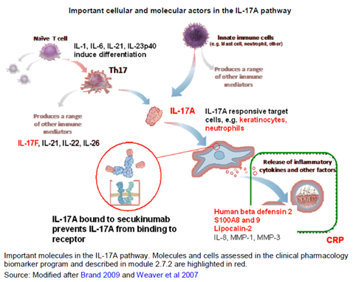

### Regulatory status

The product received initial registration on the Australian Register of Therapeutic Goods (ARTG) on 12 January 2015.

#### Overseas regulatory status

At the time the TGA considered this application, a similar application was under consideration in EU (submitted 22 October 2013), USA (submitted 24 October 2013), Canada (submitted 11 December 2013) and Switzerland (submitted 11 November 2013).

The FDA’s Dermatologic and Ophthalmic Drugs Advisory Committee discussed this application on 20th October 2014[1]). The sponsor announced that the committee unanimously recommended approval for adult patients with moderate-to-severe plaque psoriasis who are candidates for systemic therapy or phototherapy[2]. A decision had not been announced about approval by the FDA, as of 4.November.2014 (prior to the presentation to of this submission to ACPM).

The proposed indication for the application under review by the EMA is:

*Cosentyx is indicated for the treatment of moderate to severe plaque psoriasis in adults who failed to respond to, or who have a contraindication to, or are intolerant to other systemic therapies including ciclosporin, methotrexate and Psoralen ultraviolet light A (therapy)PUVA.*

This narrower wording is ostensibly due to precedent set in the EU by indications of other biological therapies. A decision about approval/wording of the indication has not been made as of 4 November 2014.

#### Guidelines

The TGA has adopted the EU ‘Guideline on clinical investigation of medicinal products indicated for the treatment of Psoriasis’ – CHMP/EWP/2454/02 corr. The TGA has annotated as follows: ‘Section 5.2.5 on this guideline suggests that regulatory approval requires a comparison with an active comparator (for example cyclosporine, methotrexate etcetera). Placebo controlled studies may also be acceptable in Australia’. This annotation is not critical in this application, as the sponsor used an active control arm in Study A2303.

### Product Information

The approved Product Information (PI) current at the time this AusPAR was prepared can be found as Attachment 1. For the most recent Product Information please refer to the TGA website at <<https://www.tga.gov.au/product-information-pi>>.

## II. Quality findings

### Drug substance (active ingredient)

Secukinumab (AIN457) is a recombinant human monoclonal antibody directed against human IL-17A and belongs to the IgG1/κ isotype subclass. It is expressed in a recombinant Chinese Hamster Ovary (CHO) cell line and contains two heavy chains and two light chains. Both heavy chains contain oligosaccharide chains linked to the protein.

Due to expression in a CHO cell line, the C-terminal lysine residues of the heavy chains are post translationally removed, resulting in Mr = 147,688 Da (not taking into account post translational modification (for example, glycosylation)).

This substance is manufactured in a bioreactor. The cell culture supernatant is harvested by centrifugation and depth filtration. Secukinumab is purified from the harvested cell culture fluid. The bulk drug substance solution is filtered, filled into single use containers and frozen for long term storage.

Cell banking processes are satisfactory. All viral/prion safety issues have been addressed, including use of animal derived excipients, supplements in the fermentation process and in cell banking.

### Drug product

The drug product, Cosentyx, is available in two dosage forms:

* 150 mg Powder for injection in a glass vial
* 150 mg/mL Solution for injection in pre filled syringe and pre-filled pen.

The two proposed presentations for the pre filled syringe drug product are:

* Pre filled syringe with rigid needle shield assembled with a passive safety device
* Pre filled syringe assembled with an autoinjector.

The powder and solution for injection drug product are manufactured and sterilised by filtration.

The stability data support the proposed shelf life of 36 months at 5°C ± 3°C for Cosentyx 150 mg powder for solution for injection in vial and the reconstituted drug product for up to 14 days at 2°C to 8°C.

The stability data support the proposed shelf life of 24 months at 5°C ± 3°C for Cosentyx 150 mg/1 mL solution for injection in prefilled syringe with safety device and in auto injector.

### Biopharmaceutics

Evaluation of bioavailability data is not required according to current TGA practice ([http://www.tga.gov.au/pdf/pm-argpm-ap15.pdf dated 2004](http://www.tga.gov.au/pdf/pm-argpm-ap15.pdf%20dated%202004)).

#### Advisory committee recommendation

The application was referred to the Pharmaceutical Subcommittee (PSC) of the Advisory Committee on Prescription Medicines (ACPM).

The PSC considered the application submitted from Novartis Pharmaceuticals Australia Pty Ltd to register Cosentyx, solution for injection in prefilled syringe, containing 150 mg/1 mL of a new biological entity, secukinumab.

The PSC made the following recommendation (Recommendation No 2355):

The PSC considered that the manner in which the population pharmacokinetic modelling has been designed, implemented and reported accords with acceptable standards and regulatory guidelines and that this should provide some confidence in the conclusions drawn.

### Quality summary and conclusions

The quality evaluators have no objection to the registration of:

* Cosentyx secukinumab (rch) 150 mg powder for injection vial
* Cosentyx secukinumab (rch) 150 mg/1 mL solution for injection in prefilled syringe
* Cosentyx secukinumab (rch) 150 mg/1 mL solution for injection in prefilled pen.

Batch release testing of the first five batches by the TGA Laboratories Branch is recommended to verify quality of the product and consistency of the manufacturing process. Subject to the Delegates agreement, the batch release conditions, as described below, should be added to the conditions of registration of this product.

## III. Nonclinical findings

### Introduction

The submitted nonclinical data were in general accordance with the ICH guideline (ICH S6)[3] on the nonclinical evaluation of biotechnology derived pharmaceuticals. All pivotal repeat dose toxicity and reproductive toxicity studies were good laboratory practice (GLP) compliant. Secukinumab acts by binding to the human form of the cytokine interleukin -17A (IL-17A). Secukinumab does not interact with IL-17A from rodent species so most studies investigating the kinetics and toxicity of secukinumab were conducted in cynomolgus monkeys as secukinumab does interact with IL-17A in this species. Two reproductive toxicity studies were conducted in mice using BZN035[4].

### Pharmacology

#### Primary pharmacology

Secukinumab is a fully human, anti-human IL-17A monoclonal antibody (mAb) of the IgG1/κ isotype. Secukinumab binds to human IL-17A and neutralises its activity. IL-17A is the principal effector of TH17 cells and plays an important role in host defence against extracellular bacteria and fungi at mucosal surfaces. IL-17A also promotes inflammatory pathology in autoimmune disease. IL-17A activates a highly pro inflammatory program of gene expression and induces the production of IL-6 (a major cytokine in inflammation and host defence) and the production of IL-8 (a chemokine ligand for CXC chemokine receptor 2 (CXCR2) that mediates the recruitment of neutrophils into tissues). Neutralisation of IL-17A with secukinumab may be valuable in the treatment of inflammatory or autoimmune diseases in which IL-17A plays a role.

Initial primary pharmacology studies established the methods for the generation and the selection of an anti-human IL-17A monoclonal antibody and established binding and biological activity characteristics. Secukinumab selectively binds to the human IL-17A homodimer (dissociation constant (KD) 0.227 nM) and also cross reacts with cynomolgus (KD 6 nM), rhesus (KD 9 nM) and marmoset monkey (KD 1.2 nM) IL-17A but with lower affinity compared to human IL-17A. Secukinumab did not cross react with most other homodimeric members of the IL-17 family (IL-17B to IL-17E), but weak interactions with IL-17F, which could not be quantified, were observed. Measurable binding to IL-17AF (a heterodimer) from humans and cynomolgus monkeys was observed but KD values were substantially higher than to IL-17A from humans (2.4 versus 0.06 nM) and also higher for cynomolgus monkey (4.3 versus 0.9 nM). No cross reactivity of secukinumab with other human cytokines (IL-1α, IL-1β, TNF-α, IFNγ, IL-2, IL-6, IL-8, IL-13, IL-18, IL-19, IL-20, IL-22, IL23, TGF-β1 and TGFβ2) was detected.

IL-17A mediates its effects via interaction with IL-17A receptors (IL-17AR). IL-17ARs are expressed ubiquitously with particularly high levels on haematopoietic cells. Secukinumab inhibited the release of IL-6 from human synoviocytes stimulated with IL-17A, IL-17F and IL-17A/F in combination with TNF-α (50 % inhibitory concentration (IC50) 0.14 nM). Secukinumab inhibited the release of IL-6 from monkey synoviocytes stimulated with IL-17A or IL-17F with complete inhibition observed at concentrations ≥ 10 µmol/L. Secukinumab was also shown to inhibit the binding of recombinant human IL-17A homodimers to recombinant human IL-17AR (IC50 0.51 nM).

Secukinumab did not cross react with mouse or rat IL-17A and for this reason primary pharmacology studies were essentially confined to in vitro studies. Mouse 3T3 cells engineered to secrete human IL-17A were used in two in vivo pharmacology studies. In the first of these studies secukinumab was shown to inhibit the immigration of neutrophils into air pouches containing 3T3 cells in mouse skin (50% effective dose (ED50) 5.4 mg/kg IP). In the second study secukinumab suppressed inflammatory symptoms in DBA-1 mice whose knee joints had been injected intra articularly with 3T3 cells.

A mouse anti-mouse IL-17A surrogate antibody (BZN035) was developed. This antibody showed high affinity binding (KD 0.067 nM) to, and neutralisation of, mouse IL-17A comparable to that seen with secukinumab with human IL-17A and no cross reactivity with other mouse cytokines. This antibody was used in one pharmacology study and two reproductive toxicity studies in mice. In the pharmacology study, BZN035 inhibited knee swelling in an antigen induced arthritis model by 72% at approximately 10 mg/kg intra peritoneal (IP) (three times per week).

#### Secondary pharmacodynamics and safety pharmacology

Secukinumab showed on and off rates and KD values in binding to recombinant Fcγ and FcRn receptors typical for a human antibody of the IgG1 isotype. Safety pharmacology was evaluated in monkeys following (IV) intravenous doses of secukinumab up to 100 mg/kg. No effects on the cardiovascular, respiratory or central nervous systems were observed.

### Pharmacokinetics

#### Absorption

The pharmacokinetics (PK) of secukinumab was linear and fitted a 2 compartment model in monkeys and humans. The average time to reach maximum plasma concentration (Tmax) value following subcutaneous (SC) administration in monkeys (13 week study) was 2.7 days which is comparable to the human estimated value of 6 days based on simulated dose cycles employing the SC route. No gender differences in plasma kinetics were observed and dose proportionality was observed between doses on specific days. Typical of monoclonal antibodies, plasma half-life values were long. At the 150 mg/kg weekly IV dose (26 week study) the apparent terminal half-life values were 24 and 30 days for males and females, respectively. The estimated terminal half-life in humans was 26.9 days based on a population pharmacokinetic model. The bioavailability in monkeys and humans following SC dosing was similar (63% in monkeys, 73% in the human PK model).

#### Distribution

No studies were performed to investigate the tissue distribution of secukinumab in non-pregnant animals. Distribution to the fetus was demonstrated in mice (with BZN035) and monkeys (with secukinumab). The volume of distribution (Vd) in cynomolgus monkeys ranged from 59 to 76 mL/kg following IV administration of 10 mg/kg secukinumab. These values are in the range of blood volume data for cynomolgus monkey which is expected for a monoclonal antibody. A low volume of distribution was also calculated for secukinumab in humans with a central Vd of 3.61 L and a peripheral compartment Vd of 2.87 L. Total systemic clearance of secukinumab in monkeys was 1.8 mL/day/kg and was also low in humans (0.19 L/d).

#### Metabolism

No metabolism studies were performed since secukinumab is a member of a therapeutic class understood to be degraded into smaller peptides and individual amino acids.

#### Pharmacokinetic interactions

As a fully human monoclonal antibody, secukinumab is expected to be metabolically degraded through peptide hydrolysis and is therefore unlikely to interact with other drugs via cytochrome P450 enzymes or transporters.

#### Conclusion

The pharmacokinetic profiles in cynomolgus monkeys were sufficiently similar to those in humans to allow them to serve as appropriate models for the assessment of drug toxicity.

### Toxicology

#### Acute toxicity

One study of acute toxicity was conducted in the monkey. In this study the maximum non-lethal dose was 150 mg/kg SC and this dose produced no treatment related effects. Further, no unscheduled deaths were recorded in any of the repeat dose toxicity studies in monkeys at weekly SC doses of up to 150 mg/kg. Secukinumab has a low order of toxicity by the clinical route.

#### Repeat dose toxicity

Studies of up to 26 weeks duration were conducted in cynomolgus monkeys using the weekly dosing and either SC or IV administration. The duration (up to 6 months) and dosing were appropriate for a biopharmaceutical product (ICH S6R1[5]). All pivotal studies were conducted according to GLP. Test material derived from the mouse B lymphocyte hybridoma (Sp2/0) cell line was used in one 4 week study and material derived from the CHO cell line in the remaining repeat dose studies. The commercial form of secukinumab is produced in CHO cells.

#### Relative exposure

Exposure ratios (ER) have been calculated based on animal: human plasma maximum plasma concentration (Cmax) and Caverage values. Human reference values are from AIN457 population PK modelling report and are based on simulated concentration profiles of 1,000 subjects with the dosing regimen SC 300 mg: Week 0, 1, 2, 3 (Induction), followed by once every 4 weeks from Week 4 (Maintenance). The comparisons presented below (Table 1) use the predicted human induction and maintenance Cmax values and Cmax values obtained in the repeat dose toxicity studies (both in µg/mL). Further comparisons use the estimated average plasma concentration Caverage (µg/mL) which is calculated as the area under the serum concentration time curve from time zero to time 168 hours (AUC0-168 h) divided by 168 hours in the monkey studies and the AUCτ divided by τ in the human simulated concentration profiles. The levels of the relative exposure achieved in cynomolgus monkeys were high in the repeat dose toxicity studies. The ER at the highest dose (150 mg/kg) was 52 (Induction) and 117 (maintenance) based on Caverage. Taking into account the difference in binding affinity to monkey and human IL-17A (KD 6 nM versus 0.227 nM), the pharmacological ER was approximately 26 fold lower.

Table 1. Relative exposure in repeat dose toxicity studies.

|  |  |  |  |  |  |  |  |  |
| --- | --- | --- | --- | --- | --- | --- | --- | --- |
| Species | Study duration | Dose (mg/kg/ week) | Cmax  (µg/mL) | Caverage  (µg/mL)‡ | Exposure ratio# | | | |
| **Induction** | | **Maintenance** | |
| **Cmax** | **Caverage** | **Cmax** | **Caverage** |
| **Monkey** (Cynomolgus) | 4 weeks | 15 | 642 | 432 | 6.2 | 4.3 | 12 | 9.7 |
| 50 | 2535 | 1563 | 25 | 16 | 46 | 35 |
| 150 | 6960 | 4307 | 67 | 43 | 126 | 97 |
| 13 weeks | 15 | 556 | 503 | 5.4 | 5.0 | 10 | 11 |
| 50 | 2015 | 1768 | 20 | 18 | 37 | 40 |
| 150 | 5455 | 4824 | 53 | 48 | 99 | 108 |
| 26 weeks | 15 | 883.5 | 602 | 8.6 | 6.0 | 16 | 14 |
| 50 | 3175 | 1884 | 31 | 19 | 58 | 42 |
| 150 | 8615 | 5211 | 83 | 52 | 156 | 117 |
| **Human** (psoriasis patients)* | Induction | 300 mg | 103.3 | 99.8 | - | | | |
| Maintenance | 300 mg | 55.2 | 44.5 | - | | | |

‡ Monkey Caverage = AUC 0-168h/168, human Caverage = AUCτ/28; # animal:human Cmax or Caverage; * Human plasma concentration values from AIN457 population PK Modelling Report.

#### Major toxicities

Secukinumab was well tolerated in all the repeat dose studies. No unscheduled deaths were reported following either SC or IV dosing. There was no evidence of treatment related adverse effects in clinical signs, bodyweight, food consumption, ophthalmology, electrocardiography or on organ weights or macroscopic or microscopic pathological examinations. Some small effects on haematology parameters were observed at the highest dose (150 mg/kg/week) in the 26 week repeat dose study (ER = 117). These were small, statistically non significant decreases in neutrophils in males (40%) and in red blood cells, haemoglobin and haematocrit in females (< 10%) when compared to control group values. The decrease in neutrophils in males persisted in the recovery period (53%). There were small elevations in globulin levels in all treatment groups at Weeks 13 and 26, and the elevations only reached statistical significance in males at 150 mg/kg/week (< 15%) and were not present in the recovery period.

#### Immunotoxicity

Although IL-17A is only one factor in the complex response to infection, targeting IL-17A does raise the potential risks of infection and immune dysfunction. Animals in the repeat dose toxicity studies did not show evidence of increased susceptibility to infection during the treatment period except for one high dose female in the 26 week study (discussed below). In addition to general observations potential immunological effects of secukinumab were investigated directly. Immuno- area under the drug serum concentration-time curve area phenotyping of peripheral blood was performed in the repeat dose studies and results were reported as relative percentages and absolute numbers of total T lymphocytes (CD45+/CD3+), helper T lymphocytes (CD45+/CD3+/CD4+), cytotoxic T lymphocytes (CD45+/CD3+/CD8+), B lymphocytes (CD45+/CD20+) and natural killer (NK) lymphocytes (CD45+/CD3-/CD16+). There were some differences in the lymphocyte subsets in peripheral blood of the treated groups when compared to controls, which were statistically significant for some subsets in some studies. The large variability of pre-treatment and concurrent control group values, and small group sizes make the interpretation of the changes difficult.

No effects on T cell dependent antibody responses were seen in either 4 week study. In the 13 week study there was evidence of reduced anti keyhole limpet hemocyanin (KLH) IgG antibody in males. Some group means were statistically different from control values and there were statistically significant dose related trends at the end of the dosing period. There was no difference between the high dose group and controls at the end of the recovery period. There were also reductions in anti KLH IgG antibodies in females and IgM antibodies in both males and females but the individual variability made these results difficult to interpret. In the 26 week repeat dose study, there were reductions in the primary anti KLH IgM and anti KLH IgG responses in treated males and females at doses ≥ 15 mg/kg/week (ER > 14) compared to their concurrent controls but the variability observed among animals as well as the general lack of dose dependent trends and statistical significance make the meaning of these results uncertain. However given the importance of IL-17 in immune responses and reported reduction in T cell dependent antibody (IgG) response in IL-17 deficient mice compared to wild type mice[6], the decreases in T cell dependent antibody response, despite the variability observed in the 13 and 26 week studies, might be related to secukinumab treatment.

Natural killer cell (CD45+/CD3-/CD16+) activity was assessed using the NK cell sensitive cell line K562 as a target for the measurement of cytotoxic activity of cynomolgus monkey NK cells. Generally no changes in NK cell activity were seen in the repeat dose studies. One female (26 weeks, 150 mg/kg/week) who presented with skin lesions, showed an NK cell activity lower than that observed during its pre-treatment period and also of that of the control group. Secukinumab may have increased the animals’ susceptibility to skin lesions and/or impaired its ability to generate an adequate immune response. This was a single case but as the group sizes of 6 are small a relationship to treatment with secukinumab cannot be excluded.

The sponsor studied the potential for increased susceptibility to infection due to IL-17A neutralisation in mouse models of infections and also provided a comprehensive review of IL-17A in innate and adaptive immunity and an infection risk assessment. In a mycobacterial infection model anti IL-17A antibodies had no effect on host resistance to acute mycobacterial infections with M. tuberculosis in the lung. However published literature suggests that IL-17A plays an important role in the protection of hosts from mycobacterial infection and experimental animals with IL-17A neutralisation or lacking IL-17A are more susceptible to mycobacterial infection. The importance of IL-17A against mycobacterial infection was further confirmed in recent studies. Ling and colleagues demonstrated that IL-17A significantly enhanced the clearance of intracellular BCG by macrophages[7] and another research group showed that IL-17A confers early protective immunity against virulent mycobacterium.[8]

IL-17A is critical in immune surveillance of mucocutaneous barrier tissues. In a sponsor study, treatment with anti-IL-17A antibodies resulted in delayed clearance of oropharyngeal candidiasis although constitutive ablation of IL-17A in IL17-/- mice had no effect on the time course of infection. Published studies clearly showed that neutralising IL-17A or knocking out the IL-17A/F gene reduces immunity against topical or systemic fungal infection and increases fungal burden.[9]

As indicated in the sponsors’ assessment, IL-17A and other cytokines induce acute secretion of antimicrobial peptides by epithelial cells, thereby promoting the direct destruction of invading pathogens, and factors promoting and recruiting granulocytes, contributing to pathogen eradication at early stages of infection. The T helper 17 cell (Th17)/IL-17A pathway is also involved in promoting adaptive immune responses by recruiting dendritic cells and lymphocytes, all contributing to pathogen recognition and eradication. Human primary immunodeficiencies in the Th17/IL-17 pathway are associated with mucocutaneous infections by Candida albicans (C. albicans) and Staphylococcus aureus (S. aureus). IL-17 pathway deficient mice (Il17ra-/-, Il17a-/- and Il17f-/-) or in mice treated with anti-IL-17A or IL‑17F antibodies had increased susceptibility to Candida and Staphylococcus infections. While there is no clear evidence of compromised immunity against parasites and viruses due to impairment of the Th17/IL-17 pathway, increased susceptibility to infections by all pathogens in patients treated with secukinumab remains a concern. In a mouse model of fungal infection, Bӓr and co-workers showed that IL-17 controls the development of functional NK cells and suggested that defects in the IL-17 pathway might also adversely impact immunity against bacteria, viruses and tumours in addition to fungi.9

The possibility of immune compromise is a concern with an agent which interferes with innate and adaptive immunity. Other biologic therapies which target key components of the immune system have been introduced to treat immune mediated disease states. A number of these are direct cytokine antagonists for example, infliximab (an antagonist of TNF-α) and anakinra (an antagonist of IL-1). Other biologic agents (abatacept, rituximab) work by altering other parts of the inflammatory response cascade. A recent meta-analysis of these agents for the Cochrane collaboration[10] found some increases in the incidence of infection in patients receiving these drugs although there was no significantly increased risk for serious infections.

#### Immunogenicity

Animals in the repeat dose studies were tested for anti secukinumab antibodies. A positive immune response was detected in one female (150 mg/kg/week) in the post dose period of the 13 week toxicity study and in two animals in single dose toxicokinetic studies. Detection of anti secukinumab antibodies was however compromised by the presence of residual secukinumab in the samples and antibodies may have been present in other animals.

IL-17A levels were measured in animals in the repeat dose toxicity studies with a validated sandwich enzyme linked immunoabsorbance assay (ELISA). Although the concentrations of IL-17 were highly variable between animals, IL-17A levels increased with dose and duration of treatment. No IL-17A was detected in placebo animals or in treated animals at the end of the recovery periods in the 13 and 26 week studies. The changes seen in the plasma concentrations of IL-17A are consistent with the pharmacological action of secukinumab that is, binding to IL-17A, reducing the clearance of IL-17A.

#### Genotoxicity

No genotoxicity studies were submitted. This was based on the ICH Guideline for the Preclinical Safety Evaluation of Biotechnology-Derived Pharmaceuticals (ICH S6R1 2011) which states that routine genotoxicity studies are not applicable to biotechnology derived pharmaceuticals. In addition there are no aspects of the structure of secukinumab to indicate any cause for concern in this respect.

#### Carcinogenicity

No carcinogenicity studies were submitted. The sponsor indicated that there had been discussions with EU health authorities which had agreed carcinogenicity studies were not appropriate. The reasons for this decision were a mixture of practical; secukinumab is not active in rodents and carcinogenicity studies are not feasible in primates and theoretical; the IgG1structure itself is not carcinogenic and the available evidence to date suggests that blocking IL-17A does not pose a risk for tumour promotion.

The sponsor provided an extensive review of the literature evidence relating to the possible roles of IL-17A in tumour inhibition and/or promotion. The key points from the literature on IL-17A are firstly that IL-17A (the cytokine itself) has tumour promoting activities. These activities are:

* inhibition of apoptosis of several tumour cell lines in vitro
* promotion of angiogenesis and tumour growth in various animal models in vivo and
* induction of protease production and promotion of tumour invasion in vitro.

The second key point of evidence is that IL-23 knockout mice which have no or low IL-17A as well as mice treated with an anti-IL-17A monoclonal antibody show reduced nascent tumour growth.

IL-17A has been shown to be up regulated in multiple tumour types including several advanced human tumours and this evidence implicates this cytokine in tumour progression. The picture is not however completely clear as there is also evidence from IL‑17 knockout mice and recombinant IL-17A transfected tumour cells showing that IL‑17A could contribute to effective immune surveillance of tumours. The evidence for the contribution of IL-17A to T cell responses includes recruitment of memory T cell responses to the site of mycobacterial challenge, the induction of intercellular adhesion molecule 1 (ICAM-1) and human leukocyte antigen DR (HLA-DR) expression and dendritic cell maturation. An IL-17A dependent T cell response is postulated to favour tumour infiltration by T cells and NK cells. As discussed above, IL-17 was showed to control the development of functional NK cells and defects in the IL-17 pathway might compromise immune surveillance of tumour cells in addition to pathogens.

On balance, the carcinogenic risk of secukinumab therapy is low.

#### Reproductive toxicity

Reproductive toxicity was evaluated in one study in cynomolgus monkeys using secukinumab and in two studies in mice using BZN035 against IL-17A. All studies employed weekly SC administration and were GLP compliant. The studies investigated potential effects on male and female fertility (mice), embryofetal toxicity (monkeys) and pre /postnatal development (mice). Adequate animal numbers were used in the pivotal studies and treatment periods were appropriate.

Table 2. Relative exposure.

|  |  |  |  |  |  |  |  |  |
| --- | --- | --- | --- | --- | --- | --- | --- | --- |
| Species | Study | Dose (mg/kg/ day) | Cmax  (µg/mL) | Caverage  (µg/mL)‡ | Exposure ratio# | | | |
| **Induction** | | **Maintenance** | |
| Cmax | Caverage | Cmax | Caverage |
| **Monkey** (cynomolgus) | Embryofetal development | 15 | 493 | 417 | 4.8 | 4.2 | 8.9 | 9.4 |
| 50 | 1680 | 1458 | 16 | 15 | 30 | 33 |
| 150 | 5070 | 4226 | 49 | 42 | 92 | 95 |
| **Human** (healthy volunteers)* | Induction | 300 mg | 103.3 | 99.8 | - | | | |
| Maintenance | 300 mg | 55.2 | 44.5 | - | | | |

‡ Monkey Caverage = AUC 0-168h/168, human Caverage = AUCτ/28; # animal:human Cmax or Caverage; * Human plasma concentration values from AIN457 population PK Modelling Report.

The relative exposure achieved in the embryofetal development study in monkeys was high (ERCaverage = 42 to 95).

Placental transfer of secukinumab was demonstrated in cynomolgus monkeys in the embryofetal development study. Fetal serum levels of secukinumab were 20 to 30% of maternal serum levels on gestation day 100 (GD 100) (10 days after the last dose). Secukinumab concentrations in amniotic fluid were low, approximately 30 fold lower than maternal serum concentrations. Excretion into milk was not investigated. The pre /postnatal development study in mice dosed with the anti-murine surrogate (BZN035) showed serum levels in pups around 1.5 fold higher than in dams after the last dose on postnatal day 16 (based on area under the serum concentration time curve (AUC)).

BZN035 at up to 150 mg/kg/week had no effects on the reproductive function, fertility or early embryonic development in mice. Secukinumab had no major effects on embryofetal development in monkeys. The only notable observation was a small dose related increase in the frequency of misaligned vertebrae in the tail. This variation does occur spontaneously in this species and the incidence was within the historical control range. The apparent dose relationship was probably a chance finding. Potential effects on embryofetal development were not studied in a second species. There were no signs of skeletal abnormalities in the mouse pre-/post-natal study with the surrogate antibody BZN035.

There were no effects of BZN035 on the general development of first filial (F1) or second filial (F2) generations of mice. Immunological effects were noted, however, in F1 males and females. Decreased blood lymphocyte counts were seen only in males of the mid dose group, and were probably not treatment related due to the lack of effects at the high dose and no effects in females. Increases in the total lymphocytes and subsets in blood, spleen and thymus were observed in males and an increase in total lymphocyte and subsets in the thymus in females. The significance of increased lymphocyte numbers is uncertain but probably not adverse. No changes in anti-KLH IgM or IgG levels were observed suggesting that these lymphocyte changes did not affect T cell dependent antibody responses.

#### Pregnancy classification

The sponsor has proposed Pregnancy Category B1[11]. Considering the pharmacological action, importance of IL-17A in immune responses to infection and placental transfer of secukinumab, pregnancy category C[12] is appropriate and consistent with the category for other monoclonal antibody immunomodulators.

#### Tissue cross reactivity

Studies on tissue cross reactivity in samples from humans and cynomolgus monkeys were conducted using material derived from SP2/0 and CHO cell lines. There was more unexpected (and unexplained) staining of monkey and human tissues with secukinumab derived from the SP2/0 cell line than from the CHO cell lines. As the SP2/0 material is not to be used clinically these observations probably have no relevance. Staining of human and monkey tissues was qualitatively similar with antibodies derived from the CHO cell line but there was a reduced amount of mononuclear cell/lymphocyte staining in monkey tissues compared with human tissues. The lower mononuclear cell/lymphocyte staining may be due to the fact that cynomolgus monkey tissues are collected quickly after euthanised of young healthy monkeys that are less likely to have activated lymphocytes than post-mortem tissues from humans. One unexpected finding with the CHO derived antibody was staining of haematopoietic precursor cells in human bone marrow. There was no evidence of effects on haematopoietic precursor cells in the repeat dose toxicity studies in monkeys.

#### Local tolerance

Secukinumab did not cause lysis of B21 T cells via antibody dependent cell mediated cytotoxicity. B21 T cells were considered a possible target cell as memory T cells have been reported to be capable of producing IL‑17A. Secukinumab did not cause haemolysis of human or monkey whole blood or coagulation of human or monkey plasma in vitro.

In the repeat dose toxicity studies, repeated IV or SC dosing in monkeys did not cause significant local reactions at the injection site. Mild reactions were observed in both control and treated groups.

#### Paediatric use

Secukinumab is not proposed for paediatric use and no specific studies in juvenile animals were submitted.

### Nonclinical summary and conclusions

#### Summary

* The submitted nonclinical data were in general accordance with the EU/ICH guidelines (ICH S6) on the nonclinical evaluation of biotechnology derived pharmaceuticals. All pivotal repeat dose toxicity and reproductive toxicity studies were GLP compliant.
* Secukinumab is a fully human monoclonal antibody which binds to and neutralises human IL-17A, a cytokine released from a subset of T helper cells and playing important roles in inflammatory pathology in autoimmune diseases and immunity. Primary pharmacology studies in vitro established the specificity of secukinumab binding to human and cynomolgus monkey IL-17A and demonstrated functional inhibition of IL-17A from both species and suppression of inflammation in mouse models of inflammatory diseases. No cross reactivity of secukinumab with 15 other human cytokines was detected. Secukinumab did not cross-react with mouse or rat IL-17A.
* Safety pharmacology was evaluated in monkeys following IV doses of secukinumab up to 100 mg/kg. No effects on the cardiovascular, respiratory or central nervous systems were observed.
* The pharmacokinetic profile in cynomolgus monkeys was typical of an IgG antibody and similar to that seen in humans. The volume of distribution of the central compartment in monkeys approximated the plasma volume consistent with that in humans.
* Acute toxicity was assessed in monkeys following SC administration of 150 mg/kg. No effects were noted in animals up to 28 days following this dose. Secukinumab was also well tolerated by IV doses up to 150 mg/kg. It has a low order of toxicity by the clinical route.
* Secukinumab had no effects on clinical signs, bodyweight, food consumption, ophthalmology, electrocardiography or clinical pathology at doses up to 150 mg/kg/week for 4 to 26 weeks (ER = 117). No effects were detected in post mortem or histopathological examinations. Some sporadic variations in lymphocyte (and subsets including NK cells) numbers in the blood and T cell dependent antibody responses were observed in the repeat dose studies. Animals in the repeat dose toxicity studies generally did not show evidence of increased susceptibility to infection except for one monkey which presented skin lesions and showed an NK cell activity lower than the pre-treatment and concurrent control values. Although this was a single case a relationship to treatment with secukinumab cannot be excluded given the small number of monkeys used in the study. IL-17A plays an important role in innate and adaptive immunity. Secukinumab treatment is expected to increase susceptibility to infections by bacteria, fungi and possibly viruses and parasites since IL-17A was shown to control the development of functional NK cells. In particular human primary immunodeficiencies in the Th17/IL-17 pathway are associated with mucocutaneous infections by C. albicans and S. aureus. IL-17 pathway deficient mice (Il17ra-/-, Il17a-/- and Il17f-/-) or in mice treated with anti-IL-17A or IL-17F antibodies had increased susceptibility to Candida and Staphylococcus infections.
* Reproductive toxicity was evaluated in one study in cynomolgus monkeys using secukinumab and in studies in mice using BZN035 against IL-17A. BZN035 had no effects on the reproductive function, fertility or early embryonic development in mice. Secukinumab had no major effects on embryofetal development in monkeys (ER = 117). There were no effects of BZN035 on the general development of F1 or F2 generations of mice. Increases in lymphocyte numbers in the blood, spleen and thymus were noted in F1 males and/or females. No changes in T-cell dependent antibodies, anti-KLH IgM or IgG levels were observed suggesting that the lymphocyte changes did not affect T-cell dependent antibody responses.

#### Conclusions

* Primary pharmacology studies in vitro established the specificity of secukinumab binding to human and cynomolgus monkey IL-17A and demonstrated functional inhibition at receptors of both species.
* Clinically significant off target activities are unlikely. No major organ toxicities were observed with secukinumab in the monkey except for one case with skin lesions and low NK cell activity. The main safety concern is increased susceptibility to infections by bacteria, fungi and possibly viruses and parasites. IL-17A plays an important role in innate and adaptive immunity and was shown to control the development of functional NK cells.
* No reproductive toxicity was observed with secukinumab in monkeys or with mouse anti-murine IL-17A antibody in mice.

#### Recommendations

There are no nonclinical objections to registration.

Recommended revisions to nonclinical statements in the draft PI are beyond the scope of the AusPAR.

## IV. Clinical findings

A summary of the clinical findings is presented in this section. Further details of these clinical findings can be found in Attachment 2.

### Introduction

#### Clinical rationale

Psoriasis is a multifactorial, relapsing syndrome triggering immune responses which manifest as red, inflamed plaques on the skin, occurring anywhere on the body, but most often on the extremities, scalp, elbows, knees, nails, palms, and soles of feet. It is one of the most common human skin disorders, affecting 2.6 % of Australians.[13] Approximately 85 to 90% of psoriasis patients have chronic plaque psoriasis. Of the 350,000 Australians that suffer from plaque psoriasis, around 10 per cent suffer from severe chronic plaque psoriasis. Several low molecular weight drugs (including cyclosporine, methotrexate), and biologics, including TNF-α antagonists (adalimumab, etanercept, infliximab) and anti IL12/IL23 (ustekinumab) have been approved for the treatment of psoriasis. Most of these treatments are associated with specific safety concerns (that is, organ toxicity, infections including tuberculosis, malignancies including lymphoma, immunogenicity and demyelinating neurologic event), which limits their value in the long term management of psoriasis. None achieve the goal of clear/almost clear skin for a majority of patients.[14] Thus there remains a significant medical need for new therapeutic approaches in moderate to severe psoriasis, in particular approaches that target specific immunopathogenic events of the condition and are safer when administered chronically. Interleukin-17A (IL-17A) is recognised as one of the principal cytokines in a number of chronic, immune mediated, inflammatory conditions including psoriasis. Evidence of the role of IL-17A in the inflammatory processes of psoriasis is that inhibition of IL-17 signalling[15] correlates with relief of symptoms and successful treatment of psoriasis. Cosentyx works by targeting IL-17A and inhibiting its interaction with the IL- 17 receptor, which is expressed on various cell types including keratinocytes. As a result, Cosentyx inhibits the release of proinflammatory cytokines, chemokines and mediators of tissue damage and reduces IL- 17A mediated contributions to autoimmune and inflammatory diseases. Clinically relevant levels of secukinumab reach the skin and reduce local inflammatory markers. As a direct consequence, treatment with secukinumab reduces erythema, induration and desquamation present in plaque psoriasis lesions. At therapeutic concentrations, secukinumab does not neutralise IL-17F, leaves other functions of Th17 cells intact, and does not directly influence the Th1 pathway. Therefore it is expected that Th1 based host defence mechanisms are largely unaltered by Cosentyx. This new mechanism of action offers greater specificity and selectivity in targeting the specific downstream cytokine. This specificity offers the potential for fewer off target effects when compared to other available current treatment options for psoriasis. In addition, as IL-17A is further downstream in the inflammation cascade, mechanistically it is expected to have a better safety profile as compared to other approved therapies such as anti TNF agents.

#### Contents of the clinical dossier

The submission contained the following clinical information:

* 20 clinical pharmacology studies, including 15 that provided pharmacokinetic data and 12 that provided pharmacodynamic data.
* 1 population pharmacokinetic analyses.
* 5 pivotal efficacy/safety studies (A2302, A2308, A2309, A2303, A2304) for the proposed psoriasis indication.
* 5 Phase II dose-finding studies (A2204, A2102, A2211, A2212 and A2220) for the proposed psoriasis indication.
* Supportive Phase III studies (A2307 and A2211E1) for the proposed psoriasis indication.
* Pooled analyses, meta-analyses, Periodic Safety Update Reports (PSURs), Integrated Summary of Efficacy and, Integrated Summary of Safety.

**Comments**: The submission also contains other studies for indications for which approval is not sought in this submission. These include studies in psoriatic arthritis (A2206, A2206E1), Rheumatoid arthritis (A2101, F2201, F2206 and F2208), Ankylosing spondylitis (A2209, A2209E1), Uveitis (A2208, A2301, A2301E1, C2302E1, C2303 and C2303E1), multiple sclerosis (B2201), Crohn’s disease (A2202, A2202E1) and dry eye syndrome (PJMR0092202). These studies have not been evaluated as they do not provide data in direct support of the proposed psoriasis indication. Safety data from these studies was included in Pool C safety dataset which included 34 studies in all different indications; and has been evaluated in this report.

#### Paediatric data

The submission did not include paediatric data.

Novartis will defer the start of a paediatric psoriasis study in patients 6 to less than 18 years of age until after both data from twelve months treatment period from the Phase III program in psoriasis adult patients becomes available and the PK model of this data is available to support dose justification. In addition, Novartis is proposing a waiver for the patient population less than 6 years of age. The sponsors paediatric investigation plan (PIP) was adopted by the FDA and the European Medicines Agency (EMA).

#### Good clinical practice

All the clinical studies were conducted in compliance with good clinical practice (GCP) guidelines and adequate ethics approval.

### Pharmacokinetics

#### Studies providing pharmacokinetic data

Summaries of the pharmacokinetic studies were provided. Table 3 shows the studies relating to each pharmacokinetic topic.

Table 3. Submitted pharmacokinetic studies.

|  |  |  |  |
| --- | --- | --- | --- |
| PK topic | Subtopic | Study ID | Primary aim of the study |
| PK in healthy adults | Bioequivalence (BE) | CAIN457A2106 | BE between single SC dose of PFS1 and LYO2. |
| Single dose | CAIN457A1101 | PK following IV and SC doses in healthy Japanese |
|  | CAIN457A2228 | PK following IV infusion |
|  | CAIN457A2104 | Ability to inhibit ozone-induced airway neutrophilia |
| Ascending dose | CAIN457A2101 | Ascending IV dose in healthy subjects |
| Distribution | CAIN457A2225 | Distribution into dermal interstitial fluid |
| PK in special populations | Target population (Psoriasis patients) | PK Modelling Report | Pooled PPK analysis of secukinumab in psoriasis |
|  | CAIN457A2103 | Absolute bioavailability after SC dosing |
|  | CAIN457A2302 | Efficacy of Response and Safety of 2 Fixed Regimens |
|  | CAIN457A2308 | Efficacy after twelve weeks of treatment |
|  | CAIN457A2309 | Efficacy of 150 mg and 300 mg doses |
|  | CAIN457A2102 | Efficacy of a single dose infusion |
|  | CAIN457A2204 | Efficacy of 3 active treatment arms |
|  | CAIN457A2212 | Efficacy at 12 weeks following different loading-dose regimens |
|  | CAIN457A2220 | Efficacy of 3 different doses |
|  | CAIN457A2211 | Efficacy of three induction regimens |

1. PFS = pre filled syringe. 2. LYO = lyophilised.

**Comment:** It should be noted that a number of studies included in the evaluation materials examined the bioequivalence of different forms of GP2015 (Etanercept) and Enbrel (CAIN457GP15-101, CAIN457GP15-102 and CAIN457GP15-105). As these studies do not relate to the current application they have not been reviewed by the evaluator.

#### Evaluators conclusions on pharmacokinetics

##### Absorption, distribution, metabolism and excretion in healthy subjects

* Following a single SC dose of 300 mg secukinumab via pre filled syringe (PFS) the mean Cmax and area under the serum concentration-time curve from time zero to infinity (AUCinf) were 43.2 µg/mL and 1785 µg/mL respectively, the median Tmax occurred 5 hours after dosing and the mean t1/2 was 26.6 hours.
* The absolute bioavailability of SC secukinumab in healthy Japanese males was 77%, which was similar to the bioavailability for human IgG (65 to 67%).
* The lyophilised presentation (vial) (LYO) and PFS forms of secukinumab were bioequivalent. By contrast, no studies compared the bioequivalence following doses of secukinumab administered via the PFS and the auto injector/pen (AI) in healthy subjects.
* Dose proportionality was not demonstrated for Cmax, area under the drug serum concentration time curve (time 0 to the last measurable concentration sampling time) (AUClast) and AUCinf following SC injection of 150 mg and 300 mg secukinumab in healthy Japanese males.
* No studies examined the effects of food, multiple dosing or administration timing, on PKs of secukinumab in healthy subjects. Nor were studies conducted to identify secukinumab binding to non-IL7A proteins.
* The mean apparent volumes of distribution following a 150 mg SC dose of secukinumab formulated from a LYO or as a PFS were 6.72 L and 6.57 L, respectively. The mean concentration of secukinumab in dermal interstitial fluid (ISF) is approximately 23% of the serum concentration in healthy volunteers at two weeks post dose.
* Although no studies examined the metabolic pathways involved in secukinumab metabolism, it is expected to be degraded into small peptides and amino acids via catabolic pathways in the same manner as endogenous IgG.
* Following SC administration of 150 mg secukinumab the apparent systemic clearance was approximately 0.181 L/day. Secukinumab is not expected to be excreted in urine and the majority of IgG elimination occurs via intracellular catabolism, following fluid-phase or receptor mediated endocytosis.
* Following SC injection of 150 mg secukinumab, the inter subject variability (coefficient of variation (CV%) in Cmax and AUCinf ranged from 13.8 to 27.7% and 14.3 to 26.7%, respectively.

##### Absorption, distribution, metabolism and excretion in target population

* Population PK modelling in plaque psoriasis patients indicated that the Cmax of secukinumab, following single SC doses of either 150 mg or 300 mg, was 13.7 µg/mL or 27.3 ± 9.5 µg/mL, respectively, and occurred between 5 to 6 days following a single dose. The t1/2 was 26.9 days for both doses.
* After initial weekly dosing during the first month, the Tmax occurred between 31 and 34 days. Maximum plasma concentration at steady state (Cmax,ss) following SC administration of either 150 mg or 300 mg was 27.6 µg/mL and 55.2 µg/mL, respectively, and steady-state was reached following 20 weeks with monthly dosing regimens.
* Patients exhibited a 2 fold increase in peak serum concentrations and AUC following repeated monthly dosing during maintenance compared to a single dose. Secukinumab was absorbed with an average absolute bioavailability of 73% in patients with psoriasis.
* Comparison of three separate Phase III studies, which examined 150 mg and 300 mg SC doses of the LYO, PFS and AI formulations, indicated that the Cmin of secukinumab was similar for all three formulations and that Cmin also demonstrated a dose proportional increase in exposure from 150 to 300 mg SC, both at Week 4 and Week 12 in all three studies.
* The mean volume of distribution in patients with psoriasis ranged from 5.56 L to 8.6 L. Secukinumab was more strongly distributed, by approximately 4 to 15%, into the skin of psoriasis patients than in the skin of healthy subjects. The mean systemic clearance of secukinumab was 0.19 L/day and clearance was both dose and time independent.
* The CV% for PK parameters such as Cmin,ss, Cmax,ss, Cave,ss, AUCtau,ss for the 150 mg and 300 mg SC regimens identified in the population PK analysis was between 38.9% and 48.0%.

##### Effect of intrinsic and extrinsic factors on secukinumab PK

* No studies examined the PKs of secukinumab in patients with either hepatic or renal impairment, in a paediatric population or in pregnant women. Based on population PK analysis, clearance in elderly patients and patients less than 65 years of age was similar. Population PK analysis indicated that bodyweight did not influence the bioavailability and the absorption rate in patients with moderate to severe psoriasis following single and multiple doses administered either IV or SC In addition, in Asian patients secukinumab clearance was 12.4% higher than Non-Asian subjects.
* No studies examined the interaction of secukinumab with other drugs in either healthy subjects or the target population.

##### Limitations of pharmacokinetic data

* No studies compared the bioequivalence following doses of secukinumab administered via the PFS and the AI in healthy subjects.
* No studies examined the effects of food, multiple dosing or administration timing, on PKs of secukinumab in healthy subjects. Nor were studies conducted to identify secukinumab binding to non IL7A proteins.
* Information regarding the intra subject variability in healthy subjects or the target population could not be identified in the evaluation materials.
* No pharmacokinetic data are available from paediatric patients, breast feeding/pregnant women or patients with hepatic/renal impairment.
* No studies examined the interaction of secukinumab with other drugs in either healthy subjects or the target population.

### Pharmacodynamics

#### Studies providing pharmacodynamic data

Summaries of the pharmacodynamic studies were provided. Table 4 (below) shows the studies relating to each pharmacodynamic topic.

Table 4. Submitted pharmacodynamic studies.

|  |  |  |  |
| --- | --- | --- | --- |
| PD Topic | Subtopic | Study ID | Primary aim of the study |
| Primary PD | Effect on IL17A levels | BxSD RCAN457A1101-pd | Bioanalytical analysis of IL-17A levels for samples acquired during Study CAIN457A1101 |
| BMD RCAIN457A2212h | IHC analysis of skin biopsies taken during study AIN457A2212. |
| Effect on biomarkers | BMD RCAIN457A2212e | Statistical integrated biomarker analysis report for Study CAIN457A2212 |
| Effect on IGA and PASI | CAIN457A2223 | Effect on IGA and PASI |
| PD Interactions | Vaccinations | CAIN457A2224 | Efficacy of vaccination against influenza and neisseria meningitides serogroup C following 150 mg (SC) |

IGA = Investigator Global Assessment (scores). PASI = Psoriasis Area and Severity Index IHC = immunohistochemistry

None of the pharmacodynamic studies had deficiencies that excluded their results from consideration.

#### Evaluators conclusions on pharmacodynamics

##### Mechanism of action

Secukinumab selectively neutralises IL-17A in human biofluids and target tissues, leading to inhibition of IL-17A pathway related inflammatory cascades that cause tissue damage and disease.

##### Primary pharmacodynamic actions

* Effect on IL-17A levels: In healthy subjects, the median duration of increase in total IL‑17A increased with secukinumab dose and median Cmax for total IL-17A after 10 mg/kg IV was 130 pg/mL.
* Total IL-17A concentrations increased over 14 days and the peak levels were reached after approximately 3 weeks.
* In psoriasis patients, following weekly SC administrations of secukinumab (150 mg and 300 mg) median concentrations at Week 4 of IL-17A varied widely across patients and were approximately 130 pg/mL following both doses and decreased to approximately 80 pg/mL at Week 12.

###### IL-17A and IL-17F levels in interstitial fluid

Mean dermal IL-17A concentrations were higher in the lesional skin of psoriasis patients than in non lesional skin or in skin from healthy volunteers. IL-17F baseline levels did not differ significantly between lesional and non lesional skin in psoriasis patients and a single 300 mg dose secukinumab did not significantly affect IL-17F levels in serum from psoriasis patients.

###### IL-17A staining in lesional skin

Prior to treatment with 1 x 10 mg/kg IV secukinumab, IL-17A staining was most prominent in the epidermis in Munros microabscesses, the stratum corneum and spongiform pustules of Kogoj. Two weeks following treatment, IL-17A staining was no longer present in the epidermis but was still evident in the dermis. By Week 12 epidermal IL-17A staining was still absent and the specimen as a whole showed normal skin histology.

###### Effect on histological/immunohistochemistry markers

* Secukinumab IV at doses between 1 x 3 mg/kg and 3 x 10 mg/kg induced rapid, profound and statistically significant reductions of acanthosis, epidermal thickness, the keratinocyte marker Ki67, Munros abscesses, parakeratosis and myeloperoxidase (MPO) positive cell counts (total and dermal) which were paralleled by clinical improvements (that is, reduction of the Psoriasis Area and Severity Index (PASI) score).
* CD3 positive T cell counts were slightly reduced and treatment effects only reached statistical significance in all dose groups at Week 12 (also at Week 2 in the highest dose group 3 x 10 mg/kg).
* CD11c positive cell counts showed smaller and later reductions in a dose related manner.
* IL-17A and tryptase (total) scores did not show any relevant and consistent changes upon treatment with secukinumab.

###### Effect on mRNA markers

Messenger RNA (mRNA) transcript levels for IL-17A and interferon gamma (INFG) were statistically significantly decreased following treatment with IV secukinumab at doses of 1 x 3 mg/ml to 3 x 10 mg/ml. By contrast, no significant changes in mRNA levels for T cell surface glycoprotein CD3 gamma chain (CD3G) were observed following treatment.

###### Effect on soluble protein markers in interstitial fluid

Beta-defensin 2 levels in lesional skin decreased significantly following a single 300 mg dose of secukinumab.

By contrast, lipocalin-2 levels were not significantly decreased after single 300 mg dose secukinumab.

###### Effect on investigator global assessment and psoriasis area and severity index

* Interim analysis, conducted without formal statistical modelling or tests, indicated that following multiple SC doses of 300 mg secukinumab the clinically relevant responder rates (PASI 90 and even PASI 100 respectively achieving 90% or 100% of reduction of clinical signs of psoriasis) reached high levels in 70% and 40% of patients, respectively, following 12 weeks of treatment in the 10 subjects available for study at the time of the interim report.
* The results for Investigator Global Assessment (scores) (IGA) indicate that secukinumab is effective as the number of responders is 70% (or 7/10) versus. 0% for placebo (0/4) treated patients.
* PASI 75 response at 12 weeks was significantly higher following multiple doses of SC secukinumab than following a single dose.

#### Secondary PD effects

##### Effect on immunogenicity

Subcutaneous doses of 150 mg secukinumab had little to no effect on immunogenicity in healthy subjects.

##### Effect on ozone-induced neutrophilia and C reactive protein

In healthy subjects, secukinumab, 10 mg/kg IV, had no effect on neutrophil counts in blood or on high sensitivity C reactive protein (hsCRP). In addition, no relationships were observed between baseline neutrophils in blood and induced sputum neutrophils, or between baseline hsCRP and induced sputum neutrophils at 24 or 48 hours post ozone challenge.

##### Time course of pharmacodynamic effects

In healthy males, a 10 mg/kg IV dose of secukinumab resulted in an increase in total IL‑17A concentrations over 14 days and the peak levels were reached after approximately 3 weeks.

##### Relationship between drug concentration and pharmacodynamic effects

* In patients with moderate to severe chronic plaque type psoriasis, the median IL-17A concentrations at Week 4 and Week 12 were comparable following multiple doses of either 150 mg or 300 mg SC secukinumab, indicating that the extent of suppression of free IL-17A was similar regardless of dose.
* PASI 75 response at 12 weeks increased dose dependently following multiple SC doses of 150 mg, 75 mg or 25 mg secukinumab but not following single doses of 25 mg.
* The effects of IV doses of secukinumab on histological/ immunohistochemistry (IHC) and mRNA markers was dose dependent.

##### Genetic, gender or age effects

No specific studies examined whether there were genetic, gender or age related differences in PD response following treatment with secukinumab.

##### Pharmacodynamic interactions

Secukinumab (150 mg SC) had no effect on the generation of protective antibody titres following vaccination with influenza and Neisseria meningitides serogroup C vaccinations in healthy subjects.

##### Limitations of PD data

* A number of studies aimed to assess the levels of IL-17A in serum. These studies included CAIN457A2101, CAIN457A2103, CAIN457A2204 and CAIN457A2212. However due to the lack of a reliable assay system for this protein these analyses have not been conducted. If these results are now available, they should be provided for evaluation.
* The number of patients included in the IL-17A analysis in Study CAIN457A2309 has not been provided.
* The histological images of IL-17A staining in lesional skin for the other patients should be provided for comparison.

### Dosage selection for the pivotal studies

The model based predictions for the most favourable dosing regimen (Baseline and Weeks 1, 2, 3, 4, 8) are shown in Figure 4, Attachment 2. The PASI 75 response rate was predicted to be better with 300 mg than with 150 mg and clinically inadequate with 75 mg, both with and without the inclusion of the Study A2220 data, which showed higher efficacy than the other studies. Thus, 150 mg and 300 mg were both selected as doses for Phase III studies.

A frequency of maintenance dosing every 4 weeks was supported by model based predictions of fixed interval dosing every 4, 8 or 12 weeks with 150 mg, which showed that the PASI 75 response declined only marginally with 4 week dosing intervals but more rapidly with 8 or 12 week dosing intervals.

The model based predictions for the most favourable overall regimen (induction plus maintenance) are shown in Figure 5, Attachment 2. The PASI 75 response rate was predicted to be adequate and well sustained over time with 150 mg and 300 mg, but to be too low with 75 mg.

**Comments**: The dose selection strategy was based on the clinical data obtained in the Phase II and Phase III programs in the target indication of moderate to severe plaque psoriasis, using data from individual studies, pooled analyses, and modelling approaches. Overall, 150 mg was identified as the lowest effective dose to be tested in Phase III studies. Furthermore, the need for an initial period of more frequent dosing (weekly during the first four weeks) was identified, and subsequent dosing at intervals of four weeks was considered appropriate for maintenance treatment. In addition, the ‘re-treatment at start of relapse’ approach was slightly changed and also tested in one Phase III study (A2304) as a possible alternative maintenance treatment regimen.

Hence, the two secukinumab doses (150 mg and 300 mg) chosen for evaluation in the pivotal Phase III studies were adequately justified.

### Efficacy

#### Studies providing efficacy data

##### Pivotal efficacy studies

There were 4 pivotal efficacy studies evaluated for this application:

* Study A2302
* Study A2303
* Study A2308
* Study A2309

Details of these studies and the clinical assessment can be found in Attachment 2.

##### Other efficacy studies

Several other studies assessed efficacy:

* Maintenance regimen Phase III Study A2304
* Study 2307 a Phase III study
* Study A2211E1 a Phase II multicentre extension study

Details of these studies and the clinical assessment can be found in Attachment 2.

##### Analysis performed across trials (pooled analyses and meta-analyses).

Data from the Phase III trials A2302, A2303, A2308 and A2304 were pooled to create two different pooled databases for efficacy. The goals of these databases were to assess short term and long term efficacy.

###### Short term efficacy

The aim of this analysis was to evaluate the short term efficacy (12 weeks) of secukinumab for treatment of moderate to severe psoriasis in comparison to placebo. The pivotal trials A2302, A2303, A2308 and A2309 were pooled from randomisation up to Week 12 to create the short term efficacy database. These trials were similar double blind placebo controlled Phase III studies, with the exception of the A2303 which included the active comparator arm etanercept. The purpose of these studies was to show the superiority of secukinumab 150 mg and 300 mg over placebo for the co primary endpoints.

###### Long term efficacy

The aim of this analysis was to assess the long term efficacy of secukinumab up to 52 weeks in subjects with moderate to severe psoriasis. The trials A2302, A2303 and A2304 were pooled from randomisation up to Week 52 to create the long term efficacy database. A2304 trial was a double blind Phase III study that does not include a placebo treatment group. As the purpose of this study was to show the non inferiority of secukinumab 150 mg and 300 mg administered at the start of relapse versus fixed interval regimens.

###### Efficacy analysis in subgroups

The primary and selected secondary endpoints were evaluated using a pooled dataset from the Phase III studies, for subgroups based on demographic, baseline disease characteristics, and prior treatments. Subgroup analyses are presented for PASI 75, PASI 90, and Investigator Global Assessment 2011 modified version (IGA mod 2011 0 or 1) response (see Table 8 Attachment 2 for a description) at Week 12. In addition Health Assessment Questionnaire – Disability Index (HAQ-DI) results over time were analysed by region at Weeks 12 and 52.

The following subgroups were analysed:

* Age, gender, race, region
* Body weight
* Disease factors
* Response to previous psoriasis therapy
* Concomitant emollient use
* Efficacy in patients with psoriatic arthritis comorbidity

For details of the results of these analyses see Attachment 2

#### Evaluators conclusions on efficacy

Evaluator’s conclusions on clinical efficacy for ‘*Treatment of moderate to severe plaque psoriasis in adult patients who are candidates for systemic therapy or phototherapy’.*

Main efficacy analyses are based on a full analysis set (FAS) consisting of 3,366 patients with moderate to severe plaque psoriasis enrolled in four placebo-controlled and two individualised maintenance regimen Phase III trials, with patients randomised to secukinumab (n=2,348), placebo (n=692), and etanercept (n=326). The study design and efficacy endpoints of the Phase II and III studies complied with the CHMP guidelines for evaluation of systemic treatments for psoriasis. The study population evaluated in the studies were representative of the target patient population for secukinumab.

A robust Phase II program allowed for appropriate dose and regimen selection for the Phase III trials. The population studied in Phase II and III was in line with precedent and health authority recommendations and reflective of the proposed target population.

The large, pivotal Phase III program [Studies A2302, A2303, A2308 and A2309] subsequently demonstrated the responder rates to PASI 75, 90, 100 and to IGA mod 2011 0 or 1 to be statistically significantly different from placebo in all studies with both doses. Efficacy was dose-related, with a higher proportion of PASI 75, 90, 100 and IGA mod 2011 0 or 1 responders in the 300 mg than the 150 mg regimen at 12 weeks.

Secukinumab demonstrated superior efficacy over placebo and etanercept in the treatment of patients with moderate to severe plaque psoriasis on both co-primary endpoints (PASI 75 and IGA mod 2011 0 or 1), and secondary endpoints (PASI 90, PASI 100, dermatology life quality index (DLQI) 0/1). Efficacy was dose-dependent, with higher response rates observed with the 300 mg dose group (compared to the 150 mg dose group) at all time-points in terms of PASI 50, PASI 75, PASI 90, PASI 100, IGA mod 2011 0 or 1, DLQI 0/1, Psoriasis Symptom Diary items (itching, pain, scaling), and EuroQOL 5-dimension health questionnaire (EQ-5D).

The 300 mg dose of secukinumab delivered the most clinically meaningful benefit to patients compared to 150 mg, which was evident for all endpoints across all pivotal studies, in all subgroups of patients and for all time points between Week 12 and Week 52. The difference in efficacy between doses was also statistically significant for all major endpoints in exploratory analyses of pooled Phase III efficacy data. For these reasons, 300 mg SC is the recommended dose for all patients. The regimen that offers the most clinically meaningful benefit to patients is secukinumab 300 mg administered at Weeks 0, 1, 2, and 3, followed by monthly maintenance dosing starting at Week 4.

An earlier onset of efficacy was observed in the 300 mg secukinumab dose group, with 50% of improvement in mean PASI scores achieved after around 3 weeks versus around 4 weeks for 150 mg and around 8 weeks for etanercept. Response rates reached a plateau around Week 16. At this time point, higher response rates were observed with the 300 mg dose compared to 150 mg ((PASI 75: 86.4% with 300 mg (76.3% with 150 mg) IGA mod 2011 0 or 1: 74.6% with 300 mg (59.9% with 150 mg)). The high response rates were sustained up to 52 weeks of treatment, again with higher response rates observed with the 300 mg dose compared to 150 mg PASI 75: 77.2% with 300 mg (63.0% with 150 mg) IGA mod 2011 0 or 1: 63.1% with 300 mg (47.2% with 150 mg). The maintenance of effect at 52 weeks was evaluated in two Phase III trials: A2302 and A2303. The 300 mg dose delivered the best sustained response up to Week 52, compared to secukinumab 150 mg and etanercept. The response improved for all measures to approximately Week 16 and was then sustained for the rest of the 52 week period and was consistent for both studies. This was further supported in maintenance regimen Study A2304, where both patients on fixed dose maintenance therapy and those who were retreated at start of relapse showed higher proportions of PASI 75, 90, 100 and 0 or 1 responders with 300 mg than with 150 mg secukinumab. Hence, the 300 mg dose is recommended not only for induction treatment but also for maintenance therapy.

Relapse rates were lower in the 300 mg group (7.4%) compared to the 150 mg group (17.1%) or etanercept (21.1%). After cessation of therapy, very few rebound events were observed. The majority of these rare events were diagnosed based on non-PASI criteria and in patients receiving the 150 mg dose of secukinumab, or etanercept.

Patients with 90% PASI improvement have a much better chance (60%) to achieve a DLQI 0/1 response than those with 75% PASI improvement (40%). Therefore, PASI 90 is considered more relevant to patients than PASI 75. PASI 90 was achieved more frequently with 300 mg (56.6%) than with 150 mg (41.1%).

The maintenance of effect at 52 weeks was evaluated in two Phase III trials: A2302 and A2303. The 300 mg dose delivered the best sustained response up to Week 52, compared to secukinumab 150 mg and etanercept. The response improved for all measures to approximately Week 16 and was then sustained for the rest of the 52 week period and was consistent for both studies. This was further supported in maintenance regimen study A2304, where both patients on fixed dose maintenance therapy and those who were retreated at start of relapse showed higher proportions of PASI 75, 90, 100 and IGA 0 or 1 responders with 300 mg than with 150 mg secukinumab. Hence, the 300 mg dose is recommended not only for induction treatment, but also for maintenance therapy.

The superior efficacy of secukinumab versus placebo in the PASI 75, IGA mod 2011 0 or 1, and PASI 90 responses at Week 12 was consistent in all subgroups of body weight, age, race (Asian versus Non-Asian), disease severity, and previous exposure or failure to systemic psoriasis therapy (including in anti TNF-α incomplete responder and biologic incomplete responder patients). The 300 mg dose was associated with higher response rates across weight groups and all other subgroups examined.

Psoriatic arthritis (PsA) patients (approximately 20% of the population) benefited from secukinumab treatment both in terms of skin improvement and physical function (HAQDI), with the greatest benefit observed with secukinumab 300 mg.

Efficacy results were consistent with both formulations tested (lyophilisate versus liquid), all forms (LYO in a vial, PFS or autoinjector/pen (AI)), and both types of administration (injection performed by site staff versus self-injection). The efficacy section of the proposed PI was an accurate representation of the results of the submitted studies.

##### Limitations

The long-term efficacy and safety results of the Phase III studies which evaluated the PFS (A2308) and AI (A2309) formulations of secukinumab should be provided on completion of these studies as only data up to week 12 were provided in this submission.

### Safety

#### Studies providing safety data

Three data pools were used to assess safety of secukinumab in psoriasis and other indications (see Table 5, below).

Table 5. Trials used in pooled safety datasets.

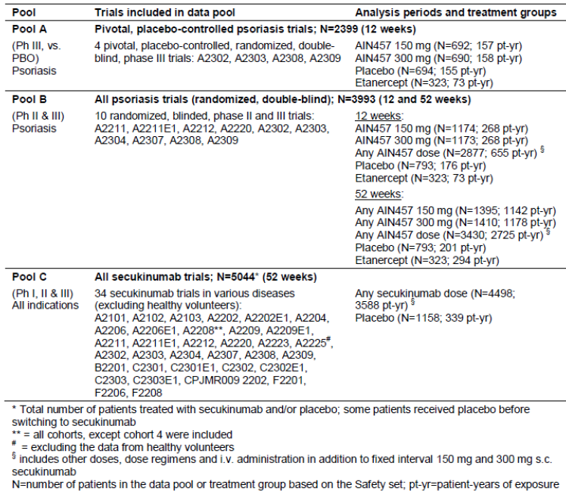

#### Patient exposure

The overall patient exposure to secukinumab includes 3,588 patient years of exposure in 34 clinical studies (for which an interim or final clinical study report is available) in any indication in which secukinumab was used as a treatment for a medical condition. The majority of the total safety experience with secukinumab involves clinical studies in the target population of adult patients with moderate to severe plaque psoriasis (Pool B). The overall patient exposure to secukinumab in the target population comprises 2725 patient years of exposure, comprising 76% of the total exposure across all indications to secukinumab, in 10 clinical Phase II/III studies with long term data up to 12 months.

#### Safety issues with the potential for major regulatory impact

For detail of the review of these please see Attachment 2.

#### Post marketing data

Secukinumab has not yet been marketed in any country.

#### Evaluators conclusions on safety

Based on safety data in 3,993 psoriasis patients studied for ≥ 1 year in 10 Phase II/III clinical trials, with 3,430 patients treated with secukinumab covering 2,725 patient-years of exposure, the overall safety of secukinumab 300 mg was comparable to 150 mg. Secukinumab at both doses also showed comparable safety to placebo and etanercept over 52 weeks of treatment in 10 clinical trials in psoriasis.

Three data pools were used to assess safety of secukinumab in psoriasis and other indications.

Four pivotal, randomised, placebo controlled trials in the target indication formed the key dataset (Pool A; N = 2,399) for comparisons of short term safety (12 weeks) among secukinumab, placebo and etanercept. Two other data pools assess longer term safety data (52 weeks), one with 10 Phase II/III trials in psoriasis (Pool B; N = 3,993) and the other with all patients treated with secukinumab across 34 trials of various indications (Pool C; N = 5,044), and increase the power to detect selected rare AEs such as major adverse cardiac events (MACE) and malignancies. Pool B contributes 76% of the total patient-years exposure to secukinumab in any indication, with 3,993 psoriasis patients studied for ≥ 1 year (3,430 on secukinumab: 1,641 for at least 1 year and 2,751 for at least 6 months) in 10 clinical trials with a broad range of doses tested (IV doses of 3 to 30 mg/kg and SC doses of 25 to 300 mg). This exposure exceeds ICH E1[16] safety exposure requirements of > 1,500 patients exposed, 300 to 600 for 6 months and > 100 for 1 year.

Secukinumab showed an imbalance versus placebo in total AEs, which was driven by infections, mainly non serious upper respiratory tract infections, but this difference was observed only in the first 12 weeks of treatment and did not translate into infection SAEs or into an imbalance over 52 weeks of treatment. There was also no difference between 300 mg and 150 mg secukinumab in the overall rate of infections or in upper respiratory tract infections. Secukinumab at both doses was comparable to etanercept in total AEs and infection AEs in the first 12 weeks and over the entire 52 week treatment period. Candida infections were more frequent with secukinumab 300 mg, while 150 mg was comparable to placebo and etanercept. The imbalance between the doses was limited to non serious, localised mucosal or cutaneous candidiasis, with no reports of chronic or systemic disease in any treatment group. Candida infections were responsive to standard treatment and did not necessitate discontinuation. No serious opportunistic infections were reported. No tuberculosis or viral hepatitis reactivation was observed in any psoriasis trial. The single non serious case of latent tuberculosis on 150 mg secukinumab was reported at baseline. A higher incidence of ear infections, primarily otitis externa, and oral herpes was also noted for 300 mg relative to 150 mg, which was comparable to placebo and etanercept, with all cases across the treatment groups being non serious and not causing study treatment discontinuation. In addition, there was a small imbalance between the doses in conjunctivitis and tinea pedis. Collectively, these differences are consistent with the implied role of interleukin 17 ((IL-17) in skin, mucosal and fungal infections.

Treatment related AEs were reported at higher rates in the induction and entire treatment periods for secukinumab compared to placebo, but there was no difference between the secukinumab doses, and both secukinumab doses and placebo were lower than etanercept. The difference between secukinumab and placebo were due mainly to treatment related infection AEs such as upper respiratory tract infection and pharyngitis. The higher rate for etanercept versus secukinumab and placebo was driven by injection site reactions, which are well known AEs associated with etanercept administration.

Adverse drug reactions (ADRs) classified as very common or common included upper respiratory tract infections (nasopharyngitis, upper respiratory tract infection, rhinitis and pharyngitis), oral herpes, rhinorrhoea, diarrhoea and urticaria. Uncommon ADRs included sinusitis, tonsillitis, oral candidiasis, tinea pedis, neutropenia and conjunctivitis.

SAEs and discontinuations due to AEs were infrequent in the first 12 weeks of treatment and showed no differences among secukinumab, placebo and etanercept or between the secukinumab doses. Over 52 weeks, SAEs remained comparable across the treatment groups, with no dose dependence and no clustering of specific events. Secukinumab was comparable to etanercept in AEs leading to discontinuation over 52 weeks, while few placebo patients remained after 12 weeks due to lack of response and were not available for comparison at later time points. The rate of AEs causing discontinuation was low and comparable for the secukinumab, placebo and etanercept groups during the induction periods of both data pools and no dose effect was observed. For the entire treatment period (Pool B), the incidence of AEs causing discontinuation was comparable between the secukinumab dose groups and etanercept. While the placebo group reported fewer discontinuations over the entire treatment period, this may be confounded by the much lower placebo exposure after Week 12. AEs causing more frequent discontinuation with secukinumab relative to placebo included psoriatic arthropathy, thrombocytopenia and erythrodermic psoriasis. Psoriasis caused more discontinuations in patients on placebo compared to patients on any secukinumab dose.

In the first 12 weeks of treatment in psoriasis trials (Pools A and B), the rate of MACE was very low and secukinumab at both doses was comparable to both placebo and etanercept. There was no increased risk over 52 weeks compared with placebo and no dose dependence for secukinumab in Pool B of all psoriasis trials and in Pool C of all secukinumab treated patients. Similarly, there was no difference between secukinumab and placebo for MACE confirmed by an independent cardiovascular/cerebrovascular (CCV) adjudication committee based on data from psoriasis studies and across all indications. All cases of confirmed MACE across the treatment groups were associated with prior or active cardiovascular disease and relevant risk factors, such as hypertension, obesity, dyslipidaemia and diabetes. The rate of CCV related AEs was low and comparable across the treatment groups in the first 12 weeks of treatment, and after adjusting for exposure the incidence rate was lower for secukinumab and etanercept compared to placebo over 52 weeks of treatment.

The incidence (absolute and exposure adjusted) of malignancies for both doses of secukinumab was comparable to both placebo and etanercept, and there was no dose dependence in the secukinumab groups. There was also no increase in the ratio of squamous cell carcinoma (SCC) to basal cell carcinoma (BCC). There were 2 cases of malignant melanoma on secukinumab, both in patients who were smokers and had prior exposure to phototherapy. There was no cluster of specific malignancies in any treatment group.

Secukinumab specific treatment emergent anti-drug antibodies (ADA) were detected across the Phase II and III program in a minimal number of patients (0.7%), who were ADA negative prior to secukinumab exposure. Treatment emergent ADA were not associated with a loss of efficacy or alteration of PK in patients with assessable data. No severe or serious hypersensitivity reactions or administration reactions were reported in any patients with treatment emergent ADA.

Fewer injection site reactions were reported with secukinumab, with the same rate for both doses, compared to etanercept, while the active treatment groups were higher versus placebo. Safety of pre-filled syringe (PFS) or AI forms was comparable to LYO, supporting the safe use of the PFS/AI forms for self and home administration. The LYO form is intended for administration by a health care professional. The incidence of hypersensitivity AEs was comparable between secukinumab and etanercept and lowest with placebo, with the difference due to urticaria and eczema. The urticaria AEs were non serious, mostly mild to moderate in severity and not accompanied by systemic symptoms, and therefore do not reflect possible anaphylaxis. The imbalance in eczema, which encompasses a heterogeneous group of inflammatory dermatologic diseases, did not reflect an increased risk of a defined pathophysiologic disease. No new events of central nervous system demyelinating disorders were reported. A higher rate of nervous system disorders for secukinumab versus placebo was driven primarily by headache and migraine, while secukinumab was comparable to etanercept.

In psoriasis trials, Crohn’s disease was reported in 3 patients (2 on 150 mg fixed interval dosing and 1 on an alternative 150 mg dosing regimen). Two cases were exacerbations of existing Crohn’s disease and 1 case was a new event. Additional cases were reported in other indications. Due to the potential involvement of the IL-17 pathway in the pathogenesis of Crohn’s disease, it is not possible to rule out a potential increased risk of an exacerbation of Crohn’s disease.

Neutropenia was more frequently observed with secukinumab and etanercept than with placebo, but most cases were mild, transient and reversible. Neutropenia < 1.0 to 0.5 x 109/L (CTCAE Grade 3[17]) was reported in 18/3,993 patients on secukinumab, with no dose dependence and no temporal relationship to infections in 15/18 cases. The remaining 3 cases had mild to moderate, non-serious infections (rhinitis, upper respiratory tract infection and cystitis) which did not cause study treatment discontinuation. Neutropenia, < 0.5 x 109/L (CTCAE Grade 4), was observed in 1 etanercept patient only, who experienced a mild infection at the same time.

There was an imbalance in mild hepatic transaminase elevations versus placebo, but there was no increase in the combined elevations of hepatic transaminase and bilirubin. Laboratory criteria for Hy’s law were met in 4 patients (2 on 150 mg, 1 on 300 mg based on local laboratory data, and 1 on placebo); all cases had evidence of an established causative etiology or showed normalised values upon re-exposure to secukinumab.

There were no clinically relevant effects associated with use of secukinumab in vital signs or electrocardiogram (ECG).

No subpopulation treated with secukinumab showed an increased risk of any safety parameter compared to the overall population.

No notable difference was seen in the safety profile across the range of doses studied and the different administration routes for all secukinumab trials in Pool C.

In conclusion, secukinumab 300 mg or 150 mg has an acceptable safety profile for intended use in adult patients with moderate to severe plaque psoriasis. Secukinumab 300 mg was comparable to 150 mg and both doses showed comparable safety to placebo and etanercept over 52 weeks of treatment (see Table 44, Attachment 2).

### First round benefit-risk assessment

#### First round assessment of benefits

The benefits of secukinumab in the proposed usage are:

* All 4 pivotal trials showed consistent results demonstrating superiority of secukinumab to placebo for PASI 75 and IGA mod 2011 0 or 1 at 12 weeks. In the study which included etanercept (A2303), superiority was also demonstrated against this active comparator.
* Rapid onset of action with most rapid response was observed with secukinumab 300 mg with over 50% reduction in PASI score by Week 3 compared with by Week 4 for the 150 mg dose, and around Week 8 for etanercept.
* The measures of almost clear/clear skin (PASI 90, PASI 100 and IGA mod 2011 0 or1) in the two large Phase III studies (A2302 and A2303) over 52 weeks were better with secukinumab compared with placebo and etanercept.
* The improvement in skin scores were associated with the best chance to not only improve, but to achieve normal quality of life (DLQI 0/1) and 68.2% of the patients treated with secukinumab 300 mg were able to achieve this important goal after one year compared with 52.9% for 150 mg and 46.9% for etanercept (pooled 52 week data for A2302 and A2303).
* The benefits demonstrated for secukinumab versus placebo extended to all subgroups studied (age, gender, race, region, weight, baseline disease severity, exposure to previous systemic psoriasis therapy, and comorbid psoriatic arthritis).
* Psoriatic arthritis patients (approximately 20% of evaluated psoriasis population) benefited from secukinumab treatment beyond skin improvements, as compared with placebo or etanercept, in terms of physical functioning (HAQ-DI), with the most improved responses again seen with secukinumab 300 mg.
* All three forms of product lyophilisate powder (Studies A2302 and A2303) and liquid formulation in either pre-filled syringe (A2308) or an AI A2309) produced similar results in efficacy.
* Other than the small, incremental risk in candida infections for the secukinumab 300 mg dose (limited to non-serious, localised mucosal or cutaneous candidiasis), the incidence of AEs were not suggestive of a dose response compared to 150 mg.
* Secukinumab 300 mg or 150 mg has an acceptable safety profile for intended use in adult patients with moderate to severe plaque psoriasis. Secukinumab 300 mg was comparable to 150 mg and both doses showed comparable safety to placebo and etanercept over 52 weeks of treatment.

#### First round assessment of risks

The risks of Secukinumab in the proposed usage are:

* Secukinumab has not yet been studied in patients less than 18 years of age, in patients with hepatic impairment or renal impairment or in pregnant women.
* Live vaccines cannot be given concurrently with secukinumab.
* Increased risk of infections, especially candida infections, oral herpes and otitis media showed dose related increase.
* Increased risk of opportunistic infections.
* Increased risk of neutropenia.
* Potential of increase in risk of malignancy and MACE.
* Potential risks of foreign proteins; hypersensitivity, injection site reactions and anaphylaxis.
* Based on the possible negative effect for IL- 17A inhibition for patients with active Crohn’s disease, caution is advised when treating these patients due to risk of Crohn’s disease exacerbation.
* Secukinumab is to be used with caution in patients with a chronic infection or a history of recurrent infection.
* Lack of long term efficacy and safety data with the PFS and AI forms of secukinumab as Studies A2308 an A2309 are still ongoing.

#### First round assessment of benefit-risk balance

Although there are many new biologic agents approved for the treatment of psoriasis, many of the patients still do not achieve optimal efficacy when one considers clinically meaningful measures such as clear/almost clear skin (and demonstrated by PASI 90) with as few as 22% achieving this with etanercept, one of the most widely used approved biologic agents. Other limitations such as slow onset, diminishing efficacy over time and drug-specific safety concerns (for example, infection including tuberculosis (TB), malignancies including lymphoma, and demyelinating neurologic events). Thus, there remains a significant unmet patient need for new agents with unique mechanisms that can provide a rapid onset of effect, improved and sustained symptom clearance, and a safety profile that allows for chronic use.

Secukinumab is a fully human IgG1 antibody that selectively binds to and neutralises the pro-inflammatory cytokine interleukin-17A (IL-17A). IL-17A is a naturally occurring cytokine that is involved in normal inflammatory and immune responses. IL-17A plays a key role in the pathogenesis of plaque psoriasis. Secukinumab was evaluated in a large clinical program which complied with CHMP guidelines for evaluation of treatments for psoriasis. The clinical studies involved adequate number of the target patient population. It was demonstrated that secukinumab is a highly efficacious treatment with the most pronounced benefits seen with the 300 mg dose, particularly at the more difficult to achieve measures of clear/almost clear skin (PASI 90, PASI 100, IGA mod 2011 0 or 1). The superior efficacy of secukinumab versus placebo was consistent in all subgroups of body weight, age, race, disease severity, and previous exposure or failure to systemic psoriasis therapy (including anti TNF-α-incomplete responder and biologic incomplete responder patients).

The 300 mg dose was associated with higher response rates across weight groups and all other subgroups examined. The majority of patients attained clear or nearly clear skin as evidenced by PASI 90 (56.6%) and IGA mod 2011 0 or 1 response (65.0%) by Week 12 with secukinumab 300 mg. This high level of response is maintained over at least 52 weeks (62% PASI 90; 63.1% IGA mod 2011 0 or 1) with differences in response rates between 300 mg and 150 mg of approximately 16 to 20% for the higher endpoints at the 52 Week time point. Loss of IGA mod 2011 0 or 1 response was lowest with secukinumab 300 mg (25.8%) compared with 150 mg (39.2%) and etanercept (56.9% in Study A2303).

Patient reported outcome data were consistent with the quantitative data showing the advantage with secukinumab 300 mg. Secukinumab 300 mg resulted in a substantially higher proportion of patients with DLQI 0/1 (58.9%) compared with 150 mg (50.1%) at Week 12, with an even greater differential seen at Week 52 (68.5% for 300 mg versus 53.8% for 150 mg), representing a difference of approximately 15% between the 300 mg and 150 mg groups. Additionally, secukinumab 300 mg had a relatively rapid onset of efficacy with an approximate 40% reduction of symptoms at Week 2 and 50% reduction by Week 3. This compares with 50% reductions for secukinumab 150 mg at Week 4 and etanercept at Week 8. PsA patients (approximately 20% of the population) also benefited from secukinumab treatment both in terms of skin improvement and physical function (HAQ-DI), with the greatest benefit observed with secukinumab 300 mg.

The risk profile of secukinumab is based on 4,498 patients treated with any dose of secukinumab across a variety of autoimmune diseases. In the clinical program, there was no evidence of an imbalance of serious events compared with either placebo or etanercept. There was an imbalance in the overall incidence of infections in the secukinumab dose groups (26.9% for 150 mg and 25.8% 300 mg at 12 weeks in Pool B) compared to placebo (20.6%) and comparable to etanercept (25.7%). There was no evidence of a dose response and the vast majority of reported infections were mild/moderate upper respiratory infections. Candida infections were more frequent with 300 mg, while 150 mg was comparable to placebo and etanercept. This imbalance between doses was limited to non serious, localised mucosal or cutaneous candidiasis, consistent with the mechanism of action, with no reports of chronic or systemic disease in any treatment group.

No serious opportunistic infections were reported. The proposed PI however needs to adequately highlight the slightly increased risk for these infections which will allow early detection and intervention. No tuberculosis or viral hepatitis reactivation was observed in any psoriasis trial.

Neutropenia was more frequently observed with secukinumab and etanercept than with placebo, but most cases were mild (limited to CTC Grade 1 to 2), transient and reversible. Neutropenia < 1.0 to 0.5x109/L (CTCAE Grade 3) with secukinumab was not associated with an increase in infections.

Despite small imbalances in the incidence of mild hepatic transaminase elevations versus placebo, secukinumab was not associated with a higher rate of combined elevations in hepatic transaminases and serum bilirubin. There was no dose response for secukinumab and rates were comparable to etanercept.

Malignancy may represent a theoretical risk with any immunosuppressive therapy, but there is no evidence that secukinumab confers an increased risk for malignancy. There was no imbalance in malignancies among secukinumab, placebo and etanercept, or between the secukinumab doses, in psoriasis trials (Pools A and B) or between secukinumab and placebo over 52 weeks across all indications (Pool C). Skin tumours were more frequently observed with placebo than with secukinumab or etanercept. There was no increase in the ratio of squamous cell carcinoma to basal cell carcinoma and no cluster of specific malignancies.

Due to the potential involvement of the IL-17 pathway in the pathogenesis, it is not possible to rule out the potential of increased risk of an exacerbation of Crohn’s disease.

Other than the small, incremental risk in candida infections for the secukinumab 300 mg dose (limited to non serious, localised mucosal or cutaneous candidiasis), the incidence of AEs were not suggestive of a dose response compared to 150 mg. Secukinumab 300 mg was highly efficacious, allowing a substantially higher proportion of patients to achieve and maintain clear/almost clear skin for the entire controlled study duration of 52 weeks compared with either secukinumab 150 mg or the active comparator etanercept. The small increase in candida infections (< 1% higher with secukinumab 300 mg versus placebo, etanercept or 150 mg secukinumab, does not outweigh the substantially greater clinical benefit observed with 300 mg secukinumab in the treatment of psoriasis.

Overall, the benefit-risk balance of secukinumab 300 mg for the proposed indication of use in adult patients with moderate to severe plaque psoriasis, who are candidates for systemic therapy or phototherapy, is favourable. The recommended dose is 300 mg by SC injection with initial dosing at Weeks 0, 1, 2 and 3, followed by monthly maintenance dosing starting at Week 4.

### First round recommendation regarding authorisation

It is recommended that secukinumab 300 mg be approved for the treatment of adult patients with moderate to severe plaque psoriasis, who are candidates for systemic therapy or phototherapy. The approval is subject to incorporation of suggested changes to the proposed PI and an adequate response to the *Clinical questions* (see below).

### Clinical questions

#### Pharmacokinetics

1. The evaluator requested that the sponsor provides any information they have regarding the binding of secukinumab to non-IL7A proteins in humans.
2. Can the sponsor please provide information regarding the intra-subject variability in healthy subjects and the target population?

#### Pharmacodynamics

1. It must be noted that a number of studies aimed to assess the levels of IL-17A in serum. These studies included CAIN457A2101, CAIN457A2103, CAIN457A2204 and CAIN457A2212; however, due to the lack of a reliable assay system for this protein these analyses have not been conducted. If these results are now available the evaluator requests that they are provided by the sponsor for evaluation.
2. How many patients were included in the IL-17A analysis described in Study CAIN457A2309?
3. Can the sponsor please provide the histological images of IL-17A staining in lesional skin for the other patients from Study BMD RCAIN457A2212h for comparison?
4. If Study CAIN457A2223 is now complete can the full analysis be presented for evaluation?

#### Efficacy

1. In pivotal Phase III Study A2303, no justification was provided for selection of the 10% non-inferiority margin for comparison of each dose of secukinumab (150 mg and 300 mg) versus the active control etanercept 50 mg.
2. In pivotal Phase III Study A2303, the results regarding rebound following discontinuation of secukinumab treatment should be interpreted with caution, as assessments of rebound were based on a small, biased sample of discontinued patients and patients not continuing in the extension study. Further analyses of rebound for the completers of the study who do not enter extension study will be presented within a separate study report of the Week 52 to Week 60 follow up period. These results should be presented for evaluation when available.
3. Studies A2308 and A2309 efficacy and safety results beyond 12 weeks should be provided for evaluation on completion of the study.

#### Safety

None.

### Second round evaluation of clinical data submitted in response to questions

No second round clinical evaluation was required during the evaluation process. Answers to clinical questions in the clinical evaluation report (CER) have been taken into account in the Delegate’s *Overall conclusion and risk-benefit analysis* (see below).

### Second round benefit-risk assessment

Not Applicable.

## V. Pharmacovigilance findings

### Risk management plan

The sponsor submitted a Risk Management Plan EU-RMP, version 1.0, dated 10 October 2013 and Australian Specific Annex, version 1.0, dated 20 December 2013 which was reviewed by the TGAs Pharmacovigilance and Special Access Branch (PSAB).

#### Safety specification

The sponsor provided a summary of ongoing safety concerns which are shown at Table 6.

Table 6. Summary of ongoing safety concerns.

|  |  |
| --- | --- |
| Important identified risks | Infections and infestations  Neutropenia  Hypersensitivity |
| Important potential risks | Malignant or unspecified tumours  Major Adverse Cardiovascular events (MACE)  Immunogenicity  Crohn’s disease  Interaction with live vaccines |
| Missing information | Fetal exposure in utero  Long term safety data  Long term efficacy data |

#### Pharmacovigilance plan

The sponsor proposes routine pharmacovigilance activities to address all ongoing safety concerns. An additional pharmacovigilance activity in form of a registry is proposed for the potential risk of ‘Malignant or unspecified tumours’ and the missing information of ‘long-term safety data’.

Regarding the proposed registry to address the potential risk of ‘Malignant or unspecified tumours’ and the missing information of ‘long-term safety data’ the sponsor states in the ASA: *There are no obligatory/required additional pharmacovigilance activities planned for Cosentyx in Australia. Please note that the registry described in Part III, Pharmacovigilance Plan, of the EU RMP proposed to collect long-term information in a real-life population is a stated and not obligatory/required additional pharmacovigilance activity. That is why this registry is included under Part III.4.4 and not Part III.4.3 and Part III.5.1 of the EU RMP. The study protocol has not been included with this or in the application submitted to the EMA in the EU.*

Regarding details about the proposed registry the sponsor states in the pharmacovigilance plan of the EU-RMP: Registry to assess incidence and nature of malignancies in a real-world population of moderate-to-severe psoriasis patients on secukinumab therapy; estimated sample size 2000, follow up period of 5 years. No further details regarding the registry have been provided.

Regarding specific paediatric issues the sponsor states: *A paediatric investigational plan (PIP) for paediatric patients with psoriasis has been agreed with the Paediatric Committee PDCO (decision number P/154/2009; PIP reference EMEA-000380-PIP01-08). The study program foreseen for patients aged 6-18 years have been deferred with a deadline for completion by December 2018. The final study design including doses to be assessed will be initiated after future PIP modification as outlined in the original PIP, and based on the established dose in adults. A waiver was agreed with PDCO for children below age 6 years.*

#### Risk minimisation activities

The sponsor concludes that routine risk minimisation activities are sufficient to mitigate the risk associated with the use of the product.

#### Reconciliation of issues outlined in the RMP report

It is considered that the sponsor’s response to the TGA request for further information has not adequately addressed all of the issues identified in the RMP evaluation report.

Table 7 summarises the PSAB s first round evaluation of the RMP, the sponsor’s responses to issues raised by the PSAB and the PSAB s evaluation of the sponsor’s responses.

Table 7. Reconciliation of issues outlined in the RMP report.

|  |  |  |
| --- | --- | --- |
| Recommendation in RMP evaluation report | Sponsor’s response | PSAB (RMP) evaluator’s comment |
| 1. Safety considerations may be raised by the nonclinical and clinical evaluators through the TGA consolidated request for information and/or the nonclinical and clinical evaluation reports respectively. It is important to ensure that the information provided in response to these includes a consideration of the relevance for the RMP, and any specific information needed to address this issue in the RMP. For any safety considerations so raised, the sponsor should provide information that is relevant and necessary to address the issue in the RMP. | The clinical evaluator comments in the CER that the safety specifications in the draft RMP are satisfactory. The nonclinical evaluation report comments that results and conclusions drawn from the nonclinical program for secukinumab detailed in the sponsor’s draft RMP are in general concordance with those of the nonclinical evaluator with only one exception. Novartis believes that the RMP safety specification remains current and does not require amendment at this time. | The sponsor’s response has been noted. |
| 2. It is brought to the Delegate’s attention that the indication for the product is a second line indication in Europe. In contrast the indication sought in Australia, Canada and the USA is a first line indication.  3. The sponsor should amend the section ‘Differences in indications between the EU and Australia’ in the ASA to provide a justification regarding the difference in the indication sought in Europe (second line indication) and Australia (first line indication). | A similar question was raised by the clinical evaluator. Novartis response to this question is included in the response to the TGA clinical evaluation. An update has been included in the relevant section of the ASA. | The ASA has been updated to explain and justify the difference in indication between Europe and Australia. This is considered acceptable.  The appropriateness of the justification, as to why the sponsor believes that a first line indication in Australia is acceptable, will be evaluated by the clinical evaluator. |
| 4. As the product will be provided in ready to use devices (pen or pre-filled syringe), and there is limited information available about the safety of this product in a home treatment setting, ‘Medication errors’, which should include medication errors in a home treatment setting should be added as a potential risk.  It is considered appropriate that ‘Medication errors’, which should include medication errors in a home treatment setting, be added as missing information in the table of ongoing safety concerns. | RMP evaluator’s comment: The sponsor has provided a detailed response to this recommendation, and states that it is not considered appropriate to add ‘medication error’ as missing information to the RMP.  The sponsor refers to the following: 1.) Appropriate wording is included in the PI to ensure that physicians train patients in the administration technique, 2.) Appropriate instructions are provided in the Instructions for Use Document, 3.) Two clinical studies during which patient’s ability to use the product for self-administration was assessed, 4.) Human factor studies during which patient’s ability to use the product for self-administration was assessed.  Overall, the sponsor concludes that a high level of successful self-administration was detected.  Further detail was provided in the sponsor’s response document. | The sponsor’s response has been noted.  In the majority of cases included in the described studies, the subject were trained in the use of the product (self-injecting devices) prior to first using the product.  Overall, the sponsor relies heavily on patient’s training conducted by their treating physician to ensure safe use of the product by patients in a home treatment setting.  In the RMP evaluator’s opinion, it cannot be guaranteed that a thorough training of the use of the product, and a thorough assessment of the patient’s ability for self-administration, will be conducted in busy daily clinical practice.  Consequently, the RMP evaluator maintains the opinion that ‘Medication errors’, which should include medication error in a home treatment setting, should be added as potential risk to the table of ongoing safety concerns.  Risk-minimisation and pharmacovigilance activities should be assigned to this potential risk as appropriate. |
| 5. The sponsor states: ‘*Children were not studied in the psoriasis clinical studies’*. Consequently, ‘Safety in paediatrics should be added as missing information in the table of ongoing safety concerns. | The sponsor agrees with the assessor’s recommendation to add ‘Use in paediatric patients’ as missing information in the table of ongoing safety concerns. | This is considered acceptable. |
| 6. Patients with severe hepatic and renal impairment were excluded from the clinical development program and therefore, these two patient groups should be added as missing information from the table of ongoing safety concerns | The sponsor considers that it is not necessary to add ‘patients with severe hepatic and renal impairment’ as missing information to the table of ongoing safety concerns of the RMP. This position is supported by  1. The secukinumab clinical program represents the largest registration program for a biologic for the treatment of psoriasis to date, which included:   * Over 5044 patients have been studied, including 4498 patients who were treated with secukinumab in blinded and open-label clinical studies in various indications (plaque psoriasis and other autoimmune conditions) in 39 clinical studies. * Psoriasis Program: 4546 patients were studied to support the claim that secukinumab is safe and effective in adults with moderate to severe plaque psoriasis in 10 Phase II/III studies.   2. Patients with some degree of hepatic impairment have been assessed in clinical trials in psoriasis patients although patients with severe hepatic impairment were excluded. In addition, there is no evidence to suggest that treatment with secukinumab at 150mg (2.03 per 100 patient years) or 300mg (1.71 per 100 patient years) increased the risk of hepatobiliary disorders when compared with etanercept (1.72 per 100 patient years) or placebo (3.50 per 100 patient years) over the entire treatment period in all secukinumab psoriasis clinical studies.  3. Similarly, patients with some degree of renal impairment have been assessed in clinical trials in psoriasis patients, although patients with severe renal impairment were excluded.  There is no evidence to suggest that treatment with secukinumab at 150mg (3.38 per 100 patient years) or 300mg (3.10 per 100 patient years) increased the risk of renal and urinary disorders when compared with etanercept (3.14 per 100 patient years) or placebo (1.50 per 100 patient years) over the entire treatment period in all secukinumab psoriasis clinical studies. | This is considered acceptable for the following reasons.  It is noted that patients with severe renal and hepatic impairment were excluded from clinical trials. However, renal and hepatic impairment is unlikely to significantly interfere with the metabolism and excretion of the product and the target population is not expected to have a significantly higher incidence of renal and hepatic impairment. Appropriate statements describing that these patient populations have not been specifically studied are included in the PI. |
| 7. Patients with severe cardiac disease or uncontrolled hypertension were excluded from the clinical development program and therefore, these two patient groups should be added as missing information from the table of ongoing safety concerns. | Novartis considers that it is not necessary to add ‘patients with severe cardiac disease or uncontrolled hypertension’ as missing information to the table of ongoing safety concerns of the RMP. This position is supported by;  1. The secukinumab clinical program represents the largest registration program for a biologic for the treatment of psoriasis to date, which included:   * Over 5044 patients have been studied, including 4498 patients who were treated with secukinumab in blinded and open-label clinical studies in various indications (plaque psoriasis and other autoimmune conditions) in 39 clinical studies. * Psoriasis Program: 4546 patients were studied to support the claim that secukinumab is safe and effective in adults with moderate to severe plaque psoriasis in 10 Phase II/III studies.   2. Patients with some degree of cardiac insufficiency (NYHA 1-2[18]) or with controlled hypertension have been assessed in secukinumab clinical trials in psoriasis patients, although patients with severe cardiac disease or uncontrolled hypertension were excluded.  3. No increased risk of hypertension or major adverse cardiovascular events was observed in patients treated with secukinumab when compared with placebo or etanercept even though there were numerically more patients with baseline cardiovascular risk factors (for example; hypertension, stable coronary heart disease/ myocardial infarctions and uncomplicated diabetes) in the secukinumab dose groups compared to both the placebo and etanercept groups. | The sponsor’s response has been noted. However, the RMP evaluator maintains the opinion that ‘Safety in patients with severe cardiac disease or uncontrolled hypertension’ should be added as missing information to the table of ongoing safety concerns.  The sponsor states in the EU-RMP that several studies have shown an association between psoriasis and cardiovascular disease (CVD). Furthermore, there is an association between adiposity and psoriasis (see EU-RMP section 2.1.1), and adipose patients would be expected to have a higher incidence of CVD and hypertension. |
| 8. Due to the potential of secukinumab to have an immunomodulatory effect, and as there is very limited information about the following patient groups; they should be added as missing information in the table of ongoing safety concerns. A.) human immunodeficiency virus (HIV) positive patients. | A.) HIV positive patients: Novartis does not consider it necessary to add ‘HIV positive patients’ as missing information to the proposed RMP. This position is supported by:  1. Infection is already an identified risk in the proposed RMP with proper pharmacovigilance activities and risk minimisation measures in place to address this safety issue.  2. Although patients with known HIV infections or active systemic infections during the last two weeks prior to randomisation and any infections that recur on a regular basis were excluded from the secukinumab psoriasis clinical trial program, inevitably in a program of this size (n=4,546 psoriasis patients), patients with non-serious infections were allowed to participate in the secukinumab psoriasis clinical studies. Therefore, this is not in general seen as missing data. More importantly, a. There is no evidence to suggest that treatment with secukinumab 150mg (1.05 per 100 patient years) or 300mg (1.36) increased the risk of serious infections (SOC) regardless of type of infections when compared to placebo (0.99) and etanercept (1.37) over the entire treatment period in all secukinumab psoriasis clinical studies.  Specifically for viral infections, the exposure adjusted incidence rate of serious viral infections (HLGT) was comparable between secukinumab 150mg (0.09 per 100 patient years), 300mg (0.00), placebo (0.00) and etanercept (0.00).  3. Appropriate language is already included in the proposed Product Information regarding use in patients with chronic infection. | A.) The identified risk of ‘Infections and Infestations’ appears to capture only newly acquired infections due to administration of the product, but does not seem to include worsening of existing infections (for example, HIV). Consequently, the sponsor should amend the identified risk of ‘Infections and Infestations’ to include worsening of existing infections, including HIV.  Alternatively, ‘safety in patients with HIV and active severe infections’ should be included as missing information. |
| 8 Immunomodulatory effects continued  B.) Patients with a history of malignant disease. | B) Patients with a history of malignant disease: Novartis considers that the current RMP has adequately addressed the potential safety concern of malignancy as a potential risk. Therefore, adding ‘patients with a history of malignant disease’ to the missing information in the table of ongoing safety concerns of the RMP is not necessary. This position is supported by;  1. No evidence of tumour progression was observed for patients (n=84) who had a history of tumours at baseline in the secukinumab psoriasis clinical database.  2. When compared with placebo (1.78 per 100 patient years), no increased risk of malignancy with secukinumab (1.09 per 100 patient years) has been observed in the extensive secukinumab clinical development program encompassing a total of 4498 patients exposed to secukinumab (3588.1 patient-years) and 1158 patients on placebo (338.7 patient-years).  3. Overall literature data on preclinical models indicates a more pro-tumorigenic role of IL-17A. In preclinical studies, secukinumab demonstrated no effect on immune function parameters (T cell dependent antibody responses or NK cell function) that are essential for tumour surveillance  4. Secukinumab is not a potent immunosuppressant and the IgG1 chemical structure itself does not represent a carcinogenic risk Novartis will closely monitor the potential risk of malignancy in the ongoing routine pharmacovigilance. In addition, a psoriasis disease registry is proposed to assess the incidence and nature of malignancies in patients receiving secukinumab therapy in a real world population of moderate to severe plaque psoriasis. The registry will systematically collect and analyse longitudinal outcomes associated with psoriasis treatments (biologics and non biologics) in a cohort of patients with psoriasis, allowing for a better understanding of the epidemiology and natural history of the disease, comorbidities, current treatment practices, and comparative effectiveness. For the convenience of TGA assessors, the draft synopsis of the proposed registry was provided. | B.) The RMP evaluator accepts the sponsor’s justification for not including this as missing information. In particular because the sponsor commits to implement a registry which will include 2000 patients, with a recruitment period of 4 years and a follow-up period of five years. |
| 8. Immunomodulatory effects continued  C.) Patients with active severe infections. | C) Patients with active severe infections: Novartis does not consider it necessary to add ‘patients with active severe infections’ as missing information to the table of ongoing safety concerns of the RMP. This position is supported by;  1. Infection is already an identified risk in the proposed RMP with proper pharmacovigilance activities and risk minimisation measures in place to address this safety issue.  2. Although patients with active systemic infections during the last two weeks prior to randomisation and any infections that recur on a regular basis were excluded from the secukinumab psoriasis clinical trial program, inevitably in a program of this size (n=4546 psoriasis patients), patients with non-serious infections and uniquely patients with latent tuberculosis, when properly treated, were allowed to participate in the secukinumab psoriasis clinical studies. Therefore, this is not in general seen as missing data. More importantly.   * There is no evidence to suggest that treatment with secukinumab increased the risk of serious infections regardless of type of infections when compared to placebo and etanercept (please refer to Novartis’ response for Question A ‘HIV positive patients’ for details). * There is no evidence to suggest secukinumab increased the risk of reactivation of tuberculosis. For instance, in the secukinumab psoriasis clinical studies, there were 149 patients who were diagnosed with latent TB infection during screening and treated with anti-TB medications according to local guidelines (secukinumab 105, etanercept 21 and placebo 23). None of these patients had a reactivation of TB during the secukinumab studies.   3. Appropriate language is already included in the proposed Product Information regarding use in patients with chronic infection. | C.) The identified risk of ‘Infections and Infestations’ appears to capture only newly acquired infections due to administration of the product, but does not seem to include worsening of existing infections. Consequently, the sponsor should amend the identified risk of ‘Infections and Infestations’ to include worsening of existing infections.  Alternatively, ‘safety in patients with active severe infections’ should be included as missing information. |
| 9. As there is very limited information available about the safety of the product for women who are breastfeeding, this patient group should be added as missing information in the table of ongoing safety concerns as missing information. | Novartis does not consider it necessary to add ‘women who are breastfeeding’ to the missing information in the table of ongoing safety concerns of the proposed RMP. This position is based on the appropriate wording provided in the current proposed Product Information as shown below. | The RMP evaluator maintains the opinion that ‘women who are breastfeeding’ should be added as missing information in the table of ongoing safety concerns. |
| 10. As there is very limited information available about the safety of the product for very elderly patients (aged >75 years), this patient group should be added as missing information in the table of ongoing safety concerns. | Novartis does not consider it necessary to add ‘elderly patients (aged>75 years)’ as missing information in the table of ongoing safety concerns of the proposed RMP.  The secukinumab clinical program included:   * Over 5,044 patients, including 4,498 patients who were treated with secukinumab in blinded and open-label clinical studies in various indications (plaque psoriasis and other autoimmune conditions) in 39 clinical studies. * Psoriasis Program: 4,546 patients were studied to support the claim that secukinumab is safe and effective in adults with moderate to severe plaque psoriasis in 10 Phase II/III studies.   This represents the largest registration program for a biologic for the treatment of psoriasis to date.  Across the psoriasis trials, the majority of patients were < 65 years of age. Of the 3,430 plaque psoriasis patients exposed to secukinumab in clinical studies, a total of 230 were 65 years of age or older and 32 patients were 75 years of age or older. This is a significant number of elderly patients for a new psoriasis product.  From an efficacy perspective, this product is effective in the elderly population, as stated in the sponsor’s summary of clinical efficacy. | This is considered acceptable. |

#### Summary of recommendations

##### Outstanding issues

###### Issues in relation to the RMP

1. The RMP evaluator maintains the opinion that ‘Medication errors’, which should include medication error in a home treatment setting, should be added as potential risk to the table of ongoing safety concerns (see point 4 in Table 7 above).
2. The RMP evaluator maintains the opinion that ‘Safety in patients with severe cardiac disease or uncontrolled hypertension’ should be added as missing information to the table of ongoing safety concerns (see point 7 in Table 7 above).
3. The sponsor should amend the identified risk of ‘Infections and Infestations’ to include worsening of existing infections, including HIV. Alternatively, ‘safety in patients with HIV and active severe infections’ should be included as missing information (see point 8 A and C in Table 7 above).
4. The RMP evaluator maintains the opinion that ‘women who are breastfeeding’ should be added as missing information in the table of ongoing safety concerns (see point 9 in Table 7 above).
5. It is recommended to the Delegate that the sponsor includes a statement in the Consumer Medicine Information (CMI) to ensure that patients with known allergies to Hamster protein are aware of a potentially increased risk of an allergic reaction.

##### Advice from the Advisory Committee on the Safety of Medicines (ACSOM)

ACSOM advice was not sought for this submission.

##### Suggested wording for conditions of registration

###### RMP

The European Risk Management Plan (version 1.1, dated 9 July 2014), with Australian Specific Annex (version 1.1, dated 2 September 2014), to be revised to the satisfaction of the TGA, must be implemented.

##### Key changes to the updated RMP

In their response to the TGA consolidated requests for further information the sponsor provided an updated RMP (version 1.1, dated 9 July 2014). Key changes from the version evaluated in the first round are summarised below in Table 8.

Table 8. Key changes to the updated RMP.

|  |  |
| --- | --- |
| Safety specification | Addition of ‘Safety in paediatrics’ as missing information |
| Pharmacovigilance activities | Routine pharmacovigilance, A future paediatric investigation plan is proposed (age group 6-18 years) |
| Risk minimisation activities | Routine risk-minimisation through product labelling |

## VI. Overall conclusion and risk/benefit assessment

The submission was summarised in the following Delegates overview and recommendations.

### Quality

There were no objections to registration.

Different storage conditions apply for the powder and solution dose forms.

Batch release testing of the first five batches by the TGA is recommended, as a condition of registration.

### Nonclinical

There were no objections to registration from the nonclinical evaluator.

Pregnancy category was proposed as B1 by the sponsor, C by the nonclinical evaluator. The Delegate supports Category C, because reversible harm other than malformation may be expected (for example, risk of infection) in fetuses and neonates exposed to secukinumab, based on mechanism of action. This risk does not in the Delegate’s opinion have to be unique to the fetus/newborn or higher than in adults, to confer Category C. Clinical data in this setting are too limited to recommend Category B1.

### Clinical

#### Background

##### Plaque Psoriasis

Psoriasis affects 2.6% of Australians and 85 to 90% of psoriasis patients have chronic plaque psoriasis. 10% of these have severe disease (the sponsor proposes an indication in moderate to severe disease). Treatment is chosen on the basis of disease severity, relevant comorbidities, patient preference (including cost and convenience), efficacy, and evaluation of individual patient response. Disease severity takes into account extent of body surface involvement, involvement of face/palm/sole, and disability.

Various topical agents are used for psoriasis (topical corticosteroids; emollients; etcetera). Severe disease requires UV light (for example phototherapy; Psoralen ultraviolet light A (therapy) (PUVA)) or systemic therapies. The following systemic agents are approved for psoriasis in Australia:

* Cyclosporin (for example, Neoral: In patients with severe psoriasis in whom conventional therapy is ineffective or inappropriate and the disease has caused a significant interference with quality of life.).
* Methotrexate (for example, Methoblastin: Because of the high risk attending to its use, Methoblastin is only indicated in the symptomatic control of severe, recalcitrant, disabling psoriasis which is not adequately responsive to other forms of therapy, but only when the diagnosis has been established, as by biopsy and/or after dermatologic consultations.).
* Acitretin (Severe intractable psoriasis in all its forms).
* Infliximab (TNF-α inhibitor): Remicade is indicated for the treatment of adult patients with moderate to severe plaque psoriasis for whom phototherapy or conventional systemic treatments have been inadequate or are inappropriate. Safety and efficacy beyond 12 months have not been established.
* Etanercept (TNF-α inhibitor): Adult patients with moderate to severe chronic plaque psoriasis, who are candidates for phototherapy or systemic therapy.
* Adalimumab (TNF-α inhibitor): Humira is indicated for the treatment of moderate to severe chronic plaque psoriasis in adult patients who are candidates for systemic therapy or phototherapy.
* Ustekinumab (anti-IL12/IL-23): Stelara is indicated for the treatment of adult patients (18 years or older) with moderate to severe plaque psoriasis who are candidates for phototherapy or systemic therapy.

Golimumab and certolizumab pegol are not indicated for psoriasis.

Apremilast (a phosphodiesterase 4 inhibitor) has been approved by the US FDA for treatment of moderate to severe plaque psoriasis in candidates for phototherapy or systemic therapy.

##### Targets and mechanism of action

Secukinumab is a recombinant human monoclonal antibody of the IgG1/kappa isotype; it has a molecular weight of approximately 148 kDa (based on amino acid sequence, although in fact there is glycosylation at a point in each heavy chain).

Figure 2. Schematic of AIN457 IgG1 (secukinumab).

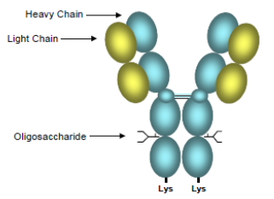

Interleukin 17A (IL-17A) is a cytokine implicated in psoriasis. Secukinumab targets IL-17A and inhibits its interaction with the IL-17A receptor (IL-17AR), which is expressed ubiquitously, for example on keratinocytes, but at high levels on haematopoietic cells. The IL-17A pathway is depicted above in Figure 1. It has also been reported that IL-17 may be produced by other adaptive immune cells.[19]

Beyond high affinity binding to IL-17A, there is a weak interaction with IL-17F and low level binding to the IL-17AF heterodimer. It is stated that at therapeutic concentrations, secukinumab does not neutralise IL-17F, leaves other functions of Th17 cells intact, and does not directly influence the Th1 pathway. Th17 cells produce, in addition to IL-17A, the cytokines IL-17F, IL-21 and IL-22. However, pharmacodynamic studies revealed a decline in IL-17 transcripts in lesional skin biopsies after secukinumab treatment as shown in Figure 3. This suggests that some aspects of the function of at least Th17 and other IL-17-producing cells may be modulated by secukinumab-induced IL-17 deficiency.

Figure 3. Study BMD RCAIN457A2212e. Plot of the mean log2 (NRQ data (+/- SEM) of the mRNA markers for the different visits and treatment groups.

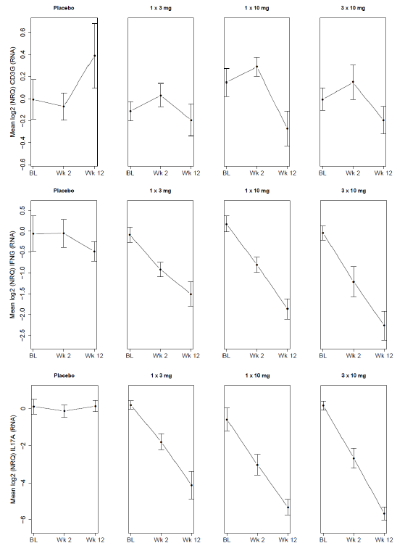

Experimental drugs targeting this pathway include briakinumab (anti-IL-12/IL-23), ixekizumab (anti-IL-17) and brodalumab (anti-IL-17R). IL-23 signalling helps maintain and amplify Th17 cells, for example promoting IL-17 transcription and Th17 differentiation.

#### Clinical evaluation

No second round clinical evaluation was required during the evaluation process. Answers to clinical questions in the CER have been taken into account in this overview.

##### Overview of data

In support of efficacy and safety, there were five pivotal Phase III studies (A2302, A2303, A2304, A2308, A2309), two supportive Phase III studies (A2307, A2211E1), and five Phase II dose finding studies. Only efficacy of the Phase III studies is discussed below. There were 20 clinical pharmacology studies, and there was one population PK analysis. Overall, the dataset conforms to that expected for a new systemic psoriasis agent, as outlined in the relevant TGA adopted EU guideline.

The clinical evaluator noted that studies in the dossier in psoriatic arthritis, rheumatoid arthritis, ankylosing spondylitis, uveitis, multiple sclerosis, Crohn’s disease and dry eye syndrome have not been evaluated. Safety data from these studies were included in the ‘Pool C safety dataset’ and have been taken into account in the clinical evaluation.

In approximately 3% of psoriasis patients, onset is in childhood. The clinical evaluator states on page 12 of Attachment 2 that;

*‘Novartis will defer the start of a paediatric psoriasis study in patients 6 to less than 18 years of age until after both data from twelve months treatment period from the Phase III program in psoriasis adult patients becomes available and the PK model of this data is available to support dose justification. In addition, Novartis is proposing a waiver for the patient population less than 6 years of age.’*

Formulation development was provided. Drug product intended for market is derived from a CHO cell line; supplements in the cell culture medium are not of human origin. The lyophilised and liquid forms differ in excipients.

##### Pharmacokinetics

Pharmacokinetic data is evaluated in Section 4 of Attachment 2. PK studies in populations other than psoriasis were not evaluated. PK is summarised in Section 4.3 of Attachment 2. The following comments supplement that summary.

Absolute bioavailability was estimated to be 77% in healthy subjects (Study A1101); the population PK model in psoriasis produced an estimate of 73%. In A2103, in psoriasis patients, estimates were 55 to 63%.

In A1101, dose proportionality was not shown for SC injections of 150 mg and 300 mg doses (Attachment 2; Section 4.2.2.2.7: dose proportionality), the suggestion being that the higher dose would result in 16 to 17% less dose adjusted total exposure than the lower dose (for example AUC last was 999 µg day/mL for 150 mg SC, but 1804 µg day/mL for 300 mg SC). The population PK modelling from psoriasis patients indicated linear PK.

Thus, there is some conflict between population PK outcomes (often referenced in the PIs discussion of PK) and individual study results. There were no major discrepancies.

Tissue distribution was studied in Study CAIN457A2225 (Attachment 2, Section 4.2.2.3.4). In healthy subjects, mean concentration of secukinumab in dermal ISF was 23% of serum concentration two weeks post dose. Distribution into dermal ISF in psoriasis patients was slightly higher. Volume of distribution was 5.6 to 8.6 L (Attachment 2, Section 4.2.2.3.1) but evidently secukinumab is not confined to the circulation.

##### Population pharmacokinetic analysis

The PK modelling report was based on pooled PK data from 1,233 patients with plaque psoriasis (Tables 9 and 10). Results are summarised in Table 11 (for 150 mg) and Table 12 (for 300 mg). Assuming a 20% change in clearance to be clinically relevant, none of age, baseline PASI, gender and race (Asian versus other) had a relevant effect on clearance. Steady state was reached at 20 weeks with monthly dosing; exposure at steady state was double that seen after a single dose. t½ was 27 days in psoriasis patients. Inter subject variability in PK parameters was moderate with SC dosing and higher than with IV dosing (Attachment 2, Section 4.2.3.8) (and also higher in psoriasis patients than healthy volunteers).

Table 9. Secukinumab studies constituting the analysis data set (PK Modelling report).

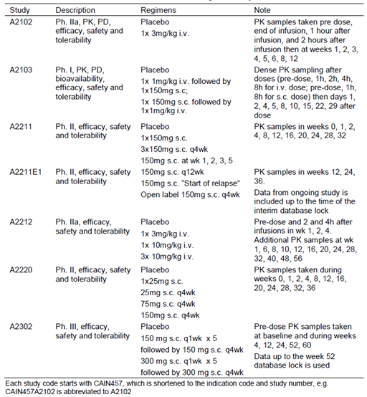

Table 10 PK Modelling report. Summary table of categorical covariates.

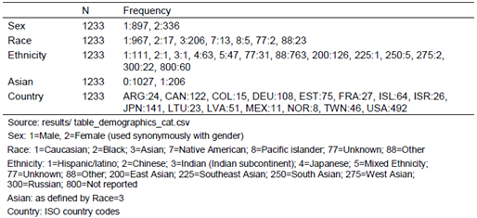

Table 11. PK modelling report. Simulated PK metrics for 150 mg Phase III regimen.

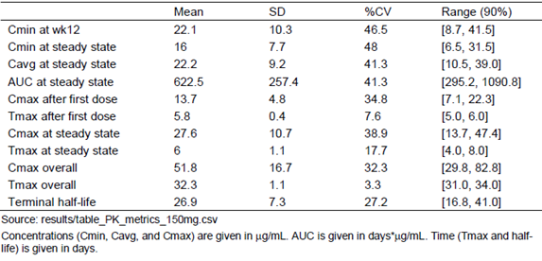

Table 12. PK modelling report. Simulated PK metrics for 300 mg Phase III regimen.

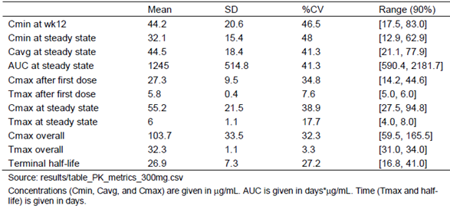

##### Bioequivalence across formulations

There are three presentations: 150 mg powder for injection (LYO; lyophilised); 150 mg/1 mL solution for injection in prefilled syringe (PFS); and 150 mg/1 mL solution for injection in prefilled auto-injector pen (AI).

In the Phase III program, studies were conducted using the LYO formulation, except for A2308 (PFS) and A2309 (AI).

The formulations of secukinumab solution in the PFS and AI presentations are identical, and the clinical evaluator considered there would be little difference in PK between the two presentations (Attachment 2, Section 4.2.2.2.4).

A study in healthy volunteers, A2106, showed bioequivalence between single SC doses of the PFS formulation and a developmental lyophilised formulation (Table 13, Figure 4, Table 14). The two formulations produced very similar exposure (AUC, Cmax) in subjects. The lyophilised formulation was a formulation used during drug development but was the basis for the commercial powder for injection formulation.

Table 13. Study CAIN457A2106. Descriptive statistics of pharmacokinetic parameters.

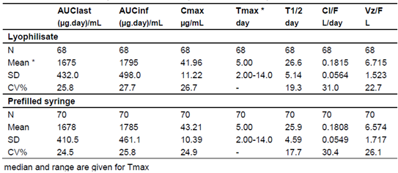

Figure 4. Study CAIN457A2106. Arithmetic mean (SD) concentration time profiles by formulation.

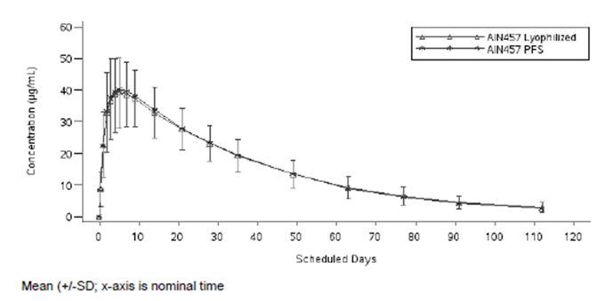

Table 14. Study CAIN457A2106. Geometric means, estimated geometric mean ratio and 90% CI for geometric ratio of PK parameters (PK analysis set).

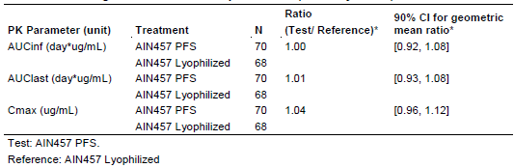

Bioavailability was compared across Phase III studies that used different formulations (Attachment 2; Table 3). Patients in A2309 (AI) had higher exposures than in A2302 (LYO) and A2308 (PFS). Since formulations for PFS and AI are identical, these differences seem more likely to have arisen from patient variability than formulation. The differences were not dramatic.

Although bioequivalence was not formally demonstrated between proposed marketed presentations, the Delegate thinks it is likely there will be no significant differences in exposure from the LYO to the PFS to the AI presentations.

##### Pharmacodynamics

Pharmacodynamic data are evaluated on Section 5 of Attachment 2 which also includes a summary. The following comments supplement that summary.

A ‘*statistical integrated biomarker analysis report*’ was provided (Attachment 2, Section 5.2.2.1.4; also Table 15 and Figure 5 below); a relationship was sought between secukinumab dose (as opposed to for example, observed or modelled exposure) and histological changes/immunohistochemistry markers. Clear relationships with dose were observed for many potentially relevant markers. IL-17A transcripts decreased with treatment, suggesting feedback at some level to cells producing IL-17A.

Table 15. Study BMD RCAIN457A2212e Means of PASI, histology/IHC and mRNA marker data.

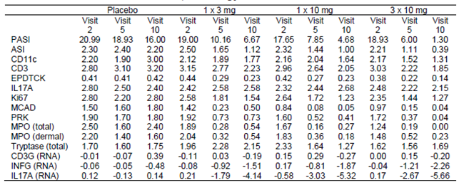

Figure 5. Plot of the mean histological/IHC scores for the different visits and treatment groups. The corresponding mean PASI scores are superimposed.

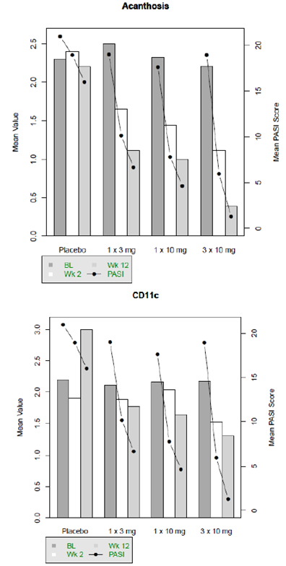

Figure 5 (continued). Plot of the mean histological/IHC scores for the different visits and treatment groups. The corresponding mean PASI scores are superimposed.

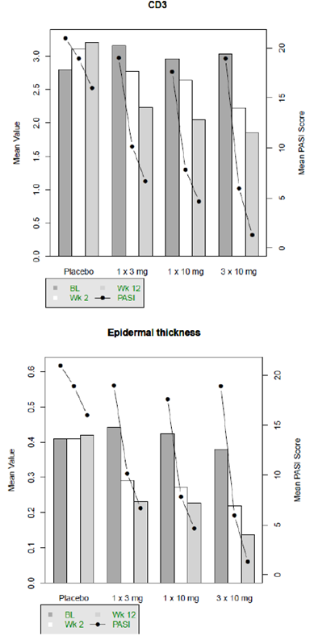

Figure 5 (continued). Plot of the mean histological/IHC scores for the different visits and treatment groups. The corresponding mean PASI scores are superimposed.

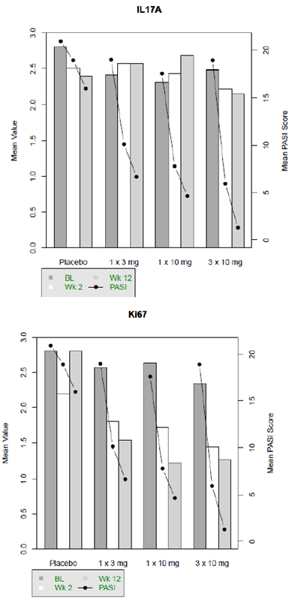

Figure 5 (continued). Plot of the mean histological/IHC scores for the different visits and treatment groups. The corresponding mean PASI scores are superimposed.

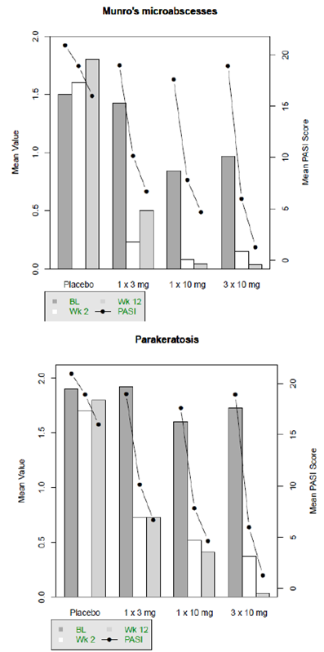

Figure 5 (continued). Plot of the mean histological/IHC scores for the different visits and treatment groups. The corresponding mean PASI scores are superimposed.

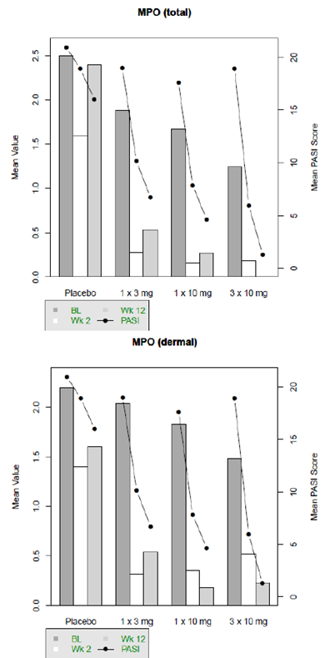

Figure 5(continued). Plot of the mean histological/IHC scores for the different visits and treatment groups. The corresponding mean PASI scores are superimposed.

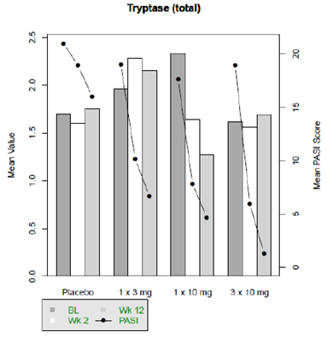

In A2224, secukinumab had no effect on the production of protective antibodies after vaccination with an influenza vaccine or a Neisseria meningitidis serogroup C vaccine (Attachment 2 section 5.2.6).

##### Efficacy

Dosage selection for pivotal trials is discussed in Attachment 2 Section 6. Phase III studies used 150 mg and 300 mg SC dosing, since earlier studies suggested (directly and via modelling) inadequate efficacy with doses lower than 150 mg.

###### Pivotal studies

Study A2302 (ERASURE) (lyophilisate) (52 week data)

This study is described in Attachment 2, Section 7.1.1. It was randomised, double blind and placebo controlled. It was conducted from June 2011 to March 2013 at 88 centres in 12 countries (USA and Japan had 34 and 18 centres respectively). The study is reported by Langley et al in NEJM (July, 2014)[20].

Randomisation was 1:1:1 to: secukinumab 150 mg; 300 mg; and placebo (all given SC). There was stratification by region and by body weight (± 90 kg). Administration was by the investigator. The regimen specified once weekly dosing for 4 weeks (0, 1, 2, 3), then every 4 weeks from weeks 4 to 48. PASI 75 placebo non responders at Week 12 were re‑randomised 1:1 to the two active arms (and were given induction and maintenance doses). Doses were administered into non affected skin.

Bland emollients were allowed. Treatments for psoriatic arthritis were allowed if dose had been stable for 4 weeks; dose adjustment was to be avoided during the study.

The primary objective of the study was to demonstrate superiority of secukinumab as measured by both PASI 75 and IGA mod 2011 ‘0 or 1 response’ (clear or almost clear skin, on a scale where 4 indicates severe disease as per clinician impression) at Week 12, versus placebo. Analysis was in the ‘full analysis set’ (that is, all patients to who study treatment had been assigned; similar to intention to treat).

Key inclusion criteria were: age > 18 years; diagnosis of chronic plaque type psoriasis for 6 + months prior to randomisation; moderate to severe disease defined as PASI score ≥ 12 and IGA mod 2011 of ≥ 3 and total involved body surface area (BSA) of ≥ 10%; and candidacy for systemic therapy defined by inadequate control with: topical agents and/or phototherapy and/or previous systemic therapy. A wide variety of exclusions is listed (see Attachment 2 section 7.1.1.2).

The IGA mod 2011; scale from 0 to 4 (as detailed in Table 8 of Attachment 2) and PASI were key measures of efficacy. The PASI scoring system (from 0 to 72) is detailed in Table 9 of Attachment 2. Multiple secondary variables were defined, and various subgroups were pre-specified for analysis.

Some 951 patients were screened; 738 were randomised (245 to 150 mg; 245 to 300 mg; 248 to placebo). Mean age was 45 years; 70% were male; 70% were Caucasian. Mean body mass index (BMI) was 30.1 kg/m2; 37% were smokers. Baseline mean PASI was 22.1; 45.3% had a PASI > 20. 23.2% had psoriatic arthritis. There was previous exposure to systemic therapy in 63% (two thirds of these had failed such therapy). In 29.3%, biologic systemic therapy had been trialled, with a failure rate of 33.3% (most often primary failure). More details about prior therapy are set out in Table 11 of Attachment 2.

For PASI 75 at Week 12, 71% of those on 150 mg, 81% of those on 300 mg and 4.5% of those on placebo attained PASI 75. For IGA mod 2011, 51% (150 mg), 65% (300 mg) and 2.4% (placebo) attained a score of 0 or 1. There were no concerns arising from sensitivity and subgroup analyses. PASI 90 is also of interest (39% (150 mg), 59% (300 mg) and 1.2% (placebo) reached this threshold). PASI 100 is of clear interest (at Week 12, 12.8% (150 mg), 28.6% (300 mg) and 0.8% (placebo) attained this outcome). Maintenance of PASI 75 at Week 52 was reported; 80.5% of 300 mg subjects who achieved PASI 75 at Week 12 maintained the response at Week 52; the figure was 72.4% for the 150 mg arm. The > 90 kg subgroup appeared to be more likely to lose response by 52 weeks. These results were also translated into clear benefits in quality of life/symptom indices. No prominent rebound effect was observed.

Study A2303 (FIXTURE) (lyophilisate) (comparison with etanercept) (52 week data)

This study is described in Attachment 2 Section 7.1.2. It was randomised, double blind, double dummy, and placebo controlled. It was conducted from June 2011 to July 2013 at 231 centres in 26 countries (Germany and USA had 42 and 37 centres respectively). The study is reported by Langley et al21.

Randomisation was 1:1:1:1 to: etanercept (Enbrel) 50 mg SC; secukinumab 150 mg SC; secukinumab 300 mg SC; and placebo SC. There was stratification by region and body weight (± 90 kg). Administration was by the investigator. The regimen specified once weekly dosing for Weeks 0, 1, 2, 3, then every 4 weeks from Weeks 4 to 48. Etanercept 50 mg was given twice per week from randomisation to Week 12, then weekly to Week 51. PASI 75 placebo non responders at Week 12 were re randomised 1:1 to the two secukinumab arms. At Week 52, patients could enter an extension study.

The primary objective of the study was to demonstrate superiority of secukinumab as measured by both PASI 75 and IGA mod 2011 ‘0 or 1 response’ at Week 12, versus placebo. Some secondary objectives were to demonstrate superiority over etanercept. Analysis was in the ‘full analysis set’.

Key inclusion criteria were: age > 18 years; diagnosis of chronic plaque type psoriasis for 6 + months prior to randomisation; moderate to severe disease defined as PASI score ≥ 12 and IGA mod 2011 of ≥ 3 and total involved BSA of ≥ 10%; and poor control of psoriasis by topical agents and/or phototherapy and/or previous systemic therapy. A wide variety of exclusions is listed in Attachment 2 Section 7.1.2.2. Patients who had used etanercept at any time before screening were excluded.

Efficacy variables were similar to those in A2302.

Some 1,560 patients were screened; 1,306 were randomised (n = 326 or 327 per arm). Mean age was 44 years; 71% were male; 67% were Caucasian. Mean BMI was 28.3 kg/m2; 35% were smokers. At baseline, mean PASI was 23.7; 14.7% had psoriatic arthritis. 64% had received previous systemic therapy and 82% of these had failed systemic therapy. There was a slightly higher incidence of latent tuberculosis in the secukinumab arms than in other arms (6.4 to 7.0% versus 3.7 to 5.2%).

PASI 75 was reached by 44% (etanercept), 67.0% (150 mg secukinumab), 77.1% (300 mg secukinumab) and 4.9% (placebo), at Week 12. IGA mod 2011 0 to 1 was reached by 27.2%, 51.1%, 62.5% and 2.8% (etanercept, 150 mg secukinumab, 300 mg secukinumab and placebo respectively). PASI 90 was attained by 20.7%, 41.9%, 54.2% and 1.5% (etanercept, 150 mg secukinumab, 300 mg secukinumab and placebo respectively), at Week 12. PASI 100 was attained by 4.3%, 14.4%, 24.1% and 0% (etanercept, 150 mg secukinumab, 300 mg secukinumab and placebo respectively), at Week 12. There were no concerns arising from sensitivity and subgroup analyses. Maintenance outcomes are noted in Section 7.1.2.13.2 of Attachment 2; 82 to 84% of Week 12 responders in secukinumab arms maintained a PASI 75 response at Week 52, versus 72.5% for etanercept. Analysis of relapse and rebound raised no concern. Secukinumab arms outperformed the etanercept arm in exploratory quality of life/symptom indices used.

A Week 60 clinical study report (CSR) covered the 578 patients who discontinued treatment prematurely or who completed treatment but did not enter an extension study. Given this, the follow up report is of limited value. No issues of concern arose in the follow up period. There was a decrease in PASI 75/90/100 and IGA mod 2011 0 to 1, off treatment. Relapse (> 50% reduction of maximum PASI improvement) was infrequent in the first 4 weeks after last study drug (2.5% for 300 mg; 4.3% for 150 mg; 6.0% for etanercept) but frequency rose thereafter. Rebound at 8 weeks was seen in 11.9% (300 mg), 9.4% (150 mg), 15.3% (etanercept) and 21.7% (placebo). Some classification as rebound on the basis of new erythrodermic psoriasis was questioned by the sponsor, since 18/20 such cases across all arms had < 70% BSA involvement at the time of the event (as opposed to a published definition of erythrodermic psoriasis that requires > 75% BSA involvement).

Study A2308 (FEATURE) (interim data) (self-injection using pre-filled syringe)

This study is described in Section 7.1.3 of Attachment 2. It was randomised, double blind and placebo controlled. It started in May 2012 and is ongoing (there is an extension phase for 3 years after the initial year) at 32 centres in 5 countries (USA had 17 centres). The CSR reported mainly to Week 12.

Randomisation was 1:1:1 to secukinumab 150 mg, 300 mg or placebo, stratified by body weight ± 90 kg. The relevant regimen was a dose at Weeks 0, 1, 2, 3, 4 and 8 (last dose of the induction period).

Inclusions/exclusions were similar to those in A2303. Efficacy variables were similar to those in A2302. Two hundred and nine people were screened; 177 were randomised (59 per arm). Some 66.1% of patients were male; 86 to 97% were Caucasian; median age was 46 years (the 300 mg arm had fewer patients > 65 years than other arms). Mean PASI was 20.8. Fourteen percent had psoriatic arthritis. Previous systemic therapy was reported in 67%; two thirds of these patients had failed systemic therapy.

PASI 75 was seen at Week 12 in 69.5% (150 mg), 75.9% (300 mg) and 0% (placebo). IGA 0 to 1 was obtained by 52.5% (150 mg), 69% (300 mg) and 0% (placebo). PASI 90 was obtained by 46% (150 mg), 60% (300 mg) and 0% (placebo). PASI 100 was obtained by 8.5% (150 mg), 43.1% (300 mg) and 0% (placebo). Subgroup and sensitivity analyses were consistent with these outcomes. Usability of the PFS was measured and attitudes about self-injection improved over the induction period in all arms.

Week 52 results were reported by the sponsor as follows in Table 16.

Table 16. PASI and IGA0/1 responses at Week 52 (non responder imputation).

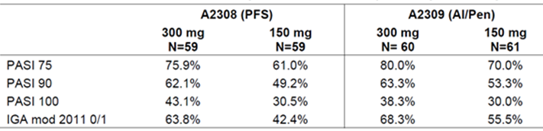

Study A2309 (JUNCTURE) (interim data) (autoinjectors)

This study is described in Section 7.1.4 of Attachment 2. It was randomised, double blind and placebo controlled. It started in October 2012 and is ongoing (the CSR reports mainly to Week 12; the study includes 40 week maintenance and 8 week follow up phases) at 38 centres in 5 countries (Germany had 16 centres).

Randomisation was 1:1:1 to secukinumab 150 mg, 300 mg or placebo, stratified by body weight ± 90 kg. The relevant regimen was a dose at Weeks 0, 1, 2, 3, 4 and 8 (last dose of the induction period).

Inclusions/exclusions were similar to those in A2303. Efficacy variables were similar to those in A2302. Some 220 people were screened; 182 were randomised (60 to 61 per arm). Some 69% were male; 95% were Caucasian; median age was 44 years; mean BMI was 30 kg/m2. Mean PASI was 20.1. Some 23% had psoriatic arthritis. Some 55.5% had prior systemic therapy; most had failed such therapy.

PASI 75 was reached at Week 12 by 71.7% (150 mg), 86.7% (300 mg) and 3.3% (placebo). IGA 0 to 1 was obtained by 53.3% (150 mg), 73.3% (300 mg) and 0% (placebo). PASI 90 was reached by 40% (150 mg), 55% (300 mg) and 0% (placebo). PASI 100 was obtained by 17% (150 mg), 27% (300 mg) and 0% (placebo). Subgroup and sensitivity analyses were consistent with these outcomes.

Week 52 results were reported (Table 16 above) by the sponsor, as noted for FEATURE above.

##### Other studies

###### Study A2304 (SCULPTURE) (lyophilisate) (start of relapse versus fixed interval maintenance)

This study is described in Section 7.2.1 of Attachment 2. It was randomised and double blind. It was conducted from August 2011 to March 2013 at 133 centres in 16 countries (USA had 33 centres; Germany had 22).

This study’s main objective was to compare a fixed interval maintenance regimen versus retreatment at start of relapse. Inclusions/exclusions were broadly similar to those in A2303. Randomisation was 1:1 to secukinumab 150 mg SC or 300 mg SC, stratified by region and body weight ± 90 kg.

Dosing was at Weeks 0, 1, 2, 3, 4, 8 then as below. At Week 12, patients were reclassified as PASI 75 responders or PASI partial responders (attaining PASI 50 but not PASI 75) or PASI non responders. At Week 12, PASI responders were re-randomised within their original dose group to a fixed interval maintenance dosing schedule (a dose every 4 weeks, from Weeks 12 to 48), or to retreatment at the start of relapse (SoR), where after Week 12, a patient was not dosed until the patient met relapse criteria (namely, loss of at least 20% of maximum PASI gain achieved during the study relative to baseline and a loss of PASI 75); dosing was continued until PASI 75 was reattained. The dosing upon retreatment at SoR did not involve re-induction.

Efficacy variables were similar to those in A2302.

Some 1,200 patients were screened; 966 were randomised (n = 482 to 150 mg; n = 484 to 300 mg). Some 66% of patients were male; 72% were Caucasian; median age was 46 years; 34% were current smokers. Mean PASI at baseline was 23.6; 20.5% had psoriatic arthritis and 67% had prior exposure to systemic therapy; three quarters of these had failed therapy.

Some 409/482 subjects (85%) on 150 mg were included as Week 12 responders; 433/484 (89%) on 300 mg were included. In the induction period, at Week 12, PASI 100 was attained by 16.2% (150 mg) and 25.7% (300 mg).

Maintenance of response was lower for the 150 mg SoR group (52.4%) than for the 150 mg fixed interval group (62.1%) and also lower for the 300 mg SoR group (67.7%) than for the 300 mg fixed interval group (78.2%). In both cases the lower limit of the 90% CI around the difference was close to ‑20%, below the pre specified (but unjustified) non inferiority margin of ‑15%, so the study did not show non inferiority of the SoR approach in maintenance of response. However, point estimates did not indicate a dramatic difference between the two maintenance approaches.

###### Study A2307 (STATURE) (IV salvage of partial responders from A2304)

This study is described in Section 7.2.2 of Attachment 2. It was randomised, double blind, double dummy, active and placebo controlled. It studied those patients declared to be partial responders at Week 12 in A2304 (the maintenance fixed interval versus SoR trial). The study aimed to evaluate efficacy of IV administration of secukinumab, versus SC use, at Week 8 in these patients. The study was conducted from December 2011 to February 2013 at 23 centres in 8 countries.

Only 43 patients were randomised into this study from A2304 (140 had been planned). Median age was 47 years; there were some disparities in baseline demographics across arms. Baseline mean PASI was 21.8; 25.6% had psoriatic arthritis.

Randomisation was 1:1 to an IV arm (secukinumab 10 mg/kg IV at Weeks 0, 2 and 4) or an SC arm (300 mg at Weeks 0 and 4, constituting up titration for those who had received 150 mg in A2304, or prolonged treatment for those who had received 300 mg). The IV arm received considerably more secukinumab than the SC arm, since mean weight in the IV arm was 92 kg; also, there were 3 IV administrations versus 2 SC, before the Week 8 primary efficacy endpoint was measured.

There was a distinct trend towards better outcomes at Week 8 in the IV arm (for example PASI 75 was attained in 90.5% of the IV arm, 66.7% of the SC arm; IGA 0 to 1 in 66.7% (IV arm) versus 33.3% (SC arm)(p = 0.03); and PASI 90 in 61.9% (IV arm) versus 9.5% (SC arm)(p = 0.0005)). Follow up was to 40 weeks and 64 to 68% of patients achieving PASI 75 at Week 8 maintained this response at Week 40 (however, dosing after Week 8 was SC in both arms, at 300 mg, and open label). The sponsor does not propose IV use in its current application.

###### Study A2211E1 (long term safety following the Phase II core study A2211)

This study is described in Section 7.2.3 of Attachment 2. It is an extension of Study A2211.

A2211 examined different dose regimens of 150 mg SC in moderate to severe plaque psoriasis (for example single injection at Week 1; monthly injection; early loading) versus placebo. Patients achieving PASI 75 had been re randomised at Week 12 to fixed interval (Week 13 and Week 25, that is, every 12 weeks) or SoR maintenance (a dose given at every visit where SoR is observed), and partial/non responders had been allocated to an open label arm (150 mg SC every 4 weeks, to Week 33).

Within extension Study A2211E1, patients were continued in these groups. The study was started in May 2010 and will continue until Week 225 (for total treatment duration of 260 weeks). An interim CSR was provided (data cut off 21 January 2013).

Some 275 patients entered the extension study (46 in the fixed interval (FI) arm, 42 in the SoR arm and 187 in the open label arm); 148 have been withdrawn. Median exposure to secukinumab was 90.1 weeks (FI), 102.5 weeks (SoR) and 111.9 weeks (open label). Duration of exposure is detailed in Table 17. Beyond Week 73, less than half of fixed interval and SoR arm subjects remained under study. Very broadly, reasonable rates of PASI 75 were seen in all arms. The design makes efficacy of long term maintenance hard to interpret. The open label arm is most relevant in terms of dosing (though 150 mg SC doses were given) but selection into this arm was complex. Even at extension Week 121, 54% of the open label arm attained PASI 75. High rates of PASI 75 in the 12 weekly fixed interval arm at extension Weeks 97 and 121 are probably misleading, as small numbers studied at those time points (and rising PASI 75 rates compared to earlier time points) suggest responder bias.

Table 17. A2211E1 duration of exposure (extension safety set).

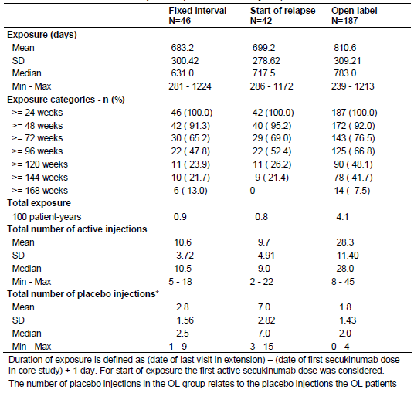

###### Pooled analyses

These analyses are described on in Section 7.3 of Attachment 2. They do not add to characterisation of secukinumab efficacy. Subjects > 90 kg and subjects who had failed systemic therapies had lower response rates (Table 24 Attachment 2); but within these sub groups secukinumab benefit was clear.

#### Safety

##### Data pooling

The safety of secukinumab is discussed in Section 8 of Attachment 2. Table 25 of Attachment 2 explains the three pooled safety datasets (A = Phase III, versus placebo, in psoriasis, short term safety up to 12 weeks; B = Phase II and III in psoriasis, longer term up to 52 weeks; C = Phase I to III across all indications, not healthy volunteers, up to 52 weeks). Details of exposure have been provided (Section 8.3 Attachment 2). In Pool B, 1,641 subjects have been exposed to ≥ 52 weeks of secukinumab.

In Pool A (and the induction period of Pool B) time at risk was similar, 12 weeks for all arms. Analyses in these datasets inform about safety risks with initial exposure to secukinumab. The sponsor also presented incidence rates of events after adjusting for exposure in the entire treatment period for Pool B. Interpretation of these analyses is difficult, as risk of some AEs may vary over time[21], intrinsically or because patients with early significant events may discontinue.

##### Overview

In Pool A, the incidence of any infection and infestation was 28.7% (secukinumab) versus 18.9% (placebo) versus 24.5% (etanercept) (Table 28 Attachment 2). Other AEs when presented per system organ class were reported at broadly similar frequencies, except for general disorders and administration site conditions (6.7% versus 5.9% versus 18% (secukinumab, versus placebo versus etanercept) respectively, due to more injection site reactivity for etanercept), eye disorders (2.5% versus 1.2% versus 0.3%) and reproductive system and breast disorders (1.45% versus 0.4% versus 0.6%).

Similar patterns were seen in Pool B, but exposure adjusted incidence (Table 18) suggested less risk with secukinumab (for example infections and infestations: incidence rate (IR) per 100 person-years was 90.4 for secukinumab, 100.1 for placebo and 91.4 for etanercept).

Table 18. Exposure adjusted incidence of AEs by primary system organ class; entire treatment period (Pool B: All psoriasis trials; Safety set).

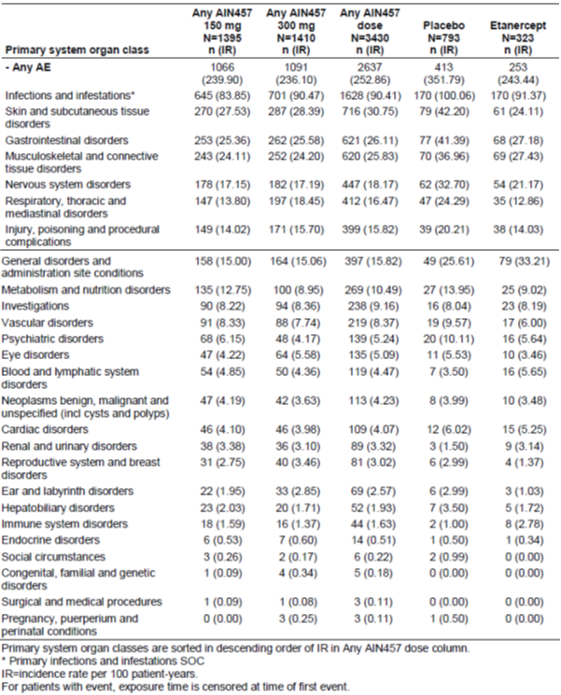

By Pool A preferred term (Table 29, Attachment 2), AEs such as nasopharyngitis, diarrhoea and URTI were commoner in both the secukinumab and etanercept arms than the placebo arm. Cough was seen in 2.03% (secukinumab) versus 1.3% (placebo) versus 1.2% (etanercept). Exposure adjusted incidence rates are reported in Table 19 below; interestingly, IRs for eczema were 2.45 (secukinumab), 0.5 (placebo) and 0.68 (etanercept) respectively.

Table 19. Exposure adjusted incidence of the most frequent (≥ 3.0 per 100 patient-years in any group) AEs by preferred term; entire treatment period (Pool B: All psoriasis trials; safety set).

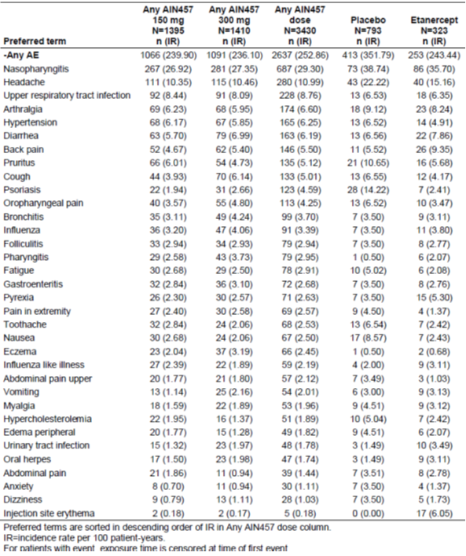

###### Deaths

There have been 16 deaths (to 31 July 2013) across all secukinumab trials: 6 psoriasis patients, 6 RA patients and 4 others. 9/16 deaths were on treatment. In psoriasis, a 66 year old male died on day 319 of 150 mg SC (SoR), after a haemorrhagic stroke (clinical diagnosis); no relationship with study drug was suspected. A 64 year old male died of disseminated aspergillosis 370 days after the last 150 mg SC dose; however, the patient had several liver transplants in the lead up to death, due to cirrhosis. The transplant surgeon suspected a relationship with secukinumab but the investigator did not. IL-17 is considered to mediate immunity against Aspergillus infection,20 but apparently the last dose of secukinumab was > 1 year prior to the infection, so it seems reasonable to exclude a contributory role of secukinumab. A 69 year old female died of acute myocardial infarction (AMI) 4 days after the last secukinumab dose in an RA trial; a relationship was suspected (although the patient had hypertension and coronary artery disease as risk factors). Details of some other deaths were not supplied due to ongoing blinding of non-psoriasis studies.

###### Other serious AEs

Serious AEs are discussed in Section 8.4.3 of Attachment 2; incidence of all SAEs was 2.0% for secukinumab 150 mg and 300 mg, 1.7% for placebo and 0.9% for etanercept in Pool A (see Table 20 below). However the incidence in the placebo arm included multiple SAEs reflecting inefficacy in treating psoriasis. Related SAEs were seen in 0.4%, 0.6%, 0.4% and 0.3% (150 mg, 300 mg, placebo and etanercept) respectively; in Pool A. Secukinumab related SAEs in this pool included cardiac failure, Crohn’s disease, bladder cancer, 7th nerve paralysis, pulmonary oedema, overdose, fluid overload and bursitis. In Pool B, angina pectoris, AMI and pulmonary oedema were each reported by 2 to 3 secukinumab patients; the sponsor notes a higher rate of prior AMI in the 300 mg group. This resulted in 10 out of 2,877 Pool B secukinumab patients (0.35%) reporting serious cardiac AEs, versus 0 out of 793 placebo and 0 out of 323 etanercept patients, within the induction period. Over the entire treatment period, and exposure adjusted, the incidence rate for any SAE in Pool B was 7.8 for any secukinumab dose, 7.5 for placebo and 7.1 for etanercept (per 100 patient years); for cardiac SAEs the values were 0.92, 0 and 1.03 respectively (Table 32, Attachment 2). By preferred term (Table 21, below), some significant outcomes were a higher incidence rate for angina, coronary artery disease, hypertensive crisis, unstable angina, cerebrovascular accident, AMI and pulmonary oedema for secukinumab; and a higher incidence rate for both ulcerative colitis and Crohn’s disease. Absolute numbers of these serious AEs were small, but in a common condition that will require ongoing treatment, even apparently small increases in serious AEs may result in significant health impacts (if the increases are valid).

Table 20. SAAEs by primary system organ class; induction period (Pool A: Pivotal placebo controlled psoriasis trials; safety set).

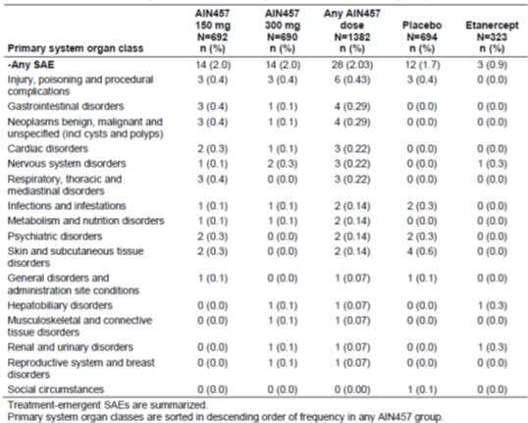

Table 21. Exposure adjusted incidence of the most frequent (≥ 0.10 per 100 patient-years in any group) SAEs by preferred term; entire treatment period (Pool B: All psoriasis trials; safety set).

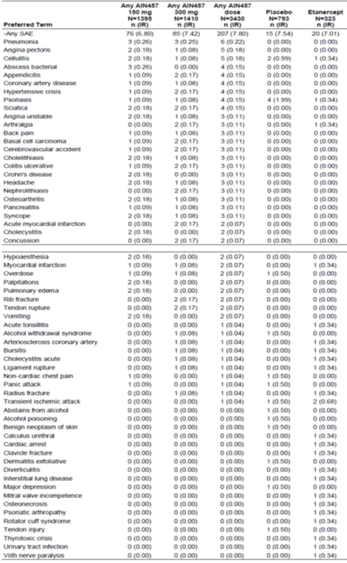

###### Discontinuations

Discontinuations due to AEs are discussed in Section 8.4.4 of Attachment 2. There were multiple incidences in secukinumab patients of discontinuation due to erythrodermic psoriasis (n = 2) and eczema (including nummular eczema) (n = 2) in the Pool A induction period (Table 22, below). Common discontinuations for Pool B’s entire treatment period are listed (Table 33 Attachment 2). Four cases of thrombocytopenia and three of ulcerative colitis are significant; but discontinuations for such events were relatively infrequent.

Table 22. AEs causing discontinuation by preferred term; induction period (Pool A: Pivotal placebo controlled psoriasis studies; Safety set).

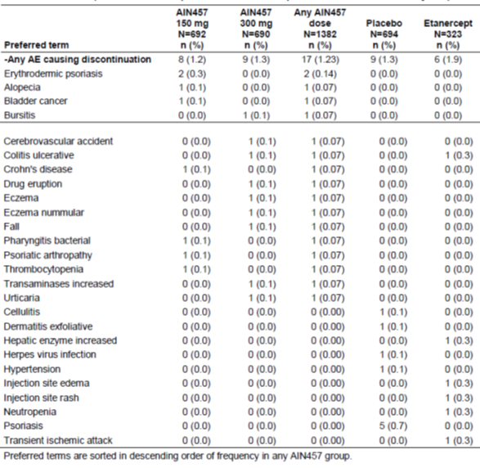

###### Adverse events of special interest

Adverse events of special interest are summarised in Section 8.5.7 of Attachment 2.

Candidiasis (Tables 37 and 38 of Attachment 2 and Table 23 below) and eczema (Table 39 Attachment 2) AEs were more common in secukinumab patients than others. Eczema and chronic candidiasis are hallmarks of autosomal dominant hyper IgE syndrome (HIES), which is characterised by deficiency in IL-17-secreting CD4+ cells due to insufficient expression of RAR related orphan receptor gamma t isoform (RORɣt) (attributable in turn to signal transducer and activator of transcription 3(STAT3) mutations). Also characteristic of this syndrome is S. aureus infection (classically presenting with cold abscesses and pneumonia). Staphylococcus infections were not prominently reported with use of secukinumab; but there was an increase in otitis externa AEs and pneumonias were reported. Although Candida and S. aureus are typical pathogens in HIES, risk of infection with some other pathogens is also elevated. Immunodeficiency in HIES may be caused by defects broader than IL-17 deficiency. It would have been useful to analyse patients with these AEs for evidence of higher secukinumab exposure/more complete suppression of IL-17/IL-17 transcripts (particularly patients with > 1 event of interest), in case it is possible to identify risk factors for such outcomes.

Table 23. Exposure adjusted incidence e of candida infections; entire treatment period (Pool B; all psoriasis trials; safety set).

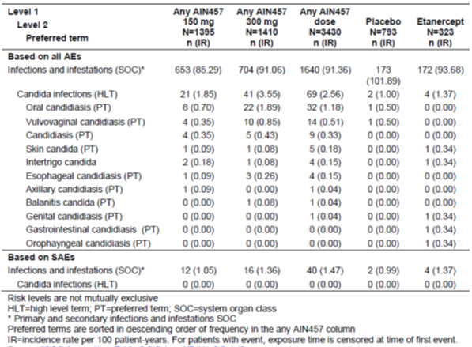

There were two cases of malignant melanoma on secukinumab (both patients had prior exposure to phototherapy).

Infection

Secukinumab’s higher rate of infections than placebo was driven mainly by non serious upper respiratory tract infection (including otitis externa), in the induction period.

There was a signal for increased frequency of Candida infection with 300 mg dosing. No serious Candida infections were reported for secukinumab, but oesophageal candidiasis was reported once.

In autosomal recessive HIES, the syndrome includes an increased risk of infection with herpes viruses. Herpes infections were reported with secukinumab but after adjusting for time at risk in the Pool B entire treatment period, the signal of elevated risk relative to placebo or etanercept was weakened; and there were no disseminated or central nervous system (CNS) cases.

Cardiovascular system

In the Pool B entire treatment period, AMI/stroke/cardiovascular death was reported in 0.4% of 300 mg arm patients, 0.4% of 150 mg patients, 0.3% of etanercept patients (n = 1) and 0.1% of placebo patients. This imbalance between secukinumab and placebo arms disappeared after adjusting for exposure (Section 8.7.4 Attachment 2) as was the case in Pool C. Psoriasis patients have a relatively high cardiovascular risk, so any additive effect of the treatment is highly relevant; but evidence for this was not compelling. As a footnote, in HIES there appears to be an intrinsic risk of systemic vascular disease, with at least one line of evidence suggesting a possible role of Th17 deficiency as opposed to other effects of STAT3 mutation.[22].

Reproductive system

Subgroup analysis showed a disparity across treatments in reproductive system and breast disorders for males (0.7% versus 0.2% versus 0.4%)( for any secukinumab versus placebo versus etanercept respectively ) and for females (3.1% versus 1.0% versus 1.1%). Th17 cells have been reported to have a role in immune defence of the female reproductive tract, but wider roles have been suggested, for example modulation of pregnancy progression. The actual preferred terms reported in females on secukinumab included dysmenorrhoea (5/421, 1.2%) and other menstrual disorders. Of note in this regard, women of child bearing potential were excluded from clinical studies or were included only if using adequate contraception.

Eye disorders

There was a higher rate of eye disorders with secukinumab (Section 8.4.1.1 Attachment 2). The signal was somewhat reduced after adjustment for time at risk in Pool B (Table 18 above).

Worsening of psoriasis

There was a signal in pools A and B that more patients on secukinumab discontinued due to worse manifestations of psoriasis (erythrodermic psoriasis and arthritis). These events occurred in 150 mg patients and not in 300 mg patients and at low frequencies. There were two AEs of erythrodermic psoriasis (entire treatment period, Pool B). Symptoms started on Days 5 and 8, interpretable as due to worsening of psoriasis in the lead up to treatment, or as a flare up triggered by receipt of secukinumab. In neither case did the investigator suspect a causal relationship with study drug. Across the entire treatment period in Pool B, the IR for erythrodermic psoriasis was 0.85 for secukinumab, 0.50 for placebo and 0.34 for etanercept. The sponsor speculated based on accompanying PASI scores that many of these cases were not confirmed cases of erythrodermic psoriasis.

Inflammatory bowel disease

Three cases of Crohn’s disease were seen in the secukinumab psoriasis cohort; 1/3 was a new case. Ulcerative colitis was also reported. In Section 8.5.7.4 ‘autoimmune disorders’ of Attachment 2, it is noted that Crohn’s Study A2202 showed no benefit of secukinumab in reducing Crohn’s disease Activity Index, and several patients on secukinumab reported worsening Crohn’s disease in the follow up period.

Immunogenicity

A case of anaphylaxis has been reported in an ankylosing spondylitis trial within 1 hour of first infusion with 10 mg/kg IV secukinumab. Urticaria was a commonly reported AE, but not suggestive of anaphylaxis.

Injection site reactions were infrequent, compared to etanercept, and similar across the different presentations of secukinumab.

Among 3,627 patients evaluated for ADAs, 27 (0.7%) showed treatment emergent ADA, and 9/27 cases revealed neutralising antibodies. Cases were not linked with injection site reactions, administration reactions or hypersensitivity (Section 8.7.5, Attachment 2). Table 24 is a list of Phase III psoriasis patients with ADAs; presence of anti-secukinumab antibodies was not clearly linked to loss of efficacy. Incidence of ADAs may be influenced by frequency of assay, for example assays were more frequent in Phase II studies and treatment-emergent ADAs were reported more often in these studies. It is also relevant that many patients reverted to seronegative while on treatment.

Table 24. Overview of patients with treatment emergent anti-drug antibodies (ADA) in Phase III studies (A2302, A2303, A2304, A2308 and A2309).

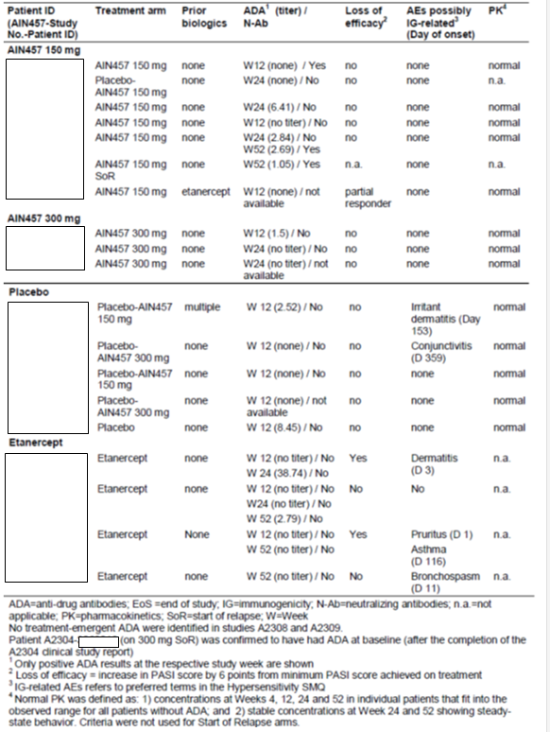

Laboratory tests

Evaluation of lab test results (see Attachment 2 Section 8.5, 8.7.1 and 8.7.2) found no major safety signals.

There were more ‘low level transaminase elevations’ in active treatment arms than with placebo, but this imbalance did not extend to severe or serious events (Attachment 2 Section 8.7.1). A case conforming to Hy’s Law (alanine aminotransferase (ALT) or aspartate aminotransferase (AST) > 3 x upper limit of normal (ULN) + total bilirubin (TBL) > 2 x ULN + alkaline phosphatase (ALP) < 2 x ULN) in the secukinumab Pool A (1/1382; < 0.1%) was confounded by alcoholism; there was a Hy’s Law case in the placebo arm, too. There were no additional cases in Pool B’s induction period, but one further case was reported in the Pool B maintenance phase, at Week 44, and considered by the investigator a non serious AE related to treatment; but 16 days prior to the finding, the patient had taken two forms of paracetamol for 5 days. Liver function tests (LFTs) were normalising by the next visit (Week 48). No viral hepatitis reactivation was reported in any psoriasis study.

More Grade 3 neutropenia was seen in secukinumab arms than the placebo arm of Pool B (0.6 to 0.8% versus 0.1%); IL-17 may regulate granulopoiesis and neutrophil chemotaxis.

#### Clinical evaluators recommendation

The clinical evaluator recommended that secukinumab 300 mg be approved for the treatment of adult patients with moderate to severe plaque psoriasis, who are candidates for systemic therapy or phototherapy. The recommendation for approval was subject to an adequate response to questions in Section 11 (Attachment 2).

The Delegate noted that no second round clinical evaluation was required during the evaluation process. Answers to clinical questions in Section 11 (Attachment 2) have been taken into account in the Delegate’s overview.

### Risk management plan

The RMP Evaluator proposes the following condition of registration:

*The European Risk Management Plan (version 1.1, dated 9 July 2014), with Australian Specific Annex (version 1.1, dated 2 September 2014), to be revised to the satisfaction of the TGA, must be implemented (see outstanding issues above).*

The Delegate proposed the following wording, which separates the condition of registration from any list of issues considered outstanding.

*The European Risk Management Plan (version 1.1, dated 9 July 2014), with Australian Specific Annex (version 1.1, dated 2 September 2014), or any updates to these documents that are agreed by the TGAs RMP Evaluation Section, must be implemented.*

The RMP evaluator identifies various outstanding issues with the RMP. These issues should be reconciled between the sponsor and RMP Evaluation Section, and the RMP updated as appropriate, not necessarily prior to registration[23].

### Risk-benefit analysis

##### Efficacy

###### Psoriatic arthritis

Psoriasis patients with psoriatic arthritis benefited from secukinumab in terms of their psoriasis; but there was limited information in the Phase III psoriasis program about impact on such patients psoriatic arthritis (see Section 7.1.1.13.3.7 of Attachment 2 for some such data from A2302; reliance was on the HAQ-DI measure of function, as few patients were evaluated for American College of Rheumatology (ACR) response). HAQ-DI measured the level of function ability and activity restriction.

###### Comparison with etanercept

Comparison with etanercept was favourable, however etanercept is considered by some less efficacious than, for example, infliximab or adalimumab in treatment of psoriasis, at least in the short term.

##### Safety

###### Cardiovascular risk

Some 10 out of 2,877 Pool B secukinumab patients (0.35%) reported serious cardiac AEs, versus 0 out of 793 placebo and 0 out of 323 etanercept patients, within the induction period. Adjustment for time at risk over the entire treatment period resulted in IRs of 0.92, 0 and 1.03 per 100 patient-years, for secukinumab, placebo and etanercept respectively. However, a different metric, MACE, produced a different picture, with no substantial differences across arms (Attachment 2; Section 8.7.4 and Table 42). MACE cases were adjudicated by a blinded safety committee. It could be argued that risk seems no worse than with etanercept, but the quantification of risk with etanercept seems unstable due to the relatively small number of subjects given that treatment, in only one study. The sponsor’s analyses suggest secukinumab imposes no major cardiovascular risk, but long term data would be helpful to rule this possibility out. The proposed PI does not discuss cardiovascular risk, which the Delegate thinks is reasonable.

###### Reproductive system AEs

There was some evidence that secukinumab may affect the female reproductive system, for example AEs of dysmenorrhoea and altered menstrual bleeding were somewhat commoner on secukinumab than on placebo (or etanercept). This has not been communicated well in the proposed PI.

Other safety concerns (for example infection; Crohn’s disease) are reasonably well addressed in the proposed Product Information. The issue of predisposition to malignancy was well analysed in the dossier and no compelling signals were evident.

###### Pregnancy category

See nonclinical evaluation above.

##### Benefit-risk

The Delegate considers the high probability of benefit with secukinumab in treating moderate to severe chronic plaque psoriasis to outweigh the risks of harm that it imposes.

#### Delegates considerations

Efficacy has been demonstrated to 52 weeks using the proposed regimen, in treatment of moderate to severe plaque psoriasis. Psoriasis returns once off treatment.

Efficacy has not been established in other forms of psoriasis or in psoriatic arthropathy.

IL-17 is a key mediator within the immune system, and blockade via secukinumab may be expected to translate to immunosuppression. An increase in infections has been observed in the clinical program, although this increase has not been substantial.

There are weak signals of a small absolute increase in cardiovascular risk with secukinumab. The signals are mostly abolished when incidence rates are considered, that is, when exposure (time at risk) is taken into account.

There is disagreement between the sponsor and the TGA nonclinical evaluators about appropriate pregnancy categorisation.

#### Proposed action

The Delegate has no reason to say, at this time, that the application for secukinumab should not be approved for registration.

#### Request for ACPM advice

The committee is requested to provide advice on the following specific issues:

1. To what extent (if any) this medicine increases risk of cardiovascular AEs; and how this should be communicated in the PI and CMI (for example is a Precaution required in the PI)?
2. Appropriate Pregnancy Category.
3. Whether the balance of efficacy and safety for this product is favourable in the proposed population.

The committee is also requested to provide advice on any other issues that it thinks may be relevant to a decision on whether or not to approve this application.

#### Response from sponsor

Presented here is the sponsor’s response to the Delegates overview and request for the Australian Committee on Prescription Medicines (ACPM) advice in relation to the application for the registration of Cosentyx secukinumab 150 mg powder for injection and 150 mg/mL solution for injection. Where appropriate, the sponsor’s comments have been cross referenced to the Delegates overview, the clinical evaluation report, nonclinical evaluation report and the risk management plan evaluation report or to the submission.

##### Introduction

The Delegate and clinical evaluator both recommend approval of Cosentyx for the treatment of moderate to severe plaque psoriasis in adult patients who are candidates for systemic therapy or phototherapy. The clinical evaluator considers the benefit-risk of secukinumab, given the proposed usage, to be favourable. Consistent with this, the Delegate considers the high probability of benefit with secukinumab in treating moderate to severe chronic plaque psoriasis to outweigh the risks. The Delegate has sought the advice of the ACPM on a number of issues. For ease of reference, the Delegates comments are transcribed in italics.

##### Response to issues raised in the delegates overview

##### Efficacy in psoriatic arthritis

*Psoriasis patients with psoriatic arthritis benefited from secukinumab in terms of their psoriasis; but there was limited information in the Phase III psoriasis program about impact on such patients psoriatic arthritis (see section 7.1.1.13.7 Attachment 2 for some such data from A2302); reliance was on the HAQ-Dl (Health Assessment Questionnaire; Disability Index) measure of function, as few patients were evaluated for ACR response). HAQ-Dl measured the level of function ability and activity restriction.*

###### Sponsor’s response

Secukinumab relieves skin symptoms independent of the comorbidity of psoriatic arthritis (PsA). It also improves the physical functioning of patients with concomitant PsA within the psoriasis Phase III program, which was a pre-defined efficacy endpoint. Results suggest that secukinumab can relieve the symptoms of PsA. At Baseline, PsA was reported between 15 to 25% of patients in the plaque psoriasis Phase III studies which is in line with the expectation for this population. In the subset of psoriatic arthritis patients in the ERASURE and FIXTURE studies, physical function was assessed using the HAQ-DI. In these studies, patients treated with 150 mg or 300 mg Cosentyx showed greater improvement from baseline in the HAQ-DI score (mean decreases of ‑27.5% and ‑50.2% at Week 12) compared to placebo (‑8.9%). This improvement was maintained up to Week 52. There are future plans to submit findings from the secukinumab psoriatic arthritis clinical program to support the use in the population of PsA. In the psoriasis clinical program, it can however be concluded that secukinumab demonstrates a favourable efficacy and safety profile in those with the comorbidity of PsA, and this data on physical functioning HAQ in PsA is felt to be helpful to include for prescribers at this time.

##### Efficacy in comparison with etanercept

*Comparison with etanercept was favourable, however etanercept is considered by some less efficacious than, for example, infliximab or adalimumab in treatment of psoriasis, at least in the short term.*

###### Sponsor’s response

The clinical program of secukinumab is the first submission package for plaque psoriasis that includes an active biologic comparator arm in a pivotal Phase III study for a one year period.

Enbrel (etanercept) was selected as an active comparator as it was required to be included in the program following discussion with the EMA. Etanercept is an established product with considerable safety experience. Approved in 2005 for the treatment of moderate to severe plaque psoriasis, Enbrel was the market leader when Novartis was developing protocols for this study.

Etanercept has greater than 9 to 10 years of post-marketing experience in moderate to severe plaque psoriasis. It is a widely used biological agent in psoriasis patients, and is considered the standard of care in many countries. It is true that etanercept is not the most effective of the anti TNF-α therapies, but it serves as arguably the best anti TNF-α agent from a safety perspective (based on clinician feedback), due to the well understood safety profile and wealth of safety data. Etanercept as an active comparator provides the reassurance of an established product with a well understood risk benefit ratio.

##### Balance of efficacy and safety in the proposed population

The clinical evaluator and Delegate concluded that overall, the benefit-risk balance of secukinumab for the proposed indication of use in treating moderate to severe chronic plaque psoriasis is favourable. The sponsor notes that the Delegate has also sought the ACPM advice on the balance of efficacy and safety for secukinumab. For completeness, Novartis has taken the opportunity to comment on the benefit-risk balance of secukinumab.

Secukinumab is a first in class fully human monoclonal antibody which selectively binds and neutralises the pro inflammatory cytokine, interleukin 17A (IL-17A). Although there are multiple agents approved for the treatment of psoriasis, many patients still do not achieve optimal efficacy when considering clinically meaningful measures such as clear/almost clear skin (as demonstrated by PASI 90). As few as 21% achieve this with etanercept.21

An overview of key benefits and risks is provided below:

Benefits:

* Highly effective therapy with the majority of patients attaining clear/almost clear skin at Week 12 with maximum response observed at Week 16
* Week12 (A2302/3 300mg): PASI 75 77 to 82%; PASI 90 54 to 59%; PASI 100 24 to 29%
* Week16 (A2302/3 300mg): PASI 75 86 to 87%; PASI 90 70 to 72 %; PASI 100 37 to 42%
* Higher rates in clear skin directly improve patients quality of life (DLQI & Psoriasis Symptom Diary)
* Vast majority of patients maintain their skin clear up to Week 52
* Superiority was demonstrated against a standard of care biologic comparator, etanercept.

Risks:

* A comparable safety profile to etanercept over 1 year, allows for confident long term use
* 300 mg supported as optimal dose by a safety profile comparable to 150 mg
* Identified safety risks are manageable:
  + Mostly mild to moderate upper respiratory tract infections
  + Dose related AEs limited to non-serious superficial candida infection
* Rates of serious infections, malignancies and MACE are low and comparable to etanercept and placebo

This new, novel mechanistic approach to the treatment of psoriasis represents an improvement in the currently available therapeutic options for physicians and patients with psoriasis. The demonstrated advances in efficacy with 300 mg secukinumab and a manageable safety profile provide support for the addition of this therapy to the armamentarium of plaque psoriasis treatments.

##### Safety and cardiovascular risk

*To what extent (if any) this medicine increases the risk of cardiovascular events; and how this should be communicated in the PI and CMI (for example is a Precaution required in the PI)?*

###### Sponsor’s response

There is no evidence of a signal for cardiovascular events associated with secukinumab and therefore a precaution in the PI would not be justified. Additionally, Novartis notes that the Delegate considers it reasonable that the PI does not discuss cardiovascular (CV) risk and that there is no compelling evidence of an additional effect to the already present CV risk in psoriasis patients.

Cardiovascular events

The exposure adjusted IR of cardiovascular events was low over the entire treatment period (4.07 per 100 patient-years for any secukinumab dose, 6.02 for placebo and 5.25 for etanercept) and the number of cardiac disorder serious adverse events (SAEs) was low for all dose groups. There is no apparent pattern of these SAEs and there was no dose response. Patients with stable cardiovascular risk factors were not excluded from secukinumab treatment and most patients with reported cardiovascular SAEs had prior or active cardiovascular disease or relevant risk factors.

Major adverse cardiac events (MACE)

An independent Cardiovascular and Cerebrovascular Safety Adjudication Committee (CCVAC) was established to review and adjudicate potential MACE cases in a blinded manner on a program wide basis. Overall, the incidence of MACE on study was low (0.4%, 0.5%, 0.3%, and 0.5% in the 150 mg, 300 mg, etanercept, and placebo groups, respectively) and the exposure adjusted incidence of MACE cases were similar to placebo. No risk difference for adjudicated MACE compared to placebo was seen in individual and pooled data from placebo controlled psoriasis studies (see Figure 6 below). All reported MACE cases were associated with prior or active cardiovascular disease or risk factors at baseline and there was no dose dependence noted for secukinumab.

Figure 6. Individual and pooled comparisons of secukinumab versus placebo in placebo-controlled psoriasis studies for adjudicated MACE cases (Subset of Pool B).

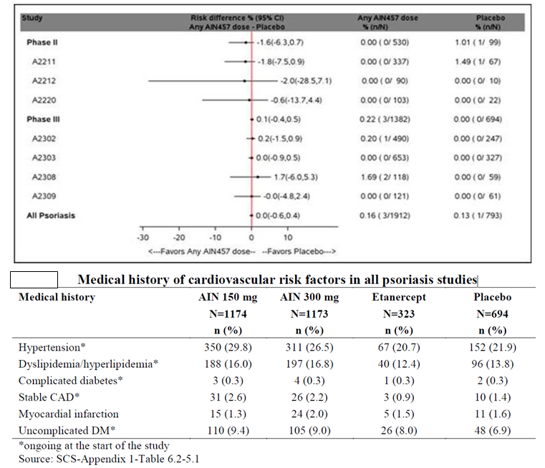

Even though there were numerically more patients with some baseline cardiovascular risk factors (for example hypertension, stable coronary heart disease/myocardial infarctions and uncomplicated diabetes) in the secukinumab dose groups compared to both the placebo and etanercept groups, the treatment emergent incidence rate of MACE was not elevated, remained low and exposure adjusted incidence over the longer term entire treatment period was comparable across all treatment groups.

When this observed incidence of MACE in the secukinumab psoriasis clinical program was compared to a real world database of patients with moderate to severe psoriasis (UK Clinical Practice Research Datalink), the number of MACE observed were within the range of what was expected in this population (Standard Incidence Ratio for 300 mg was 1.25 (95%CI: 0.41, 2.92), 150 mg was 1.08 (95%CI: 0.29, 2.76), placebo was 1.55 (95%CI: 0.02, 8.60), as shown in Table 25 below).

Table 25. MACE observed in psoriasis studies (Pool B) compared to those expected based on the UK Clinical Research Datalink (CPRD). Standardised incidence ratio (SIR).

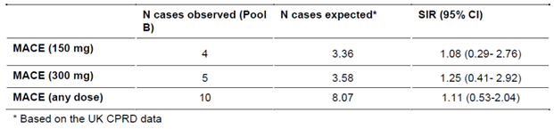

The evidence from the psoriasis clinical program in over 4,000 patients treated with secukinumab in both short and long term studies does not support a precaution of CV risk in the PI for secukinumab.

##### Safety and reproductive system AEs

*There was some evidence that secukinumab may affect the female reproductive system, for example AEs of dysmenorrhoea and altered menstrual bleeding were somewhat commoner on secukinumab than on placebo (or etanercept). This has not been communicated well in the proposed PI.*

###### Novartis response

The incidence of reproductive system disorders (dysmenorrhoea, menorrhagia and metrorrhagia) between secukinumab, placebo and etanercept in Pool A was numerically higher in the secukinumab treatment groups. However, the overall incidence across all groups was low and the observed imbalance is not considered clinically meaningful and may be due to a chance observation based on the medical evaluation of cases with dysmenorrhea, menorrhagia and/or metrorrhagia.

As shown in Table 26, the incidence of AEs at System Organ Class level was 1.45% for all secukinumab compared to 0.4% and 0.6% for placebo and etanercept, respectively. The number of cases with dysmenorrhea (n = 5), menorrhagia (n = 2) and metrorrhagia (n = 2) was small for all patients on secukinumab including one case who reported both dysmenorrhea and menorrhagia.

All events were non serious, mild to moderate in severity, and in most cases the events were self-limited, lasting for 1 to 2 days. In 1 case, the patient with a medical history of thyroidectomy was also reported to have intermenstrual bleeding which lasted for approximately 220 days. The event was mild, non serious, resolved spontaneously and did not lead to any interruption of secukinumab treatment. One case reporting menorrhagia was reported as suspected to be related to the study medication, however, the event started on Day 1 at randomisation and no action was taken towards secukinumab, and the patient continued on treatment. All other cases were not suspected to be related to study medication and did not lead to treatment discontinuation. Female reproductive system disorders is not included as an AE in the proposed PI because all events were mild to moderate in severity, most were self-limiting, and the small overall imbalance is not considered to be clinically meaningful.

Table 26. Adverse events of reproductive system and breast disorders in Pool A.

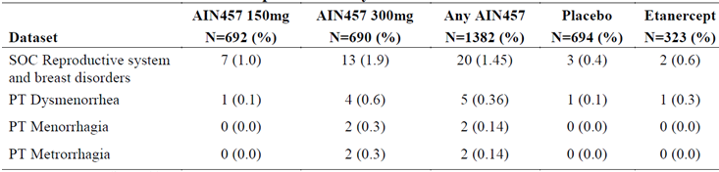

##### Safety and pregnancy category

*Pregnancy category was proposed as B1 by the sponsor, C by the nonclinical evaluator. The Delegate supports Category C, because reversible harm other than malformation may be expected (for example, risk of infection) in fetuses and neonates exposed to secukinumab, based on mechanism of action. This risk does not in the Delegate’s opinion have to be unique to the fetus/newborn or higher than in adults, to confer Category C. Clinical data in this setting are too limited to recommend Category B1.*

###### Sponsor’s response

The safety profile observed in adults in the psoriasis Phase III program with secukinumab shows a low rate of ADRs, and overall is favourable. The current nonclinical data so not suggest any safety concern in relation to reproductive and developmental issues with secukinumab treatment or any evidence that the developing fetus or neonate is uniquely susceptible to adverse immunomodulatory effects with secukinumab treatment during pregnancy (further details were provided to TGA in the response to the consolidated questions). Immunotoxicity/immunosuppression was not observed in the conducted nonclinical studies. Consequently, a theoretical concern for infections in the newborn following exposure to secukinumab during gestation is considered to be no different than that for adult subjects treated with secukinumab. Therefore, the Pregnancy category B1 is considered appropriate.

Further given the mechanism of action of IL17 being a more targeted therapy compared to anti TNF-α (Pregnancy Category B2 or C) and is more similar to p40 that is, Ustekinumab (Pregnancy Category B1) from a general safety profile perspective than anti-TNF-α it is unclear why secukinumab is being suggested to be Pregnancy Category C. Even when the risk of infection mentioned as a concern, secukinumab has a comparable incidence of events when compared to the active comparator etanercept, which is assigned a Pregnancy category of B2 in Australia. Over a 52 week treatment period, secukinumab doses had a lower exposure adjusted incidence rate of all infections and infestations when compared to etanercept (IR for 300 mg: 49.72, 150 mg: 46.24, and etanercept: 52.6). Novartis will continue to monitor, collect and medically evaluate all cases of pregnancy and the impact on newborns in the routine post-marketing pharmacovigilance.

#### Advisory committee considerations

The submission seeks to register a new biological medicine.

The Advisory Committee on Prescription Medicines (ACPM), taking into account the submitted evidence of efficacy, safety and quality, agreed with the Delegate and considered Cosentyx powder for injection or solution for injection containing 150 mg, 150 mg/mL of secukinumab to have an overall positive benefit–risk profile for the indication:

*Treatment of moderate to severe plaque psoriasis in adult patients who are candidates for systemic therapy or phototherapy.*

##### Proposed conditions of registration

The ACPM agreed with the Delegate on the proposed conditions of registration.

##### Proposed Product Information/Consumer Medicine Information amendments

The ACPM agreed with the Delegate to the proposed amendments to the Product Information (PI) and Consumer Medicine Information (CMI) and specifically advised on the inclusion of the following:

* A statement in the ‘Precautions’ section of the PI and relevant sections of the CMI on the effects on the female reproductive system in line with that proposed by the evaluator. These are uncommon.
* Statements in the relevant sections of the CMI on infection risks, especially opportunistic infection, should be clarified and expanded. Symptoms and signs which should prompt immediate action to seek medical assessment and the need to treat active infection should be highlighted.
* A statement in the ‘Precautions’ section of the PI and relevant sections of the CMI on the risks for uncontrolled hypertension and heart failure.
* Amendment to the Pregnancy Classification to be category C.
  + A possible statement was proposed: *There are no adequate data from the use of Cosentyx in pregnant women. Secukinumab was shown to cross the placenta in monkeys. Use of secukinumab during pregnancy may compromise the immunity of the foetus and neonate. Administration of live vaccines to infants for 16 weeks after the mother's last dose of Cosentyx is generally not recommended.*
* The ‘Clinical trials’ section should include the results of the SCULPTURE trial including the group differences.
* Amend the side effects section of the CMI which is confusing for example, have separate lists for serious AEs, common AEs and less common AEs. Remove repetition.
* The CMI should include the statement that Cosentyx is an immune suppressant.

##### Specific advice

The ACPM advised the following in response to the Delegate’s specific questions on this submission:

1. *To what extent (if any) this medicine increases risk of cardiovascular adverse events; and how this should be communicated in the PI and CMI (e.g. is a Precaution required in the PI)?*

The ACPM advised that for cardiovascular risk in particular the data are inconsistent within the submission. The sponsor should explain why the data in the MACE table (major adverse cardiac events) is difficult to reconcile and requested the sponsor to confirm patient numbers and AE categories. If the safety signal is confirmed by the sponsor then the ACPM was of the view that the PI should be adjusted accordingly. Suitable cardio vascular events should be included in the post-market surveillance. There should be a precaution on uncontrolled hypertension and heart failure (both excluded from drug trial inclusion) in any case.

1. *The appropriate pregnancy category*

The study in Cynomolgus monkeys showed no evidence of secukinumab antibody production. Secukinumab was neither teratogenic nor embryotoxic. However, there was no immune-phenotyping done on the foetuses so the possible effect on the neonatal immune system was not assessed. It also demonstrated placental transfer. The mouse study had similar limitations.

The ACPM noted the sponsor’s arguments for Category B1 in line with comparators; however, the levels of evidence provided for the comparators were more substantial. The ACPM agreed with the nonclinical evaluator’s determination of Category C because reversible harm other than malformation may be expected based on the pharmacological action (for example, risk of infection) in fetuses and neonates exposed to secukinumab. In addition, it was noted the importance of IL-17A in immune responses to infection and the placental transfer of secukinumab was recognised.

1. *Whether the balance of efficacy and safety for this product is favourable in the proposed population.*

The ACPM agreed the totality of evidence supported a positive benefit-risk profile, providing amendments were made to the PI.

### Outcome

Based on a review of quality, safety and efficacy, TGA approved the registration of;

* Cosentyx secukinumab (rch) 150 mg powder for injection vial
* Cosentyx secukinumab (rch) 150 mg/1 mL solution for injection in prefilled pen
* Cosentyx secukinumab (rch) 150 mg/1 mL solution for injection in prefilled syringe
* Zafrez secukinumab (rch) 150 mg powder for injection vial
* Zafrez secukinumab (rch) 150 mg/1 mL solution for injection in prefilled pen
* Zafrez secukinumab (rch) 150 mg/1 mL solution for injection in prefilled syringe

indicated for:

*Treatment of moderate to severe plaque psoriasis in adult patients who are candidates for systemic therapy or phototherapy.*

#### Specific conditions of registration applying to these goods

1. The European Risk Management Plan (version 1.1, dated 9 Ju1y 2014), with Australian Specific Annex (version 1.1, dated 2 September 2014), or any updates to these documents that are agreed by the TGA's RMP Evaluation Section, must be implemented.
2. It is a condition of registration that, as a minimum, the first five independent batches of secukinumab (rch)

* 150 mg powder for injection vial
* 150 mg/1 mL solution for injection in prefilled syringe
* 150 mg/1 mL solution for injection in prefilled pen

imported into Australia are not released for sale until samples and/or the manufacturer's release data have been assessed and endorsed for release by the TGA.

## Attachment 1. Product Information

The Product Information approved for main Cosentyx at the time this AusPAR was published is at Attachment 1. For the most recent Product Information please refer to the TGA website at <<https://www.tga.gov.au/product-information-pi>>. The PI for Zafrez is identical except for the product name.

## Attachment 2. Extract from the Clinical Evaluation Report

|  |
| --- |
| Therapeutic Goods Administration |
| PO Box 100 Woden ACT 2606 Australia  Email: [info@tga.gov.au](mailto:info@tga.gov.au) Phone: 1800 020 653 Fax: 02 6232 8605  [**https://www.tga.gov.au**](https://www.tga.gov.au) |

1. 2014 Meeting Materials, Dermatologic and Ophthalmic Drugs Advisory Committee <http://www.fda.gov/AdvisoryCommittees/CommitteesMeetingMaterials/Drugs/DermatologicandOphthalmicDrugsAdvisoryCommittee/ucm404866.htm>
2. 21-Jan-2015 Novartis announces FDA approval for first IL-17A <www.novartis.com.ph/newsroom/2015/news_2015-01-21_002.html>
3. International Conference on Harmonisation of registration requirements for pharmaceuticals for human use - S6 preclinical safety evaluation of biotechnology derived pharmaceuticals.
4. Secukinumab surrogate BZN035 is a mouse, anti mouse IL-17A monoclonal antibody shown to have similar in vitro affinity, cross reactivity and neutralising activity in mice to secukinumab in humans.
5. International conference on harmonisation of technical requirements for registration of pharmaceuticals for human use. Preclinical safety evaluations of biotechnology-derived pharmaceuticals S6(R1)
6. Nakae S et al. Antigen-specific T cell sensitisation is impaired in IL-17-deficient mice, causing suppression of allergic cellular and humoral responses. Immunity 2002;17: 375–387.
7. Ling WL et al. A role for interleukin-17A in modulating intracellular survival of Mycobacterium bovis bacillus Calmette-Guerin in murine macrophages*. Immunology* 2013;140: 323-334.
8. Gopal R et al. Unexpected role for IL-17 in protective immunity against hypervirulent Mycobacterium tuberculosis HN878 infection. *PLOS Pathogens*. 2014;10: e1004099.
9. Bӓr E et al. IL-17 regulates systemic fungal immunity by controlling the functional competence of NK cells. *Immunity* 2014;40:117-127; and the sponsors infection risk assessment.
10. Singh JA et al. Adverse effects of biologics: a network meta-analysis and Cochrane overview (Review). *The Cochrane Library* 2013, Issue 4.
11. Category B1: *Drugs which have been taken by only a limited number of pregnant women and women of childbearing age, without an increase in the frequency of malformation or other direct or indirect harmful effects on the human fetus having been observed. Studies in animals have not shown evidence of an increased occurrence of fetal damage.*
12. Category C: *Drugs which, owing to their pharmacological effects, have caused or may be suspected of causing, harmful effects on the human fetus or neonate without causing malformations. These effects may be reversible. Accompanying texts should be consulted for further details.*
13. M.A.Cimmino. Epidemiology of psoriasis and psoriatic arthritis *Rheumatological Clinic, Department of Internal Medicine, University of Genova, Italy.* Novartis Pharmaceuticals limited licensed copy.
14. Gelfand JM, et al. Comparative effectiveness of commonly used systemic treatments or phototherapy for moderate to severe plaque psoriasis in the Clinical practice setting. *Arch Dermatol*. 2012;148: 487-494.
15. Zaba LC. Effective treatment of psoriasis with etanercept is linked to suppression of IL-17 signalling, not immediate response TNF genes*. L. Allergy Clin Immunol* 2009;124:1023-1030.
16. International conference on harmonisation of technical requirements for registration of pharmaceuticals for human use. E1 - The extent of population exposure to assess clinical safety for drugs intended for long term treatment of non-life threatening conditions.
17. Common terminology criteria for adverse events National Institutes of Health. The grade refers to the severity of the adverse event. Grade 1: Mild AE, Grade 2: Moderate AE, Grade 3: Severe AE, Grade 4: Life threatening or disabling AE, Grade 5: Death related to AE.
18. New York Heart Association classification. Class1: No limitations. Ordinary physical activity does not cause undue fatigue, dyspnoea or palpitations (asymptomatic LV dysfunction). Class 2: Slight limitation of physical activity. Ordinary physical activity results in fatigue, palpitation, dyspnoea or angina pectoris (mild CHF).
19. O’Connor W The dual nature of TH17 cells: shifting the focus to function. Nature Immunology 2010; 11: 471 – 476.
20. Langley RG et al Secukinumab in Plaque Psoriasis – results of two Phase III Trials. *NEJM* 2014; 371: 326 – 338.
21. Siddiqui O. Statistical methods to analyse adverse events data of randomised clinical trials*. J Biopharmaceutical Statistics* 2009; 19: 889-899
22. Chandesris M-O et al Frequent and widespread vascular abnormalities in human signal transducer and activator of transcription 3 deficiency. *Circ Cardiaovasc Genet* 2012; 5: 25-34
23. Resolution of these issues is unlikely to alter the Delegate’s conclusion based on, amongst other things, the current version of the RMP, that the efficacy and safety of secukinumab, for the purpose for which it is to be used, is favourable. Therefore, the Delegate does not consider that the outstanding issues need resolution prior to a decision.