CER Report: 23 April 2014

AusPAR Attachment 2

Extract from the Clinical Evaluation Report for Secukinumab (rch)
  - Proprietary Product Name: Cosentyx
  - Sponsor: Novartis Pharmaceuticals Australia Pty Ltd

About the Therapeutic Goods Administration (TGA)
- The Therapeutic Goods Administration (TGA) is part of the Australian Government Department of Health, and is responsible for regulating medicines and medical devices.
- The TGA administers the Therapeutic Goods Act 1989 (the Act), applying a risk management approach designed to ensure therapeutic goods supplied in Australia meet acceptable standards of quality, safety and efficacy (performance), when necessary.
- The work of the TGA is based on applying scientific and clinical expertise to decision-making, to ensure that the benefits to consumers outweigh any risks associated with the use of medicines and medical devices.
- The TGA relies on the public, healthcare professionals and industry to report problems with medicines or medical devices. TGA investigates reports received by it to determine any necessary regulatory action.
- To report a problem with a medicine or medical device, please see the information on the TGA website <https://www.tga.gov.au>.
About the Extract from the Clinical Evaluation Report
- This document provides a more detailed evaluation of the clinical findings, extracted from the Clinical Evaluation Report (CER) prepared by the TGA. This extract does not include sections from the CER regarding product documentation or post market activities.
- The words [Information redacted], where they appear in this document, indicate that confidential information has been deleted.
- For the most recent Product Information (PI), please refer to the TGA website <https://www.tga.gov.au/product-information-pi>.
Copyright
© Commonwealth of Australia 2015
This work is copyright. You may reproduce the whole or part of this work in unaltered form for your own personal use or, if you are part of an organisation, for internal use within your organisation, but only if you or your organisation do not use the reproduction for any commercial purpose and retain this copyright notice and all disclaimer notices as part of that reproduction. Apart from rights to use as permitted by the Copyright Act 1968 or allowed by this copyright notice, all other rights are reserved and you are not allowed to reproduce the whole or any part of this work in any way (electronic or otherwise) without first being given specific written permission from the Commonwealth to do so. Requests and inquiries concerning reproduction and rights are to be sent to the TGA Copyright Officer, Therapeutic Goods Administration, PO Box 100, Woden ACT 2606 or emailed to <tga.copyright@tga.gov.au>.

Contents
List of abbreviations 5
1. Background 11
2. Clinical rationale 11
3. Contents of the clinical dossier 12
3.1. Scope of the clinical dossier 12
3.2. Paediatric data 12
3.3. Good clinical practice 13
4. Pharmacokinetics 13
4.1. Studies providing pharmacokinetic data 13
4.2. Summary of pharmacokinetics 15
4.3. Evaluator’s overall conclusions on pharmacokinetics 21
5. Pharmacodynamics 23
5.1. Studies providing pharmacodynamic data 23
5.2. Summary of pharmacodynamics 23
5.3. Evaluator’s overall conclusions on pharmacodynamics 30
6. Dosage selection for the pivotal studies 33
7. Clinical efficacy 36
7.1. Pivotal efficacy studies 37
7.2. Other efficacy studies 76
7.3. Analyses performed across trials (pooled analyses and meta-analyses) 88
7.4. Evaluator’s conclusions on clinical efficacy 96
8. Clinical safety 98
8.1. Studies providing evaluable safety data 98
8.2. Pivotal studies that assessed safety as a primary outcome 102
8.3. Dose-response and non-pivotal efficacy studies 102
8.4. Adverse events 104
8.5. Laboratory tests 115
8.6. Post-marketing experience 130
8.7. Safety issues with the potential for major regulatory impact 130
8.8. Other safety issues 136
8.9. Evaluator’s overall conclusions on clinical safety 140
9. First round benefit-risk assessment 143
9.1. First round assessment of benefits 143
9.2. First round assessment of risks 144
9.3. First round assessment of benefit-risk balance 144
10. First round recommendation regarding authorisation 146
11. Clinical questions 146
11.1. Pharmacokinetics up to here 146
11.2. Pharmacodynamics 147
11.3. Efficacy 147
11.4. Safety 147
12. Second round evaluation of clinical data submitted in response to questions 147
13. Second round benefit-risk assessment 147
14. Second round recommendation regarding authorisation 148
15. References 148

List of abbreviations
Abbreviation | Meaning
ACR | American College of Rheumatology
ADA | anti-drug-antibodies
ADR | adverse drug reaction
AE | Adverse Event
AI | autoinjector/pen
AIN457 | secukinumab
ALP | alkaline phosphatase
ALT | alanine aminotransferase
ANCOVA | analysis of covariance
AS | ankylosing spondylitis
AST | aspartate aminotransferase
AUC_{0-t} | area under the serum concentration-time curve from time zero to time t, using the log-linear trapezoidal rule
AUC_{inf} | area under the serum concentration-time curve from time zero to infinity
AUC_{last} | area under the drug serum concentration-time curve (time 0 to the last measurable concentration sampling time).
AV | atrioventricular
b.i.d | twice a day
BA | bioavailability
BE | bioequivalence
BMI | body mass index
BSA | body surface area
Cav | average concentration
CCV | cardiovascular/cerebrovascular
CD3G | T-cell surface glycoprotein CD3 gamma chain
CHO | Chinese hamster ovary
CL | plasma or serum clearance, calculated as dose/AUC_{inf} after an i.v. dose
CL/F | the apparent systemic (or total body) clearance from plasma (or serum or blood) following extravascular administration [volume / time]
C_{max} | maximum serum concentration after a single dose
CMH | Cochran-Mantel-Haenszel
CMI | Confidence Interval
Cmin | pre-dose concentration
CRF | case report/record form
CSR | clinical study report
CTCAE | Common Terminology Criteria for Adverse Events
CV | coefficient of variation
CYP | cytochrome
DDI | drug-drug interaction
DILI | drug-induced liver injury
DLQI | Dermatology Life Quality Index
dPGA | dynamic Physician’s Global Assessment
ECG | electrocardiogram
ECL | electrochemiluminescence
EFD | embryo foetal development
ELISA | enzyme-linked immunosorbent assay
EMA | European Medicines Agency
EQ-5D | EuroQOL 5-Dimension Health Questionnaire
F | fraction of the dose systemically available
FAS | Full Analysis Set
FDA | United States Food and Drug Administration
FI | fixed interval dosing
GCP | Good Clinical Practice
GGT | gamma-glutamyltransferase
HA | health authority
HAQ-DI | Health Assessment Questionnaire-Disability Index
hBD-2 | human beta defensin-2
HBsAg | hepatitis B surface antigen
HLT | high level term
HRQoL | health-related quality of life
HAS | human serum albumin
hsCRP | high sensitivity C-reactive protein
i.v. | intravenous(ly)
IA | interim analysis
IBD | inflammatory bowel disease
Ig | immunoglobulin
IGA | Investigator’s Global Assessment
IGA mod 2007 | IGA scale used in part of the Phase II program, 6-point scale
IGA mod 2009 | IGA scale used in part of the Phase II program, 6-point scale
IGA mod 2011 | IGA scale used in the Phase III program, 5-point scale
IgG | Immunoglobulin G
IHC | immunohistochemistry
IL | interleukin
IL-17 | interleukin 17
INFG | interferon gamma
Ir | incidence rate
IR | incomplete responder
ISF | interstitial fluid
LDL | low-density lipoprotein
LLOQ | lower limit of quantification
LOQ | limit of quantification
LYO | Lyophilisate in vial
mAB | monoclonal antibody
MACE | major adverse cardiovascular event
MCID | minimal clinically important difference
MPO | myeloperoxidase
MSD | Meso Scale Discovery
MTX | methotrexate
NAFL | non-alcoholic fatty liver disease
NICE | National Institute for Health and Clinical Excellence
NMQ | Novartis MedDRA Query
NVP-AIN457 | Secukinumab
OFM | open flow microperfusion
OTC | over the- counter
PASI | Psoriasis Area and Severity Index
PASI 75 | patients achieving ≥ 75% improvement (reduction) in PASI
PCR | polymerase chain reaction
PD | pharmacodynamics
PFS | pre-filled syringe
PK | pharmacokinetics
PPK | population PK
PsA | psoriatic arthritis
PUVA | psoralen and UVA
q4w | dosing once every four weeks
ROC | receiver-operator characteristic
s.c. | subcutaneous(ly)
SAE | Serious Adverse Event
SBP | Summary of Biopharmaceutics
SCE | Summary of Clinical Efficacy
SCP | Summary of Clinical Pharmacology
SCS | Summary of Clinical Safety
SIAQ | Self-injection assessment questionnaire
SMQ | Standardized MedDRA Query
SOC | system organ class
SoR | start of relapse (synonymous with retreatment as needed)
ss | steady state
t_{1/2} | apparent terminal elimination half-life
TB | tuberculosis
TBL | total bilirubin
TCR | tissue cross-reactivity
Th17 | T helper 17 cell
T_{max} | time to the maximum observed serum concentration
TNFα | tumor necrosis factor alpha
UGT UDP | glucuronosyltransferase
ULN | upper limit of normal
VAS | visual analog scale
Vz | apparent volume of distribution during the terminal elimination phase
Vz/F | apparent volume of distribution
WOCBP | women of child bearing potential

Background
This is a Category 1 submission to register a novel recombinant protein, Cosentyx (secukinumab) for the treatment of moderate to severe plaque psoriasis.
The proposed indication is for the treatment of moderate to severe plaque psoriasis in adult patients who are candidates for systemic therapy or phototherapy.
The submission proposes registration of the following dosage forms and strengths:
- Cosentyx: secukinumab 150 mg powder for injection
- Cosentyx: secukinumab 150 mg/1 mL solution for injection in prefilled syringe (PFS) and
- Cosentyx: secukinumab 150 mg/1 mL solution for injection in prefilled auto-injector pen.
The recommended dose is 300 mg, administered as two subcutaneous (s.c.) injections of Cosentyx 150 mg, at weeks 0, 1, 2, and 3, followed by chronic maintenance dosing every 4 weeks starting at Week 4.

Clinical rationale
Psoriasis is a multifactorial, relapsing syndrome triggering immune responses which manifest as red, inflamed plaques on the skin, occurring anywhere on the body, but most often on the extremities, scalp, elbows, knees, nails, palms, and soles of feet. It is one of the most common human skin disorders, affecting 2.6 % of Australians (Cimmino 2007). Approximately 85 to 90% of psoriasis patients have chronic plaque psoriasis. Of the 350,000 Australians that suffer from plaque psoriasis, around 10 per cent suffer from severe chronic plaque psoriasis (Psoriasis Australia 2013).
Several low molecular weight drugs (including cydosporin, methotrexate), and biologics, including TNF-α antagonists (adalimumab, etanercept, infliximab) and anti IL12/IL23 (ustekinumab) have been approved for the treatment of psoriasis. Most of these treatments are associated with specific safety concerns (that is organ toxicity, infections including tuberculosis, malignancies including lymphoma, immunogenicity and demyelinating neurologic event), which limits their value in the long term management of psoriasis. None achieve the goal of clear/almost clear skin for a majority of patients (Gelfand et al 2012). Thus, there remains a significant medical need for new therapeutic approaches in moderate to severe psoriasis, in particular approaches that target specific immunopathogenic events of the condition and are safer when administered chronically.
Interleukin-17A (IL-17A) is recognized as one of the principal cytokines in a number of chronic, immune mediated, inflammatory conditions including psoriasis. Evidence of the role of IL-17A in the inflammatory processes of psoriasis is that inhibition of IL-17 signalling (Zaba et al 2009) correlates with relief of symptoms and successful treatment of psoriasis.
Cosentyx works by targeting IL-17A and inhibiting its interaction with the IL- 17 receptor, which is expressed on various cell types including keratinocytes. As a result, Cosentyx inhibits the release of proinflammatory cytokines, chemokines and mediators of tissue damage and reduces IL-17A-mediated contributions to autoimmune and inflammatory diseases. Clinically relevant levels of secukinumab reach the skin and reduce local inflammatory markers. As a direct consequence, treatment with secukinumab reduces erythema, induration, and desquamation present in plaque psoriasis lesions. At therapeutic concentrations, secukinumab does not neutralize IL-17F, leaves other functions of Th17 cells intact, and does not directly influence the Th1 pathway. Therefore it is expected that Th1-based host defense mechanisms are largely unaltered by Cosentyx.
This new mechanism of action offers greater specificity and selectivity in targeting the specific downstream cytokine. This specificity offers the potential for fewer off target effects when compared to other available current treatment options for psoriasis. In addition, as IL-17A is further downstream in the inflammation cascade, mechanistically it is expected to have a better safety profile as compared to other approved therapies such as anti-TNF agents.

Contents of the clinical dossier

Scope of the clinical dossier
The submission contained the following clinical information:
- 20 clinical pharmacology studies, including 15 that provided pharmacokinetic data and 12 that provided pharmacodynamic data.
- 1 population pharmacokinetic analyses.
- 5 pivotal efficacy/safety studies (A2302, A2308, A2309, A2303, A2304) for the proposed psoriasis indication.
- 5 Phase II dose-finding studies (A2204, A2102, A2211, A2212 and A2220) for the proposed psoriasis indication.
- Supportive Phase III studies (A2307 and A2211E1) for the proposed psoriasis indication.
- Other, for example pooled analyses, meta-analyses, PSURs, Integrated Summary of Efficacy, Integrated Summary of Safety.
Comment: Module 5 contains other studies for indications for which approval is not sought in this submission. These include studies in psoriatic arthritis (A2206, A2206E1), rheumatoid arthritis (A2101, F2201, F2206 and F2208), ankylosing spondylitis (A2209, A2209E1), uveitis (A2208, A2301, A2301E1, C2302E1, C2303 and C2303E1), multiple scleorosis (B2201), Crohn’s disease (A2202, A2202E1) and dry eye syndrome (PJMR0092202). These studies have not been evaluated as they do not provide data in direct support of the proposed psoriasis indication. Hence, these studies would require evaluation if an application for these indications is sought in the future.
Safety data from these studies was included in Pool C safety dataset which included 34 studies in all different indications; this was provided in the Summary of Clinical Safety (Module 2) and has been evaluated in section 8 of this report.
The submission also contained a Clinical Overview, Summary of Clinical Efficacy, Summary of Clinical Safety and literature references.

Paediatric data
The submission did not include paediatric data.
Novartis will defer the start of a paediatric psoriasis study in patients 6 to less than 18 years of age until after both data from twelve months treatment period from the Phase III program in psoriasis adult patients becomes available and the PK model of this data is available to support dose justification. In addition, Novartis is proposing a waiver for the patient population less than 6 years of age. The sponsor’s paediatric investigation plan (PIP) was adopted by the FDA and the EMEA.

Good clinical practice
All the clinical studies were conducted in compliance with GCP guidelines and adequate ethics approval.

Pharmacokinetics

Studies providing pharmacokinetic data
Summaries of the pharmacokinetic studies were presented. Table 1 shows the studies relating to each pharmacokinetic topic.

Table 1. Submitted pharmacokinetic studies.
PK topic | Subtopic | Study ID | *
PK in healthy adults | Bioequivalence (BE) | CAIN457A2106 | BE between single s.c. dose of PFS and LYO.
 | Single dose | CAIN457A1101 | PK following i.v. and s.c. doses in healthy Japanese
 |  | CAIN457A2228 | PK following i.v. infusion
 |  | CAIN457A2104 | Ability to inhibit ozone-induced airway neutrophilia
 | Ascending dose | CAIN457A2101 | Ascending i.v. dose in healthy subjects
 | Distribution | CAIN457A2225 | Distribution into dermal interstitial fluid
PK in special populations | Target population (Psoriasis patients) | PK Modelling Report | Pooled PPK analysis of secukinumab in psoriasis
 |  | CAIN457A2103 | Absolute BA after s.c. dosing
 |  | CAIN457A2302 | Efficacy of Response and Safety of 2 Fixed Regimens
 |  | CAIN457A2308 | Efficacy after twelve weeks of treatment
 |  | CAIN457A2309 | Efficacy of 150 mg and 300 mg doses
 |  | CAIN457A2102 | Efficacy of a single dose infusion
 |  | CAIN457A2204 | Efficacy of 3 active treatment arms
 |  | CAIN457A2212 | Efficacy at 12 weeks following different loading-dose regimens
 |  | CAIN457A2220 | Efficacy of 3 different doses
 |  | CAIN457A2211 | Efficacy of three induction regimens
* Indicates the primary aim of the study. † Bioequivalence of different formulations. § Subjects who would be eligible to receive the drug if approved for the proposed indication.
Comment: It should be noted that a number of studies included in the evaluation materials examined the bioequivalence of different forms of GP2015 (Etanercept) and Enbrel (CAIN457GP15-101, CAIN457GP15-102 and CAIN457GP15-105). As these studies do not relate to the current application they have not be reviewed by the evaluator.
In addition, Table 2 (below) lists pharmacokinetic studies that were not evaluated as they were related to indications that were not relevant to the current application.

Table 2. Pharmacokinetic studies excluded from consideration.
Study ID | Target population | PK results excluded
CAIN457A2206 | Psoriatic Arthritis | All
CAIN457A2206E1 | Psoriatic Arthritis | All
CAIN457A2101 | Rheumatoid Arthritis | Data relating to healthy subjects included all other data excluded.
CAIN457F2201 | Rheumatoid Arthritis | All
CAIN457F2206 | Rheumatoid Arthritis | All
CAIN457F2208 | Rheumatoid Arthritis | All
CAIN457A2209 | Ankylosing Spondylitis | All
CAIN457A2209E1 | Ankylosing Spondylitis | All
CAIN457A2208 | Uveitis | All
CAIN457C2301 | Uveitis | All
CAIN457C2301E1 | Uveitis | All
CAIN457C2302 | Uveitis | All
CAIN457C2302E1 | Uveitis | All
CAIN457C2303 | Uveitis | All
CAIN457C2302E1 | Uveitis | All
CAIN457B2201 | Multiple Sclerosis | All
CAIN457A2202 | Crohns Disease | All
CAIN457A2202E1 | Crohns Disease | All
CPJMR0092202 | Dry Eye | All

Summary of pharmacokinetics
The information in the following summary is derived from conventional pharmacokinetic studies unless otherwise stated.
The active ingredient, secukinumab, is a recombinant human monoclonal anti human Interleukin-17A (IL-17A, IL-17) antibody of the IgG1/kappa isotype. The heavy and light chain segments are comprised of 457 and 215 amino acids, respectively, and it has a molecular weight of approximately 148 kDa.

Analytical method for determination of secukinumab in human samples
Total secukinumab, that is free secukinumab plus secukinumab bound to IL-17A (secukinumab - IL-17A complex), was analysed in human serum using a specific competitive ELISA method which had an LLOQ of 80 ng/mL. The intra day accuracy and intra day precision were within the range 76.4% to 118% and within the range 1.4% to 17.8%, respectively. The inter day accuracy and inter day precision were within the range 89.6% to 99.0% and 7.2% to 15.6%, respectively. Secukinumab was proven to be stable at - 20°C for at least 20 months. This anti idiotypic method was used in all clinical studies. The anti idiotypic assay format was validated to quantify total secukinumab in dermal interstitial fluid (ISF) and blister fluid as well. LLOQ was 76 ng/mL for both ISF and blister fluid.

Pharmacokinetics in healthy subjects
As the current application relates to secukinumab formulated for s.c. injection, the following section will focus on the PKs related to that form of the drug.

Absorption

Sites and mechanisms of absorption
Study CAIN457A2106 examined the bioequivalence between a single s.c. 300 mg dose of secukinumab packaged as a pre-filled syringe (PFS-test) and the lyophilised (LYO-reference) material in 150 healthy, predominantly Caucasian subjects. The mean C_{max} and AUC_{inf} for the PFS were 43.2 µg/mL and 1785 µg.day/mL respectively. The median T_{max} occurred 5 hours after dosing and the mean t_{1/2} was 26.6 hours.
Similar results were obtained in study CAIN457A1101, which compared the PKs of secukinumab following the administration of an i.v. infusion and s.c. injection in 42 healthy Japanese males. Following a 300 mg s.c. dose of secukinumab, the mean C_{max}, AUC_{inf} and t_{1/2} were 46.3 µg/mL, 1929 µg/mL and 25.9 hours, respectively. The median T_{max} occurred at 8 hours following dosing.

Bioavailability

Absolute bioavailability
Study CAIN457A1101 also examined the absolute bioavailability of s.c. secukinumab by comparing dose normalised AUC_{inf} after s.c. injection and following i.v. infusion. In this study the estimated bioavailability of secukinumab in healthy Japanese males was 77%, which was similar to the BA for human IgG (65 to 67%).

Bioavailability relative to an oral solution or micronised suspension
Not applicable.

Bioequivalence of clinical trial and market formulations
Study CAIN457A2106 identified that the LYO, used during development (which was the basis for the to be marketed powder for injection) and secukinumab manufactured as a liquid formulation in a PFS (another of the to be marketed formulations) were bioequivalent in terms of their AUC_{inf}, AUC_{last} and C_{max}. The C_{max} of each formulation was similar, 42.0 μg/mL for the LYO and 43.2 μg/mL for the PFS and reached median T_{max} at 5 days post dose. In addition, the mean concentration time profiles for both formulations were nearly superimposable.
Study CAIN457A2228 examined the PKs, safety and tolerability of secukinumab following a single i.v. infusion of 10 mg/kg administered over a 30 minute period in 12 healthy males. The mean C_{max} and AUC_{last} for this formulation were 237 μg/mL and 1070 μg.day/mL, respectively and the median T_{max} was 0.083 days. Similar results were identified in study CAIN457A2104 which also examined the PKs following a 10 mg/kg i.v. infusion of secukinumab in healthy subjects, in regard to C_{max} and T_{max}; however, the AUC_{last} was approximately 5.6 fold higher.

Bioequivalence of different dosage forms and strengths
Secukinumab is planned to be available in 150 mg/mL strength, as a LYO, for injection in a PFS and as a 150 mg/mL solution for injection in a pre filled auto injector/pen (AI). In the Phase III program, studies were conducted with the LYO in vial, except for study CAIN457A2308 and study CAIN457A2309 which were conducted with a PFS and AI as injection devices, respectively.
As stated, bioequivalence between the LYO and PFS was demonstrated in healthy subjects in Study CAIN457A2106, using formulations that had been manufactured using the CHO derived material.
By contrast, no studies compared the bioequivalence following doses of secukinumab administered via the PFS and the AI in healthy subjects. However, as the formulation of secukinumab solution used for both delivery methods is identical it would be expected that there would be little difference in PKs of these two products (please see Section 4.2.3 Target Population of this report for further discussion).

Bioequivalence to relevant registered products
Not applicable.

Influence of food
As secukinumab is administered subcutaneously the effect of food on its PKs were not examined.

Dose proportionality
Dose proportionality was not demonstrated for C_{max}, AUC_{last} and AUC_{inf} following s.c. injection of 150 mg and 300 mg secukinumab in healthy Japanese male subjects (Study CAIN457A1101) with the slope estimates (range) for the three parameters being 1.13 (0.90 to 1.36), 0.84 (0.58 to 1.09) and 0.83 (0.55 to 1.11), respectively.
Part I of Study CAIN457A2101 examined the PKs of secukinumab following 3.0 mg/kg (n = 3) and 10 mg/kg (n = 3) i.v. doses and placebo (n = 2) in 8 healthy subjects; however, all of the healthy subjects were excluded from the PK analysis due to unexplainable low concentrations in five out of six treated healthy volunteers.
All other studies relating to dose proportionality were conducted in the target group of psoriasis patients (please see Section 4.2.3 Target Population of this report for further discussion).

Bioavailability during multiple dosing
No studies examined the PKs of secukinumab during multiple dosing in healthy subjects.

Effect of administration timing
Not examined in healthy subjects.

Distribution

Volume of distribution
In healthy subjects (Study CAIN457A2106), the mean apparent volumes of distribution (Vz/F) following a 150 mg s.c. dose of secukinumab formulated from LYO or as a PFS were 6.72 L and 6.57 L respectively.

Plasma protein binding
The mechanism of action of secukinumab is based on its ability to selectively bind to the protein IL-17A; therefore, no specific study was undertaken to determine the binding of secukinumab to other, unrelated proteins.

Erythrocyte distribution
Not applicable.

Tissue distribution
Study CAIN457A2225 investigated the distribution of secukinumab into dermal interstitial fluid (ISF), following a single 300 mg s.c. dose of secukinumab in 8 healthy subjects. This study identified that the mean concentration of secukinumab in dermal ISF is approximately 23% of the serum concentration in healthy volunteers at two weeks post dose.

Metabolism
As a human IgG1κ monoclonal antibody secukinumab is expected to be degraded into small peptides and amino acids via catabolic pathways in the same manner as endogenous IgG; the metabolic pathway of secukinumab has not been characterised.

Interconversion between enantiomers
Not applicable.

Sites of metabolism and mechanisms / enzyme systems involved
Not applicable.

Non-renal clearance
Not applicable.

Metabolites identified in humans

Active metabolites
Not applicable.

Other metabolites
Not applicable.

Pharmacokinetics of metabolites
Not applicable.

Consequences of genetic polymorphism
Not known.

Excretion
Following a 150 mg s.c. dose of secukinumab (Study CAIN457A2106) in healthy subjects, the apparent systemic clearance was approximately 0.181 L/day.

Routes and mechanisms of excretion
As secukinumab is a human IgG immunoglobulin with a large molecular size (approximately 150 kDa) it is unlikely that it will be filtered by the kidney. Therefore, the antibody is not expected to be excreted in the urine and the majority of IgG elimination will occur via intracellular catabolism, following fluid phase or receptor mediated endocytosis.

Mass balance studies
Not applicable.

Renal clearance
See Section 4.2.2.5.1 above.

Intra- and inter-individual variability of pharmacokinetics
Following s.c. injection of 150 mg secukinumab in healthy subjects (Studies CAIN457A2106 and CAIN457A1101), the inter subject variability (CV%) in C_{max} and AUC_{inf} ranged from 13.8 to 27.7% and 14.3 to 26.7%, respectively.
Comment: Information on intra subject variability in healthy subjects was not provided.

Pharmacokinetics in the target population

Absorption
The PK Modelling Report, which was based on the pooled pharmacokinetic data taken from 1233 patients enrolled in Studies CAIN457A2102, CAIN457A2103, CAIN457A2211, CAIN457A2212, CAIN457A2220 and CAIN457A2302, identified that the C_{max} of secukinumab was 13.7 ± 4.8 µg/mL or 27.3 ± 9.5 µg/mL following a single s.c. dose of either 150 mg or 300 mg, respectively in plaque psoriasis patients; C_{max} occurred between 5 to 6 days following a single dose. The t_{1/2} was 26.9 days for both doses.
After the initial weekly dosing during the first month, the time to reach the maximum concentration was between 31 and 34 days. Peak concentrations at steady state (C_{max},_{ss}) following subcutaneous administration of 150 mg or 300 mg were 27.6 µg/mL and 55.2 µg/mL, respectively, and steady state was reached following 20 weeks with monthly dosing regimens.
Patients exhibited a 2 fold increase in peak serum concentrations and AUC following repeated monthly dosing during maintenance compared to a single dose.

Bioavailability
The PK Modelling Report indicated that secukinumab was absorbed with an average absolute bioavailability of 73% in patients with psoriasis, which was similar to the bioavailability of secukinumab in healthy Japanese subjects (77%, Study CAIN457A1101). In Study CAIN457A2103 in patients with psoriasis, the absolute bioavailability of secukinumab was estimated to be 55% and 63% using non compartmental and compartmental population methods, respectively.

Bioequivalence of to be marketed formulations
Secukinumab serum exposure following administration of 150 and 300 mg s.c. doses of the LYO, PFS and AI formulations at 4 and 12 weeks can be compared by examining the results of 3 separate Phase III studies (Studies CAIN457A2302, CAIN457A2308 and CAIN457A2309). Pre dose concentrations (C_{min}) of secukinumab were similar across the three dosage forms and demonstrated a dose proportional increase in exposure from 150 to 300 mg s.c., both at Week 4 and Week 12 in all three studies (Table 3, below). Differences in concentrations between the AI and PFS were somewhat higher than those observed between the PFS and LYO. However, it should be noted that the bulk syringe used in PFS and AI is identical and that these are cross-study comparisons. Importantly, the differences do not appear to be clinically meaningful which is supported by the fact that efficacy and safety across the three studies were comparable.

Table 3. Mean pre dose secukinumab serum concentrations in Phase III studies with different formulations/injection devices.
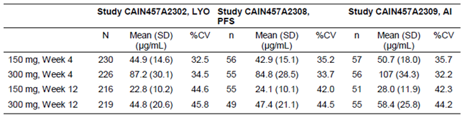

Steady state
Following once weekly s.c. dosing with either 150 mg or 300 mg secukinumab in predominantly Caucasian patients with moderate to severe chronic plaque type psoriasis (Study CAIN457A2302), mean C_{min} at Weeks 24 and 52 were stable in both dosing arms, indicating that exposure to secukinumab was at steady state during the second half of the study.

Volume of distribution
The mean volume of distribution in patients with psoriasis ranged from 5.56 L to 8.6 L (Studies CAIN457A2102, CAIN457A2204 and CAIN457A2212).

Tissue distribution
Study CAIN457A2225 investigated the distribution of secukinumab into dermal ISF, after a single 300 mg s.c. administration of secukinumab, in 8 healthy and 8 psoriasis patients; results of this study suggested that distribution of secukinumab was approximately 4 to 15% greater into the skin of psoriasis patients than in the skin of healthy subjects.

Excretion
Results of the PK Modelling Report indicated that secukinumab had a mean systemic clearance of 0.19 L/d in patients with plaque psoriasis and that clearance was both dose and time independent. Individual studies in the target population estimated that following i.v. administration of secukinumab at doses ranging from 3 to 30 mg/kg resulted in CL ranging from 0.14 to 0.21 L/day (Studies CAIN457A2102, CAIN457A2204 and CAIN457A2212).
PK modelling also indicated that the t_{1/2} was 27 days in plaque psoriasis patients. Individual studies conducted in the target population (Studies CAIN457A2102, CAIN457A2204, CAIN457A2212, CAIN457A2103 and Study CAIN457A2220) identified that the t_{1/2} of secukinumab ranged from between 25.7 and 32.4 days following i.v. infusions of doses ranging from 0.3 to 30 mg/kg secukinumab and 22 and 33.6 days following s.c. doses of 25 to 150 mg secukinumab (studies CAIN457A2103 and CAIN457A2220).

Inter subject variability
Inter subject variability with typical coefficients of variation between 17.6 % and 22.8% for C_{max} and between 22.2% and 27.2 % for AUC_{inf} was low to moderate in psoriasis patients following a single 3 mg/kg i.v. dose of secukinumab (Table 4).

Table 4. PK parameters after 3 mg/kg i.v. administration.
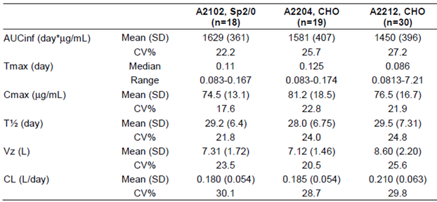
Study CAIN457A2211), which examined three induction regimens of s.c. secukinumab in patients with moderate to severe chronic plaque type psoriasis, identified that during the induction and maintenance phases of the study, the inter subject variability was between 32% and 64%. However, during the open label regimen the %CV was between 43% and 55%. Similarly, the derived inter subject variability for PK parameters such as C_{min},_{ss}, C_{max},_{ss}, C_{av},_{ss}, AUC_{tau},_{ss} for the 150 mg and 300 mg s.c. regimens identified in the PK Modelling Report was between 38.9% and 48.0%.

Pharmacokinetics in other special populations

Pharmacokinetics in subjects with impaired hepatic function
No pharmacokinetic data are available in patients with hepatic impairment.

Pharmacokinetics in subjects with impaired renal function
No pharmacokinetic data are available in patients with renal impairment.

Pharmacokinetics according to age

Paediatrics (< 18 years of age)
No pharmacokinetic data are available from paediatric patients.

Elderly patients
Of the 3,430 plaque psoriasis patients exposed to secukinumab clinical studies, a total of 230 were 65 years of age or older and 32 patients were 75 years of age or older. Based on the PPK analysis, clearance in elderly patients and patients less than 65 years of age was similar.

Pharmacokinetics related to genetic factors
Not applicable.

Pharmacokinetics according to other population characteristics.

Body weight
Following single and multiple doses administered either i.v. or s.c., the PK Modelling Report identified that bodyweight did not influence the bioavailability or the absorption rate in subjects with moderate to severe psoriasis.

Race
The PK Modelling Report also examined the effect of race (non Asian versus Asian patients) on clearance. Two hundred and six patients in the database were Asian and these patients showed a 12.4% higher secukinumab clearance than non Asian subjects; however, this relatively small difference in clearance is unlikely to be clinically relevant.

Pharmacokinetic interactions

Pharmacokinetic interactions demonstrated in human studies
No studies examined the interaction of secukinumab with other drugs in either healthy subjects or the target population. To this end the sponsor states that: ‘secukinumab is designed to be prescribed to patients with autoimmune and immune mediated diseases. Medications co administered to these patient populations may include potent low molecular weight immunosuppressant agents with known potential for drug-drug interactions. However, drug-drug interactions between monoclonal antibodies and such low molecular weight drugs were not routinely investigated, because hepatic metabolising enzymes such as CYPs and UGTs are not presumed to be involved in mAb elimination.’

Clinical implications of in vitro findings
In vitro drug-drug interaction studies were not conducted.

Evaluator’s overall conclusions on pharmacokinetics
Secukinumab is planned to be available in a 150 mg/mL strength, as a lyophilisate in vial (LYO) or for injection in a pre-filled syringe (PFS) or auto-injector/pen (AI).

Absorption, distribution, metabolism and excretion (ADME) in healthy subjects
- Following a single s.c. dose of 300 mg secukinumab via PFS the mean C_{max} and AUC_{inf} were 43.2 µg/mL and 1785 µg/mL respectively, the median T_{max} occurred 5 hours after dosing and the mean t_{1/2} was 26.6 hours.
- The absolute bioavailability of s.c. secukinumab in healthy Japanese males was 77%, which was similar to the BA for human IgG (65 to 67%).
- The LYO and PFS forms of secukinumab were bioequivalent. By contrast, no studies compared the bioequivalence following doses of secukinumab administered via the PFS and the AI in healthy subjects.
- Dose proportionality was not demonstrated for C_{max}, AUC_{last} and AUC_{inf} following s.c. injection of 150 mg and 300 mg secukinumab in healthy Japanese males.
- No studies examined the effects of food, multiple dosing or administration timing, on PKs of secukinumab in healthy subjects. Nor were studies conducted to identify secukinumab binding to non-IL7A proteins.
- The mean apparent volumes of distribution following a 150 mg s.c. dose of secukinumab formulated from a LYO or as a PFS were 6.72 L and 6.57 L, respectively. The mean concentration of secukinumab in dermal ISF is approximately 23% of the serum concentration in healthy volunteers at two weeks post dose.
- Although no studies examined the metabolic pathways involved in secukinumab metabolism, it is expected to be degraded into small peptides and amino acids via catabolic pathways in the same manner as endogenous IgG.
- Following s.c. administration of 150 mg secukinumab the apparent systemic clearance was approximately 0.181 L/day. Secukinumab is not expected to be excreted in urine and the majority of IgG elimination occurs via intracellular catabolism, following fluid phase or receptor mediated endocytosis.
- Following s.c. injection of 150 mg secukinumab, the inter subject variability (CV%) in C_{max} and AUC_{inf} ranged from 13.8 to 27.7% and 14.3 to 26.7%, respectively.

Absorption, distribution, metabolism and excretion (ADME) in target population
- PPK modelling in plaque psoriasis patients indicated that the C_{max} of secukinumab, following single s.c. doses of either 150 mg or 300 mg, was 13.7 µg/mL or 27.3 ± 9.5 µg/mL, respectively, and occurred between 5 to 6 days following a single dose. The t_{1/2} was 26.9 days for both doses.
- After initial weekly dosing during the first month, the T_{max} occurred between 31 and 34 days. C_{max},_{ss} following s.c. administration of either 150 mg or 300 mg was 27.6 µg/mL and 55.2 µg/mL, respectively, and steady-state was reached following 20 weeks with monthly dosing regimens.
- Patients exhibited a 2 fold increase in peak serum concentrations and AUC following repeated monthly dosing during maintenance compared to a single dose. Secukinumab was absorbed with an average absolute bioavailability of 73% in patients with psoriasis.
- Comparison of 3 separate Phase III studies, which examined 150 mg and 300 mg s.c. doses of the LYO, PFS and AI formulations, indicated that the C_{min} of secukinumab was similar for all three formulations and that C_{min} also demonstrated a dose proportional increase in exposure from 150 to 300 mg s.c., both at Week 4 and Week 12 in all three studies.
- The mean volume of distribution in patients with psoriasis ranged from 5.56 L to 8.6 L. Secukinumab was more strongly distributed, by approximately 4 to 15%, into the skin of psoriasis patients than in the skin of healthy subjects. The mean systemic clearance of secukinumab was 0.19 L/day and clearance was both dose and time independent.
- The CV% for PK parameters such as C_{min},_{ss}, C_{max},_{ss}, C_{av},_{ss}, AUC_{tau},_{ss} for the 150 mg and 300 mg s.c. regimens identified in the PPK analysis was between 38.9% and 48.0%.

Effect of Intrinsic and Extrinsic Factors on Secukinumab PK
- No studies examined the PKs of secukinumab in patients with either hepatic or renal impairment, in a paediatric population or in pregnant women. Based on PPK analysis, clearance in elderly patients and patients less than 65 years of age was similar. PPK analysis indicated that bodyweight did not influence the bioavailability and the absorption rate in patients with moderate to severe psoriasis, following single and multiple doses administered either i.v. or s.c. In addition, in Asian patients secukinumab clearance was 12.4% higher than non Asian subjects.
- No studies examined the interaction of secukinumab with other drugs in either healthy subjects or the target population.

Limitations of PK data
- No studies compared the bioequivalence following doses of secukinumab administered via the PFS and the AI in healthy subjects.
- No studies examined the effects of food, multiple dosing or administration timing, on PKs of secukinumab in healthy subjects. Nor were studies conducted to identify secukinumab binding to non-IL7A proteins.
- Information regarding the intra subject variability in healthy subjects or the target population could not be identified in the evaluation materials.
- No pharmacokinetic data are available from paediatric patients, breast feeding/pregnant women or patients with hepatic/renal impairment.
- No studies examined the interaction of secukinumab with other drugs in either healthy subjects or the target population.

Pharmacodynamics

Studies providing pharmacodynamic data
Summaries of the pharmacodynamic studies were presented. Table 5 (below) shows the studies relating to each pharmacodynamic topic.

Table 5. Submitted pharmacodynamic studies.
PD Topic | Subtopic | Study ID | *
Primary PD | Effect on IL17A levels | BxSD RCAN457A1101-pd | Bioanalytical analysis of IL-17A levels for samples acquired during Study CAIN457A1101
 |  | BMD RCAIN457A2212h | IHC analysis of skin biopsies taken during Study AIN457A2212.
 | Effect on biomarkers | BMD RCAIN457A2212e | Statistical integrated biomarker analysis report for Study CAIN457A2212
 | Effect on IGA and PASI | CAIN457A2223 | Effect on IGA and PASI
PD Interactions | Vaccinations | CAIN457A2224 | Efficacy of vaccination against influenza and neisseria meningitides serogroup C following 150 mg (s.c.)
* Indicates the primary aim of the study. § Subjects who would be eligible to receive the drug if approved for the proposed indication. ‡ And adolescents if applicable.
None of the pharmacodynamic studies had deficiencies that excluded their results from consideration.

Summary of pharmacodynamics
The information in the following summary is derived from conventional pharmacodynamic studies in humans unless otherwise stated.

Mechanism of action
Secukinumab selectively neutralises IL-17A in human biofluids and target tissues, leading to inhibition of IL-17A pathway related inflammatory cascades that cause tissue damage and disease.
In psoriasis, keratinocytes produce innate immune related proteins such as the S100 proteins, defensins and lipocalin-2. IL-17A acts as an inducer of these mediators. These molecules are known to be markedly increased in lesional psoriasis skin and are typically down regulated upon successful treatment of psoriasis.. Thus, human beta defensin-2 (hBD-2), lipocalin-2 and S100 proteins represent important downstream markers of IL17A (Figure 1, below).
Figure 1. Important cellular and molecular actions in the IL-17A pathway.
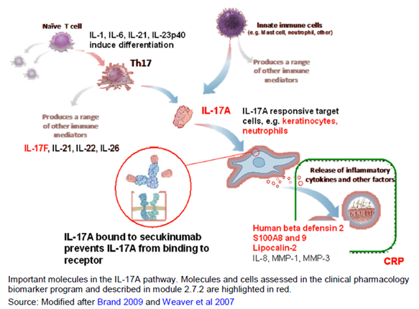

Targets examined to identify secukinumab Pharmacodynamic effects

Primary PD
- Total IL-17A is defined as free IL-17A plus IL-17A complexed with secukinumab. Secukinumab acts by binding to human IL-17A and blocking the interaction of this cytokine to its receptor, thus functionally neutralising its bioactivity. The secukinumab/IL-17A complex is eliminated at a much slower rate than free IL-17A, which results in an elevation of total IL-17A following secukinumab administration, thus making the total IL-17A level a relevant PD biomarker for secukinumab and indicative of target engagement.
- Gene expression (mRNA) studies were conducted with the goal to demonstrate that clinical improvements are paralleled by molecular changes in psoriatic skin.
- Protein levels of IL-17A and IL-17F in skin of psoriasis patients.
- Protein levels of human beta defensin-2 (hBD-2) in lesional psoriasis skin, and in peripheral blood in patients with psoriasis and other diseases, as hBD-2 is a downstream marker of IL-17A signalling.
- Histology and immunohistochemistry of psoriasis lesional skin to demonstrate that clinical improvements are paralleled by cellular and histological changes in psoriatic skin.
- Other soluble serum markers that indirectly support secukinumab PD effects including: serum CRP, which is a relevant marker in psoriasis indicating systemic inflammation; S100 proteins A8 and A9 as they are downstream mediators of the IL-17A pathway; and lipocalin-2, which is a pluripotent effector molecule involved in tissue responses to environmental, metabolic and developmental triggers such as inflammatory responses.
- T cell populations in peripheral blood.

Secondary PD
- Vaccination study, to assess the impact of secukinumab on vaccination responses.
- Immunogenicity, to assess the presence of anti drug antibody (ADA) responses.

Pharmacodynamic effects

Analytical method for determination of total IL-17A in human samples
Total IL-17A, that is, free IL-17A and IL-17A bound to secukinumab in calibrator samples, quality control samples and incurred samples was captured by an anti-human IL-17 antibody (CBI459), which was biotinylated and immobilised on a MSD Streptavidin multi array 96 well plate. The LLOQ was 2 pg/mL. The intra run bias and intra run precision were within the range of 13.4% to 24% and within the range of 1% to 9%, respectively. The inter run bias and inter day precision were within the range - 5% to 8% and 8% to 11%, respectively. Serum samples from studies CAIN457A1101 and CAIN457A2309 were analysed and reported.
It must be noted that a number of studies aimed to assess the levels of IL-17A in serum. These studies included CAIN457A2101, CAIN457A2103, CAIN457A2204 and CAIN457A2212; however these analyses have not been conducted due to the lack of a reliable assay system for this protein.
Comment: If these results are now available, the evaluator requests that they be provided by the sponsor for evaluation.

Primary pharmacodynamic effects

IL-17A levels

Healthy Subjects
Study BxSD RCAN457A1101-pd represents the bioanalysis relating to IL-17A levels from Study CAIN457A1101 which examined the PK/PD of secukinumab administered as an i.v. infusion or s.c. injection to healthy Japanese males. The median duration of increase in total IL-17A increased with secukinumab dose, that is from 150 mg s.c. to 10 mg/kg i.v. and median C_{max} for total IL-17A after 10 mg/kg i.v. was 130 pg/mL. Total IL-17A concentrations increased over 14 days following 10 mg/kg i.v. and the peak levels were reached after approximately 3 weeks. Considerable inter subject variability was observed in total IL-17A profiles across individual Japanese healthy subjects. It must be noted that given the low number of subjects examined in this study and the high levels of inter subject variability it is difficult to draw any definite conclusions from this trial regarding IL-17A levels.

Target Population – psoriasis patients
Phase III Study CAIN457A2309 examined IL-17A levels in patients with moderate to severe chronic plaque type psoriasis following s.c. administration of secukinumab (150 mg and 300 mg). The dosing regimen consisted of weekly administrations for the first 4 weeks (that is 0, 1, 2, 3, and 4) and a further dose at Week 8. IL-17A concentrations were below the assay quantification limit in all patients prior to treatment. After four, once weekly injections median concentrations at Week 4 varied widely across patients and were approximately 130 pg/mL in both arms, decreasing to about 80 pg/mL at Week 12. Median IL-17A concentrations at Week 4 and Week 12 were comparable at both dose levels, indicating that the extent of suppression of free IL-17A was similar regardless of dose.
Comment: The number of patients included in the IL-17A analysis in Study CAIN457A2309 has not been provided.
Visual inspection of total IL-17 levels, following a single 3 mg/kg i.v. infusion in patients with stable plaque psoriasis (Study CAIN457A2102) indicated that IL-17 levels initially increased and this was followed by a slow decline after 10 to 20 days.

Secukinumab and IL-17A levels in ISF
Study CAIN457A2225 examined IL-17A concentrations in lesional and non lesional skin of psoriasis patients and in the skin of healthy volunteers and identified that the mean dermal IL-17A concentration at baseline was 9.80 pg/mL in the lesional skin of psoriasis patients, which was higher than IL-17A concentrations in non lesional skin and in skin of healthy volunteers. IL-17F baseline levels did not differ significantly between lesional and non lesional skin in psoriasis patients in this study and a single 300 mg dose secukinumab did not significantly affect IL-17F levels in serum from psoriasis patients. Following a single s.c. dose of 300 mg, the dermal ISF secukinumab concentration was approximately 7 μg/mL (0.047 μM) between 7 to 14 days after dosing. Systemic concentrations of secukinumab accumulated 2 fold after repeated 4 weekly dosing of 300 mg s.c. and a similar accumulation would be expected in ISF, giving a secukinumab concentration in ISF of about 94 nM.

IL-17A staining in lesional skin
One objective of Study CAIN457A2212 was to examine IL-17A staining in sentinel plaque tissues obtained by biopsy of affected skin from patients with moderate to severe chronic plaque type psoriasis at baseline, Week 2, and Week 12 following treatment with 1 x 10 mg/kg i.v. secukinumab. At Baseline (Figure 2, top row), IL-17A staining was most prominent in the epidermis in Munro’s microabscesses, which were composed of neutrophils (indicated by an oval circle in rightmost panel) in the stratum corneum and in spongiform pustules of Kogoj, which are also composed of neutrophils (indicated by an arrow) in the stratum spinosum. At Week 2 (Figure 2, middle row), IL-17A staining was no longer present in the epidermis but was still evident in the dermis (mainly due to the staining in mast cells). At Week 12 (Figure 2, bottom row), epidermal IL-17A staining remains absent, and the specimen as a whole shows normal skin histology.
Figure 2. IL-17A staining over time and kinetics of histological changes in lesional skin of one representative patient after treatment with secukinumab 1 x 10 mg /kg i.v. (Study CAIN457A2212).
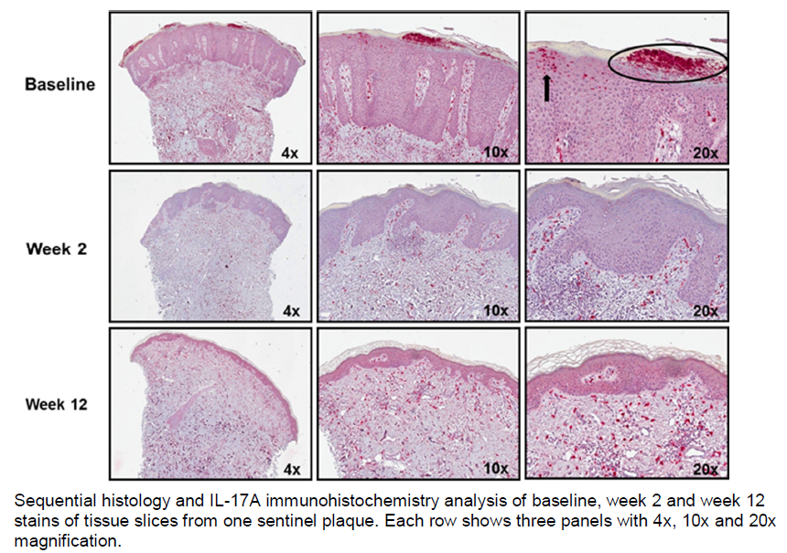
Comment: The histological images of IL-17A staining in lesional skin for the other patients should be provided for comparison.

Effect of secukinumab treatment on histological/IHC markers
The relationships between secukinumab dose and the histological/IHC markers were investigated graphically by plotting the arithmetic means per treatment group (placebo, 3 mg/kg, 10 mg/kg, 3 x 10 mg/kg) and visit (within treatment group) in statistical integrated biomarker analysis report (Study BMD RCAIN457A2212e) for data generated in Study CAIN457A2212. Secukinumab i.v. at doses between 1 x 3 mg/kg and 3 x 10 mg/kg induced rapid, profound and statistically significant (p < 0.001) reductions of acanthosis, epidermal thickness, the keratinocyte marker Ki67, Munro’s abscesses, parakeratosis and MPO positive cell counts (total and dermal) paralleled by clinical improvements (reduction of the PASI score). CD3 positive T cell counts were slightly reduced and treatment effects only reached statistical significance in all dose groups at Week 12 (also at Week 2 in the highest dose group 3 x 10 mg/kg). CD11c positive cell counts showed smaller and later reductions in a dose related manner. Compared to baseline (Visit 2), only the 3 x 10mg/kg group at wWeek 2 and Week 12 was statistically different. IL-17A and tryptase (total) scores did not show any relevant and consistent changes upon treatment with secukinumab.

Effect of secukinumab treatment on mRNA markers
Study BMD RCAIN457A2212e also examined the effect of secukinumab treatment on mRNA markers for IL-17A, CD3G and INFG using graphical techniques. IL-17A and INFG transcripts were both strongly and statistically significantly (p < 0.005) decreased upon treatment with secukinumab at all doses of secukinumab, but not in the placebo group. For CD3G no significant changes upon treatment were observed.

Effect of secukinumab treatment on soluble protein markers in ISF
Study CAIN457A2225 identified that beta-defensin 2 levels were significantly higher in lesional than in non lesional skin in psoriasis patients (p < 0.001), and decreased significantly after a single 300 mg dose secukinumab (p < 0.01). Pre dose lipocalin-2 levels in open flow microperfusion (OFP) tended to be higher in lesional than in non lesional skin (p < 0.05; adjusted geometric mean 62.05 versus 28.16 ng/mL) and healthy skin (p < 0.05; adjusted geometric mean 62.05 versus 27.68 ng/mL). However, lipocalin-2 levels were not significantly decreased after single 300 mg dose secukinumab.

Effect of secukinumab on Investigator Global Assessment scores (IGA) and Psoriasis Area and Severity Index (PASI).
Three trials examined PASI and IGA following s.c. doses of secukinumab.
Study CAIN457A2223 represented an interim analysis (IA) of an incomplete trial that examined the effects of s.c. secukinumab in patients with chronic psoriasis. Despite the small sample size, and the lack of formal statistical modelling or statistical tests, the data indicates the clinically relevant responder rates (PASI 90 and even PASI 100 respectively achieving 90% or 100% of reduction of clinical signs of psoriasis) reached high levels in this IA of 70% and 40% of patients, respectively, following 12 weeks of treatment in the 10 subjects available for study at the time of the IR. Similarly, the results for the IGA indicate that secukinumab is effective as the number of responders is 70% (7/10) versus 0% for placebo (0/4) treated patients.
Study CAIN457A2220, examined the effect of dose on PASI 75 response following s.c. doses of secukinumab or placebo in patients with moderate to severe chronic plaque psoriasis. The secukinumab doses administered were 150 mg, 75 mg or 25 mg at Weeks 1, 5 and 9 or a single dose of 25 mg secukinumab at Week 1. The study identified a dose dependent increase in PASI 75 response in the multiple dose cohorts but not for the single 25 mg dose cohort after 12 weeks of treatment. The highest proportion of PASI 75 responders at Week 13 was observed with secukinumab 3 × 150 mg which was significantly superior to placebo (81.5% versus 9.1%; p < 0.001). Secukinumab 3 × 75 mg was also significantly better than placebo in the PASI 75 response at Week 13 (57.1% versus 9.1%; p = 0.002). No significant difference versus placebo in the Week 13 PASI 75 response was seen with the lower secukinumab dose cohorts 3 × 25 mg and 1 × 25 mg, although the response was numerically better with 3 × 25 mg versus placebo (19.2% versus 9.1%).
Study CAIN457A2211 evaluated the PASI 75 at 12 weeks following three induction regimens of 150 mg s.c. secukinumab compared with placebo in patients with moderate to severe chronic plaque type psoriasis. This study identified that the PASI 75 response rates after 12 weeks of treatment were statistically significantly higher following the ‘Early’ and ‘Monthly’ induction regimens, which involved multiple s.c. injections of 150 mg secukinumab during the induction period, than in the Placebo group. By contrast, the ‘Single dose’ induction regimen did not attain statistical significance versus Placebo (p value = 0.225).
In addition, a number of other studies examined PASI and IGA following i.v. doses of secukinumab.
For instance, following a single 3 mg/kg i.v. infusion in patients with stable plaque psoriasis (Study CAIN457A2102), statistically significant reductions were identified in mean PASI score and change in IGA scores at 4, 8 and 12 weeks post infusion.
At the primary endpoint at Week 4 in Study CAIN457A2204, which examined the efficacy of secukinumab following i.v. doses of 0.3, 1.0 and 3.0 mg/kg in patients with chronic plaque psoriasis, mean PASI reductions were seen in patients treated with secukinumab 3 mg/kg and 1 mg/kg, but not in patients receiving 0.3 mg/kg or placebo. Decreases in mean PASI were observed as early as 1 week after dosing in both the 1 mg/kg and 3 mg/kg groups. At Week 12, improvements in mean PASI at the middle and high doses of secukinumab and from Week 14, a worsening in PASI was seen in these patients. At 0.3 mg/kg, there were no PASI 50, PASI 75 or PASI 90 responders. At 1 mg/kg, all 4 patients (100%) were PASI 50 responders and 2 patients (50%) were PASI 75 responders. At 3 mg/kg, all 4 patients (100%) were PASI 50 responders, 2 patients (50%) were PASI 75 responders and one patient (25%) was a PASI 90 responder. In addition, an improvement from baseline IGA scores was seen from Week 1 in patients treated with the 1.0 and 3.0 mg/kg secukinumab. Improvement from baseline was noted till Week 12 for all patients who received 3 mg/kg secukinumab, and till Week 16 for all patients treated with 1 mg/kg secukinumab.
The primary objectives of Study CAIN457A2212 were to compare the change from baseline in PASI scores at 12 weeks between the placebo and single doses of 3, 10 and 3 x 10 mg/kg i.v. doses of secukinumab and to compare the proportion of patients who had not relapsed at any time up to and including Week 56 between each of the loading dose regimens of secukinumab in patients with moderate to severe chronic plaque psoriasis. All 3 secukinumab dose regimens resulted in statistically significant reductions (improvement) in mean PASI score at Week 12 compared to placebo. The largest mean reduction in PASI score was seen with the 3 x 10 mg/kg regimen (− 18.02; p = 0.001), followed by 1 x 10 mg/kg and 1 x 3 mg/kg (− 13.35; p = 0.008 and − 12.46; p = 0.020, respectively). For relapse, which was defined as an increase in PASI of at least 50% of the maximum PASI improvement, there were no statistically significant differences between the 3 dose groups at each visit from Week 14 through Week 40. However, when compared directly there were significantly fewer patients who experienced relapse in this time interval in the secukinumab 3 x 10 mg/kg than in the 3 mg/kg cohort.

Secondary pharmacodynamic effects

Analytical method for determination of anti-drug-antibodies (ADA’s) in human samples
In Phase II psoriasis (and other indications), the immunogenicity of secukinumab was measured by a Biacore assay. A more sensitive, homogenous bridging immunogenicity assay on a Meso Scale Discovery (MSD) platform was used in Study CAIN457A2106, some Phase II extension studies including Studies CAIN457A2206E1, and CAIN457A2209E1, which examined patients with arthritis and severe ankylosing spondylitis, respectively, and in the psoriasis Phase III program. The sensitivity (4 ng/mL) and secukinumab drug tolerance of this assay were 4 ng/mL and 53.8 µg/mL at 250 ng/mL positive control, respectively.

Effect of secukinumab on immunogenicity
Study CAIN457A2106 examined the immunogenicity of secukinumab following single 150 mg s.c. doses given via the PFS or LYO powder in healthy subjects. In this study, only one case of transient immunogenicity was observed and it occurred in a single subject following administration of the lyophilised secukinumab product.
For the Phase II and III trials, immunogenicity was measured as part of the safety analysis and has been discussed in Below in Section 8.7.5.

Effect of secukinumab on ozone induced neutrophilia and C reactive protein
Study CAIN457A2104 compared the effect of secukinumab, 10 mg/kg i.v., on ozone induced airway neutrophilia to placebo in 24 healthy subjects. There was no apparent effect of secukinumab on any of the primary or secondary endpoints compared to placebo. There was no evidence of a treatment effect on neutrophil counts in blood or on high sensitivity C reactive protein (hsCRP); a measure of inflammation present in the body. In addition, no relationships were observed between baseline neutrophils in blood and induced sputum neutrophils, or between baseline hsCRP and induced sputum neutrophils at 24 or 48 hours post ozone challenge.

Time course of pharmacodynamic effects
The results submitted relating to the time course of PD effects is for i.v. doses only.

Effect on IL-17A
Following a 10 mg/kg i.v. dose of secukinumab in healthy Japanese males (Study BxSD RCAN457A1101-pd), total IL-17A concentrations increased over 14 days and the peak levels were reached after approximately 3 weeks.

Effect of secukinumab treatment on histological/IHC markers
Following a single i.v. infusion of 3 mg/mL or 10 mg/ml statistically significant reductions in acanthosis, epidermal thickness, Ki67, Munro’s abscesses, parakeratosis and MPO positive cell counts (total and dermal), which were paralleled by clinical improvements (reduction of the PASI score), were identified at two and twelve weeks post dosing (Study BMD RCAIN457A2212e). CD3 positive T cell counts were slightly reduced 2 weeks following dosing and the treatment effects reached statistical significance for both dose groups at Week 12.

Effect of secukinumab treatment on mRNA markers
Following a single i.v. dose of 3 mg/mL or 10 mg/mL secukinumab, mRNA transcripts for IL-17A and INFG were significantly lower at both 2 and 12 weeks post dose.

Relationship between drug concentration and pharmacodynamic effects

Subcutaneous
In Study CAIN457A2309 following 4 weekly s.c. doses and an additional s.c. dose at Week 8, of either 150 mg or 300 mg secukinumab, in patients with moderate to severe chronic plaque type psoriasis, the median IL-17A concentrations at Week 4 and Week 12 were comparable at both dose levels, indicating that the extent of suppression of free IL-17A was similar regardless of dose.
Study CAIN457A2220 identified a dose dependent increase in PASI 75 response at 12 weeks in patients given 150 mg, 75 mg or 25 mg doses of s.c. secukinumab at Weeks 1, 5 and 9 but not for the cohort given a single 25 mg dose at Week 1.

Intravenous
Study BMD RCAIN457A2212e indicates that effects of i.v. doses of secukinumab on histological/IHC and mRNA markers were dose dependent.

Genetic, gender and age related differences in pharmacodynamic response
No specific studies examined whether there was genetic, gender or age related differences in PD response following treatment with secukinumab.

Pharmacodynamic interactions
Effect of secukinumab on vaccinations against influenza and neisseria meningitides serogroup C; Study CAIN457A2224 evaluated the efficacy of vaccination against influenza and neisseria meningitides serogroup C in 50 healthy subjects treated with 150 mg (s.c.) secukinumab. In this study secukinumab had no effect on the generation of protective antibody titres following vaccination with either vaccine.

Evaluator’s overall conclusions on pharmacodynamics
Mechanism of Action: Secukinumab selectively neutralises IL-17A in human biofluids and target tissues, leading to inhibition of IL-17A pathway related inflammatory cascades that cause tissue damage and disease.

Primary pharmacodynamic actions

Effect on IL-17A levels:
- In healthy subjects
  - The median duration of increase in total IL-17A increased with secukinumab dose and median C_{max} for total IL-17A after 10 mg/kg i.v. was 130 pg/mL.
  - Total IL-17A concentrations increased over 14 days and the peak levels were reached after approximately 3 weeks.
- In psoriasis patients
  - Following weekly s.c. administrations of secukinumab (150 mg and 300 mg) median concentrations at Week 4 of IL-17A varied widely across patients and were approximately 130 pg/mL following both doses and decreased to approximately 80 pg/mL at Week 12.

IL-17A and IL-17F levels in ISF
Mean dermal IL-17A concentrations were higher in the lesional skin of psoriasis patients than in non-lesional skin or in skin from healthy volunteers. IL-17F baseline levels did not differ significantly between lesional and non-lesional skin in psoriasis patients and a single 300 mg dose secukinumab did not significantly affect IL-17F levels in serum from psoriasis patients.

IL-17A staining in lesional skin
Prior to treatment with 1 x 10 mg/kg i.v. secukinumab, IL-17A staining was most prominent in the epidermis in Munro’s microabscesses, the stratum corneum and spongiform pustules of Kogoj. Two weeks following treatment, IL-17A staining was no longer present in the epidermis but was still evident in the dermis. By Week 12, epidermal IL-17A staining was still absent and the specimen as a whole showed normal skin histology.

Effect on histological/IHC markers
- Secukinumab i.v. at doses between 1 x 3mg/kg and 3 x 10mg/kg induced rapid, profound and statistically significant reductions of acanthosis, epidermal thickness, the keratinocyte marker Ki67, Munro’s abscesses, parakeratosis and MPO positive cell counts (total and dermal) which were paralleled by clinical improvements (that is reduction of the PASI score).
- CD3 positive T cell counts were slightly reduced and treatment effects only reached statistical significance in all dose groups at Week 12 (also at Week 2 in the highest dose group 3 x 10mg/kg).
- CD11c positive cell counts showed smaller and later reductions in a dose related manner.
- IL-17A and tryptase (total) scores did not show any relevant and consistent changes upon treatment with secukinumab.

Effect on mRNA markers
mRNA transcript levels for IL-17A and INFG were statistically significantly decreased following treatment with i.v. secukinumab at doses of 1 x 3 mg/ml to 3 x 10 mg/ml. By contrast, no significant changes in mRNA levels for CD3G were observed following treatment.

Effect on soluble protein markers in ISF
- Beta-defensin 2 levels in lesional skin decreased significantly following a single 300 mg dose of secukinumab.
- By contrast, lipocalin-2 levels were not significantly decreased after single 300 mg dose secukinumab.

Effect on IGA and PASI
- Interim analysis, conducted without formal statistical modelling or tests, indicated that following multiple s.c. doses of 300 mg secukinumab the clinically relevant responder rates (PASI 90 and even PASI 100 respectively achieving 90% or 100% of reduction of clinical signs of psoriasis) reached high levels in 70% and 40% of patients, respectively, following 12 weeks of treatment in the 10 subjects available for study at the time of the IR.
- The results for IGA indicate that secukinumab is effective as the number of responders is 70% (or 7/10) versus 0% for placebo (0/4) treated patients.
- PASI 75 response at 12 weeks was significantly higher following multiple doses of s.c. secukinumab than following a single dose.

Secondary PD effects

Effect on immunogenicity
- Subcutaneous doses of 150 mg secukinumab had little to no effect on immunogenicity in healthy subjects.

Effect on ozone-induced neutrophilia and C reactive protein
- In healthy subjects, secukinumab, 10 mg/kg i.v., had no effect on neutrophil counts in blood or on hsCRP. In addition, no relationships were observed between baseline neutrophils in blood and induced sputum neutrophils, or between baseline hsCRP and induced sputum neutrophils at 24 or 48 hours post ozone challenge.

Time course of pharmacodynamic effects
- In healthy males, a 10 mg/kg i.v. dose of secukinumab resulted in an increase in total IL-17A concentrations over 14 days and the peak levels were reached after approximately 3 weeks.

Relationship between drug concentration and pharmacodynamic effects
- In patients with moderate to severe chronic plaque type psoriasis, the median IL-17A concentrations at Week 4 and Week 12 were comparable following multiple doses of either 150 mg or 300 mg s.c. secukinumab, indicating that the extent of suppression of free IL-17A was similar regardless of dose.
- PASI 75 response at 12 weeks increased dose dependently following multiple s.c. doses of 150 mg, 75 mg or 25 mg secukinumab but not following single doses of 25 mg.
- The effects of i.v. doses of secukinumab on histological/IHC and mRNA markers were dose dependent.

Genetic, gender or age effects
No specific studies examined whether there was genetic, gender or age related differences in PD response following treatment with secukinumab.

Pharmacodynamic interactions
Secukinumab (150 mg s.c.) had no effect on the generation of protective antibody titres following vaccination with influenza and neisseria meningitides serogroup C vaccinations in healthy subjects.

Limitations of PD data
- A number of studies aimed to assess the levels of IL-17A in serum. These studies included CAIN457A2101, CAIN457A2103, CAIN457A2204 and CAIN457A2212; however, due to the lack of a reliable assay system for this protein these analyses have not been conducted. If these results are now available, they should be provided for evaluation.
- The number of patients included in the IL-17A analysis in Study CAIN457A2309 has not been provided.
- The histological images of IL-17A staining in lesional skin for the other patients should be provided for comparison.

Dosage selection for the pivotal studies
A comprehensive Phase II program allowed selection of two doses (150 mg and 300 mg s.c.) and three regimens (fixed dose, SoR, and up titration) to be used in Phase III studies. Dose selection was done using both review of efficacy data and also statistical modelling approaches. Both the individual study data and the combined data analysis using modeling techniques, indicated that the dose of 150 mg with an initial dosing at Weeks 0, 1, 2, 3, 4, and 8 and with the same maintenance dose every 4 weeks afterwards was the minimum dose to offer acceptable efficacy and to maintain PASI response rates over time. Hence, the fixed interval dosing regimen, using both doses of 150 and 300 mg, formed the basis for Phase III program, and in one study (A2304) was compared with a Start of Relapse (SoR) regimen. The Phase II data and PK modelling also indicated that a higher dose might offer improved efficacy.
The relationship between dose and regimen, plasma concentration, and PASI response was modelled using a population PK/PD approach, whose parameter estimates allowed the outcome for the proposed dosing regimen to be simulated. The PASI 75 response rate was predicted to be too low with 75 mg, and to be adequate and well sustained over time with 150 mg and 300 mg. However, the 300 mg dose appeared to provide the greatest benefit.
In small proof of concept Study A2102, a single i.v. 3 mg/kg dose of secukinumab was shown to be efficacious, with a reduction in PASI scores and in dynamic Physician’s Global Assessment (dPGA) scores when compared to placebo.
In the dose ranging Study A2220, which included secukinumab s.c. as a single dose (25 mg) or a dose once every 4 weeks (25 mg, 75 mg and 150 mg), consistent efficacy after 12 weeks (statistically significant versus placebo in response rates for PASI 75, PASI 90 and IGA mod 2009, (Table 6) was only observed for the 150 mg dose with a good safety and tolerability profile. In contrast, the results achieved with the 75 mg dose were not considered an appropriate treatment success, with efficacy less than expected with currently available treatment options. Thus, 150 mg was viewed as the lowest dose for achieving adequate overall efficacy in Phase III studies. This was supported by PK modelling analysis.

Table 6. Study A2220. PASI 75, 90 and IGA mod 2009 responders at Week 12.
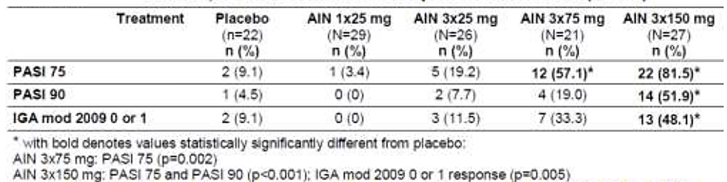
Dose ranging Study A2212 assessed the higher range of the potential dose spectrum and demonstrated that better response rates were achieved with higher exposures of secukinumab achieved by 3 times repeated 10 mg/kg i.v. dose, which modelling suggested could be achieved with 300 mg s.c.. The study compared the effectiveness of three i.v. loading doses to placebo: single doses of 3 or 10 mg/kg i.v. or multiple doses of 10 mg/kg i.v. (at Randomization, Week 2, and Week 4). The response rates to PASI 75, PASI 90 and IGA mod 2007 0 or 1 showed dose related efficacy, with a higher proportion of responders in the 10 mg/kg i.v., rather than the 3 mg/kg i.v., single dose cohort and an even higher proportion seen with the 3 times repeated 10 mg/kg i.v. dose (Table 7). The PK exposure for these i.v. doses supported the s.c. doses chosen for the Phase III studies, with the exposure range for the 150 mg and 300 mg s.c. dose regimens lying within the exposure range achieved with these i.v. doses. Furthermore, modeling analysis suggested similar efficacy would be expected for secukinumab 300 mg s.c. to that shown for 3 x 10 mg/kg i.v. doses (Figure 3).

Table 7. Study A2212. PASI 75, PASI 90 and IGA mod 2007 0 or 1 responders at 12 weeks.
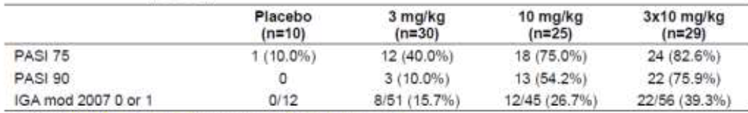
Figure 3. Simulated exposures for different secukinumab induction regimens.
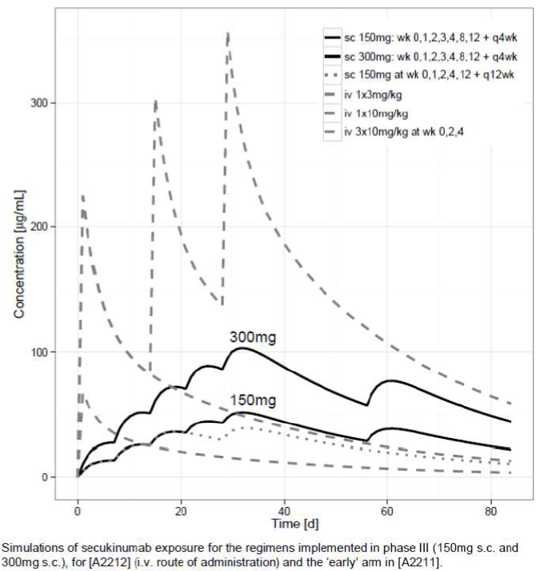
Regimen finding Study A2211 examined the effectiveness of 150 mg s.c. secukinumab administered initially as one of four initial dosing regimens and then administered to responders as one of two maintenance treatments (fixed time interval regimen with doses at Weeks 12 and 24 versus Start of relapse regimen with dosing resumed once relapse started) with non PASI 75 responders and those with 2 consecutive relapses at scheduled visits, treated open label once every four weeks that is a third regimen. Start of relapse occurred if the patient lost a third of the maximum PASI response (compared to baseline) achieved at any time before the visit at which the assessment was made. Overall, the study showed that early weekly loading was the most efficacious initial dosing regimen (but that doses above 150 mg may be more effective) and that a fixed interval maintenance regimen every four weeks may be appropriate. However, both fixed interval dosing and start of relapse dosing were still seen as potentially feasible regimens for maintaining efficacy and hence were tested in a Phase III Study A2304.
The data from the four relevant Phase II studies (A2102, A2211, A2212, and A2220) were used to examine the dose response effects. The PASI 75 response rates relative to the total dose received during the 12 week induction, after adjusting s.c. doses according to the lesser bioavailability than i.v. doses. In each study, there was a clear dose response, with no suggestion that saturation of effect had been reached, as the PASI 75 responses appeared to be rising linearly with the logarithm of total dose. The data from each study were consistent, except that the response rates in Study A2220 were higher at each dose level than in the other studies; a systematic study effect was seen for A2220, which however had no major impact on the overall modeling efforts, as was shown by sensitivity analyses that excluded Study A2220 from the data pool. In addition, when placebo adjusted response rates were analyzed, only a minor difference in effect size compared with the other Phase II studies remained. These data also suggested that higher PASI 75 response rates may be achieved with s.c. doses greater than 150 mg.
The model based predictions for the most favourable dosing regimen (Baseline and Weeks 1, 2, 3, 4 and 8) are shown in Figure 4. The PASI 75 response rate was predicted to be better with 300 mg than with 150 mg, and clinically inadequate with 75 mg, both with and without the inclusion of the Study A2220 data, which showed higher efficacy than the other studies. Thus, 150 mg and 300 mg were both selected as doses for Phase III studies.
Figure 4. Simulated PASI 75 response rates for induction dosing.
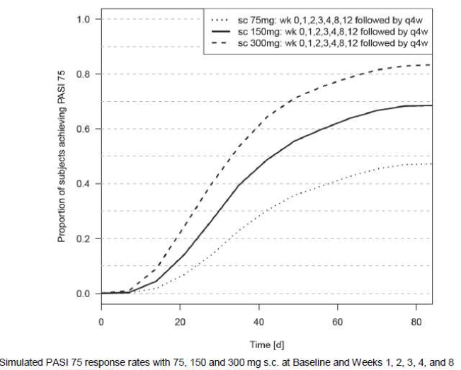
A frequency of maintenance dosing every 4 weeks was supported by model based predictions of fixed interval dosing every 4, 8 or 12 weeks with 150 mg, which showed that the PASI 75 response declined only marginally with 4 week dosing intervals but more rapidly with 8 or 12 week dosing intervals.
The model based predictions for the most favourable overall regimen (induction plus maintenance) are shown in Figure 5. The PASI 75 response rate was predicted to be adequate and well-sustained over time with 150 mg and 300 mg, but to be too low with 75 mg.
Figure 5. Simulated PASI 75 response rates for induction plus maintnence.
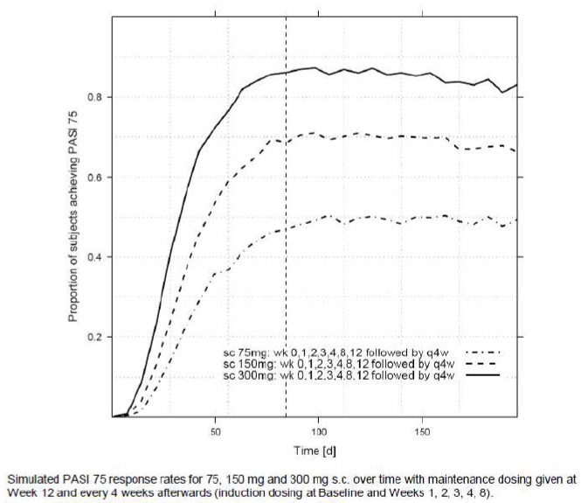
Comment: The dose selection strategy was based on the clinical data obtained in the Phase II and Phase III programs in the target indication of moderate to severe plaque psoriasis, using data from individual studies, pooled analyses, and modeling approaches. Overall, 150 mg was identified as the lowest effective dose to be tested in Phase III studies. Furthermore, the need for an initial period of more frequent dosing (weekly during the first four weeks) was identified, and subsequent dosing at intervals of four weeks was considered appropriate for maintenance treatment. In addition, the ‘re treatment at start of relapse’ approach was slightly changed and also tested in one Phase III study (A2304) as a possible alternative maintenance treatment regimen.
Hence, the two secukinumab doses (150 mg and 300 mg) chosen for evaluation in the pivotal Phase III studies were adequately justified.

Clinical efficacy
The clinical efficiacy was reviewed for the indication of treatment of moderate to severe plaque psoriasis in adult patients who are candidates for systemic therapy or phototherapy.

Pivotal efficacy studies

Study A2302

Study design, objectives, locations and dates
This was a Phase III, multicenter, randomised, double blind, placebo controlled, parallel group study in 738 patients with moderate to severe chronic plaque type psoriasis. The study consisted of 4 periods: screening (1 to 4 weeks), induction (12 weeks), maintenance (40 weeks) and follow up (8 weeks). Patients were randomised 1:1:1 (stratified by geographical region and body weight (< 90 kg or ≥ 90 kg) into one of the treatment groups: secukinumab 150 mg; secukinumab 300 mg and placebo. PASI 75 placebo responders: continued on placebo and received their placebo injections at Weeks 12, 13, 14, 15, and then every 4 weeks starting at Week 16 until Week 48. PASI 75 non-responders were re randomised 1:1 to 150 mg or 300 mg secukinumab and received their treatment on Weeks 12, 13, 14, 15, and then every 4 weeks starting at Week 16 until Week 48. Re randomization was also stratified by geographical region and body weight (< 90 or ≥ 90 kg) collected at Visit 2.
Figure 6. Study A2302 Study Design Schematic.
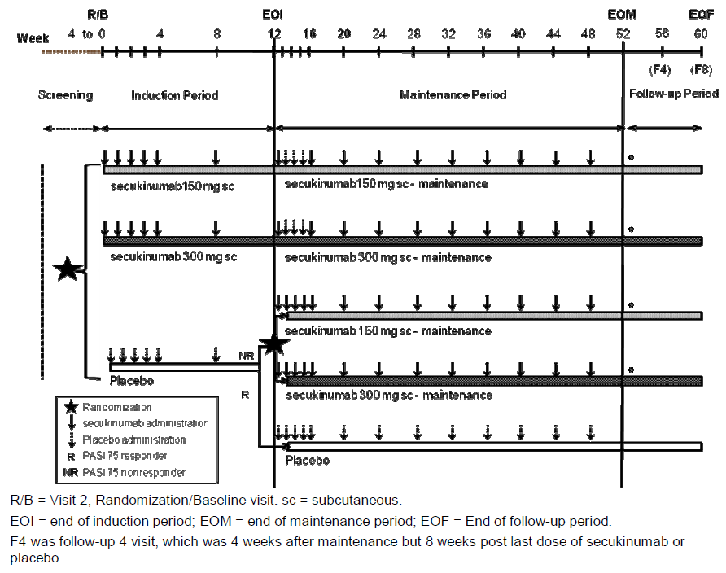
The primary objective was to demonstrate the superiority of secukinumab in patients with moderate to severe chronic plaque type psoriasis with respect to both PASI 75 and IGA mod 2011 0 or 1 response (co primary endpoints) at Week 12, compared to placebo.
The key secondary objectives were: to demonstrate the superiority of secukinumab with respect to PASI 90 response at Week 12, as compared to placebo; to assess the efficacy of secukinumab in maintaining PASI 75/IGA mod 2011 0 or 1 response at Week 52 for patients who were PASI 75/IGA mod 2011 0 or 1 responders at Week 12; to demonstrate the superiority of secukinumab with respect to psoriasis related itching, pain and scaling as measured by the Psoriasis Symptom Diary at Week 12 compared to placebo.
Other secondary objectives were; to assess the efficacy of secukinumab with respect to PASI 50 / 75 / 90 / 100 and IGA mod 2011 0 or 1 response compared to placebo and over time up to Week 52; to assess the efficacy of secukinumab with respect to time to PASI 75 response up to Week 12 compared to placebo; to assess the efficacy of secukinumab in patients with PASI 50 response but without PASI 75 response at Week 12 with respect to PASI 75 / 90 / 100 response over time after Week 12 up to Week 52.
The study was conducted from 9 June, 2011 to 7 Mar, 2013 at 88 centres in 12 countries (Argentina (4 centers), Canada (5), Columbia (4), Estonia (4), Iceland (1), Israel (3), Japan (18), Latvia (4), Lithuania (4), Mexico (4), Taiwan (3) and United States (34)).
Comment: The double blind, randomised, parallel group, placebo controlled design used in this study was similar to Phase III trials of other systemic therapies for psoriasis (including biological and non biological immunomodulatory drugs) and is in accordance with Health Authority guidelines and feedback, including the United States FDA and European Medicines Agency (EMA). The primary endpoint of the trial was at Week 12 which was similar to efficacy data from all currently approved systemic therapies for psoriasis. The total study duration including one year of treatment plus the follow up period allowed for assessment of long term safety and efficacy. The choice of placebo control is a standard requirement to ascertain study sensitivity due to the seasonal and fluctuating character of chronic plaque type psoriasis. Placebo responders (based on achievement of a PASI 75 response) remained in the placebo arm beyond Week 12 and were not re randomised to secukinumab for the maintenance period, as they did not require active treatment which ensured continuous blinding of allocation beyond the induction period.

Inclusion and exclusion criteria
The main inclusion criteria were adults > 18 years of age with diagnosis of chronic plaque type psoriasis for at least 6 months prior to randomization; moderate to severe psoriasis defined as PASI score of ≥ 12, and IGA mod 2011 of ≥ 3 and a total BSA of ≥ 10%; candidate for systemic therapy, defined as having chronic plaque type psoriasis considered inadequately controlled by: topical treatment and/or phototherapy and/or previous systemic therapy.
The main exclusion criteria were; forms of psoriasis other than chronic plaque type (for example, pustular, erythrodermic and guttate psoriasis); drug induced psoriasis (that is, new onset or current exacerbation from beta blockers, calcium channel inhibitors or lithium); ongoing use of prohibited psoriasis treatments (for example, topical or systemic corticosteroids (CS)), ultraviolet (UV) therapy or non psoriasis prohibited treatments; all other prior non psoriasis concomitant medications must be on a stable dose for at least four weeks before randomization; previous exposure to secukinumab or any other biologic drug directly targeting IL-17 or the IL-17 receptor; active ongoing inflammatory diseases; active, ongoing, chronic or recurrent infectious disease, or evidence of tuberculosis infection underlying condition significantly immunocompromising the patient and/or places the patient at unacceptable risk for receiving an immunomodulatory therapy; lymphoproliferative disease, malignancy, history of malignancy within the past 5 years; past medical history of HIV, hepatitis B or hepatitis C; plans for administration of live vaccines during the study period or 6 weeks prior to randomization; significant medical problems (current severe progressive or uncontrolled disease), including uncontrolled hypertension and congestive heart failure; serum creatinine exceeding 176.8 μmol/L (2.0 mg/dL) or screening total white blood cell count < 2,500/μL, or platelets < 100,000/μL or neutrophils < 1,500/μL or hemoglobin < 8.5 g/dL; any medical or psychiatric condition including history or evidence of ongoing alcohol or drug abuse up to 6 months before randomization which, in the investigator’s opinion, would preclude the participant from adhering to the protocol or completing the study per protocol; patients not willing to limit UV light exposure (for example, sunbathing and/or the use of tanning devices) during the course of the study.
Comment: The study population consisted of male and female out patients (≥ 18 years old) with moderate to severe chronic plaque type psoriasis that was poorly controlled by topical treatments and/or phototherapy and/or previous systemic therapy. Patients included in this study had moderate to severe plaque type psoriasis with disease severity such that systemic treatment was justified. The requirement of a PASI of ≥ 12, IGA mod 2011 of ≥ 3 and a total body surface area (BSA) of ≥ 10% reflects published guidelines (CHMP 2004).

Study treatments
Patients were randomised 1:1:1 [stratified by geographical region and body weight (< 90 kg or ≥ 90 kg)] into one of the treatment groups below:
- Secukinumab 150 mg: secukinumab 150 mg subcutaneous (s.c.) injection plus a placebo secukinumab s.c. injection once weekly for 4 weeks (at randomization, Weeks 1, 2, and 3), followed by dosing every 4 weeks, starting at Week 4 and until Week 48, except for Weeks 13, 14, and 15 when they received two s.c. injections of placebo per week to maintain the blind.
- Secukinumab 300 mg: secukinumab 300 mg (two s.c. injections of 150 mg) once weekly for 4 weeks (at randomization, Weeks 1, 2, and 3), followed by dosing every 4 weeks, starting at Week 4, and until Week 48, except for Weeks 13, 14, and 15 when they received two s.c. injections of placebo per week to maintain the blind.
- Placebo: placebo secukinumab (two s.c. injections per dose) once weekly for 4 weeks (at randomization, Weeks 1, 2, and 3), followed by dosing every 4 weeks (Weeks 4 and 8). Prior to receiving the Week 12 dose, all patients in the placebo group were assigned to the following treatment groups based on their PASI 75 response at Week 12: PASI 75 responders: continued on placebo and received their placebo injections at Weeks 12, 13, 14, 15, and then every 4 weeks starting at Week 16 until Week 48; PASI 75 non-responders were re randomised 1:1 to 150 mg or 300 mg secukinumab and received their treatment on Weeks 12, 13, 14, 15, and then every 4 weeks starting at Week 16 until Week 48. Re randomization was also stratified by geographical region and body weight (< 90 or ≥ 90 kg) collected at Visit 2.
The vials containing lyophilisate were appropriately reconstituted for the dose assigned to each patient. Each patient required the complete contents of two vials per dose: either one vial of active 150 mg secukinumab and one vial of placebo secukinumab (150 mg group) or two vials of 150 mg secukinumab (300 mg group) or two vials of placebo secukinumab (placebo group). Each vial was used for one application and one patient only. The study treatment solution was injected in non affected areas of the skin. The Investigator was instructed to administer the study treatment to one of the following body regions, changing the injection site from visit to visit: right thigh, left thigh, right stomach, left stomach.
After screening, patients with intolerable scaling and/or itching were permitted to use bland emollients, but they were to be avoided during the 12 hours preceding a scheduled study visit. The definition of ‘bland’ excludes all topical medications that contained pharmacologically active ingredients such as (but not limited to) lactic acid, salicylic acid, urea, α-hydroxy acids or fruit acids. The use of NSAIDs, analgesics treatments or any other treatment given to treat PsA was permitted only if given at a stable dose for at least 4 weeks. Dose adjustments of these medications were to be avoided during the study.
The following treatments were prohibited during the study for any indication and wash out periods prior to randomization are provided: alefacept, briakinumab, efalizumab, ustekinumab (6 month washout); biological immunomodulating agents other than above (for example, adalimumab, etanercept, infliximab) (12 week washout); live virus vaccinations (6 week washout); other systemic immunomodulating treatments such as methotrexate (MTX), cyclosporine A, corticosteroids, cyclophosphamide (4 week washout); Other systemic psoriasis treatments (for example retinoids, fumarates) (4 week washout); photochemotherapy (for example, PUVA) (4 week washout); phototherapy (for example, UVA, UVB) (2 week washout); Topical treatment that is likely to impact signs and symptoms of psoriasis (for example, corticosteroids, vitamin D analogues, pimecrolimus, retinoids, salicylvaseline, salicylic acid, lactic acid, tacrolimus, tar, urea, α-hydroxy or fruit acids) (2 week washout); any investigational treatment or participation in any interventional trial (washout for 4 weeks or 5 half-lives whichever is longer).

Efficacy variables and outcomes
The main efficacy variables were: Investigator’s Global Assessment (IGA mod 2011; scale from 0 to 4) (Table 8); Psoriasis Area and Severity Index (PASI; score 0 to 72) (Table 9) and Rebound assessment. The following definitions of efficacy variables based on PASI were used in this study:
- PASI 50 response: a patient achieving ≥ 50% improvement (reduction) in PASI score compared to baseline
- PASI 75 response: a patient achieving ≥ 75% improvement (reduction) in PASI score compared to baseline
- PASI 90 response: a patient achieving ≥ 90% improvement (reduction) in PASI score compared to baseline
- PASI 100 response: complete clearing of psoriasis (PASI = 0)
- PASI non response: a patient achieving < 50% improvement (reduction) in PASI score compared to baseline
- Partial response: a patient achieving ≥ 50% improvement (reduction) in PASI score but less than 75% compared to baseline
- Relapse: > 50% reduction in maximal PASI improvement from baseline

Table 8. The IGA mod 2011 rating scale.
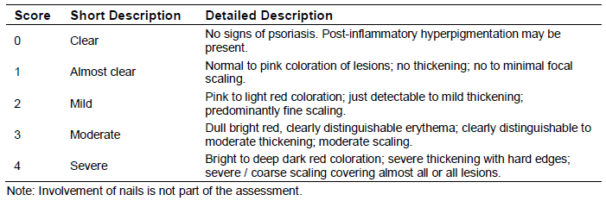

Table 9 The PASI scoring system.
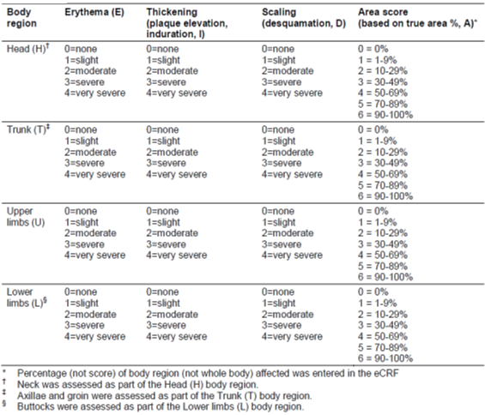
Other efficacy outcomes included Health related quality of life assessments. The impact of psoriasis on various aspects of patient’s health related quality of life (HRQoL) was assessed by the following validated instruments:
- The Psoriasis Symptom Diary; Novartis developed and validated a novel electronic diary of psoriasis signs and symptoms reported by the patient (Strober et al 2013). All patients were asked to participate in the diary assessments in the screening period. Diary assessments were not performed if the patient refused to participate or due to lack of available device at the site at the time of screening.
- Patient Global Impression of Change (PGIC).
- Dermatology Life Quality Index (DLQI; The Dermatology Life Quality Index (DLQI) is a 10 item general dermatology disability index designed to assess health related quality of life in adult patients with skin diseases such as psoriasis (Finlay and Khan, 1994).
- Health Status Questionnaire (EuroQOL 5-Dimension Health Questionnaire, EQ-5D); EQ- 5D is a generic instrument to assess patient’s health status. It provided a simple descriptive profile and a single index value for health status.
- Health Assessment Questionnaire; Disability Index (HAQ-DI) only in patients who had psoriatic arthritis (PsA) prior to randomization. The purpose of the HAQ-DI in this study was to assess the functional ability of patients with PsA.
The co primary efficacy variables were PASI 75 and IGA mod 2011 0 or 1 response at Week 12. The analysis of the co primary variables was based on the FAS.
The key secondary variables were:
- PASI 90 response at Week 12
- Psoriasis Symptom Diary items itching, pain and scaling at Week 12
- Maintenance of PASI 75 response after 52 weeks of treatment for patients who were PASI 75 responders after 12 weeks of treatment
- Maintenance of IGA mod 2011 0 or 1 response after 52 weeks of treatment for patients who were IGA mod 2011 0 or 1 responders after 12 weeks of treatment
Other efficacy endpoints included PASI 50/75/90/100 and IGA mod 2011 0 or 1 over time and Time to PASI 75 response.
The following subgroups were also defined for analysis; body weight stratum at randomization (< 90 kg, ≥ 90 kg); previous systemic therapy (yes, no); failure to previous systemic therapy (yes, no); previous biologic therapy (yes, no); failure of previous biologic therapy (yes, no); previous anti tumor necrosis factor (TNF-α) therapy (yes, no); failure of previous anti TNF-α therapy (yes, no); previous non biologic therapy (yes, no); failure to previous non biologic therapy (yes, no); failure to at least 2 previous non biologic therapies (yes, no); ongoing use of emollients (yes, no).
For subgroup analyses of PASI 50, PASI 75, PASI 90, PASI 100 and IGA mod 2011 0 or 1 responses at Week 12, risk differences to placebo were derived and Fisher’s exact test was applied for pairwise treatment group comparisons to placebo.
Comment: The IGA mod 2011 scale was developed based on a previous version of the scale used in secukinumab Phase II studies in collaboration with health authorities, in particular the FDA. The explanations/descriptions of the points on the scale were improved to ensure appropriate differentiation between the points. The IGA mod 2011 used in this study was static, that is it referred exclusively to the patient’s disease state at the time of the assessments, and did not attempt a comparison with any of the patient’s previous disease states, whether at baseline or at a previous visit. The PASI score, the assessment of the severity of the psoriasis symptoms and the extent to which the patient’s body area is affected by the disease, are considered acceptable by health authorities (CHMP 2004) to assess efficacy in conjunction with Investigator’s Global Assessment mod 2011 (IGA mod 2011). Overall, the efficacy endpoints in this pivotal Phase III study were appropriate and complied with the regulatory guidelines.

Randomisation and blinding methods
All eligible patients were randomised via the Interactive Response Technology (IRT) to one of the treatment arms. The IRT assigned a randomization number, which was used to link the patient to a treatment arm and specify unique medication pack numbers for the first packages of study treatment to be prepared for the patient by unblinded personnel. Patients, investigator staff, persons performing the assessments, and data analysts remained blinded to the identity of the treatment from the time of randomization until end of follow up database lock. The blinding was maintained beyond the primary endpoint so as to ensure reliable efficacy measures beyond the induction period of 12 weeks. The regular assessments of disease activity and clinical status ensured that safety was monitored closely and that both patient and investigator had the opportunity to assess whether continued participation of the patient in the study was to the patient’s benefit.

Analysis populations
The following analysis sets were used for the data analysis. The randomised set was defined as all patients who were randomised at baseline visit. Unless otherwise specified, misrandomised patients (misrandomised in the IRT system) were excluded from the randomised set. If patients were re screened and successfully randomised, they were included in the randomised set according to the treatment assigned in the last randomization. The Full analysis set (FAS) was comprised of all patients to whom study treatment had been assigned. Following the intent-to-treat principle, patients were analyzed according to the treatment assigned to at randomization and patients excluded from the randomised set were excluded from the FAS. The safety set included all patients who took at least one dose of study drug during the treatment period. Patients were analyzed according to treatment received. Baseline was defined as follows: For efficacy analyses, baseline was the last assessment (including unscheduled visits) obtained before the randomization. All assessments obtained after randomization were considered as post-baseline unless otherwise specified.

Sample size
In order to fulfil registration and ICH E1 requirements on the number of patients treated for 6 months and 12 months in the development program, a sample size of 240 patients for each treatment group was targeted. Hence, the total sample size was 720 patients. Since 2 secukinumab dose regimens were tested versus placebo with respect to the co primary endpoints (PASI 75 response and IGA mod 2011 0 or 1 response at Week 12), the type I error were split to 2.5% two sided for each comparison. With 240 patients per group and assuming a response rate of 5% for PASI 75 response and IGA mod 2011 0 or 1 response in the placebo group, the power to show a response rate of 55% for PASI 75 response and 30% for IGA mod 2011 0 or 1 response in the secukinumab groups based on Fisher’s exact test (2 group Fisher’s-exact test of equal proportions) is above 99%. Placebo response rates between 3% and 7% have been reported in Papp et al 2005, Menter et al 2008, Leonardi et al 2008 and Papp et al 2008.
With respect to the key secondary endpoint of PASI 90 response at Week 12, and with a sample size of 240 patients per group, the study provides more than 99% power to detect differences in response rates for each secukinumab dose regimen versus placebo. This power estimate is based on a Fisher’s exact test with two sided type I error of 2.5%, placebo response rate of 5% and 30% for secukinumab. This power estimate is conservative since smaller placebo response rates have been reported (Papp et al 2005, Menter et al 2008, Leonardi et al 2008 and Papp et al 2008).
Assuming a type I error of 2.5% two sided and a Psoriasis Symptom Diary completion rate of 50%, the power to show differences versus placebo is above 99% for the three Psoriasis Symptom Diary items of itching, pain and scaling based on data observed in Study A2211.

Statistical methods
The statistical hypotheses for PASI 75 response at Week 12 and IGA mod 2011 0 or 1 response at Week 12 being tested was that there was no difference in the proportion of patients with PASI 75 response and IGA mod 2011 0 or 1 response at Week 12 in any of the secukinumab groups versus placebo. The primary analysis method was the stratified Cochran Mantel Haenszel (CMH) test. The tests were stratified by geographical region and body weight stratum. Secukinumab treatment groups were compared to placebo in a pairwise fashion with respect to the proportion of patients with PASI 75 response and IGA mod 2011 0 or 1 response at Week 12 using the CMH test statistics. In case of response rates of 0% or of 100% in one of the treatment groups, Fisher’s exact test was applied. Treatment differences between secukinumab groups and placebo in the time to PASI 75 response were evaluated using a log rank test, stratified by geographical region and body weight stratum. The hazard ratios for the variable and their corresponding 95% confidence intervals were computed using a stratified Cox proportional hazards regression model with treatment and baseline PASI as explanatory variable and stratified by geographical region and body weight stratum.

Participant flow
A total of 951 patients were screened at 88 study centers and 738 were randomised to one of 3 treatments (245 to secukinumab 150 mg, 245 to secukinumab 300 mg, and 248 to placebo). The majority (196/213, 90.7%) of screened patients who did not complete the screening phase were screen failures (that is, did not meet inclusion/exclusion criteria). Most randomised patients (94.9%) completed the induction period. The most common reasons for discontinuation of induction treatment were subject/guardian decision (2.4% overall) and AE (1.6% overall). All other reasons for discontinuation were reported by ≤ 0.4% of patients overall, including discontinuation due to lack of efficacy reported in 1 patient or 0.4% in each secukinumab dose group. Of the 700 patients who entered the maintenance period, 623 (89.0%) completed this period. The majority of patients originally randomised to placebo were re randomised to secukinumab 150 mg or 300 mg starting at Week 12, as designated by the protocol if PASI 75 was not achieved at Week 12. The most common reasons for discontinuation of maintenance treatment among the 700 patients were AEs (24/700, 3.4%), subject/guardian decision (17/700, 2.4%) and lack of efficacy (16/700, 2.3%). Participant flow is shown in Table 10.

Table 10. Participant flow. Study A2302.
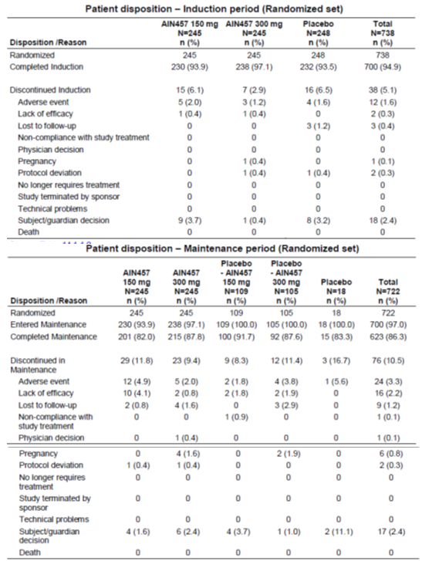

Major protocol violations/deviations
Overall, 69.6% of randomised patients had at least one protocol deviation; however, only 5.8% were considered a deviation of major or potential impact. Minor deviations with no impact on efficacy and safety analyses were reported in 501 patients. Overall, 43 patients had a deviation that was considered sufficiently important as to have a potential impact with most common deviations in this category being related to prohibited concomitant medication use (n = 31). Other deviations in this category included accidental unblinding at study site (n = 5), noncompliance with concomitant medication rules (n = 3), baseline BSA affected by plaque type psoriasis missing or < 10% (n = 3), and baseline PASI score missing or < 12 (n = 2). The impact of these deviations on the overall results is likely minimal, if any, given the small percentage of patients affected and the balanced distribution across the treatment groups. Per protocol analyses excluding these patients were not performed. One placebo patient who was re randomised to 150 mg secukinumab was excluded from the FAS and Safety Set for not meeting selection criteria based on informed consent being signed after initiating study procedures. Overall, there were no imbalances in the frequency or type of protocol deviations across the treatment groups.

Baseline data
The mean age of all patients was 45 years, and approximately 70% were male and Caucasian. Overall, the mean body weight was 88.6 kg and mean BMI was 30.1 kg/m². About 63% of patients were non smokers at baseline. Baseline mean PASI score was 22.1 and 45.3% had a baseline PASI score > 20. The mean total BSA (body surface area) affected was 31.9%. All patients had moderate to severe disease, as measured by IGA mod 2011 and Severity of Psoriasis criteria. The majority of patients (76.8%) did not have a history of psoriatic arthritis. Induction treatment groups were well balanced in demographic and baseline disease characteristics.
A total of 73.6% of patients had at least one relevant medical history or current medical condition and the most common were musculoskeletal and connective tissue disorders (21.3%), surgical and medical procedures (21.0%), infections and infestations (18.6%), and gastrointestinal disorders (18.2%). A history of cardiac disorders was reported for 4.9% of patients overall; the three most commonly reported cardiovascular risk factors were hypertension (27.5%), dyslipidemia/hyperlipidemia (19.4%) and uncomplicated diabetes (10.3%). Overall, 36.9% were current smokers, 21.3% were former smokers, and 41.9% had never smoked.
There were no meaningful differences in any previous exposure across the induction treatment groups. Previous exposure to any systemic therapy was reported by 63.0% of patients overall and 66.5% of these patients had failed on such therapy. Previous exposure to biologic systemic therapy was reported by 29.3% of patients with a failure rate of 33.3%. Among those patients who were previously exposed to biologics, 46.3% took an anti-p40 (IL-12/23 antagonist) therapy and 66.2% took an anti TNF-α therapy (exposures were not mutually exclusive). The failure rate with prior anti TNF-α therapy (39.2%) was higher than with prior anti-p40 therapy (18.0%). The most common reason for having failed on prior anti TNF-α therapy was primary failure (69.6%), while 28.6% were due to secondary failure and 8.9% due to lack of tolerability. Nearly half of all patients (48.9%) were previously exposed to non biologic systemic therapy. Of those exposed, 75.6% reported having failed on such therapy. Failure on at least 2 non biologic systemic therapies was reported by 18.8%. Previous exposure to other types of psoriasis therapies included topical applications used by 82.8% of patients, phototherapy (37.1%), and photochemotherapy (10.0%) as shown in Table 11. All patients in the induction treatment groups took at least one prior medication. The most frequently reported (≥20%) prior medications by preferred term were methotrexate (27.7%), calcipotriol (24.2%), clobetasol propionate (22.8%) and daivobet (20.9%). Phototherapy, previously used by 41.9% of patients, was the most common type of non drug therapy. Only 8 (1.1%) patients overall had a prior medical procedure. There were no differences among the induction treatment groups in the type or frequency of prior medications, non drug therapies or medical procedure.

Table 11. Previous exposure to psoriasis therapies – induction treatment groups (randomised set).
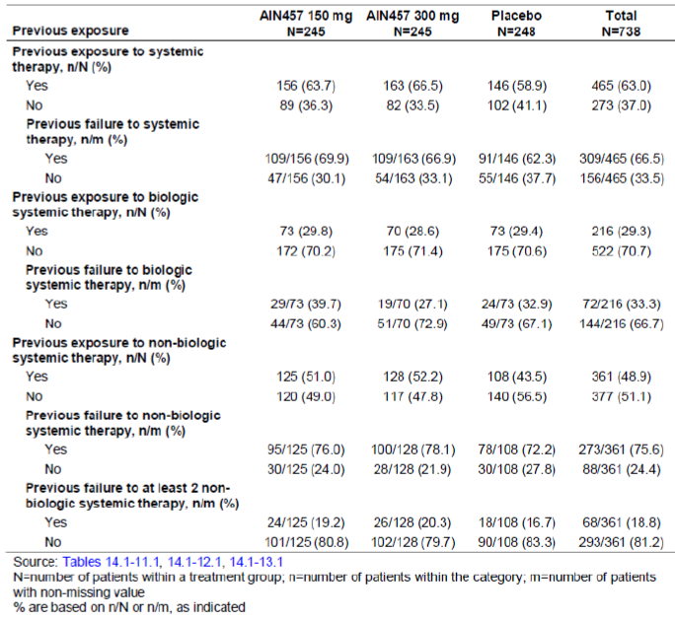
The baseline profile of the maintenance treatment groups was very similar to that of the induction treatment groups and showed no meaningful imbalances between the secukinumab and placebo groups. The demographic and baseline disease characteristics of non responder placebo patients who switched to 150 mg or 300 mg secukinumab were comparable to the originally randomised secukinumab and placebo groups.
Treatment compliance was assessed via several methods. The study drug was administered under the supervision of the investigator or a deputy and was verified by measuring drug concentrations in serum. Drug accountability was noted by the field monitor during site visits and at the completion of the trial. Over the induction period, 94.3%, 96.3% and 92.7% of patients in the secukinumab 150 mg, 300 mg and placebo groups, respectively received all 12 of the planned study treatment injections as per protocol. Over the entire treatment period, the total number of injections received was less informative from a compliance perspective, given that some patients discontinued the study early. However, non compliance with intended study treatment was captured as a protocol deviation of ‘Treatment deviation’ (for example, less than 2 injections of secukinumab or matching placebo administered by the investigator at a visit; wrong medication kit/vial administered but treatment arm maintained), which was reported for 6.5% of all patients and at comparable rates across the treatment groups (6.9%, 6.5%, and 6.0% in the secukinumab 150 mg, 300 mg and placebo groups, respectively).

Results for the primary efficacy outcome
The study met both co primary endpoints and the 2 key secondary endpoints. Both 300 mg and 150 mg secukinumab doses were superior to placebo with respect to PASI 75 response at Week 12 and to IGA mod 2011 0 or 1 response at Week 12. Both secukinumab doses were also superior to placebo in the PASI 90 response at Week 12, and in the Psoriasis Diary items itching, pain and scaling at Week 12. The p value adjusted for multiple testing was < 0.0001 for all comparisons tested. The results of the hypothesis tests within the testing strategy were provided.
Compared with placebo, both secukinumab 150 mg and 300 mg showed statistically significantly greater proportion of patients achieving PASI 75 (71%, 81% and 4.5% with secukinumab 150 mg, 300 mg and placebo, respectively) and IGA mod 2011 0 or 1 (51.2%, 65.3% and 2.4%, respectively). Compared to the 150 mg dose, response rates with 300 mg were 10% higher for PASI 75 (CMH, p = 0.0080) and 14% higher for IGA mod 2011 0 or 1 (p = 0.0016). Results in favour of secukinumab versus placebo were confirmed in the sensitivity analyses, in which non response was imputed for patients with missing injections up to Week 12, dropouts due to AEs and unsatisfactory therapeutic effect up to Week 12, patients with protocol deviations due to inclusion/exclusion criteria, and patients with missing PASI and IGA mod 2011 data at Week 12. PASI 75 response rates were 62.4%, 74.7% and 4% in the 150 mg, 300 mg secukinumab and placebo groups, respectively; IGA mod 2011 0 or 1 response rates were 44.9%, 60.4% and 1.6%, respectively; PASI 90 responses rates were 34.3%, 55.1% and 1.2%, respectively. Both secukinumab doses were better than placebo, with p values < 0.0001 for all comparisons based on the CMH test and confirmed in the logistic regression analysis model with treatment group, geographical region, body weight stratum, and baseline PASI score as explanatory variables. Similar results in favour of secukinumab versus placebo were observed in the sensitivity analysis based on the CMH test with multiple imputations for missing values.
Results for PASI 75 and IGA mod 2011 0 or 1 at Week 12 in the two body weight subgroups were consistent with the superior efficacy of 300 mg and 150 mg secukinumab versus placebo demonstrated in the overall population (Fisher’s exact test, p< 0.0001 for all comparisons in both body weight subgroups). Secukinumab 300 mg was associated with numerically higher response rates in all efficacy variables at Week 12 compared to the 150 mg dose, regardless of body weight (Table 12).

Table 12. PSAI 75, PASI 90 and IGA mod 2011 0 or 1 respose by Week 12 by body weight (non-responder imputation) (FAS).
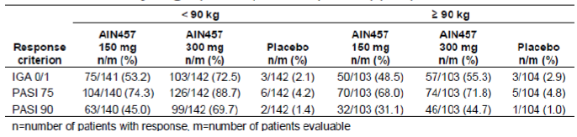
There were 465 (63.0%) of patients previously exposed to systemic therapy and 273 (37.0%) patients not previously exposed. Results for PASI 75, PASI 90 and IGA 2011 mod 0 or 1 at Week 12 in subgroups of previous exposure to systemic therapy were consistent with the superior efficacy of 300 mg and 150 mg secukinumab versus placebo demonstrated in the overall population. Response rates on secukinumab treatment were comparable between treatment naïve patients and previously exposed patients, except for a slightly higher rate of PASI 75 response in treatment naïve versus previously exposed patients treated with 300 mg secukinumab.
There were 216 (29.3%) of patients previously exposed to biologic systemic therapy and 522 (70.7%) patients not previously exposed. Results for PASI 75, PASI 90 and IGA 2011 mod 0 or 1 at Week 12 in subgroups of previous exposure to biologic systemic (including anti TNF-α therapy) psoriasis therapies were consistent with the superior efficacy of 300 mg and 150 mg secukinumab versus placebo demonstrated in the overall population. Response rates were generally higher in treatment naïve patients compared with previously exposed patients. More than half of patients previously exposed to biologic therapy were treated with anti TNF-α therapy. Failure to respond to previous anti TNF-α therapy did not affect the overall result: both 300 mg and 150 mg secukinumab doses in prior failures showed better efficacy than placebo.
There were 361 (48.9%) of patients previously exposed to non biologic systemic therapy and 377 (51.1%) not previously exposed. Results for PASI 75, PASI 90 and IGA 2011 mod 0 or 1 at Week 12 in subgroups of previous exposure to non biologic systemic therapies were consistent with the superior efficacy of 300 mg and 150 mg secukinumab versus placebo demonstrated in the overall population. Although there were numerical variations, the pattern of response was comparable between previously exposed patients and treatment naïve patients. Ongoing use of emollients up to Week 12 also had no impact on the greater efficacy of secukinumab relative to placebo. Response rates for PASI 75, PASI 90 and IGA mod 2011 0 or 1 were comparable between patients with ongoing use of emollients and those with no ongoing use.

Results for other efficacy outcomes

Key secondary efficacy results
PASI 90: Compared with placebo, both secukinumab 150 mg and 300 mg showed statistically significantly (p < 0.001) greater proportion of patients achieving PASI 90 (39.1%, 59.2% and 1.2% with secukinumab 150 mg, 300 mg and placebo, respectively) and IGA mod 2011 0 or 1 (51.2%, 65.3% and 2.4%, respectively). Response rates were 10% higher for PASI 75 and 14% higher for IGA mod 2011 0 or 1 with 300 mg relative to 150 mg secukinumab. PASI 90 response rates in the sensitivity analysis for 300 mg and 150 mg versus placebo were 55.1% and 34.3% versus 1.2% (p values < 0.0001 for all comparisons). Higher PASI 90 response rates at Week 12 with secukinumab 300 mg and 150 mg relative to placebo were observed in all subgroups by body weight and by previous exposure to psoriasis therapies. In subgroup analysis by previous exposure to systemic therapy, previous anti TNF-α therapy or previous non biologic systemic therapy, PASI 90 response rates were comparable between previously exposed patients and those who had failed to respond to previous therapy.

Psoriasis symptom diary items:
Patients treated with either 300 mg or 150 mg secukinumab had significantly greater improvements in the Psoriasis Symptom Diary items itching, pain and scaling after 12 weeks of treatment compared with patients on placebo. Improvements from baseline were numerically greater with 300 mg than with 150 mg secukinumab (Table 13).

Table 13. Analysis of covariance for absolute change from baseline to Week 12 in Psoriarsis Symptom Diary items itching, pain and scaling (FAS).
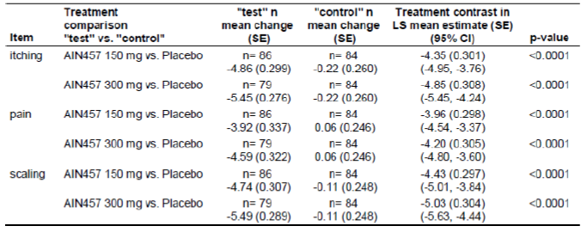

Other efficacy results

Maintenance of PASI 75 response at 52 weeks
The majority of secukinumab treated patients (80.5% with 300 mg and 72.4% with 150 mg) who achieved PASI 75 at Week 12 maintained the response at Week 52. The cumulative probability of losing PASI 75 response at 52 weeks of treatment in Week 12 PASI 75 responders was lower with the higher secukinumab dose: 14.2% with 300 mg versus 27.5% with 150 mg. The overall decline in the PASI 75 response rate among Week 12 responders from Week 13 to Week 52 was greater in the 150 mg secukinumab group (− 20% from 92.5% to 72.4%) than in the 300 mg secukinumab group (- 13% from 93.5% to 80.5%).
The cumulative rate of loss of PASI 75 response up to 52 weeks of treatment was higher in patients weighing ≥ 90 kg (31.0% and 21.2% with 150 mg 300 mg, respectively) than in those weighing < 90 kg (25.3% and 10.1%, respectively). However, the rate of losing PASI 75 response was lower with 300 mg versus 150 mg in both weight groups.
Week 12 PASI 75 responders who were previously exposed to systemic therapies were more likely to lose PASI 75 response at 52 weeks of treatment (32.3% and 16.4% with 150 mg 300 mg, respectively) than those who were not previously exposed (18.8% and 10.4%, respectively). This imbalance was not due to prior failures, as cumulative rates of PASI 75 loss did not differ between subgroups of patients who had failed systemic therapy and the overall group of previously exposed patients. For subgroups by previous exposure to biologic systemic therapy, the rate of PASI 75 loss at 52 weeks was higher in previously exposed patients (47.4% with 150 mg and 23.6% with 300 mg) than in treatment naïve patients (20.1% with 150 mg and 10.8% with 300 mg. Based on the small number of evaluable patients who failed previous anti TNF-α therapy, the rates of PASI 75 (37.5% with 150 mg and 29.3% with 300 mg) were comparable to those observed in the overall group of patients previously exposed to anti TNF-α therapy (45.4% with 150 mg and 24.2% with 300 mg). There were no meaningful differences in PASI 75 loss at Week 52 across subgroups of previous exposure to non biologic therapies. The rates of PASI 75 loss were 30.2% (150 mg) and 14.5% (300 mg) in patients previously exposed to non biologics compared to 24.7% (150 mg) and 13.9% (300 mg) in those not previously exposed. Patients who had failed a prior non biologic therapy showed comparable rates of PASI 75 loss (32.9% with 150 mg and 15.7% with 300 mg) as previously exposed patients.

Maintenance of IGA mod 2011 0 or 1 response at 52 weeks
The proportion of secukinumab treated patients who achieved IGA mod 2011 0 or 1 at Week 12 and maintained this response at Week 52 was higher with 300 mg than with 150 mg (74.4% versus 59.2%). The cumulative probability of losing IGA mod 2011 0 or 1 response at 52 weeks of treatment in Week 12 IGA mod 2011 0 or 1 responders was lower with the higher secukinumab dose: 28.8% with 300 mg versus 41.4% with 150 mg. The overall decline in the IGA mod 2011 0 or 1 response rate from Week 13 to Week 52 was greater in the 150 mg secukinumab group (− 30% from 89.6% to 59.2%) than in the 300 mg secukinumab group (-17.5% from 91.9% to 74.4%).
An effect of body weight on the cumulative probability of loss of IGA mod 2011 0 or 1 response at 52 weeks of treatment was observed only in heavier patients treated with the higher secukinumab dose. Among those treated with 300 mg, patients weighing < 90 kg had a 17.4% probability of losing IGA mod 2011 0 or 1 response at 52 weeks, whereas patients weighing ≥ 90 kg had a 48.8% probability of losing this response. The cumulative rate of loss at 52 weeks was similar in the two weight subgroups treated with secukinumab 150 mg (40.7% for < 90 kg subgroup versus 42.4% for ≥ 90 kg subgroup). There were no marked differences in the probability of losing IGA mod 2011 0 or 1 response among subgroups of previous exposure to psoriasis therapies. There were minor numerical variations across the subgroups, but all showed the general trend of lower rates of loss with 300 mg versus 150 mg secukinumab. Patients who failed to respond to any previous systemic, biologic systemic or non biologic systemic therapies showed comparable rates of loss as the overall group of previously exposed patients. Based on the small number of evaluable patients who failed prior anti TNF-α therapy, the rate of losing IGA mod 2011 0 or 1 response at Week 52 was 71.4% with 150 mg and 27.3% with 300 mg, in the prior failures compared with 59.7% and 44.3%, respectively, in the overall group of patients previously exposed to anti TNF-α therapy.

PASI 50, PASI 75, PASI 90, PASI 100, and IGA mod 2011 0 or 1 response over time:
Higher response rates with secukinumab relative to placebo appeared as early as Week 2, with 18.5% of patients on 150 mg secukinumab and 28.2% of patients on 300 mg secukinumab achieving PASI 50 compared with only 3.3% of placebo patients. Both secukinumab doses were better than placebo in the PASI 75 and IGA mod 2011 0 or 1 response starting at Week 3 and in PASI 90 at Week 4. Notably, at Week 12, PASI 100 (denoting a complete clearance of psoriasis as measured by the PASI scoring system) was achieved by 12.8% of patients on 150 mg secukinumab and 28.6% of patients on 300 mg secukinumab versus only 0.8% of placebo patients. Rapid onset of response for secukinumab, particularly the 300 mg dose, was supported by the percentage change in PASI score. A ≥ 50% mean decrease from baseline in PASI score was achieved by Week 3 in the 300 mg secukinumab group and by Week 4 in the 150 mg secukinumab group, but was not observed at any visit in the placebo group. Secukinumab 300 mg and 150 mg showed higher efficacy compared to placebo at each of the time points. A clear difference in response rates between the two doses of secukinumab was observed as early as Week 2, with patients in the 300 mg secukinumab group achieving higher rates of PASI 50, PASI 75 and IGA mod 2011 0 or 1 responses than patients in the 150 mg secukinumab group (Table 14).

Table 14. Number (%) of patients with PASI 50, PASI 75, PASI 90 and PASI 100 and IGA mod 2011 0 or 1 response by visit – induction period (non responder imputation) (FAS).
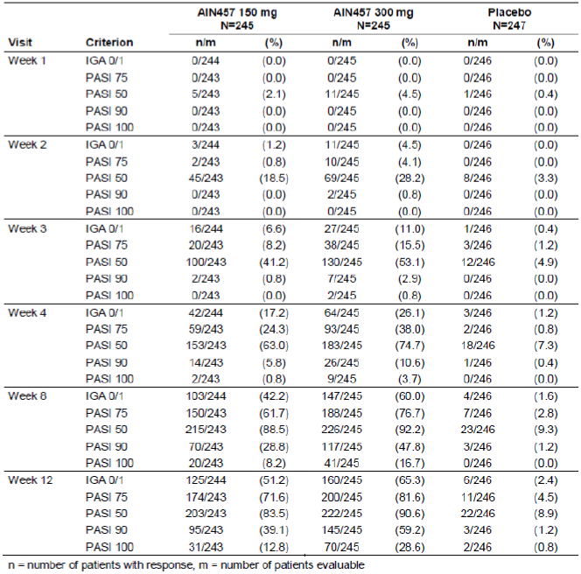
The high response rates at Week 12 in both secukinumab dose groups were sustained throughout the maintenance period, up to Week 52. Response rates for PASI 75, IGA mod 2011 0 or 1 and PASI 90 peaked at Weeks 16 to 24 for the 150 mg secukinumab group and at Weeks 15 to 20 for the 300 mg group. The PASI 100 response peaked at Week 28 for both secukinumab dose groups. PASI 50 response peaked earlier at Week 8 of the induction period. The high response rates persisted at Week 52, with the majority of secukinumab treated patients showing PASI 50 (84.5% and 77.0% for 300 mg and 150 mg, respectively) and PASI 75 (74.3% and 60.1%). Rates of IGA mod 2011 0 or 1 response at Week 52 were 60.4% (300 mg) and 41.4% (150 mg). For the Week 52 endpoints assessing higher plaque clearance, PASI 90 was achieved in 60.0% (300 mg) and 36.2% (150 mg), and PASI 100 in 39.2% (300 mg) and 20.2% (150 mg). The 300 mg secukinumab dose resulted in higher response rates at all time points in the maintenance period compared to the 150 mg dose.
Placebo non responders re randomised to secukinumab 150 mg or 300 mg showed gradual increases in response rates starting at Week 14 (that is, 2 weeks after switching to secukinumab treatment). By Week 24, or 12 weeks after switching to secukinumab treatment, the response rates in the re randomised patients were similar to those observed at Week 12 in the original 150 mg and 300 mg secukinumab group.
The overall results for PASI 75, PASI 90 and IGA mod 2011 0 or 1 responses at Week 12, demonstrating superior efficacy with secukinumab versus placebo, was consistent in all subgroups of previous exposure to systemic, biologic (including anti TNF-α) and nonbiologic therapies. Failure to respond to any prior systemic therapy had no impact on the result: response rates were similar between the overall group of previously exposed patients and those who had failed to respond to previous systemic therapy. Patients who failed previous biologic therapy showed numerically lower response rates for PASI 75 (on both doses) and PASI 90 (on 300 mg) than the overall group of previously exposed patients, while IGA mod 2011 0 or 1 (on both doses) and PASI 90 (on 150 mg) were comparable between the two groups. A similar pattern was observed in patients who failed previous anti TNF-α therapy. There were no differences in response rates between patients previously exposed to nonbiologic systemic therapy and those who had failed to any or at least 2 non biologic systemic therapies. Secukinumab 300 mg was associated with numerically higher rates of PASI 75, PASI 90 and IGA mod 2011 0 or 1 response at Week 12 compared with 150 mg, regardless of whether or not patients had failed the previous therapy.

DLQI
Secukinumab treatment resulted in significantly larger reductions (improvements) from baseline in DLQI total scores compared with placebo. At Week 12, the median treatment difference was − 75.8 and − 66.7 for 300 mg and 150 mg secukinumab, respectively, versus placebo (both, p< 0.0001). The significantly greater improvement relative to placebo was also observed at Week 4 and Week 8. The improvements in DLQI were sustained up to Week 52 in the secukinumab-treated patients.

EQ-50
A clear effect of secukinumab treatment was seen in the category of ‘Pain/Discomfort,’ where the proportion of secukinumab treated patients reporting no pain or discomfort increased from 26.2% and 22.1% (300 mg and 150 mg, respectively) at baseline to 72.8% and 70.8%, respectively, at Week 12. For the placebo group, the extent of improvement was considerably lower, with 18.9% at baseline reporting no pain or discomfort compared with 28.4% at Week 12. In the category of ‘Anxiety/Depression,’ the proportion of patients in the 300 mg and 150 mg secukinumab groups reporting not being anxious or depressed increased from 50.8% and 43.9% at baseline to 84.4% and 76.5% at Week 12, respectively, compared with 46.1% to 56.7% for placebo. Similar trends favouring secukinumab were seen in the category of ‘Usual Activities.’ The improvements were sustained through Week 52 for both 300 mg and 150 mg groups. As the majority of patients in all treatment groups did not report any problems with ‘Mobility’ and ‘Self care’ at baseline, no impact of secukinumab treatment could be discerned.

Relapse and rebound
Relapse was defined as a 50% reduction of the maximal PASI improvement. The cumulative probability of relapse at 52 weeks of treatment was lower with the higher secukinumab dose: 2.1% with 300 mg versus 6.8% with 150 mg. Rebound (defined as increase in PASI to > 125% of baseline PASI within 8 weeks of last dose of study treatment) was more frequently reported in the placebo group (2/15 patients, 13.3%) than in either secukinumab dose group (4/50 patients, 8.0% for 150 mg and 2/44 patients, 4.5% for 300 mg). Rebound up to 4 weeks after the last dose was also more frequent with placebo (4/14 patients, 28.6%) than with either secukinumab dose (1/21, 4.8% for 150 mg and 1/13, 7.7% for 300 mg). Similar results were observed for rebound like event up to 12 weeks after the last dose of study treatment: 1/4 patients, 25.0% for placebo versus 2/30 patients, 6.7% for 150 mg and 1/22 patients, 4.5% for 300 mg. These results should be interpreted with caution, as assessments of rebound were based on a small, biased sample of discontinued patients.

HAQ-DI and ACR response in patients with psoriatic arthritis
The HAQ-DI response was defined as a clinically important reduction of ≥ 0.3 points from baseline. At Week 12, the highest rate of HAQ-DI response was reported in the 300 mg secukinumab group (47.1%) compared with the 150 mg secukinumab (26.7%) and placebo (21.5%) groups. Only 5 patients were evaluated for ACR response. All 5 patients showed an improvement in ACR response following secukinumab treatment. For 3 of these patients, an improvement was observed 12 weeks after starting 150 mg secukinumab and was sustained up to the last assessment at Week 52 in 2 patients while for another patient the ACR20 response was lost at Week 24 due to worsening of tender joint count although other ACR components continued to improve. For the remaining 2 patients, both of whom were placebo non-responders re-randomised to 300 mg secukinumab, no improvement was observed on placebo, but both patients showed an improvement after starting 300 mg.
Comment: In this well conducted large, pivotal Phase III study, secukinumab demonstrated a rapid onset of response with superior efficacy over placebo in the treatment of patients with moderate to severe chronic plaque type psoriasis. Both 300 mg and 150 mg secukinumab doses were significantly better than placebo in achieving PASI 75, PASI 90 and IGA mod 2011 0 or 1 at 12 weeks of treatment. The high response rates for PASI 75 and IGA mod 2011 0 or 1 with secukinumab were sustained up to 52 weeks of treatment. Secukinumab 300 mg provided faster onset of response, higher response rates, particularly for IGA mod 2011 0 or 1, PASI 90 and PASI 100 endpoints reflecting higher levels of plaque clearance, and greater maintenance of response over 52 weeks compared with the lower dose.

Study A2303

Study design, objectives, locations and dates
This was a Phase III, randomised, double blind, double dummy, placebo controlled, multicentre study of subcutaneous secukinumab to demonstrate efficacy after twelve weeks of treatment, compared to placebo and etanercept, and to assess the safety, tolerability and long term efficacy up to one year in subjects with moderate to severe chronic plaque type psoriasis. FIXTURE (Full year Investigative examination of secukinumab versus etanercept Using 2 dosing Regimens to determine Efficacy in psoriasis).
The primary objective of this study was to demonstrate the superiority of secukinumab in subjects with moderate to severe chronic plaque type psoriasis with respect to both PASI 75 and IGA mod 2011 0 or 1 response (co primary endpoints) at Week 12, compared to placebo. The key secondary objectives of this study were to demonstrate:
- Superiority of secukinumab with respect to PASI 90 response at Week 12, compared to placebo.
- Non inferiority of secukinumab with respect to PASI 75 response at Week 12, compared to etanercept.
- Superiority of secukinumab with respect to PASI 75 response and IGA mod 2011 0 or 1 response at Week 12, compared to etanercept.
- Superiority of secukinumab in maintaining PASI 75 / IGA mod 2011 0 or 1 response at Week 52 for subjects who were PASI 75 responders at Week 12, compared to etanercept.
- Superiority of secukinumab with respect to psoriasis-related itching, pain and scaling as measured by the Psoriasis Diary at Week 12, compared to placebo.
The study was conducted from 14 June, 2011 to 7 July, 2013 at 231 centers in 26 countries (Argentina 7, Australia 4, Belgium 6, Brazil 6, Canada 15, Colombia 6, Egypt 1, Finland 2, France 8, Germany 42, Guatemala 5, Hungary 9, Iceland 1, India 13, Italy 8, Philippines 2, Poland 4, Republic of Korea 12, Romania 5, Russian Federation 11, Singapore 2, Spain 7, Sweden 4, Turkey 5, UK 9, United States 37).
Comment: The choice of placebo control was a standard requirement to ascertain study sensitivity due to the seasonal and fluctuating character of chronic plaque type psoriasis. Etanercept has been approved for the indication of psoriasis for over 5 years in most countries and is commonly accepted by dermatologists as an efficacious psoriasis treatment with a convenient delivery form and an acceptable safety profile and its s.c. route of administration matches that of secukinumab. Hence, the choice of etanercept as an active control in this pivotal Phase III study is justified.

Inclusion and exclusion criteria
The study population consisted of a representative group of male and female out patients (≥ 18 years old) with moderate to severe chronic plaque type psoriasis that was poorly controlled by topical treatments and/or phototherapy and/or previous systemic therapy. Chronic plaque type psoriasis had to be diagnosed for at least 6 months before randomization. At randomization, psoriasis had to be moderate to severe, with a PASI score of ≥ 12, IGA mod 2011 score of ≥ 3 (based on a scale of 0 to 4), and a body surface area (BSA) affected by plaque type psoriasis of ≥ 10%.
Additional important exclusion criteria included ongoing inflammatory diseases other than psoriasis, underlying immune-compromising conditions, significant medical problems (such as uncontrolled hypertension [systolic blood pressure (BP) ≥ 160 mmHg and/or diastolic BP ≥ 95 mmHg] or congestive heart failure [NYHA class III or IV]), active systemic infections during the last 2 weeks (exception: common cold) prior to randomization and any infections that reoccurred on a regular basis, and history of ongoing, chronic or recurrent infectious disease (for example tuberculosis, human immunodeficiency virus [HIV], hepatitis B or hepatitis C, lymphoproliferative disease/known malignancy or history of malignancy). Patients with a serum creatinine level exceeding 176.8 μmol/L (2.0 mg/dL) and patients with a total white blood cell count (WBC) < 2500/μL, platelets < 100,000/μL, neutrophils < 1500/μL, or hemoglobin < 8.5 g/dL at screening were also excluded from the study.
Other inclusion/ exclusion criteria were similar to those described in pivotal Study A2302 above.

Study treatments
Secukinumab 150 mg LYO, supplied by Novartis, was provided in glass vials, each containing 150 mg secukinumab as lyophilized cake. The 150 mg LYO was used to prepare both the 150 mg dose (1 vial for 1 s.c. injection) and the 300 mg dose (2 vials for 2 s.c. injections). Secukinumab (active or placebo) was injected s.c. in non affected areas of the skin. If possible, the investigator administered the study treatment to one of the following body regions throughout the study, changing the injection site from visit to visit: right thigh, left thigh, right stomach, left stomach. The active comparator, etanercept 50 mg (Enbrel), was provided as a 50 mg single use prefilled syringe (0.98 mL of a 50 mg/mL solution of etanercept) but was masked to maintain the blind. Placebo etanercept was provided in a form to match active etanercept. Patients were treated for a total of 52 weeks (12 weeks induction period and 40 weeks maintenance period). After the end of the maintenance period (EOM) visit, qualifying patients in the active treatment groups during the maintenance period entered an extension study. The allowed concomitant medications and list of prohibited medications were similar to those described for Study 2302 above.

Efficacy variables and outcomes
The efficacy variables evaluated in this study were similar to those described for Study A2302. The co primary efficacy variables of this study were PASI 75 response at Week 12 and IGA mod 2011 0 or 1 response at Week 12. The key secondary efficacy outcomes were: PASI 90 response at Week 12; PASI 75 response and IGA mod 2011 0 or 1 response after Week 12 (PASI 75 response for non-inferiority and both for superiority comparison of secukinumab doses versus etanercept); maintenance of PASI 75 response after 52 weeks of treatment for subjects who were PASI 75 responders after 12 weeks of treatment; maintenance of IGA mod 2011 0 or 1 response after 52 weeks of treatment for subjects who were IGA mod 2011 0 or 1 responders after 12 weeks of treatment; Psoriasis Diary items (pain, itch and scaling) at Week 12.

Randomisation and blinding methods
Patients were randomised in a 1:1:1:1 ratio (stratified by geographical region and body weight) via the IVRS to one of the following 4 treatment groups: Etanercept 50mg , secukinumab 150 mg, secukinumab 300 mg or placebo group. Patients in the placebo group were assigned to the following treatment groups based on their PASI 75 response status at Week 12: PASI 75 responders continued on placebo, whereas PASI 75 non-responders were re randomised 1:1 to receive 150 mg or 300 mg secukinumab. A double dummy design was used because the comparator had a different dosing regimen than secukinumab (AIN457) and the identity of the study treatments could not be disguised due to their different forms. Patients, investigator staff, persons performing the assessments, and data analysts remained blinded to the identity of the treatment from the time of randomisation until end of follow up database lock.

Analysis populations
Statistical analyses of efficacy variables were performed on an intent to treat basis, involving all randomised patients who were assigned to study treatment (full analysis set, FAS). Baseline characteristics were analyzed for all randomised patients. Safety analyses were performed for all randomised patients who received at least 1 dose of study treatment (safety set).

Sample size
The sample size was determined by the key secondary objective to demonstrate the non inferiority of secukinumab versus etanercept with respect to PASI 75 response at Week 12. The total sample size was 1,264 patients, that is using a balanced randomisation 316 patients were randomised to each treatment group. Since two secukinumab dose regimens were tested versus placebo with respect to the co primary endpoints (PASI 75 response and IGA mod 2011 mod 2011 0 or 1 response at Week 12), the type I error was split to 2.5% 2 sided for each comparison. With 316 patients per group and assuming a response rate of 5% for PASI 75 response and IGA mod 2011 mod 2011 0 or 1 response in the placebo group, the power to show a response rate of 55% for PASI 75 response and 30% for IGA mod 2011 mod 2011 0 or 1 response in the secukinumab groups based on Fisher’s exact test was above 99%. The type I error for the non inferiority comparison of secukinumab versus etanercept with respect to PASI 75 response at Week 12 was set to 0.625% one sided. With a non inferiority margin of 10% and assumed PASI 75 response rates of 50% for etanercept and 55% for secukinumab, 316 patients per treatment group were needed to achieve a power of 90% For etanercept, PASI 75 response rates of about 50% have been reported in Tyring et al (2006), Papp et al (2005) and Leonardi et al (2003). The power to show the superiority of each secukinumab dose regimen versus etanercept with respect to PASI 75 response at Week 12, that is to reject H9 or H10, is shown in Table 15 below for different scenarios, given a type I error of 2.5% 2 sided and a sample size of 316 patients per group.

Table 15. Power to show superiorority of each secukinumab (AIN457) dose regimen versus etanercept.
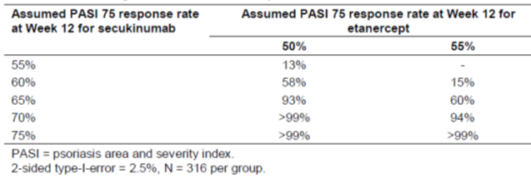

Statistical methods
A sequentially rejective testing strategy was used to evaluate the study hypotheses for co-primary and key secondary variables while retaining a family wise type I error of 5%. The statistical hypothesis for the co primary efficacy variable (PASI 75 response at Week 12 and IGA mod 2011 0 or 1 response at Week 12) being tested was that there was no difference in the proportion of patients with PASI 75 response and IGA mod 2011 0 or 1 response at Week 12 in any of the secukinumab groups versus placebo.
For the key secondary efficacy variables, the following hypotheses were included in the testing strategy:
- Secukinumab150 mg and secukinumab 300 mg are not different to placebo with respect to PASI 90 response at Week 12.
- Secukinumab150 mg and secukinumab 300 mg are not non inferior to etanercept with respect to PASI 75 response at Week 12.
- Secukinumab150 mg and secukinumab 300 mg are not superior to etanercept with respect to PASI 75 response at Week 12.
- Secukinumab150 mg and secukinumab 300 mg are not superior to etanercept with respect to IGA mod 2011 0 or 1 response at Week 12.
- Secukinumab150 mg and secukinumab 300 mg are not superior to etanercept in maintaining PASI 75 response at Week 52 for subjects who were PASI 75 responders at Week 12.
- Secukinumab150 mg and secukinumab 300 mg are not superior to etanercept in maintaining IGA mod 2011 0 or 1 response at Week 52 for subjects who were IGA mod 2011 0 or 1 responders at Week 12.
- Secukinumab150 mg and secukinumab 300 mg are not different to placebo with respect to absolute changes from baseline in Psoriasis Diary items pain, itching, and scaling at Week 12. For response efficacy variables, the Cochran Mantel Haenszel (CMH) test was performed for pairwise comparisons of secukinumab dose regimens versus placebo or etanercept.
For the non inferiority comparison with regards to PASI 75 response at Week 12, the stratified Mantel Haenszel risk difference for each secukinumab dose minus etanercept and the associated confidence interval (CI) was calculated and compared to the pre set non inferiority margin delta of 10%. The non inferiority margin delta was set to 10% and for each secukinumab dose regimen, the CI was calculated for the stratified Mantel-Haenszel risk difference secukinumab minus etanercept in PASI 75 response rates, on both FAS and PPS.
Comment: Justification for setting the non inferiority margin at 10% for the risk difference between each secukinumab dose and etanercept was not provided in the CSR.

Participant flow
Overall 1,560 patients were screened of whom 1,306 patients were randomised to 4 treatment groups in the induction period: secukinumab 150 mg (n = 327), secukinumab 300 mg (n = 327), placebo (n = 326), or etanercept (n = 326). Most patients (94.4%) completed the induction period; the most common reason for premature discontinuation during the induction period was patient/guardian decision, occurring at a higher rate in the placebo group (3.1%, 1.5%, 1.5% and 1.5% in the placebo, secukinumab 150 mg, 300 mg and etanercept 50mg groups, respectively).
Discontinuations due to AEs were not common and occurred in less than 2% in all treatment groups. Overall 1,233 patients entered the maintenance period, of which 1,100 patients (89.21%) completed the maintenance period. Randomised patients in the maintenance period (n = 1,281) included all patients originally randomised to the secukinumab groups (150 mg and 300 mg; n = 327 each) and to the etanercept group (n = 326). In addition, this patient set also contained all patients originally randomised to placebo who completed the induction period (n = 301). These patients continued to receive placebo if they were PASI 75 responders (placebo; n = 17) or they were re randomised to receive either secukinumab 150 mg (placebo secukinumab 150 mg; n = 142) or secukinumab 300 mg (placebo secukinumab 300 mg; n = 142). For the 133 patients who discontinued during the maintenance period, the most common reason for premature discontinuation was patient/guardian decision, occurring at the highest rate in the placebo group (11.8%) and at the lowest rates in the secukinumab 300 mg group (1.8%) and placebo secukinumab 300 mg group (2.1%). Discontinuations due to lack of efficacy were most frequent in the secukinumab 150 mg group (3.1%) and etanercept group (3.4%), followed by the placebo secukinumab 150 mg group (2.1%) and the secukinumab 300 mg group (0.9%). Discontinuation due to AEs occurred at low rates (< 3%) in all treatment groups.

Major protocol violations/deviations
Patients having at least 1 protocol deviation ranged from 84.1 to 87.8% across treatment groups, however, only 34 (2.6%) patients had a deviation considered to be of major or having potential impact to the interpretation of the efficacy and safety analyses. There were no imbalances in the frequency or type of protocol deviations across the treatment groups. Protocol deviations leading to exclusion from the PPS were reported for 33 patients in the Randomised set and included utilization of prohibited concomitant medication (19 patients), procedures not performed as per protocol (11 patients) and selection criteria not met (6 patients). One patient in the placebo secukinumab 300 mg group was excluded from the FAS (and PPS) and the safety set. The data sets analysed in the induction and maintenance periods were provided.

Baseline data
The mean age (± SD) was 44.4 (± 12.93) years and majority of patients (94.0%) were < 65 years of age, Caucasian (67.4%), males (71.1%). The mean BMI (± SD) was 28.34 (± 6.089) kg/m², and one third of patients were smokers at baseline (452 patients, 34.6%). Baseline demographics were similar across treatment groups at start of induction period. At the beginning of the induction period, the mean (±SD) PASI score was 23.7 (± 10.18), the mean affected BSA was 34.4 (± 18.93), and the mean time since psoriasis diagnosis was 16.6 (± 12.04) years. PsA was diagnosed in 192 patients (14.7%). In total, 836 patients (64.0%) were previously treated with systemic psoriasis therapy and 682 patients (81.6%) failed their systemic therapy. The disease history and baseline disease characteristics at the beginning of the induction period were well balanced across treatment groups. The incidence of relevant medical history and current medical conditions was similar across treatment groups with the most common being surgical and medical procedures (247 patients, 18.9%), musculoskeletal and connective tissue disorders (212 patients, 16.2%), infections and infestations (200 patients, 15.3%), gastrointestinal disorders (177 patients, 13.6%) and psychiatric disorders (127 patients, 9.7%). Infections and infestations were reported by higher percentages of patients in the secukinumab 150 mg (17.7%) and 300 mg (17.4%) groups compared to either the etanercept (14.7%) or placebo (11.3%) groups. This trend was mainly driven by the higher incidence of latent tuberculosis in the secukinumab 150 mg group (23 patients, 7.0%) and secukinumab 300 mg group (21 patients, 6.4%) compared to either the etanercept group (17 patients, 5.2%) or placebo group (12 patients, 3.7%). There were no other meaningful differences between treatment groups. The most common cardiovascular conditions were hypertension (274 patients, 21.0%) and hyperlipidemia (174 patients, 13.3%) with similar incidence across treatment groups.
Prior medications were reported by nearly all patients (1,302 out of 1,303 patients, 99.9%) in the safety set at the beginning of the induction period and the most common ones were dermatologicals (94.0%), non drug therapies/procedures (50.7%) and antineoplastic and immunomodulating agents (49.4%). Non drug phototherapy was reported by a slightly higher percentage of patients in the secukinumab 300 mg group (46.2%, 51.7%, 54.0% and 49.2% in the placebo, secukinumab 150 mg, 300 mg and etanercept 50mg groups, respectively). Previous systemic psoriasis therapies were reported by almost two thirds of patients (836 patients, 64.1%) in the randomised set at the beginning of the induction period, and more than one half of these patients reported one therapy (480 patients, 57.4%). The majority of patients with previous systemic psoriasis therapy reported a lack of primary or secondary efficacy or lack of tolerability and were considered to be therapy failures (682 patients, 81.6%). The failure rate of therapy was lower in the etanercept group (84.8%, 82.6%, 81.6% and 77.6% in the placebo, secukinumab 150 mg, 300 mg and etanercept 50mg groups, respectively). Previous biologic psoriasis therapies were reported by 163 (12.5%) patients and more than one third of these patients were therapy failures (59 patients, 36.2%). There were no clinically meaningful differences between treatment groups for percentages of patients reporting previous biologic psoriasis therapies or for failure rate of those therapies. Previous non biologic psoriasis therapies were reported by 796 (61.0%) patients and majority of these were treatment failures (667 patients, 83.8%). The failure rate of therapy was lower in the etanercept group (84.6%, 86.4%, 83.6% and 78.9%, respectively). Other prior psoriasis therapies included topical agents (1,114 patients, 85.4%), phototherapy (488 patients, 37.4%) and photochemotherapy (274 patients, 21.0%) with no clinically meaningful differences between treatment groups. Overall, demographic and baseline disease characteristics were similar in both the induction and maintenance treatment periods.

Results for the primary efficacy outcome
The results of the hypothesis tests within the pre planned testing strategy were provided. The study met both co primary endpoints and the key secondary efficacy endpoints.
Compared with placebo, both doses of secukinumab (150 mg and 300 mg) showed statistically significantly (p < 0.001) greater response rates for both co primary endpoints of PASI 75 (67%, 77% and 4.9% with secukinumab 150 mg, 300 mg and placebo, respectively) and IGA mod 2011 0 or 1 (51.1%, 62.5% and 2.8%, respectively). The higher secukinumab dose of 300 mg was also statistically significantly better than the 150 mg dose (p values for the differences between 300 mg versus 150 mg secukinumab at Week 12, as assessed by the CMH test, were 0.0046 for PASI 75 and 0.0032 for IGA mod 2011 0 or 1).
The sensitivity analysis on the number and percentage of patients with PASI 75 and IGA mod 2011 0 or 1 response at Week 12 (non responder imputation for patients with missing injection(s) up to Week 12, dropouts due to AEs or lack of efficacy, protocol deviations due to inclusion/exclusion criteria, and missing data at Week 12) yielded higher response rates in both secukinumab dose groups than in the placebo group for PASI 75 (57.8%, 65.7% and 3.7%, respectively) and for IGA mod 2011 0 or 1 (44.3%, 52.6% and 2.2%, respectively). Further sensitivity analyses of PASI 75 and IGA mod 2011 0 or 1 response with multiple imputations for missing values and with non responder imputation but excluding patients with certain protocol deviations provided similar results with higher response rates in the secukinumab 300 mg dose group than in the secukinumab 150 mg dose group.
Consistent with the results obtained for the overall population, PASI 75, PASI 90, and IGA mod 2011 0 or 1 response rates at Week 12 were higher in both secukinumab dose groups than in the etanercept and placebo groups when analysed for both body weight subgroups (< 90 kg and ≥ 90 kg) (Table 16), by previous systemic therapy and by previous biologic therapy. Response rates were higher for patients with no previous biologic therapy than for patients with previous biologic therapy and for patients who did not fail their previous biologic therapy than for patients with previous failure to biologic therapy. Irrespective of previous exposure and failure to biologic therapy, secukinumab 300 mg always provided the highest response rates compared to all other treatment groups. Secukinumab 150 mg showed better efficacy than etanercept for IGA mod 2011 0 or 1 response and PASI 90 response for patients with previous exposure to biologic therapy and for PASI 75 response and PASI 90 response for patients who failed their previous biologic therapy. Of the 163 patients with previous exposure to biologic therapy, approximately one third (60 patients) had received previous anti tumor necrosis factor (TNF)α treatment, and 32 patients had failed that previous anti TNFα therapy. For patients with previous anti TNFα treatment exposure, IGA mod 2011 0 or 1 response rates were comparable for secukinumab 300 mg and etanercept and lower for secukinumab 150 mg, whereas secukinumab 300 mg showed higher response rates than both secukinumab 150 mg and etanercept in PASI 75 and PASI 90 response. Failure to previous anti TNFα treatment was consistent with the overall results, although the limited patient numbers made it difficult to draw conclusions. Secukinumab 300 mg provided the highest response rates for IGA mod 2011 0 or 1, PASI 75, and PASI 90 in the subgroup of patients who had failed their previous anti TNFα therapy, followed by secukinumab 150 mg and etanercept. Consistent with the results obtained for the overall population, PASI 75, PASI 90, and IGA mod 2011 0 or 1 responses at Week 12 were higher in both secukinumab dose groups than in the etanercept and placebo groups when analyzed by previous non biologic therapy. Response rates were similar for patients with previous non biologic therapy and for patients with no previous non biologic therapy. PASI 75 and IGA mod 2011 0 or 1 response rates at Week 12 were higher in both secukinumab dose groups than in the etanercept group and the placebo group irrespective of the ongoing use of emollients (emollients were used by 15 to 18% of patients during entire treatment period).

Table 16. PASI 75, PASI 90 and IGA mod 2011 0 or 1 response at Week 12 by body weight (non responder imputation) (FAS).
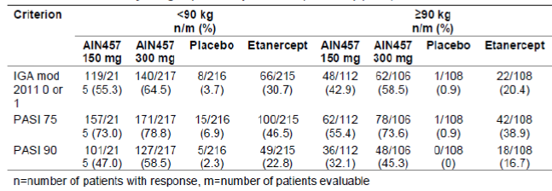

Results for other efficacy outcomes

Key secondary efficacy endpoints

PASI 90 response at week 12
Secukinumab at both doses was statistically significantly (p < 0.0001) superior to placebo, with a higher odds ratio estimate for the secukinumab 300 mg dose (118.48; 95% CI: 41.34, 339.58) than for the secukinumab 150 mg dose (56.10; 95% CI: 21.41, 147.03). The comparison of PASI 90 response between secukinumab and etanercept was done descriptively only; a higher proportion of patients in both secukinumab dose groups were PASI 90 responders than in the etanercept group (41.9% for 150 mg and 54.2% for 300 mg versus 20.7% for etanercept).

PASI 75 response and IGA mod 2011 0 or 1 response at Week 12 – comparison versus etanercept
A non inferiority analysis (Mantel-Haenzel risk difference) of PASI 75 response at Week 12 (secukinumab versus etanercept) yielded risk difference estimates that were in favour of secukinumab both for the 150 mg dose (estimate of 23.12%; 95% CI: 14.06, 32.19) and for the 300 mg dose (estimate of 32.80%; 95% CI: 24.06, 41.53). Non inferiority can be concluded for both secukinumab doses as the lower limits of the CIs were above – 10%, (Table 17). Non inferiority was also confirmed in the PPS analysis; Mantel Haenzel risk difference estimates of PASI 75 response at Week 12 for the PPS were again in favour of secukinumab over etanercept both for the 150 mg dose (estimate of 24.79%; 95% CI: 15.46, 34.13) and for the 300 mg dose (estimate of 32.30%; 95% CI: 23.31, 41.30). Furthermore, subsequent tests for superiority were statistically significant and superiority of both secukinumab doses versus etanercept was shown as the response rates at Week 12 were statistically significantly (p < 0.0001) higher for secukinumab at both doses compared to etanercept both for PASI 75 (67.0%, 77.1% and 44% for secukinumab 150 mg, 300 mg and etanercept, respectively) and IGA mod 2011 0 or 1 (51.1% and 62.5% versus 27.2%, respectively).

Table 17. Non inferiority analysis (Mantel Haenzel risk difference oa PASI 75 response at Week 12 (non responder imputation) (Full analysis set).
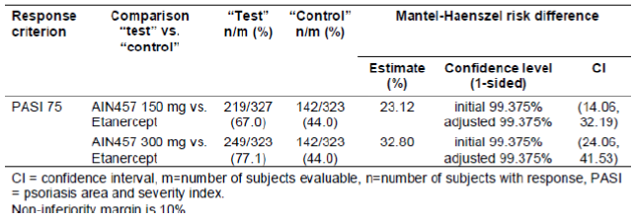

Other efficacy results

Maintenance of PASI 75/IGA mod 2011 0 or 1 response after 52 weeks of treatment for subjects who were PASI 75 responders after 12 weeks of treatment
Maintenance of PASI 75 response at Week 52 was similar in the secukinumab 300 mg group (84.3%) and secukinumab 150 mg group (82.2%), but lower in the etanercept group (72.5%). The probability to lose PASI 75 response was statistically significantly lower in both secukinumab groups as compared to etanercept (HR versus etanercept was 0.30 and 0.57 for secukinumab 300 mg and 150 mg, respectively). The cumulative rate for the loss of PASI 75 response was highest in the etanercept group (33.8) and lowest in the secukinumab 300 mg group (11.9). During the first 4 weeks of the maintenance period, 18/326 patients (5.5%) in the etanercept group lost PASI 75 response compared to 12/327 patients (3.7%) in the secukinumab 150 mg group and 5/327 patients (1.5%) in the secukinumab 300 mg group. In the overall population (without regard to Week 12 PASI 75 response), the high PASI 75 response rates achieved on induction treatment with 300 mg and 150 mg secukinumab increased from Week 12 to 16, and were then sustained to Week 52.
Maintenance of IGA mod 2011 0 or 1 response at Week 52 was higher in the secukinumab 300 mg group (79.7%) than in the secukinumab 150 mg group (67.7%) and etanercept group (56.8%). The HR (secukinumab versus etanercept) for the loss of IGA mod 2011 0 or 1 response was significantly (p < 0.05) in favour of secukinumab at both dose groups, with a smaller HR versus etanercept for secukinumab 300 mg (0.33) than for secukinumab 150 mg (0.55). The cumulative rate for the loss of IGA mod 2011 0 or 1 response was highest in the etanercept group (56.9) and lowest in the secukinumab 300 mg group (23.5). During the first 4 weeks of the maintenance period, 15/88 patients (17.0%) in the etanercept group lost PASI 75 response compared to 16/167 patients (9.6%) in the secukinumab 150 mg group and 9/202 patients (4.5%) in the secukinumab 300 mg group. In the overall population (regardless of Week 12 IGA mod 2011 0 or 1 response), the high response rates for IGA mod 2011 0 or 1 achieved on induction treatment with 300 mg and 150 mg secukinumab increased from Week 12 to 16 and were then sustained to Week 52 (Figure 7).
Figure 7. IGA mod 2011 0 or 1 response over the induction and maintenance periods (estimate + 95% CI) (non-responder imputation) (FAS).
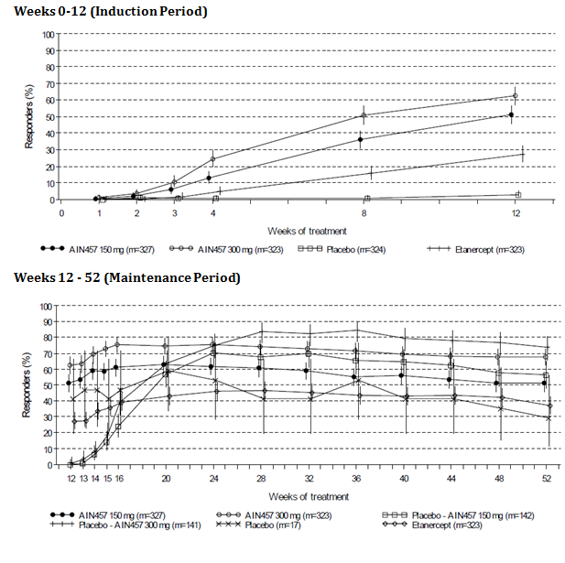

PASI 75, PASI 90 and PASI 100 response during the maintenance period for patients with partial PASI response at Week 12
At Week 12, there were 47 patients in each secukinumab dose group, 84 patients in the etanercept group, and 4 patients in the placebo group with partial PASI response. Of those, the proportion of responders at any time up to Week 52 was highest in the secukinumab 300 mg group (95.7%, 78.7% and 29.8% for PASI 75, PASI 90 and PASI 100, respectively), followed by the etanercept group (82.1%, 51.2% and 15.5%, respectively) and the secukinumab 150 mg dose group (80.9%, 44.7% and 8.5%, respectively). PASI 75 response rates were significantly higher for secukinumab 300 mg than for etanercept at Week 14, Week 16, Week 28, Week 32, and Week 52 (CMH only), and for secukinumab 150 mg than for etanercept at Week 44 and Week 48. In addition, PASI 90 response rates were significantly higher for secukinumab 300 mg than for etanercept at Weeks 15, Week 16, 20, 32, 48, and 52, and PASI 100 response rates were significantly higher for secukinumab 300 mg than for etanercept at Week 32.

Psoriasis Symptom Diary items itching, pain and scaling at Week 12
Compared with placebo, both doses of secukinumab showed a statistically significantly (p < 0.001), higher improvement in itching, pain and scaling at week 12. Further analyses indicated superiority of secukinumab over etanercept in the assessment of the Psoriasis Symptom Diary items itching, pain and scaling. The percentage of patients with responses at any time up to Week 12 was higher in the secukinumab dose groups than in the etanercept group, particularly for itching (81.8%, 84.5% and 72.1% for secukinumab 150 mg, 300 mg and etanercept groups, respectively) and scaling (83.2%, 81.4% and 66.2%, respectively), but not for pain (70.1%,, 69.8% and 64.7%, respectively).

Time course of response
The time courses for PASI 75 and IGA mod 2011 0 or 1 response rates of the different treatment groups separated early: from Week 3 on, higher response rates were observed in both secukinumab dose groups than in the etanercept group, with a higher percentage of responders in the secukinumab 300 mg group than in the secukinumab 150 mg group. During the maintenance period, response rates increased from Week 12 to 16, and were then sustained in the secukinumab 150 mg, secukinumab 300 mg, and etanercept groups; in the placebo secukinumab dose groups, the percentage of PASI 75/ IGA mod 2011 0 or 1 responders increased quickly and reached the level of the secukinumab dose groups from Week 20 (Figure 8).
Figure 8. PASI 75 response over the induction and maintenance periods (estimate + 95% CI) (non responder imputation) (FAS).
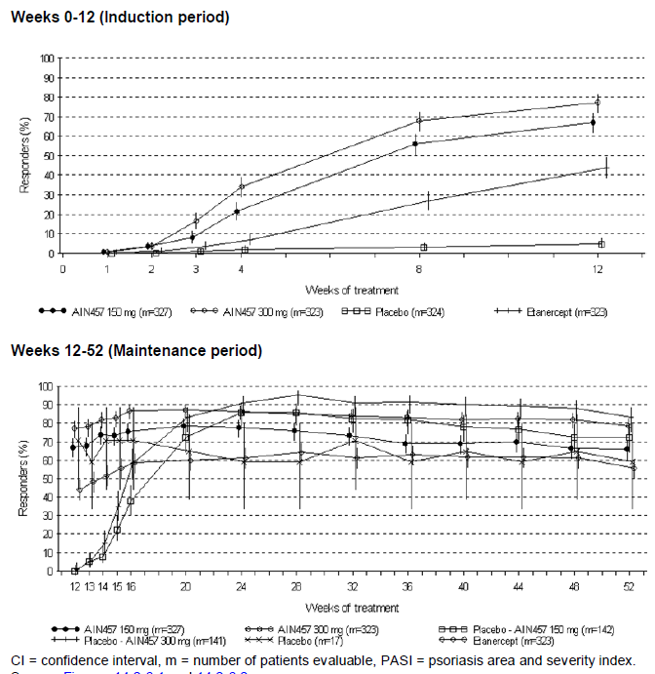

PASI 50, PASI 75, PASI 90, PASI 100, and IGA mod 2011 0 or 1 response over time
For all assessed variables, the proportion of responders increased continuously during the induction period in the secukinumab 150 mg and secukinumab 300 mg groups, always with a higher response rate in the higher 300 mg dose group. Throughout the maintenance period, the number and percentage of patients with PASI 50, PASI 75, PASI 90, PASI 100 and IGA mod 2011 0 or 1 response was higher in both secukinumab dose groups than in the etanercept group at each visit, with superior response rates in the secukinumab 300 mg dose group than in the secukinumab 150 mg dose group. In the placebo-secukinumab dose groups, the percentage of responders increased between Week 12 and Week 52 and reached response rates comparable or even higher than the secukinumab 150 mg and secukinumab 300 mg group, respectively. The percentage of responders was always higher in the placebo-secukinumab 300 mg group than in the placebo-secukinumab 150 mg group.
PASI 90 response rates at any time up to Week 52 for patients with PASI 75 response but without PASI 90 response at Week 12 were highest in the secukinumab 300 mg group (85.1%), followed by the secukinumab 150 mg group (80.5%) and the etanercept group (78.7%). A similar trend was seen for the PASI 100 response during the maintenance period for patients with PASI 75 response but without PASI 90 response at Week 12 the percentage of patients with PASI 100 response at any time up to Week 52 was highest in the secukinumab 300 mg group (35.1%), followed by the secukinumab 150 mg group (29.3%) and the etanercept group (28.0%). Collectively, these results indicate that patients who responded to treatment (that is, achieve PASI 75) after 12 weeks of induction therapy had numerically higher rates of further improvement (that is, achieving PASI 90 or PASI 100) with the higher dose of secukinumab, compared to the lower dose or etanercept.
Similarly, IGA mod 2011 0 or 1 response rates increased between Week 13 and Week 52 in all active treatment groups: from 14.4% to 34.4% for secukinumab 150 mg, from 18.2% to 47.9% for secukinumab 300 mg, and from 7.2% to 29.8% for etanercept. Throughout the maintenance period, the IGA mod 2011 0 or 1 response rate was higher in the secukinumab 300 mg group than in the secukinumab 150 mg and etanercept groups.

Exploratory efficacy results
HAQ-DI was assessed for the subset of patients who had PsA at baseline, as noted on the eCRF (48, 49, 50 and 44 patients had psoriatic arthritis in the placebo, secukinumab 150 mg, 300 mg and etanercept groups, respectively). The mean HAQ-DI score improved during the induction period in both secukinumab dose groups and in the etanercept group but not in the placebo group. The mean improvements achieved at Week 12 were sustained throughout the maintenance period in all active treatment groups.
The cumulative probability of relapse (defined as a > 50% reduction of the maximal PASI improvement) at > 36 to ≤ 40 weeks after Week 12 was lowest in the secukinumab 300 mg group (3%, 6.6% and 11.1% in secukinumab 300 mg, 150 mg and etanercept groups, respectively). Rebound (defined as increase in PASI to > 125% of baseline PASI within 8 weeks of last dose of study treatment) was less frequently reported in any active treatment group (10/43 patients [23.3%] for secukinumab 150 mg, 6/28 patients [21.4%] for secukinumab 300 mg, and 8/41 patients [19.5%] for etanercept) than in the placebo group (7/12 patients [58.3%]) and the majority of cases having rebound were identified by the presence of ‘more inflammatory’.
Comment: The results regarding rebound following discontinuation of secukinumab treatment should be interpreted with caution, as assessments of rebound were based on a small, biased sample of discontinued patients and patients not continuing in the extension study. Further analyses of rebound for the completers of the study who do not enter extension study will be presented later within a separate study report of the Week 52 to Week 60 followup period.

Quality of life
PGIC: At baseline, the overall impact of psoriasis on the patient’s life and the severity of current psoriasis symptoms since the start of the study were assessed as ‘about the same’ for the largest proportion of patients in all treatment groups (35.5% to 50.8%). At Week 12, approximately 60% of patients in both secukinumab dose groups assessed the overall impact of psoriasis on their life and the severity of current psoriasis symptoms since the start of the study as ‘a great deal better,’ compared to approximately 30% and 5% of patients in the etanercept and placebo groups, respectively. Overall, > 90% of patients in both secukinumab dose groups reported an improvement in PGIC items since start of the study compared to approximately 80% and 25% of patients in the etanercept and placebo groups, respectively. A worsening in PGIC items during the induction period was reported by < 5% of patients in both secukinumab dose groups compared to 8.5% and 50% of patients in the etanercept and placebo groups, respectively.
Comment: It is important to note that PGIC was collected for a subset of patients for whom the Psoriasis Symptom Diary was collected and therefore the results should be interpreted with caution due to possible selection bias.
Mean changes from baseline in the EQ-5D health assessment (ranging from 0 (worst possible health state) to 100 (best possible health state)) increased continuously during the induction period in both secukinumab dose groups and in the etanercept group but not in the placebo group.
The DLQI total score improved (decreased) continuously during the induction period in all active treatment groups, with a more pronounced decrease in both secukinumab dose groups than in the etanercept group. Changes in DLQI total score at Week 12 reached a mean of − 10.4 (− 78.8%) in the secukinumab 300 mg group, − 9.7 (− 72.7%) in the secukinumab 150 mg group, and − 7.9 (− 56.0%) in the etanercept group. In contrast, total DLQI scores in the placebo group only improved by a mean score of – 1.9 (− 3.6%). More pronounced improvements in both secukinumab dose groups than in the etanercept group were also seen for all individual scores (symptoms and feelings score, daily activities score, leisure score, work and school score, personal relationships score, and treatment score). The improvements in DLQI scores seen during the induction period were sustained throughout the maintenance period.
Comment: Secukinumab demonstrated a rapid onset of efficacy with superior efficacy over placebo and etanercept in the treatment of patients with moderate to severe chronic plaque type psoriasis. Secukinumab 300 mg and 150 mg were both significantly superior to placebo and etanercept with respect to PASI 75 and to IGA mod 2011 0 or 1 response at Week 12. Moreover, both secukinumab doses were superior to placebo in the PASI 90 response at Week 12. Rapid onset of efficacy was demonstrated with the higher efficacy of 300 mg and 150 mg secukinumab relative to placebo and etanercept appearing as early as Week 2 for PASI 50, Week 3 for PASI 75 and IGA mod 2011 0 or 1, and Week 4 for PASI 90, with a peak effect seen around Week 16 for PASI 75 and IGA mod 2011 0 or 1 responders. A higher percentage of responders were observed in the secukinumab 300 mg group than in the secukinumab 150 mg group. The efficacy of secukinumab was sustained up to 52 weeks of treatment with a statistically significantly greater percentage of patients achieving PASI 75 response and IGA mod 2011 0 or 1 response at Week 52 compared with etanercept and placebo. Secukinumab 300 mg showed improved responses rates, particularly for IGA mod 2011 0 or 1, PASI 90 and PASI 100 which were all endpoints reflecting higher levels of plaque clearance. Both secukinumab doses were superior to placebo and showed greater improvement versus etanercept in the Psoriasis Symptom Diary items itching, pain, and scaling at Week 12.

Study A2308

Study design, objectives, locations and dates
This was a Phase III, randomised, double blind, placebo controlled, multicenter study of subcutaneous secukinumab in pre filled syringes to demonstrate efficacy after twelve weeks of treatment, and to assess the safety, tolerability, usability and long term efficacy in subjects with chronic plaque type psoriasis: first study of Secukinumab in pre filled syringes in subjects with chronic plaque type psoriasis: response at 12 weeks (FEATURE). The study consists of 5 periods: screening (1 to 4 weeks), induction (12 weeks), maintenance (40 weeks), extension (up to 156 additional weeks), and follow up (8 weeks). The CSR provided in this submission only provides results up to Week 12 and for the Follow up period for patients who prematurely discontinued during the Induction period.
The study was initiated on 8 May 2012 and is still ongoing. It is being conducted at 32 centers in Canada (4), Estonia (2), France (4), Germany (5), and United States (17).

Inclusion and exclusion criteria
The study population consisted of a representative group of male and female outpatients (≥ 18 years old) with moderate to severe chronic plaque type psoriasis (defined as a PASI ≥ 12 and IGA mod 2011 of ≥ 3, in whom the disease was poorly controlled by topical treatments and/or phototherapy and/or previous systemic therapy. Other inclusion and exclusion criteria were similar to those discussed for Study A2302 above.

Study treatments
Eligible patients were randomised in a ratio of 1:1:1 to either secukinumab (150 mg or 300 mg) or placebo. Randomization was stratified by body weight (< 90 kg, ≥ 90 kg). Study treatment consisted of 2 s.c. injections, self administered via a PFS (secukinumab 150 mg + placebo, secukinumab 300 mg, or placebo only), at Randomization and Weeks 1, 2, 3, 4 and 8 (last dose of the Induction period).

Efficacy variables and outcomes
The main efficacy assessment was based on two co-primary variables evaluated at Week 12: PASI 75 response rate and the IGA mod 2011 0 or 1 response rate. PASI based secondary variables included absolute PASI score, response rates for PASI 50, PASI 90, and PASI 100. Secondary variables were based on the assessment of quality of life (DLQI) and health status (EQ-5D).
Usability assessments of the PFS were performed using a self injection check list, a possible hazard checklist, and SIAQ. The SIAQ PRE module was self completed before the first self injection at randomization, and the POST module was completed following the 2 self injections. The PRE module includes several items grouped into 3 domains (feelings about injections, self confidence and satisfaction with self injection) and was completed immediately before the first self injection. The POST module includes several items addressing four principal causal domains (feelings about injections, self confidence, injection site reactions, ease of use) plus a single item assessing self image, and was completed 20 to 40 minutes after dosing. There is no stipulated recall period for the SIAQ, because the recall period varies from one domain to another. Patients rated each item of the SIAQ on a 5 point semantic Likert type scale (1 corresponded to the patient’s worst experience and a score of 5 corresponded to the patient’s best experience). Item scores were transformed to obtain a score ranging from 0 (worst experience) to 10 (best experience) for each item. The domain score was the mean of the item scores included in the domain. Domain scores were calculated only if at least half of the domain items were completed.

Randomisation and blinding methods
All eligible patients were randomised via the Interactive Response Technology (IRT) to 1 of the 3 treatment groups. Randomization was stratified by body weight (≥ 90 kg or < 90 kg) as measured at the randomization visit of the induction period. It was targeted to have at least approximately 30% of the patients in either of the 2 strata. This was a double blind study. Patients, investigator staff, and persons performing the assessments remained blinded to the identity of the treatment from the time of randomization until final database lock.

Analysis populations
The randomised set included all 177 patients randomised to treatment. The Full Analysis Set (FAS) identical to the randomised set also consisted of all randomised patients. Patients were analyzed according to the treatment assigned at randomization and actual body weight stratum (< 90 kg, ≥ 90 kg). The safety set included all patients who took at least one dose of study drug and had at least one post baseline safety assessment. All efficacy analyses were based on the FAS. The safety analyses were based on the safety set. Patients were analysed according to the treatment they received.

Sample size
Since two secukinumab dose regimens were tested versus placebo with respect to the co primary endpoints (PASI 75 response and IGA mod 2011 0 or 1 response at Week 12), the type I error is split to 2.5% two sided for each comparison. With 57 patients per group and assuming a response rate of 5% for PASI 75 response and IGA mod 2011 0 or 1 response in the placebo group, the power to show a response rate of 55% for PASI 75 response and 30% for IGA mod 2011 0 or 1 response in the secukinumab groups based on Fisher’s exact test was above 99% for PASI 75 response and 90% for IGA mod 2011 0 or 1 response.

Statistical methods
The statistical methods were similar to those described for pivotal Study A2302.

Participant flow
Of the 209 screened patients, 177 patients were randomised to 3 treatment groups (59 patients in each treatment group). Most patients (96.0%) completed the 12 week induction period. Two patients discontinued treatment due to AEs; 1 patient each in the secukinumab 300 mg and placebo groups.

Major protocol violations/deviations
No patient had a major protocol deviation which excluded them from the FAS or safety analysis sets. Eight patients had deviations that were considered important enough to have a potential impact. The deviations in this category were primarily related to prohibited concomitant medications used during the study (n = 4) and for not complying with the washout period for prohibited medications prior to study inclusion (n = 3). The impact of these deviations on the overall results is likely minimal, if any, given the small percentage of patients affected. Per protocol analyses excluding these patients were not performed. Overall 42.9% of all patients had at least one protocol deviation (most common being key procedures not being performed as per protocol and selection criteria not having been met). The treatment groups were evenly balanced with the respect to most of the protocol deviations reported.

Baseline data
The 3 treatment groups were balanced in terms of the baseline demographic, disease history and baseline disease characteristics. Most patients were male (66.1%), Caucasian (86.4% to 96.6%), with median age of 46 years. There were fewer patients ≥ 65 years old in the secukinumab 300 mg group (1/59, 1.7%) compared with the secukinumab 150 mg group (8/59, 13.6%) or placebo group (6/59, 10.2%). No other meaningful differences were noted between the treatment groups. Overall 28.8% of patients were current smokers. The disease history and baseline disease characteristics were consistent among treatment groups. The mean PASI score was 20.8, the affected mean body surface area (BSA) was 32.0% and the mean time since psoriasis diagnosis was over 19 years.
Overall 78 to 81% of the patients had relevant medical history/current medical conditions and the most common were musculoskeletal and connective tissue disorders (35.6% with psoriatic arthritis in 14.1%), surgical and medical procedures (29.4%), metabolism and nutrition disorders (18.1%), infections and infestations (17.5%), and immune system disorders (16.9%). There were no meaningful differences between treatment groups in terms of cardiovascular history with most common ongoing conditions being hypertension (36%), dyslipidemia/hyperlipidemia (23.2%), uncomplicated diabetes (9.0%) and stable coronary artery disease (2.8%).
Previous psoriasis systemic therapy was reported for 67.2% (119/177) of patients with a higher proportion in the secukinumab 150 mg group (76.3%, 59.3% and 66.1% in the secukinumab 150 mg, 300 mg and placebo groups, respectively). Patients had been treated with one (55/119, 46.2%), two (25/119, 21.0%), or three or more (39/119, 32.8%) psoriasis systemic therapies. Approximately two thirds of the patients (82/119, 68.9%) failed systemic therapy. The most common prior immunomodulating therapies included methotrexate (43/177, 24.3%), etanercept (42/177, 23.7%), ustekinumab (25/177, 14.1%) and adalimumab (24/177, 13.6%).
Overall 43.5% (77/177) of patients were exposed previously to biological therapy and over half of them (41/77, 53.2%) did not respond. Approximately half of the patients (49.4%) on prior biological therapy had received anti p40 therapy and about a quarter of them (26.3%) failed to respond. Of the patients on previous biologic therapy, 70.1% (54/77) had received anti TNFα treatment and 63.0% (34/54) of them failed to respond. For patients who previously failed anti TNFα treatment, the most frequently reported reason for discontinuation of previous biological therapy was lack of primary or secondary efficacy (32/34, 94.1%), while lack of tolerability was much less common (6/34 17.6%). Approximately half of the patients (88/ 177, 49.7%) were exposed previously to non biologic systemic therapy and three quarters (66/88, 75%) of them failed to respond. A higher proportion of patients randomised to the secukinumab 150 mg group had prior exposure non biologic systemic therapy. Other previous psoriasis therapies included topical medications (158/177, 89.3%), phototherapy (71/177, 40.1%) and photochemotherapy (24/177, 13.6%).
Treatment compliance was similar across treatment groups and most patients received all of their assigned injections: 93.2%, 91.5%, and 89.8% in the secukinumab 150 mg, 300 mg and placebo groups, respectively.

Results for the primary efficacy outcome
Compared with placebo, both secukinumab regimens (150 mg and 300 mg) were statistically significantly (p < 0.0001) superior to placebo with respect to PASI 75 response and IGA mod 2011 0 or 1 response at Week 12. None of the placebo treated patients achieved an IGA mod 2011 0 or 1 response or PASI 75 response at Week 12. Although the difference in PASI 75 response rates between the two secukinumab treatment groups was small, both IGA mod 2011 0 or 1 response rate and PASI 90 response show an incremental improvement in efficacy with secukinumab 300 mg dose.
The difference in response rates between the two doses of secukinumab was most pronounced with respect to PASI 100 response, which corresponds to a complete clearance of psoriasis based on PASI evaluation at Week 12, 43.1 % of the patients in the secukinumab 300 mg group achieved a PASI 100 response versus 8.5% of the patients in the secukinumab 150 mg group, and 0% of the patients in the placebo group (Table 18). A significant and rapid onset of efficacy was observed with high PASI 50 response rates as early as by Week 4 of treatment (77.6% with secukinumab 300 mg versus 67.8% with secukinumab 150 mg). At the same time point nearly a quarter of the patients in the secukinumab 150 mg group and over half of the patients in the 300 mg group had already achieved PASI 75 response. The p values for the differences between 300 mg versus 150 mg secukinumab, as assessed by the CMH test, were 0.8195 for PASI 50, 0.4405 for PASI 75, 0.0974 for PASI 90, < 0.0001 for PASI 100, and 0.0570 for IGA mod 2011 0 or 1 (CMH test and logistic regression for PASI 75, PASI 90, PASI 100, and IGA mod 2011 0 or 1 response at Week 12 could not be performed as there were no responders in the placebo group).

Table 18. Number (%) of patients with PASI 50, PASI 75, PASI 90 and PASI 100 and IGA mod 2011 0 or 1 response by visit (non responder imputation) (FAS).
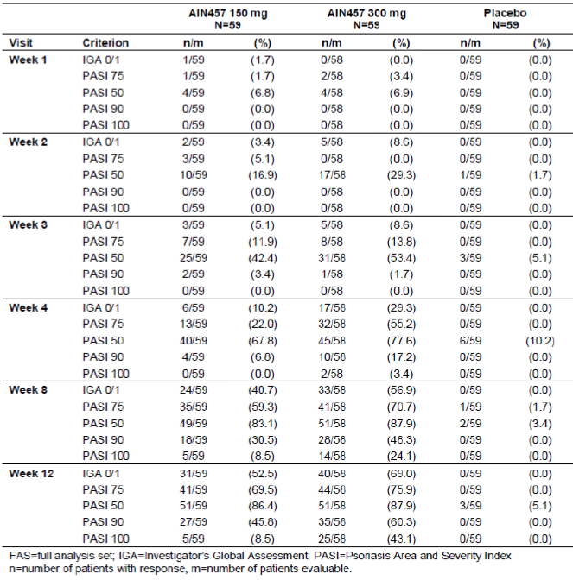
The robustness of these results were confirmed by the sensitivity analysis in which non response was imputed for patients with missing injections up to Week 12, dropouts due to AEs or lack of efficacy, patients with protocol deviations due to inclusion/exclusion criteria, and patients with missing data at Week 12 and also in the sensitivity analysis using multiple imputation method for missing values.

Results for other efficacy outcomes

Secondary efficacy results
In both secukinumab groups, there was a general increase in the percentage of PASI 50, PASI 75, PASI 90, and PASI 100 responders over the first 12 weeks of treatment. Except for PASI 50 response, the effects on PASI rates were dose dependent with a higher response rates observed with secukinumab 300 mg compared with secukinumab 150 mg. A rapid onset of efficacy was observed with both secukinumab groups with peak response rates for PASI 50, PASI 75, PASI 90 and PASI 100 observed at Week 8, then remained steady until Week 12. In the placebo group, the PASI 50, PASI 75 and PASI 90 responder remained ≤ 10.2%, 0% and 0%, respectively throughout the Induction period. Similar results were observed for IGA mod 2011 0 or 1 response rates.

Efficacy results in subgroups
Significantly improved responses were seen for secukinumab 150 mg and 300 mg versus placebo with respect to PASI 75, IGA mod 2011 0 or 1 and PASI 90 responses at Week 12 and were consistent in both body weight subgroups although higher response rates were observed in patients weighing < 90kg for all treatment groups.
There were 119 (67.2%) patients previously exposed to systemic therapy and 58 (32.8%) systemic treatment naïve patients. At Week 12, IGA mod 2011 0 or 1, PASI 75, and PASI 90 responses for 150 mg and 300 mg were significantly higher than placebo both in patients previously exposed to systemic therapy and in patients not previously exposed to systemic therapy. Response rates in previously exposed patients were similar to the rates in those not previously exposed, except for PASI 90 response, which was higher in the 150 mg group in patients who were not previously exposed to systemic therapy. The IGA mod 2011 0 or 1, PASI 75 and PASI 90 response rates in the patients who had failed on previous systemic therapy were similar to response rates for the overall group of patients previously exposed to systemic therapy.
There were 77 (43.5%) patients who were previously exposed to biologic therapy and 100 (56.5%) patients who were not previously exposed to biologic therapy At Week 12, IGA mod 2011 0 or 1, PASI 75, and PASI 90 responses for 150 mg and 300 mg were significantly higher than placebo in patients previously exposed or not exposed to biologic therapy. Patients not previously exposed to biologic therapy generally showed numerically higher response rates than those previously exposed to biologic therapy. The PASI 75 response rate was about 80% for both the 150 mg and 300 mg groups in those patients previously exposed and about 70% in those not previously exposed to biologic therapy. Among those exposed patients who had responded to previous biologic therapy, the PASI 75 response rate was approximately 60 to 70% for both the 150 and 300 mg groups. The IGA mod 2011 0 or 1, PASI 75 and PASI 90 response rates in the patients who had failed on previous biologic therapy were similar to response rates for the overall group of patients previously exposed to biologic therapy. Most of the patients previously exposed to biologic therapy were treated with anti TNFα therapy. Among the patients previously exposed to anti TNFα therapy, IGA mod 2011 0 or 1 PASI 75 and PASI 90 response rates were higher for the secukinumab 300 mg group compared with the 150 mg group. Response rates were comparable between those previously exposed to anti TNFα therapy and those who had failed previous anti TNFα therapy.
There were 88 (49.7%) patients who were previously exposed to non biologic systemic therapy and 89 (50.3%) patients who were not previously exposed to non biologic systemic therapy. At Week 12, IGA mod 2011 0 or 1, PASI 75, and PASI 90 responses for 150 mg and 300 mg were significantly higher than placebo in patients previously exposed to non biologic systemic therapy and in patients not previously exposed to non biologic systemic therapy, with similar response rates between these groups. In patients who failed previous non biologic systemic therapy, the IGA mod 2011 0 or 1, PASI 75 and PASI 90 response rates were similar to the response rates for the overall group of patients previously exposed to non biologic systemic therapy.

EQ-5D and DLQI (0 or 1 achievement)
Generally, more patients in the secukinumab groups reported improvements on each of the questions of the EQ-5D health state assessment. The EQ-5D questions where improvements in secukinumab groups were most evident were on pain/discomfort, usual activities, and anxiety/depression questions. Benefit of secukinumab treatment over placebo was statistically significant in the EQ-5D questions on self care, usual activities, and pain/discomfort. At Week 12, the overall change from baseline on the EQ-5D health state assessment (from 0 to 100) indicated an improved health state in both secukinumab groups (mean percent change of + 24.6% for secukinumab 150 mg and + 24.7% for secukinumab 300 mg) compared with placebo (+ 6.8%). The proportion of patients achieving DLQI 0 or 1 response (that is, total score of 0 or 1 out of the maximum of 30) at Week 12 was statistically significantly higher for both secukinumab groups compared with placebo (54.4%, 54.7% and 7.4% with secukinumab 150 mg, 300 mg and placebo, respectively).
There were no rebounds or rebound like events observed in the 7 patients who discontinued using the induction period of this study.

Usability of secukinumab administration via a prefilled syringe
The patient reported scores on the principal domains of the SIAQ (scale 0 to 10) increased (improved) over time between the randomization and Week 12 visits for all treatment groups. The absolute change from baseline to Week 12 in the mean score for the total population was + 0.83 for the ‘feelings about self-injection’ domain, + 1.14 for the ‘self confidence’ domain, and + 1.52 for the ‘satisfaction with self injection’ domain suggesting that self injection with PFS was acceptable to study participants.
Comment: In this study of patients with chronic moderate to severe plaque type psoriasis, secukinumab 150 mg and 300 mg administered s.c. via a prefilled syringe was significantly superior to placebo in achieving clinically relevant PASI 75 and IGA mod 2011 0 or 1 responses after 12 weeks of treatment. Secondary efficacy analyses suggested that the 300 mg secukinumab dose was more effective at achieving PASI 75, PASI 90, PASI 100 and IGA mod 2011 0/1 responses with a faster onset of action, compared to the 150 mg secukinumab dose, with both doses showing higher response rates than placebo. This is an on going study and results of the maintenance (40 weeks) and extension (up to 156 weeks) should be provided by the sponsor on completion of the study.

Study A2309

Study design, objectives, locations and dates
This was a Phase III, randomised, double blind, placebo controlled, multicenter study of subcutaneous secukinumab in autoinjectors to demonstrate efficacy after 12 weeks of treatment, and to assess the safety, tolerability, usability and long term efficacy in 182 patients with chronic plaque type psoriasis. Judging the Efficacy of Secukinumab in Patients with Psoriasis using Autoinjector: a Clinical Trial Evaluating Treatment Results (JUNCTURE).
The study was designed to compare 2 doses of secukinumab (150 mg and 300 mg) and placebo administered subcutaneously (s.c) using an autoinjector/pen (AI). The study consisted of 4 periods: Screening (1 to 4 weeks), Induction (12 weeks), Maintenance (40 weeks), and Follow up (8 weeks). At randomization, eligible patients were assigned equally to 1 of 3 treatment groups (stratified by body weight (< 90 kg or ≥ 90 kg at the Randomization visit)). During the Induction period, all 3 treatment groups received AI study treatment and/or AI placebo weekly for four weeks (Randomization and Weeks 1, 2, and 3) and then one dose of study treatment and/or placebo at Weeks 4 and 8 (last dose during the Induction period).
The study was initiated on 17 Oct 2012 and is currently ongoing; it was conducted at 38 centres in Canada (6), Estonia (2), France (3), Germany (16) and United States (11).

Inclusion and exclusion criteria
These were similar to those described for Study A2308 above.

Study treatments
Secukinumab 150 mg provided in a 1 mL pre filled AI (1 AI for 150 mg dose, 2 AI for 300 mg dose), administered s.c..

Efficacy variables and outcomes
These were similar to those described for Study A2308 above.

Randomisation and blinding methods
These were similar to those described for Study A2308 above.

Analysis populations, sample size and statistical methods
These were similar to those described for Study A2308 above.

Participant flow
Of the 220 screened patients, 182 patients were randomised and 177 patients (97.3%) completed the 12 week induction period. Only 5 patients discontinued (3 in secukinumab 150 mg and 2 in placebo group).

Major protocol violations/deviations
Overall, only 6 patients had deviations that may have had a potential impact (related to prohibited concomitant medication use during the study (n = 5) and for not complying with the washout period for prohibited medications prior to study inclusion (n = 1)). There were no major protocol violations which excluded patients from FAS and safety datasets. However, 54.9% of all randomised patients had at least one protocol deviation (most common were key procedures not being performed as per protocol (33.5% overall), selection criteria not having been met and GCP related deviations (both 12.1% overall)). The treatment groups were generally balanced with respect to most of the protocol deviations reported.

Baseline data
The three treatment groups were balanced in terms of the baseline demographic and disease characteristics. Most patients were male (68.7%) and Caucasian (95.1%) with median age of 44.0 years and a mean BMI of 30.21kg/m². There were variations between treatment groups in the history of smoking; more patients in the secukinumab 150 mg treatment group were current smokers (44.3%) compared with the secukinumab 300 mg group (28.3%) and placebo group (36.1%). Current smokers had a mean 16.8 average pack years. The treatment groups were generally balanced according to disease history and baseline disease characteristics. The mean PASI score was 20.1, the affected mean BSA was 27.4%, and the mean time since psoriasis diagnosis was 20.5 years.
The most common prior antineoplastic and immunomodulating therapies included methotrexate (17.0%), ustekinumab (9.3%), adalimumab (8.8%), and etanercept (8.2%). Similar proportions of patients reported exposure to previous systemic therapy (55.5%) with most patients failing systemic therapy. Overall, 23.6% of the patients were previously exposed to biological therapy of whom nearly half failed to respond to biological therapy. Of the patients who had received biological therapy (20/43, 46.5%) had received anti p40 therapy with (8/20, 40%) of those patients failing to respond. Of the patients previously exposed to biologic therapy, (27/43, 62.8%) had received anti TNFα treatment and over half failed to respond (15/27, 55.6%). For patients who previously failed anti TNFα treatment, the most frequently reported reason for discontinuation of previous biological therapy was lack of primary efficacy (11/15, 73.3%), lack of secondary efficacy (5/15, 33.3%), or lack of either primary or secondary efficacy (15/15, 100.0%), while no patient reported lack of tolerability. Approximately half of the patients (49.5%) were exposed previously to non biologic therapy with most failing to respond.
The majority of patients in all treatment groups had a relevant medical history or current medical condition (79 to 82%) with surgical and medical procedures (28.0%) followed by musculoskeletal and connective tissue disorders (20.9%) being most common. There was some variation between treatment groups regarding cardiovascular history; compared to the other treatment groups, more patients in the secukinumab 300 mg group had atrial fibrillation (5.0% versus 0 to 3.3%), dyslipidemia/ hyperlipidemia (20.0% versus 8.2 to 16.4%), hypertension (31.7% versus 26.2 to 27.9%), and stable coronary artery disease (5.0% versus 1.6 to 3.3%) compared with patients in other treatment groups, respectively. The rate of uncomplicated diabetes was higher in the placebo group (11.5%) compared with secukinumab treated patients (6.7 to 9.8%).
Treatment compliance: Most patients received all of their assigned injections; 88.5% (54/61) of patients on secukinumab 150 mg; 93.3% (56/60) of patients on secukinumab 300 mg, and 85.2% (52/61) of patients on placebo.

Results for the primary efficacy outcome
The co primary efficacy endpoint of PASI 75 response and IGA mod 2011 0 or 1 response at Week 12 was achieved. Both secukinumab regimens were superior to placebo with respect to PASI 75 response (71.7%, 86.7% and 3.3% in the secukinumab 150 mg, 300 mg and placebo groups, respectively) and the IGA mod 2011 0/1 response (53.3%, 73.3% and 0%, respectively). In both secukinumab groups, there was a general increase in the percentage of PASI 50, PASI 75, PASI 90, PASI 100 responders, and IGA mod 2011 0 or 1 responses over the first 12 weeks of treatment. The effects on PASI rates were dose dependent with higher response rates observed with secukinumab 300 mg compared with secukinumab 150 mg.

Results for other efficacy outcomes

Secondary efficacy results
PASI 50 response rates at Week 4 showed a rapid onset of efficacy in both secukinumab dose groups (300 mg vs 150 mg: 71.7% versus 51.7%). At the same time point nearly a quarter of patients in the secukinumab 300 mg group had already achieved PASI 75 response. PASI 50, PASI 75, PASI 90, and PASI 100 response rates showed similar trends over time. The percentage of PASI 50 responders increased after the first week of treatment in the secukinumab 300 mg group, the response was not as rapid for the secukinumab 150 mg dose group. For PASI 75 a sharper rise in response rates was observed early (Week 4) in the secukinumab 300 mg group compared with the 150 mg group. A higher proportion of patients achieved a PASI 75 by Week 12 in the 300 mg dose group.
In contrast the increase in PASI 90 and PASI 100 response rates was more gradual in both dose groups compared with PASI 75 or PASI 50, with a large increase from Week 8 to Week 12. A higher proportion of patients treated with secukinumab 300 mg achieved a PASI 90 and PASI 100 at any time point during the induction period compared with secukinumab 150 mg.
The IGA mod 2011 0 or 1 response over time followed a similar trend to the PASI 90 response over time, with a rapid increase in the proportion of patients achieving a response from Weeks 8 to 12 (Figure 9). No placebo treated patients achieved a PASI 90, PASI 100, or IGA 0/1 response at Week 12.
Figure 9. Time course of IGA mod 2011 0 or 1 responders (estimate + 95% CI) (non responder imputation). Induction period (FAS).
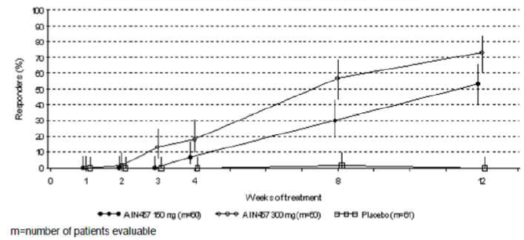

Efficacy in subgroups
Generally, patients weighing < 90 kg had numerically higher response rates on the endpoints (PASI 50, PASI 75, PASI 90, PASI 100, and IGA mod 2011 0 or 1) compared with those weighing > 90 kg in both the secukinumab groups. Dose appeared to have a greater impact on efficacy than baseline body weight (as assessed by a 90 kg stratification factor).
The improved efficacy seen with secukinumab 150 mg and 300 mg versus placebo at Week 12 with respect to IGA mod 2011 0 or 1, PASI 75, and PASI 90 was comparable in patients previously exposed and patients not previously exposed to either systemic therapy, biologic therapy or non biologic therapy. Secukinumab treated patients who had failed systemic, biologic, or non biologic therapy generally had comparable response rates to the overall group of patients previously exposed to each of these therapies. Response rates were higher in the 300 mg group than the 150 mg group, whether patients had been previously exposed or not to these therapies.

Other efficacy results
Similar improvements in the measures of QOL and health status (EQ-5D, DLQI) were shown for both secukinumab groups compared with placebo. Five patients discontinued treatment during the Induction period. Among these patients, only 1 patient had a follow up visit and was thus evaluable for rebound or rebound like events. There were no rebounds or rebound like events observed during the first 12 weeks of this study.
Comment: This trial confirmed the efficacy of secukinumab 150 mg and 300 mg administered via autoinjector/pen in the treatment of chronic moderate to severe plaque type psoriasis. Secukinumab 150 mg and 300 mg were superior to placebo in achieving clinically relevant PASI 75 and IGA mod 2011 0 or 1 responses after 12 weeks of treatment. The 300 mg secukinumab dose showed higher response rates for PASI 75, PASI 90, PASI 100 and IGA mod 2011 0 or 1 with a faster onset of action compared to the 150 mg dose. This is an on going study and results of the maintenance (40 weeks) and extension (up to 156 weeks) should be provided by the sponsor on completion of the study.

Other efficacy studies

Maintenance regimen Phase III Study A2304

Study design, objectives, locations and dates
This was a Phase III, randomised, double blind, multicenter study of subcutaneous secukinumab assessing PASI response and maintenance of response in subjects with moderate to severe chronic plaque type psoriasis on either a fixed dose regimen or on a retreatment at start of relapse regimen. The study consisted of four periods: screening (at least 1 week and up to 4 weeks), induction (12 weeks), maintenance (40 weeks), and follow up (8 weeks). The primary objective was to demonstrate the non inferiority of administration of 150 mg and 300 mg secukinumab at the start of relapse (SoR) versus fixed interval (FI) regimens with respect to PASI 75 response in patients with moderate to severe chronic plaque type psoriasis who were PASI 75 responders at Week 12: at Week 52 for patients in the fixed interval regimen, or at Week 40 for patients in the retreatment at start of relapse regimen who do not and who do require active treatment at Week 40 or at Week 52 for patients in the retreatment at start of relapse regimen who do require active treatment at Week 40.
The secondary objectives were the following, which applied to all patients for data up to Week 12 as well as to patients who were PASI 75 responders at Week 12; to evaluate the efficacy of treatment regimens with secukinumab with respect to PASI 50/75/90/100 and IGA mod 2011 0 or 1 response over time, up to Week 52; to evaluate the effects of treatment regimens with respect to PASI score and IGA mod2011 score over time, up to Week 52; to evaluate the clinical safety/tolerability and immunogenicity of secukinumab treatment regimens and to assess the effects of secukinumab treatment regimens with respect to EQ-5D, DLQI score over time, up to Week 52.
The study was conducted from 4 Aug 2011 to 7 Mar 2013 at 133 centers worldwide: Austria (4), Bulgaria (6), Canada (5), Czech Republic (6), France (5), Germany (22), India (10), Italy (4), Japan (15), Poland (3), Singapore (2), Slovakia (6), Switzerland (3), United Kingdom (5), United States (33), Vietnam (4).

Inclusion and exclusion criteria
Patients were included in the study if they were at least 18 years of age, were diagnosed with chronic plaque type psoriasis for at least 6 months prior to randomization, had moderate to severe psoriasis (defined as PASI score of minimally 12, an IGA mod 2011 score of at least 3, and a total BSA of at least 10%), and were candidates for systemic psoriasis therapy.
Key exclusion criteria were forms of psoriasis other than chronic plaque type (for example, pustular, erythrodermic and guttate psoriasis), drug induced psoriasis (that is, new onset or current exacerbation from beta-blockers, calcium channel inhibitors or lithium), had ongoing use of prohibited psoriasis treatments (for example, topical or systemic corticosteroids (CS), ultraviolet (UV) therapy) or non psoriasis prohibited treatments, and had previous exposure to secukinumab or any other biologic drug directly targeting IL-17 or the IL-17 receptor.

Study treatments
Secukinumab (AIN457) 150 mg, provided in glass vials each containing powder for solution for injection and matching placebo. The 150 mg powder for solution was used to prepare both the 150 mg dose (1 vial for 1 s.c. injection) and the 300 mg dose (2 vials for 2 s.c. injections). Patients were randomised using a 1:1 ratio into one of the two induction treatment arms below:
- Secukinumab 150 mg group: treated with secukinumab 150 mg from randomization to Week 8.
- Secukinumab 300 mg group: treated with secukinumab 300 mg from randomization to Week 8; Patients received treatment at Weeks 1, 2, 3, 4 and 8 (Week 8 was the last dose during the induction period).
At Week 12 (end of induction period), patients were classified and progressed as follows:
- PASI 75 responders (patients achieving at least 75% reduction of PASI compared to baseline) were re randomised into the maintenance period.
- PASI partial responders (patients achieving at least 50%, but less than 75% reduction of PASI compared to baseline) could enter Study A2307 and partial responders who did not want to enter protocol A2307 entered the treatment free follow up period.
- PASI non responders (patients achieving less than 50% reduction of PASI compared to baseline) progressed immediately into the treatment free follow up period; patients who discontinued study treatment prematurely during the induction period also entered the treatment free follow up period.
Maintenance Period (re randomization at Week 12 to Week 52):
At Week 12 PASI 75 responders were re randomised, within their same dose group of either 150 or 300 mg subcutaneous (s.c.) secukinumab, in a ratio of 1:1 to one of two treatment schedules: ‘fixed interval’ or ‘retreatment at start of relapse’, and stratified according to the same criteria as in the induction period. This resulted in four treatment arms.
Fixed interval regimen (FI):
In the maintenance period patients in the FI groups received the same dose they received during the induction period. Thus, secukinumab 150 mg patients continued to receive 150 mg secukinumab every four weeks, and secukinumab 300 mg patients continued to receive 300 mg secukinumab every four weeks, from Week 12 up to and including Week 48.
Retreatment at start of relapse regimen (SoR):
In the maintenance period, patients in the SoR group also received the same dose of secukinumab (150 mg or 300 mg) they received during the induction period every 4 weeks; however, after week 12, a patient was not dosed with active secukinumab until that patient met start of relapse criteria and continued dosing until PASI 75 response was regained. ‘Start of relapse’ was defined as a loss of ≥ 20% of the maximum PASI gain achieved during the study compared to baseline, and a loss of PASI 75 response. If a patient did not fulfil the criteria for start of relapse or achieved PASI 75 response after a start of relapse, they received placebo injections (two injections per dose) to maintain the blind. This treatment regimen was applied up to and including Week 48. Patients who discontinued study treatment prematurely during the maintenance period entered the treatment-free follow up period.

Efficacy variables and outcomes
PASI score, BSA assessment, IGA mod 2011 score, and quality of life measures (EQ-5D, DLQI, health assessment questionnaire disability index (HAQ-DI)) were used to evaluate the primary and secondary efficacy endpoints of the study.
The primary analysis of this trial was to show the non inferiority of the retreatment at start of relapse regimen to the fixed interval regimen with respect to maintenance of response, separately for the 150 mg and 300 mg dose groups. For patients in the fixed interval regimens, maintenance of response was defined as PASI 75 response at Week 52 and for patients in the start of relapse regimens, maintenance of response was defined as PASI 75 response at Week 52 for patients who qualified and did not qualify for active treatment at Week 40.
The secondary efficacy endpoints were PASI 50, PASI 75, PASI 90, PASI 100 and IGA mod 2011 0 or 1 response over time, PASI and IGA 2001mod 0 or 1 score over time; time to start of relapse; relationship between response to secukinumab treatment and having failed to respond to previous biologic psoriasis therapy; number of visits with PASI 50, PASI 75, PASI 90, PASI 100 and IGA mod 2011 0 or 1 response; number of secukinumab injections needed to regain PASI 75 response; subgroup analyses for maintenance of response; correlation between start of relapse criteria and changes in DLQI score.
Other exploratory efficacy variables included maintenance of IGA mod 2011 0 or 1 response after 52 weeks of treatment; Rebound which was defined as a worsening of PASI of > 125% of the value at baseline, or new pustular, erythrodermic or more inflammatory psoriasis occurring within 8 weeks of stopping therapy, where stopping treatment was defined as last study treatment administration; proportion of patients with relapse (achieved maximal PASI improvement from baseline is reduced by > 50%) during the maintenance period HAQ-DI score and HAQ-DI response were summarized over time for all patients with psoriatic arthritis.

Randomisation and blinding methods
Randomization was stratified by geographical region and by body weight collected at baseline (< 90 kg or ≥ 90 kg). In the induction period, eligible patients were randomised 1:1 using Interactive Response Technology (IRT) to treatment with either 150 mg or 300 mg subcutaneous (s.c.) secukinumab. In the maintenance period, PASI 75 responders were re randomised to either a fixed time interval regimen of the dose received during the induction period (150 mg or 300 mg s.c. secukinumab), or a ‘re treatment at start of relapse (SoR) regimen’ of the dose received during the induction period (150 mg or 300 mg s.c. secukinumab). Partial responders did not continue in the maintenance period of the study, but were given the option to enter Study A2307. Non responders did not continue in the maintenance period but entered the treatment free follow up period. This was a double blind study. Patients, investigator staff, and persons performing the assessments remained blinded to the identity of the treatment from the time of randomization until final database lock.

Analysis populations
The FAS comprises all patients to whom study treatment was assigned. The safety set includes all patients who took at least one dose of study treatment during the treatment period. Patients were analyzed according to treatment received. The per protocol set comprises all patients in the FAS who were re randomised at Week 12 who did not fulfil any criteria that could potentially confound the interpretation of analyses conducted on the FAS. In addition, patients non compliant with the treatment regimen were excluded from the per protocol set. The analysis of the primary variable was based on the FAS.

Sample size
The type I error for the non inferiority comparison of each retreatment at start of relapse dose regimen versus the corresponding fixed interval dose regimen with respect to maintenance of response was set to 1.25% one sided. With a non inferiority margin of 15% and assumed maintenance of response rates of 85% for the fixed interval and retreatment at start of relapse regimens, 141 patients per treatment group were needed to achieve a power of 90%.
Assuming a drop out rate of 5% from Week 12 up to Week 52, 149 patients per maintenance treatment group would have been needed, that is, about 298 patients should have been PASI 75 responder at Week 12 for each induction treatment group. Assuming a PASI 75 response rate of 65% at Week 12, the sample size per induction treatment group should have been 459. Hence the total sample size should have been 918. The assumed PASI 75 response rate at Week 12 for the induction regimens was assumed larger than in other placebo controlled studies in this development program. This assumption maybe justified since the secukinumab response rates were chosen conservatively in the placebo controlled studies and PASI 75 response rates in non placebo controlled trials tend to be larger than in placebo controlled trials (Leonardi at al 2003, Papp et al 2005, Tyring et al 2006 and Griffith et al 2010). If the assumed PASI 75 response rate at week 12 would have been 10% less, that is 55%, 119 patients would have been randomised to each maintenance treatment group. Under the assumptions above the power to show non inferiority would then have been about 84% In case a smaller maintenance of response rate was assumed (75% instead of 85%) the power to show non inferiority of the retreatment at start of relapse regimens versus the fixed interval regimens would have been decreased to about 75%. If both smaller PASI 75 response rates at Week 12 and smaller rates of maintenance of response were assumed, the power would have been decreased to 67%.

Statistical methods
The statistical null hypotheses with respect to maintenance of response is that the proportion of patients with maintenance of response was more than 15% points less in the retreatment at start of relapse regimen than in the fixed interval maintenance regimen. The primary analysis method was the stratified Mantel Haenszel test for risk differences. The test was stratified by geographical region and body weight stratum. Within a dose, the retreatment at start of relapse regimen was compared to the fixed interval regimen in a pairwise fashion with respect to the proportion of patients with maintenance of response using the Mantel Haenszel test statistics.
The family wise error was set to α = 2.5% (one sided). For the non inferiority comparison for each of the two doses, the one sided 98.75% confidence interval (CI) was derived. In case - 15% was smaller than the lower bound of the confidence interval for the difference in maintenance responder rates ‘retreatment at start of relapse regimen’ minus ‘fixed interval regimen,’ non inferiority was to be concluded. In the event non inferiority was shown for one dose, but not for the other dose, the alpha was to be shifted to the other dose and the null hypotheses could be retested at level α = 2.5% (one sided). Additional, sensitivity analyses on maintenance of response were performed, as well as exploratory analyses on a number of secondary efficacy variables, also on a number of subgroups.
Comment: No justification was provided for choosing a non inferiority margin of 15% between the secukinumab maintenance fixed interval and SoR regimens and this question has been raised in Section 11 below.

Participant flow
Of the 1200 screened patients, 966 patients were randomised to two balanced groups in the induction period: secukinumab 150 mg (n = 482) or secukinumab 300 mg (n = 484). Most randomised patients (928/966, 96.1%) completed the 12 week induction period. The most common reasons for premature discontinuation in the induction period were AEs (1.8%) and patient/guardian decision (1.4%) Of the 928 patients who completed the induction period, a total of 843 (90.8%) patients were re randomised to the maintenance period to either fixed interval dosing or start of relapse dosing at their respective dose level, resulting in four balanced groups: fixed interval secukinumab 150 mg (N = 203), fixed interval secukinumab 300 mg (N = 217), secukinumab 150 mg SoR (N = 206), or secukinumab 300 mg SoR (N = 217). Most patients (91.0%) completed the 52 week maintenance period. The discontinuation rate was highest in the 150 mg SoR group (12.1%) compared to the other groups (between 7.4% and 8.4%). The most common reason for premature discontinuation at any secukinumab dose was patient/guardian decision (35, 4.2%). Discontinuations due to AEs were similar in both the 150 mg SoR group (1.9%) and the 150 mg FI group (1.0%). Discontinuations due to AEs were more frequent in the 300 mg FI group (3.7%) compared to the 300 mg SoR group (0.9%). Discontinuations due to lack of efficacy were more common in the 150 mg and 300 mg SoR groups compared with the corresponding FI groups.

Major protocol violations/deviations
Protocol deviations occurred in 667 randomised patients (71 patients (57.7%) who participated in the induction period only, and 596 patients (70.7%) who participated in both the induction and maintenance periods). Of those patients assessed in the primary endpoint, that is, who re randomised into the maintenance period, 70.7% (n = 596) had at least one protocol deviation, of which the majority were considered minor and only 5.7% (n = 34) were considered a deviation of major or potential impact to efficacy or safety analyses; 46 patients had a deviation that was considered sufficiently important as to have a potential impact. The most common deviations in this category were related to prohibited medication use during the trial (n = 37) but the distribution across the treatment groups was balanced.

Baseline data
Baseline demographics and background characteristics for the induction period were evenly distributed between the treatment arms. Most patients were male (66.0%), Caucasian (71.6%) with median age of 46 years and majority were < 65 years. Overall, 34.1% of patients were current smokers. Baseline demographics and background characteristics for the maintenance period were similarly distributed, with the exception of a greater proportion of female patients in the 150 mg FI group.
For the induction period, the mean PASI score was 23.63, the affected mean BSA was 34.67, and the mean time since psoriasis diagnosis was 17.26 years; overall, 67%, 28% and 55% of the patients had prior exposure to systemic, biologic and non biologic psoriasis therapy, respectively. There were no significant differences in baseline disease characteristics between treatment groups. Similar results were observed for the maintenance period in terms of disease characteristics. Overall 65% of the patients had at least one relevant medical history or current medical condition in the induction period with similar results in the maintenance period; surgical and medical procedures (25.3%), musculoskeletal and connective tissue disorders (17.6%), infections and infestations (14.7%) and metabolism and nutrition disorders (13.6%) were most common. A history of cardiac disorders was reported by 3.4% of patients and 30.7%, 15.3%, 9.5% and 2.8% of patients had ongoing hypertension, dyslipidemia/hyperlipidemia, uncomplicated diabetes and stable coronary artery disease, respectively. In the induction period, the proportion of patients who were previously exposed to psoriasis systemic therapy were very similar between the 150 mg and 300 mg treatment groups (66.9% versus 66.3%, respectively) and 75.6% of patients at any secukinumab dose had failed prior psoriasis systemic therapy. Overall, the proportion of patients who were previously exposed to biologic psoriasis therapy was low (28.0%) and comparable in the 150 mg and 300 mg treatment groups (26.8% and 29.1%, respectively). Nearly half of the patients on prior biologic therapy had received anti p40 therapy (43.0%) and 17.2% of those patients failed to respond. Of the patients on previous biologic systemic therapy, 70.7% had received anti TNFα treatment and 59.2% failed to respond. For patients who previously failed anti TNFα treatment, the most reported reason for discontinuation was lack of primary or secondary efficacy (93.8%), while lack of tolerability was much less common (12.4%). Overall, 54.9% of the patients in the induction period were exposed previously to non biologic systemic therapy and 80.2% failed to respond. Other previous psoriasis therapies at any secukinumab dose during the induction period included topical medications (85.7%), phototherapy (35.5%), and photochemotherapy (17.0%). The most common prior immunomodulating therapies included methotrexate (30.5%), etanercept (14.2%), and ustekinumab (8.4%). Similar profile of previous exposure to systemic psoriasis therapy including failure rates were observed during the maintenance period.
Over the induction period 94.6% and 93.6% of patients in the 150 mg and 300 mg groups, respectively, received all 12 of the planned study treatment injections, as per protocol. Over the maintenance period, 91.6%, 87.0%, 86.8% and 87.1% of patients in the 150 mg and 300 mg FI and SoR groups, respectively, received all 20 of the planned study treatment injections, as per protocol. Overall compliance was high and there was no imbalance with regard to treatment non compliance among the treatment group.

Results for the primary efficacy outcome
This study did not meet the primary objective, as it was not shown that the re treatment at SoR maintenance regimen was non inferior to a FI regimen with treatment every 4 weeks. The maintenance of response was consistently lower for the SoR group compared with the FI group for both 150 mg (SoR versus FI: 52.4% versus 62.1%; diff = - 9.61%, 98.75% CI: - 20.19, 0.88) and 300 mg (67.7% versus 78.2%; - 10.34%, 98.75% CI: - 19.37, - 1.30) secukinumab groups. The non inferiority margin was pre defined at - 15% and the difference of the lower limit of the adjusted CI for SoR minus FI was approximately - 20% (for both 150 mg and 300 mg), and, hence, the non inferiority margin was exceeded.
Sensitivity analyses of maintenance of PASI response were performed in which non response was imputed for patients with missing injections from Week 12 to Week 48, dropouts due to AEs and unsatisfactory therapeutic effect up to Week 48, patients with protocol deviations due to inclusion/ exclusion criteria, and patients with missing PASI score from Week 40 to Week 52. The proportion of patients in the 300 mg SoR group who were able to maintain response was lower compared to the 300 mg FI group (57.6% versus 69.4%) with similar observation made between the 150 mg SoR group and the 150 mg FI group (46.6% versus 54.7%). Similar results were consistently observed: when PASI score was calculated without rounding the percentage area scores; when non inferiority was analysed using the CMH test. Overall, these data support the results of the primary efficacy endpoint where non inferiority could not be shown between SoR and FI dosing, in both 300 mg and 150 mg treatment groups.
Comment: No justification was provided for selection of the - 15% non inferiority margin. Furthermore, there was no non inferiority analysis done on the per protocol population although the sensitivity analysis did confirm findings of the primary FAS analysis.

Results for other efficacy outcomes

Induction period
Patients treated with 300 mg secukinumab in general showed numerically higher response rates than those treated with 150 mg. Response rates to secukinumab appeared as early as Week 2 (PASI 50 response rates 300 mg versus 150 mg = 32.9% versus 20.2%) and by Week 4, a notable difference in the proportion of patients achieving PASI 75 was observed between the 300 mg and 150 mg groups (42.9% versus 27.9%). Notably, at Week 12, PASI 100 (denoting a complete clearance of psoriasis as measured by the PASI scoring system) was achieved by 25.7% of patients on 300 mg secukinumab and 16.2% of patients on 150 mg secukinumab.

Maintenance period
The proportion of patients who entered the maintenance period with PASI 75 response and were re randomised were similar between the 150 mg SoR and FI groups (98.1% versus 98.0%) and between the 300 mg SoR and FI groups (99.1% versus 99.5%). Throughout the maintenance period, a higher proportion of patients in the FI groups (300 mg and 150 mg) achieved PASI 50, 75, 90, 100 and IGA mod 2011 0 or 1 responses compared with SoR groups (300 mg and 150 mg). At Week 52, the proportion of patients with PASI 75 response was higher in the FI compared to the SoR group for both 150 mg (FI versus SoR: 62.1% versus 35%) and 300 mg (78.2% versus 41.0%) dose groups. Similar results were observed for PASI 90 response rate (FI versus SoR: 150 mg: 45.8% versus 11.2%; 300 mg: 59.7% versus 13.8%) and PASI 100 (FI versus SoR: 150 mg: 46.8% versus 2.4%; 300 mg: 58.8% versus 5.1%). The highest proportion of patients with PASI 75 response (that is, peak response time) was observed at Week 16. At this particular time point, all four treatment groups had ≥ 90.0% of patients who achieved PASI 75 response. The proportion of patients who achieved IGA mod 2011 0 or 1 response at Week 12 and maintained this response at Week 52 was higher with the 300 mg and 150 mg FI groups (68.6% versus 60.3%, respectively) compared with the 300 mg and 150 mg SoR groups (22.6% versus 21.9%, respectively). The proportion of patients in both the 300 mg and 150 mg SoR dose groups with IGA mod 2011 category of clear (0) or almost clear (1) increased after Week 12 and peaked between Weeks 16 to 20. In contrast to the FI dose groups, the proportion of patients in the SoR dose groups with clear (0) or almost clear (1) responses declined steadily throughout the maintenance period. By Week 52, the proportion of patients with clear (0) responses in the 300 mg and 150 mg SoR groups was numerically lower (6.5% versus 5.8%, respectively) compared to the 300 mg and 150 mg FI dose groups (40.2% versus 23.3%, respectively).

Time to relapse after last study treatment administration
For both the 150 mg and 300 mg FI groups, the cumulative probability of having a relapse after last study treatment was low (13.3% versus 5.9%, respectively). In contrast to the FI groups, patients in both 300 mg and 150 SoR groups had higher cumulative probabilities of having a relapse (65.9% versus 33.7%, respectively), which was consistent with the study design. For the SoR groups, most patients relapsed earlier (between 0 and ≤ 16 weeks after last treatment for the 300 mg SoR group and between 0 and ≤ 20 weeks after last treatment for the 150 mg SoR group).

Number of visits with PASI 50, 75, 90, and 100 and IGA mod 2011 0 or 1 response
Most patients, regardless of treatment group, achieved PASI 50 response at most visits (that is, 8 to 10 visits). Patients in both the 300 mg and 150 mg FI groups achieved PASI 75, 90, and 100 responses and IGA mod 2011 0 or 1 response at more visits than their respective SoR groups.

Number of injections needed to regain PASI 75 response after retreatment at start of relapse has been initiated
Of patients who regained PASI 75 any time during the trial after meeting SoR criteria for the first time, 68.0% in the 150 mg SoR group and 76.6% in the 300 mg SoR group regained PASI 75 response within 8 weeks; and 79.3% in the 150 mg SoR and 90.7% in the 300 mg SoR regained PASI 75 response within 12 weeks, indicating overall a shorter time to regain PASI 75 response in the 300 mg SoR group. In the 150 mg SoR group, 59 of the 206 patients in the FAS (28.6%) met SoR criteria a second time within the maintenance period; in the 300 mg SoR group 85 of the 217 patients assessed (39.2%) met SoR criteria a second time within the maintenance period. In the 150 mg SoR group, 59 of the 206 patients in the FAS (28.6%) met SoR criteria a second time within the maintenance period; in the 300 mg SoR group 85 of the 217 patients assessed (39.2%) met SoR criteria a second time within the maintenance period. Of those that met SoR criteria, only 21/59 (35.5%) in the 150 mg SoR group and 36/85 (42.4%) in the 300 mg SoR group were successful in regaining PASI 75 response a second time during the treatment period. Of those successful in regaining PASI 75 response at any time in the trial, four weeks after meeting criteria (after 1 active secukinumab injection for the 150 mg dose level and 2 active secukinumab injections for the 300 mg dose level), 47.6% and 58.3% in the 150 mg SoR and 300 mg SoR groups regained PASI 75 response, and eight weeks after meeting criteria (after 2 active secukinumab injections for the 150 mg dose level and 4 active secukinumab injections for the 300 mg dose level), an additional 42.9% (cumulatively 90.5%) and 19.4% (cumulatively 77.7%) in the 150 mg SoR and 300 mg SoR groups had regained PASI 75 response. Few patients in either the 150 mg or 300 mg SoR groups had three or more SoR episodes. Therefore, no meaningful conclusions could be drawn.

Rebound or rebound like events
The patients evaluable were those who had received their last dose of medication and included primarily patients who terminated early in the study (that is, in total, 121/842 (14.4%) evaluable patients for rebound up to 8 weeks after last injection). Patients were identified as having rebound by an increase in PASI to > 125% of baseline PASI, or presence of new pustular, erythrodermic, or more inflammatory psoriasis occurring at any time after 8 weeks of stopping therapy (CHMP/EWP/2454/02 2004). Most of the patients identified as having rebound were identified by the presence of ‘new erythrodermic psoriasis or new pustular psoriasis’. These included 4/38 (10.5%) of patients in the 150 mg FI group and 3/36 (8.3%) in the 300 mg FI group.

EQ-5D
During the induction period, a clear effect of secukinumab treatment was seen in the category of ‘Pain/Discomfort,’ where the proportion of secukinumab treated patients reporting no pain or discomfort increased from 19.6% and 24.1% (150 mg and 300 mg, respectively) at baseline to 66.8% and 77.4%, respectively, at Week 12. Similar results were observed for the categories ‘Anxiety/Depression’ and ‘Usual Activities.’ As the majority of patients in all treatment groups did not report any problems with ‘Mobility’ and ‘Self care’ at baseline, no impact of secukinumab treatment could be discerned post baseline. In the maintenance period, the improvements observed during the induction period in ‘Pain/Discomfort’, ‘Anxiety/Depression’, and ‘Usual Activities’ were maintained through Week 52 for patients who were randomised to the 300 mg and 150 mg FI groups. In contrast to the FI groups, patients who were randomised to the 300 mg and 150 mg SoR groups at Week 12 saw a decline over time in the maintenance of EQ-5D categories of ‘Pain/Discomfort’, ‘Anxiety/Depression’, and ‘Usual Activities’ up to Week 52.

DLQI
In the induction period, the number of patients who saw a decrease in DLQI score, (improvement) and achieved a score of 0 or 1 increased over time up to Week 12. At each visit, the proportion of patients with DLQI 0 or 1 response was higher for the 300 mg group compared with the 150 mg group. In the maintenance period, beginning with Week 32 and up to Week 52, highly significant differences were observed in the number of patients with DLQI 0 or 1 response in both the 300 mg and 150 mg FI groups compared to their respective SoR counterparts (p < 0.0001).
Comment: This study did not confirm the SoR dosing strategy as non inferior to a same dose FI dosing regimen of secukinumab in plaque type psoriasis, even though both FI and SoR regimens led to clinically meaningful response rates. Consistently across efficacy measures (PASI 75/90/100 and IGA mod 2011 0 or 1), patients in the FI groups showed increased maintenance of response rates at Week 52 over the SoR groups, and patients at the 300 mg dose had higher response rates and increased maintenance of response rates at Week 52 over the 150 mg dose within each regimen (FI or SoR). No new safety signals were identified during the study.

Study 2307

Study design, objectives
This was a Phase III, multicenter, randomised, double blind, double dummy, active controlled, parallel group trial in patients with moderate to severe chronic plaque type psoriasis who were ‘partial responders’ (that is, patients who achieved PASI 50 but not PASI 75) after the first 12 weeks of s.c. injection treatment in Study A2304 (Secukinumab Trial Analyzing the potential of intravenous administration to upgrade the response in psoriasis (STATURE)). Study A2307 consisted of 3 periods: i.v. (i.v. infusion and s.c. injection regimens given in a double blind fashion); Maintenance; and Follow up. The primary objective was to evaluate the efficacy of i.v. administration of secukinumab compared with s.c. administration of secukinumab with respect to both PASI 75 and Investigator’s Global Assessment (IGA) 0 or 1 response (co primary endpoints) at Week 8 in moderate to severe chronic plaque type psoriasis in patients who achieved a partial response after 12 weeks of treatment in Study A2304. The secondary objectives were to assess: the efficacy of a higher dose of secukinumab than administered in Study A2304 in achieving PASI 75 or IGA 0 or 1 response over time, up to Week 40; efficacy of secukinumab treatment regimens with respect to PASI 50/75/90/100 response and IGA mod 2011 0 or 1 response over time, up to Week 40; efficacy of secukinumab treatment regimens with respect to PASI score and IGA mod 2011 score over time, up to Week 40; effects on DLQI, EQ-5D at Week 8, and over time, up to Week 40; clinical safety/ tolerability and immunogenicity of secukinumab treatment regimens; to investigate the relationship between response to secukinumab treatment and having failed to respond to previous biologic psoriasis therapy.
The study was conducted from 2 Dec, 2011 to 28 Feb 2013 at 23 centers in Austria (1), Canada (2), Germany (5), France (1), India (3), Japan (4), Slovakia (1), and USA (6).

Patient disposition, baseline characteristics:
Since the PASI 75 response rate in Study A2304 study was higher than predicted, the number of partial responders was lower than expected and, hence, fewer patients were eligible to enter the current study than originally planned. Hence, only 43 patients were randomised into Study A2307 and 40 (93.0%) patients completed the i.v. period. Overall, 83.7% of all patients had at least one protocol deviation, and 6 patients had deviations which were considered of potential impact. There were no imbalances in the frequency or type of protocol deviations across the treatment groups No patient was excluded from any of the datasets used in this study due to a protocol deviation. A per protocol analysis was not performed. Of the 43 patients enrolled and randomised in the current study, most patients (88.4%) were below 65 years of age, with the mean age of 46.6 years (range: 20 to 71 years). Most patients were Caucasian, male and had ‘other’ designated for ethnicity. There were more men in the secukinumab 300 mg s.c. group than in the secukinumab 10 mg/kg i.v. group (76.2% versus 59.1%), who were also heavier (102.2 kg versus 92.4 kg; BMI: 34.1 versus 30.0 kg/m²). Baseline disease characteristics of patients in this study were indicative of the target population and were consistent with the population of patients in clinical studies with moderate to severe chronic plaque type psoriasis. Baseline mean PASI score was 21.8 and 60.5% had a baseline PASI score ≤ 20. The mean affected body surface area (BSA) was 32.1%, and all patients had moderate to severe disease. Most patients (67.4%) were previously treated with systemic psoriasis therapy and 48.8% of patients failed their systemic therapy. The majority of patients (74.4%) did not present with psoriatic arthritis at baseline.

Primary efficacy results
This study did not demonstrate that up titration with secukinumab 10 mg/kg i.v. was statistically significantly more efficacious than up titration to or prolonging treatment with secukinumab 300 mg s.c. with respect to PASI 75 response at Week 8. While the study did not meet the required statistical significance for both co primary endpoints, there were trends in favour of the secukinumab 10 mg/kg i.v. dose, with numerically higher response rates than observed for patients in the 300 mg secukinumab s.c. group (Table 19). Sensitivity analyses support the primary endpoint results. Compared with those in the secukinumab 300 mg s.c., a numerically higher proportion of patients in the secukinumab 10 mg/kg i.v. group achieved IGA 0 or 1 (10mg IV versus 300 mg sc: 63.6% versus 33.3%), PASI 75 (86.4% versus 61.9%) and PASI 90 (59.1% versus 9.5%) response at Week 8.

Table 19. Statisitical analysis (Cochran Mantel Haenszel test) of IGA mod 2011 0 or 1, PASI 75 and PASI 90 response at Week 8 (non responder imputation) (FAS).
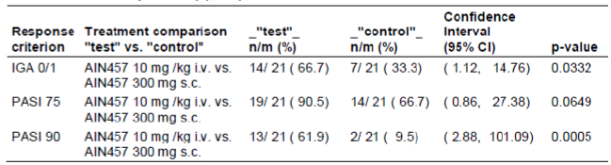

Secondary efficacy results
At every visit beginning with Week 2, a numerically higher proportion of patients in the secukinumab 10 mg/kg i.v. group achieved PASI 75, PASI 90, and PASI 100 compared with those in the secukinumab 300 mg s.c. group and these results were consistently maintained throughout the study, up to Week 40. However, it should be noted that compared to baseline, responders in the 300 mg group also improved numerically over time.
The proportion of patients who achieved IGA mod 2011 0 or 1 response was numerically higher in the secukinumab 10 mg/kg i.v. group compared with the secukinumab 300 mg s.c. group and these results were consistently maintained throughout the study, up to Week 40. At Week 8 in the i.v. period, a statistical difference was observed between the 10 mg/kg i.v. and the 300 mg s.c. group using the CMH test and logistic regression analysis for IGA 0 or 1 response (p = 0.0332 and p = 0.0324, respectively) and PASI 90 response (p = 0.0005 and p = 0.0015, respectively).

Other efficacy results
While most of the secukinumab treated patients who achieved PASI 75 response at Week 8 were able to maintain PASI 75 at Week 40 (secukinumab 10mg iv versus 300 mg sc: 68.4% versus 64.3%), the cumulative probability of losing PASI 75 response by 40 weeks of treatment in Week 8 PASI 75 responders was lower in the secukinumab 10 mg/kg i.v. group compared with 300 mg s.c. group (33.1% versus 52.4%,).
Prolonging or increasing the exposure levels in partial responders from (A2304) led to higher PASI 75 response rates at Week 8 compared to baseline in the current study (when all patients were partial responders), although these results must be interpreted with caution due to the low numbers of patients in each of these groups: Of those 6 patients who were treated with 300 mg s.c. in the A2304 study and were then maintained on the same treatment in the current study (prolongation of exposure), 4 patients (66.7%) had a PASI 75 response at Week 8. Of those 15 patients who up titrated from 150 mg s.c. in the A2304 study to 300 mg s.c. in the current study (increase in exposure), 10 patients (66.7%) had a PASI 75 response at Week 8. Of those 14 patients who were treated with 150 mg s.c. in the A2304 study and then switched to 10 mg/kg i.v. in the current study (increase in exposure), 13 patients (93%) had a PASI 75 response at Week 8. Of those 8 patients who were treated with 300 mg s.c. in the A2304 study and then switched to 10 mg/kg i.v. in the current study (increase in exposure), 6 patients (75%) had a PASI 75 response at Week 8.
Beginning at Week 4, a higher proportion of patients in the secukinumab 10 mg/kg i.v. group achieved ‘almost clear’ status compared with those in the 300 mg s.c. group (38.1% versus 9.5%). By Week 8, almost half (47.6%) of patients in the secukinumab 10 mg/kg i.v. group achieved an IGA mod 2011 category of ‘almost clear’ compared to a third (33.3%) of patients in the secukinumab 300 mg s.c. group. Further, the proportion of patients with ‘clear’ status at Week 8 was numerically higher in the secukinumab 10 mg/kg i.v. group compared with the secukinumab 300 mg s.c. group (19.0% versus 0%, respectively).

Rebound
Out of the 6 patients that were evaluable for rebound, only a single patient in the secukinumab 300 mg s.c. group satisfied the criteria for a rebound.

Health-related quality of life
By Week 8, the effect of secukinumab treatment was observed in the EQ-5D category of ‘pain/discomfort,’ where the proportion of secukinumab treated patients reporting no ‘pain/discomfort’ increased from 36.4% and 23.8% (secukinumab 10 mg/kg i.v. group and secukinumab 300 mg s.c. group, respectively) at baseline to 75.0% and 50.0%, respectively. By Week 40, the number of patients reporting improvements on the EQ-5D was greater in the secukinumab 10 mg/kg i.v. group compared with the secukinumab 300 mg s.c. group for categories of ‘mobility’ (95% versus 70%) and ‘pain/discomfort’ (70% versus 50%, respectively), whereas greater improvements were reported in the ‘anxiety/depression’ category in patients in the secukinumab 300 mg s.c. group compared with those in the secukinumab 10 mg/kg i.v. group (75% versus 60%,). For the secukinumab 300 mg s.c. group, the proportion of patients who reported no problems in walking about (‘mobility’ category) increased from 57.1% at baseline to 75.0% at Week 8, whereas in the secukinumab 10 mg/kg i.v. group, the proportion increased from 81.8% at baseline to 95% at Week 8, although the majority of patients were without a walking impediment throughout the study.
Comment: In this trial, up titration with an i.v. loading dose regimen was not shown to be statistically superior to s.c. up titration or continued s.c. dosing in achieving PASI 75 and IGA mod 2011 0 or 1 response in initial partial responders to secukinumab. The lack of statistical significance might be partly explained by the fact that fewer patients than originally planned (N = 43 enrolled versus 140 planned patients) were recruited because the PASI 75 response rate in Study A2304 was higher than predicted (that is, there were fewer partial responders who were eligible to enter A2307). However, the observed response rates in this study, which were directly related to increased levels of secukinumab exposure, suggest that higher exposure to secukinumab provides better responses for patients. The limitations of the study included a small sample size (N = 43) and a selected population of patients (partial responders at Week 12 of Study A2304) and so results should be interpreted with caution.

Study A2211E1

Study design, methodology, and objectives
This was a Phase II, multicenter extension study of the core Study A2211, which used a parallel group, double blind design, and included an open label arm. Within the core study, patients achieving PASI 75 response were re randomised at Week 12 for the subsequent maintenance period to 2 treatment regimens, fixed interval (FI) or start of relapse (SR), while non responder patients were allocated to the open label (OL) arm. Switching to the OL arm at a later time point was permitted. Patients who entered this extension study continued in the treatment group (FI, SR, or OL arms) as in the core study maintenance period. The last study drug administration for all patients remaining in the study potentially was at Week 69 for those participating in the first part only. In selected countries, patients in the prolongation part will receive study drug till Week 225 (for total treatment duration up to 260 weeks or five years). The study was initiated on 11 May 2010 and conducted at 57 centers worldwide: Germany (13), France (2), Iceland (1), Israel (3), Japan (10), Norway (3), and USA (25). The study is ongoing. The data cut off for this interim CSR is 21 Jan 2013. The primary objective was to evaluate the long term safety and tolerability of subcutaneously administered secukinumab in the treatment of moderate to severe chronic plaque type psoriasis. The secondary objectives were to evaluate the long term efficacy of secukinumab treatment as assessed by PASI 50, PASI 75, PASI 90 and IGA mod 2009 0 or 1 achievement over time during the trial up to 4 weeks after last study drug administration; long term immunogenicity of secukinumab. The exploratory objectives were to investigate the effects of treatment with secukinumab with respect to changes in DLQI, EQ-5D over time during the trial up to 4 weeks after last study drug administration; effects on the nails, the hands and feet, pruritus and symptoms of psoriatic arthritis (nail scoring, IGA, VAS); to investigate the frequency of the diagnosis of metabolic syndrome at 4 weeks after last study drug administration compared to baseline of the core study; to explore the impact of secukinumab on rebounds; to evaluate if the long term safety and tolerability of subcutaneously administered secukinumab is different between the fixed interval and start of relapse arms in the treatment of moderate to severe chronic plaque type psoriasis.

Patient disposition, baseline characteristics
A total of 275 patients entered the extension study and were included in the efficacy and safety analyses; 46 patients in the FI arm, 42 patients in the SR arm, and 187 patients in the OL arm. At the time of this interim analysis, a total of 30 patients had completed the first part of the extension study through Week 69, 97 patients are still continuing in the first part of the study, and 148 patients were withdrawn prematurely. None of the patients who completed the first part of the study and who are continuing in the extension prolongation part (where total treatment duration is up to 260 weeks or five years) have completed that portion of the study. The proportion of patients continuing in the study at the time of the interim analysis was higher in the OL arm (42.2%) than in the FI and SR arms (21.7% and 19.0%, respectively). Most baseline demographics were well balanced between the three treatment groups. There were a higher proportion of patients with body weight ≥ 90 kg at baseline in the OL group (50.3%) compared with the FI and SR groups (39.1% and 23.8%, respectively). The higher proportion of patients weighing ≥ 90 kg in the OL arm is similar to that seen at the start of maintenance in the core trial. Disease history and core baseline characteristics were consistent with the population of psoriasis patients in clinical studies with moderate to severe plaque psoriasis with a mean PASI score of 20.1, and a mean time since psoriasis diagnosis of over 16 years. These baseline characteristics were balanced across the regimens, with the exception of IGA mod 2009 score and median time since psoriasis diagnosis. There was a higher proportion of patients classified as suffering from moderate disease as compared with severe disease by IGA mod 2009 in the FI group (58.7%) compared to the other two groups (SR: 42.9% OL: 42.8%). Median time since first diagnosis of psoriasis was lower in the FI group than in the other two treatment groups. All three treatment groups were comparable with respect to other baseline characteristics.

Efficacy results
No formal statistical testing was performed for this long term extension study. The PASI 75 response rate in the FI arm was 67.4% at the start of the extension study and ranged from 54.3% to 73.7% up to Week 73. The PASI 75 response rate in the SR arm was 42.9% at the start of the extension study and ranged from 30.3% to 42.1% up to Week 73. Beyond Week 73 less than half of the patients in FI and SR arms remained in the trial, making interpretation of the findings difficult.
The PASI 75 response rate in the OL arm was 58.6% at the start of the extension study and ranged from 54.1% to 61.0% between Week 1 and Week 121 which was lower than in the FI group. However, the composition of the OL group was different from the other groups as it included all partial and non responders from the core study induction treatment groups, whereas the FI and SR groups included only PASI 75 responders from the core study (At Week 13 of the core study, only 6.4% of these patients had a PASI 75 response rate, compared with 100% in the FI and SR arms). Additionally, the OL group included those patients who switched from SR and FI regimens to the OL arm during the core study maintenance period subsequent to two consecutive full relapses. As a result, a negative selection bias, which effectively increased the number of non responders in the OL group, was to be expected. Nonetheless, the OL group, consisting of initial non responders, achieved a PASI 75 response rate of over 50% during the maintenance period of the core study and consistently maintained this response rate for the 121 weeks of the extension study. Therefore, even with the negative selection bias in the OL group, most of the patients were converted to responder status and maintained it throughout the extension study. Overall, the PASI (50/75/90/100) response rates were stable in the smaller sized FI and SR groups up to Week 73 and were also stable in the larger OL group over the entire treatment period. The SR regimen, in which patients were treated with secukinumab when there was a loss of 1/3 of the maximum PASI response, did not appear to be as effective as the FI or OL regimen. The IGA mod 2009 0 or 1 response was stable in all three groups. It tended to be higher in the FI group than in the SR group during the extension study, and was also stable in the OL group, although the number of patients was much greater in the OL group compared with the other two regimens.
At the end of the core study induction period (Week 13) more patients had IGA score of 0 (clear) for involvement of hands and feet in the FI regimen (61.5%) compared with SR (33.3%) or OL (26.4%) regimens, and this improvement remained throughout the extension study. Thus, during the extension, IGA score of 0 or 1 ranged from 44.4% to 100% of patients in the FI arm, compared with 0%-60% and 11.1%-55.6% of patients in the SR and OL arms, respectively, although the number of patients remaining on study towards these later endpoints was small, making it difficult to draw any conclusions from these data.
During the extension study, the maximum percentage of patients experiencing a rebound at a single visit up to 8 weeks after last injections was 25.0% in the FI, 14.7% in the SR, 17.8% in the OL group. Proportion of patients experiencing rebound like events 12 weeks from the last dose of study treatment was similar in the FI and OL groups (25.0% and 22.8%, respectively) but was lower in the SR group (14.7%). Most of the patients identified as having rebound or rebound like events were identified by the presence of ‘more inflammatory psoriasis’.
Patient reported outcomes and health related quality of life assessments showed that the benefits of treatment with secukinumab that were obtained in the core study remained in the extension study, suggesting that secukinumab has a robust, long term benefit for patients with moderate to severe chronic plaque type psoriasis. A total of 48 (26%) patients met the criteria for metabolic syndrome at baseline (core Week 13) and 10 of these patients did not meet the criteria (improved) 4 weeks after the last study drug administration. A total of 134 (73%) patients did not meet the criteria at baseline, and 13 of these patients met the criteria (worsened) 4 weeks after the last study drug administration. In summary, 21% of affected patients improved while 10% of unaffected patients worsened over the course of the extension study.

Analyses performed across trials (pooled analyses and meta-analyses)
Data from the Phase III trials A2302, A2303, A2308, A2309 and A2304 were pooled to create two different pooled databases for efficacy. The goals of these databases were to:
- Evaluate the short term efficacy (12 weeks) of secukinumab for treatment of moderate to severe psoriasis in comparison to placebo. The pivotal trials A2302, A2303, A2308 and A2309 were pooled from randomization up to Week 12 to create the short term efficacy database. These trials were similar double blind placebo controlled Phase III studies, with the exception of the A2303 which included the active comparator arm etanercept. The purpose of these studies was to show the superiority of secukinumab 150 mg and 300 mg over placebo for the co primary endpoints.
- Assess the long term efficacy of secukinumab up to 52 weeks in subjects with moderate to severe psoriasis. The trials A2302, A2303 and A2304 were pooled from randomization up to Week 52 to create the long term efficacy database. A2304 trial was a double blind Phase III study that does not include a placebo treatment group. As the purpose of this study was to show the non inferiority of secukinumab 150 mg and 300 mg administered at the start of relapse versus fixed interval regimens.
In the short term efficacy pooling database, Phase II studies and A2304 and A2307 Phase III studies are not included. A2304 data are not included in the short term pooling since there was no comparison to placebo in that study. In the long term efficacy pooling database, Phase II studies and A2307 Phase III study as well as A2308/A2309 are not included. Phase II data and A2307 data are not included in short and long term pooling, because the regimens intended for registration are not evaluated in these studies. Studies A2308/A2309 are not included in the long term pooling because only 12 week data were available at the time of global submission.

Short term efficacy
The placebo controlled efficacy studies (A2302, A2303, A2308, and A2309) were performed in the target population of adult patients with moderate to severe plaque psoriasis, for whom the drug is intended. No clinically meaningful differences in baseline demographic and disease characteristics were seen across the studies.
The study population pooled for Induction period (12 week) analyses consisted of 2,401 patients and the secukinumab and placebo arms were balanced in size while the etanercept arm was the smallest given that only one study contributed to this patient population. Overall, nearly all patients (93 to 96%) completed the Induction period. The discontinuations were mainly due to subject/guardian decision and adverse events. Baseline characteristics were similar across study groups and representative of the patient population with moderate to severe plaque psoriasis. The majority of patients were male (69.0% to 71.2%), Caucasian (67.2% to 73.6%) and below 65 years of age (91.6% to 94.5%). Overall, the mean age was 43.8 to 45.1 years, mean weight was between 84.6 to 86.6 kg, and mean BMI was 28.71 to 29.40 kg/m². About a third of the patients weighed ≥ 93 kg. Baseline disease characteristics were indicative of the target patient population with moderate to severe chronic plaque psoriasis. Baseline mean PASI score ranged from 22.46 to 23.23 and 50.0% to 53.2% had a baseline PASI score ≤ 20. All patients had moderate to severe disease, as measured by IGA mod 2011 and Severity of Psoriasis criteria. Approximately 13 to 20% of patients reported a history of psoriatic arthritis (PsA). Overall, 60.7% to 65.6% of patients had been exposed to previous systemic psoriasis therapy. Patients who previously failed prior systemic therapy constituted about one half (45.8% to 50.9%) of the overall patient population. Overall, 4.9% to 10.0% of the studied patient population had failed treatment with a previous biologic systemic psoriasis therapy and 42.5% to 49.4% had failed treatment with previous non biologic systemic therapy.
All four placebo controlled Phase III trials demonstrated superior efficacy of secukinumab at both dose levels (300 mg and 150 mg) over placebo at Week 12 in terms of PASI 75 response (75.9% to 86.7%, 67% to 71.7% and 0 to 4.9% for secukinumab 300 mg, 150 mg and placebo, respectively) and IGA mod 2011 0 or 1 response (62.5% to 73.3%, 51.1% to 53.3% and 0% to 2.8%, respectively). In exploratory testing, 300 mg shows statistically significantly better results than 150 mg, particularly in the larger studies (A2302, A2303). This was confirmed in the meta-analyses using the Cochran Mantel Haenszel (CMH) test and logistic regression on the pooled dataset, which showed that the differences between the doses were significant for both primary endpoints (PASI 75 and IGA mod 2011 0 or 1), as well as secondary endpoints PASI 90 and PASI 100 (p < 0.0001 for all comparisons) (Table 20).

Table 20. Non inferiority analysis (Mantel Haenszel risk difference) of PASI 75 response at Week 12 (non responder imputation) (Study A2303 FAS).
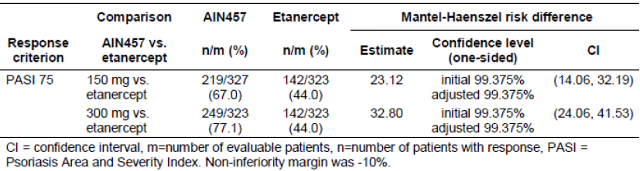
Both secukinumab doses (300 mg and 150 mg) were statistically significantly (p < 0.0001) superior to etanercept at Week 12 in achieving IGA mod 2011 0 or 1 and PASI 75 response The comparison of PASI 90 response between secukinumab and etanercept was done descriptively only (that is, it was not part of the testing strategy and was not adjusted for multiplicity testing). A higher proportion of patients in both secukinumab dose groups were PASI 90 responders than in the etanercept group (54.2% for 300 mg and 41.9% for 150 mg versus 20.7% for etanercept). A comparison of secukinumab doses versus etanercept (non inferiority and superiority) with regard to PASI 75 and IGA mod 2011 0 or 1 response at Week 12 was a key secondary variable included in the testing strategy in study A2303 (Table 21).

Table 21. IGA mod 2011 0 or 1, PASI 75 and PASI 90 response at Week 12 for secukinumab versus etanercept (non-responder imputation) (FAS).
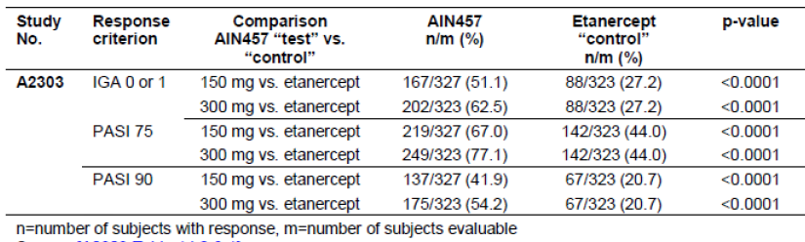
An analysis exploring the correlation between IGA and PASI was conducted and showed that PASI 90 response is clinically more meaningful than a PASI 75 response, because it has a much higher success rate of achieving an IGA 0 or 1 (clear or almost clear) response. A logistic regression was performed to explore the prediction of IGA mod 2011 0 or 1 response at Week 12 by PASI percentage change from baseline. The placebo group was excluded from the model. The predicted probability for achieving an IGA mod 2011 0 or 1 response was less than 20% if 75% PASI improvement was achieved, but about 70% with 90% PASI improvement. Among patients who achieved PASI 90 at Week 12, the majority (92.5%) achieved IGA mod score of 0 or 1: 43.7% had IGA mod 2011 score of ‘clear’ (score 0) and 48.8% had IGA mod 2011 score of ‘almost clear’ (score 1).
A subset of patients achieved IGA mod 2011 0 or PASI 100 response by Week 12, which corresponded to a clearance of psoriasis symptoms. In the two largest controlled trials (A2302, A2303), patients on secukinumab 300 mg were approximately twice as likely to achieve IGA mod 2011 0 or PASI 100 response compared with those on the lower 150 mg dose, and over 5 times more likely compared with those on etanercept.
A significant and rapid onset of efficacy was observed with secukinumab at both dose levels, compared with etanercept or placebo. Over 50% reduction in mean PASI score was observed around Week 3 of secukinumab treatment with 300 mg (A2303 - 50.2%; A2302 - 51.6%), compared to around Week 4 for 150 mg (A2303 - 51.6%; A2302 - 55.7%) or around Week 8 for etanercept (A2303 - 54.4%), as shown by the mean percentage change in PASI compared to baseline. Furthermore, the analyses also showed that patients can expect to see disease improvement clearly different from placebo as early as Week 2, with around 40% of reduction in symptoms on the 300 mg dose (and around 30% of reduction in symptoms on 150 mg) (Figure 10). There is some evidence to suggest that satisfaction with treatment, as well as an optimistic view on the treatment, can positively influence patients’ adherence to psoriasis therapy (Richards et al 2006, Thorneloe et al 2013). Hence, it is expected that an early onset of efficacy (which shows patients that the treatment promises to work) will improve treatment compliance.
Figure 10. Percentage change from baseline PASI score over time (mean +/- SE) LOCF in studies A2303 and A2303 – Induction period (FAS).
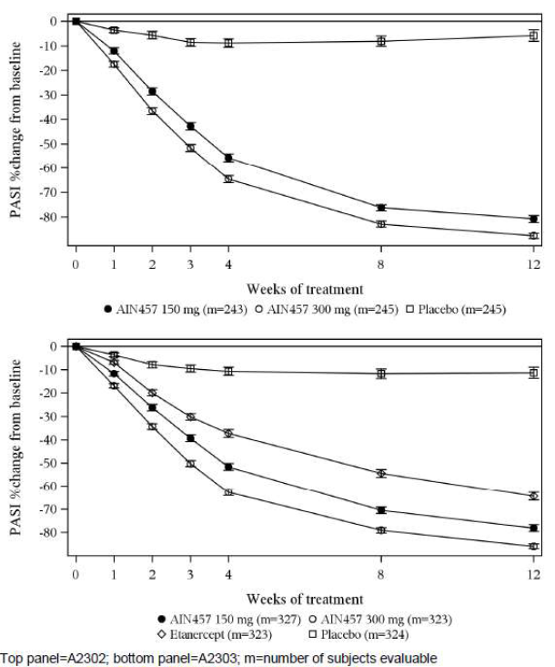
Higher PASI 50/ 75/ 90/ 100 and IGA mod 2011 0 or 1 response rates with secukinumab relative to placebo appeared early and patients treated with 300 mg secukinumab in general showed numerically higher response rates than those treated with 150 mg at all timepoints.
The improvements with secukinumab in clinical response, as measured on the PASI or IGA mod 2011 scales, were mirrored by the improvements in patient reported outcomes (PROs), including EQ-5D, DLQI, and Psoriasis symptom diary, with the 300 mg dose offering patients the highest improvements on all measures. The DLQI analysis demonstrated that patients on secukinumab achieved clinically meaningful and statistically significant improvements in the quality of life, as measured by DLQI mean score reduction and DLQI 0/1 response, compared to placebo with the highest improvements observed with the secukinumab 300 mg dose. Importantly, DLQI 0/1 response rate was shown to be correlated with PASI response, with 1.5 times as many patients achieving DLQI 0/1 response rate on a PASI 90 response, compared with a PASI 75 response.
Secukinumab therapy was also associated with improvements in Psoriasis symptoms diary items pain, itching and scaling, as well as improvements in overall health status as measured by EQ-5D.

Long term efficacy
The study population pooled for 52 week (Induction and Maintenance periods) analyses consisted of 2,843 patients from studies A2302, A2303, and A2304. The secukinumab groups were well balanced. Most of the patients randomised to placebo were nonresponders at Week 12 and were re randomised to secukinumab treatment while only 35 patients (PASI 75 responders at Week 12) remained in the placebo group past the Induction period. Single studies contributed to the etanercept arm (A2303) and the start of relapse (SoR) regimens (A2304). Overall, the majority of patients completed the Induction period (94% to 97%) and Maintenance period (81% to 93%). During the Induction period, the discontinuations were mainly due to subject/guardian decisions or adverse events. During the Maintenance period, the discontinuations were mainly due to subject/guardian decision, lack of efficacy, and AEs. Majority of patients were male, Caucasian, below 65 years of age. Overall, the mean age was 43.8 to 46.7, mean weight was between 82.04 to 87.39 kg, and mean BMI was 28.21 to 29.45. Nearly 40% of patients weighed ≥ 90 kg, with the exception of the placebo group (that is, PASI 75 responders at Week 12) where the mean weight was lower with only 25.7% weighing ≥ 90 kg. Baseline mean PASI score ranged from 22.11 to 25.39 and 41.3% to 52.8% had a baseline PASI score ≤ 20. All patients had moderate to severe disease, as measured by IGA mod 2011 and Severity of Psoriasis criteria. The majority of patients (77.9% to 86.5%) did not have a history of psoriatic arthritis. Overall, 59.8% to 66.5% of patients had been exposed to previous systemic psoriasis therapy. Patients who previously failed to prior systemic therapy constituted about a half (42.0% to 51.4%) of the overall patient population. Overall 4.4% to 12.9% of the studied patient population had failed treatment with a previous biologic systemic psoriasis therapy and 40.0% to 49.4% had failed treatment with previous non biologic systemic therapy.
The majority of secukinumab treated patients who achieved PASI 75 or IGA mod 2011 0 or 1 response at Week 12 were able to maintain their response at Week 52 (Table 22). The 300 mg secukinumab dose delivered the highest sustained response at Week 52, both on PASI 75 (80.5% to 84.3%) and IGA mod 2011 0 or 1 (74.4% to 79.7%) measures. In Study A2303, the sustainability of response for PASI 75 responders and for IGA mod 2011 0 or 1 responders at Week 52 was higher for both secukinumab doses compared with etanercept. For all efficacy measures, the 300 mg dose showed better retention of response compared to the 150 mg dose, and compared to etanercept. The cumulative probability (Kaplan-Meier estimates) of losing PASI 75 response at 52 weeks of treatment in Week 12 PASI 75 responders was lower with secukinumab 300 mg compared to 150 mg or etanercept (A2302: 300 mg versus 150 mg: 14.2% versus 27.5%; A2303: 11.9% with 300 mg versus 22.5% with 150 mg, versus 33.8% with etanercept). Based on the combined data from studies A2302 and A2303, the cumulative probability (Kaplan-Meier estimates) of loss of PASI 75 response was lowest with 300 mg (12.9%) at 40 weeks of maintenance (Week 52), with 150 mg having a loss rate almost twice as high (24.7%) and etanercept showing a loss rate almost three times as high (33.8%).

Table 22. Maintenance of PASI 75 or IGA mod 2011 0 or 1 response at Week 52 for Weel 12 PASI 75 or IGA mod 2011 0 or 1 responders, respectively (non responder imputation) (FAS) (Studies A2302, A2303).
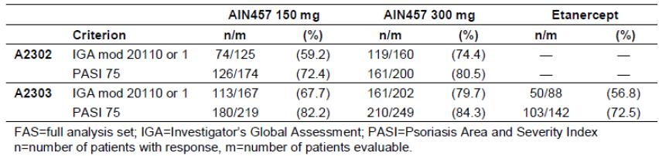
The cumulative probability (Kaplan-Meier estimates) of losing IGA mod 2011 0 or 1 response at 52 weeks of treatment in Week 12 IGA mod 2011 0 or 1 responders was lower with the secukinumab 300 mg dose: (A2302: 28.8% with 300 mg versus 41.4% with 150 mg; A2303: 23.5% with 300 mg versus 37.6% with 150 mg, and 56.9% with etanercept). Based on the combined data from studies A2302 and A2303, the cumulative probability (Kaplan-Meier estimates) of loss of IGA mod 2011 0 or 1 response was lowest with 300 mg (25.8%) at 40 weeks of maintenance (Week 52 in the study), with 150 mg having a loss rate one and a half times as high (39.2%).
The high response rates at Week 12 in both secukinumab dose groups were sustained throughout the Maintenance period up to Week 52. Response rates for PASI 75, PASI 90, PASI 100, and IGA mod 2011 0 or 1 started to plateau around Week 16 for both secukinumab groups. In comparison, PASI 75 and IGA mod 2011 0 or 1 response rates with etanercept peaked around Week 28, while PASI 90 and 100 response rates peaked even later around Week 32. The 300 mg secukinumab dose was associated with higher response rates at all timepoints in the Maintenance period compared to the 150 mg dose. The difference between the secukinumab dose groups at Week 52 was most pronounced for PASI 90 and PASI 100 (Table 23). Patients who achieve PASI 75 response but not PASI 90 response at Week 12 have a high likelihood of achieving PASI 90 response with longer treatment duration. In this patient population, PASI 90 response was achieved by 43.2% (83/192) of patients on secukinumab 300 mg and 33.7% (82/243) on secukinumab 150 mg by Week 16, and sustained up to Week 52 (43.2% on 300 mg and 32.1% on 150 mg).

Table 23. PASI 75, PASI 90 and PASI 100, and IGA mod 0 or 1 response rates at Week 52 (non responder imputation) – 52 week efficacy (pooled FAS).
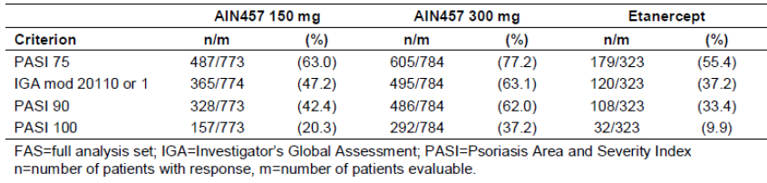
DLQI 0 or 1 response rates at Week 52 were 68.5% with secukinumab 300 mg, 53.8% with secukinumab 150 mg (based on the pooled dataset), and 46.9% with etanercept (A2303 study only). In Study A2304, the DLQI 0 or 1 response rates were significantly higher with 300 mg and 150 mg fixed interval dosing (69.2% with 300 mg and 56.4% with 150 mg) compared with the 300 mg and 150 mg ‘start of relapse’ dosing interval (37.3% with 300 mg and 31.1% with 150 mg), respectively (p < 0.0001) from Week 32 through Week 52.
The maintenance of effect at 52 weeks was mainly evaluated in two Phase III trials: A2302 and A2303. The 300 mg dose delivered the best sustained response up to Week 52, compared to secukinumab 150 mg and etanercept. The response improved for all measures to approximately Week 16 and was then sustained for the rest of the 52 week period and was consistent for both studies. This was further supported in maintenance regimen Study A2304, where both patients on fixed dose maintenance therapy and those who were retreated at start of relapse showed higher proportions of PASI 75, 90, 100 and IGA 0 or 1 responders with 300 mg than with 150 mg secukinumab. Hence, the 300 mg dose is recommended not only for induction treatment, but also for maintenance therapy.

Efficacy analysis in subgroups
The primary and selected secondary endpoints were evaluated using a pooled dataset from the Phase III studies, for subgroups based on demographic, baseline disease characteristics, and prior treatments. Subgroup analyses are presented for PASI 75, PASI 90, and IGA mod 2011 0 or 1 response at Week 12. In addition HAQ-DI results over time were analyzed by region at Weeks 12 and 52. Frequency tables by subgroup are provided for all categorical endpoints. Summary statistics and change from baseline by subgroup were presented for all continuous endpoints. Subgroup analyses of PASI 75 response and IGA mod 2011 0 or 1 response at Week 12 were performed using a logistic regression model including the subgroup and a treatment by subgroup interaction term.

Age, gender, race, region
Overall, clinically meaningful higher response rates to secukinumab treatment (300 mg and 150 mg) compared to both placebo and etanercept were seen across the subgroups defined by baseline age, gender, and race, as measured by the percentage of patients achieving IGA mod 2011 0 or 1, PASI 75, and PASI 90 at Week 12. Secukinumab treatment resulted in higher response rates compared to placebo or etanercept, and a numerically greater response rate was seen at the secukinumab 300 mg dose compared to the 150 mg dose across the subgroups except for PASI 75 in the subgroup aged 65 and older. The magnitude of the differences between the 2 secukinumab doses was larger in the comparison of response rates based on the higher threshold of PASI 90. A similar proportion of patients achieved the response criteria based on IGA mod 2011 0 or 1, PASI 75, or PASI 90 regardless of age (< 65 years versus ≥ 65 years), gender, or race (Caucasian versus Asian). Both doses of secukinumab showed greater proportions of patients achieving the defined response compared to placebo. Overall, clinically meaningful higher response rates to secukinumab treatment (300 mg and 150 mg) compared to placebo were seen, regardless of region (Europe, USA, Japan, Rest of world), and compared to etanercept in the larger subgroups of Europe and Rest of World. Numerically greater response rates were generally observed in the secukinumab 300 mg dose group.

Body weight
Both secukinumab doses generally showed numerically higher response rates in the < 90 kg subgroup than the ≥ 90 kg subgroup across all timepoints and greater response rates were seen in the secukinumab 300 mg dose compared to the 150 mg dose across the subgroups. At Week 12, PASI 75 response rates in the < 90 kg subgroup were 83.6% and 74.2% for the secukinumab 300 mg and 150 mg dose groups, respectively, compared with 72.8% and 61.7%, respectively, in the ≥ 90 kg subgroup. Similar trends by body weight strata were also evident in the IGA mod 2011 0 or 1, PASI 50, PASI 90, and PASI 100 responses at Week 12. Within each secukinumab dose, PASI 75, PASI 90 and IGA mod 2011 0 or 1 response rates were generally higher in the lower weight subgroups. The PASI 75 and IGA mod 2011 0 or 1 response rates by weight tertiles defined as < 75 kg, ≥ 75 to < 93 kg, and ≥ 93 kg. PASI 90 response rate (weight < 75 kg, ≥ 75 to < 93 kg, and ≥ 93 kg, respectively) was: 69.9%, 58.8% and 40.7% in the secukinumab 300 mg group, and 48.5%, 44.4%, and 30.4% in the secukinumab 150 mg group.

Disease factors
Clinically relevant response to secukinumab treatment was demonstrated by percentages of patients achieving PASI 75, PASI 90 and IGA mod 2011 0 or 1 at Week 12 regardless of baseline disease characteristics. Secukinumab treatment resulted in higher response rates compared to placebo or etanercept, and numerically greater response rates were seen in the secukinumab 300 mg dose compared to the 150 mg dose across the subgroups. The magnitude of the differences between the 2 secukinumab doses was larger in the comparison of response rates based on the higher threshold of PASI 90.

Response to previous psoriasis therapy
The overall profile of PASI 75, PASI 90 and IGA mod 2011 0 or 1 responses at Week 12 in subgroups of previous exposure to systemic therapies was consistent with results for the overall population. Consistent with the overall results, both secukinumab doses showed better efficacy relative to placebo in the subgroups of patients who were treatment naïve, responders and failures. Response rates were numerically lower in patients who had failed prior treatment compared to those who had not (Table 24).

Table 24. IGA mod 2011 0 or 1, PASI 75, and PASI 90 response at Week 12 by previous systemic therapy (non responder imputation) induction perios (FAS).
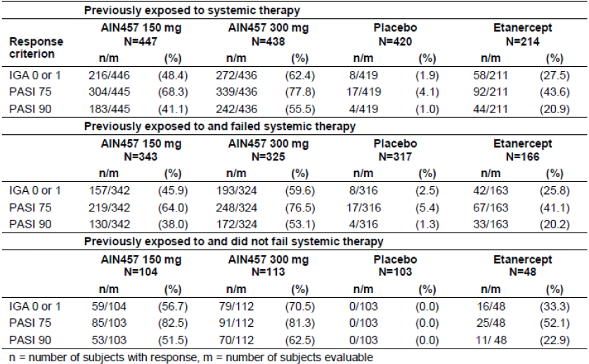
The majority of patients had not received prior biologic therapies. Given the low number of patients in most subgroups, the general trends for PASI 75, PASI 90 and IGA mod 2011 0 or 1 responses at Week 12 observed in the subgroups of previous exposure with or without failure to biologic therapies (including anti TNFα) were consistent with those in the overall population. Secukinumab 300 mg and 150 mg generally had higher response rates compared to placebo and etanercept, and higher response rates were seen with the secukinumab 300 mg dose compared to the 150 mg dose across all subgroups. In patients previously exposed to systemic biological therapy (considering failures versus those who did not fail), response rates for IGA mod 2011 0 or 1 and PASI 75 were numerically higher in the 300 mg group than the 150 mg group whether patients had previously failed systemic biological therapy or not. The overall profile of PASI 75, PASI 90 and IGA mod 2011 0 or 1 responses at Week 12 in subgroups of previous exposure to systemic non biologic therapies was consistent with results for the overall population. The higher efficacy of 300 mg and 150 mg secukinumab relative to placebo in each subgroup was of comparable magnitude as that demonstrated in the overall population, with the exception of the results in the subgroups with fewer than 100 patients per treatment arm (prior non biologic without failure and failed at least 2 non biologics). Secukinumab response rates were numerically lower in prior failures compared to prior responders, with the exception of PASI 75 response for the 300 mg dose, which was the same in the subgroups who failed and did not fail at least 2 non biologic therapies.

Concomitant emollient use
Considering the relatively low percentage of patients reporting concomitant use of emollients (11 to 14% of patients), the response rates were generally consistent for each treatment group regardless of concomitant emollient use. Secukinumab treatment resulted in higher response rates compared to placebo or etanercept. Greater PASI 90 response rates were seen in the secukinumab 300 mg dose compared to the 150 mg.

Efficacy in patients with psoriatic arthritis comorbidity
At baseline, PsA was reported in 422 out of 2,401 (17.6%) patients in studies A2302, A2303, A2308 and A2309 included in the Induction period pooled analysis. Secukinumab 300 mg and 150 mg resulted in higher response rates (PASI 75, PASI 90 and IGA mod 2011 0 or 1) compared to placebo at Week 12 across the subgroups of patients with PsA. Secukinumab provided a considerable treatment effect compared to placebo in patients with and those without PsA at baseline (p < 0.0001 for all comparisons) as measured by response rates (IGA mod 2011 0 or 1 and PASI 75). In patients with PsA at baseline, the response rates were numerically higher in the secukinumab 300 mg arm compared to the 150 mg arm: IGA mod 2011 0 or 1 of 59.5% with 300 mg and 51.7% with 150 mg, p = 0.1466; PASI 75 of 71.4% with 300 mg and 66.9% with 150 mg, p = 0.4274. Secukinumab 300 mg also provided a larger treatment effect compared to the 150 mg dose in patients without PsA at baseline (p < 0.001).

Evaluator’s conclusions on clinical efficacy
Main efficacy analyses are based on a Full Analysis Set (FAS) consisting of 3,366 patients with moderate to severe plaque psoriasis enrolled in four placebo controlled and two individualized maintenance regimen Phase III trials, with patients randomised to secukinumab (n = 2,348), placebo (n = 692), and etanercept (n = 326). The study design and efficacy endpoints of the Phase II and III studies complied with the CHMP guidelines for evaluation of systemic treatments for psoriasis. The study population evaluated in the studies were representative of the target patient population for secukinumab.
A robust Phase II program allowed for appropriate dose and regimen selection for the Phase III trials. The population studied in Phase II and III was in line with precedent and health authority recommendations and reflective of the proposed target population.
The large, pivotal Phase III program (Studies A2302, A2303, A2308 and A2309) subsequently demonstrated the responder rates to PASI 75, 90, 100 and to IGA mod 2011 0 or 1 to be statistically significantly different from placebo in all studies with both doses. Efficacy was dose related, with a higher proportion of PASI 75, 90, 100 and IGA mod 2011 0 or 1 responders in the 300 mg than the 150 mg regimen at 12 weeks.
Secukinumab demonstrated superior efficacy over placebo and etanercept in the treatment of patients with moderate to severe plaque psoriasis on both co primary endpoints (PASI 75 and IGA mod 2011 0 or 1), and secondary endpoints (PASI 90, PASI 100, DLQI 0/1). Efficacy was dose dependent, with higher response rates observed with the 300 mg dose group (compared to the 150 mg dose group) at all timepoints in terms of PASI 50, PASI 75, PASI 90, PASI 100, IGA mod 2011 0 or 1, DLQI 0/1, Psoriasis Symptom Diary items (itching, pain, scaling), and EQ-5D.
The 300 mg dose of secukinumab delivered the most clinically meaningful benefit to patients, compared to 150 mg, which was evident for all endpoints across all pivotal studies, in all subgroups of patients, and for all time points between Week 12 and Week 52. The difference in efficacy between doses was also statistically significant for all major endpoints in exploratory analyses of pooled Phase III efficacy data. For these reasons, 300 mg s.c. is the recommended dose for all patients. The regimen that offers the most clinically meaningful benefit to patients is secukinumab 300 mg administered at Weeks 0, 1, 2, and 3, followed by monthly maintenance dosing starting at Week 4.
An earlier onset of efficacy was observed in the 300 mg secukinumab dose group, with 50% of improvement in mean PASI scores achieved after around 3 weeks versus around 4 weeks for 150 mg and around 8 weeks for etanercept. Response rates reached a plateau around Week 16. At this time point, higher response rates were observed with the 300 mg dose compared to 150 mg ((PASI 75: 86.4% with 300 mg (76.3% with 150 mg) IGA mod 2011 0 or 1: 74.6% with 300 mg (59.9% with 150 mg)). The high response rates were sustained up to 52 weeks of treatment, again with higher response rates observed with the 300 mg dose compared to 150 mg PASI 75: 77.2% with 300 mg (63.0% with 150 mg) IGA mod 2011 0 or 1: 63.1% with 300 mg (47.2% with 150 mg). The maintenance of effect at 52 weeks was evaluated in two Phase III trials: A2302 and A2303. The 300 mg dose delivered the best sustained response up to Week 52, compared to secukinumab 150 mg and etanercept. The response improved for all measures to approximately Week 16 and was then sustained for the rest of the 52 week period and was consistent for both studies. This was further supported in maintenance regimen Study A2304, where both patients on fixed dose maintenance therapy and those who were retreated at start of relapse showed higher proportions of PASI 75, 90, 100 and IGA 0 or 1 responders with 300 mg than with 150 mg secukinumab. Hence, the 300 mg dose is recommended not only for induction treatment, but also for maintenance therapy.
Relapse rates were lower in the 300 mg group (7.4%) compared to the 150 mg group (17.1%) or etanercept (21.1%). After cessation of therapy very few rebound events were observed. The majority of these rare events were diagnosed based on non PASI criteria and in patients receiving the 150 mg dose of secukinumab or etanercept.
Patients with 90% PASI improvement have a much better chance (60%) to achieve a DLQI 0/1 response than those with 75% PASI improvement (40%). Therefore, PASI 90 is considered more relevant to patients than PASI 75. PASI 90 was achieved more frequently with 300 mg (56.6%) than with 150 mg (41.1%).
The maintenance of effect at 52 weeks was evaluated in two Phase III trials: A2302 and A2303. The 300 mg dose delivered the best sustained response up to Week 52, compared to secukinumab 150 mg and etanercept. The response improved for all measures to approximately Week 16 and was then sustained for the rest of the 52 week period and was consistent for both studies. This was further supported in maintenance regimen Study A2304, where both patients on fixed dose maintenance therapy and those who were retreated at start of relapse showed higher proportions of PASI 75, 90, 100 and IGA 0 or 1 responders with 300 mg than with 150 mg secukinumab. Hence, the 300 mg dose is recommended not only for induction treatment, but also for maintenance therapy.
The superior efficacy of secukinumab versus placebo in the PASI 75, IGA mod 2011 0 or 1, and PASI 90 responses at Week 12 was consistent in all subgroups of body weight, age, race (Asian versus non Asian), disease severity, and previous exposure or failure to systemic psoriasis therapy (including in anti TNFα-IR and biologic IR patients). The 300 mg dose was associated with higher response rates across weight groups and all other subgroups examined.
Psoriatic arthritis (PsA) patients (approximately 20% of the population) benefited from secukinumab treatment both in terms of skin improvement and physical function (HAQDI), with the greatest benefit observed with secukinumab 300 mg.
Efficacy results were consistent with both formulations tested (lyophilisate versus liquid), all forms (lyophilisate in a vial, pre filled syringe, or autoinjector pen), and both types of administration (injection performed by site staff versus self injection). The efficacy section of the proposed PI was an accurate representation of the results of the submitted studies.

Limitations
The long term efficacy and safety results of the Phase III studies which evaluated the PFS (A2308) and AI (A2309) formulations of secukinumab should be provided on completion of these studies as only data up to week 12 were provided in this submission.

Clinical safety

Studies providing evaluable safety data
Three data pools were used to assess safety of secukinumab in psoriasis and other indications (see Table 25 below).

Table 25: Trials used in pooled safety datasets.
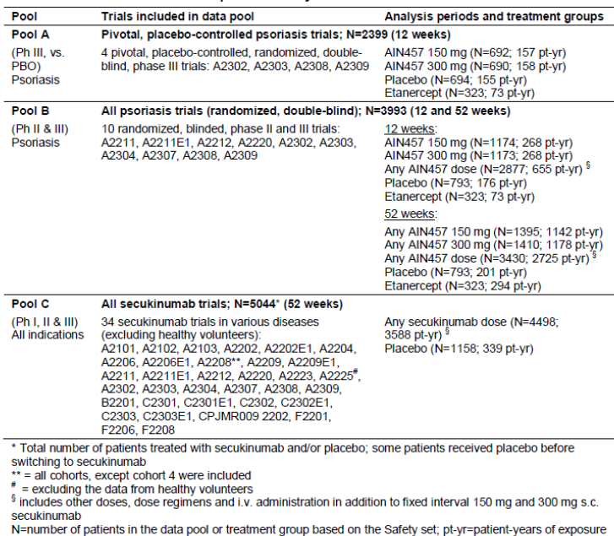
Four pivotal, randomised, placebo controlled trials, including one with an active comparator, in the target indication formed the key dataset (Pool A, N = 2,399). Pool A was used to evaluate the short term (12 weeks) safety of secukinumab in comparison to placebo and etanercept in the treatment of moderate to severe psoriasis. This pool describes the relevant route of administration (s.c.), the relevant doses of study drug (150 mg and 300 mg) and the inactive and active comparators (placebo and etanercept). Data were pooled at the patient level, and safety analyses were performed for the induction period (Day 1 until Week 12 visit for all assessments). However, etanercept was studied in only 1 of 4 pivotal Phase III trials, accounting for the smaller sample size relative to secukinumab and placebo.
Pool B assessed longer term safety data (52 weeks) with 10 Phase 2/3 trials in psoriasis (N = 3,993) which describes all routes of administration (s.c. and i.v.), all doses of study drug (i.v. doses of 3 to 30 mg/kg; s.c. doses of 25 to 300 mg) and the inactive and active comparators (placebo and etanercept). Data were pooled at the patient level and separate analyses were performed for the induction period, the maintenance period (for selected parameters) and the entire treatment period. Pool B includes data up to the following time points: Week 12 for Studies A2308 and A2309, Week 52 for Studies A2302, A2303 and A2304, Week 40 for Study A2307 (patients in A2307 were previously exposed for 12 weeks in A2304 and therefore total exposure is 52 weeks), and Week 12 for Studies A2212 and A2220. For Studies A2211 and A2211E1, safety data were combined at the patient level and included data up to Week 52 (encompassing 36 weeks in A2211 and 16 weeks in A2211E1).
Pool C consists of 34 trials in patients with various autoimmune diseases (N = 5,044). This pool describes all studies, treatments, doses, routes of administration and treatment durations performed in a number of different autoimmune conditions in which secukinumab has or is actively being evaluated that were available to be pooled in time for this submission. The data were pooled as a meta analysis at the study level and only the entire treatment period was analyzed for the assessment of rare events of interest for biologics in the treatment of autoimmune disorders, that is MACE and malignance’s. Pool C (all secukinumab trials) also includes the following:
- a number of higher dose regimens than intended for registration in psoriasis
- a number of other immune disorders with different background disease characteristics, and
- populations taking concomitant therapies, that is, rheumatoid arthritis and uveitis (with background methotrexate or immunosuppressant’s)
The main pooled treatment groups in each data pool are summarised in Table 26. The pooled group for ‘any secukinumab dose’ varied depending on the data pool. For Pool A, the ‘any secukinumab dose’ group is the sum of patients who were treated with 150 mg or 300 mg secukinumab in the pivotal, placebo controlled psoriasis studies. For Pool B, the ‘any secukinumab dose’ group covers a wide range of doses (3 to 30 mg/kg i.v. and 25 to 300 mg s.c.) in Phase II and III studies and also two different maintenance dose regimens in Study A2304 (chronic maintenance treatment and re treatment at ‘start of relapse’), in addition to the 150 mg and 300 mg secukinumab dose regimens studied in Pool A trials. For Pool C, the any secukinumab dose group includes all patients who received secukinumab (s.c. or i.v.). In Pools B and C, placebo patients who switched to secukinumab treatment were counted as placebo patients until the first secukinumab dose and thereafter as secukinumab patients.

Table 26. Pooled treatment groups.
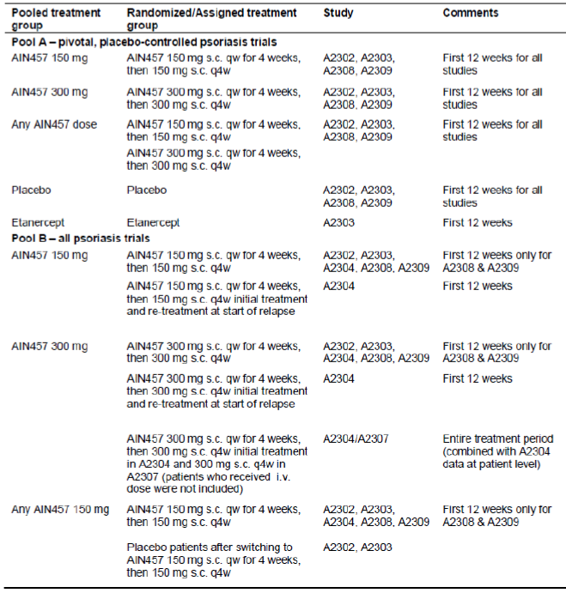

Table 26 continued.
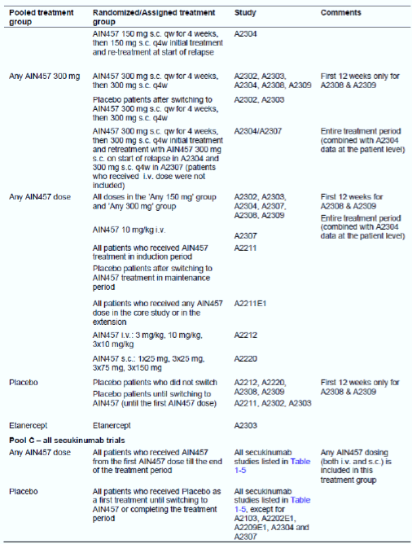
Standard safety variables (AEs, laboratory variables, vital signs and ECG assessments) were used to assess safety in all Phase II and III studies, in accordance with published guidelines (CHMP 2004) and agreements with Health Authorities (FDA Type B Guidance Meeting, EMA scientific advice meeting, PMDA End of Phase II meeting). As the individual studies were completed at various times, AEs were coded according to different versions of Medical Dictionary for Regulatory Activities (MedDRA versions 13.1 to 16.0). For the pooled analyses or meta analyses, the codes for lower level terms were mapped to the most current MedDRA version available (version 16.0).
Potential risks associated with immunomodulating biologic therapies in psoriasis consist of infections (all infections, serious infections and serious opportunistic infections), cardiovascular/ cerebrovascular safety including MACE, malignancies and autoimmune disorders. Potential risks of a foreign protein include administration or immune reactions, such as hypersensitivity, injection site/infusion reactions and immunogenicity. Crohn’s disease is also assessed as a topic of heightened interest for compounds targeting the IL-17 pathway. All these potential risks have been adequately evaluated.
All analyses were based on the safety set, defined in each of the individual studies as all patients who took at least one dose of study treatment during the treatment period and who had at least one post baseline safety assessment. Safety analyses were conducted for the different study phases (induction period, maintenance period and entire treatment period).

Pivotal studies that assessed safety as a primary outcome
No studies were conducted that measured safety as a primary outcome.

Dose-response and non-pivotal efficacy studies
The dose response and non pivotal Phase II efficacy studies were included in the Pool B safety dataset (Table 25, above).

Patient exposure
The overall patient exposure to secukinumab includes 3,588 patient years of exposure in 34 clinical studies (for which an interim or final clinical study report is available) in any indication in which secukinumab was used as a treatment for a medical condition. The majority of the total safety experience with secukinumab involves clinical studies in the target population of adult patients with moderate to severe plaque psoriasis (Pool B). The overall patient exposure to secukinumab in the target population comprises 2,725 patient years of exposure, comprising 76% of the total exposure across all indications to secukinumab, in 10 clinical Phase II/III studies with long term data up to 12 months.
All treatment groups in Pool A had similar duration of exposure to study treatment in the induction period. The median duration of exposure was 84 days and ≥ 96% of patients were exposed for at least 8 weeks.
All treatment groups in Pool B had similar duration of exposure to study treatment in the induction period; the median duration of exposure was 84 days and ≥ 95% of patients were exposed for at least 8 weeks. The duration of exposure to study treatment over the entire 52 week treatment period was substantially lower in the placebo group (median 84 days) compared with the secukinumab dose groups (364 days for both 300 mg and 150 mg) and etanercept group (365 days). This was as expected due to the high proportion of placebo non responders (in Studies A2211, A2302 and A2303) or partial responders (in Study A2211) who switched to secukinumab 300 mg or 150 mg starting at Week 12. This is also reflected in the large decrease in the proportion of patients in the placebo group exposed for ≥ 16 weeks and in the lower overall exposure expressed in patient years. While the median duration of exposure to etanercept was similar to secukinumab, fewer patients were exposed to etanercept and therefore this translated into less exposure expressed in total patient years. The total number of injections was consistent with the planned number of injections for the secukinumab, placebo and etanercept regimens over 52 weeks of treatment.
Patient exposure to secukinumab in Pool C involves safety experience from 34 studies, which included 4,498 secukinumab treated patients with 3,588 patient years of exposure, in a number of different autoimmune conditions. The median duration of exposure to secukinumab was 357 days, with 4,207 patients exposed for at least 12 weeks and 1,900 for at least 52 weeks. There were fewer placebo patients studied across the different indications and a shorter median duration of exposure (84 days), resulting in lower total exposure of 339 patient years.

Patient disposition
The majority (95%) of patients in Pool A who entered a pivotal placebo controlled psoriasis study, completed the induction period of that study. The rate of discontinuation was higher in the placebo and etanercept groups compared to both secukinumab dose groups. This difference was driven by more discontinuations due to lack of efficacy, subject/guardian decision and lost to follow up in the placebo and etanercept groups. Discontinuations due to AEs were well balanced across the treatment groups. Approximately 95% of patients in Pool B completed the induction period of the 10 Phase II/III trials in psoriasis. The most common reasons for discontinuation of induction treatment were subject/guardian decision, AEs and lack of efficacy. No patient died during the induction period. The rate of discontinuation during the induction period was higher in the placebo group, mainly driven by discontinuations due to lack of efficacy and subject/guardian decision. Discontinuations due to AEs were well balanced between the treatment groups. In total, 88% of patients who entered the maintenance period of Phase II/III psoriasis trials in Pool B completed the maintenance period and the most common reasons for discontinuation in the maintenance period was similar to those reported for the induction period; furthermore discontinuations due to AEs or lack of efficacy were well balanced across the treatment groups (Table 27).

Table 27. Patient disposition – maintenance period (Pool B: All psoriasis trials – Safety set).
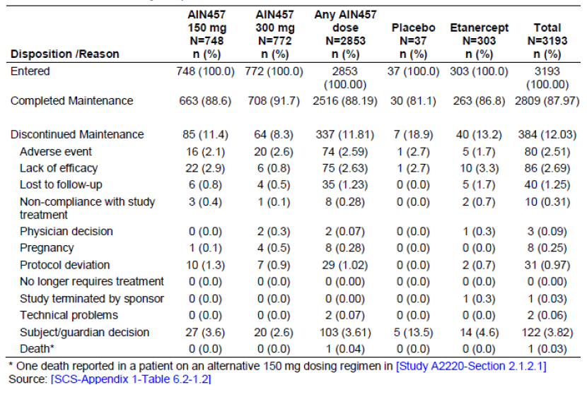

Adverse events

All adverse events (irrespective of relationship to study treatment)

Pivotal studies (Pool A)
The overall incidence of AEs in the two secukinumab dose groups was higher than placebo, primarily driven by the most frequently occurring SOC of infections and infestations, but was similar to etanercept. There was no imbalance between the secukinumab doses in total AEs or in the infections and infestations SOC (Table 28). Gastrointestinal disorders (SOC) were more frequently reported for 300 mg secukinumab (12.5%) compared with 150 mg (11%), placebo (9.2%) and etanercept (9.9%) mainly due to higher incidence of diarrhoea and vomiting in the secukinumab 300 mg group. Eye disorders (SOC) were more common with secukinumab (3.2% for 300 mg and 1.7% for 150 mg) than with placebo (1.2%) and etanercept (0.3%). The higher rate at the SOC level observed with 300 mg versus 150 mg was driven by conjunctivitis, blepharitis, dry eye and eye pruritus. Skin and subcutaneous tissue disorders (SOC) occurred with a higher rate in the secukinumab dose groups (11.7% for 300 mg and 11.4% for 150 mg) versus placebo (9.1%) and etanercept (10.5%) groups. Pruritus and urticaria were the main events driving this difference, but these were not associated with an imbalance between secukinumab and placebo in allergic or injection site reactions.
Respiratory, thoracic and mediastinal disorders (SOC) were more common with 300 mg (8.0%) than with 150 mg (5.8%), which was comparable to placebo (5.6%) and etanercept (5.0%) mainly due to higher incidence of cough (2.8%, 1.3%, 1.2% and 1.3% in secukinumab 300 mg, 150 mg, etanercept and placebo groups, respectively) and rhinorrhea (1.2%, 0.3%, 0.6% and 0.1%, respectively). Blood and lymphatic system disorders (SOC) were comparable between secukinumab and etanercept, whilst rates in all active treatment groups were greater than placebo (1.9%, 2.5%, 2.5% and 1.0%, respectively). The imbalance versus placebo was primarily due to lymphadenopathy, eosinophilia, leukopenia, lymphocytosis and neutropenia, although the rates of these events in the 300 mg secukinumab dose group were generally low (0.1 to 0.7%) and comparable to etanercept (0 to 0.9%). Nervous system disorders (SOC) was reported with a higher rate for 300 mg secukinumab (9.9%, 8.5% 9.0% and 7.2%, respectively). The higher rate with 300 mg was driven mainly by headache and migraine.
Renal disorders were reported with a comparable rate for 300 mg and 150 mg secukinumab and etanercept which were higher than placebo (1.0%, 1.2%, 1.5% and 0.3%, respectively). A higher rate of vascular disorders was observed with 150 mg secukinumab (4.0%) than with 300 mg (1.3%), which was lower than placebo (2.3%) and etanercept (2.2%). This difference was primarily due to a higher rate of hypertension in the 150 mg group (1.0%, 3.2%, 1.7% and 1.5% in the secukinumab 300 mg, 150 mg, placebo and etanercept groups resepctively). Both secukinumab dose groups also reported a higher rate of hypertension at baseline (25.8% for 300 mg and 28.3% for 150 mg versus 22.3% for placebo and 20.7% for etanercept). A higher rate of reproductive system and breast disorders was reported with 300 mg secukinumab (1.9%, 1.0%, 0.6% and 0.4%, respectively). This difference was driven by menstruation irregularities (dysmenorrhea, menorrhagia and metrorrhagia).

Table 28. AEs by primary system organ class – Induction period (Pool A: Pivotal placebo-controlled psoriarsis trials Safety set).
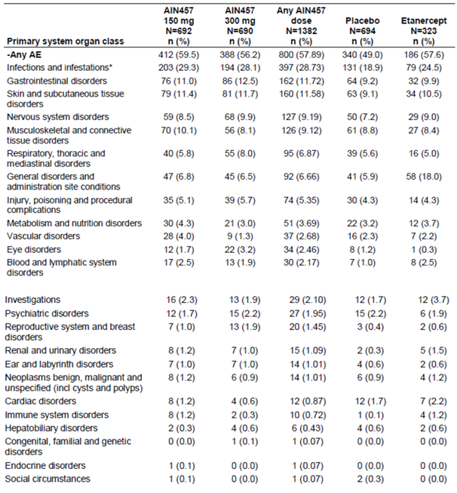
Other SOCs showed comparable or lower rates for secukinumab versus placebo and/or etanercept. General disorders and administration site conditions (SOC) were reported more frequently for etanercept (18.0%) compared to both secukinumab doses, which were similar to each other (6.5% for 300 mg and 6.8% for 150 mg), and to placebo (5.9%) due to higher rates of injection site erythema, pruritus, reaction, urticaria in the etanercept group. Neoplasms, benign, malignant and unspecified (SOC) showed no differences across the treatment groups (0.9%, 1.2%, 0.9% and 1.2%, respectively, for 300 mg, 150 mg, placebo and etanercept). Cardiac disorders (SOC) were reported more frequently for placebo and etanercept (1.7% and 2.2%, respectively) than for either secukinumab dose (0.6% for 300 mg and 1.2% for 150 mg), despite higher rates of prior cardiovascular disease or risk factor such reported at baseline. Immune system disorders (SOC) showed lower rates with 300 mg secukinumab and placebo (0.3% and 0.1%, respectively) compared with 150 mg and etanercept (both, 1.2%). AEs contributing to this difference were seasonal allergy and hypersensitivity. One case of anaphylactic reaction (to nuts) was reported in the 150 mg group and one case of drug hypersensitivity was reported in the etanercept group.
Consistent with the results by SOC, the rates of nasopharyngitis and upper respiratory tract infection in the two secukinumab dose groups showed higher rates than placebo but were comparable to the etanercept group; the 300 mg secukinumab dose had lower incidence rates than the 150 mg dose. Whilst headache, diarrhoea, cough and pyrexia were more frequently reported for the 300 mg group compared to 150 mg and placebo, none of these small numerical differences were considered clinically meaningful. Hypertension and arthralgia were more frequent with 150 mg compared with 300 mg, which was lower than placebo and etanercept. No other specific AEs showed numerical differences between the secukinumab doses. Psoriasis was reported as an AE more frequently in the placebo group than in the secukinumab and etanercept groups (Table 29).

Table 29. Most frequent (≥ 2.0% in any group) AEs by preferred term – Induction period (Pool A: Pivotal placebo controlled psoriasis trials – Safety set).
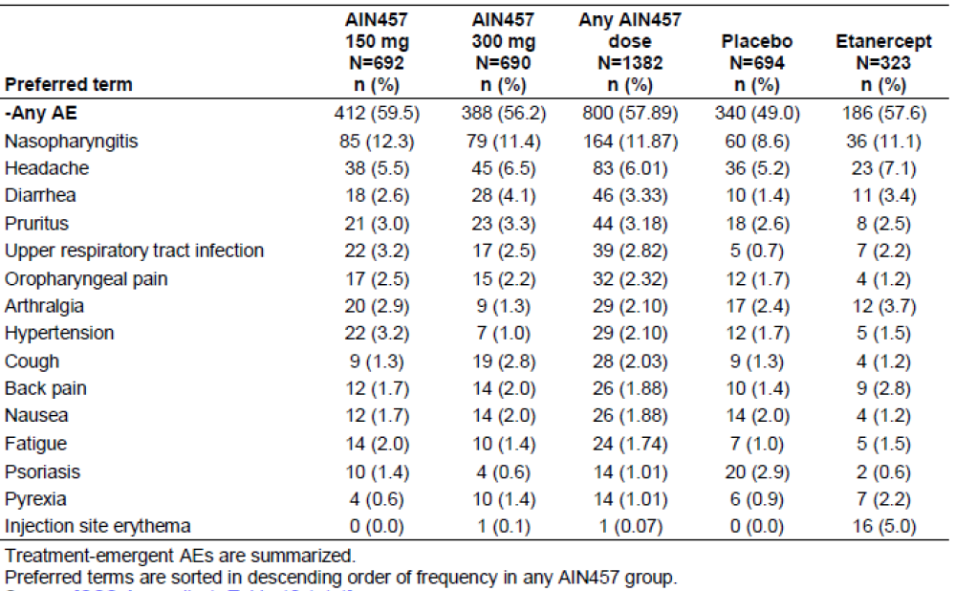

Other studies (Pool B)
The general profile of AEs in the induction period was similar between Pools A and B, with no increase in the rate of total AEs or any SOC and no new involvement of SOCs in the larger psoriasis data Pool B than seen in the pivotal placebo controlled trial Pool A. The absolute incidence of total AEs was higher with 300 mg and 150 mg versus placebo. This imbalance was driven primarily by infections and infestations. The small imbalances in some SOCs during the first 12 weeks of treatment seen in Pool A were also observed in Pool B. There were no new patterns or treatment differences observed across the SOCs in the larger psoriasis dataset. Consistent with AEs by SOC, the rates of nasopharyngitis and upper respiratory tract infection were similar between the two secukinumab dose groups and both were higher than the placebo group but similar to the etanercept group. Headache was more frequent with etanercept, but the rate was comparable between the two secukinumab doses and placebo. Diarrhoea was more frequently reported with secukinumab versus placebo, but the rate with secukinumab at either dose was lower compared to etanercept. AEs that were observed more frequently with secukinumab 300 mg versus 150 mg included diarrhoea, cough, conjunctivitis, dye eye, blepharitis, oral candidiasis and oral herpes. AEs that were more frequent with 150 mg versus 300 mg included hypertension and arthralgia.
The overall exposure adjusted incidence of AEs per 100 patient years over the entire treatment period of Pool B was lower in the any 300 mg and any 150 mg secukinumab groups (236.1 and 239.9, respectively) compared with the placebo and etanercept groups (351.8 and 243.4, respectively). The general profile of AEs over the entire treatment period was similar to the induction period, with no new involvement of SOCs over 52 weeks of treatment than seen in the first 12 weeks of treatment. The imbalance in infections and infestations for secukinumab observed in the first 12 weeks of treatment in Pools A and B did not translate into an imbalance over the longer term 52 week treatment period. The exposure adjusted incidence of the infections and infestations SOC was lower in the any 300 mg and any 150 mg groups and the etanercept group (90.5, 83.9 and 91.4, respectively) compared to the placebo group (100.1). Consistent with the trends seen in the induction periods of Pools A and B, there was a small increase in exposure adjusted incidence for infections overall with the any 300 mg group versus the any 150 mg group (90.5 versus 83.9), mainly driven by a few specific infections, notably oral candidiasis, oral herpes and otitis externa. The small imbalances for secukinumab observed in the 12 week treatment period were no longer apparent over the 52 week treatment period. However, the following SOCs showed a different pattern:
- Blood and lymphatic system disorders showed a higher exposure-adjusted incidence in the any 300 mg and any 150 mg groups compared to placebo although the highest rate was seen in the etanercept group (4.4, 4.9, 5.7 and 3.5 with secukinumab 300 mg, 150 mg, etanercept and placebo, respectively). The AEs contributing to the imbalance versus placebo were leukopenia, neutropenia, thrombocytopenia, leukocytosis, and lymphocytopenia.
- Immune system disorders also showed a higher exposure adjusted rate with secukinumab (1.6) and etanercept (2.8) compared with placebo (1.0), mainly due to seasonal allergy. The secukinumab groups showed lower or comparable exposure adjusted rates of hypersensitivity and drug hypersensitivity compared to placebo and etanercept.
- Renal and urinary disorders were reported with a higher exposure adjusted rate with secukinumab (3.1, 3.4, 3.1 and 1.5, respectively) and this difference was driven mainly by hematuria, nephrolithiasis and dysuria and is not considered clinically meaningful.
The exposure adjusted rate of general disorders and administration site conditions was highest with etanercept (33.2), followed by placebo (25.6) and the two secukinumab doses (300 mg = 15.1; 150 mg = 15.0. These results mirrored those reported for the induction period of Pools A and B. The higher rate in the etanercept group could be attributed to reactions at the injection site, including erythema, pain, swelling and pruritus.
Over the entire treatment period of Pool B, some AEs with a higher absolute incidence with secukinumab versus placebo during the induction period of Pools A and B, such as nasopharyngitis, headache, diarrhoea, cough and pruritus, no longer showed this imbalance after adjusting for exposure over 52 weeks of treatment. However, some infection AEs, such as upper respiratory tract infection, viral upper respiratory tract infection, oral candidiasis and otitis externa, occurred more frequently per 100 patient years in the secukinumab dose groups compared with the placebo and etanercept groups. Oral candidiasis, oral herpes and otitis externa showed higher exposure adjusted rates with any 300 mg versus any 150 mg secukinumab. Reactions at the injection site, including erythema, swelling, pruritus and pain, were more common with etanercept, as reported for the induction period of Pools A and B. The overall absolute incidence of AEs (not corrected for exposure differences) was higher for etanercept versus the secukinumab dose groups (77.4%, 76.4% and 78.3%, respectively, for any 300 mg, any 150 mg and etanercept) but all were higher than the placebo group (52.1%).
AEs over the entire treatment period of all psoriasis studies are summarized by 3 month intervals in Table 30. All treatment groups show the same general pattern of a decrease in the proportion of patients reporting AEs/SAEs over time. The largest decrease occurred within the first 6 months and thereafter the rates remained constant up to Month 12. Few patients remained on placebo treatment after 3 months due to lack of response and therefore were not available for comparisons at the later time points. In addition, results for Month 13 or later are difficult to interpret due to the small number of patients at that time. The most frequently occurring AEs (at least 3% total observed in the respective treatment group) showed the same pattern across all treatment groups, with rates decreasing in the first 6 months and stabilizing thereafter (Table 31).

Table 30. Summary of AEs/SAEs by 3 month intervals – Entire treatment period (Pool B: All psoriarsis trials – Safety set).
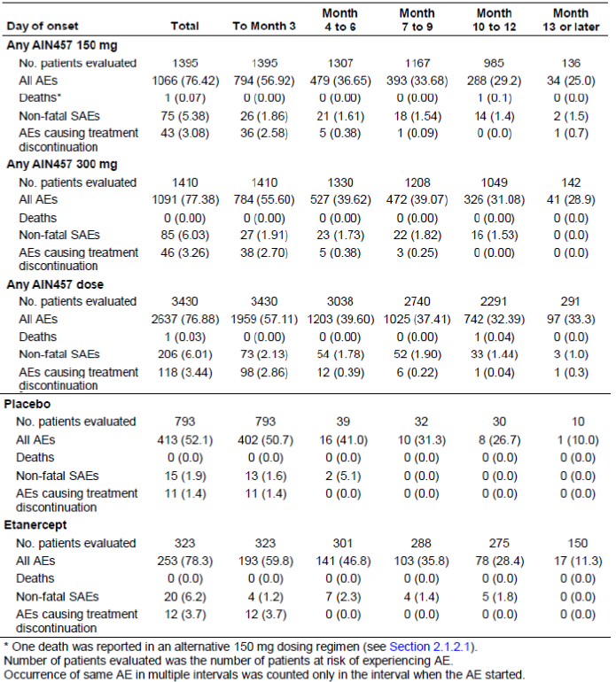

Table 31. Most frequent AEs (≥ 3% total observed in each group) by 3 month intervals and preferred term – Entire treatment period (Pool B: All psoriarsis trials – Safety set).
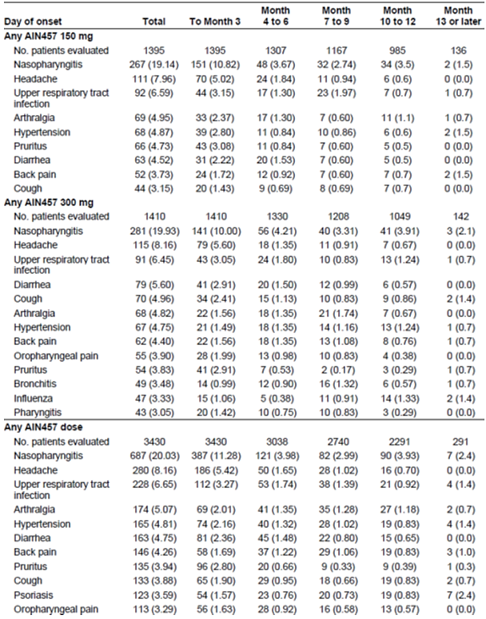

Table 31. (continued)
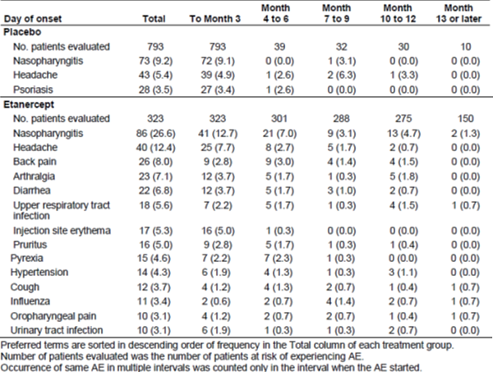
Most AEs were mild or moderate in severity. The incidence of severe AEs in the induction period of Pools A and B was low overall and showed no differences related to treatment or dose. Severe infections were reported with comparable frequency between the secukinumab doses and placebo, but were more frequent with etanercept. Severe AEs in the nervous system disorders SOC, mainly headache and migraine, were more frequent with secukinumab versus placebo but secukinumab was comparable to etanercept. No other clinically meaningful differences were noted. The total incidence of severe AEs and of severe infections over the entire treatment period in Pool B was lower with secukinumab versus etanercept.

Treatment related adverse events (adverse drug reactions)

Pivotal studies (Pool A)
The incidence of treatment related AEs in the induction period of Pool A trials was higher in the two secukinumab dose groups compared to placebo but lower than etanercept (17.4%, 20.2%, 22.9% and 13.0% for secukinumab 300 mg, 150 mg, etanercept and placebo, respectively). No dose response for secukinumab was seen in the total rate or in any event considered possibly related to study treatment. The higher total rate of treatment related AEs with secukinumab versus placebo was driven mainly by infections and infestations (6.5%, 8.2%, 4.6% and 4.5%, respectively). Treatment related nasopharyngitis (the most common AE and infection AE) was higher with 150 mg and comparable between 300 mg, placebo and etanercept (1.7%, 2.3%, 1.5% and 1.4%, respectively), while upper respiratory tract infection was higher with both secukinumab doses (0.7%, 0.7%, 0.3% and 0.1%, respectively). Overall, there was no clinically meaningful difference in treatment related infection AEs between the two secukinumab doses. Treatment related AEs in the SOC of skin and subcutaneous tissue disorders were reported in a higher proportion of patients in the secukinumab dose groups compared with placebo (4.3%, 4%, 3.4% and 2.2%, respectively) due in part to pruritus, but there were no difference between the two secukinumab doses. Treatment related AEs in the SOC of eye disorders, while rare, were reported primarily in the secukinumab dose groups (0.4%, 0.3%, 0% and 0.1%, respectively). The higher total rate of treatment related AEs with etanercept (11.1%) compared with ‘any secukinumab dose’ (2.8%) and placebo (1.7%) was driven by general disorders and administration site conditions, particularly injection site erythema, injection site pruritus and injection site reaction.

Other studies (Pool B)
Treatment related AEs in the induction period of Pool B studies also showed similar trend. The overall incidence of treatment related AEs in the any secukinumab dose (16.6%) group was higher than placebo (13.0%) but lower than etanercept (22.9%). No dose response was apparent in the total rate (15.6% for 300 mg versus 18.6% for 150 mg) or in any event considered possibly related to study treatment. AEs possibly related to study treatment in the entire treatment period of Pool B trials showed trends similar to those observed in the induction period.
The comparison of absolute incidence rates versus placebo over the entire treatment period is limited by the small number of patients receiving placebo treatment after Week 12 and therefore the following results should be interpreted with caution. The overall incidence of treatment related AEs in the any secukinumab dose (26%) group was higher compared to placebo (13.5%) but lower than etanercept (33.1%). No dose response was apparent in the total rate (300 mg versus 150 mg; 27.4% versus 28.1%). The difference versus placebo was driven mainly by infections and infestations (13.4% for any secukinumab dose versus 5.0% for placebo and 14.9% for etanercept). Nasopharyngitis and upper respiratory tract infection, the most common infections, as well as a wider range of other infection events occurring at low rates, contributed to this imbalance.
Across the psoriasis trials, in both Pool A and Pool B (induction and entire treatment period), there was no clear or consistent dose response seen for secukinumab 300 mg versus 150 mg at the SOC level. For the most part, this was also the case when AEs were examined at the PT level. Whilst they were reported infrequently, infections related to Candida did appear to show a dose response. Overall infections were comparable between the doses in Pool A (300 mg versus 150 mg: 28.3% versus 29.3%), but Candida infections were more common with 300 mg than with 150 mg (1.2% versus 0.4%). This difference remained with the larger Pool B dataset in both the induction and entire treatment periods and could be expected based on the implied role of IL-17 in mucosal defense against Candida. Ear infections, primarily otitis externa, were reported more frequently for 300 mg versus 150 mg, which was comparable to placebo and etanercept. The rate of otitis externa in Pool A (0.7% for 300 mg versus 0.4%, 0% and 0% for 150 mg, placebo and etanercept) was also observed in Pool B induction period (0.7% versus 0.3%, 0% and 0%) and entire treatment period (IR = 1.63 versus 0.97, 0.50 and 0.68).
In Pool A, more cases of oral herpes were reported for 300 mg compared to 150 mg (1.3% versus 0.1%). However, there were fewer cases of herpes simplex for 300 mg compared to 150 mg (0.3% versus 0.6%). These differences persisted in the larger Pool B induction groups, where more cases of oral herpes were reported for 300 mg versus 150 mg (0.9% versus 0.3%) but there were fewer cases of herpes simplex with 300 mg versus 150 mg (0.2% versus 0.3%). However, after adjusting for exposure over the entire treatment period, the incidence rates of oral herpes and herpes simplex were comparable in any 300 mg and any 150 mg groups.

Deaths and other serious adverse events
A total of 16 deaths have been reported up to 31 July 2013 across all secukinumab trials: 6 in psoriasis clinical trials and 10 in other indications. Of the 6 deaths in psoriasis patients, one occurred on treatment (0.03%, 1/3,430 patients in Pool B) but not during the induction period. No on treatment deaths were reported in the 12 week induction periods of Pool A. Five deaths were reported in the post induction period, including 1 on treatment death for 150 mg secukinumab, 2 off treatment deaths for 150 mg secukinumab, 1 patient who switched from placebo to secukinumab 300 mg maintenance treatment died 3 weeks post study, 1 off treatment death for a placebo patient. In addition, one patient died during the screening phase. The incidence of on treatment death in the Pool B entire treatment period was 0.03% (1/3,430) for secukinumab versus 0% (0/793) for placebo and 0% (0/323) for etanercept. Review of the death narratives did not suggest any relationship between deaths and secukinumab treatment.
A total of 10 deaths were reported from other indications up to 31 July 2013: 6 from rheumatoid arthritis, 2 from ankylosing spondylitis, 1 from psoriatic arthropathy and 1 from uveitis studies. Eight deaths occurred on treatment and 2 off treatment.
In Pool A, the incidence of SAEs was low and comparable for both doses of secukinumab and placebo (2.0%, 2.0%, 0.9% and 1.7% for secukinumab 300 mg, 150 mg, etanercept and placebo, respectively), with no pattern emerging in the type of event reported. SAEs considered by the investigator as possibly related to study treatment were reported in a small and comparable proportion of patients across the treatment groups (0.4%, 0.6%, 0.3% and 0.4% for 300 mg, 150 mg, etanercept and placebo, respectively). All treatment related SAEs were single events, except for psoriasis (n = 2 in the placebo group). Treatment-related SAEs in the 150 mg group were cardiac failure, Crohn’s disease, bladder cancer, 7th nerve paralysis and pulmonary edema (1 patient each); SAEs in the 300 mg group were overdose, fluid overload and bursitis (1 patient each); in the placebo group were cellulitis (n = 1) and psoriasis (n = 2); and in the etanercept group there was one SAE of transient ischemic attack.
The profile of SAEs in both the induction and entire treatment periods of Pool B trials showed similar trends: the rate of total SAEs was comparable between the secukinumab doses and placebo but was lowest with etanercept. Serious infections were infrequent and showed no clinically meaningful differences related to treatment or dose (induction period: 0.1%, 0.2%, 0% and 0.3%, respectively, for 300 mg, 150 mg, etanercept and placebo, respectively; entire treatment period: 1.4, 1.1, 1.4 and 1.0 per 100 patient-years, respectively). The majority of SAEs by preferred term in the induction period of Pool B trials were single occurrences. Angina pectoris, acute myocardial infarction and pulmonary edema were reported only in the secukinumab dose groups (2 to 3 patients each), with all events occurring in the 150 mg group, except for 2 cases of acute myocardial infarction, which occurred in the 300 mg group. The 300 mg group in particular reported a higher rate of prior myocardial infarction at baseline and therefore was at greater risk than the other treatment groups. Serious cases of psoriasis were more frequently reported for placebo (n = 4, 0.5%) than for the any secukinumab dose group (n = 1, 0.03%) but did not occur with etanercept. SAEs of cellulitis were reported only with placebo (n = 2, 0.3%).
The general profile of SAEs over the entire treatment period was comparable to the induction period, with no new involvement of SOCs over 52 weeks of treatment than seen in the first 12 weeks of treatment (Table 32).

Table 32. Exposure adjusted incidence of SAEs by primary sytem organ class – Entire treatment period (Pool B: All psoriasis trials – Safety set).
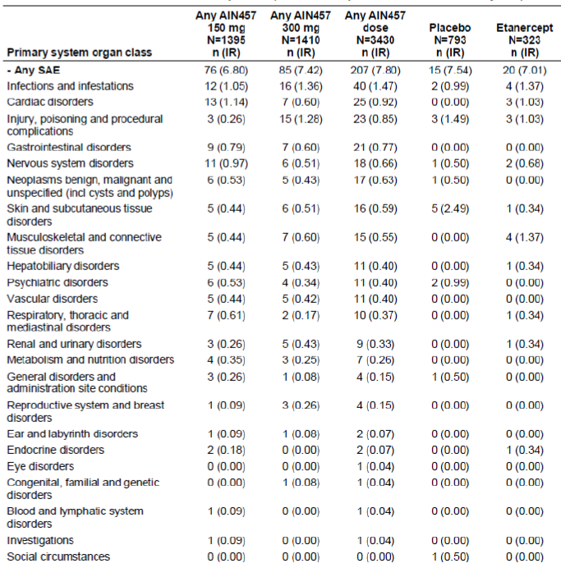
The imbalance in overall AEs and infection AEs did not translate into an imbalance in total SAEs or infection SAEs. SAEs in selected risks, such as CCV events and malignancies, showed small imbalances for secukinumab. Furthermore, all of the CCV SAEs reported during the induction periods of both data pools and the majority in the Pool B entire treatment period were associated with prior or active cardiovascular disease and relevant risk factor which were also reported at higher rates at baseline in the secukinumab dose groups, hence at greater risk, compared with the placebo and etanercept groups. The malignancy SAEs in the secukinumab dose groups included uncomplicated cases of basal cell carcinoma that resolved upon surgery and did not require study treatment discontinuation and 2 cases of malignant melanoma in patients who were smokers and previously received phototherapy. None of these malignancy SAEs were suspected to be related to study medication. For other SAEs, there were no imbalances for secukinumab and no indication of a dose relationship. No SAEs of anaphylaxis were reported in any psoriasis trial, although one patient in a trial of ankylosing spondylitis experienced an anaphylactic reaction within 1 hour of the first infusion with 10 mg/kg i.v. secukinumab that fully resolved with treatment by the following day.
No SAEs yielding new or unexpected safety findings were reported among the patient populations in the ongoing studies (treatment assignment in ongoing psoriasis studies remains blinded).

Discontinuation due to adverse events

Pivotal studies (Pool A)
The overall rate of AEs causing discontinuation of induction study treatment in Pool A studies was low and comparable among the treatment groups. Two events caused discontinuation in more than one patient in total: erythrodermic psoriasis in 2 patients on 150 mg secukinumab and psoriasis in 5 patients on placebo. All other AEs leading to discontinuation were single occurrences. The overall incidence of AEs causing dose interruption was low and comparable across the treatment groups (1.9%, 1.6%, 1.6% and 2.5% for 300 mg, 150 mg, placebo and etanercept, respectively). The specific AE causing dose interruption in > 1 patient per treatment group were nasopharyngitis (0.1%, 0.3%, 0.4% and 0.6%, respectively), oropharyngeal pain (0.3%, 0.1%, 0.1% and 0%, respectively), and pain in extremity (0.3% for placebo; 0% for all other treatment groups). No dose dependency was seen in total AEs or in any event causing dose interruption.

Other studies (Pool B)
The rate of AEs causing discontinuation in the induction period of Pool B studies was comparable between the secukinumab, placebo and etanercept groups with no dose effect in the overall rate for secukinumab. Erythrodermic psoriasis, psoriatic arthropathy and increased gamma glutamyltransferase (GGT) and thrombocytopenia led to discontinuation of secukinumab only, and at least half or more of the cases were observed in the 150 mg group compared to no cases in the 300 mg group. The rate of discontinuation due to psoriasis was higher in the placebo group (n = 5, 0.6%) than in the any secukinumab dose group (n = 1, 0.03%) and etanercept group (n = 0), although more patients on 150 mg discontinued due to worsening forms of psoriasis, that is, erythrodermic psoriasis and psoriatic arthropathy (0.2% for both events with 150 mg versus 0% with 300 mg, placebo and etanercept) (Table 33). The overall incidence of AEs causing dose interruption was low and comparable across the treatment groups (2.0%, 1.8%, 1.5% and 2.5%, respectively, for 300 mg, 150 mg, placebo and etanercept). The most common AEs causing dose interruption were nasopharyngitis (0.1%, 0.3%, 0.5% and 0.6%, respectively), alanine aminotransferase (ALT) increased (0.1%, 0.2%, 0% and 0.3%, respectively), aspartate aminotransferase (AST) increased (0.1%, 0.1%, 0% and 0.3%, respectively) and oropharyngeal pain (0.2%, 0.2%, 0.1% and 0%, respectively). No dose effect was seen in total AEs or in any event causing dose interruption.

Table 33. Most frequent (≥ 0.20% in any group) AEs causing discontinuation by preferred term – Entire treatment period (Pool B: All psoriarsis trials – Safety set).
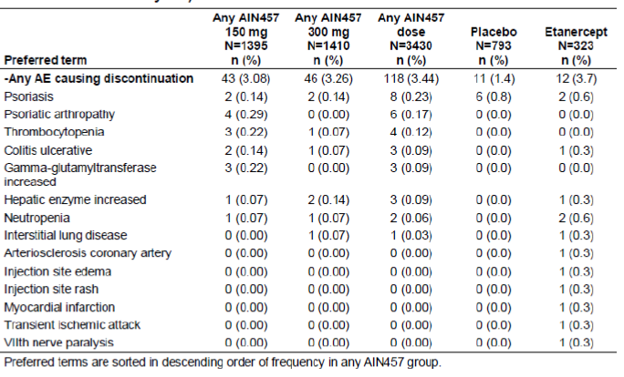
The absolute incidence of AEs causing discontinuation over entire treatment period in Pool B trials, was comparable between any secukinumab dose and etanercept (3.4% versus 3.7%), and both rates were higher than placebo (1.4%). The comparison of absolute incidence rates versus placebo over the entire treatment period is limited by the small number of patients receiving placebo treatment after Week 12 and therefore the following results should be interpreted with caution. There was no difference in the total incidence between the secukinumab doses (3.3% for 300 mg versus 3.1% for 150 mg). AEs causing more frequent discontinuation with secukinumab relative to placebo included psoriatic arthropathy, thrombocytopenia and erythrodermic psoriasis (0.17%, 0.12% and 0.15%, respectively, for any secukinumab dose versus 0%, 0% and 0%, respectively, for placebo). Psoriasis caused more discontinuations in patients on placebo compared to patients on 300 mg or 150 mg (0.8% for placebo versus 0.14% for both doses). The overall incidence of AEs causing dose interruption over the entire treatment period was identical for secukinumab doses and etanercept, which were all higher than placebo (5.3%, 4.4%, 1.9% and 4.6% for 300 mg, 150 mg, placebo and etanercept, respectively). AEs contributing to this imbalance included nasopharyngitis (0.6%, 0.9%, 0.5% and 0.9%, respectively), bronchitis (0.3%, 0.1%, 0.6% and 0%, respectively), alanine aminotransferase increased (0.2%, 0.1%, 0% and 0.3%, respectively), aspartate aminotransferase increased (0.1%, 0.1%, 0% and 0.3%, respectively).

Laboratory tests
Criteria for clinically notable laboratory abnormalities were based on CTCAE grades (Table 34) for the following parameters: hemoglobin, platelets, white blood cell (WBC), neutrophils, lymphocytes, creatinine, total bilirubin (TBL), GGT, ALT, AST, alkaline phosphatase (ALP), glucose, cholesterol, and triglycerides (TG). Additional criteria were defined for newly occurring or worsening clinically notable abnormalities in liver function tests (Table 35).

Table 34. CTCAE grades for laboratory parmaeters.
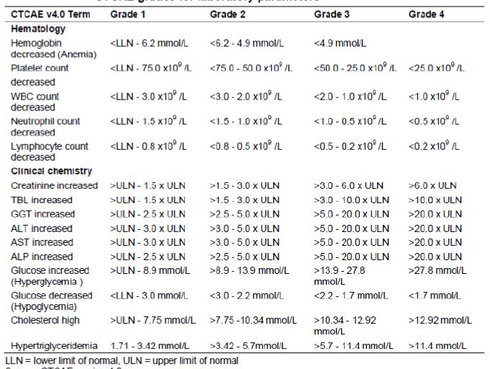

Table 35. Notable abnormalities in liver function tests.
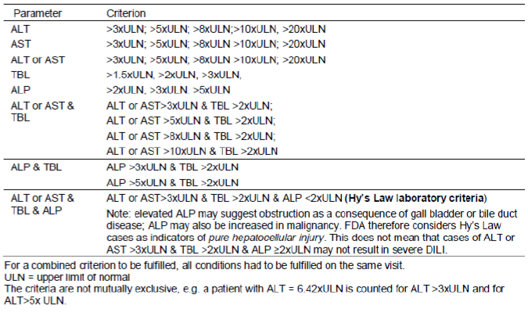

Liver function

Pivotal studies (Pool A)
The secukinumab dose groups showed higher rates of Grade 1 elevations in ALT and AST and of Grade 1 to 2 abnormalities in bilirubin compared with placebo, but these rates were comparable or lower than those in the etanercept group. The incidence of Grade 3 abnormalities in ALT, AST, GGT and triglycerides, although low, were higher in the any secukinumab dose group compared with placebo, but were the same or lower compared to rates with etanercept. Moreover, rates were comparable between the two secukinumab dose groups. The majority of patients had normal grades at baseline and continued to show normal grades post baseline during the induction period of Pool A. A proportion of patients in all treatment groups shifted from normal grade to Grade 1 to 2 for most clinical chemistry parameters, but there were no clinically meaningful differences across the treatment groups. Shifts from normal grade to Grade 3 were noted for ALT, AST, GGT, bilirubin increased fasting glucose and triglycerides in a small number of patients, with the GGT, bilirubin and glucose shifts reported in the placebo group only. There were no shifts from normal grade to Grade 4 for any parameter.
The incidence of ALT/AST elevations > 3 × ULN was generally low and comparable among treatment groups, with no secukinumab dose response (1.5%, 1.9%, 1.2%, and 1.9% for 300 mg, 150 mg, placebo, and etanercept, respectively). A similar pattern was observed with ALT/AST elevations > 5 × ULN (0.3%, 0.9%, 0.3%, and 0.9% for 300 mg, 150 mg, placebo, and etanercept, respectively). Elevations of ALT > 8 × ULN were reported in 2 (0.3%) patients on 150 mg secukinumab and 1 (0.3%) patient on etanercept, but were not noted in the 300 mg secukinumab or placebo groups. No patients in any treatment group in Pool A had AST > 8 × ULN during the induction period. Elevations in TBL > 2 × ULN were infrequent and similar across treatment groups (0.3% for the any secukinumab dose, placebo and etanercept groups), with more of the cases on secukinumab occurring with 150 mg than with 300 mg (0.4% for 150 mg versus 0.1% for 300 mg). Elevations in TBL > 3 × ULN were only observed in the placebo and etanercept groups. Combined elevations in ALT or AST > 3 × ULN and TBL> 2 × ULN was observed in 1 (0.1%) patient on 150 mg and 1 (0.1%) patient on placebo. Combined abnormalities of ALT or AST > 3 × ULN with TBL > 2 × ULN and ALP < 2 × ULN (Hy's Law laboratory criteria) were reported in 1 (0.1%) patient on 150 mg and 1 (0.1%) patient on placebo. Both cases were not reported as an AE or SAE and were also not associated with any other AEs.

Other studies (Pool B)
Grade 1 AST elevations were higher for etanercept and comparable between the secukinumab doses and placebo. Grade 2 elevations in ALT and AST were less frequent and showed no clinically meaningful differences across the treatment groups. The incidence of Grade 3 abnormalities in ALT and GGT, although low, were higher in the secukinumab dose groups compared with placebo, but were the same or lower compared to etanercept. Rates were comparable between the 300 mg and 150 mg dose groups.
Similar patterns as seen in Pool A were also observed across all psoriasis trials during the induction period in elevations of ALT/AST > 3 × ULN (1.72%, 1.89%, 1.0%, and 1.9% in 300 mg, 150 mg, placebo, and etanercept groups, respectively), > 5 × ULN (0.43%, 0.85%, 0.3%, and 0.9%, respectively) and > 8 × ULN (0%, 0.34%, 0%, and 0.3%, respectively). In all cases, rates were low and comparable across treatment groups, with no secukinumab dose response. All rates in secukinumab groups that were numerically higher than in placebo were comparable to rates with etanercept. Elevations in TBL > 2 × ULN in Pool B also reflected those of Pool A, with similar rates across treatment groups (0.4%, 0.3% and 0.3% for any secukinumab dose, placebo and etanercept). In addition, higher rates of elevations in TBL > 3 × ULN were again observed with placebo and etanercept versus secukinumab (0.3% for both placebo and etanercept versus 0.03% for any secukinumab dose). No additional cases of combined abnormalities of ALT or AST > 3 × ULN with TBL > 2 × ULN and ALP < 2 × ULN (Hy's Law laboratory criteria) were reported during the induction period in Pool B, beyond those already described in Pool A.
Similar patterns were observed in Pool B patients over the entire treatment period, as compared to the induction period, in elevations of ALT or AST > 3 × ULN (3.5%, 2.9%, 1.0%, and 4.1% in 300 mg, 150 mg, placebo, and etanercept groups, respectively) and > 5 × ULN (1.1%, 1.4%, 0.3%, and 1.2%, respectively), with comparable rates in the secukinumab and etanercept groups, which were numerically higher than placebo. When the time course of elevations > 5 × ULN was examined, 10 cases of elevations in ALT or AST > 5 × ULN that persisted for at least 2 weeks were identified in patients on secukinumab. The majority of these patients (7/10 = 70%) had hepatic transaminase elevations at baseline. In addition, 6 patients had established risk factors for elevated liver function tests prior to enrolment, including alcoholic abuse, hepatic steatosis, and active hepatopathy, while 3 others were taking concomitant medications with known hepatotoxic potential, including isoniazid and atorvastatin. Although not observed in the placebo group, elevations in Pool B across the entire treatment period of ALT/AST > 8 × ULN (0.4%, 0.6%, 0%, and 0.6% in 300 mg, 150 mg, placebo, and etanercept groups, respectively) and > 10 × ULN (0.2%, 0.4%, 0%, and 0.6%, respectively) were similar in pattern to the induction period. All cases of ALT or AST > 8 × ULN were examined in detail, which included 17 patients on secukinumab. Baseline hepatic transaminase elevations were present in 6 of these patients. Established risk factors for elevated liver function tests were noted in 8 patients, including rhabdomyolysis, alcoholic hepatitis, hepatic steatosis, cholecystitis, chronically raised liver function tests, and active hepatopathy. Potentially hepatotoxic concomitant medications were taken by 4 patients, including rosuvastatin, isoniazid, and paracetamol/acetaminophen.
For the single case of ALT > 20 × ULN that occurred during the maintenance period in a patient on the 300 mg SoR arm, hepatic enzyme elevations did not occur until Day 310, with peak values at Day 366. No action was taken with study treatment in this patient, and two additional secukinumab doses were received on Day 394 and Day 422, with all liver function tests normalizing at Day 422. While the proportion of cases of TBL > 2 × ULN increased in Pool B over the entire treatment period compared to the induction period, the absolute incidence was still comparable across treatment groups (0.6%, 0.3%, and 1.3% for the any secukinumab dose, placebo, and etanercept groups, respectively). Elevations of TBL > 3 × ULN over the entire treatment period (0.03%, 0.3%, and 0.6% for the any secukinumab dose, placebo, and etanercept groups) were also similar in pattern to the induction period.
Over the entire treatment period across all psoriasis studies, one additional patient in the 150 mg group was identified as meeting Hy’s Law laboratory criteria. Elevations in ALT (> 10 × ULN), AST (> 5 × ULN), TBL (> 2 × ULN), and ALP (< 2 × ULN) occurred in this patient at Week 44 during the maintenance period and were reported by the investigator as non serious AEs related to study treatment.

Kidney function

Pivotal studies (Pool A)
Grade 1 elevations in creatinine were more frequent with secukinumab 300 mg and 150 mg than with placebo or etanercept (5.9%, 5.2%, 4.0% and 2.9% for secukinumab 300 mg, 150 mg, placebo and etanercept, respectively), whilst Grade 2 creatinine elevations showed no clinically meaningful differences between the treatment groups (0.3%, 0.3%, 0.1% and 0%, respectively). Most of the creatinine abnormalities were transient, lasting 1 to 2 visits, and reversible while on treatment. None of the creatinine abnormalities led to discontinuation of study treatment.

Other studies (Pool B)
The profile of abnormalities in clinical chemistry parameters in the Pool B induction period was comparable to that seen in Pool A. Over the entire treatment period in Pool B, the patterns were not different from those reported in the induction period. Grade 1 abnormalities were observed with higher incidence in the secukinumab groups than in the etanercept group for creatinine (7.5%, 7.1%, 4.6%, and 6.4% in 300 mg, 150 mg, placebo, and etanercept groups, respectively).

Other clinical chemistry

Pivotal studies (Pool A)
Grade 1 or 2 abnormalities in cholesterol and triglycerides were more frequently reported in the secukinumab dose groups than the placebo and etanercept groups. No dose response relationships were apparent. Grade 4 abnormalities were noted for triglycerides, with a higher incidence in the etanercept group and a low and comparable incidence between the two secukinumab doses and placebo, and for cholesterol in 1 etanercept patient. LDL, cholesterol and triglyceride abnormalities were mostly ≥ ULN but < 1.5 × ULN. No patient in any treatment group had LDL > 2.5 × ULN, while cholesterol > 2.5 × ULN was reported in 1 (0.3%) etanercept patient only. The proportion of patients with triglycerides > 2.5 × ULN was lower in the secukinumab dose groups (0.5% for 300 mg and 0.8% for 150 mg) than in the placebo (1%) and etanercept (1.7%) groups.

Other studies (Pool B)
The profile of abnormalities in clinical chemistry parameters in the Pool B induction period was comparable to that seen in Pool A. A Grade 4 cholesterol event was reported for 1 etanercept patient. As with Pool A, Grade 4 abnormalities for triglycerides showed low and comparable incidence between the two secukinumab doses and placebo with a higher incidence in the etanercept group. As observed for Pool A, the majority of patients had normal grades at baseline and continued to show normal grades post baseline during the induction period of Pool B. A proportion of patients in all treatment groups shifted from normal grade to Grade 1 to 2 for most clinical chemistry parameters, but there were no clinically meaningful differences across the treatment groups. Shifts from normal grade to Grade 3 were noted for GGT, increased fasting glucose and triglycerides in a small number of patients, with the GGT and glucose shifts reported only in the placebo group. There were no shifts from normal grade to Grade 4 in any parameter. As observed in Pool A, LDL, cholesterol and triglyceride abnormalities were mostly ≥ ULN but few events were > 1.5 × ULN. No patient in the secukinumab or placebo groups had LDL or cholesterol > 2.5 × ULN, while 1 etanercept patient had cholesterol > 2.5 × ULN. The proportion of patients with triglycerides > 2.5 × ULN was comparable for the secukinumab dose groups (0.6% for 300 mg and 1.0% for 150 mg) and placebo group (0.8%) and lower than in the etanercept group (1.7%).
Over the entire period in Pool B, abnormalities were observed at a higher incidence in the secukinumab and etanercept groups than in the placebo group for most clinical chemistry parameters. No dose response was apparent for the secukinumab groups. No patterns different from those reported in the induction period were evident for the entire treatment period. Grade 1 abnormalities were observed with higher incidence in the secukinumab groups than in the etanercept group for cholesterol (31.8%, 32.8%, 16.6%, and 25.1% in 300 mg, 150 mg, placebo, and etanercept groups, respectively) and increased fasting glucose (10.5%, 9.9%, 3.7%, and 8.3%, respectively). The incidence of Grade 3 abnormalities continued to be low during the entire treatment period. The incidence of Grade 3 abnormalities in ALT, AST and GGT were higher in the secukinumab dose groups compared with placebo, but were the same or lower compared to rates with etanercept. Rates were comparable between the two secukinumab dose groups. Grade 4 abnormalities during the entire treatment period were noted for ALT (one patient in the any secukinumab 300 mg group), GGT (two patients in the any secukinumab 150 mg group), cholesterol (one patient in the etanercept group, as discussed for Pool A induction), decreased glucose fasting (one patient in the etanercept group) and triglycerides, with a higher incidence in the etanercept group and a low and comparable incidence between the two secukinumab doses and placebo. LDL, cholesterol and triglyceride abnormalities were mostly ≥ ULN but < 1.5 × ULN. No patient in any treatment group had LDL > 2.5 × ULN; one patient in the etanercept group had cholesterol > 2.5 × ULN. The proportion of patients with triglycerides > 2.5 × ULN was 1.6%, 1.7%, 0.8% and 3.2% for secukinumab 300 mg, 150 mg, placebo and etanercept groups, respectively.

Haematology

Pivotal studies (Pool A)
Most of the newly occurring or worsening abnormalities in hematology parameters during the induction period of Pool A studies were CTCAE Grade 1 or 2. For neutrophils, there was a trend for higher rates of Grade 1 and 2 abnormalities with secukinumab compared to placebo, but there was no clinically meaningful difference between the secukinumab doses which were both lower than etanercept. Grade 3 neutropenia was reported in 1 (0.1%) patient on 300 mg secukinumab and 1 (0.1%) patient on placebo. One patient on etanercept had Grade 4 neutropenia within a week of a mild, non serious AE of nasopharyngitis. None of the Grade 3 neutropenia cases were temporally associated with infections within ± 1 week. Grade 1 leukopenia was more frequently reported in the secukinumab and etanercept groups compared with placebo. Grade 2 leukopenia was observed more frequently for etanercept (2.2%) and with comparable frequency between secukinumab and placebo (0.4% for both doses and 0.3% for placebo). Grade 1 or 2 anemia and Grade 1 lymphocytopenia were more common with placebo than with secukinumab and etanercept. A small difference in the frequency of Grade 2 lymphocytopenia was noted for the secukinumab doses versus placebo and etanercept, but no dose relationship was observed (1.6%, 2.2%, 1.3% and 1.3% for secukinumab 300 mg, 150 mg, placebo and etanercept, respectively). Grade 3 abnormalities were observed for leukopenia in 1 (0.1%) patient on 300 mg, lymphocytopenia in 2 (0.3%) patients on 150 mg and thrombocytopenia in 1 (0.1%) patient on 150 mg.
There were no Grade 3 abnormalities in hemoglobin. No Grade 4 abnormalities were observed for any parameter, with the exception of the single case of Grade 4 neutropenia in one etanercept patient). The majority of patients across all treatment groups had normal grades at baseline and continued to show normal grades post baseline during the induction period of Pool A. A small number of patients shifted from normal grade to Grade 1 to 2, with no clinically meaningful differences across the treatment groups. Shifts in neutrophils from normal grade to Grade 3 were not observed in any patient on secukinumab but was reported for 1 placebo patient, and 1 etanercept patient shifted from normal grade to Grade 4 neutropenia. Shifts from normal grade to Grade 3 to 4 were observed in 2 patients on 150 mg secukinumab and 1 patient on placebo for lymphocytes, and in 1 patient on 150 mg secukinumab for platelets (no bleeding disorders were reported for this patient). No such shifts were reported for hemoglobin or leukocytes.

Other studies (Pool B)
The profile of newly occurring or worsening CTCAE grades in hematology parameters during the induction period of Pool B was consistent with that observed in the pivotal, placebo controlled trials, with small increases in the proportions of patients affected in the larger psoriasis data pool. Most of the newly occurring or worsening abnormalities in hematology parameters were CTCAE Grade 1 or 2.
Comparisons of absolute incidence rates versus placebo over 52 weeks are limited by the much lower placebo exposure after Week 12 and therefore these results should be interpreted with caution. The profile of hematology abnormalities over the entire treatment period was comparable between secukinumab and etanercept. The majority of newly occurring or worsening abnormalities in hematology parameters were CTCAE Grade 1 or 2. Grade 1 or 2 neutropenia was more frequent with etanercept than with secukinumab and placebo (Grade 1: 17.1%, 10.5%, 11.2% and 2.6% for etanercept, secukinumab 300 mg, 150 mg and placebo, respectively; Grade 2: 6.0%, 2.4%, 2.8% and 0.3%, respectively). The incidence of Grade 3 neutropenia was 0%, 0.7%, 0.6% and 0.1%, respectively and Grade 4 neutropenia was reported in the etanercept group only (n = 1, 0.3%). Most of the Grade 3 neutropenia events were transient and reversible, lasting 1 to 2 visits and decreasing to a lower grade or to normal grade at the next subsequent visit. The Grade 4 neutropenia in the etanercept patient was associated with a mild, non serious AE of nasopharyngitis. The placebo patient with Grade 3 neutropenia had no infections at any time. Of these 18 patients on secukinumab with Grade 3 neutropenia, 3 patients experienced an infection, 2 of which were upper respiratory tract infections, within 1 to 2 weeks of the Grade 3 neutropenia event and the remaining 15 patients either had no infections reported at any time during treatment or experienced an infection > 2 weeks before or after the time of the neutropenia event Grade 1 or 2 decreases in hemoglobin, leukocytes and platelets were comparable between the secukinumab dose groups and the etanercept group, all of which were higher than placebo.
The proportions of patients with Grade 1 or 2 lymphocytopenia were higher in the secukinumab dose groups relative to the placebo and etanercept groups, but no dose dependence was observed for secukinumab. Thrombocytopenia led to discontinuation in 1 patient (0.07%) on any 300 mg and 3 (0.22%) patients on any 150 mg but was not reported for placebo and etanercept. For 3 of these cases, the reported AEs of thrombocytopenia were associated with decreased platelet counts at baseline or an active medical condition of thrombocytopenia at study entry; no laboratory results were available to confirm the remaining case. The rates of Grade 3 hematology abnormalities, in the Pool B entire treatment period were low and not markedly worse than those reported in the induction period. Grade 3 lymphocytopenia was more frequent in the secukinumab groups (0.4% for any 300 mg and 0.5% for any 150 mg) than with placebo (0.1%) and etanercept (0%). No dose response was seen in any parameter.

Electrocardiograph
In clinical studies of secukinumab, standard 12 lead ECGs were performed at selected visits. The following ECG variables were summarized: ventricular rate, RR interval, PR interval, QRS duration, QT interval, and corrected QT interval (QTc) using Bazett (QTcB) and Fridericia (QTcF) corrections.
The following notable QTc intervals were evaluated:
- QTc > 500 msec
- QTc > 480 msec
- QTc > 450 msec
- QTc changes from baseline > 30 msec
- QTc changes from baseline > 60 msec
- PR > 250 msec
The number and percentage of patients with the above QTc intervals were summarized by treatment group in the data pools of the pivotal placebo controlled psoriasis studies (Pool A) and of all psoriasis studies (Pool B).

Pivotal studies (Pool A)
The incidence of QTc prolongation was low and comparable across the treatment groups. One patient in the 300 mg group had QTc > 500 msec. A small percentage of patients in all treatment groups had QTc changes from baseline > 30 msec, with no differences across the treatment groups. QTcB changes from baseline > 60 msec were noted for 1 patient in each secukinumab dose group (0.2%, each) and 3 patients in the placebo group (0.5%), but these abnormalities were not seen with the Fridericia correction (QTcF). Two (0.3%) patients in the 150 mg group and 1 (0.4%) patient in the etanercept group had PR duration > 250 msec.

Other studies (Pool B)
The incidence of QTc prolongation was low and comparable across the treatment groups in Pool B, as noted for Pool A. One patient on 300 mg had QTcB/QTcF > 500 msec, as reported in Pool A above, and an additional patient on 150 mg had QTcB > 500 msec. Results for all other QTc changes in the induction period of Pool B were consistent with those observed for Pool A, with no meaningful increase in the incidence of any abnormal parameter. Comparisons of absolute incidence rates versus placebo over 52 weeks are limited by the much lower placebo exposure after Week 12 and therefore these results should be interpreted with caution. The rates of QTc changes were generally comparable between the secukinumab doses and etanercept. There were no clinically meaningful differences between the secukinumab doses in any EGC abnormality.
No cases of Torsade de pointes/QT prolongation were reported as AEs in the induction period of either Pool A or Pool B or in the entire treatment period of Pool B.

Vital signs
Vital signs data were summarized for the data pools of pivotal placebo controlled trials (Pool A) and of all psoriasis studies (Pool B). Vital signs data in patients exposed to secukinumab in trials of other indications were not summarized due to differences in the medical conditions studied and in the notable criteria applied. Criteria for notable vital sign abnormalities are provided in Table 36.

Table 36. Criteria for notable vital sign abnormalities.
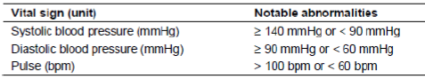

Pivotal studies (Pool A)
Increases in SBP/ DBP and pulse rate were reported at comparable rates across all treatment groups. Decreases in SBP/ DBP were less frequent and also occurred in comparable rates across the treatment groups. The incidence of low pulse rate was higher in the secukinumab dose groups compared with placebo but there were no clinically meaningful differences between the treatment groups (11.3%, 9.2%, 10.4% and 8.3% for secukinumab 300 mg, 150 mg, etanercept and placebo, respectively).

Other studies (Pool B and Pool C)
The profile of blood pressure and pulse abnormalities in Pool B is similar to that observed in Pool A, with no meaningful increase in the number of patients affected in any category. Increases in SBP/ DBP were reported with comparable rates across all treatment groups. A small and comparable proportion of patients in all treatment groups had decreases in SBP/ DBP. There was no clinically meaningful difference in BP abnormalities between the secukinumab doses. High pulse rate occurred with comparable frequency between the secukinumab dose groups and placebo group, but was less common in the etanercept group. The incidence of low pulse rate in the secukinumab dose groups was higher compared with placebo but similar to etanercept. There was no clinically meaningful difference in pulse abnormalities between the secukinumab doses. Comparisons of absolute incidence rates versus placebo over 52 weeks are limited by the much lower placebo exposure after Week 12 and therefore these results should be interpreted with caution. Changes in vital signs over the 52 weeks of treatment were comparable between the any 300 mg and any 150 mg dose groups and the etanercept group.

Other safety parameter: AEs of special interest

Infections and infestations
The overall incidence of infections and infestations in the any secukinumab dose (28.8%) group was higher than placebo (19.3%) but comparable to etanercept (25.7%). There was no clinically meaningful difference in the overall rate between the two secukinumab doses (300 mg versus 150 mg: 28.3% versus 29.3%). Upper respiratory tract infections (HLT), such as nasopharyngitis and upper respiratory tract infection, were the most common infections and also more frequent with secukinumab (300 mg = 17%, 150 mg = 18.6%) and etanercept (15.2%) compared to placebo (10.4%). Nearly all of the infections occurring in the induction period were non serious. SAEs in the infections and infestations SOC were reported in 1 (0.1%) patient in each of the secukinumab dose groups (anal abscess for 300 mg; pneumonia for 150 mg) and 2 (0.3%) patients in the placebo group (both, cellulitis). Candida infections (HLT) were reported more frequently in the 300 mg group than in the 150 mg group, which was comparable to placebo and etanercept (1.2%, 0.4%, 0.3% and 0.3%, for 300 mg, 150 mg, placebo and etanercept, respectively) (Table 37). All Candida infections on secukinumab and placebo were mild or moderate in severity, while the case of gastrointestinal candidiasis on etanercept was severe, and none of the cases across all treatment groups were serious or led to treatment discontinuation. Half the cases in the 300 mg group consisted of oral candidiasis. A search for potential opportunistic infections by NMQ yielded 1 case of esophageal candidiasis in the 300 mg group, 1 case of cytomegalovirus gastroenteritis in the placebo group and 1 case of gastrointestinal candidiasis in the etanercept group.
Ear infections were reported more frequently in the secukinumab 300 mg group (1.6%) than in 150 mg group (0.6%), which was comparable to placebo (0.3%) and etanercept (0%). Mycobacterial infectious disorders (high level group term (HLGT)) were reported in 2 (0.6%) patients, both on etanercept and were reported as latent tuberculosis. Infections requiring discontinuation or interruption of study treatment were reported with similar frequency across all treatment groups (0.9%, 0.7%, 1.0% and 0.9%, respectively) Infections requiring oral or parenteral antimicrobial concomitant treatment were more frequently reported in the 300 mg group than the 150 mg group, which was comparable to placebo and etanercept (12.2%,. 9.4%, 7.2% and 9.9%, respectively).

Table 37. Infections and overall candida infections – Induction period (Pool A: Pivotal placebo controlled trials – Safety set).
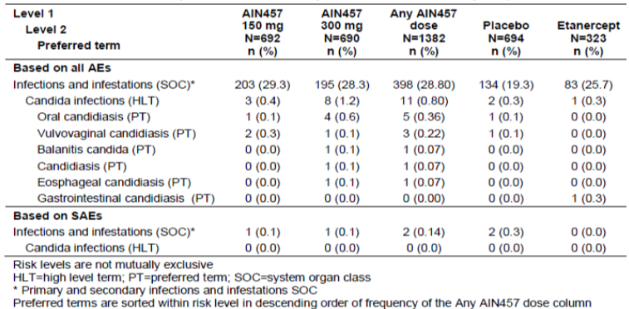
The overall incidence of infections and infestations (SOC) in the Induction period of Pool B studies was higher in the secukinumab dose groups than the placebo group but comparable to etanercept (25.8, 26.9 and 25.7, respectively, for 300 mg, 150 mg and etanercept versus 20.6% for placebo). The majority of infections were the upper respiratory tract infections (HLT), which were reported with comparable frequency between secukinumab and etanercept (16.1%, 17.5%, and 15.2%, respectively, for 300 mg, 150 mg and etanercept versus 11.5% for placebo). The vast majority of infections reported in the induction period of Pool B studies were nonserious. Mycobacterial infectious disorders (HLGT) were noted in 3 patients, all latent tuberculosis as the PT, with 1 (0.1%) patient on 150 mg and 2 (0.6%) patients on etanercept (Table38). A higher incidence of Candida infections (HLT) was observed in the any secukinumab dose group compared with the placebo and etanercept groups (0.7% versus 0.3% and 0.3%). None were serious or led to treatment discontinuation. Most of the Candida infections in the any secukinumab dose group (n = 19), and also in the 300 mg group (n = 13), consisted of oral candidiasis (n = 9 overall; n = 7 on 300 mg) and vulvovaginal candidiasis (n = 5 overall; n = 3 on 300 mg). The incidence of herpes viral infections (HLT) was higher in the secukinumab dose groups (1.2% for 300 mg and 1.0% for 150 mg) compared with placebo (0.6%) and etanercept (0.3%). No dose effect was apparent, as the rate was similar between 300 mg and 150 mg secukinumab (1.2% versus 1.0%). Infections requiring oral or parenteral antimicrobial concomitant treatment were more frequently reported in the 300 mg and 150 mg groups than in the placebo group, but there was no difference compared to the etanercept group (11.1%, 9.0%, 9.9% and 7.4% for 300 mg, 150 mg, etanercept and placebo, respectively).

Table 38. Infections overall and candida infections – induction period (Pool B: All psoriarsis triasl – Safety set) and Patients with latent tuberculosis.
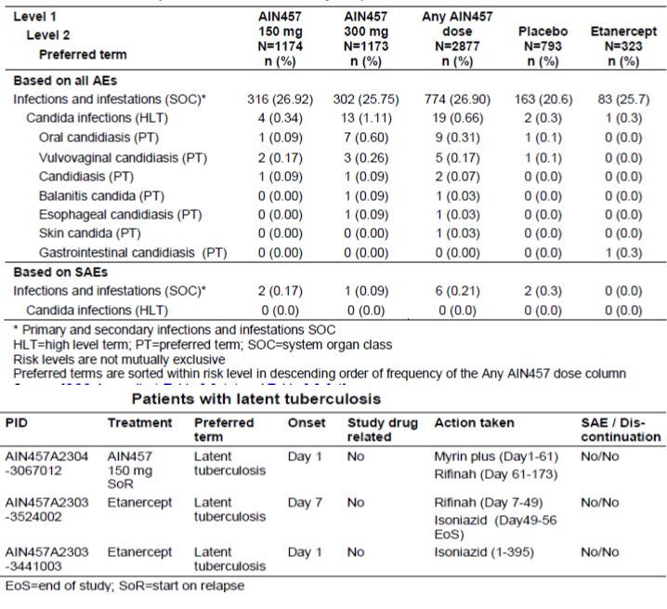
Contrary to the pattern seen in the induction period, the exposure-adjusted rate per 100 patient-years of infections and infestations SOC over the entire treatment period of Pool B in the any 300 mg (91.1%) and any 150 mg (85.3%) secukinumab groups was lower compared to placebo (101.9) and comparable to etanercept (93.7). Most of the infections occurring over the entire treatment period of Pool B were non serious. Consistent with results for the induction period, the exposure adjusted incidence of Candida infections was higher with any secukinumab dose, mainly driven by any 300 mg, compared with placebo and etanercept. The overall incidence of opportunistic infections was low and comparable across the treatment groups (0.26, 0.09, 0.50 and 0.34 per 100 patient-years for any 300 mg, any 150 mg, placebo and etanercept). Herpes viral infections (HLT) were more frequent with etanercept (3.81) compared with secukinumab (300 mg versus 150 mg: 3.28 versus 2.93) and placebo (2.49). No cases of disseminated or CNS herpes were reported over 52 weeks. No meaningful difference was observed between the secukinumab doses. The incidence of infections requiring discontinuation or interruption of study treatment over the entire treatment period was higher in the any 300 mg group than in the 150 mg group, which was similar to the etanercept group (3.5% for any 300 mg versus 2.4% for any 150 mg and 2.5% for etanercept). Infections requiring oral or parenteral antimicrobial concomitant treatment over the entire treatment period were more frequently reported in the secukinumab dose groups (300 mg versus 150 mg: 27.7% versus 21.2%) than the placebo (8.4%) group, but there was no difference compared to etanercept (23.8%).

Malignancies
The overall incidence of malignant or unspecified tumors in the Pool A pivotal studies was similar between the secukinumab dose groups and placebo (0.1% for 300 mg, 0.4% for 150 mg and 0.4% for placebo); no events were reported for etanercept. Malignant or unspecified skin tumors by broad NMQ were reported in 2 (0.3%) patients on 150 mg (1 case each of BCC and malignant melanoma in situ) compared with 3 (0.4%) patients on placebo (1 case of BCC and 2 cases of SCC), while no skin tumors were reported for 300 mg or etanercept. Malignancy SAEs were reported in the 150 mg group (n = 3, 0.4%) only and included 2 skin malignancies, one uncomplicated case of BCC and another of malignant melanoma in situ.
The profile of malignancies over the first 12 weeks of treatment in Pool B was very similar to that observed in Pool A, with no increase in frequency and no new type of malignancy reported. Two additional malignancies were identified in Pool B, both on secukinumab. These were one non serious case of SCC in the 150 mg group and one serious case of BCC in the 300 mg group. There were no additional cases in the placebo group. No dose effect was observed.
The exposure adjusted rates of AEs related to malignant or unspecified tumors over the entire treatment period of Pool B revealed a higher incidence for the placebo group compared with the active treatment groups (1.49 for placebo versus 0.96 for any secukinumab dose and 0.68 for etanercept) and no dose dependency (0.77 for any 300 mg versus 0.97 for any 150 mg) despite the small number of patients exposed to placebo after the first 12 weeks and therefore fewer placebo patients at risk of such rare events. Furthermore, the incidence of malignancies between the secukinumab doses and etanercept was comparable despite the small number of etanercept patients overall (in only one Phase III trial, A2303) compared to the large number exposed to secukinumab across 10 Phase II/III psoriasis trials. There were no reports of lymphoma in any treatment group over 52 weeks of all psoriasis trials. Malignancy SAEs were reported for secukinumab only (IR = 0.48), with no dose dependency observed (0.26 for any 300 mg versus 0.44 for any 150 mg). The serious events that occurred in more than one patient each were BCC (n = 3), malignant melanoma/malignant melanoma in situ (n = 2), bladder cancer (n = 2) and thyroid cancer/follicular thyroid cancer (n = 2). Additional malignancies reported as SAEs were individual cases of colon cancer, renal cancer, pleomorphic adenoma and testicular cancer.
There was no imbalance in malignancy AEs between secukinumab and placebo over 52 weeks of treatment in Pool C of all secukinumab studies across multiple indications. The exposure-adjusted incidence per 100 patient-years of malignant or unspecified tumors (SMQ) based on all AEs was comparable between the any secukinumab dose group and placebo over the entire treatment period of all secukinumab trials (1.1 for any secukinumab dose versus 1.8 for placebo). For malignant or unspecific tumors reported as SAEs, the exposure adjusted rate was higher with the any secukinumab dose group versus placebo (0.6 versus 0.3 per 100 patient-years). This small imbalance was driven by cases of basal cell carcinoma in the any secukinumab dose group. SAEs of malignant skin or unspecified tumors, however, were comparable between the any secukinumab dose group and placebo (0.2 versus 0.3).

Administration and immune reactions
The incidence of hypersensitivity AEs were comparable between the secukinumab doses and etanercept and lower with placebo, with this difference driven by higher rates of urticaria and eczema. Analysis of 54 cases of urticaria reported across all psoriasis studies did not suggest a link with possible anaphylaxis. Immune/administration reactions were more frequent with etanercept than with the two secukinumab doses and placebo, mainly due to more injection site reactions following etanercept administration. This was similar across the data pools and treatment periods.
No different patterns of hypersensitivity and injection site reactions were observed for the PFS and AI forms of secukinumab. There was no increase in hypersensitivity or immune/administration reactions in patients who received the SoR maintenance dosing regimens (in Study A2304) compared to patients on 4 week FI dosing regimens.
In the Pool A pivotal studies, hypersensitivity AEs were reported in a higher proportion of patients in the secukinumab dose groups and the etanercept group, which were similar to each other, compared with the placebo group (4.5%, 4.5%, 4.6% and 1.3% for secukinumab 300 mg, 150 mg, etanercept and placebo respectively). Immune/administration reactions were reported in comparable proportions of patients in the secukinumab dose groups and the placebo group, which were both lower than the rate in the etanercept group (14.2%, 12.3%, 11.8% and 18.3% respectively). The higher rate with etanercept was due primarily to reactions at the injection site, including erythema, pain, rash, swelling, urticaria and pruritus. Angioedemas (HLT) were reported with low and comparable rates across the treatment groups; 0.1%, 0.6%, 0.3% and 0% for 300 mg, 150 mg, placebo and etanercept. Eyelid edema occurred in 2 patients (on 150 mg), while all other preferred terms (laryngeal edema, swelling face, swollen tongue, angioedema and face edema) occurred in 1 patient each. One case of anaphylactic reaction by preferred term was reported in a patient on 150 mg secukinumab. The overall incidence of serious immune/administration reactions was higher in the placebo group compared to the active treatment groups (0.6% for placebo versus 0.1%, 0.1% and 0%, respectively, for 300 mg, 150 mg and etanercept), mainly due to psoriasis SAEs in the placebo group (n = 3, 0.4%) which were not reported in the active treatment groups. The SAEs in the secukinumab dose groups were reported in not more than 1 (0.1%) patient each: Crohn’s disease in the 150 mg group and ulcerative colitis in the 300 mg group.
The overall profile of hypersensitivity AEs and immune/administration reactions in the induction period of Pool B studies was similar to that observed in the induction period of Pool A, with no increase in the frequency of any specific event. The vast majority of AEs mapping to the hypersensitivity narrow SMQ and immune/administration reactions broad NMQ were non-serious; the incidence of serious immune/ administration reactions was low across all treatment groups and slightly higher in the placebo group.
Exposure adjusted rates of AEs related to hypersensitivity and immune/administration reactions over the entire treatment period of all psoriasis trials (Pool B) was similar to that observed during the induction periods of both Pools A and B. A higher incidence per 100 patient-years of hypersensitivity AEs was noted for secukinumab and etanercept compared with placebo (11.9 for any 300 mg, 10.7 for any 150 mg and 9.7 for etanercept versus 4.5 for placebo). This difference versus placebo was due to eczema (particularly for secukinumab), urticaria, dermatitis, contact dermatitis and allergic rhinitis. No secukinumab dose dependence was observed (Table 39). In addition, the non-specific PTs of eczema and dermatitis were not considered reflective of an increased risk in a defined dermatologic process. All 54 cases of urticaria were non-serious, and the reported symptoms were all mild to moderate in severity, except for 2 cases. The exposure-adjusted incidence of immune/administration reactions was lowest for secukinumab, followed by etanercept and placebo (32.1 for any 300 mg, 30.2 for any 150 mg versus 40.6 for etanercept and 57.7 for placebo). Psoriasis, pruritus, peripheral edema and psoriatic arthropathy were the main AEs driving the higher rate for placebo. The secukinumab doses were comparable to each other in the rate of overall events and most specific PTs, although there was a trend toward a higher frequency of cough and eczema with any 300 mg (6.1 and 3.2, respectively) versus any 150 mg (3.9 and 2.0, respectively). Angioedemas (HLT) were less frequent per 100 patient-years for secukinumab and etanercept compared to placebo (0.5, 0.5, 0 and 1 for any 300 mg, any 150 mg, etanercept and placebo, respectively) with no difference between the two secukinumab doses. There were no additional cases of anaphylactic reaction, other than the single case reported in the Pool A induction period. Most of these AEs were non serious and the incidence of serious hypersensitivity and immune/administration reactions were low across all treatment groups with slightly higher incidence in the placebo group.

Table 39. Exposure adjusted incidence of the most frequest AEs (≥ 1.0 per 100 patient-years in any group) of hypersensitivity and immune/administration reactions – Entire treatment period (Pool B: all psoriarssis studies – Safety set).
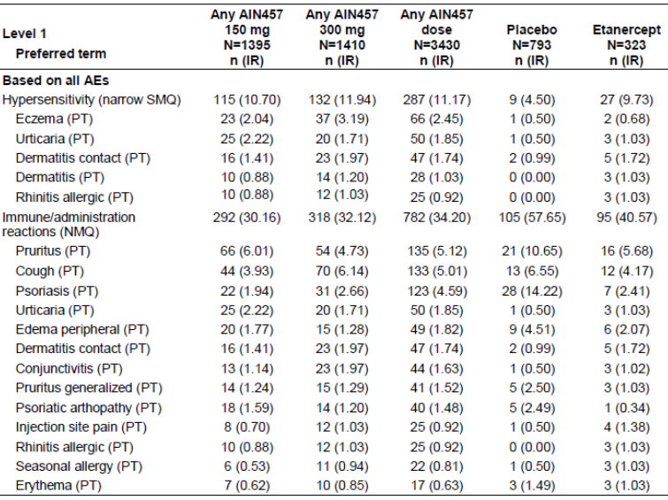

Administration and immune reactions with secukinumab pre-filled syringe and autoinjector/pen
The safety of secukinumab PFS and AI was assessed in studies A2308 and A2309. Results of both pivotal Phase III studies showed that the overall safety profile in the induction period for secukinumab PFS and AI was comparable to that of LYO used in other Phase III studies (A2302, A2303, A2304 and A2307). No deaths were reported during the induction period of either study. In Study A2308 evaluating secukinumab PFS, the overall incidence of AEs was similar between 300 mg (50.8%) and placebo (47.5%) and higher with 150 mg (57.6%). In Study A2309 evaluating secukinumab AI, total AEs were more frequent with secukinumab than with placebo (70.0% for 300 mg and 63.9% for 150 mg versus 54.1% for placebo). The incidence of SAEs was low and comparable across the treatment groups in both studies. Infections and infestations was the most frequently affected SOC in both studies and mainly consisted of upper respiratory tract infections. In Study A2309 infection rates were higher in secukinumab treated patients versus placebo treated patients and a dose response was noted (43.3%, 39.3% and 31.1% for 300 mg, 150 mg and placebo, respectively). However in Study A2308 infection rates were higher with 150 mg (20.3%) and identical between 300 mg (15.3%) and placebo (15.3%). Administration and immune reactions with PFS and AI were consistent with those observed in other Phase III trials using LYO in Pool A.
Potential use related hazards were assessed using a check list completed by a staff site member observing the self administration at Baseline and Week 1. There were no critical hazards observed, for example, no accidental needle sticks in a critical area, no immediate type allergic reactions or no breakages of the device. Nearly all patients successfully completed all 18 steps of the Instructions for Use (IFU) required to administer secukinumab via a PFS. The only step with a slightly lower compliance rate (172/177; 97.2% at Baseline) was Step 18, pertaining to syringe disposal in a sharps container.
Comment: There is lack of safety data on use of PFS and AI forms of secukinumab beyond 12 weeks in this submission as studies A2308 and A2309 are ongoing. The results of these studies should be provided for evaluation on completion.

Autoimmune disorders
The incidence of autoimmune disorders by NMQ in the induction period of Pool A studies was lower in the active treatment groups compared to the placebo group (1.0%, 2.0%, 0.9% and 3.5% for 300 mg, 150 mg, etanercept and placebo, respectively). This imbalance was driven by psoriasis being more frequent with placebo (2.9%) than with the secukinumab doses and etanercept (0.6%, 1.4% and 0.6% for 300 mg, 150 mg and etanercept, respectively). Single cases of Basedow’s (Graves) disease, Crohn’s disease, and dermatitis herpetiformis were reported for secukinumab only and were not clustered with any specific dose. Psoriatic arthropathy occurred in a small proportion of patients in the secukinumab dose groups and placebo group (0.3%, 0.3% and 0.6% for 300 mg, 150 mg and placebo, respectively) but was not observed in the etanercept group. No dose effects were observed in autoimmune disorders overall or by preferred term.
The profile of autoimmune disorders by NMQ in the induction period of Pool B studies was very similar to that observed for Pool A. The overall incidence was lower in the 300 mg, 150 mg and etanercept groups than with placebo (1.5%, 1.6%, 0.9% and 3.9%, respectively). The exposure adjusted incidence per 100 patient-years of autoimmune disorders by NMQ in the entire treatment period of Pool B was lower in the active treatment groups than in the placebo group (4.4, 4.6, 3.5 and 16.8, respectively). The imbalance was due mainly to the higher rates of psoriasis and psoriatic arthropathy AEs that occurred with placebo. All other AEs in this NMQ occurred at low rates with both secukinumab doses or with etanercept.
For SAEs in the autoimmune disorders by NMQ, the exposure-adjusted incidence was also lower in the active treatment groups relative to placebo (0.43 for any 300 mg, 0.44 for any 150 mg and 0.68 for etanercept versus 1.99 for placebo). Other SAEs in the autoimmune disorders NMQ reported for secukinumab at any dose included ulcerative colitis (n = 3, IR = 0.11), Crohn’s disease (n = 3, IR = 0.11), granulomatosis with polyangiitis (n = 1, IR = 0.04), multiple sclerosis (n = 1, IR = 0.04) and pemphigus (n = 1, IR = 0.04). For etanercept, the 2 SAEs in the autoimmune disorders NMQ were interstitial lung disease (n = 1, IR = 0.34) and psoriatic arthropathy (n = 1, IR = 0.34).
As Crohn’s disease is a topic of heightened interest, a broader search using the inflammatory bowel disease (IBD) narrow NMQ was performed to ensure all suspected cases of Crohn’s disease were retrieved, The search in the psoriasis clinical database (Pool B) identified a total of 10 cases (secukinumab 9, etanercept 1) of IBD, yielding an exposure-adjusted incidence rate per 100 patient-years of 0.26 for 300 mg, 0.35 for 150 mg and 0.34 for etanercept. No cases were reported for placebo. In addition to the cases identified in the induction period, there was 1 case of ulcerative colitis in a patient with prior history of IBD and 4 IBD events (2 cases of ulcerative colitis, 1 case of anal fistula and 1 case of sclerosing cholangitis) in patients with no prior history of IBD (Table 40). The search in Argus safety database retrieved a total of 18 cases of IBD from the non psoriasis studies: 11 cases from the proof of concept Study A2202 in patients with Crohn’s disease, 3 from the ankylosing spondylitis program, 2 from the psoriatic arthritis program, 1 from the rheumatoid arthritis program and 1 from the uveitis program. In Study A2202, patients with Crohn’s disease experienced no benefit of treatment with secukinumab (based on the primary endpoint of Crohn’s disease Activity Index (CDAI) reduction) with a comparable rate in the reporting of Crohn’s disease exacerbation between secukinumab treated (15.4%, 6/39) and placebo treated (15.0%, 3/20) patients. Two additional cases of worsening of Crohn’s disease, both on secukinumab, occurred during the follow up period.

Table 40. Exposure adjusted incidence of inflammatory bowel disease overall – Entire treatment period (Pool B: all psoriarsis studies – Safety set).
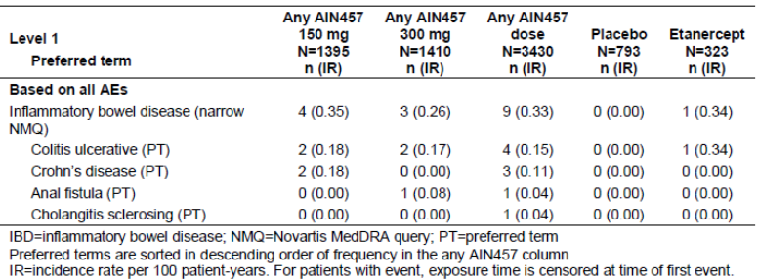

Post-marketing experience
Secukinumab has not yet been marketed in any country.

Safety issues with the potential for major regulatory impact

Liver toxicity
Risk of hepatic toxicity was monitored through monthly laboratory assessments and evaluation of hepatotoxicity related AEs throughout the entire 52 week treatment period, using regulatory guidance (FDA 2009) as a framework for risk evaluation. In the secukinumab Phase III program, although viral screens excluded patients with active or latent infection with hepatitis B or C, pre treatment elevations in hepatic enzymes or a history of hepatobiliary disorders were not criteria for absolute exclusion from study participation, allowing for broader generalization of study findings to the comorbid psoriasis population. The available safety data do not suggest the potential for severe drug induced liver injury (DILI) from secukinumab treatment. Despite small imbalances in the incidence of mild hepatic transaminase elevations versus placebo, secukinumab at both doses was not associated with a higher rate of combined elevations in hepatic transaminases and serum bilirubin.
A comprehensive search of all AEs covered under the drug related hepatic disorders broad SMQ in the Pool A pivotal studies during the first 12 weeks of treatment revealed a higher proportion of AEs in the secukinumab dose groups versus placebo (1.9% for 300 mg and 1.3% for 150 mg versus 0.9% for placebo), but a lower incidence compared to etanercept (2.5%). Of these, 1 AE of transaminases increased in the 300 mg group and 1 AE of hepatic enzyme increased in the etanercept group led to discontinuation. There was no imbalance of severe events within this SMQ (0%, 0.4%, 0.3% and 0.3%, respectively for 300 mg, 150 mg, placebo and etanercept). Only one event was reported as an SAE, a case of ascites in the setting of cardiac failure. Evaluation of the lower level SMQs within the drug related hepatic disorders broad SMQ revealed that the higher incidence rates with secukinumab versus placebo were driven largely by hepatic enzyme elevations. Liver related investigations, signs and symptoms by broad SMQ were reported for a higher proportion of patients on active treatment compared to placebo, although the overall rates were low and the rates for the secukinumab dose groups were lower or comparable to etanercept (1.7%, 1.0%, and 2.2% for 300 mg, 150 mg and etanercept versus 0.6% for placebo). Across all psoriasis trials, the incidence of drug related hepatic disorders (broad SMQ) with secukinumab was higher than with placebo during the first 12 weeks of study treatment, although rates were still lower than with etanercept, as seen in Pool A (2.1%, 1.7% and 2.5%, respectively, for 300 mg, 150 mg and etanercept versus 1.0% for placebo). No clinically meaningful difference was observed between the two secukinumab doses. The incidence of severe AEs within this broad SMQ remained comparable between the treatment groups (0.2%, 0.5%, 0.4% and 0.3%, respectively, for 300 mg, 150 mg, placebo and etanercept), with a minimal number of SAEs in the secukinumab groups only (n = 1, 0.09% for 300 mg and n = 2, 0.17% for 150 mg) The SAEs by preferred term were ascites (150 mg) in the setting of cardiac failure , hepatic cirrhosis (150 mg) in a patient with prior methotrexate use and liver injury (300 mg) secondary to a traffic accident . AEs in the lower level SMQ of cholestasis and jaundice of hepatic origin continued to be rare during the induction period of the expanded psoriasis pool, with one further event of jaundice in the any secukinumab dose group in addition to the single event reported in Pool A.
The exposure adjusted incidence rates over the entire treatment period for drug related hepatic disorders (broad SMQ) were comparable between secukinumab and etanercept groups, which were higher than placebo (5.4, 5.1 and 5.6 for any 300 mg, 150 mg and etanercept versus 4.5 for placebo). No clinically meaningful difference was apparent between the secukinumab doses. Severe events within this SMQ were more frequent per 100 patient-years for placebo than for the active treatment groups (2.0 for placebo versus 1.0 for any 300 mg, 1.1 for any 150 mg and 1.0 for etanercept), driven primarily by hepatic steatosis.
A few additional SAEs in this SMQ were reported for secukinumab only over the entire treatment period; however, the exposure adjusted incidence rates remained low and were comparable between dose groups (n = 4, IR = 0.34 for any 300 mg and n = 3, IR = 0.26 for any 150 mg) . None of these SAEs were consistent with DILI attributable to secukinumab, as all cases had plausible and well documented alternate etiologies of hepatocellular injury, including ascites secondary to cardiac failure, hepatic fibrosis in the setting of prior methotrexate use, portal hypertension, hepatic steatosis, alcoholic liver injury, trauma-related liver injury, and cholecystitis/cholelithiasis. Of note, one patient in the 300 mg group who developed acute cholecystitis and hepatitis during the maintenance period was suspected by the investigator to have drug induced hepatitis due to study treatment. However, this patient’s liver enzyme abnormalities occurred and resolved concurrently with the acute cholecystitis, which was radiographically confirmed and treated medically. In the lower level SMQ of cholestasis and jaundice of hepatic origin, 3 additional events of hyperbilirubinemia were reported over the entire treatment period in the any secukinumab dose group, but there were no additional cases of DILI, other than the single no -serious case in the 150 mg secukinumab group observed in the first 12 weeks of treatment.

Haematological toxicity
Neutropenia as defined by CTCAE Grades 1 and 2 was more frequently observed with secukinumab and etanercept than with placebo, with no dose dependency for secukinumab. Over the entire treatment period in Pool B, Grade 3 neutropenia was reported for comparable proportions of patients in the two secukinumab dose groups (n = 10, 0.7% for any 300 mg and n = 8, 0.6% for any 150 mg) and for 1 placebo patient (0.1%), with most cases being mild, transient, reversible and not temporally associated with infections. Of the 18 cases on secukinumab, only 3 patients had mild or moderate, non serious infections (rhinitis, upper respiratory tract infection and cystitis) within 1 to 2 weeks of the Grade 3 neutropenia event. Grade 4 neutropenia was reported for 1 etanercept patient only and was associated with a mild, non serious AE of nasopharyngitis. The incidence of anemia was higher with placebo than with the secukinumab doses and etanercept. Other laboratory abnormalities over the entire treatment period in leukocytes, lymphocytes and platelets were mainly of Grade 1 or 2. The rate of Grade 2 leukopenia, lymphopenia and thrombocytopenia was higher in the secukinumab dose groups versus placebo but the secukinumab dose groups were comparable to etanercept. Grade 3 abnormalities in leukocytes, lymphocytes and platelets were reported in a small number of patients, with no clinically meaningful differences between the secukinumab doses. No Grade 4 abnormalities were reported, except for the single case of Grade 4 neutropenia in one etanercept patient.

Serious skin reactions
None.

Cardiovascular safety
Psoriasis is associated with increased prevalence of cardiovascular risk factors, including hypertension, diabetes, obesity and dyslipidemia (Neimann et al 2006, Langan et al 2012). The combined presence of these risk factors is known as metabolic syndrome. Patients with psoriasis also have an increased risk of MACE (defined as myocardial infarction, stroke and cardiovascular death) beyond that attributable to the known cardiovascular risk factors (Gelfand et al 2006, Gelfand et al 2009, Mehta et al 2010).
An independent Cardiovascular and Cerebrovascular Safety Adjudication Committee (CCVAC) was established to review and adjudicate potential MACE cases in a blinded manner on a program wide basis. The adjudication definitions used by the CCV-AC are summarized in Table 41 which describes the adjudication outcome and the level of evidence used to support each outcome.

Table 41. MACE adjudication definitions.
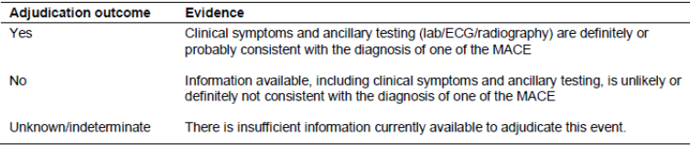

Pool A
Potential MACE cases in the induction period of Pool A studies were reported for 2 (0.3%) patients in the 300 mg group, and consisted of acute myocardial infarction and cerebrovascular accident both cases were reported as SAEs and the cerebrovascular accident led to discontinuation of induction treatment No MACE cases were reported for 150 mg, placebo or etanercept in the induction period of Pool A.

Pool B
Potential cases of MACE in the induction period of Pool B trials were reported for 3 (0.3%) patients on 300 mg secukinumab and 1 (0.1%) patient on placebo representing 2 more cases (1 on 300 mg and 1 on placebo) in addition to the 2 cases identified in Pool A. No potential MACE cases were identified for adjudication in the 150 mg or etanercept groups in the induction period of Pool B. Potential MACE cases over the entire treatment period of Pool B were reported for similar proportions of patients on secukinumab and etanercept, which were higher than placebo: 6 (0.4%) for any 300 mg, 5 (0.4%) for any 150 mg and 1 (0.3%) for etanercept versus 1 (0.1%) for placebo. The MACE PTs were as follows:
- In the any 150 mg group, the 5 events were myocardial infarction, cerebrovascular accident, haemorrhagic stroke, ischemic stroke and moyamoya disease.
- In the any 300 mg group, the 6 events were myocardial infarction (n = 2), acute myocardial infarction (n = 2) and cerebrovascular accident (n = 2).
- In the placebo group, one patient had brain stem hemorrhage.
- In the etanercept group, one patient experienced myocardial infarction.
After adjusting for exposure over the 52 weeks, the incidence per 100 patient-years of potential MACE AEs was similar across the treatment groups (0.51, 0.44, 0.50 and 0.34 for any 300 mg, any 150 mg, placebo and etanercept, respectively). The majority of potential MACE were reported as SAEs, except for 1 case in the any 300 mg group (myocardial infarction), 1 case in the any 150 mg group (moyamoya disease), and 1 case in the placebo group (brain stem hemorrhage). The absolute incidence of reported MACE SAEs was similar between the any 150 mg, any 300 mg and etanercept groups (all, 0.3%) versus 0% for the placebo group. Similar results were observed after adjusting for exposure, with comparable incidence rates between the secukinumab and etanercept groups that were all higher than placebo (0.42 for any 300 mg, 0.35 for any 150 mg and 0.34 for etanercept versus 0 for placebo). Five of the 6 cases in the any 300 mg group and the single case on placebo did not cause discontinuation. The discontinuation rate due to MACE was 0.1% (n = 1) in the any 300 mg group (cerebrovascular accident), 0.2% (n = 3) in the any 150 mg group (cerebrovascular accident, haemorrhagic stroke, ischemic stroke), and 0.3% (n = 1) in the etanercept group (myocardial infarction). The incidence of adjudication confirmed MACE was low and comparable between the secukinumab dose groups. There were 5 (0.4%) cases for any 300 mg on 1,178 patient-years of exposure, 4 (0.3%) cases for any 150 mg on 1,142 patient-years of exposure, 1 (0.1%) case for placebo on 201 patient-years of exposure, and 1 (0.3%) for etanercept on 293.5 patient-years of exposure (Table 42). All cases had prior or active cardiovascular disease or relevant risk factors.

Table 42. MACE adjudication results – Entire treatment period (Pool B: All psoriasis trials – Safety set).
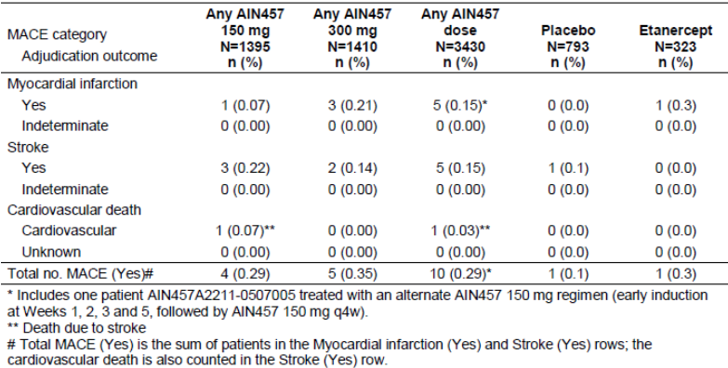

Pool C
The exposure adjusted incidence of potential MACE AEs over the entire treatment period of all secukinumab trials (Pool C) was comparable between the any secukinumab dose group and placebo (n = 15, IR = 0.42 for any secukinumab dose versus n = 2, IR = 0.59 for placebo). Similarly, no difference between the any secukinumab dose group and placebo was observed in the incidence rate of potential MACE SAEs in Pool C (n = 13, IR = 0.36 for any secukinumab dose versus n = 1, IR = 0.30 for placebo). The expanded search for MACE in Pool C of all secukinumab studies identified further cases in the clinical trial database, with an additional 4 cases on secukinumab and 1 case on placebo in other indications. Adjudication by the CCV-AC confirmed 3 of the 4 cases for secukinumab and the single case on placebo. The remaining case on secukinumab of myocardial infarction in patient was adjudicated as ‘indeterminate’. All cases had prior or active cardiovascular disease or related risk factors. When considering results from the adjudication of both psoriasis and non psoriasis trials, the incidence of adjudication-confirmed MACE in Pool C was comparable between secukinumab and placebo: 13/4498 (0.29%) for the any secukinumab dose group (this includes 10 confirmed cases in psoriasis studies and 3 confirmed cases in other indications) on 3,588 patient-years of exposure and 2/1158 (0.17%) for placebo on 339 patient-years of exposure.
Given the association between psoriasis and increased rates of cardiovascular disease and cardiovascular mortality, the evaluation of cardiovascular risk in patients with psoriasis was expanded to include events beyond myocardial infarction and stroke CCV events were identified using NMQ of the clinical database that included the following search terms:
- Myocardial infarction (broad SMQ)
- Central nervous system (CNS) haemorrhages and cerebrovascular conditions (broad SMQ)
- Cardiac failure (narrow SMQ)
- Peripheral revascularization procedures (standard NMQ)
- Cardiac arrhythmia terms, non-specific (narrow SMQ)
- Ischemic cerebrovascular conditions (broad SMQ)
- Conduction defects (narrow SMQ)
- Other ischemic heart disease (narrow SMQ)
- Supraventricular tachyarrhythmias (narrow SMQ)
- Tachyarrhythmia terms, nonspecific (narrow SMQ)
- Ventricular tachyarrhythmias (narrow SMQ)
No new MACE as per definition was identified with this expanded search. The absolute incidence of CCV events in the first 12 weeks was low and showed no clinically meaningful differences between secukinumab doses and placebo (0.4% for 300 mg and 1.0% for 150 mg versus 1.6% for placebo in Pool A, 0.8% for 300 mg and 0.9% for 150 mg versus 1.5% for placebo in Pool B) After adjusting for exposure over the 52 week period, the incidence of CCV events for the secukinumab doses (IR = 3.27 for any 300 mg and 2.65 for any 150 mg) was lower than placebo (IR = 6.54) and etanercept (4.86). Conduction defects, such as first degree atrioventricular (AV) block and left bundle branch block, contributed to the higher exposure-adjusted rate for placebo. The incidence of CCV SAEs was comparable for the two secukinumab dose groups (IR = 0.9 for any 300 mg and 1.1 for any 150 mg) and etanercept (1.0), which were higher than placebo (0.50). Nearly all CCV SAEs were associated with prior cardiovascular disease or pre existing comorbidities, and the higher rate of CCV SAEs for the secukinumab dose groups compared to placebo is in line with the higher incidence of cardiovascular comorbidities at baseline observed in Pool B for the secukinumab dose groups compared with placebo.
Unlike other biologics programs in psoriasis, patients with stable cardiovascular risk factors were not excluded from secukinumab treatment. Despite more patients with baseline cardiovascular risk factors in the secukinumab dose groups compared to both placebo and etanercept, the absolute incidence of MACE in the first 12 weeks was low (0.3% for 300 mg in Pool A; 0.3% for 300 mg and 0.1% for placebo in Pool B). After adjusting for exposure over the 52 week treatment period, the risk of MACE events with both doses of secukinumab (IR = 0.51 for any 300 mg and 0.44 for any 150 mg) was comparable to placebo and etanercept (IR = 0.50 for placebo and 0.34 for etanercept). All cases were associated with prior or active cardiovascular disease or risk factors at baseline. There was no dose dependence for secukinumab. Secukinumab at any dose was comparable to placebo for MACE (0.29% for the any secukinumab dose group versus 0.17% for placebo) in Pool C of all secukinumab studies covering 4,498 patients treated with secukinumab and 3,588 patient-years of exposure to a wide range of doses.

Unwanted immunological events
Historically, therapeutic monoclonal antibodies (mAbs) have been associated with immunogenicity rates varying from 1 to 4% for human mAbs, 1 to 12% for humanized mAbs, 1 to 13% for chimeric mAbs, and up to 80% for murine mAbs (Hwang and Foote 2005). Collectively, among the 3,627 patients evaluated for ADA across the specified Phase II and III trials (263 in A2211E1 and 3364 across all Phase III trials), a total of 27 (0.7%) showed treatment-emergent ADA, with neutralizing antibodies detected in one-third of these cases (9/27). The development of treatment emergent ADA was not associated with any injection site reactions or serious or severe administration reactions, including hypersensitivity events. In addition, with few exceptions, whether neutralizing or not, ADA were not associated with a loss of therapeutic efficacy of secukinumab or altered PK profiles.
Compared to the large Phase III program, treatment emergent ADA were observed more commonly in the smaller Phase II extension trial (Study A2211E1) (8/263 = 3.0%), in which all patients received secukinumab as part of the study design and immunogenicity was evaluated more frequently than in the Phase III trials. In the Phase II extension study, transient, mild non serious AEs within the hypersensitivity SMQ were reported in 2 secukinumab patients with treatment emergent ADA, including perioral dermatitis in 1 patient and both seasonal allergy and post-injection nausea in another patient, but these were not observed in the larger Phase III program. In addition, the AEs observed in the Phase II program were not associated with higher ADA titers, and none resulted in treatment interruptions or discontinuations.
Rates of treatment emergent ADA were not increased in patients with less frequent secukinumab dosing in the large Phase III trial A2304, who only received secukinumab retreatment during the maintenance period at the start of relapse (SoR), compared to patients on FI dosing who received secukinumab every 4 weeks across the entire Phase III program (300 mg SoR: 0/217 = 0%; 150 mg SoR: 1/205 = 0.5%; 300 mg FI: 3/948 = 0.3%; 150 mg FI: 6/940 = 0.6%).
Loss of efficacy was systematically assessed only in Phase III studies with the 4 week FI dosing regimen proposed for marketing, as other patients on irregular and less frequent secukinumab dosing schedules (for example, SoR regimens in A2304 and A2211E1 using different retreatment criteria, 12 week FI dosing in A2211E1, partial or non responders in A2211E1) were considered not assessable for loss of efficacy. Across all Phase III trials, the development of treatment emergent ADA in patients on 4 week FI dosing was not associated with a loss of PASI 75 response or a loss of efficacy defined conservatively as a 6 point increase from the minimum achieved PASI score. There was a single patient with treatment-emergent ADA at Week 12 in the 150 mg FI group who was a partial responder based on PASI score and could not be assessed for loss of PASI 75 response; however, this patient did not experience a 6 point increase from the minimum achieved PASI score and, therefore, was not considered to have experienced loss of efficacy. Although not systematically assessed for loss of efficacy, of the 8 patients with treatment-emergent ADA in the Phase II extension study, there was no discernible pattern of changes in PASI score in these patients. Higher treatment-emergent ADA titers were also not associated with loss of efficacy in Phase II or III patients.
Treatment-emergent ADA were also not associated with altered PK profiles in Phase III patients on 4 week FI dosing, in whom PK profiles could be compared to the larger study population. Secukinumab concentrations in these patients fit into the observed range for all patients without ADA at Weeks 4, 12, 24 and 52, as well as steady state concentrations observed at Weeks 24 and 52. For the 5 patients in the Phase II extension study in whom PK was analyzed, all had normal profiles. There was also no correlation between ADA titers and alteration in PK profile in Phase II or III patients. Across all secukinumab exposed patients evaluated for ADA in the Phase III trials, 3/2842 (0.1%) patients tested positive for both treatment emergent ADA and neutralizing antibodies. PK profiles were normal and therapeutic efficacy was maintained in the 2 patients with neutralizing antibodies who were on a FI dosing regimen, whereas the third patient on a SoR regimen could not be assessed for efficacy or change in PK. The incidence of neutralizing antibodies was higher in Phase II Study A2211E; with 6/263 (2.3%) patients having neutralizing antibodies, although no impact of neutralizing antibodies on PK profile or efficacy (to the extent tested) was observed in these patients.
Of the 74 patients who tested positive for ADA at any time point in either Phase II or III trials, 52 (70.3%) reverted to a seronegative state at a later time point with no detectable ADA, with 50 of these patients reverting while on treatment. This includes 5 of the 10 (50%) patients in the Phase III program with treatment-emergent ADA who also reverted to a seronegative state on treatment. Thus, the development of ADA was reversible in a substantial proportion of patients.

Other safety issues

Safety in special populations

Intrinsic factors
Safety data (AEs/SAEs) were evaluated according to the following subgroups based on intrinsic demographic and baseline disease factors:
- Age: < 65 yr, ≥65 yr, ≥75 yr
- Gender: male, female
- Race: Caucasian, Black, Asian, Native American, Pacific Islander, Other
- Weight: tertiles (< 75 kg, ≥ 75 - < 93 kg, ≥ 93 kg) and body weight strata (at randomization: < 90 kg, ≥90 kg)
- Baseline disease characteristics PASI: ≤20, > 20; Baseline IGA mod 2011 score: 3 (moderate), 4 (severe); Psoriatic arthritis PsA at baseline: yes, no
- 10-year CHD risk category: high (> 20%), medium (10-20%), low (< 10%).

Age
Most patients in Pool A were < 65 years of age and the AE profile in this age group was similar to that seen in the overall population of Pool A. AEs by age did not reveal any trends in total AEs or in the most frequently affected SOC of infections and infestations compared to the overall population. However, in the older age groups (≥ 65 and ≥ 75 years), a higher incidence of infections and infestations was observed in the etanercept group. No clinically meaningful age related differences were observed in the incidence of other SOCs. The incidence of SAEs was low in the overall population and the trends in the < 65 and ≥ 65-year age groups were similar to those in the overall population of Pool A. Only one SAE, in the 150 mg secukinumab group, was reported in the ≥ 75 year age group. Similar results were observed for the induction period of Pool B. Table 43 summarises the exposure adjusted incidence of total AEs and the 3 most frequently affected SOCs over the entire treatment period by age in Pool B. The incidence per 100 patient-years of total AEs in the < 65 year age group was consistent with the trends observed in the overall population of Pool B with a higher rate in the placebo group compared with the any secukinumab dose and etanercept groups. However, in older patients aged ≥ 65 years or ≥ 75 years, the reverse trend of higher incidence in the active treatment groups versus placebo was observed, although the relatively small number of older patients, particularly ≥ 75 years of age, makes it difficult to draw definitive conclusions. This pattern was also apparent in the most frequently affected SOC of infections and infestations, but was not consistently seen in the other SOCs.

Table 43. Exposure adjusted incidence of AEs by age – entire treatment period (Pool B: all psoriasis trials – Safety set).
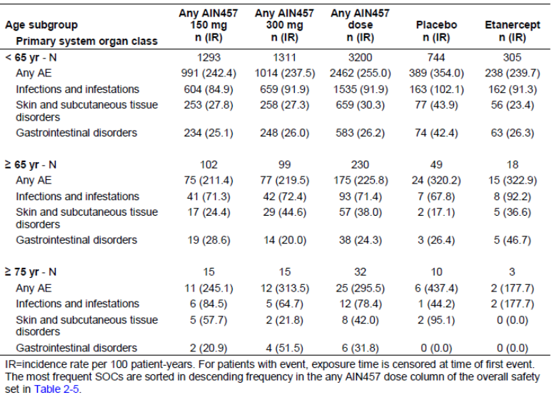

Gender
The majority of the patients in Pool A were male (69.86%) and the AE profile in both genders was similar to that for the overall population of Pool A. However, the incidence of total AEs was higher in females versus males across all treatment groups. Females also showed higher rates of AEs in the SOCs of infections and infestations and cardiac disorders, particularly with etanercept treatment. The incidence of AEs related to reproductive system and breast disorders was higher in females compared to males. No other gender or treatment specific trends were observed. Total SAEs were reported less frequently in females than males in both secukinumab dose groups and the placebo group, and there were too few SAEs in the etanercept group to observe any gender related trends (2 females and 1 male on etanercept had SAEs). SAEs related to cardiac disorders, reported only in the secukinumab dose groups, all occurred in males, but there was no dose effect. Serious infections and infestations reported for secukinumab occurred only in males; only one female, who was on placebo, experienced a serious infection. The incidence per 100 patient years of total AEs and the SOC of infections and infestations showed the same pattern in both genders as seen in the overall population, with higher rates in the placebo group compared with the two secukinumab dose groups and etanercept group. Higher exposure adjusted rates of AEs in the 3 most frequently affected SOCs as well as in reproductive system and breast disorders were also reported in females versus males. The incidence of SAEs was low in the overall population and the trends in the female and male groups were consistent with the trends observed in the overall population of Pool B comparable to the observations for the induction period.

Race
Most patients in Pool A were either Caucasian (72.11%) or Asian (18.88%). The AE profile by race showed similar trends as those observed for the overall population of Pool A. No Black patients received etanercept. No race related trends in total AEs or in infections and infestations were observed compared to the overall population. In addition, no clinically meaningful differences by race were observed in the incidence of AEs in the SOCs of skin and subcutaneous disorders, gastrointestinal disorders or cardiac disorders compared to the overall population. The incidence of SAEs was low overall and reported mainly in Caucasians and Asians, the two predominant races in the overall population. No race-related trends were observed among the small number of SAEs reported. Similar results were observed for the induction period of Pool B and also for the entire treatment period of Pool B studies.

Body weight
No specific weight-related trends in total AEs or in the most frequently affected SOC of infections and infestations were observed with secukinumab. However, the incidence of overall AEs was higher in patients weighing ≥ 75- < 93 kg across all treatment groups and in heavier patients (≥ 93 kg tertile and ≥ 90 kg stratum) in the etanercept group. A higher incidence of AEs in the infections and infestations SOC was also observed in the etanercept group in the heaviest patients (≥ 93 kg tertile). No meaningful differences were observed in the incidence of SOCs of cardiac disorders, skin and subcutaneous tissue disorders or gastrointestinal disorders compared to the overall population. However, a higher incidence of cardiac AEs was reported in patients weighing ≥ 93 kg in the etanercept group. The incidence of SAEs was low and no weight-related trends were observed. Serious infections and infestations were not reported in the ≥ 93 kg tertile or ≥ 90 kg stratum. Serious cardiac disorders, although rare, were reported in both lower weight patients (< 75 kg tertile or < 90 kg stratum) and heavier patients (≥ 93 kg tertile or ≥ 90 kg stratum). Similar results were observed for the induction period of Pool B and also for the entire treatment period of Pool B studies.

Baseline disease characteristics
There were no trends in the 3 subgroups of baseline disease characteristics that were markedly different from the overall populations of the respective data pools. However, the incidence of total AEs and AEs in the cardiac disorders SOC in the etanercept group was higher among patients with moderate disease (≤ 20 baseline PASI and moderate Severity of Psoriasis criteria). Of note, AEs of erythrodermic psoriasis was more frequently reported in patients with severe baseline disease (> 20 baseline PASI, total BSA > 20% or baseline IGA mod 2011 score = 4) than in patient with moderate baseline disease (≤ 20 baseline PASI, total BSA ≥ 10% or baseline IGA mod 2011 score = 3).
The profile of AEs for Pool B over the entire treatment period by baseline disease severity was consistent with that observed for the overall population, although the exposure adjusted rates of total AEs were generally higher in the moderate baseline disease group. Similar results were seen for SAEs in Pool B over the entire treatment period. Of the 23 AEs of erythrodermic psoriasis on secukinumab in Pool B over the entire treatment period, more cases were reported in patients with severe baseline disease (n = 16) than in patients with moderate baseline disease (n = 7).
The majority of patients had no PsA at baseline and the AE profile in the induction period by baseline PsA was similar to that observed in the overall population of Pool B. No trends related to baseline PsA were observed in total AEs or in the most frequently affected SOC of infections and infestations compared to the overall population. No clinically meaningful differences were observed in the incidence of skin and subcutaneous tissue disorders or gastrointestinal disorders compared to the overall population. However, a higher incidence of total AEs and skin and subcutaneous tissue disorders was observed in the etanercept group in patients with baseline PsA. The profile of AEs for Pool B over the entire treatment period in patients with or without baseline PsA was consistent with those observed for the overall population, although the exposure adjusted rates of total AEs and SAEs tended to be higher in patients with baseline PsA.
The majority of patients across all treatment groups were in the low risk category for 10 year CHD risk (< 10%). AEs by CHD risk category in the induction period for Pool B were consistent with the profile observed in the overall population. There was no increase in the incidence of AEs in the SOCs of cardiac disorders, nervous system disorders and vascular disorders among patients in the high 10 year CHD risk category (> 20%) compared with patients in the medium (10 to 20%) or low (< 10%) CHD risk category. There were no clinically meaningful differences across the treatment groups in any subgroups of CHD risk. Similar findings were observed for SAEs by CHD risk category for Pool A, which showed no specific trends for any event. The profile of AEs for Pool B over the entire treatment period by CHD risk category was consistent with those observed for the overall population. Similar results were seen for SAEs in Pool B over the entire treatment period, although the exposure-adjusted rates of total SAEs were generally higher in the high risk (> 20%) group.

Extrinsic factors
AEs were summarized by subgroups of patients based on previous exposure to systemic, systemic biologic or systemic non biologic psoriasis therapy. The profile of AEs/SAEs and safety risks across the subgroups of previous exposure was generally consistent with that observed for the overall population of the respectively data pools. Patients in the etanercept group who had no previous exposure to any systemic therapy experienced a higher incidence of total AEs, total SAEs, and infections AEs/SAEs than previously exposed patients. All other results of the subgroup analysis showed no clinically meaningful differences across the treatment groups.
In the entire treatment period of Pool B, no clinically meaningful differences or consistent patterns in AEs or SAEs of potential risks were observed between treatment groups based on previous systemic therapy, biologic therapy, or non biologic therapy. There was a trend towards a higher exposure-adjusted incidence of Candida infections for the any secukinumab dose group versus placebo (1.29 versus 2.55) among patients previously exposed to systemic biologic therapy while patients not previously exposed showed the same trend as the overall population. This trend was not seen in subgroups of previous exposed to systemic therapy or systemic nonbiologic therapy.

Safety related to drug drug interactions and other interactions
No study has been performed to evaluate the concurrent use of live vaccines with secukinumab. No drug interaction studies have been performed in humans.

Use in pregnancy / lactation
Women of child bearing potential were excluded from all the clinical studies or were included only if using adequate contraception. There are no adequate data from the use of secukinumab in pregnant women to determine the corresponding safety profile for use in pregnancy. Animal studies do not indicate direct or indirect harmful effects with respect to pregnancy, embryonic/ foetal development, parturition or postnatal development. Because animal reproduction studies are not always predictive of human response, secukinumab should be used during pregnancy only if the benefits clearly outweigh the potential risks. It is not known whether secukinumab is excreted in human milk. Because many drugs are excreted in human milk, caution should be exercised when secukinumab is administered to a nursing woman.

Overdose, drug abuse, withdrawal/ rebound, effects on ability to drive or operate machinery or impairment of mental ability.
No cases of overdose on secukinumab have been reported in clinical studies. The three SAEs of overdose (preferred term) consisted of extra injections of placebo to etanercept for 2 cases and extra injections of placebo for 1 case, and did not represent overdoses of secukinumab (Study A2303). Single doses of secukinumab up to 30 mg/kg (that is approximately 2000 to 3000 mg) have been administered intravenously in clinical studies in other autoimmune indications, and doses up to 3 x 10 mg/kg i.v. have been administered in psoriasis studies without acute dose limiting toxicity and (Study A2212). In case of overdose, it is recommended that the patient be monitored for any signs or symptoms of adverse reactions and appropriate symptomatic treatment be instituted immediately.
Although potential for drug abuse was not evaluated, it is expected that the pharmacological action of secukinumab should not result in drug abuse and no such reports have been received.
No clear withdrawal effects after cessation of treatment have been observed in any psoriasis clinical trial. The AE profile was comparable between patients on the 4 week FI dosing regimen and patients on the SoR maintenance dosing regimen in Study A2304, indicating no withdrawal or rebound effects. The incidence of worsening forms of psoriasis, such as erythrodermic psoriasis and pustular psoriasis, was low overall and comparable between the FI and SoR dosing regimens.
Clinical studies have shown no effects of secukinumab on mental concentration, and the effects of secukinumab on the ability to drive or operate heavy machinery have not been evaluated.

Evaluator’s overall conclusions on clinical safety
Based on safety data in 3,993 psoriasis patients studied for ≥ 1 year in 10 Phase II/III clinical trials, with 3,430 patients treated with secukinumab covering 2,725 patient-years of exposure, the overall safety of secukinumab 300 mg was comparable to 150 mg. Secukinumab at both doses also showed comparable safety to placebo and etanercept over 52 weeks of treatment in 10 clinical trials in psoriasis.
Three data pools were used to assess safety of secukinumab in psoriasis and other indications.
Four pivotal, randomised, placebo controlled trials in the target indication formed the key dataset (Pool A; N = 2,399) for comparisons of short term safety (12 weeks) among secukinumab, placebo and etanercept. Two other data pools assess longer term safety data (52 weeks), one with 10 Phase II/III trials in psoriasis (Pool B; N = 3,993) and the other with all patients treated with secukinumab across 34 trials of various indications (Pool C; N = 5,044), and increase the power to detect selected rare AEs such as MACE and malignances. Pool B contributes 76% of the total patient-years exposure to secukinumab in any indication, with 3,993 psoriasis patients studied for ≥ 1 year (3,430 on secukinumab: 1,641 for at least 1 year and 2,751 for at least 6 months) in 10 clinical trials with a broad range of doses tested (intravenous doses of 3 to 30 mg/kg and subcutaneous doses of 25 to 300 mg). This exposure exceeds ICH E1 safety exposure requirements of > 1,500 patients exposed, 300 to 600 for 6 months and > 100 for 1 year.
Secukinumab showed an imbalance versus placebo in total AEs, which was driven by infections, mainly non serious upper respiratory tract infections, but this difference was observed only in the first 12 weeks of treatment and did not translate into infection SAEs or into an imbalance over 52 weeks of treatment. There was also no difference between 300 mg and 150 mg secukinumab in the overall rate of infections or in upper respiratory tract infections. Secukinumab at both doses was comparable to etanercept in total AEs and infection AEs in the first 12 weeks and over the entire 52 week treatment period. Candida infections were more frequent with secukinumab 300 mg, while 150 mg was comparable to placebo and etanercept. The imbalance between the doses was limited to non serious, localized mucosal or cutaneous candidiasis, with no reports of chronic or systemic disease in any treatment group. Candida infections were responsive to standard treatment and did not necessitate discontinuation. No serious opportunistic infections were reported. No tuberculosis or viral hepatitis reactivation was observed in any psoriasis trial. The single nonserious case of latent tuberculosis on 150 mg secukinumab was reported at baseline. A higher incidence of ear infections, primarily otitis externa, and oral herpes was also noted for 300 mg relative to 150 mg, which was comparable to placebo and etanercept, with all cases across the treatment groups being non-serious and not causing study treatment discontinuation. In addition, there was a small imbalance between the doses in conjuncitivitis and tinea pedis. Collectively, these differences are consistent with the implied role of interleukin 17 ((IL-17) in skin, mucosal and fungal infections.
Treatment related AEs were reported at higher rates in the induction and entire treatment periods for secukinumab compared to placebo, but there was no difference between the secukinumab doses, and both secukinumab doses and placebo were lower than etanercept. The difference between secukinumab and placebo were due mainly to treatment related infection AEs such as upper respiratory tract infection and pharyngitis. The higher rate for etanercept versus secukinumab and placebo was driven by injection site reactions, which are well known AEs associated with etanercept administration.
Adverse drug reactions (ADRs) classified as very common or common included upper respiratory tract infections (nasophargynitis, upper respiratory tract infection, rhinitis and pharyngitis), oral herpes, rhinorrhea, diarrhoea and urticaria. Uncommon ADRs included sinusitis, tonsillitis, oral candidiasis, tinea pedis, neutropenia and conjunctivitis.
SAEs and discontinuations due to AEs were infrequent in the first 12 weeks of treatment and showed no differences among secukinumab, placebo and etanercept or between the secukinumab doses. Over 52 weeks, SAEs remained comparable across the treatment groups, with no dose dependence and no clustering of specific events. Secukinumab was comparable to etanercept in AEs leading to discontinuation over 52 weeks, while few placebo patients remained after 12 weeks due to lack of response and were not available for comparison at later timepoints. The rate of AEs causing discontinuation was low and comparable for the secukinumab, placebo and etanercept groups during the induction periods of both data pools and no dose effect was observed. For the entire treatment period (Pool B), the incidence of AEs causing discontinuation was comparable between the secukinumab dose groups and etanercept. While the placebo group reported fewer discontinuations over the entire treatment period, this may be confounded by the much lower placebo exposure after Week 12. AEs causing more frequent discontinuation with secukinumab relative to placebo included psoriatic arthropathy, thrombocytopenia and erythrodermic psoriasis. Psoriasis caused more discontinuations in patients on placebo compared to patients on any secukinumab dose.
In the first 12 weeks of treatment in psoriasis trials (Pools A and B), the rate of MACE was very low and secukinumab at both doses was comparable to both placebo and etanercept. There was no increased risk over 52 weeks compared with placebo and no dose dependence for secukinumab in Pool B of all psoriasis trials and in Pool C of all secukinumab treated patients. Similarly, there was no difference between secukinumab and placebo for MACE confirmed by an independent cardiovascular/cerebrovascular (CCV) adjudication committee based on data from psoriasis studies and across all indications. All cases of confirmed MACE across the treatment groups were associated with prior or active cardiovascular disease and relevant risk factors, such as hypertension, obesity, dyslipidemia and diabetes. The rate of CCV related AEs was low and comparable across the treatment groups in the first 12 weeks of treatment, and after adjusting for exposure the incidence rate was lower for secukinumab and etanercept compared to placebo over 52 weeks of treatment.
The incidence (absolute and exposure adjusted) of malignancies for both doses of secukinumab was comparable to both placebo and etanercept, and there was no dose dependence in the secukinumab groups. There was also no increase in the ratio of squamous cell carcinoma (SCC) to basal cell carcinoma (BCC). There were 2 cases of malignant melanoma on secukinumab, both in patients who were smokers and had prior exposure to phototherapy. There was no cluster of specific malignancies in any treatment group.
Secukinumab specific treatment emergent ADA were detected across the Phase II and III program in a minimal number of patients (0.7%), who were ADA negative prior to secukinumab exposure. Treatment emergent ADA were not associated with a loss of efficacy or alteration of PK in patients with assessable data. No severe or serious hypersensitivity reactions or administration reactions were reported in any patients with treatment emergent ADA.
Fewer injection site reactions were reported with secukinumab, with the same rate for both doses, compared to etanercept, while the active treatment groups were higher versus placebo. Safety of pre-filled syringe (PFS) or autoinjector/pen (AI) forms was comparable to lyophilisate in vial (LYO), supporting the safe use of the PFS/AI forms for self and home administration. The LYO form is intended for administration by a health care professional. The incidence of hypersensitivity AEs was comparable between secukinumab and etanercept and lowest with placebo, with the difference due to urticaria and eczema. The urticaria AEs were non serious, mostly mild to moderate in severity and not accompanied by systemic symptoms, and therefore do not reflect possible anaphylaxis. The imbalance in eczema, which encompasses a heterogeneous group of inflammatory dermatologic diseases, did not reflect an increased risk of a defined pathophysiologic disease. No new events of central nervous system demyelinating disorders were reported. A higher rate of nervous system disorders for secukinumab versus placebo was driven primarily by headache and migraine, while secukinumab was comparable to etanercept.
In psoriasis trials, Crohn’s disease was reported in 3 patients (2 on 150 mg fixed interval dosing and 1 on an alternative 150 mg dosing regimen). Two cases were exacerbations of existing Crohn’s disease and 1 case was a new event. Additional cases were reported in other indications. Due to the potential involvement of the IL-17 pathway in the pathogenesis of Crohn’s disease, it is not possible to rule out a potential increased risk of an exacerbation of Crohn’s disease.
Neutropenia was more frequently observed with secukinumab and etanercept than with placebo, but most cases were mild, transient and reversible. Neutropenia < 1.0 to 0.5 x 10⁹/L (CTCAE Grade 3) was reported in 18/3,993 patients on secukinumab, with no dose dependence and no temporal relationship to infections in 15/18 cases. The remaining 3 cases had mild to moderate, non-serious infections (rhinitis, upper respiratory tract infection and cystitis) which did not cause study treatment discontinuation. Neutropenia < 0.5 x 10⁹/L (CTCAE Grade 4) was observed in 1 etanercept patient only, who experienced a mild infection at the same time.
There was an imbalance in mild hepatic transaminase elevations versus placebo, but there was no increase in the combined elevations of hepatic transaminase and bilirubin. Laboratory criteria for Hy’s law were met in 4 patients (2 on 150 mg, 1 on 300 mg based on local laboratory data, and 1 on placebo); all cases had evidence of an established causative etiology or showed normalized values upon re-exposure to secukinumab.
There were no clinically relevant effects associated with use of secukinumab in vital signs or ECG.
No subpopulation treated with secukinumab showed an increased risk of any safety parameter compared to the overall population.
No notable difference was seen in the safety profile across the range of doses studied and the different administration routes for all secukinumab trials in Pool C.
In conclusion, secukinumab 300 mg or 150 mg has an acceptable safety profile for intended use in adult patients with moderate to severe plaque psoriasis. Secukinumab 300 mg was comparable to 150 mg and both doses showed comparable safety to placebo and etanercept over 52 weeks of treatment (Table 44).

Table 44. Summary of AEs and selected risks in the first 12 weeks and over 52 weeks of treatment.
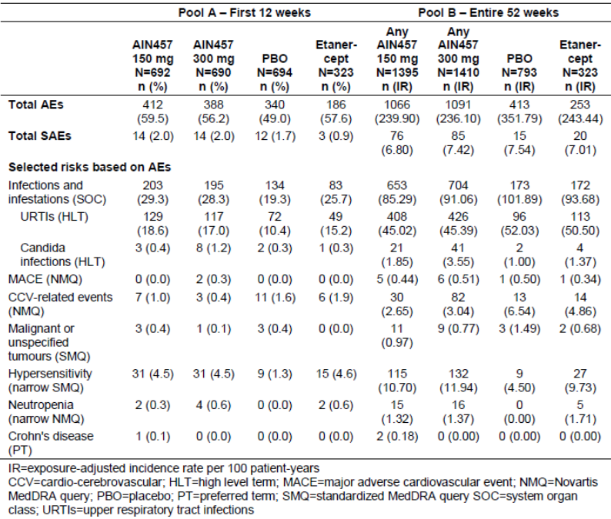

First round benefit-risk assessment

First round assessment of benefits
The benefits of secukinumab in the proposed usage are:
- All 4 pivotal trials showed consistent results demonstrating superiority of secukinumab to placebo for PASI 75 and IGA mod 2011 0 or 1 at 12 weeks. In the study which included etanercept (A2303), superiority was also demonstrated against this active comparator.
- Rapid onset of action with most rapid response was observed with secukinumab 300 mg with over 50% reduction in PASI score by Week 3 compared with by Week 4 for the 150 mg dose, and around Week 8 for etanercept.
- The measures of almost clear/clear skin (PASI 90, PASI 100 and IGA mod 2011 0 or1) in the two large Phase III studies (A2302 and A2303) over 52 weeks were better with secukinumab compared with placebo and etanercept.
- The improvement in skin scores were associated with the best chance to not only improve, but to achieve normal quality of life (DLQI 0/1) and 68.2% of the patients treated with secukinumab 300 mg were able to achieve this important goal after one year compared with 52.9% for 150 mg and 46.9% for etanercept (pooled 52 week data for A2302 and A2303).
- The benefits demonstrated for secukinumab versus placebo extended to all subgroups studied (age, gender, race, region, weight, baseline disease severity, exposure to previous systemic psoriasis therapy, and comorbid psoriatic arthritis).
- Psoriatic arthritis patients (approximately 20% of evaluated psoriasis population) benefited from secukinumab treatment beyond skin improvements, as compared with placebo or etanercept, in terms of physical functioning (HAQ-DI), with the most improved responses again seen with secukinumab 300 mg.
- All three forms of product lyophilisate powder (Studies A2302 and A2303) and liquid formulation in either pre-filled syringe (A2308) or an autoinjector/pen A2309) produced similar results in efficacy.
- Other than the small, incremental risk in candida infections for the secukinumab 300 mg dose (limited to non-serious, localized mucosal or cutaneous candidiasis), the incidence of AEs were not suggestive of a dose response compared to 150 mg.
- Secukinumab 300 mg or 150 mg has an acceptable safety profile for intended use in adult patients with moderate to severe plaque psoriasis. Secukinumab 300 mg was comparable to 150 mg and both doses showed comparable safety to placebo and etanercept over 52 weeks of treatment.

First round assessment of risks
The risks of Secukinumab in the proposed usage are:
- Secukinumab has not yet been studied in patients less than 18 years of age, in patients with hepatic impairment or renal impairment or in pregnant women.
- Live vaccines cannot be given concurrently with secukinumab.
- Increased risk of infections, especially candida infections, oral herpes and otitis media showed dose related increase.
- Increased risk of opportunistic infections.
- Increased risk of neutropenia.
- Potential of increase in risk of malignancy and MACE.
- Potential risks of foreign proteins; hypersensitivity, injection site reactions and anaphylaxis.
- Based on the possible negative effect for IL- 17A inhibition for patients with active Crohn’s disease, caution is advised when treating these patients due to risk of Crohn’s disease exacerbation.
- Secukinumab is to be used with caution in patients with a chronic infection or a history of recurrent infection.
- Lack of long term efficacy and safety data with the PFS and AI forms of secukinumab as studies A2308 an A2309 are still ongoing.

First round assessment of benefit-risk balance
Although there are many new biologic agents approved for the treatment of psoriasis, many of the patients still do not achieve optimal efficacy when one considers clinically meaningful measures such as clear/almost clear skin (and demonstrated by PASI 90) with as few as 22% achieving this with etanercept, one of the most widely used approved biologic agents. Other limitations such as slow onset, diminishing efficacy over time and drug-specific safety concerns (for example, infection including tuberculosis (TB), malignancies including lymphoma, and demyelinating neurologic events). Thus, there remains a significant unmet patient need for new agents with unique mechanisms that can provide a rapid onset of effect, improved and sustained symptom clearance, and a safety profile that allows for chronic use.
Secukinumab is a fully human IgG1 antibody that selectively binds to and neutralizes the pro-inflammatory cytokine interleukin-17A (IL-17A). IL-17A is a naturally occurring cytokine that is involved in normal inflammatory and immune responses. IL-17A plays a key role in the pathogenesis of plaque psoriasis. Secukinumab was evaluated in a large clinical program which complied with CHMP guidelines for evaluation of treatments for psoriasis. The clinical studies involved adequate number of the target patient population. It was demonstrated that secukinumab is a highly efficacious treatment with the most pronounced benefits seen with the 300 mg dose, particularly at the more difficult to achieve measures of clear/almost clear skin (PASI 90, PASI 100, IGA mod 2011 0 or 1). The superior efficacy of secukinumab versus placebo was consistent in all subgroups of body weight, age, race, disease severity, and previous exposure or failure to systemic psoriasis therapy (including anti TNFα-IR and biologic IR patients).
The 300 mg dose was associated with higher response rates across weight groups and all other subgroups examined. The majority of patients attained clear or nearly clear skin as evidenced by PASI 90 (56.6%) and IGA mod 2011 0 or 1 response (65.0%) by Week 12 with secukinumab 300 mg. This high level of response is maintained over at least 52 weeks (62% PASI 90; 63.1% IGA mod 2011 0 or 1) with differences in response rates between 300 mg and 150 mg of approximately16 to 20% for the higher endpoints at the 52 Week time point. Loss of IGA mod 2011 0 or 1 response was lowest with secukinumab 300 mg (25.8%) compared with 150 mg (39.2%) and etanercept (56.9% in Study A2303).
Patient reported outcome data were consistent with the quantitative data showing the advantage with secukinumab 300 mg. Secukinumab 300 mg resulted in a substantially higher proportion of patients with DLQI 0/1 (58.9%) compared with 150 mg (50.1%) at Week 12, with an even greater differential seen at Week 52 (68.5% for 300 mg versus 53.8% for 150 mg), representing a difference of approximately 15% between the 300 mg and 150 mg groups. Additionally, secukinumab 300 mg had a relatively rapid onset of efficacy with an approximate 40% reduction of symptoms at Week 2 and 50% reduction by Week 3. This compares with 50% reductions for secukinumab 150 mg at Week 4 and etanercept at Week 8. PsA patients (approximately 20% of the population) also benefited from secukinumab treatment both in terms of skin improvement and physical function (HAQ-DI), with the greatest benefit observed with secukinumab 300 mg.
The risk profile of secukinumab is based on 4,498 patients treated with any dose of secukinumab across a variety of autoimmune diseases. In the clinical program, there was no evidence of an imbalance of serious events compared with either placebo or etanercept. There was an imbalance in the overall incidence of infections in the secukinumab dose groups (26.9% for 150 mg and 25.8% 300 mg at 12 weeks in Pool B) compared to placebo (20.6%) and comparable to etanercept (25.7%). There was no evidence of a dose response and the vast majority of reported infections were mild/moderate upper respiratory infections. Candida infections were more frequent with 300 mg, while 150 mg was comparable to placebo and etanercept. This imbalance between doses was limited to non serious, localized mucosal or cutaneous candidiasis, consistent with the mechanism of action, with no reports of chronic or systemic disease in any treatment group.
No serious opportunistic infections were reported. The proposed PI however needs to adequately highlight the slightly increased risk for these infections which will allow early detection and intervention. No tuberculosis or viral hepatitis reactivation was observed in any psoriasis trial.
Neutropenia was more frequently observed with secukinumab and etanercept than with placebo, but most cases were mild (limited to CTC Grade 1 to 2), transient and reversible. Neutropenia < 1.0 to 0.5x10⁹/L (CTCAE Grade 3) with secukinumab was not associated with an increase in infections.
Despite small imbalances in the incidence of mild hepatic transaminase elevations versus placebo, secukinumab was not associated with a higher rate of combined elevations in hepatic transaminases and serum bilirubin. There was no dose response for secukinumab and rates were comparable to etanercept.
Malignancy may represent a theoretical risk with any immunosuppressive therapy, but there is no evidence that secukinumab confers an increased risk for malignancy. There was no imbalance in malignancies among secukinumab, placebo and etanercept, or between the secukinumab doses, in psoriasis trials (Pools A and B) or between secukinumab and placebo over 52 weeks across all indications (Pool C). Skin tumors were more frequently observed with placebo than with secukinumab or etanercept. There was no increase in the ratio of squamous cell carcinoma to basal cell carcinoma and no cluster of specific malignancies.
Due to the potential involvement of the IL-17 pathway in the pathogenesis, it is not possible to rule out the potential of increased risk of an exacerbation of Crohn’s disease.
Other than the small, incremental risk in candida infections for the secukinumab 300 mg dose (limited to non serious, localized mucosal or cutaneous candidiasis), the incidence of adverse events were not suggestive of a dose response compared to 150 mg. Secukinumab 300 mg was highly efficacious, allowing a substantially higher proportion of patients to achieve and maintain clear/almost clear skin for the entire controlled study duration of 52 weeks compared with either secukinumab 150 mg or the active comparator etanercept. The small increase in candida infections (< 1% higher with secukinumab 300 mg versus placebo, etanercept or 150 mg secukinumab, does not outweigh the substantially greater clinical benefit observed with 300 mg secukinumab in the treatment of psoriasis.
Overall, the benefit-risk balance of secukinumab 300 mg for the proposed indication of use in adult patients with moderate to severe plaque psoriasis, who are candidates for systemic therapy or phototherapy, is favourable. The recommended dose is 300 mg by subcutaneous injection with initial dosing at weeks 0, 1, 2 and 3, followed by monthly maintenance dosing starting at week 4.

First round recommendation regarding authorisation
It is recommended that secukinumab 300 mg be approved for the treatment of adult patients with moderate to severe plaque psoriasis, who are candidates for systemic therapy or phototherapy. The approval is subject to incorporation of suggested changes to the proposed PI and an adequate response to questions in Section 11.

Clinical questions

Pharmacokinetics up to here
The evaluator requests that the sponsor provides any information they have regarding the binding of secukinumab to non-IL7A proteins in humans.
Can the sponsor please provide information regarding the intra-subject variability in healthy subjects and the target population.

Pharmacodynamics
It must be noted that a number of studies aimed to assess the levels of IL-17A in serum. These studies included CAIN457A2101, CAIN457A2103, CAIN457A2204 and CAIN457A2212; however, due to the lack of a reliable assay system for this protein these analyses have not been conducted.
If these results are now available the evaluator requests that they are provided by the sponsor for evaluation.
- How many patients were included in the IL-17A analysis described in Study CAIN457A2309?
- Can the sponsor please provide the histological images of IL-17A staining in lesional skin for the other patients from Study BMD RCAIN457A2212h for comparison?
- If Study CAIN457A2223 is now complete can the full analysis be presented for evaluation?

Efficacy
- In pivotal Phase III Study A2303, no justification was provided for selection of the 10% non-inferiority margin for comparison of each dose of secukinumab (150 mg and 300 mg) versus the active control etanercept 50mg.
- In pivotal Phase III Study A2303, the results regarding rebound following discontinuation of secukinumab treatment should be interpreted with caution, as assessments of rebound were based on a small, biased sample of discontinued patients and patients not continuing in the extension study. Further analyses of rebound for the completers of the study who do not enter extension study will be presented within a separate study report of the Week 52 to Week 60 follow up period. These results should be presented for evaluation when available.
- Studies A2308 and A2309 efficacy and safety results beyond 12 weeks should be provided for evaluation on completion of the study.

Safety
None

Second round evaluation of clinical data submitted in response to questions
Not applicable.

Second round benefit-risk assessment
Not applicable.

Second round recommendation regarding authorisation
Not applicable.

References
Committee for medicinal products for human use (CHMP), European Medicines Agency for the Evaluation of Medicines for Human Use (2004) Guideline on clinical investigation of medicinal products indicated for the treatment of psoriasis. CHMP/EWP/2454/02. London, UK.
M.A.Cimmino. EPIDEMIOLOGY OF PSORIASIS AND PSORIATIC ARTHRITIS Rheumatological Clinic, Department of Internal Medicine, University of Genova, Italy. Novartis Pharmaceuticals limited licensed copy.
Finlay AY, Khan GK (1994) Dermatology Life Quality Index (DLQI): A simple practical measure for routine clinical use. Clin Exp Dermatol; 19:210-6.
Gelfand JM, Neimann AL, Shin DB, et al (2006): Risk of myocardial infarction in patients with psoriasis. JAMA; 296:1735-41.
Gelfand JM, Dommasch ED, Shin DB, et al (2009): The risk of stroke in patients with psoriasis. J Invest Dermatol; 129:2411-8.
Gelfand JM, et al (2012): Comparative effectiveness of commonly used systemic treatments or phototherapy for moderate to severe plaque psoriasis in the Clinical practice setting. Arch Dermatol. 2012. 148(4): 487-494.
Griffiths CEM, Strober BE, Kerkhof, van de P, et al (2010) Comparison of Ustekinumab and Etanercept for Moderate-to-Severe Psoriasis, N Engl J Med; 362:118-28.
Hwang WY, Foote J (2005)]: Immunogenicity of engineered antibodies. Methods; 36:3-10.
Langan SM, Seminara NM, Shin DB, et al (2012)] Prevalence of metabolic syndrome in patients with psoriasis: A population-based study in the United Kingdom. J Invest Dermatol; 132:556-62.
Leonardi CL, Powers JL, Matheson RT, et al (2003) Etanercept as monotherapy in patients with psoriasis. N Engl J Med; 349:2014-22.
Leonardi CL, Kimball AB, Papp KA, et al (2008) Efficacy and safety of ustekinumab, a human interleukin-12/23 monoclonal antibody, in patients with psoriasis: 76-week results from a randomised, double blind, placebo controlled trial (PHOENIX 1). Lancet; 371:1665- 74.
Mehta NN, Azfar RS, Shin DB, et al (2010)] Patients with severe psoriasis are at increased risk of cardiovascular mortality: cohort study using the General Practice Research Database. Eur Heart J; 31:1000-6.
Menter A, Gottlieb A, Feldman SR, et al (2008) Guidelines of care for the management of psoriasis and psoriatic arthritis: Section 1. Overview of psoriasis and guidelines of care for the treatment of psoriasis with biologics. J Am Acad Dermatol; 58:826-50.
Neimann AL, Shin DB, Wang X, et al (2006): Prevalence of cardiovascular risk factors in patients with psoriasis. J Am Acad Dermatol; 55:829-35.
Papp KA, Tyring S, Lahfa M, et al (2005) A global Phase II randomised controlled trial of etanercept in psoriasis: safety, efficacy, and effect of dose reduction. Br J Dermatol; 152:1304-12.
Papp KA, Langley RG, Lebwohl M, et al (2008) Efficacy and safety of ustekinumab, a human interleukin-12/23 monoclonal antibody, in patients with psoriasis: 52-week results from a randomised, double blind, placebo controlled trial (PHOENIX 2). Lancet; 371:1675-84.
Richards HL, Fortune DG, Griffiths CEM (2006): Adherence to treatment in patients with psoriasis. JEADV; 20:370-79.
Strober BE, Nyirady J, Mallya UG, et al (2013) Item-level psychometric properties for a new patient-reported Psoriasis Symptom Diary. Value in Health; 2013 (in press).
Thorneloe RJ, Bundy C, Griffiths CEM, et al (2013): Adherence to medication in patients with psoriasis: a systematic literature review. Br J Dermatol; 168: 20-31.
Tyring S, Gottlieb A, Papp KA, et al (2006) Etanercept and clinical outcomes, fatigue, and depression in psoriasis: double blind placebo controlled randomised Phase III trial. Lancet; 367:29-35.
Zaba LC. Effective treatment of psoriasis with etanercept is linked to suppression of IL-17 signaling, not immediate response TNF genes. L. Allergy Clin Immunol 2009. 124; 1023-1030.

Therapeutic Goods Administration
PO Box 100 Woden ACT 2606 Australia
Email: info@tga.gov.au Phone: 1800 020 653 Fax: 02 6232 8605
https://www.tga.gov.au

Melvin Berger, Stephen Jolles, Jordan S. Orange, John W. Sleasman 2013 Bioavailability of IgG Administered by the Subcutaneous Route J Clin Immunol; 33:984–990.
Wang W, et al. Monoclonal antibody pharmacokinetics and pharmacodynamics. Clin Pharmacol Therapeut 2008; 34: 548-558.
Gambichler T, Kobus S, Kobus A, et al 2011 Expression of antimicrobial peptides and proteins in etanercept-treated psoriasis patients. Regul Pept 167:163–66.
Note that the total dose received during the 12 week induction is shown on a logarithmic scale.
Rebound-like event: if PASI increased to > 125% of baseline PASI, or if new pustular psoriasis, or new erythrodermic psoriasis, or more inflammatory psoriasis occurred after the last dose of study treatment; Rebound: any rebound like event occurring within 8 weeks of the last dose of study treatment.
Note, prior exposure to non biologic PUVA therapy was not considered as a prior systemic or non biologic systemic therapy in the subgroup analyses.
Misrandomized patients included patients who were screen-failures, but had been randomized by the investigator before eligibility was finally assessed; however they had not been treated.
In study CAIN457A2211, an absolute mean change of -3.40 (SD 2.82) was observed for Psoriasis Symptom Diary item itching in the AIN457 early treatment group versus -1.17 (SD: 3.27) in the placebo treatment group, for pain -2.51 (SD: 2.40) versus -1.07 (SD: 2.19) and for scaling - 3.69 (SD: 3.06) versus -1.40 (SD: 2.57).
Most of these deviations were related to key procedures not performed as per protocol (n = 454), which consisted mainly of visits completed outside of the protocol-specified window (n = 358).
The most frequently reported cardiac events were atrioventricular block (5 patients, 0.7%), bundle branch block left (0.7%), bundle branch block right (3 patients, 0.4%), and supraventricular extrasystoles (0.4%). Arrhythmia, cardiomegaly, sinus bradycardia and tachycardia were reported by 2 (0.3%) patients each. All other cardiac events were reported in one patient each.
Daivobet is calcipotriol/ beclomethasone 50/500 gel.
The HAQ-DI measured the level of function ability and activity restriction in patients with psoriatic arthritis (PsA) at baseline. Higher scores indicate greater disability.
The ACR response was evaluated in patients with PsA at randomization defined as ≥ 3 points according to the CASPAR criteria, and ≥ 3 tender and ≥ 3 swollen joints at randomization.
Due to a Good Clinical Practice –related deviation, described as laboratory test taken before the ICF date.
Secukinumab 150 mg provided in a 1 mL pre filled syringe (1 syringe for 150 mg dose, 2 syringes for 300 mg dose), administered s.c.
DLQI measures functional disability of patients with dermatological disorders who are greater than 18years of age. It is a simple, validated, self administered 10 item questionnaire. The instrument contains six functional scales (that is, symptoms and feeling, daily activities, leisure, work and school, personal relationships, treatment).
EQ-5D is a generic instrument to assess health status. It provides a simple descriptive profile and a single index value for health status. The questionnaire has 5 questions (regarding mobility, self care, usual activities, pain/discomfort, and anxiety/depression) each with 3 categories (no problems, moderate problems, severe problems) and contains a visual analog scale (VAS) assessing the health status from 0 (worst possible health state) to 100 (best possible health state).
The identity of the treatments was concealed by the use of study drugs that were all identical in packaging, labelling, schedule of administration, appearance, taste and odour.
Metabolic syndrome is defined as the presence of ≥3 of NCEP ATP III criteria which include increased waist circumference, hypertriglyceridemia, low HDL cholesterol, elevated blood pressure and elevated glucose.
Severity of Psoriasis criteria (CHMP 2004) were defined as follows: Moderate PASI ≥ 10 or total BSA ≥ 10%; and PASI ≤ 20 and total BSA ≤ 20%; Severe: total BSA > 20% or PASI > 20.
Although the duration of exposure was similar across the treatment groups, there were fewer patients exposed to placebo or etanercept compared with patients exposed to secukinumab in Pool B trials. This accounts for the lower exposure in patient years for the placebo and etanercept groups compared to the 300 mg and 150 mg secukinumab groups. For those patients who came earlier than Day 85 for the Week 12 visit, they were not included in the ‘≥ 12 weeks’ row for the induction period.
Sixteen days prior, this patient had taken two different non-prescription cold preparations both containing acetaminophen for 5 days. By the next visit (Week 48) ALT, AST, TBL and ALP levels were all decreased and the patient received the next scheduled dose of secukinumab after a 1-week delay. By Week 52 (end of maintenance period), all hepatic enzyme levels had returned to within normal limits.
This patient (information redacted) who entered the study with congestive cardiac failure, had a baseline QTcB/QTcF = 489/479 msec and an abnormal baseline ECG showing multiple abnormalities. His QTcB/QTcF was 509/504 msec at Day 85 (Week 12), decreasing thereafter and remained > 450 msec throughout the maintenance period (while the patient continued dosing) up to Week 52, when it decreased slightly to 447/436 msec. No AEs in the cardiac disorders SOC were reported for this patient.
This patient,(information redacted) with a history of ongoing hypertension, had a baseline QTcB/QTcF = 492/476 msec. Her QTcB/QTcF was 504/481 msec at Day 85 (Week 12), decreasing thereafter and remained > 450 msec throughout the maintenance period (while the patient continued dosing) up to Week 52 (487/467 msec). The QTcB prolongation event was not reported as an AE and no AEs in the cardiac disorders SOC were reported for this patient.
A search for opportunistic infections by NMQ yielded 4 cases of esophageal candidiasis on secukinumab, 1 case of cytomegalovirus gastroenteritis in a placebo patient and 1 case of gastrointestinal candidiasis in an etanercept patient.
This patient who had a history of allergy to nuts, experienced a moderate anaphylactic reaction to nuts (reported verbatim term) on a day when no study drug was administrated and 2 days after the last prior dose of study drug.
Moyamoya syndrome is a hereditary disease in which certain arteries in the brain are constricted. Blood flow is blocked by the constriction, and also by blood clots.
At Weeks 13, 25, 37, 49, 61, 73, 97, 121 and follow-up Week 12 for phase III trials, whereas additional evaluations were performed at Weeks 145, 169, 193 and 217 for Study A2211E1

