Date of first round report: 29 July 2015
Date of second round report: 3 December 2015

AusPAR Attachment 2

Extract from the Clinical Evaluation Report for Selexipag
  - Proprietary Product Name: Uptravi
  - Sponsor: Actelion Pharmaceuticals Australia Pty Ltd

About the Therapeutic Goods Administration (TGA)
- The Therapeutic Goods Administration (TGA) is part of the Australian Government Department of Health, and is responsible for regulating medicines and medical devices.
- The TGA administers the Therapeutic Goods Act 1989 (the Act), applying a risk management approach designed to ensure therapeutic goods supplied in Australia meet acceptable standards of quality, safety and efficacy (performance), when necessary.
- The work of the TGA is based on applying scientific and clinical expertise to decision-making, to ensure that the benefits to consumers outweigh any risks associated with the use of medicines and medical devices.
- The TGA relies on the public, healthcare professionals and industry to report problems with medicines or medical devices. TGA investigates reports received by it to determine any necessary regulatory action.
- To report a problem with a medicine or medical device, please see the information on the TGA website <https://www.tga.gov.au>.
About the Extract from the Clinical Evaluation Report
- This document provides a more detailed evaluation of the clinical findings, extracted from the Clinical Evaluation Report (CER) prepared by the TGA. This extract does not include sections from the CER regarding product documentation or post market activities.
- The words [Information redacted], where they appear in this document, indicate that confidential information has been deleted.
- For the most recent Product Information (PI), please refer to the TGA website <https://www.tga.gov.au/product-information-pi>.
Copyright
© Commonwealth of Australia 2016
This work is copyright. You may reproduce the whole or part of this work in unaltered form for your own personal use or, if you are part of an organisation, for internal use within your organisation, but only if you or your organisation do not use the reproduction for any commercial purpose and retain this copyright notice and all disclaimer notices as part of that reproduction. Apart from rights to use as permitted by the Copyright Act 1968 or allowed by this copyright notice, all other rights are reserved and you are not allowed to reproduce the whole or any part of this work in any way (electronic or otherwise) without first being given specific written permission from the Commonwealth to do so. Requests and inquiries concerning reproduction and rights are to be sent to the TGA Copyright Officer, Therapeutic Goods Administration, PO Box 100, Woden ACT 2606 or emailed to <tga.copyright@tga.gov.au>.

Contents
Common abbreviations 5
1. Introduction 14
1.1. Drug class and therapeutic indication 14
1.2. Dosage forms and strengths 14
1.3. Dosage and administration 14
2. Clinical rationale 15
3. Contents of the clinical dossier 16
3.1. Scope of the clinical dossier 16
3.2. Paediatric data 17
3.3. Good clinical practice 17
4. Pharmacokinetics 17
4.1. Studies providing pharmacokinetic data 17
5. Pharmacodynamics 41
5.1. Studies providing pharmacodynamic data 41
6. Dosage selection for the pivotal studies 49
7. Clinical efficacy 49
7.1. For the proposed indication 49
7.2. Other efficacy studies 72
7.3. Analyses performed across trials (pooled analyses and meta-analyses) 79
7.4. Evaluator’s conclusions on clinical efficacy for the proposed indication 79
8. Clinical safety 83
8.1. Studies providing evaluable safety data 84
8.2. Patient exposure 86
8.3. Adverse events 89
8.4. Treatment-related adverse events (adverse drug reactions) 92
8.5. Laboratory tests 95
8.6. Post-marketing experience 110
8.7. Safety issues with the potential for major regulatory impact 110
8.8. Other safety issues 110
8.9. Safety related to drug-drug interactions and other interactions 111
8.10. Evaluator’s overall conclusions on clinical safety 114
9. First round benefit-risk assessment 117
9.1. First round assessment of benefits 117
9.2. First round assessment of risks 119
9.3. First round assessment of benefit-risk balance 120
9.4. First round recommendation regarding authorisation 121
10. Clinical questions 122
10.2. Pharmacodynamics 122
10.3. Efficacy 122
10.4. Safety 123
11. Second round evaluation of clinical data submitted in response to questions 123
11.1. Clinical questions 123
12. Second round benefit-risk assessment 137
12.2. Second round assessment of risks 137
12.3. Second round assessment of benefit-risk balance 137
13. Second round recommendation regarding authorisation 138
14. References 138

Common abbreviations
Abbreviation | Meaning
≥ | At or greater than
≤ | At or lesser than
ΔΔQTcI | baseline-adjusted, placebo-corrected effect on QTcI
< | Less than
> | Greater than
6-MWD | 6-minute walk distance
6-MWT | 6-minute walk test
ACT-293987 | selexipag/NS-304
ACT-333679 | MRE-269, the active metabolite of selexipag
ADP | adenosine-5’-diphosphate
ADR | Adverse drug reaction
AE | Adverse event
ALP | alkaline phosphatase
ALT | alanine aminotransferase
APTT | activated partial thromboplastin time
APTT AUC_{(0-144h)} | area under the APTT versus time curve to 144 h post-dose
APTT_{max} | the maximum APTT value
AST | Aspartate transaminase
AUCSS | area under the curve at steady state (over one dosing interval)
AUCτ | area under plasma concentration-time curve during a dose interval
AUC_{0–24 h} | area under the plasma concentration-time curve from time of administration until 24 hours post-dose
bd | Twice daily
BCRP | breast cancer resistant protein
BMI | body mass index
BMP | bone morphogenetic protein
BMPR | bone morphogenetic protein receptor
BP | Blood pressure
bpm | Beats per minute
BSEP | bile salt export pump
cAMP | cyclic adenosine monophosphate
CAMPHOR | Cambridge Pulmonary Hypertension Outcome Review
CEC | Critical Event Committee
CES1 | carboxylesterase 1
CHD | Congenital heart disease
CHO | Chinese hamster ovary
CK | creatine kinase
CNS | central nervous system
CYP | cytochrome P450
CI | Confidence interval
Cl | clearance
CL | Confidence limit
CLcr | creatinine clearance
CLpop | population-typical clearance
CLr | renal clearance
C_{max} | Maximum plasma concentration
C_{max},ss | maximum plasma concentration at steady-state
CrCL | creatinine clearance
CSR | Clinical Study Report
CTD | connective tissue disease
Ctrough | plasma concentration at the end of one dose interval
C_{trough,ss} | plasma concentration at the end of one dose interval at steady-state
CTx | carboxy-terminal telopeptide
CTx | serum C-telopeptides
CV | coefficient of variation
CVb | inter-subject coefficient of variation
CVw | Intra-subject coefficient of variation
DB | Double-blind
DBP | diastolic blood pressure
ECG | electrocardiogram
eGFR | estimated glomerular filtration rate
EC | endothelial cell
EC₅₀ | half-maximal effective concentration
EMA | European Medicines Agency
eNOS | endothelial nitric oxide synthase
GD | gestation day
GI | gastrointestinal
GLP | Good Laboratory Practice
HD | high dose
hERG | human ether-à-go-go-related gene
hPASMC | human pulmonary artery smooth muscle cells
EOS | End-of-study
EOT | End-of-treatment
ERA | Endothelin receptor antagonist
EU | European Union
FAS | Full analysis set
FC | Functional class
FDA | Food and Drug Administration
Fe% | amount of total radioactivity eliminated in the urine over the collection period, expressed as a percentage of the administered dose
GCP | Good Clinical Practice
Hb | Hb
HR | heart rate
IC₅₀ | half maximal inhibitory concentration
ICH | International Conference on Harmonisation
IL | interleukin
IMD | individual maintenance dose
IMP | investigational medicinal product
IMTD | individual maximum tolerated dose
INR AUC_{0-144h} | area under the INR versus time curve to 144 h post-dose
INR | International normalised ratio
INRmax | maximum INR value
INRtmax | time taken to achieve the maximum INR value
IP | Prostacyclin
iPAH | idiopathic PAH
IV | intravenous
IVRS | interactive voice response system
k12, k21, k34, k43 | transfer rate constants (compartment 1 to compartment 2, etc) ka - absorption rate constant
ke | elimination rate constant (selexipag)
Kel | terminal elimination rate constant (fractional turnover rate)
Ki | inhibition constant
Km | elimination rate constant (metabolite ACT-333679)
Km | Michaelis-Menten constant
kmet | metabolism rate constant (from parent to metabolite)
kt | transfer rate constant
L | Litre
LB | lower bound
LC-MS/MS | liquid chromatography with tandem mass spectrometry
LLOQ | Lower limit of quantification
LOQ | limit of quantification
LD | low dose
LVEDP | left ventricular end diastolic pressure
m | metre
MACE | major adverse cardiovascular events
MAP | mean arterial pressure
MDCKII | Madin-Darby canine kidney tubular epithelium type II
MD | mid dose
MRP2 | multidrug resistance-associated protein 2
MDRD | Modification of Diet in Renal Disease
MED | minimal erythema dose
mg | Milligram
mL | Millilitre
MM | morbidity/mortality
mPAP | mean pulmonary artery pressure
ms | millisecond
MTD | maximum tolerated dose
NADPH | nicotinamide adenine dinucleotide phosphate (reduced)
NCx | serum N-telopeptides
NO | nitric oxide
NOAEL | no observed adverse effect level
NOEL | no observed effect level
NONMEM | nonlinear mixed effects modelling (software)
NS-304 | selexipag
NT pro-BNP | NT pro-brain natriuretic peptide
NYHA | New York Heart Association
NZW | New Zealand White
OAS | ophthalmological sub-study analysis set
OATP | organic anion-transporting polypeptide
OCT | organic cation transporter
OL | Open-label
OSB | ophthalmology safety board
P1NP | procollagen type 1 N-terminal propeptide
PAH | Pulmonary arterial hypertension
PAP | pulmonary arterial pressure
PAT | platelet aggregation test
PCWP | pulmonary capillary wedge pressure
PD | Pharmacodynamics
PDE-5 | phosphodiesterase-5
PDE-5i | PDE-5 inhibitor
PDGF | platelet-derived growth factor
PGE₁ | prostaglandin E₁
PGI₂ | Prostacyclin
P-gp | P-glycoprotein
PI | phototoxic index
PK | Pharmacokinetics
PND | post-natal day
PO | per os (oral (gavage))
PopPK/PD | population pharmacokinetic(s)/pharmacodynamic(s)
PPS | Per-protocol set
PR | Pulse rate
P-selectin | platelet-selectin
PT | prothrombin time
PT AUC_{0-144h} | area under the PT versus time curve to 144 h post dose
PT | Preferred term
PVR | pulmonary vascular resistance
QAS | Quality of Life analysis set
QoL | Quality of Life
QTc | QT interval corrected for heart rate
QTcB | QT interval corrected with Bazett’s formula
QTcF | QT interval corrected with Fridericia’s formula
QTcI | QT interval corrected using the individualised formula
RBC | Red blood cell
RR | R-to-R interval
SC | Subcutaneous
SAE | serious adverse event
SAEM | stochastic approximation expectation maximisation
SAF | Safety analysis set
SAS | statistical analysis system (software)
SBP | Systolic blood pressure
SC | Subcutaneous
SD | Standard Deviation
SMC | smooth muscle cell
SE | standard error
SMQ | Standardised MedDRA queries
sOC | serum osteocalcin
SOC | System Organ Class
SRFI | severe renal function impairment
sTM | soluble thrombomodulin
t_{1/2} | terminal elimination half-life
TEAE | Treatment emergent adverse event
TGA | Therapeutic Goods Administration
TGF-β | transforming growth factor beta
Tlag | lag time (absorption)
T_{max} | time to reach maximum plasma concentration
T_{max},ss | time to reach maximum plasma concentration at steady-state
UB | upper bound
UGT | uridinediphosphate-glucuronosyltransferase
ULN | Upper limit normal
US | United States
UV | ultraviolet light
V/F | apparent volume of distribution (of selexipag)
Vd | volume of distribution
Vm/F | apparent volume of distribution of the central compartment for the metabolite
Vp/F | apparent volume of distribution of the central compartment for the parent
versus | versus
Vss | volume of distribution at steady-state
vWF | von Willebrand Factor
WHO | World Health Organisation
μg | µg
τ | dosing interval

Introduction
This is a submission to register a new chemical entity, Selexipag.

Drug class and therapeutic indication
Selexipag is an oral, selective non-prostanoid prostacyclin receptor (IP receptor) agonist. The vasculo-protective effects of prostacyclin (PGI2) are mediated by the IP receptors. Decreased expression of IP receptors and decreased synthesis of prostacyclin are believed to contribute to the pathophysiology of pulmonary arterial hypertension (PAH). Stimulation of the IP receptor by selexipag and its active metabolite (which is approximately 37 fold more potent than selexipag) leads to vasodilatory as well as anti-proliferative and anti-fibrotic effects.
The proposed indication is ‘for the treatment of:
- idiopathic pulmonary arterial hypertension
- heritable pulmonary arterial hypertension
- pulmonary arterial hypertension associated with connective tissue disease
- pulmonary arterial hypertension associated with congenital heart disease with repaired shunts
- pulmonary arterial hypertension associated with drugs and toxins in patients with WHO functional class II, III or IV symptoms.
Uptravi is effective in combination with an endothelin receptor antagonist (ERA) or a phosphodiesterase-5 (PDE-5) inhibitor, or in triple combination with an ERA and a PDE-5 inhibitor, or as monotherapy.’

Dosage forms and strengths
The submission proposes registration of the following dosage forms and strengths:
Uptravi 200 microgram (µg), light yellow, debossed with '2', round, film-coated tablet
Uptravi 400 µg, red, debossed with '4', round, film-coated tablet
Uptravi 600 µg, violet, debossed with '6', round, film-coated tablet
Uptravi 800 µg, green, debossed with '8', round, film-coated tablet
Uptravi 1000 µg, orange, debossed with '10', round, film-coated tablet
Uptravi 1200 µg, dark violet, debossed with '12', round, film-coated tablet
Uptravi 1400 µg, dark yellow, debossed with '14', round, film-coated tablet
Uptravi 1600 µg, brown, debossed with '16', round, film-coated tablet

Dosage and administration
The selexipag film-coated tablets are to be taken orally in the morning and in the evening, with or without food. Tolerability may be improved when taken with food. The tablets should not be split, crushed or chewed, and are to be swallowed with some water.
The recommended dosage regimen is to dose by individualised dose titration. The recommended starting dose is 200 µg given twice daily (bd), approximately 12 hours apart. The dose is to be increased in increments of 200 µg given twice daily, usually at weekly intervals, until adverse pharmacological effects that cannot be tolerated or medically managed are experienced, or until a maximum dose of 1600 µg bd is reached. The maintenance dose is also to be individualised. The highest tolerated dose reached during dose titration should be continued as the maintenance dose. If the therapy is less tolerated at a given dose over time, symptomatic treatment or a dose reduction to the next lower dose should be considered. According to the sponsor, PAH patients have variable degrees of IP receptor expression, and differences in maintenance dose of selexipag between individuals may be related to differences in IP receptor expression levels.

Clinical rationale
PAH is characterised by vasculopathy and remodelling of the pulmonary circulation resulting in narrowing of the arterial lumen and impaired vasodilation. This leads to an increase in pulmonary arterial pressure (PAP) and pulmonary vascular resistance (PVR), which limits the ability of the right ventricle to pump blood through the lungs and thereby causing shortness of breath, and eventually resulting in right heart failure and death. According to the sponsor, the pathophysiology of PAH is not fully understood, but is thought to involve abnormal interactions between endothelial and smooth muscle cells, leading to vasoconstriction, vascular smooth muscle cell proliferation, vascular endothelial proliferation, and in-situ thrombosis. Mediators of these pathological changes include reduced prostacyclin synthase activity and variably reduced IP receptor expression, an up-regulated endothelin-1 (ET-1) system, and abnormalities of the nitric oxide pathway. Current pharmacological therapies for PAH are therefore targeted towards these three mediator pathways: endothelin receptor antagonists (ERA) which inhibit the effects of elevated ET-1 levels and thus reducing vasoconstriction, smooth muscle cell proliferation and pulmonary vessel fibrosis; prostacyclin (epoprostenol) and its analogues which relax and reduce proliferation of vascular smooth muscle cells; and phosphodiesterase type 5 inhibitors (PDE-5i) and the soluble guanylate cyclase agonist, riociguat, which potentiates the anti-platelet, anti-proliferative, and vasodilatory effects of nitric oxide.
According to the sponsor, the utility of IP receptor agonism in the treatment of patients with PAH had been shown with epoprostenol and supported by studies on symptomatic endpoints with the prostacyclin (PGI₂) analogues iloprost, treprostinil, and beraprost, but that these treatments of PAH had been approved based on their symptomatic effects and no long-term controlled studies focusing on long-term clinical outcomes (morbidity/mortality) of PAH disease have been previously conducted with an agent targeting the IP receptor. In addition, the short elimination half-life of prostacyclin and most of its analogues approved for treatment of PAH requires administration of these drugs by continuous intravenous (IV) or subcutaneous (SC) infusion or multiple daily inhalations, and these modes of administration can potentially introduce risks of rapid-onset, overdosing or underdosing, thus affecting tolerability and efficacy. The sponsor was therefore of the opinion that there was an unmet medical need in the availability of a long-acting, oral pharmacological agent targeting the prostacyclin pathway for which efficacy has been demonstrated using clinically relevant endpoints associated with PAH disease progression and hospitalisation due to PAH, in a patient population representative of current treatment strategies.
Comments: The clinical rationale is sound. The currently approved IP receptor agonists for the treatment of PAH in Australia include epoprostenol, iloprost and treprostinil. Epoprostenol is to be administered by continuous intravenous infusion, and is approved for the indication of ‘long-term treatment, via continuous intravenous infusion, in WHO functional class III or class IV patients with:
- Idiopathic pulmonary arterial hypertension
- Familial pulmonary arterial hypertension
- Pulmonary arterial hypertension associated with the scleroderma spectrum of diseases’
Iloprost is a prostacyclin analogue and is to be administered by inhalation. It is approved for the indication of ‘treatment of patients with primary pulmonary hypertension or secondary pulmonary hypertension due to connective tissue disease or drug-induced, in moderate or severe stages of the disease. In addition, treatment of moderate or severe secondary pulmonary hypertension due to chronic pulmonary thromboembolism, where surgery is not possible.’
Treprostinil is a prostacyclin analogue and is to be administered by continuous subcutaneous infusion. It is approved for the indication of ‘treatment of pulmonary arterial hypertension in patients with NYHA class III-IV to diminish symptoms associated with exercise.’ Beraprost is an oral synthetic analogue of prostacyclin, but is not currently approved for use in Australia. A check through the FDA and EMA website shows that it is also not currently approved by the FDA or EMA. According to the sponsor, Beraprost is approved in Japan and South Korea.
In December 2013, oral, extended-release treprostinil (Orenitram) was approved by the FDA ‘for the treatment of pulmonary arterial hypertension (PAH) (WHO Group 1) to improve exercise capacity. The study that established effectiveness included predominately patients with WHO functional class II-III symptoms and aetiologies of idiopathic or heritable PAH (75%) or PAH associated with connective tissue disease (19%). When used as the sole vasodilator, the effect of Orenitram on exercise is about 10% of the deficit, and the effect, if any, on a background of another vasodilator is probably less than this. Orenitram is probably most useful to replace subcutaneous, intravenous, or inhaled treprostinil, but this use has not been studied’. The approved dosing regimen is by individualised titration, with recommended starting dose of 0.25mg bd, and increasing the dose as tolerated (recommended increment is 0.25mg to 0.5mg bd every 3 to 4 days) to achieve optimal clinical response.

Contents of the clinical dossier

Scope of the clinical dossier
The submission contained the following clinical information:
- Eleven clinical pharmacology studies, including 11 that provided pharmacokinetic data and 4 that provided pharmacodynamic data.
- Two population pharmacokinetic analyses.
- One pivotal efficacy/safety study (AC-065A302 [GRIPHON])
- Two other efficacy/safety studies (studies NS-304/-02 [a Phase II, placebo-controlled study] and AC-065A201 [a Phase II, uncontrolled, open-label study in Japanese patients])
- Integrated Summary of Efficacy, Integrated Summary of Safety, independent ophthalmology board safety report, two exploratory Phase II studies looking at indication unrelated to this submission (AC-065B201: efficacy and safety of selexipag in patients with chronic thromboembolic pulmonary hypertension [CTEPH]; AC-065B202: open-label extension study of selexipag in CTEPH patients who have completed Study AC-065B201)
In this evaluation report, Study AC-065A302 (GRIPHON) will be evaluated as the pivotal efficacy/safety study and Studies NS-304/-02 and AC-065A201 will be evaluated as supportive studies. As per instructions in the TGA’s ‘statement of requirements’, Studies AC-065B201 and AC-065B202 are evaluated for the purpose of this submission with regards to providing supportive safety data, and did not raise any additional safety concerns. Studies AC-065A302 and NS-304/-02 have ongoing open-label extension studies assessing long-term safety (AC-065A303 [GRIPHON OL] and NS-304/-03, respectively) and interim results are submitted, which will be evaluated with regards to supportive safety data on selexipag. For ease of reference, the study design and subject disposition of these extension studies will be discussed in the efficacy section of this report together with the respective core studies, and the safety results presented in the safety section of this report.

Paediatric data
The submission did not include paediatric data. The sponsor is not using data in this submission to support the use of selexipag in a paediatric population. The sponsor has provided the completed TGA Paediatric Development Plan and a copy of the EU Paediatric Investigation Plan (PIP). These paediatric development plans are appropriate.

Good clinical practice
The clinical studies reviewed in this evaluation were in compliance with CPMP/ICH/135/95 Note for Guidance on Good Clinical Practice.

Pharmacokinetics

Studies providing pharmacokinetic data
Table 1 shows the studies relating to each pharmacokinetic topic and the location of each study summary.

Table 1: Submitted pharmacokinetic studies.
PK topic | Subtopic | Study ID | *
PK in healthy adults | General PKs | QGUY/2006/NS-304-01 | PKs of single and multiple oral rising doses; PKs of a single oral dose of selexipag under fasting and non-fasting conditions; and PK interaction between selexipag and warfarin
PK in healthy adults | General PKs | PS003 | PKs of a 100 μg oral dose of selexipag in a 10ml solution
PK in healthy adults | Bioequivalence | AC-065-108 | Bioequivalence between 1600 μg selexipag bd administered as a single film-coated tablet and as 8 film-coated tablets of 200 μg
PK in healthy adults | Multi-dose | AC-065-101 | PKs of selexipag and ACT-333679 after multiple-ascending doses of selexipag administered orally bd
PK in healthy adults | Multi-dose | AC-065-102 | Photosensitising potential and PKs of 800 μg and 1,200 μg selexipag bd
PK in healthy adults | Multi-dose | AC-065-106 | Cardiac repolarisation and PKs following 800 and 1600 μg selexipag bd
PK in healthy adults | Mass balance | 186933 | Absorption and excretion kinetics following administration of [¹⁴C] selexipag
Special Populations | Hepatic Impairment | AC-065-104 | Effect of mild, moderate, and severe hepatic impairment on the PKs of selexipag and ACT-333679
Special Populations | Renal Impairment | AC-065-105 | PKs of selexipag and ACT-333679 in subjects with SRFI and healthy subjects
Special Populations | Japanese | NS304p101 | PKs of selexipag in healthy adult and elderly male Japanese volunteers
PK interactions | Kaletra | AC-065-109 | Effects of multiple-dose lopinavir/ritonavir on the PKs of single-dose selexipag
PopPK | Healthy subjects | AC-065-106-PPK | PopPK characteristics of selexipag and its metabolite ACT-333679
PopPK | Target population§ | AC-065A302-PPK | PopPK/PD characteristics of selexipag and its metabolite ACT-333679
* Indicates the primary aim of the study.
§ Subjects who would be eligible to receive the drug if approved for the proposed indication.
None of the pharmacokinetic studies had deficiencies that excluded their results from consideration.

Summary of pharmacokinetics
The information in the following summary is derived from conventional pharmacokinetic studies unless otherwise stated.

Physicochemical characteristics of the active substance
The following information is derived from the sponsor’s summaries.
Figure 1: Structural formula
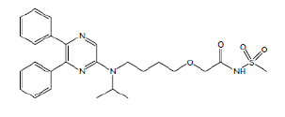
Chemical name: 2-{4-[(5,6-diphenylpyrazin-2-yl)(isopropyl)amino]butoxy}-N-(methylsulfonyl) acetamide.
Molecular formula: C26H32N4O4S
Molecular weight: 496.62 mg/mol
CAS: 475086-01-2
Pharmacotherapeutic group: Platelet aggregation inhibitors excl. heparin ACT code: B01AC27.
Description: Selexipag is a pale yellow crystalline powder that is practically insoluble in water. In the solid state selexipag is very stable, is not hygroscopic, and is not light sensitive.

Pharmacokinetics in healthy subjects
Bioanalytical methods
Five validated LC-MS/MS methods were used for the determination of selexipag and its active metabolite, ACT-333679, in human plasma [BP-304-001, PBC38-23, PBC119-001, SBQ-09003, BA-12.396]. The LOQ for both analytes was 0.01 ng/mL.

Absorption

Sites and mechanisms of absorption
Study QGUY/2006/NS-304-01 examined the PKs of selexipag following single, oral, tablet doses of 100 μg, 200 μg, 400 μg, 600 μg or 800 μg in healthy male volunteers. Selexipag was rapidly absorbed with median T_{max} values ranging from 1.0 h to 1.26 h (Table 2). Following a single dose of 200 μg (that is, the recommended starting dose), the mean C_{max} and AUC_{0-inf} values for selexipag were 3.44 ng/mL and 6.75 ng.h/mL.

Table 2: Pharmacokinetic variables of NS-304 by dose group (Part A)
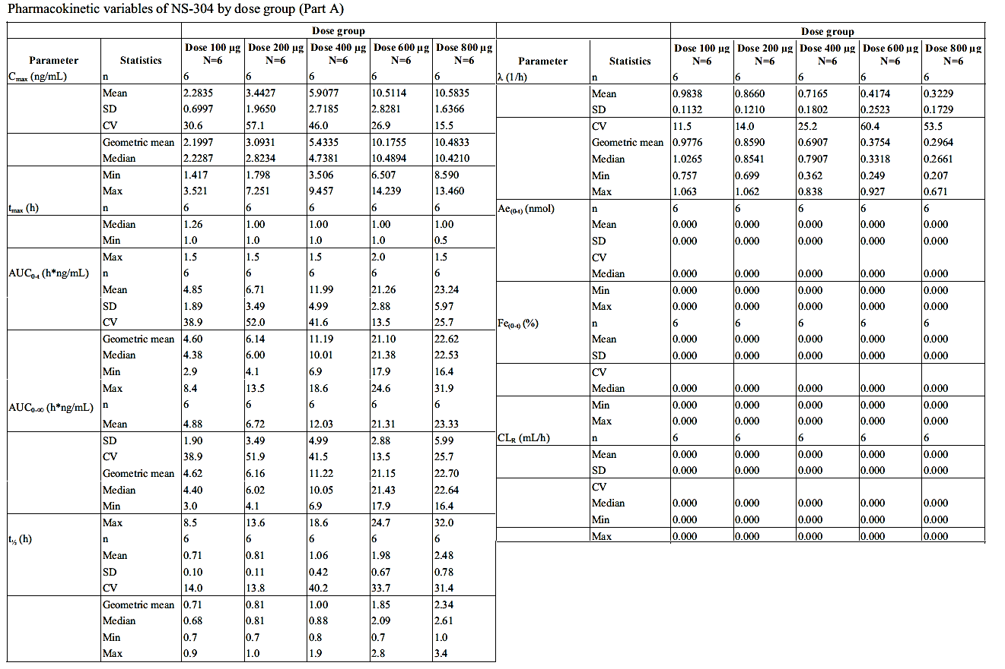

Bioavailability

Absolute bioavailability
The absolute bioavailability of selexipag is unknown as all attempts to develop an IV formulation of the drug to support the conduct of an absolute bioavailability study were unsuccessful.

Bioavailability relative to an oral solution or micronised suspension
No studies directly compared the film-coated tablet formulation to an oral solution. However, Study PS003 examined the PKs of selexipag following a single, oral administration of 100 μg selexipag in a 10ml solution. The results indicated that the mean T_{max} and t_{1/2} and geometric mean C_{max} and AUC_{0-inf} values for selexipag were 0.65 h, 1.71 h, 4.07 ng/mL and 5.84 ng.h/mL. The comparative results for the PK values following a single, oral, 100 μg dose of the tablet formulation in Study QGUY/2006/NS-304-01 were 1.26 h, 0.71 h, 2.20 ng/mL and 4.62 ng.h/mL, respectively (Table 3).

Table 3: Pharmacokinetics of selexipag and the metabolite MRE-269
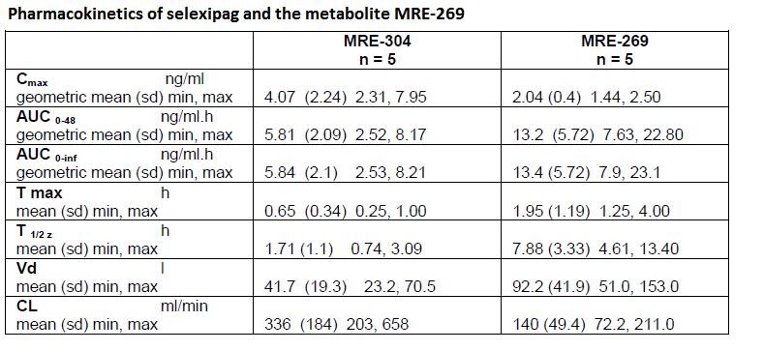

Bioequivalence of clinical trial and market formulations
As stated in the section of this report on formulation development the 200 μg commercial dose formulation is identical to that used in the pivotal Phase III trial. The difference between film-coated tablets used in other clinical studies (200, 400, 800, and 1600 μg) and commercial material is only in the colour and debossing of the tablets. These differences in formulation can be considered minor and therefore unlikely to result in differences between the PKs of the clinical trial and commercial formulations

Bioequivalence of different dosage forms and strengths
Study AC-065-108 examined the bioequivalence between 1600 μg selexipag (that is, the highest intended commercial dose strength) administered orally as a single film-coated tablet bd and as 8 film-coated tablets of 200 μg bd at steady-state following a multiple-dose up-titration. The results indicate that the two forms of selexipag were bioequivalent in regards to selexipag AUCτ and C_{max,ss}, as the 90% CIs for the geometric mean ratios fell within the acceptance bioequivalence interval of 80.00–125.00% (Table 4). T_{max,ss} values were also similar (both were 3.00 h), whereas, the C_{trough,ss} was 1.30 fold higher (90% CI: 1.10 – 1.52) following administration of the 1 x 1600 μg tablet bd.

Table 4: Plasma PK variables of selexipag and its metabolite ACT-333679 in healthy subjects at steady state after treatment with 1600 µg selexipag bd as Treatment A (reference treatment) or Treatment B (test treatment) Per protocol set (n=65)
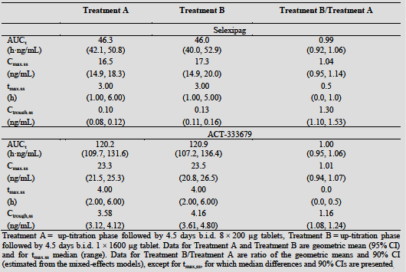
Question: Can the sponsor please provide an explanation for the 1.3 fold increase in selexipag C_{trough,ss} following administration of the single tablet form of 1600 μg selexipag bd compared to when it was administered as 8 x 200 μg selexipag bd in Study AC-065-108.
Question: The evaluator could not identify a request for a biowaiver for the intermediate dose strengths in Module 1 of the evaluation materials. Therefore, can the sponsor please direct the evaluator to the location of the request for a biowaiver in Module 1 if it has been over looked, or provide a statement for a request for a biowaiver if it has not been provided by the sponsor?

Bioequivalence to relevant registered products
Not applicable.

Influence of food
Part B of Study QGUY/2006/NS304-01 examined selexipag PKs following a single oral dose of 400 μg under fasted conditions and following a high fat breakfast. Selexipag C_{max} was 35% lower in the fed state than in the fasted state, whereas AUC_{0-t} and AUC_{0-inf} were approximately 10% higher in the fed state. Food intake delayed the absorption of selexipag with median T_{max} increasing from 1 h in the fasting state to 2.8 h in the fed state and mean t_{1/2} increased from 1.38 h to 1.81 h.

Dose proportionality
The results of a power model assessment of dose-proportionality in Part A of Study QGUY/2006/NS304-01 indicate that dose-dependent increases in selexipag C_{max} and AUC_{0-inf} values were almost dose proportional as the 95% CIs for the slopes of these parameters included or in the case of C_{max} almost included 1.

Bioavailability during multiple-dosing
A number of studies examined the PKs of a range of selexipag doses following multiple dosing. These included: Part C of Study QGUY/2006/NS304-01, which examined 8 days dosing with 200 μg, 400 μg or 600 μg selexipag bd under fed conditions; Study AC-065-101 in which the dose was up-titrated in 200 μg steps every 3 days from 400 μg to 1800 μg selexipag bd; Study AC-065-102 which evaluated the photosensitising potential and PKs of selexipag following up-titration to doses of 800 μg and 1,200 μg bd; and Study AC-065-106 which examined the effects on cardiac repolarisation and PKs of selexipag following up-titration to doses of 800 μg and 1,600 μg bd
The results of Part C of Study QGUY/2006/NS304-01 identified that there was no selexipag accumulation at steady state. In addition, the 95% CIs of the slopes for C_{max} and AUC_{0-τ} obtained from the power model assessments included 1, which indicated that the increase in rate and extent of exposure to selexipag following bd administration of doses between 200-600 μg was dose-proportional. On Day 8, it was estimated that a 2 fold increase in selexipag dose would result in a 1.97 and 1.81 fold increase in C_{max} and AUC_{0-τ}, respectively.
These findings were supported by the results of Study AC-065-101, which also failed to identify selexipag accumulation following 3 days bd dosing with 400 μg to 1800 μg selexipag (Table 5). Moreover, increases in selexipag C_{max} and AUC_{0-τ} were dose-proportional over the dose range examined (Table 6).

Table 5: Summary of descriptive statistics for the pharmacokinetic parameters of ACT-293987 on very 3rd day in each period
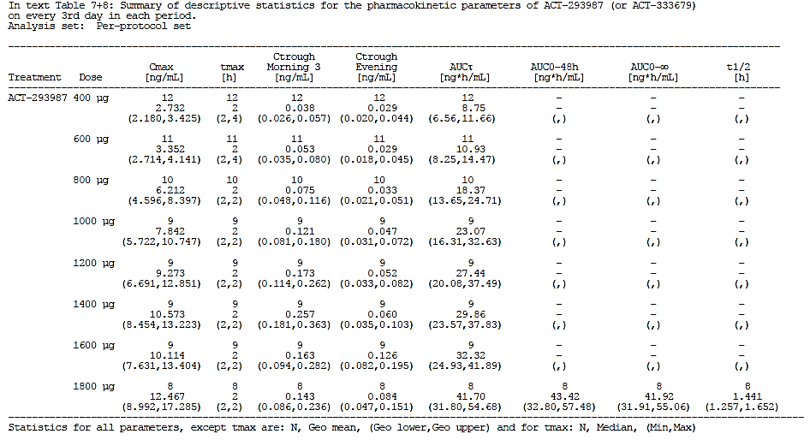

Table 6: Power model assessment of dose proportionality of C_{max} (ng.mL) and AUC_{τ} for ACT-293987 and ACT-333679 on each 3rd day after dose escalation
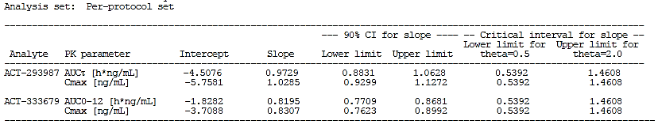

Effect of administration timing
No studies directly examined the effect of administration timing on the PKs of selexipag.

Distribution

Volume of distribution
In the absence of an absolute bioavailability study, the volume of distribution (Vd) of selexipag as a general measure of the extent of tissue distribution could not be determined. However, Study PS003, which examined the PK profile of selexipag following a single, oral solution dose of 100 μg selexipag, provided an estimated selexipag Vd of 41.7 L (Table 3). The predicted selexipag Vd at steady-state (V_{ss}) obtained from the final PK model in the PopPK study, AC-065-106-PPK was similar and V_{ss} was estimated to be 36.2 L (Table 7).

Table 7: Final model: Population PK parameters
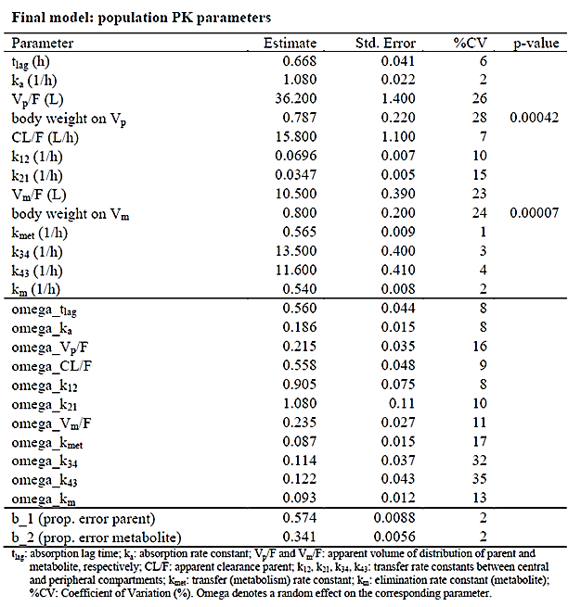

Plasma protein binding
In vitro studies indicate that selexipag is highly bound to human plasma proteins (99.7%). Further studies indicated high binding to human albumin and α1-acid glycoprotein, which was in the range of 95.9 to 97.7%.

Erythrocyte distribution
In partitioning studies the mean blood/plasma ratio of selexipag was 0.57, indicating that selexipag demonstrated little to no binding to blood cells. This result was consistent with the findings of Study AC-065-104, which identified a mean blood/plasma ratio for selexipag in healthy subjects 3 h following drug administration of 0.55% (Table 8).

Table 8: Plasma pharmacokinetic parameters of selexipag in healthy subjects and subjects with liver impairment after administration of a single dose of 200 or 400 µg selexipag
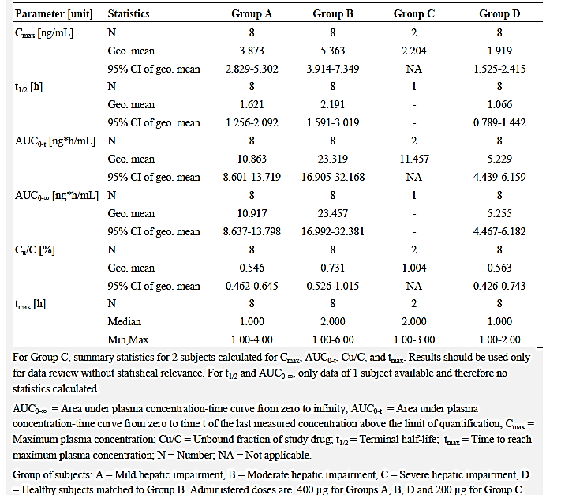

Tissue distribution
Please see the section of this report pertaining to the ‘Volume of Distribution.’

Metabolism

Interconversion between enantiomers
Not applicable.

Sites of metabolism and mechanisms/enzyme systems involved
In addition to selexipag, a total of nine metabolites were identified following multiple doses of 1.8 mg in pooled human plasma samples obtained in Study AC-065-101. The proposed metabolite structures and the proposed chemical interrelationship between these products are summarised in Figure 2.
Figure 2: Proposed metabolic pathways of selexipag in humans
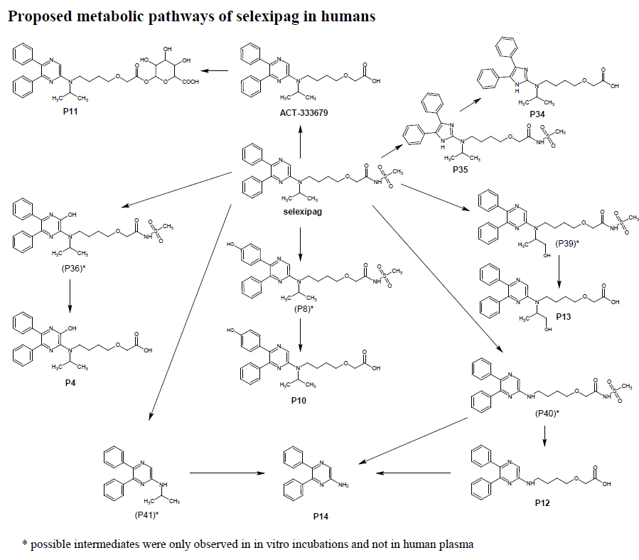
The main metabolic pathway of selexipag was via hydrolysis to its active metabolite ACT-333679. In addition, selexipag formed the ring-contracted imidazole metabolite P35 which was subsequently hydrolysed to P34. In turn, ACT-333679 was metabolised via several secondary pathways including: stepwise N-dealkylation of the aminopyrimidine, which yielded P14 via the intermediate P12; aromatic hydroxylation of the pyrimidine rings, which gave P4; oxidation at the phenyl ring, which resulted in formation of P10; and aliphatic hydroxylation of the N-isopropyl group, which yielded P13. ACT-333679 also underwent conjugation with glucuronic acid to give the acylglucuronide P11.

Non-renal clearance
The mass balance study, 186933, identified that following a single oral administration of [¹⁴C] selexipag, at a target dose of 400 µg (equivalent to 1.66 MBq/0.33 mSv), total radioactivity was eliminated primarily in the faeces, accounting for a mean of 92.74% of the administered dose by the end of the collection period (168 h post dose).

Metabolites identified in humans

Active metabolites
One circulating active metabolite, ACT-333679, was identified in humans. The sponsor states that ACT-333679 has a 13 fold higher affinity than selexipag for the human IP receptor and it is at least 16 fold more potent than selexipag in cellular systems. ACT-333679 is considered to be the major contributor to the efficacy of selexipag in man.

Other metabolites
Please refer to ‘Sites of metabolism and mechanisms’ for further details.

Pharmacokinetics of metabolites
Almost all of the PK studies which examined selexipag also investigated the PKs of its active metabolite ACT-333679 (MRE-269).

ACT-333679 PK and dose-proportionality following single doses of selexipag
Following single doses of 100 μg to 800 μg selexipag, the median T_{max} of ACT-333679 occurred between 2.25 h and 2.75 h of dosing and the mean t_{1/2} ranged from 9.40 h to 12.65 h. Following a 200 μg dose of selexipag the mean C_{max} and AUC_{0-inf} values for the active metabolite were 3.80 ng/mL and 24.42 ng.h/mL, respectively. A power model assessment indicated that exposure to ACT-333679 was dose proportional following single doses of selexipag over the range of 100 μg to 600 μg and that for every two fold increase in dose there was a 1.91 fold and 1.92 fold increases in C_{max} and AUC_{0-inf}, respectively.

ACT-333679 dose-proportionality following multiple-doses of selexipag
Following multi-dose administration of a range of selexipag doses (200 μg, 400 μg and 600 μg) bd power modelling indicated that although C_{max} increased dose-proportionally, AUC_{0-τ} increased slightly less than dose proportionally, as the upper limit for the 95% CI for slope was 0.97. In this case, the estimated increases in ACT-333679 C_{max} and AUC_{0-τ} values following a doubling of selexipag dose were estimated to be 1.97 and 1.81 fold, respectively.
Study AC-065-101 also examined the dose-proportionality of ACT-333679 following multiple doses of selexipag bd ranging from 400 μg to 1800 μg. In this case, both the C_{max} and AUC₀₋₁₂ values for ACT-333679 were found to increase less than dose proportionally as the upper bounds of the 90% CIs for the slopes of the power models were 0.83 and 0.82, respectively (Table 6).

Effect of food
Study QGUY/2006/NS-304-01 identified that the C_{max} and AUC of ACT-333679 were decreased by 48% and 27%, respectively, when selexipag was administered in the fed compared to the fasting state (Table 2). In addition, food intake delayed the exposure to ACT-333679, as median T_{max} increased from 2.5 h in the fasted state to 4 h in fed state.

Bioequivalence
Study AC-065-108, which examined the PKs at steady-state following 1600 μg selexipag administered as a single tablet bd and administered as 8 x 200 μg tablets bd, identified that the C_{max,ss}, AUCτ and C_{trough,ss} values of ACT-333689 were bioequivalent following administration of both dosage forms (Table 4). In addition, ACT-333689 T_{max} following both treatments occurred at 4 h after dosing.

Consequences of genetic polymorphism
Not examined.

Excretion

Routes and mechanisms of excretion
The mass balance study, 186933 identified that, following a single oral administration of 400 µg [¹⁴C] selexipag, total radioactivity was primarily eliminated in the faeces, with 92.7% of administered dose excreted by the end of the collection period (168 h post dose).

Mass balance studies
Study 186933 identified that approximately100% of the total radioactivity was recovered in urine and faeces by 168 h following [¹⁴C] selexipag administration.

Renal clearance
Almost 12% of the administered [¹⁴C] selexipag dose was eliminated via the urine by 168 h post drug administration.

Intra and inter-individual variability of pharmacokinetics
The estimated %CV for selexipag CL/F and Vd identified in the PopPK analysis undertaken in healthy patients, Study AC-065-106, were 7% and 26%, respectively (Table 7). The intra-subject variabilities associated with these parameters were 9% and 16%, respectively.

Pharmacokinetics in the target population
No dedicated PK/PD studies examined the PKs of selexipag in the target population. However, the PopPK/PD study, AC-065A302-PPK, provided estimates for the PK parameters of selexipag and ACT-333679 based on modelling of the plasma concentration data from 512 subjects with PAH, who were enrolled in the Phase III Study AC-065A302. The results indicated that for a typical patient with a body weight of 72 kg, the Vd and CL/F values for selexipag were 12.9 L and 19.1 L/h, respectively (Table 9). For the active metabolite, the estimate of Vd was 4.65 L. The PAH PopPK model also provided PK estimates that indicated that the AUC_{ss} values for selexipag and ACT-333679 were 30% and 20% higher, respectively, in patients with PAH than in healthy subjects (Table 10). By contrast, the C_{trough,ss} for selexipag was similar in both populations, whereas, the C_{trough,ss} for ACT-333679 in patients with PAH was 1.9 fold higher than in healthy subjects.

Table 9: Study AC-065A302 Final PopPK model parameter estimates
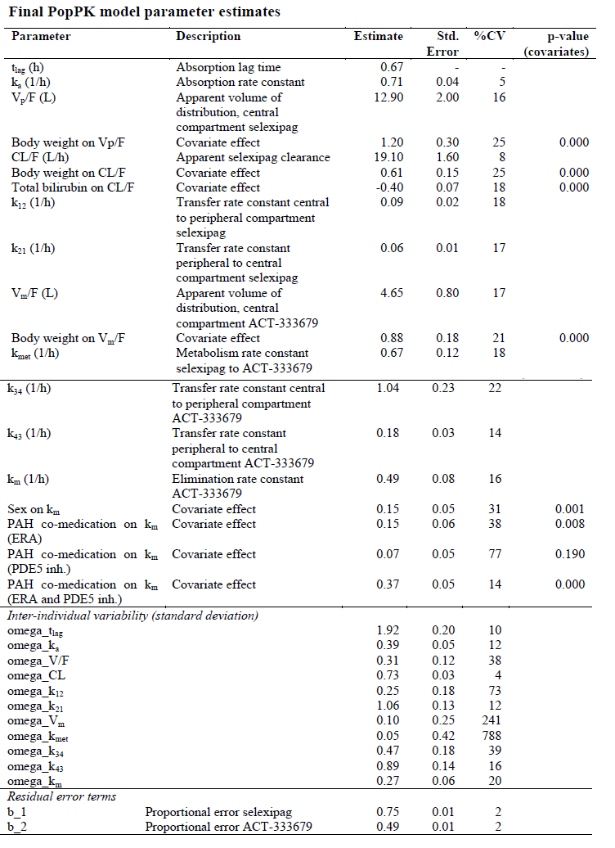

Table 10: Comparison of model prediction of PK parameters for a reference healthy subject based on healthy and patient model for steady-state doses of 1600 µg bd
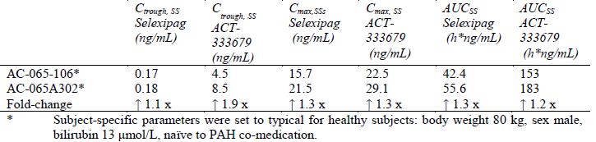
Question: The 1.9 fold increase in C_{trough,ss} for ACT-333679 identified in patients with PAH compared to healthy subjects in the PopPK/PD Study AC-065A302-PPK is unexpected. Can the sponsor please explain why they believe this is occurring and whether it is of concern, especially regarding the incidence of AEs in healthy subjects compared to patients with PAH? For instance, would the dose-dependent increase in HR identified in Study AC-065-106 be potentiated in subjects with PAH compared to healthy subjects?
Question: The PopPK Study AC-065A302-PPK provides a comparison of selexipag PKs in healthy subjects and in patients with PAH following dosing with 1600 μg bd This comparison indicates that differences in selexipag PKs exist between the two populations, in particular that there is a 1.9 fold increase in C_{trough} in patients with PAH compared to healthy subjects (Table 9). The two studies used to source the data for this comparison (that is, Study AC-065-106 for healthy subjects and Study AC-065A302 for patients with PAH) also examined the PKs of selexipag following 800 μg bd dosing. Can the sponsor therefore identify whether the same differences in selexipag PKs exist between healthy subjects and patients with PAH following 800 μg bd dosing, and in particular is selexipag C_{trough} affected to the same extent in subjects with PAH at the lower selexipag dose?

Pharmacokinetics in other special populations

Pharmacokinetics in subjects with impaired hepatic function
Study AC-065-104 investigated the effect of mild, moderate, and severe hepatic impairment on the PKs of selexipag and ACT-333679, following a single, oral dose of 400 μg or 200 μg selexipag following a light breakfast. Healthy subjects and subjects with mild and moderate impairment received the 400 μg dose, whereas, subjects with severe impairment received a 200 μg dose of selexipag. The results indicated that selexipag C_{max} and AUC_{0-inf} were increased by approximately2 fold in subjects with mild liver impairment when compared to healthy subjects (Table 8), whereas, the C_{max} and AUC_{0-inf} values for ACT-333679 were similar (1.18 fold and 0.97 fold higher, respectively) in both groups (Tables 11 and 12). In subjects with moderate hepatic impairment compared to healthy subjects, selexipag C_{max} and AUC_{0-inf} were 2.8 fold and 4.5 fold higher, respectively, the median T_{max} was longer (2.0 versus 1.0 h) and the elimination phase was characterised by a longer t_{1/2} (2.2 versus 1.1 h). The PKs of ACT-333679 were also affected by moderate liver impairment but to a smaller extent. The AUC_{0-inf} was increased more than 2 fold, median T_{max} was longer (6.0 versus 4.0 h) as was t_{1/2} (16.0 versus 12.6 h). In the 2 subjects with severe hepatic impairment compared to healthy subjects, the dose normalised selexipag C_{max} and AUC_{0-inf} were 2.3 and 3.0 fold higher, respectively, and the dose normalised C_{max} and AUC_{0-inf} of ACT-333679 were 1.2 and 2.9 fold higher, respectively.

Table 11: Study AC-065-104 Plasma pharmacokinetic parameters of ACT-333679 in healthy subjects and subjects with liver impairment after administration of a single dose of 200 or 400 µg selexipag
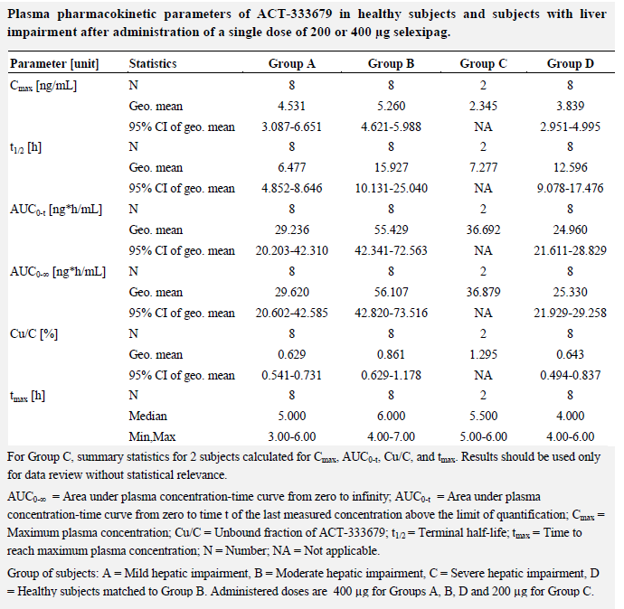

Table 12: Study AC-065-104 Geometric mean ratios and 90% confidence interval of C_{max}, AUC_{0-t} and t_{1/2} and median difference and 90% confidence interval of Tmax for selexipag comparing healthy subjects and subjects with liver impairment
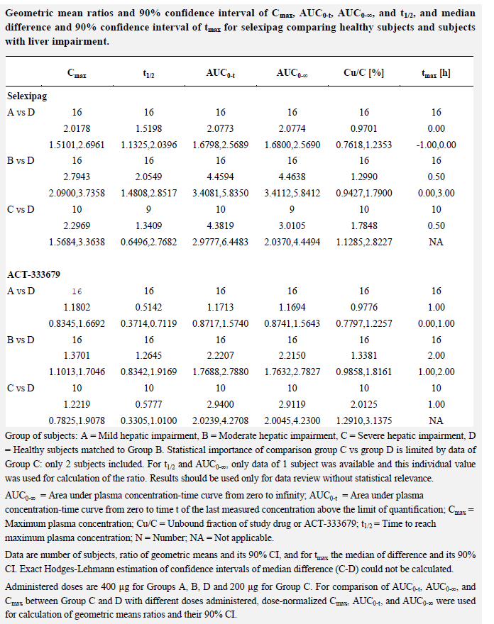

Pharmacokinetics in subjects with impaired renal function
Study AC-065-105 compared the PKs of selexipag and ACT-333679 in subjects with severe renal function impairment (SRFI) with those in matched healthy subjects after administration of a single dose of 400 μg selexipag. The results identified a approximately1.7 fold increase in selexipag C_{max}, AUC_{0–12}, and AUC_{0–inf} in patients with SRFI compared to healthy subjects, whereas, selexipag t_{1/2} was similar in both groups (1.0 h and 1.4 h, respectively) (Table 13). For ACT-333679, there was a 1.43 fold and 1.61 fold increases in C_{max} and AUC_{0-inf}, respectively, in patients with SRFI compared to healthy subjects as well as a 1.61 fold increase in t_{1/2}.

Table 13: Study AC-065-105. Geometric mean ratios (8 subjects with SRFI versus healthy subjects) and their 90% CIs for PK parameters of selexipag and ACT-333679 Per protocol set (n=16)
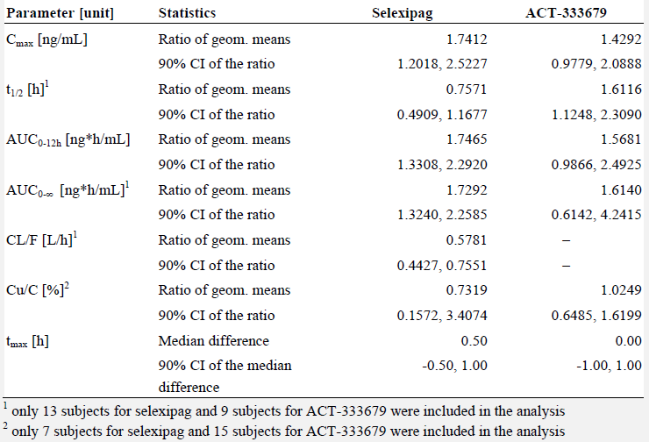

Pharmacokinetics according to age
The two PopPK studies, AC-065-106-PPK and AC-065A302-PPK did not identify age as a significant covariate of the selexipag PKs in either healthy subjects or patients with PAH, respectively. By contrast, Study NS304p101, which examined the PKs of selexipag in healthy adult and elderly Japanese males, identified that following a single oral dose of 200 μg selexipag, under fasting conditions, the C_{max} and AUC_{0-inf} of selexipag were decreased by 20% and 26%, respectively, and C_{max} and AUC_{0-inf} of ACT-333679 were decreased by 34% and 36%, respectively, in elderly (aged 65-74 years) compared to younger subjects (20-26 years). Following 10 days administration of 400 μg selexipag bd after a meal, selexipag C_{max} was decreased by 23% in elderly compared to younger subjects, whereas, AUC₀₋₁₂ was similar in both groups. For ACT-333679, following multiple doses of selexipag, the C_{max} and AUC₀₋₁₂ of ACT-333679 were decreased by 16% and 19%, respectively, in elderly compared to younger subjects.

Pharmacokinetics related to genetic factors

Effect of gender
The PopPK analysis undertaken in data from healthy subjects, AC-065-106-PPK, predicted that gender did not affect the PKs of selexipag or ACT-333679. By contrast, in patients with PAH the PopPK analysis, AC-065A302-PPK, identified gender as a significant covariate for the elimination rate constant of ACT-333679, whereby, a male subject was predicted to have a 13% lower AUC_{ss} for ACT-333679 than a female reference subject (Table 14).

Table 14: Study AC-065A302 Covariate effects in the final model
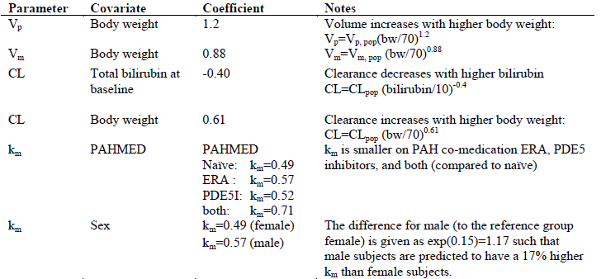

Effect of Race
Neither of the PopPK studies identified Race as a significant covariate for the PK parameters of selexipag or ACT-333679.

Pharmacokinetics in other special populations

Effect of body weight on PKs
The PopPK Study AC-065-106-PPK identified body weight as a significant covariate on the apparent volumes of distribution of selexipag and ACT-333679 in healthy subjects (Table 7). The results indicated that the plasma concentrations in a 50 kg subject were approximately 22% and 27% higher than in a 75 kg subject for selexipag and ACT-333679, respectively, whereas, in a 100 kg subject, they were estimated to be 17% and 15% lower, respectively. In patients with PAH, AC-065A302-PPK, body weight was also identified as significant covariate for the volume of distribution of selexipag and ACT-333679. In addition, body weight was identified as significant covariate for drug clearance (Table 14). The results indicated that a patient with a body weight of 51 kg would have 30% higher selexipag exposure and 20% higher ACT-333679 exposure than a reference patient with a body weight of 70 kg.

PKs in Japanese subjects
Study NS304p101 also examined the PKs of selexipag and ACT-333679 in healthy Japanese males following a range of single doses and under fed and fasted conditions. The C_{max} and AUC_{0-inf} values for selexipag and ACT-333679 increased dose-proportionally following single oral dose of selexipag 200 μg to 600 μg under fasting conditions in healthy adult male volunteers (Tables 15 and 16). When 400 μg selexipag was administered with a meal compared to when it was administered under fasting conditions the T_{max} values for a selexipag and ACT-333679 occurred 0.88 h and 0.5 h later, respectively (Table 17). In addition, the C_{max} and AUC_{0-inf} of selexipag were 32% and 15% lower, following a meal than under fasted conditions (Table 18). By contrast, the C_{max} of ACT-333679 was similar in fed and fasting states, whereas, the AUC was 12% lower in the fed state.

Table 15: Study NS304p101 Pharmacokinetic parameters of NS-304, MRE-269 and MRE-6001 following a single oral dose of NS-304 under fasting conditions in healthy adult male volunteers
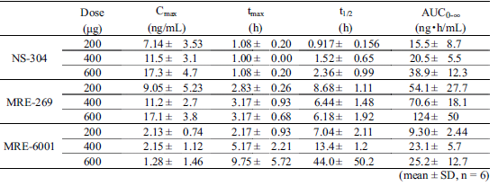

Table 16: Study NS304p101 Power model analysis of the relationship between Cmax/AUC_{0-∞} of NS-304 and MRE-269 and the dose of NS-304 following a single oral dose of NS-304 in healthy adult male volunteers (slope and 95% confidence interval)
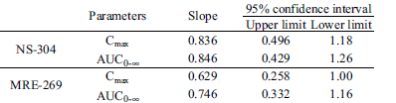

Table 17: Study NS304p101 Pharmacokinetic parameters of NS-304 and MRE-269 following a single oral dose of NS-304 (400 µg) under fasting conditions and after meals in healthy adult male volunteers
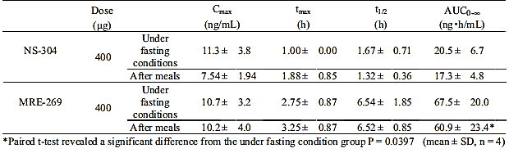

Table 18: Study NS304p101 90% confidence interval of the difference in the geometric mean values of the logarithmically transformed C_{max} and AUC_{0-∞} of NS-304 and MRE-269 following a single oral dose NS-304 (400 µg) under fasting conditions and after meals in healthy adult male volunteers
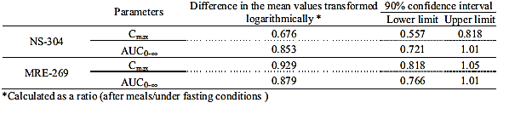

Pharmacokinetic interactions

Pharmacokinetic interactions demonstrated in human studies

Warfarin – a substrate of CYP2C9 and CYP3A4
Part D of Study QGUY/2006/NS-304-01 examined the PK interaction between steady-state selexipag (400 μg bd) and a single dose of 20 mg warfarin in healthy male subjects. Warfarin is a commonly prescribed drug in patients with PAH, which has a narrow therapeutic index. S-warfarin is mainly metabolised by CYP2C9, whereas metabolism of R-warfarin is mainly via CYP3A4. The results indicated that selexipag had no effect on the C_{max} or AUC of either R or S-warfarin. In addition, the AUC_{0-inf} of ACT-333679 and selexipag and C_{max} for ACT-333679 at steady state were not affected by a single dose of 20 mg warfarin, whereas, the C_{max} of selexipag was decreased by approximately 6%.

Lopinavir/ritonavir - inhibitors of OATP1B1 and OATP1B3
Study AC-065-109 examined the effects of multiple doses of lopinavir/ritonavir (Kaletra®) on the PK of selexipag and ACT-333679 following a single 400 μg dose of selexipag in the fasted state. The C_{max} and AUC_{0-inf} of selexipag were 2.07 and 2.24 fold higher when administered with Kaletra compared to when selexipag was given alone, whereas, the C_{max} and AUC_{0-inf} of ACT-333679 were 1.33 and 1.08 fold higher in the presence of Kaletra compared with selexipag alone (Table 19). The T_{max} values of selexipag and ACT-333679 were not affected by the presence of Kaletra, whereas, selexipag t_{1/2} was prolonged 1.46 fold and ACT-333679 t_{1/2} was 35% shorter in the presence of Kaletra.

Table 19: Study AC-065-109 Summary of pharmacokinetics parameters of selexipag and its active metabolite ACT-333679 Per Protocol set (n=20)
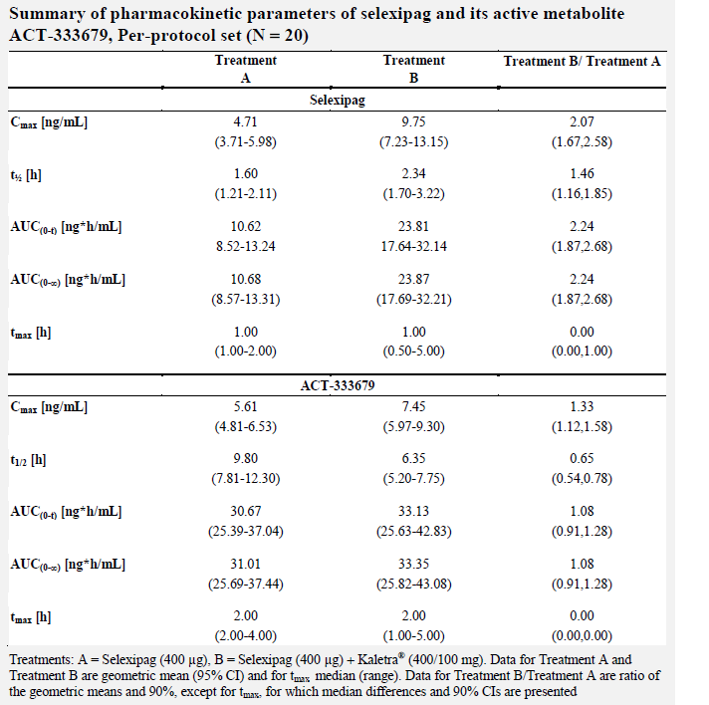

PAH co-medication
The PopPK Study AC-065A302-PPK examined the effect of PAH co-medication on the PKs of selexipag and ACT-333679. Although PAH co-medication was found not to influence the PKs of selexipag, PAH co-medications (ERAs, PDE-5 inhibitors, and both) were identified as statistically significant covariates of the elimination rate constant of ACT-333679 (Table 9) and the use of selexipag in combination with both an ERA and PDE-5 inhibitor was predicted to result in a 30% lower ACT-333679 AUCτ,ss.

Clinical implications of in vitro findings

Selexipag
In vitro studies identified that the metabolism of selexipag to its major metabolite, ACT-333679, occurs via hepatic CES1 catalysed hydrolysis. No clinically relevant inhibition of CES1 by medicinal products has been reported.
Studies undertaken in human hepatic microsomes identified that selexipag only weakly inhibited most forms of human CYP enzymes, with IC50 values for CYP1A2, CYP2A6, CYP2B6, CYP2C19, CYP2D6, CYP2E1, and CYP3A4 close to or higher than the maximum concentration of selexipag tested (that is, 50 μM). By contrast, the IC50 values of selexipag for CYP2C8 and CYP2C9 were 3.6 μM and 8.3 μM, while the respective Ki values were 2.0 μM and 3.5 μM.
Selexipag was also found to induce the expression of CYP3A4, CYP2C9, and CYP2B6 mRNA in human hepatocytes in a concentration-dependent manner. Compared to rifampicin (that is, the positive control) the induction potential of selexipag on CYP3A4 following a 10 μM dose was estimated to be 38%.
The efflux ratios of selexipag in MDCKII-MDR1 cells overexpressing P-gp ranged from 1.9–5.6 and were reduced to 1.0–2.0 in the presence of the P-gp inhibitors elacridar or zosuquidar. The corresponding values of the positive control digoxin were 11–24, and reduced to about unity in the presence of elacridar or zosuquidar. In addition, selexipag did not stimulate basal P-gp-ATPase activity, suggesting that selexipag is a weak substrate of P-gp.
In BCRP-expressing vesicles, the uptake ratios of selexipag were between 0.8 and 1.4 and were not concentration-dependent, whereas, the uptake ratios for the positive control methotrexate were 2.7–2.8. Therefore, it was concluded that selexipag is not a substrate of BCRP.
Selexipag uptake into OATP1B1 and OATP1B3-expressing cells was about 2 to 3 fold higher than in wild-type cells. The Km for selexipag was 0.9–2.6 μM for OATP1B1 and 1.2–3.5 μM for OATP1B3. Therefore, it was concluded that selexipag was a weak substrate of OATP1B1 and OATP1B3.
Selexipag did not affect the P-gp-mediated efflux of digoxin or rhodamine 123, whereas, it inhibited the uptake transporters OCT1 and OCT2 and the efflux transporters BSEP, MATE1, MATE2K, and MRP2 with IC50 values ranging from 11 μM to greater than 100 μM. Stronger inhibition was observed on the uptake transporters OATP1B1, OATP1B3, OAT1, and OAT3 with IC50 values in the range of 1.4–2.4 μM. Selexipag showed a similar inhibition of the efflux transporter BCRP with an IC50 of 1.9 μM. However, given the low plasma concentrations of selexipag following clinical doses and the high degree of binding to plasma proteins, unbound selexipag concentrations in plasma are expected to be below the IC50 values obtained in these in vitro studies. Therefore, the potential of selexipag to significantly inhibit transporters OATP1B1, OATP1B3, BCRP, OAT1, and OAT3 in clinical practice is estimated to be low.

ACT-333679
Overall, the active metabolite ACT-333679 had similar activity at the CYP isoforms and transporter proteins to selexipag.

Population PK modelling studies

Healthy subjects
Study AC-065-106-PPK examined the PopPK of selexipag and ACT-333679 in 91 healthy male and female subjects who had been enrolled in Study AC-065-106. The results indicated that a two-compartment model with absorption lag time, first-order absorption and elimination, and first-order metabolism rate constant for the conversion to ACT-333679 adequately described the PKs of selexipag, whereas, the PK of ACT-333679 was adequately characterised by a two-compartment model with first-order elimination. For a typical subject with a body weight of 75 kg, the selexipag V_{p}/F and CL/F values were 36.2 L and 15.8 L/h, respectively (Table 7).

Patients with PAH
Study AC-065A302-PPK described the PopPK/PD characteristics of an analysis dataset comprising 512 subjects who had been enrolled in the Phase III study, AC-065A302. The results indicated that the PopPK of selexipag and ACT-333679 in PAH subjects was similar to the model identified for healthy subjects and can be adequately described by a two-compartment model with absorption lag time, first-order absorption, elimination for selexipag and ACT-333679, and first-order metabolism for the conversion from selexipag to ACT-333679. For a typical subject with a body weight of 72 kg, the V_{p}/F and CL/F values for selexipag were 12.9 L and 19.1 L/h, respectively (Table 9).

Evaluator’s overall conclusions on pharmacokinetics
The 200 μg commercial dose formulation is identical to that used in the pivotal Phase III trial and the differences between film-coated tablets used in the other clinical studies and the commercial formulation are the colour and debossing of the tablets.

Absorption
Selexipag was rapidly absorbed with median T_{max} values ranging from 1.0 to 1.26 h. Following a single dose of 200 μg the mean C_{max} and AUC_{0-inf} values for selexipag were 3.44 ng/mL and 6.75 ng.h/mL.
The absolute bioavailability of selexipag is unknown.
Selexipag AUC_{τ} and C_{max,ss} values were bioequivalent following administration of 1600 μg selexipag bd as a single film-coated and following oral administration as 8 film-coated tablets of 200 μg. The trough plasma concentration at steady state (C_{trough,ss}) was 1.30 fold higher (90% confidence interval (CI): 1.10 – 1.52) following administration of the 1 x 1600 μg tablet bd
The bioequivalence of the intermediate doses has not been established by the sponsor. However, the bioequivalence study on the highest dose, in vitro dissolution studies and the fact that all dose strengths have the same dosage form, qualitative composition and quantitative composition, except for the filler D-mannitol and are manufactured by the same manufacturer indicate that a biowaiver is appropriate for the intermediate dose strengths.
Following a single oral dose of 400 μg under fasted conditions and following a high fat breakfast, Selexipag C_{max} was 35% lower in the fed state than in the fasted state, whereas AUC_{0-t} and AUC_{0-inf} were approximately 10% higher in the fed state. Food intake delayed the absorption of selexipag with median T_{max} increasing from 1 h in the fasting state to 2.8 h in the fed state and mean t_{1/2} increased from 1.38 h to 1.81 h.
Following a single administration of a range of selexipag doses, increases in selexipag C_{max} and AUC_{0-inf} values were almost dose proportional as the 95% CIs for the slopes of these parameters included or in the case of C_{max} almost included 1.
No accumulation of selexipag was identified at steady state.
Following multiple administrations of a range of selexipag doses, the C_{max} and AUC_{0-τ} values for selexipag increased dose-proportionally.

Distribution
Following a single, oral solution dose of 100 μg selexipag, the estimated selexipag volume of distribution (Vd) was 41.7 L. Population PK (PopPK) modelling estimated that the selexipag volume of distribution at steady state (Vss) in healthy subjects was 36.2 L.
In vitro studies indicate that selexipag is highly bound to human plasma proteins (99.7%) with a high degree of binding to human albumin and α1-acid glycoprotein, which was in the range of 95.9 to 97.7%.
Partitioning studies identified that the mean blood/plasma ratio of selexipag was 0.57, indicating that selexipag demonstrated little to no binding to blood cells.

Metabolism
Studies in pooled samples of human plasma identified nine selexipag metabolites.
The main metabolic pathway of selexipag was via hydrolysis to its active metabolite ACT-333679.
The active metabolite ACT-333679 was metabolised via several secondary pathways.
Following single doses of 100 μg to 800 μg selexipag, the median T_{max} of ACT-333679 occurred between 2.25 h and 2.75 h of dosing and the mean t_{1/2} ranged from 9.40 h to 12.65 h.
Following a 200 μg dose of selexipag the mean C_{max} and AUC_{0-inf} values for the active metabolite were 3.80 ng/mL and 24.42 ng.h/mL, respectively.
Increases in ACT-333679 exposure were dose proportional following single doses of selexipag over the dose range of 100 μg to 600 μg.
Following multi-dose administration of a range of selexipag doses (200 μg, 400 μg and 600 μg) bd, C_{max} increased dose-proportionally, whereas, AUC_{0-τ} increased slightly less than dose proportionally, as the upper limit for the 95% CI for slope was 0.97.
Following multiple doses of selexipag bd ranging from 400 μg to 1800 μg, the C_{max} and AUC₀₋₁₂ values for ACT-333679 were found to increase less than dose proportionally as the upper bounds of the 90% CIs for the slopes of the power models were 0.83 and 0.82, respectively.

Excretion
A mass balance study identified that total radioactivity was primarily eliminated primarily in the faeces, which accounted for 92.74% of the administered dose by 168 h postdosing and almost 12% of the administered [¹⁴C] selexipag dose was eliminated via the urine.

Intra- and inter-individual variability of PKs
The estimated %CV for selexipag CL/F and Vd identified in the popPK analysis undertaken in healthy patients were 7% and 26%, respectively. The intra-subject variabilities associated with these parameters were 9% and 16%, respectively.

Target population
No dedicated PK/PD studies examined the PKs of selexipag in the target population.
PopPK/PD modelling of data from 512 patients with PAH indicated that for a typical patient with a body weight of 72 kg, the Vd and CL/F values for selexipag were 12.9 L and 19.1 L/h, respectively. For the active metabolite the estimate for Vd was 4.65 L.
The AUC_{ss} values for selexipag and ACT-333679 were 30% and 20% higher, respectively, in patients with PAH than in healthy subjects. By contrast, the C_{trough,ss} for selexipag was similar in both populations, whereas, the C_{trough,ss} for ACT-333679 in patients with PAH was 1.9 fold higher than in healthy subjects.

Impaired hepatic function
Selexipag C_{max} and AUC_{0-inf} were increased by approximately2 fold in subjects with mild liver impairment compared to healthy subjects, whereas, the C_{max} and AUC_{0-inf} values for ACT-333679 were similar (1.18 fold and 0.97 fold higher, respectively) in both groups.
In subjects with moderate hepatic impairment compared to healthy subjects, selexipag C_{max} and AUC_{0-inf} were 2.8 fold and 4.5 fold higher, respectively, the median T_{max} was longer (2.0 versus 1.0 h) and the elimination phase was characterised by a longer t_{1/2} (2.2 versus 1.1 h). For ACT-333679, AUC_{0-inf} was increased more than 2 fold, median T_{max} was longer (6.0 versus 4.0 h) as was t_{1/2} (16.0 versus 12.6 h).

Impaired renal function
There was an approximately1.7 fold increase in selexipag C_{max}, AUC_{0–12}, and AUC_{0–inf} in patients with SRFI compared to healthy subjects. For ACT-333679, there was a 1.43 fold and 1.61 fold increases in C_{max} and AUC_{0-inf}, respectively, in patients with SRFI compared to healthy subjects as well as a 1.61 fold increase in t_{1/2}.

Age
PopPK studies in healthy subjects and patients with PAH did not identify age as a significant covariate of the selexipag PKs.
In healthy adult and elderly Japanese males however, the C_{max} and AUC_{0-inf} of selexipag, following a single dose under fasted conditions, were decreased by 20% and 26%, respectively, and C_{max} and AUC_{0-inf} of ACT-333679 were decreased by 34% and 36%, respectively, in elderly (aged 65-74 years) compared to younger subjects (20-26 years).
Following 10 days administration of 400 μg selexipag bd after a meal, selexipag C_{max} decreased by 23% in elderly compared to younger subjects, whereas, AUC₀₋₁₂ was similar in both groups. For ACT-333679 the C_{max} and AUC₀₋₁₂ decreased by 16% and 19%, respectively, in elderly compared to younger subjects.

Gender
The popPK analysis undertaken in data from healthy subjects predicted that gender did not affect the PKs of selexipag or ACT-333679. By contrast, in patients with PAH the popPK analysis identified gender as a significant covariate for the elimination rate constant of ACT-333679, whereby, a male subject was predicted to have a 13% lower AUCss for ACT-333679 than a female reference subject.

Race
Neither of the popPK studies identified Race as a significant covariate for the PK parameters of selexipag or ACT-333679.
In healthy Japanese males under fasting conditions, the C_{max} and AUC_{0-inf} values for selexipag and ACT-333679 increased dose-proportionally following a single oral dose of selexipag 200 μg to 600 μg. When 400 μg selexipag was administered with a meal compared to when it was administered under fasting conditions the T_{max} values for a selexipag and ACT-333679 occurred 0.88 h and 0.5 h later, respectively. The C_{max} and AUC_{0-inf} of selexipag were 32% and 15% lower, following a meal than under fasted conditions, whereas, the C_{max} of ACT-333679 was similar in fed and fasting states and the AUC was 12% lower in the fed state.

Body weight
Body weight was a significant covariate on the apparent volumes of distribution of selexipag and ACT-333679 in healthy subjects. The results indicated that the plasma concentrations in a 50 kg subject were approximately 22% and 27% higher than in a 75 kg subject for selexipag and ACT-333679, respectively, whereas, in a 100 kg subject, they were estimated to be 17% and 15% lower, respectively.
In patients with PAH body weight was also identified as significant covariate for the volume of distribution of selexipag and ACT-333679. In addition, body weight was identified as significant covariate for drug clearance. The results indicate for a patient with a body weight of 51 kg selexipag exposure was 30% higher and ACT-333679 exposure was 20% higher than a reference patient with a body weight of 70 kg.

Pharmacokinetic interactions in man
Selexipag had no effect on the C_{max} or AUC of either R- and S-warfarin. In addition, the AUC_{0-inf} of ACT-333679 and selexipag and C_{max} for ACT-333679 at steady state were not affected by a single dose of 20 mg warfarin, whereas, the C_{max} of selexipag was decreased by approximately 6%.
The C_{max} and AUC_{0-inf} of selexipag were 2.07 and 2.24 fold higher when administered with Kaletra compared to when selexipag was given alone, whereas, the C_{max} and AUC_{0-inf} of ACT-333679 were 1.33 and 1.08 fold higher in the presence of Kaletra compared with selexipag alone. Selexipag t_{1/2} was prolonged 1.46 fold and ACT-333679 t_{1/2} was 35% shorter in the presence of Kaletra.
PAH co-medication did not influence the PKs of selexipag, whereas, PAH co-medications (ERAs, PDE-5 inhibitors, and both) were significant covariates of the elimination rate constant of ACT-333679 and the use of selexipag in combination with both an ERA and PDE-5 inhibitor was predicted to result in a 30% lower ACT-333679 AUCτ,ss.

Pharmacokinetic interactions in vitro
Studies undertaken in human hepatic microsomes identified that selexipag weakly inhibits most forms of human CYP enzymes, with IC₅₀ values for CYP1A2, CYP2A6, CYP2B6, CYP2C19, CYP2D6, CYP2E1, and CYP3A4 close to or higher than the maximum concentration of selexipag tested (i.e. 50 μM).
The IC₅₀ values of selexipag for CYP2C8 and CYP2C9 were 3.6 μM and 8.3 μM, while the respective Ki values were 2.0 μM and 3.5 μM.
Selexipag induces the expression of CYP3A4, CYP2C9, and CYP2B6 mRNA in human hepatocytes in a concentration-dependent manner. Compared to rifampicin (that is, the positive control) the induction potential of selexipag on CYP3A4 following a 10 μM dose was estimated to be 38%.
Selexipag is a weak substrate of P-gp, OATP1B1 and OATP1B3.
Selexipag is not a substrate of BCRP.
Selexipag does not affect P-gp-mediated efflux, whereas, it inhibited the uptake transporters OCT1 and OCT2 and the efflux transporters BSEP, MATE1, MATE2K, and MRP2 with IC₅₀ values ranging from 11 μM to greater than 100 μM. Stronger inhibition was observed on the uptake transporters OATP1B1, OATP1B3, OAT1, and OAT3 with IC₅₀ values in the range of 1.4–2.4 μM. Selexipag also demonstrated a similar inhibition of the efflux transporter BCRP with an IC₅₀ of 1.9 μM.
Overall, the active metabolite ACT-333679 had similar activity at the CYP isoforms and transporter proteins as selexipag.

Population PK modelling studies
A two-compartment model with absorption lag time, first-order absorption and elimination, and first-order metabolism rate constant for the conversion to ACT-333679 adequately described the PKs of selexipag in healthy subjects, whereas, the PK of ACT-333679 was adequately characterised by a two-compartment model with first-order elimination. For a typical subject with a body weight of 75 kg, the selexipag V_{p}/F and CL/F values were 36.2 L and 15.8 L/h, respectively.
The PopPK of selexipag and ACT-333679 in PAH subjects was similar to the model identified for healthy subjects. For a typical subject with PAH and a body weight of 72 kg, the V_{p}/F and CL/F values for selexipag were 12.9 L and 19.1 L/h, respectively.

Limitations of PK studies
No dedicated studies examined the PKs of selexipag/ACT-333679 in the target population.

Questions arising from the PK studies
Can the sponsor please provide an explanation for the 1.3 fold increase in selexipag C_{trough,ss} following administration of the single tablet form of 1600 μg selexipag bd compared to when it was administered as 8 x 200 μg selexipag bd in Study AC-065-108?
The evaluator could not identify a request for a biowaiver for the intermediate dose strengths in the evaluation materials. Therefore, can the sponsor please direct the evaluator to the location of the request for a biowaiver or provide a statement for a request for a biowaiver if it has not been provided by the sponsor?
The 1.9 fold increase in C_{trough,ss} for ACT-333679 identified in patients with PAH compared to healthy subjects in the PopPK/PD Study AC-065A302-PPK is unexpected. Can the sponsor please explain why they believe this is occurring and whether it is of concern, especially regarding the incidence of AEs in healthy subjects compared to patients with PAH? For instance, would the dose-dependent increase in HR identified in Study AC-065-106 be potentiated in subjects with PAH compared to health y subjects?
The PopPK Study AC-065A302-PPK provides a comparison of selexipag PKs in healthy subjects and in patients with PAH following dosing with 1600 μg bd This comparison indicates that differences in selexipag PKs exist between the two populations, in particular that there is a 1.9 fold increase in C_{trough} in patients with PAH compared to healthy subjects. The two studies used to source the data for this comparison (Study AC-065-106 for healthy subjects and Study AC-065A302 for patients with PAH) also examined the PKs of selexipag following 800 μg bd dosing. Can the sponsor therefore identify whether the same differences in selexipag PKs exist between healthy subjects and patients with PAH following 800 μg bd dosing, and in particular is selexipag C_{trough} affected to the same extent in subjects with PAH at the lower selexipag dose?
Questions arising from the PK studies
Can the sponsor please provide an explanation for the 1.3 fold increase in selexipag C_{trough,ss} following administration of the single tablet form of 1600 μg selexipag bd compared to when it was administered as 8 x 200 μg selexipag bd in Study AC-065-108?
The evaluator could not identify a request for a biowaiver for the intermediate dose strengths in Module 1 of the evaluation materials. Therefore, can the sponsor please direct the evaluator to the location of the request for a biowaiver in Module 1 if it has been over looked, or provide a statement for a request for a biowaiver if it has not been provided by the sponsor?
The 1.9 fold increase in C_{trough,ss} for ACT-333679 identified in patients with PAH compared to healthy subjects in the PopPK/PD Study AC-065A302-PPK is unexpected. Can the sponsor please explain why they believe this is occurring and whether it is of concern, especially regarding the incidence of AEs in healthy subjects compared to patients with PAH? For instance, would the dose-dependent increase in HR identified in Study AC-065-106 be potentiated in subjects with PAH compared to health y subjects?
The PopPK Study AC-065A302-PPK provides a comparison of selexipag PKs in healthy subjects and in patients with PAH following dosing with 1600 μg bd This comparison indicates that differences in selexipag PKs exist between the two populations, in particular that there is a 1.9 fold increase in C_{trough} in patients with PAH compared to healthy subjects (Table 10). The two studies used to source the data for this comparison (that is, Study AC-065-106 for healthy subjects and Study AC-065A302 for patients with PAH) also examined the PKs of selexipag following 800 μg bd dosing. Can the sponsor therefore identify whether the same differences in selexipag PKs exist between healthy subjects and patients with PAH following 800 μg bd dosing, and in particular is selexipag C_{trough} affected to the same extent in subjects with PAH at the lower selexipag dose?

Pharmacodynamics

Studies providing pharmacodynamic data
Comment: As all of the trials that contain information regarding selexipag PDs also contain relevant PK data they are listed in Table 1.
None of the pharmacodynamic studies had deficiencies that excluded their results from consideration.

Summary of pharmacodynamics
The information in the following summary is derived from conventional pharmacodynamic studies in humans unless otherwise stated.

Mechanism of action
Uptravi (selexipag) is a selective non-prostanoid prostacyclin IP receptor agonist. The vasculo-protective effects of prostacyclin (PGI2) are mediated by the IP receptor. Decreased expression of IP receptors and decreased synthesis of prostacyclin contribute to the pathophysiology of PAH.

Pharmacodynamic effects

Measures of primary PD effects

Six minute walk distance (6-MWD)
The 6-MWD was developed in 1963 by Balke to evaluate functional capacity and is used to test exercise tolerance in chronic respiratory disease and heart failure. It measures the distance an individual is able to walk over a total of six minutes on a hard, flat surface. The goal is for the individual to walk as far as possible in six minutes; however, the individual is allowed to self-pace and rest as needed.

New York Heart Association (NYHA) class
Clinician-assigned measure, which classifies a patient’s heart failure according to the severity of their symptoms, is an established predictor of outcomes in heart failure.

Plasma N-terminal pro-brain natriuretic peptide (NT pro-BNP) levels
NT-proBNP is a measure of wall stress in pulmonary hypertension with elevated levels indicating that the heart is under strain and failing.

Primary pharmacodynamic effects
No dedicated PD studies examined the primary PD effects of selexipag or its active metabolite ACT-333679. However, the PopPK/PD Study AC-065A302-PPK examined the relationship between selexipag/ACT-333679 plasma levels and selected clinical safety and efficacy endpoints based on the results of a Phase III study (AC-065A302), which assessed the safety and efficacy of selexipag on morbidity and mortality in patients with PAH. The results of this study in regards to primary PD effects are reported below.

6-MWD
Study AC-065A302-PPK indicated that 6-MWD at steady state showed a significant increase with increasing exposure, from 369 m with no exposure to 392 m with high exposure. Disease status at baseline (NYHA/WHO functional class) and total bilirubin at baseline showed significant effects on the intercept: the 6-MWD without exposure to drug is smaller with higher NYHA/WHO functional class and with higher total bilirubin at baseline (Figure 3).

Figure 3: Study AC-065A302 PD model visualisation: 61-MWD versus AUC Combined for different baselines, grouped by disease status (NYHA/WHO functional class) and total bilirubin at baseline
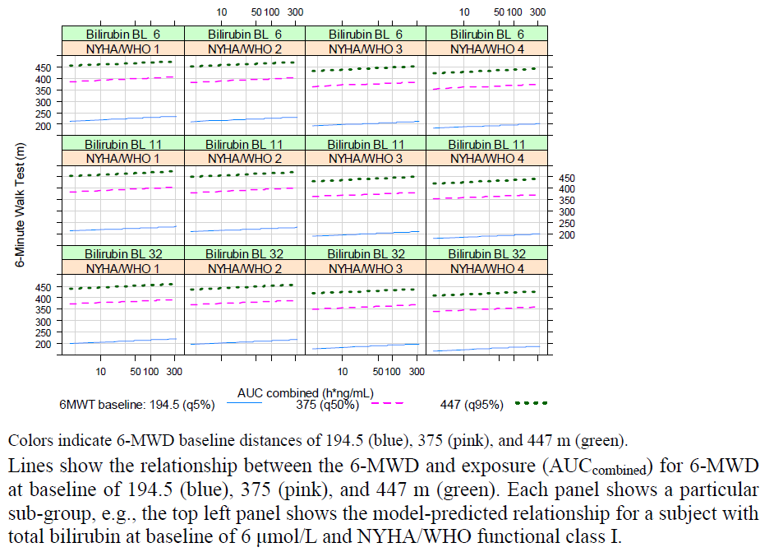

NT pro-BNP levels
Plasma NT pro-BNP showed a statistically significant decrease with higher exposure, from 667 with no exposure to 475 ng/mL with high exposure. PAH co-medication was identified as significant covariate of plasma NT pro-BNP.

Secondary pharmacodynamic effects

Cardiac repolarisation
Study AC-065-106 examined the effects of selexipag and ACT-333679 on cardiac repolarisation, as measured by the QTc interval, at steady-state following doses of 800 or 1600 μg selexipag bd in healthy male and female subjects. The results indicated that steady-state levels of selexipag were associated with mild increases in the HR with the largest placebo-corrected change-from-baseline HR reaching 6 bpm to 7 bpm at 1.5 to 3 h after dosing with 800 μg selexipag and 9 bpm to 10 bpm at the same time-points following dosing with 1600 μg selexipag (Figure 4). By contrast, selexipag did not affect cardiac conduction (that is, the PR and QRS intervals).
Figure 4: Study AC-065-106 Placebo-corrected change from time-matched baseline heart rate (∆∆HR, bpm) across treatment groups and time points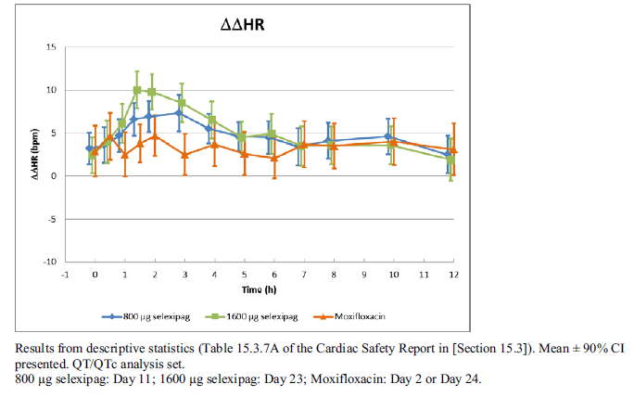
Placebo-corrected ΔQTcI (ΔΔQTcI) did not exceed 1.4 ms (UB of 90% CI 3.9 ms) and -0.7 ms (UB of CI 2.1 ms) following administration of 800 μg and 1600 μg selexipag, respectively (Figure 5).
Figure 5: Study AC-065-106 Placebo-corrected change from time-matched baseline QTcI (∆∆QTcI, ms) across treatment groups and time points
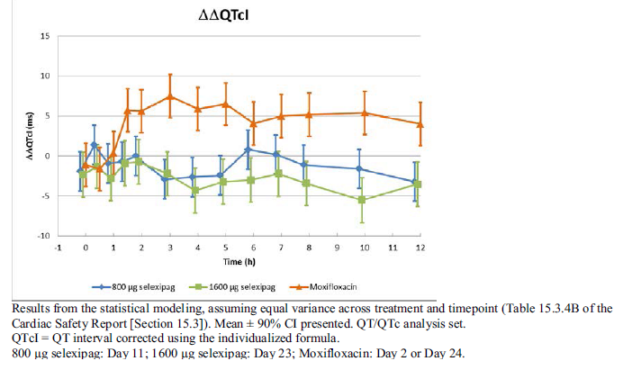
Similar results were identified in regard to QTcF. No subjects had a QTcI exceeding 480 ms (Table 20) or ΔQTcI >30 ms following administration with selexipag (Table 21) and the number of time-points at which T-wave morphology changes were observed was small and distribution was similar across treatment groups. By contrast, the mean ΔΔQTcI peak effect following administration of the positive control, 400 mg moxifloxacin, was 7.5 ms with a LB of the 90% CI of 4.8 ms. Therefore, it would appear that neither selexipag nor its active metabolite affect cardiac repolarisation.

Table 20: QTcI per absolute categories (>450 ms, >480 ms, and >500 ms) across treatment groups
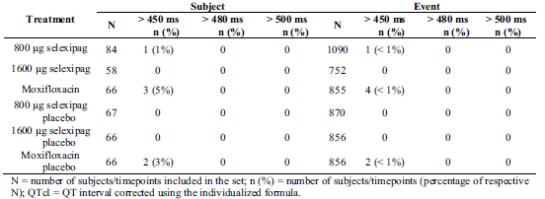

Table 21: Study AC-065-106 QtcI per change from baseline categories (> 30 ms and >60 ms) across treatment groups
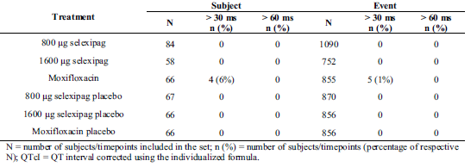

Photosensitising effect
Study AC-065-102 aimed to evaluate the photosensitising potential of selexipag (at 800 μg and 1,200 μg bd), as measured by the PI and change from baseline in MED, in comparison with placebo and a positive control, (ciprofloxacin 500 mg bd), under steady-state conditions in healthy males. However in this study, the anticipated mild photo-sensitising potential of the positive control, ciprofloxacin, could not be confirmed and there was no significant difference in UV-A or UV-B photosensitivity following treatment with either dose of selexipag, placebo or ciprofloxacin. Given these findings, the evaluator believes that it is impossible to either confirm or reject the possibility that selexipag and ACT-333679 possess photosensitising potential.

Total bilirubin
Study AC-065A302-PPK indicated that there was a significant inverse correlation between total bilirubin and exposure. For instance, total bilirubin levels decreased from 12.03 μmol/L to 10.58 μmol/L at low (placebo) and high exposure levels, respectively. The steepness of decrease was significantly larger with PAH aetiology ‘connective tissue disease’ compared to ‘congenital heart disease’ and ‘idiopathic PAH’, suggesting more sensitivity of ‘connective tissue disease’ towards selexipag and ACT-333679 (Figure 6).
Figure 6: Study AC-065A302 PD model visualisation: Total bilirubin at steady state versus exposure for different base line levels, grouped by PAH etiology
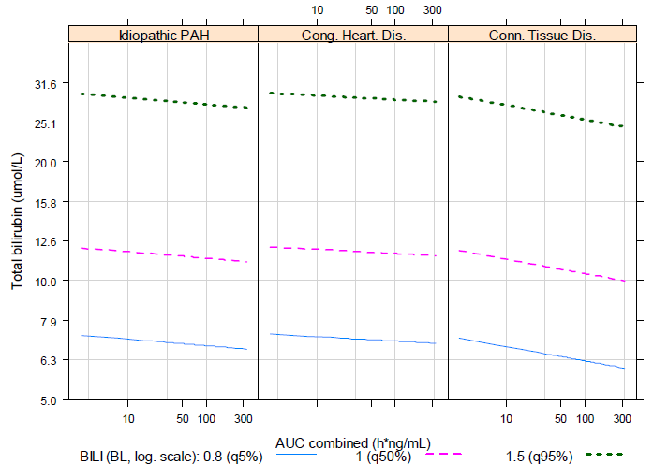

Leukocytes and erythrocyte counts
Study AC-065A302-PPK indicated that leukocyte, erythrocyte and haemoglobin levels were all significantly and inversely correlated with selexipag/ACT-333679 exposure. Leukocyte levels were 6.82 G/L at low levels of drug exposure (placebo) and 6.26 G/L with high exposure. Similarly, erythrocyte levels were 4.66 TI/L with placebo and 4.58 TI/L following high drug exposure and haemoglobin levels were 138.84 G/L and 134.58 G/L, respectively. The steepness of decrease in leukocytes was significantly larger with PAH aetiology ‘connective tissue disease’ compared to ‘congenital heart disease’ and ‘idiopathic PAH’ (Figure 7). For haemoglobin, PAH aetiology was identified as significant towards the intercept (parallel shift) with aetiology ‘connective tissue disease’ showing lower haemoglobin levels compared to ‘congenital heart disease’ and ‘idiopathic PAH’ (Figure 8).
Figure 7: Study AC-065A302 PD model visualisation: leucocytes at steady state versus exposure for different baseline levels, grouped by PAH etiology
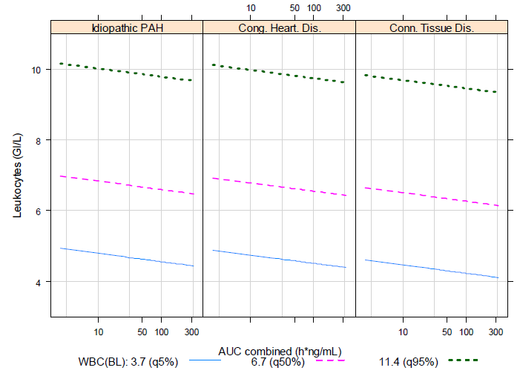
Haemoglobin showed a statistically significant decrease with higher exposure, from 138.84 G/L with placebo to 134.58 G/L with high exposure. PAH aetiology was identified as significant towards the intercept (parallel shift) with aetiology ‘connective tissue disease’ showing lower haemoglobin levels compared to ‘congenital heart disease’ and ‘idiopathic PAH’ (Figure 8).
Figure 8: Study AC-065A302 PD model visualisation: haemoglobin at steady state versus exposure for different baseline levels, grouped by PAH etiology
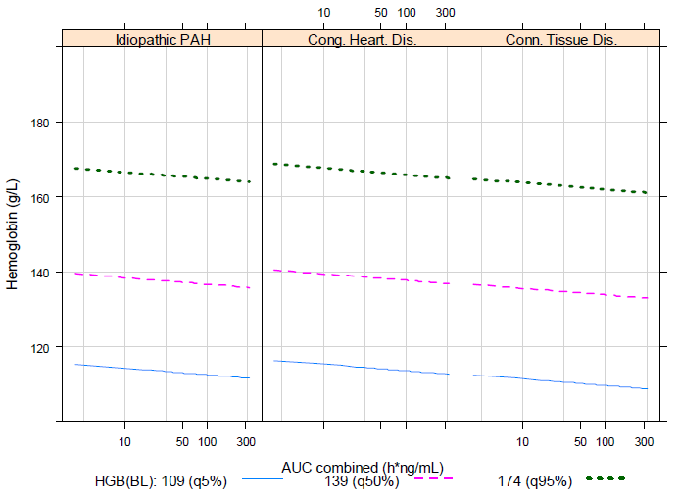

Other secondary effects
The results of Study AC-065-101 indicate that selexipag had no relevant effects on platelet aggregation, blood coagulation markers, vWF, sTM, and P-selectin, or on bone turnover markers, sOC, P1NP, CTx, and NTx.

Time course of pharmacodynamic effects
The maximum increases in placebo-corrected changes-from-baseline HR occurred between 1.5 h and 3 h following administration of either 800 μg or 1600 μg selexipag (Figure 4).

Relationship between drug concentration and pharmacodynamic effects
The results of Study AC-065A302-PPK regarding the relationship between drug concentration and efficacy/laboratory values have been discussed in Primary pharmacodynamic effects and Secondary pharmacodynamic effects of this report.

Cardiac Repolarisation
The concentration-effect modelling, undertaken in Study AC-065-106, did not identify a relationship between plasma concentrations of selexipag or ACT-333679 and the effect on the QTc interval. In addition, the projected QTc effect, using the concentration-effect model, was negligible within the observed range of plasma levels and the results consistent with the time-matched analysis.

Vital signs
Study AC-065A302-PPK indicated that systolic blood pressure, diastolic blood pressure, mean arterial blood pressure and heart rate did not demonstrate statistically significant relationships with drug exposure.

AEs
In regards to AEs, Study AC-065A302-PPK identified a statistically significant relationship between the probability of occurrence of a prostacyclin-like associated AE and drug exposure, PAH aetiology, and PAH co-medication. The probability of occurrence of a prostacyclin-like associated AE was predicted to increase by about 20–30% on the highest exposure compared to placebo. PAH co-medication as a covariate showed up to 20% difference in the probability of occurrence of the AE between naïve and ERA and/or PDE5 inhibitors. The PAH aetiology connective tissue disease was predicted to be associated with an up to 10% higher probability of the AE compared to idiopathic PAH and congenital heart disease. By contrast, there was no evidence that the number of treatment-emergent haemorrhages or gastrointestinal haemorrhages correlated with drug exposure.
Comment: Given, following 800 μg bd dosing with selexipag, that selexipag and its active metabolite (ACT-333679) have similar T_{max} values (2 h and 4h, respectively), the C_{max} for the active metabolite is 13.4 ng/mL and for selexipag is 8.20 ng/mL and that it has been reported that ACT-333679 is at least 16 fold more potent than selexipag in cellular systems, then both the primary and secondary pharmacodynamic effects of selexipag can be attributed to the activity of ACT-333679.

Genetic-, gender and age-related differences in pharmacodynamic response
Not examined.

Pharmacodynamic interactions
Part D of Study QGUY/2006/NS-304-01 indicated that steady state levels of selexipag and ACT-333679 did not affect the INR AUC_{0-144h}, INRmax or INRtmax of warfarin.

Evaluator’s overall conclusions on pharmacodynamics

Mechanism of action
Selexipag is a selective non-prostanoid prostacyclin IP receptor agonist.

Primary PD
No dedicated PD studies examined the primary PD effects of selexipag or its active metabolite ACT-333679.

6-MWD PK/PD modelling identified that
6-MWD at steady state showed a significant increase with increasing exposure, from 369 m with no exposure to 392 m with high exposure.
Plasma NT pro-BNP showed a statistically significant decrease with higher exposure, from 667 with no exposure¹¹ to 475 ng/mL with high exposure.

Secondary PD
Steady-state levels of selexipag were associated with mild increases in the HR with the largest placebo-corrected change-from-baseline HR reaching 6 bpm to 7 bpm at 1.5 to 3 h after dosing with 800 μg selexipag and 9 bpm to 10 bpm at the same time-points following dosing with 1600 μg selexipag.
Neither selexipag nor its active metabolite affect cardiac repolarisation or cardiac conduction.
It is impossible to either confirm or reject the possibility that selexipag and ACT-333679 possess photosensitising potential.
There was a significant inverse correlation between total bilirubin and exposure. For instance, total bilirubin levels decreased from 12.03 μmol/L to 10.58 μmol/L at low (placebo) and high exposure levels, respectively.
Leukocyte, erythrocyte and haemoglobin (Hb) levels were all significantly and inversely correlated with selexipag/ACT-333679 exposure.
Selexipag had no relevant effects on platelet aggregation, blood coagulation markers, vWF, sTM, and P-selectin, or on bone turnover markers, sOC, P1NP, CTx, and NTx.

Time course of PDs
The maximum increases in placebo-corrected changes-from-baseline HR occurred between 1.5 h and 3 h following administration of either 800 μg or 1600 μg selexipag.

Relationship between drug concentration and PDs
There was no relationship between drug exposure and changes in QTc, SBP, DBP, MAP or HR.
There was a statistically significant relationship between the probability of occurrence of a prostacyclin-like associated AE and drug exposure, PAH aetiology, and PAH co-medication.
There was no evidence that the number of treatment-emergent haemorrhages or gastrointestinal haemorrhages correlated with drug exposure

PD interactions
Steady state levels of selexipag and ACT-333679 did not affect the INR AUC_{0-144h}, INRmax or INRtmax of warfarin.

Limitations of PD studies
No dedicated PD studies examined the primary PDs of selexipag/ACT-333679 in the target population.

Dosage selection for the pivotal studies
The dosage regimen in the pivotal study was individual titration starting from 200 µg bd and increasing in weekly increments of 200 µg bd until the individual maximum tolerated dose was achieved, or up to a maximum of 1600 µg bd The sponsor has provided the rationale for the up-titration regimen, that up-titration to an individual patient’s highest tolerated dose was the generally accepted treatment regimen for prostacyclin receptor agonists as starting treatment with high doses of these compounds was associated with poor tolerability due to typical prostacyclin-associated pharmacological effects (for example, headache, diarrhoea, jaw pain, myalgia, flushing, and nausea). In addition, results from Phase I studies with selexipag showed that starting at lower doses and up-titrating improved tolerability.
Results from Phase I studies showed that the highest tolerated dose in healthy subjects was 1600 µg bd The starting dose of 200 µg bd in the pivotal study was based on safety and tolerability data from the Phase I Study QGUY/2006/NS304/-01, which showed a comparable tolerability profile of multiple doses of both 200 µg and 400 µg bd on initiation with the lower dose. Titration steps of 200 µg bd were introduced based on the understanding that the first up-titration step to 400 µg bd would result in a dose that had shown acceptable tolerability as a starting dose in Study QGUY/2006/NS304/-01.
Comments: The rationale for the dose selection and dosing regimen for the pivotal Phase III trial is sound. The sponsor has also confirmed that the 200 µg commercial dose formulation is identical to the 200 µg tablet used in the pivotal Study AC-065A302.

Clinical efficacy

For the proposed indication
Treatment of pulmonary arterial hypertension (PAH) in patients with WHO functional class II, III or IV symptoms
Support for the efficacy of selexipag for the proposed indication is based on the results of a single, long-term, pivotal Phase III study (AC-065A302/GRIPHON) in 1156 patients with symptomatic PAH. Additional supportive efficacy data is drawn from a Phase II, placebo-controlled study (NS-304/-02) and from an open-label, uncontrolled Phase II study in Japanese patients (AC-065A201). The sponsor has also provided an integrated summary of efficacy (ISE), which was composed of appendices (for example, statistical plans, tables and figures) referenced to in the Summary of Clinical Efficacy.

Pivotal efficacy study

Study GRIPHON (AC-065A302)

Study design, objectives, locations and dates
Study AC-065A302 was a multi-centre, randomised, double-blind, placebo-controlled, parallel-group, event-driven, Phase III study evaluating the efficacy and safety of selexipag (administered orally at an individualised dose in the range of 200–1600 µg bd) on morbidity and mortality in patients with symptomatic PAH. Subjects were randomised in a 1:1 ratio (stratified by site) to selexipag or placebo.
The study included a screening period (up to 28 days) followed by a treatment period from randomisation (Visit 1) to the end of study (EOS) visit (Figure 9). The treatment period started with a titration phase up to 12 weeks, followed by a maintenance phase, and concluded with an EOS visit within 4 weeks of study closure announcement. Study closure was announced by the sponsor once the overall target number of 331 Critical Event Committee (CEC)-confirmed morbidity/mortality (MM) events with onset date up to 7 days after last study drug intake was achieved. For patients who had a CEC-confirmed MM event or who prematurely discontinued study drug prior to study closure, the EOS visit occurred following the MM event or premature discontinuation. All patients who discontinued study drug prior to study closure announcement (with or without an MM event) had the option to enter a post-treatment observation period (PTOP) for the continued collection of MM data up to the post-treatment observation closure visit (PTOCV), which was to occur within 4 weeks following the announcement of study closure.
Figure 9: AC-065A302/GRIPHON study design
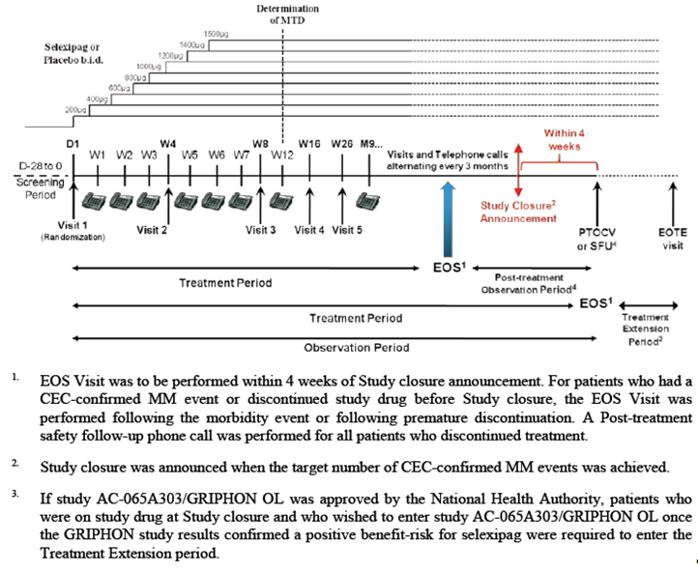
Patients who had an EOS visit following a morbidity event confirmed by the CEC were eligible to join the open-label extension Study AC-065A303 (GRIPHON OL), an ongoing open-label, uncontrolled study to assess the long-term safety of selexipag. For patients who entered AC-065A303 after a CEC-confirmed morbidity event prior to the unblinding of AC-065A302, entry into AC-065A303 study was without knowledge of their study treatment allocation (selexipag or placebo) in AC-065A302. This was to preserve the integrity of the double-blind Study AC-065A302. Therefore, all patients started treatment in AC-065A303 with selexipag 200 µg bd (lowest dose), which was to be up-titrated until the individual maximum tolerated dose was achieved (Figure 10). This safety study was still ongoing at the time of this TGA submission. The Clinical Study Report (CSR) submitted for this application covers all efficacy data from Study AC-065A302, including all data from the AC-065A302 post-treatment observation period. Safety data in the CSR included all safety data in Study AC-065A302 (GRIPHON) and safety data of Study AC-065A303 (GRIPHON OL) up to the analysis cut-off date for GRIPHON OL of 10 March 2014.
Figure 10: AC-065A303/GRIPHON OL study design for patients who entered the OL study after a CEC-confirmed morbidity event in AC-065A302/GRIPHON
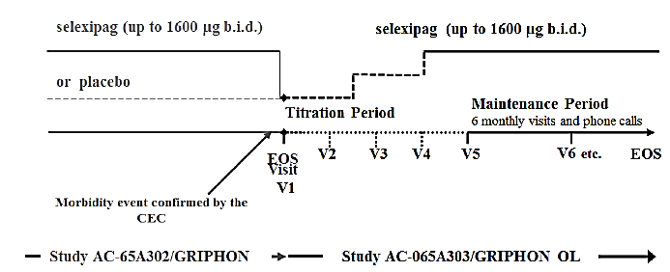
The primary objective of Study AC-065A302 was to demonstrate the effect of selexipag on time to first MM event in patients with PAH. The secondary objectives were to evaluate the effects of selexipag on exercise capacity and other secondary and exploratory efficacy endpoints in patients with PAH, and to evaluate the safety and tolerability of selexipag in patients with PAH. The objective of Study AC-065A303 was to assess the long-term safety and tolerability of selexipag in patients with PAH.
Study AC-065A302 was a multi-centre study where subjects were enrolled in a total of 181 centres in 39 countries across Asia, Australia, Europe, Latin America, and North America. The study start and end dates were 30 December 2009 (first patient, first visit) and 27 April 2014 (last patient, last visit in AC-065A302 treatment period), respectively.

Inclusion and exclusion criteria
Subjects enrolled in this study were males or females aged 18–75 years (inclusive), with a confirmed diagnosis of symptomatic PAH in modified NYHA/WHO Functional Class (FC) I to IV and with a 6-minute walk distance (6MWD) of between 50 and 450m (inclusive) at screening. The PAH aetiology was required to be within groups 1.1 to 1.4 of the Updated Dana Point 2008 Clinical Classification (that is, idiopathic PAH [iPAH], heritable PAH, drug or toxin induced PAH, or PAH associated with connective tissue disease [CTD], congenital heart disease with simple systemic-to-pulmonary shunt [at least 1 year after surgical repair], or HIV infection). The PAH diagnosis also had to be confirmed by haemodynamic evaluation by right heart catheterisation, performed at any time prior to screening, showing all of the following: resting mean pulmonary artery pressure (mPAP) ≥ 25 mmHg; pulmonary capillary wedge pressure (PCWP) or left ventricular end diastolic pressure (LVEDP) ≤15 mmHg; and resting pulmonary vascular resistance (PVR) at rest ≥ 400 dyn·s/cm⁵. Subjects with moderate to severe obstructive or restrictive lung disease, moderate to severe hepatic impairment, or severe renal insufficiency were excluded.
Background PAH-specific therapy with approved endothelin receptor antagonists (ERA) and/or PDE-5 inhibitors (PDE-5i) was allowed if subjects had been on a stable dose for at least 3 months prior to the baseline visit, and the dose was to remain unchanged during study treatment up to Week 26 (Month 6). Treatment with stable doses of oral diuretics, as well as any other treatment needed for PAH (including anticoagulant/antithrombotic medicines) was also allowed. Throughout the entire study period, the introduction of any new treatment for PAH (or increase in dose) without a CEC-confirmed MM event was strongly discouraged. Concomitant administration of prostacyclin (epoprostenol) or prostacyclin analogues (that is, treprostinil, iloprost, beraprost) was forbidden from 1 month prior to Baseline up to EOS Visit, with the exception of a single administration of IV/inhaled prostacyclin or analogues during a right heart catheterisation procedure.
Comments: The inclusion and exclusion criteria were in line with recommendations on the study population in the TGA-adopted EMA guidelines on the clinical investigation of medicinal products for the treatment of pulmonary arterial hypertension. The sponsor had provided the rationale for including patients in NYHA/WHO FC I and II as being to investigate the occurrence of clinical events in a population with less advanced disease. This rationale is sound.
The PAH aetiological classification used in this study was that adopted during the fourth World Symposium on PAH held in 2008 in Dana Point, California. The aetiologies of PAH that were included in the study are appropriate and allowed evaluation of the intended target patient population. Overall, the study aimed to recruit adult patients (≥ 18 years) including elderly patients (up to 75 years inclusive) with symptomatic PAH who were naïve to or receiving PAH-specific treatment (ERAs and/or PDE-5i; excluding prostacyclin and prostacyclin analogues).

Study treatments
Study drugs were film-coated tablets containing 200 µg selexipag or matching placebo. Study treatments were oral administration of selexipag or matching placebo 200, 400, 600, 800, 1000, 1200, 1400 or 1600 µg bd (with a dosing interval of approximately 12 hours), following an up-titration scheme (Table 22).

Table 22: Study drug up-titration scheme in studies AC-065A302 and AC-065A303
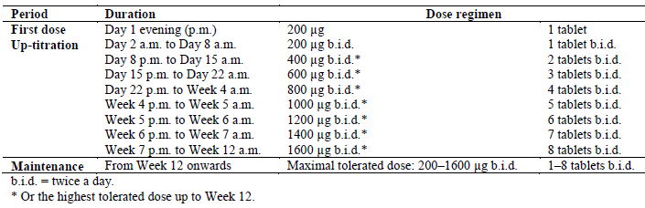
Treatment with selexipag or matching placebo started at 200 µg bd and was up-titrated during the initial 12 weeks in weekly increments of 200 µg bd until the individual maximum tolerated dose (IMTD, up to a maximum of 1600 µg bd) for each patient was achieved. At each up-titration step, the investigator could decide not to further up-titrate the dose if, according to medical judgment, the patient could not tolerate the occurrence and severity of typical pharmacological effects of IP receptor agonists (for example, headache, diarrhoea, jaw pain, myalgia, flushing, and nausea) that could not be managed symptomatically. In such cases, the investigator was to reduce the dose by 200 µg bd, and the adjusted dose at Week 12 was defined as the maximum tolerated dose for the patient and continued during maintenance treatment. At Week 12, the IMTD for each patient was determined, and this dose was to be kept stable for the next 14 weeks (that is, from Week 12 onwards) up to the Week 26 assessment of the secondary endpoint of change in 6MWD. The individual maintenance dose (IMD) was defined as the selexipag or placebo matching selexipag dose to which each patient was exposed for the longest duration in the maintenance period, or for patients who did not enter the maintenance period, the highest tolerated selexipag or placebo-matching selexipag dose to which each patient was exposed during the titration period.
After Week 26, for patients with study drug dose < 1600 µg bd, investigators were allowed to further up-titrate the dose if needed, by 200 µg increments up to the maximum of 1600 µg bd, only at scheduled visits. Dose reduction was allowed at any time, if the investigator identified a tolerability concern for a patient.
For patients who entered AC-065A303 (GRIPHON OL) after a CEC-confirmed morbidity event prior to the unblinding of AC-065A302, entry into AC-065A303 study was without knowledge of their study treatment allocation (selexipag or placebo) in AC-065A302, in order to preserve the integrity of the double-blind study. These patients started treatment with selexipag 200 µg bd (lowest dose) in AC-065A303. The dose was to be up-titrated until the IMTD for an individual patient was achieved, as described in Table 22).
Comments: The study dose regimen of up-titration to an individual patient’s highest tolerated dose is appropriate, and has been previously discussed in this report. The study design involving a placebo control is appropriate and consistent with the recommendation of the TGA-adopted EMA guidelines on the clinical investigation of medicinal products for the treatment of pulmonary arterial hypertension.

Efficacy variables and outcomes
The primary efficacy endpoint was the time from start of treatment to first CEC-confirmed morbidity or mortality (MM) event up to 7 days after last study drug intake (that is, end of treatment [EOT] + 7 days). These MM events were defined as: death (all causes); hospitalisation for worsening of PAH based on predefined criteria; worsening of PAH resulting in need for lung transplantation or balloon atrial septostomy; initiation of parenteral (subcutaneous or intravenous) prostanoid therapy or chronic oxygen therapy due to worsening of PAH; disease progression (patients in modified NYHA/WHO FC II or III at baseline) confirmed by decrease in 6MWD from baseline (≥ 15%, confirmed by 2 tests on different days within 2 weeks) and worsening of NYHA/WHO FC; or disease progression (patients in modified NYHA/WHO FC III or IV at baseline) confirmed by decrease in 6MWD from baseline (≥ 15%, confirmed by 2 tests on different days within 2 weeks) and need for additional PAH-specific therapy.
Study secondary efficacy endpoints were absolute change from Baseline to Week 26 in 6MWD measured at trough; absence of worsening from Baseline to Week 26 in NYHA/WHO FC; time from randomisation to first of CEC-confirmed death due to PAH or CEC-confirmed hospitalisation due to PAH worsening up to EOT + 7 days; time from randomisation to death of all causes up to study closure; absolute change from Baseline to Week 26 in the sub-scale ‘Breathlessness’ of CAMPHOR (Cambridge Pulmonary Hypertension Outcome Review) ‘Symptoms’ (at selected centres); absolute change from Baseline to Week 26 in CAMPHOR ‘Symptoms’ score (at selected centres).
Exploratory efficacy endpoints were related to morbidity/mortality events, and absolute changes from Baseline over time up to EOS in 6MWD, NYHA/WHO FC, Borg dyspnoea index, plasma NT pro-brain natriuretic peptide (NT pro-BNP), and CAMPHOR score. The pharmacoeconomic endpoints were the annualised number of all-cause and PAH-related hospitalisations up to the EOS visit; annualised number of days spent in hospital up to the EOS visit; annualised number of days spent in hospital for PAH-related causes up to the EOS visit.
Comments: Overall, the primary and secondary endpoints of this study are appropriate and consistent with the TGA-adopted EMA guidelines on the clinical investigation of medicinal products for the treatment of pulmonary arterial hypertension, which recommended as primary efficacy endpoints time to clinical worsening and/or improvement in exercise capacity. The guidelines recommended that evaluation of efficacy should include endpoints of all-cause mortality, PAH-related morbidity (for example, PAH-related hospitalisation or deterioration in functional class), clinical symptoms (in terms of improvement in WHO/NYHA functional class) or exercise capacity (in terms of the 6MWT). Overall, the study primary endpoint allowed evaluation of all-cause mortality and PAH-related morbidity, while the study secondary endpoints of change from baseline in 6MWD, absence of worsening from baseline of NYHA/WHO FC, and change from baseline in CAMPHOR symptom score allowed evaluation of the effect of selexipag on exercise capacity and clinical symptoms. The definition of worsening PAH that included a decrease of at least 15% in the 6MWD from baseline confirmed by two 6MWTs performed on separate days was also in line with the above mentioned guidelines.
The sponsor has also provided the rationale for the composite primary endpoint; it was considered that this composite endpoint would represent clinically highly relevant outcomes for patients with a progressive disease such as PAH, was line with regulatory guidelines, and was agreed to by FDA in a Special Protocol Assessment. The morbidity and mortality events of the endpoint were chosen to reflect irreversible disease progression. The defined observation period of up to EOT + 7 days was chosen as the best to define the treatment effect of selexipag versus placebo, taking into account both the PK characteristics of the drug and the consideration that patients would be switched to other PAH therapies, including open-label selexipag, following the occurrence of a confirmed morbidity event. This rationale is sound.

Randomisation and blinding methods
Subjects were randomised in a 1:1 ratio to receive selexipag or matching placebo using a centralised randomisation system via Interactive Voice Recognition System (IVRS) or Interactive Web Recognition System (IWRS). Randomisation was stratified by site. A block size of 4 was used. This study was conducted in a double-blind fashion. The investigational drug and its matching placebo were indistinguishable and all medication bottles were identically packaged and labelled.
The investigator and study staff, the subjects, study monitors, and sponsor employees and contractors were blinded to study drug allocation.

Analysis populations
Several analysis sets were defined in the study. The Full Analysis Set (FAS) included all randomised patients, and patients were evaluated according to the study drug to which they were randomised. The per-protocol set (PPS) included all patients from the FAS who did not have defined protocol deviations. Patients were evaluated according to the study drug they were randomised to. The Safety analysis set (SAF) included all randomised patients who had received at least one dose of study drug in Study AC-065A302. Patients were evaluated according to the study drug they had received. If a patient had taken at least one dose of selexipag in Study AC-065A302, then she/he was assigned to the selexipag treatment group. The ophthalmological sub-study analysis set (OAS) included all patients in the Safety analysis set who participated in the ophthalmology sub-study. The Quality of Life (QoL) analysis set (QAS) included all patients in the FAS for whom a suitable language of the CAMPHOR questionnaire was available at his/her site.
All main statistical analyses of all efficacy endpoints were based on the FAS. All statistical safety analyses were based on the SAF.
Comments: The definitions of the analysis populations and the efficacy analyses on the FAS are in keeping with the TGA-adopted ICH E9 Statistical Principles for Clinical Trials, and with the intent-to-treat principle of efficacy analyses.

Sample size
Study AC-065A302 was designed to compare selexipag to placebo for the risk of occurrence of an MM event up to EOT + 7 days. It was initially estimated that a total of 202 CEC-confirmed MM events were needed to obtain an overall power of 90% for rejection of the null hypothesis (at 2-sided alpha of 0.01), assuming a hazard ratio of 0.5729 for selexipag versus placebo (that is, event rate reduction due to active treatment of 40%) over the estimated maximum study duration of 3.5 years. The originally assumed hazard ratio of 0.5729 was based largely on previous monotherapy studies with bosentan in patients with modified NYHA/WHO FC III-IV. Taking into account that the predominant enrolment in Study AC-065A302 was of patients in modified NYHA/WHO FC II and III and were on background PAH therapy, the estimated hazard ratio was later amended to 0.65 (that is, event rate reduction due to active treatment of 35%) in order to detect a smaller and still clinically relevant treatment effect. To detect this amended treatment effect without changing the protocol requirements for the Type-I and Type-II error rates, and to be within the study timelines, an increase of the number of CEC-confirmed MM events to 332 and of the sample size to 1150 patients was estimated to be required. This sample size calculation was based on the assumption that the yearly event rate in the placebo group was 20% (that is, hazard rate of 0.2231/year) and that the censoring rate (drop-out) was 5.1% per year constant over time in both treatment arms.

Statistical methods
Due to the sample size increase as described above, a group-sequential design with one interim analysis to be conducted by the Independent Data Monitoring Committee (DMC) after the originally projected 202 CEC-confirmed MM events (approximately 61% of the newly defined total number of events) was introduced, with options to recommend early stopping of the trial for futility or for compelling and robust efficacy at the interim analysis. The group-sequential design used a one-sided overall Type-I error probability fixed to α = 0.005, maximum information was specified as 331 first MM events confirmed by the CEC, and the one-sided Type-I error probability at the interim analysis was fixed to 0.00005 (Table 23).

Table 23: Summary of group-sequential design, Study AC065A302
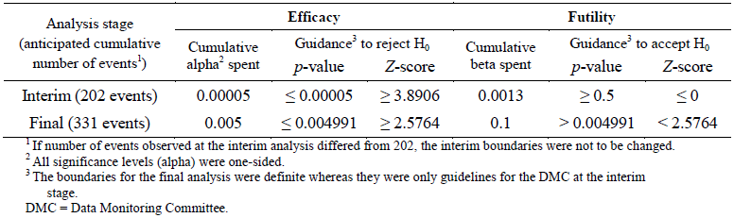
H₀ = null hypothesis . The interim futility stopping rule was non-binding. If at the interim stage the observed Z-score was greater or equal to the efficacy stopping boundary for rejection of the null hypothesis (i.e. if Z-score ≥ 3.8906), the DMC could nevertheless recommend to continue the trial to its end (i.e. when 331 morbidity/mortality events had been confirmed by the CEC). In addition, the sponsor could also decide to continue the trial to its end despite the DMC recommendation to stop it at the interim stage
The change in the target hazard ratio was initially discussed with the FDA (Global Amendment 4 of the protocol). In order to eliminate any concern that the protocol changes based on Global Amendment 4 could be considered informed, MM events with a CEC-confirmed onset date up to 16 August 2011 were censored at the event onset date and were not considered as events in the primary analysis. Additional analyses on the primary efficacy endpoint including these MM events were done.
The null hypothesis for the primary endpoint was that there was no difference between selexipag and placebo for the risk of first occurrence of a CEC -confirmed MM event during treatment, with the period of evaluation defined as up to EOT + 7 days. Consistent with the nature of the endpoint, no imputation method was applied for missing data. The primary statistical analysis was performed on the FAS by a 1-sided unstratified log-rank test. Cox models were used to calculate the hazard ratio and 2-sided 99% confidence interval (CI) for the comparison of selexipag versus placebo. No adjustment for covariates was performed for the primary analysis. For a patient without a CEC-confirmed MM event up to EOT + 7 days, time to first CEC-confirmed MM event was defined using protocol-specified censoring rules.
In case of rejection of the null hypothesis in the primary statistical analysis of the primary efficacy endpoint, the null hypotheses for the secondary efficacy endpoints were to be tested in a conditional hierarchical manner (following the order the secondary endpoints were listed). A null hypothesis was to be rejected if and only if the main analysis of the endpoint and all main analyses of the preceding secondary efficacy endpoints resulted in rejection of respective null hypotheses. For each secondary efficacy endpoint, the 1-sided significance level was set to 0.005 and 2-sided 99% CI was provided.

Participant flow
A total of 1156 patients (574 in the selexipag group versus 582 in the placebo group) were randomised, of whom 1152 (574 versus 578) received study treatment during the treatment period. Of the randomised patients, 285 patients (49.7%) in the selexipag group and 330 patients (56.7%) in the placebo group discontinued study drug and/or study prior to study closure, either with a CEC-confirmed MM event (selexipag: 155 patients, 27%; placebo: 242 patients, 41.6%), or without such an event (selexipag: 130, 22.6%; placebo: 88, 15.1%). Altogether, 113 (19.7%) and 137 (23.5%) patients in the selexipag and placebo groups, respectively, consented to participate in the PTOP, and 63 (11.0%) and 155 (26.6%) patients in the selexipag and placebo groups, respectively, were enrolled in the open-label extension Study AC-065A303. In Study AC-065A303 (data cut-off date: 10 March 2014), 36 patients (prior treatment allocation in AC-065A302: 4 selexipag, 32 placebo) discontinued the study and had an EOS visit. A total of 23 patients (selexipag) and 39 patients (ex-placebo) discontinued the study without having an EOS visit. The main reason for discontinuation without an EOS visit was death (19 patients [30.2%] selexipag, 36 patients [23.2%] ex-placebo).
A summary of the analysis population datasets and reasons for exclusions is presented in Tables 24 and 25). In each analysis set, the distribution of subjects across the treatments groups was generally comparable.

Table 24: Overview of analysis sets, Study AC-065A302
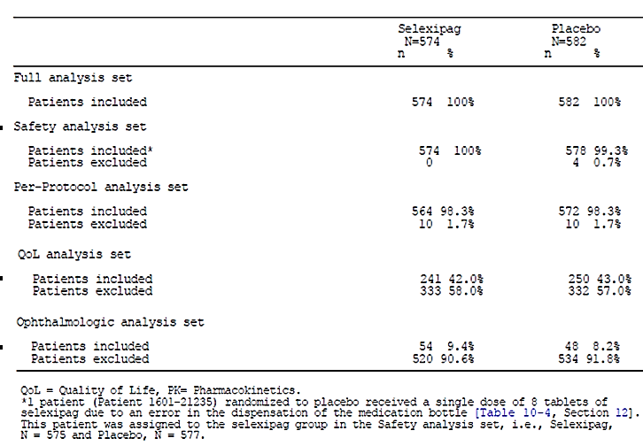

Table 25: Reasons for exclusion from analysis sets, FAS, Study AC-065A302
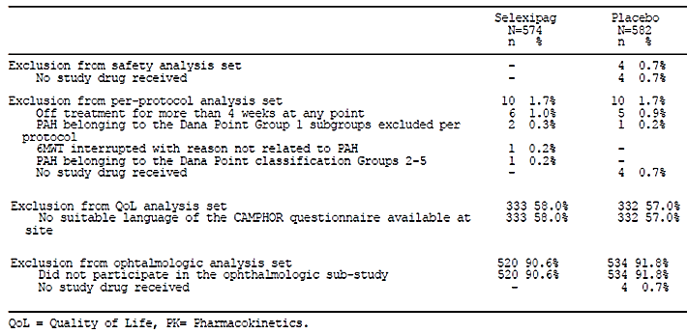

Major protocol violations/deviations
Overall, the proportion of subjects with significant protocol deviations was similar between treatment groups (6.4% [37/574] in the selexipag group versus 6.5% [38/582] in the placebo group).
Compliance with study treatment was assessed by study treatment accountability, which was performed by the site staff on the day of the visit before providing further study treatment, and was recorded in the Drug Accountability Log. Investigational medicinal product compliance of ˂ 80% at EOS visit was reported for 7.3% of patients in the selexipag group compared to 3.1% in the placebo group. Investigational medicinal product compliance > 120% at EOS visit was reported for 1.7% of patients in the selexipag group and 0.7% in the placebo group.

Baseline data
Baseline demographic characteristics were comparable between treatment groups in the FAS. The majority of patients in each treatment group were White (65.5% and 64.4% in the selexipag and placebo groups, respectively) and female (79.6% and 80.1%, respectively). The mean (standard deviation [SD]) age was 48.2 (15.19) and 47.9 (15.55) years, respectively. Baseline mean body mass index (BMI) was similar between treatment groups (mean [SD] BMI of 26.9 [6.40] and 26.7 [6.13], respectively).
Baseline disease characteristics were also generally comparable between treatment groups in the FAS. Overall, mean (SD) time since PAH diagnosis was 2.4 (3.62) years. Idiopathic PAH was the most common aetiology (56.1%), followed by PAH associated with connective tissue disease (28.9%) and congenital heart disease (9.5%). At baseline, patients were predominantly in NYHA/WHO FC II (45.8%) and FC III (52.5%). Mean (SD) 6MWD at baseline was 353.2 (80.01) m. The majority of patients (80.5% in selexipag group and 78.7% in placebo group) had concomitant PAH-specific medication at baseline. The majority were on concomitant treatment at baseline with a PDE-5i monotherapy (reported for 32.9% and 31.8% of patients in the selexipag and placebo groups, respectively) or combined PDE-5i plus ERA therapy (31.2% and 33.8%, respectively). The proportions of patients who were receiving concomitant ERA monotherapy at baseline were 16.4% and 13.1% in the selexipag and placebo groups, respectively.
Comments: Overall, the baseline demographic and disease characteristics were comparable between treatment groups, and were generally consistent with the target patient population. Epidemiologic data had suggested that the worldwide prevalence of PAH may be up to 15 per million, with a prevalence of idiopathic PAH of about 6 per million (that is, accounting for about 40% of PAH),. Idiopathic PAH is about 2 times as common in women as in men, and with a mean age at diagnosis of about 37 years, although onset of symptoms can occur at any age. The sample size of patients with NYHA/WHO FC IV was small (N=11; selexipag: n=3, placebo: n=8). This may impact the evaluation of efficacy and safety in these subgroups of patients. This will be discussed in Section 9.3 of this report.

Results for the primary efficacy outcome
As described in above, MM events with a CEC-confirmed onset date up to 16 August 2011 were not considered in the primary analysis. Excluding these events, a CEC-confirmed MM event up to EOT + 7 days was recorded for 140 (24.4%) patients in the selexipag group compared to 212 (36.4%) patients in the placebo group. In the time-to-event analysis, the hazard ratio for selexipag versus placebo for the occurrence of an MM event was 0.61 (99% CI: 0.46, 0.81), with 1-sided unstratified log-rank p-value of ˂ 0.0001 (that is, lower than the nominal alpha according to the group-sequential design). The corresponding relative risk reduction with selexipag versus placebo was 39%. The absolute risk reduction was 15.8% at 3 years.
The Kaplan-Meier (KM) curves of the first MM event in the FAS are presented in Figure 11. The curves showed that the treatment effect of selexipag on the primary endpoint appeared to be established early, with the separation in the curves between selexipag and placebo observed by Month 6 and was sustained for the duration of the treatment.
Figure 11: Kaplan-Meier estimates of time from randomisation to first CEC-confirmed MM event up to 7 days after last study drug intake in AC-065A302 treatment period (Events with CEC-confirmed onset date up to 16 Aug 2011 are not included as events), FAS, Study AC065A302
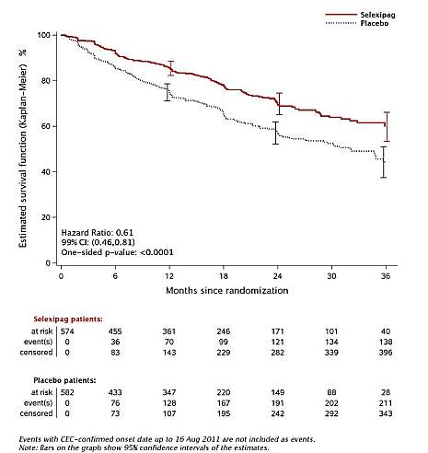
In the analysis that included events with CEC-confirmed onset date up to 16 August 2011, a CEC-confirmed MM event up to EOT + 7 days was recorded for 155 (27.0%) patients in the selexipag group compared to 242 (41.6%) patients in the placebo group. In the time-to-event analysis, the hazard ratio for selexipag versus placebo for the occurrence of an MM event was 0.60 (99% CI: 0.46, 0.78; 1-sided unstratified log-rank p ˂ 0.0001). The corresponding relative risk reduction with selexipag versus placebo was 40%. The absolute risk reduction was 16.5% at 3 years. The KM curves of the first MM event in the FAS for this analysis that included events with CEC-confirmed onset date up to 16 August 2011 are presented in Figure 12 and results are consistent with the primary analysis.
Figure 12: Kaplan-Meier estimates of time from randomisation to first CEC-confirmed MM event up to 7 days after last study drug intake in AC-065A302 treatment period, analysis including CEC-confirmed MM events up to 16 August 2011, FAS, Study AC065A302
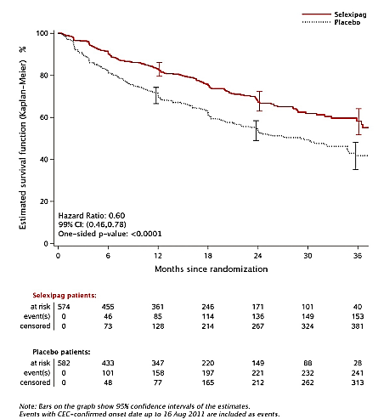
The sponsor has stated that as the results for the primary endpoint with and without censoring of CEC-confirmed MM events up to 16 August 2011 were very similar, all CEC-confirmed MM events were taken into consideration for all sensitivity and subgroup analyses of the primary endpoint, as well as for all secondary and exploratory time-to-event endpoints.

Results for other efficacy outcomes

Other analysis on the primary efficacy endpoint

Analysis of the primary efficacy endpoint in the per-protocol set
The results of the analysis of the primary endpoint in the per-protocol set were consistent with those in the FAS (Figure 13). The hazard ratio for selexipag versus placebo for the occurrence of an MM event in the per-protocol set was 0.58 (99% CI: 0.44, 0.76, 1-sided unstratified log rank p ˂ 0.0001). The corresponding relative risk reduction with selexipag versus placebo in the per-protocol set was 42%.
Figure 13: Kaplan-Meier estimates of time from randomisation to first CEC-confirmed MM event up to 7 days after last study drug intake, Per-Protocol Set, Study AC065A302
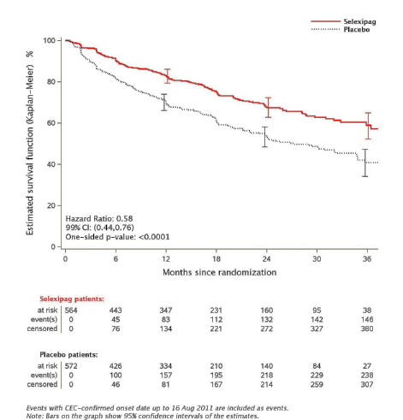

Components of the primary efficacy endpoint
In the FAS, the commonest first-reported morbidity or mortality event in all treatment groups was hospitalisation for PAH worsening (13.6% of patients in the selexipag group versus 18.7% in the placebo group), followed by disease progression (6.6% versus 17.2%) and death (all causes) (4.9% versus 3.1%).

Sensitivity analyses
The sensitivity analyses of the primary endpoint, based on variation of the endpoint definition and/or population analysed, yielded results consistent with those of the main analysis, showing a reduced risk of MM event during treatment with selexipag compared to placebo (Table 26).

Table 26: Summary of results of the supportive analyses to the primary endpoint, Study AC065A302
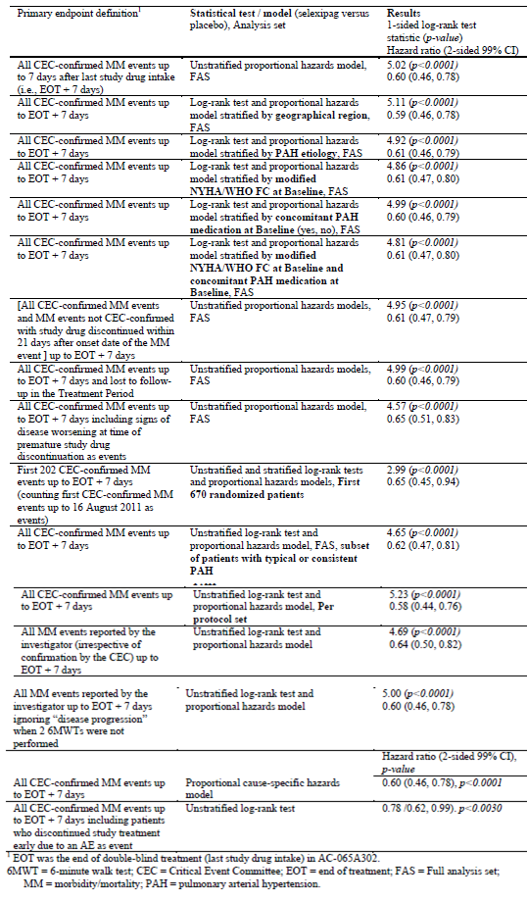

Subgroup analyses
Analyses of the occurrence of a first MM event in the treatment groups across the subgroups of gender, race/ethnicity, PAH therapy at baseline, PAH aetiology at baseline, NYHA/WHO FC at baseline, age at screening, and geographical region yielded results that were generally consistent with those in the overall study population (Figure 14).
Figure 14: Time from randomisation to first CEC-confirmed MM event up to EOT + 7 days– forest plot for subgroup analyses, FAS, Study AC065A302
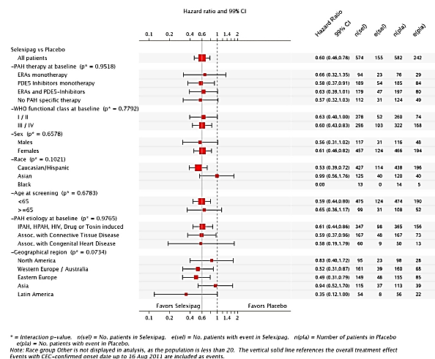
The p-values for the interaction tests did not show any statistically significant heterogeneity of the treatment effect (selexipag versus placebo) across the subgroups. Of particular note, analyses on the effect of selexipag across subgroups of background PAH therapy showed that the benefit versus placebo observed on selexipag given as add-on to ongoing ERA monotherapy, PDE-5i monotherapy or double therapy with ERA plus PDE-5 inhibitor, was similar to that of selexipag used as monotherapy. Outcomes were also stable across subgroups of PAH aetiology.
It is noted that there was an apparent neutral effect on the primary study endpoint in the Asian patient subgroup (HR of 0.99). The sponsor had explored this further and found that although there were some differences in baseline demographic and disease characteristics between Asian and non-Asian subgroup populations (the Asian patients were generally younger [median age of 38 years in the selexipag group and 34 years in the placebo group versus 52 years in both groups in the non-Asian population], and had less severe PAH disease as assessed by NYHA/WHO FC [35.7% and 41.6% of Asian patients in the selexipag and placebo groups, respectively, were in FC III, compared to 54.9% and 56.9%, respectively, for the non-Asian population]), no single factor could be identified to explain the apparent lower efficacy of selexipag in Asian patients compared to non-Asian patients. The duration of exposure to study drug was comparable between Asian and non-Asian populations. In addition, it was noted that for the primary efficacy endpoint, the KM estimate for event-free survival in the selexipag arm up to Month 30 was similar between patients in the Asian (61.1%) and non-Asian (62.1%) regions, while in the placebo arm, the KM estimates were 60.4% and 46.8%, respectively, suggesting that the observed primary efficacy endpoint results were largely due to differences in the placebo groups between the Asian and non-Asian subpopulations. In view of these findings, the sponsor had concluded that the results were likely to represent random variation. The evaluator is of the opinion that this conclusion is rational.
The sponsor had also performed an exploratory, prospectively planned analysis on the primary efficacy endpoint by individual maintenance dose (IMD) categories, excluding patients randomised to selexipag with IMD = 0 (that is, patients who only received the initial selexipag 200 µg dose during the titration period and discontinued at this dose) or ‘other’ (that is, patients who were treated according to a regimen that differed from the bd dosing regimen). Results showed comparable effects across the IMD categories (Figure 15). The hazard ratios for the selexipag IMD categories 200–500 µg (that is, 200-<600 µg), 600–1100 µg (that is, 600-<1200 µg), and 1200–1600 µg bd versus placebo were 0.60 (95% CI: 0.41, 0.88; 1-sided unstratified log-rank p = 0.0038), 0.53 (95% CI: 0.38, 0.72; 1-sided unstratified log-rank p ˂ 0.0001), and 0.64 (95% CI: 0.49, 0.82; 1-sided unstratified log rank p = 0.0002), respectively. The sponsor considered these findings as supporting the rationale for the dosing strategy employed in the study and proposed in the prescribing information, of up-titration to the individual maximum well-tolerated dose.
Figure 15: Kaplan-Meier estimates of time from randomisation to first CEC-confirmed MM event up to 7 days after last study intake by selexipag IMD, FAS (excluding patients randomised to selexipag with IMD = 0 or “other”), Study AC065A302
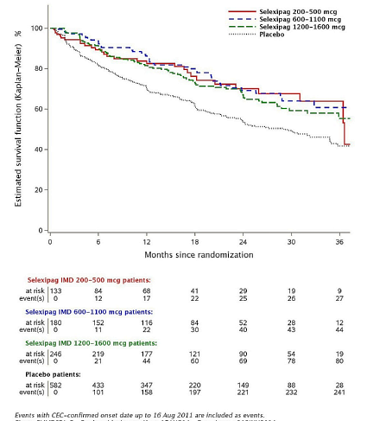

Analyses of number-needed-to-treat
Analysis of the number-needed-to-treat (NNT) was done as the sponsor considered that the NNT could reflect the absolute risk reduction of selexipag versus placebo, on top of allowed background medication, and would complement the main analysis of the relative risk reduction. The NNT was 8.0 (95% CI: 5.7, 13.6) at 1 year and 7.1 (95% CI: 4.8, 13.5) at 2 years, suggesting that 7 patients needed to be treated in the selexipag group in order to prevent one MM event in up to 2 years as compared to placebo.

Secondary and exploratory efficacy endpoints

Secondary and exploratory endpoints on 6MWD
Median absolute change from Baseline to Week 26 in 6MWD measured at trough (secondary endpoint) was 4.0 m in the selexipag group and −9.0 m in the placebo group (. The treatment effect of selexipag versus placebo in the median change in 6MWD from Baseline to Week 26 was 12.0 m (99% CI: 1, 24; 1-sided Wilcoxon-Mann-Whitney p = 0.0027). Subgroup analyses of the absolute change from Baseline to Week 26 in 6MWD at trough showed that there was no statistically significant heterogeneity of treatment effects across subgroups based on the interaction tests.
Analyses of change in 6MWD over time at trough (exploratory endpoints) showed that median absolute changes from baseline in 6MWD measured at trough in the selexipag versus placebo groups at Week 8 were 8.0 versus 7.0 m, Week 16 (10.0 versus 4.0 m), Week 26 (16.0 versus 6.0 m), Month 12 (16.0 versus 5.0 m), Month 18 (18.0 versus 3.0 m), Month 24 (18.5 versus 5.0 m), Month 30 (26.0 versus 13.5 m), and at Month 36 (6.0m versus 15.0m) (Figure 16). The median absolute change from Baseline to EOT (corresponding to each individual patient’s EOS visit) in 6MWD measured at trough was 3.0 m in the selexipag group compared to −12.0 m in the placebo group.
Figure 16: Absolute change from Baseline to regular visits in 6MWD at trough, FAS, Study AC065A302
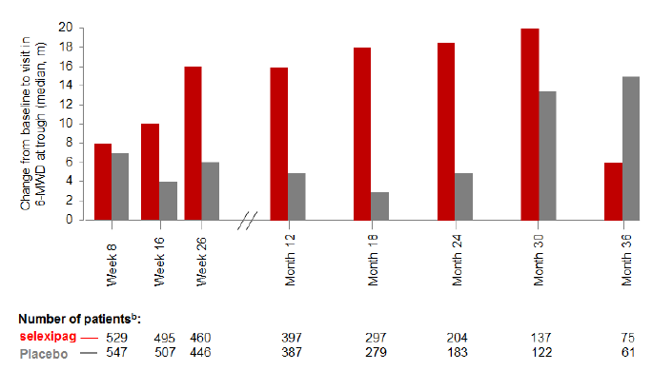

Secondary and exploratory endpoints on NYHA/WHO Functional Class
Absence of worsening from Baseline in NYHA/WHO FC at Week 26 (secondary endpoint) was reported for 77.8% of patients in the selexipag group and 74.9% in the placebo group. The common odds ratio for the effect of selexipag relative to placebo was 1.16 (99% CI: 0.811, 1.664; 2-sided Breslow-Day p = 0.1916). In the various subgroups of patients with concomitant PAH-specific therapies (ERA monotherapy, PDE-5i monotherapy, ERA plus PDE-5i), the proportion of patients with absence of worsening from baseline in NYHA/WHO FC at Week 26 was generally comparable between selexipag and placebo. In the subgroup of patients who had no concomitant PAH-specific therapy at baseline (that is, treatment naïve), absence of worsening from baseline in NYHA/WHO FC at Week 26 was reported for 83.0% and 67.7% of patients in the selexipag and placebo groups, respectively (common odds ratio for the effect of selexipag relative to placebo: 2.30 [99% CI: 1.01, 5.25; 2-sided Breslow-Day p = 0.7287]).
In the analysis of the absence of worsening from Baseline in NYHA/WHO FC over time (exploratory endpoints), it was observed that from Week 8 onwards, the proportion of patients with absence of worsening from Baseline in NYHA/WHO FC was higher in the selexipag group compared to the placebo group at all-time points except at Week 26 (93.5% in both groups) and Month 24 (87.9% with selexipag versus 87.3% with placebo) (Figure 17).
Figure 17: Change from Baseline in modified NYHA/WHO FC at regular visits, FAS (excluding patients with baseline FC IV), FAS, Study AC065A302
(i) absence of worsening from baseline in modified NYHA/WHO FC
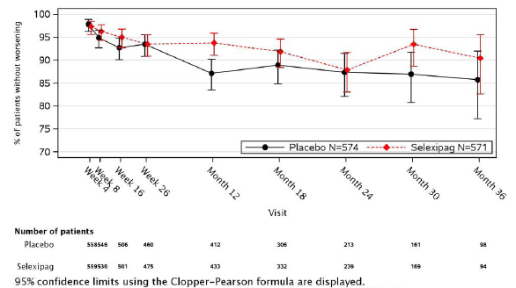
(ii) improvement from baseline in modified NYHA/WHO FC, and worsening in modified NYHA/WHO FC from baseline
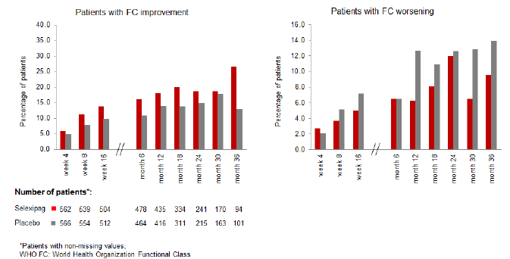
Absence of worsening from Baseline in NYHA/WHO FC at EOT (corresponding to individual patient’s EOS visit) was reported for 84.9% and 72.1% of patients who had non-missing baseline and EOS assessments in the selexipag and placebo groups, respectively. The proportion of patients with improvement from Baseline in NYHA/WHO FC was mostly higher in the selexipag group compared to the placebo group from Week 4 up to Month 36, and the proportion of patients who had worsened NYHA/WHO FC compared to Baseline was mostly lower in the selexipag group than in the placebo group from Week 8 up to Month 36.

Secondary endpoint of death due to PAH or hospitalisation for PAH worsening
Analyses on the time from randomisation to first event of death due to PAH or hospitalisation for PAH worsening up to EOT + 7 days (secondary endpoint) showed that a total of 102 (17.8%) patients in the selexipag group and 137 (23.5%) patients in the placebo group died due to PAH or were hospitalised due to PAH worsening up to 7 days after last study drug intake. The hazard ratio for selexipag versus placebo for the first occurrence of death due to PAH or hospitalisation due to PAH worsening up to EOT + 7 days was 0.70 (99% CI: 0.50, 0.98; 1-sided unstratified log-rank p = 0.0031) (Figure 18). The corresponding relative risk reduction on selexipag versus placebo was 30%.
Figure 18: Kaplan-Meier estimates of time from randomisation to first occurrence of CEC-confirmed death due to PAH or CEC-confirmed hospitalisation due to PAH worsening up to 7 days after last study drug intake, FAS, Study AC065A302
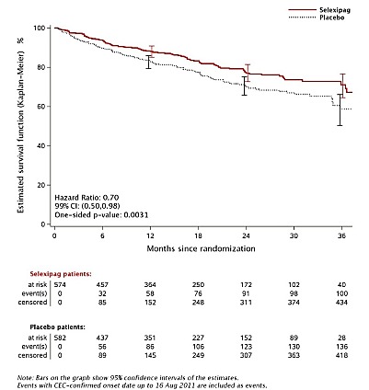
The proportion of patients with hospitalisation due to PAH worsening was 15.0% in the selexipag group compared to 21.1% in the placebo group. The proportion of patients who died due to PAH as first event was 2.8% in the selexipag group compared to 2.4% in the placebo group. The subgroup analyses for the time from randomisation to first of CEC-confirmed death due to PAH or CEC-confirmed hospitalisation due to PAH worsening up to EOT + 7 days showed that the observed treatment effect was generally consistent across subgroups (Figure 19).
Figure 19: Time from randomisation to first CEC-confirmed death due to PAH or CEC-confirmed hospitalisation due to PAH worsening up to 7 days after last study drug intake- forest plot for subgroup analyses, FAS, Study AC065A302
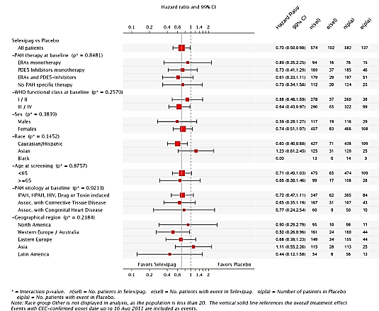
Analyses on the time from randomisation to first event of death due to PAH or hospitalisation due to PAH worsening up to study closure (exploratory endpoint) showed similar results. A total of 131 (22.8%) patients in the selexipag group compared to 168 (28.9%) patients in the placebo group had a first occurrence of death due to PAH or hospitalisation due to PAH worsening up to study closure. The hazard ratio for selexipag versus placebo for the occurrence of death due to PAH or hospitalisation due to PAH worsening up to study closure was 0.76 (95% CI: 0.60, 0.95; 1-sided unstratified log-rank p = 0.0081). The corresponding relative risk reduction with selexipag versus placebo was 24% (Figure 20).
Figure 20: Kaplan-Meier estimates of time from randomisation to first occurrence of CEC-confirmed death due to PAH or CEC-confirmed hospitalisation due to PAH worsening up to Study closure, FAS, Study AC065A302
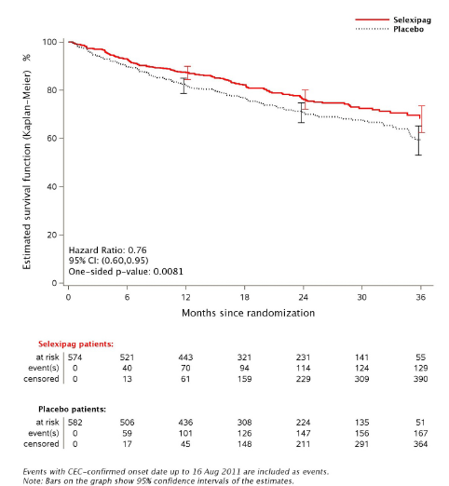

Death-related endpoints
Analyses on the time from randomisation to death (all causes) up to study closure (secondary endpoint) showed that a total of 100 (17.4%) and 105 (18.0%) patients in the selexipag and placebo groups, respectively, died up to study closure. The hazard ratio for selexipag versus placebo for the time to death of all causes up to study closure was 0.97 (99% CI: 0.68, 1.39; 1-sided unstratified log-rank p = 0.4214).
Analyses on the time from randomisation to death due to PAH up to study closure (exploratory endpoint) showed that a total of 70 (12.2%) patients in the selexipag group compared to 83 (14.3%) patients in the placebo group had a CEC-confirmed death due to PAH up to study closure. The hazard ratio for selexipag versus placebo for the occurrence of a CEC-confirmed death due to PAH up to study closure was 0.86 (95% CI: 0.63, 1.18; 1-sided unstratified log-rank p = 0.1763).
Analyses on the time from randomisation to death due to PAH up to EOT + 7 days (exploratory endpoint) showed that a total of 33 (5.7%) patients in the selexipag group compared to 27 (4.6%) patients in the placebo group had a CEC-confirmed death due to PAH up to EOT + 7 days. The hazard ratio for selexipag versus placebo for the occurrence of a CEC-confirmed death due to PAH up to EOT + 7 days was 1.16 (95% CI: 0.70, 1.93; 1-sided unstratified log-rank p = 0.7153).

Quality of Life endpoints (CAMPHOR questionnaire)
The Cambridge Pulmonary Hypertension Outcome Review (CAMPHOR) questionnaire, consisting of 3 sections: Symptoms (with sub-scales related to Energy, Breathlessness, and Mood), Activity, and QoL, was used to assess PAH-specific Quality of Life (QoL). The CAMPHOR ‘Symptoms’ score could range from 0 (good) to 25 (poor). Scores of the sub-scale ‘Breathlessness’ of the CAMPHOR ‘Symptoms’ section could range from 0 (good) to 8 (poor). Results showed that the median absolute changes from Baseline to Week 26 in CAMPHOR ‘Symptoms’ score (secondary endpoint) were −1.0 in the selexipag group and 0.0 in the placebo group. The treatment effect of selexipag versus placebo was 0.0 (99% CI: −1.0, 1.0; p = 0.2185). The median absolute changes from Baseline to Week 26 in the sub-scale ‘Breathlessness’ of CAMPHOR ‘Symptoms’ score (secondary endpoint) was 0.0 in both treatment groups. The treatment effect of selexipag versus placebo was 0.0 (99% CI: −0.4, 0.0; p = 0.1700).
The analyses of the exploratory endpoints of the absolute change from Baseline to all regular visits in the CAMPHOR ‘Symptoms’ score showed similar results. Median absolute change from Baseline to EOT (corresponding to individual patient’s end of study visit) was 0.0 in the selexipag group and −0.4 in the placebo group. Analyses of the exploratory endpoints of absolute change from Baseline to all regular visits in the ‘Breathlessness’ sub-scale score also showed similar results. Median absolute change from Baseline to EOT (corresponding to individual patient’s end of study visit) was 0.0 in both treatment groups.

Other exploratory endpoints
Analyses on the endpoint of time from randomisation to first MM event up to study closure showed that a total of 185 (32.2%) patients in the selexipag group compared to 258 (44.3%) patients in the placebo group had a MM event up to study closure. The hazard ratio for selexipag versus placebo was 0.65 (95% CI: 0.54, 0.79; 1-sided unstratified log-rank p ˂ 0.0001).
Analyses on the endpoint of time from randomisation to first MM event (excluding ‘disease progression’) up to EOT +7 days showed that a total of 125 (21.8%) patients in the selexipag group compared to 161 (27.7%) in the placebo group had a MM event (excluding ‘disease progression’) up to EOT +7 days. The hazard ratio for selexipag versus placebo was 0.73 (95% CI: 0.58, 0.92; 1-sided unstratified log-rank p = 0.0037).
Analyses on the endpoint of time from randomisation to first MM event (excluding ‘disease progression’) up to study closure showed that a total of 166 (28.9%) patients in the selexipag group compared to 199 (34.2%) patients in the placebo group had a MM event (excluding ‘disease progression’) up to study closure. The hazard ratio for selexipag versus placebo was 0.80 (95% CI: 0.65, 0.99; 1-sided unstratified log-rank p = 0.0189).
Analyses on the endpoint of time from randomisation to first MM event (excluding ‘disease progression’ and ‘initiation of parenteral prostanoid therapy or chronic oxygen therapy due to worsening of PAH’) up to EOT +7 days showed that a total of 117 (20.4%) patients in the selexipag group compared to 146 (25.1%) patients in the placebo group had such a MM event up to EOT +7 days. The hazard ratio for selexipag versus placebo was 0.75 (95% CI: 0.59, 0.96, 1-sided unstratified log-rank p = 0.0107).
Analyses on the endpoint of time from randomisation to first MM event (excluding ‘disease progression’ and ‘initiation of parenteral prostanoid therapy or chronic oxygen therapy due to worsening of PAH’) up to study closure showed that a total of 157 (27.4%) patients in the selexipag group compared to 186 (32.0%) patients in the placebo group had such a MM event up to study closure. The hazard ratio for selexipag versus placebo was 0.82 (95% CI: 0.66, 1.01, 1-sided unstratified log-rank p = 0.0322).
Analyses of the endpoint of the Borg dyspnoea index at scheduled visits showed that over time, no change in Borg dyspnoea index was observed in both treatment groups. At baseline, median score was 3.0 in both groups. At EOT (corresponding to individual patient’s EOS visit), the median score was 3.0 in the selexipag group and 4.0 in the placebo group.
Analyses of the absolute change from baseline to regular visits in plasma NT pro-BNP (a biomarker for cardiac overload) showed that starting from Week 4, curves for selexipag and placebo separated with no consistent increase in median NT pro-BNP in the selexipag group over the course of the study while the placebo group showed a consistent trend for increase at each post-baseline visit (Figure 21). The absolute change from baseline to EOT (corresponding to individual patient’s EOS visit) in median plasma NT pro-BNP was 5.5 ng/L (range: −4790 to 10873 ng/L) in the selexipag group compared to 75.0 ng/L (range: −7309 to 41586 ng/L) in the placebo group.
Figure 21: Absolute change from baseline to regular visits in plasma NT pro-BNP, FAS, Study AC065A302
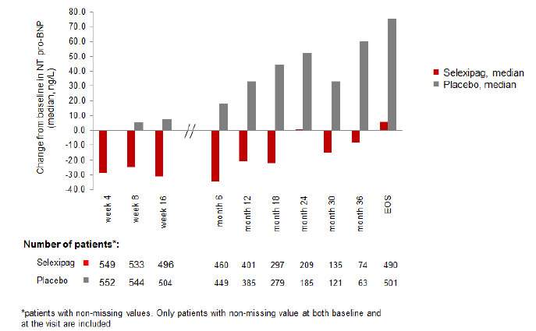
Pharmacoeconomic endpoints looking at the annualised number of all-cause and PAH-related hospitalisations up to the EOS visit showed that the (group-level) mean annualised number of hospitalisations for all causes up to the EOS visit was 0.40 in the selexipag group and 0.42 in the placebo group. Based on a negative binomial model, the relative reduction in mean annualised number of hospitalisations for all causes in the selexipag group compared to placebo was 0.92 (99% CI: 0.69, 1.22; p = 0.4378). The (group-level) mean annualised number of PAH-related hospitalisations up to the EOS visit was 0.17 in the selexipag group compared to 0.21 in the placebo group. Based on the negative binomial model, the relative reduction in mean annualised number of PAH-related hospitalisations in the selexipag group compared to placebo was 0.80 (99% CI: 0.55, 1.16; p = 0.1256).
Pharmacoeconomic endpoints looking at annualised number of days spent in hospital for all causes and for PAH-related causes up to the EOS visit showed that the medians for annualised number of days spent in hospital for all causes up to the EOS visit were 0 for both treatment groups and the upper quartile (Q3) was 5.2 days in the selexipag group compared to 6.7 days in the placebo group (1-sided Wilcoxon-Mann-Whitney p-value=0.2213). The medians for annualised number of days spent in hospital for PAH-related causes up to the EOS visit were also 0 for both treatment groups and the upper quartile (Q3) was 0 day in the selexipag group compared to 0.9 day in the placebo group(1-sided Wilcoxon-Mann-Whitney p-value = 0.0525).

Other efficacy studies

Study NS-304/-02
Study NS-304/-02 was a multicentre, multinational Phase IIa study, with an open-label, single-dose, acute haemodynamic period followed by a randomised, double-blind, placebo-controlled period to assess the safety, tolerability, pharmacokinetics, and preliminary efficacy (proof-of-concept) of selexipag (ACT-293987) in the treatment of PAH in subjects aged 18 years and above. The primary objective of the acute haemodynamic period was to evaluate the effect of the drug on right heart catheterisation parameters (pulmonary vascular resistance [PVR], systemic vascular resistance [SVR], and PVR/SVR) after a single oral dose of selexipag. The primary objective of the randomised, placebo-controlled, double-blind study was a proof-of-concept assessment of the efficacy (change in PVR from baseline at Week 17) of selexipag as add-on therapy in PAH patients compared with placebo. The secondary objective was to assess efficacy using the 6MWT, the proportion of patients with aggravation of PAH, and right heart catheterisation parameters other than PVR. The tertiary objective was to assess efficacy using NYHA FC, Borg dyspnoea score, plasma NT pro-BNP concentration, and echocardiographic parameters. Study start and end dates were 16 April 2008 (first patient, first visit) and 23 June 2009 (last patient, last visit), respectively.
The study design included two periods: an open-label, single-dose, acute haemodynamic testing period followed by a randomised, double-blind, placebo-controlled, parallel-group treatment period (Figure 22).
Figure 22: Study design, study NS-304/-02
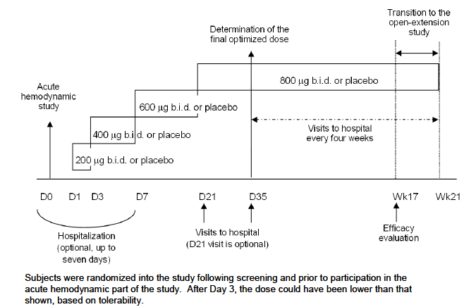
The study consisted of a screening visit (within 28 days before acute haemodynamic testing), acute haemodynamic testing following a single dose of selexipag, and a 21-week double-blind treatment period. Patients had the option to continue in a following open-label extension study, and those who did not continue were followed up 30 days after the last visit. In the acute haemodynamic period, patients were admitted to hospital, underwent right heart catheterisation, and were administered a single, oral dose of selexipag on Day 0. Haemodynamic parameters were assessed pre-dose and at 1, 2, 3 and 4 hours after dosing, and safety and tolerability continually monitored. The first 12 patients were to receive a 200 µg dose. After the first 12 patients had completed the acute haemodynamic testing, the investigators and the sponsor’s medical monitor were to decide whether it was acceptable to increase the single dose to 400 µg for the remaining patients.
In the double-blind treatment period, patients started the double-blind treatment (randomised in a 3:1 ratio [selexipag: placebo]) on Day 1, with no wash-out period from acute testing. Patients were initially administered selexipag 200 µg bd or matching placebo and were up-titrated over the first 35 days to find his or her maximum tolerated dose (MTD or ‘final optimised dose’). If the initial 200 µg dose was well tolerated, the dose was to be up-titrated to 400 µg bd on Day 3, followed by 600 µg bd on Day 7, and then 800 µg bd (the highest possible dose in this study) on Day 21. Up-titrations could be delayed, depending on the tolerability of the dose. However, the dose reached by Visit 4 (Day 35 ± 3 days) was to be maintained until the end of the study. The dose could be temporarily reduced at any time at the discretion of the investigator if adverse events persisted, but the dose was to be stable for at least 4 weeks before evaluation at Visit 7 (Week 17).
Post-study, patients who completed the double-blind period of the study up to Week 17 were able to enter an open-label extension safety study (separate protocol NS-304/-03) and continue to receive or initiate treatment with selexipag, if the investigator considered it appropriate. Patients who withdrew from the study prematurely or otherwise did not enter the open- label extension study had a follow-up visit 30 days after the last study visit during which all end-of-study (EOS) assessments were performed along with right heart catheterisation and echocardiography, if possible.
During the open-label extension study, patients on selexipag in the double-blind study were to continue to receive their optimised dose, while those on placebo were to undergo up-titration over the first 35 days to find his or her MTD starting with 200 µg bd on D1, following the up-titration schedule as described above. Once the MTD had been reached, subjects would be maintained on this dose for the duration of the study. The total duration of treatment in the open-label extension study would be at least 24 weeks. The dose can be reduced at the discretion of the investigator if adverse events persisted. Patients who were continuing in the extension study were unblinded on a patient-by-patient basis, when that patient’s Week-17 data were fixed and locked. Patients could transition to the open-label extension study at any time between Week17 (Visit 7) and Week 21 (Visit 8) after treatment was unblinded. This open-label extension Study NS-304/-03 was ongoing at the time of this TGA submission. Safety data up to the analysis cut-off date of 10 March 2014 was included in the safety analysis for this submission, although the study protocol and CSR of Study NS-304/-03 was not provided separately in this submission; the sponsor has instead provided, in the summary of clinical safety, pooled safety data of 4 studies which included Study NS-304/-03 (Studies AC-065A302 [GRIPHON], AC-065A303 [GRIPHON OL], NS-304/-02 and NS-304/-03).
Study entry criteria were male or female, ≥ 18 years of age with symptomatic PAH despite treatment with anticoagulants, calcium channel blockers, diuretics, cardiac glycosides, supplemental oxygen, ERAs, and/or PDE-5 inhibitors and having a PVR > 400 dyn·s/cm⁵ and two 6-min walk tests between 150 and 500 m (inclusive) and with the variation between the two tests within ± 15%. Patients were included if they had as aetiology of PAH: idiopathic PAH, familial PAH, or PAH associated with collagen vascular disease, corrected congenital vitium (congenital systemic-to-pulmonary shunts surgically repaired at least 5 years before), or anorexigen use. Patients were excluded if they had PAH associated with portal hypertension, HIV infection, or unrepaired congenital systemic-to-pulmonary shunt. Patients with NYHA FC IV were also excluded.
Primary efficacy endpoint for the acute haemodynamic period was the change in PVR from baseline to 4 hours after the single selexipag dose. Primary efficacy endpoint for the double-blind treatment period was the change in PVR from baseline to Week 17. Secondary efficacy endpoints were the change in 6MWD from baseline to Week 17; the proportion of patients with aggravation of PAH; changes in right heart catheterisation parameters other than PVR from baseline to Week 17. Tertiary endpoints were changes from baseline to Week 17 in NYHA FC, Borg dyspnoea score, plasma NT pro-BNP concentration and echocardiography parameters.
Overall, 44 patients (33 in selexipag group and 11 in placebo group) were planned and 43 patients were randomised (33 were treated with selexipag, and 10 patients received placebo). All patients received the single dose of selexipag for acute haemodynamic testing and all patients also received double-blind (DB) study treatment. A total of 39 patients (31 had received selexipag and 8 had received placebo in the core study) participated in the open-label extension safety Study NS-304/-03.
An overview of the study analysis sets is presented in Table 27.

Table 27: Overview of analysis sets, all-enrolled set, study NS-304/-02
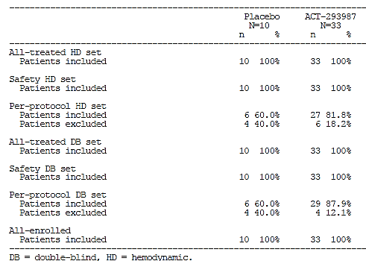
All-treated HD set – included all patients who received study drug (i.e. at least one tablet) during the acute haemodynamic period of the study; Safety HD set – included all patients who received study drug (i.e. at least one tablet) during the acute haemodynamic period of the study and had at least one safety assessment post baseline during the acute haemodynamic period of the study; Per-protocol HD set – included all patients included in the all-treated HD set who did not violate the protocol in a way that might affect the evaluation of the effect of study drug on the primary endpoint of the acute haemodynamic period of the study (i.e. patients without major protocol violations); All-treated DB set – included all patients who received study treatment (i.e. at least one tablet) during the double-blind period; Safety DB set – included all patients who received study treatment (i.e. at least one tablet) during the double-blind period and had at least one safety assessment post-baseline during the double-blind period; Per-protocol DB set – included all patients included in the all-treated double-blind set who did not violate the protocol in a way that might affect the evaluation of the effect of study treatment on the primary endpoint of the double-blind period of the study (i.e. patients without major protocol violations)
The main efficacy analyses were performed on the per-protocol haemodynamic (HD) set and per-protocol DB set for the acute haemodynamic and double-blind periods, respectively. Eight patients (four randomised to each treatment group) were excluded from the per-protocol DB set as they had violated essential entry criteria or had no baseline assessment of PVR. These 8 patients were also excluded from the per-protocol HD set along with 2 additional patients who had no post-baseline PVR recorded 4 hours after the single dose of selexipag. One of the patients excluded from the per-protocol HD set received 200 µg during the acute haemodynamic period and the other nine patients received 400 µg.
Baseline demographic and disease characteristics were comparable between treatment groups (selexipag versus placebo). Overall, the majority of patients were female (81.8% and 80.0% in the selexipag and placebo groups, respectively) and Caucasian (87.9% and 90.0%, respectively). The overall mean (SD) age was 54.8 (16.8) years and 53.8 (16.3) years, respectively. The mean (SD) time from initial diagnosis was 5.5 (6.1) years and 4.0 (3.1) years, respectively. Idiopathic PAH was the most common aetiology (72.7% and 70.0%, respectively).
During the acute haemodynamic period, there was no effect on PVR after 4 hours of selexipag single oral dose (200 or 400 µg). There was no difference in effect between the 200 and 400 µg doses. Primary efficacy analysis in the double-blind period showed that at Week 17, PVR (geometric mean and 95% confidence limits [CL]) was 80.7% (72.8, 89.6) and 115.9% (106.5, 126.1) of the baseline values in the selexipag and placebo groups, respectively. Compared with placebo, patients on selexipag had a statistically significant 30.3% decrease in geometric mean PVR (95% CL: -44.7, -12.2; p = 0.0045, Wilcoxon rank-sum test). The median change from baseline in PVR at Week 17 was -166.0 dyn∙sec/cm⁵ with selexipag compared to 124.0 dyn·s/cm⁵ with placebo.
Analyses of secondary efficacy endpoints of changes in right heart catheterisation parameters other than PVR from baseline to Week 17 showed that the median treatment effect on selexipag (versus placebo) was 0.41 L/min/m² (95% CL: 0.10, 0.71) for cardiac index and -427 dyn·s/cm⁵ (95% CL: −668.3, −134.5) for systemic vascular resistance. Other haemodynamic variables did not show clear treatment effects with selexipag for the change from baseline to Week 17. Analyses of secondary endpoint of change in 6MWD from baseline to Week 17 showed that median 6MWD increased to a greater extent from baseline to Week 17 on selexipag (25 m; 95% CLs: −2 m, 42 m) than on placebo (6 m; 95% CL: −33m, 23 m), but the difference was not statistically significant (median treatment effect on selexipag versus placebo of 18 m [95% CL:–12.4, 61.4 m]; Wilcoxon rank sum test p-value =0.2218; t-test p-value =0.3129). Analyses of secondary endpoint of the proportion of patients with aggravation of PAH showed that 1 patient (3.0%) on selexipag versus 2 patients (20.0%) on placebo had an event that qualified as aggravation of PAH. The proportion of patients whose NYHA FC status improved from baseline to Week 17 was 15.6% and 10% in the selexipag and placebo groups, respectively (relative risk of 1.56 [95% CL: 0.21 - 11.85], Fisher Exact Test p-value = 1.0000). The proportion of patients with worsening of NYHA FC was 6.3% on selexipag compared to 20% on placebo (relative risk of 0.31 [95% CL: 0.05 – 1.94], Fisher Exact Test p-value = 0.2356).
There were only minimal median changes from baseline to Week 17 in Borg dyspnoea score with both selexipag (-0.25 units) and placebo (0.00 units) (median treatment effect of 0.03 units [95% CL: -1.25, 0.97]; Wilcoxon rank sum test p-value = 0.9513; t-test p-value = 0.8467). Median plasma NT pro-BNP concentrations at baseline were lower in the selexipag group (56.10 pmol/L) than the placebo group (299.15 pmol/L). There was no statistically significant difference in the changes from baseline to Week 17 in NT pro-BNP concentrations between treatment groups (median treatment effect of selexipag versus placebo of 17.30 [95% CL: -63.76, 69.50]; Wilcoxon rank sum test p-value =0.5466; t-test p-value =0.5916). Analyses of changes in echocardiography parameters from baseline to Week 17 showed that small median changes in echocardiography parameters were similar between selexipag and placebo groups, and no statistically significant treatment effect was indicated.

Study AC-065A201
Study AC-065A201 was a multicentre (37 patients enrolled in 26 centres in Japan), uncontrolled, open-label Phase II study conducted to assess the efficacy, safety and pharmacokinetics of selexipag in Japanese patients with PAH. The primary objective was to evaluate the effect of selexipag based on change from baseline in PVR at rest in PAH patients. The secondary objectives were to evaluate the effect of selexipag based on change from baseline in pulmonary haemodynamic variables other than PVR, 6MWD, Borg dyspnoea index, WHO FC and NT pro-BNP plasma concentrations, the pharmacokinetics of selexipag and its metabolites, and the safety and tolerability of selexipag in PAH patients. Study start date was 25 May 2011. The study was ongoing at the time of this TGA submission, and the CSR the sponsor provided was an interim report which included the results up to Week 16 of treatment with selexipag (24 Jan 2013 [Visit date of Week 16 of the last patient]).
The study design included screening phase (up to 8 weeks prior to the start of study drug administration), followed by a treatment and efficacy evaluation period of 16 weeks (composed of a titration period of maximum of 12 weeks and a maintenance dose period of at least 4 weeks). After the efficacy evaluation at Week 16, treatment with selexipag was to be continued up to 144 weeks (that is, the long-term treatment period). An extension to the long-term treatment period (that is, more than 144 weeks) would be allowed if the patient had no clinically significant adverse events and the investigators requested to do so. Patients were followed up for 30 days after discontinuation of study drug. Selexipag treatment was initiated at a dose of 200 µg bd, and the dose was up-titrated in 3-day intervals in a 200 µg bd stepwise manner up to 800 µg bd, and thereafter at weekly intervals up to a maximum dose of 1600 µg bd within the first 12 weeks (Figure 23). The dose was required to be maintained stable for at least 4 weeks prior to the efficacy evaluation visit at Week 16 (cut-off for the interim analysis).
Figure 23: Study design, Study AC-065A201
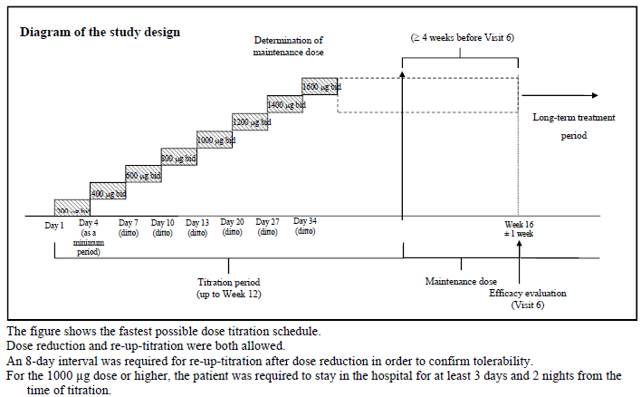
Study entry criteria were male or female, ≥ 18 years of age with PAH group 1.1 to 1.4 of the updated Dana point clinical classification (that is, idiopathic PAH, or heritable PAH, or associated with connective tissue disease, congenital heart disease with simple systemic-to-pulmonary shunt at least 1 year after surgical repair, HIV infection, or drugs and toxins), with NYHA/WHO FC I to IV, and baseline PVR via right heart catheterisation of > 400 dyn·s/cm⁵.
The primary endpoint of the study was the absolute change from baseline to Week 16 in PVR at rest. The secondary efficacy endpoints of the study were absolute change from baseline to Week 16 in pulmonary haemodynamic variables other than PVR; absolute changes from baseline to Week 16 in 6MWD and Borg dyspnoea index; shifts from baseline to Week 16 in NYHA/WHO FC; absolute change from baseline to Week 16 in NT pro-BNP plasma concentrations. Exploratory efficacy endpoints included the evaluation of the time to first clinical worsening, changes from baseline to each measurement time point until Week 16 in vascular endothelial cell function markers, changes from baseline to each measurement time point beyond Week 16 in 6MWD, Borg dyspnoea index, NYHA/WHO FC and NT pro-BNP plasma concentration.
Overall, a total of 37 patients were enrolled and treated with selexipag. Four patients prematurely discontinued the study prior to Week 16 (primary efficacy evaluation). The reasons for study drug discontinuation were treatment initiation with calcium channel blocker after start of selexipag, occurrence of an SAE, use of prohibited concomitant medication, and withdrawal of consent, respectively. Therefore, a total of 33 patients were included in the primary efficacy evaluation at Week 16.
Overall, the majority of patients were female (70.3%) with an overall mean (SD) age of 44.5 (13.3) years. Idiopathic PAH was the most common aetiology (67.6%). PAH severity at baseline was NYHA/WHO FC II in 56.8% of patients and FC III in 37.8. At baseline, 83.8% of patients were receiving concomitant medications for the treatment of PAH, most frequently bosentan (51.4%), tadalafil (43.2%), sildenafil (35.1%) and ambrisentan (24.3%).
Primary efficacy analysis showed that there was a statistically significant median decrease in PVR from baseline to Week 16 on selexipag (median change from baseline of -120.9 dyn∙sec/cm⁵, p < 0.0001, Wilcoxon signed rank test) (Table 28). Other haemodynamic variables with statistically significant mean changes from baseline included pulmonary vascular resistance index and total pulmonary resistance.

Table 28: Mean changes in pulmonary haemodynamic variables on selexipag treatment, Per-protocol set, Study AC-065A201
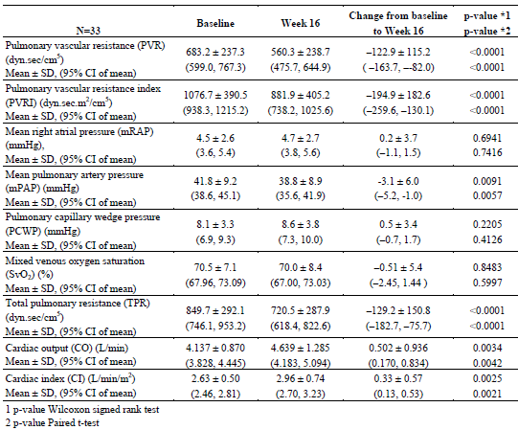
Median 6MWD increased by 19.5 m (95% CLs 0, 37.0 m) at Week 16 on selexipag treatment from a baseline median value of 460.5 m (range: 183-620 m). The mean (± SD) change from baseline to Week 16 in Borg dyspnoea index was −0.2 (± 1.2) (mean [± SD] Borg dyspnoea index at baseline: 2.7 [± 2.1]; at Week 16: 2.5 [± 2.0]). Overall, 12.1% of patients (n=4) showed improvement in NYHA/WHO FC from baseline to Week 16 (three from FC III to II and one from II to I). No patient experienced worsening of NYHA/WHO FC. The median change in NT pro-BNP plasma concentration from baseline to Week 16 was −13.0 pg/mL.
Analyses of exploratory endpoint of time to first clinical worsening showed that overall, one patient showed clinical worsening at Week 16 (that is, Week 16 ± 7 days). The patient started treatment with PGI₂ due to PAH worsening 118 days after administration of selexipag. No other patients with clinical worsening were reported during treatment period up to Week 16. Results of analyses of the exploratory endpoints of change from baseline in vascular endothelial cell function markers are presented in Table 29.

Table 29: Change from baseline in vascular endothelial cell function markers, Study AC065A201
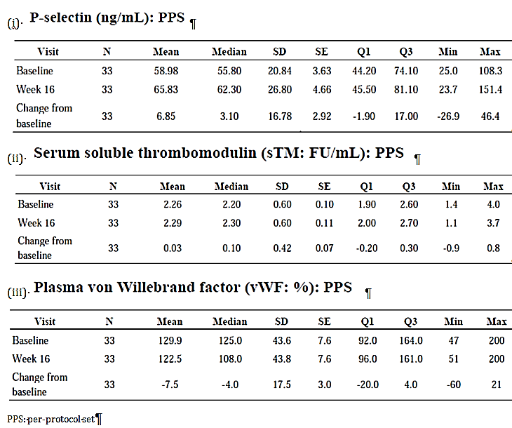

Analyses performed across trials (pooled analyses and meta-analyses)
Not applicable.

Evaluator’s conclusions on clinical efficacy for the proposed indication
Treatment of pulmonary arterial hypertension (PAH) in patients with WHO functional class II, III or IV symptoms
Overall, the study design, study inclusion and exclusion criteria, and study endpoints of the pivotal Phase III study (AC-065A302) were appropriate and in line with the recommendations of the TGA-adopted EMA guidelines on the clinical investigation of medicinal products for the treatment of pulmonary arterial hypertension. The study primary endpoint (composite) allowed evaluation of the effect of selexipag (administered in dosing regimen of initial 12-week up-titration from 200 µg bd until the individual maximum tolerated dose [IMTD; up to maximum dose of 1600 µg bd] and then maintained at IMTD for the next 14 weeks up to Week 26) on all-cause mortality and PAH-related morbidity, while the study secondary endpoints allowed evaluation of the effect of selexipag on exercise capacity (6MWD) and clinical symptoms (NYHA/WHO functional class and CAMPHOR questionnaire). Baseline demographic and disease characteristics were comparable between treatment groups, and were generally consistent with the target patient population. The majority of patients (80.5% in selexipag group and 78.7% in placebo group) had concomitant PAH-specific medication at baseline.
Analysis of the primary efficacy endpoint (that is, time to first morbidity/mortality [MM] event up to EOT + 7 days) showed that the relative risk reduction for the occurrence of a MM event with selexipag compared to placebo was 40% (1-sided unstratified log-rank p ˂ 0.0001). Additional analyses of the primary efficacy endpoint in the per-protocol set and sensitivity analyses on the primary efficacy endpoint yielded results generally consistent with those of the main analysis, showing a reduced risk of MM event during treatment on selexipag compared to placebo. Exploratory endpoints involving analyses of time to first MM event up to study closure, and analyses of time to first MM event excluding certain components of the composite primary endpoint also yielded results generally consistent with the primary efficacy analysis.
Analyses on the components of the primary efficacy endpoint showed that the observed treatment difference in the primary endpoint was driven mainly by hospitalisation due to PAH worsening (13.6% % of patients in the selexipag group versus 18.7% in the placebo group) and the composite component of disease progression (6.6% with selexipag versus 17.2% with placebo), while there was a higher proportion of patients with death (all cause) as the first MM event in the selexipag group (4.9% versus 3.1% in the placebo group). Additional competing risk analysis to explore the treatment effect on the 4 main components of the primary endpoint (death, disease progression, hospitalisation for PAH worsening, and PAH worsening [including need for lung transplantation or balloon atrial septostomy, parenteral prostanoid treatment or chronic oxygen therapy]) also showed that patients on selexipag had statistically significantly lower risk of disease progression (p < 0.0001) and hospitalisation for PAH worsening (p = 0.0402) than patients on placebo, but no statistically significant difference was observed between selexipag and placebo for the risk of death (p = 0.0827) or for the risk of PAH worsening (p = 0.5342) (Figure 24).
Figure 24: Competing risk analysis for time from randomisation to first CEC- confirmed morbidity / mortality event up to EOT + 7 days. Cumulative incidence functions (Aalen Johansen estimates) by event, FAS, AC-065A302
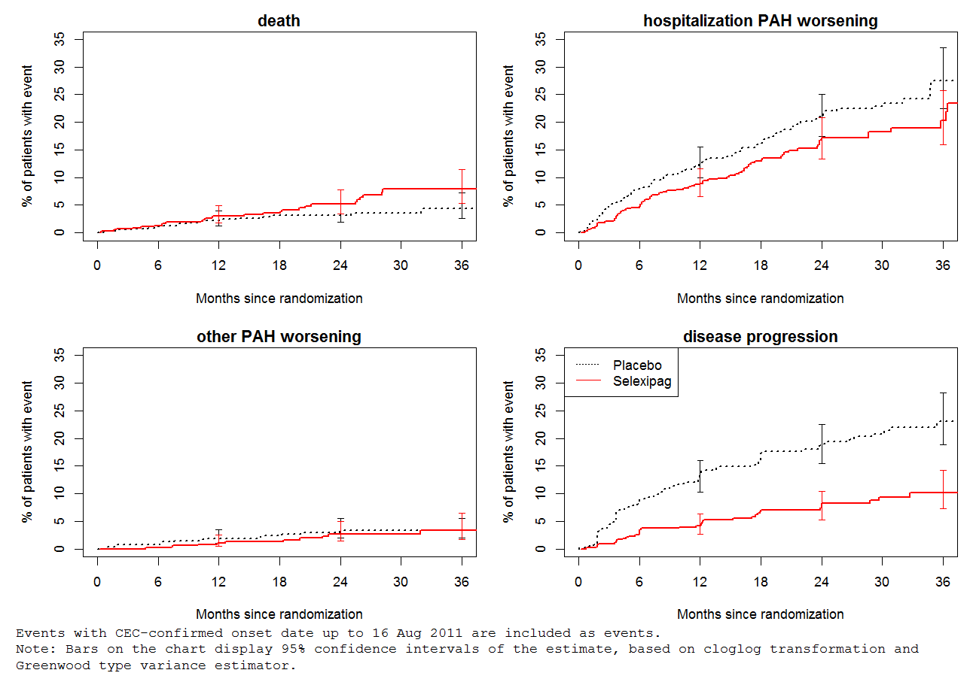
Analyses on the secondary endpoint of time from randomisation to first event of death due to PAH or hospitalisation for PAH worsening up to EOT + 7 days showed similar results where the overall treatment difference of selexipag over placebo (17.8% of patients in selexipag group versus 23.5% in placebo group, hazard ratio of 0.70, 1-sided unstratified log-rank p = 0.0031) was mainly driven by hospitalisation due to PAH worsening (15.0% in the selexipag group versus 21.1% in the placebo group) and there was a higher proportion of patients with death due to PAH as the first MM event in the selexipag group (2.8% versus 2.4%).
The sponsor had done additional survival analyses and had offered the rationale that the analysis of death up to EOT in Study AC-065A302 was biased by informative censoring, which could happen when death occurred predominantly after the occurrence of the primary endpoint morbidity event, and when the primary endpoint event led directly to the discontinuation of study treatment. In Study AC-065A302, after a morbidity event, study drug was discontinued and necessary changes to PAH treatment (including the option of selexipag in the extension study) were introduced. Patients were then censored at EOT + 7 days and could not contribute further to the EOT survival analysis. Additional analyses by the sponsor showed that in Study AC-065A302, morbidity events (mainly disease progression) occurred earlier and more frequently in placebo patients than in selexipag patients (205 and 109 patients censored due to a morbidity event, respectively), and that the risk of dying for patients who were censored due to a morbidity event was twice that of those who did not experience an event up to Study closure. This therefore could introduce a bias that led to an under-estimation of the true risk of death, as the mortality event that occurred after the first-reported morbidity event was not taken into account. The underestimation effect was expected to be greater in the placebo group compared to the selexipag group due to the fact that almost twice as many patients were censored, and censored earlier, because of a morbidity event. The sponsor was of the opinion that due to this bias, observed data on survival up to EOT + 7 days have limited interpretability. The sponsor therefore looked at analyses of survival up to Study closure, which would not have this informative censoring bias. Results showed that overall, death (all causes) from randomisation up to study closure was reported in 17.4% and 18.0% of patients in the selexipag and placebo groups, respectively (hazard ratio of 0.97, 1-sided unstratified log-rank p = 0.4214). Death due to PAH up to study closure was reported in 12.2% and 14.3% of patients in the selexipag and placebo groups, respectively (hazard ratio of 0.86, 1-sided unstratified log-rank p = 0.1763). The sponsor formed the conclusion that overall, selexipag had a neutral effect on survival in the PAH population in Study AC-065A302.
Analyses on the effect of selexipag on exercise capacity in terms of the 6MWD showed that the median treatment effect in 6MWD of selexipag versus placebo at trough at Week 26 was 12.0 m (median absolute change from Baseline to Week 26 of 4.0 m with selexipag versus −9.0 m with placebo; 1-sided Wilcoxon-Mann-Whitney p = 0.0027). Analyses of change in 6MWD over time at trough showed that median absolute increases from baseline in 6MWD measured at trough were greater in the selexipag compared to placebo group at scheduled time points from Week 8 to Month 30. These results were generally supported by those in the placebo-controlled Phase II Study NS-304/-02 (median treatment effect in 6MWD of selexipag versus placebo at Week 17 of 18 m; median absolute change from baseline to Week 17 of 25 m with selexipag versus 6 m with placebo; Wilcoxon rank sum test p-value =0.2218; t-test p-value =0.3129) and the open-label, uncontrolled Phase II Study AC-065A201 in Japanese patients (median 6MWD increase from baseline at Week 16 of 19.5 m with selexipag).
Analyses on the effect of selexipag on symptom relief in terms of NYHA/WHO FC showed that the proportion of patients with absence of worsening from Baseline in NYHA/WHO FC at Week 26 was numerically higher in the selexipag group compared to the placebo group, but the difference was not statistically significant (77.8% versus 74.9%, 2-sided Breslow-Day p = 0.1916). Analyses over time showed that the proportion of patients with absence of worsening from Baseline in NYHA/WHO FC was mostly numerically higher in the selexipag group compared to the placebo group from Week 4 to Month 36, as was the proportion of patients with improvement from Baseline in NYHA/WHO FC from Week 4 up to Month 36. The proportion of patients who had worsened NYHA/WHO FC compared to Baseline was mostly lower in the selexipag group than in the placebo group from Week 8 up to Month 36. These results were generally supported by those in the placebo-controlled Phase II Study NS-304/-02, where the proportion of patients with improvement in NYHA FC from baseline to Week 17 was 15.6% with selexipag versus 10% with placebo (Fisher Exact Test p-value = 1.0000), and the proportion of patients with worsening of NYHA FC was 6.3% on selexipag versus 20% on placebo (Fisher Exact Test p-value = 0.2356). In the open-label, uncontrolled Phase II Study AC-065A201 in Japanese patients, no patient experienced worsening of NYHA/WHO FC, and 4 patients (12.1%) showed improvement in NYHA/WHO FC from baseline to Week 16 (three from FC III to II and one from II to I).
Analyses on the effect of selexipag on patient-reported symptoms in terms of CAMPHOR questionnaire showed minimal difference between selexipag and placebo (median treatment effect of selexipag versus placebo at Week 26 was 0.0 [99% CI: −1.0, 1.0; p = 0.2185] for the CAMPHOR ‘Symptoms’ score, and 0.0 [99% CI: −0.4, 0.0; p = 0.1700] for the sub-scale ‘Breathlessness’ of CAMPHOR ‘Symptoms’ score). Results were similar for analyses of the Borg dyspnoea index, showing that at scheduled visits over time, there was minimal change in Borg dyspnoea index in both treatment groups. Analyses of the Borg dyspnoea index in Study NS-304/-02 also showed similar results (minimal median changes from baseline to Week 17 with both selexipag [-0.25 units] and placebo [0.00 units], as did those of Study AC-065A201 (mean [± SD] change from baseline to Week 16 with selexipag was −0.2 [± 1.2]).
Subgroup analyses of the primary efficacy endpoint in Study AC-065A302 yielded results that were generally consistent with those in the overall study population Analyses of the occurrence of a first MM event in the treatment groups across the subgroups of gender, race/ethnicity, PAH therapy at baseline, PAH aetiology at baseline, NYHA/WHO FC at baseline. The p-values for the interaction tests did not show any statistically significant heterogeneity of the treatment effect (selexipag versus placebo) across the subgroups, including subgroups of PAH aetiology at baseline (idiopathic PAH, heritable PAH, PAH associated with HIV or drugs and toxins versus PAH associated with CTD versus PAH associated with CHD), NYHA/WHO FC (FC I or II versus FC III or IV), and concomitant PAH specific therapy at baseline (ERA alone versus PDE-5i alone versus ERA and PDE-5i versus no concomitant PAH specific therapy). However, it is noted that the sample size was small for patients with baseline NYHA/WHO FC I (N= 9; selexipag: n=4, placebo: n=5) and FC IV (N=11; selexipag: n=3, placebo: n=8). This will be discussed in the First round benefit-risk assessment of this report. Subgroup analyses of the time from randomisation to first of CEC-confirmed death due to PAH or CEC-confirmed hospitalisation due to PAH worsening up to EOT + 7 days also showed that the observed treatment effect was generally consistent across subgroups (Figure 14), and that there was no statistically significant heterogeneity of treatment effects across subgroups based on the interaction tests, as did the subgroup analyses on the absolute change from Baseline to Week 26 in 6MWD at trough.

Clinical safety
A summary of trials that contributed to safety data in PAH patients is presented in Table 30. The sponsor has also provided, in the summary of clinical safety, pooled safety data of 4 studies: Study AC-065A302 and its ongoing open-label extension (AC-065A303), and Study NS-304/-02 and its ongoing open-label extension (NS-304/-03). This pooled safety data analyses were evaluated for the purpose of this submission, and results were found to be consistent with the safety findings in the pivotal study, and did not raise any additional safety concerns.

Table 30: Trials contributing to safety data of selexipag in PAH patients
(i) Completed clinical trials in patients with PAH
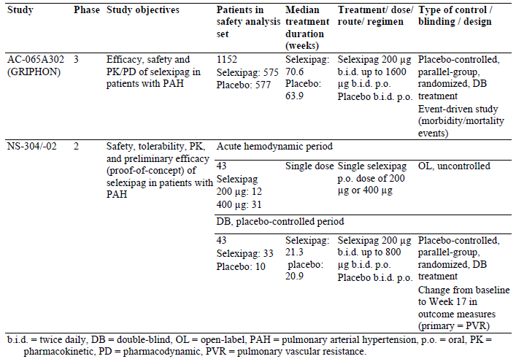
(ii) Ongoing clinical trials in patients with PAH
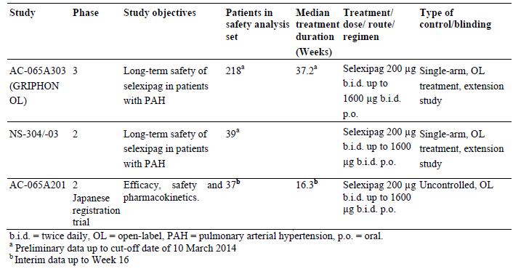

Studies providing evaluable safety data
The following studies provided evaluable safety data:

Pivotal efficacy study (AC-065A302)
In the pivotal efficacy study, the following safety data were collected:
- General adverse events (AEs) were assessed by the investigator obtaining and recording all AEs at each scheduled visit.
- AEs of particular interest were AEs expected to be observed with selexipag based on its mechanism of action and AEs of potential risk identified from preclinical studies with selexipag. These included eye and retinal disorders, haemorrhage and adjudicated bleeding event AEs, major adverse cardiovascular events (MACE), anaemia, thrombocytopenia, hypotension, hyperthyroidism and other thyroid disorders, liver disorders, renal and urinary dysfunction, rash and skin disorders, bone disorders, malignancies, and prostacyclin-associated AEs.
- Ophthalmological monitoring: during AC-065A302, ophthalmological monitoring (that is, fundoscopy with digital pictures) was performed at the Baseline visit (Visit 1), Month 12 (Visit 6), and EOS visit for enrolled patients at selected sites after approval of Global Amendment 3. Pictures were taken by the ophthalmologist/qualified ophthalmologist technician according to common guidelines, and were read by an external central reading centre. At baseline and follow-up visits, the central reader was to list the abnormal findings that were observed on the fundoscopy images. In addition, severity of retinal arterial tortuosity was qualitatively assessed in order to measure the change from baseline in this variable at each post-baseline time point. In the case of treatment-emergent abnormal findings, the central reader was to advise on additional ophthalmological check-up. In addition, the ophthalmology safety board (OSB) reviewed the ophthalmology data and findings.
- Laboratory tests included haematology, serum chemistry tests, thyroid markers (free triiodothyronine [T3], free thyroxine [T4], and thyroid stimulating hormone [TSH]), and bone turnover markers (bone alkaline phosphatase [ALP] and carboxy-terminal telopeptide [CTx]).
- Other safety variables included vital signs (blood pressure [BP] and heart rate), 12-lead electrocardiogram (ECG) and body weight measurements
Safety assessments were performed according to the schedule presented.

Pivotal studies that assessed safety as a primary outcome
Not applicable.

Dose-response and non-pivotal efficacy studies
The dose-response and non-pivotal efficacy studies provided safety data, as follows:
- Study NS-304/-02 provided data on AEs, routine laboratory evaluations (clinical chemistry, haematology, and urinalysis), ECG, vital signs, and body weight.
- Study AC-065A201 provided data on AEs, routine laboratory evaluations (haematology, clinical chemistry), thyroid function markers, bone metabolism markers, fundus assessment (at selected sites; at Visit 1, at each visit every 24 weeks thereafter, and at study discontinuation or end of treatment.), ECG and vital signs.

Other studies evaluable for safety only
AC-065A303 (GRIPHON-OL): Safety evaluation comprised the collection of AE data, routine laboratory evaluations (clinical chemistry, haematology, urinalysis), vital signs, and body weight. For safety endpoints in this study, baseline was defined as the last assessment prior to or on start date of study drug in Study AC-065A302 for patients in the AC-065A302 selexipag treatment group. For patients in the AC-065A302 placebo treatment group, baseline was the last assessment prior to or on start date of study drug in AC-065A303.
NS-304/-03: Safety evaluation comprised the collection of AE data, routine laboratory evaluations (haematology, clinical chemistry), thyroid function markers, bone metabolism markers, fundus assessment (at selected sites), ECG and vital signs.
Independent Ophthalmology Safety Board Report: Tortuosity and dilatation of retinal vessels were observed in rats in Week 104 of treatment in a long-term toxicity study in rats. Although the occurrence of this finding in man was considered unlikely, fundus assessments were implemented in Phase II and Phase III studies, and an Ophthalmology Safety Board (OSB), composed of individuals external to the sponsor, who had experience and expertise in the field of ophthalmology, and who were independent of all clinical trials with selexipag as an investigational drug, was constituted to review fundus assessment findings in a blinded fashion.
The sponsor has also provided an integrated summary of safety (ISS). This composed of appendices (for example, statistical plans, tables and figures) referenced to in the Summary of Clinical Safety.

Pivotal studies that assessed safety as a primary outcome
Not applicable.

Patient exposure
In Study AC-065A302, the median duration of study treatment was 70.7 weeks (range: 0.3–216.7 weeks) in the selexipag group and 63.7 weeks (range: 0.7–192.0 weeks) in the placebo group (Table 31). The proportion of patients who received study treatment for a cumulative duration of at least 1 year was 63.8% in the selexipag group and 62.6% in the placebo group. The proportion of patients who received study treatment for a cumulative duration of at least 2 years was 31.3% in the selexipag group and 27.4% in the placebo group. Overall, 28.3% of patients in the selexipag group received selexipag at an individual maintenance dose (IMD) of 1600 µg bd (that is, the maximum selexipag dose allowed in the study) (Table 32).
Table 31: Duration of study treatment in Study AC065A302, safety analysis set (SAF)
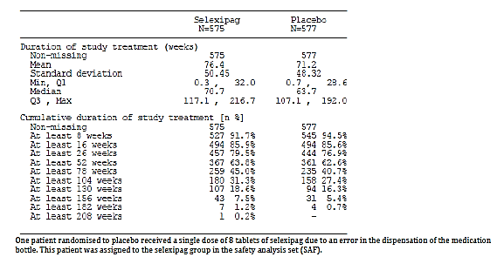
Table 32: Individual maintenance dose (IMD) of selexipag in AC-065A302, SAF
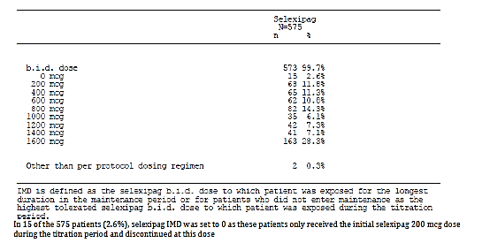
In Study NS-304/-02, all 43 patients in the study received a single dose of selexipag during the acute haemodynamic testing period (200 µg for the first 12 patients and 400 µg for the remaining 31 patients). All patients also received double-blind treatment, and the median total exposures to study drug were similar in the 2 treatment groups (149.0 and 146.0 days in selexipag and placebo groups, respectively) (Table 33). Among patients receiving selexipag, the final dosage was 800 µg bd (maximum selexipag dose allowed in the study) for 14 patients (42.4%), 600 µg bd for 7 patients (21.2%), 400 µg bd for 6 patients (18.2%), 200 µg bd for 4 patients (12.1%), and missing for the two patients who were discontinued prematurely. Among patients on placebo, the final optimised dosage was placebo 800 µg bd for all except one, who was discontinued on Day 61 and had a missing final optimised dosage.
Table 33: Summary of double-blind treatment exposure, all-treated DB set, study NS-304-02
In Study AC-065A201 the median exposure to study drug in the safety set was 114 days (Table 34). Seven patients (18.9%), 2 patients (5.4%), 3 patients (8.1%) and 6 patients (16.2%) were treated with the maximum final maintenance dose of 1600 µg (maximum selexipag dose allowed in the study), 1400 mcg, 1200 µg and 1000 µg bd, respectively (Table 35).
Table 34: Summary of exposure to the study drug (SS), Study AC065A201
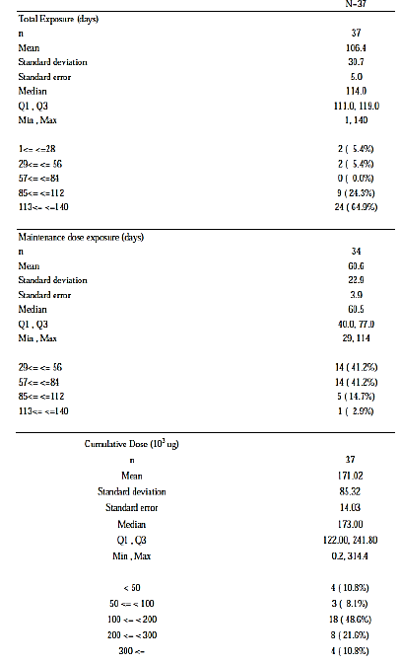
Table 35: Distribution of FMD, Safety set (SS), Study AC065A201
In Study AC-065A303 (GRIPHON-OL), the median duration of study treatment (up to data cut-off date of 10 March 2014) was 37.2 weeks, with 34.4% of patients receiving study treatment for a cumulative duration of at least 1 year (Table 36). Of the 218 selexipag-treated patients in Study AC-065A303, 26.6% received selexipag at an IMD of 1600 µg bd (the maximum selexipag dose allowed in the study) (Table 37).
Table 36: Duration of study treatment in AC-065A303, SAF (subset treated in Study AC065A303)
Table 37: Individual maintenance dose (IMD) of selexipag in AC-065A303, SAF (subset treated in Study AC065A303)
In Study NS-304/-03, 39 patients were exposed to selexipag up to 1600 µg bd for up to 5.4 years.
Comment: Overall, the study drug exposure is adequate to assess the safety profile of selexipag.

Adverse events

All adverse events (irrespective of relationship to study treatment)

Pivotal study
The percentages of patients with any treatment-emergent AEs (TEAEs) were comparable between treatment groups (98.3% [565/575] and 96.9% [559/577] in the selexipag and placebo groups, respectively). TEAEs that occurred in ≥3% of patients in selexipag group are presented in Table 38.

Table 38: TEAEs (by preferred term) occurring in ≥3% of subjects in selexipag group, sorted by PT incidence in the selexipag group, SAF, Study AC065A302
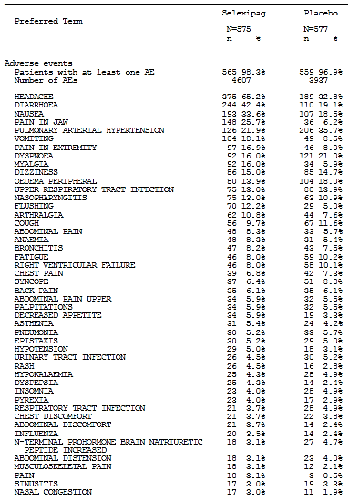
The most commonly reported TEAEs in the selexipag group were headache (65.2% with selexipag versus 32.8% with placebo), diarrhoea (42.4% versus 19.1%) and nausea (33.6% versus 18.5%). TEAEs reported more frequently on selexipag compared to placebo, with a difference in incidence of at least 1.0% is presented in Table 39. TEAEs occurring with greatest difference in incidence between the 2 treatment groups (higher incidence with selexipag versus placebo) were headache, diarrhoea and pain in jaw (25.7% versus 6.2%).
Table 39: Treatment-emergent AEs, sorted by difference in incidence (at least 1.0%) between selexipag and placebo, SAF, Study AC065A302
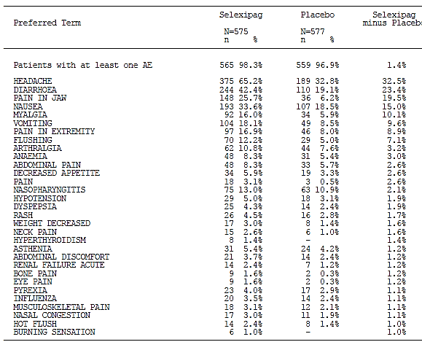

Other studies
In Study NS-304/-02, during the acute haemodynamic period, 58.1% [25/43] of patients had at least one AE. The overall incidence of adverse events was not higher at 400 µg than at 200 µg (54.8% [17/31] and 66.7% [8/12], respectively). The most commonly reported AEs were headache (46.5%), nausea (14.0%), and pain in jaw (11.6%), and were not more frequent with the 400-µg than the 200-µg dose. During the double-blind treatment period, the percentages of patients with any AEs were comparable between treatment groups (93.9% [31/33] and 100% [10/10] in the selexipag and placebo groups, respectively). The most commonly reported AEs in the selexipag group were headache (66.7% with selexipag versus 20.0% with placebo), pain in jaw (36.4% versus 0%) and pain in extremity (30.3% versus 0%).
In Study AC-065A201, the proportion of patients with at least one AE was 97.3% (36/37). The most commonly reported AEs were headache (67.6%), diarrhoea (48.6%), pain in jaw (43.2%) and nausea (35.1%).
In Study AC-065A303, the proportion of patients with at least one AE was 95.9% (209/218). The most commonly reported AEs were headache (54.6%), diarrhoea (35.8%), PAH (23.7%), pain in jaw (21.1%) and nausea (20.2%). Of the 218 patients who received selexipag in Study AC-065A303, 63 (28.9%) had previously received selexipag in Study AC-065A302 (‘selexipag/selexipag’) and 155 (71.1%) had previously received placebo in Study AC-065A302 (‘placebo/selexipag’). Analyses in these subgroups of patients showed that the incidence of all-causality AEs in Study AC-065A303 was comparable between the selexipag/selexipag patients (98.4%) and the placebo/selexipag patients (94.8%). Within the selexipag/selexipag patients, the incidence of all-causality AEs was comparable between Study AC-065A302 (100%) and Study AC-065A303 (98.4%).
Analyses of all causality AEs in Study NS-304/-03 was not provided. The sponsor has provided, in the summary of clinical safety, pooled safety data of 4 studies which included Study NS-304/-03 (Studies AC-065A302, AC-065A303, NS-304/-02 and NS-304/-03). Results of this integrated analysis were consistent with those of the pivotal study.

Treatment-related adverse events (adverse drug reactions)

Pivotal study
The percentages of patients with at least one treatment-related TEAE were higher in the selexipag group (89.6%; 515/575) compared to the placebo group (56.7%; 327/577) (Table 38). The most commonly reported treatment-related TEAEs in the selexipag group were headache (61.4% versus 26.2% in the placebo group), diarrhoea (36.0% versus 10.2%), nausea (27.0% versus 11.4%) and pain in jaw (24.9% versus 5.0%). Treatment-related AEs that occurred in ≥5% of patients in selexipag group and at higher incidence with selexipag than with placebo were headache, diarrhoea, nausea, pain in jaw, myalgia (13.9% versus 3.8%), vomiting (13.6% versus 3.3%), pain in extremity (13.4% versus 4.0%), flushing (11.7% versus 4.3%), dizziness (8.3% versus 6.2%) and arthralgia (7.0% versus 3.1%).

Other studies
In Study NS-304/-02 double-blind treatment period, the percentages of patients with at least one treatment-related AE were higher in the selexipag group (90.9%; 30/33) compared to the placebo group (30.0%; 3/10). The most commonly reported treatment-related AEs in the selexipag group were headache (66.7% versus 20.0% in the placebo group), pain in jaw (36.4% versus 0%) and pain in extremity (30.3% versus 0%).
In Study AC-065A201, the percentage of patients with at least one treatment-related AE was 62.2% (23/37). The most commonly reported treatment-related AEs were headache (62.6%), diarrhoea (44.9%), pain in jaw (43.2%) and nausea (29.7%).
In Study AC-065A303, the proportion of patients with at least one treatment-related AE was 80.3% (175/218). The most commonly reported treatment-related AEs were headache (52.8%), diarrhoea (28.4%), pain in jaw (20.6%), and nausea (16.1%).
Analyses of treatment-related AEs in Study NS-304/-03 were not provided. The sponsor has provided, in the summary of clinical safety, pooled safety data of 4 studies which included Study NS-304/-03 (Studies AC-065A302, AC-065A303, NS-304/-02 and NS-304/-03). Results of this integrated analysis were consistent with those of the pivotal study.

Deaths and other serious adverse events

Pivotal study
At study closure, the incidence of deaths was comparable between selexipag and placebo groups in the FAS (17.4% [100/574] and 18.0% [105/582], respectively) (Table 40).

Table 40: Summary of deaths in AC-065A302
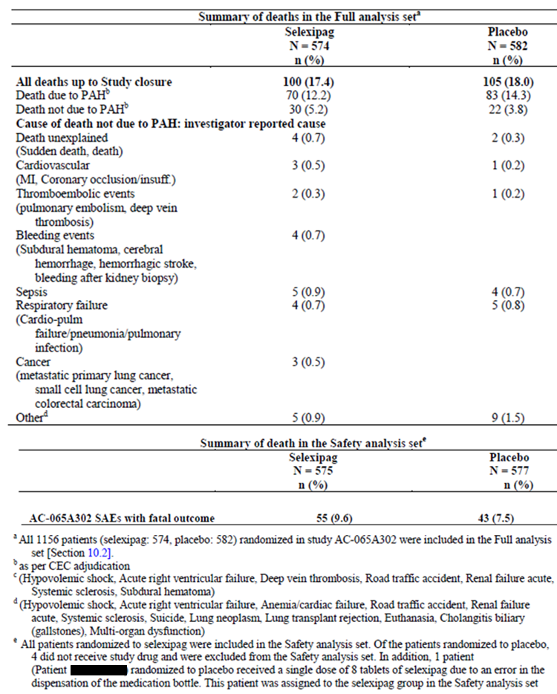
The most commonly reported cause of death was PAH (12.2% and 14.3% in the selexipag and placebo groups, respectively). In the safety analysis set, the incidence of SAEs with an onset date up to EOT + 30 days with a subsequent fatal outcome was 9.6% (55/575) and 7.5% (43/577) in the selexipag and placebo groups, respectively. The most commonly reported SAE with fatal outcome in the selexipag group was PAH (3.5% versus 2.8% with placebo).
The incidences of SAEs were lower in the selexipag group (43.8%, 252/575) compared to the placebo group (47.1%, 272/577). The most commonly reported SAEs in the selexipag group were PAH (14.4% versus 22.0% with placebo) and right ventricular failure (5.9% versus7.1%).

Other studies
In Study NS-304/-02, no patient died during the study. SAEs occurred only during the double-blind treatment period. The incidences of SAEs were lower in the selexipag group (18.2%, 6/33) compared to the placebo group (40.0%, 4/10). Most SAEs were reported for single study patients; the only SAE reported for > 1 patient in the selexipag group was headache (two patients on selexipag versus none with placebo).
No patient died during Study AC-065A201 (up to Week 16). Four patients (10.8%) reported at least one SAE. All SAEs were reported for single study patients.
In Study AC-065A303, a total of 61 deaths were reported: 18 in patients previously on selexipag in Study AC-065A302 (selexipag/selexipag; 28.6%), 43 in patients previously on placebo in Study AC-065A302 (placebo/selexipag; 27.7%). The proportion of patients who died due to PAH was 20.6% and 24.5% in the selexipag/selexipag and placebo/selexipag groups, respectively. The sponsor had offered the opinion that the high proportion of deaths could be attributed to the fact that all patients who entered the OL extension had experienced a morbidity event in Study AC-065A302 and were therefore more likely to have a fatal event. In Study AC-065A303, the proportion of patients with at least one SAE was 52.3% (114/218). In patients previously treated with selexipag in AC-065A302, the incidence was 57.1% compared to 50.3% in the group of patients previously treated with placebo. Within the selexipag/selexipag patients, the incidence of SAEs was lower during Study AC-065A303 (57.1%) than during Study AC-065A302 (74.6%). Overall, the most frequently reported SAEs were PAH (overall: 23.4%; selexipag/selexipag: 23.8%; placebo/selexipag: 23.2%) and right ventricular failure (overall: 15.1%; selexipag/selexipag: 15.9%; placebo/selexipag: 14.8%).
In Study NS-304/-03, eight patients died up to the cut-off date of 10 March 2014. The reported causes of death were subdural haematoma, malignant lung neoplasm and cardiac arrest, acute right ventricular failure, cardiac failure, sudden death, and euthanasia. In addition, one patient died due to right ventricular failure approximately 2 months after discontinuation of study treatment, and another died due to right ventricular failure approximately 3 months after discontinuation of study treatment. Up to the cut-off date of 10 March 2014, a total of 25 patients (64.1%) had at least 1 SAE. The most frequently reported SAEs were PAH (10 patients, 25.6%) and right ventricular failure (4 patients, 10.3%).

Discontinuation due to adverse events

Pivotal study
The incidences of TEAEs leading to discontinuation of study drug were lower in the selexipag group (31.7%, 182/575) compared to the placebo group (37.1%, 214/577) (Table 41). The most commonly reported TEAE leading to discontinuation of study drug in the selexipag group was PAH (13.6% versus 23.4% with placebo).
Table 41: Treatment-emergent AEs leading to discontinuation of study drug, sorted by PT incidence (at least 2 patients) in the selexipag group, SAF, Study AC065A302
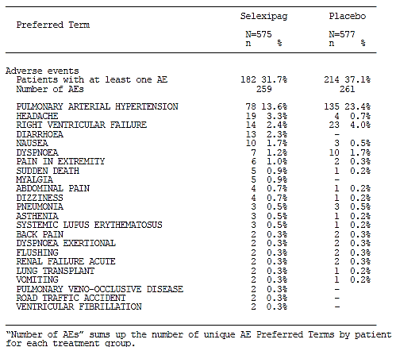

Other studies
In Study NS-304/-02, two patients (6.0%) in the selexipag group were discontinued from study treatment due to AEs (1 due to worsening PAH and the other due to AEs of headache, asthenia and myalgia) compared to 1 patient (10.0%) in the placebo group (due to worsening PAH).
In Study AC-065A201 one patient (2.7%) discontinued study treatment due to an AE of blood pressure decreased. This AE was also reported as an SAE.
In Study AC-065A303, the proportion of patients with at least one AE leading to discontinuation of study drug was 23.9% (52/218). Of these, 14 (22.2%; 14/63) were selexipag/selexipag patients and 38 (24.5%; 38/155) were placebo/selexipag patients. Overall, the most frequently reported AEs leading to discontinuation of study drug were PAH (8.7%) and right ventricular failure (4.6%).
Analyses of AEs leading to discontinuation of study drug in Study NS-304/-03 were not provided. The sponsor has provided, in the summary of clinical safety, pooled safety data of 4 studies which included Study NS-304/-03 (Studies AC-065A302, AC-065A303, NS-304/-02 and NS-304/-03). Results of this integrated analysis were consistent with those of the pivotal study.

Laboratory tests

Liver function

Pivotal study
Evaluation of laboratory liver function parameters did not trigger any safety concerns. The proportion of patients with marked abnormalities in laboratory liver function parameters was generally low and comparable between treatment groups.

Other studies
Evaluation of laboratory liver function parameters in studies NS-304/-02, AC-065A201, and AC-065A303 did not raise any additional safety concerns. Analyses of laboratory liver function parameters in Study NS-304/-03 were not provided. Results of laboratory liver function in the integrated analysis consisting of the pooled data of Studies AC-065A302, AC-065A303, NS-304/-02 and NS-304/-03 were consistent with those of the pivotal study.

Kidney function

Pivotal study
Evaluation of laboratory renal function parameters did not trigger any safety concerns. The proportion of patients with marked abnormalities in laboratory renal function parameters was generally comparable between treatment groups.

Other studies
Evaluation of laboratory renal function parameters in studies NS-304/-02, AC-065A201, and AC-065A303 did not raise any additional safety concerns. Analyses of laboratory renal function parameters in Study NS-304/-03 were not provided. Results of laboratory renal function in the integrated analysis consisting of the pooled data of Studies AC-065A302, AC-065A303, NS-304/-02 and NS-304/-03 were consistent with those of the pivotal study.

Haematology

Pivotal study
Mean baseline haemoglobin (Hb) levels were comparable between treatment groups (140.39 [SD 20.407] g/L and 140.59 [20.605] g/L in the selexipag and placebo groups, respectively). Mean absolute changes from baseline to regular visits up to Month 36 in haemoglobin ranged from -3.4 to -0.16 g/L in the selexipag group compared to -0.5 to 2.5 g/L in the placebo group. The decrease in median Hb concentrations in the selexipag group was apparent within 3 months of the start of treatment and was not progressive over time (Figure 25). Decreases in Hb concentrations to < 100 g/L at any time post-baseline were reported for 8.8% of selexipag-treated patients and 5.0% placebo-treated patients. Decreases to < 80 g/L were reported for 1.3% of selexipag-treated patients and 0.7% of placebo-treated patients.
Figure 25: Median (Q1, Q3) haemoglobin concentrations over time, Study AC065A302
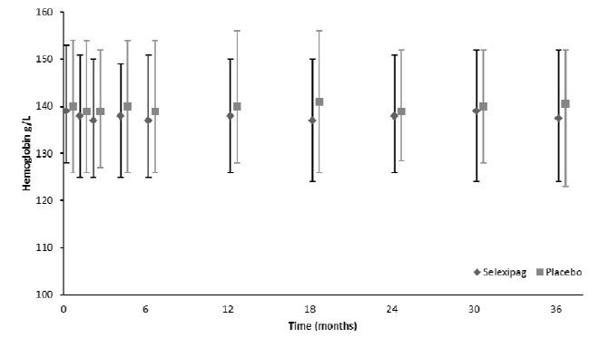
Evaluation of other haematology parameters did not trigger any safety concerns.

Other studies
Evaluation of haematology parameters in Studies NS-304/-02 and AC-065A201 did not raise any additional safety concerns.
Evaluation of haematology parameters in Study AC-065A303 also did not raise any additional safety concerns. Changes from baseline in Hb concentrations over time were variable and did not show a decreasing trend. Intra-patient comparison looking at incidence of marked/alert abnormalities in haemoglobin in patients who were on selexipag in Study AC-065A302 and AC-065A303 and those who were on placebo in Study AC-065A302 and then selexipag in Study AC-065A303 showed that in selexipag/selexipag patients, the incidence of Hb < 80 g/L remained comparable in Studies AC-065A302 and AC-065A303 (3.2% versus 2.0%) while that of Hb < 100 g/L was higher in Study AC-065A302 compared to Study AC-065A303 (19.0% versus 9.8%) (Table 42). In placebo/selexipag patients, the incidence of Hb < 80 g/L remained comparable in Studies AC-065A302 and AC-065A303 (0.6% versus 0.8%) while that of Hb < 100 g/L was lower in Study AC-065A302 compared to Study AC-065A303 (3.9% versus 8.4%).
Table 42: Haemoglobin: treatment-emergent (marked/alert) abnormalities in studies AC-065A302 and AC-065A303 - intra-patient comparison, SAF (subset treated in Study AC065A303)
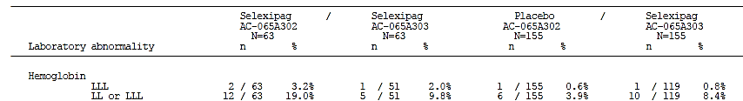
LL: Hb< 100 g/L LLL: Hb <80 g/L
Analyses of laboratory haematology parameters in Study NS-304/-03 were not provided. Results of haematology parameters in the integrated analysis consisting of the pooled data of Studies AC-065A302, AC-065A303, NS-304/-02 and NS-304/-03 were consistent with those of the pivotal study.

Thyroid markers

Pivotal study
Analyses of absolute changes from baseline to regular visits in T3 and T4 did not trigger any safety concerns in either treatment group. Analyses of absolute changes from baseline to regular visits in TSH showed a small reduction (up to −0.3 MU/L from a baseline median of 2.5 MU/L) in median TSH at most visits in the selexipag group, while in the placebo group, little change in median values was apparent. In the selexipag group, there was no apparent trend of progressive TSH changes over time.

Other studies
Analyses of thyroid markers in Study AC-065A201 did not raise any additional safety concerns.

Bone turnover markers

Pivotal study
Analyses of bone turnover markers (bone specific alkaline phosphatase and carboxy-terminal telopeptide) over time did not trigger any safety concerns in either treatment group.

Other studies
Analyses of bone turnover markers in Study AC-065A201 did not raise any additional safety concerns.

Electrocardiograph

Pivotal study
Analyses of the mean changes from baseline in the ECG variables did not raise any particular safety concerns.

Other studies
Evaluation of ECG variables in Studies NS-304/-02, AC-065A201 and AC-065A303 did not trigger any safety concerns. Analyses of ECG variables in Study NS-304/-03 were not provided. Results of ECG variables in the integrated analysis consisting of the pooled data of Studies AC-065A302, AC-065A303, NS-304/-02 and NS-304/-03 were consistent with those of the pivotal study.

Vital signs

Pivotal study
Mean absolute changes from baseline to scheduled visits in systolic blood pressure (SBP) diastolic blood pressure (DBP) were small and similar between treatment groups, and did not show any progression over time. In the selexipag group, mean changes from baseline in SBP ranged from −2.0 to 1.5 mmHg compared to −1.3 to 0.0 mmHg in the placebo group; DBP: −1.6 to −0.1 mmHg versus −1.1 to 0.3 mmHg. A higher proportion of patients (9.7%) in the selexipag group had SBP ˂ 90 mmHg compared to 6.7% in the placebo group. However, decreases from baseline of > 40 mmHg in SBP were reported for 2.3% and 3.0% of patients in the selexipag and placebo groups, respectively. The proportion of patients with DBP < 50 mmHg was 3.2% in the selexipag group compared with 3.9% in the placebo group. Decreases from baseline of > 20 mmHg in DBP were reported for 16.6% of patients in the selexipag group compared to 13.1% in the placebo group.
Analyses of other vital signs parameters did not raise any particular safety concerns

Other studies
In Study NS-304/-02, vital signs measured at 4 hours after a single oral dose of selexipag during the acute haemodynamic period showed median increases in SBP and DBP (5.0 and 7.0 mmHg, respectively) and pulse rate (3.0 bpm) with the 400-µg dose, while with the 200-µg dose there was a median increase in DBP (2.5 mmHg) and no increase in SBP or pulse rate was observed. During the double-blind treatment period, analyses of change from baseline up to end of treatment period (that is, when patients were at their optimised dose), showed median changes from baseline in SBP, DBP and pulse rate in the selexipag group of -1.0 mmHg (vs. -4.5 mmHg with placebo), 3.0 mmHg (vs. 3.0 mmHg with placebo) and 3.0 bpm (vs. 6.0 bpm with placebo), respectively.
Analyses of vital signs in Study AC-065A201 did not raise any additional safety concerns. Mean ± SD changes from baseline in SBP at Weeks 4, 8, 12, and 16 were 4.2 ± 11.5 mmHg, 4.4 ± 13.3 mmHg, 5.0 ± 14.5 mmHg and 0.5 ± 12.4 mmHg, respectively. Corresponding mean changes from baseline in DBP were 5.5 ± 9.6 mmHg, 5.0 ± 8.7 mmHg, 5.7 ± 10.4 mmHg and 1.9 ± 10.7 mmHg, respectively.
In Study AC-065A303, changes from baseline in vital signs over time were variable and did not show any particular trend over time. The proportion of patients with low blood pressures is presented in Table 43.
Table 43: Treatment-emergent low blood pressure in Study AC065A303, SAF (subset of patients treated in Study AC065A303)
(i) In Study AC-065A303
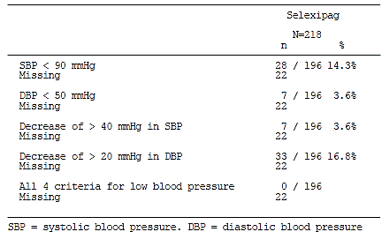
(ii) In Studies AC-065A302 and AC-065A303 - intra-patient comparison
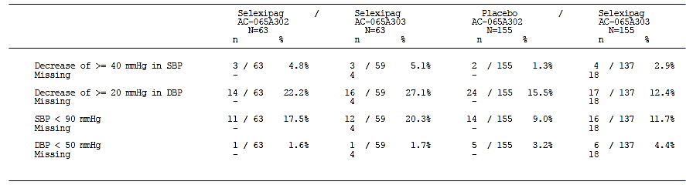
Intra-patient comparison looking at patients who were on selexipag in Study AC-065A302 and AC-065A303 and those who were on placebo in Study AC-065A302 and then selexipag in Study AC-065A303 showed that in selexipag/selexipag patients, the incidence of SBP < 90 mmHg was higher in Study AC-065A303 (20.3%) than in Study AC-065A302 (17.5%), but the incidence of decreases from baseline of > 40 mmHg in SBP was comparable between the 2 studies (4.8% versus 5.1%). In these patients, the incidence of DBP < 50 mmHg was comparable between the 2 studies (1.6% versus 1.7%), but that of decreases from baseline of > 20 mmHg in DBP was higher in Study AC-065A303 (27.1%) than in Study AC-065A302 (22.2%).
The sponsor has stated that no vital signs data were available for the ongoing Study NS-304/-03.

AEs of special interest

Pivotal study
An overview of the AEs of special interest in the double-blind PAH population from Study AC-065A302 is presented in Table 44.

Table 44: Overview of the safety topic AEs of special interest in the double-blind (DB) PAH Safety set from Study AC-065A302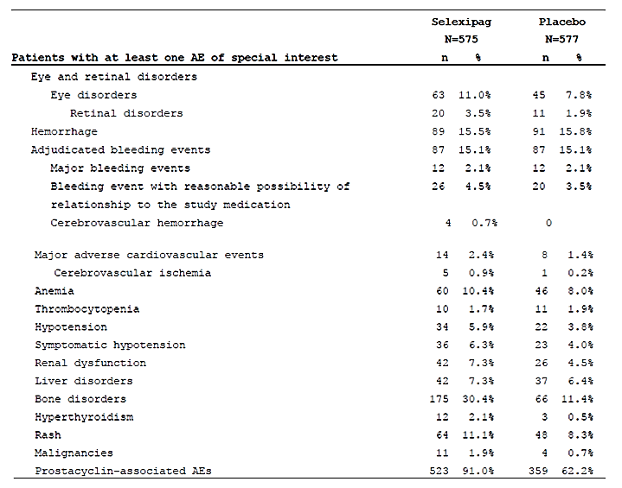
The Standardised MedDRA queries (SMQ) retinal disorders grouping is a subset of the SOC eye disorders and includes a number of broad and non-specific preferred terms that are not specific to the retinal vasculature (e.g. eye disorder, blurred vision and reduced visual acuity).

Eye and retinal disorders
Eye and retinal disorder AEs were identified as a safety topic of special interest following non-clinical findings of tortuosity and dilatation of retinal blood vessels in rats at the end of a 2-year carcinogenicity study. The proportion of patients who had at least one AE of special interest within the SOC ‘eye disorders’ in the selexipag and placebo groups was 11.0% and 7.8%, respectively (Tables 45 and 46).
Table 45: Summary of eye and retinal disorder AEs in the DB PAH safety analysis set from Study AC065A302
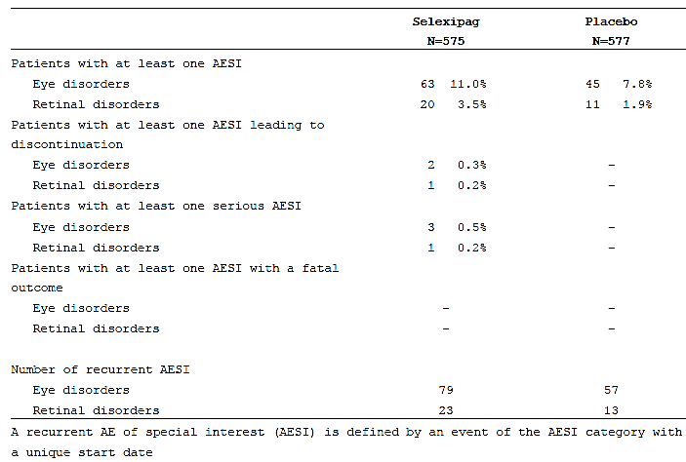
Table 46: Eye disorder AEs by PT in the DB PAH safety analysis set Study AC-065A302
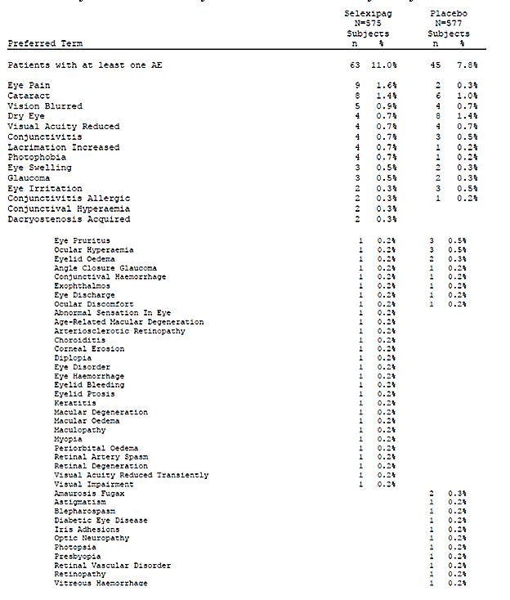
The proportion of patients who had at least one AE of special interest within the Standardised MedDRA queries (SMQ) ‘retinal disorders’ in the selexipag and placebo groups were 3.5% and 1.9%, respectively. Eye disorder AEs specifically associated with retinal vasculature abnormalities were reported at generally comparable frequencies in the selexipag and placebo groups: in the selexipag group, retinal vasculature AEs reported were arteriosclerotic retinopathy, retinal artery spasm, and retinal degeneration, each reported by 1 patient (0.2%); in the placebo group, retinal vasculature AEs were retinal vascular disorder and retinopathy, each reported by 1 patient (0.2%). Eye disorders were reported as SAEs for 0.5% (3 patients) in the selexipag group and 0% in the placebo group. One patient had SAEs of choroiditis (bilateral posterior uveitis) and cataract and another patient had an SAE of cataract. These SAEs were assessed by the investigator as not related to treatment. The third patient had SAEs of maculopathy and blurred vision, which were considered by the investigator to be treatment-related. According to the sponsor, the investigator had also commented that the patient was suffering from stress (reported as an SAE) and had concomitant treatment with sildenafil and L-arginine as potential reasons for the reported events. Study treatment, sildenafil, and L-arginine were temporarily interrupted for this patient. Ocular events resolved and did not recur after treatment with selexipag was re-introduced.
In addition, as a result of the non-clinical findings of tortuosity and dilatation of retinal blood vessels in rats, an ophthalmology sub-study was introduced in Global Protocol Amendment 3 of Study AC-065A302 and included a total of 102 patients (54 selexipag, 48 placebo) at selected sites (33 sites in 22 countries). The assessments introduced in the sub-study included fundoscopy with digital pictures at the Baseline/Randomisation Visit, Month 12 and EOS Visit (or discontinuation of study drug treatment). Baseline and post-baseline fundoscopy/fundus imaging findings in patients who participated in the ophthalmology sub-study were summarised. Overall, no new post-baseline or worsening of baseline fundoscopy/fundus imaging findings were reported in the selexipag group, while 4 patients in the placebo group had treatment emergent worsening at Month 12 or the EOS visit. Four (8.5%) and two (4.5%) patients in the selexipag and placebo groups, respectively, with fundoscopy/fundus imaging at Baseline had retinal arterial tortuosity reported for both eyes. At the Month 12 and EOS assessments, improvement in the severity of retinal arterial tortuosity (in both eyes) compared to baseline was reported in 1 patient in the selexipag group. No case of worsening in retinal arterial tortuosity was reported in either group.
In addition, all relevant ocular data from the Phase I-III selexipag studies, including the ophthalmology sub-study in Study AC-065A302, were reviewed by the OSB, and the conclusion from the OSB was that there no evidence of an increase in relevant adverse ocular effects in selexipag-treated patients compared to placebo-treated patients. The OSB did not recommend any additional ocular safety studies or post-approval ocular monitoring measures. The conclusion was that the findings of tortuosity and dilation of retinal arterioles in rats at the end of a 2-year carcinogenicity study were without clinical relevance.

Haemorrhage and adjudicated bleeding events AEs
Bleeding events were identified as AEs of special interest based on the pharmacological effect of prostacyclin receptor agonists of inhibiting platelet aggregation. Assessment of bleeding event AEs were evaluated on 2 levels. The first level was based on identification according to the SMQs of haemorrhage and gastrointestinal haemorrhage, and the second level was based on an independent, blinded adjudication process for bleeding events in the study by 2 experts on haemostasis. The focus of the adjudication process was on differentiation of major versus non-major bleeding and on possible relationship to study treatment.
Overall, the proportion of patients with haemorrhage AEs (according to the SMQs of haemorrhage and gastrointestinal haemorrhage) was similar in the selexipag (15.5%) and placebo group (15.8%). The most commonly reported event in both groups was epistaxis (5.2% with selexipag versus 5.0% with placebo). Results showed that cerebrovascular/intracranial bleeds were reported for 4 (0.7%) patients on selexipag versus none on placebo. All 4 of the cerebrovascular haemorrhage AEs were considered SAEs and were adjudicated as major bleeding events but were not considered by the adjudication committee to have a reasonable possibility of relationship to study treatment, as alternative explanations of anticoagulant use and road traffic accident were considered more likely. Overall, the proportions of haemorrhage AEs that were fatal, serious or led to discontinuation of study treatment were similar in both groups. An analysis of AE rates by prevailing dose at the time of AE onset did not indicate a dose–response relationship for haemorrhage AEs.
An analysis of haemorrhage AEs was also conducted according to time periods in which patients were with/without confounding medications, such as antithrombotic agents, non-steroidal anti-inflammatory drugs, and systemic corticosteroids. Results showed that in both the selexipag and placebo groups, the incidence of haemorrhage was higher in patients treated with these medications, but no imbalance between the groups was identified (incidence of haemorrhage AEs in patients during the time period with no confounding medication: 7.1% and 10.7% in the selexipag and placebo groups, respectively; incidence of haemorrhage AEs in patients during the time period with confounding medication: 16.5% and 16.3%, respectively).
Following independent adjudication of the AEs associated with bleeding, the proportion of patients with confirmed major bleeding events was similar in the 2 groups (selexipag 2.4%, placebo 2.1%). The proportion of patients with AEs that were considered to have a reasonable possibility of relationship to study treatment was 4.5% in the selexipag group and 3.5% in the placebo group, with the difference resulting mainly from the higher incidence of epistaxis in the selexipag group.

Major adverse cardiovascular events (MACE)
According to the sponsor, MACE were evaluated as part of due diligence and not because of any specific, identified safety concern with selexipag. Overall, the proportion of patients with such events was 2.4% (14/575) in the selexipag group and 1.4% (8/577) in the placebo group. The difference was primarily driven by events of cerebrovascular ischemic nature (selexipag n = 5 [0.9%]; placebo n = 1 [0.2%]). Of these 6 patients with cerebral ischemia AEs, 4 patients in the selexipag group and 1 patient in the placebo group had events that were serious, but none had a fatal outcome. All these 5 patients had medical history suggesting elevated risk for such events.

Anaemia
According to the sponsor, anaemia was evaluated as event of special interest because PAH patients, compared to the general population, had a higher incidence of co-morbidities as well as medications (such as ERAs) that could predispose to anaemia and/or bleeding. In Study AC-065A302, anaemia as previous or concomitant disease at baseline was reported in 11.3% and 11.1% of patients in the selexipag and placebo groups, respectively. The overall proportion of patients in the study with AEs denoting anaemia was higher in the selexipag group (10.4%) compared to the placebo group (8.0%). None of the anaemia events in either group were fatal or led to discontinuation of study treatment. The incidence of anaemia events reported as SAEs was higher in the selexipag group (6 patients [1%]) than in the placebo group (3 patients [0.5%]). The proportion of patients who received at least one blood transfusion was comparable between treatment groups (12 patients [2.1%)] in the selexipag group versus 13 patients [2.3%] in the placebo group). The incidences of anaemia AEs in patients who received no PAH-specific medication were 4.5% and 6.7% in the selexipag and placebo groups, respectively. In patients who received selexipag in addition to any of the other PAH-specific medications, the incidences of anaemia were higher in the selexipag group than in the placebo group (concomitant ERA monotherapy: 14.9% with selexipag versus 9.2% with placebo; PDE5i monotherapy: 11.1% versus 5.4%; ERA and PDE5i: 11.2% versus 10.7%).
Results of laboratory analyses of haemoglobin levels have been described above, and results suggested that selexipag was associated with greater decrease of haemoglobin from baseline compared to placebo, but the change over time was not progressive.
The sponsor had indicated that the cause for this effect was unclear. In an analysis of AEs by achieved MTD during up-titration, anaemia as an AE of special interest in the selexipag group ranged from 6.7% in the 0 µg bd category to 13.6% in the 1600 µg bd category. In the placebo group, the corresponding frequencies were 5.6% and 9.1% based on the matching number of tablets. Population PK/PD analysis also indicated a relationship between exposure and decrease in haemoglobin. In the absence of an effect of selexipag on haemorrhagic events, the sponsor had found it difficult to rationalise these observations. It is noted that anaemia/Hb decrease is reflected in the proposed prescribing information for selexipag.

Thrombocytopenia
Thrombocytopenia was evaluated as slight decreases in platelet counts were observed in rats and dogs during non-clinical development studies of selexipag. Results showed that the overall proportion of patients with thrombocytopenia AEs were comparable between the selexipag and placebo groups (1.7% versus 1.9%). In addition, laboratory analyses of platelet levels did not raise any safety concerns. The proportion of patients who had a marked decrease in platelet counts (defined as ˂ 75 GI/L) was comparable between treatment groups (2.2% in the selexipag group and 2.5% in the placebo groups).

Hypotension
Hypotension was evaluated as event of special interest as it was considered a class effect, given the vasodilatory properties of IP receptor agonists. The overall proportions of patients with hypotension events was higher in the selexipag group (5.9%) compared to the placebo group (3.8%). The higher frequency of hypotension AEs in the selexipag group was primarily due to a greater number of non-serious AE PTs of hypotension. Clinically relevant cases (those with a fatal outcome, or were serious, or led to discontinuation of treatment) were reported for a similar proportion of patients in both treatment groups (4 patients (0.7%) in each group). One patient (on selexipag) had hypotension AE with fatal outcome (the patient had mixed CTD and was receiving selexipag 200 µg bd and concomitant treatment with colchicine; she was hospitalised on Day 14 and died the same day, and the reported causes of death were hypotension, hypoglycaemia and bradycardia; these fatal events were considered by the investigator to be unrelated to selexipag treatment).
Analysis of treatment-emergent hypotension AEs on the basis of concomitant PAH therapy at baseline showed that hypotension AEs were reported more frequently in selexipag patients who were receiving concomitant PDE-5 inhibitors, particularly in combination with ERAs, compared to those on placebo. In patients receiving ERA monotherapy, the incidence in the selexipag group was not higher than in the placebo group. An analysis of AE rates by prevailing dose at the time of AE onset did not indicate a dose–response relationship for hypotension AEs (see Section 8.5.9).
Results of analyses of vital signs data of blood pressure have been described above. Results showed that the proportion of patients with decrease from baseline in DBP of > 20 mmHg was higher in the selexipag group (16.6%) than in the placebo group (13.1%), but that with decrease from baseline in SBP of > 40 mmHg in SBP was lower in the selexipag group than in the placebo group (2.3% versus 3.0%). Analyses over time showed that mean absolute changes from baseline in SBP and DBP, were small and similar between treatment groups, and did not show any progression over time. It is noted that information regarding hypotension is given in the proposed prescribing information for selexipag.

Hyperthyroidism and other thyroid disorders
Thyroid disorders were evaluated as AEs of special interest on the basis of findings of an increased incidence of thyroid adenomas in selexipag groups in a 24-month carcinogenicity study in mice. Results showed that the overall proportions of patients with thyroid disorder AEs was higher in the selexipag group (2.1%; 12 patients) than in the placebo group (0.5%; 3 patients) (Table 47).
Table 47: Hyperthyroidism AEs by PT in the DB, placebo-controlled PAH Safety analysis set from Study AC065A302
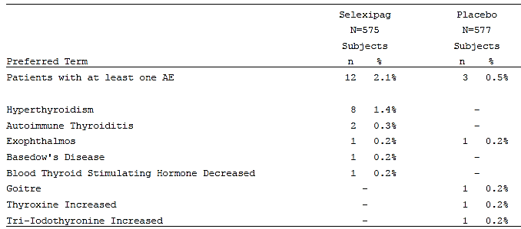
Of these, 2 patients (0.3%) in the selexipag group had thyroid disorder events that were reported as SAEs (both considered treatment-related; one of which led to discontinuation of study treatment), compared to none in the placebo group. One SAE was hyperthyroidism (symptomatic), reported 11 months after the start of selexipag treatment, with concurrent diagnoses of autoimmune thyroiditis and thyroid adenoma. Study drug was discontinued and the events were reported as resolved 3 weeks later. The second SAE was Basedowʼs disease, which was diagnosed 12 months after start of selexipag treatment. Treatment with metoprolol and thiamazole was initiated on Day 412. The event remained unresolved, and the patient continued treatment with selexipag. Analyses of AE PTs specifically denoting hyperthyroidism (PT hyperthyroidism and PT Basedowʼs disease) were reported for 9 (1.6%) patients in the selexipag group compared to no cases on placebo. Seven of the 9 cases (1.2%) were of mild intensity and 2 (0.4%) of moderate intensity.
Laboratory analyses of thyroid markers have been described above and results showed a small reduction in median TSH from baseline (up to −0.3 MU/L from a baseline median of 2.5 MU/L) at most visits in the selexipag group, while in the placebo group, little change in median values was apparent. No associated changes from baseline in mean T3 and T4 were observed.
The sponsor had offered the opinion that the observations suggested that selexipag may have an effect on thyroid function through a stimulatory effect on thyroid follicular cells in some patients, and that this had been previously described for prostacyclin. It was noted by the sponsor that there had been published reports of hyperthyroidism with the use of IP receptor agonists, and that hyperthyroidism is a labelled adverse drug reaction (ADR) for epoprostenol. Based on these findings, hyperthyroidism was identified by the sponsor as an ADR for selexipag and appropriate information has been included in the proposed prescribing information.

Liver disorders
According to the sponsor, liver disorders were evaluated as AEs of special interest as part of due diligence, and not on the basis of any safety signal. It was also noted that liver disorders were common co-morbidities in patients with PAH as a result of congestive hepatopathy due to increased central venous pressure resulting from right heart failure. The overall proportions of patients with liver disorder events in the selexipag and placebo groups were 7.3% and 6.4%, respectively. The most frequently reported events in both groups were increased ALT (1.4% with selexipag versus 1.9% with placebo) and increased AST (1.4% versus 1.7%). Overall 6 patients (1.0%) and 3 patients (0.5%) in the selexipag and placebo groups, respectively, had liver disorder SAEs. Of these 6 patients in the selexipag group, 2 had SAEs of ascites, 1 had SAEs of increased ALT (9.8 x upper limit normal [ULN]) and AST (18.5 x ULN), 1 had SAEs of liver cirrhosis and hepatic nodules, 1 had SAE of hepatic cyst, and the 6th had an SAE of nodular regenerative hyperplasia (worsening). Of the 3 patients in the placebo group, one had an SAE of increased ALT (156 U/L), one had an SAE of hepatorenal syndrome, and the third had SAEs of acute hepatic failure and abnormal liver function test (ALT, AST, ALP, and total bilirubin values on the day of the event were 321 U/L, 489 U/L, 263 U/L, and 74 μmol/L, respectively).
Laboratory analyses of liver function parameters have been described above and overall, results did not trigger any safety concerns. The proportion of patients with marked abnormalities in laboratory liver function parameters was generally low and comparable between treatment groups. There were no Hy’s Law range cases (ALT > 3 × ULN and total bilirubin > 2 × ULN at any time) in the selexipag group, while 2 cases were identified in the placebo group.

Renal and urinary disorders
Renal dysfunction AEs (SMQ) were reported in 7.3% of patients on selexipag, compared to 4.5% on placebo. The difference was driven mainly by the preferred term ‘acute renal failure’ (2.4% with selexipag versus 1.2% with placebo). Among the cases of acute renal failure, the proportion of cases that were clinically relevant (that is, reported as fatal, serious, or leading to discontinuation of treatment) was the same in the 2 groups (1.0%, 6 patients in each group). None of the events in the selexipag group was reported in the context of hypotension. Most of the AEs of acute renal failure were of mild or moderate intensity (incidence of severe intensity acute renal failure AEs: 0.9% of patients in the selexipag group and 0.5% in the placebo group). Incidence of renal dysfunction SAEs were comparable between treatment groups (1.7% versus 1.2%). The incidence of acute renal failure as an SAE was the same in both groups (1.0%, 6 patients in each group).
Laboratory analyses of renal function parameters have been described above and overall, results did not trigger any safety concerns. The proportion of patients with marked abnormalities in laboratory renal function parameters was generally comparable between treatment groups.

Rash and skin disorders
The grouping of rash and skin disorders was selected as an AE of special interest due to the higher apparent incidence of such events in the selexipag group compared to the placebo group, and because rash had been associated with IP receptor agonists. Results showed that the overall proportions of patients with rash and skin disorder events was 11.1% in the selexipag group and 8.3% in the placebo group. The most-commonly reported AE by preferred term was rash (4.5% with selexipag versus 2.8% with placebo) and erythema (2.3% versus 1.4%). None of these AEs in the selexipag group were reported as SAEs. Rash has been included as an ADR in the prescribing information for selexipag.

Bone disorders
According to the sponsor, bone disorder AEs were identified as a safety topic of special interest due to findings in subacute and chronic toxicity studies in dogs showing an increase in bone ossification, although this was considered most likely a species-specific finding. Results showed that the proportions of patients with bone disorder AEs in the selexipag and placebo groups were 30.4% and 11.4%, respectively. However, the difference was noted to be driven by the AE PT of ‘pain in jaw’ (a prostacyclin-associated AE; 25.7% with selexipag versus 5.7% with placebo), which was not related to bone disorder but which was harboured in this SMQ. No jaw fracture AEs were reported in the selexipag group, but one case was reported in the placebo group. Incidence of bone disorder AEs relating to fractures were comparable between the selexipag and placebo groups (2.8% versus 3.3%). The incidence of bone disorder SAEs was lower with selexipag (1.0%) compared to placebo (1.7%). Laboratory analyses of bone turnover markers have been described above and overall, results did not trigger any safety concerns.

Malignancies
Malignancies were evaluated as an AE of special interest due to an observed small imbalance between selexipag and placebo groups. Results showed that the overall proportions of patients with such events was 1.9% (n=11) in the selexipag group and 0.7% (n=4) in the placebo group. The observed numerical imbalance regarding overall malignancies between selexipag and placebo derived mainly from cutaneous malignancies (selexipag: n = 4 [basal cell tumours; 2 reported as SAEs]; placebo: n=1 [malignant melanoma; SAE]) and blood and lymphatic system malignancies (selexipag: n=3 [two with B-cell lymphoma and one with lymphangiomatosis carcinomatosa; one AE of B-cell lymphoma and the AE of lymphangiomatosis carcinomatosa were reported as SAEs]; placebo: n=0). The incidence of breast malignancies was comparable between treatment groups (n=3 in each group; 2 in selexipag group and 3 in placebo group were reported as SAEs), as was that for other solid organ malignancies (selexipag: n=2 [lung adenocarcinoma and colorectal cancer metastatic; both SAEs]; placebo: n=1 [benign/malignant unknown left upper lobe lung lesion increased in size]).
According to the sponsor, the findings for basal cell tumours, a common tumour type, were of uncertain relevance. The sponsor also noted that there were a number of literature reports of co-occurrence of PAH and B-cell lymphomas. There was an absence of any findings indicating genotoxicity or immunotoxicity of selexipag, and absence of tumour findings of human relevance in rodent carcinogenicity studies. Taken together, the sponsor was of the opinion that there was no specific safety signal on the basis of these observations in the clinical studies with selexipag.

Prostacyclin-associated AEs
According to the sponsor, prostacyclin-associated AEs was used as a collective term for pharmacologically mediated adverse reactions described as typically occurring with other IP receptor agonists, such as epoprostenol and its analogues, and usually with highest frequency and intensity during treatment initiation and up-titration: mainly, headache, flushing, gastro-intestinal symptoms (diarrhoea, nausea, vomiting), and pain manifestations (such as jaw pain, muscle pain, leg pain). The overall proportion of patients with such events was 91.0% in the selexipag group compared with 62.2% in the placebo group. The most commonly-reported prostacyclin-associated AEs by PT in both groups were headache (65.2% with selexipag versus 31.5% with placebo), diarrhoea (42.4% versus 18.4%) and nausea (33.4% versus 18.2%). Most of these AEs in the selexipag group were mild to moderate in severity (71.8%), but the incidence of severe prostacyclin-associated AEs was higher with selexipag compared to placebo (19.1% versus 4.7%). The most commonly reported severe prostacyclin-associated AEs in the selexipag group were headache (11.3% versus 1.9% with placebo), diarrhoea (4.7% versus 1.6%) and nausea (2.4% versus 0.7%). The proportion of patients with prostacyclin-associated SAEs was higher with selexipag (2.3%; 13/575) compared to placebo (0.5%; 3/577). The most commonly reported prostacyclin-associated SAEs in the selexipag group were diarrhoea (0.5% in both groups [n=3 in each group]), vomiting (0.3% in both groups [n=2 in each group]), headache, myalgia, and pain in extremity (0.3% each in the selexipag group, versus 0% in placebo). None of the prostacyclin-associated SAEs in the selexipag group had a fatal outcome. The most-commonly reported treatment-related prostacyclin-associated AEs in the selexipag group were headache (61.4% versus 24.8% with placebo), diarrhoea (36.0% versus 9.5%), nausea (26.8% versus 10.7%), jaw pain (24.9% versus 4.5%) and vomiting (13.6% versus 3.3%).
KM estimation of the median time to the first prostacyclin-associated AE was shorter in the selexipag group (11 days; 95% CIs: 9, 14 days) than in the placebo group (57 days; 95% CIs: 45, 93 days). An Andersen-Gill model was used to analyse the time to occurrence of multiple AEs and mean cumulative function data were computed using the Nelson-Aalen estimate. These data indicated that the reporting frequency of prostacyclin-associated AEs was much higher during the early part of the study, particularly in the 12-week titration period (Figure 26).
Figure 26: Mean Cumulative Function for AEs: Prostacyclin-associated AEs, Study AC065A302
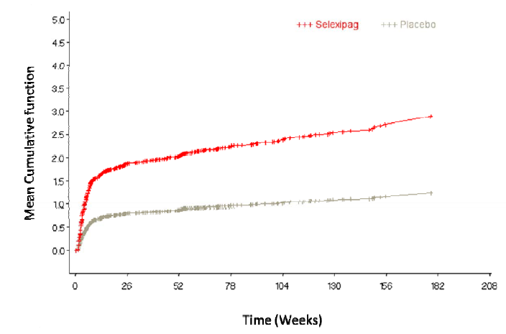
This was consistent with the expected pattern with an IP receptor agonist, that is, that the reporting frequency of prostacyclin-associated AEs was much higher during treatment initiation and up-titration. These results were supported by analyses results showing the proportion of patients with prostacyclin-associated AEs were higher in the shorter (12 week) titration period compared to the longer (approximately 58 week) maintenance period in selexipag group (86.6% in titration period versus 72.1% in maintenance period) (Table 48). The incidences of commonly-reported prostacyclin-associated AEs by preferred term (headache, diarrhoea, nausea) were also higher in titration period compared to in the maintenance period (headache: 64.4% versus 39.9%; diarrhoea: 35.8% versus 29.7%; nausea: 29.1% versus 19.6%).
Table 48: Treatment-emergent prostacyclin-like associated AEs in Study AC065A302 - separately for titration and maintenance periods, SAF (patients treated in both titration and maintenance periods)
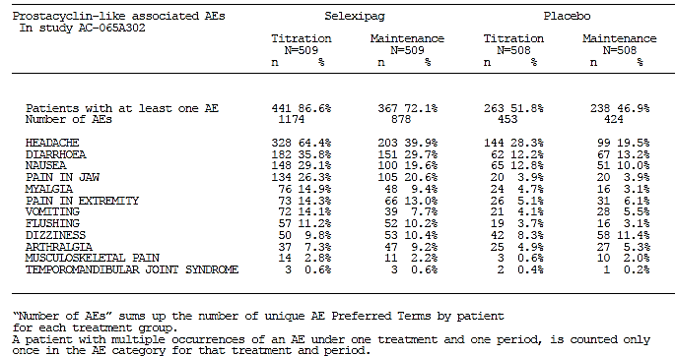
The sponsor also performed an intra-patient comparison looking at incidence of prostacyclin-associated AEs in patients who were on selexipag in both Studies AC-065A302 and AC-065A303 compared with that in patients who were on placebo in AC-065A302 and then selexipag in AC-065A303 (Table 49).
Table 49: Prostacyclin-associated AEs in Studies AC 065A302 and AC-065A303 intra-patient comparison sorted by PT incidence, SAF (subset treated in Study AC-065A303)
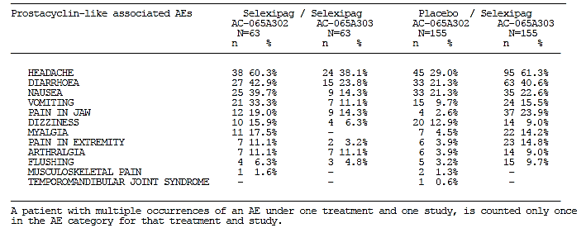
Results showed that in selexipag/selexipag patients, prostacyclin-associated AEs were less frequently reported in AC-065A303 compared to in AC-065A302. In placebo/selexipag patients, prostacyclin-associated AEs (except dizziness) were more frequently reported following the switch to selexipag treatment, and occurred at similar frequencies as in patients randomised to selexipag in AC-065A302. The sponsor has offered the opinion that the lower incidence of prostacyclin-associated AEs in the extension study for selexipag/selexipag patients could be indicative of the development of tolerability or amelioration of the AEs over time, while for patients who switched from double-blind placebo to open-label selexipag, the pattern of prostacyclin AEs was generally similar to that seen for patients treated with selexipag during the double-blind study.

Other studies
Fundoscopy was performed in Studies AC-065A201 and NS-304-03. The results did not raise any additional safety concerns. The Independent Ophthalmology Safety Board Report submitted was evaluated for the purpose of this report and did not raise any additional safety concerns. Adverse events of special interest was presented by the sponsor for the pooled data of Studies AC-065A302, AC-065A303, NS-304/-02 and NS-304/-03, as well as for the Japanese Study AC-065A201 and 2 other Japanese studies on the use of selexipag in patients with chronic thromboembolic pulmonary hypertension (CTEPH; Studies AC-065B202 and AC-065B201). These were evaluated and results were consistent with those in the pivotal study and no additional safety concerns were triggered.

Exposure-adjusted AE rates by prevailing dose

Pivotal study
The sponsor had performed analyses of exposure-adjusted AE rates by prevailing dose and patient-week in the pivotal Study AC-065A302, as requested by the US FDA. In these analyses, each AE was linked to the patient’s prevailing dose for the week in which the event occurred. The prevailing dose was defined as the highest dose given during the study week in which the AE occurred. Exposure-adjusted event rates were calculated and presented according to patient-weeks for the titration period and patient-months for the maintenance period and the overall (titration + maintenance) period. The results were summarised by the sponsor for all AEs, AEs of special interest and SAEs excluding death (defined as an SAE that preceded death by no more than 2 days). In addition, an analysis, also requested by the FDA, to assess the crude incidence estimates of AEs by the IMTD category (0, 200 to < 600, 600 to < 1600 and 1600 µg bd) in the titration period was performed.
Results showed that there was no clear trend for the exposure-adjusted AE or SAE rates, overall or by study period. Analysis of all-causality AEs by IMTD during the titration period showed an increase in the AE of anaemia by preferred term with increasing selexipag dose (0 µg: 3.3%; 200 to < 600 µg bd: 7.1%; 600 to < 1600 µg bd: 7.9%; 1600 µg bd: 11.1%), but there was no obvious indication of dose dependent trend for other AEs. The analysis of SAEs by IMTD category during the titration period showed an overall similar frequency of selexipag patients with SAEs across the IMTD categories (44.2% to 45.2%), with the exception of the small 0 μg bd category (23.3%). There was no clear evidence of dose dependent trend for any SAEs by preferred term.
Analyses of AEs of special interest showed that there was no clear trend for the exposure-adjusted rates for these AEs. In particular, no consistent increase in exposure-adjusted rate of anaemia as an AE of special interest was observed across the selexipag dose range in the overall study treatment period. However, analysis of anaemia as an AE of special interest by IMTD category during the titration period showed an increase in frequency with increasing dose (0 µg: 6.7%; 200 to < 600 µg bd: 8.9%; 600 to < 1600 µg bd: 9.8%; 1600 µg bd: 13.6%) (Table 50).
Table 50: Treatment-emergent AESI of anaemia by IMTD in overall study treatment period, safety analysis set, Study AC065A302
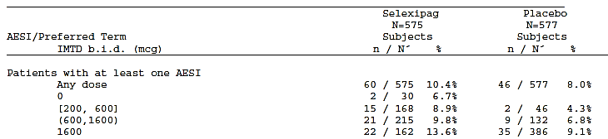
The sponsor has also performed exploratory PK analyses looking at the relationship between the combined exposure of selexipag and its active metabolite (ACT-333679) based on the area under the plasma concentration–time curve (AUC_{combined}) and the safety of selexipag in Study AC-065A302 using a logistic regression model. Results showed that the probability of occurrence of a prostacyclin-associated AE was predicted to increase by about 20–30% at the highest exposure compared to placebo. In comparison to placebo, haemoglobin concentration was predicted to decrease to a small but statistically significant extent with higher exposure to selexipag and ACT-333679 (from 138.84 G/L with placebo to 134.58 G/L at the highest active exposure). AEs of haemorrhage and GI haemorrhage showed no statistically significant relationship to exposure. Vital signs (SBP, DBP, and heart rate) also did not show a statistically significant relationship to exposure.

Post-marketing experience
Not applicable.

Safety issues with the potential for major regulatory impact

Haematological effect
The association between selexipag use and the occurrence of anaemia has been described above.

Other safety issues

Safety in special populations
Subgroup evaluation of adverse events by baseline PAH aetiology in Study AC-065A302 showed that the overall incidence of AEs was generally comparable among the selexipag groups in the different PAH aetiology categories (IPAH/ HPAH/ drug and toxin–induced PAH/ PAH associated with HIV infection: 98.9% [vs. 96.7% with placebo in this subgroup]; PAH associated with CTD: 98.2% [vs. 97.0% with placebo with placebo in this subgroup]; PAH associated with CHD with corrected systemic-to-pulmonary shunts: 96.0% [versus 98.0% with placebo in this subgroup]). The pattern of AEs by SOC and preferred term was also generally similar across the different PAH aetiology categories, and no obvious trend was noted.
Subgroup evaluation of adverse events by age subgroups in Study AC-065A302 showed that the overall incidence of AEs was generally comparable among the selexipag groups in the different age group categories (< 65 years: 97.5% [vs. 97.0% with placebo in this subgroup]; 65–74 years: 100% [vs. 96.1% with placebo in this subgroup]; ≥ 75 years: 100% [vs. 100% with placebo in this subgroup]). The pattern of AEs by SOC and preferred term was also generally similar across the different age group categories, and no obvious trend was noted. It is noted that the number of patients ≥ 75 years old was low (8 selexipag, 5 placebo) and this would affect the ability to make meaningful interpretation of AEs in this age group.
Subgroup evaluation of prostacyclin-associated AEs by age group showed that the frequencies of most of these AEs were generally similar between selexipag groups in the age subgroup of < 65 years old and that of 65–74 years old and no obvious trend was detected. Certain AEs showed an increased incidence in the 65–74 years old subgroup compared to the < 65 years old subgroup (for example, diarrhoea, pain in extremity), but similar patterns were also observed for these AEs in the placebo groups.

Safety related to drug-drug interactions and other interactions
Subgroup analyses in Study AC-065A302 of prostacyclin-associated AEs according to concomitant PAH-specific therapy at baseline showed that the incidence of many of these AEs relative to placebo was greater in patients who were treated with selexipag in addition to other PAH medications, compared to those who received selexipag monotherapy (Figure 27).
Figure 27: Prostacyclin-associated associated AEs by PT according to PAH-specific medication at baseline in the DB, placebo-controlled PAH Safety analysis set from Study AC065A302
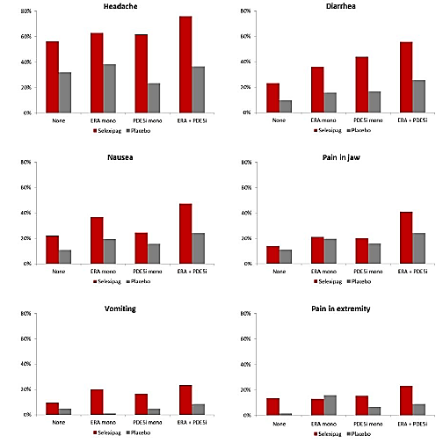

Figure 27 continued: Prostacyclin-associated associated AEs by PT according to PAH-specific medication at baseline in the DB, placebo-controlled PAH Safety analysis set from Study AC065A302
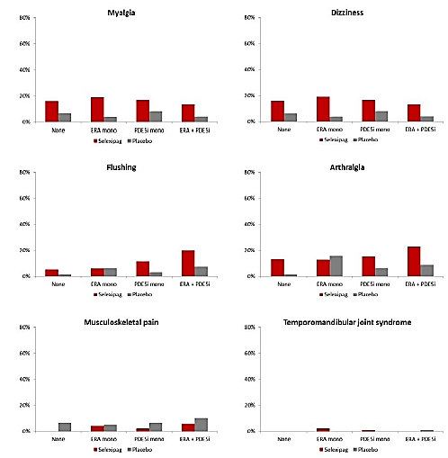
In the selexipag group, the placebo-corrected incidences for headache in patients who received concomitant PDE5i monotherapy and ERA + PDE5i combination therapy were 38.2% and 39.4%, respectively, compared to 24.6% in those who received ERA monotherapy, or no concomitant PAH therapy. For diarrhoea, the placebo-corrected incidences in patients who received PDE5i monotherapy and ERA + PDE5i combination therapy were 27.4% and 30.0%, respectively, compared to 20.4% in those who received ERA monotherapy and 13.2% in those who received no concomitant PAH therapy. The sponsor has offered a rationale for the observations, that many of these events considered to be associated with prostacyclin were also common to other PAH-specific medications, as suggested by the incidences in the placebo group.
The incidences of anaemia AEs of special interest (AESIs) in patients who received no PAH-specific medication were 4.5% and 6.7% in the selexipag and placebo groups, respectively. In patients who received selexipag in addition to any of the other PAH-specific medications, the incidences of anaemia were higher in the selexipag group than in the placebo group (concomitant ERA monotherapy: 14.9% with selexipag versus 9.2% with placebo; PDE5i monotherapy: 11.1% versus 5.4%; ERA and PDE5i: 11.2% versus 10.7%).
Subgroup analyses of treatment-emergent hypotension AESIs on the basis of concomitant PAH therapy at baseline showed that hypotension AEs were reported more frequently in selexipag patients who were receiving concomitant PDE-5 inhibitors at baseline, particularly in combination with ERAs, compared to those who were not on any concomitant PAH specific therapy (no concomitant PAH specific therapy: 3.6% [vs. 2.5% with placebo in the same subgroup]; PDE-5i: 5.8% [vs. 4.3% with placebo in the same subgroup]; PDE-5i plus ERA: 8.4% [vs. 3.0% with placebo in the same subgroup]; ERA: 4.3% [vs. 6.6% with placebo in the same subgroup]) (Table 51).
Table 51: Hypotension AEs in the DB, placebo-controlled PAH safety analysis set from Study AC065A302 according to concomitant PAH medication at baseline
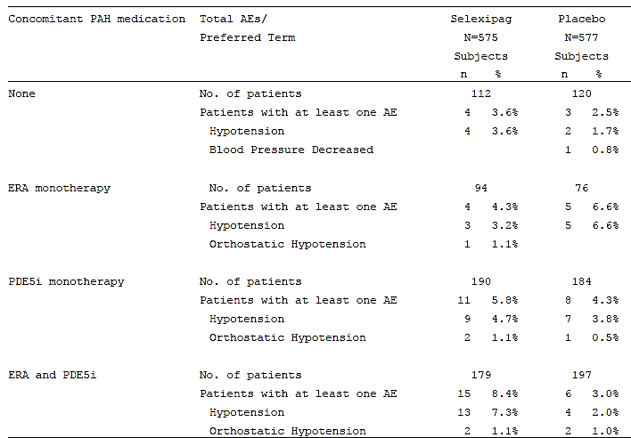

Evaluator’s overall conclusions on clinical safety
Overall, safety results in the pivotal Phase III study (AC-065A302) showed that selexipag has a safety profile largely expected for a prostacyclin receptor agonist. The incidence of all-causality TEAEs and death up to study closure was comparable between selexipag and placebo groups. The incidence of treatment-related TEAEs was higher in the selexipag group (89.6%) compared to the placebo group (56.7%), and the higher incidence was mainly driven by that of prostacyclin-associated AEs. The most commonly reported treatment-related TEAEs by preferred term in the selexipag group were headache (61.4% versus 26.2% in the placebo group), diarrhoea (36.0% versus 10.2%), nausea (27.0% versus 11.4%) and pain in jaw (24.9% versus 5.0%). The incidences of SAEs were lower in the selexipag group compared to the placebo group (43.8% versus 47.1%), as was the incidences of TEAEs leading to discontinuation of study drug (31.7% versus 37.1%). The most commonly reported SAEs in the selexipag group were PAH and right ventricular failure, and both occurred less frequently with selexipag than with placebo (PAH: 14.4% with selexipag versus 22.0% with placebo; right ventricular failure: 5.9% versus7.1%).The most commonly reported TEAE leading to discontinuation of study drug in the selexipag group was PAH and also occurred less frequently with selexipag than with placebo (13.6% versus 23.4% with placebo).
Safety results in Study AC-065A303 were generally supportive of long-term safety of selexipag. Analyses comparing safety of the subgroup of patients who had received selexipag in Study AC-065A302 and then continued on selexipag in Study AC-065A303 (‘selexipag/selexipag’) compared to those who had previously received placebo in Study AC-065A302 (‘placebo/selexipag’) showed that the overall incidence of all-causality AEs in Study AC-065A303 was generally comparable between the selexipag/selexipag patients and the placebo/selexipag patients (98.4% versus 94.8%). Within the selexipag/selexipag patients, the incidence of all-causality AEs was comparable between Study AC-065A302 (100%) and Study AC-065A303 (98.4%). The incidence of TEAE leading to discontinuation of study drug in Study AC-065A303 was also generally comparable between the selexipag/selexipag patients and the placebo/selexipag patients (22.4% versus 24.5%). The incidence of SAE in Study AC-065A303 was higher in selexipag/selexipag patients (57.1%) than in placebo/selexipag patients (50.3%), but there were no any particular SAE that was contributing to the higher incidence. The most frequently reported SAEs in Study AC-065A303 were PAH and right ventricular failure, and the incidences of both were comparable between the selexipag/selexipag and placebo/selexipag patients (PAH: selexipag/selexipag 23.8% versus placebo/selexipag 23.2%; right ventricular failure: selexipag/selexipag 15.9% versus placebo/selexipag 14.8%). Within the selexipag/selexipag patients, the incidence of SAEs was lower during Study AC-065A303 (57.1%) than during Study AC-065A302 (74.6%).
Analyses of exposure-adjusted rates by prevailing dose at the time of AE onset in Study AC-065A302 showed that there was no clear dose-dependent trend for the overall AE or SAE rates with selexipag. Subgroup analyses of AEs in Study AC-065A302 showed that the overall incidence of AEs was generally comparable among the selexipag groups across the different PAH aetiology categories and across the age subgroups.
Analyses of AEs of special interest showed that main adverse effects with selexipag were related to prostacyclin-associated AEs, anaemia and hypotension. In addition, hyperthyroidism and rash were also identified as potential ADRs, although the incidence was low.
In Study AC-065A302, the overall proportion of patients with prostacyclin-associated AEs was higher with selexipag to placebo (91.0% versus 62.2%), as would be expected for a prostacyclin receptor agonist, and the most commonly-reported prostacyclin-associated AEs with selexipag were headache (65.2% versus 31.5% with placebo), diarrhoea (42.4% versus 18.4%) and nausea (33.4% versus 18.2%). Most of these AEs in the selexipag group were mild to moderate in severity (71.8%). The incidence of prostacyclin-associated SAEs with selexipag was low (2.3% versus 0.5% with placebo). Consistent with the expected pattern with an IP receptor agonist, the incidence of prostacyclin-associated AEs was higher during the 12-week up-titration period compared to during the maintenance period. Intra-patient comparison looking at incidence of prostacyclin-associated AEs in patients who were on selexipag in both Studies AC-065A302 and AC-065A303 compared with that in patients who were on placebo in AC-065A302 and then selexipag in AC-065A303 suggested possibility of development of tolerability or amelioration of these AEs over time, with results showing that in selexipag/selexipag patients, prostacyclin-associated AEs were less frequently reported in AC-065A303 compared to in AC-065A302 (for example, headache: 38.1% in AC-065A303 versus 60.3% in AC-065A302; diarrhoea: 23.8% versus 42.9%; nausea: 14.3% versus 39.7%). Analyses by prevailing dose at the time of AE onset showed that there was no clear dose-dependent trend for the exposure-adjusted prostacyclin-associated AE rates with selexipag. The frequencies of most of the prostacyclin-associated AEs were generally similar between selexipag-treated patients aged < 65 years old and those aged 65–74 years old. However, the incidence of many of these prostacyclin-associated AEs with selexipag relative to placebo was greater in patients who were treated with selexipag in addition to other PAH medications, compared to those who received selexipag monotherapy.
Analyses of AEs denoting anaemia in Study AC-065A302 showed that the incidence was higher in the selexipag group (10.4%) compared to the placebo group (8.0%), but none of the anaemia events in either group were fatal or led to discontinuation of study treatment. The incidence of anaemia events reported as SAEs was low in the selexipag group (1% versus 0.5% with placebo), as was the proportion of patients who received at least one blood transfusion (2.1% versus 2.3% in the placebo group). Laboratory analyses of haemoglobin levels suggested that selexipag was associated with greater decrease of haemoglobin compared to placebo (mean absolute changes from baseline to regular visits up to Month 36 in Hb: ranged from -3.4 to -0.16 g/L in the selexipag group versus -0.5 to 2.5 g/L in the placebo group), but the incidence of haemoglobin decreases to < 80 g/L at any time post-baseline was low (1.3% with selexipag versus 0.7% with placebo). The decrease in median haemoglobin concentrations in the selexipag group was apparent within 3 months of the start of treatment and the decrease was not progressive over time. This was supported by results showing that in patients who were on selexipag in both Studies AC-065A302 and AC-065A303, the incidence of Hb < 80 g/L any time post-baseline remained comparable in Studies AC-065A302 and AC-065A303 (3.2% versus 2.0%) while that of Hb < 100 g/L was lower in Study AC-065A303 compared to Study AC-065A302 (9.8% versus 19.0%). Although analyses by prevailing dose at the time of AE onset showed that there was no consistent increase in exposure-adjusted rate of anaemia as an AE of special interest across the selexipag dose range in the overall study treatment period (that is, titration plus maintenance period), analysis of anaemia as an AE of special interest by IMTD category during the titration period showed an increase in frequency with increasing dose (0 µg: 6.7%; 200 to < 600 µg bd: 8.9%; 600 to < 1600 µg bd: 9.8%; 1600 µg bd: 13.6%). The incidence of anaemia AEs in patients who received selexipag in addition to any of the other PAH-specific medications was higher compared to those with no PAH-specific medication (no PAH-specific therapy: 4.5% [vs. 6.7% in placebo group]; concomitant ERA monotherapy: 14.9% [vs. 9.2% with placebo]; PDE5i monotherapy: 11.1% [vs. 5.4% with placebo]; ERA and PDE5i: 11.2% [vs. 10.7% with placebo]).
This observed higher incidence of anaemia AEs in the selexipag group compared to the placebo group appeared to be unrelated to any increased bleeding risk with selexipag. The overall incidence of haemorrhage AEs (according to the SMQs of haemorrhage and gastrointestinal haemorrhage) in Study AC-065A302 was similar in the selexipag and placebo groups (15.5% versus 15.8%), as was the incidence of haemorrhage AEs that were fatal, serious or led to discontinuation of study treatment, and the incidence of major bleeding events (selexipag 2.4%, placebo 2.1%).
The overall proportions of patients with hypotension events in Study AC-065A302 was higher in the selexipag group compared to the placebo group (5.9% versus 3.8%), but the incidence of clinically relevant cases of hypotension (that is, those with a fatal outcome, or were serious, or led to discontinuation of treatment) was low and comparable between treatment groups (0.7% in each group). Analyses over time of blood pressure measurements showed that mean absolute changes from baseline in SBP and DBP were small and similar between treatment groups, and did not show any progression over time (mean changes from baseline in SBP: ranged from −2.0 to 1.5 mmHg in selexipag group versus −1.3 to 0.0 mmHg in the placebo group; mean changes from baseline in DBP: -1.6 to −0.1 mmHg versus −1.1 to 0.3 mmHg). This was generally supported by results showing that in patients who were on selexipag in both Studies AC-065A302 and AC-065A303, although the incidence of SBP < 90 mmHg was slightly higher in Study AC-065A303 (20.3%) than in Study AC-065A302 (17.5%), incidence of DBP < 50 mmHg was comparable between the 2 studies (1.6% in Study AC-065A303 versus 1.7% in Study AC-065A302). Analysis of AE rates by prevailing dose at the time of AE onset showed that there was no clear dose-dependent trend for the exposure-adjusted hypotension AE rates with selexipag. Hypotension AEs were reported more frequently in selexipag patients who were receiving concomitant PDE-5 inhibitors at baseline, particularly in combination with ERAs, compared to those who were not on any concomitant PAH specific therapy (no concomitant PAH specific therapy: 3.6% [vs. 2.5% with placebo]; PDE-5i: 5.8% [vs. 4.3% with placebo]; PDE-5i plus ERA: 8.4% [vs. 3.0% with placebo]; ERA: 4.3% [vs. 6.6% with placebo]).
Analyses of thyroid disorders as AEs of special interest showed that the incidence of thyroid disorder AEs was low in the selexipag group, although it was higher compared to the placebo group (2.1% with selexipag versus 0.5% with placebo). The majority of these thyroid disorder AEs in the selexipag group were non-serious and none were fatal. Analyses of AE PTs specifically denoting hyperthyroidism (PT hyperthyroidism and PT Basedowʼs disease) showed similar results, with low incidence in the selexipag group, but higher compared to placebo (1.6% versus 0%), and all were of mild (1.2%) to moderate severity (0.4%). Laboratory analyses of thyroid markers showed a small reduction in median TSH from baseline (up to −0.3 MU/L from a baseline median of 2.5 MU/L) at most visits in the selexipag group (compared to little change in median values in the placebo group). No associated changes from baseline in mean T3 and T4 were observed, and there was no apparent trend of progressive TSH changes over time. An analysis of AE rates by prevailing dose at the time of AE onset showed that there was no clear dose-dependent trend for the exposure-adjusted thyroid disorder AE rates with selexipag. It is noted that the sponsor has included under the ‘Precautions’ section of the proposed PI that ‘Thyroid function tests are recommended as clinically indicated’. This is considered appropriate.
Analyses of rash and skin disorders as events of special interest showed that the incidence was higher with selexipag (11.1%) than with placebo (8.3%). The most-commonly reported skin disorder AEs by preferred term were rash (4.5% with selexipag versus 2.8% with placebo) and erythema (2.3% versus 1.4%). None of these AEs in the selexipag group were reported as SAEs. An analysis of AE rates by prevailing dose at the time of AE onset showed that there was no clear dose-dependent trend for the exposure-adjusted rash and skin disorder AE rates with selexipag.
Safety results in supportive studies did not raise any additional safety concerns.

First round benefit-risk assessment

First round assessment of benefits
The benefits of selexipag in the proposed usage are:
- Treatment of PAH in terms of potential benefits in reducing morbidity/mortality and in symptom relief.
Efficacy results in the pivotal study (AC-065A302) showed that there was a statistically significant relative risk reduction of 40% (1-sided unstratified log-rank p ˂ 0.0001) with selexipag compared to placebo for the occurrence of a morbidity or mortality event up to 7 days after the last study drug intake (primary endpoint). The number-needed-to-treat was 7.1 at 2 years, suggesting that 7 patients needed to be treated with selexipag in order to prevent one morbidity or mortality event in up to 2 years as compared to placebo. The relative risk reduction with selexipag compared to placebo for the occurrence of death due to PAH or hospitalisation due to PAH worsening up to 7 days after the last study drug intake was 30% (1-sided unstratified log-rank p = 0.0031).
Further analyses suggested that these observed effects were largely due to risk reduction of morbidity (especially hospitalisation due to PAH worsening and disease progression) rather than mortality, with results showing that overall survival (death from randomisation up to study closure) was comparable between selexipag and placebo (all-causality death: hazard ratio [selexipag over placebo] of 0.97, 1-sided unstratified log-rank p = 0.4214; death due to PAH: hazard ratio of 0.86, 1-sided unstratified log-rank p = 0.1763). Competing risks analysis to explore the treatment effect on the components of the primary endpoint also showed that patients on selexipag had statistically significantly lower risk of disease progression (p < 0.0001) and hospitalisation for PAH worsening (p = 0.0402) than patients on placebo, but no statistically significant difference was observed between selexipag and placebo for the risk of death (p = 0.0827) or for the risk of PAH worsening (p = 0.5342). However, it is noted that the study was not powered for mortality endpoints.
Analyses of the effect of selexipag on symptom relief in terms of improvements in exercise capacity (6MWD) were supportive of the beneficial effect of selexipag on symptom relief in patients with PAH. Results showed that after 6 months of treatment, the median treatment effect in 6MWD of selexipag versus placebo (that is, placebo-corrected median change from baseline in 6MWD) was 12.0 m (1-sided Wilcoxon-Mann-Whitney p = 0.0027). Analyses of changes in 6MWD over time showed that this treatment effect was generally sustained up to Month 30. The clinical significance of a treatment effect of 12.0m is unclear. It is noted that the sponsor has not pre-defined in the statistical analysis plan or protocol what would constitute a clinically relevant treatment effect. The EMA guidelines on the clinical investigation of medicinal products for the treatment of pulmonary arterial hypertension cited as an example that deterioration in 6MWT could be defined as a decrease of 15 % from baseline, but did not provide guidance as to a clinically relevant treatment effect. There are currently 3 IP receptor agonists approved for the treatment of PAH in Australia, and clinical results (in terms of 6MWT) described in the respective TGA-approved PIs were, for epoprostenol: ‘Results of the 12-week study showed that exercise capacity was improved in the 56 patients treated with FLOLAN (median distance walked in 6 minutes, 316m at 12 weeks versus 270m at Baseline), but it decreased in the 55 patients treated with conventional therapy alone (192m at 12 weeks versus 240 m at Baseline; p<0.001 for the comparison of the treatment groups).’; for iloprost: ‘at week 12, at least 10% increase in the six minute walking distance as compared to baseline was noted in 37.6% of the iloprost group and 25.5% of the control group (p = 0.059).’; for treprostinil: ‘the median change from baseline on Remodulin was 10 metres and the median change from baseline on placebo was 0 metres, the median between-treatment difference over placebo was 16 metres.’ The clinical significance of the treatment effect of 12.0m in 6MWD will be raised as a clinical question for the sponsor in Section 12.
However, analyses of the effect of selexipag on symptom relief in terms of changes in NYHA/WHO FC, CAMPHOR questionnaire symptom scores and Borg dyspnoea index all showed comparable results between selexipag and placebo. The difference in the proportion of patients with absence of worsening from Baseline in NYHA/WHO FC at Week 26 between the selexipag and placebo groups was not statistically significant (77.8% with selexipag versus 74.9% with placebo, 2-sided Breslow-Day p = 0.1916), although the proportion of patients with absence of worsening from Baseline in NYHA/WHO FC, and that of patients with improvement from Baseline in NYHA/WHO FC was mostly numerically higher in the selexipag group compared to the placebo group from Week 4 up to Month 36, and the proportion of patients who had worsened NYHA/WHO FC compared to Baseline was mostly numerically lower in the selexipag group than in the placebo group from Week 8 up to Month 36.
Subgroup analyses in the pivotal Study AC-065A302 on the primary efficacy endpoint, on time from randomisation to first of death due to PAH or hospitalisation due to PAH worsening up to EOT + 7 days, and on the absolute change from Baseline to Week 26 in 6MWD, showed that the treatment effect of selexipag across the subgroups were generally consistent with those in the overall study population, and there was no statistically significant heterogeneity of treatment effects across subgroups based on the interaction tests, including subgroups of PAH aetiology at baseline, NYHA/WHO FC, and concomitant PAH specific therapy at baseline.
Prostacyclin receptor agonists currently approved in Australia for treatment of PAH were epoprostenol, iloprost and treprostinil, none of which could be administered orally (epoprostenol is to be administered by continuous intravenous infusion, iloprost by inhalation, and treprostinil by continuous subcutaneous infusion). The availability of a prostacyclin receptor agonist that can be taken orally is therefore a potential benefit in increasing the ease of administration which can in turn increase patient compliance and reduce potential complications associated with intravenous or subcutaneous infusions.

First round assessment of risks
The main risks of selexipag in the proposed usage are:
- Prostacyclin-associated symptoms
- Anaemia
- Hypotension
As would be expected for a prostacyclin receptor agonist, the incidence of prostacyclin-associated AEs in the pivotal Study AC-065A302 was higher in the selexipag group compared to in the placebo group (91.0% versus 62.2%), the most commonly-reported with selexipag being headache (65.2%), diarrhoea (42.4%) and nausea (33.4%). However, most of these AEs in the selexipag group were mild to moderate in severity (71.8%), and the incidence of prostacyclin-associated SAEs with selexipag was low (2.3%). Consistent with the expected pattern with an IP receptor agonist, the incidence of these prostacyclin-associated AEs with selexipag was higher during the initial up-titration period compared to during the maintenance period. In patients who were on selexipag in Study AC-065A302 and then continued on selexipag in the open-label Study AC-065A303, prostacyclin-associated AEs were less frequently reported in AC-065A303 compared to in AC-065A302, suggesting a possibility of development of tolerability or amelioration of these AEs over time. Analyses of exposure-adjusted rates by prevailing dose at the time of AE onset showed that there was no clear dose-dependent trend for the occurrence of these prostacyclin-associated AEs with selexipag. Subgroup analyses showed that the frequencies of these AEs with selexipag were mostly similar between patients < 65 years old and those 65–74 years old. However, the incidence of these AEs with selexipag relative to placebo was mostly greater in patients who were treated with selexipag in addition to other PAH medications, compared to those who received selexipag monotherapy.
Selexipag-treated patients in the pivotal Study AC-065A302 had a higher incidence of AEs denoting anaemia compared to the placebo group (10.4% versus 8.0%). However, none of these anaemia events were fatal or led to discontinuation of study treatment, and the incidence of anaemia events reported as SAEs was low in the selexipag group (1%), as was the proportion of selexipag patients who received at least one blood transfusion (2.1%; comparable with incidence with placebo of 2.3%), and the proportion of selexipag patients with Hb concentration decreases to < 80 g/L at any time post-baseline (1.3%). Mean absolute changes in Hb from baseline up to Month 36 with selexipag was modest, ranging from -3.4 to -0.16 g/L, and this decrease in Hb was apparent within 3 months of the start of treatment and was not progressive over time. This was supported by observations that in patients who were on selexipag in Study AC-065A302 and then continued on selexipag in the open-label Study AC-065A303 the incidence of Hb < 80 g/L remained comparable between Studies AC-065A303 and AC-065A302 (2.0% versus 3.2%) while that of Hb < 100 g/L was lower in Study AC-065A303 compared to Study AC-065A302 (9.8% versus 19.0%). This observed higher incidence of anaemia AEs with selexipag versus placebo appeared to be unrelated to any increased bleeding risk with selexipag. Analysis of anaemia AEs by individual maximum tolerated dose category during the titration period showed a dose-dependent trend, with an increase in frequency of these AEs with increasing dose (from 6.7% with 0 µg bd to 13.6% with 1600 µg bd). The incidence of anaemia AEs in patients who received selexipag in addition to other PAH-specific medications was higher compared to those with no PAH-specific concomitant medication (4.5% with no concomitant PAH therapy versus 11.1% to 14.9% with concomitant PAH therapy). As this effect on haemoglobin concentrations is an adverse effect that is monitorable by routine laboratory tests, these findings allowed clinicians to identify high-risk patients and treatment periods and be more vigilant in monitoring of Hb levels. The sponsor has not presented any data looking the reversibility of this effect. This will be brought up as a clinical question for the sponsor in Section 12.
Selexipag-treated patients in the pivotal Study AC-065A302 had a higher incidence of hypotension AEs compared to the placebo group (5.9% versus 3.8%). However, the incidences of clinically relevant cases of hypotension (that is, those with a fatal outcome, or were serious, or led to discontinuation of treatment) were low and comparable with that in placebo group (0.7% in both groups). Analyses of BP measurements over time showed that changes from baseline in SBP and DBP with selexipag were small and comparable with that in the placebo group, and did not show any progression over time (mean changes from baseline with selexipag in SBP: ranged from −2.0 to 1.5 mmHg; DBP: -1.6 to −0.1 mmHg). Analyses of exposure-adjusted rates by prevailing dose at the time of AE onset showed that there was no clear dose-dependent trend for the occurrence of these hypotension AE rates with selexipag. However, the incidence of hypotension AEs in patients who received selexipag in addition to other PAH-specific medications was higher compared to those with no PAH-specific concomitant medication (3.6% with no concomitant PAH therapy versus 4.3% to 8.4% with concomitant PAH therapy). It is also noted by the evaluator that this is an adverse effect that can be monitored by routine blood pressure measurements.

First round assessment of benefit-risk balance
The benefit-risk balance of selexipag, given the proposed usage, is favourable.
Efficacy results showed relative risk reduction of selexipag over placebo for the occurrence of combined mortality or morbidity events as well as beneficial effect on exercise capacity in terms of improvements in 6MWD. Although analyses in the pivotal study suggested that the use of selexipag did not improve survival, the study had not been powered for survival analyses. Safety results raised concerns mainly with respect to prostacyclin-associated symptoms, decreases in haemoglobin and hypotension. However, the prostacyclin-associated symptoms that developed with selexipag were mostly mild to moderate in severity. These adverse effects also occurred more frequently during the initial up-titration period compared to during the maintenance period, and results had suggested a possibility of development of tolerability or amelioration of these effects over time. The decrease in haemoglobin appeared to occur within 3 months of the start of treatment and thereafter was not progressive over time. The decreases were also modest, and the incidence of anaemia SAE and the proportion of selexipag patients with decreases of Hb to < 80 g/L post-baseline or had needed to receive at least one blood transfusion were low. In addition, this is an adverse effect that can be monitored by routine laboratory assessments. Although there was a higher incidence of hypotension AEs with selexipag compared to placebo, the incidence of clinically relevant cases of hypotension was low and the decreases in BP from baseline with selexipag were modest and did not show any progression over time. In addition, this is an adverse effect that can be monitored by routine blood pressure measurements.
The posology of oral administration is a potential benefit in increasing the ease of drug administration, which can in turn increase patient compliance. None of the prostacyclin receptor agonists currently approved in Australia for treatment of PAH (epoprostenol, iloprost and treprostinil) could be administered orally. With regards to the proposed dosing regimen of up-titration to individual maximum well-tolerated dose, results generally supported the proposed dosing regimen. Analysis on the primary efficacy endpoint of the pivotal study by individual maintenance dose (IMD) categories showed comparable effects across the IMD categories. In addition, safety analyses by prevailing dose at the time of AE onset showed that there was no clear dose-dependent trend for the exposure-adjusted overall AE or SAE rates with selexipag.
The proposed indication for selexipag, as stated in the proposed PI, is ‘for the treatment of:
- idiopathic pulmonary arterial hypertension
- heritable pulmonary arterial hypertension
- pulmonary arterial hypertension associated with connective tissue disease
- pulmonary arterial hypertension associated with congenital heart disease with repaired shunts
- pulmonary arterial hypertension associated with drugs and toxins
in patients with WHO functional class II, III or IV symptoms.
Uptravi is effective in combination with an endothelin receptor antagonist (ERA) or a phosphodiesterase-5 (PDE-5) inhibitor or in triple combination with an ERA and a PDE-5 inhibitor, or as monotherapy’
Subgroup analyses in the pivotal study on the primary efficacy endpoint and the endpoint of change from Baseline to Week 26 in 6MWD showed that the treatment effects of selexipag in the subgroups of PAH aetiology at baseline, concomitant PAH-specific therapy at baseline, and NYHA/WHO FC were generally consistent with those in the overall study population. In addition, subgroup analyses in the pivotal study of adverse events by baseline PAH aetiology showed that the overall incidence of AEs was generally comparable among the selexipag groups across the different PAH aetiology categories. Safety results suggested that the incidence of prostacyclin-associated AEs, anaemia AEs and hypotension AEs with selexipag was higher in patients who were treated with selexipag in addition to other PAH medications, compared to those who received selexipag monotherapy. However, as noted above, the majority of these AEs in the overall study population (the majority of whom had concomitant PAH-specific medication at baseline [80.5% in selexipag group]), were not severe or serious, and changes in haemoglobin and blood pressures were modest and not progressive, and were monitored with routine laboratory assessments or blood pressure measurements. It is noted that the sample size for the study population with aetiology of heritable PAH and PAH associated with drugs and toxins was small (2.2% [n=26] and 2.3% [n=27], respectively). However, this reflects the composition of the target patient population in clinical practice. The proposed indication wording with specification of the aetiologies covered by the indication is necessary as PAH is a disease condition with diverse aetiologies and as the study population in the pivotal study is limited to particular aetiologies these need to be stated clearly in the proposed PI. This proposed indication wording with specification of the aetiologies is also consistent with indication wording for the other currently approved IP receptor agonists in Australia.
With regards to the use of selexipag in patients across WHO FC of II to IV, it is noted that the majority of subjects in the pivotal study were of WHO FC II (45.8%) and III (52.5%), with only 1.0% (11/1156) in WHO FC IV. However, this reflects the composition of the target patient population in clinical practice. Subgroup analyses of the efficacy and safety endpoints in this small group of patients with baseline WHO FC IV would not have been viable in view of the very small sample size. The sponsor had performed efficacy subgroup analyses based on subgroups of baseline WHO FC I or II versus III or IV, and results were generally consistent with that of the overall study population. However, results of safety subgroup analyses based on subgroups of baseline WHO FC I or II versus III or IV were not presented in this submission. This would be raised as a clinical question to the sponsor.

First round recommendation regarding authorisation
It is recommended that the application for the registration of selexipag for the treatment of pulmonary arterial hypertension in adult patients of WHO Functional Class II to IV be approved. This is subject to a satisfactory response to the Clinical questions raised (see below).

Clinical questions

Pharmacokinetics

Question 1
Can the sponsor please provide an explanation for the 1.3 fold increase in selexipag C_{trough,ss} following administration of the single tablet form of 1600 μg selexipag bd compared to when it was administered as 8 x 200 μg selexipag bd in Study AC-065-108?

Question 2
The evaluator could not identify a request for a biowaiver for the intermediate dose strengths in the evaluation materials. Therefore, can the sponsor please direct the evaluator to the location of the request for a biowaiver or provide a statement for a request for a biowaiver if it has not been provided by the sponsor?

Question 3
The 1.9 fold increase in C_{trough,ss} for ACT-333679 identified in patients with PAH compared to healthy subjects in the PopPK/PD Study AC-065A302-PPK is unexpected. Can the sponsor please explain why they believe this is occurring and whether it is of concern, especially regarding the incidence of AEs in healthy subjects compared to patients with PAH? For instance, would the dose-dependent increase in HR identified in Study AC-065-106 be potentiated in subjects with PAH compared to healthy subjects?

Question 4
The PopPK Study AC-065A302-PPK provides a comparison of selexipag PKs in healthy subjects and in patients with PAH following dosing with 1600 μg bd This comparison indicates that difference in selexipag PKs exist between the two populations, in particular that there is a 1.9 fold increase in C_{trough} in patients with PAH compared to healthy subjects (Table 10). The two studies used to source the data for this comparison (that is, Study AC-065-106 for healthy subjects and Study AC-065A302 for patients with PAH) also examined the PKs of selexipag following 800 μg bd dosing. Can the sponsor therefore identify whether the same difference in selexipag PKs exist between healthy subjects and patients with PAH following 800 μg bd dosing and in particular is selexipag C_{trough} affected to the same extent in subjects with PAH at the lower selexipag dose?

Pharmacodynamics
None at this time.

Efficacy

Question 1
Please comment on the clinical significance of a treatment effect in 6MWD of 12.0m?
Rationale for question:
As described above, the clinical significance of a treatment effect of 12.0m is unclear. It is noted that the sponsor has not pre-defined in the statistical analysis plan or protocol what would constitute a clinically relevant treatment effect. There are currently 3 approved IP receptor agonists for the treatment of PAH in Australia, and clinical results (in terms of 6MWT) described in the respective TGA-approved PI were, for epoprostenol: ‘Results of the 12-week study showed that exercise capacity was improved in the 56 patients treated with FLOLAN (median distance walked in 6 minutes, 316m at 12 weeks versus 270m at Baseline), but it decreased in the 55 patients treated with conventional therapy alone (192m at 12 weeks versus 240 m at Baseline; p<0.001 for the comparison of the treatment groups).’; for iloprost: ‘at week 12, at least 10% increase in the six minute walking distance as compared to baseline was noted in 37.6% of the iloprost group and 25.5% of the control group (p = 0.059).’; for treprostinil: ‘the median change from baseline on Remodulin was 10 metres and the median change from baseline on placebo was 0 metres, the median between-treatment difference over placebo was 16 metres.’

Safety

Question 1
Please comment on whether there is any data that has looked at the reversibility of the effect of selexipag in haemoglobin concentrations, and provide these data or analyses results.
Rationale for question:
As described above, it is noted that the decreases from baseline of haemoglobin concentrations with selexipag were modest, appeared to occur within 3 months of the start of treatment and thereafter were not progressive over time. However, no data was presented with regards to reversibility of this effect. Knowing the reversibility of this effect would guide clinicians in the duration necessary in the monitoring of haemoglobin concentrations in patients who have ceased selexipag.

Question 2
Please provide safety results on subgroups of patients with baseline WHO FC I or II versus III or IV.
Rationale for question:
As described above, the sponsor is proposing use of selexipag for the treatment of PAH patients with WHO FC II to IV. It is noted that the majority of subjects in the pivotal study were of WHO FC II and III with only 1.0% (11/1156) in WHO FC IV, but that this reflects the composition of the target patient population in clinical practice and that subgroup analyses of the efficacy and safety endpoints in this small group of patients with baseline WHO FC IV would not have been viable in view of the very small sample size. The sponsor had performed efficacy subgroup analyses based on subgroups of baseline WHO FC I or II versus III or IV, and efficacy results were generally consistent with that of the overall study population. However, corresponding safety results comparing these subgroups were not provided.

Second round evaluation of clinical data submitted in response to questions

Clinical questions

Pharmacokinetics

Question 1
Can the sponsor please provide an explanation for the 1.3 fold increase in selexipag C_{trough,ss} following administration of the single tablet form of 1600 μg selexipag bd compared to when it was administered as 8 x 200 μg selexipag bd in Study AC-065-108?

Sponsor’s response
In Study AC-065-108, bioequivalence (the rate [maximum plasma concentration (C_{max}) at steady-state (C_{max,ss})] and extent [area under plasma concentration-time curve (AUC) during a dose interval (AUCτ)] of absorption) at steady state was tested between the reference 8 x 200 μg strength film-coated selexipag tablets (Treatment A) and the test 1 x 1600 μg strength film-coated selexipag tablet (Treatment B) in healthy subjects [AC-065-108 Clinical Study Report (CSR)].
The geometric mean ratios (Treatment B versus A) and their 90% confidence intervals (CIs) for C_{max,ss} and AUCτ for both selexipag and ACT-333679 were within the accepted bioequivalence limits of 0.80–1.25 (Table 20). Thus bioequivalence was demonstrated.
The 90% CIs of the median differences of the reference and test treatment for T_{max,ss} of selexipag and ACT-333679 were 0.0, 1.0 and 0.0, 0.5, respectively, indicating no difference between treatments (Table 52).

Table 52: AC-065-108: Plasma PK parameters of selexipag and its metabolite ACT-333679 in healthy subjects (n=65) at steady-state (Day 23) after treatment with 1600 µg bd of selexipag in treatment A (reference) and Treatment B (test)
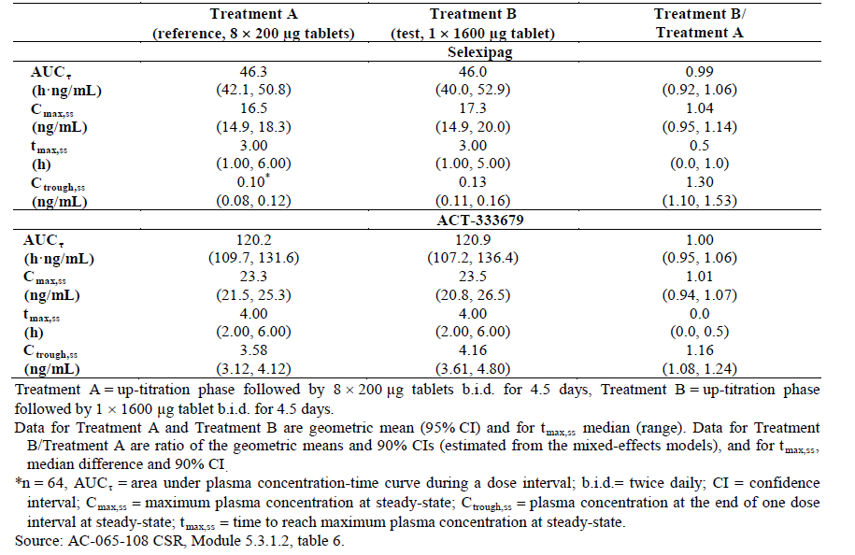
Analysis of plasma concentration at the end of one dose interval (C_{trough}) at steady-state (C_{trough,ss}), performed as part of the secondary pharmacokinetic (PK) analysis in Study AC-065-108 showed that the upper bound of the 90% CI for the geometric mean ratio of the C_{trough,ss} value of selexipag was outside 80.00–125.00% (geometric mean ratio [90% Cl] of test: reference treatment: 1.30 [1.10, 1.53]). Geometric mean (95% CI) of C_{trough,ss} (ng/mL) was 0.1 (0.08, 0.12) in Treatment A compared to 0.13 (0.11, 0.16) in Treatment B [AC-065-108 CSR]. Considering the very low (close to the bioanalytical limit of quantification of 0.01 ng/mL) and, consequently, highly variable selexipag concentrations measured at trough/pre-dose, the differences observed between treatments are considered negligible [AC-065-108 CSR]. The trough concentrations of the metabolite, ACT-333679, were higher compared to those for selexipag, therefore, the measurements were more reliable. The 90% CI for the geometric mean ratio of C_{trough,ss} test: reference treatment for ACT-333679 was 1.08, 1.24 (within the interval of 80.00–125.00%) [AC-065-108 CSR].

Evaluator’s response
The evaluator is satisfied with the sponsor’s response.

Question 2
The evaluator could not identify a request for a biowaiver for the intermediate dose strengths in Module 1 of the evaluation materials. Therefore, can the sponsor please direct the evaluator to the location of the request for a biowaiver if it has been over looked, or provide a statement for a request for a biowaiver if it has not been provided by the sponsor?

Sponsor’s response
The sponsor did not provide a request for a biowaiver for the intermediate dose strengths in the original Marketing Authorisation Application (MAA) but would like to hereby request such a biowaiver. Justification for the biowaiver was contained in the original submission and has been provided in e-submission Sequence 0001, Justification for not providing Biopharmaceutical Studies. The biowaiver addresses the points in the TGA guidance document.

Evaluator’s response
The sponsor has now provided a ‘request for a biowaiver’ for the intermediate dose strengths of selexipag (that is, 400 μg, 600 μg, 800 μg, 1,000 μg, 1,200 μg and 1,400 μg film coated tablets). Having reviewed the new biowaiver the evaluator believes that the request for a biowaiver for the intermediate doses of selexipag is justified (please see below for further information).
Review of data that supports the application for a biowaiver
Although the bioequivalence of the intermediate dose strengths of selexipag was not examined by the sponsor, the results of Study AC-065-108, which identified bioequivalence between the 200 μg dose strength and the 1600 mg dose strength, are supported by a comparison of the in vitro dissolution profiles of multiple tablets of the 200 μg dose strength to that of a single tablet of higher dose strengths. These results demonstrated the technical equivalence between all dose strengths. In addition, the sponsor indicates that all dose strengths for commercialisation are of the same dosage form (that is, film-coated tablets), which are manufactured by the same manufacturer according to the same manufacturing process, the qualitative composition of the different selexipag film-coated tablet strengths is the same and that all tablets strengths have the same quantitative composition, except for the filler D-mannitol which changes to account for differences in the amount of active substance.
In addition, the evaluator considered the following specific criteria as per the TGA adopted guidance.
The PK characteristics of the drug substance(s), such as permeability (or absolute bioavailability), linearity, first-pass effect (if any) and its significance
Although the absolute bioavailability of selexipag is unknown, as all attempts to develop an IV formulation of the drug were unsuccessful, and no studies directly compared the film-coated tablet formulation to an oral solution, Study PS003, examined the PKs of selexipag following a single, oral administration of 100 μg selexipag in a 10 mL solution. The results indicated that the mean T_{max} and t_{1/2} and geometric mean C_{max} and AUC_{0-inf} values for selexipag were 0.65 h, 1.71 h, 4.07 ng/mL and 5.84 ng.h/mL (Table 3). The comparative results for the PK values following a single, oral, 100 μg dose of the tablet formulation in Study QGUY/2006/NS-304-01 were 1.26 h, 0.71 h, 2.20 ng/mL and 4.62 ng.h/mL, respectively. Although, there were differences between the T_{max}, t_{1/2} and C_{max} values for the two formulations the AUC values for both formulations were similar (approximately1.25 fold higher for the oral solution), indicating that overall the tablet formulation is absorbed almost to the same extent as the oral solution.
The clinical consequences of any potential differences in bioavailabilities of the products under consideration (for example, increased dose leading to toxicity or decreased dose leading to lack of efficacy)
The highest intended commercial dose strength of 1600 μg selexipag has been examined following administration of selexipag as a single film 1600 μg tablet bd and as 8 film-coated tablets of 200 μg bd at steady-state and the two treatments were found to bioequivalent in regards to selexipag PKs (Study AC-065-108). In addition, Study AC-065-101 identified dose-proportional PKs over the proposed therapeutic dose range. As all dose strengths of the proposed commercial formulation have the same quantitative composition, are the same size, have equivalent dissolution profiles and any differences between the tablets in regards to colour are only minor, it would be expected that the intermediate dose strengths would be bioequivalent with both the 200 and 1600 μg dose strengths examined in Study AC-065-108.
The margin between the minimum effective and minimum toxic plasma concentration
The safety analysis from Study AC-065-108 which examined the PK, safety and tolerability of selexipag following 1600 μg bd dosing, identified that during the course of the study there were: no deaths or SAEs, no differences in the frequency of AEs following treatment with a single film 1600 μg tablet bd and as 8 film-coated tablets of 200 μg bd and all AEs were of mild intensity. Therefore, it can be reasonably assumed that treatment with 1600 μg selexipag was well tolerated by the enrolled subjects.
The safety results for doses higher than 1,600 μg selexipag bd (that is, 1,800 μg bd) indicated that selexipag was less well tolerated due to an increase in moderate AEs (headache, myalgia and nausea), which required concomitant medication and the maximum tolerated dose of selexipag was set at 1,600 μg bd (Study AC-065-101). Therefore, at the highest proposed clinical dose (1600 μg bd) the PKs and safety profile of selexipag are known; therefore, it would appear that at this dose selexipag is extremely unlikely to be toxic.

Question 3
The 1.9 fold increase in C_{trough,ss} for ACT-333679 identified in patients with PAH compared to healthy subjects in the PopPK/PD Study AC-065A302-PPK is unexpected. Can the sponsor please explain why they believe this is occurring and whether it is of concern, especially regarding the incidence of AEs in healthy subjects compared to patients with PAH? For instance, would the dose-dependent increase in HR identified in Study AC-065-106 be potentiated in subjects with PAH compared to healthy subjects?

Sponsor’s response
In Study AC-065A302, seven pre-dose plasma PK samples were drawn from each patient to obtain trough plasma concentrations of selexipag and ACT-333679. In addition, one post-dose sample at a specified time interval after drug administration (window sample) was taken from each patient at Week 16, visit 4 (sparse PK sampling) [AC-065A302 PK /pharmacodynamic (PD) report].
The main purpose of the PK modelling, using the PK samples during a dosing interval at Week 16 in Study AC-065A302 was to predict the PK model parameters (V/F, Vp, Vm, CL/F, kmet, km, ka) and to estimate AUCτ at steady state. The estimations of the effect of PK covariates and PK/PD analyses were performed based on the estimated steady-state AUCτ values [AC-065A302 PK/PD report].
C_{trough,ss} values of ACT-333679 and the 1.9 fold increase compared to healthy subjects as displayed in table 22 of the AC-065A302 PK/PD report were estimated by a simulation of the 1600 μg dose based on the population PK model. Since AUC_{τ,ss} estimation was based on exposure over an entire dosing interval (taking into account all window PK samples of the population at Week 16), it is considered robust. However, estimation of the concentration at a particular time point, such as C_{trough} is not expected to be robust (for example,, models with similar goodness of fit can yield quite different C_{trough} estimates, while the exposure estimates remain similar). The difference in model-predicted AUC_{τ,ss} of ACT-333679 between healthy subjects and pulmonary arterial hypertension (PAH) patients was 1.2 fold [AC-065A302 PK/PD report].
In Study AC-065A302, the analysis of C_{trough} concentrations used observed trough concentrations, separate from PK modelling. The summary statistics of C_{trough} concentrations of ACT-333679, per visit and dose (last dose prior to PK trough sample) are presented in the CSR of AC-065A302 [GRIPHON CSR].
The arithmetic mean observed C_{trough,ss} plasma concentrations of ACT-333679 among PAH patients in Study AC-065A302 were approximately 1.3 fold those in healthy subjects at doses of 800 and 1600 μg bd in Study AC-065-106. Taking into consideration the observed variability, this difference is considered small. Review of the median observed C_{trough,ss} of ACT-333679 showed comparable values between healthy subjects and PAH patients at these doses.
As previously shown, when selexipag is administered at the highest tolerated dose achieved through a weekly up-titration scheme (AC-065A302), no difference in the safety profile across doses within the range from 200 to 1600 μg bd is evident.
In the thorough QT study (AC-065-106), as part of the cardiodynamic evaluation, the effect of selexipag on heart rate was analysed. The placebo-corrected increase from time-matched baseline heart rate (ΔΔHR, bpm) 1.5 to 3 hours post-dose was 6–7 bpm at 800 μg bd and 9–10 bpm at 1600μg bd [AC-065-106 CSR].
The AC-065A302 study employed a titration regimen based on individual patient tolerability, resulting in individual maintenance doses (IMDs) ranging between 200 and 1600 μg bd The assessment of change from baseline in pulse rate and electrocardiogram (ECG) derived heart rate at trough over time did not show any clinically relevant differences between the selexipag and placebo groups [GRIPHON CSR]. At the Month 12 visit, ECG variables were assessed 2 and 4 hours post-dose.
This analysis showed that the mean (median) placebo-corrected increase in heart rate from pre-dose for selexipag-treated patients at 2 and 4 hours post-dose was 3.7 (4.0) bpm and 1.1 (1.0) bpm, respectively [GRIPHON CSR], and thus of lower magnitude than the changes observed in healthy subjects in the Phase I study (AC-065-106).
Change from baseline in heart (pulse) rate assessed pre-dose at each study visit as part of vital signs assessments did not show any appreciable difference between the selexipag and placebo groups, or a trend over time [GRIPHON CSR].
In conclusion, the appropriate comparison of C_{trough,ss} values between these two studies should be based on observed C_{trough,ss} values rather than model-predicted C_{trough,ss} values. Consistent with AUC results, there was approximately a 1.3 fold increase in observed C_{trough,ss} of ACT-333679 in PAH patients compared to healthy subjects. This difference in C_{trough,ss} of ACT-333679 (responsible for the majority of the drug effect) is not clinically significant and does not lead to any change in the safety profile of selexipag in PAH patients compared to healthy subjects. Review of the safety data in GRIPHON and the thorough QT study confirms this conclusion.

Evaluator’s response
The evaluator is satisfied with the sponsor’s response.

Question 4
The PopPK Study AC-065A302-PPK provides a comparison of selexipag PKs in healthy subjects and in patients with PAH following dosing with 1600 μg bd This comparison indicates that differences in selexipag PKs exist between the two populations, in particular that there is a 1.9 fold increase in C_{trough} in patients with PAH compared to healthy subjects (Table 10). The two studies used to source the data for this comparison (that is, Study AC-065-106 for healthy subjects and Study AC-065A302 for patients with PAH) also examined the PKs of selexipag following 800 μg bd dosing. Can the sponsor therefore identify whether the same differences in selexipag PKs exists between healthy subjects and patients with PAH following 800 μg bd dosing and in particular is selexipag C_{trough} affected to the same extent in subjects with PAH at the lower selexipag dose?

Sponsor’s response
The reviewer is kindly referred to the response to Question 3. The appropriate comparison of C_{trough,ss} between Study AC-065-106 and GRIPHON should be based on the observed C_{trough,ss} values and not on the model-predicted C_{trough,ss} reported in the PK/PD report. Comparison of observed C_{trough,ss} of ACT-333679 (responsible for the majority of the drug effect) at two doses of 800 and 1600 μg bd are displayed in Table 53 and Table 54. Consistent with AUC results, there was approximately a 1.3 fold increase in observed C_{trough,ss} of ACT-333679 in PAH patients compared to healthy subjects.

Table 53: Arithmetic mean trough plasma concentrations of ACT-333679 at steady state
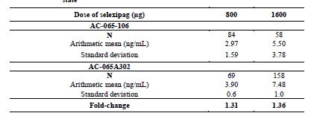
Table 54: Median trough plasma concentrations of ACT-333679 at steady state
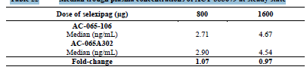
The comparison of median C_{trough,ss} of selexipag between Study AC-065-106 and GRIPHON at 800 and 1600 μg (Table 55) showed no more than a 1.2 fold increase in C_{trough,ss} values in PAH patients compared to those in healthy subjects [GRIPHON CSR]. Due to the very low and, therefore, highly variable trough concentrations of selexipag, a reliable comparison of arithmetic mean C_{trough,ss} values between the two studies was not possible.
Table 55: Median trough plasma concentration of selexipag at steady state
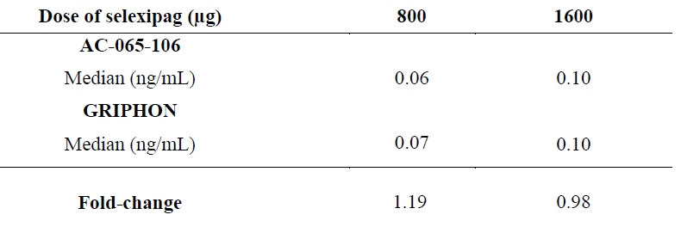

Evaluator’s Response
The evaluator is satisfied with the sponsor’s response.

Pharmacodynamics
Not applicable.

Efficacy

Question 1
Please comment on the clinical significance of a treatment effect in 6MWD of 12.0m?
Rationale for question:
The clinical significance of a treatment effect of 12.0m is unclear. It is noted that the sponsor has not pre-defined in the statistical analysis plan or protocol what would constitute a clinically relevant treatment effect. There are currently 3 approved IP receptor agonists for the treatment of PAH in Australia, and clinical results (in terms of 6MWT) described in the respective TGA-approved PI were, for epoprostenol: ‘Results of the 12-week study showed that exercise capacity was improved in the 56 patients treated with FLOLAN (median distance walked in 6 minutes, 316m at 12 weeks versus 270m at Baseline), but it decreased in the 55 patients treated with conventional therapy alone (192m at 12 weeks versus 240 m at Baseline; p<0.001 for the comparison of the treatment groups).’; for iloprost: ‘at week 12, at least 10% increase in the six minute walking distance as compared to baseline was noted in 37.6% of the iloprost group and 25.5% of the control group (p = 0.059).’; for treprostinil: ‘the median change from baseline on Remodulin was 10 metres and the median change from baseline on placebo was 0 metres, the median between-treatment difference over placebo was 16 metres.

Sponsor’s response
When comparing 6-minute walk distance (6MWD) results as observed in the GRIPHON study versus other studies, differences in endpoint definition, study design, patient demographics and baseline characteristics, and disease management have to be considered. Perhaps the most important difference between the referenced studies with IP-receptor agonists [Barst 1996, Olschewski 2002, Horn 2002] and GRIPHON is that these previous studies were conducted in a monotherapy setting in patients naïve to PAH-specific therapies. In contrast, in approximately 80% of patients in the GRIPHON study, the effect of selexipag on 6MWD was evaluated in combination with other PAH-specific therapies.
Three large studies provide consistent findings regarding what average placebo/control-adjusted 6MWD response can be expected with an endothelin receptor antagonist (ERA; macitentan in SERAPHIN [Pulido 2013], bosentan in COMPASS-2 [McLaughlin 2015]) or with selexipag (GRIPHON) in a mixed WHO FC II/III population with high prevalence of background PAH-specific therapy (64% in SERAPHIN, 100% in COMPASS-2, 80% in GRIPHON [including 32% of patients on two PAH background therapies]):
SERAPHIN (6 months): Median 15 m (97.5% CI: 2, 28)
COMPASS-2 (4 months): Median 13 m (95% CI: 3, 23)
GRIPHON (6 months): Median 12 m (99% CI: 1, 24)
In addition, the placebo-corrected median treatment effect on 6MWD in the subset of patients treated with selexipag as monotherapy in GRIPHON was 34 m (99% CI: 10, 63), providing clear evidence of an effect on exercise capacity similar to that reported from monotherapy studies in patients with WHO FC II/III [Gabler 2012].
Overall, these data do not provide any indication that the effect of selexipag on exercise capacity would be lower than that of currently approved PAH-specific medicines. Of more importance for a medicine aimed at delaying irreversible disease progression in PAH, the effect of selexipag on 6MWD was maintained over time in the long-term GRIPHON study. A significantly lower proportion of patients in the selexipag group (198 patients, 34.5%) compared to the placebo group (284 patients, 48.8%) experienced a drop (deterioration) in 6MWD ≥ 15% from baseline during the GRIPHON treatment period (sub-component of the primary endpoint). Landmark analysis [Anderson 1983] at 6 and 12 months identified a deterioration in 6MWD ≥ 15% as a strong risk factor for subsequent death (Figure 28).
Figure 28: Kaplan-Meier estimates of time of death from Month 6 up to Study closure (selexipag and placebo combined)-landmark analysis by occurrence or not of decline from baseline in 6MWD ≥ 15% prior to Month 6. Full Analysis Set, patient risk at Month 6
In summary, the effect of selexipag on exercise capacity (6MWD) is within the expected range in a population largely on treatment with PAH medicines. The observed treatment effect of selexipag as monotherapy is consistent with that observed with approved PAH medicines, including IP receptor agonists. The clinical relevance of the achieved 6MWD effect with selexipag is further supported by responder analysis in the GRIPHON study. The mentioned references are provided in updated Module 5.4 Literature References.

Evaluator’s response
The sponsor provided additional comment that the studies with the other 3 IP-receptor agonists were conducted in a monotherapy setting in patients naïve to PAH-specific therapies, whereas in the GRIPHON study, the effect of selexipag on 6MWD was evaluated in combination with other PAH-specific therapies in approximately 80% of study patients. The sponsor provided comparison in the placebo/control-adjusted 6MWD responses between studies on 2 endothelin receptor antagonists (macitentan in study SERAPHIN and bosentan in study COMPASS-2) and the GRIPHON study, where there was a high prevalence of background PAH-specific therapy in the study populations (64% in SERAPHIN, 100% in COMPASS-2, and 80% in GRIPHON). Results were comparable among the 3 studies (SERAPHIN [6 months]: Median 15 m [97.5% CI: 2, 28]; COMPASS-2 [4 months]: Median 13 m [95% CI: 3, 23]; GRIPHON [6 months]: Median 12 m [99% CI: 1, 24]). In addition, the sponsor looked at the placebo-corrected median treatment effect on 6MWD in the subset of patients treated with selexipag as monotherapy in GRIPHON (34 m [99% CI: 10, 63]), showing that the effect on exercise capacity was similar to that reported from monotherapy studies in patients with WHO FC II/III (Gabler 2012: a study which looked at data from ten randomised placebo-controlled trials previously submitted to the US Food and Drug Administration; meta-analysis showed an average difference in Δ6MWD of 22.4 m [95% CI: 17.4 to 27.5], favouring active treatment over placebo). The sponsor concluded that overall, these data do not provide any indication that the effect of selexipag on exercise capacity would be lower than that of currently approved PAH-specific medicines. The sponsor’s response to this question is considered to be adequate and has not resulted in any changes to the conclusions of the first round of evaluation.

Safety

Question 1
Please comment on whether there is any data that has looked at the reversibility of the effect of selexipag in haemoglobin concentrations, and provide these data or analyses results.
Rationale for question:
It is noted that the decreases from baseline of haemoglobin concentrations with selexipag were modest, appeared to occur within 3 months of the start of treatment and thereafter were not progressive over time. However, no data was presented with regards to reversibility of this effect. Knowing the reversibility of this effect would guide clinicians in the duration necessary in the monitoring of haemoglobin concentrations in patients who have ceased selexipag.

Sponsor’s response

Quantification of haemoglobin changes and anaemia adverse events (AEs) in the GRIPHON study
Compared to the general population, PAH patients have a higher incidence of co-morbidities, including cardiac failure and complications of connective tissue disease, as well as medications (such as ERAs) that predispose them to anaemia and/or bleeding. Iron deficiency has been frequently reported in idiopathic PAH patients [Rhodes 2011, Ruiter 2011].
Selexipag was shown to be associated with a modest increase in the incidence of AEs denoting anaemia compared to placebo (10.4% versus 8.0% in the selexipag and placebo groups, respectively) in the double-blind, placebo-controlled GRIPHON study (Safety analysis set) [Summary of Clinical Safety (SCS)].
Changes in haemoglobin concentration over time showed a small and non-progressive decrease within 3 months of treatment initiation [GRIPHON CSR] that is not considered to be clinically relevant. Up to Month 36, the greatest decrease from baseline at any time in median haemoglobin concentration was 3.0 g/L in the selexipag group and 1.0 g/L in the placebo group [Integrated Safety Analyses]. Furthermore there was no imbalance in the proportion of patients who received blood transfusion or had serious AEs of anaemia between the selexipag and placebo groups [SCS]. None of the anaemia events led to discontinuation of study treatment.
No haemoglobin values were collected beyond treatment cessation dates.

Reversibility of marked low haemoglobin values
In order to assess reversibility of treatment-emergent haemoglobin decreases, longitudinal data of patients presenting with a haemoglobin value of < 100g/L at any time were reviewed by the sponsor for a response to study drug dose reduction, iron substitution, and transfusions (Table 56).

Table 56: Summary of treatment-emergent marked laboratory abnormalities LL or LLL in haemoglobin and interventions, GRIPHON, Full analysis set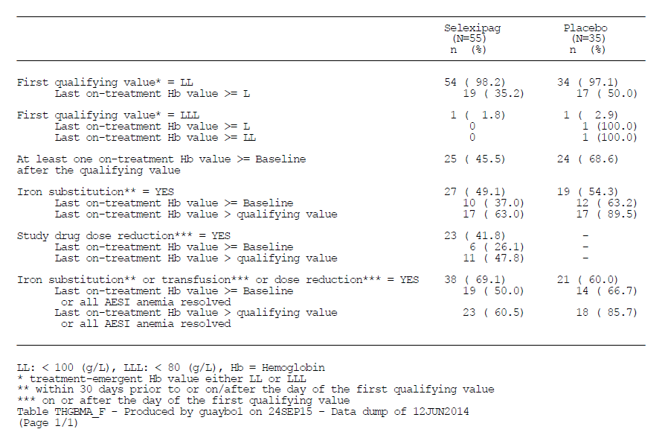
An improvement to a value ≥ 100 g/L without a record of initiated iron substitution or blood transfusion was observed in 15/55 (27.3%) of patients in the selexipag group at any time following the initial low value, suggesting some degree of spontaneous reversibility of anaemia. In the placebo treatment group, this was the case in 8 out of 35 patients (22.9%). Other factors did not show a consistent impact on the resolution of anaemia.
In conclusion, the observed onset of haemoglobin decrease within 3 months from the start of treatment and lack of worsening over time excludes a progressive underlying pathology. Reversibility of anaemia has been observed both with iron substitution and without any specific intervention. No specific guidance can be provided regarding monitoring of haemoglobin following selexipag cessation due to the lack of follow-up data. Given the small observed decrease in mean haemoglobin concentrations that reached clinical significance in a few patients only, the sponsor does not propose specific guidance or monitoring regarding haemoglobin.

Evaluator’s response
The sponsor performed additional analyses to assess reversibility of treatment emergent haemoglobin decreases by reviewing longitudinal data of patients presenting with a haemoglobin value of < 100g/L at any time, looking for a response to study drug dose reduction, iron substitution, and transfusions. Reversibility of anaemia (last on-treatment Hb value ≥ 100g/L) was observed with iron substitution in 17/55 (63%) of patients in the selexipag group and 17/35 (89.5%) in the placebo group. Following study dose reduction, reversibility of anaemia (last on-treatment Hb value ≥ 100g/L) was observed in 11/55 (47.8%) of patients in the selexipag group. An improvement to a value ≥ 100 g/L without a record of initiated iron substitution or blood transfusion was observed in 15/55 (27.3%) of patients in the selexipag group at any time following the initial low value (placebo group: 8/35; 22.9%), suggesting some degree of spontaneous reversibility of anaemia. The sponsor is of the opinion that no specific guidance can be provided regarding monitoring of haemoglobin following selexipag cessation due to the lack of follow-up data, and that given that the overall observed decreases in mean haemoglobin concentrations were small and mostly not reaching clinically relevant levels, the sponsor does not propose specific guidance or monitoring regarding haemoglobin. The sponsor’s response to this question is considered to be adequate and has not resulted in any changes to the conclusions of the first round of evaluation.

Table 57: Summary of treatment-emergent marked laboratory abnormalities LL or LLL in haemoglobin and interventions, GRIPHON, Full analysis set
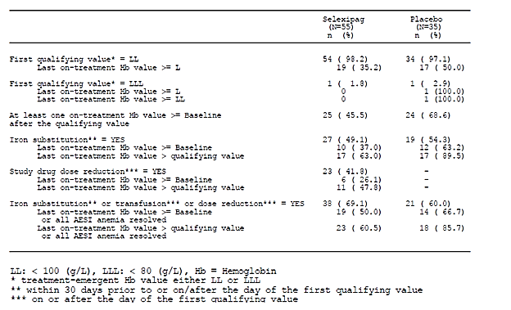

Question 2
Please provide safety results on subgroups of patients with baseline WHO FC I or II versus III or IV.
Rationale for question:
The sponsor is proposing use of selexipag for the treatment of PAH patients with WHO FC II to IV. It is noted that the majority of subjects in the pivotal study were of WHO FC II and III with only 1.0% (11/1156) in WHO FC IV, but that this reflects the composition of the target patient population in clinical practice and that subgroup analyses of the efficacy and safety endpoints in this small group of patients with baseline WHO FC IV would not have been viable in view of the very small sample size. The sponsor had performed efficacy subgroup analyses based on subgroups of baseline WHO FC I or II versus III or IV, and efficacy results were generally consistent with that of the overall study population. However, corresponding safety results comparing these subgroups were not provided.

Sponsor’s response
The positive benefit–risk assessment of selexipag is based primarily on the overall patient population in GRIPHON and is supported by the consistent efficacy and safety profile across all key subgroups. Additional safety data for World Health Organization (WHO) functional class (FC) I/II and III/IV are provided below.

Baseline demographics and PAH disease characteristics
The baseline characteristics and key demographic variables for the GRIPHON study population varied between patients in WHO FC I/II and WHO FC III/IV. In comparison to the FC III/IV patients, patients in FC I/II were younger (mean age 44.6 versus 51.1 years), lighter (mean weight 68.7 versus 73.3 kg), had a shorter median time since PAH diagnosis (0.9 versus 1.2 years), and a longer median 6MWD (394.5 versus 345.0 m). There were also differences in geographical distribution, with a higher proportion of FC I/II patients in Asia (26.0% versus 14.2%) and a lower proportion in Western Europe/Australia (18.2% versus 36.1%), compared to other regions.
The use of PAH-specific therapy at baseline differed between patients in WHO FC I/II and WHO FC III/IV. In the selexipag group, no PAH-specific therapy was reported for 26.6% in WHO FC I/II, compared to 12.8% in FC III/IV. Correspondingly, the use of two PAH-specific medicines was reported for a higher proportion of WHO FC III/IV patients (41.9%) compared to FC I/II patients (19.8%). Comparable trends were observed for the placebo group.
Previous and concomitant diseases at baseline Previous and concomitant diseases at baseline in patients in WHO FC I/II and WHO FC III/IV were generally comparable between the selexipag and placebo groups and were generally reported for a lower proportion of patients in WHO FC I/II compared to WHO FC III/IV. Differences were identified in the system organ class (SOC) Cardiac disorders, with a somewhat higher proportion of FC I/II patients randomised to selexipag presenting cardiac disorders at baseline (41.6% selexipag versus 34.4% placebo), compared to a higher proportion of WHO FC III/IV randomized to placebo presenting cardiac disorders at baseline (47.3% selexipag versus 50.5% placebo).

Dose
The analysis of IMD according to WHO FC I/II and III/IV showed no appreciable difference in IMD categories distribution between WHO FC cohorts.

Safety
Overall, the nature of reported AEs was similar in the WHO FC I/II and FC III/IV cohorts. Consistent with the information provided in the Adverse Effects section of the proposed PI, the most commonly reported adverse reactions related to the pharmacological effects of Uptravi are headache, diarrhoea, nausea and vomiting, jaw pain, myalgia, pain in extremity, arthralgia and flushing. The frequency of these events was similar in the WHO FC I/II and III/IV cohorts.
As for WHO FC III/IV, AEs reported in the WHO FC I/II subgroups associated with the mode of action of selexipag (that is, prostacyclin-associated AEs) were reported more frequently in the selexipag arm, whereas AEs associated with PAH were reported more frequently in the placebo group. Other AEs were reported in a comparable frequency between both treatment arms or showed only small differences (Table 58).

Table 58: Adverse events in ≥ 4% of patients in any group Safety analysis set, GRIPHON study

AEs leading to discontinuations
A total of 61 and 69 selexipag-treated patients in WHO FC I/II and III/IV, respectively, discontinued study drug treatment prior to study closure without having experienced a primary endpoint event]. The main reason reported was the occurrence of an AE, which was the reason reported for premature discontinuation of 31 and 41 patients in the WHO FC I/II and III/IV cohorts, respectively. In the placebo group, AEs were reported as the reason for premature discontinuation of study drug at a comparable frequency in the WHO FC I/II (17) and FC III/IV (16) cohorts.
In selexipag-treated patients in WHO FC I/II and III/IV, the most frequent AEs reported as leading to discontinuation of study medication more frequently than in the placebo group were headache, diarrhoea, nausea and myalgia. No apparent difference in these events was evident between the WHO FC cohorts (Table 59). These events are in line with the expected PD action of selexipag.
Table 59: Adverse events leading to study drug discontinuation ≥ 4 patients in any group Safety analysis set GRIPHON study

Serious adverse events
A lower proportion of selexipag-treated patients in WHO FC I/II had a serious adverse event (SAE) compared to those in FC III/IV (38.7% versus 48.6%, respectively). The placebo-adjusted frequency of SAEs by SOC in the selexipag group was generally comparable between the WHO FC I/II and FC III/IV cohorts. SAEs of the Cardiac disorders SOC were not more frequent in WHO FC I/II patients in either the selexipag or the placebo groups compared to WHO FC III/IV (WHO FC I/II: selexipag 8.2%, placebo 11.7%; WHO FC III/IV: selexipag 15.2%, placebo 15.3%).

Laboratory assessments
No appreciable differences for notable haematological laboratory abnormalities were apparent between the WHO FC I/II and FC III/IV cohorts in either the selexipag or the placebo group. For biochemistry abnormalities, no relevant differences between the selexipag group and placebo group were evident in WHO FC I/II patients.

Vital signs
The frequencies of notable vital sign abnormalities were comparable in the WHO FC I/II and FC III/IV cohorts for both the selexipag and the placebo groups.

Summary
In conclusion, observed differences in demographics and PAH background characteristics between WHO FC I/II and FC III/IV patients are expected and largely reflect patients’ disease stage. There is, however, evidence of a significant overlap between WHO FC II and III patients in baseline parameters reflecting disease severity. The safety profile of selexipag shows a general trend for overall less AEs and laboratory abnormalities as well as fewer serious AEs in FC II compared to FC III. This is also reflected in a notably lower number of discontinuations in FC I/II compared to III/IV. Taken together, the assessment of benefit-to-risk for selexipag in both WHO FC cohorts is considered to be positive. This has been demonstrated by a comparable effect size on the primary endpoint for both WHO FC cohorts, and a comparable safety and tolerability profile for WHO FC I/II compared to WHO FC III/IV.

Evaluator’s response
The sponsor performed additional analyses on subgroups of patients with baseline WHO FC I or II versus III or IV. Results were generally comparable between the 2 subgroups (Table 60). The percentages of selexipag patients with any AEs were 97.8% and 98.6% in the WHO FC I/II and III/IV groups, respectively. Similar to the safety results in the overall population, the most commonly reported AEs in the selexipag groups were headache (63.8% in WHO FC I/II versus 66.6% in WHO FC III/IV), diarrhoea (40.1% versus 44.6%) and nausea (33.0% versus 34.1%). The sponsor’s response to this question is considered to be adequate and has not resulted in any changes to the conclusions of the first round of evaluation.

Table 60: Adverse events in ≥ 4% of patients in any group, Safety analysis set. GRIPHON study
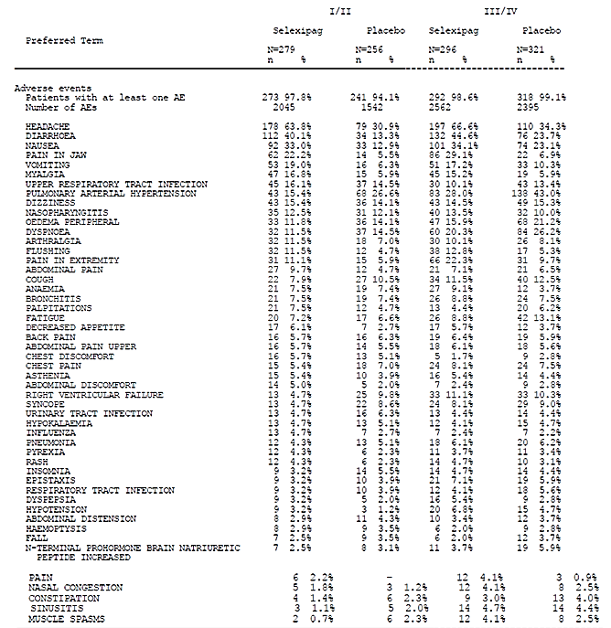

Second round benefit-risk assessment

Second round assessment of benefits
After consideration of the responses to clinical questions, the benefits of selexipag in the proposed usage are unchanged from those identified in the First round.

Second round assessment of risks
After consideration of the responses to clinical questions, the risks of selexipag in the proposed usage are unchanged from those identified in the First round.

Second round assessment of benefit-risk balance
The benefit-risk balance of selexipag, given the proposed usage, is favourable. The benefit-risk balance in the subgroups in the proposed indication of treatment of
- idiopathic pulmonary arterial hypertension
- heritable pulmonary arterial hypertension
- pulmonary arterial hypertension associated with connective tissue disease
- pulmonary arterial hypertension associated with congenital heart disease with repaired shunts
- pulmonary arterial hypertension associated with drugs and toxins
in adult patients with WHO functional class II, III or IV symptoms, to be used in combination with an endothelin receptor antagonist (ERA) or a phosphodiesterase-5 (PDE-5) inhibitor, or in triple combination with an ERA and a PDE-5 inhibitor, or as monotherapy
has been assessed and is found to be favourable.

Second round recommendation regarding authorisation
It is recommended that the application for the registration of selexipag be approved for the proposed indication of treatment of:
- idiopathic pulmonary arterial hypertension
- heritable pulmonary arterial hypertension
- pulmonary arterial hypertension associated with connective tissue disease
- pulmonary arterial hypertension associated with congenital heart disease with repaired shunts
- pulmonary arterial hypertension associated with drugs and toxins
- in adult patients with WHO functional class II, III or IV symptoms to be used in combination with an endothelin receptor antagonist (ERA) or a phosphodiesterase-5 (PDE-5) inhibitor, or in triple combination with an ERA and a PDE-5 inhibitor, or as monotherapy.

References
American heart association, ACCF/AHA 2009 Expert Consensus Document on Pulmonary Hypertension. Circulation, 119:2250-2294, 2009
Anderson JR, Cain KC, Gelber RD. Analysis of survival by tumor response. J Clin Oncol. 1983 Nov; 1(11): 710–9.
Barst RJ, Rubin LJ, Long WA, McGoon MD, Rich S, Badesch DB, et al. A comparison of continuous intravenous epoprostenol (prostacyclin) with conventional therapy for primary pulmonary hypertension. N Engl J Med 1996;334(5):296-302.
European Medicines Agency. Paediatric addendum to CHMP guideline on the clinical investigations of medicinal products for the treatment of pulmonary arterial hypertension, May 2010
European Medicines Agency. Guidelines on the clinical investigation of medicinal products for the treatment of Pulmonary Arterial Hypertension. October 2009
European Medicines Agency, Points to Consider on Application with 1. Meta-Analyses; 2. One Pivotal Study. 31 May 2001
European Society of Cardiology, Guidelines for the diagnosis and treatment of pulmonary. European Heart Journal, 30, 2493–2537, 2009
Farber HW, Loscalzo J, Pulmonary Arterial Hypertension. New England Journal of Medicine, 351:1655-65, 2004
Gabler NB, French B, Strom BLValidation of 6-minute walk distance as a surrogate end point in pulmonary arterial hypertension trials. Circulation. 2012 17; 126:349-56
Horn EM, Barst RJ. Treprostinil therapy for pulmonary artery hypertension. Expert Opin Investig Drugs. 2002 Nov;11(11):1615-22.
McLaughlin W, et al. Reduction in pulmonary vascular resistance with long-term epoprostenol (prostacyclin) therapy in primary pulmonary hypertension. New England Journal of Medicine, 338:273–7, 1998
lschewski H, Simonneau G, Galiè N, et al. Inhaled iloprost in severe pulmonary hypertension. N Engl J Med 2002;347:322-7.
Pulido T, Adzerikho I, Channick RN, et al. Macitentan and morbidity and mortality in pulmonary arterial hypertension. N Engl J Med 2013;369(9):809–18.Simonneau G, et al. Updated clinical classification of pulmonary hypertension. J Am Coll Cardiol vol. 54(1 Suppl):S43–54, 2009
Rhodes CJ, Wharton J, Howard L, Gibbs JS, Vonk-Noordegraaf A, Wilkins MR. Iron deficiency in pulmonary arterial hypertension: a potential therapeutic target. Eur Respir J. 2011;38(6):1453–1460.
Ruiter G, Lankhorst S, Boonstra A, Postmus PE, Zweegman S, Westerhof N, van der Laarse WJ, Vonk-Noordegraaf A. Iron deficiency is common in idiopathic pulmonary arterial hypertension. Eur Respir J. 2011;37(6):1386-91.

Therapeutic Goods Administration
PO Box 100 Woden ACT 2606 Australia
Email: info@tga.gov.au Phone: 1800 020 653 Fax: 02 6232 8605
https://www.tga.gov.au

Proposed Australian Product Information for Uptravi
Australian PI for epoprostenol, November 2014
Australian PI for iloprost, June 2013
Australian PI for treprostinil, July 2007
FDA Prescribing Information for Orenitram, December 2013
This study is ongoing at the time of this submission and interim data are presented
In this submission, the study results of Study AC065A303 is presented in the clinical study report (CSR) of Study AC065A302; however, the study results of Study NS-304/-03 was not provided separately. The sponsor has provided, in the summary of clinical safety, pooled safety data of 4 studies which included Study NS-304/-03 (studies AC-065A302, AC-065A303, NS-304/-02 and NS-304/-03).
estimated as
Study QGUY/2006/NS-304
Balke B. A simple field test for the assessment of physical fitness. Rep Civ Aeromed Res Inst US. 1963(53):1 - 8.
placebo
Except in Canada, France, the Netherlands, South Korea and the United Kingdom. In these countries, entry into Study AC-065A30e was to be limited to patients who had received study treatment until the end of Study AC065A302. For these patients on double-blind study treatment at study closure and willing to enter the open-label extension Study AC065A303, a treatment extension period (TEP) with continued double-blind treatment up to unblinding of the AC-065A302 database was available. The treatment-extension period was planned to be up to 3 months, from the EOS visit up to the End-of-Treatment-Extension (EOTE) visit following unblinding of the AC-065A302 database. The TEP did not collect efficacy information.
Modified NYHA/WHO classification of functional status of patients with PAH: Class I- Patients with pulmonary hypertension in whom there is no limitation of usual physical activity; ordinary physical activity does not cause increased dyspnoea, fatigue, chest pain, or presyncope; Class II- Patients with pulmonary hypertension who have mild limitation of physical activity. There is no discomfort at rest, but normal physical activity causes increased dyspnoea, fatigue, chest pain, or presyncope; Class III- Patients with pulmonary hypertension who have a marked limitation of physical activity. There is no discomfort at rest but less than ordinary activity causes increased dyspnoea, fatigue, chest pain, or presyncope; Class IV- Patients with pulmonary hypertension who are unable to perform any physical activity at rest and who may have signs of right ventricular failure. Dyspnoea and/or fatigue may be present at rest and symptoms are increased by almost any physical activity.
patients had to have been on a stable dose for at least 1 month prior to Baseline visit, and the dose was to remain unchanged during study treatment up to Week 26 (Month 6).
European Medicines Agency. Guidelines on the clinical investigation of medicinal products for the treatment of Pulmonary Arterial Hypertension. October 2009
Simonneau G, Robbins IM, Beghetti M, et al. Updated clinical classification of pulmonary hypertension. J Am Coll Cardiol vol. 54(1 Suppl):S43–54, 2009
MM events were adjudicated by an independent CEC blinded to study treatment allocation and to the occurrence of any prostacyclin-associated AEs. The CEC consisted of three independent PAH experts, who were not involved as investigators in the study.
Hospitalisation for worsening of PAH based on predefined criteria was defined as any non-elective hospital stay (≥ 24 h) for worsening of PAH. Worsening of PAH included signs and symptoms of right heart failure (e.g. syncope or near syncope, cyanosis, increase of breathlessness, clinically relevant deterioration of exercise capacity, decrease of oxygen saturation, increased peripheral oedema, hepatomegaly, and ascites)
Chronic oxygen therapy was defined as a continuous use (24 hours, 7 days per week) of oxygen, with the intention of maintaining the therapy long term
Patients in NYHA/WHO FC III at baseline were qualified for both disease progression definitions. For patients in NYHA/WHO FC I at baseline, the disease progression component was not defined in the protocol. Sites which had enrolled patients with baseline NYHA/WHO FC I and the CEC were informed and instructed to respectively report and adjudicate disease progression events for these patients as per criteria applicable for NYHA/WHO FC II.
A 6-minute walk test (6MWT) at Week 26 was considered as “at trough” if the date of last selexipag administration prior to the 6MWT at Week 26 was the day before the date of the 6MWT at Week 26 or on the same date (and there was at least 12 hours between the last selexipag intake and the 6MWT). If the 6MWT at Week 26 corresponded to a 6MWT performed at a Clinical worsening event visit, the 6MWT was considered by default at trough.
The CAMPHOR questionnaire has been developed to assess patient-reported outcome in patients with PAH. It consists of 3 sections (Symptoms, Activities, and Quality of Life). The symptom (impairment) score contains 25 negatively weighted items consisting of three sub-scales related to energy (10 items), breathlessness (8 items) and mood (7 items). The sub-scale “Breathlessness” of CAMPHOR “Symptoms” was defined as the sum of the “Breathlessness” items 11 to 18. It ranged from 0 (good) to 8 (poor).
The CAMPHOR “Symptoms” score was defined as the sum of the “Symptoms” items 1 to 25. It ranged from 0 (good) to 25 (poor).
Eye disorders were identified as a safety topic of special interest on the basis of non-clinical findings of tortuosity and dilatation of retinal blood vessels in rats at the end of a 2-year carcinogenicity study. As a result, an ophthalmology sub-study was introduced in Global Protocol Amendment 3 of Study AC065A302. The safety assessments introduced in the sub-study included fundoscopy with digital pictures at the Baseline/Randomisation Visit, Month 12 and EOS Visit (or discontinuation of study drug treatment).
For randomised patients who received at least one intake of study drug and who did not consent to the post-treatment observation period (PTOP): minimum (date of last study drug intake in the AC-065A302 treatment period plus 7 days, EOS visit date, date of last contact, analysis cut-off date of AC-065A302 [i.e. 27 April 2014]) minus date of randomisation plus 1 day; for randomised patients who received at least one intake of study drug and who did consent to the PTOP: minimum (date of last study drug intake in the AC-065A302 treatment period plus 7 days, date of last contact, 27 April 2014) minus date of randomisation plus 1 day; for randomised patients who did not receive any study drug: minimum (maximum [EOS visit date, randomisation date], date of last contact, 27 April 2014) minus date of randomisation plus 1 day.
American Heart Association, ACCF/AHA 2009 Expert Consensus Document on Pulmonary Hypertension. Circulation, 119:2250-2294, 2009
Farber HW, Loscalzo J, Pulmonary Arterial Hypertension. New England Journal of Medicine, 351:1655-65, 2004
Overall, 47 CEC-confirmed MM events in 47 patients (16 in selexipag group and 31 in placebo group) were initially excluded. Subsequently, 2 of the 47 patients (1 in each group) had a CEC-confirmed MM event after 16 Aug 2011. Therefore 45 patients were actually censored for the primary analysis. The patients contributed information up to the event (time of censoring).
The Borg dyspnoea index rates dyspnoea severity on a scale from 0 (no shortness of breath) to 10 (very, very severe shortness of breath).
Seven centres in Europe (one centre per country in Austria, Belgium, France, Germany, Hungary, Italy, and Poland)
Diagnosis of PAH should have been established according to the following criteria: resting mPAP > 25 mmHg; PVR > 240 dyn·s/cm⁵; PCWP or left ventricular end diastolic pressure < 15 mmHg.
ERAs and PDE-5 inhibitors had to have been used at a stable dose for more than 12 weeks before screening.
Patients should have a confirmed diagnosis of PAH based on the following right heart catheterisation criteria: resting mPAP ≥ 25 mmHg; PCWP or left ventricular end-diastolic pressure (LVEDP) < 15 mmHg
mean right atrial pressure (mRAP), mPAP, cardiac output (CO), cardiac index, pulmonary vascular resistance index (PVRI), total pulmonary resistance (TPR) and mixed venous saturation (SvO2)
Events defined for clinical worsening were: death (regardless of the cause), hospitalisation due to worsening of PAH, worsening of PAH requiring lung transplant or balloon atrial septostomy, initiation of continuous infusion of PGI₂ or long-term oxygen therapy due to worsening of PAH, decrease by ≥ 15% in 6MWD from baseline in 2 or more tests conducted within 2 weeks and worsening of WHO functional class (for class II or III patients at Visit 1), decrease by ≥ 15% in 6MWD from baseline in 2 or more tests conducted within 2 weeks and necessity of additional medications for PAH (for class III or IV patients at Visit 1).
Components of composite primary efficacy endpoint: death (all causes); hospitalisation due to worsening of PAH; worsening of PAH requiring lung transplant or balloon atrial septostomy; worsening of PAH requiring initiation of parenteral infusion of PGI₂ or long-term oxygen therapy; disease progression confirmed by decrease by ≥ 15% in 6MWD from baseline (in 2 or more tests conducted on different days within 2 weeks) and worsening of WHO FC (for patients in NYHA/WHO FC II or III at baseline); disease progression confirmed by decrease by ≥ 15% in 6MWD from baseline (in 2 or more tests conducted on different days within 2 weeks) and necessity of additional PAH-specific therapy (for patients in NYHA/WHO FC III or IV at baseline).
Time from randomisation to first MM event (excluding “disease progressionˮ) up to EOT +7 days; time from randomisation to first MM event (excluding “disease progressionˮ) up to study closure; time from randomisation to first MM event (excluding “disease progressionˮ and “initiation of parenteral prostanoid therapy or chronic oxygen therapy due to worsening of PAHˮ) up to EOT +7 days; time from randomisation to first MM event (excluding “disease progressionˮ and “initiation of parenteral prostanoid therapy or chronic oxygen therapy due to worsening of PAHˮ) up to study closure.
‘Prostacyclin-associated AEs’ were defined by the following preferred terms: pain in jaw/ temporomandibular joint syndrome/ arthralgia/ musculoskeletal pain/myalgia/ pain in extremity; flushing; nausea/vomiting; diarrhoea; headache; dizziness
These additional safety assessments were added in global protocol amendment 3 due to findings of tortuosity and dilation of retinal vessels (not accompanied by histopathological findings) at Week 104 in a long-term toxicity study in rats.
Alanine aminotransferase (ALT), aspartate aminotransferase (AST), alkaline phosphatase, total and direct bilirubin, serum creatinine, estimated creatinine clearance (Cockcroft-Gault equation), urea, glucose (irrespective of fasting status), sodium, potassium, and albumin.
Additional safety assessments of thyroid markers to be performed on all newly enrolled patients were added in global protocol amendment 3 due to a finding of non-malignant thyroid hyperplasia in a 2-year carcinogenicity study in mice.
It is to be noted that patients who were previously on selexipag in Study AC-065A302 and entered Study AC-065A303 did not start selexipag at their IMTD in Study AC065A302, but started selexipag at the starting dose of 200 mcg bd and then were up-titrated again.
This may include patients for whom death occurred beyond 30 days after EOT.
Marked abnormality in Hb defined as Hb< 100 g/L; alert abnormality in Hb defined as Hb <80 g/L.
The SMQ retinal disorders grouping was a subset of the SOC eye disorders and included a number of broad and non-specific PTs that were not specific to the retinal vasculature e.g. eye disorder, blurred vision and reduced visual acuity.
A major bleeding event was defined as the occurrence of at least one of the following events: fatal bleeding; symptomatic bleeding in a critical area or organ, such as intracranial, intra-spinal, intraocular, retroperitoneal, intra-articular, or intramuscular with compartment syndrome; bleeding causing a fall in haemoglobin level of at least 20 g/L (1.24 mmol/L) leading to transfusion of two or more units of whole blood or red cells.
Three out of the 4 serious cases in selexipag-treated patients had a medical history of congenital heart disease and the fourth had a medical history of mitral valve incompetence, rheumatoid arthritis with vasculitis and essential hypertension; the one patient in the placebo group had a medical history that included factor V Leiden mutation and atrial septal defect
Of the 6 patients with anaemia SAEs in the selexipag group, 3 were in the context of haemorrhage, one had suspected myelodysplastic syndrome, one had presumed GI angiodysplasia and one had splenomegaly and hypersplenism; of the 3 patients in the placebo group, one had iron deficiency anaemia, and two had anaemia associated with haemoptysis.
ARGPM Guidance 15, section 15.9

