First round 31 March 2016
Second round September 2016

AusPAR Attachment 1

Extract from the Clinical Evaluation Report for Sodium zirconium cyclosilicate hydrate
  - Proprietary Product Name: Lokelma
  - Sponsor: AstraZeneca Pty Ltd

About the Therapeutic Goods Administration (TGA)
- The Therapeutic Goods Administration (TGA) is part of the Australian Government Department of Health, and is responsible for regulating medicines and medical devices.
- The TGA administers the Therapeutic Goods Act 1989 (the Act), applying a risk management approach designed to ensure therapeutic goods supplied in Australia meet acceptable standards of quality, safety and efficacy (performance), when necessary.
- The work of the TGA is based on applying scientific and clinical expertise to decision-making, to ensure that the benefits to consumers outweigh any risks associated with the use of medicines and medical devices.
- The TGA relies on the public, healthcare professionals and industry to report problems with medicines or medical devices. TGA investigates reports received by it to determine any necessary regulatory action.
- To report a problem with a medicine or medical device, please see the information on the TGA website < https://www.tga.gov.au>
About the Extract from the Clinical Evaluation Report
- This document provides a more detailed evaluation of the clinical findings, extracted from the Clinical Evaluation Report (CER) prepared by the TGA. This extract does not include sections from the CER regarding product documentation or post market activities.
- The words [Information redacted], where they appear in this document, indicate that confidential information has been deleted.
- For the most recent Product Information (PI), please refer to the TGA website < https://www.tga.gov.au/product-information-pi> .
Copyright
© Commonwealth of Australia 2018
This work is copyright. You may reproduce the whole or part of this work in unaltered form for your own personal use or, if you are part of an organisation, for internal use within your organisation, but only if you or your organisation do not use the reproduction for any commercial purpose and retain this copyright notice and all disclaimer notices as part of that reproduction. Apart from rights to use as permitted by the Copyright Act 1968 or allowed by this copyright notice, all other rights are reserved and you are not allowed to reproduce the whole or any part of this work in any way (electronic or otherwise) without first being given specific written permission from the Commonwealth to do so. Requests and inquiries concerning reproduction and rights are to be sent to the TGA Copyright Officer, Therapeutic Goods Administration, PO Box 100, Woden ACT 2606 or emailed to < tga.copyright@tga.gov.au> .

Contents
List of abbreviations 5
1. Introduction 7
2. Clinical rationale 7
3. Contents of the clinical dossier 7
3.1. Scope of the clinical dossier 7
3.2. Paediatric data 8
3.3. Good clinical practice 8
4. Pharmacokinetics 8
4.1. Studies providing pharmacokinetic data 8
4.2. Evaluator’s overall conclusions on pharmacokinetics 8
5. Pharmacodynamics 9
5.1. Studies providing pharmacodynamic data 9
5.2. Summary of pharmacodynamics 10
5.3. Evaluator’s overall conclusions on pharmacodynamics 13
6. Dosage selection for the pivotal studies 13
7. Clinical efficacy 14
7.1. Pivotal efficacy studies 14
7.2. Other efficacy studies 27
7.3. Analyses performed across trials (pooled analyses and meta-analyses) 28
7.4. Evaluator’s conclusions on clinical efficacy for treatment of hyperkalaemia (acute and extended) 29
8. Clinical safety 29
8.1. Studies providing evaluable safety data 30
8.2. Pivotal studies that assessed safety as a primary outcome 30
8.3. Patient exposure 30
8.4. Adverse events 31
8.5. Laboratory tests 35
8.6. Post-marketing experience 38
8.7. Evaluator’s overall conclusions on clinical safety 38
9. First round benefit-risk assessment 38
9.1. First round assessment of benefits 38
9.2. First round assessment of risks 38
9.3. First round assessment of benefit-risk balance 38
10. First round recommendation regarding authorisation 39
11. Clinical questions 39
12. Second round evaluation of clinical data submitted in response to questions 39
13. Second round benefit-risk assessment 41
13.1. Second round assessment of benefits 41
13.2. Second round assessment of risks 41
13.3. Second round assessment of benefit-risk balance 41
14. Second round recommendation regarding authorisation 42

List of abbreviations
Abbreviation | Meaning
ACE | angiotensin converting enzyme
AE | adverse event
BP | blood pressure
BUN | blood urea nitrogen
CKD | chronic kidney disease
FDA | United States Food and Drug Administration
g | grams
GI | gastrointestinal
HIV | Human Immunodeficiency Virus
IP | investigational product
ITT | intention to treat
KEC | potassium exchange capacity
LLOQ | lower limit of quantification
ml | millilitres
mmol/L | millimoles per litre
QD | once daily
QTc | corrected QT interval on ECG
RAAS | renin-angiotensin aldosterone system
SAE | serious adverse event
SK | serum potassium
SPS | sodium polystyrene sulfonate
TEAE | treatment-emergent adverse event
TID | three times daily
ZS | sodium zirconium cyclosilicate
ZS-9 | nonprotonated sodium zirconium cyclosilicate

Introduction
This is a Category 1 application, to register a new chemical entity sodium zirconium silicate (ZS) for the treatment of hyperkalaemia.
The product is a non-absorbed, insoluble, free flowing, odourless, tasteless, white crystalline mixable powder with a specific particle size distribution profile > 3 μm (mean particle size 20 μm) and no inactive ingredients. It is an inorganic cation exchange agent with a high capacity to selectively entrap monovalent cations, including potassium ions, in exchange for sodium ions, as it traverses the GI tract. It does not selectively trap divalent cations such as calcium and magnesium.
The proposed indication is “for the treatment of hyperkalaemia (acute and extended use)”.

Clinical rationale
Sodium zirconium silicate is an insoluble, non-absorbable inorganic crystalline compound that binds potassium ions in exchange for hydrogen and sodium cations. It binds potassium ions throughout the gastrointestinal tract, and the trapped potassium ions are excreted from the body, together with the ZS, in the faeces. Serum potassium concentration is closely correlated with potassium concentration of intestinal fluid. The binding of potassium within the GI tract, and its subsequent elimination from the body, therefore results in a reduction in serum potassium concentration. In vitro, it has been shown to absorb approximately ten fold the amount of potassium as the currently most used therapy for hyperkalaemia (sodium polystyrene sulfonate, SPS). It is also proposed that the rate of onset of the effect of ZS on serum potassium is more rapid than that of SPS because it commences entrapment of potassium ions in the upper GI tract, unlike SPS, which has its effect within the colon.
The formulation consists of the active ZS only, with no excipients.

Contents of the clinical dossier

Scope of the clinical dossier
The submission contained the following clinical information:
- two clinical pharmacology studies, including none that provided pharmacokinetic data and two that provided pharmacodynamic data:
  - one Phase I study (ZS-006) to characterize the effects of ZS on sodium and potassium excretion in 30 healthy subjects on a fixed, low-sodium and high-potassium diet
  - one double blind, placebo controlled Phase II study (ZS-002)
- one completed pivotal Phase III efficacy/safety double blind, placebo controlled study (EUZS-003) and one open label, non comparative acute phase study (ZS-004) with a pivotal double blind, placebo controlled maintenance phase; ZS-004 also included urine and blood sampling to demonstrate lack of systemic absorption of ZS
- one uncontrolled efficacy/safety open label, long term extension of ZS-004 (ZS-004E)
- one ongoing long term open label Phase III study of efficacy and safety up to 12 months, with a randomized, double blind, placebo controlled, withdrawal study in a subset of patients (ZS-005); interim data as of 15 July 2015 are available in the dossier
Clinical Overview, Summary of Clinical Efficacy, Summary of Clinical Safety and literature references.

Paediatric data
The submission did not include paediatric data, and the currently requested indication is for the treatment of hyperkalaemia in adult patients. No formal justification as to why the product is not appropriate for use in children has been included. The sponsor has an agreed Paediatric Investigation Plan (PIP) in Europe, which requires submission of a report of a study conducted in paediatric patients by January 2021. An agreed Paediatric Plan in the USA requires submission of a Phase I study in 2017. Therefore, no such studies are included in this dossier.

Good clinical practice
Certification is included that indicates that all clinical studies were undertaken according to GCP.

Pharmacokinetics

Studies providing pharmacokinetic data
ZS is an inorganic, insoluble compound that is not systemically absorbed following oral administration. A study in dogs demonstrated that there was no significant absorption of ZS or zirconium following dosing up to 2 g/kg/day for 9 months. An in vivo mass balance study in rats showed that ZS was recovered in the faeces at > 99% of administered dose. Non-absorption was confirmed in the acute phase of clinical study ZS-004. The site of action of ZS is within the GI tract, and its activity does not require absorption or distribution. Pharmacokinetic studies in human subjects, apart from the demonstration that systemic absorption does not occur, are therefore not required.
Subjects from Study ZS-004 at selected sites within the US, receiving placebo (n = 17) or ZS at doses of 5 g, 10 g or 15 g QD (n = 9, 10 and 10 respectively) had collections of urine and blood for analysis of zirconium (Zr). These results have been analysed and referred to as Study BR-01519. The urinary Zr concentrations were below the lower level of quantification (LLOQ) in all but two subjects, one receiving placebo, and one receiving 5 g QD. Retesting of these samples returned a result < LLOQ in both cases. The assay was appropriately sensitive. Similarly, the Zr concentration in blood samples were below the LLOQ in all but one subject (receiving ZS 10 g QD). These data provide confirmation that there is negligible systemic absorption of ZS during administration to humans.
No tabulation or summaries of pharmacokinetic studies are provided in this report and this is appropriate.

Evaluator’s overall conclusions on pharmacokinetics
Adequate evidence is provided to support the conclusion that the compound is not absorbed systemically, and that the site of action is within the gastrointestinal lumen. Therefore, there is no requirement for any further consideration of pharmacokinetics, and no pharmacokinetic data have been provided.

Pharmacodynamics

Studies providing pharmacodynamic data
Summaries of the pharmacodynamic studies were provided. Table 1 shows the studies relating to each pharmacodynamic topic.

Table 1: Submitted pharmacodynamic studies
PD Topic | Subtopic | Study ID | *
Primary Pharmacology | Effect on sodium and potassium excretion in healthy subjects  Acute effect on serum potassium in hyperkalaemic patients  Acute effect on serum potassium in hyperkalaemic patients | ZS-006  ZS-002 (Acute phase)  EUZS-003 (Acute phase) | *  *
Primary Pharmacology | Maintenance of normokalaemia | EUZS-003 (Maintenance phase)
Primary Pharmacology |  | ZS-004 (Maintenance Phase)
Secondary Pharmacology | Effect of food on activity of ZS | ZS-002 (Acute phase)
Gender, Age-Related, and other Differences in PD Response | Effect of gender | EUZS-003  ZS-004
Gender, Age-Related, and other Differences in PD Response | Effect of age | EUZS-003  ZS-004
Gender, Age-Related, and other Differences in PD Response | Effect of baseline SK | EUZS-003  ZS-004
* Indicates the primary aim of the study.
None of the pharmacodynamic studies had deficiencies that excluded their results from consideration.

Summary of pharmacodynamics
The information in the following summary is derived from conventional pharmacodynamic studies in humans unless otherwise stated.

Mechanism of action
The potassium exchange capacity (KEC) of ZS has been investigated in in vitro studies in which a 112 mg sample of ZS was added to 20 ml of a potassium standard solution containing 2000 ppm of potassium. After 2 hours of gentle agitation at room temperature, the mean KEC of various batches of ZS used in the clinical trials was calculated to be between 2.3 to 3.5 MEq/g.
In Study ZS-002, hyperkalaemic patients received their first dose of ZS in the fasting state, while in EUZS-003 and ZS-004, the first dose was administered with food. Thus the effect of food on the activity of ZS can be inferred from a cross-study comparison of the mean change in SK from baseline at one hour after the first dose (see Table 2). The most relevant comparison is between the studies in which there was an upper limit on the severity of hyperkalaemia permitted at baseline, Studies ZS-002 and EUZS-003, and it is evident that there was a very similar reduction in SK in both studies. The sponsor concludes that this independence of the presence of food indicates that ZS has its effect primarily via binding potassium in intestinal fluid and this is reasonable.

Table 2: Combined data: acute dosing. Mean change in serum potassium from baseline at selected time points after the first dose of study drug (Acute Phase for studies ZS-002, EUZS-003, and ZS-004, ITT Population)
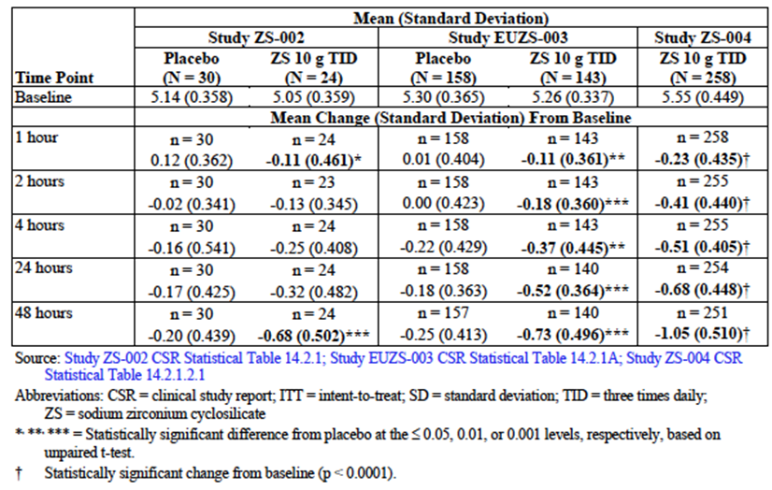
Sufficient evidence has been provided to demonstrate that ZS binds potassium both in vitro and in vivo, and that its therapeutic effects are predominantly due to removal of potassium from intestinal fluid, which is in equilibrium with blood plasma, thus leading to a reduction in circulating serum potassium.

Pharmacodynamic effects

Primary pharmacodynamic effects
The primary pharmacodynamics effect of ZS is to bind potassium within the intestinal lumen. This has been demonstrated in Study ZS-006 in healthy subjects receiving a standardized intake of sodium and potassium (see Summary in Table 3). Compared with baseline measurements, administration of ZS led to a statistically significant increase in faecal excretion of potassium (Table 4), which is numerically greater for the 10 g dose than the 5 g dose, although no direct statistical comparison has been carried out. Serum potassium is then reduced because of the equilibrium between serum and intestinal fluid in relation to electrolytes. In this study, serum potassium was significantly reduced in the group receiving 10 mg ZS but not in the group receiving 5 g.

Table 3: Summary of Study ZS-006 (subjects, objectives and treatments)
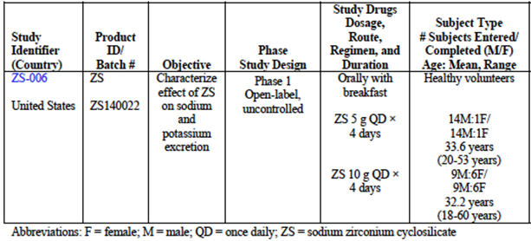

Table 4: Urinary and faecal potassium excretion and serum potassium (Study ZS-006)
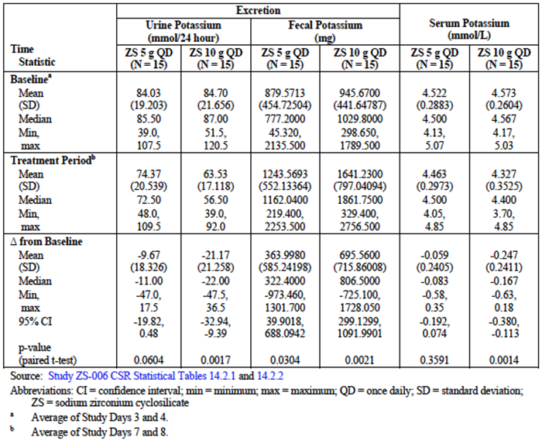

Time course of pharmacodynamic effects
In three studies, measurements of SK were made at one hour after the first dose of ZS (Table 2), and show a statistically significant reduction. Further characterization of the time course was carried out in Studies ZS-002, EUZS-003 and ZS-004, and demonstrated that the most rapid lowering of SK is seen within the first 4 hours after the initial dose, and a slower rate of reduction then continues over the next 48 hours.

Relationship between drug concentration and pharmacodynamic effects
The drug is not absorbed systemically and therefore plasma drug concentration is not relevant. However, a clear dose response relationship was demonstrated in the acute phase of Study ZS-002 and in the maintenance phase of Study ZS-004.

Genetic, gender and age related differences in pharmacodynamic response
A sub-population analysis was performed in Studies EUZS-003 and ZS-004, including age, gender, race, geographic region, baseline renal function, baseline SK, concomitant diseases, and use of renin-angiotensin-aldosterone system inhibitor medication. No clinically relevant differences in response were observed in either the acute or maintenance phases.

Pharmacodynamic interactions
No in vivo drug interaction studies have been performed. This is generally appropriate because of the mechanism of action. Subgroup analyses showed that the effect of ZS was not altered by the presence of drugs that inhibit the renin-angiotensin-aldosterone system.

Evaluator’s overall conclusions on pharmacodynamics
Sufficient evidence has been submitted to demonstrate that ZS has its effect by binding potassium in intestinal fluid, causing it to be excreted bound to the ZS in faeces. This results in a rapid reduction in SK. There are no clinically relevant differences in the pharmacodynamics effect of ZS in different subgroups of patients divided by age, gender or other characteristics. There is a clear dose response relationship in the maintenance phase of management of hyperkalaemia.

Dosage selection for the pivotal studies
Dose-ranging studies were carried out in the acute phases of three clinical studies. Given that the compound is not absorbed and there is therefore no issue of systemic toxicity, this is a reasonable approach. The choice of initial doses in Study ZS-002 was based on the in vitro finding that ZS was approximately 10 times more effective than sodium polystyrene sulfonate (SPS), a potassium binding resin used for the management of hyperkalaemia, in exchanging potassium cations in the presence of physiological levels of magnesium and calcium. It also took into account the results of 14 day oral toxicity studies performed in rats and dogs. The recommended oral dose of SPS in mild hyperkalaemia is 15 g once daily, and the extrapolated dose of ZS for initial investigation in hyperkalaemic subjects (0.3 g TID) is therefore less than 10% of the daily dose of SPS, thus providing an adequate safety margin. The additional doses tested in ZS-002 were 3 g and 10 g TID.
Subsequent doses investigated in the pivotal studies were based on the results of the early dose ranging studies. In Study ZS-002, doses of 0.3 g TID, 3 g TID and 10 g TID were used. All subjects were mildly hyperkalaemic for a variety of reasons, and all (n = 12 in the first cohort, and 24 in each of the other two) completed the study. Only the highest dosage resulted in statistically significantly greater mean reductions in SK (the primary outcome) compared with placebo. Secondary outcomes supported the results of the primary outcome. The time to first reduction in SK by 0.5 mmol/L was significantly lower for the high dose group than placebo, but not so for the other two dosage groups. Following administration of the fourth dose, a statistically significantly larger number of subjects in the high dose group (58.3%) had achieved a ≥ 0.5 mmol/L reduction in SK, compared to the placebo (17.2%), lowest dose (16.7%) and middle dose (26.1%) groups (Table 5 in Study ZS-002 report). The pivotal efficacy studies used a range of doses, from 1.25 g to 10 g TID in Study EUZS-003 and 10 g TID in Study ZS-004. This dose is adequately supported by the early phase studies.

Table 5: Proportion of serum potassium (mmol/L) abnormal values over time (Intent-to-Treat population)
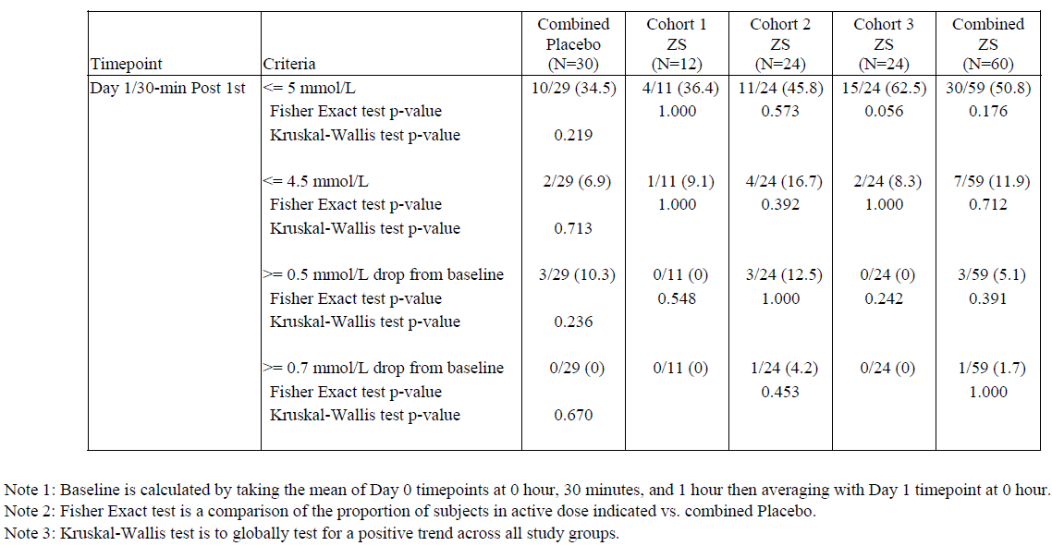

Clinical efficacy
There were two 2 pivotal (double blind, placebo controlled) studies assessing the clinical efficacy of ZS in the acute lowering of SK with TID dosing (Studies ZS-002 and EUZS-003) and two pivotal (double blind, placebo controlled, randomized withdrawal studies for maintenance of normokalaemia with once daily dosing (EUZS-003, ZS-004). An open label, non-comparative, long term (11 months) study provided supportive efficacy data but is not considered in detail in this section and is more applicable to consideration of safety (ZS-004E).

Pivotal efficacy studies
Pivotal efficacy studies for treatment of hyperkalaemia (acute and extended).

Study ZS-002 (Acute treatment of hyperkalaemia)

Study design, objectives, locations and dates
Randomized, placebo controlled, double blind, dose escalating study, investigating safety, tolerability and pharmacodynamics of three different doses of ZS administered 3 times daily to patients with mild hyperkalaemia and moderate kidney dysfunction. Conducted at 9 centres in the US from November 2011 to May 2012.

Inclusion and exclusion criteria
Subjects with mild hyperkalaemia (SK between 5.0 and 6.0 mmol/L) and moderate CKD (GFR initially between 40 to 60 ml/min, expanded during the study to between 30 to 60 ml/min); exclusion criteria included pseudo-hyperkalaemia (for example hydrolysed blood specimen), treatment with lactulose, rifazimin or other non-absorbed antibiotics for hyperammonaemia within the last 7 days, treatment with resins including SPS within the last 7 days, life expectancy of less than 3 months, HIV positive status, severe physical or mental incapacity resulting in inability to perform the tasks required by the protocol, women who were pregnant, lactating or planning to become pregnant, ketoacidosis/acidaemia, cancer within the last 5 years, presence of any condition that placed the subject at undue risk, known hypersensitivity to ZS, cardiac arrhythmias requiring immediate treatment, ECG changes associated with hyperkalaemia, acute kidney injury.

Study treatments
Cohorts of subjects received escalating doses of ZS (0.3 g, 3 g, or 10 g TID or matching placebo, mixed with 180 mL of purified water and given orally as a suspension); dosed in fasting state for first dose on study Day 1, and with meals thereafter for at least 48 hours and up to 96 hours in subjects whose SK had not normalized.

Efficacy variables and outcomes
The main efficacy variables were:
- serum potassium (SK)
The primary efficacy outcome was the difference in the exponential rate of change in SK during the initial 48 hours of study drug treatment between placebo-treated subjects and ZS treated subjects.
Other efficacy outcomes included:
- mean changes in SK over 48 hours in treated groups compared with placebo group
- SK levels at other individual times points
- time to normalization of SK
- time to a decrease in SK of 0.5 mmol/L
- proportion of subjects achieving normalization in SK levels at the end of 48 hours
- urinary excretion of sodium, potassium and urea nitrogen

Randomisation and blinding methods
A blocked randomization scheme was used, with a random block size (of 3 or 6) and separate randomization strata for each of the three cohorts and for each study site within each cohort. A centralized randomization scheme was used for randomization to study arm per cohort, and this was maintained in a data file outside the clinical database. Following enrolment of each subject a phone call was made to the central facility to access the randomization code and treatment designation, which was available only to the pharmacist and unblinded pharmacy staff preparing the blended investigational product (IP) samples. All other study staff were blinded to treatment allocation. All IP was provided in identical appearing dosing bottles labelled with a unique numeric code. The placebo was silicified microcrystalline cellulose, a white powder with the same appearance, taste, odour and mode of administration as ZS. These methods were rigorous and appropriate.

Analysis populations
All subjects who enrolled also completed the study and were analysed. Thus the ITT population used for the efficacy and safety analysis included all enrolled subjects.

Sample size
Ninety subjects were randomized to three cohorts. Cohort 1 included 12 receiving 0.3 g of ZS per dose and 6 receiving placebo. Cohorts 2 and 3 included 24 subjects receiving 3 g and 10 g respectively, and 12 subjects receiving placebo. The overall sample size was adequate to provide statistical power to detect clinically significant differences between placebo and the three dosing levels.

Statistical methods
The exponential rate of decline of SK levels over 48 hours was calculated for each subject using a longitudinal model and SAS PROC MIXED. Time to normalization of SK levels as well as time to a decrease of 0.5 mmol/L in SK levels was tested using a Wilcoxon-Gehan test to compare each ZS dose versus combined placebo controls. A 2-sided Fisher’s exact test was used to compare each ZS dose with placebo for the proportion of subjects in the different groups who reached normal SK levels at specified times. These methods were appropriate.

Participant flow
No enrolled subjects withdrew from the study.

Major protocol violations/deviations
There were no major protocol deviations (this assessment was determined before the blind was broken).

Baseline data
Baseline data for SK were based on three separate blood draws taken 30 minutes apart at the screening visit.

Results for the primary efficacy outcome
The exponential rate of change of SK to 48 hours is shown in Table 6. The rate of change was statistically significantly greater for the 10 g ZS dosing group compared with placebo. The mean serum potassium over 48 hours is shown in Figure 1.

Table 6: Statistical model of serum potassium (mmol/L) exponential rate of change to 24 hours and 48 hours. From Table 11-4, ZS-002 Study report
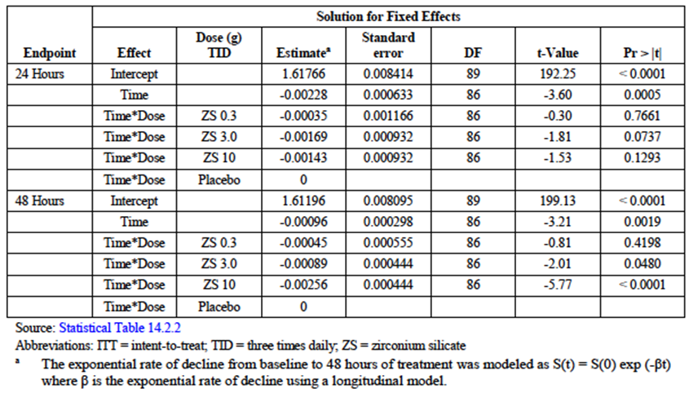
Figure 1: Mean serum potassium over 48 hours – ITT population (Study ZS-002)
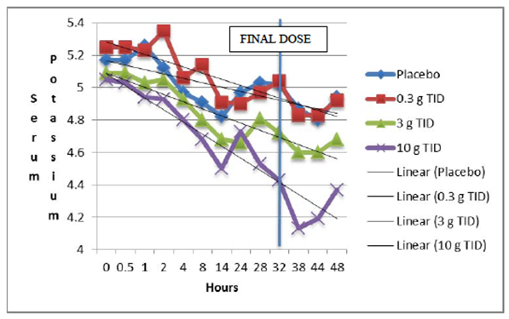

Results for other efficacy outcomes
Other efficacy outcomes supported the result of the primary outcome. At 48 hours, the mean reduction in SK (placebo subtracted) was 0.15 and 0.48 mmol/L for the medium and high dose groups, respectively. The proportion of subjects with a > 1 mmol/L reduction in SK was 41.7% for the high dose group, compared with 3.4% of the placebo subjects at the 38 hour time point. The time to a decrease of 0.5 mmol/L in SK was significantly shorter in the high dose group compared with the placebo group, such that by 24 hours, over 70% of the ZS subjects had achieved this, compared with about 55% of the placebo group. Normalization of SK levels also occurred statistically significantly more rapidly in the ZS 10 g group compared with the placebo group.
Overall, this study has demonstrated that ZS 10 g TID produces significant reductions in SK in mildly hyperkalaemic subjects with chronic kidney disease.

Study EUZS-003 (Acute and extended treatment of hyperkalaemia)

Study design, objectives, locations and dates
This study was designed to examine both the acute lowering of SK (using a TID dose for 48 hours, as proposed) and the maintenance of normokalaemia (using a QD dose, as proposed). It had a randomized, double blind, placebo controlled design for the acute phase, with four different doses of ZS being given, and a randomized, double blind, placebo controlled withdrawal design for the subacute phase, again testing four different doses of ZS. The objectives were to assess safety and efficacy of four different doses of ZS given TID for 2 days in the acute phase for the lowering of SK, and safety and efficacy of four different doses of ZS given QD for 12 days in the subacute phase, for the maintenance of normokalaemia. It was carried out at 65 sites in the US, Australia and South Africa from November 2012 to October 2013.

Inclusion and exclusion criteria
For the acute phase, the subjects were adult patients with mild to moderate hyperkalaemia (mean of three SKs between 5.1 and 6.5 mmol/L), in most cases secondary to chronic kidney disease with or without ACE inhibitor treatment. Major exclusion criteria included severe illness, HIV, pregnancy or lactation, ketoacidosis, hypersensitivity to ZS, cardiac arrhythmias requiring immediate treatment, insulin dependent diabetes mellitus, dialysis, treatment with other medical management for hyperkalaemia within the last 7 days.
The subacute phase included subjects who had completed the acute phase and were normokalaemic after 48 hours of treatment with ZS or placebo. Those subjects who had received ZS in the acute phase were randomized to receive the same dose of ZS once daily or placebo, while those who had received placebo in the acute phase were randomized to receive ZS at a dose of either 1.25 g or 2.5 g daily. Decisions regarding eligibility were made based on point-of-care testing (i-STAT), and central laboratory measurements subsequently showed that 22% of subjects entered into this phase did not have SK within the predetermined normal range, but this protocol violation is not likely to have influenced the results of the study.

Study treatments
The acute phase study treatments (with number of subjects) were the following doses, administered three times daily for 48 hours:
- Placebo (n = 158); note that the placebo was silicified microcrystalline cellulose
- ZS 1.25 g (n = 154)
- ZS 2.5 g (n = 141)
- ZS 5 g (n = 157)
- ZS 10 g (n = 143).
The subacute phase study treatments (with number of subjects) were the following doses, administered once daily for 12 days:
Acute phase ZS subjects
- ZS 1.25 g (n = 49) corresponding placebo (n = 41)
- ZS 2.5 g (n = 54) corresponding placebo (n = 46)
- ZS 5 g (n = 65) corresponding placebo (n = 68)
- ZS 10 g (n = 63) corresponding placebo (n = 61).
Acute phase placebo subjects
- ZS 1.25 g (n = 46)
- ZS 2.5 g (n = 50).
The purpose of randomizing the acute phase placebo subjects to the two lower doses in the subacute phase was to increase the experience with these doses, assuming that fewer of the subjects receiving them in the acute phase would have qualified for the subacute phase by virtue of normokalaemia.

Efficacy variables and outcomes
The main efficacy variable was SK, measured at predetermined intervals before, during and after treatment with ZS.
The primary efficacy outcome for the acute phase was the percentage of subjects achieving normokalaemia after 48 hours of treatment.
The primary efficacy outcome for the subacute phase was the cumulative number of days for which subjects remained normokalaemic during and after the 12 days of subacute treatment. Note that this is misreported in the study report and summary as being the number of days of normokalaemia only during the treatment period.
Other efficacy outcomes included:
Acute phase:
- Exponential rate of change in SK values during the initial 48 hours of study drug treatment
- SK change from baseline at all time points
- Time to first reduction in SK of 0.5 mmol/L
- Time to normalization of SK (3.5 to 5.0 mmol/L)
- Proportion of subjects achieving normokalaemia at each time point.
Subacute phase:
- Exponential rate of change in SK values over the 12 days of treatment and 7 further days of follow-up (to Day 21); this is misreported in the study report and summary
- Time to relapse in SK values
- Proportion of subjects within each treatment group maintaining normokalaemia at the end of the study (Day 21)
- SK change from baseline at all time points
- Time to increase in SK values of 0.5 mmol/L.

Randomisation and blinding methods
Central process for randomisation; all study staff at study centres were blinded to the treatment allocation, and the randomization code was held by a third party not associated with the clinical management of the study. The placebo substance was chosen to have an identical appearance, smell and taste to the active study treatment.

Analysis populations
Very few subjects withdrew from the study, and the analysis population was based on intention to treat (ITT), which included all subjects who were randomized, received any study drug, and had SK values determined after 48 hours of treatment. A Full analysis set was also defined, including any subject who was treated with study drug and had any post-baseline SK determinations after receiving the IP during either the acute or the subacute phases. In practice, this population was identical to the ITT population.
Analysis of safety used the Safety Population, defined as all randomized subjects who received any study drug. Given the small number of withdrawals, this was very similar to the ITT population.

Sample size
Sample size calculations were appropriately done, and the target total population was 750 (actual number enrolled was 754).

Statistical methods
The overall Type I error was controlled at 0.05 by use of a closed procedure applied in a prospectively defined manner, starting with the highest dose levels.
Results of the acute phase were analysed using a logistic regression model to control for baseline SK values and each aetiology for hyperkalaemia, and an exponential model to evaluate the rate of change in SK values during the initial 48 hours of study drug treatment. Unpaired t-tests were used to test for differences between each acute phase dose group and the corresponding placebo group. Time to initial normalization of SK values and time to a decrease of at least 0.5 mmol/L were assessed with Kaplan-Meier curves and log rank tests.
Results of the subacute phase were analysed using a linear regression model and comparison of each ZS dose group with its corresponding placebo control group. While the protocol specified that this would be based on the results from Day 3 to Day 14 (end of treatment), some of the tables and graphs appear to be based on the results to Day 21 (end of study). A Fisher exact test was used to compare each ZS dose versus placebo control for the proportion of subjects in the 4 cohorts that remained normokalaemic at the end of the subacute phase. An unpaired t-test was used to compare the ZS groups with their corresponding placebo control groups at each time point throughout the subacute phase.
Safety analyses performed for each phase included a statistical comparison of AE incidence between each dose group and placebo, using a two-sided Fisher exact test.

Participant flow
Overall, 1433 subjects were screened for entry, 679 of whom failed to meet the entry criteria, primarily for mean baseline SK values (n = 628). Thus, 754 subjects were randomized in the acute phase. A total of 18 subjects, including one who was never dosed with ZS, prematurely discontinued during the acute phase, predominantly because of withdrawal of consent (n = 6), hyperkalaemia above the acceptable range (n = 5), and adverse events (n = 3). The acute phase was completed by 736 subjects.
Of these, those with iSTAT SK values within the normal range (3.5-5.0 mmol/L) on the morning of Study Day 3 were eligible to enter the subacute phase. A total of 543 patients were treated in this phase, the others being excluded predominantly because of SK above the predetermined range. Eleven subjects in the ZS group and 11 in the corresponding placebo groups prematurely discontinued from the subacute phase, the common reasons being AEs (n = 12) and withdrawal of consent (n = 6). Additional details were provided.

Major protocol violations/deviations
Protocol deviations included failure to fast for SK measurements (n = 2), dosed while SK above acceptable range (n = 1), receipt of incorrect study drug (n = 1), received SPS within 7 days (n = 1), and compliance < 80% (n = 1). Although not protocol violations, it is also noted that 22% of the participants entering the subacute phase with i-STAT SK values within the normal range actually had hyperkalaemia by central laboratory measurement (available later). This would not be expected to affect the results of the study.

Baseline data
Baseline SK was measured in the acute phase using three blood draws at least 30 minutes apart, and the mean of the three values was taken as the baseline.

Results for the primary efficacy outcome
Acute phase: the percentage of subjects in each group who achieved normokalaemia at 48 hours showed a dose response relationship and was statistically significantly different for the three higher ZS dosing groups compared with placebo (see Table 7).

Table 7: Acute phase: percentage of normokalaemic subjects at 48 hours– ITT population
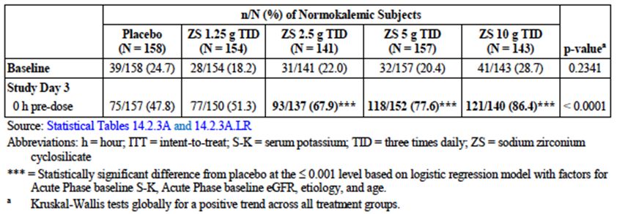
Subacute phase: the total number of days of normokalaemia during the subacute phase was statistically significantly higher for the three higher ZS dosing groups compared with the corresponding placebo group (see Table 8).

Table 8: Subacute phase: Total number of days normokalaemic – Subjects receiving ZS in acute phase
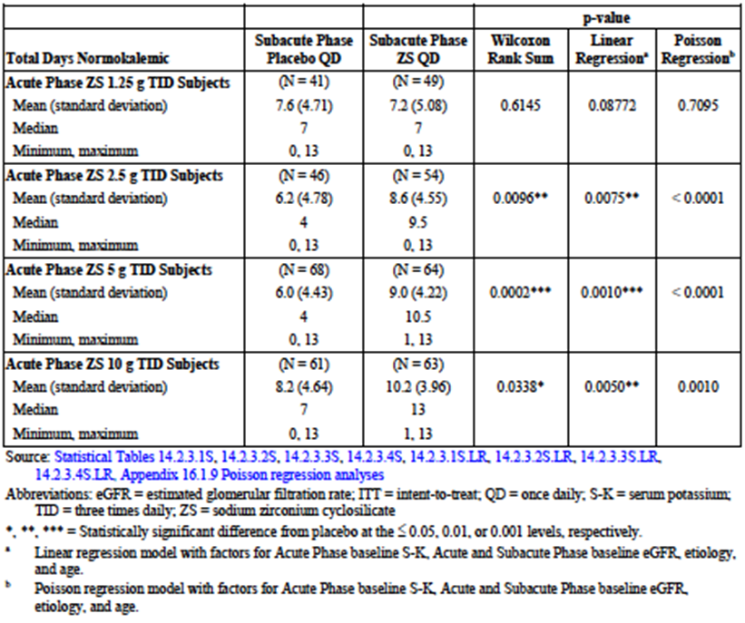

Results for other efficacy outcomes
Secondary efficacy endpoints supported the primary outcomes in both phases.
Acute phase: the exponential rate of change from baseline in SK values was statistically significantly superior to placebo for the three higher dose groups receiving ZS. The mean change in SK from baseline values was also statistically significantly superior to placebo for the three higher dose groups, and the SK-lowering effect was detectable in the 10 g TID group at one hour after the first dose of ZS and remained significant at all scheduled time points to 48 hours. At the 48 hour time-point, the mean changes in SK (mmol/L) were as follows:
- Placebo: -0.25 (SD 0.413)
- ZS 1.25 g: -0.30 (SD 0.404)
- ZS 2.5 g: -0.46 (SD 0.398) p < 0.001 compared with placebo
- ZS 5 g: -0.54 (SD 0.459) p < 0.001 compared with placebo
- ZS 10 g: -0.73 (SD 0.496) p < 0.001 compared with placebo.
Other analyses, including the time to a 0.5 mmol/L reduction in SK, the time to normalization of SK values, and the percentage of subjects achieving normokalaemia at other time points, supported the primary analysis in terms of supporting the efficacy of the 10 g TID dose of ZS in reducing SK in subjects with mild-moderate hyperkalaemia. At some time points, the groups receiving 5 g TID and 2.5 g TID also showed significant differences from placebo.
Subacute phase: the exponential rate of change in SK values, time to relapse in SK values, proportion of subjects within each treatment group maintaining normokalaemia at the end of the subacute phase, mean change from baseline in SK and time to an increase in SK values of 0.5 mmol/L all supported the efficacy of ZS 10 g QD, and in some cases ZS 5 g QD, in maintaining normokalaemia. For subjects who had received placebo in the acute phase, there were no statistical differences between ZS 1.25 g QD and ZS 2.5 g QD, both of which appear to be sub-therapeutic doses for most subjects.

Study ZS-004 (Extended treatment of hyperkalaemia)

Study design, objectives, locations and dates
This study included both acute and chronic phases, but the acute phase had an open design to allow safe enrolment of patients with severe hyperkalaemia and only the chronic phase was conducted in a randomized, placebo controlled, double blind withdrawal approach. Therefore, the acute phase of the study is considered as a non-pivotal study.
The objectives of the chronic phase were to evaluate the safety and efficacy of three different doses of ZS administered QD for 28 days in maintaining normokalaemia (3.5 to 5.0 mmol/L) in subjects who had achieved normokalaemia following 2 days of acute therapy with ZS 10 g TID. The chronic phase was carried out at 44 sites in the US, Australia and South Africa, from March 2014 to August 2014.

Inclusion and exclusion criteria
Subjects enrolled in the chronic phase of this study were adults with SK ≥ 5.1 mmol/L (mean of two values measured 60 minutes apart using i-STAT) at entry into the acute phase, and achieving normokalaemia after 48 hours of treatment with ZS 10 g TID. Inclusion criteria included a requirement that women of childbearing potential were to be using 2 forms of medically acceptable contraception and have a negative pregnancy test at screening. Exclusions included pseudo-hyperkalaemia, treatment with other medical treatments for hyperammonemia or with resins, calcium acetate, calcium carbonate or lanthanum carbonate within 7 days, life expectancy of less than 3 months, severe physical or mental incapacity, pregnancy or lactation , diabetic ketoacidosis, hypersensitivity to ZS, randomization into the previous ZS-002 or ZS-003 studies, treatment with non-approved drug or device within 30 days, cardiac arrhythmias requiring immediate treatment, dialysis.

Study treatments
Following open label acute treatment for hyperkalaemia, normokalaemic subjects were randomized in a 4:4:4:7 ratio to ZS 5 g QD, ZS 10 g QD, ZS 15 g QD or Placebo.

Efficacy variables and outcomes
The main efficacy variable was:
- SK measurements taken on Maintenance Days 1, 2, 5, 8, 12, 15, 19, 22, 26 and 29.
The primary efficacy outcome was the mean SK value between study Days 8 and 29 inclusive.
Other efficacy outcomes included:
- Number of normokalaemic days during Days 8 to 20 inclusive
- Mean change in SK from the Maintenance phase baseline
- Time to recurrence of hyperkalaemia during the Maintenance phase
- Time to relapse in SK values to the original acute phase baseline
- Mean SK intra-subject standard deviation
- Proportion of subjects who remained normokalaemic at each collection time point during the maintenance phase.

Randomisation and blinding methods
Centralized randomization with treatment provided according to a unique identification number. All staff involved with the clinical study were adequately blinded, as were patients.

Analysis populations
237 subjects entered maintenance phase and 208 subjects completed; 231 subjects analysed in ITT population (six subjects appropriately excluded from analysis because they had less than 8 days of SK levels after the first dose of randomized treatment and the primary outcome was mean SK value between Days 8 and 29). Safety population included all patients receiving study treatment (n = 237 in maintenance phase).

Sample size
Sample size was calculated appropriately and was clearly large enough to demonstrate a statistically significant difference between the ZS 10 g/day and 15 g/day groups and the placebo group for all efficacy outcomes.

Statistical methods
Statistical methods for analysis of the primary efficacy outcome were based on a longitudinal model that simultaneously compared each active dose to placebo control. Secondary outcomes were analysed using a linear regression model for the number of normokalaemic days, and a mixed effect regression model for the change in SK from baseline to follow-up time points. Within-treatment group changes were assessed using two sided, paired t-tests, and comparisons between treatment groups were assessed using two-sided, 2-sample t-tests. Time to hyperkalaemia and relapse were summarized using Kaplan-Meier estimates with corresponding log-rank tests. The proportion of subjects remaining normokalaemic at each follow-up time point was compared between groups using a 2-sided Fisher Exact test. Overall, the statistical approach appears appropriate.

Participant flow
Overall, 258 hyperkalaemic subjects were enrolled into the acute phase and received open label ZS 10 g TID. Of the 240 who completed the acute phase and were eligible to enter the maintenance Phase, 3 did not, leaving 237 entering the maintenance phase. 208 completed the maintenance Phase. Additional details were provided.

Major protocol violations/deviations
There were no major protocol violations. Minor deviations noted during the study included mistiming or omission of study procedures or deviations in study drug dosing.

Baseline data
The baseline for the maintenance phase was the SK value on the morning of Day 3 of the overall study (Day 1 of the maintenance phase). At this point, subjects were randomized to the four groups (placebo, ZS 5 g/day, ZS 10 g/day and ZS 15 g/day). The mean SK value at randomization was similar in all four groups (4.55, 4.51, 4.38 and 4.45 mmol/L respectively). There was a statistically significant difference in the mean baseline SK between the ZS 10 g/day group and the placebo group. Demographic and other baseline characteristics were very similar across the four groups (Study ZS-004 Table 9).

Table 9: Maintenance phase: demographic and other baseline characteristics – Safety Population
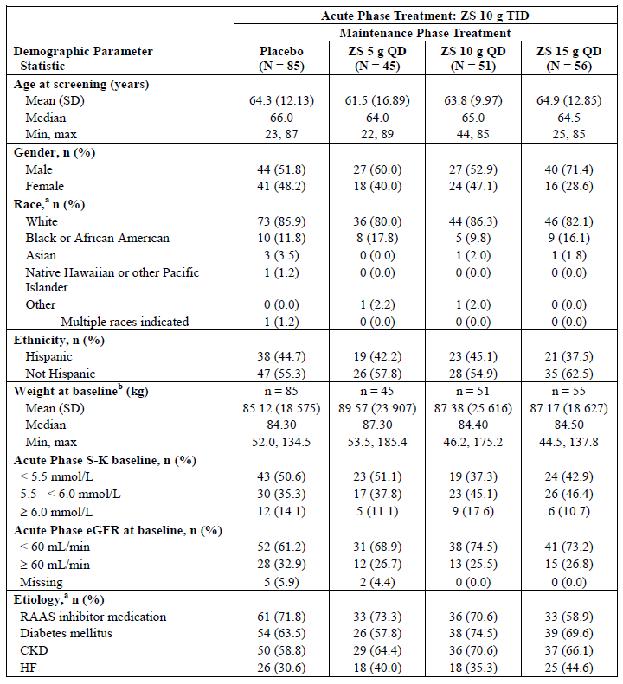

Results for the primary efficacy outcome
The mean SK for the period between Days 8 and 29 of the Maintenance phase was statistically significantly lower in all ZS groups compared with placebo (see Table 10), with an apparent dose response relationship (Table 10).

Table 10: Mean SK between Study Days 8 to 29 (ITT population)
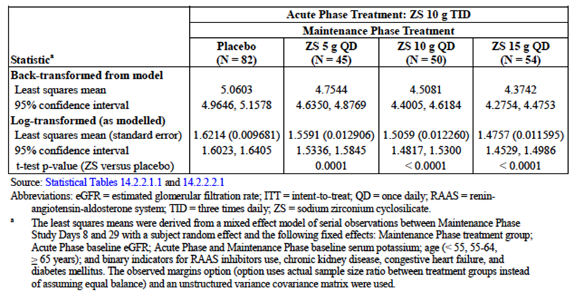
Figure 2: Mean serum potassium over time in three dosing groups compared with placebo (Study ZS-004). Note that all patients received active treatment in the acute phase and were then randomized to four dosing groups (Placebo, ZS 5g, ZS 10g, ZS 15g daily)
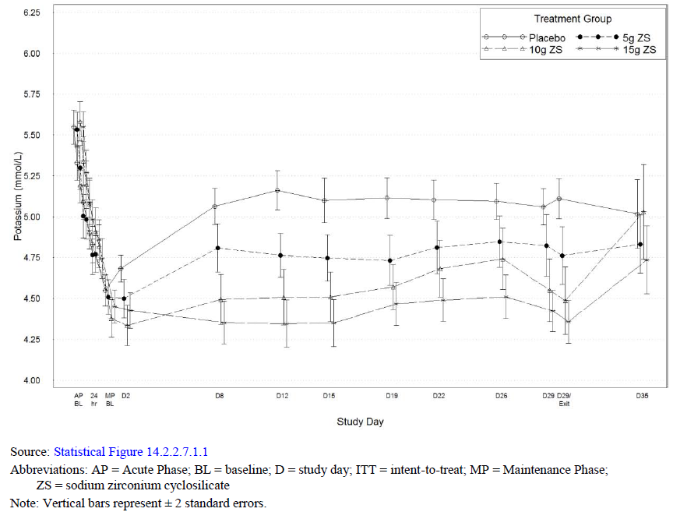

Results for other efficacy outcomes
The secondary outcomes supported the result of the primary efficacy outcome. All demonstrated statistically significant advantages for all three doses of ZS over placebo, with a dose response effect being apparent for most parameters.

Other efficacy studies

Study ZS-004 (Acute phase)
The acute phase of this study, which is described above in relation to its double blind, placebo controlled maintenance phase, was an open label study of the efficacy and tolerability of ZS 10 g TID administered for 48 hours to subjects with hyperkalaemia. The dose was chosen on the basis of the results of dose-ranging acute phase studies ZS-002 and EUZS-003, described above. Both of these studies showed that ZS 10 g TID given for 48 hours was effective and well-tolerated in the acute treatment of hyperkalaemia.
This study had an open label design in the acute phase to allow the safe enrolment of subjects with more severe hyperkalaemia than had been possible in the studies with a placebo group. Subjects with hyperkalaemia of any degree were enrolled in the study under the same entry criteria as described in Section 7.1.1.2 and all were treated with ZS 10 g TID for 2 days (6 doses). Results showed that 66.1% of subjects had normal SK values by 24 hours after the first dose of ZS, and 88% had normal SK values at 48 hours after the first dose of ZS. The median time to normalization of SK values was approximately 2.2 hours after the first dose of ZS. More detail was provided.

Study ZS-004E (Long term extension phase)
This study was available to subjects who completed Study ZS-004, and continued treatment for up to eleven months. The initial protocol specified treatment duration of 56 days, and 15 subjects terminated at this point. An amendment increased the duration to 140 days, and 7 completed the study at this point, and 57 subjects completed 336 days of treatment under a third amendment.
The primary efficacy endpoint was the proportion of subjects with average SK ≤ 5.1 during Study Days 8-337. Detailed results are in Table 11. In summary, a total of 88.3% of subjects maintained an average SK of ≤ 5.1 throughout the study.

Table 11: Proportion of subjects with average SK values ≤ 5.1 during study Days 8 to 337 (ITT population, Study ZS-004E)
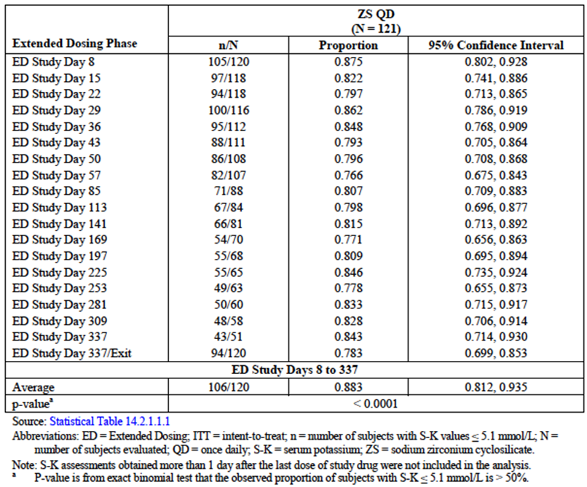

Analyses performed across trials (pooled analyses and meta-analyses)
The Summary of Clinical Efficacy provided in the submission includes a comparison and analysis of results across studies, presented by similar endpoints in order to evaluate the consistency of the results across the ZS study program. No formal meta-analysis was done.
For the Acute Phase, the placebo and ZS 10 g TID groups were compared across pivotal Studies ZS-002 and EUZS-003 and supporting Study ZS-004. The primary outcomes varied across studies, but similar endpoint data were collected, allowing direct comparisons (see Tables 2 and 12). The most useful outcome is the proportion of normokalaemic subjects (responders) at 24 and 48 hours after the start of dosing, and the results are shown in Table 12. In all three studies, more than 85% of subjects had become normokalaemic by 48 hours. The change in SK started to separate statistically from placebo by one hour after the first dose in all three studies (Table 2). Taken overall, the results of the Acute Phases of these three studies provide evidence that treatment with ZS 10 g TID leads to a rapid and clinically meaningful acute lowering of SK in patients with hyperkalaemia.

Table 12: Combined data: acute dosing. Proportion of normokalaemic subjects at 24 and 48 hours (Acute Phase for Studies ZS-002, EUZS-003 and ZS-004, ITT population)
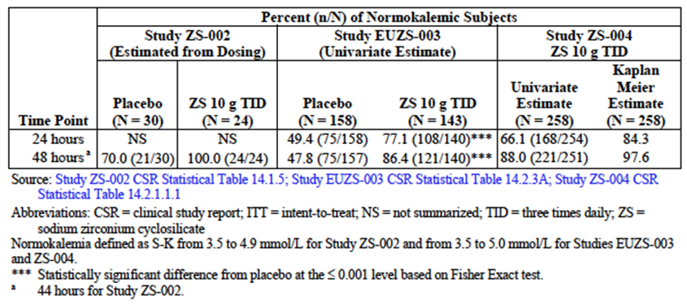
For the Extended Phase (also called Maintenance or Chronic or Subacute Phase in various parts of the documentation), the placebo, ZS 5 g QD, ZS 10 g QD and ZS 15 g QD dose groups were compared. The first three dosing groups were studied in pivotal studies EUZS-003 and ZS-004 (which was pivotal only for the extended phase), while the 15 g QD dose was studied only in ZS-004. The primary endpoints differed in the two studies, but similar endpoints can be compared. The number of normokalaemic days over different time periods was significantly higher for the ZS treated patients than the placebo group in both studies. The mean SK over the period of extended dosing (12 days for Study EUZS-003 and 29 days for Study ZS-004) was maintained in the normokalaemic range throughout the treatment period using ZS 10 g QD in both studies. Study ZS-004 included three ZS dose groups, and there was an apparent dose response effect (see Figure 2). Taken together, these studies provide strong evidence that once daily dosing of ZS at a dose of 10 g daily maintains normokalaemia in subjects who have previously been hyperkalaemic.

Evaluator’s conclusions on clinical efficacy for treatment of hyperkalaemia (acute and extended)
The two pivotal trials assessing the clinical efficacy of ZS at a dose of 10 g TID for 2 days have provided evidence that ZS treatment leads to a rapid lowering of SK in patients with hyperkalaemia (Studies ZS-002 and EUZS-003). This was confirmed in the acute phase of Study ZS-004. Lower doses of ZS are also effective, but have a smaller effect than the proposed dose, 10 g TID.
The two pivotal trials (EUZS-003, ZS-004) assessing the clinical efficacy of ZS in the maintenance of normokalaemia in patients who have received acute treatment have demonstrated that ZS in a dose of 5 to 10 g OD is effective in maintaining normokalaemia in the majority of subjects.

Clinical safety
The safety of ZS was expected to be favourable because of its non-absorbability and therefore its very low likelihood of causing systemic adverse effects. The major potential issues of interest were therefore effects that could be caused during transit of ZS through the GI tract, either through an influence on overall GI function causing GI-related symptoms, or by alterations in the absorption or excretion of potassium or other cations (including sodium, calcium and magnesium).

Studies providing evaluable safety data
The following studies provided evaluable safety data: ZS-002, EUZS-003, ZS-004, ZS-004E (an open label extension of ZS-004), ZS-005 (interim results) and ZS-006 (healthy subjects).

Pivotal efficacy studies
In the pivotal efficacy studies (ZS-002, EUZS-003, and ZS-004) the following safety data were collected:
- General adverse events (AEs) were assessed by patient history and physical examination.
- AEs of particular interest, including hypokalaemia and changes in other electrolytes, were assessed by biochemical measurements at regular intervals.
- Laboratory tests, including biochemistry and haematology, were performed at appropriate intervals.

Pivotal studies that assessed safety as a primary outcome
No additional pivotal studies assessed safety as a primary outcome.

Dose-response and non-pivotal efficacy studies
The dose response and non-pivotal efficacy studies provided safety data, as follows:
Study ZS-006 (open label, non-comparative) provided data on safety and tolerability in healthy subjects who were not hyperkalaemic, who received either 5 g or 10 g once daily for 4 days
Study ZS-004E (open label, non-comparative) was an extension study of ZS-004 Study and provided data on the longer term efficacy, tolerability and safety of ZS over 11 months of follow-up.

Other studies evaluable for safety only
Study ZS-005 is an on-going study for which interim results have been provided.

Pivotal studies that assessed safety as a primary outcome
All pivotal studies that included assessment of safety have already been described in Section 7.

Patient exposure
A total of 1,592 subjects had been exposed to ZS during the clinical trials as at 15 July 2015. Of these, 1,102 subjects had received ZS once daily during extended dosing phases, with 579 treated for at least 30 days, 264 for at least 6 months, 98 for at least 9 months and 40 for 12 months.
In terms of dose exposure, in the acute phase clinical studies, 331 patients were exposed to ≤ 3 g TID, 157 to 5 g TID, and 425 to 10 g TID (the proposed acute phase dose). In the extended phase studies, 199 subjects were exposed to ≤ 2.5 g QD, 110 to 5 g QD, 114 to 10 g QD and 56 to 15 g QD.

Adverse events

All adverse events (irrespective of relationship to study treatment)

Pivotal studies

Acute phase treatment (Summary in Table 13)
In Study ZS-002, the overall incidence of TEAEs was 20% in the combined ZS groups compared with 10% in the placebo group. The commonest TEAE in both groups were GI disorders, including nausea, vomiting, diarrhoea and constipation. Combining the acute phase groups from Studies ZS-002, EUZS-003 and ZS-004 gave the following rates for any event by dose group:
Placebo (n = 188): 10.6%; ZS≤ 3 g TID (n = 331): 12.4%; ZS 5 g TID (n = 157): 14.0%, ZS 10 g TID (n = 425): 10.4%. The commonest reported events in all groups was diarrhoea, with the reported rates being 2.1%, 2.4%, 1.9% and 1.2% respectively. Thus there was little difference between the ZS treated groups and the placebo group.

Table 13: Combined data: acute dosing. Overall summary of treatment-emergent adverse events reported by ≥1.0% of subjects in any treatment group by system organ class and preferred term (Safety population; Studies ZS-002, EUZS-003, and ZS-004)
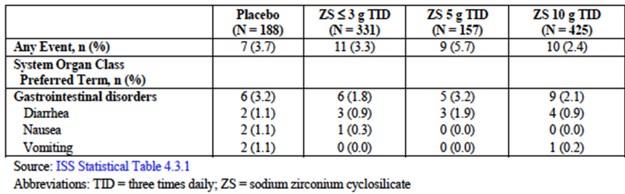

Extended treatment (Summary in Table 14)
The overall incidence of TEAEs in the combined safety populations of Studies EUZS-003 and ZS-004 was 26.6% for the placebo group (n = 310), 23.6% for the ZS ≤ 2.5 g QD group (n = 199), 34.5% for the ZS 5 g QD group (n = 110), 31.6% for the ZS 10 g QD group (n = 114) and 44.6% for the ZS 15 g QD group. Thus there appeared to be a higher incidence in the 15 g group, with a higher incidence of peripheral oedema, infections and infestations. The latter were primarily nasopharyngitis and influenza and were not regarded as related to study drug.

Table 14: Combined data: extended dosing. Overall summary of treatment-emergent adverse events by system organ class (Safety population; Studies EUZS-003 and ZS-004)
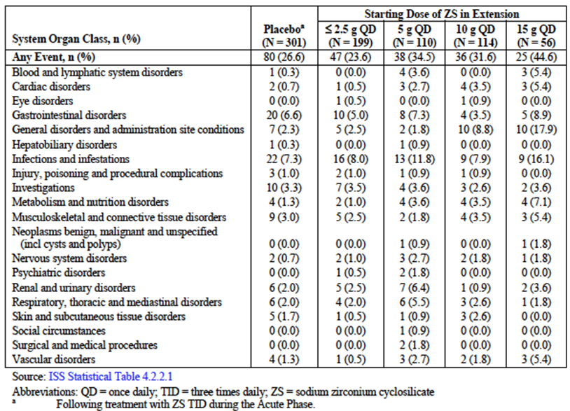

Other studies
In short term Study ZS-006 in healthy subjects, one TEAE occurred during the study (mild headache); there were no serious AEs or discontinuations due to an AE.
In Study ZS-004E (the open label, non-comparative extension study following ZS-004), 66.7% of subjects experienced at least one TEAE over the eleven months of follow-up. The commonest TEAEs were hypertension (12.2%), urinary tract infection (8.9%), peripheral oedema (8.1%) and constipation (5.7%), all of which were likely to be related to underlying co-morbidities.

Treatment related adverse events (adverse drug reactions)

Pivotal studies

Acute phase treatment
A dose related increase in mean corrected QT interval (QTc) on ECG was observed during the acute phase in several studies, consistent with the lowering of SK; however, the increase was minor and no cases of cardiac arrhythmias or sudden deaths due to cardiac causes were observed. There were no changes in QTc during extended dosing.
The overall incidence of GI disorders considered related to study drug in the combined Acute Phase studies was as follows: Placebo (n = 188): 3.2%; ZS ≤ 3 g TID (n = 331): 1.8%; ZS 5 g TID (n = 157): 3.2%, ZS 10 g TID (n = 425): 2.1%.

Extended treatment
Peripheral oedema was reported during extended dosing in Studies EUZS-003 and ZS-004, and was most frequent in the ZS 15 g QD group (14.3%) compared with rates in the placebo (1.7%), ZS ≤ 2.5 g QD (1.0%), ZS 5 g QD (0.9%) and ZS 10 g QD (5.3%). One ZS 15 g QD subject was withdrawn due to generalized oedema, but the events were not regarded as being related to study drug but rather to the underlying comorbidities present in the subjects. Analysis of these events further indicated that most were mild to moderate and resolved without cessation of drug, about half required an adjustment in their diuretic dose. All but one of the subjects were determined to be at risk of fluid overload related events. It is speculated that release of sodium from the ZS matrix may contribute to this observation, although only four events were considered likely to be related to study drug.

Other studies
Longer term safety results of Study ZS-004E are summarized in Table 15, showing the occurrence and type of treatment-related EAs by duration of dosing. Fourteen subjects had TEAEs considered related to study drug, including muscle spasms (n = 3), peripheral oedema (n = 2), QTc prolongation (n = 2) and hypomagnesaemia (n = 2). A similar distribution of AEs has been noted in the interim safety results of the continuing long term study, ZS-005, in which the commonest TEAEs have been infection (unrelated to treatment), peripheral oedema, hypertension, and GI symptoms (both constipation and diarrhoea).

Table 15: Summary of treatment-related AEs reported by ≥ 1.0% of ZS subjects presented by duration of treatment and system organ class and preferred term (Safety population, Study ZS-004E)
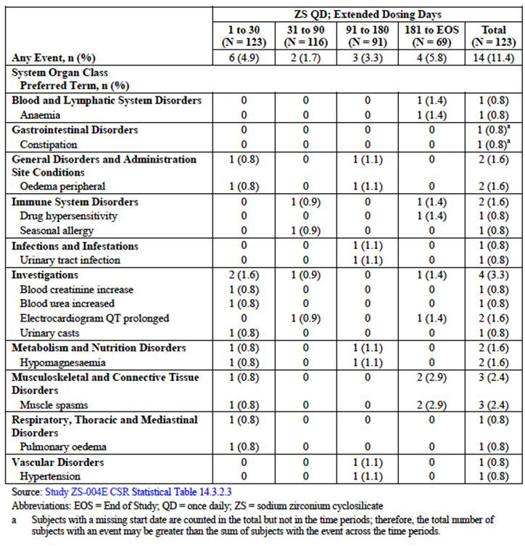

Deaths and other serious adverse events

Pivotal studies

Acute phase treatment
Only one subject (taking ZS 10 g TID) reported a severe treatment-related AE (severe episodes of vomiting and diarrhoea, leading to discontinuation of study drug).

Extended treatment
The overall incidence of severe TEAEs was higher in the ZS 5 g (4.5%) and 15 g (5.4%) groups compared with the other ZS dose groups or the placebo group (0.9 to 1.5%). The only severe event reported by more than one subjects was pneumonia (n = 3; 1 in the ZS ≤ 2.5 g QD group, 1 in the 5 g QD group and 1 in the 15 g QD group). Of the severe events reported, only gastroenteritis (1 placebo subject) and vomiting (1 ZS ≤ 2.5 g QD subject) were considered related to study drug. There was one death in EUZS-003 (respiratory arrest) and one in ZS-004 (myocardial infarction).

Other studies
Twenty subjects had severe TEAEs during Study ZS-004E, including two subjects each reporting anaemia, congestive cardiac failure, and chronic obstructive pulmonary disease, and one subject each reporting drug hypersensitivity (which resolved spontaneously after drug withdrawal), acute myocardial infarction, cardiac failure (which should be combined with the two reported as having congestive cardiac failure) and an eye disorder (unilateral blindness, not further specified).
Interim results of ongoing long term study ZS-005 indicate that three deaths have occurred, the causes being haemorrhagic cystitis, interstitial lung disease with pulmonary emboli, and sudden cardiac death. None were judged to be related to study drug.

Discontinuation due to adverse events

Pivotal studies
There were no discontinuations due to adverse events in Study ZS-002. In Study EUZS-003, three subjects withdrew because of AEs in the acute treatment phase (atrial flutter, lethargy, vomiting and diarrhoea) and nine withdrew in the chronic treatment phase (lethargy, vomiting, diarrhoea, long QTc, gastroenteritis, respiratory arrest leading to death, chest pain with dyspnoea, pneumonia, bradycardia, congestive cardiac failure). The majority of these AEs were related to underlying co-morbidities and unlikely to be related to study drug, with the exception of the GI-related symptoms.
There were seven withdrawals from Study ZS-004 because of AEs (3 with prolonged QTc, one death due to myocardial infarction, one with small intestinal obstruction, one with confusional state and one with generalized oedema).

Other studies
There were no discontinuations due to adverse events in Study ZS-006.
Seven subjects discontinued early from Study ZS-004E because of AEs (QTc prolongations in two, right bundle branch block, acute myocardial infarction, chronic obstructive pulmonary disease, unilateral blindness, localized infection, diabetic foot infection and hyperkalaemia). To July 15, 2015, in Study ZS-005 (total n = 575 in extended dosing phase) there had been 26 premature discontinuations due to AEs, including worsening of cardiac failure, acute kidney injury, GI disorders, and death (n = 3).

Laboratory tests

Liver function

Pivotal studies
No consistent changes were observed in any study, as expected given the non-absorbability of ZS.

Other studies
No consistent changes were observed in any study, as expected given the non-absorbability of ZS.

Kidney function

Pivotal studies
No consistent clinically important changes were observed in any study, as expected given the non-absorbability of ZS. There were small dose-related mean increases in eGFR in the pooled pivotal study treatment groups during the Acute phase (range 0.09-0.84 ml/min/1.73 m²). In the Extended phase, there were mean increases in eGFR in the ZS 10 g QD group (1.35 ml/min/1.73 m²) and ZS 15 g QD group (1.39 ml/min/1.73 m²).

Other studies
No consistent changes were observed.

Other clinical chemistry

Pivotal studies

Bicarbonate
Mean dose-related increases in bicarbonate were noted in the pooled pivotal study ZS treatment groups during the acute phase (ranging from 0.4 to 1.6 mmol/L), compared with a mean decrease in the placebo group. In the extended phase, mean dose-related increases in bicarbonate were again noted for the higher dose ZS groups from 5 g to 15 g QD (ranging from 1.1 to 2.6 mmol/L) compared with smaller increases noted for the placebo and the lower ZS dose groups (0.6 mmol/L for each). These changes are unlikely to be clinically important.

Calcium
Dose related mean decreases in calcium were observed during the acute phase in the pooled pivotal study ZS treatment groups (ZS 3 g (-0.13 mg/dL), 5 g (-0.18 mg/dL) and 10 g (-0.28 mg/dL) TID groups compared with placebo (-0.07 mg/dL), although mean values remained within the normal range. Similar findings were noted in the extended dosing studies, with the maximum mean decrease being 0.2 mmol/L, which is not regarded as clinically relevant.

Other electrolytes
There were no consistent changes in serum sodium or magnesium throughout the studies, either in the Acute or Extended phases.

Other studies
In long term Study ZS-004E, no subjects developed potentially clinically significant high or low values for sodium, or high values for magnesium, calcium or bicarbonate. Two subjects each had potentially significant low calcium and low phosphorus values, and one had a potentially clinically significant low magnesium result. Seven subjects developed potentially clinically significant low bicarbonate values, in contrast to the shorter term studies in which there were mean increases in bicarbonate. Given the population included in the study and the presence of CKD in most of them, this observation is more likely to be related to underlying co-morbidities rather than to study drug.

Haematology

Pivotal studies
There was a small mean decrease in haemoglobin (≤ 0.5 g/L) in all treatment groups as well as the placebo group during the Acute phase (pooled safety populations from Studies ZS-002, EUZS-003 and ZS-004). In the extended dosing studies (EUZS-003 and ZS-004) a similar small decline in haemoglobin was observed in all groups (< 0.6 g/L). This was reasonably interpreted to be likely to be related to haemodilution and underlying co-morbidities rather than study drug.

Other studies
In the long term study, ZS-004E, reductions in haemoglobin from the study baseline were observed in 43.5% of subjects. Given that the majority of subjects in this study had underlying chronic kidney disease, which itself is causally associated with anaemia, this is not a cause for concern in relation to ZS.

Serum potassium

Pivotal studies
Given the mechanism of action, and indication for treatment, it was expected that some subjects may become hypokalaemic during treatment with ZS. This was specifically examined in all efficacy studies.
An increased incidence of hypokalaemia was observed with ZS compared to placebo, although the rate was generally low (2.5% in the combined population receiving ZS in studies ZS-002, EUZDS-003, ZS-004 and ZS-004E [n = 913]). Only one of these subjects developed moderate hypokalaemia (SK < 3.0 mmol/L), and no cases of severe hypokalaemia were reported. Clearly, SK would require careful monitoring during treatment with ZS, but it appears that there is little risk of sudden, severe hypokalaemia.

Other studies
In Study ZS-004E, seven subjects were found to have hypokalaemia (SK< 3.5 mmol/L). The majority were able to continue the study with dose reduction.

Electrocardiograph

Pivotal studies
Pooled results from the pivotal studies showed no clinically significant dose related changes in the Acute phase in PR interval, QRS duration or heart rate. There were mean increases in QTc interval, with an apparent dose related effect. The mean increases were 0.1 msec for the placebo group, 4.2 msec for the ZS 5 g TID group, and 9.1 msec for the ZS 10 g TID group. Further analysis of subjects with potentially clinically significant changes in QTc was carried out, finding only one subject in the placebo group and five (1.2%) in the ZS 10 g TID group reaching a maximum QTc interval > 500 msec. A total of four subjects (one in the placebo group and 3 in the ZS 10 g TID group) reached the ECG criteria for withdrawal (increase from baseline in QTc of > 30 msec, with a corresponding QTc interval of > 500 msec). Overall the changes in QTc were very small and unlikely to be clinically significant except in the presence of pre-existing abnormalities.

Other studies
Study ZS-002, an acute phase dosing study, included monitoring of ECGs, which showed no significant change in mean QTc from baseline to Day 4. In the long term extension study, ZS-004E, three subjects were withdrawn because of ECG changes, two of which were long QTc. There were no significant mean changes in QTc during this prolonged follow-up, open label study, and only four (3.3%) subjects had a maximum QTc > 500 msec with a > 30 msec increase from baseline. All of these subjects had multiple comorbidities and were receiving multiple concomitant medications. The overall safety results do not suggest any serious concern regarding the effects of ZS on QTc, except in patients with pre-existing abnormalities.

Vital signs

Pivotal studies
No clinically significant mean changes in blood pressure, heart rate, respiratory rate, temperature or body weight occurred during the acute or extended phases of pivotal studies. Very few individual subjects (≤ 2.0% for all dosing groups, with no apparent dose relationship) had changes of potential clinical significance in the acute phase. In the pooled extended phase, the commonest change was an increase in systolic blood pressure (in up to 5.7% of subjects). This would be a common observation in the population being studied.

Other studies
In long term Study ZS-004E, seven subjects, all with past histories of hypertension, had worsening of hypertension. No other clinically significant changes in vital signs were observed.

Post-marketing experience
ZS has not yet been marketed in any country.

Evaluator’s overall conclusions on clinical safety
The combined safety data, including from studies using long term dosing for up to twelve months, indicate that ZS is well tolerated in the acute lowering of SK in patients with hyperkalaemia, and in the longer term maintenance of normokalaemia. The characteristics of the population studied explain the majority of TEAEs, serious AEs and withdrawals. There are no specific safety concerns related to this submission, with the exception of the risk of hypokalaemia if patients receiving treatment are inadequately monitored in relation to their SK. This is particularly important during the acute phase of treatment, when ZS is administered three times daily.

First round benefit-risk assessment

First round assessment of benefits
The benefits of ZS in the proposed usage are:
- Rapid and effective lowering of SK in patients with hyperkalaemia
- Maintenance of normokalaemia for up to twelve months.

First round assessment of risks
The risks of ZS in the proposed usage are:
- Hypokalaemia, requiring regular monitoring of SK
- Hypertension exacerbation, requiring regular monitoring of BP
- Peripheral oedema
- Prolongation of QT interval in individuals with pre-existing QT abnormalities.

First round assessment of benefit-risk balance
The benefit-risk balance of ZS, given the proposed usage, is favourable.

First round recommendation regarding authorisation
It is recommended that the application for registration of sodium zirconium cyclosilicate be granted and that the drug be registered for the treatment of hyperkalaemia (acute and extended use).

Clinical questions
- Please justify the lack of in vivo drug interactions with lithium, calcium, iron, digoxin, thyroxine, aluminium hydroxide
- Is there any risk of using this agent in patients with an ileus or bowel obstruction?
- Does this agent affect absorption of vitamins or micronutrients or trace elements?

Second round evaluation of clinical data submitted in response to questions
- Please justify the lack of in vivo drug interactions with lithium, calcium, iron, digoxin, thyroxine, aluminium hydroxide
Sponsor response:
Sodium zirconium cyclosilicate is a compound characterised by a negatively charged covalent framework that is neutralised by Na⁺ and H⁺ cations located in the crystal lattice channels. The framework-cation interactions are electrostatic, thus the cations can undergo exchange with other cations in the external media that can pass through the uniformly sized micropore openings. The exchange is dynamic, and will change with cations in the external environment. The extent of exchange depends upon the inner-outer ionic concentrations, the size of the cations and other thermodynamic factors.
The micropore opening is 3 Å. Cations such as potassium that have an ionic radius of 1.5 Å will have high affinity to ZS. Cations with lower or higher radius will have lower affinity. Those that are less than 1.5 Å will not form bonds to the oxygen atoms, thus total binding energy will be lower. Cations with a larger radius can also pass through the micropore, but at the expense of s structural change to the covalent framework that is not energetically favoured.

Table 16: Ionic radius of selected cations
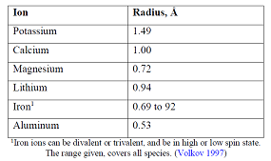
Based on the ionic size, the binding ratio for calcium, lithium, iron and aluminium is lower.
In vitro studies showed an uptake of calcium and magnesium that was 7 fold less than potassium at ion rations of 1:3:3 for K:Ca:Mg. But not uptake at ion rations of 1:2:2 or less. There was no interaction between SZ and lithium.
Digoxin and thyroxin are too large to fit into the micropores. However ZS can affect gastric pH through the uptake of H⁺. In a clinical study, ZS had no effect on the pharmacokinetics of levothyroxine but some pH related effects of ZS on digoxin occurred, although none are considered clinically meaningful enough to warrant a dose adjustment or separation in time of dosing from ZS.
Clinical Drug-Drug Interaction Study Between ZS and 9 Other Drugs (Study ZS-009)
Since the filing of the submission, the sponsor has conducted a Phase I study (Study ZS-009) to examine the potential for drug-drug interactions with ZS in vivo in a set of 9 compounds that displayed significant in vitro changes in solubility in the presence of ZS. Study ZS-009 was conducted in healthy volunteers and tested basic drugs (amlodipine, dabigatran, clopidogrel) and acidic drugs (atorvastatin, furosemide, glipizide, warfarin, losartan, levothyroxine) with pKa’s ranging from 2.2 to 8.7. The set also contained compounds that exhibited the largest observed changes in solubility in vitro (furosemide + 563% and dabigatran -99%) and contained examples of solubility changes at all 3 pH levels tested in vitro.

Table 17: Summary of pharmacokinetic changes with ZS
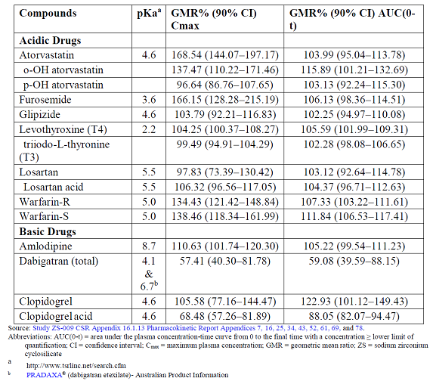
Evaluator comment:
The response is acceptable. The sponsor has suggested that the 40% (90%CI 20 to 60%) decrease in dabigatran exposure is unlikely to be clinically significant. The evaluator disagrees. Dabigatran is used to prevent thrombosis. Sub therapeutic levels may increase the risk of thrombosis.
- Is there any risk of using this agent in patients with an ileus or bowel obstruction?
Sponsor response:
The clinical development program did not exclude subjects with GI motility disorders, ileus or bowel obstruction. The sponsor searched the databases of studies ZS-003 and ZS-004 to find subjects with a history of GI disorders.

Table 18: Medical history of GI motility disorders in ZS-003 and ZS-004
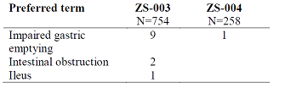
ZS was equally efficacious in these patients. No AE were reported in this group.
The experience with ZS in the face of acute motility disorders is limited. There was one subject in study ZS-004 with small intestinal obstruction, which was thought not to be related to the study medication, he was discontinued from the study.
Evaluator comment:
The response is acceptable
- Does this agent affect absorption of vitamins or micronutrients or trace elements?
Sponsor response:
The sponsor has not conducted any in vitro or in vivo studies on any possible effects of ZS on vitamins or micronutrients. Based on the mechanism of action of ZS, the sponsor’s view is that ZS would not bind vitamins or micronutrients in vivo in any clinically significant amount. Cationic microminerals could theoretically be exchanged if they could pass through the ZS micropores, but since these are small cations with low affinity to ZS and present in very low concentration in vivo compared to potassium, the amount taken up by ZS will be non-significant. Vitamins and other organic micronutrients are too large to enter through the micropores in ZS.
Evaluator comment:
The response is acceptable

Second round benefit-risk assessment

Second round assessment of benefits
After consideration of the responses to clinical questions, the benefits of sodium zirconium in the proposed usage are unchanged from those identified in the first round assessment of benefits.

Second round assessment of risks
After consideration of the responses to clinical questions, the risks in the proposed usage are better characterised.

Second round assessment of benefit-risk balance
The benefit-risk balance of sodium zirconium for the treatment of hyperkalaemia is positive.

Second round recommendation regarding authorisation
The clinical data submitted would support the registration of sodium zirconium to treat hyperkalaemia in adults. However, the final decision would also need to take in to accounts reports from chemistry, toxicology and RMP evaluators.
As this is a new chemical entity with limited efficacy and safety data, however a broad indication- the evaluator would recommend some changes to the PI to optimise safe use of this product with an awareness of the limitations of the clinical trial data available.

Therapeutic Goods Administration
PO Box 100 Woden ACT 2606 Australia
Email: info@tga.gov.au Phone: 1800 020 653 Fax: 02 6232 8605
https://www.tga.gov.au

