|  |
| --- |
| **First round 21 April 2016**  **Second round 11 August 2016** |

|  |
| --- |
| AusPAR Attachment 2 |
| Extract from the Clinical Evaluation Report for Sofosbuvir / Velpatasvir |
| Proprietary Product Name: Epclusa |
| Sponsor: Gilead Sciences Pty Ltd |

About the Therapeutic Goods Administration (TGA)

* The Therapeutic Goods Administration (TGA) is part of the Australian Government Department of Health, and is responsible for regulating medicines and medical devices.
* The TGA administers the *Therapeutic Goods Act 1989* (the Act), applying a risk management approach designed to ensure therapeutic goods supplied in Australia meet acceptable standards of quality, safety and efficacy (performance), when necessary.
* The work of the TGA is based on applying scientific and clinical expertise to decision-making, to ensure that the benefits to consumers outweigh any risks associated with the use of medicines and medical devices.
* The TGA relies on the public, healthcare professionals and industry to report problems with medicines or medical devices. TGA investigates reports received by it to determine any necessary regulatory action.
* To report a problem with a medicine or medical device, please see the information on the TGA website < <https://www.tga.gov.au>> .

About the Extract from the Clinical Evaluation Report

* This document provides a more detailed evaluation of the clinical findings, extracted from the Clinical Evaluation Report (CER) prepared by the TGA. This extract does not include sections from the CER regarding product documentation or post market activities.
* The words [Information redacted], where they appear in this document, indicate that confidential information has been deleted.
* For the most recent Product Information (PI), please refer to the TGA website < <https://www.tga.gov.au/product-information-pi>> .

Copyright

© Commonwealth of Australia 2017  
This work is copyright. You may reproduce the whole or part of this work in unaltered form for your own personal use or, if you are part of an organisation, for internal use within your organisation, but only if you or your organisation do not use the reproduction for any commercial purpose and retain this copyright notice and all disclaimer notices as part of that reproduction. Apart from rights to use as permitted by the *Copyright Act 1968* or allowed by this copyright notice, all other rights are reserved and you are not allowed to reproduce the whole or any part of this work in any way (electronic or otherwise) without first being given specific written permission from the Commonwealth to do so. Requests and inquiries concerning reproduction and rights are to be sent to the TGA Copyright Officer, Therapeutic Goods Administration, PO Box 100, Woden ACT 2606 or emailed to < [tga.copyright@tga.gov.au](mailto:tga.copyright@tga.gov.au)> .

Contents

List of abbreviations 5

1. Introduction 14

1.1. Drug class and therapeutic indication 14

1.2. Dosage forms and strengths 14

1.3. Dosage and administration 14

2. Clinical rationale 15

3. Contents of the clinical dossier 16

3.1. Scope of the clinical dossier 16

3.2. Paediatric data 16

3.3. Good clinical practice 16

4. Pharmacokinetics 16

4.1. Summary of pharmacokinetics 18

4.2. Evaluator’s overall conclusions on pharmacokinetics 34

5. Pharmacodynamics 38

5.1. Studies providing pharmacodynamic data 38

5.2. Summary of pharmacodynamics 38

5.3. Evaluator’s overall conclusions on pharmacodynamics 44

6. Dosage selection for the pivotal studies 45

7. Clinical efficacy 45

7.1. Pivotal efficacy studies 45

7.2. Other efficacy studies 69

7.3. Analyses performed across trials 77

7.4. Evaluator’s conclusions on clinical efficacy for the indication: 82

8. Clinical safety 82

8.1. Studies providing evaluable safety data 82

8.2. Pivotal studies that assessed safety as a primary outcome 83

8.3. Patient exposure 83

8.4. Adverse events 84

8.5. Laboratory tests 93

8.6. Post-marketing experience 100

8.7. Safety issues with the potential for major regulatory 100

8.8. Other safety issues 101

8.9. Evaluator’s overall conclusions on clinical safety 104

9. First round benefit-risk assessment 105

9.1. First round assessment of benefits 105

9.2. First round assessment of risks 105

9.3. First round assessment of benefit-risk balance 105

10. First round recommendation regarding authorisation 106

11. Clinical questions 106

11.1. Pharmacokinetics 106

11.2. Pharmacodynamics 106

11.3. Efficacy 106

11.4. Safety 106

12. Second round evaluation of clinical data submitted in response to questions 107

12.1. Pharmacokinetics 107

12.2. Efficacy 108

13. Second round benefit-risk assessment 109

14. Second round recommendation regarding authorisation 109

## List of abbreviations

| Abbreviation | Meaning |
| --- | --- |
| 3TC | lamivudine |
| Ab | antibody |
| ADME | absorption/distribution/metabolism/excretion |
| AE | adverse event |
| AFP | alpha fetoprotein |
| ALT | alanine aminotransferase |
| ANC | absolute neutrophil count |
| ANOVA | analysis of variance |
| ARV | antiretroviral |
| AST | aspartate aminotransferase |
| ATR | Atripla |
| ATV | atazanavir |
| ATZ | atazanavir |
| ATZ/r | atazanavir/ritonavir |
| AUC | area under the concentration/time curve |
| AUCinf | area under the plasma concentration versus time curve extrapolated to infinite time, calculated as AUC0-last + (Clast/λz) |
| AUClast | area under the plasma concentration versus time curve from time zero to the last quantifiable concentration |
| AUCtau | area under the plasma concentration versus time curve over the dosing interval |
| BA | bioavailability |
| BCRP | breast cancer resistance protein |
| BID | twice daily |
| BLQ | below the limit of quantitation |
| BMI | body mass index |
| bpm | beats per minute |
| CatA | cathepsin A |
| CES1 | carboxylesterase 1 |
| CI | confidence interval |
| CL | clearance |
| CL/F | apparent oral clearance after administration of the drug: CL/F = Dose/AUCinf, where “Dose” is the dose of the drug |
| Clast | last observed quantifiable concentration of the drug in serum, plasma, or PBMCs |
| CLcr | creatinine clearance |
| CLr | renal clearance |
| CLss/F | apparent oral clearance at steady state |
| Cmax | maximum observed concentration of drug in plasma |
| CMH | Cochran-Mantel-Haenszel |
| COBI | cobicistat |
| CPT | Child-Pugh-Turcotte |
| CPT-A | compensated cirrhosis |
| CPT-B | decompensated cirrhosis |
| CsA | cyclosporine (cyclosporin A) |
| Ctau | observed drug concentration at the end of the dosing interval |
| CTCAE | Common Terminology Criteria for Adverse Events |
| Ctrough | trough plasma concentration |
| CV | coefficient of variation |
| CYP | cytochrome P450 |
| DAA | direct-acting antiviral agent |
| DBP | diastolic blood pressure |
| DDI | drug-drug interaction study |
| DILI | drug induced liver injury |
| DNA | deoxyribonucleic acid |
| DRM | drug related material |
| DRV | darunavir |
| DRV/r | darunavir/ritonavir |
| DTG | dolutegravir |
| EC50 | concentration of a compound inhibiting virus replication by 50% |
| ECG | electrocardiogram |
| EFV | efavirenz |
| eGFR | estimated glomerular filtration rate |
| Emax | maximum effect |
| EOTR | end-of-treatment response |
| ESRD | end stage renal disease |
| EVG | elvitegravir |
| FAS | full analysis set |
| FDA | Food and Drug Administration |
| FDC | fixed dose combination |
| FSH | follicle stimulating hormone |
| FTC | emtricitabine |
| GCP | Good Clinical Practice |
| GI | gastrointestinal |
| GLSM | geometric least-squares means |
| GM | geometric mean |
| GMR | geometric mean ratio |
| GT1a | genotype 1a |
| GT1b | genotype 1b |
| GT4 | genotype 4 |
| h | hour/s |
| H2RA | H2-receptor antagonist |
| HBsAg | hepatitis B surface antigen |
| HBV | hepatitis B virus |
| HCC | hepatocellular carcinoma |
| HCV | hepatitis C virus |
| HDPE | high density polyethylene |
| HI | hepatic impairment |
| HINT1 | histidine triad nucleotide-binding protein 1 |
| HIV | human immunodeficiency virus |
| ICH | International Conference on Harmonisation |
| IEC | Independent Ethics Committee |
| IgG | immunoglobulin G |
| IgM | immunoglobulin M |
| IL28B | interleukin 28B |
| IP-10 | interferon gamma-induced protein 10 |
| IRT | interactive response technology |
| ITT | intent-to-treat |
| IU | international units |
| Ka | absorption rate constant |
| LC/MS/MS | liquid chromatography-mass spectrometry/mass spectrometry |
| LCB | lower bound of the 95% confidence interval |
| LCS | liquid scintillation counting |
| LDL | low density lipoprotein |
| LDV | ledipasvir |
| LLN | lower limit of normal |
| LLOD | lower limit of detection |
| LLOQ | lower limit of quantitation |
| LOQ | limit of quantification |
| LPV | lopinavir |
| LS | least squares |
| MedDRA | Medical Dictionary for Regulatory Activities |
| MELD | Model for End-stage Liver Disease |
| MEMS | Medication Event Monitoring System |
| mL | millilitre |
| mRNA | messenger RNA |
| MRP2 | multidrug resistance protein 2 |
| ms | milliseconds |
| N | number |
| N/A | not applicable |
| NI | nucleoside inhibitor |
| NIA | no information available in evaluation materials |
| NONMEM | non-linear mixed-effects modelling software |
| NS3 | non-structural protein 3 |
| NS4A | non-structural protein 4A |
| NS5A | non-structural protein 5A |
| NS5B | non-structural protein 5B |
| OATP | organic anion transporting polypeptide |
| OC | oral contraceptive |
| OD | once daily |
| PBO | placebo |
| PCS | potentially clinically significant |
| PD | pharmacodynamics |
| PegIFN | pegylated interferon |
| Peg-IFN | pegylated interferon |
| P-gp | p-glycoprotein |
| PK | pharmacokinetics |
| PopPK | population PK |
| PP | per protocol |
| PPI | proton pump inhibitor |
| PT | post treatment |
| PT | preferred term |
| PTM | placebo to match |
| PVF | primary virologic failure |
| QD | once daily |
| QPS | Quest Pharmaceutical Services, L.L.C. |
| QRS | electrocardiographic deflection between the beginning of the Q wave and termination of the S wave, representing time for ventricular depolarization |
| QT | electrocardiographic interval between the beginning of the Q wave and termination of the T wave, representing the time for both ventricular depolarization and repolarization to occur |
| QTcF QT | interval corrected for heart rate using the Fridericia formula |
| QTcN QT | interval corrected for heart rate using population-specific correction factor |
| r | ritonavir |
| RAL | raltegravir |
| RAV | resistance-associated variants |
| RBV | ribavirin |
| RNA | ribonucleic acid |
| RPV | rilpivirine |
| RTV | ritonavir |
| RVR | rapid virologic response |
| SAE | serious adverse event |
| SAS | safety analysis set |
| SBP | systolic blood pressure |
| SD | standard deviation |
| SE | standard error |
| SmPC | summary of product characteristics |
| SOC | System Organ Class |
| SOF | sofosbuvir (GS-7977) |
| SOF | sofosbuvir/solvaldi/GS-7977/PSI-7977 |
| SOF/LDV | sofosbuvir/lepidasvir FDC |
| SOF/VEL | sofosbuvir/velpatasvir FDC |
| SSD | spray-dried dispersion |
| SVR | sustained virologic response |
| SVR12 | sustained virologic response at 12 weeks following completion of all treatment |
| SVR24 | sustained virologic response 24 weeks post-dosing |
| SVR4 | sustained virologic response 4 weeks post-dosing |
| TAF | tenofovir alafemamide fumarate |
| TDF | tenofovir disoproxil fumarate |
| TEAE | treatment emergent adverse event |
| TFV | tenofovir |
| Tlag | Lag-time (time delay between drug administration and first observed concentration above LOQ in plasma) |
| TN | treatment naïve |
| TND | target not detected |
| UGT | uridine glucuronosyltransferase |
| ULN | upper limit of normal |
| URTI | upper respiratory tract infections |
| US | United States |
| VAS | visual analogue scale |
| Vc | volume of distribution in the central compartment |
| Vc/F | apparent volume of distribution in central compartment after oral dosing |
| VDV | vedroprevir |
| VEL | velpatasvir/GS-5816 |
| Vp | volume of distribution in the peripheral compartment |
| Vp/F | apparent volume of distribution in peripheral compartment after oral dosing |
| WBC | white blood cell |
| ZDV | zidovudine |
| ΔQTcF | change from pre-dose baseline in QTcF |
| ΔΔQTc | time matched, baseline adjusted, placebo corrected QTc |
| ΔΔQTcF | time matched, baseline adjusted, placebo corrected QTcF QTc QT interval corrected for heart rate |

## Introduction

This is a submission to register sofosbuvir and velpatasvir as an oral fixed dose combination tablet.

### Drug class and therapeutic indication

Sofosbuvir is a nucleotide analogue non-structural protein 5B (NS5B) polymerase inhibitor. The approved indication is for use in combination with other agents for the treatment of chronic HCV infection in adults (Sovaldi and Harvoni).

Velpatasvir is a novel pan-genotypic HCV non-structural protein 5A (NS5A) inhibitor for use in combination with sofosbuvir for the treatment of HCV infection. Gilead does not intend to develop velpatasvir for use as a single agent tablet.

The proposed indication for the FDC is:

*Epclusa (sofosbuvir/velpatasvir fixed dose combination) is indicated for the treatment of chronic hepatitis C virus (HCV) infection in adults.*

### Dosage forms and strengths

The submission proposes registration of the following dosage form and strength:

Epclusa is a fixed dose combination tablet containing sofosbuvir 400 mg and velpatasvir 100 mg.

### Dosage and administration

One Epclusa tablet should be taken orally, once daily with or without food.

Epclusa should be used in combination with ribavirin (RBV) in patients with decompensated cirrhosis. The recommended dose of RBV is based on body weight: 1000 mg/day for patients weighing ≤ 75 kg, and 1200 mg/day for those weighing > 75 kg, divided and given twice daily with food.

Table 1, below provides the recommended treatment regimen based on patient population.

Table 1: recommended treatment regimen

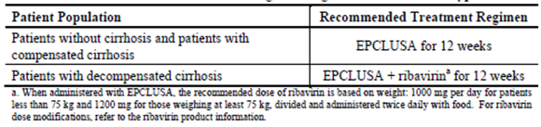

#### Children and adolescents up to 18 years of age

No data are available on which to make a dose recommendation for children < 18 years of age.

#### Elderly

No dose adjustment is warranted for elderly patients.

#### Renal impairment

No dose adjustment of Epclusa is required for patients with mild or moderate renal impairment. The safety and efficacy of Epclusa have not been established in patients with severe renal impairment (eGFR < 30 mL/min/1.73 m2) or end stage renal disease (ESRD) requiring haemodialysis.

#### Hepatic impairment

No dose adjustment of Epclusa is required for patients with mild, moderate, or severe hepatic impairment (Child-Pugh Class A, B, or C). Safety and efficacy of Epclusa have been established in patients with decompensated cirrhosis.

## Clinical rationale

It is estimated that 130 to 210 million people worldwide are infected with HCV with 2 to 4 million new infections reported annually. Approximately 80% of infections are related to IV drug use, with lesser numbers attributed to sexual transmission, blood transfusions, and tattoos. Approximately 300,000 Australians were infected with HCV in 2011. Acute infections become chronic in 70% to 90% of cases and this leads commonly to cirrhosis, chronic liver failure, hepatocellular carcinoma, liver transplantation and death. After 20 years of infection, 20 to 30% of patients will have progressed to cirrhosis, 5 to 10% will have developed end-stage liver disease, and 4 to 8% will have died of liver-related causes. HCV has six genotypes (GT) and multiple subtypes with genotypes 1 to 3 distributed worldwide. Genotypes 1a and 1b account for 60% of global HCV infections. In Australia, the most common genotypes are 1a and 1b (54% prevalence) and 3a (37% prevalence). The incidence of HCV GT4 infection is low in the US (approximately 1%), and in Europe (approximately 5% on average). However, in North Africa and the Middle East, GT4 infection has a prevalence of approximately 50% (up to 90% in Egypt), and it is spreading to Europe and the rest of the world through immigration and IV drug use.

Until recently, the standard of care treatment for chronic HCV infection for all genotypes was the combination of pegylated interferon and ribavirin (pegIFN/RBV) for 48 weeks. The response to this treatment varies according to HCV genotype and host IL28B genotypic subtypes (CC, CT, and TT). Patients with the IL28B CC genotype are able to mount stronger immune responses to the HCV virus, and spontaneous viral clearance rates and responsiveness to antiviral therapy are enhanced. In patients with HCV GT1 infection, sustained viral response (SVR) rates following pegIFN/RBV therapy are only 45% in treatment naïve patients, and significantly lower rates are achieved in prior relapsers and non-responders. Moreover, the side effect profile of pegIFN/RBV is unfavourable with a high incidence of lethargy, fatigue, depression and anaemia. Recently approved DAA combinations such as Viekira PAK (paritaprevir, ombitasvir, and dasabuvir) and Technivie (paritaprevir and ombitasvir) achieve high SVR rates in HCV GT1 and GT4 infections without the adverse events associated with pegIFN. Harvoni (ledipasvir and sofosbuvir) is well tolerated and effective in HCV GT1 infection, and sofosbuvir with RBV is effective in HCV GT2 and GT3 infections. It is also approved for use GT4 GT5, or GT6-infected patients who are not suitable for pegIFN treatment. In the EU, Harvoni with RBV for 24 weeks is approved for the treatment of GT1 and GT4 infection in patients with decompensated cirrhosis, who are either awaiting liver transplantation or during the post‑transplant period. There are no approved treatments for patients with decompensated cirrhosis in the US.

Velpatasvir is a novel HCV NS5A inhibitor with potent antiviral activity in vitro against GT1 to 6 replicons. Velpatasvir and sofosbuvir have been formulated in a FDC tablet for once daily use. It is hoped that Epclusa will offer a well-tolerated, once daily, single dose, 12 week treatment for patients with HCV infection of any genotype, in non-cirrhotic patients and in those with compensated or decompensated cirrhosis.

## Contents of the clinical dossier

### Scope of the clinical dossier

* Fifteen clinical pharmacology studies, including 15 that provided pharmacokinetic data and 4 that provided pharmacodynamic data.
* Three population pharmacokinetic analyses.
* Three pivotal Phase III efficacy/safety studies (GS-US-342-1138, GS-US-342-1139, GS‑US‑342-1140)
* A pivotal Phase III special population study in patients with decompensated cirrhosis (GS‑US-342-1137).
* Two Phase II dose ranging studies (P7977-0221 and P7977-0422)
* Three Phase II studies (GS-US-337-0122, GS-US-342-0102, GS-US-342-0109)
* A pooled efficacy and safety analysis of the three pivotal Phase III studies (GS-US-342-1138, GS-US-342-1139, GS-US-342-1140).

The submission included a clinical overview, summary of clinical efficacy, summary of clinical safety and literature references.

### Paediatric data

The submission did not include paediatric data.

### Good clinical practice

All clinical studies were performed according to the principles of ICH GCP.

## Pharmacokinetics

Summaries of the pharmacokinetic studies were provided. Table 2 shows the studies relating to each pharmacokinetic topic.

**Comment:** Many of the PK/PD studies that form part of the present submission have been previously evaluated by the TGA as part of the Category 1 applications for Harvoni ledipasvir (90 mg)/ sofosbuvir (400 mg) Tablets (PM-2014-00469-1-2) and Sovaldi sofosbuvir (400 mg) Tablets (PM-2013-01283-1-2). Therefore, the current PK/PD evaluation will focus on the previously unevaluated studies, in particular those that examined the proposed FDC, and the evaluator requests that the Delegate please refer to the appropriate CERs when reviewing the previously submitted data.

Table 2: Submitted pharmacokinetic studies

| PK topic | Subtopic | Study ID | * |
| --- | --- | --- | --- |
| PK in healthy adults | PK Single dose† | GS-US-342-0104 | Relative BA of FDC tablets relative to free combination and the effect of food |
| Multi-dose | GS-US-281-0101 | PKs of escalating single and multiple oral doses of VEL |
| Special Populations | Hepatic Impairment | GS-US-281-0112 | Single dose PKs of VEL in subjects with normal hepatic function, moderate and severe hepatic impairment |
| Renal Impairment | GS-US-281-1056 | Single-dose PKs of VEL in subjects with severe renal impairment and matched healthy subjects |
| Mass Balance | Healthy subjects | GS-US-281-1055 | Mass balance of VEL using a single dose of radiolabelled [14C]VEL |
| PopPK | Healthy and HCV infected | 15-0001 to 15-0003 | Develop popPK models for VEL, SOF, and GS-331007 in healthy and HCV infected subjects |
| Target Population§ | HCV infected | GS-US-281-0102 | PKs following escalating multiple oral doses of VEL in subjects infected with HCV |
| Drug-drug Interactions | FDC and ARVs | GS-US-342-1167 | PKs of SOF, its metabolites and VEL upon co-administration with ATR; EFV/FTC/TDF, Complera, Tivicay, or EVG/COBI/FTC/TAF |
|  | GS-US-342-1326 | PKs of SOF, its metabolites and VEL upon co-administration with EVG/COBI/FTC/TDF, DRV + RTV + FTC/TDF, ATV + RTV + FTC/TDF, LPV/RTV + FTC/TDF or RAL + FTC/TDF |
| FDC and PPIs | GS-US-342-1709 | PKs of SOF/VEL upon co-administration with a representative PPI and food |
| GS-US-342-1346 | PKs of SOF/VEL upon co-administration with a representative H2RA or PPI. |
| VEL and OATP/BCRP/P-gp/CYP substrates, inhibitors and inducers | GS-US-281-0115 | Effect of VEL on OATP/BCRP and P-gp substrates; CYP3A/CYP2C8/P-gp inducers or inhibitors on the PKs of VEL; selective OATP1B1/1B3 inhibitors and mixed OATP/P‑gp/MRP2 inhibitors on the PK of VEL; and potent selective CYP3A or CYP2C8 inhibitors on the PK of VEL |
| VEL and oral contraceptive | GS-US-281-1058 | Effect of VEL on the PK of a representative hormonal contraceptive medication |
| VEL and PPI/H2RA | GS-US-281-0119 | PKs of VEL upon co-administration with a representative PPI (omeprazole) or H2RA (famotidine) |
| SPF and ARVs | P7977-1910 | Effect of SOF on the PK parameters of ATV/r, EFV, TDF, FTC, ZDV, 3TC, DRV/r, or RAL in healthy HIV/HCV co-infected subjects |

* Indicates the primary aim of the study. † Bioequivalence of different formulations. § Subjects who would be eligible to receive the drug if approved for the proposed indication. Complera - FTC/RPV/TDF; Tivicay – DTG

None of the pharmacokinetic studies had deficiencies that excluded their results from consideration.

### Summary of pharmacokinetics

The information in the following summary is derived from conventional pharmacokinetic studies unless otherwise stated.

#### Analytical methods

##### Sofosbuvir

A number of validated methods were used to quantitate levels of SOF and its metabolites in human plasma. Each method involved protein precipitation extraction from human plasma followed by liquid chromatography/mass spectrometry/mass spectrometry (LC/MS/MS) with positive or negative ionisation and had a lower limit of quantification (LLOQ) of 5 ng/mL. The validation parameters and the studies supported for each of methods were provided.

Two bioanalytical methods were developed and validated to identify GS-9851, GS‑566500, and GS-331007 levels in human urine. Both methods involved protein precipitation extraction from human urine followed by LC/MS/MS with positive ionisation and had a LLOQ of 10 ng/mL. The validation parameters and the studies supported for both of the methods were provided.

##### Velpatasvir

Two methods were used to identify VEL concentrations in human plasma. The first method, involved solid phase extraction of VEL and internal standard GS-620920 (VEL-13C6) from human plasma followed by LC/MS/MS with positive ionization, whereas, the second method, involved the liquid-liquid extraction of VEL and its internal standard (VEL-13C6) from human plasma followed by LC/MS/MS with positive ionisation. The validation parameters and the studies supported for both of the methods were provided.

A single validated bioanalytical method was developed for the determination of VEL in human urine. This method involved the liquid-liquid extraction of VEL and its internal standard (VEL‑13C6) from human urine followed by LC/MS/MS with positive ionisation. Bioanalytical method validation parameters and the studies supported were provided.

#### Physicochemical characteristics of the active substance

The following information is derived from the sponsor’s summaries in the quality dossier.

##### Sofosbuvir

Chemical Name: (S)-Isopropyl 2-((S)-(((2R,3R,4R,5R)-5-(2,4-dioxo-3,4-dihydropyrimidin-1(2H)-yl)-4-fluoro-3-hydroxy-4-methyltetrahydrofuran-2-yl)methoxy)-(phenoxy)phosphorylamino)propanoate.

Molecular Formula: C22H29FN3O9P

Molecular Weight: 529.45.

CAS registry number: 1190307-88-0

Structural formula: as shown in Figure 1.

Figure 1: Structural formula of sofosbuvir

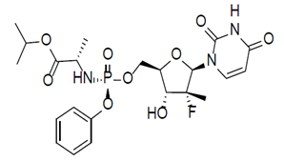

Description: SOF is a white to off-white powder with a solubility of ≥ 2 mg/mL across the pH range of 2 to 7.7 at 37 °C. The partition coefficient (log P) for SOF is 1.62 and the pKa is 9.3.

##### Velpatasvir

Chemical Name: Methyl {(1R)-2-[(2S,4S)-2-(5-{2-[(2S,5S)-1-{(2S)-2-[(methoxycarbonyl)amino]-3-methylbutanoyl}-5-methylpyrrolidin-2-yl]-1,11-dihydro[2]benzopyrano[4',3':6,7]naphtho[1,2-d]imidazol-9-yl}-1H-imidazol-2-yl)-4-(methoxymethyl)pyrrolidin-1-yl]-2-oxo-1-phenylethyl}carbamate.

Molecular Formula: C49H54N8O8

Molecular Weight: 883

CAS registry number: 1377049-84-7

Structural Formula: The structural formula is shown in Figure 2.

Figure 2: Structural formula of Velpatasvir

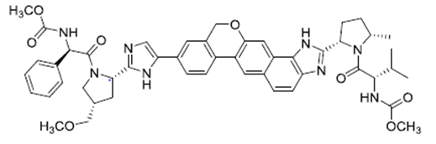

Description: VEL is practically insoluble (less than 0.1 mg/mL) above pH 5, slightly soluble (3.6 mg/mL) at pH 2, and soluble (greater than 36 mg/mL) at pH 1.2.

#### Pharmacokinetics in healthy subjects

##### Absorption

###### Sites and mechanisms of absorption

Epclusa is an oral FDC tablet, which contains 400 mg SOF and 100 mg VEL that is to be taken once daily with or without food. Following a single oral dose of the proposed FDC formulation for marketing in fasted, healthy subjects the Tmax values (median [Q1, Q3]) for SOF and VEL occurred at 1 hour (0.50, 1.50) and 3 hours (2.00, 3.00) following dosing, respectively.

##### Bioavailability

###### Absolute bioavailability

The absolute bioavailability of Epclusa was not determined; however, the sponsor has provided a justification for not providing biopharmaceutic studies in regards to the absolute bioavailability of Epclusa (see below).

**Comment:** In the justification for a biowaiver, the sponsor correctly states that “a thorough characterisation of the absorption, distribution, metabolism, and elimination (ADME) profiles of SOF and VEL, as single agents or in combination, have been conducted across the preclinical and clinical development programmes”. The sponsor also addresses the solubility and lack thereof of the drug substances in question. In addition as they only propose a single dose strength FDC tablet for registration, which has been thoroughly tested and found to be safe in the clinical setting, much of the information normally required for a successful application for a biowaiver is not necessary in this case. For instance information regarding the margin between the minimum effective and minimum toxic plasma concentration is not needed. Therefore the evaluator believes that the biowaiver is justified.

###### Bioavailability relative to an oral solution or micronised suspension

The bioavailability of Epclusa relative to an oral solution or micronised suspension was not determined.

###### Bioequivalence of clinical trial and market formulations

Not applicable.

###### Bioequivalence of different dosage forms and strengths

A single dose form and strength, which contains SOF (400 mg)/VEL (100 mg) as a FDC tablet, is proposed for marketing.

###### Bioequivalence to relevant registered products

Study GS-US-342-0104 evaluated the relative BA of the FDC tablets proposed for marketing (that is SOF (400 mg)/VEL (100 mg)) relative to the corresponding dose strengths of the individual tablet formulations in healthy subjects. Plasma exposure to SOF, its metabolites GS‑566500 and GS-331007, and VEL were similar but not bioequivalent following administration of the proposed FDC compared with the free combination of SOF/VEL. The GLSM ratios (90% CIs) for the primary PK parameters (AUCinf and Cmax) of SOF were 89.5 (78.8, 101.8) and 90.0 (74.7, 108.4), respectively, and for VEL were 103.5 (75.7, 141.7) and 103.0 (74.5, 142.4), respectively.

###### Influence of food

Study GS-US-342-0104 also examined the PK parameters of SOF and VEL following the administration of SOF/VEL (400 mg/100 mg) under fasting conditions, with a moderate fat meal or with a high calorie, high fat meal.

Compared to administration under fasted conditions, a moderate fat meal increased the AUCinf of SOF by 1.6 fold, whereas, SOF Cmax was relatively unaffected (that is < 5% change). Similarly, a high fat meal increased SOF AUCinf by 1.78 fold, whereas, Cmax decreased by approximately 11%.

For the VEL component, compared to administration under fasted conditions, a moderate fat meal increased VEL AUCinf and Cmax by 1.34 fold and 1.31 fold, respectively, whereas, a high fat meal increased these values by 1.22 fold and 1.05 fold, respectively.

**Comment:** Although SOF AUC appeared to decrease significantly in the fed state compared to the fasted state there appeared to be little change in the AUC of its active metabolite GS-331007 and the safety profiles of SOF in the presence and absence of food were almost identical; therefore, food is unlikely to affect the efficacy and safety of SOF. Similarly, in this study food had little to no effect on the safety profile of VEL when it was co-administered with SOF. In addition, studies with supratherapeutic doses of VEL indicate that much higher exposures to VEL can be tolerated with little change to the safety profile of the drug.

Overall, these results would suggest that SOF/VEL can be administered without regard to food.

###### Dose proportionality

The dose proportionality and bioavailability of SOF during multiple dosing has been reported as part of a previous submission to the TGA, whereas, Study GS-US-281-0101 examined the PKs of VEL following single and multiple administrations of a range of VEL doses in healthy subjects. Following single doses of 5 mg to 450 mg VEL, Tmax ranged from 1.50 hour to 3.25 hours and VEL exhibited nonlinear PK across the entire dose range with greater than dose proportional increases in AUC and Cmax from doses of 5 to 50 mg and less than dose proportional increases in exposure at doses from 50 to 450 mg.

###### Bioavailability during multiple dosing

As mentioned above, Study GS-US-281-0101 also examined VEL PKs following multiple doses of 5 mg to 450 mg VEL in healthy subjects. Following multiple doses of VEL Tmax ranged from 2.0 hours to 3.0 hours and as for single doses VEL exhibited nonlinear PK across the entire dose range with greater than dose proportional increases in AUC and Cmax from doses of 5 to 50 mg and less than dose proportional increases in exposure at doses from 50 to 450 mg. Little to no accumulation in VEL AUC was identified, for instance following a single dose of 50 mg VEL AUClast was 2971 ng.h/mL, whereas, following multiple doses 50 mg VEL AUCtau was 3033 ng.h/mL.

###### Effect of administration timing

The effect of administration timing has not been examined.

##### Distribution

###### Volume of distribution

Two studies (GS-US-281-0112 and GS-US-281-1056) examined the apparent volume of distribution in healthy subjects and subjects with hepatic or renal impairment. In healthy subjects, VEL was widely distributed to the tissues as the Vz/F ranged from 521 L to 678 L across the two studies.

###### Plasma protein binding

Two in vitro studies, AD-281-2001 and AD-281-2029, identified that VEL was highly bound to human plasma proteins with less than 0.5% of VEL free. Similarly, the results of studies GS‑US‑281-0112 and GS-US-281-1056 also indicated that VEL protein binding was high (≥ 99.5%) in healthy human subjects.

###### Erythrocyte distribution

The mass balance study, GS-US-281-1055 indicated that the whole blood-to-plasma concentration ratio for VEL through 12 hours ranged from 0.517 to 0.670, indicating that total radioactivity was excluded from erythrocytes.

###### Tissue distribution

The apparent volume of distribution of VEL indicates that it is highly distributed to the tissues.

##### Metabolism

The metabolism of SOF has been described in a previous submission to the TGA; therefore, the following discussion will focus on VEL metabolism. The proposed biotransformation and excretion pathways for VEL are summarised in Figure 3.

Figure 3: Proposed major biotransformation and excretion pathways of GS-5816 (VEL) in humans

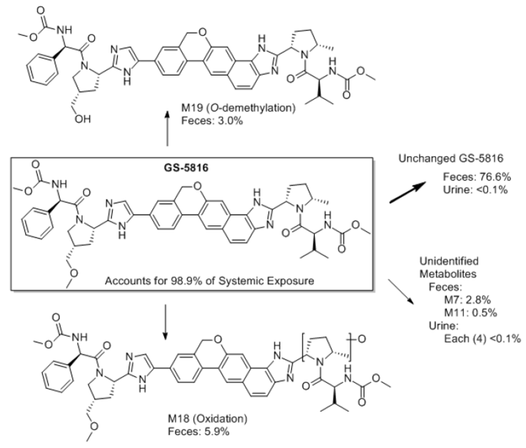

###### Interconversion between enantiomers

Not applicable.

###### Sites of metabolism and mechanisms / enzyme systems involved

In vitro studies indicated that VEL was slowly metabolised by CYP2B6, CYP2C8 and CYP3A4 (AD-281-2007) and that it was also a substrate for both P-gp and BCRP mediated transport (AD‑281-2041).

###### Non-renal clearance

Following a single oral dose administration of [14C] VEL approximately 94% of the radioactive dose was recovered in the faeces.

##### Metabolites identified in humans

###### Active metabolites

The activity of the VEL metabolites identified in the mass balance study is not discussed but due to the extremely low levels detected in plasma they are unlikely to be pharmacologically active.

###### Other metabolites

Please see the preceding section of this report entitled active metabolites.

###### Pharmacokinetics of metabolites

Following administration of the FDC proposed for marketing a moderate or high fat meal increased the AUCinf of the GS-566500 metabolite of SOF by 1.51 fold and 1.78 fold, respectively, compared to when the FDC was administered under fasted conditions. For GS-331007, an approximately 25% (following a moderate fat meal) to 37% (following a high calorie, high fat meal) lower Cmax was observed upon SOF/VEL (400 mg/100 mg) administration with food with no change in AUC. The 90% CIs of the GLSM ratios for AUC of GS-331007 remained within the bioequivalence bounds of 80% to 125%. Since the decrease in GS-331007 Cmax was modest and the AUC parameters met PK equivalence criteria, the effect of food on GS‑331007 PK was not considered clinically significant.

###### Consequences of genetic polymorphism

Not examined.

##### Excretion

###### Routes and mechanisms of excretion

As stated previously, VEL is primarily excreted via the faeces with unchanged VEL as the major species identified, which accounted for a mean of 76.6% of the administered dose, followed by one known oxidative metabolite M18 (hydroxy-VEL-1, 5.9%) and one known dealkylated metabolite M19 (desmethyl-VEL, 3.0%).

###### Mass balance studies

The mass balance study, GS-US-281-1055, identified two minor VEL metabolites in human plasma that each represented less than 1% of the total radioactivity administered.

###### Renal clearance

Renal clearance of VEL was low as approximately 0.4% of the dose administered in the mass balance study was identified in the urine as either parent drug or metabolites.

##### Intra- and inter-individual variability of pharmacokinetics

The PopPK analyses (Study Reports 15-0001 to 15-0003) based on the results of 11 clinical trials, including 4 Phase I, 3 Phase II and 4 Phase III studies, which examined healthy subjects and HCV infected subjects, including those with decompensated cirrhosis, indicated that inter-individual variability on VEL CL/F, Vc/F, peripheral volume (Vp/F) and Ka in fasted subjects were 50.8%, 68.9%, 50.8% and 54.2%, respectively. The intra-subject variability on VEL PKs was 56.7%. For SOF PKs, the inter-individual variability on CL, Vc/F and Ka were 48.2%, 94.9% and 4.6%, respectively. The intra-subject variability on SOF PKs was 119.9% and 108.8% in healthy volunteers and in patients, respectively.

#### Pharmacokinetics in the target population

##### Study GS-US-281-0102

Study GS-US-281-0102 examined the PKs of VEL following escalating single and multiple oral doses of VEL in 87 subjects infected with HCV. The results indicated that VEL was absorbed quickly following single and multiple oral doses, with a median Tmax of between 1.50 and 3.0 hours. At the dose proposed for marketing (that is 100 mg) VEL Cmax and AUCinf were 372.8 ng/mL and 2727.3 ng.h/mL, respectively. Over the dose range of 25 mg to 150 mg VEL increases in exposure were near dose proportional, whereas, increases in VEL exposures were generally greater than dose proportional from 5 mg to 25 mg. Modest accumulation (less than 1.5 fold) was observed following 3 days of dosing, consistent with the median VEL t½ranging from 14 to 20 hours. The plasma PK of VEL was similar between subjects with genotype 1a, 1b, 2, 3, or 4 HCV.

##### The PopPK analyses

The PopPK analyses also provided estimates of SOF and VEL PKs in healthy subjects and in patients infected with HCV. The results indicated that following once daily administration of SOF 400 mg and VEL 100 mg as either, a free combination or FDC, VEL Cmax and AUCinf were approximately 1.71 fold and 1.59 fold lower in HCV infected subjects than in healthy subjects. By contrast, SOF Cmax and AUCinf were equivalent in HCV infected and healthy subjects. As in Study GS-US-281-0102, mean exposure to VEL was similar across HCV genotypes, and HCV genotype was not identified as a covariate during population PK modelling.

#### Pharmacokinetics in other special populations

##### Pharmacokinetics in subjects with impaired hepatic function

The primary objective of Study GS-US-281-0112 was to evaluate the single dose PKs of VEL in subjects with normal hepatic function, moderate hepatic impairment, and severe hepatic impairment. VEL AUCinf values in subjects with normal hepatic function, moderate or severe impairment were relatively similar and ranged from 4104.6 ng.h/mL to 5403.7 ng.h/mL. By contrast VEL Cmax decreased as impairment increased and was 599.7 ng/mL, 343.8 ng/mL and 268.4 ng/mL, in subjects with normal function, moderate and severe hepatic impairment, respectively. Median terminal t½ was prolonged for subjects with moderate hepatic impairment (approximately 23 hours) and severe hepatic impairment (approximately 31 hours) compared to subjects with normal hepatic function (approximately 18 hours). The results possibly indicate that although hepatic impairment reduces the bioavailability and systemic clearance of VEL, there is no change in overall VEL exposure.

##### Pharmacokinetics in subjects with impaired renal function

Study GS-US-281-1056 evaluated the single dose PKs of VEL (100 mg) in subjects with severe renal impairment and matched control subjects with normal renal function. The results indicated that the AUCinf was approximately 1.5 fold higher in subjects with severe renal impairment compared to those with normal renal function, whereas, Cmax was approximately 1.11 fold higher. The sponsor argues that since the exposure of VEL was not significantly altered by severe renal impairment, evaluation of VEL PK in subjects with mild or moderate renal impairment was not necessary and was thus not conducted. Based on the results of this study, VEL dose adjustment is not necessary for subjects with mild, moderate, or severe renal impairment.

##### Pharmacokinetics according to age

Age was not identified as a significant covariate for either SOF or VEL exposure in the PopPK analyses.

##### Pharmacokinetics related to genetic factors

See below.

##### Pharmacokinetics in other special population / according to other population characteristic

Covariate analysis performed as part of the PopPK analyses indicated statistically significant effects of sex, HCV infection, and decompensated cirrhosis on VEL CL/F and Vc/F and food on VEL Ka, F1 (bioavailability), and lag time. By contrast, race, ethnicity, CLcr, HCV genotype, IL28B genotype, (compensated) cirrhosis, body weight, BMI, and concomitant medications were not considered relevant covariates for the population PK of VEL.

For SOF PopPK, covariate analysis indicated statistically significant effects of sex and hepatic impairment (subjects without cirrhosis and subjects with compensated cirrhosis compared with subjects with decompensated cirrhosis) on SOF CL/F and Vc/F and food on SOF Ka (Table 3,). All other covariates tested, including race, ethnicity, CLcr, HCV infection status, HCV genotype, IL28B genotype, (compensated) cirrhosis, body weight, BMI, and concomitant medications were not considered relevant covariates for the population PK of SOF.

Table 3: effect of covariates on SOF PK parameters

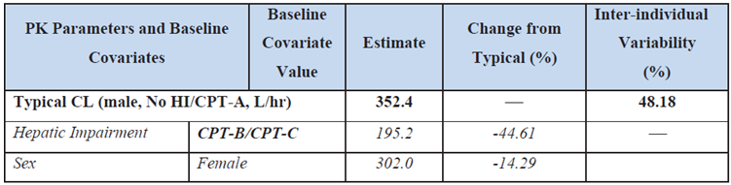

#### Pharmacokinetic interactions

##### Pharmacokinetic interactions demonstrated in human studies

###### Interaction between SOF and VEL

One of the objectives of Study GS-US-281-0101 was to determine the effects of a single dose of 150 mg VEL on the PKs of a single dose of 400 mg SOF and metabolites, and the effect of SOF on the PK of VEL in healthy subjects under fed conditions. Results indicated that the co‑administration of SOF had little to no effect on VEL plasma exposures based on VEL AUCtau, Cmax, and Ctau. By contrast, SOF plasma exposures increased approximately 1.8 (Cmax) and 2.4 fold (AUC) when co-administered with VEL. GS-566500 Cmax and AUC increased approximately 1.6 and 1.8 fold, respectively, when SOF was co-administered with VEL. GS‑331007 (the predominant circulating nucleoside metabolite of SOF) Cmax decreased approximately 36%, but AUC was unaffected by co-administration of SOF+VEL.

**Comment:** The proposed dose of VEL (100 mg) was not used in this study and although SOF AUC increased significantly (2.4 fold following co-administration with VEL), there was little change in exposure to the major metabolite of SOF (that is GS-331007) and the safety profile of the drugs was similar whether they were administered alone or in combination.

###### Interaction between the FDC and other antiretroviral drugs

Two studies, GS-US-342-1167 and GS-US-342-1326, examined the drug-drug interactions between SOF/VEL FDC and other antiretroviral drugs. The first of these, Study GS-US-342-1167, examined the PKs of SOF and its metabolites GS-566500 and GS-331007, and VEL upon administration of SOF/VEL FDC with Atripla (ATR), efavirenz/emtricitabine/tenofovir disoproxil fumarate (EFV/FTC/TDF), emtricitabine/rilpivirine/tenofovir disoproxil fumarate (FTC/RPV/TDF), dolutegravir (DTG), or elvitegravir/cobicistat/emtricitabine/tenofovir alafenamide fumarate (EVG/COBI/FTC/TAF).

The results indicated that other than a small increase in SOF Cmax (38%) when administered with EFV/FTC/TDF, the 90% CIs for the %GLSM ratios for all of the primary PK parameters (AUCtau, Cmax, and Ctau [if measurable]) of SOF and its metabolites were within the predetermined lack of PK alteration boundaries of 70% to 143%, following co-administration of the SOF/VEL FDC with EFV/FTC/TDF, FTC/RPV/TDF, or DTG (Table 4). By contrast, when co-administered with EVG/COBI/FTC/TAF, the AUCtau of SOF and GS-331007 increased by 37% and 48%, respectively, and GS-331007 Ctau increased by 58%.

Table 4: Study GS-US-342-1167 Effect of co-administered drugs on the PK of SOF and GS 331007 following administration of SOF single agent or SOF/VEL in healthy subjects

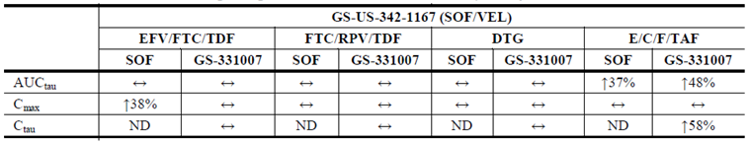

For the VEL component of the FDC, the PKs of VEL were not affected by the co-administration of FTC/RPV/TDF or DTG, whereas, VEL Cmax and AUCtau were decreased by 47% and 53%, respectively, when the FDC was co-administered with EFV/FTC/TDF (Table 5). By contrast, VEL Cmax, AUCtau and Ctau were increased 30%, 50% and 60%, respectively following co‑administration of EVG/COBI/FTC/TAF with the FDC tablet.

Table 5: Study GS-US-342-1167 effect of co-administered drugs on the PK of VEL following administration of VEL single agent or SOF/VEL in healthy subjects

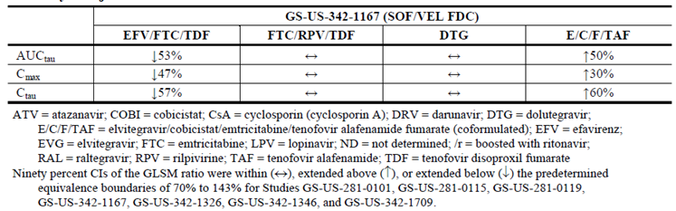

Co-administration of SOF/VEL with EFV/FTC/TDF, FTC/RPV/TDF, DTG, or EVG/COBI/FTC/TAF had no effect on the PKs of EFV, RPV, DTG, EVG, and FTC, whereas, COBI Ctau increased by 103% and TAF Cmax decreased by 20% (Table 6). The PKs of tenofovir (TFV) were not affected following co-administration of EVG/COBI/FTC/TAF with SOF/VEL. By contrast, TFV AUCtau, Cmax, and Ctau increased by approximately 81%, 77%, and 121%, respectively, following co-administration of EFV/FTC/TDF with SOF/VEL. Similarly, TFV AUCtau, Cmax, and Ctau increased approximately 40%, 44%, and 84%, respectively, following co-administration of FTC/RPV/TDF with SOF/VEL.

Table 6: Study GS-US-342-1167. Effect of SOF/VEL FDC on the PK of co-administered drugs in health subjects

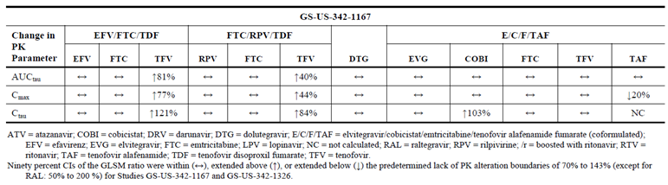

Study GS-US-342-1326

Study GS-US-342-1326 examined the drug-drug interactions between the SOF/VEL FDC and several other antiretroviral combinations including EVG/COBI/FTC/TDF, darunavir (DRV) + ritonavir (RTV) + FTC/TDF, atazanavir (ATV) + RTV + FTC/TDF, lopinavir (LPV)/RTV + FTC/TDF, or raltegravir (RAL) + FTC/TDF.

Results indicated that plasma exposure to SOF, GS-566500, GS-331007and VEL was not affected following co-administration of SOF/VEL with, either RAL + FTC/TDF, or EVG/COBI/FTC/TDF (Table 7). By contrast, co-administration of SOF/VEL with DRV+RTV+FTC/TDF or LPV/RTV+FTC/TDF resulted in a modest decrease in the overall exposure of SOF (approximately 28% and approximately 29%, respectively) with no alteration in the overall exposure of GS-566500, GS-331007, or VEL. However, co-administration with ATV+RTV+FTC/TDF resulted in an increase in VEL AUCtau (approximately 142%), Cmax (approximately 55%), and Ctau (approximately 301%) with no change in the overall exposure of SOF or its metabolites (GS-566500 and GS-331007).

SOF/VEL co-administration did not affect the AUCtau or Cmax of EVG, COBI, DRV, ATV, LPV, RTV, and FTC, as the 90% CIs for the %GLSM ratios for AUCtau were within the protocol predefined lack of PK alteration boundaries of 70% to 143% (Table 7). By contrast, the Ctau of ATV and RTV increased by approximately 39% and approximately 29%, respectively, following co-administration of ATV+RTV+FTC/TDF with SOF/VEL and COBI Ctau increased by approximately 71% when EVG/COBI/FTC/TDF was co-administered with the FDC. In addition, TFV AUCtau (range: 39% to 40%), Cmax (range: 36% to 55%), and Ctau (range: 45% to 70%) were increased following administration of EVG/COBI/FTC/TDF, DRV+RTV+FTC/TDF, or RAL+FTC/TDF with SOF/VEL and an increase in TFV Cmax (approximately 55%) and Ctau (approximately 39%), but no change in AUC, was observed following administration of ATV+RTV+FTC/TDF with SOF/VEL. TFV Cmax also increased (approximately 42%) following administration of LPV/RTV+FTC/TDF with SOF/VEL, whereas, there was no change in either TFV AUCtau or Ctau under these conditions.

Table 7: Study GS-US-342-1326. The differences in PK parameters of SOF, its metabolites GS-566500 and GS-331007, GS-5816 and evaluated ARV (EVG, COBI, DRV, ATV, LPV, RTV, RAL, FTC and TFV) when SOF/GS-5816 or the ARVs were administered alone compared with administration of SOF/GS-5816 + ARVs

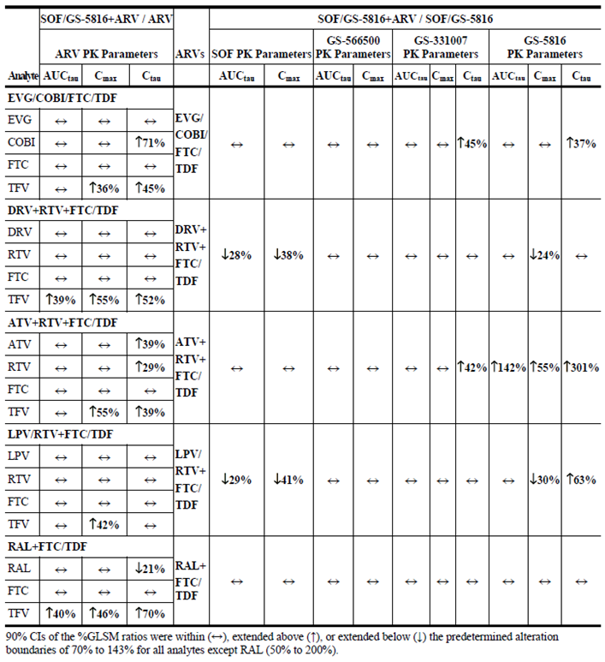

###### Interaction between the FDC and PPIs/H2RA

Two studies, GS-US-342-1709 and GS-US-342-1346, examined the drug-drug interaction between the SOF/VEL FDC tablet and proton pump inhibitors (PPI). In Study GS-US-342-1709, 20 mg or 40 mg doses of the proton pump inhibitor omeprazole were administered for 5 days, then on the 6th day the SOF/VEL FDC was administered with food either 4 hours before or 2 hours after the omeprazole dose. Administration of SOF/VEL with food and omeprazole had no effect on the AUC of SOF or its metabolites GS‑566500 and GS-331007, regardless of timing or dose of omeprazole, whereas, SOF Cmax was 16% to 30% lower following administration of SOF/VEL with food and omeprazole. By contrast, administration of food and omeprazole with SOF/VEL resulted in a decrease in VEL Cmax and AUC with the smallest decrease in VEL exposure (AUC: 26%, Cmax: 33%) occurring following administration of SOF/VEL with food 4 hour before omeprazole 20 mg. A slightly larger decrease in VEL exposure (AUC: 38%, Cmax: 48%) was observed when SOF/VEL was administered with food 2 hour after omeprazole 20 mg. The largest decline in VEL exposure (AUC: 53%, Cmax: 56%) was observed following SOF/VEL administration with food 4 hour before omeprazole 40 mg.

The second study, GS-US-342-1346, examined the relative bioavailability and PKs of SOF/VEL following administration of the FDC in the presence or absence of a representative H2 receptor antagonist (H2RA), famotidine (40 mg) or the selective PPI 20 mg omeprazole. The results indicated that administration of SOF/VEL with famotidine 40 mg (simultaneously or staggered by 12 hours) had no effect on the AUC values for SOF, GS-566500, GS-331007, or VEL, as the 90% CIs for the %GLSM ratios were within the protocol predefined lack of PK alteration boundaries of 70% to 143%, whereas, there was a small decrease in SOF Cmax (23%), (Table 8). By contrast, administration of SOF/VEL with omeprazole 20 mg (simultaneous or staggered by 12 hours) resulted in a decrease in the AUCinf values for SOF, GS-566500, and VEL, ranging from 29% to 55%, whereas there was no effect on the PKs of GS-331007.

Table 8: **Study GS-US-342-1346 the differences in primary PK parameters of SOF, GS-566500, GS-331007, and GS-5816 following administration of SOF/GS-5816 alone and with famotidine or omeprazole administered simultaneously or staggered by 12 hours**

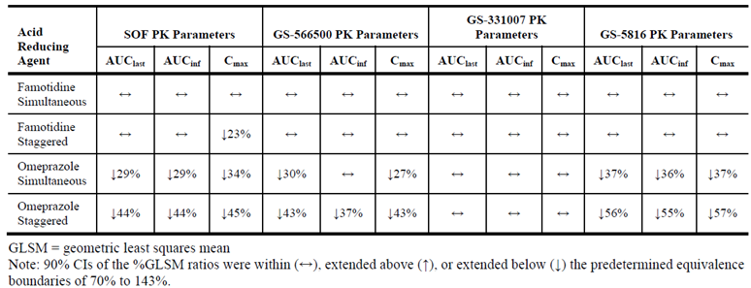

###### Effect of VEL on the PKs of other drugs in the absence of SOF

Study GS-US-281-0115 had a number of objectives including the examination of the interaction between VEL and the following drugs: an organic anion transporting polypeptides (OATP) substrate pravastatin; an OATP/breast cancer resistance protein (OATP/BCRP) substrate, rosuvastatin; a p-glycoprotein (P-gp) substrate, digoxin; a cytochrome CYP3A/CYP2C8/P-gp inducer, rifampin; the CYP3A/CYP2C8/P-gp inhibitor ketoconazole; a selective OATP1B1/1B3 inhibitor, rifampin, and mixed OATP/P-gp/MRP2 inhibitor, cyclosporine, on the PK of VEL. Pravastatin AUC and Cmax were modestly increased by 35% and 28%, respectively, following co-administration with VEL, relative to pravastatin administration alone (Table 9). By contrast, rosuvastatin AUC and Cmax were approximately 2.8 fold and approximately 2.6 fold higher, respectively, following co-administration with VEL, relative to rosuvastatin administration alone. Due to the magnitude of this increase the sponsor suggests that monitoring for signs and symptoms of muscle weakness or myopathy, including rhabdomyolysis, during concomitant use of rosuvastatin with VEL may be warranted. Digoxin AUClast, AUCinf, and Cmax were 60%, 34%, and 88% higher, respectively, following co-administration with VEL, relative to digoxin administration alone. This result does not preclude the use of P-gp substrates with VEL, but for digoxin, a drug with narrow therapeutic range, therapeutic monitoring is recommended while receiving VEL. By contrast, VEL had little to no effect on cyclosporine exposure (approximately 10% decrease).

Table 9: Study GS-US-281-0115 a summary of pharmacokinetic parameters of pravastatin, rosuvastatin, digoxin and cyclosporine

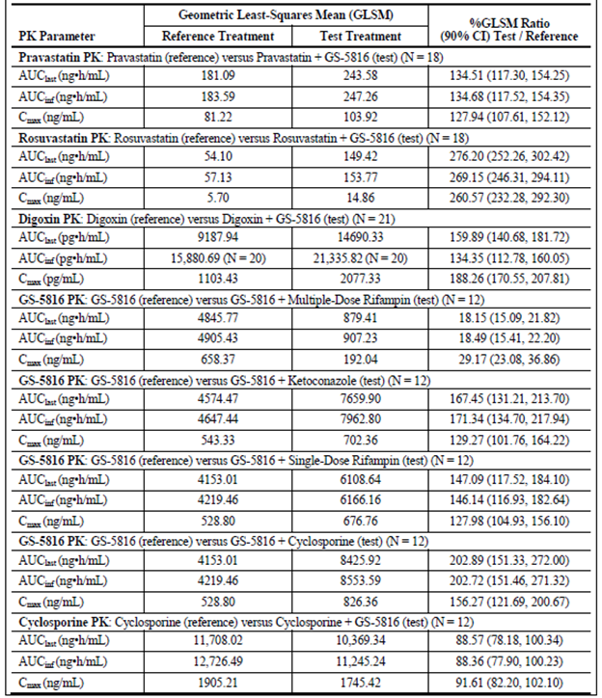

Study GS-US-281-1058 examined the effect of VEL on the PK of a representative hormonal oral contraceptive (OC) medication containing norgestimate /ethinyl estradiol 0.025 mg in healthy female subjects. In this study 3 doses of norgestimate were used: 0.180 mg on Days 1 to 7 of the 28–day cycle; 0.215 mg on Days 8 to 14; and 0.250 mg on Days 15 to 21. The results indicated that there were small decreases (≤ 10%) in the Cmax and AUC values for norelgestromin (major active metabolite of norgestimate) and norgestrel (minor active metabolite of norgestimate) following co-administration of OC with VEL compared to OC alone. For the ethinyl estradiol component there was an approximately 39% increase in Cmax and 17% decrease in Ctau while the AUCtau was not affected following co-administration of the OC and VEL compared to when the OC was administered alone.

###### Effect of other drugs on VEL PKs in the absence of SOF

Study GS-US-281-0115 also examined the effects of other drugs on the PKs of VEL. For instance, following administration of multiple dose rifampin, a strong inducer of CYP3A4/2C8 and P-gp, VEL AUC (approximately 82%) and Cmax (approximately 71%) were substantially reduced compared to when VEL was administered alone (Table 9). Therefore the sponsor indicates that VEL should not be administered with strong inducers of CYP3A4/2C8 and P-gp. Conversely compared to when VEL was administered alone, following co-administration with ketoconazole, a strong inhibitor of CYP3A4/2C8 and P-gp, VEL AUC and Cmax were approximately 70% and 29% higher, respectively. The sponsor argues that due to the favourable clinical safety profile of VEL identified to date, inhibitors of CYP3A4/2C8 and P-gp can be administered with VEL.

Administration of single dose rifampin, an inhibitor of OATP, with VEL resulted in an approximate 47% and 28% increase in VEL AUC and Cmax, respectively, as compared to administration of VEL alone, demonstrating that VEL is a weak substrate of OATP. As VEL concentrations increased only modestly following concomitant administration with single dose rifampin, an OATP inhibitor, inhibitors of OATP can be administered with VEL.

VEL AUC and Cmax were approximately 2 fold and 56% higher, respectively, following co‑administration with cyclosporine, a strong inhibitor of OATP/P-gp/MRP2, as compared to VEL administered alone. Once again the sponsor argues that due to the favourable safety profile of VEL, inhibitors of OATP/P-gp/MRP2 can be administered with VEL.

**Comment:** The sponsor has been asked to comment on the likely changes to VEL exposure and safety following co-administration with combinations of drugs that have been shown to increase VEL exposure, for instance cyclosporine combined with ketoconazole.

The sponsor has also been asked to comment on the likely changes to VEL exposure and safety following co-administration with drugs that increase VEL exposure, for example ketoconazole or cyclosporine, in patients with renal impairment.

One of the objectives of Study GS-US-281-1058 was to also assess the effect of norgestimate/ethinyl estradiol on the PK of VEL. Although in this study VEL was not given in the absence of the OC, the sponsor reported that the systemic exposure of VEL in the presence of OCs was consistent with historical data.

Study GS-US-281-0119 examined the relative bioavailability and PKs of VEL following co-administration with the PPI omeprazole or the H2RA famotidine. Simultaneous administration of famotidine, had no impact on the relative bioavailability of VEL as the 90% CIs of the GLS mean ratios were between 70% and 120% for VEL AUC. VEL Cmax, on the other hand, did decrease modestly (approximately 14%) when VEL was co-administered with famotidine.

Staggered administration famotidine had little to no impact on the AUClast, AUCinf, and Cmax of VEL. Therefore, VEL may be administered with an H2RA at a dose not to exceed famotidine 20 mg or equivalent when staggered by 12 hours. By contrast, simultaneous administration of the PPI, omeprazole, with VEL resulted in substantial decreases in the AUCinf (approximately 53%) and Cmax (approximately 55%) values of VEL compared to when VEL was administered alone indicating that VEL should not be administered with PPIs as exposure of VEL is considerably decreased in the presence of omeprazole.

###### Effect of SOF on the PKs of other drugs in the absence of VEL

Study P7977-1910 examined whether the co-administration of SOF (400 mg OD) significantly influenced the PK parameters of a range of anti-retroviral drugs including: ATR (EFV 600 mg/FTC 200 mg/TDF 300 mg OD); EFV (600 mg OD) + ZDV/3TC (ZDV 300 mg/3TC 150 mg BID); ATV/r (400 mg/100 mg) + TVD (FTC 200 mg/TDF 300 mg OD); DRV/r (800 mg/100 mg) + TVD (FTC 200 mg/TDF 300 mg OD); and RAL (400 mg BID)+ TVD (FTC 200 mg/TDF 300 mg OD) in healthy HIV/HCV co-infected subjects. The results identified only modest changes in the PK parameters of the evaluated ARVs. The largest decrease in Cmax occurred following administration of SOF with DRV/r + TVD, which resulted in a 38% decrease in RTV Cmax and the largest decrease in AUCtau occurred when SOF was administered with ATV/r + TVD, which resulted in a 21% decrease in RTV AUCtau. Conversely, the largest increases in Cmax values were identified following co-administration of SOF with ATR (35% increase in TFV) or ATV/r + TVD, which resulted in a 40% increase in TFV Cmax.

###### Effect of other drugs on the PKs of SOF in the absence of VEL

Study P7977-1910 also evaluated whether ATV/r, EFV, TDF, FTC, ZDV, 3TC, DRV/r, or RAL significantly affected the PK parameters of SOF and its metabolites, GS-566500 (formerly PSI-352707) and GS-331007 (formerly PSI-6206), in healthy HIV/HCV co-infected subjects. The largest increases in exposure of SOF, GS-566500, and GS-331007 resulted following co-administration of SOF with ATV/r + TVD, DRV/r + TVD and RAL + TVD (Table 10). For instance following co-administration of SOF with ATV/r + TVD, DRV/r + TVD or RAL + TVD the AUCtau values for SOF were increased by 342%, 173%and 221%, respectively.

**Comment:** The sponsor states that “co-administration of SOF with ATR, DRV/r, RPV, and RAL has been examined in a healthy subject DDI study (GS-US-334-0131, and GS‑US‑344-0102) and no clinically relevant DDIs between SOF, GS-566500, and GS‑331007 and EFV, FTC, TFV, DRV, RTV, ATV, RPV, or RAL were observed. Collectively, PK results from this study (and studies GS-US-334-0131 and GS-US-344-0102) indicate that SOF may be co-administered with ARVs, such as ATR (EFV/FTC/TFV), EFV+ZDV/3TC, TVD (FTC/TDF), DRV/r, ATV/r, RPV, and RAL.” However, the magnitude of these changes in exposure, particularly in regard to co‑administration of SOF with ATV/r + TVD, DRV/r + TVD and RAL + TVD, is clearly significant (that is 342%, 173% and 221%, respectively) and therefore should be highlighted in the PI.

Table 10: Study P7977-1910 effects of the evaluated ARVs on the PK of SOF, GS-566500 and GS-331007

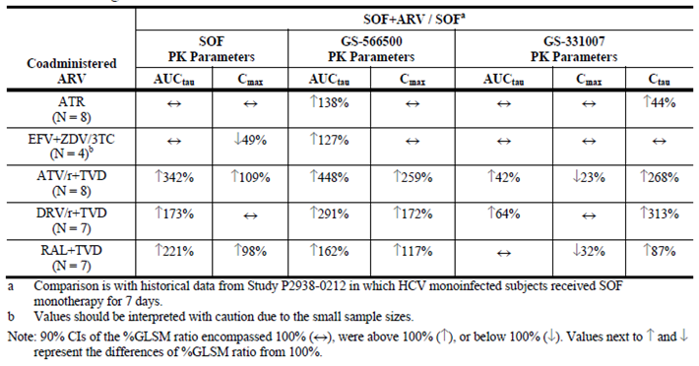

##### Clinical implications of in vitro findings

###### VEL

In vitro studies examined the potential for VEL to be metabolised by, inhibit or stimulate a range of metabolic pathways. Overall, VEL was relatively metabolically stable in human hepatocytes and hepatic microsomal fractions (Study AD-281-2006) and it was not a substrate for recombinant CYP1A2, CYP2C9, CYP2C19, CYP2D6 (AD-281-2007), OATP1B1, OATP1B3 (AD-281-2011) or OCT1 (AD-281-2026). By contrast, VEL was slowly metabolised by CYP2B6, CYP2C8 and CYP3A4 (AD-281-2007) and it was identified as a substrate for both P-gp and BCRP mediated transport (AD-281-2041).

At µM concentrations, VEL had no inhibitory effect on the activities of CYP1A2, CYP2B6, CYP2C8, CYP2C9, CYP2C19, CYP2D6, CYP3A (AD-281-2008), OATP1A2 transport (AD‑281‑2040), multidrug resistance protein 2, Na+-taurocholate co-transporting polypeptide (AD-281-2012), OAT1 or OAT3 (AD-281-2026). By contrast, VEL dose dependently inhibited OATP1B1 and OATP1B3 with IC50s of 1.5 ± 0.5 µM and 0.26 ± 0.03 µM, respectively (AD‑281‑2010); P-gp and BCRP with IC50s of 20.6 ± 5.7 µM and 0.23 ± 0.08 µM, respectively (AD-281-2010); human bile salt export pump transporter (IC50 = 0.64 µM, AD-281-2012); and human UGT1A1 (IC50 = 1.56 µM, AD-281-2016). In addition, VEL was a relatively weak inhibitor (30% at 10 µM) of OATP2B1 mediated E3S transport (AD-281-2040) and a concentration of 4 µM VEL inhibited OCT1, OCT2 and MATE1 transporter activity by 22%, 45% and 19%, respectively (AD‑281‑2026).

In general, VEL did not induce the CYP1A, CYP2B, CYP2C, CYP3A subfamilies (AD-281-2009) and at concentrations up to 10 µM it had little to no potential to induce CYP1A2, CYP2B6, and CYP3A4, whereas, it had a low potential to induce CYP2C9, P-gp, and UGT1A1 mRNA expression (AD-281-2025).

###### SOF

SOF did not significantly inhibit CYP1A2, CYP2B6, CYP2C8, CYP2C9, CYP2C19 and CYP2D6 and previously it has been shown to display no potential for mechanism based inhibition of human CYP3A (AD-334-2026). In addition, SOF, at concentrations up to 300 µM, did not demonstrate dose dependent inhibition of P-gp mediated transport (AD-334-2023). The nucleoside metabolite of SOF, GS-331007, did not inhibit P-gp, OCT1, MATE1, BSEP and MRP2 mediated transport at test concentrations up to 300 µM, whereas, at 300 µM, GS-331007 inhibited OCT2 mediated transport of TEA and OAT3 mediated transport of E3S by 17% and 34%, respectively (IC50 values > 300 µM, AD-334-2024).

#### Population pharmacokinetics

As stated previously, PopPK analyses were undertaken in Study Reports 15-0001 to 15-0003.

##### VEL

The population PK model development dataset for VEL included measurable PK observations from a total of 2022 subjects (331 healthy subjects, 1691 subjects with HCV infection, including 266 subjects with decompensated cirrhosis). The final population PK model that best described VEL plasma concentration data was a 2 compartment PK model with first order absorption, an absorption lag time, and first order elimination from the central compartment, with inter-individual variability terms on PK variables Ka, CL/F, Vc/F, and Vp/F. Values of VEL CL/F, Vc/F, Vp/F, Q/F, Ka, and Tlag for the ‘typical’ male HCV infected subject weighing 80 kg who was administered SOF/VEL under fasting conditions were estimated to be 46.5 L/hour, 392 L, 219 L, 10.8 L/hour, 0.78 hour-1, and 0.295 hour, respectively.

##### SOF

The population PK model development dataset for SOF included measurable PK observations from a total of 1,519 subjects (331 healthy subjects, 1,188 subjects with HCV infection, including 206 subjects with decompensated cirrhosis). The final population PK model that best described SOF plasma concentration data was a 1 compartment PK model with first order absorption, an absorption lag time, and first order elimination from the central compartment, with inter-individual variability terms on PK variables Ka, CL/F, and Vc/F. Values of SOF CL/F, Vc/F, Ka, and Tlag for the ‘typical’ male HCV infected subject weighing 80 kg who was administered SOF/VEL under fasting conditions were estimated to be 352.4 L/hour, 197.2 L, 1.247 hour-1, and 0.0925 hour, respectively.

### Evaluator’s overall conclusions on pharmacokinetics

#### Absorption, distribution, metabolism, and elimination

* Epclusa is an oral FDC tablet, which contains 400 mg SOF and 100 mg VEL that is to be taken once daily with or without food.
* Following a single oral dose of Epclusa in fasted, healthy subjects the Tmax values for SOF and VEL occurred at 1 hour and 3 hours, respectively.
* Plasma exposure to SOF, its metabolites GS-566500 and GS-331007, and VEL were similar but not bioequivalent following administration of either Epclusa or the free combination. The GLSM ratios (90% CIs) for SOF AUCinf and Cmax were 89.5 (78.8, 101.8) and 90.0 (74.7, 108.4), respectively, and for VEL were 103.5 (75.7, 141.7) and 103.0 (74.5, 142.4), respectively.
* Compared to administration of SOF/VEL under fasted conditions, a moderate fat or high fat meal increased SOF AUCinf by 1.6 fold and 1.78 fold, respectively, whereas, there was little to no change in SOF Cmax (≥ 11% decrease). For the VEL component, a moderate fat meal increased VEL AUCinf and Cmax by 1.34 fold and 1.31 fold, respectively and a high fat meal increased these values by 1.22 fold and 1.05 fold, respectively.
* Following single doses of 5 mg to 450 mg VEL, Tmax ranged from 1.50 hours to 3.25 hours and VEL exhibited nonlinear PK across the entire dose range with greater than dose proportional increases in AUC and Cmax from doses of 5 to 50 mg and less than dose proportional increases in exposure at doses from 50 to 450 mg.
* Following multiple doses, VEL exhibited nonlinear PK across the entire dose range examined with greater than dose proportional increases in AUC and Cmax from doses of 5 to 50 mg and less than dose proportional increases in exposure at doses from 50 to 450 mg. Little to no accumulation in VEL AUC was identified, for instance following a single dose of 50 mg VEL AUClast was 2,971 ng.h/mL, whereas, following multiple doses 50 mg VEL AUCtau was 3,033 ng.h/mL.
* VEL was widely distributed to the tissues of healthy subjects as the Vz/F ranged from 521 L to 678 L. In vitro and clinical trials identified that VEL was highly bound to plasma proteins (≥ 99.5%). The whole blood-to-plasma concentration ratio for VEL through 12 hours ranged from 0.517 to 0.670, indicating that total radioactivity was excluded from erythrocytes.
* In vitro studies indicated that VEL was slowly metabolised by CYP2B6, CYP2C8 and CYP3A4 and that it was also a substrate for both P-gp and BCRP mediated transport.
* Following a single oral dose administration of [14C] VEL approximately 94% of the radioactive dose was recovered in the faeces, with the major species identified being unchanged VEL, which accounted for a mean of 76.6% of the administered dose, followed by one known oxidative metabolite M18 (hydroxy-VEL-1, 5.9%) and one known dealkylated metabolite M19 (desmethyl-VEL, 3.0%).
* The activity of the VEL metabolites identified in the mass balance study is not discussed but due to the extremely low levels detected in plasma they are unlikely to be pharmacologically active.

#### Intra- and inter-individual variability

* The inter-individual variability on VEL CL/F, Vc/F, Vp/F and Ka in fasted subjects were 50.8%, 68.9%, 50.8% and 54.2%, respectively, whereas, the intra-subject variability was 56.7%. For SOF PKs, the inter-individual variability on CL, Vc/F and Ka were 48.2%, 94.9% and 4.6%, respectively, whereas, the intra-subject variability was 119.9% and 108.8% in healthy volunteers and in patients, respectively.

#### Pharmacokinetics in the target population

* VEL was absorbed quickly following single and multiple oral doses, with a median Tmax of between 1.5 hours and 3.0 hours.
* Following 100 mg VEL the Cmax and AUCinf were 372.8 ng/mL and 2727.3 ng.h/mL, respectively.
* Over the dose range of 25 mg to 150 mg VEL increases in exposure were near dose proportional, whereas, increases in VEL exposures were generally greater than dose proportional from 5 mg to 25 mg. Modest accumulation (less than 1.5 fold) was observed following 3 days of dosing.
* VEL plasma PKs were similar between subjects with genotype 1a, 1b, 2, 3, or 4 HCV.
* PPK analyses indicated that following once daily administration of SOF 400 mg and VEL 100 mg as either, a free combination, or FDC, VEL Cmax and AUCinf were approximately 1.71 fold and 1.59 fold lower in HCV infected subjects than in healthy subjects. By contrast, SOF Cmax and AUCinf were equivalent in HCV infected and healthy subjects.

#### Pharmacokinetics in other special populations

* VEL AUCinf values in subjects with normal hepatic function, moderate or severe impairment were relatively similar and ranged from 4,104.6 ng.h/mL to 5403.7 ng.h/mL, whereas, Cmax decreased from 599.7 ng/mL to 268.4 ng/mL as impairment increased. t½ values were prolonged for subjects with moderate hepatic impairment (approximately 23 hours) and severe hepatic impairment (approximately 31 hours) compared to subjects with normal hepatic function (approximately 18 hours).
* VEL AUCinf was approximately 1.5 fold higher in subjects with severe renal impairment compared to those with normal renal function, whereas, Cmax was approximately 1.11 fold higher.
* Covariate analysis indicated statistically significant effects of sex, HCV infection, and decompensated cirrhosis on VEL CL/F and Vc/F and food on VEL Ka, F1 and lag time. For SOF PKs, the significant covariates on SOF CL/F and Vc/F were sex and hepatic impairment and food on SOF Ka.
* Age, race, ethnicity, CLcr, HCV genotype, IL28B genotype, (compensated) cirrhosis, body weight, BMI, and concomitant medications were not considered relevant covariates for the population PK of either VEL or SOF.

#### Interaction between SOF and VEL

* Co-administration of SOF (400 mg) with VEL (150 mg) had little to no effect on VEL AUCtau, Cmax, and Ctau. By contrast, SOF plasma exposures increased approximately 1.8 (Cmax) and 2.4 fold (AUC) when co-administered with VEL. GS-566500 Cmax and AUC increased approximately 1.6 and 1.8 fold, respectively, when SOF was co-administered with VEL. GS‑331007 (the predominant circulating nucleoside metabolite of SOF) Cmax decreased approximately 36%, but AUC was unaffected by co-administration of SOF+VEL.

#### Effect of antiretroviral drugs on the PKs of the FDC

* The PKs of SOF and its metabolites were within the predetermined lack of PK alteration boundaries of 70% to 143%, following co-administration of the FDC with EFV/FTC/TDF, FTC/RPV/TDF, DTG, RAL + FTC/TDF, EVG/COBI/FTC/TDF or ATV+RTV+FTC/TDF.
* For the VEL component of the FDC, the PKs of VEL were not affected by the co-administration of FTC/RPV/TDF, DTG, RAL + FTC/TDF, EVG/COBI/FTC/TDF, DRV+RTV+FTC/TDF or LPV/RTV+FTC/TDF.
* Co-administration with EVG/COBI/FTC/TAF increased the AUCtau of SOF and GS-331007 by 37% and 48%, respectively, and GS-331007 Ctau increased by 58%, whereas, DRV+RTV+FTC/TDF or LPV/RTV+FTC/TDF resulted in decreased exposure to SOF (approximately 28% and approximately 29%, respectively) with no alteration in the overall exposure of GS-566500 or GS-331007.
* Co-administration with ATV+RTV+FTC/TDF resulted in an increase in VEL AUCtau (approximately 142%), Cmax (approximately 55%), and Ctau (approximately 301%) and EVG/COBI/FTC/TAF increased VEL Cmax, AUCtau and Ctau by 30%, 50% and 60%, respectively. By contrast, VEL Cmax and AUCtau were decreased by 47% and 53%, respectively, when co-administered with EFV/FTC/TDF.

#### Effect of FDC on the PKs of other antiretroviral drugs

* Co-administration of SOF/VEL had no effect on the PKs of EFV, RPV, DTG, EVG, FTC, EVG, DRV, ATV, LPV or RTV.
* COBI Ctau increased by 103% and approximately 71% when the FDC was co-administered with either EVG/COBI/FTC/TAF or EVG/COBI/FTC/TDF.
* TAF Cmax decreased by 20% when the FDC was co-administered with EVG/COBI/FTC/TAF.
* TFV AUCtau, Cmax, and Ctau increased by approximately 81%, 77%, and 121%, respectively, following co-administration of EFV/FTC/TDF with SOF/VEL. Similarly, TFV AUCtau, Cmax, and Ctau increased approximately 40%, 44%, and 84%, respectively, following co-administration of FTC/RPV/TDF. In addition, TFV AUCtau (range: 39% to 40%), Cmax (range: 36% to 55%), and Ctau (range: 45% to 70%) values were increased following co-administration with EVG/COBI/FTC/TDF, DRV+RTV+FTC/TDF, or RAL+FTC/TDF and an increase in TFV Cmax (approximately 55%) and Ctau (approximately 39%), but no change in AUC, was observed following administration of ATV+RTV+FTC/TDF with SOF/VEL. TFV Cmax also increased (approximately 42%) following administration of LPV/RTV+FTC/TDF with SOF/VEL, whereas, there was no change in either TFV AUCtau or Ctau under these conditions.
* Ctau values for ATV and RTV increased by approximately 39% and approximately 29%, respectively, following co-administration of ATV+RTV+FTC/TDF with SOF/VEL.

#### Interaction between the FDC and PPIs/H2RA

* Administration of SOF/VEL with food and the PPI omeprazole had no effect on the AUC of SOF or its metabolites GS-566500 and GS-331007, regardless of timing or dose of omeprazole, whereas, SOF Cmax was 16% to 30% lower. By contrast, VEL Cmax and AUCinf decreased by 33% to 56% and 26% to 53%, respectively, following co-administration of the FDC with food and omeprazole.
* When SOF/VEL was administered under fasted conditions with omeprazole 20 mg (simultaneous or staggered by 12 hours) the AUCinf values for SOF, GS-566500, and VEL, decreased by 29% to 55%, whereas there was no effect on the PKs of GS-331007.
* Administration of SOF/VEL with the H2RA famotidine 40 mg (simultaneously or staggered by 12 hours) had no effect on the AUC values for SOF, GS-566500, GS-331007 or VEL, whereas, there was a small decrease in SOF Cmax (23%).

#### Effect of other drugs on VEL PKs in the absence of SOF

* Co-administration with rifampin, a strong inducer of CYP3A4/2C8 and P-gp, substantially reduced VEL AUC (approximately 82%) and Cmax (approximately 71%).
* Co-administration with ketoconazole, a strong inhibitor of CYP3A4/2C8 and P-gp, increased VEL AUC and Cmax by approximately 70% and 29%, respectively.
* Administration of single dose rifampin, an inhibitor of OATP, with VEL resulted in an approximate 47% and 28% increase in VEL AUC and Cmax, respectively.
* VEL AUC and Cmax were approximately 2 fold and 56% higher, respectively, following co-administration with cyclosporine, a strong inhibitor of OATP/P-gp/MRP2, as compared to VEL administered alone.
* Hormonal OCs do not appear to affect the PKs of VEL.
* Simultaneous administration of famotidine, had no impact on the AUC of VEL as the 90% CIs of the GLS mean ratios were between 70% and 120%, whereas, VEL Cmax decreased modestly (approximately 14%). By contrast, staggered administration famotidine had little to no impact on the AUClast, AUCinf, and Cmax of VEL.
* Simultaneous administration of the PPI, omeprazole, with VEL resulted in substantial decreases in the AUCinf (approximately 53%) and Cmax (approximately 55%) values of VEL.

#### Effect of VEL on the PKs of other drugs in the absence of SOF

* Pravastatin AUC and Cmax were modestly increased by 35% and 28%, respectively, following co-administration with VEL, relative to pravastatin administration alone.
* Rosuvastatin AUC and Cmax were approximately 2.8 fold and approximately 2.6 fold higher, respectively, following co-administration with VEL, relative to rosuvastatin administration alone.
* Digoxin AUClast, AUCinf, and Cmax were 60%, 34%, and 88% higher, respectively, following co-administration with VEL, relative to digoxin administration alone.
* VEL had little to no effect on cyclosporine exposure (approximately 10% decrease) or the PKs of a hormonal OC.

##### Effect of SOF on the PKs of other drugs in the absence of VEL

* Co-administration of SOF (400 mg OD) with range of anti-retroviral therapies including: ATR; EFV + ZDV/3TC; ATV/r + TVD; DRV/r + TVD; and RAL + TVD in healthy HIV/HCV co-infected subjects identified only modest changes in the PK parameters of the evaluated ARVs. The largest identified decrease in Cmax (38%) was for RTV following administration of SOF with DRV/r + TVD, whereas, the largest decrease identified in AUCtau (21%) was for RTV following the administration of SOF with ATV/r + TVD. Conversely, the largest increases in Cmax values were identified following co-administration of SOF with ATR (35% increase in TFV) or ATV/r + TVD, which resulted in a 40% increase in TFV Cmax.

##### Effect of other drugs on the PKs of SOF in the absence of VEL

* The largest increases in exposure of SOF, GS-566500, and GS-331007 resulted following co-administration of SOF with ATV/r + TVD, DRV/r + TVD and RAL + TVD. For instance following co-administration of SOF with ATV/r + TVD, DRV/r + TVD or RAL + TVD the AUCtau values for SOF were increased by 342%, 173%and 221%, respectively.

##### PopPK Modelling

* The final population PK model that best described VEL plasma concentration data was a 2 compartment PK model with first order absorption, an absorption lag time, and first order elimination from the central compartment, with inter-individual variability terms on PK variables Ka, CL/F, Vc/F, and Vp/F.
* Values of VEL CL/F, Vc/F, Vp/F, Q/F, Ka, and Tlag for the ‘typical’ male HCV infected subject weighing 80 kg who was administered SOF/VEL under fasting conditions were estimated to be 46.5 L/hour, 392 L, 219 L, 10.8 L/hour, 0.78 hour-1, and 0.295 hour, respectively.
* The final population PK model that best described SOF plasma concentration data was a 1 compartment PK model with first order absorption, an absorption lag time, and first order elimination from the central compartment, with inter-individual variability terms on PK variables Ka, CL/F, and Vc/F.
* Values of SOF CL/F, Vc/F, Ka, and Tlag for the ‘typical’ male HCV infected subject weighing 80 kg who was administered SOF/VEL under fasting conditions were estimated to be 352.4 L/hour, 197.2 L, 1.247 hour-1, and 0.0925 hour, respectively.

#### Limitation of PK studies

* The absolute bioavailability of Epclusa was not determined.
* The effect of timing of Epclusa administration has not been examined.

## Pharmacodynamics

NOTE: Three of the studies that contain results pertaining to the pharmacodynamics of SOF/VEL have been previously summarised in Table 2.

### Studies providing pharmacodynamic data

Summaries of the pharmacodynamic studies were provided. Table 11 shows the studies relating to each pharmacodynamic topic.

Table 11: Submitted pharmacodynamic studies

| PD Topic | Subtopic | Study ID | Primary aim of the study |
| --- | --- | --- | --- |
| Secondary Pharmacology | Effect on QTc | GS-US-281-1054 | Effects of VEL on time matched, baseline adjusted, and placebo corrected QTcF (corrected QT calculated using Fridericia’s correction formula). |

None of the pharmacodynamic studies had deficiencies that excluded their results from consideration.

### Summary of pharmacodynamics

The information in the following summary is derived from conventional pharmacodynamic studies in humans unless otherwise stated.

#### Mechanism of action

##### SOF

SOF is a novel inhibitor of the HCV NS5B RNA-dependent RNA polymerase with potent broad genotypic activity in vitro. It is a nucleotide pro-drug that undergoes intracellular metabolism to form the pharmacologically active uridine analogue triphosphate (GS-461203), which can be incorporated by HCV NS5B and acts as a chain terminator. In a biochemical assay, GS-461203 inhibited the polymerase activity of the recombinant NS5B from HCV genotypes 1b, 2a, 3a, and 4a with a concentration that resulted in 50% inhibition (IC50) values ranging from 0.4 to 3.3 µM. GS-461203 is neither an inhibitor of human DNA and RNA polymerases nor an inhibitor of mitochondrial RNA polymerase.

##### VEL

VEL is a novel HCV NS5A inhibitor that has demonstrated potent antiviral activity against genotype 1 to 6 HCV replicons in vitro with mean concentration of a compound inhibiting virus replication by 50% (EC50) values ranging from 0.002 to 0.13 nM. The broad potency of VEL has also been demonstrated in diverse subtypes of genotype 1 to 6 clinical isolates with median EC50 values for the genotypes similar to the results of laboratory replicons. Biochemical studies have demonstrated that VEL lacks activity against the HCV NS3/4A protease, NS5B polymerase, or the HCV internal ribosomal entry site.

#### Pharmacodynamic effects

##### Primary pharmacodynamic effects

###### VEL

Antiviral Response

One of the primary objectives of Study GS-US-281-0102 was to evaluate the antiviral activity of VEL doses, ranging from 5 mg to 150 mg, against HCV in genotype 1 to 6 infected patients. The results indicated that following the administration of 3 consecutive daily doses of VEL there were rapid reductions in HCV RNA[1] at all doses, with median reductions of ≥ 2 log10 IU/mL observed within 12 hour across all HCV genotypes. The greatest median change from baseline in HCV RNA in each treatment group was generally observed by 54 hours, and was > 2 log10 IU/mL. Median maximum HCV RNA reductions were > 3 log10 IU/mL for all doses of VEL across all genotypes (Table 12). Median HCV RNA levels declined from approximately 6 log10 IU/mL at baseline to approximately 2 to 3 log10 IU/mL at 54 hour after dosing. Antiviral activity was similar for subjects with genotype 1a and 1b HCV who received VEL 150 mg. By contrast, there were no meaningful changes from baseline in median HCV RNA at any post-dose assessment for the placebo group.

Six subjects with varying genotypes and VEL doses had reductions in HCV RNA below the LLOQ and categorical analysis indicated that the majority of subjects treated with VEL achieved a ≥ 3 log10 IU/mL reduction from baseline in HCV RNA within 48 hours to 72 hours following the initial dose. Due to the small number of subjects in each treatment group, no conclusions were made concerning the effect of IL28B genotype on viral decline.

Table 12: GS-US-281-0102 maximal reduction from baseline in HCV RNA (log10 IU/mL) (efficacy analysis set)

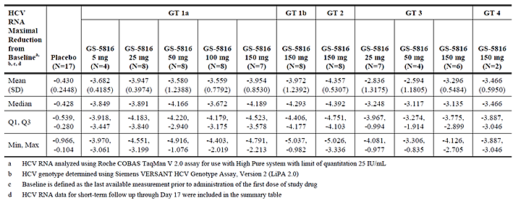

##### Secondary pharmacodynamic effects

###### VEL

QTc

Study GS-US-281-1054 evaluated the effects of VEL on time matched, baseline adjusted, placebo corrected QTc following a single therapeutic (100mg) or supratherapeutic dose (500 mg) of VEL or 400 mg moxifloxacin (positive control) to healthy subjects. As expected, a single dose of moxifloxacin increased the lower bound of the 2 sided 96.67% CI above 5 msec at all 3 preselected time points using either QTcF or QTcN.

Evaluation of the baseline adjusted mean differences between VEL 100 mg or 500 mg and placebo and their associated 2 sided 90% CIs indicated that VEL did not prolong either QTcF or QTcN interval as the upper bounds of the 90% CIs were below 10 msec at all time points after dosing. No subject administered either dose of VEL or placebo experienced absolute QTcF intervals > 450 msec. Similarly, no subject on VEL had absolute QTcN intervals > 450 msec, one subject had an absolute QTcN interval > 450 msec (baseline = 447.8 msec, 24 hours post baseline = 450.7 msec) following treatment with placebo. No subject on VEL or placebo had a change from baseline QTc > 30 msec or > 60 msec using either QTc correction formula (QTcF or QTcN). In addition, no clinically significant changes from baseline in PR, QRS, or RR intervals or HR were observed following administration of VEL compared with placebo and no notable U or T wave abnormalities were detected.

Resistance - NS5A sequence analysis

In Study GS-US-281-0102, which in part examined the antiviral activity of VEL in genotype 1 to 6 HCV infected subjects, NS5A resistance associated variants (RAVs) were detected pre‑treatment by deep sequencing in 22 of 70 subjects who received VEL: 10 of 35 (28.6%) subjects with genotype 1a HCV infection, 1 of 8 (12.5%) subjects with genotype 1b HCV infection, 4 of 8 (50.0%) subjects with genotype 2 HCV infection, 5 of 17 (29.4%) subjects with genotype 3 HCV infection and 2 of 2 (100.0%) subjects with genotype 4 HCV infection (Table 13).

Table 13: GS-US-281-0102 Number (%) of subjects with NS5A RAVs at pre-treatment or post-baseline time-points

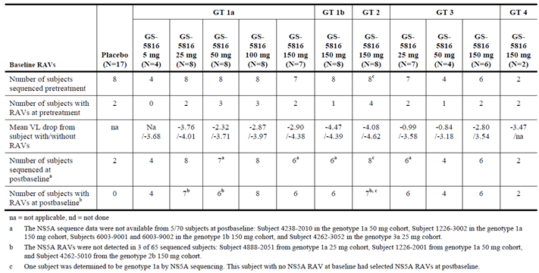

In genotype 1a and 3a HCV infected subjects, the pre-treatment presence of NS5A RAVs was associated with a slightly reduced decline in HCV RNA compared with subjects without NS5A RAVs at baseline. However, in genotype 1b, 2, and 4 HCV infected subjects, no significant difference in response was observed between subjects with or without NS5A RAVs at baseline.

Following treatment, NS5A RAVs emerged at more positions in the genotype 1a virus compared with the other genotypes; RAVs were observed at only 2 NS5A positions in genotypes 1b, 2, 3, and 4 virus (Table 14). Genotype 1a virus showed RAVs at NS5A positions M28, Q30, L31, P32, H58, and Y93; RAVs at positions Y93, M28 and L31 were the most prevalent. In genotype 1b and 2b HCV infected subjects, L31M/V and Y93H were the most commonly observed RAVs; and in genotype 3 HCV infected subjects, E92K and Y93H/N were the only observed RAVs following dosing with VEL. In addition, Y93H and L30H RAVs were detected in both genotype 4 HCV infected subjects at post-baseline time points.

Table 14: GS-US-281-0102: NS5A RAVs detected at post-baseline time-points (between Day 2 and 17) in subjects who received GS-5816

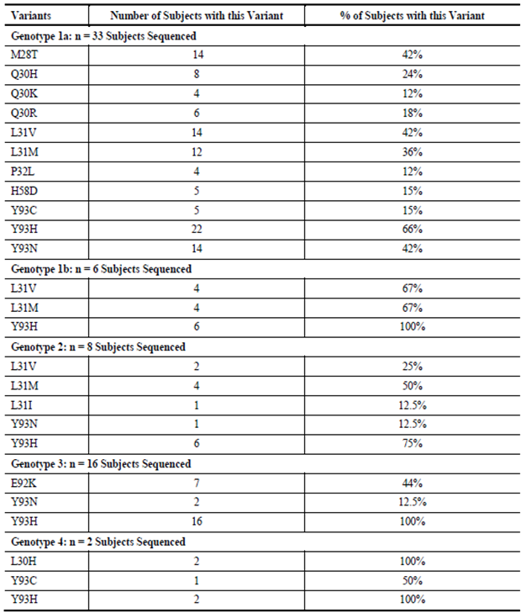

The long-term persistence results showed that NS5A RAVs that were present prior to treatment persisted through the 48 week follow-up period; however, NS5A RAVs that developed during treatment were more likely to disappear during the follow-up period. A total of 22 of 33 subjects (66.7%) with available sequences and without NS5A RAVs pre-treatment did not have any detected NS5A RAVs at post treatment Week 48. RAVs were detected at low frequencies at post treatment Week 48 in 29% to 50% of genotype 1a, 1b, and 3 HCV infected subjects. In contrast, the treatment emergent NS5A RAVs were no longer detected with 1% assay sensitivity in all genotype 2 HCV infected subjects, and the remaining 50% to 71% of genotype 1a, 1b, and 3 HCV infected subjects.

#### Time course of pharmacodynamic effects

Please see Section 5.2.2.1 of this report, which relates to the Primary Pharmacodynamics of VEL.

#### Relationship between drug concentration and pharmacodynamic effects

##### VEL

In Study GS-US-281-0102 a simple Emax model was fit to examine the relationships between the change from baseline in HCV RNA and VEL plasma exposure (assessed as AUCtau on Day 3). The model indicated that exposures achieved following administration of VEL doses ≥ 5 mg were predicted to provide > 95% of maximal antiviral response in subjects with genotype 1 HCV infection. Based on this model, VEL systemic exposures for subjects with genotype 3 HCV infection were predicted to achieve at least 80% of maximal antiviral response at the ≥ 25-mg dose.

#### Genetic, gender and age related differences in pharmacodynamic response

Not examined.

#### Pharmacodynamic interactions

##### Effect of VEL on OC therapy

Study GS-US-281-1058, which examined the effect of VEL on the PK of a representative hormonal OC, indicated that luteinizing hormone (LH), follicle stimulating hormone (FSH), and progesterone concentrations were similar following cycles of OC administration in the presence or absence of 100 mg VEL OD. Median LH and FSH values were at the low end of expected values for the ovulatory phase. Progesterone was lower than the expected range for the luteal phase. These results are consistent with a decrease in serum LH and FSH caused by oral hormonal contraceptives and absence of ovulation, as assessed by very low progesterone values on cycle Day 21.

##### SOF primary pharmacodynamics in the presence of other ARVs

Part A of Study P7977-1910 evaluated the viral kinetics of the effect of SOF on HCV RNA in HIV/HCV co-infected subjects who received pre-specified ARV regimens for 7 days. In this part of the trial, rapid declines in HCV RNA levels were observed, with > 4 log10 IU/mL mean reduction over 7 days of treatment with SOF. At Day 14 (7 days after stopping SOF dosing), the overall mean (SD) change in HCV RNA levels from baseline was -3.08 (1.529) log10 IU/mL. Early HCV viral kinetics appeared to be independent of HCV genotype and subtype.

Part B of the same study examined the efficacy of treatment with SOF+ PegIFN + RBV as measured by the proportion of subjects with sustained virologic response (SVR) 12 weeks after discontinuation of therapy (SVR12). In addition, the proportion of subjects who attained SVR at 4 and 24 weeks after discontinuation of therapy (SVR4 and SVR24) was determined as was the emergence of viral resistance to SOF during treatment and after treatment discontinuation.

The majority of subjects (91.3%, 21 subjects) in Part B of this study achieved SVR12. There was no on-treatment virologic failure. There were a total of 2 subjects (8.7%) who relapsed; both of these subjects relapsed within 4 weeks of stopping treatment.

Potent and rapid suppression of HCV RNA was observed with a mean 4.88 log10 IU/mL decrease in HCV RNA after 1 week of treatment with SOF + PegIFN + RBV + ARV that was maintained for the duration of the study. By Week 4 and at each subsequent on-treatment assessment, 100% of subjects had HCV RNA < LLOQ.

##### Effect of SOF + Peg-IFN+RBV on alanine aminotransferase (ALT)

Approximately 57% of subjects (n = 13) had ALT > ULN at baseline and most had normalised ALT values during treatment, coincident with decreases in viral HCV RNA.

##### RAVS following treatment with SOF + other ARVs

In Part A of Study P7977-1910, 2 of 37 subjects who completed study treatment had HCV RNA > 1000 IU/ml by the end of the treatment period. NS5B amplification failed in 1 of these 2 subjects (Subject [information redacted]) and was successful in the other subject (Subject [information redacted]). Deep sequencing analysis of NS5B with assay cut-off at 1% did not detect S282T or any other NI RAVs at the end of 7 days of SOF monotherapy treatment in this subject. In addition, for 26 of 37 subjects with HCV RNA > 400 IU/mL at the Day 14 follow-up visit, deep sequencing analysis at this time point was successfully obtained for 21 of 26 subjects with no S282T or any other NI RAVs detected.

In Part B, 2 subjects experienced HCV viral relapse and qualified for resistance testing (Subjects [information redacted] and [information redacted]). No S282T or any other NI RAVs were detected at baseline or relapse (post treatment Week 4).

### Evaluator’s overall conclusions on pharmacodynamics

#### Mechanisms of action

SOF is a novel inhibitor of the HCV NS5B RNA dependent RNA polymerase with potent broad genotypic activity in vitro, whereas, VEL is a novel HCV NS5A inhibitor that has demonstrated potent in vitro antiviral activity against genotype 1 to 6 HCV replicons.

#### VEL; antiviral response

* Administration of 3 consecutive daily doses of VEL (5 to 150 mg) resulted in rapid reductions in HCV RNA, with median reductions of ≥ 2 log10 IU/mL observed within 12 hours across all HCV genotypes.
* The greatest median change from baseline in HCV RNA in each treatment group was generally observed by 54 hours, and was > 2 log10 IU/mL and 6 of 70 subjects with varying genotypes and VEL doses had reductions in HCV RNA below the LLOQ.
* Antiviral activity was similar for subjects with genotype 1a and 1b HCV who received VEL 150 mg.

#### VEL; QTc

Therapeutic (100 mg) and supratherapeutic doses (500 mg) of VEL in healthy subjects did not prolong either QTcF or QTcN. In addition, no clinically significant changes from baseline in PR, QRS, or RR intervals or HR were observed following administration of VEL compared with placebo and no notable U or T wave abnormalities were detected.

#### VEL; RAVs

* RAVs were detected pre-VEL treatment in 22 of 70 subjects.
* In genotype 1a and 3a HCV infected subjects, the pre-treatment presence of NS5A RAVs was associated with a slightly reduced decline in HCV RNA compared with subjects without NS5A RAVs at baseline.
* Following VEL treatment, NS5A RAVs emerged at more positions in the genotype 1a virus than in other genotypes.
* Long-term persistence results showed that NS5A RAVs that were present prior to treatment persisted through the 48 week follow-up period; however, NS5A RAVs that developed during treatment were more likely to disappear during the follow-up period.

#### VEL; relationship between drug concentration and pharmacodynamic effect

An Emax model predicted that exposures achieved following administration of VEL doses ≥ 5 mg would provide > 95% of maximal antiviral response in subjects with genotype 1 HCV infection. Based on this model, VEL systemic exposures for subjects with genotype 3 HCV infection were predicted to achieve at least 80% of maximal antiviral response at the ≥ 25 mg dose.

#### Pharmacodynamic interactions

* VEL (100 mg OD) did not affect the ability of OCs to reduce serum LH, FSH and progesterone levels.
* In the presence of pre-specified ARV regimens, 7 days treatment with SOF resulted in a rapid decline in HCV RNA level, with a mean reduction in RNA of > 4 log10 IU/mL over the 7 days. At Day 14 (7 days after stopping SOF dosing), the overall mean (SD) change in HCV RNA levels from baseline was -3.08 (1.529) log10 IU/mL and early HCV viral kinetics appeared to be independent of HCV genotype and subtype.
* Ninety-one percent of subjects administered SOF+Peg-IFN+RBV achieved SVR12 and there was no on-treatment virologic failure. There were a total of 2 subjects (8.7%) who relapsed; both of these subjects relapsed within 4 weeks of stopping treatment.
* Potent and rapid suppression of HCV RNA was observed with a mean 4.88 log10 IU/mL decrease in HCV RNA after 1 week of treatment with SOF + Peg-IFN + RBV that was maintained for the duration of the study. By Week 4 and at each subsequent on-treatment assessment, 100% of subjects had HCV RNA < LLOQ.
* Approximately 57% of subjects had ALT > ULN at baseline and most had normalised ALT values during treatment with SOF + Peg-IFN + RBV, coincident with decreases in viral HCV RNA.

## Dosage selection for the pivotal studies

The dose of sofosbuvir 400 mg given once daily with RBV, with or without pegIFN, is the approved dose for the treatment of HCV infection. Safety and efficacy have been confirmed in multiple Phase II and Phase III studies. For the NCE velpatasvir, activity against HCV was demonstrated in the Phase II study GS-US-281-0102. Doses > 25 mg achieved at least 80% of maximal antiviral response in all HCV genotypes. Favourable safety, efficacy and PK profiles have been shown for the SOF/VEL 400 mg/100 mg FDC in Phase II studies involving 237 patients with HCV infection evaluated in Section 7(GS-US-342-0102, GS-US-337-0102 and GS-US-342-0109). In study GS-US-281-0112, systemic exposure to velpatasvir 100 mg was similar in patients with normal hepatic function and those with moderate or severe hepatic dysfunction.

## Clinical efficacy

Indication

“*Epclusa (sofosbuvir/velpatasvir fixed dose combination) is indicated for the treatment of chronic hepatitis C virus (HCV) infection in adults*”.

### Pivotal efficacy studies

#### Study GS-US-342-1137 (ASTRAL-4)

##### Study design, objectives, locations and dates

This was a Phase III, multicentre, randomised, open label study to investigate the efficacy and safety of sofosbuvir/velpatasvir (SOF/VEL) FDC in patients with chronic HCV infection and Child-Pugh-Turcotte class B decompensated cirrhosis. It is an on-going study being conducted at 47 sites in the US. The study started in July 2014 and the cut-off date for analysis of the primary endpoint was August 2015. This interim analysis was conducted when all patients had completed the Week 12 visit, or had prematurely discontinued from the study.

The primary objectives were to measure the proportion of patients achieving SVR12[2], and to assess tolerability and safety. Other objectives were to measure SVR4[3] and SVR24[4], and the proportion of patients with virologic failure. Approximately 225 patients were planned to be randomised 1:1:1 to one of three treatment groups:

* Group 1: SOF/VEL given for 12 weeks
* Group 2: SOF/VEL + RBV given for 12 weeks
* Group 3: SOF/VEL given for 24 weeks

The patients were stratified by HCV genotype (1, 2, 3, 4, 5, 6, and indeterminate).

All patients were required to complete the Week 4 and Week 12 post treatment visits. Patients with HCV RNA < LLOQ at Week 12 were required to complete Week 24 unless viral relapse had occurred.[5] Up to 15 eligible patients in each group participated in an intensive 24 hour PK sub-study conducted at the Week 2 or Week 4 visits. Random samples for a population PK analysis were taken in all patients at each visit.

Study visits were conducted on Day 1, and at Weeks 1, 2, 4, 6, 8, 10, 12, 16, 20 and 24. At each visit vital sign and clinical hepatic assessments were performed, including CPT[6] and MELD scores.[7] AEs were recorded at each visit and measurements of biochemistry and haematology parameters, HCV RNA, and SOF/VEL PK were made. Drug accountability and compliance were assessed and study drug was dispensed at each visit.

##### Inclusion and exclusion criteria

The key inclusion criteria were: males or females aged ≥ 18 years; HCV RNA > 104 IU/mL at screening; documented chronic HCV infection for at least 6 months; cirrhosis confirmed by liver biopsy (Metavir score = 4, or Ishak score ≥ 5), Fibroscan (> 12.5 kPa), or FibroTest (> 0.75); CPT class B (7-9) at screening; and patients unlikely to have a liver transplant for at least 12 weeks from baseline.

The key exclusion criteria were: current or prior history of clinically significant illnesses including hepatic, gastro-intestinal, pulmonary and cardiac diseases; unstable, severe psychiatric illnesses; malignancy within 5 years; any solid organ transplantation; significant drug allergy including hepatotoxicity; inability to exclude HCC by imaging within the previous 6 months; HBV or HIV co-infection; clinically significant ECG abnormalities; prior exposure to SOF, or any NS5B or NS5A inhibitor; haematopoietic stimulating agents in the previous 3 months; medical conditions associated with other chronic liver disease; severe hepatic disease such as HCC, current hepatopulmonary syndrome, or intractable encephalopathy (assessed by MELD score); chronic use of systemic immunosuppressants; infection requiring antibiotics at screening; active variceal bleeding within previous 6 months; portosystemic shunt; haemoglobin < 10 g/dL; platelets ≤ 30,000/mm3; ALT/AST ≥ 10 x ULN; sodium < 125 mEq/L; total bilirubin > 5 mg/dL; creatinine clearance < 50 mL/min (by the Cockcroft-Gault equation); drug or alcohol abuse within previous 12 months; contraindication to RBV; and protocol defined prohibited medications.

##### Study treatments

* Group 1: One SOF/VEL (400/100 mg) tablet once daily for 12 weeks
* Group 2: One SOF/VEL (400/100 mg) tablet + RBV (1000 or 1200 mg/day based on body weight and divided twice daily) once daily for 12 weeks
* Group 3: One SOF/VEL (400/100 mg) tablet once daily for 24 weeks.

The tablets were taken with or without food. Dose modification for SOF/VEL was not permitted but RBV dose modification or discontinuation was permitted at the discretion of the investigator.

##### Efficacy variables and outcomes

The main efficacy variables were:

* SVR12
* HCV RNA
* Virologic failure and virologic resistance
* Changes in CPT
* ALT and other indices of hepatic function
* PK

The primary efficacy outcome was the proportion of patients with SVR12.

Other efficacy outcomes included:

* The proportions of patients with SVR4 and SVR24
* The proportion of patients with virologic failure[8]
* Changes in CPT and MELD scores
* HCV RNA kinetics during and after treatment[9]
* Emergence of viral resistance during and after treatment
* Steady state PK of study drugs during treatment

##### Randomisation and blinding methods

Patient randomisation, treatment assignment and drug resupply were conducted using IWRS. Randomisation was stratified according to HCV genotype. The study was open label.

##### Analysis populations

The randomised analysis set (RAN) included all patients who were randomised. The safety (SAS) and full analysis (FAS) sets included all randomised patients who received at least one dose of study drug. The PK analysis set included all randomised patients who received at least one dose of study drug and for whom study drug concentrations were available.

##### Sample size

A sample size of 75 patients in each treatment group was estimated to provide at least 99% power to detect a minimum 40% improvement from the assumed spontaneous rate of 1% using a 2 sided exact 1 sample binomial test at a significance level of 0.0167.

##### Statistical methods

The primary endpoint was the proportion of patients with SVR12 for the FAS. The SVR12 rate of each treatment group was compared to the assumed spontaneous rate of 1% using the 2 sided exact 1 sample binomial test at the 0.0167 significance level. The Clopper-Pearson method was used to calculate the 2 sided 95% CIs for the SVR12 rate in each group. Correction for multiplicity was applied using the Bonferroni method. For the secondary endpoints, the proportion of patients with SVR4 and SVR24, the proportion of patients with HCV RNA < LLOQ, and HCV RNA absolute values were summarised. Analyses of CPT and MELD scores were summarised for patients in the FAS who achieved SVR12, and for patients who did not achieve SVR12. The proportion of patients with ALT normalisation was presented by study visit. All continuous endpoints were summarised using descriptive statistics by treatment group and stratification within group. All categorical endpoints were summarised by number and percentage of patients who met the endpoint definition. Missing HCV RNA data were imputed up to the time of the last dose. Sub-group analyses were performed based on HCV genotype, age, gender, race, ethnicity, baseline BMI, IL28 genotype (CC or non-CC), baseline HCV RNA, baseline CPT and MELD, previous treatment experience, and adherence to study regimen.

##### Participant flow

A total of 438 patients were screened, 268 were randomised, and 267 received at least one dose of study treatment. A total of 255 (95.5%) patients completed study treatment and 12 (4.5%) patients discontinued study treatment. The most common reason for discontinuation was an AE (3.4%). Additional details are shown in Table 15.

Table 15: Study GS-US-342-1137 Patient disposition (screened subjects)

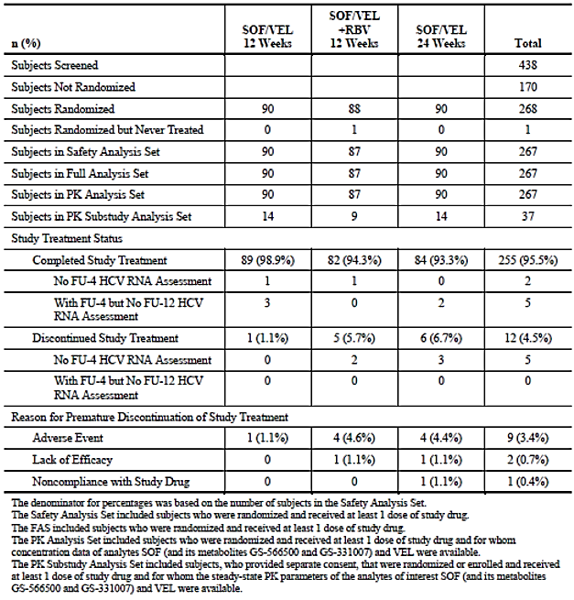

##### Major protocol violations/deviations

A total of 51 major protocol deviations were reported in 44 (16.4%) patients. The deviations were related to inclusion/exclusion criteria (5.2%), not managed according to protocol (4.1%), study medication errors (4.1%), prohibited medications (3.0%) and improper informed consent (2.6%). The deviations occurred in similar proportions in each study group and none warranted exclusion from the primary analysis.

Overall, the mean SOF/VEL study drug compliance rate was > 90%. Compliance with SOF/VEL was < 80% in 7.8%, 4.6%, and 7.8% in Groups 1, 2, and 3, respectively. However, compliance with RBV in Group 2 was much lower (< 80% in 36.8% of patients).

##### Baseline data

The baseline demographic data were similar in each treatment group. Overall, the majority of patients were male (69.7%), and White (89.5%), with a mean age of 58 years (range 42-73). Most patients were aged < 65 years (87.6%). The mean BMI was 30.4 kg/m2. With the exception of previous treatment experience, the baseline disease characteristics were also similar in each group. Overall, most patients (77.5%) had HCV GT1 infection (59.6% GT1a, 18.0% GT1b), and 14.6% of patients had GT3 infection. There were only small numbers of patients with genotypes 2, 4, and 6 (4.5%, 3.0% and 0.4%, respectively). The IL28B CC genotype was present in 23.2% of patients, and 76.0% were non-CC. The mean baseline HCV RNA was 5.9 log10 IU/mL, and HCV RNA was < 800,000 IU/mL in 44.2% of patients. Mean baseline ALT was 67 U/L (> 1.5 x ULN in 48.3% of patients), and mean creatinine clearance was 89.6 mL/min. A total of 44.9% of patients were treatment- naïve and 55.1% were treatment experienced. Compared with the overall population, notably fewer patients (35.6%) were treatment naïve in Group 1 (SOF/VEL for 12 weeks). Overall, baseline CPT B and MELD score 10-15 were reported in 89.9% and 61.0% of patients, respectively. Mild to moderate ascites was present in 77.5% of patients, and 2.6% had severe ascites. At baseline, 38.2% of patients had no encephalopathy and 61.8% had Grade 1-2 encephalopathy. No patients had severe encephalopathy.

###### Results for the primary efficacy outcome

The proportions of patients achieving SVR12 by treatment group were:

* Group 1 (SOF/VEL for 12 weeks): 83.3% (95% CI: 74.0, 90.4)
* Group 2 (SOF/VEL + RBV for 12 weeks): 94.3% (95% CI: 87.1, 98.1)
* Group 3 (SOF/VEL for 24 weeks): 85.6% (95% CI: 76.6, 92.1).

All SVR12 rates were statistically significantly superior to the assumed spontaneous rate of 1% (p < 0.001).

###### Results for other efficacy outcomes

SVR12 by genotype

SVR12 rates by genotype were provided. In patients with GT1 infection (n=207), SVR12 was achieved by 88.2% (95% CI: 78.1, 94.8) of patients in Group 1, 95.6% (95% CI: 87.6, 99.1) in Group 2, and 91.5% (95% CI: 82.5, 96.8) in Group 3. There were no notable differences in SVR12 rates between patients with GT1a and GT1b infection (88.0% versus 88.9%). In patients with GT3 infection (n=39), SVR12 was achieved by 50% (95% CI: 23.0, 77.0) of patients in Group 1, 84.6% (95% CI: 54.6, 98.1) in Group 2, and 50.0% (95% CI: 21.1, 78.9) in Group 3. There were only small numbers of patients with GT2, GT4, and GT6 infection but all achieved SVR12. The single exception was one patient with GT2 infection in Group 3 who died 39 days after receiving 28 days of treatment.

SVR12 in sub-groups

No meaningful comparisons were possible in sub-groups due to the low patient numbers in each treatment group.

Virologic outcomes

In Group 1, 12.2% of patients relapsed but no patients had on-treatment virologic failure. In Group 2, 2.4% of patients relapsed and 1.1% had on-treatment virologic failure. In Group 3, 8.0% of patients relapsed and 1.1% had on-treatment virologic failure. Virologic outcomes by genotype are shown in Table 16. In patients with GT1 infection, overall virologic failure occurred in 7.4%, 1.5%, and 4.2% of Groups 1, 2, and 3, respectively. In patients with GT3 infection, virologic failure occurred in 42.9%, 15.4%, and 41.7% of Groups 1, 2, and 3, respectively. There were no virologic failures in patients with GT2, GT4, or GT6 infections. Virologic outcomes could not be assessed in 11 patients, 7 patients died, and a further four patients were lost to follow-up.

Table 16: Study GS-US-342-1137. Virologic outcomes by genotype (FAS)

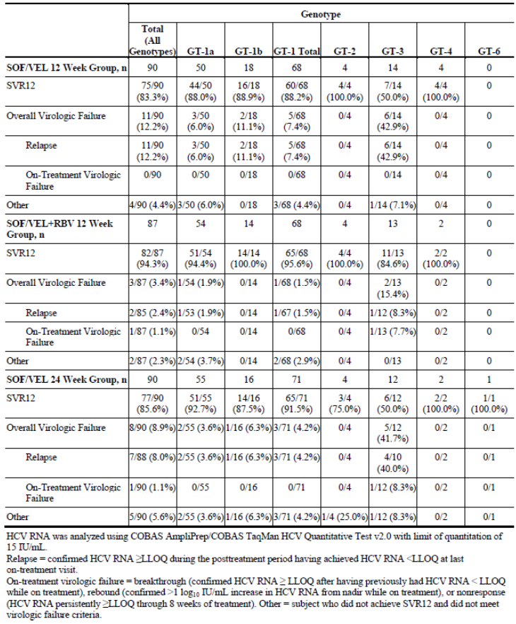SVR4 and SVR24

Overall, SVR4 and SVR12 were achieved by 92.2% and 83.3% of Group 1; by 95.4% and 94.3% of Group 2; and by 90.0% and 85.6% of Group 3. The proportions of patients with SVR4 by genotype were provided. SVR24 rates were not available for the interim analysis.

Virologic failure in sub-groups

Virologic failure did not occur in any patients in Groups, 2, 4, or 6. Virologic failures by sub-group in patients with GT1 or GT3 infection were provided. There were no notable differences between groups but the numbers in the sub-groups were too small for meaningful comparisons.

HCV RNA < LLOQ

The proportions of patients with HCV RNA < LLOQ during treatment were provided. Rapid suppression of HCV RNA occurred in all treatment groups and genotypes. At Week 4, 80.5% to 91.0% of patients had HCV RNA < LLOQ, and all but two patients were suppressed at Week 8.

HCV RNA during treatment

Mean HCV RNA levels declined rapidly by approximately -4.5 log10 IU/mL from baseline to the end of treatment in all treatment groups and genotypes.

CPT and MELD scores

Changes from baseline in CPT scores reported in patients who achieved SVR12 are illustrated in Figure 4. Overall, CPT scores were improved in 47.2% of patients and unchanged in 43.2%. Worsening occurred in only 9.6% of patients. Changes from baseline in MELD scores reported in patients who achieved SVR12 are illustrated in Figure 5. Overall, MELD scores were improved in 55.5% of patients and unchanged in 19.7%. Worsening occurred in 24.9% of patients. A total of 84% of patients with baseline MELD ≥ 15 improved and only 8% worsened.

Figure 4: Study GS-US-342-1137 Changes in CPT scores from baseline to post treatment week12 (FAS, subjects who achieved SVR12)

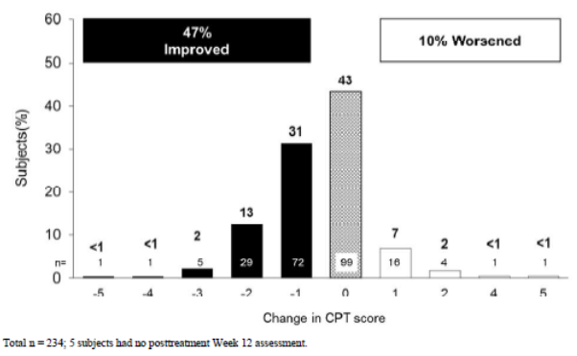

Figure 5: Study GS-US-342-1137 Changes in MELD score scores from baseline to post treatment week12 (FAS, subjects who achieved SVR12)

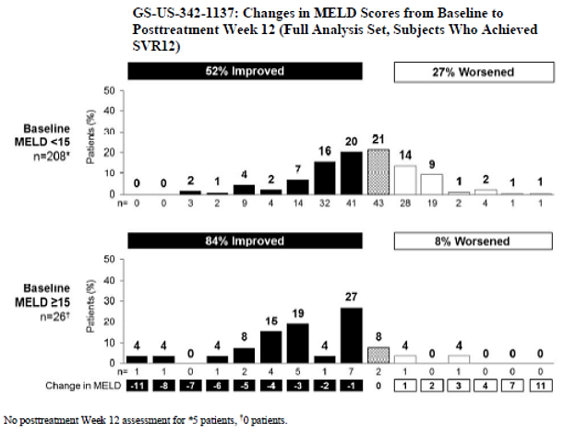

Virologic resistance

A total of 256 patients in the SAS had a virologic outcome (86 in Group 1, 85 in Group 2, and 85 in Group 3). A total of 22 patients (9%) experienced virologic failure (20 relapsers, 2 on-treatment failure). Mutations at NS5A position 93 (mainly Y93H) were observed in 19/22 (86%) patients at the time of virologic failure. NS5B mutations occurred in 5/22 (23%) patients at the time of virologic failure.

**Comment:** This randomised study compared three SOF/VEL regimens given for 12 or 24 weeks in patients with HCV GT1-6 infection and confirmed decompensated cirrhosis. Approximately 55% of patients were non-responders to previous therapies; mostly peg-IFN based regimens. The overall study design was appropriate and powered to demonstrate an efficacy benefit of at least 40% compared to an assumed spontaneous remission rate of 1%. A control group given placebo for 12 weeks was not considered appropriate due to the life-threatening nature of the underlying disease.

SVR12 rates in the three treatment groups were each outstanding and statistically significant compared with the assumed comparator rate of 1% (p < 0.001). The SVR12 rate was 83.3% in the SOF/VEL 12 week group; treatment for 24 weeks conferred no additional benefit with a comparable SVR12 rate of 85.6%. Efficacy was greatest in the group treated with SOF/VEL + RBV for 12 weeks with an SVR12 rate of 94.3%. This impressive outcome was achieved despite poor RBV compliance rates (patient or investigator initiated). The large majority of patients had GT1 (77.5%) or GT3 infection (14.6%). However, efficacy was 100% in the small number of patients with GT2, GT4 and GT6 infections (no patients with GT5 infection were treated). Virologic failure was reported in only 1.5% of GT1 infected patients but there were no failures in the GT2, GT4, and GT6 groups. Virologic failure occurred in two GT3 patients (15.4%) but PK analysis confirmed non-compliance in one of these patients. Approximately half of the patients who achieved SVR12 had improved liver function assessed by CPT and MELD scores (most commonly increased serum albumin and decreased total bilirubin).

Historically, treatment experienced patients with chronic HCV infection and cirrhosis are the group least likely to respond to subsequent therapies. The results of this study support the use of SOF/VEL in combination with RBV in treatment naïve or treatment experienced patients with decompensated cirrhosis. The results also support the use of SOF/VEL in patients who are unable to tolerate RBV therapy. Only small numbers of patients with GT2 to GT6 infection were studied. However, SVR12 rates were 100% in these groups. In light of this and the results of study GS‑US-342-1139, it is reasonable to predict valuable efficacy rates in all genotypes.

#### Study GS-US-342-1138 (ASTRAL-1)

##### Study design, objectives, locations and dates

This was a Phase III, multicentre, randomised, double-blind, placebo controlled study to investigate the efficacy and safety of SOF/VEL in patients with chronic HCV infection (genotypes 1, 2, 4, 5, or 6). It is an on-going study being conducted at 81 sites in the Belgium, Canada, France, Germany, Italy, Hong Kong, the UK and the US. The study started in July 2014 and the cut-off date for analysis of the primary endpoint was June 2015. This interim analysis was conducted when all patients had completed the Week 12 visit, or had prematurely discontinued from the study.

The primary objectives were to measure the proportion of patients achieving SVR12, and to assess tolerability and safety. Other objectives were to measure SVR4 and SVR24, and the proportion of patients with virologic failure. Approximately 600 patients were planned to be randomised 5:1 to one of two treatment groups:

* Group 1: SOF/VEL given for 12 weeks
* Group 2: Placebo given for 12 weeks

The patients were stratified by HCV genotype (1, 2, 4, 6, and indeterminate), and the presence or absence of cirrhosis at screening. Patients with GT5 infection were not randomised but were enrolled into the active treatment group. Approximately 20% of patients were planned to be treatment experienced, and approximately 20% of patients were planned to have cirrhosis.

All patients were required to complete the Week 4 and Week 12 post treatment visits. Patients with HCV RNA < LLOQ at Week 12 were required to complete Week 24 unless viral relapse had occurred. An intensive 24 hour PK sub-study was conducted at the Week 2 or Week 4 visits in a sub-group of patients who provided separate consent. Random samples for a population PK analysis were taken in all patients at each visit. Patients in the placebo group were offered the option to participate in a deferred study if HCV RNA was ≥ LLOQ at the 12 Week visit. Patients in the active group could enrol into the SVR Registry Study or the Sequence Registry Study if SVR was not achieved.

Study visits were conducted on Day1, and at Weeks 1, 2, 4, 6, 8, 10, 12, and 24. AEs were recorded at each visit. Vital signs were recorded and measurements of biochemistry and haematology parameters, HCV RNA, and SOF/VEL PK were made. Drug accountability and compliance were assessed and study drug was dispensed at each visit.

##### Inclusion and exclusion criteria

The key inclusion criteria were: males or females aged ≥ 18 years; HCV RNA > 104 IU/mL at screening; documented chronic HCV infection for at least 6 months (genotypes 1, 2, 4, 5, 6, or indeterminate); cirrhosis confirmed by liver biopsy (Metavir score = 4, or Ishak score ≥ 5), Fibroscan (> 12.5 kPa), or FibroTest (> 0.75); CPT class B (7-9) at screening, or absence of cirrhosis defined by liver biopsy within previous 2 years, FibroTest ≤ 0.48, or Fibroscan ≤ 12.5 kPa at screening; and patients unlikely to have a liver transplant for at least 12 weeks from baseline.

The key exclusion criteria were: current or prior history of clinically significant illnesses including hepatic, gastro-intestinal, pulmonary and cardiac diseases; unstable, severe psychiatric illnesses; malignancy within 5 years; any solid organ transplantation; significant drug allergy including hepatotoxicity; inability to exclude HCC by imaging within the previous 6 months; HBV or HIV infection; clinically significant ECG abnormalities; prior exposure to SOF, or any NS5B or NS5A inhibitor; clinical hepatic decompensation; haemoglobin < 11 g/dL for females and < 12 g/dL for males ; platelets ≤ 50,000/mm3; ALT/AST ≥ 10 x ULN; direct bilirubin > 1.5 x ULN; albumin < 3 g/dL; creatinine clearance < 60 mL/min (Cockcroft-Gault); drug or alcohol abuse within previous 12 months; contraindication to RBV; and protocol defined prohibited medications.

##### Study treatments

* Group 1: One SOF/VEL (400/100 mg) tablet once daily for 12 weeks
* Group 2: Placebo tablet once daily for 12 weeks

##### Efficacy variables and outcomes

The main efficacy variables were:

* SVR12
* HCV RNA
* Virologic failure and virologic resistance
* ALT and other indices of hepatic function
* PK.

The primary efficacy outcome was the proportion of patients with SVR12 in each treatment group.

Other efficacy outcomes included:

* The proportion of patients with SVR4 and SVR24
* The proportion of patients with virologic failure
* HCV RNA kinetics during and after treatment
* Emergence of viral resistance during and after treatment
* Steady state PK of study drugs during treatment.

##### Randomisation and blinding methods

Patient randomisation, treatment assignment and drug resupply were conducted using IWRS. Randomisation was stratified according to HCV genotype. Approximately 20% of patients were planned to be treatment experienced, and 20% were planned to have cirrhosis. Patients with GT5 infection were not randomised but were included in the active treatment group.

Study drugs (SOF/VEL or matching placebo) were dispensed at baseline and at Weeks 4 and 8. The investigators and patients were blind to the randomised treatment identity but emergency unblinding was permitted via IWRS.

##### Analysis populations

The randomised analysis set (RAN) included all patients who were randomised. The safety (SAS) and full analysis (FAS) sets included all randomised patients who received at least one dose of study drug. The PK analysis set included all randomised patients who received at least one dose of study drug and for whom study drug concentrations were available. A total of 70 patients were enrolled in the steady-state PK sub-study.

##### Sample size

A sample size of 500 patients in the SOF/VEL treatment group was estimated to provide 90% power to detect an improvement of at least 5% in the SVR12 rate from the performance goal of 85% using a 2 sided exact 1 sample binomial test at a significance level of 0.05.

##### Statistical methods

The primary endpoint was the proportion of patients with SVR12 for the FAS. The SVR12 rate in the SOF/VEL group was compared with a performance goal of 85% using the 2 sided exact 1 sample binomial test at the 0.05 significance level. The Clopper-Pearson method was used to calculate the 2 sided 95% CIs for the SVR12 rate in each group. Additionally, the point estimate was provided for the placebo group. No correction for multiplicity was made as only one test was performed.

For the secondary endpoints, the proportion of patients with SVR4 and SVR24, the proportion of patients with HCV RNA < LLOQ, and HCV RNA absolute values were summarised for patients who did not achieve SVR12. ALT normalisation was presented by study visit. All continuous endpoints were summarised using descriptive statistics by treatment group and stratification within group.

All categorical endpoints were summarised by number and percentage of patients who met the endpoint definition. Missing HCV RNA data were imputed up to the time of the last dose. Sub-group analyses were performed based on HCV genotype, age, gender, race, ethnicity, baseline BMI, IL28 genotype (CC or non-CC), baseline HCV RNA, previous treatment experience, and adherence to study regimen (< 80%, ≥ 80%).

##### Participant flow

A total of 847 patients were screened, 741 were randomised, and 740 received at least one dose of study treatment. A total of 623 patients were included in the PK analysis, and 70 patients were enrolled in the steady-state PK sub-study. A total of 735 (99.3%) patients completed study treatment and 5 (0.7%) patients discontinued. The most common reason for discontinuation was AEs (0.4%). Additional details are shown in Table 17.

Table 17: Study GS-US-342-1138 Patient disposition

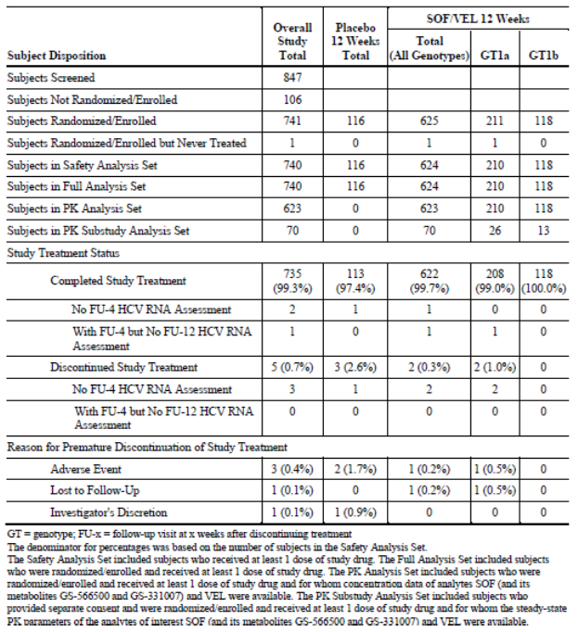

##### Major protocol violations/deviations

Overall, the number of protocol deviations was low. A total of 79 significant protocol deviations were reported in 75 patients, most commonly due to violation of inclusion/exclusion criteria (0.07%). Other deviations were related to management not according to protocol (0.01%), study medication errors (0.01%), prohibited medications (0.01%), and improper informed consent (0.01%). The deviations occurred in similar proportions in each study group and none warranted exclusion from the primary analysis.

Overall, the mean SOF/VEL study drug compliance rate measured by tablet counts was > 90%. Compliance < 80% was reported in 4.0% of the SOF/VEL group, and 7.8% of the placebo group.

##### Baseline data

The baseline data were comparable in each treatment group. Overall, the majority of patients were male (59.7%), and White (78.8%), with a mean age of 54 years (range 18 to 82). Most patients were aged < 65 years (86.5%). The mean BMI was 26.6 kg/m2. The baseline demographics for each genotype were provided. Patients with GT5 infection tended to be older with a mean age of 59 years, and patients with GT6 infection were mainly Asian (97.6%) with a lower mean BMI (23.8 kg/m2). The baseline disease characteristics were comparable in each treatment group. In the SOF/VEL group, the majority of patients (52.6%) had HCV GT1 infection (33.7% GT1a, 18.9% GT1b), 16.7% had GT2 infection, 18.6% had GT4 infection, 5.6% had GT5 infection, and 6.6% had GT6 infection. In the overall population, the IL28B CC genotype was present in 30.0% of patients, and 69.2% were non-CC. The mean baseline HCV RNA was 6.3 log10 IU/mL, and HCV RNA was < 800,000 IU/mL in 25.9% of patients. Mean baseline ALT was 73 U/L (> 1.5 x ULN in 45.0% of patients), and mean estimated creatinine clearance was 107.5 mL/min. Overall, 68.4% of patients were treatment- naïve, and 31.6 were treatment experienced. Overall, cirrhosis was present in 19.2% of patients (SOF/VEL 19.4%, PBO 18.1%). Patients with GT2 infection had the lowest incidence of cirrhosis, and patients with GT4 infection had the highest (23.3%). Patients with GT4 infection had the highest proportion of treatment experienced patients (44.8%), and patients with GT6 infection had the lowest proportion (7.3%).

##### Results for the primary efficacy outcome

The primary endpoint was achieved with an SVR12 rate of 99.0% (95% CI: 97.9, 99.6) which was statistically superior to the pre-specified performance goal of 85% (p < 0.001). No patients in the placebo group achieved SVR12.

##### Results for other efficacy outcomes

###### SVR12 by genotype

SVR12 rates by genotype are shown in Table 18 and Table 19. In the SOF/VEL group, SVR12 was achieved by 98.1% to 100% of patients across the study genotypes.

Table 18: Study GS-US-342-1138 Virologic outcomes (SOF/VEL 12 Week group) by genotype (Genotype 1)

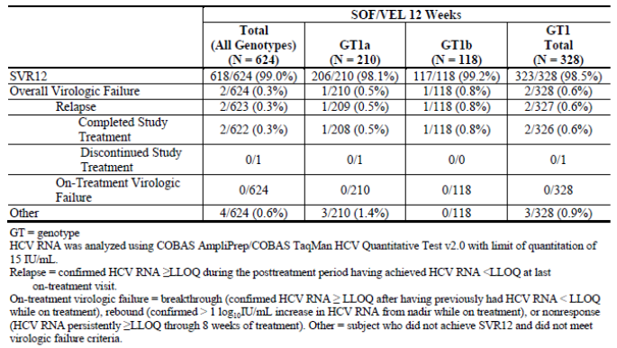

Table 19: Study GS-US-342-1138 Virologic outcomes (SOF/VEL 12 Week group) by genotype (Genotypes 2, 4, 5 and 6)

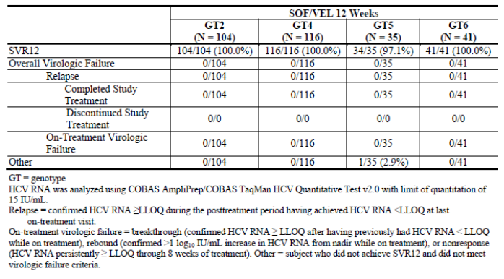

###### SVR12 in sub-groups

In the SOF/VEL group, high SVR12 rates were achieved in all sub-groups, including gender, race and age. Notably, SVR12 was achieved by 99.2% (95% CI: 95.5, 100.0) of cirrhotic patients, and 99.0% (95% CI: 97.7, 99.7) of non-cirrhotic patients. SVR12 rates were less favourable but still high in patients with study drug compliance < 80%.

###### Virologic outcomes

No patients in the SOF/VEL group had on-treatment virologic failure. A total of 6/624 patients (1%) did not achieve SVR12. Two had virologic relapse detected at Week 4, and four patients did not achieve SVR12 (one patient died and three were lost to follow-up).

###### SVR4 and SVR24

Overall, SVR4 and SVR12 were achieved by 99.2% and 99.0% of the SOF/VEL group. SVR4 rates were achieved by 97.1% (in the GT5 sub-group) to 100% of patients across the study genotypes. SVR24 rates were not available for the interim analysis.

###### HCV RNA < LLOQ

The proportions of patients with HCV RNA < LLOQ during treatment were provided. Rapid suppression of HCV RNA occurred in all genotypes. In the SOF/VEL group at Week 4 and Week 8, 90.5% and 99.7% of patients had HCV RNA < LLOQ.

###### HCV RNA during treatment

Mean HCV RNA levels declined rapidly by -5.12 to -4.82 log10 IU/mL from baseline to the end of treatment across the study genotypes.

###### Virologic resistance

A total of 599/620 patients in the SAS had a virologic outcome. Two patients experienced virologic relapse. Both had NS5A RAVs at baseline and both developed additional NS5A RAVs at relapse.

**Comment:** This randomised, placebo controlled study assessed the safety and efficacy of SOF/VEL given for 12 weeks in treatment naïve or treatment experienced HCV patients with genotype 1, 2, 4, 5, or 6 infections, with or without compensated cirrhosis.

The primary endpoint was achieved with an SVR12 rate of 99.0% in the SOF/VEL group which exceeded the 85% performance target (p < 0.001). The SVR12 rates were comparable in all genotypic and demographic subgroups. Notably, SVR12 was achieved by 99.2% of cirrhotic patients, and by 99.5% of treatment experienced patients. There were only two virologic failures in 624 patients treated with SOF/VEL, both with GT1 infections. There were no virologic failures in patients with GT2, GT4, GT5, or GT6 infections. The results of this study are outstanding and support the use of SOF/VEL for 12 weeks in treatment naïve or treatment experienced patients with genotypes 1, 2, 4, 5, or 6 infections, with or without compensated cirrhosis.

#### Study GS-US-342-1139 (ASTRAL-2)

##### Study design, objectives, locations and dates

This was a Phase III, multicentre, randomised, open label study to compare the efficacy and safety of SOF/VEL with SOF + RBV in patients with chronic HCV genotype 2 infection. It is an on-going study being conducted at 51 sites in the US. The study started in September 2014 and the cut-off date for analysis of the primary endpoint was July 2015. This interim analysis was conducted when all patients had completed the Week 12 visit, or had prematurely discontinued from the study. The primary objectives were to compare the proportions of patients achieving SVR12, and to assess tolerability and safety. Other objectives were to measure SVR4 and SVR24, and the proportion of patients with virologic failure. Approximately 240 patients were planned to be randomised 1:1 to one of two treatment groups:

* Group 1: SOF/VEL given for 12 weeks
* Group 2: SOF + RBV given for 12 weeks.

The patients were stratified by the presence or absence of cirrhosis at screening, and prior treatment experience. Approximately 20% of patients were planned to be treatment experienced, and approximately 20% of patients were planned to have cirrhosis. All patients were required to complete the Week 4 and Week 12 post treatment visits. Patients with HCV RNA < LLOQ at Week 12 were required to complete Week 24 unless viral relapse had occurred.

Study visits were conducted on Day 1, and at Weeks 1, 2, 4, 6, 8, 10, and 12, and post treatment study visits were conducted at Weeks 4, 12, and 24. A single PK sample was collected from all patients at each visit but no PK analyses were performed for the interim report. At each visit vital signs were recorded and measurements of biochemistry and haematology parameters and HCV RNA were made. Drug accountability and compliance were assessed and study drug was dispensed at each visit.

##### Inclusion and exclusion criteria

The key inclusion criteria were: males or females aged ≥ 18 years; HCV RNA > 104 IU/mL at screening; documented chronic HCV infection for at least 6 months (genotype 2); treatment naïve or treatment experienced; cirrhosis confirmed by liver biopsy (Metavir score = 4, or Ishak score ≥ 5), Fibroscan (> 12.5 kPa), or FibroTest (> 0.75); CPT class B (7-9) at screening, or absence of cirrhosis defined by liver biopsy within previous 2 years, FibroTest ≤ 0.48, or Fibroscan ≤ 12.5 kPa at screening.

The key exclusion criteria were: decompensated cirrhosis; current or prior history of clinically significant illnesses including hepatic, gastro-intestinal, pulmonary and cardiac diseases; unstable, severe psychiatric illnesses; malignancy within 5 years; any solid organ transplantation; significant drug allergy including hepatotoxicity; inability to exclude HCC by imaging within the previous 6 months; HBV or HIV infection; clinically significant ECG abnormalities; prior exposure to SOF, or any NS5B or NS5A inhibitor; clinical hepatic decompensation; haemoglobin < 11 g/dL for females and < 12 g/dL for males ; platelets ≤ 50,000/mm3; ALT/AST ≥ 10 x ULN; direct bilirubin > 1.5 x ULN; albumin < 3 g/dL; creatinine clearance < 60 mL/min (Cockcroft-Gault); drug or alcohol abuse within previous 12 months; contraindication to RBV; and protocol defined prohibited medications.

##### Study treatments

* Group 1: One SOF/VEL (400/100 mg) tablet once daily for 12 weeks
* Group 2: One SOF 400 tablet once daily + RBV (1,000 or 1,200 mg/day based on body weight and divided twice daily) once daily for 12 weeks.

The tablets were taken with or without food. Dose modification for SOF/VEL was not permitted but RBV dose modification or discontinuation was permitted at the discretion of the investigator. If RBV was permanently discontinued, SOF was also discontinued.

##### Efficacy variables and outcomes

The main efficacy variables and outcomes were identical in the pivotal studies ASTRAL-1, ASTRAL-2, and ASTRAL-3.

##### Randomisation and blinding methods

Patient randomisation, treatment assignment and drug resupply was conducted using IWRS. Randomisation was stratified according to the presence or absence of cirrhosis and prior treatment experience (naïve or experienced). The study was open label.

##### Analysis populations

The all randomised set included all patients who were randomised. The safety (SAS) and full analysis (FAS) sets included all randomised patients who received at least one dose of study drug.

##### Sample size

A sample size of 120 patients in each group had 90% power to establish non-inferiority of the SVR12 rates between the two groups. This assumed a non-inferiority margin of 10% that both groups would achieve an SVR12 rate of 94%, and the1 sided significance level was 0.025.

##### Statistical methods

A closed testing procedure was used initially with a non-inferiority margin of 10% using a Cochran-Mantel-Haenszel test statistic for stratified proportions which controlled for multiplicity. The non-inferiority of SOF/VEL to SOF + RBV was assessed by comparing the lower bound of the 2 sided 95% CI to -10%. If the lower bound was greater than -10%, a 2 sided CMH test was used to test for superiority of SOF/VEL over SOF + RBV at a 0.05 significance level. If non-inferiority and superiority were both rejected, the superiority of SOF/VEL over SOF + RBV was demonstrated. If non-inferiority was rejected but there was insufficient evidence to reject superiority, then only non-inferiority was demonstrated. If there was insufficient evidence to reject non-inferiority, then neither non-inferiority nor superiority was demonstrated. The proportion of patients with HCV RNA < LLOQ was calculated using the 2 sided 95% exact CI based on the Clopper-Pearson method. Missing on-treatment HCV RNA data had the missing data imputed up to the time of the last dose.

##### Participant flow

A total of 317 patients were screened, 269 were randomised, and 266 received at least one dose of study treatment. A total of 264 patients (99.2%) completed study treatment and 2 patients (0.8%) discontinued (one AE and one lost to follow). Additional details are shown in Table 20.

Table 20: Study GS-US-342-1139 Participant flow

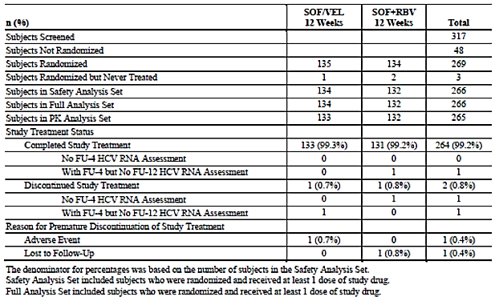

##### Major protocol violations/deviations

A total of 24 significant protocol deviations were reported in 22 patients, most commonly due to improper informed consent procedure (3.7%) and violation of inclusion/exclusion criteria (3.0%). The deviations were comparable in both treatment groups and none warranted exclusion from the primary analysis.

Overall, the mean study drug compliance rates measured by tablet counts in both groups were 98.0% and 97.7% in the SOF/VEL and SOF + RBV groups, respectively. Compliance < 80% was reported in 3.0% of the SOF/VEL group, but at a higher rate in the SOF + RBV group (SOF 4.5%, RBV 8.3%).

##### Baseline data

The baseline data were comparable in each treatment group. Overall, the majority of patients were male (59.4%), and White (88.3%), with a mean age of 57 years (range 23 to 81). Most patients were aged < 65 years (81.2%). The mean BMI was 28.6 kg/m2. The baseline disease characteristics were provided. All patients had HCV GT2 infection. In the overall population, the IL28B CC genotype was present in 38.0% of patients, and 62.0% were non-CC. The mean baseline HCV RNA was 6.4 log10 IU/mL, and HCV RNA was < 800,000 IU/mL in 20.3% of patients. Mean baseline ALT was 61.8 U/L (> 1.5 x ULN in 39.1% of patients), and mean estimated creatinine clearance was 109.8 mL/min. Overall, 85.3% of patients were treatment naïve, and 14.7 were treatment experienced. Overall, cirrhosis was present in 14.3% of patients.

##### Results for the primary efficacy outcome

The proportions of patients who achieved SVR12 were:

* SOF/VEL 99.3% (95% CI: 95.9, 100)
* SOF + RBV 93.9% (95% CI: 88.4, 97.3).

The primary endpoint was achieved with the SOF/VEL group proved non-inferior to the SOF + RBV group. The strata adjusted difference in proportions was 5.2% (95% CI: 0.2, 10.3, p = 0.018). The statistical superiority of SOF/VEL compared with SOF + RBV was also demonstrated based on pre-determined criteria (p = 0.018).

##### Results for other efficacy outcomes

###### SVR12 in sub-groups

High SVR12 rates and low patient numbers in each sub-group prevented meaningful comparisons. However, SVR12 rates in most sub-groups were comparable to the overall population. Of note, SVR12 rates were comparable in cirrhotic patients in both treatment groups. SOF/VEL was marginally superior to SOF + RBV in treatment naïve patients (99.1% versus 95.5%) but notably superior in treatment experienced patients (100% versus 85.0%). SVR12 rates were notably affected by poor drug compliance. SVR12 was achieved by only 75% of patients who were < 80% compliant with SOF/VEL. In the SOF + RBV group, patients with study drug compliance < 80% had SVR12 rates of 83.3% for SOF and 72.7% for RBV.

###### Virologic outcomes

Only one patient (0.7%) in the SOF/VEL group did not achieve SVR12 and no patients had on‑treatment virologic failure or relapse. In the SOF + RBV group, eight patients (6.1%) did not achieve SVR12, six of whom relapsed.

###### SVR4 and SVR24

Overall, SVR4 and SVR12 were achieved by 99.3% and 99.3% of the SOF/VEL group and 96.2% and 93.9% of the SOF + RBV group.

###### HCV RNA < LLOQ

The proportions of patients with HCV RNA < LLOQ during treatment were provided. Rapid suppression of HCV RNA occurred in both treatment groups. In both groups, 90.2% and 100.0% of patients had HCV RNA < LLOQ at Weeks 4 and 8, respectively.

###### HCV RNA during treatment

Mean HCV RNA levels declined rapidly by -5.32 and -5.04 log10 IU/mL from baseline to end of treatment in the SOF/VEL and SOF +RBV groups.

###### Virologic resistance

No patients in the SOF/VEL group had virologic failure or relapse. Six patients in the SOF + RBV group experienced virologic relapse. Two patients had NS5B RAVs detectable at baseline but no other RAVs were detected in the other patients.

**Comment:** This randomised study compared the safety and efficacy of SOF/VEL and SOF + RBV given for 12 weeks in treatment naïve or treatment experienced HCV patients with GT2 infection, with or without compensated cirrhosis. The SVR12 rate was 99.3% in the SOF/VEL group which was statistically superior to SOF + RBV treatment, the current standard of care (p = 0.018). The SVR12 rates were comparable in all subgroups based on treatment status, cirrhosis, high viral load, BMI, and IL28 allele status. There were no virologic failures in the SOF/VEL group, compared with 6 (4.5%) in the SOF + RBV group.

The results of this study support the use of SOF/VEL for 12 weeks in treatment naïve or treatment experienced patients with GT2 infection, with or without compensated cirrhosis.

#### Study GS-US-342-1140 (ASTRAL-3)

##### Study design, objectives, locations and dates

This was a Phase III, multicentre, randomised, open label study to compare the efficacy and safety of SOF/VEL for 12 weeks with SOF + RBV for 24 weeks in patients with chronic HCV genotype 3 infection. It is an on-going study being conducted at 76 sites in Australia, Canada, France, Germany, Italy, New Zealand, the UK, and the US. The study started in July 2014 and the cut-off date for analysis of the primary endpoint was September 2015. This interim analysis was conducted when all patients had completed the Week 24 visit, or had prematurely discontinued from the study. The primary objectives were to compare the proportions of patients achieving SVR12, and to assess tolerability and safety. Other objectives were to measure SVR4 and SVR24, and the proportion of patients with virologic failure. Approximately 240 patients were planned to be randomised 1:1 to one of two treatment groups:

* Group 1: SOF/VEL given for 12 weeks
* Group 2: SOF + RBV given for 24 weeks

The patients were stratified by the presence or absence of cirrhosis at screening, and prior treatment experience. Approximately 20% of patients were planned to be treatment experienced, and approximately 20% of patients were planned to have cirrhosis. All patients were required to complete the Week 4 and Week 12 post treatment visits. Patients with HCV RNA < LLOQ at Week 12 were required to complete Week 24 unless viral relapse had occurred.

Study visits were conducted on Day1, and at Weeks 1, 2, 4, 6, 8, 10, and 12, and Weeks 16, 20, and 24 for Group 2 only. A single PK sample was collected from all patients at each visit but no PK analyses were performed for the interim report. At each visit vital signs were recorded and measurements of biochemistry and haematology parameters and HCV RNA were made. Drug accountability and compliance were assessed and study drug was dispensed at each visit.

##### Inclusion and exclusion criteria

The key inclusion criteria were: males or females aged ≥ 18 years; HCV RNA > 104 IU/mL at screening; documented chronic HCV infection for at least 6 months (genotype 3); cirrhosis confirmed by liver biopsy (Metavir score = 4, or Ishak score ≥ 5), Fibroscan (> 12.5 kPa), or FibroTest (> 0.75); CPT class B (7-9) at screening, or absence of cirrhosis defined by liver biopsy within previous 2 years, FibroTest ≤ 0.48, or Fibroscan ≤ 12.5 kPa at screening; and patients unlikely to have a liver transplant for at least 12 weeks from baseline.

The key exclusion criteria were: current or prior history of clinically significant illnesses including hepatic, gastro-intestinal, pulmonary and cardiac diseases; unstable, severe psychiatric illnesses; malignancy within 5 years; any solid organ transplantation; significant drug allergy including hepatotoxicity; inability to exclude HCC by imaging within the previous 6 months; HBV or HIV infection; clinically significant ECG abnormalities; prior exposure to SOF, or any NS5B or NS5A inhibitor; clinical hepatic decompensation; haemoglobin < 11 g/dL for females and < 12 g/dL for males ; platelets ≤ 50,000/mm3; ALT/AST ≥ 10 x ULN; direct bilirubin > 1.5 x ULN; albumin < 3 g/dL; creatinine clearance < 60 mL/min (Cockcroft-Gault); drug or alcohol abuse within previous 12 months; contraindication to RBV; and protocol defined prohibited medications.

##### Study treatments

* Group 1: One SOF/VEL (400/100 mg) tablet once daily for 12 weeks
* Group 2: One SOF 400 tablet once daily+ RBV (1,000 or 1,200 mg/day based on body weight and divided twice daily) once daily for 12 weeks.

The tablets were taken with or without food. Dose modification for SOF/VEL was not permitted but RBV dose modification or discontinuation was permitted at the discretion of the investigator. If RBV was permanently discontinued, SOF was also discontinued.

##### Efficacy variables and outcomes

The main efficacy variables and outcomes were identical in the pivotal studies ASTRAL-1, ASTRAL-2, and ASTRAL-3.

##### Randomisation and blinding methods

Patient randomisation, treatment assignment and drug resupply was conducted using IWRS. Randomisation was stratified according to the presence or absence of cirrhosis and prior treatment experience (naïve or experienced). The study was open label.

##### Analysis populations

The all randomised set included all patients who were randomised. The safety (SAS) and full analysis (FAS) sets included all randomised patients who received at least one dose of study drug.

##### Sample size

A sample size of 250 per treatment group provided 94% power to demonstrate non-inferiority of the SVR12 rates between the two treatment groups. This assumed a non-inferiority margin of 10%, both groups would have an SVR12 rate of 89%, and the 1-sided significance level was 0.025.

##### Statistical methods

A closed testing procedure was used initially with a non-inferiority margin of 10% using a Cochran-Mantel-Haenszel test statistic for stratified proportions which controlled for multiplicity. The non-inferiority of SOF/VEL given for 12 weeks to SOF + RBV given for 24 weeks was assessed by comparing the lower bound of the 2 sided 95% CI to -10%. If the lower bound was greater than -10%, a 2 sided CMH test was used to test for superiority of SOF/VEL over SOF + RBV at a 0.05 significance level. If non-inferiority and superiority were both rejected, the superiority of SOF/VEL over SOF + RBV was demonstrated. If non-inferiority was rejected but there was insufficient evidence to reject superiority, then only non-inferiority was demonstrated. If there was insufficient evidence to reject non-inferiority, then neither non-inferiority nor superiority was demonstrated. The proportion of patients with HCV RNA < LLOQ was calculated using the 2 sided 95% exact CI based on the Clopper-Pearson method. Missing on-treatment HCV RNA data had the missing data imputed up to the time of the last dose.

##### Participant flow

A total of 652 patients were screened, 558 were randomised, and 552 received at least one dose of study treatment. A total of 529 patients (95.8%) completed study treatment and 23 patients (4.2%) discontinued, most commonly due to AEs (1.6%). Additional details are shown in Table 21.

Table 21: Study GS-US-342-1140 Participant flow

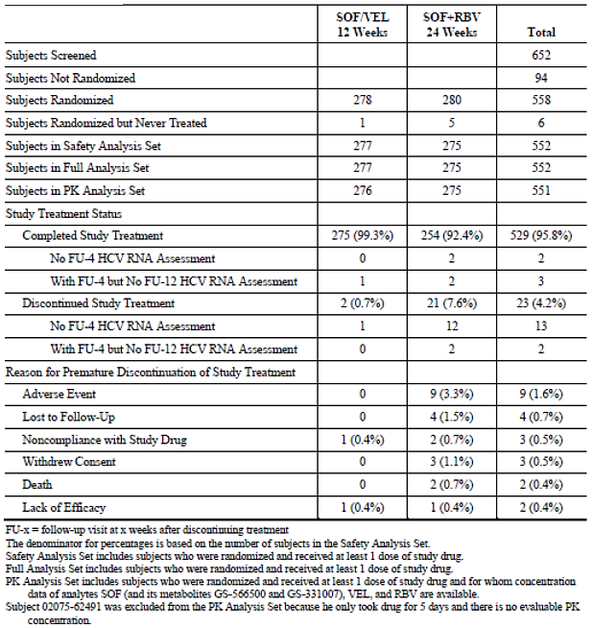

##### Major protocol violations/deviations

A total of 91 significant protocol deviations were reported in 79 patients, most commonly due to violation of inclusion/exclusion criteria (SOF/VEL 7.9%, SOF + RBV 8.7%), and use of prohibited medications (SOF/VEL 1.1%, SOF + RBV 5.5%). With the exception of prohibited medications, the deviations were comparable in both treatment groups and none warranted exclusion from the primary analysis.

Overall, the mean study drug compliance rates measured by tablet counts were 97.3% in the SOF/VEL group; and 94.5% (SOF) and 91.9% (RBV) in the SOF + RBV group. Compliance < 80% was reported in 4.7% of the SOF/VEL group, but at a higher rate in the SOF + RBV group (SOF 7.6%, RBV 12.0%).

##### Baseline data

The baseline data were comparable in each treatment group. Overall, the majority of patients were male (62.3%), and White (88.6%), with a mean age of 50 years (range 19 to 76). Most patients were aged < 65 years (96.2%). The mean BMI was 26.5 kg/m2. The baseline disease characteristics were provided. All patients had HCV GT3 infection. In the overall population, the IL28B CC genotype was present in 39.1% of patients, and 60.9% were non-CC. The mean baseline HCV RNA was 6.3 log10 IU/mL, and HCV RNA was < 800,000 IU/mL in 30.3% of patients. Mean baseline ALT was 103 U/L (> 1.5 x ULN in 67.0% of patients) and mean estimated creatinine clearance was 115.9 mL/min. Overall, 74.3% of patients were treatment- naïve and 25.7% were treatment experienced. Overall, cirrhosis was present in 29.5% of patients.

##### Results for the primary efficacy outcome

The proportions of patients who achieved SVR12 were:

* SOF/VEL for 12 weeks: 95.3% (95% CI: 92.1, 97.5)
* SOF + RBV for 24 weeks: 80.4% (95% CI: 75.2, 84.9)

The primary endpoint was achieved with the SOF/VEL group proved non-inferior to the SOF + RBV group. The strata adjusted difference in proportions was 14.8% (95% CI: 9.6, 20.0; p < 0.001) (Table 22). The statistical superiority of SOF/VEL compared with SOF + RBV was also demonstrated based on pre-determined criteria (p = 0.001).

Table 22: Study GS-US-342-1140 SVR12 primary endpoint

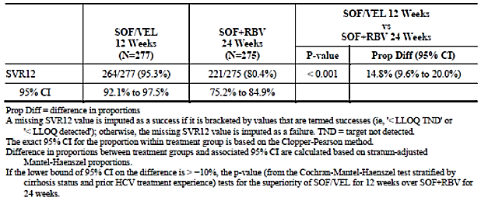

##### Results for other efficacy outcomes

###### SVR12 in sub-groups

High SVR12 rates and low patient numbers in each sub-group prevented meaningful comparisons. However, SVR12 rates in most sub-groups were comparable to the overall population. Of note, SVR12 rates in cirrhotic patients and treatment experienced patients were higher in the SOF/VEL group (91.3% and 90.1%, respectively), compared with the SOF + RBV group (66.3% and 63.4%, respectively). SVR12 rates were also notably affected by poor drug compliance. SVR12 was achieved by 92.3% of patients who were < 80% compliant with SOF/VEL. However, in the SOF + RBV group, patients with study drug compliance < 80% had SVR12 rates of only 41.2%.

###### Virologic outcomes

In the SOF/VEL group 13/277 patients (4.7%) did not achieve SVR12. Of these, no patients had on-treatment virologic failure, 11 patients relapsed, and two patients were lost to follow-up. In the SOF + RBV group, 54/275 patients (19.6%) did not achieve SVR12. One patient had on‑treatment virologic failure, 38 patients relapsed, and 15 patients did not achieve SVR12 for reasons other than virologic failure (including loss to follow-up, AEs, and withdrawal of consent) (Table 23).

Table 23: Study GS-US-342-1140 Virologic outcomes

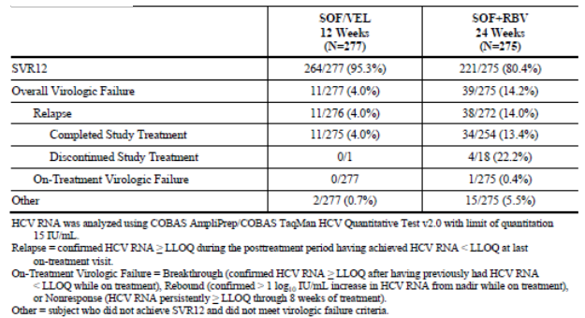

###### SVR4 and SVR24

Overall, SVR4 and SVR12 were achieved by 96.8% and 95.3% of the SOF/VEL group and 81.8% and 80.4% of the SOF + RBV group.

###### HCV RNA < LLOQ

The proportions of patients with HCV RNA < LLOQ during treatment were provided. Rapid suppression of HCV RNA occurred in both treatment groups. In the SOF/VEL group, HCV RNA < LLOQ was reported in 91.7% and 99.6% of patients at Weeks 4 and 8, respectively. In the SOF + RBV group, HCV RNA < LLOQ was reported in 88.2% and 99.3% of patients at Weeks 4 and 8, respectively.

###### HCV RNA during treatment

Mean HCV RNA levels declined rapidly by -5.14 and -4.79 log10 IU/mL from baseline to the end of treatment in the SOF/VEL and SOF +RBV groups.

###### Virologic resistance

In the SOF/VEL group, 11 patients (4.0%) had virologic failure. One patient had GT3 infection at baseline but GT1 infection at the point of virologic failure (presumably due to re-infection). NS5A RAV Y93H emerged in the 10 remaining patients. In the SOF + RBV group, 39 patients (14.2%) experienced virologic failure. Seven patients had NS5B RAVs which emerged post treatment.

**Comment:** This randomised study compared the safety and efficacy of SOF/VEL given for 12 weeks and SOF + RBV given for 24 weeks in treatment naïve or treatment experienced HCV patients with GT3 infection, with or without compensated cirrhosis. The SVR12 rate was 95.3% in the SOF/VEL group which met the primary endpoint of statistical non-inferiority to SOF + RBV treatment (80.4%). The SOF/VEL for 12 weeks regimen was also statistically superior to the SOF + RBV for 24 weeks regimen (p < 0.001). In the SOF/VEL for 12 weeks group, the SVR12 rate was 90.1% in patients with prior treatment failure, and 91.3% in patients with cirrhosis. Virologic failure occurred in 4.0% of the SOF/VEL group, all due to post treatment relapse. The results of this study support the use of SOF/VEL for 12 weeks in treatment naïve or treatment experienced patients with GT3 infection, with or without cirrhosis.

### Other efficacy studies

#### Study GS-US-337-0122 (ELECTRON-2)

##### Design and methodology

This is an ongoing Phase II, multicentre, open label study of the efficacy and safety of sofosbuvir containing regimens for the treatment of chronic HCV infection for up to 24 weeks. It was conducted at two centres in New Zealand. It started in April 2013 and the cut-off date for this second interim report is December 2014. The primary efficacy objective was the proportions of patients achieving SVR12. Secondary objectives included SVR4 and SVR24, viral dynamics during treatment and viral resistance. Patients were randomised to receive regimens of SOF (400 mg) or LDV/SOF (lepidasvir 90 mg/sofosbuvir 400 mg FDC, approved as Harvoni) in combinations with RBV given twice daily, GS-9669[10] given once daily, or Peg-IFN given SC once weekly. Groups of approximately 25 patients were planned and no formal statistical hypotheses were tested. For the primary analysis, SVR12 was calculated for each treatment group with the 2 sided 95% CIs based on the Clopper-Pearson method.

##### Baseline characteristics, SVR12 results and virologic failures by treatment group

Note: The sponsor has not provided integrated efficacy data or tables in the CSRs of the following Phase II studies. The designs and results in each treatment cohort and group are summarised individually but tables have not been provided in the interests of brevity.

##### Part A: patients previously treated in study P7977-0523 without achieving SVR

###### Cohort 1

Group 1

LDV/SOF + RBV for 12 weeks in patients with GT1 infection who had previously been treated in study P7977-0523 but who did not achieve SVR. A total of 19 patients were randomised and all completed the study treatment. The majority of patients were male (68.4%), and White (94.7%) with a mean age of 55 years. Most patients were non-cirrhotic (94.7%), and mean baseline HCV RNA was 6.3 log10 IU/mL. SVR12 was achieved by 100% of patients (95% CI: 82.4, 100) and there were no cases of virologic failure.

Group 2

SOF + Peg-IFN for 12 weeks in patients with GT1 or GT3 infection who had previously been treated in study P7977-0523 but who did not achieve SVR. A total of 10 patients were randomised and nine (90%) completed the study treatment. The majority of patients were male (80.0%), and White (90.0%) with a mean age of 49 years. Most patients were non-cirrhotic (90.0%), and mean baseline HCV RNA was 6.5 log10 IU/mL. SVR12 was achieved by 90% of patients (95% CI: 55.5, 99.7), and there was one case of virologic failure.

###### Cohort 2

Group 1

LDV/SOF + RBV for 12 weeks in treatment experienced patients with GT1 infection and advanced hepatic fibrosis or compensated cirrhosis. A total of 25 patients were randomised and all completed the study treatment. The majority were male (60.0%), and White (88.00%) with a mean age of 56 years. Most patients were cirrhotic (72.0%), and mean baseline HCV RNA was 6.5 log10 IU/mL. SVR12 was achieved by 100% of patients (95% CI: 86.3, 100) and there were no cases of virologic failure.

Group 2

LDV/SOF + GS-9669 for 12 weeks in treatment experienced patients with GT1 infection and advanced hepatic fibrosis or compensated cirrhosis. A total of 26 patients were randomised and all completed the study treatment. The majority of patients were male (57.7%), and White (92.3%) with a mean age of 55 years. Most patients were cirrhotic (65.4%), and mean baseline HCV RNA was 6.1 log10 IU/mL. SVR12 was achieved by 100% of patients (95% CI: 86.8, 100) and there were no cases of virologic failure.

Group 3

LDV/SOF for 12 weeks in treatment naive patients with GT3 infection. A total of 25 patients were randomised and 23 (92.0%) completed the study treatment. The majority of patients were male (52.0%), and White (88.0%) with a mean age of 43 years. Most patients were non-cirrhotic (84.0%), and mean baseline HCV RNA was 6.3 log10 IU/mL. SVR12 was achieved by 64.0% of patients (95% CI: 42.5, 82.0) and there were eight cases (32.0%) of virologic failure.

Group 4

LDV/SOF + RBV for 12 weeks in treatment naive patients with GT3 infection. A total of 26 patients were randomised and 24 (92.3%) completed the study treatment. The majority were female (57.7%), and White (88.5%) with a mean age of 48 years. Most patients were non-cirrhotic (76.9%), and mean baseline HCV RNA was 6.3 log10 IU/mL. SVR12 was achieved by 100% of patients (95% CI: 86.8, 100) and there were no cases of virologic failure.

Group 5

LDV/SOF for 12 weeks in treatment naive or treatment experienced patients with GT6 infection. A total of 25 patients were randomised and 23 (92.0%) completed the study treatment. The majority were female (64.0%) and Asian (88.0%) with a mean age of 51 years. Most patients were non-cirrhotic (92.0%) and mean baseline HCV RNA was 6.7 log10 IU/mL. SVR12 was achieved by 96.0% of patients (95% CI: 79.6, 99.9) and there was one case of virologic failure.

Group 6

LDV/SOF + RBV for 12 weeks in treatment experienced patients with GT3 infection. A total of 50 patients were treated all completed the study treatment. The majority of patients were male (78.0%), and White (80.0%) with a mean age of 52 years. Most patients were non-cirrhotic (56.0%), and mean baseline HCV RNA was 6.3 log10 IU/mL. SVR12 was achieved by 82.0% of patients (95% CI: 68.6, 91.4) and there were nine (18.0%) cases of virologic failure.

###### Cohort 3

Group 1

LDV/SOF for 12 weeks in treatment naïve or treatment experienced patients with GT1 infection and CPT B cirrhosis. A total of 20 patients were treated and all completed the study treatment. The majority were male (85.0%), and White (85.0%) with a mean age of 56 years. All patients were cirrhotic, and mean baseline HCV RNA was 6.0 log10 IU/mL. SVR12 was achieved by 65.0% of patients (95% CI: 40.8, 84.6) and there were seven (35.0%) cases of virologic failure.

##### PART B (patients treated with SOF + VEL +/- RBV for 8 weeks)

###### Cohort 4

Group 1

SOF + VEL 25 mg for 8 weeks in treatment naïve, non-cirrhotic patients with GT3 infection. A total of 27 patients were treated and all completed the study treatment. The majority of patients were male (63.0%), and White (74.1%) with a mean age of 48 years. All patients were non‑cirrhotic, and mean baseline HCV RNA was 5.9 log10 IU/mL. SVR12 was achieved by 100% of patients (95% CI: 87.2, 100) and there were no cases of virologic failure.

Group 2

SOF + VEL 25 mg + RBV for 8 weeks in treatment naïve, non-cirrhotic patients with GT3 infection. A total of 24 patients were treated and 23 (95.8%) completed the study treatment. The majority of patients were male (75.0%), and White (83.3%) with a mean age of 47 years. All patients were non-cirrhotic, and mean baseline HCV RNA was 6.3 log10 IU/mL. SVR12 was achieved by 87.5% of patients (95% CI: 67.6, 97.3) and there were two (8.3%) cases of virologic failure.

Group 3

SOF + VEL 100 mg for 8 weeks in treatment naïve, non-cirrhotic patients with GT3 infection. A total of 27 patients were treated and 26 (96.3%) completed the study treatment. The majority of patients were male (63.0%), and White (74.1%) with a mean age of 50 years. All patients were non-cirrhotic, and mean baseline HCV RNA was 6.0 log10 IU/mL. SVR12 was achieved by 96.3% of patients (95% CI:81.0, 99.9) and there were no cases of virologic failure.

Group 4

SOF + VEL 100 mg + RBV for 8 weeks in treatment naïve, non-cirrhotic patients with GT3 infection. A total of 26 patients were treated and all completed the study treatment. The majority of patients were female (57.7%), and White (73.1%) with a mean age of 47 years. All patients were non-cirrhotic, and mean baseline HCV RNA was 6.2 log10 IU/mL. SVR12 was achieved by 100% of patients (95% CI: 86.8, 100) and there were no cases of virologic failure.

##### PART C (treatment experienced patients with GT1 or GT3 infection who did not achieve SVR in previous studies)

###### Cohort 5

Group 1

LDV/SOF + RBV for 24 weeks in patients who did not achieve SVR with exposure to a SOF containing regimen in a previous study. A total of 20 patients were treated and 19 (95.0%) completed the study treatment. The majority of patients were male (90.0%), and White (90.0%) with a mean age of 54 years. Most patients were cirrhotic (70.0%), and mean baseline HCV RNA was 6.0 log10 IU/mL. No patients had reached the post treatment Week 12 visit at the time of the interim analysis.

###### Cohort 6

Group 1

LDV/SOF for 12 weeks in patients with GT1 and HBV co-infection. A total of 8 patients were treated and all completed the study treatment. The majority of patients were male (75.0%), and the most common race was Pacific Islander (50.0%). The mean age was 53 years. Most patients were non-cirrhotic (75.0%), and mean baseline HCV RNA was 6.5 log10 IU/mL. SVR12 was achieved by 100% of patients (95% CI: 63.1, 100) and there were no cases of virologic failure.

**Comment:** In treatment experienced patients with GT1 infection, 100% of patients achieved SVR12 in the LDV/SOF + RBV treatment group; and 90.0% achieved SVR12 in GT3 patients treated with SOF + PegIFN. In treatment experienced patients with GT1 infection and advanced liver fibrosis or decompensated cirrhosis, all patients in the LDV/SOF + RBV and LDV/SOF + GS-9669 groups achieved SVR12. In treatment naïve patients with GT3 infection, only 64.0% of patients achieved SVR12 in the LDV/SOF for 12 weeks group. In treatment naïve GT3 patients, 100% of patients achieved SVR12 in the LDV/SOF + RBV group. In treatment experienced patients with GT3 infection, 82.0% of patients achieved SVR12 in the LDV/SOF + RBV for 12 weeks group (72.7% in cirrhotic patients and 89.3% in non-cirrhotic patients). In treatment naïve GT3 patients, 100% of patients achieved SVR12 in the LDV/SOF + RBV group. In patients with GT6 infection, of mixed prior treatment and cirrhosis status, 96.0% of patients achieved SVR12 in the LDV/SOF for 12 weeks group. These data suggest that LDV/SOF for 12 weeks was effective in GT6 patients but not fully effective in patients with GT3 infection without concomitant RBV.

In treatment naïve or treatment experienced patients with GT1 infection and decompensated cirrhosis, 65% of patients achieved SVR12 following treatment with LDV/SOF for 12 weeks. This response was suboptimal but 100% of patients with HCV and HBV co-infection achieved SVR12 following treatment with LDV/SOF for 12 weeks. Overall, SVR12 rates in patients treated with LDV/SOF were high in most patient groups but mostly when given in combination with RBV, GS-9669, or PegIFN.

In treatment naïve patients with GT3 infection and without cirrhosis, 87.5% to 100% of patients achieved SVR12 following treatment with SOF + VEL 25 mg, SOF + VEL 25 mg + RBV, SOF + VEL 100 mg, or SOF + VEL 100 mg + RBV for 8 weeks. The response in all SOF + VEL groups was impressive and the need for RBV was not obvious. The overall conclusion of this Phase II study was that the combination of LDV/SOF (Harvoni) is effective but it would require concomitant RBV or an additional DAA to achieve optimal SVR12 rates in all patients groups. The data supported the decision to progress the SOF/VEL combination into the Phase III program.

#### Study GS-US-342-0102

##### Design and methodology

This was a Phase II, multicentre, open label study of the efficacy and safety of SOF + VEL 25 mg or 100 mg, with or without RBV for 8 or 12 weeks in treatment naïve, non-cirrhotic patients with chronic HCV infection. It was conducted at 48 centres in US. It started in April 2013 and the cut-off date for this second interim report is August 2014. The primary efficacy objective was the proportions of patients achieving SVR12. Secondary objectives included SVR4 and SVR24, viral dynamics during treatment, and viral resistance. Approximately 340 patients were planned to be randomised to one of 14 treatment groups. No formal statistical hypotheses were tested. For the primary analysis, SVR12 was calculated for each treatment group with the 2 sided 95% CIs based on the Clopper-Pearson method.

##### Baseline characteristics, SVR12 results and virologic failures by treatment group

###### Patients with HCV GT1 infection

Group 1

SOF + VEL 25 mg once daily for 12 weeks. A total of 27 patients were randomised and all completed the study treatment. The majority were male (51.9%) and White (85.2%) with a mean age of 49 years. No patients were cirrhotic, and mean baseline HCV RNA was 6.4 log10 IU/mL. SVR12 was achieved by 96.3% of patients (95% CI: 81.0, 99.9) and there was one case (3.7%) of virologic failure.

Group 2

SOF + VEL 100 mg once daily for 12 week. A total of 28 patients were randomised and all completed the study treatment. The majority were male (60.7%), and White (89.3%) with a mean age of 49 years. No patients were cirrhotic, and mean baseline HCV RNA was 6.4 log10 IU/mL. SVR12 was achieved by 100% of patients (95% CI: 87.7, 100) and there were no cases of virologic failure.

###### Patients with GT3 infection

Group 3

SOF + VEL 25 mg once daily for 12 weeks. A total of 27 patients were randomised and 26 (96.3%) completed the study treatment. The majority were male (66.7%), and White (81.5%) with a mean age of 52 years. No patients were cirrhotic, and mean baseline HCV RNA was 6.4 log10 IU/mL. SVR12 was achieved by 92.6% of patients (95% CI: 75.7, 99.1) and there were two cases (7.4%) of virologic failure.

Group 4

SOF + VEL 100 mg once daily for 12 week. A total of 27 patients were randomised and all completed the study treatment. The majority were male (63.0%), and White (96.3%) with a mean age of 50 years. No patients were cirrhotic, and mean baseline HCV RNA was 6.2 log10 IU/mL. SVR12 was achieved by 92.6% of patients (95% CI: 75.7, 99.1) (identical to the results in Group 3), and there were two cases (7.4%) of virologic failure.

###### Patients with GT2, 4, 5, or 6 infections

Group 5

SOF + VEL 25 mg once daily for 12 weeks. A total of 11 patients were randomised and all completed the study treatment. The majority were male (54.5%), and all were White with a mean age of 53 years. No patients were cirrhotic, and mean baseline HCV RNA was 6.5 log10 IU/mL. SVR12 was achieved by 90.9% of patients (95% CI: 58.7, 99.8) and there were no cases of virologic failure.

Group 6

SOF + VEL 100 mg once daily for 12 week. A total of 10 patients were randomised and all completed the study treatment. The majority were male (70.0%), and all were White with a mean age of 53 years. No patients were cirrhotic and mean baseline HCV RNA was 6.7 log10 IU/mL. SVR12 was achieved by 100% of patients (95% CI: 69.2, 100), and there were no cases of virologic failure.

###### Patients with GT1 infection

Group 7

SOF + VEL 25 mg once daily for 8 weeks. A total of 30 patients were randomised and 29 (96.7%) completed the study treatment. The majority were male (53.3%), and White (86.7%) with a mean age of 50 years. No patients were cirrhotic, and mean baseline HCV RNA was 6.5 log10 IU/mL. SVR12 was achieved by 86.7% of patients (95% CI: 69.3, 96.2) and there were three cases (10.0%) of virologic failure.

Group 8

SOF + VEL 25 mg once daily + RBV for 8 weeks. A total of 30 patients were randomised and all completed the study treatment. The majority were male (60.0%), and White (90.0%) with a mean age of 53 years. Most patients were non-cirrhotic (93.3%), and mean baseline HCV RNA was 6.5 log10 IU/mL. SVR12 was achieved by 83.3% of patients (95% CI: 65.3, 94.4) and there were five cases (16.7%) of virologic failure.

Group 9

SOF + VEL 100 mg once daily for 8 weeks. A total of 29 patients were randomised and all completed the study treatment. The majority were male (55.2%), and White (82.8%) with a mean age of 55 years. No patients were cirrhotic, and mean baseline HCV RNA was 6.3 log10 IU/mL. SVR12 was achieved by 89.7% of patients (95% CI: 72.6, 97.8) and there were three cases (10.3%) of virologic failure.

Group 10

SOF + VEL 100 mg once daily + RBV for 8 weeks. A total of 31 patients were treated and 30 (96.8%) completed the study treatment. The majority were male (51.6%), and White (77.4%) with a mean age of 52 years. All patients were non-cirrhotic, and mean baseline HCV RNA was 6.6 log10 IU/mL. SVR12 was achieved by 80.6% of patients (95% CI: 62.5, 92.5) and there were five cases (16.1%) of virologic failure.

###### Patients treated with GT2 infection

Group 11

SOF + VEL 25 mg once daily for 8 weeks. A total of 26 patients were randomised and all completed the study treatment. The majority were male (57.70%), and White (84.6%) with a mean age of 52 years. All patients were non-cirrhotic, and mean baseline HCV RNA was 6.4 log10 IU/mL. SVR12 was achieved by 76.9% of patients (95% CI: 56.4, 91.0) and there were six cases (23.1%) of virologic failure.

Group 12

SOF + VEL 25 mg once daily + RBV for 8 weeks. A total of 25 patients were randomised and all completed the study treatment. The majority were male (68.0%), and White (92.0%) with a mean age of 54 years. All patients were non-cirrhotic, and mean baseline HCV RNA was 6.6 log10 IU/mL. SVR12 was achieved by 88.0% of patients (95% CI: 68.8, 97.5) and there were two cases (8.0%) of virologic failure.

Group 13

SOF + VEL 100 mg once daily for 8 weeks. A total of 26 patients were randomised and treated and all completed the study treatment. The majority were female (53.8%), and White (92.3%) with a mean age of 54 years. All patients were non-cirrhotic, and mean baseline HCV RNA was 6.5 log10 IU/mL. SVR12 was achieved by 88.5% of patients (95% CI: 69.8, 97.6) and there were three cases (11.5%) of virologic failure.

Group 14

SOF + VEL 100 mg once daily + RBV for 8 weeks. A total of 26 patients were randomised and treated and all completed the study treatment. The majority were female (61.5%), and White (96.2%) with a mean age of 51 years. All patients were non-cirrhotic, and mean baseline HCV RNA was 6.7 log10 IU/mL. SVR12 was achieved by 88.5% of patients (95% CI: 69.8, 97.6) and there were three cases (11.5%) of virologic failure.

**Comment:** This study explored regimens of SOF + VEL 25 mg or 100 mg, given with or without RBV for 8 or 12 weeks to patients infected with different genotypes. SVR12 rates were high in groups given VEL 25 mg for 8 weeks, with or without RBV. However, SVR12 rates were approximately 10% higher in groups given VEL 100 mg for 12 weeks (90 to 100%) compared with groups given VEL 25 mg for 8 weeks (80 to 90%). Virologic failures were also less common in groups receiving VEL 100 mg for 12 weeks. No obvious benefit was demonstrated with the addition of RBV in any treatment group. Overall, the data supported the conclusions of GS-US-337-0122 that SOF/VEL (400/100 mg) for 12 weeks was the combination most likely to achieve the best outcomes in all patient groups.

#### Study GS-US-342-0109

This is an ongoing Phase II, multicentre, open label study of the efficacy and safety of SOF + VEL in treatment experienced patients with chronic HCV infection. It was conducted at 58 centres in Australia, New Zealand and the US. It started in April 2013 and the cut-off date for this second interim report is August 2014. The primary efficacy objective was the proportions of patients achieving SVR12. Secondary objectives included SVR4 and SVR24, viral dynamics during treatment, and viral resistance. A total of 300 patients were planned and 323 patients were randomised to one of 12 treatment groups given SOF + VEL 25 mg or 100 mg once daily, with or without RBV. No formal statistical hypotheses were tested. For the primary analysis, SVR12 was calculated for each treatment group with the 2 sided 95% CIs based on the Clopper-Pearson method.

##### Baseline characteristics, SVR12 and virologic failures by treatment group

###### Non-cirrhotic patients with HCV GT3 infection

Group 1

SOF + VEL 25 mg once daily for 12 weeks. A total of 26 patients were randomised and all completed the study treatment. The majority were male (69.2%) and White (96.2%) with a mean age of 54 years. No patients were cirrhotic, and mean baseline HCV RNA was 6.7 log10 IU/mL. SVR12 was achieved by 84.6% of patients (95% CI: 65.1, 95.6) and there were four cases (15.4%) of virologic failure.

Group 2

SOF + VEL 25 mg once daily + RBV for 12 week. A total of 28 patients were randomised and 27 (96.4%) completed the study treatment. The majority were male (78.6%) and White (92.9%) with a mean age of 51 years. No patients were cirrhotic, and mean baseline HCV RNA was 6.6 log10 IU/mL. SVR12 was achieved by 96.4% of patients (95% CI: 81.7, 99.9) and there was one case (3.6%) of virologic failure.

Group 3

SOF + VEL 100 mg once daily for 12 weeks. A total of 27 patients were randomised and all completed the study treatment. The majority were male (66.7%) and White (92.6%) with a mean age of 55 years. No patients were cirrhotic, and mean baseline HCV RNA was 6.6 log10 IU/mL. SVR12 was achieved by 100% of patients (95% CI: 87.2, 100) and there were no cases of virologic failure.

Group 4

SOF + VEL 100 mg once daily + RBV for 12 weeks. A total of 26 patients were randomised and all completed the study treatment. The majority were male (65.4%) and White (92.3%) with a mean age of 56 years. No patients were cirrhotic, and mean baseline HCV RNA was 6.7 log10 IU/mL. SVR12 was achieved by 100% of patients (95% CI: 86.8, 100) and there were no cases of virologic failure.

###### Cirrhotic patients with GT3 infection

Group 5

SOF + VEL 25 mg once daily for 12 weeks. A total of 26 patients were randomised and all completed the study treatment. The majority were male (80.8%) and White (96.2%) with a mean age of 57 years. All patients were cirrhotic, and mean baseline HCV RNA was 6.6 log10 IU/mL. SVR12 was achieved by 57.7% of patients (95% CI: 36.9, 76.6) and there were 11 cases (42.3%) of virologic failure.

Group 6

SOF + VEL 25 mg once daily + RBV for 12 week. A total of 25 patients were randomised and 24 (96.0%) completed the study treatment. The majority were male (60.0%) and White (92.0%) with a mean age of 56 years. All patients were cirrhotic, and mean baseline HCV RNA was 6.2 log10 IU/mL. SVR12 was achieved by 84.0% of patients (95% CI: 63.9, 95.5) and there were three cases (12.0%) of virologic failure.

Group 7

SOF + VEL 100 mg once daily for 12 weeks. A total of 26 patients were randomised and all completed the study treatment. The majority were male (76.9%) and White (96.2%) with a mean age of 56 years. All patients were cirrhotic, and mean baseline HCV RNA was 6.4 log10 IU/mL. SVR12 was achieved by 88.5% of patients (95% CI: 69.8, 97.6) and there were three cases (11.5%) of virologic failure.

Group 8

SOF + VEL 100 mg once daily + RBV for 12 weeks. A total of 26 patients were randomised and all completed the study treatment. The majority were male (76.9%) and White (92.3%) with a mean age of 54 years. All patients were non-cirrhotic, and mean baseline HCV RNA was 6.8 log10 IU/mL. SVR12 was achieved by 96.2% of patients (95% CI: 80.4, 99.9) and there was one case (3.8%) of virologic failure.

###### Patients with GT1 infection

Group 9

SOF + VEL 25 mg once daily for 12 weeks. A total of 27 patients were randomised and all completed the study treatment. The majority were male (55.6%) and White (74.1%) with a mean age of 55 years. The majority of patients were non-cirrhotic (63.0%), and mean baseline HCV RNA was 6.5 log10 IU/mL. SVR12 was achieved by 100% of patients (95% CI: 87.2, 100) and there were no cases of virologic failure.

Group 10

SOF + VEL 25 mg once daily + RBV for 12 weeks. A total of 29 patients were treated and all completed the study treatment. The majority were male (75.9%) and White (93.1%) with a mean age of 57 years. The majority of patients were non-cirrhotic (65.5%), and mean baseline HCV RNA was 6.8 log10 IU/mL. SVR12 was achieved by 96.6% of patients (95% CI: 82.2, 99.9) and there was one case (3.4%) of virologic failure.

Group 11

SOF + VEL 100 mg once daily for 12 weeks. A total of 27 patients were randomised and all completed the study treatment. The majority were male (55.6%) and White (85.2%) with a mean age of 57 years. The majority of patients were non-cirrhotic (66.7%), and mean baseline HCV RNA was 6.4 log10 IU/mL. SVR12 was achieved by 100% of patients (95% CI: 87.2, 100) and there were no cases of virologic failure.

Group 12

SOF + VEL 100 mg once daily + RBV for 12 weeks. A total of 28 patients were randomised and all completed the study treatment. The majority were male (64.3%) and White (75.0%) with a mean age of 56 years. The majority of patients were non-cirrhotic (64.3%), and mean baseline HCV RNA was 6.5 log10 IU/mL. SVR12 was achieved by 96.4% of patients (95% CI: 81.7, 99.9) and there was one case (3.6%) of virologic failure.

**Comment:** This study compared the efficacy and safety of SOF + VEL 25 mg or 100 mg, given with or without RBV for 8 or 12 weeks to patients with GT1 or GT3 infection, with or without cirrhosis. As in the other Phase II studies, SVR12 rates were numerically higher in patients receiving SOF + VEL for 12 weeks rather than 8 weeks. In patients with GT3 infection given SOF + VEL 100 mg for 12 weeks, SVR12 was achieved in 100% of non-cirrhotic patients compared with 96.2% in cirrhotic patients given SOF + VEL 100 mg + RBV for 12 weeks. In patients with GT1 infection (approximately 65% were non-cirrhotic in each group), SVR12 was achieved by 100% of patients given SOF + VEL 100 mg for 12 weeks, compared with 96.4% of patients given SOF + VEL 100 mg + RBV for 12 weeks. Overall, the results support the use of SOF + VEL 100 mg for 12 weeks given without RBV in GT1 and GT3 patients with or without cirrhosis.

### Analyses performed across trials

A pooled efficacy analysis of the pivotal Phase III studies GS-US-342-1138, GS-US-342-1139, GS-US-342-1140 was performed in patient groups who received SOF /VEL for 12 weeks. A total of 1,038 patients were randomised, and 1,035 patients received at least one dose of SOF/ VEL. A total of 1,030 patients (99.5%) completed the treatment period and were included in the FAS (Table 24). The baseline demographics categorised were provided. Overall, the majority of patients were male (60.9%) and White (83.8%). Among other races, 8.3% of patients were Asian, and 5.9% were Black. The mean age was 53 years and the majority of patients were aged < 65 years (88.1%). The mean BMI was 26.8 kg/m2 and 78.3% of patients had a BMI < 30 kg/m2. Patients with GT5 infection were generally older than the overall population, and patients with GT6 infection were mostly Asian with a lower mean BMI. The baseline disease characteristics were provided. By genotype, patients were either GT1 (31.7%), GT2 (23.0%), GT3 (26.8%), GT4 (11.2%), GT5 (3.4%), or GT6 (4.0%). Overall, 71.9% of patients were treatment naïve, 28.1% were treatment experienced, and most were non-cirrhotic (78.6%). IL28B genotypic sub-types were CC (33.4%), CT (52.9%), or TT (13.1%). Mean baseline HCV RNA was 6.3 log10 IU/mL, and 73.7% of patients had HCV RNA ≥ 800,000 IU/mL. ALT > 1.5 x ULN was present in 49.8% of patients and mean eGFR was 109.4 mL/min (range 48 to 244). The mean duration of exposure to study drug was 12 (+/- 0.67 SD) weeks.

Table 24: Study Pooled efficacy analysis; patient disposition

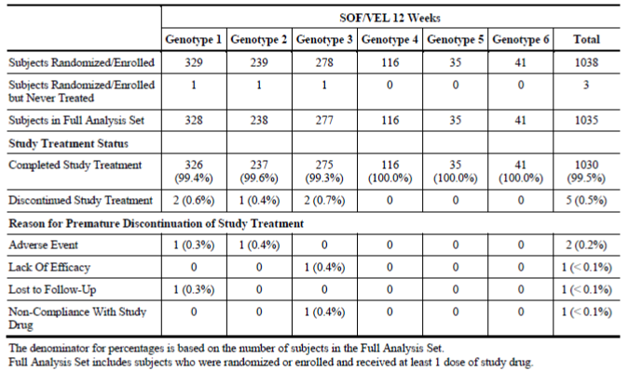

The results for the primary endpoint are shown below in Table 25 (below). Overall, SVR12 was achieved by 98.1% of patients (range 95.3% to 100.0%).

Table 25: SVR12 by genotype in the pooled efficacy analysis

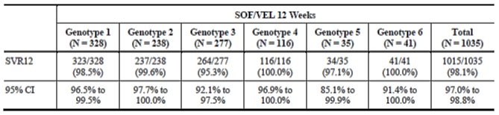

Virologic outcomes by genotype are shown in Table 26. Overall, virologic failure occurred in 1.3% of patients, mostly in those with GT3 infection (4%). No cases of on-treatment virologic failure were reported and each failure was due to relapse. The overall SVR4 were similar to the SVR12 rates [SVR4: 98.6% (range 96.8% to 100%)]. The SVR24 data were incomplete at the time of the interim analyses. Rapid viral suppression was observed in all genotypes. At Week 4, 90.8% of patients (range 89.3% to 92.7%) had HCV RNA < LLOQ. Of 13 patients with virologic failure, 10 patients had GT3 infection, and two patients had GT1 infection. One patient with GT3 infection at baseline had GT1 re-infection post treatment. The NS5A RAVs Y93H and Y93N conferred high level resistance to VEL in eleven of these patients. No SOF NS5B resistance was observed in patients who had virologic failure.

Table 26: Study Pooled efficacy analysis: virologic outcomes

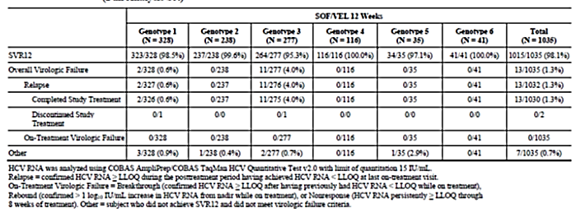

SVR12 rates > 90% were achieved in GS-US-342-1138, GS-US-342-1139, GS-US-342-1140 in patients treated with SOF/VEL for 12 weeks, irrespective of treatment experience and presence or absence of cirrhosis. Overall, SVR12 was achieved in 96.4% of patients with cirrhosis (range 91.3% to 100%), and in 97.3% of patients with prior treatment experience (range 90.1% to 100%). In patients given SOF/VEL for 12 weeks, SVR12 rates by genotype ranged from 95.3% to 100% (Table 27). SVR12 rates in subgroups are shown in Table 28. There were no notable differences and SVR12 rates were achieved by > 96% of all subgroups.

Table 27: SVR12 by genotype in the pooled efficacy analysis

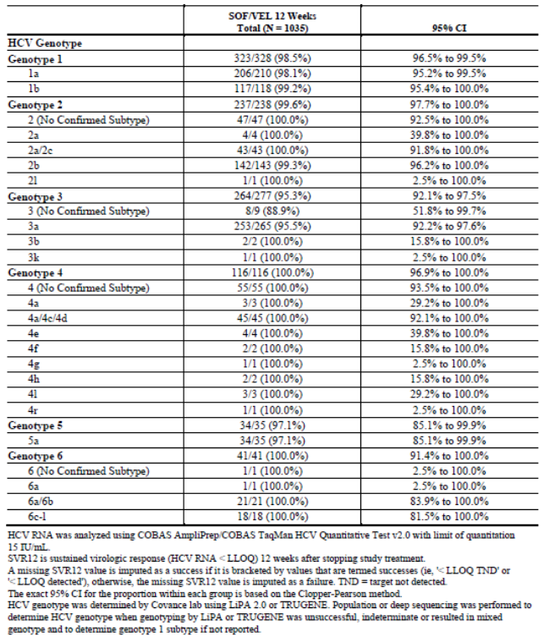

Table 28: SVR12 by subgroup in the pooled efficacy analysis

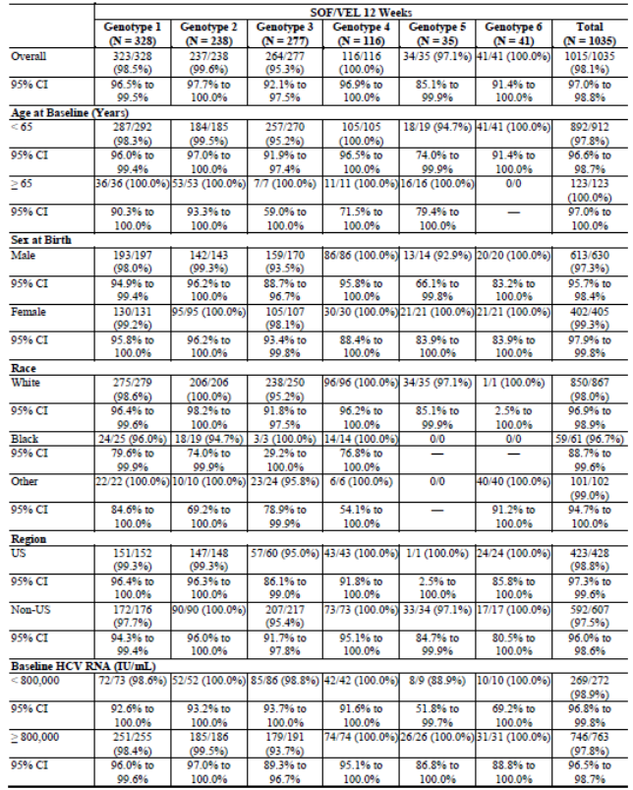

Table 28 (continued): SVR12 by subgroup in the pooled efficacy analysis

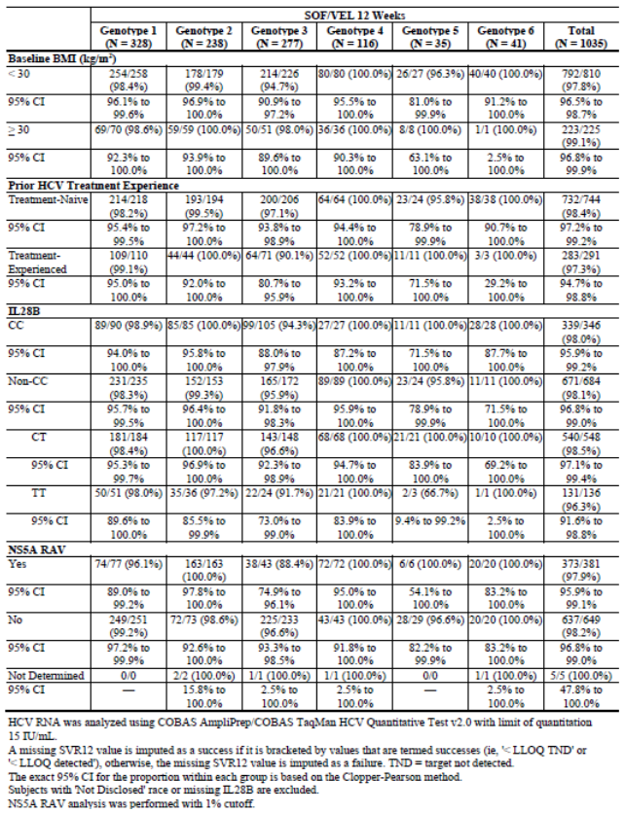

**Comment:** The pooled analysis confirmed outstanding SVR12 rates of 95.3% to 100% in HCV patients of any genotype treated with SOF/VEL for 12 weeks. High efficacy rates were achieved irrespective of age, gender, race, region, baseline HCV RNA, baseline BMI, prior HCV treatment, IL28B genotype, NS5A RAVs and cirrhosis. SVR12 rates were > 91% across all genotypes in patients with cirrhosis and > 90% in patients with prior treatment experience.

### Evaluator’s conclusions on clinical efficacy for the indication:

“Epclusa (sofosbuvir/velpatasvir fixed dose combination) is indicated for the treatment of chronic hepatitis C virus (HCV) infection in adults”.

In the Phase II studies, SOF + VEL regimens were compared at different doses and for different durations of treatment (8, 12 or 24 weeks). Treatment naïve and treatment experienced patients included all genotypes, and those with or without cirrhosis. The SOF + VEL regimens were given with or without RBV, and compared with LDV/SOF (Harvoni) and other SOF containing regimens. High efficacy rates were observed in patient groups treated for 8 weeks, and in patients given VEL 25 mg. However, the best SVR12 rates were obtained in patients given SOF + VEL 100 mg for 12 weeks, particularly in patients with GT3 infection. The SVR12 rates were 100.0% in treatment naïve GT1 patients without cirrhosis, and 100.0% in treatment experienced patients. The SVR12 rate was 92.6% in treatment naïve, GT3 patients without cirrhosis; 100% in treatment experienced, GT3 patients without cirrhosis; and 88.5% in treatment experienced, GT3 patients with cirrhosis. All patients with genotype 2, 4, 5, or 6 were treatment naïve without cirrhosis and none had virologic failure.

The SOF/VEL combination was given for 12 weeks to a total of 1035 patients in the Phase III studies, and the SVR12 rates ranged from 95.3% to 100%. Only 35 GT5 and 41 GT6 patients were studied but the results in these patients were comparable to the overall population. In studies GS-US-342-1138, GS-US-342-1139, and GS-US-342-1140, there were no on-treatment virologic failures in patients given SOF/VEL for 12 weeks. Overall, viral relapse was reported in only 13/1035 patients, in two (0.6%) patients with GT1 infection, and in 11 (4%) patients with GT3 infection. Overall, SVR4 rates were comparable to the SVR12 rates; however, full SVR24 data were not available for the interim analyses. Patients with decompensated cirrhosis were evaluated in GS-US-342-1137. The overall SVR12 rate in 90 patients treated with SOF/VEL for 12 weeks was 83.3% (range 50% to 100.0%) compared with 94.3% (range 84.6% to 100%) in patients treated with SOF/VEL + RBV for 12 weeks, and 85.6% (range 50% to 100%) in patients treated with SOF/VEL for 24 weeks. Patients with GT3 infection were least likely to achieve SVR12 (50%, 84.6%, and 50% in the respective treatment groups). Overall virologic failure was also common in GT3 patients treated with SOF/VEL for 12 weeks (42.9%).

Subgroups in the Phase III studies were analysed according to age, gender, race, region, baseline HCV RNA, baseline BMI, prior HCV treatment, IL28B genotype, NS5A RAVs, and cirrhosis. In patients treated with SOF/VEL for 12 weeks in studies GS-US-342-1138, GS-US-342-1139, and GS-US-342-1140, there were no meaningful differences in SVR12 and all subgroups achieved SVR12 rates > 95%. SVR12 rates were > 91% across all genotypes in patients with cirrhosis, and > 90% in patients with prior treatment experience.

## Clinical safety

### Studies providing evaluable safety data

The following pivotal studies provided evaluable safety data:

* Study GS-US-342-1137 (ASTRAL-4)
* Study GS-US-342-1138 (ASTRAL-1)
* Study GS-US-342-1139 (ASTRAL-2)
* Study GS-US-342-1140 (ASTRAL-3)

#### Pivotal efficacy studies

In the pivotal efficacy studies, the following safety data were collected:

* General adverse events (AEs) were recorded and classified according to MedDRA.
* AEs of particular interest included cardiovascular, hepatic, and renal events. Potential interactions between SOF/VEL and cardiovascular agents were explored.
* Laboratory tests, including HCV RNA assays, were performed at central laboratories.

#### Pivotal studies that assessed safety as a primary outcome

None submitted.

#### Dose-response and non-pivotal efficacy studies

The non-pivotal efficacy studies provided safety data, as follows:

* Study GS-US-337-0122
* Study GS-US-342-0102
* Study GS-US-342-0109

#### Other studies evaluable for safety only

None submitted.

#### Clinical pharmacology studies

In healthy subjects, no deaths, SAEs or Grade 4 AEs were reported in any of the new PK/PD studies, following the administration of VEL or SOF alone, or VEL/SOF as a free combination or as a FDC. In addition, no clinically significant trends in vital signs or 12-lead ECGs were identified.

Overall, the AEs reported were generally mild and the most frequently reported AEs (that is reported in two or more studies) were: headache, constipation, respiratory tract infection, nausea and dizziness. At times these AE were considered related to study drug but in other studies were considered unrelated.

When VEL was administered alone there was no difference in the overall incidence of AEs following administration in the fasted state, following a light breakfast, or a high fat breakfast. In addition, there was no increase in the incidence of AEs with increasing doses of VEL.

### Pivotal studies that assessed safety as a primary outcome

None submitted.

### Patient exposure

A total of 2,603 patients received at least one dose of SOF and VEL as individual agents or as the FDC tablet (Table 29). Of these, a total of 1,302 patients received the SOF/VEL FDC for a minimum of 12 weeks; 802 patients received SOF + VEL in three Phase II studies; and 499 patients received SOF/VEL in five Phase I studies. In GS-US-342-1137, a total of 267 patients with decompensated cirrhosis received SOF/VEL (SOF/VEL for 12 weeks, n=90; SOF/VEL + RBV for 12 weeks, n=87; or SOF/VEL for 24 weeks, n=90).

In the Phase III studies, the total exposures were 1035 weeks (mean 12.0) for SOF/VEL; 116 weeks (mean 11.9) for placebo; 132 weeks (mean 12.1) for SOF + RBV; and 275 weeks (mean 23.2) for SOF + RBV for 24 weeks. Patient/year treatment analyses were not provided in the Summary of Clinical Safety.

Table 29: SOF/VEL exposure in Phase I, Phase II, and Phase III studies

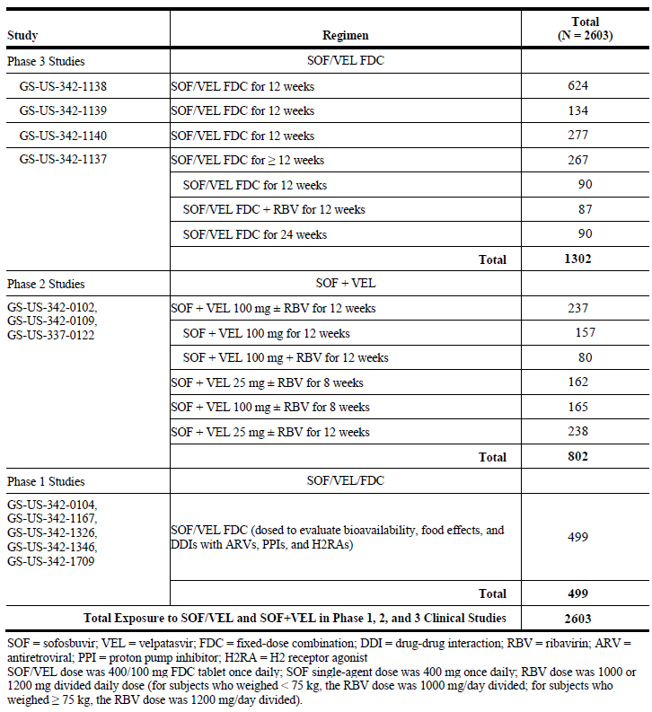

### Adverse events

#### All adverse events (irrespective of relationship to study treatment)

##### Pivotal studies

###### GS-US-342-1137

An overall summary of AEs is shown in Table 30. AEs were reported in 84.3% of the overall population with a higher incidence in the SOF/VEL + RBV group (SOF/VEL for 12 weeks 81.1%, SOF/VEL + RBV for 12 weeks 90.8%, and SOF/VEL for 24 weeks 81.1%). The most common AES reported in at least 10% of any treatment group by PT are shown in Table 31). In the SOF/VEL 12 week group, the most common AEs were fatigue (25.6%), headache (25.6%), and nausea (24.4%). In the SOF/VEL +RBV for 12 weeks group, the most common AEs were fatigue (39.1%), anaemia (31.0%) and nausea (25.3%). In the SOF/VEL for 24 week group, the most common AEs were fatigue (23.3%), nausea (20.0%), and headache (18.9%). In the SOF/VEL + RBV group, fatigue anaemia, diarrhoea, muscle spasms, dyspnoea, and cough were notably more common than in the SOF/VEL groups (consistent with the known toxicity profile of RBV). Most AEs were of mild to moderate severity. Grade 3 or 4 AEs were reported in 17.8%, 12.6%, and 18.9% of the respective groups. In keeping with a population of patients with decompensated cirrhosis, the most common severe AEs were hepatic encephalopathy, sepsis, GI haemorrhage, and HCC.

Table 30: Study GS-US-342-1137 Summary of AEs

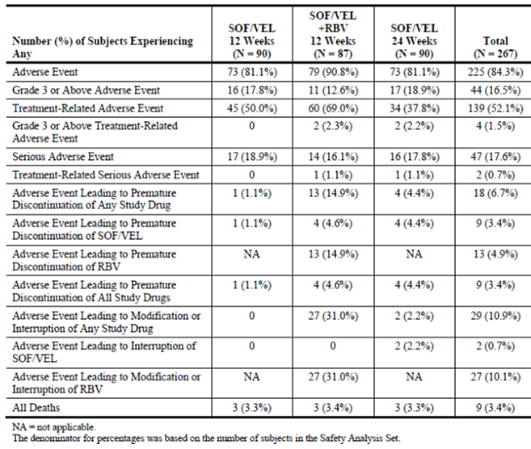

Table 31: GS-US-342-1137 AEs that occurred in at least 10% of subjects in any treatment group by preferred term

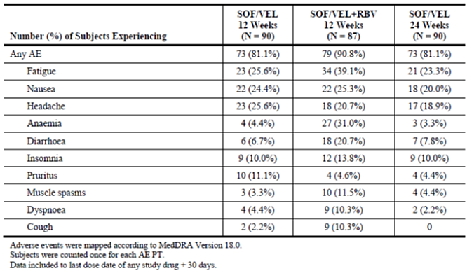

###### GS-US-342-1138

An overall summary of AEs were provided (Table 32). AEs were reported in 77.7% of the SOF/VEL group compared with 76.7% in the placebo group. The most common AEs reported in at least 5% of any treatment group by PT are shown in Table 33. In the SOF/VEL group, the most common AEs were headache (29.2%), fatigue (20.2%), nasopharyngitis (12.7%) and nausea (12.0%. In the placebo group, the most common AEs were headache (28.4%), fatigue (19.8%), nausea (11.2%), and nasopharyngitis (10.3%). Most AEs were of mild to moderate severity. Grade 3 or 4 AEs were reported in 2.3% and 0.3% of the SOF/VEL and placebo groups, respectively, most commonly headache.

Table 32: Study GS-US-342-1138 Summary of AEs

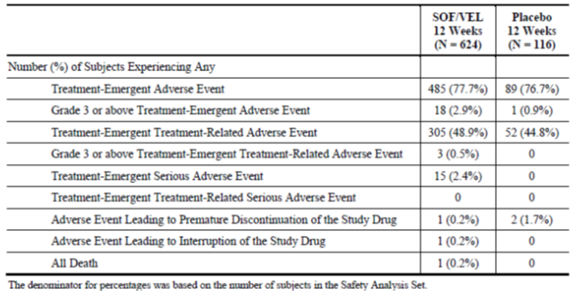

Table 33: Study GS-US-342-1138 AEs reported for at least 5% of subjects in any treatment group by PT

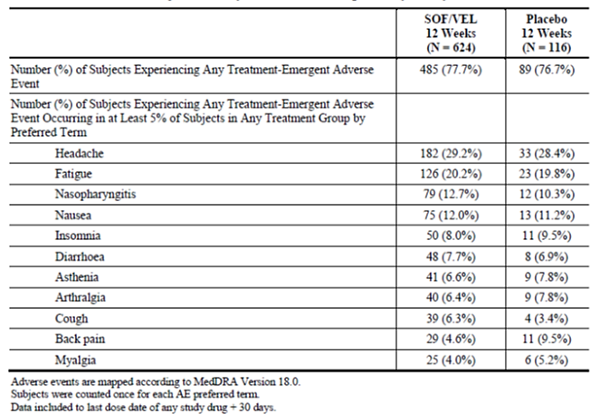

###### GS-US-342-1139

An overall summary of AEs was provided. AEs were reported in 68.7% of the SOF/VEL group compared with 76.5% in the SOF/VEL + RBV group. The most common AEs reported in at least 5% of any treatment group by PT were provided. In the SOF/VEL group, the most common AEs were headache (17.9%), fatigue (14.9%), and nausea (10.4%. In the SOF/VEL + RBV group, the most common AEs were fatigue (35.6%), headache (22.0%), nausea (14.4%), and insomnia (13.6%), each occurring more commonly than in the SOF/VEL group. Most AEs were of mild to moderate severity. Grade 3 or 4 AEs were reported in 2.2% and 2.3% of the SOF/VEL and SOF + RBV groups, respectively.

###### GS-US-342-1140

An overall summary of AEs was provided. AEs were reported in 88.4% of the SOF/VEL for 12 weeks group compared with 94.8% in the SOF/VEL + RBV for 24 weeks group. The most common AES reported in at least 5% of any treatment group by PT was provided. In the SOF/VEL group, the most common AEs were headache (32.5%), fatigue (25.6%), nausea (16.6%), and insomnia (11.2%). In the SOF/VEL + RBV group, the most common AEs were fatigue (38.2%), headache (32.4%), insomnia (26.9%), and nausea (21.1%), each occurring more commonly than in the SOF/VEL group with the exception of headache. Most AEs were of mild to moderate severity. Grade 3 or 4 AEs were reported in 4.3% and 8.4% of the SOF/VEL and SOF/VEL + RBV groups, respectively.

##### Other studies

**Comment:** The sponsor did not provide integrated safety data or tables in the GS-US-337-0122 CSR. The safety outcomes in each treatment cohort and group are summarised individually but tables have not been provided in the interests of brevity. However, summarised data and tables were provided in the GS-US-342-0102 and GS-US-342-0109 CSRs.

###### GS-US-337-0122

In treatment experienced patients with GT1 or GT3 infection (Cohort 1), AEs were reported in 89.5% to 100% of patients treated for 12 weeks. In Group 1 patients given LDV/SOF + RBV, the most common AEs were insomnia (36.8%), fatigue (31.6%) and headache (26.3%). Most AEs were mild in severity (68.4%). In Group 2 patients given SOF + PegIFN + RBV, the most common AEs were fatigue, nausea and arthralgia (each 30.3%). The majority of AEs were mild in severity (80%).

In treatment experienced patients with GT1 infection and advanced liver fibrosis or compensated cirrhosis treated for 12 weeks (Cohort 2, Groups 1 and 2), AEs were reported in 92.3% to 96.0% of patients. In Group 1 patients given LDV/SOF + RBV, the most common AEs were headache (40.0%), URTI (32%), nausea (28.0%), insomnia (28.0%) and fatigue (20.0%). Only one Grade 3 or 4 AE was reported. In Group 2 patients given LDV/SOF + GS-9669, the most common AEs were nausea (42.3%), headache (34.6%), fatigue (34.6%) and URTI (19.2%). No Grade 3 or 4 events were reported. In treatment naïve and treatment experienced patients with GT3 or GT6 infection (Cohort 2, Groups 3 to 6), AEs were reported in 84.0% to 100% of patients treated for 12 weeks. In Group 3 treatment naïve GT3 patients given LDV/SOF, the most common AEs were headache (40.0%), nausea (36.0%), URTI (36.0%) and fatigue (20.0%). Grade 3 or 4 AEs were reported in 12% of patients. In Group 4 treatment naïve GT3 patients given LDV/SOF + RBV, the most common AEs were URTI (34.6%), headache (30.8%) and nausea (15.4%). No Grade 3 or 4 AEs were reported. In Group 5 treatment naïve or treatment experienced GT6 patients given LDV/SOF, the most common AEs were fatigue (24.0%) and URTI (24.0%). Grade 3 or 4 AEs were reported in 4% of patients. In Group 6 treatment experienced GT3 patients given LDV/SOF + RBV, the most common AEs were headache (26.0%), fatigue (26.0%) and URTI (18.0%). Grade 3 or 4 AEs were reported in 2% of patients.

In treatment naïve or treatment experienced patients with GT1 infection and cirrhosis treated with LDV/SOF for 12 weeks (Cohort 3), 95% of patients reported at least one AE. The most common AEs in patients who all received LDV/SOF were URTI (40%), headache (20.0%), fatigue (20.0%), nausea (15.0%) and insomnia (15%). All AEs except one (renal colic) were mild or moderate in severity.

In treatment naïve patients with GT3 infection treated for 8 weeks (Cohort 4), 66.7% to 84.6% of patients reported at least one AE. Only two AEs were Grade 3 or 4, and the rest were mild or moderate in severity. In Group 1 patients given SOF + VEL 25 mg, the most common AEs were headache (22.2%), fatigue (18.5%) and nausea (14.8%). In Group 2 patients given SOF + VEL 25 mg + RBV, the most common AEs were headache (20.8%), fatigue (12.5%) and insomnia (12.5%). In Group 3 patients given SOF + VEL 100 mg, the most common AEs were insomnia (22.2%), fatigue (14.8%), and nausea (14.8%). In Group 4 patients given SOF + VEL 100 mg + RBV, the most common AEs were fatigue (26.9%), headache (15.4%) and nausea (11.5%).

In patients with GT1 or GT3 infection previously treated with a SOF-containing regimen (Cohort 5), 85% of patients reported at least one AE. Grade 3 or 4 AEs were reported in 15% of patients and the remainder were mild to moderate in severity. In patients given LDV/SOF + RBV for 24 weeks, the most common AEs were URTI and lower respiratory infections (each 30%), fatigue (20.0%), headache (15.0%) and rash (15.0%). In eight patients with HCV/HBV co-infection treated with LDV/SOF for 12 weeks (Cohort 6), 75% of patients reported at least one AE but no Grade 3 or 4 AEs were reported. The most common AEs were viral infection (62.5%), URTI (25.0%) and fatigue (25.0%).

###### GS-US-342-0102

An overall summary of AEs in all treatment groups was provided. Overall, AEs were reported in 69.5% of patients (range 60.0% to 81.8%), most commonly in the two groups given RBV (SOF + VEL 25 mg + RBV for 8 weeks 81.8%; SOF + VEL 100 mg + RBV for 8 weeks 73.7%). Overall, the most common AEs were fatigue (21.2%), headache (20.4%), nausea (11.7%), diarrhoea (7.4%), insomnia (6.4%), constipation (6.1%), nasopharyngitis (5.3%) and rash (5.0%). Fatigue and insomnia were generally more common in the RBV treatment groups. There were no meaningful differences between groups given VEL 25 mg or VEL 100 mg. Grade 3 or 4 AEs were reported in only 1.6% of patients.

###### GS-US-342-0109

An overall summary of AEs in all treatment groups was provided. Overall, AEs were reported in 81.9% of patients (range 78.8% to 86.3%); most commonly in the SOF + VEL 100 mg + RBV group (86.3%). Overall, the most common events were headache (29.0%), fatigue (27.7%), nausea (17.1%), insomnia (14.0%), irritability (8.4%), diarrhoea (8.1%), constipation (6.1%), pruritus (7.8%) and rash (6.2%). Fatigue, insomnia, and nausea were generally more common in the RBV treatment groups. Most AEs were mild to moderate, and Grade 3 or 4 AEs were reported in only 2.2% of patients.

#### Treatment-related adverse events (adverse drug reactions)

##### Pivotal studies

###### GS-US-342-1137

ADRs were reported in 50.0%, 69.0%, and 37.8% of the respective treatment groups), most commonly in the SOF/VEL +RBV group. In the overall population, severe and serious ADRS were reported infrequently (1.5% and 0.7% of patients, respectively).

###### GS-US-342-1138

ADRs were reported in 48.9% and 44.8% of the SOF/VEL and placebo groups, most commonly headache (21.8% versus 21.6%), fatigue (14.6% versus 15.5%), nausea (8.8% versus 8.6%), insomnia (5.0% versus 6.0%) and asthenia (5.3% versus 3.4%).

###### GS-US-342-1139

ADRs were reported in 33.6% and 56.8% of the SOF/VEL and SOF + RBV groups, most commonly fatigue (28.8% versus 10.4%), headache (19.7% versus 12.7%), nausea (10.6% versus 8.2%) and insomnia (11.4% versus 3.0%).

###### GS-US-342-1140

ADRs were reported in 61.4% and 78.2% of the SOF/VEL and SOF/VEL + RBV groups, most commonly fatigue (20.9% versus 32.4%), headache (23.5% versus 27.6%), insomnia (7.6% versus 22.2%) and nausea (11.6% versus 17.5%).

##### Other studies

###### GS-US-337-0122

In treatment experienced patients with GT1 or GT3 infection (Cohort 1), ADRs were reported in 78.9% to 100.0% of patients treated for 12 weeks. The most common ADRs in patients given LDV/SOF + RBV (Group 1) were insomnia (36.8%), fatigue (31.6%), headache (21.1%) and nausea (15.8%). In patients given SOF + PegIFN + RBV (Group 2), the most common ADRs were fatigue (30.0%), nausea (30.0%), insomnia (20.0%) and headache (20.0%).

In treatment experienced patients with GT1 infection and advanced liver fibrosis or compensated cirrhosis (Cohort 2, Groups 1 and 2), ADRs were reported in 69.2% to 92.0% of patients treated for 12 weeks. The most common ADRs in patients given LDV/SOF + RBV (Group 1) were headache (36.0%), nausea (28.0%), fatigue (20.0%) and insomnia (16.0%). In patients given LDV/SOF + GS-9669 (Group 2), the most common ADRs were nausea (38.5%), fatigue (34.6%) and headache (23.1%). In treatment naïve and treatment experienced patients with GT3 or GT6 infection (Cohort 2, Groups 3 to 6), ADRs were reported in 24.0% to 72.0% of patients treated for 12 weeks. In treatment naïve GT3 patients given LDV/SOF (Group 3) the most common ADRs were headache (36.0%), nausea (32.0%), and fatigue (20.0%). In treatment naïve GT3 patients given LDV/SOF + RBV (Group 4), the most common ADRs were headache (15.4%) and nausea (15.4%). In treatment naïve or experienced GT6 patients given LDV/SOF (Group 5), the most common ADRs were headache (8.0%) and fatigue (8.0%). In treatment experienced GT3 patients given LDV/SOF + RBV (Group 6), the most common ADRs were insomnia (20.0%), fatigue (18.0%) and headache (14.0%).

In treatment naïve or treatment experienced patients with GT1 infection and cirrhosis (Cohort 3), ADRs were reported in 60.0% of patients treated with LDV/SOF for 12 weeks (two cases each (10%) of balance disorder, fatigue, headache, insomnia, lethargy and nausea).

In treatment naïve patients with GT3 infection treated for 8 weeks (Cohort 4), ADRs were reported in 25.9% to 61.5% of patients. In patients given SOF + VEL 25 mg (Group 1) the most common ADRs were headache (11.1%) and fatigue (7.4%). In patients given SOF + VEL 25 mg + RBV (Group 2), the most common ADRs were headache (12.5%), fatigue (12.5%) and insomnia (12.5%). In patients given SOF + VEL 100 mg (Group 3), the most common ADRs were insomnia (22.2%) and nausea (11.1%). In patients given SOF + VEL 100 mg + RBV (Group 4), the most common ADRs were fatigue (19.2%), rash (15.4%) and nausea (11.5%).

In patients with GT1 or GT3 infection previously treated with a SOF-containing regimen (Cohort 5), 65.0% of patients reported at least one ADR. Grade 3 or 4 AEs were reported in 15% of patients and the remainder were mild to moderate in severity. In patients treated with LDV/SOF + RBV for 24 weeks, the most common ADRs were fatigue (15.0%), headache (15.0%) and rash (15.0%). In patients with HCV and HBV co-infection treated with LDV/SOF for 12 weeks (Cohort 6), only one ADR was reported (12.5%).

###### GS-US-342-0102

Overall, ADRs were reported in 43.2% of patients (range 32.5% to 65.5%) as shown in Table 34. ADRs occurred more frequently in the RBV groups, most notably fatigue, headache, insomnia, rash and anaemia. There was only one Grade 3 or 4 ADR in the SOF + VEL 25 mg 8 week group.

Table 34: GS-US-342-0102 Overall summary of common ADRs by PT

###### Table 34: GS-US-342-0102 Overall summary of common ADRs by PT

###### GS-US-342-0109

Overall, ADRs were reported in 59.5% of patients. ADRs occurred more frequently in the RBV groups, most notably fatigue, headache, nausea, insomnia, pruritus, and rash. There were only two Grade 3 or 4 ADRs (0.6%), both in the SOF + VEL 100 mg + RBV group.

#### Deaths and other serious adverse events

##### Pivotal studies

###### GS-US-342-1137

Death occurred in 9 patients (3.3%, 3.4%, and 3.3% of the respective treatment groups). Two deaths were treatment emergent; sepsis and myocardial infarction in the SOF/VEL + RBV and SOF/VEL 24 week groups, respectively. Overall, SAEs were reported in 17.6% of patients (18.9%, 16.1% and 17.8%, respectively) but only one event was considered related to SOF/VEL (hepatorenal syndrome with peritonitis and sepsis).

###### GS-US-342-1138

Only one death was reported in the SOF/VEL group. The patient died suddenly of unknown causes eight days after completing study treatment and the event was considered unrelated. SAEs were reported in 2.4% of the SOF/VEL group compared with none in the placebo group. None of the SAEs were considered drug related by the investigator.

###### GS-US-342-1139

There were two deaths, each in the SOF/VEL group. One patient died of metastatic lung cancer on post treatment Day 112, and the second died of cardiac arrest on her last day of study drug. Neither event was considered drug related by the investigator. SAEs were reported in 1.5% of both treatment groups but none were considered drug related.

###### GS-US-342-1140

Three deaths were reported, each in the SOF/VEL + RBV group. One patient died of natural causes (sic) on Day 141, one died of gunshot wounds on Day 74, and one died of unknown causes on Day 118. No events were considered drug related by the investigator. SAEs were reported in 2.2% of the SOF/VEL group and 5.5% of the SOF/VEL + RBV group. No trends in SAE type or time of onset were apparent.

##### Other studies

###### GS-US-337-0122

Only one death was reported, a case of HCC which occurred on post treatment Day 55 in Cohort 5. No SAEs were reported in treatment experienced patients with GT1 or GT3 infection treated with LDV/SOF + RBV, or SOF + PegIFN + RBV (Cohort 1). In treatment experienced patients with GT1 infection and advanced liver fibrosis or compensated cirrhosis, (Cohort 2, Groups 1 and 2), a single SAE was reported in one patient in the LDV/SOF + RBV group. In Cohort 2, Groups 3 to 6, SAEs were reported in 16.0%, 4.0%, and 2.0% of Groups 3, 5, and 6, respectively. No SAEs were reported in Group 4. In patients with GT1 infection and cirrhosis treated with LDV/SOF (Cohort 3), two SAEs (10%) were reported, both considered unrelated to study drug. In Cohort 4, Groups 1 to 4, one SAE was reported in Group1 in a patient treated with LDV/SOF + RBV. It was considered unrelated to study treatment. In patients with GT1 or GT3 infection previously treated with a SOF-containing regimen (Cohort 5), four SAEs were reported, one case each of encephalopathy, cirrhosis, HCC and lower respiratory tract infection. There were no SAEs in patients with HCV and HBV co-infection treated with LDV/SOF (Cohort 6).

###### GS-US-342-0102

One death was reported after completing 12 weeks of treatment in the SOF + LDV 25 mg 12 week group. The patient had underlying psychiatric disorders and committed suicide. Overall, SAEs were reported in 1.9% of patients, most commonly in the SOF + LDV 25 mg 8 week group. No trends in SAE type were observed, and all SAEs were considered unrelated to study drug by the investigator. No SAEs led to study drug discontinuation.

###### GS-US-342-0109

There was one death due to metastatic breast cancer in a patient who received SOF + GS-5816 100 mg. SAEs were reported in 2.5% of patients, most commonly in the SOF + VEL 100 mg group (5.0%), and the SOF + VEL 100 mg + RBV group (3.8%). No trends in SAE type were observed, and all SAEs were considered unrelated to study drug by the investigator. No SAEs led to study drug discontinuation.

**Comment:** Few deaths were reported in the Phase II and Phase III studies and only one was considered possibly related to SOF/VEL (a case of hepatorenal syndrome with peritonitis and sepsis).

#### Discontinuation due to adverse events

##### Pivotal studies

###### GS-US-342-1137

In the overall population, discontinuations due to AEs were reported in 3.4% of patients for SOF/VEL, compared with 14.9% of patients for RBV.

###### GS-US-342-1138

One patient (0.2%) in the SOF/VEL group discontinued due to Grade 3 anxiety. Two patients (1.7%) in the placebo group discontinued because of ALT/AST elevations which met protocol stopping rules.

###### GS-US-342-1139

No patients in the SOF/VEL group had AEs leading to dose interruption or modification, compared with 9.8% in the SOF + RBV group (most commonly due to anaemia and fatigue).

###### GS-US-342-1140

No patients in the SOF/VEL group had AEs leading to study drug discontinuation compared with 3.3% in the SOF/VEL + RBV group (most commonly due to insomnia).

**Comment:** In GS-US-342-1137, only 3.4% of patients with decompensated cirrhosis discontinued SOF/VEL due to AEs. SOF/VEL was well tolerated in the other Phase III studies and one patient discontinued due to an AE (anxiety).

##### Other studies

###### GS-US-337-0122

In Cohort 1, no AEs leading to treatment discontinuation were reported in treatment experienced patients with GT1 or GT3 infection treated with LDV/SOF + RBV or SOF + PegIFN + RBV. In Cohort 2 (Groups 1 and 2) no patients had an AE leading to discontinuation of LDV/SOF in treatment experienced patients with GT1 infection and advanced liver fibrosis or compensated cirrhosis. In Cohort 2 (Groups 3 to 6), only two patients given LDV/SOF had AEs leading to treatment discontinuation. In Cohort 3, no AEs leading to drug discontinuation were reported patients with GT1 infection and cirrhosis treated with LDV/SOF. In Cohort 4 (Groups 1 to 4), one patient in Group 1 discontinued SOF + VEL 25 mg + RBV due to eczema and eye inflammation. In Cohort 5, LDV/SOF + RBV for 24 weeks were discontinued in one patient who developed HCC. In Cohort 6, there were no study drug discontinuations due to AEs in patients with HCV and HBV co-infection treated with LDV/SOF for 12 weeks.

###### GS-US-342-0102

Only one patient discontinued study drug in the SOF + VEL 25 mg 8 week group due to abdominal pain, palpitations and dizziness.

###### GS-US-342-0109

Only one patient discontinued study drug in the SOF + VEL 25 mg + RBV group due to a Grade 3 ALT elevation and a Grade 2 AST elevation. The LFT abnormalities resolved post treatment and they were considered drug related by the investigator.

### Laboratory tests

#### Liver function

##### Pivotal studies

###### GS-US-342-1137

There were no Grade 3 or 4 increases in ALT. Decreases from baseline were observed in all SOF/VEL treatment groups. Median changes from baseline ranged from -38 to -32 U/L with no notable differences between the groups. Two patients had Grade 3 AST elevations. AST changes were comparable to ALT with median changes from baseline ranging from -48 to -46 U/L. No notable changes in total bilirubin were observed in the SOF/VEL 12 and 24 week groups. However, there was an increase in total bilirubin in the SOF/VEL +RBV group in keeping with the known haemolytic effect of RBV.

###### GS-US-342-1138

A median decrease from baseline of -45 U/L was observed in the SOF/VEL group but no meaningful changes were observed in the placebo group. AST changes were comparable to ALT. No notable changes in total bilirubin were observed in either treatment group although values were generally lower in the SOF/VEL group throughout the treatment period.

###### GS-US-342-1139

There were no Grade 3 or 4 increases in ALT. Decreases from baseline were observed with median changes from baseline of -29 to -21 U/L in both treatment groups with no notable differences between the groups. Two patients had Grade 3 AST elevations, one (0.8%) in each group. AST changes were comparable to ALT with median changes from baseline of -18 to ‑13 U/L. No notable changes in total bilirubin were observed in the SOF/VEL groups. However, there was an increase in total bilirubin in the SOF +RBV group in keeping with the known haemolytic effect of RBV.

###### GS-US-342-1140

There was one Grade 3 increase in ALT in the SOF/VEL 12 week group and in the SOF/VEL + RBV 24 week group (each 0.4%). Decreases from baseline were observed in both treatment groups. Median changes from baseline were -63 U/L in the SOF/VEL group and -38 U/L in the SOF/VEL + RBV group. One patient in the SOF/VEL group had a Grade 3 AST elevation, and one patient had a Grade 4 elevation in the SOF/VEL +RBV group. AST changes were comparable to ALT with median changes from baseline of -39 U/L and -29 U/L in the respective groups. No notable changes in total bilirubin were observed in the SOF/VEL groups. However, there was an increase in total bilirubin in the SOF/VEL +RBV group in keeping with the known haemolytic effect of RBV.

##### Other studies

###### GS-US-337-0122

In treatment experienced patients with GT1 or GT3 infection treated with LDV/SOF + RBV or SOF + PegIFN + RBV (Cohort 1, Groups 1 and 2), a single Grade 3 ALT elevation was observed in the SOF + PegIFN + RBV group. No Grade 3 elevations in AST or total bilirubin were reported. In treatment experienced patients with GT1 infection and advanced liver fibrosis or compensated cirrhosis (Cohort 2, Groups 1 and 2), no patients had Grade 3 or 4 abnormalities of ALT, AST or total bilirubin. In treatment naïve and treatment experienced patients with GT3 or GT6 infection (Cohort 2, Groups 3 to 6), only two patients had significant ALT abnormalities, one patient had an AST abnormality, and two patients had a raised total bilirubin (both in Group 4). No significant LFT abnormalities were reported in patients with GT1 infection and cirrhosis treated with LDV/SOF (Cohort 3). In patients with GT3 infection treated for 8 weeks (Cohort 4, Groups 1 to 4), there was only one LFT abnormality, a Grade 3 ALT elevation in Group 1. No patients had Grade 3 or 4 abnormalities of AST or total bilirubin. No significant ALT or AST abnormalities were reported in patients with GT1 or GT3 infection previously treated with a SOF-containing regimen (Cohort 5). Three patients (15.0%) had Grade 3 hyperbilirubinaemia. In patients with HCV and HBV co-infection treated with LDV/SOF (Cohort 6), there were no Grade 3 or 4 LFT abnormalities.

###### GS-US-342-0102

No Grade 3 or 4 increases in ALT or AST were reported in any treatment group. Two Grade 3 increases in total bilirubin were reported, one in each of the RBV groups.

###### GS-US-342-0109

There was one Grade 3 ALT elevation (1.3%) in the SOF + VEL 25 mg group. In the SOF + VEL 25 mg + RBV group, there a Grade 4 ALT elevation with a Grade 3 AST elevation. There were three Grade 3 or 4 elevations in total bilirubin, all considered related to haemolysis in patients receiving RBV.

**Comment:** Overall, liver function improved in all patient groups treated with SOF containing regimens, in keeping with viral clearance and reduced inflammation. As expected, there were increases in total bilirubin in patients treated with RBV. There was no evidence of drug induced liver toxicity.

#### Kidney function

##### Pivotal studies

###### GS-US-342-1137

A single transient Grade 3 elevation in serum creatinine was reported in the SOF/VEL 24 week group. This was attributed to NSAID use.

###### GS-US-342-1138

There were no clinically significant changes in serum creatinine in the SOF/VEL or placebo groups.

###### GS-US-342-1139

There were no clinically significant changes in serum creatinine in the SOF/VEL or SOF +RBV groups.

###### GS-US-342-1140

A single transient Grade 3 elevation in serum creatinine was reported in the SOF/VEL + RBV group. This was attributed to NSAID use.

##### Other studies

###### GS-US-337-0122

No Grade 3 or 4 elevations in serum creatinine were reported in any study cohort or treatment group.

###### GS-US-342-0102

One Grade 3 increase in serum creatinine was reported in the SOF + VEL 25 mg 12 week group.

###### GS-US-342-0109

No Grade 3 or 4 elevations in serum creatinine were reported in any study cohort or treatment group.

#### Other clinical chemistry

##### Pivotal studies

###### GS-US-342-1137

Grade 3 or 4 chemistry laboratory abnormalities are shown in Table 35. The most common abnormalities were elevated glucose and bilirubin. Elevated bilirubin was reported more commonly in the SOF/VEL + RBV group, but there were no notable differences in glucose abnormalities between the treatment groups.

Table 35: Study GS-US-342-1137 Severe chemistry laboratory abnormalities

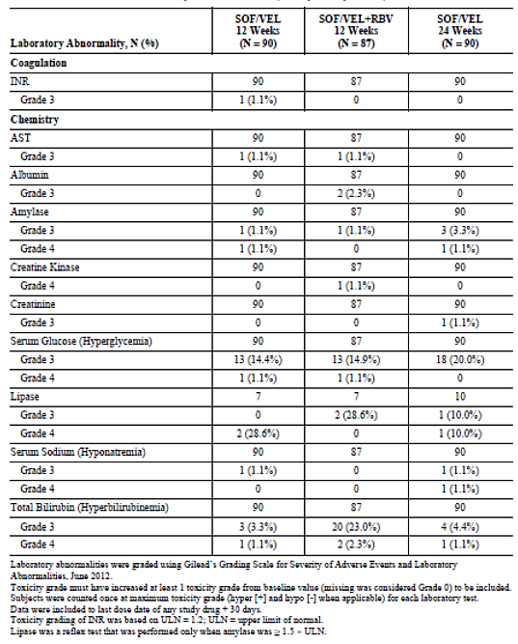

###### GS-US-342-1138

Grade 3 or 4 chemistry laboratory abnormalities were provided. Lipase elevations were more common in the SOF/VEL group compared with placebo but there were no other meaningful differences.

###### GS-US-342-1139

Grade 3 or 4 chemistry laboratory abnormalities are shown in Table 36. Elevated total bilirubin and hyperglycaemia occurred more commonly in in the SOF + RBV group.

Table 36: Study GS-US-342-1139 Grade 3 or 4 chemistry laboratory abnormalities

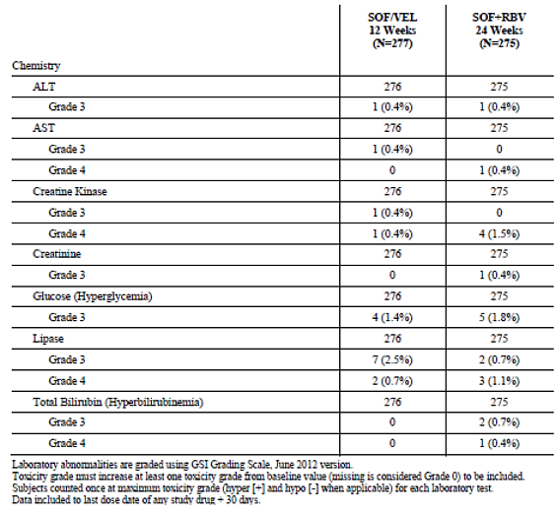

###### GS-US-342-1140

Grade 3 or 4 chemistry laboratory abnormalities were provided. Elevated total bilirubin occurred more commonly in in the SOF/VEL + RBV group.

##### Other studies

###### GS-US-337-0122

In Cohort 1 (Groups 1 and 2), the majority of laboratory abnormalities were mild to moderate in severity. Grade 3 abnormalities were reported in 10.5% and 10.0% of the LDV/SOF + RBV and SOF + PegIFN + RBV groups. No Grade 4 abnormalities were reported. In treatment experienced patients with GT1 infection and advanced liver fibrosis or compensated cirrhosis (Cohort 2, Groups 1 and 2), more patients in the LDV/SOF + RBV group had Grade 3 abnormalities than in the LDV/SOF + GS-9669 group (12.0% versus 3.8%). One subject had a Grade 4 abnormality of increased lipase. In Cohort 2, Groups 3 to 6, Grade 3 increases in lipase were reported in 4.0%, 3.8%, and 2.0% of Groups 3, 4, and 6, respectively. In Cohort 3, there was only one Grade 3 abnormality (hyperglycaemia) in patients with GT1 infection and cirrhosis treated with LDV/SOF. In Cohort 4, Groups 1 to 4, Grade 3 or 4 increases in lipase were reported in one patient in each of the treatment groups. There was one Grade 3 hyperglycaemia event in Group 4. In Cohort 5, a single patient had a Grade 3 increase in lipase. In patients with HCV and HBV co-infection treated with LDV/SOF (Cohort 6), there were no Grade 3 laboratory abnormalities.

###### GS-US-342-0102

Overall, four patients (1.1%) had Grade 3 or 4 increases in serum lipase. Three of the four patients were in the group given SOF + VEL 25 mg for 12 weeks. Two patients (0.5%) had Grade 3 hyperglycaemic events.

###### GS-US-342-0109

Overall, six patients (1.9%) had Grade 3 increases in serum lipase, and five patients (1.6%) had Grade 4 elevations. Three of the four patients were in the group given SOF + VEL 25 mg for 12 weeks. Four patients (1.2%) had Grade 3 hyperglycaemic events.

**Comment:** There were several reports of increased lipase but there were no cases of clinical pancreatitis.

#### Haematology

##### Pivotal studies

###### GS-US-342-1137

Grade 3 or 4 haematology abnormalities in the SOF/VEL 12 week, SOF/VEL + RBV 12 week, and SOF/VEL 24 week groups were provided. Grade 3 haemoglobin abnormalities were recorded in 4.4%, 11.5%, and 5.6% of the respective groups. In the SOF/VEL + RBV group, the median fall in haemoglobin was 1.4 g/dl (range -4.5 to 2.5). However, the median falls in haemoglobin returned towards baseline within four weeks of the last dose of study drug. Low lymphocyte counts are associated with decompensated cirrhosis and this was further exacerbated in the SOF/VEL + RBV group. There were no clinically meaningful changes from baseline in neutrophils or platelets in any treatment group.

###### GS-US-342-1138

Grade 3 or 4 haematology abnormalities in the SOF/VEL 12 week and placebo groups were provided. No Grade 3 haemoglobin abnormalities were recorded in either group. Grade 3 abnormalities relating to lymphocytes, neutrophils, and platelets were reported in < 1% of the SOF/VEL group compared with none in the placebo group.

###### GS-US-342-1139

Grade 3 or 4 haematology abnormalities in the SOF/VEL 12 week and SOF + RBV 12 week groups were provided. There were no Grade 4 AEs in either group, and no Grade 3 AEs in the SOF/VEL group. Grade 3 haemoglobin abnormalities were recorded in 5.3% of the SOF + RBV group.

###### GS-US-342-1140

Grade 3 or 4 haematology abnormalities in the SOF/VEL 12 week and SOF + RBV 24 weeks groups were provided. Grade 3 or 4 haematological AEs were reported in < 1% of patients in the SOF/VEL group. Haemoglobin abnormalities were reported in 9.1% of the SOF + RBV group. In the SOF + RBV group, Grade 3 or 4 lymphocyte abnormalities were reported in 1.5% of patients, and there was a single Grade 3 AE of low platelets.

##### Other studies

###### GS-US-337-0122

In Cohort 1, Grade 3 haemoglobin reductions were reported in 10.5% of LDV/SOF/ + RBV patients (Group 1) compared with none in SOF + PegIFN + RBV patients (Group 2). There were no Grade 4 reductions. In treatment experienced patients with GT1 infection and advanced liver fibrosis or compensated cirrhosis (Cohort 2, Groups 1 and 2), there were two haemoglobin abnormalities, both in LDV/SOF + RBV patients (Group 1). In Cohort 2 (Groups 3 to 6), Grade 3 haemoglobin abnormalities were reported in Groups 4 and 6 (both treated with LDV/SOF + RBV). No haemoglobin abnormalities were reported in patients with GT1 infection and cirrhosis treated with LDV/SOF (Cohort 3). Grade 3 or 4 abnormalities of low lymphocytes were reported in two patients (10%). In patients with GT3 infection treated for 8 weeks (Cohort 4, Groups 1 to 4), there were two Grade 3 abnormalities, one in each RBV group. There was one Grade 3 lymphocyte reduction in Group 1. In patients with GT1 or GT3 infection treated with LDV/SOF + RBV (Cohort 5), there was a single Grade 3 reduction in haemoglobin. In patients with HCV and HBV co-infection treated with LDV/SOF (Cohort 6), there were no Grade 3 or 4 haematology abnormalities.

###### GS-US-342-0102

Overall, Grade 3 or 4 haemoglobin abnormalities were reported in 3.4% of patients, all in the two RBV treatment groups. A single patient had a Grade 3 neutrophil reduction.

###### GS-US-342-0109

Overall, Grade 3 haemoglobin abnormalities were reported in 12 patients (3.7%), most commonly in the two RBV treatment groups. A single patient had a Grade 3 neutrophil reduction, and a single patient had a neutrophil reduction, both in the SOF + VEL 100 mg group.

**Comment:** With the exception of haemolytic anaemia in patients given RBV, no haematological safety signals were detected.

#### Electrocardiograph

##### Pivotal studies

###### GS-US-342-1137

No ECG changes suggestive of cardiac toxicity were observed.

###### GS-US-342-1138

One patient in the SOF/VEL group considered drug related by the investigator. At the Week 12 visit, QTc was 475 msec compared with 419 msec change at baseline. No medical intervention or investigations were conducted.

###### GS-US-342-1139

No patients had treatment emergent clinically significant abnormal ECGs.

###### GS-US-342-1140

One patient in the SOF/VEL group developed a clinically significant ECG abnormality, atrial fibrillation considered related to underlying cardiac disease.

##### Other studies

###### GS-US-337-0122

No clinically significant ECG changes were reported in any study cohort or treatment group.

###### GS-US-342-0102

No clinically significant ECG changes were reported in any study cohort or treatment group.

###### GS-US-342-0109

No clinically significant ECG changes were reported in any study cohort or treatment group.

#### Vital signs

##### Pivotal studies

###### GS-US-342-1137

There were no notable changes or trends from baseline in vital signs in any treatment group in any of the four pivotal studies.

##### Other studies

###### GS-US-337-0122

There were no notable changes or trends from baseline in vital signs in any study cohort or treatment group.

###### GS-US-342-0102

There were no notable changes or trends from baseline in vital signs in any study cohort or treatment group.

###### GS-US-342-0109

There were no notable changes or trends from baseline in vital signs in any study cohort or treatment group.

### Post-marketing experience

Not applicable.

### Safety issues with the potential for major regulatory

#### Liver toxicity

Grade 3 or 4 liver chemistry abnormalities were provided. No safety signals were detected. In the integrated Phase III study analysis, one patient (< 0.1%) in the SOF/VEL 12 week group had a Grade 3 or 4 ALT abnormality compared with eight (6.9%) in the placebo group. There were no Grade 3 or 4 total bilirubin elevations in the SOF/VEL or placebo groups. An independent adjudication committee assessed predefined criteria for DILI. A total of 56 cases were reviewed in the Phase II and Phase III safety populations but only one case of potential DILI was identified. This was a Phase II study, female patient who received SOF + VEL 25 mg + RBV who developed unexplained increases in ALT and AST. The LFT abnormalities were associated with starting anti-hypertensive therapy and they resolved when the antihypertensive therapy was stopped.

#### Haematological toxicity

With the exception of the well understood toxicity profile of RBV, no haematological safety signals were detected. There were no cases of pancytopenia. In the SOF/VEL group of integrated Phase III safety analysis, the only Grade 3 events were decreased lymphocytes (0.5%), neutrophils (0.4%), and platelets (0.2%). There were no Grade 3 or 4 events in the placebo group.

#### Serious skin reactions

No serious skin reactions were reported in the integrated Phase III study analysis. One patient in the SOF + RBV 24 week group was hospitalised due to a generalised eczematous reaction but study treatment was not interrupted.

#### Cardiovascular safety

No significant safety signals were detected in the Phase III program. In the integrated Phase III study analysis, one patient in the SOF/VEL 12 week group had a Grade 3 AE of ischaemic cardiomyopathy. The event resolved and it was considered unrelated to drug treatment. Bradycardia at the start of treatment has been observed in previous studies of sofosbuvir and other DAAs. In the integrated Phase III studies, 7.9% of patients had cardiac disease at baseline. However, similar percentages of patients using beta-blockers, calcium channel blockers, or neither treatment had cardiac AEs during treatment. Four treatment emergent ECG abnormalities events were noted, one case each of QTc prolongation, extra-systoles, atrial fibrillation, and supraventricular tachycardia. Three events were in the SOF/VEL 12 week group and one was in the SOF + RBV 12 week group.

#### Unwanted immunological events

Not applicable.

### Other safety issues

In the integrated Phase III study analysis, there was a single psychiatric event of depression. There were no cases of pancreatitis, rhabdomyolysis, myopathy, or renal failure.

**Comment:** The development and persistence of viral resistance is associated with all DAA treatments. However, treatment failures due to treatment emergent virologic resistance were very uncommon and unlikely to raise significant safety concerns.

#### Safety in special populations

The incidence of AEs and laboratory abnormalities was comparable in the overall population and in subgroups defined by gender, race, age, BMI, renal function, and hepatic function.

In the SOF/VEL 12 week group in the integrated Phase III safety population, AEs were reported more commonly in females than in males (82.7% versus 77.3%). However, they were also reported more commonly in females than males in the placebo group. Overall, laboratory abnormalities were reported equally commonly in male and female patients. The percentages of AEs reported in Whites, Blacks, and other races were 81.4%, 73.8%, and 65.7%, respectively. More AEs were reported in Whites but there were no racial differences for Grade 3 or 4 events, or for SAEs. Patients aged ≥ 65 years did not have a higher incidence of AEs, Grade 3 or 4 AEs, or SAEs compared with younger patients. BMI did not appear to influence the incidence of AEs. Patients with BMI < 30 kg/m2 had fewer AEs compared with their heavier counterparts (62.5% versus 73.3%). The incidence of AEs in patients with eGFR < 90 mL/min was comparable to that in patients with eGFR ≥ 90 mL/min (patients with impaired renal function were excluded from the Phase III studies). The incidence of AEs was similar in patients with or without compensated cirrhosis (80.5% versus 79.1%). Laboratory abnormalities were reported more commonly in patients with compensated cirrhosis (77.3% versus 61.4%) than in those without cirrhosis, most commonly due to increased glucose or lipase. AEs reported in patients with decompensated cirrhosis are summarised above.

#### Safety related to drug-drug interactions and other interactions

Drug-drug interaction studies in healthy subjects examined the interactions between the FDC and other antiretroviral drugs and between the FDC and PPIs/H2RA. Further studies, examined the interactions between VEL when administered in the absence of SOF and when it was co-administered with pravastatin, rosuvastatin, digoxin, rifampin, ketoconazole, cyclosporine or oral contraceptives. In addition, the interactions between SOF when administered alone and in combination with other retroviral drugs were also examined.

In the drug-drug interaction studies, there were no deaths, SAEs or grade 4 AEs reported, AEs were generally mild and there were no clinically significant trends in vital sign measurements or ECG findings. The most commonly reported AEs (that is in two or more studies) were headache, nausea, dizziness, vomiting, abdominal pain and constipation.

#### Pooled safety studies

A pooled analysis of safety data from the integrated Phase III safety population (excluding patients with decompensated cirrhosis) is summarised below in Table 37 below. An overview of the Phase II safety population was provided.

Table 37: Overview of the integrated Phase III studies

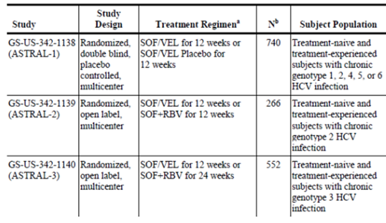

The Phase III safety data have been pooled by treatment regimen and presented as follows:

* SOF/VEL 12 week Group: patients who received SOF/VEL for 12 weeks in studies GS‑US‑342-1138, GS-US-342-1139, and GS-US-342-1140
* SOF/VEL Placebo Group: patients who received SOF/VEL placebo for 12 weeks in study GS‑US-342-1138
* SOF + RBV 12 week Group: patients who received SOF + RBV for 12 weeks in study GS‑US‑342-1139
* SOF + RBV 24 week Group: patients who received SOF + RBV for 24 weeks in study GS‑US‑342-1140.

An overall summary of AEs in the SOF/VEL integrated Phase III population is shown in Table 38. Overall, 81.6% of patients reported at least one AE, most commonly in the SOF + RBV 24 week group. Grade 3 or 4 AEs were reported in 3.2% of patients in the SOF/VEL group compared with 0.9% in the placebo group, 2.3% in the SOF + RBV group, and 8.4% in the SOF + RBV 24 week group. ADRs were reported in 50.2%, 44.8%, 56.8%, and 78.2% of the respective groups. SAEs were reported in 2.2%, 0%, 1.5%, and 5.5% of the respective groups but only one SAE was considered drug related (in the SOF + RBV for 24 weeks group). There were six deaths (0.4%), three in the SOF/VEL group, and three in the SOF + RBV for 24 weeks group. No deaths were considered drug related by the investigator. AEs leading to discontinuation of any study drug were reported in 13 (0.8%) patients, two of whom were in the placebo group.

Table 38: SOF/VEL Overall summary if adverse events in the SOF/VEL integrated Phase III safety population (Safety Analysis Set)

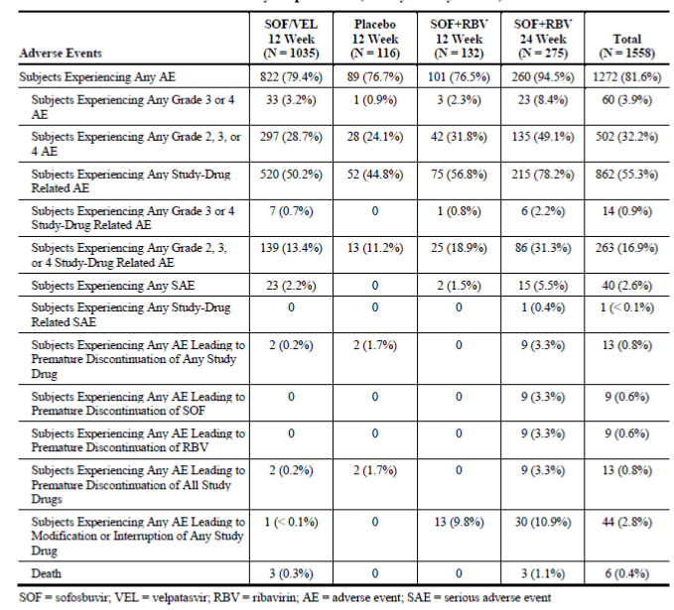

The most common AEs by PT are shown in Table 39. Overall, the most common AEs were headache (28.7%), fatigue (25.2%), nausea (14.4%), insomnia (12.2%), nasopharyngitis (10.8%), diarrhoea (6.9%), cough (6.5%), irritability (6.5%), arthralgia (6.1%), back pain (6.0%), asthenia (6.0%), pruritus (5.1%), and dizziness (5.0%). The AE profiles were comparable in the SOF/VEL and placebo groups. AEs were reported more commonly in the SOF + RBV 12 week group, notably fatigue, insomnia, and rash (AE rates are not comparable in the SOF + RBV 24 week group as the treatment period was longer). Laboratory abnormalities in the integrated Phase III study analysis are summarised above.

Table 39: Adverse events reported for at least 5% of subjects for any treatment regimen by preferred term in the SOF/VEL Phase III safety population (safety analysis set)

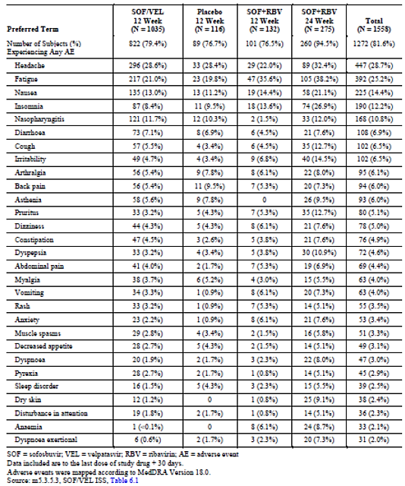

### Evaluator’s overall conclusions on clinical safety

No specific safety concerns have been identified in the SOF/VEL development program. In the integrated safety analysis, the overall rates of AEs were comparable in patients given SOF/VEL for 12 weeks and in patients given placebo. The most commonly reported AEs in the SOF/VEL and placebo groups were headache (28.6% versus 28.4%), fatigue (21.0% versus 19.8%), nausea (13.0% versus 11.2%) and nasopharyngitis (11.7% versus 10.3%). Most AEs were mild to moderate in severity and the pattern of AEs was similar in all subgroups, irrespective of gender, race, age, and other factors. In the SOF/VEL group, Grade 3 AEs were reported in 3% of patients, most commonly headache and anxiety, with only 0.7% considered drug related. Only two Grade 4 AEs were reported in the SOF/VEL group and neither was considered drug related. In patients treated with SOF/VEL, SAEs were reported in 2.2% of patients. Only three deaths were reported, each occurring post treatment and were considered unrelated to drug treatment. Laboratory abnormalities were reported less frequently in the SOF/VEL group compared with placebo. Grade 3 AEs were reported in 6.5% and 10.3% of the respective groups, and Grade 4 AEs were reported in 1.0% and 1.7% of the respective groups. Five patients had Grade 4 lipase elevations in the SOF/VEL group but all were asymptomatic and transient.

AEs of special interest were identified based on historical treatment regimens including regimens containing RBV, PegIFN, and other DAAs. These included serious skin rash, pancytopaenia, depression and other psychiatric events, pancreatitis, rhabdomyolysis and renal failure. In addition, bradycardia has been observed with DAAs following initiation of treatment. However, with the exception of a single AE of depression, no events of special interest were observed. As would be expected, AEs occurred more commonly in the SOF + RBV compared with the SOF/VEL and placebo groups.

## First round benefit-risk assessment

### First round assessment of benefits

The benefits of SOF/VEL in the proposed usage are:

* Very high efficacy rates in non-cirrhotic patients of all HCV genotypes
* Effective in patients with compensated or decompensated cirrhosis
* Effective in all patients, irrespective of age, gender, race, BMI, and hepatic function
* Improves underlying hepatic dysfunction
* Simple, once daily treatment regimen
* Well tolerated with an adverse event profile comparable to placebo
* The safety profile of sofosbuvir is well established
* Potential use in patients before or after liver transplantation
* While a controlled clinical trial cannot be conducted, SOF/VEL will inevitably reduce the incidence of cirrhosis, HCC and liver-related deaths in patients with chronic HCV who achieve SVR12.

### First round assessment of risks

The risks of SOF/VEL in the proposed usage are:

* No specific safety signals have been identified but uncommon ADRs relating to velpatasvir may emerge
* SOF/VEL has not been studied in patients with severe renal impairment or in patients with HCV/HIV co-infection
* Unidentified drug-drug interactions may emerge
* Treatment emergent viral resistance in a very small percentage of patients.

### First round assessment of benefit-risk balance

The benefit-risk balance of SOF/VEL, given the proposed usage, is favourable.

SOF/VEL given for 12 weeks provides outstanding SVR12 rates of 90 to 100% in HCV patients with or without cirrhosis, irrespective of genotype and prior treatment experience. Virologic failure (mainly relapse) is uncommon and reported mostly in patients with GT3 infection. SOF/VEL is given as a simple once daily dose and it obviates the need for potentially toxic RBV, PegIFN, or other DAA therapies. SOF/VEL with RBV is also extremely effective in patients with decompensated cirrhosis. In this vulnerable population, high SVR12 rates are associated with improved liver function in a significant proportion of patients. It is effective in all subgroups irrespective of age, gender, and race, including those with impaired hepatic function. SOF/VEL is well tolerated and no specific ADRs have been identified. The safety profile of sofosbuvir is well established but uncommon ADRs to velpatasvir may emerge.

## First round recommendation regarding authorisation

Authorisation is recommended for the proposed indication:

*“Epclusa (sofosbuvir/velpatasvir fixed dose combination) is indicated for the treatment of chronic hepatitis C virus (HCV) infection in adults”.*

## Clinical questions

### Pharmacokinetics

#### Question 1

Can the sponsor please comment on the likely changes to VEL exposure and safety following co-administration with combinations of drugs that have been shown to increase VEL exposure, for instance cyclosporine combined with ketoconazole?

#### Question 2

Can the sponsor please comment on the likely changes to VEL exposure and safety following co-administration with drugs that increase VEL exposure, for example ketoconazole or cyclosporine, in patients with renal impairment?

### Pharmacodynamics

No questions.

### Efficacy

#### Question 1

Please provide the final CSRs including SVR24 rates for the pivotal studies if they are available.

### Safety

No questions.

## Second round evaluation of clinical data submitted in response to questions

### Pharmacokinetics

#### Question 1

*Can the sponsor please comment on the likely changes to VEL exposure and safety following co‐administration with combinations of drugs that have been shown to increase VEL exposure, for instance cyclosporine combined with ketoconazole?*

##### Sponsor’s response

Cyclosporine potently inhibits multiple drug transporters, such as P-gp, BCRP, and OATP, and leads to approximately 100% higher VEL AUC upon co-administration. Ketoconazole potently inhibits P-gp and CYP3A4, as well as CYP2B6 and CYP2C8, and leads to approximately 70% higher VEL AUC upon co-administration. The impact of inhibiting both drug transport and metabolising enzymes is established in Study GS-US-342-1326, where SOF/VEL was administered with a regimen containing ritonavir-boosted atazanavir (ATV/r), a combination which potently inhibits drug transporters (for example, P-gp, OATP) and CYP enzymes and thus approximates the impact of co-administration of SOF/VEL with both cyclosporine and ketoconazole. A 142% increase in VEL exposure was observed following multiple dose administration with ATV/r. The increase in VEL exposure in the context of ATV/r is modestly higher than VEL with cyclosporine, and is consistent with the minor role of metabolism in VEL disposition.

The safety and efficacy of SOF/VEL in the presence of ATV/r is supported by an ongoing Phase III study GS-US-342-1202 (ASTRAL-5). In this study, 20 of the 106 subjects treated with SOF/VEL were on an ATV/r-containing regimen. The safety profile of SOF/VEL was similar among subjects receiving ATV/r and subjects not on ATV/r.

Following single and multiple doses up to VEL 450 mg in first in man study GS-US-281-0101, no clinically significant adverse events (AEs) or laboratory abnormalities were observed. In the thorough QT study GS-US-281-1054, a supratherapeutic dose (500 mg) of VEL resulted in no change to QTc interval, nor were any significant AEs, ECG abnormalities, or changes in vital signs observed. Of note, exposure of VEL in Study GS-US-281-1054 was approximately 5 fold greater than mean VEL exposure observed in Phase III studies. Evaluating exposure safety relationships in the Phase III population revealed no correlation between commonly occurring AEs or laboratory abnormalities and VEL exposure.

In addition, Gilead performed an analysis of the safety of SOF/VEL when administered with strong P-gp inhibitors, some of which also inhibit CYP enzymes, in subjects receiving the following drugs: azithromycin, carvedilol, clarithromycin, erythromycin, felodipine, fluvoxamine, ketoconazole, quercetin, and verapamil. For this analysis, the use of strong P-gp inhibitor was defined as either chronic use (> 14 days) or short-term (≤ 14 days) use.

In the integrated safety population (ASTRAL -1, -2 and -3), 40 (3.9%) of 1035 subjects treated with SOF/VEL for 12 weeks reported concomitant use of a strong P-gp inhibitor; 19 subjects used a strong P-gp inhibitor chronically (> 14 days) and 21 subjects reported short-term (≤ 14 days) use. In general, SOF/VEL was safe and well tolerated. A similar safety profile was observed in subjects co-administered strong P-gp inhibitors (chronic or short-term) compared to subjects that were not taking strong P-gp inhibitors.

Among subjects co-administered chronic, strong P-gp inhibitors, no serious AEs (SAEs) were reported. One subject taking chronic verapamil with a history of cluster headaches had a grade 3 AE of cluster headache during therapy. Among subjects taking short term P-gp inhibitors, 3 experienced SAEs (COPD exacerbation/influenza in a subject with underlying COPD, viral gastroenteritis, and pneumonia). There were 2 subjects with grade 3 AEs (gastroenteritis and intervertebral disc degeneration). All SAEs and grade 3 AEs were assessed as unrelated to SOF/VEL by the investigator. There were no grade 4 AEs (life threatening events), deaths, study drug discontinuations or interruptions/modifications observed in subjects on strong P-gp inhibitors (chronic or short-term).

Collectively these data demonstrate that inhibition of one or many drug transporters or metabolising enzymes for which VEL is a substrate is not expected to cause interactions of clinical relevance.

In summary, the totality of data supports the use of SOF/VEL with potent inhibitors of drug transport and metabolising enzymes.

##### Evaluator’s response

The evaluator is satisfied with the sponsor’s response.

#### Question 2

*Can the sponsor please comment on the likely changes to VEL exposure and safety following co‐administration with drugs that increase VEL exposure, for example ketoconazole or cyclosporine, in patients with renal impairment?*

##### Sponsor’s response

As the human mass balance study (GS-US-281-0115) determined that renal elimination of VEL is not a significant contributor to VEL systemic clearance (0.4% of the radioactive dose excreted in the urine), increases in VEL exposure in the context of renal impairment are due to extrarenal mechanisms. Increased bioavailability and/or decreased hepatic clearance of various drugs have been observed in the renally impaired population; these effects are secondary to reduced expression or inhibition of intestinal or hepatic drug transporters/metabolising enzymes. As overlapping mechanisms are responsible for changes in PK in the context of renal impairment and drug-drug interactions (for example, inhibition of CYPs/drug transporters), it is anticipated that co-administration of VEL with drug transport/metabolising enzyme inhibitors in subjects with renal impairment will result in less than additive increases in VEL exposure, and are not expected to be of clinical relevance.

##### Evaluator’s response

The evaluator is satisfied with the sponsor’s response.

### Efficacy

#### Question 1

*Please provide the final CSRs including SVR24 rates for the pivotal studies if they are available.*

##### Sponsor’s response

Study synopses have been provided detailing SVR24 rates for the four pivotal studies. There was complete concordance between SVR12 and SVR24 rates, SVR12 had a positive predictive value of 100% in all treatment groups and HCV genotypes.

##### Evaluators’ response

The sponsor’s response is satisfactory.

## Second round benefit-risk assessment

No change to the first round assessment.

## Second round recommendation regarding authorisation

The sponsor advises that Epclusa has now been approved in the US on 28 June 2016, in Europe on 6 July 2016, and in Canada on 11 July 2016.

Authorisation is recommended for the proposed indication:

“*Epclusa (sofosbuvir/velpatasvir fixed dose combination) is indicated for the treatment of chronic hepatitis C virus (HCV) infection in adults”.*

|  |
| --- |
| Therapeutic Goods Administration |
| PO Box 100 Woden ACT 2606 Australia  Email: [info@tga.gov.au](mailto:info@tga.gov.au) Phone: 1800 020 653 Fax: 02 6232 8605  [**https://www.tga.gov.au**](https://www.tga.gov.au) |

1. *On-treatment quantifiable HCV RNA*: Any two consecutive HCV RNA values ≥LLOQ during treatment, or at the final treatment measurement and the next consecutive post-treatment measurement.
2. SVR12: HCV RNA <LLOQ measured 12 weeks after the last actual dose of study drug without any confirmed quantifiable (≥LLOQ) post-treatment value before or during that SVR window.
3. SVR4: HCV RNA <LLOQ measured 4 weeks after the last actual dose of study drug without any confirmed quantifiable (≥LLOQ) post-treatment value before or during that SVR window.
4. SVR24: HCV RNA <LLOQ measured 24 weeks after the last actual dose of study drug without any confirmed quantifiable (≥LLOQ) post-treatment value before or during that SVR window.
5. In all studies, plasma HCV RNA levels were measured by a central laboratory using PCR (COBAS AmpliPrep/COBAS Taqman Quantitative Test v2.0). The LLOQ was 15 IU/mL.
6. CPT (Child-Pugh-Turcotte) is a clinical scoring system used to assess cirrhosis severity. Encephalopathy, ascites, bilirubin, albumin, and INR are each scored +1, +2 or +3 and the sum equals the CPT score.
7. MELD is a scoring system to assess the severity of chronic liver disease. It is calculated using the formula: MELD = 3.78 x In[serum bilirubin (mg/dL)] + 11.2 x In[INR] + 9.57 x In[serum creatinine (mg/dL)] + 6.43. In hospitalised patients, the 3 month mortality ranges from 71.3% for scores ≥40 to 1.9% for scores <10.
8. On-treatment virologic failure: Confirmed HCV RNA ≥LLOQ after HCV RNA <LLOQ during treatment, or confirmed increase from nadir in HCV RNA (two consecutive HCV RNA values > 1 log10 IU/mL above nadir) at any time point during treatment or HCV RNA ≥LLOQ persistently during treatment with at least 6 weeks treatment.
9. Post-treatment quantifiable HCV RNA: Any two consecutive post-treatment HCV RNA measurements ≥LLOQ
10. GS-9669 is a novel HCV NS5B inhibitor with potent antiviral activity in vitro against GT1 replicons but not against GT2, GT3, or GT4 replicons.