|  |
| --- |
| **30 November 2014** |

|  |
| --- |
| AusPAR Attachment 2 |
| Extract from the Clinical Evaluation Report for Sorafenib |
| Proprietary Product Name: Nexavar |
| Sponsor: Bayer Australia Ltd |

About the Therapeutic Goods Administration (TGA)

* The Therapeutic Goods Administration (TGA) is part of the Australian Government Department of Health, and is responsible for regulating medicines and medical devices.
* The TGA administers the *Therapeutic Goods Act 1989* (the Act), applying a risk management approach designed to ensure therapeutic goods supplied in Australia meet acceptable standards of quality, safety and efficacy (performance), when necessary.
* The work of the TGA is based on applying scientific and clinical expertise to decision-making, to ensure that the benefits to consumers ouweigh any risks associated with the use of medicines and medical devices.
* The TGA relies on the public, healthcare professionals and industry to report problems with medicines or medical devices. TGA investigates reports received by it to determine any necessary regulatory action.
* To report a problem with a medicine or medical device, please see the information on the TGA website <<http://www.tga.gov.au>>.

About the Extract from the Clinical Evaluation Report

* This document provides a more detailed evaluation of the clinical findings, extracted from the Clinical Evaluation Report (CER) prepared by the TGA. This extract does not include sections from the CER regarding product documentation or post market activities.
* The words [Information redacted], where they appear in this document, indicate that confidential information has been deleted.
* For the most recent Product Information (PI), please refer to the TGA website <<http://www.tga.gov.au/hp/information-medicines-pi.htm>>.

Copyright

© Commonwealth of Australia 2014  
This work is copyright. You may reproduce the whole or part of this work in unaltered form for your own personal use or, if you are part of an organisation, for internal use within your organisation, but only if you or your organisation do not use the reproduction for any commercial purpose and retain this copyright notice and all disclaimer notices as part of that reproduction. Apart from rights to use as permitted by the *Copyright Act 1968* or allowed by this copyright notice, all other rights are reserved and you are not allowed to reproduce the whole or any part of this work in any way (electronic or otherwise) without first being given specific written permission from the Commonwealth to do so. Requests and inquiries concerning reproduction and rights are to be sent to the TGA Copyright Officer, Therapeutic Goods Administration, PO Box 100, Woden ACT 2606 or emailed to <[tga.copyright@tga.gov.au](mailto:tga.copyright@tga.gov.au)>.

Contents

List of commonly used abbreviations 5

1. Clinical rationale 7

1.1. Guidance 7

2. Contents of the clinical dossier 8

2.1. Scope of the clinical dossier 8

2.2. Paediatric data 8

2.3. Good clinical practice 8

3. Pharmacokinetics 8

3.1. Studies providing pharmacokinetic data 8

3.2. Summary of pharmacokinetics 9

4. Pharmacodynamics 10

5. Dosage selection for the pivotal studies 10

5.1. Studies providing pharmacodynamic data 10

6. Clinical efficacy 10

6.1. Pivotal efficacy study 10

6.2. Other efficacy studies 24

6.3. Analyses performed across trials (pooled analyses and meta-analyses) 25

6.4. Evaluator’s conclusions on clinical efficacy 25

7. Clinical safety 26

7.1. Studies providing evaluable safety data 26

7.2. Overall patient exposure 26

7.3. Pivotal study 14295 27

7.4. Supportive phase II studies 39

7.5. Postmarketing experience 44

7.6. Safety issues with the potential for major regulatory impact 45

7.7. Other safety issues 45

7.8. Evaluator’s overall conclusions on clinical safety 46

8. First round benefit-risk assessment 46

8.1. First round assessment of benefits 46

8.2. First round assessment of risks 46

8.3. First round assessment of benefit-risk balance 47

9. First round recommendation regarding authorisation 47

10. Clinical questions 47

10.1. General 47

10.2. Pharmacokinetics 47

10.3. Efficacy 47

11. Second round evaluation of clinical data submitted in response to questions 47

12. References 47

## List of commonly used abbreviations

| Abbreviation | Meaning |
| --- | --- |
| AE | Adverse Event |
| ALT | Alanine Transaminase |
| AST | Aspartate Transaminase |
| ARTG | Australian Register of Therapeutic Goods |
| AUC | Area under the curve |
| Cmax | Maximum concentration |
| CR | Complete Response |
| CT | X-Ray Computed Tomography |
| CV | Coefficient of Variation |
| DCR | Disease Control Rate |
| DoR | Duration of Response |
| DTC | Differentiated Thyroid Cancer |
| EMA | European Medicines Agency |
| EORTC | European Organisation for Research and Treatment of Cancer |
| FACT-G | Functional Assessment of Cancer Therapy: General |
| FAS | Full Analysis Set |
| FDA | Food and Drug Administration |
| GCP | Good Clinical Practice |
| HRQoL | Health Related Quality of Life |
| ICH | International Conference on Harmonisation |
| INR | International Normalised Ratio |
| LDH | Lactate Dehydrogenase |
| MRI | Magnetic Resonance Imaging |
| MTD | Maximum Tolerated Dose |
| OS | Overall Survival |
| PD | Pharmacodynamics |
| PET | Positron Emission Tomography |
| PFS | Progression free survival |
| PI | Product Information |
| PK | Pharmacokinetics |
| PPS | Per Protocol Set |
| PR | Partial Response |
| PRO | Patient Reported Outcome |
| PT | Prothrombin Time |
| PTT | Partial Thromboplastin Time |
| RAI | Radioactive Iodine |
| RECIST | Response evaluation criteria in solid tumours |
| RR | Response Rate |
| SAE | Serious Adverse Event |
| SAF | Safety Analysis Set |
| SD | Stable Disease |
| T3 | Tri-iodothyronine |
| T4 | Thyroxine |
| TGA | Therapeutic Goods Administration |
| Tmax | Time of maximum concentration |
| TSH | Thyroid Stimulating Hormone |
| TTP | Time to Progression |

## Clinical rationale

Cancer of the thyroid is an uncommon malignancy. The Australian Institute of Health and Welfare estimated that in 2012 the incidence of thyroid cancer in Australia would be 2,420 persons and that it would cause 130 deaths (1). The major types of thyroid carcinoma and their relative incidences are as follows (2):

* Papillary carcinoma 80%;
* Follicular carcinoma 11%;
* Hürthle cell carcinoma 3%;
* Medullary carcinoma 4%;
* Undifferentiated/anaplastic carcinoma 2%.

Papillary, follicular and Hürthle cell tumours arise from the follicular epithelium of the thyroid, which is responsible for the production of the thyroid hormones thyroxine (T4) and triiodothyronine (T3). Medullary carcinoma arises from the C cells of the thyroid that are responsible for the production of calcitonin. The term ‘differentiated thyroid carcinoma’ encompasses papillary, follicular and Hürthle cell carcinomas.

Current clinical practice guidelines for differentiated thyroid cancer (3, 4) recommend the use of surgery (thyroidectomy), followed remnant ablation by radioactive iodine (RAI) therapy in selected patients. Patients are also treated with thyroxine to suppress TSH levels, as TSH can stimulate growth of thyroid cancer cells. Disease recurrence is common and is treated with repeated surgery and/or RAI. In patients with unresectable disease that is refractory to RAI, there are limited treatment options. Cytotoxic chemotherapy (such as doxorubicin) is considered to have poor efficacy. RAI-refractory disease which is the indication proposed by the sponsor, is rare with an estimated incidence of 4 cases per million of population (5).

The rationale for examining the efficacy and safety of sorafenib in differentiated thyroid cancer, as explained by the sponsor is as follows.

In thyroid carcinoma tissues, vascular endothelial growth factors (VEGFs) and VEGF receptors are often overexpressed both in tumour cells and supporting vascular endothelium. Also in these tumours, activating mutations are often found in genes encoding signalling molecules of the MAP kinase pathway (RAS, Raf, MEK, ERK). Sorafenib has been shown to inhibit multiple kinases involved in cell proliferation and angiogenesis, for example Raf kinase and VEGF receptors.

### Guidance

The following EMA guidelines, which have been adopted by the TGA are considered relevant to the current submission:

* Guideline on the evaluation of anticancer medicinal products (6);
* Appendix 1 to the guideline on the evaluation of anticancer medicinal products relating to the use of progression-free survival as a primary endpoint (7);
* Points to consider document on applications based on one pivotal study (8).

Compliance with these guidelines is considered in the relevant sections of this report.

## Contents of the clinical dossier

### Scope of the clinical dossier

The submission contained the following clinical information:

* A full study report for one pivotal Phase III, randomised, double blind, placebo controlled trial (Study 14295);
* 2 pharmacokinetic reports based on sparse PK sampling performed in Study 14295;
* Some limited post-marketing data based on adverse event reports received by the sponsor regarding patients who had received ‘off-label’ sorafenib for the treatment of thyroid cancer.
* Literature references. These included publications relating to five investigator initiated Phase II studies, which the sponsor cited as supportive evidence for the application.

### Paediatric data

The submission did not include paediatric data. According to Module 1 of the submission, both the EMA and the FDA have waived any requirement for paediatric data. The EMA granted a waiver on the grounds that the drug does not represent a significant therapeutic benefit over existing treatments. The FDA granted a waiver on the grounds that the drug had received an orphan designation for thyroid cancer.

Comment: Thyroid cancer is rare in children. The sponsor’s arguments that led to the EMA waiver were not presented in Module 1 of the current submission. For completeness, the sponsor should provide these.

### Good clinical practice

The study report for the pivotal clinical trial in this submission included an assurance that the study was conducted in accordance with the ethical principles that have their origin in the Declaration of Helsinki and the International Conference on Harmonization (ICH) guideline E6: Good Clinical Practice (GCP).

The protocol and all protocol amendments were reviewed and approved by each study site’s institutional ethics committee before the start of the study and before implementation of any amendments.

## Pharmacokinetics

### Studies providing pharmacokinetic data

There were no new pharmacokinetic (PK) studies in the submission. Some sparse PK sampling was included in the pivotal efficacy study and the resulting PK data are summarised in Table 1 below.

Table 1. Pharmacokinetic results

Results for AUC(0-12).ss were as follows:

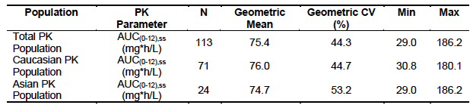

An exposure-efficacy analysis was undertaken. Median PFS was longer in the quartile of subjects with the highest AUC compared to subjects with lower AUCs. However, the analysis was based on small numbers of subjects in the quartiles, and the 95% CIs were largely overlapping.

An exposure-safety analysis was also undertaken. No obvious clinically relevant relationship was observed between sorafenib AUC and incidence or severity of treatment-emergent AEs in the PK population.

Steady state plasma sorafenib AUC (0-12) was compared between thyroid cancer subjects and subjects with other tumour types from 25 other sorafenib studies. Subjects within the non-thyroid cancer pool were administered 400 mg bid sorafenib, with samples collected at steady state following at least 7 days of uninterrupted dosing. Results were summarised in the following table:

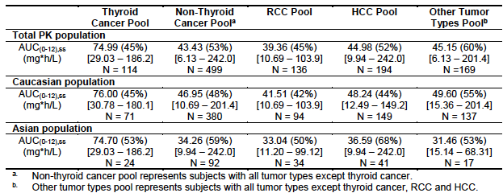

These data suggest that systemic exposure to sorafenib in patients with thyroid cancer is higher (by approximately 70%) than in patients with other tumour types.The sponsor proposed the hypothesisthat thyroxine treatment in subjects with thyroid cancer may inhibit glucuronidation by UGT1A9, and its metabolite T3 may inhibit CYP3A4. Both UGT1A9 and CYP3A4 are involved in the metabolism of sorafenib. However, the sponsor also notes that a previously evaluated study demonstrated that the potent CYP3A4 inhibitor ketoconazole had no effect on sorafenib exposure.

### Summary of pharmacokinetics

The limited PK sampling data suggest that systemic exposure to sorafenib will be higher (by approximately 70%) in subjects with thyroid cancer than in subjects with other tumour types. The reason(s) for this observation have not been determined.

Comment: The concern raised by this finding is that toxicity of sorafenib may be greater in thyroid cancer subjects than in patients with other tumour types. The study report stated that investigations were ongoing within the sponsor to determine the mechanism responsible for the increase in sorafenib exposure. The sponsor should be asked for an update on the progress of these investigations.

## Pharmacodynamics

The starting dose chosen for the pivotal study was 400 mg BD, which is the same starting dose approved for current indications of hepatocellular carcinoma and renal cell carcinoma. The rationale for the 400 mg BD dose was not discussed in the current submission, but it appears to have been the maximum tolerated dose (MTD) in early phase 1 studies (10).

## Dosage selection for the pivotal studies

### Studies providing pharmacodynamic data

No new pharmacodynamic studies were included in the submission. The pivotal study (14295) included exploratory analyses of the relationship between tumour mutations and sorafenib efficacy. These data are reviewed in *Results for other efficacy outcomes*.

## Clinical efficacy

### Pivotal efficacy study

The pivotal efficacy study was Study 14295, also known as the DECISION study (stu**D**y of soraf**E**nib in lo**C**ally advanced or metastat**I**c patient**S** with radioactive **I**odine refractory thyr**O**id ca**N**cer).

#### Study design, objectives, locations and dates

The study was a Phase III, randomised, double blind, placebo-controlled trial. A study schema is shown in Figure 1.

Figure 1. Study schema for the pivotal study

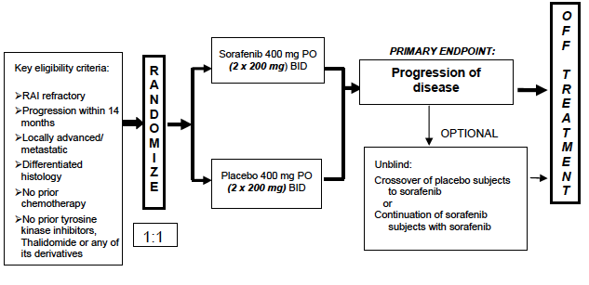

The **primary** objective of this study was to compare sorafenib and placebo in terms of progression-free survival (PFS) in subjects with DTC who were refractory to RAI treatment.

The **secondary** objectives were to:

1. Compare the sorafenib and placebo treatment groups in terms of:
   1. Overall survival (OS);
   2. Time to progression (TTP);
   3. Disease control rate (DCR);
   4. Response rate (RR);
   5. Duration of response (DOR);
   6. Safety, including assessment of adverse events (AEs) and abnormalities in laboratory parameters.
2. Describe the exposure of sorafenib in subjects with DTC using the area under the concentration time curve from time 0 to 12 hours at steady state [AUC (0-12). ss]

**Exploratory** objectives of the study were to examine:

* 1. Health-Related Quality of Life (HRQoL)/Healthy Utility Values
  2. Biomarker analysis
  3. PFS after unblinding until further disease progression in subjects who had received placebo and crossed over to sorafenib treatment
  4. PFS after unblinding until further disease progression in subjects who had received sorafenib and continued sorafenib treatment

The trial was conducted in 81 centres in 18 countries, as follows:

* Europe (9 centres each in the United Kingdom and Italy; 8 in France; 6 in Germany; 4 each in Poland and in Sweden; 2 each in Spain and the Netherlands; 1 centre each in Austria, Belgium, Bulgaria, Denmark, and Russia)
* North America (13 centres in the United States); and
* Asia (8 centres in China, 6 in South Korea, 4 in Japan, 1 in Saudi Arabia).

The first subject was enrolled on 15 October 2009. The submitted study report included data up to a cut-off date of 31 August 2012. The date of the study report itself was dated 29 May 2013.

At the time of writing, the results of the study do not appear to have been published other than as a conference abstract (11).

#### Inclusion and exclusion criteria

Comment: The inclusion and exclusion criteria show that the trial intended to enrol a population of subjects with advanced or metastatic disease, which was progressing and which was not amenable to further treatment with RAI, surgery or radiotherapy.

#### Study treatments

Subjects were randomised (1:1) to receive either sorafenib 400 mg twice daily or matching placebo twice daily. Each dose was to be taken 12 hours apart without food, at least 1 hour before or 2 hours after a meal.

Comment: According to the currently approved product information (PI) for sorafenib, the drug can be taken either without food or with a moderate-fat meal. However, a high-fat meal reduced bioavailability by 29%.

Treatment was administered continuously. However, for the purposes of the trial, a treatment ‘cycle’ consisted of 28 days of treatment. Subjects continued on their assigned treatment until disease progression, unacceptable toxicity, noncompliance or withdrawal of consent.

In the event of toxicity, the dose of sorafenib or placebo could be reduced from 800 mg/day to as low as 200 mg/day. The dose reductions used and the criteria for implementing them are summarised in Table 2.

Table 2. Study 14295 Dose reductions for toxicity. Tables a) to e).

a) Levels of dose reduction

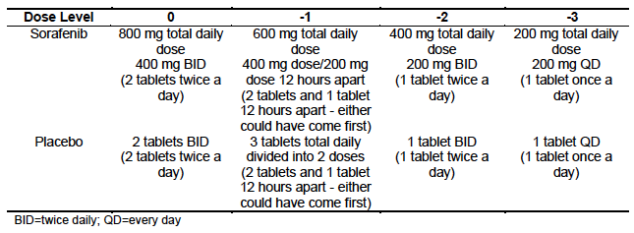

b) Haematological toxicities - Dose reductions/delays

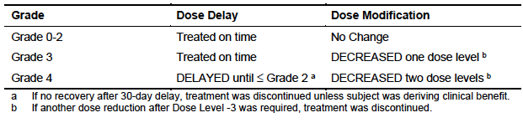

c) Non-haematological toxicities - Dose reductions/delays

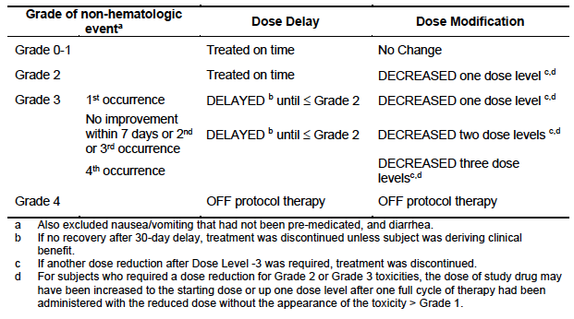

d) Hypertension - Dose reductions/delays

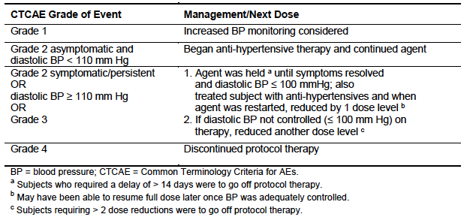

e) Skin toxicity - Dose reductions/delays

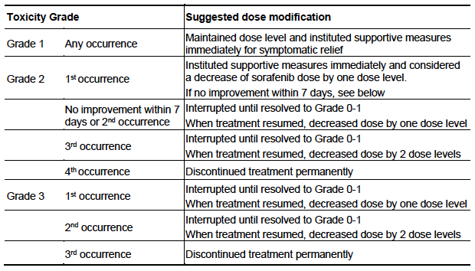

If confirmed disease progression occurred while on treatment, the study treatment could be unblinded. Subjects who had been receiving sorafenib could continue to receive the drug. Subjects who had been receiving placebo could cross over to sorafenib. Subjects were then able to continue to receive sorafenib until unacceptable toxicity, lack of benefit based on the investigator’s judgment, withdrawal of consent or death.

The following treatments were prohibited during the study: strong CYP3A4 inducers, investigational therapies, other anticancer therapies, anticoagulants (other than low-dose warfarin, low-dose aspirin or prophylactic doses of heparins) and concomitant radioiodine therapy.

#### Efficacy variables and outcomes

The main efficacy variables were:

* Change in tumour size/load as assessed by modified Response Evaluation Criteria in Solid Tumours (RECIST) version 1.0
* Progression-free survival and overall survival.

The **primary efficacy outcome** was progression-free survival (PFS) defined as the time from the date of randomisation to the date of any of the following:

* Radiological progression (as per RECIST criteria) as determined by a central independent radiology review panel; or
* The administration of radiotherapy for the treatment of bone lesions; or
* Death (if death occurred before progression).

**Secondary efficacy outcomes** included:

* Overall survival (OS), defined as the time from the date of randomisation to the date of death due to any cause.
* Time to progression (TTP), defined as the time from the date of randomisation to the date of radiological progression (as per RECIST criteria) or the administration of radiotherapy for bone lesions.
* Response rate (RR), defined as the proportion of subjects who achieve a best overall tumour response of partial response (PR) or complete response (CR) according to RECIST criteria during treatment or within 30 days after termination of study medication.
* Duration of response (DoR), defined as the time from the first documented objective response of PR or CR (whichever is noted earlier) to disease progression or death (if death occurs before progression is documented). The date of disease progression was the date of first observation of progression.
* Disease control rate (DCR), defined as the proportion of subjects who have a best response rating of CR, PR or SD according to RECIST criteria, that is achieved during treatment or within 30 days after termination of study medication.

Imaging studies (CT or MRI) were performed during screening and every 56 days (Day 1 of every second cycle) while on treatment, until disease progression. In subjects who discontinued due to reasons other than disease progression, imaging was performed at 30 days after stopping the drug and at every 3 months until death. Patients were followed up for survival every 3 months after disease progression or drug discontinuation.

A central blinded independent radiology review panel (consisting of 3 board-certified radiologists in the United States) reviewed all scans.

Comment: PFS is an acceptable primary endpoint for Phase III confirmatory studies according to the relevant EMA guideline adopted by the TGA (6). The secondary efficacy endpoints are all standard for oncology studies.

##### Exploratory efficacy outcomes

Examination of HRQoL was an exploratory objective in this study. HRQoL outcomes were referred to as ‘Patient Reported Outcomes (PRO)’. The instruments used to measure HRQoL were:

* The Functional Assessment of Cancer Therapy: General (FACT-G) version 4.0. This is a validated general quality of life instrument. The questionnaire covers 4 domains (physical, social/family, emotional, and functional well-being) with a total of 27 items.
* The EQ-5D. This is a generic measure of QoL. It consists of a questionnaire (index) and a visual analogue scale (VAS). The questionnaire has five ‘dimensions’ (mobility, self-care, usual activities, pain/discomfort and anxiety/depression). For each dimension, the subject can choose one of three responses (e.g. no problems, some problems, severe problems). The VAS asks the subject to rate his or her current health state from 0 (‘worst imaginable health state’) to 100 (‘best imaginable health state’).

Comment: The HRQoL endpoints were only exploratory and the sponsor is not seeking to include any of the data in the PI. These data will therefore only be reviewed briefly.

‘Secondary PFS’ (that is, from unblinding following first progression until further disease progression), was also an exploratory endpoint.

Another exploratory objective of the study was to analyse various biomarkers for prognostic value in the disease, and as predictors of benefit with sorafenib. Tumour samples were tested using the ‘Sequenom OncoCarta 1.0’ mutation panel that tests for 238 mutations in 19 common oncogenes. The analysis focused on BRAF and RAS mutations.

#### Randomisation and blinding methods

Subjects were randomised to either sorafenib or placebo via an interactive voice response system. Subjects were stratified at randomisation according to:

* Age (< 60 years versus ≥ 60 years); and
* Geographical region (North America versus Europe versus Asia).

Investigators, the subjects and the sponsor were all blinded to treatment allocation through the use of a placebo that was identical in appearance to sorafenib. The radiologists who conducted the central review of CT and MRI scans were also blinded to treatment allocation.

#### Analysis populations

The **full analysis set (FAS)** included all randomised subjects. It was the primary population for efficacy analysis was the FAS. Subjects were analysed as randomised.

The **per protocol set (PPS)** included all randomised subjects who were evaluable for tumour response based on imaging data, had exposure to study medication and had no major protocol deviations.

**FAS – subjects valid for Secondary PFS**: A subject was included in the FAS (valid for SPFS) set if he/she had a re-baseline (new baseline) scan and started open-label treatment with sorafenib.

The **safety analysis set (SAF)** included all subjects who were randomised and received at least one dose of study medication. Subjects were analysed as randomised.

**PRO analysis set (PROAS):** This population included all FAS subjects who had evaluable PRO assessments at baseline and at least one post-baseline assessment.

#### Sample size

It was assumed that the median PFS in the placebo group would be 6.0 months and the desired percentage increase in median survival was 55.5%. With 1:1 randomisation, a one-sided significance level of 0.01 and a power of 90%, it was calculated that 267 PFS events would be required. In order to achieve this number it was estimated that a total of 420 subjects would have to be enrolled.

#### Statistical methods

For the primary endpoint of PFS, the 2 treatment arms were compared using a one-sided stratified log-rank test with an overall one-sided alpha of 0.01, stratified by age (< 60 years versus ≥ 60 years) and geographical region (North America, Europe, and Asia). Kaplan-Meier estimates of median times to PFS and Kaplan-Meier curves were presented for each treatment arm, as well as the hazard ratio with its confidence interval derived with a Cox proportional hazards model.

A number of sensitivity analyses for PFS were also conducted. Subgroup analyses were conducted for geographical region, age, sex, histological subtype, site of metastases, FDG-PET uptake (positive or negative), prior cumulative dosing of RAI and tumour burden.

OS and TTP were analysed using the same methods as those used for the primary analysis of PFS. DCR and RR were analysed using the Cochran-Mantel-Haenszel test with one-sided alpha of 0.025 adjusting for the same stratification factors as used for randomisation. The estimates of DCR and RR and their 95% confidence intervals were computed for each treatment group. The difference in DCR/RR between the sorafenib and placebo arms and the corresponding 95% confidence interval were also calculated.

For DoR, Kaplan-Meier estimates and survival curves were presented for each treatment group. No statistical testing of the difference in DoR was performed.

#### Participant flow

A total of 556 subjects were screened and 419 were randomised. Of the 137 subjects who were screened but not randomised, 124 had protocol violations (mainly inclusion and exclusion criteria violations), 9 withdrew consent and 4 had adverse events.

A total of 417 of 419 subjects who had been randomised commenced treatment in the double blind phase of the study, 207 in the sorafenib group and 210 in the placebo group. Of these, 89 subjects (43.0%) in the sorafenib group and 164 subjects (78.1%) in the placebo group developed disease progression and entered the open label sorafenib treatment period.

At the time of data cut-off 66 subjects were receiving ongoing treatment in the double blind phase (43 on sorafenib and 23 on placebo) and 65 subjects were receiving ongoing sorafenib treatment in the open-label phase (12 originally assigned to sorafenib and 53 originally assigned to placebo).

Additional details are shown in Figure, Tables 3 and 4. The analysis populations are shown in Table 5.

Figure 2. Study 14295 - Participant flow

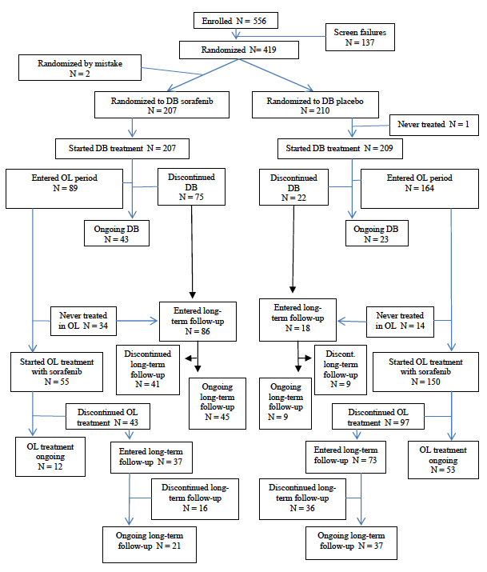

Table 3. Study 14295 Subject disposition for double blind treatment phase

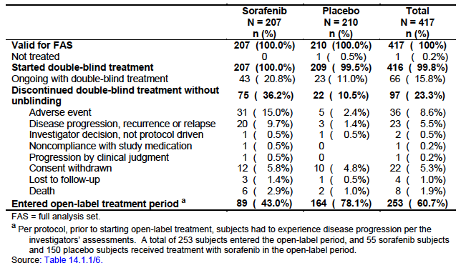

Table 4. Study 14295 Subject disposition in open label treatment phase

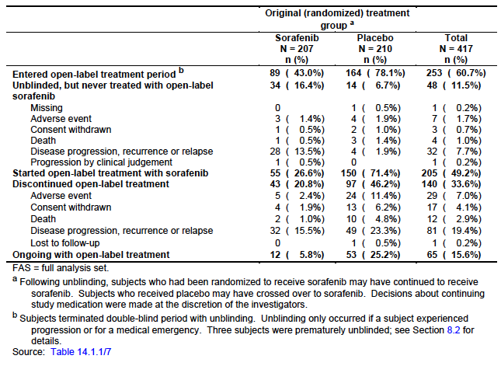

Table 5. Study 14295 Analysis sets

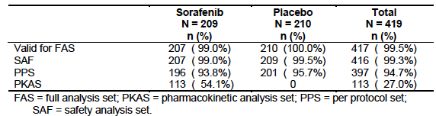

#### Major protocol violations/deviations

The study report did not include an analysis of major protocol violations. However, a major protocol violation was one reason to exclude subjects for the per-protocol analysis set (PPS). A total of 20 subjects in the FAS (n=417) were excluded from the PPS (n=397). The number of subjects excluded was comparable for the two groups (11 in the sorafenib group and 9 in the placebo group). The most common reason for exclusion from the PPS was ‘no post-baseline assessment’ (11 in the sorafenib group and 7 in the placebo group), rather than protocol violation. It therefore seems that there were few major protocol violations and they were unlikely to have affected the outcome of the study.

#### Baseline data

According to the investigators’ assessment, a total of 96.4% of the population had distant metastases and only 3.6% had locally advanced disease. The median time since initial diagnosis was 288 weeks (range 17 to 1,576) in the sorafenib group, and 291 weeks (range 29 to 1,747) in the placebo group.

Comment: The two treatment groups were well balanced with respect to baseline characteristics. The gender distribution of the population was approximately 50% male and 50% female. Thyroid cancer is approximately 2 to 3 times more common in females than in males but is more aggressive in males (4). The advanced disease of the population may therefore explain the high percentage of males.

A small proportion of patients had received prior systemic anticancer therapy. Most commonly this had been administered in the adjuvant/neoadjuvant setting and only 1.2% of subjects had received palliative chemotherapy. During the double-blind phase of the study 99.5% of subjects in both arms received thyroid therapy (including thyroxine).

#### Results for the primary efficacy outcome

The results for PFS are summarised in Table 6 and the Kaplan-Meier curves are shown in Figure 3. At the time of data cut-off there had been a total of 250 PFS events (113 in the sorafenib group and 137 in the placebo group). There was a statistically significant reduction (of approximately 41%) in the risk of a PFS event in the sorafenib group (hazard ratio [HR]: 0.587 [95%CI: 0.454 – 0.758]; p<0.0001). Median PFS was increased by approximately 5.0 months (10.8 versus 5.8). The probability of being alive and progression-free at 12 months was 43% in the sorafenib group and 31% in the placebo group.

Table 6. Study 14295 Progression-free survival (primary endpoint)

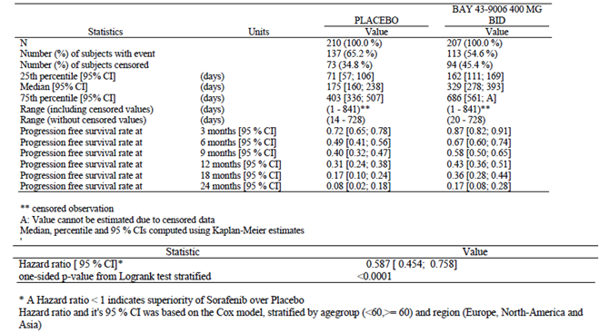

Figure 3. Study 14295 Progression-free survival Kaplan Meier curves

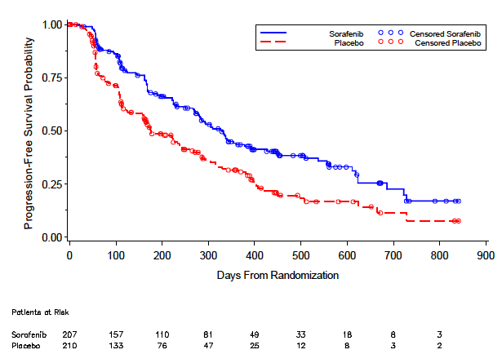

Subgroup analyses indicated that the benefit was consistent across all subgroups tested, with the hazard ratios all being < 1.0.

A variety of sensitivity analyses on PFS were conducted, which all supported the primary analysis of PFS. Briefly, the results were as follows:

* In an analysis based on the local investigators’ assessment of progression, including radiological progression and any type of clinical progression, the HR was 0.485 (95%CI: 0.386 – 0.609); p<0.0001.
* In an analysis based on the local investigators’ assessment of progression, including radiological progression only, the HR was 0.478 (95%CI: 0.375 – 0.608); p<0.0001.
* In an analysis based on the central assessment of radiological progression but including any type of clinical progression the HR was 0.567 (95%CI: 0.441 – 0.729); p<0.0001.
* In an analysis based on the central assessment of radiological progression only, the HR was 0.584 (95%CI: 0.449 – 0.759); p<0.0001.
* In an unstratified analysis, the HR was 0.597 (95%CI: 0.464 – 0.767); p<0.0001.

#### Results for other efficacy outcomes

##### Overall survival

The results for OS are summarised in Table 7 and the Kaplan-Meier curves are shown in Figure 4. The OS data were immature with only 99/417 subjects (24%) having died. There was no significant difference between the groups.

Table 7. Study 14295 Overall survival

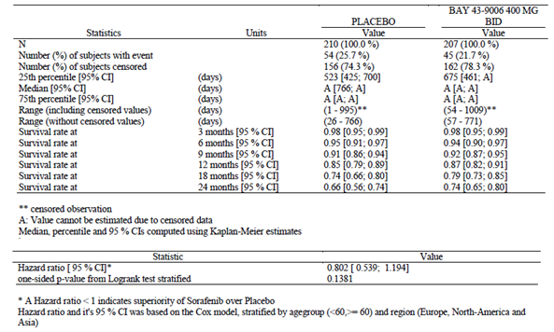

Figure 4. Study 14295 Overall survival Kaplan Meier curves

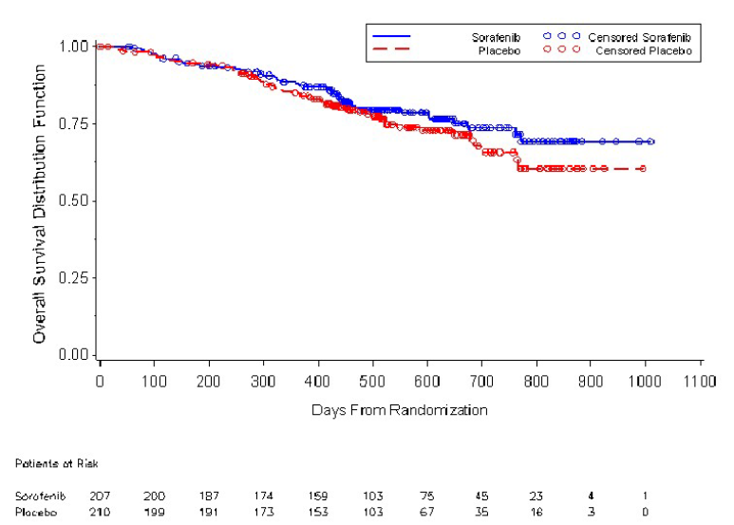

Comment: Patients randomised to placebo were able to cross over to sorafenib treatment after disease progression, and 150 (71.4%) of these subjects received open-label sorafenib. It is likely that this high rate of crossover would have obscured any survival benefit produced by the drug. The statistical analysis plan for the study indicated that a follow-up analysis of OS would be performed approximately 9 months after the date of the initial data cut-off. The sponsor should be requested to provide the results of this analysis. The results have been included in the U.S. PI.

The sponsor conducted two exploratory analyses of OS in an attempt to correct for the crossover effect. Both of these exploratory analyses were pre-specified in the statistical analysis plan. The two statistical methods used were:

* An iterative parameter estimation (IPE) method; and
* The rank preserving structural failure time (RPSFT) method.

Both methods estimate the treatment effect as if subjects in the control arm had never switched to sorafenib treatment. When these statistical models were used, the estimated corrected hazard ratios of sorafenib to placebo were 0.698 for IPE (95%CI: 0.467 to 1.043; one-sided p = 0.0388) and 0.613 for RPSFT (95%CI: 0.398; 0.944; one-sided p = 0.0125).

Comment: The study report acknowledges that these analyses were exploratory only and that no firm conclusions can be drawn from them. The sponsor is not seeking to make any claims regarding a survival benefit in the proposed PI.

##### Time to progression (TTP)

The results for TTP are summarised in Table 8 and the Kaplan-Meier curves are shown in Figure 5.

Comment: The results for TTP were consistent with those for PFS.

Table 8. Study 14295 Time to disease progression

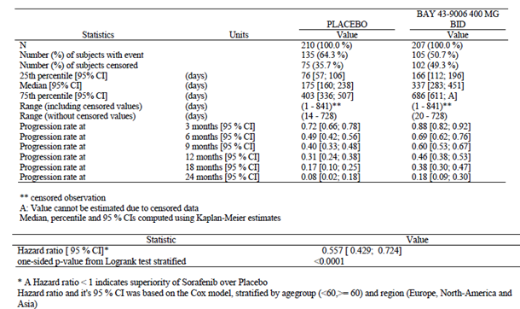

Figure 5. Study 14295 Time to disease progression Kaplan Meier curves

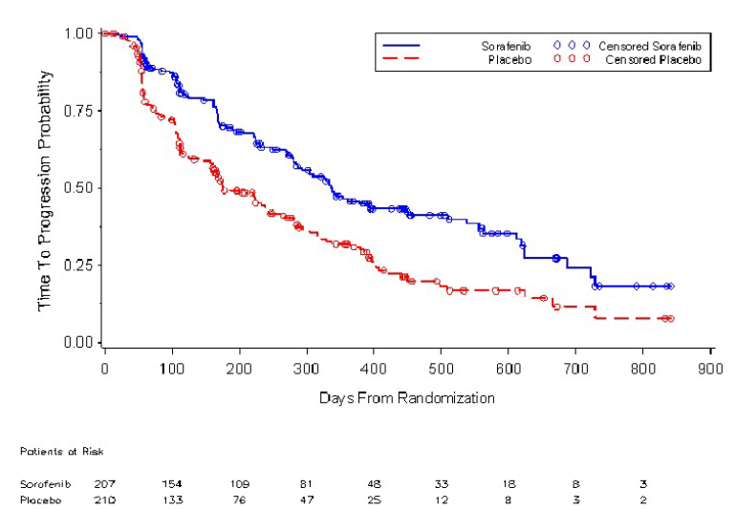

##### Response rate (RR) and disease control rate (DCR)

The results for RR and DCR are shown in Table 9. The protocol specified that these endpoints would be analysed in the per-protocol set.

Table 9. Study 14295 Response rate / Disease control rate

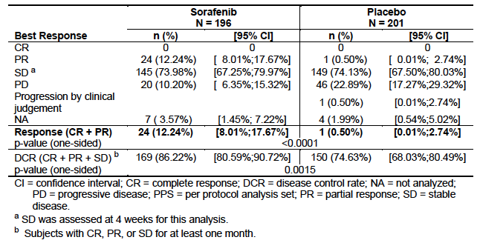

The RR was **12.2%** in the sorafenib group versus **0.5%** in the placebo group, and the difference was statistically significant (p<0.0001). All responses were partial responses.

The DCR was 86.2% in the sorafenib group and 74.6% in the placebo group (p=0.015).

Comment: The RR was low, suggesting sorafenib prevents tumour growth rather than causes tumour shrinkage. The response rate for sorafenib in the currently approved indication of renal cell carcinoma was similarly low (approximately 10%).

The DCR in the placebo group was high (74.6%), perhaps reflecting the slowly progressive nature of thyroid cancer, and the short period over which stability of disease was assessed (4 weeks only).

##### Duration of response

For the 24 subjects who achieved a partial response in the sorafenib group, the median duration of response was 10.2 months (range 7.4 – 16.6).

##### HRQoL

For the EQ-5D index, higher scores represent better health status and according to the sponsor a change of 0.10 to 0.12 points is considered clinically significant. For the EQ-VAS, higher scores are also indicative of better health status and a change of 7 points is considered clinically significant. Results for the mean scores for these two parameters are shown in Table 10. Over the course of the study, mean scores tended to improve in the placebo group and deteriorate in the sorafenib group. The difference between the groups was statistically significant, in favour of the placebo group for both parameters, however the differences were not considered clinically significant.

For the FACT-G questionnaire, scores range from 0 to 108, with higher scores indicating better QoL. A difference of 3 to 7 points is considered clinically significant. The analysis demonstrated a statistically significant treatment effect in favour of placebo for the total FACT-G score (p=0.0006), the physical well-being domain (p<0.0001) and the functional well-being domain (p=0.0443). The difference was of marginal clinical significance for the total score (3.4527 points) and not clinically significant for the two domains (Table 11).

Table 10. Study 14295 HRQoL (EQ-5D)

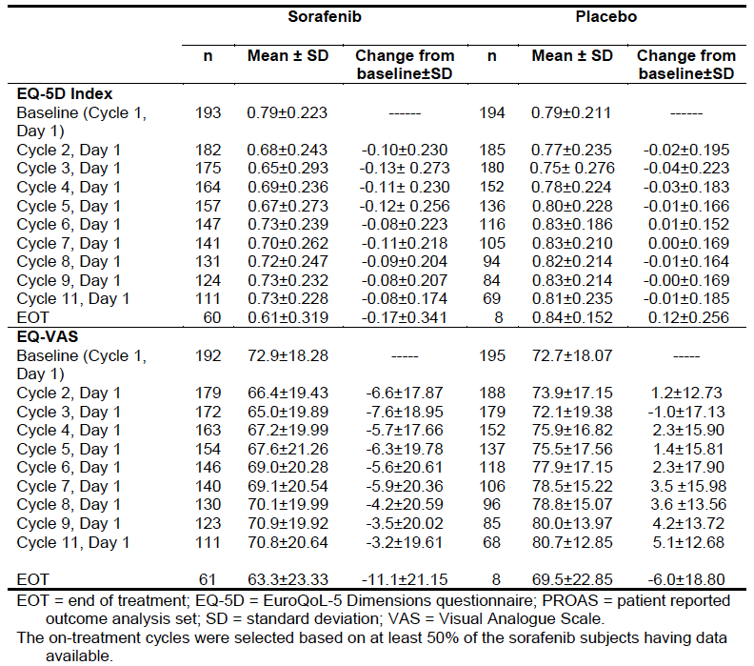

Table 11. Study 14295 HRQoL (FACT-G)

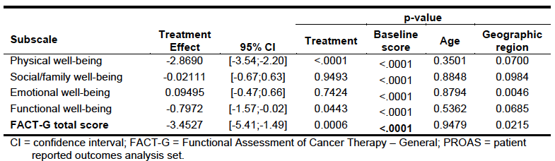

##### Secondary PFS

Results for PFS after initial disease progression are shown in table 12.

Comment: In the group of patients who were initially treated with placebo, and received sorafenib on disease progression, median PFS was 9.6 months, which is comparable to the median PFS observed in subjects originally randomised to sorafenib (10.8 months).

Table 12. Study 14295 Secondary PFS

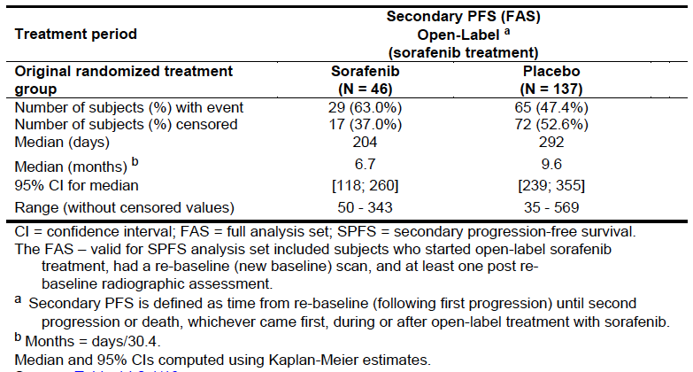

##### Biomarker analysis

A total of 256 tumour samples were suitable for mutation analysis. The distribution of mutations identified is shown in Table 13, with BRAF and RAS mutations being the most common. The presence or absence of BRAF, RAS or other rare mutations did not correlate with benefit from sorafenib.

Table 13. Study 14295 Tumour mutations

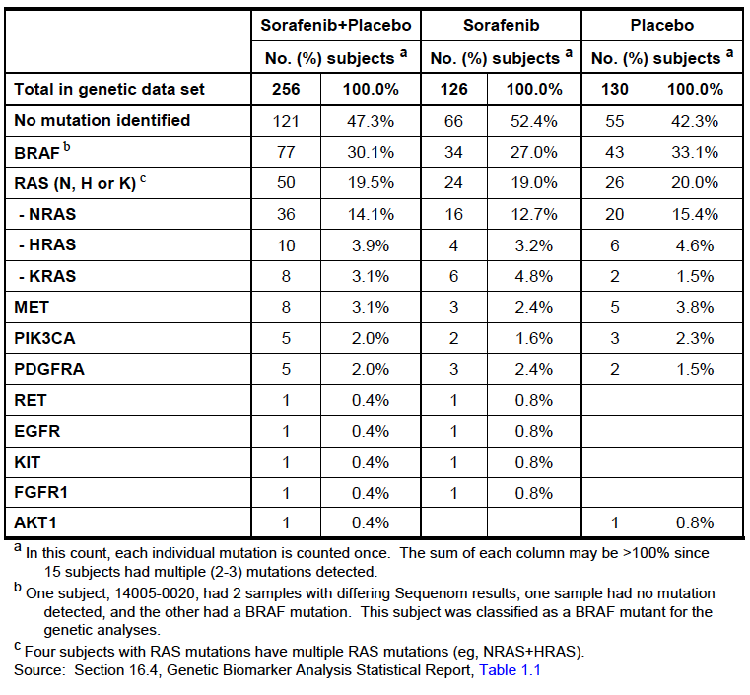

### Other efficacy studies

The sponsor identified five, single-arm, Phase II studies of the use of sorafenib in DTC from the literature (12, 13, 14-16, 17, 18). Although the sponsor supported several of these, the studies were described as being ‘investigator-sponsored’ and only published papers (rather than detailed study reports) were included in the submission.

Comment: The sponsor has included these studies as supportive evidence only. Neither a detailed literature search strategy, agreed beforehand with the TGA, nor a search output has been provided. It therefore cannot be assumed that the five studies presented reflect a complete or balanced view of the available literature.

The efficacy data from these five studies, including the results of the sorafenib arm in Study 14295 for comparison, is presented in Table 14. Response rates in the Phase II studies varied from 15-38%. All responses were partial responses.

Comment: Although cross-trial comparisons are not reliable, the efficacy results from these studies in terms of RR and PFS are generally comparable to, or more favourable than, those seen in Study 14295.

Table 14. Phase II studies Efficacy results for subjects with differentiated thyroid cancer

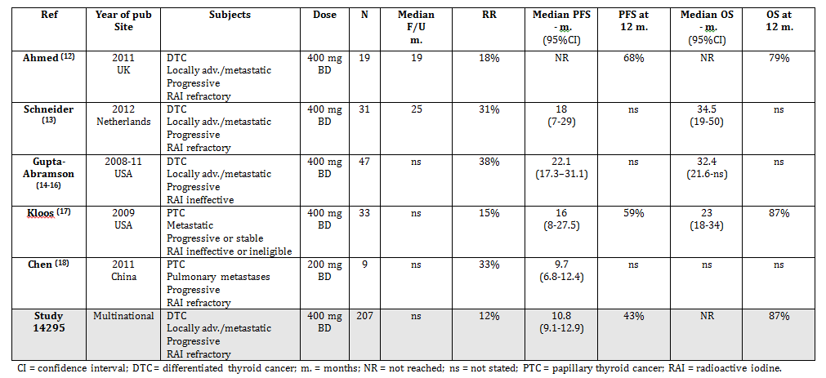

### Analyses performed across trials (pooled analyses and meta-analyses)

There were no pooled analyses or meta-analyses of efficacy included in the submission.

### Evaluator’s conclusions on clinical efficacy

The pivotal study was well designed and conducted. The design complied with the relevant EMA guidelines adopted by the TGA (6,7). The study demonstrated that sorafenib is clearly an active agent in RAI-refractory DTC, with a statistically significant (p<0.0001) improvement in PFS compared to placebo.

The magnitude of the efficacy benefit is considered clinically significant. The risk of experiencing a PFS event (that is, disease progression or death) was reduced by approximately 40% (HR: 0.587; 95%CI: 0.454 – 0.758) and median PFS was increased by approximately 5 months (10.8 versus 5.8 months). The study did not demonstrate a benefit in terms of overall survival and this is most likely due to the trial design which permitted crossover from placebo to sorafenib after disease progression. The EMA guidelines indicate that PFS is acceptable as a primary endpoint in Phase III studies and the TGA has previously approved new anticancer therapies on the basis of a PFS benefit, in the absence of a demonstrated OS benefit.

The efficacy benefit is considered valuable given the serious nature of the disease being treated and the lack of alternative treatments.

The exploratory HRQoL data suggested that patients treated with placebo had a better quality of life however the differences were of doubtful clinical significance.

Only one pivotal study has been submitted to support use of sorafenib in DTC and the TGA has adopted an EMA guideline that addresses this situation (8). It requires that the study should be ‘exceptionally compelling’. In the opinion of this reviewer, the pivotal study meets the criteria laid down in this guideline; the study design minimised the potential for bias, the population included in the study was representative of the population likely to receive the drug in clinical practice, the efficacy benefit was clinically significant, was highly statistically significant, and was consistent across subgroups. The clinical rationale for using sorafenib in DTC is also plausible.

The published Phase II studies submitted by the sponsor also provide some supportive evidence of efficacy.

Overall it is considered that the efficacy of sorafenib in the treatment of RAI-refractory DTC has been adequately established.

## Clinical safety

### Studies providing evaluable safety data

The following studies provided evaluable safety data:

#### Pivotal efficacy study

In the pivotal efficacy trial, study visits were scheduled at screening, Day 1 of Cycle 1 (randomisation visit), Day 1 of the next 8 cycles, Day 1 of every second cycle thereafter while still receiving study drug and 30 days after stopping study drug (end of treatment visit).

The following safety data were collected:

* General adverse events (AEs) were assessed at each study visit;
* A physical examination including vital signs, weight and brief examination of pertinent organ systems, was performed at each study visit.
* The following laboratory tests, were performed at each study visit (except at randomisation):
  + Haematology: complete blood count (CBC) with differential count;
  + Chemistry including: total bilirubin, ALT, AST, amylase or lipase, blood urea nitrogen (BUN), phosphate, sodium, potassium, chloride, calcium, albumin, glucose and creatinine,
  + Prothrombin Time/INR, Partial Thromboplastin Time (PTT);
  + Urinalysis (dipstick: pH, glucose, protein, leukocytes, and erythrocytes);
  + Thyroglobulin level and thyroglobulin antibodies (as part of the biomarker analyses), TSH, total T3, free T4.

#### Other studies

The published Phase II studies reported adverse events and laboratory abnormalities.

### Overall patient exposure

Safety data were available for a total of 517 subjects in the submitted studies. Two of the Phase II studies pooled safety data from patients with DTC and subjects with other types of thyroid cancer.

Table 15. Exposure to sorafenib and placebo in clinical studies.

| Study type/Indication | | Pivotal study | | Uncontrolled studies |
| --- | --- | --- | --- | --- |
| Sorafenib | Placebo | Sorafenib |
| Pivotal | | | | |
| * Double-blind phase * Open label phase | **207** | | 209  - | -  - |
| * + From placebo group   + From sorafenib group | **150**  55 | | -  - |  |
| Phase II | | | | |
| * Ahmed 2009 | - | | - | 34 (1) |
| * Schneider 2012 | - | | - | 31 |
| * Gupta-Abramson 2008 | - | | - | 30 (2) |
| * Kloos 2009 | - | | - | 56 (1) |
| * Chen 2011 | - | | - | 9 |
| **TOTAL for sorafenib** | **357** | | | **160** |

(1) Ahmed 2009 and Kloos 2009 included subjects with other thyroid cancer types in the safety database presented.

(2) For Gupta-Abramson 2008, detailed safety data were only presented for the first 30 subjects.

### Pivotal study 14295

#### Patient exposure by dose/duration

The duration of exposure in the pivotal study is summarised in Figure 66. The extent of exposure to sorafenib or placebo in the double blind phase is summarised in Table 16. The median time under treatment was longer in the sorafenib group (46.1 weeks versus 28.3 weeks). More sorafenib-treated than placebo-treated subjects required dose reduction (68.1% versus 11.5%) and most of these reductions were due to toxicity.

The extent of exposure to sorafenib over both the double blind and open phases is summarised in Table 17.

Over the entire study, 357 subjects received sorafenib. Of these, 248 subjects received the drug for at least 24 weeks and 154 subjects received the drug for at least 48 weeks.

Figure 6. Study 14295 Duration of exposure

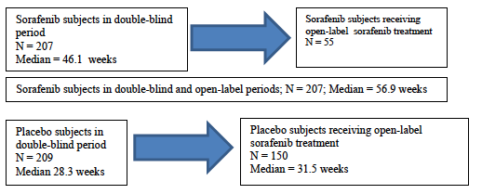

Table 16. Study 14295 Exposure to sorafenib or placebo in double blind phase

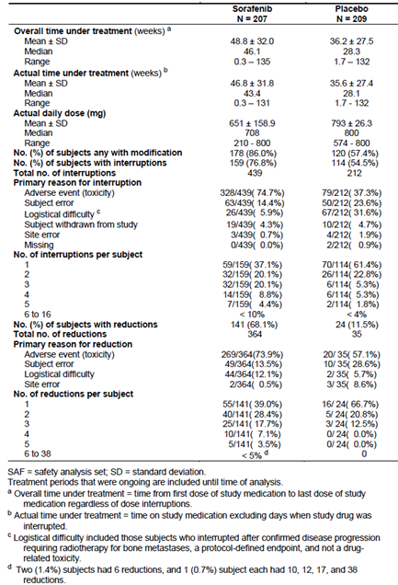

Table 17. Study 14295. Exposure to sorafenib in double blind and open phases

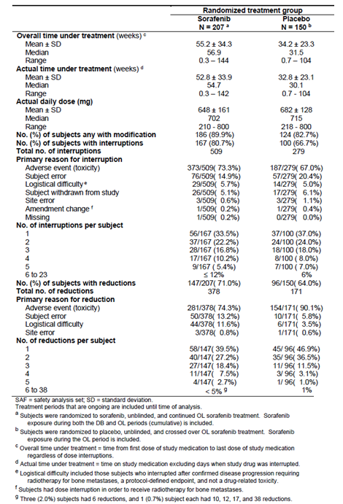

#### Adverse events

A summary of the overall incidence of AEs including serious AEs during the double-blind phase is shown in Table 18.

Table 18. Study 14295 Overall AEs (with sorafenib or placebo) in the double-blind phase

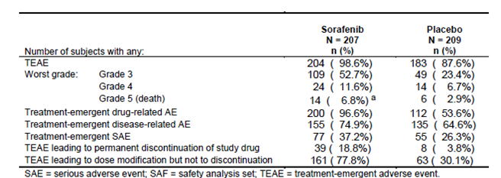

aTwo subjects in the sorafenib group developed a serious Grade 5 TEAE during the double-blind period, but dies 30 days post permanent double blind treatment discontinuation. One subject experienced pleural effusion and one experienced dyspnea. Therefore they are not counted amongst the other 12 subjects who died during the double-blind period and up to 30 days post permanent double blind treatment.

##### All adverse events (irrespective of relationship to study treatment)

The incidence of **AEs** during the double blind treatment phase was **98.6%** in the sorafenib group and **87.6%** in the placebo group. Common AEs (that is, those occurring in at least 10% of subjects in either arm) were summarised. Toxicities that occurred more commonly with sorafenib included:

* Skin toxicity: for example hand-foot syndrome (76.3% versus 9.6%), alopecia (67.1% versus 7.7%) and rash/desquamation (50.2% versus 11.5%);
* Gastrointestinal toxicity: for example diarrhoea (68.6% versus 15.3%), anorexia (31.9% versus 4.8%) and mucositis (23.2% versus 3.3%);
* Constitutional symptoms: for example fatigue (49.8% versus 25.4%) and weight loss (46.9% versus 13.9%);
* Hypertension (43.0% versus 13.4%);
* Elevated transaminases: ALT (12.6% versus 4.3%) and AST (11.1% versus 2.4%);
* Hypocalcaemia (18.8% versus 4.8%).

The study report included a comparison of exposure-adjusted incidence rates for common AEs, taking into account the longer period of treatment in the sorafenib arm. The results did not alter the overall pattern of toxicity.

In placebo treated patients who received sorafenib in the open-label phase (n=150), the incidence of AEs was **99.3%** and the pattern of AEs observed was similar to that described above for sorafenib.

Comment: These AEs are generally known to be associated with sorafenib and are currently listed in the approved Australian PI. However, **hypocalcaemia** appears to be a new AE not previously associated with the drug.

The incidence of **Grade 3 or 4 AEs** during the double blind treatment phase was **64.3%** in the sorafenib group and **30.1%** in the placebo group. Common AEs (that is, those occurring in at least 1% of subjects in either arm) are shown in Table 19.

Table 19. Study 14295 Grade 3 or 4 AEs (incidence >1%) in the double-blind phase

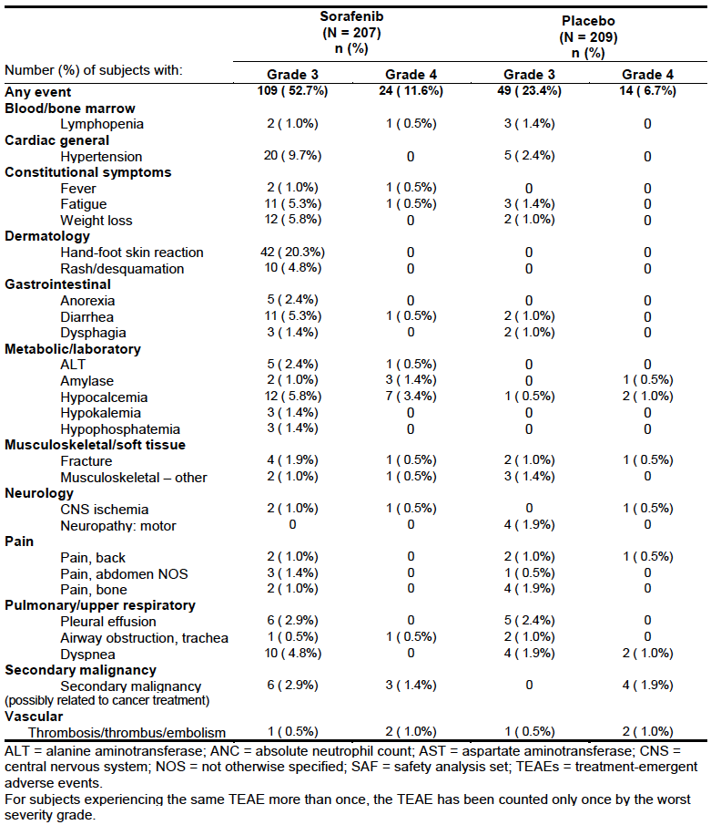

The pattern of Grade 3 or 4 AEs was similar to that seen with overall AEs. For each individual AE term the incidence figure was notably lower than for overall AEs, indicating that most toxicities were of Grade 1 or 2 in severity.

In placebo treated patients who received sorafenib in the open-label phase (n=150), the incidence of Grade 3 or 4 AEs was **52.7%** and the pattern of AEs observed was similar to that previously described.

Comment: In the double blind phase, notable Grade 3 or 4 events in the sorafenib group included hypocalcaemia (9.2% versus 1.4%) and secondary malignancies (4.3% versus 1.9%).

##### Treatment-related adverse events (adverse drug reactions)

The incidence of **treatment-related AEs** during the double blind treatment phase was **96.6%** in the sorafenib group and **53.6%** in the placebo group. Common treatment-related AEs (that is, those occurring in at least 10% of subjects in either arm) are shown in Table 20.

In placebo treated patients who received sorafenib in the open-label phase (n=150), the incidence of treatment-related AEs was **96.7%.**

The incidence of **Grade 3 or 4 treatment-related AEs** during the double blind treatment phase was **54.1%** in the sorafenib group and **6.7%** in the placebo group. Common treatment-related Grade 3 or 4 AEs (that is, those occurring in at least 2 subjects in either arm) are shown in Table 21.

In placebo treated patients who received sorafenib in the open-label phase (n=150), the incidence of Grade 3 or 4 treatment-related AEs was **44.7%.**

Comment: The pattern of toxicity observed by analysing treatment-related events, was similar to that observed by analysing all events.

Table 20. Study 14295 Treatment-related AEs (incidence >10%) in the double-blind phase

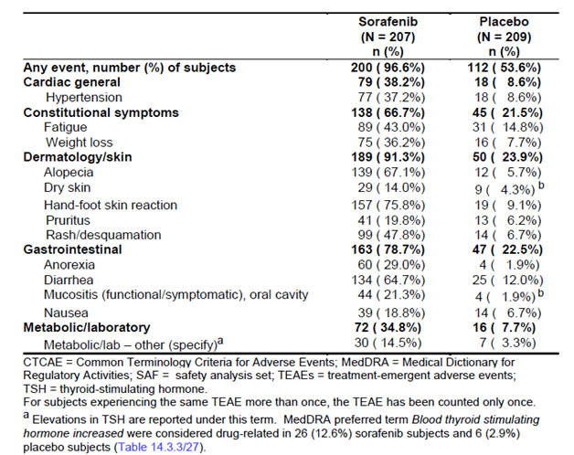

bOne subject was randomised to placebo but erroneously received sorafenib for Cycle 1. The subject experienced 2 drug related TEAEs during Cycle 2 (within 30 days of sorafenib exposure) that are captured under placebo treatment (Grade 1 dry skin and Grade 1 oral mucositis).

Table 21. Study 14295 Grade 3 or 4 treatment related AEs (incidence >2 subjects) in the double-blind phase

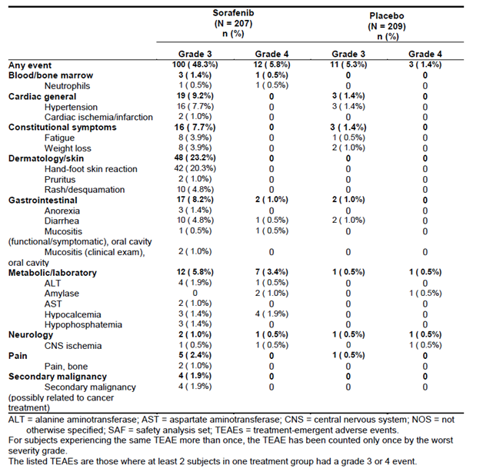

##### Deaths and other serious adverse events

###### Deaths

There were a total of 18 deaths during the double-blind treatment period or within 30 days of discontinuation. Of these, 12 were in the sorafenib group and 6 were in the placebo group. Only two deaths were considered related to study drug:

* [information redacted] died of an acute myocardial infarction while on sorafenib.
* [information redacted] died of a subdural haemorrhage while on placebo. {information redacted] was also receiving enoxaparin for atrial fibrillation.

The sponsor explains the higher incidence of death in the sorafenib group as being due to the longer duration of double-blind treatment in the sorafenib arm (medians 46.1 weeks versus 28.3 weeks), and the fact that fewer subjects from the sorafenib arm received the drug in the open-label phase.

Comment: Myocardial infarction is a known risk associated with sorafenib. The individual patient narratives for the remaining 16 patients have been reviewed and most of these subjects died of events known to be associated with advanced cancer (such as disease progression, infections and pulmonary embolus). None were suspicious of sorafenib toxicity.

In patients who did not receive open-label treatment with sorafenib, there were 32 deaths occurring more than 30 days after the double blind phase. In patients who did receive open-label treatment, there were 25 deaths occurring more than 30 days after the double blind phase, and within 30 days of cessation of the open label treatment. There were a further 24 deaths occurring more than 30 days after the cessation of open-label treatment. None of these deaths were considered related to sorafenib, and the stated cause of death was usually progressive disease.

###### Serious AEs (other than deaths)

A serious AE (SAE) was defined as an AE that resulted in death, was life-threatening, required hospitalisation or prolongation of hospitalisation, resulted in persistent or significant disability or incapacity or was regarded as an important medical event.

The incidence of SAEs during the double blind treatment phase was **37.2%** in the sorafenib group and **26.3%** in the placebo group. SAEs occurring in the double-blind phase are shown in Table 22.

Comment: Serious AEs that were more common in the sorafenib group were constitutional symptoms (fever, fatigue, weight loss), rash/desquamation and secondary malignancy. Cardiac ischaemic/infarction occurred in 2 subjects in the sorafenib arm and none in the placebo arm.

In placebo treated patients who received sorafenib in the open-label phase (n=150), the incidence of SAEs was **44.0%.** The pattern of SAEs was consistent with that observed for sorafenib in the double-blind phase.

Table 22. Study 14295 Serious AEs in the double-blind phase

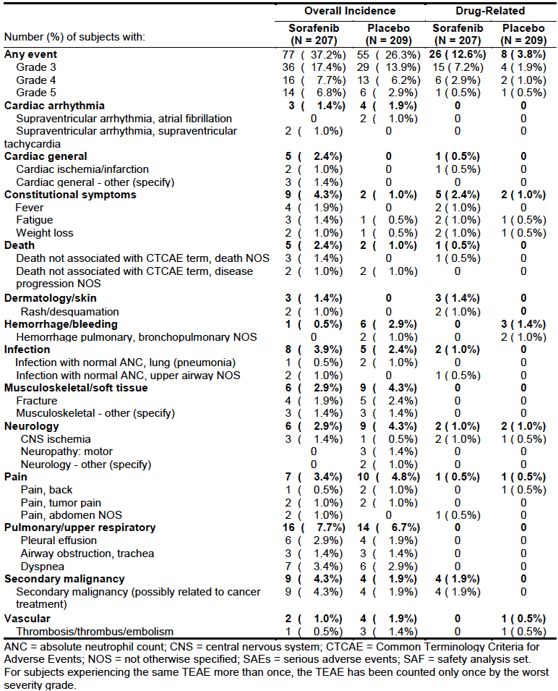

##### Discontinuation due to adverse events

The incidence of AEs leading to permanent discontinuation of study drug during the double blind treatment phase was **18.8%** in the sorafenib group and **3.8%** in the placebo group. In placebo treated patients who received sorafenib in the open-label phase (n=150), the incidence of AEs leading to permanent discontinuation was **18.7%.**

The AEs leading to permanent discontinuation in the double blind and open label phases were summarised.

Comment: The pattern of adverse events was similar to previous analyses. Notably, in the double-blind phase, 5.3% of subjects discontinued due to hand-foot syndrome (versus 0% in the placebo arm).

##### Adverse events of special interest

The sponsor identified the following as AEs of special interest:

* Bleeding events;
* Hypertension;
* Hand-foot syndrome
* Weight loss;
* Left ventricular systolic dysfunction;
* Cardiac ischaemia / infarction
* Other cardiac events;
* Pancreatitis;
* Secondary cancer;
* Keratoacanthoma / squamous cell carcinoma of the skin (SCC).

These events (apart from secondary cancer) are all currently listed in the approved Australian PI.

The incidence of these AEs (apart from cancers) in the double-blind phase is summarised in Table 23. The incidence of secondary cancers and keratoacanthoma/SCC in the double blind and open label phases were also summarised.

Comment: If SCC is excluded, there was no apparent increased risk of secondary malignancy in the sorafenib group. SCC and keratoacanthoma are known to be associated with sorafenib.

Table 23. Study 14295 – AEs of special interest in the double blind phase

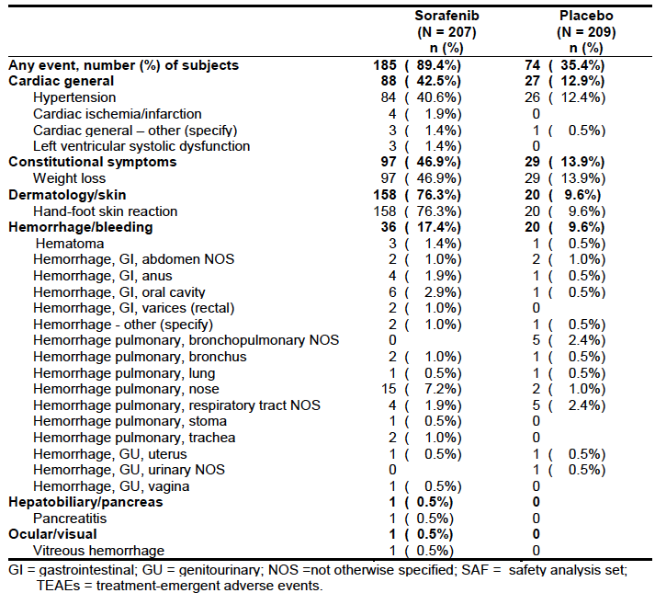

#### Laboratory tests

Grade 3 or 4 biochemical abnormalities are summarised in Table 24. Grade 3 or 4 haematological abnormalities are summarised in Table 25.

Table 24. Study 14295 Biochemistry abnormalities

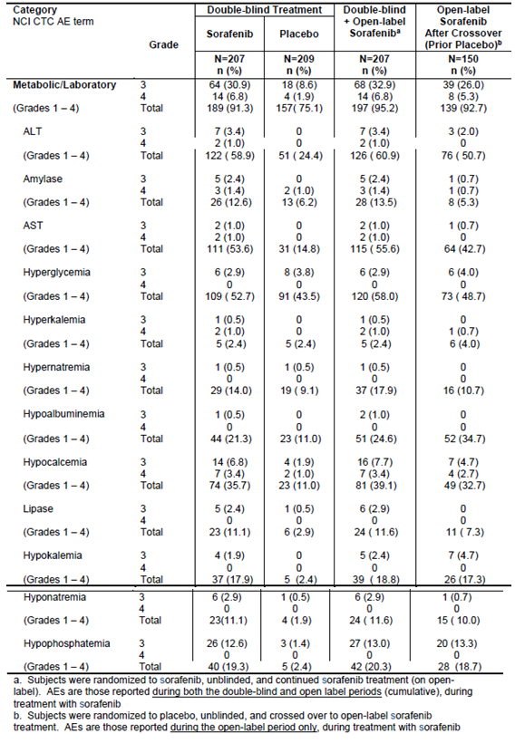

Table 25. Study 14295 Haematology abnormalities

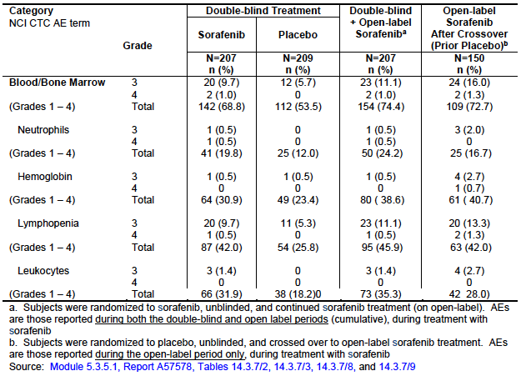

##### Liver function

In the double blind phase, the following liver function test abnormalities were more common in the sorafenib arm:

* ALT elevations: 58.9% versus 24.4% (Grade 3/4: 4.4% versus 0%);
* AST elevations: 53.6% versus 14.8% (Grade 3/4: 2.0% versus 0%);
* Bilirubin elevations: 8.7% versus 4.8% (there were no Grade 3 or 4 elevations);
* Hypoalbuminaemia: 21.3% versus 11.0% (Grade 3/4: 0.5% versus 0%).

None of the subjects with abnormal LFTs fulfilled the criteria for Hy’s Law (predictive of severe drug-induced liver injury). However, the PI for sorafenib already lists drug-induced hepatitis (with a life-threatening or fatal outcome) as a rare adverse event.

##### Kidney function

In the double blind phase, the following renal function test abnormalities were more common in the sorafenib arm:

* Creatinine elevations – 6.8% versus 5.3% (there were no Grade 3 or 4 elevations);

Elevations of blood urea nitrogen were not reported.

The currently approved Australian PI lists renal failure (and proteinuria) as common adverse drug reactions.

##### Pancreatic enzymes

In the double blind phase, the following pancreatic enzyme abnormalities were more common in the sorafenib arm:

* Amylase elevations: 12.6% versus 6.2% (Grade 3/4: 3.8% versus 1.0%);
* Lipase elevations: 11.1% versus 2.9% (Grade 3/4: 2.4% versus 0.5%).

In the double-blind phase of the pivotal study there was one case of pancreatitis in the sorafenib arm and none in the placebo arm.

##### Hypocalcaemia

In the double blind phase, hypocalcaemia more common in the sorafenib arm:

* Hypocalcaemia :35.7% versus 11.0% (Grade 3/4: 10.2% versus 2.9%).

There was no increased incidence of hypercalcaemia.

##### Hypophosphataemia

In the double blind phase, hypophosphataemia more common in the sorafenib arm:

* Hypophosphataemia: 19.3% versus 2.4% (Grade 3/4: 12.6% versus 1.4%).

##### Thyroid function

Subjects entered into the study were required to have been TSH suppressed (TSH < 0.5 mU/L; normal range: 0.4 to 5.0 mU/L). Elevations of TSH above 0.5 mU/L were therefore considered to be adverse events and managed as shown in Table 26.

Table 26. Management of elevated TSH levels

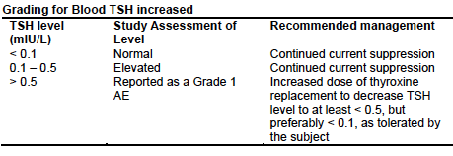

In the double blind phase of the study, increases in TSH (reported as AEs) were more common in the sorafenib arm (33.3% versus 13.4%). Elevations in free T4 and total T3, reported as laboratory abnormalities, were also more common in the sorafenib arm; 86.7% versus 70.6% and 8.3% versus 5.2% respectively.

The incidence of elevated thyroglobulin levels was lower in the sorafenib arm (9.5% versus 26.2%), a finding that would be consistent with an antitumour effect. There were no anti-thyroglobulin antibodies reported.

##### Other clinical chemistry

In the double blind phase, the following were more common in the sorafenib arm:

* Hypokalaemia: 17.9% versus 2.4% (Grade 3/4: 1.9% versus 0%);
* Hyponatraemia: 11.1% versus 1.9% (Grade 3/4: 2.9% versus 0.5%).

##### Haematology

In the double-blind phase, haematological abnormalities were more common in the sorafenib arm (Table 25). This may have been due in part to the longer duration of double-blind treatment in this group. Grade 3 or 4 abnormalities were only marginally more common. Cytopaenias are listed in the current PI as being common adverse drug reactions with sorafenib.

##### Coagulation parameters

There was no increased incidence of elevations in aPPT, PT or INR in the sorafenib group during the double blind phase.

##### Urinalysis

Although urine dipstick testing was conducted throughout the study, the report did not include any data on results.

Comment: Laboratory testing abnormalities observed in the pivotal study were generally consistent with those previously described for sorafenib. Hypocalcaemia appears to be a new AE. It was very common (incidence of 35.7%) and potentially clinically significant (incidence of Grade 3/4 events of 10.2%).

The observation of an increased incidence of elevated TSH levels with sorafenib is important for this population who require TSH suppression as part of ongoing management.

The sponsor has added statements to the sorafenib PI addressing these two issues.

#### Vital signs

As noted above, the incidence of hypertension was significantly increased in the sorafenib arm of the study. No other notable changes to vital signs were observed.

#### Comparative adverse event rates

In the sponsor’s Summary of clinical safety, the sponsor presented a comparison of AE rates observed in the pivotal study with those observed in the previous pivotal studies in renal cell carcinoma (RCC) and hepatocellular carcinoma (HCC) (see Table 27). Although not a consistent finding across all AE terms, there was a suggestion that AE rates were higher in DTC patients than in other indications. This was particularly noticeable for hand-foot syndrome, alopecia, hypocalcaemia and diarrhoea. AST and ALT elevations were much more common than in RCC.

The sponsor has added a statement to the ‘Adverse Reactions’ section of the PI outlining this finding.

Comment: An increased incidence of adverse events in DTC subjects would be consistent with the finding of increased systemic exposure to sorafenib in this population (see Table 27). In retrospect, a lower starting dose may have been appropriate for the pivotal study. However, there is no data to support efficacy of a lower starting dose and toxicities were manageable in most patients with dose interruptions or dose reductions.

Table 27. Adverse event rates in different indications

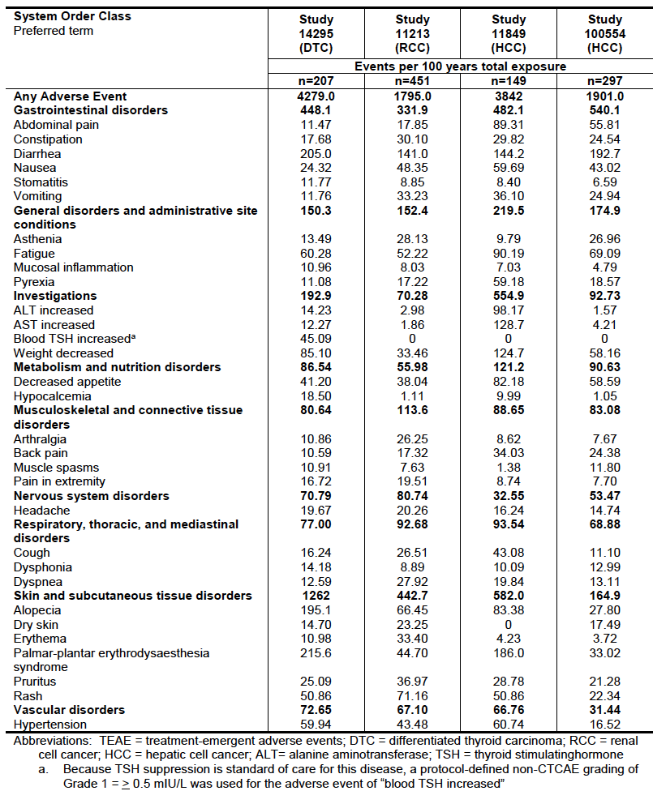

### Supportive phase II studies

The five published studies included in the submission provided the following safety data.

#### Ahmed (2011)

This trial enrolled 34 subjects (19) with DTC). Adverse events (incidence > 5%) are summarised in Table 28, and laboratory abnormalities (incidence > 5%) are summarised in Table 29.

Table 28. Ahmed (2011) Phase II study AEs with a frequency > 5%.

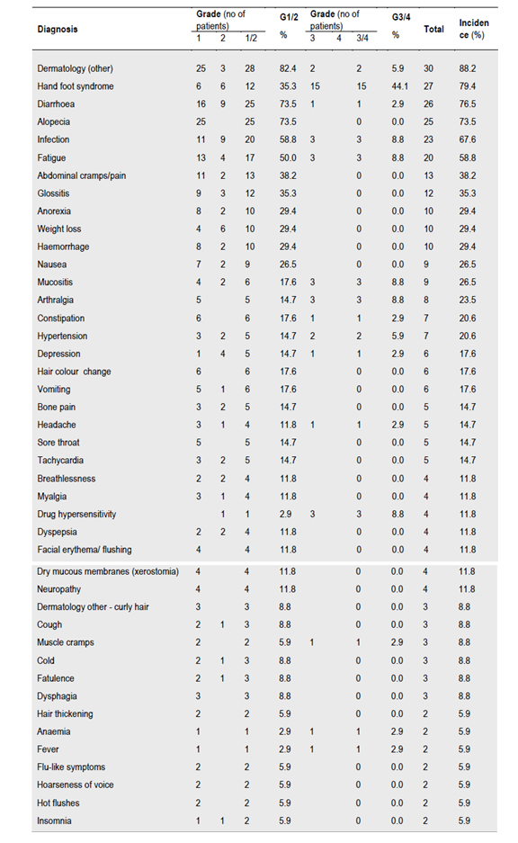

Table 29. Ahmed (2011) Phase II study Laboratory abnormalities with a frequency > 5%.

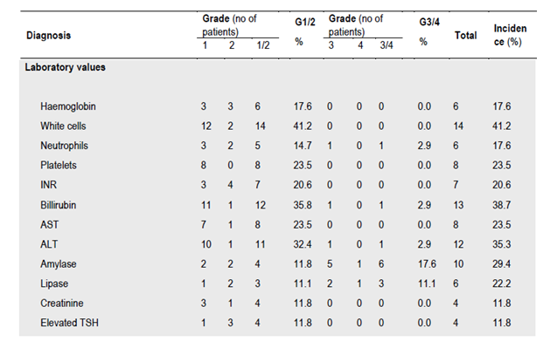

#### Schneider (2012)

This study enrolled 31 subjects with DTC. Adverse events are summarised in table 30.

Table 30. Schneider (2012). Phase II study AEs

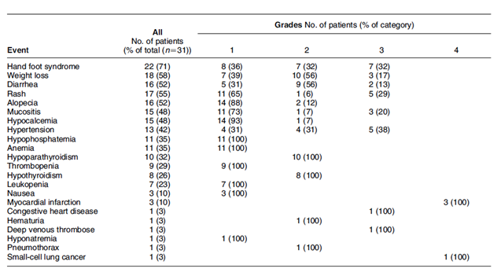

#### Gupta-Abramson (2008)

This study enrolled 47 subjects with DTC. The initial publication reported on the first 30 subjects, including safety data. Follow-up conference abstracts reported efficacy but not safety data for the remaining subjects. Treatment-related AEs for the initial 30 subjects are summarised in Table 31. In addition, 10 subjects (33%) developed elevated TSH levels (> 0.1 mU/L).

Table 31. Gupta-Abramson (2012) Phase II study Treatment-related AEs

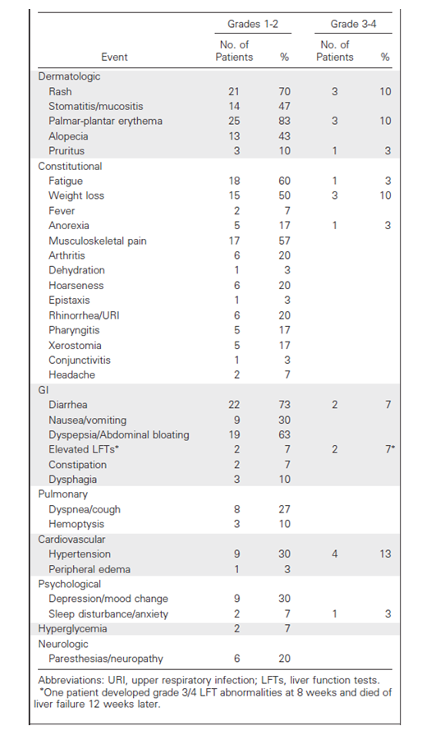

#### Kloos (2009)

This study included 56 subjects; 19 with papillary thyroid cancer in ‘Arm A’ (the main statistical arm) and 37 with various thyroid cancers in ‘Arm B’. Grade 1-3 toxicities are summarised in Tables 32 and 33. In addition to these events, there were 2 reports (4%) of reversible neutropaenia and 1 report (2%) of pericardial effusion. One patient with advanced disease had sudden death.

Table 32. Kloos (2009) Phase II study Grades 1-3 AEs

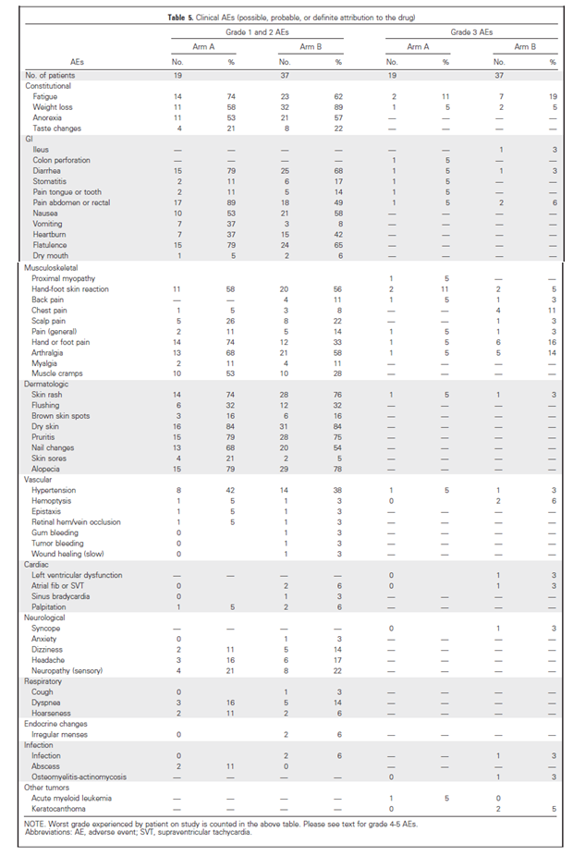

Table 33. Kloos (2009) Phase II study Laboratory abnormalities (Grades 1-3)

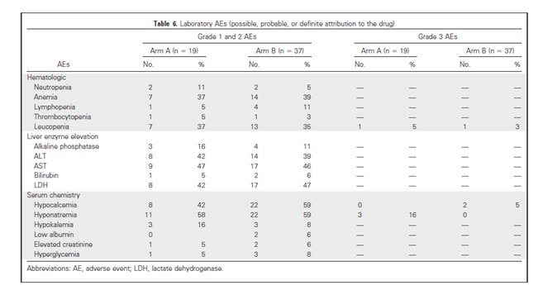

#### Chen (2011)

This study enrolled only 9 subjects. Reported AEs are listed in Table 34. All AEs were Grade 1 or 2.

Comment: The toxicities observed in the Phase II studies were consistent with those established for sorafenib or those reported in the pivotal study.

Table 34. Chen (2011) Phase II study AEs

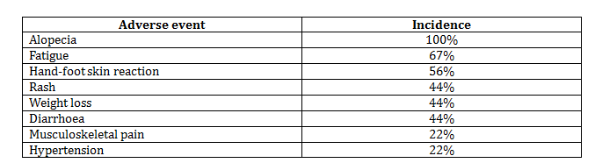

#### Other

Safety data from 9 subjects with DTC who were enrolled in company-sponsored early Phase I and II studies were also provided. The reported toxicities were unremarkable.

### Postmarketing experience

As sorafenib had been used “off-label” for the treatment of thyroid cancer for some time prior to the current submission, the sponsor had received reports of adverse events occurring in this population. The sponsor’s Summary of clinical safety included an analysis of AE reports from patients receiving sorafenib for thyroid cancer.

A total of 1354 cases had been received up to 31 March 2013. Of these, 582 were classed as serious. The sponsor’s analysis focused on those that were considered serious, related to sorafenib (either by the reporter or the sponsor) and unexpected. There were 88 of these cases. Individual AEs with more than one report included the following:

* Atrial fibrillation (2 reports). Both subjects had ‘hypertensive decompensation’ and one had hypokalaemia, both known AEs associated with sorafenib;
* Dyspnoea (6 reports). Most reports had insufficient information. Some were most likely related to disease progression (lung metastases, pneumonia). Interstitial lung disease like events are known to be uncommonly associated with sorafenib treatment;
* Cerebrovascular accident (2 reports). Both reports had insufficient information to clearly understand the event. Hypertension and haemorrhage are both known AEs with sorafenib.

Many of the ‘unexpected’ AEs were simply different terms used to describe known AEs (such as ‘inability to walk’ and ‘gait disturbance’ in subjects with hand-foot syndrome; ‘pharyngeal oedema’ in subjects with mucositis).

Overall, the review of the postmarketing reports did not suggest any novel toxicity for the drug.

### Safety issues with the potential for major regulatory impact

#### Liver toxicity

As described in *Liver function* above, LFT abnormalities are common with sorafenib treatment. However, in the pivotal study, no evidence of severe drug induced liver injury was observed. The PI for sorafenib already lists drug induced hepatitis (with a life-threatening or fatal outcome) as a rare adverse event.

#### Haematological toxicity

As described in *Haematology* above, cytopaenias are a common adverse event with sorafenib treatment. There were no reports of pancytopaenia or aplastic anaemia in the pivotal study.

#### Serious skin reactions

Serious skin toxicities, principally hand-foot syndrome and rash/desquamation are common with sorafenib, and this was confirmed in the pivotal study (see Table 19). Stevens-Johnson syndrome and toxic epidermal necrolysis have also been reported in postmarketing experience and are listed in the current PI.

#### Cardiovascular safety

Sorafenib is known to be associated with cardiovascular toxicity. Hypertension, myocardial infarction/ischaemia, QT prolongation and congestive heart failure are all listed in the currently approved PI. The new safety data provided with the current submission did not indicate any novel cardiovascular toxicity.

#### Unwanted immunological events

Anaphylactic and hypersensitivity reactions are listed in the draft PI as uncommon adverse reactions. In the pivotal study, one subject experienced a Grade 4 anaphylactic reaction (considered related) and one had a Grade 4 allergic reaction (considered unrelated). Both subjects were receiving sorafenib.

### Other safety issues

#### Safety in special populations

In the pivotal study, subgroup analyses of adverse events were performed for the following variables: geographical region, age, body mass index, sex, race, baseline ECOG status, histological subtype, history of hypoparathyroidism, renal function and hepatic function. Findings of note included the following:

* Among sorafenib-treated subjects, toxicity appeared comparable in patients aged <60 and those aged ≥ 60 years. However, subjects aged ≥ 75 years experienced greater toxicity than those aged < 75 years (SAEs 52.0% versus 35.2%; Grade 3/4 toxicity 84.0% versus 61.5%);
* The incidence of hypocalcaemia in the sorafenib arm was higher in subjects with a history of hypoparathyroidism (28.6%) than in subjects with no such history (5.2%), although numbers in the former group were small (n=14);

#### Safety related to drug-drug interactions and other interactions

The submission contained no new data on interactions.

### Evaluator’s overall conclusions on clinical safety

The pattern of toxicity seen with sorafenib in the submitted studies was generally consistent with that previously documented for sorafenib. The most common AEs were dermatological (hand-foot syndrome, alopecia, rash/desquamation), gastrointestinal (diarrhoea, anorexia, mucositis), constitutional (fatigue, weight loss), hypertension and hepatic (elevated transaminases).

Novel toxicities identified in the new population were hypocalcaemia and elevated TSH levels.

The data suggested that some toxicities were more common in the thyroid cancer population than in the renal cell carcinoma and hepatic carcinoma populations. This would be consistent with the observation that systemic exposure to sorafenib is greater in the thyroid cancer population.

The toxicity of sorafenib is significant. Compared to placebo treatment, sorafenib treatment was associated with an excess incidence of Grade 3/4 AEs of 34% (64.3% versus 30.1%) and an 11% excess incidence of serious AEs (37.2% versus 26.3%). However, in most patients, sorafenib toxicity was manageable with dose interruptions and reductions, as the incidence of discontinuations due to AEs was increased by only 15% (18.8% versus 3.8%). Sorafenib was not associated with an increase in treatment-related deaths.

Overall, the toxicity of sorafenib in the treatment of patients with advanced DTC has been adequately documented.

## First round benefit-risk assessment

### First round assessment of benefits

The benefits of sorafenib in the proposed usage are:

* A significant reduction, of approximately 40%, in the risk of disease progression (or death) events. Median progression-free survival was increased by approximately 5 months.

### First round assessment of risks

The risks of sorafenib in the proposed usage are:

* An increased risk of several adverse events, which have previously been documented with the drug.
* An increased risk of two novel adverse events, hypocalcaemia and elevated TSH.

In a significant proportion of patients these events may be severe or life threatening (that is, Grade 3 or 4). However, there does not appear to be an increased risk of fatal adverse drug reactions. In most patients the toxicities can be managed, such that only 15% of subjects have to discontinue the drug due to adverse events caused by the drug.

### First round assessment of benefit-risk balance

The benefit-risk balance of sorafenib, given the proposed usage, is considered favourable. This assessment takes into account the nature of the population (subjects with a life-threatening illness) and the very limited alternative treatments available.

## First round recommendation regarding authorisation

It is recommended that the application be approved.

## Clinical questions

### General

Please provide an assurance that the formulation of sorafenib used in the pivotal study (14295) was identical to that currently registered in Australia.

Please outline the arguments that were put to the EMA to obtain the paediatric waiver.

### Pharmacokinetics

Please provide an update on the progress of the investigations being undertaken to determine the mechanism responsible for the increased sorafenib exposure observed in thyroid cancer patients.

### Efficacy

Please provide the results of the follow-up analysis of overall survival that was due to be conducted nine months after the primary completion date of 31 August 2012. Please advise whether any further analyses of overall survival are planned.

## Second round evaluation of clinical data submitted in response to questions

No second round evaluation was conducted.

The sponsor’s responses to the evaluator’s request for further information (*Clinical questions* above) have been taken into account in the Delegate’s overview (see Nexavar AusPAR) and a second round evaluation was not generated.

## References

1. 2012. Cancer in Australia: an overview, 2012. Cancer series no. 74. Cat. no. CAN 70. Canberra: AIHW.
2. Hundahl SA, Fleming ID, Fremgen AM and Menck HR. A National Cancer Data Base Report on 53,856 Cases of Thyroid Carcinoma Treated in the U.S., 1985–1995. Cancer 1998 Dec 15; 83 (12): 2638-48.
3. Cooper DS, David S, Doherty GM et al. Revised American Thyroid Association Management Guidelines for Patients with Thyroid Nodules and Differentiated Thyroid Cancer. Thyroid; 2009; 19 (11): 1164-1214.
4. National Comprehensive Cancer Network (NCCN), Clinical Practice Guidelines in Oncology, Thyroid Carcinoma, Version 1.2013. Available from: <<http://www.nccn.org/professionals/physician_gls/pdf/thyroid.pdf>>
5. Xing M, Haugen BR, Schlumberger M. Progress in molecular-based management of differentiated thyroid cancer. Lancet 2013; 381:1058-1069
6. European Medicines Agency. Guideline on the Evaluation of Anticancer Medicinal Products in Man (CPMP/EWP/205/95/Rev.3/Corr.); 2005. Available from: <<http://www.tga.gov.au/industry/pm-euguidelines-adopted-clinical.htm#chmp205>>
7. European Medicines Agency. Appendix 1 To The Guideline On The Evaluation of Anticancer Medicinal Products In Man: Methodological Considerations For Using Progression-Free Survival (PFS) As Primary Endpoint In Confirmatory Trials For Registration (EMEA/CHMP/EWP/27994/2008); 2008. Available from: <<http://www.tga.gov.au/industry/pm-euguidelines-adopted-clinical.htm#chmp27994>>
8. European Medicines Agency. Points to Consider on Application with 1. Meta-Analyses; 2. One Pivotal Study (CPMP/EWP/2330/99); 2001. Available from: <<http://www.tga.gov.au/industry/pm-euguidelines-adopted-clinical.htm#ewp2330>>
9. Food and Drug Administration. FDA News Release. 22 Nov 2013. Available from: <<http://www.fda.gov/NewsEvents/Newsroom/PressAnnouncements/ucm376443.htm>>
10. Semrad TJ, Gandara DR and Lara PN. Enhancing the clinical activity of sorafenib through dose escalation: rationale and current experience. Therapeutic Advances in Medical Oncology; 2011 March; 3(2): 95-100.
11. Brose MS, Nutting C, Jarzab B et al. Sorafenib in locally advanced or metastatic patients with radioactive iodine-refractory differentiated thyroid cancer: The phase III DECISION trial. J Clin Oncol; 2013 31 (suppl): abstract 4. [ASCO 2013 Abstract]
12. Ahmed M, Barbachano Y, Riddell A et al. Analysis of the efficacy and toxicity of sorafenib in thyroid cancer - a phase II study in a UK based population. Eur J Endocrinol. 2011; 165: 315-322.
13. Schneider TC, Abdulrahman RM, Corssmit EP, et al. Long-term analysis of the efficacy and tolerability of sorafenib in advanced radio-iodine refractory differentiated thyroid carcinoma: final results of a phase II trial. Eur J Endocrinology 2012; 167: 643-650.
14. Gupta-Abramson V, Troxel AB, Nellore A et al. Phase II trial of sorafenib in advanced thyroid cancer. J Clin Oncol 2008; 26: 4714-4719.
15. Brose MS, Troxel AB, Harlacker K et al. Completion of a phase II study of sorafenib for advanced thyroid cancer. Eur J Cancer. 2009;7(suppl):22. Abstract 51LBA. [ESMO 2009 Abstract].
16. Keefe SM, Troxel ABH, Rhee S, Puttaswamy K et al. Phase II trial of sorafenib in patients with advanced thyroid cancer. J Clin Oncol. 2011;29 (suppl):375S. Abstract 5562. [ASCO 2011 Abstract]
17. Kloos RT, Ringel MD, Knopp MV et al. Phase II trial of sorafenib in metastatic thyroid cancer. J Clin Oncol 2009; 27: 1675-1684.
18. Chen l, Shen Y, Luo Q, et al. Response to sorafenib at a low dose in patients with radioiodine-refractory pulmonary metastases from papillary thyroid carcinoma. Thyroid 2011; 21 (2): 119-124.

|  |
| --- |
| Therapeutic Goods Administration |
| PO Box 100 Woden ACT 2606 Australia  Email: [info@tga.gov.au](mailto:info@tga.gov.au) Phone: 1800 020 653 Fax: 02 6232 8605  [**http://www.tga.gov.au**](http://www.tga.gov.au) |