PRODUCT INFORMATION

NEXAVAR® (sorafenib tosylate)

NAME OF THE MEDICINE
NEXAVAR is a multikinase inhibitor targeting several serine/threonine and receptor tyrosine kinases.

Sorafenib tosylate is 4-(4-{3-[4-Chloro-3-(trifluoromethyl)phenyl]-ureido}phenoxy)-N2-methylpyridine-2-carboxamide 4-methylbenzenesulfonate. The empirical formula is C₂₁H₁₆ClF₃N₄O₃ x C₇H₈O₃S and the CAS number is 28844-1-73-01 (sorafenib) and 475207-59-1 (sorafenib tosylate).

Sorafenib tosylate has the following structural formula:

DESCRIPTION
Sorafenib tosylate is a white to yellowish or brownish solid with a molecular weight of 637 g/mole. Sorafenib tosylate is practically insoluble in aqueous media, slightly soluble in ethanol and soluble in PEG 400.

In addition to sorafenib tosylate, each NEXAVAR tablet contains the following inactive ingredients: croscarmellose sodium, microcrystalline cellulose, hypromellose, sodium lauryl sulphate, magnesium stearate, macrogol, titanium dioxide, iron oxide red.

PHARMACOLOGY

Pharmacological actions
Sorafenib is a multikinase inhibitor that targets various receptor tyrosine kinases and RAF kinases (serine/threonine kinases) associated with tumour growth. Sorafenib inhibits the activity of targets present in tumour cells (Raf-1 [CRAF], BRAF, V600E BRAF, KIT and FLT-3) and in the tumour vasculature (Raf-1 [CRAF], VEGFR-2, VEGFR-3 and PDGFR-β). Sorafenib has been shown to inhibit tumour cell proliferation in vitro, and to inhibit the growth of mouse renal cell carcinoma (RENCA) allografts, human renal cell carcinoma (A498) xenografts, human hepatocellular carcinoma (PLC/PRF/5) xenographs, as well as a broad range of other human tumour xenografts, in nude mice. Inhibition of tumour growth was accompanied by a reduction in tumour angiogenesis.

Pharmacokinetics
After administration of NEXAVAR tablets, the mean relative bioavailability is 38-49% when compared to an oral solution. Absolute bioavailability has not been determined.

The elimination half-life of sorafenib is approximately 25-48 hours. Multiple dosing of NEXAVAR for 7 days results in a 3 to 7 fold accumulation compared to single dose administration.

Steady state plasma sorafenib concentrations are achieved within 7 days, with a peak to trough ratio of mean concentrations of less than 2.
The steady-state pharmacokinetics of sorafenib administered at 400 mg twice a day were evaluated in thyroid carcinoma, renal cell carcinoma and hepatocellular carcinoma. The highest mean exposure was observed in thyroid carcinoma patients (approximately twice that observed in patients with RCC and HCC), though variability was high for all tumor types. The clinical relevance of the increased exposure in thyroid carcinoma patients is unknown.

Absorption and distribution
Following oral administration, sorafenib reaches peak plasma levels in approximately 3 hours. When given with a moderate-fat meal, bioavailability is similar to that in the fasted state. With a high-fat meal, sorafenib bioavailability is reduced by 29% compared to administration in the fasted state.

Mean C_{max} and AUC increase less than proportionally beyond doses of 400 mg administered orally twice daily.

In vitro binding of sorafenib to human plasma proteins is 99.5%.

Metabolism and elimination
Sorafenib is metabolised primarily in the liver undergoing oxidative metabolism, mediated by CYP3A4, as well as glucuronidation mediated by UGT1A9. Sorafenib conjugates may be cleaved in the GI tract by bacterial glucuronidase activity, allowing reabsorption of unconjugated drug. Co-administration of neomycin interferes with this process, decreasing the mean bioavailability of sorafenib by 54%.

Sorafenib accounts for approximately 70-85% of the circulating analytes in plasma at steady state. Eight metabolites of sorafenib have been identified, of which five have been detected in plasma. The main circulating metabolite of sorafenib in plasma, the pyridine N-oxide, shows in vitro potency similar to that of sorafenib and comprises approximately 9-16% of circulating analytes at steady state.

Following oral administration of a 100 mg dose of a solution formulation of sorafenib, 96% of the dose was recovered within 14 days, with 77% of the dose excreted in faeces, and 19% of the dose excreted in urine as glucuronidated metabolites. Unchanged sorafenib, accounting for 51% of the dose, was found in faeces but not in urine.

Renal impairment
In patients with normal renal function (N = 71) and in patients with mild renal impairment (CrCl > 50-80 mL/min, N = 24) or moderate renal impairment (CrCl 30-50 mL/min, N = 4), there was no relationship observed between steady state sorafenib AUC and renal function at doses of 400 mg twice daily. The pharmacokinetics of sorafenib has not been studied in patients with severe renal impairment (CrCl < 30 mL/min) or patients undergoing dialysis.

Hepatic impairment
Sorafenib is cleared primarily by the liver.
In HCC patients with mild (Child-Pugh A) or moderate (Child-Pugh B) hepatic impairment, exposure values were within the range observed in patients without hepatic impairment. In non-HCC patients the pharmacokinetics (PK) of sorafenib in Child-Pugh A and Child-Pugh B patients were similar to the PK in healthy volunteers. The pharmacokinetics of sorafenib have not been studied in patients with severe (Child-Pugh C) hepatic impairment (see PRECAUTIONS).

QT interval prolongation
In a clinical pharmacology study, QT/QTc measurements were recorded in 31 patients at baseline (pre-treatment) and post-treatment. After one 28-day treatment cycle, at the time of maximum concentration of sorafenib, QTcB was prolonged by 4±19 ms and QTcF by 9±18 ms, as compared to placebo treatment at baseline. No subject showed a QTcB or QTcF >500 ms during the post-treatment ECG monitoring. (See PRECAUTIONS)

CLINICAL trials
The clinical safety and efficacy of NEXAVAR have been studied in patients with hepatocellular carcinoma (HCC), in patients with advanced renal cell carcinoma (RCC) and in patients with differentiated thyroid carcinoma (DTC).

Hepatocellular Carcinoma
Study 100554 was a Phase III, international, multi-centre, randomised, double blind, placebo-controlled trial in 602 patients with hepatocellular carcinoma. Overall survival (OS) was a primary endpoint of this study, time to progression (TTP) a secondary endpoint.

Demographics and baseline disease characteristics were comparable between the NEXAVAR and placebo groups with regard to age, gender, ethnicity, performance status, aetiology (including hepatitis B, hepatitis C and alcoholic liver disease), TNM (tumour node metastasis) stage (stage I: < 1% vs. < 1%; stage II: 10.4% vs. 8.3%; stage III: 37.8% vs. 43.6%; stage IV: 50.8% vs. 46.9%), absence of both macroscopic vascular invasion and extrahepatic tumour spread (30.1% vs. 30.0%), and BCLC (Barcelona Clinic Liver Cancer) stage (stage B: 18.1% vs. 16.8%; stage C: 81.6% vs. 83.2%; stage D: < 1% vs. 0%). Liver function Child-Pugh status was comparable between the NEXAVAR and placebo groups (A: 95% vs. 98%; B: 5% vs. 2%). Only one patient with Child-Pugh C liver dysfunction was treated in the study. Prior treatment included surgical resection procedures (19.1% vs. 20.5%), locoregional therapies (including radiofrequency ablation, percutaneous ethanol injection and transarterial chemoembolisation; 38.8% vs. 40.6%), radiotherapy (4.3% vs. 5.0%) and systemic therapy (3.0% vs. 5.0%).

The study was stopped after a planned interim analysis of OS had crossed the prespecified efficacy boundary. This OS analysis showed a statistically significant advantage for NEXAVAR over placebo for OS (HR: 0.69; p = 0.00058, see Table 1 and Figure 1). This advantage was consistent across all subsets analysed. In the prespecified stratification factors [ECOG (Eastern Cooperative Oncology Group) status, presence or absence of macroscopic vascular invasion and/or extrahepatic tumour spread, and region] the hazard ratio consistently favoured NEXAVAR over placebo. The TTP (by independent radiological review) was significantly longer in the NEXAVAR arm (HR: 0.58; p = 0.000007, see Table 1).
Table 1: Efficacy results from Study 100554 in hepatocellular carcinoma
Efficacy Parameter | Nexavar  (N = 299) | Placebo  (N = 303) | P-value | HR  (95% CI)
Overall Survival (OS) [median, months (95% CI)] | 10.7  (9.4, 13.3) | 7.9  (6.8, 9.1) | 0.00058* | 0.69  (0.55, 0.87)
Time to Progression (TTP) [median, months (95% CI)]** | 5.5  (4.1, 6.9) | 2.8  (2.7, 3.9) | 0.000007 | 0.58  (0.45, 0.74)
CI = Confidence interval, HR = Hazard ratio (Nexavar over placebo)
* statistically significant because the p-value was below the prespecified O’Brien Fleming stopping boundary of 0.0077
** independent radiological review

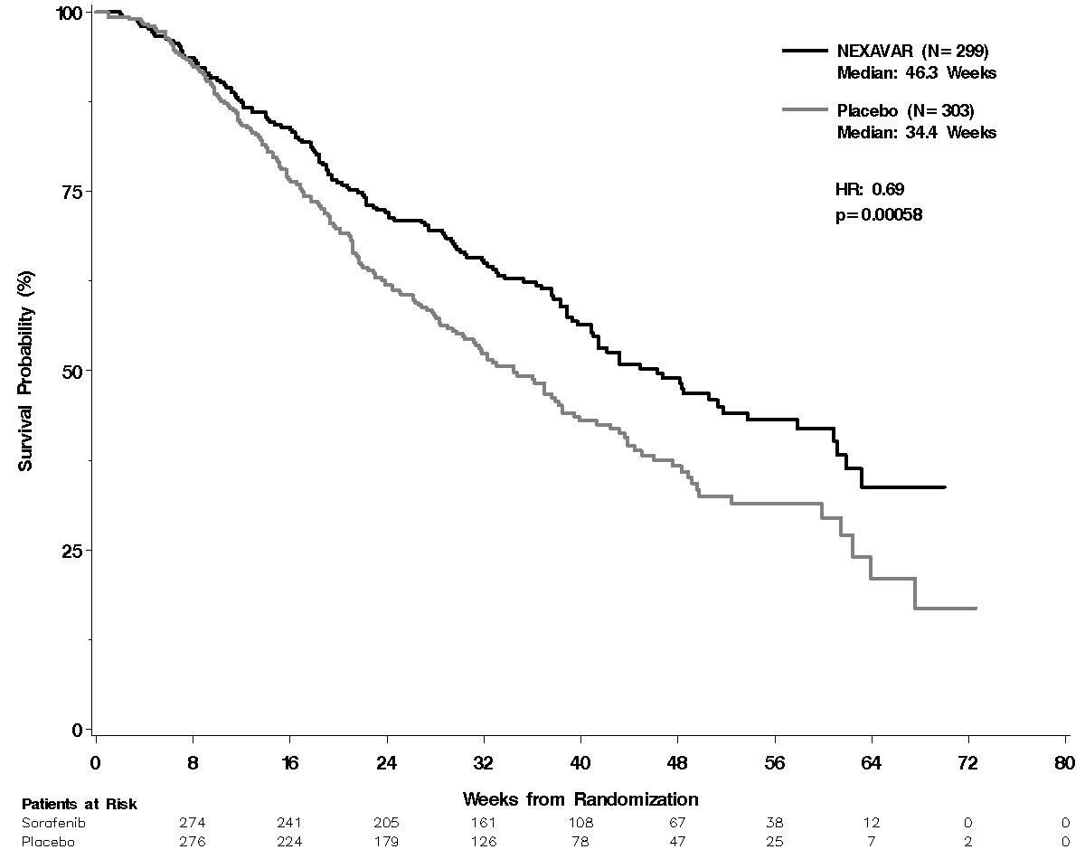
Figure 1: Kaplan-Meier curve of overall survival in Study 100554, intent-to-treat population)

Renal Cell Carcinoma

Study 11213, TARGET (Treatment Approaches in Renal cancer Global Evaluation Trial)
The TARGET study was a Phase III multi-centre, randomised, double blind, placebo-controlled trial in 903 patients with advanced renal cell carcinoma who had received prior systemic therapy. Primary study end points included overall survival and progression free survival (PFS). Tumour response rate was a secondary endpoint.

Patients were randomised to NEXAVAR 400 mg twice daily (N = 451) or to placebo (N = 452). Baseline demographics and patient characteristics were well balanced for both treatment groups. Approximately half of the patients had an ECOG performance status of 0 and half of the patients were in the low MSKCC (Memorial Sloan Kettering Cancer Centre) prognostic group.

Two planned interim analyses of survival were conducted. In the first analysis based on 220 deaths, there was an estimated 39% improvement in overall survival for patients receiving NEXAVAR vs. placebo. The estimated hazard ratio (risk of death with NEXAVAR compared to placebo) was 0.72 (95% CI: 0.55-0.95; p = 0.018. The threshold for statistical significance of the interim analysis was p < 0.0005). As of 30 November 2005, 367 deaths were reported, comprising 68% of the protocol-specified 540 survival events, there was an estimated 30% improvement in overall survival for patients receiving NEXAVAR compared to placebo. A total of 216 placebo patients had crossed over to NEXAVAR treatment. The median overall survival for the NEXAVAR and placebo group was 19.3 months and 15.9 months, respectively. The estimated hazard ratio (risk of death with sorafenib compared to placebo) was 0.77 (95% CI: 0.63-0.95; p = 0.015. The threshold for statistical significance of the interim analysis was p < 0.0094).
Progression free survival in the intent-to-treat population was evaluated by blinded independent radiological review using RECIST criteria. Figure 2 depicts Kaplan-Meier curves for PFS. The PFS analysis was a two-sided Log-Rank test stratified by Motzer/MSKCC prognostic risk category and country.
Figure 2: Kaplan-Meier Curves for Progression Free Survival
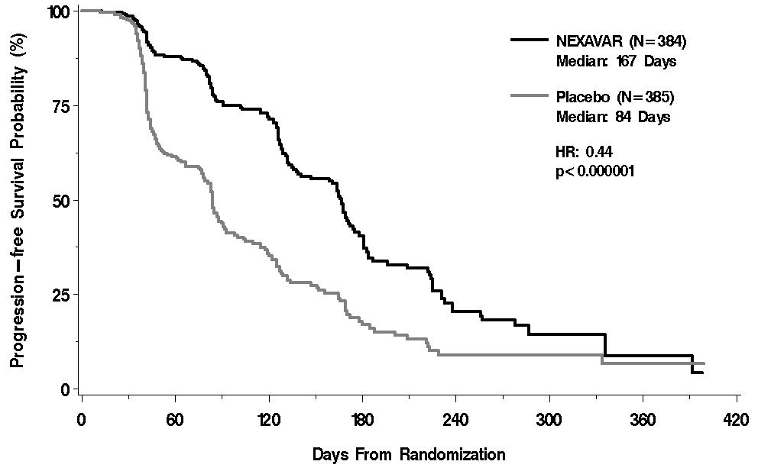
NOTE: HR is from Cox regression model with the following covariates: Motzer/MSKCC prognostic risk category¹ and country.
P-value is from two-sided Log-Rank test stratified by Motzer/MSKCC prognostic risk category¹ and country.

The PFS analysis included 769 patients randomised to NEXAVAR 400 mg twice daily (N = 384) or to placebo (N = 385). The median PFS was double for patients randomised to NEXAVAR (167 days) compared to patients randomised to placebo (84 days), representing a 56% reduction in risk of progression for patients receiving NEXAVAR compared to placebo. (HR: 0.44; 95% CI: 0.35-0.55; p < 0.000001)

A series of patient subsets were examined in exploratory univariate analyses of PFS. These results are shown in Figure 3. The effect of NEXAVAR on PFS was consistent across these subsets, including patients with no prior IL-2 or Interferon therapy (N = 137), for whom the median PFS was 172 days on NEXAVAR compared to 85 days on placebo.

Figure 3: Progression Free Survival in Patient Subgroups (Hazard Ratio and 95% CI for NEXAVAR : Placebo)

Best overall tumour response was determined by investigator radiological review according to RECIST criteria. In the NEXAVAR group 1 patient (0.2%) had a complete response, 43 patients (9.5%) had a partial response, and 333 patients (73.8%) had stable disease. In the placebo group 0 patients (0%) had a complete response, 8 patients (1.8%) had a partial response, and 239 patients (52.9%) had stable disease.

Overall, 293 patients in the NEXAVAR group and 281 patients in the placebo group had at least one post-baseline radiographic tumour evaluation available for independent review; tumour shrinkage was reported in 74% of patients receiving NEXAVAR compared to 20% of patients in the placebo group (see Figure 4).
Figure 4: Maximum Percent Reduction of Target Lesions by Patient, Using Independent Review of Scans in the TARGET Study
*
* Maximum percentage reduction in tumour burden from baseline for individual patients, each of whom is represented by a bar on the graph. Bars pointing in the positive direction of the Y axis represent patients whose tumours grew, while bars pointing in the negative direction represent patients with tumour shrinkage.

NEXAVAR demonstrated no overall deterioration in kidney-cancer specific symptoms (FKSI-10) or health-related quality of life compared to placebo.

Study 100391
Study 100391 was a Phase II discontinuation trial in patients with metastatic malignancies including RCC. The primary endpoint was percentage of randomised patients (N = 65) remaining progression free at 24 weeks. Progression free survival was significantly longer in the NEXAVAR group (163 days) than in the placebo group (41 days) (p = 0.0001; HR = 0.29). The progression free rate was significantly higher in patients randomised to NEXAVAR (50%) than in the placebo patients (18%) (p = 0.0077).

Differentiated thyroid carcinoma
Study 14295, a Phase III, international, multi-centre, randomised, double blind, placebo-controlled trial included 417 patients with locally advanced or metastatic differentiated thyroid carcinoma refractory to radioactive iodine.
Progression-free survival (PFS) was the primary endpoint of the study. Secondary endpoints included overall survival (OS), tumor response rate and duration of response. Following progression, patients were allowed to receive open label NEXAVAR. Concomitant radioactive iodine treatment was not permitted.
Patients were included in the study if they experienced progression within 14 months of enrollment and had differentiated thyroid carcinoma (DTC) refractory to radioactive iodine (RAI). DTC refractory to RAI was defined as having a lesion without iodine uptake on a radioactive iodine (RAI) scan, or receiving cumulative RAI ≥ 600 mCi, or experiencing progression after a RAI treatment within 16 months of enrollment or after two RAI treatments within 16 months of each other.
Baseline demographics and patient characteristics were well balanced for both treatment groups. Metastases were present in the lungs in 86%, lymph node in 51% and bone in 27% of the patients. Almost all patients had thyroidectomy (99.5%) and had a median delivered cumulative radioactive activity of approximately 400 mCi. The majority of patients had papillary carcinoma (56.8%), followed by follicular (25.4%) and poorly differentiated carcinoma (9.6%).
The full analysis set included 207 patients randomised to NEXAVAR 400 mg twice daily and 210 patients randomised to placebo. PFS was evaluated by blinded independent radiological review using RECIST criteria.
Median PFS was 329 days (10.8 months) in the NEXAVAR group compared to 175 days (5.8 months) in the placebo group. (HR): 0.587; 95% Confidence Interval (CI): 0.454-0.758; one-sided p <0.0001). (Table 2, Figure 5)
The effect of NEXAVAR on PFS was consistent across all subsets including geographic region, age above or below 60 years, gender, histological subtype, tumor burden and presence or absence of bone metastasis.
There was no statistical difference in overall survival between the treatment groups (the HR was 0.802; 95% CI: 0.539- 1.194; one-sided p value of 0.138, Table 2). The median OS was not reached for either arm. One hundred fifty (71.4%) patients randomised to placebo and 55 (26.6%) patients randomised to NEXAVAR received open-label NEXAVAR.
The median duration of therapy in the double-blind period was 46 weeks (range 0.3-135) for patients receiving NEXAVAR and 28 weeks (range 1.7–132) for patients receiving placebo.
No complete response (CR) according to RECIST were observed. The overall response rate (CR + partial response (PR) per independent radiological assessment was higher in the NEXAVAR group (24 patients, 12.2%) than in the placebo group (1 patient, 0.5%), one-sided p<0.0001. The median duration of response was 309 days (95% CI: 226- 505 days) in NEXAVAR treated patients who experienced a PR.

Table 2: Efficacy Results from Study 14295 in Differentiated Thyroid Carcinoma
Efficacy Parameter | NEXAVAR  (N=207) | Placebo  ( N=210) | P-value | HR  (95% CI)
Progression-Free Survival (PFS) [median, days (95% CI)]* | 329  (278, 393) | 175  (160, 238) | <0.0001 | 0.587  (0.454-0.758)
Overall Survival (OS) [median, days (95% CI)] | NR | NR | 0.1381 | 0.802  (0.539-1.194)
NR = Not reached CI=Confidence interval, HR=Hazard ratio (NEXAVAR over placebo)
*independent radiological review
Figure 5: Kaplan-Meier curve of Progression-Free Survival (PFS) in Study 14295 Thyroid carcinoma (full analysis set)
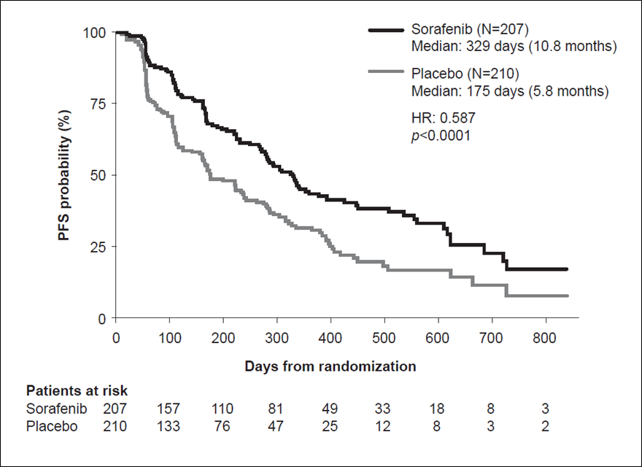

INDICATIONS

Hepatocellular carcinoma
NEXAVAR is indicated for the treatment of patients with advanced hepatocellular carcinoma.

Renal cell carcinoma
NEXAVAR is indicated for the treatment of patients with advanced renal cell carcinoma.

Differentiated Thyroid carcinoma
NEXAVAR is indicated for the treatment of patients with locally advanced or metastatic, progressive, differentiated thyroid carcinoma refractory to radioactive iodine.

CONTRAINDICATIONS
NEXAVAR is contraindicated in patients with known severe hypersensitivity to sorafenib or any of the excipients in the tablet.

PRECAUTIONS

Pregnancy and Lactation
Women should avoid becoming pregnant while on therapy. Women of childbearing potential must be apprised of the potential hazard to the fetus, which includes severe malformation (teratogenicity), failure to thrive and fetal death (embryotoxicity). (See Use in Pregnancy).

NEXAVAR should not be used during pregnancy. Breastfeeding should be discontinued during NEXAVAR therapy. (See Use in Lactation).

Effects on ability to drive and use machines
No studies on the effects of sorafenib on the ability to drive or use machines have been performed. There is no evidence that sorafenib affects the ability to drive or operate machinery.

Dermatological toxicities
Hand foot skin reaction (palmar plantar erythrodysaesthesia) and rash represent the most common adverse drug reactions with NEXAVAR. Rash and hand foot skin reaction are usually CTC (National Cancer Institute Common Toxicity Criteria) Grade 1 and 2 and generally appear during the first six weeks of treatment with NEXAVAR. Management of dermatologic toxicities may include topical therapies for symptomatic relief, temporary treatment interruption and/or dose modification of NEXAVAR, or in severe or persistent cases, permanent discontinuation of NEXAVAR (see ADVERSE EFFECTS).

Hypertension
An increased incidence of hypertension was observed in NEXAVAR-treated patients. Hypertension was usually mild to moderate, occurred early in the course of treatment, and was amenable to management with standard antihypertensive therapy. Blood pressure should be monitored regularly and treated, if required, in accordance with standard medical practice. In cases of severe or persistent hypertension, or hypertensive crisis despite adequate antihypertensive therapy, permanent discontinuation of NEXAVAR should be considered (see ADVERSE EFFECTS).

Haemorrhage
An increase in the risk of bleeding may occur following NEXAVAR administration. The incidence of severe bleeding events is uncommon. If any bleeding event necessitates medical intervention, it is recommended that permanent discontinuation of NEXAVAR should be considered (see ADVERSE EFFECTS). Due to the potential risk of bleeding, tracheal, bronchial, and oesophageal infiltration should be treated with localised therapy prior to administering NEXAVAR in patients with differentiated thyroid carcinoma.

Warfarin
Infrequent bleeding events or elevations in the International Normalized Ratio (INR) have been reported in some patients taking warfarin while on NEXAVAR therapy. Patients taking warfarin concomitantly should be monitored regularly for changes in prothrombin time, INR and for clinical bleeding episodes (see ADVERSE EFFECTS).

Wound Healing Complications
No formal studies of the effect of NEXAVAR on wound healing have been conducted. In patients undergoing major surgical procedures, temporary interruption of NEXAVAR therapy is recommended for precautionary reasons. There is limited clinical experience regarding the timing of reinitiation of therapy following major surgical intervention. Therefore, the decision to resume NEXAVAR therapy following a major surgical intervention should be based on clinical judgment of adequate wound healing.

Additional information on sorafenib combinations in 1st line NSCLC
Higher mortality has been reported in patients with squamous cell carcinoma of the lung treated with sorafenib in combination with platinum-based chemotherapies. In two randomised trials investigating patients with non-small cell lung cancer in the subgroup of patients with squamous cell carcinoma treated with sorafenib as add-on to paclitaxel/carboplatin, the HR for overall survival was found to be 1.81 (95% CI 1.19; 2.74) and as add-on to gemcitabine/cisplatin 1.22 (95% CI 0.82; 1.80). No single cause of death dominated, but higher incidence of respiratory failure, hemorrhages and infectious adverse events were observed in patients treated with sorafenib as add-on to platinum-based chemotherapies.

Cardiac ischemia and/or infarction
In Study 11213, the incidence of treatment-emergent cardiac ischaemia/infarction events was higher in the NEXAVAR group (4.9%) compared with the placebo group (0.4%). In Study 100554, the incidence of treatment-emergent cardiac ischaemia/infarction events was 2.7% in sorafenib patients compared with 1.3% in the placebo group. Patients with unstable coronary artery disease or recent myocardial infarction were excluded from these studies. Temporary or permanent discontinuation of NEXAVAR should be considered in patients who develop cardiac ischaemia and/or infarction (see ADVERSE EFFECTS).

QT interval prolongation
NEXAVAR has been shown to prolong the QT/QTc interval (see PHARMACOLOGY), which may lead to an increased risk for ventricular arrhythmias. Use NEXAVAR with caution in patients who have, or may develop prolongation of QTc, such as patients with a congenital long QT syndrome, patients treated with a high cumulative dose of anthracycline therapy, patients taking certain anti-arrhythmic medicines or other medicinal products that lead to QT prolongation, and those with electrolyte disturbances such as hypokalemia, hypocalcaemia, or hypomagnesemia. When using NEXAVAR in these patients, periodic monitoring with on-treatment electrocardiograms and electrolytes (magnesium, potassium, calcium) should be considered.

Gastrointestinal perforation
Gastrointestinal perforation is an uncommon event and has been reported in less than 1% of patients taking NEXAVAR. In some cases this was not associated with apparent intra-abdominal tumour. NEXAVAR therapy should be discontinued.

Hepatic impairment
No data is available on patients with Child-Pugh C (severe) hepatic impairment. Since sorafenib is mainly eliminated via the hepatic route, exposure might be increased in patients with severe hepatic impairment (see Pharmacokinetics).

Hypocalcaemia
When using NEXAVAR in patients with differentiated thyroid carcinoma, close monitoring of blood calcium level is recommended. In clinical trials, hypocalcaemia was more frequent and more severe in patients with differentiated thyroid carcinoma, especially with a history of hypoparathyroidism, compared to patients with renal cell or hepatocellular carcinoma. (see section ADVERSE EFFECTS)

TSH Suppression in Differentiated Thyroid Carcinoma (DTC)
In the DTC clinical trials, increases in TSH levels above 0.5mU/L were observed in NEXAVAR treated patients. When using NEXAVAR in differentiated thyroid carcinoma patients, close monitoring of TSH level and appropriate adjustment of thyroxine dosing is recommended.

Effects on fertility
No specific studies with NEXAVAR have been conducted in animals to evaluate the effect on fertility. An adverse effect on male and female fertility is expected, however, based on histological changes in reproductive organs observed in repeat-dose studies in animals. Sorafenib caused testicular tubular degeneration and oligospermia in mice, rats, and dogs at daily doses producing plasma exposures approximately 0.9-, 1.5- and 0.3-times respectively that expected in patients (based on relative AUC for unbound sorafenib). Retardation of prostatic and seminal vesicle development were also observed in rats. In female mice and rats, arrested follicular development in the ovaries was observed following treatment with sorafenib at doses producing exposure levels 0.7-0.9 times that expected in patients.

Use in pregnancy
Pregnancy Category D
There are no adequate and well-controlled studies in pregnant women using NEXAVAR. Sorafenib has been shown to be embryotoxic and teratogenic when administered to rats and rabbits. Observed effects included decreases in maternal and fetal body weights, an increased number of fetal resorptions and an increased number of skeletal and visceral malformations. Adverse fetal outcomes were observed at an oral dose of 1 mg/kg/day in rats (relative exposure, 0.08) and 3 mg/kg/day in rabbits (relative exposure, 0.4). In rats, sorafenib and/or its metabolites were demonstrated to cross the placenta. NEXAVAR therapy in pregnant patients is anticipated to inhibit angiogenesis in the fetus.

NEXAVAR should not be used during pregnancy. Women must be advised to avoid becoming pregnant while on therapy. If NEXAVAR is used during pregnancy or if the patient becomes pregnant while using NEXAVAR, the patient must be apprised of the potential hazard to the fetus, which includes severe malformation (teratogenicity), failure to thrive and fetal death (embryotoxicity). Adequate contraception should be used during therapy and for at least 2 weeks after completion of therapy.

Use in lactation
It is not known whether NEXAVAR is excreted in human milk. In lactating rats, sorafenib and/or its metabolites were readily excreted in milk (milk: plasma AUC ratio of approximately 5:1). Because of the potential for excretion in human milk and the likelihood that infants will be particularly sensitive to the toxic effects of sorafenib, women must be advised to discontinue breastfeeding during NEXAVAR treatment.

Paediatric use
The safety and effectiveness of NEXAVAR in paediatric patients has not been established.

Effects on bone and teeth were observed after repeated dosing to young and growing dogs. The changes consisted of irregular thickening of the femoral growth plate at a dose of 30 mg/kg/day (relative exposure 0.5 based on relative AUC for unbound drug), hypocellularity of the bone marrow at 10 mg/kg/day (relative exposure, 0.25) and alteration of dentin composition at 30 mg/kg/day (relative exposure, 0.3). Similar effects were observed in mice and rats. A study in adult dogs revealed no effects on teeth and minimal effects on bone marrow.

Carcinogenicity
Carcinogenicity studies have not been performed with sorafenib.

Genotoxicity
Sorafenib has been tested for genotoxicity in a series of in vitro (bacterial mutation and mammalian chromosomal aberration) and in vivo (mouse micronucleus test) assays. Sorafenib did not cause genetic damage in the bacterial reverse mutation and mouse micronucleus tests. Weak clastogenicity was displayed by sorafenib in the in vitro mammalian chromosomal aberration assay (using Chinese Hamster lung cells) in the presence of metabolic activation but only at cytotoxic concentrations. An impurity in the final drug substance (< 0.15%), picolinamide phenylether (PAPE), was mutagenic in the bacterial reverse mutation assay.

Effect on laboratory tests

Laboratory test abnormalities in RCC patients (study 11213)
Elevated lipase and amylase levels were very commonly reported. In the TARGET Study CTC AE grade 3 or 4 lipase elevations occurred in 10% of patients in the NEXAVAR group compared to 5% of patients in the placebo group. CTC AE grade 3 or 4 amylase elevations were reported in 1% of patients in the NEXAVAR group compared to 3% of patients in the placebo group. Clinical pancreatitis was reported in 2 of 384 NEXAVAR treated patients (CTC AE grade 4) and 1 of 384 patients (CTC AE grade 2) in the placebo group.

Hypophosphataemia was a common laboratory finding, observed in 45% of sorafenib treated patients compared to 11% of placebo patients. CTCAE grade 3 hypophosphataemia (10-20 mg/L) occurred in 13% on sorafenib treated patients and 3% of patients in the placebo group. There were no cases of CTCAE grade 4 hypophosphataemia (< 10 mg/L) reported in either sorafenib or placebo patients. The aetiology of hypophosphataemia associated with sorafenib is not known.

Laboratory abnormalities in HCC patients (study 100554)
Elevated lipase was observed in 40% of patients treated with NEXAVAR compared to 37% of patients in the placebo group. CTCAE Grade 3 or 4 lipase elevations occurred in 9% of patients in each group. Elevated amylase was observed in 34% of patients treated with NEXAVAR compared to 29% of patients in the placebo group. CTCAE Grade 3 or 4 amylase elevations were reported in 2% of patients in each group. Many of the lipase and amylase elevations were transient, and in the majority of cases NEXAVAR treatment was not interrupted. Clinical pancreatitis was reported in 1 of 297 NEXAVAR-treated patients (CTCAE Grade 2).

Hypophosphataemia was a common laboratory finding, observed in 35% of sorafenib treated patients compared to 11% of placebo patients; CTCAE Grade 3 hypophosphataemia (10-20 mg/L) occurred in 11% of sorafenib treated patients and 2% of patients in the placebo group; there was 1 case of CTCAE Grade 4 hypophosphataemia (< 10 mg/L) reported in the placebo group. The aetiology of hypophosphataemia associated with sorafenib is not known.
Laboratory test abnormalities in thyroid carcinoma patients (study 14295)
Hypocalcaemia was reported in 35.7% of sorafenib treated patients compared to 11.0% of the patients in the placebo group. Most reports of hypocalcaemia were low grade. CTCAE grade 3 hypocalcaemia occurred in 6.8% of sorafenib treated patients and 1.9% of patients in the placebo group, and CTCAE grade 4 hypocalcaemia occurred in 3.4% of sorafenib treated patients and 1.0% of patients in the placebo group.

Interactions with Other Medicines
Sorafenib is metabolised primarily in the liver, undergoing oxidative metabolism mediated by CYP3A4, as well as glucuronidation mediated by UGT1A9. Studies with human liver microsomes demonstrated that sorafenib is a competitive inhibitor of CYP2B6, CYP2C8, and CYP2C9 (K_{i} = 1-8 µM).

Caution is recommended when administering NEXAVAR together with compounds that are metabolised / eliminated predominantly by the UGT1A1 pathway (e.g. irinotecan). In vitro data show that sorafenib inhibits glucuronidation by the UGT1A1 (K_{i} = 1 μM) and UGT1A9 (K_{i} = 2 μM) pathways. Concomitant clinical administration of sorafenib with irinotecan, whose active metabolite SN-38 is further metabolised by the UGT1A1 pathway, resulted in a 67-120% increase in the AUC of SN-38. Systemic exposure to substrates of UGT1A1 and UGT1A9 may be increased when co-administered with sorafenib.

CYP inducers:
CYP1A2, 2A6, 2B6, 2C9, 2C19 and CYP3A4 activities were not altered after treatment of cultured human hepatocytes with sorafenib, indicating that sorafenib is unlikely to be an inducer of these enzymes. Continuous concomitant clinical administration of sorafenib and rifampicin resulted in an average 37% reduction of sorafenib AUC. Other inducers of CYP3A4 activity (e.g. Hypericum perforatum also known as St. John’s wort, phenytoin, carbamazepine, phenobarbital, and dexamethasone) may also increase metabolism of NEXAVAR and thus decrease NEXAVAR concentrations.

CYP3A4 inhibitors:
Ketoconazole (400 mg), a potent inhibitor of CYP3A4 and P-glycoprotein, administered once daily for 7 days to healthy male volunteers did not alter the mean AUC of a single 50 mg dose of NEXAVAR. Therefore, clinical pharmacokinetic interactions of NEXAVAR with CYP3A4 inhibitors are unlikely.

CYP2C9 substrates:
In vitro studies with human liver microsomes demonstrated that sorafenib is a competitive inhibitor of CYP2C9 with a K_{i} value of 7-8 µM. The possible effect of sorafenib on warfarin, a CYP2C9 substrate, was assessed in vivo in NEXAVAR-treated patients compared to placebo treated patients. The concomitant treatment with NEXAVAR and warfarin did not result in changes in mean PT-INR compared to placebo suggesting that NEXAVAR may not be an in vivo inhibitor of CYP2C9. However, patients taking warfarin should have their INR checked regularly.

CYP isoform-selective substrates:
Concomitant clinical administration of midazolam, dextromethorphan and omeprazole, which are substrates of cytochromes CYP3A4, CYP2D6 and CYP2C19, respectively, following 4 weeks of NEXAVAR administration did not alter the exposure of these agents. This indicates that NEXAVAR is neither an inhibitor nor an inducer of these cytochrome P450 isoenzymes.

Sorafenib inhibits CYP2C8 and CYP2B6 in vitro with K_{i} values of 1-2 and 6µM, respectively. Concomitant clinical administration of sorafenib with paclitaxel resulted in an increase, instead of a decrease, in the exposure of 6-OH paclitaxel, the active metabolite of paclitaxel that is formed by CYP2C8. These data suggest that sorafenib may not be an in vivo inhibitor of CYP2C8. Concomitant clinical administration of sorafenib with cyclophosphamide resulted in a small decrease in cyclophosphamide exposure, but no decrease in the systemic exposure of 4-OH cyclophosphamide, the active metabolite of cyclophosphamide that is formed primarily by CYP2B6. These data suggest that sorafenib may not be an in vivo inhibitor of CYP2B6.

P-glycoprotein substrates
Sorafenib inhibited P-glycoprotein in vitro. Sorafenib could increase the concentrations of concomitantly administered drugs that are P-glycoprotein substrates.

Combination with other anti-neoplastic agents:
In clinical studies, NEXAVAR has been administered together with a variety of other anti-neoplastic agents at their commonly used dosing regimens, including gemcitabine, cisplatin, cyclophosphamide, oxaliplatin, paclitaxel, carboplatin, capecitabine, doxorubicin, irinotecan, and docetaxel. NEXAVAR had no clinically relevant effect on the pharmacokinetics of cisplatin, gemcitabine or oxaliplatin.

Paclitaxel/Carboplatin

Administration of paclitaxel (225 mg/m²) and carboplatin (AUC = 6) with sorafenib (≤ 400 mg twice daily), administered with a 3-day break in sorafenib dosing around administration of paclitaxel/carboplatin, resulted in no significant effect on the pharmacokinetics of paclitaxel.

Co-administration of paclitaxel (225 mg/m², once every 3 weeks) and carboplatin (AUC = 6) with sorafenib (400 mg twice daily, without a break in sorafenib dosing) resulted in a 47% increase in sorafenib exposure, a 29% increase in paclitaxel exposure and a 50% increase in 6-OH paclitaxel exposure. The pharmacokinetics of carboplatin were unaffected.

These data indicate no need for dose adjustments when paclitaxel and carboplatin are co-administered with sorafenib with a 3-day break in sorafenib dosing. The clinical significance of the increases in sorafenib and paclitaxel exposure, upon co-administration of sorafenib without a break in dosing, is unknown.

Capecitabine

Co-administration of capecitabine (750-1050 mg/m² twice daily, days 1-14 every 21 days) and sorafenib (200 or 400 mg twice daily, continuous uninterrupted administration) resulted in no significant change in sorafenib exposure, but a 15-50% increase in capecitabine exposure and a 0-52% increase in 5-FU exposure. The clinical significance of these small to modest increases in capecitabine and 5-FU exposure when co-administered with sorafenib is unknown.

Cyclophosphamide

Concomitant administration with NEXAVAR resulted in a 37% increase in the AUC of 4-OH cyclophosphamide, the active metabolite of cyclophosphamide. The clinical significance of this finding is unknown.

Doxorubicin/Irinotecan

Concomitant treatment with NEXAVAR resulted in a 21% increase in the AUC of doxorubicin. When administered with irinotecan, whose active metabolite SN-38 is further metabolized by the UGT1A1 pathway, there was a 67-120% increase in the AUC of SN-38 and a 26-42% increase in the AUC of irinotecan. The clinical significance of these findings is unknown (see PRECAUTIONS).

Docetaxel
Docetaxel (75 or 100 mg/m² administered once every 21 days) when co-administered with sorafenib (200 mg twice daily or 400 mg twice daily administered on days 2 through 19 of a 21-day cycle) with a 3-day break in dosing around administration of docetaxel, resulted in a 36-80% increase in docetaxel AUC and a 16-32% increase in docetaxel C_{max}. Caution is recommended when NEXAVAR is co-administered with docetaxel.

Combination with other agents:
Neomycin
Co-administration of neomycin, a non-systemic antimicrobial agent used to eradicate GI flora, interferes with the enterohepatic recycling of sorafenib (see Pharmacokinetics, Metabolism and Elimination), resulting in decreased sorafenib exposure. In healthy volunteers treated with a 5-day regimen of neomycin the average bioavailability of sorafenib decreased by 54%. The clinical significance of these findings is unknown. Effects of other antibiotics have not been studied, but will likely depend on their ability to decrease glucuronidase activity.

ADVERSE EFFECTS
The most common adverse reactions were diarrhoea, fatigue, alopecia, infection, rash,andhand-foot skin reaction (corresponds to palmar plantar erythrodysaesthesia syndrome in MedDRA).

Hepatocellular carcinoma
Table3. Adverse reactions reported in at least 5% of patients in any treatment group – Study 100554 in hepatocellular carcinoma (see CLINICAL TRIALS).

System organ class/  Preferred term | Nexavar N = 297 |  |  | Placebo N = 302
System organ class/  Preferred term | all grades  % | grade 3  % | grade 4  % | all grades  % | grade 3  % | grade 4  %
Metabolism and Nutrition Disorders
anorexia | 11 | <1 | 0 | 3 | <1 | 0
Gastrointestinal Disorders
diarrhoea | 39 | 8 | 0 | 11 | 2 | 0
nausea | 11 | <1 | 0 | 8 | 1 | 0
abdominal pain | 7 | 2 | 0 | 3 | <1 | 0
vomiting | 5 | 1 | 0 | 3 | <1 | 0
Skin and Subcutaneous Tissue Disorders
hand foot skin reaction ** | 18 | 7 | 0 | 2 | 0 | 0
alopecia | 14 | 0 | 0 | 2 | 0 | 0
rash | 11 | <1 | 0 | 8 | 0 | 0
pruritus | 8 | 0 | 0 | 7 | <1 | 0
dry skin | 8 | 0 | 0 | 4 | 0 | 0
General Disorders and Administration Site conditions
fatigue | 17 | 2 | <1 | 13 | 3 | <1
asthenia | 6 | 1 | <1 | 2 | <1 | 0
Investigations
weight decreased | 9 | 2 | 0 | <1 | 0 | 0
Respiratory, Thoracic and Mediastinal Disorders
hoarseness | 5 | 0 | 0 | <1 | 0 | 0
** palmar plantar erythrodysaesthesia syndrome in MedDRA

Renal cell carcinoma
The overall safety profile of NEXAVAR is based on 1286 cancer patients, who received NEXAVAR as single agent.

Table4. Adverse reactions reported in at least 5% of patients in any treatment group – Study 11213 in renal cell carcinoma (see CLINICAL TRIALS)

System Organ Class/ Preferred term | Nexavar N = 451 |  |  | Placebo N = 451
System Organ Class/ Preferred term | All Grades  % | Grade 3  % | Grade 4  % | All Grades  % | Grade 3  % | Grade 4  %
Metabolism and Nutrition Disorders
anorexia | 9 | <1 | 0 | 5 | <1 | 0
Nervous System Disorders
headache | 6 | 0 | 0 | 3 | 0 | 0
Vascular Disorders
hypertension | 12 | 2 | <1 | 1 | <1 | 0
flushing | 6 | 0 | 0 | 2 | 0 | 0
Gastrointestinal Disorders
diarrhoea | 38 | 2 | 0 | 9 | <1 | 0
nausea | 16 | <1 | 0 | 12 | <1 | 0
vomiting | 10 | <1 | 0 | 6 | <1 | 0
constipation | 6 | 0 | 0 | 3 | 0 | 0
Skin and Subcutaneous Tissue Disorders
rash | 28 | <1 | 0 | 9 | <1 | 0
alopecia | 25 | <1 | 0 | 3 | 0 | 0
hand foot skin reaction ** | 19 | 4 | 0 | 3 | 0 | 0
pruritis | 17 | <1 | 0 | 4 | 0 | 0
erythema | 15 | 0 | 0 | 4 | 0 | 0
dry skin | 11 | 0 | 0 | 2 | 0 | 0
skin exfoliation | 7 | <1 | 0 | 2 | 0 | 0
Musculoskeletal, Connective Tissue and Bone Disorders
arthralgia | 6 | <1 | 0 | 3 | 0 | 0
pain in extremity | 6 | <1 | 0 | 2 | 0 | 0
General Disorders and Administration Site Conditions
fatigue | 15 | 2 | 0 | 11 | <1 | 0
asthenia | 9 | <1 | 0 | 4 | <1 | 0
** palmar plantar erythrodysaesthesia syndrome in MedDRA

Differentiated thyroid carcinoma
Adverse Reactions in Differentiated Thyroid Carcinoma study 14295: double blind period
Table 5 shows the percentage of differentiated thyroid carcinoma patients experiencing adverse reactions (TEAE – treatment emergent adverse events) that were reported in at least 5% of patients and at a higher rate in the NEXAVAR treated subjects than the placebo arm in double blind phase. Grade 3 adverse reactions were reported in 53% of patients receiving NEXAVAR compared to 23% of patients receiving placebo. Grade 4 adverse reactions were reported in 12% of patients receiving NEXAVAR compared to 7% of patients receiving placebo.
Table 5. Adverse reactions reported in at least 5% of patients treated with NEXAVAR and more commonly than in patients receiving placebo – Study 14295 in differentiated thyroid carcinoma (double blind period, safety analysis set) - see CLINICAL TRIALS
System Organ Class/ Preferred term | NEXAVAR N = 207 |  |  | Placebo N = 209
System Organ Class/ Preferred term | All Grades  % | Grade 3  % | Grade 4  % | All Grades  % | Grade 3  % | Grade 4  %
Metabolism and Nutrition Disorders
anorexia | 30.4 | 1.9 | 0 | 4.8 | 0 | 0
hypocalcaemia | 16.4 | 5.8 | 2.9 | 4.8 | <1 | 1.0
hypokalaemia | 6.8 | 1.4 | 0 | 2.4 | 0 | 0
Nervous System Disorders
headache | 16.9 | 0 | 0 | 6.2 | 0 | 0
paraesthesia | 7.2 | <1 | 0 | 2.9 | 0 | 0
dizziness | 6.3 | 0 | 0 | 2.4 | 0 | 0
dysgeusia | 5.8 | 0 | 0 | 0 | 0 | 0
Vascular Disorders
hypertension | 38.2 | 9.2 | 0 | 11.0 | 1.9 | 0
Gastrointestinal Disorders
diarrhoea | 67.6 | 5.3 | <1 | 14.8 | 1.0 | 0
nausea | 20.8 | 0 | 0 | 11.5 | 0 | 0
constipation | 15.5 | 0 | 0 | 7.7 | <1 | 0
vomiting | 11.1 | <1 | 0 | 5.7 | 0 | 0
stomatitis | 11.1 | <1 | 0 | 2.4 | 0 | 0
abdominal pain | 10.6 | 1.0 | 0 | 2.9 | <1 | 0
abdominal pain upper | 8.7 | <1 | 0 | 3.8 | <1 | 0
dry mouth | 7.7 | 0 | 0 | 3.8 | 0 | 0
dyspepsia | 5.3 | 0 | 0 | 4.3 | 0 | 0
dysphagia | 5.3 | 1.4 | 0 | 2.9 | 1.0 | 0
Skin and Subcutaneous Tissue Disorders
hand foot skin reaction ** | 69.1 | 19.3 | 0 | 7.7 | 0 | 0
alopecia | 66.7 | 0 | 0 | 7.7 | 0 | 0
rash | 35.3 | 4.8 | 0 | 7.2 | 0 | 0
pruritis | 20.3 | <1 | 0 | 10.5 | 0 | 0
dry skin | 13.0 | <1 | 0 | 4.8 | 0 | 0
erythema | 10.1 | 0 | 0 | <1 | 0 | 0
hyperkeratosis | 7.2 | 0 | 0 | 0 | 0 | 0
Respiratory, thoracic and mediastinal dosorders
cough | 15.0 | 0 | 0 | 13.9 | 0 | 0
dysphonia | 12.6 | <1 | 0 | 3.3 | 0 | 0
dyspnoea | 12.1 | 4.3 | 0 | 10.5 | 2.4 | 1.0
oropharyngeal pain | 9.2 | 0 | 0 | 2.9 | 0 | 0
epistaxis | 7.2 | 0 | 0 | 1.0 | 0 | 0
Musculoskeletal, Connective Tissue and Bone Disorders
pain in extremity | 14.5 | 1.0 | 0 | 6.7 | 0 | 0
arthralgia | 10.1 | 0 | 0 | 7.7 | 1.4 | 0
muscle spasms | 10.1 | 0 | 0 | 2.9 | 0 | 0
Blood and lymphatic system disorders
anaemia | 5.3 | 1.0 | 0 | 3.8 | <1 | 0
General Disorders and Administration Site Conditions
fatigue | 41.1 | 4.8 | 0 | 20.1 | 1.0 | 0
asthenia | 12.1 | 0 | 0 | 6.7 | 0 | 0
pyrexia | 10.6 | 1.0 | 0 | 4.8 | 0 | 0
mucosal inflammation | 10.1 | 1.0 | <1 | <1 | 0 | 0
chest pain | 8.2 | 0 | 0 | 2.9 | 0 | 0
nasopharyngitis | 6.8 | 0 | 0 | 5.3 | 0 | 0
urinary tract infection | 5.3 | 0 | 0 | 2.4 | 0 | 0
Investigations
weight decreased | 48.8 | 5.8 | 0 | 13.9 | 1.0 | 0
blood thyroid stimulating hormone increased* | 33.3 | 0 | 0 | 13.4 | 0 | 0
alanine aminotransferase increased | 12.6 | 2.4 | <1 | 4.3 | 0 | 0
aspartate aminotransferase increased | 11.1 | 1.0 | 0 | 2.4 | 0 | 0
* blood TSH increased was collected as an AE when TSH was >0.5 mU, as this was the target for TSH suppression in this study
** palmar plantar erythrodysaesthesia syndrome in MedDRA

Multiple Clinical Trials
Adverse reactions reported in multiple clinical trials are listed below in Table 6, by system organ class (in MedDRA) and frequency. Frequencies are defined as: very common (≥ 10%), common (≥ 1% to < 10%), uncommon (≥ 0.1% to < 1%), rare (≥ 0.01% to < 0.1%). Within each frequency grouping, undesirable effects are presented in order of decreasing seriousness.

Table 6: All Adverse Drug Reactions reported in patients in multiple clinical trials in MedDRA Coding

System Organ Class | Very Common  ≥10% | Common  ≥1% to <10% | Uncommon  ≥0.1% to <1% | Rare  ≥0.01% to <0.1%
Infections and Infestations | infection | folliculitis
Blood and Lymphatic System Disorders | lymphopenia | leucopoenia  neutropenia  anaemia  thrombocytopenia
Immune system Disorders |  |  | anaphylactic reaction hypersensitivity reactions (including skin reactions and urticaria)
Endocrine Disorders |  | hypothyroidism | hyperthyroidism
Metabolism and Nutrition Disorders | anorexia  hypophosphataemia | hypocalcaemia  hypokalemia  hyponatraemia | dehydration
Psychiatric Disorders |  | depression
Nervous System Disorders |  | peripheral sensory neuropathy  dysgeusia | reversible posterior leukoencephalopathy*
Ear and Labyrinth Disorders |  | tinnitus
Cardiac Disorders |  | congestive heart failure*  myocardial ischaemia and/or infarction* |  | QT prolongation
Vascular Disorders | haemorrhage (inc. gastrointestinal*, respiratory tract* and cerebral haemorrhage*)  hypertension | flushing | hypertensive crisis*
Respiratory, Thoracic and Mediastinal Disorders |  | rhinorrhoea  dysphonia | interstitial lung disease-like events* (includes reports of pneumonitis, radiation pneumonitis, acute respiratory distress, interstitial pneumonia, pulmonitis and lung inflammation)
Gastrointestinal Disorders | diarrhoea  nausea  vomiting  constipation | stomatitis (including dry mouth and glossodynia)  dyspepsia  dysphagia  gastrooesophageal reflux disease | pancreatitis  gastritis  gastrointestinal perforations*
Hepato-biliary Disorders |  |  | increase in bilirubin and jaundice, cholecystitis, cholangitis | drug induced hepatitis*
Skin and Subcutaneous Tissue Disorders | dry skin  rash  alopecia  hand foot skin reaction**  erythema  pruritus | keratoacanthoma/  squamous cell cancer of skin  dermatitis exfoliative  acne  skin desquamation  hyperkeratosis | eczema  erythema multiforme
Musculoskeletal, Connective Tissue and Bone Disorders | arthralgia | myalgia  muscle spasms
Renal and Genitourinary Disorders |  | renal failure  proteinuria |  | nephrotic syndrome
Reproductive System and Breast Disorders |  | erectile dysfunction | gynaecomastia
General Disorders and Administration Site Conditions | fatigue  pain (including mouth, abdominal, bone, tumour pain and headache)  fever | asthenia  influenza like illness  mucosal inflammation
Investigations | weight decreased  increased amylase increased lipase | transient increase in transaminases | transient increase in blood alkaline phosphatase  INR abnormal, prothrombin level abnormal
* The adverse reactions may have a life-threatening or fatal outcome.
** palmar plantar erythrodysaesthesia syndrome in MedDRA

Post-marketing experience

The following adverse drug reactions have been identified during post-approval use of NEXAVAR®. Because these reactions are reported voluntarily from a population of uncertain size, it is not always possible to reliably estimate their frequency or establish a causal relationship to drug exposure.

Skin and subcutaneous tissue disorders: radiation recall dermatitis, Stevens-Johnson syndrome, leukocytoclastic vasculitis, toxic epidermal necrolysis
Immune system disorders: angioedema
Musculoskeletal, Connective Tissue and Bone Disorders: rhabdomyolysis

Further information on selected adverse drug reactions

Congestive Heart Failure: In company sponsored clinical trials, congestive heart failure was reported as an adverse event in 1.9% of patients treated with sorafenib (N = 2276). In study 11213 (RCC) adverse events consistent with congestive heart failure were reported in 1.7% of those treated with sorafenib and 0.7% receiving placebo. In study 100554 (HCC), 0.99% of those treated with sorafenib and 1.1% receiving placebo were reported with these events consistent with congestive heart failure.

Additional information on special populations: In clinical trials, certain adverse drug reactions such as hand foot skin reaction, diarrhoea, alopecia, weight decrease, hypertension, hypocalcaemia, and keratoacanthoma/squamous cell carcinoma of skin occurred at a substantially higher frequency in patients with differentiated thyroid cancer compared to patients in the renal cell or hepatocellular carcinoma studies.

DOSAGE AND ADMINISTRATION

Use in adults

Recommended dose
The recommended daily dose of NEXAVAR is 400 mg (2 x 200 mg tablets) taken twice a day, either without food or together with a moderate fat meal.

Duration of treatment
Treatment should be continued until the patient is no longer clinically benefiting from therapy or until unacceptable toxicity occurs.

Dose titration, dose adjustment, special monitoring advice
Management of suspected adverse drug reactions may require temporary interruption and/or dose reduction of NEXAVAR therapy.

When dose reduction is necessary during the treatment of hepatocellular carcinoma (HCC) and advanced renal cell carcinoma (RCC), the NEXAVAR dose should be reduced to two tablets of 200 mg once daily (see PRECAUTIONS).

When dose reduction is necessary during the treatment of differentiated thyroid carcinoma, the NEXAVAR dose should be reduced to 600 mg daily in divided doses (two tablets of 200 mg and one tablet of 200 mg twelve hours apart).

If additional dose reduction is necessary, NEXAVAR may be reduced to one tablet of 200 mg twice daily, followed by one tablet of 200 mg once daily. After improvement of non-haematological adverse reactions, the dose of NEXAVAR may be increased.

Table 7 : Suggested Dose Reduction Levels for Patients with Differentiated Thyroid Carcinoma
Dose Level | Total daily dose | Dosage
0 | 800 mg daily dose | (400 mg twice daily, 2 tablets twice daily)
-1 | 600 mg daily dose | (400 mg and 200 mg 12 hours apart, 2 tablets and 1 tablet 12 hours apart – either dose can come first)
-2 | 400 mg daily dose | (200 mg twice daily, 1 tablet twice daily)
-3 | 200 mg daily dose | (200 mg once daily, one tablet once daily)

Table 8: Suggested Dose Modifications for Skin Toxicity in Patients with Differentiated Thyroid Carcinoma
Grade | Occurrence | NEXAVAR dose modification*
Grade 1 | Any | Institute supportive measures immediately and continue NEXAVAR treatment
Grade 2 | First | Institute supportive measures immediately and consider a decrease NEXAVAR dose to 600 mg daily (400 mg and 200 mg 12 hours apart)  If no improvement within 7 days, see below
 | No improvement within 7 days or second occurrence | Interrupt NEXAVAR until resolved to grade 0-1. When NEXAVAR is resumed, decrease dose by one dose level
 | Third | Interrupt NEXAVAR until resolved to grade 0-1. When NEXAVAR is resumed, decrease dose by two dose levels
 | Fourth | Discontinue NEXAVAR permanently
Grade 3 | First | Interrupt NEXAVAR until resolved to grade 0-1. When NEXAVAR is resumed, decrease dose by one dose level
 | Second | Interrupt NEXAVAR until resolved to grade 0-1. When NEXAVAR is resumed, decrease dose by two dose levels
 | Third | Discontinue NEXAVAR permanently
*For patients who require a dose reduction for Grade 2 or 3 skin toxicity, the dose of NEXAVAR may be
increased if skin toxicity improved to Grade 0-1 after at least 28 days treatment on the reduced dose of NEXAVAR

Elderly (above 65 years), Gender and Body Weight
No dose adjustment is required on the basis of patient age (above 65 years), gender, or body weight.

Use in patients with renal impairment
No dose adjustment is required in patients with mild to moderate renal impairment. NEXAVAR has not been studied in patients with severe renal impairment or patients undergoing dialysis (see PHARMACOLOGY-Pharmacokinetics-Renal Impairment).
Monitoring of fluid balance and electrolytes in patients at risk of renal dysfunction is advised.

Use in patients with hepatic impairment
No dose adjustment is required in patients with Child-Pugh A or B hepatic impairment. NEXAVAR has not been studied in patients with Child-Pugh C hepatic impairment (see PHARMACOLOGY-Pharmacokinetics-Hepatic Impairment).

Use in children
The safety and effectiveness of NEXAVAR in paediatric patients has not been established.

OVERDOSAGE
There is no specific treatment for NEXAVAR overdose.
The highest dose of NEXAVAR studied clinically is 800 mg twice daily. The adverse reactions observed at this dose were primarily diarrhoea and dermatologic events.
In the event of suspected overdose, NEXAVAR should be withheld and supportive care instituted.
For information on the management of overdose, contact the Poison Information Centre on 131126 (Australia).

PRESENTATION AND STORAGE CONDITIONS
NEXAVAR tablets contain 200 mg of sorafenib (274 mg sorafenib tosylate). The tablets are film coated red round, biconvex marked with a Bayer cross on one side and “200” on the other and supplied in packs of 120, 112, and 60 tablets (120 and 112 tablet pack sizes are not marketed in Australia).

Shelf life is 3 years when stored below 25°C.

NAME AND ADDRESS OF THE SPONSOR
Bayer Australia Ltd
ABN 22 000 138 714
875 Pacific Highway
Pymble, NSW 2073

POISON SCHEDULE of the medicine
PRESCRIPTION ONLY MEDICINE

DATE OF first inclusion in the artg
27 September 2006

Date of most recent amendment:
22 April 2014

® Registered Trademark of Bayer AG, Germany

- Motzer RJ, Bacik J, Schwartz LH, Reuter V, Russo P, Marion S et al. Prognostic factors for survival in previously treated patients with metastatic renal cell carcinoma. J Clin Oncol 2004;223:454-63

