First round CER: 6 June 2012
Second round CER: 26 September 2012

AusPAR Attachment 2

Extract from the Clinical Evaluation Report for tadalafil
  - Proprietary Product Name: Cialis
  - Sponsor: Eli Lilly Australia Pty Ltd
About the Therapeutic Goods Administration (TGA)
- The Therapeutic Goods Administration (TGA) is part of the Australian Government Department of Health and Ageing, and is responsible for regulating medicines and medical devices.
- The TGA administers the Therapeutic Goods Act 1989 (the Act), applying a risk management approach designed to ensure therapeutic goods supplied in Australia meet acceptable standards of quality, safety and efficacy (performance), when necessary.
- The work of the TGA is based on applying scientific and clinical expertise to decision-making, to ensure that the benefits to consumers outweigh any risks associated with the use of medicines and medical devices.
- The TGA relies on the public, healthcare professionals and industry to report problems with medicines or medical devices. TGA investigates reports received by it to determine any necessary regulatory action.
- To report a problem with a medicine or medical device, please see the information on the TGA website <http://www.tga.gov.au>.
About the Extract from the Clinical Evaluation Report
- This document provides a more detailed evaluation of the clinical findings, extracted from the Clinical Evaluation Report (CER) prepared by the TGA. This extract does not include sections from the CER regarding product documentation or post market activities.
- The words [Information redacted], where they appear in this document, indicate that confidential information has been deleted.
- For the most recent Product Information (PI), please refer to the TGA website <http://www.tga.gov.au/hp/information-medicines-pi.htm>.
Copyright
© Commonwealth of Australia 2013
This work is copyright. You may reproduce the whole or part of this work in unaltered form for your own personal use or, if you are part of an organisation, for internal use within your organisation, but only if you or your organisation do not use the reproduction for any commercial purpose and retain this copyright notice and all disclaimer notices as part of that reproduction. Apart from rights to use as permitted by the Copyright Act 1968 or allowed by this copyright notice, all other rights are reserved and you are not allowed to reproduce the whole or any part of this work in any way (electronic or otherwise) without first being given specific written permission from the Commonwealth to do so. Requests and inquiries concerning reproduction and rights are to be sent to the TGA Copyright Officer, Therapeutic Goods Administration, PO Box 100, Woden ACT 2606 or emailed to <tga.copyright@tga.gov.au>.

Contents
List of abbreviations 5
1. Clinical rationale 9
2. Contents of the clinical dossier 10
2.1. Scope of the clinical dossier 10
2.2. Paediatric data 10
2.3. Good clinical practice 10
3. Pharmacokinetics 10
3.1. Studies providing pharmacokinetic data 10
3.2. Summary of pharmacokinetics 11
3.3. Evaluator’s overall conclusions on pharmacokinetics 14
4. Pharmacodynamics 15
4.1. Studies providing pharmacodynamic data 15
4.2. Summary of pharmacodynamics 15
4.3. Evaluator’s overall conclusions on pharmacodynamics 17
5. Dosage selection for the pivotal studies 17
6. Clinical efficacy 19
6.1. Treatment of the signs and symptoms of BPH in adult men 19
6.2. Treatment of ED and the signs and symptoms of BPH in adult men 72
7. Clinical safety 79
7.1. Studies providing evaluable safety data 79
7.2. Pivotal studies that assessed safety as a primary outcome 82
7.3. Patient exposure 101
7.4. Adverse events 102
7.5. Laboratory tests 132
7.6. Post-marketing experience 142
7.7. Safety issues with the potential for major regulatory impact 143
7.8. Other safety issues 146
7.9. Evaluator’s overall conclusions on clinical safety 147
8. First round benefit-risk assessment 148
8.1. First round assessment of benefits 148
8.2. First round assessment of risks 148
8.3. First round assessment of benefit-risk balance 149
9. First round recommendation regarding authorisation 149
10. Clinical questions 150
10.1. Additional expert input 150
10.2. Clinical questions 150
11. Second round evaluation of clinical data submitted in response to questions 151
12. Second round benefit-risk assessment 158
12.1. Second round assessment of benefits 158
12.2. Second round assessment of risks 158
12.3. Second round assessment of benefit-risk balance 158
13. Second round recommendation regarding authorisation 158
14. References 159

List of abbreviations
Abbreviation | Meaning
5-ARI | 5-alpha reductase inhibitor
ABPM | ambulatory blood pressure monitoring
ADR(s) | adverse drug reaction(s)
AE(s) | adverse event(s)
ALT | alanine transaminase
ANCOVA | analysis of covariance
ANOVA | analysis of variance
ARGPM | Australian Regulatory Guidelines for Prescription Medicines
AST | aspartate transaminase
AUA | American Urological Association
AUC | area under the curve
AUCτ | area under the plasma concentration time curve for the dosing interval
AUC 0-∞ | area under the plasma concentration time curve from zero to infinity
BII | Benign Prostatic Hyperplasia (BPH) Impact Index
BCI | Bladder Contractility Index
BMI | Body Mass Index
BP | blood pressure
BPM | beats per minute
BOOI | Bladder Outlet Obstruction Index
BPH | benign prostatic hyperplasia
BPH-LUTS | lower urinary tract symptoms associated with benign prostatic hyperplasia
BVE | bladder voiding efficiency
CABG | coronary artery bypass graft (surgery)
CCDS | Company Core Data Sheet
CGI-I | Clinician Global Impression of Improvement
CIOMS | Council for International Organisations of Medical Sciences
cGMP | cyclic guanosine monophosphate
CI | confidence interval
CL/F | apparent clearance
Cmax | maximum observed drug concentration
CNS | central nervous system
DBP | diastolic blood pressure
ECG | electrocardiogram
ED | erectile dysfunction
EMA | European Medicines Agency
ERG | electroretinogram
EU | European Union
FAD | female (sexual) arousal disorder
FDA | US Food and Drug Administration
GCP | Good Clinical Practice
IC351 | tadalafil
IIEF | International Index of Erectile Function
IPSS | International Prostate Symptom Score
ITT | intention-to-treat
IVRS | interactive voice response system
IC710 | unconjugated methylcatechol
LHRH | luteinising hormone-releasing hormone
LLQ | lower limit of quantification
LOCF | last observation carried forward
LS | least squares
LUT | lower urinary tract
LUTS | lower urinary tract symptoms
LUTS-GAQ | lower urinary tract symptoms-global assessment question
LY450190 | tadalafil
MedDRA | Medical Dictionary for Regulatory Activities
MI | myocardial infarction
mIPSS | Modified International Prostate Symptom Score
ms | millisecond
NAION | nonarteritic ischemic optic neuropathy
NO | nitric oxide
NYHA | New York Heart Association
OAB | over active bladder
PAH | pulmonary arterial hypertension
PDE5 | phosphodiesterase type 5
pdetQmax | detrusor pressure at peak urinary flow rate
PGI-I | patient global impression of improvement
PI | Product Information
PK | pharmacokinetic
PSA | prostate-specific antigen
PSUR | Periodic Safety Update Report
PVR | post-void residual (volume)
PVRcath | post-void residual (volume) measurement by catheterisation
Qave | average/mean flow rate
Qmax | peak flow rate
Qmean | mean urine flow
QoL | quality of life
QTc | corrected QT interval
RA | accumulation ratio
RMP | Risk Management Plan
SAE | serious adverse event
SAP | statistical analysis plan
SBP | systolic blood pressure
SEP | sexual encounter profile
SNRI | serotonin norepinephrine reuptake inhibitor
SOC | system organ class
SPC | Summary of Product Characteristics
t _{1/2} | half-life
TEAE | treatment-emergent adverse event
TGA | Therapeutic Goods Administration
tmax | time of maximum observed drug concentration
total IC710 | total hydrolysed methyl cathecol glucaronide metabolite
TSS-BPH | Treatment Satisfaction Scale – Benign Prostatic Hyperplasia
TURP | transurethral resection of prostate
ULN | upper limit of normal
UTI | urinary tract infection
V 2/F | volume of distribution
Vcomp | voided volume

Clinical rationale
Benign prostatic hyperplasia (or hypertrophy) is the non-cancerous enlargement of the prostate gland (3). It is reported that BPH will occur in a microscopic form in all men if they live long enough but that only half develop the macroscopic form and only half of these men develop symptoms which require treatment (4). Mechanical obstruction by the enlarged prostate, dynamic obstruction caused by the tone of the prostatic smooth muscle and the reaction of the bladder to the obstruction are thought to contribute to the symptoms of BPH (4). Men with BPH may have lower urinary tract symptoms including hesitance, weak and poorly directed stream, straining, post-urination dribble or irregular stream, overflow or paradoxical incontinence, urgency, frequency and nocturia (3). Serious complications of urethral obstruction as a result of BPH are retention, bladder stones, recurrent infections, renal failure and large residual urine volume (4). Treatment options for BPH range from watchful waiting, for mild or low impact symptoms, to medical therapy with an alpha blocker or 5-alpha-reductase inhibitor, or both, for moderate to severe symptoms, to surgical therapy, including transurethral resection of the prostate, transurethral incision of the prostate, open prostatectomy and laser ablation or resection of the prostate, for severe or high impact symptoms (3).
Erectile dysfunction, a condition affecting one in five men over the age of 40 years, is the consistent or recurrent inability to attain and/or maintain an erection sufficient for satisfactory sexual activity and intercourse (5). ED is usually of multi-factorial aetiology (6) and may be of organic cause or psychosocial cause or both (5). Treatment may include alteration of modifiable risk factors and causes, oral agents such as PDE5 inhibitors (tadalafil, vardenafil and sildenafil), counselling and education, vacuum devices and rings, and referral to a specialist for options such as intracavernous vasoactive drug injection or surgical treatments such as penile prosthesis or vascular surgery (5).
Based on the results of non-clinical studies, the sponsor suggests that it is biologically plausible that the inhibition of PDE5 may improve BPH-LUTS. It is reported that a link between ED and BPH-LUTS is hypothesised to be secondary to pelvic deficiency of nitric oxide synthase/nitric oxide. There were also some preliminary clinical data from uncontrolled small studies that led to the hypothesis that a PDE5 inhibitor may improve BPH-LUTS (7, 8).
The sponsor indicates that the side effects of currently approved medicines for BPH-LUTS, specifically alpha-blockers and 5-alpha-reductase inhibitors (5-ARIs), may lead to adverse events associated with sexual dysfunction. Men requiring treatment for BPH-LUTS may be hesitant to initiate such treatment when advised of the possible adverse effects related to sexual function. Therefore, the availability of a new medicine from a different chemical class, and with a different mechanism of action, that is proven to be effective and safe would increase the treatment options available to men with BPH-LUTS, including those with ED.
Comment: Benign prostatic hyperplasia is a very common condition. Therefore, a large number of adult men may choose to try Cialis as a treatment for lower urinary tract symptoms associated with benign prostatic hyperplasia, some of whom would be expected to have ED also. As the prevalence of BPH increases with age (9), the absolute number of affected men is predicted to increase with the ageing population and hence the need for suitable treatment options is important. The sponsor’s clinical rationale for this submission seems reasonable based on the pharmacology of tadalafil and the adverse effect profile of other medicines currently approved in Australia for the management of symptoms of BPH (10, 11, 12, 13).

Contents of the clinical dossier

Scope of the clinical dossier
The clinical dossier documented a development program of pharmacology, efficacy and safety studies relating to the proposed extension of indications.
The submission contained the following clinical information:
- Ten clinical pharmacology studies, including six that provided pharmacokinetic data and six that provided pharmacodynamic data
- Four pivotal efficacy studies, one of which was a dose-finding study
- Three pivotal safety studies
- Six other efficacy/safety studies
- Integrated analysis set (LVHG, LVHJ, LVHR, LVID)
- literature references
Comment: Four pivotal efficacy studies relate to the proposed indication of the treatment of the signs and symptoms of benign prostatic hyperplasia (BPH) in adult men, namely studies LVHG, LVHJ, LVHR and LVID. Study LVHR also relates to the proposed indication of treatment of ED and the signs and symptoms of BPH (ED/BPH) in adult men. One of the ten clinical pharmacology studies (LVHN) evaluated the pharmacokinetics and cardiovascular dynamics of tadalafil in young and elderly men with BPH-LUTS. One safety and efficacy study (LVDI) relates to the use of tadalafil in men with ED only. A number of the non-pivotal clinical efficacy and safety studies and clinical pharmacology studies were in Asian study populations.
The clinical dossier includes reports of bioanalytical and analytical methods for human studies and other non-clinical information relating to method validation and sample testing.

Paediatric data
The submission did not include paediatric data.

Good clinical practice
The sponsor states that their sponsored studies were conducted following standard research design conventions in accordance with International Conference on Harmonisation (ICH) guidelines, good clinical practice procedures and local regulatory requirements. The sponsor also indicates that clinical studies were conducted in accordance with the spirit of the Declaration of Helsinki and were conducted in compliance with “Ordinance on Good Clinical Practice” and “Details of Good Clinical Practice”.

Pharmacokinetics

Studies providing pharmacokinetic data
Only one pharmacokinetic study was submitted to specifically support the proposed BPH indication (Study LVHN). Other conventional pharmacokinetic studies were submitted in this application as they were included in the integrated clinical pharmacology analysis set.
Studies H6D-FW-LVFU, H6D-EW-LVCT, H6D-EW-LVGG, H6D-EW-LVHN and H6D-EW-LVFV had a pharmacokinetic primary objective.
None of the pharmacokinetic studies had deficiencies that excluded their results from consideration.

Summary of pharmacokinetics
The information in the following summary is derived from conventional pharmacokinetic studies unless otherwise stated.

Pharmacokinetics in healthy subjects

Bioequivalence of clinical trial and market formulations
In a pilot bioequivalence study (Study H6D-EW-LVGG), the bioequivalence of two rapidly disintegrating test formulations of tadalafil 20 mg, WOWTAB and DuraSolv, were compared with marketed Cialis 20 mg tablet. This study was not submitted in support of the application to extend the indication to Cialis. DuraSolv and WOWTAB 20 mg doses were not bioequivalent to the 20 mg tablet of marketed Cialis as the respective 90% confidence intervals of the ratios of the geometric least squares (LS) means for the area under the curve (AUC)(0-6) were outside the bioequivalence limits of 0.80 to 1.25 as was the 90% confidence interval (CI) of the ratio of the geometric LS means for the maximum observed drug concentration (Cmax) for the comparison between Cialis and DuraSolv. The time to maximum observed serum concentration (Tmax) was longer for both WOWTAB and DuraSolv compared with Cialis.

Dose proportionality
Dose-proportionality was assessed over the 10 mg and 20 mg doses of tadalafil in healthy Chinese men in study H6D-FW-LVFU. AUC was shown to be dose proportional over the 10 mg and 20 mg doses of tadalafil but Cmax less than doubled with a doubling in dose. Apparent terminal half-life, apparent clearance and apparent volume of distribution appeared to be independent of dose. The range of tmax values was similar following a 10 mg and 20 mg dose of tadalafil, respectively.
Comment: The finding that AUC was dose proportional over the 10 mg and 20 mg doses of tadalafil but Cmax less than doubled with a doubling in dose appears to be consistent with findings in previous pharmacokinetic studies including Study H6D-EW-LVBX, which was included in the initial submission for the registration of tadalafil and provided the definitive dose-proportionality assessment over the dose range 2.5 mg to 20 mg. In the study, Cmax was reported to have been slightly less than proportional to dose but the excursion was considered minor and not clinically relevant and it was concluded that tadalafil exposure was proportional to dose over the range 2.5 mg to 20 mg. The approved Australian PI for Cialis (1) states that tadalafil pharmacokinetics in healthy subjects are linear with respect to time and dose suggesting that the lack of dose proportionality for Cmax was not considered clinically relevant.
Study H6D-EW-LVFA was a clinical pharmacology study in healthy male subjects to evaluate the effects of 20 mg and 80 mg doses of tadalafil (IC351) or placebo on effective renal plasma flow and lumbar and gluteal venocongestion. The mean plasma level of tadalafil was approximately 2.1 times higher two hours post-dose, and 2.8 times higher at 24 hours post-dose, following the 80 mg dose compared with the 20 mg dose. Total hydrolysed methyl cathecol glucaronide metabolite (total IC710) was 2.5 times higher at two hours, and 3.4 times higher at 24 hours, following the 80 mg dose of tadalafil compared with the 20 mg dose. Unconjugated methylcatechol (IC710) was 2.6 times higher at both two hours, and 24 hours, following the 80 mg tadalafil dose compared with the 20 mg dose.
Comment: It is noted that the primary endpoints of study H6D-EW-LVFA were the plasma concentrations of tadalafil, unconjugated methylcatechol, and total hydrolysed methyl cathecol glucaronide metabolite in hydrolysed plasma, and the primary objective is stated to be to determine the safety and comparative pharmacokinetic (PK) effect of 20 mg and 80 mg tadalafil single doses versus placebo. The primary endpoint and primary objective in the Listing are different from those in the study protocol and study report. It appears that the primary objective of this study has been changed. Therefore, it is difficult to interpret the study results.

Bioavailability during multiple-dosing
Bioavailability of tadalafil following a single 20 mg oral dose and following 10 consecutive days of tadalafil 20 mg once-a-day dosing was compared between men with BPH aged 70 to 85 years and men with BPH aged 60 years and younger in study H6D-EW-LVHN. The accumulation ratio (RA) for AUC (0-24) and Cmax were comparable in the young and the elderly subjects. On Day 10, the AUC (0-24) was 1.89 fold and 1.84 fold the AUC (0-24) on Day 1 in elderly and young subjects, respectively, and, on Day 10, Cmax was 1.73 and 1.63 fold compared to Day 1 in elderly and young subjects, respectively.
Comment: The sponsor indicates that the estimates of tadalafil accumulation seen in this study are comparable with the accumulation expected. In one published study, tadalafil accumulation in healthy subjects was 1.6 fold on Day 10, after once-a-day dosing with 20 mg tadalafil for 10 days, compared with Day 1, following a single 20 mg dose (17).

Pharmacokinetics of metabolites
In study H6D-EW-LVCT, a study in healthy Japanese men, mean exposure during the dosing interval to total hydrolysed methyl cathecol glucaronide metabolite (total IC710), the metabolite of tadalafil (IC351), was higher than exposure to tadalafil after 10 days of once daily dosing with tadalafil 20 mg. After one dose of tadalafil 20 mg, mean exposure during the dosing interval was higher to tadalafil than to its metabolite. For tadalafil, mean exposure during the dosing interval increased by 44% after 10 days of once daily dosing with tadalafil 20 mg, compared with exposure after a single dose, and Cmax increased by 36%. The increases from Day 1 to Day 10 in total hydrolysed methyl cathecol glucaronide metabolite were higher, with a 179% increase in mean exposure during the dosing interval and a 153% increase for Cmax. Steady-state was attained for both tadalafil and total hydrolysed methyl cathecol glucaronide metabolite by Day 4 of the 10 day study. The half-life value range for tadalafil and total hydrolysed methyl cathecol glucaronide metabolite were similar following the last dose of tadalafil 20 mg on Day 10.

Pharmacokinetics in the target population
Study H6D-EW-LVHN included subjects in the target population. The results in men with BPH aged 70 to 85 years (elderly) and men with BPH aged 60 years and younger (young) in the target population are described below.

Pharmacokinetics in other special populations

Pharmacokinetics according to age
In study H6D-EW-LVHN, the pharmacokinetics of tadalafil following a single 20 mg oral dose and multiple doses were compared between men with BPH aged 70 to 85 years (elderly) and men with BPH aged 60 years and younger (young). The mean AUC (0-24) and Cmax were lower for the elderly group compared with the younger group on Day 1, following a single dose of oral tadalafil 20 mg, and on Day 10, after once daily dosing with oral tadalafil 20 mg. Tmax was comparable between the groups on both days. The effect of age on the pharmacokinetics of tadalafil in subjects with BPH showed no statistically significant difference at Day 1 or Day 10 between the elderly and young groups for AUC (0-24), Cmax and tmax. For total hydrolysed methyl cathecol glucaronide metabolite, the major metabolite of tadalafil, the mean AUC (0-24) was higher in the elderly compared with the younger group on Day 1 and the 90%CI for the ratio of the geometric LS means indicated a statistically significant difference. This difference was not present at Day 10 when the geometric LS means were similar. The mean Cmax was also higher in the elderly group compared with the young group on Day 1 but the 90%CI for the ratio of the geometric LS means included 1.0 suggesting no difference between the two groups. At Day 10, the mean Cmax for total hydrolysed methyl cathecol glucaronide metabolite was similar in both groups. On both Day 1 and Day 10, the median tmax of total hydrolysed methyl cathecol glucaronide metabolite was the same in both groups. The estimates of tadalafil accumulation for elderly and young subjects with BPH were comparable.

Pharmacokinetics according to renal impairment
In study H6D-EW-LVHN, ninety-three per cent of elderly BPH subjects were reported to have had mild renal impairment. Mean tadalafil exposures on Day 1 and Day 10 were generally comparable in young subjects with BPH, with and without mild renal impairment, and elderly subjects. Exposure to total hydrolysed methyl cathecol glucaronide metabolite (total IC710) was higher in young subjects with mild renal impairment compared with young subjects with BPH and normal renal function. For the one young subject with BPH and mild renal impairment the individual exposure estimates were reported to be not differentiable from the remaining BPH subjects.

Pharmacokinetics in Asian study populations
In H6D-FW-LVFU, a study in healthy Chinese males, AUC was dose-proportional but Cmax did not double with a doubling in dose. The sponsor indicates that the level of exposure and the magnitude of increase are consistent with previous data collected in Japanese and Caucasian subjects in historic study H6D-EW-LVCS. In this study, in both Japanese subjects and subjects of Western origin, Cmax less than doubled when the dose of tadalafil was doubled, based on the geometric mean for Cmax following 5 mg, 10 mg, 20 mg and 40 mg tadalafil. The sponsor also indicates that in study H6D-EW-LVBX, a historic study that provided the definitive dose-proportionality assessment over the dose range 2.5 to 20 mg, the increase in Cmax was reported to have been slightly less than proportional to dose but the excursion was considered minor and not clinically relevant.
In study H6D-EW-LVCT, a multi-dose pharmacokinetic study in healthy adult Japanese males, it was found that on Day 10, the area under the plasma concentration time curve for the dosing interval (AUCτ) of IC351 (tadalafil) was 44% higher, and the Cmax 36% higher, than on Day 1 and AUCτ of total IC710 (total hydrolysed methyl cathecol glucaronide metabolite) was 179% higher and the Cmax 153% than on Day 1.

Pharmacokinetics in Japanese men with BPH
A secondary objective of the efficacy and safety study H6D-JE-LVIA (LVIA) was to assess the tadalafil pharmacokinetics in Japanese men with BPH following once-a-day dosing with tadalafil 2.5 mg and tadalafil 5 mg. Evaluation of plasma tadalafil concentration data using a population pharmacokinetic approach was planned but not performed as, based on an exploratory graphical analysis, the pharmacokinetic results showed that the measured tadalafil concentrations were higher than those observed in previous studies of 2.5 mg and 5 mg once daily dosing of tadalafil and the measured tadalafil concentrations demonstrated uncharacteristically marked intra-subject variability. The sponsor considered that a lack of strict adherence to the assigned treatment was a possible explanation for the results. Based on the descriptive summary of the data, mean plasma tadalafil concentration was highest 0-6 hours post-dosing with tadalafil 5 mg and 2.5 mg and gradually decreased. After a dose of 5 mg tadalafil, the mean concentration of plasma tadalafil during each six-hour time period between 0 and 48 hours was approximately twice that after a dose of 2.5 mg tadalafil. The mean tadalafil concentration during each six-hour time period between 0 and 48 hours were generally similar across Visits 5, 6 and 7 post- 2.5 mg and 5 mg tadalafil respectively. The greatest differences between the visits in mean plasma tadalafil concentration were seen at 24-48 hours post-dose for both doses of tadalafil but the numbers of quantifiable concentrations available for this time period for each visit were small. It is indicated in the submission that based on the results of previous pharmacokinetic studies no ethnicity-based dose adjustment was warranted.
Comment: The proportions of subjects treated with tadalafil who reported adverse events in study LVIA were similar to the proportions of subjects treated with tadalafil reporting adverse events in other studies in Asian study populations (studies LVHB and LVHT). The adverse events reported in study LVIA were generally consistent with the known adverse event profile for tadalafil. No change to the PI for Cialis appears to be warranted based on the pharmacokinetic results of this study.

Pharmacokinetic interactions

Pharmacokinetic interactions demonstrated in human studies
In study H6D-EW-LVFV, in which the effects of ritonavir 500 mg or 600 mg twice daily on the pharmacokinetics of tadalafil following a single 20 mg oral dose were assessed in healthy men, the AUC (0-∞) for tadalafil was 48% higher following administration of tadalafil with 500 mg ritonavir twice daily and 18% higher following administration of tadalafil with 600 mg of ritonavir twice daily. Compared with the Cmax following the administration of a single 20 mg dose of tadalafil, Cmax was approximately 30% lower when tadalafil was administered with ritonavir 500 mg or 600mg. The half life of tadalafil was prolonged following the administration of tadalafil with ritonavir and the mean apparent total plasma clearance (CL/F) was decreased. The AUC (0-∞) of the metabolite of tadalafil, total hydrolysed methyl cathecol glucaronide metabolite, was approximately 74% lower when tadalafil was administered with ritonavir than following administration of tadalafil alone, and Cmax was reduced by approximately 80%.
Comment: The approved PI for Cialis (1) includes a precautionary statement that ritonavir 200 mg twice daily had been found to increase tadalafil single dose exposure by 124% with no change in Cmax. The results of study LVFV also showed an increase in tadalafil single dose exposure but with a decrease in Cmax. From the current Australian PI for Norvir (ritonavir) (18), the recommended dose for the treatment of HIV infection is 600 mg twice daily. The results of study LVFV are relevant as they show the effects of ritonavir 500 mg or 600 mg twice daily, rather than the effects of 200 mg twice daily, on the pharmacokinetics of tadalafil following a single 20 mg oral dose. As men taking ritonavir 600 mg twice daily may take tadalafil 20 mg on-demand for the treatment of ED, the concomitant use of these medicines may alter the clinical effect of tadalafil. It is recommended that the pharmacokinetic results of study LVFV are added to the Australian PI for Cialis.

Evaluator’s overall conclusions on pharmacokinetics
Study H6D-EW-LVHN was the only pharmacokinetic study submitted to specifically support the proposed use of tadalafil in the treatment of the signs and symptoms of BPH in adult men. This study compared the pharmacokinetics of tadalafil following a single 20mg oral dose and multiple doses between men with BPH-LUTS aged 70 to 85 years and men with BPH-LUTS aged 60 years and younger. The effect of age on the pharmacokinetics of tadalafil in subjects with BPH-LUTS showed no statistically significant difference at Day 1 or Day 10 between the elderly and young groups for AUC (0-24), Cmax and tmax. Exposure (AUC (0-24)) to the metabolite of tadalafil, total hydrolysed methyl cathecol glucaronide metabolite, was higher in the elderly subjects compared to the younger subjects at Day 1 and the difference between the groups was statistically significant. At Day 10 the exposure to the metabolite of tadalafil was comparable in subjects in both age groups. As the proportion of men with BPH-LUTS increases with age it is anticipated that a significant proportion of subjects who may use tadalafil for the treatment of BPH will be 70 years and older. This study indicates that the pharmacokinetics of tadalafil in men of such an age are comparable to the pharmacokinetics in younger men.
It is recommended that the results of study H6D-EW-LVFV, which assessed the effects of ritonavir 500 mg or 600 mg twice daily on the pharmacokinetics of tadalafil following a single 20 mg oral dose in healthy men, are added to the Australian PI for Cialis as they are potentially clinically relevant. The results of the other pharmacokinetic studies submitted do not appear to warrant any changes to the Australian PI for Cialis.

Pharmacodynamics

Studies providing pharmacodynamic data
Studies H6D-EW-LVFB, H6D-EW-LVFF, H6D-EW-LVFS and H6D-EW-LVFT had a primary pharmacodynamic objective.
There were no pharmacodynamic studies submitted in relation to the effect of tadalafil in the proposed indications. The studies submitted relate to secondary pharmacodynamic effects. The results of these studies contribute to the adverse effects profile of tadalafil.

Summary of pharmacodynamics
The information in the following summary is derived from conventional pharmacodynamic studies in humans unless otherwise stated.

Pharmacodynamic effects

Primary pharmacodynamic effects
There were no clinical studies included in the submission that evaluated the primary pharmacodynamic effects in the proposed indications.
Comment: It was noted in the submission that one primary pharmacodynamic study in rats and two secondary pharmacodynamic studies in human tissue are included in the submission. These studies will be evaluated by the evaluator. It is reported that the results of these studies support the hypothesis that stimulation of NO/cGMP–mediated relaxation of prostate vascular smooth muscle and stimulation of the vascular supply to the lower urinary tract increases blood perfusion and oxygenation. It is reported that these effects of tadalafil may be involved in the mechanism by which treatment with tadalafil reduces LUTS in men with BPH. The sponsor proposes changes to the Pharmacology section of the PI based on this information.

Secondary pharmacodynamic effects
Study H6D-EW-LVFB was a pharmacodynamic study with the primary objective of demonstrating that tadalafil (IC351) had no adverse effect on ventricular repolarisation as assessed by QTc, when tadalafil was given as a single 100 mg dose. In the comparison of tadalafil 100 mg and placebo, using a model-based correction method with RR as a covariate, the mean change in QTc interval from baseline to peak concentration of tadalafil was 6.9 ms (SE 0.7) and the mean change in QTc interval from baseline in the placebo period was 3.5 ms (SE 0.7). Comparing the two treatments, the difference in the mean change in QTc interval was 3.3 ms (90% CI [1.7, 5.0]). As the upper limit of the 90% CI for the difference in change in QTc interval was below the pre-defined limit of +10 ms, the effect of 100 mg IC351 on the change in QTc interval was declared to be equivalent to that of placebo. The effect of 100 mg tadalafil on the change in QTc interval, compared with placebo, was also analysed using other correction methods (individual, Fridericia and Lilly correction methods) and the mean changes were similar using these methods.
Comment: A QT prolongation of more than 5 ms is considered of regulatory concern based on TGA- adopted guidelines (19). Based on the QT study, Study H6D-EW-LVFB, the mean change from baseline in QTc interval in the IC351 period was less than 5 ms after subtraction of the mean change in QTc interval from baseline in the placebo period. As this was a study to specifically evaluate the effect of tadalafil on ventricular repolarisation, it is recommended that the results of study H6D-EW-LVFB are added to the Precautions section of the PI. It is noted that the results of this study are included in the US label for Cialis (14).
Study H6D-EW-LVFF assessed the effects, in healthy male subjects, of single oral doses of 40 mg IC351 (Cialis) and 200 mg sildenafil on colour vision, as determined by the FM100-Hue test. No statistically significant difference in FM-100 Hue test score two hours post-dose was found between the tadalafil and placebo groups, suggesting that tadalafil does not affect colour vision.

Genetic-, gender- and age-related differences in pharmacodynamic response
In the pharmacokinetic study H6D-EW LVHN, assessment of cardiovascular dynamics in elderly subjects with BPH-LUTS (70-85 years) and young subjects with BPH-LUTS (≤ 60 years) was a secondary objective. Mean maximum drop in standing and supine systolic and diastolic BP at both Day 1, following a single dose of tadalafil 20mg, and Day 10, following once daily dosing with tadalafil 20mg, were higher in the elderly subjects compared with the young subjects. Mean maximum increases in standing and supine heart rate were greater in the young group compared with the elderly group. A higher number of elderly subjects experienced clinically significant blood pressure findings compared with young subjects. Two young subjects were reported to have experienced orthostatic hypotension.
Comment: The approved PI for Cialis (1) includes a precautionary statement regarding the effect of tadalafil on blood pressure. There is no specific precaution with respect to the possibly more pronounced effect of tadalafil on the blood pressure in the elderly. In this study, there was a greater maximum drop from baseline in standing and sitting systolic and diastolic blood pressure measures at Day 1 and Day 10 in the elderly men compared with the younger men. Although the mean difference between the elderly and young was only statistically significant for the maximum drop from baseline in standing BP at Day 10, this may have been due to the fact that the study was not powered for the comparison in hemodynamic parameters. It is recommended that the information from this study in relation to the hemodynamic effect of tadalafil is added to the PI for Cialis. It is clinically relevant in view of the anticipated use of tadalafil to treat BPH-LUTS in men aged 70 years and older.

Pharmacodynamic interactions
Study H6D-EW-LVFS evaluated the changes in blood pressure following administration of 0.7 g/kg alcohol and 20 mg tadalafil in combination, and alone, in healthy subjects. The mean maximum decreases in standing systolic BP following administration of tadalafil and alcohol in combination, compared with alcohol alone, and tadalafil alone, were similar. Non-inferiority between the treatments was demonstrated as the upper limit of the 90% CI was less than 8 mmHg, the pre-defined upper limit for non-inferiority, for each of the comparisons. A higher mean maximum increase in standing heart rate was observed after tadalafil was taken in combination with alcohol compared with tadalafil alone and alcohol alone but these differences may not be clinically relevant. The numbers of subjects with potentially clinically significant changes in standing and supine blood pressure following tadalafil and alcohol, alcohol alone, and tadalafil alone, were small and not dissimilar.
Comment: The current Australian PI for Cialis includes a precautionary statement regarding the effect of concomitant tadalafil and alcohol on blood pressure. No change to this statement is warranted based on the results of this study.
In study H6D-EW-LVFT, the effects on blood pressure of different dosing regimens of 20 mg tadalafil and 4mg and 8 mg doxazosin once daily in healthy males were compared. Non-inferiority was declared between two treatments if the upper limit of the 95% CI for the difference in the maximal systolic blood pressure decrease from baseline was below 8mmHg. Non-inferiority was demonstrated in the maximal decrease in systolic blood pressure for tadalafil 20 mg dosing at 1600 hours and 2000 hours, when compared with dosing at 0800 hours, in subjects given concomitant doxazosin 4 mg at either 0800 hours or 2000 hours. The proportions of subjects with potentially clinically significant blood pressure changes were high when tadalafil 20 mg was given to subjects receiving doxazosin 4 mg at either 0800 hours or 2000 hours regardless of whether the tadalafil 20 mg was administered at 0800, 1600 or 2000 hours.
When 20mg tadalafil was administered at either 0800 hours or 2000 hours to subjects receiving doxazosin 8 mg at 0800 hours, non-inferiority could not be declared between the treatments tadalafil/doxazosin and placebo/doxazosin in relation to the maximum decrease compared to baseline in systolic blood pressure. A higher proportion of subjects who had received tadalafil 20 mg at 2000 hours had a systolic blood pressure less than 85 mmHg and a diastolic blood pressure less than 45 mmHg, potentially clinically significant blood pressure changes, compared with subjects who had received tadalafil at 0800 hours or who had received placebo at 0800 and 2000 hours.
Comment: The currently approved Australian PI for Cialis (1) includes a statement regarding the augmentation of blood pressure lowering effect of doxazosin (4-8 mg) observed when tadalafil was co-administered in three clinical pharmacology studies in healthy subjects. The precaution indicates that a greater number of patients with potentially clinically significant blood pressure decreases were seen in these studies when doxazosin and tadalafil were administered together, and that there were symptoms associated with the decrease in blood pressure. No change to this information in the PI appears to be warranted as the results of this current study are consistent with the statement in the currently approved PI.

Evaluator’s overall conclusions on pharmacodynamics
Study H6D-EW-LVFB was a pharmacodynamic study with the primary objective of demonstrating that tadalafil had no adverse effect on ventricular repolarisation as assessed by QTc, when tadalafil was given as a single 100 mg dose. As the upper limit of the 90% CI for the difference in change in QTc interval in the comparison of 100 mg tadalafil and placebo was below the pre-defined limit of +10 ms, the effect of 100 mg tadalafil on the change in QTc interval was declared to be equivalent to that of placebo. It is recommended that the results of this study are included in the Australian PI for Cialis as this is important safety-related information.
The results of the other pharmacodynamic studies are either consistent with information already included in the PI for Cialis or do not appear to warrant a change to the PI.

Dosage selection for the pivotal studies
One phase 2b/3 study, study H6D-MC-LVHG (LVHG), was conducted to determine a suitable dose of tadalafil for the treatment of BPH-LUTS in the phase 3 trials.
Study LVHG was a randomised, double-blind, placebo-controlled, parallel design, multi-national study to compare the efficacy, dose-response, and safety of tadalafil 2.5 mg, 5 mg, 10 mg, and 20 mg once daily. The study population was men aged 45 years or older who had had BPH-LUTS for at least 6 months at Visit 1. Duration of study treatment was 12 weeks. The primary efficacy outcome was the change in IPSS total from baseline to Visit 6 (Week 12) for subjects taking tadalafil 5 mg once daily versus placebo. A comparison of tadalafil 5 mg with placebo was chosen based on the results of study H6D-MC-LVGC (LVGC), a proof of concept, dose escalation study in men with BPH-LUTS. A statistically significant improvement in IPSS was found in subjects who received tadalafil 5 mg once-a-day for six weeks followed by tadalafil 20 mg once-a-day for six weeks compared with placebo.
Secondary objectives of study LVHG were to examine if a dose-response relationship exists for placebo and tadalafil 2.5 mg, 5 mg, 10 mg and 20 mg once daily for 12 weeks in the treatment of BPH-LUTS, to test the hypothesis that tadalafil 2.5 mg, 5 mg, 10 mg and 20 mg once daily for 12 weeks is superior to placebo in the treatment of BPH-LUTS, to examine the impact of tadalafil 2.5 mg, 5 mg, 10 mg and 20 mg once daily on erectile function in men with both BPH-LUTS and ED, and to assess the safety of tadalafil 2.5 mg, 5 mg, 10 mg and 20 mg once daily for 12 weeks in the treatment of men with BPH-LUTS.
Of 1058 subjects randomised (2.5 mg (n=209); 5 mg (n=212); 10 mg (n=216); 20 mg (n=209)), two subjects did not receive the study drug and one was double randomised. All subjects were male and the majority were Caucasian. The mean age was 62 years. At Visit 1, 67.8% of subjects had ED, the majority of whom had mild to moderate ED.
The primary inferential analysis of change in IPSS from baseline to Week 12 or last visit was a permutation test. The median improvement was greater in the tadalafil 5mg treatment group compared with the placebo group (median change from baseline: tadalafil 5mg (n=205) -4.00, placebo (n=205) -2.00). The treatment difference was statistically significant (p <0.001). These reults were supported by the results of an analysis in which tadalafil 5 mg was compared to placebo using an ANCOVA model (parametric method). Compared with placebo, treatment with tadalafil 5 mg once a day resulted in a statistically significant improvement in mean IPSS from baseline to endpoint (primary analysis population)(LS mean change: tadalafil 5 mg treatment group (n=205) -4.83 (SE 0.49), placebo treatment group (n=205) -2.23 (SE 0.49); LS mean placebo adjusted change from baseline for tadalafil 5 mg treatment group -2.60 (SE 0.557) (95% CI [ -3.69,- 1.51]; p <0.001).
Secondary analyses based on permutation tests compared once daily dosing with the other doses of tadalafil (2.5 mg, 10 mg, and 20 mg) with placebo. Median change from baseline in IPSS total increased with increasing dose for the 2.5 mg, 5 mg and 10 mg doses and was the same for the 10 mg and 20 mg doses and the differences in median change from baseline to endpoint in IPSS total each dose of tadalafil and placebo were statistically significant (median change from baseline: placebo -2.00; tadalafil 2.5 mg -3.00 (p=0.0043), 5mg -4.00 (p <0.001), 10 mg -5.00 (p <0.001), 20 mg -5.00 (p <0.001)).
The results of secondary analyses based on the ANCOVA showed a dose-response effect for tadalafil, compared with placebo, in the LS mean change from baseline to endpoint in IPSS total. The greatest increase in the treatment difference was from the tadalafil 2.5 mg dose compared with placebo (LS mean of the treatment difference -1.58 (SE0.56); 95% CI [-2.68, -0.48], p=0.005) to the tadalafil 5 mg dose versus placebo (LS mean of the treatment difference -2.60 (SE0.56), 95% CI [-3.69, -1.51], p<0.001). Smaller increases in treatment differences were seen with the tadalafil 10 mg dose (LS mean of the treatment difference -2.90 (SE0.56), 95% CI [-3.99, -1.81], p<0.001) and 20 mg dose (LS mean of the treatment difference -2.94 (SE0.56), 95% CI [-4.04, -1.84], p<0.001) compared with placebo. Based on the mean treatment differences, the percentage decrease in IPSS total relative to the next smallest tadalafil dose was 63% for the 5 mg dose, 12% for the 10 mg dose and 0% for the 20 mg dose.
The proportions of subjects with TEAEs and treatment–related adverse events increased with increasing dose but a dose-response effect for serious adverse events was not demonstrated.
The 5 mg dose was selected for use in the pivotal studies as it was considered by the sponsor to have a positive risk-benefit profile.
Comment: The examination of whether a dose-response relationship exists for placebo and tadalafil 2.5 mg, 5 mg, 10 mg and 20 mg once a day for 12 weeks in the treatment of BPH-LUTS was a secondary objective of study LVHG. There were no adjustments made for multiple doses comparison. The choice of the tadalafil 5mg dose for the pivotal studies appears justified based on the relative improvement in IPSS total, based on the placebo-adjusted mean change, for the four tadalafil doses.

Clinical efficacy

Treatment of the signs and symptoms of BPH in adult men

Pivotal efficacy studies

Study H6D-MC-LVHG (Double-Blind Period) (LVHG)

Study design, objectives, locations and dates
Study LVHG was a phase 2b/3 randomised, five group, double-blind, placebo-controlled, parallel design, dose-finding study to evaluate the efficacy, dose response, and safety of tadalafil 2.5 mg, 5 mg, 10 mg, and 20 mg once a day for 12 weeks versus placebo in men with benign prostatic hyperplasia lower urinary tract symptoms (BPH-LUTS). The primary objective was to test the hypothesis that tadalafil 5 mg once a day for 12 weeks is superior to placebo in improving the IPSS in men with signs and symptoms of BPH-LUTS.
The study was undertaken in 92 study centres in Australia, France, Canada, Germany, Greece, Italy, Mexico, Spain, Sweden and the US. The study was started in August 2006 and ended in October 2007.
The study design is shown in Figure 1.
Figure 1: Study H6D-MC-LVHG: Study design for protocol H6D-MC-LVHG.
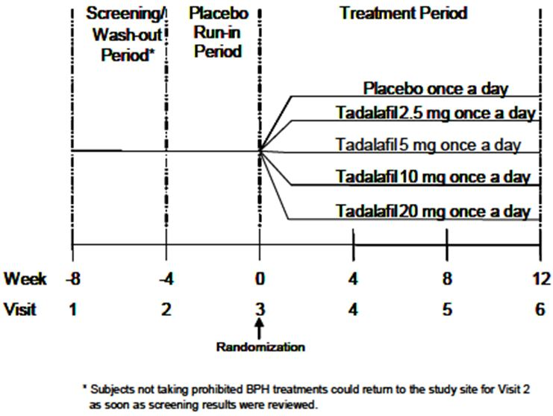
The study had three periods:
- a one to four week screening period. If needed this was also a four week wash-out period of prohibited BPH treatments. Subjects not taking prohibited BPH treatments were able to begin the next study period after screening results were reviewed
- a placebo run-in period. After the screening/wash-out period, subjects returned for Visit 2 to have their study eligibility assessed. Eligible subjects then began a four week single-blind placebo run-in period to assess treatment compliance and to establish baseline measures at the end of the period
- a treatment period – at Visit 3 eligible subjects were randomly assigned to treatment. The treatment period was of 12 weeks duration. Treatment compliance was assessed and study endpoints measured at Visits 4, 5, 6 which were at Weeks 4, 8 and 12 respectively.
Comment: Although this was a phase 2b/3 dose-finding study, it would seem reasonable to include it as a pivotal efficacy study as the primary endpoint and treatment regimen were the same as the other three pivotal efficacy studies.

Inclusion and exclusion criteria
There were a large number of inclusion and exclusion criteria. Important inclusion criteria included study subjects who:
- were ≥45 years old
- had BPH-LUTS (as diagnosed by a qualified physician) for >6 months at screening
- had total IPSS ≥13 at the start of the placebo lead-in period
- had a peak urinary flow rate (Qmax) ≥ 4 and ≤ 15 mL/sec at the start of the placebo lead-in period
- had not taken the following treatments during the indicated duration:
  - Finasteride therapy for at least 3 months prior to Visit 2
  - Dutasteride therapy for at least 12 months prior to Visit 2
  - All other BPH therapy (including herbal preparations for at least 4 weeks prior to Visit 2
  - ED therapy for at least 4 weeks prior to Visit 2
Important exclusion criteria included subjects who:
- had a prostate-specific antigen (PSA) value >10 ng/mL (men with a PSA of 4 to 10 ng/mL were required to have a prostate biopsy negative for malignancy within the preceding 12 months)
- a post-void residual (PVR) volume ≥300 mL at screening
- had clinical evidence of prostate cancer
- had evidence of New York Heart Association (NYHA) ≥ Class III cardiovascular disease (NYHA 1994) within 6 months of screening
- had a history of significant renal insufficiency, defined as renal dialysis or having an estimated creatinine clearance <50 mL/min at screening as calculated by the Cockcroft-Gault formula
- had clinical evidence of hepatic impairment at Visit 1
- had a glycosylated haemoglobin (HbA1c) > 9% at Visit 1
Comment: Excluding subjects with uncontrolled diabetes, liver impairment and significant renal disease would appear to limit the generalisability of the results as it could be anticipated that a proportion of the target population for use of tadalafil in the proposed indication will have these conditions.
The source of recruitment of the study subjects is not clear in the submission.

Study treatments
Study subjects were randomised to receive tadalafil 2.5 mg, 5 mg, 10 mg or 20mg or placebo once daily orally for 12 weeks. For each strength of tadalafil tablet there was a placebo tablet that was identical in appearance. Subjects received four tablets once daily orally. In the study treatment groups, subjects received three placebo tablets and one tablet of tadalafil 2.5 mg, 5 mg, 10 mg or 20 mg, and in the placebo group subjects received four placebo tablets. Each dose of four tablets was identical in appearance. Subjects were instructed to administer each dose at approximately the same time once a day, with or without food.
Subjects were discontinued from the study drug and the study if:
- The subject was enrolled in the study but did not meet the enrolment criteria
- The subject developed a condition listed in the exclusion criteria and the sponsor determined that discontinuation was warranted
- The investigator decided that the subject should be discontinued
- The subject or attending non-study physician requested that the subject be discontinued
- The subject required treatment with another therapy that had been demonstrated to be effective for the treatment of the study indication
- The study site personnel performing assessments, the investigator or the subject became unblinded to the treatment assignment
- The study, or subject participation in the study, was stopped by the sponsor
- The subject required treatment with therapies prohibited during the study (nitrates, potent systemic CYP3A4 inhibitors, systemic cancer chemotherapy, androgens, anti-androgens or estrogens, anabolic steroids, LHRH agonists or antagonists, SNRIs, tricyclic antidepressants, 5-alpha reductase inhibitors, alpha blockers, herbal remedies for BPH-LUTS, PDE5 inhibitors (other than the study drug), other therapies for ED.
Chronic (administration for more than 7 consecutive days) or intermittent use (administration for 2 to 6 consecutive days on more than two occasions) of the following medications also resulted in the subject being discontinued from the study: cholinergics, anticholinergics, antimuscarinics, antihistamines, decongestants, sympathomimetics and phenothiazines.
Comment: Based on the TGA-adopted EMA guideline “Note for guidance on choice of control groups in clinical trials” (20), the choice of placebo as the comparison group seems reasonable. Even though tamsulosin was registered in Australia for the relief of LUTS associated with BPH at the time that this study was conducted, it may not have been registered in all the countries that had participating study centres. The registered indication for tamsulosin does not imply that it prevents death or irreversible morbidity, so serious harm from the use of placebo as the comparison group does not seem likely, although it is noted that clinical progression of BPH without treatment is considered to include conditions such as acute urinary retention, renal insufficiency and recurrent urinary tract infection (21). The exclusion of subjects from the study who had urinary tract infection, significant renal insufficiency or a history of urinary retention is likely to have reduced the risk of such complications.

Efficacy variables and outcomes
The main efficacy variable was the International Prostate Symptom Score (IPSS). The IPSS total, or total IPSS, is the combined score from the responses to the seven questions in the IPSS questionnaire. The IPSS questionnaire is a self-administered questionnaire that measures the severity of BPH-LUTS. Each question is scored 0-5 so the IPSS can range from 0-35 points. The higher the score from the IPSS questionnaire, the greater the severity of the symptoms. The IPSS is an internationally validated instrument.
The primary efficacy outcome was the change in IPSS total from baseline (Week 0, Visit 3) to endpoint (Week 12, Visit 6) for subjects taking tadalafil 5 mg once daily versus placebo.
The secondary efficacy endpoints were the change from baseline to Weeks 4, 8 and 12 (Visits 4, 5, and 6) for:
- The total score of IPSS, defined as the sum of the scores for IPSS Questions 1 through 7
- The irritative (storage) subscore of the IPSS, defined as the sum of the scores for Questions 2, 4, and 7
- The obstructive (voiding) subscore of the IPSS, defined as the sum of the scores for Questions 1, 3, 5, and 6
- IPSS Question 7 (nocturia)
- The IPSS QoL Index
- BPH Impact Index (BII)
- Lower Urinary Tract Symptoms-Global Assessment Question (LUTS-GAQ) (final visit only)
- Uroflowmetry parameters, including peak flow rate, mean flow rate, and voided volume.
- International Index of Erectile Function (IIEF) including the Erectile Function (EF) Domain (sum of scores for Questions 1 through 5 and Question 15))
Subjects were asked the following questions at Visit 2:
- Are you sexually active with a female partner?
- If you responded “yes” to Question 1, do you expect to remain sexually active with your female partner for the duration of the study
Only subjects responding “yes” to both questions were asked to complete the IIEF questionnaire at Visit 2 and subsequent visits. The questionnaire was filled in relation to sexual interactions with only one sexual partner. These subjects were also assessed for ED by the investigator.
The BII questionnaire is a four item self-administered questionnaire used to evaluate the impact of urinary problems on overall health and activity. It has a score range of 0 to 13 with higher scores representing an increased perceived impact of BPH-LUTS on overall health. The BII questionnaire is reported to be validated.
The LUTS GAQ is one question to which the subject responds “yes” or “no”. The LUTS GAQ assesses whether the subject has observed an overall improvement in LUTS during the treatment period.
Uroflowmetry was assessed by Qmax (peak urine flow), Qave (mean urine flow rate) and Vcomp (volume of voided urine). The data were read by the principal investigator and a central reader, both blinded to treatment assignment. Uroflowmetry results were only considered valid if the prevoid total bladder volume was ≥ 150 mL to ≤ 550 mL on ultrasound and the voided volume was ≥ 125 mL. The principal investigator interpreted Visit 2 uroflowmetry data to assess subject eligibility. Efficacy analyses were performed using central reader assessments.
The three IIEF Domains, Erectile Function Domain, Intercourse Satisfaction Domain and Overall Satisfaction Domain, were assessed by the validated, 15 item, multi-dimensional, self-administered IIEF questionnaire. This questionnaire has been used to assess the efficacy of erectile dysfunction therapy. Only the IIEF Erectile Function (EF) Domain (score range 0-30) was a secondary endpoint in this study. A lower IIEF EF Domain score represented diminished erectile function. The Intercourse Satisfaction and Overall Satisfaction Domains were assessed as exploratory endpoints. For any individual Domain at any visit, if less than 30% of its component questions were missing for the subject, the missing questions were imputed with the mean of the scores for the non-missing questions, rounded to the nearest integer.
Comment: The proposed PI includes study outcomes in relation to the efficacy variables IPSS, BII and EF Domain of the IIEF (IIEF EF Domain). In this study IPSS total is the primary efficacy outcome and BII and IIEF-EF Domain are secondary efficacy outcomes. These efficacy measures are reported to have been validated by the American Urological Association (22). Based on the Australian PI for Cialis (1), the IIEF questionnaire was used in clinical studies supporting the registration of tadalafil for the treatment of ED. The IIEF questionnaire is validated (23).
Based on the PI for Flomaxtra (10), the IPSS total was also the primary efficacy parameter used in the studies evaluating the efficacy of Flomaxtra for use in the registered indication, the relief of LUTS associated with BPH.
The IPSS total cut-off points for mild, moderate and severe BPH-LUTS have been reported as < 7, 8-19 and 20-35, respectively (24). Men were included in this study if they had an IPSS total of 13 or more at Visit 2, indicating that they had moderate to severe BPH-LUTS. There is evidence from one study that a decrease in the American Urological Association (AUA) symptom index (IPSS total) of more than three points is clinically meaningful (25). In this study, smaller mean decreases in the AUA symptom index were perceived as an improvement by the subgroup of subjects with baseline scores of less than 20 points compared with the subgroup of subjects with a baseline score of 20 points or more (25).

Randomisation and blinding methods
Eligible subjects were randomly assigned in a 1:1:1:1:1 ratio to one of the five treatment groups – tadalafil 2.5 mg, 5 mg, 10 mg, 20 mg or placebo once daily for 12 weeks. The assignment of subjects to the treatment groups was determined by a computer-generated random sequence using an interactive voice response system (IVRS). Randomisation was stratified by baseline LUTS severity (IPSS <20 or ≥ 20) assessed at Visit 3, geographic region (North America, Latin America, Europe, Australia) and history of ED (defined as consistent change in the quality of erection adversely affecting subject satisfaction with sexual intercourse) for at least 3 months at Visit 1 (yes or no).
During the placebo-run in period only subjects did not know which treatment was being administered. During the treatment period, the subjects, study site personnel and the sponsor did not know which treatment was being administered. Access to the randomisation table and treatment assignments was restricted to a minimum number of personnel prior to database lock. A subject was discontinued from the study if they were unblinded.
Comment: It is not indicated whether different study personnel assessed the efficacy and safety endpoints and whether the efficacy assessors were prohibited from asking about adverse events which could have in turn indicated the study group to which the subject had been randomised. It is possible that if the study personnel knew that the subject had had certain adverse events known to be related to tadalafil, or if the subject had adverse events that he was aware had been reported with tadalafil, this may have introduced bias into the assessment of the study endpoints. However, it is indicated in the study protocol that a subject was to be discontinued from the study if he was unblinded to the treatment assignment or if the personnel performing the assessments at the study site became unblinded to the subject’s treatment, although the actions taken to prevent personnel performing the assessments becoming aware of adverse events, and what they needed to do if adverse events were revealed by the subject, are not specified.

Analysis populations
Efficacy analyses were performed on an intent-to-treat basis. The primary analysis population for efficacy included subjects who were randomised and started study medication and who had a baseline and at least one post-baseline assessment. Subjects were grouped by the treatment to which they were assigned by random allocation.
The population for the analysis of safety variables included all randomised subjects who had received study treatment, grouped by the treatment to which they were randomised, even if the subject did not take the treatment assigned, did not receive the correct treatment, or did not follow the protocol.
The per-protocol population included subjects who completed the 12 week treatment period and who had administered ≥ 70% of prescribed doses. Subjects were analysed by the treatment to which they had been randomly assigned. The per-protocol population was used for additional analyses.
Comment: The primary analysis population used in the analyses was consistent with that specified in the study protocol. Based on the study protocol, the safety variables were to be analysed by treatment taken, this was changed in the SAP so that the analysis of safety variables included all randomised subjects who received treatment by the treatment randomised even if the subject does not take the treatment assigned, does not receive the correct treatment or does not follow the protocol. This seems reasonable.

Sample size
The planned total sample size was 990 subjects. Based on the results of Study LVGC, a common standard deviation of 6 units was assumed. It was determined by the sponsor that, based on a two sided t-test at a significance level of 0.05, 198 subjects per treatment group would provide 91% power to detect a difference of 2.0 points in change in IPSS total from baseline for tadalafil 5 mg compared with placebo.
As a secondary analysis, each dose of tadalafil was compared with placebo using Dunnett’s adjustment for multiplicity. With 198 subjects per treatment group, the power for each comparison to detect a 2.0 point IPSS change from baseline was 80%.
Comment: In a second protocol amendment, the study power calculation was changed from a placebo-adjusted change in IPSS total score of 1.5 to a change in IPSS total score of 2.0. This change occurred while the study was being undertaken. The sponsor indicates that a change in IPSS total score of 2.0 instead of 1.5 is a more rigorous threshold for a clinically meaningful change. This seems reasonable.

Statistical methods
The primary efficacy outcome was change in IPSS total from baseline to Week 12.
The hypothesis to be tested was that tadalafil 5 mg resulted in a greater decrease in total IPSS score than placebo.
The primary inferential analysis of the change in IPSS from baseline (Week 0, Visit 3) to Week 12 (or last visit) was a non-parametric permutation test stratified by the randomisation factors geographic region, baseline LUTS severity and ED history. The primary efficacy comparison was between tadalafil 5 mg once daily and placebo. The change in IPSS total score between tadalafil 5mg once daily and placebo once daily was compared in the primary analysis population. No data transformations were performed. A statistically significant decrease in total IPSS was to be declared if the p-value for the two sided permutation test was less than 0.05 and the sample mean from the tadalafil treatment group is less than the sample mean from the placebo treatment group.
Secondary analyses compared tadalafil 2.5 mg, 10 mg and 20 mg to placebo using non- parametric permutation test for the primary efficacy outcome. A linear model with linear and quadratic terms was used to examine the dose-response relationship.
An Analysis of Covariance (ANCOVA) model, with treatment effect, geographical region and baseline IPSS value as covariates, was used to compare the 2.5 mg, 5 mg, 10 mg and 20 mg doses of tadalafil with placebo, respectively, for the primary efficacy outcome. No adjustments for multiple comparisons were performed.
A sensitivity analysis for the primary endpoint was performed on the randomised population. Those subjects without a post-baseline value had their endpoint set to their baseline value.
For the secondary endpoints, analyses were performed on the primary analysis population except for the analysis of IIEF which was analysed in the subgroup of sexually active men reporting ED at baseline. Permutation tests stratified by randomisation factors were used to compare the 2.5 mg, 5 mg, 10 mg and 20 mg doses of tadalafil with placebo respectively for IPSS storage (irritative) subscore, IPSS voiding (obstructive) subscore, IPSS nocturia question, BII, urine peak flow rate and IIEF EF Domain. Adjustments for multiplicity were not performed. These outcomes were also analysed by ANCOVA. No adjustments for multiple comparisons were performed.
A repeated-measures model for IPSS total, IPSS storage (irritative) subscore, IPSS voiding (obstructive) subscore, IPSS nocturia question, BII and IIEF EF Domain was undertaken. For LUTS-GAQ, the proportion of subjects responding “yes” at the final visit and the Cochran-Mantel-Haenszel test stratified by randomisation factors based upon the non-missing responses.
Mean flow rate and voided volume were analysed by descriptive methods.
The primary efficacy endpoint was summarised according to the subgroups ED (yes, no), use of alpha blockers at study entry (yes, no), baseline LUTS severity (moderate, severe), sexually active (yes, no), age (<65 years, >65 years), baseline ED severity (IIEF EF Domain mild 17-30), moderate (11-16), severe (1-10)), previous use of BPH therapy (yes, no) and region (North America, Latin America, Europe, Australia). Subgroups were also analysed using an ANCOVA model.
Supportive analyses of the change in the primary endpoint from the beginning of the placebo run-in period (Week-4, Visit 2) to endpoint (Week 12. Visit 6) were undertaken.
Comment: A statistical analysis plan (Version 1.0), dated 6 December 2007, superseded the study protocol approved on 5 April 2006 and the two amendments on 27 July 2006 (amendment a) and 12 March 2007 (amendment b). It is indicated that changes were made to the analyses described in the SAP that was approved prior to database lock (16 January 2008).
The results of the analyses in the clinical study report appear to be consistent with these changes to the statistical analysis plan.
The sponsor proposes to add the results of the ANCOVA analysis for the primary efficacy outcome to the PI even thought this was not the principal analysis for the primary efficacy outcome. The use of ANCOVA for analysis of the primary efficacy outcome was added to the study protocol through an amendment (amendment b). The reasons for using two statistical techniques (parametric or non-parametric) to analyse the primary efficacy outcome does not appear to be pre-specified in the protocol. The sponsor indicates that the IPSS data met the assumptions for a standard ANCOVA analysis. The sponsor is requested to clarify why the results of the ANCOVA analysis are included in the draft PI given the non-parametric permutation test was used for the primary comparison of the primary efficacy outcome.

Participant flow
A total of 1813 subjects were screened, of whom 1058 subjects were randomised. Of the 755 subjects who failed screening, the main reason was that protocol criteria were not met (74.7%) followed by subject decision (14.3%).
Two subjects who were randomised were not assigned to any treatment group (one subject in the placebo group and one in the tadalafil 2.5mg group). The proportions of randomised subjects who completed the 12 week treatment period were very similar for the placebo, tadalafil 2.5 mg and tadalafil 5 mg groups and lower for the tadalafil 10 mg and 20 mg groups (placebo 87.3%(n=185), tadalafil 2.5mg 87.1%(n=182), tadalafil 5mg 85.8% (n=182), tadalafil 10mg 81.0% (n=175), tadalafil 20mg 77.5% (n=162)). Greater numbers of subjects discontinued in the tadalafil 5 mg, 10 mg, and 20 mg treatment groups due to an adverse event compared with the placebo group and tadalafil 2.5 mg group. Subject decision was the most frequent reason for subject discontinuation in the placebo tadalafil 2.5 mg and tadalafil 20 mg groups.
One subject signed informed consent at four study sites and was randomised at two study sites. At one site, the subject was randomised to 20 mg tadalafil and he participated to Visit 6 and at the other site he was randomised to placebo and participated through to Visit 10. The data from this subject were included in the safety analyses but not the efficacy analyses.
The number of subjects in the analysis population was 1020 with a similar proportion of randomised subjects in each treatment group. Of the analysis population, higher proportions of subjects in the placebo and tadalafil 2.5 mg and 5 mg treatment groups had non-missing week 12 IPSS assessment data. The number of subjects in the per-protocol set for the primary efficacy outcome was 880. The proportion of randomised subjects who completed the 12 week treatment period and received at least 70% of treatment doses was lowest in the tadalafil 20 mg group.
Comment: The proportions of randomised subjects in the analysis population were comparable across the five treatment groups.

Major protocol violations/deviations
There were 127 significant protocol violations across 54 of the 92 study sites. Of these 127 significant protocol violations, 92 were related to inclusion/exclusion criteria having not been met and 28 were in relation to the discontinuation criteria being met but the subject was not withdrawn. The numbers of protocol violations due to other reasons were small (other (n=2), excluded medication (n=2), study procedure omitted or incorrectly completed (n=2), informed consent (n=1)).
Comment: The sponsor indicates that these protocol variations did not necessitate changes to the data analyses and that they did not affect the validity of the study conclusions. However, the actual details of the protocol violations do not appear to have been provided so they could not be reviewed by the evaluator. The sponsor’s conclusion that the protocol violations did not affect the validity of the study conclusions is accepted.

Baseline data
Baseline data were defined as the most recent data collected prior to randomisation, Visit 1 or Visit 2 for subject and disease characteristics, and Visit 3 for baseline efficacy endpoints.
The majority of randomised subjects were from the US (51.0%, n=540). Twenty-four subjects (2.3%), at three sites, were randomised in Australia. Of the 1056 subjects who were randomised and received double-blind study drug, the demographic characteristics of subjects at baseline in each treatment group with regard to age, ethnicity, vital signs, height, weight and Body Mass Index (BMI) were comparable. The mean age in each group was approximately 62 years with the majority of subjects aged less than 65 years. The proportion of subjects aged 65 years and older was 37.31% (placebo (n=74); tadalafil (all groups) (n=320)) and the proportion of subjects 75 years and older was 6.06% (placebo (n=12); tadalafil (all groups) (n=52)). Subjects were predominantly Caucasian. The mean post void residual (PVR) was lower in the tadalafil 2.5 mg group compared with the other treatment groups (mean PVR: placebo 50.84 mL (SD 51.99), tadalafil 2.5mg 45.88 mL (SD 53.03), tadalafil 5mg 53.52 mL (SD 57.07), tadalafil 10mg 53.94 mL (SD 55.31), tadalafil 20mg 52.01 mL (SD 58.36)).
Baseline (Visit 3) LUTS severity was comparable across the treatment groups with approximately two thirds of subjects in each treatment group with LUTS of moderate severity (IPSS <20). In terms of duration of LUTS secondary to BPH, the highest proportion of subjects in each group had had LUTS secondary to BPH for more than three years. The proportions of subjects in each treatment group who had used alpha blocker therapy and alpha-5 reductase therapy in the previous 12 months, respectively, were comparable. Approximately 30% of subjects in each treatment group had used alpha blocker therapy and approximately 1-2% had used alpha-5 reductase therapy. Approximately one quarter of subjects in each treatment group had used previous therapy for BPH (placebo 27.49% (n=58), tadalafil 2.5mg 33.17% (n=69), tadalafil. 5mg 25.47% (n=54), tadalafil 10mg 25.93% (n=56), tadalafil 20mg 27.27% (n=57)). The most frequent previously used BPH-LUTS therapy in all treatment groups was tamsulosin.
The proportions of men in each treatment group who had erectile dysfunction (ED) were comparable and ranged between 64.90% and 69.44%. For men with ED, in all five treatment groups the greatest proportion of subjects had ED of moderate severity and had had ED for at least one year. The majority of men who were randomised and received the study drug had had no previous ED therapy (overall 73.11% (n=772)). The proportions of men who were sexually active, and who expected to remain so, were similar across the treatment groups. The proportions of men who were sexually active with ED was also comparable (placebo 54.50% (n=115), tadalafil 2.5mg 54.33% (n=113), tadalafil 5mg 55.19% (n=117), tadalafil 10mg 55.56% (n=120), tadalafil 20mg 55.50% (n=116)). The proportions of men who were current tobacco and alcohol users respectively were relatively similar across the treatment groups.
The compliance rate was slightly lower in the tadalafil 20 mg treatment groups compared with the other four treatment groups (placebo 94.97% (n=200), tadalafil 2.5mg 92.31% (n=192), tadalafil 5mg 93.87% (n=199), tadalafil 10mg 93.98% (n=203), tadalafil 20mg 89.95% (n=188)).
Comment: As it is anticipated that men using tadalafil 5 mg once daily for the treatment of BPH-LUTS will include older men, the inclusion of subjects aged 65 years or older, including a proportion of subjects aged 75 years and older, is important to assess the efficacy and safety of tadalafil in the proposed indication in these subjects. Approximately one third of subjects (n=394) in this study were aged 65 years and older and 64 subjects were aged 75 years above. In the guideline “Clinical investigation of medicinal products in geriatrics” (26), the geriatric population is arbitrarily defined as patients aged 65 years or older. The guideline suggests that the study includes a minimum of 100 elderly patients to allow the detection of clinically important difference compared with younger patients. The number of subjects aged 65 years and older in this study is adequate based on this recommendation.

Results for the primary efficacy outcome
The primary analysis method used to analyse the primary efficacy outcome was the non-parametric permutation test. Based on the primary analysis population, there was an improvement in IPSS total from baseline (Visit 3 (Week 0)) to endpoint (Visit 6 (Week 12) or end of therapy) in both the placebo and tadalafil 5 mg treatment groups. The median improvement was greater in the tadalafil 5 mg treatment group compared with the placebo group (median change from baseline: tadalafil 5mg (n=205) -4.00, placebo (n=205) -2.00). The treatment difference was statistically significant (p <0.001) (Table 1).
Table 1: Study H6D-MC-LVHG: International Prostate Symptom Score Permutation Test Results (tadalafil 5mg versus placebo) (all randomised subjects in the primary analysis population).
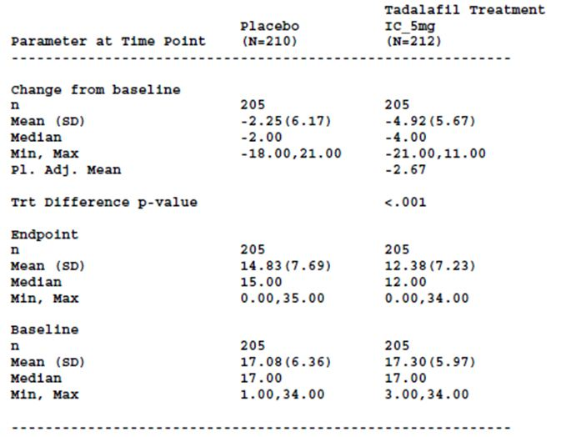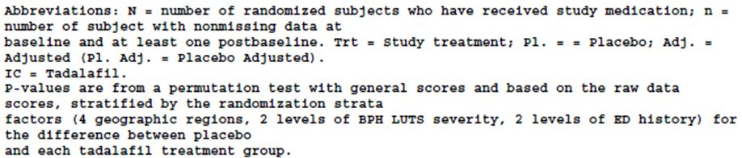
This was supported by the results of an analysis in which each dose was compared to placebo using an ANCOVA model (parametric method). Compared with placebo, treatment with tadalafil 5 mg once-a-day resulted in a statistically significant improvement in mean IPSS from baseline to endpoint (LS mean change: tadalafil 5mg treatment group (n=205) -4.83 (SE 0.49), placebo treatment group (n=205) -2.23 (SE 0.49); LS mean placebo -adjusted change from baseline for tadalafil 5mg treatment group -2.60 (SE 0.557) (95% CI[ -3.69,- 1.51]; p <0.001) (Table 2).
Table 2: Study H6D-MC-LVHG: International Prostate Symptom Score – ANCOVA of change from baseline to end of therapy (all randomised subjects in the primary analysis population).
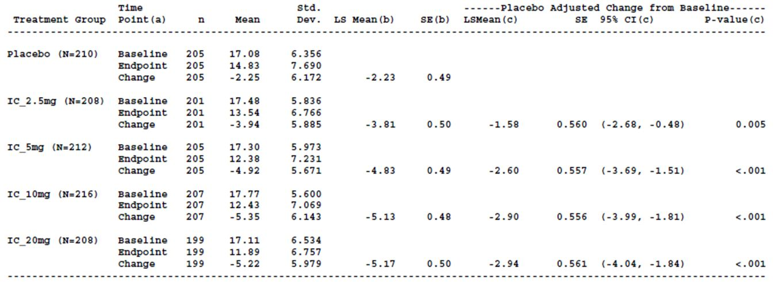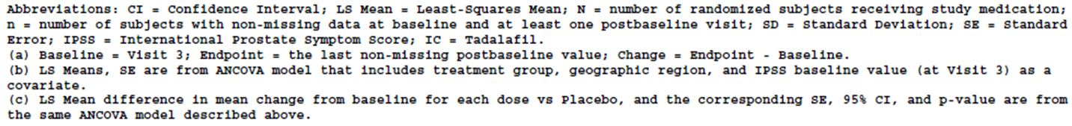
Based on the per-protocol population, the results of the non-parametric permutation test and ANCOVA were similar to the results based on the primary analysis population (Permutation test: median change from baseline to endpoint: tadalafil 5mg (n=180) -4.00, placebo (n=183)-2.00; p<0.001; ANCOVA LS mean placebo-adjusted change from baseline for tadalafil 5mg treatment group -2.65; 95% CI [-3.81,-1.49]; p <0.001).
A sensitivity analysis for the primary endpoint was performed on the randomised population using an ANCOVA. Those subjects without a post-baseline value had their endpoint set to their baseline value. The results were very similar to those observed in the primary analysis population (LS mean placebo adjusted change from baseline -2.60 (SE 0.557); 95% CI [-3.69, -1.51]; p <0.001)).
Subgroup analyses for IPSS total were undertaken for a number of variables. There was a larger decrease in overall mean IPSS total from baseline to endpoint in subjects who had not previously used BPH therapy compared with those who had. A significant difference for IPPS total by region was detected. Changes in IPSS total were also significantly different across subgroups of sexual activity (yes, no).
Comment: From the SAP, a statistically significant decrease in total IPSS was to be declared if the p-value for the two sided permutation test was less than 0.05 and the sample mean from the tadalafil treatment group is less than the sample mean from the placebo treatment group. The p value was based on the difference in the median change from baseline to endpoint in the tadalafil 5mg treatment group compared with the placebo treatment group. This seems reasonable given the mean and median were not identical suggesting the data were not normally distributed.
The number of subjects from Australia included in the subgroup analysis (n=24) was very small compared to the other regions.

Results for other efficacy outcomes
When each dose of tadalafil was compared with placebo for IPSS total in a non-parametric permutation test, the improvement in IPSS was greater in the tadalafil treatment groups compared with the placebo group. The treatment difference was statistically significant for the 2.5 mg, 5 mg, 10 mg and 20 mg tadalafil groups compared with placebo (Table 3). Based on the ANCOVA results, the difference between the least squares mean change in IPSS from baseline to endpoint was statistically significant when each treatment group was compared with placebo also (Table 2). The repeated measures analysis of the change from baseline to end of therapy showed statistically significant changes for Weeks 4, 8 and 12 for each of the tadalafil groups compared with placebo.
Table 3: Study H6D-MC-LVHG: International Prostate Symptom Score – All doses permutation test results (all randomised subjects in the primary analysis population).
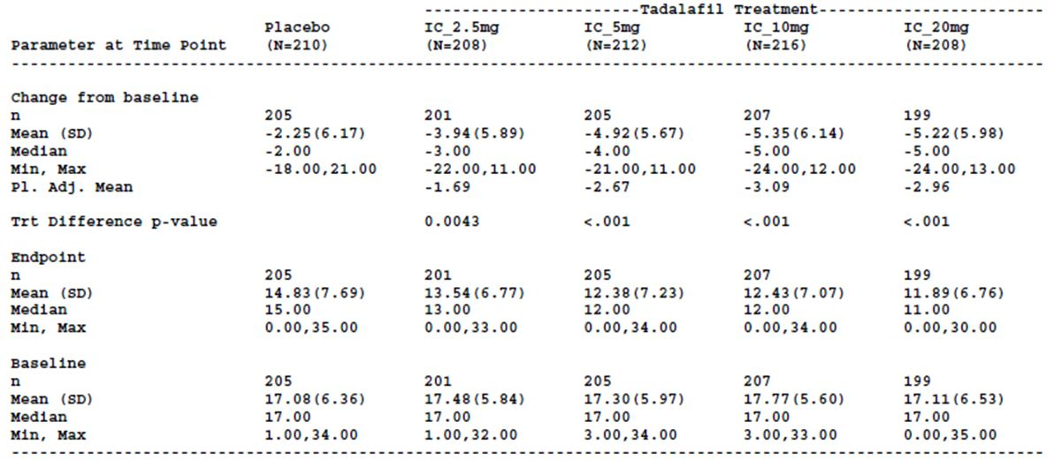
For the comparison of tadalafil 5mg with placebo, the results of analyses for the secondary endpoints, IPSS irritative (storage) subscore, IPSS obstructive (voiding) subscore, IPSS question 7 (nocturia), IPSS Question 8 (Quality of Life Index) were consistent with the results for the primary efficacy outcome in that the LS mean change from baseline to endpoint was greater in the tadalafil 5 mg group than the placebo group. For the comparisons between the other doses of tadalafil and placebo, greater improvements in the tadalafil group compared with the placebo group in the change from baseline was seen for most tadalafil doses for most of the secondary efficacy variables.
Other clinically important secondary endpoints, referred to in the proposed PI, were:
- BPH Impact Index (BII) – based on the permutation test, the median change from baseline to endpoint for all the tadalafil treatment groups and the placebo group was -1.00. The treatment difference was statistically significant for the 10 mg tadalafil and 20 mg tadalafil groups only compared with placebo (primary analysis population) (Table 4). The per-protocol analysis had similar results. Based on the ANCOVA of change from baseline to end of therapy (primary analysis population), there was a statistically significant difference for the tadalafil 5 mg, 10 mg and 20 mg treatment groups compared with placebo (Table 5). The results for the per-protocol population were similar. Statistically significant differences in LS mean change from baseline to endpoint were seen at Weeks 4, 8 and 12 for tadalafil 5 mg, 10 mg and 20 mg, compared with placebo, in the repeated measures analysis of change from baseline to end of therapy (primary analysis population). Comparing the tadalafil 2.5mg group with placebo, there were no statistically significant differences at any visit. Changes in BII were significantly different across subgroups for sexual activity and region.
Table 4: Study H6D-MC-LVHG: BPH Impact Index – All doses permutation test results (all randomised subjects in the primary analysis population).
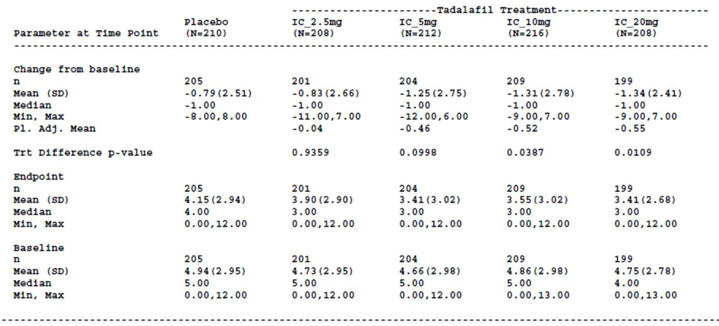
Table 5: Study H6D-MC-LVHG: BPH Impact Index – ANCOVA of change from baseline to end of therapy (all randomised subjects in the primary analysis population).
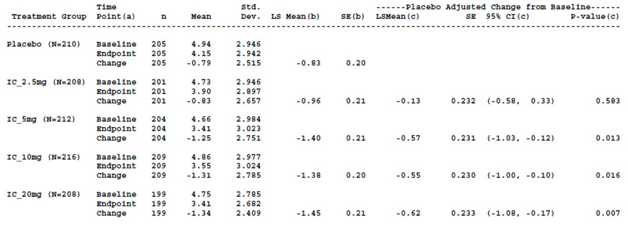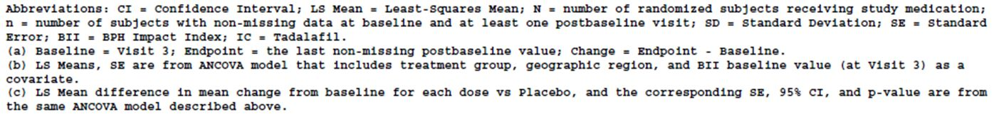
- IIEF EF Domain – Of sexually active men with a history of ED eligible to complete the IIEF questionnaire, approximately 96% (n=557) completed at least one post-randomisation IIEF questionnaire. Based on the permutation tests, there were statistically significant improvements in the median IIEF EF Domain score from baseline to endpoint for each of the tadalafil treatment groups compared with placebo (Table 6). The results of the ANCOVA showed the difference in LS mean change from baseline to endpoint was statistically significant for tadalafil 2.5 mg, 5 mg, 10 mg and 20 mg, respectively, compared with placebo (Table 7). Statistically significant differences in LS mean change from baseline to end of therapy were also observed at Visits 4, 5 and 6 (Weeks 4, 8, 12) in all tadalafil treatment groups compared with placebo based on the IIEF EF Domain repeated measures analysis from change of baseline to end of therapy for all randomised and sexually active subjects with a history of ED. The results of the non-parametric permutation tests and ANCOVA in the per-protocol population were consistent with those in the primary analysis population. A statistically significant subgroup by treatment interaction in the improvement in IIEF EF Domain by ED history (yes/no) was detected on subgroup analysis.
Table 6: Study H6D-MC-LVHG: IIEF Erectile Function Domain – All doses permutation test results (randomised and sexually active subjects with history of ED).
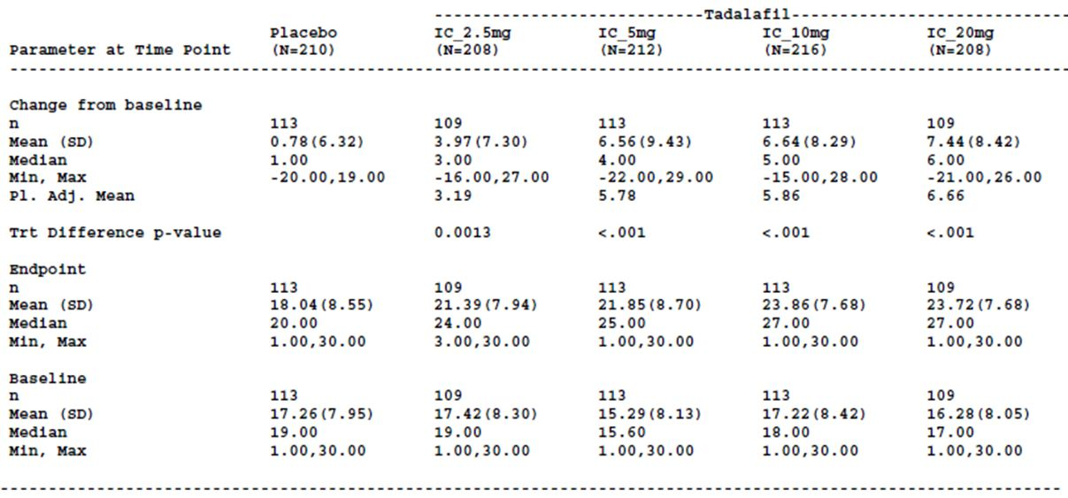
Table 7: Study H6D-MC-LVHG: IIEF Erectile Function Domain – ANCOVA of change from baseline to end of therapy (randomised and sexually active subjects with history of ED).
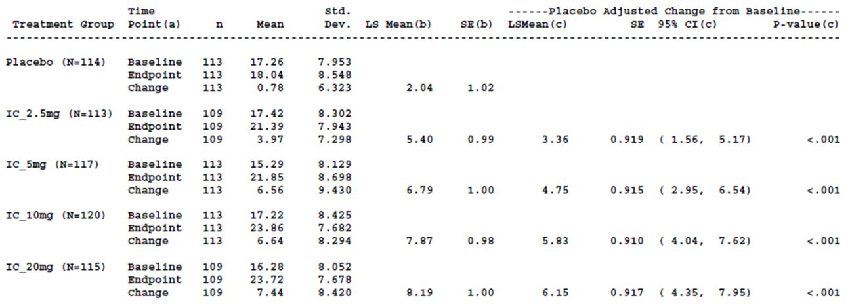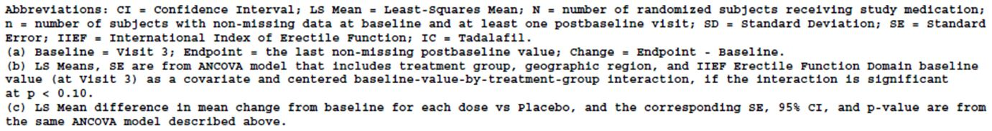
Of subjects who answered the BPH-LUTS global assessment question, the proportions who reported improved urinary symptoms during therapy were higher in all the tadalafil groups compared with placebo group.
Based on the primary analysis population, there were small changes in median peak flow rate in the tadalafil treatment groups and the placebo group from baseline to endpoint but the differences between the respective tadalafil treatment groups and the placebo group were not statistically significant based on the permutation tests. The LS mean changes from baseline to endpoint in each treatment group were not statistically significant compared with placebo based on the ANCOVA analyses. The results of the non-parametric test and ANCOVA for the peak flow rate were similar for the per-protocol population. The repeated–measures analysis for peak flow rate (primary analysis population) revealed no statistically significant differences in the LS mean changes at Visits 4, 5, 6 (Weeks 4, 8, 12) for any tadalafil dose compared with placebo except for tadalafil 10 mg compared with placebo at Week 4 and Week 8. Based on a subgroup analysis, subjects younger than 65 years had a significantly greater change in peak flow rate compared to older subjects. Changes in peak flow rate were also significantly different for subgroups of ED history, sexual history, previous alpha blocker use and previous BPH therapy use.
There were small increases in mean flow rate and voided volume in the tadalafil groups and the placebo group from baseline to endpoint, based on the primary analysis population. The increases were greater in the tadalafil treatment groups compared with the placebo group.
In terms of the dose-response relationship, based on the ANCOVA (primary analysis population) (Table 2), the placebo-adjusted mean change from baseline increased with increasing dose for the 2.5 mg, 5 mg and 10 mg tadalafil groups and was approximately the same for the 10 mg and 20 mg treatment groups. The biggest decrease in IPSS total score, relative to the next smallest tadalafil dose, was the 63% decrease seen with tadalafil 5 mg compared with the decrease seen with 2.5 mg tadalafil. The decrease in IPSS total was 12% when the tadalafil dose was doubled to 10mg and there was no further improvement in IPSS total with the 20mg dose. The trend was similar for the IPSS irritative and obstructive subscores, respectively, and the BII.
Comment: The results of the primary analysis showed a significantly greater improvement in IPSS total for subjects in the tadalafil 5 mg treatment group compared with placebo. The results of the secondary efficacy outcomes were generally consistent with the results of the primary analysis but as there was no adjustment for multiple comparisons, the statistically significant results for these endpoints may be due to chance.

Study H6D-MC-LVHJ (LVHJ)

Study design, objectives, locations and dates
Study LVHJ was a pivotal phase 3 randomised, double-blind, placebo controlled, parallel design study. There were 28 study centres and the study was undertaken in Argentina, Germany, Italy, Mexico and the US. The study was started in February 2009 and ended in November 2009.
The study had three periods (Figure 2). The first period was for screening and included a four week wash-out period for men who had discontinued treatment with BPH, overactive bladder (OAB) and/or ED treatments at the beginning of the period. After this period, subjects were assessed to determine if they met the eligibility criteria (IPSS ≥ 13 and Qmax ≥4 to ≤15 mL/second) to begin the placebo run-in period to assess treatment compliance and establish baseline levels at the end of the period. Subjects who were compliant with at least 70% of therapy during the placebo run-in were eligible for randomisation.
Figure 2: Study H6D-MC-LVHG: Study design for protocol H6D-MC-LVHG.
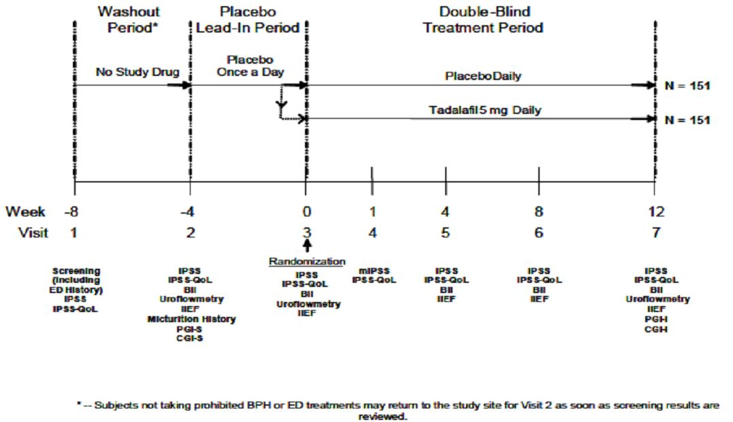
The primary objective of the study was to evaluate the efficacy of tadalafil 5 mg once a day for 12 weeks compared with placebo in improving total IPSS in men with BPH-LUTS.

Inclusion and exclusion criteria
The main exclusion criteria were men aged 45 years or older who have had BPH-LUTS diagnosed by a qualified physician for more than 6 months. Important exclusion criteria were significant renal insufficiency, severe hepatic impairment, a history of specific cardiac and coronary conditions, and a HbA1c >9% (uncontrolled diabetes).
Comment: The source from which the study participants were recruited does not appear to have been stated.
The inclusion and exclusion criteria for study LVHJ were generally consistent with those of study LVHG but were not identical. In this study, subjects had to agree not to use any approved or experimental pharmacologic overactive bladder (OAB) treatment, as well as BPH or ED treatments, and subjects were eligible for inclusion in the study if they had not taken dutasteride therapy for at least 6 months prior to Visit 2 (this was 12 months in study LVHG) and if they had not taken OAB therapy for at least 4 weeks prior to Visit 2. Differences in the exclusion criteria included the exclusion of subjects with clinical evidence of severe hepatic impairment from study LVHJ and clinical evidence of hepatic impairment in study LVHG. In study LVHJ, the exclusion criterion relating to history of significant renal insufficiency was defined as renal dialysis or having an estimated creatinine clearance <30mL/min at Visit 1 calculated by the Cockcroft-Gault formula (<50mL/min in study LVHG).

Study treatments
Subjects received no study drug during the wash-out period. During the placebo run-in period all subjects received a placebo 5 mg tablet once daily for four weeks and during the double-blind period, subjects received one 5 mg tadalafil tablet, or one placebo tablet, once daily orally for 12 weeks. Subjects were instructed to take the once daily study treatment to which they had been assigned at approximately the same time each day, with or without food. The placebo 5 mg tablets were identical in form and appearance to the tadalafil 5 mg tablets.
Subjects were discontinued from the study drug and the study if:
- The subject was enrolled in the study but did not meet the enrolment criteria
- The subject developed a condition listed in the exclusion criteria and the sponsor determined that discontinuation was warranted
- The investigator decided that the subject should be discontinued
- The subject or attending non-study physician requested that the subject be discontinued
- The subject required treatment with another therapy that had been demonstrated to be effective for the treatment of the study indication, OAB or ED
- The study site personnel performing assessments, the investigator or the subject became unblinded to the treatment assignment
- The investigator or the sponsor stops the study or stops the subject’s participation in the study for any reason (considering the rights, safety and well being of the subject).
Subjects requiring treatment with a prohibited concomitant therapy during the study were also discontinued. The prohibited concomitant medication included those medications specified in the exclusion criteria plus systemic cancer chemotherapy, serotonin norepinephrine reuptake inhibitors, tricyclics antidepressants, 5-alpha reductase inhibitors, alpha blockers, herbal remedies for BPH-LUTS, other therapies for BPH-LUTS or symptoms of OAB, including pelvic floor muscle training and bladder training, PDE5 inhibitors other than study medication, other suppositories for ED and anti-diuretic hormone.
Chronic or intermittent use of specific medications also resulted in the subject being discontinued from the study. The specific medications are the same as those specified in study LVHG.
Comment: The criteria for discontinuing subjects from the study drug and study were similar to those specified in study LVHG. The main point of difference was that subjects were discontinued from study LVHJ if they required treatment with another therapy that had been demonstrated to be effective for the treatment of OAB or ED, as well as therapy effective for the study indication.

Efficacy variables and outcomes
The main efficacy variable was the IPSS. The primary efficacy outcome was change from baseline (Visit 3) to endpoint (Visit 7) in total IPSS for subjects taking tadalafil 5 mg once daily compared with placebo once daily.
The key secondary efficacy outcomes were:
- Change from baseline for the two treatment groups in:
  - IIEF-EF Domain after 12 weeks of treatment
  - Total IPSS after four weeks of treatment
  - BII after 12 weeks of treatment
  - Modified IPSS after one week of treatment
  - BII after four weeks of treatment
The efficacy measures were administered prior to clinical assessments during study visits. The modified version of the IPSS questionnaire (mIPSS) consisted of questions in the IPSS that had been modified to obtain responses based on the time since last visit, rather than over the past month. The mIPSS was administered at Visit 4 (Week 1) and therefore assessed the effects of treatment with the study drug after one week (since Visit 3).
There were other secondary efficacy variables and outcomes. The secondary efficacy variables included a subject-rated instrument, the subject global impression of severity (PGI-I), and a clinician rated instrument, the clinician global impression of severity, the CGI-I, that the subject and clinician respectively used to measure improvement or worsening in the subject’s symptoms from study entry. These two instruments consist of a seven point scale from “very much better” (score of one) to “very much worse” (score of 7).
Comment: It is not stated if the PGI-I and CGI are validated instruments for use in men with BPH. The references provided by the sponsor in relation to the appropriateness of the PGI-I and CGI-I as measures relate to women with urinary stress incontinence (27, 28).
Uroflowmetry was a safety variable in this study not an efficacy variable as in study LVHG.

Randomisation and blinding methods
Subjects who had met all the enrolment criteria were randomly assigned, at Visit 3, to the tadalafil 5 mg or placebo treatment groups in a 1:1 ratio. Randomisation was stratified by baseline LUTS severity (IPSS total <20 (moderate) or ≥ 20 (severe), assessed at Visit 3), geographic region (Europe, Latin America or US) and history of ED at Visit 1. A computer-generated random sequence using an IVRS was used to determine the assignment of subjects to the two treatment groups.
Subjects were blinded to the treatment that they were receiving during the placebo run-in period and during the double-blind treatment period, subjects, study site personnel and the sponsor did not know which treatment was administered.

Analysis populations
The primary analysis population included all subjects who were randomised and started study medication. The IIEF Domain analyses were undertaken on the subset of the primary analysis set who were sexually active and had ED.
The per-protocol population included those subjects who met the criteria for the primary analysis population, completed the 12 week treatment period and took at least 70% of the prescribed doses in the double-blind study period.
The safety population for the double-blind treatment period was the randomised population. Some safety analyses in the screening/wash-out period and the placebo lead-in period included screen-failure subjects.

Sample size
The null hypothesis was that there was no difference between tadalafil 5 mg and placebo in terms of change from baseline to end of therapy or Week 12 in total IPSS.
To provide at least 80% power to detect a placebo-adjusted mean difference in IPSS of 2.0, assuming a standard deviation of 6, using a two sided t-test at 0.05 level of significance, the sponsor calculated that 143 subjects in each treatment arm was required. It was planned that a total of 302 subjects would be randomised (151 per treatment group) given a projectable non-evaluable rate of 5%.
Comment: The justification for a placebo-adjusted mean difference in IPSS of 2.0 is not stated in the protocol.

Statistical methods
All efficacy analyses were performed on an intent-to-treat basis. Subjects were analysed and reported by the treatment group to which they were randomly assigned.
For subjects who discontinued the study early, or who were missing post-baseline data, analyses were based on the most previous non-missing post-baseline data. Subjects with no post-baseline data for a specific efficacy endpoint were excluded from the analysis for that endpoint. For IPSS, if a subject has a missing question at a visit, then the total IPSS score, and any subscore containing that question, was treated as missing at that visit. If the subject has a missing question for the BII at a visit then the BII will be treated as missing at that visit. If scores for less than 30% of the component questions of the IIEF Domains are missing, the missing scores were imputed using the mean of non-missing scores.
The baseline visit for the efficacy measurements was Visit 3. Endpoint (the final visit) was the last measurement collected prior to study discontinuation. LOCF data imputation methodology was used.
The primary efficacy analysis and key secondary efficacy analyses were conducted in the primary analysis population.
ANCOVA modelling was used as the primary inferential analysis method to evaluate the mean change from baseline to endpoint in total IPSS between the tadalafil 5 mg and placebo treatment groups. Changes from baseline to endpoint, and the treatment difference of the changes, were estimated using least squares means. The p-values from the Type III sums of squares were assessed for treatment effects significance at a two-sided significance level of 0.05.
The ANCOVA model included terms for the baseline value of the efficacy variable, treatment group, region, baseline-by-treatment interaction and the treatment-by-region interaction. The interaction terms were tested at a significance level of 0.1 and if the p-value was ≥ 0.1 it was removed from the model.
The primary efficacy analysis was repeated in the per-protocol population. A sensitivity analysis using the same ANCOVA model, with the additional randomisation factor ED history, was conducted for total IPSS based on the primary analysis population.
The ANCOVA model used for the primary analysis was used for the key secondary analyses. These analyses were included in a fixed- sequence testing procedure. If the result of the primary efficacy analysis was significant at a two-sided significance level of 0.05, the key secondary endpoints were to be assessed for statistical significance, at a two-sided significance level of 0.05, in a pre-specified order:
- IIEF-EF Domain after 12 weeks of treatment in sexually active subjects with ED
- Total IPSS after four weeks of treatment
- BII after 12 weeks of treatment
- Modified IPSS after one week of treatment
- BII after four weeks of treatment
Claims of statistical significance at the level of the individual test were dependent on the significance of the previous tests.
The ANCOVA model used for the primary analysis was used also to compare the changes from baseline to end of therapy between treatment groups at a two sided 0.05 significance level for the secondary efficacy outcomes IPSS storage (irritative) subscore, IPSS voiding (obstructive) subscore, IPSS nocturia subscore and IPSS QoL Index. There was no adjustment for multiplicity.
Descriptive statistics were used to summarise proportions of subjects in each of the seven response categories and the three derived categories (worse/no change/between) for the PGI-I and CGI-I.
A repeated measures model was applied to total IPSS, BII and IIEF-EF Domain with change of the efficacy variable from baseline to 4, 8 and 12 weeks as the response. The model included terms for treatment group, region, visit, centred-baseline of the efficacy endpoints, visit-by-treatment interaction, centred-baseline-by-treatment interaction and treatment-by-region interaction. If the p-value was ≥ 0.1 for the centred-baseline-by-treatment interaction or treatment-by-region interaction then the interaction term was removed from the model.
An exploratory analysis of change in total IPSS from Visit 1 to Visit 2 was evaluated in subjects who required wash-out of alpha blocker therapy and those who did not require wash-out. A number of other exploratory analyses were undertaken also.
The primary efficacy endpoint was summarised according to baseline LUTS severity (moderate, severe), age (≤ 65 years, > 65 years) and baseline ED. ANCOVA models were used for the subgroup analyses and included two additional effects for subgroup and treatment-by-subgroup interaction.
Descriptive statistics were also used for the study measures.
Comment: The key secondary efficacy endpoints and the order of testing of these endpoints, as presented in the amended study report, are not consistent with the secondary efficacy analyses described in protocol amendment (a). In the protocol it is indicated that the comparison of BII changes from baseline to endpoint between the treatment groups was to be conducted only if the result of the primary efficacy analysis was significant at a two-sided significance level of 0.05. For the other secondary efficacy outcomes the statistical analyses to compare changes from baseline to Week 12 between the treatment groups were to be undertaken and the p-values reported. Statistical significance at the level of the test was only to be established for IPSS storage, voiding and nocturia subscores, and the IPSS QoL index, if the result of the BII analysis was significant at a two-sided 0.05 alpha level. It was indicated that similar statistical analyses were to be conducted to compare the changes from baseline between the treatment groups for mIPSS after one week of treatment, total IPSS after 4 weeks for treatment and BII after 4 weeks of treatment and, in sexually active men with ED, for IIEF EF after 12 weeks of treatment. However, the order of these analyses was not specified. It is anticipated that the changes to the secondary efficacy analyses are included in the SAP approved on 6 November 2009. However, the SAP was not included in the submission. The sponsor is requested to clarify why the amended study report and protocol H6D-MC-LVHJ (a) differ in relation to the testing of secondary endpoints and if the order of testing the key secondary endpoints, as described in the amended study report, was determined a priori.
The protocol indicates that a repeated measures model would be applied to total IPSS and BII with change of the efficacy variable from baseline to 4, 8 and 12 weeks as the response. However, in the amended study report it is indicated that a repeated measures model was applied to the IIEF-EF Domain as well as the total IPSS and BII.

Participant flow
Of 442 subjects screened, 117 were screen failures. The most common reason for screen failure was that the subject did not meet the entry criteria. All 325 subjects randomised received the study drug, 164 in the placebo group and 161 in the tadalafil 5 mg treatment group. One hundred and fifty-two subjects in the placebo group, and 148 subjects in the tadalafil 5 mg group, met the criteria for the per-protocol population. The proportions of subjects who discontinued were similar in the two treatment groups (placebo 7.3% (n=12), tadalafil 5mg 8.1% (n=13)). Three subjects in the tadalafil group had adverse events that led to study discontinuation, including one death, compared with one subject in the placebo group.
Comment: The number of subjects in the primary analysis set is higher than the planned sample size of 302.

Major protocol violations/deviations
Forty-two subjects had protocol violations in the category “inclusion criteria not met/exclusion criteria met” (placebo 11.6% (n=19); tadalafil 5mg 14.3% (n=23)). Use of ED therapy within 28 days of Visit 2 was the most common violation (placebo n=11; tadalafil 5mg n=16).
Protocol violations were also identified during blinded study data reviews. These protocol violations related to inclusion criteria not having been met or the exclusion criteria having been met, use of excluded or restricted medications, and procedural error. The sponsor states that these protocol violations were unlikely to have affected the analyses.
Comment: The use of ED therapy within 28 days of Visit 2 was reported for a similar number of subjects in each treatment group and is therefore unlikely to have had a differential effect on the results.
The protocol violations that the sponsor identified during blinded study data reviews are not further described so the introduction of possible bias cannot be assessed.

Baseline data
The mean age of randomised study participants was 64.9 years (range 44.8 years to 87.0 years). Almost half of the subjects were aged over 65 years (47.1% (n=153) – placebo (n=78); tadalafil 5 mg (n=75)). Twenty per cent of subjects were aged 75 years or older (placebo (n=35); tadalafil 5 mg (n=30)). The mean age was comparable between the treatment groups as was the proportions of subjects by age category. A similar proportion of subjects in each treatment group were of Hispanic or Latino ethnicity (placebo 26.8%; tadalafil 5mg 28.6%). The remaining subjects were categorised as not of Hispanic or Latino ethnicity.
The majority of subjects were of white (91.1%). A small numbers of subjects were American Indian or Alaska Native, Asian, Black or African American and subjects of different ethnic origins. The tadalafil treatment group included two study subjects who were Asian but there were no Asian subjects in the placebo group. The two treatment groups were otherwise comparable.
Subjects were from Europe, Latin America and the US and the proportions of subjects from each region were very similar in each treatment group.
The mean height, weight and BMI of subjects in each treatment group were comparable. For all randomised subjects, the mean sitting heart rate of subjects was 70.2 bpm, mean sitting diastolic blood pressure 80.9 mmHg and mean sitting systolic blood pressure 134.2 mmHg. The mean values of these parameters were comparable in the two treatment groups.
Similar proportions of subjects in the placebo and tadalafil 5mg groups were using tobacco (placebo 13.4%; tadalafil 5mg 11.8%) and alcohol (placebo 65.2%; tadalafil 5mg 59.6%).
A similar proportion of subjects in each treatment group had a baseline (Visit 3) LUTS severity classified as severe (IPSS ≥ 20) (placebo 32.9%; tadalafil 5mg 37.9%). The remainder of the subjects in each treatment groups had a baseline LUTS severity classified as moderate (IPSS < 20). At Visit 3, the proportions of subjects in the two treatment groups who had a Qmax < 10mL/sec were similar (placebo 40.5%, tadalafil 5mg 35.3%). A higher proportion of subjects in the tadalafil 5mg group had a Qmax of 10-15 mL/sec compared with the placebo group at Visit 3 (43.8% vs 51.3%). Mean post-void residual volume was higher in the placebo group compared with the tadalafil group at Visit 3 (placebo 63.3 mL; tadalafil 5mg 44.9 mL).
Previous use of one or more alpha blockers was reported by similar proportions of subjects in each treatment group (placebo 31.1%; tadalafil 5mg 29.8%), the most common was tamsulosin in both groups (placebo 17.7%; tadalafil 5mg 22.4%). Alfuzosin had been used by a higher proportion of subjects in the placebo group compared with the tadalafil 5mg group) (placebo 9.8%; tadalafil 5mg 3.7%). Previous use of one or more therapies for BPH-LUTS, excluding alpha blockers, was also comparable between the treatment groups (placebo 7.9%; tadalafil 5mg 9.3%).
Erectile dysfunction was reported by 68.9% of randomised subjects. The proportions of subjects with ED, and the proportions of subjects with erectile dysfunction of mild, moderate and severe severity, were similar in the two treatment groups (ED: placebo: 68.3%, tadalafil 5mg 69.6%; severe ED: placebo 11.6%, tadalafil 5mg 15.2%). Most subjects in each treatment group had had ED for at least one year (placebo 84.8%, tadalafil 5mg 87.5%). Similar proportions of subjects in the placebo and tadalafil 5 mg groups were sexually active with a female partner (placebo: 78.7%, tadalafil 5mg 79.5%) and all these subjects, except for one subject in the tadalafil 5 mg group expected to remain sexually active. Approximately 25% of subjects randomised to tadalafil 5 mg had used one or more previous ED therapies compared with 21% of subjects in the placebo group. Considering only sexually active randomised subjects with ED, the proportion of subjects with moderate and severe ED was higher in the tadalafil 5 mg group than the placebo group (moderate ED: placebo 51.8% (n=44), tadalafil 5mg 58.9% (n=53);.severe ED: placebo 7.1% (n=6), tadalafil 5mg 12.2% (n=11)).
All subjects randomised to tadalafil 5mg, and all but one subject in the placebo group, were at least 70% treatment compliant.
Comment: The study population appears to be generally representative of the target population for the proposed indication. Almost half of study subjects were aged over 65 years. As BPH-LUTS increases with age it is likely that a large proportion of patients who may use tadalafil for the treatment of BPH-LUTS will be elderly. With the ageing of the population in Australia, the absolute number of men, including men aged 75 years and older, who could potentially take tadalafil for the treatment of BPH-LUTS is anticipated to increase. Therefore, the benefit-risk profile of tadalafil use in the proposed indication in the subset of men aged 75 years or older is an important consideration.

Results for the primary efficacy outcome
One subject in the tadalafil 5 mg treatment group had no baseline and post-baseline data and was therefore excluded from the primary efficacy analysis.
Based on the primary analysis population, the LS mean change in total IPSS from baseline to endpoint was -3.6 in the placebo group (n=164) and -5.6 in the tadalafil 5 mg group (n=160). The LS mean of the treatment difference was statistically significant (-1.9 (SE 0.66) 95% CI [-3.2, -0.6], p =0.004) (Table 8). The results in the pre-protocol population (LS mean of the treatment difference-2.4 (95% CI [-3.7, -1.1], p<0.001) were consistent with those in the primary analysis population.
Table 8: Study H6D-MC-LVHJ: Total International Prostate Symptom Score (IPSS) –change from baseline to endpoint (LOCF) (primary analysis population).
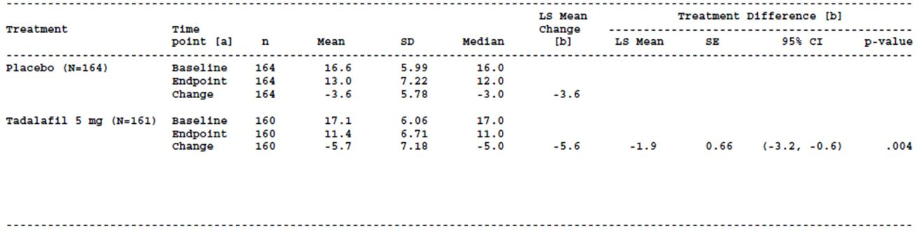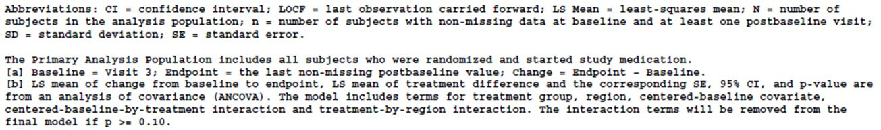
The change in total IPSS, adjusted for ED status, resulted in the same LS mean of the treatment difference as that in the primary efficacy analysis (-1.9).
Based on the repeated measures analysis of total IPSS during the double-blind treatment period for the primary analysis population, the LS mean differences of the changes from baseline to Weeks 4, 8, and 12 were statistically significant for the tadalafil treatment group compared with the placebo group. The repeated measures analysis for total IPSS from the beginning of the placebo lead-in period (Week -4) to Weeks 0, 4, 8, 12 for the primary analysis population showed a LS mean of the treatment difference that was statistically significant for tadalafil at Weeks 4 and 12 but not at Weeks 0 and 8. The LS mean change was shown to increase from baseline (Visit 2) to each time point in the tadalafil group, consistent with the results of the repeated measures analysis during the double-blind treatment period.
In subjects with a baseline IPSS <20, the LS mean difference of the changes from baseline to endpoint in the tadalafil and placebo groups was -0.87 compared with -3.98 for the subgroup of subjects with a baseline IPSS ≥ 20. In subjects with a history of ED, the LS mean of the difference in the change from baseline to endpoint in total IPSS in the two treatment groups was -2.58 compared with -0.05 for subjects who had no history of ED. The results of the other subgroup analyses showed differences in treatment effect between the subgroups that were not large.
Comment: The sponsor proposes to indicate in the PI that patients treated with Cialis 5 mg once daily in each of the four pivotal efficacy studies had clinically meaningful improvements in lower urinary tract symptoms. In this study, the reduction in total IPSS of 5.6 from baseline to endpoint in the tadalafil 5 mg group was greater than the 3.6 reduction in total IPSS in the placebo group. When the change in the placebo group is taken into account, the pharmacologically-mediated effect of tadalafil in the reduction of IPSS from baseline to endpoint was 1.9 points. One study suggests that a clinically meaningful improvement in total IPSS is a reduction in total IPSS of more than 3.0 points, but this varies with baseline BPH-LUTS severity (25). It is unclear if the “clinically meaningful improvement” in total IPSS, was assessed based on the mean change in total IPSS from baseline to Week 12 in the tadalafil 5 mg treatment group, the placebo-adjusted change in the tadalafil 5 mg treatment group, or the limits of the 95% confidence interval for the placebo-adjusted change.

Results for other efficacy outcomes
As a statistically significant difference between the tadalafil 5mg and placebo groups was found on the primary efficacy analysis, the key secondary efficacy measures were analysed sequentially as pre-specified.
For sexually active subjects with ED (placebo N=85, tadalafil 5mg N=90), the LS mean change in IIEF-EF Domain from baseline to Week 12 was 2.0 in the placebo group (n=84) and 6.7 in the tadalafil 5 mg group (n=88). The LS mean difference of the changes in the two treatment groups was statistically significant (LS mean treatment difference 4.7, 95% CI [2.5, 6.9]; p < 0.001).
In the primary analysis population, the LS mean change in total IPSS from baseline to Week 4 was -3.5 in the placebo group (n=162) and – 5.3 in the tadalafil 5mg group and the difference in the LS mean changes in the two groups was statistically significant (LS mean treatment difference -1.8, 95% CI[-3.0, -0.6.]; p = 0.003).
In the primary analysis population (placebo N=164; tadalafil 5mg N=161), the LS mean change from baseline to Week 12 in the BII was numerically greater in the tadalafil 5mg group ((n=163) -1.8) compared with the placebo group ((n=160) -1.3) but the difference in LS mean change between the two treatment groups was not statistically significant (LS mean treatment difference -0.6, 95% CI [-1.2, 0.0.]; p = 0.057).
The results of the analyses for the subsequent two pre-specified key secondary efficacy endpoints, could not be claimed as statistically significant even if the p-value was <0.05.
In the primary analysis population, the LS mean change in the modified IPSS between baseline and Week 1 was -2.7 in the placebo group (n=150) and -3.4 in the tadalafil 5mg group (n=147) with a LS mean treatment difference of -0.7. The LS mean change in BII between baseline and Week 4 was -1.2 in the placebo group (n=162) and -1.8 in the tadalafil 5mg group (n=158) with a LS mean treatment difference of -0.6.
Based on the repeated measures analysis for BII during the double-blind treatment period for the primary analysis population, the LS mean of the treatment difference was statistically significant for the change between baseline and Weeks 4 and 12 for the tadalafil group, compared with the placebo group, but the difference was not statistically significant at Week 8.
Based on the repeated measures analysis for IIEF-EF Domain during the double-blind treatment period for sexually active subjects with ED in the primary analysis population, the LS mean of the treatment difference was statistically significant for tadalafil 5mg, compared to placebo, for change from baseline to Weeks 4, 8 and 12.
The results of the analyses in the primary analysis population for the IPSS subscores pre-specified as secondary endpoints, and the IPSS QoL Index, were supportive of the results of the primary efficacy analysis.
After adjustment for baseline LUTS severity, the proportion of subjects reporting that their urinary symptoms were better at the end of the study was higher in the tadalafil 5 mg group than the placebo group based on the PGI-I. The results of the CGI-I were consistent.
The results of the exploratory analyses for IIEF intercourse satisfaction Domain and the IIEF overall satisfaction Domain were supportive of the results of the key secondary efficacy outcome relating to the IIEF EF Domain.
Comment: The minimal clinically important difference in IIEF EF Domain has been estimated in one study to be 4, with variation in the minimal clinically important difference according to baseline ED severity (29). The minimal clinically important differences in IIEF EF Domain for subjects with mild, moderate and severe baseline ED severity were estimated in this study to be 2, 5 and 7 points respectively (29). In study LVHJ, the mean change in IIEF-EF Domain from baseline to Week 12 of 6.7 in the tadalafil 5 mg group and the pharmacologically-mediated, or placebo-adjusted, improvement was 4.7 (95% CI [2.5, 6.9]). The placebo-adjusted mean change in IIEF-EF Domain from baseline to Week 12 in the tadalafil 5 mg group was more than 4 points which could suggest a clinically meaningful improvement in IIEF-EF Domain due to tadalafil 5 mg, depending on how a clinically meaningful improvement is defined. If the lower limit of the 95% confidence interval for the placebo-adjusted change (2.5) was used to assess a clinically meaningful improvement, the improvement in IIEF-EF Domain due to tadalafil 5 mg may not be considered clinically meaningful.

Study H6D-MC-LVHR (LVHR)

Study design, objectives, locations and dates
Study LVHR was a phase 3, randomised, double-blind, placebo-controlled, parallel-design study. The study objective was to evaluate the efficacy of tadalafil taken once daily for 12 weeks compared with placebo in improving both total IPSS and IIEF Erectile Function Domain score in men with both ED and signs and symptoms of BPH. Tadalafil 2.5 mg and 5 mg were compared with placebo.
The study had three periods. The study design is shown in Figure 3.
Figure 3: Study H6D-MC-LVHR: Study design.
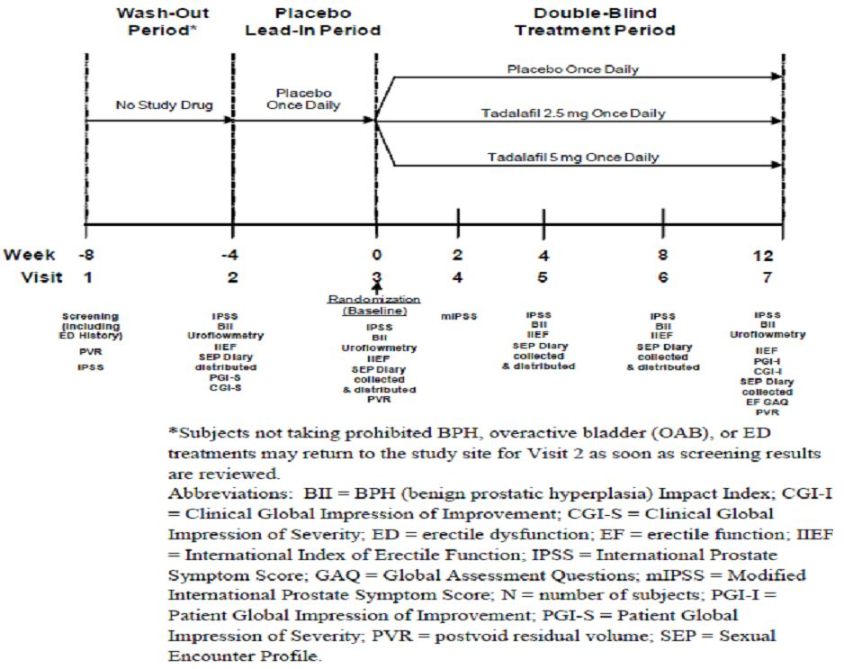
Study LVHR was conducted in 54 study centres in nine countries. The date of first subject enrolment was 14 April 2009. The last subject completed the study on 7 July 2010.

Inclusion and exclusion criteria
Study subjects were men aged 45 years or older with BPH-LUTS and a history of ED for three months or more who were sexually active with an adult female partner. It was expected that the subjects would remain sexually active with the same female partner for the duration of the study an make at least four sexual intercourse attempts during the four-week placebo lead-in period.
Important exclusion criteria were significant renal insufficiency, severe hepatic impairment, a history of specific cardiac and coronary conditions, a HbA1c >9% (uncontrolled diabetes) and evidence of NYHA ≥ Class II cardiovascular disease (cardiac disease resulting in slight limitation of physical activity).
Comment: The inclusion and exclusion criteria were similar to those used for BPH studies LVHG and LVHJ. In studies LVHG and LVHJ subjects with NYHA Class III heart disease (cardiac disease resulting in marked limitation in physical activity) were excluded. This study excluded patient who had cardiac disease resulting in slight limitation of physical activity which may limit the generalisability of the results to such patients in the target population. The source of subject recruitment was not specified.

Study treatments
During the wash-out period, subjects did not receive any study treatment. During the four week placebo-run in period, subjects received a dose of one 2.5 mg and one 5 mg placebo tablet once daily orally. These placebo tablets were identical to the tadalafil 2.5 mg and 5 mg tablets. During the 12 week double blind period, study subjects received two tablets once daily orally. In the tadalafil 2.5 mg treatment group, subjects received tadalafil 2.5 mg and a 5 mg matching placebo once daily. In the tadalafil 5mg group, subjects received tadalafil 5 mg tablet plus one 2.5 mg matching placebo tablet once daily. Subjects in the placebo treatment group received two matched placebo tablets (2.5mg and 5mg) once daily. Subjects were instructed to take the dose (the two tablets) at the same time once daily, with or without food.
The criteria for subject discontinuation from the study and prohibited concomitant therapy were consistent with those criteria specified for study LVHJ. In study LVHR, subjects were also discontinued from the study drug and the study if they were enrolled in any other clinical trial involving off-label use of an investigational drug or device or were enrolled in any other type of medical research judged not to be scientifically or medically compatible with study LVHR.
Comment: The doses selected for this study, 2.5 mg and 5 mg, are the doses approved for once-daily treatment of men with ED in Australia. This is reasonable. The placebo comparison group is reasonable. BPH and ED do not usually become life-threatening or lead to irreversible morbidity if treatment is delayed. There may not have been an available active comparator for the treatment of both ED and BPH-LUTS.

Efficacy variables and outcomes
The primary efficacy variables were the IPSS and the IIEF EF Domain score (sum of Questions 1-5 and 15 of the IIEF).
The co-primary efficacy outcomes were change from baseline to endpoint in total IPSS and IIEF-EF Domain score for subjects taking tadalafil 2.5 mg or 5 mg once daily compared with placebo.
The key secondary efficacy measures were the Sexual Encounter Profile (SEP) diary Question 3 and the BII.
The key secondary efficacy outcomes were:
- Change from baseline to endpoint in the percentage of “yes” responses to SEP diary Question 3 for subjects taking tadalafil 2.5 mg or 5 mg once daily compared with placebo (baseline defined as percentage of yes responses to SEP Q3 during the placebo run-in period relative to the number of sexual encounters during that period, and endpoint defined as percentage of yes responses to SEP Q3 during the double-blind treatment period relative to the number of sexual encounters during that period)
- Change from baseline to endpoint in mean BII score for subjects taking tadalafil 2.5 mg or 5 mg once daily compared with placebo.
There were numerous additional secondary efficacy outcomes including:
- Change in mIPSS from baseline to Week 2
- Change from baseline to Weeks 4,8 and 12 in IPSS subscores, IPSS QoL, IIEF Overall and Intercourse Satisfaction Domain scores, IIEF Q3 and Q4, and percentage of “yes” responses to SEP diary Questions 2, 4, and 5
- PGI-I and CGI-I at the end of therapy
- Erectile Function Global Assessment Questions at the end of therapy

Randomisation and blinding methods
Subjects were randomised at Visit 3 to receive study treatment (tadalafil 5mg, tadalafil 2.5mg or placebo) in a 1:1:1 ratio by a computer-generated random sequence using an IVRS. Randomisation was stratified by baseline (Visit 3) LUTS severity (total IPSS < 20 (mild-moderate) or ≥ 20 (severe)) and ED severity (IIEF EF Domain score: 17-30 (mild), 11-16 (moderate), 1-10 (severe)) and also by geographic region (North America, Mexico, Europe).
During the placebo-lead in period only subjects did not know which treatment was being administered. During the treatment period, subjects, study site personnel and the sponsor did not know which treatment was being administered.

Analysis populations
The randomised population included all subjects who were randomised to study treatment regardless of whether double-blind study medication was taken. The primary analysis population included all subjects who were randomised and started study medication.
The per-protocol population included subjects who met the criteria for the primary analysis population, completed the 12 week treatment period and took at least 70% of the prescribed doses in the double-blind treatment period.
For subjects who discontinued the study early or were missing post-baseline data, analyses were based on the most recent post-baseline data using last observation carried forward data imputation methodology and subjects with no post-baseline data for a particular efficacy endpoint were excluded from the analysis for that endpoint. The treatment of a missing question or questions for the IPSS, BII or IIEF Domain at a specific visit was the same as that described for study LVHJ.
The safety analysis population included all randomised subjects according to the treatment to which they were assigned. The safety population was equivalent to the randomised population.

Sample size
The planned sample size was 552 subjects (184 subjects per treatment group). A total of 175 subjects per treatment group were required to provide at least 80% power to detect a placebo-adjusted mean difference in IPSS of 1.9 points assuming a standard deviation of 6 points and using the Dunnett-Bonferroni gatekeeping approach. The non-evaluable rate was projected to be 5%. This sample size would provide at least 80% power to detect placebo-adjusted difference in IIEF EF Domain score of 2.6 points with a standard deviation of 8.0.
Comment: The placebo-adjusted difference (1.9) in IPSS used in the sample size calculation in this study was similar to those used in the sample size calculation for study LVHJ (2.0) and study LVHG (2.0).

Statistical methods
The primary efficacy analyses, and key secondary efficacy analyses, were conducted using the primary analysis population and repeated in the per-protocol population. If the primary analysis population did not include all subjects included in the randomised population, sensitivity analyses were performed using all randomised subjects for the co-primary and key secondary efficacy outcomes.
The null hypotheses tested were:
- no difference between tadalafil and placebo in mean changes from baseline to the end of therapy in total IPSS
- no difference between tadalafil and placebo in mean changes from baseline to the end of therapy in IIEF EF Domain score.
The null hypotheses were to be rejected only if both co-primary endpoints for a tadalafil dose reached statistical significance at the 0.0271 alpha level for a two tailed test. This significance level was derived from a three step gatekeeping procedure, the Dunnett-Bonferroni gatekeeping procedure, which was applied to control the family-wise Type 1 error rate at a two-sided 0.05 alpha level associated with the comparison of two doses of tadalafil with placebo for the co-primary and key secondary endpoints. Statistical testing of the key secondary endpoints was to proceed for each dose of tadalafil only if both co-primary endpoints for that dose reached statistical significance at the 0.0271 alpha level for a two tailed test. The secondary hypotheses were tested in a pre-specified order. The significance levels specified for each of the key secondary endpoint comparisons depended on whether one or two doses were significant, compared with placebo, in the previous step of the algorithm. The Dunnett-Bonferroni gatekeeping procedure is shown in Figure 4.
Figure 4: Study H6D-MC-LVHR: Testing strategy for the primary and key secondary efficacy hypotheses.
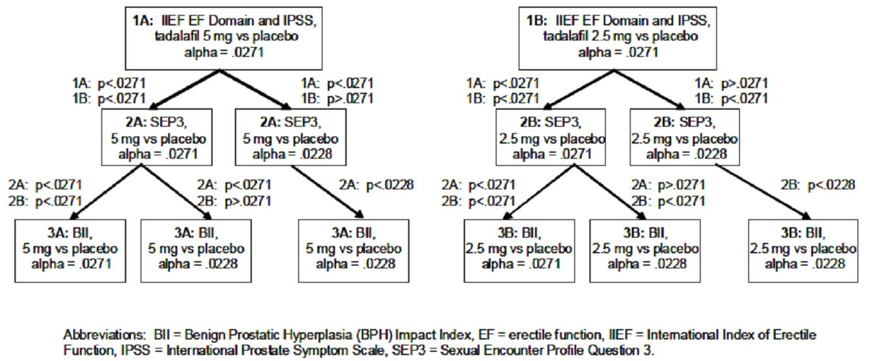
An ANCOVA model was used to analyse each of the co-primary outcomes and the key secondary outcomes. The model included terms for treatment, region and centered baseline value of the variable (baseline value for a subject minus the overall mean baseline value). Interaction terms for centred-baseline value-by-treatment and region-by-treatment were included in the model if the interaction term was significant at the 0.10 level.
Changes from baseline to endpoint in the each of the co-primary outcomes, and the treatment differences in these changes between tadalafil doses and placebo, were estimated using least-squares means. The p-values associated with the Type III sums of squares of the estimated treatment difference between 5 mg tadalafil and placebo or 2.5 mg tadalafil and placebo were assessed for significance according to the Dunnett-Bonferroni gatekeeping procedure described above.
Additional sensitivity analyses using ANCOVA models were undertaken to investigate the potential influence of baseline ED severity randomisation stratification factor on total IPSS and of baseline LUTS severity randomisation stratification factor on IIEF EF Domain score. Repeated measures analyses of variance were also conducted for the co-primary outcomes and key secondary efficacy outcomes.
The statistical methods used for the additional secondary efficacy outcomes varied depending on the type of data to be analysed. No adjustments for multiplicity were made for the analysis of these outcomes.
Comment: The SAP does not appear to have been provided for this study. Only the Dunnett-Bonferroni gatekeeping procedure was specified. It appears that this gatekeeping procedure was requested by the FDA.
The statistical analyses described in the clinical study report seem to follow most of those proposed in the study protocol (protocol H6D-MC-LVHR (a)). Changes to the analyses specified in the protocol are highlighted in the clinical study report and did not affect the primary efficacy analyses or key secondary efficacy analyses. A subgroup analysis of the co-primary efficacy endpoints by region that was undertaken, does not appear to be specified in the protocol.
The co primary efficacy outcomes were summarised by the subgroups baseline LUTS, baseline ED severity, prior alpha blocker therapy, prior PDE5 inhibitor therapy, age and region. Subgroup analyses for the primary efficacy endpoints used ANCOVA models.

Participant flow
Of 1127 subjects screened, 521 were screen failures and 606 subjects were randomised (placebo n=200, tadalafil 2.5mg n=198, tadalafil 5mg n=208). A similar number of subjects discontinued from the study in each treatment group (placebo n=30, tadalafil 2.5mg n=26, tadalafil 5mg n=24), adverse events leading to the discontinuation of six subjects in the tadalafil 5 mg group compared with three subjects in the placebo and tadalafil 2.5 mg groups respectively. Few subjects were lost to follow-up (placebo n=1, tadalafil 2.5 mg n=1, tadalafil 5mg n=3). The proportion of subjects in each treatment group who completed the 12 weeks of double-blind treatment was comparable (placebo 85.0% (n=170), tadalafil 2.5mg 86.9% (n=172), tadalafil 5mg 88.5% (n=184)). The primary analysis population was identical to the randomised population (placebo n=200, tadalafil 2.5mg n=198, tadalafil 5mg n=208).

Major protocol violations/deviations
The proportion of subjects in each of the treatment group who had protocol violations that related to inclusion criteria not being met or exclusion criteria being met was similar (placebo 8.0% (n=16), tadalafil 2.5mg 7.6% (n=15), tadalafil 5mg 6.3% (n=13)). The most common protocol violation was the uroflowmetry assessment criteria were out of the protocol specified range. The number of subjects with this protocol violation was similar in each treatment group (placebo n=9, tadalafil 2.5mg n=7, tadalafil 5mg n=7). The differences between the treatment groups in the numbers of subjects reported with other specific protocol violations were generally small.
All of the subjects randomised in Portugal (3% of randomised subjects) were reported to have had at least one protocol violation which included not meeting an inclusion criterion and/or meeting an exclusion criterion. A few protocol violations relating to use of excluded medication during the double-blind treatment period were identified by the sponsor. Errors in the calculation of the IIEF EF Domain scores and total IPSS used for entry into the IVRS, or entry of the scores into the IVRS, were also identified by the sponsor. The errors in the IIEF EF Domain score resulted in 45 subjects being incorrectly stratified but a similar numbers of subjects in each of the treatment groups were affected.
Comment: It would seem that the protocol violations described would not have appreciably affected the results of the primary efficacy results as they generally affected small numbers of subjects and were reasonably balanced across the treatment groups.

Baseline data
The mean age of randomised study subjects was 62.6 years (range 45.3 years - 83.2 years). Thirty-seven percent of study subjects were aged over 65 years with similar proportions of subjects in each treatment group aged over 65 years. In the tadalafil 5 mg group, 83 subjects were aged over 65 years. The tadalafil 2.5 mg group had a smaller proportion of subjects aged 75 years or older compared with the other two treatment groups (placebo 11.5% (n=23), tadalafil 2.5mg 6.1% (n=12), tadalafil 5mg 10.1% (n=21)). The majority of subjects were white (93.2%) and were from the regions Europe (41.1%) and North America (46.4%). There were only 14 randomised subjects who were Asian. Mean height, weight, BMI and sitting vital signs were comparable between the treatment groups. Tobacco use and current alcohol consumption were reported by similar proportions of subjects in each treatment group at baseline. Baseline LUTS severity was reported as severe (IPSS ≥ 20) for 39.0% of randomised subjects and moderate (IPSS < 20) for 61.0% of subjects, with comparable proportions of subjects in each category across the treatment groups. Half of all randomised subjects (50.6%) had a Qmax <10 mL/sec and the mean post-void residual urine volume was 53.2mL. Similar proportions of subjects in each treatment group had previously used one or more alpha blockers (placebo 23.0%, tadalafil 2.5mg 20.2%, tadalafil 5mg 26.9%), one or more BPH-LUTS therapies other than alpha blockers (placebo 9.0%, tadalafil 2.5mg 6.6%, tadalafil 5mg 10.1%) and one or more OAB therapies (placebo 2.0%, tadalafil 2.5mg 1.5%, tadalafil 5mg 2.4%). The severity and duration of erectile dysfunction were comparable across the treatment groups. For all randomised subjects, 26.6% had an erectile dysfunction severity of severe and almost all (91.6%) had had ED for at least one year. Overall, 28.5% of subjects had used one or more previous ED therapies and the proportion was comparable across the treatment groups.
One subject in the tadalafil 2.5 mg group and one subject in the tadalafil 5 mg group were <70% compliant with the prescribed doses during the placebo-period but they were still randomised, constituting a protocol violation (inclusion criteria not met).
During the double-blind treatment period, the proportion of subjects who were at least 70% compliant with the prescribed treatment was very high (placebo 98.0%, tadalafil 2.5mg 98.0%, tadalafil 5mg 99.5%).
Comment: No subjects were recruited in Australia. As the majority of subjects in this study were white and were from the regions Europe and North America, the results may not be generalisable to the whole Australian population which is comprised of people of many different ethnic origins.

Results for the primary efficacy outcome
There was an improvement in total IPSS from baseline to endpoint in all three treatment groups. The LS mean change was greatest in the tadalafil 5 mg group (LS mean change: placebo (n=194) -3.8, tadalafil 2.5mg (n=191) -4.6, tadalafil 5mg (n=206) -6.1). The LS mean difference of the change from baseline to endpoint in total IPSS between the tadalafil 5 mg group and the placebo group was statistically significant at the prespecified alpha level of 0.0271 (LS mean treatment difference -2.3 (SE 0.58); 95% CI [-3.5, -1.2]; p<0.001). Comparing the tadalafil 2.5 mg and placebo treatment groups, the LS mean difference of the change from baseline to endpoint in total IPSS was not statistically significant (LS mean treatment difference -0.8 (SE 0.59); 95% CI [-2.0, 0.4]; p=0.181).
There was also an improvement in the IIEF EF Domain score in all three treatment groups between baseline and endpoint. The greatest LS mean change was in the tadalafil 5 mg group (LS mean change: placebo (n=190) 1.8, tadalafil 2.5mg (n=190) 5.2, tadalafil 5mg (n=203) 6.5). The LS mean difference of the change from baseline to endpoint was statistically significant for the tadalafil 5 mg group compared with the placebo group and the tadalafil 2.5 mg group compared with the placebo group at the pre-specified alpha level of 0.0271. (Tadalafil 5mg compared with placebo: LS mean treatment difference 4.7 (SE 0.66); 95% CI [3.4, 6.0]; p<0.001; Tadalafil 2.5mg compared with placebo: LS mean treatment difference 3.4 (SE 0.67); 95% CI [2.1, 4.7]; p<0.001) (Table 9).
Table 9: Study H6D-MC-LVHR: IIEF EF Domain score change from baseline to endpoint (LOCF) (primary analysis population).
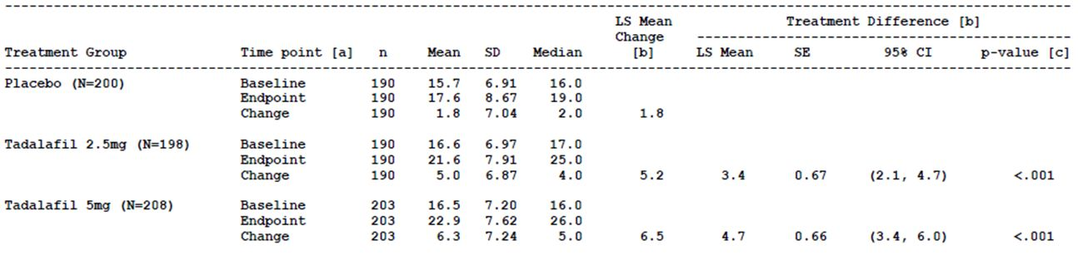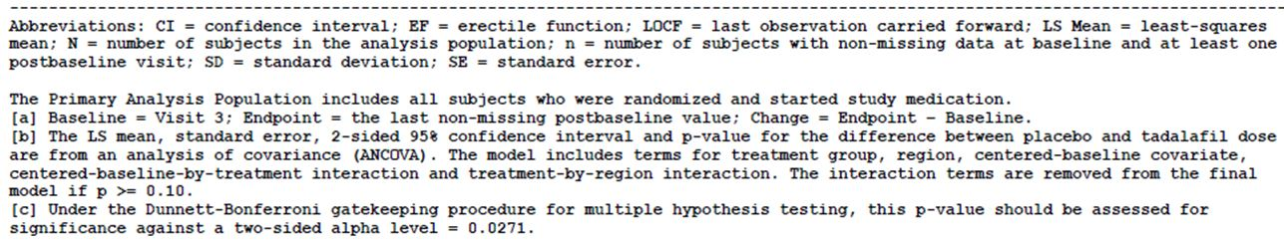
The changes from baseline to endpoint for both total IPSS and IIEF EF Domain score were statistically significant only for the tadalafil 5 mg group compared with the placebo group, not the tadalafil 2.5 mg group compared with placebo, therefore only the tadalafil 5 mg versus placebo comparison met the criteria for statistical significance stipulated in the prespecified gatekeeping procedure (Figure 4).
The results of the analyses of change from baseline to endpoint in total IPSS and IIEF EF Domain score in the per-protocol population were consistent with the results in the primary analysis population.
The results of the repeated measures analysis of change in total IPSS during the double-blind treatment period for the primary analysis population revealed a LS mean change (improvement) from baseline to endpoint at Weeks 4, 8 and 12 in each treatment group. The LS mean change at each time point was highest in the tadalafil 5 mg group followed by the tadalafil 2.5 mg and then the placebo group. Comparing tadalafil 5 mg with placebo, the LS mean difference of the change was statistically significant at each time point (p< 0.001). Comparing tadalafil 2.5 mg with placebo, the LS mean difference of the change at each time point was not statistically significant. For the IIEF EF Domain score, the repeated measures analysis in the primary analysis population also showed a LS mean change (improvement) from baseline to endpoint at Weeks 4, 8 and 12 in each treatment group with the greatest improvement at each time point being seen in the tadalafil 5mg group. Comparing tadalafil 5 mg with placebo, and tadalafil 2.5 mg with placebo, the LS mean difference of the change was statistically significant at each time point (p< 0.001).
The results of an analysis of the change from baseline to endpoint in total IPSS in the primary analysis population adjusted for ED severity were similar to those of the primary efficacy analysis. The results of an analysis of the change from baseline to endpoint in IIEF EF Domain score in the primary analysis population adjusted for LUTS severity were similar to those of the primary efficacy analysis.
Subgroup analyses for total IPSS and IIEF EF Domain score indicated that there were no detectable differences in treatment effects across the pre-specified subgroup categories.

Results for other efficacy outcomes
The two key secondary parameters were assessed in accordance with the pre-specified gatekeeping procedure (Figure 4).
The comparison of the percentages of “yes” responses to SEP dairy Q3 was assessed between the tadalafil 5 mg group and the placebo treatment group was assessed for statistical significance at an alpha level of p=0.0228. The LS mean difference in the changes in the percentage of “yes” responses to SEP diary Question 3 between the tadalafil 5 mg group (n=199) and the placebo group (n=187) in the primary analysis population was statistically significant at the alpha level of p=0.0228 (LS mean difference of change: 19.7 (SE 2.80), 95% CI [14.2, 25.2]; p<0.001). Based on the primary analysis population, the mean per-subject proportion of successful intercourse attempts at endpoint was 48.3% (SD 38.50) for subjects in the placebo group and 71.9% (SD 34.74) for subjects in the tadalafil 5 mg group.
The LS mean difference of the change in the tadalafil 2.5 mg group compared with the placebo group from baseline to endpoint was 12.5. The statistical significance of the result was not interpreted as the tadalafil 2.5 mg dose was not statistically significant when compared with placebo for the co-primary endpoints.
The LS mean difference of the change in the BII from baseline to endpoint between the tadalafil 5mg group and the placebo group was statistically significant at the pre-specified alpha level of p=0.0228 (LS mean change from baseline to endpoint: placebo (n=190) -1.3 (SD 2.93), tadalafil 5mg (n=203) -2.1 (SD 3.11); LS mean difference of change: -0.9, 95% CI [-1.4, -0.4]; p<0.001). The LS mean difference of the change in the BII from baseline to endpoint between the tadalafil 2.5 mg group and the placebo group was -0.4. The statistical significance of the result was not interpreted as the tadalafil 2.5 mg dose was not statistically significant when compared with placebo for the co-primary endpoints.
The results of analyses for the two key secondary outcomes in the per-protocol population were consistent with the results in the primary analysis population. The results of the repeated measures analysis for the double-blind period in the primary analysis population were also supportive of the results for the key secondary efficacy analyses.
The results of the analyses for the additional secondary outcomes were generally supportive of the results for the primary outcomes. There was a larger improvement in the IPSS total (mIPSS) from baseline to Week 2 in the tadalafil 5mg group compared with the placebo group (LS mean change from baseline to Week 2: placebo (n=162) -2.2, tadalafil 5mg (n=160) -4.0). Based on the three category PGI-I, higher proportions of subjects in the tadalafil treatment groups, compared with the placebo group, reported that their symptoms were better at the end of the study compared with before they took the study treatment. The results of the CGI-I were consistent. Based on the EF-GAQ, completed at the end of the study or on early discontinuation, higher proportions of subjects in the tadalafil groups, compared with the placebo group, reported that the treatment had improved their erections and improved their ability to engage in sexual activity.
Comment: Study LVHR was the pivotal study for the proposed indication “Cialis is indicated for the treatment of ED and the sign and symptoms of BPH (ED/BPH) in adult men” and was one of four pivotal studies supporting the proposed indication “Cialis is indicated for the treatment of the signs and symptoms of benign prostatic hyperplasia (BPH) in adult men”.
The sponsor proposes to indicate in the PI that Cialis 5 mg once daily resulted in clinically meaningful and statistically significant improvements in both BPH symptoms, as measured by the total IPSS, and erectile funcation, as measured by IIEF EF Domain.
Comparing tadalafil 5 mg with placebo, the results of this study showed a statistically significant improvement in total IPSS and IIEF from baseline to endpoint. In the tadalafil 5 mg group, the absolute changes from baseline to endpoint in total IPSS score and IIEF–EF Domain score were -6.1 and 6.5, respectively. After subtracting the improvements in the placebo group for each of these variables, the pharmacologically-mediated effect is lower (total IPSS -2.3 95% CI [-3.5, -1.2]; IIEF-EF 4.7 95% CI [3.4, 6.0]). Greater than half of the improvement in total IPSS score in the tadalafil 5 mg group could be attributed to a placebo effect (placebo group -3.8). For the change in baseline for total IPSS, the lower limit of the 95% confidence interval for the LS mean difference between the treatments was -3.5 indicating that, in the population, there may be a clinically significant improvement from the effect of tadalafil 5 mg alone if a decrease of more than 3 points is considered an improvement. Regarding the change in baseline for IIEF–EF Domain score, the placebo-adjusted mean change from baseline could be considered clinically meaningful, but maybe not for all men with ED as the estimated minimal clinically important differences in IIEF EF Domain varied according baseline ED severity varied in one study (29). It is unclear if the assessments of a “clinically meaningful improvement” in total IPSS and IIEF-EF Domain, respectively, are based on the mean change from baseline to Week 12 in the tadalafil 5 mg group, the placebo-adjusted change in the tadalafil 5 mg group, or the limits of the 95% confidence interval for the placebo-adjusted change.
There is evidence from one study that a decrease in BII of more than 0.5 points is clinically meaningful. In this study the subgroup of subjects with baseline BII scores of less than 5 points perceived smaller decreases in the BII as an improvement compared with the subgroup of subjects with a baseline BII score of more than 5 points (25). There was an improvement of more than 0.5 points from baseline to endpoint in both the tadalafil 5 mg and placebo groups, with a significantly greater improvement in the tadalafil 5 mg group. The difference in LS mean change between the treatments was -0.9 (95% CI [-1.4, -0.4]). If the definition of a clinically meaningful improvement is based on the LS mean change between the treatments (that is, the placebo-adjusted change from baseline for the tadalafil 5 mg group), this difference would be considered clinically meaningful improvement in BII due to tadalafil 5 mg. However, if the definition is based on the upper limit of the 95% confidence interval, it is possible that the placebo-adjusted change from baseline may not be considered clinically meaningful in the population as the true population improvement from tadalafil 5 mg treatment may be only a decrease of 0.4 points.
The sponsor proposes to include in the PI the results of the change from baseline to Week 2 in IPSS total in this study. Change from baseline to Week 2 in IPSS total was an additional secondary efficacy outcome in study LVHR. It does not appear that there was an adjustment made for multiple comparisons in relation to the additional secondary efficacy outcomes. It is recommended that this information is removed from the draft PI.

Study H6D-MC-LVID (LVID)

Study design, objectives, locations and dates
Study LVID was a phase 3, randomised, double-blind, tamsulosin- and placebo- controlled, parallel-design study. The study was undertaken in 44 centres across Austria, Australia, Belgium, France, Germany, Greece, Italy, Mexico, the Netherlands and Poland between December 2009 and January 2011.
There were three study periods. As soon as the screening results were available, eligible subjects not taking prohibited treatment for BPH, overactive bladder or ED, started the four-week single-blind, once-a-day placebo lead-in period to assess treatment compliance and establish baseline values for efficacy measures during the double-blind treatment period. Subjects who were taking a prohibited treatment for BPH, overactive bladder or ED, entered a four week washout period followed by the placebo lead-in period. At Visit 3, eligible subjects were randomly assigned to treatment groups. The treatment period ended at Week 12 (Visit 7) (Figure 5).
Figure 5: Study H6D-MC-LVID: Study design.
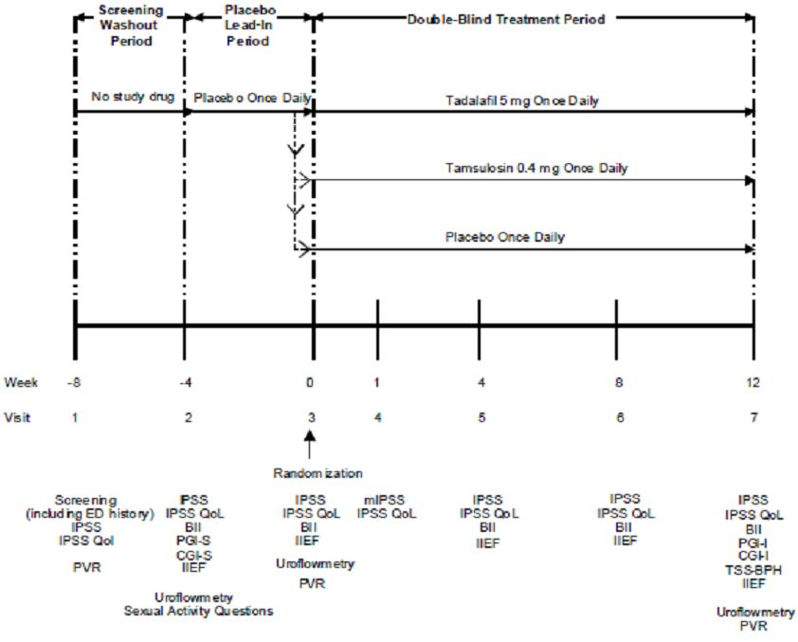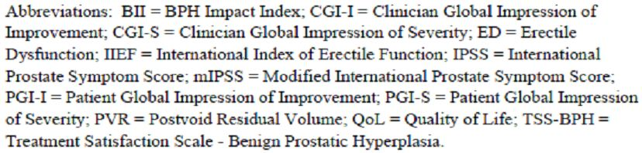
The primary objective was to evaluate the efficacy of tadalafil 5 mg once daily for 12 weeks compared with placebo in improving total IPSS in men with BPH-LUTS.
Comment: Tamsulosin 0.4 mg was included as an active control group. Tamsulosin is registered in Australia for the relief of LUTS associated with BPH and the recommended dose is 0.4 mg once daily (10) and is a medical therapy treatment option for moderate to severe BPH-LUTS included in Andrology Australia’s Clinical Summary Guide for Prostate Disease (3).

Inclusion and exclusion criteria
Study subjects were men who were at least 45 years of age with BPH-LUTS and evidence of bladder outlet obstruction. Important exclusion criteria were significant renal insufficiency, severe hepatic impairment, a history of specific cardiac and coronary conditions and a HbA1c >9%.
Comment: The inclusion and exclusion criteria were similar to those used in the other pivotal studies. The source of the study subjects does not appear to have been specified.

Study treatments
There was no treatment given during the wash-out period. During the placebo lead-in period, all subjects received a tadalafil placebo tablet and a tamsulosin placebo capsule once daily for four weeks. During the 12 week treatment period, subjects in the tadalafil treatment group received one 5 mg tadalafil tablet and one tamsulosin placebo capsule once daily, subjects in the tamsulosin treatment group received one 0.4 mg tamsulosin capsule and one tadalafil placebo tablet once daily, and subjects in the placebo group received one tadalafil placebo tablet and one tamsulosin placebo capsule once daily. The tablet and capsule were to be taken at the same time each day, approximately 30 minutes after eating a meal.
The criteria for discontinuing a subject from the study and prohibited concomitant therapy were consistent with study LVHR.

Efficacy variables and outcomes
The primary efficacy variable was the IPSS. The key secondary efficacy variables were the BII and mIPSS.
Other secondary efficacy variables included the IIEF, PGI-I, CGI-I, and the Treatment Satisfaction Scale - Benign Prostatic Hyperplasia (TSS-BPH). The TSS is a validated subject-rated instrument. It measures the subject’s satisfaction with treatment based on a 13 item questionnaire (3 subscales of 10 generic items and 3 condition specific items). The overall score is calculated as the mean of the items. The score range is 0-100 with lower scores indicating greater satisfaction.
The primary efficacy outcome was change in total IPSS from baseline (Visit 3, Week 0) to end of therapy (Visit 7, Week 12) for subjects taking tadalafil 5 mg compared with placebo.
The key secondary efficacy outcomes were the comparison of the changes from baseline between tadalafil 5 mg and placebo in the following:
- total IPSS after four weeks of treatment
- BII after 12 weeks of treatment (end of therapy using LOCF)
- mIPSS after one week of treatment
- BII after 4 weeks of treatment
Other secondary efficacy outcomes included the comparison between tadalafil 5 mg and placebo of the change in IIEF EF Domain from baseline to end of therapy in sexually active men with both BPH-LUTS and ED history. There were also secondary efficacy outcomes relating to the comparison of tamsulosin 0.4 mg with placebo.

Randomisation and blinding methods
Subjects who had met the criteria for enrolment at Visit 3 were randomly assigned to one of the three treatment groups in a 1:1:1 ratio. Randomisation was stratified by baseline LUTS severity (total IPSS < 20 or ≥ 20) at Visit 1, geographic region (EU or non EU) and history of ED (yes or no) at Visit 1 A computer-generated random sequence using an IVRS was used to determine assignment to the treatment groups.
During the placebo lead-in period, only subjects did not know the treatment being administered. During the treatment period, subjects, study site personnel and the sponsor did not know which treatment was being administered.

Analysis populations
The efficacy analyses were performed on an intent-to-treat basis.
The randomised population consisted of subjects who were randomised to study treatment, regardless of whether or not they took the double-blind study medication.
The primary analysis population included all subjects who were randomised and started study medication.
The per-protocol population included subjects who met the criteria for the primary analysis population, completed the 12 week treatment period and took at least 70% of the prescribed doses in the double-blind study period.
The safety analysis population for the double-blind treatment period consisted of all randomised subjects according to the treatment to which they were assigned.
Baseline for the efficacy measurements was Visit 3. For subjects who discontinued the study early or were missing post-baseline data, the analyses were based on the most previous non-missing post-baseline data. Subjects with no post-baseline data for a particular efficacy outcome were excluded from the analysis for that outcome.
For subjects who discontinued the study early or were missing post-baseline data, analyses were based on the most recent post-baseline data using last observation carried forward data imputation methodology and subjects with no post-baseline data for a particular efficacy endpoint were excluded from the analysis for that endpoint. The treatment of a missing question or questions for the IPSS, BII or IIEF Domain at a specific visit was the same as that described for study LVHJ.
The safety analysis population consisted of all randomised subjects according to the treatment to which they were assigned.

Sample size
The null hypothesis was that there would be no difference between tadalafil 5 mg and placebo in terms of change from baseline to end of therapy or Week 12 in total IPSS.
It was determined that a total of 143 subjects per treatment arm would provide at least 80% power to detect a placebo-adjusted mean difference in IPSS of 2.0, assuming a standard deviation of 6 (estimated based on data from study LVHG) and using a two-sided t-test at 0.05 level of significance. It was anticipated that 151 subjects per treatment group (453 subjects in total) would be randomised given a projected non-evaluable rate of 5%.
The sample size was reported to have sufficient power to show the superiority of tamsulosin to placebo if the tadalafil and tamsulosin data had the same standard deviation. The trial was not powered to directly compare the tadalafil and tamsulosin treatment groups or for a statistical analysis of non-inferiority.
Comment: The number of subjects in the randomised, primary analysis and per protocol study populations exceeded the total number of subjects planned. In all these populations the number of subjects per treatment group exceeded 143 subjects.

Statistical methods
For the primary outcome, the primary inferential analysis of mean change in total IPSS from baseline to end of therapy between tadalafil 5 mg and placebo was conducted using an ANCOVA using the primary analysis population. The p-value from Type III sums of squares for the difference between the tadalafil 5 mg and placebo groups was assessed for significance at a two-sided significance level of 0.05. The ANCOVA model included terms for centered parameter baseline, treatment group, region, centered baseline-by-treatment interaction and treatment-by-region interaction. If the interaction was not significant (p>0.10), it was removed from the model and the main effects model remained from which the between-treatment-group p-value was obtained.
Sensitivity analyses and subgroup analyses were also undertaken for the primary efficacy outcome using ANCOVA models.
A fixed sequence testing procedure was undertaken to control the family-wise Type 1 error in primary and multiple key secondary endpoints for the comparison between tadalafil 5 mg and placebo. The key secondary endpoints were to be analysed only if the result of the primary efficacy analysis was significant at a two-sided significance level of 0.05. The key secondary analyses were performed at a two-sided significance level of 0.05.
For the key secondary efficacy endpoints claims of statistical significance at the level of the individual test were dependent upon the significance of all the previous tests.
For the analyses of other secondary efficacy outcomes, no adjustment for multiplicity was made.
For the comparison between the tamsulosin 0.4 mg and placebo treatment groups, the ANCOVA model used in the primary efficacy analysis was used to compare the mean change in total IPSS from baseline to end of therapy. The keys secondary outcomes were analysed for the comparison between tamsulosin 0.4 mg and placebo regardless of the fixed sequence testing procedure.
A repeated measures model was applied to total IPSS and BII with the change of the efficacy variable from baseline to 4, 8 and 12 weeks as the response. This model was applied to the comparisons between tadalafil 5 mg and placebo and tamsulosin 0.4mg and placebo respectively.
Comment: The statistical analyses undertaken followed the protocol. The SAP was not provided in the submission.

Participant flow
Of 652 subjects screened for the study, 21.6% (n=141) were screen failures and 78.4% (n=511) subjects were randomised (placebo n=172, tadalafil 5mg n=171, tamsulosin 0.4mg n=168)). The proportion of subjects in each treatment group who completed the 12 week double blind treatment period was similar (placebo 86.0% (n=148), tadalafil 5mg 91.2% (n=156), tamsulosin 0.4mg 89.3% (n=150)).
The primary analysis population consisted of 510 subjects who were randomised and started the study drug (placebo n=172, tadalafil 5mg n=171, tamsulosin 0.4mg n=167)). One subject in the tamsulosin 0.4 mg group discontinued the study before taking his first dose of study drug.
Comment: This study included 25 subjects randomised in four Australian sites.

Major protocol violations/deviations
Seven subjects in each of the treatment groups had protocol violations identified from the clinical database using pre-specified criteria defined in the SAP relating to the inclusion criteria having not been met or the exclusion criteria being met. The specific protocol violations were reported in only a small number of subjects and the numbers of subjects reported with a specific protocol violation were generally similar number across the groups. Additional protocol violations were reported to have been identified during blinded study data reviews which were not considered by the sponsor to have been likely to have affected the analyses or conclusions.
Fifteen subjects across two study sites were potentially unblinded to their treatment during the placebo lead-in phase as they were consented under a version of the informed consent document that inadvertently informed subjects about the single-blind 4 week placebo lead-in period.
Comment: The 15 subjects who were potentially unblinded to the treatment given during the placebo lead-in would not be expected to substantially affect the primary efficacy analysis as the number of subjects is small compared to the total number of subjects in the primary analysis population and it is likely that the number of these subjects randomised to the three treatment groups would have been fairly similar minimising any bias resulting from the unblinding.

Baseline data
The mean age of randomised study subjects was 63.6 years (range 45.1-88.6 years). The majority of randomised subjects were aged less than 75 years (89.8%), were white (76.7%) and were from Europe (71.2%). With regard to baseline LUTS symptom severity, 70.5% had symptoms of moderate severity (IPSS<20) and the remainder of subjects had symptoms that were severe (IPSS ≥ 20).
Over half of all randomised subjects (54.0%) had a Qmax <10mL/sec and 36.2% had a Qmax 10-15 mL/sec. One quarter of subjects (25.2%) had used one or more alpha blockers in the 12 months prior to Visit 1, the most commonly used was tamsulosin. Smaller proportions of subjects had used treatments, other than alpha blockers, for the treatment of BPH-LUTS , and over active bladder therapy, in the 12 months prior to Visit 1 (BPH-LUTS therapy 4.5%, OAB therapy 1.0%). The majority of randomised subjects (69.9%) had erectile dysfunction and of the randomised subjects with ED the majority had ED of moderate severity (52.9%) and had had ED for at least one year (79.8%). Of all randomised subjects, 12.7% had used one or more ED therapies in the 12 months prior to Visit 1, the most common was tadalafil.
The baseline demographics and other characteristics were generally comparable between the treatment groups. Of note, there were more subjects aged 75 years or older in the placebo group compared with the other treatment groups (placebo n=23 (13.4%), tadalafil 5mg n=13 (7.6%), tamsulosin n=16 (9.5%)) and a lower proportion of subjects reporting current alcohol consumption in the placebo group (placebo n=102 (59.3%), tadalafil 5mg n=112 (65.5%), tamsulosin 0.4mg n=113 (67.3%)). A higher proportion of subjects in the tamsulosin 0.4 mg group had a Qmax <10mL/sec (placebo n=79 (45.9%), tadalafil 5mg n=92 (53.8%), tamsulosin n=105 (62.5%)).
The proportion of subjects who were at least 70% compliant with study medication during the double-blind treatment period was high and the same in each treatment group (99.4%).
Comment: Although alcohol consumption was reported in a lower proportion of subjects in the placebo group than the tadalafil 5 mg group, the difference in the proportions was not large so it would appear that the difference in this factor is unlikely to bias the results.

Results for the primary efficacy outcome
There was a decrease in total IPSS from baseline to endpoint in both the tadalafil 5 mg and placebo treatment groups (LS mean change: placebo group (n=172) -4.2 (SE 0.5), tadalafil 5mg group (n=171)-6.3 (SE 0.5)). The LS mean for the difference between the tadalafil 5 mg and placebo groups was statistically significant (LS mean for the treatment difference -2.1 (SE 0.6); 95% CI [-3.3, -0.8]; p=0.001) (Table 10). The results in the per-protocol population were consistent with those in the primary analysis population as were the results of a sensitivity analysis adjusted for ED status. The results of the repeated measures analysis in the primary analysis population were also consistent.
Table 10: Study H6D-MC-LVID: Total IPSS – change from baseline to endpoint (LOCF) (primary analysis population).
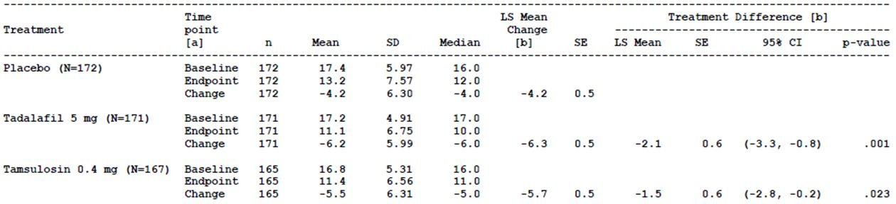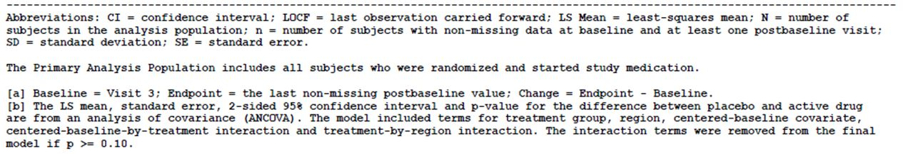
Subgroup analyses for the change from baseline to endpoint in total IPSS revealed no detectable difference in treatment effects between baseline LUTS severity subgroups, baseline ED history subgroups, geographical region subgroups, or age category subgroups (≤ 65, >65 and ≤ 75, > 75) and previous alpha blocker usage subgroups.

Results for other efficacy outcomes
As the primary efficacy analysis showed a statistically significant difference between the tadalafil 5 mg and placebo groups for the primary efficacy outcome, the key secondary efficacy outcomes were analysed in the primary analysis population sequentially as pre-specified.
The difference in LS mean change from baseline to Week 4 in total IPSS between the tadalafil 5 mg and placebo groups was statistically significant (LS mean change placebo (n=166) -3.3 (SE 0.4), tadalafil 5mg (n=167) -5.5 (SE 0.4); LS mean for the treatment difference -2.2 (SE 0.6); 95% CI [-3.4, -1.0]; p < 0.001).
For the change in BII from baseline to endpoint, the difference in LS mean change between the tadalafil 5 mg and placebo groups was statistically significant (LS mean change placebo (n=167) -0.9 (SE 0.2), tadalafil 5mg (n=168)-1.7 (SE 0.2); LS mean for the treatment difference -0.8 (SE 0.3); 95% CI [-1.3, -0.3]; p = 0.003).
For the change in mIPSS from baseline to Week 1, the difference in LS mean change between the tadalafil 5 mg and placebo groups was statistically significant (LS mean change placebo (n=154) -2.5 (SE 0.4), tadalafil 5mg (n=162) -4.0 (SE 0.4); LS mean for the treatment difference -1.5 (SE 0.5); 95% CI [-2.6, -0.5]; p = 0.003).
For the last key secondary efficacy endpoint, change in BII from baseline to Week 4, the difference in LS mean change between the tadalafil 5 mg and placebo groups was also statistically significant (LS mean change placebo (n=166) -0.4 (SE 0.2), tadalafil 5mg (n=167) -1.2 (SE 0.2); LS mean for the treatment difference -0.8 (SE 0.2); 95% CI [-1.3, -0.3]; p < 0.001).
With regard to the comparisons between the tamsulosin 0.4 mg and placebo groups, the LS mean change from baseline to endpoint in total IPSS was greater in the tamsulosin 0.4 mg group compared with the placebo group and the difference between the treatment groups in the LS mean change was statistically significant (LS mean change: tamsulosin (n=165)-5.7 (SE 0.5), placebo -4.2 (SE 0.5), LS mean difference -1.5 (SE 0.6) ; 95% CI[-2.8, -0.2]; p=0.023). For each of the key secondary endpoints, the LS mean change was greater in the tamsulosin 0.4 mg group compared with the placebo group also.
In sexually active subjects with ED in the primary analysis population, a greater improvement in IIEF EF Domain from baseline to endpoint was reported in the tadalafil 5mg group compared with the placebo group (LS mean change: placebo 2.1, tadalafil 5mg 6.0).
A higher proportion of subjects in the tadalafil 5 mg group reported that their symptoms were much better or very much better at endpoint than before they began taking the study medication, compared with subjects in the placebo group, based on the PGI-I. Based on the CGI-I, a higher proportion of subjects in the tadalafil 5mg group, compared with the placebo group, were rated by their clinician as having symptoms that were much better or very much better at endpoint than before they began taking the study medication. Based on the TSS-BPH, subjects in the tadalafil 5mg group reported greater overall satisfaction with treatment compared with the placebo group. The difference in overall satisfaction was related to a difference in the subjects’ satisfaction with the efficacy of tadalafil 5 mg compared with placebo rather than a difference in satisfaction with dosing and side effects.
The results for other secondary efficacy outcomes were generally consistent with the results for the primary efficacy outcome.
With regard to the comparison between the tamsulosin 0.4 mg and placebo groups, the LS mean change from baseline to endpoint in total IPSS was greater in the tamsulosin 0.4 mg group compared with the placebo group and the difference between the treatment groups in the LS mean change was statistically significant (LS mean change: tamsulosin (n=165) -5.7 (SE 0.5), placebo -4.2 (SE 0.5), LS mean difference -1.5 (SE 0.6); 95% CI[-2.8, -0.2]; p=0.023) (Table 10). For each of the key secondary endpoints, the LS mean change was greater in the tamsulosin 0.4 mg group compared with the placebo group also.

Other efficacy studies

Study H6D-MC-LVGC (LVGC)
Study H6D-MC-LVGC was a proof of concept study. It was a randomised, double-blind, double-dummy, placebo-controlled, parallel-design study conducted at 21 study centres in the US. The investigators were urologists. The primary objectives of the study were to:
- evaluate the efficacy of 5 mg tadalafil when taken daily for 6 weeks, and of 20 mg tadalafil when taken daily for an additional six weeks, compared with placebo, in improving LUTS secondary to BPH as measured by total IPSS
- assess the safety of 5 mg tadalafil and 20 mg tadalafil taken daily in men with LUTS secondary to BPH.
The study started in November 2004 and ended in July 2005. Subjects who had previously received a BPH treatment had a wash-out period of four weeks. Subjects were men aged 45 years or older with BPH-LUTS for six months or more and an IPSS ≥ 13 and bladder outlet obstruction (urinary peak flow rate between 4 and 15 mL/s on a voided volume of at least 125 mL). There were numerous exclusion criteria.
After a wash-out period, if required, and a four week single-blind, double-dummy placebo run-in period, subjects were randomised, by computer-generated random sequence, 1:1 to either the tadalafil or placebo treatment group, within geographic region stratified by baseline LUTS severity and previous alpha blocker use. Subjects in the tadalafil group received 5 mg once a day orally (one 20 mg tadalafil placebo and one 5 mg tadalafil) for six weeks followed by 20 mg once a day orally (one 20 mg tadalafil and one 5 mg tadalafil placebo) for six weeks. Subjects in the placebo group received placebo once a day orally (one 20 mg tadalafil placebo and one 5 mg tadalafil placebo) for 12 weeks. Placebo subjects had a sham dose escalation of placebo at 6 weeks. The study design is shown in Figure 6.
Figure 6: Study H6D-MC-LVGC: Study design.
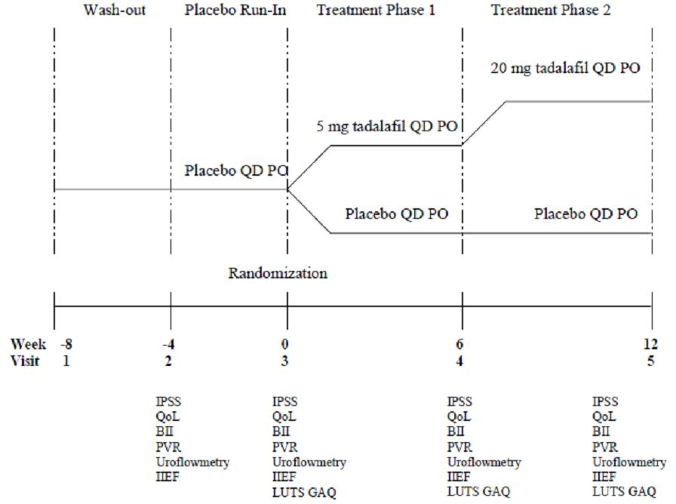
Efficacy and safety measures were recorded before dosing at Visit 3 (baseline) and at Visit 4 (Week 6) ad Visit 5 (Week 12).
The primary efficacy variable was the IPSS. The primary efficacy outcome was the change in IPSS from baseline to Visit 4 (Week 6), for the comparison of placebo and tadalafil 5 mg ,and the change from baseline to Visit 5 (Week 12) for the comparison of placebo and tadalafil 5 mg escalated to 20 mg.
There were numerous secondary efficacy outcomes. The secondary efficacy variables included the IIEF and the BII.
The sample size was 250 subjects overall. The null hypothesis was that there was no difference between tadalafil and placebo in change from baseline in the IPSS. Assuming a 10% drop-out, 125 subjects in each treatment group would result in the 112 subjects with baseline and post-baseline efficacy data to have 80% power to detect a difference of 2.0 points in the change from baseline in the IPSS compared with placebo, assuming a standard deviation for the change in IPSS from baseline of 6.0. The null hypothesis was tested using a one-tailed test at the 0.05 significance level.
The primary efficacy analysis used an ANCOVA model of change in the IPSS from baseline to Visits 4 and 5, respectively. Testing of the null hypothesis for the two six week treatment periods was based on least-squares means for the treatment-group contrasts within the ANCOVA model for each follow-up visit. Each null hypothesis was evaluated against a one-sided alpha of 0.05. No adjustment was made for multiple comparisons. Terms in the ANCOVA model included baseline IPSS, previous use of alpha blockers, treatment group, geographic region and baseline-by-treatment group interaction. If the interaction was not significant (p ≥ 0.10), it was removed from the model. Last observation carried forward was used in the analysis of Week 12 data for the efficacy variables. ANCOVA modelling was also used for the analyses of most of the secondary efficacy endpoints. No correction for multiplicity was made for the secondary efficacy endpoints.
Of 479 subjects screened, 281 subjects were randomised, 143 subjects to the placebo group, 138 subjects to the tadalafil group. Of the subjects in the placebo group, 133 (93.0%) completed Week 6 and had the sham dose escalation and 126 subjects (88.1%) completed the protocol. Of the subjects in the tadalafil group, 129 subjects (93.5%) completed Week 6 and had the dose of tadalafil increased to 20 mg, and 125 subjects (90.6%) completed the protocol.
Primary and secondary efficacy analyses were undertaken, unless stated otherwise, on an ITT basis and included all randomly assigned subjects who had baseline and at least one post-baseline observation. The analyses of safety variables included all randomised subjects.
The subject demographics and baseline characteristics were generally similar between the two treatment groups. The mean age of subjects was 61.5 years (range 45.0- 82.4 years) and the majority of subjects were Caucasian (81.1%). Over half the subjects (55.2%) had had LUTS for more than three years and just over a third (36.3%) had IPSS of 20 or more indicating a LUTS severity of severe. The mean IPSS at baseline was 17.9.
There were improvements in IPSS in both the tadalafil and placebo treatment groups between baseline and Weeks 6 and 12, respectively. The results of the primary analysis showed statistically significant differences in the LS mean changes in IPSS from baseline to Week 6, and from baseline to Week 12, between the tadalafil 5 mg/20 mg group and the placebo group (Table 11). For subjects in the tadalafil group (receiving 5 mg daily), subjects had a LS mean change of -2.8 from baseline (Week 0) to endpoint (Week 6) compared with a LS mean change of -1.2 in the placebo group (p=0.003). From baseline to Week 12, the LS mean change in IPSS was also greater in the tadalafil group compared with the placebo group (LS mean change: placebo -1.7 (SE 0.49), tadalafil 5mg/20mg -3.8 (SE 0.50); p <0.001). The results of secondary analyses for the primary endpoint, based on randomised subjects who had completed the dose escalation visit (Visit 4) and the per-protocol population, were consistent with the results of the primary analysis.
Table 11: Study H6D-MC-LVGC: IPSS (all randomised subjects) (LOCF analysis).
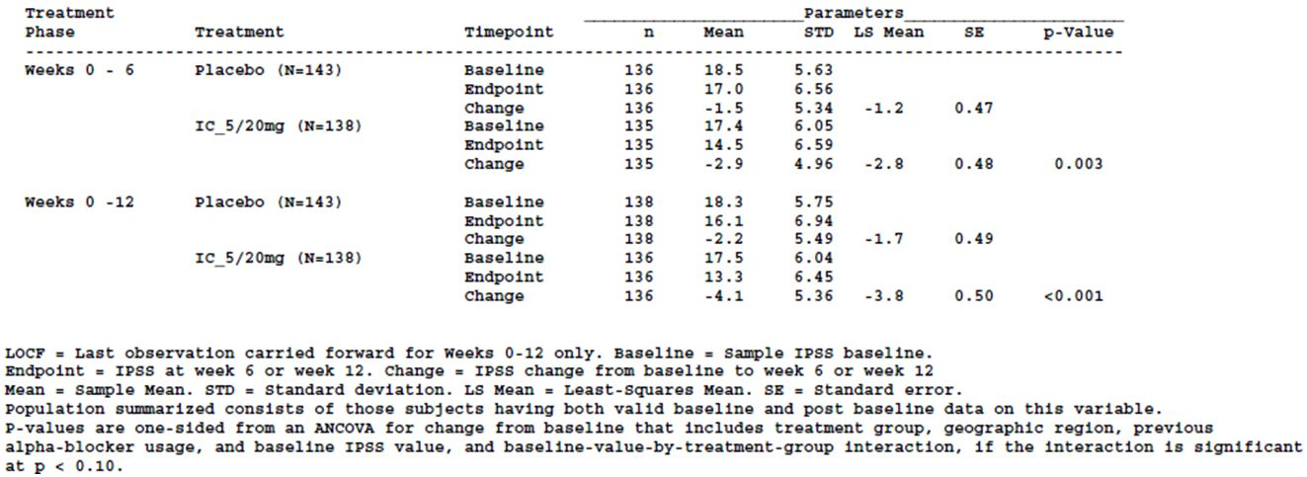
Results of secondary endpoints specifically relevant to information in the proposed PI were the BII and IIEF EF Domain. The change in BII between baseline and Weeks 6 and 12 respectively were greater in the tadalafil group compared with the placebo group (Week 6: LS mean change placebo (n=137) -0.4, tadalafil 5mg/20mg (n=130) -0.7); Week 12: LS mean change placebo (n=138) -0.6, tadalafil 5mg/20mg (n=130) -1.3). The IIEF EF Domain analyses were exploratory. In men who answered “yes” to a sexual activity question at Visit 2, and who also had ED, the LS mean IIEF EF Domain score increased from baseline to endpoint (Week 6 and Week 12 respectively) to a greater extent in the tadalafil 5 mg/20 mg group compared with the placebo group (Weeks 0-6: LS mean change placebo (n=74) 0.6, tadalafil 5mg/20mg (n=78) 6.0; Weeks 0-12: LS mean change placebo (n=74) 1.4, tadalafil 5mg/20mg (n=78) 7.7).
Comment: The inclusion and exclusion criteria were similar to the inclusion and exclusion criteria stipulated for the pivotal efficacy studies.
The results of the primary efficacy outcome are supportive of the results of the pivotal efficacy studies.
There was no null hypothesis related to the primary safety objective.

Study H6D-MC-LVHG Open-label extension (LVHG OLE)
This was primarily a safety study with the following secondary efficacy objectives:
- To evaluate the long-term effectiveness of tadalafil 5 mg once-a-day dosing throughout the one year open-label extension period in men with BPH-LUTS as measured by the IPSS, the IPSS storage (irritative) subscore, the IPSS voiding (obstructive) subscore, IPSS Question 7 (nocturia), IPSS Quality of Life (QoL) Index and the BII.
- To examine the effect of tadalafil 5 mg once-a-day dosing on erectile function in men with both BPH-LUTS and ED, as assessed by the IIEF EF Domain.
Analyses of effectiveness were reported to be primarily descriptive. Based on all subjects enrolled in the open-label extension (OLE) period, there were decreases in total IPSS from Visit 3 to endpoint (n=416; mean change -5.0 (SD 6.7)) and Visit 6 to endpoint (n=416; mean change -0.9 (SD 5.7)). The largest decreases in total IPSS from Visit 6 to endpoint were in subjects who had been randomised to the placebo (mean change -2.2 (SD 5.3)) and tadalafil 2.5 mg groups (mean change -2.5 (SD 5.1)) in the double-blind treatment period. In subjects randomised to the tadalafil 5 mg and tadalafil 20 mg groups there were small mean increases in total IPSS from Visit 6 to endpoint (mean change tadalafil 5mg 0.2 (SD 5.4) ; tadalafil 20mg 0.8 (SD 6.4)). Subjects who had been randomised to tadalafil 10 mg during the double-blind period had a small mean decrease in total IPSS from Visit 6 to endpoint (-0.2 (SD 5.8)). The mean change in total IPSS from Visit 6 to Visit 8, during which time subjects transitioned from the randomised treatment to tadalafil 5 mg, was largest in the placebo group (placebo -2.9 (SD 5.1), tadalafil 2.5mg -1.2 (SD 4.2), tadalafil 5mg -0.6 (SD 3.7), tadalafil 10mg -0.7 (SD 4.9), tadalafil 20mg -0.6 (SD 4.2)).
Based on descriptive statistics, the IPSS total score was maintained at the end of the open-label period in subjects who were randomised to tadalafil 5 mg in the double-blind treatment period (Visit 6 (Week 12)) mean IPSS total (n=83) 12.7 (SD 7.1), Visit 12 (Week 64) mean IPSS total (n=60) 11.4 (SD 7.5)).
Changes from Visit 3 to endpoint, and from Visit 6 to endpoint, in the IPSS storage (irritative) subscore, IPSS voiding (obstructive) subscore and IPSS-QoL, respectively, were consistent with the changes in the total IPSS. For the IPSS Question 7 (nocturia), there was a small mean change from Visit 3 to endpoint (-0.5 (SD 1.3)) but not from Visit 6 to endpoint (0.0 (SD 1.1)).
The overall mean BII (regardless of randomised treatment group during the double-blind period) decreased from Visit 3 to endpoint (mean change -1.3 (SD 2.7)) and to a lesser extent from Visit 6 to endpoint (mean change -0.3 (SD 2.4)). Subjects randomised to placebo and tadalafil 2.5 mg during the double-blind period had a minimal decrease in BII between Visit 6 and endpoint. Subjects who had received tadalafil 5 mg, 10 mg or 20 mg in the double-blind period had minimal increases in BII between Visit 6 and endpoint.
The mean IIEF EF Domain score increased from Visit 3 to endpoint (mean change 5.9 (SD 7.6)) and from Visit 6 to endpoint (mean change 1.1 (SD 8.0)). Between Visit 6 to endpoint, mean IIEF EF Domain score increased in subjects who had been randomised to placebo (mean change 6.8 (SD 8.0)) and tadalafil 2.5 mg (mean change 1.3 (SD 6.5)) and decreased in subjects who had been randomised to the other treatment groups (mean change: tadalafil 5mg -0.1 (SD 6.8); tadalafil 10mg -3.2 (SD 9.0); tadalafil 20mg-0.1 (SD 6.2)).
Comment: For subjects who had received tadalafil 5mg for the whole LVHG study period (double-blind treatment phase and OLE) the decrease in total IPSS that was observed during the double-blind treatment period was maintained during the OLE period indicating that the effect of tadalafil was maintained over the one year period of the open-label extension. The decreases in IIEF-EF Domain score in subjects who had been randomised to tadalafil to 5 mg, 10 mg and 20 mg during the double-blind period were small and did not show a dose-response effect. The small mean decrease in IIEF-EF Domain score, between the end of the double-blind treatment period and endpoint in the OLE period, seen in subjects who received tadalafil 5 mg though the double-blind period and the OLE period is unlikely to be considered clinically significant.

Study H6D-MC-LVHS (LVHS)
This was primarily a safety study with a secondary efficacy objective that was to evaluate the change from baseline to endpoint for the IPSS when tadalafil 5 mg once daily is added to concomitant alpha blocker therapy, compared to adding placebo to concomitant alpha blocker therapy, for 12 weeks in the treatment of men with BPH-LUTS.
Based on the primary analysis population, the difference in the LS mean change from baseline (Visit 3) to endpoint (last non-missing post baseline value) in total IPSS for the tadalafil 5 mg treatment group was not statistically significant compared with the placebo group (LS mean change: placebo -1.33, tadalafil 5mg -2.20; treatment difference in LS mean change -0.87 (SE 0.58); 95% CI [-2.01, 0.26]; p=0.130).
Comment: The study sample size was based on the primary safety outcome. Therefore, the study may not have had the power to evaluate the difference in total IPSS between the treatment groups. The results of this secondary efficacy outcome showed a greater mean change in total IPSS from baseline to endpoint in the tadalafil 5 mg group compared with the placebo group. This result is supportive of the results in the pivotal studies.

Study H6D-MC-LVHK (LVHK)
This was primarily a safety study with a secondary efficacy objective that was to assess the efficacy of tadalafil 20 mg once daily for 12 weeks in the treatment of men with BPH-LUTS as examined using the IPSS. The secondary efficacy outcome was change in IPSS from baseline to endpoint. The sponsor indicated that the study sample size lacked power to evaluate differences in total IPSS between the treatment groups.
Based on the primary analysis population, there was a decrease in IPSS total score in both the placebo group and tadalafil 20 mg group from baseline to endpoint (mean change: placebo -5.04 (SD 6.93), tadalafil 20mg -9.13 (SD 6.90)).
Comment: The results of this secondary endpoint showed a greater mean change in total IPSS from baseline to endpoint in the tadalafil 5 mg group compared with the placebo group. This result is supportive of the results in the pivotal studies.

Studies conducted in Asian countries

Study H6D-MC-LVHT (LVHT)
Study LVHT was a phase 2, randomised, double-blind, placebo-controlled, parallel design pilot study. It was conducted in ten study centres in Korea between October 2007 and June 2008. This study was conducted to estimate the effect of tadalafil once daily dosing on efficacy and safety outcomes using tamsulosin hydrochloride once daily as an active control, to estimate IPSS changes and variability in Asian men, and to guide the design of future studies examining the effect of tadalafil in the treatment of BPH-LUTS in Asian men.
The primary objective of the study was to evaluate the change from baseline of tadalafil 5 mg once daily, compared with placebo, in IPSS total score after 12 weeks in Asian men with BPH-LUTS. Subjects were Asian men aged 45 years or older with moderate to severe BPH-LUTS (IPSS total ≥ 13) and evidence of bladder obstruction.
The study had three periods – a screening/wash-out period (up to 4 weeks), single-blind placebo run-in period (4 weeks) and a 12 week double-blind treatment period. At Visit 3, eligible subjects were stratified by LUTS severity and prior alpha-blocker therapy and randomly assigned to tadalafil 5 mg, placebo or tamsulosin 0.2 mg once daily in a 1:1:1 ratio. Subjects received a dose of one tablet and one capsule once daily, either a placebo capsule and tablet (placebo group), a placebo capsule and tadalafil 5 mg tablet (tadalafil 5 mg group) or a tamsulosin 0.2 mg capsule and placebo tablet (tamsulosin 0.2 mg group).
The planned sample size was 150 subjects. The number of randomised subjects anticipated to complete the study (135 subjects - 45 per group) was calculated to have a 50% power to detect a 2.5 difference between two treatments in the change from baseline in the IPSS total score and 80% power to detect a 3.6 difference between two treatments, assuming a 6.0 unit standard deviation of change from baseline in IPSS total score. The primary analysis population included all randomised subjects with at least one non-missing post-baseline assessment. Efficacy analyses were performed on an ITT basis. The primary efficacy comparison was between tadalafil 5mg and placebo and the primary inferential analysis was the difference in mean change in IPSS total from baseline (Visit 3, Week 0) to endpoint (Visit 6 (Week 12) or early discontinuation) between tadalafil 5 mg and placebo. LOCF data imputation methodology was used for subjects who discontinued the study early or who were missing post-baseline data. An ANCOVA model was used to analyse the primary endpoint. The model included effects for treatment, prior alpha blocker use and baseline IPSS total as a covariate. It is indicated by the sponsor that, as this was a pilot study, the study was not powered for the primary endpoint.
Of 196 subjects screened, 151 subjects were randomised and received the study drug (placebo n=51, tadalafil 5mg n=51, tamsulosin 0.2mg n=49). The majority of subjects in each treatment group completed the study (placebo n=47, tadalafil 5mg n=48, tamsulosin 0.2mg n=48). The primary analysis population included almost all randomised subjects (placebo 98.0% (n=50), tadalafil 5 mg 98.0% (n=50), tamsulosin 0.2mg 100.0% (n=49)) as did the per-protocol population (placebo 92.2% (n=47), tadalafil 5mg 94.1% (n=48), tamsulosin 0.2mg 98.0% (n=48)). The mean age of study subjects was 61.6 years (range 46.3-78.5 years), 99.3% of whom were aged less than 75 years. All subjects were East Asian. Overall, 59.6% of subjects had ED, of whom the majority had ED of mild severity (57.8%) and a duration of ED of one year or more (77.8%). Baseline LUTS severity was reported as moderate (IPSS <20) in 68.2% of subjects and severe in the remainder. Almost half of study subjects (45.7%) had used an alpha blocker within the previous 12 months. Mean PVR was 35.7 mL (SD 44.3) at baseline. The baseline demographic characteristics of subjects in each of the treatment groups were generally similar.
For the primary analysis population, there was an improvement in the IPSS total score from baseline to endpoint in both the placebo and tadalafil 5 mg group but the difference in the change between the two treatment groups was not statistically significant (LS mean change: placebo -4.2 (SE 0.6), tadalafil 5mg -5.8 (SE 0.6); LS mean of the treatment group difference -1.7; 95% CI [-3.5, 0.2]; p=0.073). The results in the per-protocol population were consistent with the results in the primary analysis population. The results of additional analyses for the primary endpoint were also consistent. For the comparison of tadalafil 5 mg with placebo, the results of analyses for the secondary efficacy outcomes, changes from baseline to endpoint in IPSS irritative (storage) subscore, IPSS obstructive (voiding) subscore, IPSS Question 7 (nocturia), IPSS QOL and BII, were supportive of the results of the primary efficacy analysis.
Comment: The study was not powered for the primary endpoint as it was a pilot study. The trend in the results with a higher decrease in IPSS total in the tadalafil 5 mg group compared with the placebo group is consistent with the results of other studies submitted in this submission to support the BPH indication.

Study H6D-JE-LVIA (LVIA) double blind period
Study LVIA was conducted in Japan in 19 study centres between November 2008 and June 2009.
It was a phase 2, randomised, double-blind, placebo-controlled, parallel design, dose-ranging study of 12 weeks duration. The study had two phases. Phase 1 consisted of a 2 week screening/washout period, 4 week placebo lead-in period and 12 week double-blind treatment period. Phase II was a 42 week open-label extension period. In the double-blind treatment period, subjects were randomly assigned in a 1:1:1 ratio to placebo, tadalafil 2.5 mg or tadalafil 5 mg once daily orally for 12 weeks after stratification by BPH severity and prior alpha blocker therapy. Subjects received two tablets each day during the placebo lead-in (two 2.5 mg placebo tablets) and during the double-blind treatment period (placebo group: two 2.5 mg placebo tablets, tadalafil 2.5 mg group: one 2.5 mg tadalafil tablet and one 2.5 mg placebo tablet, tadalafil 5 mg group: two 2.5 mg tadalafil tablets).
The primary objective of the double-blind period was to compare tadalafil 5 mg once daily, and tadalafil 2.5 mg once daily, to placebo in the change of IPSS total score from baseline to Week 12. There were a number of secondary efficacy objectives. A secondary objective of this study was to assess tadalafil pharmacokinetics in Japanese men with BPH following once daily dosing of tadalafil 2.5 mg and 5 mg. Study subjects were Japanese men aged 45 years or older with diagnosed BPH-LUTS for more than six months and an IPSS total score ≥ 13. A prostate volume of ≥ 20 mL was also an inclusion criterion.
The efficacy analyses were performed on an intent-to-treat basis. The primary analysis population included all subjects who were randomised and started study medication (full analysis set). Secondary analyses for the efficacy variables were conducted using all subjects who completed the 12 week double-blind treatment period and who had taken at least 70% of prescribed doses (per protocol population). The safety analysis set included randomised subjects who had received study treatment grouped by the treatment taken.
For the primary efficacy analysis, a step-down procedure was used with a comparison of tadalafil 5 mg with placebo first undertaken followed by the comparison of tadalafil 2.5 mg with placebo if a significance level of 0.05 was achieved for the 5 mg dose. The primary analysis of the change in IPSS total score from baseline (Visit 3 (Week 0)) to endpoint (Visit 7 (Week 12) or discontinuation) was undertaken using an ANCOVA model. Baseline IPSS total score was a covariate and treatment group and prior alpha blocker therapy were included as fixed effects. The planned sample size was approximately 420 subjects (140 subjects in each treatment group). With 137 subjects per treatment group, the study was considered to have 90% power to detect a mean difference, between the tadalafil 5mg group and placebo, in the change from baseline to endpoint in IPSS total score of -2.36 points, assuming a standard deviation of 6.0 and a two sided significance level of 0.05. With 137 subjects per treatment group, the study had a power of approximately 80% to detect a treatment difference in change in IPSS total from baseline between tadalafil 2.5 mg and placebo of 2.0 points.
Of 494 subjects who entered the study, 422 were randomised and received double-blind study treatment (placebo n=140, tadalafil 2.5mg n=142, tadalafil 5mg n=140 (full analysis set)). A high proportion of subjects completed the study (93.4%). The proportion of subjects from each treatment group who met the criteria for the per-protocol set was similar (placebo 92.9% (n=130), tadalafil 2.5mg 95.8% (n=136), tadalafil 5mg 90.7% (n=127)). The demographics and other baseline characteristics of randomised subjects in each of the treatment groups were similar. Overall, the mean age of subjects was 66.8 years (SD 7.3) (range 45.4-87.4 years) with the highest proportion of subjects aged between 65 and 74 years. At baseline, 71.6% of subjects had BPH of moderate severity and the remaining subjects had BPH that was severe. Subjects had had BPH for a mean duration of 4.2 years (SD3.1) at baseline and the majority had used alpha blockers within the previous 12 months (77.0%) but not other BPH therapy (19.7%) or OAB therapy (6.9%). Mean PVR at baseline was 33.0mL (SD 42.1).
The results of the primary analysis, on the full analysis set, revealed an improvement in the total IPSS in the three treatment groups from baseline to endpoint (LS mean change: tadalafil 5mg (n=140) -4.9 (SE 0.4), tadalafil 2.5mg (n=142) -4.5 (SE 0.4), placebo (n=139) -3.8 (SE 0.4)). The difference in the change from baseline to endpoint between the tadalafil 5 mg group and the placebo group was not statistically significant (LS mean of the treatment difference -1.1 (SE 0.6); 95% CI [-2.2, 0.1]; p=0.062). The difference in the change from baseline to endpoint between the tadalafil 2.5 mg group and the placebo group was not statistically significant either (LS mean of the treatment difference -0.7 (SE 0.6); 95% CI [- 1.8, 0.4]; p=0.201).
A secondary analysis was performed on the per-protocol set using the same ANCOVA model. The difference in change between baseline and endpoint in IPSS total was statistically significant for the comparison of tadalafil 5 mg with placebo (LS mean change tadalafil 5mg (n=127) -5.2 (SE0.4), placebo (n=130) -3.9 (SE 0.4); LS mean of the treatment difference -1.2 (SE 0.6); 95% CI [- 2.4, -0.1]; p=0.034) but not for the comparison between tadalafil 2.5 mg with placebo (LS mean change tadalafil 2.5mg (n=136) -4.4 (SE0.4), placebo (n=130) -3.9 (SE 0.4); LS mean of the treatment difference -0.5 (SE 0.6); 95% CI [-1.6, -0.6]; p=0.367). In a repeated measures analysis of IPSS total, performed on the full analysis set, there was a greater improvement from baseline in IPSS total in the tadalafil groups compared with the placebo group at each time point (Visits 4-7) but the differences between the groups were small.
Based on the full analysis set, changes in peak flow rate from baseline to endpoint, a secondary efficacy outcome, were similar in all three treatment groups (LS mean change :placebo (n=136) 1.4 (SE 0.3), tadalafil 2.5 mg (n=140) 0.7 (SE 0.3), tadalafil 5 mg (n=135) 0.6 (SE 0.3)).
Based on a subgroup analysis by baseline BPH severity, subjects who had a baseline BPH severity of severe had greater improvements in IPSS total from baseline to endpoint in both tadalafil treatment groups compared with placebo (LS mean change: placebo (n=39) -3.6 (SE 0.5), tadalafil 2.5mg (n=42)-5.9 (SE 0.5), tadalafil 5mg (n=38) -7.9 (SE 0.5)) than those subjects who had a baseline BPH severity of moderate (LS mean change: placebo (n=100) -4.0 (SE 0.8), tadalafil 2.5mg (n=100)-4.0 (SE 0.8), tadalafil 5mg (n=102) -3.8 (SE 0.8)).
Comment: Although there was not statistically significant difference between the tadalafil 5 mg group and the placebo group with regard to the primary outcome based on the full analysis set, there was a greater decrease in IPSS total in the tadalafil 5 mg group compared with the placebo group, consistent with the results of other studies submitted to support the BPH indication.
The inclusion and exclusion criteria for this study were generally consistent with those of the pivotal efficacy studies.

Study H6D-JE-LVIA open label extension
The open label extension of study LVIA, the second phase of study LVIA, was undertaken between March 2009 and April 2010. Phase I of study LVIA, which includes the double-blind treatment period, is described above. After subjects had finished the double-blind treatment period of Phase 1 at Visit 7 (Week 12,), they entered the 42 week open-label extension which ended at Visit 18 (Week 54). During the open-label period all subjects received tadalafil 5 mg once daily (two 2.5 mg tadalafil tablets).
The objectives of the open-label extension period, which were secondary objectives of the study LVIA, were to assess the long-term safety of tadalafil 5mg once daily dosing for one year in Japanese men with BPH as examined by adverse events, vital signs, clinical laboratory tests, PSA and PVR, and to evaluate the long-term effectiveness of tadalafil 5mg once daily dosing for one year as measured by the IPSS total score, IPSS subscores, IPSS QOL, OABSS and Qmax.
Safety analyses included all subjects who had received at least one dose of tadalafil in the open-label extension period. Efficacy analyses included all subjects enrolled in the open-label extension period with a baseline and at least one post-baseline efficacy evaluation after Visit 7.
Of the 394 subjects who completed the double-blind treatment period, all entered the open-label extension period and received at least one dose of tadalafil 5 mg. Of the 422 subjects randomised at Visit 3 (Week 0), 323 subjects (76.5%) completed the open-label period. By treatment received in the double-blind period, the proportions of subjects who enrolled in the open-label extension period who completed it were similar (placebo 77.1% (n=101), tadalafil 2.5mg 83.7% (n=113), tadalafil 5mg 85.2% (n=109)). The exposure data indicate that 110 subjects who had been randomised to tadalafil 5 mg during the double-blind treatment period had received 40 or more weeks of tadalafil 5 mg during the open-label extension.
In the open-label treatment period, the mean age of subjects was 66.6 years (range 45.4 to 83.5 years), the majority of subjects had a BPH severity at Visit 3 of moderate (72.1%) and had used alpha blocker therapy within the previous 12 months of Visit 1 (76.6%). The mean duration of BPH was 4.2 years (SD 3.1) at Visit 1. Mean PVR was 33.7 mL (SD 42.9). The majority of subjects (97.2%) were treatment compliant.
Based on all subjects enrolled in the OLE period, the change in IPSS total score from the start of the double-blind treatment period (Visit 3) to the end of the open-label extension period (endpoint, Visit 18) was -5.6 (SD 5.9). The change from Visit 7 (end of the double-blind treatment period) to endpoint was -1.2 (SD 4.6). The decrease in IPSS total was greatest for subjects who were randomised, during the double-blind treatment period of study LVIA, to placebo, compared with tadalafil 2.5 mg and tadalafil 5 mg, for both the change from Visit 3 to Visit 18 and the change from Visit 7 to Visit 18.
From Visit 7 (end of the double-blind treatment period) to Visit 9 (six weeks after the start of open-label tadalafil 5 mg) subjects who had been in each of the three treatment groups during the double-blind treatment period had small mean decreases in IPSS total score (mean change: placebo (n=125) -1.8 (SD 3.2), tadalafil 2.5mg (n=134) -0.7 (SD 3.1), tadalafil 5mg -1.2 (SD 2.8)) and the mean IPSS total scores at Visit 18 (Week 54) were similar to those at Visit 9 for each of these subgroups of subjects. There was a small increase in mean peak flow rate, a secondary efficacy outcome, from Visit 3 to endpoint (1.94 mL/sec (SD 4.61)) and from Visit 7 to endpoint (1.16 mL/sec (SD 4.40)).
Comment: The improvement in IPSS total from baseline to endpoint observed in the tadalafil 5mg group during the double-blind treatment period was maintained during the OLE period of 42 weeks.
The number of subjects who had at least 52 weeks of exposure to tadalafil 5 mg during the double-blind and open-label extension periods of study LVIA does not appear to be specified. In the double-blind period, 106 subjects were exposed to tadalafil 5 mg for at least 12 weeks but it is unclear if these subjects all entered the OLE period of the study.

Study H6D-MC-LVHB (LVHB)
Study LVHB was undertaken in 34 study centres in Japan, Korea and Taiwan. The study was undertaken between March 2009 and June 2010. This study was a phase 3, randomised, double-blind, placebo and tamsulosin controlled, parallel design study. Study subjects were Asian men aged 45 years or older with BPH-LUTS and evidence of bladder outlet obstruction. The primary objective was to compare the change in IPSS total score from baseline to Week 12 for tadalafil 5mg once daily, versus placebo, in Asian men with signs and symptoms of BPH.
The study had three periods: a screening/wash-out period, a four week single-blind placebo lead-in period and a 12 week double-blind treatment period. After stratification by BPH severity, prior alpha blocker therapy and country, eligible subjects were randomly assigned in a 1:1:1:1 ratio to tadalafil 5 mg, tadalafil 2.5 mg, tamsulosin HCl 0.2 mg or placebo once daily. A double-dummy design was used. During the placebo lead–in and double-blind treatment periods each subject received a once daily dose of three tablets consisting of active and/or placebo tablets according to the treatment group.
The primary efficacy outcome was the difference between tadalafil 5 mg once daily and placebo in the change in IPSS total score from baseline (Visit 3, Week 0) to endpoint (Visit 7, Week 12) in the full analysis set using LOCF data imputation methodology. Secondary efficacy variables included IPSS subscores, IPSS QoL, BII and Qmax. The planned sample size was 560 randomised subjects (140 per treatment group). Based on a two-sided t-test at significance level of 0.05 and standard deviation of 6.0 units, 137 subjects per treatment group provided 90% power to detect a difference from placebo of 2.36 points in the IPSS total score change from baseline to endpoint. The study was not powered to show non-inferiority or superiority in a comparison between the tamsulosin HCl and tadalafil treatment groups.
For the primary analysis of IPSS total, all doses were compared with placebo in an ANCOVA model that included treatment group, prior alpha blocker therapy and country as fixed effects and baseline IPSS total score as a covariate. There was no adjustment for multiplicity for the primary endpoint as the sole primary comparison was tadalafil 5 mg versus placebo. The primary analysis population was the full analysis set which included subjects who were randomised and started study medication. All efficacy analyses were performed on an ITT basis.
Seventeen subjects from one study site were not included in the efficacy and safety analyses as a result of GCP violations (hardcopy source documents/records were lost). Excluding these 17 subjects, of 784 subjects who entered the study, 612 were randomised (placebo n=154, tadalafil 2.5mg n=151 tadalafil 5mg n=155, tamsulosin HCl 0.2mg n=152). All randomised subjects received double-blind study drug. A higher number of subjects discontinued the study in the tadalafil groups (tadalafil 2.5mg n=15 (9.9%), tadalafil 5mg n=18 (11.6%) compared with the placebo n=9 (5.8%)) and tamsulosin HCl 0.2mg (n=9 (5.9%)) groups, predominantly due to a higher number of adverse events and subject decision. The proportions of subjects in the per-protocol set (subjects who completed the 12 week double-blind treatment period and were ≥ 70% compliant) were higher in the placebo and tamsulosin 0.2mg groups than the tadalafil groups (placebo 93.5% (n=144), tadalafil 2.5mg 89.4% (n=135), tadalafil 5mg 87.7% (n=136), tamsulosin 0.2 mg 94.1% (n=143)). The mean age of study subjects was 63.1 years (range 44.9-86.2 years) and the majority were from Japan (Japan 55.9%, Korea 29.4%, Taiwan 14.7%). At Visit 3 (baseline), 66.7% of subjects had BPH of moderate severity (IPSS total < 20) and mean PVR was 36.7mL (SD 44.5). At screening, the mean duration of BPH was 3.7 years (range 0.4-19.1 years) and 54.7% of subjects had used an alpha blocker within the previous 12 months. The demographics and other baseline characteristics of subjects in each of the treatment groups were generally similar.
Based on the full analysis population, IPSS total score decreased in all treatment groups from baseline to endpoint (LS mean change: placebo (n=154) -3.0 (SE 0.4), tadalafil 2.5mg (n=151) -4.8 (SE 0.4), tadalafil 5mg (n=155) -4.7 (SE 0.4), tamsulosin HCl 0.2mg (n=152) -5.5 (SE 0.4)). For the primary efficacy outcome, the difference in the change from baseline to endpoint in the tadalafil 5 mg group compared with the placebo group was statistically significant in the full analysis population (LS mean of placebo-adjusted change from baseline: -1.7 (SE 0.6), 95% CI[-2.9, -0.6], p=0.004). The results in the per-protocol population were consistent as were the results in the full analysis population including the 17 subjects excluded from the analyses as a result of the GCP violation. The results of additional analyses for the primary outcome, and the results for the secondary efficacy outcomes, were supportive of the results of the primary analysis for the primary efficacy outcome. Based on the full analysis set, the change from baseline to endpoint in Qmax was similar in the four treatment groups (LS mean change: placebo 2.1 mL/sec (SE 0.4), tadalafil 2.5 mg 1.6 mL/sec (SE 0.4), tadalafil 5 mg 1.3 mL/sec (SE 0.4) tamsulosin 0.2 mg. 2.1mL/sec (SE 0.4)).
Comment: The results of the primary efficacy analysis are supportive of the results of the pivotal efficacy studies as there was a greater improvement in IPSS total from baseline to endpoint in the tadalafil 5mg group compared with the placebo group based on the full analysis set.
The inclusion and exclusion criteria for this study were generally consistent with the inclusion and exclusion criteria of the pivotal efficacy studies as were the criteria for discontinuation of subjects from the study and the prohibited concomitant therapies.
The magnitude of the treatment effect to be detected was the same as that used to calculate the sample size in study LVIA. Both were based on the upper bound of the one-sided 70% confidence interval for the mean difference between tadalafil 5mg and placebo in the change from baseline to endpoint (Week 12) in IPSS total score from study LVHG.
Change from baseline to endpoint in Qmax was a secondary outcome. The differences between the treatment groups in relation to the change from baseline in Qmax were small.

Analyses performed across trials (pooled analyses and meta-analyses)

Integrated analysis set (studies LVHG, LVHJ, LVHR and LVID)
Integrated analyses of the 12 week double-blind treatment period data from the four pivotal studies LVHG, LVHJ, LVHR and LVID were undertaken. In the integrated analysis set, a total of 752 subjects were randomised to tadalafil 5 mg and 748 subjects were randomised to placebo. The majority of subjects completed the 12 week double-blind treatment period of the study in which they were enrolled (integrated data set: placebo 87.6% (n=655); tadalafil 5 mg 89.1% (n=670)). The mean age of subjects randomised to placebo and to tadalafil 5 mg respectively was 63.1 years. The majority of subjects in the integrated analysis set were aged 65 years or under (59.0% in both the tadalafil 5mg group (n=444) and placebo group (n=441)). Forty-one percent of subjects in each group were aged over 65 years (placebo n=307; tadalafil 5mg n=308) and a small proportion of subjects were aged 75 years or older (placebo 12.4% (n=93), tadalafil 5mg 11.2% (n=84)). At baseline the majority of subjects in the integrated analysis set had mild to moderate LUTS severity (approximately 65% in both groups) and had ED (placebo 77.0%, tadalafil 5mg 77.8%). Of those subjects with ED, a similar proportion of subjects in each treatment group were sexually active with an adult female partner at study entry (placebo 88.0% (n=505); tadalafil 5mg 89.1% (n=521)). Almost half of the subjects in each treatment group had a Qmax < 10mL/sec (placebo 48.2%, tadalafil 45.4%)and approximately a quarter of subjects in each group had previously used alpha blocker therapy (placebo 27.4%, tadalafil 27.1%) and PDE5 –inhibitor therapy (placebo 22.3%, tadalafil 23.0%).
ANCOVA models were used to analyse continuous data and included terms for centred baseline of the variable of interest, treatment group, region, protocol, baseline-by-treatment interaction and treatment-by-region interaction. If an interaction p-value was ≥ 0.10 it was removed from the final model. LOCF data imputation was used if data were missing at the final visit. The p values associated with the estimated differences between the treatment groups were assessed for significance at a two-sided 0.05 level. There were no adjustments for multiplicity undertaken for the analyses of the integrated data.
Based on the integrated analysis set, the LS mean change in IPSS total score was greater in the tadalafil 5 mg group compared with the placebo group (LS mean change placebo (n=735) -2.7, tadalafil 5mg (n=742) –5.0) and the difference between the groups in the change from baseline to endpoint in IPSS total was statistically significant (LS mean of the treatment difference -2.3 (SE 0.30); 95% CI [-2.9, -1.7]; p <0.001) (Table 12). The results based on the integrated analysis set were consistent with the results of each of the four pivotal efficacy studies.
Table 12: Summary of IPSS total score – change from baseline to endpoint in the double-blind treatment period (LOCF) – Overall integrated analysis set and individual studies LVHG, LVHJ, LVHR and LVID.
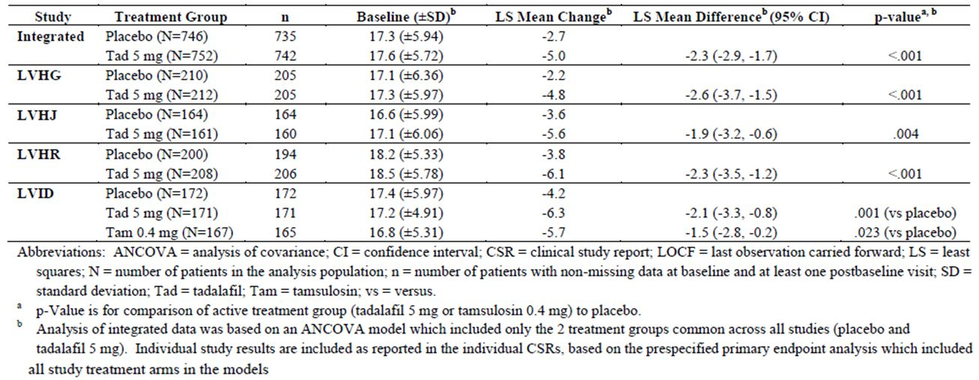
An integrated analysis of data from studies LVHJ and LVID was undertaken to examine the change in IPSS total from baseline to Week 1, based on the mIPSS, comparing subjects treated with tadalafil 5 mg and those treated with placebo. The integrated analysis was based on the primary analysis populations of these two studies. There was a statistically significant greater LS mean change from baseline to Week 1 in the tadalafil 5mg group compared with the placebo group (LS mean change placebo (n=333) -1.7, tadalafil 5mg (n=330) –3.0; LS mean of the treatment difference -1.3 (SE 0.34); 95% CI [-2.0, -0.6]; p <0.001). The results of the individual studies, LVHJ and LVID, were consistent in that the LS mean change from baseline to Week 1 were greater in the tadalafil 5mg group compared with the placebo group (LS mean change: LVHJ placebo (n=164) -2.6, tadalafil 5mg (n=161) –3.4; LVID placebo (n=172) -2.4, tadalafil 5mg (n=171) –4.1). However, the LS mean of the treatment difference was only statistically significant for study LVID.
Based on the integrated analysis set, the changes from baseline to Week 4, and from baseline to Week 8, respectively, showed a statistically significant decrease in the tadalafil 5mg treatment group compared with the placebo group. For the change from baseline to Week 4 the LS mean of the treatment difference was -2.3 (SE 0.27) 95% CI [-2.8, -1.8]; p <0.001. For the change from baseline to Week 8 the LS mean of the treatment difference was -1.9 (SE 0.29) 95% CI [-2.5, -1.3]; p <0.001. The results of the individual studies were consistent. Repeated measures analyses were also undertaken on the integrated analysis set, and on the primary analysis population of each of the four pivotal studies. The results of the analyses in the integrated analysis set, and for each individual study, showed statistically significant decreases in IPSS total score in the tadalafil 5 mg group compared with the placebo group from baseline to Weeks 4, 8 and 12, respectively.
Analyses of the integrated data were also undertaken for a number of secondary efficacy outcomes.
Based on the integrated analysis set, the change from baseline to endpoint in the double-blind treatment period (LOCF) in BII showed a statistically significant greater improvement in the tadalafil 5mg treatment group compared with the placebo group (LS mean change: placebo (n=725) -0.9, tadalafil 5mg (n=735) -1.6; LS mean of the treatment difference -0.7 (SE 0.13); 95% CI [-1.0, -0.5]; p <0.001). In each of the four individual trials, there were greater mean improvements in BII from baseline to endpoint the tadalafil 5mg group compared with the placebo group.
Based on the integrated analysis set, there was a statistically significant improvement (p <0.001) from baseline to endpoint in the double-blind treatment period in IPSS QOL, patient global impression of improvement and clinician global impression of improvement in subjects receiving treatment with tadalafil 5mg compared with placebo. The results of the individual studies were consistent.
In the integrated analysis set, no significant treatment by subgroup interactions were detected between age category, baseline LUTS severity, ED status at study entry, previous alpha blocker therapy, previous PDE5 inhibitor therapy and region and change from baseline to endpoint in IPSS total. In sexually active subjects with ED in the integrated analysis set, the change in IIEF EF Domain from baseline to endpoint during the double-blind treatment period was statistically significant (p <0.001), consistent with the results of the individual studies. These subgroup analyses were exploratory.
Comment: The study designs and study inclusion and exclusion criteria and subjects were generally similar across the four studies that comprised the integrated analysis set. Study LVHR included only men with both BPH-LUTS and ED whereas the other three studies included men with BPH-LUTS, a proportion of whom had ED (LVHG, LVHJ and LVID). Bladder outlet obstruction was an inclusion criterion for studies LVHG, LVHR and LVID but an exclusion criterion for study LVHJ. Each of the studies included a tadalafil 5 mg and placebo treatment arm. Two of the studies included treatment arms with other doses of tadalafil and one study had an active treatment arm (tamsulosin 0.4 mg). Change from baseline to endpoint in IPSS total was the pivotal primary efficacy outcome in three of the studies and a co-primary endpoint in one study (LVHR). Change from baseline to endpoint in BII was a key secondary efficacy outcome in three studies with control for type 1 error undertaken, and a secondary efficacy outcome in study LVHG with no control for multiple comparisons.
The sponsor proposes to indicate in the PI that patients treated with Cialis 5 mg once daily in each of the four pivotal efficacy studies had clinically meaningful improvements in lower urinary tract symptoms. It is unclear if a “clinically meaningful improvement” in total IPSS is based on the mean change from baseline to Week 12 in the tadalafil 5 mg group, the placebo-adjusted change in the tadalafil 5 mg group, or the limits of the 95% confidence interval for the placebo-adjusted change. It is indicated that in each of the four pivotal efficacy studies, and in the integrated analysis set, there were clinically meaningful improvements in BPH symptoms as the improvement (decrease) in total IPSS from baseline to endpoint was greater than 3 points. The clinically meaningful total IPSS results cited for these studies, and the integrated analysis set, were the LS mean changes from baseline to endpoint for the tadalafil 5 mg group. As there was an improvement in total IPSS score in the placebo groups in each of the four pivotal studies, the improvement in total IPSS score that can be attributed to tadalafil 5 mg would be the placebo-subtracted LS mean change. It is noted that the LS mean difference between the tadalafil 5 mg and placebo groups for studies LVHG, LVHJ, LVHR, LVID and the integrated analysis set were -2.6,-1.9, -2.3,-2.1 and -2.3, respectively. This suggests that the placebo effect plus the effect of tadalafil 5 mg contributed to the clinically meaningful improvement of more than 3 points, rather than tadalafil 5 mg alone. The 95% confidence intervals for the LS mean difference in the change from baseline in the tadalafil 5 mg and placebo treatment groups in studies LVHG, LVHJ, LVHR, and LVID, and the integrated analysis set, respectively, were [ -3.7, -1.5],[-3.2, -0.6], [ -3.5, -1.2], [-3.3, -0.8], and [-2.9, -1.7]. These confidence intervals suggest that the placebo-adjusted improvement in total IPSS in patients receiving treatment with tadalafil 5 mg once daily in the population may or may not be clinically meaningful.
The integrated analysis set appears to be derived from simple pooling of data for subjects in the tadalafil 5 mg and placebo groups in the primary analysis populations of the four pivotal studies. The results from the pivotal studies do not appear to have been synthesised using meta-analyses. It is not clear if the integrated analyses were pre-specified. There was no adjustment for multiple comparisons. The sponsor is requested to clarify if the integrated analyses were pre-specified and to confirm if the data from the four pivotal efficacy studies were integrated using simple pooling.
The sponsor proposes to include in the CLINICAL TRIALS section of the PI, the results of the primary efficacy outcome, change from baseline to endpoint in total IPSS, based on the integrated data from the four pivotal efficacy studies. In addition, the sponsor also proposes to include the results of the secondary efficacy outcomes, change from baseline in BII, based on the integrated data from the four pivotal efficacy studies, and change from baseline to Week 1 in total IPSS based on the integrated data from studies LVHJ and LVID.
With regard to the proposed addition to the draft PI of the results of the primary efficacy outcome from the integrated data, the data from the pivotal studies do not appear to have been synthesised using meta-analyses. It is suggested, therefore, that this information is removed from the draft PI or the sponsor justifies why it should remain in the PI. The results of the individual pivotal studies included in this section impart the same information regarding the statistical superiority of tadalafil 5 mg over placebo in improving total IPSS score as the results of the integrated analysis set.
The sponsor proposes to include in the PI the results of the change from baseline to Week 1 in IPSS total based on the integrated data from studies LVHJ and LVID. The results do not appear to be derived from a formal meta-analysis. The change from baseline to Week 1 was a key secondary outcome in studies LVHJ and LVID. In both studies a fixed sequence testing procedure was used for comparisons between tadalafil 5 mg and placebo to control for familywise Type 1 error in the analyses of primary and multiple key secondary efficacy outcomes. Both studies showed a greater numerical decrease in IPSS total from baseline to Week 1 in the tadalafil 5 mg group compared with the placebo group. The treatment difference was statistically significant in study LVID only. It is recommended that the results of the change from baseline to Week 1 in IPSS total based on the integrated data from studies LVHJ and LVID are removed from the draft PI. If the sponsor wishes to include the results of the change from baseline to Week 1 in IPSS total from these two studies, it is suggested that a qualitative description is included in the PI.
It is recommended that proposed information in relation to the BII is modified. The information in the draft PI based on the integrated data but the results do not appear to be derived from a formal meta-analysis. BII was a key secondary outcome in these four pivotal studies. The results of each of the individual studies showed a similar improvement in BII from baseline to endpoint in the tadalafil 5 mg group compared with the placebo group but the difference between the treatment groups was not statistically significant in study LVHJ. A fixed sequence testing procedure was undertaken to control for Type 1 error in primary and multiple key secondary analyses in studies LVHJ and LVID. In study LVHR, pre-specified decision rules for interpreting the significance of co-primary and key secondary analyses based on a gatekeeping procedure were used to control familywise Type 1 error. It is indicated in the clinical study report for LVHG that adjustment for multiple comparisons was not undertaken for the secondary efficacy outcomes. It is suggested that the sponsor include a qualitative description of the results of the BII results in the four pivotal studies but stipulating that there was no adjustment for multiple comparisons in study LVHG.
The guideline “Clinical Investigation of Medicinal Products in Geriatrics” (26) suggests that for medicines used in diseases that occur in the elderly, but which are not unique to this age group, a minimum of 100 subjects would allow detection of clinically important differences. Based on the integrated analysis data from the four pivotal studies , there were more than 100 subjects aged over 65 treated with tadalafil 5 mg (n=308) but fewer than 100 subjects aged 75 years or older (n=93). Including subjects from the non-pivotal efficacy studies, more than 100 subjects aged 75 years or older were treated with tadalafil 5 mg in the studies supporting the use of tadalafil to treat BPH-LUTS.

Evaluator’s conclusions on clinical efficacy for the treatment of the signs and symptoms of benign prostatic hyperplasia (BPH) in adult men
Four double-blind pivotal efficacy studies were submitted to support the proposed use of tadalafil for the treatment of the signs and symptoms of BPH in adult men. The studies were similar in design and subject inclusion and exclusion criteria. Subjects were aged 45 years and older and had moderate to severe BPH-LUTS.
The primary efficacy variable in three studies, and the co-primary efficacy variable in one study, was the internationally validated self-administered IPSS questionnaire. The IPSS questionnaire is used to assess the severity of symptoms of BPH-LUTS. In each pivotal study the principal analysis of the primary efficacy outcome was the comparison between tadalafil 5 mg and placebo. The use of a placebo comparison group is reasonable in these studies even though there are other treatments available for the treatment of BPH-LUTS. Untreated BPH-LUTS would not usually be considered life-threatening and would not normally lead to irreversible morbidity.
Based on the primary analysis populations of the four pivotal efficacy studies (LVHG, LVHJ, LVHR and LVID), the least squares mean change from baseline to endpoint in total IPSS score for tadalafil 5 mg was similar across the groups, ranging from -4.8 to -6.1. In each of the studies a placebo effect was seen with a least squares mean improvement in total IPSS score for placebo ranging from -2.2 to -4.2. The differences between the tadalafil 5 mg and placebo groups in the mean changes from baseline to endpoint in total IPSS score were statistically significant in all four studies.
There is evidence that a clinically meaningful improvement in IPSS total is a decrease of more than 3 points. However, it is unclear if the clinically meaningful improvement in total IPSS in the tadalafil 5 mg group in each of the four pivotal efficacy studies was assessed based on the mean change from baseline to Week 12 in the tadalafil 5 mg group, the placebo-adjusted change in the tadalafil 5 mg group, or the limits of the 95% confidence interval for the placebo-adjusted change.
The results of the non-pivotal efficacy studies, including studies in Asian populations, also showed a greater improvement in the change from baseline to endpoint in total IPSS for tadalafil 5 mg compared with placebo, although the treatment difference was not statistically significant in all studies.
In the open-label extension periods of two studies, the improvements in total IPSS score from baseline to endpoint in the double-blind treatment phase for tadalafil 5 mg persisted for 42 weeks and 52 weeks respectively.
As BPH-LUTS increases with age it is likely that a large proportion of patients who may use tadalafil for the treatment of BPH-LUTS will be elderly. With the ageing of the population in Australia, the absolute number of men, including men aged 75 years and older, who could potentially take tadalafil for the treatment of BPH-LUTS is anticipated to increase. In total, across the pivotal and non-pivotal efficacy studies of 12 weeks duration, there were adequate numbers of subjects aged over 65 years and aged 75 years or older. However, it is anticipated that tadalafil will be used long-term in the proposed indication. In the open-label extension periods of studies LVIA and LVHG only 43 and 33 of the enrolled subjects were aged 75 years. It is recommended that a statement is included in the PI that the number of subjects aged 75 years or older who received tadalafil 5 mg for more than 12 weeks in studies supporting this indication is limited. It is also recommended that the proportion of all subjects, who received tadalafil 5 mg for more than 12 weeks in studies supporting the BPH indication, who were aged 75 years or older is specified.
The pivotal studies had a large number of exclusion criteria. The efficacy of tadalafil 5 mg once daily in the proposed indications has, therefore, not been evaluated in the subgroups of the potential target population who have these medical conditions.
No objective measures of the signs of BPH were included as primary or key secondary efficacy variables in the pivotal efficacy studies. It is unclear to the evaluator why the proposed indication includes the treatment of the signs of BPH. The sponsor is requested to clarify the wording of the proposed indication in this regard.

Treatment of ED and the signs and symptoms of BPH in adult men

Pivotal efficacy studies

Study H6D-MC-LVHR (LVHR)
Study LVHR was a phase 3, randomised, double-blind, placebo-controlled, parallel-design study. This study was also submitted to support the proposed indication “treatment of the signs and symptoms of benign prostatic hyperplasia (BPH) in adult men”. The study is described above.
In summary, the study objective was to evaluate the efficacy of tadalafil taken once daily for 12 weeks compared with placebo in improving both total IPSS and IIEF Erectile Function Domain score in men with both ED and signs and symptoms of BPH. Tadalafil 2.5 mg and 5 mg were compared with placebo. The co-primary efficacy outcomes were change from baseline to endpoint in total IPSS and IIEF-EF Domain score for subjects taking tadalafil 2.5 mg or 5 mg once daily compared with placebo.
There was an improvement in total IPSS from baseline to endpoint in all three treatment groups. The LS mean change was greatest in the tadalafil 5 mg group (LS mean change: placebo (n=194) -3.8, tadalafil 2.5mg (n=191) -4.6, tadalafil 5mg (n=206) -6.1). The LS mean difference of the change from baseline to endpoint in total IPSS between the tadalafil 5 mg group and the placebo group was statistically significant at the prespecified alpha level of 0.0271 (LS mean treatment difference -2.3 (SE 0.58); 95% CI [-3.5, -1.2]; p<0.001). Comparing the tadalafil 2.5 mg and placebo treatment groups, the LS mean difference of the change from baseline to endpoint in total IPSS was not statistically significant (LS mean treatment difference -0.8; 95% CI [-2.0, 0.4]; p=0.181).
There was also an improvement in the IIEF EF Domain score in all three treatment groups between baseline and endpoint. The greatest LS mean change was in the tadalafil 5 mg group (LS mean change: placebo (n=190) 1.8, tadalafil 2.5mg (n=190) 5.2, tadalafil 5mg (n=203) 6.5). The LS mean difference of the change from baseline to endpoint was statistically significant for the tadalafil 5 mg group compared with the placebo group and the tadalafil 2.5 mg group compared with the placebo group at the prespecified alpha level of 0.0271. (Tadalafil 5mg compared with placebo: LS mean treatment difference 4.7 (SE 0.66); 95% CI [3.4, 6.0]; p<0.001; Tadalafil 2.5mg compared with placebo: LS mean treatment difference 3.4 (SE 0.67); 95% CI [2.1, 4.7]; p<0.001).
The change from baseline to endpoint for both total IPSS and IIEF EF Domain score were statistically significant only for the tadalafil 5 mg group compared with the placebo group, not the tadalafil 2.5 mg group compared with placebo, therefore only the tadalafil 5 mg versus placebo comparison met the criteria for statistical significance stipulated in the prespecified gatekeeping procedure (Figure 4).
Comment: Study LVHR is the only study supporting the proposed indication “treatment of ED and the signs and symptoms of BPH (ED/BPH) in adult men”. The study subjects had both BPH-LUTS and ED and is therefore also a supporting study for the proposed indication “treatment of the signs and symptoms of benign prostatic hyperplasia (BPH) in adult men”.
Based on the guidance in the TGA-adopted EMA guideline “Points to consider on application with 1. Meta-analyses 2. One pivotal study” (CPMP/EWP/2330/99) (30), a single supporting study for this indication would appear to be adequate. Although no studies replicating the results of study LVHR have been included in the dossier, the efficacy of tadalafil 5 mg in the treatment of men with BPH-LUTS has been demonstrated in three pivotal studies included in this submission (LVHG, LVHJ and LVID) and once a day dosing with tadalafil 5 mg for the treatment of ED in adult males is already an approved indication in Australia (1).
The evaluation of the long-term efficacy of tadalafil 5 mg once daily was a secondary objective of study LVHG OLE. The results of this study support the efficacy of tadalafil 5 mg once daily for the treatment of BPH-LUTS over 64 weeks. Of men with BPH-LUTS in the open-label extension of study LVHG, 55.04% (n=235) had ED and were sexually active. Of these 235 subjects, there were end point data for 229 subjects. Based on descriptive statistics, mean IIEF EF Domain score increased in subjects from baseline to the end of the randomised treatment period and the improvement was still present at the endpoint (last non-missing post-baseline value after Visit 7). These results were seen regardless of the dose of tadalafil received during the double-blind treatment period. This suggests that the improvement in IIEF EF Domain score is maintained with ongoing use. It is not specified how many subjects with ED who were sexually active had 52 weeks of tadalafil 5 mg once daily. The current PI for Cialis (1) states that there is insufficient evidence on the maximum duration of once-a-day dosing treatment for ED and that the appropriateness of continued use of the once-a-day regimen should be reassessed periodically. As the IIEF–EF Domain score was a secondary efficacy measure in a subset of the study population of study LVHG OLE it would be appropriate to include a similar statement in the PI under the sub-heading in the DOSAGE AND ADMINISTRATION section relating to the treatment of ED and BPH-LUTS in adult men.
Of note, the number of subjects aged over 65 years in the tadalafil 5 mg group in study LVHR was 83, fewer than the number recommended in the guideline “Clinical investigation of medicinal products in geriatrics” (26) to allow detection of a clinically important difference in this subgroup versus younger subjects. Only 21 randomised subjects were aged 75 years or older. There were no detectable differences in treatment effects between the age subgroups (≤ 65 and > 65 years and <75 and ≥ 75 years) for each of the co-primary endpoints. Across all the pivotal BPH studies, however, more than 100 subjects aged over 65 were treated with tadalafil 5mg and, including subjects from the non-pivotal efficacy studies, more than 100 subjects aged 75 years or older were treated with tadalafil 5 mg. This number of subjects would appear adequate to support the proposed indication in relation to the treatment of BPH. In relation to the treatment of ED, tadalafil 5 mg once daily dosing for the treatment of ED is already approved in Australia without restriction on the age of the patient who can use tadalafil in this indication.
Study LVHR did not include subjects enrolled in Australia. The majority of subjects were white and from the regions Europe and North America. These results may not be generalisable to the whole Australian population which is comprised of people of many different ethnic origins. However, the efficacy of tadalafil 5 mg once daily for the treatment of BPH-LUTS had been supported by the pivotal and non-pivotal efficacy studies that included subjects of different ethnic origins and from different countries. Tadalafil 5 mg once daily is already approved for the treatment of ED in Australia.

Other efficacy studies
There were no non-pivotal efficacy studies with a primary endpoint relating to this indication. In pivotal studies LVHG, LVHJ and LVID, in which all study subjects had BPH-LUTS, the change from baseline to endpoint in IIEF EF Domain in men in the primary analysis population with ED, and who were sexually active, was a secondary efficacy outcome. It was a key secondary efficacy outcome in study LVHJ only. The results showed a greater mean improvement in the tadalafil 5 mg group compared with the placebo group from baseline to endpoint in all three studies.
Study LVGC, a non-pivotal efficacy study, included IIEF EF Domain as a secondary efficacy outcome. The results of this study were consistent with the results of the pivotal studies.
IPSS total was evaluated in men with BPH-LUTS, who had a history of ED at study entry, in the primary analysis populations of pivotal studies LVHG, LVHJ and LVID. The mean change from baseline to endpoint was greater in the tadalafil 5 mg group compared with the placebo group in both subjects who had a history of ED, and those who did not, across all three studies. No statistically significant treatment-by-ED status interactions were detected. These subgroup analyses were considered exploratory.
Comment: The results of the secondary efficacy outcome, change from baseline to endpoint in IIEF EF, in the subset of the men with BPH-LUTS who had ED and were sexually active in pivotal studies LVHG, LVHJ and LVID are supportive of the proposed indication. Although exploratory, the results of the subgroup analyses of change from baseline to endpoint in IPSS total by ED status at study entry are also supportive of the proposed indication.
There was also one study that related to erectile dysfunction only (Study H6D-MC-LVDI).

Study H6D-MC-LVDI (LVDI)
Study LVDI was a phase 2, randomised, double-blind, double-dummy, placebo-controlled, parallel-design study. It was conducted in 34 study centres in Japan. Subjects were males aged 20 years or older with a history of ED for a duration of three months or more and who were in a monogamous sexual relationship with a female partner. There were a large number of exclusion criteria including exclusion of subjects from the study who had ED caused by other primary sexual disorders or by untreated endocrine disease, subjects who had evidence of clinically significant renal insufficiency or hepatobiliary disease and subjects with certain cardiovascular conditions.
The primary objectives of this study were:
- to evaluate the efficacy of tadalafil at doses of 10 mg and 20 mg, compared with placebo when taken on-demand for 12 weeks in male Japanese patients with ED as measured by change from baseline to endpoint in IIEF EF Domain score and the percentage of “yes” responses to Question 2 and Question 3 of the SEP dairy
- to assess the safety of tadalafil in male Japanese patients with ED
This study had numerous secondary objectives including the verification of the dose-response curve in male Japanese patients with ED as measured by the IIEF EF Domain score, and further characterisation of the pharmacokinetics of tadalafil. It is indicated in the submission that a separate pharmacokinetic report was planned.
The study had a treatment-free run-in period of approximately four weeks and a treatment period of 12 weeks. There were four treatment groups: placebo, tadalafil 5mg, tadalafil 10mg and tadalafil 20mg. Subjects took a dose of three tablets daily prior to expected sexual activity (placebo group: 5mg placebo tablet + two 10mg placebo tablets; 5mg tadalafil group: 5mg tadalafil tablet + two 10mg placebo tablets; 10mg tadalafil group: 5mg placebo tablet+ 10mg tadalafil tablet + 10mg placebo tablet; 20mg tadalafil group: 5mg placebo tablet+ two 10mg tadalafil tablets). Subjects were instructed to take no more than one dose daily.
Subjects were stratified across the study sites into mild, moderate and severe groups based on their IIEF EF Domain scores at baseline. Subjects were randomly assigned within each severity group into treatment groups in a 1:1:1:1 ratio using a dynamic allocation method.
The primary efficacy variables were the IIEF EF Domain and SEP diary Questions 2 and 3. The IIEF was administered at baseline (Visit 2) and then at four week intervals corresponding to Visits 3, 4 and 5. The SEP diary books were given to subjects at Visits 1 to 4 and each diary was collected at the subsequent visit.
The primary efficacy endpoints were change from baseline to endpoint in IIEF-EF Domain score and percentage of “Yes” responses to Question 2 and Question 3 of the SEP diary, respectively.
For the IIEF EF Domain score, baseline was Visit 2 (Week 0) and endpoint was Visit 5 (Week 12). If the Visit 5 IIEF EF Domain score was not available, the last non-missing post-baseline value was carried forward. For any individual Domain at any visit, if less than 30% of the individual questions making up that Domain were missing for that subject at any visit, the missing questions were imputed with the mean of the non-missing questions for that subject at that visit, rounded to the nearest integer. If 30% or more of the individual questions in that Domain were missing at a specific visit, then the Domain was considered missing for that visit for that subject.
For SEP Questions 2 and 3, the baseline score was the subject’s percentage of “yes” responses to the respective questions during the run-in period (between Visit 1 and Visit 2) and the endpoint score was the percentage of “yes” responses to the respective questions during the post-baseline period.
Two doses of tadalafil, 10mg and 20mg, were evaluated in the primary analyses of the primary efficacy variables. There were two null hypotheses in relation to the comparison of these two doses of tadalafil to placebo. Each null hypothesis was made up of three hypotheses relating to each of the primary efficacy variables – that there was no difference in tadalafil (10mg or 20mg) versus placebo in change from baseline on, respectively, the IIEF EF Domain, Question 2 and Question 3 of SEP. The null hypothesis concerning the 10mg and 20mg doses of tadalafil versus placebo respectively was rejected only if all three component hypotheses were rejected. The p-value for testing each null hypothesis was adjusted by the method of Dunnett for the comparison of two doses with placebo.
Each test was two-tailed. For each comparison of tadalafil versus placebo, the null hypothesis was rejected if the adjusted p value for each of the three component hypotheses was < 0.05.
Rejection of the null hypothesis for either dose of tadalafil versus placebo was interpretable as statistically significant due to the Dunnett correction for multiple comparisons with respect to dose.
ANCOVA models were used to evaluate change from baseline for the primary efficacy variables. The models included terms for the centered baseline value of the efficacy variable, treatment group, pooled site and the centred baseline-by-treatment group interaction. In any model if the interaction was not significant (p ≥ 0.10), it was removed from the model and the main effects model was used to obtain the between treatment group p-value. The testing of the null hypotheses was based on least squares means for treatment group contrasts within the model for each of the three primary efficacy variables.
The sample size of 300 subjects overall (75 subjects in each of the treatment groups) was reported to detect a significant treatment effect between the placebo and tadalafil dose on SEP Question 2 at a power of 80% and for the 10mg and 20mg tadalafil treatment groups at a power of more than 99%. Observed data from a number of tadalafil studies were used in the determination of the sample size.
The primary analyses were undertaken on an intent-to-treat basis. For each of the primary efficacy variables, the analyses included all subjects with baseline and post-baseline observations. Questionnaire responses were treated as continuous variables.
Of 382 subjects screened, 343 subjects were randomised: 86 subjects to the placebo group, 85 subjects to the tadalafil 5 mg group, 86 subjects to the tadalafil 10 mg group and 86 subjects to the tadalafil 20 mg group. Discontinuations were highest in the placebo group (placebo n=19, tadalafil 5mg n=8, tadalafil 10mg n=7, tadalafil 20mg n=7). The most common reason for discontinuation in the placebo group was lack of efficacy, patient perception (n=14). The proportions of subjects who completed the study were higher in the tadalafil groups than the placebo group (placebo 77.9% (n=67), tadalafil 5mg 90.6% (n=77), tadalafil 10mg 91.9% (n=79), tadalafil 20mg 91.9% (n=79)).
All subjects were of Japanese origin. The mean age of subjects was 55.12 years (range 20.47 years -79.12 years). Overall, 88.3% of subjects had had ED for at least one year. The IIEF erectile function severity at baseline was mild, moderate and severe in 37.3% 24.2% and 38.5% of randomised subjects, respectively. The demographic and baseline characteristics of subjects in each treatment group were generally similar.
From baseline to endpoint, there were improvements in the mean IIEF EF score, and the mean per-patient proportion of successful insertions of the patient’s penis into his partner ‘s vagina (SEP Question 2) and successful intercourse (SEP Question 3) increased in the placebo, tadalafil 10 mg and tadalafil 20 mg treatment groups. The LS mean changes in the IIEF EF Domain score were greater in the tadalafil 10 mg and 20 mg groups compared with the placebo group and the differences in the LS mean changes between the tadalafil groups and the placebo group, respectively, were statistically significant (Table 13). For SEP Question 2, the LS mean change from baseline to endpoint in the proportion of successful penetrations of the patient’s penis into his partner’s vagina was greater for both the tadalafil 10 mg group and the tadalafil 20 mg group compared with the placebo group and the differences between the tadalafil groups and placebo group were both statistically significant (Table 14). For SEP Question 3, the LS mean change in the proportion of successful intercourse attempts was greater in the tadalafil groups compared with the placebo group. The difference in the LS mean change from baseline to endpoint between the tadalafil 10 mg group and placebo group and the tadalafil 20 mg group and placebo were both statistically significant (Table 15). The results of the secondary efficacy analyses were supportive of the results of the primary efficacy analyses.
Table 13: Study H6D-MC-LVDI: IIEF EF Domain – LOCF analysis summary (all randomised subjects).
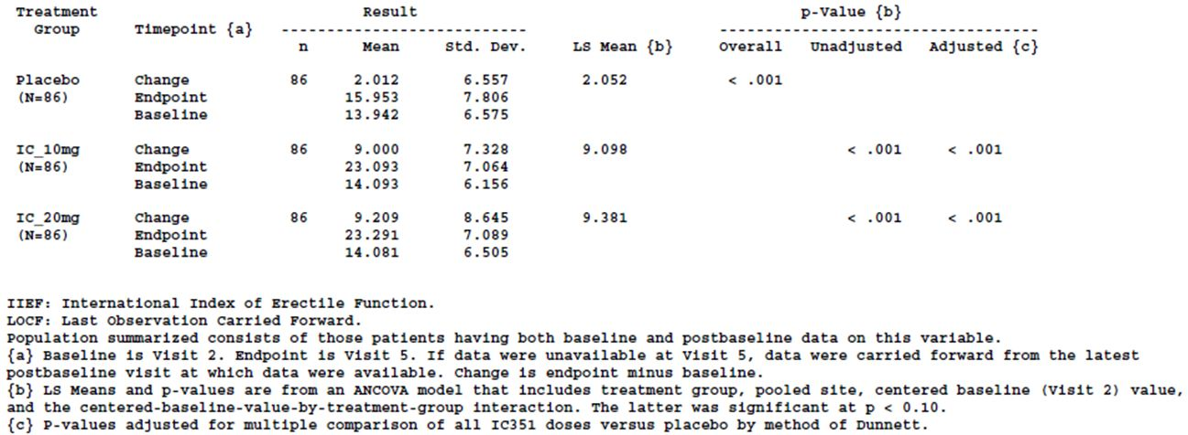
Table 14: Study H6D-MC-LVDI: SEP Question 2 (insertion of penis into vagina) – post-baseline versus baseline summary (all randomised subjects).
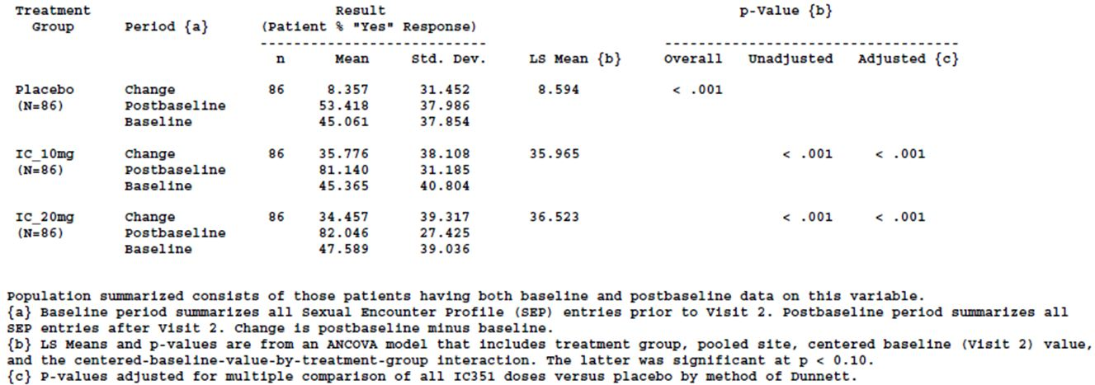
Table 15: Study H6D-MC-LVDI: SEP Question 3 (successful intercourse) – post-baseline versus baseline summary (all randomised subjects).
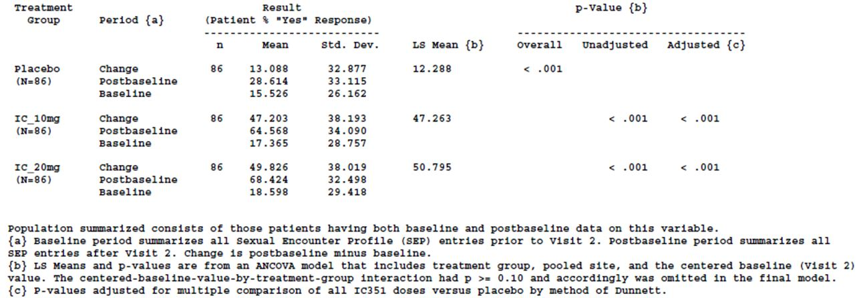
For the IIEF EF Domain score, the increase in the LS mean change from baseline to endpoint increased with increasing tadalafil dose (LS mean change: tadalafil 5mg = 7.514, tadalafil 10mg = 9.098, tadalafil 20mg = 9.381).
Comment: This study included subjects with ED but not BPH therefore it is not supporting the proposed indication rather the currently approved indication “Cialis is indicated for the treatment of erectile dysfunction in adult males.”

Analyses performed across trials (pooled analyses and meta-analyses)

Integrated analysis set (studies LVHG, LVHJ, LVHR and LVID)
There was only one study submitted to support the proposed use of tadalafil for the treatment of ED and the signs and symptoms of BPH in adult men, study LVHR.
In the integrated analysis set of studies LVHG, LVHJ, LVHR and LVID, there were 745 subjects in the placebo group and 752 in the tadalafil 5 mg group, of whom 77.0% and 77.8%, respectively, had ED at study entry. Of the men with ED at study entry, 88.0% (n=505) in the placebo group and 89.1% (n= 521) in the tadalafil 5 mg group were sexually active with an adult female partner at study entry. There was improvement in both treatment groups in the IIEF-EF Domain (placebo (n=487) LS mean change 1.5, tadalafil 5mg (n=507) LS mean change 6.3). The LS mean treatment difference was statistically significant between the tadalafil 5 mg and placebo groups (LS mean treatment difference 4.8 (SE 0.44); 95% CI [3.9. 5.6]; p <0.001.) The results of the individual studies were consistent with the results of the pooled analysis.
Comment: It is not clear if the change in IIEF-EF Domain from baseline in the subset of sexually active subjects with ED, receiving tadalafil 5 mg, compared with placebo, was a pre-specified outcome and if the statistically significant treatment difference could be due to chance.. Based on the absolute change from baseline to endpoint only, subjects with BPH-LUTS who had ED and were sexually active had a greater improvement from baseline to endpoint in IIEF EF Domain score compared with placebo. These results support the proposed indication.

Evaluator’s conclusions on clinical efficacy for the treatment of ED and the signs and symptoms of BPH in adult men
A single phase 3, randomised double-blind, placebo-controlled study, study LVHR, was submitted to support the use of tadalafil in the treatment of ED and the signs and symptoms of BPH in adult men. There was a significantly greater improvement from baseline to endpoint for tadalafil 5 mg, compared with placebo, for both of the co-primary efficacy outcomes, total IPSS score and IIEF-EF Domain score. For the comparison between tadalafil 2.5 mg and placebo, the change from baseline to endpoint was statistically significant only for the IIEF-EF Domain score. It is unclear if the clinically meaningful improvements in total IPSS and IIEF-EF Domain in the tadalafil 5 mg treatment group of study LVHR were assessed based on the mean change from baseline to Week 12 in the tadalafil 5 mg group, the placebo-adjusted change in the tadalafil 5 mg group, or the limits of the 95% confidence interval for the placebo-adjusted change.
The results of study LVHR support the proposed indication at the proposed dosage of 5 mg once daily. These results are supported by relevant secondary and exploratory analyses undertaken in the other three pivotal efficacy studies. Change from baseline to endpoint in IIEF EF Domain was a secondary efficacy outcome in the in pivotal studies LVHG, LVHJ, and LVID. In these studies, subjects with BPH-LUTS who had ED, and were sexually active, in the tadalafil 5 mg group had a greater mean improvement in IIEF-EF Domain from baseline to endpoint compared with the placebo group. Although not confirmatory, these results support the proposed indication. IPSS total was evaluated in men with BPH-LUTS, who had a history of ED at study entry, in the primary analysis populations of pivotal studies LVHG, LVHJ and LVID. The mean change from baseline to endpoint was greater in the tadalafil 5 mg group compared with the placebo group in both subjects who had a history of ED, and those who did not, across all three studies. Although these subgroup analyses were exploratory, the results are also supportive of the proposed indication.
Study LVHR, the single study submitted to support this indication, was of 12 weeks duration. No long-term efficacy data were provided in relation to the study subjects. However, for men with BPH-LUTS, long-term efficacy of tadalafil 5 mg once daily was evaluated as a secondary objective of study LVHG OLE. The results of this study support the efficacy of tadalafil 5 mg once daily for the treatment of BPH-LUTS over 64 weeks. IIEF EF Domain was also a secondary efficacy measure in this study. Fifty-five per cent of subjects (n=235) had ED and were sexually active. Based on descriptive statistics, mean IIEF EF Domain score increased in subjects from baseline to the end of the randomised treatment period and the improvement was still present at the end of the OLE period. These results were seen regardless of the dose of tadalafil received during the double-blind treatment period. This suggests that the improvement in IIEF –EF Domain score is maintained with long-term use. The current PI for Cialis (1) states that there is insufficient evidence on the maximum duration of once-a-day dosing treatment for ED and that the appropriateness of continued use of the once-a-day regimen should be reassessed periodically. As the IIEF-EF Domain score was a secondary efficacy measure in study LVHG OLE, and subjects with ED who were sexually active were only a subset of all study subjects, it would be appropriate to include a similar statement in relation to the results of once daily doing of tadalafil 5 mg on IIEF-EF Domain in this study.
Of note, the number of subjects aged over 65 years in the tadalafil 5 mg group in study LVHR was 83, fewer than the number recommended in the guideline “Clinical investigation of medicinal products in geriatrics” (26) to allow detection of a clinically important difference in this subgroup versus younger subjects. Only 21 randomised subjects were aged 75 years or older. There were no detectable differences in treatment effects between the age subgroups (≤ 65 and > 65 years and <75 and ≥ 75 years) for each of the co-primary endpoints. Across all the pivotal BPH studies, however, more than 100 subjects aged over 65 were treated with tadalafil 5mg and, including subjects from the non-pivotal efficacy studies, more than 100 subjects aged 75 years or older were treated with tadalafil 5 mg. This number of subjects would appear adequate to support the proposed indication in relation to the treatment of BPH. In relation to the treatment of ED, tadalafil 5 mg once daily dosing for the treatment of ED is already approved in Australia without restriction on the age of the patient who can use tadalafil in this indication.
Study LVHR had a large number of exclusion criteria. The efficacy of tadalafil 5 mg once daily in the proposed indication has, therefore, not been evaluated in the subgroups of the potential target population who have these medical conditions.
No objective measures of the signs of BPH were included as primary or key secondary efficacy variables in the pivotal efficacy studies. It is unclear to the evaluator why the proposed indication includes the treatment of the signs of BPH. The sponsor is requested to clarify the wording of the proposed indication in this regard.

Clinical safety

Studies providing evaluable safety data
The evaluable safety data included data from pivotal efficacy studies, pivotal studies that assessed safety as a primary efficacy, non-pivotal efficacy studies, a study relating to the ED indication, and clinical pharmacology studies. An integrated analysis of safety data from the four pivotal efficacy studies was undertaken by the sponsor.
Comment: The pivotal efficacy and safety studies had a large number of exclusion criteria. The safety of the use of tadalafil in the proposed indications has, therefore, not been assessed for patients with excluded medical conditions.
Exclusion criteria of particular importance include renal impairment, hepatic impairment and certain cardiac and coronary conditions. As BPH-LUTS affects ageing men, it is anticipated that a proportion of men will have such conditions. The existing precautions in relation to hepatic impairment and renal impairment that are included in the currently approved PI appear to be adequate for the proposed indication. The current PI includes contraindications to the use of tadalafil in groups of patients with cardiovascular disease that were not included in the ED trials. These contraindications are applicable to the proposed indications also. There are a number of cardiovascular conditions that were exclusion criteria in the pivotal studies in the proposed indications that are not proposed as contraindications or precautions in the draft PI. It is recommended that cardiovascular conditions that were exclusion criteria in the pivotal studies are included in the PI as contraindications or precautions in relation to the use of tadalafil in the treatment of BPH-LUTS and the treatment of ED and BPH-LUTS. The sponsor is requested to summarise the important exclusion criteria in the introductory paragraph describing the four pivotal studies in the Clinical Trials section of the PI.

Pivotal efficacy studies
Comment: Safety data from the four pivotal efficacy studies (LVHG, LVHJ, LVHR, LVID) relate to both of the proposed indications as all men had BPH-LUTS. The demographics and baseline characteristics of the subjects in study LVHR, the study supporting the indication treatment of ED and the signs and symptoms of BPH in adult, were similar to those of the other three studies. The only difference was all the men in study LVHR had ED compared with a proportion of men in the other three pivotal efficacy studies.
In the pivotal efficacy studies, the following safety data were collected: adverse events, post-void residual volume (PVR), clinical chemistry and haematology and urinalysis.
Additional safety data were collected in one or more of the pivotal studies as follows:
- Vital signs: LVHG, LVID
- Uroflowmetry: LVHJ, LVHR and LVID
- Orthostatic vital signs: LVHR, LVHJ
- ECG: LVHG
- PSA: LVHG

General adverse events
General adverse events were collected at each visit and included adverse events reported since informed consent was given (including protocol-related adverse events in studies LVHJ, LVHR and LVID). Study subjects were to report adverse events to the investigator. Adverse events were assessed to determine if they were treatment-emergent and if they were related to the study drug (or protocol).
Comment: The method by which adverse events were collected does not appear to have been described.

AEs of particular interest
In study LVHG, adverse events of particular interest, based on previous regulatory concerns or relevance to BPH-LUTS disease state, were TEAEs related to the cardiovascular system, vision/eyes, hepatic system, PSA and urinary tract invasive procedures. From the MedDRA dictionary terms were chosen to reflect these adverse events of interest. Cases in the safety database matching the list of MedDRA terms were evaluated further to gain additional knowledge about any correlation with tadalafil.
Orthostatic signs were of particular interest in studies LVHJ and LVHR. Blood pressure and heart rate were measured at Visits 2 to 7 according to a protocol. A subject was reported to have had a positive orthostatic test if they met one of the following criteria at any time as assessed from supine to standing position: SBP decrease ≥ 20mmHg, DBP decrease ≥ 10mmHg, heart rate increase ≥ 20 beats/minute or unable to remain standing during the orthostatic assessment. A treatment-emergent positive orthostatic test was defined as one in which one of the four criteria was present at any post-baseline visit but was not present at baseline (Visit 3). Subjects were to report adverse events upon standing during the orthostatic vital sign assessment. TEAEs were events first reported or worsened in severity during the assessment. The Visit 3 assessment was used as the baseline severity for a specific AE preferred term.
Adverse events possibly related to hypotension were of particular interest in study LVID. TEAEs possibly related to hypotension were assessed using a list of predefined MedDRA preferred terms. HR, SBP and DBP in the sitting position were measured at each visit. Potentially significant vital signs occurring during the double-blind treatment period were summarised using the criteria:
- Heart rate: Low if <50 beat per minute (bpm) and the decrease from baseline was ≥15 bpm, High if >120 bpm and the increase from baseline was ≥15 bpm.
- Systolic blood pressure: Low if ≤90 mm Hg and the decrease from baseline was ≥20 mm Hg, High if ≥160 mm Hg and the increase from baseline was ≥20 mm Hg.
- Diastolic blood pressure: Low if ≤50 mm Hg and the decrease from baseline was ≥10 mm Hg, High if ≥100 mm Hg and the increase from baseline was ≥10 mm Hg.

Laboratory tests
Clinical haematology and chemistry and urinalysis were undertaken in each of the pivotal studies. In study LVHG, clinical haematology and chemistry, and urinalysis, were performed at Visits 1, 3, 6 (Weeks -8 to -5, 0, 6). In the other three pivotal studies, standard laboratory tests including chemistry, haematology and urinalysis were collected at Visit 1 (Week -8 to -5), Visit 3 (Week 0) and Visit 7 (Week 12) or the final visit for subjects who discontinued the study early. A central laboratory performed all the clinical laboratory assessments.
PSA testing was done in study LVHG at Visit 1 (Week -8 to -5), Visit 3 (Week 0) and Visit 6 (Week 12). Blood samples for the PSA were to be collected at least 48 hours after the subject’s most recent ejaculation. To monitor the possible effect of time and frequency of ejaculation on serum PSA subjects were asked to record the date and time of each ejaculation in ejaculation diaries given to them at Visits 2, 3, 4 and 5. The completed diary for the period between the visits was returned to the study sites. PSA was only measured once in the other three studies, during the screening/wash-out period.

Other safety variables assessed

Post-void residual volume (PVR)
Post-void residual volumes were determined by ultrasound at all six study visits in study LVHG. In studies LVHJ, LVHR and LVID, PVR was determined by ultrasound at Visits 1, 3 and 7. There was a specific protocol for the PVR determination.

ECG
In study LVHG, ECGs were done at Visit 1 (screening) and Visit 6 (final study visit). ECGs were to be electronically obtained and sent to an interpreted by a specific central cardiologist who was to compare each tracing sequentially to evaluate if there were treatment-emergent ECG wave abnormalities. Standardised codes for wave form changes were used.

Uroflowmetry
In studies LVHJ, LVHR and LVID, uroflowmetry measurements were performed at Visits 2 (Week -4), 3 (Week 0) and 7 (Week 12). Parameters assessed were Qmax (peak urine flow rate), Qmean (mean urine flow rate) and Vcomp (volume of voided urine). Results were considered valid only if the pre-void bladder volume was ≥ 150 to ≤ 550 mL on ultrasound and the voided volume was ≥ 125 mL. In study LVHJ, the uroflowmetry data were read by the principal investigator. In studies LVHR and LVID, at Visit 2 uroflowmetry data were recorded on the case report form by a central reader for those subjects randomised. Data from Visits 3 and 7 were recorded by the blinded principal investigator and central reader.

Pivotal studies that assessed safety as a primary outcome
Studies H6D-MC-LVHS (LVHS), H6D-MC-LVHK (LVHK) and the open label extension period of study LVHG (LVHG OLE) were pivotal studies that assessed safety as a primary outcome.

Dose-response and non-pivotal efficacy studies
Study LVGC provided data on adverse events, vital signs, clinical chemistry and haematology, PSA, urinalysis, and PVR.
Studies in Asian populations:
- Study LVHT provided data on adverse events, concomitant medications, vital signs, ECG, clinical chemistry and haematology, urinalysis, and PVR
- Study LVIA provided data on adverse events, vital signs, clinical chemistry and haematology, urinalysis, PSA, and PVR
- Study LVIA OLE provided data on adverse events, vital signs, clinical chemistry and haematology, urinalysis, PSA, and PVR
- Study LVHB provided data on adverse events, concomitant medications, vital signs, clinical chemistry and haematology, urinalysis, PSA, and PVR.
Study LVDI, a study related to the currently approved ED indication, provided data on adverse events, vital signs, ECG, clinical chemistry and haematology, and urinalysis.

Other studies evaluable for safety only
There were no other studies evaluable for safety only.

Clinical pharmacology studies
All the clinical pharmacology studies provided adverse event data. A number of the studies also provided data on ECG parameters, clinical chemistry and haematology, vital signs and physical examination.
Study LVFB was a QT study. Study LVHN provided hemodynamic data.

Pivotal studies that assessed safety as a primary outcome

Study H6D-MC-LVHS (LVHS)

Study design, objectives, locations and dates
Study LVHS was a phase 3 randomised, double-blind, placebo-controlled, parallel design study. There were three study periods: a screening/wash-out period, placebo lead-in period and double-blind treatment period (Figure 7). The study was conducted in 33 centres in the US and Puerto Rico between March 2009 and December 2009. The primary objective of the study was to evaluate the proportion of men with BPH-LUTS experiencing treatment-emergent dizziness when tadalafil 5 mg once a day was added to concomitant alpha blocker therapy compared with the addition of placebo to alpha blocker therapy.
Figure 7: Study H6D-MC-LVGC: Study design.
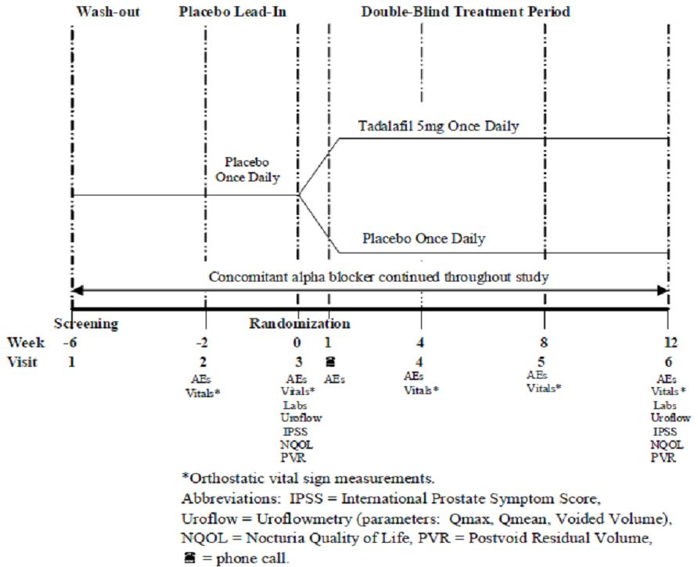

Inclusion and exclusion criteria
The study population consisted of men who were aged 45 years or older, had BPH –LUTS and were on a stable dose of alpha blocker therapy for the treatment of BPH-LUTS. There were numerous exclusion criteria including criteria relating to pelvic, urinary tract, prostate and bladder conditions, renal and hepatic impairment and cardiac conditions.

Study treatments
All subjects were instructed to continue using the same alpha blocker therapy throughout the study. During the two week single blind placebo lead-in period, subjects received a placebo tablet, identical in form and appearance to the tadalafil 5mg tablet, once daily orally. In the double-blind treatment period subjects were randomised to receive placebo or tadalafil 5 mg once daily orally for 12 weeks. Subjects were to administer each dose at approximately the same time each day with or without food.
During the placebo lead-in period, and the first four weeks of the double blind treatment period only, downward titration of alpha blocker dose was allowed. Titration of the alpha blocker dose up or down, as necessary, was permitted for the last eight weeks of the double-blind treatment period.
The criteria for discontinuing subjects from the study included if the subject discontinues alpha blocker therapy or begins a new alpha blocker therapy or adjusts the dosage of the alpha blocker therapy at times not allowed.
Comment: The remaining criteria for subject discontinuation from the study were consistent with the criteria specified in the pivotal efficacy studies.

Safety variables and outcomes
The main safety variable was dizziness. This was assessed through the spontaneous reporting of adverse events by study subjects. The primary safety outcome was the proportion of subjects who experienced treatment-emergent dizziness when tadalafil 5mg was added to alpha blocker therapy compared to the proportion of subjects who experienced treatment-emergent dizziness when placebo was added to alpha blocker therapy. Treatment-emergent dizziness was defined as dizziness that first occurred or worsened after subject randomisation. Treatment-emergent dizziness included MedDRA (version 12) preferred terms “dizziness”, “dizziness postural” and “procedural dizziness”.
Other safety variables were:
- Adverse events: collected at Visits 2 to 6. Adverse events were coded to MedDRA terms by the sponsor’s blinded clinical personnel. Investigative site personnel were instructed not to proactively ask subjects about specific adverse events during the study.
- Orthostatic vital signs: collected at Visits 2 to 6 according to a specific protocol.
- Uroflowmetry: obtained at Visits 3 and 6. Data were considered valid, and included in the statistical analyses, if the voided volume was ≥ 125 mL. Data were recorded on an electronic case report form (eCRF) by the blinded central reader according to a specific protocol.
- PVR: measured by ultrasound at Visits 1, 3, 6 according to a specific protocol.
- Clinical laboratory tests: chemistry, haematology and urinalysis panels were collected at Visits 1, 3 and 6. Haemoglobin A1c and PSA were performed at Visit 1 only and endocrine-related parameters were performed at Visit 3 for the exploratory assessment of subject characteristics. A central laboratory performed the clinical laboratory assessments.

Randomisation and blinding methods
Subjects who met the criteria for enrolment were randomly assigned, as determined by a computer-generated random sequence using an IVRS, to tadalafil 5mg or placebo in a 1:1 ratio at Visit 3. Randomisation was stratified by age, type of alpha blocker and baseline LUTS severity.
Only subjects were blinded to the treatment assignment in the placebo lead-in period. During the double-blind treatment period, the study subjects, study site personnel and sponsor did not know which treatment was being administered.

Analysis populations
The primary analysis population included subjects who were randomised and started study medication.
The randomised population included subjects who were randomised to study treatment by the IVRS regardless of whether double-blind study medication was taken.
The per-protocol population consisted of those subjects who met the criteria for the primary analysis population, completed the 12 week treatment period and had taken at least 70% of prescribed doses in the double-blind study period.
For subjects who discontinued the study early, or were missing post-baseline data, analyses were based on the most previous non-missing post-baseline data (LOCF data imputation methodology). Subjects with no post-baseline visit for the primary safety measure were excluded from the primary safety analysis.

Sample size
The planned sample size was 300 subjects in total (150 subjects per treatment group). A sample size of 142 subjects per treatment arm was stated to provide 91% power to detect a difference between a Group 1 proportion of 0.03 and a Group 2 proportion of 0.13 using a one-sided Fisher’s exact test at 0.05 level of significance. The non-evaluable rate was projected to be 5%.

Statistical methods
The primary analysis of the difference in the proportions of subjects in the two treatment groups experiencing treatment-emergent dizziness was conducted using the one-sided Fisher’s exact test at a significance level of 0.05. A two-sided p-value at a significance level of 0.05 was also presented. Sensitivity analyses of the primary analysis were presented with both one and two- sided p-values. All other tests of the difference between the treatment groups were conducted at a two-sided significance level of 0.05.
The primary safety measure was summarised by age subgroup (< 75, ≥ 75) and type of alpha blocker (selective (alfuzosin, silodosin, or tamsulosin), non-selective (doxazosin or terazosin)).
ANCOVA models were used for the secondary efficacy and exploratory analyses.

Participant flow
Of 445 subjects who were screened, 318 subjects were randomised, 160 to the placebo treatment group and 158 subjects to the tadalafil 5 mg treatment group. The proportion of subjects who completed the study was similar in each treatment group (placebo 87.5% (n=140), tadalafil 5 mg 88.6% (n=140). The most common reason for study discontinuation in both treatment groups was an adverse event (placebo 3.8% (n=6), tadalafil 5 mg 4.4% (n=7)).
The primary analysis population consisted of 159 subjects in the placebo group and 158 subjects in the tadalafil 5 mg group. One randomised subject in the placebo group was lost to follow-up after the randomisation visit.

Major protocol violations/deviations
A similar proportion of subjects in each treatment group had protocol violations relating to the inclusion criteria not being met, or the exclusion criteria being met, based on statistical output from the clinical database(placebo 11.3% (n=18), tadalafil 10.1% (n=7)). Additional protocol violations were identified from reviews of the study data during the study. The majority of protocol violations related to invalid or incomplete uroflowmetry assessments. There were also protocol violations relating to the use of alpha blocker therapy. Initiation of therapy less than four weeks prior to Visit 1 was reported for one subject in the tadalafil 5 mg group and six subjects in the placebo group. All subjects had initiated the alpha blocker more than two weeks prior to Visit 1. One subject in each treatment groups was taking an alpha blocker above the maximum approved dose.
Comment: The protocol violations related to uroflowmetry were reported in a similar number of subjects in each treatment group. The absolute number of protocol violations identified relating to alpha blocker therapy was small (placebo (n=9), tadalafil (n=3) and the difference in the number of violations between the treatment groups is unlikely to have appreciably affected the primary outcome. Most of the protocol violations listed in the Appendix to the study report were related to having started alpha blocker therapy less than four weeks prior to Visit 1 (placebo (n=6), tadalafil 5 mg (n=1)).

Baseline data
The mean age of randomised study subjects was 67.38 years (range 46.88 – 87.98 years). Over half the subjects (58.8%) were aged over 65 years (placebo n=92, tadalafil 5 mg n=95) and approximately one quarter (24.5%) of study subjects were aged 75 years or older (placebo n=38, tadalafil n=40). The majority (88.4%) of subjects were white. The treatment groups were comparable with regard to subject demographics and baseline clinical characteristics. Tobacco and alcohol consumption habits were relatively similar in the two groups. A higher proportion of subjects in the placebo group reported current alcohol consumption (placebo 56.9%, tadalafil 51.9%). The majority of study subjects (58.2%) had a baseline LUTS severity categorised as moderate (IPSS 8-19). Forty per cent of subjects had a Qmax 10-15 mL/sec, 88.2% < 10mL/sec and 21.8% > 15 mL/sec. A higher proportion of subjects in the tadalafil 5 mg group had a Qmax < 10mL (placebo 34.7%, tadalafil 5mg 42.0%). The mean PVR was higher in subjects in the tadalafil 5 mg group compared with the placebo group but the median was comparable (placebo mean 71.77 mL, median 54.50 mL; tadalafil 5mg mean 79.01 mL, median 53.00 mL).
Adjunct therapy with a selective alpha blocker was reported for 67.3% of study subjects. Tamsulosin was the most common selective alpha blocker used. Non-selective alpha blockers (doxazosin and terazosin) were used as adjunct therapy by 33.0% of randomised subjects. The use of specific alpha blockers was similar in the two treatment groups. Overall duration of alpha blocker use was comparable between the treatment groups (mean duration placebo 45.4 months, tadalafil 5mg 40.1 months). The proportions of subjects in the two treatment groups taking concomitant 5-ARI therapy were similar (placebo 16.9%, tadalafil 5mg 19.6%). A similar proportion of subjects in each group reported having used previous BPH-LUTS (excluding concomitant alpha blockers and 5-ARIs) in the 12 months prior to Visit 1.
Erectile dysfunction was reported by 61.9% of randomised subjects. The duration and severity of ED was similar in the two treatment groups, the majority of subjects in both groups having ED of a mild or moderate severity and ED of at least one year’s duration.
Compliance to treatment during the double-blind treatment period was considered unknown for one subject (0.6%) in the placebo group who was lost to follow-up after randomisation. Two subjects in the tadalafil 5mg group (1.3%) were not considered compliant with treatment during this period (compliance < 70%).

Results for the primary safety outcome
Treatment-emergent dizziness was defined as any of the pre-defined terms of dizziness that were first reported, or worsened in severity, after baseline (the period after Visit 2 through to Visit 3).
Based on the primary analysis population, a similar proportion of subjects in each treatment group had one or more treatment-emergent dizziness adverse events during the double-blind period (placebo 5.7% (n=9); tadalafil 5mg 7.0% (n=11); p= 0.403 (one sided); p=0.653 (two-sided)). With regard to the individual preferred terms reported in relation to dizziness, the proportions of subjects reporting specific preferred terms in each group were comparable (dizziness: placebo 5.0% (n=8); tadalafil 5mg 6.3% (n=10); dizziness postural: placebo 0.6% (n=1); tadalafil 5mg 0.6.% (n=1)).
The results from analyses of treatment-emergent dizziness based on the per-protocol population and randomised population were consistent with the results based on the primary analysis population.

Results for other safety outcomes
The results in relation to adverse events, orthostatic vital signs, uroflowmetry, PVR and clinical laboratory tests are described below.

Study H6D-MC-LVHK (LVHK)

Study design, objectives, locations and dates
Study LVHK was a randomised, double-blind, placebo-controlled, parallel design, two group study. It was conducted in 20 study centres in Canada and the US. The first subject was randomised on 16 November 2006 and the last subject visit was on 5 May 2008. The study had three periods: a screening/wash-out period, baseline urodynamic assessment period and double-blind treatment period (Figure 8). The duration of each study period may have varied. After screening results were reviewed, the subjects not taking prohibited BPH-LUTS treatments proceeded to Visit 2. If results from the baseline urodynamic assessment at Visit 2 were considered invalid, the subject was requested to undergo a repeat urodynamic assessment. If both the original and repeat assessments were invalid the subject was not to proceed to Visit 3. Visit 3 was 7 ± 2 days after a baseline assessment with valid results.
Figure 8: Study H6D-MC-LVHK: Study design.
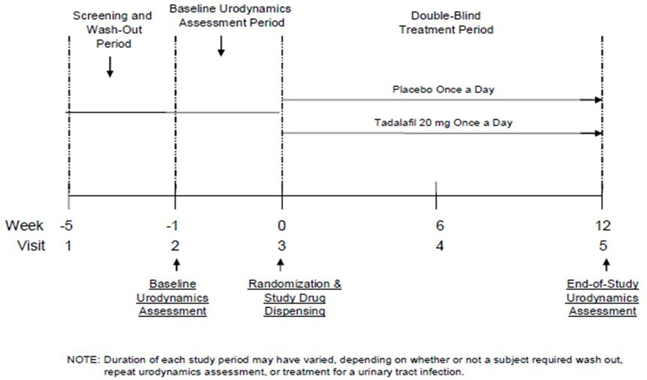
The primary objective of the study was to compare the effect of tadalafil 20 mg once daily for 12 weeks on detrusor pressure at peak urinary flow rate (pdetQmax), compared with placebo, in men with signs and symptoms of benign prostatic hyperplasia, including lower urinary tract symptoms.
The sponsor had indicated that, according to urodynamic experts, a decrease in pdetQmax, without a decline in Qmax or an increase in PVR, would represent a clinically beneficial outcome. It is noted by the sponsor that there are many possible reasons for changes in pdetQmax making the interpretation of study findings difficult.
Comment: The dosage of tadalafil used in this study, 20 mg once daily, is higher than the dosage proposed for the new indications (5 mg once daily).

Inclusion and exclusion criteria
The study population were men aged 40 years or older who had diagnosed BPH-LUTS of greater than six months duration. Subjects were required have a total IPSS ≥ 13 at Visit 1, if the subject did not require wash-out of therapy for BPH-LUTS, or at Visit 2, if the subject did require washout of BPH-LUTS therapy. Subjects had to agree not to use any other approved or experimental pharmacologic treatments for BPH-LUTS during the study. Exclusion criteria included clinical evidence of specific bladder and urinary tract conditions, and prostate cancer as well as a history of significant renal insufficiency, active symptomatic hepatobiliary disease and a history of cardiac and coronary conditions.
Comment: The source of study subjects was not specified but the study investigators were all urologists.
The exclusion criteria were similar to those of the pivotal efficacy studies.

Study treatments
The double-blind treatment period was 12 weeks. The treatments were tadalafil 20 mg or placebo orally once daily. The tadalafil 20 mg and placebo tablets were identical in appearance. Subjects were to take each treatment dose at approximately the same time each day, with or without food.
No study treatments were given during the wash-out and urodynamic assessment periods.
The criteria for discontinuing subjects from the study included if the subject developed a persistent UTI following randomisation.
Comment: The remaining criteria for subject discontinuation from the study were consistent with the criteria specified in the pivotal efficacy studies.

Safety variables and outcomes
The primary safety variable was the detrusor pressure at peak urinary flow rate (pdetQmax). The primary endpoint was the change in pdetQmax from baseline (Visit 2) to Week 12 (Visit 5).
Other safety variables included free-flow urodynamic parameters (peak urine flow rate (Qmax), mean urine flow (Qave), volume of voided urine (Vcomp), PVR measurement by catheterisation (PVRcath), total bladder capacity (Vcomp + PVRcath) and bladder voiding efficiency (Vcomp/total bladder capacity) x 100 (obtained from a full bladder) and pressure-flow urodynamic parameters (Qmax, Qave, Vcomp, maximum detrusor pressure observed during voiding (max pdet), bladder contractibility index (BCI) (pdetQmax + 5Qmax) and bladder outlet obstruction index (BOOI) (pdetQmax-2Qmax)).
Presence of involuntary detrusor contractions during filling, and bladder volume at first involuntary detrusor contraction, were also secondary safety measures.
Urodynamic parameters were measured using free-flow and pressure-flow test instrumentation. Study sites were required to comply with procedures contained in an urodynamic operations manual. The free flow test used a standard calibrated flow meter. The pressure-flow urodynamic test was used to indirectly measure bladder detrusor contractibility. Abdominal pressure, measured by a transrectal transducer, was subtracted from intravesical pressure, measured by a transurethral bladder catheter, to calculate detrusor pressure.
For the urodynamic assessment at baseline and at the end of study, one free flow test and two separate pressure flow tests were evaluated by the blinded principal investigator and central reader for interpretability. The central reader reviewed both sets of pressure flow test results from each urodynamic assessment to determine which set would be used in the statistical analysis. The set of results used (pressure flow study 1 or pressure flow study 2) was based on the quality of the data.
If the central reader considered the results of the baseline urodynamic assessment to be invalid, the subject was requested to participate in a repeat assessment. Subjects could not return for Visit 3 until the repeat assessment was confirmed to be valid by the central reader. The subject could not be randomised (Visit 3) if both assessments were invalid. At the end of the study, subjects with an urodynamic assessment that was considered invalid were asked to return for a repeat assessment in 7 ± 2 days. No additional testing was undertaken if both assessments were considered invalid.
Urinalysis was performed at Visit 2 and subjects who had tests positive for UTI had the urodynamic assessment rescheduled until after treatment of the UTI was finished. If repeat testing revealed positive results for a UTI, the subject was not randomised to treatment. Similarly, at the end of the study, subjects with a positive test result for a UTI were treated and had the end of study assessment rescheduled. The subject was instructed to continue the study drug until the assessment. Subjects who had positive UTI results on re-testing were not able to participate in the end of study urodynamic assessment.
Other safety variables were adverse events, vital signs, physical examination, weight, BMI and clinical chemistry and haematology. Adverse events and concomitant medication taken during the study were recorded at each visit. Vital signs were collected at each visit and laboratory data at baseline (Visit 1) and endpoint (Visit 5). A central laboratory was used.
Comment: It is unclear if all the urodynamic assessment variables are validated. It is indicated in the submission that the urodynamic parameters used in this study are standard parameters used to assess the effects of study drug administration on urodynamics. The sponsor has provided justification for the measurements used which seem reasonable.

Randomisation and blinding methods
Subjects were randomly assigned to placebo or tadalafil 20 mg once daily in a 1:1 ratio at Visit 3 if they had met all the enrolment criteria, had completed a baseline urodynamic assessment with valid results, and had agreed to participate in the end of study urodynamic assessment.
Randomisation was stratified by class of bladder outlet obstruction (obstructed (BOOI > 40, equivocal BOOI 20 to 40, unobstructed BOOI < 20) and baseline LUTS severity (moderate (IPSS <20), severe (IPSS ≥20)).
Subjects were randomly assigned to treatment groups as determined by a computer-generated random sequence using an IVRS employing permuted blocks within strata. Stratification by BOOI was based on the evaluation of the baseline urodynamic assessment by the central reader.
Subjects, investigators and other personnel involved in the conduct of the study were blinded to the individual treatment assignments during the study. Emergency unblinding could be undertaken through the IVRS for adverse events. The central reader remained blinded throughout the study.

Analysis populations
The primary analysis population included randomised subjects who started study medication, had both a baseline and end of study pressure-flow urodynamic assessment, and who had at least 37 days (6 weeks minus a five day visit window) between randomisation and the final urodynamic assessment.
The per-protocol population included randomised subjects who completed the 12 week treatment period and who had administered at least 70% of doses.
The safety analysis included all randomised subjects who received study treatment grouped by the treatment to which they were randomised.
If a subject discontinued the study or withdrew from the study early the final visit procedures were performed at the time of discontinuation.

Sample size
The study was powered to exclude a change in pdetQmax of 15cm H₂O. The choice of the value of change in pdetQmax of 15cm H₂0 was based on studies that applied a non-inferiority design using the convention of excluding change in pdetQmax of 15 or 20 cm H₂O. The sponsor indicates that urodynamic experts are unsure if a change as high as 20cm H₂O is clinically meaningful. A decrease in pdetQmax of 15 cm H₂O or more was considered potentially clinically adverse and it was considered that such a decrease may indicate a detrimental effect on the bladder if there had been no improvement in Qmax.
The sample size was based on a two-sided 95% confidence interval for the difference between the treatment groups in the change in pdetQmax from baseline, an assumed standard error of the change from baseline to Week 12 in pdetQmax of 30 cm H₂O, and an 80% probability that the confidence interval will exclude a difference of 15cm H₂O in pdetQmax when the true difference is 0. A sample size of 190 randomised subjects (95 per treatment group) was planned to yield approximately 128 subjects with both baseline and end-of-study urodynamic assessment results. It was planned that the total subjects randomised may be increased if the number of valid end-of-study urodynamic assessments was smaller than anticipated.

Statistical methods
The protocol was amended twice and the SAP superseded the statistical plans in the protocol. The primary analysis derivation was provided in an appendix. The main changes to the protocol made in the two amendments related to changes in the urodynamic parameters included in the study, the addition of bladder obstruction categories as stratification factors, modification of inclusion and exclusion criteria and changes to the study schedule.
With regard to the planned analyses, three subjects (placebo (n=2), tadalafil 20mg (n=1)) were excluded from post hoc analyses of the primary endpoint and from the secondary pressure-flow endpoints because the pressure-flow tracings were considered invalid. Data from subjects who had free-flow parameters measured via mechanical fill after pressure flow studies were excluded in the post-hoc analyses of secondary free-flow endpoints. An additional post hoc analysis was performed for BOOI category shift from baseline to endpoint.
The primary inferential analysis of change in pdetQmax from baseline (Visit 2) to end of study (Week 12, Visit 5) was a two-sided 95% confidence interval for the difference between the treatment groups. An ANOVA based on Type II sum of squares approach was used.
The mean difference of change, standard error, two-sided 95% confidence interval and p-value for the difference between the tadalafil 20 mg treatment group and placebo group were from the ANOVA stratified by the six randomisation strata factors (class of bladder outlet obstruction by LUTS severity).
The overall mean difference was calculated by estimating the difference within the randomisation strata and then combining the stratum-specific estimators over the six randomisation strata. The within-strata differences were combined proportionate to stratum sample size.
Subgroup analyses were undertaken for the primary endpoint according to the subgroups use of alpha blockers at study entry (yes, no), baseline LUTS severity (moderate, severe), bladder outlet obstruction (obstructed, equivocal and unobstructed), BMI (< 27, ≥ 27), age (≤ 65 years, > 65 years), ED (yes, no), previous use of LUTS within 12 months of study entry (yes, no).
An interim analysis was to be performed if subject screening had not been completed by the end of 2007. An interim analysis of 74 evaluable subjects was calculated to have a 80% probability that the confidence interval for the difference in change in pdetQmax on tadalafil and placebo excludes a difference of more than 20cm H₂O when the true difference is 0. No adjustments to the alpha level for the final analyses were planned. The study was not to be terminated at the interim. No interim analysis was conducted.
Comment: The changes in the planned analyses related to post-hoc analyses only.

Participant flow
Of 345 subjects screened, 200 were randomised (placebo (n=101), tadalafil 20mg (n=99)). In the placebo group 92 subjects (91.09%) completed the 12 week treatment period. Of the 9 subjects in the placebo group who discontinued the study the main reason was subject decision (n=5). A single subject discontinued due to an adverse event (death), loss to follow-up, protocol violation and sponsor decision. In the tadalafil 20 mg group, 89 subjects (89.90%) completed the treatment period. Of the 10 subjects who discontinued the study, subject decision was the main reason (n=4), followed by adverse event (n=2) and protocol entry criteria not met (n=2). A single subject discontinued due to the sponsor’s decision and one subject was lost to follow-up.
The primary analysis population included a total of 175 subjects (placebo n=91; tadalafil n=84).
Comment: A notable proportion of randomised subjects in each of the treatment groups was not included in the primary analysis population (tadalafil 20 mg (n=15 (15.2%); placebo n=10 (9.9%)). The subjects not included in the primary analysis population may have differed in some way from those who were included (n=84) therefore biasing the results.
The planned sample size, of 128 for subjects with both baseline and end-of-study urodynamic assessment results, was exceeded.

Major protocol violations/deviations
Prespecified key protocol violations were reported in similar proportions of randomised subjects in each treatment group. The most common protocol violation in both treatment groups was inclusion/exclusion criteria not met (placebo 7.92% (n=8); tadalafil 20mg 11.11% (n=11)). The proportions of subjects who used excluded medications started after randomisation (placebo 5.94%; tadalafil 20mg 3.03%), and who developed discontinuation criteria during the study but were not withdrawn (placebo 2.97%; tadalafil 20mg 1.01%), were small and similar between the groups.
Comment: As the proportion of subjects in the two treatment groups who had key protocol violations was similar it is unlikely that these protocol violations would have biased the results.

Baseline data
Subjects had a mean age of 58.60 years (range 41.09 - 83.46 years) and were predominantly white (76.50%). Twenty subjects in the tadalafil 20 mg group were aged 65 years or older. The two treatment groups were comparable for age, age category (proportion of subjects aged under 65 and 65 years and older), ethnic origin, height, weight, BMI, current alcohol and tobacco use. Overall, 59.00% of subjects had ED, the majority of whom had ED of moderate severity (52.54%). The two treatment groups were comparable with regard to the proportion of subjects with ED. A higher proportion of subjects in the placebo group had ED of severe severity compared with the tadalafil 20 mg group but the absolute difference in the number of subjects was small (placebo 15.00% (n=9); tadalafil 8.62% (n=5)).
The majority of subjects had severe baseline BPH-LUTS severity (64.00%) and a duration of BPH LUTS at Visit 1 of more than 3 years (54.40%). The two treatment groups were comparable. Overall, 31.50% of subjects had used previous therapy for BPH, including alpha blocker therapy, within 12 months prior to Visit 1. The mean PVR by ultrasound was higher in the placebo group compared with the tadalafil 20mg group (placebo 59.30 mL (SD 60.87), tadalafil 20mg 45.65 mL (SD 49.58)).
Approximately one third of subjects in each group fell into each of the bladder outlet obstruction categories (obstructed, equivocal and unobstructed) respectively. The proportion of subjects reporting specific pre-existing conditions was generally similar.

Results for the primary safety outcome
Both groups had small mean changes from baseline to endpoint, with a mean increase in pdetQmax in the placebo group (1.92 cm H₂0) and a mean decrease in the tadalafil 20mg group (-2.95 cm H₂0). The mean difference of the change from baseline to endpoint in pdetQmax between the tadalafil 20mg treatment group and placebo group was not statistically significant (mean difference of change (tadalafil – placebo) - 4.95 cm H₂0; 95% CI [-10.26, 0.37]; p=0.068).
The results of a post-hoc analysis of the change from baseline to endpoint in pdetQmax for all randomised subjects in the primary analysis population, excluding three subjects who had changes of more than 60 cm H₂O (considered non-physiological), were consistent with the results in the primary analysis population (mean difference of change -2.18 cm H₂O; 95% CI [- 6.54, 2.18]; p=0.325). The results in the per-protocol population, including and excluding the three subjects with invalid tracings, were consistent with the results in the primary analysis population. The decrease in pdetQmax in the tadalafil 20 mg group was not considered to be clinically adverse. In the subgroup analyses, small mean decreases in PdetQmax from baseline to endpoint were seen in the tadalafil 20 mg group across the subgroups except for the subgroups use of alpha blocker at study entry, which showed a small mean increase in PdetQmax (3.5 cm H₂O) in subjects who reported use of alpha blocker at study entry and a small mean decrease in PdetQmax (-4.7 cm H₂O) in subjects who did not, and previous use of BPH therapy within 12 months of study entry (yes mean change 0.9 cm H₂O, no mean change -4.6 cm H₂O). The effect of tadalafil 20 mg on pdetQmax was not considered to be clinically adverse by the sponsor in any of the subgroups.

Results for other safety outcomes
The secondary urodynamic analyses were performed on the primary analysis population.

Free-flow studies
The mean changes from baseline to endpoint for each parameter assessed were generally small and in the same direction in the two treatment groups. The median changes from baseline to endpoint in the parameters were more similar between the treatment groups. The results of post-hoc analyses of urodynamic parameters measured during free flow studies, based on randomised subjects in the primary analysis population, excluding subjects with free-flow parameters measured after pressure-flow via mechanical fill, were generally consistent with the results of the pre-specified analyses. The results of these analyses were not considered clinically significant.

Pressure-flow studies
Based on all randomised subjects in the primary analysis population, for the urodynamic parameters measured during the pressure flow studies, there were small mean differences of change from baseline to endpoint between the two treatment groups. Excluding the three subjects with invalid data did not alter the results to any notable extent.
A decrease in BCI in the tadalafil group compared with the placebo group (tadalafil 20 mg (n=84) mean change -1.04 (SD 20.37)); placebo ((n=91) mean change4.43 (SD 20.86); mean difference of change -5.40 (SE 3.17)) was not considered to be clinically adverse. The endpoint mean BCI for each of the treatment groups was in the normal range (100-150). A higher proportion of subjects in the tadalafil 20 mg group had a BCI shift from normal at baseline to weak (BCI <100) at end of therapy in the tadalafil 20 mg group compared with the placebo group (placebo 4.40% (n=4); tadalafil 20mg 14.29% (14.29% (n=12)).
Based on all randomised subjects in the primary analysis population, the number of subjects who had a BOOI shift from equivocal or unobstructed at baseline, to obstructed at endpoint, was smaller in the tadalafil 20mg group compared with the placebo group (placebo: equivocal to obstructed 13.19% (n=12); unobstructed to obstructed 2.20% (n=2); tadalafil 20mg: equivocal to obstructed 7.14% (n=6); unobstructed to obstructed 0.00% (n=0)). On post-hoc analysis , a smaller proportion of subjects in the tadalafil 20 mg group had a worsening of BOOI category between baseline and endpoint compared with the placebo group, based on all randomised subjects in the primary analysis population excluding the subjects with invalid data ( placebo 23.6% (n=21); tadalafil 20mg 12.0% (n=20)).
The results of these secondary analyses were not considered clinically significant.
The proportions of subjects in the placebo and tadalafil 20mg groups who had involuntary detrusor contractions during bladder filling at baseline and endpoint were similar.
The mean change in bladder volume at first involuntary detrusor contraction was similar in the two treatment groups for subjects who had involuntary detrusor contractions during bladder filling at baseline and endpoint (placebo (n=22) mean change 27.86mL; tadalafil 20mg (n=18) 28.56 mL).
In subgroup analyses of urodynamic parameters by bladder outlet obstruction category, there were no clinically adverse findings apparent within any of the subgroups.
Adverse events and other safety outcomes are described below.
Comment: There was no obvious adverse effect of tadalafil on the urodynamic parameters tested in this study when compared with placebo.

Study H6D-MC-LVHG Open-Label Extension (LVHG OLE)

Study design, objectives, locations and dates
An open-label extension period of study LVHG was conducted in 44 study centres in Canada and the US between January 2007 and October 2008. Subjects were men who had completed the placebo-controlled double-blind period of study LVHG and had elected to enter the open-label period. Studies sites in the US and Canada were chosen for the OLE of study LVHG because their location enabled ease of shipment (this was not considered by the sponsor to introduce bias).
Subjects who wanted to participate in the OLE after the placebo-controlled period of study LVHG at Visit 6 (Week 12) completed Visit 7 up to 3 days after Visit 6. At Visit 7, informed consent was obtained. The OLE had five more visits (Visits 8 (Week 16), 9 (Week 24), 10 (Week 38), 11 (Week 51), 12 (Week 64)).
The primary objective was to evaluate the safety of tadalafil 5 mg once daily dosing for one year in men with BPH-LUTS.
Comment: The open-label nature of the study design may introduce bias as the men are aware of the study drug which may influence their reporting of adverse events. As participation was optional for those men who were eligible this may also introduce bias as the men who agreed to participate in this period may have differed in some way from the men who did not agree to participate.

Inclusion and exclusion criteria
Subjects in the US and Canada were eligible to participate if they had completed the placebo-controlled period of the study, agreed not to use any other approved or experimental pharmacologic BPH or ED treatments at any time during the OLE period and provided signed consent at Visit 7.
The exclusion criteria were the same as those for the placebo-controlled period of study LVHG.

Study treatments
All subjects received one 5 mg tadalafil tablet once a day orally from Week 12 (Visit 7) to Week 64 (Visit 12).
Subjects were discontinued from the study drug and from study for the same reasons as in Study LVHG. In addition, subjects were discontinued for the following reasons:
- Significant non-compliance with the minimum treatment requirements at two consecutive visits
- Visit 6 PSA results, and subsequent re-test results (within 7 days), ≥ 2 times higher than those observed at Visit 3
- Visit 10 PSA results, and subsequent re-test results (within 7 days), ≥ 2 times higher than those observed at Visit 3
The concomitant therapies with restrictions on use were the same as for Study LVHG.

Safety variables and outcomes
The primary endpoint was the safety of tadalafil as measured by adverse events, clinical laboratory tests, vital signs, ECG, PSA and PVR.
At each of Visits 8 to 12, adverse events were collected and vital signs and PVR measured. Clinical chemistry and haematology were collected at Visits 8, 10 and 12 and urinalysis at Visits 8 and 12.
ECGs were obtained at Visit 12 (Week 64). ECGs used in the analyses were over read by a cardiologist designated by a central ECG vendor.
PSA was tested at Visit 10 (Week 38) and Visit 12 (Week 64).

Randomisation and blinding methods
This was an open-label extension of the randomised, placebo-controlled, double blind study LVHG. All subjects received tadalafil 5 mg once a day regardless of the treatment to which they were randomised in the placebo-controlled period. Study subjects, site personnel and the sponsor were not blinded to the treatment.

Analysis populations
The analysis population for the safety and efficacy variables consisted of those subjects who received at least one dose of tadalafil in the OLE.

Sample size
The target enrolment was 413 subjects. It was determined that a sample size of 413 subjects would be sufficient to expose at least 300 subjects to tadalafil for six months and at least 100 subjects to tadalafil for one year, based on an estimated discontinuation rate of 23% per year.
Comment: The selected sample size was chosen to meet the exposure guidelines in the International Conference on Harmonisation “The Extent of Population Exposure to Assess Clinical Safety for Medicines Intended for Long-Term Treatment of Non-Life-Threatening Conditions” (31). This guideline had been adopted by the TGA with conditions.
The dosage being studied (5mg once daily) is the dosage intended for use in the proposed indications.

Statistical methods
No formal tests of safety parameters were conducted. The baseline for changes in safety variables were data collected at Visit 3 of the placebo-controlled period of study LVHG (the visit at which study therapy was initiated). The post-baseline visits began after Visit 7 of the open-label extension period and continued through to Visit 12. Endpoint was the last measurement collected at Visit 12 or at study discontinuation after Visit 7. A second comparison of data collected after Visit 7 was made with data collected at Visit 6 of the placebo-controlled period of study LVHG (the end of the period). Summary statistics were presented for continuous variables and counts and percentages for categorical variables.
For subjects who discontinued the study early, but after Visit 7, or were intermittently missing post-baseline data, analyses of change from baseline used the last non-missing post-baseline data starting from Visit 8. The analysis of change from baseline was undertaken only for subjects for whom baseline and endpoint values were available.

Participant flow
Of 428 subjects who entered the open-label extension period, 427 received at least one dose of study drug. Of these 427 subjects, the number who had received each of the five different study treatments during the double-blind phase was relatively similar except for the tadalafil 20 mg group (placebo=92, tadalafil 2.5mg n=96, tadalafil 5mg n=83, tadalafil 10mg n=85, tadalafil 20mg n=71).
Two hundred and ninety-nine enrolled subjects (69.86%) completed the open-label extension period and approximately 30% of enrolled subjects (n=128) discontinued the open-label extension period early. The most common reason for discontinuation was subject decision.

Major protocol violations/deviations
Significant protocol violations during the open-label period, identified from pre-defined criteria were inclusion/exclusion criteria not met (by randomised group: placebo=0, tadalafil 2.5mg n=0, tadalafil 5mg n=1, tadalafil 10mg n=2, tadalafil 20mg n=0), use of excluded medications started after the subject was randomised (placebo=1, tadalafil 2.5mg n=1, tadalafil 5mg n=1, tadalafil 10mg n=0, tadalafil 20mg n=1), appropriate informed consent not obtained (placebo=0, tadalafil 2.5mg n=1, tadalafil 5mg n=1, tadalafil 10mg n=1, tadalafil 20mg n=0) and subject developed discontinuation criteria during the study but was not withdrawn obtained (placebo=1, tadalafil 2.5mg n=1, tadalafil 5mg n=0, tadalafil 10mg n=0, tadalafil 20mg n=0).
Three subjects used a nitrate during the open-label period but were not recorded as protocol violations and additional protocol violations were identified post-database lock in relation to concomitant medications.
Comment: The above-mentioned protocol violations are unlikely to have biased the results in relation the comparison of endpoints based on the randomised treatments as the number s of subjects reporting certain violations are small and are spread across the treatment groups.

Baseline data
Subjects in the open-label extension were only from the US (90.89% (n=389)) and Canada (9.11% (n=39)). The mean age of subjects who entered the open-label period and who received at least one dose of tadalafil (n=427) was 62.66 years (range 45.57 - 82.20 years). Approximately one third (32.32%) of these subjects were aged 65 years or older (n=138) and 7.73% were aged 75 years or older (n=33). The majority were Caucasian (91.57%). Mean PVR was 51.27mL and 62.76% had a baseline (Visit 3) BPH LUTS severity of moderate and for the remainder (37.24%) severe. The majority of subjects (59.95%) had had BPH-LUTS for more than three years at Visit 1 but had not used previous therapy for BPH (70.26%). At baseline (Visit 1), 69.09% of subjects (n=295) who entered the open-label period and who received at least one dose of tadalafil reported ED of whom 90.51% reported having ED for one year or more. Of 325 subjects who were sexually active with a female partner, 3231 subjects (98.77%) expected to remain sexually active. Of the 427 subjects who entered the open-label period and who received at least one dose of tadalafil, 55.04% (n=235) were sexually active and had ED. There were also 57 subjects (13.35%) who reported having ED at Visit 1 but who were not sexually active. The majority of subjects (94.38%) who entered the open-label period and who received at least one dose of tadalafil were treatment compliant.
Based on the randomised treatment groups, the subject demographic and baseline characteristics were, in general, relatively similar.
Over half the subjects (54.7%, n=233) who entered the open-label period and who received at least one dose of tadalafil had at least 365 days of exposure to tadalafil 5mg in the open-label extension period.
Comment: The number of subjects exposed to at least 365 days of tadalafil 5 mg during the open label extension period of study LVHG (n=233) is adequate as it exceeds 100 patients, the number of patients exposed for a minimum of one year considered to be acceptable to include as part of the safety database for medicines intended for the long-term treatment of non-life threatening conditions (31). Although the number of subjects aged 65 years and older enrolled in the open-label period appears to be consistent with the guideline “Clinical Investigation of medicinal products in Geriatrics “(26), the number of subjects aged 75 years or older appears inadequate in view of the possible extensive use of tadalafil to treat BPH-LUTS in this age group. It is suggested, therefore, that the PI include a precaution in relation to the proposed indications that the safety of tadalafil 5 mg once daily for the treatment of BPH and the treatment of ED and BPH had not been adequately studied in men aged 75 years or older. Of the men aged 65 years and older, and 75 years and older, respectively, it is not clear how many of them actually received tadalafil 5 mg for 52 weeks.

Results for the primary safety outcome

Adverse events
Treatment-emergent adverse events occurring in at least 2% of tadalafil-treated subjects during the OLE period are shown in Table 16.
Table 16: Study H6D-MC-LVHG Open Label Extension: Treatment-emergent adverse events occurring in ≥ 2% of tadalafil-treated subjects ordered by preferred term in decreasing frequency in the total population (all subjects enrolled in the OLE period).
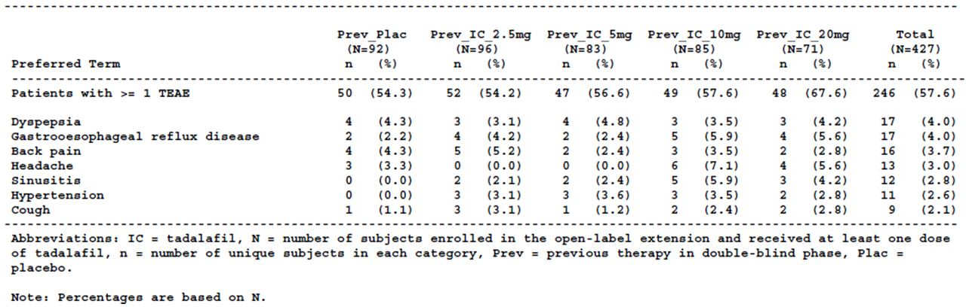
There were no deaths. Serious adverse events (n=23) were reported in 20 subjects (4.7%) who entered the open-label period and who had received at least one dose of tadalafil. The majority of serious adverse events were reported in single subjects. Arthritis, knee arthroplasty and non-cardiac chest pain were each reported in two subjects. Of note, one subject was reported to have had a cardiac arrest and single subjects had atrial flutter, coronary artery disease of increasing severity and congestive cardiac failure requiring hospitalisation. One subject had global amnesia, lasting for one hour, four days after completing the study. He had no history of prior memory problems and was on no medications at the time of the event. His sister had experienced global amnesia also. Serious adverse events considered to be possibly related to the study drug were global amnesia and coronary artery disease of increasing severity. The reports of atrial flutter, congestive cardiac disease and cardiac arrest in single subjects were not considered related to the study drug.
Twenty-two subjects (5.2%) discontinued the open-label extension due to one or more adverse events. The numbers of subjects who discontinued based on the randomised treatment during the double-blind period were similar. The majority of subjects (n=18) discontinued due to different adverse events including cardiac related adverse events (acute coronary syndrome, arrhythmia, coronary artery disease), liver-related adverse events (hepatic enzyme increased, hepatic function abnormal), deafness unilateral and visual disturbance. Adverse events that led to study discontinuation that were considered possibly related to the study drug were visual disturbance, muscle tightness, deafness unilateral, hot flush, oesophagitis, hepatic enzyme increased, coronary artery disease and gastro oesophageal reflux disease. Dyspepsia and stomach discomfort both led to the discontinuation of two subjects, respectively. Dyspepsia was assessed as possibly related to the study drug in both these subjects and stomach discomfort was considered possibly related to the study drug in one subject.
Over half (57.6% (n=246)) of the subjects who entered the open-label period, and who received at least one dose of tadalafil, reported one or more TEAE (compared with Visit 3). TEAEs reported in at least 2% of subjects were dyspepsia (4.0%), gastro-oesophageal reflux disease (4.0%), back pain (3.7%), headache (4.0%), sinusitis (2.8%), hypertension (2.6%) and cough (2.1%). The highest proportions of subjects reported adverse events falling under the Gastrointestinal disorders SOC (13.6%), Infections and infestations SOC (12.9%) and Musculoskeletal and connective tissue disorders SOCs (12.6%). The majority of TEAEs were of mild or moderate severity.
Twenty-six subjects (6.1%) had TEAEs that were severe (atrial flutter (n=1), cardiac arrest (n=1), cardiac failure congestive (n=1), coronary artery stenosis (n=1), Basedow’s disease (n=1), gastro-oesophageal reflux disease (n=2), oedema mouth (n=1), non cardiac chest pain (n=1), infection (n=1), perirectal abscess (n=1), pneumonia (n=1), fibula fracture (n=1), muscle injury (n=1), blood creatinine phosphokinase increased (n=1), arthritis (n=1), back pain (n=2), intervertebral disc protrusion (n=1), muscle spasms (n=1), muscle tightness (n=1), osteoarthritis (n=1), tendonitis (n=1), bladder neoplasm (n=1), global amnesia (n=1), urinary retention (n=1), knee arthroplasty (n=1), hip arthroplasty (n=1).
Compared with baseline (Visit 3), and compared with Visit 7 (the start of the OLE period), respectively, the proportions of subjects enrolled in the OLE who reported one or more TEAEs during the OLE were relatively similar, irrespective of the group to which they were randomised during the double-blind treatment period.
The most common TEAEs (compared with Visit 3) reported in the first month of the open-label extension period, corresponding to the month after subjects ceased the randomised treatment and commenced tadalafil 5 mg were consistent with those reported in the 12 month open label period.
When compared with Visit 7 as the baseline, the only TEAEs reported in at least 2% of subjects were sinusitis (2.6%), back pain (2.3%) and dyspepsia (2.1%). One month after open-label treatment was commenced 11% of subjects reported one or more TEAEs compared with Visit 7 – the most frequent were dyspepsia, myalgia and back pain, all of which were reported in a higher proportion of subjects who had been randomised to placebo during the double-blind treatment period.
In the open-label period, 14.8% (n=63) of subjects had one or more adverse events assessed as possibly or probably related to the study drug. The treatment–related adverse events affecting the highest proportion of subjects were dyspepsia (3.3%), headache (3.0%), back pain (1.2%) and myalgia (1.2%). The remainder of treatment-related adverse events were reported in less than 1% of subjects. Treatment-related adverse events occurring in three or more subjects (but less than 1%) were gastro-oesophageal reflux disease (n=3), pain in the extremity (n=4) and flushing (n=4). As well as the single reports of treatment-related global amnesia and coronary artery disease noted above, there was a report of deafness unilateral. The subject was reported to have previously experienced neurosensory hearing loss.
Adverse events of special interest for study LVHG were TEAEs related to the cardiovascular system, vision/eyes, hepatic system, PSA and urinary tract procedures.
Twenty-five subjects had cardiovascular disorders during the OLE period. The majority of cardiovascular disorders reported were reported in single subjects. Five subjects reported hypotensive adverse events during the open-label extension period, none of which led to study discontinuation (dizziness (n=4), vertigo positional (n=1)). Only the vertigo positional was assessed as possibly related to the study drug.
Two subjects had elevated ALT or AST levels more than three times the upper limit of normal, reported as adverse events, during the open-label extension period. Both subjects had been randomised to tadalafil 5 mg during the double-blind treatment period. The bilirubin levels were normal for both subjects. One subject had other medical conditions and was taking multiple concomitant medications had raised AST and ALT at Visit 6 and Visit 8. He discontinued the study at Visit 9. The subject was reported with the adverse events “hepatic enzyme increased” at Visit 6, which was the end of the double-blind treatment period, and “hepatic steatosis” at Visit 9. The adverse events were not assessed by the investigator as being related to the study drug. The second subject had hepatitis C. He had levels of ALT and AST more than five times the upper limit of normal at Visit 6 (the end of the double-blind treatment period), and Visit 7 (the start of the OLE period) three days later, at which time he discontinued the study. GGT was also high at Visits 6 and 7. The elevated AST and ALT levels were assessed by the investigator as being possibly drug-related.
Two subjects were diagnosed with prostate malignancy during the OLE period, neither of which was considered by the investigator to be related to the study drug.
One subject, who had received tadalafil 2.5 mg during the double-blind treatment phase, had acute urinary retention 99 days into the open-label extension period and discontinued from the study because he started alfuzosin treatment. A second subject, who had received tadalafil 5 mg during the double-blind treatment phase, had an increase in PVR reported as an adverse event (PVR Visit 1 164 mL, Visit 6 194 mL, Visit 8 220 mL, Visit 9 319 mL) The PVR had decreased to 183 mL eleven days after Visit 9. This subject discontinued the study due to this adverse event.
One subject was reported with thrombocytopenia at Visit 10. The subject had been randomised to tadalafil 2.5 mg in the double-blind phase. His platelet count was within normal limits at Visit 1 but the platelet counts were low at Visit 6 (109 bill/L), Visit 8 (108 bill/L), and Visit 10 (90 bill/L (normal 130 to 483 bill/L). The subject had started treatment with valaciclovir for herpes zoster five days prior to Visit 6. The investigator did not assess the thrombocytopenia as related to the study drug.
Based on the long-term analysis set (baseline Visit 7 for TEAEs), there were six bleeding events in subjects randomised to tadalafil during the double-blind treatment period and three in subjects who had been randomised to placebo during the double-blind treatment period.. During the OLE period (during which subjects received tadalafil 5 mg), there were three subjects reported with haematuria, two with contusion and single reports of ecchymosis, eye haemorrhage, haematoma and intra-abdominal haematoma. None of these events were serious adverse events or led to study discontinuation.
One subject was reported with treatment-related deafness unilateral during the OLE period and discontinued due to this adverse event. Six subjects were reported with treatment-emergent eye disorder AEs. Three subjects were reported with vision blurred and single subjects were reported with Basedow’s disease, eye haemorrhage and visual impairment respectively. There were no reports of NAION.
There were no reports of seizures. Two subjects were reported with transient global amnesia TEAEs, one of which was serious and of severe severity in a subject who had been randomised to tadalafil 5mg during the double blind treatment period. The other subject had received placebo during the double blind treatment period. Neither subject discontinued the study due to this event.
The most common treatment-emergent myalgia or back pain adverse events were back pain (2.3% (n=10), myalgia (1.4% (n=6)) and arthralgia 1.2% (n=5)).

Vital signs
The mean changes in heart rate and systolic and diastolic blood pressure were minimal from Visit 3 to endpoint and from Visit 6 to endpoint.

Clinical laboratory tests
Four subjects had an ALT or AST above three times the upper limit of normal but no subjects had bilirubin levels above 1.5 times the upper limit of normal.
For the haematology and serum chemistry parameters, any mean changes in the specific parameter from Visit 3 to endpoint, and from Visit 6 to endpoint, were small, and only a small proportion of subjects had shifts from a normal baseline results to a low or high results at the end of therapy for any given parameter.

ECGs
Electronic ECGs were interpreted by a cardiologist at the clinical research organisation (CRO) based on a comparison of sequential ECGs. ECGs that were not electronically transferred to the CRO were reviewed and interpreted by an external cardiologist but were not included in the tables of ECG changes.
Based on the review of 164 ECGs for 82 subjects by the external cardiologist, 15 subjects with paired observations (Visit 6 and Visit 12 or endpoint) had a significant change from the Visit 6 baseline ECG during the open-label treatment period. Three of these subjects had changes considered clinically significant by the external cardiologist. The paired ECGs of these three subjects showed, respectively, findings of a new lateral myocardial infarction and junctional rhythm, new nonspecific ST segment changes and criteria for left ventricular hypertrophy, and new left axis deviation. It is indicated that the external cardiologist found no particular pattern in relation to the treatment-emergent ECG abnormalities.
Based on the ECGs evaluated by the CRO, there were small mean changes in heart rate, PR interval, QRS interval and RR interval from baseline (the last non-missing value before Visit 3) to endpoint and from Visit 6 to endpoint. From baseline to endpoint the mean change in QT interval was an increase of 3.3 ms (SD 23.6; 95% CI [0.5, 6.0]) and, from Visit 6 to endpoint, the mean change in QT interval was an increase of 0.6 ms (SD 22.7; 95% CI [-2.1, 3.2]). For the QTc interval the mean changes were greater from baseline to endpoint (4.6 ms (SD 17.3); 95% CI [2.5, 6.6]) and Visit 6 to endpoint 6.1 ms (SD 17.2); 95% CI [4.1, 8.1]). The maximum changes in QTc interval from baseline to endpoint, and from Visit 6 to endpoint, respectively, were 64.0 ms and 69.0 ms. The mean QTc intervals were similar at Visits 1, 6 and 12 (Visit 1 mean (SD) 404.9 (22.5) [95% CI 402.7, 407.1); Visit 6 mean (SD) 403.6 (22.6) [95% CI 401.3, 405.8); Visit 12 mean (SD) 409.2 (23.6) [95% CI 406.5, 411.9). The maximum QTc intervals at Visit 1 and Visit 12 were greater than 500 ms (QTc min, max: Visit 1 334.0, 509.0; Visit 6 346.0, 499.0; Visit 12 356.0, 504.0). The maximum changes in QT interval from baseline to endpoint, and from Visit 6 to endpoint, were 81.0 ms and 119.0 ms respectively. The maximum QT interval was 524.0 ms at baseline, 501.0 ms at Visit 6 and 499.0 ms at Visit 12.
A small proportion of subjects had treatment emergent axis abnormalities on ECG, the most commonly reported being left axis deviation (2.7% (n=10)). Treatment-emergent ECG abnormalities relating to conduction were reported in 28 subjects: 17 subjects had AV block (15 first degree AV block) and 11 subjects had ventricular block. Treatment-emergent ECG abnormalities related to morphology were reported in approximately 20% of subjects who had a baseline (Visit 1) ECG that was normal for morphology (n=312). Eighteen subjects had left atrial enlargement. Twelve subjects were reported to have had the abnormality at Visit 1 and five subjects had an ECG abnormality at baseline and/or predisposing factors for the development of left atrial enlargement. A 62 year old subject, with no abnormal ECG findings at Visit 1 and no pre-disposing factors, was reported as having left atrial enlargement at Visit 12. He was not reported to be on any concomitant medications and his blood pressure was normal at all study visits.
Atrial premature depolarisation, sinus arrhythmia, occasional ventricular premature depolarisation and sinus bradycardia were the most commonly reported treatment emergent ECG abnormalities related to rhythm, affecting 6.1%,(n=23), 5.1%, (n=19), 4.5% (n=17) and 4.3% (n=16) of subjects, respectively. The incidence of ST segment treatment-emergent abnormalities was low, 96.1% of subjects (n=372) who had a normal ST segment at baseline continued to have normal ST segments. Of those with abnormal ST segments, the highest proportion of subjects had a non-specific ST abnormality. Compared to Visit 1, the majority of subjects (97.8%) did not have myocardial ischemia treatment-emergent ECG abnormalities. Three subjects had T wave abnormalities and three subjects had ST depression.
Non-specific T-wave abnormality was reported in 6.5% (n=24) of subjects. No U- wave abnormalities were reported.

PSA
The mean changes in PSA from Visit 3 to endpoint and from Visit 6 to endpoint were minimal (Visit 3 to endpoint 0.1 (SD 0.8); Visit 6 to endpoint 0.2 (SD 0.7)).

PVR
There was a small decrease in mean PVR from Visit 3 to endpoint (mean change -12.6 (SD 69.2)) and from Visit 6 to endpoint (mean change -14.8 (80.7)).
Comment: Based on the information provided in the submission there were no obvious new safety signals arising in the open-label extension period of study LVHG. Of potential concern are the QTc results, in view of the reported maximum changes in QTc interval from baseline to endpoint, and from Visit 6 to endpoint, of more than 60 ms, and the maximum absolute QTc interval of more than 500 ms at Visit 12. There was no placebo group for comparison. An analysis of outlier QT/QTc interval values does not appear to be included in the study report. There were no TEAE adverse event reports of torsade de pointes but there were single subjects reported with treatment-emergent “cardiac arrest” and “ventricular arrhythmia” plus four subjects reported with treatment-emergent “dizziness”. Further details provided in the report in relation to these subjects do not suggest that these TEAEs were manifestations of torsade de pointes. The TEAE “cardiac arrest” was self-reported and corrective treatment was not given. Dizziness is a known adverse effect reported with tadalafil. Of the four subjects with dizziness, three completed the study and one subject decided to discontinue the study. The subject reported with ventricular arrhythmia, of severe severity, was also reported to have had atrial flutter at the same time, reported as a serious adverse event. These adverse events occurred the day after the study drug was discontinued. The subject had a number of ECGs taken. A prolonged QT interval was not reported in the individual case report.
The other treatment-emergent ECG changes do not appear to suggest a safety signal. They affected small proportions of subjects and were varied in nature.
Based on the case histories, the investigator’s assessment that the serious adverse event reports of atrial flutter, cardiac arrest and congestive cardiac failure were not related to the study drug seems reasonable.
With regard to the subjects with raised liver transaminases more than three times the upper limit of normal, there appears to be no information regarding the results of liver function tests after the tadalafil 5 mg was ceased so it is unclear if there was a positive dechallenge. Both subjects had concomitant conditions and/or medications that may have contributed to the abnormal liver function test results. Nonetheless, for one of the subjects the elevated AST and ALT levels were assessed by the investigator as being possibly drug-related. It is noted that the US label for Cialis (14) includes abnormal liver function tests as an adverse event reported in less than 2% of subjects reported in controlled trials of Cialis once daily or as needed for which the causal relationship to Cialis is uncertain.
There were no mean changes in haematological parameters, serum chemistry parameters and vital signs from Visit 6 to endpoint (OLE) or from Visit 3 to endpoint (LVHG plus OLE) that are likely to be of important clinical significance.

Results for other safety outcomes
There were no other safety outcomes.

Patient exposure
In Module 2, it is indicated that 2618 subjects have been exposed to any dose of tadalafil dosed once a-day in all placebo controlled BPH studies, with 752 subjects being exposed to tadalafil 5 mg in the integrated analysis set of the four pivotal studies. In the long term analysis set (Study LVHG OLE) it is indicated that 357 subjects were exposed to tadalafil 5 mg for at least six months (at least 177 days) and 283 subjects were exposed to tadalafil 5 mg for at least one year ( at least 359 days).
In the placebo controlled studies LVID, LVHG, LVHJ, LVHR, LVHK, LVHS, and LVHG OLE, it is reported that in total 104 subjects aged over 65 years, and 28 subjects aged 75 years or older, have been exposed to tadalafil 5 mg for at least 12 months.
Exposure to tadalafil in the clinical pharmacology analysis set, comprising of 68 studies including studies LVHN, LVFU, LVCT, LVFV, LVFB, LVFF, LVFS, LVFT, LVGG, LVFA submitted in this dossier are shown in Table 17.
Table 17: Subject exposure to tadalafil: clinical pharmacology analysis set (68 studies).
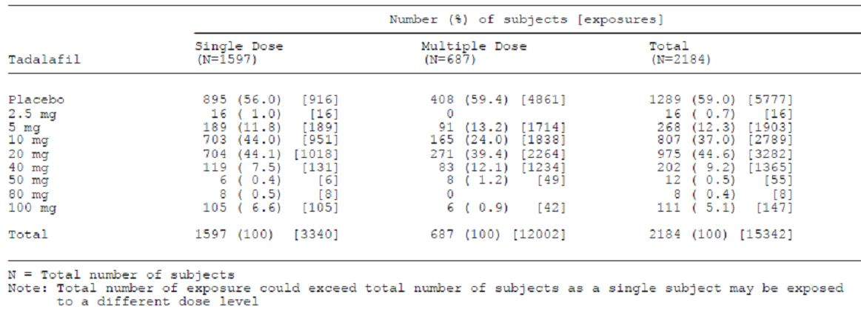
Comment: The exposure in clinical study LVDI is not included in Table 17 as the study was not related to either of the proposed indications but related to the approved indication, treatment of ED.
The number of subjects aged over 65 exposed to tadalafil 5 mg for at least 12 months appears to be adequate based on the recommendations in the TGA adopted guideline “Clinical Investigation of medicinal products in Geriatrics “(26). As the proportion of men with BPH–LUTS increases with age, and the Australian population is aging, it is anticipated that a significant proportion of the target population for the proposed use of tadalafil in the treatment of ED in Australia will be men aged 75 years or older. It is unlikely that the long-term safety of tadalafil 5 mg once daily in the proposed indications can be elucidated by such a small number of subjects aged 75 years or older exposed to tadalafil 5 mg for at least 12 months. Therefore, it is recommended that a statement regarding using in the elderly is added to the precautions section of the PI indicating that there is insufficient evidence on the safety of tadalafil in this subgroup.
With regard to exposure to tadalafil by duration of treatment, it appears that the information on exposure for at least 12 weeks was not available for a number of the studies. The sponsor is requested to provide the number of subjects exposed for 12 weeks or more to tadalafil 2.5 mg in study LVHR, and tadalafil 5 mg in studies LVHJ, LVHR and LVGC, and to tadalafil 20 mg in study LVGC, or indicate where this information can be found in the submission.
The duration of exposure is not totalled for the individual doses of tadalafil and duration of treatment category (≥ 12 weeks, ≥ 6 months, ≥ 12 months) where the data did not appear to have been provided.

Adverse events

All adverse events (irrespective of relationship to study treatment)
Comment: The pivotal and non-pivotal studies reported treatment-emergent adverse events (TEAEs), that is, adverse events that were either first reported, or worsened in severity, during the study period. The information, therefore, relates to TEAEs.

Pivotal studies

BPH indication

Study LVHG
Based on all randomised subjects, treatment-emergent adverse events (TEAEs) during the double-blind treatment period were reported in a higher proportion of subjects who received tadalafil compared with placebo and the proportions of subjects reporting TEAEs in the tadalafil treatment groups increased with increasing dose (placebo 21.2% (n=45), tadalafil 2.5mg 26.8% (n=56), tadalafil 5mg 30.7% (n=65), tadalafil 10mg 34.7% (n=75), tadalafil 20mg 39.7% (n=83), tadalafil (all doses) 33.0% (n=279)).
The treatment-emergent adverse events reported in at least 2% of randomised subjects in any tadalafil treatment group are shown in Table 18. For all the TEAEs listed in this table the proportion of subjects reporting the AE was higher in subjects receiving tadalafil (any dose) than in the placebo group. The TEAEs reported in the highest proportion of subjects in the tadalafil treatment groups were headache, dyspepsia, back pain, myalgia and nasopharyngitis but there was no clear dose-response relationship. For many of the TEAEs reported at any frequency, the event was reported by only one or two subjects in any one treatment group and there were, therefore, no notable differences when the proportions of subjects reporting that event were compared across the treatment groups. Dizziness was reported in five subjects treated with tadalafil compared with one subject treated with placebo. Three subjects in the tadalafil 20 mg treatment group were reported with dizziness, and one in the tadalafil 5 mg and 10 mg groups respectively. Syncope was reported in two subjects in the tadalafil 2.5 mg treatment group only, one of which was reported as severe, and hypotension in one subject in the tadalafil 5 mg group.
Table 18: Study H6D-MC-LVHG: Treatment-emergent adverse vents by decreasing frequency of occurrence in at least 2% of subjects in any tadalafil group.
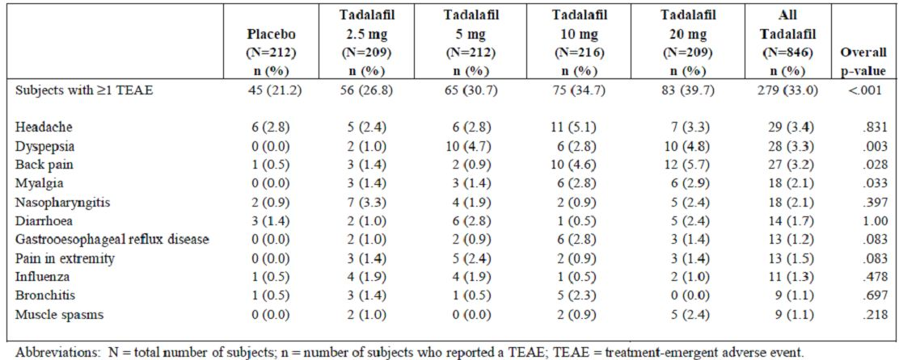
TEAEs were reported across a number of System Organ Classes (SOCs). The highest proportions of subjects in the tadalafil group had TEAEs falling under the Gastrointestinal disorders SOC (tadalafil 10.5%; placebo 3.8%), Infections and infestations SOC (tadalafil 7.0%; placebo 5.7%), Musculoskeletal and connective tissue disorders SOC (tadalafil 8.9%; placebo 3.3%) and Nervous system disorders SOC (tadalafil 5.2%; placebo 3.8%). For a number of SOCs, many preferred terms were reported for one subject only in any treatment group. Of note, dyspepsia was reported in 28 subjects treated with tadalafil (all doses)(3.3%) compared with no subjects in the placebo group, back pain was reported in 27 subjects treated with tadalafil (all doses) (3.2%) compared with one (0.5%) in the placebo group, myalgia, pain in the extremity and muscle spasms were reported in no subjects in the placebo group and by 18, 13 and 9 subjects (2.1% ,1.5%, 1.1%) treated with tadalafil (all doses), respectively.
Most of the TEAEs were mild or moderate in severity. No safety signals were identified in relation to the adverse events of special interest.
Comment: The treatment-emergent adverse events reported in study LVHG did not appear to indicate any new safety concerns. The most commonly reported adverse events were consistent with those in the currently approved PI for Cialis (1) and the proposed draft PI.

Study LVHJ
Treatment-emergent adverse events reported in the double-blind period of study LVHJ are shown in Table 19.
Table 19: Study H6D-MC-LVHJ: Treatment-emergent adverse events, double-blind period (all randomised subjects).
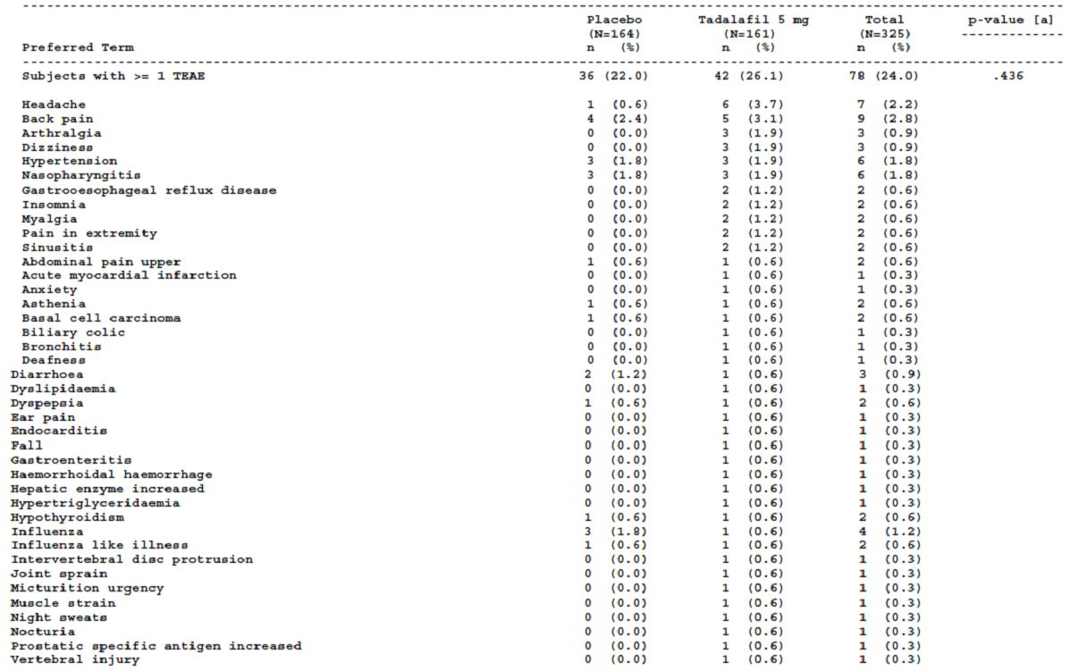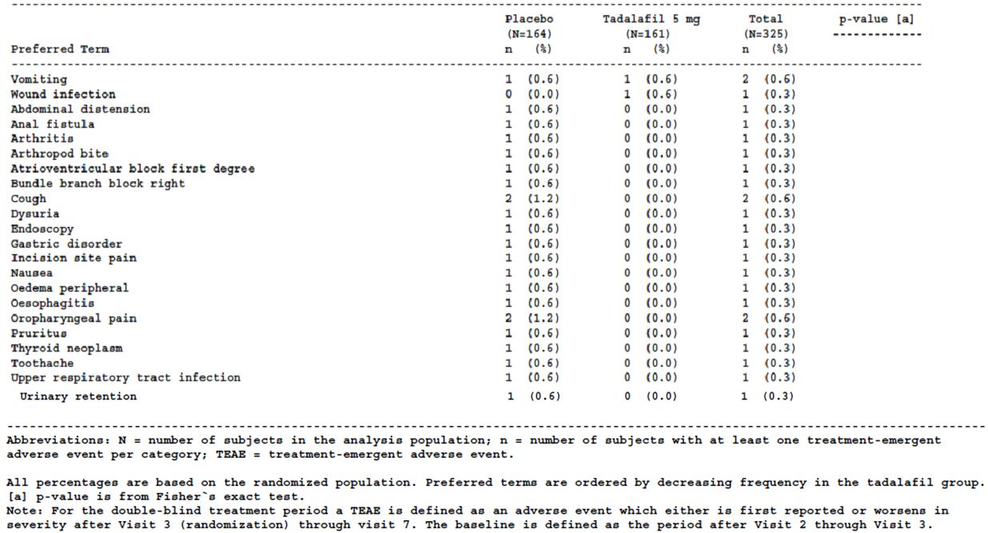
The proportions of randomised subjects reporting at least one treatment-emergent adverse event during the double-blind treatment period was similar in the two treatment groups (placebo 22.0% (n=36), tadalafil 5 mg 26.1% (n=42)). Headache was the TEAE reported by the highest proportion of subjects in the tadalafil 5mg group (3.7% (n=6)), followed by back pain (3.1% (n=5)), arthralgia (1.9% (n=3)), dizziness (1.9% (n=3)) and hypertension (1.9% (n=3)). For each of these TEAEs the proportion of subjects in the placebo group who reported the AE was lower than in the tadalafil 5 mg group but the only notable difference was for headache (placebo 0.6% (n=1), tadalafil 5mg 3.7% (n=6)). For subjects in the tadalafil 5mg group who reported TEAEs, the system organ classes under which the preferred terms fell most commonly were the Gastrointestinal disorders SOC (4.3%, placebo 4.9%), Infections and infestations SOC (5.6%, placebo 4.3%,) and Musculoskeletal and connective tissue disorders SOC (6.2%, placebo 3.0%). Most TEAEs were of mild or moderate maximum severity. There were two subjects in each treatment group who had one or more TEAEs that were of severe maximum severity (placebo - back pain (n=1), urinary retention (n=1); tadalafil 5mg acute myocardial infarction (n=1), headache (n=1)).
None of the subjects in the placebo group reported events that mapped to the pre-specified MedDRA preferred terms of TEAEs possibly related to hypotension. Three subjects in the tadalafil 5 mg group reported adverse events that mapped to the MedDRA preferred term “dizziness”. For two of the subjects the investigator considered that the dizziness was unlikely to be related to the study drug and for one subject it was considered possibly related. Twelve subjects, 10 in the tadalafil 5mg group and two in the placebo group, had at least one TEAE possibly related to hypotension based on the expanded list of preferred terms possibly related to hypotension, which included headache, asthenia and fatigue. In the tadalafil 5 mg group, as well as the three subjects who reported dizziness, 6 subjects reported headache and one subject asthenia. The subject with asthenia had started tadalafil 11 days prior to the onset of the event. He reported concomitant headache, myalgia, and adynamia, all of which were considered by the investigator to be possibly related to the study drug. In the placebo group one subject reported headache and one asthenia.
Comment: The TEAEs are displayed as the proportions of subjects who have had at least one TEAE in the preferred term category. This presentation is consistent with the display of TEAEs in the other three pivotal efficacy studies. However, this information does not indicate how many times the subjects reported the individual adverse events during the course of the study and when the adverse events occurred in relation to the commencement of the study drug.
The TEAEs reported in more than 1% of subjects receiving tadalafil 5 mg during the double-blind treatment period were generally consistent with the known safety profile for tadalafil. No new safety signals were apparent.
Study LVID
Treatment-emergent adverse events reported in the double-blind period of study LVID are shown in Table 20.
Table 20: Study H6D-MC-LVID: Treatment-emergent adverse events, double-blind period (all randomised subjects).
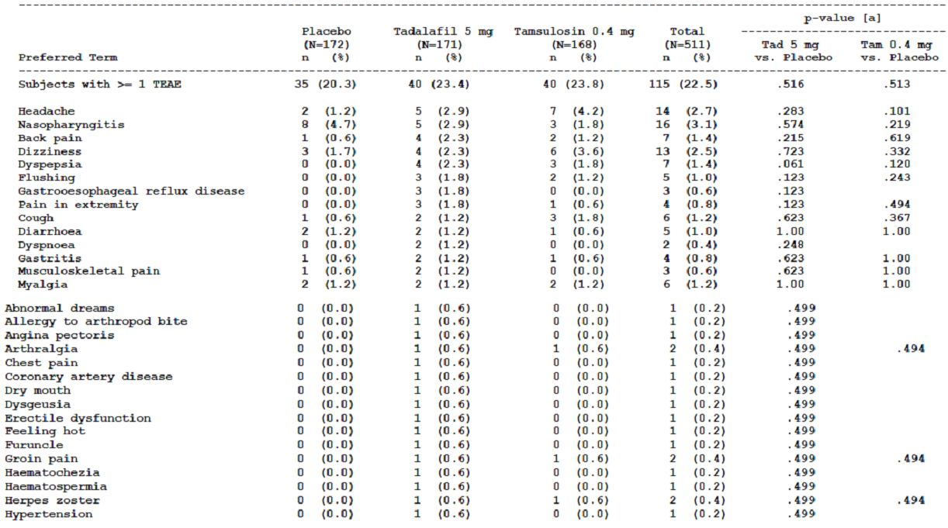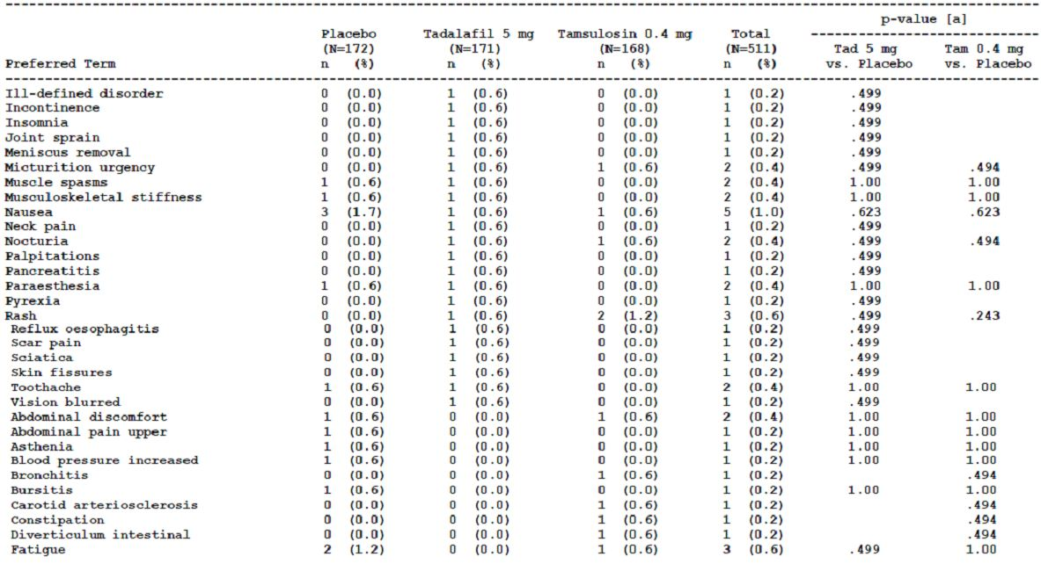
Table 20 (continued): Study H6D-MC-LVID: Treatment-emergent adverse events, double-blind period (all randomised subjects).
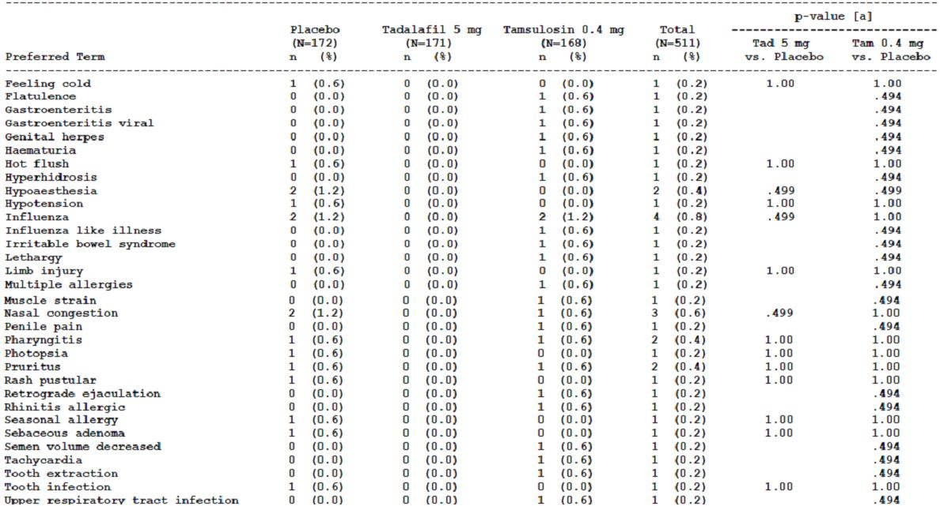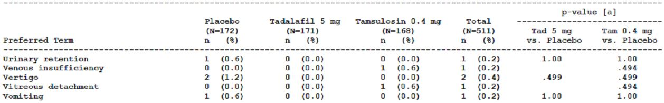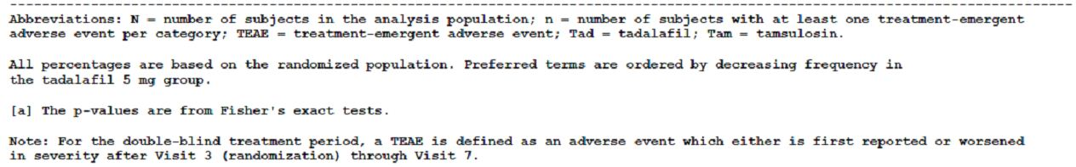
In the double-blind treatment period, similar proportions of subjects in the three treatment groups reported one or more TEAEs (placebo 20.3% (n=35), tadalafil 5mg 23.4% (n=40), tamsulosin 0.4mg 23.8% (n=40)). TEAEs reported in more than 2% of subjects in the tadalafil group were headache (2.9%), nasopharyngitis (2.9%), back pain (2.3%), dizziness (2.3%), and dyspepsia (2.3%). Except for nasopharyngitis, a lower proportion of subjects in the placebo group reported these adverse events. Headache and dizziness were reported in a higher proportion of subjects in the tamsulosin 0.4 mg group. AEs reported on the day of randomisation were not included in the summary of TEAEs. AEs that occurred after the first dose of double-blind study medication on the day of randomisation were headache (placebo n=1), and tachycardia and anxiety (placebo n=1) and gastrointestinal reflux disease (tadalafil 5mg n=1) and vomiting (tadalafil 5mg n=1).
The highest proportions of subjects in the tadalafil 5 mg group with TEAEs fell into the Gastro intestinal disorders SOC (8.2%), Musculoskeletal and connective tissue disorders SOC (5.8%) and Nervous system disorders SOC (5.3%). The proportions of subjects reporting TEAEs in these SOCs were lower in the placebo group and lower in the tamsulosin 0.4 mg group except for the Nervous system disorders SOC.
Of randomised subjects who reported one or more TEAEs during the double blind treatment period, most had TEAEs that were mild or moderate in severity. Three subjects in the tadalafil 5 mg and tamsulosin 0.4 mg groups, and one subject in the placebo group, had TEAEs that were severe. The subjects with severe TEAEs in the tadalafil 5 mg group had coronary artery disease, pancreatitis and nocturia.
During the double-blind treatment period, similar proportions of subjects in each treatment group had one or more TEAEs possibly related to hypotension (based on pre-specified MedDRA preferred terms) (placebo 2.3% (n=4), tadalafil 5mg 2.3% (n=4), tamsulosin 0.4mg 3.6% (n=6)). The 4 subjects in the tadalafil 5 mg group all reported dizziness, which was assessed by the investigator as possibly related to the study drug for three of the four subjects.
Comment: The TEAEs reported by more than 1% of subjects receiving tadalafil 5 mg in this study were generally consistent with the known safety profile for tadalafil. There were no apparent new safety signals.

BPH indication and ED and BPH indication

Study LVHR
Treatment-emergent adverse events reported in the double-blind period of study LVHR are shown in Table 21.
Table 21: Study H6D-MC-LVHR: Treatment-emergent adverse events, double-blind period (all randomised subjects).
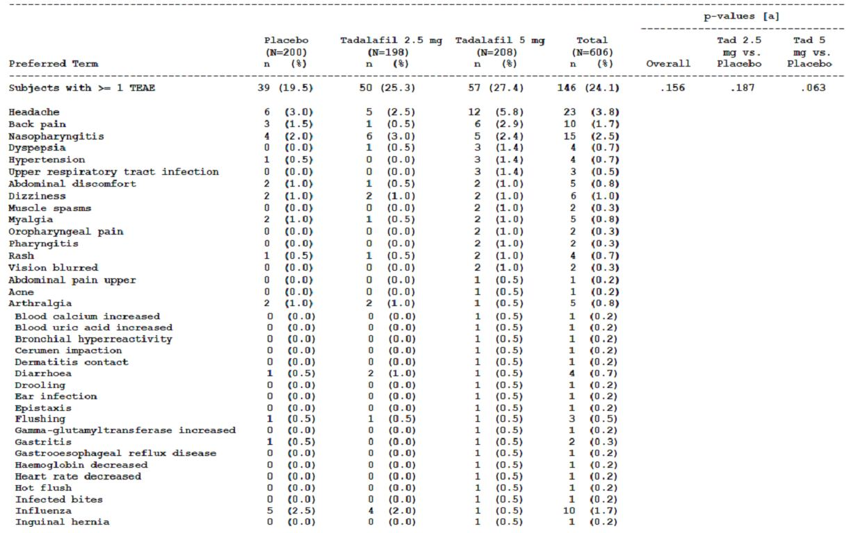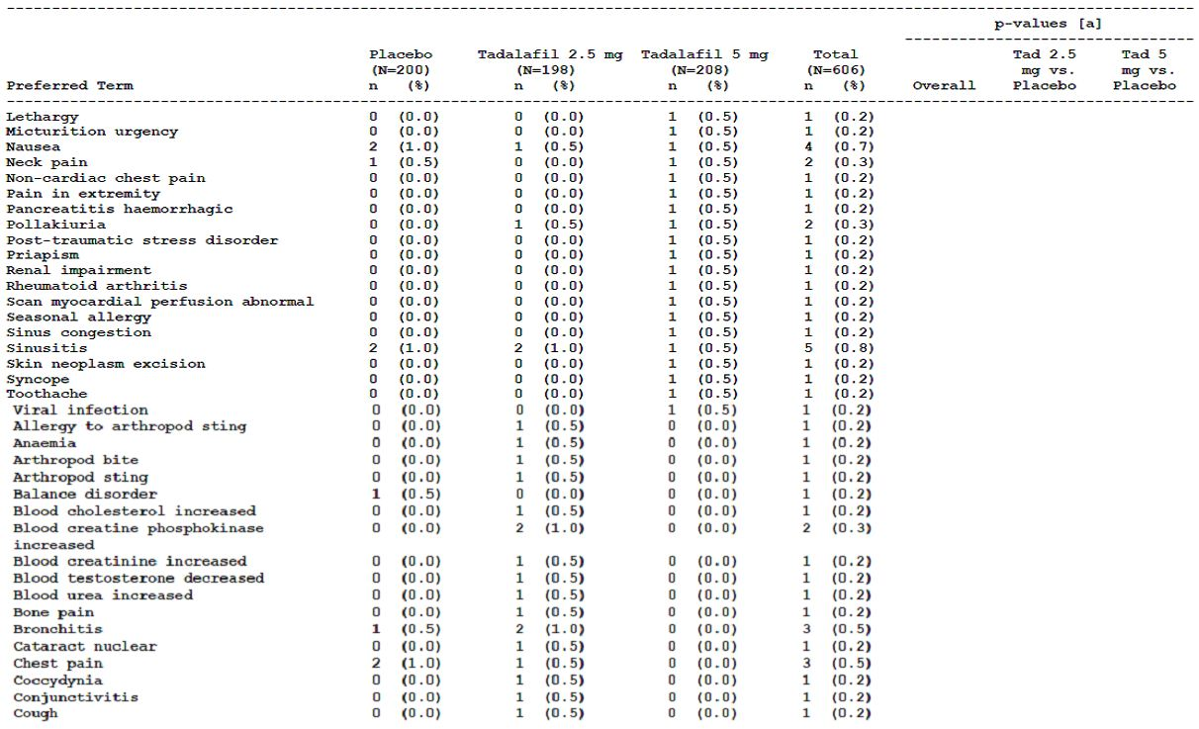
Table 21 (continued): Study H6D-MC-LVHR: Treatment-emergent adverse events, double-blind period (all randomised subjects).
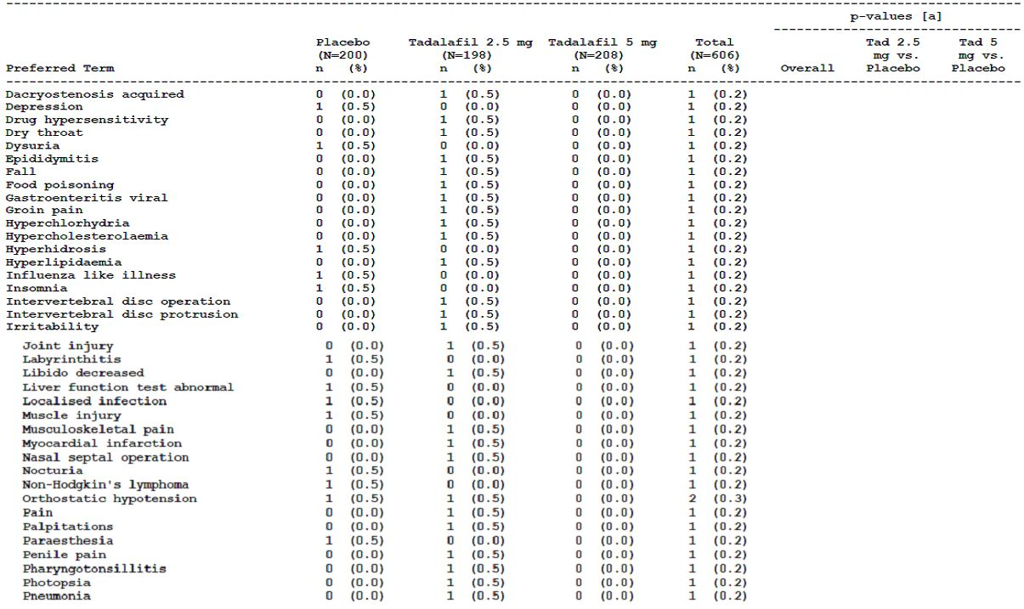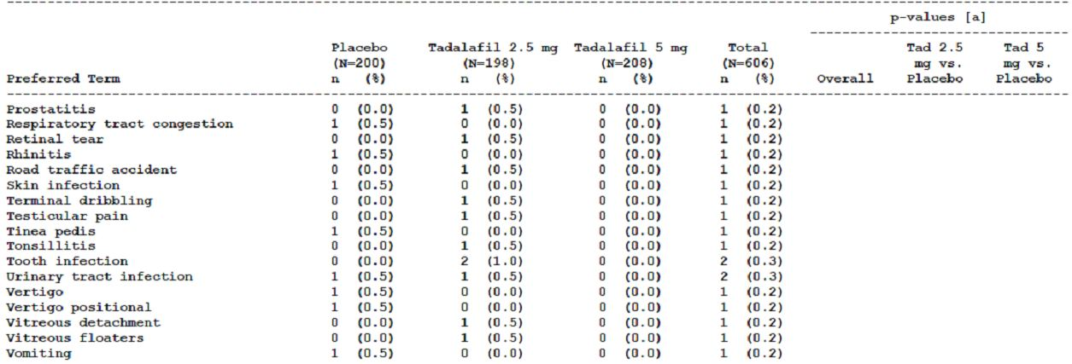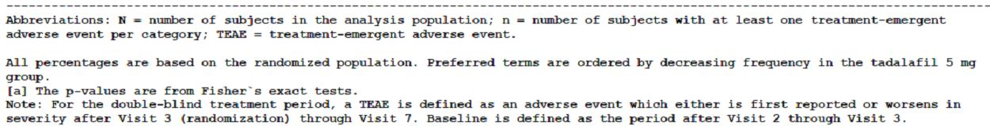
Higher proportions of subjects randomised to the tadalafil treatment groups had one or more TEAEs during the double-blind treatment period compared with the placebo group (placebo 19.5% (n=39), tadalafil 2.5mg 25.3% (n=50), tadalafil 5mg 27.4% (n=57)). TEAEs that were reported in at least 2% of subjects in the tadalafil 5 mg group were headache, back pain and nasopharyngitis. These TEAEs occurred in a higher proportion of subjects in the tadalafil 5mg treatment group than the placebo treatment group and, for headache and back pain, in a higher proportion subjects in the tadalafil 2.5 mg group (headache: placebo 3.0% (n=6), tadalafil 2.5mg 2.5% (n=5), tadalafil 5mg 5.8% (n=12); back pain: placebo 1.5% (n=3), tadalafil 2.5mg 0.5% (n=1), tadalafil 5mg 2.9% (n=6); nasopharyngitis: placebo 2.0% (n=4), tadalafil 2.5mg 3.0% (n=6), tadalafil 5mg 2.4% (n=5)). Dyspepsia, hypertension and upper respiratory tract infection were each reported in three subjects in the tadalafil 5 mg group (1.4%) compared with no subjects, or one subject, in the other treatment groups. There was no obvious dose-response across the tadalafil treatment groups. Other TEAEs were reported in between 0 and 2 subjects in each of the treatment groups except for influenza, which was reported in 5 subjects (2.5%) in the placebo group, four subjects (2.0%) in the tadalafil 2.5 mg group and one subject (0.5%) in the tadalafil 5 mg group. For subjects in the tadalafil 2.5 mg and 5 mg groups who reported TEAEs, the system organ classes under which the preferred terms fell most commonly were the Gastrointestinal disorders SOC (placebo 3.0%, tadalafil 2.5 mg 3.5%, , tadalafil 5mg 6.3%), Infections and infestations SOC (placebo 7.0%, tadalafil 2.5 mg 9.1%, , tadalafil 5mg 6.7%), Musculoskeletal and connective tissue disorders SOC (placebo 3.5%, tadalafil 2.5 mg 3.5%, tadalafil 5mg 5.8%) and Nervous system disorders SOC (placebo 4.0%, tadalafil 2.5 mg 3.0%, tadalafil 5mg 6.7%). Eight subjects had one or more TEAEs of maximum severity reported to be severe (placebo (n=1), tadalafil 2.5mg (n=3), tadalafil 5mg (n=4)). The severe events reported in subjects in the tadalafil 2.5 mg group were myocardial infarction, intervertebral disc protrusion and blood creatinine increased and blood urea increased respectively. Of the four subjects in the tadalafil 5 mg group, one was reported to have had abdominal discomfort and back pain, one subject had pancreatitis haemorrhagic, one subject had myalgia and the fourth subject had hypertension. The subject in the placebo group was reported with non-Hodgkin’s lymphoma.
During the double-blind treatment period, similar proportions of subjects in each treatment group had one or more TEAEs possibly related to hypotension when based on the focused analysis including 7 pre-specified MedDRA preferred terms (dizziness, dizziness postural, procedural dizziness, hypotension, orthostatic hypotension, syncope and presyncope)(placebo 1.5% (n=3), tadalafil 2.5mg 1.5%(n=3), tadalafil 5mg 1.4% (n=3)) and when based on an expanded analysis including headache , asthenia and fatigue (placebo 4.5% (n=9), tadalafil 2.5mg 3.5% (n=7), tadalafil 5mg 6.7% (n=14)). Headache was the only additional adverse events identified in the expanded analysis of TEAEs possibly related to hypotension. Dizziness was assessed by the investigator as possibly related to tadalafil for four subjects who received tadalafil (tadalafil 2.5 mg (n=2) and tadalafil 5 mg (n=2)). One subject in the tadalafil 2.5 mg treatment group met the criterion for a treatment emergent positive orthostatic test at Visits 4 to 7 based on the SBP criterion but he had also met the criterion at Visit 2. The subject reported no adverse events. One subject in the tadalafil 5 mg group reported dizziness upon standing during the orthostatic test but did not meet the criteria for a treatment-emergent positive orthostatic test.
In subjects aged 65 years and under, the proportion of subjects with one or more TEAEs during the double blind period was similar in each treatment group (placebo 22.0% (n=27), tadalafil 2.5mg 25.0% (n=33), tadalafil 5mg 24.8% (n=31)) but in subjects aged over 65 years the proportion of subjects with one or more TEAEs was higher in the tadalafil groups (placebo 15.6% (n=12), tadalafil 2.5mg 25.8% (n=17), tadalafil 5mg 31.3% (n=26)). Headache was the most commonly reported TEAE in both subjects aged less than 65 years and under those aged over 65 years and, in both age subgroups, affected a higher proportion of subjects in the tadalafil 5 mg group than the other treatment groups. The proportions of subjects in each treatment group aged over 65 years, and over 75 years, who had treatment-emergent positive orthostatic tests during the double-blind treatment period were similar to the proportions of younger subjects who had treatment-emergent positive orthostatic tests.
Comment: The TEAEs were similar in both study LVHR (all subjects had BPH-LUTS and ED) and the other three pivotal studies (LVHG, LVHJ, LVID – all subjects had BPH-LUTS and a proportion had ED) suggesting that there was no difference in the safety profile with the use of tadalafil in the two different indications.
The TEAEs reported by at least 1% of subjects receiving tadalafil 5 mg in the double-blind period of study LVHR were consistent with the known safety profile of tadalafil. There were no new safety signals arising from the TEAEs reported in subjects receiving tadalafil 2.5 mg or 5 mg during the study.

Integrated analysis set of the four pivotal efficacy studies (LVHG, LVHJ, LVHR, LVID)
The integrated analysis set included data from the four pivotal efficacy studies, LVHG, LVHJ, LVHR and LVID. TEAEs reported by randomised subjects during the double-blind treatment period of these studies were included in the summary of TEAEs.
Treatment-emergent adverse events (baseline Visit 3) were more common in subjects randomised to tadalafil 5 mg compared with placebo (placebo 20.9% (n=156); tadalafil 5mg 27.4% (n=206)). Treatment-emergent adverse events that were reported in at least 1% of subjects randomised to tadalafil 5 mg were headache, back pain, dyspepsia, nasopharyngitis, hypertension, pain in the extremity, diarrhoea, dizziness, myalgia and gastro oesophageal reflux disease. The proportion of subjects randomised to placebo who were reported with these TEAEs was lower than in subjects randomised to tadalafil 5 mg except for nasopharyngitis, which was reported in the same proportion of subjects in each group. Of TEAEs reported in less than 1% of subjects randomised to tadalafil 5 mg, four subjects (0.5%) were reported with dyspnoea compared with none in subjects randomised to placebo. Three subjects (0.4%) randomised to tadalafil 5 mg were reported with epistaxis, gout and micturition urgency, respectively, compared with no subjects randomised to placebo. The majority of TEAEs in subjects randomised to tadalafil 5 mg were reported in single subjects. Three subjects randomised to placebo were reported with urinary retention but there were no subjects randomised to tadalafil 5 mg reported with urinary retention. Subjects randomised to tadalafil 5 mg reported TEAEs predominantly in the Gastrointestinal disorders SOC (7.7%), Infections and infestations SOC (5.7%), Nervous system disorder SOC (5.2%) and Musculoskeletal and connective tissue disorders SOC (6.1%). The proportions of subjects reporting TEAEs in these SOCs were 3.9%, 6.1%, 3.2% and 3.3%, respectively. The proportions of subjects with one or more TEAES of maximum severity severe in the integrated analysis set were similar in subjects randomised to placebo (1.3% (n=10)) and tadalafil 5mg 2.0% (n=15)).
TEAEs related to special safety topics identified by the sponsor were assessed using the integrated analysis set. These special safety topics were bleeding events, cardiovascular events, ear disorders, eye disorders, TEAEs possibly related to hypotension, myalgias and back pain, seizures and transient global amnesia.
Based on the integrated analysis set, there were numerically more bleeding events in subjects randomised to tadalafil 5mg (n=8) compared with placebo (n=0) during the double blind period. The most common bleeding event was epistaxis (n=3) which was reported as mild in all three subjects and did not lead to study discontinuation. There were single reports of other bleeding events; only one of these events was severe and led to study discontinuation (pancreatitis haemorrhagic).
There were small numerical differences in specific treatment-emergent cardiovascular disorders between subjects randomised to tadalafil 5 mg and those randomised to placebo, except for hypertension which was reported in 12 subjects (1.6%) randomised to tadalafil 5 mg and five subjects (0.7%) randomised to placebo. Of these 17 subjects, a number had pre-existing hypertension. A treatment-emergent high blood pressure result was defined as a change from a value less than the specified high limit at baseline to a value greater than or equal to the high limit at any post-baseline visit. Blood pressure measurements were taken in the supine position in two of the studies and in the sitting position in two of the studies. A review of each subject’s pre- and post-randomisation serial blood pressure measurements undertaken by the sponsor found no evidence of treatment-emergent increases in blood pressure for these subjects with a TEAE of hypertension. Similar proportions of subjects randomised to tadalafil 5mg and placebo in the integrated analysis set were reported with TEAEs possibly related to hypotension (placebo 1.1% (n=8); tadalafil 5mg 1.6% (n=12)). Dizziness was the most frequently reported TEAE possibly related to hypotension in both groups (placebo (n=6); tadalafil 5mg (n=10)). One subject randomised to tadalafil 5mg discontinued the study due to syncope.
Based on the integrated analysis set, fewer subjects randomised to tadalafil 5 mg experienced treatment-emergent ear disorder adverse events than subjects randomised to placebo group (placebo 0.7% (n=5); tadalafil 5mg 0.3% (n=2)). There was one report of deafness in a subject randomised to tadalafil 5mg compared to no reports in subjects randomised to placebo. The adverse event of deafness did not lead to study discontinuation and was not considered to be study-drug related by the investigator. The deafness was treated and was reported as resolved at the final study visit. Treatment-emergent eye disorder adverse events were reported in 0.3% (n=2) of subjects randomised to placebo and 0.7% (n=5) of subjects randomised to tadalafil 5 mg. Four subjects randomised to tadalafil 5 mg were reported with vision blurred of mild severity, but leading to study discontinuation in one subject. There were also single subjects randomised to tadalafil 5mg reported with photopsia, retinal tear and vitreous floaters compared with single subjects reported with vision blurred and photopsia in the placebo group. There were no reports of NAION in the integrated analysis set.
A higher proportion of subjects randomised to tadalafil 5 mg were reported with one or more treatment-emergent myalgia or back pain adverse events (placebo 2.7% (n=20); tadalafil 5mg 5.9% (n=44)) during the double-blind treatment period. Specifically, back pain, pain in the extremity, myalgia, arthralgia, muscle spasms and pain were reported in a higher proportion of subjects randomised to tadalafil 5 mg compared with placebo with the biggest differences for back pain (placebo 1.2% (n=9); tadalafil 5mg 2.4% (n=18)), pain in the extremity (placebo 0.0% (n=0); tadalafil 5mg 1.5% (n=11))and myalgia (placebo 0.5% (n=4); tadalafil 5mg 1.2% (n=9)).
There were no reports of seizures or transient global amnesia.
Subgroup analyses of TEAEs were undertaken for the integrated analysis set, by age, ED status at baseline, cardiovascular disease, hypertension, diabetes, renal impairment and hepatic impairment at baseline, prior alpha blocker therapy and PDE5 inhibitor use at baseline and concomitant CYP3A4 inhibitor use. No new safety concerns were identified by the sponsor. Of note, in subjects aged 75 years and over the proportion of subjects randomised to tadalafil 5mg who reported diarrhoea was notably greater than in subjects randomised to placebo (placebo 1.1% (n=1); tadalafil 5mg 7.1%(n=6)). In subjects aged under 75 years, the proportions of subjects with diarrhoea were more comparable between the treatment groups (placebo 1.1% (n=1); tadalafil 5mg 0.6% (n=4)). Dizziness was also more common in subjects aged 75 years and older (placebo 1.1% (n=1), tadalafil 5mg 4.8% (n=4)) compared with subjects aged less than 75 years (placebo 0.8% (n=5), tadalafil 5mg 0.9% (n=6)). By ED status at baseline (yes/no), there was no notable differences across the two subgroups in the proportions of subjects randomised to tadalafil 5mg and placebo reporting common TEAEs during the double-blind treatment period. In the integrated analysis set, the proportions of subjects in the tadalafil 5 mg group reporting common TEAEs by normal, mild, moderate and severe baseline renal impairment in the double-blind treatment period were relatively similar. The only difference of note was a higher proportion of subjects with moderate renal impairment who reported diarrhoea (15.4% (n=2)) compared with the other subgroups (normal 1.1% (n=6), mild 1.1% (n=2), severe 0% (n=0)).
Comment: Although not identical, the four pivotal studies were of similar design, had similar inclusion and exclusion criteria and similar safety and efficacy outcomes.
In terms of the TEAEs reported in a greater proportion of subjects randomised to tadalafil 5 mg compared with placebo, hypertension is reported in the draft PI as an adverse event identified from spontaneous post-marketing surveillance. This is reasonable as, in regard to the 17 subjects reported with hypertension in the integrated analysis set, a review of each subject’s pre- and post-randomisation serial blood pressure measurements did not suggest a clear signal of treatment-emergent increases in blood pressure.
Back pain is included in the draft PI as a TEAE reported by than more than 2% of subjects treated with tadalafil 5 mg, and more frequently than placebo, in the phase 3 BPH studies and myalgia is included as an adverse reaction reported by less than 2% of subjects in these studies.
Hypotension, dizziness, epistaxis, hearing loss and blurred vision are included in the currently approved Australian PI for Cialis (1), and in the draft PI, as adverse events identified from spontaneous post-marketing surveillance.
Dyspnoea has been added to the draft PI as an uncommon adverse reaction to be consistent with the CCDS. Pain in extremity is also included as a common adverse reaction reported in the BPH studies.
The three subjects randomised to tadalafil 5 mg reported with pancreatitis were on concomitant medications and two of the three had other medical conditions. In all three cases the investigator assessed the subject’s pancreatitis as being unrelated to the study drug. This seems reasonable. The onset of pancreatitis after randomisation to tadalafil 5 mg varied and two of the subjects had risk factors for pancreatitis.
For the subgroup analyses, a number of the subgroups comprised of small numbers of subjects resulting in apparent large differences in the proportions of subjects reporting a given TEAE even if the absolute number of subjects with that TEAE were small.

Comparison of adverse events reported in the integrated analysis set and in subjects receiving tadalafil once daily for ED
The sponsor has compared the data from subjects randomised to tadalafil 5mg in the integrated analysis set (LVHG, LVID, LVHJ, LVHR) with adverse events data from subjects randomised to tadalafil 5 mg in the five integrated placebo-controlled 12 week ED tadalafil once daily studies (LVCV, LVFP (12 week), LVFZ, LVGH, LVHX). The demographics and baseline characteristics of these two populations differed. Specifically, the mean age of men at study entry in the integrated analysis set of the pivotal BPH studies (63.1 years) was older than that of the integrated ED studies (55.6 years) and there were higher proportions of subjects aged over 65 years, and aged 75 years or older, in the BPH integrated analysis set. As one of the ED studies only included subjects with diabetes, the proportion of subjects with diabetes was higher in the integrated ED data (30.8%) compared with the BPH integrated analysis set (12.8%) and all subjects in the integrated ED data had ED compared with 77% of subjects in the integrated analysis set. The majority of common TEAEs reported in ≥ 1% of subjects in the integrated ED data were also reported in the integrated analysis set at a similar or lower proportion of subjects and vice versa. The proportions of subjects in the BPH integrated analysis set reporting hypertension (1.6%) and dizziness (1.3%) were higher than in the integrated ED data (0.4% and 0.7% respectively). By SOC, the proportions of subjects randomised to placebo and tadalafil 5 mg reporting TEAEs were generally similar in the two integrated data sets with the highest proportions of subjects randomised to tadalafil 5 mg reporting TEAEs in the Gastrointestinal disorders SOC, Musculoskeletal and connective tissue disorders SOC and Nervous system disorders SOC in both integrated analysis sets.
Comment: Based on the TEAEs, the safety profile of tadalafil was similar in the ED studies and BPH studies.

Pivotal safety studies

Study LVHS
Treatment-emergent adverse events reported in the double-blind period of study LVHS are shown in Table 22.
Table 22: Study H6D-MC-LVHS: Treatment-emergent adverse events, double-blind period (all randomised subjects).
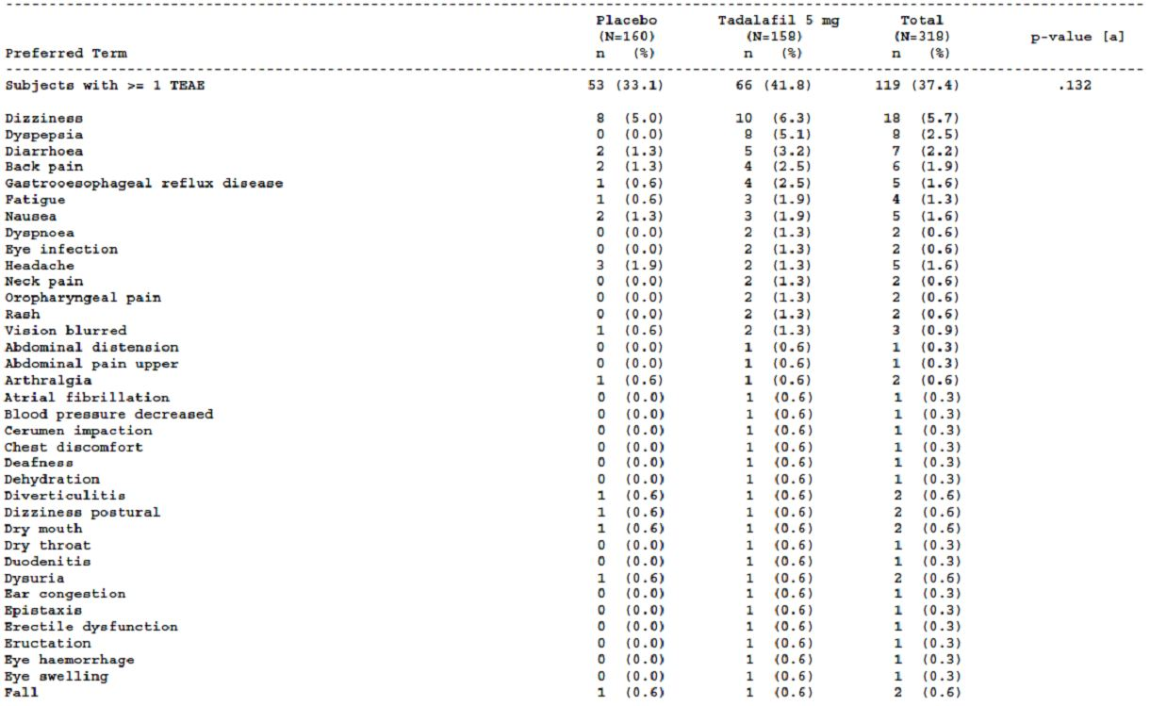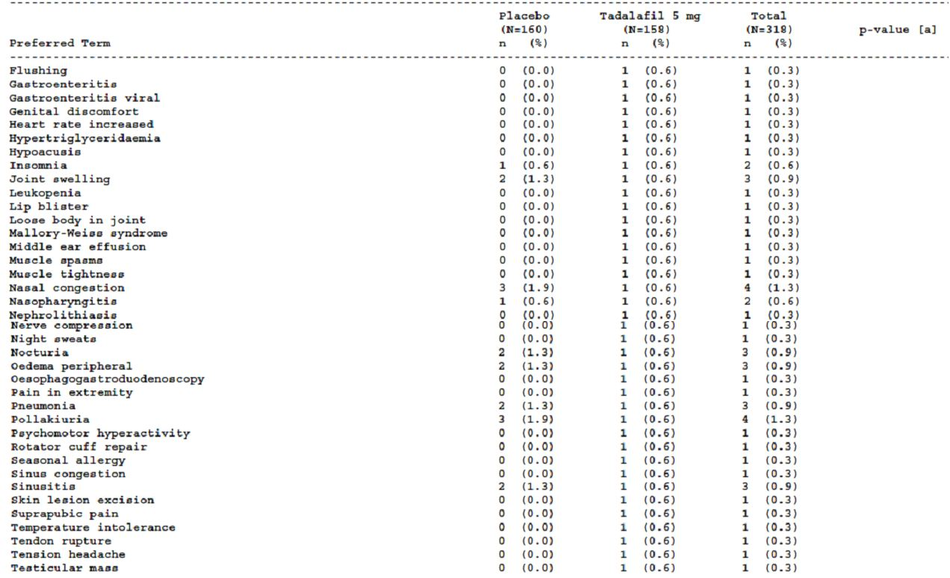
Table 22 (continued): Study H6D-MC-LVHS: Treatment-emergent adverse events, double-blind period (all randomised subjects).
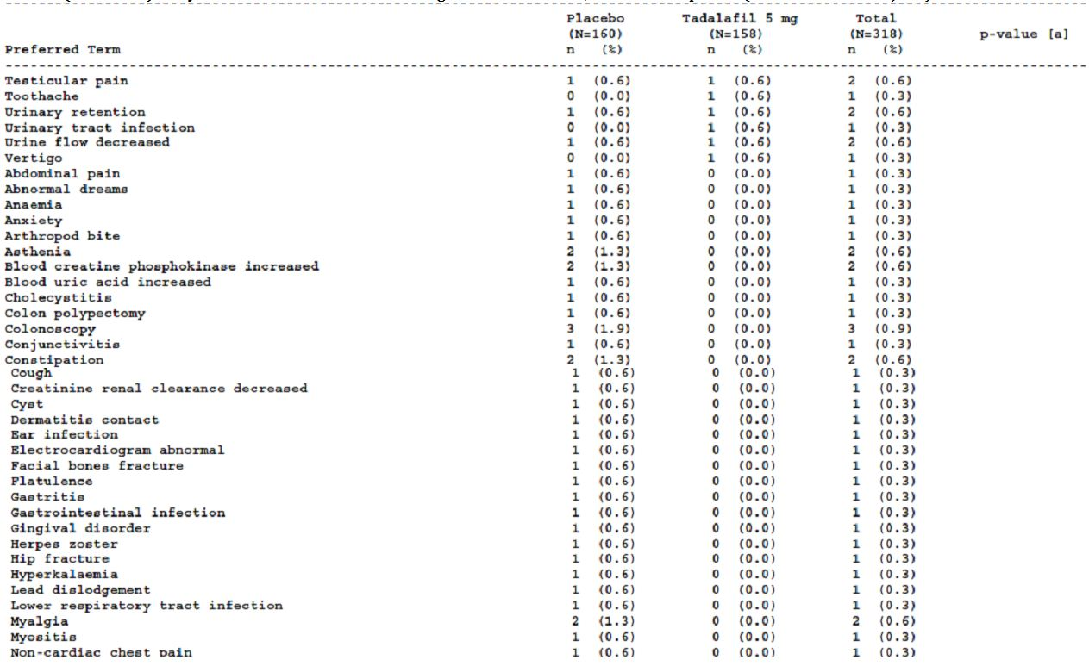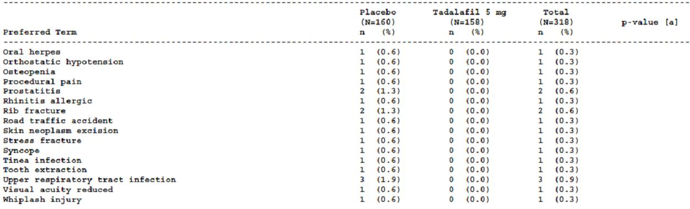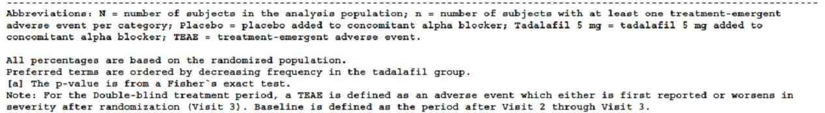
A higher proportion of subjects randomised to the tadalafil 5 mg treatment group reported one or more TEAEs during the double-blind period, compared with the placebo group (placebo 33.1% (n=53), tadalafil 5mg 41.8% (n=66)). Dizziness was the most commonly reported TEAE by subjects in both groups (placebo 5.0% (n=8), tadalafil 5mg 6.3% (n=10)). Other TEAEs reported by more than 2% of subjects in the tadalafil 5 mg group were dyspepsia, diarrhoea, back pain and gastro oesophageal reflux disease, all of which were reported by a higher proportion of subjects in the tadalafil 5 mg group compared with the placebo group. Fatigue and nausea were both reported by three subjects (1.9%) in the tadalafil group and all the other TEAEs were reported by two or fewer subjects. TEAEs fell most commonly into the following SOCs: Gastrointestinal disorders (placebo 6.3%, tadalafil 5mg 13.9%), Infections and infestations (placebo 7.5%, tadalafil 5mg 4.4%), Musculoskeletal and connective tissue disorders (placebo 5.6%, tadalafil 5mg 7.0%), Nervous system disorders (placebo 8.1%, tadalafil 5mg 9.5%) and Respiratory, thoracic and mediastinal disorders (placebo 2.5%, tadalafil 5mg 4.4%). Most TEAEs were of mild or moderate severity. Five subjects in each treatment group had TEAEs of a maximum severity assessed as severe. In the tadalafil 5mg group these TEAEs were Mallory-Weiss syndrome, urinary tract infection, tendon rupture, back pain (n=2) and headache.
As TEAEs did not include AEs that were reported on the day of randomisation, AEs with a start date equal to the date of randomisation (Visit 3) were queried to determine if the AE occurred prior to, or after, the first dose of study medication. Four subjects in each treatment group reported one or more TEAEs on the day of randomisation following the first dose of double-blind treatment. There were no reports of dizziness. Headache was reported by two subjects randomised to tadalafil 5 mg and one randomised to placebo but it is reported that none of these subjects met the criteria for a positive orthostatic test. During the double-blind treatment period, similar proportions of subjects in each treatment group had one or more TEAEs possibly related to hypotension when based on the focused analysis including 7 prespecified MedDRA preferred terms (dizziness, dizziness postural, procedural dizziness, hypotension, orthostatic hypotension, syncope and presyncope)(placebo 6.3% (n=10), tadalafil 5mg 7.0% (n=11)).
When based on an expanded analysis including, along with the seven preferred terms for dizziness above, headache, asthenia and fatigue, the proportions of subjects in the two groups with TEAEs possibly related to hypotension were again similar (placebo 9.4% (n=15), tadalafil 5mg 10.1% (n=16)). Of the 16 subjects in the tadalafil group with TEAEs possibly related to hypotension, two reported headache and did not have other concurrent adverse events suggestive of hypotension. Six of the remaining 14 subjects met one or more of the criteria for a treatment-emergent positive orthostatic test. Nine of the 14 subjects were on concurrent non-selective alpha blockers.
Comparing subjects aged 65 years and under, and subjects aged over 65 years, the proportions of subjects in each treatment group with TEAEs possibly related to hypotension were similar across the subgroups. In subjects aged 75 years or older, 12.5% (n=5) reported treatment-emergent adverse events possibly related to hypotension, compared with 5.3% (n=2) in the placebo group. Two of the subjects in the tadalafil 5 mg group were reported with headache as a possible TEAE related to hypotension, compared with none in the placebo group. In subjects aged less than 75 years the proportions of subjects in the treatment groups with one or more TEAEs possibly related to hypotension were similar (placebo 10.7%, tadalafil 5mg 9.3%).
During the double-blind treatment period, a slightly higher proportion of subjects in the placebo group reported TEAEs upon standing during the vital sign assessments than subjects randomised to tadalafil 5 mg (placebo 2.5% (n=4), tadalafil 5mg 1.9% (n=3)). Only one subject in each treatment group who had TEAEs upon standing during the vital sign assessments met at least one of the four criteria for a treatment-emergent positive orthostatic test.
Dizziness was reported in higher proportions of subjects in both treatment groups during the double-blind period when the subject was also taking a non-selective alpha blocker compared with a selective alpha blocker (selective alpha blocker: placebo 2.8% (n=3), tadalafil 5mg 3.8% (n=4); non-selective alpha blocker placebo 9.4% (n=5), tadalafil 5mg 11.5% (n=6)).
Comment: Both the current and proposed PIs include information in the Precautions section regarding the blood pressure lowering effect of the concomitant use of tadalafil with non-selective alpha blockers.
The proportion of subjects aged 75 years or older reporting treatment-emergent adverse events possibly related to hypotension was notably higher in the tadalafil 5 mg group compared with the placebo group although the absolute numbers of subjects affected were small.

Study LVHK
Treatment-emergent adverse events reported in study LVHK are shown in Table 23.
Table 23: Study H6D-MC-LVHK: Treatment-emergent adverse events by decreasing frequency of occurrence in tadalafil 20 mg treatment group (all randomised subjects).
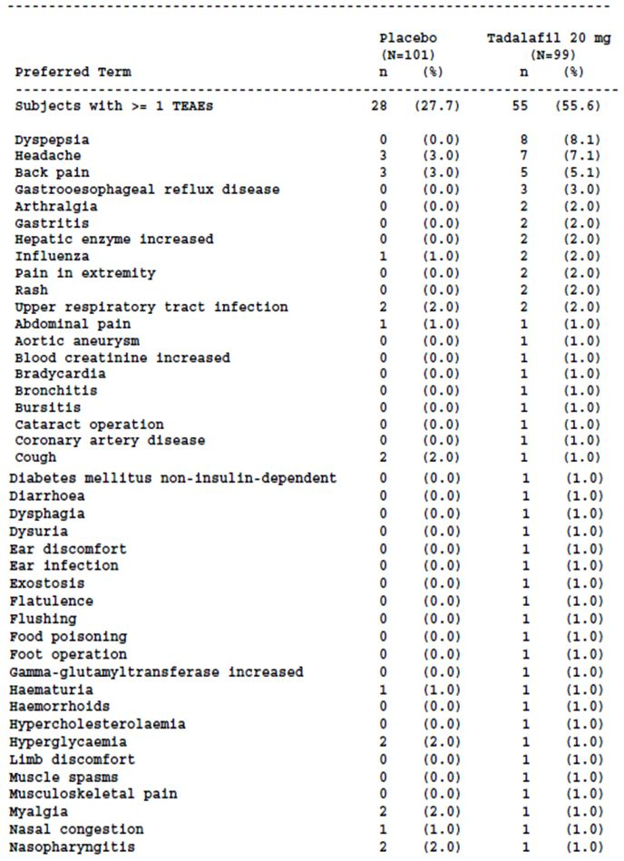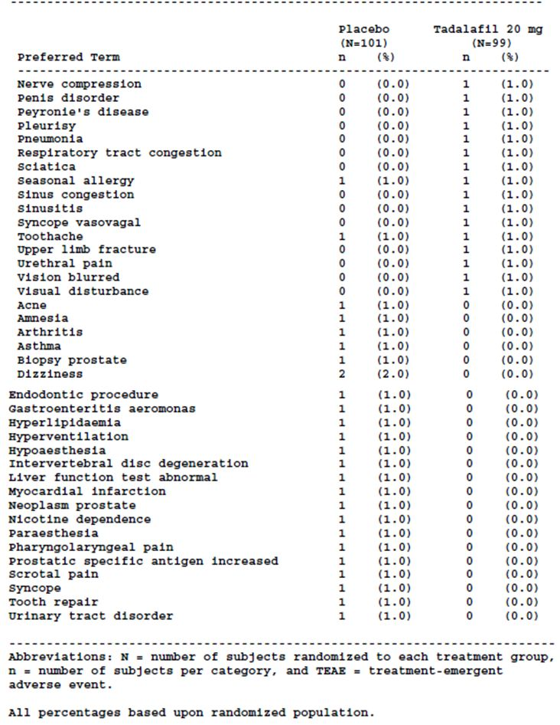
The proportion of randomised subjects with one or more TEAEs in the tadalafil 20 mg group was approximately double that in the placebo group (placebo 27.7% (n=28); tadalafil 20 mg 55.6% (n=55)). In the tadalafil 20 mg group, the most common TEAEs, reported by more than 2% of subjects, were dyspepsia, headache, back pain and gastro oesophageal reflux disease. There were four subjects (4.0%) in the tadalafil 20 mg group who had one or more TEAEs that were of severe maximum severity (gastritis (n=1), pneumonia (n=1), hypercholesterolemia (n=1), pain in the extremity (n=1), pleurisy (n=1)).

Study LVHG OLE
Comment: The pivotal safety studies were all in men with BPH-LUTS. There was no specific safety study undertaken in men with both BPH-LUTS and ED.

Other studies

BPH indication

Study LVGC
Treatment-emergent adverse events were reported in a higher proportion of randomised subjects in the tadalafil 5mg/20mg group compared with the placebo group between Weeks 0-6 (placebo 17.5% (n=25), tadalafil 5mg/20mg 22.5% (n=31)) and Weeks 0 -12 placebo 24.5% (n=35), tadalafil 5mg/20mg 34.8% (n=48)). The most common TEAEs occurring in more than 2% of subjects in the tadalafil 5mg/20mg group during Weeks 0-6 and Weeks 0-12, were erection increased (Weeks 0-6 placebo 1.4%, tadalafil 3.6%; Weeks 0-12: placebo 1.4%, tadalafil 5.1%), dyspepsia (Weeks 0-6 placebo 0.0%, tadalafil 2.2%; Weeks 0-12: placebo 0.0%, tadalafil 4.3%), back pain (Weeks 0-6 placebo 0.0%, tadalafil 2.3%; Weeks 0-12: placebo 1.4%, tadalafil 3.6%) and headache (Weeks 0-6 placebo 0.0%, tadalafil 2.2%; Weeks 0-12: placebo 0.7%, tadalafil 2.9%). Over the 12 weeks of treatment, nasopharyngitis and upper respiratory tract infection were also reported in more than 2% of subjects in the tadalafil group (nasopharyngitis: placebo 0.0%, tadalafil 2.2%; upper respiratory tract infection placebo 0.7%, tadalafil 2.2%). All of the subjects reported with treatment-emergent “erection increased” in both treatment groups were reported by the one investigator. This TEAE was actively solicited by the investigator and occurred in the context of sexual stimulation. Most of the TEAEs were of mild or moderate maximum severity. Of note, one subject was reported with ventricular tachycardia of severe severity in the period Weeks 6-12 during which time he was receiving tadalafil 20 mg. This adverse event was not reported as a serious adverse event and was not considered to be drug related by the investigator.
Comment: The proportions of subjects randomised to tadalafil reporting the most common AEs were higher over the whole 12 week treatment period (tadalafil 5 mg for 6 weeks followed by tadalafil 20 mg for 6 weeks) compared with the first six weeks when the subjects were receiving 5 mg tadalafil.
The TEAEs reported by more than 1% of subjects receiving tadalafil 5/20 mg were generally consistent with the known safety profile for tadalafil. No new safety signals were apparent. The subject reported with ventricular tachycardia does not suggest a new safety signal as the subject did not discontinue the study due to the adverse event, the ventricular tachycardia was not reported as a serious adverse event and the investigator did not consider it to be drug-related.

Studies in Asian countries

Study LVIA
During the double-blind treatment period a similar proportion of subjects in each treatment group were reported with TEAEs (placebo 37.9% (n=53), tadalafil 2.5mg 38.0% (n=54), tadalafil 5mg 38.6% (n=54)). The most commonly reported TEAE in all treatment groups was nasopharyngitis (placebo 12.9% (n=18), tadalafil 2.5mg 7.7% (n=11), tadalafil 5mg 10.0% (n=14)). Other TEAEs reported in three or more subjects in either tadalafil group were dyspepsia, diarrhoea, headache, hot flush, reflux oesophagitis, cataract, gingivitis and palpitations. Of these TEAEs, the proportions of subjects with dyspepsia and cataract increased with increasing tadalafil dose, and were reported in a higher proportion of subjects in the tadalafil groups than the placebo group (dyspepsia (placebo 0.0% (n=0), tadalafil 2.5mg 1.4% (n=2), tadalafil 5mg 2.9% (n=4)), cataract (placebo 0.0% (n=0), tadalafil 2.5mg 0.7% (n=1), tadalafil 5mg 2.1% (n=3)). All the subjects in the tadalafil groups who experienced one or more TEAEs had TEAEs of mild to moderate severity. One subject was reported with urinary retention in the tadalafil 5 mg and placebo groups, respectively.
Comment: Dyspepsia is included in the proposed PI as a TEAE reported by more than 2% of subjects treated with tadalafil 5 mg, and more frequent than placebo, in the phase 3 BPH studies. Although there was an apparent dose-response effect seen for cataract the absolute numbers of subjects reported were very small and are unlikely to represent a new safety signal given the primary risk factor for cataract is age.
TEAEs reported by more than 1% of subjects in the tadalafil 2.5 mg and 5 mg groups were generally consistent with the known safety profile of tadalafil. Across the tadalafil and placebo treatment groups, the majority of TEAE preferred terms were reported for only one or two subjects. No new safety signal was apparent.

Study LVIA OLE
Of the 394 subjects who entered the open-label extension period, 257 (65.2%) were reported to have had one or more TEAEs. Compared with baseline at Visit 3 (before randomised treatment in the double-blind treatment period was commenced), TEAEs reported in ≥ 2% of subjects during the 54 weeks of the double-blind treatment and OLE periods of study LVIA (Visit 3 to Visit 18) were nasopharyngitis (21.1% (n=83), diarrhoea 8.6% (n=34), back pain 5.8% (n=23), headache 4.8% (n=19), dyspepsia 4.1% (n=16)), reflux oesophagitis 3.3% (n=13), cataract 2.3% (n=9), eczema 2.8% (n=11). For subjects who had received tadalafil 5 mg in the double-blind treatment period, 66.4% (n=85) had one or more TEAEs during the study. Nasopharyngitis (18.0% (n=23), diarrhoea (8.6% (n=11)), back pain (5.5% (n=7) and dyspepsia (4.7% (n=6)) were reported in more than 4 per cent of subjects. Between two and three per cent of subjects (three and four subjects respectively)were reported with abdominal pain upper, dermatitis, haematuria, headache, periarthritis, reflux oesophagitis, abdominal distension, cataract, conjunctivitis, dysuria, eczema, fall, musculoskeletal pain, nausea and prostatitis.
Using Visit 7 as baseline (the end of the double-blind treatment period), 58.6% of subjects reported one or more TEAE during the OLE period (Visit 7 to Visit 18). A higher proportion of subjects who were in the placebo group during the double-blind treatment period reported TEAEs in the OLE period compared with those randomised to the tadalafil groups (placebo 63.4% (n=83), tadalafil 2.5mg 55.6% (n=75), tadalafil 5mg 57.0% (n=73)). The TEAEs reported by ≥ 2% of subjects during the OLE were nasopharyngitis (10.7%), diarrhoea (6.1%), back pain (4.3%), headache (3.0%), dyspepsia (2.5%), eczema (2.3%), insomnia (2.0%) and reflux oesophagitis (2.0%). Most TEAEs reported in the OLE period were of mild or moderate maximum severity. TEAEs of maximum severity severe in the OLE period were single reports of jaw fracture, back pain, lung neoplasm malignant, pancreatic carcinoma, prostate cancer, cerebral infarction, subarachnoid haemorrhage, urinary retention, prostatitis and nephrectomy. One subject who had received tadalafil 5 mg in the double blind period was reported with a toxic skin reaction of moderate maximum severity in the OLE period.
Comment: The TEAEs reported in the OLE period by ≥ 2% of subjects who had received tadalafil 5 mg in the double blind treatment period were generally consistent with those reported in the double-blind treatment period. The proportions of subjects reporting diarrhoea (7.0% (n=9)) and back pain (3.9% (n=5)) during the OLE (compared to Visit 7 as baseline) were higher than the proportions of subjects in the tadalafil 5 mg treatment group who reported these TEAEs during the double-blind period (compared to Visit 3 as baseline) (diarrhoea 1.4% (n=2), back pain 1.4% (n=2)), but the absolute number of subjects affected were small.
The most common TEAEs reported in the OLE were generally consistent with the known safety profile for tadalafil and no new safety signals were apparent.

Study LVHB
During the placebo lead-period, the proportion of subjects reporting adverse events was highest in the placebo group (placebo 13.6% (n=21), tadalafil 2.5mg 8.6% (n=13), tadalafil 5mg 7.1% (n=11), tamsulosin 0.2mg 9.9% (n=15)). During the double-blind treatment period, higher proportions of subjects in the tadalafil groups reported TEAEs compared with the other treatment groups (placebo 15.6% (n=24), tadalafil 2.5mg 27.8% (n=42), tadalafil 5mg 27.1% (n=42), tamsulosin 0.2mg 23.0% (n=35)). TEAEs reported in ≥ 1% of subjects in the combined tadalafil groups (N=306), and in a greater proportion of subjects than in the placebo group, were myalgia (2.9%), headache (2.0%), back pain (1.6%), diarrhoea (1.3%), rhinitis allergic (1.3%), dizziness (1.0%)and nausea (1.0%). There was a dose-response effect across the tadalafil groups for myalgia and back pain. In the tadalafil 5 mg group the TEAEs reported by the highest proportions of subjects (≥ 1%) were myalgia (3.9%), headache (1.9%), back pain (2.6%), nasopharyngitis (1.3%), diarrhoea (1.3%), rhinitis allergic (1.3%), nausea (1.9%), dyspepsia (1.3%), hot flush (1.3%), muscle tightness (1.3%) and PSA increased (1.3%). The highest proportions of subjects in the tadalafil 5mg group had TEAEs falling under the Gastrointestinal disorders SOC (6.5%) and the musculoskeletal and connective tissue disorders SOC (9.0%). Most TEAEs were of mild or moderate maximum severity. One subject was reported with a TEAE that was severe in the tadalafil 5 mg group and three subjects in the tadalafil 2.5 mg group (tadalafil 5mg: blood creatinine phosphokinase increased (n=1); tadalafil 2.5mg: injury (n=1), lumbar spinal stenosis (n=1), hepatic cancer metastatic (n=1)).

Study LVHT
Treatment-emergent adverse events were reported in 3.9% (n=2) of subjects in the placebo group, 13.7% (n=7) of subjects in the tadalafil 5 mg group and 26.5% (n=13) of subjects in the tamsulosin 0.2mg group during the treatment period. One subject in the tadalafil 5 mg group had treatment-emergent back pain reported during the placebo run-in period.
During the double-blind treatment period, three subjects (5.9%) in the tadalafil 5 mg group were reported with myalgia compared with no subjects in the placebo group and one subject in the tamsulosin 0.2 mg group. The majority of TEAEs reported in the tadalafil 5 mg group were in single subjects (2.0%) of which flushing, intentional overdose, lumbar spinal stenosis, lung adenocarcinoma metastatic, nasopharyngitis, pleural effusion and pruritus were reported in the tadalafil 5 mg group but not the placebo group. Nasopharyngitis was reported in 5 subjects in the tamsulosin 0.2 mg group and there were also single subjects reported with myalgia and intentional overdose in this group. No subject had a TEAE of severe maximum severity.
Comment: The adverse events reported in Asian populations in studies LVIA, LVHB, LVHT and LVIA OLE are consistent with the adverse events reported in the study populations of the pivotal studies, the majority of whom were white.

ED indication

Study LVDI
The proportions of subjects reporting one or more TEAEs were higher in the tadalafil groups, compared with the placebo group, and in the tadalafil groups, the proportions of subjects reporting one or more TEAEs increased with increasing dose (placebo 27.9% (n=24), tadalafil 5mg 40.0% (n=34), tadalafil 10mg 41.9% (n=36), tadalafil 20mg 54.7% (n=47)). Headache and flushing were reported in > 5% of subjects in the tadalafil groups combined and the proportions of subjects reporting these TEAEs were higher than in the placebo group. There was a clear increase in the proportion of subjects reporting headache with increasing dose of tadalafil (tadalafil 5mg 5.9%, tadalafil 10mg 11.6%, tadalafil 20 mg 18.6%) and flushing occurred in a higher proportion of subjects in the tadalafil 2 0mg group (5.8%) compared with the 5 mg and 10 mg groups (4.7% respectively). The proportions of subjects reporting headache, flushing and nasopharyngitis were similar at Visits 3, 4, and 5 for each treatment group. Of those subjects reporting one or more TEAEs, the majority had TEAEs with a maximum severity of mild. There were two subjects, one in the tadalafil 10 mg group and one in the tadalafil 20 mg group, who had TEAEs of pyelonephritis and mental disorder, respectively, that had a maximum severity of severe. Neither of these TEAEs was assessed by the investigator as possibly related to the study drug.
Comment: The TEAEs reported in this study were consistent with those included in the currently approved PI for Cialis in relation to the treatment of ED indication.

Clinical pharmacology analysis set
The results of study LVHN were integrated with the safety data from 67 clinical pharmacology studies including a number of studies included in this submission (LVFU, LVCT, LVFV, LVFB, LVFF, LVFS, LVFT, LVGG, LVFA). Overall, 2080 subjects received at least one dose of tadalafil and 1289 subjects received at least one dose of placebo. The majority of subjects in these studies were aged under 65 years (89.7%), were male (85.5%) and of Caucasian ethnicity (90.5%). The demographic characteristics of subjects who received placebo were comparable with those who received tadalafil. Similar proportions of subjects receiving placebo and tadalafil completed the study (placebo 97.3%, tadalafil 95.9%).
Compared with the placebo group, higher proportions of subjects receiving tadalafil 2.5 mg, 5 mg, 10 mg, 20 mg, 40 mg, 50 mg, 80 mg and 100 mg were reported with TEAEs (For preferred terms occurring in at least 1% of tadalafil-treated subjects only: placebo 44.4% (n=572); tadalafil (overall) 75.0%. (n=1561)). Generally higher proportions of subjects receiving the higher tadalafil doses were reported with one or more TEAEs. TEAEs of maximum severity severe were reported in 4.0% (n=84) of subjects receiving tadalafil (any dose) and 2.1% (n=27) of subjects receiving placebo. For the majority of subjects reported with TEAEs while receiving placebo or tadalafil 5 mg, the maximum severity of the TEAE was assessed as mild or moderate.
Comment: It is indicated in the submission that the results of study LVHN were integrated with the safety data from 67 previously reported clinical pharmacology studies. Different doses and dose forms of tadalafil were used in these studies. The sponsor reports that there were generally no discernable differences in the pharmacokinetics in the five formulations administered in these studies and that the dose form in most studies was the commercial tablet. The subjects and study design for those studies evaluated in this submission were not identical and it is not known if the other studies included in the analysis set were of comparable design. As indicated by the sponsor, no definitive conclusion can be drawn from the results of the clinical pharmacology analysis set due to the differences between the studies.
It is not clear if all the studies in the clinical pharmacology analysis set have been submitted to the TGA previously. This information is, however, not crucial to the outcome of the evaluation.
In general, the adverse events reported during the clinical pharmacology studies were consistent with the known adverse event profile for tadalafil.

Treatment-related adverse events (adverse drug reactions)

Pivotal studies

BPH indication

Study LVHG
The proportion of subjects who had one or more adverse events recorded by the investigator as possibly related to the study drug was higher in subjects treated with tadalafil (all doses) compared with placebo (tadalafil (all doses) 14.7% (n=124), placebo 8.5% (n=18)), although the proportion of subjects who were treated with 2.5 mg tadalafil reported with treatment-related adverse events was less than in the placebo group (tadalafil 2.5mg 6.2% (n=13), placebo 8.5% (n=18)). Across the tadalafil groups, the proportions of subjects reported with treatment-related adverse events increased with increasing dose (tadalafil 2.5mg 6.2% (n=13), tadalafil 5mg 15.6% (n=33), tadalafil 10mg 16.7% (n=36), tadalafil 20mg 20.1% (n=42)). Headache, dyspepsia, myalgia and back pain were the treatment-related adverse events reported in the highest proportion of subjects treated with tadalafil.

Study LVHJ
In the double-blind treatment period, the proportion of subjects with treatment-related adverse events was higher in the tadalafil group compared with the placebo group (placebo 3.7% (n=6), tadalafil 5 mg 10.6% (n=17)). Compared with the placebo group, a higher proportion of subjects in the tadalafil 5mg group reported headache that was assessed by the investigator as being possibly related to the study drug (placebo 0.6% (n=1), tadalafil 5mg 3.7% (n=6)). Other treatment-related adverse events reported in subjects in the tadalafil 5 mg group were dyspepsia (1.9%, (n=3) placebo 0% (n=0)), back pain (1.2% (n=2), placebo 0.6% (n=1)), myalgia 1.2% (n=2), placebo 0.6% (n=1)), abdominal pain upper (0.6% (n=1), placebo 0.6% (n=1)) and single subjects were reported with acute myocardial infarction, asthenia, dizziness, flushing, gastric pH decreased and insomnia in the tadalafil 5 mg group only.

Study LVID
A similar proportion of subjects in each of the treatment groups had one or more adverse events assessed by the investigator as possibly related to the study drug (placebo 9.9% (n=17), tadalafil 5 mg 12.3% (n=21), tamsulosin 0.4 mg 11.9% (n=20)).
Gastro oesophageal reflux disease and headache were the most frequent treatment-related AEs in the tadalafil group, both occurring in 2.3% of subjects. Dizziness and pain in the extremity were reported in 1.8% of subjects in the tadalafil 5 mg group and back pain, dyspepsia, flushing, gastritis, insomnia and myalgia were drug-related AEs reported in 1.2% of subjects (n=2) in the tadalafil 5 mg group. The remainder of the drug-related adverse events were reported in single subjects (0.6%) in the tadalafil 5 mg group. Headache was the drug-related AE reported in the highest proportions of subjects in both the placebo group (1.7%) and tamsulosin 0.4 mg group (3.6%).

BPH indication and ED and BPH indication

Study LVHR
One or more treatment-related adverse events were reported in more subjects in the tadalafil 5 mg group than the tadalafil 2.5 mg and placebo groups (placebo 6.0% (n=12), tadalafil 2.5mg 7.6% (n=15), tadalafil 5mg 12.5% (n=26)). For subjects in the tadalafil 5 mg group, headache and back pain were the most commonly reported treatment-related adverse events (headache: placebo 1.0% (n=2), tadalafil 2.5mg 2.0% (n=4), tadalafil 5mg 4.3% (n=9); back pain: placebo 0.5% (n=1), tadalafil 2.5mg 0.0% (n=0), tadalafil 5mg 1.9% (n=4)). For all the other treatment-related adverse events reported during the double-blind period, the number of subjects reported with the event in each treatment group was small (between 0 and two subjects).
Of the severe TEAEs reported, the events of abdominal discomfort, back pain and myalgia, reported in two subjects in the tadalafil 5 mg group, were assessed by the investigator as possibly related to the study drug.
Comment: The treatment-related adverse events were consistent across the four pivotal studies suggesting that the adverse events considered related tor tadalafil 5 mg once daily dosing are comparable in the study populations of men with BPH-LUTS and men with both BPH-LUTS and ED in these 12 week studies.
The treatment-related adverse events were generally consistent with the known safety profile for tadalafil and no new safety signals were apparent. Insomnia was reported as treatment-related in a small number of subjects (between one and three) in the double-blind period of studies LVHJ, LVID, LVHR and LVHG. There was no dose-response effect seen for insomnia in study LVHG. The number of subjects reported with this adverse event was low and there are many causes of insomnia so the inclusion of this adverse effect in the PI at this time does not seem warranted.

Integrated analysis set of the four pivotal efficacy studies (LVID, LVHG, LVHJ, LVHR)
Adverse events possibly related to the study drug were more common in subjects randomised to tadalafil 5 mg compared with placebo (placebo 7.1% (n=53); tadalafil 5mg 12.9% (n=97)). Headache was the most common treatment-related adverse event (2.0%). Dyspepsia, myalgia, back pain and pain in extremity occurred in between 1.1% and 1.9% of subjects randomised to tadalafil 5 mg and a lower proportion of subjects randomised to placebo. Other treatment-related adverse events for which there were three or more reports in subjects randomised to tadalafil 5 mg, but none in subjects randomised to placebo, were gastro oesophageal reflux disease (0.88% (n=6)), diarrhoea (0.3% (n=4)) muscle spasms 0.4% (n=3) and vision blurred 0.4% (n=3)).

Comparison of adverse events reported in the integrated analysis set and in subjects receiving tadalafil once daily for ED
The common treatment-related adverse events in the BPH integrated analysis set, headache, dyspepsia, myalgia, back pain and pain in extremity, were also common treatment-related adverse events in the integrated ED analysis set.

Pivotal safety studies

Study LVHS
Adverse events reported during the double-blind treatment period assessed by the investigator to be possibly related to treatment (although not necessarily treatment–emergent) were more common in subjects randomised to tadalafil 5 mg compared with placebo (placebo 10.6% (n=17), tadalafil 5mg 18.4% (n=29). The most common treatment-related adverse events were dizziness (placebo 3.1%, tadalafil 5mg 5.7%), dyspepsia (placebo 0.6%, tadalafil 5mg 4.4%) and headache (placebo 1.9%, tadalafil 5mg 2.5%). Dizziness assessed by the investigator as possibly related to the concomitant alpha blocker was reported in three subjects in each treatment group during the double-blind treatment period.

Study LVHK
Compared with the placebo group, there was a notably higher proportion of subjects in the tadalafil 20 mg group with adverse events recorded as possibly related to the study drug (placebo 3.0% (n=3); tadalafil 20mg 26.3% (n=26)). Headache, back pain, flushing dyspepsia and gastro-oesophageal reflux disease recorded as possibly related to the study drug occurred in more than 2% of subjects in the tadalafil 20 mg group.
Other adverse events considered related to the study drug reported in single subjects in the tadalafil group were diarrhoea, gastritis, hepatic enzyme increased, musculoskeletal pain, myalgia, nausea, pain in extremity, penis disorder, rash, vision blurred and visual disturbance.
One subject had ALT and AST levels above the ULN at the end of study (ALT=90 IU/L (normal 6-43), AST =70 IU/L (normal 11-36)) that were considered, by the investigator, to be adverse events possibly related to the study drug. The gamma GT was also raised (119 IU/L (normal 10-50)). Bilirubin was reported to be within normal limits.

Other studies

BPH indication

Study LVGC
A higher proportion of randomised subjects in the tadalafil 5mg/20mg group, compared with the placebo group, had adverse events recorded as possibly related to the study drug during Weeks 0-6 (placebo 2.8% (n=4); tadalafil 5mg/20mg 11.6% (n=16)) and Weeks 0-12 (placebo 3.5% (n=5); tadalafil 5mg/20mg 15.2% (n=21)). Over the period Week 0-6, when subjects in the tadalafil 5mg/20mg group were receiving tadalafil 5 mg, the most common adverse events possibly related to the study drug were erection increased (placebo 1.4% (n=2), tadalafil 3.6% (n=5)), headache (placebo 0.0% (n=0), tadalafil 2.2% (n=3)), dyspepsia (placebo 0.0% (n=0), tadalafil 0.7% (n=1)) and back pain (placebo 0.0% (n=0), tadalafil 2.2% (n=3)). Over the period Weeks 0-12, the proportion of subjects in the tadalafil 5mg/20mg group reported with these drug-related adverse events increased (erection increased (5.1%), headache (2.9%) and dyspepsia (2.2%)), compared with the period Week 0-6. There were single reports of other adverse events considered to be possibly drug-related during the treatment period. Diarrhoea, flank pain, gastro-oesophageal reflux, myalgia, nausea, penile erection and stomach discomfort were reported during the first six weeks of treatment (5 mg once daily) and ejaculation disorder and flushing were reported in the second six weeks of treatment (20 mg once daily).
Comment: The proportion of subjects in the tadalafil 5mg/20mg group who were reported with certain drug-related adverse events increased for the period Weeks 0-12, compared with the period Week 0-6, indicating that some subjects were reported with these adverse reactions only when the tadalafil dose was increased to 20 mg daily.
The treatment-related adverse events were generally consistent with the known adverse effect profile for tadalafil and no new safety signals were apparent.

Studies in Asian countries

Study LVIA
In the placebo group, 10 subjects (7.1%) had adverse events during the double-blind period that were considered by the investigator to be treatment-related, compared with seven subjects (4.9%) in the tadalafil 2.5 mg group and nine subjects (6.4%) in the tadalafil 5 mg group. Hot flush was reported as a treatment-related adverse event in both tadalafil groups but not in the placebo group (tadalafil 2.5mg 2.1% (n=3), tadalafil 5mg 1.4% (n=2)). Dyspepsia was assessed as treatment-related in three subjects in the tadalafil 5 mg group and two subjects in the tadalafil 2.5 mg groups had treatment-related palpitations. None of the subjects in the other two treatment groups were reported with treatment-related dyspepsia or palpitations. There were single subjects with treatment-related reflux oesophagitis, drug eruption, erythema, flushing, gastritis, headache and nipple disorder in one or both of the tadalafil groups.

Study LVIA OLE
Treatment-related adverse events were reported for 14.5% (n=57) of subjects enrolled in the OLE period. Compared with baseline at Visit 3, dyspepsia was the only adverse event reported as treatment-related in ≥ 2% of subjects (2.3% (n=9)) during the 54 week study treatment period (double–blind treatment and OLE periods). Other treatment-related adverse events reported in three or more subjects during the 54 week study period were hot flush, reflux oesophagitis, back pain, diarrhoea, eczema, gastritis, palpitations and headache. Also of note were single reports of treatment-related toxic skin eruption (n=1), orthostatic hypotension (n=1) and sudden hearing loss (n=1). There was also a report of treatment-related urinary retention that was of maximum severity severe. There were a number of reports of chest pain and palpitations that were considered by the investigator to be related to the study drug.

Study LVHB
Treatment-related adverse events were reported in a higher proportion of subjects in the tadalafil 5 mg group compared with the other treatment groups (placebo 6.5% (n=10), tadalafil 2.5mg 10.6% (n=16), tadalafil 5mg 13.5% (n=21), tamsulosin 0.2mg 8.6% (n=13)). Treatment-related adverse events reported in more than one subject in the tadalafil 5 mg group were myalgia (n=5), blood creatine phosphokinase increased (n=2), dyspepsia (n=2), muscle tightness (n=2) and nausea (n=2). There was a dose-response effect for treatment-related myalgia (tadalafil 2.5mg 1.3% (n=2), tadalafil 5mg 3.2% (n=5)). One treatment-related adverse event of severe maximum severity was reported in each of the tadalafil groups (tadalafil 2.5mg : injury (n=1), tadalafil 5mg : blood creatine phosphokinase increased (n=1)). Of note, a subject in the tadalafil 2.5 mg group had orthostatic hypotension assessed by the investigator as treatment-related, two subjects, one in each of the tadalafil groups, had palpitations considered by the investigator as being related to the study drug, and a subject in the tadalafil 2.5 mg group reported black dots in his eyes (abnormal sensation in eye) assessed by the investigator as treatment-related. A subject in the tadalafil 5 mg group had a PSA above the upper limit of the reference range at Visit 7, considered to be drug-related, which returned to normal after the last visit.

Study LVHT
Four subjects in the tadalafil 5 mg group had adverse events that were assessed by the investigator as possibly treatment-related (intentional overdose (n=1), myalgia (n=3), headache (n=1), pruritus (n=1), flushing (n=1)), compared with two subjects in the placebo group (headache (n=2)), and two subjects in the tamsulosin 0.2 mg group (intentional overdose (n=1), myalgia (n=1)).

ED indication

Study LVDI
The proportions of subjects with one or more adverse event recorded as possibly related to the study drug were higher in the tadalafil groups, compared with the placebo group, and in the tadalafil groups the proportions of subjects with such drug-related adverse events increased with increasing dose (placebo 11.6% (n=10), tadalafil 5mg 21.2% (n=18), tadalafil 10mg 26.7% (n=23), tadalafil 20mg 33.7% (n=29)). Headache and flushing possibly related to the study drug were reported in > 5% of subjects in the tadalafil groups combined and the proportions were higher than in the placebo group.

Clinical pharmacology analysis set
Treatment-related adverse events were also reported in a higher proportion of tadalafil treated subjects (66.1% (n=1374)) compared with placebo treated subjects (21.0% (n=271)). Treatment-related adverse events occurring in more than 10% of tadalafil treated subjects (any dose) were headache (40.3%), back pain (24.7%) and myalgia (23.5%).
Comment: The adverse reactions reported in the clinical pharmacology analysis set were generally consistent with adverse effects reported with use of tadalafil for the treatment for ED. Nausea and arthralgia were both reported as treatment-related adverse events in a higher proportion of tadalafil-treated subjects compared with placebo-treated subjects (nausea: placebo 2.1% (n=27); tadalafil 5.0% (n=105); arthralgia placebo 0.2% (n=2); tadalafil 3.4% (n=70))). Although there was no clear dose-response effect across the tadalafil groups this may be a reflection of the small number of subjects who had taken the 2.5 mg, 50 mg and 80 mg doses making the proportions of subjects with a specific adverse reaction appear high even though the absolute numbers of subjects affected were small. Nausea and arthralgia are not in the current, or proposed, PI for Cialis as adverse events. Of note, both nausea and arthralgia are listed in the US PI for Cialis (14) as adverse reactions reported in less than 1% of subjects in the controlled clinical trials of Cialis for BPH or ED and BPH. These adverse reactions are not included in the proposed Australian PI for Cialis. The sponsor is requested to clarify why these adverse reactions are not included.
The adverse events assessed as treatment-related during the clinical pharmacology studies included in this submission are described.

Deaths and other serious adverse events

Pivotal studies

BPH indication

Study LVHG
There were no deaths in this study and the proportion of subjects reported with one or more serious adverse events was higher in the placebo treatment group than in any of the tadalafil treatment groups (placebo 2.8% (n=6), tadalafil 2.5mg 1.4% (n=3), tadalafil 5mg 0.5% (n=1), tadalafil 10mg 0.9% (n=2), tadalafil 20mg 2.4% (n=5), tadalafil (all doses) 1.3% (n=11)). The only serious adverse event reported in more than one subject was arthritis (n=3 (placebo n=1, tadalafil 10mg n=1, tadalafil 20 mg n=1)). Regarding serious adverse events reported by subjects in the tadalafil 5mg treatment group, only one subject was reported with two serious adverse events - cholecystitis and pancreatitis - not considered by the investigator to have been related to the tadalafil.
There were five serious adverse events considered to be related to the study drug. Three subjects in the tadalafil 20 mg treatment group were reported with the serious adverse events back pain, pulmonary embolism and cerebrovascular accident respectively. Two subjects in the placebo group were reported to have had serious adverse events of rheumatoid arthritis.

Study LVHJ
There were no deaths in the placebo treatment group. One subject in the tadalafil 5 mg group died from an acute myocardial infarction assessed by the investigator as possibly treatment-related. The 81 year old subject had commenced tadalafil 5 mg 80 days prior to the acute myocardial infarct. The subject received the last dose of study treatment on the day of the acute myocardial infarct. The subject died three days later. The subject had pre-existing hyperlipidaemia and hypertension and was taking concomitant lisinopril and simvastatin.
Two subjects in the tadalafil 5 mg group reported serious adverse events. One subject had an acute myocardial infarction which resulted in death and another subject had endocarditis. The investigator assessed the endocarditis as unlikely to be related to the study drug or protocol procedure. No subjects reported serious adverse events in the placebo group.

Study LVID
There were no deaths. Serious adverse events were reported in two subjects in the tadalafil 5 mg group (coronary artery disease (n=1), pancreatitis (n=1) and two subjects in the tamsulosin 0.4 mg group (dyspepsia (n=1), and dizziness, flushing, headache, hyperhidrosis and tachycardia in the second subject).
The subject in the tadalafil treatment group reported with coronary artery disease had a past history of coronary angioplasty with stent placement, hypertension and hyperlipidaemia. The principal investigator assessed that coronary artery disease as unrelated to the study drug. The subject reported with pancreatitis had pancreatitis secondary to biliary duct obstruction and the pancreatitis was assessed as unrelated to the study drug.

BPH indication and ED and BPH indication

Study LVHR
There was one death during the double-blind treatment period. The subject was in the tadalafil 2.5 mg group. The 67 year old male died approximately one day after the last dose of study drug. The cause of death was reported to be a myocardial infarction. The subject had other medical conditions including impaired glucose tolerance and episodic atrial fibrillation and was on concomitant medications. The investigator assessed the subject’s death as unrelated to the study drug and unrelated to study protocol procedures.
During the double-blind treatment period, there were single reports of serious adverse events in the placebo and tadalafil 5 mg groups and in the tadalafil 2.5 mg there were two reports including the above-mentioned death. In the tadalafil 5 mg group, a 69 year old male reported pancreatitis haemorrhagic which led to his discontinuation from the study. The event was reported 25 days post-randomisation. It was reported that this subject had no pertinent medical history and was taking pantoprazole. The investigator assessed the event as unrelated to the study drug. The serious adverse events reported in two subjects in the tadalafil 2.5 mg group, intervertebral disc protrusion and myocardial infarction, were assessed by the investigator as not related to the study drug. A third subject in the tadalafil 2.5 mg group reported prostatitis approximately five weeks post-randomisation. He had been discontinued from the study eight days earlier as he was found to have not met the Qmax inclusion criteria. He developed pollakiuria, acute urinary retention and acute prostatitis and required hospitalisation. The investigator assessed the prostatitis as possibly related to protocol procedures.

Integrated analysis set of the four pivotal efficacy studies (LVID, LVHG, LVHJ, LVHR)
Based on the integrated analysis set, comprised of all subjects who were randomised to tadalafil 5 mg and placebo in the double-blind treatment periods of studies LVID, LVHG, LVHJ and LVHR, the proportions of subjects who died and had serious adverse events were comparable for subjects randomised to tadalafil 5 mg and placebo. One subject randomised to tadalafil 5 mg died compared with no subjects randomised to placebo. Six subjects randomised to tadalafil 5 mg had seven serious adverse events. Two subjects were reported with pancreatitis and one subject with pancreatitis haemorrhagic and the remaining serious adverse events, reported in single subjects, were acute myocardial infarction, cholecystitis, coronary artery disease and endocarditis. Five subjects randomised to placebo were reported with nine serious adverse events, none of which were reported by subjects randomised to tadalafil 5 mg.

Pivotal safety studies

Study LVHS
There were no deaths in study LVHS. Three subjects in each treatment group reported one or more serious adverse events during the double-blind treatment period (placebo: non-cardiac chest pain (n=1), fall and hip fracture (n=1), pacemaker lead dislodgement (n=1); tadalafil 5mg cellulitis (n=1) (started in the placebo lead-in period), Mallory-Weiss syndrome (n=1), fall and tendon rupture (n=1)). None of the serious adverse events were assessed by the principal investigator as being related to the study drug, protocol procedure or adjunct therapy.

Study LVHK
One subject in the placebo group died of a myocardial infarction. Another subject in the placebo group was reported with the serious adverse event of hypoesthesia.
One subject in the tadalafil 20 mg group had two serious adverse events diagnosed, pleurisy and pneumonia, approximately one month after he had received the first dose of study drug. The events were assessed by the investigator as not related to the study drug.

Other studies
There were no deaths in studies LVGC, LVIA, LVHB, LVHT and LVDI. One subject died during the OLE period of study LVIA. The subject, who had received placebo in the double-blind treatment period, died of a subarachnoid haemorrhage five months after he enrolled in the OLE. The investigator did not consider the event to be due to the study drug or procedure. A second subject who had received placebo in the double-blind treatment period, died of cancer of the head of the pancreas seven months after withdrawal, due to pancreatic carcinoma, from the OLE period of the study. The investigator did not consider the event to be due to the study drug or procedure.
The majority of serious adverse events reported in studies LVGC, LVIA, LVIA OLE, LVHB, LVHT and LVDI were reported in single subjects and were not considered to be treatment-related by the investigator. Of note, during the OLE period of study LVIA, eleven subjects (2.8%) experienced twelve serious adverse events. Single reports of urinary retention and sudden hearing loss, respectively, were assessed as possibly related to the study drug.
Comment: Hearing loss is included in the PI as an adverse event identified from post-marketing surveillance. Urinary retention may be a symptom of BPH (3). No change to the PI would seem warranted at this point in time.
Based on the serious adverse events reported in study LVIA and the OLE, there appeared to be no new safety signals evident with 54 weeks of treatment with tadalafil 5 mg once daily.

Clinical pharmacology analysis set
Two subjects receiving tadalafil were reported with three serious adverse events (tadalafil 5mg (n=1) angina pectoris, spinal laminectomy; tadalafil 40mg (n=1) pneumothorax) compared with six subjects reported with six serious adverse events in the placebo group.
Comment: Based on the Summary of subject disposition by study drug administered for the clinical pharmacology analysis set, no subjects receiving tadalafil died during the 68 clinical pharmacology studies that comprised the clinical pharmacology analysis set.

Discontinuation due to adverse events

Pivotal efficacy studies

BPH indication

Study LVHG
Compared with the placebo group, a higher proportion of subjects in the combined tadalafil treatment group (all doses) had one or more adverse events leading to study discontinuation. The proportion of subjects with one or more adverse event s leading to study discontinuation increased with increasing dose of tadalafil (placebo 2.4% (n=5), tadalafil 2.5mg 1.9% (n=4), tadalafil 5mg 5.7% (n=12), tadalafil 10mg 5.1% (n=11), tadalafil 20mg 6.7% (n=14), tadalafil (all doses combined) 4.8% (n=41)).
The most common adverse events leading to discontinuation in the combined tadalafil group were back pain (n=8), myalgia (n=7) and headache (n=5). There was a dose-response effect seen for back pain with no subjects discontinuing due to this adverse event in the placebo, tadalafil 2.5 mg and tadalafil 5mg treatment groups and 3 subjects and 5 subjects in the tadalafil 10 mg and 20 mg treatment groups, respectively, with back pain leading to study discontinuation.
In the tadalafil 5 mg treatment group, the adverse events leading to study discontinuation were myalgia (n=1), headache (n=3), abdominal pain upper (n=2), dyspepsia (n=1), pain (n=1), pain in the extremity (n=1), pancreatitis (n=1), retinal tear (n=1) and rotator cuff syndrome (n=1).

Study LVHJ
In the double-blind treatment period, three subjects (1.9%) in the tadalafil 5 mg group had adverse events leading to study discontinuation compared with one subject (0.6%) in the placebo group.
The three subjects in the tadalafil 5mg group who discontinued from the study had adverse events considered to be possibly related to the study drug (acute myocardial infarct (n=1), upper abdominal pain (n=1) and headache (n=1)).

Study LVID
Five randomised subjects discontinued due to an adverse event during the double-blind treatment period (placebo 1.2% (n=2), tadalafil 5mg 1.2% (n=2), tamsulosin 0.4mg 0.6% (n=1)). In the tadalafil 5 mg group, one subject discontinued due to pancreatitis and one due to blurred vision. The blurred vision was assessed by the investigator as possibly related to study drug.

BPH indication and ED and BPH indication

Study LVHR
During the double-blind treatment period a higher proportion of subjects in the tadalafil 5 mg group discontinued from the study due to an adverse event (placebo 1.5% (n=3), tadalafil 2.5mg 1.5% (n=3), tadalafil 5mg 2.9% (n=6)). All the adverse events leading to discontinuation were reported by single subjects. In the tadalafil 5 mg group these adverse events were back pain, headache, muscle spasms, myalgia, pancreatitis haemorrhagic and syncope. In the tadalafil 2.5 mg group adverse events leading to discontinuation were dizziness, myocardial infarction and nocturia.

Integrated analysis set of the four pivotal efficacy studies (LVID, LVHG, LVHJ, LVHR)
The proportion of subjects discontinuing the study due to an adverse event in the tadalafil 5mg group was double that in the placebo group (Placebo 1.5% (n=11), tadalafil 5mg 3.1% (n=23)). Headache was the most commonly reported adverse event leading to the discontinuation of subjects randomised to tadalafil 5 mg (0.3% (n=5)). There were no subjects randomised to placebo who discontinued due to headache. In subjects randomised to tadalafil 5 mg in the integrated analysis set, 15 of the 23 adverse events leading to discontinuation were considered to be study-related (headache (n=5), myalgia (n=2), upper abdominal pain (n=2) and single reports of back pain, muscle spasms, pain in the extremity, dyspepsia, vision blurred and acute MI).
Comment: The adverse events leading to discontinuation in the pivotal efficacy studies were generally consistent with known adverse events for tadalafil. Of adverse events leading to discontinuation that are not included in the PI for Cialis, only single cases were reported.

Pivotal safety studies

Study LVHS
A similar proportion of subjects in each group had adverse events leading to study discontinuation (placebo 3.8% (n=6); tadalafil 5mg 4.4% (n=7)). Except for headache, which led to two subjects in the tadalafil group discontinuing the study, the remainder of adverse events leading to discontinuation in both groups were reported by single subjects. The five other subjects in the tadalafil 5 mg group who discontinued the study did so due to abdominal pain upper, atrial fibrillation, back pain, blood creatinine phosphokinase increased and chest discomfort. The subject with blood creatinine phosphokinase increased had an elevated level at Visit 3, the result of which was not available until after the subject was randomised.

Study LVHK
In the tadalafil 20 mg, one subject discontinued from the study due to headache, considered to be drug-related by the investigator, and a second subject discontinued due to Peyronie’s disease, considered to be an undiagnosed pre-existing condition by the investigator. One subject in the placebo group discontinued from the study due to a myocardial infarct which resulted in death.

Other studies
The majority of adverse events leading to discontinuation of subjects from studies LVGC, LVIA, LVIA OLE, LVHB, LVHT and LVDI were reported in single subjects and were known adverse events for tadalafil. Of note, a subject who was receiving tadalafil 5 mg in study LVHB discontinued due to liver injury. The investigator did not consider the adverse event to be study drug-related. The adverse event was reported to have been moderate in severity. The subject had raised AST, ALT and GGT at Visit 3. At Visit 5, AST was 623 U/L (normal 11-36), and ALT was 320 U/L (normal 6-43) and the subject also had raised GGT (392 U/L; normal 10-50) and ALP (131 U/L; normal 35-125). The subject’s bilirubin level was not reported to be abnormal at any visit. At Visit 3 the subject was on a number of other concomitant medications. Eight days after tadalafil was ceased ALT was still above the upper limit of normal (54 U/L) as was GGT (368 U/L).
A subject in study LVIA discontinued due to a drug eruption considered be drug-related. The subject discontinued the study two months after the onset of the drug eruption.
Comment: The subject in study LVHB who discontinued due to liver injury appeared to have had a negative de-challenge to tadalafil as the ALT, AST and ALP decreased after tadalafil was ceased but, from the case history, none of the concomitant medications were ceased.

Clinical pharmacology analysis set
Based on the clinical pharmacology analysis set, discontinuation from the study was due to an adverse event in 37.1% of subjects (n=13) receiving placebo and 45.3% (n=39) receiving tadalafil. Adverse events reported as the reason for discontinuation in more than one subject receiving tadalafil were nausea (n=9), headache (n=8), vomiting (n=5), myalgia (n=5), back pain (n=3), dizziness (n=3) and ventricular extrasystoles (n=2). Adverse events reported as leading to discontinuation in subjects treated with placebo were reported in single subjects only.
Comment: The adverse events that led to the discontinuation of subjects from the clinical pharmacology studies are generally consistent with the known adverse events for tadalafil. Nausea and vomiting are not adverse effects reported in the PI for Cialis. It is not indicated in the submission whether there were alternative causes of the nausea and vomiting experienced by subjects in this analysis set. It is possible that the nausea and vomiting adverse events could have been secondary to other known adverse effects of tadalafil such as dyspepsia, gastrooesophageal reflux and headache. It is noted that the US label for Cialis (14) includes nausea and vomiting as adverse reactions reported in less than 1% of subjects in the controlled clinical trials for BPH or ED and BPH. The sponsor is requested to clarify if the nausea and vomiting adverse events that resulted in the subjects’ discontinuation from the clinical pharmacology studies were considered drug-related.

Laboratory tests

Liver function

Pivotal studies
Based on the integrated analysis set of the pivotal efficacy studies, the numbers and proportions of subjects who had treatment-emergent elevations of ALT or AST three or more times the upper limit of normal were small and comparable (ALT ≥ 3 ULN : placebo 0.4% (n=3), tadalafil 5mg 0.3% (n=2); AST ≥ 3 ULN : placebo 0.1% (n=1), tadalafil 5mg 0.1% (n=1)). No subjects in the integrated analysis set had a treatment-emergent increase in total bilirubin more than twice the upper limit of normal.
In study LVHG, three subjects receiving tadalafil 5 mg, and two subjects receiving tadalafil 10 mg, had AST or ALT more than three times the ULN. In study LVHG, a subject receiving tadalafil 5mg was found to have raised AST (181 U/L), ALT (254 U/L) and GGT (105 U/L) at Visit 6. His values were normal at Visits 1 and 3. Bilirubin values were normal. He had known hepatitis C. A second subject receiving tadalafil 5mg had normal liver enzymes at Visits 1 and 3 and raised AST (53 U/L) and ALT (131 U/L) at Visit 6 with decreased bilirubin (<0.2 micromol /L) and normal GGT. This subject was taking multiple concomitant medications. A third subject had abnormal hepatic enzyme values at Visit 3 prior to receiving tadalafil 5 mg. The AST, ALT and GGT decreased between Visit 3 and Visit 6.
One subject receiving tadalafil 10 mg had elevated hepatic enzymes throughout the study and the ALT and GGT at Visit 6 was not greatly different from the values at Visit 3. The second subject had peripheral oedema 49 days after randomisation. He was on multiple concomitant medications. His ALT was elevated more than three times the upper limit of normal at Visit 3 (151 U/L) following an abnormal value at Visit 1 (57 U/L). The value was 59 U/L at Visit 5. AST was normal at visits 1 and 5 and abnormal at Visit 3 (78 U/L).
No subjects in pivotal safety studies LVHS, LVHK and LVHG OLE had a treatment-emergent increase in ALT or AST three or more times the upper limit of normal and a total bilirubin more than twice the upper limit of normal.

Other studies
None of the subjects in studies LVGC and LVDI, and the studies in Asian populations, studies LVIA, LVIA OLE, LVHB and LVHT, had a treatment-emergent increase in ALT or AST three or more times the upper limit of normal and a total bilirubin more than twice the upper limit of normal.
Of note, in study LVGC one subject randomised to tadalafil had normal liver function test results at screening and raised ALT (478 U/L (reference range 5-95 U/L)) and AST (214 U/L (reference range 10-78 U/L)) at Week 12. GGT, bilirubin and alkaline phosphatase were normal at screening and Week 12. The patient had a number of medical conditions and was on concomitant medications all started prior to the commencement of the study drug and not ceased. The subject’s LFTs returned to within the reference range approximately two weeks after the study (ALT 45 U/L, AST 24 U/L).
Comment: This case history suggests a negative dechallenge in view of the other medications not being ceased. The sponsor is requested to clarify if this was the case.

Kidney function

Pivotal studies
The changes in kidney function parameters in the pivotal efficacy and safety studies did not suggest a safety signal for tadalafil. Of note, in study LVHG, changes in creatinine from baseline to endpoint were small in each of the tadalafil treatment groups. Except for the tadalafil 10 mg group, 2 to 3 subjects in each treatment group had a shift from normal to high creatinine from baseline to end of therapy in each treatment group (including placebo). There was no dose-response in such shifts across the tadalafil groups. There were a small proportion of subjects in each treatment group who had a shift in urinalysis parameters (leucocyte esterase, occult blood protein and glucose) from normal to abnormal from baseline to endpoint. The differences between the placebo and respective tadalafil groups were not notable and there was no evidence of a dose-response in the shifts from normal to abnormal across the tadalafil treatment groups.
In study LVHJ, five subjects in the tadalafil 5 mg group, and no subjects in the placebo group, had a shift from normal serum creatinine at baseline to a high serum creatinine at endpoint. Four of these subjects had a low creatinine clearance at endpoint also but in only one subject was there a shift from normal at baseline to a low creatinine clearance at endpoint, which was just below the LLN. Most subjects in all three treatment groups had a normal result at baseline and endpoint for the parameters of kidney function and urinalysis in study LVID. In study LVHR, changes in creatinine from a normal result at baseline to a high result at endpoint occurred in a similar proportion of subjects in each group (placebo 1.1% (n=2), tadalafil 2.5mg 1.7% ,(n=3), tadalafil 5mg 2.1% (n=4). A shift from a normal creatinine clearance at baseline to a low creatinine clearance at endpoint occurred in a higher proportion of subjects in the tadalafil treatment groups compared with the placebo group (placebo 5.7% (n=10), tadalafil 2.5mg 10.8% (n=19), tadalafil 5mg 10.8% (n=20)). Urea nitrogen shifted from normal at baseline to high at endpoint in three subjects (1.6%) in the tadalafil 5 mg group, and one subject in each of the other two treatment groups.
In study LVHS, one subject (0.6%) in the placebo group and two subjects (1.3%) in the tadalafil 5 mg group had shifts from normal creatinine levels at baseline to high levels at endpoint. A higher proportion of subjects in the tadalafil group had a shift from normal creatinine clearance at baseline to low creatinine clearance at endpoint compared with placebo (placebo 3.9% (n=6)); tadalafil 5mg 7.4% (n=11)). Changes from normal to abnormal in urinalysis laboratory analytes from baseline to endpoint were seen in both treatment groups. None of the subjects with changes in their urinalysis had reported notable TEAEs and the principal investigator did not record the shifts as clinically significant findings. Studies LVHK and study LVHG OLE did not reveal any changes of note in kidney function parameters.

Other studies
In studies LVGC, LVIA, LVIA OLE, LVHB, LVHT and LVDI, the changes in kidney function parameters from baseline to endpoint in the treatment groups were small and did not demonstrate a dose-response effect with increasing dose of tadalafil. The proportions of subjects with shifts in kidney function parameters from normal readings at baseline to a low or high reading at end of therapy were small and did not suggest a dose-response effect across the tadalafil groups in studies LVIA and LVHB. In the OLE of study LVIA, mean changes in renal function parameters from Visit 3 (double-blind period) to endpoint and from Visit 7 (OLE) to endpoint were also small. A small proportion of subjects (4.8% (n=19)) had a shift in creatinine clearance from normal at baseline to low at end of therapy. Only one subject had a shift from a normal to high creatinine level from baseline to end of therapy. The majority of subjects had normal urinalysis results at baseline and end point.

Other clinical chemistry

Pivotal studies
In the pivotal efficacy and safety studies, the changes from baseline to endpoint in clinical chemistry parameters, other than kidney and liver function parameters, were small. Of note, in both tadalafil groups in study LVHR there were subjects who had a shift from a normal baseline potassium to a high endpoint potassium (placebo 0.0% (n=0), tadalafil 2.5mg 3.4% (n=6), tadalafil 5mg 1.1% (n=2)). Six subjects in the tadalafil 2.5 mg group, and one subject in the tadalafil 5mg group, had a shift from normal at baseline to high at endpoint for creatinine phosphokinase, compared with two subjects in the placebo group. There were no notable differences between the treatment groups in shifts from baseline to endpoint in other chemistry laboratory analytes.

Other studies
In the studies in Asian populations, the mean changes from baseline to endpoint in clinical chemistry parameters, other than kidney and liver function parameters, were small in each treatment group in studies LVIA, LVHB and LVHT. In study LVIA, the proportions of subjects with shifts in these parameters from normal readings at baseline, to a low or high reading at end of therapy, were small and there was no clear evidence of a dose-response effect across the tadalafil groups and in studies LVHB and LVHT there were no obvious differences between the treatment groups in the proportions of subjects who had shifts from normal baseline values to abnormal endpoint values. In the OLE of study LVIA, mean changes in clinical chemistry parameters (other than for kidney and liver function) from Visit 3 (double-blind period) to endpoint and from Visit 7 (OLE) to endpoint were small.
Of note in study LVDI, the mean change (decrease) in total protein increased with increasing tadalafil dose but the difference in the mean changes between the tadalafil groups were small (mean change: placebo -0.1, tadalafil 5mg -0.9, tadalafil 10mg -1.1, tadalafil 20mg -1.5). There were no notable differences between the treatment groups regarding treatment-emergent abnormalities in other clinical chemistry parameters.
In study LVGC, small numbers of subjects had treatment-emergent abnormal values in clinical chemistry parameters, other than kidney and liver function parameters, during the treatment periods Weeks 0-6 and Weeks 0-12 respectively. There were no notable differences between the treatment groups in either treatment period.
Comment: The changes in clinical chemistry parameters, other than kidney and liver function parameters, do not appear to be of clinical importance.
It is reported there were no clinically adverse laboratory findings observed with tadalafil treatment in the clinical pharmacology set.
Based on the integrated analysis set, there were no apparent safety signals arising from the changes from baseline to last observation in clinical chemistry parameters during the double-blind period in subjects randomised to tadalafil 5 mg, compared with placebo, or from treatment-emergent abnormalities at any time during the double-blind period.

Haematology

Pivotal studies

Pivotal efficacy studies

Study LVHG
There were no notable changes from baseline to endpoint in haematological parameters in any of the treatment groups except for a small decrease in mean lymphocyte count from baseline to endpoint in the tadalafil 10mg treatment group (-0.11 (SD 0.38)) that was greater than that in the placebo group -0.03 (SD 0.40)). There were only a small number of subjects in each treatment group who had shifts in the respective haematological parameters from normal values at baseline to low or high values at end of therapy. There was no obvious pattern in any one treatment group or across the tadalafil treatment groups.
Comment: The changes in haematological parameters from baseline to endpoint were only small and would not appear to be of clinical significance.

Study LVHJ
Four subjects in the tadalafil group had a shift from a normal platelet count at baseline to a low platelet count at endpoint compared with no subjects in the placebo group. Two subjects in the tadalafil group had endpoint counts of 118 billion/L and 122 billion/L, below the LLN of 130 thousand/microliter (billion/L). One subject had a platelet count that was below the LLN at screening (124 billion /L) and endpoint (122 billion /L), but on the LLN at baseline (130 billion /L). The fourth subjects had platelet counts below the LLN at screening 125 billion /L and endpoint 128 billion /L but a normal count at baseline (137 billion /L). No bleeding events were reported for these subjects.
Comment: These fluctuations in platelet count are not very far below the LLN and would not appear to be of major clinical concern.

Study LVHR
For any given haematological parameter, the numbers of subjects reported to have had a shift from a normal baseline result to a low or high endpoint result were small. There were no notable differences between the treatment groups.

Study LVID
For each haematological parameter, the majority of subjects in each treatment group who had a normal baseline result also had a normal endpoint result. There was a decrease in platelet count from baseline to endpoint in the tadalafil 5 mg group compared with an increase in platelet count in the placebo group (mean change: placebo 3.53 billion/L (SD 32.01), tadalafil 5mg -2.99 billion/L (SD 42.48)). There were no subjects in the tadalafil 5mg group who had a shift form a normal platelet count at baseline to a low platelet count at endpoint.

Integrated analysis set
Mean changes from baseline to last observation in individual haematological parameters were generally similar in subjects randomised to tadalafil 5 mg compared with subjects randomised to placebo. There were mean decreases in haemoglobin, leucocyte count and platelet count in both subjects randomised to tadalafil 5 mg and placebo from baseline to endpoint. The respective decreases were greater in subjects randomised to tadalafil 5 mg although the absolute decreases were small (haemoglobin mean change: placebo -0.04 (SD 0.51), tadalafil 5mg -0.09 (SD 0.46); leucocyte count mean change: placebo -0.06 (SD 1.30), tadalafil 5mg -0.18 (SD 1.35); platelet count mean change: placebo -4.41 (SD 35.41), tadalafil 5mg -9.00 (SD 39.98)). The proportion of subjects randomised to tadalafil 5 mg who had a low platelet count at any time during the double-blind period was 0.9% (n=6), comparable to the proportion in subjects randomised to placebo (0.8%).
Comment: These decreases in haemoglobin, leucocyte count and platelet count are unlikely to be clinically significant.

Pivotal safety studies
There were small changes in haematological parameters from baseline to endpoint in studies LVHS, LVHK and LVHG OLE. Of note, in study LVHS, three subjects in the placebo group and seven subjects in the tadalafil group had a normal platelet results at baseline and an abnormal platelet result at endpoint. These changes were not associated with bleeding events. In the open label extension period of study LVHG (LVHG OLE, long term analysis set), seven subjects had a treatment-emergent low platelet count (< 130 x 10⁹/L) any time during the OLE period. None of the subjects had a platelet count less than 100 x 10⁹/L. One subject, randomised to tadalafil 2.5mg during the double-blind treatment period, reported mild epistaxis from Visits 4 to 12 (the double-blind treatment period). The subject’s lowest platelet count was reported to be 114 x 10⁹/L at Visit 8.

Other studies
There were small mean changes in haematological parameters from baseline to endpoint in each treatment group in studies LVGC, LVDI, LVIA, LVHB and LVHT. In studies LVDI and LVIA the mean changes from baseline to endpoint in the tadalafil groups did not appear to demonstrate a dose-response. In the open-label period of study LVIA (LVIA OLE), the mean changes in haematological parameters from Visit 3 to endpoint and from Visit 7 to endpoint were small. For each of the haematological parameters, the majority of subjects who had a normal baseline value (Visit 3) had normal value at the end of therapy. Approximately 6% of subjects enrolled in the OLE period had a normal haemoglobin at baseline and a low haemoglobin at end of therapy, irrespective of the treatment that they had received during the double-blind period. Three subjects had a low platelet count at end of therapy following a normal count at baseline.
Comment: There was no obvious safety signal from the haematological results of these studies.

Prostate-specific antigen

Pivotal studies
In study LVHG, based on the primary analysis population, from baseline to end of therapy there were mean changes in PSA in each treatment group which were generally small (placebo -0.11 (SD 0.699), tadalafil 2.5 mg 0.01(SD 0.517), tadalafil 5 mg 0.06 (SD 0.760), tadalafil 10 mg -0.03(SD 0.688), tadalafil 20 mg -0.00(SD 0.548)). When the results of those subjects with a PSA measured between 48 hours and 7 days after last ejaculation, and measured more than 7 days after last ejaculation, respectively, were analysed, the changes from baseline to end of therapy did not demonstrate a dose-response effect across the tadalafil groups either.
Small numbers of subjects had a PSA value at Week 12 that was greater than or equal to two times the PSA value at baseline (placebo (n=3), tadalafil 2.5 mg (n=2), tadalafil 5 mg (n=6), tadalafil 10 mg (n=0), tadalafil 20 mg (n=3)).
In study LVHG OLE, the mean changes in PSA from baseline to endpoint were minimal.
Comment: In study LVHG, the direction of the mean change was not consistent for each of the tadalafil treatment groups and there was no dose-response effect demonstrated.

Other studies
In study LVGC, there were no clinically relevant elevations in PSA results. In study LVHB, three subjects in the tadalafil 5 mg group, and one subject in the tadalafil 2.5 mg group, had shifts from a normal PSA at baseline to a value higher than the upper limit of normal at Visit 7. Of these four subjects, the PSA level was reported to have returned to normal at subsequent visits. For one of these subjects the investigator considered that the elevated PSA was related to the study drug. None of the subjects had a PSA ≥ 10 micrograms/L. One subject had the increased PSA reported as an adverse event that was not considered by the investigator to be related to the study treatment. No adverse event was reported for the other subjects.
In study LVIA, the change from baseline to endpoint in PSA levels in each of the three treatment groups was small and did not show a dose-response effect across the 2.5 mg and 5 mg tadalafil treatment groups. A small proportion of subjects (1.9%, n=8) had a PSA level at the end of therapy that was two or more times that at baseline (placebo 2.9% (n=4), tadalafil 2.5 mg 2.1% (n=3), tadalafil 5 mg 0.7% (n=1)). The proportions of subjects who had a shift from a normal PSA level at baseline to a high level at endpoint were relatively similar between the treatment groups and did not show a dose-response effect across the tadalafil groups (placebo 2.1% (n=3), tadalafil 2.5 mg 5.6% (n=8), tadalafil 5 mg 1.4% (n=2)).
In the open-label extension period of study LVIA, the mean changes from Visit 3 to end of therapy, and from Visit 7 to end of therapy, were relatively small (0.3 (SD 1.1) both periods). Twenty subjects (5.1%) had a shift from a normal PSA value at baseline to a high value at end of therapy, of whom 16 were assessed as not having prostate cancer and there was no further information for three subjects. One subject had a PSA ≥ 10 micrograms/L at endpoint. Thirteen subjects had PSA values at the end of therapy that were two or more times the level at baseline, 8 of whom had values within the reference range during the whole study period, for two there was no further information available and three subjects were assessed as not having prostate cancer. Eight subjects had a PSA ≥ 10 micrograms/L at endpoint, including the subjects who had a shift from a normal PSA value at baseline to a high value at end of therapy. For each of these eight subjects, the PSA level remained stable, or decreased, over subsequent visits or prostate cancer was ruled out by biopsy.
Comment: No safety signal is apparent from the results of these studies.

Electrocardiograph

Pivotal studies

Study LVHG
Mean changes in ECG parameters (heart rate, PR interval, QRS interval, QTc interval, QT interval, RR interval) from baseline to end of therapy were small and did not show a dose-response across the tadalafil treatment groups. Comparing the tadalafil 2.5 mg, 5 mg, 10 mg and 20 mg groups, respectively, and the placebo group, the differences in LS means for the changes from baseline to end of therapy in the QT and QTc intervals were each less than 5 ms and the upper limits of the 95% confidence intervals were all below 10 ms. The proportions of subjects with normal ECGs at baseline and abnormal ECGs at end of therapy were similar across the treatment groups. With regard to QTc interval (Fridericia) there were shifts from normal absolute values at baseline to high absolute values at end of therapy in four subjects in the tadalafil groups (placebo n=0, tadalafil 2.5 mg n=2 (1.18%), tadalafil 5 mg n=0, tadalafil 10 mg n=1 (0.62%), tadalafil 20 mg n=1 (0.69%)) but there was no apparent dose-response.
For subjects with non-missing data at screening and end of treatment, the proportions of subjects in each treatment group with increases in QT interval from baseline by more than 30 seconds were similar. Increases in QT interval of more than 60 seconds occurred in a small number of study subjects and there was no dose-response observed across the tadalafil treatment groups (placebo n=2 (0.95%), tadalafil 2.5 mg n=2 (0.96%), tadalafil 5 mg n=1 (0.47%), tadalafil 10 mg n=0, tadalafil 20 mg n=1 (0.48%)). One subject in the tadalafil 2.5 mg group had a QTc increase from baseline of more than 60 seconds and the numbers of subjects who had an increase in QTc of more than 30 seconds were higher in the tadalafil groups than the placebo group, although there was no clear dose-response effect (placebo n=3 (1.43%), tadalafil 2.5 mg n=4 (1.92%), tadalafil 5 mg n=4 (1.89%), tadalafil 10 mg n=11 (5.09%), tadalafil 20 mg n=7 (3.37%)). The proportions of subjects in each treatment group with non-missing data who had absolute QT intervals at baseline of more than or equal to 450 ms, 480 ms and 580 ms were similar. At the end of treatment 12 subjects (5.77%) in the tadalafil 2.5 mg group had a QT interval of at least 450 ms compared with six subjects (2.88%) at baseline but the proportions of subjects in the other treatment groups with absolute QT intervals of more than or equal to 450 ms, 480 ms and 580 ms were similar to the proportions at baseline. In relation to the QTc interval, the proportions of subjects in each treatment group with absolute QTc intervals of more than or equal to 450 ms, 480 ms and 580 ms were similar at baseline and end of therapy. Of note, two subjects (0.96%) in the tadalafil 2.5 mg group had QTc intervals of at least 480 ms and 580 ms, respectively, at the end of treatment, and one subject in the tadalafil 10 mg group had QTc intervals of at least 480 ms and 580 ms, respectively, at the end of treatment. There were no subjects in the tadalafil 2.5 mg and 10 mg groups reported in these categories at baseline.
A higher proportion of subjects in the tadalafil 5 mg group had T wave abnormalities not associated with MI or ischemia than the other treatment groups but the clinical meaning of these changes is not known (placebo n=6 (3.70%), tadalafil 2.5mg n=7 (4.40%), tadalafil 5mg n=16 (10.00%), tadalafil 10mg n=3 (1.92%), tadalafil 20mg n=6 (4.23%)).
Sinus arrhythmia was found in a higher proportion of subjects in the tadalafil treatment groups compared with placebo but there was no clear dose-response (placebo n=2 (1.20%), tadalafil 2.5mg n=2 (1.27%), tadalafil 5mg n=8 (4.97%), tadalafil 10mg n=8 (5.03%), tadalafil 20mg n=5 (3.50%)). There were no other notable differences between the treatment groups in relation to treatment-emergent rhythm abnormalities. There were also no notable differences between the treatment groups with regard to conduction abnormalities. Early R wave progression was seen in a higher proportion of subjects in the tadalafil treatment groups compared with the placebo treatment group but there was no dose-response effect seen across the tadalafil treatment groups (placebo n=5 (3.65%), tadalafil 2.5mg n=11 (8.46%), tadalafil 5mg n=8 (5.63%), tadalafil 10mg n=11 (7.86%), tadalafil 20mg n=9 (7.03%)).
Based on the ECG interpretations, for three subjects, one in the tadalafil 5 mg group and two in the tadalafil 10mg group, a myocardial infarction could not be ruled out. None of these subjects had reported clinical signs and symptoms of a MI. Two of the three subjects had risk factors for cardiovascular disease. One subject in the tadalafil 2.5 mg group was reported to have treatment-emergent myocardial infarction abnormalities of undetermined age and an inferior infarct based on the Visit 6 electronic ECG. However, when the Visit 1 and Visit 6 ECGs were reviewed by an external cardiologist, no changes were reported. Of subjects who had their baseline and endpoint ECGs evaluated by the external cardiologist only, one subject receiving tadalafil 10 mg had ECG changes indicative of a new inferior myocardial infarction that were considered clinically significant. The event was not clinically verified.
Comment: Paired ECG results for assessment were not available for all the subjects in study LVHG.
There were no reports of torsade de pointes but there was two subjects reported with “syncope”, both in the tadalafil 2.5 mg group, and five subjects in the tadalafil groups who were reported with “dizziness”. Although these adverse events could be manifestations of torsade de pointes, for most of these subjects the information provided in the study report suggests that there were alternative explanations for these adverse events. No ECG information at the point of syncope or dizziness was reported.

Other studies

Study LVDI
None of the study subjects had an ECG change that was assessed by the investigator to be a serious adverse event and no subject was discontinued from the study due to an abnormal ECG reading.
The mean change from baseline to endpoint in ECG measured heart rate, PR interval, QRS interval, QTcB interval, QTcF interval and QT interval were small and the changes were not notably different between the treatment groups although for the QTcB interval there was a small mean decrease from baseline to endpoint in the placebo group and small mean increases in the tadalafil groups. The increases did not increase with increasing tadalafil dose. For the QTcF interval, there was a mean decrease from baseline to endpoint for all the treatment groups except for tadalafil 20 mg, and the mean QT interval decreased from baseline to endpoint in all the treatment groups. One subject in the tadalafil 5 mg group had a nonspecific intraventricular conduction delay with a prolonged QTc of 476 ms at Visit 3 and another subject had a 52 ms prolongation of QT and QTc measured by the central reader, which were measured as 36 ms and 28 ms, respectively, by the site’s ECG machine. The sponsor’s medical experts found no clinically significant ECG abnormalities after reviewing an over read of abnormal ECGs and ECGs assessed as clinically significant by the investigator.
Comment: An analysis of outlier QT/QTc interval values does not appear to be included in the report.

Study LVHT
In the tadalafil 5 mg group, three subjects were reported with study-emergent sinus bradycardia compared with two subjects in the tamsulosin 0.2 mg group and no subjects in the placebo group. There were also single subjects reported with first degree AV block, left atrial enlargement, bigeminy and frequent ventricular premature depolarisation in the tadalafil 5 mg group and two subjects were reported with non-specific T wave abnormality. Mean changes in ECG intervals from baseline to end of therapy were small in each of the treatment groups. Mean QTc interval (Fridericia) decreased from baseline to end point in each group and the mean QT interval decreased from baseline to end point in the placebo and tamsulosin groups but there was a small increase in the tadalafil 5 mg group (mean change 0.7 (SD 29.2)).
Comment: An analysis of outlier QT/QTc interval values does not appear to be included in the report.

Clinical pharmacology studies
The primary objective of study LVFB was to demonstrate that tadalafil has no adverse effect on ventricular repolarisation when given as a 100 mg single dose. Other pharmacology studies that included ECG findings in the assessment of safety were study LVFU, study LVCT, study LVGG, study LVHN, study LVFV, study LVFF and study LVFT.
Comment: The results for specific ECG parameters, such as QT/QTc interval, are not reported in a number of the clinical pharmacology studies. In some of these studies it appears that ECGs were taken for safety reasons only, not specifically to assess the effect of tadalafil on ECG parameters.

Vital signs and orthostatic vital signs

Pivotal studies

Pivotal efficacy studies
In study LVHG, mean changes in heart rate and sitting systolic and diastolic blood pressure between baseline and end of therapy were small in each treatment group and did not show a dose-response effect across the tadalafil treatment groups. Maximal decreases in systolic BP of more than 30 mmHg and diastolic BP of more than 20 mmHg were seen in similar proportions of subjects in each treatment group with no clear indication of a dose-response effect. One subject in the tadalafil 20 mg group had a systolic BP less than 85 mm Hg.
In study LVHJ, the proportion of randomised subjects in each treatment group who met the definition of a treatment-emergent positive orthostatic test during the study was similar (placebo 23.2% (n=38), tadalafil 5mg 19.3% (n=31)). The DBP decrease ≥ 10 mm Hg was the most common criterion met in both groups (placebo 17.7%(n=29), tadalafil 5mg 13.0% (n=21)). No subject in either group was unable to remain standing during the assessment. A similar proportion of subjects in each treatment group had a shift from a negative overall orthostatic test result pre-randomisation to a positive overall test result at any post-randomisation visit (meeting at least one of the four positive orthostatic test criteria)(placebo 15.9% (n=26); tadalafil 5mg 14.5% (n=23)).
The proportions of subjects in the three treatment groups in study LVHR who had at least one positive orthostatic test during the double blind treatment period were similar (placebo 21.0%(n=42), tadalafil 2.5mg 20.7% (n=41), tadalafil 5mg 18.3% (n=38)) and for each of the four criteria the proportions of subjects in each treatment group meeting the individual criterion were comparable except for the SBP criterion, which was met by a higher proportion of subjects in the placebo and tadalafil 2.5 mg groups compared with the tadalafil 5 mg group (placebo 8.5%, tadalafil 2.5mg 7.6%, tadalafil 5mg 3.8%). A similar proportion of subjects in each treatment group had a shift from a negative orthostatic test result at the pre-randomisation visits to a positive orthostatic test result at any of the post-randomisation visits (placebo 16.67%, tadalafil 2.5mg 16.40%, tadalafil 5mg 14.85%). Of note, a smaller proportion of subjects in the tadalafil 5 mg group had a shift from a negative test at the pre-randomisation visits to a positive test at any post-randomisation visit for the SBP criterion when compared with the other two groups (placebo 8.33%, tadalafil 2.5mg 6.88%, tadalafil 5mg 3.47%).
In study LVID, from baseline to endpoint, and at each post-baseline visit, there were small changes in mean sitting heart rate, systolic and diastolic blood pressure in all three groups. The median change from baseline to endpoint in all three groups for these three parameters was 0.00. With regard to potentially significant vital sign changes during the treatment period, one subject in each of the tadalafil 5 mg and the tamsulosin 0.4 mg groups had a heart rate less than 50 bpm and a decrease from baseline of at least 15 bpm at one visit only. A number of subjects in each group were reported with a sitting systolic BP of 160 mmHg or higher and an increase from baseline of at least 20 mmHg (placebo 1.7% (n=3), tadalafil 5mg 2.9% (n=5), tamsulosin 0.4mg 1.8% (n=3)). Three of the five subjects in the tadalafil group did not have pre-existing hypertension or high systolic blood pressure pre-randomisation. No treatment-emergent adverse events were reported in these subjects that related to hypertension or changes in blood pressure. There were no potentially significant changes in diastolic BP in subjects in the tadalafil 5mg group.
Comment: Hypertension is included in both the currently approved and proposed PI for Cialis as an adverse event identified from spontaneous post-marketing surveillance.

Pivotal safety studies
In study LVHS, similar proportions of randomised subjects in the placebo and tadalafil 5 mg groups had one or more treatment-emergent positive orthostatic test results during the double-blind treatment period (placebo 18.8% (n=30), tadalafil 19.0% (n=30)). The proportions of subjects who shifted from a negative orthostatic test result at the pre-randomisation visits to a positive orthostatic test result at any post-randomisation visit were also similar (placebo 13.3% (n=21); tadalafil 5mg 12.2% (n=19)). Higher proportions of subjects aged 75 years or older had at least one treatment-emergent positive orthostatic test in both treatment groups compared with subjects aged under 75 years (< 75 years: placebo 17.2% (n=21); tadalafil 16.1% (n=19); ≥ 75 years: placebo 23.7% (n=9); tadalafil 27.5% (n=11)). A higher proportion of subjects in the tadalafil 5 mg group had at least one treatment-emergent positive orthostatic test if they were taking a concomitant non-selective alpha blocker compared with a selective alpha blocker (non-selective alpha blocker 28.8% (n=15); selective alpha blocker 14.2% (n=15)). For subjects in the placebo group, the proportions of subjects who had at least one treatment-emergent positive orthostatic test were similar with both the selective and non-selective alpha blocker (non-selective alpha blocker 18.9% (n=10); selective alpha-blocker 19.4% (n=21)).
In study LVHK, there were no clinically significant mean changes in sitting vital signs from baseline to endpoint in the two treatment groups. Similar proportions of subjects in both treatment groups had a potentially significant systolic and diastolic blood pressure decrease at any visit during the treatment period ( SBP decrease ≥ 20mmHg: placebo 20.79% (n=21), tadalafil 20mg 22.22% (n=22); DBP decrease ≥ 10mmHg: placebo 29.70% (n=30), tadalafil 20mg 35.35% (n=35)).
Comment: The higher proportion of subjects in study LVHS who had at least one treatment-emergent positive orthostatic test if they were taking tadalafil 5 mg concomitantly with a non-selective alpha blocker, compared with a selective alpha blocker, appears to be consistent with the known safety profile for tadalafil. The PI for Cialis (1) includes information in the Precautions section regarding the effect on blood pressure of the concomitant use of tadalafil with alpha blockers.
It is anticipated that tadalafil will be used in the proposed indications in men who are older than those using tadalafil for the treatment of ED. In study LVHS, the higher proportion of subjects in the tadalafil group aged 75 years or older who had at least one treatment- emergent orthostatic test, compared with the younger subjects, is of potential clinical significance if the vital sign changes are associated with clinical symptoms and signs such as dizziness, syncope and falls.

Other studies
In study LVGC, there were no clinically significant changes in the two treatment groups over the first six weeks of the treatment period and over the whole 12 week treatment period with regard to systolic and diastolic blood pressure and heart rate.
In study LVDI, the mean changes from baseline to endpoint in heart rate, sitting systolic blood pressure and sitting diastolic blood pressure were small in all the treatment groups. In the tadalafil treatment groups, there were small mean decreases in sitting diastolic and systolic blood pressure that increased with increasing tadalafil dose.
In the studies in Asian populations, studies LVIA, LVIA OLE, LVHB and LVHT, the changes in vital signs from baseline to endpoint were small in each of the treatment groups. In study LVIA, the mean changes in each of the vital signs were greater in the tadalafil 5 mg group compared with the tadalafil 2.5 mg group but the differences were small (Mean change: SBP: tadalafil 2.5mg -2.0 (SD 11.9), tadalafil 5mg -3.4 (SD 12.2); DBP: tadalafil 2.5mg -0.7 (SD 9.5), tadalafil 5mg -2.9 (SD 8.3), sitting heart rate: tadalafil 2.5mg -0.7(SD 9.9), tadalafil 5mg -1.2 (SD 9.8)). In study LVHB, no dose-response effect was seen across the tadalafil groups for the mean changes in vital signs.
Of note in study LVHT, four subjects (7.8%) in the tadalafil 5 mg group had a maximum decrease in systolic blood pressure of ≥ 20mmHg compared with one subject (2.0%) in the placebo group and three subjects (6.1%) in the tamsulosin 0.2 mg group. These subjects did not report TEAEs related to hypotension. No subject in any of the treatment groups had a maximum decrease in systolic blood pressure of > 30 mmHg and no subject had a systolic BP < 85mmHg. Similar proportions of subjects in the tadalafil 5 mg and tamsulosin 0.2 mg groups had a maximum decrease in diastolic BP of ≥ 10mmHg (placebo 15.7% (n=8), tadalafil 5mg 27.5% (n=14), tamsulosin 0.2 mg 24.5% (n=12)). One subject in the tadalafil 5 mg group had a maximum decrease in diastolic BP > 20mmHg. The subject was receiving treatment with two anti-hypertensive medications.

Post void residual urine (PVR)

Pivotal studies
In study LVHG, the mean change in post-void residual volume (PVR) from baseline to end of therapy, based on the primary analysis population, varied across the treatment groups with no dose-response effect across the tadalafil groups (mean change: placebo (n=202) 0.88 mL (SD 62.822), tadalafil 2.5mg (n=198) 9.02 mL (SD 67.542), tadalafil 5mg(n=203) 0.19mL (SD 62.939), tadalafil 10mg (n=207) 6.75mL (SD 73.490), tadalafil 20mg (n=191) -8.50mL (SD 57.968)).
In study LVHJ, there were small mean increases from baseline to endpoint in PVR in both treatment groups and in studies LVHR and LVID, small mean decreases in PVR were seen in all the treatment groups from baseline to endpoint.
Based on the integrated analysis set of these four pivotal studies, the mean changes in PVR in subjects randomised to placebo and tadalafil 5 mg were very small (placebo (n=699) mean change 0.2 mL (SD 60.21); tadalafil 5mg (n=708) mean change 0.4mL (SD 55.73)). The median change in both groups was 0.00 mL.
One subject in the tadalafil group in study LVHJ, and two subjects in the placebo group, had a PVR of 300 mL or more at endpoint. The subject in the tadalafil group did not report any TEAEs during the study. At baseline he had PVR of 145mL and at Visit 5, his final visit, 329mL.
In pivotal safety study LVHS, a larger decrease in the mean PVR from baseline to endpoint was seen in the tadalafil 5mg group compared with the placebo group (mean change in PVR: placebo (n=150) -1.9 mL (SD 82.86); tadalafil 5mg (n=151) -8.1 mL (SD 88.50)).
Comment: In most cases, mean increases or decreases in PVR from baseline to endpoint were small. There does not appear to be any evidence from these studies that tadalafil has a clinically important adverse effect on PVR.

Other studies
In study LVGC, decreases in mean PVR were seen in both treatment groups between baseline and Weeks 6 and 12 respectively. For subjects in the tadalafil 5mg/20mg group, the changes in mean PVR from baseline to Week 6 and from baseline to Week 12 were smaller than the changes for subjects in the placebo group. There were no reports of urinary retention.
In studies LVIA, LVIA OLE, LVHB and LVHT, in Asian populations, the mean changes from baseline to endpoint were small in each of the treatment groups. Of note, in study LVIA OLE, from Visit 3 to end point there was a small mean decrease in PVR (-4.4mL (SD 46.6)) and a small mean increase from Visit 7 to endpoint (2.2mL (SD 40.3)).
Comment: In study LVIA OLE, the mean PVR was quite variable from one study visit to the next. The mean change from Visit 3 and Visit 7, respectively, to end point is unlikely to be clinically significant.

Uroflowmetry

Pivotal studies
Peak flow rate was measured as an efficacy outcome in study LVHG. Small mean increases in peak urine flow rate from baseline to endpoint were seen in each treatment group.
In the other three pivotal efficacy studies, uroflowmetry parameters were a safety outcome. There were small increases in mean peak urine flow rate, mean urine flow rate and mean voided volume in each of the treatment groups between baseline and endpoint.
In study LVHS, a pivotal safety study, a comparable small increase in mean peak urine flow rate from baseline to endpoint was seen in each treatment group. The change from baseline to endpoint in mean urine flow rate was small in both groups (mean change: placebo (n=115) 0.21 mL/sec; tadalafil 5mg (n=115) 0.50 mL/sec). Mean voided volume did not change appreciably in the placebo group from baseline to endpoint (mean change: 0.6 mL) and showed a small decrease in the tadalafil 5 mg group (mean change: -8.8 mL).
Comment: There was no obvious dose- response effect across the tadalafil groups in study LVHR in the uroflowmetry results.
There is no evidence that the effect of tadalafil on the measured uroflowmetry parameters is clinically adverse.

Post-marketing experience
In the Clinical Safety Summary, the sponsor reports that the exposure to tadalafil, excluding Adcirca for PAH, was approximately 31.2 million patients worldwide as at 30 April 2011. Four spontaneously reported adverse events reported in subjects receiving tadalafil off-label for BPH had been received by the sponsor up to 15 April 2011 ( myalgia (n=2), drug ineffective (n=1), nausea(n=1)). The sponsor reports that the latest Periodic Safety Update Report (PSUR) for tadalafil (PSUR 14) was submitted on 10 June 2011 and that post-marketing data indicate that the overall risk-benefit profile of tadalafil once daily remains favourable.
Three pregnancies were reported in the female sexual partners of men who received tadalafil once daily in ED clinical studies. It is reported that the outcome of one pregnancy was not made available to the sponsor. One pregnancy resulted in a healthy baby and the third a full term baby without abnormalities. A female subject in a PAH study received tadalafil 40 mg daily for two days during her first trimester of pregnancy and delivered at 36 weeks gestation. The health of the baby was not described. A second subject who became pregnant during a PAH study had a therapeutic abortion. Up to 15 April 2011, eight spontaneous and literature pregnancy reports had been received by the sponsor. A female patient was taking tadalafil 40 mg daily for PAH, started at 16 weeks gestation. No complications were reported. Seven reports were for pregnancies in which the male partner was taking tadalafil. In relation to these 7 reports, there were two live births, one spontaneous abortion, one infant death due to a diaphragm malformation and three pregnancies for which the outcome was unknown.
Up to 15 April 2011, 428 spontaneous and literature reports of adverse events related to tadalafil overdose had been received by the sponsor. The majority of reports related to patients with ED who took more than the recommended dose because of less than anticipated efficacy and a number of reports related to physicians prescribing a higher than recommended dose. No adverse events were reported for the majority of intentional and prescribed overdose cases. Clinically significant adverse events were reported in 19 patients who were also reported with tadalafil overdose. Adverse events reported included cerebrovascular accident (n=3), cerebral infarction (n=1), cerebral haemorrhage (n=1) and intracranial haemorrhage (n=1), myocardial infarction/infarction (n=3) and cardiac failure (n=1), cardiac failure congestive (n=1). A number of cases of tadalafil overdose with clinically significant adverse events died.
No other post-marketing data were included in the dossier for this submission.
Comment: The Periodic Safety Update Report for Cialis (tadalafil) for the period 16 October 2010 to 15 April 2011, the last PSUR received by the TGA, was reviewed at the time of the evaluation of a previous submission in relation to the use of Cialis in the treatment of ED (submission PM-2010-02892-3-3). No new safety signals were apparent in relation to the use of Cialis in the treatment of ED. This PSUR related to the both the treatment of ED and PAH. The sponsor reported that no new safety signals were identified in relation to use of tadalafil in the PAH indication.
Insufficient information was provided in the submission to conclude if there was a causal relationship between tadalafil and the clinically significant adverse events in the cases of tadalafil overdose. Of the 19 cases reported with clinically significant adverse events, the patients were of various ages and taking a variety of doses of tadalafil. The onset of the event in relation to the overdose, start and top dates of concomitant medications and medical history, were not provided for all cases. The number of patients reported with tadalafil overdose resulting in clinically significant adverse events was small compared with the overall exposure although it is anticipated that this is an underestimation of the true number of cases. The deaths of cases of tadalafil overdose, and the cardiovascular and cerebrovascular events reported by cases of tadalafil overdose, are of concern. However, this issue does not impact significantly on the outcome of this evaluation. The PI includes clear dosage recommendations and actions to be taken in the case of overdosage.

Safety issues with the potential for major regulatory impact

Liver toxicity
There were no reports of subjects receiving tadalafil with ALT or AST levels at least three times the upper limit of normal and a total bilirubin level more than two times the upper limit of normal.
In the integrated dataset of the four pivotal efficacy studies, two subjects who had been randomised to tadalafil 5 mg in study LVHG had a treatment-emergent increases in ALT ≥ 3 times the ULN and one subjects also had a treatment-emergent increase in AST ≥ 3 times the ULN. Both subjects had other possible explanations for the raised transaminases. In the OLE of study LVHG, two subjects had elevated ALT or AST levels more than three times the upper limit of normal, reported as adverse events. Both subjects had been randomised to tadalafil 5 mg during the double-blind treatment period. The bilirubin levels were normal for both subjects. One subject had other medical conditions and was taking multiple concomitant medications and the second subject had hepatitis C. The elevated AST and ALT levels were assessed by the investigator as being possibly drug-related for the subjects with hepatitis C.
In the pivotal safety studies, a single subject in the tadalafil 20 mg group was reported with treatment-emergent elevated AST levels in study LVHK, and in LVHS, a single subject in the tadalafil 5 mg group was reported with a bilirubin level more than 1.5 times the ULN at endpoint. Both subjects had certain baseline liver function test abnormalities, had pre-existing conditions and were on concomitant medications.
Of note, in study LVGC one subject randomised to tadalafil had normal liver function test results at screening and raised ALT (478 U/L (reference range 5-95 U/L)) and AST (214 U/L (reference range 10-78 U/L)) at Week 12. GGT, bilirubin and alkaline phosphatase were normal at screening and Week 12. The patient had a number of medical conditions and was on concomitant medications that were all started prior to the commencement of the study drug and not ceased. The subject’s LFTs returned to within the reference range approximately two weeks after the study (ALT 45 U/L, AST 24 U/L). Concomitant medications were not ceased.
Of note, a subject who was receiving tadalafil 5 mg in study LVHB discontinued due to liver injury. The investigator did not consider the adverse event to be study drug-related. The adverse event was reported to have been moderate in severity and to have started two days after tadalafil 5 mg once daily was commenced. The subject had raised AST, ALT and GGT at Visit 3. At Visit 5, AST was 623 U/L (normal 11-36), and ALT was 320 U/L (normal 6-43) and raised GGT (392 U/L; normal 10-50) and ALP (131 U/L; normal 35-125). The subject’s bilirubin level was not reported as abnormal at any visit. At Visit 3 the subject was on a number of other concomitant medications. Eight days after tadalafil was ceased ALT was still above the upper limit of normal (54 U/L) as was GGT (368 U/L).
Comment: The subject in study LVHB with liver injury appeared to have a negative de-challenge to tadalafil as the ALT, AST and ALP decreased after tadalafil was ceased but, from the case history, none of the concomitant medications were ceased. This is not a case of “Hy’s law” (32) as the bilirubin was not raised.

Haematological toxicity
There were no cases of severe thrombocytopenia, agranulocytosis or aplastic anaemia reported in the studies.
A single subject was reported with treatment-emergent thrombocytopenia of mild severity in study LVHG OLE.

Serious skin reactions
There were no cases of erythema multiforme, Stevens-Johnson syndrome or toxic epidermal necrolysis reported in the clinical studies and no skin reactions were reported as serious.
In study LVHG, a subject randomised to tadalafil 2.5 mg was reported with a photosensitivity reaction of moderate severity.
In study LVIA, a single subject discontinued the study due to a drug eruption of moderate severity. The adverse event occurred two days after tadalafil 5 mg was commenced and was considered to be drug-related. The subject had not recovered approximately four weeks later at the last study visit. The subject remained on the study drug for approximately two months after the onset of the drug eruption.
In study LVIA OLE, one subject who had received tadalafil 5 mg in the double-blind period was reported with a toxic skin reaction of moderate maximum severity in the OLE period. The skin reaction was considered to be treatment-related by the investigator.
Comment: There were reports of “rash”, “rash NOS” and “rash generalised” of mild and moderate severity in a number of the studies. Not all of these TEAEs were assessed by the investigator as being drug-related. The current, and proposed, PI for Cialis include rash as an example of a hypersensitivity reaction identified from spontaneous post-marketing surveillance. This would seem adequate at this point in time.
In the Periodic Safety Update Report for Cialis (tadalafil) for the period 16 October 2010 to 15 April 2011, it is indicated that there have been a small number of reports cumulatively of Stevens-Johnson syndrome reported spontaneously, from the literature or regulatory authorities. Stevens-Johnson syndrome is included in the currently approved PI for Cialis (1), and the draft PI, as an adverse event identified from spontaneous post-marketing surveillance.

Cardiovascular safety
The report for one thorough QT/QTc study, study LVFB, was included in the submission. Based on the results of this study, the effect of 100 mg tadalafil on the change in QTc interval was declared to be equivalent to that of placebo. A number of the other submitted study reports included summaries of the results of ECG parameters. However, these studies were not designed as thorough QT/QTc studies and not all the studies had a placebo control group. Therefore, it was difficult to interpret the clinical relevance of the results. There were no reports of torsade de pointes in any of the submitted studies. However, other clinical events which may be evidence of an effect on the QT interval, such as ventricular tachycardia and syncope, were reported. It is noted that vardenafil, another PDE5 inhibitor, produced increases in QTc interval at therapeutic and supratherapeutic doses in a study to elucidate the effect of vardenafil on QT interval in healthy males (33).
Based on the double-blind treatment period of the four pivotal efficacy studies, the proportions of subjects reported with specific treatment-emergent cardiac disorders were similar in the placebo and tadalafil 5 mg groups and the majority of adverse events were reported in single subjects in both groups. Based on the integrated analysis set, the only treatment-emergent cardiovascular disorder that was reported in a notably higher proportion of subjects randomised to tadalafil 5 mg, compared with placebo, was hypertension. The absolute numbers in both groups were small (placebo 0.7% (n=5), tadalafil 5 mg 1.6% (n=12)).
Comment: It is recommended that information on study LVFB is added to the PI, including the results of the primary statistical analysis of the QT interval in the tadalafil and placebo periods based on the ANOVA model with RR as a covariate, and the results of the secondary comparisons using other correction methods. The results of this study impart important safety-related information.
It is also recommended that QT/QTc prolongation is added to the Risk Management Plan as an important potential risk. Although the effect of 100 mg tadalafil on the change in QTc interval was declared to be equivalent to that of placebo based on the results of study LVFB, there is a possibility that QT/QTc interval prolongation may occur and has not yet been demonstrated. Increases in QTc interval were reported in a study to elucidate the effect of vardenafil on QT interval in healthy males. As vardenafil and tadalafil are both PDE 5 inhibitors, there is the possibility that PDE5 inhibitors, as a class of medicine, may prolong the QT/QTc interval.
There were no other potential cardiovascular safety signals that were apparent from the clinical studies submitted to support the proposed indications.
Hypertension is included in the currently approved PI for Cialis (1), and the draft PI, as an uncommon adverse event identified from spontaneous post-marketing surveillance.

Unwanted immunological events
Other than skin reactions, there appeared to be no reports in the submitted studies of serious hypersensitivity reactions and few reports of mild and moderate hypersensitivity reactions with tadalafil. In the open-label extension period of study LVHG, a single subject in was reported with drug hypersensitivity of moderate severity and in study LVHR there was a single subject randomised to tadalafil 2.5 mg who was reported with drug hypersensitivity of mild severity. In study LVFB, a subject was reported with “hypersensitivity NOS” following 100 mg IC351.
In the integrated analysis set there was a single report of hypersensitivity of mild severity in a subject receiving tadalafil 5 mg (study LVHG).
Comment: A number of different symptoms and signs can be manifestations of a hypersensitivity reaction, such as urticaria, which was reported as an adverse event in a number of studies. Hypersensitivity reactions are included in the currently approved PI for Cialis (1), and the draft PI, as adverse events identified from spontaneous post-marketing surveillance.

Other safety issues

Safety in special populations
In study LVHN, a greater mean maximum drop in standing and supine systolic and diastolic BP was seen in male subjects with BPH-LUTS aged between 70 and 85 years compared with subjects aged 60 years and younger, after both a single dose of tadalafil 20 mg and after 10 days of tadalafil 20 mg once daily. A higher number of elderly subjects had clinically significant blood pressure findings compared with the younger patients.
Comment: As the proportion of men with BPH-LUTS increases with age, it is likely that subjects aged over 70 years will use tadalafil for the treatment of BPH-LUTS. In the currently approved PI for Cialis (1), and the draft PI, there is precaution regarding the effect of tadalafil on blood pressure. It is suggested that the sponsor add a precautionary statement to the PI that tadalafil use may decrease blood pressure to a greater extent in patients aged 70 years or older compared with younger patients.

Safety related to drug-drug interactions and other interactions
In study H6D-EW-LVFV, a pharmacokinetic study in which the effects of ritonavir 500 mg or 600 mg twice daily on the pharmacokinetics of tadalafil following a single 20 mg oral dose were assessed in healthy men, the AUC (0-∞) for tadalafil was 48% higher following administration of tadalafil with 500 mg ritonavir twice daily and 18% higher following administration of tadalafil with 600mg of ritonavir twice daily. Compared with the Cmax following the administration of a single 20 mg dose of tadalafil, Cmax was approximately 30% lower when tadalafil was administered with ritonavir 500 mg or 600mg. The half life of tadalafil was prolonged following the administration of tadalafil with ritonavir and the mean apparent total plasma clearance (CL/F) was decreased. This drug interaction may affect the pharmacodynamic effect of tadalafil in the treatment of ED.
In study LVFS, the least squares mean maximum decrease in standing systolic blood pressure was similar after the administration of tadalafil 20 mg with alcohol 0.7g/kg, compared with alcohol alone, and tadalafil 20 mg alone, respectively. The mean difference between the treatment groups in each of the two comparisons was not statistically significant.
In study LVFT, when doxazosin 4 mg was administered at 0800 hours and tadalafil 20 mg at 0800, 1600 or 2000 hours 33.3%, 22.7% and 34.8% of subjects respectively had a systolic blood pressure <85mmHg and 66.7%, 59.1% and 78.3% had a change from baseline in SBP >30mmHg. When doxazosin 4 mg was administered at 2000 hours and tadalafil 20 mg at 0800, 1600 or 2000 hours 43.5%, 34.8% and 52.2% of subjects respectively had a systolic blood pressure <85mmHg and 65.2%, 65.2% and 826% had a change from baseline in SBP >30mmHg. The proportions of subjects who had potentially clinically significant blood pressure changes of a systolic blood pressure < 85 mmHg and a diastolic blood pressure <45 mm Hg were 41.7% and 58.3%, respectively. Following administration of tadalafil 20 mg and doxazosin 8 mg at 0800 hours, 4.2% subjects had a systolic blood pressure <85 mmHg and 8.3% of subjects had a diastolic blood pressure <45 mm Hg.
Comment: It is recommended that the pharmacokinetic results of study LVFV, showing the changes in AUC, Cmax and tmax when tadalafil is administered to subjects taking ritonavir, compared with tadalafil alone, are added to the PI. These pharmacokinetic results are of potential clinical relevance in men being treated with ritonavir.
The currently approved PI for Cialis (1), and the draft PI, already contain a precaution regarding the use of tadalafil concomitantly with alpha blockers and the potential for clinically significant blood pressure changes. No change to the information appears warranted in relation to this interaction.
The currently approved PI for Cialis (1), and the draft PI, already contain a precaution in relation to the interaction between tadalafil and alcohol. No change to this precaution is required based on the results of study LVFS.

Colour vision
The results of study LVFF did not indicate that tadalafil 40 mg affects colour vision.

Evaluator’s overall conclusions on clinical safety
Overall, the safety profile of tadalafil in the studies submitted to support the proposed indications, treatment of the signs and symptoms of BPH in adult men and treatment of ED and the signs and symptoms of BPH in adult men, was similar to the known safety profile for tadalafil in the treatment of ED. There were few potential safety issues arising from the submitted studies.
Of clinical relevance to the use of tadalafil in the proposed indications, a higher proportion of subjects aged 75 years or older had at least one treatment-emergent positive orthostatic test, compared with younger subjects, in study LVHS, a pivotal safety study. This finding was seen in both the placebo and tadalafil 5 mg treatment groups but only in subjects aged aged 75 years or older was the proportion of subjects who had at least one treatment-emergent positive orthostatic test higher in the tadalafil 5 mg group compared with the placebo group. As the target population for the use of tadalafil in the treatment of BPH-LUTS is anticipated to be older than the target population for the use of tadalafil for the treatment of ED, this is of concern. If the decrease in blood pressure is associated with hypotension–related symptoms, such as dizziness, this may in turn result in morbidity for older men, such as falls and their potential clinical sequelae.
The effect of 100 mg tadalafil on the change in QTc interval was found to be equivalent to that of placebo in one thorough QT/QTc study, study LVFB. However, QTc prolongation has been reported with vardenafil, another PDE5 inhibitor. There were no reports of torsade de pointes in any of the submitted studies, although other clinical events which may be evidence of an effect on the QT interval, such as ventricular tachycardia and syncope, were reported. QT/QTc prolongation is considered a potential safety concern with tadalafil and should be added as a potential risk to the Risk Management Plan.
The concomitant administration of a single dose of tadalafil 20 mg and ritonavir 500 mg and 600 mg twice daily affected the pharmacokinetics of tadalafil. This is of particular clinical relevance in relation to men who are receiving treatment for HIV with ritonavir 600 mg twice daily and who may wish to take tadalafil 20 mg in an on-demand dosing regimen for the treatment of ED. It is possible that this drug interaction may affect the pharmacodynamic effect of tadalafil in the treatment of ED.
The pivotal studies had a large number of exclusion criteria. The safety of tadalafil 5 mg once daily in the proposed indications has, therefore, not been evaluated in patients who have the excluded medical conditions.
There appeared to be no new safety issues arising from the studies in Asian study populations with BPH-LUTS.

First round benefit-risk assessment

First round assessment of benefits
The benefits of tadalafil in the proposed usage “treatment of the signs and symptom of BPH in adult men” are:
- Tadalafil is in a different drug class than the currently approved medicines for use in the management of the symptoms of BPH. It has a different mechanism of action and a different adverse effect profile. The addition of tadalafil to the suite of pharmacological management options for BPH-LUTS would be beneficial as patients who cannot use other treatment options may be able to use tadalafil. The contraindications to the use of tadalafil, tamsulosin and dutasteride are not identical potentially enabling a greater proportion of men with BPH-LUTS to receive pharmacological treatment. Of note, tadalafil is indicated for the treatment of ED and does not have the same sexual function adverse effect profile as tamsulosin and dutasteride.
- The results of the pivotal and other efficacy studies submitted to support this indication showed a consistent improvement from baseline in BPH-LUTS, as measured by the total IPSS score.
The benefits of tadalafil in the proposed usage “treatment of ED and the signs and symptom of BPH in adult men” are:
- For men who have both BPH-LUTS and ED, the approval of tadalafil for the treatment of both conditions removes the need for the patient to take separate medications for each condition which in turn reduces the possibility of adverse effects and drug interactions.
- As outlined above, tadalafil is in a different drug class than the currently approved medicines for use in the treatment of BPH-LUTS. Tadalafil is indicated for the treatment of ED and does not have the same sexual function adverse effect profile as tamsulosin, finasteride and dutasteride.
- The single supporting pivotal study for this proposed indication showed a greater improvement in total IPSS score and IIEF-EF score from baseline for tadalafil 5 mg, compared with placebo, and a statistically significant result for both total IPSS score and IIEF-EF score for the comparison between tadalafil 5 mg and placebo.

First round assessment of risks
The risks of tadalafil in the proposed usages “treatment of the signs and symptom of BPH in adult men” and “treatment of ED and the signs and symptom of BPH in adult men” are:
- Although the effect of 100 mg tadalafil on the change in QTc interval was declared to be equivalent to that of placebo based on the results of a thorough QT/QTc study, an association between tadalafil and QT interval prolongation may still exist as vardenafil, another PDE5 inhibitor, produced increases in QTc interval at therapeutic and supratherapeutic doses in a study to elucidate the effect of vardenafil on QT interval in healthy males.
- The pivotal studies had a large number of exclusion criteria. The efficacy and safety of tadalafil 5 mg once daily in the proposed indications has, therefore, not been evaluated in patients who have these excluded medical conditions.
- The effect of tadalafil 5 mg in the improvement in total IPSS and IIEF-EF Domain in the pivotal efficacy studies may not be considered clinically meaningful.
- Although an adequate number of subjects aged over 65 years were exposed to tadalafil 5 mg once daily for at least 12 months in the pivotal efficacy and safety studies, only 28 subjects aged 75 years or older had such exposure, a number unlikely to be sufficient to detect safety signals in this population subgroup with the ongoing use of tadalafil 5 mg once daily.
- In two studies LVHN and LVHS, there was evidence that tadalafil had a greater negative effect on the blood pressure of older subjects compared with younger subjects. In study LVHN, a pharmacokinetic study, the mean maximum drop in standing and supine systolic and diastolic blood pressure at both Day 1, following a single dose of tadalafil 20 mg, and Day 10, following once daily dosing with tadalafil 20mg, were higher in the elderly subjects compared with the young subjects. In study LVHS, a pivotal safety study, a higher proportion of subjects in the tadalafil 5 mg group aged 75 years or older reported TEAEs possibly related to hypotension compared with subjects in the tadalafil 5 mg group aged less than 75 years. In addition, a greater proportion of subjects in the tadalafil 5 mg group aged 75 years or older had at least one treatment-emergent positive orthostatic test compared with subjects aged under 75 years. It is anticipated that a proportion of the target population for the proposed indication will be men aged 75 years or older as the proportion of men with BPH-LUTS increases with age. These effects on blood pressure are of potential clinical concern as they may be associated with hypotension related adverse events and possibly falls and the complications of falls.
- Ritonavir 500 mg and 600 mg twice daily affected the pharmacokinetics of tadalafil following a single 20 mg oral dose. This drug interaction may affect the pharmacodynamic effect of tadalafil in the treatment of ED.
In relation to the proposed usage “treatment of ED and the signs and symptom of BPH in adult men”, additional risks are:
- The efficacy and safety of use of tadalafil in this specific indication has not been demonstrated beyond 12 weeks although the safety of tadalafil 5 mg once daily in the treatment of BPH-LUTS has been demonstrated over 52 weeks. It is indicated in the currently approved PI for Cialis that there is insufficient evidence of the maximum duration of treatment with tadalafil 5 mg once daily for the treatment of ED. This limitation would also apply to the proposed usage treatment of ED and the signs and symptom of BPH in adult men.

First round assessment of benefit-risk balance
The benefit-risk balance of tadalafil, given the proposed usage, is favourable.

First round recommendation regarding authorisation
It is recommended that the use of tadalafil 5 mg once daily in the proposed indications is approved if:
- the indications are amended to the treatment of “the lower urinary tract symptoms associated with benign prostatic hyperplasia in adult men” and the treatment of the “ED and the lower urinary tract symptoms associated with benign prostatic hyperplasia in adult men”, respectively
- the product documentation is amended as recommended
- the sponsor provides satisfactory answers to the questions below.

Clinical questions

Additional expert input
No questions.

Clinical questions

Pharmacokinetics
No questions.

Pharmacodynamics
No questions.

Efficacy
- With regard to LVHG, the sponsor is requested to clarify why the results of the ANCOVA analysis are included in the draft PI given the non-parametric permutation test was used for the primary comparison of the primary efficacy outcome.
- With regard to LVHJ, the sponsor is requested to clarify why the amended study report and protocol H6D-MC-LVHJ (a) differ in relation to the testing of secondary endpoints and at what point in the study the order of testing the key secondary endpoints, as described in the amended study report, was determined.
- With regard to the integrated analysis set, the sponsor is requested to clarify if the integrated analyses were pre-specified and to confirm if the data from the four pivotal efficacy studies were integrated using simple pooling.
- Regarding the two proposed indications, no objective measures of the signs of BPH were included as primary or key secondary efficacy variables in the pivotal efficacy studies. It is unclear to the evaluator why the proposed indications include the treatment of the signs of BPH. The sponsor is requested to clarify the wording of the proposed indications in this regard.

Safety
- For the two subjects with raised liver transaminases more than three times the upper limit of normal reported in the open-label extension period of study LVHG, there appears to be no information regarding the results of liver function tests after the tadalafil 5 mg was ceased so it is unclear if there was a positive dechallenge. It is requested that the sponsor provide this information.
- In study LVGC, a subject randomised to tadalafil who had normal liver function test results at screening and raised ALT and AST at Week 12 (subject 120-2012) appears to have had a positive dechallenge after the study ended. From the subject narrative his concomitant medications had been started at least four months prior to the subject commencing tadalafil and they were not ceased. Please clarify if this subject had a positive dechallenge and whether the raised ALT and AST were considered related to tadalafil.
- With regard to exposure to tadalafil by duration of treatment, it appears that the information on exposure for at least 12 weeks was not available for a number of the studies. The sponsor is requested to provide the number of subjects exposed for 12 weeks or more to tadalafil 2.5 mg in study LVHR, and tadalafil 5 mg in studies LVHJ, LVHR and LVGC, and to tadalafil 20 mg in study LVGC, or indicate where this information can be found in the submission.
- The TEAEs reported in the pivotal efficacy studies are presented as the proportions of subjects who have had at least one TEAE in the preferred term category. This information does not indicate how many times the subjects reported the individual adverse events during the course of the study and when the adverse events occurred in relation to the commencement of the study drug. The sponsor is requested to describe any specific patterns in the adverse events reported over the course of the respective pivotal efficacy studies, specifically if there were certain adverse events reported on multiple occasions and, if so, the time between the study commencement and the reporting of the adverse event, and whether there were any changes in the severity of the adverse event over the study period.
- In the clinical pharmacology analysis set, nausea and vomiting led to the discontinuation of a number of study subjects receiving tadalafil (nausea (n=9), vomiting (n=5)). The sponsor is requested to advise if these adverse events were considered to be related to tadalafil.
- Nausea and arthralgia are listed in the US PI for Cialis as adverse reactions reported in less than 1% of subjects in the controlled clinical trials of Cialis for BPH or ED and BPH. These adverse reactions are not included in the proposed Australian PI for Cialis. The sponsor is requested to clarify why these adverse reactions are not included in the proposed PI.

Second round evaluation of clinical data submitted in response to questions
Question 1: With regard to LVHG, please clarify why the results of the ANCOVA analysis are included in the draft PI given the non-parametric permutation test was used for the primary comparison of the primary efficacy outcome.
Evaluation of sponsor’s response to Question 1:
The sponsor has confirmed that the primary analysis for study LVHG was a non-parametric permutation test and indicates that this test of the differences in the distributions of the change from baseline in total IPSS between tadalafil 5 mg and placebo does not rely on an easily interpretable test statistic. The sponsor indicates that the least squares means from the ANCOVA were used in the proposed PI to allow study LVHG to be compared to the other BPH studies. The sponsor reports that this had been deemed an appropriate characterisation of the results based on the observed normality of total IPSS data and based on the fact that there were no noteworthy differences in inference using the least squares means relative to the unadjusted means or the medians. The sponsor’s response seems reasonable.
Question 2: With regard to LVHJ, please clarify why the amended study report and protocol H6D-MC-LVHJ (a) differ in relation to the testing of secondary endpoints and at what point in the study the order of testing the key secondary endpoints, as described in the amended study report, was determined.

Evaluation of sponsor’s response to Question 2:
The sponsor has clarified that the analyses of the secondary endpoints presented in the clinical study report for study LVHJ are different from those stated in protocol LVHJ (a) as, after protocol LVHJ (a) was approved, the FDA requested that a procedure was pre-specified for controlling the overall type I error rate for secondary endpoints that followed the BPH Impact Index. With the agreement of the FDA, a fixed-sequence testing procedure to control the family-wise type I error in the primary and secondary endpoints was pre-specified in the statistical analysis plan. The sponsor has clarified that this change was made prior to the completion of the study. The sponsor’s response is accepted.
Question 3: With regard to the integrated analysis set, please clarify if the integrated analyses were pre-specified and to confirm if the data from the four pivotal efficacy studies were integrated using simple pooling.
Evaluation of sponsor’s response to Question 3:
The sponsor has clarified that the analysis plan for the integrated summaries reported in the submission was completed prior to the last patient visit of study LVID, the final study, but after the sponsor was unblinded to the results of the other three pivotal efficacy studies. The sponsor has highlighted that, in the analyses of the integrated data, the efficacy parameters were generally consistent with those of the individual studies, that the ANCOVA models used were the same as those used in individual studies with the exception of the addition of an effect for study, and that the analyses used the intent-to-treat population. The sponsor has confirmed that the analyses of the integrated data from the four pivotal efficacy studies used a simple pooling technique. It is unclear to the evaluator whether using simple pooling to integrate the efficacy results of the pivotal efficacy studies for statistical analysis yields valid results. The comments provided with regard to the inclusion of results from the integrated data analyses remain unchanged.
Question 4: Regarding the two proposed indications, no objective measures of the signs of BPH were included as primary or key secondary efficacy variables in the pivotal efficacy studies. It is unclear to the evaluator why the proposed indications include the treatment of the signs of BPH. Please clarify the wording of the proposed indications in this regard.
Evaluation of sponsor’s response to Question 4:
The sponsor has not provided clarification of the wording of the proposed indications but has proposed to remove reference to the signs of BPH from the proposed indications as follows:
“CIALIS is indicated for the treatment of:
- erectile dysfunction (ED) in adult men
- the signs and lower urinary tract symptoms (LUTS) associated with of benign prostatic hyperplasia (BPH) in adult men
- ED and the signs and symptoms LUTS associated with of BPH (ED/BPH) in adult men”
This is acceptable. The proposed wording is consistent with that recommended.
Question 5: For the two subjects with raised liver transaminases more than three times the upper limit of normal reported in the open-label extension period of study LVHG, there appears to be no information regarding the results of liver function tests after the tadalafil 5 mg was ceased so it is unclear if there was a positive dechallenge. Please provide this information.
Evaluation of sponsor’s response to Question 5:
The sponsor has provided further information on two subjects, denoted as subjects “A” and “B” for the purposes of this Extract. Although not stated, the question was in regard to two other subjects, denoted as subjects “C” and “D” for the purposes of this Extract. The sponsor has not provided further information in relation to these two subjects.
On further review by the evaluator of the information provided in relation to these subjects, for subject C it is acknowledged that the ALT level was three times the upper limit of normal at the end of the double blind period in which the subject received placebo and it is noted that the investigator did not believe that the increase in hepatic enzymes was due to the study drug. It is also noted that after the subject entered the open-label extension period, and was receiving tadalafil 5 mg once daily, the ALT decreased from Visit 6 (111 International Units (IU)/L)to Visit 8 (88 IU/L). The subject discontinued the study at Visit 9 due to subject decision. No further information is required in relation to this subject.
With regard to subject D, information regarding whether the subject had a positive dechallenge after study discontinuation would have been pertinent as the investigator had assessed the adverse event of “hepatic enzyme increased” as possibly related to the study drug and this adverse event led to study discontinuation. It is noted that this subject had been randomised to tadalafil 5 mg during the double-blind period and that the AST and ALT were raised more than three times the upper limit of normal at the end of the double-blind period. The sponsor is requested to clarify if this patient had a positive dechallenge.
The information provided by the sponsor in relation to subjects LVHG-107-1752 and LVHG-117-2713 does not suggest a safety signal. Subject LVHG-107-1752 had an AST level of 119 IU/L (Upper limit of normal 36 IU/L) at study Visit 8. At this visit, ALT was also elevated (72 IU/L; upper limit of normal 43 IU/L) and the total bilirubin level was normal. The subject also had elevated creatine phosphokinase levels at Visits 1, 3, 8 and 12; the highest value was recorded at Visit 8. The subject was not discontinued from the study. At Visit 10 the AST had decreased to 27 IU/L and the ALT and total bilirubin levels were within the normal range. Subject LVHG-117-2713 had an AST level greater than three times the upper limit of normal (144 IU/L; upper limit of normal 36 IU/L) at Visit 12 only. ALT was also increased (127 IU/L; upper limit of normal 43 IU/L) at this visit only. This subject also had elevated creatine phosphokinase levels at Visits 1, 3, 8, 10 and 12; the highest value was recorded at Visit 8. Total bilirubin was normal at study Visits 1, 3, 8, 10 and 12. The subject completed the study but the sponsor indicates that there are no laboratory data available for this patient after he completed the study and ceased tadalafil.
The sponsor has highlighted that, based on the integrated data from the double-blind periods of studies LVID, LVHG, LVHJ and LVHR, the proportions of subjects randomised to placebo and tadalafil 5 mg who had treatment-emergent ALT levels of more than three times the upper limit of normal, AST levels of more than three times the upper limit of normal, and total bilirubin of more than two times the upper limit of normal were similar. Based on these integrated data there were no treatment-emergent reports of ALT or AST more than three times the upper limit of normal with a total bilirubin of more than two times the upper limit of normal. This is acknowledged.
Question 6: In study LVGC, a subject randomised to tadalafil who had normal liver function test results at screening and raised ALT and AST at Week 12 (subject 120-2012) appears to have had a positive dechallenge after the study ended. From the subject narrative his concomitant medications had been started at least four months prior to the subject commencing tadalafil and they were not ceased. Please clarify if this subject had a positive dechallenge and whether the raised ALT and AST were considered related to tadalafil.
Evaluation of sponsor’s response to Question 6:
The sponsor has clarified that the patient does appear to have had a positive dechallenge but indicates that, based on analysis of integrated data from the double-blind period of studies LVID, LVHG, LVHJ and LVHR, it is not likely that the increases in AST and ALT in this patient are related to treatment with tadalafil. This is accepted.
Question 7: With regard to exposure to tadalafil by duration of treatment, it appears that the information on exposure for at least 12 weeks was not available for a number of the studies. Please provide the number of subjects exposed for 12 weeks or more to tadalafil 2.5 mg in study LVHR, and tadalafil 5 mg in studies LVHJ, LVHR and LVGC, and to tadalafil 20 mg in study LVGC, or indicate where this information can be found in the submission.
Evaluation of sponsor’s response to Question 7:
The sponsor has provided the number of subjects exposed to tadalafil 2.5 mg in study LVHR (n=172) and to tadalafil 5 mg in studies LVHR (n=184) and LVHJ (n=148), respectively, for 12 weeks, and has clarified the location of this information in the respective clinical study reports. With regard to study LVGC, the sponsor has clarified that no subjects were exposed to a single dose of tadalafil for 12 weeks as subjects were randomised to tadalafil 5 mg daily for six weeks and those subjects who completed six weeks of tadalafil 5 mg daily were dose-escalated to receive tadalafil 20 mg daily for six weeks. The information provided by the sponsor is accepted. The information on exposure to tadalafil in clinical studies according to dose and duration was updated to incorporate the numbers of subjects exposed for 12 weeks to tadalafil 2.5 mg in study LVHR and to tadalafil 5 mg in studies LVHR and LVHJ, and to indicate that exposure of ≥ 12 weeks was not applicable for tadalafil 5 mg and tadalafil 20 mg in study LVGC.
Question 8: The TEAEs reported in the pivotal efficacy studies are presented as the proportions of subjects who have had at least one TEAE in the preferred term category. This information does not indicate how many times the subjects reported the individual adverse events during the course of the study and when the adverse events occurred in relation to the commencement of the study drug. Please describe any specific patterns in the adverse events reported over the course of the respective pivotal efficacy studies, specifically if there were certain adverse events reported on multiple occasions and, if so, the time between the study commencement and the reporting of the adverse event, and whether there were any changes in the severity of the adverse event over the study period.
Evaluation of sponsor’s response to Question 8:
In response to this question, the sponsor has provided:
- an analysis of treatment-emergent adverse events, and episodes of treatment-emergent adverse events, reported in at least 1% of tadalafil patients in the integrated analysis set.
- an analysis of the mean and median time of first occurrence, in days from randomisation, for treatment-emergent adverse events reported in at least 1% of tadalafil patients in the integrated analysis set.
- analyses of the incidence of all, and clinically relevant, treatment-emergent adverse events, by visit and treatment group in the placebo-controlled double-blind period, reported by all randomised subjects in the integrated placebo-controlled once-a-day studies for ED.
The sponsor indicates the analysis of multiple occurrences of the same treatment-emergent adverse event is limited by patient recall and how the investigators reported multiple occurrences of an adverse event in the individual studies. These limitations are acknowledged.
The results of this analysis indicate that, for treatment-emergent adverse events reported in at least 1% of tadalafil patients in the integrated analysis set, only a small number of subjects had more than one episode of the adverse event and multiple episodes of an adverse event were more common in subjects randomised to tadalafil 5 mg than to placebo. The sponsor reports that, of subjects randomised to placebo, one subject reported two episodes of nasopharyngitis. Of subjects randomised to tadalafil 5 mg, one subject reported two episodes of headache, one subject reported three episodes of nasopharyngitis, one subject reported two episodes of back pain, one subject reported two episodes of dyspepsia and another subject four episodes of dyspepsia, one subject reported two episodes of diarrhoea and another six episodes, and one patient reported two episodes of pain in extremity.
The median and mean numbers of days from randomisation to the first occurrence of treatment-emergent adverse events reported in at least 1% of tadalafil patients in the integrated analysis set were, respectively, less than 30 days except for hypertension and diarrhoea (median time to first occurrence 55 days and 54 days, respectively). The sponsor indicates that, overall, these findings are consistent with previously undertaken analyses of integrated data from placebo-controlled once-a-day studies for the treatment of erectile dysfunction. These analyses were provided by the sponsor and show that the incidences of first reporting of any treatment-emergent adverse event, and the most common treatment-emergent adverse events, were generally highest at the four week study visit for subjects randomised to tadalafil.
The sponsor does not indicate in the response if the severity of the treatment-emergent adverse event changed for those subjects who had multiple episodes of the one event.
The information provided by the sponsor does not raise new safety concerns.
Question 9: In the clinical pharmacology analysis set, nausea and vomiting led to the discontinuation of a number of study subjects receiving tadalafil (nausea (n=9), vomiting (n=5)). Please advise if these adverse events were considered to be related to tadalafil.
Evaluation of sponsor’s response to Question 9:
The sponsor has provided a summary of the adverse events reported as the reason for study discontinuation in the clinical pharmacology analysis set and information on the individual study subjects who discontinued due to nausea or vomiting. Of the nine subjects who discontinued due to nausea, and the five who discontinued due to vomiting, the information provided suggests that tadalafil was the sole study drug implicated in the discontinuation of three subjects due to nausea or vomiting.
The sponsor highlights that, based on the integrated analysis set of studies LVID, LVHG, LVHJ and LVHR, the proportion of subjects who had treatment-emergent nausea was higher in subjects randomised to placebo than tadalafil 5 mg and the proportions of subjects who had treatment-emergent vomiting were identical in the two treatment groups. The sponsor also indicates that in these four studies no subjects discontinued from the study due to nausea or vomiting.
The sponsor indicates that nausea and vomiting are not considered to be adverse drug reactions in the treatment of men with BPH-LUTS. This seems reasonable. The proportions of subjects who had treatment-emergent nausea and vomiting based on the integrated analysis set of studies LVID, LVHG, LVHJ and LVHR, do not suggest that these adverse events are adverse drug reactions. In addition, as there were 2080 subjects who received tadalafil in the clinical pharmacology analysis set, the proportion who discontinued due to nausea or vomiting, where tadalafil was the sole study drug implicated, was small (0.14%).
However, it is noted that the US label for Cialis (14) includes nausea and vomiting as adverse reactions reported in less than 1% of subjects in the controlled clinical trials for BPH or ED and BPH. The sponsor’s response to Question 10 below suggests that, in relation to the Australian and US product information documents, the criteria used to determine if treatment-emergent adverse events are adverse reactions are different.
Question 10: Nausea and arthralgia are listed in the US PI for Cialis as adverse reactions reported in less than 1% of subjects in the controlled clinical trials of Cialis for BPH or ED and BPH. These adverse reactions are not included in the proposed Australian PI for Cialis. Please clarify why these adverse reactions are not included in the proposed PI.

Evaluation of sponsor’s response to Question 10:
The sponsor has outlined the process used for determining adverse drug reactions. The sponsor indicates that, as per CIOMS guidance, a set of criteria was applied in the review and analysis of treatment-emergent adverse events in the integrated database of the phase 3 studies to determine if a specific treatment-emergent adverse event (TEAE) could have a potential causal association with tadalafil use. The criteria in the determination of a possible causal association include a higher incidence of a given TEAE in the tadalafil treatment group compared with the placebo treatment group that is statistically significant (p < 0.05), a numerical imbalance in the incidences between the two treatment groups, even if the difference is not statistically significant, and a significant positive dose-response. The sponsor indicates that medical personnel review all TEAEs and use clinical judgement to determine if there is a potential causal association.
The sponsor indicates that the TEAEs nausea and arthralgia, respectively, do not fulfil any of these criteria. Based on the integrated analysis set of studies LVID, LVHG, LVHJ and LVHR, the proportion of subjects who had treatment-emergent nausea was higher in subjects randomised to placebo than tadalafil 5 mg. Based on the integrated analysis set of studies LVID, LVHG, LVHJ and LVHR, the proportion of subjects who had treatment-emergent arthralgia was higher in subjects randomised to tadalafil 5 mg than placebo (tadalafil 5 mg 0.8%; placebo 0.3%) but the difference between the groups was not statistically significant (p=0.159). The sponsor reports that, after review, arthralgia was not considered an adverse drug reaction.
The sponsor has acknowledged that nausea and arthralgia are listed in the US PI for Cialis with a frequency of less than 1%. The sponsor indicates that nausea and arthralgia are included in the US PI as TEAEs based on their frequency and not because they were considered to be adverse drug reactions. The sponsor also indicates that in the US PI TEAEs are listed based on their frequency and a numerical imbalance (higher than placebo), and not necessarily following the CIOMS criteria for considering if a TEAE could be an adverse drug reaction.
The sponsor’s response seems reasonable and is accepted. However, it is still not clear why nausea is included in the US PI as an adverse reaction reported by < 1% subjects in the controlled clinical trials of Cialis for BPH or ED and BPH, as treatment-emergent nausea was reported by a higher proportion of subjects randomised to placebo than tadalafil 5 mg based on the integrated analysis set.
Question 11: In relation to the adverse events identified from BPH clinical studies:
- It is noted that the term “treatment-emergent adverse reactions” is used in the proposed PI. However, it is indicated in the clinical study reports for studies LVHG, LVHR, LVID that adverse reactions may not have been treatment-emergent. The reference in the draft PI for the proposed information on treatment-emergent adverse reactions reported by <2% of subjects treated with tadalafil 5 mg in phase 3 studies is a table of common treatment-emergent adverse events in the integrated analysis set (Table 2.7.4.6). As the proposed sub-heading relates to treatment-emergent adverse reactions it is unclear if this Table is referenced in error. Please clarify the reference for the treatment-emergent adverse reactions and whether the adverse reactions were treatment-emergent.
Evaluation of sponsor’s response to Question 11:
The sponsor has clarified that the reference for the treatment-emergent adverse reactions reported by <2% of patients treated with tadalafil 5 mg in the BPH phase 3 studies is Table 2.7.4.27 in the Summary of Clinical Safety. Table 2.7.4.27 includes all TEAEs in the integrated analysis set by decreasing frequency in the tadalafil 5 mg group (all randomised subjects in studies LVID, LVHG, LVHJ and LVHR, double-blind treatment period) where as Table 2.7.4.6 includes common TEAEs in the integrated analysis set by decreasing frequency in the tadalafil 5 mg group (all randomised subjects in studies LVID, LVHG, LVHJ and LVHR, double-blind treatment period). Dyspnoea is included in Table 2.7.4.27 but not Table 2.7.4.6. The sponsor has clarified that all adverse drug reactions are TEAEs but not all TEAEs are adverse drug reactions. To determine if a specific TEAE could have a potential causal association with tadalafil use, and therefore be an adverse drug reaction, a set of criteria was applied in the review and analysis of the treatment-emergent adverse events in the integrated database of the phase 3 studies, as per CIOMS guidance. This explanation is accepted.
On further review of the clinical study reports for studies LVHG, LVHR, LVID, it is noted that it is stated that treatment-related adverse events may not have been treatment-emergent, rather than adverse reactions may not have been treatment-emergent as indicated in Question 11. The evaluator had assumed that the terms “treatment-related adverse event” and “adverse (drug) reaction” had the same meaning. It is noted that in the response to Question 12, the sponsor clarifies the meanings of the terms “treatment-related adverse events” and “adverse drug reactions”. The sponsor indicates that treatment-related adverse events are determined to be related to the study drug by the investigator but the relatedness, as determined by the investigator, is not considered as part of the medical evaluation to determine if a TEAE is an adverse drug reaction.
To avoid confusion, the sponsor proposes to revise the text as follows:
“Treatment-Emergent Adverse drug reactions reported by <2% of patients treated with Tadalafil 5 mg in phase 3 studies”
The sponsor also proposes similar changes to the related text in relation to the on-demand and once-a-day ED sections of the ADVERSE EFFECTS section of the draft PI.
The proposed change to the text, and to the text in relation to the on-demand and once-a-day ED sections to be consistent, seems reasonable.
To provide clarification for the reader of the PI, it is recommended that the terms “adverse events” and “adverse drug reactions” are defined in the PI.
Question 12: With regard to the treatment-related adverse events reported by <2% of subjects treated with tadalafil 5 mg, only some of the treatment-related adverse events reported in the integrated analysis set are listed in the PI and others are not. Please clarify how the treatment-related adverse reactions were determined.
Evaluation of sponsor’s response to Question 12:
The sponsor has clarified that treatment-related adverse events were not used as the basis for determining adverse drug reactions. The sponsor indicates that, as per CIOMS guidance, a set of criteria was applied in the review and analysis of treatment-emergent adverse events in the integrated database of the phase 3 studies to determine if a specific TEAE could have a potential causal association with tadalafil use, and, therefore, be considered an adverse drug reaction. The sponsor states that relatedness, as determined by the investigator, is not considered as part of the medical evaluation undertaken to consider if a TEAE is an adverse drug reaction. The evaluator had assumed that the terms “treatment-related adverse event” and “adverse (drug) reaction” had the same meaning. The sponsor has clarified that a “treatment-related adverse event” is an adverse event determined to be related to the study drug by the investigator, and which may or may not be treatment-emergent, and an “adverse drug reaction” is determined by the application of a set of criteria based on CIOMS guidance.
It is now understood how the list of adverse drug reactions, reported with a frequency <2% of patients treated with tadalafil 5 mg in the phase 3 BPH studies, was determined. The explanation is accepted.
The sponsor has also provided background information in relation to the proposed addition of dyspnoea to the PI as an adverse drug reaction. Dyspnoea was reported by four subjects (0.5%) randomised to tadalafil 5 mg during the double-blind treatment period based on the integrated analysis set of studies LVID, LVHG, LVHJ and LVHR. No subjects randomised to placebo reported dyspnoea. The sponsor has provided summaries of these four cases with the response to this question. The sponsor indicates that based on the clinical trial cases in the ED (as needed and once-a-day) and BPH placebo-controlled studies, a potential contribution of tadalafil to dyspnoea could not be ruled out in the respective patient populations. It is reported that the review of rarely reported spontaneous cases in the spontaneous AE database suggested that there may be a possible causal association between dyspnoea and tadalafil use in the ED patient population.
The proposed addition of dyspnoea as an uncommon adverse drug reaction reported by <2% of patients treated with tadalafil 10-20 mg in phase 3 ED studies and by <2% of patients treated with tadalafil 5 mg in phase 3 BPH studies, to be consistent with the CCDS, is acceptable.
The sponsor has also provided background information in relation to the addition of transient amnesia to the PI as an adverse drug reaction reported by <2% of patients treated with tadalafil 5 mg in phase 3 BPH studies. Although there were no cases of transient amnesia in the integrated analysis set of studies LVID, LVHG, LVHJ and LVHR, the proposed inclusion, for consistency, of transient amnesia as an adverse drug reaction reported by <2% of patients treated with tadalafil 5 mg in phase 3 BPH studies is acceptable. The sponsor has included an explanatory note under this adverse drug reaction indicating that the frequency category is based on events reported in ED placebo-controlled trials in patients who were treated with tadalafil on demand and daily at doses within the currently approved dosing range. The proposed dosage for the proposed indications, 5 mg once daily, is the same as that recommended for once-a-day dosing for ED, so this safety-related information is applicable to the proposed indications.

Second round benefit-risk assessment

Second round assessment of benefits
After consideration of the responses to clinical questions, the benefits of tadalafil in the proposed usage are unchanged from those identified in the first round assessment.

Second round assessment of risks
After consideration of the responses to clinical questions, the risks of tadalafil in the proposed usage are unchanged from those identified in the first round assessment.

Second round assessment of benefit-risk balance
The benefit-risk balance of tadalafil, given the proposed usage, is favourable.

Second round recommendation regarding authorisation
It is recommended that the use of tadalafil 5 mg once daily in the proposed indications is approved if:
- the product documentation is amended as recommended or the sponsor justifies why the recommended changes should not be made
- the sponsor provides an analysis of outlier QT/QTc interval results for the open-label extension period of study LVHG, study LVDI and study LVHT, or clarifies the location of such information in the submission
- the sponsor clarifies if use of the term “clinically meaningful improvement”, in relation to total IPSS and IIEF EF Domain in the draft PI, is referring to the absolute change from baseline in the tadalafil 5 mg group, or the placebo-subtracted change from baseline in the tadalafil 5 mg group, or the 95% confidence interval for the LS mean difference in the change from baseline for the two treatments
- the sponsor clarifies if there have been important changes in the analytical methods used in the studies submitted in the dossier and specifies any such changes and their impact on the interpretation of the data
- the sponsor clarifies if subject LVHG 118-2837 had a positive dechallenge
- the sponsor further clarifies why nausea is included in the US PI as an adverse reaction reported by < 1% subjects in the controlled clinical trials of Cialis for BPH or ED and BPH in view of the fact that treatment-emergent nausea was reported by a higher proportion of subjects randomised to placebo than tadalafil 5 mg, based on the integrated analysis set.

References
- Australian Product Information for Cialis (Tadalafil). Eli Lilly Australia Pty Limited. Version cialis –pi-16sep11. Date of approval 16 September 2011. Accessed 5 December 2011. Available from: https://www.ebs.tga.gov.au/ebs/picmi/picmirepository.nsf/pdf?OpenAgent&id=CP-2010-PI-06346-3
- Australian Government. Australian Regulatory Guidelines for Prescription Medicines. Appendix 8. May 2011. Accessed 7 December 2011. Available from: http://www.tga.gov.au/pdf/pm-argpm-ap08.pdf
- Andrology Australia. Prostate Disease. BPH and Prostatitis - Diagnosis and Management. Clinical Summary Guide 7. May 2010. Accessed 12 December 2011. Available from: http://www.andrologyaustralia.org/docs/clinical-summary-guide07_May2010.pdf
- 4. Stricker PD. Drug treatment of benign prostatic hypertrophy. Aust Prescr 1995;18:30-2. Accessed 12 December 2011. Available from: http://www.australianprescriber.com/magazine/18/2/30/2
- Andrology Australia. Erectile Dysfunction- Diagnosis and Management. Clinical Summary Guide 9. May 2010. Accessed 12 December 2011. Available from: http://www.andrologyaustralia.org/docs/clinical-summary-guide09_May2010.pdf
- Kim ED. Erectile Dysfunction- Etiology. Updated 21 October 2011. Medscape. Accessed 12 December 2011. Available from: http://emedicine.medscape.com/article/444220-overview#aw2aab6b2b4aa
- Sairam K, Kulinskaya E, McNicholas TA, Boustead GB, Hanbury DC. Sildenafil influences lower urinary tract symptoms. BJU Int. 2002;Dec;90(9):836-9.
- Hopps C, Mulhall J. Assessment of the impact of sildenafil citrate on lower urinary tract symptoms (LUTS) in men with erectile dysfunction (ED). J Urol. 2003;169 (4 Suppl):375. Abstract 1401.
- Charles, J, Valenti L, Britt, H. BPH –management in general practice. Aust Fam Physician. 2011. 40 (10):757. Accessed: 14 May 2012. Available from: http://www.racgp.org.au/afp/201110/201110beach.pdf
- Australian Product Information for Flomaxtra (Tamsulosin hydrochloride). Astellas Pharma Europe B.V. Date of most recent amendment: 2 June 2011. Accessed 5 December 2011. Available from: https://www.ebs.tga.gov.au/ebs/picmi/picmirepository.nsf/pdf?OpenAgent&id=CP-2011-PI-02647-3
- Australian Product Information for Avodart (dutasteride). GlaxoSmithKline Australia Pty Ltd. Version No 6. Approved by the TGA 19 August 2011. Accessed 5 December 2011. Available from: https://www.ebs.tga.gov.au/ebs/picmi/picmirepository.nsf/pdf?OpenAgent&id=CP-2010-PI-07763-3
- Australian Product Information for Proscar (finasteride). Merck Sharp and Dohme Australia Pty Limited. Approved by the TGA 11 May 2004. Accessed 5 December 2011. Available from: https://www.ebs.tga.gov.au/ebs/picmi/picmirepository.nsf/pdf?OpenAgent&id=CP-2010-PI-03378-3
- Australian Product Information for Duodart. GlaxoSmithKline Australia Pty Ltd. Version No 4.0. Approved by the TGA 19 August 2011 Accessed 5 December 2011. Available from: https://www.ebs.tga.gov.au/ebs/picmi/picmirepository.nsf/pdf?OpenAgent&id=CP-2010-PI-07740-3
- US label for Cialis. Lilly USA. Revision date October 2011. Accessed 5 December 2011. Available from: http://www.accessdata.fda.gov/drugsatfda_docs/label/2011/021368s20s21lbl.pdf
- European Medicines Agency website. Online information for Cialis (tadalafil). Accessed 8 May 2012. Available from: http://www.ema.europa.eu/ema/index.jsp?curl=pages/medicines/human/medicines/000436/human_med_000699.jsp&mid=WC0b01ac058001d124&murl=menus/medicines/medicines.jsp
- Heath Canada. Drug Product Database. Online query for tadalafil. Accessed 8 May 2012. Available from: http://webprod3.hc-sc.gc.ca/dpd-bdpp/info.do?lang=eng&code=78224
- Forgue ST, Patterson BE, Bedding AW, et al. Tadalafil pharmacokinetics in healthy subjects. Br J Clin Pharmacol. 2005;61(3):280-288.
- Australian Product Information for Norvir tablets and oral solution (ritonavir).Abbott Australasia Pty Ltd. Date of most recent amendment 16 April 2012. Accessed 10 May 2012. Available from: https://www.ebs.tga.gov.au/ebs/picmi/picmirepository.nsf/pdf?OpenAgent&id=CP-2011-PI-03653-3
- EU guideline as adopted in Australia by the TGA with amendment : Note for guidance on the clinical evaluation of QT/QTc interval prolongation and proarrhythmic drugs (CHMP/ICH/2/04). Accessed 10 April 2012. Available from: http://www.tga.gov.au/pdf/euguide/ich000204entga.pdf
- European Medicines Agency. Note for guidance on choice of control group in clinical trials (CPMP/ICH/364/96). London, 27 July 2000. Adopted by the TGA (effective 19 April 2001). Accessed 14 May 2012. Available from: http://www.tga.gov.au/pdf/euguide/ich036496en.pdf
- Wei JT, Calhoun E, Jacobsen SJ. Urologic diseases in America Project: benign prostatic hyperplasia. J Urol. 2005. 173:1256-1261. Accessed 14 May 2012. Available from: http://www.udaonline.net/publications/file/view/2005/BPH_Wei2005.pdf
- [AUA] American Urological Association Benign Prostatic Hyperplasia (BPH) Guideline Update Panel: Guideline on the Management of Benign Prostatic Hyperplasia (BPH). 2003, updated 2010. Chapter 3. Accessed 14 May 2012. Available from: http://www.auanet.org/content/guidelines-and-quality-care/clinical-guidelines/main-reports/bph-management/chap_3_ResultsTreatmentOutcomesAnalyses.pdf
- Rosen RC, Riley A, Wagner G, Osterloh IH, Kirkpatrick J, Mishra A. The international index of erectile function (IIEF): a multidimensional scale for assessment of erectile dysfunction. Urology. 1997; 49(6):822-830.
- Heldwein FL, Sanchez-Salas RE, Sanchez-Salas R, Teloken PE, Teloken C, Castillo O, Vallancien G. Health and quality of life in urology: issues in general urology and urological oncology. Arch. Esp. Urol. 2009; 62 (7): 519-530. Accessed 14 May 2012. Available from: http://scielo.isciii.es/pdf/urol/v62n7/en_01.pdf
- Barry MJ, Williford WO, Chang Y, et al. Benign prostatic hyperplasia specific health status measures in clinical research: how much change in the American Urological Association symptom index and the benign prostatic hyperplasia impact index is perceptible to patients? J Urol. 1995 Nov; 154(5):1770-1774.
- Clinical investigation of medicinal products in geriatrics. pp. 169 - 174 of Rules 1998 (3C) - 3CC9a. Adopted by the TGA (effective 12 February 2002). Accessed 8 May 2012. Available from: http://www.tga.gov.au/pdf/euguide/vol3cc9aen.pdf
- Yalcin I, Bump RC. Validation of two global impression questionnaires for incontinence. Am J Obstet Gynecol. 2003;189 (1):98-101.
- Yalcin I, Viktrup L. Comparison of physician and patient assessments of incontinence severity and improvement. Int Urogynecol J Pelvic Floor Dysfunct. 2007. 18 (11): 1291-5
- Rosen RC, Allen KR, Vi X, Araujo AB. Minimal clinically important differences in Erectile Function Domain of the International Index of Erectile Function scale. Eur Urol. 2011 Nov;60(5):1010-6. Accessed 15 May 2011. Available from: http://www.europeanurology.com/article/S0302-2838(11)00791-3/pdf/Minimal+Clinically+Important+Differences+in+the+Erectile+Function+Domain+of+the+International+Index+of+Erectile+Function+Scale
- European Medicines Agency. Points to consider on application with 1. Meta-analyses 2. One pivotal study” (CPMP/EWP/2330/99). London, 31 May 2001. Accessed 8 May 2012. Available from: http://www.tga.gov.au/pdf/euguide/ewp233099en.pdf
- The extent of population exposure to assess clinical safety for medicines intended for long term treatment of non-life threatening conditions. pp. 121 - 125 of Rules 1998 (3C) - 3CC5a. Adopted by the TGA with conditions (effective 12 February 2002). Accessed 8 March 2012. Available from: http://www.tga.gov.au/pdf/euguide/vol3cc5aen.pdf
- US Department of Health and Human Services Food and Drug Administration. Guidance for Industry Drug-Induced Liver Injury: Premarketing Clinical Evaluation. July 2009. Accessed 22 May 2012. Available from: http://www.ccd.org.cn/ccd/fs/web_edit_file/20090807144518.pdf
- Australian product information for Levitra (vardenafil) 5, 10 and 20 mg film-coated tablets. Bayer Australia Pty Ltd. Version 110905. Date of most recent amendment 5 September 2011. Accessed 16 July 2012. Available from: https://www.ebs.tga.gov.au/ebs/picmi/picmirepository.nsf/pdf?OpenAgent&id=CP-2009-PI-01026-3
- Stacey P, Rulten S, Dapling A, Phillips SC. Molecular cloning and expression of human cGMPbinding cGMP-specific phosphodiesterase (PDE5). Biochem Biophys Res Commun. 1998;Jun 18;247(2):249-54.
- Uckert S, Küthe A, Jonas U, Stief CG. Characterization and functional relevance of cyclic nucleotide phosphodiesterase isoenzymes of the human prostate. J Urol. 2001;166(6):2484-2490.
- Guh JH, Hwang TL, Ko FN, Chueh SC, Lai MK, Teng CM. Antiproliferative effect in human prostatic smooth muscle cells by nitric oxide donor. Mol Pharmacol 1998;53(5):467-474.
- Persson K, Pandita RK, Aszòdi A, Ahmad M, Pfeifer A, Fässler R, Andersson KE. Functional characteristics of urinary tract smooth muscles in mice lacking cGMP protein kinase type I. Am J Physiol Regul Integr Comp Physiol. 2000;Sep;279(3):R1112-20.
- European Medicines Agency. Guideline on the Investigation of Bioequivalence. (CPMP/ EWP/QWP/1401/98 Rev.1/Corr). 20 January 2010. Adopted by the TGA with notation. Accessed 21 June 2012. Available from: http://www.tga.gov.au/pdf/euguide/ewp140198rev1.pdf

