|  |
| --- |
| **November 2018** |

|  |
| --- |
| Australian Public Assessment Report for Tafenoquine (as succinate) |
| Proprietary Product Name: Kozenis |
| Sponsor: GlaxoSmithKline Australia Pty Ltd |

About the Therapeutic Goods Administration (TGA)

* The Therapeutic Goods Administration (TGA) is part of the Australian Government Department of Health and is responsible for regulating medicines and medical devices.
* The TGA administers the *Therapeutic Goods Act 1989* (the Act), applying a risk management approach designed to ensure therapeutic goods supplied in Australia meet acceptable standards of quality, safety and efficacy (performance) when necessary.
* The work of the TGA is based on applying scientific and clinical expertise to decision-making, to ensure that the benefits to consumers outweigh any risks associated with the use of medicines and medical devices.
* The TGA relies on the public, healthcare professionals and industry to report problems with medicines or medical devices. TGA investigates reports received by it to determine any necessary regulatory action.
* To report a problem with a medicine or medical device, please see the information on the TGA website <<https://www.tga.gov.au>>.

About AusPARs

* An Australian Public Assessment Report (AusPAR) provides information about the evaluation of a prescription medicine and the considerations that led the TGA to approve or not approve a prescription medicine submission.
* AusPARs are prepared and published by the TGA.
* An AusPAR is prepared for submissions that relate to new chemical entities, generic medicines, major variations and extensions of indications.
* An AusPAR is a static document; it provides information that relates to a submission at a particular point in time.
* A new AusPAR will be developed to reflect changes to indications and/or major variations to a prescription medicine subject to evaluation by the TGA.

Copyright

© Commonwealth of Australia 2018  
This work is copyright. You may reproduce the whole or part of this work in unaltered form for your own personal use or, if you are part of an organisation, for internal use within your organisation, but only if you or your organisation do not use the reproduction for any commercial purpose and retain this copyright notice and all disclaimer notices as part of that reproduction. Apart from rights to use as permitted by the *Copyright Act 1968* or allowed by this copyright notice, all other rights are reserved and you are not allowed to reproduce the whole or any part of this work in any way (electronic or otherwise) without first being given specific written permission from the Commonwealth to do so. Requests and inquiries concerning reproduction and rights are to be sent to the TGA Copyright Officer, Therapeutic Goods Administration, PO Box 100, Woden ACT 2606 or emailed to <[tga.copyright@tga.gov.au](mailto:tga.copyright@tga.gov.au)>.

Contents

Common abbreviations 5

I. Introduction to product submission 8

Submission details 8

Product background 8

Regulatory status 10

Product Information 11

II. Registration time line 11

III. Quality findings 11

Drug substance (active ingredient) 11

Drug product 12

Biopharmaceutics 12

Quality summary and conclusions 13

IV. Nonclinical findings 13

Introduction 13

Pharmacology 14

Pharmacokinetics 17

Toxicology 18

Nonclinical summary 25

Nonclinical conclusions and recommendation 27

V. Clinical findings 27

Introduction 28

Pharmacokinetics 29

Pharmacodynamics 31

Dosage selection for the pivotal studies 33

Efficacy 35

Safety 36

First round benefit-risk assessment 52

First round recommendation regarding authorisation 55

Second round evaluation 55

VI. Pharmacovigilance findings 55

Reconciliation of RMP evaluator recommendations 56

VII. Overall conclusion and risk/benefit assessment 57

Quality 57

Nonclinical 58

Clinical 58

Risk management plan 66

Risk-benefit analysis 66

Outcome 75

Attachment 1. Product Information 75

Attachment 2. Extract from the Clinical Evaluation Report 76

## Common abbreviations

|  |  |
| --- | --- |
| Abbreviation | Meaning |
| ≥ | At or greater than |
| ≤ | At or lesser than |
| < | Less than |
| > | Greater than |
| 90% CI | Ninety per cent confidence interval |
| ACT | Artemisinin combination therapy |
| ADR | Adverse drug reaction |
| AE | Adverse event |
| AL | Artemether/lumefantrine |
| ALT | Alanine aminotransferase |
| AST | Aspartate aminotransferase |
| AUC | Area under the curve |
| BP | Blood pressure |
| CI | Confidence interval |
| CQ | Chloroquine |
| CSR | Clinical Study Report |
| CYP | Cytochrome P450 |
| DBP | Diastolic blood pressure |
| DHA | Dihydroartemisinin |
| EU | European Union |
| FAF | Fundus autofluorescence |
| FDA | Food and Drug Administration |
| g Hb | Gram of haemoglobin |
| G6PD | Glucose‐6‐phosphate dehydrogenase |
| GCP | Good Clinical Practice |
| HPLC | High pressure liquid chromatography |
| L | Litre |
| MATE | Multi antimicrobial extrusion protein |
| mg | Milligram |
| mITT | Modified Intent-to-Treat |
| mL | Millilitre |
| OCT2 | Organic cation transporter 2 |
| OR | Odds ratio |
| Pf | *Plasmodium falciparum* |
| Pv | Plasmodium vivax |
| PC | Placebo controlled |
| PD | Pharmacodynamic |
| PI | Product Information |
| PK | Pharmacokinetic(s) |
| PP | Per-protocol |
| QTc | Corrected QT interval |
| QTcF | Fridericia-corrected QT interval |
| RBC | Red blood cell |
| SAE | Serious adverse event |
| SBP | Systolic blood pressure |
| SD | Standard deviation |
| SD-OCT | Spectral domain optical coherence tomography |
| SIL | Stable isotope labelled |
| SMQ | Standardised MedDRA queries |
| SOC | System Organ Class |
| TGA | Therapeutic Goods Administration |
| ULN | Upper limit of normal |
| US | United States |
| WHO | World Health Organization |
| μg | Microgram |

## I. Introduction to product submission

### Submission details

|  |  |
| --- | --- |
| *Type of submission:* | New chemical entity |
| *Decision*: | Approved |
| *Date of decision:* | 12 September 2018 |
| *Date of entry onto ARTG:* | 13 September 2018 |
| *ARTG number:* | 297214 |
| *Black Triangle Scheme* | Yes. This product will remain in the scheme for 5 years, starting on the date the product is first supplied in Australia. |
| *Active ingredient:* | Tafenoquine (as succinate) |
| *Product name:* | Kozenis |
| *Sponsor’s name and address:* | GlaxoSmithKline Australia Pty Ltd  436 Johnston Street, Abbotsford, VIC, 3067 |
| *Dose form:* | Film coated tablet |
| *Strength:* | 150 mg |
| *Container:* | Blister pack |
| *Pack size:* | 2 tablets |
| *Approved therapeutic use:* | *Tafenoquine is indicated for the radical cure (prevention of relapse) of Pv malaria in patients aged 16 years and older who are receiving appropriate antimalarial therapy for the acute Plasmodium vivax infection (see Section 4.2 Dose and Method of Administration).* |
| *Route of administration:* | Oral (PO) |
| *Dosage:* | All patients must be tested for glucose-6-phosphate dehydrogenase (G6PD) deficiency prior to prescribing tafenoquine (see Section 4.3 Contraindications and Section 4.4 Special Warnings and Precautions for use). A single 300 mg dose (two 150-mg tafenoquine tablets) is recommended to be given on Day 1 or Day 2 of the 3 day course of chloroquine (see Section 5.1 Pharmacodynamic Properties). |

### Product background

This AusPAR describes the application by the sponsor to register a new chemical entity, tafenoquine succinate (Kozenis). Kozenis is proposed to be used for the radical cure (prevention of relapse) of *Plasmodium vivax* (Pv) malaria in patients aged 16 years and older. The sponsor proposed the following wording for the indications:

*Tafenoquine is indicated for the radical cure (prevention of relapse) of Plasmodium vivax (Pv) malaria in patients aged 16 years and older.*

The submission proposes registration of film coated, oral tablets containing 188.2 mg tafenoquine succinate equivalent to 150 mg tafenoquine base. The proposed dosing regimen involves oral administration of 300 mg, co-administered with chloroquine once on the first or second day of the three days chloroquine administration, to patients tested for glucose‐6‐phosphate dehydrogenase (G6PD).

Tafenoquine (tafenoquine) belongs to 8-aminoquinoline group of antimalarial agents and is a synthetic analogue of primaquine. Primaquine is registered under the tradename Primacin (AUST R 226430).

In Australia, malaria occurs in the context of exposure to malarial parasite carrying vector during travel to overseas endemic areas. However, the suitable vector, anopheles mosquito, is present in northern Australia and the area remains malaria-receptive.

Malaria is a notifiable disease in Australia. The number of malaria cases reported in Australia over the last 5 years is as follows: 422 (2013), 325 (2014), 234 (2015), 304 (2016) and 357 (2017).

Pv infection in humans, unlike *Plasmodium falciparum* (Pf) malaria, causes both blood stage and the dormant liver stage. Treatment of blood stage infection or continuous suppressive prophylaxis (such as with chloroquine) does not eradicate the persisting liver stage (hypnozoites). This dormant form can lead to subsequent relapse of parasitaemia or symptomatic malaria.

Among the currently approved drugs, only the 8-aminoquinoline primaquine can treat liver hypnozoites. In Australia, primaquine is approved for ‘*prevention of relapse (radical cure) of malaria caused by Plasmodium vivax and Plasmodium ovale*’ requiring 15 to 30 mg daily for 14 to 21 days.

Table 1: Chemoprophylaxis against *Plasmodium vivax*

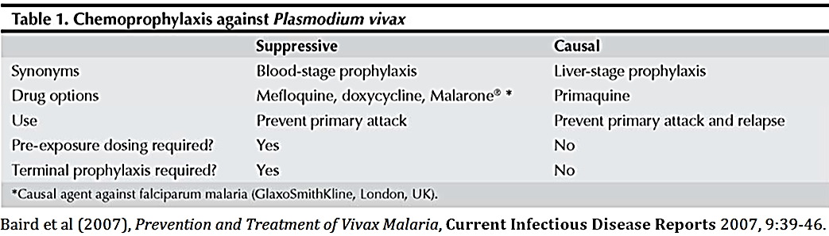

A capsule formulation of tafenoquine was used in earlier clinical studies, including the dose ranging Phase II Study TAF112582 (Part 1). When the dose for Phase III clinical studies was confirmed as 300 mg, a direct compression tablet of tafenoquine (150 mg base) was developed for Phase III trials and was determined to be equivalent to the earlier capsule formulation. The formulation used in the pivotal Phase III trial (Study TAF112582 Part 2) is the same as the proposed commercial product.

Tafenoquine for radical cure of Pv has received orphan drug designation from TGA and ‘informal’ priority review status.

#### Information on the condition being treated

Pv is a parasitic infection of the red blood cell that is transmitted by mosquitoes. Pv infection can have debilitating or life-threatening complications leading to hospitalisations or deaths, such as acute respiratory distress syndrome and renal failure. According to the World Health Organization (WHO), there were an estimated 8.5 million cases of Pv malaria, and 3100 associated deaths in 2015. The highest case numbers of Pv malaria occur in the Southeast Asia region (4.9 million estimated cases in 2015), with the highest burden in India, Indonesia, and Papua New Guinea.

Pv has been eradicated from Australia but suitable vectors are present in northern Australia and the area remains malaria-receptive. Malaria in Australia is a disease associated primarily with residing in or travelling to overseas areas with endemic transmission. In 2013/2014, there were 373 cases of malaria (all species) notified through the Australian national surveillance system.

Pv infection in humans consists of both blood and liver stages. Treatment of the blood stage infection with quinine, chloroquine or artemisinin combination therapy does not clear the liver stage (hypnozoites). The latent liver hypnozoite may then cause relapses days, months or years later.

#### Current treatment options

The aim of any Pv treatment regimen is to both treat the blood stage infection causing symptoms and also remove the hypnozoite burden in the liver which will remain a source of recurrent infection if ineffective treatment is used. Currently, only the 8-aminoquinoline class of drugs (for example, primaquine) can treat the liver hypnozoites and prevent relapse. Using these drugs in combination with standard blood-stage anti-malarial drugs (for example, chloroquine) is called ‘radical cure’ since both the blood and liver stages of Pv are then eliminated.

Primaquine is the only treatment currently registered in Australia for the radical cure of Pv malaria. It is widely used globally for the radical cure of Pv malaria, in combination with chloroquine or artemisinin combination therapy. The licensed dose for primaquine is oral daily dose of 15 mg for 14 days.

### Regulatory status

This is a new chemical entity (NCE) application for Australian regulatory purposes.

#### Orphan drug designation

Tafenoquine was designated an orphan drug on 21 April 2017 for the treatment of radical cure (prevention of relapse) of Pv malaria.

#### International regulatory status

Application for registration of tafenoquine was submitted in the United States (US) on 22 November 2017 and was still under evaluation at the time of this submission to the TGA. The proposed indication in the US is ‘*for the radical cure (prevention of relapse) of Pv malaria in patients aged 16 years and older’.’*[1]

The sponsor has confirmed that the core data submitted to the TGA in support of this application is the same as that submitted to the US Food and Drug Administration (FDA).

### Product Information

The Product Information (PI) approved with the submission which is described in this AusPAR can be found as Attachment 1. For the most recent PI, please refer to the TGA website at <<https://www.tga.gov.au/product-information-pi>>.

## II. Registration time line

The following table captures the key steps and dates for this application and which are detailed and discussed in this AusPAR.

|  |  |
| --- | --- |
| Description | Date |
| Positive Designation (Orphan) | 21 April 2017 |
| Submission dossier accepted and first round evaluation commenced | 11 January 2018 |
| Evaluation completed | 21 June 2018 |
| Delegate’s Overall benefit-risk assessment and request for Advisory Committee advice | 2 July 2018 |
| Sponsor’s pre-Advisory Committee response | 16 July 2018 |
| Advisory Committee meeting | 2 August 2018 |
| Registration decision (Outcome) | 12 September 2018 |
| Completion of administrative activities and registration on ARTG | 13 September 2018 |
| Number of working days from submission dossier acceptance to registration decision* | 147 |

*Statutory time frame is 255 working days from acceptance for evaluation to the decision.

Evaluations included under *Quality findings* and *Nonclinical findings* incorporate both the first and second round evaluations.

## III. Quality findings

### Drug substance (active ingredient)

Tafenoquine succinate is a pale green or pale orange to orange solid. The following is a figure of the chemical structure of tafenoquine.

Figure 1: Chemical structure of tafenoquine

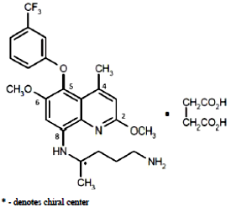

**Molecular formula**: C24H28F3N3O3.C4H6O4

**Molecular weight**: 463.49 g/mol (free base);

581.58 g/mol (succinate)

Tafenoquine succinate is very slightly soluble in water (0.54 mg/mL) and shows pH dependant solubility with higher solubility under acidic conditions (18 mg/mL at pH 2; 0.02 mg/mL at pH 8). It is soluble in methanol but practically insoluble in n-heptane.

Tafenoquine succinate drug substance is produced by chemical synthesis. The drug substance specifications are sufficient to ensure the quality and consistency of the active pharmaceutical ingredient (API).

The drug substance shows good solid state stability and adequate stability data have been provided to support a retest period for the drug substance of 36 months for this drug substance.

### Drug product

The proposed tafenoquine (as succinate) 150 mg tablets are unscored, immediate release, pink, capsule shaped, film coated tablet debossed with ‘GS J11’ on one side and plain on the other.

The tablets are to be marketed in blister packs of 2 tablets only.

The tablets are manufactured by a typical direct compression technique, using excipients which are commonly used in this type of product.

The finished product specifications include tests for appearance, identification, assay, content uniformity, control of related impurities, dissolution and microbial quality. The finished product specifications are considered sufficient to ensure the quality of the finished product at release and throughout the shelf-life. A shelf life of 24 months, stored below 30°C, is supported by the stability data.

All issues raised with the sponsor regarding chemistry and quality control aspects have been satisfactorily resolved, apart from a minor labelling issue.

Chemistry and quality control aspects are acceptable.

### Biopharmaceutics

#### Human Pharmacokinetics

The active entity is the parent drug tafenoquine. Peak plasma concentrations of tafenoquine occurs about 12 to 15 hours after oral administration (time to maximum plasma concentration (Tmax)). Absolute bioavailability has not been determined.

Tafenoquine undergoes minimal metabolism when incubated with cytochrome P450 (CYP) enzymes in vitro and only the parent drug is detectable in plasma after three consecutive daily doses of 400 mg.

Tafenoquine is >99.5% bound to plasma proteins and concentrations measured in whole blood and calculated red blood cell concentrations are 2.0 and 3.4 times higher respectively than plasma concentrations.

The major route of excretion (in animals) is faecal. The plasma elimination half-life (t1/2) of tafenoquine is 15 days.

The pharmacokinetics (peak plasma concentration (Cmax) and area under the plasma concentration versus time curve (AUC)) of tafenoquine after administration of single doses up to 600 mg are dose-proportional.

Administration of single doses with food increased tafenoquine Cmax and AUC approximately 1.3 fold and 1.4 fold respectively when compared with the fasted state. Tmax and t½ were similar in the fasted and fed states. The PI recommends taking the tablets with food.

#### Submitted studies

Clinical Study 022 comparing fed and fasted state exposures of the 200 mg Phase III capsule formulation used the majority of the Phase III clinical studies is considered the most pertinent.

Study 022 was a randomised, parallel group study to compare the bioavailability of tafenoquine from the 200 mg capsule formulation used in the majority of the Phase III clinical studies under fasted and fed conditions. The investigators concluded that administration of tafenoquine 200 mg capsules after a high fat meal resulted in Cmax and AUC values 1.31 and 1.41 times higher respectively than under fasted conditions.

The results support the recommendation in the draft PI to take the tablets with food, although it is noted that this is based only on the Phase III 200 mg capsule formulation and no study examining the effect of food on the tablet formulation proposed for registration was performed.

No studies have been performed to compare the 150 mg tablet formulation proposed for registration directly with the Phase III capsule formulation.

### Quality summary and conclusions

Pending resolution of a minor labelling issue, approval of the registration of the proposed tafenoquine (as succinate) 150 mg tablets is recommended from a chemistry and quality control perspective.

## IV. Nonclinical findings

### Introduction

Overall the nonclinical submission was considered to be adequate.

### Pharmacology

#### Primary pharmacology

##### In vitro susceptibility of malaria parasites

A preliminary in vitro study showed blood schizonticidal activity of tafenoquine (50% inhibitory concentration (IC50) 1130 nM against Sierra Leone Clone D6 resistant to mefloquine, 150 nM against Indochina clone W-2 resistant to chloroquine and pyrimethamine) was 4 to 15 fold greater than primaquine against drug-resistant clones of the malaria parasite Pf. In a published study investigating the activity of tafenoquine and 12 other 8-aminoquinoline compounds against seven Pf clones and isolates, tafenoquine was more effective than primaquine against all isolates with an average IC50 (436 nM, range 59 to 1470 nM) approximately 3 fold lower than primaquine.[2] It would be relevant to note in this same study no cross resistance was observed between tafenoquine and chloroquine or tafenoquine and mefloquine; however, tafenoquine cross resistance correlated significantly with primaquine against blood stage parasites in culture (r = 0.783, p= 0.037). The submission did not include any studies predicting the expected drug-resistance, which would have been useful in understanding the likelihood of the emergence of general resistance to tafenoquine. The 50% effective concentration (EC50) of tafenoquine (209 nM) against the most drug resistant Pf schizont maturation was in the same range as quinine and 2.4 and 10 times greater than the EC50 for chloroquine and mefloquine, respectively.[3] Tafenoquine (mean IC50 4430 nM) was either equal to or approximately 2 fold more potent than primaquine but less potent than chloroquine and mefloquine against multi-drug resistant Pf isolates from Djibouti (East Africa), Gabon (Central Africa) and Senegal (West Africa).[4] The IC50 of tafenoquine and primaquine were comparable (2189.9 nM and 1990 nM, respectively) against Pf clone HB3 (Honduras, chloroquine-sensitive).[5] In the same study tafenoquine against Pf clone Dd2 (Indochina, chloroquine-resistant), exhibited IC50 of 2092 nM which was 2 fold lower than the IC50 of primaquine (4695 nM). Ghanaian Pf isolates (160 from 3 sentinel sites; Cape Coast, Hohoe and Navrongo representing three distinct epidemiological zones) were highly sensitive to tafenoquine (pooled IC50 value of 93.6 nM).[6] These in vitro studies demonstrated schizonticidal activity of tafenoquine and that sensitivity of Pf asexual forms to tafenoquine was greater than to primaquine. The in vitro IC50 values were considerably higher than the expected clinical unbound Cmax (6.47 nM).[7]

##### Susceptibility of different life cycle stages to tafenoquine in vivo

*Blood schizonticidal activity in mice and monkeys*: In mice, subcutaneous (SC) administration of tafenoquine at doses of 16 to 128 mg/kg 72 h after infection with the blood stages of Plasmodium berghei (a rodent malaria), enabled survival of animals for at least 60 days post infection demonstrating the blood schizonticidal activity of tafenoquine (untreated animals died 6 to 8 days after infection). Tafenoquine caused different effects against different malaria strains in Panamanian Aotus trivirgatus monkeys. An oral dose of 1 mg/kg/day tafenoquine (approximately 0.1 times human dose on a μg/m2 body surface area basis) administered for 3 days had no effect or a slight suppressive effect against the Uganda Palo Alto or Vietnam Smith strain Pf. An oral dose of 4 mg/kg/day (approximately 0.3 times human dose on a μg/m2 body surface area basis) administered for 3 days cleared primary parasitemia (Uganda Palo Alto) or recrudescent parasitemia (Vietnam Smith), but cured (defined as no evidence of blood parasitemia for 100 days) only a small number of recrudescent animals infected with Pf (Vietnam Smith strain only). An improved response was seen after 3 daily doses of 16 mg/kg which did cure a higher proportion of primary and recrudescent infections with *P. falciparum*. These data are in contrast to effects against Pv (Chesson strain), where tafenoquine doses of 1, 4 or 16 mg/kg/day (approximately 0.1, 0.3 or 1 times human dose on μg/m2 body surface area basis respectively) administered orally for 3 days cleared primary parasitemia in Aotus trivirgatus monkeys, with cures at doses ≥ 4 mg/kg/day in some primary and recrudescent animals. A combination study investigating tafenoquine and chloroquine showed 100% tissue schizonticidal cures in monkeys. These studies collectively show schizonticidal potential of tafenoquine.

*Prophylaxis in mice and monkeys:* Prophylactic activity of tafenoquine (that is, preventing the schizogony of liver parasites thus preventing entry of erythrocytic forms into the blood), was demonstrated in mice with oral or SC doses of tafenoquine given 4 h prior to infection with sporozoites of *Plasmodium berghei yoelii* (Pby), and prevented parasitaemia when administered at doses greater than 8 mg/kg. In another study, prophylactic activity in mice was demonstrated when 24 mg/kg tafenoquine was administered SC to mice 2 h following inoculation with the sporozoites of *Plasmodium yoelii nigeriensis* (Pyn). Duration of action of tafenoquine administered at doses of 64 mg/kg on day 0 followed by challenge with *Plasmodium yoelii yoelii* sporozoites in mice was determined to be 3 days, and no to limited activity was reported 7 to 21 days prior to challenge. In Rhesus monkeys tafenoquine at oral doses of ≥ 0.3 mg/kg/day (≥ approximately 0.02 times human dose on a μg/m2 body surface area basis) given for 3 days was found to be effective at preventing *Plasmodium cynomolgi* sporozoite induced infection and a single dose of 5.68 mg/kg (approximately 0.4 times human dose on μg/m2 body surface area basis) was fully protective when given 3 days prior to challenge (studied in 3 animals only), but not when given 4 days prior to challenge. These findings indicate that tafenoquine is active against the initial liver stage of malaria infection, consistent with higher levels of tafenoquine found in the liver in the tissue distribution studies.

*Sporontocidal activity in mosquitoes ingesting blood of treated mice*: Tafenoquine had no impact on ookinete production; however, oocyst numbers were significantly reduced in mosquitoes fed on *Plasmodium berghei* (Pb) infected mice, 90 mins after treatment with a single intraperitoneal (IP) dose of 5 to 25 mg/kg tafenoquine. Subsequent salivary gland infection rates were significantly reduced in mosquitoes fed on mice treated with 10 to 25 mg/kg tafenoquine.[8] In another study Pv infected Anopheles dirus mosquitoes (4 days post infection) were fed on uninfected mice treated 90 mins earlier with 100 mg/kg of primaquine or tafenoquine by IP injection. Tafenoquine significantly reduced sporozoite production while primaquine had no effect on sporozoite production.[9]

Administration of tafenoquine (that is, fed on mice 90 min after IP injection of 25 to 100 mg/kg tafenoquine) 4 days after the infectious feed inhibited sporozoite invasion of mosquito salivary glands, but had no impact on sporozoite invasion of the salivary glands when tafenoquine was given 8, 11 or 16 days post-infection. Doses of 6.25 to 100 mg/kg tafenoquine did not affect either the percentage of mosquitoes with oocysts or the number of oocysts per infected mosquito. These studies demonstrated that tafenoquine affects sporogenic development (that is, it inhibits the development of the parasite to sporozoites in the mosquito) of Pb and Pv in mosquitoes at doses of ≥ 25 mg/kg IP in mice, but does not affect oocyst production.

##### Possible mechanisms of action against malaria parasites in vivo

The mechanism of action of tafenoquine is not fully understood. Possible tafenoquine mechanism of action that have been proposed include: (i) tafenoquine inhibits detoxification of haem to haemozin in the parasite;[10],[11] (ii) tafenoquine pro-oxidant properties may have blood schizonticidal activity;11 and (iii) tafenoquine causes destruction of internal structures of the mitochondria causing the organelles to swell;[12] and (iv) possible disruption of mitochondrial function in *Leishmania* promastiogotes leading to apoptosis death.

Nonclinical data have demonstrated that tafenoquine is active against the liver and blood stages of malaria infections in mice and monkeys and also has activity against sporozoite development in mosquitos.

#### Safety pharmacology

Safety pharmacology studies covered the central nervous (CNS), respiratory and the cardiovascular systems. No CNS drug related effects (including microscopic findings of the brain) were observed at doses up to 500 mg/kg (approximately 25 times the clinical dose based on Cmax) in rats. Tafenoquine inhibited potassium (hERG) current with an IC50 of 0.51 µg/mL (>200 times the expected clinical Cmax of tafenoquine (unbound)). In isolated dog Purkinje fibres, exposure to tafenoquine at concentrations of 0.46 and 4.64 μg/mL showed no potential to prolong QT interval;[13] (although nonspecific effects were observed at the highest concentration of 46.4 µg/mL). IV infusion of tafenoquine at doses or 18.6 to 64.8 mg/kg for 20 mins produced dose-related effects on cardiopulmonary parameters in anaesthetised dogs (which included decrease in blood pressure, increase in stroke volume, mean pulmonary artery and pulmonary wedge pressures, a rise in respiratory rate and volume and depressed tidal volume and death of one dog). Tafenoquine is not intended to be given by the intravenous (IV) route and when administered orally at doses up to 16 mg/kg (approximately 7 times the clinical dose based on Cmax) to conscious dogs, there were no treatment related effects on either cardiovascular or electrocardiogram (ECG) parameters up to 170 h (7 days) after dosing. Therefore, cardiovascular effects may not be of potential clinical significance given that no effects were observed when dogs were dosed orally.

### Pharmacokinetics

#### Absorption

Oral bioavailability was high in dogs (approximately 80%). Tafenoquine levels were observed to peak relatively slowly after oral dosing in all species tested (with Tmax in the mouse being 6 to 12 h; in the rat 8 to 12 h; and in the dog 4 to 12 h). There were no observed differences in absorption parameters between male and female animals. The t½ following oral dosing of tafenoquine to dogs was highly variable between animals but was not affected by dose, showing mean elimination t½ ranging from 2.25 to 6.9 days. In the monkey mean t½ was 2.3 days. After a single dose, the elimination in humans was much slower (14 days in males) than in animals.[14]

#### Distribution

Tafenoquine is highly protein bound (generally >99%) across animal species. There was also a high uptake of circulating tafenoquine and metabolites into red blood cell (RBC) in vivo in dogs (blood/plasma ratio: 2 to 4 based on blood and plasma AUC for tafenoquine and 1.2 in vitro incubation in blood) and rats (blood/plasma ratio 2.6 in vitro incubation in blood) but not monkeys (blood/plasma ratio: 1.1 based on AUC for total radioactivity), and there was moderate uptake of tafenoquine to human red blood cell (RBC) (blood/plasma ratio: 1.4 in vitro incubation in blood). Tissue distribution was studied in rats where orally administered radio-labelled tafenoquine was distributed relatively slowly but was widespread as shown by measureable peak exposure around 12 to 24 h across a large number of body tissues. The decline in radioactivity was slow with tissue radioactivity still measureable at 10 days after a single PO dose of 0.5 mg/kg. Apart from the intestines, exposure was highest in the lung, liver, spleen, kidney, adrenal cortex, pituitary, ovary and Harderian gland and lowest in the brain, spinal cord and white fat. Concentration of radioactivity in the body tissues was generally higher than those in the blood with the exception of the brain and the spinal cord which was similar to levels measured in blood.

#### Metabolism

No metabolism of tafenoquine could be detected in in vitro systems (rat, dog and human microsomes or human hepatocytes) mainly due to analytical issues and lack of sensitivity of assays, which prevented simple cross species comparison. In rats and dogs, tafenoquine was found to be the primary circulating component in plasma at all time-points examined as reported in humans, and unchanged tafenoquine was the primary extractable drug-related component observed in extracts of rat and dog liver homogenate. Absorbed tafenoquine eliminated via the bile was primarily in the form of desaryl metabolites, with low levels of detectable tafenoquine. In dogs and rats, metabolites in urine were predominantly in the form of desaryl metabolites, where the trifluoromethyl benzene group had been removed (accounting for 1 to 2% of the dose). Routes of phase I metabolism in the rat and dog also included O-demethylation, oxidation (to alcohols, ketones and carboxylic acids) and deamination, similar to the pathways in humans. Phase II metabolism consisted of N-glucuronidation, carbamyl glucuronidation and possibly glucuronidation of hydroxyl groups, which also occur in humans. The structure of metabolites in rat faeces was not obtained. In dog faecal metabolites, the majority were identified but structural identity was unclear. Faecal metabolite profiles in the rat and dog were less complex than those in the bile. Detection of predominantly unchanged tafenoquine in the plasma of nonclinical species and metabolism and excretion in bile and urine are also similar between animal species.

#### Excretion

The major route of excretion in the rat, dog and monkey was via the faeces and to a lesser extent via the urine. In the dog, the approximate ratio of faecal to urinary excretion was 3 to 7:1 while in the rat was approximately 10:1. Overall excretion of radioactivity was slow; approximately 60% and 80% of a single dose was excreted in faeces and urine within 10 days of administration in the dog and monkey respectively and 90% and 79% was excreted within 7 to 5 days in the rat following a single oral dose of 2 or 25 mg/kg respectively. Biliary excretion was demonstrated in bile-cannulated rats and dogs, with approximately 5% of the dose found in bile in rats (compared with 75% in faeces in 4 days) and equal amounts in bile and faeces in dogs (approximately 20% of dose in 7 days) following oral dosing. Human radiolabelled mass balance studies have not been conducted to characterise the clinical excretion of tafenoquine.

Considering the metabolic profiles of tafenoquine in rats, dogs and humans, the similarity in protein binding and RBC uptake of tafenoquine in humans and these nonclinical species, rats and dogs are adequate animal models for the assessment of tafenoquine.

#### Pharmacokinetic drug interactions

In vitro tafenoquine demonstrated only very weak inhibition of CYP1A2, CYP2A6, CYP2C8, CYP2C9 and CYP3A4 with IC50 values of 16, 6.7, 7.2, 4.8 and 3.4 to 8.6 µM respectively (that is, > 800 times the expected clinical unbound Cmax), indicating low potential for clinical relevance. Oral administration of tafenoquine to rats at dose levels up to 9.0 mg/kg/day for 56 consecutive days did not affect total CYP450 proteins and had no marked effect on CYP1A, CYP2E, or CYP4A; however induction of CYP3A (approximately 2 fold increase) was observed in male rats at the highest dose level of 9.0 mg/kg/day (approximately 15 times the clinical exposure based on AUC). In vitro tafenoquine (up to 50 µM) failed to activate the human pregnane-X-receptor relative to the positive control rifampicin, thus it might not cause induction of CYP3A4 genes. Oral administration of tafenoquine to dogs at 4.0 mg/kg/day (approximately 23 times clinical exposure based on AUC) for 56 consecutive days, decreased the activities of a number of enzymes, including CYP2C and/or CYP2B, CYP2E, CYP3A and CYP4A. Decreased CYP3A and 4A activities were also observed at 1 mg/kg/day. Given the conflicting results of CYP3A induction/inhibition in rats and dogs, the effects on CYP3A activity in patients are uncertain.

In vitro tafenoquine inhibited the renal transporters organic cation transporter 2 (OCT2) and multidrug and toxin extrusion transporters 1 and 2-K (MATE1 and MATE2-K) with IC50 values between 65 and 460 times the expected clinical unbound Cmax indicating a small potential clinical risk of interactions with OCT2 and MATE substrates. In dogs, there was evidence of minor interactions when tafenoquine was co-administered with chloroquine (51% increase in tafenoquine AUC and 45% increase in Cmax) or quinine and doxycycline (approximately 35% decrease in tafenoquine AUC and Cmax), suggesting potential interactions in humans.

### Toxicology

#### Acute toxicity

Single-dose toxicity studies were conducted in mice, rats, guinea pigs and rabbits (IP and PO), with limited observations performed over 14 days (which was sufficient to observe delayed toxicity effects and recovery). The maximum non-lethal oral dose for male and female mice was 84 mg/kg for male and female rats it was 172 and 220 mg/kg respectively, for male guinea pigs it was 242 mg/kg and for female rabbits < 332 mg/kg (mortality at all doses). The maximum non-lethal IP dose for male and female mice was 36.8 mg/kg, for male and female rats was <28 and 28 mg/kg respectively, for male guinea pig was 10.9 mg/kg and female rabbits was 18.4 mg/kg. The mouse was the species most sensitive to tafenoquine (showing 3 to 4 fold lower 50% lethal dose (LD50), followed by the guinea pig and the rat). High single doses at or near the lethal doses produced non‑specific clinical signs of toxicity in the different species and dosing routes. These generally included observations of rough coat, nasal/ocular discharge, hyperactivity, abnormal/laboured respiration, lethargy, hunched posture, tremors, bloated/distended abdomen (IP route), prostration and paralysis. The rabbit also showed signs of soft stools, diarrhoea and reduction in food and water consumption. In the guinea pig, oral doses causing lethality caused a pale liver, a fluid-filled abdomen and distended caecum. Death and/or clinical signs were generally noted at high doses within the first few days following dosing and if animals survived, recovery was seen after 1 week. In all species, acute IP dosing was associated with greater toxicity and lower LD50 values; however this is of limited relevance as tafenoquine is intended for oral administration and the oral route showed moderate acute toxicity.

#### Repeat-dose toxicity

Studies of up to 52 weeks duration were conducted in mice, rats, and dogs, including pivotal Good Laboratory Practice (GLP) compliant studies of 13 weeks in mice, 1-6 months in rats and 1-12 months in dogs. Tafenoquine was administered orally by daily gavage, consistent with the route of administration in humans. Group sizes and study duration were adequate. The studies conducted were generally consistent with relevant guidelines on repeated dose toxicity.

##### Relative exposure

Exposure ratios were calculated based on animal: human plasma steady state AUC0–8 week for pivotal repeat-dose studies. Human reference values are from clinical Study 200951 where healthy volunteers were administered a single dose of 300 mg (24 participants) and AUC0-8week were determined. The AUC0-8week in the nonclinical studies was extrapolated from values derived from AUC0-24 h values (both sexes combined as they were similar). Most rodent and dog studies did not include toxicokinetics measurements. When data was not available, it was calculated by extrapolation from studies of shorter duration (see Table 2 below).

In studies of 13 weeks or longer the predicted relative exposures were up to 3.5 in mice, 29.5 in rats and 34.5 in dogs which were adequate.

Table 2: Comparative assessment of relative exposure in repeat-dose toxicity and carcinogenicity studies

|  |  |  |  |  |
| --- | --- | --- | --- | --- |
| Species | Study duration [Study no.] | Dose mg/kg/day | AUC0–8 week^ µg∙h/mL | Exposure ratio# |
| Mouse (CD‑1) | 13 weekA  [Study G99554, RSD-101BOJ] | 0.1 | 11.5 | 0.1 |
| 0.3 | 33.8 | 0.4 |
| 1.0 | 114 | 1.2 |
| 3.0 | 342 | 3.5 |
| Rat (SD) | 13 weeksB  [Study 098, RSD1018RN] | 0.5 | 53.2 | 0.5 |
| 6 | 955.7 | 9.8 |
| 18 | 2867.2 | 29.5 |
| 26 weeksB [Study SBF 152,RSD1018S9] | 0.5 | 53.2 | 0.5 |
| 2 | 223.7 | 2.3 |
| 9 | 1433.6 | 14.7 |
| 2 yearsC [carcinogenicity; data collected at 12 months Study 9200-02-04,RD2007/01198] | 0.1 | 10.1 | 0.1 |
| 0.5 | 98.9 | 1.0 |
| 1.0 | 271.1 | 2.8 |
| 2.0 | 598.2 | 6.2 |
| Dog (Beagle) | 13 weeksD  [Study 097, RSD1018L3] | 0.1 | 54.7 | 0.6 |
| 2.0 | 1668.8 | 17.2 |
| 6.0 | 3351.6 | 34.5 |
| 52 weeksD  [Study 219, RSD-100V3Z] | 0.1 | 54.7 | 0.6 |
| 1 | 834.4 | 8.6 |
| 4 | 2234.4 | 23.0 |
| Monkey cynomolgus | 4 daysE  [Study RSD-1016TK] | 3 | 34.3 | 0.4 |
| 6 | 53.8 | 0.6 |
| 12 | 55.3 | 0.6 |
| Human (healthy volunteers) | Steady state  [Study 200951] | [300 mg] | 97.2 | – |

ABased on pharmacokinetic data from an 8 week PK study (802-589/RSD101DSB) with doses of between 0.1 to 1 mg/kg/day, and assuming linear pharmacokinetics between 0.1 and 3 mg/kg/day; BBased on pharmacokinetic data from an 8-week PK study (SBF-232/RSD-1011XG) with doses of between 0.5 and 9 mg/kg/day, and assuming linear pharmacokinetics between 0.5 and 18 mg/kg/day; C Pharmacokinetic data at 12 months; D Based on pharmacokinetic data from an 8 week PK study (SBF-233/RSD-1011XH) with doses of between 0.1 and 4 mg/kg/day, and assuming linear pharmacokinetics between 0.1 and 6 mg/kg/day; E=AUC calculated over 31 days and not 24 h; ^ AUC0-8week values were calculated by multiplying AUC0-24h by 56 for mice, rats and dogs and AUC0.744h by 1.806 for monkeys; # animal:human plasma AUC0–8 week; ^ = data are for the sexes combined at the last sampling occasion.

##### Major toxicities

The major target organs for tafenoquine were the lung (phospholipidosis), liver (centrilobular inflammation, apoptosis, fatty change and increased plasma transaminases) and kidney (tubular nephrosis, necrosis and dilation at 13 weeks in the rat; not present in the dog). Mortalities occurred in mice at ≥ 3 mg/kg/day (relative exposure ≥ 4) and in rats at ≥9 mg/kg/day (relative exposure ≥ 15). Other principal and consistent recurrent toxicological findings included poor clinical conditions, reduced food consumption and weight gain, increased methaemoglobin (MetHb), the appearance of blue tongue or gums in the dog, blue skin/ears and pallor in rats, mild anaemia associated with compensatory erythropoiesis, increased deposition of brown/haemosiderin pigment in a number of tissues, bone marrow hyperplasia in rats and dogs, increased spleen weight (all species) and splenic hyperplasia, as well as splenic congestion and pooling of red blood cells in rats and dogs, increased adrenal weight, pigmentation and congestion in the rat, and lymphocyte depletion/necrosis in lymphoid tissues in rats and dogs. These effects were both time and dose dependent and showed partial or complete reversibility.

Lung phospholipidosis was observed in all pivotal repeat dose toxicity studies in mice, rats and dogs, and was characterised by increases in the number of foamy macrophages, presence of eosinophilic material in lung alveolar spaces and alveolar proteinosis. Generally no functional consequences to the pathology were observed (except in the case of one dog receiving 4.0 mg/kg/day (predicted exposure ratio 23) in the 52 week study which showed increased respiratory rate and also showed the largest lung weight increase compared to other similarly dosed males). In rats and dogs these effects were reversed during the recovery period; however, chronic inflammation of minimal severity and hemosiderin deposition in alveolar macrophages of the lungs developed. Phospholipidosis was also seen by electron microscopy in kidneys of rats in a 13 week study. Phospholipidosis has been associated with this class of drugs, including chloroquine and other cationic amphiphilic drugs (for example, amiodarone, fluoxetine), in animal species and humans.

Tafenoquine related liver changes were observed in dogs and rats. The dog appeared more sensitive to the liver changes. A minimal to mild chronic inflammation of the liver was seen in treated dogs with an increase in haptoglobin levels, haemosiderin deposits and minimal subacute inflammation with the addition of Kupffer cell hypertrophy or Kupffer cell pigmentation and in severe cases hepatocellular necrosis (predicted exposure ratios 23). All changes in dogs showed reversibility over 13 weeks except haemosiderin deposits which remained. Mild hepatic effects were evident in the rat, shown by an increase in serum aspartate aminotransferase at ≥ 9 mg/kg/day (predicted exposure ratio 15) and increased liver weight in males only at 27.7 mg/kg but with no associated pathology. The liver pathology of male rats dosed for 26 weeks at 9.0 mg/kg/day (predicted exposure ratio of 15) showed apoptosis, brown pigmentation and fatty change; the fatty change, also being evident in males at 2.0 mg/kg (predicted exposure ratio of 2).

Tafenoquine related changes were also observed in the kidneys and included brown pigment (haemosiderin), eosinophilic droplets (consistent with haemoglobin and haemoglobin related material), focal cortical tubular basophilia in the cortical tubular cells, and diffuse cytoplasmic basophilia and karyomegaly in the outer strip of renal medulla in rats dosed with 2 or 18 mg/kg/day in a 13 week study. There was also diffuse medullary epithelial vacuolation and single cell necrosis at 18 mg/kg/day. In the 26 week study, pigment was noticed in kidney tubules at 2 and 9 mg/kg/day, but eosinophilic droplets were not described. Renal tumours were observed in the carcinogenicity study (discussed below).

Haematological changes were observed across the studies. In rats a mild anaemia (up to approximately 15% reduction in red blood cell count, haematocrit, haemoglobin concentration, mean cell haemoglobin and/or mean cell haemoglobin concentration) was evident, probably as a result of haemolysis induced by tafenoquine. In the dog a mild dose-related anaemia was similarly seen and changes included a decrease in red blood cell count, haemoglobin levels, haematocrit, mean cell haemoglobin and/or mean cell haemoglobin concentration up to a maximum of approximately 20%. MetHb level increase was observed in both rats and dogs and recovery was evident in both species. The red blood cell changes, MetHb, bone marrow and spleen hyperplasia, and haemosiderin deposition are consistent with oxidative red cell damage and death and are known effects of 8-aminoquinoline compounds and so would need to be monitored in clinical studies. Other observations that could possibly be secondary changes as a result of anaemia include splenic and bone marrow hyperplasia, haemosiderin deposits in the kidney and bone marrow, and protein nephropathy. Lymphocyte depletion in the spleen (but not in other lymphoid tissues) was observed in the 4 week rat study at ≥ 27.7 mg/kg/day. In dogs, lymphocyte depletion and/or necrosis were seen in spleen, lymph nodes and thymus at ≥ 3.1 mg/kg/day for 4 weeks, and lymphocyte depletion in thymus (not in spleen or lymph nodes) at ≥ 2 mg/kg/day for 13 weeks. There was no lymphocyte depletion in rats in the 3 and 6 month studies or in dogs in the one-year study, and peripheral lymphocyte counts were unaffected in all toxicity studies.

In vitro tafenoquine had minimal effect on the heart (unlike primaquine). Heart pathology was only observed in the mouse after 13 week dosing (related myocardial degeneration with or without inflammation) and was not seen in the 2 year mouse carcinogenicity study. In rats a decrease in the heart weight was observed at ≥ 2 mg/kg/day with no associated pathology. No heart weight change or heart pathology was observed in dogs in any of the studies. Animal studies predict low risks of myocardial effects in humans.

#### Genotoxicity

The genotoxic potential of tafenoquine was tested in bacterial reverse mutation assays, in gene mutation assays in mammalian cells (mouse lymphoma cells and Chinese hamster ovary cells), in vitro chromosome aberration assays in Chinese hamster ovary cells, and in vivo mouse micronucleus test. This testing strategy was consistent with relevant European Union (EU) guideline.[15] All the studies were negative except for a weakly positive result in the mouse lymphoma cell assay with metabolic activation. The in vitro studies indicated that tafenoquine was not mutagenic or clastogenic however generally these assays used limited to very low test concentrations of tafenoquine (5 to 10 µg) due to cytotoxicity. A single dose of 400 mg/kg tafenoquine (relative exposure of 6 based on body surface area) did not increase micronucleus formation in mice.

A Good Laboratory Practice (GLP) bacterial Ames assay was also performed with GSK3172964A, an N-nitroso metabolite of tafenoquine. GSK3172964A was not mutagenic in the bacterial mutation assay.

#### Carcinogenicity

The carcinogenic potential of tafenoquine by the oral route was assessed in mice and rats in conventional 2 year oral carcinogenicity studies as per the relevant EU guidelines. In the mice study, the group sizes used (n=60/sex) and the duration of dosing (2 years) were appropriate. However, the selection of the dose tested was based on maximum tolerated dose (1 mg/kg) in a dose range finding study and was limited to only approximately 1.2 times the clinical AUC. There were no treatment related increases in tumour development in the mice study at these low doses. In the lungs there was a higher incidence of eosinophilic histiocytes (indicative of phospholipidosis) and alveolar crystals in mice given 1.0 mg/kg/day which were also reported and discussed in the repeat dose studies.

In the rat carcinogenicity study, tafenoquine was given daily, by oral gavage, to rats at doses of 0, 0.1, 0.5, 1 or 2 mg/kg/day (equivalent to approximately 0.1, 1.0, 2.8, 6.2 times the clinical AUC) for 2 years. Incidence of renal tumours (renal cell adenoma at 1 and 2 mg/kg/day with only one incidence of carcinoma at 2 mg/kg/day) and cortical hyperplasia (male rats at 2 mg/kg/day) were observed. Chronic progressive nephropathy (CPN) was increased in male rats at 1 and 2 mg/kg/day. CPN is a common renal lesion in male rats with no counter-part in humans, is exacerbated by many chemicals and drug substances and is considered a risk factor for renal tubular hyperplasia and tumours. In a 13 week study, immunostaining of kidney sections showed increased Ki67 and proliferating cell nuclear antigen, both of which are markers of cell proliferation, in females at 18 mg/kg/day and in males at ≥ 2 mg/kg/day. In the same 13 week study there were karyomegaly in the outer strip of renal medulla at 2 or 18 mg/kg/day, and diffuse medullary epithelial vacuolation and single cell necrosis in both sexes at 18 mg/kg/day. The above findings, together with the absence of genotoxicity point to a non-genotoxic mechanism of renal carcinogenicity. The renal tumours in rats probably resulted from chronic cellular damage leading to cell regeneration, proliferation, hyperplasia and finally renal tumours. The exact mechanism is unclear but CPN might be a contributing factor since renal tumours were observed only in male rats. The renal tumours in rats are considered clinically relevant. However, the risk of renal tumours in humans is low given (i) proposed single dose compared with the life time exposure in the rat carcinogenicity study, (ii) the absence of tumours in the 6-month rat study and in the mouse carcinogenicity study, and (iii) the absence of hyperplasia of renal tubule cells in the one year dog study.

#### Reproductive toxicity

A GLP fertility and embryonic development study in rats was submitted in which tafenoquine was administered to males for 67 to 69 days and to pregnant females for 15 days before cohabitation , during cohabitation and from Day 0 to 6 of pregnancy. Embryofetal development was studied in rats and rabbits. Tafenoquine was administered daily during organogenesis (gestation days (GD) 6 to 15 in rats or GD 6 to 18 in rabbits). Caesarean sectioning was performed on GD 20 in rats and GD 29 in rabbits. A GLP postnatal development study was performed in rats where tafenoquine was administered to pups from GD 6 to postnatal day (PND) 21 and terminated on PND 21. These studies were consistent with the relevant EU guideline.[16] Pharmacokinetics data was not provided and placental transfer and excretion of tafenoquine into milk were also not assessed.

In the fertility study no effects on mating and fertility indices, oestrous cycles, sperm motility, sperm count or morphology were observed in rats, when tafenoquine was given at doses 1.5, 5 or 15 mg/kg/day (up to approximately 25 times the clinical exposure based on AUC from Study SBF232/RSD1011XG). Females dosed with 15 mg/kg/day showed a statistically significant decrease p<0.05) in the number of corpora lutea, the number of implantations and ultimately the number of viable fetuses compared to control animals, which suggest that dosing with 15 mg/kg/day for 15 days prior to mating affected oocyte maturation but not ovulation, mating behaviour, implantation or embryonic development. Maternal and paternal toxicity was observed at 15 mg/kg/day and to a lesser extent at 5 mg/kg/day and was characterised by clinical signs (piloerection, rough coat and audible breathing or increased respiratory rate) and by significantly decreased body weight gain. The No observable adverse effect level (NOAEL) for effects on female fertility was 5 mg/kg/day (approximately 8 times the clinical exposure). No gross or histopathology findings were noted in the testes or prostate of the male rats administered tafenoquine at doses up to 18 mg/kg/day for thirteen weeks (Study 098/RSD 1018RN).

Pregnant rats at doses up to 30 mg/kg/day and rabbits at doses up to 25 mg/kg showed maternal toxicity at ≥ 10 mg/kg in the rat and 25 mg/kg in the rabbit. These maternally toxic doses did not cause fetal toxicity, and tafenoquine was not teratogenic in either species at any dose. The highest dose in the rat and rabbit embryofetal development studies was 7 times (rat) and 11 times (rabbit) the clinical dose on an mg/m2/week basis.

In the pre/postnatal development study, tafenoquine had no effect on pregnancy, parturition or lactation in rats at up to 18 mg/kg/day in spite of maternal toxicity observed at this dose level. However, alterations in pup body weights, slight developmental and functional delays in offspring including delayed eye opening and decreased rearing activity were observed at this dose. There were no postnatal effects at 6 mg/kg/day.

#### Pregnancy classification

The sponsor has proposed Pregnancy Category C.[17] Placental transfer of tafenoquine in rats and rabbits were not determined. Anaemia (haemolysis) and methaemoglobinaemia may occur in the fetus due to pharmacological activity of the drug, although there was no evidence of these effects in pups born from rats dosed with up to 18 mg/kg/day tafenoquine during gestation and lactation. However, fetuses with G6PD deficiency in patients may be susceptible to haemolysis induced by tafenoquine. Therefore, Pregnancy Category C is considered appropriate.

#### Juvenile studies

Table 3 describes the exposure ratios for the juvenile studies.

Table 3:  Relative exposure in juvenile studies

|  |  |  |  |  |
| --- | --- | --- | --- | --- |
| Species | Study [Study no.] | Dose (mg/kg/day) | AUC0–8 weeks (µg∙h/mL) | Exposure ratio# |
| Rat (SD) | Juvenile rat  8 weeks  R43239G/ 2015N233460 | 5/10 | 215 | 2.2 |
| 15/20 | 418 | 4.3 |
| 25/50 | 1120 | 11.5 |
| Human (healthy volunteers) | Steady state  [Study 200951] | [300 mg] | 97.2 | – |

AUC calculated over 5 days and not 24 hours; # = animal: human plasma AUC0–8 week

Tafenoquine was generally well tolerated by juvenile rats when dosed orally every 5 days from post-natal Day (PND) 7 at doses of 5, 15 or 25 mg/kg and from PND 27 to 62 at 10, 20 or 50 mg/kg (up to 12 times the clinical exposure based on AUC). Tafenoquine related effects were similar to those seen in adults and included decreased body weight gain and food consumption, anaemia, increases in methaemoglobin formation, minimal/slight microscopic changes in the spleen, lung and kidney associated with macroscopic pathology and increased weight in the spleen, liver and kidney with some associated minor disturbances in clinical chemistry and urine analysis in males and/or females. These changes were generally reversible. There was no tafenoquine related effect on growth or development, including pre-weaning body weight gain, long bone length, sexual maturation, and neuro-behavioural function.

#### Local tolerance

Local tolerance studies were performed for worker health and safety purposes. Tafenoquine was a mild/moderate irritant to intact/broken skin of rabbits, severe irritant to the eye of rabbits and a potential skin sensitiser in mice.

#### Phototoxicity

The phototoxicity of tafenoquine was assessed in a validated in vitro assay (3T3 Neutral Red uptake). Tafenoquine was considered ‘probably phototoxic’ after producing a photo-irritation factor (PIF) of 4, calculated from concentrations which caused 50% inhibition (IC50) of Neutral Red uptake into Balb/c 3T3 fibroblast cells in the presence and absence of ultra-violet A. A tissue distribution study in albino rats showed minimal distribution to skin and uveal tract (pigmented tissue). No further testing for phototoxicity was performed which is consistent with the relevant EU guidance.[18]

#### Impurities

All identified impurities have been assessed for potential mutagenicity and are considered non-mutagenic or are below the threshold of toxicological concern TTC.

### Nonclinical summary

* Pivotal core safety pharmacology, toxicokinetic and repeat dose toxicity studies were GLP compliant and were generally conducted in accordance with the relevant EU guidance.[19]
* Tafenoquine affects multiple aspects of the malaria life cycle. In vitro blood schizonticide activity of tafenoquine was demonstrated to be 2 to 15 fold greater than primaquine. In vivo blood schizonticidal and prophylaxis activity was demonstrated in mice. In monkeys tafenoquine showed slow acting schizonticide activity in the treatment of malaria infection. Together these studies demonstrated that tafenoquine kills the early hepatic stages of the parasite that result from sporozoite infection of the liver after a mosquito bites the host and is also a slow acting blood schizonticide. However the actual mechanism of action of tafenoquine was not defined.
* Safety pharmacology studies assessed effects on the cardiovascular, respiratory, and CNS. No adverse effects were seen on CNS function (including microscopic findings of the brain) in rats, or respiratory function in dogs. Significant tafenoquine inhibition of potassium (hERG) channel tail current was observed in a dose dependent manner in vitro (IC50 > 200 times the expected clinical Cmax of tafenoquine). However, when administered orally at doses up to 16 mg/kg (7 times the clinical dose based on Cmax), there were no treatment related effects on either cardiovascular or ECG parameters and therefore tafenoquine is not predicted to prolong the QT interval in patients.
* Single doses of tafenoquine in mice, rats and dogs demonstrated slow absorption and elimination with Tmax of 4 to 12 h (similar to humans) and elimination t1/2 of 2 to 7 days, compared with 14 days in humans. Tafenoquine is highly protein bound (generally >99%) across animal species. Minimal metabolism of tafenoquine occurred in all species and generally only tafenoquine was extracted in the plasma of all species. The major route of excretion in the rat, dog and monkey was via the faeces (with biliary excretion) and to a lesser extend via the urine.
* Single dose toxicity studies in rats, guinea pigs and rabbits (by the oral route) showed moderate to acute toxicity.
* Pivotal repeat dose studies were conducted in mice, rats and dogs with low exposures. The major target organs for tafenoquine were lung (phospholipidosis), liver (centrilobular inflammation, apoptosis, fatty change and increased plasma transaminases) and kidney (tubular nephrosis, necrosis and dilation at 13 weeks in the rat; not present in the dog). Mortalities occurred in mice at ≥ 3 mg/kg/day (relative exposure of ≥4) and in rats at ≥9 mg/kg/day (relative exposure of ≥ 15). Other principal and consistent recurrent toxicological findings included poor clinical conditions, reduced food consumption and weight gain, decreased red cell parameter values, increased methemoglobin (MetHb), the appearance of blue tongue or gums in the dog, blue skin/ears and pallor in rats, mild anaemia associated with compensatory erythropoiesis, increased deposition of brown/haemosiderin pigment in a number of tissues, bone marrow hyperplasia in rats and dogs, increased spleen weight (all species) and splenic hyperplasia, as well as splenic congestion and pooling of red blood cells in rats and dogs, increased adrenal weight, pigmentation and congestion in the rat, and lymphocyte depletion/necrosis in lymphoid tissues in rats and dogs. These effects were both time and dose dependent and showed partial or complete reversibility.
* Tafenoquine was not mutagenic in bacterial reverse mutation assays and in vivo micronucleus tests. Overall, tafenoquine is not considered to present a genotoxic risk to humans.
* In a two year rat carcinogenicity study, an increase in the incidence of renal tumours and hyperplasia in male rats was observed following oral administration of 1.0 and/or 2.0 mg/kg/day (clinical exposures of 3 and 6 respectively based on AUC). Increased cell proliferation, karyomegaly and diffuse medullary epithelial vacuolation and single cell necrosis were observed in both sexes in a 13 week study at 2 and/or 18 mg/kg/day (approximately relative exposure of 2 and 30). The above findings, together with the absence of genotoxicity point to a non-genotoxic mechanism of renal carcinogenicity. The renal tumours in rats probably resulted from chronic cellular damage leading to cell regeneration, proliferation, hyperplasia and finally renal tumours. The exact mechanism is unclear but CPN was increased in male rats at these doses, suggesting CPN might be a contributing factor since renal tumours were observed only in male rats. CPN is a common renal lesion in male rats with no counter-part in humans, and is not considered relevant to human risk assessment. Considering other findings described above in both sexes in the 13 week study and that the exact mechanism is unclear, renal tumours in male rats treated with tafenoquine are clinically relevant. Tafenoquine was not carcinogenic in a life time study in mice at up to 1 mg/kg/day for 2 years. There is a low risk of carcinogenicity in humans from the proposed single dosing regimen.
* In fertility studies, female rats dosed with 15 mg/kg/day (approximately 25 times the clinical exposure based on AUC) showed a statistically significant decrease (p<0.05) in the number or corpora lutea, resulting in decreased number of implantations and viable fetuses. There was no effect on male fertility in rats. In embryofetal development studies, tafenoquine was not teratogenic in rats or rabbits. In a postnatal development study, developmental and functional delays were observed in rat offspring at the highest dose of 18 mg/kg/day (approximately 30 times the clinical AUC).
* Tafenoquine-related effects in juvenile rats were similar to those seen in adults and were generally reversible. There was no tafenoquine-related effect on growth or development, including pre-weaning body weight gain, long bone length, sexual maturation and neuro-behavioural function.
* In vitro inhibition of renal transporter OCT2, MATE1 and MATE2‐K (based on unbound Cmax and IC50 values) indicate a weak potential interaction of tafenoquine with OCT2 and MATE.
* Tafenoquine showed low potential to be phototoxic in a validated in vitro assay (3T3 Neutral Red uptake). The in vitro phototoxicity results and low distribution to skin in rats suggest low risk of phototoxicity in humans.

### Nonclinical conclusions and recommendation

* Overall the nonclinical submission was considered adequate.
* The primary pharmacology studies support the use of tafenoquine for the proposed indication.
* The major target organs for tafenoquine in repeat dose studies were the lung (phospholipidosis), liver (centrilobular inflammation, apoptosis, fatty change, and increased plasma transaminases) and kidney (tubular nephrosis, necrosis and dilation at 13 weeks in the rat; not present in the dog). These findings are clinically relevant.
* Tafenoquine does not pose a genotoxic hazard but caused renal tumours in male rats through a non-genotoxic mechanism, probably as result of chronic cellular damage leading to cell regeneration, proliferation, hyperplasia and finally renal tumours. There is a very low risk of developing renal tumours in humans from the proposed short term use.
* Tafenoquine is not teratogenic. Postnatal developmental and functional delays were observed in the offspring of rats at approximately 30 times the clinical exposure based on AUC.
* Pregnancy Category C17 is considered appropriate based on the expected haemolytic effects on fetuses with G6PD deficiency in patients. Use during pregnancy and breastfeeding is not recommended.
* Provided the above effects are adequately monitored or managed during clinical use and that the benefit/risk profile seems acceptable from a clinical perspective, there are no objections on nonclinical grounds to the proposed registration of tafenoquine succinate (Kozenis).
* The nonclinical evaluator recommended amendments to the draft PI but the details of these are beyond the scope of this AusPAR.

## V. Clinical findings

A summary of the clinical findings is presented in this section.

### Introduction

#### Clinical rationale

According to the sponsor, compliance with the 14 day primaquine dosing regimen in the real world is poor, resulting in a decrease in efficacy. Tafenoquine is proposed to be administered as a single dose for the radical cure of *Plasmodium vivax* (Pv) malaria. The simple dosing regimen is anticipated to provide higher treatment adherence in the real-world setting, resulting in improved individual and public health outcomes.

Evaluation of the background information did not raise any major concerns. The clinical rationale is sound. Primaquine is currently approved in Australia for radical cure of malaria caused by Pv. The approved indications for primaquine in Australia are:

* ‘*Prevention of relapses (radical cure) of malaria caused by Pv and P. ovale*
* *adjunctive therapy in the treatment of gametocytemia due to Pf in patients resident in areas receptive to malaria’*[20].

#### Formulation

##### Formulation development

A capsule formulation was used in earlier clinical studies, including Study TAF112582 Part 1 (Phase IIb dose-ranging study; a supportive efficacy/safety study in this submission), to determine the appropriate therapeutic dose for Phase III clinical studies. When the dose for Phase III clinical studies was confirmed as 300 mg, this dose was considered too large to proceed with a capsule formulation due to the density of the powder blend and the volume capacity of typical capsule shells.

A direct compression tablet formulation was therefore developed for Phase III clinical studies and for the proposed commercial supply. The commercial tafenoquine formulation is 2 x 150 mg immediate release tablets to support the recommended 300 mg single dose regimen whilst ensuring the tablets are easy to swallow. Equivalent tafenoquine exposures between the tablet formulation used in Phase III studies and the capsule formulation used in the Phase IIb dose-ranging study were bridged via a population PK analysis approach as agreed by the FDA. The formulation used in the pivotal Phase III trial in this submission (Study TAF112582, Part 2) is the same as the proposed commercial formulation.

#### Guidance

The sponsor has confirmed that issues identified in the pre-submission meetings had been addressed.

#### Contents of the clinical dossier

##### Scope of the clinical dossier

The submission contains the following clinical information relevant to the proposed indication:

Clinical:

* 1 pivotal efficacy/safety study (Study TAF112582 Part 2; a Phase III study)
* 2 supporting efficacy/safety studies (Study TAF112582 Part 1 (dose-ranging Phase IIb study); TAF116564 (Phase III study investigating the incidence of haemolysis of tafenoquine versus primaquine))
* 21 biopharmaceutical, pharmacokinetic (PK) and pharmacodynamic (PD) studies
* 13 other studies: Studies 047 and 058 (investigating different dosing regimens of tafenoquine in Pv malaria)); Study 201807 (healthy volunteer study assessing ophthalmic safety); Other studies mostly on the investigation of tafenoquine in unrelated indication of malaria prophylaxis.

#### Paediatric data

This submission does not include paediatric data (< 16 years of age). According to the sponsor, tafenoquine was granted orphan drug designation in the USA on 15 January 2013 and so is exempt from the requirement for a Paediatric Plan in the USA.

#### Good clinical practice

The clinical studies reviewed in this evaluation were in compliance with CPMP/ICH/135/95: *Note for Guidance on Good Clinical Practice*.

### Pharmacokinetics

#### Studies providing pharmacokinetic data

Tables 4 and 5, shown below, summarise the pharmacokinetic (PK) studies submitted and PK results excluded from consideration.

Table 4: Submitted pharmacokinetic studies

|  |  |  |
| --- | --- | --- |
| PK topic | Subtopic | Study ID |
| PK in healthy adults | General PK- Single dose | 052 |
| - Multi-dose |  |
| Bioequivalence †- Single dose | 014 |
| Relative Bioavailability -Single dose | 201780 |
| - Multi-dose | No studies |
| Food effect | 022 |
| PK in special populations | Target population §- Single dose |  |
| - Multi-dose |  |
| Hepatic impairment Renal impairment Neonates/infants/children/ adolescents  Elderly | No studies |
| G6PD deficiency | TAF110027 |
| Genetic/gender related PK | Males versus females |  |
| Other genetic variable |  |
| PK interactions | Desipramine | 015 |
| Multiple Cytochrome P450 Substrates | 040 |
| Chloroquine | TAF106491 |
|  | Artemisinin-based Combination Therapies | 200951 |
| Population PK analyses | Healthy subjects |  |
| Target population | TAF112582 Part1,  Part 2, TAF116564,  TAF114582,  200951, 201780 |
| Target population | TAF112582 Part 1 |

* Indicates the primary PK aim of the study. † Bioequivalence of different formulations. § Subjects who would be eligible to receive the drug if approved for the proposed indication.

Table 5: Pharmacokinetic results excluded from consideration

|  |  |  |
| --- | --- | --- |
| Study ID | Subtopics | PK results excluded |
| 050 | PK in healthy subjects | Original PK data were contained in an appendix with no formal analysis presented; numbers per group too small to be reliable; Subsequent paper available but lacked PK details |
| 051 | Multiple dose PK | PK data not reported |
| UM2006/00240/00 | Multiple dose study | PK data not reported (safety study) |
| RSD-100R7H/1 | Effect of food and gender | Plasma data inadequate for PK determinations |

#### Evaluator’s conclusions on pharmacokinetics

Tafenoquine is an 8-aminoquinoline anti-malarial drug. The compound exhibits optical isomerism and the drug will be marketed as a racemate. PK of the individual isomeric forms has not been evaluated. A preliminary analysis showed that plasma concentrations of the R- and S-isomer of tafenoquine were equal. The activity of the individual isomers does not seem to have been evaluated in the pre-clinical or clinical studies. The PK of all studies refers to the racemate.

Some Phase I and Phase II studies were performed with a capsule formulation whereas the intended market formulation is a tablet, which was used in Phase III studies. Strict bioequivalence between the capsule and tablet formulations was established in healthy volunteers. A population PK analysis also established bio-equivalence between capsule and tablet formulation in patients with Pv, the intended target population.

At doses from 36 to 1200 mg the drug exhibited linear PK. The drug is very slowly absorbed. Food increases the extent of exposure by 30 to 40% compared to the fasted state but does not increase the rate of absorption (Tmax values about the same for fasted and fed state). The drug is widely distributed the tissues and highly protein bound. Blood concentrations on average are 67% higher than plasma concentrations. Tafenoquine undergoes negligible metabolism using various in vitro systems. It is eliminated unchanged via very slow metabolism. Intra-individual variability in most PK parameters was approximately 20 to 30%, but was higher for Tmax. No major metabolites were observed in blood or plasma following dosing in clinical studies. Tafenoquine is eliminated mainly in the faeces. The elimination half-life is approximately 15 days. The drug has not been studied in renal or hepatic disease nor was there a mass balance study. The sponsor has justified this on the basis of radiation exposure and safety.

Although tafenoquine inhibited CYP1A2, CYP2A6, CYP2C8, CYP2C9 and CYP3A4 enzymes with Ki values ranging from 2 to 10 µM in in vitro studies, clinical studies with selective substrates generally demonstrated a lack of clinically relevant effect of tafenoquine on those enzymes. Tafenoquine was administered with a number of other antimalarial compounds (chloroquine, artemisinin-based combination therapies (ACTs) such as dihydroartemisinin, piperaquine, artemether, lumefantrine) without a clinically significant drug-drug interaction. Based on population PK analysis, the apparent oral volume of distribution was different between the healthy subjects and subjects with Pv malaria. This might be attributable to the disease condition that is, dehydration in an acute febrile condition (malaria) or study design that is, minor increase in tafenoquine Cmax on co-administration of tafenoquine with chloroquine in patient populations. There was no impact of any other covariates studied such as age or ethnicity on PK of tafenoquine. Similarly, tafenoquine exposure was similar in subjects with and without G6PD deficiency.

For the most part the PK studies presented by the sponsor were well designed and adequately powered.

The PK section of the draft PI adequately covers the main findings of the studies submitted by the sponsor for evaluation of the product.

### Pharmacodynamics

#### Studies providing pharmacodynamic data

Table 6 summarises the PD studies submitted.

Table 6: Submitted pharmacodynamic studies

|  |  |  |
| --- | --- | --- |
| PD Topic | Subtopic | Study ID |
| Primary Pharmacology | Prophylactic effect against *Pf* | 053 |
| Prophylactic effect against *Pf* | 054 |
| Secondary Pharmacology | Effect on Renal, ophthalmic function | 057 |
| Effect on ophthalmic function | 201807 |
| Effect on QTc interval | TAF114582 |
| Gender other genetic and Age Related Differences in PD Response | Effect of gender |  |
| G6PD deficiency | 001 |
| G6PD deficiency | TAF110027 |
| Effect of age | No studies |
| PD Interactions | Drug A | No studies |
| Population PD and PK-PD analyses | Healthy subjects |  |
| Target population | TAF112582 Part 1 |

* Indicates the primary PD aim of the study. § Subjects who would be eligible to receive the drug if approved for the proposed indication. ‡ And adolescents if applicable.

#### Evaluator’s conclusions on pharmacodynamics

Tafenoquine as a prophylactic agent against Pf was evaluated in two studies in healthy volunteers but was regarded as ineffective in preventing malaria. A study to examine the safety and haemolytic potential in females with G6PD deficiency was abandoned due to low recruitment. A later study found a dose response relationship between haemoglobin decline and subjects with 40% to 60% G6PD enzyme activity. The clinical dose of 300 mg is expected to cause less haemolysis in subjects with >60% G6PD activity as compared to that observed in subjects with 40% to 60% G6PD activity. No major clinical symptoms relating to the observed haemoglobin decline have been reported in G6PD normal or deficient subjects.

The effect of tafenoquine on renal function and night blindness was investigated in one study. The 300 mg tafenoquine single dose was associated with small reversible increases in creatinine, which were consistent with the known renal transporter inhibition effect. Tafenoquine had no apparent adverse effects on night vision. Although corneal deposits were reported more frequently in the tafenoquine group, there were no apparent trends with respect to time of onset and there was no evidence that they impaired night vision. There were no retinal abnormalities observed during the dosing phase of the study.

Tafenoquine did not cause QT prolongation13 at clinically relevant doses of 300 and 600 mg compared to placebo. The 90% CI maximum effect on QTcF prolongation with the supra therapeutic dose of tafenoquine 1200 mg compared to placebo was within the safety margin of 10ms.

The PK/PD relationship for tafenoquine was conducted based on tafenoquine exposure and Pv malaria relapse at the end of 6 months. The tafenoquine exposure (AUC) of 56.4 μg.hr/mL at the breakpoint exposure threshold was a significant predictor of relapse outcome with lower probability of relapse for patients above the threshold AUC.

The PD section of the draft PI covers the majority of the main findings of the studies submitted by the sponsor for evaluation of the product.

### Dosage selection for the pivotal studies

#### Pharmacokinetics and pharmacodynamics: dose finding studies

Tafenoquine systemic exposure (AUC) was characterised from the individual post hoc estimate from the population PK model (Study TAF112582, Part 1; Table 7). The exposures were linear between 50 mg to 600 mg doses. Disease recurrence at the end of 6 months was the primary response endpoint. Exposure-response analyses were conducted based on the exposure and Pv recurrence from the same dose ranging Study TAF112582, Part 1 (Figure 2). This was undertaken to provide additional support for the dose to be carried forward in the Phase III studies.

Table 7: Population PK parameters for the final model and bootstrap results

Table 7: Population PK parameters for the final model and bootstrap results

Figure 2: Probability of being relapse-free below and above tafenoquine exposure breakpoint

Figure 2: Probability of being relapse-free below and above tafenoquine exposure breakpoint

A classification and regression tree (CART) analysis identified 56.4 μg.h/mL tafenoquine exposures as a breakpoint which significantly predicted recurrence outcome. An AUC >56.4 μg.h/mL had a recurrence free rate of 89% while AUC<56.4 μg.h/mL resulted in a success rate of only 48%.

#### Phase II dose finding studies

Tafenoquine dose ranging Study TAF112582 Part 1 evaluated single dose treatments of 50, 100, 300 and 600 mg tafenoquine co-administered with chloroquine in subjects with Pv malaria as compared to chloroquine only treatment. The study also included a primaquine 14 day treatment arm. Based on the primary efficacy of the recurrence rates at the end of 6 months, 89% and 92% recurrence-free efficacy rates were obtained in the 300 mg and 600 mg tafenoquine treatment arms as compared to the 58%, 54% and 38% recurrence-free rates in the tafenoquine 50 mg, 100 mg and chloroquine only arm respectively. Similar high recurrence-free rates were observed based on the efficacy analysis at the end of 4months. The 300 and 600 mg doses were significantly better than chloroquine.

Overall, dose selection for the pivotal Study TAF112582 Part 2 was based mainly on this Phase IIb dose-finding Study TAF112582 Part 1. In this dose-finding study, tafenoquine doses that achieved a statistically significant difference in 6 month recurrence efficacy relative to chloroquine alone were to be considered as potential Phase III doses for Part 2 of the study if the point estimate of the treatment difference was at least 30%. Efficacy results showed that among the 4 tafenoquine doses studied in this study, tafenoquine 300 mg and 600 mg met the efficacy criteria for selection to Part 2 (that is, p≤0.05, tafenoquine - chloroquine≥30%). The treatment differences versus chloroquine alone for tafenoquine 300 mg and tafenoquine600 mg were 52% and 55%, respectively (p<0.0001).

Once these 2 doses meeting the efficacy requirements were identified, criteria based on an acceptable safety profile were applied. All safety data, including those generated in subjects with inherited G6PD deficiency in another Study TAF110027 were assessed. No new safety concerns were identified at any of the 4 tafenoquine dose levels in Study TAF112582 Part 1. Study TAF110027 was an open label, single dose, dose-escalation study, where tafenoquine (100, 200 and 300 mg doses) was administered to female healthy volunteers without and with heterozygous G6PD deficiency (40 to 60% of site median normal that is, intermediate levels of G6PD activity).[21] This study also evaluated primaquine 15 mg once daily x 14 days as a positive control. Results showed that in contrast to the G6PD normal subjects, there was a dose dependent decline in haemoglobin in heterozygous G6PD deficient subjects with intermediate levels of G6PD activity with increasing doses of tafenoquine. The highest median haemoglobin declines were observed in G6PD deficient females in the tafenoquine 300 mg group and the primaquine group. The haemolytic potential of tafenoquine 300 mg single dose was found to be comparable to that of primaquine 15 mg daily for 14 days. No subjects reported any major clinical symptoms relating to their observed haemoglobin decline.

On the basis of the haemolytic safety findings in subjects with G6PD deficiency from Study TAF110027, the tafenoquine 300 mg dose was selected as the preferred dose for further study in Phase III due to the potential for increased levels of haemolysis in G6PD deficient subjects at the higher 600 mg dose and the minimal increase in efficacy between 300 mg and 600 mg found in Study TAF112582 Part 1.

#### Evaluator’s conclusions on dose finding for the pivotal studies

The rationale for the dose selection for the pivotal Phase III trial is sound.

### Efficacy

#### Studies providing efficacy data

Evidence for the clinical efficacy of tafenoquine for the radical cure of Pv malaria is provided by one pivotal efficacy Study TAF112582 Part 2 and two supportive studies (Studies TAF112582 Part 1 and TAF116564).

#### Evaluator’s conclusions on efficacy

Overall, the study design, inclusion and exclusion criteria, and study endpoints of the pivotal Phase III study (Study TAF112582 Part 2) were appropriate. The primary and secondary efficacy endpoints allowed assessment of the effect of tafenoquine and chloroquine compared to chloroquine alone on recurrence-free efficacy at 6 months and 4 months post-dosing. Baseline demographic and disease characteristics were comparable among treatment groups and were consistent with the target patient population.

Efficacy results were generally supportive of a positive treatment effect of tafenoquine and chloroquine over chloroquine alone in reducing the risk of recurrence at 6 months and 4 months post-dosing. Analysis of the primary efficacy endpoint (Kaplan-Meier and Cox proportional hazards methodology) showed that treatment with tafenoquine and chloroquine resulted in a statistically significant reduction in the risk of recurrence over 6 months by 70.1% (p<0.001) compared with chloroquine alone (recurrence-free efficacy rate at 6 months of 62.4% in the tafenoquine and chloroquine group versus 27.7% in the chloroquine alone group). Alternative logistic regression analysis yielded similar results, showing a statistically significant reduction in the odds of recurrence by 75.9% (p<0.001) with tafenoquine and chloroquine treatment compared with chloroquine alone.

Secondary efficacy analysis showed that treatment with tafenoquine and chloroquine resulted in a statistically significant reduction in the risk of recurrence in the first 4 months by 72.9% (p<0.001) compared with chloroquine treatment alone (recurrence-free efficacy rate at 4 months of 73.0% in the tafenoquine and chloroquine group versus 36.0% in the chloroquine alone group). Alternative logistic regression analysis yielded similar results, showing a statistically significant reduction in the odds of recurrence by 74.4% (p<0.001) with tafenoquine and chloroquine treatment compared with chloroquine alone.

Efficacy results in the supportive Studies TAF112582 Part 1 and TAF116564 were generally consistent with results in the pivotal Phase III study. In Study TAF112582 Part 1, there was a statistically significant improvement in recurrence-free efficacy rate at 6 months with 300 mg tafenoquine and chloroquine over chloroquine alone of 52% (p<0.0001; recurrence-free efficacy rate of 89.2% with 300 mg tafenoquine and chloroquine versus 37.5% with chloroquine alone). There was also a statistically significant improvement in recurrence free efficacy rate at 4 months with 300 mg tafenoquine and chloroquine over chloroquine alone of 43% (p<0.0001; recurrence-free efficacy rate of 89.4% with 300 mg tafenoquine and chloroquine versus 46.5% with chloroquine alone). In Study TAF116564, recurrence free efficacy rate at 6 months and 4 months post-dose with 300 mg tafenoquine and chloroquine was 72.2% and 82.3%, respectively.

Comparison between tafenoquine and chloroquine and primaquine and chloroquine in Study TAF116564 showed that recurrence-free efficacy rates at 6 months and at 4 months were numerically comparable between the 2 treatment groups (6 months: 72.7% with tafenoquine and chloroquine and 75.1% with primaquine and chloroquine; 4 months: 82.3% with tafenoquine and chloroquine and 79.7% with primaquine and chloroquine). Exploratory non-inferiority analysis using pooled data from Study TAF112582 Part 2 and Study TAF116564 showed that the non-inferiority of tafenoquine and chloroquine to primaquine and chloroquine could not be demonstrated (proportion of recurrence-free subjects during 6-month post-dosing period: 69% with tafenoquine and chloroquine versus 73% with primaquine and chloroquine; odds ratio: 1.81 (95% CI: 0.824, 3.960)). However, it is noted that primaquine treatment compliance was very high in the study population (>99% of subjects received ≥12 doses of primaquine) and that this high compliance rate may not be attainable outside of a clinical study environment.

Efficacy sections of the proposed PI have been evaluated and found to be appropriate.

### Safety

#### Studies providing safety data

The safety data to support this submission were drawn mainly from the pivotal study (Study TAF112582 Part 2), with supportive data from Studies TAF112582 Part 1 and TAF116564. In addition, two individual studies in healthy volunteers, Study 201807 (ophthalmic safety study) and Study TAF114582 (a pharmacodynamic QTc study) provided ophthalmic safety data and cardiac safety data, respectively.

The sponsor has also provided several pooled safety datasets. The placebo controlled primary studies (PC) dataset includes data from Studies TAF112582 Part 1 and TAF112582 Part 2 and evaluates the safety of tafenoquine and chloroquine versus chloroquine alone in the proposed indication. The All Primary studies (AP) dataset includes all 3 efficacy/safety studies (that is, Studies TAF112582 Part 2, TAF112582 Part 1 and TAF116564) and provides additional safety data for tafenoquine and chloroquine in Pv malaria compared with the current standard of care, primaquine and chloroquine. Other pooled safety databases include pooled data from all tafenoquine studies in the clinical development program, pooled data of studies involving different dosing regimens of tafenoquine in Pv malaria, and pooled data of studies on other indications (for example, malaria prophylaxis). Study groupings for the various pooled safety datasets are presented in Table 8.

Table 8: Study groupings for the pooled safety datasets

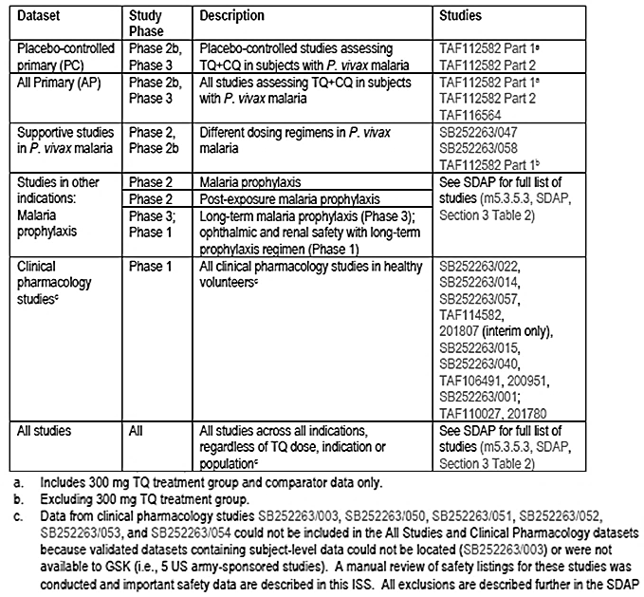

In this evaluation report, safety data from Study TAF112582 Part 2 will be evaluated as providing pivotal safety data, with supportive data from Studies TAF112582 Part 1 and TAF116564. Findings of the ophthalmic safety study will be described more below. The QTc study was evaluated and did not raise any safety concerns.

The various pooled safety data as well as the safety data of the individual studies in the pooled datasets were also evaluated and were found to be consistent with the safety findings in the pivotal study, and did not raise any additional safety concerns. Table 9 presents an overview of adverse events in the pooled Placebo-Controlled dataset (PC dataset; pooled Studies TAF112582 Part 1 and TAF112582 Part 2) and All Primary dataset (AP dataset; pooled Studies TAF112582 Part 1, TAF112582 Part 2 and TAF116564), alongside those of the pivotal Study TAF112582 Part 2, showing that results in the pooled datasets were consistent with those in the pivotal study. Incidence of drug-related adverse events in the pooled PC dataset is presented in Table 10, alongside those of the pivotal Study TAF112582 Part 2, showing that results were also consistent with those in the pivotal study.

Table 9: Adverse events overview (i) PC and AP safety populations (ii) safety population, Study TAF112582 Part 2

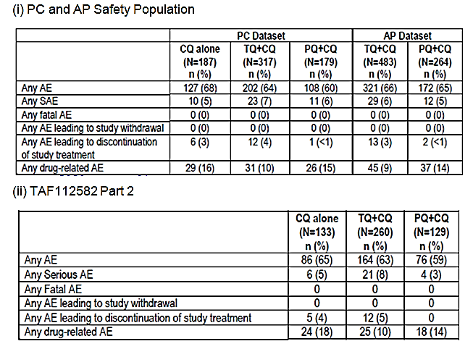

Table 10: Summary of drug related adverse events reported in at least 1% of subjects in any treatment group by preferred term (i) PC safety population (ii) safety population; Study TAF112582, Part 2

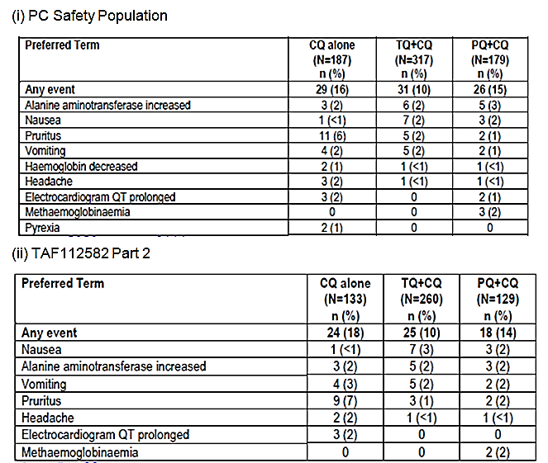

#### Pivotal studies that assessed safety as the sole primary outcome

Not applicable.

#### Pivotal and/or main efficacy studies

In the pivotal efficacy study, the following safety data were collected:

* Adverse events (AEs) from the time of informed consent through to the end of study participation. AEs were coded using Medical Dictionary for Regulatory Activities (MedDRA, version 18.0 or higher)
* Safety laboratory tests (standard haematology and chemistry tests; methaemoglobin levels)
* Other safety variables included vital signs, 12-lead electrocardiograms (ECGs) and physical examinations (including eye examination at selected sites)
* AEs of special interests included haemoglobin-associated events, neuropsychiatric events, ophthalmic events, hepatobiliary disorders and renal and urinary disorders.

#### Other studies

##### Other efficacy studies

Study TAF112582 Part 1 provided data on AEs, safety laboratory assessments, vital signs, 12 lead ECGs, and physical examinations (including eye examination at selected sites).

The primary endpoint of Study TAF116564 was a safety endpoint: occurrence of clinically relevant haemolysis in adult subjects with Pv treated with tafenoquine and chloroquine or primaquine and chloroquine (defined as a decrease in haemoglobin of ≥30% or >30 g/L from baseline or an overall drop in haemoglobin below 60 g/L). Other safety assessments are AEs, safety laboratory assessments, vital signs, 12 lead ECGs, and physical examinations (including eye examination at selected sites).

##### Studies evaluable for safety only

Study 201807 (an ophthalmic safety study) was an ongoing, multi-centre, randomised, single-blind, placebo controlled, parallel group study of a single 300 mg oral dose of tafenoquine in healthy adult subjects. The primary objective of this study was to assess the pharmacodynamics effects of tafenoquine on the retina via spectral domain optical coherence tomography (SD-OCT) and fundus autofluorescence (FAF). The secondary objective was to assess the overall ophthalmic safety of tafenoquine compared with placebo.

Following initial screening assessments, eligible subjects underwent baseline ophthalmic examinations. Subjects were then randomised in a 2:1 ratio to 300 mg tafenoquine or matched placebo within 7 days of the screening ophthalmic examinations. Subjects were followed for safety assessments and return to the clinic for follow-up ophthalmic evaluations at approximately 90 days post-dose. Ophthalmic assessments included key SD-OCT measurements of central retinal thickness and appearance of the retina on FAF at screening and Day 90. Visual acuity was measured using Early Treatment Diabetic Retinopathy Study (ETDRS) chart reading. Additional retinal morphology was assessed by SD-OCT and fundus photography captured at screening and Day 90.

The primary endpoint was the proportion of subjects treated with tafenoquine who developed significant protocol defined retinal changes from baseline to Day 90. A subject was considered to have a clinically significant retinal change if any of the following 5 parameters indicated a change from baseline in either eye: SD-OCT central subfield thickness, SD-OCT total macular volume, SD-OCT central retinal lesion thickness, SD-OCT ellipsoid zone disruption (EZD), or abnormal autofluorescence patterns.

A sample size of 300 subjects was planned to be treated with tafenoquine based on 95% probability of detecting an event when the underlying risk of clinically significant retinal findings at 90 day follow-up was 1%. The results of Study 201807 presented in this submission were from a planned interim analysis, done after approximately 100 tafenoquine subjects and 50 placebo subjects had completed baseline and Day 90 ophthalmic assessments.[22] The interim sample size of 100 subjects treated with tafenoquine was expected to allow for detection of a 3% risk of clinically significant retinal findings at 90 days after a single 300 mg dose of tafenoquine.

#### Patient exposure

Across the tafenoquine development program, more than 4000 subjects have been exposed to tafenoquine, including >800 subjects exposed to a 300 mg total dose (Table 11). A total of 483 Pv-infected subjects have been treated with tafenoquine 300 mg single dose plus chloroquine in the 3 efficacy/safety: Studies TAF112582 Part 2, TAF112582 Part 1 and TAF116564.

In the pivotal Study TAF112582 Part 2, all subjects received their scheduled in-clinic single dose of tafenoquine/tafenoquine placebo, according to randomisation.

Overall, the study drug exposure is adequate to assess the safety profile of tafenoquine in patients with Pv malaria infection.

Table 11: Summary of exposure across the tafenoquine development program by dataset

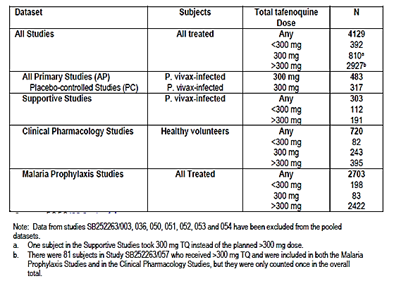

#### Safety issues with the potential for major regulatory impact

##### Liver function and liver toxicity

###### Pivotal and/or main efficacy study

Analysis of laboratory liver parameters did not raise any safety concerns. The incidences of raised alanine aminotransferase (ALT) and aspartate aminotransferase (AST) outside the reference range were low and comparable across treatment groups (raised ALT: 4% with tafenoquine and chloroquine versus 8% with chloroquine alone and 4% with primaquine and chloroquine; raised AST: 3% with tafenoquine and chloroquine versus 4% with chloroquine alone and 2% with primaquine and chloroquine) (see Table 12, below).

The proportion of subjects with AEs in the hepatobiliary disorders System Organ Class (SOC) was low and similar across the treatment groups (2% with tafenoquine and chloroquine versus 2% with chloroquine alone; <1% with primaquine and chloroquine) (Table 13). Of the 4 subjects in the tafenoquine and chloroquine group with hepatobiliary disorders AEs, 2 were considered serious adverse events (SAEs) but neither of these was considered treatment related (one case of hepatitis E and one case of drug-induced liver injury due to herbal medications). The other 2 AEs were considered treatment related but both were of Grade 1 or Grade 2 in severity, and neither was an SAE.

Table 12: Chemistry laboratory data outside the reference range at any time on-study (Safety Population), Study TAF112582 Part 2

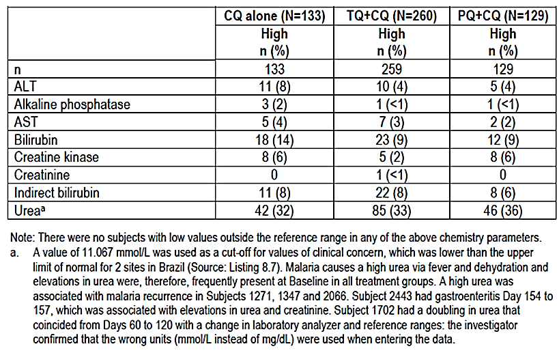

Table 13: Treatment emergent AEs in the hepatobiliary disorders System Organ Class (Safety Population), Study TAF112582 Part 2

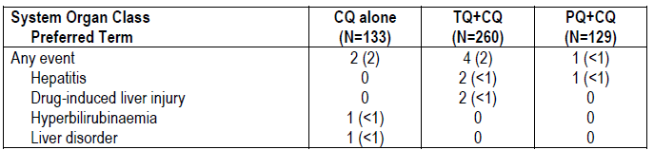

###### Other studies

Study TAF112582 Part 1

Analysis of laboratory liver parameters did not raise any safety concerns. The incidences of post-baseline raised ALT and AST outside the reference range were low and comparable across treatment groups (raised ALT: 7% with tafenoquine300 mg and chloroquine versus 6% with chloroquine alone and 4% with primaquine and chloroquine; raised AST: 5% with tafenoquine300 mg and chloroquine versus 2% with chloroquine alone and 2% with primaquine and chloroquine). There was no clear dose-related trend among the tafenoquine and chloroquine groups.

Study TAF116564

Analysis of laboratory liver parameters did not raise any safety concerns. The incidences of raised ALT and AST outside the reference range were low and comparable between treatment groups (raised ALT: 5% with tafenoquine and chloroquine versus 0% with primaquine and chloroquine; raised AST: 4% with tafenoquine and chloroquine versus 4% with primaquine and chloroquine) (Table 14).

Table 14: Subjects with clinical chemistry laboratory data outside the reference range at any visit post-baseline (Safety Population), Study 116564

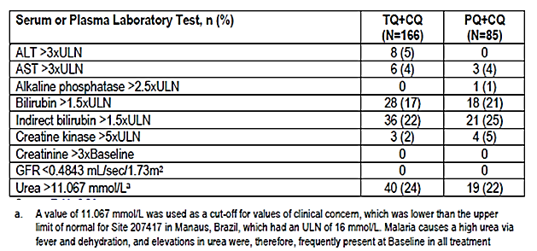

The proportion of subjects with AEs in the hepatobiliary disorders SOC was low and similar between the treatment groups: one subject in each treatment group reported AE of hyperbilirubinemia (both of severity Grade 2).

##### Renal function and renal toxicity

###### Pivotal and/or main efficacy study

Analysis of laboratory renal parameters did not raise any safety concerns. The incidence of post-baseline raised creatinine outside the reference range was low (<1% (n=1) with tafenoquine and chloroquine versus 0% with chloroquine alone and 0% with primaquine and chloroquine) as was that of low estimated glomerular filtration rate (eGFR) (<1% (n=1) with tafenoquine and chloroquine versus 0% with chloroquine alone and 0% with primaquine and chloroquine) (Table 12).

The proportion of subjects with AEs in the renal and urinary disorders SOC was low and similar across the treatment groups (2% of subjects in each treatment group) (Table 15).

Table 15: Treatment emergent AEs in the renal and urinary disorders System Organ Class (Safety Population), Study TAF112582 Part 2

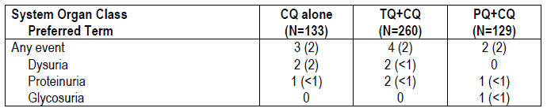

###### Other studies

Study TAF112582 Part 1

Analysis of laboratory renal parameters did not raise any safety concerns. The incidence of post-baseline raised creatinine outside the reference range was low (2% (n=1) each in the tafenoquine 50 mg and chloroquine and tafenoquine 600 mg and chloroquine groups; 0% in the other treatment groups) as was that of low eGFR (5% (n=3) in the tafenoquine 600 mg and chloroquine group; 2% (n=1) each in the tafenoquine50 mg and chloroquine and tafenoquine300 mg and chloroquine groups 0% in the other treatment groups).

Study TAF116564

Analysis of laboratory renal parameters did not raise any safety concerns. No subjects in either treatment group had post-baseline raised creatinine >3x baseline or low eGFR outside the reference range.

The proportion of subjects with AEs in the renal and urinary disorders SOC was low and similar between treatment groups (3% (5/166) in the tafenoquine and chloroquine group versus 2% (2/85) in the primaquine and chloroquine group). There were 4 AEs of dysuria (2%) and 1 AE of nephrolithiasis (<1%) in the tafenoquine and chloroquine group, and 2 AEs of dysuria (2%) in the primaquine and chloroquine group.

##### Haematology and haematological toxicity

###### Pivotal and/or main efficacy study

Analysis of laboratory haematology parameters did not raise any safety concerns. The incidences of decreases in haemoglobin that fell to below the lower limit of normal were low (as shown below in Figure 3). Two subjects (both in the primaquine and chloroquine group) had haemoglobin values of <80 g/L during the study and both subjects fully recovered without medical intervention. Changes from baseline in haemoglobin over time were similar across the treatment groups and showed recovery following treatment for the underlying disease (shown in Figure 4). The majority of patients had maximal decrease in haemoglobin from baseline over the first 29 days of ≤20g/L (83% with tafenoquine and chloroquine, 90% with chloroquine alone, and 88% with primaquine and chloroquine) (see Table 16). None of the subjects with decreased haemoglobin in the tafenoquine and chloroquine group were symptomatic and no subject required a blood transfusion. All subjects fully recovered without blood transfusion or other medical intervention.

Figure 3: Haemoglobin values by visit (Safety Population); Study TAF112582 Part 2

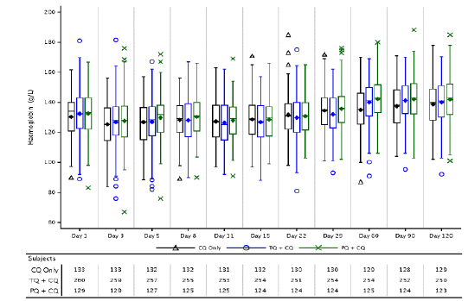

Figure 4: Change from Baseline in haemoglobin by visit (Safety Population); Study TAF112582 Part 2

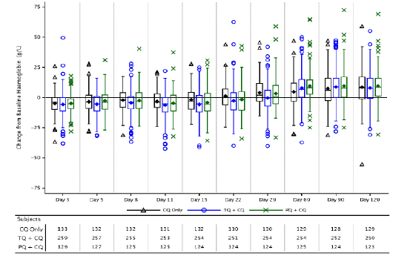

Table 16: Haemoglobin declines over first 29 days (Safety Population); Study TAF112582 Part 2

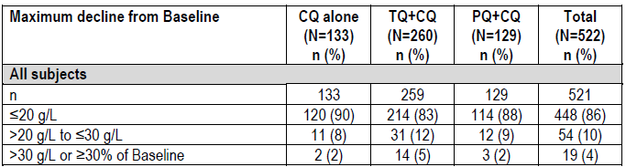

The incidence of AEs that were potentially related to haemoglobin decreases was low across treatment groups (6% with tafenoquine and chloroquine versus 4% with chloroquine alone and 2% with primaquine and chloroquine) (see Table 17). Among these AEs, the preferred term of haemoglobin decreased was the most common AE in all 3 treatment groups (5% with tafenoquine and chloroquine versus 2% with chloroquine alone and 2% with primaquine and chloroquine). The incidence of protocol-defined SAEs of decreased haemoglobin[23] was 5% with tafenoquine and chloroquine (versus 2% with chloroquine alone and 2% with primaquine and chloroquine). None of these SAEs in subjects who received tafenoquine and chloroquine treatment were considered to be related to study medication and all subjects recovered without specific medical intervention.

Table 17: Treatment emergent AEs potentially related to haemoglobin decreases (Safety Population); Study TAF112582 Part 2

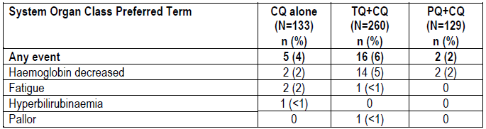

The proportions of subjects with abnormal values in other haematology parameters were generally comparable among treatment groups, except raised methaemoglobin levels which was higher in the primaquine and chloroquine group (9%; versus 2% with tafenoquine and chloroquine and 3% with chloroquine alone). A higher proportion of subjects in the primaquine and chloroquine group had a methaemoglobin of >10% compared with the other treatment groups. Methaemoglobinaemia is a known effect of primaquine.

###### Other studies

Study TAF112582 Part 1

Analysis of laboratory haematology parameters did not raise any safety concerns. Changes from baseline in haemoglobin over time were similar across the treatment groups (see Figure 5). At Day 3, all treatment groups showed a post-baseline decline in haemoglobin. Subsequently, all groups improved with no discernible dose-related trends. The majority of patients had maximal decrease in haemoglobin from baseline of ≤ 15g/L over the first 29 days (67% with tafenoquine300 mg and chloroquine, 70% with chloroquine alone, and 68% with primaquine and chloroquine) (Table 18). The incidence of maximal decrease in haemoglobin from baseline of >25g/L or ≥ 25% drop from baseline was low (4% with tafenoquine300 mg and chloroquine, 2% with chloroquine alone, and 2% with primaquine and chloroquine). No subject received a blood transfusion during the course of the study.

Figure 5: Box Plot change in haemoglobin from baseline by visit and treatment group (Safety Population); Study TAF112582 Part 1

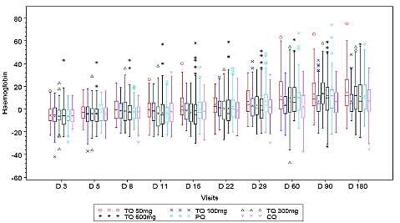

Table 18: Summary of haemoglobin declines over first 29 Days (Safety Population), Study TAF112582 Part 1

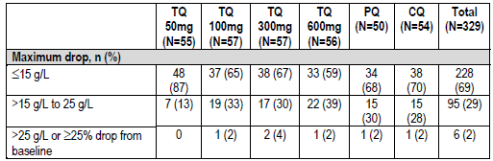

Raised methaemoglobin levels was highest in the primaquine and chloroquine group (24%; versus 9% with tafenoquine300 mg and chloroquine and 11% with chloroquine alone). A dose-related increase in methaemoglobin levels across the tafenoquine and chloroquine groups was observed (5%, 5%, 9% and 20% in the tafenoquine50 mg and chloroquine, tafenoquine100 mg and chloroquine, tafenoquine 300 mg and chloroquine, tafenoquine 600 mg and chloroquine groups, respectively). Across treatment groups, raised methaemoglobin peaked at around Day 11 and resolved by Day 60.

Study TAF116564

The overall incidence of clinically relevant haemolysis (primary safety endpoint; defined in the protocol as a decrease in haemoglobin of ≥30% or >30 g/L from Baseline or an overall drop in haemoglobin below 60 g/L) was low and comparable in both treatment groups (2.4% with tafenoquine and chloroquine versus 1.2% with primaquine and chloroquine) (see Table 19).

The incidences of decreases in haemoglobin that fell to below the lower limit of normal were low (Figure 6). Changes from baseline in haemoglobin over time were similar between the treatment groups and showed recovery following treatment for underlying disease (Figure 7). The majority of patients had maximal decrease in haemoglobin from baseline of ≤20g/L over the first 29 days (78% with tafenoquine and chloroquine and 82% with primaquine and chloroquine) (Table 20). The incidence of maximal decrease in haemoglobin from baseline of >30g/L or ≥30% drop from baseline was low (4% (2/166) with tafenoquine and chloroquine and 1% (1/85) with primaquine and chloroquine). No subjects received blood transfusions in the study.

The incidence of AEs that were potentially related to haemoglobin decreases was low and comparable between treatment groups (5% with tafenoquine and chloroquine versus 4% with primaquine and chloroquine) (Table 21).

The proportions of subjects with abnormal values in other haematology parameters were generally comparable among treatment groups. The proportion of subjects with post-baseline methaemoglobin of >10% was low in both treatment groups (1% with tafenoquine and chloroquine and 4% with primaquine and chloroquine).

Table 19: Incidence of clinically relevant haemolysis (Safety Population), Study 116564

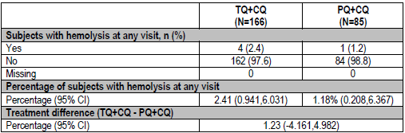

Figure 6: Boxplot of haemoglobin by visit and treatment group (Safety Population), Study 116564

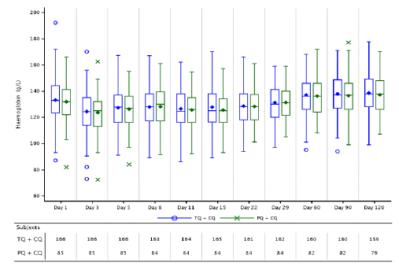

Figure 7: Boxplot of change from baseline in haemoglobin by visit and treatment Group (Safety Population), Study 116564

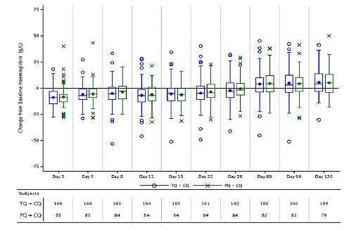

Table 20: Summary of haemoglobin declines over first 29 days (Safety Population)

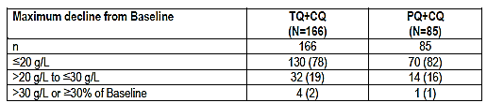

Table 21: Treatment emergent AEs potentially related to haemoglobin decreases (Safety Population), Study 116564

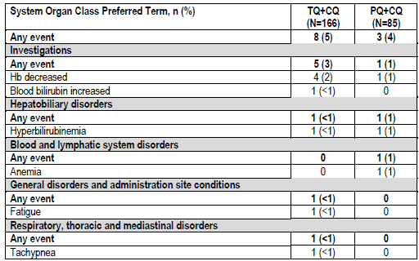

##### Electrocardiograph findings and cardiovascular safety

###### Pivotal and/or main efficacy study

Analysis of electrocardiography did not raise any safety concerns.

###### Other studies

Study TAF112582 Part 1

Analysis of electrocardiography did not raise any safety concerns. QTcF changes were comparable among treatment groups and there were no dose-related trends among the tafenoquine and chloroquine groups.

Study TAF116564

Analysis of electrocardiography did not raise any safety concerns.

##### Vital signs

###### Pivotal and/or main efficacy study

Analysis of vital signs did not raise any safety concerns.

###### Other studies

Study TAF112582 Part 1

Analysis of vital signs did not raise any safety concerns.

Study TAF116564

Analysis of vital signs did not raise any safety concerns.

##### Other safety parameters

###### Pivotal and/or main efficacy study

Neuropsychiatric events

The most common neuropsychiatric AEs with onset on or prior to Day 29 in the tafenoquine and chloroquine group was dizziness (8% with tafenoquine and chloroquine versus 3% with chloroquine alone and 6% with primaquine and chloroquine) and headache (5% with tafenoquine and chloroquine versus 7% with chloroquine alone and 4% with primaquine and chloroquine). All these neuropsychiatric AEs were of mild to moderate severity and none were considered SAEs.

Ophthalmic events

Approximately 25% of randomised subjects in this study had available results for eye assessments. Assessments included visual acuity measurements, anterior segment examination with evaluation for vortex keratopathy, posterior segment examination including fundus photographs, colour perception assessment, and Humphrey visual field perimetry. Analyses of ophthalmic assessments did not raise any major concerns. Findings associated with changes in visual acuity, vortex keratopathy, and retinal examination findings are presented in Table 22. The incidence of new post-baseline vortex keratopathy was low (2% with tafenoquine and chloroquine versus 0% with chloroquine alone and 0% with primaquine and chloroquine), as was that for retinal changes from baseline (3% with tafenoquine and chloroquine versus 4% with chloroquine alone and 3% with primaquine and chloroquine).

Table 22: Keratopathy, best corrected visual acuity classification, and retinal changes from Baseline (Ophthalmic Population), Study TAF112582 Part 2

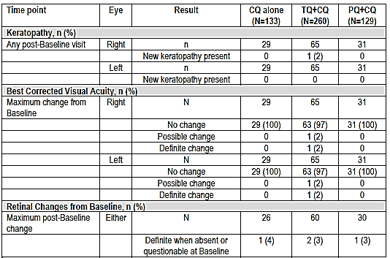

###### Other studies

Study TAF112582 Part 1

The incidence of treatment related psychiatric AEs were low. Only 2 subjects reported treatment related psychiatric AEs (both in the tafenoquine 100 mg and chloroquine group, both are for AE of insomnia).

Overall, 93 subjects underwent ophthalmic investigations in this study. Analyses of ophthalmic data did not raise safety concerns. Results showed that there were no reports or observations of keratopathy. No change from baseline was observed on review of slit lamp examination data.

Study TAF116564

The most common neuropsychiatric AEs in the tafenoquine and chloroquine group were dizziness (17% with tafenoquine and chloroquine versus 19% with primaquine and chloroquine) and headache (16% with tafenoquine and chloroquine versus 19% with primaquine and chloroquine) (Table 23).

Table 23: Summary of neuropsychiatric AEs by System Organ Class and Preferred Term (Safety Population), Study 116564

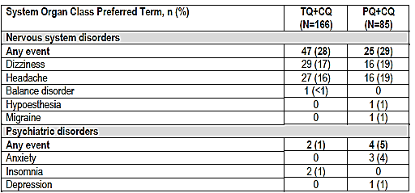

In this study, one centre performed ophthalmic safety assessments at selected visits to monitor subjects for changes in the eye. Assessments included visual acuity measurements, anterior segment examination including evaluation for vortex keratopathy, posterior segment examination including color fundus photographs, color perception assessments and Humphrey perimetry assessments. Analyses of ophthalmic safety assessments did not raise any concerns. No subjects in either treatment arm developed vortex keratopathy at any time point.

Study 201807 (Ophthalmic safety study)

Interim analysis results in this study did not identify any safety signal for retinal toxicity with use of a single 300 mg dose of tafenoquine in healthy subjects. The proportion of subjects with retinal findings in either eye as defined in the primary endpoint[24] was low (1% (1/101) with tafenoquine 300 mg and 0% with placebo) (Table 24). There was no evidence of development of vortex keratopathy seen in any subject.

Table 24: Proportion of subjects in the primary ophthalmic safety population with retinal findings in either eye as defined in the primary endpoint, Study 201807

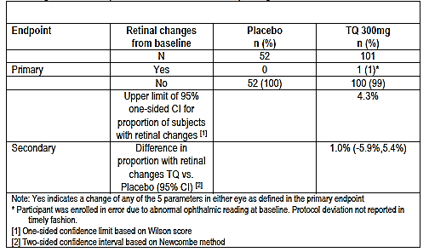

##### Other safety issues

###### Safety in special populations

Safety related to drug-drug interactions and other interactions

Tafenoquine is an inhibitor of human transporters OCT2 and MATE in vitro. There may be a potential, but low risk of lactic acidosis in subjects who receive tafenoquine concomitantly with substrates of these renal transporters.

Drug-drug interaction studies demonstrated no clinically relevant inhibition of CYP1A2, CYP2A6, CYP2C8, CYP2C9, and CYP3A4 enzymes. Mild to moderate side effects of headache, abdominal pain and fatigue were reported in these studies. Generally there were no clinically significant changes in ECG or routine lab tests in these studies. In Study 040 the multi-substrate cytochrome P450 trial, four subjects experienced transient increases in total bilirubin, without evidence of haemolysis. One subject with elevated methaemoglobin level was symptomatic, hospitalised and required treatment with methylene blue.

In Study 200951, the co-administration of tafenoquine with artemisinin based combination therapies; one subject experienced a cardiac arrest while receiving the combination of dihydroartemisinin (DHA) + piperaquine. Another subject receiving artemether/lumefantrine (AL) treatment alone experienced ventricular tachycardia. This was attributed to an undiagnosed Wolff-Parkinson-White syndrome in this subject.

There were no SAEs in subjects receiving tafenoquine alone or with other medications in these studies.

#### Postmarketing data

Not applicable.

#### Evaluator’s conclusions on safety

Overall, safety analyses in the pivotal Phase III Study TAF112582 Part 2 showed that a single-dose of tafenoquine300 mg with chloroquine did not raise any major safety concerns. Results showed that incidences of all-causality AEs and SAEs were comparable among treatment groups of tafenoquine300 mg and chloroquine, chloroquine alone and primaquine and chloroquine. The incidence of all-causality AEs was 63% with tafenoquine and chloroquine versus 65% with chloroquine alone and 59% with primaquine and chloroquine. The most commonly reported AEs with tafenoquine and chloroquine were pruritus (13% versus 15% with chloroquine alone versus 11% with primaquine and chloroquine), headache (10% versus 14% versus 8%) and dizziness (10% versus 8% versus 7%). Few severe AEs (≥Grade 3) were reported (1% with tafenoquine and chloroquine versus 3% with chloroquine alone; <1% with primaquine and chloroquine). The incidence of SAEs was low (8% with tafenoquine and chloroquine versus 5% with chloroquine alone and 3% with primaquine and chloroquine). The most common SAE with tafenoquine and chloroquine was decreased haemoglobin (5% with tafenoquine and chloroquine versus 2% with chloroquine alone and 2% with primaquine and chloroquine).

The incidence of treatment related AEs was lower in the tafenoquine and chloroquine group compared with the chloroquine alone group (10% versus 18%; 14% with primaquine and chloroquine), and the most commonly reported treatment related AE with tafenoquine and chloroquine was nausea (3% versus <1% with chloroquine alone and 2% with primaquine and chloroquine).There were no treatment related SAEs in the tafenoquine and chloroquine group (vs. 3% with chloroquine alone and <1% with primaquine and chloroquine). There were no deaths reported in the study.

Analysis of liver, renal and haematological parameters and AEs did not raise any safety concerns. The incidence of AEs that were potentially related to haemoglobin decreases was low across treatment groups (6% with tafenoquine and chloroquine versus 4% with chloroquine alone and 2% with primaquine and chloroquine). No subject required a blood transfusion.

The incidence of neuropsychiatric AEs was low and the most common neuropsychiatric AEs with onset on or prior to Day 29 in the tafenoquine and chloroquine group was dizziness (8% with tafenoquine and chloroquine versus 3% with chloroquine alone and 6% with primaquine and chloroquine) and headache (5% with tafenoquine and chloroquine versus 7% with chloroquine alone and 4% with primaquine and chloroquine). All these neuropsychiatric AEs were of mild to moderate severity and none were considered SAEs.

Safety results in the other studies were consistent with those of the pivotal study. Safety sections of the proposed PI were evaluated and found to be appropriate.

### First round benefit-risk assessment

#### First round assessment of benefits

Table 25, shown below, summarises the assessment of the benefits, strengths and uncertainties for Kozenis for the proposed indication at the first round.

Table 25: First round assessment of benefits

|  |  |
| --- | --- |
| Indication | |
| Benefits | Strengths and Uncertainties |
| Potential benefit is in the radical cure (prevention of relapse) of Pv malaria in patients. | Efficacy results were generally supportive of a positive treatment effect of tafenoquine and chloroquine over chloroquine alone in reducing the risk of recurrence at 6 months and 4 months post-dosing.  Treatment with tafenoquine and chloroquine resulted in a statistically significant reduction in the risk of recurrence over 6 months by 70.1% (p<0.001) compared with chloroquine alone (recurrence-free efficacy rate at 6 months of 62.4% in the tafenoquine and chloroquine group versus 27.7% in the chloroquine alone group).  Treatment with tafenoquine and chloroquine also resulted in a statistically significant reduction in the risk of recurrence in the first 4 months by 72.9% (p<0.001) compared with chloroquine treatment alone (recurrence-free efficacy rate at 4 months of 73.0% in the tafenoquine and chloroquine group versus 36.0% in the chloroquine alone group). |
| Additional benefit is the ease of administration of a single oral dose of two 150 mg tablets. This confers an advantage over the alternative currently approved radical cure treatment with primaquine which has a posology of oral daily dose of 15 mg for 14 days. Efficacy of tafenoquine in the radical cure of Pv malaria appears to be comparable with that of primaquine.  A single dose posology could increase dosing convenience to patients, reduce the risk of medication non-compliance, as well as reduce the potential risk of adverse effects. | In Study TAF116564, recurrence-free efficacy rates at 6 months and at 4 months were numerically comparable between tafenoquine and chloroquine and primaquine and chloroquine (6 months: 72.7% with tafenoquine and chloroquine and 75.1% with primaquine and chloroquine; 4 months: 82.3% with tafenoquine and chloroquine and 79.7% with primaquine and chloroquine).  However, exploratory non-inferiority analysis using pooled data from TAF112582 Part 2 and TAF116564 showed that the non-inferiority of tafenoquine and chloroquine to primaquine and chloroquine could not be demonstrated.  It is noted that primaquine treatment compliance was very high in this study population (>99% of subjects received ≥12 doses of primaquine) and that this high compliance rate may not be attainable outside of a clinical study environment. |

#### First round assessment of risks

Table 26, shown below, summarises the assessment of the risks, strengths and uncertainties for Kozenis for the proposed indication at the first round.

Table 26: First round assessment of risks

|  |  |
| --- | --- |
| Risks | Strengths and Uncertainties |
| Safety analyses showed that single-dose of tafenoquine300 mg with chloroquine did not raise any major safety concerns. AEs were largely limited to mild to moderate symptoms such as nausea, headache and dizziness. Safety profile was generally comparable with chloroquine alone and with primaquine and chloroquine. | In the pivotal study, the incidence of treatment related AEs was lower in the tafenoquine and chloroquine group compared with the chloroquine alone group (10% versus 18%; 14% with primaquine and chloroquine).  The most commonly reported treatment related AE with tafenoquine and chloroquine was nausea (3% versus <1% with chloroquine alone and 2% with primaquine and chloroquine).There were no treatment related SAEs in the tafenoquine and chloroquine group.  The incidence of dizziness with tafenoquine and chloroquine was comparable with that of primaquine and chloroquine (8% with tafenoquine and chloroquine versus 6% with primaquine and chloroquine) as was that of headache (5% versus 4%). These AEs were of mild to moderate severity and none were considered SAEs. |
| The main safety concern with tafenoquine is drug-induced haemolysis in patients with G6PD deficiency. This is also a safety liability for primaquine.  Safety results showed that excluding patients with a G6PD activity <70% of normal could protect patients from clinically significant haemoglobin declines. | Across the 3 efficacy/safety studies (TAF112582 Parts 1 and 2, TAF116564) where patients with a G6PD activity <70% of normal were excluded, the incidences of decreases in haemoglobin that fell to below the lower limit of normal were low in all treatment groups.  Changes from baseline in haemoglobin over time were similar across the treatment groups.  The amount of haemoglobin decreases was small. The majority of patients had maximal decrease in haemoglobin from baseline over the first 29 days of ≤20g/L. No subjects required blood transfusions or other medical interventions. |

#### First round assessment of benefit-risk balance

Overall, the benefit-risk balance for the use of tafenoquine for the radical cure (prevention of relapse) of Pv malaria in patients aged 16 years and older is positive. Compared with chloroquine alone, treatment with tafenoquine and chloroquine resulted in a statistically significant reduction in the risk of recurrence by 70.1% over 6 months and by 72.9% over 4 months.

Efficacy of tafenoquine in the radical cure of Pv malaria appears to be comparable with that of primaquine. The posology of a single oral dose of two tafenoquine 150 mg tablets confers an advantage over the alternative currently approved radical cure treatment with primaquine, which requires oral dosing of 15 mg daily for 14 days. A single dose posology could increase dosing convenience to patients, reduce the risk of medication non-compliance as well as reduce the potential risk of adverse effects.

Safety analyses showed that single-dose of tafenoquine 300 mg with chloroquine did not raise any major safety concerns. Safety profile of tafenoquine 300 mg single dose was generally comparable with primaquine 15 mg once daily for 14 days.

### First round recommendation regarding authorisation

It is recommended that the application for the registration of tafenoquine for the radical cure (prevention of relapse) of Pv malaria in patients aged 16 years and older be approved.

### Second round evaluation

No clinical questions were raised and therefore no second round clinical evaluation was conducted.

## VI. Pharmacovigilance findings

Tafenoquine was assigned orphan drug status by the TGA on 21 April 2017 for the radical cure (prevention of relapse) of Pv malaria.

The sponsor has submitted Australian risk management plan (RMP) version 1.0 (dated 31 October 2017; data lock point 13 October 2017) in support of this application.

In response, the sponsor has submitted Australian RMP version 1.1 (dated 11 January 2018).

The proposed Summary of Safety Concerns and their associated risk monitoring and mitigation strategies are summarised below (see Table 27) after receiving the sponsor’s response.

Table 27: Summary on ongoing safety concerns

|  |  |  |  |  |  |
| --- | --- | --- | --- | --- | --- |
| Summary of safety concerns | | Pharmacovigilance | | Risk Minimisation | |
| Routine (R) | Additional (A) | R | A |
| **Important identified risks** | Haemolytic anaemia (in G6PD deficiency) | ✓ | – | ✓ | – |
| Use in pregnancy* | ✓ | – | ✓ | – |
| **Important potential risks** | Serious psychiatric events in individuals with a past or current history of significant psychiatric disorders | ✓ | – | ✓ | – |
| Use in lactation | ✓ | – | ✓ | – |
| **Missing information** | Use in children and adolescents | ✓ | – | ✓ | – |
| Use in patients with severe renal impairment | ✓ | – | – | – |
| Use in patients with hepatic impairment | ✓ | – | – | – |
| Use in patients 65 years of age or older | ✓ | – | – | – |

*The sponsor agreed to add ‘Use in pregnancy’ in its response and it has now been added as an Important Identified Risk in the updated Australian RMP (version 1.1). ** Retinopathy has been removed from Missing Information based on the results of Study 201807 which is now complete and did not show a risk of retinopathy.

There are no additional pharmacovigilance activities. A study on ophthalmic safety, Study 201807, was included in the sponsor’s application to the TGA. The results have been included in the updated Australian RMP provided with the sponsor’s response.

There are no additional risk minimisation activities which is acceptable.

### Reconciliation of RMP evaluator recommendations

* The sponsor’s response and proposed pharmacovigilance and risk minimisation activities are appropriate. The Australian RMP (version 1.1) has been amended satisfactorily and ‘Use in Pregnancy’ is now a separate Important Identified Risk.
* The Australian RMP has been updated with results from Study 201807.
* The sponsor provided further details of the paediatric programme, including expected finalisation dates which were noted by the evaluator.
* Kozenis is a new chemical entity and as such meets the inclusion criteria for the Black Triangle Scheme. The following symbol and statement should appear on top of the first page of the PI:

*This medicinal product is subject to additional monitoring in Australia. This will allow quick identification of new safety information. Healthcare professionals are asked to report any suspected adverse events at* [*www.tga.gov.au/reporting-problems*](http://www.tga.gov.au/reporting-problems)

▼

The PI and Consumer Medicine Information (CMI) have been amended appropriately and the black triangle is the correct size.

* The clinical and nonclinical evaluators considered the sponsor’s Summary of Safety Concerns to be satisfactory.

The Delegate may wish to consider if the following wording from the US PI should be included under Warnings and Precautions in the Australian PI:

‘*Serious hypersensitivity reactions (for example, angioedema) have been observed with administration of (Kozenis) [see Adverse Reactions (6.1)]. Institute appropriate therapy if hypersensitivity reactions occur. Do not re-administer (Kozenis) to patients who develop hypersensitivity to (Kozenis)*.’

#### *Wording for conditions of registration*

Any changes to which the sponsor has agreed should be included in a revised RMP and Australian Specific Annex (ASA). However, irrespective of whether or not they are included in the currently available version of the RMP document, the agreed changes become part of the risk management system.

The suggested wording is:

*The Kozenis AUS-Risk Management Plan (RMP) (version 1.1, dated 11 January 2018), included with submission PM-2017-04578-1-2, and any subsequent revisions, as agreed with the TGA will be implemented in Australia.*

The following wording is recommended for the Periodic Safety Update Reports (PSURs) requirement:

*An obligatory component of risk management plans is routine pharmacovigilance. Routine pharmacovigilance includes the submission of Periodic Safety Update Reports (PSURs).*

*Unless agreed separately between the supplier who is the recipient of the approval and the TGA, the first report must be submitted to TGA no later than 15 calendar months after the date of this approval letter. The subsequent reports must be submitted no less frequently than annually from the date of the first submitted report until the period covered by such reports is not less than three years from the date of this approval letter. The annual submission may be made up of two PSURs each covering six months. If the sponsor wishes, the six monthly reports may be submitted separately as they become available.*

*The reports are to at least meet the requirements for PSURs as described in the European Medicines Agency’s Guideline on good pharmacovigilance practices (GVP) Module VII-Periodic Safety Update Report (Rev 1), Part VII.B Structures and processes. Note that submission of a PSUR does not constitute an application to vary the registration. Each report must have been prepared within ninety calendar days of the data lock point for that report.*

As Kozenis is a new chemical entity it should be included in the Black Triangle Scheme as a condition of registration. The following wording is recommended for the condition of registration:

*Kozenis (Tafenoquine) is to be included in the Black Triangle Scheme. The PI and CMI for Kozenis must include the black triangle symbol and mandatory accompanying text for five years, which starts from the date that the sponsor notifies the TGA of supply of the product.*

## VII. Overall conclusion and risk/benefit assessment

The submission was summarised in the following Delegate’s overview and recommendations:

### Quality

The quality review has been completed. There are no outstanding quality issues preventing approval.

### Nonclinical

The nonclinical review has been completed. There are no nonclinical objections to the proposed single dose use in humans. Pregnancy classification C17 is proposed and agreed based on the risk of haemolytic anaemia. Recommendations for PI have been provided.

### Clinical

The clinical evaluator supports approval.

#### Pharmacokinetics

Tafenoquine will be marketed as a racemate mixture. PK of the individual isomeric forms has not been evaluated. Absolute bioavailability of tafenoquine has not been determined. The PK parameters refer to the racemate.

The median Tmax is 12 to 15 hours (range 6 to 48 h) and is not affected by food. The systemic availability is modestly increased with food (AUC and Cmax increased by 41% and 31% respectively). The mean volume of distribution was about 2550 L but in vitro studies show tafenoquine is highly protein bound (≥ 99.5%). The drug concentrates in RBCs (67% higher concentration in blood than in plasma).

The overall systemic clearance is low (approximately 3 L/h). The terminal t1/2 is 300 h or more (mean 15 days). Tafenoquine demonstrated linear PK in 2 single dose studies. Steady-state studies were not done (feasible).

Tafenoquine has not been studied in patients with hepatic impairment or renal impairment.

##### Metabolism

Tafenoquine demonstrated some metabolism in various in vitro systems. However in humans, following administration of single doses of up to 300 mg tafenoquine to G6PD enzyme normal and deficient female subjects, drug-related material identified in blood and plasma was almost exclusively the unchanged drug. Faecal-biliary route appears to be the main route of excretion.

At least 18 drug related components were detected in human urine. It is not clear whether these were products of ex vivo degradation and/or in vivo metabolism. Due to the long half-life of the drug and concerns about radioactive exposure, mass balance studies were not performed in humans.

##### Drug interactions

Although tafenoquine inhibited CYP1A2, CYP2A6, CYP2C8, CYP2C9 and CYP3A4 enzymes in in vitro hepatocyte and microsomal studies, clinical studies have not demonstrated clinically relevant effect of tafenoquine on those enzymes. These include studies with desipramine (CYP2D6 substrate), midazolam (CYP3A4 substrate), flurbiprofen (CYP2C9 substrate) and caffeine (CYP1A2 substrate). Clinically relevant interactions were also not shown in separate studies with chloroquine and artemisinin-based anti-malarial combination therapies.

The effect of tafenoquine on drug transporter proteins has not been studied in vivo. Tafenoquine was shown to be an inhibitor of radio ([14C]) labelled metformin transport via human OCT2, MATE1 and MATE2-K in vitro. Potentially this may be related to transient small increases in serum creatinine in clinical studies. Based on concentrations of tafenoquine observed at therapeutic doses there is a small potential risk of drug interaction risk with OCT2 and MATE substrates. Blockade of the transporters may increase metformin exposure leading to secondary lactic acidosis. Tafenoquine should be used cautiously with metformin. Drugs with a narrow therapeutic index which are also substrates of the renal transporters OCT2 and MATEs should not be co-administered with tafenoquine.

The P-glycoprotein (Pgp) substrate status of tafenoquine has not been reliably established. It was suggested that there may be a potential increase in the systemic exposure to tafenoquine when co-administered with strong Pgp inhibitors.

#### Pharmacodynamics

The molecular target of tafenoquine is not known. Tafenoquine acts primarily on exoerythrocytic stages of malarial parasite including the dormant hepatic hypnozoites (causal prophylaxis). It has not been shown to be an effective agent for the treatment of acute malaria.

The data demonstrated that tafenoquine does not have clinically relevant effect on QT prolongation at doses of 300 and 600 mg compared to placebo. The 90%CI maximum effect on corrected QT interval (QTcF) with the supra-therapeutic dose (1200 mg tafenoquine) was within 10 ms.

The Study TAF110027 **was** a single dose, dose escalation study in which tafenoquine (100, 200 and 300 mg doses) was administered to female healthy volunteers with (40–60% activity) and without (normal) G6PD deficiency. There was a dose dependent decline in haemoglobin in heterozygous G6PD enzyme deficient females with intermediate levels of G6PD activity. The highest median haemoglobin declines were observed with the tafenoquine 300 mg dose and the positive control primaquine (15 mg daily for 14 days). No subjects reported major clinical symptoms relating to haemoglobin decline.

In a randomised, double blind, placebo controlled study, the safety and tolerability of tafenoquine versus placebo over 6 month duration, tafenoquine had no apparent adverse effect on renal function as assessed by GFR and serum creatinine concentrations. Mild subclinical increases in serum creatinine were reported that were less than the pre-specified criteria (≥ 0.3mg/dL). These reversible increases are consistent with renal transporter inhibition effect.

**Dosage selection**

PK/PD relationship for tafenoquine was assessed based on tafenoquine exposure and Pv malaria relapse at the end of 6 months in a challenge study. The modelling indicated that a tafenoquine exposure (AUC) threshold of 56.4 μg.hr/mL was a significant predictor of relapse. The probabilities of remaining relapse free at 6 months for subjects with an AUC above and below 56.4μg.hr/mL were as follows:

* 85% (95%CI: 80-90%) in subjects with an AUC ≥56.4 μg.hr/mL
* 52% (95%CI: 44-61%) in subjects with an AUC <56.4 μg.hr/mL

The population PK model predicted that 93% of subjects would have an AUC value exceeding 56.4μg.hr/mL with a 300 mg tafenoquine dose.

The Phase II dose ranging Study TAF112582 (Part 1) evaluated single dose 50, 100, 300 and 600 mg tafenoquine co-administered with chloroquine (CQ) in subjects with Pv malaria versus chloroquine only treatment. Based on the primary efficacy outcome of rate of recurrence at 6 months, 89% and 92% recurrence-free rates were obtained in 300 mg and 600 mg tafenoquine treatment arms respectively compared with 58%, 54% and 38% recurrence free rates in tafenoquine 50 mg, tafenoquine 100 mg and chloroquine only arms respectively. The predefined minimal clinically useful treatment difference of >30% against chloroquine was met for the 300 mg and 600 mg tafenoquine doses.

The findings led to the selection of 300 mg single dose for testing in the subsequent Phase III study (Study TAF112582 Part 2).

**Efficacy**

The pivotal efficacy study is Study TAF112582 (Part 2) and there were 2 supportive studies (Studies TAF112582 Part 1 and TAF116564).

##### Pivotal efficacy Study TAF112582 (Part 2)

This was a Phase III randomised, double-blind, parallel group, active controlled trial to evaluate the efficacy of tafenoquine for radical cure in subjects with Pv malaria. The study was conducted in 6 countries (Brazil, Peru, Ethiopia, Cambodia, Philippines and Thailand) from 2014 to 2016.

The participants were aged 16 years or older (18 years or older in Ethiopia) with positive malarial smears for Pv and parasite densities of >100 but <100,000/µL and G6PD activity at least 70% of the site median for G6PD normal (quantitative spectrophotometric phenotype assay). The exclusions included mixed malarial infection, severe Pv malaria, haemoglobin <7g/dL and baseline ALT >2x upper limit of normal (ULN), among others.

The eligible subjects (n=522) were randomised (1:2:1) to 3 treatment arms: chloroquine alone (n=133), tafenoquine and chloroquine (n=260) and primaquine and chloroquine (n=129).

The treatment duration was 15 days. All participants received open label chloroquine (CQ) 600 mg single dose on Days 1 and 2 and 300 mg single dose on Day 3 to treat the blood stage of the infection.

On Day 1 or Day 2, the subjects also received tafenoquine 300 mg single dose or primaquine (15 mg daily for 14 days) or a double blind (placebo), randomised manner.

Subjects stayed in the clinic for the first 3 days and were followed up as outpatients for the remainder of the study. High treatment compliance to study drugs (primaquine >95%) was reported. The subjects were allowed paracetamol during the study. Other allowable medicines included antibiotics penicillins, cephalosporins, carbapenems and aminoglycosides. The follow-up was to a total of 180 days.

The primary efficacy outcome (modified ITT population) was recurrence free rate;[25] at 6 months after completion of treatment analysed using the Cox proportional hazards method. Baseline demographic and disease characteristics were generally comparable among the treatment groups. The mean age of the participants was 35 years (standard deviation (SD) 14 years).

A total of 35/133 (26%) subjects in chloroquine only group, 155/260 (60%) subjects in tafenoquine and chloroquine group and 83/129 (64%) subjects in primaquine and chloroquine group were Pv recurrence-free at 6 months:

Table 28: Summary of relapse free efficacy at 6 months

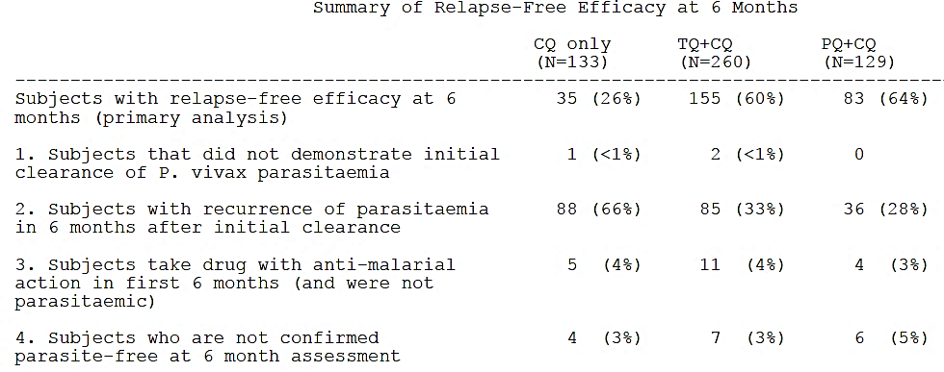

The proportional hazards analysis of recurrence-free efficacy over the 6 months duration of follow up showed the following results, shown in Table 29.

Table 29: Survival analysis of relapse free efficacy over 6 months

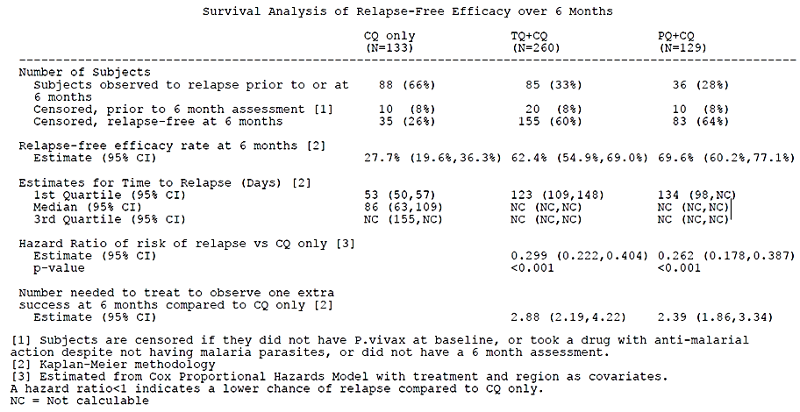

Thus the treatment with tafenoquine and chloroquine resulted in a reduction in the risk of recurrence over 6 months of 70.1% (95% CI 59.6%, 77.8%) compared with chloroquine alone. This was similar to the risk reduction in primaquine and chloroquine group (hazard ratios of 0.299 and 0.262 in tafenoquine and chloroquine and primaquine and chloroquine groups respectively).

The median time to recurrence was 86 days (95% CI 63 days, 109 days) with chloroquine alone and not calculable for tafenoquine and chloroquine group and primaquine and chloroquine groups as survival rates remained above 50% in these groups, as shown in Figure 8, below.

Figure 8: Kaplan Meier survival curves for relapse free efficacy over 6 months

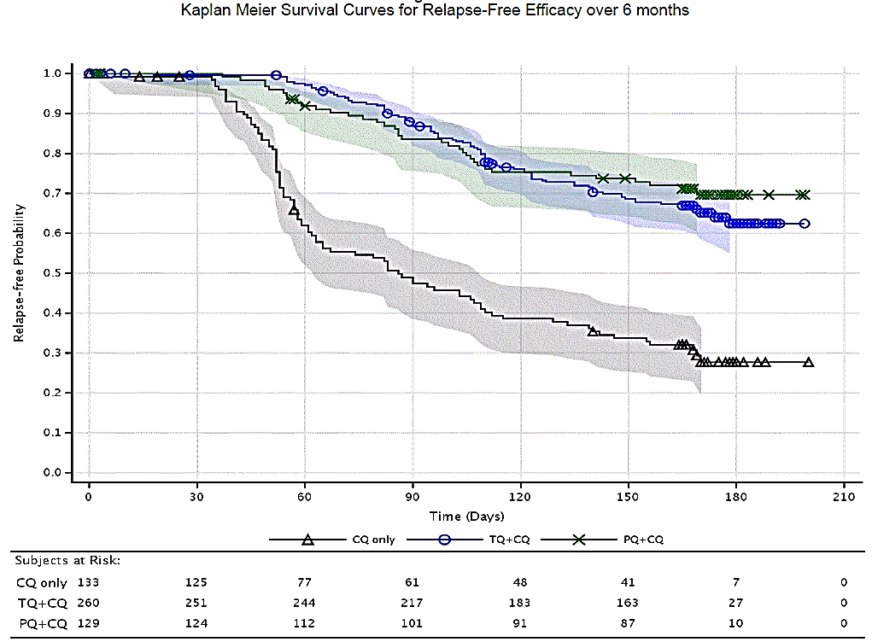

Analysis of primary efficacy outcome using the alternative logistic regression approach was consistent with the results above with the Cox proportional hazards method.

Estimates of recurrence-free efficacy at 6 months in individual groups stratified by region are shown in Figure 9, below.

Figure 9: Kaplan Meier estimate for recurrence free efficacy at 6 months by region (mITT population)

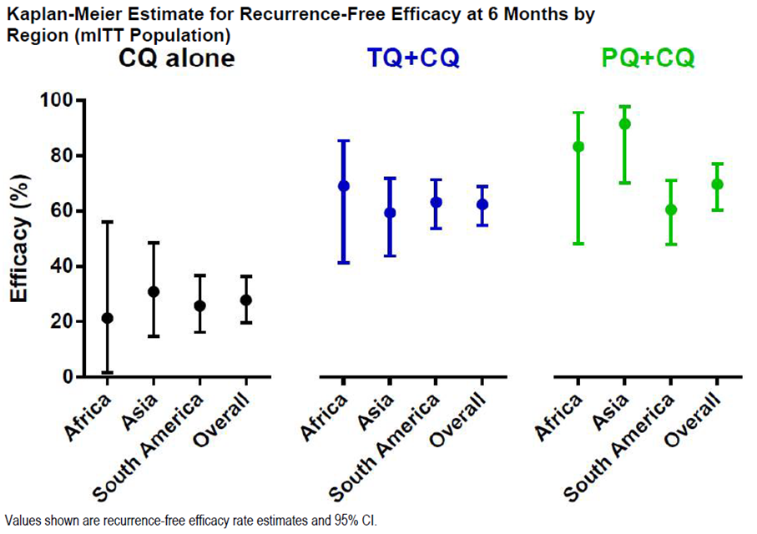

Analysis of primary efficacy outcome at 4 months was consistent with the analysis at the 6 months.

No difference was observed in the risk of recurrence for either homologous or heterologous parasite strains. Also so clinically relevant effect of CYP2D6 polymorphism was demonstrated on tafenoquine efficacy in this study.

The frequency of early treatment failures;[26] was reported as follows: chloroquine alone (2 subjects; 1.5%), tafenoquine and chloroquine (3 subjects; 1.2%), and primaquine and chloroquine group (0%). One subject in chloroquine alone group had recrudescence (blood stage failure) prior to Day 33. One additional subject in tafenoquine and chloroquine group had a genetically heterologous infection which did not meet the criteria for recrudescence.

Early response to treatment in terms of parasite clearance, fever clearance and gametocyte clearance were similar across the treatment groups.

Pf infection was not detected in any subject at baseline. Post baseline, the incidence of Pf detection was as follows in Table 30).

Table 30: Summary of Pf asexual parasite emergence

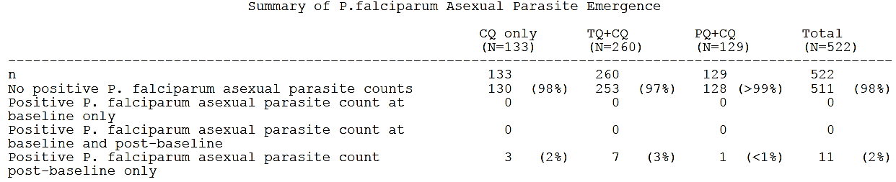

##### Other efficacy studies

Other efficacy studies included Studies TAF112582 (Part 1) and TAF116564.

**Safety**

The safety data supporting the use of a single 300 mg tafenoquine dose when used with chloroquine for the prevention of Pv relapse are based on the pivotal efficacy Study TAF112582 (Part 2).

The supportive data are available from Studies TAF112582 (Part 1) and TAF116564 (G6PD study in females) and 2 studies in healthy volunteers (ophthalmic safety Study TAF201807 and QT Study TAF114582) as well as other studies in the tafenoquine clinical development program.

Overall, more than 4000 subjects have been exposed to tafenoquine including >800 exposed to a 300 mg total dose**.** A total of 483 Pv infected subjects were treated with tafenoquine 300 mg single dose plus chloroquine in the 3 efficacy/safety studies (Studies TAF112582 Parts 1 and 2 and Study TAF116564). In the pivotal Study TAF112582 (Part 2), all subjects received their scheduled tafenoquine 300 mg dose in clinic according to randomisation.

The safety outcomes in the pivotal Study TAF112582 (Part 2) are presented here as they capture the risk specifically associated with the proposed clinical use of single dose in Pv radical cure. Overall, 59 to 65% participants reported at least one adverse event (AE) in this trial as follows in Table 31.

Table 31: AE reported for each treatment

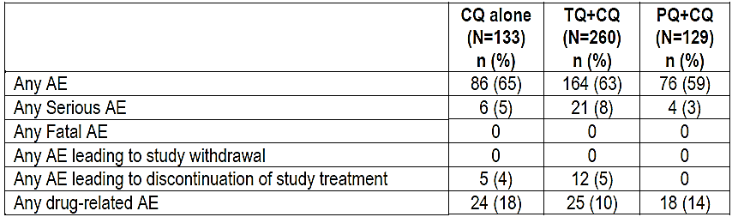

AEs with frequency >5% were reported in nearly 50% subjects in all groups and were as follows in Table 32.

Table 32: AEs with frequency >5%

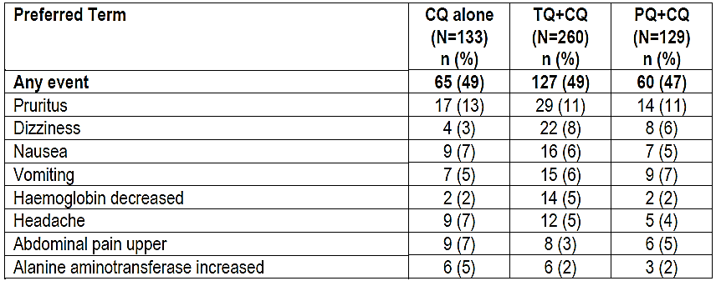

Serious adverse events (SAEs) were reported in 3 to 5% subjects as follows in Table 33.

Table 33: Serious AEs (SAEs) reported by Preferred Term

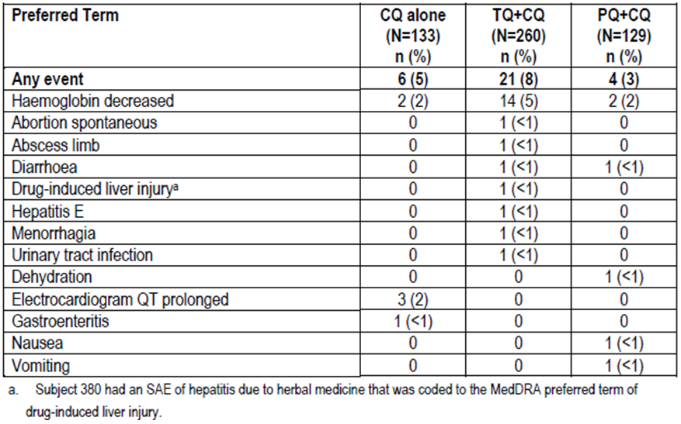

The incidence of neuropsychiatric events was as follows in Table 34.

Table 34: Incidence of neuropsychiatric events

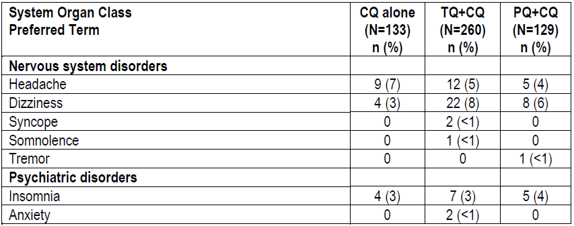

The reported declines in haemoglobin over the first 29 days of this study were as follows in Table 35.

Table 35: Declines in haemoglobin over the first 29 days

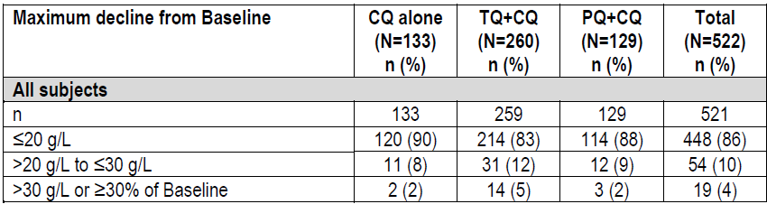

Haemoglobin values by Visit over the course of study treatment and follow up were as follows in Figure 10.

Figure 10: Haemoglobin values by Visit over the course of study treatment and follow up

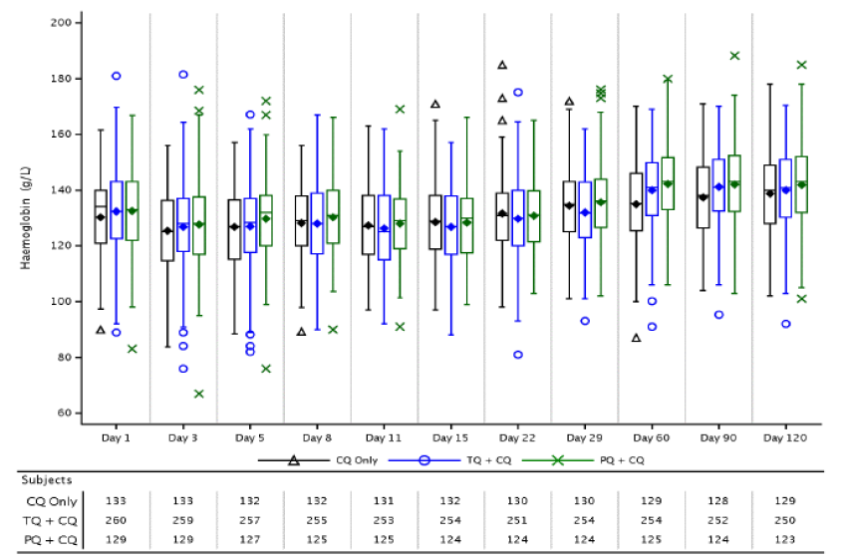

Haematology results were as follows in Table 36.

Table 36: Haematology laboratory data outside the reference range at any time on treatment (Safety population)

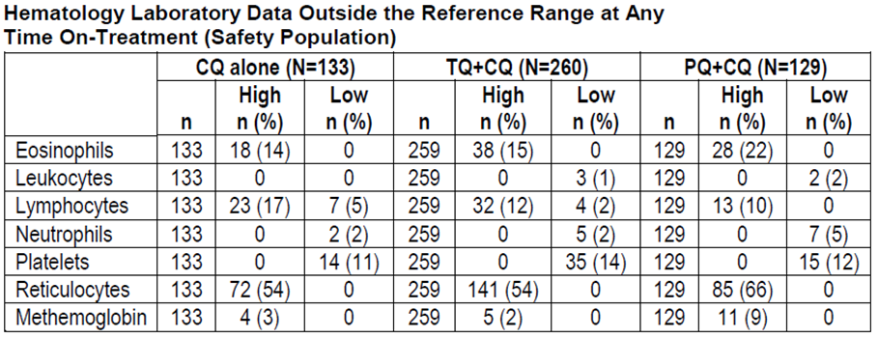

Seminal laboratory data were reported as follows in Table 37.

Table 37: Chemistry laboratory data outside the reference range at any time on study (Safety population)

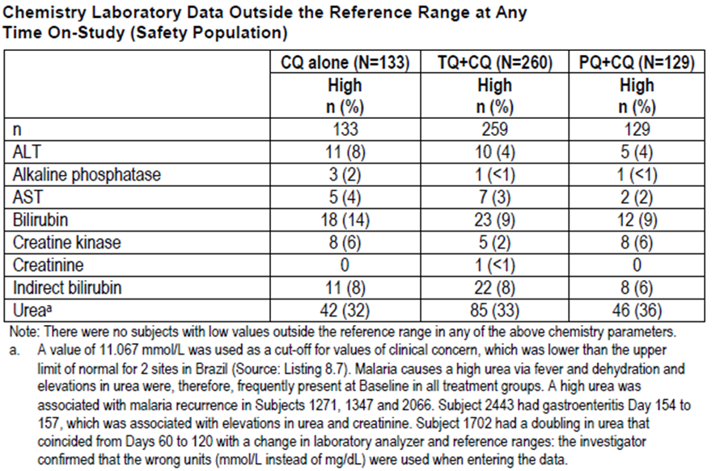

Ophthalmic outcomes in this study were as follows in Table 38.

Table 38: Keratopathy, best corrected visual acuity classification and retinal changes from baseline (ophthalmic population)

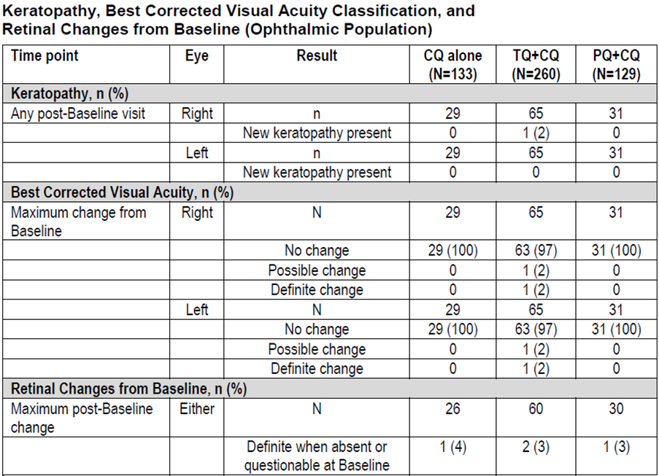

At present, no post-market surveillance data are available for tafenoquine.

### Risk management plan

An Australian specific RMP was provided by the sponsor. This been reviewed by the TGA post-market area and will be a condition of registration. Routine pharmacovigilance is proposed.

### Risk-benefit analysis

#### Delegate’s considerations

There are no outstanding chemistry, quality, manufacturing or GMP issues or nonclinical objections.

The clinical efficacy demonstrated in the pivotal trial (Part 2) is supportive of malarial chemoprophylaxis with tafenoquine and chloroquine for radical cure of Pv infection that is, prevention of relapse of Pv malaria over a 6 months duration; relapse free rates at 6 months were 60% (tafenoquine and chloroquine), 64% (primaquine and chloroquine) and 26% (chloroquine only). The adverse effects profile with the single 300 mg tafenoquine dose is considered acceptable and the overall risk-benefit of the proposed clinical use is favourable.

The Kaplan Meier curve (reproduced earlier as Figure 8) showed rapid decline in survival in the chloroquine only group over 60 days, whereas the relapse-free survival remained stable through to 150 days of follow-up in the tafenoquine and chloroquine and primaquine and chloroquine groups. There were very few subjects left at 180 days for reliable interpretation.

The clinical trial was conducted in endemic regions where reinfection is an ongoing issue. The number of reinfections (new infections) among subjects who relapsed within 6 months after initial clearance (33% versus 28% versus 66% in tafenoquine and chloroquine, primaquine and chloroquine and chloroquine only groups respectively) cannot be determined from the reported results. However, on theoretical grounds, the relapse rates can be expected to be (much) lower when used in the intended population for this submission that is, incident cases of malaria on return to non-endemic area after exposure in overseas endemic regions. The study, carried out in semi-immune population resident in endemic areas, is considered to be of clinical relevance to the proposed use in Australia.

The efficacy of primaquine and chloroquine (numerically better) was similar to tafenoquine and chloroquine. However, tafenoquine and chloroquine is advantageous over primaquine and chloroquine due to single dose requirement for tafenoquine compared to 2 weeks course with primaquine. Tafenoquine and chloroquine (300 mg single dose use) also may have better safety profile with respect to the risk of haemolysis.

The sponsor has proposed following specifications for the clinical use:

* G6PD deficiency is a contraindication. Patients must be tested for G6PD deficiency prior to prescribing tafenoquine. This is considered appropriate.
* Tafenoquine should be co‐administered with chloroquine on the first or second day of the three days chloroquine administration. This is appropriate but should be part of the therapeutic indication.
* Tafenoquine should be taken with food to increase systemic absorption and minimise gastrointestinal side effects. This is considered appropriate.
* In the event of vomiting within 60 minutes after dosing, a repeat dose should be given. Re‐dosing should not be attempted more than once. This is considered appropriate.
* There are no data regarding the subsequent re‐treatment of recurrent Pv infection with tafenoquine following initial dosing. This is considered appropriate.
* There are no data regarding co‐administration of tafenoquine with antimalarial agents other than chloroquine in patients with acute Pv infection. Consideration should be given to official guidance on the appropriate use of antimalarial medicinal products in areas where chloroquine is not recommended. This is considered appropriate.
* Populations: Adults and Adolescents (16 years and older): A single 300 mg dose (two 150 mg tafenoquine tablets) is recommended. This is considered appropriate but should specify that it is used with chloroquine.

Pending advice from the TGA’s Advisory Committee on Medicines (ACM), the Delegate is of the view that the supplied data are supportive of approval for general marketing of Kozenis (tafenoquine 150 mg oral tablets) for the following indication:

*‘Tafenoquine is indicated for the radical cure (prevention of relapse) of Pv malaria in patients aged 16 years and older. Tafenoquine should be co‐administered with chloroquine on the first or second day of the three days chloroquine administration.’*

The recommended dosing is as follows:

*‘Populations: Adults and Adolescents (16 years and older): A single 300 mg dose (two 150‐mg tafenoquine tablets) is recommended to be given on Day 1 or Day 2 of the 3 day course with chloroquine (see Clinical Trials).’*

#### Proposed action

The Delegate had no reason to say, at this time, that the application for Kozenis should not be approved for registration.

#### Request for ACM advice

1. The ACM is requested to provide advice on the adequacy of the dossier supporting the clinical efficacy/safety of the intended use (single dose of tafenoquine in conjunction with 3 day chloroquine course) to achieve radical cure (prevention of relapse) of Pv malaria.
2. The committee is also requested to provide advice on any other issues that it thinks may be relevant to a decision on whether or not to approve this application.

#### Response from sponsor

##### Executive Summary

* Tafenoquine is co-administered with chloroquine (CQ) on the first or second day of the three-day chloroquine administration program as a single dose. Use of tafenoquine with chloroquine treats both the dormant liver and blood stage phases of Pvmalaria, respectively.
* The sponsor developed tafenoquine together with the not for profit organisation Medicines for Malaria Venture (MMV), as part of the sponsor’s Global Health program aimed at improving healthcare for underprivileged populations.
* While only a small number of Australians are affected by Pvmalaria, the Australian registration of tafenoquine would offer Australian physicians and their patients a treatment choice. In addition, it will be used to support the registration process for tafenoquine in Pvendemic countries in Asia, Africa and South America, where there is significant unmet medical need for effective therapies.
* The primary evidence for the clinical efficacy and safety of tafenoquine for radical cure of Pv malaria is provided by 3 randomised, double blind studies: Studies TAF112582 Part 1 (Phase IIb), TAF112582 Part 2 (pivotal Phase III) and TAF116564 (supportive Phase III).
* Treatment with tafenoquine, when co-administered with standard doses of CQ, resulted in a clinically and statistically significant reduction in the risk of recurrence of Pvmalaria at 6 months by 70.1% compared with chloroquine alone (p<0.001).
* The safety profile of tafenoquine 300 mg single dose is acceptable and broadly like that of primaquine (primaquine) 15 mg/day for 14 days, which is the only treatment option for the radical cure of Pvmalaria.
* Coupled with high efficacy and a very simple and convenient dosing regimen, tafenoquine would be an important and significant new tool in the treatment of Pvmalaria for Australian patients, as well as addressing the high regional and global burden of this disease.
* The tafenoquine registration data was discussed with the TGA during two pre-submission meetings (2014 and 2017) and the registration application was granted Orphan Drug Designation and given ‘unofficial’ Priority Review status by the TGA in 2017.

##### Specific questions raised by the TGA Delegate for the ACM’s advice

1. *The ACM is requested to provide advice on the adequacy of the dossier supporting the clinical efficacy/safety of the intended use (single dose of tafenoquine in conjunction with 3 day chloroquine course) to achieve radical cure (prevention of relapse) of Pv malaria.*

The sponsor with their partner designed a clinical program for tafenoquine for the radical cure of Pv malaria in consultation with the TGA and FDA, as well as with the World Health Organization (WHO) Global Malaria Program.

Using a drug to target the hypnozoite or liver stage of Pv malaria, in combination with standard anti- malarial drugs (such as CQ) to treat the blood stage is called ‘radical cure’, since both the blood and liver stages of Pv are eliminated. Without elimination of both stages, patients may suffer from several relapses. Only the 8-aminoquinoline class of drugs, which includes tafenoquine and primaquine, have shown efficacy against hypnozoites. Primaquine is currently the only 8-aminoquinoline approved by the TGA and is administered as a once daily oral dose for 14 days, but in real world use this regimen is associated with poor compliance. Tafenoquine is administered as a single dose in conjunction with the standard 3 day treatment with CQ.

The primary evidence for the clinical efficacy and safety of tafenoquine for the radical cure of Pvmalaria is provided by the fully powered Phase IIb study (Study TAF112582 Part 1) which was used to confirm dose selection, and two Phase III studies, namely the fully powered Studies TAF112582 Part 2, and TAF116564. Safety data from a total of 33 studies across the development program were used to inform the type and frequency of uncommon and rare events observed with tafenoquine.

Study TAF112582 part 1 was a Phase IIb dose ranging study of tafenoquine single dose (50 mg, 100 mg, 300 mg and 600 mg). The primary comparison was the difference in recurrence-free efficacy between each of the different tafenoquine doses + chloroquine arm and chloroquine alone over 6 months. The 300 mg dose was selected for Phase III, because no clinically-relevant additional efficacy benefit was seen with the 600 mg dose.

The pivotal Study TAF112582 Part 2, was a multi-centre, double blind, double dummy, parallel-group, randomised, active and placebo controlled study with sites in Brazil, Peru, Ethiopia, Thailand, Cambodia and the Philippines. The primary objective was to determine the efficacy of tafenoquine as a radical cure for Pvmalaria, relative to a chloroquine only control. The primary comparison was the difference in recurrence-free efficacy between 300 mg tafenoquine and chloroquine and chloroquine alone over 6 months. Both parts of Study TAF112582 included an arm with 15 mg primaquine daily for 14 days + chloroquine for benchmarking as a non-powered comparison of safety and efficacy. Although conducted under the same protocol as Study TAF112582 Part 1, each part of the protocol represented distinct and independent studies, with different subjects being recruited to each part.

The design of TAF116564 was purposely made similar to the pivotal Study TAF112582 Part 2, based on regulatory agency guidance. The primary objective in Study TAF116564 was to compare clinically relevant haemoglobin declines between tafenoquine and chloroquine and primaquine and chloroquine. Although there was no placebo arm, recurrence-free efficacy assessments were secondary endpoints.

##### Efficacy

In Study TAF112582 Part 2, evidence of the efficacy of 300 mg single dose tafenoquine was demonstrated as follows:

* Primary endpoint: 300 mg single dose tafenoquine, when given with CQ, resulted in a clinically and statistically significant reduction in the risk of recurrence over 6 months by 70.1% (95% confidence interval (CI): 59.6%, 77.8%; p<0.001) compared with chloroquine alone, based on a Cox proportional hazards model. The Kaplan Meier estimates of recurrence-free efficacy at 6 months were 27.7% (95% CI: 19.6%, 36.3%) in the chloroquine alone group and 62.4% (95% CI: 54.9%, 69.0%) in the tafenoquine and chloroquine group.
* Treatment with primaquine and chloroquine also resulted in a significant reduction in the risk of recurrence at any time over 6 months by 73.8% (95% CI: 61.3%, 82.2%; p<0.001) compared with chloroquine alone. The estimate of recurrence-free efficacy at 6 months was 69.6% (95% CI: 60.2%, 77.1%) in the primaquine and chloroquine group. Study participants were highly compliant with the 14 day course of primaquine.

The two other primary efficacy studies (Studies TAF112582 Part 1 and TAF116564) provided consistent and supportive evidence of efficacy for the 300 mg single dose tafenoquine and chloroquine treatment, as follows:

* The dose range finding Study TAF112582 part 1, showed a statistically significant difference in efficacy between tafenoquine and chloroquine compared to chloroquine alone. The estimates of recurrence-free efficacy at 6 months were 37.5% (95% CI: 23%, 52%) in the chloroquine alone group, 89.2% (95% CI: 77%, 95%) in the 300 mg tafenoquine and chloroquine group, and 77.3% (95% CI: 63%, 87%) in the primaquine and chloroquine group.
* In Study TAF116564the estimates of recurrence-free efficacy at 6 months were 72.7% (95% CI: 64.8%,
* 79.2 %) in the tafenoquine and chloroquine group, and 75.1% (95% CI: 64.2%, 83.2%) in the primaquine and chloroquine group.

The 3 studies were conducted in malaria-endemic areas and therefore there was a continuous risk of re- infection throughout the follow-up period. For Pvrecurrences, it is not possible to distinguish true relapses from new infections, even using parasite genotyping. The observed efficacy in the Phase IIb/III studies thus demonstrates the overall benefit of tafenoquine in preventing recurrence, even in the presence of likely re-infection over the 6-month period of follow-up.

In the Phase III studies, study sites could achieve very high (96%) compliance with all study medications due to intensive educational and supportive efforts from site staff, hence almost all of the primaquine and chloroquine group took the full 14 day treatment course of primaquine. In the real world, compliance with the 14-day primaquine dosing regimen is poor, and missing as few as 3 doses can result in a 3 to 4 fold decrease in efficacy. As stated by the TGA clinical evaluator, *‘However, it is noted that Primaquine treatment compliance was very high in the study population (>99% of subjects received ≥12 doses of Primaquine) and that this high compliance rate may not be attainable outside of a clinical study environment.’*

##### Safety

The safety profile of tafenoquine at the recommended 300 mg single dose supports its use for radical cure. In Phase IIb/III studies the safety profile of tafenoquine was like that of primaquine 15 mg daily for 14 days. Altogether, a total of 483 subjects with Pv malaria have been exposed to tafenoquine and chloroquine in the primary studies. This dataset of patients with acute Pvmalaria who received tafenoquine and chloroquine enables comparison both with patients who received alone (tafenoquine and chloroquine: N=317; chloroquine alone: N=187) across the placebo controlled studies (PC grouping), and those who received primaquine and chloroquine (tafenoquine and chloroquine: N=483; primaquine and chloroquine: N=264) across the three Phase IIb/III studies (all primary, AP grouping). Overall, the AE profiles for treatment groups in the PC grouping were similar.

Safety data from across the whole tafenoquine development program include 33 studies in healthy volunteers and patients, which were used to inform the type and frequency of uncommon and rare events observed with tafenoquine. Across the tafenoquine development program, more than 4000 subjects have been exposed to tafenoquine, including >800 subjects exposed to a 300 mg total dose, of which >700 subjects received a single dose.

In the primary safety studies (Studies TAF112582 Parts 1 and 2, and TAF116564), there were no deaths or adverse events leading to withdrawal. Most subjects had adverse events that were mild or moderate in severity. A comprehensive review of neuropsychiatric adverse events reported in the primary studies showed that all events were mild to moderate in severity and self-limiting. The incidence was similar in the tafenoquine and chloroquine, primaquine and chloroquine and chloroquine treatment groups. As stated by the clinical evaluator: ‘*The incidence of neuropsychiatric AEs was low and the most common neuropsychiatric AEs with onset on or prior to Day 29 in the tafenoquine and chloroquine group was dizziness (8% with tafenoquine and chloroquine versus 3% with chloroquine alone and 6% with primaquine and chloroquine) and headache (5% with tafenoquine and chloroquine versus 7% with chloroquine alone and 4% with primaquine and chloroquine). All these neuropsychiatric AEs were of mild to moderate severity and none were considered SAEs*.’

Tafenoquine is a synthetic analogue of primaquine and so a similar safety profile may be expected. In both studies, the safety profile of single dose tafenoquine 300 mg was broadly like that of primaquine 15 mg once daily for 14 days. The TGA Delegate stated, ‘*The adverse effects profile with the single 300 mg tafenoquine dose is considered acceptable and the overall risk-benefit of the proposed clinical use is favourable*.’

###### 8-aminoquinolines and G6PD deficiency

Primaquine and tafenoquine, as 8-aminoquinolines, can cause haemolysis in individuals with a deficiency in G6PD enzyme activity, a hereditary X-linked condition. The key factors determining the severity of drug induced haemolysis are dose and the degree of G6PD enzyme activity. To manage this haemolysis risk, patients must be tested for G6PD deficiency and G6PD deficient patients then excluded from treatment with tafenoquine or primaquine. In the tafenoquine Phase IIb/III clinical program, all subjects were tested for G6PD deficiency. Including only patients with levels that were  70% of the site median proved effective in avoiding any cases of clinically significant haemolysis.

In Australia, existing quantitative laboratory diagnostics already have this capability. However, access to G6PD testing remains a barrier to effective treatment of Pvmalaria in many endemic countries. The sponsor and their partner are collaborating with the organization PATH, on the parallel development of a robust, portable, quantitative G6PD diagnostic suitable for use in resource poor settings. This may also prove to be an important innovation in addressing the global disease burden of Pvmalaria.

##### Benefit: risk ratio

The Phase IIb/III program has demonstrated high efficacy for tafenoquine, even in the face of likely re-infections during the 6 month follow-up. These studies demonstrated an appropriate safety profile throughout the 6 month follow-up that supports use in the proposed indication, and the risks of haemolysis in G6PD deficiency can be minimised by a requirement for G6PD testing prior to treatment.

Overall, tafenoquine 300 mg single dose has a favourable benefit to risk profile in adults and adolescents ≥ 16 years with G6PD levels ≥70% of normal, for the radical cure of Pv malaria. This is based on a large tafenoquine safety database of >4000 subjects exposed to various doses and regimens, including safety and efficacy data in 483 Pv infected subjects exposed to the recommended 300 mg single dose in the primary Phase IIb/III studies.

Tafenoquine offers important advantages over the current treatment with primaquine. As a single dose highly efficacious treatment, tafenoquine offers a greatly simplified and convenient regimen. In contrast to primaquine, the single dose regimen facilitates high compliance and would be predicted to ensure ease of use as well as consistent use in Pv malaria endemic countries.

##### Medical need

Pv has been eradicated from northern Australia but suitable vectors are present in northern Australia and the area remains malaria receptive. The last case of malaria acquired on mainland Australia was in 2002 during a Pvoutbreak in Northern Queensland. Malaria in Australia is therefore a disease associated primarily with residing or travelling overseas to areas with endemic transmission (Queensland Health). In 2013/2014, there were 373 cases of malaria (all species) notified through the Australian national surveillance system. Of these notified cases, 34% were due to Pvmalaria (n=126).

In 2015, according to the WHO, there were an estimated 8.5 million cases of Pv malaria (95% uncertainty interval 6.6 to 10.8 million), and 3100 associated deaths (95% uncertainty interval 1800 to 4900 deaths).[27] While Pvaccounts for 4% of malaria in Africa, it accounts for 41% of malaria cases elsewhere. The highest case numbers occur in the Southeast Asia WHO region (4.9 million estimated cases in 2015). The countries with the highest burden in Southeast Asia are India, Indonesia, and Papua New Guinea.

Pvmalaria is responsible globally for a very significant burden of illness. Relapse from the dormant liver stages undoubtedly contributes to this burden of disease in the individual patient and to the onward transmission of the infection. Compliance is a known issue with the currently available therapy (primaquine) due to the required, unmonitored, two week dosing regimen versus the single dose of tafenoquine. In many countries, malaria elimination efforts are challenged by the capacity of Pvto relapse and new tools are urgently needed.

Tafenoquine, when administered as a single dose in conjunction with the standard 3 day course of CQ, is a simple dosing regimen that is anticipated to provide high treatment compliance even in the real-world setting, resulting in improved individual and public health outcomes. As stated by the TGA clinical evaluator: ‘*A single dose posology could increase dosing convenience to patients, reduce the risk of medication non- compliance, as well as reduce the potential risk of adverse effects*.’

The sponsor therefore believes that tafenoquine offers patients in Australia, Southeast Asia and other malaria endemic areas of the world a significant therapeutic advantage over primaquine for radical cure of Pv malaria*.*

**Other issues raised by the TGA delegate**

Pending advice from ACM, the Delegate is of the view that the supplied data are supportive of approval for general marketing of Kozenis (tafenoquine 150 mg oral tablets) for the following indication:

*‘Tafenoquine is indicated for the radical cure (prevention of relapse) of Pv malaria in patients aged 16 years and older. Tafenoquine should be co‐administered with chloroquine on the first or second day of the three days chloroquine administration.’*

The recommended dosing is as follows:

*‘Populations: Adults and Adolescents (16 years and older): A single 300 mg dose (two 150‐mg tafenoquine tablets) is recommended to be given on Day 1 or Day 2 of the 3 day course with chloroquine (see Clinical Trials).’*

The sponsor proposes alternative wording below for the indication statement for consideration by the Delegate. The primary trials evaluated the effectiveness of tafenoquine in treating the liver stage of Pvinfection. While tafenoquine was administered with chloroquine as the agent used to treat the acute blood infection, the mechanism of action of tafenoquine on the liver hypnozoite should not be dependent on the agent used to treat the acute stage of infection. Monotherapy with chloroquine does not have any activity in preventing the relapse of hypnozoites so inclusion of this specific therapy within the indication statement may unnecessarily restrict therapeutic options for the treatment of the acute stage of the infection for use with tafenoquine. A drug-drug interaction study demonstrated that tafenoquine administered in combination with artemisinin-based combination therapies (ACTs) such as DHA/primaquine and AL in healthy volunteers did not affect the pharmacokinetics of these agents and there were no clinically relevant safety concerns observed with the co-administration. Whilst there was a modest increase in the Cmax of tafenoquine on co-administration with DHA/primaquine this change in tafenoquine exposure is not considered clinically relevant. There was no change in tafenoquine exposure on co-administration with AL. Tafenoquine can therefore be co-administered with these ACTs without any dose adjustment.

The sponsor would propose to clearly indicate the design of the study within ‘Clinical Trials’ to accurately reflect that chloroquine was the agent utilised for the blood stage infection but would propose to not unnecessarily restrict the acute blood stage treatment of Pvinfection to one particular agent for use with tafenoquine. Of note and for the TGA’s information, the text proposed below in red is consistent with labelling proposed by the FDA which was recently provided to sponsor (labelling negotiations ongoing):

*Indication: ‘Tafenoquine is indicated for the radical cure (prevention of relapse) of Pv malaria in patients aged 16 years and older who are receiving appropriate antimalarial therapy for the acute Pv infection (see Dosage and Method of Administration). ~~Tafenoquine should be co‐administered with chloroquine on the first or second day of the three days chloroquine administration.’~~*

*Recommended Dosing: Populations: Adults and Adolescents (16 years and older): A single 300 mg dose (two 150‐mg tafenoquine tablets) is recommended to be given on Day 1 or Day 2 of ~~the 3 day course with chloroquine~~ the appropriate antimalarial therapy (for example, chloroquine) for acute Pv malaria (see Clinical Trials).’*

##### RMP

The sponsor will implement the Kozenis Australian Risk Management Plan (version 1.1, dated 20 June 2018) which was submitted to the TGA on 5 July 2018.

##### PI/CMI

The sponsor has considered the PI recommendations from the TGA Delegate the sponsor’s responses are provided. The sponsor commits to liaising with the TGA Delegate to finalise the PI and CMI to the satisfaction of the TGA.

##### Conclusion

Pv malaria is a serious, debilitating and life-threatening disease. This regulatory application for tafenoquine was processed via a submission and evaluation mechanism analogous to the TGA priority application pathway. This was in consideration of the deemed importance of this new medicine to Pv malaria endemic regions (South-East Asia in particular), which have a pressing need for significantly improved treatment options for Pv malaria. Tafenoquine would provide a new treatment option for the radical cure of Pv malaria and the first in over 60 years since the initial registration of primaquine.

The safety profile of tafenoquine 300 mg single dose is acceptable and broadly like that of already approved primaquine 15 mg for 14 days. Coupled with high efficacy and a very simple and convenient dosing regimen, tafenoquine would be an important and significant new tool in the treatment of Pvmalaria for Australian patients. With a G6PD diagnostic suitable for use in resource-poor settings, it would also address the high regional and global burden of this disease.

#### Advisory Committee Considerations[28]

The ACM taking into account the submitted evidence of efficacy, safety and quality, agreed with the delegate and considered Kozenis film-coated tablets containing 150 mg of tafenoquine to have an overall positive benefit-risk profile for the delegate’s proposed indication:

*Tafenoquine is indicated for the radical cure (prevention of relapse) of Pv malaria in patients aged 16 years and older. Tafenoquine should be co‐administered with chloroquine on the first or second day of the three days chloroquine administration.*

In providing this advice the ACM noted the following:

* The pivotal efficacy study (Study TAF112582, Part 2), demonstrated that the recurrence-free efficacy at 6 months in the tafenoquine + chloroquine (60%) group, was comparable to the efficacy in the primaquine + chloroquine group (64%) and was superior to the chloroquine + placebo (26%) group.
* In the trial, all participants were co-administered chloroquine. There was no data available to support co-administration of tafenoquine with antimalarial agents other than chloroquine in patients with acute Pv infection.
* The clinical trial was conducted in endemic regions where reinfection is an ongoing issue. Theoretically, the relapse rates may be lower when used in the intended population for this submission, that is, incident cases of malaria on return to a non-endemic area.
* The safety profile of tafenoquine in the proposed indication was considered acceptable.
* Currently, primaquine is the only treatment currently registered in Australia for the radical cure of Pv malaria. At this time, only the 8-aminoquinoline class of drugs (for example, primaquine, tafenoquine) are known to treat the liver hypnozoites and prevent relapse.
* Single dose radical cure treatment with tafenoquine may offer advantages with respect to adherence compared to the 14 day primaquine course.

Proposed conditions of registration

The ACM agreed with the Delegate on the proposed conditions of registration.

Proposed PI/CMI amendments

The ACM agreed with the Delegate to the proposed amendments to the PI and CMI.

Specific Advice

The ACM advised the following in response to the Delegate’s specific questions on the submission:

1. *The ACM is requested to provide advice on the adequacy of the dossier supporting the clinical efficacy/safety of the intended use (single dose of tafenoquine in conjunction with 3-day chloroquine course) to achieve radical cure (prevention of relapse) of Pv malaria.*

The ACM agreed that the evidence provided in the submission for tafenoquine, when co-administered with chloroquine, supported an overall positive benefit-risk profile for the proposed indication of radical cure of Pv malaria in patients 16 years and older.

The ACM advised that implementation by the sponsor of the recommendations outlined above to the satisfaction of the TGA, in addition to the evidence of efficacy and safety provided would support the safe and effective use of this product.

### Outcome

Based on a review of quality, safety and efficacy, TGA approved the registration of Kozenis tafenoquine 150 mg film-coated tablet blister pack for oral administration, indicated for:

*Tafenoquine is indicated for the radical cure (prevention of relapse) of Pv malaria in patients aged 16 years and older who are receiving appropriate antimalarial therapy for the acute Pv infection (see Section 4.2 Dose and Method of Administration).*

#### Specific conditions of registration applying to these goods

1. Kozenis (tafenoquine) is to be included in the Black Triangle Scheme. The PI and CMI for Kozenis must include the black triangle symbol and mandatory accompanying text for five years, which starts from the date that the sponsor notifies the TGA of supply of the product.
2. The Kozenis Australian Risk Management Plan (RMP) (version 1.1, dated 11 January 2018), included with submission PM-2017-04578-1-2, and any subsequent revisions, as agreed with the TGA will be implemented in Australia.

## Attachment 1. Product Information

The PI for Kozenis approved with the submission which is described in this AusPAR is at Attachment 1. For the most recent PI, please refer to the TGA website at <<https://www.tga.gov.au/product-information-pi>>.

## Attachment 2. Extract from the Clinical Evaluation Report

|  |
| --- |
| Therapeutic Goods Administration |
| PO Box 100 Woden ACT 2606 Australia  Email: [info@tga.gov.au](mailto:info@tga.gov.au) Phone: 1800 020 653 Fax: 02 6232 8605  [**https://www.tga.gov.au**](https://www.tga.gov.au) |

1. Proposed FDA product label, tafenoquine, Module 1.11.2
2. Vennerstrom et al. (1999). 8-Aminoquinolines active against blood stage Plasmodium falciparum in vitro inhibit hematin polymerization. Antimicrob Agents Chemo. 43(3): 598-602
3. Ramharter *et al.* (2002). *In vitro* activity of tafenoquine alone and in combination with artemisinin against *Plasmodium Falciparum*. Am J Trop Med Hyg. **67**(1), 39–43.
4. Pradines *et al,* (2006). *In vitro* activity of tafenoquine against the asexual blood stages of *Plasmodium falciparum* isolates from Gabon, Senegal, and Djibouti. Antimicrob Agents Chemother. **50**(9): 3225–3226.
5. Gorka *et al.* 2013. Cytostatic versus cytocidal profiling of quinolone drug combinations via modified fixed-ratio isobologram analysis. Malaria Journal **12**:332.
6. Quashie et al. 2013. A SYBR Green 1-based in vitro test of susceptibility of Ghanaian Plasmodium falciparum clinical isolates to a panel of anti-malarial drugs. Malaria Journal 12:450.
7. Based on Cmax ~186 ng/ml (647 nM) and 99% plasma protein binding.
8. Coleman et al., (1992). Gametocytocidal and sporontocidal activity of antimalarials against Plasmodium Berghei anka in ICR mice and Anopheles Stephensi mosquitoes. Am J Trop Med Hyg. 46(2):169-182
9. Ponsa et al., (2003). Transmission-blocking activity of tafenoquine and artelinic acid against naturally circulating strains of Plasmodium Vivax in Thailand. Am J Trop Med Hyg 69(5): 542–547
10. Tekwani et al. (2005). Targeting the hemozin synthesis pathway for new antimalarial drug discovery: Technologies for in vitro β-Hematin formation assay. Combinational Chemistry and High Throughput Screening 8:63-79
11. Vennerstrom et al. (1999). 8-aminoquinolines active against blood stage Plasmodium falciparum in vitro inhibit hematin polymerization. Antimicrob Agents Chemo 43:598-602
12. Lanners H. N. (1991). Effect of the 8-aminoquinoline primaquine on culture-derived gametocytes of the malaria parasite *Plasmodium falciparum*. Parasitol Res **77**:478-481
13. The QT interval is the time from the start of the Q wave to the end of the T wave. It represents the time taken for ventricular depolarisation and repolarisation, effectively the period of ventricular systole from ventricular isovolumetric contraction to isovolumetric relaxation. The QT shortens at faster heart rates. An abnormally prolonged QT is associated with an increased risk of ventricular arrhythmias, especially Torsades de Pointes.
14. Brueckner *et al*. 1998. First time in humans safety and pharmacokinetics of WR238605, a new antimalarial. Am J Trop Med Hyg., **58**(5):645–649
15. ICH guideline S2 (R1): Guidance on genotoxicity testing and data interpretation for Pharmaceuticals intended for human use.
16. ICH guideline S5 (R2): Detection of toxicity to reproduction for medicinal products & toxicity to male fertility.
17. Category C: Drugs which, owing to their pharmacological effects, have caused or may be suspected of causing, harmful effects on the human fetus or neonate without causing malformations. These effects may be reversible. Accompanying texts should be consulted for further details.
18. ICH guidance S10; Photosafety evaluation of pharmaceuticals.
19. ICH guidelines (ICH M3 (R2)): Guideline on Nonclinical Safety Studies for the Conduct of Human Clinical Trials and Marketing Authorization for Pharmaceuticals
20. Product Information for primaquine, February 2017
21. Tafenoquine is an 8-aminoquinoline, a class of drugs known to be a haemolysis risk factor in subjects with G6PD deficiency. The distribution of G6PD enzyme activity in males is bimodal and individuals are either normal or deficient, since they carry only one copy of the G6PD gene. Females carry two copies of the gene, and can therefore be heterozygous for G6PD deficiency. Females who are heterozygous for G6PD deficiency have varying levels of X-chromosome inactivation, resulting in a spectrum of G6PD enzyme activity ranging from fully deficient, to intermediate levels of deficiency, through to normal levels of enzyme activity.
22. Full study results provided to TGA in May 2018.
23. Haemoglobin decreases from baseline of ≥30% or >30 g/L, or an overall drop to below 60 g/L in the first 15 days of the study were protocol-defined SAEs
24. In the primary endpoint, a subject was considered to have a clinically significant retinal change if any of the following 5 parameters indicated a change from Baseline in either eye: SD-OCT central subfield thickness, SD-OCT total macular volume, SD-OCT central retinal lesion thickness, SDOCT ellipsoid zone disruption (EZD), or abnormal autofluorescence patterns.
25. Recurrence-free at 6 months required all 5 criteria (1) non-zero Pv asexual parasite count at baseline (2) Initial clearance of Pv parasitaemia (3) negative asexual parasite count at all times prior to Day 201 following initial clearance (4) no use of concomitant antimalarial drug and (5) parasite free at 6 months. According to the sponsor the primary endpoint was described as ‘relapse’ in the study protocol (in agreement with overseas regulatory authorities), but the term ‘recurrence’ was used in the study report to more accurately reflect the efficacy outcome.
26. Subjects who did not demonstrate initial clearance of Pv parasitaemia or demonstrated initial clearance and had a subsequent non-zero asexual *P. vivax* parasite count on or before Day 32.
27. WHO (2016) World Malaria Report 2016. World Health Organization: Geneva, Switzerland. [http://www.who.int/malaria/publications/world-malaria-report-2016/report/en/]
28. The ACM provides independent medical and scientific advice to the Minister for Health and the Therapeutic Goods Administration (TGA) on issues relating to the safety, quality and efficacy of medicines supplied in Australia including issues relating to pre-market and post-market functions for medicines.

    The Committee is established under Regulation 35 of the Therapeutic Goods Regulations 1990. Members are appointed by the Minister. The ACM was established in January 2017 replacing Advisory Committee on Prescription Medicines (ACPM) which was formed in January 2010. ACM encompass pre and post-market advice for medicines, following the consolidation of the previous functions of the Advisory Committee on Prescription Medicines (ACPM), the Advisory Committee on the Safety of Medicines (ACSOM) and the Advisory Committee on Non-Prescription Medicines (ACNM). Membership comprises of professionals with specific scientific, medical or clinical expertise, as well as appropriate consumer health issues relating to medicines.