|  |
| --- |
| **Date of first round report: 13 April 2015**  **Date of second round report: 3 September 2015** |

|  |
| --- |
| AusPAR Attachment 2 |
| Extract from the Clinical Evaluation Report forTalimogene Laherparepvec |
| Proprietary Product Name: Imlygic |
| Sponsor: Amgen Australia |

About the Therapeutic Goods Administration (TGA)

* The Therapeutic Goods Administration (TGA) is part of the Australian Government Department of Health, and is responsible for regulating medicines and medical devices.
* The TGA administers the *Therapeutic Goods Act 1989* (the Act), applying a risk management approach designed to ensure therapeutic goods supplied in Australia meet acceptable standards of quality, safety and efficacy (performance), when necessary.
* The work of the TGA is based on applying scientific and clinical expertise to decision-making, to ensure that the benefits to consumers outweigh any risks associated with the use of medicines and medical devices.
* The TGA relies on the public, healthcare professionals and industry to report problems with medicines or medical devices. TGA investigates reports received by it to determine any necessary regulatory action.
* To report a problem with a medicine or medical device, please see the information on the TGA website <<https://www.tga.gov.au>>.

About the Extract from the Clinical Evaluation Report

* This document provides a more detailed evaluation of the clinical findings, extracted from the Clinical Evaluation Report (CER) prepared by the TGA. This extract does not include sections from the CER regarding product documentation or post market activities.
* The words [Information redacted], where they appear in this document, indicate that confidential information has been deleted.
* For the most recent Product Information (PI), please refer to the TGA website <<https://www.tga.gov.au/product-information-pi>>.

Copyright

© Commonwealth of Australia 2016  
This work is copyright. You may reproduce the whole or part of this work in unaltered form for your own personal use or, if you are part of an organisation, for internal use within your organisation, but only if you or your organisation do not use the reproduction for any commercial purpose and retain this copyright notice and all disclaimer notices as part of that reproduction. Apart from rights to use as permitted by the *Copyright Act 1968* or allowed by this copyright notice, all other rights are reserved and you are not allowed to reproduce the whole or any part of this work in any way (electronic or otherwise) without first being given specific written permission from the Commonwealth to do so. Requests and inquiries concerning reproduction and rights are to be sent to the TGA Copyright Officer, Therapeutic Goods Administration, PO Box 100, Woden ACT 2606 or emailed to <[tga.copyright@tga.gov.au](mailto:tga.copyright@tga.gov.au)>.

Contents

List of common abbreviations 5

1. Introduction 8

2. Clinical rationale 8

3. Contents of the clinical dossier 9

3.1. Scope of the clinical dossier 9

3.2. Paediatric data 9

3.3. Good clinical practice 9

4. Pharmacokinetics 9

4.1. Studies providing pharmacokinetic data 9

4.2. Summary of pharmacokinetics 10

4.3. Evaluator’s overall conclusions on pharmacokinetics 13

5. Pharmacodynamics 13

5.1. Studies providing pharmacodynamic data 13

5.2. Summary of pharmacodynamics 13

5.3. Evaluator’s overall conclusions on pharmacodynamics 15

6. Dosage selection for the pivotal studies 15

7. Clinical efficacy 16

7.1. Melanoma 16

7.2. Analyses performed across trials (pooled analyses and meta-analyses) 27

7.3. Evaluator’s conclusions on clinical efficacy for melanoma 30

8. Clinical safety 33

8.1. Studies providing evaluable safety data 33

8.2. Patient exposure 37

8.3. Adverse events 39

8.4. Laboratory tests 45

8.5. Post-marketing experience 47

8.6. Evaluator’s overall conclusions on clinical safety 47

9. First round benefit-risk assessment 48

9.1. First round assessment of benefits 48

9.2. First round assessment of risks 48

9.3. First round assessment of benefit-risk balance 48

9.4. First round recommendation regarding authorisation 48

10. Clinical questions 49

10.1. Additional expert input 49

10.2. Clinical questions 49

11. Second round evaluation of clinical data submitted in response to questions 50

11.1. Question 1 50

11.2. Question 2 51

11.3. Question 3 52

11.4. Question 4 52

11.5. Question 5 54

11.6. Second round benefit-risk assessment 55

11.7. Second round recommendation regarding authorisation 55

12. References 55

## List of common abbreviations

| Abbreviation | Meaning |
| --- | --- |
| ALP | Alkaline phosphatase |
| ALQ | Above the limit of quantitation |
| ALT | Alanine aminotransferase |
| AST | Aspartate aminotransferase |
| BLQ | Below the limit of quantitation |
| CDMS | Clinical data management system |
| CMV | Cytomegalovirus |
| CR | Complete response |
| CRF | Case report form |
| CRO | Contract research organization |
| CT | Computed tomography |
| CTCAE | Common Toxicity Criteria for Adverse Events |
| DLST | Dose level review team |
| DRR | Durable response rate |
| EAC | Endpoint assessment committee |
| ECG | Electrocardiogram |
| ECOG | Eastern cooperative oncology group |
| ELISA | Enzyme-linked immunosorbent assay |
| EU | European union |
| EUS | Endoscopic ultrasound |
| FIH | First-in-Human |
| FNI | Fine needle injection |
| GCP | Good clinical practice |
| GM-CSF | Granulocyte macrophage colony stimulating factor |
| GMO | Genetically modified organism |
| HCMV IE | Human cytomegalovirus immediate early promoter |
| hGM-CSF | Human granulocyte macrophage colony stimulating factor |
| HIV | Human immunodeficiency virus |
| HLA | Human lymphocyte antigen |
| HSV | Herpes simplex virus |
| HSV-1 | Herpes simplex virus, type 1 |
| ICH | International Conference on Harmonization |
| Ig | Immunoglobulin |
| IRB | Institutional review board |
| ITT | Intent to treat |
| LDH | Lactate dehydrogenase |
| MCHC | Mean corpuscular hemoglobin concentration |
| MCV | Mean corpuscular volume |
| MedDRA | Medical Dictionary for Regulatory Activities |
| MHC | Major histocompatibility complex |
| MRI | Magnetic resonance imaging |
| OECD | Organization for Economic Cooperation and Development |
| ORR | Objective response rate (=[PR+CR]) |
| OS | Overall survival |
| PCR | Polymerase chain reaction |
| PD | Progressive disease |
| PFU | Plaque forming units |
| PR | Partial response |
| qPCR | Quantitative polymerase chain reaction |
| RECIST | Response Evaluation Criteria In Solid Tumors |
| SCCHN | Squamous Cell Carcinoma Of The Head And Neck |
| SC | Subcutaneous |
| SD | Stable disease |
| SD | Standard deviation |
| SOC | Standard of care |
| UK | United kingdom |
| ULN | Upper limit of normal range |
| US | United States |
| WBC | White blood cell count |
| WHO | World Health Organization |
| WT | Wild-type |

## Introduction

This is a submission to register a new chemical entity, an oncolytic immunotherapy derived from the wild-type HSV-1 genome (newly isolated strain JS1; ECAAC Accession Number 01010209). It is based on an attenuated non-integrating HSV-1 (a non-integrating double-stranded DNA virus) that is designed to selectively replicate in tumour tissues. In particular, genes that encode for neurovirulence (both copies of the genes encoding ICP34.5) have been removed and replaced with coding sequences for GM-CSF to enhance the systemic response to tumour antigens released during virus replication.

The proposed indication is the treatment of melanoma that is regionally or distantly metastatic.

## Clinical rationale

The sponsor’s Clinical Overview states: In Australia 12,500 people (50 per 100,000) are diagnosed with melanoma and 1560 people (6 per 100,000) die of melanoma annually. Melanoma is responsible for 3.6% of total cancer deaths in Australia and the number of new cases of melanoma in Australia has been increasing for the last 30 years.

Recently, several novel therapies for advanced melanoma have been approved: a v-raf murine sarcoma viral oncogene homolog Bl (BRAF) inhibitor, vemurafenib (Zelbora®); an immune stimulatory agent, ipilimumab (Yervoy®; a BRAF inhibitor in the same class as vemurafenib dabrafenib (Tafinlar®) and trametinib (Mekinist®), a MEK inhibitor indicated in BRAFV600 mutant melanoma without prior BRAF inhibition.

While the approval of these agents represents a clear advance in the treatment of advanced melanoma, they have inherent limitations. Results for all 4 treatments demonstrate a low percentage of complete responses. In addition, vemurafenib, dabrafenib, and trametinib are indicated in patients with BRAFV600 mutations, which are found in between 25-46% of melanoma depending on age (Menzies et al., 2012). These treatments are commonly associated with resistance and responses are rarely durable.

**Comment:** The introduction of immunotherapy with monoclonal antibodies (MAbs) against immune checkpoints on lymphocytes has been a major advance in treatment of melanoma. Responses are seen in patients irrespective of the mutation status of the melanoma and the stage of melanoma including the most advanced Stage IV M1c (Robert et al., 2014; Hamid et al., 2013). The MSD MAb ‘Keytruda’ against programmed death receptor 1 (PD1) on T cells was approved for treatment of melanoma by the FDA in September 2014. It induced responses in approximately 38% of patients and 1 year survivals of approximately 70%. Similarly the BMS MAb ‘Opdivo’ against PD1 induced responses in approximately 40% of patients and 1 year survivals of 72%. It was approved for treatment of melanoma by the FDA in December 2014 Grade 3-4 toxicities were minimal during treatment with either of these agents. Investigators treating melanoma now regard these agents as the standard of care in treatment of melanoma. It is understood that both agents are before the TGA for approval in treatment of melanoma. Keytruda (Merck) was approved 20 January 2015.

There remains an important need to offer additional therapies to melanoma patients that are both safe and effective. In particular, a high unmet medical need exists among patients with disease that is limited to regional metastases, non-visceral distant metastases, and low volume and/or stable visceral metastases, to attain local and distant disease control and regression without the toxicities associated with systemically administered therapies.

**Comment:** The introduction of treatments against PD1/PD-L1 has reduced the unmet need so that the need now is for treatments that increase the percentage of patients that respond to these agents or which increase the duration of responses to them. It is unlikely that Imlygic would be used in preference to the anti PD1/PD-L1 agents but after future study may have a role to increase and maintain responses to them when given in combination

#### Guidance

The TGA has adopted the following guidelines relevant to this submission:

* Guideline on the evaluation of anticancer medicinal products in man EMA/CHMP/205/95/Rev.4 effective 1 April 2014

## Contents of the clinical dossier

### Scope of the clinical dossier

The clinical dosser documented a full clinical development program of pharmacology, efficacy and safety studies.

The submission contained the following clinical information:

* 1 clinical pharmacology study that provided bio distribution and biological activity (rather than pharmacokinetic) data: Study 001/01.
* 1 pivotal efficacy/safety study (plus extension): Study 005/05 and Study 005/05e –comparator granulocyte macrophage colony-stimulating factor (GM-CSF)
* 1 safety study (plus extension) in Melanoma: Study 002/03 and Study 002/03e
* 5 other efficacy/safety studies: including 3 related to other cancers (head and neck, GI), 1x Phase 1b related to Melanoma, plus 1 registry study

### Paediatric data

The submission did not include paediatric data.

### Good clinical practice

Clinical studies were conducted under Good Clinical Practices as described in International Conference on Harmonization (ICH) Tripartite Guideline E6 (ICH, 1996), under the principles of the Declaration of Helsinki, and in accordance with local and regional regulations.

## Pharmacokinetics

### Studies providing pharmacokinetic data

Table 1 shows the studies relating to each pharmacokinetic topic and the location of each study summary.

Table 1: Submitted pharmacokinetic studies.

| PK topic | Subtopic | Study ID | * |
| --- | --- | --- | --- |
| PK in healthy adults | General PK - Single dose | N/A |  |
| - Multi-dose | N/A |  |
| Bioequivalence† - Single dose | N/A |  |
| - Multi-dose | N/A |  |
| Food effect | N/A |  |
| Bio-distribution/biological activity in special populations | Target population § - Single dose | 001-01 |  |
| - Multi-dose | 001-01 |  |
| Hepatic impairment | N/A |  |
| Renal impairment | N/A |  |
| Neonates/infants/children/adolescents | N/A |  |
| Elderly | N/A |  |
| Genetic/gender-related PK | Males versus females | N/A |  |
| PK interactions |  | N/A |  |
| Population PK analyses | Healthy subjects |  |  |
| Target population | 001-01 |  |
| Other |  |  |

* Indicates the primary aim of the study. † Bioequivalence of different formulations. § Subjects who would be eligible to receive the drug if approved for the proposed indication.

### Summary of pharmacokinetics

Traditional pharmacokinetic studies investigating absorption, distribution, metabolism and excretion are not relevant for talimogene laherparepvec. Pharmacokinetic studies focused on issues more relevant to this type of product including virus biodistribution to body tissues (using a validated qPCR assay) and assessment of viral shedding following various routes of administration.

#### Physical characteristics of the active substance

Talimogene laherparepvec is derived from a novel primary viral isolate (JS1, ECACC Accession Number 01010209), which demonstrates enhanced oncolytic activity towards tumour cells as compared to the commonly used laboratory strains and other primary isolates (Liu et al. 2003). JS1 was subsequently genetically modified to improve anti-tumour activity and patient safety. The HSV-1 genome consists of linear, double-stranded DNA that is divided into two components, L (long) and S (short). Each component contains a unique region (UL and US) flanked by inverted repeat regions, both internally (IRL and IRS) and at the termini (TRL and TRS). Genetic modifications have been made that involve four genes: deletion of ICP34.5 and ICP47, immediate-early expression of US11 under the ICP47 promoter, and insertion of human granulocyte-monocyte colony stimulating factor (hGM-CSF), as depicted in Figure 1. The ICP47 gene is situated in the US region and the ICP34.5 gene is situated in the long repeats.

Figure 1: Schematic of talimogene laherparepvec genome

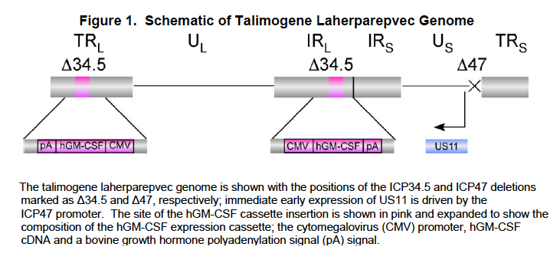

#### Pharmacokinetics

##### Biodistribution

A total of 5 nonclinical studies were conducted to assess the biodistribution of talimogene laherparepvec to body tissues and tumours and viral shedding in excreta. In addition, the expression of GM-CSF, a direct evidence of talimogene laherparepvec presence, was measured in tumour and serum samples. Four of these studies were conducted in BALB/c mice, a relevant and sensitive model for evaluating the safety and neurovirulence of an HSV-1-based therapeutic; one study evaluating the biodistribution of talimogene laherparepvec was conducted in dogs to support potential clinical testing of talimogene laherparepvec in patients with prostate cancer. In addition, an embryo-fetal development study was conducted to evaluate placental transfer.

The most comprehensive data regarding viral biodistribution was obtained from the 2-part first-in-human Study 001/01, which enrolled subjects with varied tumour types, including melanoma. Subjects in Part 1 received single doses of 106, 107and 108 plaque-forming units (PFU)/mL in separate dose cohorts, while subjects in Part 2 received one dose of 106 PFU/mL followed by 2 doses of either 107 or 108 PFU/mL.

Viral DNA was not detected in the urine samples collected from subjects treated with this dosing regimen during Part 2 when multiple doses were administered. This study provided the primary evidence for the pattern of talimogene laherparepvec biodistribution that informed these assessments for all subsequent clinical studies.

Results from 28 subjects who had completed their first cycle of administration in Study 002/03 were consistent with those from subjects in Study 001/01 in that viral DNA was infrequently detected in blood and urine samples.

Subsequent studies (004/04 and 005/04) showed a similar pattern of biodistribution.

In Study 004/04 viral DNA was measured in biopsies. This confirmed results observed in preclinical studies whereby viral DNA was detected predominantly in tumours as opposed to the blood. This suggests that viral replication was predominantly confined within the tumour, thus resulting in comparatively lower levels of viral DNA being detected in blood and urine samples.

The biodistribution pattern of talimogene laherparepvec in blood and urine demonstrated consistently across studies that low copy numbers of viral DNA were sporadically detected in blood samples from 33% of subjects and urine samples from 22% of subjects from 1 hour to 1 week after intralesional injection. Blood and urine samples were negative by 2 weeks post-injection in those subjects for whom additional samples were available. The copy numbers of virus detected in blood and urine in all subjects at all collection time points was far lower than the doses administered during treatment

##### Viral Shedding

Viral shedding was assessed by the collection of swab samples from the surface of injected tumours and the exterior dressing. The samples were analysed by a plaque assay to determine if any infectious virus was present and to assess whether the occlusive dressings provided adequate containment for virus present at the tumour surface. The plaque assay did not distinguish between wild-type (WT) HSV-1 and talimogene laherparepvec. It was assumed that a positive plaque assay result indicated the presence of talimogene laherparepvec since the probability that WT HSV present on the surface of injected tumours and/or dressings would be very low.

Investigative swab samples were collected after each injection in Studies 001/01 and 004/04 and after the first injection in Study 002/03. In all studies (with the exception of pancreatic cancer Study 005/04), ‘reactive’ swabs were collected from herpes labialis or other non-injected lesions that arose during treatment and that were suspected to be herpetic in origin, and from injected tumours that were oozing or weeping

The most comprehensive set of samples (that is, in terms of the number of time points tested) was obtained from Study 001/01. Overall, at any time point, a low percentage of subjects (13% [4/30]) had swabs that were positive for virus at the tumour site. These samples were further tested by a specific custom polymerase chain reaction (PCR) assay to distinguish between talimogene laherparepvec and WT HSV; it was determined that the virus detected in 3 of the swab samples was talimogene laherparepvec and not WT HSV.

Results from Studies 002/03 and 004/04 were consistent with those from Study 001/01. Investigative swabs showed that only a single subject (4%) had a positive investigative swab sample from the tumour site and 3/17 subjects (18%) in Study 004/04 had investigative swabs that were positive at the tumour site.

All swabs of the exterior of the dressing were negative at all time points tested across all studies. See *Clinical efficacy* below for results.

##### Dosing optimisation regime

The dosing regimen for the Phase II and Phase III studies was based on results from Study 001/01. In part 1, single doses at concentrations of 106 PFU/mL, 107 PFU/mL, and 108 PFU/mL (up to 4 mL) were evaluated. In Study 001/01, pyrexia and chills (‘rigor’) were more frequent and included serious adverse events among subjects who were HSV seronegative at study entry and received doses at concentrations of 107 PFU/mL and higher.

In Part 2 of the study, a dosing regimen that included an initial lower dose of 106 PFU/mL in all subjects followed by subsequent doses of 108 PFU/mL given every 2 weeks thereafter (the second dose was given 3 weeks after the first dose), was better tolerated regardless of HSV serostatus.

The dosing regimen selected for Phase III Study 005/05 employed an initial dose of 106 PFU/mL followed by subsequent doses of 108 PFU/mL in all subjects.

#### Pharmacokinetic interactions

##### Pharmacokinetic interactions demonstrated in human studies

A perfect oncolytic virus would be one that would preferentially infect cancer cells and not normal cells. Evidence provided indicates that the genetically modified HSV virus appears to preferentially multiply in the injected tumours and that shedding into the circulation is minimal and transient (no longer than 2 weeks). Importantly it does not appear to have been investigated whether virus shed into the circulation would infect non injected metastases. Such a result would presumably add to the efficacy of the virus.

Virus was infrequently detected in exudates from injected tumours (4-18%) and not on the exterior of dressings. ‘Herpetic like’ lesions in patients were apparently tested for wild type or genetically modified virus. Details were not available but apparently there was no evidence of infection of normal cells with the genetically altered virus.

##### Clinical implications of in vitro findings

Conclusions from the in-vitro findings are two-fold. Firstly they suggest that transmission of the virus to normal cells in patients such as labial epithelia are unlikely. Secondly they suggest that secondary transmission from injected lesions in patients would be unlikely but nevertheless care was recommended in disposal of dressings and avoidance of contact with infants, pregnant females and people with immunosuppression. The sponsor appears to have missed the opportunity of showing whether there was transfer of virus to non-injected metastases.

### Evaluator’s overall conclusions on pharmacokinetics

The overall conclusion is that the modified herpes virus does not appear to pose a risk to patients when injected into individual melanoma metastases. There also appears no or very little risk of secondary transmission to caregivers or healthy adult people in contact with the patient.

## Pharmacodynamics

### Studies providing pharmacodynamic data

See below.

### Summary of pharmacodynamics

Traditional pharmacokinetic studies investigating absorption, distribution, metabolism, elimination, and drug-drug interactions are not relevant in evaluating oncolytic virus therapies such as talimogene laherparepvec (US FDA, 2012).

The clinical pharmacology assessments of talimogene laherparepvec included optimisation of the dosing regimen, assessment of the kinetics of viral clearance through biodistribution in the blood and urine, shedding from the tumour and exterior of the dressing, anti-HSV-1 serostatus, and GM-CSF expression in tumour tissue and serum.

Oral absorption studies have not been conducted because talimogene laherparepvec is administered by injection. In addition, hepatic impairment and drug interaction studies (for example, with cytochrome P450 enzyme inhibitors) have not been conducted because talimogene laherparepvec is not eliminated via hepatic metabolic mechanisms (for example, by cytochrome P450 enzymes). Talimogene laherparepvec is cleared through mechanisms including autophagy and adaptive immune response and is expected to be degraded by typical endogenous protein and DNA catabolic pathways.

Table 2 summarises the biodistribution and shedding tests conducted during each clinical study. Based on the comprehensive nonclinical results, assessment of biodistribution in clinical studies evaluated the presence of talimogene laherparepvec DNA in blood and urine, and the presence of virus using swabs of the injected tumour site(s).

Table 2: Overview of Biodistribution and Viral Shedding, Data Obtained in each clinical study of Talimogene Laherparepvec

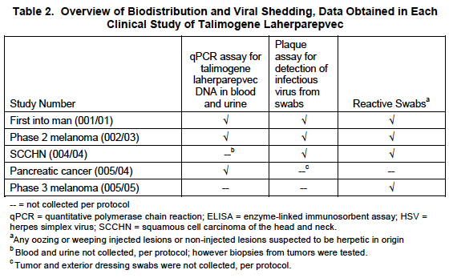

(Note that Study 005/05 was not evaluated in the assessment of viral biodistribution)

#### Mechanism of action

Talimogene laherparepvec is an oncolytic immunotherapy derived from the wild-type HSV-1 genome (newly isolated strain JS1; ECAAC Accession Number 01010209). It is based on an attenuated non-integrating HSV-1 (a non-integrating double-stranded DNA virus) that is designed to selectively replicate in tumour tissues. In particular, genes that encode for neurovirulence (both copies of the genes encoding ICP34.5) have been removed and replaced with coding sequences for GM-CSF to enhance the systemic response to tumour antigens released during virus replication. The proposed therapeutic mechanism of action of talimogene laherparepvec is two-fold (see also figure below):

1. a direct oncolytic effect is achieved following intralesional administration by viral replication in tumour tissue, resulting in tumour cell lysis and release of putative tumour-derived antigens.
2. to promote the development of an anti-tumour adaptive immune response, the virally produced GM-CSF is expressed locally in order to promote the local maturation of antigen presenting cells which can take up released tumour antigens, travel to lymph nodes, and induce a systemic anti-tumour immune response following presentation to T-cells. This strategy results in the destruction of injected and non-injected tumours (including micro-metastatic disease) and reduces the development of new metastases.

Clinically, the intended biologic effects are delay or prevention of disease progression and relapse, and prolongation of OS.

Herpes simplex virus type 1 has several advantages over other viruses for development as an oncolytic agent. It infects a wide variety of cell types, has a rapid replication cycle resulting in cell lysis, allows the incorporation of single or multiple inserted genes, which may improve the anti-tumour effect, and appropriate titers can be produced in quantities sufficient for clinical use.

Nonclinical and clinical data have shown that selective deletion of HSV genes encoding ICP34.5 results in a non-pathogenic virus with promising properties for cancer therapy (Harrington et al, 2010; Senzer et al, 2009; Hu et al, 2006; MacKie et al, 2001; Markert et al, 2000; Rampling et al, 2000; Mineta et al, 1995).

Figure 2: Proposed Mechanism of action for Talimogene Laherparepvec

Local effect: Tumour cell lysis
1: Selective viral replication in tumour tissue
2: Tumour cells rupture for an oncolytic effect
Systemic effect: Tumour specific immune response
3: Systemic tumour-specific immune response
4: Death of distant tumour cells


### Evaluator’s overall conclusions on pharmacodynamics

Enthusiasm for use of oncolytic viruses in treatment of cancer has centred on their ability to selectively destroy cancer cells either because the cancer cell (but not normal cells) express receptors for the virus (as for Coxackie A21) or because normal cells but not cancer cells can kill the virus as proposed for the genetically modified HSV described in this application. Increasingly proponents of treatments with oncolytic viruses see them as agents that stimulate immune responses against the tumour (or even viral antigens expressed in tumour cells) rather than as direct oncolytic agents.

The genetically modified virus in this study attempted to increase this aspect by incorporating production of a cytokine believed to increase antigen presentation by adjacent dendritic cells (GM-CSF) and deletion of a gene that inhibited antigen processing in the cancer cell. Given these features it is surprising that very little information was provided as to the effectiveness on this aspect of pharmacodynamic effects of the treatment on anti-tumour effects against the tumour. (Only one study appears to have been conducted (Kaufman et al., 2010). Such studies are difficult and debate continues on immune correlates with clinical responses. Nevertheless simple assessments of the effect of the treatment on T cell infiltration into injected and non‑injected metastases might have been expected. The pharmacodynamics study is incomplete without such information. There is no mention of biomarkers that might be helpful in patient selection.

## Dosage selection for the pivotal studies

The dosing regimen selected for evaluation in the Phase II and III studies was based on results from the FIH study (Study 001/01) which included subjects with melanoma. The dosing regimen consisted of an initial dose of talimogene laherparepvec of up to 4 mL of 106 PFU/mL followed by 4 mL of 108 PFU/mL administered 3 weeks later; thereafter, subsequent doses of 4 mL of 108 PFU/mL are administered every 2 weeks.

This dosing regimen was based on biological activity of the virus observed in the FIH study. In Study 001/01, talimogene laherparepvec was administered in single ascending doses of 106, 107, or 108 PFU/mL (up to 4 mL). In the first 2 single-dose cohorts, subjects who were HSV-1 seronegative at study entry experienced more adverse events, including febrile influenza-like syndromes associated with symptoms of fatigue, rigors, erythematous skin rashes and small vesicles in the skin. At the highest dose (108 PFU/mL), only HSV-1 seropositive subjects received talimogene laherparepvec and no rashes or rigors were observed. Virus was also detected on the surface of some of the injected tumours. However, virus was never detected on the exterior of the dressing covering the injection site. In the subsequent multi-dose part of Study 001/01, talimogene laherparepvec was well tolerated in HSV-1 seronegative or seropositive subjects who received a first dose of 106 PFU/mL, followed by 2 doses of 108 PFU/mL. Febrile responses were minimal, there was no detection of virus on the surface of the injected tumours, and vesicles were not seen. Of the 17 subjects, 7 subjects were HSV-1 seronegative at baseline and after given an initial dose of 106 PFU/mL before higher doses of 108 PFU/mL, 6 of the 7 subjects seroconverted within 3 weeks. Human GM-CSF expression levels appeared to increase with the increasing dose and were generally higher in subjects who were seronegative at baseline.

## Clinical efficacy

### Melanoma

#### Pivotal efficacy studies

##### Study 005-05 and 005-05e

###### Study design, objectives, locations and dates

A Phase III multicenter, randomised, open-label study to assess the efficacy and safety of talimogene laherparepvec monotherapy versus GM-CSF in subjects with unresectable Stage IIIB, IIIC and IV melanoma. Subjects were randomised in a 2:1 allocation to receive talimogene laherparepvec or GM-CSF.

The objective of this study was to evaluate the efficacy and safety of treatment with talimogene laherparepvec compared to subcutaneously (SC) administered granulocyte macrophage colony-stimulating factor (GM-CSF) in patients with unresectable Stage IIIB, IIIC, and IV melanoma.

Primary objective:

* Achieving a statistically significant improvement in durable response rate (DRR), defined as the rate of objective response (complete response [CR] or partial response [PR]) lasting continuously for 6 or more months, as compared to control therapy, and beginning at any point within 12 months of initiating therapy

Secondary objectives:

* To evaluate overall survival (OS) in subjects treated with talimogene laherparepvec as compared to control therapy
* To analyse response onset in subjects treated with talimogene laherparepvec or GM-CSF
* To evaluate time to treatment failure in subjects treated with talimogene laherparepvec or GM-CSF
* To estimate duration of response in subjects treated with talimogene laherparepvec or GM-CSF
* To evaluate best response and disease burden in subjects treated with talimogene laherparepvec or GM-CSF
* To analyse response interval in the 2 treatment arms

This study was conducted at 64 centers in the United States, Canada, South Africa, and United Kingdom.

Study period: 29 April 2009 (date first subject enrolled) to 21 December 2013 (data cutoff date).

###### Inclusion and exclusion criteria

Inclusion Criteria:

1. Males or females age ≥ 18 years.
2. Histologically confirmed diagnosis of malignant melanoma.
3. Stage IIIb, IIIc or Stage IV disease that is not surgically resectable.
4. Measurable disease defined as:

* at least 1 melanoma lesion that can be accurately and serially measured in at least 2 dimensions and for which the greatest diameter is ≥ 10 mm as measured by contrast enhanced or spiral computed tomography (CT) scan for visceral or nodal/soft tissue disease (including lymph nodes) and/or;
* at least 1 ≥ 10 mm superficial cutaneous melanoma lesion as measured by calipers and/or;
* at least 1 ≥ 10 mm subcutaneous melanoma lesion and/or;
* multiple superficial melanoma lesions which in aggregate have a total diameter of ≥ 10 mm.

5. Injectable disease (that is, suitable for direct injection or through the use of ultrasound guidance) defined as:

* at least 1 injectable cutaneous, subcutaneous or nodal melanoma lesion ≥ 10 mm in longest diameter or,
* multiple injectable melanoma lesions which in aggregate have a longest diameter of ≥ 10 mm.

1. Serum LDH levels ≤ 1.5 x ULN.
2. ECOG Performance Status of 0 or 1.
3. Life expectancy >4 months from the date of randomisation.
4. Provide written informed consent in accordance with all applicable regulations and follow the study procedures. Patients must be capable of understanding the investigational nature, potential risks and benefits of the study.
5. Adequate organ function determined within 4 weeks prior to randomisation, defined as:

* Absolute neutrophil count (ANC) ≥ 1500/mm3
* Platelet count ≥ 100,000/mm3
* Hemoglobin ≥ 8 g/dL without need for hematopoietic growth factor or transfusion support
* Serum creatinine ≤ 1.5 x ULN, or 24 hour creatinine clearance ≥50 cc/min. (Note: Creatinine clearance need not be determined if the baseline serum creatinine is within normal limits.)
* Serum bilirubin ≤ 1.5 x ULN
* Aspartate amino transferase (AST) ≤ 2.5 x ULN
* Alanine amino transferase (ALT) <2.5 x ULN
* Alkaline phosphatase ≤ 2.5 x ULN
* Serum albumin ≥ 2.5 g/dL.
* Prothrombin time (PT) ≤ 1.5 x ULN (or INR ≤ 1.3)*
* Partial thromboplastin time (PTT) ≤ 1.5 x ULN*

*Prolongation in INR, PT, and PTT when the result is from therapeutic anticoagulation treatment are permitted for patients whose injectable lesions are cutaneous and/or subcutaneous such that direct pressure could be applied in the event of excessive bleeding.

###### Exclusion Criteria

1. Clinically active cerebral or any bone metastases. Patients with up to 3 (neurological performance status of 0) cerebral metastases may be enrolled, provided that all lesions have been adequately treated with stereotactic radiation therapy, craniotomy, gamma knife therapy, with no evidence of progression, and have not required steroids, for at least two months prior to randomization.
2. Greater than 3 visceral metastases (this does not include lung metastases or nodal metastases associated with visceral organs). For patients with ≤ 3 visceral metastases, no lesion >3 cm, and liver lesions must meet RECIST criteria for SD for at least 1 month prior to randomization.
3. Any underlying medical condition, which in the opinion of the investigator, would make administration of the study drugs hazardous or make it difficult to monitor adverse effects.
4. History of second cancer unless disease-free for > 5 years. In the case of malignancies that are diagnosed at a stage where a definitive therapy results in near certain cure, a disease free interval of < 5 years is permissible. The Medical Monitor must approve such patients.
5. Primary ocular or mucosal melanoma.
6. Evidence of immunosuppression for any reason:

* known HIV disease
* acute or chronic active hepatitis B or hepatitis C infection
* chronic oral or systemic steroid medication use at a dose of >10 mg/day of prednisone or equivalent (steroids with low systemic absorption [for example, triamcinolone hexacetonide] injected into a joint space is allowed
* other signs or symptoms of clinical immune system suppression

1. Baseline prolongation of QT/QTc interval (QTc interval >470 msec).
2. Open herpetic skin lesions.
3. Pregnant or breast-feeding female. Confirmation that women of child-bearing potential are not pregnant. A negative serum or urine β-human chorionic gonadotropin (β-hCG) pregnancy test result must be obtained during the screening period.
4. Fertile males and females who are unwilling to employ adequate means of contraception (for example, condom with spermicide, diaphragm with spermicide, birth control pills, injections, patches, or intrauterine device) during study treatment and through 30 days after the last dose of study treatment.
5. Previous treatment with OncoVEXGM-CSF or treatment with GM-CSF for active disease (prior adjuvant therapy with GM-CSF is permitted).
6. Currently enrolled in another clinical research study or received an investigational agent for any reason within 4 weeks prior to randomization.
7. Require intermittent or chronic treatment with an anti-herpetic drug (for example, acyclovir), other than intermittent topical use.

###### Study treatments

OncoVEXGM-CSF to be administered by injection into lesions every two weeks. Each treatment cycle to be defined as 28 days, however Cycle 1 to be 5 weeks (second injection 3 weeks after the initial injection). The first dose of OncoVEXGM-CSF to be up to 4 mL of 106 PFU/mL (nominal). Subsequent doses to be up to 4 mL of 108 PFU/mL (nominal).

GM-CSF to be administered by subcutaneous injection. The first injection to be administered in the study clinic to observe for any first-dose reactions (for example, flushing, faint, dizzy or weak spells). Subsequent GM-CSF injections may be administered at home by the patient or a caregiver. GM-CSF to be administered in multiple cycles, at a dose of 125 μg/m2 daily subcutaneously for 14 consecutive days followed by 14 days of rest. Each cycle to be 28 days. All patients to return for clinic visits on Days 1 and 15 in each treatment cycle.

Subjects were to receive treatment until Week 24 (even in the presence of disease progression, including the appearance of new lesions), or achievement of a CR, to allow for delayed immune-based anti-tumour effects to occur, unless other therapy for melanoma was required. After 24 weeks, subjects were to remain on study until clinically relevant disease progression (disease progression associated with a decline in performance status and/or alternative therapy was required in the opinion of the investigator), up to 12 months. Subjects in response at 12 months were to continue treatment for up to an additional 6 months or disease progression, whichever was earlier. Subjects with stable disease for > 9 months were eligible for central review of tumour response; however, the results of the central review were not available for treatment decisions by the investigator. Thus, subjects with stable disease at 12 months were also allowed to remain on treatment for up to an additional 6 months if the investigator determined that the subject was likely to continue to receive benefit from additional treatment.

In addition, subjects with lesions that progressed on treatment were permitted to be treated on a weekly basis at the investigator’s discretion for up to 12 weeks as long as progression was observed between each series of 4 weekly injections. Subjects who received 2 consecutive doses of talimogene laherparepvec less than 9 days apart were considered to have undergone accelerated dosing. As expected, the overall exposure to talimogene laherparepvec was higher in subjects who underwent accelerated dosing; higher mean cumulative doses were observed in this subgroup compared to subjects who did not undergo accelerated dosing (52.1 x 108 PFU versus 27.1 x 108 PFU, respectively.

**Comment:** Although treatment was to be continued for 24 weeks in both groups the provision for continued treatment despite PD in the Imlygic arm had the potential for longer treatment in the Imlygic arm and bias in favour of this treatment arm. This was reflected in median times on treatment of 10 weeks in the GM-CSF arm compared to 23 weeks in the talimogene laherparepvec arm.

Figure 3: Study Design and Treatment Schema

Stratify by important prognostic factors
Randomise
Talimogene laherparepvec
GM-CSF
24 weeks
PDr
CR, PR, SD, PDn


###### Efficacy variables and outcomes

The main efficacy variables were:

* The primary endpoint in Study 005/05 was durable response rate (DRR)
* Overall survival was a key secondary endpoint, defined as the time from the date of randomization to the date of death due to any cause.

(Tumour response was evaluated using modified WHO criteria in Study 005/05 (by central review and investigator assessment) and modified RECIST in Study 002/03 (based on derived tumour burden change and investigator assessment). The tumour response data in the side-by-side analyses were based on investigator assessment for both studies.)

Outcomes assessed by investigator and an independent endpoint assessment committee. Modified WHO criteria were used to assess outcome rather than RECIST 1.1 due to variable shape of lesions. Nevertheless RECIST was used for non-injected visceral lesions.

**Comment**: In RECIST criteria, 2 selected lesions per organ are measured in the longest dimension and the sum of the lesions used for comparison. PD defined as an increase of 20% or more. WHO criteria measure all lesions, the product of the 2 longest diameters in perpendicular dimensions, and the sum of these added. In the 005/05 lesions could be less than 10 mm in diameter but the smaller lesions had to add up to 10 mm or greater. WHO criteria were used to assess outcome in this study to take into account different shapes of the lesions; but in general WHO criteria have fallen out of favour due to the time involved and inaccuracy of measurements. It was also not clear whether regrowth of lesions were regarded as PD or reinjected. By WHO criteria PD is taken as a 30% increase in the measures and PR greater than a 50% reduction.

###### The primary efficacy outcome was

Talimogene laherparepvec demonstrated a statistically significant improvement in the durable response rate compared to GM-CSF (16.3% versus 2.1% per EAC), based on data from the parent study only (005/05). The unadjusted odds ratio (95% CI) was 8.9 (2.7, 29.2), with a p-value of < 0.0001 (Table 4). Similar results were observed using the per-protocol population and in a sensitivity analysis based on all available central review data (including data from the extension protocol, 005/05-E). Similar results were also observed using evaluations by the investigator (ITT and per-protocol populations) (Table 4).

Table 1: Study 005/05: Summary of Durable Response rate

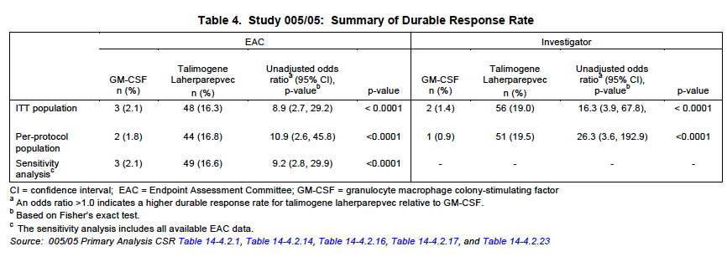

###### Secondary outcomes

Although talimogene laherparepvec improved OS over GM-CSF in the primary analysis of the ITT population (based on 290 events), this improvement was of borderline statistical significance (Table 5). The pre-planned un-stratified hazard ratio for talimogene laherparepvec relative to GM-CSF was 0.79 (95% CI: 0.62, 1.00), p = 0.051. The Kaplan-Meier median estimates for OS time were 23.3 months for talimogene laherparepvec and 18.9 months for GM-CSF; therefore, subjects who received talimogene laherparepvec lived a median of 4.4 months longer than subjects who received GM-CSF. At the time of the primary analysis, the median potential follow-up for all subjects was 44.4 months (range: 32.4 to 58.7 months); therefore, Kaplan-Meier survival rates could be reliably estimated through approximately 3 years.

In the interim OS analysis based on 250 events, treatment with talimogene laherparepvec resulted in a (non-significant) improvement in OS compared with GM-CSF (median of 23 months vs 19 months; hazard ratio 0.79; 95% CI: 0.61, 1.02).

The *objective response rate* (CR and PR) (95% Cl) per EAC was 5.7% (1.9%, 9.5%) in the GM-CSF group and 26.4% (21.4%, 31.5%) in the talimogene laherparepvec group; p-value < 0.0001 (Table 6). The percentage of CRs was 0.7% and 10.8%, respectively. Similar results were observed when using EAC evaluable subjects or evaluations from the investigator (Table 6). A high degree of correlation was observed between the EAC and investigators. Kappa statistics were calculated to assess the agreement between EAC and the investigators. The kappa (95% Cl) was 0.82 (0.76, 0.89). Of the 78 overall responders in the talimogene laherparepvec arm, 42 (54%) progressed before achieving a response.

Results for objective response rate by subgroups for disease stage and HSV-1 status are shown in Table 7. Objective responses were observed in all subsets of subjects by stage and HSV-1 status; however, it was not improved over GM-CSF in the subjects with Stage IV M1b or IV M1c disease.

*Best Overall Response and Disease Burden:* Since talimogene laherparepvec and GM-CSF elicit immune responses, some subjects may experience a lag before demonstrating a visible response. An ad hoc analysis of 86 objective responders (per EAC. in the ITT population showed 45 subjects progressed before ultimately responding to treatment. Of the 78 objective responders on the talimogene laherparepvec arm, (54%) progressed before responding, and of the 8 objective responders in the GM-CSF arm, 3 (38%) progressed before responding.

Progression was defined as either an increase of at least 25% in tumour burden relative to baseline, or the appearance of a new lesion post baseline (whether or not the lesion was measurable).

*Duration of response:* Duration of response is defined as the longest individual period from entering response (PR or CR) to the first documented evidence of the subject no longer meeting the criteria for being in response or the subject’s death, whichever is earlier. Responses were censored at the last assessment showing response.

Among the 78 objective responders in the talimogene laherparepvec arm, the median duration of response (and 95% CI) per EAC has not been reached (Table 5). At the last tumour assessment, 56 subjects (71.8%) were still in response. Among the 8 objective responders in the GM-CSF arm, the median duration of response (and 95% CI) per EAC was 2.8 (1.2, NE) months. At the last tumour assessment, 4 subjects (50%) were still in response.

Similar results were observed in the per-protocol population (per EAC and investigator).

**Table 5: Study 005/05: Summary of Key Secondary Efficacy Results (ITT Population)**

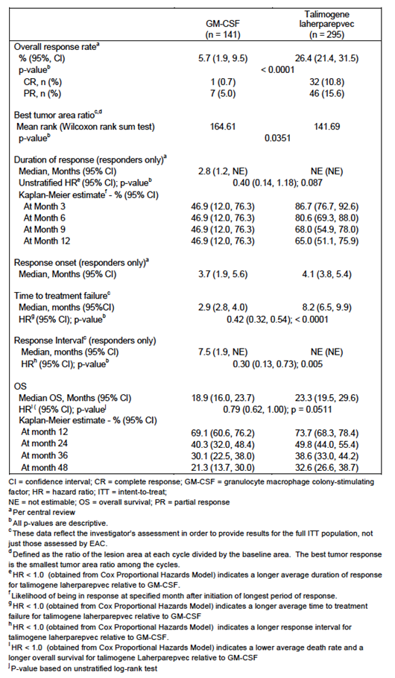

**Table 6: Study 005/05: Objective Response Rate by EAC and investigators (ITT Population)**

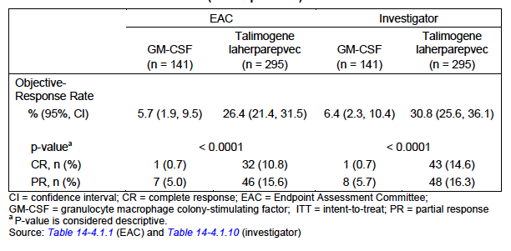

Table 7: Study 005/05: Objective Response Rate per EAC by Subgroups (ITT Population)

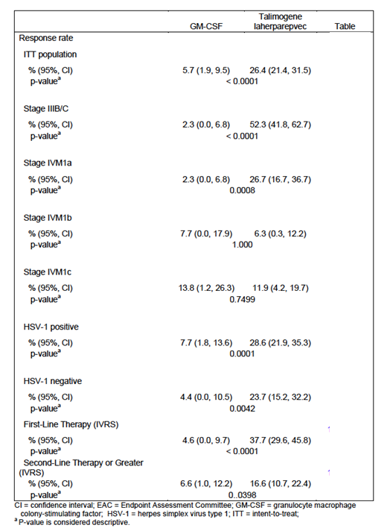

Other efficacy outcomes included:

###### Analysis in subpopulations

The treatment effect of talimogene laherparepvec on durable response and OS was heterogeneous across subgroups based on the stratification factors and key covariates (Figures 4 and 5).

Figure 4: Durable Response rate per EAC. Key Stratification Factors and Covariates (ITT population)

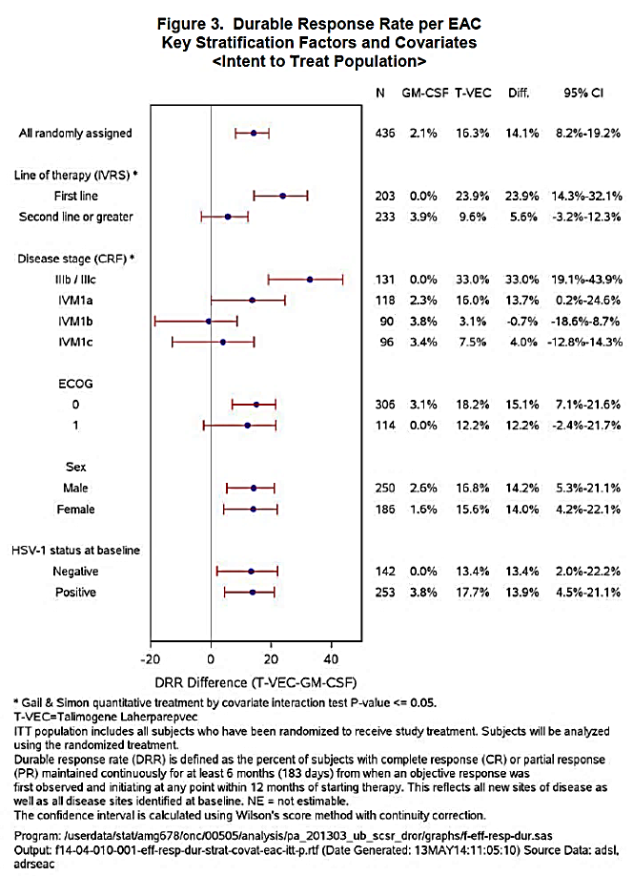

Figure 5: Hazard Ratio Plot with Log Scale. Overall survival hazard ratio key stratification factors and covariates.

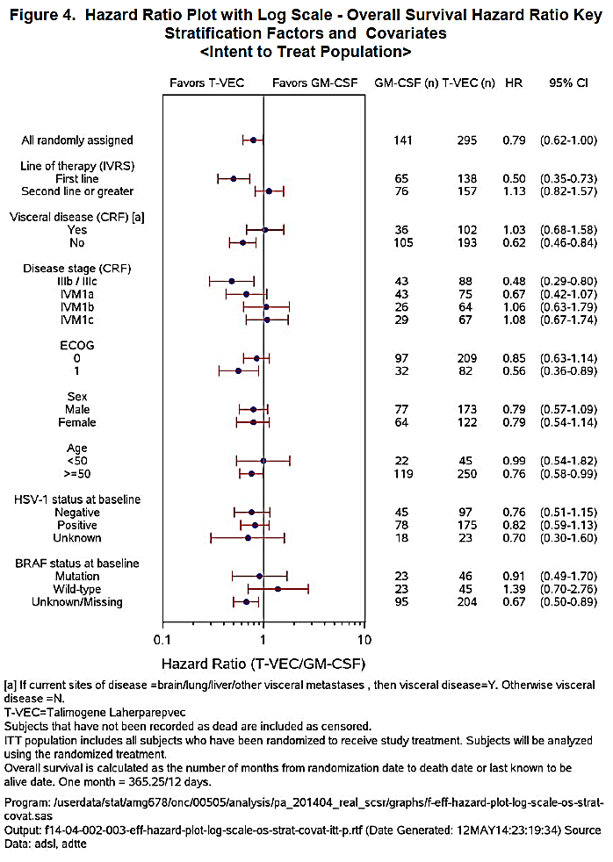

###### Evaluation of Systemic activity

In exploratory analyses to evaluate the systemic activity of talimogene laherparepvec (that is, beyond local effects in injected lesions), responses were observed in non-injected lesions, including non-visceral lesions (most commonly in the skin and lymph nodes) and visceral lesions (most commonly in the lung and liver) (supplemental clinical study report 005/05).

In analyses of subjects with non-injected lesions, 27 of 79 subjects (34.2%) had a ≥ 50% overall decrease in non-visceral lesions, and 8 of 71 subjects (11.3%) had a ≥ 50% overall decrease in visceral lesions.

Among 2116 individual lesions directly injected with talimogene laherparepvec, 1361 (64.3%) decreased in size by ≥ 50% and 995 (47.0%) completely resolved. Of 981 non-injected non-visceral lesions, 331 (33.7%) decreased in size by ≥ 50%, the majority of which (212 [21.6%]) completely resolved. Of 177 visceral lesions, 27 (15.3%) decreased in size by ≥ 50%, the majority of which (16 [9.0%]) completely resolved.

The estimated median time to lesion response among all measurable lesions (responding or non-responding) was shortest for lesions that were directly injected (21.1 weeks), followed by non-injected non-visceral lesions (44.1 weeks) and visceral lesions (110.4 weeks), consistent with initiation of a delayed loco-regional and systemic anti-tumour immune response to talimogene laherparepvec. The median (range) time to response for responding lesions was 13.3 (4.1 to 79.7) weeks for lesions that were directly injected, 12.9 (3.1 to 65.1) weeks for non-injected non-visceral lesions, and 12.3 (6.1 to 48.4) weeks for visceral lesions.

###### Randomisation and blinding methods

Randomisation was stratified by known prognostic factors, including the site of first recurrence, stage of disease, presence of liver metastases, and prior nonsurgical melanoma treatment other than adjuvant therapy. Enrollment for subjects with Stage IV M1c disease was limited to no more than 40% of the total subjects in each treatment arm.

###### Analysis populations

The primary analysis of the primary endpoint, DRR, was performed using the intent-to-treat (ITT) analysis set, which was to consist of all subjects who were randomized to study treatment.

###### Sample size

A total of 439 randomizations occurred (143 randomizations to the GM-CSF arm and 296 randomizations to the talimogene laherparepvec arm). One subject was randomised three times at three different sites (the first two times to GM-CSF, each time being withdrawn before being treated; the third time to the talimogene laherparepvec arm, receiving treatment); this subject was excluded from the ITT and per-protocol populations, but was included in the safety population based on the treatment received. Therefore, the ITT population consisted of 436 subjects who had been randomized into the study one time (141 subjects to GM-CSF, 295 subjects to talimogene laherparepvec).

###### Statistical methods

An independent EAC confirmed response status. A 2-sided unadjusted Fisher exact test was used to determine whether talimogene laherparepvec improved DRR relative to GM-CSF. Overall survival as a secondary endpoint was to be tested only if DRR was found to be statistically significant. Overall survival, response onset, time to treatment failure, duration of response, and response interval were estimated according to the Kaplan-Meier method and compared using a log-rank test. Best response and disease burden were summarised by treatment arm, and best tumour reduction was compared using a Wilcoxon Rank Sum test. Descriptive statistics were provided for all safety endpoints.

###### Participant flow

Figure 6: Subject Disposition


Subjects randomised n=437
ITT population n=436 (1 subject excluded (1 randomised 3x at different sites)
GM-CSF n=141
§ Subjects who received investigational product n=127; Subjects who never received investigational product n=14
§ Subjects who are continuing study n=42 subjects who discontinued study n=99
Talimogene laherparepvec n=295
– Subjects who received investigational product n=291; subjects who never received investigational product n=4
– Subjects who are continuing study n=127 subjects who discontinued study n=168


###### Major protocol violations/deviations

Overall, 41 (9.4%) subjects experienced important protocol deviations. The subject incidence of important protocol deviations was 3.5% (5/141) in the GM-CSF group and 12.2% (36/295) in the talimogene laherparepvec group. The most common important protocol deviation was due to subjects missing confirmatory scans (19 subjects, 4.4%), which was defined as not having a scan performed prior to the next scheduled radiologic assessment after a response (CR or PR) was determined by clinical assessment.

Table 8: Study 005/05: Summary of Important Protocol Deviations (ITT population)

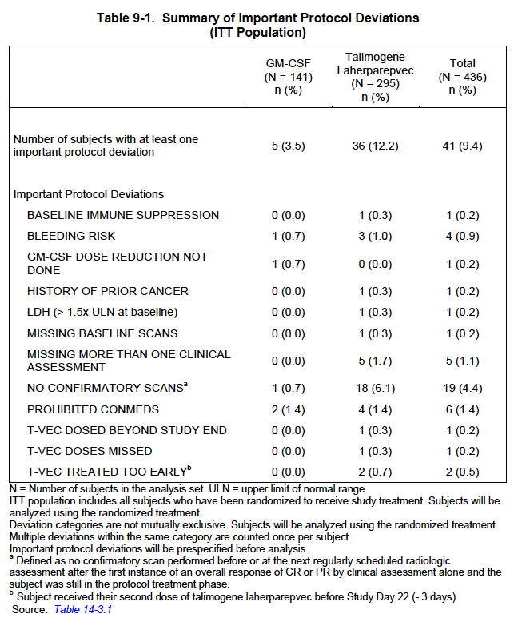

###### Baseline data

Baseline demographics for the ITT population are summarised in Table 9. Baseline demographics were generally balanced between the talimogene laherparepvec and GM-CSF groups. Overall, 57.3% were men and 97.9% were white. The mean (range) age was 63 (22 to 94) years.

Table 9: Study 005/05: Key baseline demographics (ITT population)

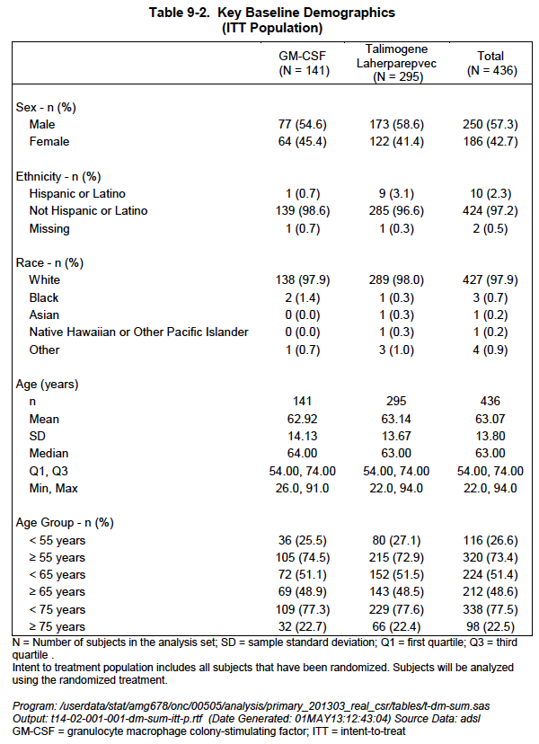

###### Results for the primary efficacy outcome

See above.

##### Results for other efficacy outcomes

See above.

#### Other efficacy studies

Summaries of Studies 002/03, 004/04 and 005/04 were provided.

### Analyses performed across trials (pooled analyses and meta-analyses)

The efficacy analysis sets used for the comparison across studies were those defined within the individual protocols. The efficacy analysis for Study 005/05 included all subjects in the ITT analysis set (295 talimogene laherparepvec, 141 GM-CSF). The efficacy analysis for Study 002/03 included all subjects who received at least 1 dose of talimogene laherparepvec (n = 50).

Table 10: Study 005/05: Baseline Demographics (integrated efficacy analysis set)

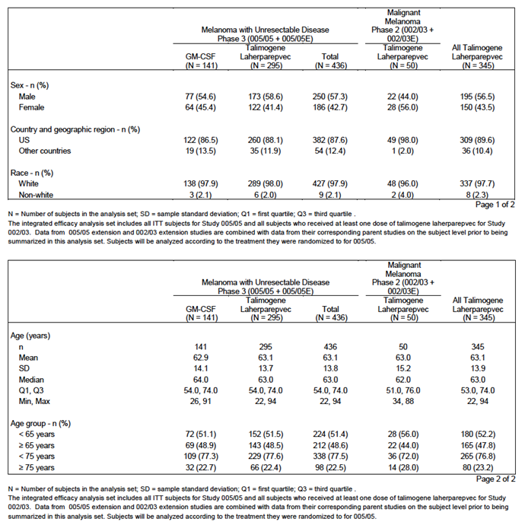

Tumour response results based on central review are presented for Study 005/05 and 005/05-E only (as central review was not performed in Study 002/03). For the comparison of efficacy between Phase III Study 005/05 and Phase II Study 002/03, the tumour response results were based on investigator assessment. Where possible, data from the 005/05-E and 002/03-E extension protocols were combined with data from the corresponding parent studies at the subject level for the side-by-side analyses.

Table 11: Analysis of durable response per investigator (integrated efficacy analysis set)

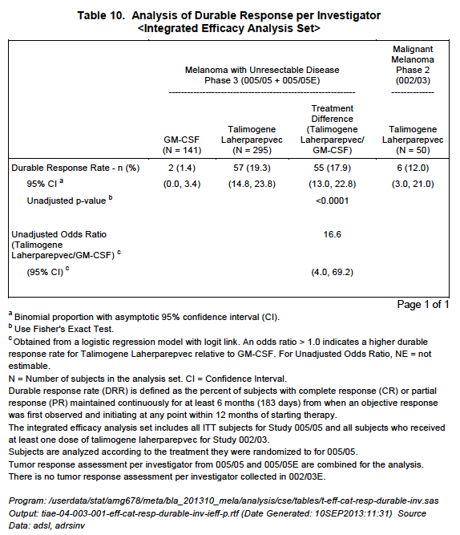

**Table 12: Overall survival (integrated efficacy analysis set)**

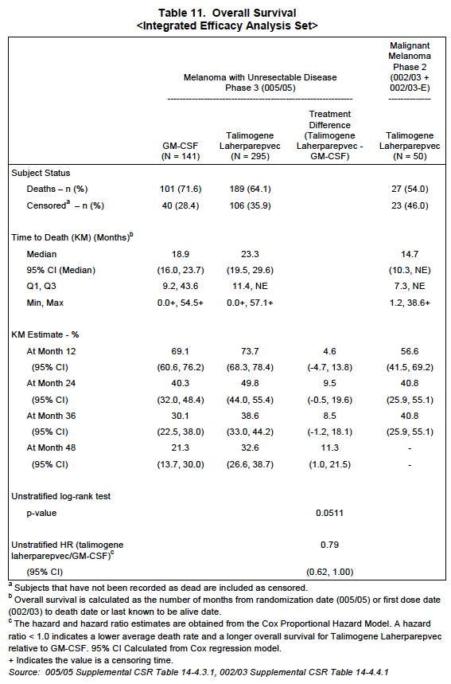

### Evaluator’s conclusions on clinical efficacy for melanoma

In assessing the clinical efficacy of Imlygic against melanoma there are several points in the design that potentially limit the significance of the findings. These are listed below:

#### Choice of comparator: Was the comparator known to have activity against melanoma?

The selection of GM-CSF given at a dose of 125 µg/m2 each day for 14 of 28 days has received considerable criticism as there is no evidence that such a regime would have any beneficial treatment effects. There are no background studies suggesting that such a regime would be efficacious in un-resectable Stage III/IV melanoma. The protocol of administration was adopted from that used in adjuvant studies (that is, after surgical resection of melanoma) by Spitler et al., (2000) which suggested it was of benefit in this clinical setting. A recent review has summarised studies with GM-CSF in an adjuvant setting and in treatment of patients with metastatic melanoma (Kaufman et al., 2014). The one large randomised study (743 patients) conducted by ECOG (E4697) using GM-CSF at 250ug/m2 for 14 days each 28 days reported by Lawson et al 2010, did not show any benefit compared to placebo in patients following surgical removal of their melanoma. Exactly similar studies have not been carried out in patients with measurable disease but the large Phase II trial on 120 patients (ECOG 1696) did not show any benefit in patients receiving a vaccine plus GM-CSF compared to vaccine alone. GM-CSF was given at 250ug/m2 for 14 of 28 days in that trial (Kirkwood et al., 2009).

GM-CSF given intralesionally has been associated with clinical responses in several small studies. For example, Si et al., (1996) reported that GM-CSF given intralesionally at 15-50 µg dose was associated with regression of injected and non-injected lesions in 3 of 13 patients and 6 of 7 patients given 400ug perilesionally had reduced lesion size. The intralesional studies are interesting but not relevant to the choice of parental GM-CSF used in the 005/05 OPTiM study which was given SC.

Overall the evidence cited above suggests that the comparator used in the OPTiM trial *was likely to be no better than a placebo.*

[Note- Combinations of immunotherapy with GM-CSF appear more promising particularly with Ipilimumab as reported in the Phase II ECOG study. Previously treated patients (N245) were randomised to treatment with Ipi alone (10 mg/kg) or Ipi combined with GM-CSF 250ug/m2 for 14 of 28 days. OS was 12.7 months for Ipi alone compared to 17.5 months for the combination. There were no differences in PFS. It was concluded that larger confirmatory studies with longer follow up were needed. This study is not relevant to the choice of control arm in the OPTiM study but does indicate combinations may be worth exploring in future studies. Similarly the suggestion that combinations of Imlygic with Ipilimumab or anti PD1 may be efficacious but this is not relevant for the present application. They would properly be the subject of separate applications when large studies with these combinations have been completed]

#### Endpoints used to assess efficacy in 005/05 studies. Were these standard endpoints?

The primary endpoint in the 005/05 OPTiM study was durable response rate (DRR) [defined as the percent of patients with complete response (CR) or partial response (PR) maintained continuously for a minimum of 6 months]. Lesions were studied individually and collectively. To take into account the variable shapes of the lesions modified WHO criteria were used to assess responses. The investigator assessment was reviewed by an independent endpoint assessment committee. The secondary endpoints included overall survival (OS), objective response rate (ORR) [PR+CR], time to response, duration of response, and time to treatment failure [time from randomisation until the first episode of clinically relevant disease progression where there is no response achieved after the progression event or until death].

DRR and ORR were determined according to tumour responses determined using modified WHO criteria by a blinded, independent Endpoint Assessment Committee (EAC).

**Comment:** The introduction of biologic therapies that depend on responses by the patient’s immune system has given rise to new endpoints that take into account the time taken for host immune responses to develop. The primary endpoint used in this study, DRR, is one such measure and varies only in allowing the DRR to commence at any time in the first 12 months of therapy. Minimum treatment was for 24 weeks and maximum of 18 months. The main reservations in such a design is the bias likely to result in the period on treatment in the 2 arms with patients discontinuing in the GM-CSF arm at earlier periods than those receiving intralesional therapy even though similar degrees of progression may be involved. This was reflected in median times on treatment of 10 weeks in the GM-CSF arm compared to 23 weeks in the talimogene laherparepvec arm. In practice it is also doubtful whether a clinician will wait 12 months for such responses to occur. Another difficulty is comparing results across studies particularly when other studies have fixed landmarks such as percent progression free (PFS) at 6 months as used in some studies (Wolchok et al., 2009). The secondary endpoints are less controversial. A clear increase in OS from randomisation would dispel many of the doubts about efficacy of the treatment. Time to ORR and duration of response will be of value in assessing the cost of the treatment as these measures will indicate the approximate amount of Imlygic used and the number of visits to medical personnel.

#### Subgroup Analyses: Were the responders in subgroups of patients with more advanced disease that are difficult to treat by other treatments?

It is well established that patients with melanoma metastases at different sites have different outcomes. This has been captured in the staging systems used for assessing prognosis such as the American joint committee on cancer (AJCC) (Thompson et al., 2011). Patients with Stage IIIB/IIIC survive longer than those with Stage IV and those with Stage IV,M1a (skin and LNs) survive longer than those with Stage IV, M1b (lung metastases) and Stage IV, M1c (visceral metastases). Patients with brain metastases have poorer survival. Given that there are a number of treatment options available for M1a disease the unmet need has been for treatments that are effective on visceral metastases.

In Study 005/05, 57% of subjects had Stage IIIB to Stage IV M1a disease. 47% of subjects were receiving talimogene laherparepvec [Imlygic] as first-line therapy. From the presentation by Kaufman et al at ASCO in 2014 and the data in 4 and 5 above it is evident that the patients in the 005/05 studies were highly selected to have low tumour burdens, for example, LDH enzyme levels were ≤ 1.5x ULN, they were to have ≤ 3 visceral metastases (lung lesions excepted) and no lesion > 3 cm. Liver lesions had to have been stable for at least 1 month. Brain lesions must have been treated and stable for at least 2 months. Patients with bone metastases were excluded. The majority of Stage IV disease patients entered had M1a disease (25-30%) with 18-22% having M1b and 21-23 % the unfavourable M1c stage. The latter usually accounts for most of the patients in previous studies. Nine percent had Stage IIIB and 22% Stage IIIc disease.

The treatment effect of Imlygic was highly dependent on stage of disease and previous treatment status. In exploratory analyses improvement in the primary endpoint DDR was only seen in patients with Stage IIIB/C and Stage IVM1a disease and only in *previously untreated* patients (that is, nominal p ≤ 0.05, not adjusted for multiplicity). Analysis of overall survival showed that benefit appeared to be confined to patients with Stage IIIB/C and Stage IV M1a melanoma (P<.001) and only in patients who had not had any previous systemic treatments(P<.001) At the primary survival analysis, the median OS was 23.3 months with talimogene laherparepvec compared with 18.9 months for GM-CSF (HR = 0.787; 95% CI, 0.62-1.00; P =.051). This examination occurred after 290 events and was powered to detect an HR of 0.67, with a P value of.05 representing significance.

The patients entered into the study appeared well balanced between the 2 arms and it was reported subsequently that following progression on the trial patients between the two arms received similar therapies so the results were not due to subsequent cross over therapies favouring the GM-CSF arm. (This conclusion is from a talk by, Andtbacka et al. ASCO 2013; LBA9008 and in part from information in the sponsor’s Clinical overview)

Dr Kaufman (2014) presented data on changes in individual lesions during treatment with Imlygic. In the 2116 injected lesions there was a 33% response rate with 15% CR. In 981 non-injected skin lesions OR was 18% with 6% CR. In 177 non injected visceral lesions response was 14% with 3% CR. The latter is evidence of systemic effects from the injections but compare this with responses after treatment with to MAbs against PD1 referred to above where rates were approximately 40%. Progression of metastases was evident in 20% of injected lesions and 40-60% of non-injected lesions.

The subgroup analyses indicate that a relatively small number of patients would benefit from this form of intralesional therapy. They would be patients with minimal disease who have injectable lesions and who for some reason or other could not be treated with monoclonal antibodies against checkpoint inhibitors or BRAFi targeted therapy and who live close to clinicians willing to give frequent injections over prolonged periods. *The present evidence also does not support a role for talimogene laherparepvec in second line treatment. This is an important point as otherwise it may have been useful in treating patients who had failed these first line therapies*

#### Method of application of the vaccine: Treatment procedures are not simple and may be difficult outside of clinical trials

The sponsors describe the basis for choosing the dose of the virus used for injection starting at a low dose of 106 PFU for the first dose escalating to 108 PFU for the second and subsequent doses at 2 week intervals for at least 24 weeks, irrespective of whether there was progression in size or number of the injectable lesions. Injections into lymph nodes (LNs) were allowed but ultrasound guidance was recommended for deep subcutaneous (SC) lesions and LNs. A fanning technique by which the needle is moved back and forth from one site to evenly distribute the virus through the lesion is recommended. In most centres the injections are administered by surgeons or medical oncologists but injection by trained nursing staff is possible for simple cutaneous or SC lesions. Use of local anaesthetics is usually needed. The product needs to be stored at -80 degrees centigrade which restricts it use to large facilities with such storage and monitoring facilities.

This description indicates a degree of complexity which would restrict its use to major centres and administration by well trained and highly paid staff. The need for ultrasound guidance and dressings would add to the costs. Injection by untrained staff without adequate imaging could pose risks of damage to blood vessels or adjacent nerves as in the axilla.

## Clinical safety

### Studies providing evaluable safety data

The following studies provided evaluable safety data:

The primary analysis of safety is based on the Primary Melanoma Analysis set, which consisted of 419 subjects in Study 005/05 (n = 292 talimogene laherparepvec, n = 127 GM-CSF). This analysis is supported by data from the Supportive Melanoma Analysis set, which consisted of 342 subjects treated with talimogene laherparepvec: 292 subjects in the Primary Melanoma Analysis Set and 50 subjects in Study 002/03, including 30 subjects (27 from Study 005/05 and 3 subjects from Study 002/03) who ‘rolled over’ into their respective extension Studies 005/05-E and 002/03-E. Analyses of exposure, fatal adverse events, and drug-induced liver toxicity were performed on the Program-Wide Analysis Set consisting of 408 subjects treated with talimogene laherparepvec in the Primary and Supportive Melanoma Analysis Sets, as well as in Studies 001/01, 004/04, and 005/04.

#### Pivotal efficacy and safety study – Study 005/05

In the pivotal efficacy and safety studies, the following safety data were collected:

* General adverse events (AEs) were assessed by collection of adverse events throughout the studies.
* The subject incidence of potential cases of hepatotoxicity was retrieved using the SMQ drug related hepatic disorders - comprehensive search. In addition, a listing of potential Hy’s Law cases identified from the Program-wide Analysis Set is provided. Potential hepatotoxicity was identified by application of Hy’s Law as: alanine aminotransferase (ALT) or aspartate aminotransferase (AST) > 3.0 upper limit of normal (ULN), total bilirubin (TBL) ≥ 2.0 ULN, alkaline phosphatase (ALP) < 2.0 ULN, and no other confounding factors including pre-existing or acute liver disease.
* The subject incidence of potential cases of nephrotoxicity was retrieved using the SMQ *acute renal failure*.
* The subject incidence of potential cases of bone marrow toxicity was retrieved using the SMQ *hematopoietic cytopenias*.
* The subject incidence of potential cases of QT prolongation was retrieved using the SMQs of *torsade de pointes/QT prolongation* and *cardiac arrhythmias*. ECG findings (normal, abnormal but not clinically significant, abnormal and clinically significant) at baseline were summarised.
* Adverse events of special interest in the context of talimogene laherparepvec administration have been identified by the sponsor and include: immune-mediated adverse events (autoimmune disorders), cellulitis at the injection site, flu-like symptoms, HSV infections, hypersensitivity reactions, injection site reactions, and vitiligo. Impaired wound healing at the injection site, plasmacytoma, and other neoplastic events were added as events of interest during the review of integrated clinical trial data.

#### Pivotal studies that assessed safety as a primary outcome

Study 005/05 was a pivotal study that assessed safety as a primary outcome.

#### Dose-response and non-pivotal efficacy studies

The dose-response and non-pivotal efficacy studies provided safety data, as follows:

* Studies 001/01and 004/04 provided data on biodistribution of shed virus in blood and urine
* Study 002/03 provided data on efficacy and viral shedding into investigative swabs
* Studies 001/01, 002/03 provided data on ‘reactive swabs’’ from injected and non-injected melanoma lesions

#### Other studies evaluable for safety only

Not applicable

#### Pivotal studies that assessed safety as a primary outcome

##### Study 005/05

###### Study design, objectives, locations and dates

See section 7.1.1.1 of this report.

###### Inclusion and exclusion criteria

See section 7.1.1.1 of this report.

###### Study treatments

See section 7.1.1.1 of this report.

###### Safety variables and outcomes

Safety was evaluated using National Cancer Institute (NCI) Common Terminology Criteria for Adverse Events (CTCAE), version 3.0, based on adverse events, physical examinations, and clinical laboratory assessments.

All adverse events were coded according to Medical Dictionary for Regulatory Activities (MedDRA) version 10.1 or later. A patient experiencing multiple events that map to a single adverse event, the greatest severity and strongest investigator assessment of relation to study drug was assigned to the adverse event in order to summarize the findings for the purpose of comparing OncoVEXGM-CSF versus GM-CSF.

###### Randomisation and blinding methods

See section 7.1.1.1 of this report.

Study was not blinded for reasons of intralesional treatments

###### Analysis populations

The primary analysis of the primary endpoint, DRR, was performed using the intent-to-treat (ITT) analysis set, which was to consist of all subjects who were randomized to study treatment.

**Comment:** Heavily biased towards patients with good prognosis and minimal disease burden. Not representative of patients seen in clinics.

###### Sample size

See Section 7.1.1.1 of this report.

###### Statistical methods

See Section 7.1.1.1 of this report.

###### Participant flow

See Section 7.1.1.1 of this report.

###### Major protocol violations/deviations

See Section 7.1.1.1 of this report.

###### Baseline data

See Section 7.1.1.1 of this report.

###### Results for the primary safety outcome

In the Primary Melanoma Analysis Set, at least one adverse event was reported for most subjects in both treatment arms; most of these events were non-serious, and infrequently led to discontinuation of study treatment. Serious adverse events and events with a worst severity Grade of 3 or 4 were reported more frequently in the talimogene laherparepvec arm, although most of these events were due to progressive melanoma or other underlying disease processes and were not related to treatment. The exposure-adjusted subject incidence of serious adverse events was similar in both arms (47.5 and 38.3 per 100 subject years in the talimogene laherparepvec and GM-CSF arms, respectively.

Disease progression was the most frequently reported serious adverse event in both arms. Fatal adverse events were infrequently reported, and were most often due to disease progression in both treatment arms. No fatal events were reported as treatment-related. A review of the remaining fatal events did not suggest a new safety signal. The risk of fatal adverse events over time was similar between treatment arms.

Table 13 provides a high-level overview of adverse events for the Primary Melanoma Analysis Set.

Table 13: Summary of Subject Incidence of Treatment-emergent Adverse Events (Primary Melanoma analysis set)

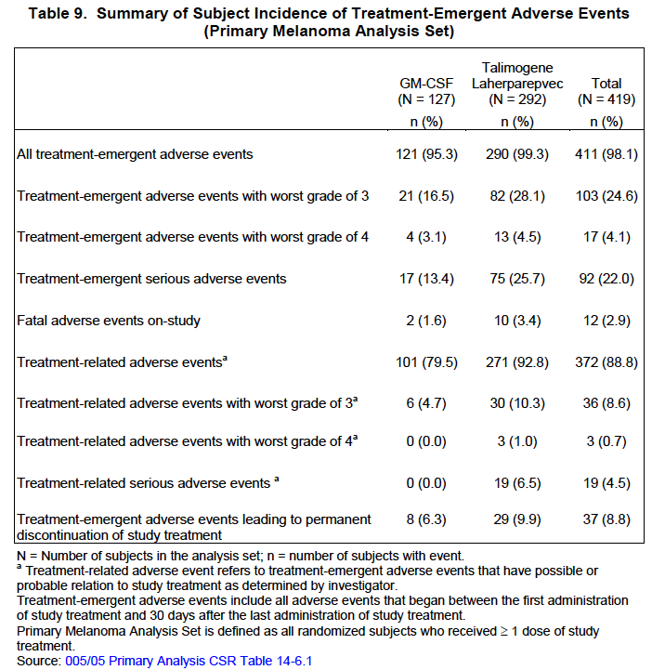

###### Results for other safety outcomes

Safety in special groups

Clinical studies with talimogene laherparepvec to date have excluded pediatric subjects, pregnant or lactating subjects, and subjects with renal or hepatic impairment. Subjects who are immunocompromised were also excluded from clinical studies.

*Subgroup analyses:* for the analysis of adverse events and serious adverse events for talimogene laherparepvec relative to GM-CSF do not indicate an altered safety profile of talimogene laherparepvec by age, sex, race, region, or disease stage. The ‘non-White’ subgroup for race comprised < 2% of subjects (n = 8) in the analysis set, and the ‘Other countries’ subgroup for region each comprised < 15% of subjects (n = 54) in the analysis set.

*HSV-Seronegative Subject:* In the Primary Analysis Set, the overall subject incidence of adverse events was similar in subjects who were HSV-1 seropositive compared with subjects who were HSV-1 seronegative. When adjusted for duration of exposure, the subject incidence rates of treatment-emergent adverse events were higher in subjects receiving talimogene laherparepvec who were HSV-1 seronegative at baseline compared with those who were HSV-1 seropositive at baseline.

*Pregnancy and Lactation:* Adequate and well controlled studies with talimogene laherparepvec have not been conducted in pregnant women. If a pregnant woman has a primary infection with wild type HSV-1 or reactivation of a previous wild-type HSV-1 infection, there is potential for the virus to cross the placental barrier, and also a risk of transmission during birth due to viral shedding. Fetal and perinatal infections with wild-type HSV-1 (including primary infection and reactivation) have been associated with disseminated viral infection, multi-organ failure and death.

*Overdose:* Volumes of up to 4 mL at concentrations up to 108 PFU/mL have been safely administered once every 2 to 3 weeks in clinical studies and no events of overdose have been reported in any talimogene laherparepvec clinical studies.

### Patient exposure

Patient exposure expressed as the number of Subject receiving talimogene laherparepvec by duration of cumulative exposure is summarised in the table below.

**Table 14: Number of Subject receiving talimogene laherparepvec by duration of cumulative exposure**

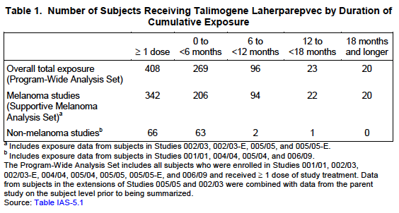

Study 005/05 (the Primary Melanoma Analysis Set) provides up to 18.2 months of exposure to talimogene laherparepvec. The extension Study 005/05-E provides up to 14.1 months of additional exposure to talimogene laherparepvec or GM-CSF in a limited number of subjects (n = 27 and n =3, respectively).

Table 15: Summary of talimogene laherparepvec exposure (Safety population)

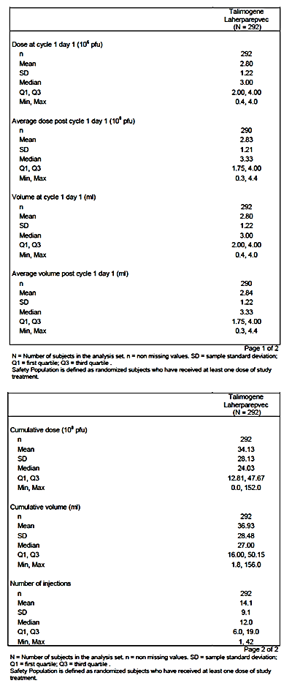

**Table 16: Summary of GM-CSF exposure (Safety population)**

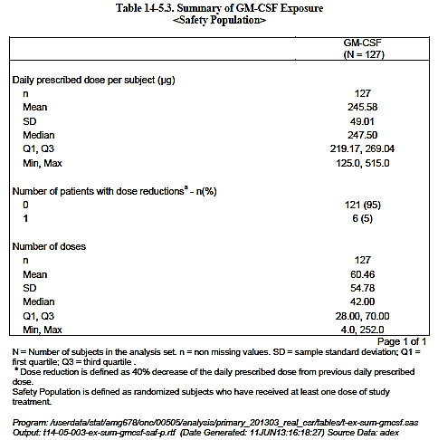

### Adverse events

#### All adverse events (irrespective of relationship to study treatment)

##### Pivotal studies

The subject incidence of treatment-emergent adverse events was 95.3% in the GM-CSF group and 99.3% in the talimogene laherparepvec group. The 3 most common adverse events in the talimogene laherparepvec arm were fatigue (36.2% GM-CSF, 50.3% talimogene laherparepvec), chills (8.7%, 48.6%), and pyrexia (8.7%, 42.8%).

The subject incidence of treatment-related adverse events was 79.5% in the GM-CSF group and 92.8% in the talimogene laherparepvec group. The 3 most common adverse events in the talimogene laherparepvec group reported as treatment-related by the investigator were chills (5.5% GM-CSF, 48.3% talimogene laherparepvec), fatigue (28.3%, 41.8%), and pyrexia (7.1%, 40.8%). The 3 most common treatment-related adverse events in the GM-CSF group were fatigue (28.3% GM-CSF, 41.8% talimogene laherparepvec), injection site erythema (25.2%, 5.1%), and injection site pruritus (16.5%, 1.7%).

Twenty-nine (9.9%) subjects in the talimogene laherparepvec arm and 8 subjects (6.3%) in the GM-CSF arm experienced adverse events leading to discontinuation of investigational product. The most common adverse event leading to discontinuation of investigational product was disease progression (4 subjects in the talimogene laherparepvec arm; 1 subject in the GM-CSF arm).

**Table 17: Summary of Subject Incidence of Treatment-Emergent Adverse Events (Primary Melanoma Analysis Set)**

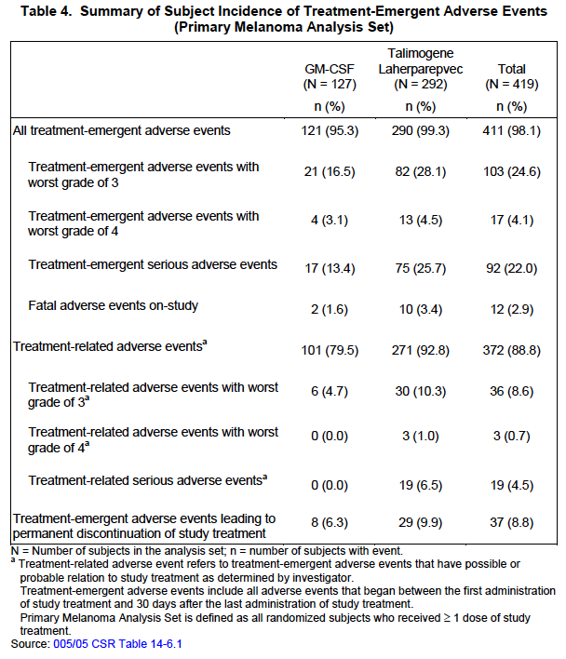

**Table 18: Subject Incidence of Adverse Events by Category (Primary Melanoma Analysis Set)**

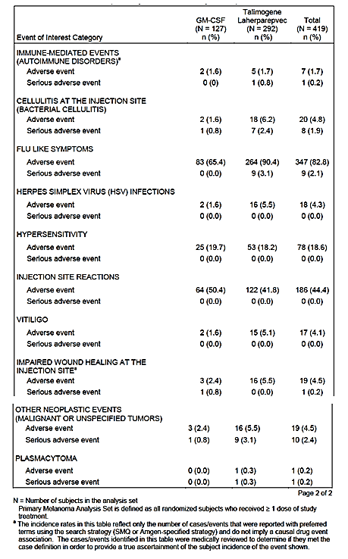

#### Adverse Events of Interest

Adverse events of special interest were defined for talimogene laherparepvec based upon events identified in emerging clinical data, the mechanism of action of the product, potential risks as defined by nonclinical data, and events identified with other products. Adverse events of interest in the context of talimogene laherparepvec administration include: immune-mediated adverse events (autoimmune disorders category), cellulitis at the injection site (bacterial cellulitis category), flu-like symptoms, HSV infections, hypersensitivity reactions, injection site reactions, vitiligo, and impaired wound healing at the injection site, plasmacytoma at the injection site, and other neoplastic events (malignant and unspecified tumours category).

**Table 19: Adverse Events of Interest by Category (based on a narrow search) (Safety Population)**

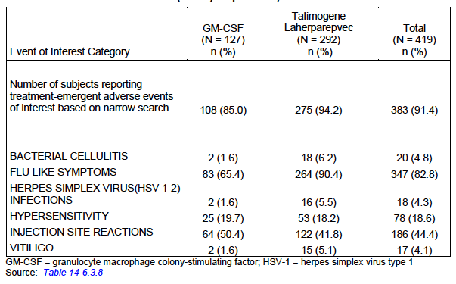

*Immune mediated (Autoimmune Adverse reactions):* Five subjects in the talimogene laherparepvec arm had events confirmed as likely immune mediated: glomerulonephritis (n = 2 including 1 subject with acute renal failure), pneumonitis (n = 1), vasculitis (n = 1), and psoriasis exacerbation (n = 1).

*Cellulitis:* Cellulitis developed after one to multiple doses, and 5 of the 7 serious cases were reported as possibly related to treatment by the investigator. Cellulitis at the injection site was frequently reported among these cases.

*Flu-like symptoms:* The most frequently reported preferred term was fatigue (50.3% in the talimogene laherparepvec arm and 36.2 % in the GM-CSF arm). Other flu like symptoms reported with a > 5% difference between the talimogene laherparepvec arm compared to the GM-GM-CSF arm included chills (48.6% versus 8.7%); headache (18.8% versus 9.4%); nausea (35.6% versus 19.7%); oropharyngeal pain (5.8% versus 0.8%); pyrexia (42.8% versus 8.7%) and influenza-like illness (30.5%, 15.0%)

*Herpes Simplex Virus:* The most frequently reported preferred term was oral herpes (4.8% [n = 14] in the talimogene laherparepvec arm and 1.6 % in the GM-CSF arm [n = 2]. None of these were reported as serious and the incidence was lower than the background population rate.

*Hypersensitivity:* Rash was the most frequently reported preferred term (8.9% in the talimogene laherparepvec arm and 7.9% in the GM-CSF arm). Two serious adverse events were reported: asthma and bronchial hyper reactivity that were considered to be possibly related to study treatment. The asthma resolved with appropriate treatment. The bronchial hyper reactivity recurred and the treatment was discontinued.

*Injection site pain:* The most frequently reported adverse event in the talimogene laherparepvec arm was Injection site pain (27.7% in talimogene laherparepvec arm; 6.3% in GM-CSF arm.

*Vitiligo:* Skin discoloration was considered non-serious.

#### Treatment-related adverse events (adverse drug reactions)

##### Pivotal studies

The Safety Population consisted of 292 subjects in the talimogene laherparepvec group and 127 subjects in the GM-CSF group who received at least 1 dose. The subject incidence of all treatment-emergent adverse events was 95.3% in the GM-CSF group and 99.3% in the talimogene laherparepvec group. The 3 most common adverse events were fatigue (36.2% GM-CSF, 50.3% talimogene laherparepvec), chills (8.7%, 48.6%), and pyrexia (8.7%, 42.8%).

**Table 20: Adverse Events by Preferred Term (≥5% Subject incidence in either treatment group; safety population)**

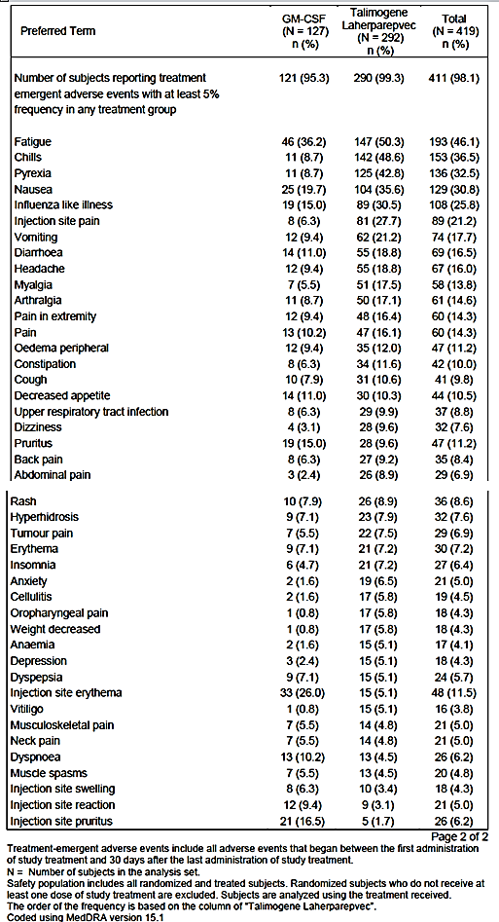

In the Primary Melanoma Analysis Set, the subject incidence of all treatment-related adverse events (as determined by the investigator) was 92.8% in the talimogene laherparepvec group and 79.5% in the GM-CSF group.

The most common treatment-related adverse events (subject incidence rate ≥ 20%) in the talimogene laherparepvec group were chills (48.3% talimogene laherparepvec, 5.5% GM-CSF), fatigue (42.1%, 28.3%), pyrexia (40.8%, 7.1%), influenza-like illness (29.8%, 13.4%), nausea (26.7%, 10.2%), and injection site pain (25.3%, 6.3%).

Treatment-related adverse events of cellulitis were reported in 3.1% of subjects (n = 9) in the talimogene laherparepvec group and no subjects in the GM-CSF group.

**Table 21: Summary of Subject Incidence of Adverse Events for the Primary Melanoma Analysis Set (Study 005/05) and extension Study (Study 005/05 - E)**

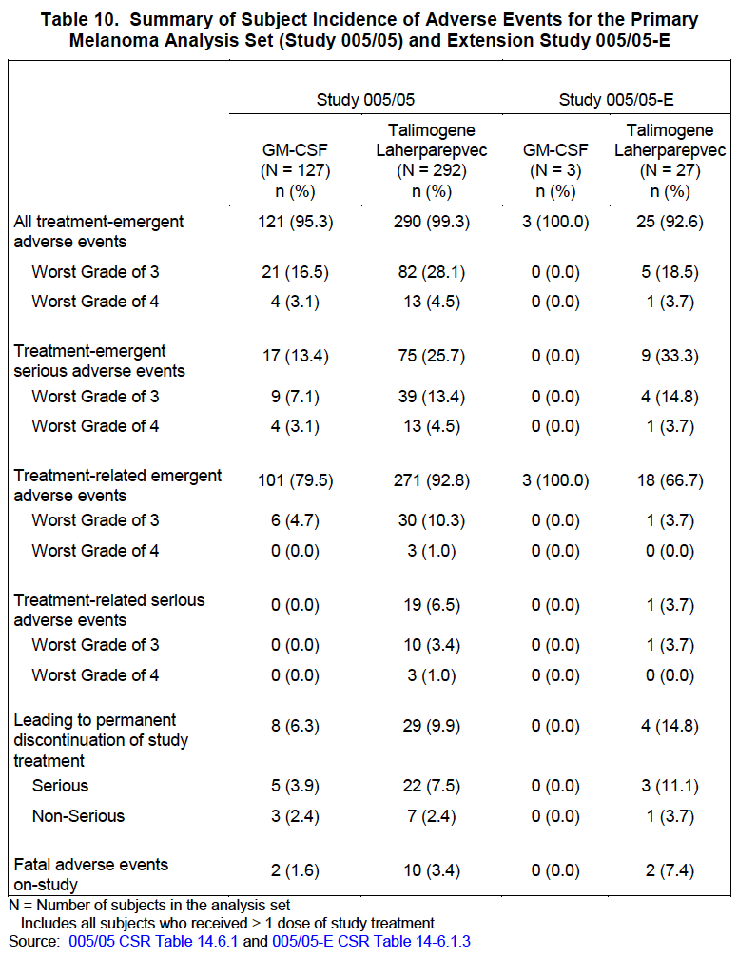

##### Other studies

As above

#### Deaths and other serious adverse events

##### Pivotal studies – Study 005/05

Deaths: fatal adverse events were reported for 10 subjects (3.4%) in the talimogene laherparepvec group and 2 subjects (1.6%) in the GM-CSF group. None of the fatal adverse events were considered by the investigator or sponsor to be related to talimogene laherparepvec or GM-CSF.

In the 005/05 extension study, fatal adverse events were reported for 2 subjects in the talimogene laherparepvec group.

##### Other studies

In the Phase II study 002/03 of talimogene laherparepvec in subjects with Stage IIIc or Stage IV melanoma, fatal adverse events were reported for 4 subjects. Two of the fatal events were due to disease progression, one was due to pneumonia and one was due to acute respiratory failure (due to disease progression).

In the Phase I study 005/04 of talimogene laherparepvec in subjects with unresectable pancreatic cancer; fatal adverse events were reported for 4 of the 17 enrolled subjects. Two of the fatal events were due to general physical health deterioration, one was due to metastatic pain (for which the verbatim term was reported as ‘pancreatic cancer with intractable pain’), and one was due to respiratory failure (due to disease progression)

In the Phase I study 001/01 of talimogene laherparepvec which included subjects with various tumours (breast adenocarcinoma, melanoma, epithelial cancer of the head and neck, gastrointestinal carcinoma, and vulval tumours), 3 subjects had fatal adverse events due to disease progression, aspiration pneumonia, and accidental overdose of analgesia.

None of these fatal events were considered by the investigator or sponsor to be related to talimogene laherparepvec.

#### Discontinuation due to adverse events

##### Pivotal studies

In the Primary Melanoma Analysis Set, 29 subjects (9.9%) in the talimogene laherparepvec group and 8 subjects (6.3%) in the GM-GSF group experienced adverse events leading to discontinuation of study treatment. The most common adverse event leading to treatment discontinuation was disease progression.

### Laboratory tests

#### Liver function

##### Pivotal studies and other studies

The SMQ *drug-related hepatic disorders* was used to identify potential cases that were then medically reviewed to determine if there were events that suggested hepatoxicity. Of the 342 subjects receiving talimogene laherparepvec in the Supportive Melanoma Analysis Set, 14 subjects (4.1%) had treatment-emergent adverse events in this category. These events included ascites (n = 3), hepatotoxicity (n = 1), hyperbilirubinemia (n = 1), liver tenderness (n = 1), ALT increased (n = 3), AST increased (n = 2), hypoalbuminemia (n = 2), blood alkaline phosphatase increased (n = 1), hepatic enzyme increased (n = 1), international normalized ratio increased (n = 1), prothrombin time prolonged (n = 1), and hemangioma of the liver (n = 1).

In all cases, underlying disease or an alternate etiology (for example, liver metastases or cholecystitis) was more likely responsible for the event reported. No cases meeting Hy’s Law criteria were identified in any talimogene laherparepvec studies in the Program-Wide Analysis Set.

#### Kidney function

##### Pivotal studies and other studies

The SMQ *acute renal failure* was used to identify potential cases that were then medically reviewed to determine if there were events that suggested nephrotoxicity. Of the 342 subjects receiving talimogene laherparepvec in the Supportive Melanoma Analysis Set, 10 subjects (2.9%) had treatment-emergent adverse events in this category. These events included blood creatinine increased (n = 4), blood urea increased (n = 4), glomerular filtration rate decreased (n = 1), urine output decreased (n = 1), and renal failure (n = 3).

With the exception of glomerulonephritis (n = 2 including 1 subject with acute renal failure), none of these cases were considered to be related to talimogene laherparepvec. The glomerulonephritis resulted in study treatment discontinuation and was thought to be possibly related to treatment by both investigator and sponsor.

#### Bone Marrow

##### Pivotal studies and other studies

The SMQ *hematopoietic cytopenias* was used to identify potential cases that were then medically reviewed to determine if there were events that suggested bone marrow toxicity. Of the 342 subjects receiving talimogene laherparepvec in the Supportive Melanoma Analysis Set, 32 (9.4%) subjects had treatment-emergent adverse events in this category. These events included anemia (n=23), hemoglobin decreased (n = 7), thrombocytopenia (n=5), hematocrit decreased (n = 4), red blood cell count decreased (n = 2) leukopenia (n = 2), lymphopenia (n = 1), and neutropenia (n=1).

During the sponsor’s medical review, anemia was considered more likely to be related to progression of underlying disease with bone marrow suppression. In all cases, the presence of underlying bone metastases or an alternate etiology (for example, gastrointestinal bleed) was more likely responsible for the events reported.

#### Haematology

##### Pivotal studies and other studies

No clinically relevant differences between treatment groups were observed. No clinically relevant differences between treatment groups were observed in the change from baseline to end of treatment.

In Study 002/03 and the extension Studies 002/03-E and 005/05-E, no other clinically significant laboratory abnormalities or changes in clinical laboratory measurements were reported.

#### Electrocardiograph

##### Pivotal studies and other studies

The SMQs of *torsade de pointes/QT prolongation* and *cardiac arrhythmias* was used to identify potential cases of QT prolongation. Of the 342 subjects receiving talimogene laherparepvec in the Supportive Melanoma Analysis Set, 28 subjects (8.2%) in the talimogene laherparepvec treatment groups experienced treatment-emergent adverse events of tachycardia (n = 13), atrial fibrillation (n = 5), palpitations (n = 5), syncope (n = 3), heart rate irregular (n = 2), and in 1 subject each, atrial flutter, atrioventricular block complete, cardiac arrest, cardiac flutter, sinus bradycardia, heart rate increased, and loss of consciousness.

No relationship was observed between talimogene laherparepvec treatment and adverse events relating to potential QT prolongation and other ECG abnormalities.

In Study 005/05, 6 subjects had abnormal, clinically significant ECG findings at baseline

##### Other studies

No abnormal, clinically significant ECG findings were reported in Study 002/03.

#### Anti HSV-1 antibody response

Serum samples were collected from subjects in Studies 001/01, 002/03, 004/04, 005/04, and 005/05 at baseline and at protocol-specified times (pre- and post-dose) and were assayed for anti-HSV-1 antibodies.

For initial serostatus testing, 63.4% of all subjects entering talimogene laherparepvec clinical studies were HSV-1 antibody positive. The majority of baseline seronegative subjects seroconverted after treatment with talimogene laherparepvec.

#### Vital signs

##### Pivotal studies

In the Primary Melanoma Analysis Set, no notable changes were observed from baseline in vital signs, including systolic blood pressure, diastolic blood pressure, pulse, respiration, and temperature.

#### Biodistribution

##### Pivotal studies and other studies

The kinetics of biodistribution, shedding, and clearance of talimogene laherparepvec in humans was evaluated in 4 clinical studies (Studies 001/01, 004/04, 005/04, and 002/03). In these studies, blood and urine were tested for the presence of talimogene laherparepvec viral DNA after dosing. The samples were analysed using a quantitative polymerase chain reaction (qPCR) assay. The qPCR assay was performed to detect talimogene laherparepvec viral DNA.

Overall, the results from these studies indicated that subjects with tumours of different types had similar results of low levels of viral DNA transiently present in blood and urine. Across the 3 studies, a total of 19/95 (20%) subjects had viral DNA detected in urine at any time point tested, and 29/93 (30%) had viral DNA detected in blood at any time point tested.

#### Viral shedding

##### Pivotal studies and other studies

Overall, 4/27 subjects (15%) in 001/01, 1/28 subjects (4%) in Study 002/03, and 3/17 subjects (18%) in Study 004/04 had swabs that were positive for virus at the tumour site at any time-point tested. Across the 3 studies, this represents 8/72 (11%) of subjects. All swabs of the exterior of the dressing were negative at all time points tested across all studies.

In Study 005/05, a total of 18 reactive swabs in 12 subjects were collected. None of the 18 samples tested positive for infectious HSV in a plaque assay.

### Post-marketing experience

Not applicable. Study 20130193 not started.

### Evaluator’s overall conclusions on clinical safety

Data provided by the sponsor and from presentations at ASCO (Kaufman et al) documented a long list of reported side effects which were usually minor Grade 1 or 2 side effects. Nevertheless flu like symptoms were reported in most patients (90%) and the treatment is clearly not without side effects that could adversely affect the quality of life for long periods given the long periods that some patients were treated for. The Clinical overview indicates that common (>20%) side-effects in the Imlygic treated patients were fatigue, fever, chills and injection site pain. Serious adverse events were recorded in 25.7% of patients and 6.5% of these were attributed to treatment with Imlygic (cellulitis, pyrexia, tumour pain) There were 10 fatalities all of which could be attributed to disease progression or unrelated events such as myocardial infarction in 1 and sepsis in 1. 29 patients (9.9%) discontinued treatment, 7 patients discontinued due to treatment issues such as cellulitis (1), Herpetic keratitis (1). Immune related events of interest were patients with glomerulonephritis (1) pneumonitis (1), psoriasis (1) renal failure (1) and vasculitis (2). In general the side effects were tolerable but nevertheless could be expected to have had adverse effects on the quality of life of the patients.

*Is there a risk of herpetic infection from the injected tumour of genetically engineered HSV virus to normal body tissues?*

This issue was studied by examining swabs from exudative lesions or herpetic looking lesions (‘Reactive swabs’) in all the studies except in studies on pancreatic cancer. It was stated that no HSV were detected from these swabs

*Is secondary spread a risk, ie spread of the genetically engineered HSV virus to health care personnel or to contacts of the patient by shedding of the virus from injected lesions?*

This was tested by examining the dressings covering the lesions and the surface of dressings covering the injected sites in Studies 001/01 (30 patients), 002/03 and 004/04(SCC). Swabs were not examined in the 005/05 study. In total HSV was detected in swabs from 11% of the tests in the 3 studies. No positive tests were recorded from the surface dressings covering the injected lesions. It is reasonable to conclude that the risk of secondary spread of the genetically altered virus is low.

There was one reported incident where a health care worker had accidental exposure and developed a whitlow requiring treatment with acyclovir. It would appear therefore prudent to continue to recommend that patients should avoid contact with infants, pregnant women and immunosuppressed patients and that care be taken in disposal of dressings from treated patients.

## First round benefit-risk assessment

### First round assessment of benefits

The benefits of Imlygic in the proposed usage are:

* regression of some SC metastases in approximately 15% of patients, partial regression in about 15%, durable for 6 months in 19%. See limitations below

### First round assessment of risks

The risks of Imlygic in the proposed usage are:

* Reduced quality of life due to frequency of injections and side effects such as fatigue, flu like symptoms, pain at tumour sites
* Open lesions are a potential source of systemic infections and septicaemia especially during treatment outside of trials.
* Effects in patients with compromised renal or liver function unknown

### First round assessment of benefit-risk balance

The benefit-risk balance of Imlygic is unfavourable given the proposed usage, but may become favourable if the changes recommended in Section 9.4 (combination with other systemic treatments) are adopted.

### First round recommendation regarding authorisation

It is recommended that approval not be granted for use of Imlygic as monotherapy in melanoma.

* Although the modified virus is novel the use of intralesional therapies for melanoma is not. Advantages over other forms of intralesional therapies or surgical removal have not been shown.
* The treatment is not filling an unmet need as such patients would likely be treated by immune checkpoint inhibitors or MEK pathway inhibitors that are more effective.
* Its efficacy is modest and restricted to a small subgroup of patients in a first line setting. 70 % of patients do not appear to have significant benefit from even prolonged treatments. It appears to have minor effects on visceral metastases.
* Evidence suggests (as monotherapy) it would not be useful as salvage therapy in patients failing existing treatments.
* The need for transport and storage at -80º C would limit its applicability to large centres
* Its administration would require trained personnel and facilities. Treatment may be needed over long periods of time at frequent intervals. These factors would likely impact on its cost effectiveness. These issues are likely to be important outside clinical trial settings.
* Preliminary evidence suggests that it may have a role in combination with other treatments and the sponsors should be encouraged to continue to evaluate the product with other treatments such as anti PD1 or Ipilimumab.

## Clinical questions

### Additional expert input

Practical aspects of shipping and storage and the need for administration by well trained personnel would limit the use of the therapy Imlygic.

### Clinical questions

1. See above. Many aspects of the so called OPTiM study have received widespread criticisms, for example, choice of a control with no proven activity against melanoma. No comparison with intralesional injection of GM-CSF or other agents. Selection of patients with minimal disease. Use of non-standard outcome criteria. Poor assessment of quality of life issues. These issues raise credibility problems that count against its value in treatment of melanoma. Comments invited from sponsor.
2. What evidence do they have that immune responses mediated the effects on melanoma? Or that it was due to the oncolytic virus.
3. Given the introduction of immunotherapy with immune checkpoint inhibitors what role do the sponsors now see for their product?
4. Are they able to provide information about ongoing studies?

#### Pharmacokinetics

No comment.

#### Pharmacodynamics

No comment.

#### Efficacy

1. See limitations above. If the sponsor has more recent data on combinations with Ipilimumab or PD1 it would be relevant to report them to support a possible future role?

#### Safety

No further comment

## Second round evaluation of clinical data submitted in response to questions

### Question 1

#### Sponsor’s response

Study design aspects noted to have received criticism were evaluated. The following areas were reviewed, and are supported by the key points provided. A more detailed description of each aspect follows. Finally Amgen has drawn together this information with a commentary on benefit risk of this product.

##### Choice of a control with no proven activity against melanoma

At the time Study 005/05 was designed, there was no standard comparator for the patient population intended for this trial. A placebo comparator would offer no benefit and hinder enrollment. Amgen considers granulocyte macrophage colony stimulating factor (GM-CSF) to be a valid comparator as long as it was no worse than a placebo. Based on the available evidence of its activity in melanoma, it is unlikely that GM-CSF treatment accelerated disease or shortened survival in Study 005/05. The expected median survival for patients receiving standard of care is 18 months (based on the Surveillance, Epidemiology and End Results (SEER) cancer registry through 2011 for stage IV disease and the Melanoma Institute Australia through 2009 for Stage IIIB/C disease), which is similar to the observed median survival of 18.9 months in the GM-CSF arm of Study 005/05. Moreover, any favorable effect of GMCSF on response or survival in the current study would raise the threshold for demonstration of superiority relative to a placebo comparison.

##### No comparison with intralesional injection of GM-CSF or other agents;

There were no intralesional agents that are approved for use in the metastatic setting at the time this study was designed. Further, there was no data to suggest that intralesional GM-CSF would offer any benefit to patients.

##### Selection of patients with minimal disease

In order for patients to be evaluable for the primary endpoint of durable response rate, they had to be alive and responding to treatment for at least 6 months. Patients with rapid deterioration due to disease progression were less likely to have the time/capability to develop an effective anti-tumour response. In addition, results from the Phase II melanoma study indicated a higher response rate in patients with less advanced disease. Therefore, some limitations were placed on the amount of visceral disease burden patients were allowed to have prior to enrolment.

##### Use of non-standard outcome criteria (that is, durable response rate [DRR])

Durable response rate was selected as the primary endpoint because lasting responses to anti-cancer therapy were expected to be associated with meaningful benefits to the patient, including improvement in symptoms or quality of life (QoL; see key points in next bullet), achieving disease-free or treatment-free intervals, and extended survival. The longer the duration of response, the more likely these benefits are to be experienced. Such benefits were demonstrated in Study 005/05.

##### Poor assessment of quality of life issues

Since the pre specified QoL analysis was inconclusive, Amgen conducted an alternative analysis on detrimental QoL. There were no statistically significant associations between durable response/overall response (DR/OR) and detrimental QoL change. Results suggest that achieving a DR or OR is usually associated with a neutral to lower likelihood to report detrimental QoL. Disease stage was a significant predictor for detrimental QoL change in that subjects with early stage disease had a lower risk of experiencing a detrimental QoL change as compared those with late stage disease.

The expected association between DRR and improvement in QoL (see previous bullet) was demonstrated in Study 005/05 based on the Functional Assessment of Cancer Therapy-Biological Response Modifier (FACT-BRM; including the Trial Outcome Index [TOI]). Further, a greater proportion of subjects who achieved a durable response per the Endpoint Assessment Committee (EAC) reported improvements in TOI when compared to those who did not achieve a durable response.

Additionally, data from the 51 patients who demonstrated a durable response were reviewed for demonstration of clinical benefit. The majority of patients with a durable response had responses ongoing at the time of the primary analysis, was still alive at the time of the most recent last contact date, did not experience any serious adverse events during study treatment, and did not require subsequent systemic anti-cancer treatment during the follow-up period. Among patients with visible tumour metastases, many had appreciable improvement in the appearance of their disease.

##### Regarding the benefit-risk profile of talimogene laherparepvec

Based on talimogene laherparepvec's consistent anti-tumour efficacy, positive trend in survival, and minimal incidence of grade 3 adverse events observed in the Phase III study, talimogene laherparepvec has a positive benefit-risk profile for the treatment of patients with injectable regionally or distantly metastatic melanoma.

#### Evaluator’s comment

The response is considered acceptable.

### Question 2

#### Sponsor’s response

##### Nonclinical conclusions

The nonclinical studies support the development of T-cell mediated systemic anti-tumour immune response following intra-tumoural injection of talimogene laherparepvec (or murine surrogate[1]). Further, the data from these studies demonstrate that talimogene laherparepvec induces tumour regression through both local direct effects following intra-tumoural injection into tumours and through secondary induction of systemic anti-tumoural immunity.

##### Clinical Conclusion

An immune mediated mechanism of action for talimogene laherparepvec is supported by the generation of anti-melanoma antigen-specific T-lymphocytes in un-injected lesions in response to talimogene laherparepvec administration, regression of un-injected lesions, including visceral lesions, and a reduction in the risk of developing visceral metastasis.

##### Overall Conclusion

The nonclinical studies support the development of T-cell mediated systemic anti-tumour immune response following intratumoural injection of talimogene laherparepvec (or murine surrogate[2]). These data are consistent with the development of tumour specific T cells systemic observed in the Phase II study (Kaufman et al, 2010) and in the systemic anti-tumour effects reported in the Phase III study.

#### Evaluator’s comment

The response is considered acceptable.

### Question 3

#### Sponsor’s response

The sponsor acknowledges that while the approval of these agents represents a clear milestone in the treatment of advanced melanoma, there are some inherent limitations. With the immunotherapies, the rate of complete response is still low. With the targeted agents (for example, vemurafenib, dabrafenib, trametinib), the duration of responses can be limited due to innate or acquired resistance (Wagle et al, 2011). In addition, vemurafenib, dabrafenib, and trametinib are indicated only for patients with BRAFV600 mutant tumours (40% to 50% of melanomas; Columbino et al, 2012). Each class of agent is associated with specific toxicities, which can limit or preclude treatment in some cases; the checkpoint inhibitors (for example, ipilimumab and the anti-PD-1 agents) are associated with serious and sometimes fatal immune related adverse events and the targeted agents can be associated with severe skin toxicity, secondary skin cancers, and serious febrile reactions. When assessing the benefit-risk of these new agents, it is important to note that approximately 80% or more of patients in the registrational studies had Stage IVM1b or IVM1c disease. The benefit-risk profile is less well established in the small subsets of patients with Stage III or IVM1a disease. Finally, the most appropriate combination and sequencing of these new drugs are still not known.

The sponsor convened an Advisory Board in May 2015 comprising 11 medical, surgical and radiation oncologists from key melanoma centres, to better understand how melanoma is currently managed, how it will evolve in light of the emerging agents and to understand the role of talimogene laherparepvec in this environment. A clear role for talimogene laherparepvec was seen: a relatively high percentage of talimogene laherparepvec use was suggested for patients with indolent or slowly progressing or low volume disease, for older patients, for patients with poor venous access, or for patients who are intolerant of checkpoint inhibitors or anti-PD-1 agents. Patient preferences were also mentioned as a key determinant for therapy choice. Talimogene laherparepvec is a local therapy with systemic effects and this may be the preferred option for some patients. Talimogene laherparepvec may be also considered in patients with small lung metastases and subcutaneous disease. Talimogene laherparepvec is also an important treatment option difficult to treat loco regional disease (for example, scalp melanoma or multiply recurrent in transit disease following multiple attempts at surgical resection) but where systemic therapy may be desired to be reserved for use only if the patient’s local regional disease becomes more advanced in the future.

#### Evaluator’s comment

The response is considered acceptable.

### Question 4

#### Sponsor’s response:

There are six ongoing clinical studies with talimogene laherparepvec in subjects with melanoma (4 studies are listed here. For information regarding studies evaluating the combination of talimogene laherparepvec with ipilimumab and pembrolizumab; see Question 5)

Study 20120324 is a Phase II, multicenter open-label, single-arm trial to evaluate the biodistribution and shedding of talimogene laherparepvec in subjects with unresected, Stage IIIB to IVM1c melanoma.

Primary endpoint of the study is the prevalence of detectable talimogene laherparepvec DNA in the blood and urine during administration of talimogene laherparepvec within the first 3 cycles. Secondary endpoints are clearance of talimogene laherparepvec DNA from blood and urine, rate of talimogene laherparepvec DNA detection and live virus detection on the exterior of the occlusive dressing, surface of injected lesions, oro-labial and anogenital regions during administration of talimogene laherparepvec and after the end of treatment, incidence of talimogene laherparepvec DNA detection in lesions suspected to be herpetic in origin, best overall response rate, objective response rate, duration of response, durable response rate and subject incidence of treatment-emergent and treatment-related adverse events.

Interim analysis of this study was conducted with the data-cut off was 23 February 2015 and included 2,447 samples from 31 subjects. Talimogene laherparepvec DNA was detected with the lowest frequency in samples from the oral mucosa (1 sample in one subject) and from urine (2% in 20% of subjects). Talimogene laherparepvec DNA was detected in 55% swabs from injected lesions in 90% of subjects. Most of the positive samples were obtained during Cycle 2 when talimogene laherparepvec was administered in concentration of 108 PFU/mL for the first time.

Study 20120325 is a Phase II, multicenter open-label, single-arm trial to evaluate the correlation between objective response rate and baseline intratumoural CD8+ cell density in subjects with unresected Stage IIIB to IVM1c melanoma treated with talimogene laherparepvec.

Primary endpoint of the study is a correlation between baseline intratumoural CD8+ cell density and objective response rate. Secondary endpoints are correlation between baseline intratumoural CD8+ cell density and DRR, DOR, and changes in tumour burden, correlation between changes in intratumoural CD8+ cell density during treatment (in injected and un-injected lesions) and overall response rate, durable response rate, duration of response, and changes in tumour burden, efficacy endpoints (overall response rate, duration of response, time to treatment failure, durable response rate, overall survival, and change in tumour burden during treatment) and subject incidence of treatment-emergent and treatment-related adverse events. The trial is planned at approximately 35 sites in Europe and USA. Accrual to the study has begun in April 2015.

Study 20110266 is a Phase II, multicenter randomised open-label trial assessing efficacy and safety of talimogene laherparepvec neoadjuvant treatment plus surgery versus surgery for resectable stage IIIB to IVM1a melanoma.

Primary end-point of the study is recurrence-free survival (RFS). Secondary end-points are 3 years, 5 years and overall RFS, 2 years, 3 years, 5 years and overall survival, overall tumour response (talimogene laherparepvec arm only), response in injected and un-injected lesions (talimogene laherparepvec arm only), R0 resection rate, pathological CR rate, local recurrence- and distant metastasis-free survival, and subject incidence of treatment-emergent and treatment-related adverse event.

Study 20120139 is a registry study to evaluate the survival and long-term safety of subjects with melanoma who previously received at least one dose of talimogene laherparepvec in Amgen-sponsored trial and have permanently ended treatment on that trial. Subjects in this study are monitored every 3 months for survival and adverse events deemed by the investigator to be related to talimogene laherparepvec until withdrawal of consent, death, or end of study, whichever occurs first.

#### Evaluator’s comment

The response is considered acceptable.

### Question 5

#### Sponsor’s response

Study 20110264 (A Phase Ib/II, Multicenter, Open-label Trial to Evaluate the Safety and Efficacy of Talimogene Laherparepvec and Ipilimumab Compared to Ipilimumab Alone in Subjects With Unresected, Stage IIIB-IV Melanoma) is a multicenter, ongoing, open label trial evaluating the combination of talimogene laherparepvec with ipilimumab.

An updated analysis of safety, response rates, progression-free survival (PFS), and overall survival (OS) from the Phase Ib portion the study with all patients beginning treatment more than 22 months was performed with a data cutoff of May 22, 2015. Median PFS was not yet reached with 50% of patients still without progression at 18 months. Median OS was not yet reached with 67% of patients still alive at 18 months. Objective response rate per irRC was 50%; complete response rate was 22%; disease control rate was 72%; and durable response rate was 44%. No new safety signals were identified with the combination of talimogene laherparepvec and ipilimumab.

Phase II comparing the combination of talimogene laherparepvec and ipilimumab versus ipilimumab alone began enrollment August 2013 and is ongoing with plans to enrol approximately 100 subjects in each arm across 60 sites in the USA, France, and Germany. The primary objective is to determine the efficacy of the combination as determined by objective response rate.

At the data cut-off, 29 of the 35 subjects enrolled as of the data cut-off date and received at least 1 dose of investigational product were included in the Safety Analysis Set (14 subjects in the talimogene laherparepvec plus ipilimumab arm and 15 subjects in the ipilimumab alone arm). Thirteen subjects (93%) in the talimogene laherparepvec plus ipilimumab arm and 13 subjects (87%) in the ipilimumab alone arm had treatment-emergent adverse events; Grade 3/4 events were reported for 3 subjects (21%) and 6 subjects (40%), respectively. Serious adverse events were reported for 4 subjects (29%) in the talimogene laherparepvec plus ipilimumab arm and 5 subjects (33%) in the ipilimumab alone arm. One subject (in the talimogene laherparepvec plus ipilimumab arm) had a Grade 5 adverse event (disease progression).

Adverse events considered related to treatment were reported for 10 subjects (71%) in the talimogene laherparepvec plus ipilimumab arm and 9 subjects (60%) in the ipilimumab alone arm; most of these events were Grade 1 or 2 in severity.

Study 20110265 (A Phase Ib/II, Multicenter, Open-label Trial of Talimogene Laherparepvec in Combination With MK-3475 [pembrolizumab] for Treatment of Previously Untreated, Unresected, Stage IIIB to IVM1c Melanoma) is a multicenter, ongoing, open label trial evaluating the combination of talimogene laherparepvec with pembrolizumab.

Key eligibility criteria include unresectable Stage IIIB-IV melanoma; with at least 1 injectable cutaneous, subcutaneous or nodal mass ≥ 10 mm, ECOG performance status of 0 or 1, and no prior systemic anti-cancer therapy. The primary objective of Phase Ib is safety and tolerability as assessed by incidence of DLT. Secondary objectives of Phase Ib include efficacy as determined by multiple endpoints including ORR per irRC, PFS, OS, and safety as determined by incidence of adverse events (AE).

To date there have been 21 subjects enrolled in Study 20110265 who received at least one dose of combination therapy. Adverse events reported in n > 3 subjects included: nausea (n=5, 23.8%), chills (n=4, 19.0%), fatigue (n=5, 23.8%), pyrexia (n=8, 38.1%), headache (n=5, 23.8%), rash (n=6, 28.6%).

Because of the promising preliminary safety and efficacy data from the combination of talimogene laherparepvec and ipilimumab in 20110264, the original Phase II portion of 20110265 comparing the combination of talimogene laherparepvec and pembrolizumab to pembrolizumab alone will be replaced by a Phase III design. Approximately 660 subjects will be randomized 1:1 to pembrolizumab 200 mg (intravenous) every 3 weeks either with or without talimogene laherparepvec 106 PFU/mL for the first dose, 108 PFU/mL (≤ 4 mL intralesional) 3 weeks later for the second dose, then every 2 weeks until the ninth week of treatment, and then every 3 weeks thereafter. There will be dual primary objectives to evaluate the efficacy of talimogene laherparepvec and pembrolizumab as assessed by both PFS and OS.

#### Evaluator’s comment

The response is considered acceptable.

### Second round benefit-risk assessment

#### Second round assessment of benefits

After consideration of the responses to clinical questions, the benefits of Imlygic in the proposed usage are unchanged from those identified in the First round evaluation.

#### Second round assessment of risks

After consideration of the responses to clinical questions, the benefits of Imlygic in the proposed usage are unchanged from those identified in the First round evaluation.

#### Second round assessment of benefit-risk balance

The benefit-risk balance of Imlygic is unfavourable given the proposed usage, but would become favourable if the changes recommended in Second round evaluation are adopted (11.7).

### Second round recommendation regarding authorisation

* Imlygic usage be restricted to patients with Stage IIIB/C and IV1a melanoma.
* That administration with immune checkpoint inhibitors be restricted to approved clinical trials.

## References

Andtbacka RHI et al OPTiM: A randomized phase III trial of talimogene laherparepvec (T-VEC) versus subcutaneous (SC) granulocyte-macrophage colony-stimulating factor (GM-CSF) for the treatment (tx) of unresected stage IIIB/C and IV melanoma. Journal of Clinical Oncology, 2013.

Chapman PB, Hauschild A, Robert C, Haanen JB, Ascierto P, Larkin J, et al. Improved survival with vemurafenib in melanoma with BRAF V600E mutation. The New England journal of medicine. 2011;364(26):2507-16.

Colombino M, et al. (2012). BRAF/NRAS Mutation Frequencies Among Primary Tumors and Metastases in Patients With Melanoma. J Clin Oncol 30:2522-2529.

Hamid, O., Robert, C., Daud, A., Hodi, F. S., Hwu, W.-J., Kefford, R., Ribas, A. (2013). Safety and Tumour Responses with Lambrolizumab (Anti–PD-1) in Melanoma. The New England Journal of Medicine, 369(2), 134–144. doi:10.1056/NEJMoa1305133

Harrington K, Hingorani M, Tanay MA, et al. Phase I/II study of oncolytic HSVGM-CSF in combination with radiotherapy and cisplatin in untreated Stage III/IV squamous cell cancer of the head and neck. Clin Cancer Res. 2010;16:4005-4015.

Hodi FS, Lee S, McDermott DF, Rao UN, Butterfield LH, Tarhini AA, et al. Ipilimumab plus sargramostim vs ipilimumab alone for treatment of metastatic melanoma: a randomized clinical trial. Jama. 2014;312(17):1744-53.

Hoos A, Eggermont AM, Janetzki S, Hodi FS, Ibrahim R, Anderson A, et al. Improved endpoints for cancer immunotherapy trials. Journal of the National Cancer Institute. 2010;102(18):1388-97.

Hu JC, Coffin RS, Davis CJ, et al. A phase I study of OncoVEXGM-CSF, a secondgeneration oncolytic herpes simplex virus expressing granulocyte macrophage colonystimulating factor. Clin Cancer Res. 2006;12:6737-6747.

Kaufman HL, Ruby CE, Hughes T, Slingluff CL. Current status of granulocyte–macrophage colony-stimulating factor in the immunotherapy of melanoma. Journal for Immunotherapy of Cancer. 2014;2:11.

Kaufman HL et al. Primary overall survival (OS) from OPTiM, a randomized phase III trial of talimogene laherparepvec (T-VEC) versus subcutaneous (SC) granulocyte-macrophage colony-stimulating factor (GM-CSF) for the treatment (tx) of unresected stage IIIB/C and IV melanoma. J Clin Oncol 32:5s, 2014 (suppl; abstr 9008a)

Kaufman HL, Kim DW, DeRaffele G, Mitcham J, Coffin RS, Kim-Schulze S. Local and distant immunity induced by intralesional vaccination with an oncolytic herpes virus encoding GM-CSF in patients with stage IIIc and IV melanoma. Ann Surg Oncol. 2010;17:718–730. doi: 10.1245/s10434-009-0809-6.

Kirkwood JM, Lee S, Moschos SJ, Albertini MR, Michalak JC, Sander C, et al. Immunogenicity and antitumour effects of vaccination with peptide vaccine+/-granulocyte-monocyte colony-stimulating factor and/or IFN-alpha2b in advanced metastatic melanoma: Eastern Cooperative Oncology Group Phase II Trial E1696. Clinical cancer research: an official journal of the American Association for Cancer Research. 2009;15(4):1443-51.

Lawson DH, Lee SJ, Tarhini AA, Margolin KA, Ernstoff MS, Kirkwood JM. E4697: Phase III cooperative group study of yeast-derived granulocyte macrophage colony stimulating factor (GM-CSF) versus placebo as adjuvant treatment of patients with completely resected stage III-IV melanoma [abstract]. J Clin Oncol 2010;28(supp):Abstract 8504

Liu BL, et al. ICP34.5 deleted herpes simplex virus with enhanced oncolytic, immune stimulating, and anti-tumour properties. *Gene Ther*. 2003; 10(4):292-303.

Long GV, Stroyakovskiy D, Gogas H, Levchenko E, de Braud F, Larkin J, et al. Combined BRAF and MEK inhibition versus BRAF inhibition alone in melanoma. The New England journal of medicine. 2014;371(20):1877-88.

MacKie RM, Stewart B, Brown SM. Intralesional injection of herpes simplex virus 1716 in metastatic melanoma. Lancet. 2001;357:525-526.

Markert JM, Medlock MD, Rabkin SD,et al. Conditionally replicating herpes simplex virus mutant, G207 for the treatment of malignant glioma: results of a phase I trial. Gene Ther. 2000;7:867-874.

Menzies, Alexander M, Georgina V Long, and Rajmohan Murali. ‘Dabrafenib and Its Potential for the Treatment of Metastatic Melanoma.’ Drug Design, Development and Therapy 6 (2012): 391–405.

Mineta T, Rabkin R, Yazaki T, Hunter WD, Martuza RL. Attenuated multi-mutated herpes simplex virus-1 for the treatment of malignant gliomas. Nat Med. 1995;1:938-943.

Rampling R, Cruickshank G, Papanastassiou V, et al. Toxicity evaluation of replication-competent herpes simplex virus (ICP 34.5 null mutant 1716) in patients with recurrent malignant glioma. Gene Ther. 2000;7:859-866.

Ribas A, Hersey P, Middleton MR, Gogas H, Flaherty KT, Sondak VK, et al. New challenges in endpoints for drug development in advanced melanoma. Clinical cancer research : an official journal of the American Association for Cancer Research. 2012;18(2):336-41.

Robert C, Karaszewska B, Schachter J, Rutkowski P, Mackiewicz A, Stroiakovski D, et al. Improved Overall Survival in Melanoma with Combined Dabrafenib and Trametinib. The New England journal of medicine. 2014.

Robert C, Long GV, Brady B, Dutriaux C, Maio M, Mortier L, et al. Nivolumab in Previously Untreated Melanoma without BRAF Mutation. The New England journal of medicine. 2014.

Senzer NN, Kaufman HL, Amatruda T, et al. Phase II clinical trial of a granulocytemacrophage colony-stimulating factor-encoding, second-generation oncolytic herpesvirus in patients with unresectable metastatic melanoma. J Clin Oncol. 2009;27:5763-5771.

Si Z, Hersey P, Coates AS. Clinical responses and lymphoid infiltrates in metastatic melanoma following treatment with intralesional GM-CSF. Melanoma Res. 1996;6(3):247-55.

Spitler LE, Grossbard ML, Ernstoff MS, Silver G, Jacobs M, Hayes FA, et al. Adjuvant therapy of Stage III and IV malignant melanoma using granulocyte-macrophage colony-stimulating factor. Journal of clinical oncology : official journal of the American Society of Clinical Oncology. 2000;18(8):1614-21.

Thompson JF, Soong SJ, Balch CM, Gershenwald JE, Ding S, Coit DG, et al. Prognostic significance of mitotic rate in localized primary cutaneous melanoma: an analysis of patients in the multi-institutional American Joint Committee on Cancer melanoma staging database. Journal of clinical oncology : official journal of the American Society of Clinical Oncology. 2011;29(16):2199-205.

US FDA. Preclinical Assessment of Investigational Cellular and Gene Therapy Products (Draft Guidance). November 2012.

Wagle N et al (2011). Dissecting Therapeutic Resistance to RAF Inhibition in Melanoma by Tumor Genomic Profiling*. J Clin Oncol* 29:3085-3096.

Wolchok JD, Hoos A, O'Day S, Weber JS, Hamid O, Lebbe C, et al. Guidelines for the evaluation of immune therapy activity in solid tumours: immune-related response criteria. Clinical cancer research : an official journal of the American Association for Cancer Research. 2009;15(23):7412-20.

|  |
| --- |
| Therapeutic Goods Administration |
| PO Box 100 Woden ACT 2606 Australia  Email: [info@tga.gov.au](mailto:info@tga.gov.au) Phone: 1800 020 653 Fax: 02 6232 8605  [**https://www.tga.gov.au**](https://www.tga.gov.au) |

1. A virus modified in the same manner as talimogene laherparepvec, except that it expresses murine GM‑CSF instead of human GM-CSF
2. A virus modified in the same manner as talimogene laherparepvec, except that it expresses murine GM CSF instead of human GM-CSF.