|  |
| --- |
| AusPAR Attachment 2 |
| Extract from the Clinical Evaluation Report for teduglutide |
| Proprietary Product Name: Revestive |

|  |
| --- |
| **Date of first round report: July 2016**  **Date of second round report: January 2017** |
|  |

About the Therapeutic Goods Administration (TGA)

* The Therapeutic Goods Administration (TGA) is part of the Australian Government Department of Health, and is responsible for regulating medicines and medical devices.
* The TGA administers the *Therapeutic Goods Act 1989* (the Act), applying a risk management approach designed to ensure therapeutic goods supplied in Australia meet acceptable standards of quality, safety and efficacy (performance), when necessary.
* The work of the TGA is based on applying scientific and clinical expertise to decision-making, to ensure that the benefits to consumers outweigh any risks associated with the use of medicines and medical devices.
* The TGA relies on the public, healthcare professionals and industry to report problems with medicines or medical devices. TGA investigates reports received by it to determine any necessary regulatory action.
* To report a problem with a medicine or medical device, please see the information on the TGA website <<https://www.tga.gov.au>>.

About the Extract from the Clinical Evaluation Report

* This document provides a more detailed evaluation of the clinical findings, extracted from the Clinical Evaluation Report (CER) prepared by the TGA. This extract does not include sections from the CER regarding product documentation or post market activities.
* The words [Information redacted], where they appear in this document, indicate that confidential information has been deleted.
* For the most recent Product Information (PI), please refer to the TGA website <<https://www.tga.gov.au/product-information-pi>>.

Copyright

© Commonwealth of Australia 2018  
This work is copyright. You may reproduce the whole or part of this work in unaltered form for your own personal use or, if you are part of an organisation, for internal use within your organisation, but only if you or your organisation do not use the reproduction for any commercial purpose and retain this copyright notice and all disclaimer notices as part of that reproduction. Apart from rights to use as permitted by the *Copyright Act 1968* or allowed by this copyright notice, all other rights are reserved and you are not allowed to reproduce the whole or any part of this work in any way (electronic or otherwise) without first being given specific written permission from the Commonwealth to do so. Requests and inquiries concerning reproduction and rights are to be sent to the TGA Copyright Officer, Therapeutic Goods Administration, PO Box 100, Woden ACT 2606 or emailed to <[tga.copyright@tga.gov.au](mailto:tga.copyright@tga.gov.au)>.

Contents

List of abbreviations 5

1. Introduction 6

1.1. Drug class and therapeutic indication 6

1.2. Dosage forms and strengths 6

1.3. Dosage and administration 6

2. Clinical rationale 7

3. Contents of the clinical dossier 8

3.1. Scope of the clinical dossier 8

3.2. Paediatric data 8

3.3. Good clinical practice 8

4. Pharmacokinetics 8

4.1. Studies providing pharmacokinetic information 8

4.2. Summary of pharmacokinetics 9

4.3. Evaluator’s overall conclusions on pharmacokinetics 14

5. Pharmacodynamics 15

5.1. Studies providing pharmacodynamic information 15

5.2. Summary of pharmacodynamics 15

5.3. Evaluator’s overall conclusions on pharmacodynamics 16

6. Dosage selection for the pivotal studies 17

7. Clinical efficacy 17

7.1. Studies providing evaluable efficacy data 17

7.2. Pivotal or main efficacy studies 17

7.3. Other efficacy studies 24

7.4. Analyses performed across trials: pooled and meta analyses 31

7.5. Evaluator’s conclusions on clinical efficacy 31

8. Clinical safety 32

8.1. Treatment related adverse events (adverse drug reactions) 34

8.2. Evaluation of issues with possible regulatory impact 37

8.3. Post marketing experience 41

8.4. Evaluator’s comments on clinical safety 43

9. First round benefit-risk assessment 43

9.1. This evaluator’s assessment 43

9.2. Assessment of benefits across overseas evaluations 43

9.3. Assessment of risks across overseas evaluations 44

9.4. Assessment of benefit-risk balance across overseas evaluations 45

10. First round recommendation regarding authorisation 45

11. Clinical questions 46

12. Second round evaluation of clinical data 46

13. Second round benefit-risk assessment 46

14. Second round recommendation regarding authorisation 46

## List of abbreviations

| Abbreviation | Meaning |
| --- | --- |
| AE | adverse event |
| AUC | Area Under the Curve |
| BSA | Body Surface Area |
| Cmax | Maximum observed concentration |
| ECP | *Escherichia coli* protein |
| EMA | European Medicines Agency |
| GI | gastrointestinal |
| GLP-2 | glucagon-like peptide-2 |
| IV | intravenous (hydration) |
| PI | Product Information |
| PN | parenteral nutrition |
| SAE | serious adverse event |
| SBS | Short Bowel Syndrome |
| t1/2 | elimination half life |

## Introduction

This is a full submission to register a new biological entity, teduglutide (Revestive).

### Drug class and therapeutic indication

Teduglutide is a recombinant analogue of naturally occurring glucagon-like peptide-2 (GLP-2).

Revestive is indicated for the treatment of adult patients with Short Bowel Syndrome (SBS) who are dependent on parenteral support.

### Dosage forms and strengths

The submission proposes registration of the following dosage form and strength:

*Teduglutide 5mg Powder and Solvent for Solution for Injection*

### Dosage and administration

Treatment should be initiated under the supervision of a medical professional with experience in the treatment of SBS.

#### Dosage

The recommended daily dose of Revestive is 0.05mg/kg body weight administered by subcutaneous injection once daily.

Treatment effect should be evaluated on an ongoing basis. Clinical assessment by the physician should consider individual treatment objectives and patient preferences. If no overall improvement is achieved after 12 months, the need for continued treatment should be assessed. Continued treatment is recommended for patients who have weaned off parenteral nutrition.

#### Special populations

* Elderly: No dose adjustment is necessary in patients above the age of 65 years.
* Hepatic impairment: No dose adjustment is necessary for patients with mild and moderate hepatic impairment based on a study conducted in Child-Pugh grade B subjects. Teduglutide has not been formally studied in subjects with severe hepatic impairment.
* Renal impairment: Reduce the dose by 50% in patients with moderate and severe renal impairment (creatinine clearance less than 50 mL/min), and end-stage renal disease. No dose adjustment is necessary for patients with mild renal impairment.
* Paediatric population: Safety and efficacy in paediatric patients have not been established.

#### Administration

Detailed instructions on the preparation (including assembly of the pre-filled syringe, dissolving the powder, preparing the injection syringe) and injection of Revestive reconstituted solution are provided in the package leaflet.

The reconstituted solution must be injected subcutaneously into a cleaned area on the abdomen, or if this is not possible, on the thigh using a thin needle for subcutaneous injection. Revestive should not be administered intravenously or intramuscularly. Alternation of sites for subcutaneous injection is recommended. Sites of injection include the thighs, arms, and the quadrants of the abdomen.

Determination of the number of vials needed for administration of one dose must be based on the individual patient’s weight and the recommended dose of 0.05mg/kg/day. The physician should at each visit weigh the patient, determine the daily dose to be administered until next visit and inform the patient accordingly. A table with the injection volume per body weight is provided below in Table 1.

Table 1: Injection volume per body weight.

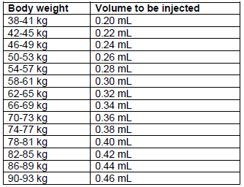

The powder in the vial must be dissolved by adding all the solvent from the pre-filled syringe.

The vial should not be shaken, but can be rolled between the palms and gently turned upside-down once.

Reconstituted Revestive is a sterile, clear, colourless to light straw-coloured solution, which should be free from particulates. The drug should be completely dissolved before the solution is withdrawn from the vial. Do not shake or freeze the reconstituted solution. The solution should not be used if it is cloudy or contains particulate matter. Revestive does not contain any preservatives and is for single-use only. Any unused portion should be discarded. The product should be used within 3 hours after reconstitution.

Once the drug is completely dissolved, withdraw the prescribed dose solution into an injection syringe (up to 1 mL with scale intervals of 0.02 mL or lower).

If two vials are needed, the procedure for the second vial must be repeated and the additional solution drawn up into the injection syringe containing the solution from the first vial. Any volume exceeding the prescribed dose in mL must be expelled and discarded. Any unused medicinal product or waste material should be disposed of in accordance with local requirements.

## Clinical rationale

Teduglutide is a 33-amino acid recombinant analogue of human GLP-2, a peptide secreted primarily from the lower gastrointestinal tract that preserves mucosal integrity by promoting repair and normal growth of the intestine through an increase of villus height and crypt depth. Teduglutide accelerates intestinal adaptation after bowel resection and enhances selective barrier function in the small intestine.

## Contents of the clinical dossier

### Scope of the clinical dossier

The submission contained the following clinical information:

* 5 Relevant *In vitro* studies.
* 13 clinical pharmacology studies, including 8 that provided pharmacokinetic data and 5 that provided pharmacodynamic data.
* 6 population pharmacokinetic analyses.
* 2 double blind efficacy/safety studies.
* 3 long term open label efficacy/safety studies.
* Multiple PSURs, Integrated Summary of Efficacy, Integrated Summary of Safety, Integrated Summary of Immunogenicity.

### Paediatric data

The sponsor is not seeking adolescent or paediatric approval; data has been submitted to the EU for use down to 28 days (i.e. excluding newborn and there is an agreed Paediatric Investigation Plan).

### Good clinical practice

The studies were conducted in accordance with Good Clinical Practice.

## Pharmacokinetics

### Studies providing pharmacokinetic information

PK data were also available from other studies.

Table 2: Submitted pharmacokinetic studies.

| PK topic | Subtopic | Study ID | * |
| --- | --- | --- | --- |
| PK in healthy adults | Single dose, SC bioavailability random. 2-way crossover 0.12mg/kg | CL0600-006 | * |
| 3-way crossover, 10mg, 3 different body sites | CL0600-015 | * |
| Ascending single SC doses single-blind, placebo-controlled | 1621/13 | * |
| Multi-dose double blind 10-80mg OD for 8days | CL0600-022 | * |
| PK in special populations | Moderate hepatic impairment subjects single dose 20mg compared to healthy subjects | CL0600-017 | * |
| Moderate severe and end stage renal impairment, single dose of 10mg Compared to Healthy Subjects | CL0600-018 | * |
| *In vitro* relevant to PK interactions | Assessment of Human Liver Cytochrome P450 Inhibition Potential | P10-001 |  |
| Assessment of Induction Potential in Primary Cultures of Human Hepatocytes | P10-002 |  |
| P-gp Substrate and inhibitor Assessment | P10-005 |  |
| Stability of teduglutide in Human Hepatocytes | P10-007 |  |
| Determination of Potential to inhibit Cytochrome P450 Activity | PK-0600-E-011 |  |
| Population PK analyses | Healthy subjects & Target population Pop PKs from Phase I, II and III Study Data | NPS·RAS-004 | * |
| PopPK: Safety and Efficacy in SBS (Target population) | CL0600-004 | * |
| Pharmacokinetic Parameters for Study Cl0600-021 (Target population) | NPSP-RAS-017 | * |
| Other PopPK in SBS, Crohn’s, hepatic or renal impairment. | PopPK Meta-analysis | * |
| Other PopPK, Safety and Efficacy in Crohn's Disease | CL0600-008 | * |

* Indicates the primary PK aim; § Subjects who would be eligible to receive the drug if approved for the proposed indication.

### Summary of pharmacokinetics

See Table 3.

Table 3: Summary of Revestive Pharmacokinetic Parameters in Patients with SBS.

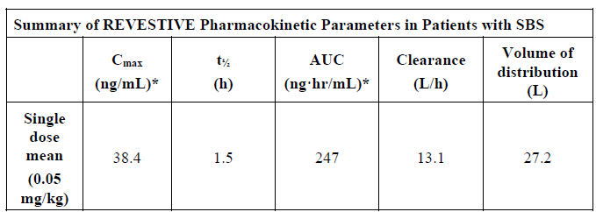

Cmax and AUC are measured under steady state conditions

Following a teduglutide 0.05mg/kg SC in SBS subjects, the median Cmax was 36ng/mL and the median AUC0-inf was 0.15mcg.hr/mL. No accumulation of teduglutide was observed following repeated subcutaneous administration.

Figure 1: Mean concentration-time profiles of teduglutide in plasma after IV or SC injection.

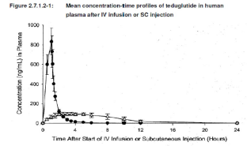

The Cmax and AUC of teduglutide was dose proportional over the dose range of 0.05 to 0.4mcg/kg teduglutide. Absorption of teduglutide was rapid, and dose-proportionality was suggested for AUC(0-∞), AUC(0-tz) and Cmax over the dose range 2.5 to 10mg teduglutide.

Figure 2: Observed Median Plasma Concentrations of teduglutide vs. time 2.5 to 10mg.

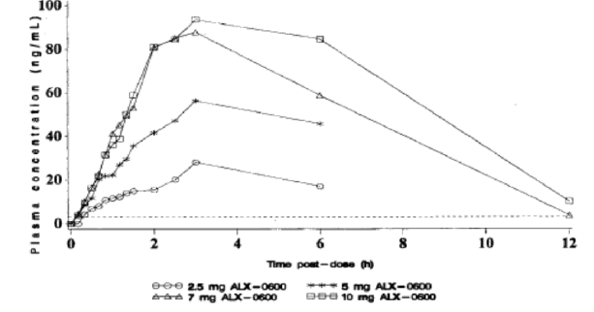

Table 4: Observed and dose normalized PKs 2.5 to 10mg.

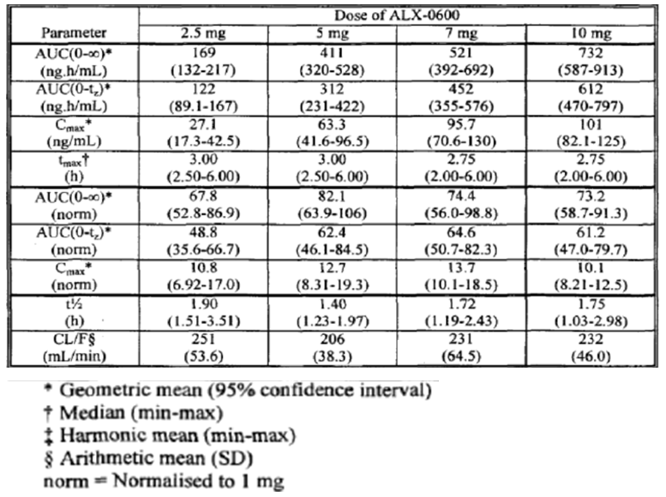

#### Bioavailability

Study CL06090-006: The tested dose was 0.12mg/kg (single dose). Bioavailability was 87%.

**Table 5: Summary of mean PK parameters of teduglutide (arithmetic mean and SD) Study CL06090-006.**

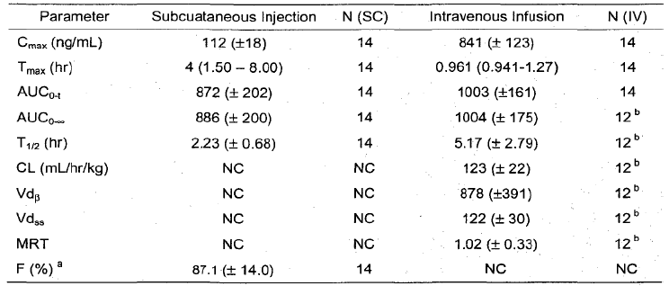

##### Bioequivalence of sites

The relative bioavailability of teduglutide was 89% and 92% for SC injection at the thigh and the arm, respectively, relative to SC injection at the abdomen (based on ANCOVA analysis of   
AUC0-∞). The 90%CIs were within the 80% to 125% range (Study 015). However Cmax was lower for arm and thigh and the lower 90%CI was < 80%.

##### Distribution

###### Volume of distribution

In healthy subjects, teduglutide had a volume of distribution of 103mL/kg, similar to blood volume.[1] However the EMA evaluator commented on the wide range of results seen from studies and Pop PK analysis from 29L to 65L.

##### Metabolism

The metabolic pathway of teduglutide was not investigated in humans. However, teduglutide is expected to be degraded into small peptides and amino acids via catabolic pathways, similar to the catabolism of endogenous GLP-2.[2]

##### Excretion

###### Routes and mechanisms of excretion

After SC administration, teduglutide was eliminated from plasma with a t1/2 of about 2 hours (CL0600- 006, CL0600-015, 1621/13) which was confirmed for the proposed concentration for commercial use of 10mg/mL teduglutide (CL0600-018, C09-001). Following IV administration teduglutide plasma clearance was approximately 127 mL/h/kg, which is roughly equivalent to the glomerular filtration rate. These observations suggest that teduglutide is primarily cleared by the kidneys (CL0600-006), which was confirmed by the PK study in patients with renal impairment (CL0600-018).[3]

##### Intra and inter individual variability of pharmacokinetics

From study C09-001 (PK part), the intersubject CV% was around 17% for AUC and almost 30% for Cmax; intrasubject variability was smaller with 7.78% for AUC, and 14.8% for Cmax (doses were 5mg and 20mg with 10mg/ml concentration).

#### Pharmacokinetics in the target population

Table 6: Estimates of PK parameters in study ALX0600-92001.*

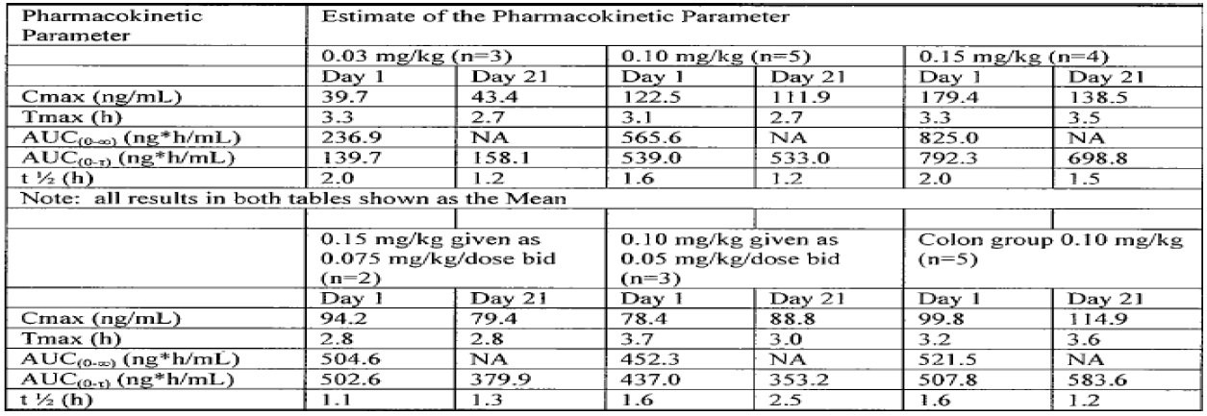

* Open-Label, Multicentre, Dose-Ranging, Pilot Safety, Tolerability and Effect of 21-day, Ascending, Multidose SC Treatment with SBS

#### Pharmacokinetics in special populations

##### Pharmacokinetics in subjects with impaired hepatic function

Subjects with moderate hepatic impairment had lower teduglutide Cmax and AUC (10 ~15%) compared to healthy matched control subjects after a single subcutaneous dose of 20mg Revestive. Teduglutide PK was not assessed in subjects with severe hepatic impairment.

The relative bioavailability evaluations for Cmax, AUC0-t, and AUC0-∞ resulted in the following: 90.12 (75.9 – 107.8), 85.12 (70.6 – 102.7), and 89.40 (75.1 – 106.5). The company concludes that a dose adjustment for patients with mild or moderate hepatic impairment is not considered necessary. In the PopPK studies (NPS-RAS-004), the relationship between individual values of Clearance and Volume of distribution were tested for their relationship with biomarkers of potential hepatic impairment (bilirubin, ALT, AST, GGT). In the analysis, however, no trend was observed between PK parameters and the markers, and therefore hepatic impairment was not tested in the population PK model.

Figure 3: Mean plasma teduglutide concentrations versus time (linear scale).

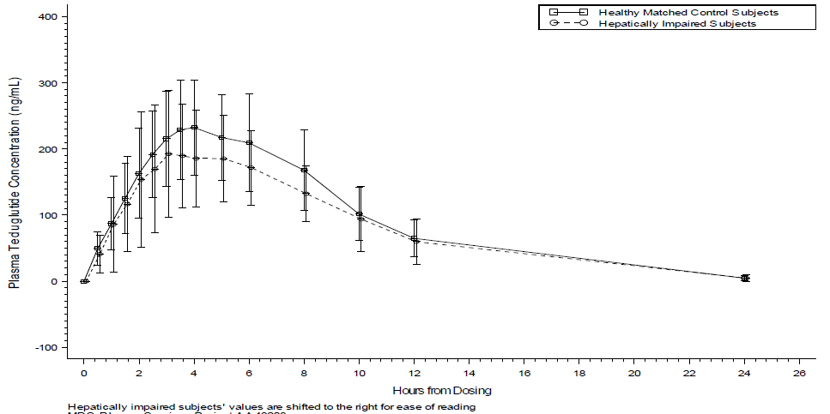

##### Pharmacokinetics in subjects with impaired renal function

In subjects with moderate to severe renal impairment or end stage renal disease (ESRD), teduglutide Cmax and AUC0-inf increased with the degree of renal impairment following a single subcutaneous administration of 10mg teduglutide. Teduglutide exposure increased by a factor of 2.1 (Cmax) and 2.6 (AUC0-inf) in ESRD subjects compared to healthy subjects. Clearance of teduglutide decreased with increasing degree of renal impairment.

Table 7: Geometric mean (68% range) PK parameters after SC administration of 10mg Teduglutide.

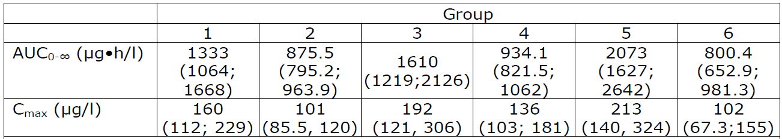

Group 1: Moderate renal impairment, Group 2 (Control group healthy subjects to Group 1) Group 3: Severe renal impairment; Group 4 (Control group healthy subjects to Group 3) Group 5: End stage renal disease (requiring dialysis), Group 6: (Control group healthy subjects to Group 5)

**Table 8: Statistical comparison of AUC0-∞ and Cmax after 10mg SC teduglutide.**

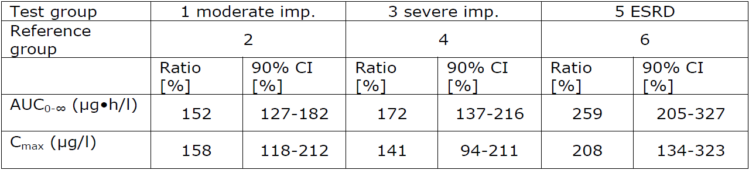

Figure 4: Clearance of teduglutide with Increasing Degree of Renal Impairment

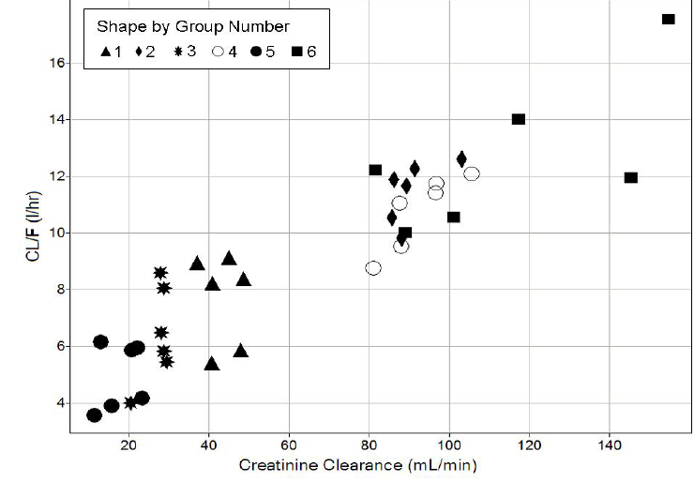

##### Pharmacokinetics according to age

No differences in PK were observed between healthy subjects younger than 65 years and those older than 65 years. Experience in subjects 75 years and older is limited.

#### Population pharmacokinetics

Only weight and dose were found to have any relationship with PK, however, these effects were not deemed to be clinically relevant. Gender, age, body weight, BMI, creatinine clearance, and dose were tested.

#### Clinical implications of *in vitro* findings

Based on the results of *in vitro* studies, where no significant inhibition or induction of P450 isozymes was observed at 2000ng/mL (55- fold median Cmax at dose level of 0.05mg/kg/day), no *in vivo* DDI studies were conducted. Teduglutide had no effect on gastric emptying, and can be administered with or without food.

### Evaluator’s overall conclusions on pharmacokinetics

The mean clearance is approximately equivalent to the GFR, which indicates that teduglutide is mainly cleared by the kidneys, however, this is an assumption and has not been demonstrated by for instance use of radioactive marked teduglutide.

No accumulation or change in the pharmacokinetics of teduglutide was observed after a 21-day once daily SC treatment.

Teduglutide is absorbed with a peak concentration at 3-5 hours after subcutaneous administration, and rapidly eliminated with t1/2 of approximately 2 hours that has been confirmed for the to-be-marketed concentration (10mg/mL). However, as stated by the applicant, the ELISA assay detected teduglutide, endogenous GLP-2, and other GLP-2 related peptides. This cross-reactivity to native GLP-2 and GLP-2 related peptides may have had significant impact on the teduglutide concentrations measured by the ELISA method.

## Pharmacodynamics

### Studies providing pharmacodynamic information

Table 9 shows submitted PD studies.

Table 9: Submitted pharmacodynamic studies.

| PD Topic | Subtopic | Study ID | * |
| --- | --- | --- | --- |
| Primary Pharmacology | Single Dose. Random, Placebo and Active Control, Effect on cardiac Repolarisation and Conduction in healthy subjects | C09-001 | * |
| Effects on Gastric Emptying healthy subjects | C10-003: | * |
| Effect on Gall Bladder in healthy subjects | TED-C10-004 | * |
| Population PD and PK-PD analyses | Open-Label, Multicentre, Dose-Ranging, Pilot Safety, Tolerability and Effect of 21-day, Ascending, Multidose Subcutaneous Treatment with SBS (Target population) | ALX-0600-92001 |  |
| A 24-week Double-blind safety, Efficacy and Pharmacodynamic Study Investigating Two Doses of Teduglutide in Paediatric Subjects Through 17 Years of Age with Short Bowel Syndrome who are Dependent on Parenteral Support | TED-C14-006: |  |

* Indicates the primary PD aim § Subjects who would be eligible to receive the drug if approved for the proposed indication.

### Summary of pharmacodynamics

Based upon the pharmacodynamic effect of Revestive, there is a potential for increased absorption of concomitant oral medications, which should be considered if the concomitant drugs require titration or have a narrow therapeutic index.

Study 92001 group 5 received 0.10mg/kg/day and had at least 50% of their colon remaining in continuity. Parameters included in the evaluation were ion and nutrient transport, and enterocyte-associated nutrient transporter proteins (SGLT-1, GLUT2, GLUT5, and Na/K ATPase alpha1 subunit) and mRNA abundance, derived from the biopsies taken. The effects on mucosal RNA and protein expression are shown in the following graphs as examples for the findings. No consistent results were seen on transmucosal resistance, transmucosal potential difference and short circuit current (as measures of ion transport). An effect on sodium dependent glucose transport was only seen in group 5.

Figure 5: Effects of teduglutide on mucosal RNA and protein concentration.

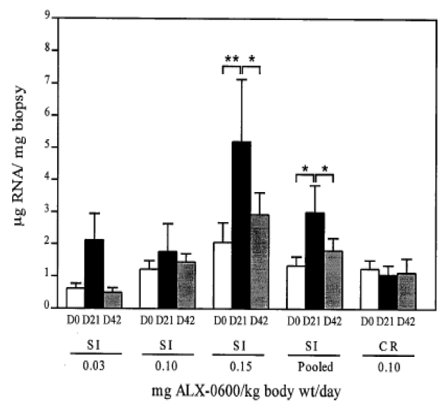

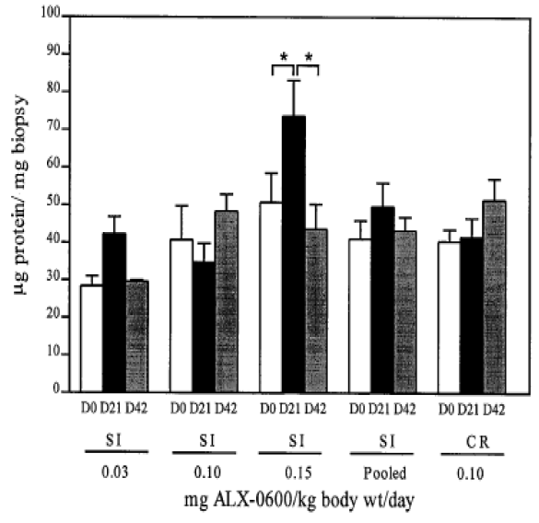

#### QT Interval

Teduglutide appears not to influence heart rate conduction velocity, as the results of the thorough QT study presented can exclude a relevant effect on QT interval.

### Evaluator’s overall conclusions on pharmacodynamics

From the pharmacodynamic data presented, it can be deduced that teduglutide acts on the GLP-2 receptor, and exerts a roughly dose-related effect on the architecture of the epithelia of the large and small intestine with an obvious early “saturation” of the PD effects. Teduglutide increases the absorption of fluids and nutrients by increasing the expression of transporter proteins at the cellular level, and exerts a trophic effect by inducing an increase in gastrointestinal tissue mass, as proven by the increased villus height and crypt depth in the small and large intestine.[4]

## Dosage selection for the pivotal studies

* Study 92001: An open-label dose-ranging, pilot study to examine the safety, tolerability and effect of a 21 day, ascending, multidose subcutaneous treatment with teduglutide in patients with short bowel syndrome. Any conclusion regarding dose-response relationship, and the choice of the final dose for the phase III trials must necessarily be considered to be premature and bear a relatively high risk of error.[5]
* Study CL0600-004 failed to meet its primary objective and was only considered hypothesis generating. Based on exploratory analyses of this study, the sponsor identified a dose of teduglutide (0.05mg/kg/day) which seemed efficacious.[6]

## Clinical efficacy

### Studies providing evaluable efficacy data

These studies included:

* CL0600-020: 24-Week, Double-Blind, Safety and Efficacy in SBS.
* CL0600-021: Long-Term, Open Label Study With Teduglutide for Subjects with Parenteral Nutrition Dependent SBS Who Completed Study CL0600-020.
* TED-C11-001: 1-Year, Open-Label Study with Teduglutide for Subjects with Parenteral Nutrition-dependent SBS who Completed Study CL0600·021.
* CL0600-004. Double-Blind, Safety and Efficacy in SBS.
* CL0600-005. Open-Label Extension of Study CL0600-004, Safety and Efficacy m SBS.

### Pivotal or main efficacy studies

Study CL0600-020 is considered pivotal.[7]

Study CL0600-004 was submitted to the EMA as pivotal; however it “failed to meet its primary objective and was only considered hypothesis generating.”[8]

#### Study CL0600-020

##### Study design, objectives, locations and dates

This was a randomized, double-blind, placebo-controlled, multi-national, multi-centre clinical trial to evaluate the efficacy, safety, and tolerability of teduglutide compared with placebo in adult subjects adults with SBS who were dependent on parenteral nutrition/intravenous support for at least 12 months and required PN at least 3 times per week.

After initial screening and optimisation, prior to randomization, all subjects underwent a stabilization[9] period of 4-8 weeks on that subject’s minimally tolerated stable volume of PN/IV.

Subjects were randomized to placebo (n = 43) or Revestive 0.05mg/kg/day (n = 43). Study treatment was administered subcutaneously once daily for 24 weeks. PN/I.V. volume adjustments (up to 30% decrease) and clinical assessments were made at Weeks 2, 4, 8, 12, 20, and 24.

The objectives were to evaluate the efficacy, safety, and tolerability of teduglutide compared with placebo in SBS subjects dependent on parenteral support (PN and/or I.V. fluids).

It was conducted from November 2008 to January 2011 at 27 sites in 10 countries.

##### Inclusion criteria

* Intestinal failure resulting in SBS as a consequence of major intestinal resection (e.g., due to injury, volvulus, vascular disease, cancer, Crohn’s disease).[10]
* Undergone intestinal resection resulting in at least 12 continuous months of PN dependency.
* PN/I.V. required at least 3 times per week during the week before screening and during the 2 weeks prior to baseline to meet their caloric, fluid, or electrolyte needs due to ongoing malabsorption.

##### Exclusion criteria

* History of cancer or clinically significant lymphoproliferative disease with < 5 years documented disease-free state.
* Use of native glucagon-like peptide-2 (GLP-2) or human growth hormone within 6 months or I.V. glutamine, octreotide, GLP-1 analog, or dipeptidyl peptidase IV (DPP-IV) inhibitors within 30 days prior to screening.
* Subjects with Crohn’s disease who had been treated with biological therapy[11] within the 6 months prior to screening.
* Subjects with inflammatory bowel disease who required chronic systemic immunosuppressant therapy that had been introduced or changed during the last 3 months.
* 4 SBS-related or PN-related hospital admissions[12] within 12 months prior to the screening visit.
* Signs of severe hepatic impairment or disturbed renal function.

##### Study treatments

Teduglutide (0.05 or 0.10mg/kg/day) or placebo was administered by the SC route once daily into one of the four quadrants of the abdomen or either thigh, for 24 weeks.

##### Efficacy variables and outcomes

The primary efficacy variablewas the percentage of subjects who demonstrate a response at Week 20 and who maintain that response through Week 24.[13]

The secondary efficacy variables were based on reductions in PN/IV volume or the direct effects of improved intestinal absorption of fluid. The other variables include:

* Duration of response (i.e., total number of weeks at ≥ 20% reduction from Baseline);
* The proportion of subjects with a ≥ 20% reduction or a ≥ 2 litre (L) reduction from Baseline in weekly PN at Week 20 and maintained through Week 24;
* The number of subjects who stopped PN and time of discontinuation;
* Absolute change and percent change in PN between Baseline and last dosing visit.

An additional secondary efficacy variable was an ordered categorical (or graded) response that accounts for both intensity and duration of the response at the end of the 24-week treatment period.[14]

Subjects’ quality of life (QoL) was evaluated by using a subject reported outcome SBS specific QoL scale.[15]

##### Randomisation and blinding methods

The randomization was stratified at 2 levels of baseline PN/I.V. volume (≤ 6L/week or > 6L/week). Subjects were randomized across centres rather than within centres.

##### Analysis populations

The ITT population included all subjects who were randomized into the study.

##### Sample size

Eighty-six subjects were randomized at a 1:1 ratio to detect a difference in responder rates between teduglutide and placebo groups of 35% and 6%, respectively, α = 0.05, 2-sided test and power = 90%. Grounded on these assumptions, nQuery Advisor (v. 6.0) based on a Fisher’s Exact Test was used to calculate the power. The sample size calculations are considered acceptable.

##### Statistical methods

The number and percentage of responders (20 to100% reduction in PN/I.V. volume) were presented by treatment group. The analysis compared the event rates for the two treatment groups using the Cochran-Mantel-Haenszel test statistics adjusted for the randomization stratification variable (≤ 6 or > 6L/week of PN at baseline). The percent and absolute change in PN/I.V. volume from baseline to the last dosing visit, as well as all scheduled visits starting at Week 4, are presented by treatment group using descriptive statistics. Treatment group differences were compared using an ANCOVA model with effects for treatment and baseline PN volume, with the potential for the interaction of the two variables also included as an effect. The least squares means and standard error, along with 95% CIs, are presented for each treatment.

###### Duration of response

The duration of response based on the number of consecutive visits (categorized as 0, 1, 2, and   
≥ 3) for which the subject had a 20 to 100% reduction in weekly PN/I.V. volume from baseline at Week 24 plus previous scheduled visits with a 20 to 100% reduction from baseline were presented based upon the number and percentage of subjects for each category. The two treatment groups were compared using extended CMH test statistics (with standardized mid-ranks) adjusted for the randomization stratification variable.

Graded response: The number and percentage of subjects with individual graded response categories were presented by treatment group. No statistical testing was performed for these individual items. The number and percentage of subjects with each level of the graded (or ordered categorical) response were presented by treatment group. The analysis compared the graded response categories for the two treatment groups using extended CMH test statistics (with standardized mid-ranks) adjusted for the randomization stratification variable

##### Participant flow

This is shown in Figure 6.

Figure 6: Flow Diagram study CL0666-020.

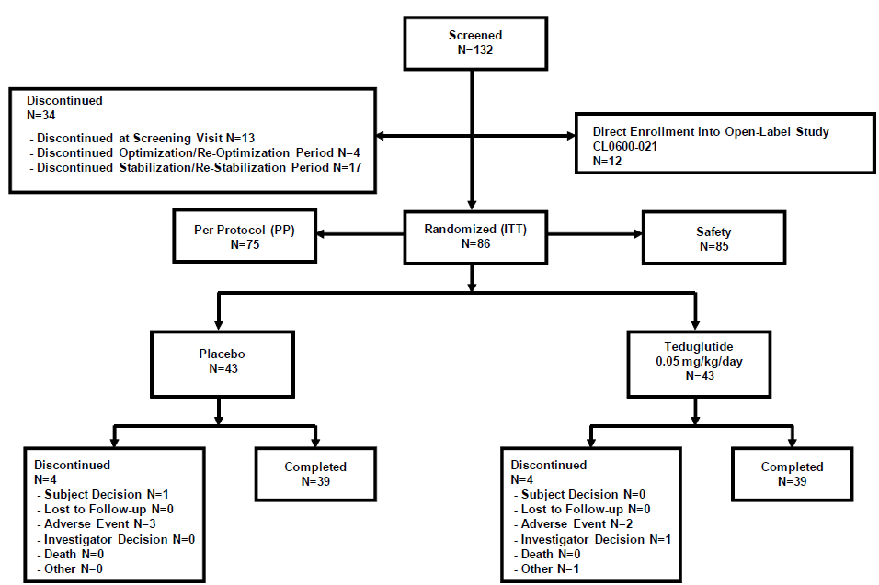

##### Major protocol violations/deviations

Most protocol violations were minor, 11 patients were excluded for major deviations.

##### Baseline data

See Table 10-11.

Table 10: Demographics and Baseline Characteristics - ITT Population.

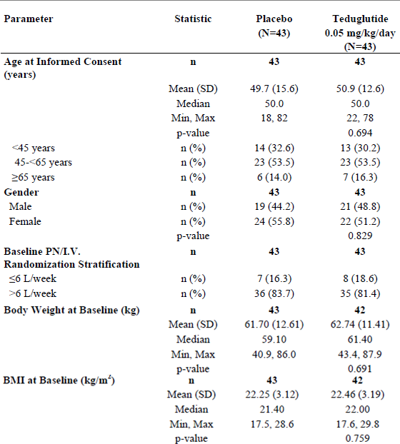

The treatment comparisons for continuous variables are based on an ANOVA model with treatment as an effect. The treatment comparisons for gender are based on Fisher’s Exact Test.

Table 11: Demographic and Baseline Characteristics: Short Bowel Syndrome History – Safety Population.

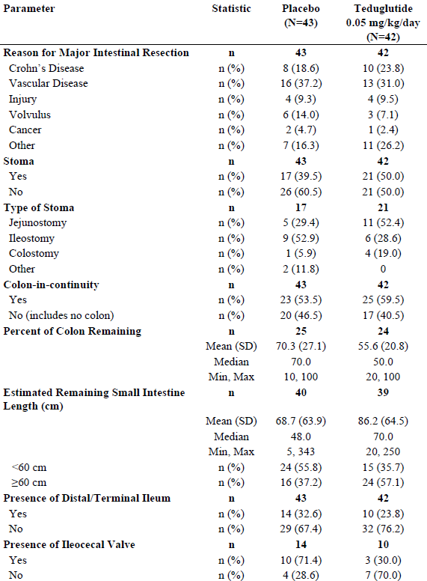

Questions for type of stoma and presence of ileocecal valve were only relevant when a distal/terminal ileum was present. Percent of colon remaining was only relevant when the subject had a colon.

##### Results for the primary efficacy outcome

Subjects on 0.05mg/kg/day teduglutide achieved a higher responder rate than the placebo-treated subjects (27/43 subjects 62.8%, and 13/43 subjects 30.2%, respectively; p = 0.002). Results were similar in the PP population (p < 0.001).

##### Results for other efficacy outcomes

* For subjects both without colon-in-continuity and in those with colon-in-continuity, the responder rate was higher in the teduglutide group, 13/17 subjects (76.5%) and 14/26 subjects (53.8%), respectively, compared with 4/20 subjects (20.0%) and 9/23 subjects (39.1%), respectively, in the placebo group.
* The teduglutide responder rate was higher for subjects without colon- in-continuity (13/17 subjects, 76.5%) than for subjects with colon-in continuity (14/26 subjects, 53.8%).
* For subjects both with stoma as well as in those without stoma, the responder rate was higher in the teduglutide group (15/21 subjects, 71.4% and 12/22 subjects, 54.5%, respectively) than in the placebo group (3/17 subjects, 17.6% and 10/26 subjects, 38.5%, respectively).
* At all visits, subjects on teduglutide had a progressively greater absolute and percent decrease in PN/I.V. volume compared with subjects on placebo with statistical significance starting at Week 8 and Week 12 respectively, and continuing through week 24. At 24 weeks, there was a 4.4L/week mean reduction from baseline in the teduglutide group and 2.3L/week in the placebo group (p < 0.001).

*Comment: The 95% CIs overlapped at most time points, as shown in the proposed PI.*

* A statistically significantly (p = 0 .002) higher percentage of subjects on teduglutide achieved a 20 to 100% or 2L reduction in PN/IV volume at weeks 20 and 24 compared with subjects on placebo.
* No subjects were considered to have completely weaned off their PN/IV at the end of the study.
* Further analyses showed that a 1 day or more reduction in actual weekly PN/I.V. volume at Week 24 was achieved in 21/39 subjects (53.8%) in the teduglutide group compared with 9/39 subjects (23.1 %) in the placebo group.
* In addition, to support the primary efficacy endpoint and take into account changes in oral intake and urine output calculation and analysis of the composite effect encompassing volumes of PN/IV oral intake and urine output (PN/IV + Oral Intake - Urine Output) was performed. At all visits, greater reduction in fluid composite effect was seen in the teduglutide group than in the placebo group. The mean reduction in the teduglutide group was more than double that seen in placebo group at all visits through Week 24 (-5.4L/week in the teduglutide group vs. -1.1L/week in the placebo group). These reductions were achieved while maintaining nutritional status and weight and represent a useful measure of intestinal absorption related to teduglutide.
* In the teduglutide group the mean change in plasma citrulline from baseline (18.4mcmol/L ± 9.5) was 20.6mcmol/L (± 17.5) at Week 24. The corresponding Week 24 change from baseline (17.5mcmol/L ± 9.0) for subjects on placebo was 0.7mcmol/L (± 6.3).

Table 12: Binary Response Status at Week 20, Maintained to Week 24 - By Presence of Stoma (Y / N) - Intent-to-Treat Population.

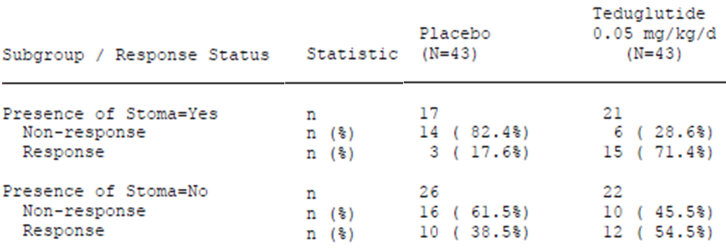

Response is defined as at least a 20% reduction from baseline in weekly PN volume at both Week 20 and Week 24.

### Other efficacy studies

#### Study CL0600-004

This was a randomized, double-blind, placebo-controlled, multinational study in adults with SBS who were dependent on parenteral nutrition/intravenous (PN/I.V.) support for at least 12 months and required PN at least 3 times per week. After optimisation and stabilisation periods as in Study CL0600-020, subjects were randomized to receive 24 weeks of one of the following treatment regimens: Revestive 0.05mg/kg/day (n = 35), Revestive 0.10mg/kg/day dose (n = 32), or placebo (n = 16).

The primary endpoint in Study CL0600-004 was an ordered categorical response that accounted for both response intensity (% reduction in PN requirements) and duration of the response at the end of the 24-week treatment period. The response was graded according to a numerical scale with the following algorithm:

Table 13: Criterion values for response in study CL0600-004.

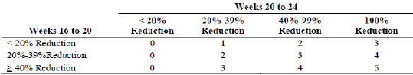

The secondary efficacy variableswere the following:

* The number and percentage of subjects who demonstrated a response at week 20, and who maintained that response at week 24, which was defined as the achievement of at least a 20% reduction from baseline in the weekly PN volume.
* The number and percentage of subjects who achieved at least a 1-day reduction in weekly PN.
* The absolute reduction from baseline in weekly PN kilojoules (transformed from Kcal).
* The absolute reduction of weekly volume of PN from baseline.
* The change from baseline in plasma citrulline at dosing week 24.

For a subset of selected study centres, an additional secondary variable was evaluated at weeks 8 and 24 with the testing of intestinal absorption of fluid, energy, nitrogen, fat, carbohydrate, sodium, potassium, magnesium and calcium.

Exploratory efficacy variableswere defined as:

* Time to 20% reduction in PN volume, time to discontinuation of PN, time to a 1-day reduction in weekly PN, number and percentage of subjects with reduced IV catheter access at week 24, change from baseline in bone markers BSAP and NTx, in lumbar spine and hip BMD, and in PTH at week 24, change from baseline in QoL at weeks 4, 8, 12, 16, 20, and 24 (scores to be used were: SF-36, IBDQ, and abbreviated EuroQol)., the mucosal crypt-villus architecture and cellular composition within the small and large intestine.

Within the study, a 72-hour nutrient absorption study was to be conducted in selected centres, citrulline as marker of PD activity was evaluated, and, as mentioned above, endoscopic and histological evaluation of the small and large intestine was performed in subsets of patients. A PK substudy was also conducted

The original protocol defined the (now used as) secondary variable as primary, and it was only in the year 2007, when the company introduced the new primary endpoint (obviously after complete recruitment had taken place).

Power assumptions and sample size calculation were based on the original endpoint, and it was obviously not possible to transfer these assumptions to the new endpoint. However, even the assumptions for the primary endpoint were not really based on a clear hypothesis due to the missing of a proper dose-finding and/or proof of concept study that had used a similar endpoint.

No evaluation was conducted for the importance/relevance of protocol violations and no other exclusions from the PP populations were introduced other than the ones for the incomplete study duration.

##### Primary Efficacy

The primary efficacy endpoint of the study was a graded response score (a scoring algorithm that takes both response intensity and duration at Weeks 16, 20 and 24 into account). In the protocol, a step-down procedure was to be done and if the 0.10mg/kg/day dose was not significant, no further statistical testing was to be done. There was no statistically significant difference between placebo and the 0.10mg/kg/day groups when using the step down procedure. However, since there was clinical evidence of efficacy (e.g. subjects with a 20% reduction of PN and some subjects off PN) with the 0.05mg/kg/day dose, it was decided to test the statistical significance of the 0.05mg/kg/day dose. The graded score for the 0.05mg/kg/day teduglutide treatment group was statistically significantly higher than placebo (p = 0.007. rank-ANCOVA.).

##### Secondary Efficacy

The proportion of subjects achieving a 20% reduction of PN at both Week 20 and Week 24 (responder) was statistically significantly higher in the 0.05mg/kg/day teduglutide dose compared to placebo (16135; 45.7% vs. 1/16; 6.3%. p = 0.005). There was no significant difference between 0.10mg/kg/day teduglutide and placebo (8132; 25% vs. 1/16; 6.3%, p = 0.172).

#### Study CL0600-021

This was a 2-year open-label extension study for long-term safety and efficacy in subjects who completed 24 weeks of dosing or participated in or qualified for Study CL0600-020. Eighty-eight subjects received Revestive 0.05mg/kg/day. Ninety-seven percent (76/78) of subjects who completed CL0600-020 elected to enrol in CL0600-021 (37 received Revestive; 39 received placebo). An additional 12 subjects entered CL0600-021.[16] All “responder” patients enrolled from study CL0600-020 remained responders in this study. Mean age 50.9 years, range 18-82 years), 41 (46.6%) male and 47 (53.4%) female.

The duration of treatment was to be up to 2 years. Including exposure to teduglutide in Study CL0600-020, total exposure to teduglutide was thus up to 30 months for those previously receiving teduglutide and up to 24 months for the others.

The study monitored safety and PN/I.V. volume requirements at 2 weeks after the first dose of teduglutide, at monthly intervals for the first 3 months, and at 3-month intervals thereafter in PN/I.V.-dependent SBS subjects taking teduglutide.

The key efficacy parameters evaluated were:

* Percent and absolute change in weekly PN/I.V. volume by visit
* Binary response status by visit, where response at a given visit was defined as the achievement of at least a 20% reduction from baseline in weekly PN/I.V. volume, with additional binary response status variables based on 50% reduction, 75% reduction, and 100% reduction from baseline in weekly PN/I.V. volume, based on subject diary data
* Duration of response
* Subjects weaned off PN/I.V. and time of weaning
* Change in days of weekly PN/I.V.
* Categorical reduction in days of weekly PN/I.V.
* Binary response by visit based on prescribed weekly PN/I.V. volume.

The exploratory efficacy parameters evaluated were:

* Percent and absolute change in prescribed weekly PN/I.V. volume
* Reduction from baseline of at least 20% in prescribed weekly PN/I.V. volume
* Fluid composite balance
* Change from baseline in plasma citrulline.

Table 14: Absolute and Percent Change in PN/I.V. Volume by Visit and at the Last Dosing Visit - ITT Population.

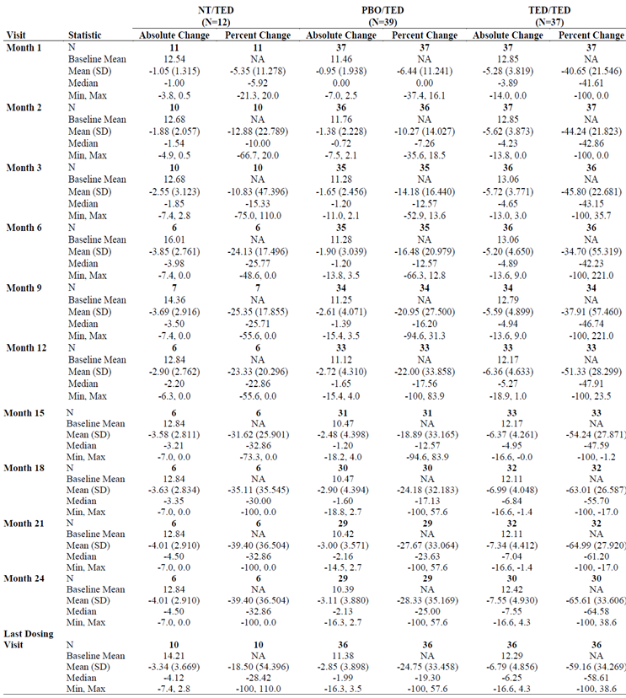

N = number of subjects in the treatment group or overall; n = number of subjects for parameter specified; NA = not applicable; NT/TED = Not Treated/Teduglutide (subjects who were eligible for randomization in Study CL0600-020 but qualified after the enrolment number was satisfied and entered Study CL0600-021 directly); PBO/TED = Placebo/Teduglutide (subjects who participated in Study CL0600-020 and received placebo); TED/TED = Teduglutide/Teduglutide (subjects already exposed to active treatment with teduglutide for 24 weeks in Study CL0600-020). All observations reported for TED/TED subjects are relative to the baseline prior to exposure to teduglutide at the beginning of Study CL0600-020. All observations reported NT, PBO/TED subjects are relative to the last visit before exposure to teduglutide in Study CL0600-021, which was considered their baseline.

After overall one year of treatment (6 months in study CL0600-020 and 6 months in study CL0600-021), 8 out of 34 patients (23.5%) achieved at least a 3-day reduction in days on PN per week. Furthermore, 13 out of 34 patients (38.2%) achieved at least a 2-day reduction in days on PN per week, and 18 out of 34 patients (52.9%) achieved at least a 1- day reduction in days on PN per week. The corresponding numbers for patients that have been on teduglutide for 6 months in study CL0600-021 are: at least a 3-day reduction 2/43 (4.7%); at least a 2-day reduction 3/43 (7.0%); at least a 1-day reduction 10/43 (23.3%).

There continued to be evidence of increased efficacy of teduglutide over time in all groups exposed to teduglutide in terms of PN/I.V. volume reduction, gaining additional days off per week, and achieving complete weaning of parenteral support. The most significant reductions were for those subjects who received 24 weeks of teduglutide 0.05mg/kg/day in Study CL0600 020 and continued treatment in Study CL0600 021 for another 24 months. These subjects who were exposed to teduglutide for 30 months experienced significant reductions in PN/I.V. support of 66% (7.6 litres) in volume per week compared to baseline. No subject had achieved PN/I.V. independence in the Study CL0600-020. Ten subjects over an additional 24 months were completely weaned off of PN/I.V. support and 18/30 (60.0%) had a reduction in their PN/I.V. requirement of at least 3 days/week.

In addition, reductions in PN/I.V. volume support were seen in subjects who received placebo in Study CL0600-020 and then were exposed to teduglutide for 24 months, 13/43 of whom (30.2%) were considered responders at the end of the previous study. After 6 months of teduglutide, 37.1% these subjects now had at least a 20% reduction in weekly PN/I.V. volume. By Month 24, a ≥ 20% reduction was seen in 16/29 (55.2%) subjects in this cohort. These reductions in PN/I.V. volume led to decreased days per week off PN/I.V. support over the 24 months in Study CL0600-021. This included 14/29 (48.3%) subjects having reduction of at least 1 day/week, 7/29 (24.1%) having at least a 2-day/week reduction, and 5/29 subjects (17.2%) having a reduction in their PN/I.V. requirement of at least 3 days/week. Of these, 2 subjects completely weaned off their PN/I.V. support. One additional subject who was a direct rollover from Study CL0600-020 into Study CLO600-021 (i.e., was not randomized in the previous study) was completely weaned from PN/I.V. support by Month 24.

Overall, significant PN/IV volume reductions were seen in CL0600-021 in subjects exposed to teduglutide from 24 to 30 months. The most dramatic reductions were in subjects who were exposed to teduglutide for the longest duration. Reductions ranged from 13 PN-dependent subjects achieving complete weaning to 25/65 (38.5%) subjects who demonstrated a reduction of ≥ 3 days/week in their parenteral support by the end of study at Month 24.[17]

Figure 7: Mean (± SE) of Change from Baseline in Weekly PN/I.V. Volume by Visit - ITT Population.

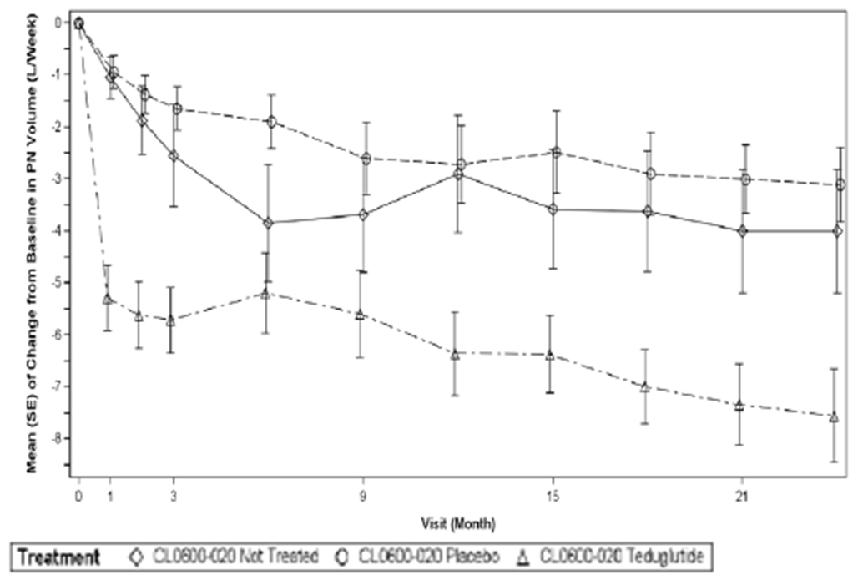

All observations reported for subjects treated with teduglutide in Study CL0600-020 are relative to the baseline prior to exposure to teduglutide at the beginning of Study CL0600-020. All observations reported for untreated subjects or subjects treated with placebo in Study CL0600-020 are relative to the last visit before exposure to teduglutide in Study CL0600-021, which was considered their baseline.

Table 15: Binary Response Status of at Least 20% Based on Subject Diary Data - ITT Population.

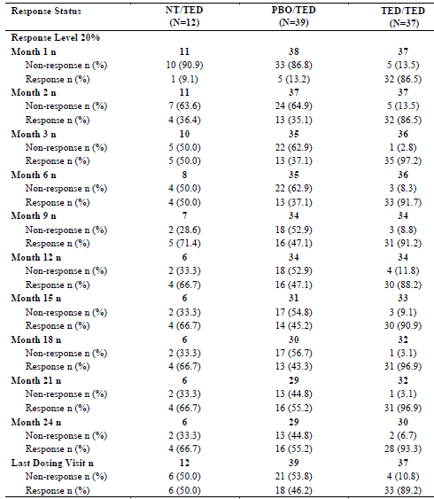

N = number of subjects in the treatment group or overall; n = number of subjects for parameter specified; NT/TED = Not Treated/Teduglutide (subjects who were eligible for randomization in Study CL0600-020 but qualified after the enrolment number was satisfied and entered Study CL0600-021 directly); PBO/TED = Placebo/Teduglutide (subjects who participated in Study CL0600-020 and received placebo);; TED/TED = Teduglutide/Teduglutide (subjects already exposed to active treatment with teduglutide for 24 weeks in Study CL0600-020)

Table 16: Proportion of Subjects with a Clinically-Relevant Response to Teduglutide 0.05mg/kg/day (20% to 100% Reduction from Baseline in PN/I.V. Volume) in Studies CL0600-020/021 and CL0600-004/005.

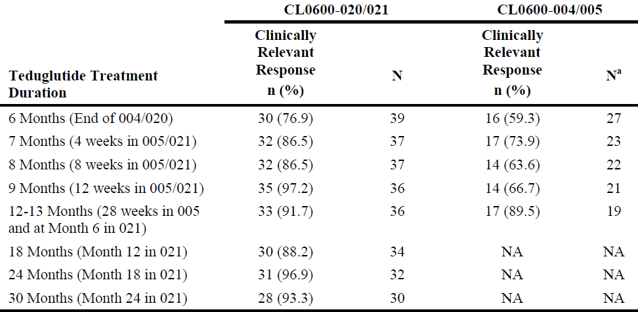

a Subjects who completed study; N = total number of subjects; n = number of subjects in category specified; NA = not applicable

### Analyses performed across trials: pooled and meta analyses

Not applicable. Being concurrently reviewed.

### Evaluator’s conclusions on clinical efficacy

‘The efficacy of Revestive was demonstrated in Study CL0600-020 and extension Study CL0600-021. Taken together, results from both the pivotal and non-pivotal studies support the long efficacy of Revestive in the target patient population.’[18]

‘Based on the results of study CL0600-020, teduglutide at a dose of 0.05mg/kg/day for up to 24 weeks of treatment was superior to placebo in reducing the volume of PN/I.V. in adult SBS subjects. The magnitude of the PN reduction (i.e. 4.4L/week vs. 2.3L/week) and the number of subjects achieving at least a 1-day reduction in weekly PN (21 vs. 9 patients) support the benefit of teduglutide. Furthermore, the results from the study CL0600-004 although formally a failed study point in the same direction as the results from study CL0600-020.

In the ongoing long-term follow-up safety study CL0600-021 teduglutide continues to provide benefits to the subjects with SBS. Reductions in PN/I.V. volume achieved during 24 weeks of therapy in study CL0600-020 are maintained during long-term therapy, and the frequency of parenteral nutrition was reduced by up to 3 days per week in a subset of subjects, with complete weaning from parenteral nutrition for 3 patients at interim cut-off date.’[19]

*Comment: While the effect of teduglutide on responder rate in study CL00-020 was double that of placebo, nevertheless there were 30.2% of placebo treated patients who had a 20 to 100% reduction from baseline in weekly PN/I.V. volume at both Weeks 20 and 24.*

## Clinical safety

‘Due to the small sample sizes in the pivotal studies, an integrated safety analysis is acceptable. Across all clinical studies, 595 subjects were exposed to at least one dose of Revestive (249 patient-years of exposure; mean duration of exposure was 22 weeks). Of the 595 subjects, 173 subjects were treated in Phase 3 SBS studies (77% at 0.05mg/kg/day and 23% at 0.10mg/kg/day).

The most commonly reported (≥ 10%) adverse reactions in patients treated with Revestive across all clinical studies (n = 595) were: abdominal pain (31.3%), injection site reactions (21.8%), nausea (18.8%), headaches (16.3%), abdominal distension (14.8%), and upper respiratory tract infection (11.9%).’[20]

In pivotal and extension studies, three subjects who received Revestive 0.05mg/kg/day were diagnosed with malignancy; one (metastatic adenocarcinoma in the gastro-intestinal tract) was determined by the investigator to be related to Revestive. Colorectal polyps were identified in 1.7% of subjects on placebo vs. 0.9% of subjects on Revestive 0.05mg/kg/day. Twelve subjects experienced one or more episodes of intestinal obstruction/stenosis. Fluid overload was reported in 6.8% of subjects on placebo vs. 11.7% subjects on Revestive 0.05mg/kg/day. Twelve percent of the patients in each of the placebo and Revestive 0.05mg/kg/day treatment groups experienced an injection site reaction; the majority of reactions were moderate in severity and no occurrences led to drug discontinuation. The most common markedly abnormal clinical laboratory finding was C-Reactive Protein (CRP) ≥ 21mg/L: 8.6% of subjects on placebo vs. 25% of subjects on Revestive 0.05mg/kg/day.

Teduglutide has cross-reactivity to native GPL-2. Anti-teduglutide antibodies appear to have no impact on short term efficacy and safety; the long-term impact is unknown.

In the post-marketing phase the following adverse reactions were reported in patients receiving Revestive: cardiac arrest, cardiac failure, and cerebral haemorrhage.

Table 17: Exposure to teduglutide and comparators in clinical studies.

| Study type/ Indication | Controlled studies | | Uncontrolled  studies | Total teduglutide |
| --- | --- | --- | --- | --- |
| Teduglutide | Placebo | Teduglutide |  |
| **Clinical pharmacology** | **281** | **145** | **47** | **328** |
| **Efficacy and Safety Studies (SBS)** | **109** | **59** | **153a** | **180** |
| Other Studies (Crohn’s disease) | 75 | 25 | 65a | 100 |
| **TOTAL** | **465** | **229** | **130** | **595** |

n = number of subjects in category specified; SBS = short bowel syndrome  
a Some subjects in the cell total have already been counted in the same column and primary study group by virtue of having participated in the placebo-controlled study. Subjects who received both teduglutide and placebo in a crossover study are counted once in the Placebo column, once in the teduglutide column, and once in the Total column.

Table 18: Exposure to teduglutide in clinical studies according to duration.

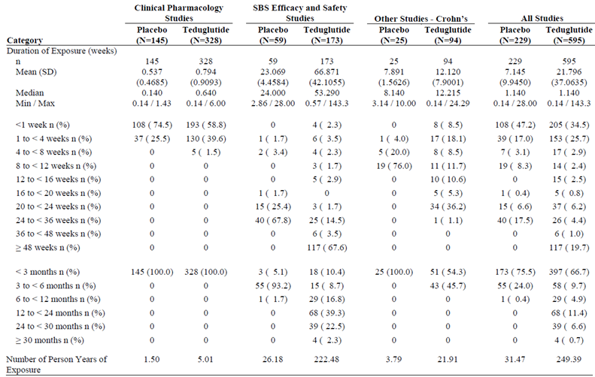

N = total number of subjects; n = number of subjects in category specified; Percentages for duration of exposure are based upon the number of subjects in the Safety Population. Percentages for duration of dose exposure are based upon the number of subjects in the Safety Population who obtained that dose. Duration of exposure is defined as: (last teduglutide dose date - first teduglutide dose date + 1) / 7. Three month intervals are defined as 91 days, with the exception that 360 days will be used as the definition for 12 months. Person years of exposure is defined

Table 19: Summary of TEAEs by Preferred Term (Reported in ≥ 5% of Subjects in All Teduglutide) - Safety Population - All Studies

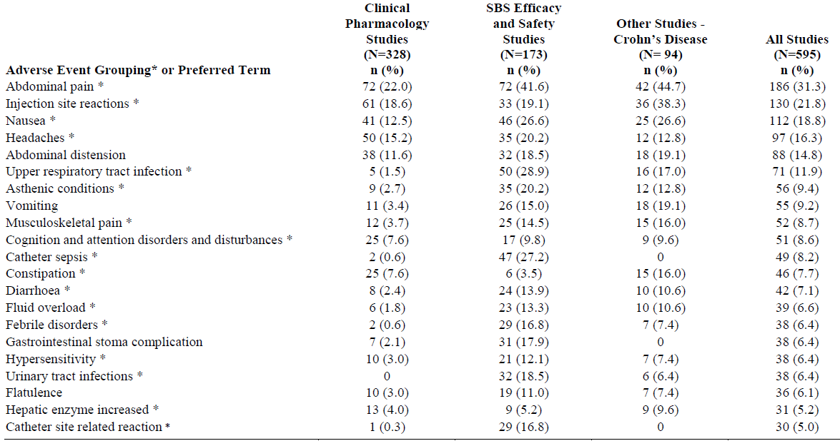

n = number of subjects in category specified Percentages are based upon the number of subjects in the Safety Population. Subjects are counted no more than once for incidence of Preferred Term.

TEAEs are defined as any adverse event with a start date on or after the date of first dose and within 30 days after discontinuation of study drug.

* shows special interest in Body System or Organ Class. The Preferred Terms in the AE groupings represent medically similar terms.

### Treatment related adverse events (adverse drug reactions)

See Table 20.

**Table 20: Adverse reactions in ≥ 5% of Revestive-treated SBS subjects and more frequent than placebo: CL0600-020 and CL0600-004.**

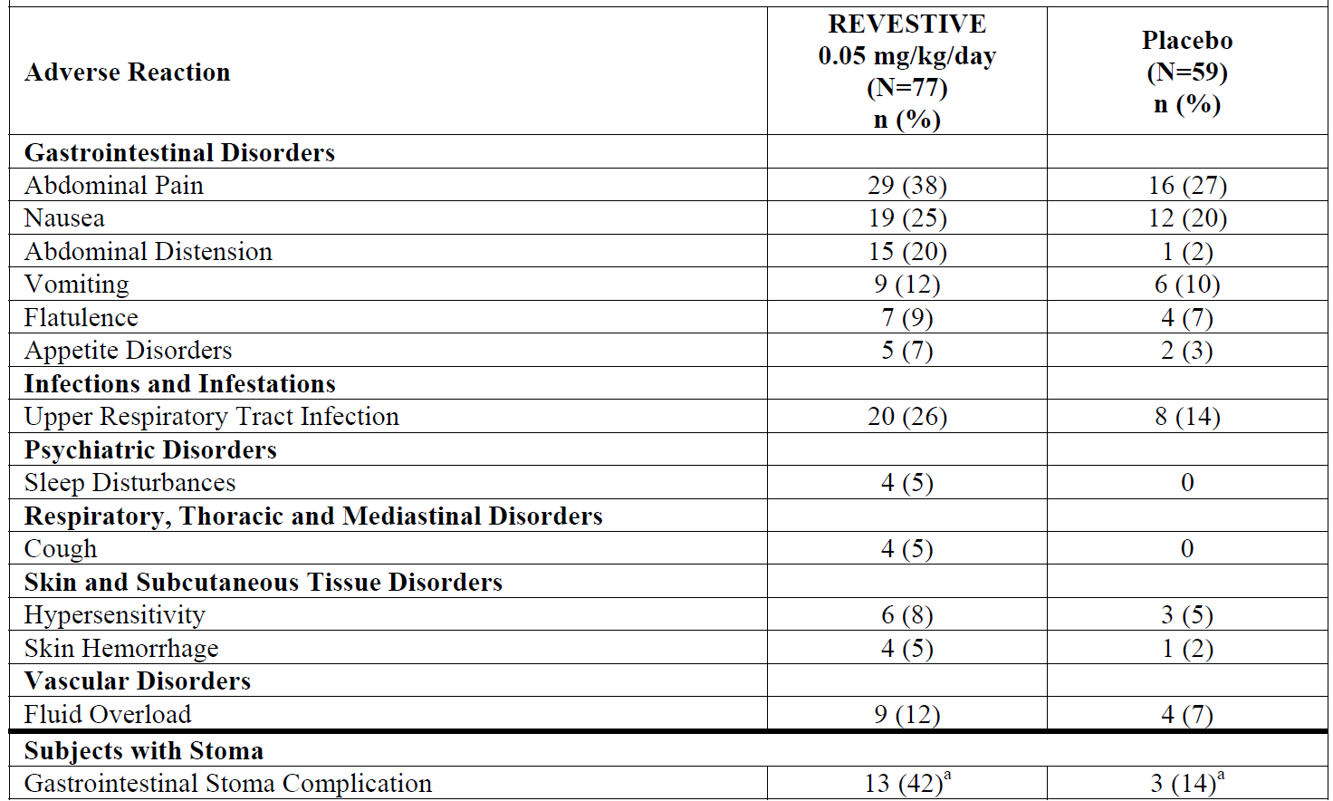

a Percentage based on 53 subjects with a stoma (n = 22 placebo; n = 31 Revestive 0.05mg/kg/day)

#### Deaths and other serious adverse events

##### Integrated safety analyses

3 deaths from:

* Metastatic Cancer: one event in a patient with pre-existing cancer was considered by the investigator to be severe and related to treatment, the second was considered not to be related to study drug.
* Sepsis which was considered by the investigator to be severe and unrelated to treatment with teduglutide.
* Metastatic Cancer: one event in a patient who had teduglutide for 84ays when non-small cell lung cancer was diagnosed. Teduglutide was ceased. The investigator did not attribute the SAE to teduglutide treatment.

##### Serious Adverse Events

Across the 16 integrated clinical studies, 20.8% (124/595), of subjects in the teduglutide group reported a total of 289 SAEs and 7.9% (18/229) of subjects in the placebo group reported a total of 35 SAEs.

Table 21: Summary of SAEs by Preferred Term incidence >1%- Safety Population – SBS Efficacy and Safety Studies – Teduglutide.

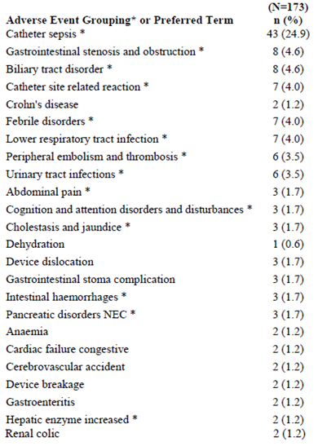

N = total number of subjects; n = number of subjects in category specified; NEC = not elsewhere classified; Percentages are based upon the number of subjects in the Safety Population. TEAEs are defined as any AE with a start date on or after the date of first dose and within 30 days after discontinuation of study drug. Subjects are counted no more than once for incidence of Preferred Term. * shows special interest in Body System or Organ Class. The Preferred Terms in the AE groupings represent medically similar terms

In the 59 patients receiving placebo, most SAEs were related to the device (in 19 subjects of whom 9 had catheter sepsis).

#### Discontinuations due to adverse events

##### Integrated safety analyses

Among subjects treated with teduglutide, the most common (> 1%) TEAEs leading to discontinuation were abdominal pain (3.5%) abdominal distension (1.2%), Crohn’s disease (1.0%) and nausea (1.0%). Other TEAEs leading to discontinuation that were reported by more than one teduglutide-treated subject included vomiting, gastrointestinal stoma complication, asthenia, constipation, foreign body trauma, and small intestinal obstruction.

Of the 14 subjects who discontinued due to TEAEs in the combined SBS Placebo-controlled Studies, 5 subjects (3 treated with placebo and 2 treated with teduglutide 0.05mg/kg/d) in Study CL0600-020 and 7 subjects (6 treated with teduglutide 0.05mg/kg/d and one treated with teduglutide 0.10mg/kg/d) in Study CL006-004 had TEAEs leading to discontinuation that were considered by the investigator to have been related to the study drug. These TEAEs were abdominal distension, abdominal pain, haemorrhoidal haemorrhage, asthenia, dysgeusia, nausea, vomiting, constipation, coma, drug level increased, hypersomnia, cardiac failure congestive, pancreatitis, and small intestinal obstruction among subjects treated with teduglutide and intestinal polyp, faecal volume increased, and frequent bowel movements among subjects treated with placebo.

In the extension Study, CL0600-005 the TEAEs considered related to study drug leading to discontinuation in 4 patients were inflammatory bowel disease, abdominal pain, vomiting, and nausea.

In the extension Study CL0600-021, ten subjects had discontinuations due to events that were considered related to study drug:

* peripheral oedema (severe)
* confusion due to sepsis with emaciation, and hydro-electrolytic disorders
* abdominal pain, continuing nausea, and heart burn
* abdominal pain (moderate)
* abdominal pain, nausea and weight (all moderate)
* continuous, severe abdominal pain
* GI stoma complication
* gastrointestinal stoma complication, cholecystitis, bowel obstruction, worsening of portal hypertension)
* Crohn’s disease exacerbation
* metastatic neoplasm.

Table 22: Summary of TEAEs Leading to Discontinuation by Preferred Term - Decreasing Frequency - Safety Populations.

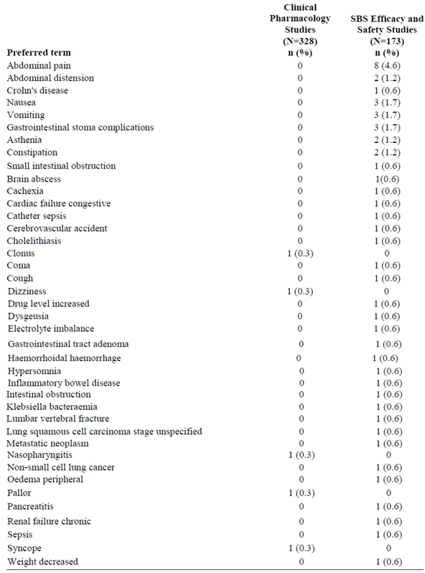

N = total number of subjects; n = number of subjects in category specified; Percentages are based upon the number of subjects in the Safety Population. TEAEs are defined as any adverse event with a start date on or after the date of first dose and within 30 days after discontinuation of study drug.

### Evaluation of issues with possible regulatory impact

#### Gastrointestinal disorders

From the EMA evaluation:

*Primarily abdominal pain/distension, nausea/vomiting but difference regarding number of patients reporting intestinal obstruction.*

*Although a large fraction being mild to moderate in severity GI adverse events were the main AE leading to premature discontinuation. The mechanism behind these events appears reasonable well explained on the basis of the pharmacological effects of the drug and the predisposition of the treated patients. It is considered a real, but manageable risk. Adequate warnings should be included in the SmPC.*

Gastrointestinal obstruction occurs more frequently in teduglutide treated patients than in placebo treated patients. Considering the pharmacological mechanism of the drug (increase in thickness of the intestinal mucosa) and the target population (subjects with multiple resections of the small and/or large intestine with anastomoses/stomas prone to narrowing, in particular in patients with Crohn’s disease) the increased rate of cases of obstruction may not come as a surprise. The mechanism described by the applicant (increased thickness of mucosa due to the pharmacologic effect of teduglutide in a predisposed subject with a pre-existing sub-clinical stenosis) seems plausible although a component of impaired motility (due to increased absorption of the anti-propulsives that most of these patients routinely are treated with) cannot be completely ruled out. In any case this is a real risk that treating physicians and patients should be made clearly aware of (in particular in patients with pre-existing stenosis of the intestine). On the other hand, as most of the cases reported resolved by conservative measures (such as NPO, nasogastric tube, pausing/discontinuing teduglutide) and as physician treating these patients are experienced in diagnosing and treating cases of intestinal obstruction, the risk is considered manageable.

#### Stomal complications

The evaluator has concerns about the high adverse event (AE) rate among stoma patients teduglutide 13/31 (42%) vs. placebo 3/22 (14%) although the numbers were small. There were 2 discontinuations among 31 (6%) stoma patients due to treatment related stomal AEs.

The sponsor’s elaboration on “Stomal Complications” was:

*In placebo controlled SBS studies “gastrointestinal stoma complications” occurred in 3 patients (13.6% of patients with stoma) of the placebo groups reporting 3 events and in 17 patients (37.8% of patients with stoma) of the teduglutide groups reporting 19 events. There was no apparent dose dependence, because the 0.05mg/kg/day teduglutide dose group had 41.9% of the patients with stoma reporting stoma complications and the 0.10mg/kg/ day teduglutide dose group had 28.6%.*

*In all Phase III SBS studies (CL0600-004, CL0600-005, CL0600-020 and CL0600-021) “gastrointestinal stoma complications” occurred altogether in 28 patients with stoma (41.2%) reporting 47 events (Study ALX0600-92001 was not included in this analysis as no systematic data on the presence of a stoma were available). No tendency towards dose dependency could be seen. The 0.05mg/kg/day teduglutide dose group had 42.3% of the patients reporting stoma complications and the 0.10mg/kg/ day teduglutide had 37.5%.*

*The verbatims behind the AE-term gastrointestinal stoma complications included typically stoma hypertrophy, stoma swelling, increased stoma nipple or other similar terms describing an enlargement of the stoma nipple. However, two cases describing actual complications on the verbatim level were also regarded serious.*

*Thus, the majority of patients (28/68 SBS patients with stoma in the phase 3 SBS studies), experienced a stoma nipple enlargement which was described typically as stoma hypertrophy, stoma swelling or increased stoma nipple. In one patient this led to a bowel obstruction based on a hypertrophied ileal stoma, which resolved after 9 days. In addition, one patient reported the SAE “clotted stoma” which was found to be caused by food particles.*

*Two patients in the teduglutide development program (both in Study CL0600-021) discontinued prematurely due to gastrointestinal stoma complications.*

*From a pharmacological perspective it is known that GLP-2 and also teduglutide cause an increased mesenteric blood flow, which is probably the reason for the increased stoma nipple size under teduglutide treatment: Bremholm L, et al. Glucagon-like peptide-2 increases mesenteric blood flow in humans. Scand J Gastroenterol 44: 314-319 (2009).*

From the EMA evaluation:

*Considering the pharmacological effect of teduglutide (swelling of intestinal mucosa due to hypertrophy of intestinal mucosa as well as increased intestinal blood flow) swelling of the stoma and in some cases obstruction must be anticipated. The SmPC should include appropriate warning*

#### Depression

Depression was reported by 11 patients treated with teduglutide (5.8 %) and by no patients treated with placebo. This is a major concern in view of the low number of patients included in the studies. In the Safety Summary only “depression” has been mentioned as a psychiatric adverse event. However, a look into the Integrated Safety Summary exposes more adverse events within this area; for example, anxiety, insomnia, nightmare, and sleep disorder - all only reported in the teduglutide groups. Furthermore, headache was reported in 38 (19.9%) teduglutide treated patients (placebo: two [4.9%] patients) in the phase 2/3 studies. Although the non-clinical data report no CNS related toxicity and demonstrate a low passage of teduglutide across the blood brain barrier in rats, these findings have not been explained (EMA evaluation, Day 80).

In the pooled analysis of the placebo controlled long term studies in SBS, ‘depression’ was not reported more often in the teduglutide group compared to the placebo group. Therefore ‘depression’ is not considered a specific risk for teduglutide. In contrast ‘sleep disorders’ and ‘anxiety’ was clearly more common among teduglutide treated patients than among placebo treated patients.

#### Liver function and liver toxicity

No hepatobiliary or pancreatic events were reported for placebo patients, while 36 events were reported for 18 teduglutide patients (9.4%). Two (1.0%) and 6 (3.1%) patients experienced serious pancreatic and hepatobiliary events, respectively. Adverse events of special significance were pancreatitis, abnormal faeces, cholecystitis (incl. acute), and gallbladder perforation. Of the serious events the events of pancreatitis, pancreatic duct stenosis, cholecystitis (incl. acute) deserve special attention.

One patient discontinued due to pancreatitis (in the 0.1mg/kg/d group). Furthermore, two patients discontinued because of either ALT or AST increase.

In conclusion, there is a signal of a biliary/pancreatic problems associated with teduglutide treatment of SBS patients (EMA evaluation, Day 80).

The assessment of this issue is complicated by the fact that SBS patients have an increased risk of bile stones (EMA evaluation, Day 150).

In SBS double-blind, placebo-controlled studies CL0600-004 and CL0600-020, biliary-related treatment-emergent AEs were reported in 4 of 109 subjects (3.7%) treated with teduglutide and 2 of 59 subjects (3.4%) in placebo groups

Biliary tract-related AEs were reported in 12 subjects in SBS extension studies CL0600-005 and CL0600-021, and in 4 subjects in Crohn's disease extension Study CL0600-009 (also referred to as 009). These subjects did not have biliary tract-related AEs reported in the respective core studies. Serious adverse events were reported in 8 of the 16 subjects.

#### Renal function and renal toxicity

It is acknowledged that there is no indication that teduglutide has a negative impact on serum creatinine. In patients with impaired renal function, reduction of teduglutide dose is recommended (EMA evaluation, Day 80).

#### Other clinical chemistry

It is acknowledged that the increases in CRP noted were primarily of temporary nature and primarily noted in the short term pharmacology studies.

However, the issue of the observed general increase in CRP and its possible clinical implications has not been fully resolved.

Changes in CRP and potential impact on cardiovascular risk remain an area of uncertainty (EMA evaluation, Day 150).

In the pooled analysis of the placebo controlled Phase III studies there was no difference between placebo and teduglutide as regards frequency of markedly abnormal post baseline calcium levels (EMA evaluation, Day 150).

#### Haematology and haematological toxicity

Mean increases were seen in platelet and WBC counts in subjects treated with teduglutide while mean decreases were seen in patients treated with placebo; however, these changes were not clinically relevant. No clinically meaningful changes were seen in any of the remaining analyses. Shift tables did not show any meaningful changes. The most common post-baseline markedly abnormal measure was low haematocrit (≤ 37 % [M]; ≤ 32 % [F]) (42%, 25/59 for placebo, 32%, 24/74 for teduglutide 0.05 mg/kg/d, and 26%, 8/31 for teduglutide 0.10 mg/kg/d) (EMA evaluation, Day 150).

#### Electrocardiograph findings and cardiovascular safety

Overall, it appears that teduglutide treatment entails the occurrence of fluid overload which might be due to the PD effect of teduglutide. Whether there is a relationship to CV AEs due to the PD effect of teduglutide or whether this is associated to fluid overload cannot be determined (EMA evaluation).

#### Vital signs and clinical examination findings

The following vital signs were summarised by treatment group for the Safety Population: systolic blood pressure, diastolic blood pressure, heart rate, and body temperature. No clinically meaningful trends in changes in vital signs from baseline were noted (EMA evaluation, Day 150).

However, the evaluator also expressed concern about the incidence of pyrexia.

In the randomised, placebo controlled Phase III studies there was no difference between placebo and teduglutide in terms of frequency with which pyrexia was reported. Most cases of pyrexia were not associated with infection and pyrexia was neither associated with anti-ECP antibodies or teduglutide antibodies. The high rate of pyrexia remains unexplained. It does not appear to be related to teduglutide treatment but could be related to the underlying disease necessitating central venous line with increased risk of temporary, subclinical infections.

As regards catheter sepsis, it is acknowledged that in the placebo controlled Phase III studies the total number of AEs indicative of catheter sepsis was similar in placebo and teduglutide treated patients (EMA evaluation, Day 150).

#### Immunogenicity and immunological events

As regards immunogenicity, the data collected so far does not indicate that immunogenicity poses a significant risk to the safety and efficacy of the drug. However, as only relative short term studies are available, immunogenicity and potential impact on safety and efficacy should remain under observation (EMA evaluation day 150).

#### Serious skin reactions

Events of injection site pain were experienced by 33 teduglutide treated patients (16.8%) and by none in the placebo group. In this respect it is important to highlight that in monkey repeat dose toxicity studies a foreign body reaction (chronic active granulomatous inflammation with secondary necrosis and fibrosis) was recorded in the subcutaneous tissue at the injection site. The severity of the inflammation was increased compared to vehicle treatment and exhibited a clear teduglutide dose relation. It is currently not known if these reactions are related (EMA evaluation, Day 80).

Detailed review of this problem did not indicate that injection site reactions were more common for teduglutide (in the proposed dose, 0.05mg/kg/day) than for placebo. Thus injection site reactions do not constitute a major problem for teduglutide in the proposed dose (EMA evaluation, Day 150).

### Post marketing experience

From 01 September 2012 to 28 February 2014 the total exposure from marketing experience was vials, which were dispensed to 374 patients The total calculated subject years of exposure is 101.4 (36,996/365 days/year). Teduglutide was used to treat 357 subjects with SBS, 16 with an unknown indication and one subject with autoimmune enteropathy as part of a compassionate use program.

Of the 8 deaths on teduglutide in the US, the contribution of teduglutide could not be excluded in 2 cases. The Rapporteur and co-rapporteur day 150 joint response assessment report and other EMA reports contain information in relation to deaths. In 2 cases, a causal relationship could not be ruled out:

* Fluid retention was associated with a death when using teduglutide in the setting of progressive coronary artery disease, a prior history of respiratory failure and multiple comorbid conditions. Fluid overload could not be definitively attributed to either the effect of teduglutide or to the underlying disease.
* Patient died in her sleep and increased absorption of concomitant oral medication (narcotics) could not be excluded as a contributing factor to the death.

#### Important Identified Risks Cumulative post-marketing ACR reports as of 28 February 2014

Growth of pre-existing polyps, was a change in the known safety profile of teduglutide after marketing approval.

Additional case reports received from the completion of CL0600-021 revealed an additional 9 subjects diagnosed with intestinal polyps. As a result, the EU SPC was updated in May 2014 to include a recommendation for follow-up colonoscopies yearly for the first 2 years after start of treatment with teduglutide, and then every 5 years thereafter or more frequently as determined by the treating physician.

##### Biliary AEs

During the interval 01 September 2013 to 28 February 2014, no cases reported the PTs cholecystitis or cholelithiasis. Cumulative post-marketing ADR reports as of 28 February 2014 show that 5 patients reported 6 AEs: 3 patients reporting cholecystitis, one of whom also reported cholelithiasis; 1 patient reported cholelithiasis; and 1 patient reported cholecystectomy (1.3% of all post-marketing patients, n= 374).

##### Pancreatic AEs

2 patients reporting pancreatitis: one of whom reported acute and chronic pancreatitis, and the other reported acute pancreatitis (1.1% of post-marketing patients, n = 374).

##### Cardiovascular AEs associated with fluid overload

32 patients reported 38 events of symptoms indicative of fluid overload (8.8% of post- marketing patients, n=374).

##### Gastrointestinal stenosis and obstruction

14 patients with intestinal obstructions: 10 reports of intestinal obstruction, 1 of obstruction gastric, 2 of small intestine obstruction and 1 of small intestine stenosis (3.7% of post-marketing patients, n = 374).

##### Gastrointestinal Stoma Complications

Cumulative post-marketing reports include 22 subjects reporting 24 events of gastrointestinal stoma complications (5.9% of post-marketing subjects, n = 374).

##### Pre-existing moderate or severe renal impairment, or end-stage renal disease (ESRD)

During the reporting period of 01 March 2013 to 30 August 2013, there was 1 case in a patient with medical history of chronic renal insufficiency. During the reporting period of 01 September 2013 to 28 February 2014, 5 cases (3 serious and 2 non –serious) reported a medical history which included pre-existing renal impairment or ESRD. For 4/5 there was no indication in the report that the patient’s event was related to administration of teduglutide in the setting of moderate or severe renal impairment; and for 1/5, no additional information was provided to assess whether or not the patient’s events were related to administration of teduglutide in the setting of moderate or severe renal impairment. Therefore, the cumulative post-marketing reports include 6 cases (1.6% of post-marketing patients, n = 374).

##### Growth of pre-existing polyps of the colon

Cumulative post-marketing AE reports include no reports of colonic polyps.

##### Benign neoplasia of the GI tract including the hepatobiliary system

Cumulative post-marketing ADR reports as of 28 February 2014 included 1 report of duodenal polyp and no other reports (0.26% of post-marketing patients, n = 374).

##### Tumour promoting ability

Cumulative post-marketing ADR reports as of 28 February 2014 include 3 reports: 1 of melanocytic naevus, 1 of acrochordon, and 1 of squamous cell carcinoma (0.8% of post-marketing patients, n = 374).

##### Occurrence of anti-teduglutide antibodies, cross reactivity with GLP 2, and occurrence of anti- E. coli protein (ECP) antibodies (and associated clinical immunogenicity reactions)

Cumulative post-marketing ADR reports as of 28 February 2014 included 34 patients reporting 48 AEs with at least one of these specific event terms (9.1% of Postmarketing patients, n = 374).

#### Important Potential Risks

The available case information is not sufficient to allow confirmation of a causal relationship with teduglutide of these risks.

* Increased absorption of oral concomitant medications:4 reports of potentially increased absorption of oral concomitant medications (1.1% of post-marketing patients, n = 374).
* Local skin reactions:24 patients reporting a total of 36 injection site events (6.4% of post-marketing patients, n = 374).

### Evaluator’s comments on clinical safety

Postmarketing observation has added the increased risk of **‘**Growth of pre-existing polyps,’ with the added precaution of more frequent colonoscopies, not themselves without added risks.

There is an increased risk of GI complications particularly of the stoma. It is assumed by the EMA evaluator that this treatment will be supervised by a gastroenterologist (EMA evaluation day 150).

## First round benefit-risk assessment

### This evaluator’s assessment

This evaluator considers efficacy was demonstrated. There is no similar treatment registered for this group of patients. However the incidence of similar improvement without treatment was also high. While the effect of teduglutide on responder rate in study CL00-020 was double that of placebo, nevertheless there was 30.2% of placebo treated patients who had a 20 to 100% reduction from baseline in weekly PN/I.V. volume at both Weeks 20 and 24.

There is a demonstrated increased risk of GI complications particularly of the stoma. The theoretical concern of induction and/or promotion of benign and/or malignant tumour growth was not demonstrated in the limited studies, however post-marketing data added the increased risk of **‘**Growth of pre-existing polyps.’ The proposal of more frequent colonoscopies carries an added risk.

### Assessment of benefits across overseas evaluations

See Table 23.

Table 23: Assessment of benefits across overseas evaluations.

| **Benefits** | **Strengths and Uncertainties** |
| --- | --- |
| The efficacy of the drug was demonstrated by achieving the primary endpoint and two pre-specified secondary endpoints in pivotal study CL0600-020.  Long-term extension Study CL0600-021 confirmed the efficacy conclusions from the controlled study.a |  |
| Due to the capacity of the intestine to undergo adaptation after surgical resection, PN requirements may not be permanent. Based on the mechanism of action, teduglutide could have the potential to improve/accelerate this adaptive process thereby providing a potential valuable additional treatment option to these patients with limited possibilities.b  Study CL0600-020 demonstrated that compared to placebo, teduglutide statistically significantly reduces the volume of PN/IV in SBS. The results showed that compared to placebo, teduglutide had statistically significant effect on the primary efficacy parameter, 20% or greater reduction in volume of PN/IV at weeks 20 and 24.  The long-term extension trial indicated that the beneficial effects mentioned after 6 months treatment could be maintained, or even improved after 12 months of treatment, and that the beneficial effects shown in the placebo-controlled phase with active treatment could also be achieved when the substance was given to previously placebo-treated patients. | * Study CL0600-004 failed to meet its primary objective and was only considered hypothesis generating. Based on exploratory analyses of this study, the applicant identified a dose of teduglutide (0.05mg/kg/day) which seemed efficacious * None of the subjects in the short term study could be weaned off PN/IV fluid completely which could constitute to a clear clinically relevant effect. As complete weaning off might only be realistic in a less severe population it may be more appropriate to show clinical relevance in the present setting with patients with a very short segment of remaining intestine and a substantial requirement for PN/IV in the reduction in number of days on PN/IV. * In the present study with the instrument applied (SBS-QoL) it was not possible to demonstrate any significant difference in QoL between placebo and teduglutide treated patients. * It seems therefore appropriate to evaluate the treatment effect after 6 months, because only very few patients with potential PN volume response might stop treatment inappropriately after this point in time. * Due to the unknown long-term risks associated with teduglutide treatment, a lifelong treatment without clear signs of efficacy is not justified. |

a Source: Health Canada evaluation; b Source: EMA evaluation

### Assessment of risks across overseas evaluations

See Table 24.

Table 24: Assessment of risks across overseas evaluations.

| **Risks** | **Strengths and Uncertainties** |
| --- | --- |
| Clinical data collected from almost 600 patients who received Revestive in clinical trials (249 patient-years of exposure) indicates an acceptable safety profile for this patient population. One malignancy was reported in an extension study that was determined to be related to Revestive.a |  |
| Most of the adverse events observed following administration of teduglutide were mild and moderate in severity; one third of the adverse events were considered to be severe.  The most commonly reported GI AEs for teduglutide vs. placebo were abdominal pain; nausea; vomiting; abdominal distension and constipation. While these events are important, the risk is well known.  Hepatobiliary and pancreatic events were only reported in teduglutide patients. In this respect, it is a concern that a considerable part of the reports were serious.  The non-clinical studies revealed hyperplastic and/or hypertrophic effects of teduglutide on intrahepatic and extrahepatic bile ducts, the gallbladder and pancreatic ducts.b | The causality assessment is more uncertain for the two other cases of cancer during teduglutide treatment (including open label treatment). From the theoretical point of view, due to its character of being a growth factor inducer and inducing epithelial hyperplasia, there is some concern of induction and/or promotion of benign and/or malignant tumours. The concerns are corroborated by the data derived in animals, where benign biliary tumours have been induced by high doses. The applicant has evaluated the occurrence of tumours and its precursors during the clinical studies and has found some colonic adenomatous changes, one being dysplastic in nature.  The combined analyses of data from the placebo controlled SBS studies CL0600-004 and CL0600-020 showed a small overall increase in average CRP during teduglutide treatment (1.43mg/L above baseline at end of study) compared placebo treatment. Increased CRP values are a known predictor for an increased cardiovascular risk. In the SBS population an increased rate of cardiovascular AEs has not been observed in clinical trials with teduglutide.b |
| This evaluator in reviewing the post marketing data submitted noted an increase in pre-existing polyp growth | The result was a recommended increase in colonoscopy frequency which has in itself a risk e.g. perforation and in the associated sedation/anaesthesia.  Only 280 patients were exposed in clinical SBS trials, with 68 for >12months. |

a Source: Health Canada evaluation; b Source: EMA evaluation

### Assessment of benefit-risk balance across overseas evaluations

In Study CL0600-020 for subjects both with stoma as well as in those without stoma, the responder rate was higher in the teduglutide group (15/21 subjects, 71.4% and 12/22 subjects, 54.5%, respectively) than in the placebo group (3/17 subjects, 17.6% and 10/26 subjects, 38.5%, respectively).

This evaluator has concerns about the high AE rate among stoma patients teduglutide 13/31 (42%) vs. placebo3/22 (14%). There were 2 discontinuations among 31 (6%) stoma patients due to treatment related stomal AEs.

#### Health Canada

The benefit vs. risk assessment favors the authorization of Revestive for SBS patients who are dependent on parenteral support based on:

* Demonstrated efficacy: primary endpoint met in pivotal study CL0600-020; pre-specified secondary endpoints in study CL0600-020 such as absolute change in PN/I.V.; achievement of at least one day reduction in parenteral support in some patients.
* Rarity and seriousness of the disease treated. Also, there is currently no authorized therapy in Canada for this indication.
* Acceptability of the potential risks (malignancy; intestinal polyps; fluid overload; intestinal stenosis; other gastrointestinal complications) for the target population and disease treated.

#### EMA

The results from the pivotal study showed that compared to placebo, teduglutide had statistically significant effect on the primary efficacy parameter, 20% or greater reduction in volume of PN/i.v. at weeks 20 and 24. The results were robust and confirmed in a number of sensitivity analyses. Data from the long-term extension trial indicated that the beneficial effects mentioned after 6 months treatment could be maintained, or even improved after 12 months of treatment. The clinical relevance of the observed effects was confirmed by a number of experts in this field.

Most of the adverse events observed following administration of teduglutide were mild and moderate in severity; one third of the adverse events were considered to be severe. Adequate measures have been identified to generate additional data in this rare condition to further elucidate particularly the safety profile. The SmPC is adequately describing the currently available information and provides appropriate guidance on the use of teduglutide.

Considering the serious and disabling nature of the condition with a considerable impact on QoL and only limited symptomatic treatment options, the demonstrated effect of clinical relevance clearly outweighs the safety concerns. Therefore, the benefit-risk balance for teduglutide for the treatment of adult patients with Short Bowel Syndrome, who should be stable following a period of intestinal adaptation after surgery, is deemed positive.

## First round recommendation regarding authorisation

This evaluator recommends authorisation; however, it is clearly considered essential that treatment be managed by a gastroenterologist.

What can also be said is that based on the risk benefit summaries made by other evaluators teduglutide has been approved in the US, Canada and EU, albeit with some restrictions.

## Clinical questions

Clinical questions related to PI documentation.

## Second round evaluation of clinical data

The sponsor provided data in response to questions related to the PI.

## Second round benefit-risk assessment

The assessment is unchanged.

## Second round recommendation regarding authorisation

Approval of teduglutide is recommended for the treatment of adult patients with SBS who are dependent on parenteral support.

*Patients should be stable* ***for at least 4 to 8 weeks*** *on their parenteral support regimen before initiating teduglutide therapy.*

This achieves the same aim of not initiating parenteral support and teduglutide at the same time, while the recommended additional insertion matches the requirements of the main efficacy studies.

Commencing teduglutide is not without risk and the majority of patients receiving TPN would be for short term, for example, post-surgery where the use of teduglutide is unnecessary.

|  |
| --- |
| Therapeutic Goods Administration |
| PO Box 100 Woden ACT 2606 Australia  Email: [info@tga.gov.au](mailto:info@tga.gov.au) Phone: 1800 020 653 Fax: 02 6232 8605  <https://www.tga.gov.au> |

1. Health Canada evaluation
2. Health Canada evaluation
3. EMA evaluation
4. EMA evaluation
5. EMA evaluation
6. EMA evaluation
7. This was submitted to the EMA during the evaluation so is found with the Rapporteur and co-rapporteur day 150 joint response assessment report.
8. EMA evaluation
9. Stability was described as:

   a. Actual PN/I.V. usage was to match prescribed PN/I.V.

   b. Baseline (Visit 2) 48-hour I/O volumes had to fall within ± 25% of the respective 48h I/O volumes at the time the subject was optimized and entered stabilization.

   c. Urine output volume should NOT have fallen below 2L and not have exceeded 4L per 48h when the subject completed the optimization and stabilization periods.
10. For subjects with a history of Crohn’s disease, the subject had to be in clinical remission for at least 12 weeks prior to dosing as demonstrated by clinical assessment, which might have included procedure-based evidence of remission
11. e.g., antitumor necrosis factor [anti-TNF] or natalizumab
12. e.g., catheter sepsis, bowel obstruction, severe water-electrolytes disturbances
13. A response was defined as the achievement of at least a 20% reduction from Baseline (Visit 2) in weekly PN volume.
14. The intensity of the response relied on a reduction from Baseline in weekly PN volume at a minimum of 20% and a maximum of 100%. Duration of the response incorporated responses at Weeks 16 through 20 and at Weeks 20 through 24.
15. The sponsor has developed an instrument (SBS-QoL™) specifically designed to measure QoL in short bowel syndrome.
16. They had either Participated in Study CL0600-020, but were required to stop dosing prematurely due to a non-drug related adverse event (AE) and were evaluated and determined by the investigator and the sponsor to be a candidate for the long-term study or enrolled in Stage I (optimization/stabilization) and qualified for randomization in Study CL0600-020 but were not treated because the target number of subjects was already randomized
17. Clinical Study Report CL0600-021.
18. Health Canada evaluation
19. EMA evaluation Day 150
20. Health Canada evaluation