Date of CER: August 2013

AusPAR Attachment 2

Extract from the Clinical Evaluation Report for tenofovir disoproxil fumarate / emtricitabine / rilpivirine
  - Proprietary Product Name: Eviplera
  - Sponsor: Gilead Sciences Pty Ltd
About the Therapeutic Goods Administration (TGA)
- The Therapeutic Goods Administration (TGA) is part of the Australian Government Department of Health, and is responsible for regulating medicines and medical devices.
- The TGA administers the Therapeutic Goods Act 1989 (the Act), applying a risk management approach designed to ensure therapeutic goods supplied in Australia meet acceptable standards of quality, safety and efficacy (performance), when necessary.
- The work of the TGA is based on applying scientific and clinical expertise to decision-making, to ensure that the benefits to consumers outweigh any risks associated with the use of medicines and medical devices.
- The TGA relies on the public, healthcare professionals and industry to report problems with medicines or medical devices. TGA investigates reports received by it to determine any necessary regulatory action.
- To report a problem with a medicine or medical device, please see the information on the TGA website <http://www.tga.gov.au>.
About the Extract from the Clinical Evaluation Report
- This document provides a more detailed evaluation of the clinical findings, extracted from the Clinical Evaluation Report (CER) prepared by the TGA. This extract does not include sections from the CER regarding product documentation or post market activities.
- The words [Information redacted] indicate confidential information has been deleted.
- For the most recent Product Information (PI), please refer to the TGA website <http://www.tga.gov.au/hp/information-medicines-pi.htm>.
Copyright
© Commonwealth of Australia 2014
This work is copyright. You may reproduce the whole or part of this work in unaltered form for your own personal use or, if you are part of an organisation, for internal use within your organisation, but only if you or your organisation do not use the reproduction for any commercial purpose and retain this copyright notice and all disclaimer notices as part of that reproduction. Apart from rights to use as permitted by the Copyright Act 1968 or allowed by this copyright notice, all other rights are reserved and you are not allowed to reproduce the whole or any part of this work in any way (electronic or otherwise) without first being given specific written permission from the Commonwealth to do so. Requests and inquiries concerning reproduction and rights are to be sent to the TGA Copyright Officer, Therapeutic Goods Administration, PO Box 100, Woden ACT 2606 or emailed to <tga.copyright@tga.gov.au>.

Contents
List of abbreviations 4
1. Clinical rationale 6
2. Contents of the clinical dossier 7
2.1. Scope of the clinical dossier 7
2.2. Paediatric data 7
2.3. Good clinical practice 7
3. Pharmacokinetics 7
3.1. Studies providing pharmacokinetic data 7
3.2. Summary of pharmacokinetics 8
4. Pharmacodynamics 11
5. Dosage selection for the pivotal studies 11
6. Clinical efficacy 11
6.1. Study GS-US-264-0111 12
6.2. Study GS-US-264-0106 15
6.3. Study GS-US-264-0110 22
6.4. Analyses performed across trials (pooled & meta analyses) 30
6.5. Evaluator’s conclusions on efficacy 30
7. Clinical safety 30
7.1. Studies providing safety data 30
7.2. Pivotal efficacy studies 31
7.3. Patient exposure 32
7.4. Adverse events 32
7.5. Laboratory tests 37
7.6. Post-marketing experience 41
7.7. Safety issues with the potential for major regulatory impact 41
7.8. Other safety issues 41
7.9. Evaluator’s overall conclusions on clinical safety 42
8. First round benefit-risk assessment 42
8.1. First round assessment of benefits 42
8.2. First round assessment of risks 42
8.3. First round assessment of benefit-risk balance 43
9. First round recommendation regarding authorisation 43
10. Clinical questions 44
11. References 44

List of abbreviations
Abbreviation | Meaning
AE | Adverse event
ANOVA | analysis of variance
ATR | Atripla
AUC | area under the curve
AUC_{inf} | area under the plasma concentration-time curve from time zero to infinity
AUC_{0-last} | Area under the plasma/serum/blood concentration-time curve from time zero to time t, where t is the last time point with measurable concentration
BMI | body mass index
CBP | child bearing potential
CK | creatine kinase
CI | confidence interval
CLCr | creatinine clearance
C_{last} | concentration at the last observed time point
C_{max} | maximum plasma concentration
CMI | consumer medicine information
C_{min} | minimum plasma concentration
CVA | cerebrovascular accident
CYP | cytochrome P450 enzymes
D-D | drug-drug
DAIDS | division of AIDS
DRV | darunavir
ECG | electrocardiograph
eGFRCG | estimated glomerular filtration rate using Cockcroft-Gault equation (Cockcroft DW)
EMA | European Medicines Agency
ETR | etravirine
FDA | US Food and Drug Administration
FTC | emtricitabine
GI | gastrointestinal
HBV | hepatitis B virus
HCV | hepatitis C virus
HIS | HIV symptom index
HIV-1 | human immunodeficiency-1 virus infection
HIVTSQ | HIV treatment satisfaction questionnaire
HPLC | high performance liquid chromatography
IC90 | 90% inhibitory concentration
ICH | international conference on harmonisation
IRIS | immune reconstitution inflammatory syndrome
ITT | intent to treat
KS | Kaposi's sarcoma
LLOQ | lower limit of quantification
LOCF | last-observation-carried forward
MedDRA | medical dictionary for regulatory activities
NCEP | National Cholesterol Education Program
NIAID | National Institutes of Allergy and Infectious Diseases
NtRTI | nucleoside/nucleotide reverse transcriptase inhibitors
NNRTI | non-nucleoside reverse transcriptase inhibitor
PI | product information
PI/r | ritonavir-boosted protease inhibitor
PK | Pharmacokinetics
PP | Per protocol
/r | boosting dose of ritonavir
RAP | resistance analysis population
RPV | rilpivirine
SAE | serious adverse event
SOC | system organ class
STR | single tablet regimen
3TC | lamivudine
TDF | tenofovir disoproxil fumarate
TDF/FTC | tenofovir disoproxil fumarate/emtricitabine
TDF/FTC/RPV | tenofovir disoproxil fumarate/emtricitabine/rilpivirine
TE | treatment emergent
TEAE | treatment emergent adverse events
TGs | triglycerides
t_{1/2} | half-life
TLOVR | time to loss of virologic response
T_{max} | the time (observed time point) of C_{max}
TNV | tenofovir
TRAE | treatment-related adverse event
VL | HIV plasma viral load

Clinical rationale
There are an increasing number of fixed dose combination (FDC) drugs for the treatment of HIV-1 infection and Eviplera is one. This FDC was developed as a complete ARV regimen for administration as a single tablet, administered once daily (OD) with a meal. The efficacy, safety, and tolerability of the TDF and FTC components of Eviplera single tablet regimen (STR) are well established, and key efficacy and safety data were provided in their respective original marketing applications. Within the NRTI-NNRTI class of FDC, Eviplera is an alternative agent to Atripla, the FDC consisting of TDF, FTC and efavirenz (EFV). Eviplera is registered as a drug for use in an antiretroviral (ARV) naïve setting in adults with HIV-1 infection. The clinical rationale for broadening its indication is two-fold:
- To allow its use in naïve patients with higher plasma HIV RNA, that is higher than 100,000 copies/mL and
- To allow its use in a treatment experienced setting including as a switch drug. An example would be if the patient is intolerant to the NNRTI component of their current FDC (for example, EFV), then the patient could be switched to Eviplera in lieu of Atripla. In other words, the registration of Eviplera in this setting allows an intra-class switch for intolerance through the replacement of one FDC by another.

Contents of the clinical dossier

Scope of the clinical dossier
The clinical dossier contained the following:
- Pharmacokinetics:
  - 1 Phase I pharmacokinetic study in healthy adults, GS-US-264-0112, to determine the effect of food on the pharmacokinetics of Eviplera
- 3 pivotal efficacy/safety studies:
  - Study GS-US-264-0110 is a Phase IIIb, randomised, open label study providing relevant new data that support the efficacy of the Eviplera tablets in adult patients with baseline HIV-1 RNA ≤500,000 copies/mL
  - Studies GS-US-264-0111, a Phase IIb open label study, and GS-US-264-0106, a Phase IIIb, randomised, open label study, providing pharmacokinetics, efficacy, and safety data from virologically suppressed subjects switching to Eviplera.

Paediatric data
This drug is not registered for use in the paediatric setting.

Good clinical practice
All studies included in this submission were conducted in accordance with International Conference on Harmonisation (ICH) Good Clinical Practice (GCP) Guidelines. Considerations for the ethical treatment of human subjects were in place at the time the trials were performed, and informed consent was obtained from all trial participants.

Pharmacokinetics

Studies providing pharmacokinetic data
Table 1 shows the studies relating to each pharmacokinetic (PK) topic and the location of each study summary.
Table 1: Submitted pharmacokinetic studies.
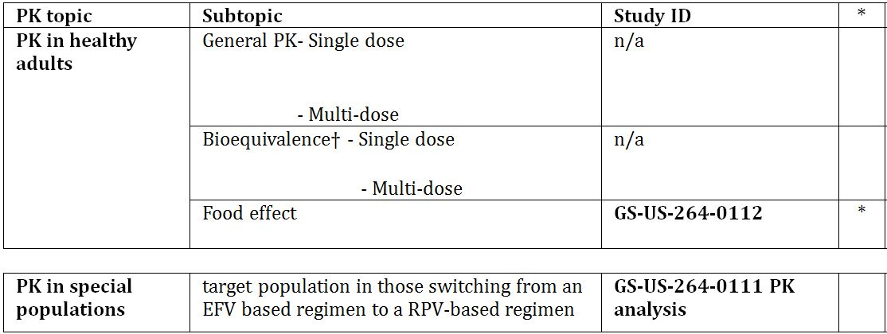
* Indicates the primary aim of the study. † Bioequivalence of different formulations. § Subjects who would be eligible to receive the drug if approved for the proposed indication.
None of the pharmacokinetic studies had deficiencies that excluded their results from consideration.

Summary of pharmacokinetics
The information in the following summary is derived from conventional PK studies unless otherwise stated. As these PK characteristics have been presented in the original registration documents, below are just the key findings in relation to the findings in GS-US-264-0112.

Physicochemical characteristics of the active substance
The following information is derived from the sponsor’s summaries.
Pharmacokinetics in healthy subjects

Absorption

Sites and mechanisms of absorption
No new data presented in this application.

Bioavailability

Absolute bioavailability
Not established.

Bioavailability relative to an oral solution or micronised suspension
Not applicable.

Bioequivalence of clinical trial and market formulations
Not applicable. Commercial stock was used in GS-US-264-0112.

Bioequivalence of different dosage forms and strengths
Not applicable.

Bioequivalence to relevant registered products
Not applicable.

Influence of food
These data are summarised in Tables 2-4.
Table 2: GS-US-264-0112: Summary Statistics for Rilpivirine Pharmacokinetic Parameters (Analysis Set, Rilpivirine PK).
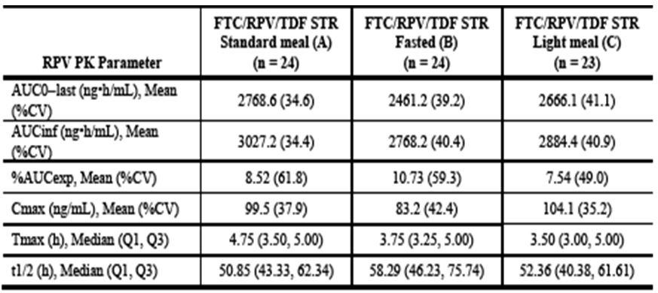
Table 3: GS-US-264-0112: Summary Statistics for Emtricitabine Pharmacokinetic Parameters (Analysis Set, Emtricitabine PK).
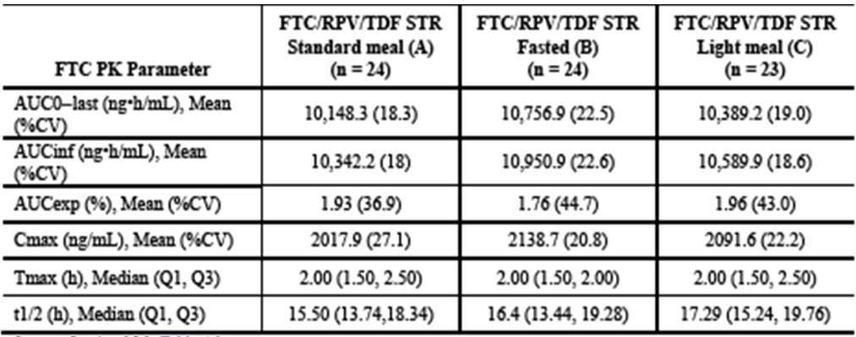
Table 4: GS-US-264-0112: Summary Statistics for Tenofovir Pharmacokinetic Parameters (Analysis Set Tenofovir PK).
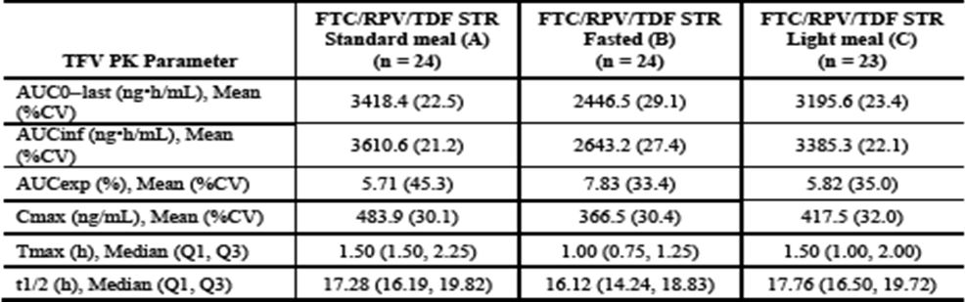

Dose proportionality
Not applicable.

Bioavailability during multiple-dosing
Not applicable, no mutidose study in healthy volunteers presented in this Application.

Effect of administration timing
Not applicable.

Distribution

Volume of distribution
Not applicable.

Plasma protein binding
No new data presented.

Erythrocyte distribution
Not applicable.

Tissue distribution
No new data presented.

Metabolism

Interconversion between enantiomers
No new data presented.

Sites of metabolism and mechanisms / enzyme systems involved
No new data presented.

Non-renal clearance
No new data presented.

Metabolites identified in humans
No new data presented.

Pharmacokinetics of metabolites
No new data presented.

Consequences of genetic polymorphism
Not applicable.

Excretion

Routes and mechanisms of excretion
No new data presented.

Mass balance studies
Not applicable.

Renal clearance
No new data presented.

Intra- and inter-individual variability of pharmacokinetics
No new data presented.

Pharmacokinetics in the target population
See below.

Pharmacokinetics in other special populations

Pharmacokinetics in subjects with impaired hepatic function
No new data presented.

Pharmacokinetics in subjects with impaired renal function
No new data presented.

Pharmacokinetics according to age
No new data presented.

Pharmacokinetics related to genetic factors
No new data presented.

Pharmacokinetics in HIV-1-infected adults switching to Eviplera from TDF/FTC/EFV
In GS-US-264-0111 PK analysis, the PK effects of commencing Eviplera in HIV-1-infected adults switching away from the Atripla were explored.

Pharmacokinetic interactions

Pharmacokinetic interactions demonstrated in human studies
No D-D studies included in this Application.

Clinical implications of in vitro findings
No new data presented.

Evaluator’s overall conclusions on pharmacokinetics
The results of the Phase I pharmacokinetic Study GS-US-264-0112 in healthy volunteers confirm the need for Eviplera dosing with food and support the recommendation in the proposed PI. Pharmacokinetic data from the switch Study GS-US-264-0111 confirm a long “tail” of EFV decline following switch to Eviplera which, through ongoing induction of CYP3A4, modestly reduces RPV levels. However, RPV levels are therapeutic ≥2 weeks after switching. When coupled with continuing therapeutic levels of EFV up to and extending beyond this cross over point, this means plasma HIV-1 RNA remains fully suppressed. These data support the proposed language in the PI in regards to an Atripla to Eviplera switch. Patients should be warned that the side effects of EFV will not cease immediately post switch as the drug takes several weeks to decline.

Pharmacodynamics
Not applicable.

Dosage selection for the pivotal studies
No change in dosage is sought, as per registered dose.

Clinical efficacy
The clinical efficacy studies presented in this application consisted of 2 switch studies in ARV treatment-experienced adults with virologically suppressed (VL <50 copies/mL) HIV-1 i.e. GS-US-264-0111 (switch from Atripla); GS-US-264-0106 (switch from PI/r+2 NRTI) and a head-to-head Phase 3 study of Eviplera vs. Atripla in HIV-1-infected ARV naïve patients with plasma HIV RNA >2500 copies/mL (no upper limit of plasma HIV RNA for inclusion).
The pivotal efficacy Study GS-US-264-0111 was titled: “A Phase IIB Open-Label Pilot Study to Evaluate Switching from a Regimen Consisting of an Efavirenz/Emtricitabine/Tenofovir Disoproxil Fumarate (TDF/FTC/EFV) Single Tablet Regimen to Emtricitabine/Rilpivirine/Tenofovir Disoproxil Fumarate (TDF/FTC/RPV) STR in Virologically-Suppressed, HIV-1 Infected Subjects”. This was a Phase IIb study, open label, multicentre, pilot study conducted between 27 January 2011 and 19 April 2012 across 18 sites in the USA.
Two others studies were:
- Study GS-US-264-0106: “A Phase III Randomised, Open-Label Study to Evaluate Switching from Regimens Consisting of a Ritonavir-boosted Protease Inhibitor (PI/r) and Two Nucleoside Reverse Transcriptase Inhibitors to Emtricitabine/Rilpivirine/Tenofovir Disoproxil Fumarate Fixed-dose Regimen in Virologically Suppressed, HIV-1 Infected Patients”
- Study GS-US-264-0110: “A Phase IIIB, Randomised, Open-label Study to Evaluate the Safety and Efficacy of a Single Tablet Regimen of Emtricitabine/Rilpivirine/Tenofovir Disoproxil Fumarate Compared with a Single Tablet Regimen of Efavirenz/Emtricitabine/Tenofovir Disoproxil Fumarate in HIV-1 Infected, Antiretroviral Treatment-Naïve Adults”.

Study GS-US-264-0111

Study design, objectives, locations and dates
Phase 2b study, open-label, multicentre, pilot study. Study conducted between 27 January 2011 (First subject screened) and 19 April 2012 (Last subject observation). 18 sites in the USA.

Inclusion and exclusion criteria
Key Inclusions: written informed consent form; currently receiving ARV consisting only of Atripla continuously for ≥3 months preceding the screening visit; plasma HIV-1 RNA concentrations (≥2 measurements) at undetectable levels while on treatment for ≥8 Wks prior to the screening visit and have RNA <50 copies/mL at the screening visit; on their first antiretroviral drug regimen and must not have had HIV-1 RNA >50 copies/mL at two consecutive time points after first achieving HIV RNA <50 copies/mL; have had a genotype prior to starting Eviplera and no known resistance to any of the study agents at any time in the past including, but not limited to the RT mutations K65R, K101E/P, E138G/K/Q/R, Y181C/I/V, M184V/I and H221Y; lab and ECG within protocol specified parameters; adequate contraception; Age ≥18 years; Life expectancy ≥1 year.
Key Exclusions: A new AIDS-defining condition diagnosed within the 21 days prior to screening; pregnant or breastfeeding; concomitant medications contraindicated or not recommended for use with any ARVs in the protocol.

Study treatments
Eviplera STR administered orally with a meal once daily.

Efficacy variables and outcomes
The main efficacy variables were:
- to evaluate the efficacy of Eviplera STR after switching from TDF/FTC/EFV at baseline in maintaining HIV-1 RNA <50 copies/mL at Wk 12
- to evaluate the safety and tolerability of Eviplera STR over 24 and 48 Wks
- to evaluate the efficacy of Eviplera STR after switching from TDF/FTC/EFV at baseline in maintaining HIV-1 RNA <50 copies/mL at Wks 24 and 48.
The primary efficacy outcome was a virological one i.e. HIV-1 RNA < 50 copies/mL at Wk 12 as defined by the FDA snapshot analysis.
Other efficacy outcomes included: an exploration of the PK of RPV after switching from EFV.

Randomisation and blinding methods
This was an open-label, non-randomised, single arm, switch study.

Analysis populations
Efficacy will be analysed using the FAS i.e. all subjects who have received at least one dose of study medication. The safety analysis set includes all subjects who received ≥1 dose of study drug. All data collected up to 30 days after the last dose of study regimen included in the safety summaries. The PK analysis set included all subjects receiving ≥1 dose of study drug.

Sample size
Sample size of this single-arm pilot was selected based on feasibility of the study conduct.

Statistical methods
Software: SAS Software Version 8.2. or higher, SAS Institute Inc., Cary, NC, USA. nQuery Advisor(R) Version 6.0. Statistical Solutions, Cork, Ireland. Analyses according to the formal statistical analysis plan:
- Primary analysis: Proportion (%) of subjects along with two-sided 95% CI, in the FAS with HIV-1 RNA <50 copies/mL at Wk 12 as defined by the FDA snapshot analysis. Descriptive statistics will summarize changes from baseline at protocol-defined study Wks
- Secondary Analysis: Proportion (%) of subjects along with two-sided 95% CI, in the FAS with HIV-1 RNA <50 copies/mL at Wks 24 and 48 as defined by the FDA snapshot analysis
- Safety Analysis: All safety analyses performed using safety analysis set. All safety data collected up to the Wk 48 visit (or last dose date for non-completers) + 30 days summarised for the Wk 48 analysis. Clinical and laboratory AEs coded using MedDRA. System Organ Class (SOC), High-Level Group Term (HLGT), High-Level Term (HLT), Preferred Term (PT), and Lower-Level Term (LLT) attached to the clinical database. Safety ECGs listed and summarised for subjects in the Safety Analysis Set.

Participant flow
Single arm, non-randomised study. 63 patients screened; 50 patients enrolled at 18 sites in the US. 49 of 50 enrollees received study drug. Subject (0407-3847) was enrolled and attended the baseline visit, but subsequently withdrew consent and was never dosed. 48 subjects completed the protocol-defined period of study drug dosing and the study. One subject (Subject 1603-3849) did not complete study drug dosing or the study because of a protocol violation.

Major protocol violations/deviations
N=1: Subject 1603-3849 had a study drug adherence rate of 82% at Wk 8; this patient was eventually discontinued because of incarceration.

Baseline data
The demographics and baseline characteristics are summarised in Table 5.
Table 5: GS-US-264-0111: Demographics and Baseline Characteristics (Safety Analysis Set).
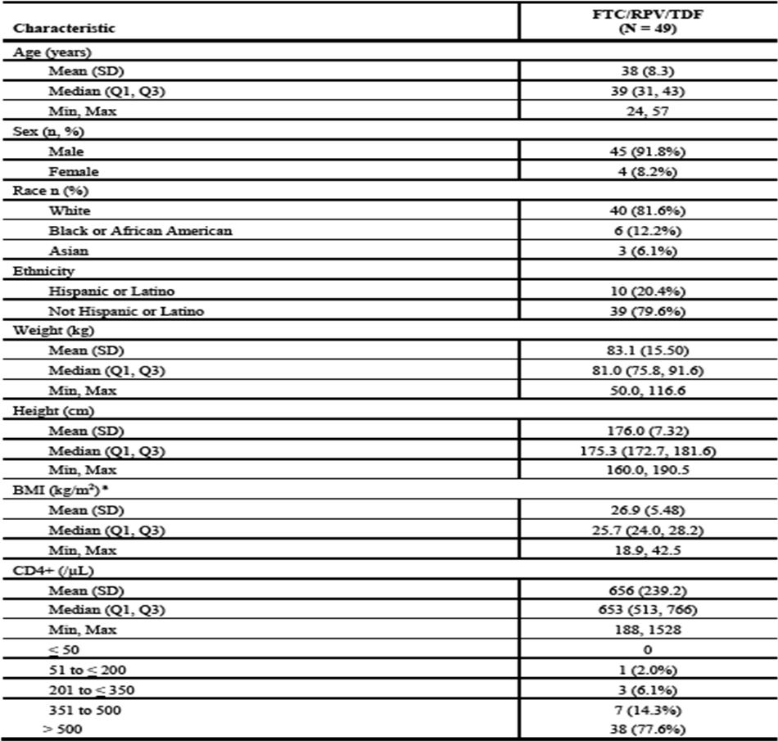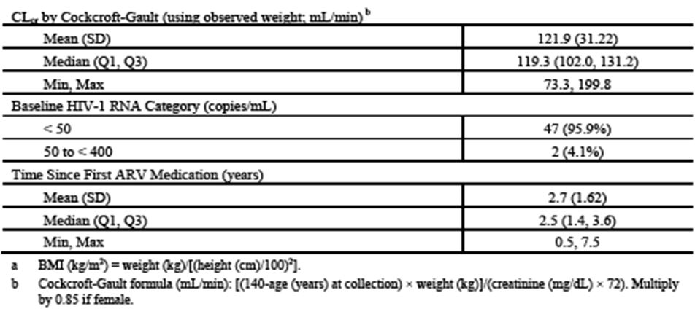

Results for the primary efficacy outcome
Eviplera adherence was measured by pill count. Overall, 91.8% had an adherence rate of ≥95%. Primary endpoint: Proportion of subjects with HIV-1 RNA <50 copies/mL at Wk 12 as defined by the FDA snapshot analysis, based on the FAS. All 49 subjects (100%; 95% CI: 92.7%, 100%) maintained virologic suppression with HIV-1 RNA <50 copies/mL at Wk 12.

Results for other efficacy outcomes
- At Wks 24 and 48, 100% and 93.9% of subjects (46 of 49 subjects; 95% CI: 83.1%, 98.7%) maintained HIV-1 RNA <50 copies/mL, respectively
- At Wk 48, 2 subjects (4.1%) had HIV-1 RNA ≥50 copies/mL and were considered virologic failures. One subject had no virologic data in the Wk 48 window; study drug was discontinued due to a protocol violation, last available HIV-1 RNA was <50 copies/mL. TLOVR analysis for data at Wk 48 confirmed the snapshot analysis: 93.9% responders (95% CI: 83.1%, 98.7%) and maintained HIV-1 RNA <50 copies/mL through Wk 48; 6.1% were nonresponders
- In the M = F analysis, the proportion of subjects with HIV-1 RNA levels <50 copies/mL at Wk 48 was 93.9% (46 of 49 subjects; 95% CI: 83.1%, 98.7%). In the M = E analysis, the proportion of subjects with HIV-1 RNA <50 copies/mL at Wk 48 was 95.8% (46 of 48 subjects; 95% CI: 85.7%, 99.5%). In the LOCF analysis, 100% of subjects had HIV-1 RNA <50 copies/mL at Wk 12, and 95.9% of subjects (47 of 49; 95% CI: 86.0%, 99.5%) had HIV-1 RNA <50 copies/mL at Wk 48; 2 subjects (4.1%) had HIV-1 RNA ≥50 copies/mL at Wk 48 and were considered virologic failures. Of the 2 subjects, 1 subject had low-level viral loads of 63 copies/mL (Wk 36) and 95 copies/mL (Wk 48). After switching the subject back to Atripla, viral load became undetectable. The second subject had viral loads of 330,000 (Wk 48), 1890 (Wk 51), and 991 copies/mL (Wk 54). This subject was noted to be poorly adherent with undetectable RPV level at Wk 48, implying ARV non-adherence
- Median (first quartile [Q1], third quartile [Q3]) baseline CD4+ counts were 653 (513, 766) cells/μL. Median (Q1, Q3) change from baseline in CD4+ cell counts were not statistically significant at Wk 48 (-2 [-76, 104] cells/μL; p = 0.87, Wilcoxon signed rank test) or at any other timepoint during the study
- Resistance to any component of Eviplera STR did not occur
- No subject had evidence of protocol-defined exclusion mutations in their historical genotype; 7 had documented NNRTI resistance mutation (14.3%), 3 had an NRTI resistance mutation (6.1%), 2 had primary protease inhibitor resistance (4.1%). One subject (Subject 1624-3817) had the RPV resistance-associated mutation E138A, which was not an exclusion mutation at the time of this study; this subject maintained virologic suppression through Wk 48. Other NNRTI-resistance mutations present were V90I (n=2), V106I (n=1), V179I/D (n=3). The NRTI-associated mutations were M41L (n=1) and V118I (n=2). All subjects with pre-existing NNRTI mutations had HIV-1 RNA <50 copies/mL at Wk 48.

Study GS-US-264-0106

Study design, objectives, locations and dates
Phase 3b, randomised, open-label, multicentre. Conducted between 17 Nov 2010 (1st subject screened) and 20 Aug 2012 (Last subject observation for present report). 110 sites: Austria, Belgium, Canada, France, Germany, Italy, Puerto Rico, Spain, UK, USA.

Inclusion and exclusion criteria
Key Inclusions: written informed consent form; currently receiving ARV with PI/r+2 NRTIs for ≥6 months; undetectable plasma HIV-1 RNA (≥2 measurements) for ≥6 months prior to the screening; HIV RNA <50 copies/mL at screening; on first or second ARV drug regimen; if on 2nd ARV regimen, must not have had HIV-1 RNA >50 copies/mL at the time of changing ARVs, nor ever experienced 2 consecutive HIV RNA >50 copies/mL after first HIV RNA <50 copies/mL; No previous use of any approved or experimental NNRTI drug; have had a genotype prior to starting initial ARV and have no known resistance to any of the study agents at any time in the past including, but not limited to the RT resistance mutations K65R, K101E/P, E138G/K/R/Q, Y181C/I/V, M184V/I, or H221Y; lab & ECG within protocol specified parameters; adequate contraception; Age ≥18 years; Life expectancy ≥1 year.
Key Exclusions: new AIDS-defining condition within 30 days prior to screening; Pregnant/breastfeeding; conmeds contraindicated/not recommended for use with any ARVs in the protocol.

Study treatments
Eviplera STR administered orally with a meal OD for 48 wks either immediate or delayed switch after 24 Wks, in the delayed Switch arm, patients remain on their PI/r + 2NRTI until wk 24.

Efficacy variables and outcomes
The main efficacy variables were to assess the non-inferiority of switching to Eviplera relative to continuing on PI/r+2NRTIs in maintaining HIV-1 RNA<50 copies/mL at Wk 24. The primary efficacy outcome was the proportion of subjects with HIV-1 RNA <50 copies/mL at Wk 24 as defined by the FDA snapshot analysis.
Other efficacy outcomes included:
- change from baseline in fasting lipid parameters over 24 and 48 Wks
- safety and tolerability of each treatment arm over 24 and 48 Wks
- change from baseline in CD4 cell count in each treatment arm at 24 and 48 Wks
- HIV-1 genotypic/phenotypic analyses in those with virologic failure.
Other endpoints of interest: Patient reported outcomes: HIV Symptom Index & HIV Treatment Satisfaction Questionnaire.

Randomisation and blinding methods
Open label. Subjects randomised in a 2:1 ratio to one of the following two treatment arms:
Treatment Arm 1: Switched Eplivera (n=280);
Treatment Arm 2: Delayed switch to Eplivera after remaining on current PI/r+ NRTI inhibitors for 24 Wks after baseline visit (n = 140). Subjects randomised in a 2:1 ratio to Treatment Arm 1 or Treatment Arm 2 utilising permuted blocks stratified for the use of TDF (either TDF or Truvada) and LPV/r at enrolment (total of 4 strata).

Analysis populations
Efficacy Full Analysis Set (FAS): all subjects randomised and receiving ≥1 dose study drug. FAS=primary set for analysis of efficacy and subjects grouped according to randomised treatment (intent-to-treat).
Per-Protocol (PP) analysis set: all subjects randomised and receiving ≥1 study medication, without any major protocol violations.
Safety analysis set: all randomised subjects receiving ≥1 dose of study drug. All data collected up to 30 days after last dose of randomised study regimen included in the safety summaries.

Sample size
Sample size=420, derived as follows; 280 subjects randomised to switch to Eviplera at study Day 1 and 140 subjects randomised to delayed switch, the lower limit of the observed one-sided 97.5% CI was expected to be greater than -0.120 (i.e., non-inferiority Δ of 12%) with >95% power when proportion of responders in both treatment groups for the primary endpoint is 90% at Wk 24. The assumed response rates (90% at Wk 24) was based on the response rates reported for analysis of HIV-1 RNA <50 copies/mL with missing=failure in the PI stratum of previously conducted switch study (GS-US-0177-0107) in stable suppressed (HIV-1 RNA <50 copies/mL at baseline) patients.

Statistical methods

Primary analysis
Non-inferiority of switching to Eviplera relative to staying on a PI/r+2NRTI regimen assessed by testing null hypothesis that the proportion of subjects maintaining HIV-1 RNA <50 copies/mL at Wk 24 in the immediate arm is ≥12% lower than the response rate in the PI/r+2NRTI regimen. The alternative hypothesis is that the response rate after switching to Eviplera is <12% lower than continuing on PI/r+2NRTI. The primary evaluation of non-inferiority assessed by constructing a two-sided exact 95% CI for the difference in treatment group response rates (Eviplera minus PI/r+2NRTI) using inverted two one-sided tests with the standardized statistic. Eviplera arm is non-inferior to PI/r +2NRTI arm if lower 95% confidence bound of responder difference is greater than −0.120. Superiority declared if lower bound of the CI is greater than 0.

Secondary endpoint analysis
Proportion of subjects maintaining HIV-1 RNA <50 copies/mL through Wk 48 analysed using TLOVR algorithm in the Eviplera group. Viral load also analysed categorically (<50, ≥50 to <200, ≥200 to <400, ≥400 to <1000, ≥1000 copies/mL, noncompleter, missing) at each visit. Nos and % maintaining HIV-1 RNA <50 copies/mL analysed using missing-equals-failure (M = F) and missing-equals excluded (M = E) approaches, and a last-observation-carried forward (LOCF) approach for missing data. The M = F and M = E analyses performed by including only subjects on study drug at the time point of interest (on-treatment analysis) and by including all subjects still on study at the time point of interest. Sensitivity analyses conducted for primary endpoint using the PP analysis set. For the 2nd sensitivity analysis, virologic outcomes at Wk 24 summarised by baseline stratification factors to evaluate robustness of the primary analysis in those subgroups. Descriptive statistics summarised CD4+ and % and change from baseline by each visit. Statistical significance of changes assessed using Wilcoxon signed-rank test at Wks 24 & 48. HIV-1 resistance testing performed and listed per subject in those with confirmed virologic failure.

Safety analysis
AEs summarised by seriousness, severity, relationship to study drug, discontinuations due to AE. Clinical lab values and change from baseline analysed using descriptive statistics incl. severity & relatedness. For fasting lipids changes from baseline between immediate and delayed switch arms through Wk 24 compared using ANOVA with baseline stratification on LPV/r or not, treatment and interaction between stratification factor (LPV/r or not) and treatment as fixed effect in the model. Cochran-Mantel Haenszel row mean score test used to test treatment differences between immediate and delayed switch arms according to US NCEP cut-offs through Wk 24, stratified by baseline stratification factor i.e. LPV/r or not. Sensitivity analysis performed for lipid summaries, excluding those starting/modifying lipid-lowering agent(s) on study.

Participant flow
This is shown in Figure 1.
Figure 1: GS-US-264-0106: Disposition of Study Subjects.
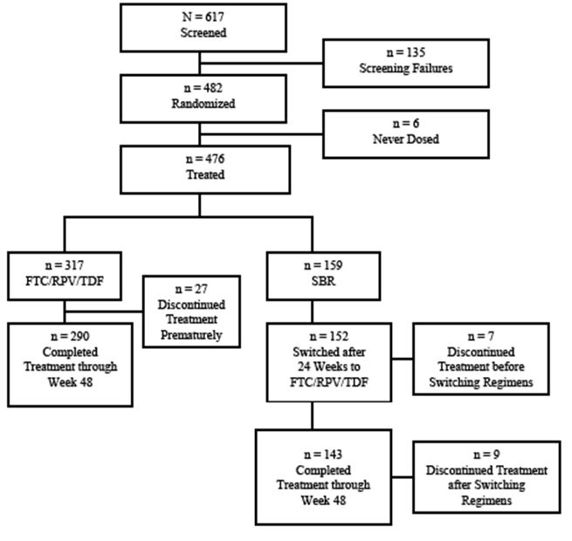

Major protocol violations/deviations
There were 54 of 469 subjects (12%) who violated ≥1 eligibility criterion; 11% had adherence deviations. A PP analysis of virologic outcomes was conducted in randomised subjects receiving ≥1 dose study medication, with no major protocol violations. This analysis yielded results consistent with the analyses in which such subjects were included.

Baseline data
Planned sample size was 420, but 62 additional patients randomised. Safety and physical/mental, scientific integrity and power of the primary endpoint analysis of the clinical trial participant not deemed affected by this over enrolment. Demographic & baseline characteristics summarised in Table 6. Majority male (87.6%), mean age 42 years (range, 19 to 73 years); majority of White (76.7%) ethnicity; at baseline 94.7% had HIV RNA <LLQ. For those subjects with HIV-1 RNA ≥50 copies/mL at baseline, 3.4% had HIV-1 RNA between 50-<200 copies/mL. At baseline, mean (SD) CD4+ was 584/μL (244.2 cells/μL) (range, 42 to 1484 cells/μL); mean ARV duration was 3.3 yrs. Most subjects (86.1%) were not taking lipid-lowering medications. 54.4% were on an ARV regimen consisting of TNV or Truvada backbone +other PI/r.
Table 6: GS-US-264-0106: Key Demographic & Baseline Characteristics (Safety Analysis Set).
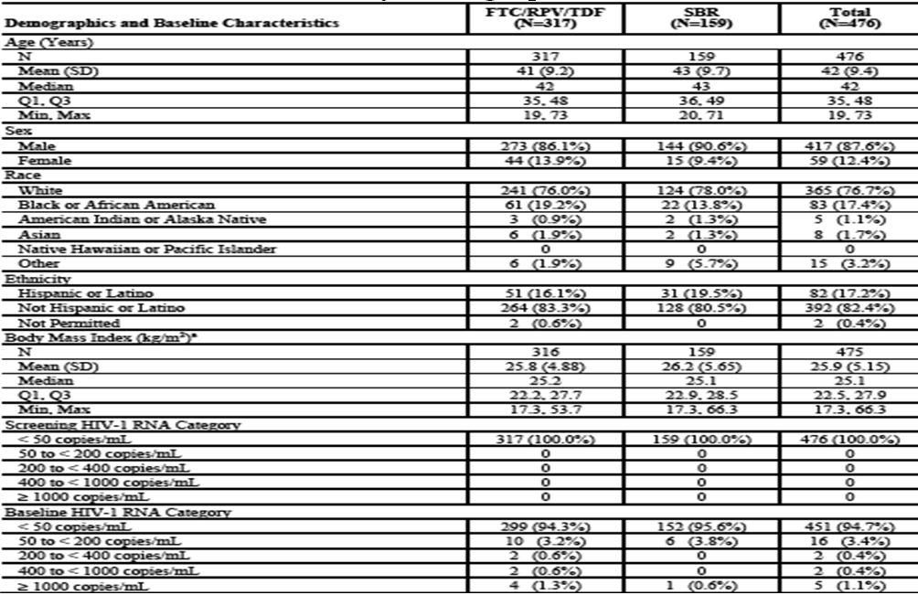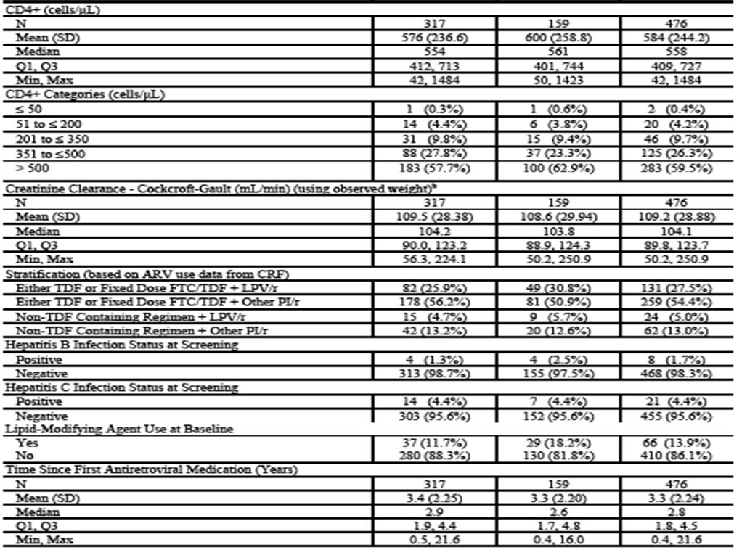
Prior & current ARV: 102/476 (21.4%) reported prior (to current regimen) ARV use. Prior use of NRTIs and PIs were reported in 13.0% and 12.6% respectively.
Prior NRTI use: most frequently (>2% overall) reported: lamivudine (3TC) + zidovudine (3.6% overall [3.8% Eviplera group; 3.1% SBR group]), abacavir (ABC) + 3TC (2.9% overall [2.2% Eviplera group; 4.4% SBR group), 3TC (4.0% overall [3.8% Eviplera group; 4.4% SBR group]); TDF (4.0% overall [4.4% Eviplera group; 3.1% SBR group]).
Prior Prot. Inhibs: most frequently (>2% overall) reported: atazanavir (2.5% Eviplera Single-Tablet Regimen overall [1.9% Eviplera group; 3.8% SBR group]) and LPV/r (7.6% [7.6% Eviplera group; 7.5% SBR group]).
ARV at study entry: NRTI backbone: majority on TDF/FTC at screening (80.4% Eviplera group; 81.8% SBR group); ~13% of subjects in both groups on ABC/3TC.
Prot. Inhibs included: ritonavir (/r)(68.8% in Eviplera group;62.9% in SBR group), atazanavir (38.5% Eviplera group; 34.0% in SBR group), LPV/r (30.6% Eviplera group; 36.5% SBR group), darunavir (DRV) (19.9% Eviplera group; 20.8% in SBR group), fosamprenavir (7.9% Eviplera group; 7.5% SBR group), saquinavir (1.9% Eviplera group;1.3% SBR group), and amprenavir (0.3% Eviplera group).
Baseline ARV Protocol violations: Two subjects in the immediate arm were on Atripla; 2 subjects in the SBR group were on raltegravir at screen.
On study ARV: 33 of 476 subjects (6.9%) used different ARVs after study participation (20 of 317 [6.3%] in the immediate group and 13 of 159 [8.2%] in SBR group). Of these 33, 30 used an NRTI (most commonly TDF/FTC [24 of 30 subjects, 5.0%]); 26 subjects used a PI (most commonly: /r; [4.4%] or DRV [3.2%]).

Results for the primary efficacy outcome
The proportion with HIV-1 RNA <50 copies/mL at Wk 24 (Table 7) was similar in Eviplera (93.7%) and SBR (89.9%) treatment groups (3.8% treatment difference; 95% CI: −1.6%, 9.1%); the lower bound of the 95% CI was within the predefined 12% margin for noninferiority of Eviplerato SBR at Wk 24. In the Delayed Switch group, 92.1% had HIV-1 RNA <50 copies/mL after 24 Wks of treatment, consistent with the Eviplera group at Wk 24. PP analysis consistent with the FAS analysis.
Table 7: GS-US-264-0106: Virologic Outcomes at Wks 24 & 48, FAS.
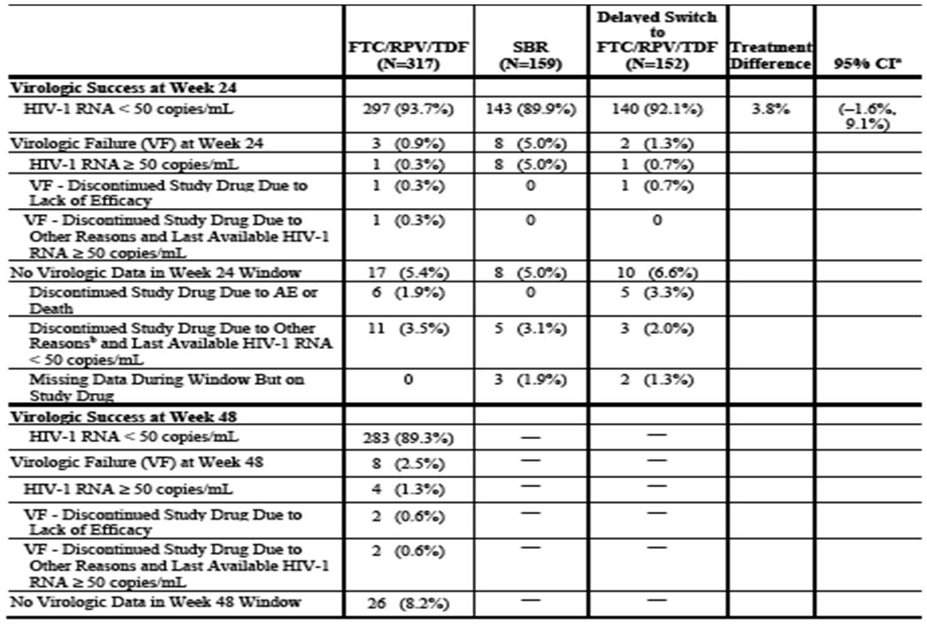

Results for other efficacy outcomes
The proportion of Eviplera subjects with HIV-1 RNA <50 copies/mL at Wk 48 was analysed as a secondary endpoint using the snapshot and TLOVR algorithms. HIV-1 RNA suppression <50 copies/mL was maintained for those receiving Eviplera for 48 Wks (89.3%). The TLOVR analysis results were generally consistent with the snapshot i.e. 88.3% of Eviplera group with HIV-1 RNA <50 copies/mL through 48 Wks (95% CI: 84.3%, 91.6%). A categorical summary of HIV-1 RNA using the following categories: <50, ≥50 to <200, ≥200 to <400, ≥400 to <1000, and ≥1000 copies/mL, missing, and noncompleters. Both on-treatment and on-study analyses were performed. As described for the primary endpoint, at Wk 24, the majority of the Eviplera group (93.7%) and SBR group (89.9%) had HIV-1 RNA <50 copies/mL. One Eviplera group subject (0.3%) and 7 subjects in the SBR group (4.4%) had HIV-1 RNA 50-<200 copies/mL at Wk 24, and 1 subject (0.6%) in SBR group had HIV-1 RNA >1000 copies/mL at that time point. At Wk 48, 89.3% Eviplera group subjects had HIV-1 RNA <50 copies/mL, 1 subject had HIV-1 RNA 50-<200 copies/mL, and 3 had HIV-1 RNA >1000 copies/mL. Results were very similar for the on-study analysis. The M=F and M=E analyses were consistent with the primary endpoint analysis (FAS) supporting the noninferiority of Eviplera to PI/r+2NRTI at Wk 24. For those receiving Eviplera for 48 Wks, viral suppression was maintained through Wk 48 (89.3% M = F, 98.6% M = E). The LOCF analyses (both on-treatment & on-study analyses) were consistent with the analysis in which subjects with missing data were excluded (M = E). At baseline, median (Q1, Q3) CD4+ count was 554 (412, 713) cells/μL in the Eviplera group and 561 (401, 744) cells/μL in SBR group. For the Delayed Switch group, median (Q1, Q3) baseline CD4+ was 601 cells/μL (436, 810). By Wk 24, median (Q1, Q3) CD4+ counts increased in the Eviplera group (+10 [−61, 82] cells/μL) and SBR group (+22 [−40, 106)] cells/ μL) (p=0.046 Eviplera and p = 0.008 SBR). Wk 24 differences not statistically significant (p=0.28). For the Delayed Switch group after 24 wks of Eviplera , median (Q1, Q3) CD4+ counts decreased from baseline (−11 cells/μL [−65, 46]). By Wk 48, median (Q1, Q3) CD4+ counts increased for those in the Eviplera group (+17 [−56, 84] cells/μL), change not statistically significant (p=0.072). These changes are not clinically significant.
There was evidence of pre-existing primary resistance mutations in 26% subjects. Among those switching to Eviplera at baseline with historical genotypes (n=316), 28% had ≥1 pre-existing primary resistance mutations: 4 had a protocol-defined exclusion mutation (E138G, E138K, E138Q, or H221Y); 65 had primary NNRTI resistance mutations i.e. K103N (n=18), V108I (n=3), E138A (n= 6), G190A (n=4); 25 had primary NRTI resistance mutations; 7 had primary Prot. Inhib resistance mutations. In the SBR group (n=159), 23% had ≥1 pre-existing primary resistance mutations: 2 had a protocol-defined exclusion mutation (E138Q or M184V); 25 had primary NNRTI resistance mutations i.e. K103N (n=8), E138A (n=3), and G190A (n=1); 11 had primary NRTI resistance mutations; and 5 had primary Prot. Inhib resistance mutations. Of the 18 Eviplera group subjects with pre-existing K103N, 100% and 94% maintained virologic suppression through Wk 24 and 48 respectively. One subject with pre-existing K103N & V179I/V had virologic failure at Wk 48 and developed additional resistance mutations (M184V, V108I/V, and E138K). Of the 8 subjects (SBR group) with pre-existing K103N, 6 subjects switched to Eviplera at Wk 24; 2 subjects discontinued while suppressed ≤Wk 24. Of the 6 still switched at Wk 24, 83% (5 of 6) maintained virologic suppression through Wk 48. One subject had no data during the Wk 48 study window, but remained on study drug and suppressed at all previous study visits. Overall, there were 24 subjects with K103N that were treated with Eviplera with high treatment response.
Virologic Failure Definition and Resistance Analysis Population (RAP): see Table 8 for a tabulated summary. Subjects who experienced virologic rebound, as defined below, were considered to have virologic failure and were included in the RAP. Virologic rebound was defined as 2 consecutive visits with HIV-1 RNA ≥400 copies/mL Of the 476 randomised treated subjects in either group, 1.7% included in the RAP (7 in Eviplera group; 1 in SBR group). Of the 469 Eviplera-treated subjects, 2 subjects who switched to Eviplera at baseline (0.6%) developed primary NRTI or NNRTI resistance mutations and reduced susceptibility to FTC and/or RPV by Wk 24. 4 of 317 from baseline to Wk 48, 1.3% Eviplera subjects developed resistance between Wks 24 and 48; no subjects in Delayed Switch group developed resistance after switching to Eviplera at Wk 24 through Wk 48. All subjects remained TNV susceptible. 1 subject (SBR group) developed the K70E/K & M184V mutations with reduced FTC susceptibility while on ATV/r+ TDF/FTC at Wk 24.
Table 8: GS-US-264-0106: Development of HIV-1 Genotypic Resistance at Wk 48.
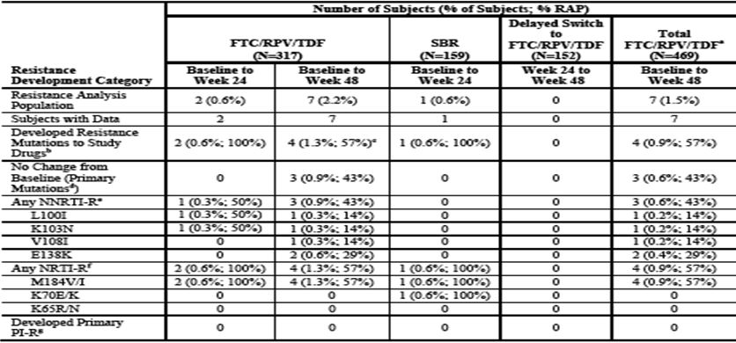

Study GS-US-264-0110

Study design, objectives, locations and dates
Phase 3b, randomised, open-label, multicentre, active-controlled study. 121 sites:USA, Canada, Puerto Rico, Europe (Austria, UK, France, Germany, Belgium, Spain, Portugal, Switzerland, Italy), Australia. First subject screen: 23 Feb 2011; Last subject observation for present report: 18 Sep 2012.

Inclusion and exclusion criteria
Key Inclusions: Adult (≥18 years old), non pregnant, HIV-1 infected ARV treatment-naïve; plasma HIV-1 RNA levels ≥2500 copies/mL; documented genotypic sensitivity to EFV, FTC, TDF at screening; no RPV mutations K101E/P, E138A/G/K/Q/R, Y181C/I/V, and H221Y; eGFR ≥50 mL/min.
Key Exclusions: No AIDS defining illness within 30 days of screening.

Study treatments
Eviplera STR orally with a meal OD for 96 Wks vs. Atripla administered orally OD on an empty stomach, preferably at bedtime, for 96 Wks.

Efficacy variables and outcomes
The main efficacy variable was to evaluate the efficacy of Eviplera STR vs. Atripla STR in HIV-1 infected, ARV treatment-naive adult subjects as determined by the achievement of HIV-1 RNA <50 copies/mL at 48 Wks using the US FDA snapshot analysis. The primary efficacy endpoint was the proportion of subjects achieving HIV-1 RNA <50 copies/mL at Wk 48 (US FDA snapshot analysis).
Other efficacy outcomes included:
- evaluate the efficacy, safety, and tolerability of the 2 treatment regimen through 96 Wks of treatment
- change from baseline CD4+ count in each treatment group at 48 and 96 Wks. To assess genotypic and phenotypic resistance at time of virologic failure
- change from baseline in fasting lipid parameters at 48 and 96 Wks.

Randomisation and blinding methods
Open label, 1:1 randomisation using IVRS system.

Analysis populations
Efficacy FAS: all subjects randomised and receiving ≥1 dose of study medication. Subjects prematurely discontinuing study drug asked to continue attending study visits to Wk 96 visit.
PP analysis set: all subjects randomised and receiving ≥1 study medication, without any major protocol violations.
Safety analysis set: all randomised subjects who received ≥1 dose of study drug. All data collected up to 30 days after the last dose of randomised study regimen included in the safety summaries. Subjects grouped according to treatment received.

Sample size
There were 700 subjects planned with 350 subjects in each group. With 700 subjects randomised (1:1) to either arm at Day 1, the LL of the observed one-sided 97.5% CI was expected to be greater than -0.120 (i.e. non inferiority margin of 12%) with >95% power when the proportion of responders in both treatment groups for the primary endpoint was 80% at Wk 48.

Statistical methods
Efficacy: The primary efficacy endpoint was the proportion of subjects with HIV-1 RNA < 50 copies/mL at Wk 48, analysed using the US FDA snapshot algorithm. The primary analysis of the primary endpoint was stratified by baseline HIV-1 RNA levels (≤100,000 vs. >100,000). As a secondary efficacy endpoint, the proportion of subjects who achieved and maintained HIV-1 RNA < 50 copies/mL through Wk 48 was analysed using the TLOVR algorithm. Analyses of HIV-1 RNA by visit were also performed using missing-equals-failure (M = F), missing-equals-excluded (M = E), and LOCF approaches. Viral load was also analysed categorically (<50, ≥50 to <200, ≥200 to <400, ≥400 to <1000, and ≥1000 copies/mL, noncompleter, missing) at each visit. Virologic outcomes (success and failure) through Wk 48 were summarised using frequency counts and percentages.
Sensitivity analyses performed for the primary endpoint in which subjects were considered to be treatment responders (virologic success in the snapshot analysis) if they were classified as having no virologic data in the Wk 48 window per the snapshot algorithm (ie. the percentages of subjects who had virologic failure per the snapshot algorithm were compared between treatment groups). A second sensitivity analyses was conducted assessing confounding effect of investigational centre & baseline HIV-1 RNA. One was a stratified analysis by region. Another analysis did not stratify for baseline HIV-1 RNA.The primary endpoint was also analysed using the PP analysis set using the same methodology as was applied in the primary analysis of the FAS. Subgroup analyses of the primary endpoint were conducted using the snapshot approach. The odds ratio and the associated 95% CI were estimated by subgroup factor. The homogeneity of the treatment effects between subgroups were evaluated using the Wald test based on the interaction between treatment and subgroup factor. In addition to the prespecified subgroup analyses mentioned above, post hoc exploratory subgroup analyses, based on baseline viral load thresholds of 500,000 copies/mL performed to examine the sensitivity of both virologic success and virologic failure using the snapshot method. Descriptive statistics used to summarise CD4+ absolute counts and % as well as change from baseline by each visit. Statistical significance of the treatment difference in change from baseline for CD4+ assessed using ANOVA; 95% CI with treatment and baseline HIV-1 RNA (≤100,000 copies/mL and >100,000 copies/mL) as fixed effects. Change from baseline in log10 HIV-1 RNA analysed in a similar manner.
Resistance: HIV-1 resistance testing performed in subjects confirmed as a virologic failure. Results of resistance analyses listed by subject.

Participant flow
This is shown in Figure 2.
Figure 2: GS-US-264-0110: Disposition of Study Subjects.
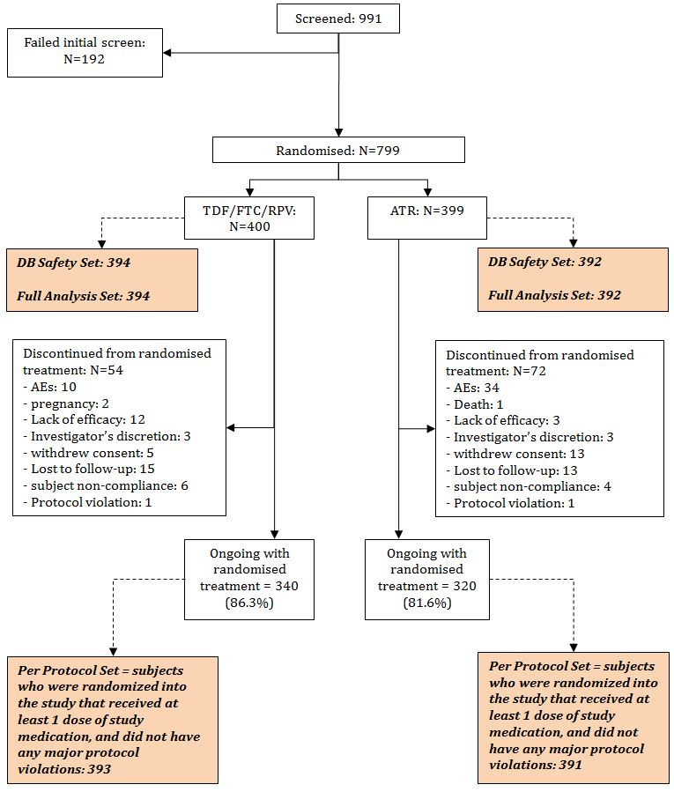

Major protocol violations/deviations
A total of 81 of 394 (20.6%) in the Eviplera group and 92 of 392 (23.5%) in the Atripla group had adherence/dosing deviations. PP analyses of HIV-1 RNA virologic outcomes conducted in which subjects with ≥1 important protocol deviations were excluded. These analyses yielded results consistent with analyses in which subjects with ≥1 important protocol deviations were included.

Baseline data
The planned sample size was 700 subjects, but a sharp increase in enrolment just before enrollment closure resulted in 799 subjects being enrolled. Over enrolment was due to parallel enrollment by multiple study centres and lower than predicted screen failure rate.
Demographics: Majority male (92.9%), mean age 37 years (range, 18 to 74 years); White ethnicity (67.3%), Black or African heritage (24.5%); non-Hispanic/Latino (82.3%). Mean (SD) BMI at baseline was 25.6 (4.70) kg/m². Mean (SD) CLcr by Cockcroft-Gault was 116.0 (28.16) mL/min at baseline (range, 54.2 to 275.4 mL/min) At baseline, mean (SD) CD4+ cell count was 390.5 cells/μL (183.21 cells/μL) (range, 1.0 to 1196.0 cells/μL), and the majority of subjects had a CD4+ cell count within the range of 351 to > 500 cells/μL. Baseline mean HIV-1 RNA was similar in both treatment groups. At baseline, mean (SD) HIV-1 RNA was 4.81 (0.646) log10 copies/mL in the Eviplera group and 4.78 (0.610) log₁₀ copies/mL in the Atripla group. At baseline, 510 subjects (64.9%) had HIV-1 RNA <100,000 copies/mL, 165 subjects (21.0%) had HIV-1 RNA >100,000 to ≤300,000 copies/mL, 50 subjects (6.4%) had HIV-1 RNA >300,000 to ≤500,000 copies/mL, 61 subjects (7.8%) had values >500,000 copies/mL. At baseline, 106 Eviplera group subjects (52 [13.2%] and 54 Atripla group [13.8%] were on lipid-modifying agents, most commonly fish oil (6.9%); pravastatin (1.9%); and simvastatin (1.7%); 39 subjects (17 [4.3%] in the Eviplera group and 22 [5.6%] in the Atripla group) started or modified lipid-modifying agents during study i.e. fish oil (1.3%); pravastatin (1.3%); simvastatin (0.8%) Key baseline HIV characteristics summarised in Table 9.
Table 9: GS-US-264-0110: Key Baseline HIV Characteristics (Safety Analysis Set).
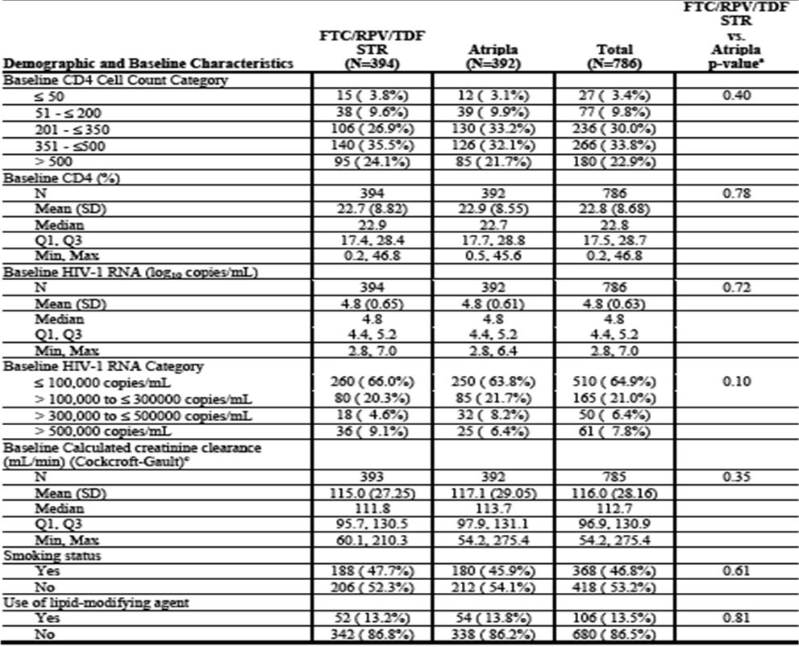

Results for the primary efficacy outcome
Adherence was high based on pill counts i.e. 96.7% [SD 4.33%] in the Eviplera group and 96.1% [SD6.89%] in the Atripla group) during the first 48 Wks with >95% adherence. The proportion of subjects with HIV-1 RNA <50 copies/mL at Wk 48 was similar in the Eviplera (85.8%) and Atripla (81.6%) treatment groups (4.1% treatment difference; 95% CI: −1.1%, 9.2%) based on the snapshot analysis. The lower bound of the 95% CI of this treatment difference was within the predefined 12% margin for noninferiority of Eviplera to Atripla at Wk 48 (Table 10).
Table 10: GS-US-264-0110: Virologic Outcomes at Wk 48 (Snapshot Analysis), FAS.
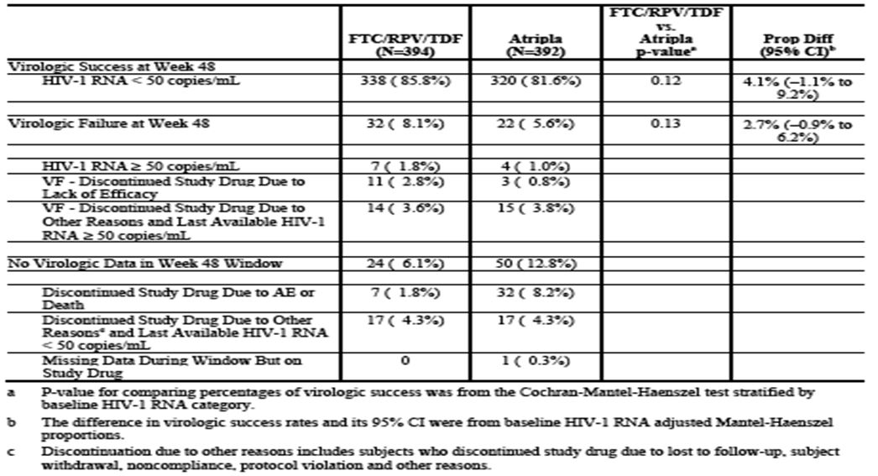
In the snapshot analysis, 32 (8.1%) Eviplera group subjects and 22 (5.6%) Atripla group subjects were considered virologic failures at Wk 48 (2.7% treatment difference; 95% CI: −0.9%, 6.2%). Among the virologic failures, 7 subjects (1.8%) in the Eviplera group and 4 subjects (1.0%) in the Atripla group had HIV-1 RNA ≥50 copies/mL at Wk 48. The remaining subjects considered as virologic failures either discontinued due to lack of efficacy (11 subjects [2.8%] in the Eviplera group and 3 subjects [0.8%] in the Atripla group) or due to other reasons. Virologic outcomes at Wk 48 were also analysed on the PP analysis set and using the snapshot, in the PP HIV-1 RNA <50 copies/mL at Wk 48 in Eviplera group vs. Atripla group was 85.8% vs. 81.6% (p = 0.12) respectively. To assess potential confounders e.g. region & baseline HIV-1 RNA stratified analyses were performed. Results were similar to the primary analysis. Analysis of the primary endpoint in specific subgroups was prespecified and conducted using the snapshot approach. Subgroup analysis by baseline HIV-1 RNA (≤100,000 and >100,000) was not stratified further. Sex, race, baseline CD4+ count, age, and adherence subgroups were analysed similar to the primary endpoint adjusting for baseline HIV-1 RNA level (≤100,000 copies/mL vs. >100,000 copies/mL. In the subgroup analysis, proportion of subjects with virologic success was significantly larger with Eviplera vs. Atripla for baseline HIV-1 RNA ≤100,000 copies/mL (88.8% Eviplera vs. 81.6% Atripla; p= 0.021; 95% CI: 1.1%, 13.4%) and for baseline CD4+ >350 cells/μL (89.4% Eviplera vs. 80.6% Atripla; p = 0.011; 95% CI: 1.8%, 15.3%). For the other subgroups (baseline HIV-1 RNA >100,000 copies/mL, baseline CD4+ counts ≤350 cells/μL, age <36 years and ≥36 years, males and females, Whites and Non-Whites, adherence <95 % and ≥95%), Eviplera similar to Atripla in proportion of subjects with HIV-1 RNA <50 copies/mL through Wk 48 (p ≥0.18). In post hoc exploratory subgroup analyses, virologic outcomes by snapshot were analysed across 3 HIV-1 RNA categories (≤100,000 copies/mL, >100,000 to ≤500,000 copies/mL, and >500,000 copies/mL). Virologic failure rates were similar for the Eviplera group vs. Atripla group in the >100,000 to 500,000 copies/mL stratum (10.2% vs. 8.5%) and higher only in the >500,000 copies/mL stratum (25.0% vs. 16.0%). As with the overall analysis, proportion of subjects with virologic failure was consistently higher in the Eviplera group within each baseline CD4+ cell count category (difference = 5.8%; 95% CI: –1.0%, 12.5% [n = 340]).
A categorical summary of HIV-1 RNA was performed using the categories: <50, ≥50 to <200, ≥200 to <400, ≥400 to <1000, and ≥1000 copies/mL, missing, noncompleters. At baseline, no subjects had HIV-1 RNA value <400 copies/mL; 784 subjects (99.7%) had values ≥1000 copies/mL; 2 had HIV-1 RNA 400-1000 copies/mL. As described for the primary endpoint results, at Wk 48, the majority of subjects in the Eviplera group (87.3%) and the Atripla group (86.5%) had HIV-1 RNA <50 copies/mL. Three subjects in the Eviplera group (0.8%) and 1 subject in the Atripla group (0.3%) had HIV-1 RNA 50 to <200 copies/mL at Wk 48. Only 1 subject (0.3%) in the Eviplera group and 3 subjects (0.8%) in the Atripla group had HIV-1 RNA between 200-<400 copies/mL, and 3 subjects (0.8%) in the Eviplera group had HIV-1 RNA between 400-1000 copies/mL at Wk 48. Eight subjects (2.0%) in the Eviplera group had HIV-1 RNA ≥1000 copies/mL at Wk 48. Results were similar based on the PP analysis set.

Results for other efficacy outcomes
The proportion of subjects in the FAS with HIV-1 RNA <50 copies/mL through Wk 48 was analysed as a secondary endpoint using TLOVR algorithm and analysed by visit using a (M = F) or excluded (M = E) from the analysis and LOCF. The TLOVR analysis was generally consistent with the snapshot i.e. 85.3% and 79.6% in Eviplera and Atripla groups respectively with HIV-1 RNA <50 copies/mL at Wk 48. However, the difference in proportions of responders was statistically significant in the TLOVR analysis (p = 0.030; difference = 5.9%, 95% CI: 0.6%, 11.2%). Based on Kaplan-Meier estimates, time to loss of virologic response was generally similar in the 2 treatment groups. The percentages of loss of virologic response through Wk 48 were 15% (95% CI: 11.6%, 19.0%) in the Eviplera group and 21% (95% CI: 16.7%, 24.9%) in the Atripla group. The results of the M = F analysis was consistent with the primary endpoint analysis based on the FAS and supported noninferiority of Eviplera to Atripla at Wk 48. Based on the M=F analysis, similar proportions of Eviplera subjects (87.3%; 95% CI: 83.6%, 90.4%) and Atripla subjects (86.5%; 95% CI: 82.7%, 89.7%) had HIV-1 RNA <50 copies/mL at Wk 48 (p = 0.77; difference = 0.7%, 95% CI: -4.0%, 5.5%). Based on the M = E analysis, similar proportions of subjects in the Eviplera group (95.8%; 95% CI: 93.2%, 97.6%) and Atripla group (97.4%; CI: 95.1%, 98.8%) had HIV-1 RNA <50 copies/mL at Wk 48 (p = 0.23; difference = –1.6%, overall 95% CI: −4.4%, 1.1%). Results of the LOCF analyses were generally consistent with the M = E analysis. Based on the LOCF analysis, similar proportions of subjects in the Eviplera group (91.6%; 95% CI: 88.4, 94.1) and Atripla group (92.8%; 95% CI: 89.8, 95.2) had HIV-1 RNA < 50 copies/mL at Wk 48 (p = 0.50; difference = -1.3%, 95% CI: -5.1%, 2.5%.
CD4+ T-cells: At baseline, the mean (SD) absolute CD4+ count was 396 (179.6) cells/μL (Eviplera group) and 385 (186.8) cells/μL (Atripla group). By Wk 48, mean (SD) CD4+ cell counts had increased from baseline in both groups i.e. +200 [158.6] cells/μL (Eviplera group) and +191 [144.3] cells/μL (Atripla group), (p = 0.34; difference = 11, 95% CI: -11, 32).
Resistance: Of 786 randomised & treated, 27 subjects (3%) were analysed for resistance development (20 [5%] in the Eviplera group and 7 [2%] in the Atripla group) and all had genotypic and phenotypic data available. More subjects in the Eviplera group than in the Atripla group developed primary emergent NRTI or NNRTI resistance mutations or reduced susceptibility to at least one regimen component (17 of 394 [4%] in the Eviplera group and 3/392 [1%] in the Atripla group). Sixteen of these had emergent NNRTI resistance mutations, most commonly Y181C/I (n= 8), E138K (n=6), V90I (n=6), and K101E (n= 5), and most had multiple NNRTI resistance mutations (Tables 11 and 12). 16 subjects developed NRTI resistance mutations, most commonly M184V/I (n=15), K65R/N (n=3), and K219E (n=3). The remaining 3 subjects in the Eviplera group lacked emergent resistance mutations in RT and remained phenotypically susceptible to all drugs in their regimen. Among the 16 subjects who lost susceptibility to RPV, most also showed reduced susceptibility to ≥1 NNRTIs: 15 to etravirine, 12 to nevirapine, 11 to delavirdine, 7 to EFV. In the Atripla group, of the 7 subjects analysed, 3 subjects (3 of 392, 0.8%) had emergent resistance to a study drug. All 3 developed NNRTI resistance mutations (1 each of K103N, Y188L, and G190E/Q). One subject also developed M184I and reduced susceptibility to FTC. The remaining 4 Atripla group subjects lacked emergent resistance mutations remaining phenotypically susceptible. No primary PI-resistance mutations in either group.
Table 11: GS-US-264-0110: Development of HIV-1 Genotypic Resistance at Wk 48.
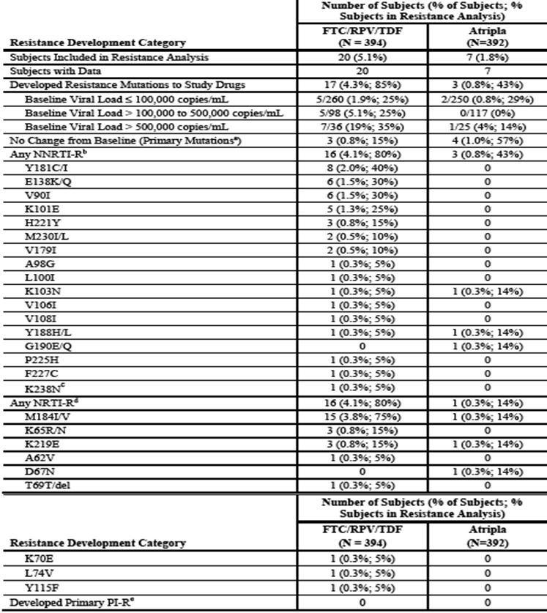
Table 12: GS-US-264-0110: Development of HIV-1 Genotypic Resistance at Wk 48 with Baseline HIV RNA and time of virologic failure.
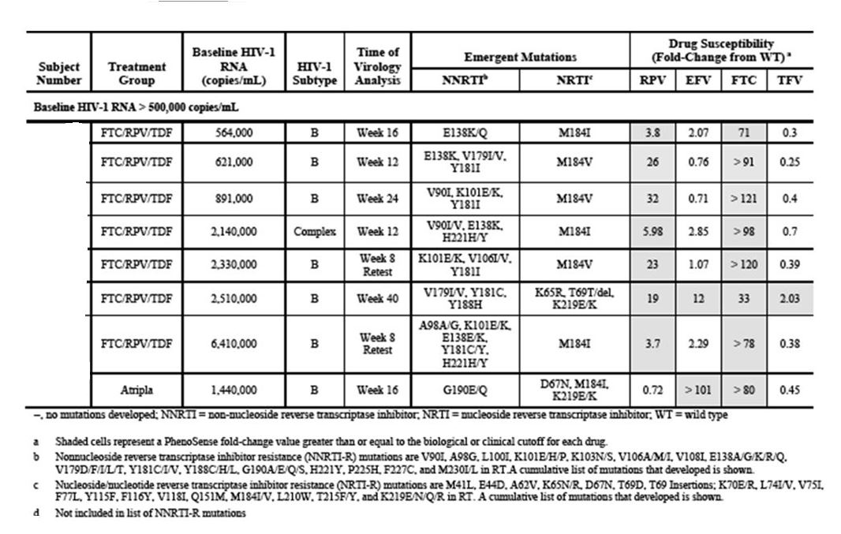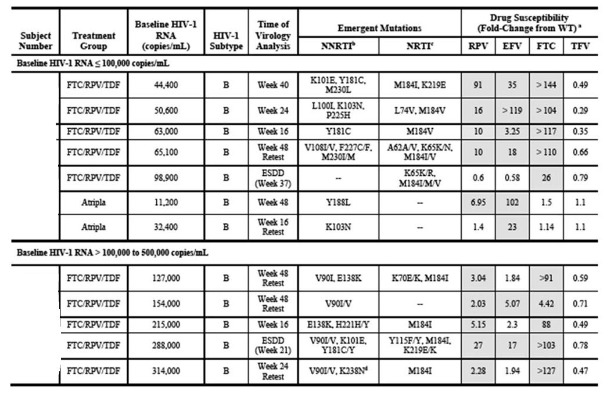
Analysis by Baseline Viral Load (see Tables 12 and 13): In subjects with baseline viral load ≤100,000 copies/mL, emergent resistance was similar between groups i.e. 1.9% for Eviplera and 0.8% for Atripla. In those with baseline viral load >100,000 to 500,000 copies/mL, 5 of 98 subjects (5.1%) Eviplera group and 0 of 117 subjects (0%) Atripla group subjects developed emergent resistance. For subjects with baseline viral load >500,000 copies/mL, 7 of 36 (19%) Eviplera group subjects and 1 of 25 (4%) Atripla group subjects had genotypic and/or phenotypic resistance to at least one regimen component.
Table 13: GS-US-264-0110: Virologic Success and Failure at Wk 48 by Baseline HIV-1 RNA Subgroups of Interest (Snapshot Analysis), Full Analysis Set.
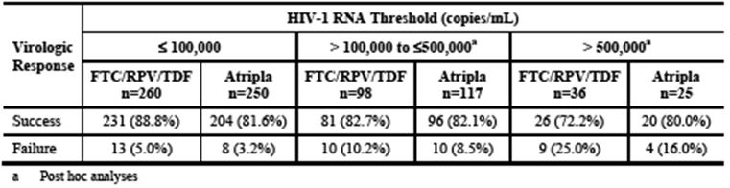

Analyses performed across trials (pooled & meta analyses)
Not applicable.

Evaluator’s conclusions on efficacy
The data from Study GS-US-264-0110 provides further data in support of Eviplera’s existing registered use with the drug being safe and well tolerated and virologically non inferior to Atripla over 48 weeks. While overall, the emergence of resistance was low in both groups, in those virologically failing Eviplera there was a greater emergence of multiple resistance mutations to both NNRTI and NRTI especially in those with baseline plasma HIV RNA >100,000 copies/mL and even more so in those with >500,000 copies/mL. The emergence of multiple NNRTI mutations impacts on the ability to use another second generation NNRTI, for example, etravirine. While the sponsor showed no statistical difference versus Atripla in regards to virological failure with baseline viral load >100,000 to <500,000 copies/mL, the clinical evaluator does not think other important factors need to be considered. First high viral load above 100,000 is associated with an increased risk of virological failure with Eviplera (and this finding is consistent with the earlier registration studies). Importantly, as the failure is associated with multiple mutations, this would impact not only on future use of NNRTI but also the potential activity of future NRTI backbones. Moreover, another strategy for the use of the drug rather than using it first up in patients with high baseline viral load is provided by the switch studies, GS-US-264-0111 and GS-US-264-0106. These studies provide data for the use of Eviplera as a switch drug for the NNRTI efavirenz, and in Study GS-US-264-0106 as a switch from PI/r in virologically suppressed patients. It is important to note that a history of virological failure to the prior ARV regimen excluded participation. That being said, a small percentage of patients in both studies did have some NNRTI and/or NRTI resistance mutations on historical genotypes; these did not appear to impact Eviplera response to any great extent. The data from these switch studies supports the use of Eviplera in virologically suppressed treatment experienced patients without any history of virological failure associated with genotypic resistance to NNRTI and NRTI.

Clinical safety

Studies providing safety data
GS-US-264-0111 (single arm pilot switch) and GS-US-264-0106 (immediate and delayed switch) and GS-US-264-0110 (randomised naïve study) provided evaluable safety data.

Pivotal efficacy studies
In the pivotal efficacy studies, the following safety data were collected.
General adverse events (AEs) were assessed by investigators through direct questioning & patient report, complete (Weeks 24 and 48 at investigator discretion) or symptom directed physical exam including vital signs at screening, baseline, Weeks 4, 8, 12, 24, 36 and 48 in both GS-US-264-0111 and GS-US-264-0106. The evaluations were completed at Weeks 4, 8, 12, 16, and then every 8 weeks through 48 Weeks, then every 12 weeks until Week 96 in GS-US-264-0110. AEs of particular interest were assessed by laboratory assessments (including renal function, liver function, alanine aminotransferase [ALT] flare, and pregnancy test at all study visits in GS-US-264-0111 and GS-US-264-0106) and electrocardiogram (ECG) measurements in GS-US-264-0111 (at screening, baseline, Weeks 4, 12 and 48). In Study GS-US-264-0110, ECGs were performed at Weeks 48 and 96. In GS-US-264-0106, subjects randomised to the stay on baseline regimen (SBR) group (Eviplera switch at Week 24) also returned for a visit at Weeks 28 and 32. Subjects in Study GS-US-264-0106 extension (after Week 48) returned for study visits every 12 Weeks (Week 60+), during which laboratory analyses (haematology, chemistry, urinalysis, pregnancy test), ECGs (annual), and complete/symptom directed physical exams were performed.
Numerous AEs were of particular interest:
- Drug resistance
- Hepatic AEs, because hepatotoxicity is considered an important potential risk for RPV, and post treatment hepatic flares in HIV-1/hepatitis B virus (HBV) co-infected subjects considered important identified risks for FTC and TDF
- Skin AEs, as severe skin reactions are considered important potential risks for RPV, and rash was a common AE identified in prior RPV studies
- Psychiatric AEs, as major depressive disorder is considered an important potential risk for RPV
- Renal AEs, as renal toxicity is considered an important identified risk for TDF
- Bone AEs, as bone events due to proximal renal tubulopathy/loss of bone mineral density are considered important identified risks for TDF. Bone events (osteomalacia and infrequently contributing to fractures) may occur as a consequence of TDF associated renal toxicity
- Muscle AEs, as these may occur as a consequence of TDF associated renal and muscle toxicity
- Cardiac AEs, because QT interval prolongation is considered an important potential risk for RPV
- Lipodystrophy, because this is considered an important identified risk for FTC and TDF and an important potential risk for RPV
- Pancreatitis, because this is considered an important identified risk for TDF
- Lactic acidosis and severe hepatomegaly with steatosis, because these are important identified risks for FTC and TDF
- Interaction with didanosine, because this is an identified risk for TDF
- Bleeding disorders, because this is a potential risk for RPV
- Overdose, because overdose is considered an potential risk
- Pregnancy/lactation, because of a paucity of information for Eviplera.
Laboratory tests were performed at all study visits (except Weeks 2 and 6 in Study GS-US-264-0111 as these were pharmacokinetic visits) in each study:
- full blood chemistry
- estimated glomerular filtration rate (eGFR) calculated from chemistry panel using Cockcroft-Gault formula
- fasting Metabolic panel (lipids and glucose)
- urinalysis
- pregnancy test
- T cells
- plasma HIV RNA
- HIV resistance testing when protocol specified algorithms for virological failure met.

Pivotal studies that assessed safety as a primary outcome
There were no pivotal studies that assessed safety as a primary outcome.

Dose-response and non-pivotal efficacy studies
Not applicable.

Other studies evaluable for safety only
Not applicable.

Patient exposure
Of 50 patients enrolled in Study GS-US-264-0111, 49 received ≥1 dose of study drug. One subject stopped study drug after Week 36 because of incarceration. All 49 subjects received study drug for ≥44 Weeks; median exposure was 48 wks. In Study GS-US-264-0106, 469 subjects received at least 1 dose of Eviplera, including 317 in the Eviplera group and 152 in the Delayed Switch group. Mean (SD) duration of Eviplera exposure was 45.6 (9.21) weeks in the Eviplera group and 23.2 (3.93) weeks in the Delayed Switch group. In Study GS-US-264-0110, 394 subjects received ≥1 dose Eviplera, and 392 subjects received ≥1 dose Atripla. The mean (SD) duration of exposure to randomised study drug was 53.2 (13.47) weeks (Eviplera group) and 50.3 (17.67) weeks in the Atripla group.

Adverse events

All adverse events (irrespective of relationship to study treatment)

Pivotal studies
GS-US-264-0111: Of 49 subjects in the safety analysis set, 43 (87.8%) experienced AEs (Table 14).
Table 14: GS-US-264-0111: Overall Summary of Adverse Events (Safety Analysis Set).
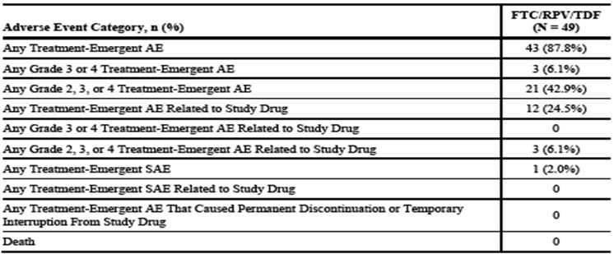
GS-US-264-0106: TEAE reported by 79.8% in the immediate Eviplera group vs. 57.2% in the SBR group. After those in SBR group switched to Eviplera at Wk 24, TEAE reported by 71.7% (Table 15).
Table 15: GS-US-264-0106: Overall Summary of Adverse Events (Safety Analysis Set).
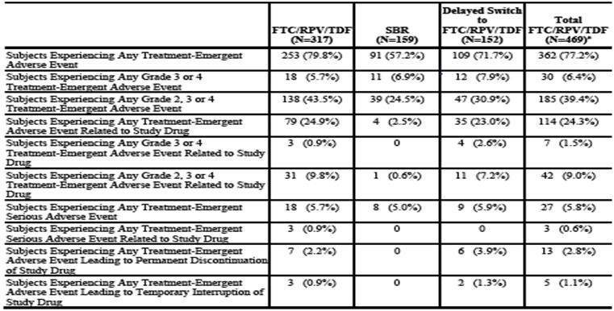
GS-US-264-0110: During the first 48 Wks, TEAEs reported by 88.6% and 93.1% of the Eviplera and Atripla groups respectively (Table 16).
Table 16: GS-US-264-0110: Overall Summary of Adverse Events (Safety Analysis Set).
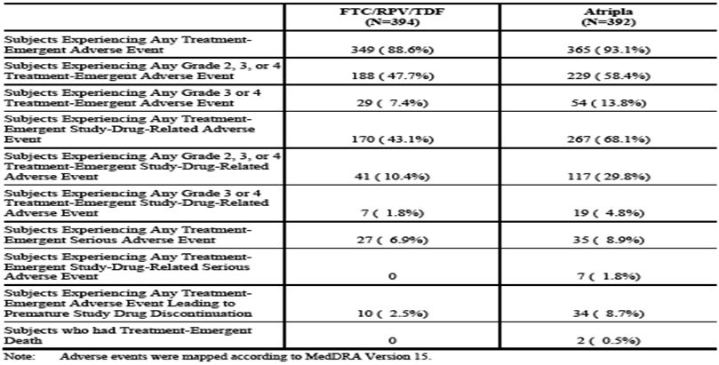

Other studies
Phase 1 healthy volunteer study GS-US-264-0112: no safety concerns revealed.

Treatment-related adverse events (adverse drug reactions) (TRAE)

Pivotal studies
GS-US-264-0111: 24.5% experienced study drug related AEs. Highest incidence TEAEs were gastrointestinal (GI) disorders (7 subjects [14.3%]. Three subjects experienced Grade 2 treatment-related AEs; all other TR AEs were Grade 1 in severity. 1 subject: Grade 2 gastritis Day 103 onwards; Subject 0121-3824 had Grade 2 fatigue Day 13-30; Subject 1536-3815 experienced Grade 2 increased bilirubin Day 31onwards. Study drug continued in these subjects. Grade 1 TR AEs consisted of the following: flatulence, nausea, abdominal pain, constipation, diarrhoea, eructation, vomiting, fatigue, feeling abnormal, amnesia, poor sleep, psychomotor hyperactivity, insomnia, abnormal dreams, anxiety, depression, dermatitis, rash. Grade 1 TR flatulence, nausea and insomnia occurred in 2 subjects each; all other Grade 1 treatment-related AEs occurred in 1 subject each.
AEs of special interest: i) psychiatric & nervous system disorders: 28.6% reported “psychiatric disorders”; i.e. insomnia (12.2%), anxiety & depression reported in 6.1% each and abnormal dreams reported in 2 subjects (4.1%). Attention deficit/hyperactivity disorder and stress reported in 1 subject (2.0%) each. AEs reported in the nervous system SOC in 14.3%. In 1 subject (2.0%) each: amnesia, cervicobrachial syndrome, attention disturbance, dizziness, headache, poor sleep, and psychomotor hyperactivity; ii) rash: 4.1% reported rash. Grade 1 rash on left inner thigh considered study drug related (onset, Day 3 onwards) reported in 1 subject and in another subject, Grade 1 right axilla rash considered unrelated to study drug. GS-US-264-0106: Subjects with TRAE similar in Eviplera (24.9%) and Delayed Switch groups (23.0%) during 48 and 24 Wks of Eviplera therapy, respectively. The % of subjects reporting a TR AE low among the subjects remaining on their current ARVs for the first 24 Wks (2.5%). The most frequently reported study drug related AEs was nausea (2.2% Eviplera group; 5.9% Delayed Switch group), diarrhoea (3.2% Eviplera group; 0.6% in SBR group, and 2.6% in Delayed Switch group), and fatigue (3.5% Eviplera group). Most study drug-related AEs were Grade 1, with no dose change. Grade 3 study drug-related AEs occurred in 1 subject each and included: fatigue, ALT increased, AST increased, blood CK increased, decreased appetite, rhabdomyolysis, amnesia, depression, insomnia, renal impairment, and dyspnoea. No Grade 4 TEAEs considered study drug related.
AE of special interest: i) psychiatric & nervous system disorders: AEs reported in 62 of 317 subjects (19.6%) in the Eviplera group (received up to 48 wks of treatment), with the most frequently occurring AEs including insomnia (6.3%), depression (4.4%), sleep disorder (2.2%). In the Delayed Switch group (received up to 24 Wks of Eviplera) the most frequent psychiatric AE were insomnia (5.3%), depression (3.3%), abnormal dreams (2.0%). Of the 159 subjects remaining on their baseline ARV regimen during the first 24 Wks (SBR group), 10 subjects (6.3%) reported psychiatric AEs i.e. Depression in 4 subjects (2.5%). All other psychiatric AEs reported in <2% of subjects in any treatment group. Psychiatric SAEs included suicidal ideation (1 subject each in the Eviplera and Delayed Switch groups), affective disorder (1 subject in the Eviplera group), and bipolar disorder (1 subject in the Eviplera group). None of these SAEs considered related.
Nervous system disorder AEs occurred in 15.1% in the Eviplera group. Headache in 8.8%. Dizziness reported in 7 subjects (2.2%). In the Delayed Switch group, the most frequently occurring were headache and dizziness (3.3% each). Of the 159 subjects remaining on their baseline ARVs during the first 24 Wks, 9.4% reported AEs within the nervous system category. i.e. headache reported by 3.8%. Nervous system SAEs included hypoesthaesia (1 subject in the Eviplera group), peripheral neuropathy (1 subject in Delayed Switch group) and sensory loss (1 subject in Delayed Switch group). The SAEs of hypoesthaesia and peripheral neuropathy resulted in temporary discontinuation of study drug. No SAEs considered related; ii) Rash: 7 of 317 subjects (2.2%) in Eviplera group and 4 of 152 subjects (2.6%) in Delayed Switch group reported a rash. Two subjects (1.3%) remaining on their baseline ARV regimen (SBR group) during the first 24 Wks reported rash. All rash AEs of rash considered nonserious. Erythematous rash reported in 1 Eviplera group subject.
GS-US-264-0110: 43.1% of Eviplera group vs. 68.1% of the Atripla groups experienced TRAE. Most frequently (> 5%): nausea (9.6% in Eviplera group; 9.2% in Atripla group), headache (5.8% in Eviplera group; 5.4% in Atripla group), diarrhoea (5.1% in Eviplera group; 7.9% in Atripla group), abnormal dreams (4.6% in Eviplera group; 24.0% in Atripla group), dizziness (4.1% in Eviplera group; 19.9% in Atripla group), insomnia (3.3% in Eviplera group; 9.7% in Atripla group), fatigue (2.5% in Eviplera group and 8.4% in Atripla group), and somnolence (1.8% in Eviplera group; 6.6% in Atripla group). The incidence of each of these events was higher in the Atripla group compared with the Eviplera group, except for nausea and headache. Most study drug-related AEs were Grade 1 or 2 in severity, and most did not require discontinuation of study drug. Grade 3 or 4 study drug-related AEs were reported in 1.8% of subjects in the Eviplera group and 4.8% of subjects in the Atripla group. Grade 4 TEAEs considered study drug related included hepatic enzyme increased, pyrexia, hypersensitivity, suicidal ideation (all occurred in 1 subject each in the Atripla group). Grade 3 TEAEs considered related to study drug and reported in at least 2 subjects overall included depression (2 subjects in the Eviplera group; 3 subjects in Atripla group), insomnia (1 subject in the Eviplera group; 2 subjects in Atripla group), diarrhoea (1 subject each in the Eviplera and Atripla groups), fatigue (1 subject in the Eviplera group and 1 subject in the Atripla group), and anxiety (2 subjects in Atripla group).
AE of special interest: i) psychiatric & nervous system disorders: reported in 27.4% of the Eviplera group; 50.5% of the Atripla group. The most frequently (> 2% of subjects) occurring psychiatric AEs in the Eviplera , and Atripla groups were insomnia (9.6% and 14.0% of subjects, respectively), depression (6.6% and 8.9% of subjects, respectively), abnormal dreams (5.8% and 24.5% of subjects, respectively), anxiety (5.1% and 8.4% of subjects, respectively), sleep disorder (2.0% and 3.1% respectively), nightmare (0.5% and 2.8% respectively). SAE reported in 5 subjects (1.3%) receiving Eviplera and 6 subjects (1.5%) receiving Atripla . Those considered study drug related: suicide attempt (n=1), bipolar I disorder and major depression in 1 subject, suicidal ideation in 1 subject (all in Atripla group). The SAE of suicidal ideation resulted in permanent discontinuation of study drug; the SAEs of bipolar disorder and major depression resulted in temporary interruption. An analysis including the psychiatric events of abnormal dreams, affect lability, aggression, agitation, anxiety, completed suicide, confusional state, depression, euphoric mood, hallucination, hallucination (auditory), nervousness, paranoia, and suicidal ideation showed a significant difference in the occurrence of these events in the Eviplera , group (62 subjects [15.7%]) compared with the Atripla group (147 subjects [37.5%]; p <0.001; Fisher exact test). All of these events are well described in the efavirenz PI.
Nervous system: 28.4% of subjects in the Eviplera, group and in 45.9% of the Atripla group. The most frequently (>2% of subjects in either treatment group) occurring nervous system AEs in Eviplera , and Atripla groups were headache (12.4% and 13.5%, respectively), dizziness (6.6% and 22.2%, respectively), somnolence (2.5% and 6.9%, respectively), paraesthaesia (2.3% and 4.1% respectively), and attention disturbance (1.5% and 2.8%, respectively). Nervous system SAEs: cerebrovascular accident (CVA) (1 Eviplera subject); convulsion (1 Atripla subject); headache, partial seizures, and accelerated hypertension (1 subject in Atripla group); syncope (1 subject in Eviplera group); and transient ischemic attack (1 subject in Atripla group). No nervous system SAEs were considered study drug related. The CVA, led to permanent discontinuation of study drug. An analysis including the nervous symptoms events of amnesia, balance disorder, convulsion, disturbance in attention, dizziness, headache, hypoesthaesia, insomnia, neuropathy peripheral, paraesthaesia, somnolence, stupor, tremor, and vertigo demonstrated that these events occurred in a statistically significant higher percentage of the Atripla group (50.5%) vs. Eviplera , group (29.7%; p <0.001; Fisher exact test). These nervous system events are in alignment with the EFV PI; ii) Rash occurred in 6.1% Eviplera vs.12.0% Atripla subjects during the first 48 Wks . Study drug-related AEs of rash were reported in 4 subjects (1.0%) in the Eviplera group and 19 subjects (4.8%) in the Atripla group. All rashes considered nonserious. An analysis including all rash events did not show a significant difference in occurrence of these events in Eviplera (17.3%) vs. Atripla groups (21.2%) (p=0.17; Fisher exact test). Rash events are described in the EFV PI.

Deaths and other serious adverse events

Pivotal studies

Deaths
No deaths in GS-US-264-0111 or GS-US-264-0106.
GS-US-264-0110: Two subjects died during the study (both in Atripla group). One subject [information redacted] committed suicide on Day 37 assessed as unrelated to study drug, but rather to a pre-existing condition. One subject [information redacted] died due to septic shock on Day 331, assessed as not related.

SAE
Study GS-US-264-0111: Two TE SAEs occurred in 1 subject (2.0%) during Study GS-US-264-0111. Subject [information redacted] experienced SAEs of Grade 3 bradycardia and Grade 3 dyspnoea on Day 87. The dyspnoea resolved the day of onset and the bradycardia resolved on Day 143. The subject was hospitalised and received medication for the bradycardia. Study drug continued and the events were not related to study medication.
Study GS-US-264-0106: TE SAEs reported in 5.7% of subjects in the Eviplera group, 5.0% in the SBR group, and 5.9% in the Delayed Switch group. The SOC with the most frequently reported TE SAEs during treatment with Eviplera was infections and infestations (6 subjects [1.9%]). The most frequently reported TE SAEs during treatment with Eviplera for up to 24 Wks (Delayed Switch group) was nervous system disorders (2 subjects [1.3%]). SOC with the most frequently reported TE SAEs in subjects remaining on baseline ARV regimen was infections & infestations (5 subjects [3.1%]).
Study GS-US-264-0110: TE SAEs reported in 6.9% Eviplera group; 8.9% of Atripla group. TE SAEs reported in ≥2 subjects in either treatment group: chest pain (2 subjects Eviplera group), pyrexia (2 subjects Atripla group), neurosyphilis (2 subjects Atripla group), concussion (2 subjects in Eviplera group), depression (2 subjects Eviplera group; 1 subject Atripla group), suicide attempt (1 subject Eviplera group; 2 subjects Atripla group), nephrolithiasis (2 subjects Eviplera group; 1 subject Atripla group). SOC with most frequently reported TE SAEs was infections & infestations (1.3% Eviplera group; 2.6% Atripla group), psychiatric disorders (1.3% in Eviplera group and 1.5% in Atripla group), injury, poisoning, and procedural complications (1.0% each treatment group).
Pregnancy: n=3 in GS-US-264-0110, incl. 1 partner pregnancy, reported through Wk 48 (all Eviplera , group). One subject had a first trimester spontaneous abortion; the other 2 pregnancies (incl. partner pregnancy) were ongoing at WK 48 analysis data cut-off:

Discontinuation due to adverse events

Pivotal studies
Overall rates of discontinuations were very low; in GS-US-264-0110, rates were significantly higher with Atripla (8.7%) vs. Eviplera (2.5%). Seven subjects (all Atripla) experienced TE SAEs considered study drug related. Study drug-related SAEs included suicide attempt, suicidal ideation, bipolar disorder, major depression, liver injury, pyrexia, hypersensitivity, femoral neck fracture. Seven subjects (1 in Eviplera group; 6 in Atripla group) experienced treatment-emergent SAEs that resulted in permanent discontinuation of study drug. Subjects 0112-9750 (Atripla group; testicular germ cell cancer), 0310-9293 (Atripla group; liver injury), 0731-9549 (Atripla group; hepatic enzyme increased), 1407-9323 (Eviplera group; CVA), 1965-9046 (Atripla group; completed suicide and asphyxia), 1967-9250 (Atripla group; pyrexia and hypersensitivity), and 5545-9386 (Atripla group; suicidal ideation) had TE SAEs resulting in permanent discontinuation of study drug. The SAEs of liver injury, hepatic enzyme increase, pyrexia, hypersensitivity, suicidal ideation leading to study drug discontinuation were considered related to study drug.
In GS-US-264-0106, 13 subjects permanently discontinued study drug due to TE AE (7 in Eviplera group; 6 in Delayed Switch group). Of these 13, 12 discontinued study drug before Wk 48 and 1 subject (1221-3416 [Delayed Switch group]) discontinued study drug due to an AE after Wk 48. No subjects discontinued from the study due to a TEAE while remaining on their baseline ARV regimen. TEAEs of depression led to discontinuation of 2 subjects in the Eviplera group, and AEs of insomnia led to discontinuation of 1 subject in the Eviplera group and 1 subject in Delayed Switch group. All other TEAEs resulting in discontinuation of study drug reported in 1 subject each.

Laboratory tests
GS-US-264-0111: The majority of TE lab abnormalities reported as Grade 1 or Grade 2. Grade 1 lab abnormalities reported in 23 of 49 subjects (46.9%) and Grade 2 lab abnormalities reported in 8 of 49 subjects (16.3%). Grade 3 lab abnormalities reported in 3 of 49 subjects (6.1%) and a Grade 4 lab abnormality reported in 1 subject (2.0%). GS-US-264-0106 The majority of TE laboratory abnormalities were reported as Grade 1 or Grade 2. Grade 3 or 4 TE laboratory abnormalities reported in more than 2 subjects in the Eviplera group included increased CK (8 subjects), elevated ALT (5 subjects), elevated AST (5 subjects), decreased absolute neutrophil count (3 subjects), increased amylase (3 subjects), increased lipase (3 subjects), and haematuria (5 subjects). Grade 3 or 4 TE laboratory abnormalities reported in more than 2 subjects in the SBR group included increased bilirubin (10 subjects), increased CK (3 subjects), and elevated AST (3 subjects). After subjects in the SBR group switched to Eviplera at Wk 24, Grade 3 or 4 TE lab abnormalities reported in >2 subjects in the Delayed Switch group (Wks 24−48) included increased CK (7 subjects), elevated ALT (7 subjects), and elevated AST (3 subjects).
GS-US-264-0110: majority of TE laboratory abnormalities reported as Grades 1 or 2. Grades 3 or 4 TE lab abnormalities reported in ≥2 subjects included increased CK (20 subjects in each group), elevated ALT and AST (13 subjects in each group), decreased neutrophils (11 subjects in Eviplera group; 3 in Atripla group), hyperglycaemia (9 subjects in Eviplera group; 2 in Atripla group), increased serum amylase (8 subjects in Eviplera group; 7 in Atripla group), glycosuria (7 subjects in Eviplera group; 4 subjects in Atripla group), elevated GGT (6 subjects in Eviplera group;10 in Atripla group), haematuria (6 subjects in Eviplera group; 5 in Atripla group), increased lipase (5 subjects in Eviplera group;3 in Atripla group), increased alkaline phosphatise (3 in Eviplera group), hypercholesterolemia (1 subject in Eviplera group; 4 in Atripla group), elevated TGs (1 subject in the Eviplera group; 3 in Atripla group).

Liver function

Pivotal studies
GS-US-264-0111: One subject experienced Grade 2 increased bilirubin considered a TEAE. No action taken with regard to study drug; AE ongoing at the time of study completion.
GS-US-264-0106: Liver related AEs reported in 2.2% of Eviplera group. Hepatic steatosis and hypertransaminasaemia reported in 2 subjects (0.6%) each. In Eviplera group, all other AEs in hepatobiliary category reported in 1 subject each. In the Delayed Switch group, cytolytic hepatitis reported in 3 subjects [2.0%]. Liver-related lab abnormalities reported in ≥2 of Eviplera group included ALT increased in 1.3%, liver fn test abnormal in 1.3%, AST increased in 0.6%. In the Delayed Switch group, AEs of liver-related lab abnormalities reported in ≥2 subjects included ALT increased in 2.6%, AST increased in 1.3%, transaminases increased in 1.3%. No liver-related lab abnormalities reported as SAEs. Two subjects (Delayed Switch group) with increased transaminases permanently discontinued study drug.
GS-US-264-0110: AEs in hepatobiliary disorders SOC reported in 0.8% Eviplera and 1.0% Atripla subjects. Cholelithiasis reported in 1 subject in each treatment group. Hepatic cyst reported in 2 subjects in the Atripla group. All other hepatobiliary SOC AEs reported by 1 subject each i.e. cholecystitis (Atripla group), hyperbilirubinemia (Eviplera group), hepatic steatosis (Eviplera group), liver injury (Atripla group). The hyperbilirubinemia AEs and liver injury (SAE) were considered study drug related study drug was discontinued.

Kidney function

Pivotal studies
In vitro, RPV inhibits the OCT2 (renal transporter) for creatinine tubular secretion (Urakami et al.)
GS-US-264-0111: Serum creatinine elevations evident by Wk 4 (mean +0.07 mg/dL) and stable through Wk 48 (mean +0.08 mg/dL). Two subjects experienced transient Grade 1 TE elevations in creatinine, not considered AEs.
GS-US-264-0106: Overall, serum creatinine elevations, and decreases in estimated CLcr (by Cockcroft-Gault using observed or ideal body weight) and eGFR, were evident by Wk 4 and stable through Wk 24 in subjects receiving Eviplera vs. subjects remaining on their baseline ARVs (SBR group). At Wk 24, the differences between the Eviplera and SBR groups in the mean changes from baseline in serum creatinine (0.05 vs. 0.01 mg/dL), estimated CLcr (using observed body weight; -4.4 vs. 0.1 mL/min), and eGFR (−4.5 vs. −0.5 mL/min/1.73 m2) were statistically significantly (p ≤ 0.001). Increases in serum creatinine and decreases in estimated CLcr and eGFR were generally maintained through Wk 48 in the Eviplera group. Similar changes in these renal function parameters were observed in the Delayed Switch group over 24 Wks of Eviplera therapy. When these renal function parameters were analysed in subjects using TDF at baseline vs. non-TDF regimens at baseline, similar trends were observed.
GS-US-264-0110: Overall, serum creatinine elevations, and decreases in estimated CLcr and eGFR, were evident by Wk 4 and stable through Wk 48 in subjects receiving Eviplera vs. those on Atripla. At Wk 4, the mean (SD) change from baseline was 0.08 (0.115) mg/dL in Eviplera group and -0.01 (0.101) mg/dL in Atripla group. Increase in serum creatinine generally maintained through Wk 48 in Eviplera, group. At Wk 4, the mean (SD) change in estimated CLcr was -7.7 (12.85) mL/min in the Eviplera group and 0.1 (12.21) mL/min in the Atripla group. In the Eviplera group, the decrease in estimated CLcr was generally maintained through Wk 48 (mean [SD] change of −5.4 [14.19] mL/min at Wk 48). In the Atripla group, increases from baseline were observed in estimated CLcr using Cockcroft-Gault through Wk 48 (mean (SD) change of 0.7 [13.99], 2.1 [17.39], 2.9 [15.43], and 4.6 [16.43] mL/min at Wks 8, 12, 24, and 48, respectively). Similar trends were observed in mean eGFR in the Eviplera and Atripla groups over the first 48 Wks. TE AEs of proteinuria (Grade 1 & 2) reported in 2.8% in Eviplera vs. 0 in Atripla. Of 7 subjects where the proteinuria was thought study drug related, in 4 subjects this resolved before Wk 48 data cut-off. Small mean increase in serum creatinine observed with Eviplera in these studies is similar to that reported in the US prescribing information for RPV-based regimens and not considered to be clinically important, note also the minimal impact on eGFR.

Other clinical chemistry - lipids

Pivotal studies
GS-US-264-0111: Median values and median change from baseline at Wk 48 for fasting lipid parameters are presented in Table 17. Statistically significant decreases from baseline in fasting lipids observed starting as early as Wk 12 and continuing through Wk 48.
Table 17: GS-US-264-0111: Median (Q1, Q3) of Observed Fasting Lipid Parameters and Changes from Baseline (mg/dL; Safety Analysis Set).
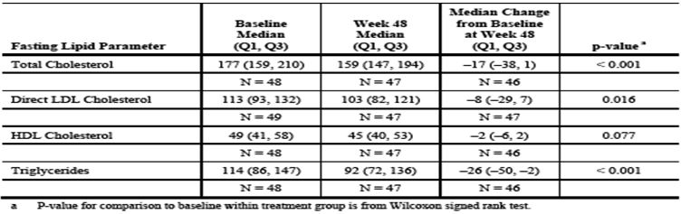
GS-US-264-0106: At baseline, the mean (SD) values for lipid parameters were similar between the Eviplera and SBR groups. Overall, fasting total cholesterol, HDL cholesterol, direct LDL cholesterol, fasting TGs, and the ratio of total cholesterol/HDL cholesterol decreased to a greater extent through Wk 24 among subjects in the randomised Eviplera group vs. those maintaining their baseline PI/r + 2 NRTIs regimen (SBR group). At Wk 24, the mean (SD) changes from baseline in fasting lipid parameters in the Eviplera and SBR groups were as follows: -25 (30.2) vs. -1 (25.9) mg/dL for total cholesterol; -4 (10.3) vs. -1 (8.2) mg/dL for HDL; -16 (25.6) vs. 0 (23.7) mg/dL for direct LDL; -53 (110.1) vs. 3 (100.1) mg/dL for TGs; and -0.27 (0.913) vs. 0.08 (0.771) mg/dL for the ratio of total cholesterol to HDL. Differences between these treatment groups for all 5 of these lipid parameters were statistically significant at Wk 24 (p <0.001). The mean reductions from baseline in lipid parameters observed at Wk 24 in the randomized Eviplera group were generally maintained through Wk 48 of therapy. After subjects in the SBR group switched to Eviplera therapy at Wk 24, similar decreases in lipid parameters were observed in the Delayed Switch group over Wks 24 to 48 of the study. In general, mean decreases from baseline to Wk 24 of Eviplera therapy were larger in subjects with prior LPV/r use at study entry compared with those without prior LPV/r use.
In accordance with NCEP targets: By Wk 12, the % of subjects with target fasting total cholesterol levels (<200 mg/dL), LDL (<100 mg/dL), TGs (<150 mg/dL), and total cholesterol to HDL ratio (<3.5) were increased in the Eviplera group compared with the SBR group. The % of subjects in these target fasting lipid categories at Wk 12 in the Eviplera and SBR groups were as follows: 86.6% vs. 60.1% for total cholesterol; 47.8% vs. 24.8% for direct LDL; 87.6% vs. 47.3% for TGs; and 57.9% vs. 31.1% for total cholesterol to HDL ratio. Similar results observed at Wk 24. Overall differences between the Eviplera and SBR groups in the categorical analyses of fasting total cholesterol, direct LDL, TGs, and the ratio of total cholesterol to HDL cholesterol (in favour of improved lipid profile for the Eviplera group) was statistically significant at Wks 12 and 24 (p <0.001). After subjects in the SBR group switched to Eviplera at Wk 24, similar fasting total cholesterol category results were observed in the Delayed Switch group over 24 Wks.
GS-US-264-0110: At baseline, the mean (SD) values for lipid parameters were generally similar between the Eviplera, and Atripla groups. The mean (SD) values for fasting total cholesterol were 164 (36.4) mg/dL in the Eviplera group and 163 (35.0) mg/dL in the Atripla group. Mean (SD) values for fasting HDL cholesterol were 44 (13.2) mg/dL in the Eviplera group and 44 (11.9) mg/dL in the Atripla group. The mean (SD) values for fasting direct LDL cholesterol were 104 (31.5) mg/dL in the Eviplera, group and 103 (33.0) mg/dL in the Atripla group. The mean (SD) values for fasting TGs were 121 (73.2) mg/dL in the Eviplera group and 129 (124.0) mg/dL in the Atripla group. The mean (SD) values for total cholesterol/HDL ratio were 4.0 (1.38) in the Eviplera, group and 4.0 (1.43) in the Atripla group. Fasting total cholesterol, HDL cholesterol, direct LDL cholesterol, TGs were increased at Wk 24 among Atripla subjects. In the Eviplera , group, fasting total cholesterol, HDL cholesterol, direct LDL cholesterol levels changed little through Wk 24, while fasting TGs were decreased at Wk 24. At Wk 24, mean (SD) changes from baseline in fasting lipids in Eviplera , and Atripla groups as follows: -3 (28.2) vs. 21 (28.5) mg/dL for total cholesterol; 2 (9.4) vs. 7 (9.9) mg/dL for HDL cholesterol; -2 (24.3) vs.13 (25.9) mg/dL for direct LDL cholesterol; and -7 (67.6) vs. 11 (100.2) mg/dL for TGs. Fasting total cholesterol, HDL cholesterol, direct LDL cholesterol, TGs generally maintained from Wk 24 through Wk 48 in both treatment groups. In accordance with NCEP targets: At Wks 24 and 48, the % of subjects with target fasting lipids (see above) remained similar to baseline in the Eviplera group, but were decreased in the Atripla group. The % of subjects in these target fasting lipid categories at Wk 48 for Eviplera and Atripla groups were: 85.9% vs. 65.9% (total cholesterol); 41.9% vs. 32.1% (direct LDL); 80.6% vs. 72.1% (TGs). Overall differences for Eviplera vs. Atripla in categorical analyses of fasting total cholesterol, LDL, TGs statistically significant at Wks 24 & 48 (p ≤ 0.013).

Haematology

Pivotal studies
No changes clinically significant changes in haematological parameters in GS-US-264-0111, GS-US-264-0106, GS-US-264-0110. In GS-US-264-0106 Grade 3 decreased neutrophils in 3 subjects.

Creatine Kinase and amylase

Pivotal studies
GS-US-264-0111: Two subjects each had Grade 3 increased CK; a Grade 4 increased CK was reported in 1 subject. One subject with Grade 3 increased CK also had Grade 3 amylase. 1 subject had Grade 3 amylase during the study. Both subjects with increased amylase had elevated values at screening and baseline.
GS-US-264-0106: In the Eviplera group, Grade 3 and 4 elevated CK (8 subjects: 3 Grade 3, 5 Grade 4), increased amylase (3 subjects), increased lipase (3 subjects). In those switching at Wk 24, Grade 3 increased CK in 7 subjects (5 Grade 3; 2 Grade 4).
GS-US-264-0110: Grade 3 or 4 TE laboratory abnormalities reported in ≥2 subjects in either treatment group included increased CK (20 subjects in each group), increased serum amylase (8 subjects in Eviplera group and 7 in the Atripla group).

HIV resistance

Pivotal studies
Discussed above in ‘Efficacy’ section.

Electrocardiograph

Pivotal studies
GS-US-264-0110: 3 subjects (1 Eviplera group; 2 Atripla group) had clinically significant abnormal Wk 48 ECG results i.e. left ventricular hypertrophy due to hypertension in the Eviplera subject. In Atripla group, 2 subjects had clinically significant abnormal Wk 48 ECG i.e. bradycardia (n=1); sinus bradycardia and borderline rhythm (n=1).

Vital signs

Pivotal studies
GS-US-264-0106: Vital signs no consistent pattern of change. No clinically important changes in body weight/BMI.
GS-US-264-0110: greater increase in body weight observed in the Eviplera vs. Atripla group during first 48 Wks. At Wk 24, mean (SD) change from baseline was 1.5 (4.01) kg vs. 0.2 (3.90) kg respectively. At Wk 48, mean (SD) change from baseline 1.9 (5.69) kg in the Eviplera group and 0.3 (5.17) kg in the Atripla group. At Wk 24, the mean (SD) change in BMI was 0.5 (1.31) kg/m² in the Eviplera group and 0.0 (1.25) kg/m² in the Atripla group. At Wk 48, the mean (SD) change from baseline in BMI was 0.6 (1.85) kg/m² in the Eviplera group and 0.1 (1.64) kg/m² in the Atripla group. Vital signs: no consistent pattern of change.
Study GS-US-264-0111: No clinically important changes in vital signs (including body weight and BMI), ECGs, or physical examination.

Immunological adverse events including immune reconstitution inflammatory syndrome (IRIS)

Pivotal studies
Nil.

Skin rashes

Pivotal studies
There was no clinically significant rash AE in these 3 pivotal studies.

Post-marketing experience
Worldwide cumulative patient exposure to Eviplera since first marketing approval in the US (10 Aug 2011) to 31 July 2012 estimated at 13,054 patient-years. PSUR x 2 (11 Aug 2011 to 10 Feb 2012; 11 Feb 2012 to 10 Aug 2012). In these PSURs, 25 and 74 medically confirmed cases met PSUR inclusion criteria respectively, of which 24 and 73 were spontaneous reports; 1 case in each PSUR was an SAE from a clinical study considered Eviplera related (investigator/Gilead physician). All safety data for the topics under close monitoring for Eviplera were reviewed. Following review of drug resistance data, the Y188L substitution was identified as an RT mutation conferring resistance to RPV. Ten spontaneous cases involving 16 SAEs received between11 Aug 2012 to 31 Oct 2012. Medically confirmed spontaneous cases received in this period with SAEs in the topics under close monitoring in PSURs were: drug resistance/lack of efficacy (n = 3), hepatic events (n = 2), skin reactions (n = 1), psychiatric (n = 1), cardiac (n = 1), bone and muscle events (n = 1). One spontaneous report of death i.e. a [information redacted] HIV/HBV co-infected patient with a CD4+ count of ‘46’ prior to initiation of Eviplera died due to IRIS with an associated respiratory component. IRIS has been reported in patients treated with ARV with low baseline CD4 count a known risk factor.

Safety issues with the potential for major regulatory impact
None identified in regards to liver, haematological toxicity, serious skin reactions, cardiovascular safety, unwanted immunological events, other safety issues.

Other safety issues

Safety in special populations
Not assessed.

Safety related to drug-drug interactions and other interactions
Not applicable.

In regards to specific NNRTI resistance mutations (Y188L).
Haddad et al. showed the HIV-1 RT mutation Y188L was associated with reduced susceptibility to RPV. The authors found that Y188L was associated with decreased phenotypic susceptibility to RPV. The median FC of clinical specimens with Y188L and no known RPV resistant associated mutation (RAM) (n = 286) was 9.2 (p <0.001). Association of RPV RAMs K101E/P, E138A/G/K/Q/R, Y181C/I/V, Y188L and M230L with increased FC to RPV was statistically significant (p <0.05). Four RPV mutations did not have statistically significantly increased FC (V179L, H221Y, F227C and M230I), although 3 of these involved three or less clinical specimens (V179L, F227C & M230I). The FC of the Y188L site-directed mutant was 6.1. This publication concluded that the NNRTI mutation Y188L is newly described as conferring reduced susceptibility to RPV. The median FC of clinical specimens and site-directed mutants with Y188L were 9.2 and 6.1, respectively; both significantly above the biological cut off of 2.0. Among reported RPV RAMs, Y188L ranked 4th in elevated FC behind K101P, Y181I and Y181V. Y188L frequency was low (1.5%), but ranked 3rd in frequency behind Y181C and E138A when no other RPV RAMs are present. Consequent to this finding, Y188L is listed as a RPV RAM in the PI.

Evaluator’s overall conclusions on clinical safety
These 3 pivotal studies and the RPV post-marketting reports confirm the drug to be safe and well tolerated. Moreover, it appears more lipid-neutral compared to both PI/r and Atripla , however, the clinical significance of this is uncertain as the changes although favourable, were small. No new AEs were revealed by these studies and aside from the addition of the Y188L as an RPV RAM, no new resistance concerns were revealed. I have commented specifically on RPV resistance in those with higher plasma HIV RNA in the ‘Efficacy’ summary. No new adverse reactions to Eviplera were identified in the 3 pivotal clinical trials presented in this Application.

First round benefit-risk assessment

First round assessment of benefits
The benefits of Eviplera in the proposed usage are:
- Safe, with a favourable tolerability profile as a switch drug for either Atripla or PI/r
- Effective as a switch drug in virologically suppressed patients on Atripla or PI/r
- Non inferior to Atripla in the head-to-head study in naïve study which patients with HIV RNA >100,000 copies/mL and
- Modest lipid benefits as a switch drug.

First round assessment of risks
The risks of Eviplera in the proposed usage are as follows:
- The sponsor is seeking a broad approval for use of the drug in “treatment experienced”, when in fact the only use of this drug in treatment experienced patients as presented in this submission is as a switch drug for either Atripla or PI/r in patients who have not virologically failed their previous regimen and without baseline resistance to the components of Eviplera on historical resistance testing
- While in subjects with baseline viral load ≤100,000 copies/mL, the numbers of subjects with emergent resistance was similar between groups, that is, 1.9% for Eviplera and 0.8% for Atripla, in those with baseline viral load >100,000 to 500,000 copies/mL, 5.1% versus 0% in the Eviplera and Atripla groups, respectively, developed emergent resistance. For subjects with baseline viral load >500,000 copies/mL, 7 of 36 (19%) subjects in the Eviplera group and 1 of 25 subjects (4%) in the Atripla group had genotypic and/or phenotypic resistance to at least one regimen component. The sponsor seeks approval for the use of Eplivera in patients with plasma HIV RNA <500,000 copies/mL, but although the viral failure rates between >100,000-<500,000 copies/mL are low, most of the patients failing were found to fail with both multiple NNRTI and NRTI resistance mutations. If this occurred, there is a real potential to impact negatively not only on the future activity of another NNRTI (for example, etravirine), but also the next NRTI backbone. This very issue of higher virological failure and multiple RT mutations in those failing is the reason why Eviplera is currently approved only for use in naïve patients with baseline plasma viral load ≤100,000 copies/mL. Moreover, because in real terms the difference between a viral load of <500,000 and >500,000 is fairly arbitrary (in log terms) and within the variability of the viral load test, the evaluator has concerns about the approval of Eviplera in those with HIV RNA >100,000 copies/mL. The clinical evaluator believes the current restriction to a plasma HIV RNA of threshhold of ≤100,000 copies/mL for Eplivera in the ARV naïve setting should continue. In this way, if patients with viral load slightly above this threshold (100,000 = 5 log10 copies/mL, 200,000 = 5.31 log10 copies/mL; 300,000 = 5.477 log10 copies/mL, etc.) inadvertently receive Eplivera, then clinicians and their patients could be somewhat reassured that the risk of virologic failure is relatively low. The evaluator’s concerns in this regard are compounded by the association of higher virological failure in patients with low CD4+ starting Eviplera, that is, as stated in the US PI:
  - Regardless of HIV-1 RNA level at the start of therapy, more rilpivirine treated subjects with CD4+ cell count less than 200 cells/mm³ at the start of therapy experienced virologic failure compared to subjects with CD4+ cell count greater than or equal to 200 cells/mm³.
- Study GS-US-264-0110 enrolled relatively few patients with CD4+ <200 cells/µL (n = 53, 13.5% of the Eviplera arm). As a result, the evaluator does not believe this study provides sufficient additional data in regards to virological success in those with these low CD4+ and plasma HIV RNA >100,000 to ≤500,000 copies/mL
- The use of the term “HIV infection” in the current PI is too loose; RPV has no activity in HIV-2 infected patients (that is, “rilpivirine demonstrated limited activity in cell culture against HIV-2 with a median EC50 Gilead Sciences 30 value of 5220 nM [range 2510 to 10830 nM] and should not be used.”). Hence, the drug can only be used in HIV-1 infected patients. The term “HIV infected” should be avoided and replaced with “HIV-1 infected”.

First round assessment of benefit-risk balance
The benefit-risk balance of Eplivera is unfavourable given the proposed usage, but would become favourable if the changes recommended in the next section (‘First Round Recommendation Regarding Authorisation’) are adopted.

First round recommendation regarding authorisation
The clinical evaluator recommends the authorisation of Eviplera in treatment experienced patients wishing to switch away from an NNRTI or PI/r regimen for tolerability or pill burden reasons. Patients must not have a history of resistance to any components of the drug on historical genotype. In other words, the evaluator does not approve the blanket use of this drug in “treatment experienced” patients. The clinical evaluator thinks the definition of “treatment experienced” needs to be qualified in line with the data provided in this Application. The evaluator does not recommend the authorisation of the drug for use in HIV-1-infected patients with Plasma HIV-RNA >100,000 to ≤500,000 copies/mL. The evaluator thinks the current threshold of ≤100,000 copies/mL is acceptable, as a strategy, the data from the switch studies detailed in this submission, could allow patients with very high viral loads to start on one drug regimen, for example, a PI/r based regimen then switch after virological suppression for >6 months.

Clinical questions
No questions.

References
- Cockcroft DW, Gault MH. Prediction of creatinine clearance from serum creatinine. Nephron 1976;16:31-41.
- Cohen CJ, et al. Rilpivirine vs. efavirenz with two background nucleoside or nucleotide reverse transcriptase inhibitors in treatment-naive adults infected with HIV-1 (THRIVE): a phase 3, randomised, non-inferiority trial. Lancet 2011;378 (9787):229-37.
- COMPLERA (emtricitabine/rilpivirine/tenofovir disoproxil fumarate) tablets. US Prescribing Information. Gilead Sciences, Inc. Foster City, CA. August 2011.
- Edurant (rilpivirine) Tablets. US Prescribing Information. Tibotec Pharmaceuticals, Raritan, NJ, USA. May 2011.
- EDURANT 25 mg film-coated Tablets. Summary of Product Characteristics. Janssen-Cilag International NV. Beerse Belgium. 24 October 2012.
- Eviplera 200 mg/25mg/245mg film-coated tablets: Summary of Product Characteristics. Gilead Sciences International Limited. Cambridge, UK. November 2012.
- Haddad M, et al. Mutation Y188L of HIV-1 reverse transcriptase is strongly associated with reduced susceptibility to rilpivirine [Poster #695]. Presented at: 19th Conference on Retroviruses and Opportunistic Infections (CROI); 2012 March 5-8; Seattle, WA.
- Molina JM, et al. Rilpivirine vs. efavirenz with tenofovir and emtricitabine in treatment-naive adults infected with HIV-1 (ECHO): a phase 3 randomised double-blind active-controlled trial. Lancet 2011;378 (9787):238-46.
- National Cholesterol Education Program (NCEP). Third report of the National cholesterol Education Program (NCEP) expert panel on detection, evaluation, and treatment of high blood cholesterol in adults (Adult Treatment Panel III) Executive Summary. May 2001.
- Pozniak AL, et al. Efficacy and safety of TMC278 in antiretroviral-naive HIV-1 patients: Wk 96 results of a phase IIb randomized trial. AIDS 2010;24 (1):55-65.
- SUSTIVA (efavirenz) capsules and tablets for oral use. US Prescribing Information. Bristol-Myers Squibb Company. Princeton, NJ. August 2012.
- SUSTIVA 600 mg film-coated tablets. Summary of Product Characteristics. Bristol-Myers Squibb Pharma EEIG. Uxbridge, UK. June 2012.
- Urakami Y, et al. Creatinine transport by basolateral organic cation transporter hOCT2 in the human kidney. Pharm Res 2004;21 (6):976-81.
- Vingerhoets J, et al. Resistance profile of etravirine: combined analysis of baseline genotypic and phenotypic data from the randomized, controlled Phase III clinical studies. AIDS 2010;24 (4):503-14.

