|  |
| --- |
| **July 2014** |

|  |
| --- |
| Australian Public Assessment Report for tenofovir disoproxil fumarate / emtricitabine / rilpivirine |
| Proprietary Product Name: Eviplera |
| Sponsor: Gilead Sciences Pty Ltd |

About the Therapeutic Goods Administration (TGA)

* The Therapeutic Goods Administration (TGA) is part of the Australian Government Department of Health and is responsible for regulating medicines and medical devices.
* The TGA administers the *Therapeutic Goods Act 1989* (the Act), applying a risk management approach designed to ensure therapeutic goods supplied in Australia meet acceptable standards of quality, safety and efficacy (performance), when necessary.
* The work of the TGA is based on applying scientific and clinical expertise to decision-making, to ensure that the benefits to consumers outweigh any risks associated with the use of medicines and medical devices.
* The TGA relies on the public, healthcare professionals and industry to report problems with medicines or medical devices. TGA investigates reports received by it to determine any necessary regulatory action.
* To report a problem with a medicine or medical device, please see the information on the TGA website <<http://www.tga.gov.au>>.

About AusPARs

* An Australian Public Assessment Record (AusPAR) provides information about the evaluation of a prescription medicine and the considerations that led the TGA to approve or not approve a prescription medicine submission.
* AusPARs are prepared and published by the TGA.
* An AusPAR is prepared for submissions that relate to new chemical entities, generic medicines, major variations, and extensions of indications.
* An AusPAR is a static document, in that it will provide information that relates to a submission at a particular point in time.
* A new AusPAR will be developed to reflect changes to indications and/or major variations to a prescription medicine subject to evaluation by the TGA.

Copyright

© Commonwealth of Australia 2014  
This work is copyright. You may reproduce the whole or part of this work in unaltered form for your own personal use or, if you are part of an organisation, for internal use within your organisation, but only if you or your organisation do not use the reproduction for any commercial purpose and retain this copyright notice and all disclaimer notices as part of that reproduction. Apart from rights to use as permitted by the *Copyright Act 1968* or allowed by this copyright notice, all other rights are reserved and you are not allowed to reproduce the whole or any part of this work in any way (electronic or otherwise) without first being given specific written permission from the Commonwealth to do so. Requests and inquiries concerning reproduction and rights are to be sent to the TGA Copyright Officer, Therapeutic Goods Administration, PO Box 100, Woden ACT 2606 or emailed to <[tga.copyright@tga.gov.au](mailto:tga.copyright@tga.gov.au)>.

Contents

List of abbreviations 4

I. Introduction to product submission 6

Submission details 6

Product background 6

Regulatory status 7

Product information 7

II. Quality findings 8

III. Nonclinical findings 8

IV. Clinical findings 8

Introduction 8

Pharmacokinetics 9

Pharmacodynamics 10

Dosage selection for the pivotal studies 10

Efficacy 10

Safety 11

First round benefit-risk assessment 13

First round recommendation regarding authorisation 15

Clinical questions 15

V. Pharmacovigilance findings 15

Risk management plan 15

VI. Overall conclusion and risk/benefit assessment 20

Quality 20

Nonclinical 20

Clinical 20

Risk management plan 24

Risk-benefit analysis 24

Outcome 29

Attachment 1. Product Information 29

Attachment 2. Extract from the Clinical Evaluation Report 29

## List of abbreviations

| **Abbreviation** | **Meaning** |
| --- | --- |
| AE | adverse event |
| ALT | alanine aminotransferase |
| ARV | antiretroviral |
| CI | confidence interval |
| CMI | consumer medicine information |
| ECG | electrocardiogram |
| EFV | efavirenz |
| eGFR | estimated glomerular filtration rate |
| FAS | full analysis set |
| FDC | fixed dose combination |
| FTC | emtricitabine |
| HBV | hepatitis B virus |
| HIV-1 | human immunodeficiency virus type 1 |
| IRIS | immune reconstitution inflammatory syndrome |
| NNTRI | non-nucleoside reverse transcriptase inhibitor |
| NRTI | nucleotide reverse transcriptase inhibitor |
| OD | once daily |
| PI | product information |
| PI/r | ritonavir boosted protease inhibitor |
| PSUR | periodic safety update report |
| RNA | ribonucleic acid |
| RPV | rilpivirine |
| SAE | serious adverse event |
| SBR | stay on baseline regimen |
| STR | single tablet regimen |
| TDF | tenofovir disoproxil fumarate |

## I. Introduction to product submission

### Submission details

|  |  |  |
| --- | --- | --- |
| *Type of submission:* | Extension of indications | |
| *Decision*: | Approved | |
| *Date of decision:* | 14 May 2014 | |
| *Active ingredients:* | Tenofovir disoproxil fumarate/emtricitabine/rilpivirine |
| *Product name:* | Eviplera |
| *Sponsor’s name and address:* | Gilead Sciences Pty Ltd Level 6, 417 St Kilda Road Melbourne VIC 3004 |
| *Dose form:* | Tablet |
| *Strengths:* | Tenofovir disoproxil fumarate 300 mg Emtricitabine 200 mg Rilpivirine (as HCl) 25 mg |
| *Container:* | High density polyethylene (HDPE) bottle |
| *Pack size:* | 30 tablets per bottle |
| *Approved therapeutic use:* | Eviplera is indicated for the treatment of HIV infection in treatment-naive adult patients with plasma HIV-1 RNA less than or equal to 100,000 copies/mL at the start of therapy. |
| *Route of administration:* | Oral |
| *Dosage:* | One tablet once daily taken with food |
| *ARTG number:* | 176537 |

### Product background

This AusPAR describes the application by Gilead Sciences Pty Ltd to extend the indications of Eviplera. Eviplera tablets are a co-formulation of tenofovir disoproxil fumarate (TDF) and emtricitabine (FTC), the standard of care nucleoside/nucleotide reverse transcriptase inhibitors (NRTIs) backbone, with the non-nucleoside reverse transcriptase inhibitor (NNRTI) rilpivirine (RPV) for the treatment of the human immunodeficiency virus type 1 (HIV-1).

The approved indication is as follows:

*Eviplera is indicated for the treatment of HIV infection in treatment-naive adult (18 years of older) patients with plasma HIV-1 RNA ≤100,000 copies/mL.*

The proposed additional indication is:

*Eviplera is indicated for the treatment of HIV infection in adult patients with plasma HIV-1 RNA ≤500,000 copies/mL.*

That is, broadening the use of Eviplera to include treatment experienced patients with a plasma HIV-1 RNA of less than or equal to 500,000 copies/mL.

### Regulatory status

The international regulatory status for Eviplera at the time of the Australian submission to the TGA is shown in Table 1.

Table 1: International regulatory status for Eviplera at the time of Australian submission.

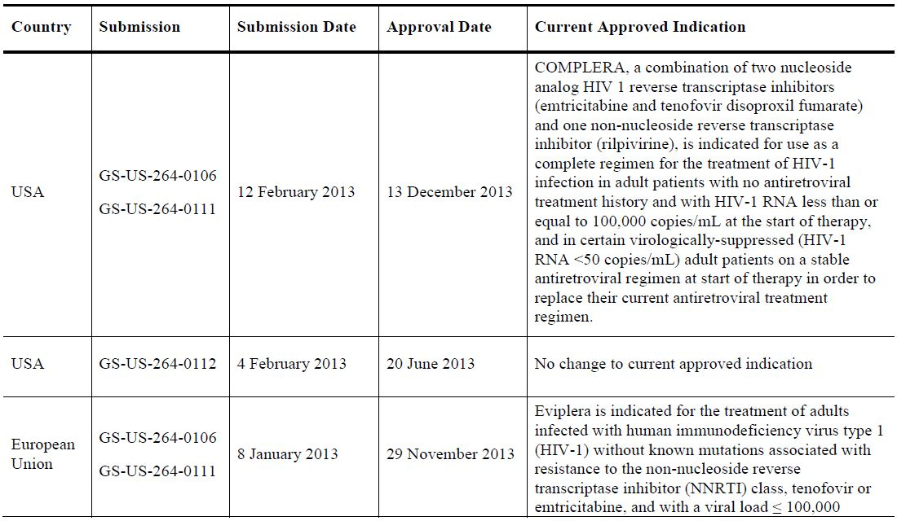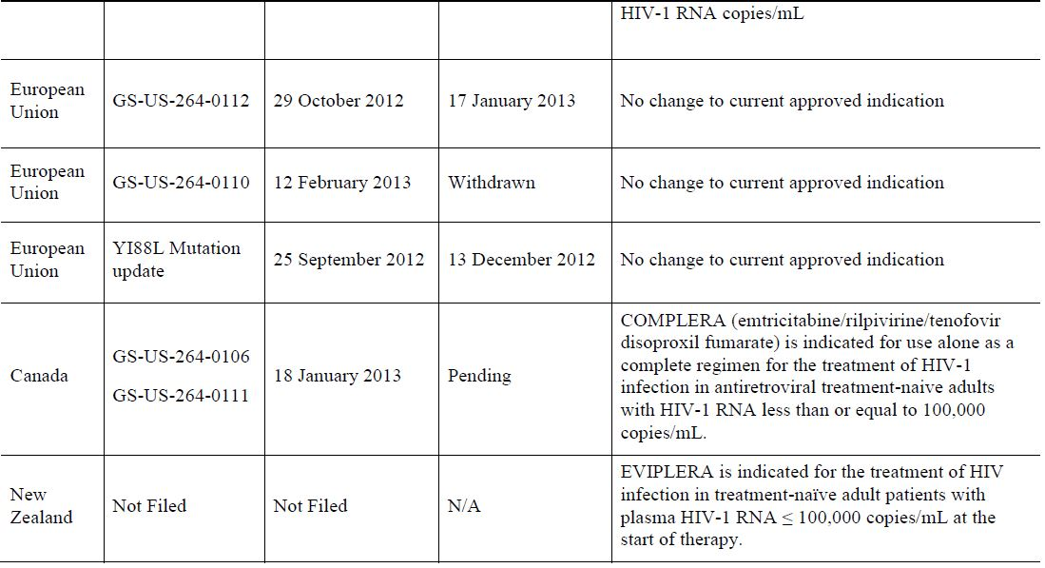

### Product information

The approved Product Information (PI) current at the time this AusPAR was prepared can be found as Attachment 1. For the most recent Product Information please refer to the TGA website at <<http://www.tga.gov.au/hp/information-medicines-pi.htm>>.

## II. Quality findings

There was no requirement for a quality evaluation in a submission of this type.

## III. Nonclinical findings

There was no requirement for a nonclinical evaluation in a submission of this type.

## IV. Clinical findings

A summary of the clinical findings is presented in this section. Further details of these clinical findings can be found in Attachment 2.

### Introduction

#### Clinical rationale

There are an increasing number of fixed dose combination (FDC) drugs for the treatment of HIV-1 infection and Eviplera is one. This FDC was developed as a complete antiretroviral (ARV) regimen for administration as a single tablet, administered once daily (OD) with a meal. The efficacy, safety, and tolerability of the TDF and FTC components of Eviplera single tablet regimen (STR) are well established, and key efficacy and safety data were provided in their respective original marketing applications. Within the NRTI-NNRTI class of FDC, Eviplera is an alternative agent to Atripla, the FDC consisting of TDF, FTC and efavirenz (EFV). Eviplera is registered as a drug for use in an ARV naïve setting in adults with HIV-1 infection. The clinical rationale for broadening its indication is two fold:

* To allow its use in naïve patients with higher plasma HIV RNA, that is higher than 100,000 copies/mL; and
* To allow its use in a treatment experienced setting including as a switch drug. An example would be if the patient is intolerant to the NNRTI component of their current FDC, then the patient could be switched to Eviplera in lieu of Atripla. In other words, the registration of Eviplera in this setting allows an intra class switch for intolerance through the replacement of one FDC by another.

#### Guidance

No specific guidance was given by the TGA. The sponsor followed the relevant format for a Category 1 submission with no deviation.

#### Contents of the clinical dossier

The clinical dossier contained the following:

* Pharmacokinetics:
  + 1 Phase I pharmacokinetic study in healthy adults, GS-US-264-0112, to determine the effect of food on the pharmacokinetics of Eviplera.
* 3 pivotal efficacy/safety studies:
  + Study GS-US-264-0110 is a Phase IIIb, randomised, open label study providing relevant new data that support the efficacy of the Eviplera tablets in adult patients with baseline HIV-1 RNA ≤500,000 copies/mL;
  + Studies GS-US-264-0111, a Phase IIb open label study, and GS-US-264-0106, a Phase IIIb, randomised, open label study, providing pharmacokinetics, efficacy, and safety data from virologically suppressed subjects switching to Eviplera.

#### Paediatric data

This drug is not registered for use in the paediatric setting.

#### Good clinical practice

All studies included in this submission were conducted in accordance with International Conference on Harmonisation (ICH) Good Clinical Practice (GCP) Guidelines. Considerations for the ethical treatment of human subjects were in place at the time the trials were performed, and informed consent was obtained from all trial participants.

### Pharmacokinetics

#### Studies providing pharmacokinetic data

Table 2 shows the studies relating to each pharmacokinetic topic and the location of each study summary.

Table 2: Submitted pharmacokinetic studies.

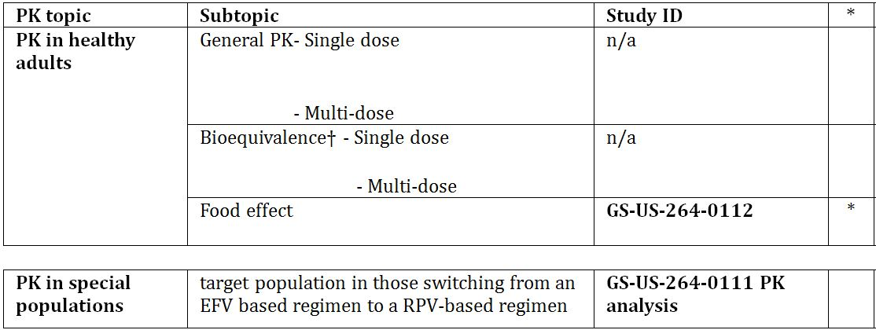

* Indicates the primary aim of the study. † Bioequivalence of different formulations. § Subjects who would be eligible to receive the drug if approved for the proposed indication.

None of the pharmacokinetic studies had deficiencies that excluded their results from consideration.

#### Evaluator’s conclusions on pharmacokinetics

The results of the Phase I pharmacokinetic Study GS-US-264-0112 in healthy volunteers confirm the need for Eviplera dosing with food and support the recommendation in the proposed PI. Pharmacokinetic data from the switch Study GS-US-264-0111 confirm a long “tail” of EFV decline following switch to Eviplera which, through ongoing induction of CYP3A4, modestly reduces RPV levels. However, RPV levels are therapeutic ≥2 weeks after switching. When coupled with continuing therapeutic levels of EFV up to and extending beyond this cross over point, this means plasma HIV-1 RNA remains fully suppressed. These data support the proposed language in the PI in regards to an Atripla to Eviplera switch. Patients should be warned that the side effects of EFV will not cease immediately post switch as the drug takes several weeks to decline.

### Pharmacodynamics

Not applicable.

### Dosage selection for the pivotal studies

No change in dosage is sought, as per registered dose.

### Efficacy

#### Studies providing efficacy data

The pivotal efficacy Study GS-US-264-0111 was titled: “A Phase IIB Open-Label Pilot Study to Evaluate Switching from a Regimen Consisting of an Efavirenz/Emtricitabine/Tenofovir Disoproxil Fumarate (TDF/FTC/EFV) Single Tablet Regimen to Emtricitabine/Rilpivirine/Tenofovir Disoproxil Fumarate (TDF/FTC/RPV) STR in Virologically-Suppressed, HIV-1 Infected Subjects”. This was a Phase IIb study, open label, multicentre, pilot study conducted between 27 January 2011 and 19 April 2012 across 18 sites in the USA.

Two others studies were:

* Study GS-US-264-0106: “A Phase III Randomised, Open-Label Study to Evaluate Switching from Regimens Consisting of a Ritonavir-boosted Protease Inhibitor (PI/r) and Two Nucleoside Reverse Transcriptase Inhibitors to Emtricitabine/Rilpivirine/Tenofovir Disoproxil Fumarate Fixed-dose Regimen in Virologically Suppressed, HIV-1 Infected Patients”
* Study GS-US-264-0110: “A Phase IIIB, Randomised, Open-label Study to Evaluate the Safety and Efficacy of a Single Tablet Regimen of Emtricitabine/Rilpivirine/Tenofovir Disoproxil Fumarate Compared with a Single Tablet Regimen of Efavirenz/Emtricitabine/Tenofovir Disoproxil Fumarate in HIV-1 Infected, Antiretroviral Treatment-Naïve Adults”

#### Evaluator’s conclusions on efficacy

The data from Study GS-US-264-0110 provides further data in support of Eviplera’s existing registered use with the drug being safe and well tolerated and virologically non inferior to Atripla over 48 weeks. While overall, the emergence of resistance was low in both groups, in those virologically failing Eviplera there was a greater emergence of multiple resistance mutations to both NNRTI and NRTI especially in those with baseline plasma HIV RNA >100,000 copies/mL and even more so in those with >500,000 copies/mL. The emergence of multiple NNRTI mutations impacts on the ability to use another second generation NNRTI, for example, etravirine. While the sponsor showed no statistical difference versus Atripla in regards to virological failure with baseline viral load >100,000 to <500,000 copies/mL, the clinical evaluator does not think other important factors need to be considered. First high viral load above 100,000 is associated with an increased risk of virological failure with Eviplera (and this finding is consistent with the earlier registration studies). Importantly, as the failure is associated with multiple mutations, this would impact not only on future use of NNRTI but also the potential activity of future NRTI backbones. Moreover, another strategy for the use of the drug rather than using it first up in patients with high baseline viral load is provided by the switch studies, GS-US-264-0111 and GS-US-264-0106. These studies provide data for the use of Eviplera as a switch drug for the NNRTI efavirenz, and in Study GS-US-264-0106 as a switch from PI/r in virologically suppressed patients. It is important to note that a history of virological failure to the prior ARV regimen excluded participation. That being said, a small percentage of patients in both studies did have some NNRTI and/or NRTI resistance mutations on historical genotypes; these did not appear to impact Eviplera response to any great extent. The data from these switch studies supports the use of Eviplera in virologically suppressed treatment experienced patients without any history of virological failure associated with genotypic resistance to NNRTI and NRTI.

### Safety

#### Studies providing safety data

GS-US-264-0111 (single arm pilot switch) and GS-US-264-0106 (immediate and delayed switch) and GS-US-264-0110 (randomised naïve study) provided evaluable safety data.

##### Pivotal efficacy studies

In the pivotal efficacy studies, the following safety data were collected.

General adverse events (AEs) were assessed by investigators through direct questioning & patient report, complete (Weeks 24 and 48 at investigator discretion) or symptom directed physical exam including vital signs at screening, baseline, Weeks 4, 8, 12, 24, 36 and 48 in both GS-US-264-0111 and GS-US-264-0106. The evaluations were completed at Weeks 4, 8, 12, 16, and then every 8 weeks through 48 Weeks, then every 12 weeks until Week 96 in GS-US-264-0110. AEs of particular interest were assessed by laboratory assessments (including renal function, liver function, alanine aminotransferase [ALT] flare, and pregnancy test at all study visits in GS-US-264-0111 and GS-US-264-0106) and electrocardiogram (ECG) measurements in GS-US-264-0111 (at screening, baseline, Weeks 4, 12 and 48). In Study GS-US-264-0110, ECGs were performed at Weeks 48 and 96. In GS-US-264-0106, subjects randomised to the stay on baseline regimen (SBR) group (Eviplera switch at Week 24) also returned for a visit at Weeks 28 and 32. Subjects in Study GS-US-264-0106 extension (after Week 48) returned for study visits every 12 Weeks (Week 60+), during which laboratory analyses (haematology, chemistry, urinalysis, pregnancy test), ECGs (annual), and complete/symptom directed physical exams were performed.

Numerous AEs were of particular interest:

* Drug resistance
* Hepatic AEs, because hepatotoxicity is considered an important potential risk for RPV, and post treatment hepatic flares in HIV-1/hepatitis B virus (HBV) co-infected subjects considered important identified risks for FTC and TDF
* Skin AEs, as severe skin reactions are considered important potential risks for RPV, and rash was a common AE identified in prior RPV studies
* Psychiatric AEs, as major depressive disorder is considered an important potential risk for RPV
* Renal AEs, as renal toxicity is considered an important identified risk for TDF
* Bone AEs, as bone events due to proximal renal tubulopathy/loss of bone mineral density are considered important identified risks for TDF. Bone events (osteomalacia and infrequently contributing to fractures) may occur as a consequence of TDF associated renal toxicity
* Muscle AEs, as these may occur as a consequence of TDF associated renal and muscle toxicity
* Cardiac AEs, because QT interval[1] prolongation is considered an important potential risk for RPV
* Lipodystrophy, because this is considered an important identified risk for FTC and TDF and an important potential risk for RPV
* Pancreatitis, because this is considered an important identified risk for TDF
* Lactic acidosis and severe hepatomegaly with steatosis, because these are important identified risks for FTC and TDF
* Interaction with didanosine, because this is an identified risk for TDF
* Bleeding disorders, because this is a potential risk for RPV
* Overdose, because overdose is considered an potential risk
* Pregnancy/lactation, because of a paucity of information for Eviplera.

Laboratory tests were performed at all study visits (except Weeks 2 and 6 in Study GS-US-264-0111 as these were pharmacokinetic visits) in each study:

* full blood chemistry
* estimated glomerular filtration rate (eGFR) calculated from chemistry panel using Cockcroft-Gault formula
* fasting Metabolic panel (lipids and glucose)
* urinalysis
* pregnancy test
* T cells
* plasma HIV RNA
* HIV resistance testing when protocol specified algorithms for virological failure met.

##### Pivotal studies that assessed safety as a primary outcome

There were no pivotal studies that assessed safety as a primary outcome.

##### Dose-response and non-pivotal efficacy studies

Not applicable.

##### Other studies evaluable for safety only

Not applicable.

#### Patient exposure

Of 50 patients enrolled in Study GS-US-264-0111, 49 received ≥1 dose of study drug. One subject stopped study drug after Week 36 because of incarceration. All 49 subjects received study drug for ≥44 Weeks; median exposure was 48 weeks. In Study GS-US-264-0106, 469 subjects received at least 1 dose of Eviplera, including 317 in the Eviplera group and 152 in the Delayed Switch group. Mean (SD) duration of Eviplera exposure was 45.6 (9.21) weeks in the Eviplera group and 23.2 (3.93) weeks in the Delayed Switch group. In Study GS-US-264-0110, 394 subjects received ≥1 dose Eviplera, and 392 subjects received ≥1 dose Atripla. The mean (SD) duration of exposure to randomised study drug was 53.2 (13.47) weeks (Eviplera group) and 50.3 (17.67) weeks in the Atripla group.

#### Safety issues with the potential for major regulatory impact

None identified in regards to liver, haematological toxicity, serious skin reactions, cardiovascular safety, unwanted immunological events, or other safety issues.

#### Post marketing data

Worldwide cumulative patient exposure to Eviplera since first marketing approval in the US (10 August 2011) to 31 July 2012 estimated at 13,054 patient years. There were 2 Periodic Safety Update Reports (PSURs): 11 August 2011 to 10 February 2012, and 11 February 2012 to 10 August 2012. In these PSURs, 25 and 74 medically confirmed cases met PSUR inclusion criteria, respectively, of which 24 and 73 were spontaneous reports; 1 case in each PSUR was a serious AE (SAE) from a clinical study that was considered Eviplera related (investigator/sponsor physician). All safety data for the topics under close monitoring for Eviplera were reviewed. Following review of drug resistance data, the Y188L substitution was identified as a reverse transcriptase (RT) mutation conferring resistance to RPV. Ten spontaneous cases involving 16 SAEs received between 11 August 2012 and 31 October 2012. Medically confirmed spontaneous cases received in this period with SAEs in the topics under close monitoring in PSURs were: drug resistance/lack of efficacy (n = 3), hepatic events (n = 2), skin reactions (n = 1), psychiatric (n = 1), cardiac (n = 1), bone and muscle events (n = 1). There was one spontaneous report of death: a HIV/HBV co-infected patient with a CD4+ count of ‘46’ prior to initiation of Eviplera, who died due to Immune Reconstitution Inflammatory Syndrome (IRIS) with an associated respiratory component. IRIS has been reported in patients treated with ARV with low baseline CD4 count a known risk factor.

#### Evaluator’s conclusions on safety

These 3 pivotal studies and the RPV post marketing reports confirm the drug to be safe and well tolerated. Moreover, it appears more lipid neutral compared to both PI/r and Atripla. However, the clinical significance of this is uncertain as the changes, although favourable, were small. No new AEs were revealed by these studies and aside from the addition of the Y188L as an RPV resistance associated mutation, no new resistance concerns were revealed. The evaluator has commented specifically on RPV resistance in those with higher plasma HIV RNA in the ‘Efficacy’ summary. No new adverse reactions to Eviplera were identified in the 3 pivotal clinical trials presented in this application.

### First round benefit-risk assessment

#### First round assessment of benefits

The benefits of Eviplera in the proposed usage are:

* Safe, with a favourable tolerability profile as a switch drug for either Atripla or PI/r
* Effective as a switch drug in virologically suppressed patients on Atripla or PI/r
* Non inferior to Atripla in the head-to-head study in naïve study which patients with HIV RNA >100,000 copies/mL and
* Modest lipid benefits as a switch drug.

#### First round assessment of risks

The risks of Eviplera in the proposed usage are as follows:

* The sponsor is seeking a broad approval for use of the drug in “treatment experienced”, when in fact the only use of this drug in treatment experienced patients as presented in this submission is as a switch drug for either Atripla or PI/r in patients who have not virologically failed their previous regimen and without baseline resistance to the components of Eviplera on historical resistance testing
* While in subjects with baseline viral load ≤100,000 copies/mL, the numbers of subjects with emergent resistance was similar between groups, that is, 1.9% for Eviplera and 0.8% for Atripla, in those with baseline viral load >100,000 to 500,000 copies/mL, 5.1% versus 0% in the Eviplera and Atripla groups, respectively, developed emergent resistance. For subjects with baseline viral load >500,000 copies/mL, 7 of 36 (19%) subjects in the Eviplera group and 1 of 25 subjects (4%) in the Atripla group had genotypic and/or phenotypic resistance to at least one regimen component. The sponsor seeks approval for the use of Eviplera in patients with plasma HIV RNA <500,000 copies/mL, but although the viral failure rates between >100,000-<500,000 copies/mL are low, most of the patients failing were found to fail with both multiple NNRTI and NRTI resistance mutations. If this occurred, there is a real potential to impact negatively not only on the future activity of another NNRTI (for example, etravirine), but also the next NRTI backbone. This very issue of higher virological failure and multiple RT mutations in those failing is the reason why Eviplera is currently approved only for use in naïve patients with baseline plasma viral load ≤100,000 copies/mL. Moreover, because in real terms the difference between a viral load of <500,000 and >500,000 is fairly arbitrary (in log terms) and within the variability of the viral load test, the evaluator has concerns about the approval of Eviplera in those with HIV RNA >100,000 copies/mL. The clinical evaluator believes the current restriction to a plasma HIV RNA of threshhold of ≤100,000 copies/mL for Eviplera in the ARV naïve setting should continue. In this way, if patients with viral load slightly above this threshold (100,000 = 5 log10 copies/mL, 200,000 = 5.31 log10 copies/mL; 300,000 = 5.477 log10 copies/mL, etc.) inadvertently receive Eplivera, then clinicians and their patients could be somewhat reassured that the risk of virologic failure is relatively low. The evaluator’s concerns in this regard are compounded by the association of higher virological failure in patients with low CD4+ starting Eviplera, that is, as stated in the US PI:
  + *Regardless of HIV-1 RNA level at the start of therapy, more rilpivirine treated subjects with CD4+ cell count less than 200 cells/mm3 at the start of therapy experienced virologic failure compared to subjects with CD4+ cell count greater than or equal to 200 cells/mm3.*
* Study GS-US-264-0110 enrolled relatively few patients with CD4+ <200 cells/µL (n = 53, 13.5% of the Eviplera arm). As a result, the evaluator does not believe this study provides sufficient additional data in regards to virological success in those with these low CD4+ and plasma HIV RNA >100,000 to ≤500,000 copies/mL
* The use of the term “HIV infection” in the current PI is too loose; RPV has no activity in HIV-2 infected patients (that is, “rilpivirine demonstrated limited activity in cell culture against HIV-2 with a median EC50 Gilead Sciences 30 value of 5220 nM [range 2510 to 10830 nM] and should not be used.”). Hence, the drug can only be used in HIV-1 infected patients. The term “HIV infected” should be avoided and replaced with **“HIV-1 infected”**.

#### First round assessment of benefit-risk balance

The benefit-risk balance of Eviplera is unfavourable given the proposed usage, but would become favourable if the changes recommended in the next section (‘First Round Recommendation Regarding Authorisation’) are adopted.

### First round recommendation regarding authorisation

The clinical evaluator recommends the authorisation of Eviplera in treatment experienced patients wishing to switch away from an NNRTI or PI/r regimen for tolerability or pill burden reasons. Patients must not have a history of resistance to any components of the drug on historical genotype. In other words, the evaluator does not approve the blanket use of this drug in “treatment experienced” patients. The clinical evaluator thinks the definition of “treatment experienced” needs to be qualified in line with the data provided in this Application. The evaluator does not recommend the authorisation of the drug for use in HIV-1-infected patients with Plasma HIV-RNA >100,000 to ≤500,000 copies/mL. The evaluator thinks the current threshold of ≤100,000 copies/mL is acceptable, as a strategy, the data from the switch studies detailed in this submission, could allow patients with very high viral loads to start on one drug regimen, for example, a PI/r based regimen then switch after virological suppression for >6 months.

### Clinical questions

No questions.

## V. Pharmacovigilance findings

### Risk management plan

#### Contents of the submission

The sponsor submitted an Australian-Risk Management Plan (AU-RMP) for Eviplera Version 2.0, dated June 2013.

The sponsor proposes routine pharmacovigilance activities to monitor all the specified ongoing safety concerns, including the use of targeted follow-up questionnaires for renal events, including renal tubulopathy, and bone events (TDF) and development of resistance (RPV). Additional pharmacovigilance activities are also proposed to further monitor and characterise all the specified ongoing safety concerns, except for the important identified risks: ‘Post-treatment hepatic flares in HIV-1/HBV co-infected patients’, ‘Interaction with didanosine’, ‘Pancreatitis’, ‘Lactic acidosis and severe hepatomegaly with steatosis’ & ‘Lipodystrophy’; the important potential risk: ‘Overdose and the important missing information: ‘Safety information for Eviplera’, ‘Safety in elderly patients’, ‘Safety in lactation’ and ‘Safety in patients with severe hepatic impairment (CPT score C)’.

The updated AU-RMP states:

*No risk minimisation measures additional to the provision of comprehensive safety information in the product labelling are considered to be warranted for Eviplera.*

This is contrary to what was previously accepted for Eviplera.

The Executive Summary of the AU-RMP states:

*A number of updates from Version 0.1 to 2.0 of the Eviplera AU-RMP have been made. The main changes of clinical importance are as follows.*

However, the information that follows appears to be incomplete and inadequate. Consequently, the quality of the RMP documentation is considered to be poor. The sponsor should briefly yet adequately summarise the material changes from the previous AU-RMP.

#### Ongoing safety concerns

The sponsor provided a summary of ongoing safety concerns for Eviplera (Table 3) and the components of Eviplera (Table 4).

Table 3: Summary of ongoing safety concerns for Eviplera.

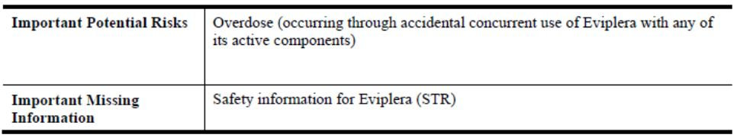

Table 4: Summary of ongoing safety concerns for the components of Eviplera.

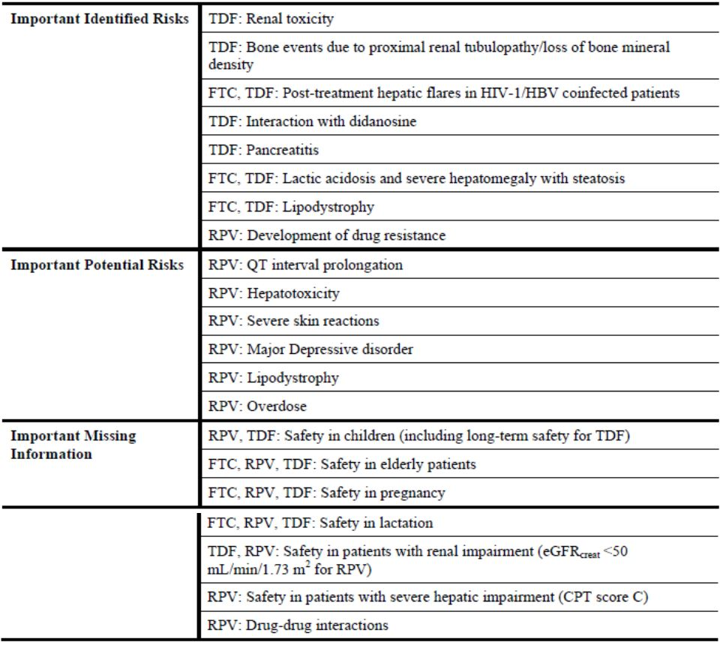

#### Reconciliation of issues outlined in the RMP report

Reconciliation of issues outlined in the RMP report is as follows.

In their response to the TGA Section 31 Requests, the sponsor provided an updated AU-RMP Version: 2.0 (dated December 2013). Key changes from the version evaluated at Round 1 are summarised in Table 5.

Table 5: Key changes between RMP Round 1 and 2 evaluations.

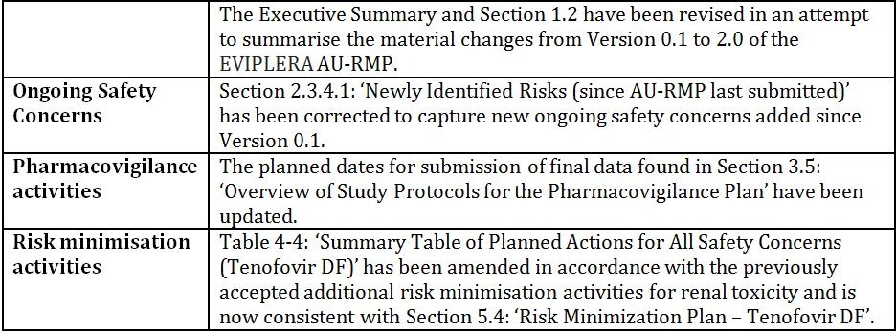

##### Recommendation #1

The Executive Summary of the AU-RMP states: “A number of updates from Version 0.1 to 2.0 of the Eviplera AU-RMP have been made. The main changes of clinical importance are as follows”. However, the information that follows appears to be incomplete and inadequate. Consequently the quality of the RMP documentation is considered to be poor. The sponsor should briefly yet adequately summarise the material changes from the previous AU-RMP.

###### Sponsor’s response

The Executive Summary and Section 1.2 of the AU-RMP have been updated with details of the material changes from the previous AU-RMP.

###### OPR evaluator’s comment

These sections of the revised AU-RMP do not appear to entirely capture the changes to the Pharmacovigilance Plan as observed in the RMP Evaluation Report (28 November 2013). These sections of the revised AU-RMP should also capture the changes to the ongoing safety concerns as observed in the RMP Evaluation Report. Consequently, this remains an outstanding issue.

##### Recommendation #2

Safety considerations may be raised by the clinical evaluator through the consolidated Section 31 request and/or the Clinical Evaluation Report, respectively. It is important to ensure that the information provided in response to these includes a consideration of the relevance for the RMP, and any specific information needed to address this issue in the RMP. For any safety considerations so raised, the sponsor should provide information that is relevant and necessary to address the issue in the RMP.

###### Sponsor’s response

The sponsor has provided no response.

###### OPR evaluator’s comment

Given no specific issues were raised in the clinical evaluation report, this is acceptable.

##### Recommendation #3

Section 2.3.4.1 of the updated AU-RMP states:

*There have been no newly identified important risks for Eviplera, emtricitabine, rilpivirine or TDF since the last AU-RMP was submitted.*

However, this contrary to what is observed as the specified ongoing safety concerns are the same as those previously accepted for Eviplera, except for the addition of:

* the important identified risk: ‘Bone events due to proximal renal tubulopathy/loss of bone mineral density’ (TDF)
* the important potential risks: ‘Lipodystrophy’ & ‘Overdose’ (RPV)
* the important missing information: ‘Safety in patients with renal impairment (eGFR <50 mL/min/1.73 m2 for RPV)’ & ‘Drug-drug interactions’ (RPV) and
* the re-classification of the important potential risk: ‘Development of drug resistance’ to an important identified risk (RPV).

In principle, there are no objections to these changes and additions to the summary of the ongoing safety concerns. However, the sponsor should provide a concise rationale for these changes and additions.

###### Sponsor’s response

The sponsor has provided a concise rationale for the observed changes and additions to the ongoing safety concerns and Section 2.3.4.1 has been updated accordingly.

###### OPR evaluator’s comment

This is acceptable.

##### Recommendation #4

The sponsor should provide copies of the targeted follow-up questionnaires for renal events, including renal tubulopathy, and bone events (TDF) and development of resistance (RPV) and include these as an annex to the AU-RMP. In addition, Table 6-1: ‘Summary Table of the AU Risk Management Plan for Eviplera’ should be amended to reflect these activities.

###### Sponsor’s response

The sponsor has provided copies of the targeted follow-up questionnaires for renal events, including renal tubulopathy, and bone events (TDF) and development of resistance (RPV) in their correspondence dated 24 December 2013 and Table 6-1 has been amended to reflect the use of targeted follow-up questionnaires as part of routine pharmacovigilance.

###### OPR evaluator’s comment

This is acceptable.

##### Recommendation #5

The sponsor should provide the current version of the draft protocol for the planned clinical Study TMC278IFD3002 (SALIF) to the TGA for review.

###### Sponsor’s response

The sponsor notes this request and provides assurance that the final protocol for the Janssen sponsored TMC278IFD3002 (SALIF) study can be provided to the TGA for informational purposes only once it becomes available. As this is an EU study and will not be conducted in Australia, the sponsor does not propose to provide the draft protocol to the TGA for review. This study has been classed by Janssen as a Category 4 study. In accordance with guidelines on good pharmacovigilance practices, only Category 1-3 studies need to be appended to an RMP.

###### OPR evaluator’s comment

This is acceptable.

##### Recommendation #6

The ongoing and initiated studies are not considered to be part of the planned clinical studies in the pharmacovigilance plan. Therefore, the related study protocols have not been reviewed or requested for review if missing. Nevertheless, these studies will either generate safety data that will simply support the known safety profile of the medicine or generate data that will provoke applications to amend the Australian registration details. It is noted that some of the planned dates for submission of final data have already passed. Therefore, the sponsor should update this information accordingly.

###### Sponsor’s response

The planned dates for submission of final data found in Section 3.5: ‘Overview of Study Protocols for the Pharmacovigilance Plan’ have been updated. The sponsor has also provided an assurance that data from these studies will be included in the next routine submission of the AU-RMP.

###### OPR evaluator’s comment

This is acceptable.

##### Recommendation #7

The submitted protocol synopsis for planned pharmacoepidemiology study to define the long term safety profile of TDF and explore the management of TDF associated renal and bone toxicity in HIV infected children aged 2 to < 18 years in Europe lends itself to detailed assessment. Consequently, the sponsor should provide an assurance that it will submit the draft protocol for the proposed post authorisation safety study (PASS) to the TGA for review once it becomes available.

###### Sponsor’s response

Gilead notes this request and provides assurance that the final protocol for the proposed PASS can be provided to the TGA once it becomes available. As this is an EU study and will not be conducted in Australia, the sponsor does not propose to provide the draft protocol to the TGA for review. The final protocol can be provided to the TGA for informational purposes only.

###### OPR evaluator’s comment

The provision of the draft protocol to the TGA for review will not be pursued and the sponsor’s assurance that the final protocol for the proposed PASS will be provided to the TGA once it becomes available is acceptable.

##### Recommendation #8

The sponsor’s conclusion that no additional risk minimisation activities are required for any of the specified ongoing safety concerns is contrary to what was previously accepted for Eviplera with no justification provided to support this change. In addition, Table 4-4: ‘Summary Table of Planned Actions for All Safety Concerns (Tenofovir DF)’ have been amended to reflect this new position, although Section 5.4: ‘Risk Minimization Plan – Tenofovir DF’ of the AU-RMP states:

*Gilead is committed to conducting educational programs for healthcare providers in Australia*

In regard to the important identified risk: ‘Renal toxicity’ for the TDF component and 6-1: ‘Summary Table of the AU Risk Management Plan for Eviplera’ still refers to additional risk minimisation activities albeit in relation to the important identified risk: ‘Bone events due to proximal renal tubulopathy/loss of bone mineral density’ for the TDF component. Consequently, the updated AU-RMP is considered to be confused and internally inconsistent in relation to this matter. The sponsor should provide compelling justification for removing the previously accepted additional risk minimisation activities in regard to the important identified risk: ‘Renal toxicity’ for the TDF component or reinstate such activities in a revised AU-RMP. In either case, the AU-RMP must be amended to be internally consistent.

###### Sponsor’s response

Table 4-4: ‘Summary Table of Planned Actions for All Safety Concerns (Tenofovir DF)’ has been amended in accordance with the previously accepted additional risk minimisation activities for renal toxicity and is now consistent with Section 5.4: ‘Risk Minimisation Plan – Tenofovir DF’.

###### OPR evaluator’s comment

This is acceptable. However, the Executive Summary of the revised AU-RMP continues to state:

*No risk minimisation measures additional to the provision of comprehensive safety information in the product labelling are considered to be warranted for Eviplera.*

Consequently, this remains an outstanding issue.

##### Recommendation #9

The provision of the results of the assessment of the effectiveness of the educational programmes related to the important identified risk: ‘Renal toxicity’ and the continued commitment to evaluate further scheduled educational meetings are acceptable. The major concern in regard to the proposed changes to the RMP previously accepted for Eviplera has been previously covered.

###### Sponsor’s response

The sponsor has provided no response.

###### OPR evaluator’s comment

Not applicable.

## VI. Overall conclusion and risk/benefit assessment

The submission was summarised in the following Delegate’s overview and recommendations:

### Quality

There was no requirement for a quality evaluation in a submission of this type.

### Nonclinical

There was no requirement for a nonclinical evaluation in a submission of this type.

### Clinical

#### Pharmacology

Pharmacokinetic study GS-US-264-0112 is a Phase I study to determine the effect of food on the pharmacokinetics of Eviplera in healthy adults. Administration of Eviplera with light meal or standard meal resulted in a modest increase in RPV and tenofovir exposures versus fasting conditions; RPV and tenofovir exposures were similar with a light meal versus standard meal. FTC exposures were similar regardless of fed or fasted conditions. The clinical evaluation report concludes these results confirm the recommendation that Eviplera single tablet regimen be administered with food.

Study GS-US-264-0111 was a pharmacokinetic analysis in the target population switching from an EFV based regimen to a RPV based regimen in a Phase IIb open label single arm pilot study. The results show plasma EFV concentrations remained measurable in the majority of subjects through to Week 4 after discontinuation of Atripla. EFV, through ongoing induction of CYP3A4, modestly reduced RPV levels. However, RPV levels are therapeutic ≥2 weeks after switching and this coupled with continuing therapeutic levels of EFV up to and extending beyond this cross over point means plasma HIV RNA remains fully suppressed.

#### Efficacy

The clinical efficacy studies presented in this application consisted of 2 switch studies in ARV treatment experienced adults with virologically suppressed (VL <50 copies/mL) HIV-1, that is, GS-US-264-0111 (switch from Atripla); GS-US-264-0106 (switch from PI/r + 2 NRTI); and a head-to-head Phase III study of Eviplera versus Atripla in HIV-1-infected ARV naïve patients with plasma HIV RNA >2500 copies/mL (no upper limit of plasma HIV RNA for inclusion).

Study GS-US-264-0111 is a Phase IIb open label pilot study to evaluate switching from a regimen consisting of a TDF/FTC/EFV single tablet regimen to TDF/FTC/RPV single tablet regimen in virologically suppressed, HIV-1 infected subjects. A total of 50 patients were enrolled at 18 sites in the US; 49 subjects received study drug. One subject was enrolled but subsequently withdrew consent and was never dosed. A total of 48 subjects completed the protocol defined period of study drug dosing. One subject did not complete study drug dosing because of a protocol violation. The majority of subjects were male with mean age 38 years. The primary efficacy endpoint (proportion of subjects with HIV-1 RNA <50 copies/mL at Week 12 as defined by the FDA snapshot analysis based on the full analysis set) was seen in all 49 subjects (100%; 95% CI: 92.7%, 100%) with HIV-1 RNA <50 copies/mL at Week 12. At Weeks 24 and 48, 100% and 93.9% of subjects (46 of 49 subjects; 95% CI: 83.1%, 98.7%) maintained HIV-1 RNA <50 copies/mL, respectively. At Week 48, 2 subjects (4.1%) had HIV-1 RNA ≥50 copies/mL and were considered virologic failures.

Study GS-US-264-0106 is a Phase III randomised, open label study to evaluate switching from regimens consisting of a PI/r and two NRTIs to TDF/FTC/RPV FDC in virologically suppressed, HIV-1 infected patients. Subjects were randomised in a 2:1 ratio to one of the following two treatment arms:

* Treatment Arm 1: Switched Eviplera (planned n = 280)
* Treatment Arm 2: Delayed switch to Eviplera after remaining on current PI/r+ NRTI inhibitors for 24 Weeks after baseline visit (planned n = 140).

Treatment groups were stratified for use of TDF (either TDF or Truvada) and Lopinavir/Ritonavir at enrolment. The primary efficacy outcome was the proportion of subjects with HIV-1 RNA <50 copies/mL at Week 24 as defined by the FDA snapshot analysis based on full analysis set. A total of 482 patients were enrolled. The majority of patients were male (87%), White (76.7%), and mean age was 42 years. 94.7% had HIV RNA < Lower Limit of Quantification (LLQ). At baseline, CD4 + was 584/μL. Mean duration of ARV 3.3 years. The majority were on TDF/FTC at screening.

The proportion with HIV-1 RNA <50 copies/mL at Week 24 was similar in Eviplera 297/317 (93.7%) and SBR 143/159 (89.9%) treatment groups. The treatment difference was 3.8% (95% CI: -1.6%, 9.1%) with the lower bound of the 95% CI was within the predefined 12% margin for non inferiority of Eviplera to SBR at Week 24. In the Delayed Switch group, 92.1% had HIV-1 RNA <50 copies/mL after 24 weeks of treatment, consistent with the Eviplera group at Week 24. The proportion of Eviplera subjects with HIV-1 RNA <50 copies/mL at Week 48 was analysed as a secondary endpoint. 88.3% of Eviplera group had HIV-1 RNA <50 copies/mL through 48 Weeks (95% CI: 84.3%, 91.6%). Virologic rebound was defined as 2 consecutive visits with HIV-1 RNA ≥400 copies/mL. In the Eviplera group, 4 patients had protocol defined exclusion mutations at baseline. In the Eviplera group, 2 patients (0.6%) developed resistance mutations to study drugs at week 24 and 4 (1.3%) by Week 48. In SBR group, 1 patient (0.6) developed resistance mutations to study drugs to Week 24.

Study GS-US-264-0110 is a Phase IIIb, randomised, open label study to evaluate the safety and efficacy of a single tablet regimen of TDF/FTC/RPV compared with a single tablet regimen of TDF/FTC/EFV in HIV-1 infected, ARV treatment naïve adults. The study enrolled adult HIV-1 infected ARV treatment naïve patients with HIV-1 RNA levels >2500 and with documented sensitivity to EFV, FTC, TDF at screening and no RPV mutations (K101E/P, E138A/G/K/Q/R, H221Y). The main efficacy variable was to evaluate the efficacy of Eviplera STR versus Atripla single tablet regimen in HIV-1 infected, ARV treatment naive adult subjects as determined by the achievement of HIV-1 RNA <50 copies/mL at 48 Weeks using the US FDA snapshot analysis. The primary analysis was stratified by baseline HIV-1 RNA levels <100,000 versus >100,000.

A total of 799 subjects were randomised, TDF/FTC/RPV (n = 400 with 394 in FAS), and TDF/FTC/EFV (n = 399 with 392 in FAS). The majority of subjects were male (92.9%), white (67.3%) and with mean age 37 years. At baseline, mean CD4+ count was 390.5 cells/μL , mean HIV-1 RNA was 4.81 log10 copies/mL in the Eviplera group and 4.78 (0.610) log10 copies/mL in the TDF/FTC/EFV group and proportion with HIV-1 RNA <100,000 copies/mL was 66% in Eviplera and 63.8% in TDF/FTC/EFV groups.

In the snapshot analysis, HIV-1 RNA < 50 copies/mL at Week 48 was 85.8% for Eviplera and 81.4% for Atripla group (4.1% treatment difference; 95% CI: -1.1%, 9.2%) The lower bound of the 95% CI of this treatment difference was within the predefined 12% margin for non inferiority of Eviplera to Atripla. A total of 32 (8.1%) Eviplera group subjects and 22 (5.6%) Atripla group subjects were considered virologic failures at Week 48 (2.7% treatment difference; 95% CI: -0.9%, 6.2%). Among the virologic failures, 7 subjects (1.8%) in the Eviplera group and 4 subjects (1.0%) in the Atripla group had HIV-1 RNA ≥50 copies/mL at Week 48. The remaining subjects considered as virologic failures either discontinued due to lack of efficacy (11 subjects [2.8%] in the Eviplera group and 3 subjects [0.8%] in the Atripla group) or due to other reasons. There were 27 subjects (3%) analysed for resistance development (20 [5%] in the Eviplera group and 7 [2%] in the Atripla group) and all had genotypic and phenotypic data available.

A total of 17 of 394 (4%) in the Eviplera group and 3/392 (1%) in the Atripla group developed primary emergent NRTI or NNRTI resistance mutations or reduced susceptibility to at least one regimen component.

In subjects with baseline viral load ≤100,000 copies/mL, emergent resistance was similar between groups, that is, 1.9% for Eviplera and 0.8% for Atripla. In those with baseline viral load >100,000 to 500,000 copies/mL, 5 of 98 subjects (5.1%) Eviplera group and 0 of 117 subjects (0%) Atripla group subjects developed emergent resistance. For subjects with baseline viral load >500,000 copies/mL, 7 of 36 (19%) Eviplera group subjects and 1 of 25 (4%) Atripla group subjects had genotypic and/or phenotypic resistance to at least one regimen component.

#### Safety

No new adverse reactions to Eviplera were identified in the 3 pivotal clinical trials. Based on these studies and RPV post marketing reports the drug was considered well tolerated. Eviplera appears to be more lipid neutral compared to both PI/r and Atripla, although differences were modest and of uncertain clinical significance.

#### Clinical evaluator’s conclusions and recommendations

The clinical evaluation report describes benefits of Eviplera in the proposed usage as:

* Safe, with a favourable tolerability profile as a switch drug for either Atripla or PI/r
* Effective as a switch drug in virologically suppressed patients on Atripla or PI/r
* Non inferior to Atripla in the head-to-head study in naïve study which patients with HIV RNA >100,000 copies/mL and
* Modest lipid benefits as a switch drug.

The sponsor is seeking a broad approval for use of the drug in “treatment experienced”, when in fact the only use of this drug in treatment experienced patients as presented in this submission is as a switch drug for either Atripla or PI/r in patients who have not virologically failed their previous regimen and without baseline resistance to the components of Eviplera on historical resistance testing.

The clinical evaluation report did not support approval of Eviplera in ARV naïve patients with HIV-1 RNA >100,000 to <500,000 copies/mL as proposed in the application because of emergent resistance. Particular issues were most patients experiencing virological failure on Eviplera failed with multiple NNRTI and NRTI resistance mutations with potential negative impacts on future treatment options. Concerns were compounded by the association of higher virological failure in patients with low CD4 + counts starting Eviplera.

The clinical evaluation report recommends the authorisation of Eviplera in treatment experienced patients wishing to switch away from an NNRTI or PI/r regimen for tolerability or pill burden reasons. Patients must not have a history of resistance to any components of the drug on historical genotype. The clinical evaluation report considered the definition of “treatment experienced” needs to be qualified in line with the data provided in this Application’. In the PI submitted in the Section 31 response, the sponsor maintains a broad indication:

*Eviplera is indicated for the treatment of HIV-1 infection in adult patients with plasma HIV-1 RNA <100,000 copies/mL (see CLINICAL TRIALS). Patients must not have a history of resistance to any of the components of Eviplera (TDF, FTC or RPV).*

Under ‘CLINICAL TRIALS’, the subheading “In Treatment Experienced HIV-1 Infected Patients has been amended to “In Virologically Suppressed HIV-1 Infected Patients”.

The Delegate considers the sponsor’s response to ‘Indications’ is inadequate in view of the very limited clinical experience in treatment experienced HIV-1 infected patients. The Delegate considers the current ‘Indications’ statement in treatment naïve adult patients with plasma HIV-1 RNA < 100,000 copies/mL should be maintained and a new statement added in relation to in certain virologically suppressed (HIV-1 RNA <50 copies/mL) adult patients on a stable antiretroviral regimen at start of therapy in order to replace their current antiretroviral treatment regimen (see Clinical Trials). Patients must not have a history of resistance to any of the components of Eviplera (TDF, FTC or RPV).

### Risk management plan

The RMP Round 2 evaluation still considers aspects of the Version 2.0 Eviplera AU-RMP are unsatisfactory and the sponsor should correct these oversights before this application is approved.

### Risk-benefit analysis

#### Delegate’s considerations

The sponsor currently proposes broad indications:

*Eviplera is indicated for the treatment of HIV-1 infection in adult patients with plasma HIV-1 RNA ≤ 100,000 copies/mL (see CLINICAL TRIALS).*

*Patients must not have a history of resistance to any of the components of EVIPLERA (TDF, FTC or RPV).*

Clinical Trials section of PI includes subheadings “In Treatment Naïve HIV-1 Infected Adults” and “In Virologically Suppressed HIV-1 Infected Patients”.

The only use of this drug in treatment experienced patients presented in this application is as a switch drug for either Atripla or PI/r in patients who have not virologically failed their previous regimen and without baseline resistance to the components of Eviplera on history and resistance testing.

The clinical evaluation report did not support approval of Eviplera in ARV naïve patients with HIV-1 RNA >100,000 to <500,000 copies/mL, as proposed in the application, because of emergent resistance in Study GS-US-264-0110. The sponsor has amended the indication statement in line with the clinical evaluator’s comment that the current threshold of ≤100,000 copies/mL is acceptable. Accordingly, the sponsor has removed all clinical data from the PI relating to Study GS-US-264-0110.

The Delegate considers that the extension of extension of Indications should have separately statements relating to use in the study populations, as follows:

*Eviplera is indicated for the treatment of HIV-1 infection in treatment-naïve adult patients with plasma HIV-1 RNA <100,000 copies/mL at the start of therapy.*

*Eviplera is also indicated in certain virologically-suppressed (HIV-1 RNA <50 copies/mL) adult patients on a stable antiretroviral regimen at start of therapy in order to replace their current antiretroviral treatment regimen (see Clinical Trials). Patients must not have a history of resistance to any of the components of Eviplera (TDF, FTC or RPV).*

#### Proposed action

The Delegate has no reason to say, at this time, that the application for Eviplera should not be approved for registration, subject to finalisation of indications.

#### Request for ACPM advice

The committee is requested to provide advice on the following specific issues:

* The acceptability of the Indications currently proposed by the sponsor:
  + *Eviplera is indicated for the treatment of HIV-1 infection in adult patients with plasma HIV-1 RNA ≤ 100,000 copies/mL (see CLINICAL TRIALS).*
  + *Patients must not have a history of resistance to any of the components of Eviplera (TDF, FTC or RPV).*

The committee is (also) requested to provide advice on any other issues that it thinks may be relevant to a decision on whether or not to approve this application.

#### Response from sponsor

Eviplera tablets were originally approved on 23 January 2012, and are currently indicated for the treatment of HIV-1 infection in treatment-naïve adult patients with plasma HIV-1 RNA ≤100,000 copies/mL at the start of therapy.

In this application, the sponsor proposes to update the Eviplera PI with data from Studies GS-US-264-0111, GS-US-264-0106 and GS-US-264-0112. Studies GS-US-264-0111 and GS-US-264-0106 are the first clinical studies to provide key efficacy data for virologically suppressed subjects switching to Eviplera from either Atripla (GS-US-264-0111) or a PI/r + NRTI based regimen (GS-US-264-0106). Study GS-US-264-0112 provides data to support an update to the ‘Dosage and Administration’ section allowing Eviplera to be administered with food, rather than a meal.

Study GS-US-264-0111 was a Phase IIb, open label study designed to evaluate switching from Atripla to Eviplera in virologically suppressed, HIV-1 infected patients who desired a change in their Atripla regimen due to EFV intolerance.

Study GS-US-264-0106 was a Phase IIIb, randomised, open label study designed to evaluate the safety and efficacy of switching from regimens consisting of a PI/r and 2 NRTIs to Eviplera in virologically suppressed, HIV-1 infected patients.

In both studies, virologic suppression was maintained after switching to Eviplera. These data support the extension of the Eviplera indication to include patients who are virologically-suppressed to replace their current ART, as outlined in the proposed PI.

Taking into account the clinical evaluator’s and Delegate’s concerns that the previously proposed indication could be viewed as allowing blanket use of this drug in treatment experienced patients, the sponsor has now amended the proposed indication. The indication that follows is supported by the safety and efficacy data provided within this Category 1 application:

*Eviplera is indicated for the treatment of HIV-1 infection in treatment-naïve adult patients with plasma HIV-1 RNA ≤100,000 copies/mL and to replace the current regimen in adults who are virologically-suppressed without known mutations associated with resistance to the components of Eviplera (see CLINICAL TRIALS).*

The indication statement proposed by the sponsor is similar to that proposed by the Delegate in that it does not mention the use of Eviplera in treatment experienced patients, and supports the use of Eviplera in the naïve population with plasma HIV-1 RNA ≤100,000 copies/mL, and virologically-supressed patients wishing to switch from their current NNRTI or PI/r regimen for tolerability or regimen simplification reasons. Once again, this indication is supported by the clinical data provided within this Category 1 application.

##### Indication statement

The Delegate requests advice from the ACPM specifically with regard to the acceptability of the indication statement proposed by the sponsor. The Delegate has noted that there is no reason, at this time that the application for Eviplera should not be approved subject to finalisation of indications.

The Delegate has recommended the indication be amended as follows:

*Eviplera is indicated for the treatment of HIV-1 infection in treatment-naïve adult patients with plasma HIV-1 RNA <100,000 copies/mL at the start of therapy.*

*Eviplera is also indicated for the treatment of HIV-1 infection in certain virologically-suppressed (HIV-1 RNA <50 copies/mL) adult patients on a stable antiretroviral regimen at start of therapy in order to replace their current antiretroviral treatment regimen (see Clinical Trials). Patients must not have a history of resistance to any of the components of Eviplera (TDF, FTC or RPV).*

During evaluation, it was noted by the clinical evaluator that the benefits of Eviplera in the proposed usage to be safe and effective, and it had favourable tolerability profile as a switch drug for virologically-suppressed patients on either Atripla or PI/r based regimen. As such, the clinical evaluator recommended the authorisation of Eviplera in treatment experienced patients (that is, virologically suppressed) wishing to switch away from an NNRTI or PI/r based regimen for tolerability or regimen simplification reasons, but did not condone the blanket use of Eviplera in treatment experienced patients.

Treatment switch is not motivated solely by tolerability issues with the previous regimen but also for reasons of simplification,[2] as such switching from 2 NRTIs + PI/r to a STR leading to a reduction in the number of pills. This change to a STR could potentially improve patient adherence. STRs have been associated with fewer hospitalisations.[3] The desire for regimen simplification by the patients is evidenced by the fact that 88.2% of patients listed treatment simplification as one of the reasons for participating in the study. Another benefit to regimen simplification has been demonstrated in multiple studies that have compared STRs with multiple pill regimens, as well as 2 pills/day regimens, and observed higher rates of adherence (defined as > 90% or > 95%) and persistency with fewer discontinuations in patients taking STRs.[4]

In response to the clinical evaluation, the sponsor amended the proposed indication in line with the clinical evaluator's comment that the current threshold of ≤100,000 copies/mL is acceptable. The sponsor also amended the indication with a statement in line with the clinical evaluator’s comment that patients must not have a history of resistance to any components of Eviplera.

The sponsor also amended the relevant headings throughout the PI to state “Virologically Suppressed” and not “Treatment Experienced” in line with the data provided in this application and the clinical evaluator’s comment.

The sponsor agrees in principle with the indication as proposed by the Delegate. However, taking into account the clinical evaluator’s and Delegate’s concerns that the previously proposed indication could be viewed as allowing blanket use of this drug in treatment experienced patients, the sponsor proposes a more succinct indication without the use of additional qualifying statements as follows:

*Eviplera is indicated for the treatment of HIV-1 infection in treatment-naïve adult patients with plasma HIV-1 RNA ≤100,000 copies/mL and to replace the current regimen in adults who are virologically-suppressed without known mutations associated with resistance to the components of Eviplera (see Clinical Trials).*

The indication now proposed by the sponsor is similar to that proposed by the Delegate in that it does not mention the use of Eviplera in treatment experienced patients, and supports the use of Eviplera in the naïve population with plasma HIV-1 RNA ≤100,000 copies/mL, and virologically supressed patients wishing to switch from their current NNRTI or PI/r based regimen for tolerability or regimen simplification reasons.

As therapy with Eviplera would be initiated by a physician who is experienced in the management of HIV infection, the reference to the CLINICAL TRIALS section of the PI will guide the physician to the data that supports the use of Eviplera in the relevant populations to allow the appropriate prescribing choices.

The proposed indication therefore reflects the data from both Studies GS-US-264-0106 and GS-US-264-0111 with reference to the CLINICAL TRIALS section of the PI and corresponding and efficacy and safety data.

##### RMP

Gilead has noted the Delegate’s comments that the RMP Round 2 evaluation still considers some aspects of the Eviplera AU-RMP unsatisfactory and provides assurance that these oversights will be corrected and an amended AU-RMP will be provided to the RMP evaluator. To note, these aspects of the AU-RMP are editorial in nature.

##### Conclusion

The sponsor believes that the proposed indication supports the use of Eviplera in HIV-1 infected, treatment naïve adults with plasma HIV-1 RNA ≤100,000 copies/mL, and virologically supressed adults wishing to switch from their current NNRTI or PI/r based regimen for tolerability or regimen simplification reasons.

#### Advisory committee considerations

The Advisory Committee on Prescription Medicines (ACPM), taking into account the submitted evidence of efficacy, safety and quality, agreed with the Delegate and considered Eviplera tablets containing 300 mg tenofovir disoproxil fumarate (TDF), 200 mg emtricitabine (FTC) and 25 mg rilpivirine (RPV) to have an overall positive benefit-risk profile for the Delegate’s amended indication:

*Eviplera is indicated for the treatment of HIV-1 infection in treatment-naïve adult patients with plasma HIV-1 RNA < 100,000 copies/mL at the start of therapy.*

*Eviplera is also indicated in certain virologically-suppressed (HIV-1 RNA <50 copies/mL) adult patients on a stable antiretroviral regimen at start of therapy in order to replace their current antiretroviral treatment regimen (see CLINICAL TRIALS). Patients must not have a history of resistance to any of the components of Eviplera (TDF, FTC or RPV).*

##### Proposed conditions of registration

The ACPM agreed with the Delegate on the proposed conditions of registration.

##### Proposed Product Information (PI)/Consumer Medicine Information (CMI) amendments

The ACPM agreed with the Delegate to the proposed amendments to the Product Information (PI) and Consumer Medicine Information (CMI) and specifically advised on the inclusion of the following:

* The **clinical trials** section should include:
  + Baseline information, demographics and outcome predictors as well as tabulation of results in the naïve and switch studies, similar to the US Package Insert (PI).
  + Information regarding Study GS-US-264-0110, containing the majority (510/786) of subjects who had a viral load less than 100,000 copies/mL to help prescribers understand why the medicine is not suitable for those with higher viral loads.
* A statement in the **precautions** section that high protein drinks reduced absorption of Eviplera.
* A statement in the PI and relevant sections of the CMI to reference prevention: ‘Effective treatment substantially reduces but does not completely eliminate transmission.’
* In the Precautions section, advice on how to manage worsening renal failure and hepatitis B whilst taking Eviplera similar to the US PI.
* In the **indications** section, statements similar to that in the US PI about antiretroviral therapy naïve patients and virologic failure when treated with rilpivirine.
* In the **clinical trials** section, a statement that patients should be virologically suppressed on their first or second antiretroviral regimen prior to switching to Eviplera.
* Amendment of the CMI to better reflect Australian circumstances and with reference to the standard CMI template and the Usability Guidelines.

##### Specific advice

The ACPM advised the following in response to the delegate’s specific questions on this submission:

* The acceptability of the Indications currently proposed by the sponsor:
  + *Eviplera is indicated for the treatment of HIV-1 infection in adult patients with plasma HIV-1 RNA ≤ 100,000 copies/mL (see CLINICAL TRIALS).*
  + *Patients must not have a history of resistance to any of the components of Eviplera (TDF, FTC or RPV).*

The ACPM advised that the wording of the sponsor’s proposed indication is broad and could apply to any pre-treated patient for whom a change in regimen is required and who does not have a history of resistance to any of the components of Eviplera (TDF, FTC or RPV). The ACPM noted that for treatment experienced patients the application presented evidence for use of Eviplera only as a switch drug for either Atripla or protease inhibitors in patients who have not virologically failed their previous regimen and without baseline resistance to the components of Eviplera on history and resistance testing. In addition, the only data submitted to support a switch from Atripla is an uncontrolled single arm Phase II study (GS-US-264-0111) which evaluated only 49 patients. The ACPM noted the sponsor’s revised indication in its pre ACPM response:

*Eviplera is indicated for the treatment of HIV-1 infection in treatment-naïve adult patients with plasma HIV-1 RNA ≤100,000 copies/mL and to replace the current regimen in adults who are virologically-suppressed without known mutations associated with resistance to the components of Eviplera (see CLINICAL TRIALS).*

For ARV experienced patients, the ACPM considered that the data presented supports the use of this medicine only in the context of a switch from an effective regimen. Neither of the proposed indications offered an alternative for ARV experienced patients who do not have genotypic or historical evidence of resistance to TDF, FTC or RPV even though the indication statement implies that this combination may be an option.

The ACPM therefore agreed with the Delegate’s proposed indications for treatment experienced and treatment naïve patients based on the evidence from the clinical trials presented in the application.

The ACPM advised that the implementation by the sponsor of the recommendations outlined above to the satisfaction of the TGA, in addition to the evidence of efficacy and safety provided would support the safe and effective use of this product.

### Outcome

Based on a review of quality, safety and efficacy, TGA approved the registration of Eviplera containing (combined 300 mg tenofovir disoproxil fumarate and 200 mg emtricitabine and 25 mg rilpivirine [as hydrochloride]) tablet for the **new indication**:

*Eviplera is also indicated in certain virologically-suppressed (HIV-1 RNA <50 copies/mL) adult patients on a stable antiretroviral regimen at start of therapy in order to replace their current antiretroviral treatment regimen (see CLINICAL TRIALS). Patients must not have a history of resistance to any of the components of Eviplera (tenofovir disoproxil fumarate, emtricitabine or rilpivirine).*

The **full indications** are now read as:

*Eviplera is indicated for the treatment of HIV infection in treatment-naïve adult patients with plasma HIV-1 RNA ≤ 100,000 copies/mL at the start of therapy.*

*Eviplera is also indicated in certain virologically-suppressed (HIV-1 RNA <50 copies/mL) adult patients on a stable antiretroviral regimen at start of therapy in order to replace their current antiretroviral treatment regimen (see CLINICAL TRIALS). Patients must not have a history of resistance to any of the components of Eviplera (tenofovir disoproxil fumarate, emtricitabine or rilpivirine).*

#### Specific conditions of registration applying to these goods

* For Eviplera (containing combined 300 mg tenofovir disoproxil fumarate and 200 mg emtricitabine and 25 mg rilpivirine [as hydrochloride]) tablets, the RMP version 2.0 dated May 2014, included with the submission PM-2013-01524-1-2 as agreed by the TGA, must be implemented in Australia.

## Attachment 1. Product Information

The Product Information approved for Eviplera at the time this AusPAR was published is at Attachment 1. For the most recent Product Information please refer to the TGA website at <<http://www.tga.gov.au/hp/information-medicines-pi.htm>>.

## Attachment 2. Extract from the Clinical Evaluation Report

|  |
| --- |
| Therapeutic Goods Administration |
| PO Box 100 Woden ACT 2606 Australia  Email: [info@tga.gov.au](mailto:info@tga.gov.au) Phone: 1800 020 653 Fax: 02 6232 8605  [**http://www.tga.gov.au**](http://www.tga.gov.au) |

1. In cardiology, the QT interval is a measure of the time between the start of the Q wave and the end of the T wave in the heart’s electrical cycle.
2. European AIDS Clinical Society (EACS) Guidelines for the Clinical Management and Treatment of HIV Infected Adults in Europe. Version 6.1, November 2012.
3. Cohen C, Davis KL, Meyers JL. Association between Partial Adherence to Antiretroviral Therapy and Hospitalization Risk in an HIV Population [Poster Number H-211]. 52nd Interscience Conference on Antimicrobial Agents and Chemotherapy (ICAAC), 9-12 September 2012, San Francisco, CA.
4. Sax PE, et al. (2012) Adherence to antiretroviral treatment and correlation with risk of hospitalization among commercially insured HIV patients in the United States. PLoS One 7: e31591; Cohen C, Davis KL, Meyers JL. Association of Partial Adherence to Antiretroviral Therapy with Hospitalizations and Healthcare Costs in an HIV Population. 11th International Congress on Drug Therapy in HIV Infection; 11-15 November 2012, Glasgow, UK, Community Research Initiative of New England, Boston, MA, RTI Health Solutions, Research Triangle Park, NC; Boyle A, et al. (2012) An investigation into frequency and reasons why patients switch antiretroviral therapy and which antiretrovirals are commonly implicated in toxicity. J Int AIDS Soc. 15: 18121; Murri R, et al. (2012) Among once-daily regimens, single tablet regimens (STRs) are associated with better adherence. J Int AIDS Soc. 15 Suppl 4: 18101.