First round report: 16 July 2015
Second round report: 4 December 2015

AusPAR Attachment 2

Extract from the Clinical Evaluation Report for tenofovir disoproxil fumarate / emtricitabine
  - Proprietary Product Name: Truvada
  - Sponsor: Gilead Sciences Australia

About the Therapeutic Goods Administration (TGA)
- The Therapeutic Goods Administration (TGA) is part of the Australian Government Department of Health, and is responsible for regulating medicines and medical devices.
- The TGA administers the Therapeutic Goods Act 1989 (the Act), applying a risk management approach designed to ensure therapeutic goods supplied in Australia meet acceptable standards of quality, safety and efficacy (performance), when necessary.
- The work of the TGA is based on applying scientific and clinical expertise to decision-making, to ensure that the benefits to consumers outweigh any risks associated with the use of medicines and medical devices.
- The TGA relies on the public, healthcare professionals and industry to report problems with medicines or medical devices. TGA investigates reports received by it to determine any necessary regulatory action.
- To report a problem with a medicine or medical device, please see the information on the TGA website <https://www.tga.gov.au>.
About the Extract from the Clinical Evaluation Report
- This document provides a more detailed evaluation of the clinical findings, extracted from the Clinical Evaluation Report (CER) prepared by the TGA. This extract does not include sections from the CER regarding product documentation or post market activities.
- The words [Information redacted], where they appear in this document, indicate that confidential information has been deleted.
- For the most recent Product Information (PI), please refer to the TGA website <https://www.tga.gov.au/product-information-pi>.
Copyright
© Commonwealth of Australia 2016
This work is copyright. You may reproduce the whole or part of this work in unaltered form for your own personal use or, if you are part of an organisation, for internal use within your organisation, but only if you or your organisation do not use the reproduction for any commercial purpose and retain this copyright notice and all disclaimer notices as part of that reproduction. Apart from rights to use as permitted by the Copyright Act 1968 or allowed by this copyright notice, all other rights are reserved and you are not allowed to reproduce the whole or any part of this work in any way (electronic or otherwise) without first being given specific written permission from the Commonwealth to do so. Requests and inquiries concerning reproduction and rights are to be sent to the TGA Copyright Officer, Therapeutic Goods Administration, PO Box 100, Woden ACT 2606 or emailed to <tga.copyright@tga.gov.au>.

Contents
Common abbreviations 5
1. Introduction 8
2. Clinical rationale 8
3. Contents of the clinical dossier 9
3.1. Scope of the clinical dossier 9
3.2. Paediatric data 9
3.3. Good clinical practice 9
4. Pharmacokinetics 10
5. Pharmacodynamics 10
6. Dosage selection for the pivotal studies 10
7. Clinical efficacy 10
7.1. Pivotal efficacy studies 10
7.2. Other efficacy studies 32
7.3. Analyses performed across trials (pooled analyses and meta-analyses) 32
7.4. Evaluator’s conclusions on clinical efficacy for the indication 32
8. Clinical safety 33
8.1. Studies providing evaluable safety data 33
8.2. Pivotal efficacy studies 34
8.3. Patient exposure 37
8.4. Adverse events 37
8.5. Treatment-related adverse events (adverse drug reactions) 39
8.6. Deaths and other serious adverse events 40
8.7. Discontinuation due to adverse events 40
8.8. Laboratory tests 41
8.9. Post-marketing experience 49
8.10. Safety issues with the potential for major regulatory impact 56
8.11. Evaluator’s overall conclusions on clinical safety 56
9. First round benefit-risk assessment 58
9.1. First round assessment of benefits 58
9.2. First round assessment of risks 58
9.3. First round assessment of benefit-risk balance 58
10. First round recommendation regarding authorisation 59
11. Clinical questions 59
11.1. Additional expert input 59
11.2. Pharmacokinetics 59
11.3. Pharmacodynamics 59
11.4. Efficacy 60
11.5. Safety 60
12. Second round evaluation of clinical data submitted in response to questions 60
12.1. Efficacy 60
12.2. Second round assessment of benefits 62
12.3. Second round assessment of risks 63
12.4. Second round assessment of benefit-risk balance 63
13. Second round recommendation regarding authorisation 63
14. References 63

Common abbreviations
Abbreviation | Meaning
AE | adverse event
ALT | alanine aminotransferase
AST | aspartate aminotransferase
ART | antiretroviral therapy
ASHM | Australasian Society for HIV Medicine
BMD | bone mineral density
CASI | computer-assisted structured interview
CDC | Centre for Disease Control
CI | confidence interval
DAIDS | NIH Division of AIDS
DEXA | dual-energy X-ray absorptiometry
DSMB | Data Safety Monitoring Board
EAE | expedited adverse event
FDA | Food and Drug Administration (US)
FDC | fixed dose combination
FTC | emtricitabine
FTC/TDF | emtricitabine and tenofovir disoproxil fumarate (Truvada®)
GCP | Good Clinical Practice
GMSM | gay men who have sex with men
HBsAg+ | hepatitis B surface antigen positive
HBV | hepatitis B virus
HIV-1 | human immunodeficiency virus (type 1)
HR | hazard ratio
HSV-2 | herpes simplex virus type 2
ICH | International Conference on Harmonisation
IEC | Independent Ethics Committee
Index subject | HIV-1 infected subject in a serodiscordant heterosexual couple
iPrEx | Pre-exposure Prophylaxis Initiative (Study CO-US-104-0288)
IQR | interquartile range
ITT | intent to treat
LLN | lower limit of normal
MedDRA | Medical Dictionary for Regulatory Activities
mITT | modified intent to treat
MSM | men who have sex with men
N/A | not applicable
NIH | National Institute of Health (US)
NNDSS | Australian National Notifiable Disease Surveillance System
NRTI | nucleoside reverse transcriptase inhibitor
Partners PrEP | Partners Pre-exposure Prophylaxis Study (CO-US-104-0380)
Partner subject | HIV-1 uninfected subject in a serodiscordant heterosexual couple
PBMC | peripheral blood mononuclear cell
PCR | polymerase chain reaction
PEP | post-exposure prophylaxis
PK | pharmacokinetic
PrEP | pre-exposure prophylaxis
PSUR | periodic safety update report
PT | preferred term
REMS | Risk Evaluation and Mitigation Strategy
RNA | ribonucleic acid
SAE | serious adverse event
SD | standard deviation
SIV | simian immunodeficiency virus
SOC | system organ class
STD | sexually transmitted disease
TDF | tenofovir disoproxil fumarate
TFV-DP | tenofovir diphosphate
ULN | upper limit of normal
URAI | unprotected receptive anal intercourse
US | United States
WHO | World Health Organization

Introduction
This is a Category 1 submission to register Truvada for a pre-exposure prophylaxis indication (PrEP) and to make editorial changes to the current indication.
Truvada is a fixed dose combination tablet containing tenofovir disoproxil fumarate 300 mg and emtricitabine 200 mg. Tenofovir disoproxil fumarate and emtricitabine are nucleotide and nucleoside analogue reverse transcriptase inhibitors (NRTIs) approved for the treatment of HIV-1 infection in adults.
The approved indication for the treatment of HIV-1 infection is:
TRUVADA is indicated for the treatment of HIV infected adults over the age of 18 years, in combination with other antiretroviral agents. This indication is based on analyses of plasma HIV-1 RNA levels and CD4 cell counts in controlled studies of VIREAD and EMTRIVA in treatment-naïve and treatment-experienced adults.
The proposed modification of the current indication removes the qualifier statement:
TRUVADA is indicated for the treatment of HIV infected adults over the age of 18 years, in combination with other antiretroviral agents.
The proposed modification brings the indication into line with other Gilead HIV-1 products approved in Australia.
The proposed new indication for HIV-1 pre-exposure prophylaxis is:
‘TRUVADA is indicated in combination with safer sex practices for pre-exposure prophylaxis (PrEP) to reduce the risk of sexually acquired HIV-1 in adults at high risk. This indication is based on clinical trials in men who have sex with men (MSM) at high risk for HIV-1 infection and in heterosexual sero-discordant couples.’

Clinical rationale
Up to 3 million new cases of HIV are diagnosed worldwide each year. The prevalence of HIV-1 infection remains high despite widespread public health campaigns which promote the use of safer sex practices and condoms. Combination antiretroviral therapy (ART) can now effectively suppress viral replication and maintain good health for extended periods, and it has the potential to reduce transmission to uninfected sexual partners. The value of post-exposure prophylaxis (PEP) with ART has been established in macaque monkeys infected with SIV, with occupational exposure to HIV-1 in healthcare workers, and with mother to child transmission. However, until recently, prevention of infection following sexual exposure in humans has not been demonstrated in large controlled clinical studies.
Truvada is a fixed dose combination tablet of emtricitabine (FTC) and the pro-drug tenofovir disoproxil fumarate (TDF) given as a once daily tablet in combination with other agents for the treatment of HIV-1 infection. Studies in macaques have shown that the FTC/TDF combination prevents or delays viraemia better than either individual component when administered before or shortly after rectal inoculation with SIV. Pre-exposure combined with post-exposure was also highly effective in preventing viral transmission in this animal model. NRTIs such as Truvada are potent but well tolerated with long half-lives enabling once daily dosage. They also achieve high concentrations in male and female genital tracts.
Truvada was approved by the FDA for PrEP in July 2012 following the publication of two significant controlled trials. Based on this approval, and efficacy in preventing mother to child transmission, the CDC amended its guidelines to include PrEP in May 2014. Currently tenofovir plus emtricitabine is the only HIV prophylactic treatment recommended by the WHO. The WHO guideline suggests that PrEP might be valuable for:
- couples wishing to conceive a child where one partner is HIV positive;
- people who are unable to insist on condom use, in particular victims of coercion or violence;
- high risk populations such as men who have sex with men (MSM), female partners of MSM, and IV drug users.
In 2013, there were 1236 new cases of HIV-1 infection reported in Australia with a cumulative total of 33,287 reports. Truvada is not approved for PrEP in Australia but demand is growing. The ASHM has updated the Melbourne Declaration in April 2015 to strongly support access to PrEP for at risk subjects in Australia. VicPrEP and QPrEP are on-going pilot clinical trials in at risk subjects sponsored by Monash University, Queensland Department of Health and the HIV Foundation of Queensland, respectively. The TORCH study sponsored by the Kirby Institute, University of New South Wales is a survey of gay men to assess the feasibility of PrEP in an Australian setting. Gilead has been lobbied by these and other academic, medical and patient advocacy groups to support a submission for tenofovir disoproxil fumarate plus emtricitabine for PrEP in Australia.

Contents of the clinical dossier

Scope of the clinical dossier
The submission contained the following clinical information:
- Two pivotal efficacy/safety studies:
  - Study CO-US-104-0288 (iPrEx Study)
  - Study CO-US-104-0380 (Partner PrEP Study)
- Integrated Summary of Efficacy, Integrated Summary of Safety, and safety update sNDA
- Interim reports of an ongoing prospective observational study of individuals who seroconvert while taking Truvada for PrEP (GS-US-276-0103)
- Truvada PSUR covering 3 April 2013 to 2 April 2014
In addition, the sponsor supplied the FDA approved product label, summaries of clinical efficacy and summaries of clinical safety.

Paediatric data
The submission did not include paediatric data.

Good clinical practice
The clinical studies were conducted in accordance with ICH GCP.

Pharmacokinetics
No new studies were submitted.

Pharmacodynamics
No new studies were submitted.

Dosage selection for the pivotal studies
The selected dosage was the same as that approved for the treatment of HIV-1 infection.

Clinical efficacy

Pivotal efficacy studies

Study CO-US-104-0288 (iPrEx)

Study design, objectives, locations and dates
This was a randomised, double-blind, placebo-controlled, Phase III study of the safety and efficacy of FTC/TDF for prophylaxis in seronegative MSM at high risk of acquiring HIV-1 infection. It was sponsored by the NIH and the National Institute of Allergy and Infectious Diseases, with co-funding from the Bill and Melinda Gates Foundation. Study drug was supplied by Gilead. It was conducted after appropriately constituted IEC approvals under supervision of the NIH DAIDS DSMB. It commenced in July 2007 at 11 centres in six countries (Peru, Ecuador, Brazil, the US, Thailand, and South Africa). It completed in May 2010 and the results were published in the same year (Grant, 2010). The primary efficacy objective was to determine if FTC/TDF reduced seroconversions compared with placebo in HIV-1-uninfected MSM. The primary safety objective was to compare the rates of AEs in subjects receiving FTC/TDF or placebo. A total of 3,000 subjects followed for approximately 48 weeks was planned to observe at least 85 seroconversions. However, the DSMB later reduced the number of enrolled subjects to 2,499 and enrolment was stopped in November 2009. The study was event driven with double-blind assessments continuing for an indefinite period until 85 seroconversions were identified. After completion of the double-blind period, subjects were offered open-label FTC/TDF. HIV-1 testing was performed for a further 8 weeks after the last dose of study drug to monitor late seroconversions.
After a screening period of up to 28 days, visits occurred every four weeks during which study drug was dispensed and compliance counselling was given. At each visit, a medical history was taken and rapid testing for HIV-1 antibodies was performed. Subjects who were HBV negative at baseline were offered vaccination and 94% accepted. Subjects were also counselled on risk reduction, including condom use and the diagnosis of STDs. Compliance was assessed at each visit by subject self-report, by tablet counts, and by comparing the number of tablets dispensed at each visit with the time interval between visits. For statistical analysis, unreturned bottles were assumed to have been either unused (lower estimate) or completely used (higher estimate).
Routine laboratory tests including haematology and clinical chemistry were performed at Weeks 4, 8, 12, 16, and 24; and every 12 weeks thereafter. Routine screening for the common STDs was performed every 24 weeks and sexual partners were offered treatment for infections transmitted by the study subjects. Subjects who reported unprotected sexual exposure to an HIV infected partner were offered post-exposure prophylaxis and treatment with the study drug was temporarily suspended. At screening and every 12 weeks during the treatment period, a computer-assisted structured interview (CASI) assessed education level, self-identified sexual behaviour, and alcohol use. To assess the relationship between study drug levels and protective effect, TFV-DP drug levels in plasma and PBMCs were tested in a pre-specified subgroup of approximately 10% of the overall population.
In an optional sub-study of changes in bone mineral density, 500 subjects were planned at sites with access to the appropriate equipment. DEXA scans were performed at baseline, at all 24 week visits thereafter, at the visit when study drug was stopped, and 24 weeks after stopping the drug. Measurements of BMD were made at the lumbar spine and femur. Fat distribution was also assessed at a combination of skeletal and soft-tissue landmarks. A total of 503 subjects (247 FTC/TDF and 256 placebo) were recruited from 5 countries (Peru, Thailand, USA, South Africa, and Brazil).

Inclusion and exclusion criteria
The key inclusion criteria were: males aged 18 years or more; not infected with HIV-1; evidence of high risk for acquiring HIV-1 infection based on protocol defined behaviours; Karnofsky performance status ≥ 80; normal renal function at baseline (creatinine clearance ≥ 60 mL/min using the Cockcroft-Gault equation and serum creatinine within normal limits); negative or trace urine dipstick glucose and protein; adequate hepatic function; adequate haematologic function (ANC ≥ 1,500/mm³, platelets >150,000/mm³, and haemoglobin ≥ 10 g/dL); and signed informed consent in local language.
High risk behaviours included:
- No condom use during anal intercourse with an HIV-positive male partner or a male partner of unknown HIV status in the 6 months prior to study enrolment.
- Anal intercourse with > 3 male sexual partners (> 5 partners at some sites) in the 6 months prior to study enrolment.
- Exchanged money, gifts, shelter, or drugs for anal sex with a male partner in the 6 months prior to enrolment.
- Had sex with a male partner and was diagnosed with an STD in the 6 months prior to enrolment.
- Had sex with a HIV-infected male partner with whom condoms were not consistently used in the six months prior to enrolment.
The key exclusion criteria were: previously diagnosed active and serious infections, malignancies or other significant medical problems; acute HBV infection; indications for treatment of chronic HBV; clinical evidence of hepatic cirrhosis; history of pathological bone fracture not related to trauma; ongoing treatment with ART or any potentially nephrotoxic therapy; possibility of receiving an anti-HIV vaccine or ART during the blinded treatment period; active alcohol or drug use likely to hinder compliance with the study in the opinion of the investigator; and significant proteinuria or glycosuria at screening or baseline.

Study treatments
- Truvada tablets
- Matching placebo tablets

Efficacy variables and outcomes
The main efficacy variables were:
- Acquisition of HIV-1 infection (infection was confirmed using an HIV testing algorithm adjudicated by an independent HIV Events Committee).
- Identification of attitudinal and behavioural characteristics before and during treatment.
- Plasma and PBMC study drug levels used to assess compliance. Drug assays were performed centrally at the University of Colorado.
The primary efficacy outcome was to determine if FTC/TDF reduced the incidence of seroconversions compared with placebo.
Other efficacy outcomes included:
- To determine if previous exposure to FTC/TDF affected the clinical and virological course of subsequent HIV-1 infection.
- To correlate FTC/TDF prophylaxis success or failure with compliance, attitude and sexual behaviour patterns.
- To determine if hepatic viral flares occurred during or after FTC/TDF prophylaxis in HBV infected subjects.

Randomisation and blinding methods
Subjects were randomised 1:1 to receive either Truvada or matching placebo. The randomisation code was generated by the study biostatistician (University of California, San Francisco). Using this code, sequentially numbered study bottles were manufactured and provided in kits to last each participant 24 weeks. Study subjects at each site were assigned a bottle number in consecutive sequence. The active and placebo study medications were identical in appearance and none of the study staff or investigators had access to the randomisation code. Unblinding was permitted only at the discretion of the protocol chairs. Subjects who discontinued study drug or who acquired HIV were not unblinded at the time of the event. The DSMB assessed the data as Group A and Group B without knowledge of the treatment assignments.

Analysis populations
The safety analysis set (SAS) included all randomised subjects for whom study drug was dispensed. The modified intent-to-treat analysis (mITT) included all randomised subjects. Randomised subjects who did not have at least one follow-up visit and those with detectable HIV-RNA were censored at Baseline.

Sample size
The planned sample size assumed that 1,500 subjects in each group would result in 85 seroconversions. This was estimated to give at least 80% power with a 1-sided α = 0.05 to reject a null hypothesis of efficacy of 30% or less if the true efficacy was > 60%. The study objective of at least 30% efficacy is the generally accepted threshold used in HIV studies.

Statistical methods
The primary analyses were performed by the iPrEx study team while some post hoc analyses were performed by Gilead. Continuous data were generated and summarised as mean, SD, minimum and maximum values. Categorical data were summarised using counts and percentages and missing data were not categorised in these summaries. The primary efficacy analysis was performed on the mITT population. The analysis used a log-rank test comparing the distributions of infection times in the treatment groups. The null hypothesis was zero efficacy with a 1-sided alternative hypothesis of positive efficacy. Significance for rejection of the null hypothesis was set at 0.025. The test for a minimum of 30% efficacy was a 1-sided Wald test. A Cox model stratified by study site was used to calculate hazard ratios. Although HIV testing was carried out throughout the study, the single endpoint was HIV-1 detection and correction for multiplicity was not required.

Participant flow
A total of 2,499 subjects were randomised (1,251 FTC/TDF, 1,248 placebo) and 98% in each group were followed and included in the ITT analysis. Total exposure to study drug was 4,237 person-years. At baseline, HIV infection was present in two subjects (< 1%) in the FTC/TDF group, and in 8 subjects (< 1%) of the placebo group. Discontinuations due to clinical or laboratory AEs occurred in 2% of each group. Discontinuations because of death, withdrawal, relocation, or other reasons occurred in 12% and 13% of the respective groups. Study drug was withdrawn after completion of follow-up; acquisition of HIV infection; unavailability for follow-up; dose-limiting toxicity; withdrawal of consent; or after taking excluded medications. Study drug was not withdrawn due to poor compliance. Additional details are shown in Figure 1. Approximately 90% of subjects attended each 12 week assessment visit. Most subjects reported that they did not know which treatment group they had been assigned to, and the minority of subjects who guessed were evenly distributed between the groups (see Table 1 below).

Table 1: Study CO-US-104-0288: Perceived group assignment at Week 12 by randomised treatment group (iPrEx analysis; randomised subjects)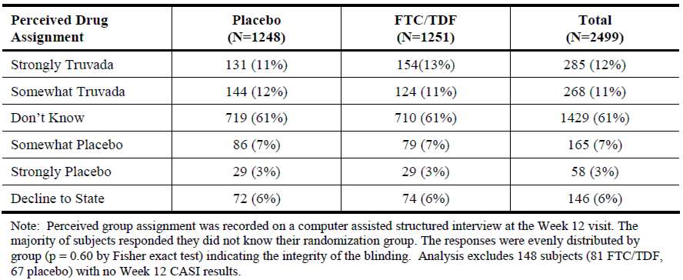

Figure 1: Study CO-US-104-0288: Disposition of study subjects (Gilead Analysis; randomised subjects)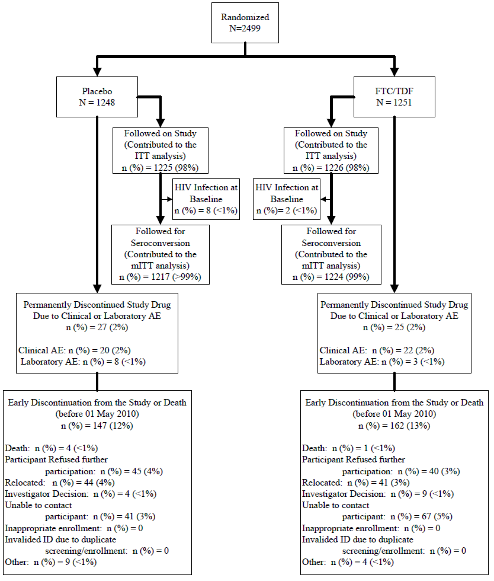

Major protocol violations/deviations
Important protocol deviations were pre-defined as enrolment of an ineligible subject, incorrect study drug dispensed, or any subject who did not return for at least one on-treatment visit. The incidence of important deviations was generally low and comparable in each treatment group (see Table 2 below).

Table 2: Study CO-US-104-0288: Summary of important protocol deviations as reported by sites (iPrEx analysis; randomised subjects)
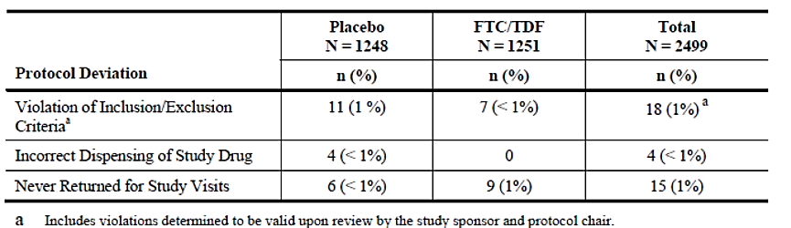

Baseline data
With the exception of age, the baseline demographics were comparable in each group (see Table 3 below). The age range was 18 to 67 years but the mean age of the FTC/TDF group was marginally higher than that of the placebo group (27.5 years versus 26.8 years, p = 0.04). All subjects were genetically male although 1.2% reported female gender identity. The majority of subjects were Hispanic/Latino (72%), 18% were White, 9% were Black, and 5% were Asian. Most subjects consumed alcohol daily and 53% to 55% consumed ≥ 5 drinks daily. The incidence of high risk sexual behaviours and STDs diagnosed at screening were comparable in each group. A total of 12 subjects had chronic HBV infection at baseline and completed the blinded study period (6 FTC/TDF, 6 placebo). A further two HBV negative subjects in each group developed acute HBV infections during the study.
In the optional BMD sub-study which enrolled 503 subjects, 48% were of mixed race (mostly Hispanic or Latino), 20% were Asian, 18% were White, and 13% were Black. Mean BMI was 23.5 kg/m². A total of 48% were aged between 18 and 24 years (and likely to be still accruing bone mass). In this group, 37% had low BMD (T-score < -1) in the spine, and 16% had low BMD in the hip. Overall, the majority of subjects had a T-score ≥ 1 at baseline (85% FTC/TDF, 83% placebo).

Table 3: Study CO-US-104-0288: Demographics and Baseline characteristics (iPrEx analysis; randomised subjects)
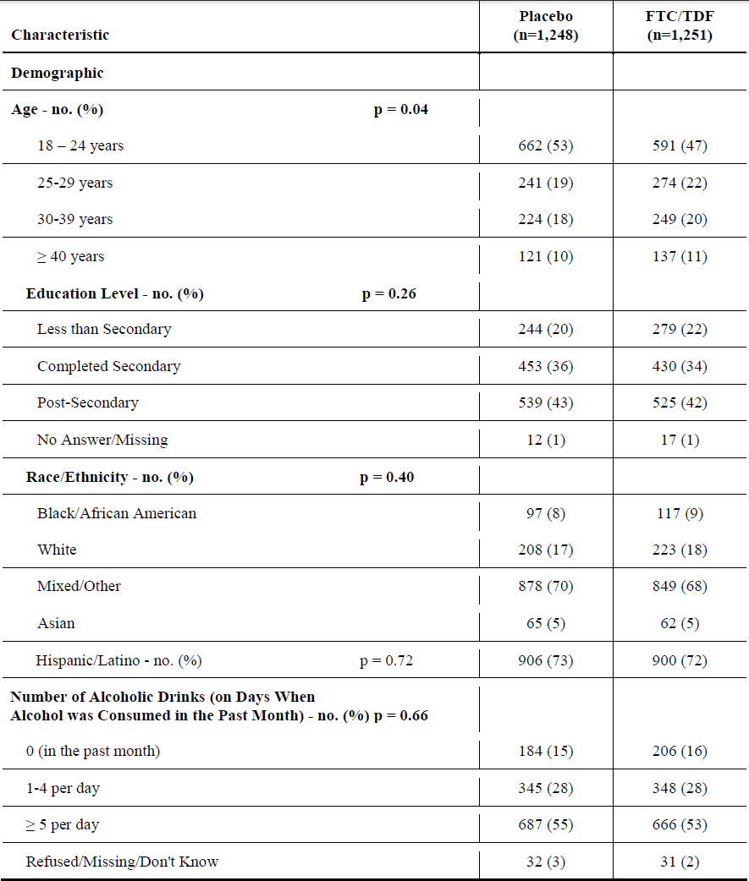

Table 3 (continued). Study CO-US-104-0288: Demographics and Baseline characteristics (iPrEx analysis; randomised subjects)
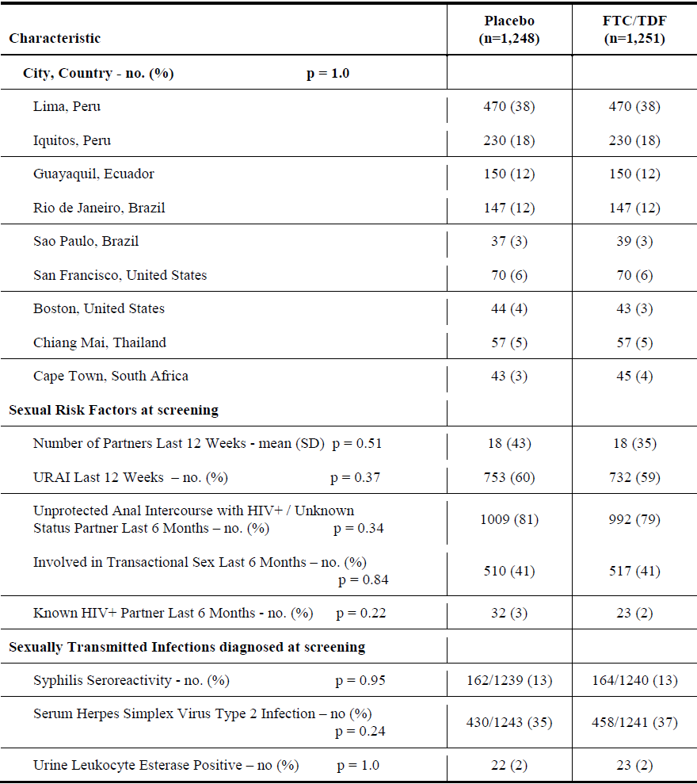
URAI = Unprotected receptive anal intercourse

Results for the primary efficacy outcome
HIV seroconversion was observed in 110 evaluable subjects, 10 of whom had HIV RNA detected in samples obtained at the enrolment visit. In the 100 subjects with treatment-emergent infection in the mITT population, 36 subjects were receiving FTC/TDF compared with 64 subjects in the placebo group (see Table 4). The relative risk reduction in favour of FTC/TDF was 44% (95% CI: 15%, 63%, p = 0.005). In the ITT population, there was a comparable risk reduction (RR 47% (95% CI: 22%, 64%, p = 0.001)). The number of infections observed over time in the mITT population is shown in Figure 2 below. To capture infections acquired late in the treatment period, an analysis of seroconversions 8 weeks after the end of treatment was performed (see Table 5). In the mITT and ITT populations, the risk reductions were 43% (95% CI: 18%, 60%) and 46% (95% CI: 23%, 61%), respectively. In each analysis, the benefit in favour of FTC/TDF was statistically significant and clinically meaningful. However, as the lower bounds of the 95% CIs were less than 30%, the null hypothesis of efficacy could not be rejected.

Table 4: Study CO-US-104-0288: Relative effectiveness: Primary analysis (iPrEx mITT and ITT analyses)
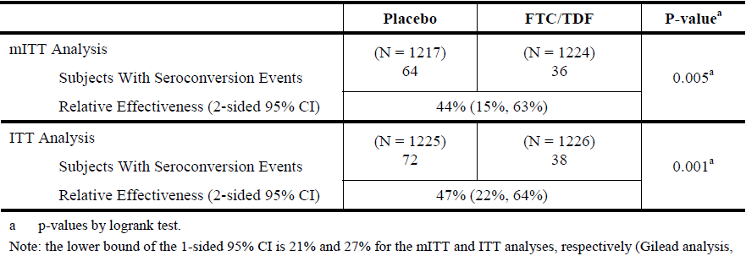
Figure 2: Study CO-US-104-0288: Kaplan-Meier estimates of time to HIV infection (iPrEx mITT analysis)
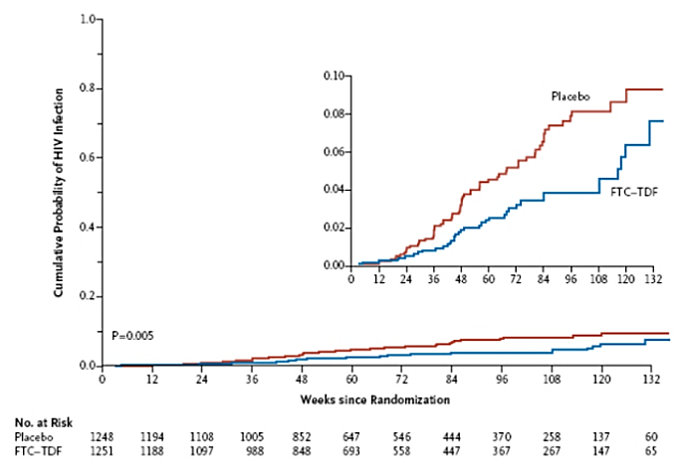
The cumulative probability of HIV acquisition is shown for the two study groups. The efficacy of pre-exposure prophylaxis with Truvada was 44%, as compared with placebo (p = 0.005). The inset graph shows a more detailed version of the overall graph up to a probability of 0.10.

Table 5: Study CO-US-104-0288: Relative effectiveness through the last dose of study drug (iPrEx mITT and ITT analyses)
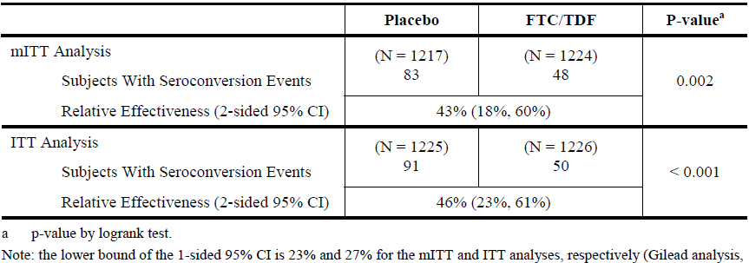
Comment: Reported in the primary publication but not in the CSR, seroconversion rates were similar in both treatment groups during an undefined follow-up period after discontinuation of study drug at the end of the study (161 FTC/TDF versus 159 placebo) (see Clinical Questions).

Results for other efficacy outcomes

Compliance
Self-reported mean tablet use was lower in the FTC/TDF group compared with placebo at Week 4, (89% versus 92%, p < 0.001), and at Week 8 (93% versus 94%, p = 0.006). However, it was the same (95%) in both groups thereafter. Approximately 6% of subjects at each visit did not report the number of tablets missed. At Week 4 and Week 8, 66% and 86% of tablet bottles, respectively, were returned. Based on tablet counts, usage increased during the first 8 weeks and remained stable at 89% to 95% at subsequent visits. However, based on tablet dispensation dates and quantities, the rate of tablet use decreased from 99% during the first year to 91% thereafter. A pre-defined analysis of efficacy was conducted based on self-reported tablet use, tablet counts, and dispensation records (< 50% daily use or ≥ 50% daily use). The risk reduction in the ≥ 50% usage group was 50% (95% CI: 18%, 70%) compared with 32% (95% CI: 41%, 67%) in the < 50% usage group. The difference between groups was not statistically significant (p = 0.48). However, in subjects who self-reported ≥ 90% tablet use, the rate reduction was 73% (95% CI: 41%, 88%) (see Table 6 below). This difference was statistically significant (p < 0.001) and the lower bound of the 95% CI exceeded the pre-defined 30% limit.

Table 6: Study CO-US-104-0288: Relative effectiveness: primary analysis by self-reported level of pill use (iPrEx mITT analysis)
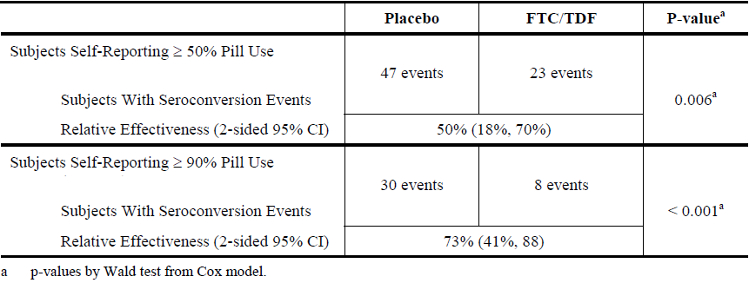
Comment: There appear to be minor inconsistencies between text and tables in the CSR (see Clinical Questions).
Based on TFV-DP PBMC levels, compliance was greater in subjects aged ≥ 25 years (46%) compared with those aged < 25 years (31%); and in subjects with a secondary education (42%) compared with those with less than secondary education. Compliance was greater in subjects aged ≥ 25 years, with higher education and URAI at screening (57%) compared with subjects without these attributes (29%).
Figure 3: Study CO-US-104-0288: Summary of the relationship between quantifiable levels of study drug components and HIV seroconversion events (iPrEx ITT analysis)
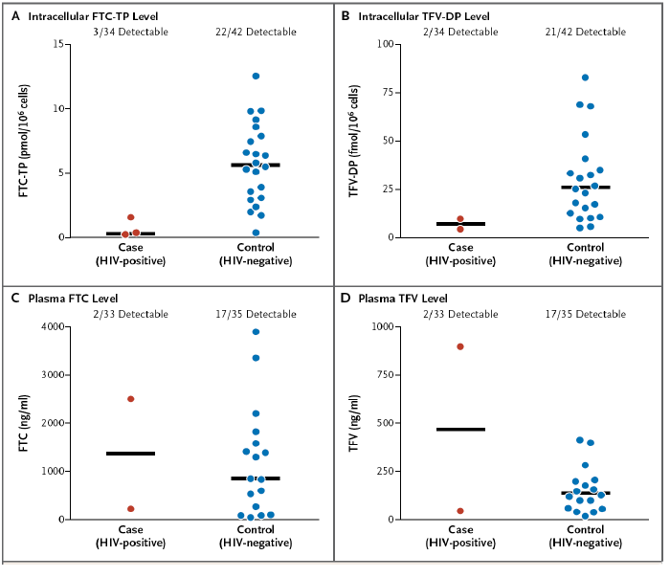
Levels of Study-Drug components in blood of subjects receiving FTC-TDF according to HIV status: Shown are intracellular levels (panels A and B) and plasma levels (panels C and D) of components of emtricitabine and tenofovir disoproxil fumarate (FTC-TDF), quantified in specimens obtained from subjects in the FTC-TDF group. FTC denotes emtricitabine triphosphate and TFV-DP tenofovir diphosphate. The horizontal lines in each panel indicate medians.
As shown in Figure 3 above, there was a close relationship between efficacy and quantifiable drug levels. The mean half-lives of FTC and TDF in plasma are 10 hours and 17 hours, respectively. However, the half-life of TFV-DP is 87 to 150 hours in PBMCs, and quantifiable levels may be detected up to 14 days after the last dose. Thus, subjects with no measurable plasma dug levels would have missed at least several days of study drug. Subjects with high plasma levels but no quantifiable TFV-DP PBMC drug levels were assumed to have taken no study drug for days or weeks and to have taken a dose just before attending a clinic visit. The risk of HIV infection was reduced by a factor of 12.9 (95% CI: 1.7, 99.3, p < 0.001) in the FTC/TDF group with quantifiable drug levels compared with placebo. The relative risk reduction was 92% (95% CI: 40%, 99%, p < 0.001). By correlating risk reduction with TFV-DP concentrations, it was estimated that four TDF doses per week conferred 97% efficacy (95% CI: 90%, 99.9%), and seven doses per week conferred 99% efficacy (95% CI: 97%, 99.9%).

Drug resistance
HIV RNA concentrations and CD4+ cell counts were comparable in subjects who seroconverted irrespective of their treatment group over the median 62.3 week exposure period. No drug resistant variants were detected in a post hoc analysis of subjects in the FTC/TDF group who seroconverted. FTC/TDF resistant variants in subjects who started treatment with pre-existing infection declined rapidly when treatment was discontinued.

Subgroup analyses
Pre-specified analyses were performed on subgroups defined by region (Andean/non-Andean), race, ethnicity, circumcision status, level of education, alcohol use, and age. In general, there was a treatment benefit in favour of the FTC/TDF group compared with placebo in all subgroups with the exception of subjects without a history of URAI (see Figure 4). Although there were no meaningful differences in relative risk reduction based on region, subject numbers in regions other than South America were too low to make meaningful comparisons (South American 2,070, Asia 114, Africa 88 and North America 227). The relative risk reduction in the URAI subgroup was 58% (95% CI: 32%, 74%, p <0.01 compared with placebo) compared with -59% (95% CI: -284%, 34%) in the non-URAI subgroup. Risk reduction rates were numerically higher in subjects aged ≥ 25 years (56%) compared with those aged < 25 years (28%); and in those with secondary or higher education (52%) compared with those without secondary education (12%). Relative risk reduction was highest (85%) in those aged ≥ 25 years, with a secondary education, and with a history of URAI compared with the group without these characteristics (23%).
Figure 4: Study CO-US-104-0288: Summary of subgroup analyses of the primary efficacy end point (iPrEx ITT analysis) 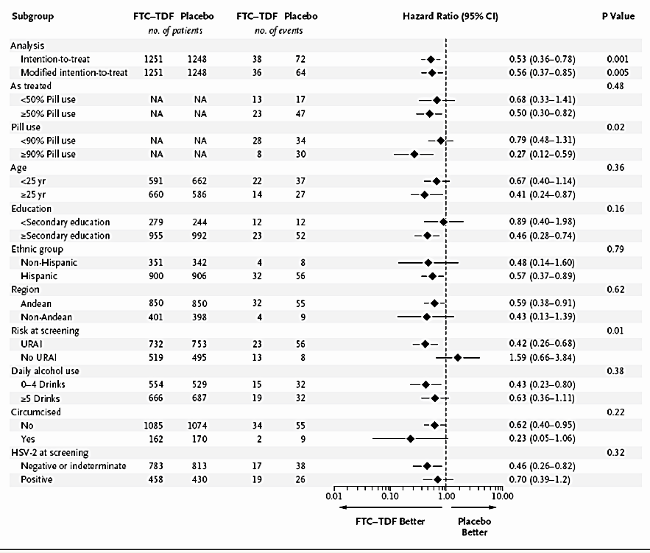
HIV incidence among subjects receiving FTC-TDF, according to subgroup: The efficacy of FTC-TDF is 1 minus the hazard ratio. Hazard ratios of less than 1 indicate efficacy and 95% confidence intervals (shown by horizontal lines) that do not cross 1 indicate significant evidence of efficacy. All subgroup analyses were pre-specified except for testing for herpes simplex virus type 2 (HSV-2) at screening and pill use at the rate of 90%. P-values for the intention-to-treat and modified intention-to-treat analysis apply to the hypothesis of any evidence of efficacy; P-values for other comparisons refer to the hypothesis that efficacy differed between the two strata. NA = not applicable. URAI = unprotected receptive anal intercourse.

BMD sub-study
The results of the BMD sub-study are summarised in the section ‘Clinical Safety; Laboratory Tests: Bone mineral density’ below.

Changes in sexual practice
There were meaningful changes in sexual practice as shown in Figure 5 taken from the primary publication. In subjects engaging in receptive anal intercourse, the number of partners in the previous 12 weeks reduced by half for the duration of the study. Self-reported condom use increased in both study drug groups in the first 12 weeks of the study and the trend was sustained long-term.
Figure 5: Study CO-US-104-0288: Sexual practices by randomisation group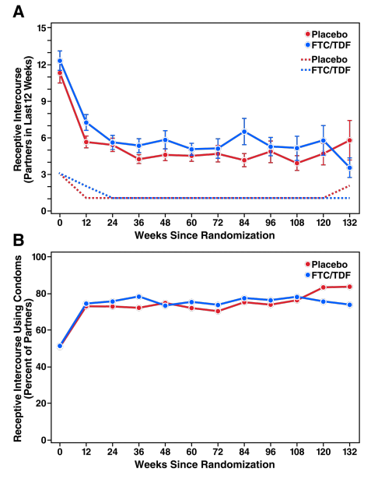
Partners with whom the participant had receptive anal sex in the previous 12 weeks (Panel A), and percentage of those partners using a condom (Panel B) by time on study and group. Solid lines represent means and dotted lines represent median numbers, and the error bars are the SE of the means.
Comment: HIV prevalence in most Western countries is highest in men and transgender women who have sex with men. This was a large, double-blind, placebo-controlled study of HIV prophylaxis in MSM which was well designed and conducted with appropriate ethical and DSMB oversight. The study was conducted by the NIH with study drug supplied by Gilead who also provided a medical monitor and statistical support. The data and analyses provided in the CSR do not always meet the highest regulatory standards and several post hoc data analyses have been provided by the sponsor. Nonetheless, the overall quality of the CSR is acceptable and the conclusions can be considered robust.
The primary endpoint of HIV seroconversion was adjudicated and compliance with study drug was carefully monitored throughout. In the mITT group, there was a statistically significant and clinically meaningful relative risk reduction in subjects receiving FTC/TDF compared with placebo (RR 44% (95% CI: 15%, 63%, p = 0.005)). There was a comparable reduction (RR 47% (95% CI: 22%, 64%, p = < 0.001)) in the ITT group. However, the risk reductions did not exclude the null hypothesis as the lower bounds of the CI did not exceed 30%. With a median exposure to FTC/TDF of 62.3 weeks, the HIV infection rates in the respective groups were 4.2 and 2.4 per 100 person-years.
Efficacy rates were clearly driven by compliance with study drug. In subjects reporting ≥ 90% compliance, the relative risk reduction compared with placebo was 73% (95% CI: 41%, 88%, p<0.001). However, it is unclear how this reported compliance rate was calculated (see Clinical Questions). In subjects with quantifiable study drug levels, the relative risk reduction was an impressive 92% (95% CI: 40%, 99%, p < 0.001). Relative risk reduction rates were also numerically higher in subjects aged ≥ 25 years, with secondary education, and with a history of URAI.
On an intent-to-treat basis, the overall efficacy result was statistically significant. However, the primary endpoint was not achieved, and the benefits of drug prophylaxis in a less intensively monitored population in real world conditions are likely to be even more marginal. Despite this caveat, efficacy rates were outstanding in compliant patients with quantifiable TFV-DP drug levels in PBMC. Efficacy rates were also notably higher in subjects with secondary education, and in those who were older (and presumably wiser). Overall, the study results are positive and support the use of pre-exposure prophylaxis in this population.
In summary, in this placebo-controlled study in MSM, there was a statistically significant 44% efficacy benefit in favour of FTC/TDF. This less than optimal efficacy rate was related almost entirely due to poor compliance in a relatively small proportion of the study population, mainly subjects with low educational levels. Much higher efficacy rates were achieved in more compliant subjects, and the benefits were associated with increased self-reported safer sex practices. With careful counselling and monitoring in the Australian context, FTC/TDF has the potential to reduce acquired HIV infections by up to 90% in MSM who are compliant with drug prophylaxis and safer sex practices.

Study C0-US-104-0380 (Partners PrEP)

Study design, objectives, locations and dates
This was a randomised, double-blind, placebo controlled, Phase III study of the safety and efficacy of PrEP with either TDF or FTC/TDF for prophylaxis in seronegative subjects in a known serodiscordant partnership (infected index subject and uninfected partner subject). It was sponsored by the University of Washington with funding from the Bill and Melinda Gates Foundation. The study drug was supplied by Gilead. It was conducted after appropriately constituted IEC approvals under the supervision of an independent DSMB. It commenced in June 2008 at nine centres in Kenya and Uganda. The study was stopped by the DSMB in July 2011 but continued treatment was offered to participants for an additional 12 months. The preliminary results were published in the same year. The primary efficacy objective was to determine if oral PrEP with TDF or FTC/TDF reduced seroconversions compared with placebo in heterosexual HIV-discordant couples who were also using standard preventive measures. The primary safety objective was to assess the incidence of AEs in subjects receiving TDF or FTC/TDF compared with placebo. A total of 4,700 subjects were planned to be followed for 24 to 36 months (1,566 subjects in each group).
The study was event driven with assessments planned to continue until 191 seroconversions were identified. After two screening visits conducted within 56 days, partner subjects were randomised with visits scheduled every four weeks until seroconversion, or for the duration of the study. At each visit, study drug was dispensed and compliance counselling was given. Compliance was assessed at each visit by tablet counts, records of tablets dispensed, and a drug compliance questionnaire. Counselling was provided by clinicians and pharmacy staff at each visit and compliance aids such as weekly pill boxes were provided. A compliance sub-study in 1,147 subjects was performed at three Ugandan sites. Enrolled subjects had increased compliance monitoring including unannounced home visits at which tablet counts were performed. Additional counselling, motivational interviewing, and problem solving was provided if compliance fell below 80%.To further assess compliance with study drug, a nested case-cohort analysis of TFV-DP in plasma was performed. Plasma TFV-DP was measured in partner subjects in the active study drug groups who acquired HIV infection during the study. These samples were compared with randomly selected samples from 100 subjects in each active study drug group who did not acquire HIV infection.
Uninfected partner subjects were seen at monthly intervals, during which a medical history was taken. Rapid testing for HIV-1 antibodies was performed and female partners had urine pregnancy testing. Women who became infected during the study stopped study drug while pregnant and breast feeding. Subjects were counselled on risk reduction, including condom use and the diagnosis of STDs. Routine laboratory tests including haematology and clinical chemistry were performed monthly at local laboratories. Routine screening for the common STDs was performed annually and treatment was provided as necessary. To assess the relationship between study drug levels and protective effect, plasma samples for measurement of PBMC drug levels were drawn at 6 monthly intervals and archived for testing at a central laboratory. In the event of HIV-1 seroconversion, study drug was stopped and the subjects were reviewed quarterly for 12 months. At each visit, medical history and physical examinations were performed. CD4+ counts and routine screening for STDs were also performed.
Index subjects were required to have documented but untreated HIV-1 infection with a CD4+ count of at least 250 cells/mm³. They must not have qualified for ART under the national treatment guidelines of Kenya and Uganda. They were assessed every 3 months throughout the study. Medical histories and physical examinations were performed and treatment was provided for STDs. Samples for central laboratory analysis were taken at 6 monthly intervals and archived for a range of assessments including HIV-1 plasma viral load. No drug concentration measurements were conducted during the study. However, a case-cohort analysis of detectable plasma TDF was performed in subjects who seroconverted during the study compared subjects who did not seroconvert. No formal PK analyses were performed.

Inclusion and exclusion criteria
The main inclusion criteria for partner subjects were: aged 18 to 65 years inclusive; able and willing to give written informed consent; part of a sexually active heterosexual couple in a planned long-term relationship; HIV-1 uninfected based on negative HIV-1 rapid tests; adequate renal function with a creatinine clearance of at least 60 mL/min assessed by the Cockcroft-Gault formula, and a normal serum creatinine; adequate hepatic function with ALT not more than 1.5 x ULN and AST not more than 2 x ULN; adequate haematologic function with ANC > 1300/mm³, platelets > 125,000/mm³, and haemoglobin > 11 g/dL at screening; and not infected with hepatitis B. The main inclusion criteria for index subjects were: adults of legal age; able and willing to give written informed consent; part of a sexually active heterosexual couple in a planned long-term relationship; HIV-1 infected based on positive enzyme immunoassay; CD4+ cell count of at least 250 cells/mm³; and no history of any clinical AIDS-defining diagnoses.
The main exclusion criteria for partner subjects were: current or planned pregnancy; current breast feeding; current enrolment in another HIV-1 vaccine or prevention study; urine dipstick glycosuria or proteinuria confirmed in repeat samples; active and serious infections; history of pathological bone fracture not related to trauma; receiving any ART; receiving other protocol-defined agents with nephrotoxic potential; and any other conditions considered significant by the investigator. The main exclusion criteria for index subjects were: current use of ART; and current enrolment in another HIV-1 treatment study.
Withdrawal criteria included: completion of all scheduled follow-up visits; acquisition of HIV-1 infection; subjects unavailable for further follow-up; drug-related toxicity; pregnancy in a female partner taking study drug; withdrawal of consent; termination by study chair or DSMB; initiation of excluded medications; and significant compliance issues likely to affect subject safety. Non-compliance with study drug was not of itself a withdrawal criterion.

Study drugs
The study drugs were provided in 30 tablet bottles by Gilead:
- Viread tablets with matching placebo tablets
- Truvada tablets with matching placebo tablets

Efficacy variables and outcomes
The main efficacy variables were:
- HIV-1 acquisition in partner subjects
- Compliance
The primary efficacy outcome was to measure the rates of HIV-1 acquisition in partner subjects receiving TDF or FTC/TDF compared with placebo.
Other efficacy outcomes included:
- To assess efficacy by gender of the partner subject
- To assess the effect of compliance on efficacy rates
- To assess plasma TDF in partner subjects who acquire HIV infection

Randomisation and blinding methods
Partner subjects in each couple were randomised 1:1:1 to receive one of the study medications using IVRS. The study medications were packaged in identical bottles and labelled in accordance with the randomisation schedule. Each subject was required to take two tablets once daily because TDF and FTC/TDF are dissimilar in appearance. Subjects randomised to TDF took one TDF tablet and one placebo FTC/TDF tablet; subjects randomised to the FTC/TDF group took one FTC/TDF tablet and one placebo TDF tablet; and subjects randomised to placebo took one placebo FTC/TDF tablet and one placebo TDF tablet. With the exception of the statistician and DSMB, all study staff and investigators remained blind to the assigned treatment.

Analysis populations
The ITT population included all randomised partner subjects who met the entry criteria. The safety analysis was performed using this population. The primary analysis was performed on the mITT population which excluded partner subjects deemed to be HIV positive at the time of randomisation. The subject numbers in each analysis set are shown in Table 7.

Table 7: Study CO-US-104-0388: Analysis sets (at time point 10 July 2011) in Partners PrEP Study
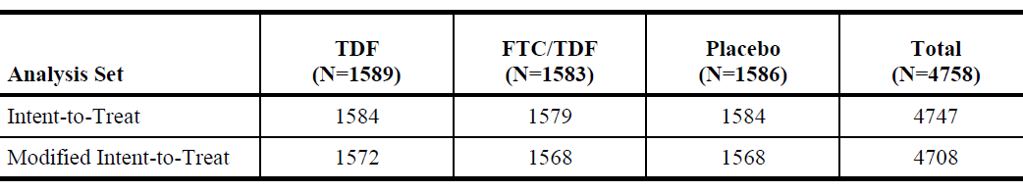

Sample size
Studies in macaque monkeys suggested a high protective rate with PrEP, but a conservative 60% target efficacy rate was set for the clinical study. This was assessed as the minimum rate required to achieve a positive impact on public health practice when balanced against risks and costs. In line with current practice, a minimum efficacy rate of 30% was set to exclude the null hypothesis for each study drug with a type 1 error of 0.05. A loss to follow-up rate of 7% was assumed, based on previous HIV-1 studies. Based on these assumptions, 3,900 subjects (1,300 in each treatment group) would yield 191 HIV-1 seroconversions with 80% power to detect efficacy rates of between 57% and 60% for each active drug compared with placebo. However, following publication of another study of PrEP in serodiscordant heterosexual couples, the DSMB increased the sample size to 4,700 subjects (1,566 subjects in each group).

Statistical methods
A Cox proportional hazards model stratified by study site was used for the primary analysis. Two comparisons between each active drug and placebo were performed. The comparisons tested the null hypotheses of the hazard ratios being 1 or 0.7 (a 30% efficacy benefit). The significance level for rejection was set at a 2-sided p = 0.05 with α = 0.025 for each comparison versus placebo. Although HIV testing was carried out throughout the study, the single endpoint of HIV-1 detection did not require correction for multiplicity. Similar analyses were conducted on pre-defined subgroup categories.

Participant flow
A total of 7,856 serodiscordant couples were screened, 4,758 couples were randomised, and 11 couples were withdrawn from the ITT group because of ineligibility. A total of 96% of partner subjects completed the follow-up period and were included in the mITT group. The subjects were followed-up for a median 23 months with a total exposure of 7,830 person-years. Additional details are shown in Figure 6.

Figure 6: Study CO-US-104-0380: Disposition of study subjects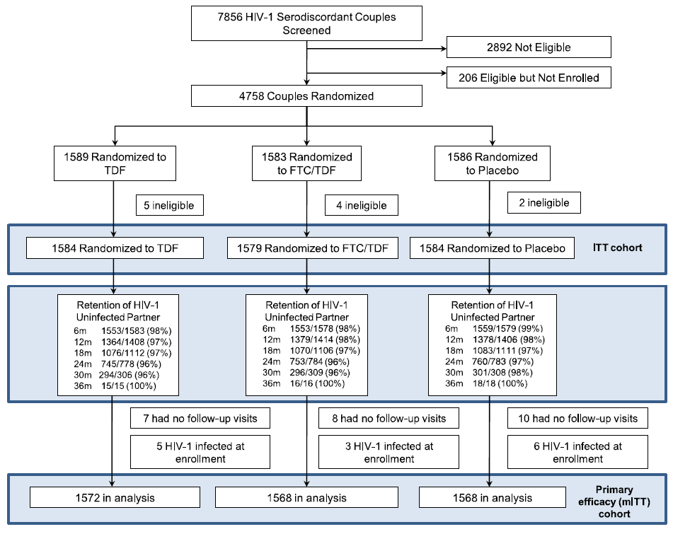

Major protocol violations/deviations
Protocol deviations were not provided in the CSR. However, all partner subjects were included in the ITT or mITT groups.

Baseline data
The demographic characteristics for the partner and index subjects were comparable in each study drug group as shown in Table 8 and Table 9. The majority of partner subjects were male (61 to 64%) with a median age of 33 to 34 years and nearly all were married (97 to 98%). The median education duration was 7 years, and the majority received a monthly income (78 to 80%). With the exception of gender, the demographics of the index subjects were comparable. The median baseline CD4+ count was (491 to 499 cells/mm³) and the median plasma HIV-1 RNA was 3.9 log10 copies/mL in each treatment group.
The couples had lived together for a median 7.0 to 7.1 years but their discordant HIV status was known for only a median 0.4 to 0.5 years. In the month before enrolment, sexual intercourse was reported on a median four occasions, and this was unprotected on 26 to 28% of occasions. STDs other than HIV were reported in 6 to 9% of partner and index subjects.

Table 8: Study CO-US-104-0380: Demographics and Baseline characteristics for partner and index subjects (ITT)
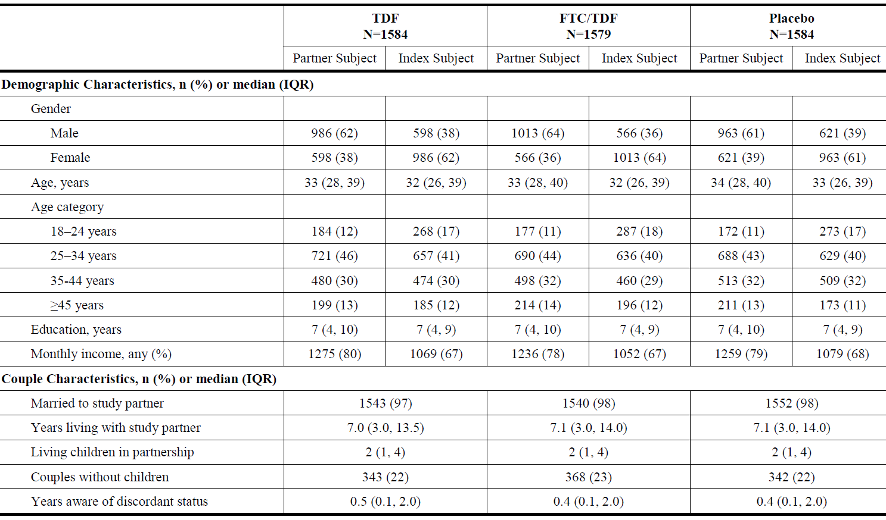

Table 9: Study CO-US-104-0380: Clinical characteristics for partner and index subjects (ITT)
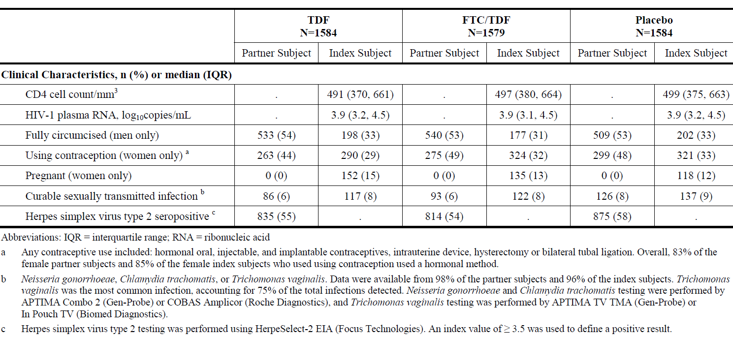

Results for the primary efficacy outcome
When the study was stopped by the DSMB, 99 seroconversions had been reported. Of these, three were determined to be false positives and 14 were considered to be present at enrolment. Overall, 82 infected subjects were included in the mITT group, representing 1.05 seroconversions per 100 person-years (95% CI: 0.83, 1.30). Seroconversion rates and hazard ratios in the mITT group are shown in Tables 10 and 11and Figure 7. In the TDF, FTC/TDF and placebo groups, 17, 13, and 52 subjects seroconverted with corresponding incidence rates of 0.65, 0.50, and 1.99 per person-years. The hazard ratios in the TDF, and FTC/TDF groups were 0.33 (95% CI: 0.19, 0.56), and 0.25 (95% CI: 0.13, 0.45), respectively. Efficacy rates in both active study drug groups were significantly different from placebo (p < 0.0001), but not from each other (HR 0.76 (95% CI: 0.37, 1.56)). The hazard ratios indicated a 67% risk reduction (95% CI: 44%, 81%, p = 0.0031) for TDF compared with placebo, and a 75% risk reduction (95% CI: 55%, 87%, p = 0.0004) for FTC/TDF compared with placebo. The efficacy rates and Kaplan-Meier curves in the ITT were comparable to those in the mITT group (data not shown).

Table 10: CO-US-104-0380: HIV-1 sero incidence for partner subjects (mITT)
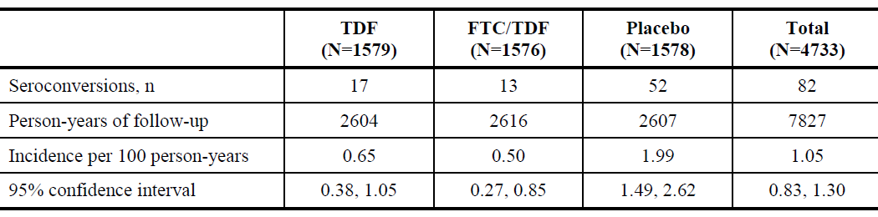

Table 11: CO-US-104-0380: Hazard ratio comparisons of HIV-1 infection risk (mITT)
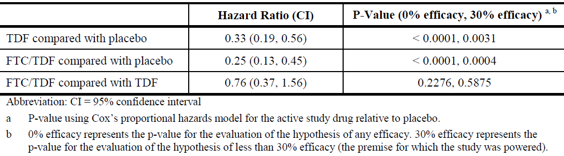
Figure 7: Study CO-US-104-0380: Kaplan-Meier curves of HIV-1 Survival (mITT) 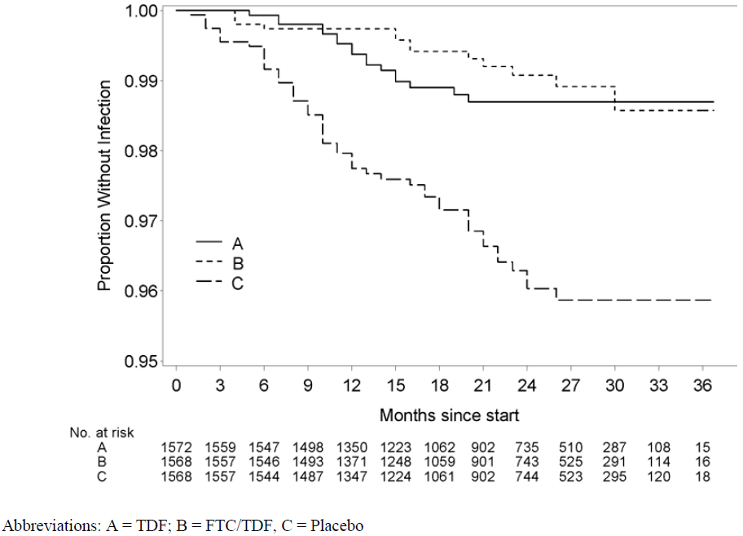

Results for other efficacy outcomes

Compliance
Study medication was dispensed at 100% of visits to the eligible subjects (96%) (see Table 12 below). The most common reasons for not dispensing drug were pregnancy (30%), possible seroconversion (22%), and subject refusal. Renal toxicity (10%) and other AEs were responsible for not dispensing study drugs in the remaining subjects. Monthly tablet counts were available for 99% of the overall population. Overall, 98% of the dispensed bottles were returned and 97% of the dispensed study tablets were counted as taken. Partner subjects reported missing at least one dose of study drug at 15% of visits but only 4% of subjects reported missing two consecutive doses. Overall, compliance in each study drug group was estimated to be at least 90% at the 87% of visits it was estimated. In the compliance sub-study of 1,147 subjects, HIV-1 infections were acquired by 14 subjects, all of which were in the placebo group (efficacy 100% (95% CI: 87%, 100%, p < 0.001)).

Table 12: CO-US-104-0380: Study Drug Dispensing by Group
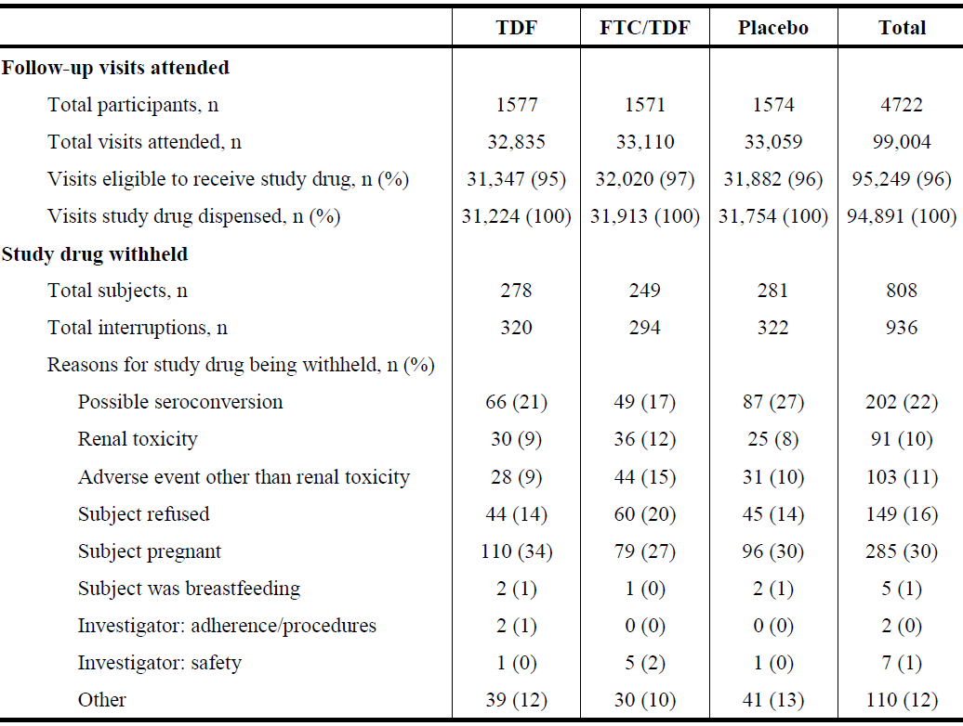

Changes in sexual behaviour
During the study follow-up period, there was a reduction in the proportion of partner subjects having sex without condoms from 27% at baseline to 13% at 12 months, and 9% at 24 months (see Figure 8). The results were comparable in each treatment group. The proportion of partner subjects who reported having sex with an outside partner in any previous month increased from 9% (13% men, 0.4% women) at baseline to 30% (42% men, 9% women) during the study.
Figure 8: Study CO-US-104-0380: Proportion of HIV-1 Partner subjects reporting any sex with the index subjects unprotected by condoms during the prior month

Subgroup analyses
HR rates were analysed in partner subject subgroups defined by gender, age, circumcision status, country, and reported frequency of unprotected sex in the month before enrolment. Index subjects were analysed according to HIV-1 plasma viral load and CD4+ count. A summary of the number and incidence of seroconversions in each group is shown in Table 13 and the corresponding hazard ratios are shown in Table 14. Overall, there was a benefit for both active study drugs compared with placebo in all subgroups. Differences within subgroups were observed but the low number of seroconversions in each subgroup did not allow meaningful comparisons.

Table 13: Study CO-US-104-0380: Summary of number and incidence of seroconversions by subgroup (mITT)

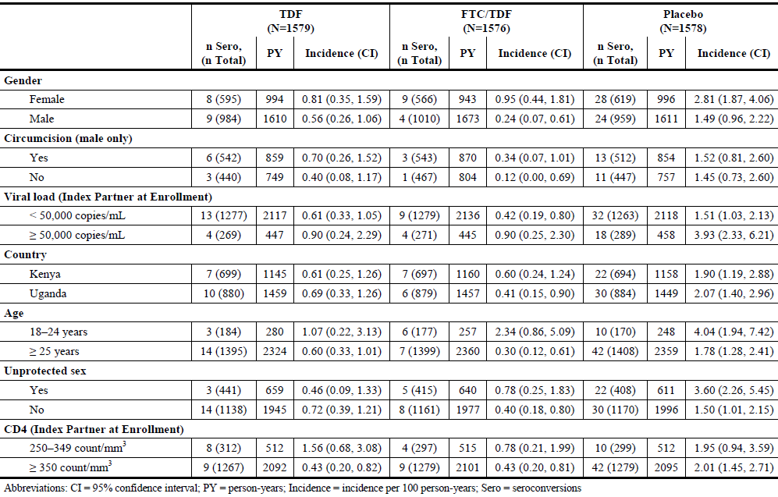

Table 14: Study CO-US-104-0380: Hazard ratio comparisons of hiv-1 infection risk by subgroup (mITT)

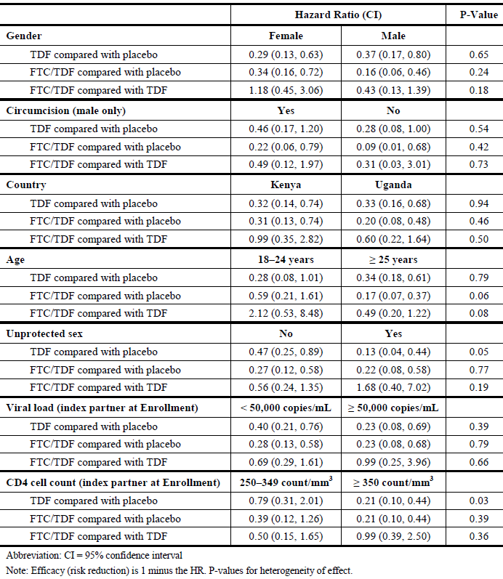

PK/PD assessment
Plasma TDF was measured in 17 partner subjects who acquired HIV infection in the TDF group, and in 12/13 infected subjects in the FTC/TDF group. These samples were compared with samples from 200 randomly selected subjects (100 in each active study drug group) who did not acquire HIV infection. In the infected subjects, detectable TFV-DP levels were present in 35.3% of the TDF group and 25.0% of the FTC/TDF group. In the sample of uninfected subjects, TFV-DP was detected in 83.1% of the TDF group, and in 80.6% of the FTC/TDF group. For partner subjects in the TDF group, the presence of detectable TFV-DP was associated with an 86% reduction in the risk of acquiring HIV infection (95% CI: 67%, 95%, p < 0.001) compared with subjects with no detectable levels. The reduction in risk in the FTC/TDF group with detectable TFV-DP levels was 90% (95% CI: 56%, 98%, p = 0.002) (see Table 15 below).

Table 15: CO-US-104-0380: Detection of tenofovir in plasma and hiv-1 prophylactic effects
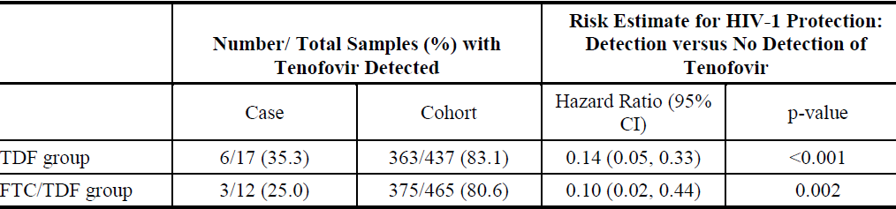

Drug resistance
Drug resistance was assessed in 95.8% of the 96 subjects who seroconverted during the study (see Table 16 below) in subjects who acquired HIV-1 infection after enrolment, only one resistant mutation was observed in a subject receiving FTC/TDF. The duration of persistence was not recorded.

Table 16: Study CO-US-104-0380: Primary study resistance mutations
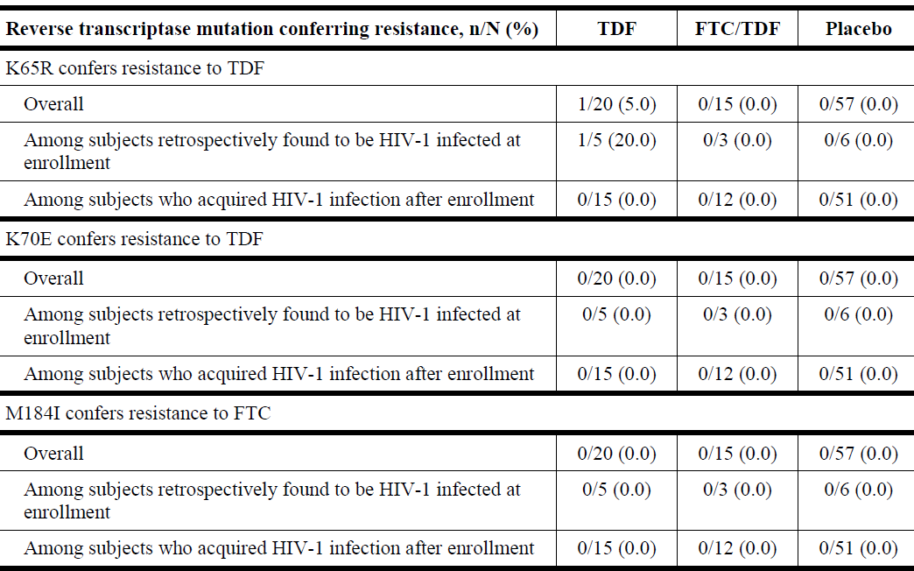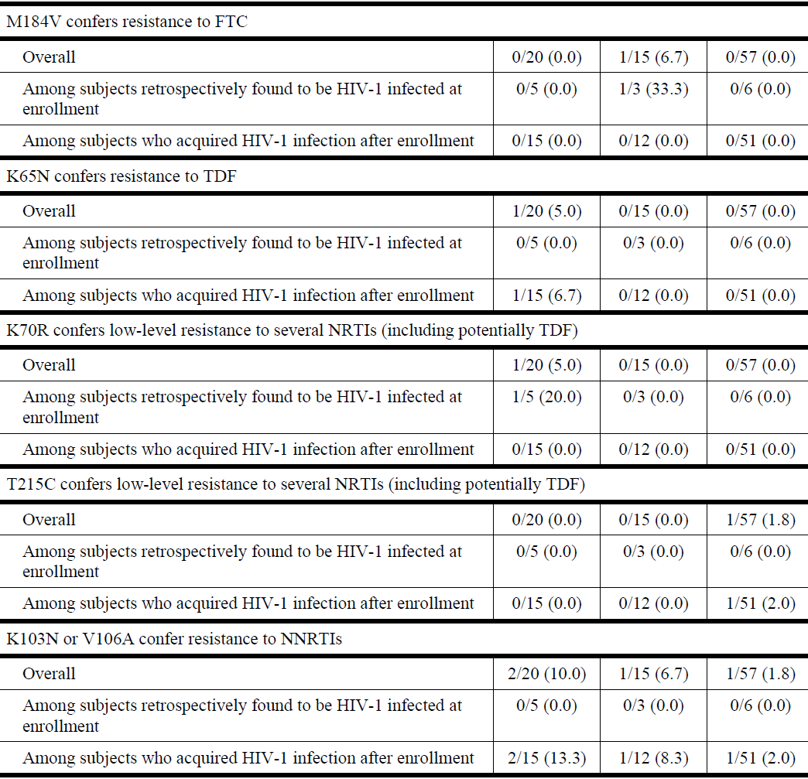

Pregnancies
The number of pregnancies occurring during the study and the pregnancy outcomes are summarised in the laboratory tests section of clinical efficacy later in this document.
Comment: This was a large, double-blind, placebo-controlled study of PrEP in HIV-1 discordant heterosexual couples. It was well designed and conducted with appropriate ethical and DSMB oversight. The primary endpoint of HIV seroconversion used a widely accepted diagnostic algorithm and events were monitored by the DSMB. Compliance with study drug and safer sex measures were emphasised at each visit and carefully monitored throughout. Rapid HIV-1 testing and pregnancy testing were performed monthly. The study was conducted in East Africa in a population of married couples; most were employed and most had at least seven years of education.
In the mITT group, there were statistically significant and clinically meaningful relative risk reductions in subjects receiving TDF (67% (95% CI: 44%, 81%, p = 0.0031)) or FTC/TDF (75% (95% CI: 55%, 87%, p = 0.0004)). The risk reductions in both active study drug groups excluded the null hypothesis as the lower bounds of the CI exceeded 30%. In the TDF, FTC/TDF and placebo groups, the HIV infection rates in the respective groups were 0.65, 0.50, and 1.99 per 100 person-years. Efficacy in subgroups was comparable with the overall population, including gender. However, the numbers of infections in each subgroup were too small to make meaningful comparisons.
As in iPrEx, efficacy rates were driven largely by compliance with study drug. Overall, compliance with study drug was approximately 90% based on self-reporting and tablet counts. The relationship between efficacy and compliance with study drug was also assessed in a nested case-cohort analysis. In subjects who acquired HIV infection, detectable TDF levels were found in only 35.3% and 25% of subjects in the TDF and FTC/TDF groups, respectively. In contrast, in a sample of uninfected partner subjects, detectable TDF levels were found in 83.1% and 80.6% of the respective groups. Detectable TDF levels were associated with an 86% risk reduction in the TDF group, and a 90% reduction in the FTC/TDF group.
Although the difference was not statistically significant, FTC/TDF was numerically superior to TDF. The protective effect of FTC/TDF for PrEP was statistically significant, highly clinically meaningful, and clearly related to drug compliance. Condom use increased during the study. However, there was some evidence of sexual disinhibition with a marked increase in the number of outside partners in each study group.

Other efficacy studies
No other efficacy studies were submitted.

Analyses performed across trials (pooled analyses and meta-analyses)
No pooled efficacy analyses were performed.

Evaluator’s conclusions on clinical efficacy for the indication
Truvada is indicated in combination with safer sex practices for pre-exposure prophylaxis (PrEP) to reduce the risk of sexually acquired HIV-1 in adults at high risk. This indication is based on clinical trials in men who have sex with men (MSM) at high risk for HIV-1 infection and in heterosexual serodiscordant couples.
Two pivotal studies have been submitted to support the proposed indication. In the double-blind, placebo-controlled iPrEx Study, 2,499 HIV-uninfected MSM were randomised and received FTC/TDF or placebo for a median of 62 weeks. In the mITT population, HIV-1 seroconversions were reported in 2.9% of the FTC/TDF group compared with 5.3% of subjects receiving placebo. There was a 44% relative risk reduction for the FTC/TDF group compared with placebo. This benefit in favour of FTC/TDF in the mITT population was statistically significant (p = 0.005) although it did not exclude the null hypothesis of 30% efficacy or less (95% CI: 15%, 63%). There was a clear relationship between efficacy and compliance with drug therapy. In subjects with ≥ 50% self-reported compliance, the relative risk reduction was 50% (95% CI: 18%, 70%, p = 0.006). In subjects with ≥ 90% self-reported compliance, the relative risk reduction was 73% (95% CI: 41%, 88%). In subjects with detectable TFV-DP drug levels, the relative risk reduction was 92% (95% CI: 40%, 99%).
In the double-blind, placebo-controlled Partners PrEP study, 4,758 heterosexual, HIV-discordant couples received either TDF, FTC/TDF or placebo for a median of 23 months. Post-randomisation HIV-1 infections were reported in 17, 13, and 52 partner subjects in the respective study drug groups, representing incidence rates of 0.65, 0.50, and 1.99 per 100 person-years. TDF and FTC/TDF were significantly more effective than placebo (p < 0.0001) but not different from each other. In the TDF group, there was a 67% reduction in the risk of HIV-1 acquisition (95% CI: 44%, 81%), and in the FTC/TDF group there was a 75% reduction (95% CI: 55%, 87%). Based on tablet counts, 97% of study medication was taken although 15% of subjects reported missing at least one dose of study medication in the preceding month. Compared with subjects with undetectable TFV-DP levels, subjects with detectable levels had a 90% reduction in the risk of HIV-1 acquisition (95% CI: 56%, 98%, p = 0.002). Sex without condom use decreased from 27% overall at baseline to 13% and 9% at 12 and 24 months, respectively.
Both pivotal studies enrolled large subject numbers in the different populations at risk. In both studies the primary endpoint of HIV-1 seroconversion was confirmed by repeat testing and adjudication. Both studies used a double-blind, placebo-controlled design and both studies confirmed highly significant reductions in the risk of HIV-1 acquisition compared with placebo. Compliance with study drug was carefully monitored in both studies by tablet counts, self-reported estimates, and plasma TFV-DP levels. Efficacy was directly related to compliance in both studies, and approximately 90% risk reduction for HIV-1 acquisition was observed in subjects with detectable TFV-DP levels.
Subject numbers in subgroups were too low to permit statistical analysis, although efficacy rates were comparable with the overall populations in both studies. There were no meaningful gender differences in the Partner PrEP study. Continuous counselling was provided and condom use increased in both studies. This was probably a factor in the observation that risk reduction was highest in older and more educated subjects. Drug resistance to FTC/TDF was not observed in subjects who acquired HIV-1 infection during the iPrEx Study, and it was observed in only one subject in the Partners PrEP Study. In both studies, resistant strains were detected in subjects with pre-existing infection. However, the resistant variants declined during the follow-up period when the study drugs were discontinued.
The studies were conducted largely in South American and East African populations with lower educational and healthcare standards compared with Australia. However, the overall efficacy rates were outstanding in patients who complied with drug and safer sex practices. There is no reason to expect less in the Australian context with appropriate counselling and monitoring.

Clinical safety

Studies providing evaluable safety data
The following studies and information sources provided evaluable safety data:
- Two pivotal efficacy studies:
  - Study C0-US-104-0288 (iPrEx)
  - Study CO-US-104-0380 (Partners PrEP)
- Interim analyses of two post-marketing safety studies:
  - GS-US-276-0101
  - GS-US-276-0103
- Latest Periodic Benefit Risk Evaluation Report of TRUVADA (3 April 2013 to 2 April 2014)

Pivotal efficacy studies
In the pivotal efficacy studies, the following safety data were collected:
- General adverse events (AEs) were assessed and reported by Gilead in accordance with ICH guidelines using MedDRA SOC and PT terminology.
- AE severity was assigned by the investigator using the Graded DAIDS Grading Table
- Expedited adverse events (EAEs) included all SAEs, all Grade 3 AEs, foetal loss, any medical event required to treat any of the above criteria, any Grade 2 creatinine elevation, and all bone fractures.
- AEs related to renal function abnormalities were assessed by measurements of serum creatinine and creatinine clearance using the Cockcroft-Gault equation.
- Bone mineral density was assessed by DEXA
- Laboratory tests, including HIV-1 RNA testing were performed at local laboratories.

Pivotal studies that assessed safety as a primary outcome
No studies were submitted.

Dose-response and non-pivotal efficacy studies
No studies were submitted.

Other studies evaluable for safety only
GS-US-276-0101 and GS-US-276-0103

Published studies with summary data provided by the sponsors
Study CDC 4323, FHI PrEP, CDC TDF2, and FEM PrEP.

Clinical pharmacology studies
No studies were submitted.

Pivotal studies that assessed safety as a primary outcome
No studies were submitted.

Other studies that assessed safety
The following studies are summarised from preliminary published data (see references). Gilead has not been provided with the CSRs or raw data.

Study CDC 4323

Methodology
Study CDC 4323 (CO-US-104-0277) was a Phase II, randomised, double-blind, placebo-controlled trial of daily TDF in HIV-1 negative MSM conducted at three centres in the US. The primary endpoint was safety. A total of 400 subjects were randomised 1:1:1:1 to receive immediate or delayed TDF 300 mg or placebo. Subjects randomised to delayed chemoprophylaxis received study drug after a 9 month interval. Seroconversions, compliance and patterns of sexual behaviour were assessed every 3 months for 24 months. Subjects with confirmed HIV-1 infection discontinued study drug but continued with safety observations for up to 12 months. In the TDF and placebo groups, most subjects were White (81% versus 73%) with an overall mean age of approximately 38 years. A total of 50% of subjects in each group had a College education. A BMD sub-study was performed in 200 subjects (100 TDF and 100 placebo).

Results
AEs were reported in 91% of subjects and the severity was mild or moderate in 97% of subjects. The frequencies of commonly reported AEs, severe AEs and SAEs were comparable in both groups. However, nausea was reported more commonly in the TDF group (11% versus 6%). There was one death (in the TDF group) related to an opiate and ethanol overdose. Grade 1 and 2 serum creatinine elevations were reported in 1% of both groups, but there were no events of Grade 3 or higher in either group. Grade 2 Hypophosphataemia (2.0 to 2.4 mg/dL) was reported in 17% and 13% of the respective groups, and Grade 3 or 4 events were reported in ≤3% of both groups. Discontinuations were comparable in both groups (16% versus 19%). Back pain was more likely in the TDF group (13%) compared with the placebo group (6%, p = 0.04), but these events were not associated with documented fractures. Fractures and the results of the BMD study are summarised in the ‘bone mineral density’ section found under ‘Clinical safety: laboratory tests’ later in this document.
Seven HIV-1 seroconversions were reported during the study period, four on placebo and three in subjects in the delayed group who had not yet received study drug. Compliance and changes in sexual behaviour were monitored but the data has not yet been published.
Comment: In this US population of MSM, TDF was generally well tolerated and no new safety signals were detected. Nausea, Hypophosphataemia and BMD loss were reported more commonly in the TDF group. Although it was not an endpoint, HIV-1 seroconversion was not reported in any of the TDF group compared with seven events in subjects not receiving active drug.

Study FHI PrEP

Methodology
FHI PrEP was a randomised, double-blind, placebo-controlled, Phase II study of the acceptability of TDF PrEP among women at high risk for HIV. It was conducted by Family Health International in Ghana, Cameroon, and Nigeria. A total of 936 HIV-1 negative women were randomised 1:1 to receive TDF 300 mg or placebo and then followed at monthly intervals for 12 months. At each visit, counselling and free male condoms were provided. Tablet counts, questionnaires and qualitative interviews were conducted at each visit to assess compliance and the participants’ perceptions of the program. HIV-1 testing was conducted at baseline and monthly thereafter but HIV-1 acquisition rates were not reported.

Results
Self-reported compliance was consistently > 82% throughout the study period but overall compliance was estimated to be 69%. The most common reasons for non-compliance were pregnancy and missed or late clinic visits. AEs were reported in 75% of the TDF group and 72% in the placebo group. The most commonly reported AEs were malaria, vaginal candidiasis, and urinary tract infections with comparable frequency in each group. In a sub-study of 400 Ghanaian women, 31% of women reported adverse events at the first monthly visit, most commonly GI disturbances, fatigue, and dizziness in the TDF group. A total of 17 subjects reported 22 SAEs but none were considered drug related. One subject died in each group (complications of abortion and anaemia, respectively) but neither was considered drug related. Laboratory abnormalities were reported with similar frequency in both groups. A single Grade 3 reduction was reported in the TDF group (< 1.0%). Grade 1 creatinine elevations were reported in 4% of each group but no events greater than Grade 1 was reported. There were no meaningful differences in AST/ALT increases between groups in the 23 TDF-treated HBsAg positive subjects when they discontinued treatment. No Grade 3 or 4 abnormalities were reported in the TDF group compared with 1% in the placebo group. Condom use increased from 52% at baseline to > 90% throughout the 12 month study period. The mean number of sexual partners in the previous month decreased from 21 at screening to 14 during the follow-up period.
Comment: In a population of West African women, TDF was well tolerated although GI disturbances, fatigue, and dizziness were reported commonly in the first month of the study. There was comparable renal and hepatic safety in subjects irrespective of HBsAg status. Sexual behaviours changed with increased condom use and a reduction in the number of sexual partners.

Study CDC TDF2

Methodology
CDC TDF2 was a double-blind, placebo-controlled, Phase III study conducted in sexually active, male and female Botswanans at high risk. A total of 1200 subjects received FTC/TDF or placebo for a median 1.1 years with testing for HIV-1 seroconversion every month. Approximately 45% of subjects were female and the majority of the overall population were unmarried (94%). Counselling was provided at each visit and compliance was assessed by self-reports, tablet counts, and TFV-DP drug levels.

Results
Compliance assessed by tablet counts was approximately 84% in both groups, and approximately 90% in subjects who seroconverted. AEs were reported in 91% of the FTC/TDF group compared with 88% of the placebo group (p = 0.003). AEs occurring more commonly in the FTC/TDF group included nausea (19% versus 7%, p < 0.0001), vomiting (11% versus 7%, p = 0.008), and dizziness (15% versus 11%, p = 0.03). SAEs were reported in 10% and 11% of the respective groups. Six deaths were reported during the study (0.3% versus 0.7%) but none were considered drug related. There were no meaningful differences in abnormal laboratory values between the groups, including Hypophosphataemia and elevated creatinine values. Overall self-reported compliance was approximately 84% Other planned analyses include drug level testing, changes in BMD, and changes in risk behaviour over time.
HIV-1 seroconversion occurred in 9 subjects in the FTC/TDF group compared with 24 subjects in the placebo group. The rate reduction was 62.6% (95% CI: 21.5%, 83.4%, p = 0.013).
Comment: This was a large, placebo-controlled study in sexually active men and women in Botswana. Although the primary endpoint was safety, there was a clinically and statistically significant reduction in the rate of HIV-1 acquisition in the group receiving FTC/TDF. FTC/TDF was generally well tolerated and no new safety signals were detected. Nausea, vomiting, and dizziness were more commonly reported in subjects given FTC/TDF.

Study FEM PrEP
FEM-PrEP was a randomised, double-blind, placebo controlled study of FTC/TDF compared with placebo in 2,056 African women followed for 52 weeks. The study was stopped after a planned interim futility analysis showed no prospect of demonstrating a protective effect of FTC/TDF. The incidence rate of infections in the FTC/TDF group was 4.7/100 person-years compared with 5.0/100 person-years in the placebo group, with a hazard ratio of 0.94 (95% CI: 0.59, 1.52, p = 0.81). It was assumed that the lack of efficacy was related to poor compliance despite counselling. In the FTC/TDF group, TFV-DP was detected in fewer than 50% of infected subjects and uninfected matched controls.
Comment: In contrast to other published studies, FTC/TDF did not prevent HIV-1 acquisition in a large population of African women. Poor overall compliance was assumed to be the cause of the failure. The main value of the study is to show that successful PrEP depends totally on adequate drug compliance.

Patient exposure
In iPrEx, median exposure in the FTC/TDF group was 62.3 weeks. Subjects were followed for one day to 145 weeks with a total exposure of 3,324 person-years. In Partners PrEP, no formal analysis of exposure was performed. The median follow-up time was 23 months and 7,830 person-years of follow-up were reported.

Adverse events

All adverse events (irrespective of relationship to study treatment)

Pivotal studies

Study CO-US-104-0288/iPrEx
A summary of treatment-emergent AEs is shown in Table 17 (below). AEs were reported in 55% of the FTC/TDF group compared with 56% of the placebo group. Most AEs were mild or moderate, and Grade 3 or 4 events were reported in only 9% of each group. The most common AEs reported by SOC were infections and infestations (36% versus 36%), and gastrointestinal disorders (13% versus 12%). The most common AEs by reported by PT were pharyngitis (6% versus 6%), urethritis (4% versus 5%), and depression (3% versus 5%). AEs reported with an incidence ≥ 2% with a higher incidence in the FTC/TDF group compared with placebo were headache (4% versus 3%), syphilis (4% versus 3%), abdominal pain (2% versus 1%), and nausea (2% versus < 1%).

Table 17: Study CO-US-104-0288: Overall summary of treatment-emergent adverse events (Gilead Analysis; randomized subjects)
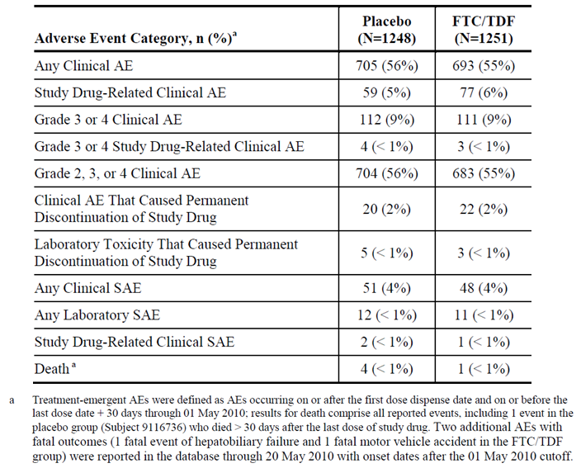

Study CO-US-104-0380/Partners PrEP
A summary of treatment-emergent AEs is shown in Table 18. AEs were reported in 85%, 86%, and 85% of the TDF, FTC/TDF and placebo groups, respectively. Overall, the most common AEs reported by SOC were investigations (72%), Infections and infestations (43%), and Gastrointestinal disorders (10%), with no meaningful differences between the groups. The most frequent AEs reported by PT are shown in Table 19. Decreased neutrophil counts were reported in 37% of the placebo group compared with 38% of subjects in the TDF group, and 44% in the FTC/TDF group. With this exception, there were no notable differences between the study groups. Non-serious AEs were not tabulated according to severity in the CSR.

Table 18: Study CO-US-104-0380: Overall summary of adverse events for partner subjects (ITT)

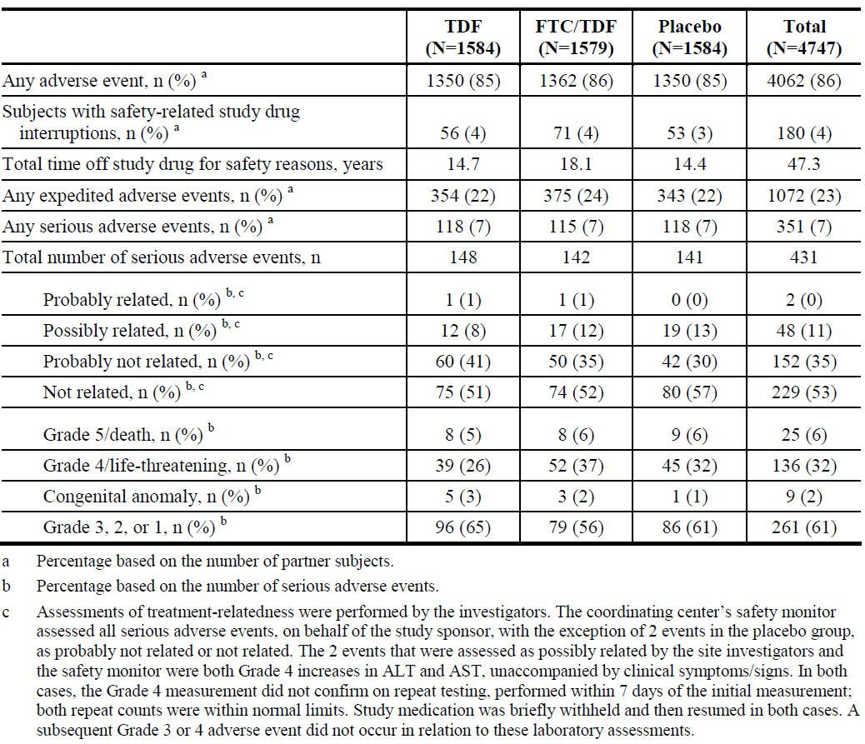

Table 19: Study CO-US-104-0380: Adverse events reported for at least 3% of the partner subjects in any treatment group (ITT) 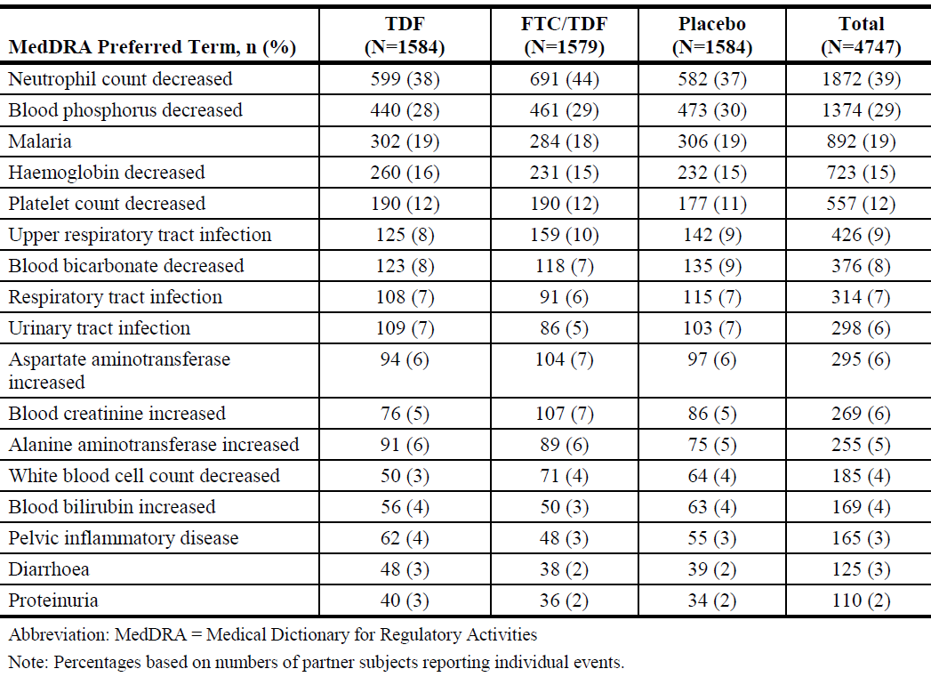

Treatment-related adverse events (adverse drug reactions)

Pivotal studies

Study CO-US-104-0288/iPrEx
ADRs were reported in 6% of the FTC/TDF group compared with 5% in the placebo group. The most common events were headache, upper abdominal pain and diarrhoea, but there were no meaningful differences between the groups.

Study CO-US-104-0380/Partners PrEP
ADRs were not reported in the CSR.

Deaths and other serious adverse events

Pivotal studies

Study CO-US-104-0288/iPrEx
Five deaths (< 1%) were reported but none were considered drug related by the investigator. The cause of death was unknown in one case, and the other four cases were related to trauma. The incidence and pattern of SAEs were comparable (4% in each group). The most common events were suicide and depression in both groups but SAEs were reported by PT in no more than 1% of subjects. Serious laboratory toxicities were also comparable in the FTC/TDF (< 1%) and placebo groups (< 1%). The number of events in subgroups was too small to make meaningful comparisons.

Study CO-US-104-0380/Partners PrEP
A total of 25 deaths were recorded in the TDF (n = 8), FTC/TDF (n = 8), and placebo groups (n = 9) (see Table 20 below). Two deaths in the FTC/TDF group (pulmonary embolus and influenza) were considered drug related by the investigator but not by the study monitor. Overall, SAEs were reported in 7% of partner subjects, mostly Grade 1-3 in severity, and comparable in each group. Few SAEs were considered drug related and the incidence of ADRs was comparable in each study drug group (TDF 13/1584, FTC/TDF 18/1579, and placebo 19/1584).

Table 20: Study CO-US-104-0380: Listing of partner subjects deaths by study drug group (ITT)
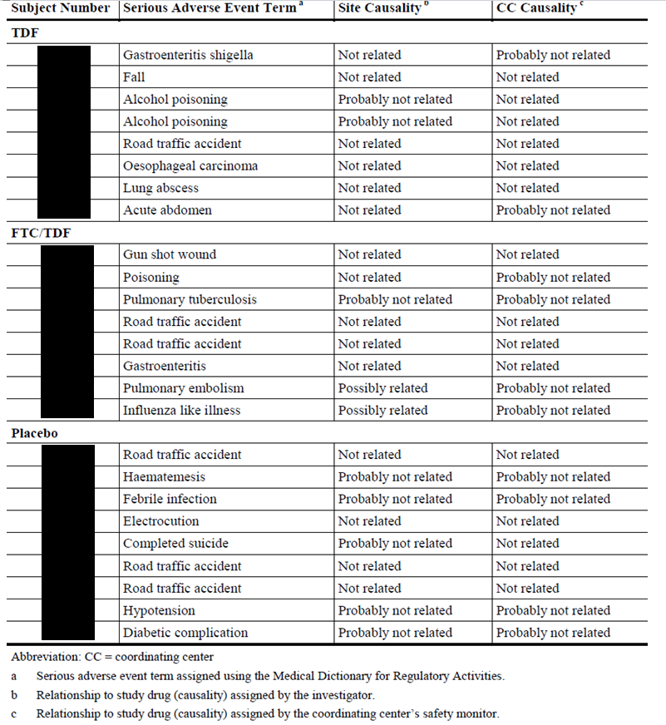
Subject identifiers have been redacted from Table 20.

Discontinuation due to adverse events

Pivotal studies

Study CO-US-104-0288/iPrEx
Overall, discontinuations due to clinical or laboratory AEs were reported in 2% of patients with no meaningful differences between groups.

Study CO-US-104-0380/Partners PrEP
Overall, there were only six AEs (0.1%) leading to discontinuation. All were minor increases in serum creatinine.

Laboratory tests

Study CO-US-104-0288/iPrEx
The number of subjects with graded laboratory AEs, including those related to hepatic, renal, and haematological function is shown in Table 21 below.

Study CO-US-104-0380/Partners PrEP
The number of subjects with treatment-emergent laboratory AEs related to hepatic and haematological function is shown in Table 22.

Table 21: CO-US-104-0288: Number of subjects with graded laboratory abnormalities (Data up to 01 May 2010; iPrEx Analysis)
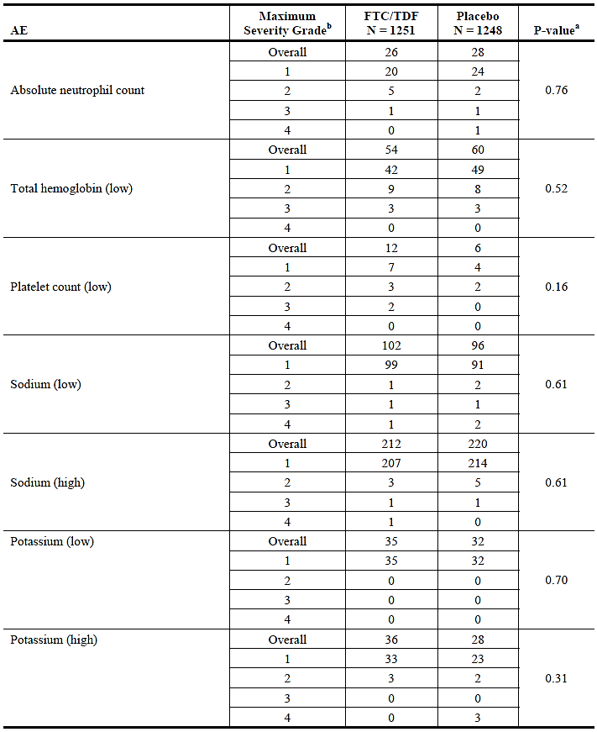

Table 21 (continued): CO-US-104-0288: Number of subjects with graded laboratory abnormalities (Data up to 01 May 2010; iPrEx Analysis)
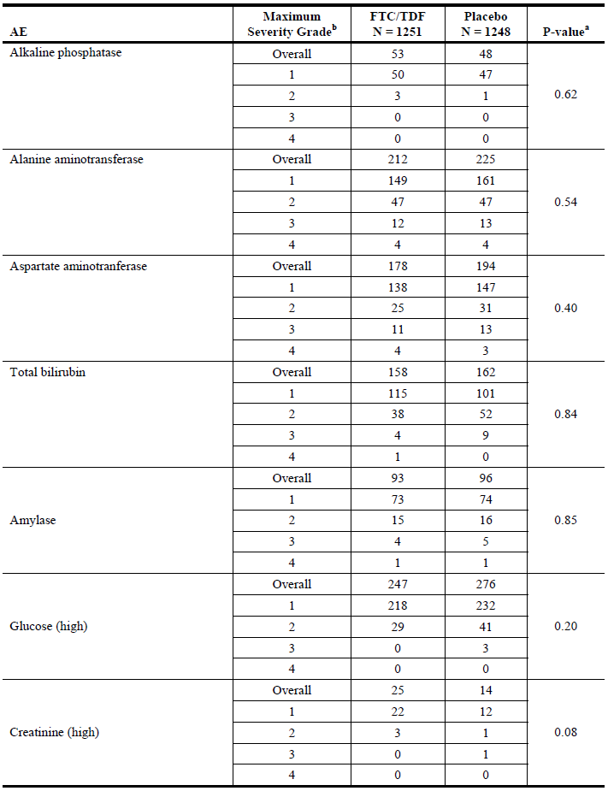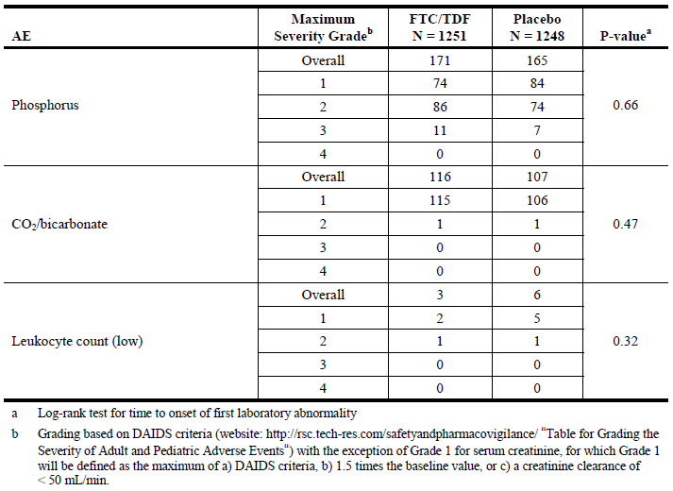

Table 22: CO-US-104-0380: Percentage of highest achieved post baseline laboratory toxicity grades (ITT-Partners PrEP) Randomized Subjects
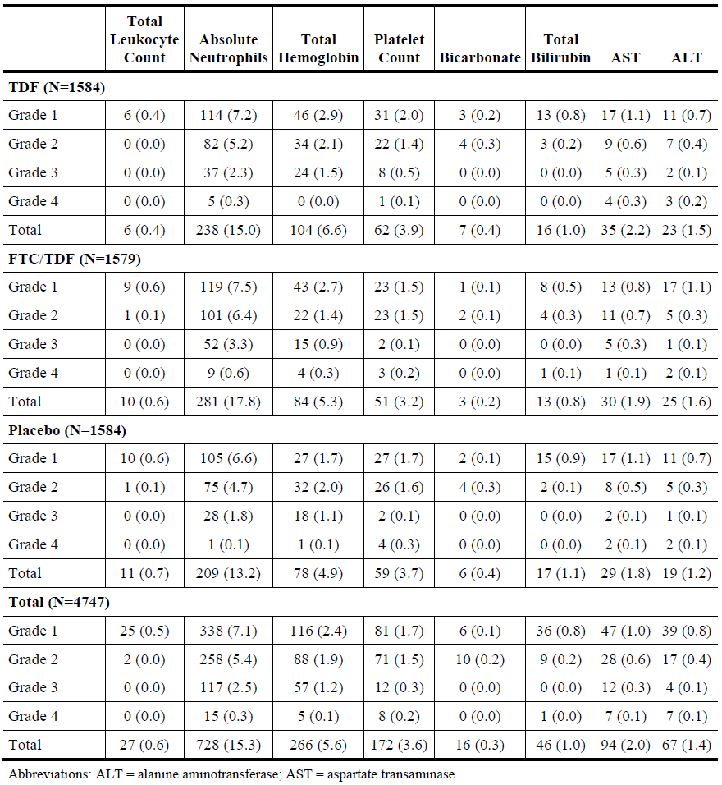

Liver function

Study CO-US-104-0288/iPrEx
The incidence of LFT abnormalities was comparable in each group. Grade 4 ALT abnormalities were recorded in only four subjects (< 0.01%) in each group. No hepatic flares were observed in the 12 subjects with chronic HBV infection at baseline, or in the four subjects who acquired acute HBV infection during the double-blind period.

Study CO-US-104-0380/Partners PrEP
No more than 2% of any study group experienced AEs related to ALT and AST abnormalities. Only two subjects in the FTC/TDF group experienced a Grade 4 ALT elevation.

Kidney function

Study CO-US-104-0288/iPrEx
AEs related to increases in creatinine levels were more common in the FTC/TDF group (0.02%) compared with placebo (< 0.01%, p < 0.08). However, nearly all events were mild to moderate in severity and no Grade 3 or 4 events were reported in the FTC/TDF group. Median creatinine values remained similar to baseline throughout the study, and there were no meaningful trends in either group. There were no meaningful changes or trends in creatinine clearance in either group throughout the study.

Study CO-US-104-0380/Partners PrEP
Changes in serum creatinine are shown in Table 23. AEs related to raised serum creatinine levels were reported in < 1.0% of subjects in each group. Only one subject (receiving TDF) had a Grade 2 elevation, and there were no Grade 3 or 4 elevations.

Table 23: CO-US-104-0380: Post-baseline creatinine and phosphorus laboratory toxicities (ITT)
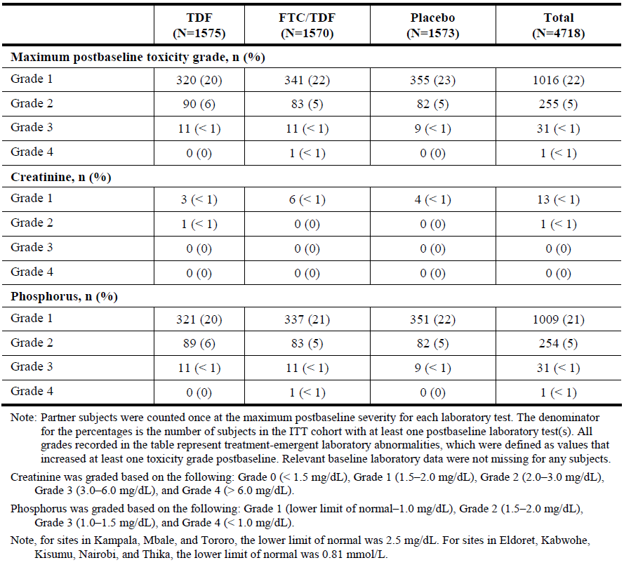

Other clinical chemistry

Study CO-US-104-0288/iPrEx
With the exception of serum phosphate, there were no meaningful changes or trends in either drug group relating to other clinical chemistry variables. AEs relating to decreased serum phosphate were reported in 13.7% of the FTC/TDF group compared with 13.2% in the placebo group. There were no Grade 4 AEs but Grade 3 events were reported in 0.9% and 0.6% of the respective groups.

Study CO-US-104-0380/Partners PrEP
AEs related to clinical chemistry abnormalities were reported in no more than 4% of each treatment group. With the exception of serum phosphate AEs, there were no meaningful changes in other clinical chemistries. AEs related to decreased serum phosphate were reported in 6.6% of the overall population with no meaningful differences between the study drug groups.

Haematology

Study CO-US-104-0288/iPrEx
AEs relating to haematological variables were uncommon in both treatment groups (< 0.1%). Only six Grade 3 events and no Grade 4 events were reported in the FTC/TDF group.

Study CO-US-104-0380/Partners PrEP
Overall, AEs relating to neutrophils, haemoglobin and platelets were reported in 15.3%, 5.6%, and 3.6% of partner subjects. Compared with placebo, low neutrophils and low haemoglobin were reported marginally more frequently in the FTC/TDF group (7.5% versus 6.6%) and (2.7% versus 1.7%), respectively.

Electrocardiograph
ECGs were not recorded in either pivotal study.

Vital signs

Study CO-US-104-0288/iPrEx
There were no clinically significant changes or trends in vital signs throughout the study.

Study CO-US-104-0380/Partners PrEP
No vital sign findings were summarised in the CSRs. Significant abnormalities were captured as AEs.

Pregnancies

Study CO-US-104-0380/Partners PrEP
A total of 1,785 female partners were randomised, and pregnancies were reported in 18%, 13%, and 14% of subjects in the TDF, FTC/TDF, and placebo groups, respectively as summarised in Table 24.
Pregnancy outcomes are summarised in Table 25. Of the 288 pregnancies reported, 62% were completed, 51% resulted in a live birth, and 49% of pregnancies were lost. Five deaths were reported in newborns within 3 months of delivery but none were considered drug related (see Table 26). Pregnancy outcomes were comparable in each study drug group.

Table 24: Study CO-US-104-0380: Summary of pregnancies in partner subjects (ITT)
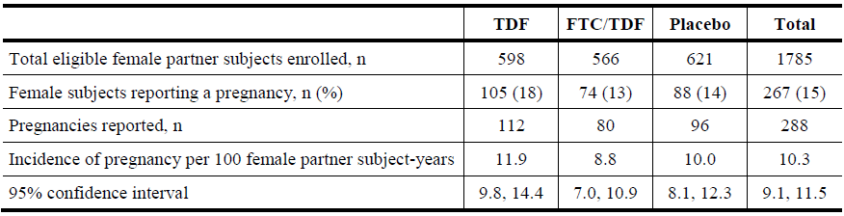

Table 25: Study CO-US-104-0380: Summary of pregnancy outcomes in partner subjects (ITT)
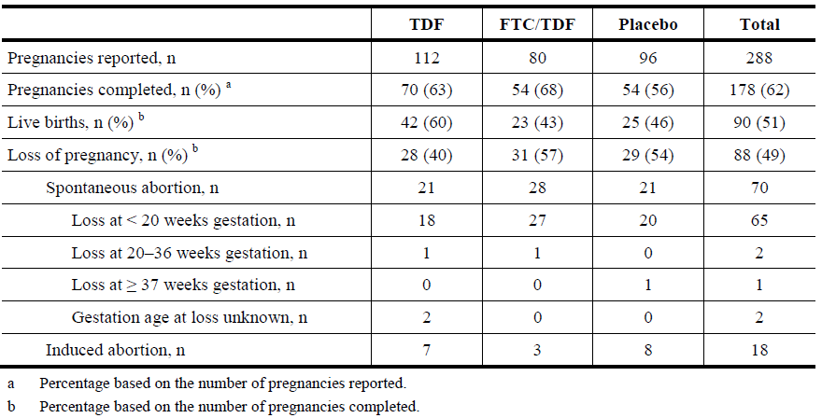

Table 26: Study CO-US-104-0380: Expedited adverse events for newborns of partner subjects (ITT)
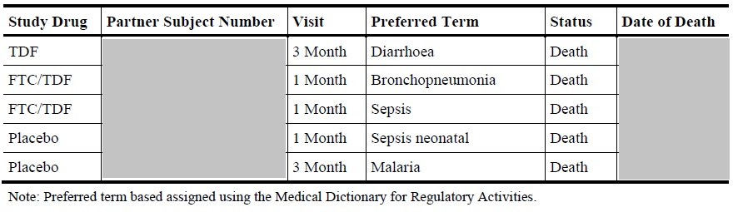
Note: Greyed out information redacted for patient confidentiality reasons.
Comment: As pointed out in the CSR, medical abortion is illegal in Kenya and Uganda and an unknown number of spontaneous abortions may actually have been induced. There was no evidence of increased adverse pregnancy outcomes in the FTC/TDF group compared with placebo. In general, the pregnancy outcomes are reassuring but follow-up appears to have been somewhat limited in scope. In particular, exposure and the incidence of birth defects do not appear to have been reported (see Clinical Questions below). Differing standards of antenatal care and social factors make it difficult to interpret these pregnancy data in the Australian context.

AEs of special interest
With the exception of EAEs (see Clinical efficacy: pivotal efficacy studies above) there were no pre-defined AEs of interest in the pivotal studies. However, post hoc analyses of AEs of interest were conducted in relation to EAEs, gastrointestinal events identified in the FTC/TDF product information (diarrhoea, nausea, and weight loss), and renal events related to proximal tubular dysfunction with TDF.

Study CO-US-104-0288/iPrEx
Treatment-emergent gastrointestinal AEs are shown in Table 27 (below):

Table 27: Study CO-US-104-0288: Incidence of treatment-emergent clinical AEs for key events identified in the FTC/TDF CCDS - CSI (Gilead Analysis; Randomized Subjects)
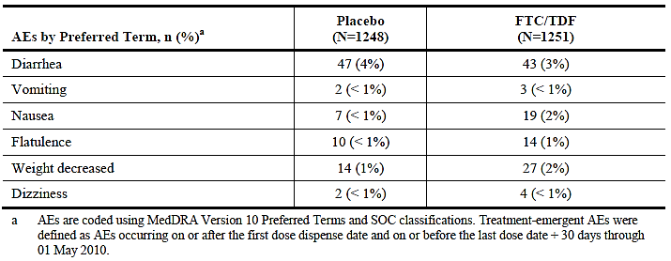
Overall, the incidence of GI events was low but, with the exception of diarrhoea, there were more events in the FTC/TDF group compared with placebo, notably nausea (2% versus 1%) and decreased body weight (2% versus 1%). As shown in Figure 9 below, increased rates of nausea and body weight reduction in the FTC/TDF group occurred during the initial phase of the study with resolution thereafter.
Figure 9: CO-US-104-0288: Nausea and weight change by randomization Group (data up to 01 May 2010 iPrEx analysis; randomized subjects)
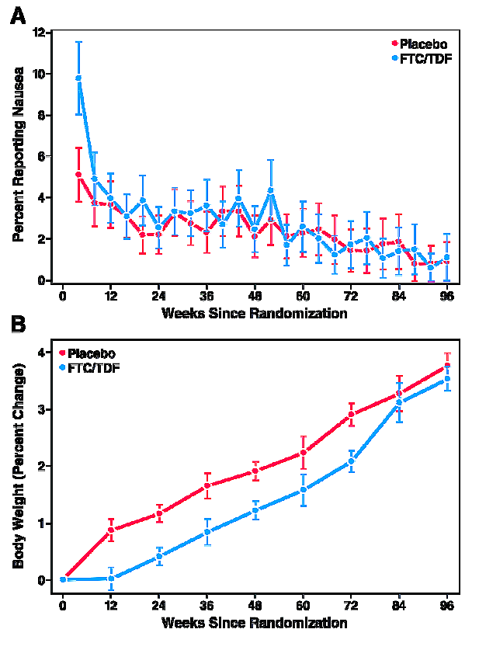
Changes in serum creatinine and creatinine clearance are summarised in the ‘Clinical safety: laboratory tests – renal function’ section above. AEs related to renal function were reported less frequently in the FTC/TDF group compared with placebo (3% versus 4%), and no SAEs were reported.
At the end of the double-blind study period, 36 subjects reported bone fractures. Fractures were more common in the FTC/TDF group (n=21, 2%) compared with the placebo group (n=15, 1%). All were traumatic, none appeared pathological, and none were considered drug related. There were no reports of delayed healing in subjects with follow-up information available. Decreased serum phosphate was not identified as an AE of interest in this study but there were no apparent differences between groups.

Study CO-US-104-0380/Partners PrEP
Diarrhoea was reported in 2% to 3% of subjects. SAEs were reported in only three subjects and none were considered drug related. Only one subject reported nausea in the FTC/TDF group and this was non-serious. Decreased body weight was reported in 9, 4, and 6 subjects in the TDF, FTC/TDF, and placebo groups, respectively. A single Grade 4 event was related to pulmonary tuberculosis.
Changes in serum creatinine and creatinine clearance are summarised in the ‘Clinical safety: laboratory tests – renal function’ section above. Increased serum creatinine (nearly all Grade 1) was reported in 5%, 7%, and 5% of partner subjects in the TDF, FTC/TDF, and placebo groups, respectively. Decreased serum phosphate was observed in 28%, 29%, and 30% of the respective groups. These decreases were reported as an EAE in 6% to 7% of each group. Most events were Grade 2 (Grade 1 events were not reported as AEs), and no confirmed events were Grade 4. Bone fractures were reported in 0.7% of the overall population with comparable frequency in each study drug group (< 1%). Nearly all of the fractures were related to direct trauma and no fracture SAEs were considered to be drug related.

Bone mineral density

Study CO-US-104-0288/iPrEx
Mean percentage changes in BMD from baseline in the hip and spine are shown in Table 27 below. At Week 24, there were modest but highly significant percentage decreases in BMD in the FTC/TDF group compared with placebo (total hip: p = 0.0004, spine: p = 0.0007). The decreases in BMD ranged from approximately 0.5% to 1% but no further reductions were apparent at subsequent visits to Week 96. Total hip osteopaenia (defined as a T-score of -1.0 to -2.5) at any post-baseline visit was reported in 19% of the FTC/TDF group compared with 18% in the placebo group. No subjects in either group had a marked reduction in BMD (> 7.0% at ≥ 2 consecutive visits). A decrease of ≥ 5% in BMD in the spine was reported in 14% of the FTC/TDF group compared with 6% of the placebo group. Marked decreases (> 5% at ≥ 2 consecutive visits) were observed in 3% and 2% of the respective groups. Increases in body fat were observed in both treatment groups with minor smaller increases in the FTC/TDF group.

Table 27: CO-US-104-0288: Least Square Mean (Standard Error) percentage change in BMD from Baseline to on-study drug visit (Data from the iPrEx study team) (iPrEx analysis; subjects who participated in the DEXA sub-study)
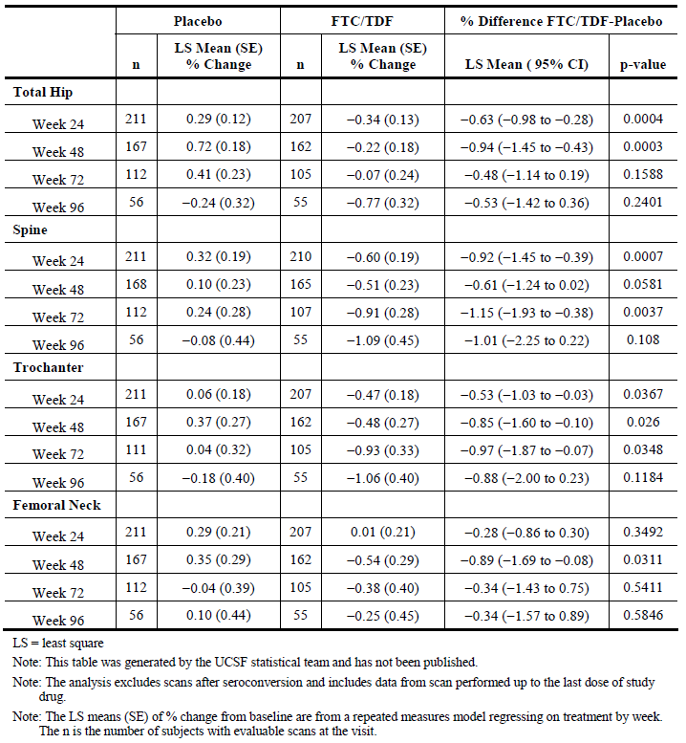

Study CO-US-104-0380/Partners PrEP
No BMD assessments were made.

Study CDC 4323
In the BMD sub-study, 184 subjects had at least one DEXA scan after randomisation. Compared with placebo, there were significant net decreases in mean BMD of -1.1% in the femoral neck (95% CI: -0.4%, -1.9%, p = 0.004), and of -0.8% in the total hip (95% CI: -0.3%, -1.3%). There was a net decrease of -0.7% in the lumbar spine but the difference was not statistically significant (95% CI: -0.1%, 1.5%). The BMD results were comparable after adjustment for baseline BMD, race, age, BMI, and renal function. Overall, 13% of subjects in the TDF group experienced ≥ 5% loss of BMD compared with 6% in the placebo group (p = 0.13). Hypogonadism or vitamin D deficiency was observed in four of the 27 subjects with severe osteopaenia. In the follow-up period, 10 fractures were reported (6 TDF, 4 placebo, p = 0.75) but all were related to trauma and not considered drug related. The probability of changes in spinal bone density in the TDF and placebo groups at 24 months is shown in Figures 10 and 11 (see below). The proportion of subjects experiencing bone loss of any severity was higher in the TDF group compared with placebo.
Figure 10: Study CDC 4323: Probability density of percent changes in bone density at 24 months at the total spine (L2 to L4) (Study CDC 4323 Dexa sub-study participants)
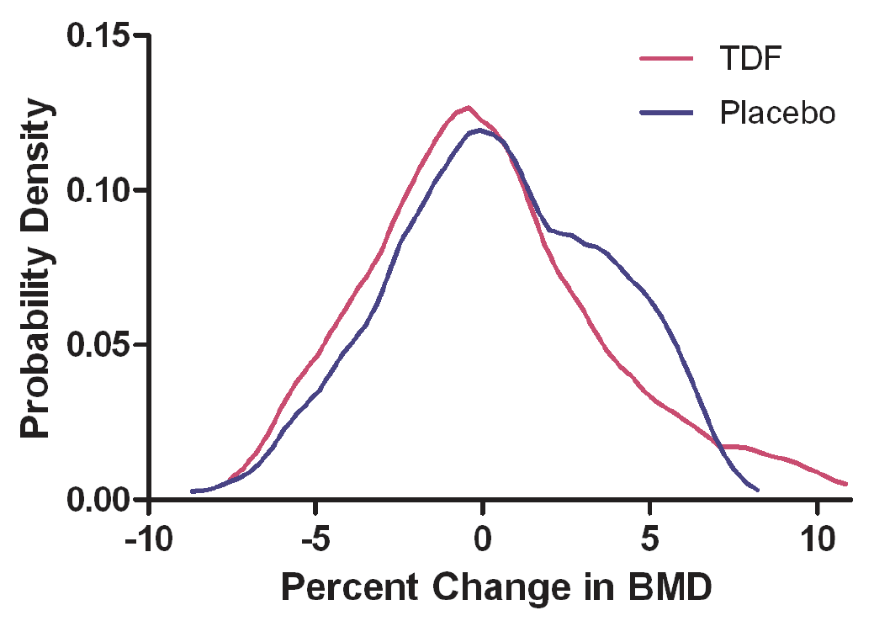
Figure 11: Study CDC 4323: Proportion of subjects experiencing bone loss at 24 Months compared to Baseline (Study CDC 4323 Dexa sub-study participants)
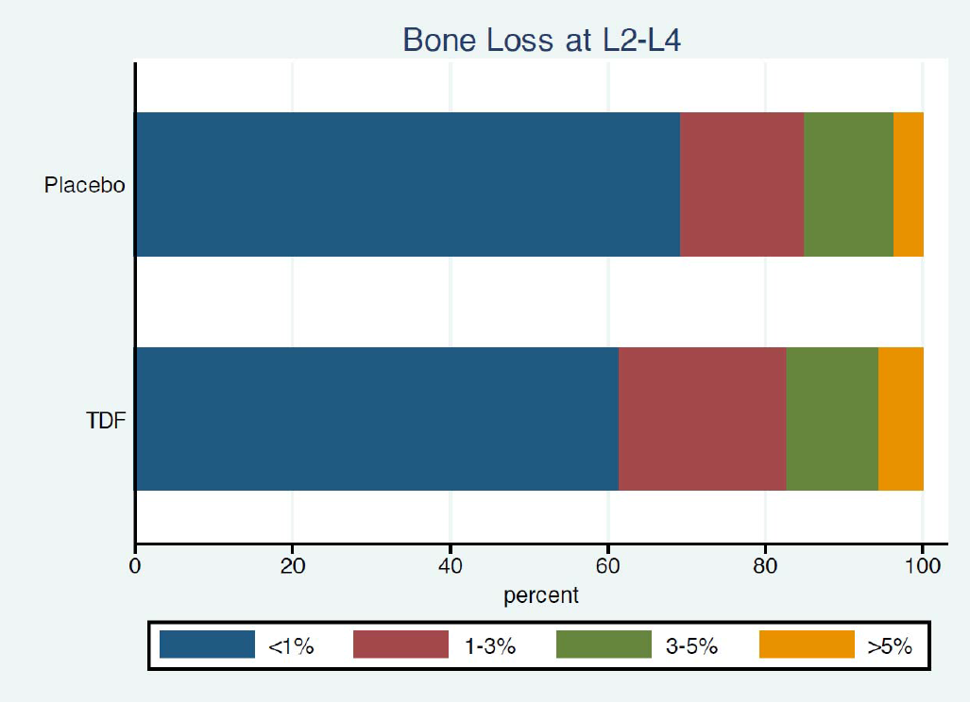

Post-marketing experience
Post-marketing safety has been assessed in:
- Data from the Antiretroviral Pregnancy Registry, including an interim report from 1 January 2011 to 31 January 2014 (Study GS-US-276-0101).
- An observational study of subject receiving Truvada for PrEP who seroconvert during follow-up (Study GS-US-276-0103).
- The latest Periodic Benefit Risk Evaluation Report (PSUR/PBRER) for Truvada dated 3 April 2013 to 2 April 2014.
- An updated summary of literature data since submission of the sNDA to 30 November 2014.
- Additional reports submitted to the FDA after the sNDA with a cut-off date of 24 July 2013.

Study GS-US-276-0101
This is an ongoing 3 year, prospective, observational study of maternal and foetal outcomes in HIV-uninfected women receiving Truvada for PrEP before conceiving. The study was mandated by the FDA as a condition of approval. Data from evaluable subjects enrolled into the Antiretroviral Pregnancy Registry (APR) between 1 January 2011 and 31 January 2014 have been analysed in this interim report. Patients receiving any antiretroviral therapy are enrolled into the APR as soon as possible after pregnancy is confirmed. At the interim analysis cut-off point, 36 pregnant women with reported Truvada prescriptions were identified in the APR database. Of the 36 patients receiving Truvada, 35 were enrolled in the Partners PrEP study which mandated discontinuation of study drug. All pregnant women taking Truvada for PrEP were then matched 1:1 with a comparison group of other HIV-1-infected pregnant women receiving any other antiretroviral therapy identified in the APR. The process matched pregnancies as closely as possible based on gestation time, exposure to antiretroviral therapy, and other demographic variables. The study outcomes include birth defects and other reported pregnancy outcomes such as spontaneous abortions, induced abortions, stillbirths and live births.
Patient demographics in the Truvada and matched control groups are shown in Table 28 below. Of the 36 patients receiving Truvada for PrEP, the mean age was 30.0 years (range 22 to 40), most were from Africa (97.2%), most were Black (91.7%), and most were enrolled in a clinical study (97.2%). All patients were exposed during the first trimester and all but one patient discontinued Truvada during the pregnancy. The mean exposure to Truvada was 6.61 weeks (range 0.1 to 31.4). Exposure was 12.9 weeks in the single individual who continued treatment during her pregnancy. The incidence of birth defects was comparable in the Truvada and control groups as shown in Table 29. In the Truvada group, there was one birth defect in 19 live births with a prevalence rate of 0.05 (95% CI: 0.01 to 0.26). The birth defect (a 2 cm haemangioma and a 1 cm umbilical hernia in the same infant) was not considered drug related. The prevalence of adverse pregnancy outcomes is shown in Table 30. In the Truvada group, there were 17 events (11 spontaneous abortions, and 6 induced abortions) with a prevalence of 0.47 (95% CI: 0.30 to 0.65). In the matched control group, there were fewer events (4 spontaneous abortions, 2 induced abortions, and 2 stillbirths).

Table 28: Study GS-US-276-0101: Patient demographics and clinical characteristics at Baseline among Truvada for PrEP cases and matched HIV-infected controls
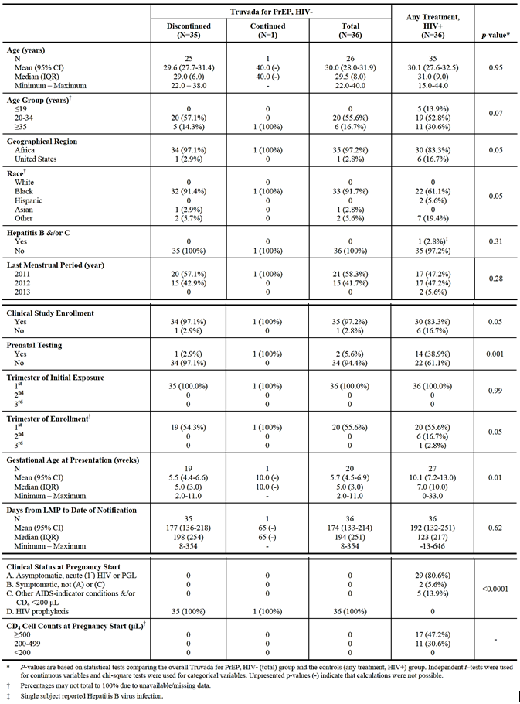

Table 29: Study GS-US-276-0101: Prevalence of birth defects*
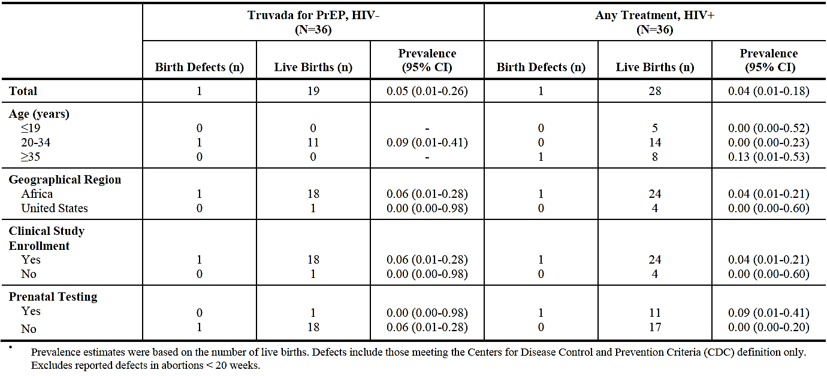
* Prevalence estimates were based on the number of live births. Defects include those meeting the Centers for Disease Control and Prevention Criteria (CDC) definition only. Excludes reported defects in abortions < 20 weeks.

Table 30: Study GS-US-276-0101: Prevalence of adverse pregnancy outcomes (spontaneous abortions, induced abortions and stillbirths)
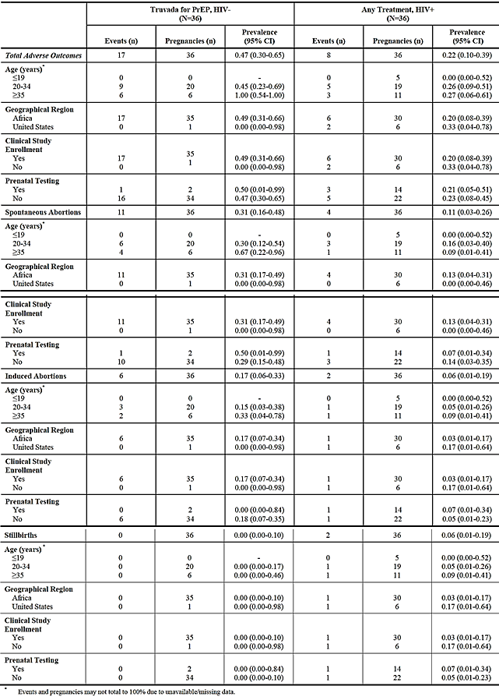
Comment: Single birth defects were reported in both the Truvada group and the control group of women receiving other antiretroviral therapies. While reassuring, the value of this study to the current submission is limited at present as 35/36 pregnancies occurred in Partners PrEP. Because Partners PrEP and Study GS-US-276-0101 overlapped in time, the great majority of pregnancies in Partners PrEP were not eligible for inclusion in GS-US-276-0101. The details of all 288 pregnancy outcomes in Partners PrEP, including those occurring in the placebo control group, are summarised in the ‘Clinical safety: laboratory tests – pregnancy outcomes’ section. Data from the latest update from the APR are summarised under the ‘Supplemental NDA safety update’ section later in this document.

Study GS-US-276-0103
This is an ongoing, prospective, observational study of subjects who seroconvert while taking Truvada for PrEP. The study was mandated as a condition of approval by the FDA and this interim report is date 18 September 2014. The planned target is a minimum of 150 adult HIV-1 negative subjects who seroconvert while taking Truvada for PrEP. Data relating to signs and symptoms of infection, sexual risk factors, and viral resistance are being collected. As of 12 August 2014, 3,604 HIV-negative subjects have or will be enrolled in 15 demonstration projects or studies of Truvada for PrEP, not including the Partner PrEP study. Screening for acquisition HIV-1 has been performed using various test kits at various intervals defined by the protocols.
The baseline demographics and baseline characteristics of the 39 subjects who seroconverted are shown in Table 31. All were male with a mean age of 27.8 years. Most subjects were of mixed or other race (51.3%), Black (25.6%), or White (15.4%). A total of 34 evaluable seroconversions have been reported in 2190 subjects with a total exposure to Truvada of 1,925 person-years, and an estimated seroconversion rate of 1.77 per 100 patient years. Resistance testing was performed in 14 cases at the cut-off date: all cases were wild type virus and no resistance mutations were identified.
Comment: The ongoing studies of Truvada for PrEP in this analysis are all sponsored by the NIH or US universities. At the cut-off date, no viral resistance has been demonstrated. While the resistance data are reassuring, the number of seroconversions is currently too low to draw valid conclusions.

Table 31: Study GS-US-276-0103: Demographics and Baseline characteristics
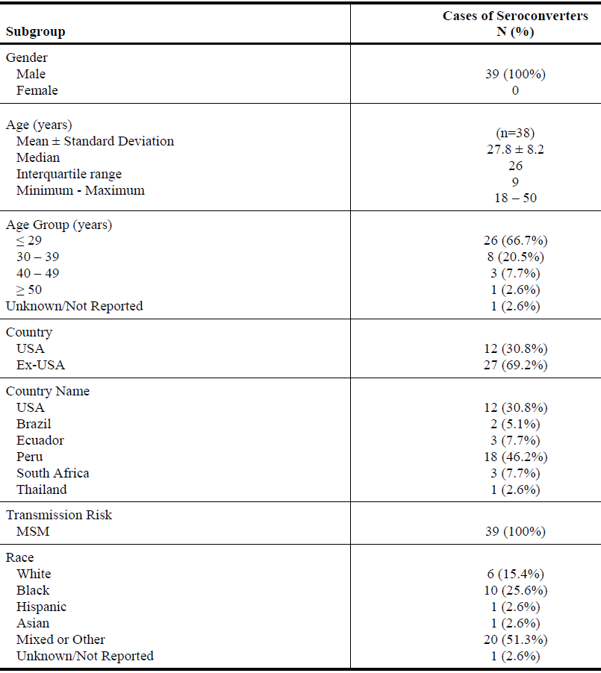

Truvada PSUR/PBRER (3 April 2013 to 2 April 2014)
Summary: Since it was first approved in 2004, the cumulative exposure to Truvada is estimated to be 3,032, 901 patient-tears, including 461,395 patient-years in the latest update period (5,814 in Australia and New Zealand) (see Table 32). During the period of the latest PSUR/PBRER, approximately 3,305 subjects received Truvada in HIV (n = 2,955) and HBV (n = 350) clinical trials. In addition, there were 56 ongoing collaborative clinical trials with a cumulative exposure of 20,559 subject-years. During the most recent observation period, no new potential safety signals have been detected and the risk-benefit profile of Truvada remains positive.
While no new safety signals have been detected, emerging data have resulted in updated warnings and precautions in the USPI. Established safety concerns include renal toxicity, loss of BMD, hepatic flares in HIV-1/HBV co-infected patients, pancreatitis, interaction with didanosine, lipodystrophy, and lactic acidosis and severe hepatomegaly with steatosis. A sNDA was submitted and approved by the FDA on 13 June 2013. This updated the USPI for products containing TDF with label changes relating to BMD, muscle effects, and high dose NSAID use in patients with risk factors for renal dysfunction. No new safety signals were detected in relation to post-treatment flares in HIV-1/HBV co-infected patients; potential interactions with didanosine; pancreatitis; lactic acidosis and severe hepatomegaly with steatosis; or lipodystrophy.

Table 32: Truvada PSUR/PBRER: Estimated patient exposure to marketed Truvada (1 April 2013 to 31 March 2014 and cumulatively)
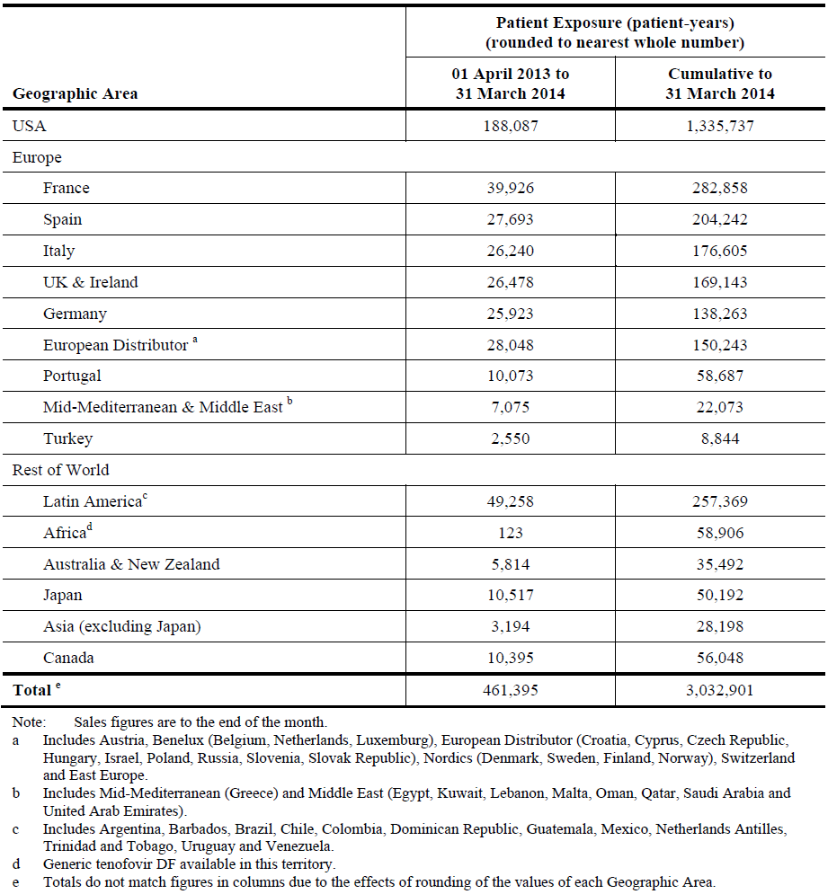
At the request of the FDA, Gilead provided an analysis of their Drug Safety and Public Health database for bone/muscle events (such as rhabdomyolysis, osteomalacia, muscular weakness, and myopathy) due to proximal renal tubulopathy/loss of BMD. In 11,786 TDF events in the database, PRT events were reported in 6.6% of cases and bone/muscle events were reported in 3.0% of cases. Only 23.9% of cases with a bone/muscle event also reported a PRT event, and only 10.9% of PRT cases also reported a bone/muscle event. Only 0.7% of all cases in the database reported both PRT and bone/muscle events. Cases which reported both PRT and NSAID use accounted for only 0.6% of all cases in the database. NSAIDs were used before a diagnosis of PRT in 4.3% of PRT cases, and high doses of NSAIDs were reported in 26.5% of these cases. All reported cases occurred in patients with risk factors for renal dysfunction. In patients with a diagnosis of PRT, only 17 cases with bone/muscle events and NSAID use were identified. A disproportionality analysis did not show an increased likelihood of PRT with NSAIDs and TDF. In addition, a multivariate analysis showed that NSAID use before or after a bone/muscle event did not increase the risk of PRT with or without exposure to TDF. In a separate Renal Tubulopathy Reversibility review, data from various sources indicated that PRT was reversible in 81% to 93% of cases following cessation of TDF. In cases that did not resolve, the outcomes were confounded by lack of prolonged follow-up and pre-disposing factors such as hypertension and diabetes.
A total of 51 cases relating to bone events were reported in the latest PSUR. Of these 20 events were related to osteopaenia/osteoporosis which improved during an 18 month observational study of DEXA following withdrawal of Truvada therapy. A total of 139 reports relating to renal toxicity were reported in the latest PSUR, corresponding to 2.5 events/10,000 patient-years exposure (see Table 33 below). This figure was comparable to that reported in the previous PSUR (2.2/10,000 patient-years). Six deaths were reported but all had other factors contributing to the fatalities.

Table 33: Truvada PSUR/PBRER: Renal cases by outcome (renal events with fatal outcome, reported as life-threatening or requiring dialysis)
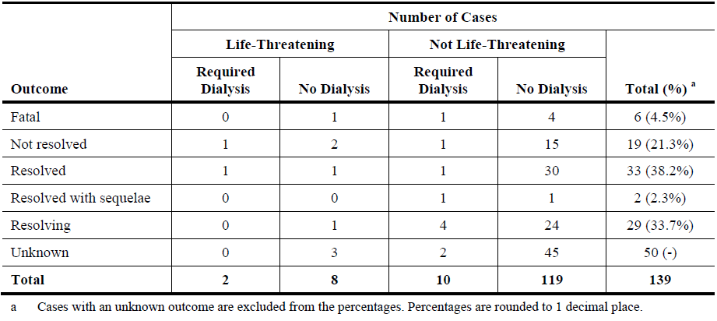
A summary of pregnancies reported in the APR to 31 July 2013 is also included in the latest PSUR/PBRER. A total of 201 birth defects have been recorded among 6,926 live births with a prevalence of 2.9 per 100 births among women exposed to Truvada in the first trimester (95% CI: 2.5, 3.3). This was comparable to the prevalence of 2.8 per 100 live births among women exposed in the second or third trimester [prevalence ratio 1.02 (95% CI: 0.85, 1.23)]. In women exposed to Truvada or any other antiretroviral drug in the APR, there does not appear to be an increased risk of birth defects when compared with those exposed to other drugs in population-based surveillance systems.

Supplemental NDA safety update
Gilead has provided a summary of new data reported since submission of the sNDA. The update is dated 16 March 2012. The main focus of the report was on newly reported bone fractures and new drug testing data in the iPrEx study; and new pregnancy outcomes and SAEs in the Partners PrEP study. In addition, a summary of new publications relevant to the PrEP indication was provided. CSRs to support the publications were not provided to Gilead.

iPrEx update
Updated data from the iPrEx study relating to TFV-DP drug testing and bone fractures are included in Sections Pivotal efficacy studies; Study CO-US-104-0288 (iPrEx) and AEs of special interest; Pivotal studies, respectively.

Partner PrEP update
Pregnancy outcome data in the Partner PrEP study are summarised in GS-US-276-0101 (see Section 8.6.1).
Pregnancies reported after submission of the sNDA are summarised in Section Truvada PSUR/PBRER 3 April 2013 to 2 April 2014 as part of latest PSUR.
A total of 24 new SAEs have been reported in 20 subjects. One SAE was fatal (a cerebrovascular event) but it was not considered drug related. Non-fatal SAEs were related to an inguinal hernia birth defect, pain, pyrexia, pneumonia, malaria, back pain, spontaneous abortion, acute psychosis, and asthma.
A study drug compliance sub-study involving 1,147 subjects was conducted as part of the Partner PrEP study. The results are summarised in Section Study C0-US-104-0380 (Partners PrEP).

Newly published studies
- CDC 4323 (CO-US-104-0277): a Phase II study of TDF for PrEP in a US MSM population
- FHI PrEP (GS-02-1020): a Phase II study of TDF for PrEP in West African women
- CDC Botswana/TDF2 (CO-US-104-0294): a Phase III study of FTC/TDF in heterosexual adults
- FEM PrEP (CO-US-164-0184): A Phase III study of FTC/TDF in high risk African women
These studies are summarised in above.

Safety issues with the potential for major regulatory impact

Liver toxicity
No hepatic toxicity was identified. No cases of hepatic viral flares were reported during or after treatment in subjects with acute or chronic HBV infection in the iPrEx or FHI PrEP studies.

Haematological toxicity
No haematological toxicities were identified.

Serious skin reactions
No serious issues were identified in the pivotal studies. In iPrEx, AEs related to skin disorders were reported in 4% of each study drug group. In Partners PrEP, AEs related to skin disorders were reported in 1% of the TDF, FTC/TDF, and placebo groups.

Cardiovascular safety
No issues were identified.

Unwanted immunological events
Not applicable.

Other safety issues

Safety in special populations
No additional data have been submitted.

Safety related to drug-drug interactions and other interactions
No new or updated information has been provided.

Evaluator’s overall conclusions on clinical safety
Safety data to support the new proposed indication are derived primarily from two pivotal Phase III studies of FTC/TDF used for PrEP in two high risk populations, MSM and heterosexual HIV-1 discordant couples. Supportive data were provided from published studies of MSM in the US, and African women and heterosexual adults. Routine recording of AEs and laboratory abnormalities was performed and compared with data in the Gilead Core Data Sheet. In addition, AEs of interest were identified including renal dysfunction and changes in bone mineral density, both related to the known effects of TDF on the proximal renal tubule.
In the iPrEx study in 2,499 randomised MSM, FTC/TDF was well tolerated with a safety profile comparable to placebo. AEs of any severity were reported in 55% of the FTC/TDF group compared with 56% in the placebo group (Gilead analysis). A similar incidence of Grade 3 or 4 AEs (9% versus 9%) and SAEs (4% versus 4%) were reported in the respective groups. Deaths occurred in < 0.1% of each group. Clinical and laboratory AEs leading to drug discontinuations were reported in 2% and < 0.1% of each group, respectively. The most commonly reported AEs by SOC were related to Infections and Infestations (36% in each group), and Psychiatric Disorders (8% versus 9%). The frequency of AEs related to gastric disturbances was similar in each group although nausea was more common in the group receiving FTC/TDF (2% versus < 1%). Bone fractures were reported in 1% of the FTC/TDF group compared with < 1% in the placebo group. However, all fractures were traumatic and none were considered drug related. Overall, serum creatinine elevations above ULN were reported more commonly in the FTC/TDF group (25 versus 14 subjects, p = 0.08) but no Grade 3 or 4 events were reported in the FTC/TDF group. Decreased serum phosphate levels were comparable in each group but Grade 3 elevations were more common in the FTC/TDF group (11 versus 7 subjects, p = 0.66).
In the Partner PrEP study, FTC/TDF and TDF were well tolerated with a safety profile comparable to placebo. AEs of any severity were reported in 86%, 85%, and 85% of the FTC/TDF, TDF, and placebo groups, respectively. Grade 4 events were reported in 37%, 26%, and 32% of the respective groups, and SAEs were reported in 7% of each group. Deaths were reported in 6%, 5%, and 6% of the respective groups. The most common AEs reported by PT in the overall population were decreased neutrophil count (39%), blood phosphorus decreased (29%), malaria (19%), haemoglobin decreased (15%), decreased platelet count (12%), and upper respiratory infections (9%). Diarrhoea was reported in 2% to 3% of the study drug groups but nausea was reported in < 1% of any group. Grade 1 or higher increases in serum creatinine were reported in < 1% of each group. Bone fractures occurred in < 1% of subjects in each study drug group. All were traumatic and not considered drug related.
In the overall populations, PrEP with FTC/TDF was well tolerated with a safety profile comparable to placebo. No obvious differences in subgroups (in particular gender) were identified although subject numbers in some categories were too small to identify possible differences. No new safety signals have been detected in the pivotal studies or supportive studies of PrEP using FTC/TDF or TDF alone. The rates of AEs, laboratory AEs, severe AEs, SAEs and deaths were generally similar in the active and placebo study groups. The overall data were also comparable with the known safety profile of Truvada used as treatment for HIV-1 infection.
AEs of interest were identified based on the known effects of Truvada. As expected, gastrointestinal adverse events (in particular nausea and vomiting) were more common in subjects receiving FTC/TDF compared with placebo. However, most events occurred in the first month and resolved with continued exposure.
Renal events associated with TDF renal tubulopathy were generally mild. Increased serum creatinine was reported more commonly in subjects receiving FTC/TDF but no Grade 3 or 4 events were reported and most elevations resolved with cessation of treatment. There was a low incidence of PRT associated with the use of TDF and NSAIDs, and most events occurred in subjects with predisposing renal risk factors.
Hypophosphataemia was also reported more commonly in subjects receiving FTC/TDF or TDF alone. Compared with placebo, there was a mean 0.5% to 1% loss of BMD in subjects receiving FTC/TDF over observation periods of 24 to 96 weeks. Most of the observed bone loss occurred in the first six months of drug administration but further minor progression was observed over the remaining period. Overall, changes in BMD were modest and there was no evidence of an increased rate of bone fractures in subjects receiving FTC/TDF. However, in the iPrEx study, BMD loss of ≥ 5% in the spine measured at any visit was observed in more subjects receiving FTC/TDF (14% versus 6%). This observation was confirmed in Study CDC4323 in which loss of BMD was higher in the FTC/TDF group (13% versus 6%). The subjects in these BMD substudies were male and no PrEP studies have been performed in women, or in women receiving depot medroxyprogesterone acetate. There was no evidence of an increased rate of bone fractures with the use of FTC/TDF or TDF alone. However, more long-term data are required to exclude progressive and damaging bone loss following extended periods of chemoprophylaxis.
No hepatic viral flares during or after treatment with FTC/TDF or TDF were reported in subjects with chronic or acute HBV infection. However, subject numbers infected with HBV were low and the risk of potentially serious hepatic events cannot be discounted.
Pregnancy outcomes in the FTC/TDF and placebo groups were comparable with no unexpected increase in birth defects. The pregnancy and foetal outcome data were comparable to data from other ART drug registries.
Sexual disinhibition is a significant safety concern as PrEP alone will not prevent HIV-1 transmission in all cases. The perception that PrEP is a ‘chemical condom’ might lead to a reduction in safer sex practices and actually increase the risk of infections, particularly in subjects with poor drug compliance. However, opposite trends were apparent in the pivotal studies with increased self-reported condom use and a decrease in the number of sexual partners.

First round benefit-risk assessment

First round assessment of benefits
The benefits of Truvada in the proposed usage are:
- Reduced risk of HIV-1 infection in high risk MSM
- Reduced risk HIV-1 infection in sexually active, HIV-1 discordant partnerships
- Well tolerated with safety profile comparable to placebo
- Adverse events related to tenofovir disoproxil fumarate well understood and predictable
- Improved safer sex practices associated with counselling and close medical supervision

First round assessment of risks
The risks of Truvada in the proposed usage are:
- Reduced but still significant risk of acquiring HIV-1 infection
- Potential viral resistance in subjects with unrecognised HIV-1 infection
- Adverse events related to tenofovir disoproxil fumarate , in particular reduced bone mineral density
- Risk of post-treatment viral flares in subjects with HBV infection
- Efficacy dependent almost entirely on good drug compliance and safer sex practices
- Reduced efficacy if not closely supervised by experienced HIV healthcare providers
- The value of PrEP not yet fully evaluated in the Australian context.

First round assessment of benefit-risk balance
The benefit-risk balance of Truvada, given the proposed usage, is favourable.
There is a statistically significant and clinically meaningful benefit for Truvada in MSM and HIV-1 discordant couples. With appropriate counselling, education, and medical supervision of selected and motivated individuals, efficacy rates of up to 90% are possible. However, as demonstrated in the FEM PrEP study in African women, chemoprophylaxis is virtually worthless unless compliance is encouraged and closely monitored. Cultural factors and the public health environment are important and PrEP has not yet been evaluated as part of an overall risk reduction strategy in the Australian context. However, PrEP has been endorsed by the ASHM and limited free access schemes are currently available in Queensland, New South Wales and Victoria.
The risks of chemoprophylaxis are generally recognised. ART requires triple therapy and the use of Truvada in infected individuals will inevitably lead to viral resistance. However, in practice and with frequent HIV-1 testing, the rate of viral resistance is low and it resolves when drug is discontinued. Discontinuation of therapy may lead to viral hepatic flares in HBV positive individuals. This does appear to be common although the number of subjects studied with HBV is limited. The adverse event profile of Truvada is characterised by gastrointestinal disturbance in some subjects in the first month of prophylaxis. Renal effects including increased serum creatinine and proteinuria are often observed but severe renal AEs are unusual. Modest reductions in bone mineral density can be expected. This appears to occur in the first year with lesser reductions thereafter. However, long-term studies of PrEP have not been performed, and DEXA studies in healthy females have not been conducted. The fear that PrEP might lead to reduced safer sex practices has not been observed in trials to date. With appropriate education and counselling, condom use may increase and the number of sexual partners may decrease.

First round recommendation regarding authorisation
Authorisation is recommended for the proposed new indications:
Truvada is indicated for the treatment of HIV infected adults over the age of 18 years, in combination with other antiretroviral agents.
The proposed modification brings the indication into line with other Gilead HIV-1 products approved in Australia.
The proposed new indication for pre-exposure prophylaxis is:
Truvada is indicated in combination with safer sex practices for pre-exposure prophylaxis (PrEP) to reduce the risk of sexually acquired HIV-1 in adults at high risk. This indication is based on clinical trials in men who have sex with men (MSM) at high risk for HIV-1 infection and in heterosexual serodiscordant couples.

Clinical questions

Additional expert input
Not required

Pharmacokinetics
None applicable

Pharmacodynamics
Not applicable.

Efficacy
- Reported in the primary publication but not in the iPrEx CSR, seroconversion rates were similar in both treatment groups during an undefined follow-up period after discontinuation of study drug (161 FTC/TDF versus 159 placebo). Please provide the duration of this follow-up period, with a Kaplan-Meier plot if it is available.
- In the iPrEx CSR, relative effectiveness in subjects with ≥ 50% tablet usage is reported as 50% (95% CI: 18%, 70%). In the text, it is stated that tablet usage was based on pill counts, self-report, and dispensation records. However, in the supporting table (see above Table 6. Study CO US 104 0288: Relative effectiveness: primary analysis by self-reported level of pill use (iPrEx mITT analysis)) relative effectiveness in the ≥ 50% usage group is identical but described as self-reported only. Please clarify this discrepancy. For the same table, please state which method of calculation was used to report relative effectiveness in the ≥ 90% usage group.
- In the iPrEx CSR, the relative risk reduction after adjustment for high-risk sexual practice (specifically URAI) was stated to be 95% (95% CI: 70%, 99%) compared with placebo. However, it is not explained how this statistic was calculated. Please clarify.
- Approximately 50% of MSM in the iPrEx study consumed ≥ 5 alcoholic drinks per day. Has an analysis been made of the influence of alcohol on compliance and efficacy rates? If not, can this be provided?
- It appears that only 35/288 pregnancies occurring in Partners PrEP were reported in Study GS-US-276-0101. Please confirm that this was related to the overlapping timeframes of the two studies. Expedited AEs for newborns are reported in the Partners PrEP CSR. However, the incidence of birth defects does not appear to have been reported. Please provide these data if they are available. In addition, please confirm that all pregnant women had study drug withdrawn and provide exposure data if they are available.

Safety
No questions.

Second round evaluation of clinical data submitted in response to questions
In this section, the initial TGA questions following first round evaluation report are mentioned first followed by a summary of the sponsor’s response and then the evaluator’s comments on the response.

Efficacy
Question 1
Reported in the primary publication but not in the iPrEx CSR, seroconversion rates were similar in both treatment groups during an undefined follow-up period after discontinuation of study drug (161 FTC/TDF vs 159 placebo). Please provide the duration of this follow-up period, with a Kaplan-Meier plot if it is available.

Sponsor’s response
A total of 161 subjects in the FTC/TDF group were followed for a total of 62.2 person years off drug. During this time, there were two HIV seroconversions at a rate of 3.2 per 100 patient years. In the placebo group, 159 subjects were followed for a total of 49.2 person years. During this time, there were three HIV seroconversions at a rate of 6.1 per 100 person years. The log rank test is not significantly different with a hazard ratio of FTC/TDF to placebo of 0.48 (95% CI: 0.08, 2.9). A Kaplan-Meier plot cannot be easily calculated as the data include both temporary holds and permanent discontinuations of study drug.

Evaluator’s response
The sponsor’s response is satisfactory.

Question 2
In iPrEx CSR, relative effectiveness in subjects with ≥50% tablet usage is reported as 50% (95% CI: 18%, 70%). In the text, it is stated that tablet usage was based on pill counts, self-report, and dispensation records. However, in the supporting table (see Table 6 above) Study CO US 104 0288: Relative effectiveness: primary analysis by self-reported level of pill use (iPrEx mITT analysis)), relative effectiveness in the ≥50% usage group is identical but described as self-reported only. Please clarify this discrepancy. In the same, please state which method of calculation was used to report relative effectiveness in the ≥90% usage group.

Sponsor’s response
Tablet usage calculations were based on a combination of pill counts, self-reports, and dispensation records in all instances. This included the data in the table in the CSR.

Evaluator’s response
The sponsor’s response is satisfactory.

Question 3
In the iPrEx CSR, the relative risk reduction after adjustment for high-risk sexual practice (that is, URAI) was stated to be 95% (95% CI: 70%, 99%) compared with placebo. However, it is not explained how this statistic was calculated. Please clarify.

Sponsor’s response
This result was a per cent risk reduction as compared to those without detected drug. The analysis was performed using a conditional logistic model, based on a matched case-control analysis in which placebo subjects were matched to cases (HIV+). The presence of any quantifiable drug concentration in the specimen was considered “detectable” drug. The absence of any quantifiable drug was considered “undetectable” drug.
For HIV infected subjects, plasma and peripheral PBMC specimens were selected from the visit having the first laboratory evidence of HIV infection. HIV- controls were tested at the study week of seroconversion for their matched cases. The design was to match the sample at the seroconversion visit from all HIV+ seroconversion cases in both arms with a sample from one HIV- placebo participant and from another HIV- active arm participant. Matching was based on study week of the seroconversion visit, and study site. Given that the HIV infection cases were most likely exposed to HIV by unprotected sexual intercourse, HIV exposure in controls was enriched by selecting at random from among participants reporting URAI at the time of the specimen. If such specimens were not available, a control was selected at random. A maximum difference in study duration of 12 weeks was allowed in the matching.

Evaluator’s response
The sponsor’s response is satisfactory.

Question 4
Approximately 50% of MSM in the iPrEx study consumed ≥5 alcoholic drinks per day. Has an analysis been made of the influence of alcohol on compliance and efficacy rates? If not, can this be provided?

Sponsor’s response
The iPrEX study team has updated the subgroup analysis of efficacy by alcohol use strata (reporting ≥5 or <5 drinks per day). The efficacy (by intention to treat) was 48% (95% CI: 12%, 61%) in those reporting <5 drinks per day and 43% (95% CI: 6%, 65%) in those reporting ≥5 drinks per day (p=0.81 for treatment by subgroup interaction).

Evaluator’s response
The sponsor’s response is satisfactory. The sponsor has not addressed the question of compliance; however, this is not important given the lack of interaction in the efficacy analysis.

Question 5
It appears that only 35/288 pregnancies occurring in Partners PrEP were reported in 0101. Please confirm that this was related to the overlapping timeframes of the two studies. Expedited AEs for newborns are reported in the Partners PrEP CSR. However, the incidence of birth defects does not appear to have been reported. Please provide these data if they are available. In addition, please confirm that all pregnant women had study drug withdrawn and provide exposure data if they are available.

Sponsor’s response
A total of 288 pregnancies were reported in the Partners PrEP study. A total of 80 pregnancies, with 47 live births, and four birth defects (8.5%) were reported in the Truvada group. None of the defects were considered drug related by the investigator or sponsor. In the Partners PrEP study 34/35 pregnant women discontinued therapy during pregnancy as mandated by the protocol and prospectively reported to the APR. Exposure data are not available for these subjects. One woman continued therapy for 12.9 weeks after reporting the pregnancy. There were no birth defects or other adverse outcomes.

Evaluator’s response
The sponsor’s response is satisfactory.

Conclusion
The clinical evaluator deemed the responses and data submitted for the all the clinical questions as satisfactory.
Specifically to Question 4, ‘Approximately 50% of MSM in the iPrEx study consumed ≥ 5 alcoholic drinks per day. Has an analysis been made of the influence of alcohol on compliance and efficacy rates? If not, can this be provided?’ the evaluator felt the sponsor has not addressed the question of compliance; however, this is not important given the lack of interaction in the efficacy analysis.

Second round assessment of benefits
No new clinical information was submitted in response to questions. Accordingly, the benefits of Truvada are unchanged from those identified in the first round assessment of benefits.

Second round assessment of risks
No new clinical information was submitted in response to questions. Accordingly, the risks of Truvada are unchanged from those identified in the first round assessment of risks.

Second round assessment of benefit-risk balance
No new clinical information was submitted in response to questions. Accordingly, the benefit-risk balance of Truvada is unchanged from those identified in the first round assessment of benefit-risk balance.

Second round recommendation regarding authorisation
Unchanged from the first round recommendation regarding authorisation.

References
Garcia-Lerma JG, et al. Prevention of rectal SHIV transmission in macaques by daily or intermittent prophylaxis with emtricitabine and tenofovir. PLoS Medicine February 2008; DOI: 10.1371/journal.pmed.0050028
Grant RM, et al. Preexposure chemoprophylaxis for HIV prevention in men who have sex with men. N Engl J Med 2010; 363:2587-99
Grohskopf L, et al. Preliminary analysis of biomedical data from the Phase II clinical safety trial of tenofovir disoproxil fumarate (TDF) for pre-exposure prophylaxis (PrEP) among U.S. men who have sex with men (MSM) [Oral presentation]. XVIII International AIDS Conference; 2010 July 18-23; Vienna, Austria
Mujugira A, et al. Characteristics of HIV-1 serodiscordant couples enrolled in a clinical trial of antiretroviral pre-exposure prophylaxis for HIV-1 prevention: the Partners PrEP Study. PLoS One 2011; 6:e25828
Peterson L, et al. Tenofovir disoproxil fumarate for prevention of HIV infection in women: a phase 2, double-blind, randomised, placebo-controlled trial. PLoS Clin Trials 2007; 2(5):e27
Van Damme L, et al. FEM-PrEP: randomised, double-blinded, placebo-controlled trial of oral FTC/TDF (Truvada®) as Pre-Exposure Prophylaxis (PrEP) among high risk women [Abstract]. Presented at: 19th Conference on Retroviruses and Opportunistic Infections (CROI); 2012 March 5-8; Seattle, WA.
Thigpen MC, et al. Daily oral antiretroviral use for the prevention of HIV infection in heterosexually active young adults in Botswana: results from the TDF2 study. [Oral Presentation]. 6th IAS Conference on HIV Pathogenesis, Treatment and Prevention; 2011 July 17-20; Rome, Italy

Therapeutic Goods Administration
PO Box 100 Woden ACT 2606 Australia
Email: info@tga.gov.au Phone: 1800 020 653 Fax: 02 6232 8605
https://www.tga.gov.au

Garcia-Lerma J, et al. Prevention of rectal SHIV transmission in macaques by daily or intermittent prophylaxis with emtricitabine and tenofovir. PLoS Medicine; February 2008
Efficacy measured as risk reduction equals 1 minus the HR.
Mujugira A, et al. Characteristics of HIV-1 serodiscordant couples enrolled in a clinical trial of antiretroviral pre-exposure prophylaxis for HIV-1 prevention: the Partners PrEP Study. PLoS One 2011; 6:e25828
A widely accepted HIV testing algorithm was used to standardise the identification and confirmation of HIV-1 infection. This included two HIV-1 rapid tests with confirmatory HIV antibody testing. The results were not centrally adjudicated.
Efficacy measured as risk reduction equals 1 minus the HR.
Grohskopf L, et al. Preliminary analysis of biomedical data from the Phase II clinical safety trial of tenofovir disoproxil fumarate (TDF) for pre-exposure prophylaxis (PrEP) among U.S. men who have sex with men (MSM) [Oral presentation]. XVIII International AIDS Conference; 2010 July 18-23; Vienna, Austria.
Peterson L, et al. Tenofovir disoproxil fumarate for prevention of HIV infection in women: a phase 2, double-blind, randomised, placebo-controlled trial. PLoS Clin Trials 2007; 2(5):e27
Thigpen MC, et al. Daily oral antiretroviral use for the prevention of HIV infection in heterosexually active young adults in Botswana: results from the TDF2 study. (Oral Presentation). 6th IAS Conference on HIV Pathogenesis, Treatment and Prevention; 2011 July 17-20; Rome, Italy.
Van Damme L, et al. FEM-PrEP: randomised, double-blinded, placebo-controlled trial of oral FTC/TDF (Truvada®) as Pre-Exposure Prophylaxis (PrEP) among high risk women (Abstract). Presented at: 19th Conference on Retroviruses and Opportunistic Infections (CROI); 2012 March 5-8; Seattle, WA.

