|  |
| --- |
| **March 2011** |

|  |
| --- |
| AusPAR Attachment 2 |
| Extract from the Clinical Evaluation Report for Terlipressin |
| Proprietary Product Name: Lucassin |
| Sponsor: Ikaria Australia Pty Ltd |

About the Therapeutic Goods Administration (TGA)

* The Therapeutic Goods Administration (TGA) is part of the Australian Government Department of Health, and is responsible for regulating medicines and medical devices.
* The TGA administers the *Therapeutic Goods Act 1989* (the Act), applying a risk management approach designed to ensure therapeutic goods supplied in Australia meet acceptable standards of quality, safety and efficacy (performance), when necessary.
* The work of the TGA is based on applying scientific and clinical expertise to decision-making, to ensure that the benefits to consumers outweigh any risks associated with the use of medicines and medical devices.
* The TGA relies on the public, healthcare professionals and industry to report problems with medicines or medical devices. TGA investigates reports received by it to determine any necessary regulatory action.
* To report a problem with a medicine or medical device, please see the information on the TGA website <<http://www.tga.gov.au>>.

About the Extract from the Clinical Evaluation Report

* This document provides a more detailed evaluation of the clinical findings, extracted from the Clinical Evaluation Report (CER) prepared by the TGA. This extract does not include sections from the CER regarding product documentation or post market activities.
* The words [Information redacted], where they appear in this document, indicate that confidential information has been deleted.
* For the most recent Product Information (PI), please refer to the TGA website <<http://www.tga.gov.au/hp/information-medicines-pi.htm>>.

Copyright

© Commonwealth of Australia 2013  
This work is copyright. You may reproduce the whole or part of this work in unaltered form for your own personal use or, if you are part of an organisation, for internal use within your organisation, but only if you or your organisation do not use the reproduction for any commercial purpose and retain this copyright notice and all disclaimer notices as part of that reproduction. Apart from rights to use as permitted by the *Copyright Act 1968* or allowed by this copyright notice, all other rights are reserved and you are not allowed to reproduce the whole or any part of this work in any way (electronic or otherwise) without first being given specific written permission from the Commonwealth to do so. Requests and inquiries concerning reproduction and rights are to be sent to the TGA Copyright Officer, Therapeutic Goods Administration, PO Box 100, Woden ACT 2606 or emailed to <[tga.copyright@tga.gov.au](mailto:tga.copyright@tga.gov.au)>.

Contents

List of abbreviations 4

1. Clinical rationale 4

2. Contents of the clinical dossier 5

2.1. Scope of the clinical dossier 5

2.2. Paediatric data 6

2.3. Good clinical practice 6

3. Pharmacokinetics 6

3.1. List of studies 6

3.2. Summary of pharmacokinetics 13

3.3. Intra- and inter-individual variability of pharmacokinetics 15

3.4. Pharmacokinetics in the target population 15

3.5. Pharmacokinetics in other special populations 15

3.6. Genetic- and gender-related pharmacokinetic differences 15

3.7. Pharmacokinetic interactions 15

3.8. Evaluator’s overall conclusions on pharmacokinetics 15

4. Pharmacodynamics 16

4.1. Summary of pharmacodynamics 16

4.2. Pharmacodynamic ‘bioequivalence’ studies 36

4.3. Genetic, gender and age related differences in PD response 36

4.4. Pharmacodynamic interactions 36

4.5. Evaluator’s overall conclusions on pharmacodynamics 39

5. Clinical efficacy 39

5.1. Treatment of Hepatorenal Syndrome (HRS) Type 1. 39

5.2. Analyses performed across trials (pooled analyses and meta-analyses) 72

5.3. Evaluator’s conclusions on efficacy for the treatment of HRS Type 1 72

6. Clinical safety 78

6.1. Studies providing safety data 78

6.2. Consolidated clinical safety data 80

6.3. Post marketing experience 94

6.4. Specific safety issues 99

6.5. Evaluator’s overall conclusions on clinical safety 102

7. First round benefit-risk assessment 103

7.1. Benefits 103

7.2. Risks 103

7.3. Benefit-risk balance 104

7.4. Recommendation regarding authorisation 104

8. Clinical questions 104

9. References 104

## List of abbreviations

| Abbreviation | Meaning |
| --- | --- |
| AVP | Arginine vasopressin (endogenous vasopressin or ADH) |
| EVH | (E) oesophageal Variceal Haemorrhage |
| FHVP | free hepatic venous pressure |
| HR | Heart rate |
| HVPG | Hepatic venous pressure gradient |
| IEVP | intravascular oesophageal variceal pressure |
| IHC | intrinsic hepatic clearance |
| IVP | Intravariceal pressure |
| HRS | Hepatorenal Syndrome |
| LVP | Lycine-Vasopressin |
| MAP | Mean arterial pressure |
| MELD Score | The Model for End stage Liver Disease (MELD) score is a disease severity scoring system used torank adult patients waiting for liver transplantation. It is a composite of total bilirubin, INR and SCr. The MELD score numerically ranks patients from 6 (less ill) to 40 (gravely ill). |
| MPBFV | mean portal blood flow velocity |
| PBFV | Portal blood flow velocity |
| PVF or PVBF | Portal venous blood flow |
| SCr or SeCr | Serum Creatinine |
| TdP | Torsades de pointes |
| Terlipressin | Triglycylvasopressin (terlipressin) |
| VPG | Variceal pressure gradient |
| VWT | Estimated variceal wall tension |
| WHVP | Wedged hepatic venous pressure |
| WMD | Weighted Mean Differences |

## Clinical rationale

Type 1 HRS is characterised by a progressive impairment in renal function and a significant reduction in creatinine clearance within 1-2 weeks of presentation. Type 2 HRS is characterised by a reduction in glomerular filtration rate with an elevation of serum creatinine level, but it is fairly stable and is associated with a better outcome than that of Type 1 HRS. The best therapy for HRS is liver transplantation; recovery of renal function is typical in this setting. In patients with either Type 1 or Type 2 HRS, the prognosis is poor unless transplant can be achieved within a short period of time.[1]

Type 1 is characterised by a short median survival time of two to four weeks.[2]

The key pathophysiological change responsible for the development of HRS in cirrhotic patients with advanced liver dysfunction is the development of arterial vasodilatation. This occurs primarily within the splanchnic circulation, and is mediated by the local release of potent vasodilators, of which the most important is nitric oxide. The resultant chain of sequelae includes the reflex secretion of vasoconstrictor hormones such as renin, angiotensin, antidiuretic hormone, catecholamines and endothelin, as well as increased sympathetic nervous system activation. These latter changes lead to renal vasoconstriction, reduced renal perfusion, reduction in glomerular filtration rate and renal failure.[3],[4],[5]

Terlipressin in Lucassin is a systemic vasoconstrictor, via vasopressin V1 receptors, acting both as a prodrug for lysine-vasopressin and having pharmacologic activity on its own, albeit of lower potency than lysine-vasopressin. Although these receptors are found throughout the arterial resistance bed, they are preferentially expressed on vascular smooth muscle cells within the splanchnic bed. It is generally accepted that the therapeutic effects of terlipressin are largely mediated by mesenteric vasoconstriction, which in turn reduces portal blood flow. The effect of expanding the circulating blood volume and reducing systemic and mesenteric vasodilatation is a reversal of the circulatory changes associated with HRS, thereby overcoming the reflex pathways responsible for renal vasoconstriction (Testro 2009), resulting in improved perfusion and renal function.

The duration of action of terlipressin is longer than vasopressin and is due to cleavage of the N-terminal glycyl residues of terlipressin by various tissue peptidases, resulting in release of the pharmacologically active metabolite lysine-vasopressin. Although terlipressin is estimated to have only about 1% of the activity of lysine-vasopressin, the initial plasma concentration of terlipressin following intravenous (IV) administration is in the order of 100-times higher than the peak plasma concentration of lysine-vasopressin.

## Contents of the clinical dossier

### Scope of the clinical dossier

The sponsor submitted the following:

| **Module 5 Contents relevant to this evaluation include** |
| --- |
| Population PK report |
| Literature study reports (PK/PD and efficacy ) |
| Study 0T-0401report (efficacy in patients) Data supplementing report |
| Study 0T-0401report (QT interval in patients) Data supplementing report |
| Study TAHRS report (efficacy & safety in patients) Data supplementing report |
| Literature reports |
| References |
| Addenda |

The revised search strategy for the literature was approved by the TGA.

The Addenda included addenda to the population PK study and to Study 0401that are considered under the relevant listings for the original studies and a 4 month New Drug Application (NDA) update that summarises the postmarketing data and literature published since the finalisation of the original Summary of Clinical Safety, they were reported as Addenda to the sponsor’s Clinical Overview and Summaries of Clinical Efficacy and Safety. These were considered under safety and efficacy in this evaluation where relevant.

### Paediatric data

Not applicable

### Good clinical practice

Both principal Studies OT-0401 and TAHRS were conducted according to Good Clinical Practice.

## Pharmacokinetics

Terlipressin does have pharmacologic action in its own right but is metabolised in the tissues (for example, liver, myometrium) to the more pharmacologically active lysine-vasopressin (and the mono and di glycyl derivatives that are possibly active). Given that the circulating concentrations of terlipressin itself and possibly the mono or di glycyl derivatives are greater than that of lysine vasopressin (LVP), they likely contribute to the clinical activity seen with terlipressin.

### List of studies

A submitted population pharmacokinetic (PK) study was based on Study OT-0401 (since HRS Type 1 patients have severe hepatic and renal impairment). Supportive literature on PK in healthy volunteers was provided.

#### Literature PK studies in healthy volunteers

1. **Forsling 1980[6]**

* 3 males/2 females; aged 23-44 years; ~7.5 µg/kg triglycylvasopressin (terlipressin) as single IV bolus.

The resting concentration of arginine-vasopressin in plasma was 2.6 ± 0.3 pmol/L as determined by bioassay and 3.1 ± 0.4 pmol/L by immunoassay and this mean was applied as a correction to both LVP and terlipressin measurements. For the group of subjects, the mean maximum concentration of terlipressin was 12.1 ± 6.3 nmol/L and the mean maximum concentration of LVP was 0.069 ±·0.014 nmol/L. The decay of terlipressin activity could be approximated to a double exponential. Taking the initial rapid decay phase, a mean half-time for the disappearance of terlipressin was 24.2 ± 1.9 min (standard error (SE)) (compared with a median of 5.7 [3.6-6.0] min for injected LVP) and the apparent volume of distribution was 15.5 ± 4.5 litres.

Figure 1. Plasma concentrations of imnunoreactive material (terlipressin) and antidiuretic activity (LVP) after IV terlipressin in (a) a single subject and (b) corrected concentrations of terlipressin and LVP using data from (a).

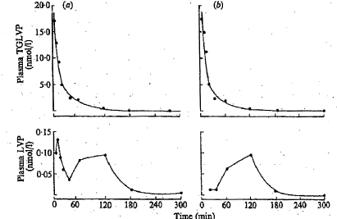

Only a small amount of the injected material appeared in the urine (~ 0.25-1.27% appeared as terlipressin and approximately one tenth of this amount as LVP).

1. **Nilsson 1990[7]**

* 14 male volunteers age 27-46 (mean 37) years; weight 61-90 (mean 77) kg.

Treatment: 8 subjects received placebo, 5, 10 or 20 µg/kg IV in blinded random order with 2 days separation between doses. The other 6 subjects received only 10 µg/kg doses.

Radioimmunoassay (RIA) of terlipressin-like immuno-reactivity in plasma was performed which cross reacts 27%, 28% and 0.03% to lysine-vasopressin, arginine-vasopressin and oxytocin.

In this assay, the presence of endogenous argentine-vasopressin (AVP) and the formation of LVP from terlipressin do not make any significant contribution to the measured concentration of terlipressin due to the low cross-reactivity of these substances and their much lower concentrations as compared to terlipressin.

Statistical analyses: Wilcoxon's Signed rank test for paired data or rank sum test of unpaired data was used for statistical analyses.

The doses of terlipressin were reflected by the plasma levels, indicating in this dose range a first order of elimination and dose independent pharmacokinetics.

Table 1. Pharmacokinetic parameters of terlipressin (mean ± SD).

| **Terlipressin dose (µg/kg)** | **n** | **t1/2α (min)** | **t1/2β (min)** | **Cl (mL/kg/min)** | **Vd (L/kg)** |
| --- | --- | --- | --- | --- | --- |
| 5 | 8 | 8 ± 2.6 | 66 ± 9.2 | 9 ± 1.3 | 0.9 ± 0.20 |
| 10 | 14 | 8 ± 1.1 | 52 ± 8.0 | 9 ± 1.5 | 0.7 ± 0.15 |
| 20 | 8 | 9 ± 1.3 | 51 ± 6.0 | 9 ± 1.7 | 0.8 ± 0.15 |

Figure 2. Mean values of plasma concentrations of terlipressin

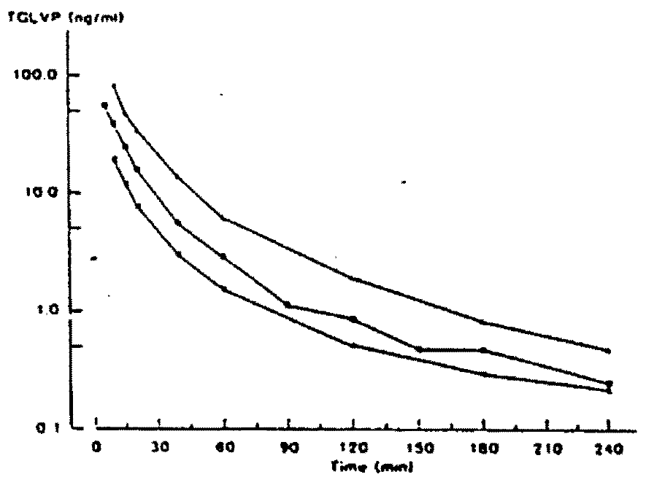

◼ = 5 µg/kg; • = 10 µg/kg; ⯅ = 20 µg/kg). Number of Observations as in Table I.

#### Population pharmacokinetics report study OT-401

This analysis used a 2 compartment model based on published study reports (as above) and review of data from Study OT-401.

The **objectives** of this population PK analysis were:

* to obtain basic information on the PKs of terlipressin and their variability in HRS Type 1 patients,
* to assess various baseline covariate factors that may affect terlipressin drug exposure, efficacy, and safety outcome measurements.

Design and treatment**:** Patients received terlipressin 1 mg boluses IV every 6 h (4 mg/day). If after 3 days of therapy serum creatinine had not decreased by ≥ 30% from baseline value, the dose was increased to 2 mg every 6 h (8 mg/day).

The population pharmacokinetics **analysis plan** included:

* Using NONMEM
* A graphical exploratory analysis of the data set to detect potential outliers.
* A base population PK model that included the structural component as well as intra- and inter-individual variability in basic PK parameters.
* A graphical exploratory analysis for the covariate factors and random effects.
* Model validation by predictive performance check.

The covariates included in the database were:

Sex, Race, Age years Age Group, Body weight, Creatinine clearance (estimated from serum creatinine measurement by the Cockcroft-Gault method), Alanine aminotransferase (ALT), Aspartate aminotransferase (AST), Total bilirubin, Alkaline phosphatise (ALP), Dose, Hepatic function/Child-Pugh Scores.

Of 174 terlipressin plasma samples from 39 patients, 104 samples from 29 patients were used in the analysis.

There were 239 PK samples collected from 53 patients in the placebo group.

Dose proportionality was evaluated based on the limited PK data collected at 2 mg. Terlipressin and lysine-vasopressin plasma concentrations appeared to increase with the dose.

The data demonstrated a larger degree of inter-subject variability than expected, the nature of the disease state and its inherent inter-patient variability likely contributed.

Figure 3. Mean (SE) Terlipressin Plasma Concentration-Time Profile in Patients with Hepatorenal Syndrome at 1 and 2 mg q6h or Placebo q6h.

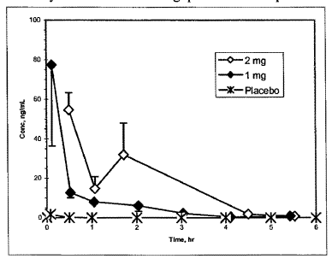

Figure 4. Mean (SE) Lysine-Vasopressin Plasma Concentration-Time in Patients with Hepatorenal Syndrome at 1 and 2 mg q6h or Placebo q6h.

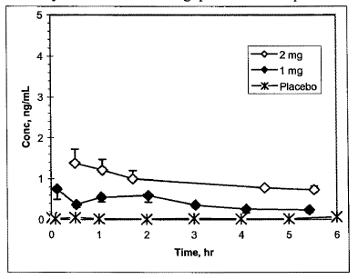

The final population pharmacokinetic model was the same as the base model without any covariate factor. Population PK parameters are shown in Table 2.

Table 2. Population PK Parameters of Terlipressin from the PPK Model (mod 1)

| **Parameters** | **Meana** | **BSV (%)b** |
| --- | --- | --- |
| CL (L/hr)c | 32.2 (21) | 68 (41) |
| VI (L)c | 27.0 (36) | 98 (65) |
| V2(L) | 10 fixed | - |
| Q (L/hr) | 14 fixed | - |

VI = volume of distribution of the central compartment, , V2 = volume of distribution of the peripheral compartment, Q=intercompartmental flow rate. Proportional residual error 65 %. a Parameter precision is expressed as coefficient of variation (% CV). b BSV between subject variability calculated as (variance)1/2*100% and its precision as % CV. c Correlation between CL and VI is 1.0, calculated as covariancel2/(variancel*variance2)1/2, where variancel and variance2 are variances of random effects for the two parameters and covariance12 is their covariance.

The model-predicted clearance of terlipressin when normalized by the median weight of HRS patients (85.9 kg) was 0.375 L/hr/kg (6.25mL/kg/min), which is similar to the clearance reported in healthy subjects of 9mL/kg/min above in Nilsson (and using the PK model on this data 0.477 L/hr/kg or 7.95mL/kg/min).

The median half-life was 1.01 h similar to the elimination half-life in healthy males.

Figure 5. Distribution of Terlipressin Half-Life (hr)a

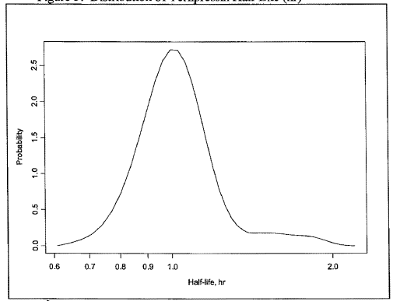

a The median half-life = 1.01 hrs, n = 29.

None of the covariates examined were found to have a significant effect on CL and VI of terlipressin, however the patient sample size was limited.

Table 3. Summary of Terlipressin Daily Drug Exposure at 1 mg every 6 h in Patients

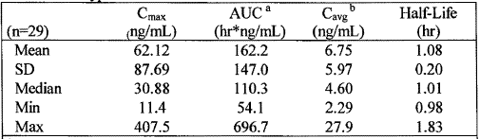

a AUC is the cumulative AUC over 24 h period. b Cavg= AUC/24 hr.

Table 4. Summary of Terlipressin Daily Drug Exposure at 2 mg every 6 h in Patients

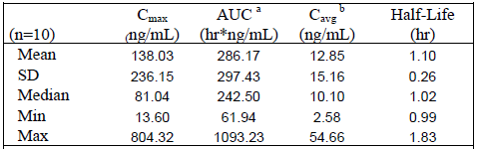

a AUC is the cumulative AUC over 24 h period. b Cavg= AUC/24 hr.

Table 5. Lysine Vasopressin (LVP) Plasma Concentration-Time Profile in Patients with HRS at 1 and 2 mg q6h or Placebo q6h

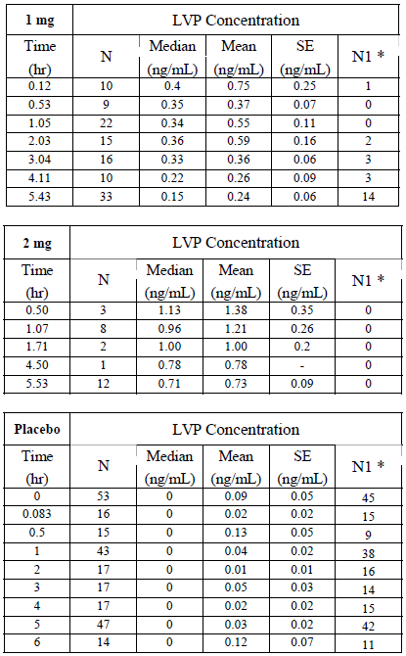

* NI = number of samples with concentration below limit of quantitation (BLQ). BLQ samples were set to zero in the mean calculation.

##### Study deficiencies

Given the use of the drug in a population with severe hepatic and renal function disturbance in whom frequent sampling for plasma levels is not deemed appropriate, the population PK analysis was considered acceptable.

### Summary of pharmacokinetics

#### Pharmacokinetics in healthy subjects

##### Absorption and bioavailability

Terlipressin is administered by IVI, therefore, studies of absorption are not relevant.

###### Bioequivalence of clinical trial and market formulations

The formulation used in Study OT -0401 is the formulation intended for marketing and is based on the commercially available terlipressin formulation marketed outside the US (Haemopressin SPC Germany). The TAHRS study utilized European commercially-available terlipressin drug product (Glypressin, Ferring S. A.) that is very similar to the intended formulation (drug product from the same commercial source was analysed and met the proposed US specifications for terlipressin).

###### Dose proportionality

Nilsson 1990: The doses of terlipressin were reflected by the plasma levels.

Population PK Study OT-0401: Based on the limited PK data terlipressin and lysine-vasopressin plasma concentrations appeared to increase with the dose.

##### Distribution

###### Volume of distribution

Healthy volunteers:

Forsling 1980: apparent volume of distribution was 15.5 ± 4.5 L;

Nilsson 1990: Pharmacokinetic parameters of terlipressin (mean ± SD) are shown in Table 6 below.

Table 6. Volume of distribution for terlipressin

| **terlipressin dose (µg/kg)** | **Vd (L/kg)** |
| --- | --- |
| 5 | 0.9 ± 0.20 |
| 10 | 0.7 ± 0.15 |
| 20 | 0.8 ± 0.15 |

Patients:

From the PPK Model.

Table 7. Volume of distribution

| **Parameters** | **Meana** | **BSV (%)b** |
| --- | --- | --- |
| VI (L)c | 27.0 (36) | 98 (65) |
| V2(L) | 10 fixed | - |

Proportional residual error 65 %. VI = volume of distribution of the central compartment. V2 = volume of distribution of the peripheral compartment. a Parameter precision is expressed as coefficient of variation (% CV). b BSV between subject variability calculated as (variance)1/2*100% and its precision as % CV. c Correlation between CL and VI is 1.0, calculated as covariancel2/(variancel*variance2)1/2, where variancel and variance2 are variances of random effects for the two parameters and covariance12 is their covariance.

###### Plasma protein binding

The distribution half life is short (~10 mins).

HRS patients are generally treated with albumin as well as a vasoconstrictor.

##### Metabolism

###### Sites of metabolism and mechanisms / enzyme systems involved

Terlipressin is not metabolised in blood or plasma (Plate 1995), while incubation with human liver and myometrial homogenates showed metabolism, with LVP as an intermediate product.

###### Non-renal clearance

After IV administration of terlipressin, the glycyl residues of terlipressin are believed to be cleaved in a stepwise fashion by various endogenous proteases.

###### Metabolites identified in humans

Active metabolites

The pharmacologically active metabolites (lysine-vasopressin and possible mono and di glycyl derivatives) are sequentially formed via metabolic breakdown of terlipressin.

Wisniewski *et al* 2005 examined both the *in vivo (rat)* and *in vitro* actions of terlipressin and its mono and di derivatives This study indicated that terlipressin and possibly its di and mono glycyl derivatives have pharmacologic action in their own right although not as potent as LVP. Given that the circulating concentrations of terlipressin itself and possibly the mono or di glycyl derivatives are greater than LVP, they likely contribute to the clinical activity seen with terlipressin, especially in the periods immediately following administration.

Human PK studies have shown the presence of lysine-vasopressin in human plasma, confirming that terlipressin is eventually metabolised to lysine-vasopressin via sequential cleavage of the three glycyl groups (Forsling 1980, Nilsson 1990, OT-0401).

Other metabolites

Once formed, lysine-vasopressin is rapidly eliminated via various peptidase-mediated routes associated with a loss of vasopressinergic activity (Jackson 2005, Plate 1995, Forsling 1980, Nilsson 1990, Fabian 1969, Lauson 1967, Carone 1987, Fjellestad-Paulson 1996).

Vasopressin is metabolised at the C- and N-terminus, as well as by the disulfide bond cleavage, by various peptidases and proteases that are detectable in almost all human tissues; however, the majority of terlipressin metabolism occurs in liver and kidney tissues (Humphrey 1986, Plate, 1995, Jackson 2005, Carone 1987, Lauson 1967, Fjellestad-Paulson 1996). In human renal brush-border membrane microvilli, the initial splitting of the cysl_cys6 disulfide bond by a glutathione-dependent oxidoreductase facilitates further degradation by peptidases (Fjellestad-Paulson 1996).

All these metabolic events are associated with a loss of vasopressinergic activity.

###### Pharmacokinetics of metabolites

Table 8. PK Parameters for Lysine-vasopressin and Arginine-vasopressin in Healthy Volunteers Fabian 1969.

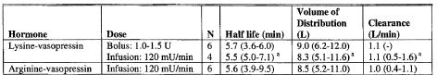

Values are shown as median (95% CI). a range.

##### Excretion

###### Routes and mechanisms of excretion

Forsling 1980: Only a small amount of the injected material appeared in the urine (~ 0.25-1.27% appeared as terlipressin and approximately one tenth of this amount as LVP).

Wisniewski *et al* 2005 showed in the rat that 57% of terlipressin was metabolised in liver, 13% in kidneys, and 11 % in heart tissues.

### Intra- and inter-individual variability of pharmacokinetics

In the population PK study the data demonstrated a larger degree of inter-subject variability than expected, the nature of the disease state and its inherent inter-patient variability likely contributed.

### Pharmacokinetics in the target population

Despite severe hepatic and renal function disturbance, in population PK Study of OT-0401 the elimination half-life and clearance were similar to that reported in healthy subjects.

### Pharmacokinetics in other special populations

Not applicable. The target population has, by definition, severe hepatic and renal function disturbance.

### Genetic- and gender-related pharmacokinetic differences

Gender not shown to be a covariate to have a significant effect on CL and VI of terlipressin, however the patient sample size was limited.

### Pharmacokinetic interactions

#### Pharmacokinetic interactions demonstrated in human studies

Terlipressin does not inhibit or induce the activity of any of the cytochrome P450 isoenzymes studied.

(Study 302-1173 *In vitro* Inhibition of CYPIA2, CYP2A6, CYP2B6, CYP2C8, CYP2C9, CYP2C19, CYP2D6, CYP2E1, and CYP3A4 in human liver microsomes; Study 302-1172 *In Vitro* Induction of CYP1A2, CYP2A6, CYP2B6, CYP2C9, CYP2C19, CYP2D6, CYP2El, and CYP3A4 in human hepatocytes).

#### Clinical implications of *in vitro* findings

Nil.

### Evaluator’s overall conclusions on pharmacokinetics

While the statements in the first two paragraphs of the PK section of the PI are supported by the population PK study they are based on limited data and this is indicated in the PI.

Plate (1995) had this to say:

*The half-life of terlipressin is reported to be approximately 24 minutes (Nilsson 1990, Forsling et al. 1980), the half-life of vasopressin is reported to be only six minutes.*

*In our measurements, terlipressin and LVP were completely degraded after sixty minutes. Based on the assumption of a delayed terlipressin uptake in the organs, a maximum duration of action of two to three h can be extrapolated. This assumption corresponds well to the statements made by Forsling et al. in 1980 regarding a biological half-life of approximately 24 minutes and the findings by Kohaus regarding a clinical duration of action of two to three hours.*

*Since a drug normally is excreted after five half-lives, a maximum duration of action of two h can also be extrapolated from the half-life. This would mean that in clinical applications terlipressin should be administered every two to three hours. The manufacturers' recommendations, however, are intervals of four to six hours.*

*Forsling 1980* showed that the decay of terlipressin activity could be approximated to a double exponential. Taking the initial rapid decay phase, a mean half-life for the disappearance of terlipressin was 24.2 ± 1.9 min (SE).

*Nilsson 1990* showed a t1/2α of 8-9 min and a t1/2β of 51-66 min.

The PK modelling in healthy subjects gave a t1/2α of 7 min and a t1/2β of 42min.

## Pharmacodynamics

Vasopressin is a potent vasoconstrictor. Pressor responses occur only with vasopressin concentrations significantly higher than those required for maximal antidiuresis; the vasopressin response reduces blood flow to nonessential organs, including the splanchnic bed, and increasing systemic blood flow with an increase in mean arterial pressure. In HRS patients and healthy volunteers receiving terlipressin the plasma level of lysine-vasopressin attained corresponds to the higher levels of vasopressin (>50 pg/mL) that activate V1 receptors compared to the antidiuretic effect via V2 receptors, which reach their maximum effectat lower concentrations (4-20 pg/mL). Additionally, a weaker agonist but in much higher concentrations, terlipressin has a vasopressin V1 to V2 receptor selectivity ratio of 2.2 compared to 1.0 for vasopressin.

### Summary of pharmacodynamics

#### Primary pharmacology

##### Primary pharmacodynamic effects – Systemic Circulation

Overall with terlipressin in study TAHRS mean arterial pressure did not change significantly from baseline to the end of treatment; while overall with terlipressin in Study OT-0401 systolic pressure increased by 4.2 mmHg to 111.8 mmHg, and diastolic pressure by 2.9 mmHg to 65.4 mmHg, the change in mean pressure was significant only when compared to the effect of placebo.

There were also small transient changes in blood pressure and heart rate following each daily dose that were not associated with HRS reversal.

###### Study OT-0401

Terlipressin patients, after dosing, had transient increases in systolic and diastolic blood pressure (4 mm Hg [3.9%] and 3 mm Hg [4.6%] at 2 h post-dose, respectively) and transient decreases in HR (3 beats/min [3.4%]).

Table 9. Change from Average Pre-Dose to Average Post-Dose in Systolic Blood Pressure (Safety Population)

|  | **Terlipressin** | | | | **Placebo** | | | |
| --- | --- | --- | --- | --- | --- | --- | --- | --- |
| **Day** | **N** | **Average Pre Dose**  **sBP (mmHg)** | **Average Post Dose**  **sBP (mmHg)** | **Change**  **sBP**  **(mmHg)** | **N** | **Average Pre Dose**  **sBP (mmHg)** | **Average Post Dose**  **sBP (mmHg)** | **Change**  **sBP (mmHg)** |

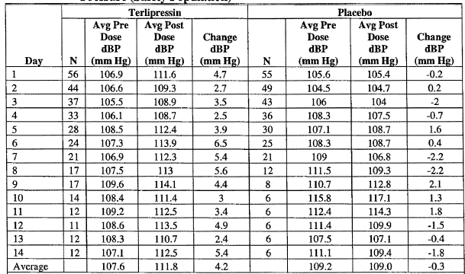

sBP=systolic blood pressure.

Table 10. Change from Average Pre-Dose to Average Post-Dose in Diastolic Blood Pressure (Safety Population).

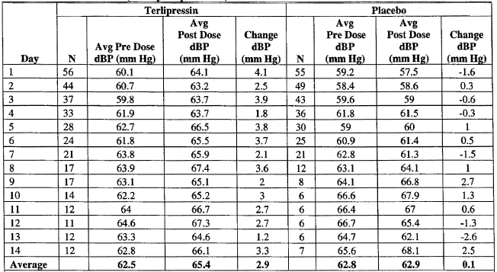

Avg =average; dBP=diastolic blood pressure.

Table 11. Change from Average Pre-Dose to Average Post-Dose in Heart Rate (Safety Population).

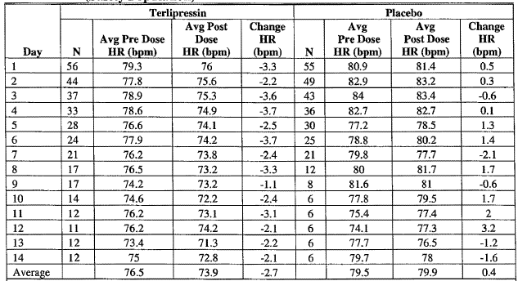

Avg =average; HR=heart rate.

Terlipressin patients who had HRS reversal showed a significant increase in MAP (10.7%) from baseline to the end of treatment (LS mean of 7.30 mm Hg; p = 0.017), while there was a non significant fall in patients not achieving HRS reversal. In placebo patients non HRS reversal was associated with a significant fall in MAP (-5.73 mm Hg, p = 0.006).

Table 12. Change from Baseline in Mean Arterial Pressure (mm Hg) to End of Treatment LOCF - ITT Population.

Table 12. Change from Baseline in Mean Arterial Pressure (mm Hg) to End of Treatment
 LOCF - ITT Population.


a From ANOVA with main effect treatment and strata (alcoholic hepatitis present or not) as a blocking factor. Note: does not include retreatment period.

Table 13. Change from Baseline in Mean Arterial Pressure to End of Treatment by Response LOCF - ITT Population (mm Hg).

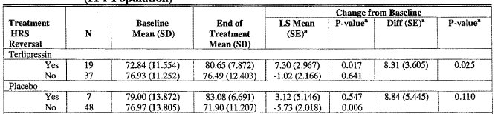

a From ANOVA with main effect HRS reversal and strata (alcoholic hepatitis present or not) as a blocking factor.

Figure 6. Mean Arterial Pressure from Baseline to Day 14 Terlipressin Group by HRS Reversal Status LOCF - ITT Population (mm Hg)

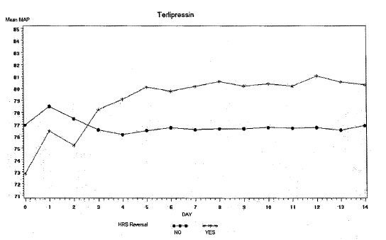

Figure 7. Mean Arterial Pressure from Baseline to Day 14 by Placebo Group by HRS Reversal Status LOCF - ITT Population (mm Hg)

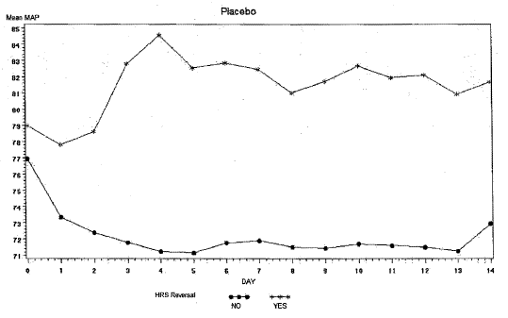

Figure 8. Average Difference between Predose and Postdose Mean Arterial Pressure (mm Hg) from Baseline Through Day 14 by Day (LOCF - ITT Population): Terlipressin Group by HRS Reversal Status

Figure 8. Average Difference between Predose and Postdose Mean Arterial Pressure (mm Hg) from Baseline Through Day 14 by Day (LOCF - ITT Population): Terlipressin Group by HRS Reversal Status

###### Study TAHRS

Mean arterial pressure did not change significantly from baseline to the end of randomised treatment in either group, and there was no significant difference between treatment groups.

Figure 9. Average Daily Mean Arterial Pressure to Day 15 LOCF - ITT Population.

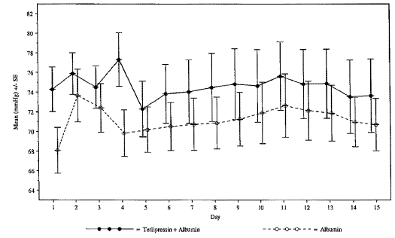

Includes results collected on randomised treatment up to Day 15.At each time point there are 23 patients in both the terlipressin + albumin and albumin treatments.

Table 14. Change from Baseline in Mean Arterial Pressure to End of Randomized Treatment LOCF - ITT Population (mm Hg).

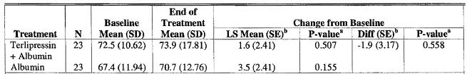

Note: For albumin patients that crossed over to terlipressin, includes data prior to receiving terlipressin. a From ANOVA with main effect treatment and strata as a blocking factor.

Terlipressin + albumin patients with HRS reversal showed a significant increase in MAP (12.4%) from baseline to the end of treatment (LS mean 9.2 mm Hg; p = 0.033).

In the albumin group there was a significant increase in MAP (6.2%) in patients with no HRS reversal (LS mean of 3.9 mm Hg; p = 0.047).

Table 15. Change from Baseline in Mean Arterial Pressure to the End of Treatment by HRS Reversal LOCF - ITT Population (mm Hg).

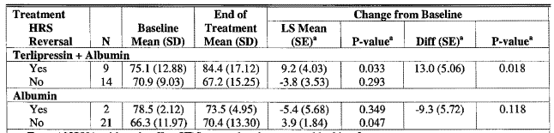

a From ANOVA with main effect HRS reversal and strata as a blocking factor.

Figure 10. Mean MAP in Terlipressin + Albumin-Treated Patients with HRS Reversal versus Patients without HRS Reversal to Day 15 LOCF - ITT Population.

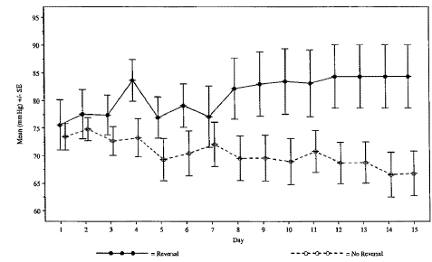

Includes results collected on randomized treatment up to Day 15. There are 9 responders and 14 non-responders patients at each time point.

**Comment:** Those with a higher initial BP were more likely to respond to albumin alone; this also was true for terlipressin in the TAHRS study but not in study OT-0401.

Table 16. Summary of Published Studies Investigating the Systemic Hemodynamic Effects of Terlipressin in Patients with HRS

| **Reference** | **Number of Patients Terlipressin dose** | **Timepoint** | **Hemodynamic effect of terlipressin on MAP % change (p-value)** | **Other hemodynamic effects of terlipressin % change (p-value)** |
| --- | --- | --- | --- | --- |
| **Randomized controlled studies** | | | | |
| Hadengue 1998b  Type I | 9  2 mg/d for 2 d  placebo cross-over | Day 2 (baseline) | T: ↓8% from control  P: ↓4%  Respondersa  T: ↑4% P: ↑2%  Non-responders  T: ↓13% P: ↓20% | Heart rate  P: ↑6% from control  T: ↓8%  SVR: T: ↑57% |
| Day 2, 60 min post dose | T: 16%↑from corre baseline (P< 0.05)  P: ↓1% | Heart rate  T: 4.9% ↓ (NS)  P: no change |
| Solanki 2003  Type I | 12  2 mg/d for 15 d  12  placebo | Day 4 | T: 20%↑ (<0.05)  P: ↓3% |  |
| Day 15  (n = 5 on T) | T: 27%↑ (<0.05)  P: ↓6% (day 8) |  |
| Alessandriac, f 2007B  Type I & II | 12  6-12 mg/d + albumin up to 2w  12 norepinephrine (C) | End of treatment | T: 14%↑ (<0.05) | CVP T: ↑8%  C: ↑9% |
| Neri 2007d  Type I | 26  3 mg/d for 5 d  then 1.5 mg/d for 2w + albumin 20-40 g/day  26  albumin 20-40 g/d | End of treatment | T: 13%↑ (<0.05)  A: 12%↑ (<0.05)e | Central venous CVP  T: 36%↑ (<0.05)  A: 30%↑ (<0.05) |
| **Prospective studies** | | | | |
| Mulkay 2001f  Type I | 12  4-6 mg/d for 1-9wg + albumin | 2 d | 9%↑ (<0.05) | 7% ↓ heart rate (NS) |
| 14 d (n ≥ 9) | 1% ↓ | 8% ↓ heart rate (NS) |
| Ortega 2002d  Type I & II | 21  T: 3-12 mg/d up to  15 d  T+A: 3-12 mg/d up to 15 d + albumin | End of treatment  Mean 8.5d & 7.4d | T+A: 13%↑ (<0.05)  T: ↓6% | CVP  T: 20%↑(NS)  T+A: 40%↑  (< 0.05) |
| Saner 2004d  Type I & II | 7  6 mg/d for 6 d  + Gelafundin (4% Gelatinepolysuccinat) 40 g/d IV | 6 d | 29%↑ (<0.001) |  |
| Uriz 2000h  Type I & II | 9  3-12 mg/d up to l5d + albumin | End of treatment | 18%↑ (<0.05) | 2% ↑ heart rate (NS) |
| **Retrospective studies** | | | | |
| Colle 2002f  Type I | 18  2-4 mg/d  + albumin (n=13) | End of treatment  Mean 9.1d | 19%↑ (0.0001) in HRS responders(11);  11%↓ in non-responders |  |
| Halimi 2002  Type I & II | 18  4 mg/day (range 1.5-12) for 5 d | End of treatment | Not evaluated | No significant effects,  Responders: systolic 4%↑ diastolic 8%↑  Non responders: systolic 13%↓ diastolic 4%↓ |

a increased urinary sodium excretion. b automatic sphygmomanometer mean. c nor adrenaline given according to measured BP i.e. result significance uncertain. d NIBP. e these results are from a Table 2 the text says Mean arterial pressure and central venous pressure did not differ (p > 0.05) from baseline values in either group A or B. f MAP not defined how derived. g dose adjusted to creatinine levels then after 2days stopped, reintroduced prn. h NIBP monitor model stated. A=albumin; C=control; MAP—mean arterial pressure; NS=not significant; P=placebo; T = terlipressin.

**Comment:** Only one literature study defined how MAP was calculated, while the NIBP model used was cited in another (i.e. it may be possible to source the algorithm used).

Table 17. Summary of Literature Studies Investigating the Systemic Vascular Resistance and Cardiac Output Effects of a Single Terlipressin Dose in Cirrhotic Patients and Healthy Volunteers

| **Reference** | **No. Patients Terlipressin Dose** | **Significant hemodynamic effects of terlipressin % change (p-value)** | |
| --- | --- | --- | --- |
| **SVR/PVR** | **CO/CI** |
| **Patients with cirrhosis: single dose** | | | |
| Gadano 1997  Cirrhosis & ascitesa | 1-2 mg (on B.Wt.)  All on low Na diet  8 Te only  8 Te + α- human ANP | ↑57%* | CI↓21%* |
| Kiszka-Kanowitz 2004  Cirrhosis & portal hypertension | 13  2 mg | ↑33%  (p < 0.001) | CO↓9% |
| Lee 2001  Cirrhosis & portal hypertension | 2 mg  12 Te only  12 Te + prazosin | ↑43%  (p < 0.05) | CI↓20%  (p < 0.05) |
| Lin 2002 | 2 mg  11 Te only  13 Te + octreotide | ↑43%  (p < 0.05) | CI↓19% |
| Merkel 1988 | 11  2 mg | ↑48%  (p < 0.01) | CI↓22%  (p < 0.01) |
| Møller 2000d | 16  2 mg | ↑56%  (p < 0.0005) | CO↓21%  (p < 0.0005) |
| Narahara 2006  Abstract only  Cirrhosis & portal hypertension | 16  1 mg | ↑33%  (p < 0.001) | CO↓12%  (p < 0.001) |
| Therapondos 2004  Cirrhosis & ascites | 6  2 mg | ↑52%  (P = 0.028) | CO↓14%  (p = 0.028) |
| **Patients with cirrhosis and oesophageal variceal haemorrhage: single dose** | | | |
| Freeman 1988  Cirrhosis with varices | 8  1.25 mg IV  and 5  2mg IV |  | 1.25mg: CI↓16%  (P < 0.02)  2mg: CI↓29%  (p < 0.1) |
| Lin 1989  Cirrhosis & portal hypertension with varices | 11  2mg SD + nitroglycerin  @ 60min |  | CO↑23%  (p < 0.005) |
| Romero 2000a  Cirrhosis & portal hypertension with varices | 20  2mgSD + hyoscine butyl-bromide | ↑48%  (p < 0.01) | CI↓27%  (p < 0.01) |

##### Primary pharmacodynamic effects – Splanchnic circulation

###### Study TAHRS

Due to the limited number of patients’ regional (6 baseline), systemic and hepatic (3 baseline and end of treatment) blood flow results an analysis in Study TAHRS was not performed.

Table 18. Systemic and Hepatic Hemodynamics at baseline and end of treatment (Terlipressin + Albumin).

|  |  |  |  |  |  |  |  |
| --- | --- | --- | --- | --- | --- | --- | --- |
| **Systemic Hemodynamics** | **Patient ID** | **04-COA** | | **13-FJUP** | | **14-CAL** | |
| **Study Day** | **0** | **12** | **0** | **15** | **0** | **17** |
| **Date** | **07JUN02** | **18JUN02** | **05AUG03** | **12AUG03** | **09OCT03** | **26OCT03** |
| Right Atrium Pressure | 4 | -- | 9.0 | 10 | 6 | 13 |
| Pulmonary Artery Pressure | 10 | 11 | 17 | 27 | 16 | 26 |
| Pulmonary Wedge Pressure | 5 | 6 | 14 | 18 | 8 | 22 |
| Cardiac Output | 5.2 | 4.6 | 8.3 | 11.7 | 5.4 | 7.6 |
| Systemic Vascular Resistance |  |  | 530 | 465 | - | 589 |
| Hepatic Hemodynamics | Free Hepatic Venous Pressure |  |  | 11 | 11 | 15 | 13.5 |
| Wedged Hepatic Venous Pressure |  |  | 36 | 36.5 | 39 | 30.5 |
| Hepatic Venous Pressure Gradient |  |  | 25 | 25 | 24 | 17 |

Literature studies of splanchnic hemodynamic effects in cirrhosis

In cirrhosis the static column behind the wedged hepatic vein cannot be decompressed at the hepatic sinusoids; thus the WHVP gives an approximation of portal pressure in cirrhosis. Hepatic Venous Pressure Gradient (HVPG) is the difference between the wedged (WHVP) and the free hepatic venous pressures.

Table 19. Overview of the Splanchnic Hemodynamic Effects of a Single Dose of Terlipressin in Patients with Cirrhosis from summarised studies in Table 18.

| **Parameter** |  | **% change range** | **Time point** | **No. studies** |
| --- | --- | --- | --- | --- |
| **Portal hemodynamics** | | | | |
| Hepatic venous pressure gradient (HPVG) | ↓ | 2-31% | 1-60 min | 13 |
| Wedged hepatic venous pressure (WHVP) | ↓ | 2-18% | 20-60 min | 8 |
| Hepatic blood flow (BF) | ↓ | 11-31% | 20-60 min | 5 |
| Azygos BF | ↓ | 17-25% | 10-60 min | 3 |
| Portal venous blood flow (PVBF) | ↓ | 28-33% | 1-30 min | 3 |
| Intrinsic hepatic clearance (IHC) | ↓ | 11-22% | 30-60 min | 3 |
| Free hepatic venous pressure (FHVP) | ↑ | 3-34% | 30-60 | 7 |
| Portal blood flow velocity (PBFV) | ↓ | 17-33% | 10-15 min | 3 |
| Relative blood volume (RBV) in the liver region | ↑ | 12% | 30 min | 1 |
| **Renal hemodynamics** | | | | |
| Renal BF | ↑ | 28% | 60 min | 1 |
| Renal perfusion pressure (PP) | ↑ | 19% | 60 min | 1 |
| **Other splanchnic hemodynamics** | | | | |
| Splenic BF | ↓ | 56% | 20-40 min | 1 |
| Superior mesenteric venous blood flow (SMVBF) | ↓ | 44% | 30 min | 1 |
| **Variceal hemodynamics** | | | | |
| Variceal/intravariceal pressure (IVP/IEVP) | ↓ | 14-28% | 1-60 min | 3 |
| Variceal pressure gradient (VPG) | ↓ | 28% | 3-60 min | 1 |
| Estimated variceal wall tension (VWT) | ↓ | 27% | 3-60 min | 1 |

Data summarised from following Table 20.

**Comment:** Thus the studies support a systemic shift from the portal circulation.

In the study by Kiszka-Kanowitz 2004[8]:

The blood volume in the liver region increased by 12% after administration of terlipressin, The fact that this increase was seen both in the scans after injection of labelled albumin and in those after labelled erythrocytes indicates that the rise in activity in the liver region was not caused by albumin leaving the circulation through the liver sinusoids and perisinusoidal space. The dynamic scanning of the liver region also shows that the increase in liver blood volume was in close temporal relationship to the terlipressin injection. There could be several explanations for the increased blood volume in the liver region. In the present study, it correlated strongly with the increase in SVR. The increase in liver blood volume may therefore reflect a decrease in HVPG, and the mechanism could be a direct or indirect action of terlipressin on the intrahepatic microcirculation with relaxation of the stellate cells, which may lead to dilatation of the sinusoids and an increase in blood volume concomitant with a reduction in the haemodynamic resistance in the liver sinusoids, and possibly also a reduction in systemic vasodilators which could add to the increase in SVR. If the increase in liver blood volume was caused by a passive congestion of blood, owing to cardiac backward failure, a concomitant increase in splanchnic blood volume would be expected. This was not seen, however.

A summary of the literature studies in patients with cirrhosis is provided in the table below.

Table 20. Summary of Literature Studies Investigating Splanchnic Hemodynamic Effects of Terlipressin in Patients with Cirrhosis (results are based on mean or median).

| **Reference** | **No. Patients Terlipressin dose** | **Significant hemodynamic effects of terlipressin % change (p-value)** | | | |
| --- | --- | --- | --- | --- | --- |
| **Time point (min)** | **HVPG** | **WHVP** | **Other** |
| **Patients with cirrhosis: single dose** | | | | | |
| Escorsell 1997  Cirrhosis & portal hypertension | 23  1mg (8) and 2mg (8)  Placebo (7) | Max. at 30 (Baseline, 1h & 4h tabulated) | 1mg = 16%↓ and  2mg = 21%↓  (<0.01) |  | azygos BF max. at 1h: 1mg 19%↓ and 2mg 25%↓ (<0.05) |
| Gadano 1997  Cirrhosis & ascitesa | 1-2 mg (on BWt)  All on low Na diet  8 Te only  8 Te + α- human ANP | 60 | 13%↓  (<0.05) | 4%↓  (<0.05) | 28%↑ renal BF  19%↑ renal PP  9%↑ FHVP (<0.05) |
| Kiszka-Kanowitz 2004  Cirrhosis & portal hypertension | 13  2 mg | 30 | - |  | 6%↑ thoracic RBV  12%↑ liver RBV (<0.004)  [When expressed as absolute amount]  No change in splanchnic or splenic RBV |
| Lee 2001  Cirrhosis & portal hypertension | 2 mg  12 Te only  12 Te + prazosin | 30 | 16%↓ (<0.05) |  | 25%↓hepatic BF  11%↓IHC (<0.05) |
| Lin 2002 | 2 mg  11 Te only  13 Te + octreotide | 60 | 14%.↓ (<0.05) |  | 27%↓ hepatic BF(<0.05)  12%↓ IHC (<0.05) |
| Merkel 1988 | 11  2 mg | 20, 30, 40 | 31%↓ (<0.01) | 18%↓ (<0.01) | 31%↓hepatic BF(<0.01)  34%↑FHPV  56%↓splenic BF (<0.01) |
| Merkel 1992 | 22  2mg | 25-35 |  |  | 22%↓ IHC (0.04) |
| Møller 2000d | 16  2 mg | 30 | 29%↓(< 0.01) | 6%↓ (<0.05) | 13%↑ FHVP (<0.001)  20%↓ Hepatic BF (<0.001) |
| Narahara 2006  Abstract only  Cirrhosis & portal hypertension | 16  1 mg | 30 | 15%↓  (< 0.005) |  | 32%↓ PVBF (< 0.005)  44%↓ SMVBF (< 0.05)  4%↓ hepatic ARI (< 0.005)  8%↓ renal ARI (< 0.005) |
| Therapondos 2004  Cirrhosis & ascites | 6  2 mg | 60 | 2%↓ | 6%↓ | 21%↓FHVP |
| Vachiery1996 | 12  1-2 mg ( on B.Wt.) + nadolol or propranolol to ↓ HR25%  All on low Na diet | 30 | 18%↓ (<0.05) | 11%↓ (<0.05) | 1%↓ FHVP  hepatic BF no change  17%↓ azygos BF (<0.05) |
| Patients with cirrhosis and oesophageal variceal haemorrhage: single dose | | | | | |
| Baik 2005b  Cirrhosis & portal hypertension | 21  2 mg IV  21  octreotide | 1, 5, 10, 15, 20, 25 | 18%↓(<0.05) |  | 33%↓PVBF (<0.05) |
| Cestari 1990  Cirrhosis & portal hypertension with varices | 11  2 mg SD  9  placebo | 1 to 10 |  |  | 14%↓IEVP at 1 mm  22%↓ 3 min (<0.01)  24%↓5 min (<0.01)  28%↓ 10 min (<0.01). |
| Freeman 1988  Cirrhosis with varices | 8  1.25 mg IV  and 5  2 mg IV | 30 | 29%↓(<0.01) and  31%↓(<0.001) |  | hepatic BF 11%↓ (NS) and 24%↓ (<0.001) |
| Hansen 2001 | 13  2mg SD | 10-15 |  |  | 23%↓ azygos BF (0.014)  28%↓ PVBF (0.03)  17%↓ MPBFV (0.008) |
| Lin 1989  Cirrhosis & portal hypertension with varices | 11  2 mg SD + nitroglycerin  @ 60min | 60 | 16%↓ (<0.005) | 10%↓ (<0.05) | 3%↑FHPV |
| Nevens 1996 | 8  2 mg SD + scopolamine | 2-4 |  |  | 27%↓ variceal pressure (<0.001) at 4 min p<0.00l at 2 min |
| Romero 2000a  Cirrhosis & portal hypertension with varices | 20  2 mgSD + hyoscine butyl-bromide | 3, 30, 60 | 3 min 13%↓.  (<0.01)  60min 13%↓.  (<0.01) | 3 min 4%↓.  60min 2%↓. | 60 min  21%↓ IVP(<0.01)  28%↓ VPG(<0.01)  27%↓ VWT (<0.01)  FHPV 3 min 20%↑(<0.01)  60min 25%↑(<0.01) |
| Villanueva 2005  With acute haemorrhage  Nonrespondersc to standard somatostatin dose | 22  250 µg somatostatin bolus 20 mins later 2 mg SD | 30 | 14%↓ (<0.001) | 4%↓  (p< 0.05) | 18%↑FHPV(p<0.01) |

a patients with renal disease excluded. b patients with HRS excluded. c defined as a ↓HVPG below 20mmHg or > 10% from baseline; d in cirrhosis the static column behind the wedged hepatic vein cannot be decompressed at the hepatic sinusoids ; thus the WHVP gives an approximation of portal pressure in cirrhosis. In this study and the abstract the terms are used interchangeably. ANP = atrial natriuriteric peptide ARI = arterial resistive index; BF = blood flow; FHVP = free hepatic venous pressure; HVPG = hepatic venous pressure gradient; IHC = intrinsic hepatic clearance; IEVP = intravascular oesophageal variceal pressure; IVP = intravariceal pressure; MPBFV = mean portal blood flow velocity; NS = no significant change; PP = perfusion pressure; PVBF = portal venous. blood flow; RBV = regional blood volume; SMVBF = superior mesenteric venous blood flow; WHVP = wedged hepatic venous pressure; VPG = variceal pressure gradient; VWT = estimated variceal wall tension.Source: Modified from sponsor’s Table 19 Summary of Clinical Pharmacology after review of tabulated studies.

##### Relationship between plasma concentration and primary pharmacodynamic effects

Table 21. Overall Average of Daily Average Change in Pre-dose to Post-dose Systolic and Diastolic Blood Pressure, and Heart Rate (ITT) - OT -0401

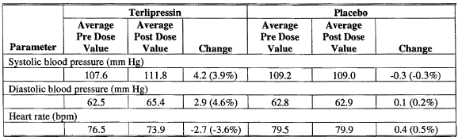

##### Relationship between administration timing and primary pharmacodynamic effects

Terlipressin significantly decreased HVPG, PVF, MAP, and HR at 1 min and these changes were sustained at all time points (p < 0.05 Baik 2005).

Figure 11. Effects of bolus injection of 2 mg terlipressin on (A) hepatic venous pressure gradient, portal venous flow and (B) mean arterial pressure, heart rate.

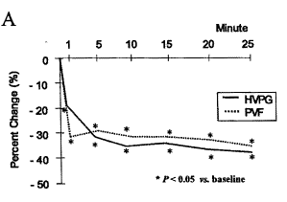 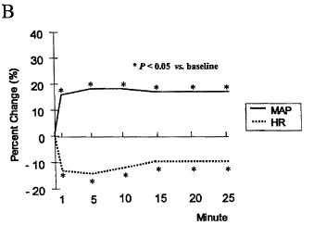

Figure 12. Variceal pressure measured endoscopically after placebo and terlipressin 2 mg.

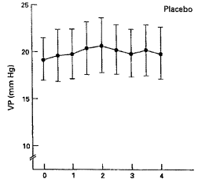 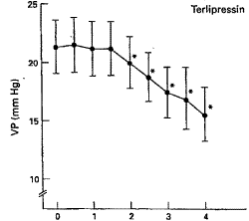

time (min) time (min)

*Only the pressure changes after terlipressin were statistically significant (p<0-001). Values mean (SEM).

#### Secondary pharmacology

##### Secondary pharmacodynamic effects

###### Renal

Gadano 1997 showed 28% increase in renal blood flow and 19% increase in renal perfusion pressure, while Narahara 2006 showed 8% decrease in renal arterial resistive index (< 0.005).

###### Skin blood flow

Consistent with V1 receptor activation, terlipressin causes peripheral vasoconstriction resulting in an immediate decrease in skin blood flow in healthy volunteers.[9]

Support for this statement is sourced from;

* **Forsling 1980**Results were: The most marked response was skin pallor, noted in the face, arms and the bands of the subjects. It was first noted within 5 min of the intravenous injection, the maximum effect being at 30-45 min. At this time all subjects were aware of a mild sensation of warmth over the face, although the skin was cool to the touch. The facial pallor was observed to be of about 4 h duration.
* **Nilsson 1990**The sponsor modified, described in text and inserted (in the Summary of Clinical Pharmacology) the figure 2 from this reference which was not the results of the 1990 study but the results of an earlier study by Nilsson[10]. The earlier reference was not provided, thus the interpretation of the figure cannot be evaluated. The figure was used in Nilssen 1990 in illustrating the calculation of a curve of maximum blood flow reduction versus terlipressin dose.

**Comment:** The data submitted supports the use of the term pallor only.

###### Cerebral blood flow

Table 22. Summary of Cerebral Hemodynamic Effects in Patients with Acute Liver Failure: Single dose of Terlipressin.

| **Reference** | **No. Patients Terlipressin dose** | **Timepoint** | **Significant hemodynamic effects of terlipressin % change (p-value)** |
| --- | --- | --- | --- |
| Eefsen 2007 | 10  1 mg  + noradrenaline infusion | Not specified | 43% ↑ cerebral perfusion pressure (< 0.05)  24% ↑ cerebral perfusion (< 0.001)  no effect on intracranial pressure |
| Shawcross 2004 | 6  0.2-0.3mg (on B.Wt.) | 60 min | 17% ↑ cerebral blood flow (0.016)  33% ↑ intracranial pressure (0.031) |

Figure 13. Changes in Mean Arterial Pressure, Intracranial Pressure, Cerebral Blood Flow and Jugular Venous Oxygen Saturation. Changes in (A) mean arterial pressure (MAP); (B) intracranial pressure (ICP); before and after administration of 0.005 mg/kg IV terlipressin.

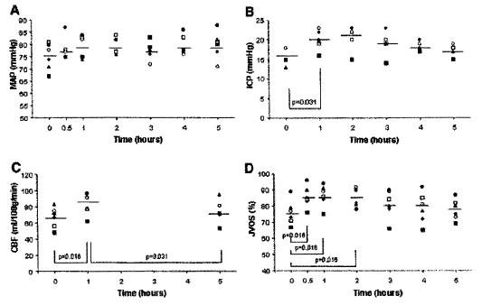

(C) cerebral blood flow(CBF); and (D) jugular venous oxygen saturation (JVOS) before and after administration of 0.005 mg/kg IV terlipressin. Individual patients are represented by each symbol P values were calculated using the Wilcoxon signed rank test. Normal values (used by authors' institution): MAP, 93-100mmHg; CBF, 45-50mL/100g/min; ICP, 0-15 mmHg; JVOS, 55%-75%.



###### Vasoactive hormones in cirrhotic and HRS patients

Terlipressin in cirrhotic and HRS patients with hyperdynamic circulation decreases plasma rennin, aldosterone and noradrenaline, and increases atrial natriuretic peptide. Results are summarised in the table below.

Table 23. Summary of Studies Investigating Terlipressin Effects on Vasoactive Hormones in Humans

| **Reference** | **No. Patients Terlipressin dose** | **Effects of Terlipressin % change (p-value)** | | | | | |
| --- | --- | --- | --- | --- | --- | --- | --- |
| **Time point (min)** | | **Renin** | **Aldosterone** | **ANP** | **Other** |
| **Patients with cirrhosis: single dose** | | | | | | | |
| Narahara 2006  Abstract only | 16  1mg | 30 min | | 51%↓  (< 0.01) |  |  |  |
| **Patients with HRS: multiple doses** | | | | | | | |
| **Randomized, controlled clinical studies for which CRFs are available** | | | | | | | |
| OT-0401b | 56  4-8 mg/d for up to 14d + albumin | End of treatment | | 16%↓(NS) | 19%↓(NS) |  |  |
| TAHRSc | 23  6-12 mg/d for up to 15 d + albumin | End of treatment | | (NS) | (NS) | (NS) | Endothelin,  Noradrenaline  (NS) |
| **Publications: Patients with HRS: randomized controlled studies** | | | | | | | |
| Hadengue 1998 | 9  2mg/d for 2 d | 2 d (end of treatment) | | 52%↓  (< 0.05) | 19%↓  (< 0.05) | 64%↑ |  |
| Neri 2007 | 26  3 mg/d for 5 d then 1.5 mg/d for 2 w plus albumin 20-40 g/day  26  albumin 20-40 g/d | End of treatment | | 64%↓  (< 0.005) | 77%↓  (< 0.005) |  |  |
| **Publications: Patients with HRS: prospective studies** | | | | | | | |
| Ortega 2002 | 21  T: 3-12 mg/d up to 15 d  T+A: 3-12 mg/d up to 15 d + albumin | End of treatment | T+A: 80%↓ (< 0.05)  T: 44%↓ | | T+A: 75%↓ (< 0.05)  T: 40%↓ | T+A: 21%↑  (< 0.05) T:29%↑ | Noradrenaline  T+A: 67%↓  (< 0.05)  T:56%↓  (< 0.05) |
| Uriz 2000 | 9  3-12 mg/d up to 15d + albumin | End of treatment | 85%↓  (< 0.01) | | 74%↓  (< 0.01) | 46%↑  (< 0.05) | Noradrenaline  76%↓(< 0.01) |

ANP = atrial natriuretic peptide. b hormones measured in 8-9 patients. c hormones measured in 4-11 patients.

###### Antidiuresis

Forsling 1980 showed that in healthy volunteers after 7.5 µg/kg terlipressin showed an antidiuresis that started within 60 min, with progressive increases in urine osmolality during the 5 h of observation (creatinine clearance and the sodium excretion rate remained relatively constant).

Figure 14. Response of urine osmolality to IV injection of TGVLP in normal subjects.

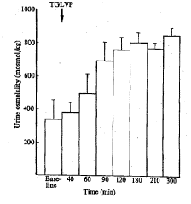

###### Coagulation

Table 24. Summary of Pharmacodynamic Effects of Terlipressin on Coagulation

| Reference | Terlipressin dose (No. Patients) | Effects of Terlipressin |
| --- | --- | --- |
| Douglas 1979 portal hypertension  oesophageal varices | IV 750 µg (n=5)  IV 2000 µg (n=3), | no effect on the level of plasminogen activator up to 90 min.  (no actual results given only this text statement). |
| Prowse 1980  portal hypertension  oesophageal varices | IV 750 µg (n=5)  IV 2000 µg (n=8) | Unlike LVP, terlipressin produced no rise in levels of plasminogen activator, factor VIII or factor VIII-related antigen up to 3 h. |

**Comment:** These studies had mostly the same authors, were published around the same time and from the descriptions of the patients and their illnesses were the same patients.

Figure 15. Plasminogen activator following LVP and terlipressin infusion.

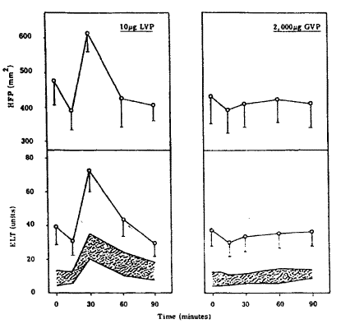

Plasminogen activator assayed by euglobulin lysis time (ELT) and unheated human fibrin plated (HFP) methods in eight cirrhotic patients infused with 10mcg LVP and 2,000mcg terlipressin between 15 and 30 min. 750mcg terlipressin infusion to five patients gave a similar response to 2,000mcg terlipressin10. The shaded area represents the normal range of response in control subjects.

Figure 16. Factor VIII response following LVP and terlipressin infusion.

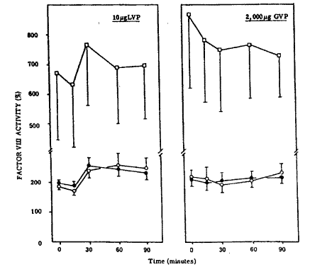

⭘ = One-stage coagulant VIII assay; ⚫ = two-stage coagulant VIII assay: = factor VIII-related antigen. Results are expressed as a percentage of normal plasma levels.

###### Uterus

Table 25. Summary of Terlipressin Effects in Pregnant and Non-Pregnant Women

| **Reference** | **Terlipressin dose  (No. Patients)** | **Effects of Terlipressin** |
| --- | --- | --- |
| Laudanski 1980A | IV 0.5mg (n=7)  IV 1mg (n=9)  Pregnant women in 1st trimester (8-12 weeks) | Increase in uterine activity: increase in uterine tone within 1 min of injection; maximum at 5-15 min. uterine contractions’ amplitude & duration remained significantly increased for 4-7 hours |
| Akerlund 1978 | IV 300mcg (n=14) Pregnant women in 1st trimester (6-9 weeks) | increase in uterine tone within 1 min of injection; maximum at 2-15 min, and amplitude and duration of uterine contractions increased in all women; change in contractions was secondary effect that lasted for duration of 4-6 h observation period |
| Akerlund 1976 | IV 100-400 mcg (n=19)  Non-pregnant women | Increase in tone and amplitude uterine activity and decrease in endometrial blood flow; more gradual in onset than LVP |

### Pharmacodynamic ‘bioequivalence’ studies

Nil.

### Genetic, gender and age related differences in PD response

None reported.

### Pharmacodynamic interactions

A summary of the literature studies investigating drug interactions with terlipressin in humans are summarised in the table below.

Table 26. Summary of Literature Studies Investigating Drug Interactions with Terlipressin in Humans

| **Reference** | **Patients Treatment** | **Significant Hemodynamic Effects Post Dose** | | | | | |
| --- | --- | --- | --- | --- | --- | --- | --- |
| **Systemic** | | | **Splanchnic** | | |
| Lin 2002 | 2 mg  11 Te only  13 Te + octreotide | Combined therapy did not modify systemic hemodynamic effects of terlipressin, except heart rate significantly ↓ in octreotide ± terlipressin group compared to placebo + terlipressin. | | | The combination of octreotide and terlipressin did not produce a significantly different decrease of the hepatic venous pressure gradient (-20.1 ± 2.5%) compared to terlipressin alone (-13.5 ± 3.1%). On terlipressin only 2 (18%) patients had HVPG < 12mmHg versus 4 (31 %) patients also on octreotide.  Among terlipressin alone patients 5 (45%) had a decrease in HVPG > 20%, while there were 7 (54%) among the octreotide plus terlipressin patients. | | |
| Lee 2001  Cirrhosis & portal hyper-tension | 2 mg  12 Te only  12 Te + prazosin | Combined therapy did not significantly modify systemic hemodynamic effects of terlipressin at 30 min. | | | Combination of prazosin and terlipressin resulted in a significantly greater reduction of HVPG than terlipressin alone at 30min (-28.6 ± 3.3% versus -16.8% ± 4.0%, p < 0.05). The changes in hepatic blood flow measurements were significantly less in prazosin plus terlipressin patients (1.4 ± 4.4% versus -23.8 ± 5.2%, p < 0.05). Changes in intrinsic hepatic clearance were significantly better in prazosin plus terlipressin patients (14.7 ± 5.9% vs-9.8 ± 4.8%, p < 0.05).  On terlipressin only 3 (25%) patients had HVPG < 12mmHg versus 7 (58%) patients on prazosin plus terlipressin.  Among terlipressin alone patients 5 (42%) had a decrease in HVPG > 20%, while there were 9 (75%) among the prazosin plus terlipressin patients. | | |
| Lin 1989  Cirrhosis & portal hyper-tension with varices | 11  2mg SD + nitroglycerin  @ 60min | At 60 min Terlipressin: ↑ MAP by 11% (p < 0.05) ↑ mean pulmonary artery pressure by 36% (p < 0.01) ↑ right atrial (p < 0.01)  ↑ pulmonary capillary wedge pressures (p < 0.01) ↓ HR by 10% (p < 0.05) ↓ cardiac output by 23% (p < 0.005) Nitroglycerin:  reversed systemic hemodynamic effects of terlipressin:  ↓ MAP by 19% (p < 0.01)  ↓ mean pulmonary artery pressure by 53% (p < 0.005)  ↓ right atrial (p < 0.01)  ↓ pulmonary capillary wedge pressures (p < 0.01) ↑ HR by 10%  ↑ cardiac output by 14%  The overall combined effect was of no significant changes, except  ↓ mean pulmonary artery pressure by 36% (p < 0.001)  ↓pulmonary capillary wedge pressures by 29% (p < 0.05). | | | At 60 min Terlipressin:  ↓ wedged hepatic venous pressure by 10% (p < 0.05).  ↑ free hepatic venous pressure by 3%  ↓ hepatic venous pressure gradient from by 16% (p < 0.005).  Nitroglycerin:  Further .↓wedged hepatic venous pressure by 8% (p < 0.0l).  ↓ free hepatic venous pressure by 25% (p < 0.05).  ↑ hepatic venous pressure gradient by 1%.  Overall combined effect was  ↓ wedged hepatic venous pressure by 17% (p < 0.005).  ↓ free hepatic venous pressure by 23%  ↓ hepatic venous pressure gradient from by 15% (p < 0.01). | | |
| Gadano 1997  Cirrhosis & ascites | 1-2 mg (on B.Wt.)  All on low Na diet  8 Te only  8 Te + α- human ANP |  | Te + ANP | Te only |  | Te + ANP | Te only |
| HR | ↓8%* | ↓11%* | WHVP | ↓4%* | ↓4%* |
| MAP | ↑6% | ↑15% | FHVP | ↑8% | ↑9%* |
| CI | ↓25%* | ↓21%* | HVPG | ↓6%* | ↓13%* |
| SVR | ↓50%* | ↓57%* | renal BF | ↑46%* | ↑28%* |
| RAP | ↑6% | ↑51%* | renal PP | ↑6% | ↑19%* |
|  |  |  | GFR | ↑16%* | ↑10% |
| * Significantly different from baseline.  Significance of differences between groups not given. | | | | | |

#### Propranolol

The sponsor submitted the paper

O. Le Moine, A. E1 Nawar, R. Jagodzinski. N. Bowpis, M. Adler, M. Gelin, and M. Cremer. Treatment with terlipressin as a bridge to liver transplantation in a patient with hepatorenal syndrome. *Acta Gastro-Enterologica Belgica.* Vol 1.XI. April-June 1998.

It was recently shown[11] that acute administration of terlipressin in patients taking beta-blockers lead(s) to additional systemic increase in systemic vascular resistances and mean arterial pressure, and an additional decrease in hepatic venous pressure gradient and azygos blood flow.

*Barash clinical anaesthesia p.1140:*

Experimental data demonstrate that propranolol decreases portal hypertension by both beta1- and beta2-adrenergic blockade. Beta1-adrenergic blockade is associated with a reduction in cardiac output and a subsequent decrease in portal blood flow. Beta2-adrenergic blockade results in splanchnic vasoconstriction and a decrease in bloodflow through portacaval collaterals. The antirenin activity of propranolol probably also plays a role in the effectiveness of this drug. The beneficial effect of propranolol is partially attributed to a decrease in anxiety and degree of alcohol abuse. The adverse effects of propranolol treatment include a decrease in the efficacy of diuretic therapy, an increase in ammonia concentration in blood, with signs of encephalopathy, sometimes hypoglycaemia, and decreased clearance of other drugs. Some controlled trials were unable to demonstrate that propranolol is effective in the prevention of variceal rebleeding in patients with liver cirrhosis.

These are both old references and beta blockers were not mentioned in the most recent review submitted by the sponsor.[12]

### Evaluator’s overall conclusions on pharmacodynamics

The proposed PI contains under Mechanism of Action the statement that:

In HRS patients with hyperdynamic circulation, the V1 receptor-mediated vasoconstrictor activity of terlipressin, particularly in the splanchnic area, results in an increase in effective arterial volume

The associated references (Arroyo 2000, Gines 2003, Kiszka-Kanowitz 2004) do not contain statements that terlipressin resulted in an increase in effective arterial volume.

The literature supports that terlipressin produces in HRS an increase in MAP, while studies TAHRS & 0401 (p = 0.333) showed no effect and Study 0401 showed significant (p = 0.017) increase compared to placebo but this was minimal (2.36mmHg), most of the difference being due to a fall in the placebo group. The literature showed a non significant decrease in HR with terlipressin, as did Study 0401[13] and study TAHRS.[14]

While the literature showed that terlipressin produces in HRS normalisation of endogenous vasoconstrictor systems (renin-angiotensin-aldosterone and sympathetic nervous system), the studies TAHRS and 0401 showed no significant change.

The literature supports that terlipressin increases renal blood flow in cirrhotic patients with refractory ascites.

The literature shows that in cirrhotic patients terlipressin increases systemic vascular resistance and decreases cardiac output.

The report gives graphical evidence of the average difference in pre and post dose MAP, but these are not given in numerical form. The range of differences reported for the systolic and diastolic pressures is much greater than suggested in the proposed PI for MAP.

## Clinical efficacy

### Treatment of Hepatorenal Syndrome (HRS) Type 1.

#### Dose-response studies

There were 29 patients included in the pharmacokinetic analysis of Study 0401 and 16 of these patients were classified as having a HRS reversal (responder).

The daily AUC of terlipressin in the responders did not appear to be any different than that observed in the non-responders. There appears to be no meaningful correlation between terlipressin drug exposure and HRS reversal response.

Figure17. Terlipressin AUC of Patients With or Without HRS Reversal- OT -0401

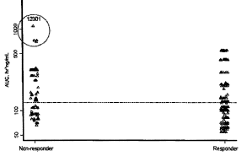

Non-responder (n=13), responder (n=16). The AUC in the y-axis is in a log scale and the dashed line represents the median AUC of 126.6 hr*ng/mL. The 4 highest AUC circled in the plot were considered outliers since they were from one patient (123-01; Day 1 to 4), who experienced an acetaminophen overdose prior to enrolment. Source: Figure 19; OT-0401 Population PK report

Table 27. Incidence of HRS Reversal by Terlipressin Dose Level (ITT) - OT -0401

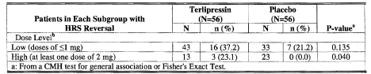

a From a CMH test for general association or Fisher's Exact Test.

#### Main (pivotal) efficacy studies

##### Study OT-0401

After completion of the study and study report the sponsor’s investigators went through the medical records seeking additional SCr results. One of the primary endpoints was redefined and as a result was now shown to be statistically significant.

###### Study design, location and dates

This was a randomised double blind, multicenter, placebo-controlled study of IV terlipressin in patients with HRS Type 1. A screening period ≤ 1 week occurred prior to randomisation. Patients were then randomised (1: 1 ratio) to either terlipressin or placebo, stratified by the presence or absence of alcoholic hepatitis. The study was conducted between September 2004 to August 2006 in 35 sites [US (30), Russia (3) and Germany (2)].

Approximately 120 patients were planned to be enrolled with at least 90 patients who did not receive a liver transplant by Day 14.

###### Inclusion and exclusion criteria

Inclusion criteria

* Chronic liver disease or acute liver disease, i.e., de novo onset within 6 weeks;
* Rapidly progressive reduction in renal function, e.g., doubling of SCr to ≥ 2.5 mg/dL in < 2 weeks prior to HRS diagnosis, or a 50% reduction of the initial 24-hour creatinine clearance to a level lower than 20 mL/min;
* Low glomerular filtration rate (GFR), as indicated by SCr > 1.5 mg/dL, or 24-h creatinine clearance of < 40 mL/min;
* No sustained improvement in renal function (decrease of SCr to 1.5 mg/dL or less or an increase in creatinine clearance to 40 mL/min or more) after diuretic withdrawal and plasma volume expansion with 1.5 L isotonic saline;
* Proteinuria < 500 mg/day;
* No evidence of granular casts on urinalysis;
* No ultrasonographic evidence of obstructive uropathy or parenchymal renal disease.

Exclusion Criteria

* Ongoing shock;
* Uncontrolled (ongoing) bacterial infection;
* Current fluid losses, i.e., gastrointestinal fluid losses (repeat vomiting or intense diarrhoea) or renal fluid losses (for example, weight loss >500 g/d for several days in patients with ascites without peripheral oedema or 1000 g/d in patients with peripheral oedema);
* Current or recent treatment with nephrotoxic drugs, such as aminoglycosides, non-steroidal anti-inflammatory drugs (NSAIDs) within 4 weeks;
* Acute liver disease due to factors known to be also directly nephrotoxic (such as acetaminophen overdose, mushroom [Amanita] poisoning);
* Evidence of intrinsic or parenchymal renal disease (for example, acute tubular necrosis).

###### Study treatments

Patients were to receive up to 14 days of study drug administered as a slow IV bolus every 6 hours. The treatment period began with the first dose. Therapy was to continue until serum creatinine had decreased to or below 1.5 mg/dL on at least 2 consecutive measurements, obtained 48 h apart, **or** for up to 14 days, unless a patient underwent liver transplantation or otherwise failed treatment (met criteria for dialysis at any time during study treatment period, or had SCr level at Day 7 or later that was at or above baseline value).

The terlipressin starting dose 4 mg/d (1 mg every 6 hours), increased to 8 mg/d (2 mg every 6 hours) after 3 days if a patient does not respond (SCr had not decreased by at least 30% from the baseline), was selected based on published experience.

The **primary objectiv**e was to demonstrate that IV terlipressin is safe and effective in the treatment of patients with HRS Type 1 when compared to placebo with regard to treatment success at 14 days, that is, survival with a reversal of HRS to SCr values at or below 1.5 mg/dL without dialysis or relapse.

**Secondary objectives** were to demonstrate that terlipressin improves renal function and survival compared with placebo.

The primary efficacy variables were:

* The Incidence of Treatment Success at Day 14 was defined as the number of patients alive at Day 14 who demonstrated reversal of HRS (SCr ≤ 1.5 mg/dL on at least 2 measurements obtained 48 ± 8h apart), without dialysis or recurrence of HRS divided by the total number of patients in the MITT[15] at Day 14 population.
* The Incidence of HRS Reversal was defined as the number of patients who demonstrated reversal of HRS (at least one SCr ≤ 1.5 mg/dL during treatment or within 8 h of the last dose of study drug), without intervening dialysis or liver transplantation divided by the total number of patients in the intent-to-treat (ITT) population.

Secondary efficacy outcomes included:

* Change from Baseline to Day 14 in Renal Function (as determined the SCr data).
* Incidence of Treatment Failure at Day 14 (the number of patients who had SCr concentrations at or above the baseline value after Day 7, died, or fulfilled the criteria for dialysis at any time during treatment divided by the total number of patients in the MITT at Day 14 population).
* Combined Incidence of Partial Response and Treatment Success at Day 14 (the sum of the incidence of Partial Response and the incidence of Treatment Success at Day 14). Partial Response was defined as the number of patients alive with SCr concentrations above 1.5mg/dL, but more than a 50% reduction from baseline without dialysis or recurrence of HRS divided by the total number of patients randomized).
* Transplant Free Survival Up to Day 60.
* Overall Survival Up to Day 60 regardless of liver transplantation status.

Other variables

* Overall Survival up to 14, 30, 90 and 180 days.
* Transplant-Free Survival up to 14, 30, 90 and 180 Days.
* Survival to Transplantation Up to 90 and 180 Days.
* Incidence of Dialysis up to 14, 30, 60, 90 and 180 Days.
* Number of Days on Dialysis up to 14, 30, 60, 90 and 180 Days.
* Change from Baseline in MELD score.
* Change from Baseline in Renin and Aldosterone Levels.

**Safety:** A separate assessment of **QT -interval** times was conducted by blinded and independent Cardiologists.

###### Protocol amendments

Amendment 1 (July 7, 2004): The titration of albumin dose to a specific albumin level was altered to all patients receiving a standard albumin dose.

Amendment 2 (12 September 2005):

* Deletion of Interim Analysis for a potential sample size recalculation.
* The definition of the secondary endpoint of partial response was harmonised with the definition of the primary endpoint of treatment success.

Amendment 3 (24 February 2006):

* Primary Endpoint Serum Creatinine Lab window used was widened from 48 ± 2 h to 48 ± 8 h.
* The analyses to be performed for the dialysis data (incidence and time to dialysis) and additional time points of Days 14 and 30 for the analyses of overall survival and transplant-free survival were specified.

###### Sample size

The sample size calculations were based on 90 patients in the MITT population (no liver transplant within 14 days). This study was designed with a type I error of 0.05 and a power of 95% to detect a 30% difference in the primary efficacy endpoint (treatment success rate at Day 14) between terlipressin (35%) and placebo (5%). Under these conditions, the study also had at least 85% power at a 0.01 level. The estimated rate of Treatment Success at Day 14 of 35% for the terlipressin group was based upon results of published clinical trials in HRS patients in which improvements in renal function (HRS reversal) were consistently shown in 42% to 100% of patients treated with terlipressin at doses generally ranging from 2 mg/d to 6 mg/d.

###### Randomisation and blinding methods

Patients were stratified by presence/absence of alcoholic hepatitis and randomly assigned to treatment with terlipressin or matching placebo in a 1: 1 ratio by an interactive voice response system.

The terlipressin and placebo vials were labelled with the randomized identification numbers for each kit to maintain the blinding of the randomized treatments. Unblinding of study code was to be done only in the event that definite knowledge of the study drug was essential for the medical treatment of the patient.

###### Statistical methods

All statistical tests were 2-sided with the final significance level of 0.05, unless stated otherwise.

The primary efficacy outcome of number and percentage of patients with treatment success at Day 14 was summarized by treatment group and analysed using a CMH chi-square test adjusted for baseline strata (alcoholic hepatitis present or not).

The primary efficacy outcome of number and percentage of patients with HRS reversal was summarised by treatment group and analysed using a CMH chi-square test adjusted for baseline strata (alcoholic hepatitis present or not).

The pre-specified secondary endpoints were to be analysed in a nested sequential step-down fashion.

Subgroup analyses were performed for the primary efficacy outcome of number and percentage of patients with Treatment Success at Day 14 and for HRS Reversal by demographic and baseline factors of interest (age group, race, gender, alcoholic hepatitis, MELD score, Child Pugh score, geographic region and dose level) as well as pooled investigational site. Treatment Success and HRS Reversal were summarized by treatment group and analysed using a separate CMH chi-square test for each subgroup of interest. These subgroup analyses were performed for the MITT population (Treatment Success) and the ITT population (HRS Reversal).

An Interim Safety Analysis for DSMB was performed using data from the first 55 ITT patients who had completed the Day 14 assessment and concluded that the study should proceed as planned.

###### Participant flow

Participant flow is described in the figure below.

Figure 18. Overview of Patient Disposition through 180 Days of Follow-up (ITT Population)

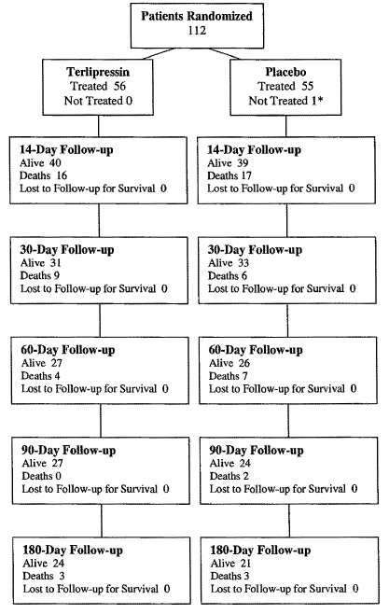

* One patient randomised to receive placebo did not receive study drug because patient had spontaneous bacterial peritonitis that was discovered after enrollment. This patient was immediately withdrawn from the study prior to receiving any study medication. Note: the number of deaths at a given follow-up time point are those occurring after the prior follow-up point and up to the current follow-up point; deaths are not cumulative.

Table 28. Summary of Reasons for Termination of Treatment as Captured on the CRF (ITT Population)

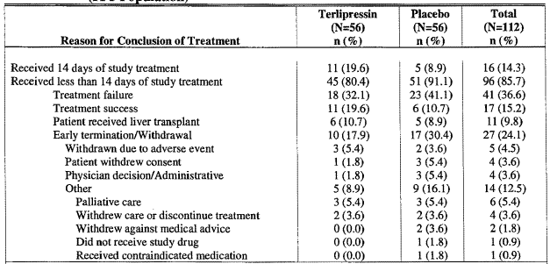

Table 29. Summary of Major Protocol Deviations (ITT Population)

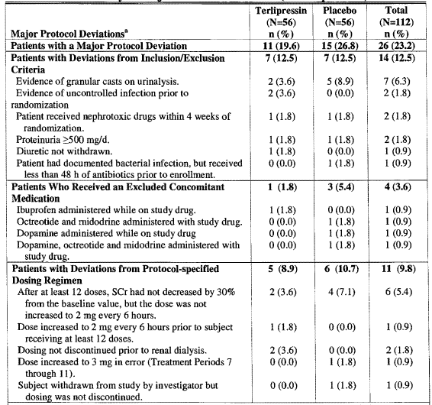

a A patient could have multiple deviations but was only counted once for a given deviation category.

###### Baseline data

Table 30. Summary of Demographics and Baseline Characteristics (ITT Population).

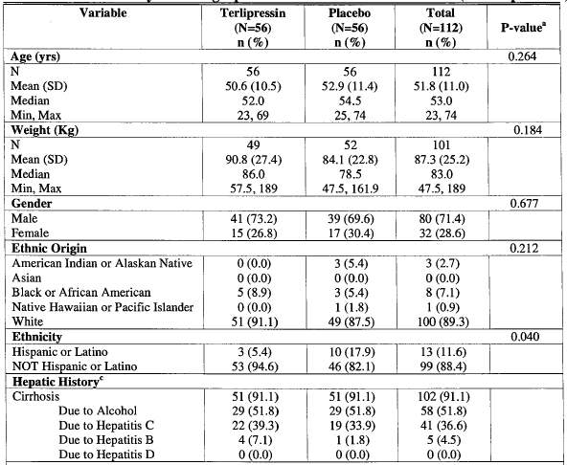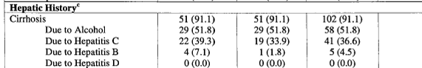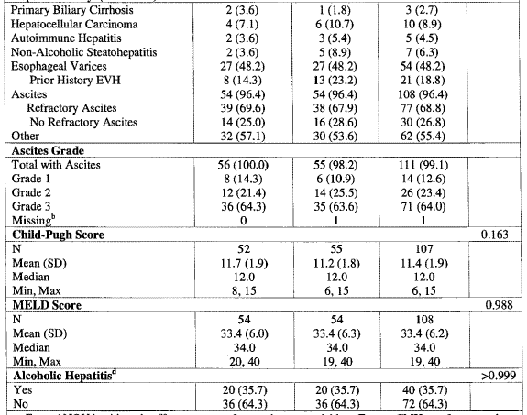

a From ANOVA with main effect treatment for continuous variables. From a CMH test for general association for discrete variables. b Missing is not included in the percentage. c Patients can be counted in multiple categories. Missing is defined as missing all major categories. Missing is not shown for the subcategories. d Alcoholic hepatitis was reported at the time of randomisation.

Table 31. Serum Creatinine Concentrations at Baseline (ITT Population)

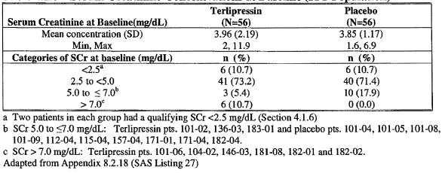

Table 32. Selected Baseline Laboratory Values (ITT Population)

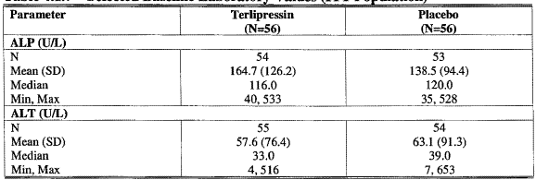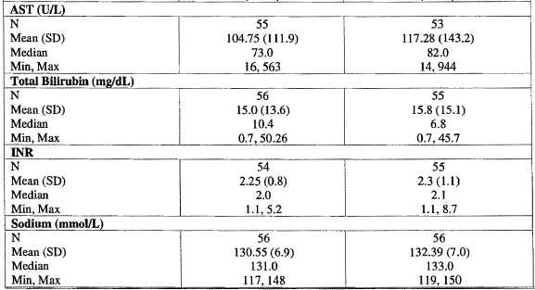

Mean duration of treatment (Safety population) was terlipressin 6.3 days and placebo 5.8 days, while 23.2% on terlipressin and 41.8% on placebo had an increased dose.

Table 33. Summary of Concomitant Albumin Received from Day 1 to End of Treatment (ITT)

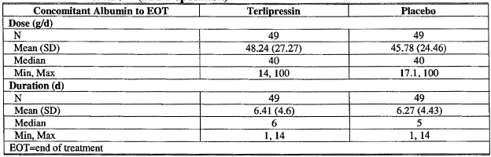

EOT=end of treatment.

##### Results for the primary efficacy outcomes

###### Treatment success at day 14

The difference from placebo was not significant:

Table 34. Summary of Incidence of Treatment Success with Missing Serum Creatinine Values at Day 14 Imputed as Not a Treatment Success

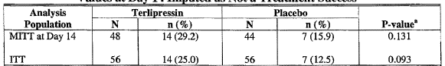

a From a CMH test for general association adjusted for strata (alcoholic hepatitis present or not).

###### HRS reversal

The difference from placebo was significant. There were 5 patients who achieved HRS reversal on terlipressin but for valid reasons did not fit the definition of treatment success.

* Reversal of HRS was maintained (1 patient in each group was retreated with study drug and reversal was maintained to the 180-day follow-up).
* 1 placebo responder received dialysis from Day 93 for suspected HRS.

Table 35. Summary of HRS Reversal

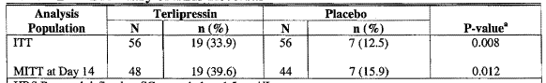

HRS Reversal defined as SCr at or below 1.5 mg/dL on treatment. a From a CMH test for general association adjusted for strata (alcoholic hepatitis present or not).

Figure 19. Composite of Serum Creatinine Values Through Day 60 for Terlipressin Treated Patients With HRS Reversal (ITT Population)

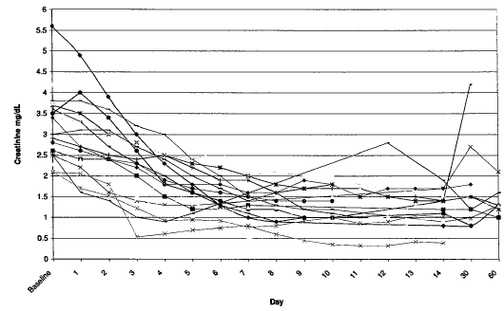

Figure 20. Composite of Serum Creatinine Values Over Time for Placebo Treated Patients With HRS Reversal (ITT Population)

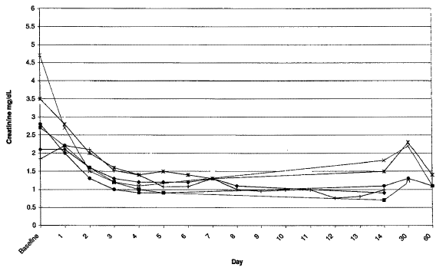

SCr data from SAE reports is not presented in Graph.

Table 36. Time (Days) to HRS Reversal in Patients with HRS Reversal (ITT Population)

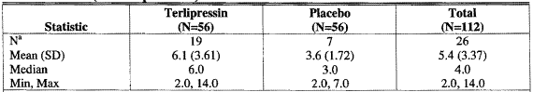

a Serum Creatinine at or below 1.5 mg/dL excluding data after transplant or dialysis. Only includes patients with HRS Reversal.

##### Results for other efficacy outcomes

###### Change from baseline to day 14 in renal function

Both OC and ITT analyses showed significant difference from placebo to day 14.

Table 37.Repeated Measures Analysis of Change from Baseline in Serum Creatinine by Study Day using Observed Cases (MITT at Day 14 Population).

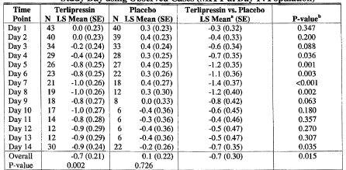

a Calculated as the Terlipressin LS Mean Change from baseline minus placebo LS Mean change from baseline. b From Repeated Measures ANOVA as implemented in Proc Mixed with factors Treatment, Day, Strata (alcoholic hepatitis present or not), Treatment by Day, and Repeated statement with factor Patient nested in Strata. Treatment p-values within Day are obtained from the Treatment by Day interaction, whereas the overall treatment p-value is obtained from the overall treatment comparison.

Note: Model uses compound symmetry covariance matrix and maximum likelihood estimation.

Figure 21. Repeated Measures Analysis of Change from Baseline in Serum Creatinine Level by Day using Observed Cases (MITT at Day 14 Population).

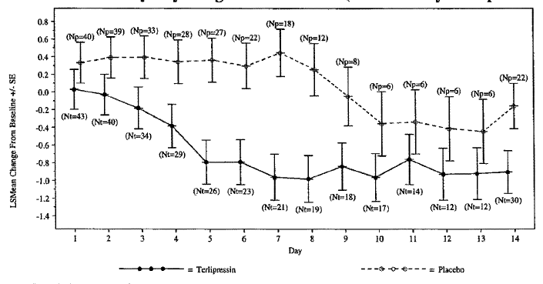

Note: (N = xx) denotes number of terlipressin patients with SCr values at that time point and at baseline; (Np = xx) denotes number of placebo patients with SCr values at that time point and at baseline. LS Means from Repeated Measures ANOVA as implemented in Proc Mixed with factors Treatment, Day, Strata (alcoholic hepatitis present or not), Treatment by Day, and Repeated statement with factor Patient nested in Strata. Model uses compound symmetry covariance matrix and maximum likelihood estimation.

###### Incidence of treatment failure at day 14

There was no significant difference (see table below).

Table 38. Summary of Incidence of Treatment Failure at Day 14 using LOCF.

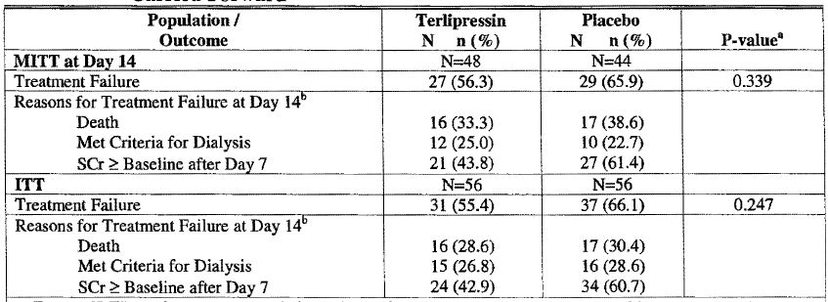

a From a CMH test for general association adjusted for baseline strata (alcoholic hepatitis present or not). b Patients may be counted for more than one reason.

###### Combined incidence of HRS reversal or partial response at day 14

The difference from placebo was significant.

Table 39. Combined Incidence of HRS Reversal and/or Partial Response (MITT at Day 14 Population).

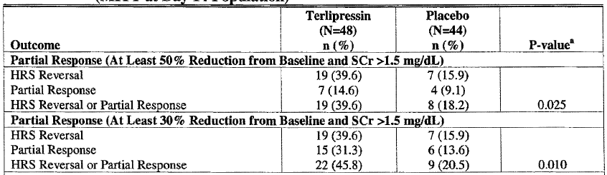

a From a CMH test for general association adjusted for baseline strata (alcoholic hepatitis present or not).

Table 40. Combined Incidence of HRS Reversal and/or Partial Response (ITT).

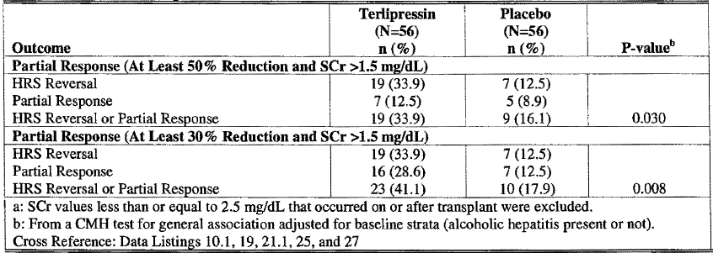

a SCr values less than or equal to 2.5 mg/dL that occurred on or after transplant were excluded.b From a CMH test for general association adjusted for baseline strata (alcoholic hepatitis present or not).

###### Transplant-free survival up to day 60

Transplant-free survival up to Day 60 was similar in both groups.

###### Overall survival up to day 60

Overall Survival up to Day 60 was not significantly different between groups (48.2% with terlipressin and 46.4% with placebo; p = 0.958).

Figure 22. Kaplan-Meier Plot of Overall Survival up to Day 180 (ITT Population).

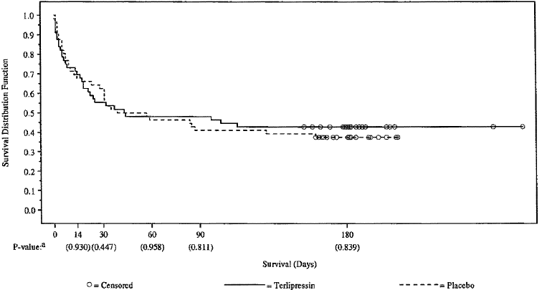

a From a two-sample log-rank test stratified by strata (alcoholic hepatitis present or not). Includes data up to and including the time point.

###### Transplant-free survival

Transplant-free Survival up to Day 180 was similar in both groups.

Figure 23. Kaplan-Meier Plot of Transplant-Free Survival up to Day 180 (ITT).

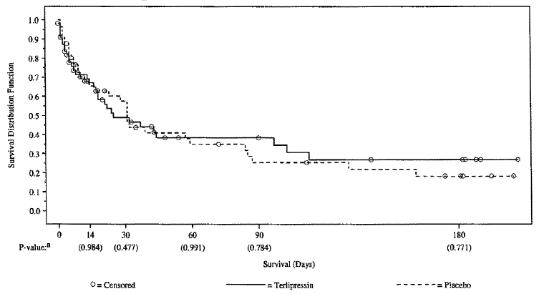

a From a two-sample log-rank test stratified by baseline strata (alcoholic hepatitis present or not). Includes data up to and including the time point.

###### Survival to transplantation

Overall, terlipressin-treated patients received their transplants later (mean 31 days) compared with the placebo-treated patients (mean 21 days).

Table 41. Summary of Time of Survival to Transplantation (patients with Transplantation).

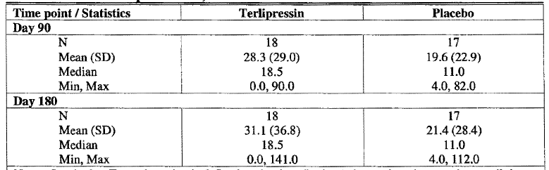



Notes: Survival to Transplantation is defined as the time (in days) that each patient survives until the occurrence of transplant (or censoring) from the beginning of the study until the 14, 30, 60, 90 and 180 day time points. Includes only those patients who had a liver transplant.

###### Change from baseline in MELD score

The overall repeated measures LS mean change from baseline through Day 14 showed a significant decrease with terlipressin compared with placebo (-2.9 versus -0.9, respectively; p=0.016).

Figure 24. Mean Change from Baseline (± SE) in MELD Scores by Day (MITT Population LOCF).

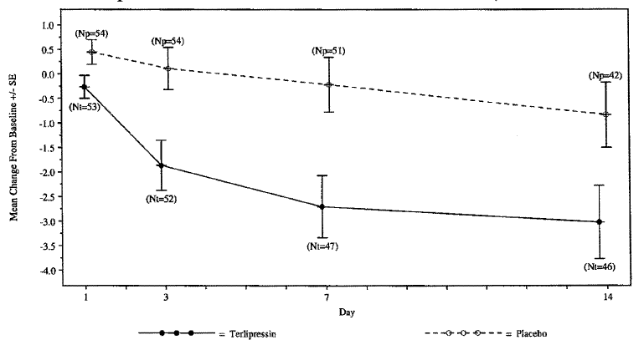

Note: (Nt=xx) denotes number of Terlipressin patients at each time point; (Np=xx) denotes number of Placebo patients at each time point.

Table 42. Repeated Measures Analysis of Change from Baseline in MELD Score by Study Day using Observed Cases (MITT at Day 14 Population).

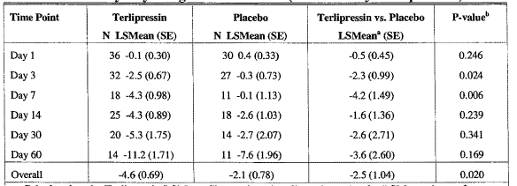

a Calculated as the Terlipressin LSMean Change from baseline minus placebo LSMean change from baseline. b From Repeated Measures ANOV A as implemented in Proc Mixed with factors Treatment, Day, Strata (alcoholic hepatitis present or not), Treatment by Day, Treatment by Strata (if significant), and Repeated statement with factor Patient nested in Strata. Treatment p-values within Day are obtained from the Treatment by Day interaction, whereas the overall treatment p-value is obtained from the overall treatment comparison. Note: Model uses unstructured covariance matrix and maximum likelihood estimation.

###### Renin and aldosterone levels

There was no significant difference the renin and aldosterone levels both in change from baseline and between treatment groups.

Table 43. Change from Baseline in Renin and Aldosterone Levels at End of Treatment LOCF (ITT).

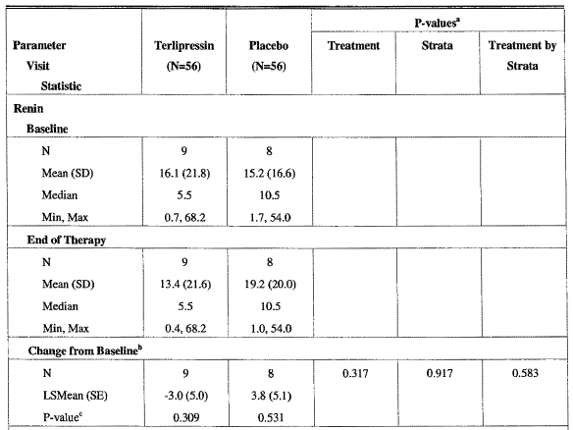

a From ANOVA with main effect treatment and strata (alcoholic hepatitis present or not) as a blocking factor and treatment by strata if significant. b Includes only those patients who had a change from baseline. c Within-group test of change from baseline from a paired t-test.

Subgroup analyses

Age < 65years, Male, MELD score < 34, Child-Pugh score ≥ 12 and high dose all had significant effects on the incidence of HRS reversal.

Table 44. Incidence of HRS Reversal by Subgroup (ITT Population).

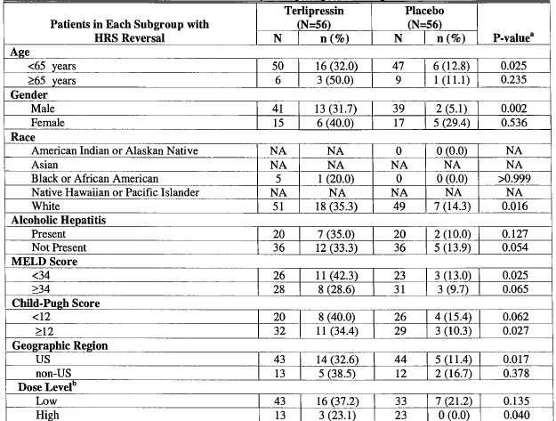

a From a CMH test for general association or Fisher's Exact Test. b Low Dose = Maximum exposure for all individual doses is less than 2 mg. High Dose = Maximum exposure for one or more individual doses is at least 2 mg.

Table 45. Selected Characteristics of All Patients Transplanted on or Before Day 14 (ITT Population).

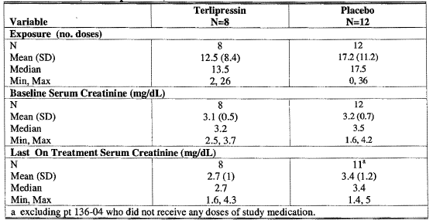

a excluding one patient who did not receive any doses of study medication.

#### Study OT-0401 additional data, subsequently acquired and reported

After completion of the study and study report the sponsor’s investigators went through the medical records seeking additional SCr results.

The primary endpoint Treatment Success was redefined as:

* an on-treatment SCr value at or below 1.5 mg/dL; and
* a second SCr value at or below 1.5 mg/dL at 48 h (-24 h to +24 h) after the first 1.5 mg/dL or lower SCr value; and,
* All SCr values (following the first SCr <1.5 mg/dL) were below 2.5 mg/dL up to and including Day 14.

As a result the primary endpoint of Treatment Success was now shown to be statistically significant. It was proposed to insert this result in the PI.

Table 46. Treatment Success Incidence Including Subsequent Data

| **Analysis Population** | **Terlipressin** | | | **Placebo** | | | **P-value** |
| --- | --- | --- | --- | --- | --- | --- | --- |
| **N** | **n (%)** | **95% CIb** | **N** | **n (%)** | **95% CIb** |
| MITT at Day 14 | 48 | 14 (29.2) |  | 44 | 7 (15.9) |  | 0.131a |
| ITT | 56 | 14 (25.0) |  | 56 | 7 (12.5) |  | 0.093a |
| ITT from subsequent review | 56 | 16 (28.6) | 17.3, 42.2 | 56 | 7 (12.5) | 5.2, 24.1 | 0.037a |

a From a CMH test for general association adjusted for strata (alcoholic hepatitis present or not).

b Exact binomial CI for within treatment. Normal approximation confidence interval with continuity correction for the difference in proportions.

#### Other efficacy studies

##### Study TAHRS

**This study was terminated early.**

Approximately 100 patients were planned to be enrolled at 16 hospitals in Spain in approximately 36 months. Enrolled: 46 (46 ITT); the study was terminated after 4 years of enrolment (January 2002 to April 2006) as the result of a protocol-specified interim analysis of survival. The estimated sample size required to demonstrate a significant treatment difference was 431 patients/group. As to achieve this sample size would have been impossible within a reasonable period of time the study was terminated.

The sponsor subsequently obtained the study data after closure and re-interpreted it using the relevant parts of the Study 0401 protocol.

###### Study design, objectives, locations and dates

This was a randomised open-label, controlled, multicenter study of terlipressin in patients with hepatic cirrhosis and HRS Type 1 or Type 2.

Primary objective: to investigate the effects of treatment with terlipressin and albumin on the survival of patients with hepatic cirrhosis and HRS Type 1 or 2.

To evaluate whether the improvement in renal function, in the event this occurs, results in an increase in the probability of survival to transplantation and in a reduction of post-transplant complications.

Other parameters assessed were:

* Renal function
* Hepatic function
* Endogenous vasoactive systems-plasma renin activity, plasma concentrations of aldosterone, noradrenalin, endothelin, neuropeptide Y, and atrial natriuretic factor
* Systemic and hepatic hemodynamics
* Regional blood flow (systemic, hepatic, renal)

###### Inclusion criteria included:

HRS Type 1 or 2, with SCr concentration >2.0 mg/dL (Patients could be enrolled whether or not they were candidates for liver transplant because they could become a candidate subsequent to enrolment).

###### Exclusion criteria included:

* Patients with hepatocarcinoma
* Active bacterial infection
* Arterial hypertension above 140/90

###### Study treatments

Patients were randomised to receive treatment with either terlipressin plus 20% human albumin or with 20% human albumin alone (control). Patients were randomised independently according to whether they had HRS Type 1 or Type 2.

Patients were to receive study drug as an IV bolus every 4 h until one day after the reversal of HRS (SCr concentration <1.5 mg/dL), or up to a maximum of 15 days if no response or only a partial response occurred. Patients were observed daily while hospitalised. After discharge, follow-up occurred on Days 21, 28, 35, 42, 60, and 90.

###### Efficacy variables and outcomes

* The Incidence of HRS Reversal: the number of ITT patients who demonstrated reversal of HRS (at least one SCr value ≤1.5 mg/dL during randomised study drug treatment without intervening dialysis or liver transplantation).
* Change from Baseline Through End of Treatment in Serum Creatinine
* Combined Incidence of HRS Reversal and Partial Response[16]
* Overall Survival[17]
* Transplant-Free Survival[18]
* Change from Baseline in Calculated Creatinine Clearance[19]
* Daily Urine Volume on Treatment
* Change from Baseline in MELD Score to the End of Randomized Treatment:
* Change from Baseline in Mean Arterial Pressure at the End of Randomized Treatment
* Change from Baseline in Vasoactive Hormone Levels at the End of Treatment (renin, aldosterone, noradrenaline, endothelin, neuropeptide Y, atrial natriuretic factor and antidiuretic hormone).
* Duration of Hospitalization

###### Statistical methods

The TAHRS protocol did not specify procedures for statistical analysis of the final study data.

The data was analysed for this report using the plan in the 401 study.

Based on the results of a historic series, and on published pilot studies of terlipressin and ornipressin, the investigators sought a survival difference between the two treatment groups of 30% (5% in the control group and 35% in the terlipressin group) at Day 90. Considering a two-sided type I error of 5% and a type II error rate of 20% and using the sequential analysis of O'Brien and Fleming 43 patients were required per group. Considering a drop-out rate of 15%, 50 patients per group were planned to be enrolled in approximately 36 months. The TAHRS protocol specified that a preliminary analysis of the primary endpoint of survival at 3 months would be conducted to determine whether the study should continue or be terminated early.

###### Participant flow

Participant flow is shown in the figure below.

Figure 25. Overview of Patient Disposition Through 90 Days of Follow-up (ITT Population)

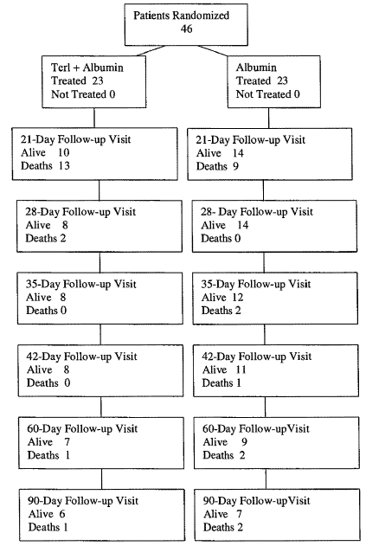

No patients were lost to follow-up for survival. The number of deaths at a given follow-up time point are those occurring after the prior follow-up point and up to the current follow-up point; deaths are not cumulative. The following windows for follow-up assessments: 21 days (+/- 2 days), 28 days (+- 2 days), 35 days (+/- 4 days), 42 days (+/- 6 days), 60 days (+/-10 days), and 90 days (+1-14 days)

Table 47. Summary of Reasons for Conclusion of Randomized Treatment (ITT Population)

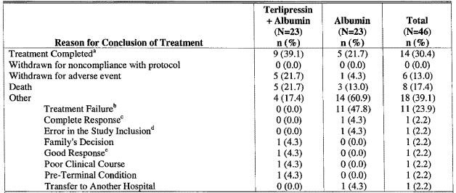

a Includes 7 terlipressin + albumin pts with HRS reversal and 2 patients who completed 15 days of treatment Includes 1 albumin pt with HRS reversal and 4 patients who completed 15 days of treatment. b Albumin patients who crossed over to terlipressin are classified as "Other: Treatment Failure." c Pt B-21-MMG experienced HRS reversal. d See 'Protocol Deviations' Section 4.1.3 (pt 31-NHG) e Pt K-24-MPG experienced HRS reversal

The original protocol was amended to allow patients who were randomised to the albumin control group and who experienced treatment failure the opportunity to receive terlipressin + albumin rescue treatment.

Table 48. Summary of Reasons for Conclusion of Crossover Treatment (ITT Population)

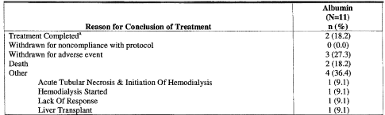

a Includes 1 pt with HRS reversal and 1 pt who completed 15 days of treatment

There were 11 patients in the terlipressin group with protocol deviations, including 3 with co-administration of vasoactive dug and 2 with under-dosing of the 6 patients with deviations in the albumin group, 3 had co-administration of vasoactive drug and 1 had active bacterial infection at enrolment.

Table 49. Summary of Demographics and Baseline Characteristics (ITT Population). Table continued across two pages.

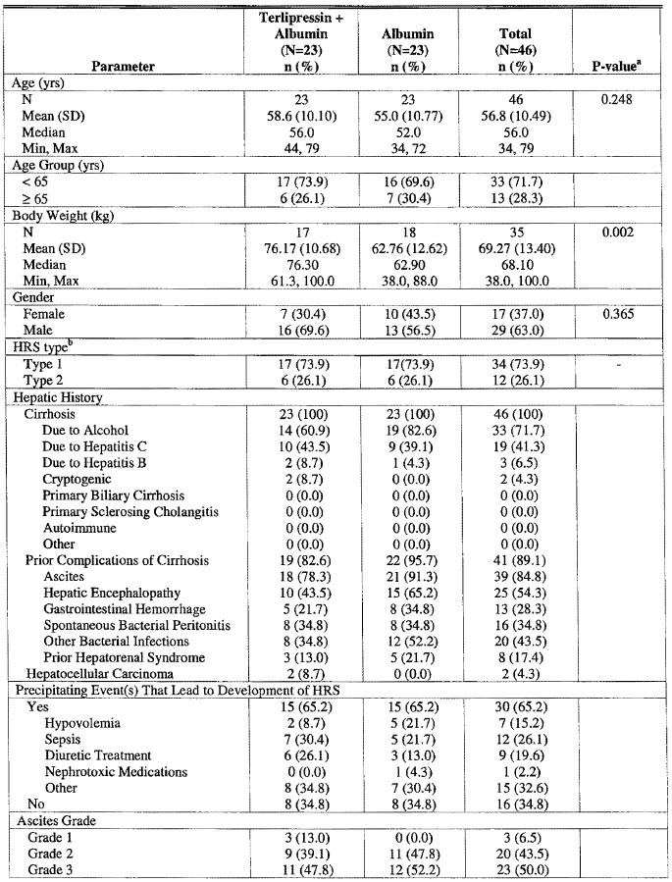

Table 49 continued. Summary of Demographics and Baseline Characteristics (ITT Population).

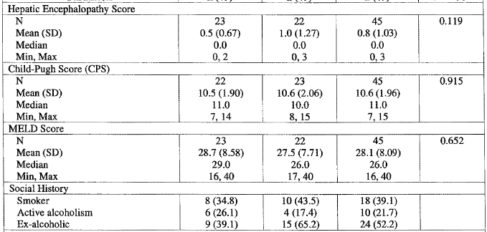

a From ANOV A with main effect treatment for continuous variables. From a CMH test for general association for discrete variables. b HRS type as stratified.

* The Incidence of HRS Reversal was significantly (p = 0.018) higher in terlipressin + albumin patients (9; 39%) compared with albumin only patients (2; 9%).
* The Change from Baseline through End of Treatment in Serum Creatinine significantly (p = 0.031) reduced in the terlipressin + albumin group (LSM -0.28 mg/dL, SE 0.230) relative (LSM -0.69 mg/dL, SE 0.308) to the albumin group (LSM 0.41 mg/dL, SE 0.230).
* Combined Incidence of HRS Reversal and Partial Response[20] was significantly (p = 0.049) higher in the terlipressin + albumin group (9, 39%) than in the albumin group (3, 13%).
* Overall Survival[21] showed no significant difference (p = 0.574) between treatment groups both 6/23, 26%. Median survival was 12.0 days on terlipressin versus 33.0days
* In the terlipressin + albumin group, unadjusted median survival was 12 days, which increased to 22-32 days when adjusted for the baseline imbalances in baseline serum sodium and baseline total bilirubin. In contrast, unadjusted median survival in the albumin group was 33 days, which decreased to 14-22 days when adjusted for these baseline imbalances. However, these differences still did not reach statistical significance (p ≥ 0.207).

Figure 26. Kaplan-Meier Plot of Overall Survival (ITT Population)

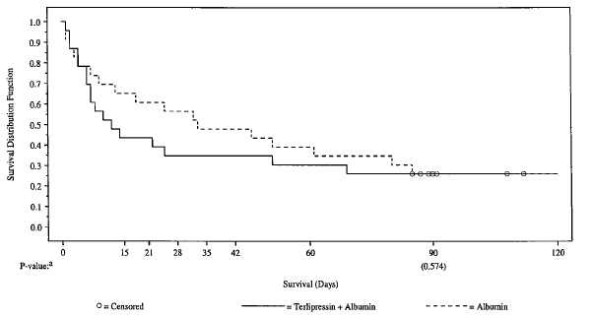

a From a stratified two-sample log-rank test.

* Transplant-Free Survival[22] was similar. The probability of surviving without transplantation (calculated by product limit estimate) was 26% for both treatment groups
* Change from Baseline in Calculated Creatinine Clearance[23] in the terlipressin + albumin group (LSM 11.01 mL/min, SE 2.033) increased significantly relative (LSM of 10.82 mL/min, p < 0.001) to the albumin group (LSM 0.19 mL/min, SE 2.031).
* Daily Urine Volume on Treatment results are difficult to interpret.
* Change from Baseline in MELD Score to the End of Randomized Treatment:

Table 50. Change from Baseline in MELD Score through End of Treatment (ITT Population with Last Observation Carried Forward)

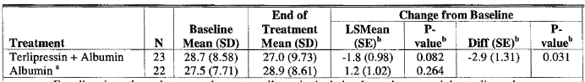

a For albumin patients that crossed over to terlipressin, includes data prior to receiving terlipressin. b From ANOVA with main effect treatment and strata as a blocking factor.

* Duration of Hospitalisation, not statistically different.

###### Results for other efficacy outcomes

Table 51. Summary of HRS Reversal on Treatment by Age, Gender and Baseline Child-Pugh Score (ITT)

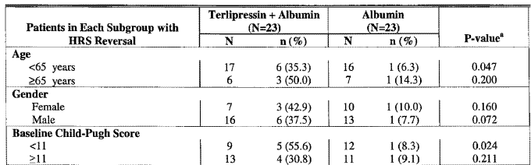

a From a stratified CMH test.

Table 52. Summary of the Effects of Baseline Characteristics on HRS Reversal on Treatment (ITT)

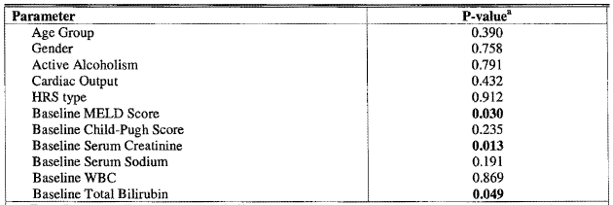

a From Wald Chi-Square tests from individual logistic regressions with Treatment and factor: Age Group (< 65, ≥ 65), Gender, Active Alcoholism (yes/no), Cardiac Output, HRS Type, Baseline MELD Score, Baseline Child-Pugh Score, Baseline Serum Creatinine, Baseline Serum Sodium, Baseline WBC, or Baseline Bilirubin. Note: Only includes patients with a non-missing value for the parameter of interest.

Table 53. Summary of the Effects of Baseline Characteristics on Overall Survival (ITT Population)

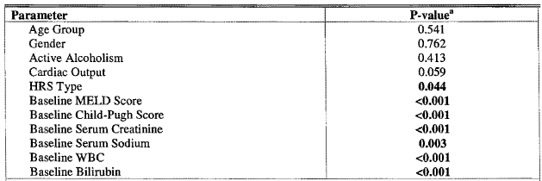

a From individual log-rank tests for association with survival pooled over treatment for parameters: Age Group (< 65, ≥ 65), Gender, Active Alcoholism (yes/no), Cardiac Output, HRS Type, Baseline MELD Score, Baseline Child-Pugh Score, Baseline Serum Creatinine, Baseline Serum Sodium, Baseline WBC, or Baseline Bilirubin. Note: Only includes patients with a non-missing value for the parameter of interest.

###### Albumin treated patients who experienced treatment failure and received Terlipressin + Albumin as rescue treatment

Their HRS had progressed for a further 5-7 days in patients randomised to the albumin group before they crossed over to receive terlipressin + albumin rescue treatment, HRS was reversed in 1/11 patients (9%) and SCr was reduced in 5/11 patients (45%).

#### Literature review

A problem with assessing the relevance of the literature is the inconsistency of the definition of responder and HRS reversal. In Study OT-0401 HRS reversal was defined as at least one SCr ≤ 1.5 mg/dL during treatment or within 8 h of the last dose of study drug. In the meta-analysis by Fabrizi *et al* it was this level or lower at the end of treatment.

Serum creatinine at 1.5 mg/dL had an equivalence given ranging in the studies of 130 to 133 mmol/L. Propranolol was used both to decrease cardiac output and cause splanchnic vasoconstriction.[24]

Table 54. Comparison of Efficacy of Terlipressin in Clinical Publications

| **Study** | **No. HRSa Patients**  **Dosed with terlipressin** | **Terlipressin**  **Dosing**  **Regimen** | **HRS Reversal** | **Other Renal Endpoints** |
| --- | --- | --- | --- | --- |
| **Prospective randomized, controlled studies** *Placebo-controlled* | | | | |
| Hadengue 1998  (Responder = ↑ urinary Na excretion) | 9 Type 1 completed  12 enrolled | 2mg/d (12 hourly) for 2 d versus placebo cross over  Restricted Na diet  Mean Child Pugh (CP)scores 10.5 & 9.8  6 on β-blockers |  | Change baseline to Day 2  Na excretion  T: +1450% ( but not significant) P:-9%  CrC1  T:+12 mL/min (80%, p< 0.05) P: +1 mL/min  Urine output  T: + 29% (P < 0.05)  P: -9% |
| Solanki 2003  (Responder not defined) | 12 Type 1  12 on placebo Assessed on day 4, 8 & 15 | 2mg/d (12 hourly) up to 15d +albumin versus placebo + albumin  22 had dopamine for 24-48h initially.  Restricted Na & fluid  All patients dropped out of trial by day 15 but for 5 pts on T who had HRS reversal | Day 15 only  T: 42% vs.  P: 0%  P < 0.05  (Reversal not defined, but appears to relate it to CrCl) | Significant change from baseline in CrCl & urine output only occurred for the 5 survivors on T.  Change from baseline to Day 8 ( 9T, 7P pts)  Urine output  T: +70% versus (P < 0.05) P: -49%  CrCl  T: +90% versus (P < 0.05) P: -46%  SCr  T: -1.3 mg/dL versus (P < 0.05) P: +1.3mg/dL  Urine output T: |
| *Active-controlled* | | | | |
| Alessandria 2007B  (Complete response = reversal of HRS) | 5 Type 1  +7 Type 2  NA: 4 Type 1  +6 Type 2 | 6-12 mg/d (4 hourly)(up to 2 w + albumin (N = 12, CP score 11)  vs. noradrenaline (NA)  0.1-0.7 µg/kg/min + albumin (N = 10, CP score 10) | Overall: T: 83%  NA: 70 %  Type 1: T: 80%  NA: 75%  (Reversal = decrease of ≥ 30% of SeCr level compared with the baseline value to a final value of 1.5 mg/dL [133 µmol/L] or lower during treatment). | Change from baseline to end of treatment (all here P < 0.05)  Urinary Na  T: + 400%  NA: +200%  Urine output: T: +126% NA: +101%  CrCl: T:+85% NA: +59%  SCr: T: -1.2 mg/dL NA: -1.2 mg/dL |
| Neri 2007  (Complete response = decrease of ≥ 30% r of SeCr level compared with the baseline value to a final value of 1.5 mg/dL [133 mcmol/L] or lower during treatment). | 26 Type 1  26 albumin only | 1.5-3mg/d (8hly) for 19d + albumin (CP score 11.5) versus control (albumin alone, CP score 11.2) | T: 81% C: 19%  Partial response T: 15%; C: 16%  (Reversal not defined; assumed to equate with complete response) | Change from baseline to end of treatment  Urine output  T:+128% versus (p < 0.001) C: +32%  SCr  T: -136 mcmoL/L versus (P < 0.00l) C: -68 mcmol/L |
| Yang 2001 | 8  7 control  HRS type not specified | 2 mg/d (12hly) for 5 d + albumin versus control (albumin + diuretics) |  | Change from baseline to end of treatmentc  Urine Na  T: +43% versus (p< 0.001) C:-3%  Urine output  T: +231% versus (p< 0.001) C: +23%  CrCl  T: +192% versus (p< 0.001) C:+48%  SCr T: -151 mcmol/L C: -21 mcmol/L, p < 0.001 |
| **Prospective studies** *Non-randomized controlled study* | | | | |
| Ortega 2002  (Complete Response = decrease of SeCr to a value of 1.5 mg/dL (132mcmol/L) or lower during treatment). | 16 Type 1  + 5 Type 2  8 had pre-trial paracentesis | 3-l2mg/d (4hly) to reversal of HRS or up to 15d (CP score 10)  62% had added albumin (CP score 11)  Mean dose 4.9mg/day in complete responders | Overall (total response) 57% :  8, 50% Type 1  4, 80% Type 2  TA: 10, 77% versus (P < 0.05) T: 2, 25%  (2 partial response)  (Reversal of HRS = Complete Response). | Change from baseline to end of treatment  Urine Na  TA: +200% (p< 0.05)  T: +100%  Urine output  TA: +85% versus (p< 0.05)  T: +3%  GFR  TA: +200% (p< 0.05)  T: +75%  SCr  TA: -2.1mg/dL (P < 0.05)  T: 0 mg/dL |
| *Uncontrolled* | | | | |
| Angeli 2006  (Complete Response = decrease of SeCr to a value of 1.5 mg/dL during treatment). | 19 Type 1  All (116) had spontaneous bacterial peritonitis | 2-12 mg/d continuous infusion up to 15d + albumin | 12 pts, 63%  2 partial response (11%)  (Reversal not defined; assumed to equate with complete response) |  |
| Mulkay 2001 | 12 Type 1 | 1-6mg/d (tid or bd) 1-9w +albumin  4pts on β-blockers  1 had dialysis commenced prior to trial | Treatment was to lowest and steady levels obtained with higher doses, stopped if stable 2days and recommenced prn | Change from baseline after 1week  Urine Na + 443%  Urine output +132%  CrCl +200%  **Plasma** Cr – 475  By day 14 Plasma Cr fell to a mean of 1.6 (-2.2) mg/dL ( all p < 0.05) |
| Saner 2004  (Responder not defined) | 7 HRS type not specified | 6mg/d continuous infusion after loading dose for 6d  +gelatinepolysuccinat | 4, 57%  (reversal of HRS = a reduction of SeCr below 1.5mg/dL) | Change from baseline to end of treatment  Urine output +316% (p< 0.04)  GFR +104% (p < 0.12)  SCr -1.9 mg/dL(-50%, p < 0.02) |
| Uriz 2000  (Responder not defined) | 6 Type 1  + 3 Type 2  8 completed | 3-l2mg/d (4hly) to reversal or up to 15d + albumin | 7, 78% overall  4 Type 1  (reversal of HRS = a reduction of SeCr below 1.5mg/dL) | Change from baseline to end of treatment  Urine Na + 133%  Urine output +57% (p < 0.001)  GFR +200%(p < 0.001)  SCr -2.4 mg/dL (-62%, P < 0.001) |
| **Retrospective Studies** *Case-controlled* | | | | |
| Restuccia 2004 | All but 1 of patients reported in other articles. Except for ornipressin patients the relevant articles have been submitted. | | | |
| *Uncontrolled* | | | | |
| Colle 2002 | 18 Type 1 some also in study Moreau 2002A | 2-4 mg/d (72% + albumin) until SeCr <130mcmol/L or ↓ > 20% to max 4d paracentesis prn  9pts on β-blocker | Only results were comparisons of with/without improved renal function.  (Treatment was stopped when renal function improved, defined as a decrease in SeCr to a value < 130mcmol/L or a decrease in serum creatinine (of at least 20%) leading to a stable value). | |
| Danalioglu 2003 | 15 type1  7 Type 2 | Terlipressin 2-4 mg/d qid up to 14d + albumin. 2pts also had dopamine infusion at the same time |  | Improved renal function (↓ SCr under the pre-treatment value measured & ↑ daily urine output)  3, 43% (overall) |
| Duhamel 2000 Letter to editor  (Responder not defined) | 12 Type 1 | 2-6mg/d (1mg bd- 2mg tds) up to 20d  (CP score 10.5)  4pts recent sepsis; 3pts on propranolol |  | Significant ↓ SCr  6, 50% |
| Halimi 2002  (Response = a decrease in baseline SeCr ≥ 30% from day 0 to day 5) | 16 Type 1  2 Type 2 | 4mg/d up to 16d  (CP score 11.2) | Results given only as responders versus non-responders. No. who actually achieved HRS reversal not given | |
| Moreau 2002A | < 99 pts that were previously unreported Type 1  (Responder not defined; assumed to equate with Improved Renal Function) | 3.2mg/d for 11d  (25% + albumin)  This study incorporates Colle  And based on dates appears to include Duhamel, Hamili | Results given only as responders versus non-responders. No. who actually achieved HRS reversal as defined not given | 58% had improved renal function  (↓ SeCr either to < 130mcmol/L or of ≥ 20% compared with the baseline value [at day 0] assessed between first and last day of treatment). |
| Niemczyk 2006 | 5 Type 1 (+4 Type 2) | 0.4mg IV and 0.4 mg in an infusion |  | Improved renal function  2, 40% Type 1 |
| **Meta-analyses** | | | | |
| Fabrizid 2006  (responder = HRS reversal) | 127  ( > 80% Type 1) | 1-6 mg/d for 2-26d ± plasma expanders | 52%  (Reversal of HRS = a decrease of SeCr to a value of 1.5 mg/dL (132mmol/L) or lower at the end of treatment). |  |
| Gluud 2006 | 25 total  HRS type not specified | 2 mg/d for 2-15 d  Various co-interventions, including albumin |  | Generally improved renal function with↓ SCr and ↑ in urine output |

a HRS diagnosis defined using criteria established by IAC (Arroyo 1996)

b HRS type as stratified

c Described as Day 1 post-therapy in sponsor’s Table 2, but comparison with sponsor’s Figure 1 shows these results to be Day 6 (that is, after 5 days treatment). The text describes baseline measurements 1day prior to treatment and observations on Days 32, 3 & 5 of treatment.

d Included Hadengue, Duhamel, Mulkay Alessandria, Colle, Halimi, Ortega, Solanki, Danalioglu, Saner.

In the **Fabrizi meta-analysis** responders showed reversal of HRS after terlipressin therapy, but this was not the only definition of responder in the studies reviewed. The analysis had only 2 controlled studies (Hadengue & Solanki) with a total of 21 patients with Type 1 HRS receiving terlipressin. Further one of the studies used plasma creatinine measurements which may differ from serum creatinine, depending on how measured.[25] The meta-analysis included Colle 2002 which had some of its 18 patients (16% of those in the meta-analysis) also included in study Moreau 2002A and Duhamel 2000 (12%) which was a Letter to the Editor. There were 112 patients with Type 1 HRS who received terlipressin in the meta-analysis studies. The meta-analysis used unpublished data from Saner 2004 and Danalioglu 2003. In the Halimi study, and the Hadengue study in relation to creatinine they only looked at progression of creatinine clearance.

The results in relation to HRS reversal after terlipressin use were given for all patients (including Type 2), the only analysis result relevant to this indication was for the 5 trials with Type 1 HRS patients only (trials included those of Colle 2002, Duhamel 2000& Hadengue 1998). For this subgroup the pooled rate of HRS reversal was 0.53 (95% CI, 0.41; 0.65), according to the random (or fixed) effects model; test for overall effect Z = 8.54 (P < 0.0001); tests for heterogeneity Q = 2.56, P = 0.63, I2 = 0%. The pooled odds ratio of HRS reversal after terlipressin included only 21 treated patients (and included Hadengue 1998).

Figure 27. Pooled Odds Ratio of hepatorenal syndrome after terlipressin: study versus controls.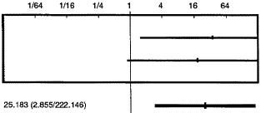

Hadengue

Solanki

Odds Ratio (CI)

Better control group Better study group

Source: Figure 3. Fabrizi meta-analysis

In their discussion the authors wrote:

*Several issues on terlipressin use in HRS remain unresolved. Firstly, a large number of patients do not respond to terlipressin or relapse after terlipressin withdrawal. Secondly, it has been suggested that there is a weakness in the criteria set by the lAC. Recently, Peron et al.34 successfully treated 20 HRS patients with albumin and furosemide infusion tailored to central venous pressure levels. They suggested that the 1.5 L of saline as suggested in the definition of HRS is not sufficient to expand the circulatory volume in these patients. In other words, their patients may not have true HRS. Thirdly, even when lAC diagnostic criteria are used at enrollment, it may be difficult to distinguish patients with true HRS from patients with HRS-induced ischaemic acute tubular necrosis. Fourthly, more information is needed on the haemodynamic responses to terlipressin therapy.*

The **Gluud 2006 Cochrane review** contained studies Hadengue 1998, Solanki 2003 and Yang 2001 (the latter did not specify the HRS type of the patients included). The maximum follow-up was 14 days after treatment. There were 21 patients identified as Type 1 HRS on terlipressin in these studies. The other study included Pomier 2003 related to the use of octreotide. The primary outcome measure was mortality. All trials reported mortality data. 5 of 25 patients randomised to terlipressin (20%) and 15 of 23 patients (65%) randomised to the control group died. Fixed-effect meta-analysis showed that terlipressin reduced mortality by 34% (RD -0.34,95% CI -0.56 to -0.12). The inter-trial heterogeneity was not statistically significant (Chi-square P 0.12). The effect remained significant when a random-effects model was used and in worst-case scenario analysis.

In fixed-effect meta-analyses, terlipressin increased creatinine clearance by 21 mL/min (weighted mean difference (WMD) 21, 95% CI 17 to 26), reduced serum creatinine by 219 µmol/L (WMD -219; 95% CI -244 to -194), and increased urine output by 685 mL/day (WMD 685, Terlipressin for hepatorenal syndrome 95% CI 492 to 879). In all of these analyses, inter-trial heterogeneity was statistically significant (P < 0.001). When using random- effect models, the effect of terlipressin remained significant for serum creatinine (WMD -205 µmol/L, 95% CI -309 to -101), but not for creatinine clearance (WMD 25 mL/min, 95% CI -5 to 56), or urine output (WMD 707 mL/ day, 95% CI -212 to 1625).

Review authors’ comments included:

The present review found three small trials with unclear bias control. The trials suggest that terlipressin may reduce mortality and improve renal function in hepatorenal syndrome.

The evidence is still too weak to establish or refute clinically relevant effects of terlipressin or octreotide. The design of the included trials suggests that the results may be overtly positive due to selection bias, assessment bias, attrition bias, and publication bias

A further **Fabrizi meta-analysis (2009)** was added without review under efficacy in volume 39. It too included Hadengue (different n quoted) and Solanki both of which looked at progression of creatinine clearance. Neri was included together with published reports of study OT-0401 (Sanyal) & TAHRS (Martin-Llahi). A total of 120 Type 1 HRS patients on terlipressin were included in this meta-analysis. The pooled odds ratio (OR) for survival rate after terlipressin therapy was 2.064; 95% CI, 0.939; 4.538; p = 0.07, according to the random effects model. The test for heterogeneity was not significant (Q-test=5.627, NS); I2=55.1%. The publication bias assessment (according to the Klein formula) was 0. The test for funnel plot asymmetry was significant (α = 2.27; 95% CI, 0.58; 3.96; p = 0.01).

The pooled OR (random effects model) for reversal of HSR after terlipressin therapy was 8.09; 95% CI, 3.521; 18.59; p = 0.0001. The test for heterogeneity was not significant (Q-test=5.113, NS); I2 = 41.3%. The publication bias assessment (PBA), according to the Klein formula, was 37. The test for funnel plot asymmetry was weakly significant (α = 1.84; 95% CI=0.11; 3.57; p = 0.04). The Galbraith plot highlighted the great precision of every single study, and the absence of heterogeneity in the analysis.

Figure 28. Pooled Odds Ratio for HRS reversal after therapy (terlipressin versus placebo).

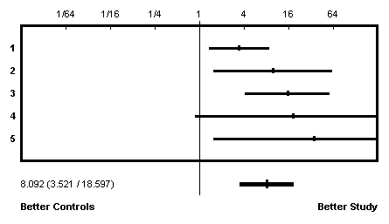

Odds Ratios are labelled with progressive numbers.1 Sanyal A. *et al* 2 Martin-Llahi M. *et al* 3 Neri S. *et al* 4 Solanki P. *et al* 5 Hadengue A. *et al*

### Analyses performed across trials (pooled analyses and meta-analyses)

Study results were not pooled.

### Evaluator’s conclusions on efficacy for the treatment of HRS Type 1

The introduction to Study report OT-0401 gives a median survival time in HRS Type 1 of 2-4 weeks. Also, patients with HRS who receive transplants have more complications and higher in-hospital mortality than those without HRS (Bataller 1997, Rimola 1987[26]). In addition HRS Type 1 patients may not survive long enough to receive a liver transplant.

Bataller quotes Rimola as a reference and makes the following comments:

*Immediately after transplantation a further impairment in renal function may be observed and more than one third of patients require haemodialysis (35% of patients with HRS as compared with 5% of cirrhotic patients without HRS).*

*Patients transplanted with HRS have more complications, spend more days in the ICU and in the hospital, and have a higher in-hospital mortality rate than patients transplanted without HRS. Despite this increased morbidity, long-term survival of patients transplanted with HRS is excellent, the probability of survival 3 years after transplantation being of 60%. This survival is only slightly reduced compared with that of patients transplanted without HRS (which ranges between 70% and 80%).*

Thus, based on this the maximum improvement possible in 3 year survival in patients with HRS would be 30%. Against this being possible Rimola found that there were 2 other independent variables apart from preoperative renal dysfunction that affected survival, and Bataller proposes a continuum of renal dysfunction in these patients.

*“suggests that in cirrhotic patients with ascites there is a continuum of changes in renal perfusion and HRS is the end of this spectrum. “*

While it is assumed that HRS reversal improves outcome, Bataller makes no such claim:

*In this regard (poor prognosis), the use of therapeutic methods (TIPS, vasoconstrictor agents, dialysis) to improve renal function temporally and act as a "bridge" to liver transplantation may be of most benefit. Nevertheless, the efficacy of these methods should be evaluated in controlled investigations.*

The Study OT-0401 showed significant differences in HRS reversal and change in SCr with minimal overlap of CIs. The interpretation of the abandoned study TAHRS and the submitted literature do not refute these results but the numbers are small. Does this translate to a difference in outcome of HRS? This was the answer sought[27] by the TAHRS study which was terminated after 4 years (enrolled 46 patients) where the estimated sample size required to demonstrate a significant treatment difference was 431 patients/group. Neither study could show a significant difference in survival, though the Cochrane review (criticised above) did. Study 0401 also failed to show a difference in transplant free survival. Overall in Study 0401, terlipressin-treated patients received their transplants later (31 days) compared with the placebo-treated patients (21 days), however this depends more on the availability of transplant.

The mean SCr concentration in responders was 3.2 mg/dL in the terlipressin group and 3.0 mg/dL in the placebo group. The highest SCr of a responder patient was 5.6 mg/dL for terlipressin and 4.7mg/dL for placebo.

Excluding patients with baseline SCr ≥ 5.0 mg/dL, the incidence in the MTIT at Day 14 population of reversal of HRS in the terlipressin group was 17/33 (51.5%) while Treatment Success (sustained reversal HRS) was 13/33(39%) versus 7/34 (21%) in the placebo group for both parameters. Among those ten in the placebo group with SCr ≥ 5.0 mg/dL none had treatment success or HRS reversal, there was 1/9 in the terlipressin group.

There was no difference in Dialysis rates in Study OT-0401 between the treatment groups and ICU/hospital stay was not reported, while in TAHRS there was no significant difference in hospital stay and dialysis rates were not reported.

A comparison of the terlipressin group responders versus non responders showed a significant difference between in survival in Study OT-0401. However, the baseline SCr affected HRS reversal (and survival), so was survival an effect arising from HRS reversal or was HRS reversal another screening test for likely survival?

For the Terlipressin group the survival and transplant free survival was statistically greater to Day 90 in the Treatment Success and HRS reversal patients compared to the other terlipressin patients without these; but there were no differences in survival for HRS reversal or Treatment Success in the placebo group.

How did the placebo success or responders compare in survival with the terlipressin? The numbers were small but some similarity is seen in Overall Survival out to Day 30 and 90 for Treatment Success and for HRS reversal; while this holds true for Transplant Free Survival for Treatment Success patients, terlipressin HRS reversal patients were transplanted earlier (not statistically tested and only sourced for ITT).

Table 55. Survival of Treatment Success patients Study OT-0401 ITT Population

|  | **Terlipressin** | | **Placebo** | |
| --- | --- | --- | --- | --- |
| **Day** | **Transplant Free Survival** | **Overall Survival** | **Transplant Free Survival** | **Overall Survival** |
| 14 | 14(100%) | 14(100%) | 7(100%) | 7(100%) |
| 30 | 11(79%) | 12(86%) | 6(86%) | 6(86%) |
| 90 | 9(64%) | 10(71%) | 4(57%) | 4(57%) |
| 180 | 4(29%) | 5(36%) | 3(43%) | 4(57%) |

Table 56. Survival of HRS reversal patients Study OT-0401 ITT Population

|  |  |  |  |  |
| --- | --- | --- | --- | --- |
|  | **Terlipressin** | | **Placebo** | |
| **Day** | **Transplant Free Survival** | **Overall Survival** | **Transplant Free Survival** | **Overall Survival** |
| 14 | 19(100%) | 19(100%) | 7(100%) | 7(100%) |
| 30 | 12(63%) | 14(74%) | 6(86%) | 6(86%) |
| 90 | 10(53%) | 12(63%) | 4(57%) | 4(57%) |
| 180 | 5(26%) | 9(47%) | 3(43%) | 4(57%) |

Table 57. Summary of Overall Survival up to Days 14, 30, 90 and 180 (Observed Cases ITT population)

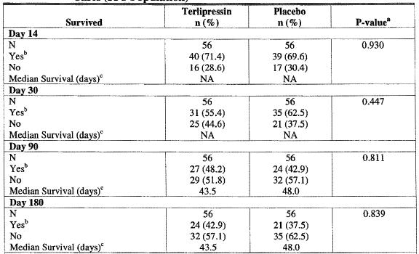

a From a two-sample log-rank test stratified by baseline strata (alcoholic hepatitis present or not). Includes data up to and including the time point. b Includes patients without a known death on or before the specified time point. cCalculated using product limit estimates. Cross Reference: Data Listings 10.1, 19,24 and 25

Table 58. Status of HRS Responders During Follow-up (ITT)

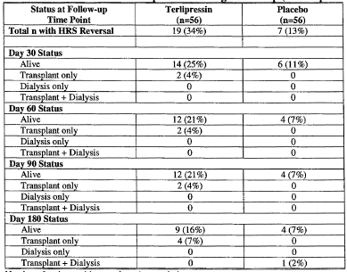

Number of patients with transplants is cumulative.

Figure 29. Summary of Terlipressin Population Overall Survival for HRS Reversal versus No HRS Reversal (ITT)

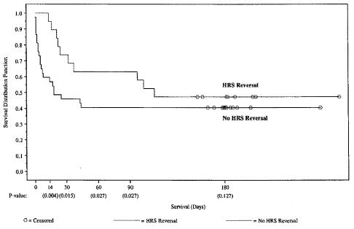

Note: From a two-sample log-rank test stratified by strata (alcoholic hepatitis present or not). Includes data up to and including the time point.

Figure 30. Summary of Terlipressin Population Transplant-Free Survival for Treatment Success versus Not Treatment Success (ITT)

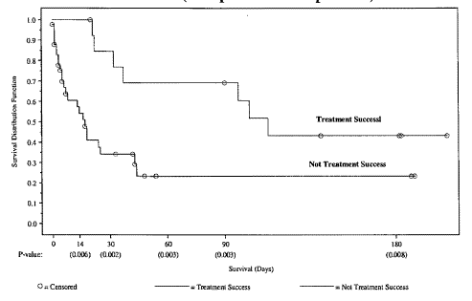

Note: From a two-sample log-rank test stratified by strata (alcoholic hepatitis present or not). Includes data up to and including the time point.

Figure 31. Summary of Terlipressin Population Transplant-Free Survival for HRS Reversal versus No HRS Reversal (ITT)

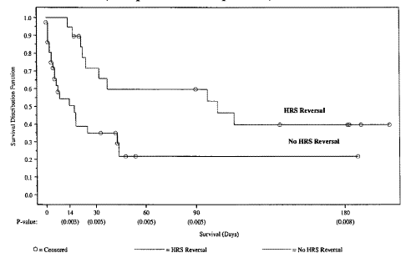

Note: From a two-sample loge rank test stratified by strata (alcoholic hepatitis present or not). Includes data up to and including the time point.

Figure 32. Summary of placebo Population Overall Survival for HRS Reversal versus No HRS Reversal (ITT)

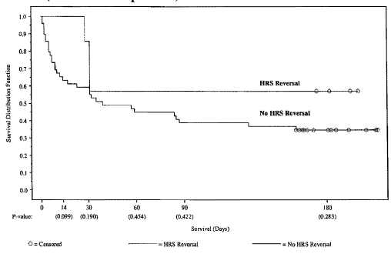

Note: From a two-sample log-rank test stratified by strata (alcoholic hepatitis present or not). Includes data up to and including the time point.

Figure 33. Summary of Placebo Population Transplant-Free Survival for Treatment Success versus Not Treatment Success (ITT)

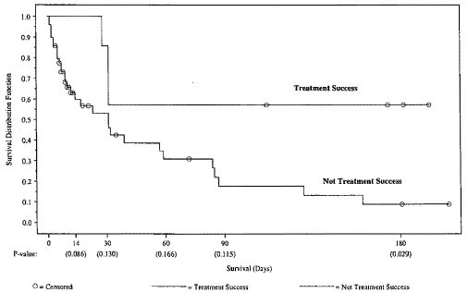

Note: From a two-sample log-rank test stratified by strata (alcoholic hepatitis present or not). Includes data up to and including the time point.

Figure 34. Summary of placebo Population Transplant-Free Survival for HRS Reversal versus No HRS Reversal (ITT)

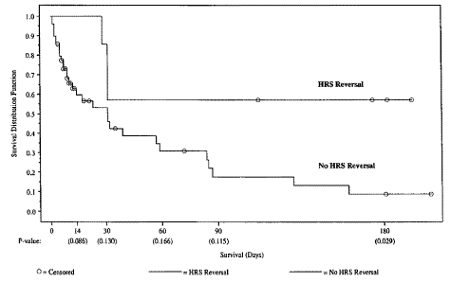

Note: From a two-sample log-rank test stratified by strata (alcoholic hepatitis present or not). Includes data up to and including the time point.

## Clinical safety

### Studies providing safety data

Safety data from the OT-0401 and TAHRS studies were not pooled because OT-0401 had a double-blind design and TAHRS was an open-label study. In addition, there were some differences in dosing schedules (regimen and maximum allowable dose; *Pharmacokinetics* above) and patients in TAHRS who were randomised to the albumin arm were allowed to receive rescue (crossover) treatment with terlipressin.

The sponsor also made comparisons of safety results between the two despite the small numbers involved.

#### Pivotal study OT-0401 safety

In addition to the pivotal efficacy study (described under *Clinical Efficacy*), pivotal safety data were derived from its Population PK study.

##### Population PK study

The population PK analysis included 29 patients on terlipressin. Twelve of these patients had an SAE reported, 3patients had treatment-related SAEs, and 5 patients died within 30 days of the end of terlipressin treatment. There was no apparent correlation between terlipressin drug exposure and SAEs in these patients.

###### QT interval population PK study

A linear mixed-effect PK/PD model was used in the PK/PD analysis to investigate the relationship between QTc intervals and terlipressin plasma concentrations. The effect of terlipressin plasma concentrations on QTc intervals was not significant (p-value > 0.05). When △QTc changes from the baseline of each patient were evaluated, the effect of terlipressin plasma concentrations was also not significant.

Table 59. Estimated PD Parameters of QTc and △QTc Intervals

|  | **Parameters** | **Mean a** | **p-value** | **BSVb** |
| --- | --- | --- | --- | --- |
| QTcB | SL (ms/(µg/mL)) | -0.212 (147) | >0.05 0 | .207 (280) |
|  | B0 (ms) | 445 (2.3) | - | 7.0% (51) |
|  | Residual error | 25.5 (9.9) | - | - |
| QTcF | SL (ms/(µg/mL)) | -0.153 (59) | >0.05 | 0.27 (0.4) |
|  | B0 (ms) | 428 (1.2) | - | 5.8% (0.4) |
|  | Residual error | 23.9 (4.1) | - | - |
| △QTcB | SL (ms/(µg/mL)) | -0.239 (88) | >0.05 | 4.99 (39) |
|  | B0 (ms) | 2.85 (94) | - | 189% (205) |
|  | Residual error | 26 (6.1) | - | - |
| △QTcF | SL (ms/(µg/mL)) | -0.21 (117) | >0.05 | 5.54 (40) |
|  | B0 (ms) | 4.1 (81) | - | 159% (140) |
|  | Residual error | 23.5 (4.4) | - | - |

a Parameter precision is expressed as coefficient of variation (% CV) b BSV = between subject variability calculated as (variance)l/2 and its precision as %CV.

###### Study OT-0401

AEs were recorded from the first administration of study medication. Non-serious AEs were recorded until 7 days post-treatment and SAEs were recorded until 30 days post-treatment. All deaths during the 180-day follow-up were recorded as SAEs.

###### Study TAHRS

For the submitted trial report the patient CRFs were reviewed to record SAEs that occurred up to 30 days post-treatment and to record all deaths during the 90-day follow-up period as SAEs.

### Consolidated clinical safety data

#### Patient exposure

Table 60. Summary of Exposure to Randomized Terlipressin/Placebo Treatment by Study (Safety Population)

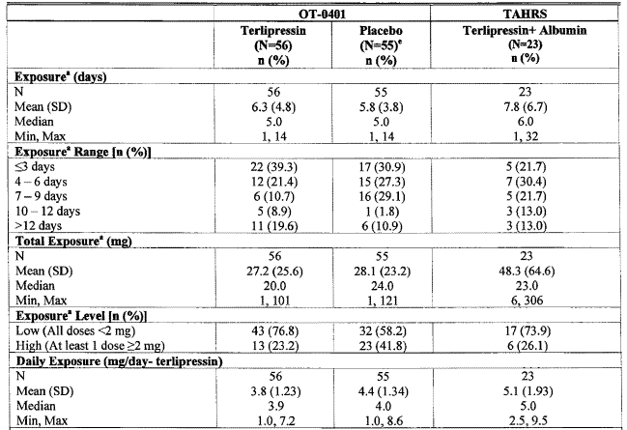

a Exposure includes retreatment for one patient in each group. b From analysis of variance (ANOVA) with main effect treatment. c From a Cochran-Mantel-Haenszel (CMH) test for row mean scores. d From a CMH test for general association. e Safety population includes only patients who received at least one dose of study drug

Table 61. Terlipressin Exposure by Mean Daily Dose and Duration of Exposure (ITT Population) - OT-0401 + TAHRS Pooled

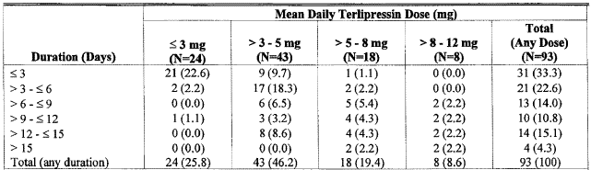

Note: Re-treat patients were counted twice. Dosing from the initial and retreat periods were counted separately.

Table 62. Discontinuation of Randomized Study Treatment (Safety Population) by Study

|  |  |  |  |  |  |  |  |  |  |
| --- | --- | --- | --- | --- | --- | --- | --- | --- | --- |
| **Study** | **Treatment**  **Group** | **Total Treatment Discontinuationsa n(%)** | | | **Reason for Discontinuation n (%)** | | | | |
| **Total** | **Male /**  **Female** | **Age ≥ 65** | **Adverse Events** | **Death On Treatment** | **Trans-plant** | **Lack of Efficacyc** | **Otherd** |
| OT-0401 | Terlipressinb  (N=56) | 34  (60.7) | 25(44.6) /  9 (16.1) | 3 (5.4) | 3 (5.4) | 6 (10.7) | 6 (10.7) | 12 (21.4) | 7 (12.5) |
| Placebob (N=55) | 45 (81.8) | 33 (60.0) / 12 (21.8) | 7 (12.7) | 2 (3.6) | 3 (5.5) | 5 (9.1) | 21 (38.2) | 14 (25.5) |
| TAHRS | Terlipressin+ Albumin (N=23) | 13 (56.5) | 10 (43.5) /  3 (13.0) | 5 (21.7) | 5 (21.7) | 0 | 1 (4.3)e | 2 (8.7) | 3 (13.0) |
| Albumin (N=23) | 17 9 (73.9) | 9 (39.1) /  8 (34.8) | 3 (13.0) | 1 (4.3) | 3 (13.0) | 0 | 11 (47.8) | 2 (8.7) |

a Discontinuations are patients who were enrolled but did not complete the planned course of treatment (includes patients who discontinued treatment or changed to a different treatment prematurely and/or were lost to follow-up. b Administered with albumin. c For OT-0401, includes dialysis, no improvement; for TAHRS, includes patients who crossed over from the albumin group to the terlipressin + albumin group. d For OT-0401, includes 6 terlipressin patients and 7 placebo patients who discontinued to opt for palliative care, withdrew consent, or transferred to another hospital. e This patient had a poor clinical course.

#### Adverse events

##### All adverse events (irrespective of relationship to study treatment)

In study OT -0401 the incidence of AEs were on 93% terlipressin and 89% on placebo; while in study TAHRS the incidence was 91% on terlipressin + albumin; and 74% on albumin.

Table 63. Overview of Safety Data (Safety Population)

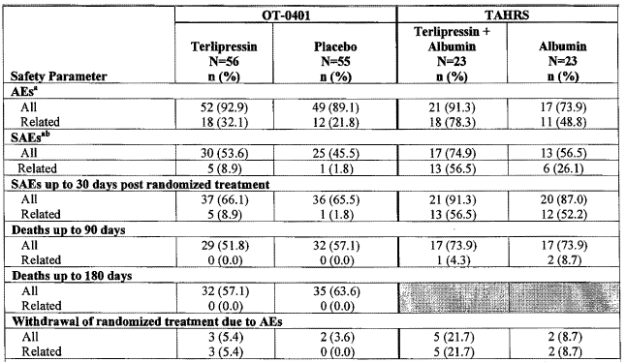

Note: Shaded areas indicate that the data were not collected or tabulated for that parameter for that study. a For OT -0401 up to 7 days post end of treatment; for T AHRS up to the end of randomized treatment. b Excludes SAEs with onset after cross over to terlipressin rescue treatment in TAHRS.

Table 64. Incidence of Adverse Events in ≥ 10% of Patients within Any Treatment Group, by Study (Safety Population)

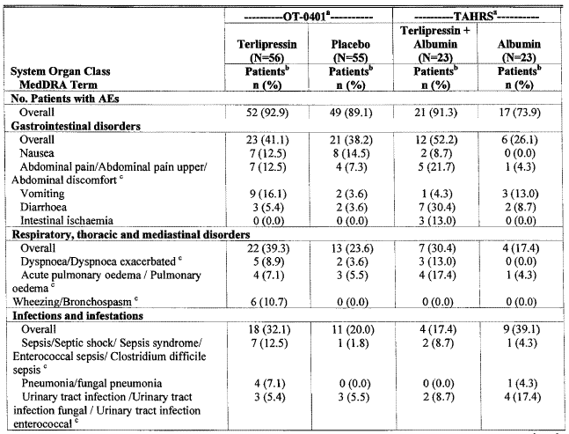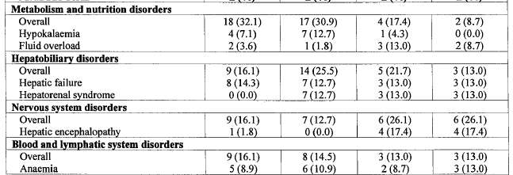

a For OT-0401 up to 7 days post end of treatment; for TAHRS up to the end of randomised treatment. b Patients are only counted once within a given row. c Two or more preferred terms represented jointly

Table 65. Incidence of Adverse Events by MedDRA Preferred Term Reported by ≥ 5 % of Patients within Any Treatment Group by Study (Safety Population)

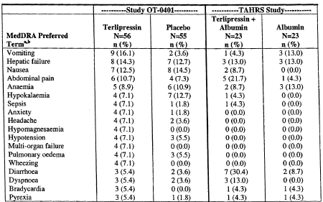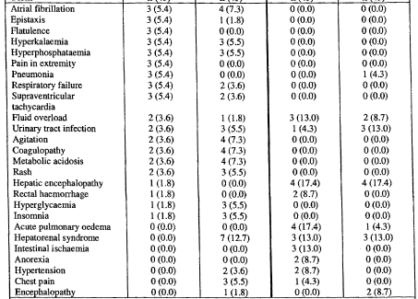

a Patients experiencing multiple episodes of a given AE are counted once within each MedDRA term. b For OT -040 1 up to 7 days post end of treatment; for T AHRS up to the end of randomized treatment.

Table 66. Overall Incidence of Adverse Events by Treatment Dose Level (Safety Population) -OT -0401

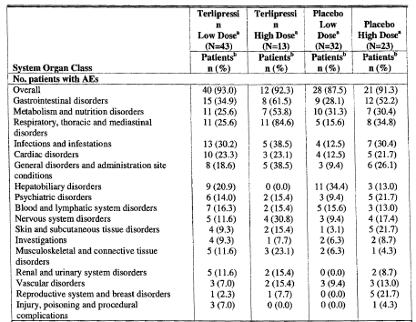

a Low Dose Maximum exposure for all individual doses is less than 2 mg. High Dose = Maximum exposure for one or more individual doses is at least 2 mg. b Patients experiencing multiple episodes of a given AE are counted once within each MedDRA term and within each SOC

##### Treatment-related adverse events (adverse drug reactions)

The studies differed in their definitions of treatment related OT -0401 considered it as probable and possible assessments, while TAHRS considered assessments of yes, probable and unlikely were treatment related.

Terlipressin-treated patients had a higher incidence of treatment-related AEs than control group patients, in both studies.

Table 67. Incidence of Adverse Reactions in at least 2 Terlipressin-Treated Patients

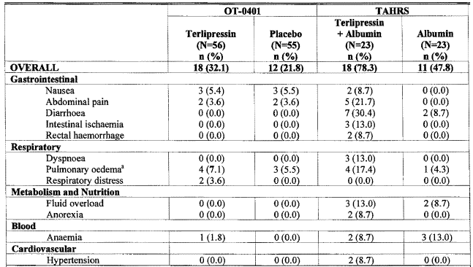

a pulmonary oedema includes acute pulmonary oedema.

Table 68. Treatment-Related SAEs Reported up to 30 Days Post Treatment by System Organ Class and MedDRA Preferred Term and Study(Safety Population) in ≥ 1 Terlipressin-Treated Patient

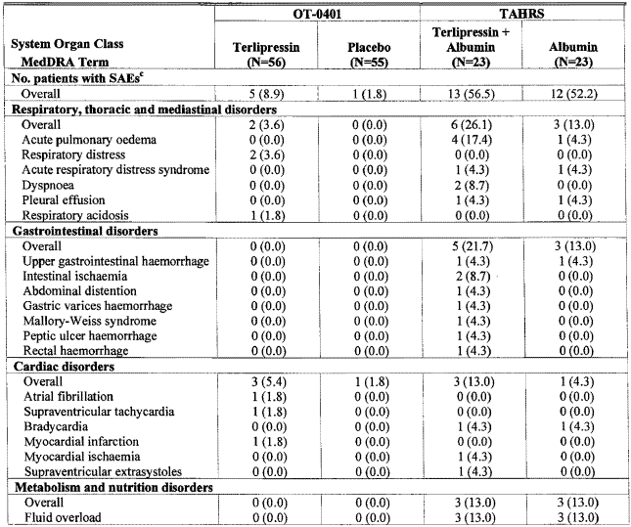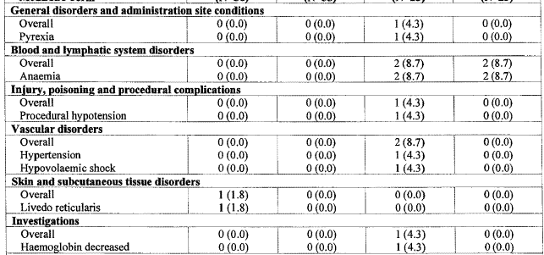

a Within each SOC, the overall total may exceed the sum from individual rows because only treatment-related SAEs are shown. b Patients are only counted once within a given row within the most probable category. An event is considered related if the investigator assessment of treatment relation is unlikely, probable, yes, or missing. c Includes SAEs up to 30 days post final treatment includes cross-over and retreat treatments.

##### Deaths and other serious adverse events

Mortality at 90 days was similar between treatment groups within a study, but was lower in OT-0401 than in TAHRS, likely at least in part related to the higher transplantation rate in OT-0401 (32%) than in TAHRS (2%).

Table 69. AEs Leading to Death Reported at Any Time during Study by System Organ Class and MedDRA Term (Safety Population)

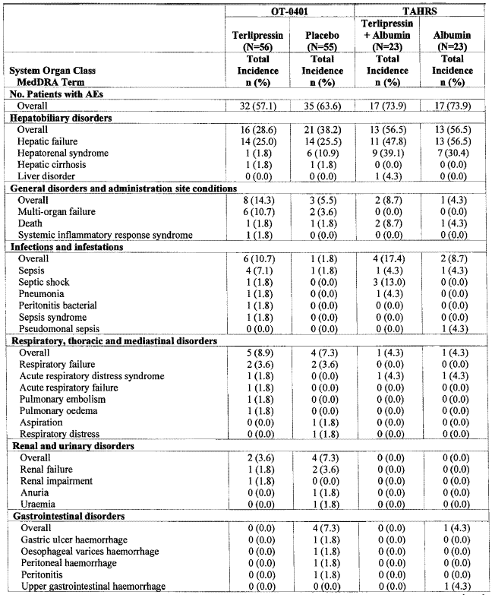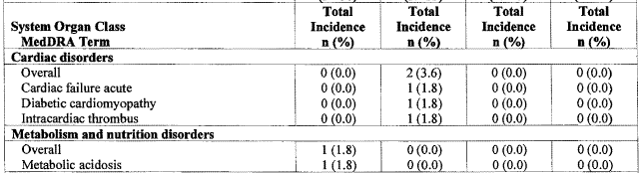

a Patients are only counted once within a given row. An event is considered related if the investigator assessment of treatment relation is unlikely, possible, probable or yes.

Table 70. Overview of Deaths OT-0401 & TAHRS (Safety Population)

| **Deaths from AEs with Onset:** | **Terlipressin**  **(N=56)**  **n(%)** | **Placebo**  **(N=55)**  **n (0/0)** | **Terlipressin + Albumin**  **(N=23) n(%)** | **Albumin**  **(N=23)**  **n(%)** |
| --- | --- | --- | --- | --- |
| Up to 30 days post treatment | 27 (48.2) | 26 (47.2) | 15 (65.2) | 12 (52.2) |
| Anytime during the study* | 32 (57.1) | 35 (63.6) | 17 (73.9) | 17 (73.9) |

*The TAHRS study reported mortality up to 90 days whereas Study OT-0401 included follow-up of patients for up to 180 days.

Table 71. SAEs by System Organ Class and MedDRA Preferred Term Reported by ≥ 5% of Patients within Any Treatment Group by Study (Safety Population)

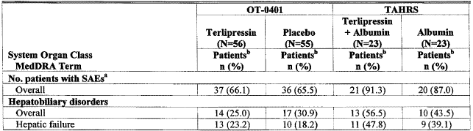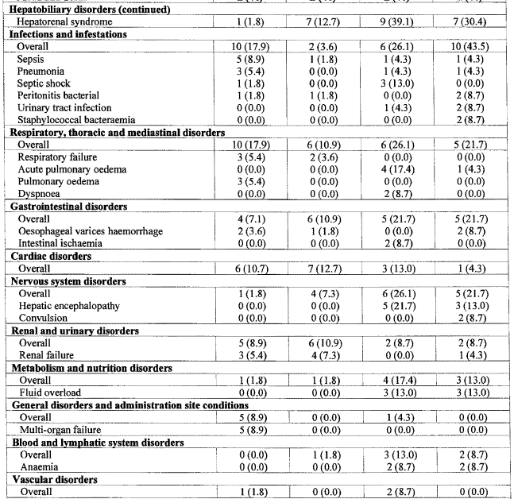

a Includes adverse events up to 30 days post randomized treatment. b Patients are only counted once within a given row.

##### Discontinuation due to adverse events

Table 72. Listing of Adverse Events Leading to Withdrawal (Safety Population) - OT -0401 & TAHRS

|  | **Day of Onset** | **Verbatim Term** | **Relationship to Treatment** | **Seriousness** |
| --- | --- | --- | --- | --- |
| **Study OT-0401c** | | | | |
| Terlipressin | 3a | Cyanosis | Probable | Moderate |
| 2a | Livedo reticularis | Possible | Severe |
| 6b | Myocardial infarction | Possible | Severe |
| Placebo | 4a | Hypotension | Unrelated | Moderate |
| 6b | Respiratory failure | Unrelated | Severe |
| **Study TAHRSd** | | | |  |
| Terlipressin + Albumin | 4 | Pancytopaenia | Probable | No |
| 3 | Intestinal ischemia | Probable | No |
| 2 | Intestinal ischemia | Probable | Yes |
| 2 | Volume overload | Probable | Yes |
| 5 | Intestinal ischemia (abdominal pain and rectorrhagia) | Yes | Yes |
| 11 | Abdominal distension | Probable | Yes |
| Albumin | 1 | Circulatory overload | Unlikely | Yes |
| 2 | Death due to upper gastrointestinal haemorrhage | Unlikely | Yes |

a Low = Maximum exposure for all individual doses is less than 2 mg. b High = Maximum exposure for one or more individual doses is at least 2 mg. c Listing up to 7 Days Post-treatment only includes events where action taken is reported as Discontinued Permanently. d Listing During Randomized Treatment only includes only AEs where termination of treatment is YES.

#### Laboratory tests

Looking at parameters other than SCr, blood and urine nitrogen; with the small numbers and the sick patients there were no differences of clinical importance noted.

Table 73. Shift from Baseline in Laboratory Values by Treatment to Day 14 Using Clinically Significant Ranges (Safety Population) - OT-0401

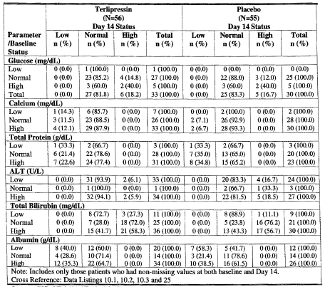

Note: Includes only those patients who had non-missing values at both baseline and Day 14.

Table 74. Shift from Baseline in Laboratory Parameters to Day 15 of Randomized Treatment using Clinically Significant Ranges and Observed Cases (Treatment Differences of ≥ 3 Patients in One Direction) (Safety Population) – TAHRS

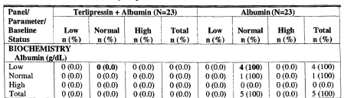

Note: Includes those patients who had a shift from baseline.

#### Vital signs

See also the *Haemodynamics* section.

In Study OT-0401 there were no apparent differences between the highest maximum daily increase in systolic and diastolic blood pressure between the study groups (terlipressin: 29.0 mm Hg/18.5 mm Hg; placebo: 33.5 mm Hg/26.0 mm Hg, respectively). The maximum daily systolic, diastolic blood pressure and minimum heart rate post dose were also similar between the groups (terlipressin: 160.3 mm Hg/90.7 mm Hg, 52 bpm; placebo: 161.0 mm Hg/88.0 mm Hg, 53.8 bpm, respectively). Hypertension was only reported in 1 (2%) terlipressin versus 2 (4%) placebo patients and bradycardia was reported in 3 (5%) terlipressin versus 0 placebo patients.

In Study TAHRS hypertension was reported in 2 terlipressin-treated patients compared with 0 albumin-treated patients. Bradycardia was reported in 1 patient in each randomized treatment group.

#### Child-Pugh scores

In Study OT-0401 the Child-Pugh score was recorded at baseline and at Day 14.

Table 75. Change from Baseline to Day 14 in Child Pugh Scores (Safety Population). OT-0401

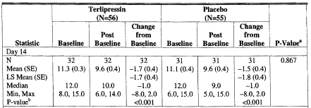

Note: Includes only those patients who had a change from baseline. a From ANOVA with main effect treatment and pooled investigator as a blocking factor. b Within-group test of change from baseline from paired t-test.

#### Encephalopathy scores

In Study OT-0401 encephalopathy was assessed prior to study drug administration, daily during the period of study drug administration, and on Day 14 (or at the end of the active study treatment period, whichever came first).

Table 76. West Haven Criteria for Semi-Quantitative Grading of Mental State

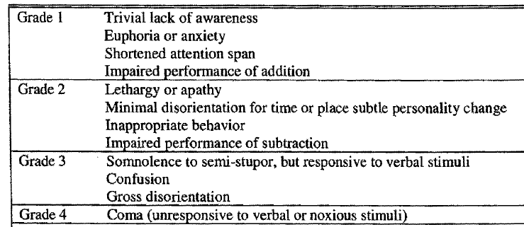

Note: Although a grade of 0 is not part of the official West Haven criteria, patients with no encephalopathy were assigned grade 0 on the CRF Adapted from Ferenci 2002.

Figure 35. Mean Encephalopathy Scores by Day (Safety Population). OT-0401

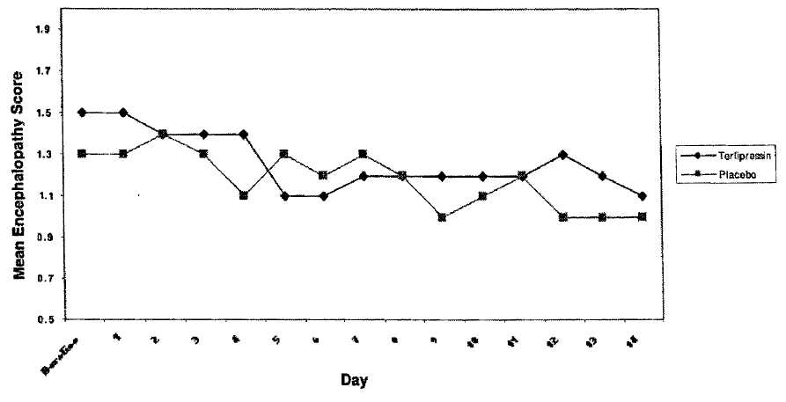

In Study TAHRS encephalopathy was assessed (on a scale of 1 to 4, with 4 being the worst impairment) at baseline, daily during the period of study drug administration, and on Days 21, 28, 35, 42, 60 and 90.

Figure 36. LS Mean Change from Baseline in Encephalopathy Scores by Study Day Through the End of Treatment or Study Day 15 using Observed Cases (Safety Population) - TAHRS

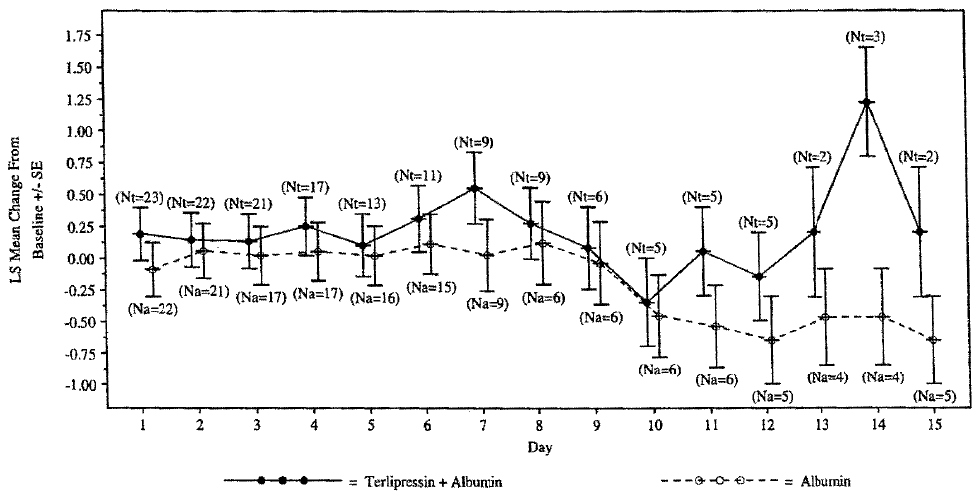

a Includes results collected on randomized treatment up to Day 15. (Nt=xx) denotes number of terlipressin + albumin patients at each time point; (Na=xx) denotes number of albumin patients at each time point. LS Means from Repeated Measures ANOV A as implemented in Proc Mixed with factors Treatment, Day, Strata, and Treatment by Day.

#### Safety in special populations

##### Geriatric

There were 15 (14%) geriatric patients (> 65 years) in the OT-0401 study and 13 (28%) in the TAHRS study. In both studies, the incidence of AEs and treatment-related AEs reported in the geriatric population was similar to the non-geriatric population. The incidence of SAEs and treatment related SAEs were similar or less frequent in geriatric patients compared with non-geriatrics. There were a similar small number of patients who withdrew due to AEs, mostly treatment related, in both geriatric and non-geriatric patients.

##### Use in pregnancy and lactation

Terlipressin has demonstrated in 3 clinical trials (2 in pregnant women and 1 in non-pregnant women) significant increases in uterine activity and reduction in endometrial blood flow (see *Pharmacodynamics* above).

#### Safety related to drug-drug interactions and other interactions

No formal drug interaction studies have been done with terlipressin.

The description of the article by Vachery *et al* 1996[28] in another paper submitted by the sponsor states that acute administration of terlipressin in patients taking beta-blockers lead to additional systemic increase in systemic vascular resistances and mean arterial pressure, and an additional decrease in hepatic venous pressure gradient and azygos blood flow.

### Post marketing experience

Assuming a 3 to 6 day treatment duration (4 mg/day), the sponsor estimates that approximately 50-100,000 patients are being treated with terlipressin annually.

#### Literature reports

The sponsor reviewed the literature reports. Criticism based on repeated use of patients in those reports relating to HRS 1 has already been made under the Efficacy section. However many of the literature reports contain sparse details on AEs and even less on deaths where lack of information is interpreted by the sponsor as no treatment related deaths. Tables carry summaries of information from each trial in the sponsor’s Summary of Clinical Safety, but there is no collation. The following table was prepared based on the literature reports reviewed in the sponsor’s Summary of Clinical Safety. It includes case reports, so is not overly useful to report incidence. Abdominal pain/cramps have been combined to show how frequent these events are. The results are distorted by the nature of some of the reports, for example, the use intra-operatively to maintain blood pressure, the use in terminations. In the latter study the 100% incidence of “Uterine activity increased” suggests that some of the abdominal pain/cramps may be uterine in origin.

There were 6 treatment related deaths reported in the literature: 2 cerebrovascular accidents (CVAs) and one each due to brochospasm, respiratory arrest, myocardial infarction and ischaemic colitis. In the supplemental data there was a further treatment-related mortality; a sudden death.

Table 77. AEs Reported in the Literature in Case Reports and Studies Where Occurrence of AEs was given*

| **Adverse event** | **N** |  | **Adverse event** | **N** |
| --- | --- | --- | --- | --- |
| Abdominal pain/cramps | 45 |  | Tachycardia ventricular | 2 |
| Pallor | 32 |  | Vomiting | 2 |
| Increased bowel movements | 30 |  | Weakness | 2 |
| Hypertension | 24 |  | Acidosis | 1 |
| Diarrhoea | 20 |  | Cerebral ischaemia | 1 |
| Tachycardia | 17 |  | Convulsions grand mal | 1 |
| Uterine activity increased | 16 |  | Fluid retention | 1 |
| Bradycardia | 12 |  | Fibrillation ventricular | 1 |
| Cyanosis | 12 |  | Gangrene | 1 |
| Heat in skin | 12 |  | Hypokalaemia | 1 |
| Bleeding postoperative | 7 |  | Liver enzyme elevated | 1 |
| Headache | 7 |  | Muscle cramps | 1 |
| Bronchospasm | 6 |  | Oesophageal ulceration | 1 |
| Fibrillation atrial | 6 |  | Oozing post-op | 1 |
| Injection site necrosis | 6 |  | Pancreatitis | 1 |
| Skin necrosis | 6 |  | Postural Hypotension | 1 |
| Genital skin necrosis (scrotal, foreskin) | 5 |  | Paraesthesia | 1 |
| Chest pain | 4 |  | Qt prolonged | 1 |
| Hypernatraemia | 4 |  | Rash | 1 |
| Myocardial ischaemia | 4 |  | Renal impairment | 1 |
| Peripheral ischaemia | 4 |  | Respiratory arrest | 1 |
| Ectopics (ventric. & atrial) | 3 |  | Rhabdomyolysis | 1 |
| Intestinal ischaemia | 3 |  | Skin blisters | 1 |
| Lower limb ischaemia | 3 |  | Skin discolouration | 1 |
| Cerebrovascular disorder | 2 |  | Stevens johnson syndrome | 1 |
| Dyspnoea | 2 |  | Syncope | 1 |
| Hyponatraemia | 2 |  | Torsade de pointes | 1 |
| Myocardial infarction | 2 |  | Tongue necrosis | 1 |
| Skin lymphangitis | 2 |  |  |  |

* Among 789 patients. Studies where incidence of AEs not reported excluded from this total as were topical terlipressin studies.

Table 78. From the Safety Addendum AEs Reported in the Literature in Case Reports and Studies Where Occurrence of AEs was Given*

| **Adverse event** | **N** | **Adverse event** | **N** |
| --- | --- | --- | --- |
| Abdominal pain/cramps | 37 | Hyponatraemia | 2 |
| Chest pain | 26 | Intestinal ischaemia | 2 |
| Diarrhoea | 25 | Myocardial ischaemia | 2 |
| Pulmonary oedema | 21 | Abdominal distension | 1 |
| Headache | 6 | Bleeding ischaemic gastric ulcer | 1 |
| Hypertension | 6 | Convulsions | 1 |
| Circulatory overload | 5 | Gangrene | 1 |
| Peripheral ischaemia | 4 | Genital skin necrosis (scrotal, foreskin) | 1 |
| Skin necrosis | 4 | Injection site reaction | 1 |
| Arrhythmia | 3 | Livedo reticularis | 1 |
| Circulatory failure | 3 | Muscle infarct | 1 |
| Myocardial infarction | 3 | Nausea | 1 |
| Tachycardia | 3 | Skin ischaemia | 1 |
| Bradycardia | 2 | Ventricular ectopics | 1 |
| Cyanosis | 2 | Vomiting | 1 |

* Among 644 patients. Studies where incidence of AEs not reported excluded from this total.

#### WHO database

The database of the WHO Collaborating Centre for International Drug Monitoring on 30 January 2007 for cases reporting terlipressin as a suspect drug identified a total of 275 AEs in 167 patients. The lack of sensitivity of that database is indicated by the 81 cases reported in one year while all other years had ≤ 10 reports except one occurrence of 19. The Addendum 1 to the sponsor’s Summary of Clinical Safety refers incorrectly to sponsor’s Table 5 and appears to have combined both sponsor Table 4 (deletions) and Table 5 (additions) and labelled them all as deletions.

Table 79. WHO Global Safety Data, Summary Tabulation of All Adverse Events by System Organ Class

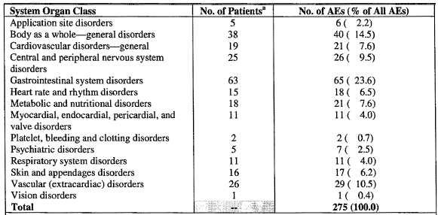

a A single patient may be counted in more than 1 SOC.

Table 80. WHO Global Safety Data, Overview of Adverse Events by Frequency Adverse event Total Number of AEs

| **Adverse event** | **N** | **Adverse event** | **N** | **Adverse event** | **N** |
| --- | --- | --- | --- | --- | --- |
| Abdominal pain | 52 | Fibrillation ventricular | 2 | Hiccup | 1 |
| Chest pain substernal | 19 | Gangrene | 2 | Hyperglycaemia | 1 |
| Vasospasm | 16 | Hypernatraemia | 2 | Hypochloraemia | 1 |
| Headache | 12 | Malaise | 2 | Hypotension | 1 |
| Fever | 11 | Nausea | 2 | Injection site atrophy | 1 |
| Hypertension | 11 | Palpitation | 2 | Injection site reaction | 1 |
| Hyponatraemia | 11 | Pleural effusion | 2 | Intestinal ischaemia | 1 |
| Angina pectoris | 8 | Acidosis | 1 | Leg pain | 1 |
| Peripheral ischaemia | 8 | Anaphylactoid reaction | 1 | Livedo reticularis | 1 |
| Skin necrosis | 8 | Anxiety | 1 | Nervousness | 1 |
| Bradycardia | 6 | Application site oedema | 1 | Oesophageal ulceration | 1 |
| Cyanosis | 5 | Arrhythmia | 1 | Paralysis | 1 |
| Circulatory failure | 4 | Cerebral ischaemia | 1 | Pruritus | 1 |
| Paraesthesia | 4 | Cerebrovascular disorder | 1 | Psychosis | 1 |
| Cardiac arrest | 3 | Chest pain | 1 | Qt prolonged | 1 |
| Confusion | 3 | COMA | 1 | Rash erythematous | 1 |
| Convulsions | 3 | Convulsions grand mal | 1 | Respiratory depression | 1 |
| GI haemorrhage | 3 | Death | 1 | Skin discolouration | 1 |
| Hypokalaemia | 3 | Delirium | 1 | Stevens johnson syndrome | 1 |
| Injection site necrosis | 3 | Dizziness | 1 | Sudden death | 1 |
| Myocardial ischaemia | 3 | Dysphagia | 1 | Sweating increased | 1 |
| Pallor | 3 | Embolism limb | 1 | Tachycardia ventricular | 1 |
| Pulmonary oedema | 3 | Encephalopathy hypertensive | 1 | Torsade de pointes | 1 |
| Rash | 3 | Fibrillation atrial | 1 | Tremor | 1 |
| Respiratory insufficiency | 3 | Flushing | 1 | Vision abnormal | 1 |
| Acidosis lactic | 2 | Haematoma | 1 | Vomiting | 1 |
| Diarrhoea | 2 | Haemorrhage rectum | 1 |  |  |
| Dyspnoea | 2 | Hemiparesis | 1 |  |  |

Table 81. Summary Tabulation of AEs deleted & reported since Jan 2007

| **WHO-ART System Organ Class** | **WHO-ART Term** | **N** |
| --- | --- | --- |
| **Deleted** | | |
| Metabolic & Nutritional Disorders | Hyponatraemia | 2 |
| **Reported** | | |
| Body as a Whole - General Disorders | Chest pain | 1 |
| Temperature changed sensation | 2 |
| Cardiovascular Disorders, General | Cardiac failure | 1 |
| Circulatory failure | 1 |
| Cyanosis | 2 |
| Central & Peripheral Nervous System Disorders | Convulsions grand mal | 1 |
| Paraesthesia | 1 |
| Gastrointestinal System Disorders | Abdominal pain | 1 |
| Diarrhea | 1 |
| Stomatitis ulcerative | 1 |
| Heart Rate & Rhythm Disorders | Bradycardia | 1 |
| Metabolic & Nutritional Disorders | Acidosis lactic | 1 |
| Hyponatraemia | 4 |
| Myo-, Endo-, Pericardial & Valve Disorders | Angina pectoris | 1 |
| Myocardial infarction | 2 |
| Psychiatric | Disorders Confusion | 1 |
| Concentration impaired | 1 |
| Skin and Appendages Disorders | Skin necrosis | 4 |
| Vascular (extracardiac) Disorders | Cerebral hemorrhage | 1 |
| Unclassified | Unclassified | 1 |

#### PSURs

Orphan Therapeutics obtained the current (7 December 2006) periodic safety update report (PSUR) for Haemopressin (terlipressin diacetate 5 H20). The PSUR summarised all adverse drug reactions reported to the market authorization holder, as well as reports of adverse side effects of terlipressin in the approved indication obtained from search of the literature published between March 1999 and July 2006.

### Specific safety issues

#### Ischaemic events

Skin pallor/blanching, local skin necrosis, ischemic bowel, peripheral ischaemia and myocardial ischemia have been reported in patients treated with terlipressin.

Table 82. Ischemia-Associated Adverse Events with Onset up to 24 Hours after Last Dose of Study Drug (Safety Population) -OT -0401

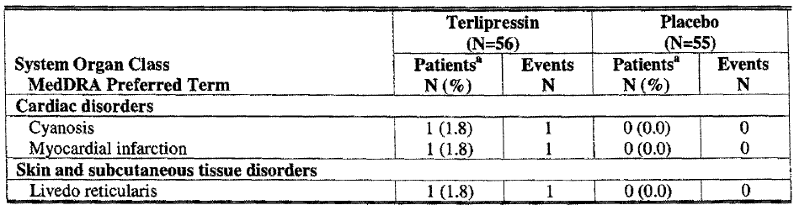

Table 83. Ischemia-Associated Adverse Events Up to the End of Randomized Treatment (Safety Population) – TAHRS

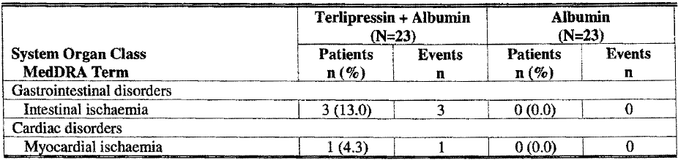

#### Gastrointestinal AEs

Consistent with this patient population with end-stage liver disease, gastrointestinal AEs were the most common AE in both studies.

In Study OT-0401 there were GI AEs in 23 patients (41%) in the terlipressin group and 21 patients (38%) in the placebo group. The only individual AEs with at least a 5% (≥ 3 patients) difference in incidence between treatment groups were vomiting, abdominal pain/abdominal pain upper/abdominal discomfort, and flatulence.

In Study TAHRS there were AEs in 12 patients (52%) in the terlipressin + albumin group and 6 patients (26%) in the albumin group. AEs with >5% difference (≥ 2 patients) in incidence between treatment groups were diarrhoea, abdominal pain/abdominal pain upper, intestinal ischemia), nausea, rectal haemorrhage and vomiting.

#### Respiratory AEs

Terlipressin is a V1-mediated vasoconstrictor affecting smooth muscle tissue and it is known to have bronchoconstricting effects.

In Study OT-0401 a respiratory AE was reported in 22 terlipressin-treated patients (39%) and 13 placebo-treated patients (24%). The difference in the incidence of respiratory AEs between the treatment groups was due to the higher incidence of wheezing/bronchospasm, and dyspnoea/exacerbated dyspnoea among terlipressin-treated patients, The increased incidence of these respiratory events parallels the increase in use of "drugs for obstructive airway disease" in terlipressin-treated patients during the study drug administration period.

Table 84. Overview of Respiratory Medication Use (Safety Population) - OT-0401

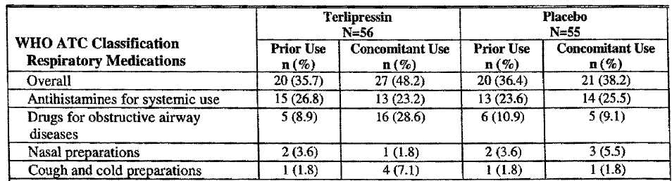

Abbreviation: WHO ATC=World Health Organization Anatomical Therapeutic Chemical.

In Study TAHRS a respiratory AE was reported in 7 terlipressin + albumin-treated patients (30%) and 4 albumin treated patients (17%). The difference in the incidence of respiratory AEs between the treatment groups was due to the higher incidence of acute pulmonary oedema and dyspnoea among terlipressin + albumin-treated patients.

#### Cardiac safety

Cardiac events including myocardial ischaemia, myocardial infarction, and dysrhythmias such as atrial fibrillation, ventricular fibrillation, bradycardia, and tachycardia have been previously reported in patients treated with terlipressin.

In Study OT-0401 a prior cardiac history was reported for 11 patients (20%) in the terlipressin group and 21 patients (38%) in the placebo group. During the trial cardiac AEs occurred in 14 terlipressin-treated patients and 9 placebo-treated patients. Cardiac arrhythmias were the most common cardiac AE (10 terlipressin patients and 7 placebo patients). The onset of the cardiac events was after discontinuation of study medication in 6 of the 14 terlipressin-treated patients, including both reports of asystole on terlipressin (considered unrelated).

Treatment-related cardiac AEs were reported in 5 terlipressin-treated patients (myocardial infarction, cyanosis, supraventricular tachycardia, atrial fibrillation, and T wave changes) and 3 placebo-treated patients (atrial fibrillation, arrhythmia, supraventricular extrasystoles, and tachycardia).

In Study TAHRS treatment-related cardiac AEs were reported in 3 terlipressin + albumin-treated patients and 1 albumin-treated patient. A serious cardiac event was reported in 3 terlipressin + albumin-treated patients (13%). All these cardiac SAEs were assessed as treatment related.

#### QT intervals

See also *Population PK study*.

HRS Type 1 patients have end-stage cirrhotic liver disease, the severity of which correlates roughly with QT interval prolongation. They also have multiple organ system dysfunction, numerous medications and fluid and electrolyte abnormalities that may also predispose to QT prolongation and a higher risk of Torsade de Pointes (TdP).

Electrocardiograms (ECGs) were taken at baseline and on Days 3 and 7 (when peak drug concentrations were expected) and end of study treatment or Day 14.

QT-corrected intervals, whether using Bazett's or Fridericia's correction (QTcB or QTcF), show small decreases in QTc interval in both treatment groups.

Table 85. Overall Mean Change from Baseline in QT/QTc Intervals -OT -0401

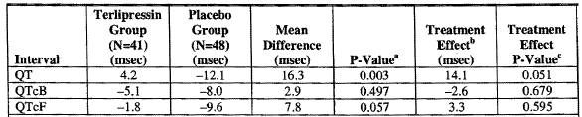

a Difference of change from baseline between treatment groups analysed by t-test or non-parametric test without adjustment. b The difference between treatment groups adjusted for baseline. c F test after baseline adjustment.

Since approximately twice as many patients in the placebo group with on-treatment ECG data also had elevated QTcF interval at baseline as compared with the terlipressin group, the data were analysed using an adjustment for this imbalance (that is, "treatment effect" data). This adjustment is especially important since patients with elevated QT -interval baseline values exhibited substantially more QT interval decreases than those with normal baseline values. When baseline correction is incorporated, the magnitude of the QTcF interval increase with terlipressin compared with placebo is very small and statistically non-significant.

Ten patients in the terlipressin group and 5 patients in the placebo group had QTcF interval increases > 30 ms from baseline. Four patients in the terlipressin group and 1 placebo patient developed a QTcF interval increase > 60 ms. Two terlipressin-treated patients and no placebo patient developed a new QTcF interval of > 500 ms.

The WHO data contains 1 report each of QT interval prolongation and TdP in 2 patients receiving 6-8 mg/day of terlipressin. The literature contains 1 case of an alcoholic patient who experienced non-fatal TdP and prolonged QT interval following terlipressin administration for duodenal bleeding.

#### Infection related AEs

In Study OT-0401 the incidence of the AEs Infections and infestations SOC was higher in terlipressin treated (32%) than in placebo-treated patients (20%). Infection was reported as a precipitating factor for HRS in more patients in the terlipressin group (25%) than in the placebo group (15%). The use of systemic antimycotics doubled during treatment and post-treatment to Day 14 in terlipressin treated patients compared with pre-randomisation use. In placebo-treated patients, the use of antimycotics increased post-treatment.

In Study TAHRS the incidence of infection-associated AE to the end of randomised treatment was lower in the terlipressin + albumin group (17%) compared with the albumin group (39%). Infection was reported as a precipitating factor for HRS in more patients in the terlipressin + albumin group (30%) than in the albumin group (22%).

In OT -0401, fatal infections occurred in 6 terlipressin-treated patients (11%) and 2 placebo-treated patients (4%). In TAHRS, fatal infections occurred in 4 patients (17%) in the terlipressin + albumin group and 2 patients (9%) in the albumin group. In both studies, all deaths due to infections were assessed as unrelated to treatment.

#### Skin and subcutaneous tissue

In Study OT-0401, six patients in each treatment group (11%) had a skin AE. There were no reports of pallor, skin necrosis, or blanching. A treatment-related AE was reported in 1 patient in each treatment group- rash in a placebo patient and livedo reticularis in a terlipressin patient. The latter was considered a treatment related SAE which led to treatment withdrawal.

### Evaluator’s overall conclusions on clinical safety

The patient numbers in the pivotal study for safety evaluation were small (56) these were subjected to intense review and comparison with those from TAHRS (23). Most of these patients had terlipressin for < 6 days.

The AE spectra across the databases, literature and trials are consistent and relate to the PDs of the drug:

* Gastrointestinal disorders – especially abdominal pain/cramps
* Cardiovascular disorders - relating to vasoconstriction and including angina/infarction and skin ischaemia/necrosis
* Bronchospasm was a cause of death in the literature.

QT prolongation was reported in the literature and who database. In the Study OT-0401 2/56 patients developed a QTcF interval > 500 ms.

The number of patients assessed for frequency of treatment–related AEs was 56 (Study OT-0401) where there was an incidence of 32% (18) that was compared to 23 patients (Study TAHRS) with an incidence of 78% (18). The sponsor offered possibilities, but was unable to explain the difference.

## First round benefit-risk assessment

### Benefits

There are two propositions supporting the benefit of HRS reversal:

1. *To prolong survival prior to liver transplant as patients wait on donor liver availability.*

Study 0401 failed to show a difference in transplant free survival. While for the Terlipressin group, transplant free survival was statistically greater to Day 180 in patients who had Treatment Success and HRS reversal compared to the other patients given terlipressin. For patients given placebo who had treatment success and reversal of HRS, differences in survival at Day 180 compared to other patients given placebo were also observed. Seven terlipressin-treated and 5 placebo-treated patients who had not received liver transplants were alive at Day 180. Thus the major clinical benefit of terlipressin would from extending the duration of survival prior to transplant.

Demonstrating a survival benefit from treating the HRS-1 component amidst other concomitant life-threatening pathologies presents a challenging task. This was only partially met in the data submitted. It seems likely that for approximately 20% of patients terlipressin results in a few additional days to weeks of survival without a liver transplant. The clinical benefit of such a small increase in survival time depends on whether this additional time is likely to result in a clinically significant increase in the availability of a liver for transplant. Therefore the clinical benefit of terlipressin will vary with the availability of livers for transplant and it is thus not possible to estimate how many patients will receive transplants (and have increased probability of longer term survival) because of the use of terlipressin. Where few livers are available the benefit would be negligible.

1. *To achieve a more successful transplant as assessed by survival, hospital and ICU stay and dialysis rate.*

Neither study could show a significant difference in survival, although the Cochrane review did (unfortunately it included Yang 2001 who did not specify the HRS type of the patients and Pomier 2003 which related to the use of octreotide.)

Again in Study OT-0401for the terlipressin group the survival was statistically greater to Day 90 in the Treatment Success and HRS reversal patients compared to the other terlipressin patients without these; but there were no differences in survival for HRS reversal or Treatment Success in the placebo group.

There was no difference in Dialysis rates in Study OT-0401 between the treatment groups and ICU/hospital stay was not reported. In TAHRS, there was no significant difference in hospital stay while dialysis rates and ICU stay were not reported.

The Study OT-0401 showed significant differences in HRS reversal and change in SCr with minimal overlap of CIs. The interpretation of the abandoned Study TAHRS and the submitted literature do not refute these results but the numbers are small.

### Risks

The survival of patients who were on terlipressin and did not have HRS reversal was comparable to patients on placebo who did not achieve HRS reversal. Overall there was no difference in survival between the terlipressin and placebo groups, but those on terlipressin who achieved HRS reversal had better survival than those on terlipressin who did not.

The studies submitted had relatively small numbers exposed to terlipressin, but showed considerable treatment related AEs; in Study OT-0401 where there was an incidence of 32% (18) that was compared to study TAHRS with an incidence of 78% (18).

More concerning was the incidence of treatment related deaths reported in the literature 7 among 1433 patients (0.5%) where the incidence of AEs was given.

Of particular concern was the incidence of cardiac and respiratory treatment related AEs in patients already with liver and renal dysfunction and the occurrence of skin and intestinal events (for example, necrosis) the increased the possibility of infection – given that infection affects survival in liver transplantation.[29]

### Benefit-risk balance

The benefit-risk balance of terlipressin given the proposed usage, was considered unfavourable.

### Recommendation regarding authorisation

It was not recommended that terlipressin be registered for the Indication proposed.

## Clinical questions

The evaluator made recommendations to the Delegate regarding the PI but these are beyond the scope of this AusPAR.

## References

Alessandria C, Ottobrelli A, Debernardi-Venon W *et al*. Noradrenalin vs terlipressin in patients with hepatorenal syndrome: A prospective, randomised, unblinded, pilot study. *J Hepatol* 2007; 47: 499-505.

Angeli P. Hepatorenal syndrome. *Yearbook Intens Care Emerg Med* 2006; 16: 661-670.

Arroyo V, Jiménez W. Complications of cirrhosis. II. Renal and circulatory dysfunction. Lights and shadows in an important clinical problem. *J Hepatol* 2000; 32: 157-170.

Baik SK, Jeong PH, Ji SW *et al*. Acute Hemodynamic Effects of Octreotide and Terlipressin in Patients with Cirrhosis: A Randomised Comparison. Am J Gastroenterol 2005; 100: 631-635.

Barash *Clinical Anaesthesia* p.1140

Cestari R, Braga M, Missale G, Ravelli P, Burroughs AK. Haemodynamic effect of triglycyl-lysine-vasopressin (glypressin) on intravascular oesophageal variceal pressure in patients with cirrhosis: A randomised placebo controlled trial. *J Hepatol* 1990; 10: 205-210.

Colle I, Durand F, Pessione F *et al*. Clinical course, predictive factors and prognosis in patients with cirrhosis and Type 1 hepatorenal syndrome treated with Terlipressin: A retrospective analysis. *J Gastroenterol Hepatol* 2002; 8: 882-888.

Danalioglu A, Cakaloglu Y, Karaca C *et al*. Terlipressin and albumin combination treatment in hepatorenal syndrome. *Hepatogastroenterol* 2003; 50 (Suppl 2): ccciii-cccv.

Eefsen M, Dethloff T, Frederiksen H-J, Hauerberg J, Hansen BA, Larsen FS. Comparison of terlipressin and noradrenalin on cerebral perfusion, intracranial pressure and cerebral extracellular concentrations of lactate and pyruvate in patients with acute liver failure in need of inotropic support. *J Hepatol* 2007; 47: 381-386.

Escorsell A, Bandi JC, Montinho E *et al*. Time profile of the haemodynamic effects of terlipressin in portal hypertension. *J Hepatol* 1997; 26: 621-627.

Fabrizi F, Dixit V, Martin P. Meta-analysis: terlipressin therapy for the hepatorenal syndrome. *Aliment Pharmacol Therapeut* 2006; 24: 935-944.

Fabrizi F, Dixit V, Piergiogio M, Martin P. Terlipressin for hepatorenal syndrome: A meta-analysis of randomised trials. Internat J Artific Org 2009; 32: 133-140.

Freeman IG, Barton JR, Record CO. Haemodynamic responses to 1.25 and 2 mg of terlipressin intravenously in man. *Aliment Pharmacol Therapeut* 1988; 2: 361-367.

Gadano A, Moreau M, Vachiery F *et al*. Natriuretic response to the combination of atrial natriuretic peptide and terlipressin in patients with cirrhosis and refractory ascites. *J Hepatol* 1997; 26: 1229-1234.

Hadengue A, Gadano A, Moreau R *et al*. Beneficial effects of the 2-day administration of terlipressin in patients with cirrhosis and hepatorenal syndrome. *J Hepatol* 1998; 29: 565-570.

Halimi C, Bonnard P, Bernard B *et al*. Effect of terlipressin (Glypressin(R)) on hepatorenal syndrome in cirrhotic patients: results of a multicentre pilot study. *Eur L Gastroenterol Hepatol* 2002; 14: 153-158.

Hansen EF, Bendtsen F, Brinch K, Møller S, Henriksen JH, Becker U. Endoscopic Doppler Ultrasound for Measurement of Azygos Blood Flow: Validation against Thermodilution and Assessment of Pharmacological Effects of Terlipressin in Portal Hypertension. *Scand J Gastroenterol* 2001; 36: 318-325.

Kiszka-Kanowitz M, Henriksen JH, Hansen EF, Møller S, Bendtsen F. Effect of terlipressin on blood volume distribution in patients with cirrhosis. *Scand J Gastroenterol* 2004; 39: 486-492.

Lee W-C, Lin H-C, Yang Y-Y *et al*. Hemodynamic effects of a combination of prazosin and terlipressin in patients with viral cirrhosis. *Am J Gastroenterol* 2001; 96: 1210-1216.

Le Moine O, Nawar AE, Jagodzinski R *et al*. Treatment with terlipressin as a bridge to liver transplantation in a patient with hepatorenal syndrome. A*cta Gastro-Enterologica Belgica.* Vol 1.XI. April-June 1998.

Lin H-C, Tsai YT, Chang TT. Haemodynamic effects of triglycyl-lysine vasopressin plus nitroglycerin in patients with HBsAg-positive cirrhosis. *J Gastroenterol Hepatol* 1989; 4: 224-227.

Lin H-C, Yang Y-Y, Hou M-C *et al*. Hemodynamic Effects of a Combination of Octreotide and Terlipressin Patients with Viral Hepatitis Related Cirrhosis. *Scand J Gastroenterol* 2002; 37: 482-487.

Merkel C, Gatta A, Bolognesi M *et al*. Hemodynamic changes of systemic, hepatic, and splenic circulation following triglycyl-lysin-vasopressin administration in alcoholic cirrhosis. *Dig Dis Sci* 1988; 33: 1103-1109.

Merkel C, Bianco S, Bolognesi M *et al*. Effect of triglycyl-lysin-vasopressin on quantitative liver function tests in patients with cirrhosis. *Am J Gastroenterol* 1992; 87: 1580-1586.

Moreau R, Durand F, Poynard T. Terlipressin in patients with cirrhosis and Type 1 hepatorenal syndrome: A retrospective multicenter study. *Gastroenterol* 2002; 122: 923-930.

Møller S, Hansen EF, Becker U, Brinch K, Henriksen JH, Bendtsen F. Central and systemic haemodynamic effects of terlipressin in portal hypertensive patients. *Liver* 2000; 20: 51-59.

[Mulkay JP](http://ukpmc.ac.uk/search/?page=1&query=AUTH:%22Mulkay+JP%22+SORT_DATE:y), [Louis H](http://ukpmc.ac.uk/search/?page=1&query=AUTH:%22Louis+H%22+SORT_DATE:y), [filter your current search](http://ukpmc.ac.uk/search/?page=1&query=AUTH:%22Donckier+V%22&refineauth=Donckier+V) [Donckier V](http://ukpmc.ac.uk/search/?page=1&query=AUTH:%22Donckier+V%22+SORT_DATE:y) *et al*. [filter your current search](http://ukpmc.ac.uk/search/?page=1&query=AUTH:%22Bourgeois+N%22&refineauth=Bourgeois+N) Long-term terlipressin administration improves renal function in cirrhotic patients with Type 1 hepatorenal syndrome: a pilot study. [*Acta Gastro-enterologica Belgica*](http://ukpmc.ac.uk/search/?page=1&query=JOURNAL:%22Acta+Gastroenterol+Belg%22+SORT_DATE:y) 2001; 64:15-9[filter your current search](http://ukpmc.ac.uk/search/?page=1&query=AUTH:%22Deviere+J%22&refineauth=Deviere+J) .[filter your current search](http://ukpmc.ac.uk/search/?page=1&query=AUTH:%22Le+Moine+O%22&refineauth=Le+Moine+O)

Neri S, Pulverenti D, Malaguernera M *et al*. Terlipressin and albumin in patients with cirrhosis and Type 1 hepatorenal syndrome. *Dig Dis Sci* 2007; published online.

Nevens F, W Van Steenbergen, S H Yap, J Fevery. Assessment of variceal pressure by continuous non-invasive endoscopic registration: a placebo controlled evaluation of the effect of terlipressin and octreotide. *Gut* 1996; 38: 129-134.

Niemczyk S, Romejko-Ciepielewska K, Niemczyk M *et al*. The results of treatment patients with hepatorenal syndrome. The analysis of 65 cases. [*Pol Arch Med Wewn*](http://www.ncbi.nlm.nih.gov/pubmed/18468428) 2006; 115: 227-33.

Ortega R, Ginés P, Uraz J *et al*. Terlipressin therapy with and without albumin for patients with hepatorenal syndrome: results of a prospective, nonrandomised study. *Hepatol* 2002; 36: 941-948.

Owen JA, Iggo B, Scandrett FJ, Stewart CP. The determination of creatinine in plasma or serum, and in urine; a critical examination. Biochem J 1954; 58: 426–437.Restuccia 2004: Effects of treatment of hepatorenal syndrome before transplantation on posttransplantation outcome. A case-control study. *J Hepatol* 2004; 40: 140-146.

Romero G, Kravetz D, Argonz J, Bildozola M, Suarez A, Terg R. Terlipressin is more effective in decreasing variceal pressure than portal pressure in cirrhotic patients. *J Hepatol* 2000; 32: 419-425

Saner F, Kavuk I, Lang H *et al*. Terlipressin and gelafundin: safe therapy of hepatorenal syndrome. *Eur J Med Res* 2004; 9: 78-82.

Shawcross DL, Davies NA, Mookerjee RP *et al*. Worsening of cerebral hyperemia by the administration of terlipressin in acute liver failure with severe encephalopathy. *Hepatol* 2004; 39: 471-475.

Solanki P, Chawla A, Garg R, Gupta R, Jain M, Sarin SK. Beneficial effects of terlipressin in hepatorenal syndrome: A prospective, randomised placebo-controlled clinical trial. *J Gastroenterol Hepatol* 2003; 18: 152-156.

Therapondos G, Stanley AJ, Hayes PC. Systemic, portal and renal effects of terlipressin in patients with cirrhotic ascites: Pilot study. J Gastroenterol Hepatol 2004; 19: 73-77.

Uriz J, Ginès P, Cárdenas I *et al*. Terlipressin plus albumin infusion: an effective and safe therapy of hepatorenal syndrome. *J Hepatol* 2000; 33: 43-48.

Vachiery F, Moreau M, Gadano A *et al*. Hemodynamic and metabolic effects of terlipressin in patients with cirrhosis receiving a nonselectiveβ-blocker. *Dig Dis Sci* 1996; 41: 1722-1726.

Villanueva C, Planella M, Aracil C *et al*. Hemodynamic effects of terlipressin and high somatostatin dose during acute variceal bleeding in nonresponders to the usual somatostatin dose. *Am J Gastroenterol* 2005; 100: 624-630.

Yang YZ, Dan ZL, Liu NZ. Efficacy of terlipressin in treatment of liver cirrhosis with hepatorenal syndrome. *J Intern Med* 2001.

1. Harrison's Principles of Internal Medicine - 17th Ed. (2008).
2. Module 5, volume 2, 5.3.3.5 pop PK report.
3. Gluud LL, Christensen K, Christensen E, Krag A. Systematic review of randomized trials on vasoconstrictor drugs for hepatorenal syndrome. *Hepatology* 2010; 51:576-584.
4. Testro A, Wongseelashote S, Angus PW, Gow PJ. Long-term outcome of patients treated with terlipressin for types 1 and 2 hepatorenal syndrome. *Hepatology* 2008; 23: 1535-1540.
5. Testro AG and Angus PW. Targeting circulatory dysfunction in cirrhosis: Terlipressin and the hepatorenal syndrome. *Hepatology* 2009; 24: 1791-1797.
6. Forsling ML, Aziz LA, Miller M, Davis R, Donovan B. Conversion of triglycylvasopressin to lysine-vasopressin in man*. J Endocr.* 1980; 85:237-244.
7. Nilsson G, Lindbom P, Ohlin M, Berling R, Vernersson E. Pharmacokinetics of terlipressin after single IV. doses to healthy volunteers. *Drugs Exptl Clin Res.* 1990; 16:307-314
8. Kiszka-Kanowitz M, Henriksen JH, Hansen EF, Møller S, Bendtsen F. Effect of terlipressin on blood volume distribution in patients with cirrhosis. *Scand J Gastroenterol* 2004; 39: 486-492.
9. Sponsor’s Summary of Clinical Pharmacology
10. Nilssen et al; The effect of triglicyl-lysine-vasopressin on skin blood flow, measured with laser Doppler flowmeter, thermography and plethysmography. A dose response study; *Scand J Plast Reconstr Surg;* 21;149-57.
11. Vachery F, Moreau R, Gadano A, Yang S, Sogni P, Hadengue A, Cailmail S, Soupison T, Lebrec D; Haemodynamic and metabolic effects of terlipressin in patients with cirrhosis receiving a nonselective betablocker. *Dig, Dis. Sci.* 1996; 41:1722-26.
12. Cárdenas 2006: Therapy insight: management of hepatorenal syndrome. *Nature* Vol 3; 6. 338-348
13. p = 0.055, Report section 7.4 page 332.
14. p = 0.061, Table 4.3.49; Clinical study report
15. The Modified Intention to Treat (MITT) population was defined as all patients in the IIT population who did not receive a liver transplant up to the day defined as the endpoint.
16. A reduction in SCr from baseline of at least 50%, but with an absolute value greater than 1.5 mg/dL and less than or equal to 2.5 mg/dL without recurrence of HRS while on randomized treatment.
17. The number of days from the beginning of the study that each patient survived regardless of liver transplantation status.
18. The number of days from the beginning of the study that each patient survived without receiving a liver transplant.
19. Using the Cockroft and Gault formula:  
    Males: (140 minus age) multiplied by (baseline weight in kg) divided by (72 x SCr in mg/mL)  
    Females: (140 minus age) multiplied by (baseline weight in kg) multiplied by 0.85 divided by (72 x SCr in mg/mL)
20. A reduction in SCr from baseline of at least 50%, but with an absolute value greater than 1.5 mg/dL and less than or equal to 2.5 mg/dL without recurrence of HRS while on randomized treatment.
21. The number of days from the beginning of the study that each patient survived regardless of liver transplantation status.
22. The number of days from the beginning of the study that each patient survived without receiving a liver transplant.
23. Using the Cockroft and Gault formula:  
    Males: (140 minus age) multiplied by (baseline weight in kg) divided by (72 x SCr in mg/mL)  
    Females: (140 minus age) multiplied by (baseline weight in kg) multiplied by 0.85 divided by (72 x SCr in mg/mL)
24. Treatment with terlipressin as a bridge to liver transplantation in a patient with hepatorenal syndrome; O. Le Moine, A. E1 Nawar, R. Jagodzinski. N. Bowpis, M. Adler, M. Gelin, and M. Cremer. Acta Gastro-Enterologica Belgica. Vol 1.XI. April-June 1998

    It was recently shown that acute administration of terlipressin in patients taking beta-blockers leads to additional systemic increase in systemic vascular resistances and mean arterial pressure, and an additional decrease in hepatic venous pressure gradient and azygos blood flow (referring to Vachery F, Moreau R, Gadano A, Yang S, Sogni P, Hadengue A, Cailmail S, Soupison T, Lebrec D; Haemodynamic and metabolic effects of terlipressin in patients with cirrhosis receiving a nonselective betablocker. *Dig, Dis. Sci.* 1996; 41:1722-26).
25. A. Owen, Betty Iggo, F. J. Scandrett, and C. P. StewartThe determination of creatinine in plasma or serum, and in urine; a critical examination *J Biochem*  1954 November; 58(3): 426–437
26. Rimola found that Univariate analysis indicated that 7 of the 16 selected variables had prognostic significance for predicting mortality: the preoperative existence of renal impairment or of encephalopathy. The preoperative serum bilirubin (>16 mg/dl) and albumin levels. The postoperative occurrence of late renal impairment, liver graft failure and the occurrence of a serious postoperative infection. Analysing these variables only a serious postoperative infection (p < 0.001), livergraft failure (p < 0.001), and preoperative renal dysfunction (p < 0.01) were found to be independent indicators of a fatal outcome.
27. Primary objective: to investigate the effects of treatment with terlipressin and albumin on the survival of patients with hepatic cirrhosis and HRS Type 1 or 2.

    To evaluate whether the improvement in renal function, in the event this occurs, results in an increase in the probability of survival to transplantation and in a reduction of post-transplant complications.
28. Vachery F, Moreau R, Gadano A, Yang S, Sogni P, Hadengue A, Cailmail S, Soupison T, Lebrec D; Haemodynamic and metabolic effects of terlipressin in patients with cirrhosis receiving a non-selective beta-blocker. *Dig, Dis. Sci.* 1996; 41:1722-26.
29. Rimola 1987.