Australian Public Assessment Report for terlipressin acetate
Proprietary Product Name: Glypressin
Sponsor: Ferring Pharmaceuticals Pty Ltd
About the Therapeutic Goods Administration (TGA)
- The Therapeutic Goods Administration (TGA) is part of the Australian Government Department of Health and Ageing, and is responsible for regulating medicines and medical devices.
- TGA administers the Therapeutic Goods Act 1989 (the Act), applying a risk management approach designed to ensure therapeutic goods supplied in Australia meet acceptable standards of quality, safety and efficacy (performance), when necessary.
- The work of the TGA is based on applying scientific and clinical expertise to decision-making, to ensure that the benefits to consumers outweigh any risks associated with the use of medicines and medical devices.
- The TGA relies on the public, healthcare professionals and industry to report problems with medicines or medical devices. TGA investigates reports received by it to determine any necessary regulatory action.
- To report a problem with a medicine or medical device, please see the information on the TGA website <www.tga.gov.au>.
About AusPARs
- An Australian Public Assessment Record (AusPAR) provides information about the evaluation of a prescription medicine and the considerations that led the TGA to approve or not approve a prescription medicine submission.
- AusPARs are prepared and published by the TGA.
- An AusPAR is prepared for submissions that relate to new chemical entities, generic medicines, major variations, and extensions of indications.
- An AusPAR is a static document, in that it will provide information that relates to a submission at a particular point in time.
- A new AusPAR will be developed to reflect changes to indications and/or major variations to a prescription medicine subject to evaluation by the TGA.
Copyright
© Commonwealth of Australia 2012
This work is copyright. You may reproduce the whole or part of this work in unaltered form for your own personal use or, if you are part of an organisation, for internal use within your organisation, but only if you or your organisation do not use the reproduction for any commercial purpose and retain this copyright notice and all disclaimer notices as part of that reproduction. Apart from rights to use as permitted by the Copyright Act 1968 or allowed by this copyright notice, all other rights are reserved and you are not allowed to reproduce the whole or any part of this work in any way (electronic or otherwise) without first being given specific written permission from the Commonwealth to do so. Requests and inquiries concerning reproduction and rights are to be sent to the TGA Copyright Officer, Therapeutic Goods Administration, PO Box 100, Woden ACT 2606 or emailed to <tga.copyright@tga.gov.au>.
Contents
I. Introduction to product submission 4
Submission details 4
Product background 4
Regulatory status 6
Product Information 6
II. Quality findings 6
Drug substance (active ingredient) 6
Drug product 7
Advisory committee considerations 8
Quality summary and conclusions 8
III. Nonclinical findings 8
Introduction 8
Pharmacology 9
Toxicology 9
Nonclinical summary and conclusions 9
IV. Clinical findings 10
Introduction 10
Pharmacokinetics 13
Pharmacodynamics 16
Dosage selection for the pivotal studies 26
Efficacy 26
Safety 56
List of questions 83
V. Pharmacovigilance findings 86
Risk management plan 86
VI. Overall conclusion and risk/benefit assessment 88
Quality 89
Nonclinical 90
Clinical 90
Risk management plan 100
Risk-benefit analysis 101
Outcome 105
Attachment 1. Product Information 105

I. Introduction to product submission

Submission details
Type of Submission | New Chemical Entity
Decision: | Approved
Date of Decision: | 11 May 2012
Active ingredient(s): | Terlipressin acetate
Product Name(s): | Glypressin
Sponsor’s Name and Address: | Ferring Pharmaceuticals Pty Ltd  PO Box 135  Pymble NSW 2073
Dose form(s): | Powder / Solution
Strength(s): | Powder for injection: 0.85 mg terlipressin (equivalent to 1 mg terlipressin acetate)  Solution for injection: 0.85 mg terlipressin (equivalent to 1mg terlipressin acetate) in 8.5 mL
Container(s): | Injection Vial / Glass Ampoules
Pack size(s): | Packs of 5 (powder for injection + diluent or solution for injection ampoules)
Approved Therapeutic use: | Glypressin is indicated for the treatment of bleeding oesophageal varices.
Route(s) of administration: | Intravenous (IV) injection
Dosage: | Initially an IV injection of 1.7 mg terlipressin (2 mg terlipressin acetate) is given every 4 h. When the bleeding is under control, the dose can be adjusted to 0.85 mg terlipressin (1 mg terlipressin acetate) IV every 4 h. After the initial dose, the dose can also be adjusted to 0.85 mg (1 mg terlipressin acetate) IV every 4 h in patients with body weight <50 kg or if adverse effects occur. The treatment should not continue for more than 48 h in total.
ARTG Number (s) | 177517; 177708

Product background
This AusPAR describes an application by the sponsor, Ferring Pharmaceuticals Pty Ltd, to register a new chemical entity, terlipressin acetate (Glypressin), for the treatment of bleeding oesophageal varices (BOV).
BOV are the main complication of portal hypertension and one of the leading causes of death in patients with cirrhosis of the liver. It is generally accepted that portal hypertension in cirrhosis occurs as a consequence of increased hepatic resistance to blood flow (secondary to structural distortion and increased vascular tone as a consequence of decreased nitric oxide bioavailability), as well as increased portal inflow of blood from a hyperdynamic splanchnic vascular bed. Portal hypertension results in the formation and dilatation of thin walled portosystemic collateral vessels (most clinically relevant are those between the portal vein and gastro oesophageal venous circulation). However, due to their higher resistance and increased portal inflow, these collaterals are unable to decrease the portal hypertension so that they become increasingly dilated over time.
The submission proposes registration of the two following dosage forms and strengths of Glypressin:
- Glypressin 1 mg: Terlipressin acetate 1 mg Powder for injection, vial + diluent
Glypressin 1 mg consists of a single vial of 1mg lyophilised terlipressin acetate (equivalent to 0.85 mg terlipressin free base) and a 5 ml ampoule of an isotonic aqueous solution of sodium chloride adjusted to pH 3.2. The powder is to be reconstituted immediately before use, giving a solution of terlipressin acetate of 0.2 mg/ml.
- Glypressin 1 mg amps: Terlipressin acetate 1 mg solution for Injection, ampoule
Glypressin 1 mg amps comprises 1 mg terlipressin acetate (equivalent to 0.85 mg terlipressin free base) in 8.5 ml solution, giving a concentration of terlipressin acetate of 0.12 mg/mL (equal to 0.1mg/ml terlipressin free base).
Terlipressin (also known as triglycyl lysine vasopressin) is a synthetic analogue of the neuropeptide hormone vasopressin and a pro drug for lysine vasopressin. Terlipressin has partial intrinsic vasopressive activity but is transformed to the fully active lysine vasopressin (LVP) by endothelial endopeptidases. Terlipressin is a C-terminal amide peptide comprised of 12 amino acids. Compared to lysine vasopressin, terlipressin has three additional glycine residues at the N-terminal end. In turn, LVP differs from human vasopressin by having a lysine residue rather than an arginine residue in position 8. Haemodynamic studies have shown that within minutes of administration, terlipressin is associated with decreases of ~25% in intravariceal pressure and reductions in hepatic venous pressure gradient and azygous blood flow of 20%.
An application by Ferring Pharmaceuticals to register Glypressin Powder and Diluent for Injection for use in BOV was submitted in April 2004 but withdrawn in December 2005 after the Australian Drug Evaluation Committee (ADEC) recommended rejection.
Glypressin Powder for Injection has been available for use in Australia via the SAS category A (life saving) provisions since 2001 for the treatment of BOV and also hepatorenal syndrome (HRS). For the 12 month period to May 2011, the TGA received 145 Category A notifications for the use of terlipressin in the treatment of BOV/upper gastro intestinal tract (GIT) bleeding.
Given the extensive history of SAS usage of Glypressin and the growing body of evidence supporting its use in BOV, Ferring Pharmaceuticals held a pre submission meeting with the TGA on 25 September 2009 to discuss the development of a possible literature based submission for Australia. The outcomes of that meeting led to the current submission. Orphan designation was also granted for Glypressin for this indication.
At the time of the submission there were no pharmacological therapies approved for the treatment of BOV in Australia, although the chemical entities vasopressin and octreotide were approved for other indications. Despite this regulatory background, octreotide and terlipressin were recommended for the treatment of BOV in both the Australian Medicines Handbook and the Therapeutic Guidelines: Gastrointestinal 2011 Version 5.

Regulatory status
As of 27 July 2010, Glypressin Powder and Diluent for Injection has been approved for BOV in 67 countries including the Netherlands (via a national registration procedure), Sweden, and New Zealand. As of 27 July 2010, the Glypressin Solution for Injection was approved for the treatment of BOV in 11 countries including the Netherlands and the UK (approved under national registration procedures in both countries) and approval was pending in 19 countries, including 12 in Europe. No applications have been made for either product in Canada or the USA. The latest summaries of the worldwide marketing authorisation status will be included in the pre Advisory Committee on Prescription Medicines (ACPM) response and since July 2010 there have been further approvals for both dosage forms. There have been no deregistrations worldwide. Both dosage forms are approved in several European countries.

Product Information
The approved Product Information (PI) current at the time this AusPAR was prepared can be found as Attachment 1.

II. Quality findings

Drug substance (active ingredient)
Terlipressin (N-α-triglycyl-8-L-lysine-vasopressin; molecular formula C₅₂H₇₄N₁₆O₁₅S₂ (free base) and MW 1227.4) is a cyclic dodecapeptide that exists as a white freeze-dried fluffy powder. It contains the amino acids cysteine, tyrosine, phenylalanine, glutamine, asparagine, proline, lysine and glycine. There is one glycine at the C-terminal end of the peptide and three glycines at the N-terminal of the peptide and a disulfide bond between Cys⁴ and Cys⁹ in the primary structure of the molecule (Figure 1). Terlipressin differs from vasopressin in that arginine in the 8th position is substituted by glycine and there are three glycine residues attached sequentially to the terminal amino group of cysteine. Terlipressin has 8 chiral centres. The four glycines are non chiral, whereas all the other amino acids have one chiral centre. These are present as the L-enantiomers.
Figure 1: Chemical structure and molecular characteristics of terlipressin.
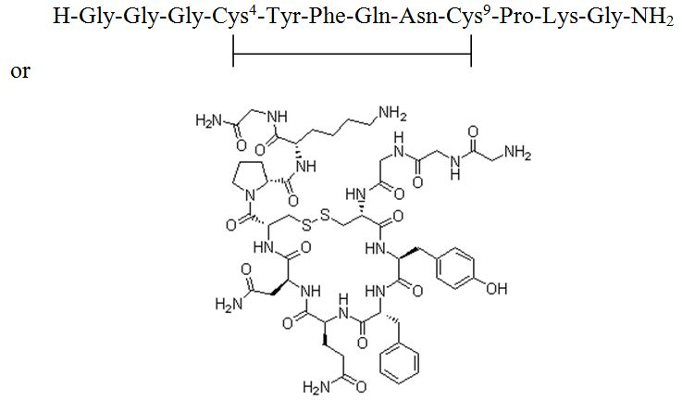 | N-[N-(N-Glycylglycyl)glycyl]-8-L-lysinevasopressin  C₅₂H₇₄N₁₆O₁₅S₂ (free base)  Molecular mass = 1227.37 (free base)  CAS # = [14636-12-5]  Aqueous solubility = freely soluble (100-1000 mg/mL)  Biopharmaceutical Classification System (BCS) Class not relevant to IV injections
The terlipressin is manufactured chemically using solid phase peptide synthesis.

Drug product

Powder for injection and diluent
Two sites of manufacture are proposed for the powder for injection. The process is similar at both sites. The sterility aspects of the manufacture are controlled to the satisfaction of the Microbiology Section of OLSS (Office of Laboratories and Scientific Services).
The specifications have acceptable expiry limits and release limits that allow for the changes observed on storage.
Stability data were provided to support an unopened shelf life of 3 years when stored below 25ºC. The condition ‘protect from light’ is also used.
The diluent ampoules are manufactured by an even simpler process Again the sterility aspects of the manufacture are controlled to the satisfaction of the Microbiology Section of OLSS. The diluent was stable for a longer period than the powder for injection (4 years when stored below 25ºC), but the overall shelf life set is that of the less stable component.
The PI states that the powder for injection must be diluted in the 0.9% sodium chloride (normal saline) provided and the constituted solution administered immediately.

Solution for injection
One site of manufacture is proposed for the solution for injection. The sterility aspects of the manufacture are controlled to the satisfaction of the Microbiology Section of OLSS.
The specifications have acceptable expiry limits and release limits that allow for the changes observed on storage.
Stability data were provided to support an unopened shelf life of 2 years when stored between 2-8ºC. The conditions ‘do not freeze’ and ‘protect from light’ are also used.

Bioavailability
Although the products as dosed are different concentrations (0.10 mg/mL free terlipressin for the solution and 0.17 mg/mL for the powder for injection), both products as dosed are simple aqueous solutions intended for IV administration only. As such, the bioavailability can be considered 100%.

Advisory committee considerations
Details of this submission were presented at the 142nd meeting of the Pharmaceutical Subcommittee (PSC) of ACPM in November 2011. The PSC endorsed all questions raised by PCS and had no need to review the submission again if all outstanding issues were resolved to the satisfaction of the TGA.
- The PSC agreed that the proposed powder and solution for injection should be labelled as containing 0.85/0.86 mg and 0.85 mg/8.5 mL of terlipressin respectively in order to avoid confusion, and supported that clarification be sought as to the amount of terlipressin in each vial of the powder for injection (0.85 or 0.86 mg). 0.86 mg is added to ensure a dose of 0.85 mg after reconstitution.
- The PSC considered that the sponsor be asked to provide batch analytical data on three recent re validation batches for the drug substance. This was satisfactorily addressed.
- The PSC commented that the two finished product manufacturer had different test methods and that it should be assessed that these were equivalent. This was accepted.

Quality summary and conclusions
Approval of the company’s application is recommended with respect to chemistry and manufacturing control. However, the way the products are labelled in terms of the amounts of what drug substance entity are yet to be concluded.
Bioavailability is 100% for this route of administration.

III. Nonclinical findings

Introduction
Ferring Pharmaceuticals Pty Ltd has submitted an application to register Glypressin (terlipressin acetate) for the treatment of BOV. There are two dosage presentations, a 1 mg (as terlipressin acetate) powder for injection and a 0.1 mg/mL (as terlipressin free base) solution for injection. The previous submission for Glypressin, which was for the powder for injection dosage form only, was withdrawn by the sponsor following negative ADEC recommendations on the grounds of inadequate efficacy. While the previously submitted nonclinical data package was limited, there were no toxicity concerns (beyond predictable exaggerated pharmacology) that would preclude the registration of terlipressin acetate for short term use (up to 48 h) in a life threatening situation. The sponsor is primarily relying on previously submitted nonclinical data to support registration and therefore the previous nonclinical evaluation report should be considered in conjunction with this evaluation report.
The nonclinical data in the current submission comprised a local tolerance study in rabbits to support the solution for injection formulation and, in response to a Section 31 request, 12 literature references published since the previous submission (2004). These published papers related primarily to efficacy issues.

Pharmacology
Ex vivo studies confirmed that terlipressin had vasoconstrictive activity in isolated cardiac tissues from rats and rabbits, and arteries from rabbits and humans. Competition studies suggested these vasopressive actions were mediated by the V_{1a} receptor. These findings are consistent with the known pharmacology of terlipressin.
Terlipressin given during haemorrhage was less effective than when given during a stable state in an experimental rat model of cirrhosis. This splanchnic hyporesponse was associated with an overexpression of constitutive nitric oxide synthase in the superior mesenteric artery and increased glucagon release due to blood retention in the stomach. These findings suggest that terlipressin has to compete with endogenous vasodilative mechanisms for its vasoconstrictive splanchnic effect. While the splanchnic response was diminished during haemorrhage, the systemic responses to terlipressin (increased mean arterial pressure and decreased cardiac output) were retained.
The efficacy of terlipressin was assessed in animal models of anaphylactic shock and septic shock. While terlipressin (up to 30 µg/kg IV) had no significant effect in a rat model of anaphylactic shock, terlipressin (12-180 µg/kg IV) consistently increased mean arterial pressure and systemic vascular resistance in ovine and porcine models of septic shock. However, negative haemodynamic side effects (decreased heart rate [HR], cardiac output and global oxygen consumption) were observed, depending on the rate of injection. These effects are known side effects of terlipressin and were reported in the previous nonclinical evaluation report.
Published papers with terlipressin in an infant animal model of asphyxia cardiac arrest and vasopressins in lithium carbonate induced polyuric rats revealed no additional safety concerns with terlipressin.

Toxicology

Local tolerance
A local irritation study in rabbits examined macroscopic and microscopic changes at the injection site following a single intra arterial or paravenous injection, or repeated IV injections of the new dosage form, Glypressin 0.1 mg/mL solution for injection. There were no significant injection site findings following intra arterial, paravenous or IV injection. However, animal movement during Glypressin injection suggested transient pain or discomfort occurred during IV injection. A comparison with the reconstituted powder for injection dosage form was not conducted.

Comments on the Safety Specification of the Risk Management Plan
All identified risks in the nonclinical package for terlipressin acetate, have been identified as risks from the clinical development programme, with the exception of the use in pregnancy. Terlipressin is contraindicated during pregnancy as there is sufficient evidence of risk to the developing foetus. Although this could have been expanded in the nonclinical safety specification of the Risk Management Plan (RMP), it has been indicated.

Nonclinical summary and conclusions
- Ferring Pharmaceuticals Pty Ltd has resubmitted an application to register the new chemical entity, terlipressin acetate (Glypressin). There are two dosage forms: a 1 mg (as terlipressin acetate) powder for injection and a 0.1 mg/mL (as terlipressin base) solution for injection.
- While the previously submitted nonclinical data for Glypressin, which was for the powder for injection dosage form only, were limited, there were no toxicity concerns (beyond predictable exaggerated pharmacology) that would preclude the registration of terlipressin acetate for short term use (up to 48 h) in a life threatening situation.
- Nonclinical data for the current submission comprised a local tolerance study in rabbits to support the new dosage form (solution for injection), and 12 literature references.
- The literature references revealed no additional safety concerns relevant to the intended clinical use of terlipressin acetate.
- Macroscopic and microscopic findings at the injection site following a single intra arterial or paravenous injection or multiple IV injections to rabbits suggested that the Glypressin solution for injection was well tolerated locally. However, animal movement during IV injection suggested transient pain or discomfort.
- There are no additional concerns raised in the newly submitted animal studies that would preclude the registration of Glypressin for the proposed short term, life threatening situation.

IV. Clinical findings

Introduction
This is a literature based submission to register the new chemical entity, terlipressin acetate.
Terlipressin acetate (also known as triglycyl lysine vasopressin) is a structural analogue of the neuropeptide hormone vasopressin and a pro drug for lysine vasopressin.
The proposed indication is the treatment of BOV. Terlipressin diacetate also has an established use in HRS for which it has been registered in a number of overseas countries. It is also being used experimentally in the management of septic shock. Neither of these indications is being sought by the sponsor.
Initially an IV injection of 2 mg terlipressin acetate is given every 4 h. The treatment should be maintained until bleeding has been controlled for 24 h, but should not continue for more than 48 h in total. After the initial dose, the dose can be adjusted to 1 mg IV every 4 h in patients with body weight <50 kg or if adverse effects occur. No data are available to guide dosage recommendations in children or the elderly.
The current submission contained the following clinical information:
- 4 published pivotal efficacy/safety studies of terlipressin versus placebo – Freeman 1989, Levacher et al 1995, Söderlund et al 1990 and Walker et al 1986. All 4 studies were considered to represent National Health and Medical Research Council (NHMRC) level II evidence. The publication by Freeman 1989 was accompanied by a 2 page study synopsis, a 6 page protocol (that appears to have been written by the investigators) and 31 pages of individual patient data (IPD). The publications by Söderlund et al 1990 and Walker et al 1986 were each accompanied by a study synopsis, a formal clinical trial report prepared by Ferring AB that included IPD listings, and a copy of the clinical trial protocol.
  - All 4 pivotal studies have been fully evaluated in this evaluation report.
- 24 supporting controlled studies in which terlipressin was compared with either placebo or other BOV treatments:
  - 1 study of terlipressin versus placebo – Patch et al 1999, which was NHMRC level II evidence. However the study was reported in an abstract.
  - 23 controlled studies comparing terlipressin to other BOV treatments, grouped as follows:
    - 5 studies of terlipressin versus octreotide:
      - 4 studies representing NHMRC level II evidence – Abid et al 2009, Brunati et al 1996, Pedretti et al 1994 and Silvain et al 1993. The publication by Brunati et al 1996 was the same abstract as that presenting data for terlipressin versus placebo;
      - 1 study representing NHMRC level III-1 evidence – Cho et al 2006. This paper was written in Korean but an English translation was included. Additionally, there were two publications (Cho et al 2006a, Kim 2006) that have not been evaluated separately in this evaluation report because they were poster abstracts and duplicated the results of the study reported by Cho et al 2006.
    - 5 studies of terlipressin versus somatostatin:
      - 4 studies representing NHMRC level II evidence – Feu et al 1996, Hafta 2001, Seo et al 2006 and Walker et al 1996. There was an additional paper by Walker et al 1992 that has not been evaluated separately in this evaluation report because it presented an interim analysis of the study reported by Walker et al 1996;
      - 1 study representing NHMRC level III-1 evidence – Pauwels et al 1994, the same paper as that presenting data for terlipressin versus placebo.
    - 5 studies of terlipressin versus vasopressin, all representing NHMRC level II evidence – Chiu 1990, D’Amico et al 1994, Desaint 1987, Freeman et al 1982 and Lee et al 1988. The paper by Lee et al 1988 was written in Chinese but an English translation was included.
    - 3 studies of terlipressin versus balloon tamponade, 2 of which represented NHMRC level II evidence (Fort et al 1990 and Garcia-Compean et al 1997) and 1 that represented level III-1 evidence (Colin et al 1987). The publication by Colin et al 1987 was accompanied by a study synopsis, a formal clinical trial report prepared by Ferring AB and a copy of the clinical trial protocol.
    - 2 studies of terlipressin versus endoscopic treatment, both representing NHMRC level II evidence – Escorsell 2000 and Lo 2009.
    - 3 studies of terlipressin at different doses and treatment durations, all of which were considered by the sponsor to have provided NHMRC level II evidence – Bruha et al 2002, Bruha et al 2009, and Hu and Lee 2008. Two publications (Bruha et al 2000a and Bruha 2000b) have not been evaluated separately in this evaluation report because they duplicated data from the study reported by Bruha et al 2002. Bruha 2000a was also a poster abstract that contained only minimal information. The study reported by Hu and Lee 2008 was described as a “bioequivalence” study of two brands of terlipressin (Haemopressin and Glypressin). However, it was not a bioequivalence study. It examined the comparability of clinical outcomes in terms of initial bleeding control, re bleeding and mortality in cirrhotic patients with endoscopically verified oesophageal variceal bleeding. This study has not been evaluated because no data have been presented to demonstrate that Haemopressin has an acceptable level of efficacy and safety.
With the exception of the study by Hu and Lee 2008, all supporting studies have been evaluated in this evaluation report (Note: published papers that duplicated data from the same study as described above have not been evaluated separately but were reviewed and any additional information was included in the evaluation of the “parent” publication).
- 8 other publications from analyses from more than one study – Bosch et al 1994, D’Amico 1995, D’Amico et al 2010, D’Amico 2003, Garcia-Tsao and Bosch 2010, Ioannou 2003 (the Cochrane Review), Krag et al 2008 and Nevens 2004.
- 22 other publications, including reports from the 5 Baveno Consensus Workshops, guidelines and treatment protocols, and publications by Australian authors; and 127 literature references.
Among the literature references were numerous clinical pharmacology papers, many of which had been submitted previously. However, there was a company pharmacokinetic (PK) study report and numerous pharmacodynamic (PD) studies that had not been previously submitted to the TGA. Among the additional PD studies were studies of terlipressin in patients with cirrhosis that had either been cited in the previous Clinical Expert’s report or found by the previous evaluator when searching Medline, but not submitted by the sponsor at that time. Although there were no outstanding issues on clinical pharmacology at the time the 2004 application was withdrawn, some of these studies provide additional, important information and have, therefore, been evaluated in this evaluation report as follows:
- A preliminary report on company PK study 45A15/PL/27 (dating from 1987) provided PK data from 3 patients with BOV, including data on levels of terlipressin in ascitic fluid and the kinetics of distribution to the ascitic fluid in 1 patient. These additional data were considered to be of importance in the context of both the proposed use of the product and the overall limited PK data;
- Two dose ranging studies (Freeman 1988 and Escorsell et al 1997) examined the effects of differing doses terlipressin on both the splanchnic/portal and systemic circulations, and there was a more recent comparison of the onset and time course of portal and systemic haemodynamic effects of terlipressin and octreotide (Baik et al 2005). These and other additional studies (either not submitted or not evaluated in the 2004 submission) were evaluated to see if there were any pharmacological data to support the proposed dosage regimen. This was in light of the fact that the 2005 evaluator noted the proposed recommended dose was determined largely by the dose used in the submitted efficacy studies.
- Post marketing experience, comprising an Italian paper submitted with an English translation (Caletti et al 1991), 5 PSURs (Periodic Safety Update Reports) covering the period from 16 April 2005 to 30 April 2010; and Glypressin Company Core Data Sheets.
Many of the studies submitted were conducted prior to 1991, when Good Clinical Practice (GCP) requirements were first promulgated. Furthermore, ICH (International Conference on Harmonisation) GCP was approved as a regulatory requirement by the then Committee for Medicinal Products for Human Use (CPMP) in July 1996 and only came into operation for studies commencing after mid January 1997. This requirement was not applicable to many of the studies, including the four pivotal studies of terlipressin versus placebo, because they were approved and started before these dates. For the 9 more recent studies (that is, those with dates of conduct after 1997), only 2 papers (Escorsell et al 2000 and Bruha et al 2002) stated the study was conducted in accordance with GCP requirements.
Only 16 of 27 papers evaluated in this Clinical Evaluation Report stated that ethical approval for the study had been obtained. One further paper (Pedretti et al 1994) mentioned that informed consent had been obtained in accordance with the Declaration of Helsinki. Ethics committee approval was obtained for all four pivotal studies.

Pharmacokinetics

Studies providing pharmacokinetic data
Three studies were evaluated in the 2005 evaluation report – two conducted in healthy volunteers (Forsling et al 1980 and Nilsson et al 1990) and one in cirrhotic patients without bleeding (Clinical Trial Report 910311, referred to in the 2005 evaluation report as Söderlund 1991).
One additional company PK study report (45A15/PL/27), dating from 1987, has been submitted with this application as a literature reference. Study 45A15/PL/27 provided PK data from 3 patients with BOV, including data on levels of terlipressin in ascitic fluid and the kinetics of distribution to the ascitic fluid in 1 patient. Data from the study were compared by Söderlund 1991 with results from their study but this was not captured in the 2005 evaluation report. Consequently, the study has been evaluated in this evaluation report and the findings incorporated in the summary below.

Summary of pharmacokinetics
The key summary points from the 2005 evaluation report are reproduced where relevant. Information about the PK of terlipressin in cirrhotic patients has been supplemented with data from Study 45A15/PL/27, a full evaluation of which can be found in this evaluation report under the heading Clinical pharmacology study synopses.

Pharmacokinetics in healthy subjects

Absorption
Not applicable as Glypressin Powder for Injection and Glypressin Solution for Injection are administered IV.

Bioavailability
Glypressin Powder for Injection and Glypressin Solution for Injection are administered IV and are thus 100% bioavailable.

Distribution
In healthy volunteers, terlipressin was rapidly distributed in a volume approximating the extracellular fluid volume (volume of distribution, V_{d} ~0.7 l/kg), with a distribution half life of ~8 minutes.

Metabolism
Terlipressin is metabolised via enzymatic cleavage of its three glycine residues by endothelial peptidases into LVP, its biologically active component. Terlipressin plasma concentrations decline bi exponentially following IV administration, with an elimination half life of approximately 1 h and plasma clearance of approximately 9ml/kg/min. Measurable concentrations of vasopressin appear in the plasma from about 30 minutes post dose, peaking at 1-2 h post dose.

Pharmacokinetics of metabolites
LVP has an elimination half life of 6 minutes. Exogenous vasopressin (8-arginine vasopressin) is not protein bound and has a V_{d} of 0.14 l/kg. It is cleared by renal excretion (65%) and metabolism by tissue peptidases (35%), resulting in an elimination half life of 24 minutes (Kam et al 2004).

Consequences of genetic polymorphism
Not applicable.

Excretion
Following IV administration of 7.5µg/kg terlipressin in 5 healthy adult volunteers, an estimated 0.25 to 1.27% of the dose was excreted unchanged in urine and 0.03 to 0.046% of the dose was excreted as LVP (Forsling et al 1980).

Intra and inter individual variability of pharmacokinetics
This issue was not specifically covered in the 2005 evaluation report. The following is a summary of this evaluator’s review of the results from the submitted PK studies.

Terlipressin PK
Intra individual variability of terlipressin PK parameters in healthy subjects could not be assessed from the two studies submitted. Individual results presented by Forsling et al 1980 by way of semi logarithmic plots of terlipressin plasma concentration-time curves, showed a degree of inter individual variability in the decline of plasma levels. Nilsson et al 1990 did not provide individual data. However, the % CV calculated from the summary statistics for the across the three doses were approximately 16% for clearance, 20% for V_{d} and 14% for the terminal phase half life.

Lysine-vasopressin
Much more marked inter individual variability was found with the PKs of the metabolite LVP. Söderlund 1991 presented data from Forsling et al 1980, obtained by personal communication, which demonstrated quite marked inter individual variability in LVP plasma concentrations and AUC (area under the plasma concentration-time curve) values (Figure 2), consistent with their findings in 5 patients with cirrhosis. The % CV in AUC for lysine-vasopressin was 33%. However, they acknowledged that the variability in PKs may have as much to do with limitations in the specificity and sensitivity of the bioassay used for determination of LVP than actual inter patient variability. (Note: a radioimmunoassay [RIA] method rather than bioassay was used to determine plasma terlipressin concentrations).
Figure 2: Individual corrected plasma concentration-time curves for lysine-vasopressin after IV bolus Glypressin in 5 healthy volunteers (Söderlund 1991; data provided by Forsling et al).
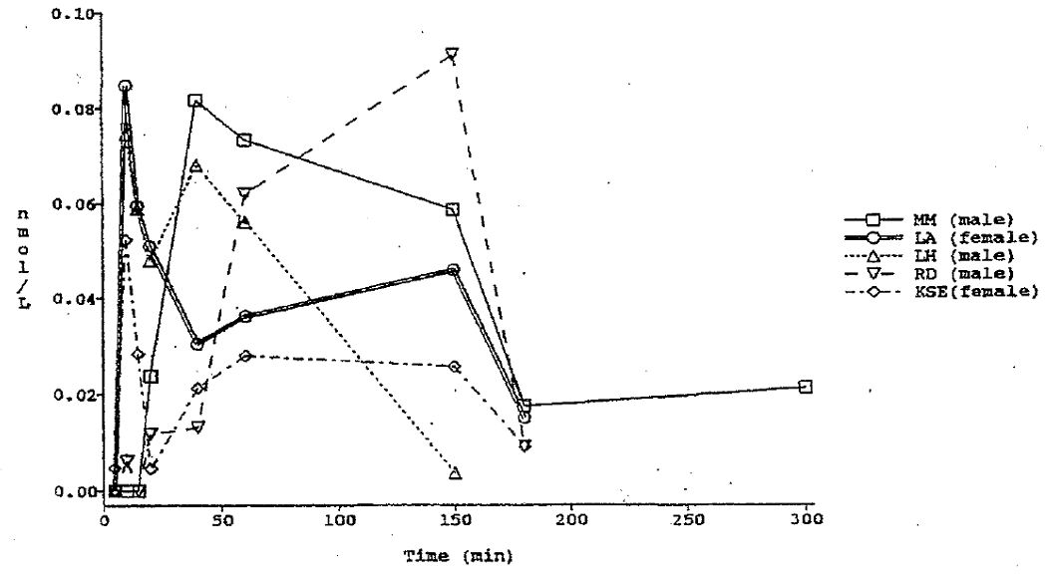

PK in the target population
The PK of terlipressin and its metabolite, vasopressin, were similar in healthy subjects and patients with cirrhosis (Söderlund 1991 and company study 45A15/PL/27). Terlipressin is distributed to ascitic fluid, with an equilibrium taking place at approximately 60 minutes post bolus (Study 45A15/PL/27).

PK in other special populations

Subjects with impaired hepatic function
See PK in the target population.

Subjects with impaired renal function
No data submitted.

PK according to age
No data submitted.

PK related to genetic factors (sex, ethnicity, genetic polymorphism)
No data submitted.

PK interactions
No PK interaction studies have been submitted.

Evaluator’s overall conclusions on PK
There are very limited PK data for terlipressin acetate in healthy volunteers and even less data in the target population despite Glypressin having been available since the early 1980s.
Terlipressin plasma concentrations decline in a bi exponential fashion following IV bolus administration, with rapid distribution in a volume approximating the extracellular fluid volume. Terlipressin also appears to be distributed to ascitic fluid, reaching equilibrium with plasma at approximately 60 minutes post administration. It is also possible that terlipressin may accumulate in ascitic fluid with repeated bolus administration.
Terlipressin is metabolised via enzymatic cleavage of its three glycine residues by endothelial peptidases into lysine-vasopressin, its biologically active component, with measurable levels of LVP appearing approximately 30 minutes after bolus administration, peaking at between 1 and 2 h. The pharmacokinetics of terlipressin and LVP appear similar in healthy subjects and patients with cirrhosis.

Pharmacodynamics

Studies providing PD data
There are a substantial number of studies examining the primary PD effects of terlipressin relevant to the proposed indication of BOV. Of these, 4 relating to haemodynamic effects (Lin 1990, Cestari 1990, Merkel 1992, Panés 1994) and 2 relating to effects on the fibrinolytic system (Cash 1978 and Douglas 1979) were evaluated in detail in the 2005 evaluation report. The aforementioned studies were either included in the original submission or submitted in response to the Section 31 request for more information. The 2005 evaluator noted there were numerous other PD studies of terlipressin in patients with cirrhosis that had either been cited in the Clinical Expert’s report or found by the evaluator when searching Medline, but not submitted by the sponsor at that time. The information available for these studies was summarised in the 2005 evaluation report, but not formally evaluated.

Evaluator’s comment:
The PD studies evaluated in the 2005 evaluation report are not re evaluated in this evaluation report, except for the paper cited as Douglas 1979. The 2005 evaluator found that the paper by Douglas et al 1979 contained insufficient information to allow a full evaluation of the study – a number of statements and conclusions regarding the effects of terlipressin on the fibrinolytic system were made without any supporting data having been presented. The 2005 evaluation report repeatedly stated that “values not reported” and “actual values not published” in relation to key findings of the study. It was noted by this current evaluator that a publication by Prowse et al 1980 duplicated data from Douglas et al 1979 and contained a much more comprehensive description of analytical methods as well as much of the data noted to be missing from Douglas et al 1979, thus overcoming many of the limitations cited by the 2005 evaluator. Consequently, Prowse et al 1980 has been evaluated in concert with Douglas et al 1979 in this evaluation report.

Summary of PD
The key summary points from the 2005 evaluation report and from the evaluation of additional studies of this evaluation report are reproduced where relevant (below). The information in the following summary is derived from conventional PD studies in humans unless otherwise stated.

Mechanism of action
Terlipressin has affinity for vasopressin receptors (V receptors). Vasopressin receptors are G-protein coupled receptors with seven trans membrane spanning domains. V receptors are divided into three specific subtypes (V₁, V₂ and V₃), the distribution and density of which account for the potential pharmacological effects:
- V₁ receptors (formerly known as V_{1a}) are the most widespread subtype, found in vascular smooth muscle, hepatocytes, platelets, and cardiomyocytes. Vasopressin effects mediated in these cell types are vasoconstriction, glycogenolysis, platelet aggregation, and positive inotropic effect, respectively;
- V₂ receptors are located mainly in the collecting ducts in the kidney, stimulating increased water permeability, and allowing the osmotically driven movement of water from the tubular lumen into the interstitium, thereby decreasing the plasma osmolality; and
- V₃ (formerly known as V_{1b}) receptors are found in the anterior pituitary, where they mediate adrenocorticotropic hormone (ACTH) release. They are also found in the pancreatic islets of Langerhans and have been implicated in mediating glucagon secretion as well as promotion of cellular proliferation.

Pharmacodynamic effects

Primary pharmacodynamic effects
The primary PD effects of terlipressin in relation to its desired therapeutic effect in BOV are the vasoconstrictive effects mediated through V₁ receptors on smooth muscle in the splanchnic and portal circulation. However, given the ubiquitous nature of V₁ receptors, terlipressin also has effects on the systemic circulation and, in particular, on HR and mean arterial blood pressure (MAP).
The primary haemodynamic effects of terlipressin have been mostly investigated in cirrhotic patients without active bleeding. Some data (albeit limited) have also been gathered from patients during elective portacaval shunt surgery (Vosmik et al 1977). Table 1 of this evaluation report summarises the key PD studies available, presenting the percentage changes in splanchnic and systemic parameters from baseline. The results are presented according to the dose of Glypressin and the data collection schedules employed. In addition, because of the quite small sample sizes used, some of the percentage changes were not statistically significant despite being of relatively large magnitude in comparison with other studies. These results are presented in the table in [parentheses]. Furthermore, some studies did not provide any statistical analyses and their results are shown in italics. It can be appreciated from Table 1 that:
- A range of splanchnic/portal and systemic haemodynamic parameters have been assessed using a variety of methods. The methods range from simple, non invasive techniques such as HR and blood pressure monitoring through to invasive techniques involving the portal, pulmonary and systemic circulations (for example, measurement of wedged hepatic vein pressure [WHVP]) and direct needle puncture of oesophageal varices (for example, Cestari 1990 and Romero 2000);
- Monitoring has been performed at different time points after bolus administration of terlipressin. Consequently, the degree to which the time course of PD effects has been elucidated largely reflects the monitoring regimens chosen for the studies;
- Studies in patients with portal hypertension have consistently shown that terlipressin at doses of 1 and 2mg results in reduced hepatic and azygos flow, reduced WHVP and hepatic vein pressure gradient (HVPG), with an associated increase in MAP and systemic vascular resistance (SVR) and reduced HR and CO (cardiac output); and
- There is somewhat more limited evidence pointing to a decrease in IVP (intra oesophageal variceal pressure), variceal pressure gradient and variceal wall tension after administration of a 2 mg bolus of terlipressin.
Table 1: Mean percentage changes in haemodynamic parameters after bolus administration of Glypressin.
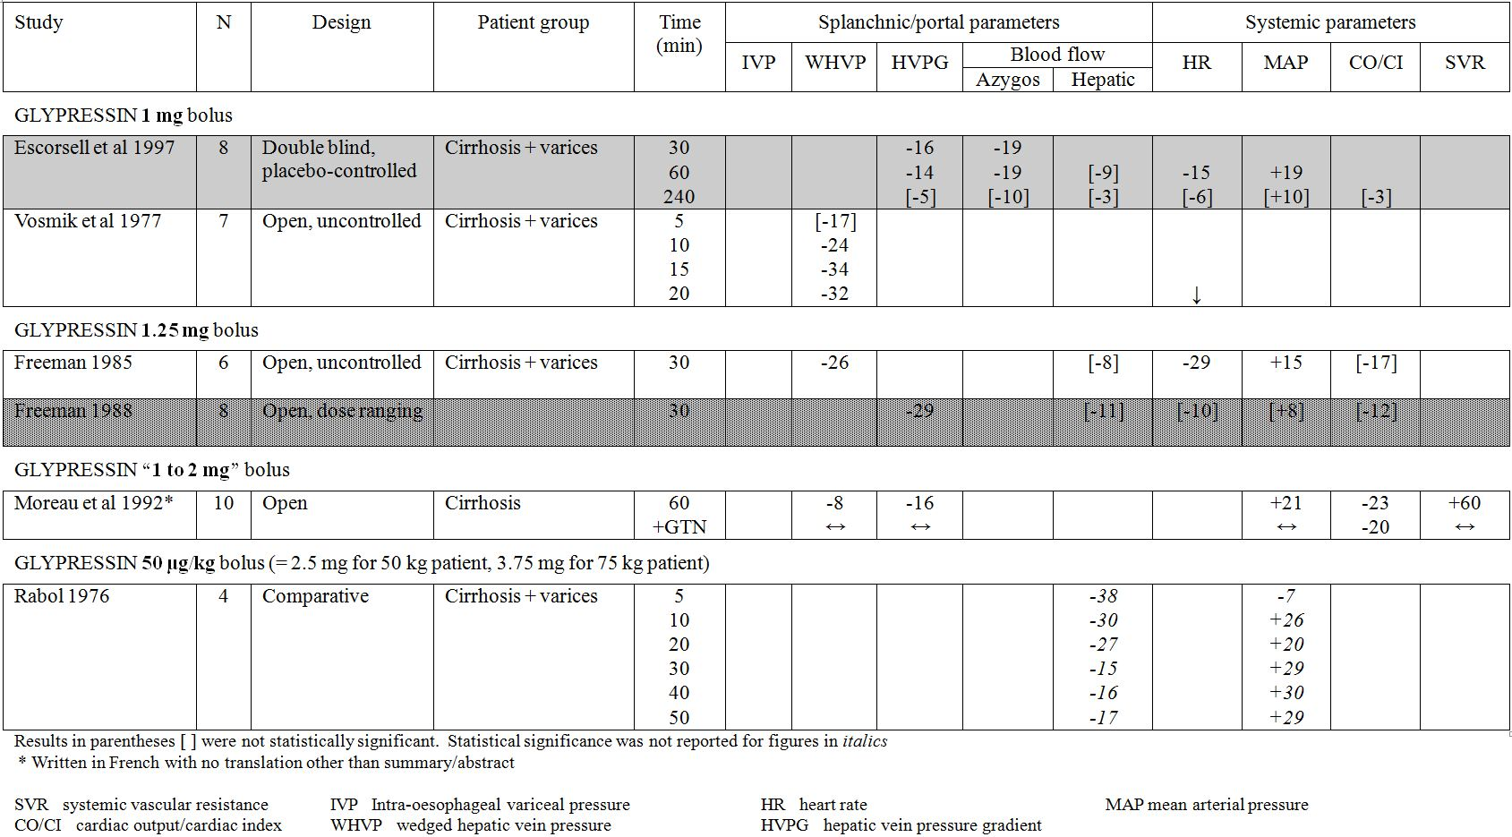
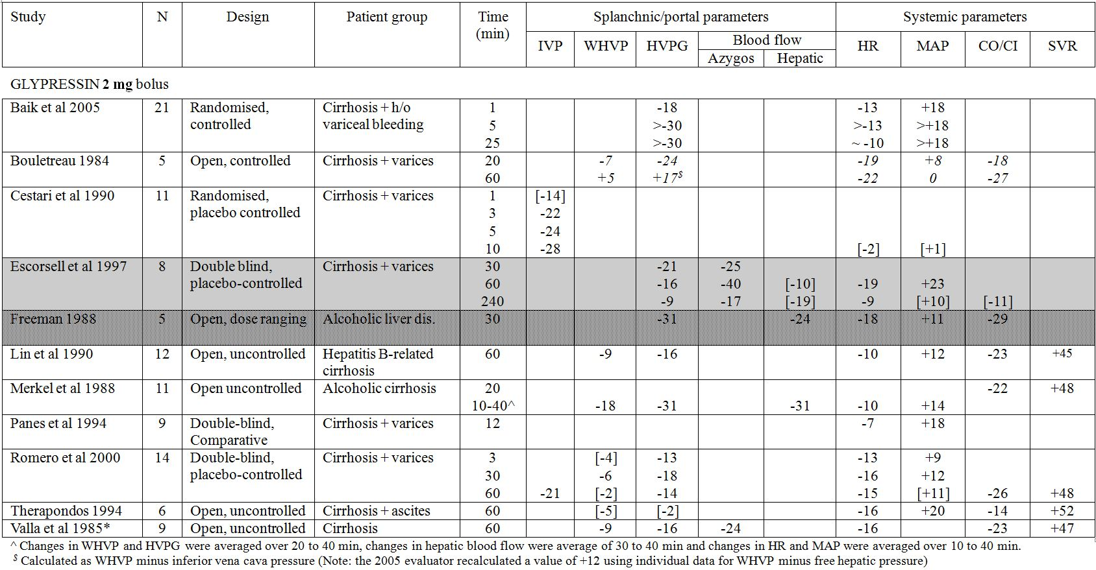
Most studies monitored the effects of terlipressin starting at 20 to 30 minutes after bolus administration and, in some cases, after 60 minutes only. There are, in the opinion of this evaluator, 4 seminal studies that monitored effects within 10 minutes of administration and showed that terlipressin itself is vasoactive, with onset of effect within minutes of administration which is then sustained by its to conversion to LVP. In addition to being placebo controlled, 2 of these studies were also either randomised or double blinded, providing relatively robust results:
- Vosmik et al 1997, demonstrated that a 1 mg bolus of terlipressin was associated with 34% decrease in hepatic vein wedge pressure in 7 patients with cirrhosis and oesophageal varices. The onset of effect was 5-10 minutes after administration, reaching a maximal level at 15 minutes and persisting through to the end of monitoring at 20 minutes. The authors also reported the haemodynamic effects in 5 patients who received 2 mg terlipressin during portacaval shunt surgery. Consistent with studies in cirrhotic patients, the portal vein pressure dropped significantly from 27.5 ± 3.4 cm H₂O to 18.8 ± 2.2 cm H₂O (32%) at 10 minutes post administration. Anecdotally, it was noted that all these patients had been bleeding profusely from small collateral veins after dissection of the portal or splenic veins and the small vessel bleeding was also observed to decrease markedly within 10 minutes of the administration of Glypressin.
- Cestari 1990 found that terlipressin 2 mg significantly reduced intra oesophageal variceal pressure at 3, 5 and 10 minutes post administration compared to placebo, with an effect noticeable after 1 minute and steadily increasing over 10 minutes. Systemic haemodynamic parameters were largely unaffected at 10 minutes in this study.
- Romero et al 2000 demonstrated that 2 mg terlipressin produced significant and prolonged decreases in variceal pressure (21% at 60 minutes), variceal pressure gradient (28% at 60 minutes) and variceal wall tension (27% at 60 minutes). The study also confirmed earlier findings of the effects of terlipressin on portal pressure and systemic haemodynamics. The authors also examined the relative changes in IVP and WHVP, and the corresponding pressure gradients obtained 60 min after terlipressin administration and found there were significantly greater relative effects on the varices than on the hepatic circulation (Figure 3). The authors opined that hepatic venous pressure gradient measurement could underestimate the local haemodynamic effects of terlipressin and that measurement of variceal pressure may provide a better marker of the potential benefits of terlipressin administration in the treatment of oesophageal varices.
Figure 2: Comparison of effects of terlipressin on hepatic vein pressure gradient (HVPG) versus variceal pressure gradient (VPG) (*, p<0.05) and wedge hepatic venous pressure (WHVP) versus intra oesophageal variceal pressure (IVP) (**, p<0.0001). Values expressed in changes from baseline (mean ± standard deviation [SD]).
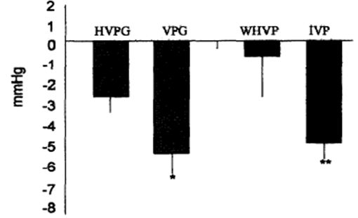
- Baik et al 2005 provided a head to head comparison of immediate haemodynamic effects of terlipressin and octreotide, the two most widely accepted and used treatments for BOV. Both octreotide and terlipressin produced measurable reductions in HPVG and portal venous flow (PVF) within 1 minute of administration, however sustained effects (over a full 25 minutes) were only observed with terlipressin. Terlipressin at a 2 mg dose resulted in an 18% reduction in HVPG and a 33% reduction in PVF at 1 minute (p<0.05 for both parameters), which were sustained at all time points to 25 minutes post administration. Terlipressin also produced an initial increase in MAP (24%) and decrease in HR (15%) at 1 minute (p<0.05 for both parameters).
A fifth study, by Rabol et al 1976 found hepatic blood flow decreased by 38% within 5 minutes of administration of a 50 µg/kg bolus of terlipressin (= 2.5 mg for 50 kg patient; 3.75 mg for 75 kg patient). This was associated with increased mean arterial pressure, evident at 10 minutes and sustained over the 50 minute monitoring period. However, this was a small, preliminary study that did not allow for any firm conclusions on a statistical basis.
A further 3 studies – Freeman et al 1988, Escorsell et al 1997 (a full publication of the conference abstract cited as Escorsell et al 1994 in the 2005 evaluation report) and Nilsson et al 1987 – are also considered of importance because they generated data that suggest a dose response with respect haemodynamic effects of terlipressin, providing further data to support the proposed dosage regimen for Glypressin:
- In a well designed and conducted double blinded, placebo controlled study in 8 cirrhotic patients, Escorsell et al 1997 demonstrated that both 1 and 2 mg terlipressin caused significant reductions in portal pressure and azygos blood flow, with more marked and prolonged effects (out to 4 h post bolus) observed with the 2 mg dose. 2 mg terlipressin caused a significant and prolonged reduction in HVPG, with a maximal effect observed at 30 minutes (-21%; p<0.01). A similar effect was observed with respect to azygos blood flow, although the peak effect was observed at 1 h (-37%; p<0.01). 1 mg terlipressin also produced significant reductions in HVPG (maximal effect -16% at 30 minutes) and azygos blood flow (-31% at 1 h; p<0.05). Although there was a trend toward greater reduction in HVPG and azygos blood flow with the higher dose (Figures 3-4), the differences were not statistically significant.
Figure 3: Effect of terlipressin on HVPG.
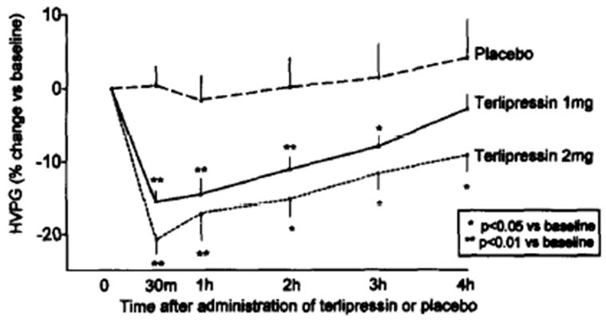
Figure 4: Effect of terlipressin on azygos blood flow.
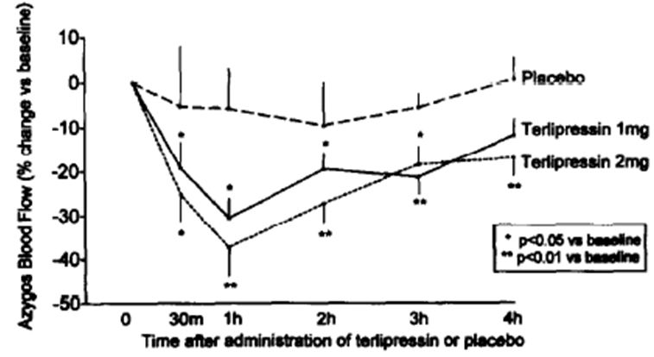
- In a study of 8 patients with BOV, Freeman 1988 found that the hepatic venous pressure gradient was significantly decreased by both a 1.25 mg and 2 mg dose of terlipressin, with a slightly greater reduction observed with the 2 mg dose (31% versus 29%). A much more marked difference was observed between the doses regarding effects on hepatic blood flow, with a 24% reduction with the 2 mg dose versus 11% reduction with 1.25 mg. HR decreased by 10% with 1.25 mg and 18% with 2 mg terlipressin, mean arterial pressure increased by 8% with 1.25 mg and 11% with 2mg and cardiac output reduced by 29% in the 2 mg terlipressin group versus 16% with the 1.25 mg dose. The authors concluded that a lower dose of terlipressin offered the advantage of reducing portal pressure whilst reducing the likelihood of adverse systemic haemodynamic effects. However, this study was neither blinded nor placebo controlled and, of note, patients receiving a 1.25 mg dose of terlipressin had less severe disease and less severe haemodynamic abnormalities at baseline than those who received a 2 mg dose. (Note: the study by Freeman 1985 also reported similar effects but of a mostly greater magnitude in 6 patients who received doses of 1.25 mg of terlipressin. It is possible that these data represent a subset of data subsequently reported by Freeman 1988, however the lack of information about patient characteristics in both publications prevented any further assessment of this.)
- In a placebo controlled crossover study of terlipressin at doses of 5, 10, 20 and 30 µg/kg), Nilsson et al 1987 demonstrated increasing skin vasoconstriction (assessed by laser Doppler flowmetry) with increasing dose. The maximal effect was observed at 60 minutes with both the 10 and 20 µg/kg dose, however, the duration of effect was prolonged with the 20 µg/kg dose (which exhibited magnitude and duration of effect similar to that observed with a 30 µg/kg dose; n=2).
The majority of studies monitored patients for 60 minutes or less, so it was not clear from these studies whether the PD effects were maintained over the proposed dosing interval. However, Escorsell et al 1997 (discussed above) monitored patients for 4 h and demonstrated a persistence of effect of a 2 mg dose of terlipressin on HVPG at 4 h (exceeding 50% of the maximal effect), whereas neither arterial pressure nor peripheral vascular resistance were significantly different from placebo or baseline at that time point. In contrast, the splanchnic effects of the 1 mg dose became non significant (compared to placebo and baseline) after 3 h.
Moreau et al 1992 reported that the concomitant administration of glyceryl trinitrate abolished the undesirable vasoconstrictor and vasopressor effects of terlipressin whilst not affecting its desired splanchnic haemodynamic effects. However, this publication was essentially of no value because it was written in French with only a very brief summary in English.
Other haemodynamic effects of terlipressin reported in the literature included changes in gastric mucosal perfusion and liver function, and effects on cerebral perfusion:
- Panes et al 1994, in a parallel group study in fasted patients with portal hypertensive gastropathy, demonstrated significantly increased MAP and decreased HR following either an IV bolus administration of 2 mg terlipressin (n=9) or infusion of vasopressin 0.4U/minute (n=9). These changes were consistent with the findings of other PD studies and showed that, at doses representative of clinical usage in patients with BOV, terlipressin had less effect on systemic haemodynamics than vasopressin. Both drugs were found to significantly reduce gastric mucosal perfusion (measured endoscopically by laser Doppler flowmetry) compared to placebo (n=10), with no significant difference between the two active treatment arms. Both drugs also reduced gastric mucosal oxygenation (measured by reflectance spectrophotometry) compared to placebo (vasopressin 17%; terlipressin 6%), however the reduction was only statistically significant for vasopressin.
- Merkel et al 1992 demonstrated that indocyanine green intrinsic hepatic clearance was significantly decreased after IV administration of 2 mg terlipressin in 10 patients with cirrhosis and oesophageal varices (median change from baseline -22% [95% CI {Confidence Interval} -36 to -1%]) but not after administration of placebo (7 historical controls – median change from baseline -1% [95% CI -7 to +6%]). The same investigators found that galactose elimination capacity was unaltered by either 2 mg IV terlipressin (n=12) or saline placebo (n=11). It was concluded that terlipressin probably leads to a preferential decrease in perfusion of functioning areas of the liver in patients with cirrhosis.
- Shawcross et al 2004, found that administration of a single low dose (IV bolus) of 0.005 mg/kg terlipressin (median dose 0.25 mg; range 0.2-0.3 mg) resulted in worsening of cerebral hyperaemia and intracranial hypertension in the absence of changes in systemic haemodynamics (CO, HR, MAP and SVR) in 6 patients with acute liver failure and severe hepatic encephalopathy (median age 27 years; range 22–46 years; four females). All patients showed evidence of a hyperdynamic circulation (that is, increased CO and HR, and reduced MAP and SVR) prior to administration of terlipressin. No clinically or statistically significant changes in these parameters were observed following administration of terlipressin. However, cerebral blood flow (CBF) increased significantly from a median of 69 mL/100 g per minute (range 48-83 mL/100 g per minute) to 81 mL/100 g per minute (range 62-97 mL/100 g per minute) 1 h after administration of terlipressin (p = 0.016) and returned to baseline values at 5 h. This coincided with an increase in intracranial pressure (ICP) in all patients from a median of 15 mmHg (range 13-18 mmHg) to 20 mmHg (range 16-23 mmHg) after 1 h (p = 0.031), which returned to baseline values at 2 h; and a significant increase in jugular venous oxygen saturation (JVOS) from a median of 75% (range 67%-89%) to 87% (range 75%-94%) 1 h afterward (p = 0.016), which remained significantly elevated for 3 h, returning to baseline values at 5 h. These data suggest terlipressin may have potentially deleterious consequences on cerebral haemodynamics and contribute to exacerbation of encephalopathy. The exact mechanism by which terlipressin leads to an increase in CBF could not be elucidated from the study. The authors postulated that it was likely to be mediated through cerebral V₂ receptors, reasoning that if the effect was mediated through V₁ receptors there would have also been a rise in MAP. The results of a then recent animal model study (Chung et al, 2003) were cited in support of the hypothesis – vasopressin increased CBF in the presence of both V₁ and V₂ receptor antagonism; and the increase in CBF that occurred with V₁ receptor antagonism was not accompanied by a simultaneous increase in the MAP indicating a V₂ receptor dependent mechanism.
In the PD studies submitted, the systemic haemodynamic effects of terlipressin were generally well tolerated. However, bradycardia significant enough to necessitate cessation of terlipressin treatment (~47 bpm [beats per minute]) was observed in one patient in the study by Bouletreau et al 1984. In studies by Therapondos et al 1994 and Prowse et al 1980, all patients experienced transient facial blanching, consistent with systemic vasoconstrictive effects, and one patient in the study by Romero et al 2000 was noted to have elevated blood pressure during oesophageal variceal puncture.

Evaluator’s comment:
Table 1 presents similar but, in some instances, different information to that contained within the 2005 evaluation report. It needs to be appreciated that:
- For many of the studies cited in the 2005 evaluation report, the evaluator was relying on the limited information contained solely within abstracts (the full papers were not submitted);
- A number of the studies cited in the 2005 evaluation report have now been included as full papers amongst the literature references in the current dossier. Consequently, additional data are now available for many of the studies and included in this evaluation report (for example, results available for many more time points, statistical significance of results reported, etcetera); and
- A number of studies cited in the 2005 evaluation report (but not submitted at that time) have still not been submitted by the sponsor (for example, Jeong 2002, Lee 1999, Kiska-Kanowitz 2004, Moller 2000 and Nevens 1996). These studies have not been included in Table 1 because the information/data could not be corroborated this evaluator.
Also of note, the 2005 evaluator highlighted anomalous results with shading in the 2005 evaluation report. It appears that the evaluator erroneously shaded the changes in HVPG for Romero 2000 (-14%) instead of those for Therapondos et al 2004 (+14%). However, it appears that the abstract for Therapondos et al 2004 that was relied upon by the 2005 evaluator, also contained an error. The abstract stated that the HPVG changed from 12.3 ± 1.6 at baseline to 14 ± 0.9mmHg following administration of Glypressin (calculated correctly by the 2005 evaluator as a change of +14%), however the change stated in the body of the text was from 14.3 ± 1.5 to 14 ± 0.9mmHg (-2%). The latter is consistent with the direction of changes in HPVG observed in other PD studies.
A number of additional studies were included in the dossier to demonstrate the potential clinical application of the vasoconstrictive effects of terlipressin, including its use to control blood loss in women undergoing conisation of the cervix (Rundqvist et al 1988), in patients undergoing skin excision for burns (Garner et al 1993a) and during wound dressings in patients with toxic epidermal necrolysis (Garner et al 1993a); as well as in patients with orthostatic hypotension associated with neurological disease (Rittig et al 1991). These studies were not evaluated in the 2005 evaluation report as they were not submitted with the application. Although the papers have been submitted as literature references in the current submission, they have not been evaluated in this evaluation report because they are of only oblique relevance to the indication sought and this evaluator considers there is already a good body of data demonstrating primary pharmacodynamic effects directly relevant to the use of terlipressin in BOV.

Secondary pharmacodynamic effects
For the purposes of the intended therapeutic effect of terlipressin in BOV, effects mediated via V₂ and V₃ receptors are considered to be secondary effects.

Effects on fibrinolysis
Activation of V₂ receptors on endothelial cells causes a release of endothelial factor VIII and enhances platelet aggregation (Kam et al 2004).
Terlipressin was found to produce a small but statistically significant increase in plasminogen activator levels in 5 healthy volunteers (Cash et al 1978). However, despite being administered at 59 times the dose of other vasopressin analogues (such as arginine vasopressin, arginine-vasotocin and desmopressin), terlipressin was slower to effect a response and the response observed was markedly less than with the other analogues. Platelet counts, plasma fibrinogen, serum fibrinogen-fibrin degradation products and partial thromboplastin times were reported to have been normal and unchanged.
Glypressin also appears to have minimal effects on the fibrinolytic system in cirrhotic patients. In a study of 8 patients with cirrhosis and portal hypertension, infusion of 0.75mg and 2 mg of Glypressin over 15 minutes did not result in statistically significant increases in factor VIII or plasminogen activator levels (Prowse et al 1980). Additionally, platelet counts, partial thromboplastin time, fibrin degradation products, fibrinogen levels, plasmin antiplasmin complexes and beta thromboglobulin levels were unaffected. Assays of vasopressin like antigen and antidiuretic activity indicated that terlipressin was cleaved to LVP in vivo, resulting in levels of LVP (~50 fmol/ml) that were maintained for at least 30 min after infusion, insufficient to cause release of plasminogen activator or factor VIII. In contrast, infusion of LVP 10 µg over 15 minutes resulted in much higher LVP levels, which were associated with a rise in plasminogen activator levels (p<0.01) immediately following the infusion that persisted through to 30 minutes post infusion (p<0.05) but resolved by 1 h post infusion. LVP infusion also resulted in elevations of factor VIII and pro coagulant factor VIII. The rise in pro coagulant factor VIII was significant immediately after infusion (p<0.01) and at 30 and 60 minutes (p<0.05), whether assayed by one or two stage analytical methods.

Evaluator’s comment:
As noted in the preceding Evaluator’s comment, Prowse et al 1980 and Douglas et al 1979 have been (re) evaluated in this evaluation report. In the view of this evaluator, the data and information available from these papers combined satisfactorily demonstrates that Glypressin has minimal effects on the fibrinolytic system in cirrhotic patients, with no change in factor VIII or plasminogen activator levels. Of note, Levacher 1995 reported that 4 patients treated with terlipressin died due to fibrinolysis. However, 4 patients treated with placebo in the same study also died due to fibrinolysis. This suggests that rather than being an effect of terlipressin, fibrinolysis was more likely due to underlying haemostatic defects known to exist in patients with cirrhosis.

Effects on renal function and sodium excretion
In vitro studies have shown that terlipressin has activity on the V2 vasopressin receptors present in the renal collecting ducts that are responsible for the antidiuretic effect of vasopressin (Machova 1992). Stimulation of V2 receptors results in antidiuresis and water retention, with decreased plasma osmolality, increased urine osmolality and hyponatraemia.
In a crossover study involving 5 healthy volunteers, IV administration of terlipressin at a dose of 7.5µg/kg produced an antidiuresis that was evident within 60 minutes, with a subsequent progressive increase in urine osmolality during a 5 h observation period (Forsling 1980). Nilsson 1987, in the same placebo controlled study that examined the relationship between terlipressin dose (5, 10, 20 and 30 µg/kg) and skin vasoconstriction in 8 healthy volunteers, found that terlipressin caused significant increases in urinary potassium and sodium concentrations and urine osmolality, but did not find any consistent effect on serum sodium, potassium, calcium, albumin or urea concentrations (Table 2). In a third study involving 72 healthy volunteers, Nadvornikova and Schuck 1982, terlipressin 200 µg (that is, much less than the proposed dose in BOV) administered IV increased urine osmolality and increased urinary potassium excretion (although to a much lesser extent than either desmopressin 10 µg intranasally or 36 h water intake restriction).
Table 2: Serum electrolytes and urinalyses before and after administration of placebo and terlipressin (Nilsson et al 1987).
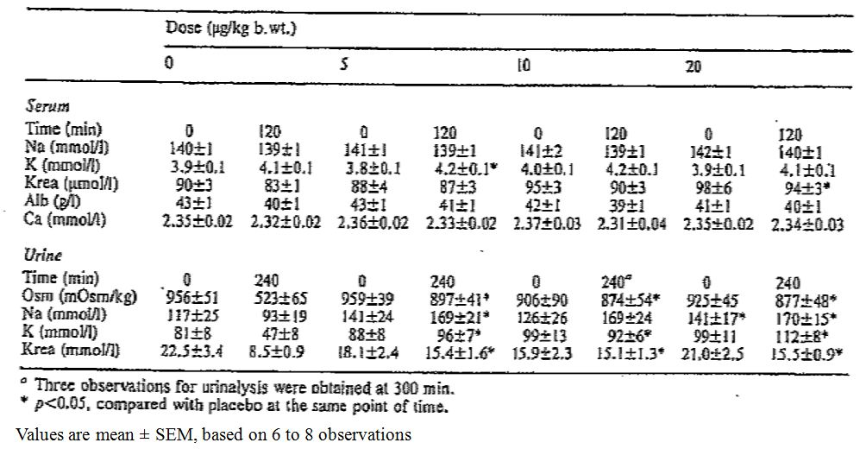
Two studies published since the 2004 submission (Bruha et al 2009 and Sola et al 2010) specifically examined the effect of terlipressin on renal function and serum sodium concentrations in patients with portal hypertension and actively bleeding oesophageal haemorrhage and demonstrated a significant potential for clinically important hyponatraemia associated with the use of terlipressin. Both of these studies examined the safety of terlipressin as a primary study outcome and therefore evaluated fully in this evaluation report.

Effects on ACTH release
V₃ receptors are found in the anterior pituitary, where they mediate adrenocorticotropic hormone (ACTH) release. In an open label cross over study, Andersson 1972 found that terlipressin administered IV at doses of 0.5 mg (n=3) and 1 mg (n=8) had no significant effects on plasma cortisol levels in healthy volunteers. These results were in stark contrast with the effects of vasopressin which, at a dose of 16 µg, almost doubled the cortisol levels and at doses of 4 µg and 1 µg increased cortisol levels by ~25%.

Evaluator’s comment:
The 2005 evaluator noted that the paper by Andersson 1978 provided insufficient detail for adequate evaluation. It was also noted that the copy of the paper submitted at that time was of such poor quality such that it was not possible to read and interpret information contained in graphs to counter the absence of textual information in the publication. Unfortunately neither the old nor a new copy of this paper has been included in the current submission, so it is not possible to address the uncertainties identified by the 2005 evaluator as part of the current evaluation.

Time course of pharmacodynamic effects
See Primary pharmacodynamic effects (above).

Relationship between drug concentration and pharmacodynamic effects
No data presented.

Genetic, gender and age related differences in pharmacodynamic response
No data presented.

Pharmacodynamic interactions
No formal drug interaction studies have been submitted. Glypressin has been shown to increase blood pressure and reduce HR and cardiac output in several animal species (including humans), which is thought to be the result of reflexogenic inhibition of cardiac activity via the vagus nerve secondary to increased blood pressure. Furthermore, it has been shown that atropine eliminates the effect and restores normal cardiac activity. Severe bradycardia has been reported in patients who were concomitantly treated with Glypressin and medicines known to induce bradycardia (for example, propofol, sufentanil and propranolol).

Evaluator’s overall conclusions on PD
A large body of evidence has been generated since the mid 1970s that consistently shows that terlipressin at doses of 1 and 2 mg reduces wedged hepatic venous pressure and hepatic venous pressure gradient, with an associated reduction in hepatic and blood azygos flow. The nature (that is, direction of change) and magnitude of the effects on splanchnic haemodynamic parameters have been generally consistent across a range of studies, such that both 1 and 2 mg appear to be effective doses in reducing portal pressure in the immediate to short term. Four seminal studies have shown that the onset of haemodynamic effects occur within a matter of minutes of bolus administration of terlipressin, indicating that terlipressin itself is vasoactive. The primary haemodynamic effects are sustained for at least 60 minutes following bolus injection, consistent with the conversion of terlipressin to lysine vasopressin.
The results of three dose ranging studies (Freeman 1988, Escorsell et al 1997 and Nilsson et al 1987) indicate trends toward a dose response relationship. However, only one of these monitored patients for long enough to show that the duration of effect is determined by dose (Escorsell et al 1997). This well designed and conducted double blinded, placebo controlled study demonstrated a persistence of effect of a 2 mg dose of terlipressin on HVPG at 4 h (exceeding 50% of the maximal effect), whereas neither arterial pressure nor peripheral vascular resistance were significantly different from placebo or baseline at that time point. However, the desired splanchnic effects of a 1 mg dose became non significant (compared to placebo and baseline) after 3 h. There is somewhat limited evidence pointing to a decrease in intra oesophageal variceal pressure, variceal pressure gradient and variceal wall tension after administration of a 2 mg bolus of terlipressin. There is also limited evidence that terlipressin reduces gastric mucosal blood flow (but not gastric mucosal oxygenation) and also probably leads to a preferential decrease in perfusion of functioning areas of the liver in cirrhosis.
Systemic haemodynamic effects of terlipressin include an increase in mean arterial pressure and systemic vascular resistance, and reductions in HR, cardiac output/cardiac index and skin blood flow.
With regard to secondary pharmacodynamic effects, in contrast to the effect of vasopressin, terlipressin has been shown to have minimal effects on the fibrinolytic system in cirrhotic patients and no significant effect on ACTH release in healthy volunteers. Administration of terlipressin has been shown to activate V2 vasopressin receptors present in the renal collecting ducts, resulting in antidiuretic effects evident within 60 minutes, with a subsequent progressive increase in urine osmolality over a 5 hour observation period. Other urinary changes include increased urinary sodium and potassium concentrations and increased urinary excretion of potassium. No consistent effects on serum sodium, potassium, calcium, albumin or urea concentrations have been observed in healthy volunteers. However, two clinical studies (published since the 2004 submission) have demonstrated the potential for clinically significant hyponatraemia associated with the use of terlipressin in the treatment of patients with portal hypertension and actively BOV.

Dosage selection for the pivotal studies
Four pivotal placebo controlled studies were identified by the sponsor. Three of the studies (Walker et al 1986, Söderlund et al 1990, Levacher et al 1995) did not provide a justification for the selection of dose or duration of treatment. The “protocol” submitted with the fourth paper (Freeman et al 1989) cited an earlier study by their group that had shown that 2 mg Glypressin every 6 h was significantly better in controlling bleeding varices than vasopressin in an open, randomised study (Freeman 1982).

Efficacy

Pivotal efficacy studies

Walker S, et al. (1986) Terlipressin in bleeding esophageal varices: a placebo controlled, double blind study. Hepatology 6: 112-115.

Study design, objectives, location and dates
This randomised, double blind, placebo controlled study examined the efficacy of terlipressin when added to standard therapy (including balloon tamponade [BT]) in cirrhotic patients with endoscopically verified variceal bleeding. The study was conducted on 50 consecutive patients with bleeding episodes between April 1983 and November 1984 at a single centre in Germany.

Inclusion and exclusion criteria
Patients with endoscopically verified BOV grade 2+ and 3+ according to Westaby et al 1983 were included in the study. Cirrhosis of the liver was diagnosed in by peritoneoscopy or needle biopsy at an earlier admission in 22 patients; during the same admission in 10 patients; and at autopsy in 2 patients. Exclusion criteria included pregnancy, coronary heart disease and asthma.

Study treatments
After endoscopy, patients were randomised to treatment with either an initial 2 mg IV injection of terlipressin (Glypressin), followed by a 1 mg injection every 4 h for a total of 36 h of treatment, or to corresponding placebo. Patients in both groups received “standard therapy” consisting of blood and plasma transfusion, fluid replacement, electrolyte correction and lactulose and BT. Sclerotherapy was to be performed if bleeding could not be controlled within 8 to 12 h. Re bleedings later than 36 h after randomisation were treated with standard therapy.

Efficacy variables and outcomes
The main efficacy variables were:
- vital signs – HR, blood pressure;
- the appearance of gastric lavage fluid – that is, clear, blood stained, etc; and
- the number of transfused blood units and fluid replacement requirements.
The primary efficacy outcome was the proportion of cases with bleeding control, where bleeding control was defined as bleeding having ceased within 36 h, with at least a 24 h period without evidence of bleeding. Bleeding was considered to have ceased when no fresh blood could be aspirated from the stomach via a nasogastric tube and haemodynamic parameters were stable. However, if sclerotherapy had been used within that time frame the outcome was considered to be a treatment failure.
Other efficacy outcomes included:
- Duration of bleeding;
- treatment failure within 36 h (including the need for sclerotherapy to stop the bleeding);
- blood and plasma transfusion requirements; and
- mortality at discharge.

Sample size
Sample size calculations showed that 105 bleeding episodes were required to be studied, based on an assumption of an increase in bleeding control rates from 60% to 80%, with a false positive rate of 5% (that is, type I error (α)) and false negative rate of 10% (that is, type II error, in which case power = 1 – type II error = 90%). An interim analysis of the first 50 bleeding episodes was reported to have prompted the investigators to stop the study.

Randomisation and blinding methods
Patients were randomised on admission. The randomisation method was not described. Allocation of treatment was concealed by the use of pre packed, numbered boxes containing either Glypressin or an identical placebo.

Statistical methods
Categorical data were analysed using a one tailed Fischer’s exact test and continuous variables were compared using the Wilcoxon signed rank test. Survival was analysed using Kaplain Meier methods (product limit estimates) and compared using the Wilcoxon test.

Participant flow
No patients were excluded from the study, refused entry or died before randomisation. A total of 50 bleeding episodes in 34 patients were randomised: 23 patients were randomised once, 8 patients were randomised twice, 1 patient three times and 2 patients four times. All 11 re randomised patients had been discharged between randomisations. All patients were followed up until discharge and no patients were lost to follow up.

Baseline data
Clinical and laboratory data obtained on admission for the 25 bleeding episodes in each group are shown in Table 3. Both treatment groups were matched for age, gender, cirrhosis aetiology, severity of liver disease and earlier bleeding and treatments with sclerotherapy. Approximately 50% of the episodes were classified as Child-Turcotte C.
Table 3: Clinical data on admission (Walker et al 1986).
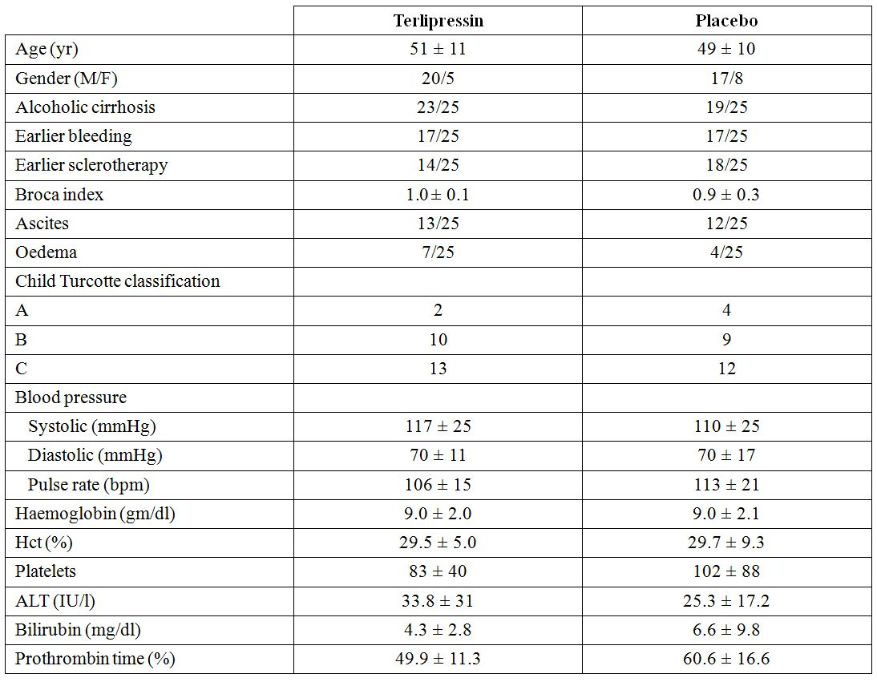

Results for the primary efficacy outcome
Control of bleeding in 36 h was reported to have been achieved in 25/25 (100%) of the episodes randomised to terlipressin, compared to 20/25 (80%) of the episodes randomised to placebo (p <0.05). However, among the episodes in which control was ultimately achieved, 5 treated with Glypressin, and 7 treated with placebo required sclerotherapy and were thus “treatment failures” according to protocol. This gave a total number of treatment failures of 5/25 (20%) for bleeding episodes randomised to terlipressin and 12/25 (48%) episodes randomised to placebo (p <0.05).
The company study report presented an additional analysis of treatment failures based on only the first enrolment for each patient. When the re randomised patients were removed from the analysis, the difference was not statistically significant.

Results for other efficacy outcomes
There were no statistically significant differences between the treatment groups in blood and plasma transfusion requirements, duration of bleeding, re bleeding after 36 h of treatment, or in hospital mortality (terlipressin: 3 deaths/25 episodes, 12%; placebo: 8 deaths/25 episodes, 32%).

Evaluator comment:
This study had a significant proportion of patients that were re randomised to treatment, with some randomised a total of 4 times. The issue of concern in this situation is that it cannot be assumed that the data represent independent observations and thus the validity of the statistical analysis is questionable. Of particular note, an additional analysis of treatment failures based on only the first enrolment for each patient was undertaken by the company and found no statistically significant difference between terlipressin and placebo for the control of bleeding at 36 h (the primary endpoint).
The published paper was accompanied by a 2½ page protocol and a company study report with a 1 page synopsis and IPD tabulations. The company study report was written some 6 years after the publication of the data and was signed off by a member of the Ferring Clinical Research Department, but not by the investigator. This evaluator has a number of concerns regarding the veracity of the data presented in the company study report:
- The text stated the treatment failure rates based on 1st enrolment were 5/21 (19%) in the Glypressin group and 5/14 (29%) in the placebo group. (Note these data were not presented in the publication.) If the raw data are correct, the calculated failure rates are arithmetically incorrect: a rate of 5/21 is 23.8% and a rate of 5/14 is 35.7%;
- The actual raw data are questionable. Given that a total of 34 patients were enrolled, there could only be 34 1st entries, not 35 (21 +14) as suggested by the company study report. It was not possible for this evaluator to confidently identify those patients who were re randomised and recalculate the failure rates from the limited IPD within the study report. This evaluator attempted to reconcile the data contained within the company study report, which were cited as the source of the data. The company study report presented data labelled “Bleeding control & therapy 0-36 h” (also denoted “first entries”) for the placebo and Glypressin groups, respectively. These tables contained entries for 14 and 21 cases, respectively, still in excess of the total of 34 patients reported to have been randomised to treatment. However, an, unlabelled, non paginated compilation of IPD titled “Survival, 1st Entry – Glypressin Group Dr Walker, Heidelberg” contained entries for 22 cases, which in addition to the 14 cases from corresponding table for placebo gives 36 first entries. Even more perplexing was the fact that this table for Glypressin included two cases (50 and 46) which did not appear in the company study report and was missing data for case 58, which did appear in the company study report. It would appear there are errors in the compilation/tabulation of data.
- The company study report presented bleeding control and therapy for 0-36 h for all episodes of bleeding in the Glypressin group. In the column headed “Bleeding control within 36 h”, 2 of the 25 episodes (cases 10 and 19) were entered as “no”, that is, taken by this evaluator to mean that bleeding control had not been achieved. However, the publication and text of the study report state bleeding control was achieved in 25/25 (100%). It was noted in the paper and study report text that 5 patients received sclerotherapy. This matches the listing in the company study report. Thus, the only way that this data can be reconciled with the statements in the paper and study report text is that if the outcome for bleeding control at 36 h for cases 10 and 19 have been erroneously entered as ‘no’ when they were in fact ‘yes’.
- The company study report showed that only 18 of all episodes of bleeding in the placebo group were considered to have bleeding controlled (and, conversely, 7 not to have had bleeding control) at 36 h. This is in contrast to 20 cases stated in the publication and study report text. Furthermore, the study report text and publication stated that 7 patients required sclerotherapy. However, the company study report showed that 5 required sclerotherapy (denoted by the entry “yes” in the relevant column labelled “sclerotherapy”). Another two cases had entries of “no” in the same column and were the only two cases where the non performance of sclerotherapy was seemingly indicated. If these 2 cases are treated as data entry errors and counted as “yes”, a figure of 7 cases of sclerotherapy is achieved.

Freeman JG, et al. (1989) Placebo controlled trial of terlipressin (Glypressin) in the management of acute variceal bleeding. J. Clin. Gastroenterol. 11: 58-60.

Study design, objectives, locations and dates
This randomised, double blind, parallel group study was conducted at the Royal Victoria Infirmary and University of Newcastle upon Tyne with the aim of comparing terlipressin (Glypressin) and placebo in the treatment of BOV. A secondary aim of the study was to examine the additive effect of Glypressin and the use of the Sengstaken-Blakemore tube (SBT). The period over which the study was conducted was not reported.

Inclusion and exclusion criteria
Patients with actively BOV confirmed by endoscopy were included in the study. Other sources of haemorrhage were required to have been endoscopically excluded. Otherwise, no other selection criteria were reported in the publication.

Study treatments
Patients received a blood transfusion on presentation and within 4 h of hospital admission were randomised to receive either terlipressin 2 ampoules (2 mg) IV every 4 h for a maximum of 6 doses (24 h) or until the bleeding stopped, followed by 4 doses of 1 mg every 4 h (that is, a further 16 h), or to corresponding placebo. Patients also received a liver failure regimen, comprising lactulose, neomycin and vitamins.
The higher dose of terlipressin was never continued for more than 6 doses and all patients were assessed as a treatment success or failure within 24 h of admission to the trial. Also, treatment was continued for at least 8 h after an episode of haematemesis or melaena before bleeding was deemed to have ceased but, importantly, cessation of bleeding was not confirmed endoscopically.

Efficacy variables and outcomes
The primary efficacy outcome was the proportion of patients with bleeding control at 24 h. Bleeding was considered to be controlled when hourly haemodynamic measurements and haemoglobin were stable, when further bleeding was not apparent and when further transfusion was unnecessary.
Other efficacy outcomes included:
- The proportion of patients requiring BT (passage of a SBT) to control bleeding. Failure of vasoconstrictor therapy was considered to have occurred if after at least 2 doses, continued haematemesis or fresh melaena necessitated the use of BT. In such circumstances removal of the tube was followed by endoscopic sclerotherapy;
- Bleeding control at 5 days;
- Transfusion requirement;
- Mortality rates; and
- Re bleeding after initial control.

Sample size
There was no a priori sample size calculation, however it was estimated from findings of a previous by the same authors study (terlipressin versus vasopressin – Freeman et al 1982) that it would be necessary to randomise 30 bleeding episodes to achieve a statistically significant difference between the two treatments.

Randomisation and blinding methods
The randomisation method was not described. It was noted in the protocol that the randomisation schedule was held by the hospital pharmacy. Blinding was achieved with the use of an identical placebo.

Statistical methods
The Mann Whitney U test and χ² test were used for tests of statistical significance. One tailed tests were used because it was considered unlikely that terlipressin would be worse than placebo.

Participant flow
A total of 29 consecutive patients entered the study. Of these, 16 were originally randomised to receive placebo and 13 to receive terlipressin.
One patient in the placebo group had a re bleed 8 days after discharge from hospital following successful treatment of the initial bleed (identified as case 22) and was readmitted and re randomised to receive terlipressin (this bleeding episode was case 23). Also, one patient originally randomised to receive terlipressin re bled 14 hours after ceasing treatment for the initial bleed (identified as case 30). This patient was subsequently re randomised to receive terlipressin (bleeding episode identified as case 33). Consequently, there were 31 bleeding episodes for which terlipressin was used to treat 15 and placebo was used to treat 16.
A total of 6 patients died from uncontrolled bleeding: 2 in the terlipressin group (bleeding cases 9 and 25) and 4 in the placebo group (bleeding cases 3, 12, 19 and 29). A SBT was passed in attempt to control the bleeding in 3 of these patients but all 3 died within 3 days of hospital admission (case 9 at 1 day; case 25 at 3 days; and case 3 at 1 day). In the remaining 3 patients there was no documented treatment of the ongoing bleeding, with the patients dying on days 1 (case 12), 4 (case 29) and 6 (case 19) of the admission. Two other patients in the placebo group (cases 27 and 31) underwent sclerotherapy and SBT, respectively following treatment failure and later died (case 27 died 2 days after admission and case 31 at an unspecified time). However, neither case was documented as being due to continued bleeding. The deaths were presumably related to the underlying alcoholic liver disease.

Baseline data
The two groups, both as initially randomised as well as after the two patients who re bled were re randomised, were well matched for age, aetiology of portal hypertension, Child Pugh classification and hepatic function tests (Table 4).
Table 4: Patient demographic and clinical characteristics (Freeman et al 1989).
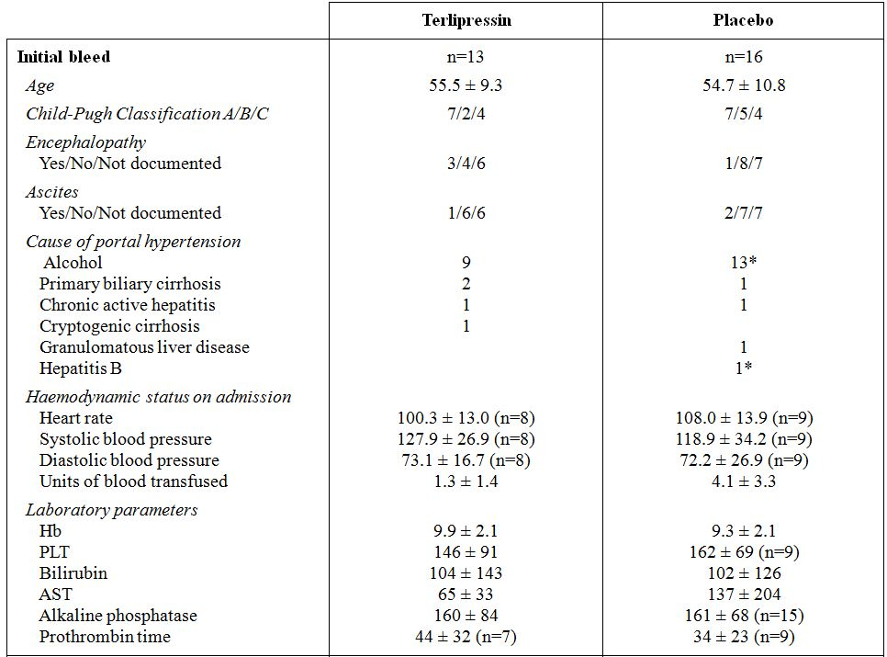
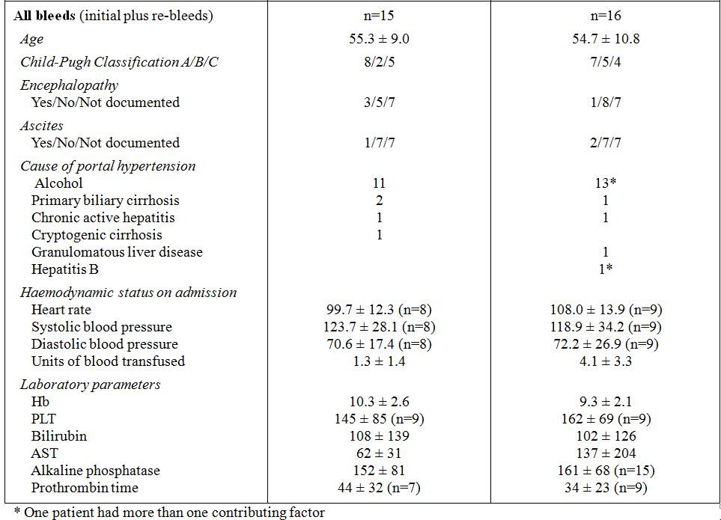

Results for the primary efficacy outcome
Initial control of bleeding within 24 h was achieved in 9/15 (60%) of the episodes randomised to terlipressin, compared to 6/16 (37%) of the episodes randomised to placebo. However, this difference was not statistically significant.

Results for other efficacy outcomes
It was reported that during follow up, 1 patient in the terlipressin group and 3 patients in the placebo group re bled within 5 days after completion of the trial protocol. Thus, control of bleeding at 5 days was 8/15 (53%) of the episodes randomised to terlipressin and 3/16 (19%) of the episodes randomised to placebo (χ2=4.04; p <0.025).
There were no statistically significant differences between the treatment groups in blood transfusion requirement or in hospital mortality (terlipressin: 3 deaths/15 episodes (20%); placebo: 4 deaths/16 episodes (25%)).

Evaluator’s comment:
The published paper was accompanied by a 2 page study synopsis (presumably written by Ferring AB), a 6 page protocol (which appears to have been written by the investigators) and 31 pages of IPD, some of which was duplicated, but no formal company study report. Despite the presence of these additional documents, the study was quite difficult to evaluate. The published paper was not of a contemporary standard and lacked detail about the randomisation process and how allocation to treatment was concealed, and did not discuss deviations from and violations of the protocol or losses to follow up. In addition, there were patchy and incomplete IPD. For example, gender was not reported and a significant number of patients (~50% in each group) did not have their clinical status (in terms of presence and/or severity of encephalopathy and ascites) recorded. A significant number of patients did not have their vital signs on admission (HR and blood pressure) recorded in the IPD (Table 4). Also, some sets of data were labelled cryptically.
The summary statistics for haemodynamic status presented in Table 4 were calculated by this evaluator using the IPD submitted by the company. The transfusion requirements calculated from the IPD could not be reconciled with statements in the published paper. The paper stated that both groups required similar volumes of blood prior to entry into the study, citing figures (presumably medians) of 2 U for terlipressin and 3 U for placebo, with an overall range of 1-12 U. However, by this evaluator’s calculations based on the IPD, the average number of units required prior to admission for all bleeding episodes treated with placebo was 4.1 ± 3.3 (median 4.5) compared to 1.3 ± 1.4 (median 1) for the terlipressin group. The difference in means was statistically significant, suggesting the bleeds treated with placebo were more severe.
There was quite a large numerical difference between the two treatment groups with respect to the primary efficacy outcome however this was not statistically significant due to lack of study power. There was also no difference between the groups for in hospital mortality.

Söderlund C, et al. (1990) Terlipressin (triglycyl-Lysine vasopressin) controls acute bleeding oesophageal varices. A double blind, randomised, placebo controlled trial. Scand. J. Gastroenterol. 25: 622-630.

Study design, objectives, location and dates
The aim of this randomised, double blind, placebo controlled study was to investigate whether terlipressin was efficacious in controlling acute variceal bleeding for at least 24 hours to allow time for subsequent, more definitive treatment such as sclerotherapy. The study was conducted in 60 consecutive patients at two centres in Sweden from November 1985 to August 1988.

Inclusion and exclusion criteria
Patients with demonstrated or clinically suspected cirrhosis with endoscopically verified variceal bleeding or varices of at least size 3 and a history of extensive upper gastrointestinal tract bleeding within the last 24 h before endoscopy, with no other lesion with bleeding stigmata (that is, varices assumed to be the source of bleeding) were eligible for inclusion in the study. Extensive bleeding was defined as bleeding likely to require at 2 U of whole blood or an equivalent amount of packed red cells in 24 h. Diagnostic endoscopy had to be performed within 12 h of admission and prior to randomisation. Patients were excluded if they were pregnant, weighed <55 kg or had participated in a previous variceal study at one of the study sites.

Study treatments
After endoscopy, patients were randomised to treatment with either an initial 2 mg IV bolus injection of terlipressin (Glypressin), followed by a 2 mg bolus injection every 4 h for a total of 24 to 36 h of treatment, or to corresponding placebo. Treatment was continued until an endoscopy with sclerotherapy was performed between 24 and 36 h after the initiation of treatment, or until an emergency intervention (for example, BT or emergency sclerotherapy) was required.

Efficacy variables and outcomes
The main efficacy variables were:
- vital signs including HR, blood pressure and continuous ECG monitoring;
- nasogastric aspirate appearance, and the occurrence of haematemesis and melaena;
- serum haemoglobin levels and transfusion requirements; and
- requirements for plasma and other solutions for infusion.
The primary efficacy outcome was ‘treatment success’, defined as no need for active intervention (for example, vasopressin, BT, sclerotherapy or shunt) for any reason during the treatment period. Patients undergoing any emergency intervention were deemed treatment failures.
Other efficacy outcomes included:
- ‘efficacy of the test medication’, defined as no or just a slight mix of blood in two consecutive gastric lavages 4 h apart in a haemodynamically stable patient, with no ongoing bleeding/fresh blood at control endoscopy;
- transfusion requirements in the 24 h subsequent to control endoscopy; and
- length of hospital stay and in hospital mortality.

Sample size
A priori sample size calculations showed that a minimum of 41 patients were required for the study to have 80% power to demonstrate a difference in “haemostatic effect” for terlipressin versus placebo of 70% versus 40%, with a level of significance of 0.05. A target sample size of 60 was chosen to accommodate uncertainties in the assumed success rates in the two groups.

Randomisation and blinding methods
Patients were included consecutively and randomised in blocks of four with stratification for Child Pugh Class C (score 11-15) severity of liver disease. Blinding was maintained by the use of an identical placebo.

Statistical methods
Comparison of the proportions of patients in each group with ‘success’ and ‘efficacy’ were performed using Fisher’s exact test. Comparison of blood transfusion requirements was made using Mann-Whitney’s test. ANOVA (analysis of variance) was used to compare repeated measures such as blood pressure, HR, and serum haemoglobin.

Participant flow
A total of 60 patients were randomised to treatment – 31 to receive terlipressin and 29 to receive placebo – and no patient was randomised more than once. All patients were followed over their entire hospital stay. A total of 14 patients died while in hospital; 3 (9.7%) from the terlipressin group and 11 (37.9%) from the placebo group (p=0.014).

Evaluator’s comment:
As noted above, diagnostic endoscopy had to be performed within 12 h of admission and prior to randomisation. The delay between admission and endoscopy was comparable between the two groups, averaging approximately 5.5 h (median approximately 3 h). However, it was evident that there was a significant departure from the protocol in the timing of the diagnostic endoscopy in 5 patients: 3 from the placebo group and 2 from the terlipressin group. In all cases the diagnostic endoscopy was delayed beyond 20 h after admission and in one case, from the terlipressin group, the delay was 47.6 h.
Also of note, the vast majority of patients received their first treatment injection within 30 minutes of the diagnostic endoscopy. However, in the placebo group the delay between endoscopy and treatment with medication for 2 patients was 23 h. In contrast, in the terlipressin group all but 1 patient received their medication within 90 minutes of the diagnostic injection, with the remaining patient experiencing a delay of 6 h.

Baseline data
Patient demographics and clinical characteristics are summarised in Table 5. The two groups were well balanced with respect to age, gender, weight, and aetiology and severity of liver disease. Of note, significantly more patients in the terlipressin group had a previous history of BOV – 19/31 (61.3%) versus 9/29 (31.0%) (p=0.02; Fisher’s exact test). However, about one-third of the patients in each group had poor hepatic function (Child Pugh Class C), known to be a major determinant of outcome.
Table 5: Patient demographic and clinical data at inclusion (Söderlund et al 1990).
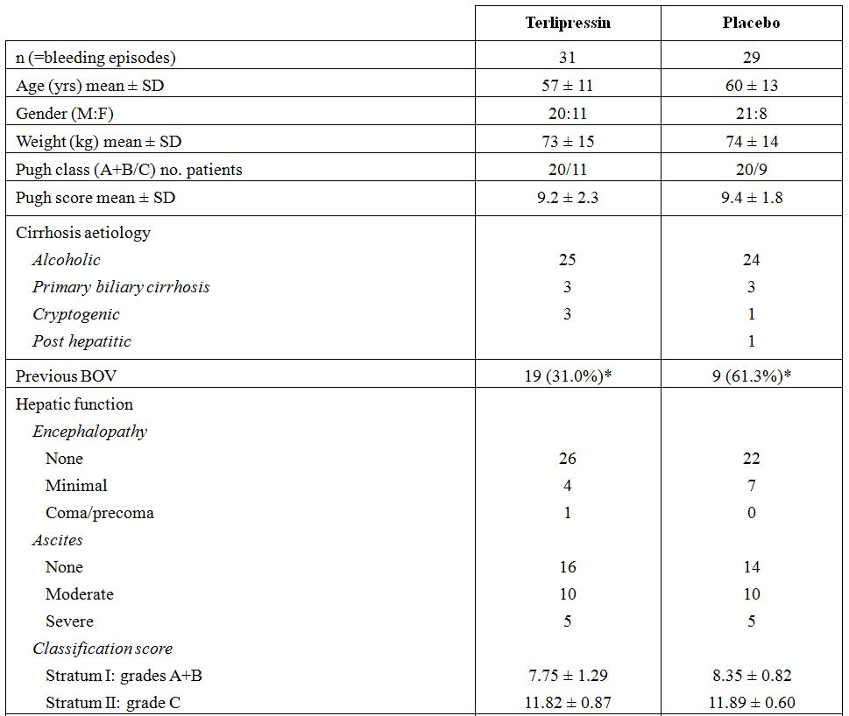
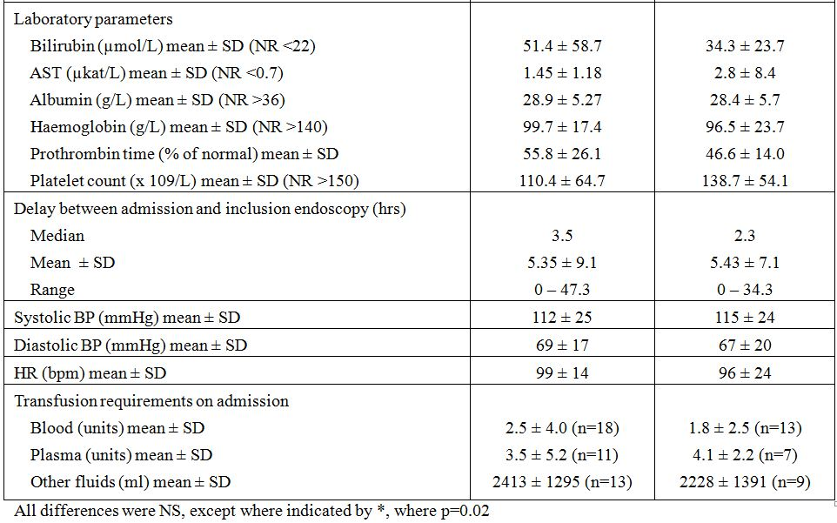

Results for the primary efficacy outcome
Efficacy results are summarised in Table 6. Initial control of bleeding (‘success’) was achieved in 28/31 (90%) of the patients randomised to terlipressin, and in 17/29 (59%) of the patients randomised to placebo (p=0.0067; Fisher’s exact test).
Table 6: Efficacy results (Söderlund et al 1990).
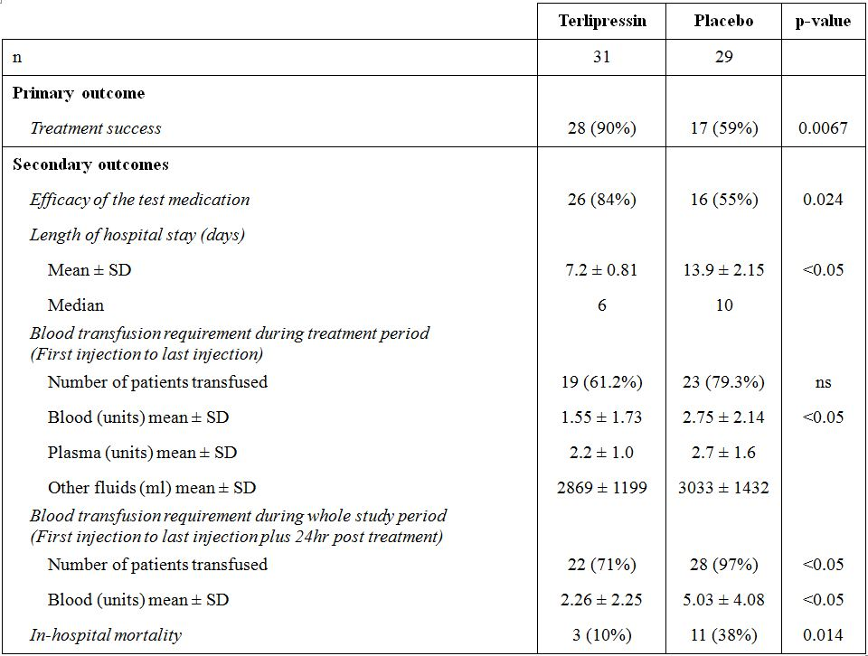

Results for other efficacy outcomes
During treatment, 2 patients in the terlipressin group and 1 patient in the placebo group had re bleeds. Consequently, ‘efficacy of the test medication’ was slightly lower in both treatment groups, however the difference was still statistically significant in favour of terlipressin (terlipressin 26/31 (84%) versus placebo 16/29 (55%); p=0.024 (Fisher’s exact test)).
The requirement for blood transfusions was also significantly lower in the terlipressin group than in the placebo group, both during the treatment period (that is, first injection to last injection) and during treatment and for the 24 h follow up period. During the whole study, from first injection to 24 h follow up, 22/31 (71%) of the patients in the terlipressin group and 28/29 (97%) of the patients in the placebo group required any blood transfusion (p <0.05).
In-hospital mortality was 3/31 (10%) of the patients in the terlipressin group and 11/29 (38%) of the patients in the placebo group (p <0.05). All deaths were due to bleeding or due to hepatic failure secondary to bleeding.

Evaluator’s comment:
On face value this study shows that terlipressin is significantly more efficacious than placebo in controlling BOV as verified by control endoscopy. Such a conclusion is supported by the fact that the use of terlipressin was also associated with a reduced requirement for blood transfusion, a shorter hospital stay and significantly reduced in hospital mortality.
The study was well designed and generally well conducted, with stratification of what is considered to be a major determinant of outcome (Child Pugh Class C). Furthermore, the statistical methods were appropriate and included an a priori sample size calculation. Compliance with inclusion criteria was also acceptable. However some major deviations were noted with respect to delays in excess of 12 h from admission to the diagnostic endoscopy and subsequent randomisation and initiation of treatment but these affected both groups more or less equally.
The greatest concern with this study is the inability of this (and the 2005) evaluator to reconcile some of the results reported in the publication by Söderlund and figures cited in the company study report. The more discrepant results (that is, those not simply explained by rounding (errors)) are highlighted by shading. The discrepancies relate mostly to clinical data at baseline. Furthermore, the magnitudes of the discrepancies in the two sets of data are unlikely to change conclusions regarding the comparability of the two groups at inclusion. However, they do cast a wider concern about the accuracy of data transcription and the veracity of results presented in the rest of the report. Of particular note, the company study report stated that of the 29 patients randomised to receive placebo, 21 were stratified to stratum I (Child Pugh Class A+B) and 8 to stratum II (Child Pugh Class C). It was subsequently found that one patient in stratum I should have been stratified to stratum II. In the terlipressin group 22 patients were included in stratum I and 9 in stratum II; however, 2 patients in stratum I should have been stratum II and 1 in stratum II should have been stratum I. A final (corrected) distribution was therefore presented in the company study report. However, neither the initial nor the final distribution presented in the study report matched that given in the published paper.
In contrast to some of the other study reports submitted in support of published papers, the first version of the company study report pre dated the literature publication and was signed off in 1988 by the principal investigators at each of the study centres as being a correct and faithful record of the results obtained. However, the last amendments to the company study report were made in 1991 and therefore post date both the investigator sign off and publication of the results in the literature. Consequently, the sponsor should be requested to summarise the content and basis of the amendments that were made to the report in 1991 and provide an explanation for the discrepancies.

Levacher S, et al. (1995) Early administration of terlipressin plus glyceryl trinitrate to control active upper gastrointestinal bleeding in cirrhotic patients. Lancet 346: 865-868.

Study design, objectives, location and dates
This randomised, double blind, placebo controlled study was conducted in cirrhotic patients with upper gastrointestinal bleeding with the aim of investigating the efficacy of a combination of terlipressin and nitroglycerin (GTN), administered early by a medical emergency team (SAMU) that goes to the patient, makes a clinical assessment and starts treatment in the home. The study was conducted from October 1991 to June 1993.

Inclusion and exclusion criteria
Cirrhotic patients aged between 18 and 70 years who received emergency care from SAMU at their home for an active upper gastrointestinal bleed (confirmed by aspiration of fresh blood from a nasogastric tube) were eligible for inclusion. Cirrhosis was diagnosed by the physician on the SAMU team on the basis of clinical history and examination, requiring evidence of at least one of the following signs: hepatomegaly; ascites; jaundice; spider naevi; asterixis; or epigastric collateral venous circulation. Patients with a history of coronary artery disease, uncontrolled hypertension, chronic renal failure, chronic respiratory failure, symptomatic arteritis, or treatment with vasopressin, somatostatin or terlipressin within the previous month were excluded from the study. Other exclusion criteria were HR <60bpm, use of β blocker agents, low blood pressure (systolic <70 mmHg despite resuscitation with 1 L of a macromolecular solution over 30 minutes); and pregnancy.

Study treatments
Patients were randomised to receive either terlipressin (Glypressin) + a transdermal nitroglycerin patch (24 mg/12 h) or to placebo injections (0.9% saline) + an excipient patch. Patients received an initial injection in the home setting with repeat injections at 4 and 8 h. The dose of terlipressin was adjusted for body weight. Patients weighing <50 kg received 1 mg doses; those weighing 50-70 kg received 1.5 mg; and patients weighing >70 kg received 2 mg doses.
After initiation of treatment, patients were transferred to the hospital intensive care unit where they received fluid replacement and/or blood transfusion and oxygen. Endoscopy was performed within 24 h of admission to hospital (but not necessarily before the primary efficacy endpoint had been achieved) to identify the cause of bleeding, to check for persistence of bleeding, and to perform sclerotherapy.

Efficacy variables and outcomes
The main efficacy variables within the first 24 h were:
- vital signs – HR, blood pressure, ECG – and Glasgow Coma score;
- the appearance of gastric lavage fluid – that is, clear, blood stained, etc;
- blood profile, particularly haemoglobin and platelet levels, prothrombin and partial thromboplastin times, and fibrinaemia; and
- the number of transfused blood units and fluid replacement requirements.
In the period after 24 h (and up to 15 days), monitoring of the following was undertaken:
- complete blood count, prothrombin time, partial thromboplastin time, fibrinaemia, factor V ;
- hepatic function – AST (aspartate aminotransferase), ALT (alanine aminotransferase), ALP (alkaline phosphatase) and blood ammonia;
- hepatic encephalopathy, including EEG evaluation; and
- severity of the hepatopathy, assessed according to Child Pugh criteria.
The primary efficacy outcome was control of bleeding without re bleeding, evaluated at 12 h. Relevant definitions were:
- Control of bleeding was defined as the appearance of a clear gastric lavage plus a stable haemoglobin (decreases of <2g/dL) once clear gastric lavage was obtained.
- Re bleeding was defined as reappearance of blood in gastric lavage and/or a haemoglobin decrease of >2g/dL after initial control of the bleeding.
- Failure of treatment was defined as persistent bleeding (continued blood in gastric lavage fluid), or re bleeding, or the occurrence of side effects requiring cessation of trial therapy or death.
Other efficacy outcomes included:
- Blood transfusion requirement during the first 12 h;
- Recurrence of bleeding after the first 12 h and within the first 15 days;
- Survival at 15 days and 6 weeks (42 days).

Sample size
No sample size calculations were performed.

Randomisation and blinding methods
Randomisation was performed by the SAMU physician at the patient’s home but the method was not described. However, it was stated that the physician was not aware of the treatment allocation. Blinding was achieved through the use of a double placebo – identical injection (0.9% saline) and identical (excipient) patch.

Statistical methods
Qualitative variables in the two treatment groups were compared using the χ² or Fisher’s exact test. Quantitative variables such as the number of blood units transfused, and clinical and biological variables were compared using the Mann-Whitney U test. Bleeding control was compared using the Mantel-Haenszel test with adjustment for the Child Pugh score. Survival curves were used for the analysis of deaths with the log rank test adjusted by the Child Pugh score. The death rate at 12 h, 24 h, 15 days and 6 weeks was analysed using the Mantel Haenszel test after adjustment for the Child Pugh score.

Participant flow
A total of 85 bleeding episodes in 77 patients were randomised to treatment: eight patients were randomised twice, having been treated on separate occasions at least 30 days apart (Note: the treatment groups were not identified.) One patient was included by ‘error’ (actual details of the error not reported) and not analysed, leaving 84 bleeding episodes in 76 patients.

Baseline data
The bleeding episodes at the time of initial infusion were similar for the two treatments with respect to age, gender, body weight, aetiology of cirrhosis, haemodynamics and severity of hepatic disease (Table 7). Of note, patients in study had severe liver disease: 80% were Child Pugh Class C, and none Class A.
Table 7: Characteristics of bleeding episodes at infusion (Levacher et al 1995).
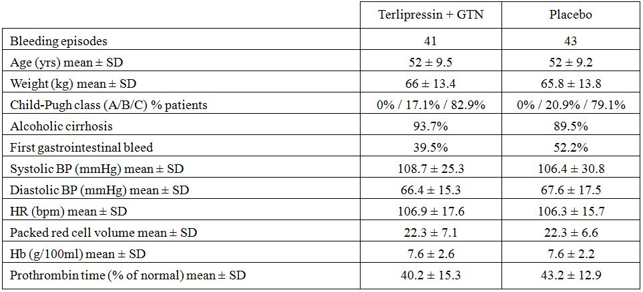

Endoscopic diagnosis
Endoscopy was performed on 78 patients (39 in each treatment group), with the remaining 6 having died in the first few hours of treatment. Endoscopy was performed at a mean ± SD of 16.9 ± 6.4 h in the terlipressin group and 17.3 ± 8.2 h in the placebo group. The presence of varices was confirmed, with no other visible cause of bleeding evident in 28/39 (71.7%) of bleeding episodes in the terlipressin group and in 31/39 (79.4%) bleeding episodes in the placebo group. It should be noted that endoscopy could be performed after the primary endpoint at which time active bleeding may or may not have been present or not. If varices were present and no other potential cause was identified, it was assumed that the bleeding had come from ruptured varices.
In 7/39 (17.9%) bleeding episodes in the terlipressin group and 3/39 (7.6%) bleeding episodes in the placebo group, there was endoscopic visualisation of varices but they were not actively bleeding and there were other potential causes of haemorrhage evident. For these cases, bleeding due to ruptured oesophageal varices was not considered to have been “confirmed”. Furthermore, in an additional 5/39 (12.8%) bleeding episodes in each group, other potential causes of upper gastrointestinal bleeding (such as oesophagitis, gastroduodenitis and duodenal ulcer) were identified.

Results for the primary efficacy outcome
Control of bleeding at 12 h was achieved in 29/41 (71%) of the episodes randomised to terlipressin and in 20/43 (47%) of the episodes randomised to placebo (p=0.039).
Time to control of bleeding was 3.9 ± 4 h in the terlipressin group and 5.2 ± 4.6 h in the placebo group (p=0.28). In patients who had re bleeding, an alternative therapy was used to achieve haemostasis in 4 cases in the terlipressin group (sclerotherapy (n=1), BT (n=3)) and in 8 cases in the placebo group (sclerotherapy (n=3), BT (n=5)).
When the analysis was limited to those episodes considered to be due to BOV, 77.7% episodes ceased within 12 h in the terlipressin group, compared to 41.9% in the placebo group (p=0.017).

Results for other efficacy outcomes
The secondary efficacy outcomes are presented in Table 8. Of note, up to and including the 12 h endpoint:
- 2 (4.9%) patients receiving terlipressin and 4 (9.3%) receiving placebo died (p=0.67). Causes of death were not reported, although it was noted that 4 patients in each group experienced fibrinolysis, with 2 dying within 12 h (treatment group not identified);
- 7 (17%) cases in the terlipressin group and 12 (27.9%) cases in the placebo group had persistent bleeding;
- 5 (12.1%) patients receiving terlipressin and 11 (25.5%) patients receiving placebo had re bleeding (p=0.11); and
- there was no statistically significant difference in the number of units of blood transfused in each group.
Table 8: Primary and secondary outcomes (Levacher et al 1995).
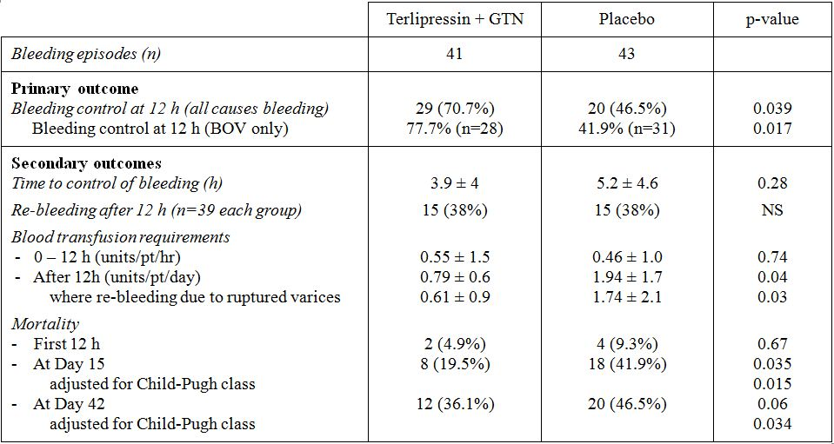
Beyond 12 h:
- there was no statistically significant difference between the treatment groups in frequency of re bleeding after 12 h, which was mainly due to ruptured oesophageal varices (terlipressin 11 episodes; placebo 12 episodes);
- re bleeding episodes randomised to terlipressin required fewer blood transfusions beyond 12 h than episodes randomised to placebo, indicating the severity of re bleeding was greater in placebo group;
- an alternative therapy was used to achieve haemostasis during 12 episodes in the terlipressin group (BT [n=9], surgical procedure [n=3]) and 15 in the placebo group (BT [n=10], surgical procedure [n=3]);
- mortality at 15 days was lower in the episodes randomised to terlipressin than in those randomised to placebo (19.5% versus 41.9%; p=0.035); and
- mortality at 42 days, although numerically lower in the terlipressin group (36.1% versus 46.5%), was not statistically significantly different (p=0.06). However, when adjusted for Child Pugh class, the difference in mortality was statistically significant in favour of terlipressin (p=0.034).

Evaluator’s comment:
In this study the dose of terlipressin received by patients was based on their body weight. This was one of only two studies to employ such an approach (the other being that reported by Garcia-Compean et al 1997). Furthermore, in this study terlipressin was administered with nitroglycerin. The routine use of a combination of vasoconstrictor plus a vasodilator is not recommended according to recent international practice guidelines.
Treatment was initiated prior to diagnostic endoscopy and, consequently, a number of patients were enrolled who did not have BOV. This study appropriately included all randomised patients in the analyses of primary and secondary endpoints but also included an analysis of the primary (but not secondary) endpoint for patients with BOV only. The results for bleeding control at 12 h were consistent across these two analyses.
Diagnostic endoscopy was to be performed within 24 h of admission to hospital and this may or may not have occurred before the primary efficacy endpoint had been achieved (that is, at 12 h). This is an important consideration because sclerotherapy was performed at the endoscopy. No data were provided on when endoscopy (and therefore sclerotherapy) was performed in the two groups. Such data are important for assessing whether the timing of endoscopy in the two groups was comparable (that is, the groups were treated equally), and for assessing extent to which sclerotherapy may have contributed to the observed primary outcomes.
At the time of reporting this was the first study to show a long term reduction in mortality with terlipressin compared to placebo in patients presenting with massive upper GIT bleeding.

Other efficacy studies
This section contains a summary of the supporting efficacy studies.

Terlipressin versus placebo
The single additional study, reported in an abstract by Patch et al 1999, was essentially unevaluable because of gross deficiencies in the information provided. However, from the minimal information available, it was evident there was no difference between patients who received terlipressin and those who received placebo with respect to treatment failures (Placebo 56% versus Terlipressin 60%), blood transfusion requirements, the number of patients requiring “salvage” TIPS (transjugular intrahepatic portosystemic shunts) or additional endoscopy; or mortality at 5 or 42 days.

Terlipressin versus octreotide
The sponsor submitted 5 studies in which the efficacy of terlipressin was compared to that of octreotide: Silvain et al 1993, Pedretti et al 1994, Brunati et al 1996, Cho et al 2006 and Abid et al 2009. Of note, Silvain et al 1993 used terlipressin in combination with glyceryl trinitrate; Brunati et al used terlipressin in combination with sclerotherapy; and the more recent studies by Cho et al 2006 and Abid et al 2009 used terlipressin in combination with endoscopic banding. All studies were open label except for Abid et al 2009 and no two studies used the same treatment regimen for either terlipressin or octreotide.
With the exception of one study (Abid et al 2009), patients were randomised after endoscopy. In Abid et al 2009, patients were randomised as ‘potential’ study subjects on initial presentation to the emergency room, following which randomised drug treatment was commenced. Endoscopic banding ligation then was performed within 24 h of admission, at which time final enrolment in the study was confirmed.
In the studies by Silvain et al 1993 and Pedretti et al 1994, patients underwent emergency sclerotherapy only if the bleeding was not controlled by the trial drugs. They found that initial bleeding control rates (at 12 and 24 h, respectively) were numerically higher in patients treated with octreotide but these differences were not statistically significant. However, both studies were underpowered to detect anything less than quite large differences between the two treatment groups. Also in the study by Silvain et al, some patients appeared to have been excluded from participation in the study without adequate explanation. In the study reported by Brunati et al 1996, patients underwent sclerotherapy at initial endoscopy and, if taken at face value, the results suggest the use of terlipressin in combination with sclerotherapy increases bleeding control compared to the use of sclerotherapy alone and gives a level of bleeding control comparable to that of octreotide and sclerotherapy. However, this study was reported in an abstract that was not evaluable.
In the study by Cho et al 2006, patients underwent endoscopic banding within 24 h of commencing drug therapy. Very high success rates (control of bleeding at 48 h in more than 95% patients) and very low re bleeding rates at 5 days were observed in both treatment groups, with no statistically significant between group differences. However, a significant limitation was that patients lost to follow up at any time up to 6 weeks post treatment were excluded from the analysis. This was potentially a significant source of bias, but there is no way of assessing its impact because the paper contained no information about the total number of patients initially randomised to treatment and subsequently lost to follow up, or their responses to treatment.
The largest and best quality data are those from a randomised, double blind, non inferiority study reported by Abid et al 2009. This study was of contemporary standard. Randomisation was centralised and computerised, and the use of placebo infusions and bolus injections ensured that double blinding was maintained. A priori sample size calculations were performed and the chosen non inferiority margin of 11% for the primary endpoint (control of variceal bleeding) was appropriate. Non inferiority of terlipressin was adequately demonstrated - control of bleeding was achieved in 158/163 (97%) of the patients randomised to terlipressin + banding ligation, and in 160/161 (99%) of the patients randomised to octreotide + banding ligation (p=NS). Also, the mean length of hospitalisation was shorter in the terlipressin group than in the octreotide group (108 h versus 126 h, p <0.001) and in hospital mortality was 9/163 (6%) in the terlipressin group and 7/161 (4%) in the octreotide group (p=NS). However, a significant limitation is that patients started study medication before their final eligibility had been determined. As a result, 35 patients were excluded after they had received study drug and no information was presented on the outcomes in these patients. Ideally, the study should have documented all the outcomes that occurred as part of the treatment strategy.

Terlipressin versus somatostatin
A total of 5 studies were submitted, of which 2 were double blind (Walker 1996 and Feu et al 1996) and 3 open label (Pauwels et al 1994, Hafta 2001 and Seo et al 2006).
A standard dose of somatostatin (250 µg bolus followed by a 250 µg/h infusion) was used, with the studies differing only in terms of the duration of treatment, which progressively increased from 24 h in the earliest studies (Walker 1996) to 5 days in the most recent study (Seo et al 2006). Two studies used a 2 mg q4h regimen for terlipressin, but this regimen was used for different durations of treatment (48 h in Feu et al 1996 and 72 h in Hafta et al 2001). Different regimens were used in each of the remaining 3 studies, although all employed a dose reduction from 2 mg to 1 mg.
In Feu et al 1996 and Walker 1996, patients were randomised after endoscopy and included only patients with variceal bleeding. Pauwels et al 1994, Hafta 2001 and Seo et al 2006 all randomised patients to treatment before endoscopy was performed. In the study by Hafta et al 2001, patients underwent sclerotherapy within 30 minutes of starting study medication; in the study by Seo et al 2006, patients actively bleeding at diagnostic endoscopy were treated with banding ligation, sclerotherapy or BT.
The publication by Pauwels et al 1994 was of low quality and contained numerous deficiencies in reporting of information, including baseline characteristics. Furthermore the study was underpowered as a result of low patient numbers and it is not surprising statistically significant differences were not found despite the fact that the point estimates for the between group differences for primary haemostasis and definitive haemostasis were ~20% in favour of somatostatin over both terlipressin and placebo.
Hafta et al 2001 found no significant differences in terms of control of bleeding between terlipressin (82%) and somatostatin (71%). However, this was a small study. Furthermore, the publication contained little information about the design and conduct of the study. A particular concern about the study design was the fact that patients could be later excluded from the study if they received sclerotherapy more than 30 minutes after starting the test medication. This was potentially a significant source of bias, but there is no way of assessing its impact because the paper contained no information about the number or outcomes of patients excluded on this basis. Ideally, the study should have documented all the outcomes that occurred as part of the treatment strategy.
Seo et al 2006 also found no statistically significant differences between terlipressin and somatostatin in regard to failure of initial haemostasis, re bleeding rates at 5 days, mortality at 5 days and overall 5 day failure rate (a combination of all three endpoints). However the rates were all numerically higher in the terlipressin group, with a 5 day failure rate (the primary endpoint) of 20.8% for terlipressin versus 12.0% for somatostatin. Of particular note is that a considerably smaller number of patients were enrolled than originally planned due to recruitment difficulties and the authors acknowledged the resultant increased potential for a type II error (that is, declaring no treatment difference when in fact there is a true population difference).
The two largest studies (Feu et al 1996 and Walker 1996) found no statistically significant differences between terlipressin and somatostatin with respect to bleeding control rate, re bleeding rates and mortality rates (at 42 days and in hospital, respectively). These studies were each adequately powered to detect ~20% differences in bleeding control rates (at a 5% level of significance), assuming a rate of ~80% for terlipressin and ~60% for somatostatin. The paper by Feu et al 1996 was a high quality publication that contained detailed descriptions of the study design and methodology, ethics approval, patient disposition and treatment outcomes. Withdrawals and dropouts were also described. The design of the study was also of contemporary standard, as evidenced by a centralised randomisation process, use of a double dummy method to ensure maintenance of blinding, and use of pre packed, numbered boxes for adequate concealment the allocation of treatment. The study by Walker 1996 was similarly well designed, but the publication did not include a description of the randomisation method or the concealment of allocation to treatment. In addition, in this study a third of the patients enrolled in the study were re randomised. The concern is that the observations in such cases may not be independent and, thus, standard statistical analytical methods would not be appropriate. However, somewhat reassuringly, the potential impact of re randomising patients was examined at the time of an interim analysis, by which stage 13 patients had been re randomised (out of an eventual total of 24), with 10 patients randomised twice; 2 patients three times; and 1 patient four times. It was found there was no statistically significant difference in the results of the first randomisation compared to the subsequent randomisations for any of the study endpoints.
Another point of note with the two double blinded studies was that the study population included patients with bleeding gastric varices (BGV: 10% in Walker 1996 and 6% in Feu et al 1996), which is not sought as an indication in this submission. Outcomes for BOV and BGV were not reported separately.

Terlipressin versus vasopressin
The sponsor submitted five published papers that presented the conduct and results of randomised, non blinded controlled trials comparing terlipressin and vasopressin: Freeman et al 1982, Desaint et al 1987, Lee et al 1988, Chiu et al 1990 and D’Amico et al 1994.
Different treatment regimens were used for terlipressin and vasopressin in each of the studies. The initial dose of terlipressin was a 2 mg bolus in all studies. Thereafter, 2 mg doses were administered until bleeding was controlled, at which point the dose was reduced to 1 mg in three studies: Freeman 1982, Desaint 1987 and Chui et al 1990. In the study by Lee et al 1988 following the initial bolus of 2 mg, the dose of terlipressin was reduced to 1 mg for the duration of treatment, whereas in the largest study (D’Amico et al 1994), 2 mg doses were administered throughout (for a duration of 24 h). Four of the studies used a six hourly regimen for terlipressin and only the study by Chui et al 1990 used a four hourly regimen as proposed in this submission. Vasopressin dose was equally as variable, ranging from 0.4 to 0.66 U/h and, in the case of Lee et al 1988 and D’Amico et al 1994, used in conjunction with GTN. In the study by D’Amico et al 1994, all patients underwent emergency endoscopy and if actively bleeding varices were identified, sclerotherapy was performed using repeated injections of 1% sodium tetradecyl sulfate until bleeding ceased. None of the other studies performed sclerotherapy routinely on presentation.
Collectively, these papers were of low quality and not of a contemporary standard. Two papers in particular, Freeman et al 1982 and Desaint et al 1987 presented quite minimal information about the selection criteria used and virtually no information about baseline characteristics of the two treatment groups. The latter is particularly important, as comparable baseline characteristics can provide reassurance that the randomisation and concealment methods had not been corrupted. In addition, information about protocol deviations and violations, and losses to follow up was lacking.
Only 1 study found a statistically significant difference between the two treatments in the achievement of bleeding control. In a very small study comprising 19 patients (21 bleeding episodes) in total, Freeman et al 1982 observed a bleeding control rate of 70% in patients receiving terlipressin and 9% in patients receiving vasopressin. However, the rate observed for vasopressin was markedly lower than that observed in any of the other studies (which ranged from 53% to 83%). Also, the trend observed in the remaining studies was not consistent. Three studies (Desaint et al 1987, Lee et al 1988 and Chiu et al 1990) had outcomes for initial haemostasis that favoured the vasopressin group, in which the between group difference in the proportions of patients with initial bleeding control ranged from 3% to 6%. However, the result from the largest study (D’Amico et al 1994) favoured terlipressin, where the between group difference in the proportions of patients with initial bleeding control was 8%. Of particular note, of the 165 bleeding episodes randomised to treatment in this study, only 111 were from variceal bleeds (101 from oesophageal varices and 10 from gastric varices). In a post hoc analysis, which should be interpreted with caution, the failure rate for variceal bleeding was 13/55 (24%) in the vasopressin group and 5/56 (9%) in the terlipressin group, with a between group difference of 15% [95% CI: -28 to 0; p=0.035].

Terlipressin versus terlipressin
Two studies conducted in the Czech Republic compared different doses and durations of treatment with terlipressin. Bruha et al 2002 compared a low dose terlipressin regimen (0.2 mg IV fourth hourly, which had been the standard dose used in that country up to that time) and a so called “high dose” terlipressin (1 mg fourth hourly) over 5 days. They found no statistically significant differences between the two regimens in terms of failure rates, re bleeding rates, transfusion requirements or mortality at 5 and 30 days. Of note were the relatively high success rates in the absence of sclerotherapy or other apparent definitive treatment, including the low dose regimen (78% at 2 days and 75% at 5 days). Although this study was double blinded and randomisation and concealment methods appear to have been adequate, there were significant limitations with its conduct, including the fact that patients were allowed to have been treated with terlipressin within the last 24 h prior to study entry (but no data were presented on how many patients actually fell into this category and how they were distributed between the two groups) and the fact that 19% of patients, mostly from the high dose group were excluded from the per protocol analysis without any explanation. As a general rule of thumb, loss of more than 10% patients from a treatment group is a cause for concern as it has the potential to corrupt the balance afforded by randomisation and substantially change the overall characteristics of the trial population. No results were presented to show that the 2 groups were balanced at baseline. It should also be noted that only 43 patients in the per protocol population actually had BOV; the remainder had portal hypertensive gastropathy.
The study by Bruha et al 2009 was essentially a small safety study, with efficacy outcomes as secondary endpoints. Patients underwent sclerotherapy or banding ligation at diagnostic endoscopy and then received 1mg terlipressin every 4 hours for either 5 or 10 days. No statistically significant differences were observed between the two groups for any of the efficacy outcomes, however the robustness of inferences that can be drawn from this study are limited because of its small size (only 25 patients were enrolled).
Collectively these studies offer little by way of establishing the efficacy of terlipressin in relation to the regimen proposed in the submission. Neither used a 2 mg dosage regimen and without a control group that received no terlipressin, it cannot be concluded that either dose of terlipressin had any effect over and above that of supportive care.

Terlipressin versus non pharmacotherapies
Four studies in compared terlipressin with non pharmacotherapies.

Terlipressin versus BT
Three older publications (Colin et al 1987, Fort et al 1990 and Garcia-Compean et al 1997) reported the results of studies of terlipressin where BT was a comparator. All three studies compared terlipressin alone with BT alone (either a SBT, in Colin et al 1987 and Fort et al 1990, or a Linton-Michel tube in Garcia-Compean et al 1997). In addition, Colin et al 1987 also compared terlipressin alone with terlipressin + BT. No two studies used the same regimen for terlipressin and only Garcia-Compean et al 1997 used a four hourly regimen (for a total duration of 24 h only). Of note, the study by Fort et al combined the use of terlipressin with glyceryl trinitrate, which is not directly relevant to proposed regimen.
All 3 studies were open label, which is to be expected, as blinding would be impossible for the treatment arm receiving BT. Overall the papers describing these studies were of low quality. There were no statistically significant differences between the groups for any of the endpoints in the studies by Colin et al 1987 and Fort et al 1990, and the initial bleeding control rates for the terlipressin groups (at 48 h and 24 h, respectively) were 85% and 78%. In contrast, in the smallest study by Garcia-Compean et al 1997 in which 50% of the patients had BGV, the control of bleeding was significantly better in patients randomised to BT (95% versus 70%; p <0.05), with superiority most evident in Child Pugh Class C classified episodes. However, in the terlipressin group re bleeding during the first week in initially controlled episodes was less common and transfusion requirements were lower but neither of these differences reached statistical significance. Haemorrhage recurrence after 1 month was statistically significantly less common in the terlipressin group (17% versus 80%; p <0.05). Also of note, this study was one of only two studies in which the dose of terlipressin was based on the patients’ body weights (the other study being that reported by Levacher et al 1995).

Terlipressin versus sclerotherapy
There was a single, open label study comparing terlipressin alone with sclerotherapy, reported by Escorsell et al 2000. Patients in this study were randomised to treatment after diagnostic endoscopy and all patients had endoscopically verified acute BOV. Terlipressin was administered at a dose of 2 mg every 4 h until bleeding control and then 1 mg every 4 h for 5 days.
This relatively large, well powered study found no significant difference in failure to control bleeding (with similar results for patients with and without active bleeding at endoscopy), re bleeding, number of blood transfusions required and 42 day mortality. Overall, this was a good quality paper, with well described methodology and results, including an explicit statement about ethical approvals and compliance with GCP.

Terlipressin versus terlipressin plus non pharmacotherapy
Two publications reported on studies that compared the efficacy of terlipressin alone to that when used as an adjuvant to a non pharmacotherapy. The first of these, by Colin et al 1987, is covered above.
A second publication by Lo et al 2009 was of good quality, with well described methodology and results. In this study, patients without evidence of active variceal bleeding received a stat dose of 2 mg terlipressin and then received either 1 mg every 6 h for 5 days or combined therapy comprising endoscopic banding followed by 1 mg terlipressin every six hours for 48 h. Terlipressin when used in combination with endoscopic variceal ligation was superior to terlipressin alone across a number of study endpoints: treatment failure occurred in 24% of the patients in the terlipressin group and only 2% of the patients in the combined therapy group (p=0.002). Furthermore, very early re bleeding (48-120 h) was higher in the terlipressin group (15% versus 0; p=0.006), with significantly higher transfusion requirements in the terlipressin group than in the combined therapy group, both in the acute phase up to 48 h, and between 49 and 120 h. Of note, a substantial proportion of patients (~35%) had gastric rather than oesophageal varices and, in the absence of separate results for the oesophageal varices subgroup, extrapolation of these results to the proposed indication of BOV should be made with caution.

Analyses performed across trials (pooled analyses and meta analyses)
The submission contained 8 publications that reported analyses from more than one study. Papers by Bosch et al 1994, Nevens 2004, Krag et al 2008 and Garcia-Tsao and Bosch 2010 were essentially review articles based on systematic reviews of literature with no new information over and above that contained in the studies submitted in the submission and, in particular, without any pooling or meta analyses of the data. These publications are not considered further in this evaluation report.
The remaining 4 publications contained results from meta analyses of data as follows:
- D’Amico 1995 was a meta analysis based on publications available at that time and therefore predated most of the supporting papers and 2 of the placebo controlled studies (including the pivotal study by Levacher et al 1995). Consequently, this paper is not considered further in this evaluation report;
- D’Amico et al 2003 was based on a Cochrane Collaboration review of sclerotherapy versus vasoactive drugs in the treatment of BOV. Only one study contained in the review was of relevance to this submission (Escorsell et al 2000) and this was considered in the 2003 Cochrane Collaboration review of terlipressin (reported by Ioannou 2003). Consequently, this paper is not considered further in this evaluation report;
- D’Amico et al 2010 was an updated report of the Cochrane Collaboration review of sclerotherapy versus vasoactive drugs in the treatment of BOV (reported earlier by D’Amico et al 2003). There were no new data of relevance to this submission and consequently, this paper is not considered further in this evaluation report; and
- Ioannou 2003 was the paper that reported the results of the 2003 Cochrane Collaboration review of terlipressin and included all the placebo controlled studies and many of the supporting studies submitted in the current dossier. This paper was submitted and evaluated as part of the previous submission to the TGA. In the current submission this publication has been submitted together with a recent reprint of the Cochrane Collaboration’s own publication of the results. These are considered below.

Ioannou GN, et al. (2003) Systematic review: terlipressin in acute variceal haemorrhage. Aliment. Pharmacol. Ther. 17: 53-64.
The 2005 evaluator detailed a number of concerns over the validity of the meta analysis in the 2005 evaluation report. The main concerns were:
- abstracts that were essentially unevaluable were included in the meta analysis;
- studies that enrolled patients more than once were included in the meta analysis and the data were analysed on the assumption that they were independent observations; and
- data from the study by Patch et al 1999 appeared to have been incorrectly reported due to transposition of results for the terlipressin and placebo groups.
The primary outcome measure was all cause mortality – chosen because of the clinical importance of the outcome and in the hope there would be less heterogeneity between studies than for bleeding control and re-bleeding, which had been defined differently in different studies.
Also, rather than assessing bleeding control, the meta analysis examined number of patients failing initial haemostasis. Other predefined endpoints included the number of patients with re bleeding, number of procedures required for uncontrolled bleeding and number of blood transfusions. The main findings/conclusions were:

Terlipressin versus placebo
Terlipressin was associated with a statistically significant reduction in:
- all cause mortality compared to placebo (relative risk 0.66; 95% CI: 0.49 to 0.88);
- failure of haemostasis compared to placebo (relative risk 0.47; 95% CI: 0.32 to 0.70); and
- the number of emergency procedures required for uncontrolled bleeding (relative risk 0.58; 95% CI: 0.38 to 0.88)

Terlipressin versus octreotide
Only small, low quality studies were identified and no difference was demonstrated in any of the major outcomes.

Terlipressin versus somatostatin
Within the limited power provided by a small number of studies, no statistically significant difference was demonstrated between terlipressin and somatostatin for any of the outcomes.
Terlipressin versus endoscopy
No statistically significant difference was demonstrated between terlipressin and endoscopy for any of the outcomes in the single study identified.

Terlipressin versus vasopressin
Only small, low quality studies were identified and no difference was demonstrated in any of the major outcomes.

Terlipressin versus BT
Only small, low quality studies were identified and no difference was demonstrated in any of the major outcomes.

Evaluator’s comment:
The 2005 evaluator’s concerns over the validity of the methodology of this meta analysis are supported by this evaluator. In particular, this evaluator agrees with the finding that results from the abstract by Patch et al 1999 were transposed. The abstract stated “there was no difference between placebo and Terlipressin in numbers of patients fulfilling failure criteria at 5 days (56%:60%) ... or death within 42 days (33% versus 42%, p=0.4)”, from which this evaluator concludes that the first mentioned figures are those for the placebo group. However, in the Cochrane review, the number failing initial haemostasis was reported as 37/66 (56%) for the terlipressin group and 40/66 (60%) for the placebo group and the numbers cited for mortality were 22/66 (33%) for terlipressin and 28/66 (42%) for the placebo group. Similarly, the results for emergency procedures appear to have also been transposed. This essentially invalidates the comparison of terlipressin and placebo for these outcomes because the study by Patch was given the greatest weighting of all the placebo controlled studies (31.2% weighting for the number failing initial haemostasis, 34.9% weighting for mortality and 35.5% weighting for emergency procedures). Thus, the true combined endpoints are likely to be substantially different.

Evaluator’s conclusions on clinical efficacy for BOV
The key efficacy results (initial bleeding control, re bleeding and mortality) are summarised according to each comparator in Tables 9 to 14. These tables include both individual study results and the results from the combined analyses performed for the 2003 Cochrane meta analysis. Studies contributing to the Cochrane analysis are shaded in grey.
Table 9: Efficacy outcomes for terlipressin versus placebo.
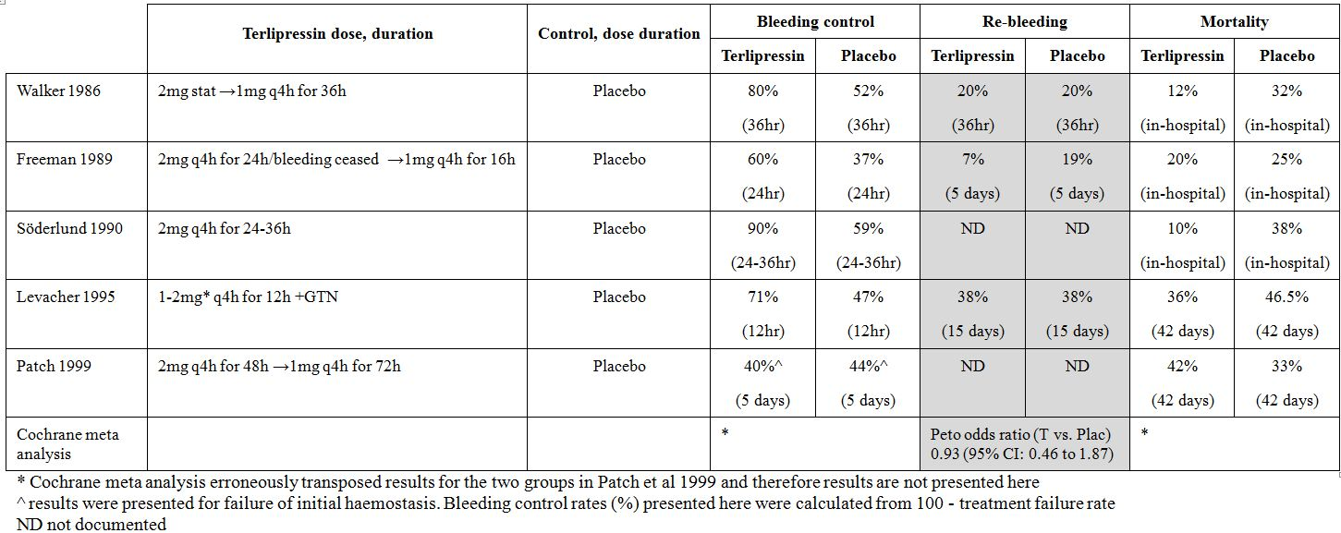
Table 10: Efficacy outcomes for terlipressin versus octreotide.
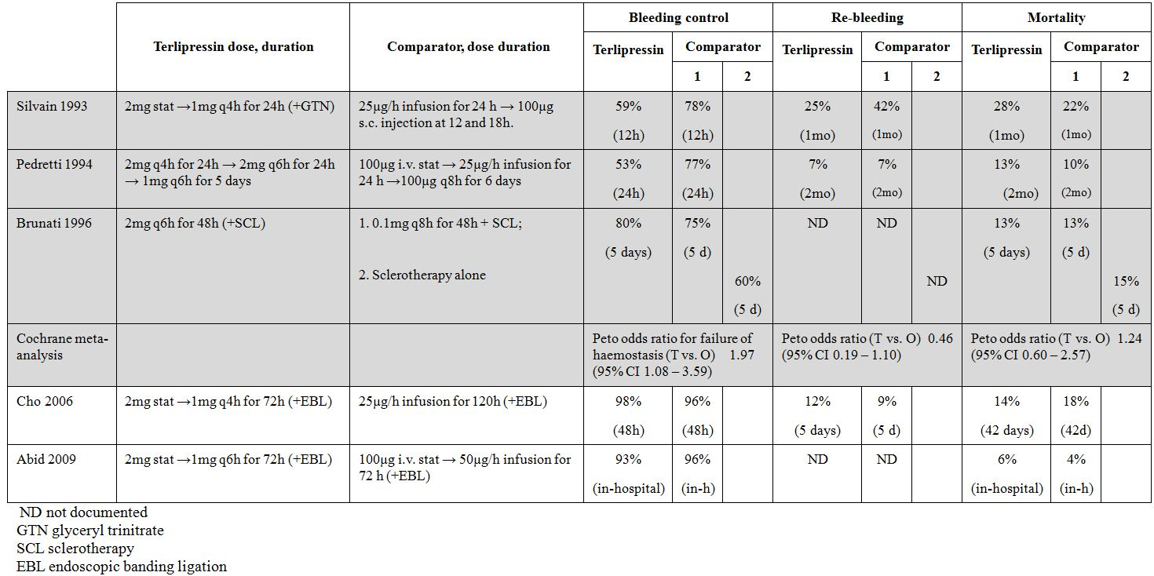
Table 11: Efficacy outcomes for terlipressin versus somatostatin.
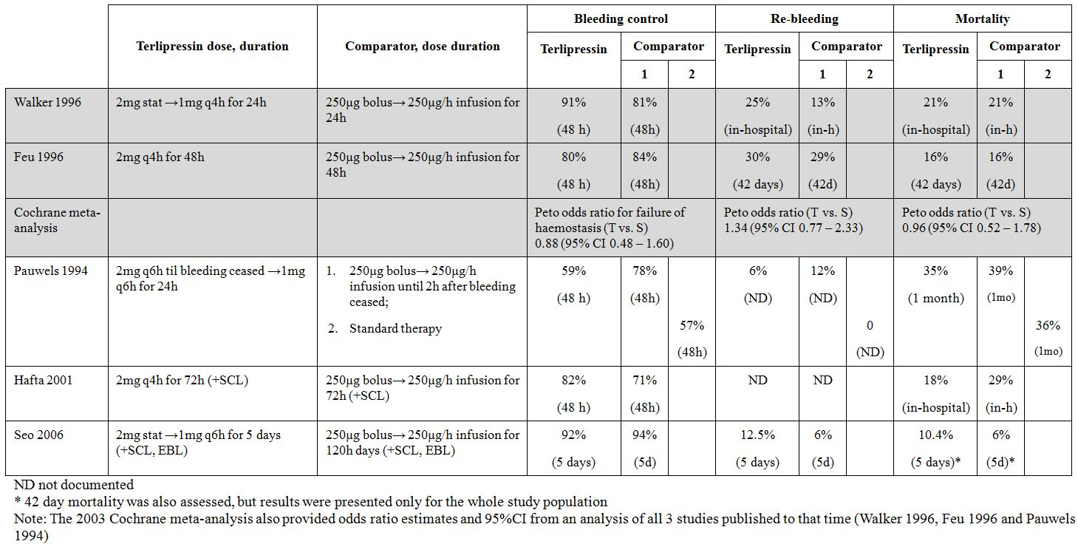
Table 12: Efficacy outcomes for terlipressin versus vasopressin.
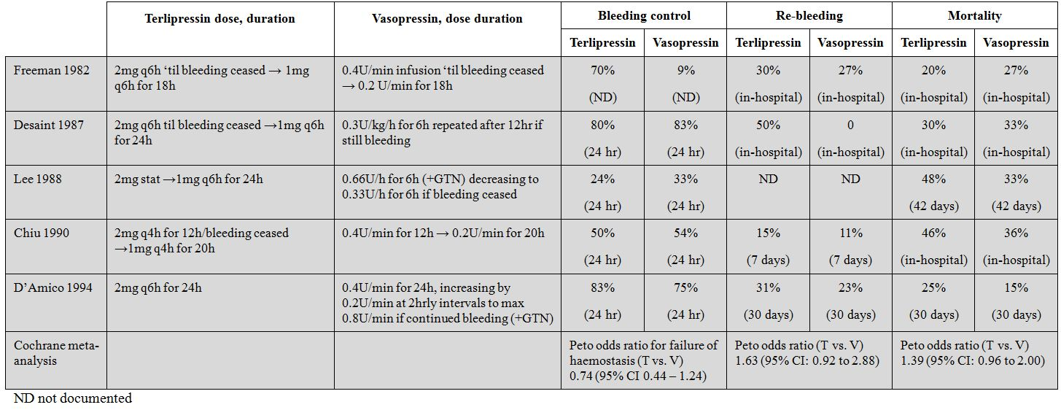
Table 13: Efficacy outcomes for terlipressin versus BT.
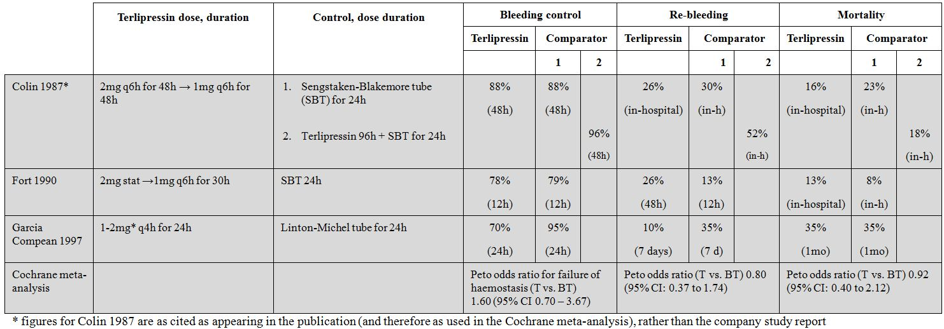
Table 14: Efficacy outcomes for terlipressin versus sclerotherapy.
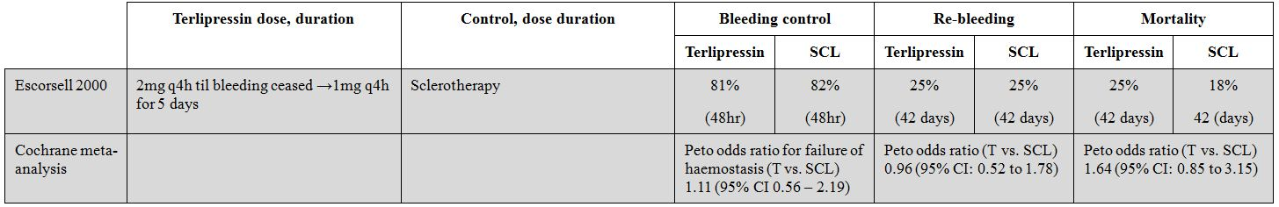
The assessment of the overall efficacy of terlipressin for BOV was particularly problematic because:
- There was an almost exclusive reliance on published papers, most of which were not of contemporary standard. Consequently, key information necessary for critical appraisal of the data were lacking;
- Many different definitions were used for bleeding control/failure of initial haemostasis and re bleeding. Furthermore, these endpoints were assessed at different times across the studies. This can be appreciated from Tables 9 to 14, which include data on the timing of each endpoint in each study (in brackets). There were also a variety of ways in which data were reported in the papers. For example, transfusion requirements were variously reported as means, medians, total number of transfusions, and transfusions per day;
- Many studies allowed patients to participate more than once. This had clearly occurred in 12 of 27 studies, including 3 of the 4 pivotal placebo controlled studies, which raises questions about the appropriateness of the use of statistical analyses that assume that the data represent independent observations;
- Some studies enrolled patients with causes of upper gastrointestinal bleeding other than oesophageal varices (for example, gastric varices, portal hypertensive gastropathy);
- Some studies did not include all randomised patients in the analysis or did not provide adequate information (including outcomes) on those excluded from the analysis (this was covered in some length by the 2005 evaluator);
- Many different dosage regimens were used, with none exactly matching that proposed in the submission; and
- The results of the Cochrane meta analysis of terlipressin versus placebo were invalid because of an apparent transposition of results for the treatment groups in the study by Patch et al 1999, which were given the greatest weighting in the analyses.

Pivotal, placebo controlled studies

Initial haemostasis
Control of initial bleeding was the primary endpoint of these studies. Two of the four pivotal placebo controlled studies (Söderlund et al 1990 and Walker et al 1986) showed a significant advantage of terlipressin over placebo in terms of control of initial haemostasis. Of these two studies, Söderlund et al 1990 did not allow re randomisation of patients. On the other hand, a significant proportion of patients were re randomised in the study by Walker et al 1986 and an additional analysis of treatment failures based on only the first enrolment for each patient was undertaken by the company and found no statistically significant difference between terlipressin and placebo for the control of bleeding at 36 h. In the remaining pivotal studies (Freeman et al 1989 and Levacher et al 1995) no significant difference was found between the two groups, although the trends were in favour of terlipressin.

Mortality
Söderlund et al 1990 showed a significant reduction of in hospital mortality with terlipressin compared to placebo. Levacher et al 1995 showed a statistically significant reduction in mortality at Day 15, but at Day 42 the difference was significant only after adjustment for Child Pugh class. No significant mortality reduction was observed with either Walker et al 1986 or Freeman et al 1989.

Re bleeding
Three of the pivotal studies presented re bleeding rates (Walker et al 1986, Freeman et al 1989, Levacher et al 1995). None of these studies showed any statistically significant differences between the two groups. No statistically significant difference was found between terlipressin and placebo for this endpoint in the Cochrane meta analysis (which used only the above mentioned three studies).
Table 9 shows a consistency of the point estimates for bleeding control despite the heterogeneity of definitions and timing for these endpoints. Furthermore, each of the pivotal studies had quite large numerical difference in favour of terlipressin for this endpoint, but statistical significance was not reached because of under powering of the studies. The study by Patch et al 1999 casts some doubt over this because it was the largest and reported non significant results in favour of placebo. However, the study has never been published in full, and without additional information about the validity and general application of the results cannot be assessed further.
In the view of this evaluator, the most compelling data are from the study reported by Söderlund et al 1990, which was well designed and generally well conducted study with stratification of what is considered to be a major determinant of outcome (Child Pugh Class C). Importantly, patients were randomised to treatment only once. The statistical methods were appropriate and included an a priori sample size calculation. This study showed a significant advantage of terlipressin over placebo in terms of control of initial haemostasis as well as a statistically significant reduction of in hospital mortality with terlipressin compared to placebo. Unfortunately, the published paper and corresponding company study report provided conflicting information, particularly with regard to group characteristics at baseline. These differences need to be reconciled by the sponsor before the results can be fully accepted.
The study by Levacher et al 1995 also deserves some consideration. This study examined outcomes in patients who were commenced on terlipressin by an emergency team before transfer of the patient to hospital and may therefore be relevant to settings where specialist endoscopy services are not available. At the time of reporting, this was the first study to show a long term reduction in mortality (at 42 days) with terlipressin compared to placebo. The company’s clinical expert argued that the initial control of bleeding was likely achieved before endoscopic sclerotherapy. However, no data were provided to support any definitive conclusions in this regard, although it is conceivable that the use of terlipressin may have contributed to the visualisation of the varices. Particular limitations of this study include the fact that some patients were re randomised during the study, and the fact that patients in the terlipressin group received a GTN patch, whereas placebo group patients did not. There is the possibility that the observed mortality effect in the terlipressin group was at least in part due to the use of the patch. The Cochrane Review investigated this possibility by performing a subgroup analysis of studies with and without the use of nitrates. However, once again the meta analysis used transposed results from the study reported by Patch et al 1999, so the combined point estimate is invalid.
It should be appreciated that the pivotal placebo controlled studies were conducted over a period of 9 years from 1986 to 1995. Only one pivotal placebo controlled study (Levacher et al 1995) employed sclerotherapy at initial endoscopy as part of the protocol and, apart from the study reported by Walker et al 1986 (in which all patients were offered BT on admission), no procedures were routinely performed in the first 24 h in the remaining studies. A particular concern therefore, is the relevance of these old studies to modern management strategies for BOV.

Other studies
With regard to the other efficacy studies, this evaluator considers particular attention should be given to:
- studies comparing the efficacy of terlipressin with that of somatostatin and octreotide (an somatostatin analogue), because octreotide is considered a drug of choice for the treatment of BOV in current Australian guidelines; and
- studies that have examined the efficacy of terlipressin either compared with endoscopic treatments or in combination with endoscopic treatments. These are important because current international guidelines and recent consensus conferences (for example, Garcia-Tsao et al 2007) have recommended the use of combined pharmacological and endoscopic therapy as a first line treatment, with a similar stance having been adopted in current Australian guidelines.
Unfortunately, only small, low quality studies were identified that compared terlipressin alone with octreotide alone and no firm conclusions can be drawn from these. There were two higher quality studies of terlipressin versus somatostatin, of which Feu et al 1996 is most relevant because it used the proposed dosage regimen throughout the 48 h duration of the study. Although this is an older publication, it contained detailed descriptions of the study design and methodology, ethics approval, patient disposition and treatment outcomes. Withdrawals and dropouts were also described. The design of the study was also of contemporary standard, as evidenced by a centralised randomisation process, use of a double dummy method to ensure maintenance of blinding and a sufficiently large sample size for power to detect ~20% differences in bleeding control rates (at a 5% level of significance), assuming a rate of ~80% for terlipressin and ~60% for somatostatin. There were no statistically significant differences between terlipressin and somatostatin with respect to bleeding control rate, re bleeding rates and mortality rates (at 42 days). No patients in this study were randomised more than once.
Two studies involving endoscopic treatments stand out as being of importance:
- Escorsell et al 2000: this relatively large, well powered study compared terlipressin with sclerotherapy and found no significant difference in failure to control bleeding (with similar results for patients with and without active bleeding at endoscopy), re bleeding, number of blood transfusions required and 42 day mortality. Overall, this was a good quality paper, with well described methodology and results. No patients in this study were randomised more than once. However, as this study was open label the results may have been impacted by ascertainment bias. The bleeding control rate at 48 h with a 2 mg q4h terlipressin regimen was 81% compared to 82% with sclerotherapy.
- Abid et al 2009: This study was of contemporary standard, employing double dummy blinding for the demonstration of non inferiority of terlipressin plus endoscopic banding to octreotide plus endoscopic banding (with non inferiority margin of 11%). Control of bleeding was achieved in 158/163 (97%) of the patients randomised to terlipressin + banding ligation, and in 160/161 (99%) of the patients randomised to octreotide + banding ligation (p=NS). The mean length of hospitalisation was shorter in the terlipressin group than in the octreotide group (108 h versus 126 h, p <0.001) and in hospital mortality was 9/163 (6%) in the terlipressin group and 7/161 (4%) in the octreotide group (p=NS). No patients in this study were randomised more than once.
In addition, if taken at face value, the results of the study by Brunati et al 1996 show that the use of terlipressin in combination with sclerotherapy increases bleeding control compared to the use of sclerotherapy alone and gives a level of bleeding control comparable to that of octreotide and sclerotherapy. However, although not specifically documented in the abstract, this study was almost certainly open label.
Many of the supporting studies were small, low quality and open label. In addition, the outcomes commonly used across these studies were quite subjective, which in the context of open label studies raises the likelihood of ascertainment bias. However, it can be appreciated from Tables 10-14 that success rates in terms of initial bleeding control have been reasonably consistent across the supporting studies, despite substantial differences in study design, the dose used, and assessment of treatment effect.

Dosage regimen
The submission proposes a dose of 2 mg every 4 h for no more than 48 h (although there is a potentially confusing statement in the draft PI that treatment may be continued to 5 days subject to local approval). Dose reduction is proposed in patients weighing <50 kg once bleeding is controlled.
The maximum duration of treatment with 2 mg (given either every 4 h or every 6 h) in any of the studies was 72 h. In those studies where treatment was continued for up to 5 days, a 1 mg dose was used, rather than the 2 mg dose as recommended in the submission. Thus, this evaluator is of the view that the data submitted only supports 72 h of treatment at the proposed dose and dosage interval.

Conclusion
There is no doubt the efficacy data are far from ideal. Based on the totality of the placebo controlled data (mainly data from Söderlund et al 1990 and trends observed in the remaining three studies), plus supporting data generated from several key studies involving pharmacological and non pharmacological comparators (Feu et al 1996, Escorsell et al 2000 and Abid et al 2009), this evaluator is of the opinion that there are sufficient data to indicate that terlipressin has an acceptable level of efficacy at a dose of 2 mg every 4 h for 72 h. However, differences in the data presented in the publication by Söderlund et al 1990 and the corresponding company study report should be reconciled by the sponsor to the satisfaction of the TGA.

Safety

Studies providing safety data
The reporting of safety data was suboptimal and not of a standard normally expected of submissions for regulatory purposes. This can be explained by the fact that there was no formal clinical development program undertaken by the sponsor and, consequently, a heavy reliance on published literature. Even though two of the pivotal efficacy studies were accompanied by additional data listings (Freeman 1989) and a formal company study report (Söderlund et al 1990), there was little in the way of additional safety information over and above that contained in the corresponding published papers.
Most papers simply stated that adverse events (AEs) were monitored and no information was given as to how events were elicited (that is, whether spontaneously reported by patients; whether by direct questioning; whether by use of questionnaires; or by a combination of these methods). A number of papers reported that “special attention” was given to reports of headache, facial pallor, increases in blood pressure, bradycardia and cardiac rhythm disturbances (for example, Walker et al 1986, Söderlund et al 1990, D’Amico et al 1994). Information was also lacking on whether and, if so, how events were assessed for drug related causality. Only one study (Caletti et al 1991) provided an outline of ADR (adverse drug reaction) data (with causality defined according to WHO [World Health Organisation] criteria) for a subgroup of patients included in the study. This study was a dedicated post market surveillance study with safety as its primary outcome.
In regard to laboratory parameters, with the exception the studies published by Bruha et al 2009 and Sola et al 2010, none of the published studies contained systematic analyses of changes in laboratory data during the course of treatment with terlipressin, either by way of changes in mean values or by way of analyses of proportions of patients developing clinically significant changes in these parameters. The data listings that accompanied the publication by Freeman et al 1989 presented individual and summary data for haematology (haemoglobin concentration, leucocyte count, platelet count and prothrombin time), renal function (sodium, potassium, urea and creatinine concentrations) and hepatic function (bilirubin, AST, ALP and albumin levels) at 0 h, 24 h, “48-72” h and “5-7” days. However, these data sets were grossly incomplete, particularly those relating to renal and hepatic function, and no formal analysis had been performed. A further two studies presented summary data for standard haematology and biochemistry parameters at baseline and at a point in time after treatment had been completed. The company study report that accompanied the publication by Colin et al 1987 presented summary data at Day 0 and Day 6 ± 1 for patients who had received treatment either terlipressin, terlipressin + SBT, or SBT alone, for 4 days. Cho et al 2006 presented summary data at Days 0 and 7 for patients who had received either terlipressin for 3 days or octreotide for 5 days. These data are of little value in assessing the effects of terlipressin during treatment but may give some indication as to whether there could be any persisting effects or evolving toxicities associated with treatment (albeit that ongoing management of the underlying disorder, particularly in patients with persistent bleeding, would be a confounder).

Studies that assessed safety as a primary outcome
There were three studies that assessed safety as a primary outcome. Two of these were prospective studies (Caletti et al 1991 and Bruha et al 2009) that examined the incidence and nature of AEs associated with the use of terlipressin. The study by Caletti et al 1991 was conducted in Italy as part of early post marketing surveillance in that country and was briefly evaluated as part of the 2004 submission. Bruha et al 2009 also specifically examined the effects of terlipressin on renal function and serum sodium concentration. The third study (Sola et al 2010) was a retrospective study that focussed solely on the effects of terlipressin on serum sodium concentrations.

Caletti GC, et al. (1991) Results of a multicentre post marketing surveillance investigation on the use of Glypressin in the treatment of bleeding caused by rupture of oesophageal varices. Giorn. Ital. End. Dig. 14: 341-350.

Study design, location and dates
This prospective, uncontrolled observational study was conducted from March 1987 to December 1989 at 58 centres across Italy, with the aim of collecting data on the efficacy and tolerability of terlipressin when used in the treatment of upper gastrointestinal bleeding.

Inclusion and exclusion criteria
No information provided.

Study treatments
Treatment was not standardised and, consequently, various Glypressin treatment regimes were employed. Doses ranged from 1 to 6 mg and the dose interval ranged from 4 to 12 hours (see Patient data, below).

Safety outcomes
Side effect data was collected using a form that included clinical data from the then WHO form for reporting toxic reactions to drugs, as well as the dose used, concomitant treatments and the outcome of treatment. No information was given about whether the side effect data were spontaneously reported or elicited by direct questioning. Data collected between July1988 and December 1989 were assessed according to WHO criteria for drug related causality.

Randomisation and blinding
Not applicable.

Statistical methods
Nil reported.

Participant flow
The duration of patient follow up was not reported.

Patient data
A total of 1258 patients were included in the study: 796 (63%) male, 451 (36%) female and 11 (1%) with no gender recorded. A total of 1030 (82.5%) patients had bleeding from ruptured oesophageal varices and a further 113 (9%) patients had non BOV for which they had undergone sclerotherapy. The remaining 106 (8.5%) patients had either gastric varices or bleeding from other sites of the gut. The majority of patients were aged 50+ years, with 369 (29.3%) aged 51-60 years and 579 (46%) aged >60 years.
The treatment regimes received by patients were presented for two periods: period 1 was March 1987 to June 1988 and period 2 was July1988 to Dec 1989. During period 1, 61.5% patients (number of patients not reported) received a 2 mg IV bolus every 6 h; 30% received a 2 mg IV bolus every 4 h, and 8.5% received various other regimens. Reporting of dosage regimens for the period 2 was grossly incomplete with the only result recorded being that 6% patients received various regimens (again, this was not reported). The duration of treatment was ≤24 h in 418 (38.2%) patients and ranged from 4 h to 432 h. Most commonly used concomitant therapies were H₂ antagonists, coagulants, blood transfusions and selective amino acids.

Results
A total of 266 (21.1%) patients experienced a side effect. “Major” side effects reported in 1% or more patients were anti diuresis (3.2%), severe abdominal pain (2.8%) and arterial hypertension (1.6%). “Minor” side effects reported in 1% or more patients were cutaneous vasoconstriction (5.8%), nausea (3.1%), headache (2.6%), increased intestinal motility (2%), and diarrhoea (1.3%).
Causality ratings for side effects occurring in period 2 (July1988 to Dec 1989) were certain 35.5%, probable 28.8%, possible 30.5%, and doubtful 5.2%. Terlipressin was withdrawn in 30.5% cases, and specific treatment of the reaction was required in 20.3% cases.
It was stated that the outcome of the reaction was recorded as ‘cure’ in 96.7% of cases and ‘fatal’ in 3.3% (that is, 9 cases of death). However, the authors then stated “in actual fact” they recorded 2 fatal cases among the entire study population of 1258. This statement was accompanied by vignettes of 2 cases. In the first case a 75 year old man treated with terlipressin 2 mg every 6 h for 24 h died from an “acute intestinal infarct”. Concomitant treatment included H₂ antagonists, blood transfusion and a SBT. A causality rating of possible was given for this case. The second patient, a 63 year old woman had a cardiac arrest with ECG signs of a myocardial infarct after receiving terlipressin 2 mg every 6 h for 24 h. Concomitant treatment included endoscopic sclerotherapy. A causality rating of probable was assigned to this case. It is not clear whether treatment with terlipressin was ongoing or had been ceased at the time of death.

Evaluator’s comment:
Although the reporting of the methodology of this study was suboptimal, it is evident the side effects identified are consistent with the known pharmacological actions of terlipressin. However, in this context, it would have been useful to know whether events were spontaneously reported or elicited by direct questioning. Also, it is somewhat disappointing there was no collation of the data according to the different doses, durations of treatment, or by age or gender, especially given that the study encompassed a large body of data (n=1258) that was far in excess of anything reported in the literature up to or since the time of its publication.
The reporting of deaths during the study was particularly confusing and perhaps the final figure of 2 deaths was based on a re adjudication of all ADRs with a recorded fatal outcome to determine those in which the ADR led directly to the patient’s death. It is likely that further explanation will not be possible.

Bruha R, et al. (2009) Double blind randomised, multicentre study comparing the efficacy and safety of 10 day to 5 day terlipressin in the treatment of bleeding esophageal varices. Hepatogastroenterology 56: 390-394.

Study design, location and dates
This multicentre, randomised, double blind study was conducted at four teaching hospitals in the Czech Republic from May 2004 to April 2005 with the primary aim of comparing the safety of a 5 day and 10 day course of treatment with terlipressin (Remestyp) in cirrhotic patients with endoscopically verified variceal bleeding.

Inclusion and exclusion criteria
Patients aged 18 to 70 years with histologically proven cirrhosis or clinical and ultrasound findings consistent with such a diagnosis were eligible for inclusion in the study if they had: clinical evidence of haematemesis or melaena in the last 24 h; either actively BOV or stigmata of recent bleeding with no other possible causes of bleeding observed endoscopically within 12 h of admission; and Child Pugh Class B or C. Patients were excluded if they: had previously participated in the study; had received vasoactive treatment other than Remestyp in the last 24 h; had received endoscopic treatment of their varices in the last 5 days; had a diagnosis of hepatocellular carcinoma; were in the terminal phase of liver failure; or had the following treatment contraindications to Remestyp: ischaemic heart disease, stroke, essential hypertension, peripheral vascular disease, asthma, epilepsy, pregnancy, or lactation.

Study treatments
Sclerotherapy or band ligation of varices were performed at the initial endoscopy, following which, patients were randomised to either 5 day or 10 day treatment with terlipressin. All patients received 1 mg IV injections every 4 h for 5 days. Patients randomised to 5 day treatment group subsequently received placebo injections every 6 h for a further 5 days and patients randomised to the 10 day treatment group subsequently received 1 mg terlipressin every 6 h for the next 5 days. A second endoscopic treatment (sclerotherapy or banding ligation) was also performed on Day 5-7 of treatment. Blood loss was corrected using plasma expanders, packed red blood cells and FFP to maintain the haematocrit at ~0.28. All patients also received antibiotics during Days 1-5. Alternative therapy (repeat endoscopic treatment, somatostatin, BT or TIPS) was used in the event of treatment failure.

Safety outcomes
The primary safety outcome was the incidence and nature of AEs. The severity of AEs was classified according to GCP guidelines. Serious adverse events (SAEs) were defined as events endangering the health of the patient. No information was given about whether the side effect data were spontaneously reported or elicited by direct questioning. A secondary safety outcome was the effect of terlipressin on renal function and electrolytes (serum creatinine concentration and endogenous clearance, and serum sodium concentration), assessed at baseline, and Days 1, 5, 10, 21 and 42.

Randomisation and blinding
Randomisation was performed centrally (actual method not described). Blinding of treatment was maintained through the use of identical placebo injections in an identical regimen from Days 6 to 10 inclusive in the 5 day treatment group. Pre packed medication kits were used throughout the study.

Sample size calculations and statistical methods
Despite the primary endpoint being a comparison of AEs, no sample size calculations appear to have been performed. It was initially planned that the study would recruit a total of 50 patients. However, the study was terminated early because of slow recruitment secondary to a competing study of activated factor VIII at the same centres. Statistical analyses were performed on intention to treat basis. Paired t tests or a Wilcoxon Signed Rank test were used for comparison of renal function and sodium concentration results to baseline for each treatment arm and t tests or the Rank Sum test were used to compare treatment groups.

Participant flow
One patient in the 5 day treatment group and none from the 10 day group withdrew because of AEs. Also, one patient in the 5 day treatment group and two in the 10 day treatment group died during the study. No information was provided on loss to follow up at 42 days.

Baseline data
A total of 25 patients were enrolled in the study, with 15 randomised to the 5 day group and 10 to the 10 day treatment group. The two groups were well matched for age and Child Pugh classification. However, the groups were mismatched with regard to gender distribution. Also of note, the serum creatinine level was higher in the 5 day treatment group (126.8 ± 79.7 versus 94.8 ± 49.8 µmol/l), although this difference was not statistically significant.

Results for the primary safety outcome
In the 5 day treatment group, 3 patients developed arterial hypertension which was considered to be non serious), and 1 patient developed ischaemia of the lower extremities necessitating discontinuation of treatment (serious AE). In the 10 day treatment group, AEs were reported in 3 patients: hypertension, hyponatraemia and epiparoxysm (epilepsy) (all n=1). All of these AEs were considered non serious.

Results for other safety outcomes
Serum sodium concentrations decreased significantly in both arms during treatment and rose again after terlipressin discontinuation (Figure 5 and Table 15). During treatment with the 5-day regimen, serum sodium levels fell from 138 ± 5.3 mEq/L at baseline to 129 ± 9.4 mEq/L at day 5 (difference 8.2 mEq/L [95% CI 2.8 to 17.1; p=0.011]). During treatment with the 10-day regimen serum sodium levels fell from 134.8 ± 7.4 mEq/L at baseline to 127.9 ± 4.4 mEq/L at day 5 (difference 7.9 mEq/L [95% CI 2.2 to 13.6; p=0.013]), decreasing further to 121.4 ± 8.1 at day 10 (change from baseline 13.4mEq/L [95% CI 4.4 to 22.4; p=0.007]). Serum creatinine levels also decreased during treatment in both groups (statistical significance reached only for the 5-day treatment group) and rose again after treatment discontinuation. Creatinine clearance was similar in both treatment groups on Days 1 and 10. One patient discontinued treatment because of hyponatraemia.
Figure 5: Effect of 5 day and 10 day treatment regimens of terlipressin on mean serum sodium and creatinine concentrations (Bruha et al 2009).
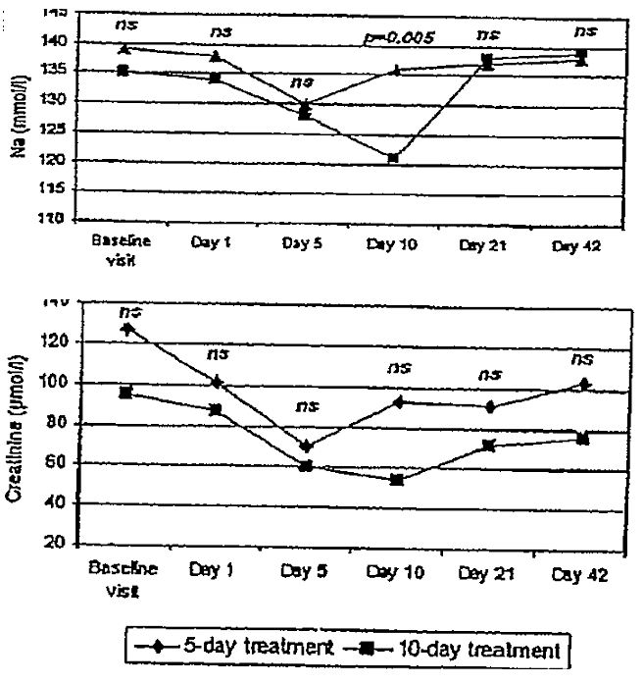
Table 15: Mean ± SD creatinine and sodium concentrations and creatinine clearance during and after treatment with terlipressin (Bruha et al 2009).
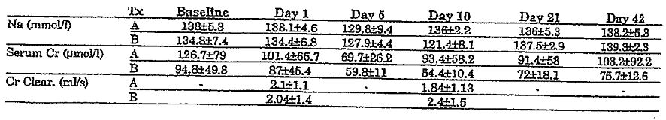
A = 5 day course of terlipressin; B = 10 day course of terlipressin.

Evaluator’s comment:
Although very small sample sizes were used in this study, statistically significant reductions in serum sodium concentrations from baseline were observed in both treatment groups throughout treatment with terlipressin. Whether these changes were entirely due to the use of terlipressin is open to conjecture because there was no formal “control” group (either placebo or other active agent). However, a causal relationship can be reasonably inferred because of the temporal relationship between the initiation of treatment with terlipressin and the onset of hyponatraemia and the reversal of hyponatraemia after withdrawal of terlipressin at Days 5 and 10, respectively.
The nadir sodium concentrations observed in the 5 day and 10 day treatment groups (approximately 128 and 121mmol/L, respectively) would be of clinical concern, especially the latter, in which the level was approaching the threshold at which neurological complications become common. The absence of reports of lethargy, alterations of mental status or seizures is difficult to reconcile with the magnitude of the change observed and may be because they were masked (for example, patients under sedation, intubation) or attributed to other clinical sequelae of the underlying disorder (for example, hepatic encephalopathy).
Another consideration is that the dose used in this study was only 1 mg q4h, whereas the proposed recommended dose is higher (2 mg q4h).

Solà E, et al. (2010) Hyponatremia in patients treated with terlipressin for severe gastrointestinal bleeding due to portal hypertension. Hepatology 52: 1783-1790.

Study design, location and dates
This retrospective cohort study was conducted in 58 consecutive patients treated with terlipressin for upper gastrointestinal bleeding at three centres in Spain between January 2003 and June 2009, with the aim of investigating the effects of terlipressin on serum sodium concentration.

Inclusion and exclusion criteria
Not stated.

Study treatments
All patients had been in an intensive care unit specialising in the management of patients with liver disease. A standardised treatment and investigation protocol was used in these units. Patients had been initially treated with somatostatin before endoscopic therapy and switched to terlipressin either because of failure to control bleeding (n=33; 57%) or re bleeding (n=25; 43%) despite an increasing dose of somatostatin. Terlipressin was administered at a dose of 2 mg IV every 4 h and reducing to 1 mg every 4 h after a 24 h bleeding free period. The total duration of treatment with terlipressin was 5 days.
Other treatments included packed red blood cells and plasma expanders as clinically indicated. The use of saline solutions was avoided in order to prevent a positive sodium balance that could cause or exacerbate ascites and oedema (most patients received 5% dextrose).

Safety outcomes
The primary safety outcome was the change in serum sodium concentration at the end of 5 days of treatment with terlipressin. Survival was also assessed.

Randomisation and blinding
Not applicable

Statistical methods
Summary statistics were calculated for the patient population as a whole and for subgroups categorised according to the difference between the baseline sodium concentration (that is, start of terlipressin treatment) and the lowest value of sodium during the 5 days of treatment with terlipressin: no change or increase/decrease <5 mEq/L; decrease of 5 to 10 mEq/L; and decrease >10 mEq/L. ANOVA was used for between group comparisons. Student’s t test, one way ANOVA (for continuous variables) and Chi square tests (for categorical variables) were used to analyse changes in variables and multivariate logistic regression models were fitted to identify the best predictors of hyponatraemia and in hospital mortality.

Participant flow
Complete in hospital follow up data were available for all patients.

Baseline data
A total of 47 patients had BOV, 8 had BGV, 2 had bleeding ectopic varices, and 1 had bleeding from portal hypertensive gastropathy. Portal hypertension was caused by cirrhosis in 55 patients, portal vein thrombosis in 2 patients, and idiopathic in the remaining patients. The main cause of cirrhosis was alcohol (78%). Baseline serum sodium concentration was at the lower of the normal range (mean ± SD 135 ±7; range 116-149 mEq/L). Most patients also had severe bleeding, with 71% being in shock on admission with an average requirement of 10 U of packed red blood cells.

Results for the primary safety outcome
In the whole population, serum sodium concentrations decreased from 134.9±6.6 mEq/L at baseline to 130.5±7.7 mEq/L at Day 5 (mean change: -4.0 ± 8.7 mEq/L; p=0.002).
Over a 5 day treatment period, 67% of patients receiving terlipressin developed an acute reduction in serum sodium concentration, with 33% (n=19) patients experiencing no change or increase/decrease <5 mEq/L; 31% (n=18) patients experiencing a decrease of 5 to 10 mEq/L; and 36% (n=21) experiencing a decrease >10 mEq/L. Moreover, hyponatraemia was found to develop rapidly after start of therapy but the hyponatraemia was also usually reversible after withdrawal of terlipressin, with a median recovery time of 4 days. Figure 6 shows the individual values of serum sodium at baseline and lowest value of serum sodium during the 5 days of therapy, presented according the degree of change over the 5 day period.
Figure 6: Changes in serum sodium concentrations during treatment with terlipressin (Sola et al 2010).
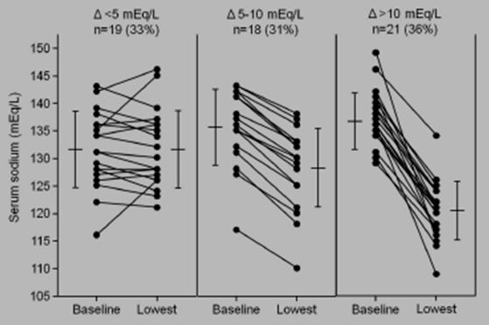
Three patients experienced quite severe neurological complications during an episode of marked hyponatraemia. The neurological manifestations included altered mental status (∆ sodium of 135 →117mEq/L); rapid impairment of neurological function resulting in coma status (∆ sodium of 130 →114mEq/L in the first 24 h of treatment); and a case of osmotic demyelination syndrome (seizures, LOC) in one patient due to a rapid recovery of serum sodium (∆ sodium of 109 →128mEq/L within 24 h of terlipressin withdrawal and treatment with hypertonic saline, after an earlier decrease from 136 →109mEq/L over the 5 days of treatment with terlipressin). Of note, the hyponatraemia was found to have developed in the absence of significant impairment of renal function, suggesting that hyponatraemia was probably secondary to a deterioration of the renal capacity to eliminate solute free water.
Interestingly, patients who developed reductions of sodium concentration of >10 mEq/L had less advanced liver disease at baseline (lower baseline bilirubin, lower model for end stage liver disease (MELD) scores, and lower rates of hepatic encephalopathy and ascites) and higher baseline serum sodium concentration compared to those of patients who did not develop hyponatraemia. Also, the degree of change in serum sodium concentrations was unrelated to the severity of bleeding, the volume of IV hypotonic fluids administered, or the cumulative dose of terlipressin. The authors hypothesised that the magnitude of reduction in serum sodium concentrations might be related to the degree of occupancy of renal V₂ vasopressin receptors before the initiation of treatment with terlipressin, with renal V₂ receptors more likely to be occupied by endogenous vasopressin in patients with advanced liver disease and low serum sodium levels. Based on such reasoning, administration of a drug with agonistic effect on the V₂ receptors to patients with advanced liver disease would not have significant antidiuretic effect because the receptors would be occupied by the endogenous ligand. By contrast, in patients with less severe liver dysfunction and normal serum sodium levels, V₂ vasopressin receptors would not be occupied by endogenous vasopressin in which case terlipressin would bind to the receptors and result in solute free water retention.

Results for other safety outcomes
Overall 17/58 (29%) patients died during hospitalisation, with an inverse relationship between the degree of change in serum sodium concentration during treatment with terlipressin and survival. In hospital mortality rates were 53% in patients with no change or increase/decrease <5 mEq/L; 28% in patients with decreases of 5-10 mEq/L; and 10% in patients with decreases >10 mEq/L; p<0.0016). The only predictive factor of in hospital mortality was the baseline MELD score (OR 1.25; 95% CI 1.09-1.44).

Evaluator’s comment:
The main limitation of this study, acknowledged by the authors, is its retrospective design. A cause-effect relationship between hyponatraemia and the administration of terlipressin has not been conclusively demonstrated in the absence of a randomised control group. However, several factors raised by the authors of the paper point to such a relationship are the close temporal relationship between the initiation of treatment with terlipressin and the onset of hyponatraemia and the rapid reversal of hyponatraemia in most patients after withdrawal of terlipressin.
Also of note, the study used a very “selective” population characterised by severe bleeding that had failed to respond to treatment with somatostatin. Consequently, the authors also undertook an analysis of changes in serum sodium levels in a contemporary group of 174 patients with portal hypertensive bleeding treated with somatostatin. It was reported that there was no change in overall serum sodium concentration (134.1±5.1 at baseline to 133.8±5.0 mEq/L (time point not reported; p=NS) and that significantly fewer patients receiving somatostatin experienced changes in serum sodium concentrations: 76% with no change or increase/decrease <5 mEq/L (33% with terlipressin), 21% patients had decreases of 5-10 mEq/L (31% with terlipressin), and 3% patients had decreases >10 mEq/L (36% with terlipressin; p<0.0001). Unfortunately, no information was presented by way of patient selection criteria, treatment regimen details, patient follow up, or baseline demographic data for this group of patients, and these results cannot be evaluated further.
Overall, this evaluator is satisfied that the study has demonstrated that an acute reduction in serum sodium concentration is common during treatment with terlipressin for severe portal hypertensive bleeding. It develops rapidly after start of therapy, may be severe in some patients and associated with neurological complications, and is reversible after terlipressin withdrawal.

Patient exposure
Exposure to terlipressin in clinical efficacy/safety trials of BOV is summarised in Tables 16-17. When reviewing these data, it should be noted that patients could be re randomised to treatment in the same study if they had more than one discrete bleeding episode. Information about participant flow was lacking in some of the studies, and it was therefore not possible to determine the number of patients exposed to either terlipressin or its comparator or both treatments in these studies. Thus, the data are presented in terms of the number of bleeds treated with the particular drug/treatment. At least 2477 bleeds have been treated with terlipressin in clinical trials (note that Brunati et al 1996 and Patch et al 1999 did not report numbers in each treatment group in those studies), of which 2149 have been treated with terlipressin alone and 328 in combination with other treatment (mostly endoscopic sclerotherapy or banding).
Table 16: Exposure to terlipressin and comparators in clinical efficacy & safety studies in BOV.
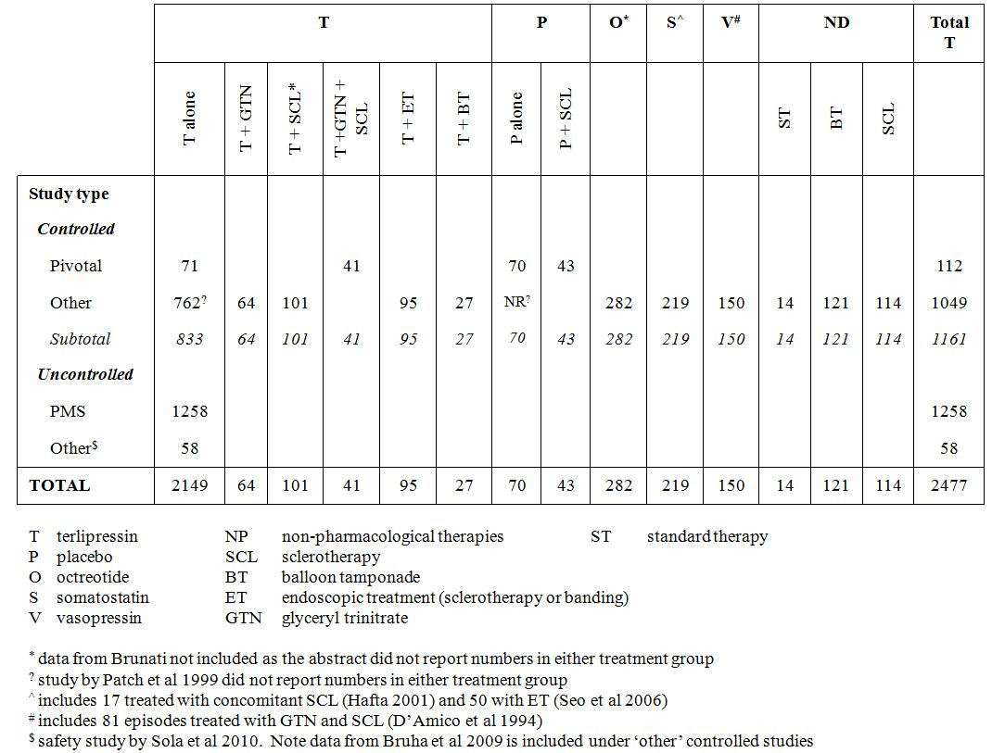
Table 17: Exposure to terlipressin according to dosage regimen – prospective, controlled studies.
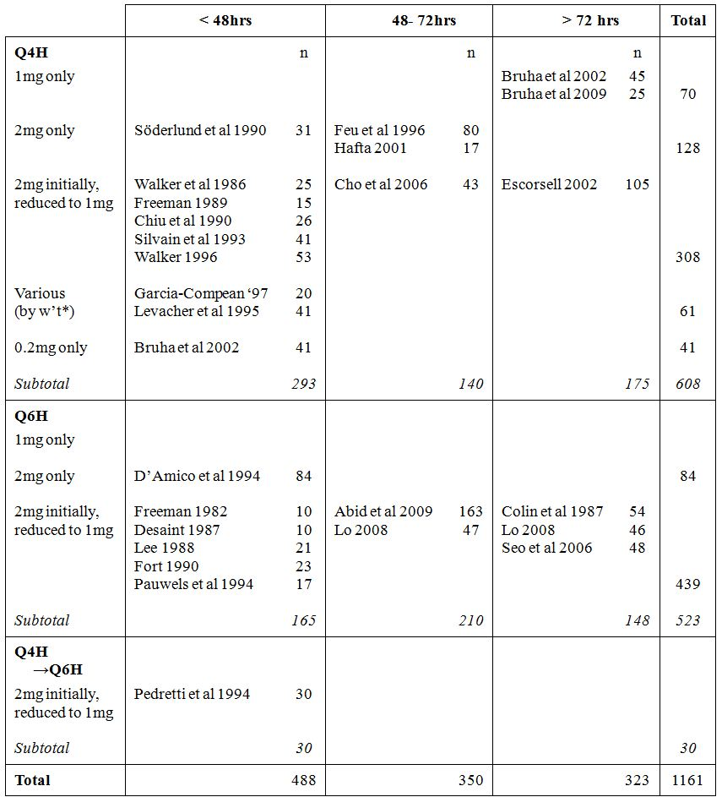
* ranged from 1 mg to 2 mg, depending on body weight: 2 mg for >70 kg weight; 1.5 mg for 50-70 kg and 1 mg for <50 kg

Dosing interval
A total of 1161 bleeds were treated in prospective, controlled studies (Table 16). In these studies, 608/1161 (52%) bleeds were treated using a four hourly regimen and 523/1161 (45%) bleeds were treated using a six hourly regimen (Table 17). A further 30/1161 (3%) bleeds were treated initially using a four hourly regimen, with the dosing interval increasing to 6 hours after 24 h in the study by Pedretti et al 1994. In that particular study, the dose was also reduced from 2 mg to 1 mg after 5 days of treatment.

Dose
Only 212 (18%) bleeds were treated exclusively with a 2 mg dose for the duration of treatment. The vast majority of bleeds (838; (72%)) were treated with an initial dose of 2 mg, which was subsequently reduced to 1 mg. In most instances the planned dose reduction was in response to bleeding having been controlled. In contrast, the dosage regimen proposed by this submission is that the dose may be reduced from 2 mg to 1 mg after 24 h in patients weighing 50 kg or less. Only two studies (Levacher et al 1995 and Garcia-Compean et al 1997) employed a dose based on body weight, with patients receiving 2 mg terlipressin if their body weight was >70 kg; 1.5 mg for body weight 50-70 kg; and 1 mg for body weight <50 kg. However, in both these studies the patients received the same dose for the duration of treatment.

Duration of treatment
The majority of patients (838/1161; 72%) were treated for up to an including 72 h, with 323/1161 (28%) treated for longer periods longer than 72 h (including 289 episodes treated for 5 days and 10 treated for 10 days). It can be appreciated from Table 17 that the actual number of bleeds treated with a 2 mg four hourly dosage regimen for up to 72 h is quite small (128 bleeds) and the number treated with 1 to 2 mg four hourly for up to 72 h is 379 bleeds. In those studies where treatment was continued for up to 5 days, a 1 mg dose was used, rather than 2 mg dose as proposed in the submission.

Adverse events

All adverse events (irrespective of relationship to study treatment)
AEs are summarised in a series of tables (Tables 18-23), presented according to the comparator used. When viewing these tables it should be appreciated that no results have been presented for SAEs and adverse drug reactions. The vast majority of published papers did not mention SAEs. Similarly, the phrases ‘side effects’, ‘AEs’ and ‘reactions’ have been used interchangeably within some of the publications. In the absence of any evidence of seriousness or causality having been assessed according to accepted predefined criteria, this evaluator has simply presented the data under the heading ‘AEs’. Also, it should be noted that in some instances the total number of events has been shown as not reported (NR), even though data for individual events was available. This has been done in situations when there was no indication as to whether any patients experienced more than one event.
Table 18: Adverse event data: terlipressin versus placebo.
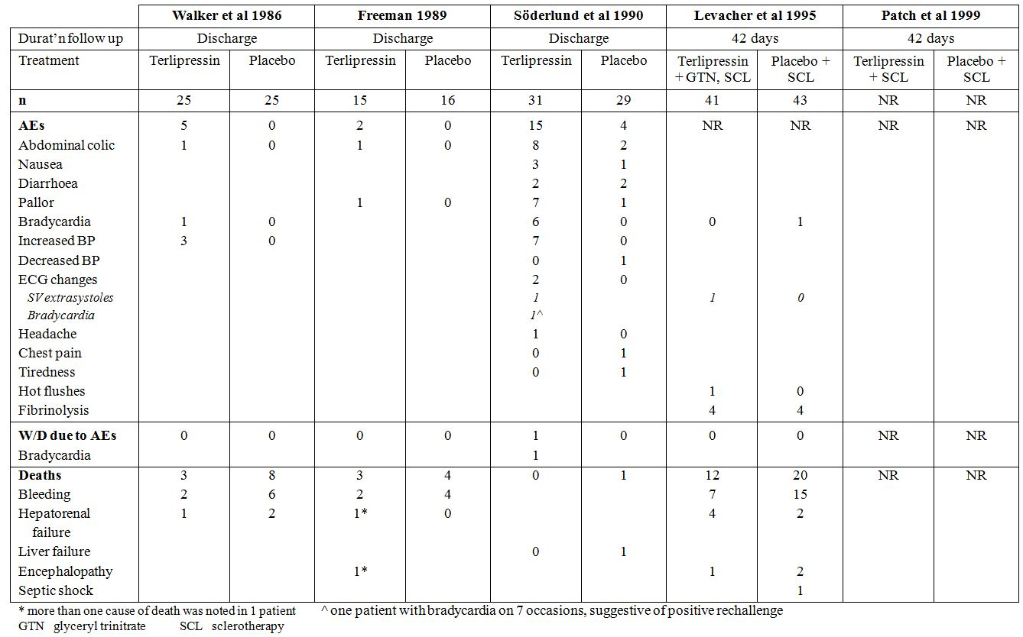
Table 19: Adverse event data: terlipressin versus octreotide.
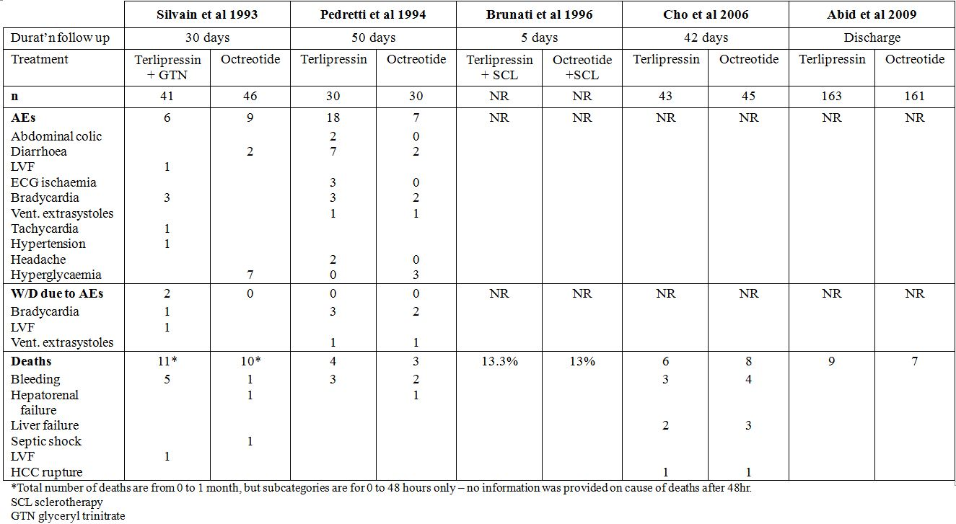

Table 20: Adverse event data: terlipressin versus somatostatin.
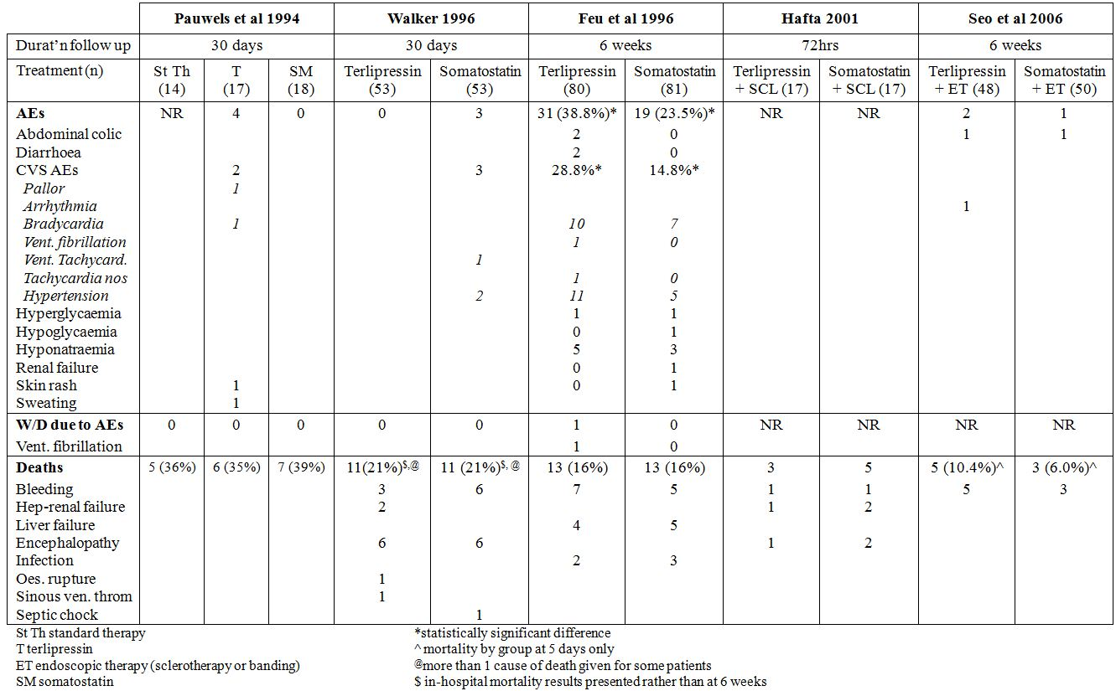
Table 21: Adverse event data: terlipressin versus vasopressin.
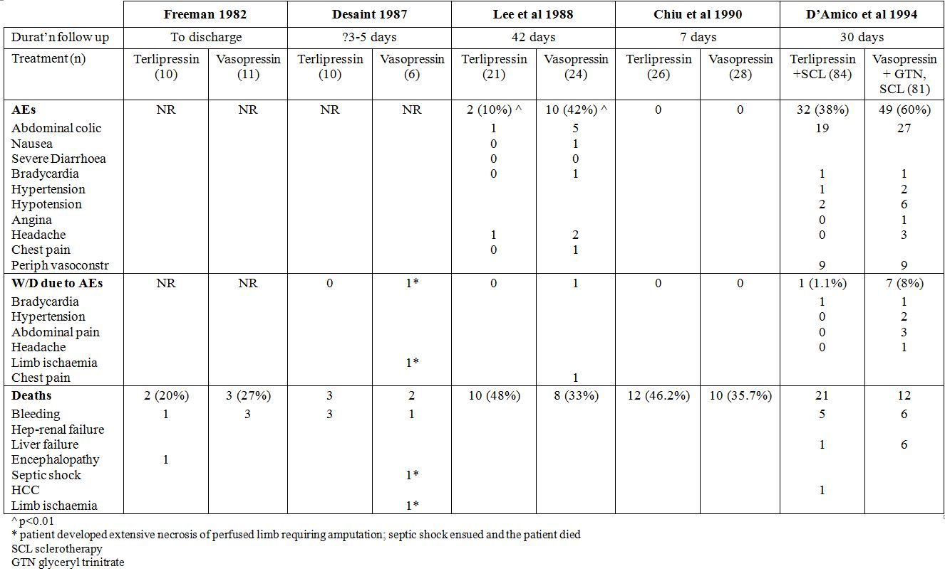

Table 22: Adverse event data: terlipressin versus non pharmacotherapies.
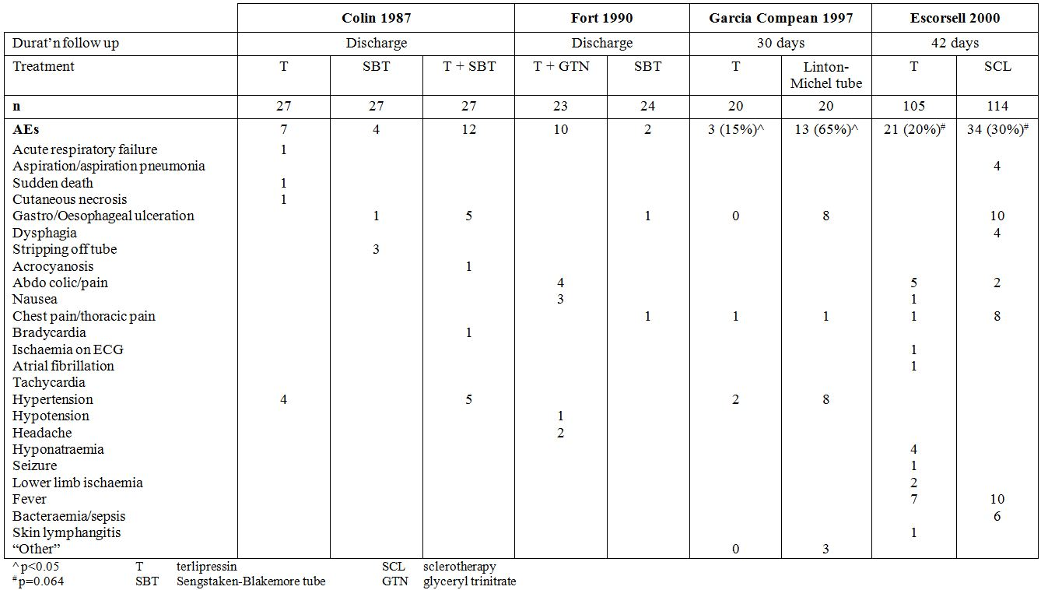
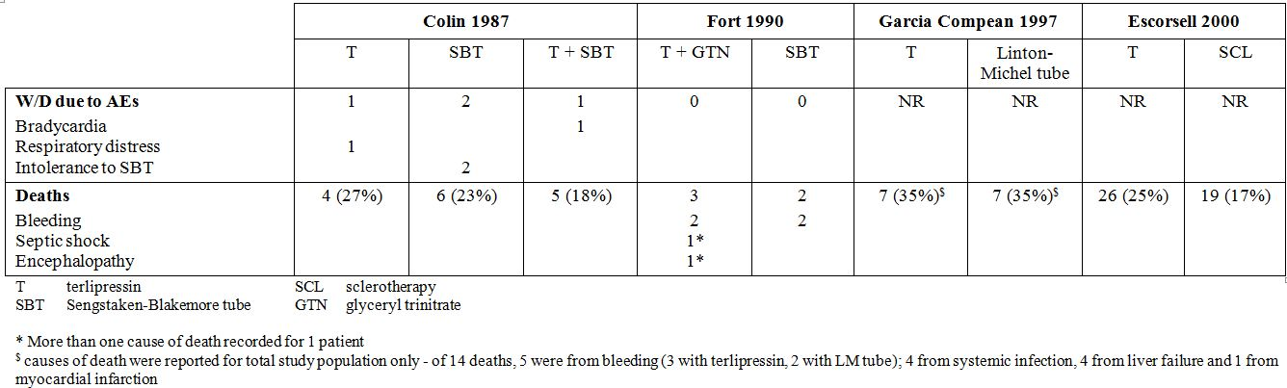
Table 23: Adverse event data: terlipressin versus terlipressin.
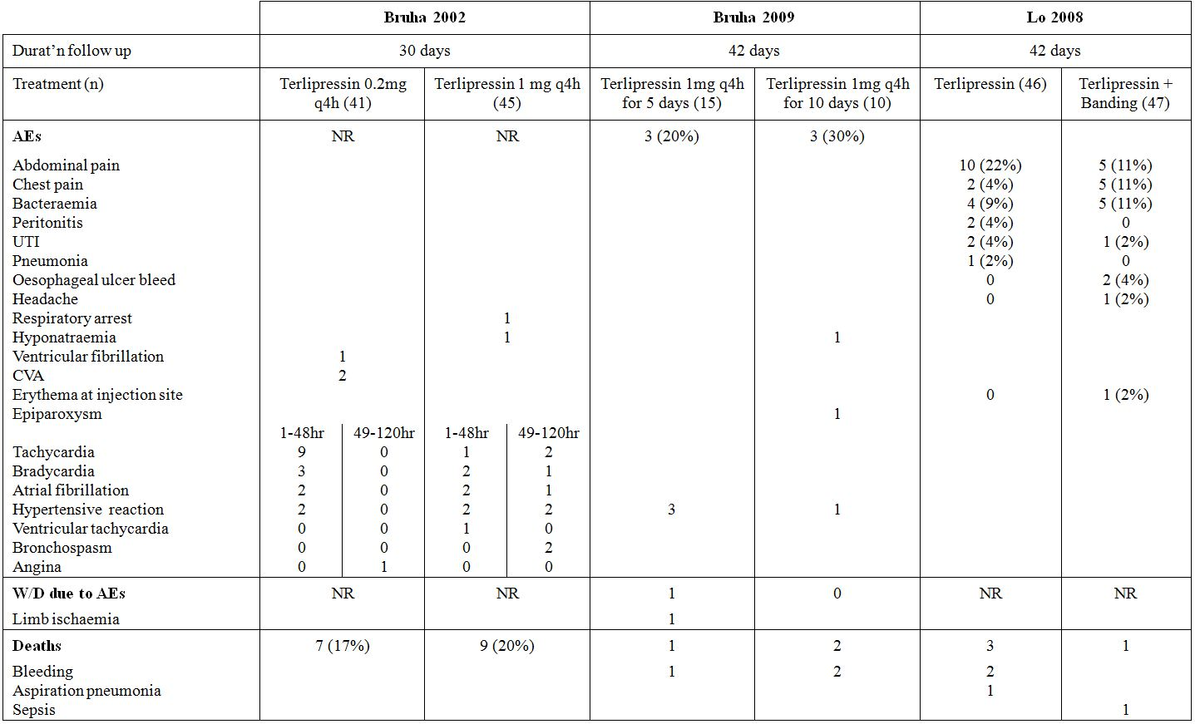
No attempt has been made by this evaluator to compare the overall and individual events rates for terlipressin and its comparators because of incomplete reporting and generally low patient numbers. The types of AEs reported are consistent with the known pharmacodynamic effects of terlipressin. Most commonly reported events were abdominal pain/colic, bradycardia, hypertension and pallor.
Also, so few AEs were reported that it is not possible to analyse the incidence of AEs according to the dose, dosage interval or duration of treatment in any meaningful way.

Treatment relative adverse events (adverse drug reactions)
Treatment related AEs could not be assessed because most studies did not draw distinction between side effects, adverse effects and adverse reactions. Furthermore, these phrases were used interchangeably and not defined.

Deaths and other serious AEs
Most of the published papers and indeed company study reports did not specifically report the incidence or nature of SAEs, whereas the number and nature of deaths were generally well reported. Not unsurprisingly, most deaths were related to uncontrolled bleeding or re bleeding, complications of the haemorrhage or underlying disorder (for example, encephalopathy, sepsis, hepatorenal failure). Across all the studies submitted, only one death was considered to be related to the use of terlipressin: death from left ventricular failure reported by Silvain et al 1993 in a patient receiving terlipressin + GTN. As noted previously, Levacher et al 1995 reported that 4 patients treated with terlipressin died due to fibrinolysis. However, 4 patients treated with placebo in the same study also died due to fibrinolysis, which suggests the deaths were more likely due to underlying haemostatic defects in the patients. Of interest, Desaint et al 1987 reported the death of one patient on study and two others off study from complications of limb ischaemia secondary to the use of vasopressin.

Discontinuation due to AEs
In the four placebo controlled pivotal studies, only one patient receiving terlipressin withdrew due to an AE. In the study by Söderlund et al 1990, one patient was withdrawn at 30 h because of severe bradycardia.
Overall, withdrawals due to AEs from terlipressin in the other studies were very infrequent. Causes of withdrawal were: bradycardia n=6 (3 from Pedretti et al 1994; and 1 each from Silvain et al 1993 [terlipressin +GTN], D’Amico et al 1994; and Colin et al 1987 [terlipressin +SBT]); left ventricular failure n=1 (Silvain et al 1993 [terlipressin +GTN]); ventricular fibrillation n=1 (Feu et al 1996); ventricular extrasystoles n=1 (Pedretti et al 1994); respiratory distress n=1 (Colin 1987 [terlipressin+SBT]; and limb ischaemia n=1 (Bruha et al 2009).

Laboratory tests

Liver function

Pivotal studies
As indicated earlier, the data listings for the publication by Freeman et al 1989 presented individual and summary data hepatic function (bilirubin, AST, ALP and albumin levels) at 0 h, 24 h, “48-72” h, and “5-7”days. In this study, patients were treated with terlipressin for a maximum of 40 h. All patients had baseline values recorded but, unfortunately, the documentation of values throughout and after treatment was poor (data was documented in 40% patients in each group, at best) (see summary data in Table 24). Of note, the 24 h time point had the most amount of missing data (hepatic function data were recorded for only 2/15 patients in the terlipressin group and 6/16 in the placebo group), making comparisons with baseline meaningless.
Table 24: Changes in hepatic function during and after treatment with terlipressin.
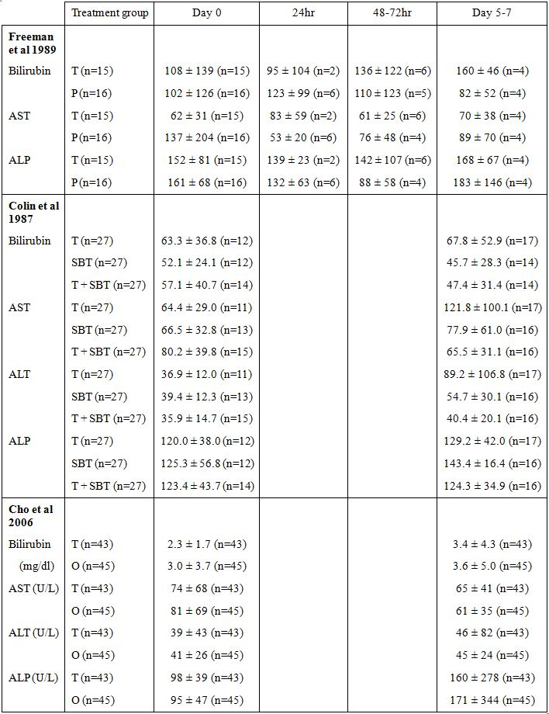
ALP, alkaline phosphatase; ALT, alanine aminotransferase; AST, aspartate aminotransferase; O, Octreotide; P, placebo; SBT, Sengstaken Blakemore Tube; T, Terlipressin

Other studies
There were no clinically significant changes in bilirubin and alkaline phosphatase levels from baseline to Day 6 (2 days post terlipressin treatment) in the study by Colin et al 1987 (Table 24). Both the ALT and AST levels increased by a factor of 2 in patients receiving terlipressin, whereas the levels did not change appreciably in the comparator groups (SBT alone and terlipressin + SBT). However, of note there was marked variability in levels at Day 6 as indicated by the high value of the SD relative to the mean value (AST mean ± SD 121.8 ± 100.1; ALT 89.2 ± 106.8), indicating a likely outlier value(s). It should also be noted that less than 50% patients in this study had baseline values recorded and the most number of patients in any group with data at Day 6 was 17 (out of 27). It is not clear whether the same patients in each group were being compared pre and post treatment.
The study by Cho et al 2006 had complete data at baseline and Day 7 (4 days post terlipressin treatment). No clinically significant changes in mean bilirubin, AST or ALT levels were observed. Mean ALP levels rose more than 1.5 fold in both treatment groups. However, there was marked variability in ALP values at Day 7, indicated by the high SD relative to the mean (terlipressin 160 ± 278; octreotide 171 ± 344), once again most likely indicating an influence of outlier value(s).

Kidney function
Bruha et al 2009 and Sola et al 2010 demonstrated a significant potential for clinically important hyponatraemia associated with the use of terlipressin.
Data from other studies are summarised in Table 25. In reviewing these data it should be appreciated that the renal function data sets of the studies reported by Freeman et al 1989 and Colin et al 1987, although somewhat more complete than the hepatic function data, were still presented for only a subset of patients enrolled. In the study by Cho et al 2006, serum sodium concentrations were numerically lower at Day 7 than prior to treatment for both treatment groups and could reflect improving levels after a nadir some time earlier.
Table 25: Changes in renal function during and after treatment with terlipressin.
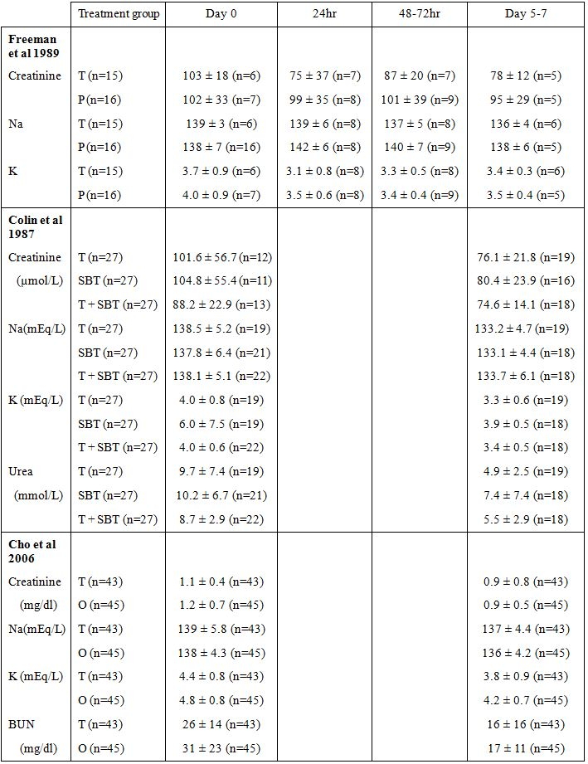
BUN, blood urea nitrogen; O, Octreotid; P, Placebo; SBT, Sengstaken Blakemore Tube; T, Terlipressin.
Additionally, Krag et al 2010 (cited in the latest PSUR but not submitted by the sponsor) reported that serum sodium levels in 62 patients with BOV decreased from 136 ± 6 at baseline to 130 ± 7 mEq/L after treatment with terlipressin 2 mg every 4 h for a mean duration of 1.7 days. Furthermore, the decrease in the serum sodium level correlated with the duration of treatment (Pearson correlation -0.48, p < 0.001). The authors recommended that terlipressin be used short term to prevent side effects such as hyponatraemia.

Other clinical chemistry
No data presented.

Haematology
Haemoglobin and haematocrit were monitored routinely in most efficacy studies as part of the assessment of haemodynamic status and, consequently, therapeutic response. However, changes in these parameters were not formally analysed or presented in most studies. Data from the studies by Freeman et al 1989, Colin et al 1987 and Cho et al 2006 are summarised in Table 26. Apart from the expected improvements in haemoglobin and haematocrit values with active and supportive treatment, no clinically significant changes in parameters were evident in these studies (although the limitations previously mentioned for the data sets supporting Freeman 1989 and Colin et al 1987 must be acknowledged).
Table 26: Changes in haematology parameters during and after treatment with terlipressin.
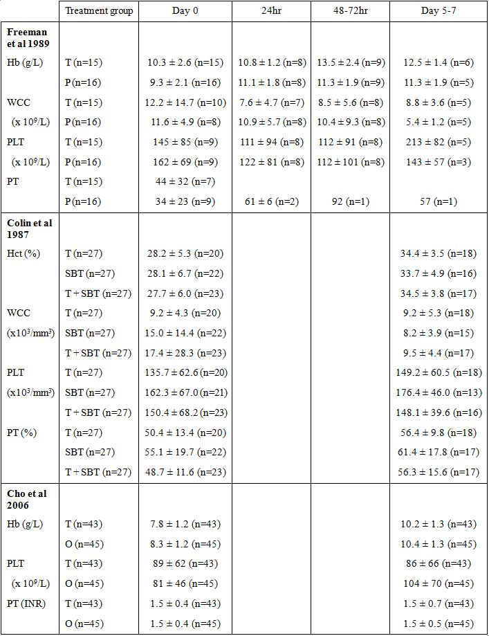
Hb, haemoglobin; HcT, haematocrit; O, Octreotide; P, Placebo; PLT, platelets; PT, prothrombin time; SBT, Sengstaken Blakemore Tube; T, Terlipressin; WCC, white cell count.

Electrocardiograph
ECG was routinely monitored in most of the studies but results were not systematically analysed or presented. Disturbances of cardiac rhythm and ECG changes reported as AEs in the studies included bradycardia, tachycardia, ventricular tachycardia, ventricular fibrillation, ventricular extrasystoles, supraventricular extrasystoles and myocardial ischaemia.

Vital signs
Vital signs were monitored routinely in all efficacy studies as part of the assessment of therapeutic response. Changes in vital signs data were not formally analysed in any of the studies.

Post marketing experience
The sponsor submitted the last five annual PSURs that collectively covered the period 16 April 2005 to 30 April 2010 and a copy of the EMEA Assessment Report (Final) on the PSUR Harmonisation Procedure for terlipressin products, which reviewed the PSURs from 16 April 2006 to 30 April 2009. In addition, the Summary of Clinical Safety contained a summary of adverse drug reaction data as at 30 June 2010. No additional information (by way of line listings) was available for reactions reported prior to April 2005.
Based on sales data, the sponsor estimated that the cumulative exposure to terlipressin from first marketing to 30 April 2010 was 600,136 treatment cycles. This assumes the entire amount of product sold has been consumed, and that a typical treatment cycle comprises administration of 16 mg terlipressin.
As at 30 June 2010, the sponsor had received reports of 339 suspected adverse drug reactions in 192 patients treated with (Glypressin and Remestyp), of which 293 were serious reactions. The indication for use of terlipressin was reported as BOV in 42% (80) patients; HRS in 16% (32) patients; ‘off label’ uses (such as septic shock, sepsis, haemoptysis) in 32% (62) patients; and was unknown in 9% (18) patients. A total of 9% of patients were aged <18 years, 55% were adults, 23% cases were elderly (not defined, presumably >65 years), and 11% were in patients of unknown age.
According to the last available PSUR (data lock 30 April 2010), the most commonly affected system organ classes were cardiac disorders (66 reactions), vascular disorders (50 reactions), skin and subcutaneous tissue disorders (34 reactions), gastrointestinal disorders (30 reactions), metabolism and nutrition disorders (26 reactions), and nervous system disorders (22 reactions).
The Summary of Clinical Safety (dated October 2010) reported that there were 73 fatal ADRs in 40 cases (read as patients) as at 30 June 2010. Of these cases, 18 were reported in association with the use of terlipressin for BOV, 9 for HRS, 9 for other indications (including septic shock, multi organ failure and MalloryWeiss Syndrome), and 4 for unknown indications. The causes of death in patients being treated for BOV were myocardial infarction (n=4), intestinal ischaemia (n=2), shock (n=3), and peripheral ischaemia (n=1).

Evaluator’s comment:
Details were not provided for 8 of the BOV fatalities. Also, the sponsor noted that 3 deaths reported by Bruha et al 2002 had not been included in the Ferring Global Safety Database because insufficient detail was provided in the published paper. A request for further information from the author was unanswered at the time of compilation of the dossier.
There appears to be a discrepancy in the number of fatal ADRs reported in the Summary of Clinical Safety and the last PSUR (data lock 30 April 2010). The latter stated that:
“the cumulative number of initial medically confirmed case reports until 30 April 2010 is 118 fatal cases.”
The sponsor should provide a reconciliation of these two sources of information, as well as details of the causes of all fatalities with BOV.
Reactions reported to 30 June 2010 occurring in 4 or more patients are summarised in Table 27. The most commonly reported reactions have been peripheral ischaemia, hyponatraemia, skin necrosis, myocardial infarction and bradycardia. These reactions are to be expected on the basis of the actions of terlipressin on V₁ receptors (manifesting as peripheral ischaemia, skin necrosis, myocardial infarction, bradycardia) and V₂ receptors (antidiuretic and water retention effects manifesting as hyponatraemia). The most important ADRs identified from post marketing experience are summarised below. It should be noted that much of this information has been reproduced from the Summary of Clinical Safety and, in the absence of complete line listings, cannot be fully corroborated by this evaluator.
Table 27: Most common ADRs reported to the sponsor for terlipressin.
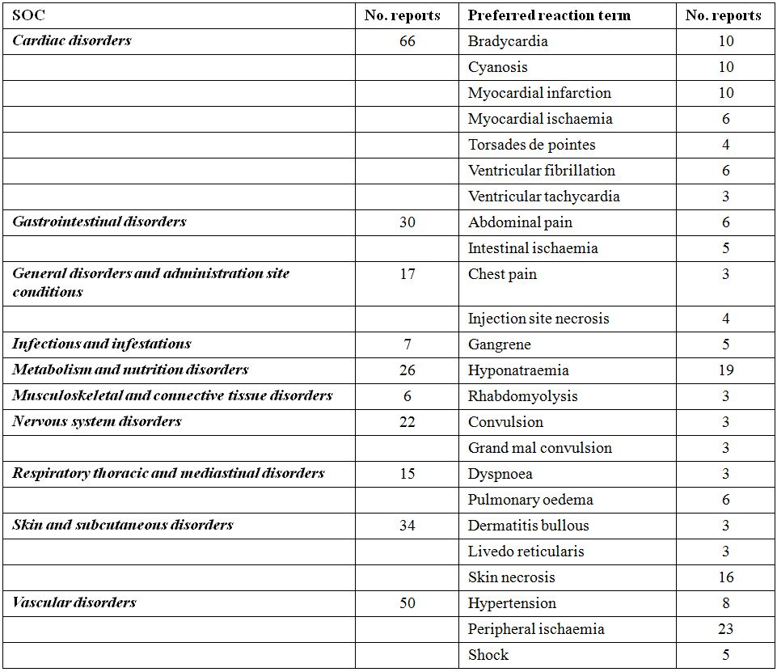
Data source: Appendix 5.1PSUR covering the period 1 May 2009 to 30 April 2010.

Peripheral ischaemia
This has been the most frequently reported reaction. A total of 25 cases of peripheral ischemia have been identified in the Ferring Global Safety Database. The cases were equally distributed between adults, children, and the elderly (n=8 [32%] in each age group). One case (representing 4%) had no patient age reported. Of note, 8 of the cases were reported in children/infants treated for the off label indication of septic shock: 7 from a non Ferring sponsored study of terlipressin in refractory septic shock, where all patients received at least two unspecified catecholamines in high doses; and 1 case of “last resort” treatment of septic shock in a two month old girl, with severe hypotension despite treatment with dopamine, epinephrine, and norepinephrine. She underwent arterial catherisation of the right leg, which became ischaemic and then developed intestinal ischaemia (this patient subsequently died due to withdrawal of therapy). Of the 7 cases of peripheral ischaemia in children enrolled in the non Ferring sponsored study, 5 cases were fatal. Catecholamines were reported as co suspect drugs in all cases. In 3 of these cases, the children had peripheral ischemia prior to initiation of terlipressin treatment and the fatal outcome was considered unrelated to the ischemic event. Of the 2 non fatal cases, one had meningococcal sepsis with cutaneous and intestinal ischemia at enrolment and had Staphylococcus aureus sepsis and propionic acidaemia as underlying disease.

Intestinal ischaemia
A total of 6 cases of intestinal ischemia have been reported to the sponsor, with 4 leading to a fatal outcome. Of those with a fatal outcome, 1 case was clinically suspected but never verified as patient was unfit for operation and did not undergo autopsy. Symptoms consistent with intestinal ischemia developed after a total dose of 1 mg of terlipressin. This patient had a history of widespread cardiovascular disease, including aortic stenosis, myocardial infarction, and peripheral vascular disease. The second case developed injection site necrosis, scrotal pain, erythema, and intestinal ischemia after three days of treatment with terlipressin for BOV secondary to alcoholic cirrhosis. This patient also had a history of cardiac disease by way of tight aortic valve stenosis. In another case, a patient treated for BOV, who died of haemorrhagic shock due to intestinal bleeding starting on the first day of treatment. Autopsy revealed mucosal necroses predominantly of the ascending colon. The final fatal case was that of the two month old female discussed under ‘peripheral ischemia’. Of the 2 non fatal cases, one patient developed myocardial infarction and intestinal ischaemia after three days of treatment with terlipressin for HRS. A positive dechallenge was reported. The last patient (an alcoholic with fresh haematemesis) had received a total of 10 mg of terlipressin over 16 h for suspected BOV. Treatment was stopped when gastroscopy revealed only severe oesophagitis with no signs of varices or active bleeding. However, at explorative laparotomy (44 h later) the patient was found to have multiple dark ischaemic areas of the intestine. No perforations were found and no resection was performed. The patient subsequently regained his intestinal function. Tests excluded vasculitis.

Hyponatraemia
Hyponatraemia has been the second most frequently reported reaction, with 20 cases. Sixteen of these were serious and, of these, 6 were severe cases in which the patients experienced seizures (5 cases), coma (2 cases), or pontine myelinolysis (1 case). One patient experienced both seizure and coma. All patients recovered; 35% cases were reported in the elderly and 65% were reported in adults. The elderly are potentially at higher risk of developing hyponatraemia.

Skin necrosis
Skin necrosis is an expected undesirable effect resulting from severe peripheral ischemia caused by vasoconstriction, but may also foreseeably occur as a consequence of accidental extravasation during administration). In 3 of the 16 cases of skin necrosis, other suspect drugs (catecholamines/antihypertensives/antibiotics) were reported. In 3 cases where outcome was reported as ‘not recovered’, the patients died later of multi organ failure; 2 of these patients were morbidly obese and 1 had severe oedema of the lower limbs. One patient was in septic shock at the time terlipressin was commenced (because of suspected HRS) and subsequently developed widespread necrosis of the skin and tongue. Seven of the cases reported negative dechallenge and only two reported positive dechallenge. Seven cases occurred in the elderly (age limit not defined), seven occurred in adults and 2 had no patient age reported. The elderly are potentially at higher risk of skin necrosis due to an increased risk of underlying vascular diseases.

Myocardial infarction and myocardial ischaemia
Myocardial infarction has been the fourth most frequently reported reaction in connection with terlipressin treatment. It is an expected undesirable effect suspected to be caused by the affinity of terlipressin for the V₁ receptor found in vascular smooth muscle and cardiomyocytes that results in vasoconstriction and a positive inotropic effect. Myocardial ischemia has been reported less frequently. A total of 21 cases of myocardial infarction/ischemia were identified in the Ferring Global Safety Database, of which 8 had a fatal outcome related to the ADR and another 4 died of reasons that were considered not directly related to the myocardial infarction (re bleeding n=1; hypovolaemic shock n=1; and multi organ failure n=2). 71% of cases were in adults, 14% were in the elderly and 14% were of unknown age. A complete discussion of these events was not provided in the Summary of Clinical Safety. It was noted that one non fatal case received terlipressin perioperatively for refractory hypotension (off label use) and immediately became hypertensive, developed an acute myocardial infarction (AMI), requiring percutaneous transluminal coronary angioplasty (PCTA). Several of the cases had confounding factors, for example, concomitant treatment with NovoSeven (recombinant Factor VIIa), cancer, and other underlying diseases; and 2 AMI events occurred more than 24 h after last dose (terlipressin’s duration of activity of 4-6 h and elimination half life of 50-70 minutes makes a causal relationship less likely for these 2 cases).

Evaluator’s comment:
The most common reactions are listed in the company’s Core Data Sheet (CDS) and draft PI. Eight of the adverse reactions appearing in Table 27 are not listed in the current CDS or proposed for inclusion in the PI for Australia. The company justified the non inclusion of these reactions as follows:
Rhabdomyolysis: Six of the seven cases concerned children enrolled in a non Ferring trial of off label terlipressin treatment in children with septic shock refractory to high dose catecholamines. In all of these cases severe infection was a confounding factor for developing rhabdomyolysis and one patient was noted to have rhabdomyolysis prior to the commencement of terlipressin. Also, rhabdomyolysis has not been identified as a potential risk in the literature. The sponsor stated it will monitor this type of event through routine pharmacovigilance (PhV) measures. This is acceptable.
Convulsions: Seven out of eight cases were reported as a complication of severe hyponatraemia, which is a listed reaction. Given this contextual information, it is acceptable to not specifically mention convulsions, for a medical practitioner ought to know the various clinical manifestations of hyponatraemia and, conversely, the causes of convulsions.
Cyanosis, Abdominal pain, Myocardial Ischaemia, and Ventricular fibrillation: These terms were considered to be “closely related” to the listed terms Peripheral Ischemia, Abdominal cramps, Myocardial Infarction, and Ventricular tachycardia, respectively. This argument is not accepted by this evaluator, as there can be quite marked differences in the aetiology and pathogenesis, clinical presentation and sequelae of such events.
Hypokalaemia: This was acknowledged as a potential class effect of vasopressin analogues, as terlipressin is slowly transformed to lysine vasopressin, which is known to potentiate the stimulatory effect of aldosterone on potassium excretion. The sponsor stated it will monitor this type of event through routine PhV measures, citing the fact that it has not been identified as a risk in the literature. As at 30 June 2010, the sponsor had received 4 reports of hypokalaemia (one of which appears to have reported prior to 2005, with no additional information was available to this evaluator for review). The last PSUR (data lock 30 April 2010) indicated that only one report of hypokalaemia had been received, indicating that three reports have been received in the last 15 months. Details of these events should be summarised and presented by the sponsor, including an assessment of causality before deciding whether or not hypokalaemia should be included in the labelling of the product.
Also, there are several discrepancies between figures cited in the Summary of Clinical Safety and cited elsewhere in the dossier that should be reconciled by the sponsor:
- The table of the most common ADRs presented in the Summary of Clinical Safety indicated there had been 5 cases of ventricular fibrillation as at 30 June 2010, whereas the last PSUR indicated there had been 6 cases as at 30 April 2010; and
- The table of the most common ADRs presented in the Summary of Clinical Safety indicated there had been 6 cases of pulmonary oedema as at 30 June 2010, whereas the RMP stated there had been 7 cases of pulmonary oedema at the data lock date of 14 June 2010.

Specific safety issues of regulatory importance

Liver toxicity
No issue has been identified. However, there was no systematic reporting in the published literature or accompanying company study reports of analyses of the proportions of patients developing clinically significant changes in hepatic enzymes during treatment with terlipressin. A number of deaths due to hepatic and hepatorenal failure were identified in the literature but these are confounded by the indication and its underlying aetiology of cirrhosis.
There were 5 reports of hepatobiliary disorders in the Ferring Global Safety Database as at 30 April 2010, comprising single reactions coded with the following preferred terms: Budd-Chiari syndrome, chronic hepatic failure, hepatic failure, hyperbilirubinaemia, and hepatorenal syndrome. It appears that all of these events were reported prior to April 2005 and no additional information was available to this evaluator.

Haematological toxicity
No issue has been identified. However, there was no systematic reporting in the published literature or accompanying company study reports of analyses of the proportions of patients developing clinically significant changes in these parameters. There have been no events reported in the literature that would be suggestive of haematological toxicity (that is, agranulocytosis, aplastic anaemia or thrombocytopaenia). In the Ferring Global Safety Database, there was a single report of thrombocytopaenic purpura that appears to have been reported prior to April 2005, and no additional information was available to this evaluator.

Serious skin reactions
Skin necrosis has been the third most frequently reported reaction and is associated with the vasopressive action of terlipressin.
In the published papers submitted for evaluation there were 2 reports of skin reactions during treatment with terlipressin. Pauwels et al 1994 reported the occurrence of a skin rash (not otherwise specified) in 1 patient, and Colin et al 1987 reported a case of skin necrosis. No further details were provided for either reaction.
In the Ferring Global Safety Database there has been a single report of Steven’s-Johnson syndrome (SJS) and a single report of toxic epidermal necrolysis (TEN) and 16 reports of skin necrosis. The reports of SJS and TEN appear to have been reported prior to April 2005 and no additional information was available for independent review by this evaluator. The Summary of Clinical Safety noted that the case of SJS occurred in a patient who received two co suspected drugs (octreotide and tacozin) as well as 15 other concomitant medications, whilst the report of TEN contained insufficient information for assessment.

Cardiovascular safety
The published literature and post marketing surveillance have shown a number of cardiovascular risks with terlipressin, consistent with its known action on V₁ receptors. These risks include hypertension, peripheral ischaemia, intestinal ischaemia, bradycardia, acute myocardial infarction and ventricular arrhythmias. Collectively they constitute the most common adverse reactions to terlipressin.
A total of 4 cases of torsade de pointes and 2 cases of QT prolongation on ECG have been reported to the sponsor. All 4 patients with torsade de pointes fully recovered from the event. There were predisposing factors in 3 cases: 1 case pre treatment borderline QT prolongation, and 2 cases had hypokalaemia. In most cases of drug induced torsade de pointes, the mechanism is lengthening of the cardiac repolarisation phase mostly by blocking specific cardiac K⁺ channels. Terlipressin has affinity for V₁ receptors, some of which have a positive inotropic effect by affecting K⁺ channels.

Unwanted immunological events
No data presented.

Other safety issues

Safety in special populations

Elderly patients
There have been no studies specifically examining the safety of terlipressin in the elderly. Issues of concern would be a predisposition to events of peripheral ischaemia, myocardial ischaemia and skin necrosis due to underlying vascular disease. The elderly are also predisposed to hyponatraemia and would be particularly vulnerable to rapid changes in sodium levels which could overwhelm compensatory mechanisms.

Children
Some use in children can be reasonably anticipated, where BOV may occur as a consequence of portal vein thrombosis and secondary biliary cirrhosis. There have been no studies specifically examining the safety of terlipressin in children with BOV and it is difficult to extrapolate the experience with adults to children because of differing physiology and adaptive responses to haemorrhage and, more so, shock.
There have been two publications (Rodriguez-Nunez et al 2006, Rodriguez-Nunez et al 2010) that have shown that the use of terlipressin in the treatment of septic shock in children has been associated with significant ischaemic injury. This has been discussed under the subheadings Peripheral ischaemia and Intestinal ischaemia.

Pregnant patients
Terlipressin is contraindicated in pregnancy due to its labour inducing activity (Åkerlund et al 1978). This is a well known class effect of vasopressin analogues.

Safety related to drug-drug interactions and other interactions
No data presented. See earlier comments on pharmacodynamic interactions.

Hyponatraemia
Acute reduction in serum sodium concentration is fairly common during treatment with terlipressin for severe portal hypertensive bleeding. It develops rapidly after start of therapy, may be severe in some patients and associated with neurological complications, and is usually reversible after terlipressin withdrawal. Fluid and electrolyte balance should be monitored carefully during treatment.

Evaluator’s overall conclusions on clinical safety
As no formal clinical development programme was conducted for terlipressin, the sponsor does not have an in house clinical database. Furthermore, there are marked issues in the quality and completeness of the safety data reported in published clinical trials. Despite these limitations, the safety profile of terlipressin has been well characterised during its thirty year marketing history through post marketing studies and PhV activities. Importantly, there have been no regulatory actions taken for safety reasons in that time.
The frequency of adverse drug reactions has, thus, been estimated using the available post marketing data. The most commonly reported reactions have been peripheral ischaemia, hyponatraemia, skin necrosis, myocardial infarction and bradycardia. These reactions are to be expected on the basis of the actions of terlipressin on V₁ receptors (peripheral ischaemia, skin necrosis, acute myocardial infarction and bradycardia) and V₂ receptors (antidiuretic and water retention effects manifesting as hyponatraemia). Other identified risks include intestinal ischaemia, hypertension, pulmonary oedema, torsades de pointes and atrial and ventricular arrhythmias.
There are limited safety data in both the elderly and children. With regard to the elderly, issues of concern would be a predisposition to events of peripheral ischaemia, myocardial ischaemia and skin necrosis due to underlying vascular disease. The elderly are also predisposed to hyponatraemia and would be particularly vulnerable to rapid changes in sodium levels which could overwhelm compensatory mechanisms. Safety data in children are essentially limited to the use of terlipressin in the treatment of septic shock and use of terlipressin in such a clinical setting been associated with significant ischaemic injury.

Benefit-risk assessment and recommendations

Assessment of benefits
- Terlipressin was associated with a statistically and clinically significant reduction of in hospital mortality (10% versus 38%) and failure of initial haemostasis (10% versus 59%) compared to placebo in one randomised double blinded placebo controlled study (Söderlund et al 1990);
- Similar numerical differences were observed in three other randomised double blinded placebo controlled studies (Walker 1986, Freeman 1989 and Levacher et al 1995), but statistical significance was not reached because of under powering of the studies;
- In a relatively large, well powered study no significant difference was found between terlipressin and sclerotherapy with respect of failure to control bleeding (with similar results for patients with and without active bleeding at endoscopy), re bleeding, number of blood transfusions required and 42 day mortality (Escorsell et al 2000);
- Terlipressin plus endoscopic banding was demonstrated to be non inferior to octreotide plus endoscopic banding (with non inferiority margin of 11%) with respect to control of bleeding (Abid et al 2009);
- In both the pivotal placebo controlled studies and supporting studies there was a consistently high rate of bleeding control with terlipressin, despite substantial differences in study design, the dose used and assessment of treatment effect.
Note: A meta analysis of seven placebo controlled studies showed a risk reduction for terlipressin of 34% relative to placebo for all cause mortality up to 42 days (Ioannou et al 2003). This analysis has been repeatedly cited as a basis for the use of terlipressin in international guidelines. However, in the opinion of this evaluator this analysis is flawed. Of particular concern are the results from one placebo controlled study (Patch et al 1999) which appeared to have been transposed for the two treatment groups. This invalidates the combined point estimate and, because this study was given the greatest weighting, the true combined estimate is likely to be substantially different. Thus, in the opinion of this evaluator, the comparison of efficacy of terlipressin with placebo must be assessed on the basis of the individual study results.

Assessment of risks
The risks of terlipressin in the proposed usage have been well characterised during its thirty year marketing history through post marketing studies and PhV activities. The main identified risks are:
- peripheral ischaemia;
- hyponatraemia;
- skin necrosis;
- myocardial infarction; and
- bradycardia.
Other identified risks include intestinal ischaemia, hypertension, pulmonary oedema, torsades de pointes and atrial and ventricular arrhythmias.

Assessment of benefit-risk balance
Despite the fact that the efficacy and safety data are less than ideal, this evaluator is of the view that terlipressin has a favourable benefit-risk balance. This view is based on:
- the benefit observed in the study by Söderlund et al 1990 and trends observed in the remaining pivotal placebo controlled studies;
- the results of the key supporting studies by Escorsell et al 2000 and Abid et al 2009, which are particularly pertinent to current management strategies for BOV;
- the well defined safety profile for terlipressin established from over thirty years of marketing; and
- the fact that the identified risks of terlipressin are by and large manageable given that patients receiving terlipressin will be undergoing intensive medical care and monitoring, especially during the initial stages of bleeding control.

Comments on clinical aspects of the safety specification in the draft RMP
The safety specifications outlined in Part I of the RMP (20 October 2010; Version 1.0) include the following important identified risks: acute myocardial infarction, atrial fibrillation, torsades de pointes, peripheral ischaemia, skin necrosis, intestinal ischaemia, hyponatraemia, respiratory failure, left ventricular failure, pulmonary oedema, and hypertension. This is generally reflective the important identified risks of terlipressin that have been identified over its thirty year marketing history. However, it is difficult to justify the inclusion of atrial fibrillation (2 cases only) and respiratory failure (1 case in an HRS patient with pneumonia).
In the opinion of this evaluator there are two major omissions: bradycardia and ventricular fibrillation. Both of these risks have been identified from the published literature (and cited as reasons for withdrawal from published clinical studies) and the company’s PhV activities. Bradycardia is also to be expected from the pharmacological activity of terlipressin.
Another issue is hypokalaemia, which is acknowledged as a potential class effect of vasopressin analogues (terlipressin is slowly transformed to lysine vasopressin, which is known to potentiate the stimulatory effect of aldosterone on potassium excretion). As at 30 June 2010, the sponsor had received four reports of hypokalaemia. The sponsor stated it will monitor this type of event through routine PhV measures. Hypokalaemia is an important predisposing factor for QT prolongation and torsades de pointes (which is an important identified risk). Therefore, consideration should be given to including hypokalaemia as an important potential risk.

Recommendation regarding authorisation
The application to register Glypressin 1 mg powder and 1 mg ampoules for the treatment of BOV should be approved, subject to satisfactory responses to the questions raised in this evaluation. The questions have been consolidated in this evaluation report.

List of questions
During 2010, the TGA began to change the way applications were evaluated. As part of this change, after an initial evaluation, a “List of Questions” to the sponsor is generated.

Additional expert input
Nil, over and above the advice of the Advisory Committee on Prescription Medicines (ACPM).

Clinical questions

Pharmacokinetics
Study 45A15/PL/27 was presented in Colin et al 1987b, which was a preliminary report (Clinical Trial Report 870506). The preliminary report intimated that the intention was to enrol more patients (for example, it was stated on page 1 of the report that “to this date 3 patients … have been included”). Please provide either a copy of the final study report or an explanation as to why no further patients were recruited.

Pharmacodynamics
The trial report authored by Bouletreau et al 1984 (unpublished) indicated the intention was to enrol more patients in the study and conduct it in two broad groups of patients as follows: (a) to assess haemodynamic effects in 20 non bleeding cirrhotic patients, and (b). to assess the haemodynamic effects ... in 10 bleeding cirrhotic patients. The study was said to have been “temporarily limited to 12 patients in group (a)”, implying additional data would be generated subsequently. Please provide either a copy of the final study report or an explanation as to why no further patients were recruited.

Efficacy
1. The evaluator has identified a number of inconsistencies and possible errors in the data presented in the company study report (Bengtsson et al 1992 [Ferring Clincal Safety Report {CSR}]) that supports the publication by Walker et al 1986. Please provide comment on and reconcile the following inconsistencies and errors:
- The text on page 9 of the Ferring CSR stated the treatment failure rates based on first enrolment were 5/21 (19%) in the Glypressin group and 5/14 (29%) in the placebo group. (These data were not presented in the publication.) If the raw data are correct, the calculated failure rates are arithmetically incorrect: a rate of 5/21 is 23.8% and a rate of 5/14 is 35.7%;
- The actual raw data are questionable. Given that a total of 34 patients were enrolled, there could only be 34 first entries, not 35 (21 +14) as suggested by the CSR. This evaluator attempted to reconcile the data contained within the CSR, which were cited as the source of the data. Presented data were labelled “Bleeding control & therapy 0-36 h” (also denoted “first entries”) for the placebo and Glypressin groups, respectively. These tables contained entries for 14 and 21 cases, respectively, still in excess of the total of 34 patients reported to have been randomised to treatment. However, an unlabelled, non paginated compilation of IPD titled “Survival, First Entry – Glypressin Group Dr Walker, Heidelberg” contained entries for 22 cases, which in addition to the 14 cases from corresponding table for placebo gives 36 first entries. The table for Glypressin included two cases (50 and 46) which did not appear and was missing data for case 58, which did appear in the relevant data table. It would appear there are errors in the compilation/tabulation of data.
- The CSR presented bleeding control and therapy for 0-36 h for all episodes of bleeding in the Glypressin group. In the column headed “Bleeding control within 36 h”, 2 of the 25 episodes (cases 10 and 19) were entered as “no”, that is, taken by this evaluator to mean that bleeding control had not been achieved. However, the publication and text of the study report state bleeding control was achieved in 25/25 (100%). It was noted in the paper and study report text that 5 patients received sclerotherapy. This matches the listing in the CSR. Thus the only way that the CSR data can be reconciled with the statements in the paper and study report text is that if the outcome for bleeding control at 36 h for cases 10 and 19 have been erroneously entered as ‘no’ when they were in fact “yes”.
- The CSR showed that only 18 of all episodes of bleeding in the placebo group were considered to have bleeding controlled (and, conversely, 7 not to have had bleeding control) at 36 h. This is in contrast to 20 cases stated in the publication and study report text. Furthermore, the study report text and publication stated that 7 patients required sclerotherapy. However, the CSR data showed that 5 required sclerotherapy (denoted by the entry “yes” in the relevant column labelled “sclerotherapy”). Another two cases had entries of “no” in the same column and were the only two cases where the non performance of sclerotherapy was seemingly indicated. If these 2 cases are treated as data entry errors and counted as “yes”, a figure of 7 cases of sclerotherapy is achieved.
2. Regarding the placebo controlled study reported by Freeman et al 1988 and its corresponding IPD listings, transfusion requirements calculated from the IPD by the evaluator could not be reconciled with statements in the published paper. The paper stated that both groups required similar volumes of blood prior to entry into the study, citing figures (presumably medians) of 2 U for terlipressin and 3 U for placebo, with an overall range of 1-12 U. However, according to the evaluator’s calculations based on the IPD, the average number of units required prior to admission for all bleeding episodes treated with placebo was 4.1 ± 3.3 (median 4.5) compared to 1.3 ± 1.4 (median 1) for the terlipressin group. The difference in means was statistically significant, suggesting the bleeds treated with placebo were more severe. Please provide comment on this apparent discrepancy.
3. Regarding the company study report (Zacrisson et al 1991[Ferring Clincal Safety Report {CSR}]) accompanying the publication by Söderlund et al 1990, please summarise the content and basis of the amendments that were made to the report in 1991 and provide an explanation for the following discrepancies with information contained in the published paper:
- The CSR stated that of the 29 patients randomised to receive placebo, 21 were stratified to stratum I (Child Pugh Class A+B) and 8 to stratum II (Child Pugh Class C). It was subsequently found that one patient in stratum I should have been stratified to stratum II. In the terlipressin group 22 patients were included in stratum I and 9 in stratum II, however, 2 patients in stratum I should have been stratum II and 1 in stratum II should have been stratum I. A final (corrected) distribution was therefore presented in the company study report. However, neither the initial nor the final distribution presented in the CSR matched that given in the published paper.
- There were numerous discrepancies in the baseline characteristics as well as discrepancies in the number of patients reported to have required transfusions during the treatment period as documented in Table 28.
Table 28: Exposure to terlipressin according to dosage regimen – prospective, controlled studies.
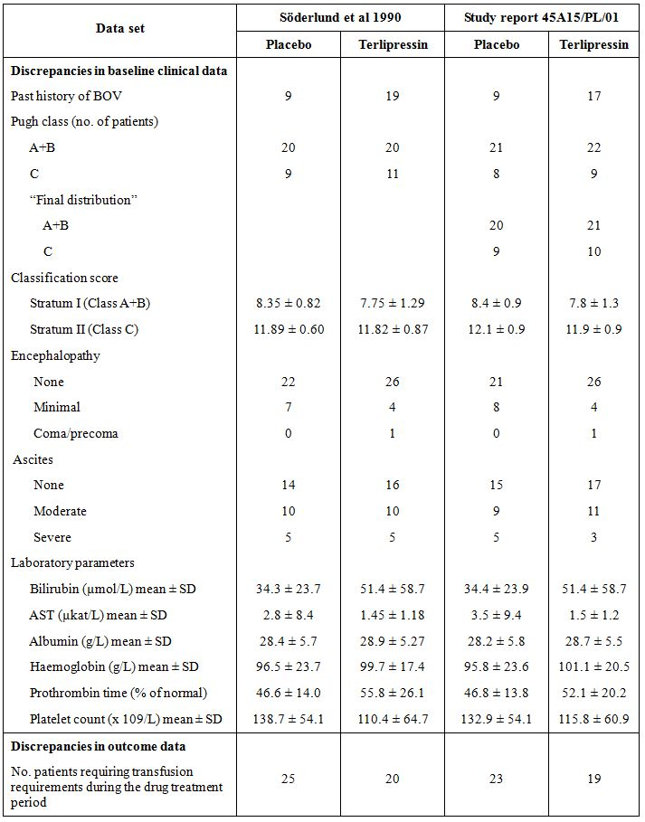
4. The evaluator has calculated 95% CIs for the point estimates of efficacy outcomes for terlipressin and for between group differences in a number of the supporting comparative studies (Silvain et al 1993, Pedretti et al 1994, Abid et al 2009, Lee et al 1988, and Chiu et al 1990). Please review these calculations and provide comment as necessary.

Safety
- The number of fatal ADRs associated with all uses of terlipressin was reported in the Summary of Clinical Safety (dated October 2010) as 73 fatal ADRs in 40 cases as at 30 June 2010. However, the last PSUR (data lock 30 April 2010) stated that the cumulative number of initial medically confirmed case reports until 30 April 2010 was 118 fatal cases. Please provide a reconciliation of the data from these two sources.
- The Summary of Clinical Safety stated there had been 18 fatal cases reported in association with the use of terlipressin for BOV, but causes of death were only provided for 10 cases. Please provide details of the causes of all fatalities with the use of terlipressin in BOV.
- Please reconcile the following discrepancies between figures cited in the Summary of Clinical Safety and cited elsewhere in the dossier:
- The table of the most common ADRs presented in the Summary of Clinical Safety indicated there had been 5 cases of ventricular fibrillation as at 30 June 2010, whereas the last PSUR (dated 18 June 2010) indicated there had been 6 cases as at 30 April 2010; and
- The table of the most common ADRs presented in the Summary of Clinical Safety indicated there had been 6 cases of pulmonary oedema as at 30 June 2010, whereas the RMP dated 20 October 2010 stated there had been 7 cases of pulmonary oedema at the data lock date of 14 June 2010.
- Please provide a summary and analysis of the four reports of hypokalaemia occurring in association with the use of terlipressin received by Ferring Pharnmaceuticals as at 30 June 2010. The analysis should include an assessment of causality.

V. Pharmacovigilance findings

Risk management plan
The sponsor submitted a RMP which was reviewed by the TGA’s Office of Product Review (OPR).

Safety specification
The sponsor provided a summary of ongoing safety concerns which are shown at Table 29.
Table 29: Ongoing safety concerns for terlipressin acetate.
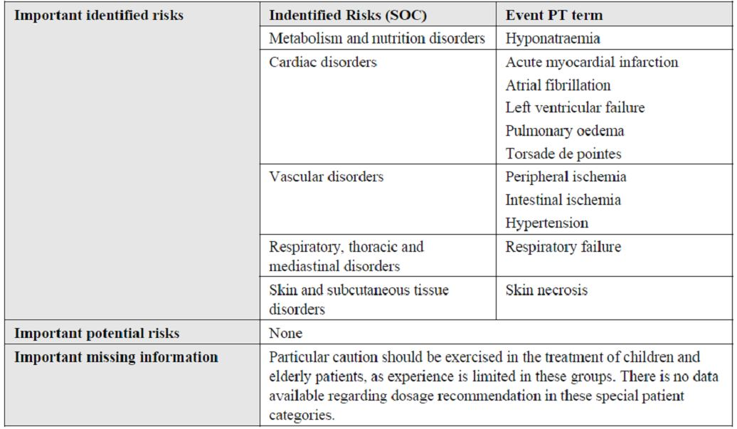

OPR reviewer comment:
Pursuant to the evaluation of the clinical aspects of the Safety Specifications, it is recommended that:
- the sponsor includes bradycardia and ventricular fibrillation as important identified risks in the ongoing safety concerns; and
- the sponsor include hypokalaemia as an important potential risk in the ongoing safety concerns.
Adequate scientific justification should be provided if the sponsor does not agree to these safety concerns being included in the RMP.
With regard to the potential for off label use, the sponsor states that “there is a potential for using the vasoconstrictive effect of terlipressin in the treatment of septic shock.” However, if Glypressin is approved for the treatment of BOV, off label use for the treatment of HRS is likely. It is therefore recommended that unless adequately justified, this section of the RMP should be updated to reflect off label use for the treatment of HRS.

Pharmacovigilance plan

Proposed pharmacovigilance activities
The sponsor is proposing routine PhV activities for all the ongoing safety concerns.

OPR reviewer comment:
Glypressin has been used in the clinical setting for around thirty years and has a fairly well established safety profile. There is no objection to the implementation of routine PhV.

Risk minimisation activities

Sponsor’s conclusion in regard to the need for risk minimisation activities
The sponsor has concluded that no additional risk minimisation activities are required beyond that provided by the product labelling. The sponsor’s justification centres on the known safety profile of Glypressin established over a number of years of exposure in the clinical setting.

OPR reviewer comment:
No regulatory action has been taken for any safety related concerns for terlipressin during its thirty year marketing history. As the treatment of acute BOV is usually undertaken in an intensive care type setting, many of the risks associated with Glypressin would be adequately mitigated by the intensive clinical and investigational monitoring of patients. Where emergency endoscopic facilities or staff trained to perform emergency endoscopies are not available, it is possible that Glypressin may be used initially in situations where it would be clinically indicated to initially proceed to emergency diagnostic endoscopy and possible variceal band ligation. However, clinical issues that are dependent on local health service resources and the use of appropriate clinical practice guidelines are unlikely to be mitigated by additional risk minimisation activities pertaining to the registration of Glypressin. Therefore, there is no objection to the implementation of routine risk minimisation measures.

Potential for medication errors
The sponsor considers the risk of medication errors to be low given that use would be restricted to patients in a hospital setting under close monitoring.

OPR reviewer comment:
As there has been over thirty years of post market experience with Glypressin, it is recommended that the sponsor provide an overview of such data with respect to medication errors.

Summary of recommendations
The following is a summary of the recommendations made to the Delegate. It is suggested that the sponsor update the RMP with respect to the recommended amendments and additional activities, or include these in an updated Australian annex to the RMP. If the sponsor objects to any of the recommendations, adequate justification should be provided.
- Pursuant to the evaluation of the clinical aspects of the Safety Specifications, it is recommended that:
- the sponsor includes bradycardia and ventricular fibrillation as important identified risks in the ongoing safety concerns; and
- the sponsor include hypokalaemia as an important potential risk in the ongoing safety concerns.
- It is recommended that the section on the potential for off label use of the RMP be updated to reflect the potential off label use of Glypressin for HRS.
- Given there has been over thirty years post market experience with Glypressin, it is recommended that the sponsor provide an overview of such data with respect to medication errors.
- The summary of the RMP should be amended to indicate that routine risk minimisation is planned.

VI. Overall conclusion and risk/benefit assessment
The submission was summarised in the following Delegate’s overview and recommendations:

Quality
As noted by the Quality evaluator, the terlipressin in this product is isolated as a solid by lyophilisation from an acetic acid solution, and the amounts of acetic acid and water in the isolated solid can vary greatly. This material is sometimes referred to as terlipressin acetate and sometimes as terlipressin diacetate.
The original submission and this new submission both were primarily labelled in terms of the mass of terlipressin diacetate but, given that the amounts of acetic acid can vary, the sponsor was asked to change the labelling to be primarily in terms of the free terlipressin. In response to a question on this issue and, in the opinion of the Delegate, only creating more confusion, the sponsor stated that their products have been registered in Europe and supplied in Australia under the Special Access Scheme with the labelling primarily in terms of terlipressin acetate and that changing the labelling may cause clinical confusion. So one has a situation where the proposed labelling under this submission employs the term terlipressin diacetate whereas the product currently supplied employs labelling with the term terlipressin acetate. The sponsor objects to the labelling being primarily in terms of the free terlipressin. The matter has also been referred to the Australian Approved Names (AAN) Committee of the TGA who have defined terlipressin to be the same as the International Non proprietary Name (INN), that is, the free base without acetic acid or water and terlipressin acetate to be terlipressin with an undefined amount of acetic acid. Terlipressin acetate also has the synonym terlipressin acetate anhydrous which, despite the latter terminology, may still contain residual water.
The Quality evaluator has indicated that it would be acceptable for the labelling to state the equivalents of terlipressin acetate if that was an AAN with an appropriate definition allowing for the presence of varying amounts of acetic acid and water. The clinical Delegate is uncomfortable with the use of the term terlipressin acetate given that, implicit in that definition, is reference to an undefined amount of acetic acid. It would seem that by far the simplest and most accurate approach is to use labelling expressed in equivalents of terlipressin which, after all, is the active moiety or more accurately the moiety from which and only from which the active is derived. This has been the approach adopted with the terlipressin medicine already on the ARTG. Thus, at this stage, the Delegate is of the opinion that the proposed trade names “Glypressin 1 mg Powder” and “Glypressin 1 mg Solution” are not acceptable. Clinical confusion would be lessened by appropriate and explanatory amendments to the proposed labelling and by appropriate communication with prescribers such as via Dear Healthcare Professional Letters. This will also have implications for the proposed PI, including the way the medicine is named and described in the sections, Name of the Medicine, Description, Pharmacology, Dosage and Administration and Presentation. Clearly, there must be absolute consistency of relevant terms throughout the PI and between those terms and the labelling of the product. The ACPM is requested to comment on this issue. The Delegate is confident that this issue can be resolved in the post ACPM negotiation period.
It should also be noted that at its 142nd meeting held on 21 November 2011, the Pharmaceutical Subcommittee (PSC) recommended (in part) to the ACPM that the PSC endorsed all the questions raised by the TGA in relation to quality and pharmaceutical aspects of the submission by Ferring Pharmaceuticals Pty Ltd to register Glypressin powder for injection and solution for injection containing 0.86 mg and 0.85 mg/0.85 mL of terlipressin. In particular, the PSC:
- Agreed that the proposed powder and solution for injection should be labelled as containing 0.86 mg and 0.85 mg/0.85 mL of terlipressin, respectively, in order to avoid confusion; and
- Supported the question in relation to confirmation of the nominal amount of terlipressin free base in each vial of the proposed powder for injection presentation.
Approval of the sponsor’s application is recommended with respect to chemistry and manufacturing control. However, the quality evaluator stated that the way the products are labelled in terms of the amounts of which drug substance entity are yet to be concluded. Bioavailability is of course 100% for this route of administration.

Nonclinical
While the previously submitted nonclinical data for Glypressin, which was for the powder for injection dosage form only, were limited, there were no toxicity concerns (beyond predictable exaggerated pharmacology) that would preclude the registration of terlipressin diacetate for short term use (up to 48 h) in a life threatening situation.
Nonclinical data for the current submission comprised a local tolerance study in rabbits to support the new dosage form (solution for injection) and 12 literature references.
The literature references revealed no additional safety concerns relevant to the intended clinical use of terlipressin.
Macroscopic and microscopic findings at the injection site following a single intra arterial or paravenous injection or multiple IV injections to rabbits suggested that Glypressin solution for injection was well tolerated locally. However, animal movement during IV injection suggested transient pain or discomfort.
There were no additional concerns raised in the newly submitted animal studies that would preclude the registration of Glypressin for the proposed short term, life threatening situation.

Clinical
Clinical data consisted of the following:
- 4 published pivotal efficacy/safety studies of terlipressin versus placebo;
- 24 supporting controlled studies in which terlipressin was compared with either placebo or other BOV treatments:
  - 1 study of terlipressin versus placebo;
  - 5 studies of terlipressin versus octreotide;
  - 5 studies of terlipressin versus somatostatin;
  - 5 studies of terlipressin versus vasopressin;
  - 3 studies of terlipressin versus BT;
  - 2 studies of terlipressin versus endoscopic treatment;
  - 3 studies of terlipressin at different doses and treatment durations;
- 8 publications of analyses from more than one study;
- 22 other publications, including reports from the 5 Baveno Consensus Workshops, guidelines and treatment protocols and publications by Australian authors together with 127 literature references;
- A preliminary report on a company PK study (45A15/PL/27 from 1987) in 3 patients with BOV;
- 2 dose ranging studies (1988, 1997) examining the effects of different doses of terlipressin on both the splanchnic/portal and systemic circulations and a more recent (2005) comparison of the onset and time course of portal and systemic haemodynamic effects of terlipressin and octreotide; and
- Post marketing experience: a 1991 paper and 5 PSURs covering the period April 2005 to April 2010.
The clinical evaluator concluded in the Clinical Evaluation Report that the application to register Glypressin 1 mg powder and 1 mg ampoules for the treatment of BOV should be approved, subject to satisfactory responses to the questions raised in the evaluation report (all the questions were consolidated in the Clinical Evaluation Report). The sponsor responded to the clinical questions on 14 October 2011 and in turn the clinical evaluator commented on the sponsor’s response. The clinical evaluator was satisfied that the sponsor had adequately addressed the questions raised throughout the Clinical Evaluation Report. All issues having been resolved, the evaluator confirmed the original recommendation for approval. For the benefit of the members of the ACPM and also of the sponsor, the Delegate has appended this comment on the sponsor’s response to this overview.
As noted by the clinical evaluator, subsequent to the 2004 submission and in consultation with the TGA, the sponsor has developed a generally well compiled submission that complies with the requirements of the Literature Based Submission – Points to Consider document. The 2004 submission has been supplemented with additional data for the Powder for Injection and entirely new data for the Glypressin Solution for Injection. The dossier contained a huge amount of clinical information. There was also a considerable amount of information generated from the 2005 clinical evaluation report that had to be reincorporated.
The Delegate does not intend to present summaries of all the studies, reports and papers from the literature. The clinical evaluator has already done an excellent job of collating and summarising all that information in the clinical evaluation report. The Delegate will instead focus on high level summaries and highlighting of any issues of importance.

Pharmacology

Pharmacokinetics
Three studies were evaluated in the 2005 evaluation report: two conducted in healthy volunteers and one in cirrhotic patients without bleeding. One additional company PK study report (45A15/PL/27) dating from 1987 was submitted with this application as a literature reference and this study provided PK data from 3 patients with BOV, including data on levels of terlipressin in ascitic fluid and the kinetics of distribution to the ascitic fluid in 1 patient.
The physicochemical characteristics of terlipressin diacetate are such that it has low oral and intranasal bioavailability and, consequently, an injectable formulation is the most feasible method of drug delivery.
There are very limited PK data for terlipressin diacetate in healthy volunteers and even less data in the target population despite Glypressin having been available since the early 1980s.
Terlipressin plasma concentrations decline in a biexponential fashion following IV bolus administration, with rapid distribution in a volume approximating the extracellular fluid volume. Terlipressin also appears to be distributed to ascitic fluid, reaching equilibrium with plasma at approximately 60 minutes post administration. It is also possible that terlipressin may accumulate in ascitic fluid with repeated bolus administration.
Terlipressin is metabolised via enzymatic cleavage of its three glycine residues by endothelial peptidases into lysine-vasopressin, its biologically active component, with measurable levels of LVP appearing approximately 30 minutes after bolus administration, peaking at between 1 and 2 h. The pharmacokinetics of terlipressin and LVP appear similar in healthy subjects and patients with cirrhosis.

Pharmacodynamics
A large body of evidence has been generated since the mid 1970s that consistently shows that terlipressin at doses of 1 and 2 mg reduces wedged hepatic venous pressure and hepatic venous pressure gradient, with an associated reduction in hepatic and blood azygos flow.
The results of three dose ranging studies indicate trends toward a dose-response relationship.
Systemic haemodynamic effects of terlipressin include an increase in mean arterial pressure and systemic vascular resistance, and reductions in HR, cardiac output/cardiac index and skin blood flow.
With regard to secondary pharmacodynamic effects, in contrast to the effect of vasopressin, terlipressin has been shown to have minimal effects on the fibrinolytic system in cirrhotic patients and no significant effect on ACTH release in healthy volunteers. No consistent effects on serum sodium, potassium, calcium, albumin or urea concentrations have been observed in healthy volunteers. However, two clinical studies (published since the 2004 submission) have demonstrated the potential for clinically significant hyponatraemia associated with the use of terlipressin in the treatment of patients with portal hypertension and actively BOV.

Efficacy

Pivotal placebo controlled studies
Four pivotal placebo controlled studies were identified by the sponsor.

Walker et al
This randomised, double blind, placebo controlled study examined the efficacy of terlipressin when added to standard therapy (including BT) in cirrhotic patients with endoscopically verified variceal bleeding. The study was conducted on 50 consecutive patients with bleeding episodes between April 1983 and November 1984 at a single centre in Germany. Control of bleeding in 36 h, the primary efficacy outcome variable, was reported to have been achieved in 25/25 (100%) of the episodes randomised to terlipressin, compared to 20/25 (80%) of the episodes randomised to placebo (p <0.05). However, among the episodes in which control was ultimately achieved, 5 treated with Glypressin and 7 treated with placebo required sclerotherapy and were thus “treatment failures” according to protocol. This gave a total number of treatment failures of 5/25 (20%) for bleeding episodes randomised to terlipressin and 12/25 (48%) episodes randomised to placebo (p <0.05). As noted by the clinical evaluator, this study had a significant proportion of patients re randomised to treatment, with some randomised a total of 4 times. The evaluator identified a number of inconsistencies and possible errors in the presentation of the data and asked a number of questions of the sponsor.

Freeman et al
This randomised, double blind, parallel group study was conducted at the Royal Victoria Infirmary and University of Newcastle upon Tyne with the aim of comparing terlipressin (Glypressin) and placebo in the treatment of BOV. A secondary aim of the study was to examine the additive effect of Glypressin and the use of the SBT. The period over which the study was conducted was not reported. A total of 29 consecutive patients entered the study. Of these, 16 were originally randomised to receive placebo and 13 to receive terlipressin. Initial control of bleeding within 24 h, the primary efficacy outcome variable, was achieved in 9/15 (60%) of the episodes randomised to terlipressin, compared to 6/16 (37%) of the episodes randomised to placebo. However, this difference was not statistically significant. It was reported that during followup, 1 patient in the terlipressin group and 3 patients in the placebo group re bled within 5 days after completion of the trial protocol. Thus, control of bleeding at 5 days was 8/15 (53%) of the episodes randomised to terlipressin and 3/16 (19%) of the episodes randomised to placebo (χ² = 4.04; p <0.025). There were no statistically significant differences between the treatment groups in blood transfusion requirement or in hospital mortality (terlipressin: 3 deaths/15 episodes (20%); placebo: 4 deaths/16 episodes (25%)). However, when the evaluator did some recalculations of the blood transfusion requirements using the IPD listings, the average number of units required prior to admission for all bleeding episodes treated with placebo was 4.1 ± 3.3 (median 4.5) compared to 1.3 ± 1.4 (median 1) for the terlipressin group, suggesting the bleeds treated with placebo were more severe. Once again, the evaluator asked the sponsor to comment on this.

Söderlund et al
The aim of this randomised, double blind, placebo controlled study was to investigate whether terlipressin was efficacious in controlling acute variceal bleeding for at least 24 h to allow time for subsequent, more definitive treatment such as sclerotherapy. The study was conducted in 60 consecutive patients at two centres in Sweden from November 1985 to August 1988. A total of 60 patients were randomised to treatment - 31 to receive terlipressin and 29 to receive placebo - and no patient was randomised more than once. All patients were followed over their entire hospital stay. A total of 14 patients died whilst in hospital; 3 (9.7%) from the terlipressin group and 11 (37.9%) from the placebo group (p=0.014). Initial control of bleeding (‘success’), the primary efficacy outcome variable, was achieved in 28/31 (90%) of the patients randomised to terlipressin, and in 17/29 (59%) of the patients randomised to placebo (p=0.0067; Fisher’s exact test). During treatment, 2 patients in the terlipressin group and 1 patient in the placebo group had re bleeds. Consequently, ‘efficacy of the test medication’ was slightly lower in both treatment groups, however the difference was still statistically significant in favour of terlipressin (terlipressin 26/31 (84%) versus placebo 16/29 (55%); p=0.024 (Fisher’s exact test)). The requirement for blood transfusions was also significantly lower in the terlipressin group than in the placebo group, both during the treatment period (that is, first injection to last injection) and during treatment and for the 24 h follow up period. During the whole study, from first injection to 24 h follow up, 22/31 (71%) of the patients in the terlipressin group and 28/29 (97%) of the patients in the placebo group required any blood transfusion (p <0.05). In hospital mortality was 3/31 (10%) of the patients in the terlipressin group and 11/29 (38%) of the patients in the placebo group (p <0.05). All deaths were due to bleeding or due to hepatic failure secondary to bleeding. The most important issue with regard to this study report was the inability of the current evaluator and evaluator in 2005 to reconcile some of the results reported in the publication by Söderlund and figures cited in the company study report. Once again in the Clinical Questions, the evaluator asked the sponsor to comment on the observed discrepancies.

Levacher et al
This randomised, double blind, placebo controlled study was conducted in cirrhotic patients with upper gastrointestinal bleeding with the aim of investigating the efficacy of a combination of terlipressin and GTN, administered early by a medical emergency team (SAMU) that goes to the patient, makes a clinical assessment and starts treatment in the home. The study was conducted from October 1991 to June 1993. A total of 85 bleeding episodes in 77 patients were randomised to treatment: 8 patients were randomised twice, having been treated on separate occasions at least 30 days apart. One patient was included by ‘error’ and not analysed, leaving 84 bleeding episodes in 76 patients. Control of bleeding at 12 h was achieved in 29/41 (71%) of the episodes randomised to terlipressin and in 20/43 (47%) of the episodes randomised to placebo (p=0.039). Time to control of bleeding was 3.9 ± 4 h in the terlipressin group and 5.2 ± 4.6 h in the placebo group (p=0.28). In patients who had re bleeding, an alternative therapy was used to achieve haemostasis in 4 cases in the terlipressin group (sclerotherapy [n=1], BT [n=3]) and in 8 cases in the placebo group (sclerotherapy [n=3], BT [n=5]). When the analysis was limited to those episodes considered to be due to BOV, 77.7% episodes ceased within 12 h in the terlipressin group, compared to 41.9% in the placebo group (p=0.017). Generally, the results secondary efficacy endpoints were consistent with and supportive of the primary. As noted by the clinical evaluator, this was the first study to show a long term reduction in mortality with terlipressin compared to placebo in patients presenting with massive upper GIT bleeding.

Other efficacy studies

Terlipressin versus placebo
One study, which was essentially not able to be evaluated.

Terlipressin versus octreotide
Of five studies, the best quality data are those from a randomised, double blind, non inferiority study reported by Abid et al 2009. Non inferiority of terlipressin was adequately demonstrated: control of bleeding was achieved in 158/163 (97%) of the patients randomised to terlipressin + banding ligation, and in 160/161 (99%) of the patients randomised to octreotide + banding ligation (p=NS). Also, the mean length of hospitalisation was shorter in the terlipressin group than in the octreotide group (108 h versus 126 h, p <0.001) and in hospital mortality was 9/163 (6%) in the terlipressin group and 7/161 (4%) in the octreotide group (p=NS).

Terlipressin versus somatostatin
Five studies of which the two largest found no statistically significant differences between terlipressin and somatostatin with respect to bleeding control rate, re bleeding rates and mortality rates (at 42 days and in hospital, respectively). These studies were each adequately powered to detect ~20% differences in bleeding control rates (at a 5% level of significance), assuming a rate of ~80% for terlipressin and ~60% for somatostatin.

Terlipressin versus vasopressin
Five studies in each of which different treatment regimens were used for terlipressin and vasopressin. The clinical evaluator judged the papers to be of low quality. Only 1 study found a statistically significant difference between the two treatments in the achievement of bleeding control. In a very small study comprising 19 patients (21 bleeding episodes) in total, Freeman et al 1982 observed a bleeding control rate of 70% in patients receiving terlipressin and 9% in patients receiving vasopressin. However, the rate observed for vasopressin was markedly lower than that observed in any of the other studies (ranging from 53% to 83%). The result from the largest study (D’Amico et al 1994) favoured terlipressin, where the between group difference in the proportions of patients with initial bleeding control was 8%.

Terlipressin versus Terlipressin
The clinical evaluator was of the opinion that overall, these studies were of little value. None used a 2 mg dosage regimen.

Terlipressin versus non pharmacotherapies
There were 4 studies. There was one relatively large, well powered study (Escorcell et al 2000) which found no significant differences in failure to control bleeding, re bleeding, number of blood transfusions required and 42 day mortality when comparing terlipressin alone with sclerotherapy.

Terlipressin versus Terlipressin plus non pharmacotherapy
One publication (Lo et al 2009) was of good quality. Terlipressin when used in combination with endoscopic variceal ligation was superior to terlipressin alone across a number of study endpoints: treatment failure occurred in 24% of the patients in the terlipressin group and only 2% of the patients in the combined therapy group (p=0.002).

Analyses performed across trials
Overall the clinical evaluator was of the opinion that these reports added little to the dossier.

Evaluator’s conclusions on clinical efficacy for BOV
The evaluator provides an excellent summary of all the issues pertaining to the accurate determination of terlipressin’s efficacy in BOV in the evaluation report. The Delegate would agree with the evaluator that, based on the overall data from the pivotal placebo controlled trials, particularly that of Söderlund et al 1990, and some of the supportive data, there is reasonable evidence of an acceptable level of efficacy of terlipressin at a dose of 2 mg every 4 h for 72 h in the treatment of BOV.

Safety

Studies which assessed safety as a primary outcome
There were 3 clinical studies which assessed safety as a primary outcome

Caletti et al
This prospective, uncontrolled observational study was conducted from March 1987 to December 1989 at 58 centres across Italy, with the aim of collecting data on the efficacy and tolerability of terlipressin when used in the treatment of upper gastrointestinal bleeding. A total of 1258 patients were included in the study: 796 (63%) male, 451 (36%) female, and 11 (1%) with no gender recorded. A total of 1030 (82.5%) patients had bleeding from ruptured oesophageal varices and a further 113 (9%) patients had non BOV for which they had undergone sclerotherapy. The remaining 106 (8.5%) patients had either gastric varices or bleeding from other sites of the gut. The majority of patients were aged 50+ years, with 369 (29.3%) aged 51-60 years, and 579 (46%) aged >60 years. A total of 266 (21.1%) patients experienced a side effect. “Major” side effects reported in 1% or more patients were anti diuresis (3.2%), severe abdominal pain (2.8%) and arterial hypertension (1.6%). “Minor” side effects reported in 1% or more patients were cutaneous vasoconstriction (5.8%), nausea (3.1%), headache (2.6%), increased intestinal motility (2%) and diarrhoea (1.3%). Terlipressin was withdrawn in 30.5% cases and specific treatment of the reaction was required in 20.3% cases. It was stated that the outcome of the reaction was recorded as ‘cure’ in 96.7% of cases and ‘fatal’ in 3.3% (that is, 9 cases of death). However, the authors then stated “in actual fact” they recorded 2 fatal cases among the entire study population of 1258 (possibly the result of a re adjudication of all ADRs, as noted by the evaluator).

Bruha et al
This multicentre, randomised, double blind study was conducted at 4 teaching hospitals in the Czech Republic from May 2004 to April 2005 with the primary aim of comparing the safety of a 5 day and 10 day course of treatment with terlipressin (Remestyp) in cirrhotic patients with endoscopically verified variceal bleeding. One patient in the 5 day treatment group and none from the 10 day group withdrew because of AEs. Also, one patient in the 5 day treatment group and two in the 10 day treatment group died during the study. No information was provided on loss to follow up at 42 days. A total of 25 patients were enrolled in the study, with 15 randomised to the 5 day group and 10 to the 10 day treatment group. The two groups were well matched for age and Child Pugh classification but not with regard to gender distribution. In the 5 day treatment group, 3 patients developed arterial hypertension which was considered to be non serious) and 1 patient developed ischaemia of the lower extremities necessitating discontinuation of treatment (serious AE). In the 10 day treatment group, AEs were reported in 3 patients: hypertension, hyponatraemia and epiparoxysm (epilepsy) (all n=1); all of these were considered non serious. Serum sodium concentrations decreased significantly in both arms during treatment and rose again after terlipressin discontinuation. Serum creatinine levels also decreased during treatment in both groups (statistical significance reached only for the 5 day treatment group) and rose again after treatment discontinuation. Creatinine clearance was similar in both treatment groups on Days 1 and 10. One patient discontinued treatment because of hyponatraemia.

Solà et al
This retrospective cohort study was conducted in 58 consecutive patients treated with terlipressin for upper gastrointestinal bleeding at three centres in Spain between January 2003 and June 2009, with the aim of investigating the effects of terlipressin on serum sodium concentration. In the whole population, serum sodium concentrations decreased from 134.9 ± 6.6mEq/L at baseline to 130.5 ± 7.7mEq/L at Day 5 (mean change -4.0 ± 8.7 mEq/L; p=0.002). Over a five day treatment period, 67% of patients receiving terlipressin developed an acute reduction in serum sodium concentration, with 33% (n=19) patients experiencing no change or increase/decrease <5 mEq/L; 31% (n=18) patients experiencing a decrease of 5 to 10 mEq/L; and 36% (n=21) experiencing a decrease >10 mEq/L. Moreover, hyponatraemia was found to develop rapidly after start of therapy but the hyponatraemia was also usually reversible after withdrawal of terlipressin, with a median recovery time of 4 days. Three patients experienced quite severe neurological complications during an episode of marked hyponatraemia. Of note, the hyponatraemia was found to have developed in the absence of significant impairment of renal function, suggesting that hyponatraemia was probably secondary to a deterioration of the renal capacity to eliminate solute free water. Overall, 17/58 (29%) patients died during hospitalisation, with an inverse relationship between the degree of change in serum sodium concentration during treatment with terlipressin and survival. In hospital mortality rates were 53% in patients with no change or increase/decrease <5 mEq/L; 28% in patients with decreases of 5 to 10 mEq/L; and 10% in patients with decreases >10 mEq/L; p<0.0016). The only predictive factor of in hospital mortality was the baseline Model for End Stage Liver Disease (MELD) score (OR 1.25; 95%CI 1.09-1.44). The Delegate would agree with the evaluator that this study has demonstrated that an acute reduction in serum sodium concentration is common during treatment with terlipressin for severe portal hypertensive bleeding. It develops rapidly after the start of therapy, may be severe in some patients and associated with neurological complications but is reversible after terlipressin withdrawal.

Patient exposure
At least 2477 bleeds have been treated with terlipressin in clinical trials of which 2149 have been treated with terlipressin alone and 328 in combination with other treatment (mostly endoscopic sclerotherapy or banding).
A total of 1161 bleeds were treated in prospective, controlled studies. In these studies, 608/1161 (52%) bleeds were treated using a four hourly regimen and 523/1161 (45%) bleeds were treated using a six hourly regimen.
Only 212 (18%) bleeds were treated exclusively with a 2 mg dose for the duration of treatment. The vast majority of bleeds (838, 72%) were treated with an initial dose of 2 mg, which was subsequently reduced to 1 mg.
The majority of patients (838/1161; 72%) were treated for up to an including 72 h, with 323/1161 (28%) treated for periods longer than 72 h (including 289 episodes treated for 5 days and 10 treated for 10 days). The actual number of bleeds treated with a 2 mg four hourly dosage regimen for up to 72 h is quite small (128 bleeds) and the number treated with 1 to 2 mg four hourly for up to 72 h is 379 bleeds. In those studies where treatment was continued for up to 5 days, a 1 mg dose was used, rather than 2 mg dose as proposed in the submission.

Adverse Events
AEs are summarised in a series of tables, presented according to the comparator used. No results have been presented for SAEs and adverse drug reactions. The vast majority of published papers did not mention SAEs.
No attempt has been made by the evaluator to compare the overall and individual events rates for terlipressin and its comparators because of incomplete reporting and generally low patient numbers. The types of AEs reported are consistent with the known PD effects of terlipressin. Most commonly reported events were abdominal pain/colic, bradycardia, hypertension and pallor. Also, so few AEs were reported that it is not possible to analyse the incidence of AEs according to the dose, dosage interval or duration of treatment in any meaningful way.
Most of the published papers and indeed company study reports did not specifically report the incidence or nature of SAEs, whereas the number and nature of deaths were generally well reported. Not unsurprisingly, most deaths were related to uncontrolled bleeding or re bleeding, complications of the haemorrhage or underlying disorder (for example, encephalopathy, sepsis, hepatorenal failure). Across all the studies submitted, only one death was considered to be related to the use of terlipressin: death from left ventricular failure reported by Silvain et al 1993 in a patient receiving terlipressin + GTN.
In the four placebo controlled pivotal studies, only one patient receiving terlipressin withdrew due to an AE. In the study by Söderlund et al 1990 one patient was withdrawn at 30 h because of severe bradycardia. Overall, withdrawals due to AEs from terlipressin in the other studies were very infrequent.
There were no good data available for the tracking of liver function. Two of the studies demonstrated a significant potential for clinically important hyponatraemia associated with the use of terlipressin. Changes in haematology parameters were not formally presented or analysed in most studies. ECG was routinely monitored in most of the studies but results were not systematically presented or analysed.

Post marketing experience
The sponsor submitted the last 5 annual PSURs that collectively covered the period 16 April 2005 to 30 April 2010 and a copy of the EMEA Assessment Report (Final) on the PSUR Harmonisation Procedure for terlipressin products, which reviewed the PSURs from 16 April 2006 to 30 April 2009. In addition, the Summary of Clinical Safety contained a summary of adverse drug reaction data as at 30 June 2010.
As at 30 June 2010, the sponsor had received reports of 339 suspected adverse drug reactions in 192 patients treated with (Glypressin and Remestyp), of which 293 were serious reactions. The indication for use of terlipressin was reported as BOV in 42% (80) patients, HRS in 16% (32) patients, ‘off label’ uses (such as septic shock, sepsis, haemoptysis etc) in 32% (62) patients, and was unknown in 9% (18) patients.
According to the last available PSUR (data lock 30 April 2010), the most commonly affected system organ classes were cardiac disorders (66 reactions), vascular disorders (50 reactions), skin and subcutaneous tissue disorders (34 reactions), gastrointestinal disorders (30 reactions), metabolism and nutrition disorders (26 reactions), and nervous system disorders (22 reactions).
The Summary of Clinical Safety (dated October 2010) reported that there were 73 fatal ADRs in 40 cases (read as patients) as at 30 June 2010. Of these cases, 18 were reported in association with the use of terlipressin for BOV, 9 for HRS, 9 for other indications (including septic shock, multiorgan failure and Mallory-Weiss Syndrome), and 4 for unknown indications. The causes of death in patients being treated for BOV were myocardial infarction (n=4), intestinal ischaemia (n=2), shock (n=3), and peripheral ischaemia (n=1). The clinical evaluator noted what appeared to be a deficiency in the number of fatal ADRs reported in the Summary of Clinical Safety and the PSUR (data lock 30 April 2010) and requested the sponsor provide a reconciliation of these two sources of information, as well as details of all fatalities with BOV.
Reactions reported to 30 June 2010 occurring in 4 or more patients are summarised in Table 27. The most commonly reported reactions have been peripheral ischaemia, hyponatraemia, skin necrosis, myocardial infarction and bradycardia. These reactions are to be expected on the basis of the actions of terlipressin on V₁ receptors (manifesting as peripheral ischaemia, skin necrosis, myocardial infarction, bradycardia) and V₂ receptors (antidiuretic and water retention effects manifesting as hyponatraemia). The most important ADRs identified from post marketing experience are peripheral ischaemia, intestinal ischaemia, hyponatraemia, skin necrosis and myocardial infarction and myocardial ischaemia. According to the evaluation report, eight of the adverse reactions appearing in Table 27 are not listed in the current Core Data Sheet or proposed for inclusion in the PI for Australia. The sponsor’s justifications for the non inclusion of Rhabdomyolysis and Convulsions were acceptable to the clinical evaluator as they are to the Delegate. The terms Cyanosis, Abdominal Pain, Myocardial Infarction and Ventricular Fibrillation were considered by the sponsor to be “closely related” to the listed terms Peripheral Ischaemia, Abdominal Cramps, Myocardial Infarction and Ventricular Tachycardia, respectively. This argument was not accepted by the evaluator and it is certainly not accepted by the Delegate. Clearly, as noted by the evaluator, there can be very marked differences in the aetiology, pathogenesis, clinical presentation and sequelae of such events. The Delegate therefore requests the inclusion of the terms Cyanosis, Abdominal Pain, Myocardial Infarction and Ventricular Fibrillation in the appropriate location in the PI proposed for Australia. Finally, hypokalaemia is acknowledged as a potential class effect of vasopressin analogues and the sponsor has stated that it will monitor this event through routine PhV measures, citing the fact that it has not been reported in the literature. As at 30 June 2010, the sponsor had received four reports of hypokalaemia. The clinical evaluator requested that the sponsor summarise and present the details of these events of hypokalaemia as well as clarify a number of discrepancies observed in the safety data between the Summary of Clinical Safety and other sources such as the PSURs and the RMP.

Specific Safety Issues of Regulatory Importance

Liver toxicity
No issues identified but no systematic reporting available.

Haematological toxicity
No issues identified but again no systematic reporting available.

Serious skin reactions
Skin necrosis has been the third most frequently reported reaction and is associated with the vasopressive action of terlipressin. In the Ferring Global Safety Database there has been a single report of Steven’s-Johnson syndrome (SJS) and a single report of toxic epidermal necrolysis (TEN) and 16 reports of skin necrosis (reports of SJS and TEN prior to April 2005 and no additional information available).

Cardiovascular safety
The published literature and post marketing surveillance have shown a number of cardiovascular risks with terlipressin, consistent with its known action on V₁ receptors. These risks include hypertension, peripheral ischaemia, intestinal ischaemia, bradycardia, acute myocardial infarction, and ventricular arrhythmias. Collectively, they constitute the most common adverse reactions to terlipressin. A total of 4 cases of torsade de pointes and 2 cases of QT prolongation on ECG have been reported to the sponsor.

Unwanted immunological events
No data available.

Summary of safety
As noted by the evaluator, the sponsor does not have an in house clinical database and as well the quality and completeness of the safety data in the published clinical trials are variable. The Delegate would agree with the evaluator that despite these limitations, the safety profile of terlipressin has been well characterised during its thirty year marketing history. In that time there have been no regulatory actions taken for safety reasons.
The frequency of ADRs has been estimated using the available post marketing data. The most commonly reported reactions have been peripheral ischaemia, hyponatraemia, skin necrosis, myocardial infarction and bradycardia. These reactions are to be expected on the basis of the actions of terlipressin on V₁ receptors (peripheral ischaemia, skin necrosis, acute myocardial infarction and bradycardia) and V₂ receptors (antidiuretic and water retention effects manifesting as hyponatraemia). Other identified risks include intestinal ischaemia, hypertension, pulmonary oedema, torsades de pointes and atrial and ventricular arrhythmias.
There are limited safety data in both the elderly and children. With regard to the elderly, issues of concern would be a predisposition to events of peripheral ischaemia, myocardial ischaemia and skin necrosis due to underlying vascular disease. The elderly are also predisposed to hyponatraemia and would be particularly vulnerable to rapid changes in sodium levels which could overwhelm compensatory mechanisms. Safety data in children are essentially limited to the use of terlipressin in the treatment of septic shock where it should be noted that such use has been associated with significant ischaemic injury.
The clinical evaluator assessed the clinical aspects of the Safety Specifications in the draft RMP. In the opinion of the clinical evaluator, there were two major omissions: bradycardia and ventricular fibrillation, both identified from the published literature and the sponsor’s PhV activities. The Delegate would also recommend the inclusion of these two AEs in the Safety Specifications of the RMP. The clinical evaluator recommended also that consideration should be given to the inclusion of hypokalaemia as an important potential risk (see earlier discussion above). This too is recommended by the Delegate.

Sponsor’s response of 14 October 2011 to the Clinical Evaluation Report and the clinical evaluator’s comment on that response
The sponsor responded to all questions asked by the clinical evaluator. Attached to this overview is a copy of the evaluator’s comment on the sponsor’s response to the evaluation report.
With regard to unresolved efficacy issues, the main issue was that of the three placebo controlled studies for which questions were raised, the predominant questions were those relating to the study by Söderlund et al 1990. This was considered the principal study by the evaluator who considered the sponsor had provided an adequate explanation of the differences between the data reported in the published paper and the most recent version of the clinical study report (the latter having been submitted to the TGA for evaluation).
With regard to the safety data, all discrepancies noticed by the clinical evaluator between the Summary of Clinical Safety and various sources such as PSURs and the RMP were clarified. With regard to the AE hypokalaemia, the sponsor advised that they had received 7 such reports (3 additonal to those 4 already accounted for). The sponsor has agreed to include hypokalaemia as an important potential risk in the RMP and has also included a statement about the recommended monitoring of electrolytes in the Precautions section of the PI.
The clinical evaluator was able to confirm his original positive recommendation regarding marketing authorisation.

Risk management plan
The following is a summary of the recommendations made to the Delegate by the RMP evaluator. It was suggested that the sponsor update the RMP with respect to the recommended amendments and additional activities, or include these in an updated Australian annex to the RMP. If the sponsor objects to any of the recommendations, adequate justification should be provided.
- Pursuant to the evaluation of the clinical aspects of the Safety Specifications (in the RMP evaluation), it was recommended that:
- the sponsor includes bradycardia and ventricular fibrillation as important identified risks in the ongoing safety concerns; and
- the sponsor include hypokalaemia as an important potential risk in the ongoing safety concerns.
- It was recommended that the section on the potential for off label use of the RMP be updated to reflect the potential off label use of Glypressin for HRS.
- Given that there has been over thirty years post market experience with Glypressin, it was recommended that the sponsor provide an overview of such data with respect to medication errors.
- The summary of the RMP should be amended to indicate that routine risk minimisation is planned.
The sponsor accepted the above recommendations and provided an appropriately updated RMP. In final minute to the Delegate, the RMP evaluator recommended that, if the application is approved, then the following specific condition of registration be imposed with respect to the RMP:
The implementation of the RMP for Glypressin in Australia, that identified as Version 2.0 and dated 14 September 2011, and any subsequent versions.

Risk-benefit analysis
As noted by the clinical evaluator and as supported by the Delegate:
- Terlipressin was associated with a statistically and clinically significant reduction of in hospital mortality (10% versus 38%) and failure of initial haemostasis (10% versus 59%) compared to placebo in one randomised double blinded placebo controlled study (Söderlund et al 1990);
- Similar numerical differences were observed in three other randomised double blinded placebo controlled studies (Walker et al 1986, Freeman et al 1989 and Levacher et al 1995), but statistical significance was not reached because of under powering of the studies;
- In a relatively large, well powered study no significant difference was found between terlipressin and sclerotherapy with respect of failure to control bleeding (with similar results for patients with and without active bleeding at endoscopy), re bleeding, number of blood transfusions required and 42 day mortality (Escorsell et al 2000);
- Terlipressin plus endoscopic banding was demonstrated to be non inferior to octreotide plus endoscopic banding (with non inferiority margin of 11%) with respect to control of bleeding (Abid et al 2009);
- In both the pivotal placebo controlled studies and supporting studies there was a consistently high rate of bleeding control with terlipressin, despite substantial differences in study design, the dose used and assessment of treatment effect.
As noted by the clinical evaluator and as supported by the Delegate:
The risks of terlipressin in the proposed usage have been well characterised during its thirty year marketing history through post marketing studies and PhV activities. The main identified risks are:
- peripheral ischaemia;
- hyponatraemia;
- skin necrosis;
- myocardial infarction; and
- bradycardia.
Other identified risks include intestinal ischaemia, hypertension, pulmonary oedema, torsades de pointes and atrial and ventricular arrhythmias.
Overall, the Delegate would agree with the clinical evaluator that there are adequate data to support the registration of terlipressin for the treatment of BOV. The major outstanding unresolved issue is that of appropriate nomenclature for the labelling of the product. The advice of the ACPM has been sought on this issue. Essentially, the Delegate’s fundamental view is that whatever nomenclature is chosen, it must be scientifically rational and accurate. Final details with regard to the labelling will be negotiated in the post ACPM period.

Delegate considerations
I propose to approve this submission by Ferring Pharmaceuticals Pty Ltd to register Glypressin (terlipressin) based on the quality, safety and efficacy of the product having been satisfactorily established for the indication below and for the reasons stated above in the Risk/Benefit Discussion and provided that satisfactory agreement can be negotiated with the sponsor concerning the proper nomenclature and labelling of the medicine and concerning the level of information conveyed to the prescriber in the PI:
“Glypressin is indicated for the treatment of bleeding oesophageal varices”
I propose to recommend the imposition of the following specific condition of registration:
- The full implementation of the RMP for Glypressin in Australia, that identified as version 2.0, dated 14 September 2011, and any subsequent updated and approved versions.
The sponsor should address the following issues in the pre ACPM response:
- An update to the registration status (with dates) for this submission of terlipressin in the USA, Europe/UK, Canada, Switzerland and New Zealand including any withdrawals, rejections or deferrals.
- The proper nomenclature of and labelling for this medicine.
- The sponsor is requested to inform the TGA in its pre ACPM response if it is the sponsor or if it is planning to be the sponsor of any clinical trials worldwide involving terlipressin for any indication. If so, the sponsor is to state when the relevant clinical study reports will become available as the submission of each of these clinical study reports as part of a Category 1 submission to the TGA will be made a specific condition of registration.

Response from Sponsor
Ferring welcomes the opportunity to provide sponsor comments on the Delegate’s Summary and Proposed Action for consideration at the March 2012 ACPM meeting. Ferring is pleased that the Delegate agrees with the clinical evaluator and other evaluators that Glypressin should be approved for treatment of BOV.
Ferring notes that the ACPM’s advice has been sought on a range of issues and the pre ACPM response addresses each of these points in turn. Other minor matters raised by the Delegate are addressed as an addendum to this response.

(a) Advice is sought from the ACPM as to the current strategies for treatment of BOV in Australia and where terlipressin sits in regard to those strategies
As noted by the Delegate:
“There are currently no pharmacological therapies approved for the treatment of BOV in Australia, although the chemical entities vasopressin and octreotide are approved for other indications. Octreotide and terlipressin are recommended for the treatment of BOV in both the Australian Medicines Handbook (AMH) and the Therapeutic Guidelines: Gastrointestinal 2011 version 5 (TGs). As noted by the clinical evaluator, treatment guidelines from two institutions, The Austin Hospital in Melbourne and Royal Prince Alfred Hospital in Sydney suggest that octreotide is currently used as a first line agent (in combination with banding or ligation) with terlipressin being reserved for situations where octreotide is ineffective. The advice of the ACPM is sought as to the current treatment of BOV in Australia”
As noted by the Clinical Evaluator in his/her report:
“The current preference for octreotide is likely to have more to do with octreotide being easier to access rather than being a reflection of the relative effectiveness of the two medicines in this indication. Octreotide is used off label whereas terlipressin is accessed through the Special Access Scheme (SAS) with its somewhat relatively burdensome requirements”
The clinical evaluator is correct in this interpretation as evidenced in a recent letter, attached to this response, from A/Professor Paul Gow from Austin Hospital in his capacity as Co Chairman of the Melbourne Liver Group. He states:
“It is the general belief of the members of the Melbourne Liver Group that the optimal pharmacological therapy is terlipressin, but I find that octreotide is chosen as first line therapy in hospitals within Melbourne for purely economic reasons.”
Similarly, while acknowledging that both octreotide and terlipressin are used for this condition, and as pointed out by the clinical evaluator, Professor Geoff McCaughan from Royal Prince Alfred Hospital in Sydney, in his capacity as Chair of the Australian Liver Group, wrote in his letter of support supplied with our submission:
“All articles and Australian Therapeutic Guidelines include reference to terlipressin as best practice for variceal bleeding. Indeed the Cochrane analysis and subsequent RCTs are the likely basis for the use of this therapy in at least eight teaching hospitals in Australia.”
In summary, as noted by the Delegate and the clinical evaluator, and as supported by clinical input from key Australian liver centres, both terlipressin and octreotide are considered to be effective treatments for BOV in Australia.

(b) Does the ACPM agree with the delegate as to the proper nomenclature and labelling of this terlipressin product? See para ix of this overview.
The Delegate has also asked Ferring to address this point in our response.
This issue has been extensively debated during the evaluation of the application for registration and has been summarised by the Delegate in paragraph ix. “The Delegate notes that the material is sometimes referred to as terlipressin acetate and sometimes as terlipressin diacetate.” Ferring would like to clarify that Glypressin has always been labelled as containing 1 mg terlipressin acetate and that Ferring’s original submission (March 2004) was also labelled as terlipressin acetate 1 mg.
With respect to the AAN, apart from its original proposal for terlipressin as an AAN, Ferring has had no further input into this matter. Terlipressin was assigned as the original AAN in Australia, in June 2004. The AAN terlipressin diacetate arose in 2005 after the original TGA evaluation. Ferring was asked to change all references from 1 mg terlipressin acetate to 1 mg terlipressin diacetate. Terlipressin diacetate was defined as the anhydrous substance at this time, despite the varying content of water. Ferring complied with this AAN in the resubmission in 2010 and adhered to the TGA’s previous request for labelling as 1 mg terlipressin diacetate. At the request of the Chemistry evaluator of the current submission, the PI was amended to read: Although the active ingredient is terlipressin, the drug substance included in this product contains non stoichiometric amounts of acetic acid and water, and this material is freely soluble in water. Terlipressin diacetate has recently been rescinded as an AAN and replaced by two variants of terlipressin acetate (anhydrous and pentahydrate), neither of which is acceptable to TGA because, as stated above, water content can vary. This is at odds with the ruling in 2005. It should be noted that there has been no change to the drug substance in the intervening period.
Ferring would like to highlight that Glypressin is known as 1 mg terlipressin acetate in Australia through more than ten years of SAS usage and internationally through extensive usage for over thirty years. Moreover, all dosing recommendations in current Australian and international references (for example, Therapeutic Guidelines, AMH, overseas PIs as attached) state the dose as 1 mg or 2 mg of terlipressin (meaning terlipressin acetate). The list below shows the labelling of Glypressin and other generic presentations internationally:
Glypressin (Ferring) terlipressin acetate 1 mg
Variquel (IS Pharmaceuticals, UK) terlipressin acetate 1 mg
Haemopressin (Specialty European Pharma) terlipressin acetate 1 mg
Terlip (Getz Pharma, United Arab Emirates) terlipressin acetate 1 mg
Novapressin (Ferozsons Laborators, Pakistan) terlipressin acetate 1 mg
The Delegate is strongly of the view that Glypressin should be labelled as containing 0.85 mg of terlipressin rather than 1 mg of terlipressin acetate (or diacetate, as previously required). Ferring understands that this may be due to the fact that an alternative form of terlipressin has now been registered and is labelled as terlipressin 0.85 mg. Should ACPM support this view, Ferring accepts that Glypressin must be labelled as containing 0.85 mg terlipressin in Australia. In order to minimise confusion, Ferring proposes to remove 1 mg from the Trade Name (Glypressin 1 mg becomes Glypressin) and to state on the labelling and in the PI that 0.85 mg terlipressin is equivalent to 1 mg terlipressin acetate.
It is the understanding of Ferring that the proposal to state that 0.85 mg terlipressin as equivalent to 1 mg terlipressin acetate is currently not an acceptable option for TGA (para ix) because terlipressin acetate is not strictly anhydrous, as per the synonym, terlipressin acetate anhydrous. Ferring requests that the ACPM and the TGA encourage the AAN Committee to delete the synonyms referring to anhydrous forms from the definition of terlipressin acetate to enable this proposal to be enacted.

(c) Does the ACPM agree with the delegate that more detailed information on the pharmacokinetics of terlipressin, including the limitations of that information, should be provided in the PI? See para xxi of this overview.
Ferring has no objection to this request and revised PIs are supplied with our response.

(d) Does the ACPM agree with the delegate that more detailed information on the pharmacodynamics of terlipressin, including the limitations of that information, should be provided in the PI? See para xxi of this overview.
Ferring has no objection to this request and revised PIs are supplied with our response?

(e) Does the ACPM agree with the delegate that there is to be considerable amendment of the Clinical Trials, Precautions and Adverse Effects sections of the PI? See para xxi of this overview.
Ferring has no objection to this request and revised PIs are supplied with our response.

Conclusion
Glypressin has been available overseas for the treatment of BOV for over thirty years and there is more than ten years’ experience with Glypressin in Australia under the SAS scheme. Ferring agrees with the Delegate and evaluators that Glypressin should be approved for treatment of BOV. As noted by the Delegate and the Clinical Evaluator, and as supported by clinical input from key Australian liver centres, both terlipressin and octreotide are considered to be effective treatments for BOV in Australia. However, if approved, terlipressin would become the only agent evaluated and approved for BOV in this country.

Advisory Committee Considerations
The ACPM (which has succeeded ADEC), taking into account the submitted evidence of efficacy, safety and quality, as well as the sponsor’s response, agreed with the Delegate and considered this product to have an overall positive benefit-risk profile for the following indication:
For the treatment of bleeding oesophageal varices.
In making this recommendation, the ACPM noted that this product is the first pharmacological therapy for this indication.
The ACPM agreed with the Delegate to the proposed amendments to the PI and Consumer Medicine Information (CMI) and specifically advised on inclusion of the following:
- a statement in the Dosage and Administration / Clinical Trials / Precautions / Contraindications sections of the PI to more accurately reflect the recommendations for modifying dosage throughout the treatment regime and the maximum duration of therapy. The CMI should also reflect these amendments.
The ACPM agreed with the Delegate on the proposed conditions of registration.
The ACPM advised that the implementation by the sponsor of the recommendations outlined above to the satisfaction of the TGA, in addition to the evidence of efficacy and safety provided, would support the safe and effective use of these products.

Outcome
Based on a review of quality, safety and efficacy, TGA approved the registration of Glypressin (terlipressin acetate) Powder for injection vials plus diluent ampoules AND Solution for injection ampoules containing terlipressin 0.85 mg and 0.85 mg/8.5 mL, respectively: The improved indication reads as follows:
Glypressin is indicated for the treatment of bleeding oesophageal varices.

Specific conditions of registration applying to these therapeutic goods:
The full implementation of the RMP for Glypressin in Australia, that identified as version 2.0, dated 14 September 2011, and any subsequent updated and approved versions.

Attachment 1. Product Information
The following Product Information was approved at the time this AusPAR was published. For the current Product Information please refer to the TGA website at <http://www.tga.gov.au/hp/information-medicines-pi.htm>.

Colin R. (1987) Pharmacokinetic study on Glypressin (Terlipressin INN; triglycyl-lysine-vasopressin: TGLVP) administered to cirrhotic patients with bleeding oesophageal varices. Clinical Trial Report 870506.
World Gastroenterology Organisation, “World Gastroenterology Organisation practice guideline: Esophageal varices”, June 2008, Web, accessed 30 October 2012 <www.worldgastroenterology.org /assets/downloads/en/pdf/guidelines/18_treatment_e_varices_en.pdf>.
Results for bleeding control and mortality are not presented for the meta analysis of terlipressin versus placebo because of the apparent transposition of results contributed by the Patch et al 1999 study.
Italian paper with English translation.
The time course of recovery is less clear because of the delay in collection of the post withdrawal samples of 5 days and 11 days in the 5 and 10 day treatment groups, respectively.
Note: 15 countries have HRS as an approved indication for terlipressin.
Note: it is acknowledged that the occurrence of pulmonary oedema was likely to be confounded by the presence of hypoalbuminaemia and aggressive fluid replacement.
In Sections I-V of this AusPAR, the material has been referred to as ‘terlipressin acetate’. References to ‘terlipressin diacetate’ were changed to ‘terlipressin acetate’ as this is the final Australian Approved Name (AAN); the former name ‘terlipressin diacetate’ was rescinded. The details of how the AAN changed from the time of submission to the time of approval are outlined in detail in Section VI for full transparency.

