November 2016

Australian Public Assessment Report for Tiotropium bromide
  - Proprietary Product Name: Spiriva Respimat / Favint Respimat
  - Sponsor: Boehringer Ingelheim Pty Limited

About the Therapeutic Goods Administration (TGA)
- The Therapeutic Goods Administration (TGA) is part of the Australian Government Department of Health and is responsible for regulating medicines and medical devices.
- The TGA administers the Therapeutic Goods Act 1989 (the Act), applying a risk management approach designed to ensure therapeutic goods supplied in Australia meet acceptable standards of quality, safety and efficacy (performance) when necessary.
- The work of the TGA is based on applying scientific and clinical expertise to decision-making, to ensure that the benefits to consumers outweigh any risks associated with the use of medicines and medical devices.
- The TGA relies on the public, healthcare professionals and industry to report problems with medicines or medical devices. TGA investigates reports received by it to determine any necessary regulatory action.
- To report a problem with a medicine or medical device, please see the information on the TGA website <https://www.tga.gov.au>.
About AusPARs
- An Australian Public Assessment Report (AusPAR) provides information about the evaluation of a prescription medicine and the considerations that led the TGA to approve or not approve a prescription medicine submission.
- AusPARs are prepared and published by the TGA.
- An AusPAR is prepared for submissions that relate to new chemical entities, generic medicines, major variations and extensions of indications.
- An AusPAR is a static document; it provides information that relates to a submission at a particular point in time.
- A new AusPAR will be developed to reflect changes to indications and/or major variations to a prescription medicine subject to evaluation by the TGA.
Copyright
© Commonwealth of Australia 2016
This work is copyright. You may reproduce the whole or part of this work in unaltered form for your own personal use or, if you are part of an organisation, for internal use within your organisation, but only if you or your organisation do not use the reproduction for any commercial purpose and retain this copyright notice and all disclaimer notices as part of that reproduction. Apart from rights to use as permitted by the Copyright Act 1968 or allowed by this copyright notice, all other rights are reserved and you are not allowed to reproduce the whole or any part of this work in any way (electronic or otherwise) without first being given specific written permission from the Commonwealth to do so. Requests and inquiries concerning reproduction and rights are to be sent to the TGA Copyright Officer, Therapeutic Goods Administration, PO Box 100, Woden ACT 2606 or emailed to <tga.copyright@tga.gov.au>.

Contents
Common abbreviations 4
I. Introduction to product submission 8
Submission details 8
Product background 9
Regulatory status 10
Product Information 12
II. Quality findings 12
III. Nonclinical findings 13
Introduction 13
Pharmacokinetics 13
Nonclinical summary and conclusions 13
IV. Clinical findings 13
Introduction 13
Pharmacokinetics 16
Pharmacodynamics 20
Dosage selection for the pivotal studies 20
Efficacy 20
Safety 27
First round benefit risk assessment 29
First round recommendation regarding authorisation 33
Clinical questions 39
V. Pharmacovigilance findings 39
Risk management plan 39
VI. Overall conclusion and risk/benefit assessment 70
Background 70
Quality 71
Nonclinical 71
Clinical 71
Risk management plan 79
Outcome 91
Attachment 1. Product Information 91
Attachment 2. Extract from the Clinical Evaluation Report 91

Common abbreviations
Abbreviation | Meaning
#PV | Pharmacovigilance endpoint
ACQ | Asthma control questionnaire
AE | Adverse event
AM | Asthma monitoring
AQLQ(S) | Standardised asthma quality of life questionnaire
ARTG | Australian Register of Therapeutic Goods
ATS | American thoracic society
AUC | Area under the plasma concentration time curve
AUC0-tz(,ss) | Area under the plasma concentration time curve from time point of administration to the time point of the last quantifiable plasma concentration (at steady state)
AUC_{t1-t2(ss)(norm)} | Area under the plasma concentration time curve from the time point t1 to the time point t2 (at steady state) (dose normalised)
BI | Boehringer Ingelheim
BD | twice daily
CD | Concomitant diagnosis
CI | Confidence interval
CLR,t1-t2 | Renal clearance of the from time point t1 until the time point t2
Cmax(,ss)(,norm) | Maximum plasma concentration (at steady state) (dose normalised)
COPD | Chronic obstructive pulmonary disease
CTR | Clinical trial report
CV | Coefficient of variation
EU | European Union
FEV₁ | Forced expiratory volume in 1 second
FVC | Forced vital capacity
GINA | Global Initiative for Asthma
h | hour
HH | HandiHaler
HR | Hazard ratio
ICH | International Conference on Harmonisation
ICS | Inhaled corticosteroids
IgE | Immunoglobulin E
LABA | Long acting β2 adrenoceptor agonist
LAMA | long acting anti muscarinic agent
MACE | Major adverse cardiovascular events
max | Maximum value
MDI | Metered dose inhaler
MedDRA | Medical Dictionary for Regulatory Activities
MI | Myocardial infarction
min | Minutes
mL | Millilitre(s)
OCS | Oral corticosteroid
PD | Pharmacodynamic
PDCO | Paediatric committee
PEF | Peak expiratory flow
PEFam | Morning peak expiratory flow
PEFpm | Evening peak expiratory flow
pg | Picogram(s)
PIP | Paediatric Investigational Plan
PK | Pharmacokinetic
PSUR | Periodic Safety Update Report
PT | Preferred term of MedDRA
qd | once daily
RR | Rate ratio
SABA | Short acting β2 adrenergic agonist
SAE | Serious adverse event
Sal 50 | Treatment group: 50 µg salmeterol administered via a hydrofluoralkane metered dose inhaler
SCE | Summary of clinical efficacy
SCS | Summary of clinical safety
SD | Standard deviation
SE | Standard error
SmPC | Summary of Product Characteristics
SMQ | Standardised MedDRA Query
SOC | System organ class of MedDRA
SS | Steady state
Tio HH | Tiotropium inhalation powder administered via the HandiHaler
Tio HH18 | Treatment group: Tiotropium 18 µg dry powder for inhalation delivered via HandiHaler
Tio R1.25 | Treatment group: 1.25 µg tiotropium administered as 2 actuations of the 0.625 µg solution for inhalation administered via the Respimat
Tio R10 | Treatment group: 10 µg tiotropium administered as 2 actuations of the 5 µg solution for inhalation administered via the Respimat
Tio R2.5 | Treatment group: 2.5 µg tiotropium administered as 2 actuations of the 1.25 µg solution for inhalation administered via the Respimat
Tio R5 | Treatment group: 5 µg tiotropium administered as 2 actuations of the 2.5 µg solution for inhalation administered via the Respimat
TIOSPIR | The tiotropium safety and performance in Respimat Trial
t_{max,ss} | Time from dosing to maximum tiotropium plasma concentration (at steady state)
TS | Treated set
US FDA or FDA | United States Food and Drug Administration
Wk (weeks) | week(s)
Yr (years) | year(s)
µg | Microgram(s)
µL | Microlitre(s)

I. Introduction to product submission

Submission details
Type of submission: | Extension of Indications
Decision: | Approved
Date of decision: | 22 May 2015
Date of entry onto ARTG | 1 June 2015
Active ingredient: | Tiotropium bromide
Product names: | Spiriva Respimat/ Favint Respimat
Sponsor’s name and address: | Boehringer Ingelheim Pty Limited  PO Box 1969  North Ryde NSW 2113
Dose form: | Inhalation, conventional
Strength: | 2.5 µg/ actuation
Container: | cartridge
Pack size: | 60 actuations (1 cartridge) + Respimat inhaler (inhalation device)
Approved therapeutic use: | Spiriva is indicated as add on maintenance bronchodilator treatment in adult patients who are currently treated with the maintenance combination of inhaled corticosteroids (≥ 800 µg budesonide/day or equivalent) and long acting β₂ agonists and who experienced one or more severe exacerbations in the previous year.
Route of administration: | Inhalation
Dosage: | The recommended dosage is 5 µg given as two puffs once daily at the same time each day.
ARTG numbers: | 132578, 132590

Product background
This AusPAR describes the application by Boehringer Ingelheim Pty Limited (the sponsor) to register Spiriva Respimat/ Favint Respimat for the following indication:
Asthma:
Spiriva Respimat is indicated as add-on maintenance treatment for the improvement of asthma symptoms, quality of life, and reduction of exacerbations, in adult patients with asthma who remain symptomatic on at least inhaled corticosteroids.
During the evaluation, the sponsor agreed to narrow the proposed indication to:
Asthma:
‘Spiriva Respimat is indicated as an add on maintenance bronchodilator treatment in adult patients with asthma who are currently treated with the maintenance combination of inhaled corticosteroids (≥ 800 µg budesonide/day or equivalent) and long acting β2 agonists and who experienced one or more severe exacerbations in the previous year.’
At the time of this submission the approved indications were
COPD:
Spiriva Respimat is indicated for the long term maintenance treatment of bronchospasm and dyspnoea associated with chronic obstructive pulmonary, disease (COPD. Spiriva Respimat is indicated for the prevention of COPD exacerbations.
This submission also included a request to make changes to the Product Information (PI) for Spiriva (ARTG 81525) and Favint (ARTG 98765) however the details of this are not included as they are beyond the scope of this AusPAR.
Tiotropium is a long acting anticholinergic bronchodilator (long acting anti muscarinic agent, (LAMA)). It blocks the M3 receptor, which results in prolonged bronchodilation. It is currently registered in Australia for chronic obstructive pulmonary disease (COPD). LAMAs are listed as a possible first line therapy in clinical practice guidelines for COPD; in many guidelines they are the preferred first line therapy.
Tiotropium is the first LAMA proposed for registration for an asthma indication. The goal of asthma treatment is to achieve and maintain control; that is, minimal or no symptoms of asthma. Treatment can be modified by stepping up in the case of uncontrolled asthma; or stepping down, if symptoms have been controlled for at least 3 months.
Inhaled corticosteroids (ICS) are the cornerstone of treatment for asthma. Long acting β2 adrenoceptor agonists (LABAs) are added when symptoms persist, to improve control. They can be considered added to low dose ICS if treatments are not effective in controlling asthma. They also may be added to medium or high dose ICS if treatments are not effective in controlling asthma. Monotherapy with LABA is not recommended because of concerns about increased mortality. The sponsor is not proposing monotherapy with tiotropium.
Both LABAs and tiotropium provide bronchodilation. This submission is to add tiotropium as possible maintenance treatment, in addition to ICS for ‘mild’ to ‘moderate’ asthma and in addition to high dose ICS + LABA for ‘severe’ asthma.

Regulatory status
The product received initial registration on the Australian Register of Therapeutic Goods (ARTG) on 2 May 2008 for the COPD indication.
At the time the TGA considered this application, a similar application for extension of indications had been submitted in the European Union (EU) in August 2013 via decentralised procedure with The Netherlands as the Reference Member State. The original proposed indication was similar to that proposed in the current Australian submission. During the evaluation, the sponsor agreed to narrow the indication (as described above).
The sponsor has provided the TGA with the assessment report from The Netherlands Medicines regulator (MEB) (2014) and also the scientific advice on design of the Phase III studies from MEB to the sponsor (2009). The sponsor also provided the TGA with the following information: ‘There was no pre submission meeting with the MEB. The submission was approved by the MEB in October 2014.
At the time the TGA considered this application other countries in the EU and elsewhere have also approved or were considering Spiriva Respimat for an asthma indication as shown in Table 1.
Table 1 Overseas regulatory status
Country | Date | Approved indication
EU (Decentralised Procedure) | Approved August 2014 | Spiriva Respimat is indicated as an add on maintenance bronchodilator treatment in adult patients with asthma who are currently treated with the maintenance combination of inhaled corticosteroids (≥ 800 µg budesonide/day or equivalent) and long acting β2 agonists and who experienced one or more severe exacerbations in the previous year.
Austria, Belgium, Bulgaria, Cyprus, Croatia, Czech Republic, Denmark, Estonia, Finland, France, Germany, Hungary, Iceland, Ireland, Latvia, Liechtenstein, Lithuania, Luxemburg, Malta, Netherlands, Norway, Poland, Portugal, Romania, Slovakia, Slovenia, Spain, Sweden, United Kingdom, Phillipines, Serbia, South Korea | Approved between August 2014 and January 2015
Greece, Italy | pending
Argentina, Peru | Approved October/November 2014 | Spiriva Respimat is indicated for maintenance bronchodilator treatment additional adult asthma patients being treated with the combination of maintenance inhaled corticosteroids (> 800 budesonide / day or equivalent µg) and long-acting B2 agonists and have experienced one or more severe exacerbations in the past year
Chile | Approved March 2014 | Spiriva Respimat is indicated as additional maintenance treatment for improvement of symptoms and reduction of asthma exacerbations in adult patients with asthma who continue to be symptomatic with the administration of inhaled corticosteroids
Colombia | Approved November 2013 | Spiriva Respimat is indicated as a bronchodilator combined maintenance treatment in adult patients with asthma who remain symptomatic during treatment with at least inhaled corticosteroids
Ecuador, Thailand | Approved February 2014 | Spiriva Respimat is indicated as additional maintenance treatment for the improvement of asthma symptoms, improving quality of life and reducing exacerbations in adult patients with asthma who remain symptomatic on inhaled corticosteroid administration
Paraguay | Approved February 2015 | Spiriva Respimat is indicated for maintenance bronchodilator therapy combined in adult patients with asthma who remain symptomatic during treatment with inhaled corticosteroids at least.
Mexico | Approved September 2014 | Spiriva Respimat is indicated as add-on maintenance treatment for the improvement of asthma symptoms, reduction of exacerbations in adult patients with asthma who remain symptomatic on at least inhaled corticosteroids
Russia | Approved February 2014 | Spiriva Respimat is indicated as additional maintenance therapy in patients with bronchial asthma with continuing symptoms of the disease while taking at least inhaled glucocorticosteroids, to reduce asthma symptoms, improve quality of life and reduce the frequency of exacerbations
Uruguay | Approved January 2015 | Spiriva Respimat is indicated as additional maintenance treatment for the relief of symptoms of asthma, improving the quality of life and reducing exacerbations in adult patients with asthma who remain symptomatic with the use of inhaled corticosteroids
Venezuela | Approved Febuary2015 | Spiriva Respimat is indicated for maintenance bronchodilator treatment of persistent moderate to severe asthma in whom treatment with inhaled corticosteroids is not enough.
Also at the time the TGA considered this application, a similar application was under consideration in: USA submitted June 2014; Canada submitted March 2014; Switzerland submitted December 2014 (for both COPD and asthma); and New Zealand submitted September 2013.
The proposed indication in Canada and Switzerland (where the product is still under evaluation) is also along the lines of ‘add on to high dose ICS + LABA’. In the USA, the proposed indication is the same as that proposed in Australia; however, the age group is not adults, but 12 years (years) and older. That is, the US dossier includes data for adolescents, which was not submitted in Australia.
Given that tiotropium is only approved as an add on for adult patients on high dose ICS and LABA in various countries in the EU, Australia would be the first regulator in a high income country to accept the wider indication of ‘add on to at least ICS’.

Product Information
The Product Information (PI) approved with the submission which is described in this AusPAR can be found as Attachment 1. For the most recent PI, please refer to the TGA website at <https://www.tga.gov.au/product-information-pi>.

II. Quality findings
There was no requirement for a quality evaluation in a submission of this type.

III. Nonclinical findings

Introduction
The dossier contained data on pharmacokinetics (PK) only. No new pharmacology or toxicology data relevant to the newly proposed asthma indication were submitted. This is acceptable given the use of the drug for this indication is rationalised by its well established long acting muscarinic antagonist activity, producing bronchodilation, and that the recommended dose is unchanged compared with the current indication COPD; 5 µg / day.

Pharmacokinetics
Rapid absorption of tiotropium after inhalational administration was previously shown in laboratory animal species and humans. Toxicokinetic sampling in the nonclinical studies submitted for the drug’s original registration involved venous blood sampling, which may not adequately reflect peak systemic concentrations for rapidly absorbed drugs. The sponsor has now compared venous and arterial plasma concentration time profiles for inhaled tiotropium in dogs, administered at 9.6 µg / day as a solution delivered by the Respimat device. The data revealed a relatively modest ratio (1.64) between the arterial and venous plasma peak concentrations, observed 3.0 to 7.5 min post dose in arterial plasma and 7.5 to 10 min in venous plasma. Peripheral venous blood sampling beginning around 5 min after inhalation is considered adequate to evaluate the PK of tiotropium after inhalation exposure to tiotropium bromide. The study confirms the relevance of previously submitted toxicokinetic data.

Nonclinical summary and conclusions
- There are no nonclinical objections to the extension of indication for Spiriva Respimat / Favint Respimat to include add-on maintenance treatment for asthma symptoms in adults.
- The draft Product Information documents for Spiriva / Favint and Spiriva Respimat / Favint Respimat should be revised. Details of revision are beyond the scope of this AusPAR.

IV. Clinical findings
A summary of the clinical findings is presented in this section. Further details of these clinical findings can be found in Attachment 2.

Introduction

Clinical rationale
Asthma is a chronic inflammatory disorder of the airways that affects approximately 5% of the world's population. Currently, about 300 million people worldwide have asthma and The Global Initiative for Asthma (GINA) guideline categorises asthma as intermittent, mild persistent, moderate persistent, or severe persistent. Previous GINA documents subdivided asthma into these categories based only on the severity of the underlying disease (that is, the level of symptoms, airflow limitation, and lung function variability) in patients who had not yet received treatment. However, as patients with very severe symptoms might respond well to low dose treatment, asthma severity is now classified using both the severity of the underlying disease and its responsiveness to treatment.
Therapy is increased in a stepwise manner until asthma control is achieved. Depending on the level of asthma control, treatment can be modified by 'stepping up' in case of uncontrolled asthma or 'stepping down' if asthma symptoms have been controlled for at least 3 months.
Inhaled corticosteroids (ICS) are the first line controller therapy for asthma. Depending on asthma severity, other therapies may also be added to the treatment regimen (that is, LABA, leukotriene modifiers, theophyllines, antihistamines, oral steroids, and anti-immunoglobulin E [IgE]), but still less than half of patients with asthma are well controlled. Thus, there is a growing need for additional therapeutic options for the treatment of asthma, especially for patients who remain symptomatic (that is, uncontrolled and/or at potential risk of asthma exacerbation) despite treatment with ICS (or ICS + LABA).
Tiotropium is one of the most widely used long acting bronchodilators worldwide for the treatment of COPD. The use of anticholinergic agents like tiotropium as add on maintenance bronchodilator treatment in patients with asthma, however, has only recently been subject to systematic clinical investigation. Studies like ‘Tiotropium Bromide as an Alternative to Increased Inhaled Glucocorticoid in Patients Inadequately Controlled on a Lower Dose of Inhaled Corticosteroid’ (TALC) showed that tiotropium inhalation powder administered via the HandiHaler (Tio HH) not only improved lung function parameters but also provided a symptomatic benefit to patients.
The addition of an anticholinergic bronchodilator (that is, tiotropium) as a maintenance therapy to the treatment regimen of patients who remain symptomatic despite treatment with at least ICS represents an important paradigm shift in the treatment of asthma.

Contents of the clinical dossier
The submission contained the following clinical information:
- A comprehensive clinical development programme was initiated comprising a total of 18 trials to evaluate the efficacy and safety of tiotropium Respimat in patients with persistent asthma (hereafter referred to as asthma). Eleven of these trials have been completed and are included in this submission. The trials are shown in Table 2.

Table 2: Summary of Phase II, proof of concept, dose ranging, and dosing frequency studies of the tiotropium Respimat clinical programme
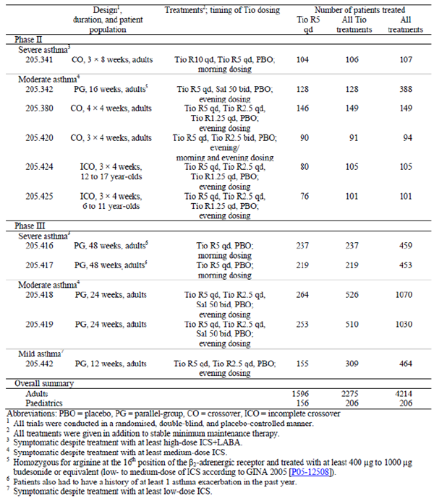
  - Clinical pharmacology studies: The PK profile of tiotropium inhaled via the Respimat was previously addressed in the clinical development programme for Spiriva Respimat in COPD. For the purposes of this submission package, the PK parameters of tiotropium in patients with asthma have been assessed in two Phase II trials in adults (205.420 and 205.380), 4 Phase III studies in adults (205.416, 205.417, 205.418, and 205.419), and one Phase II trial in adolescents (205.424).
  - The Phase II clinical programme included a total of six Phase II trials: two proof of concept trials in adults (205.341 and 205.342), one dose ranging trial in adults (205.380), one dosing regimen trial in adults (205.420), and two dose ranging trials in paediatric patients (205.424 and 205.425).
  - Meta-analysis of non-compartmental PK parameters across various tiotropium trials in the asthma program and comparison to COPD indication (U13-1604).
  - five pivotal Phase III studies were completed in adults (205.416, 205.417, 205.418, 205.419, 205.442).
  - Safety Studies 205.452 and 205.458 in COPD patients.
  - Other; for example, pooled analyses, meta analyses, Periodic Safety Update Reports (PSURs), Integrated Summary of Efficacy, Integrated Summary of Safety, etcetera.

Paediatric data
A Paediatric Investigational Plan (PIP) (EMEA-000035-PIP02-09) was submitted to the Paediatric Committee (PDCO) in November 2009. The PDCO issued a D60 Request for Modification in February 2010. The PIP, which contains seven paediatric studies (five of which [205.443, 205.444, 205.445, 205.446, and 205.456] have been deferred) was agreed upon in January 2013. In May 2013, the PDCO issued a positive opinion on PIP compliance for completed Paediatric Trials 205.424 and 205.425.
The submission contained the 2 Phase II studies 205.424 (12 to 17 years) and 205.425 (6 to 11 years) that were completed at the time of the submission. The sponsor requested a deferral for ages 1 to 11 years until deferred paediatric studies are completed and the safety and efficacy in adult patients with asthma is determined. Waiver for ages less than 1 year was requested on the grounds that Spiriva Respimat as a long acting inhalation drug product does not represent a meaningful therapeutic benefit over existing therapies for paediatric patients in this age group and is not likely to be used by a substantial number of paediatric patients in that age group.

Good clinical practice
All trials were performed according to the Declaration of Helsinki, the International Conference on Harmonisation (ICH) Good Clinical Practice, and the respective national regulatory requirements.

Pharmacokinetics

Studies providing pharmacokinetic data
For the purposes of this submission package, the PK parameters of tiotropium in patients with asthma have been assessed in two Phase II trials in adults, 4 Phase III studies in adults (205.416, 205.417, 205.418, and 205.419), and one Phase II trial in adolescents (205.424; 12 to 17 year olds). Table 3 summarises the trials and the doses tested as part of PK evaluation.

Table 3: Summary table of completed trials including pharmacokinetic evaluation in patients with asthma
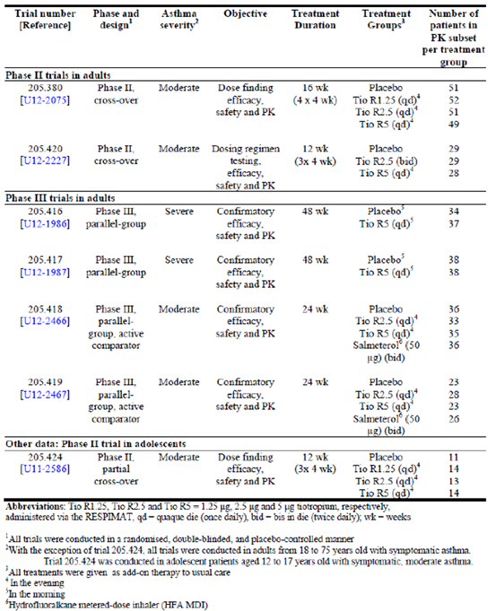
Table 4 (below) shows the studies relating to each PK topic and the location of each study summary.

Table 4: Submitted pharmacokinetic studies
PK topic | Subtopic | Study ID
PKs in healthy subjects | Not submitted in this dosser | None
PK in special populations | Target population § Single dose | None
PK in special populations | Multi dose | 205-380  205-420
PK in special populations | PK analysis in subsets of Phase III studies | 205.416  205.417  205.418  205.419
PK in special populations | Hepatic impairment | None
PK in special populations | Renal impairment | None
PK in special populations | Neonates/infants/children/adolescents | 205-424
PK in special populations | Elderly | None
PK in special populations | {Other special population} | None
Genetic/gender related PK | Males versus females
Genetic/gender related PK | {other genetic variable}
PK interactions | Not submitted in this dossier | None
Population PK analyses | Healthy subjects | None
Population PK analyses | Target population Pooled PK data from  Studies 205.380/ 420/416/ 417/ 418/419.
* Indicates the primary aim of the study. † Bioequivalence of different formulations.§ Subjects who would be eligible to receive the drug if approved for the proposed indication.
None of the PK studies had deficiencies that excluded their results from consideration.

Evaluator’s conclusions on pharmacokinetics
The PKs of tiotropium following oral inhalation via Respimat was already evaluated in the earlier submission for COPD. Hence, this section mainly summarises PK results in asthma patients and the comparison of PKs by indication (asthma versus COPD).

PKs in asthma patients
At steady state, a tiotropium peak plasma concentration of 5.15 pg/mL was attained 5 mins following the administration of 5 µg to patients with asthma. After chronic qd inhalation by patients with asthma, PK steady state was reached at the latest by Day 7 with no accumulation thereafter, which was similar to that observed in COPD patients. At steady state, following inhalation of the 5 µg dose, by patients with asthma, approximately 595 ng (11.9% of the dose) is excreted unchanged in the urine over 24 hrs post dose. At steady state, a tiotropium peak plasma concentration of 5.15 pg/mL was attained 5 mins following the administration of 5 µg to patients with asthma. The effective half-life of tiotropium following inhalation by patients with asthma was estimated based on accumulation ratio (see Figure 3 of Attachment 2 for the formula used for this estimation) It was not possible to estimate the area under the plasma concentration time curve (AUC) over the entire dosing interval and hence effective half-life was estimated based on a ratio of urinary excretion over 24 hrs over steady state and single dose. For the Tio R5 dose, the accumulation ratio based on 24 hr urine data was 2.56.

Bioequivalence between respimat and HH tiotropium formulations
The Phase II, crossover Study 205.458 involving 154 COPD patients compared the PKs of 5 µg tiotropium solution for inhalation delivered by the Respimat Inhaler (Tio R5) with tiotropium powder for inhalation 18 µg delivered by the HandiHaler (HH). The exposure to tiotropium following the use of Tio R5 was lower compared to Tio HH18. Using the parameters AUC_{0-6,ss} and C_{max,ss,} bioequivalence was not established between Tio R5 and Tio 18 HH. The ratio of AUC_{0-6,ss} (Tio R5/ Tio HH18) was 75.99% (90% CI of (70.44, 81.98)). The ratio of C_{max,ss} was 80.66% (90% CI: 73.49, 88.52). The shape of the plasma concentration time profile of tiotropium following inhalation via HH and Respimat devices was similar. Tiotropium was rapidly absorbed following inhalation via the two devices with a median t_{max,ss} value ranging between 5 and 7 mins post dosing. The plasma profile and amount excreted in the urine following inhalation via the HH was higher than all doses of Respimat.

Comparison of tiotropium PKs in asthma versus COPD patients
Tiotropium PK parameter estimates across asthma trials were compared to COPD patients because the management of COPD is the only currently approved indication for tiotropium Respimat and a vast amount of tiotropium safety data is available in this indication. Although there are limitations in correlating exposure (based on plasma and urine data) of a locally acting drug such as tiotropium to lung function improvement, exposure to tiotropium is considered as a predictor of its safety profile. Hence, the PK evaluation was intended to assess whether the exposure to tiotropium in asthma is in the range of what is known in COPD and to further support its safety evaluation in asthma. Patients with asthma had approximately 50% lower peak and total exposure but same t_{max,ss} to tiotropium compared to patients with COPD. Also the plasma concentrations of tiotropium appeared to decline comparatively more rapidly between 1 to 6 hours post dosing in patients with COPD compared to patients with asthma. In contrast, the profile in patients with asthma appears to be more flat during this time. This is potentially a result of different absorption profiles of tiotropium between patients with asthma and COPD.

Dose proportionality
PK parameters obtained from six trials in adult asthma patients (205.380, 205.420, 205.416, 205.417, 205.418 and 205.419) were combined to assess dose proportionality. PK data was available from 3 doses during the clinical development of tiotropium Respimat in asthma, that is, Tio R1.25, Tio R2.5 and Tio R5 and based on a graphical representation of various PK parameters by dose (fraction of the administered dose excreted in urine (fe) fe_{0-24,ss}, C_{max,ss,norm}) the data does not appear to meaningfully deviate from a dose proportional behaviour.

Effect of intrinsic factors on PKs of tiotropium
In common with all other drugs that undergo predominantly renal excretion, renal impairment was associated with increased tiotropium plasma drug concentrations and reduced renal clearance. Mild renal impairment was not found to relevantly influence the exposure to tiotropium in the asthma development programme. However, insufficient (moderate renal impairment) or no (severe renal impairment) data was available for other categories in the asthma programme. Hence, tiotropium should not be administered or only given with adequate precautions in asthma patients with moderate and severe renal impairment.
The effect of hepatic impairment on tiotropium PKs was not evaluated.
The PKs of tiotropium in the asthma programme was not found to be influenced by various intrinsic factors such as age, asthma severity and lung function. However, PK results in patients with severe asthma were difficult to interpret due to very small sample sizes compared to those with moderate asthma.

Drug interactions
Although no formal drug interaction studies have been performed, tiotropium bromide has been used concomitantly with other drugs commonly used in the treatment of COPD and asthma, including sympathomimetic bronchodilators, methylxanthines, oral and inhaled steroids, antihistamines, mucolytics, leucotriene modifiers, cromones, anti IgE treatment without clinical evidence of drug interactions. The co administration of tiotropium bromide with other anticholinergic containing drugs has not been studied.
The clinical evaluator also raised issues with regards to the content of the PI but this is beyond the scope of the AusPAR.

Pharmacodynamics

Studies providing pharmacodynamic data
No new pharmacodynamics (PD) studies were provided in this submission.

Evaluator’s conclusions on pharmacodynamics
There were no specific Pharmacodynamic (PD) studies submitted in the current dossier. Results of the Phase II Study 205.458 in COPD patients showed that Tio R5 was shown to be the most comparable Respimat dose to Tio HH18 in terms of forced expiratory volume in 1 second (FEV₁) and forced vital capacity (FVC) trough, AUC₀₋₆ and AUC₀₋₃, although this was not an objective of the study (due to open label HH). The Holter arrhythmia analyses in the same study did not suggest any clinically relevant untoward effects associated with the tiotropium Respimat (1.25, 2.5 and 5 µg) and HH (18 µg) treatments.

Dosage selection for the pivotal studies
The Phase II clinical programme included six trials: two proof of concept trials in adults (205.341 and 205.342), one dose ranging trial in adults (205.380), one dosing regimen trial in adults (205.420), and two dose ranging trials in paediatric patients (205.424 and 205.425).

Efficacy

Studies providing efficacy data
A comprehensive clinical development programme was initiated in July 2006 comprising a total of 18 trials to evaluate the efficacy and safety of tiotropium Respimat in patients with persistent asthma. Eleven of these trials have been completed and are included in this submission (see Table 3 above); a total of 4 Phase II studies were completed in adults (205.341, 205.342, 205.380 and 205.420), two Phase II studies were completed in paediatric patients (205.424 and 205.425) and five Phase III studies were completed in adults (205.416, 205.417, 205.418, 205.419 and 205.442). Trials that are currently ongoing in adult (205.441 and 205.464 [US and Japanese regulatory requirements]) and paediatric (205.443, 205.444, 205.445, 205.446, 205.456) patients were not included in this submission package.

Evaluator’s conclusions on efficacy
The inclusion and exclusion criteria for the Phase II and III studies allowed the recruitment of a representative sample of the target population of patients with a confirmed diagnosis of persistent asthma. A broad spectrum of asthma has been addressed in this clinical development programme including patients with severe asthma (who remained symptomatic, that is, uncontrolled according to the Asthma control questionnaire (ACQ) and at potential risk of asthma exacerbation despite treatment with at least high dose ICS + LABA), moderate asthma (who remained symptomatic, that is, uncontrolled) despite treatment with at least medium dose ICS) and mild asthma (who remained symptomatic despite treatment with at least low dose ICS). Exclusion criteria aimed at ensuring safety and patients with significant concomitant diseases or past medical history were excluded.
Across all asthma severities, more patients were female than male. Of the patients with mild and severe asthma, the majority were White, while in patients with moderate asthma the proportion of White and Asian patients was similar. The mean age was higher for patients with severe asthma than for patients with mild or moderate asthma. The median duration of asthma increased with asthma severity. The proportion of patients with concomitant diagnoses (CDs) at screening was similar across all asthma severities. CDs indicating an allergic disposition (for example, allergic rhinitis, allergic conjunctivitis) seemed to be more frequent in patients with mild or moderate asthma than in patients with severe asthma, while diagnoses known to increase in frequency with age (for example, hypertension, obesity, diabetes mellitus, hypercholesterolaemia) were reported with highest frequencies in patients with severe asthma.
It is important to note that that all trial medication was given in addition to stable dose of asthma maintenance therapy (low, medium, or high dose ICS, depending on asthma severity). Of particular note, patients who participated in Trials 205.341, 205.416, and 205.417 were additionally required to take a LABA throughout the treatment period. Because of this requirement for stable asthma maintenance therapy throughout the treatment period of all trials in this clinical programme, treatment comparisons are actually comparisons of tiotropium versus placebo against a background of at least high dose ICS + LABA, medium dose ICS, or low dose ICS. Patients of all asthma severities were to take ICS, and patients with severe asthma were to take LABAs. At randomisation, patients with mild or moderate asthma were to stop inhaled LABAs; patients of all asthma severities were to stop anticholinergics and short acting β2 adrenergic agonists (SABAs). However, salbutamol was provided for use as rescue medication in all trials.
In general, the tiotropium in asthma clinical programme took well established standards for the evaluation of the efficacy and safety of bronchodilators in asthma into consideration, the 2005, 2007, and 2009 Global Strategy for Asthma Management and Prevention from GINA, the Guidelines for the Diagnosis and Management of Asthma from the National Heart, Lung, and Blood Institute's National Asthma Education and Prevention Program (NAEPP), and the American thoracic society (ATS) and European respiratory society Statement on Asthma Control and Exacerbations. Trial design was also based on extensive interaction with and feedback from authorities in the EU and US. In pivotal Phase III Studies 205.418 and 205.419 involving adults with moderate asthma, salmeterol, a commercially available LABA approved for treatment of asthma, was included as a control group in this trial in order to comply with EU regulations requiring the inclusion of an active comparator treatment arm.
According to CHMP guidelines, a new controller treatment for asthma should place equal emphasis on lung function and symptom based clinical endpoints. A significant benefit from co primary endpoints of lung function and clinical symptoms should be demonstrated so that no multiplicity adjustment to significance levels is indicated. The severe asthma Studies 205/416/417 evaluated pre dose FEV₁, peak FEV_{1 (0-3h)} and time to first severe asthma exacerbation as co primary endpoints and complied with the CHMP recommendations. The moderate asthma studies (205.418/419) evaluated pre dose FEV₁, peak FEV_{1 (0-3h)} as co primary endpoints; although ACQ responder rate was evaluated as a primary endpoint for the pooled analysis of Studies 205/418/419, this endpoint was only a secondary endpoint in the individual studies. In the pivotal Phase III study in mild asthma, peak FEV_{1 (0-3h)} was the only primary endpoint; trough FEV₁ and ACQ responder rate were only analysed as secondary endpoints.

Phase II clinical studies
The Phase II clinical programme included six Phase II trials: 205.341, 205.342, 205.380, 205.420, 204.424, and 205.425 involving 738 adult patients and 206 paediatric patients; 468 of these adult patients (and 156 paediatric patients) were treated with at least one dose of proposed Tio R5. According to CHMP guidelines,⁴ the dose related benefit and adverse effects should be characterised in randomised, double blind, placebo controlled studies as suggested in ICH E 4. These studies should characterise the crucial part of the dose response curve. It may be useful to include one or more doses of an active control drug. Alternatively, to enhance the assay sensitivity the inclusion of a placebo and an active control would be needed. Study designs depend upon the pharmacology of the test drug and the response to treatment may follow a very different time course not only dependent on the drug but also on the outcome measure. For β2 adrenergic agonists, a cumulative dose response may be performed preferably using FEV₁ (or peak expiratory flow (PEF)) as a PD endpoint; for long acting bronchodilators 6 to 12 week studies are recommended.
Of the 4 Phase II studies in adults with asthma, only Study 205.342 complied with the above CHMP guidelines. In this double blind, double dummy, parallel group study involving moderate asthma patients homozygous for B16 Arg/Arg genotype, the primary endpoint (change in mean weekly morning pre dose PEF from baseline to the last week of treatment based on weekly means of electronic peak flow meter recordings measured at home) demonstrated the statistical non inferiority of tiotropium versus salmeterol and the superiority of both tiotropium and salmeterol versus placebo. This study also demonstrated that patients homozygous for arginine at the sixteenth position of the β2 adrenergic receptor were responsive to both qd Tio R5 and twice daily (BD) Sal 50. All Phase II trials showed the statistical superiority of tiotropium over placebo either in terms of morning PEF (PEF_{am}) (Trial 205.342) or FEV₁ peak_{0−3h} (Trials 205.341, 205.380, 205.424, and 205.425), or FEV₁ AUC_{0-24h} (Trial 205.420). However, interpretation from the Phase II adult asthma studies was limited due to crossover design and short duration in Studies 205.341 (8 weeks), 205.380 (4 weeks) and 205.420 (4 weeks). Evidence from the Phase II trials suggests that qd Tio R5 is not on the plateau of the dose response curve for tiotropium, and that an increase in bronchodilation can be achieved with increasing the dose. In Study 205.420 involving 92 patients with moderate asthma, significant and comparable bronchodilation over a complete 24 hr period was achieved following administration of a total daily dose of 5 µg tiotropium, regardless of whether it was administered as a qd dose of 5 µg (in the evening) or a BD dose of 2.5 µg (in the morning and evening). However, interpretation was again limited by the short duration (4 weeks) and crossover design of the study.

Pivotal phase III studies
The Phase III clinical programme included a total of five Phase III trials: 205.416, 205.417, 205.418, 205.419, and 205.442. A total of 3476 adult patients were treated during the Phase III clinical programme; 1128 of these patients were treated with at least one dose of Tio R5.

Efficacy in severe asthma

Lung function endpoints
The superiority of tiotropium over placebo in terms of FEV₁ peak_{0−3h} and trough FEV₁ responses was observed in both severe asthma pivotal trials (205.416/417). Improvements in FEV₁ related endpoints achieved with Tio R5 compared with placebo were either approaching or were well over 0.1 L. In Study 205.416, the observed treatment differences was 0.086 L (p = 0.0110) for adjusted mean FEV₁ peak_{0−3h} response and 0.088 L (p = 0.0050) for adjusted mean trough FEV₁ response. The response was slightly better in Study 205.417 with observed treatment differences of 0.154 L (p < 0.0001) for adjusted mean FEV₁ peak_{0−3h} response and 0.111 L (p = 0.0002) for adjusted mean trough FEV₁ response at Week 24. These results were robust as they were confirmed in the sensitivity analysis. Significant improvements in FEV₁ peak_{0-3h} response with Tio R5 as compared with placebo were already apparent after the first dose of trial medication on Day 1 of these trials, and the bronchodilator efficacy in terms of FEV₁ peak_{0−3h} and trough FEV₁ was sustained over the 48 week treatment period in Trials 205.416/417. Other FEV₁ and FVC assessments in clinic showed similar significant improvements with Tio R5 compared with placebo. Significant differences between the treatments in favour of Tio R5 were observed for adjusted weekly mean PEF_{am} (22.293 L/min; p < 0.0001), evening PEF (PEF_{pm}) (23.267 L/min, p < 0.0001), FEV₁ _{am} (0.117 L, p < 0.0001), and FEV₁ _{pm} (0.124 L, p < 0.0001) responses during the last 7 days before Visit 6 (after approximately 24 weeks of treatment); all of these parameters were measured at home using the AM3. Additionally, the 24 hr lung function measurements carried out after 24 weeks of treatment in Trials 205.416/417 confirmed the bronchodilator efficacy of tiotropium during the whole 24 hr dosing interval.

Asthma exacerbations
As the assessment of asthma exacerbations is an essential part of the evaluation of future risk for patients with severe asthma, time to first severe asthma exacerbation was included as a pre specified co primary endpoint for Trials 205.416/417. In the pooled analysis of pivotal Phase III studies involving 912 patients with severe asthma (205.416/417), time to first severe asthma exacerbation was the primary endpoint and time to first ‘any’ and ‘symptomatic’ asthma exacerbation were secondary endpoints. Treatment of severe asthma patients with tiotropium 5 µg over 48 weeks was associated with a significant 21% reduction in risk of severe asthma exacerbation (Tio 5 µg versus placebo: 26.9% versus 32.8%; hazard ratio (HR) = 0.79, p = 0.0343). However, these results were not robust as the analysis in the PPS only showed a non-significant 9% risk reduction. However, treatment of severe asthma patients with tiotropium 5 µg was associated with a significant 31% reduction in risk of ‘any’ asthma exacerbation (Tio 5 µg versus placebo: 49.9% versus 63.2%; HR = 0.69, p < 0.0001) and a 27% reduction in risk of symptomatic asthma exacerbation (37.1% versus 47.6%; HR = 0.73, p = 0.0024).

Symptoms and QOL
In Study 205.416, for the secondary endpoint of adjusted mean ACQ score, an improvement was reported for both treatment groups from study baseline (2.666) to Week 48 (tiotropium: 1.986, placebo: 2.107), but the difference between the treatment groups of −0.121 was not significant (p = 0.0727) and the minimal clinically important difference of 0.5 was not met. Similar results were observed for other patient reported outcomes such as standardised asthma quality of life questionnaire (AQLQ(S)), asthma symptoms, and use of rescue medication measured at home using the AM3. In Study 205.417, there were no statistically or clinically relevant improvements in ACQ or other patient reported outcomes such as AQLQ(S), asthma symptoms, and use of rescue medication. Although treatment with tiotropium did not significantly increase the odds of being an AQLQ(S) responder as compared to treatment with placebo, there were more AQLQ(S) responders in the tiotropium treatment groups than in the placebo groups across both Trials 205.416 and 205.417.
In patients with severe asthma, add on treatment with Tio R5 (in combination with high dose ICS + LABA) was associated with statistically and clinically significant improvements in lung function endpoints (improvements in FEV₁ peak_{0−3h} and trough FEV₁ responses with tiotropium compared to placebo were in the order of 0.1 L, whereas improvements in PEF_{am} and PEF_{pm} were generally above 20 L/min) after 24 weeks with maintenance of efficacy till 48 weeks of treatment. However, there was lack of adequate, conclusive evidence for efficacy of Tio R5 as add on treatment in terms of reduction of severe asthma exacerbation or asthma symptoms (ACQ, ACQL, other asthma symptoms) and use of rescue medication.

Efficacy in moderate and mild asthma

Lung function
Both Tio R5 and Tio R2.5 were shown to be superior over placebo for the co primary endpoints FEV₁ peak_{0−3h} and trough FEV₁ response after 24 weeks of randomised treatment. It was observed that the improvement in peak FEV_{1 (0-3h)} and trough FEV₁ was numerically greater in patients treated with the lower dose of tiotropium (2.5 µg) compared to the higher 5 µg dose, although both were statistically significantly better than placebo. Significant improvements in FEV₁ peak_{0-3h} response with Tio R2.5 as compared with placebo were observed early on (that is, at the latest by Week 4) and were sustained over the entire treatment period of Trials 205.418/419 and 205.442. The descriptive statistical comparisons of tiotropium and the well-established bronchodilator salmeterol 50 µg carried out as part of Trials 205.418/419 showed that both treatments were similar in terms of their effect size.

Asthma symptoms and quality of life
The effect of tiotropium on asthma symptoms using the ACQ responder rate was analysed as a prespecified co primary endpoint for Trials 205.418/419. Across Trials 205.418/419, patients in the tiotropium treatment groups had significantly higher odds of being ACQ responders at Week 24 as compared to patients in the placebo group. Although ACQ responder rates for Tio 2.5 and 5 µg groups were statistically significantly greater than placebo, there was no difference between the two Tiotropium dose groups (57.7%, 64.5% and 64.3% with placebo, Tio 2.5 µg and 5 µg, respectively). The adjusted mean ACQ total score improved (decreased) during the 24 week treatment period in all four treatment groups, but it was statistically significantly better than placebo at all visits for only salmeterol; it was statistically significantly better than placebo for Tio 2.5 µg at Weeks 8, 16 and 24 and for Tio 5 µg at only Weeks 8 and 24.
In the pivotal studies in moderate asthma (205.418/419), treatment differences between the tiotropium groups and placebo with respect to the adjusted weekly mean scores for night time awakenings, asthma symptoms in the morning, asthma symptoms during the day, activity limitation, shortness of breath, wheeze or cough, and number of asthma symptom free days were non-significant at all weeks. In Study 205.442 in patients with mild asthma, treatment differences between each tiotropium group and placebo with respect to the adjusted weekly mean scores for night time awakenings, asthma symptoms during the day, and wheeze or cough during the day, were small and non-significant at all weeks.

Asthma exacerbation
In the pooled analysis of pivotal Phase III studies (205.418/ 419) in moderate asthma, the time to first severe and any asthma exacerbation were secondary endpoints. Reduction in risk of severe asthma exacerbation was statistically significantly greater than placebo only following Tio 2.5 µg (not for Tio 5 µg or salmeterol), while risk reduction for any asthma exacerbation was only statistically significant for Tio 2.5 µg and salmeterol 50 µg (not for proposed dose of Tio 5 µg). However, interpretation of these results was limited by the short duration of treatment in this study (24 weeks only while CHMP recommended duration for assessment of effect on asthma exacerbations is 12 months).
In the Phase III Trials 205.418/419 and 205.442, the effect of Tio 2.5 µg was numerically greater than that of the proposed dose of Tio 5 µg for the endpoints FEV₁ peak_{0-3h} and trough FEV₁ response. The sponsors claim that there were two important imbalances between the Tio R5 and Tio R2.5 treatment groups in these trials that might have caused this apparent lack of dose ordering: an imbalance in responsiveness to salbutamol (measured at screening) in Trials 205.418/419, and a gender imbalance in Trial 205.442. Responsiveness to salbutamol (that is, increase in FEV₁ as a result of inhaling 400 µg salbutamol) at screening was lower for patients in the Tio R5 than in the Tio R2.5 treatment group in Trials 205.418/419. However, this is not true as the CSRs for Studies 205.418/419 do not mention any difference in responsiveness to salbutamol between treatment groups. An association between salbutamol responsiveness at baseline and treatment response in patients with asthma is known to exist, and is sometimes corrected for by stratification at baseline. Such stratification was not carried out in the clinical programme.
The clinical summary of efficacy mentions that significant bronchodilation of tiotropium over placebo was observed in patients in all subgroups based on post bronchodilator percent of predicted FEV₁ at screening (medium and low airways obstruction) (none of the 95% CIs included zero) but the magnitude of the benefit differed between subgroups. In patients with low airways obstruction at screening the treatment effect of Tio R2.5 compared to placebo for trough FEV₁ response was higher than that for Tio R5. However, in patients with medium airways obstruction at screening, the treatment effect for trough FEV₁ was greater with Tio R5 than with Tio R2.5. Comparing across subgroups within a dose, the treatment effect of Tio R2.5 was smaller for trough FEV₁ response in patients with medium airways obstruction than in those with low airways obstruction. In contrast, the treatment effects were similar in all patients regardless of the degree of obstruction for Tio R5 and slightly better in the more obstructed patients for salmeterol. Thus, Tio R5 was a more robust dose, with consistent treatment effects irrespective of the level of airways obstruction at screening, whereas Tio R2.5 provided less improvement in FEV₁ in patients with medium airways obstruction.
However, the above explanation by the sponsor again raised the concern about whether these patients had underlying COPD rather than asthma and the effect of tiotropium was related to known efficacy in COPD.
The sponsor also mentions that the gender imbalance observed in Trial 205.442 (with higher proportion of males in the Tio R2.5 than in the placebo and Tio R5 groups) may explain why a slightly larger response from baseline was observed for patients in the Tio R2.5 group than for patients in the Tio R5 group in Trial 205.442 for some lung function endpoints. While no dose ordering was seen for results analysed in litres for Trial 205.442, dose ordering was observed when results were analysed in percent of predicted normal, which takes gender and height as well as other factors into account (as males tend to have a greater height which impacts lung volume than females). However, the above explanation by the sponsors is not convincing as the difference between treatment groups was only minor (33.5%, 46.8% and 38.5% in placebo, Tio R2.5 and Tio R5 groups, respectively). Due to lack of conclusive evidence to support use of proposed dose of Tio 5 µg in patients with mild asthma, it is more likely that a lower dose of 2.5 µg may be more suitable for these patients.
In the Phase III pivotal trials in moderate asthma (205.418/419) and mild asthma (205.442), the effect of Tio 2.5 µg was greater than that of higher proposed dose of Tio 5 µg for the endpoints FEV₁ peak_{0-3h} and trough FEV₁ response. Overall, the dose of 2.5 µg showed similar or even numerically better lung function and symptomatic responses (ACQ responder rate in pooled Studies 205.418/419 in moderate asthma was 57.7%, 64.5%, 64.3% and 66.5% in placebo, Tio 2.5 µg, Tio 5 µg and salmeterol 50 µg groups, respectively). Overall, based on results observed, the evaluators feel that a lower dose of 2.5 µg may need to be explored further in patients with mild/moderate asthma.

Limitations of the submission
High dose and low dose ICS were defined in the CSRs for pivotal studies 205.418/419/442. However, pivotal studies in moderate asthma (205.418/419) did not define moderate dose ICS in the CSRs.
Randomisation not stratified according baseline factors such as history of exacerbations, use of LABAs et cetera.
Duration of all pivotal studies less than recommended 12 months for assessment of asthma exacerbations; 48 weeks in severe asthma Studies 205.416/417, 24 weeks in moderate asthma studies (205.418/419) and only 12 weeks in mild asthma study (205.442).
Effect on reduction of severe asthma exacerbations was not conclusive in the severe asthma studies.
Although median reversibility after salbutamol inhalation was 0.200 and 0.210 L in Study 205.416 and 205.417, respectively, the actual proportion of patients with post bronchodilator reversibility was not provided in the CSRs. The summary of clinical safety mentions that 52% of the patients enrolled in the severe asthma studies had reversible disease while 48% did not. Efficacy was not evaluated in subgroups based on reversibility to rule out the possibility that efficacy of Tio R5 was predominantly due to effects in patients with irreversible airway limitation characteristic of COPD.
The sponsor has proposed a single dose of 5 µg (Tio R5) for all asthma severities. However, in mild/moderate asthma studies, the effect of lower dose of 2.5 µg showed similar or even numerically better improvements in lung function and symptomatic endpoints.
Overall, evidence for efficacy of Tio R5 in asthma was not conclusive due to the various limitations of the submission as outlined above.

Safety

Studies providing safety data
The studies which provided evaluable safety data for Tiotropium Respimat included the nine completed studies in adult asthma patients [five Phase III studies in patients with mild (205.442), moderate (205.418, 205.419), or severe (205.416, 205.417) asthma] and four Phase II studies (205.341, 205.420, 205.380 and 205.342).
The integrated assessment of safety was primarily based on the analyses of the data from the five Phase III parallel group trials, which were grouped by asthma severity. Additionally, pooled data from all six parallel group trials were analysed; however, this pool allowed only for meaningful comparisons between the Tio R5 and the placebo groups, which were represented in all six parallel group trials across all asthma severities. Safety comparisons to the Tio R2.5 and salmeterol groups in the pool of all parallel group trials was not done because these treatment groups were only included in trials conducted in patients with mild (Tio R2.5) or moderate asthma (Tio R2.5, salmeterol). The assessment of safety was supported by the analyses of the individual and pooled data from 3 Phase II crossover trials.
For a full description of the studies and parameters please see Attachment 2.

Pivotal studies that assessed safety as a primary outcome
Study 205.452 was a Phase IIIb, randomised, active controlled, double blind, double dummy, parallel group design, multicentre study to compare the efficacy and safety of 2.5 µg and 5 µg tiotropium inhalation solution delivered by the Respimat inhaler with tiotropium inhalation capsules 18 µg delivered by the HH in 17183 patients with COPD.

Dose response and non-pivotal efficacy studies
These include the Phase II crossover (205.341/ 380/420) and parallel group study (205.342) as well as safety data from paediatric patients (205.424/425).

Patient exposure
Overall, 3,864 asthma patients were treated in the six parallel group trials and 350 patients were treated in the 3 crossover trials; 1,929 patients in the parallel group studies and 346 patients in the crossover studies were treated with tiotropium.
For further details of patient exposure please see Attachment 2.
Comment: Overall exposure was adequate for assessment of safety in patients with severe asthma however; there was lack of adequate long term safety data in patients with mild/moderate asthma.

Safety issues with the potential for major regulatory impact

Cardiovascular safety
Comment: Overall, no new cardiovascular safety concerns were identified following evaluation of tiotropium in asthma patients. The long term large safety Study 205.452 showed similar overall mortality and cardiovascular safety in COPD patients receiving tiotropium via Respimat (2.5 µg and 5 µg) and HH (18 µg) devices. However, this large safety study was conducted only in patients with COPD and there is no similar long term safety database in asthma patients.

Post-marketing data
Tiotropium has not yet received marketing approval for treatment of asthma.
Since this is an application for a label extension (asthma) of the existing marketing authorisation for tiotropium Respimat in COPD, the post marketing data of Spiriva Respimat in asthma are limited to case reports of off label use that are captured in the Post-marketing Safety database of Boehringer Ingleheim (BI).
For full details of the evaluation of the post-marketing data please see Attachment 2.

Evaluator’s conclusions on safety
In all trials, tiotropium was administered via the Respimat inhaler to adult patients with persistent asthma in addition to low dose ICS, medium dose ICS, or high dose ICS + LABA. Exposure to tiotropium Respimat in the clinical program in asthma covered more than 1,000 patient years involving more than 2,200 patients.
Major adverse cardiovascular events (MACE) were reported in individual patients only and no deaths were reported during the entire clinical program.
No clinically relevant changes in vital signs based on the review of mean changes and marked changes for either blood pressure or pulse rate were noted. No patterns were identified with regard to abnormal laboratory parameters while patients were on treatment with tiotropium.
There were no consistent patterns of increases in particular adverse events (AEs) for the tiotropium treatment groups compared to placebo in any subgroup analysis.
Overall, the safety data collected in the asthma clinical programme of tiotropium in adult patients with asthma, support both the 2.5 µg dose of tiotropium for maintenance treatment in addition to low dose ICS and medium dose ICS and the 5 µg dose of tiotropium for maintenance treatment in addition to low dose ICS, medium dose ICS, or high dose ICS + LABA delivered via the Respimat to adult patients with asthma.
For more detail on the evaluator’s conclusions regarding the safety of use with asthma please see Attachment 2.

TIOSPIR
In accordance with the EU regulations, this study (TIOSPIR) was initiated by BI as a post authorisation safety study. An unexplained numerically higher rate in all-cause mortality (compared to placebo) had been observed in the pooled tiotropium Respimat trials (Tio R5) [HR = 1.33, 95% CI: (0.93 to 1.92)], particularly in subjects with known cardiac rhythm disorders. The Respimat mortality data were contrary to data with Tio HH18 in the UPLIFT study, a 4 year placebo controlled study, where fewer deaths were observed with Tio HH18 than placebo [14.9% versus 16.5%;HR = 0.89, 95% CI: (0.79 to 1.02)] during a period of 4 years plus 30 days (1,470 days, inclusive of vital status); for the planned treatment period of 1,440 days (inclusive of vital status, analysis conducted post unblinding) 14.4% of subjects died in the tiotropium group and 16.3% in the placebo group [HR = 0.87, 95% CI: (0.76 to 0.99)]. During treatment, there was a 16% reduction in the risk of death. The incidence rate of death was 4.79 per 100 patient years in the placebo group versus 4.10 per 100 patient years in the tiotropium group [HR tiotropium/ placebo = 0.84, 95% CI = (0.73, 0.97)]. Given the smaller amount of safety data available from the pooled clinical database for Tio R5 compared to Tio HH18, combined with known comparable systemic exposure and comparable efficacy as well as retrospective pooled analyses of causes of death, a relationship between Tio R5 and mortality risk has not been established. TIOSPIR was therefore designed as a prospective trial of adequate size and duration to establish that compared to Tio HH18, Tio R5 has (a) similar effects on mortality and superior effects on exacerbations. The tiotropium Respimat 2.5 µg dose (Tio R2.5) was included to establish the safety and exacerbation efficacy relative to the other marketed tiotropium formulations.
Compared to the HH formulation (Tio HH18), the Respimat (Tio R5 and Tio R2.5) tiotropium formulations showed similar risks of all-cause mortality in a large Phase IIIb study involving 17,116 COPD patients. Although there was a higher incidence of deaths in subjects with cardiac arrhythmia at baseline compared to subjects without cardiac arrhythmia in each of the treatment groups, the relative differences between Tio R5 and Tio R2.5 compared to Tio HH18 were comparable.
The composite endpoint MACE was a predefined secondary endpoint to further evaluate cardiovascular safety. The overall incidence of MACE (3.9%, 3.9%, and 3.6% in the Tio R2.5, Tio R5, and Tio HH18 treatment groups, respectively) and death from MACE (2.1%, 2.0%, and 1.8%) was similar across all three treatment groups. Evaluation of the individual components of MACE showed no statistically significant differences across treatment groups for all components with the exception of fatal events of myocardial infarction (MI) which was higher in the Respimat tiotropium groups [IRR (Tio R5/Tio HH18) = 3.64, 95% CI: (1.02, 13.06) and IRR (Tio R2.5/Tio HH18) = 3.31, 95% CI: (0.91, 12.03).
Overall, results from this study do help clarify the issue of safety of tiotropium delivered by Respimat. However, it is important to note that the absence of a placebo group in this study has implications for its interpretation and that it cannot be concluded from these results that tiotropium reduces mortality in patients with COPD.
The frequencies of serious adverse event (SAEs), AEs leading to discontinuation, and investigator determined drug related AEs were comparable across treatment groups and no imbalance of substantial concern was identified. No overall safety advantage was observed for the lower dose of Tio R2.5 compared to the two approved dose strengths of Tio R5 and Tio HH18.
Results from the recently completed 4 week cross over Trial 205.458 have demonstrated lower but similar systemic exposure of Tio R5 compared to Tio HH18 in subjects with COPD suggesting that any potential safety difference between Tio R5 and Tio HH18 are not likely to be due to higher systemic exposure following tiotropium Respimat formulation. However, there are no dedicated safety information/ trials investigating effect on all-cause mortality and cardiovascular safety in asthma.

Limitations of the safety data for tiotropium respimat
- Inadequate evidence for long term safety of Tio R5 in treatment of asthma.
- No dedicated safety information/trials investigating effect on all-cause mortality and cardiovascular safety was obtained for use in asthma in its own right.
- No adequate explanation for higher incidence of bronchitis, pneumonia and cough in the Tio R5 group compared with placebo in the severe asthma pivotal Studies 205.416/417.
- No information on incidence of bronchospasm in the asthma in clinical studies.

First round benefit risk assessment

First round assessment of benefits
The benefits of tiotropium 5 µg (qd oral inhalation via Respimat) in the proposed usage are:
- Significant benefits with Tio R5 over placebo observed in terms of lung function when used as add on therapy to low dose ICS in mild asthma, medium dose ICS in moderate asthma and high dose ICS + LABA in severe asthma. Improvements in FEV₁ peak_{0−3h} and trough FEV₁ responses with tiotropium compared to placebo were in the order of 0.1 L, whereas improvements in PEF_{am} and PEF_{pm} were generally above 20 L/min. In patients with moderate asthma, improvements in lung function with Tio R25 and Tio R5 were similar to that observed with salmeterol 50 µg.
- Tiotropium Respimat showed a 24 hour duration of action which may be useful in asthma patients suffering from nocturnal events although no significant benefit was shown in mean scores for night time awakenings, asthma symptoms, activity limitation, shortness of breath, wheeze/ cough, symptom free days or use of rescue medications in any of the pivotal Phase III studies.
- Across moderate asthma studies 205/418/419, ACQ responder rates were significantly greater in patients treated with Tio R5 (64.3%) and TIo R2.5 (64.5%) compared with placebo (57.7%) although there was no difference between the two tiotropium doses.
- In pooled analysis across severe asthma studies 205.416/417, evidence for reduction in severe asthma exacerbation which was a co primary endpoint was not conclusive. However, there was statistically significant reduction in risk of ‘any’ or ‘symptomatic’ asthma exacerbation (secondary efficacy endpoints) with Tio R5 compared with placebo.

First round assessment of risks
The risks of tiotropium 5 µg (qd oral inhalation via Respimat) in the proposed usage are:
- It appears that Tiotropium 2.5 µg may offer a better benefit risk profile in patients with mild/moderate asthma, but the sponsors are only proposing the 5 µg once daily for all asthma severities.
- Increased risk of dry mouth, dysphonia, gastroesophageal reflux, bronchitis associated with tiotropium in treatment of asthma.
- Risk of bronchospasm.
- No dedicated safety information/trials investigating effect on all-cause mortality and cardiovascular safety was obtained for use in asthma in its own right.
- Results of the TIOSPIR (205.452) study confirmed that Respimat formulations of tiotropium showed similar overall mortality compared to HH formulation (Tio HH18) in a large Phase IIIb study involving 17,135 COPD patients. However, both Tio R5 and Tio R2.5 were associated with increased risk of fatal MI compared with Tio HH18.

First round assessment of benefit risk balance
Asthma is a chronic inflammatory disorder of the airways caused by the interaction of genetic and environmental factors. It is characterised by variable and recurring symptoms, airflow obstruction, bronchial hyper responsiveness and an underlying inflammation. Asthma is a heterogeneous disease in its manifestations and also in its response to treatment.
The GINA Workshop Report classifies drug treatments as controllers or relievers. In addition allergen specific immunotherapy is available for allergic asthma although its specific role is not completely established yet. Controllers are taken daily and long term and include both anti-inflammatory drugs and drugs which control symptoms (ICS, leukotriene modifiers, anti IgE treatment, oral corticosteroid (OCS)). Relievers are medications used on an as needed basis to reverse bronchoconstriction and relieve symptoms. Examples of relievers include rapid acting bronchodilators (for example, short and some LABAs). Some chronic treatments are of little immediate benefit in the acute attack, for example anti-inflammatory prophylactic treatment. European and US guidelines recommend a stepped management approach to treatment based on disease control. The goal of treatment is to achieve and maintain control. The level of asthma control obtained with treatment determines the need to step up or step down to the next treatment step in order to achieve optimum control with the minimum level of medication. The majority of asthma patients can achieve and maintain clinical control with standard treatment. Those patients who do not achieve adequate control with the highest level of medication (reliever plus two or more controller treatments) are considered to have difficult to treat asthma.
According to CHMP guidelines, a new controller treatment for asthma should place equal emphasis on lung function and symptom based clinical endpoints. A significant benefit from co primary endpoints of lung function and clinical symptoms should be demonstrated so that no multiplicity adjustment to significance levels is indicated. The severe asthma Studies 205/416/417 evaluated pre dose FEV₁, peak FEV₁ _{(0-3h)} and time to first severe asthma exacerbation as co primary endpoints and complied with the CHMP recommendations. The moderate asthma studies (205.418/419) evaluated pre dose FEV₁, peak FEV₁ _{(0-3h)} as co primary endpoints; although ACQ responder rate was evaluated as a primary endpoint for the pooled analysis of Studies 205/418/419, this endpoint was only a secondary endpoint in the individual studies. In the pivotal Phase III study in mild asthma, peak FEV₁ _{(0-3h)} was the only primary endpoint; trough FEV₁ and ACQ responder rate were only analysed as secondary endpoints.

Effect on lung function
In each individual Phase III pivotal trial, the superiority of tiotropium over placebo in terms of FEV₁ peak_{0−3h} (Trials 205.416, 205.417, 205.418, 205.419, 205.442) and trough FEV₁ (Trials 205.416, 205.417, 205.418, 205.419) responses was observed. Improvements in FEV₁ related endpoints achieved with Tio R5 and Tio R2.5 as compared with placebo were approaching or were well over 0.1 L and were already apparent after the first dose of trial medication on Day 1 of these trials; furthermore, the bronchodilator efficacy in terms of FEV₁ peak_{0−3h} and trough FEV₁ was sustained over the 48 week treatment period in Trials 205.416/417, over the 24 week treatment period in Trials 205.418/419, and over the 12 week treatment period in Trial 205.442. Similar improvements were observed with both Tio R5 and Tio R2.5 compared with placebo in terms of both weekly mean PEF_{am} and PEF_{pm} responses (which were > 20 L/min) evident from Week 1 and maintained for the duration of the studies (for 12 to 48 weeks). The descriptive statistical comparisons of tiotropium and the well-established bronchodilator Sal 50 carried out as part of Trials 205.418/419 revealed that both treatments were similar in terms of their effect size. Additionally, the 24 hour lung function measurements carried out after 24 weeks of treatment in Trials 205.416/417 and 205.418/419 confirmed the bronchodilator efficacy of tiotropium during the whole 24 hour dosing interval.

Effect on asthma exacerbation
In the pooled analysis of pivotal Phase III studies involving 912 patients with severe asthma (205.416/417), treatment with tiotropium 5 µg over 48 weeks was associated with a significant 21% reduction in risk of severe asthma exacerbation which was the co primary endpoint (Tio 5 µg versus placebo: 26.9% versus 32.8%; HR = 0.79, p = 0.0343). However, these results were not robust as the analysis in the PPS only showed a non-significant 9% risk reduction. Secondary endpoints of ‘any’ and ‘symptomatic’ asthma exacerbations did show a significant reduction with Tio R5 compared with placebo.
In the pooled analysis of pivotal Phase III studies (205.418/ 419) in moderate asthma, the time to first ‘severe’ and ‘any’ asthma exacerbation were secondary endpoints. Reduction in risk of severe asthma exacerbation was statistically significantly greater than placebo only following Tio 2.5 µg (not for Tio 5 µg or salmeterol), while risk reduction for ‘any’ asthma exacerbation was only statistically significant for Tio 2.5 µg and salmeterol 50 µg (not for proposed dose of Tio 5 µg). However, interpretation of these results was limited by the short duration of treatment in this study (24 weeks only while CHMP recommended duration for assessment of effect on asthma exacerbations is 12 months). Asthma exacerbation was not evaluated in the 12 week study in mild asthma (205.442).

Effect on asthma symptoms and quality of life
The effect of tiotropium on asthma symptoms using the ACQ responder rate was analysed as a pre-specified co primary endpoint for Trials 205.418/419. This co primary endpoint was also met. Across Trials 205.418/419, patients in the tiotropium treatment groups had significantly higher odds of being ACQ responders at Week 24 as compared to patients in the placebo group. Although ACQ responder rates for Tio 2.5 and 5 µg groups were statistically significantly greater than placebo, there was no difference between the two Tio dose groups (57.7%, 64.5% and 64.3% with placebo, Tio 2.5 µg and 5 µg, respectively). The adjusted mean ACQ total score improved (decreased) during the 24 week treatment period in all 4 treatment groups, but it was statistically significantly better than placebo at all visits for only salmeterol; it was statistically significantly better than placebo for Tio 2.5 µg at Weeks 8, 16 and 24 and for Tio 5 µg at only Weeks 8 and 24. Similar improvements in ACQ response was not observed for the severe asthma Trials 205.416/417. Although treatment with tiotropium did not significantly increase the odds of being an AQLQ(S) responder as compared to treatment with placebo, there were more AQLQ(S) responders in the tiotropium treatment groups than in the placebo groups across Trials 205.416/417 and 205.418/419.
In the pivotal studies in moderate asthma (205.418/419), treatment differences between the tiotropium groups and placebo with respect to the adjusted weekly mean scores for night time awakenings, asthma symptoms in the morning, asthma symptoms during the day, activity limitation, shortness of breath, wheeze or cough, and number of asthma symptom free days were non-significant at all weeks. Compared with placebo, statistically significant differences in favour of salmeterol (in Studies 205.418 and 205.419) and Tio 2.5 µg (in Study 205.419 only) were observed at some weeks. In Study 205.442 in patients with mild asthma, treatment differences between each tiotropium group and placebo with respect to the adjusted weekly mean scores for night time awakenings, asthma symptoms during the day, and wheeze or cough during the day, were small and non-significant at all weeks.
In summary, significant benefits of treatment with tiotropium over placebo in addition to at least ICS were observed in terms of lung function across a broad spectrum of patients with asthma. Improvements in FEV₁ peak_{0−3h} and trough FEV₁ responses with tiotropium compared to placebo were in the order of 0.1 L, whereas improvements in PEF_{am} and PEF_{pm} were generally above 20 L/min. These improvements were seen specifically with Tio R2.5 and Tio R5 as add on to low dose ICS in mild asthma and medium dose ICS in moderate asthma and for Tio R5 as add on to high dose ICS and LABA in severe asthma.
However, evidence for reduction of exacerbations was equivocal, that is, only severe asthma Studies 205/416/417 had adequate duration to assess effect on exacerbations (48 weeks); although Tio R5 was associated with significant reduction in risk of ‘any’ and ‘symptomatic’ asthma exacerbation, the co-primary endpoint of severe asthma exacerbation did not provide robust evidence to support Tio R5 (the significant 21% risk reduction in FAS was not observed in the PPS analysis non-significant 9% risk reduction with Tio R5). The duration of treatment was not adequate to evaluate effect on exacerbations in moderate asthma (24 weeks) and mild asthma (12 weeks in Study 205.442). Furthermore, the only evidence to support improvement in asthma symptoms was the better ACQ responder rate with Tio R5 and Tio R2.5 compared with placebo in the pooled moderate asthma Studies 205.418/419. Similar improvements were not observed in the severe asthma studies (205.416/417) and none of the pivotal Phase III studies showed significant improvements with Tio R5 in mean scores for night time awakenings, asthma symptoms in morning or during day, activity limitation, shortness of breath, wheeze/cough, symptom free days or use of rescue medications.
The main objective in asthma treatment is to maintain asthma control. The concept of ‘asthma control’ is not synonymous with ‘asthma severity’ and is defined as ‘the extent to which the various manifestations of asthma have been reduced or removed by treatment’. This concept encompasses two components, the patient’s recent clinical status/current disease impact (symptoms, night awakenings, use of reliever medication and lung function) and future risk (exacerbations, decline in lung function or treatment related side effects). According to the GINA Guidelines asthma is controlled when a patient has daytime symptoms only twice or less per week, has no limitation of daily activities, has no nocturnal symptoms and no exacerbations, has normal or near normal lung function and uses reliever medication twice or less per week. As discussed above, Tiotropium 5 µg failed to provide adequate evidence to justify this major paradigm shift in treatment of asthma.
Hence, the benefit risk balance of tiotropium 5 µg (qd oral inhalation via Respimat) is unfavourable for the proposed indication of add on maintenance treatment for the improvement of asthma symptoms, quality of life, and reduction of exacerbations in adult patients with asthma who remain symptomatic on at least ICS.

First round recommendation regarding authorisation

Recommendation for proposed extension of indications to include asthma:
It is recommended that the application for marketing approval for the use of Tiotropium 5 µg (2 puffs of 2.5 µg by oral inhalation via Respimat) be rejected for the proposed indication of add on maintenance treatment for the improvement of asthma symptoms, quality of life, and reduction of exacerbations, in adult patients with asthma who remain symptomatic on at least ICS.
The main reasons for the rejection at this stage are:
- Inadequate evidence to support claim for improvement in asthma symptoms and quality of life.
- Inadequate evidence to support claim for reduction in exacerbations.
- Use of tiotropium 5 µg dose for all asthma severities when there was evidence to suggest that lower dose of 2.5 µg might be equally effective in patients with mild/ moderate asthma.

Sponsor’s response
- Inadequate evidence to support claim for improvement in asthma symptoms and quality of life.
- Inadequate evidence to support claim for reduction in exacerbations.

Selection of endpoints
The primary assessment of efficacy in the confirmatory Phase III trials was based on lung function; in all trials, FEV₁ peak_{0-3h} response was a primary endpoint and trough FEV₁ response was either co primary or secondary endpoint. The selection of primary and secondary clinical endpoints for Trials 205.418/419 and 205.416/417 was based on CHMP guidance,⁴ which states that ‘for moderate and severe persistent asthma, symptom based (primary) endpoints are particularly important.’ These endpoints were discussed and agreed with the responsible regulatory authority of the Netherlands, the Medicines Evaluation Board (MEB) at the End of Phase II Meeting for the tiotropium Respimat in asthma clinical program. According to the guideline, the symptom based endpoints may include assessment of asthma control and frequency of exacerbations. Along with the co primary endpoints of lung function (FEV₁ peak_{0-3h} response and trough FEV₁ response), ACQ responder rate was chosen as co primary endpoint to assess asthma control in patients with moderate asthma in the combined analysis of 205.418/419. As stated in CHMP guidance, the assessment of (severe) asthma exacerbations during controller treatment is considered to be suitable in a more severe asthma population. Therefore, the assessment of time to first severe asthma exacerbation was chosen as co primary endpoint in the combined analysis of the replicate trials (205.416/417) in severe asthma. To evaluate the efficacy of tiotropium in terms of these pre specified co primary clinical endpoints, the pooled replicate Trials 205.418/419 and 205.416/417 were designed and adequately powered to detect a difference between treatments. The individual trials were not designed or adequately powered to detect a difference between treatments with regard to ACQ responder rate, ACQ total score, and time to first (severe) exacerbation, meaning that these clinical endpoints were secondary or other endpoints in these trials.
For Study 205.442, the symptomatic endpoint ACQ was only included for supportive evidence; this study was powered to detect a difference between treatments in terms of lung function only. This approach was based on the consideration that in a clinical program comprising several studies and including populations with a different grade of asthma severity, not each trial needs to be powered for all symptom based endpoints but that an extrapolation concept can be applied instead. In the event of a positive trend in these endpoints, the resulting supportive evidence can be regarded as sufficient and does not require the endpoints to be adequately powered to show statistical significance.
This approach is in accordance with the European Medicines Agency (EMA) guidance on extrapolation to reduce the need to generate additional information. This guideline states that extrapolation may be generally defined as: ‘Extending information and conclusions available from studies in one or more subgroups of the patient population (source population), or in related conditions or with related medicinal products, to make inferences for another subgroup of the population (target population), or condition or product, thus reducing the need to generate additional information (types of studies, design modifications, number of patients required) to reach conclusions for the target population, or condition or medicinal product.

Asthma symptoms: asthma control questionnaire (ACQ)
Based on the considerations on the selection of endpoints above and the results of symptomatic endpoints, as outlined below, there is sufficient evidence for improvement in asthma symptoms as reflected in higher ACQ responder rates by tiotropium Respimat compared with placebo. Moreover, the proportion of ACQ responders was comparable in tiotropium and salmeterol treatment groups.
ACQ responder rate rather than ACQ total score is the appropriate primary symptomatic endpoint in Trials 205.418/419 as this parameter reflects clinically relevant changes on the patient level better than ACQ total scores, which are calculated weekly means for entire treatment groups and might therefore not necessarily represent clinically relevant changes for an individual patient.
The ACQ responder rate at Week 24 was a pre specified co primary endpoint for the combined analysis of Trials 205.418/419 and only powered for the combined analysis of both replicate trials to show a statistical significance between the treatment groups. The combined analysis of Trials 205.418/419 met the co primary endpoint of ACQ responder rate (that is, the relative frequency of patients who reached the minimum clinically important difference (MID) in the ACQ total score of ≥ 0.5 from baseline at Week 24 and showed that patients who took Tio R5 had a statistically significant 1.32 fold odds (p = 0.0348) of being an ACQ responder compared with those who took placebo. Analysis of ACQ responders, as calculated by the Wilcoxon rank sum test, which takes responder, no changes, and worsening into account, also confirmed that all active treatments were statistically significantly more effective than placebo (p values: Tio R5; 0.0152, Tio R2.5; 0.0124, Sal 50 0.0018).
The ACQ responder rates from the combined analysis of Trials 205.416/417 (post hoc) showed similar results as those demonstrated for the combined analysis of 205.418/419, with a statistically significant 1.32 fold odds (95% CI 1.01, 1.73; p = 0.0427) compared with placebo. This highlights the consistency of the effect of tiotropium on asthma symptom control (that is, ACQ) across the Phase III clinical program. The greater ACQ responder rate for Tio R5 compared with placebo was not only apparent at Week 24 (53.9% versus 46.9%) but also at Week 48 (58.1% versus 45.2%). As shown in Figure 1, ACQ total scores in Trials 205.416/417 were statistically significantly better for Tio R5 than placebo at Weeks 4, 8, 24, 32, 40, and 48. ACQ responder rates were consistently higher for Tio R5 than placebo at Weeks 4, 8, 16, 24, 32, 40, and 48 (Figure 2).
Trial 205.442 was powered for lung function only. In this trial, statistically significant improvements in the lung function and a positive trend in ACQ were shown for patients treated with Tio R5 compared with placebo.
Figure 1: ACQ total score (± SE) at each visit for Trials 205.416/417 – MMRM results – FAS
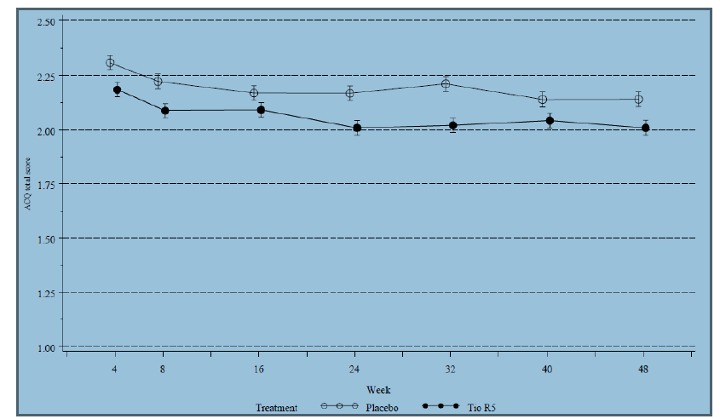
Abbreviations: ACQ = asthma control questionnaire; Tio R5 = treatment group tiotropium 5 µg (2 actuations of 2.5 µg) solution for inhalation delivered via Respimat
Figure 2: ACQ responder rate at each visit for Trials 205.416/417 – FAS
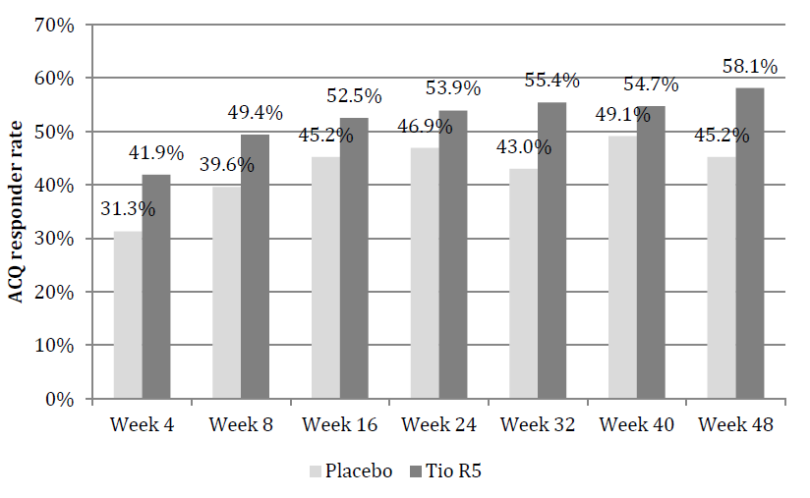
Abbreviations: ACQ = asthma control questionnaire; Tio R5 = treatment group tiotropium 5 µg (two actuations of 2.5 µg) solution for inhalation delivered via Respimat

Asthma symptoms: rescue medication and night time awakenings
Rescue medication and night time awakenings were not selected as primary symptomatic endpoints in the tiotropium Respimat in asthma clinical program. For further details, see section ‘Selection of endpoints’ above. Nevertheless, there was a positive trend for Tio R5 compared with placebo in terms of rescue medication use and night time awakenings in a category based analyses (post hoc) for adult patients with severe asthma (Trials 205.416/417, Figure 3). The positive trend for Tio R5 compared with placebo was not observed in patients with moderate asthma (Trials 205.418/419; data on file). This was not unexpected as the baseline values for rescue medication and night time awakenings were lower in patients with moderate asthma, leaving little room for improvement in these endpoints.
Figure 3: Median rate (%) of days the patients had no rescue medication use and no night time awakenings – Trials 205.416/417 – FAS
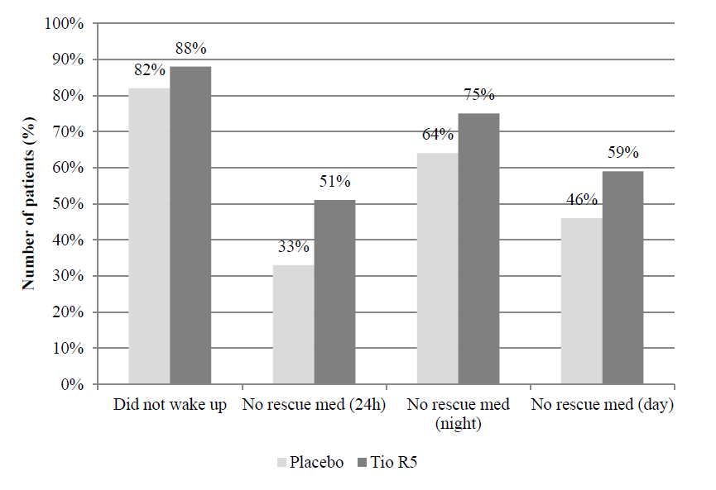Abbreviation: Tio R5 = treatment group tiotropium 5 µg (two actuations of 2.5 µg) solution for inhalation delivered via Respimat

Quality of life
With regard to quality of life, it should be noted that none of the Trials 205.416, 205.417, 205.418, and 205.419 (both individual and combined) were designed or powered to detect a difference between treatments for the AQLQ(S). Nevertheless, the scores indicated a positive trend in all trials and the differences from placebo reached statistical significance in some trials. It is therefore considered that tiotropium is also likely to have a positive effect on Quality of Life (QoL), although this was not demonstrated in a confirmatory manner. The AQLQ(S) score was improved for all treatment groups during the treatment periods of all trials that included this questionnaire (clinical trial reports (CTRs) 205.416, 205.417 and summary of clinical efficacy SCE-S).
There was a higher percentage of AQLQ(S) responders (defined as improvement [that is, increase] in the mean AQLQ(S) total score from baseline of ≥ 0.5 points) in the Tio R5 group than in the placebo group in all individual confirmatory Phase III trials with AQLQ(S) assessment except Trial 205.416. In the combined analysis of 205.418/419 at Week 24, the AQLQ(S) responder rates were numerically higher for tiotropium than for placebo (Tio R5: 57.3%; Tio R2.5: 57.5%; placebo: 52.7%); this was also true in the combined analysis of 205.416/417 at Week 24 (Tio R5: 42.8% versus placebo: 40.1%). None of the odds ratios (OR) reached statistical significance (see SCE-S).
Additionally, the placebo response rate varied and was generally quite considerable. Using a MID of 0.5, more than 40% of the patients in any treatment group in 205.416/417 and more than 50% of the patients in any treatment group in 205.418/419 experienced a clinically relevant improvement in AQLQ(S) compared with trial baseline. A systematic literature review and network meta-analysis of the ACQ and AQLQ(S) in patients with asthma recently conducted by BI indicated that a high placebo response is commonly observed in asthma clinical trials, especially in studies assessing a second or third controller on top of a background of ICS. A likely explanation of this study effect is increased adherence of patients to their background medication after having been enrolled in the clinical trial as well as a general improvement of their asthma care through regular study visits.

Exacerbations
The aspects of study duration and selection of endpoints (including considerations on extrapolation) in accordance with current CHMP guidance are addressed in the response above. Based on these considerations and the results regarding exacerbations, as outlined below, there is sufficient evidence to support the indication for the reduction in exacerbations by tiotropium Respimat.
In the tiotropium in asthma clinical program, time to first severe asthma exacerbation was a pre specified co primary endpoint of Trials 205.416/417 and powered for the combined analysis of both replicate trials to reject the hypothesis that the HR of Tio R5 versus placebo with regard to the time to first severe asthma exacerbation is ≥ 1 (versus < 1). The combined analysis of Trials 205.416/417 met the co primary endpoint of time to first severe asthma exacerbation and showed that the risk of experiencing the first severe asthma exacerbation was reduced by 21% (95% CI 0, 38) for patients taking Tio R5 compared with those taking placebo (HR 0.79 [95% CI 0.62, 1.00, p = 0.0343]; SCE-S).
The per protocol set (PPS) based analysis of time to first severe asthma exacerbation showed a positive trend for Tio R5 (HR 0.91 [95% CI 0.68, 1.20], CTR 205.416/417), which is supportive of the FAS analysis. Of note, the number of patients was considerably lower in the PPS than in the FAS as 25 % of patients from the FAS were excluded from the PPS (CTRs 205.416 and 205.417). Due to the lower number of patients in the PPS, the power to show a statistically significant difference between the treatment groups for the PPS based analysis was substantially reduced. In support of the robustness of the FAS based results, the Kaplan Meier analysis of time to first severe asthma exacerbation showed a stable and consistent response over time (SCE-S). With regard to the rate ratio (RR) for the number of severe asthma exacerbations per patient year in pooled Trials 205.416/417, the difference to placebo was also statistically significant (0.799; 95% CI 0.641, 0.996; p = 0.0458); see SCE-S.
As outlined above, neither the individual Trials 205.418 and 205.419 nor the combined trials were designed or adequately powered to detect a statistically significant difference between active treatments and placebo with regard to time to severe asthma exacerbations and time to asthma worsening. Although for Tio R5 the reduction in the risk of experiencing the first severe asthma exacerbation or the first asthma worsening did not reach statistical significance compared with placebo, HRs were both < 1, indicating a result that favoured Tio R5 over placebo. The rate of severe asthma exacerbation (number of severe asthma exacerbations per patient year) in the combined analysis of 205.418/419 was larger in the placebo group than the active treatment group, by about 1.30 fold for Tio R5, with a RR that just did not reach statistical significance (RR: 0.77, p = 0.0555). Based on the outlined reasoning, a positive trend was seen (SCE-S).

Conclusions
The effect of tiotropium on asthma symptoms and exacerbations was assessed based on the co-primary clinical endpoints ACQ responder rate (in the pooled analysis of Trials 205.418/419) and time to first severe asthma exacerbation (in the pooled analysis of Trials 205.416/417). This selection of endpoints is in accordance with current CHMP guidance. Both co primary endpoints were met, showing clinically relevant improvements in symptoms and exacerbations by tiotropium compared with placebo. The robustness of these effects was supported by additional evidence. With respect to symptom improvement, supportive evidence was obtained in terms of the ACQ in Trials 205.416/417 and 205.442 as well as rescue medication and night time awakenings in Trials 205.416/417. With respect to a reduction in exacerbations, supportive evidence was obtained in Trials 205.418/419. With respect to an improvement in QoL, supportive evidence for was obtained in terms of the AQLQ(S) in Trials 205.416, 205.417, 205.418, and 205.419. Although these analyses were not powered to detect a statistically significant difference, they did show either statistically significant differences or positive trends for improvements with the use of tiotropium compared with placebo. In conclusion, there is compelling evidence to support the use of tiotropium Respimat as an add on maintenance treatment for asthma with claims for improvement in asthma symptoms and QoL as well as a reduction in exacerbations.
- Use of tiotropium 5 µg dose for all asthma severities when there was evidence to suggest that lower dose of 2.5 µg might be equally effective in patients with mild/ moderate asthma.
Taking all the results of the Phase II and III trials into consideration, the once daily (qd) dose of 5 µg tiotropium, independent of the time of dosing, showed the most consistent effects across all grades of asthma severity in adult (and adolescent) patients with comparable safety of Tio R2.5 and Tio R5. Thus, the totality of the evidence from the clinical program supports Tio R5 qd as the appropriate dosing for asthma. In the clinical setting of being added on to a background maintenance treatment of at least ICS or a combination of ICS + LABA, the improvements in lung function (trough FEV₁, FEV₁ peak_{0-3h}, and FEV₁ AUC_{0-24h}) achieved with tiotropium were associated with an increase in ACQ responder rates and a decrease in severe asthma exacerbations and asthma worsenings. Efficacy of tiotropium was shown to be comparable with that of salmeterol.
In this respect, dosing of 5 µg tiotropium qd is consistent with other bronchodilators for which the dosing recommendations for COPD and asthma match. Having the same dosing recommendation for both indications avoids confusion for the prescribing physician.
In summary, in light of the totality of the safety and efficacy data from Phase II and Phase III studies and based on robustness and consistency, Tio R5 is the appropriate dose for the add on maintenance therapy in patients with asthma across different grades of severity.

Clinical questions
The clinical evaluator also raised questions which are presented in Attachment 2. The sponsor’s response to these questions is provided in Attachment 2. No separate evaluation of the sponsor’s response to the clinical questions was prepared however the Delegate took the sponsor’s response into consideration during the assessment of the submission.

V. Pharmacovigilance findings

Risk management plan
The sponsor submitted a Risk Management Plan, EU‐RMP Version 5.0 (dated 30 July 2013, DLP 28 February 2013) and Australian Specific Annex Version 1.0 (dated 3 March 2014) which was reviewed by the RMP evaluator.

Safety specification
The sponsor provided a summary of ongoing safety concerns which are shown at Table 5

Table 5: Ongoing safety concerns provided by the sponsor in their RMP submission
Ongoing safety concerns
Important identified risks | None
Important potential risks | All-cause mortality
Important potential risks | Cardiac mortality (for Respimat only)
Important potential risks | Sudden death and unspecified death
Important potential risks | Blood and lymphatic system disorders
Important potential risks | Blood glucose increased
Important potential risks | Psychiatric disorders
Important potential risks | Syncope
Important potential risks | Cardiac disorders (ischaemic heart disease, myocardial infarction, cardiac arrhythmia, cardiac failure, angina pectoris)
Important potential risks | Vascular disorders (aneurysm, hypertension)
Important potential risks | Renal failure
Important potential risks | Overdose
Important missing information | Pregnant and breast feeding women

RMP evaluator comment:
Notwithstanding the evaluation of the nonclinical and clinical aspects of the steady state, the following recommendations are made:

Important identified risks
- Hypersensitivity / angioedema (already in the proposed Australian PI) should be added as an important identified risk.

Important potential risks
- ‘Severe asthma exacerbations and hospitalisations’ should be added as an important potential risk.
- Cerebrovascular events’ should be added as an important potential risk.
- ‘Urinary retention (including prostate hypertrophy and bladder neck obstruction)’ should be added as an important potential risk.
- ‘Ocular effects (including narrow‐angle glaucoma)’ should be added as an Important Potential Risk.
- ‘Gastrointestinal effects (including GI obstruction)’ should be added as an important potential risk.
- ‘Paradoxic bronchospasm’ should be added as an Important Potential Risk.
- ‘Off label use (including use in children and including the use of the HH device in asthma)’ should be added as an Important Potential Risk.
- ‘Medication errors (including device errors)’ should be added as an important potential risk.

Missing information
- ‘Long‐term safety in asthma (beyond 12 months)’ should be added as missing information.
- ‘Elderly asthma patients (75 years and older)’ should be added as missing information.

Pharmacovigilance plan

Proposed pharmacovigilance activities
The sponsor proposes only routine pharmacovigilance activities for important identified and potential risks and missing information (as stated above).
One additional pharmacovigilance activity is presented as planned or ongoing activity in the EU‐RMP, namely the Trial 205.452 (TIOSPIR), but this has since been completed. This trial compared Spiriva HH and Spiriva Respimat methods of administration in COPD patients, but not asthma patients. The primary endpoints were risk of death (non‐inferiority study, Respimat 5 µg or 2.5 µg versus HH) and the risk of the first COPD exacerbation (superiority study, Respimat 5 µg versus HH) (Wise et al., 2013). This activity is only of marginal significance for the current application, that is, extension of indication to include asthma patients for Spiriva Respimat.
In summary, based on the information given in the RMP, the sponsor is not currently conducting any additional pharmacovigilance activities, in particular no activities that aim to characterise the safety profile in asthma patients further.

Risk minimisation activities

RMP reviewer’s comments in regard to the pharmacovigilance plan and the appropriateness of milestones
The safety data presented in the RMP with regard to the proposed asthma indication is not considered sufficient to not conduct any additional pharmacovigilance activities.

Additional pharmacovigilance activities to investigate asthma‐related events
The sponsor has included two important potential risks that may include asthma related deaths, namely ‘All-cause mortality’ and ‘Sudden death and unspecified death’. This should be substratified and investigated further to evaluate a potential association of tiotropium and asthma related deaths. Furthermore, severe asthma exacerbations and hospitalisations should also be evaluated. The sponsor should conduct an additional pharmacovigilance activity, or assign an existing activity, that particularly assesses asthma related deaths and severe asthma exacerbations and hospitalisations in patients taking tiotropium.

Additional pharmacovigilance activities to investigate cardiac and cerebrovascular events
Cardiac events and cerebrovascular events are a significant safety concern for tiotropium. The sponsor is not proposing any safety study to address or characterise these concerns. However, given the target population is likely to suffer from some form of cardiovascular disease as a co morbidity, given that cardiac events (currently included) and cerebrovascular events (to be added) are classified as important potential risks, and given that tiotropium is widely used in COPD and will likely to be widely used in asthma, it is necessary to conduct a clinical trial to investigate these safety concerns further. The sponsor should conduct a clinical trial to investigate cardiac events and cerebrovascular events or make the results of such a trial available to the TGA.

Additional pharmacovigilance activity to investigate long‐term safety in asthma
Long term safety is an important issue, especially when considering that the course of the disease is unlikely to be changed in patients with asthma, and hence symptomatic relief through medication is likely to be needed long‐term. It is noted that the sponsor has conducted several studies to investigate safety up to 12 months. Only 11 patients (or 0.7% of the presented trial population) were exposed for more than 12 months (0.5 patient years). The sponsor should conduct an additional pharmacovigilance activity, or assign an existing activity, that assesses the safety of tiotropium in asthma patients beyond 12 months.

Evaluation of the need for risk minimisation activities

Sponsor’s conclusion in regard to the need for risk minimisation activities
The sponsor is not proposing any additional risk minimisation activities.

RMP reviewer comment:
The sponsor’s conclusion is adequate in the context of this submission, if the requests made by the RMP evaluator are implemented.

Potential for medication errors
For the purposes of this RMP evaluation different types of medication errors, as suggested by Ferner and Aronson (2006), have been considered.

Potential for overdose
The risk for intentional overdose is low. In the proposed PI, overdosage and its management have been discussed to a satisfactory standard.
However, the potential for unintentional overdose exists, but may be sufficiently mitigated by the instructions for use given in the consumer medicines information document.

Potential for off label use
The information regarding indications for this drug given in the proposed Australian PI is considered acceptable.

Potential for off label use in children
COPD, other than from hereditary causes, is unlikely to occur in children. The sponsor recognises this drug is only indicated for patients over 18 years of age. This is reflected in the proposed PI.
There is a moderate potential for off‐label use in children with asthma or cystic fibrosis. The sponsor recognises this drug is only indicated for patients over 18 years of age. This is reflected in the proposed PI.

Risk minimisation plan

Planned actions
No additional risk minimisation activities are proposed for tiotropium bromide.

RMP evaluator comment:

Format of the proposed PI
The sponsor should present AEs in a table that allows easy visualisation of the AEs according to body system and frequency.

Adverse events
The PI should contain AEs pooled from all studies conducted, and from all other reliable sources.

Reconciliation of issues outlined in the RMP report

Recommendation 1
Hypersensitivity/angioedema (already in the proposed Australian PI) should be added as an important identified risk.
Sponsor’s response
‘The sponsor agrees that hypersensitivity and angioedema are identified risks of Spiriva; however, they should not be qualified ‘important’ since
- they are very infrequent
- the vast majority of cases are non-serious and none is fatal, and
- these conditions are medically treatable without sequelae to the patient.
Table 6 shows the frequency of hypersensitivity and angioedema in the COPD (Respimat and HH) and asthma (Respimat) clinical trials by seriousness. The results show that these events are generally very rare and non‐serious.

Table 6: Time adjusted rate ratios of tiotropium versus placebo for other hypersensitivity reactions (including immediate reactions) pharmacovigilance endpoint (#PV) and SMQ angioedema (narrow) in COPD and asthma placebo controlled trials
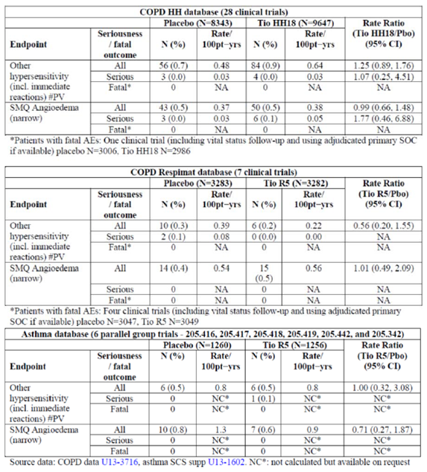

RMP evaluator’s comment
The sponsor essentially states that all cases are non-fatal and treatable without sequelae. The implied universality is rather questionable, especially when considering the limited information in asthma patients, for which definite statements are less justifiable until sufficient data will have become available.
The non-inclusion of this risk is acceptable in the context of this application, but not for the reasons stated by the sponsor. However, this does not constitute a regulatory precedent for this or other medicinal products.

Recommendation 2
Severe asthma exacerbations and hospitalisations should be added as an important potential risk.

Sponsor’s response
‘BI disagrees with the evaluator that ‘Severe asthma exacerbations and hospitalisations’ should be categorised as an important potential risk since the incidence rates are lower in the Tio R5 group than in placebo (with the exception of serious AEs of Asthma worsening Pharmacovigilance endpoint (#PV), which is based on only 1 case in Tio R5) as shown in Table 7.
Table 7: Frequency of asthma exacerbation #PV, asthma exacerbation (broad) #PV and asthma worsening #PV in asthma clinical trials by seriousness
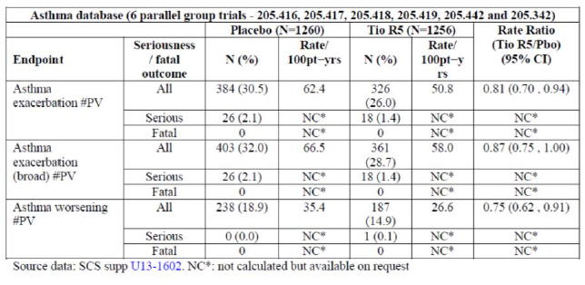

RMP evaluator’s comment
The clinical evaluation report (Round 1) states the following: ‘No adequate explanation for higher incidence of bronchitis, pneumonia and cough in the Tio R5 group compared with placebo in the severe asthma pivotal studies 205.416/417.’
These events may not have been coded as asthma exacerbation. Given the large proportion of the population with asthma that may use this product, ‘Severe asthma exacerbations and hospitalisations’ should be listed as an important potential risk to capture and report any data earlier rather than later. The recommendation remains.

Recommendation 3
‘Cerebrovascular events’ should be added as an important potential risk.

Sponsor’s response
BI disagrees with the evaluator that ‘Cerebrovascular events’ should be qualified important potential risk, since the incidence rates are either lower in the Tio R5 group than in placebo or very similar, as show in Table 8.

Table 8: Time adjusted rate ratios of tiotropium versus placebo for SMQ ischaemic cerebrovascular disorders, SMQ haemorrhagic cerebrovascular conditions and stroke #PV in COPD and asthma placebo controlled trials and in TIOSPIR (Study 205.452)
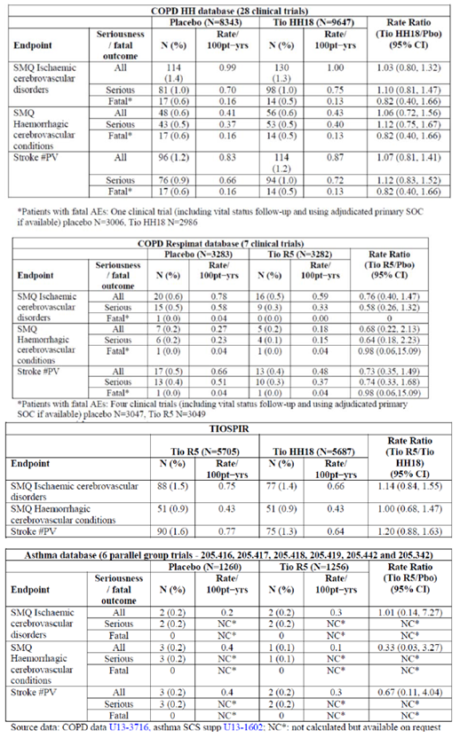

Recommendation 4
Urinary retention (including prostate hypertrophy and bladder neck obstruction) should be added as an important potential risk.

Sponsor’s response
BI disagrees with the evaluator that urinary retention (including prostate hypertrophy and bladder neck obstruction) should be added as an important potential risk. ‘Urinary retention’ is an identified risk of Spiriva; however, it should not be qualified as ‘important’ because: 1. it is very infrequent, 2. the vast majority of cases are non-serious and none is fatal, and 3. this condition is medically treatable without sequelae to the patient.
Table 9 shows the frequency of urinary retention (broad) #PV in the COPD (Respimat and HH) and asthma (Respimat) clinical trials by seriousness. The results show that these events are generally very rare and non-serious.

Table 9: Time adjusted rate ratios of tiotropium versus placebo for urinary retention (broad) #PV in COPD and asthma placebo controlled trials
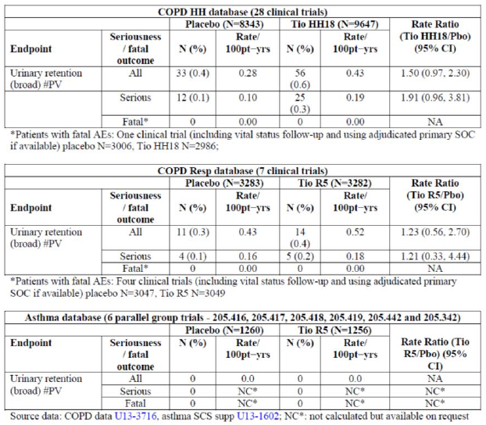
With respect to ‘prostate hypertrophy and bladder neck obstruction’, the section Precautions section of the proposed PI states: ‘As with other anticholinergic drugs, Spiriva Respimat should be used with caution in patients with narrow angle glaucoma, prostatic hyperplasia or bladder neck obstruction.’ These should not be qualified as ‘important’ since:
- they are very infrequent
- the vast majority of cases are non-serious and none is fatal, and
- These conditions are medically treatable without sequelae to the patient (Table 10).

Table 10: Time adjusted rate ratios of tiotropium versus placebo for PTs benign prostatic hyperplasia and bladder neck obstruction in COPD and asthma placebo controlled trials
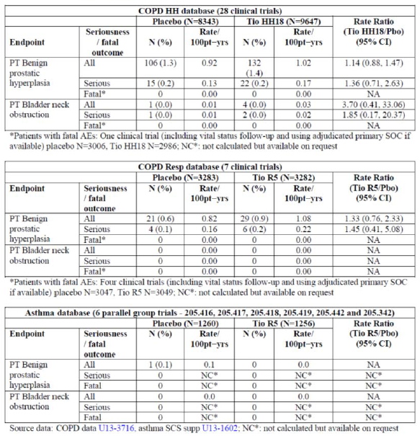

RMP evaluator’s comment
The sponsor essentially states that all cases are non-fatal and treatable without sequelae. The implied universality is rather questionable, especially when considering the limited information in asthma patients, for which definite statements are less justifiable until sufficient data will have become available.
The non-inclusion of this risk is acceptable in the context of this application, but not for the reasons stated by the sponsor. However, this does not constitute a regulatory precedent for this or other medicinal products.

Recommendation 5
Ocular effects (including narrow angle glaucoma)’ should be added as an important potential risk.

Sponsor’s response
Glaucoma, covering narrow angle glaucoma, intraocular pressure increased, and blurred vision are known risks of Spiriva. They should not be qualified as ‘important’ since
- They are very infrequent,
- the vast majority of cases are non-serious and none is fatal, and
- These conditions are medically treatable without sequelae to the patient. (Table 11)

Table 11: Time adjusted rate ratios of tiotropium versus placebo for SMQ glaucoma (narrow), intraocular pressure increased #PV, vision blurred #PV and AT angle closure glaucoma in COPD and asthma placebo controlled trials
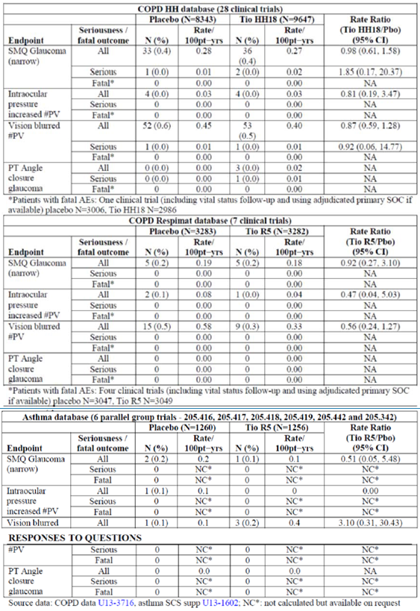
RMP evaluator’s comment
The sponsor essentially states that all cases are non-fatal and treatable without sequelae. The implied universality is rather questionable, especially when considering the limited information in asthma patients, for which definite statements are less justifiable until sufficient data will have become available.
The non-inclusion of this risk is acceptable in the context of this application, but not for the reasons stated by the sponsor.
However, this does not constitute a regulatory precedent for this or other medicinal products.

Recommendation 6
Gastrointestinal effects (including GI obstruction)’ should be added as an important potential risk.
Sponsor’s response
‘Intestinal obstruction incl. ileus paralytic is a known risk of Spiriva. It should not be qualified as ‘important’ since
- it is very infrequent and
- this condition is medically treatable without sequelae to the patient (Table 12).
With respect to the system organ class (SOC) Gastrointestinal disorders, the results show that there is a significantly increased risk with Tio R5 when considering all AEs; however, the IRRs are balanced when assessing SAEs and fatal events. This indicates that the known gastrointestinal risks of Spiriva are in general mild and, therefore, they should not be considered an important risk.’

Table 12: Time adjusted rate ratios of tiotropium versus placebo for intestinal obstruction including ileus paralytic #PV in COPD and asthma placebo controlled trials
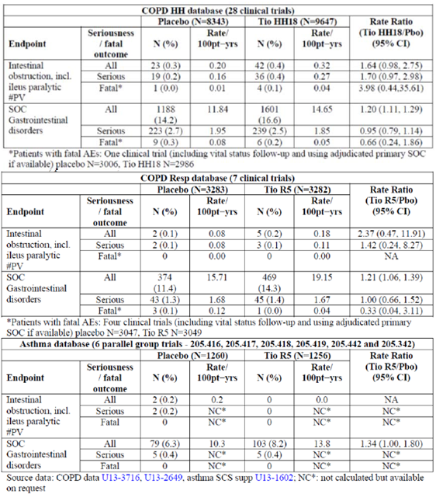

RMP evaluator’s comment
The sponsor essentially states that all cases are non-fatal and treatable without sequelae. The implied universality is rather questionable, especially when considering the limited information in asthma patients, for which definite statements are less justifiable until sufficient data will have become available.
Gastrointestinal effects have been reported with Spiriva, for example, RR 1.21 (Tio R5/Pbo – COPD) or 1.34 (Tio R5/Pbo – asthma).
Treatment discontinuation or interruption is likely to be increased outside a clinical trial setting.
The ‘Guidance on format of the risk management plan (RMP) in the EU ’ in ‘Part II: Module SVII - Identified and potential risks’ states the following: ‘In addition, risks, which whilst not normally serious enough to require specific warnings or precautions, but which occur in a significant proportion of the treated population, affect the quality of the treated person’s life, and which could lead to serious consequences if untreated, should also be considered for inclusion, e.g. severe nausea and vomiting with chemotherapy.’
Furthermore, it is noted that some fatal cases due to intestinal obstruction were reported. There does not appear to be a statistical significance yet. Therefore the risk should be monitored further.
To ensure appropriate reporting ‘Gastrointestinal effects (including GI obstruction)’ should be added as important identified risk.

Recommendation 7
Paradoxic bronchospasm’ should be added as an important potential risk.
Sponsor’s response
The available data from the COPD and asthma clinical trial databases do not indicate a risk of bronchospasm during treatment with Spiriva for either indication.
Bronchospasm was analysed in the asthma development program using the endpoints Bronchospasm #PV and Bronchospasm (broad) #PV. The PTs covered by these 2 PV endpoints are shown in Table 13.
Table 13: The PTs covered by bronchospasm #PV and bronchospasm (broad) #PV
PT’s covered by the PV endpoints
Bronchospasm #PV | Bronchospasm #PV
Analgesic asthma syndrome  Asthma  Asthma exercise induced  Asthma late onset  Bronchial hyperactivity  Bronchial obstruction  Bronchospasm  Bronchospasm paradoxical  Reversible airways obstruction  Status asthmaticus | Analgesic asthma syndrome  Asthma  Asthma exercise induced  Asthma late onset  Bronchial hyperactivity  Bronchial obstruction  Bronchospasm  Bronchospasm paradoxical  Reversible airways obstruction  Status asthmaticus  Unilateral bronchospasm  Wheezing

Table 14: Time adjusted rate ratios of bronchospasm #PV pooled parallel group trials (205.342, 205.442, 205.418/419, 2015.416/417)
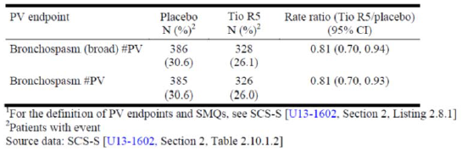
Data on these PV endpoints are presented in the summary of clinical efficacy. Briefly, in the pooled parallel group trials of adult patients with asthma both endpoints had significantly lower incidence rates in the Tio R5 group than in placebo (Table 14) Both endpoints were associated with the preferred term (PT) asthma, which occurred with a significantly lower incidence rate in the Tio R5 group than in the placebo group in all pooled parallel group trials.
Table 15 displays the data for the individual PTs covered by the two PV endpoints in the pooled parallel group trials in adult patients with asthma shows that no imbalance was observed for any of the individual PTs in these PV endpoints. This is in line with the findings of Hodder et al who compared the incidence of paradoxical bronchoconstriction after chronic use of bronchodilators via Respimat Soft Mist Inhaler (SMI) and chlorofluorocarbon metered dose inhalers (CFC MDI) in patients with asthma. No occurrences of bronchospasm were reported with Respimat SMI on any test day. Overall, the incidence of respiratory events possibly indicative of paradoxical bronchoconstriction was low and similar for both devices.
There was no increase in the incidence of events during 12 weeks' treatment. The authors concluded that delivery of bronchodilators by Respimat SMI is safe with regard to paradoxical bronchoconstriction during chronic use in patients with asthma.
Table 15: Time adjusted rate ratios of tiotropium versus placebo by PV endpoint/SMQ and preferred term all parallel group trials (205.342, 205.442, 205.418/419, 2015.416/417)
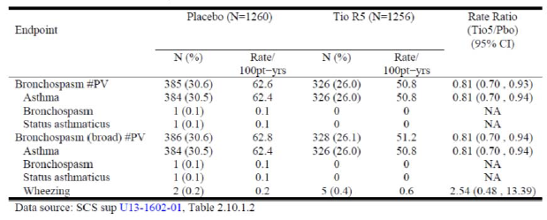
RMP evaluator’s comment
This is considered acceptable in the context of this application. However, this does not constitute a regulatory precedent for this or other medicinal products.

Recommendation 8
Off label use (including use in children and including the use of the HH device in asthma) should be added as an important potential risk.
Sponsor’s response
BI disagrees with the evaluator that ‘Off label use (including use in children and including the use of the HH device in asthma)’ should be qualified as important potential risk for the following reasons:
- The use of Spiriva by children is very rare; nevertheless, paediatric safety is included in the RMP as missing information,
- The PI and CMI clearly state the approved indication for both Spiriva HH and Spiriva Respimat and provide appropriate precautions against the use of these medications by children,
- Separate PIs for Spiriva Respimat and Spiriva HH PI reduce the potential of HH prescription for asthma, and
- The safety evaluation of off label use in the post marketing setting to date reveals no concerns. The most commonly reported AEs are shown in Table 16. Nearly all AEs are either listed or related to the underlying disease and in all cases listed or unlisted, related or not to the underlying disease the events are non-serious.
Table 16: Most frequently reported AEs among patients who used Spiriva for asthma (off-label) by formulation
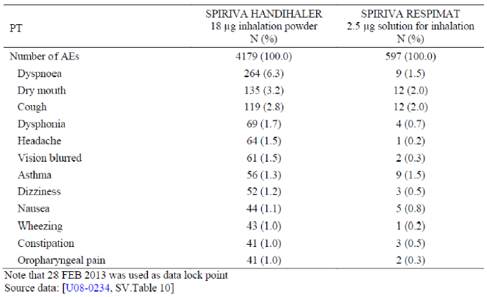

RMP evaluator’s comment
This is not considered acceptable. The risk for off‐label use does exist, in particular the use of the Handihaler device in asthma. It is requested to add ‘off‐label use’ be added as an Important Potential Risk to ensure adequate and formalised monitoring and reporting of this issue in PSURs.

Recommendation 9
Medication errors (including device errors)’ should be added as an important potential risk.
Sponsor’s response
BI disagrees with the evaluator that ‘medication errors (including device errors)’ should be qualified as ‘important’ since the vast majority of cases are non-serious and none is fatal (Table 17). A total of 15,621 cases were identified as medication error with the suspect drug Spiriva until 30 Sep 2014 (clinical studies excluded). Of these, only 171 (1.1%) are attributed to Spiriva Respimat. Serious AEs were reported in 12 of the 171 cases attributed to Spiriva Respimat, with only pneumonia and COPD being reported in more than one occasion (Table 18).
Table 17: 20 most frequently reported AEs in cases identified as medication error for Spiriva Respimat
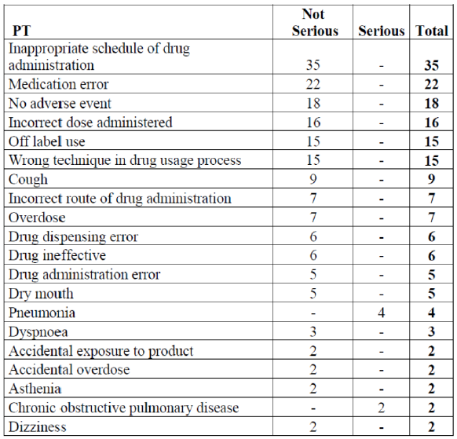

Table 18: Serious AEs in cases identified as medication error for Spiriva Respimat
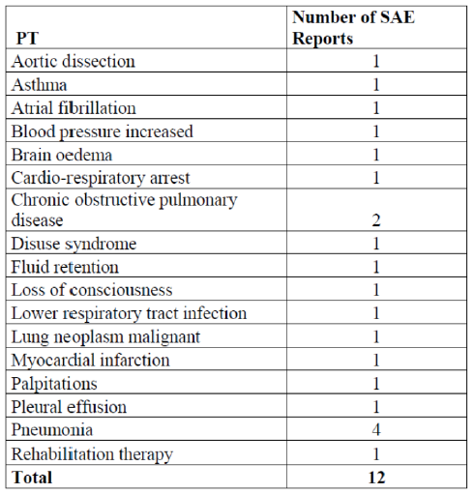

RMP evaluator’s comment
This is considered acceptable in the context of this application. However, this does not constitute a regulatory precedent for this or other medicinal products.

Recommendation 10
Long term safety in asthma (beyond 12 months)’ should be added as missing information.
Sponsor’s response
BI agrees with the evaluator that ‘Long term safety in asthma (beyond 12 months)’ should be added as missing information and it has been included in RMP version 6.0 and the ASA version 2.0.

RMP evaluator’s comment
This is considered acceptable.

Recommendation 11
Elderly asthma patients (75 years and older)’ should be added as missing information.

Sponsor’s response
Although safety information on patients aged 75 years and older with asthma is very limited, there is a large amount of data on exposure to Spiriva Respimat in elderly patients with COPD (Table 19). Table 20 presents the 10 most frequent PTs in the placebo or Tio R5 group reported in patients aged 75+ at baseline. Among the PTs with an IRR > 1.0, Pneumonia (IRR 1.75), Back pain (IRR 1.05), and Hypertension (IRR 2.19) are not known risks for Spiriva based on the totality of the patient population. Upper respiratory tract infection is considered to be covered by the known risks pharyngitis, laryngitis, and sinusitis.

Table 19: Exposure to Spiriva Respimat by age group and gender in clinical trials in COPD
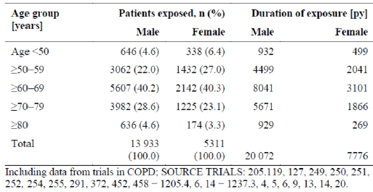

Table 20: Most frequent PTs reported for patients aged 75 + years at baseline in the Tio R5 COPD database (7 clinical trials)
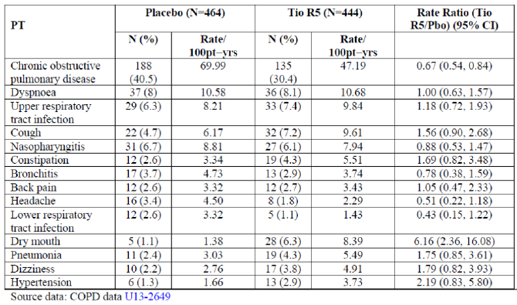

RMP evaluator’s comment
This is not considered acceptable. The data presented by the sponsor in the response is based on the COPD elderly population.
The asthma population does have different characteristics, one of which being better lung function (that is, higher absorption and systemic availability) than COPD patients in the same age group.
The recommendation remains. ‘Elderly asthma patients (75 years and older)’ should be added as missing information.
Recommendation 12
The sponsor should conduct an additional pharmacovigilance activity, or assign an existing activity, that particularly assesses asthma related deaths and severe asthma exacerbations and hospitalisations in patients taking tiotropium.

Sponsor’s response
BI conducts a medical review of each fatal case and of each serious AE case, including those with asthma exacerbation, on a weekly basis. Therefore, BI does not agree with the evaluator that an additional activity formalised in the RMP is necessary

RMP evaluator’s comment
Given the large asthma population that can potentially be exposed to this drug and given the experience with LABAs and asthma related deaths and severe exacerbations, it would be considered highly unjustified to not formalise reporting on asthma related deaths and severe asthma exacerbations.
The CER states: ‘No dedicated safety information/ trials investigating effect on all-cause mortality and cardiovascular safety was obtained for use in asthma in its own right.’
Given that the sponsor is already planning to conduct a medical review of each fatal case and each serious AE case, the sponsor should have no objections to formally report on these cases in PSURs.
Please refer to the comments made for recommendation 13 for a combined pharmacovigilance activity that can be assigned to all of asthma related deaths and severe asthma exacerbations, cardiac events and cerebrovascular events.

Recommendation 13
The sponsor should conduct a clinical trial to investigate cardiac events and cerebrovascular events or make the results of such a trial available to the TGA.

Sponsor’s response
BI does not agree with the evaluator that a clinical trial to investigate cardiac events and cerebrovascular events is necessary since these events have already been extensively studied, including in the recently conducted large study TIOSPIR (Study 205.452) (see Table 21). No safety concerns were identified. It should also be noted that ‘Cardiac disorders’ is listed as an important potential risk for Spiriva in its RMP.’

Table 21: Time adjusted rate ratios of tiotropium versus placebo for SOC cardiac disorders in COPD and asthma placebo controlled trials and in TIOSPIR (Study 205.452)
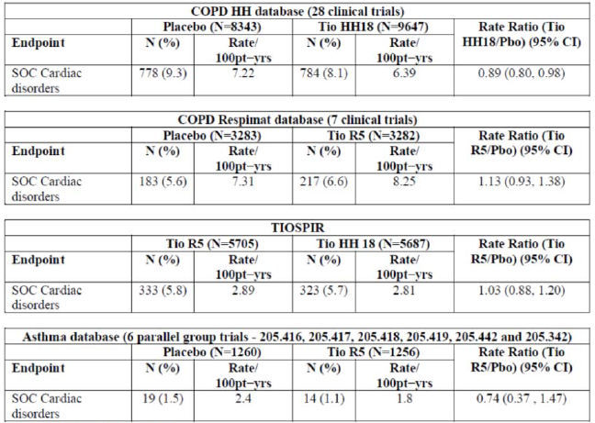

RMP evaluator’s comment
This is not considered acceptable. The existing cardiac and cerebrovascular event data is not considered sufficient.
The Advisory Committee on the Safety of Medicines (ACSOM) stated the following: ‘The committee agreed with the additional pharmacovigilance activities requested by the evaluator. The committee also advised that a more structured pharmacovigilance study to investigate cardiac and cerebrovascular events would be highly desirable given the numbers of patients likely to use the medicine. The routine pharmacovigilance activities proposed by the sponsor were unlikely to yield informative long term data on cardiac safety.’
The sponsor should propose appropriate planned or existing additional pharmacovigilance activities to which asthma related deaths and severe asthma exacerbations, cardiac events and cerebrovascular events can be assigned. The additional pharmacovigilance activity could be only one activity for all of the above safety concerns or multiple activities.
Examples include the following:
- A clinical trial with outcome measures regarding cardiac and cerebrovascular events, asthma‐related deaths, and severe asthma exacerbations.
- A PASS to evaluate the potential cardiac and cerebrovascular events, asthma‐related deaths, and severe asthma exacerbations, e.g. through sequential, nested case control studies for each outcome measure.

Recommendation 14
The sponsor should conduct an additional pharmacovigilance activity, or assign an existing activity, that assesses the safety of tiotropium in asthma patients beyond 12 months.

Sponsor’s response
BI agrees with the evaluator and the RMP has been amended to include ‘Long term safety’ as Missing Information (see RMP version 6.0 and ASA version 2.0)).’
RMP evaluator’s comment
This is considered acceptable.
However, the sponsor should provide the details of the additional pharmacovigilance activity that will assess safety of tiotropium in asthma patients beyond 12 months.

Recommendation 15
In the ‘Precautions’ section, the PI should include a statement regarding the need for a COPD action plan for any patient with COPD including the recommendation to seek medical advice if a previously effective dosage regimen fails to control symptoms adequately (or a statement to that effect).
Sponsor’s response
While it is acceptable and meaningful to include wording on seeking medical advice when the current treatment no longer controls symptoms sufficiently, specific recommendation falls under disease management which is outside the scope of Product Information documents. In addition, while the information about management of symptoms may be accurate, it is not necessarily complete, since clinical management may also depend on the severity of symptoms and the underlying co morbidity.

RMP evaluator’s comment
It is recommended to the Delegate that such a statement be included in the proposed PI document.
For similar products, the RMP evaluator has previously requested a similar statement to be included in the PI document, or a similar statement had already been proposed by other sponsors of similar products.
Furthermore, in this context, the inclusion of the need for an action plan is not considered disease management, but a risk minimisation strategy to mitigate the risks associated with worsening of the condition.
The action plan itself may be regarded as disease management; the need for an action plan is risk mitigation and within scope of the RMP and the PI document.
The recommendation to the Delegate remains.

Recommendation 16
In the ‘Precautions’ section, the PI should include a statement regarding the need for a[n] asthma action plan for any patient with asthma, including the recommendation to seek medical advice if a previously effective dosage regimen fails to control symptoms adequately (or a statement to that effect).

Sponsor’s response
While it is acceptable and meaningful to include wording on seeking medical advice when the current treatment no longer controls symptoms sufficiently, specific recommendation falls under disease management which is outside the scope of Product Information documents. In addition, while the information about management of symptoms may be accurate, it is not necessarily complete, since clinical management may also depend on the severity of symptoms and the underlying co morbidity.

RMP evaluator’s comment
It is recommended to the Delegate that such a statement be included in the proposed PI document.
For similar products, the RMP evaluator has previously requested a similar statement to be included in the PI document, or a similar statement had already been proposed by other sponsors of similar products.
Furthermore, in this context, the inclusion of the need for an action plan is not considered disease management, but a risk minimisation strategy to mitigate the risks associated with worsening of the condition.
The action plan itself may be regarded as disease management; the need for an action plan is risk mitigation and within scope of the RMP and the PI document.
The recommendation to the Delegate remains. This is supported by the ACSOM.

Recommendation 17
In the ‘Precautions’ section, the PI should include a precautionary statement regarding the potential worsening of allergic rhinitis, in particular patients with allergic asthma (or a statement to that effect).

Sponsor’s response
BI does not agree with the evaluator. As the vast majority of the cases with allergic rhinitis in the asthma clinical development programme had this condition at study baseline, as shown in Table 22, such a statement is not warranted.
Table 22: Incidence of AE allergic rhinitis in asthma clinical trials and number of patients with allergic rhinitis or seasonal rhinitis or seasonal allergy as concomitant diagnosis at baseline
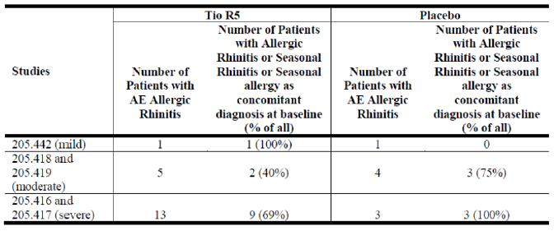
RMP evaluator’s comment
The requested wording is not to imply or insinuate that Spiriva causes allergic rhinitis, but that there is a potential for worsening of allergic rhinitis, in particular patients with allergic asthma.
The recommendation to the Delegate remains.

Recommendation 18
In the ‘Precautions’ section, the PI should include a statement anticholinergic treatment can lead to dry mouth which may be associated with dental caries in the long term (or a statement to that effect).

Sponsor’s response
BI disagrees with the evaluator that anticholinergic treatment can lead to dry mouth which may be associated with dental caries in the long term since dental caries is not a known risk of Spiriva (see Table 23) and a putative association between dry mouth and dental caries has not been observed in patients treated with Spiriva.

Table 23: Time adjusted ratios of tiotropium versus placebo for dental caries #PV in COPD and asthma placebo controlled trials
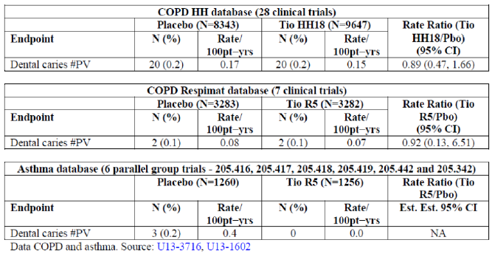

RMP evaluator’s comment
Dry mouth is associated with caries regardless of the cause of dry mouth. The risk is not mitigated with the use of Spiriva. The recommendation to the Delegate remains.

Recommendation 19
In the ‘Precautions’ section, the PI should include a statement that Spiriva HH is not indicated in asthma (or a statement to that effect).

Sponsor’s response
BI considers that such statement is not required as non-indications are not part of a PI document.

RMP evaluator’s comment
Non indications are an essential part of the PI document. In the proposed PI document, there already are several examples of such statements:
- The safety and effectiveness of Spiriva in paediatric patients has not been established. Therefore, Spiriva should not be used in paediatric patients.’
- ‘Spiriva is contraindicated in patients with a history of hypersensitivity to atropine or its derivatives, for example, ipratropium or oxitropium or to any other component of this product.’
The recommendation to the Delegate remains.

Recommendation 20
In the ‘Interaction with other Medicines’ section, the PI should include a statement that concomitant use with other anticholinergic agents is expected to have additive anticholinergic effects (or a statement to that effect).

Sponsor’s response
BI agrees with the evaluator.
RMP evaluator’s comment
This is considered acceptable pending approval by the Delegate.

Recommendation 21
In the ‘Interaction with other Medicines’ section, the PI should include examples of anticholinergic medications to assist clinicians (or a statement to that effect).

Sponsor’s response
BI agrees with the evaluator and proposes to include the examples of glycopyrronium, aclidinium bromide, umeclidinium bromide, and ipratropium bromide.

RMP evaluator’s comment
This is considered acceptable pending approval by the Delegate

Recommendation 22
In the ‘Adverse Events’ section, the PI should, under a separate heading, describe paradoxical bronchospasm, despite some of this information being also available in the ‘Precautions’ section (or a statement to that effect).

Sponsor’s response
BI disagrees with the evaluator that a description of paradoxical bronchospasm be included in the Adverse Events section of the PI. The data from COPD (Respimat and HH) and asthma (Respimat) clinical trials show no imbalance between tiotropium and placebo for any of the PT components of the Bronchospasm (broad) #PV (‘wheezing’ in the asthma clinical trials had an IRR: 2.54 based on 5 and 2 cases for Tio R5 and placebo, respectively) (Table 24).

Table 24: Time adjusted rate ratios of tiotropium versus placebo for bronchospasm (broad) #PV by PT in COPD and asthma placebo controlled trials
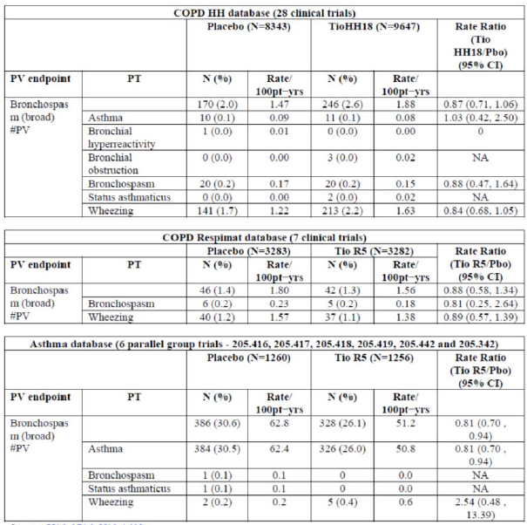

RMP evaluator’s comment
This is considered acceptable pending approval by the Delegate.

Recommendation 23
In the ‘Adverse Events’ section, the PI should, under a separate heading, describe potential worsening of prostate hypertrophy/urinary retention/bladder neck obstruction, despite some of this information being also available in the ‘Precautions’ section (or a statement to that effect).

Sponsor’s response
Prostate hypertrophy (or hyperplasia), urinary retention, and bladder neck obstruction are not considered Important Potential Risks for Spiriva. Therefore, a description of the potential worsening of these events in the ‘Adverse Events’ section is not warranted. The following sentence included in the ’Precautions’ section of the proposed Australian PI is considered to be sufficient in mitigating any potential risk to patient safety in this regard:
‘As with other anticholinergic drugs, Spiriva Respimat should be used with caution in patients with narrow angle glaucoma, prostatic hyperplasia or bladder neck obstruction. In a meta-analysis of placebo controlled trials, Spiriva was associated with a non-significant increase in the risk of urinary retention, and a significant increase in the risk of micturition difficulties.’

RMP evaluator’s comment
This is considered acceptable pending approval by the Delegate.

Recommendation 24
In the ‘Adverse Events’ section, the PI should present AEs in a table that allows easy visualisation of the AEs according to body system and frequency (as displayed above).
Sponsor’s response
BI agrees with the evaluator and proposes the AEs be presented in the PI as follows:
Spiriva / Favint:
Frequency is defined using the following convention:
Very common (≥ 1/10); common (≥ 1/100 to < 1/10); uncommon (≥ 1/1,000 to <1/100); rare (≥ 1/10,000 to < 1/1,000); very rare (< 1/10,000), not known (cannot be estimated from the available data).
Spiriva Respimat:
Frequency is defined using the following convention:
Very common (≥ 1/10); common (≥ 1/100 to < 1/10); uncommon (≥ 1/1,000 to < 1/100); rare (≥ 1/10,000 to < 1/1,000); very rare (< 1/10,000), not known (cannot be estimated from the available data).
RMP evaluator’s comment
This is considered acceptable pending approval by the Delegate.

Recommendation 25
In the ‘Adverse Events’ section, the PI should include AEs from all studies and other reliable sources.

Sponsor’s response
All available sources were considered for the identification of side effects. The presented frequency categories are based on data obtained in trials investigating the effects of Spiriva Respimat for the following indications:
COPD:
- treatment duration of at least 4 weeks
- parallel group design
- inclusion of a placebo control arm
Asthma:
- treatment duration of at least 12 weeks
- parallel group design
- inclusion of a placebo control arm
RMP evaluator’s comment
This is considered acceptable pending approval by the Delegate.

Recommendation 26
In regard to the proposed routine risk minimisation activities, it is recommended to the Delegate that the draft consumer medicines information document be revised to accommodate the changes made to the product information document.

Sponsor’s response
The draft consumer medicine information documents (CMI) have been amended in order to accommodate the changes made to the product information (PI) documents and proposed labelling.

RMP evaluator’s comment
This is considered acceptable pending approval by the Delegate.

Advice from the Advisory Committee on the Safety of Medicines
The ACSOM advice has been reviewed by the RMP Evaluator and relevant parts are incorporated in the reconciliation and outstanding issues sections above. The full advice is
- Can the committee advise whether the additional safety concerns suggested by the RMP evaluator are appropriate additions to the pharmacovigilance plan, in particular where related to the asthma patient population?
The committee advised that it endorsed the additional safety concerns suggested by the RMP evaluator as appropriate additions to the pharmacovigilance plan.
The committee noted that the safety data with regard to asthma patients was limited, with the Kerstjens study providing the only peer‐reviewed published data on adverse events. The RMP was largely based on experience in the COPD population or from unpublished studies. There were no a priori grounds to extrapolate directly from the generally reassuring safety profile of tiotropium in COPD patients to the safety of use in asthma patients. In particular, the committee noted the absence of long term data in asthma patients and the higher dosage regimen to be used by this patient group.
The committee advised that it was important for there to be specific randomised studies, of adequate size and duration relevant to likely usage (that is, greater than 6 months), to establish safety in asthma patients. It would also be useful to have additional pharmacokinetic data from the asthma population, as the COPD and asthma populations may differ in co‐morbidities, concomitant medicines (including use of beta‐agonists which may affect pharmacokinetics), age and gender profiles, affecting pharmacokinetics and patient exposure.
Pharmacokinetic studies have shown that compared with tiotropium 18 µg delivered by the HandiHaler, peak plasma concentrations with the mist inhalation at doses of 5 µg and 10 µg were 35% and threefold higher, respectively.6 However, the sponsor has provided more recent data from the unpublished study 205.458 that shows no relevant difference in absorption or systemic exposure in patients with COPD treated with tiotropium 5 µg mist inhalation or 18 µg delivered by the HandiHaler. Further, Wise et al⁹ found that tiotropium mist inhalation at a dose of 5 µg or 2.5 µg had a safety profile (and exacerbation efficacy) similar to those of the tiotropium HandiHaler at a dose of 18 µg in patients with COPD. The committee noted that this study did not address the issue of safety or increased mortality of tiotropium as the study did not include a placebo arm. It only compared two formulations of the same product.
The Singh review had also found a significantly increased risk of major cardiovascular events (stroke, myocardial infarction, and cardiovascular deaths, including sudden death) in COPD patients taking inhaled anticholinergics (relative risk 1.58; 95% confidence interval 1.21 to 2.06; P < 0.001). This meta‐analysis also found that a higher mortality rate in the group receiving inhaled anticholinergics did not reach significance (relative risk 1.26; 95% confidence interval 1.0 to 1.61; P = 0.06). Conversely, in clinical trials for the asthma indication, the numbers of events of myocardial infarction and ischaemic heart disease (including angina pectoris) were very low with wide confidence intervals including unity.
The committee noted that asthmatic patients may be more susceptible to AEs attributed to higher systemic absorption due to relatively better lung function (compared to COPD patients), and advised that long‐term safety data in asthma patients beyond 12 months should be included as missing information. Only 11 patients (or 0.7% of the asthma trial population) were exposed to tiotropium for more than 12 months.
The committee concluded that currently there are insufficient data to determine if the risks to asthmatic patients are greater or lesser than the risks to COPD patients.
- With regard to the asthma patient population, can the committee advise whether additional pharmacovigilance activities, as requested by the RMP evaluator, or otherwise, are required?
The committee agreed with the additional pharmacovigilance activities requested by the evaluator. The committee also advised that a more structured pharmacovigilance study to investigate cardiac and cerebrovascular events would be highly desirable given the numbers of patients likely to use the medicine. The routine pharmacovigilance activities proposed by the sponsor were unlikely to yield informative long term data on cardiac safety.
- Other
The committee agreed that the submission raised a number of quality use of medicines issues. These included:
- the need for patients to have an Asthma Action Plan;
- the need for the CMI to reinforce public health messages on the different roles of preventer, reliever and symptom controller (such as tiotropium) medicines, including the need for continued compliance with prescribed corticosteroids; and
- the need for the CMI to highlight that the difference in administered doses from the two dosage forms (2.5 µg from the mist inhalation; 18 µg from the HandiHaler) may confuse patients and lead to unintended over dosage.
The TGA noted these comments and would consider whether further liaison with the National Prescribing Service on the issue of compliance with multiple medications by asthma patients was required.

Outstanding issues
It is considered that the sponsor’s response to the TGA request for information has adequately addressed some of the issues identified in the RMP evaluation report. However, there are outstanding issues. Additional recommendations have been made.

Additional recommendations
- Recommendations in regard to safety concerns
  - It is noted that ‘All-cause mortality’, ‘Cardiac mortality’, and ‘Sudden death and unspecified death’ had been removed by the sponsor on transitioning from EU-RMP Version 5.0 to Version 6.0. This may be justified for the non-asthma population. However, asthma-related deaths have not been fully investigated. As a result the following recommendation is made: ‘Asthma-related deaths’ should be added as an Important Potential Risk.
- Recommendations in regard to risk minimisation activities
  - It is recommended to the Delegate the Consumer Medicine Information (CMI) document include statements that reinforce public health messages on the different roles of preventer, reliever and symptom controller (such as tiotropium) medicines, including the need for continued compliance with prescribed corticosteroids.
  - It is recommended to the Delegate the Consumer Medicine Information (CMI) document highlight the difference in administered doses from the two dosage forms (2.5 microgram from the mist inhalation; 18 microgram from the HandiHaler) which may confuse patients and lead to unintended overdosage.

Key changes to the updated RMP
EU‐RMP Version 5.0 (dated 30 July 2013, DLP 28 February 2013) and Australian Specific Annex Version 1.0 (dated 3 March 2014) has been superseded by:
EU‐RMP Version 6.0 (dated 22 October 2014, DLP 31 December 2013 (COPD), DLP 11 April 2014 (Asthma)) and Australian Specific Annex Version 2.0 (dated 11 November 2014).

Table 25: Summary of key changes between EU Risk Management Plan Version 5.0 and EU Risk Management Plan Version 6.0
Summary of key changes between EU Risk Management Plan Version 5.0 and EU Risk Management Plan Version 6.0
Safety specification | Important Potential Risks removed:  - All-cause mortality  - Cardiac mortality  - Sudden death and unspecified death  Important Missing Information added:  - Treatment of paediatric patients  - Long term safety for indication asthma
Pharmacovigilance activities | Updates to include new Safety Concerns/Missing Information
Risk minimisation activities | Updates to include new Safety Concerns/Missing Information

Suggested wording for conditions of registration
The suggested wording is:
Implement EU-RMP Version 6.0 (dated 22 October 2014, DLP 31 December 2013 (COPD), DLP 11 April 2014 (Asthma)) and Australian Specific Annex Version 2.0 (dated 11 November 2014), and any future updates as agreed with the TGA as a condition of registration.

VI. Overall conclusion and risk/benefit assessment
The submission was summarised in the following Delegate’s overview and recommendations.

Background

The product
Tiotropium is a long-acting anticholinergic bronchodilator (long-acting anti-muscarinic agent, long-acting muscarinic antagonist: (LAMA)). It blocks the M3 receptor, which results in prolonged bronchodilation. It is currently registered in Australia for COPD.
The currently registered dose forms and strengths for Spiriva in Australia (for COPD) are:
- HandiHaler device: 18 µg (dry powder) for inhalation (in hard capsule), blister pack
- Respimat/Misthaler device: 2.5 µg (aqueous solution); soft mist for inhalation.
Although both the HandiHaler and Respimat products are registered, only the HandiHaler product is marketed in Australia. Both products are currently registered and marketed in Europe for COPD. The sponsor decided not to market the Respimat product in Australia for COPD, following concerns, arising from a meta-analysis, about cardiovascular deaths among COPD patients who used the product. A sub-part of this application is to update the clinical trials section of the PI to include the results of a large, randomised post-marketing Phase IV study (TIOSPIR), addressing the concern about cardiovascular safety with the Respimat inhaler versus the HandiHaler
Only the Spiriva Respimat formulation is proposed for the extension of indication of asthma.
The sponsor has provided the following reasons for using Spivira Respimat (rather than Spivira HandiHaler) in the clinical development program for asthma
- Minimal inspiratory flow is required by the patient (it releases the drug substance via an aerosol)
- It is suitable for use with a valved holding chamber, with face mask
- It is suitable for the entire proposed age range (paediatric studies are ongoing; and a separate paediatric submission is planned)
A development program for Spiriva Respimat for cystic fibrosis is underway (Paediatric Investigation Plan agreed to by EMA).

Treatment algorithm
Long acting anti muscarinic agents (LAMAs) are listed as a possible first line therapy in clinical practice guidelines for COPD; in many guidelines they are the preferred first line therapy. Worldwide, tiotropium is probably the most widely used long acting bronchodilator in COPD patients. Tiotropium is the first LAMA proposed for registration for an asthma indication. Clinical development programs are underway for other LAMAs for asthma.
Ipratropium, a short acting ant-muscarinic agent (SAMA), has a registered indication for asthma, in addition to COPD. However, it has not been as popular as the Short acting β2 adrenergic agonist (SABAs) (salbutamol) because it has a slower onset of action and a smaller bronchodilator effect. That is, SABAs are the preferred reliever medications, although the addition of SAMA to SABA has been proposed in some treatment guidelines as a strategy for severe acute asthma (and COPD) exacerbations, requiring hospitalisation. Patients with more severe asthma were thought to possibly have a better response to an anticholinergic, compared to patients with mild asthma.
The goal of asthma treatment is to achieve and maintain control; that is, minimal or no symptoms of asthma. Treatment can be modified by stepping up in the case of uncontrolled asthma; or stepping down, if symptoms have been controlled for at least 3 months.
Inhaled corticosteroids (ICS) are the cornerstone of treatment for asthma. Long acting β2 adrenoceptor agonists (LABAs) are added when symptoms persist, to improve control. They can be considered at step 3; added to low dose ICS (if step 2 treatments are not effective in controlling asthma). Or considered at step 4; added to medium or high dose ICS (if step 3 treatments are not effective in controlling asthma).
Monotherapy with LABA is not recommended because of concerns about increased mortality. The sponsor is not proposing monotherapy with tiotropium.
Both LABAs and tiotropium provide bronchodilation. This submission is to add tiotropium as possible maintenance treatment, in addition to ICS for ‘mild’ to ‘moderate’ asthma and in addition to high dose ICS+LABA for ‘severe’ asthma.
A key methodological issue for this submission is the choice of comparator for the Phase III trials for the addition of tiotropium to ICS. These trials (418/419) used placebo; salmeterol was used for ‘assay sensitivity’, but the trials were not designed to establish non-inferiority to salmeterol or an increased dose of ICS.
The sponsor has provided the TGA with the scientific advice from The Netherlands Medicines regulator (MEB) to the sponsor (2009), which addresses this issue. Excerpts from the MEB’s scientific advice on the design of the Phase III studies (2009) were provided.
Given that tiotropium is only approved as an add-on for adult patients on high dose ICS and LABA in various countries in the EU, Australia would be the first regulator in a high income country to accept the wider indication of ‘add-on to at least ICS’

Quality
There was no requirement for a quality evaluation in a submission of this type.

Nonclinical
There are no nonclinical objections to the extension of indication for Spiriva Respimat / Favint Respimat to include add-on maintenance treatment for asthma symptoms in adults.

Clinical

Pharmacokinetic profile
The PK characteristics of inhaled tiotropium in COPD patients are well known. For the asthma indication, additional PK studies were done as sub studies of the Phase II and Phase III clinical trials for tiotropium, as part of the development program for asthma patients.
The main finding from these studies was that the rate and extent of absorption is about 50% lower in asthma patients than COPD patients. However, the sponsor has stated that dose finding for Spiriva Respimat in asthma has been based on clinical efficacy, not these PK results.
Other results include:
- Tiotropium was rapidly absorbed following inhalation with a median t_{max,ss} of 5 minutes. The effective half-life in patients with asthma was 34 hours; hence the qd dosing schedule
- Dose proportionality was observed for 2.5 to 10 µg
- Rate and extent of absorption did not vary in any significant way by asthma severity
- Tiotropium is mainly excreted unchanged in the urine. Renal impairment is the most important factor affecting systemic exposure. Consistent with use in COPD patients, mild renal impairment decreased excretion by 39% and increased tiotropium exposure by 20%. There was insufficient data in patients with moderate or severe renal impairment, but if the effects in COPD patients hold in asthma patients, a 2 fold increase in exposure is expected. The PI has a precaution. Exposure in the elderly and adolescents is similar to adults. (The sponsor is not requesting that adolescents be included in the indication.)

Phase II studies
This overview concentrates on the 4 pivotal Phase III trials. Brief details on the Phase II studies are provided below.
For severe asthma, only the 5 and 10 µg doses were assessed in the Phase II program, based on experience with COPD. The sponsor chose the 5 µg dose to carry forward into the Phase III trials for severe asthma, with the reasoning of similar efficacy and better safety than 10 µg.
For patients with less severe asthma, the 2.5 µg and 5 µg doses were assessed in Phase II studies. Efficacy was numerically in favour of 5 µg, safety was similar (Study 420 was only for 4 weeks); given these were Phase II studies they were not a definitive comparison of 2.5 µg versus 5 µg. Both doses were carried through to the Phase III studies against placebo for patients not controlled on low/medium ICS; however, in these Phase III studies (418/419) there was no evidence that 5 µg was more effective than 2.5 µg.

Evidence of clinical efficacy from the pivotal Phase III studies

Design
The pivotal Phase III trials had 2 aims
- Establish the efficacy and safety of tiotropium as an add-on therapy in patients not controlled on high dose ICS + LABA.
- Establish the efficacy and safety of tiotropium as add-on therapy to patients not controlled on low/medium dose ICS. (This positions it similarly to LABAs or increased ICS in the current clinical practice guidelines.)

Table 26: Evidence of clinical efficacy from the pivotal Phase III studies
Study | Dates | Duration | Dose | Comparator | Co primary Endpoints
Symptomatic on high dose ICS + LABA; history of at least one exacerbation per year
416 | October 08 - July 11 | 24 weeks | 5 µg | placebo | Peak FEV₁ Trough FEV₁
417 | November 08- July 11 | 24 weeks | 5 µg | placebo | Peak FEV₁ Trough FEV₁
416/ 417 pooled | October 08- July 11 | 48 weeks | 5 µg | placebo | Time to first severe asthma exacerbation
Symptomatic on low/medium dose ICS
418 | September10–November12 | 24 weeks | 2.5, 5 µg | placebo | Peak FEV₁  Trough FEV₁
419 | August 10 – November 12 | 24 weeks | 2.5, 5 µg | placebo | Peak FEV₁ Trough FEV₁
418/ 419 pooled | August 10 – November 12 | 24 weeks | 2.5, 5 µg | placebo | ACQ responder
The 2.5 µg dose of tiotropium was delivered as two puffs of a 1.25 µg strength inhaler. The 5.0 µg dose of tiotropium was delivered as two puffs of a 2.5 µg strength inhaler. In Studies 418/419, salmeterol 50 µg BD was included for assay sensitivity. These studies were not powered to assess the therapeutic non inferiority/equivalence of tiotropium versus salmeterol. No studies were conducted to assess tiotropium versus increased dose of ICS.

Definitions for primary endpoints
- Peak FEV₁: maximal response in FEV₁ within 3 hours, post dosing. It was analysed as the difference from baseline FEV₁, measured 10 mins before the first dose of study medication.
- Trough FEV₁: measured 10 mins before the study medication. It was analysed as the difference from baseline FEV₁, measured 10 mins before the first dose of study medication.
- Severe exacerbation (416/417): use of a systemic (including oral) CS for 3 + days or doubling of previous daily doses for 3 + days.
- ACQ: self-administered questionnaire: 6 questions about asthma control in the previous week, plus pre bronchodilator FEV₁ at the actual visit (that is, 7 items). This is typically analysed as the percentage of responders. A responder is defined as a patient who had a 0.5 unit improvement in the ACQ.
Note on lung function endpoints from draft EMA Guidance:
Both FEV₁ and PEF reflect airway obstruction and are accepted as spirometric evaluations of the effect of anti-asthma drugs. Pre bronchodilator FEV₁ is considered the most suitable variable and has been considered as a measure of asthma control as it is influenced by short term fluctuations in airflow limitation. Its relationship with symptoms experienced by the patient is poor but a low FEV₁ is described as an independent predictor of asthma exacerbations. PEF evaluation is a variable considered more appropriate for ambulatory monitoring of lung function.

Results

Add on to high dose ICS + LABA, 416/417

Table 27: Co primary endpoints: FEV₁, peak, trough, 24 weeks Studies 416 and 417
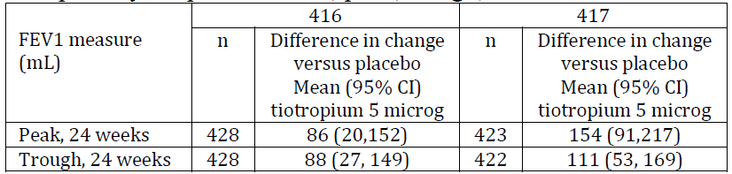
Change over 24 weeks for placebo
- Peak 416: 315 mL; 417: 248 mL
- Trough 416: 56 mL; 417: 44 mL
Pooled difference in change versus placebo
- Peak: 110 (63, 158)
- Trough: 93 (50, 137)

Other co primary endpoint: time to first severe exacerbation
Pooled analysis of 416 and 417
HR=0.79, 95% CI (0.62, 1.00)
Median time to exacerbation was not reached because fewer than 50% of patients had a severe exacerbation. Time to first quartile was 56 days longer with tiotropium than placebo (282 days versus 226 days).

Table 28: Selected secondary endpoints
Selected secondary endpoints
Measure | 416 |  | 417
Measure | n | Difference in change versus placebo  Mean (95% CI) tiotropium 5 µg | n | Difference in change versus placebo  Mean (95% CI) tiotropium 5 µg
FEV_{1,} Peak, 24 weeks | 417 | 73 (5,140) | 403 | 152 (87, 217)
FEV_{1,} Trough, 24 weeks | 417 | 42 (-21, 104) | 422 | 92 (32, 151)
ACQ at 24 weeks: 416/417, pooled: responder rates tiotropium: 54%, placebo: 47%
Exacerbations, pooled analysis of 416/417, 48 weeks; at least one severe exacerbation: tiotropium: 122 (27%), placebo: 149 (33%)
Severe exacerbations per patient year: tiotropium: 0.53, placebo: 0.66
Hospitalisations for asthma: tiotropium: 16 (3.5%), placebo 20 (4.4%).

Add-on to at least ICS, 418/419

Table 29: Co primary endpoints: FEV₁, peak, trough, 24 weeks studies 418, 419 and pooled 418/419
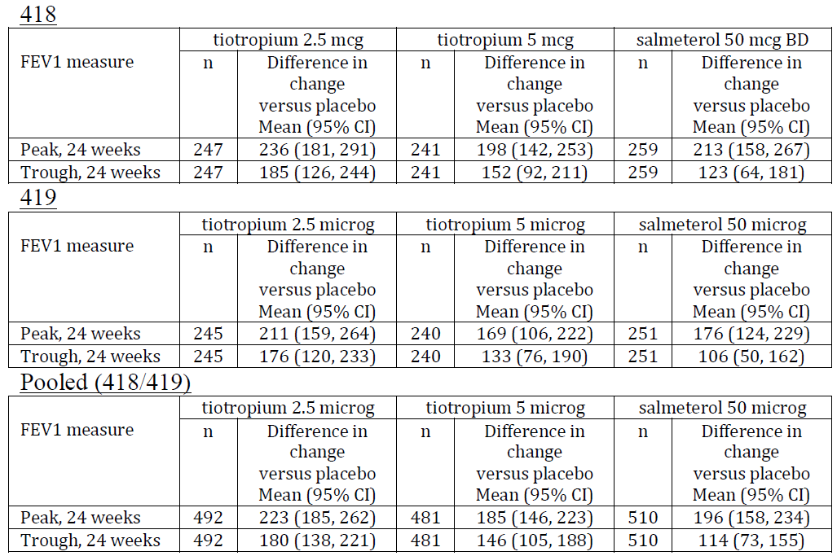

Other co primary endpoint: ACQ responder rate (patients with > 0.5 improvement)

Table 30: Pooled 418/419, 24 weeks
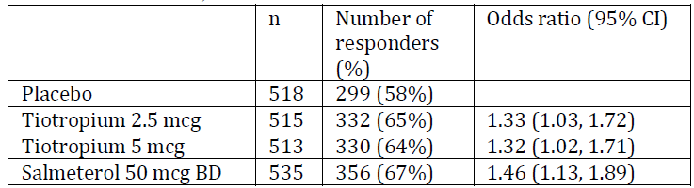
Note: Odds ratios over estimate the size of treatment effect when the event rates are > 5 to 10% (say). For example, the risk ratio for tiotropium 5 µg versus placebo is 1.10 [64%/58%] (compared with the odds ratio of 1.32). That is, tiotropium (both 2.5 and 5 µg) increases the chance of an ACQ response by about 10%, not 32%, as suggested by the odds ratio. Sponsors should, by default, use the risk ratio; and only use the odds ratio if there is a compelling reason to do so.

Table 31: Secondary endpoint: percentage of patients with at least one severe exacerbation. Pooled 418/419, 24 weeks
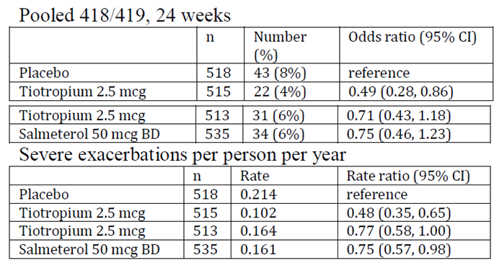
Comment: Studies 418 and 419 showed statistically significant and clinically significant improvements in FEV₁ (peak and trough) and ACQ responder rates, for tiotropium compared to placebo. There was no dose ordering; that is, the treatment effect of 2.5 µg was similar to that of 5 µg.

Note on supportive studies
Study 442 was a 12 week study of tiotropium as an add-on to low dose ICS.

Table 32: Co primary endpoints: FEV₁, peak, trough, 12 weeks
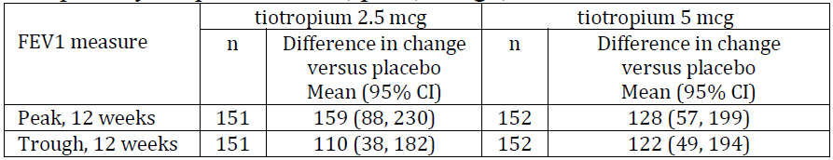
This study is only supportive because it does not meet EMA guidelines for asthma studies (for example, it is only of 12 weeks duration).
There was also a study in 100 Japanese asthma patients to assess the long term safety of tiotropium added to low/medium dose ICS; the comparator was placebo. The findings of these studies are supportive of the findings from the pivotal studies. This and other supportive evidence is not discussed in detail in this present summary document, so as to keep the content as focussed as possible.

Safety
Data on safety are currently limited to the clinical development program; that is, there is a lack of long term safety data for use of tiotropium in asthma; as opposed to COPD.
The most frequently reported AEs were dry mouth, dry throat and dysphonia, which is expected from an anticholinergic treatment.
Bronchitis was consistently observed at higher frequency in the tiotropium group than placebo. In the COPD trials, bronchitis was reported at lower frequency. The sponsor has argued that this is related to the efficacy of tiotropium in reducing the frequency of asthma. That is, if tiotropium were to reduce the intensity of an asthma exacerbation, it might be reported as bronchitis.
Both LABAs and LAMAs may affect the cardiovascular system due to systemic exposure. Data on the cardiovascular safety of tiotropium in asthma is currently limited to the clinical development program; but, based on PK studies, the systemic exposure in asthma patients is lower than in COPD patients. The sponsor has stated that the population of patients with asthma is, on average, younger and less likely to have cardiovascular co morbidities than the population of patients with COPD.

TIOSPIR (post marketing safety trial for tiotropium delivered via Respimat misthaler)
Concern about the safety of tiotropium Respimat arose when a post hoc pooled analysis of three 12 month and one 6 month Phase III trials showed that, compared to placebo, tiotropium Respimat at a dose of 5 µg was associated with an increase in mortality (RR = 1.33, 95% CI: 0.93, 1.92)(Boehringer Ingelheim 2010).
There have also been concerns about the safety of the tiotropium HH. The table below summarises some of the results for the HH and Respimat (the 2008 Singh meta-analysis also included the SAMA ipratropium).

Table 33: Summary of some of the results for the HH and Respimat
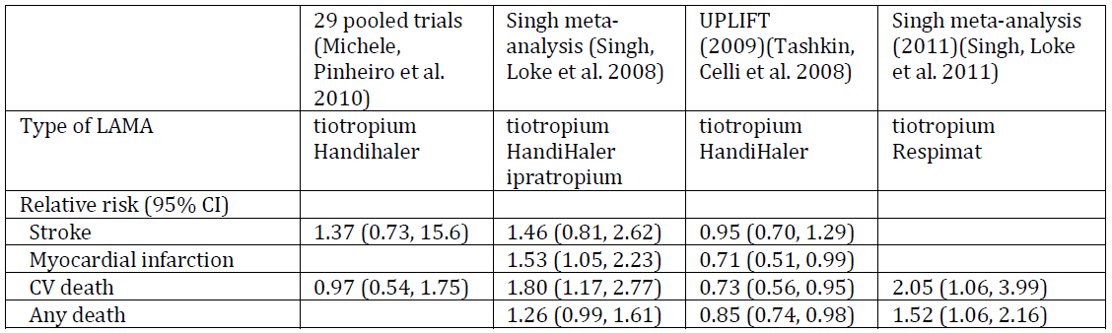
To address concerns about safety of the HH device, the UPLIFT (2009) trial was conducted (see column 3 in Table 33). It was large (approximately 6,000 participants), had adequate follow up (4 years), and was specifically designed as a safety trial. The comparator was placebo; tiotropium was given as an add-on to the patients’ usual COPD medications. Unlike the meta-analyses there was no safety signal from UPLIFT for deaths or cardiovascular events (see Column 3 in Table 33). Given the strength of these randomised data over meta analyses (problems of statistical multiplicity and heterogeneity), the US FDA stated in 2010 that: ‘current data do not support the conclusion that there is an increased risk of stroke, heart attack, or death associated with tiotropium HH’. (At that time, the signal for tiotropium Respimat remained unresolved. One hypothesis was that differences between HH and Respimat in terms of lung deposition may result in differential risk.)
As part of this current application, the sponsor has submitted the TIOSPIR study, which was designed to answer the question as to whether the Respimat inhaler was associated with a higher risk of death than the HH device; given that the UPLIFT Trial had already shown that tiotropium delivered by the HH device did not increase the risk of death, compared to placebo, when used as an add-on to the patients’ usual COPD medications. The results of TIOSPIR (see Table 34) show that the Respimat device has the same risk of death and major cardiovascular events as the HH device.

Table 34: Risk of death
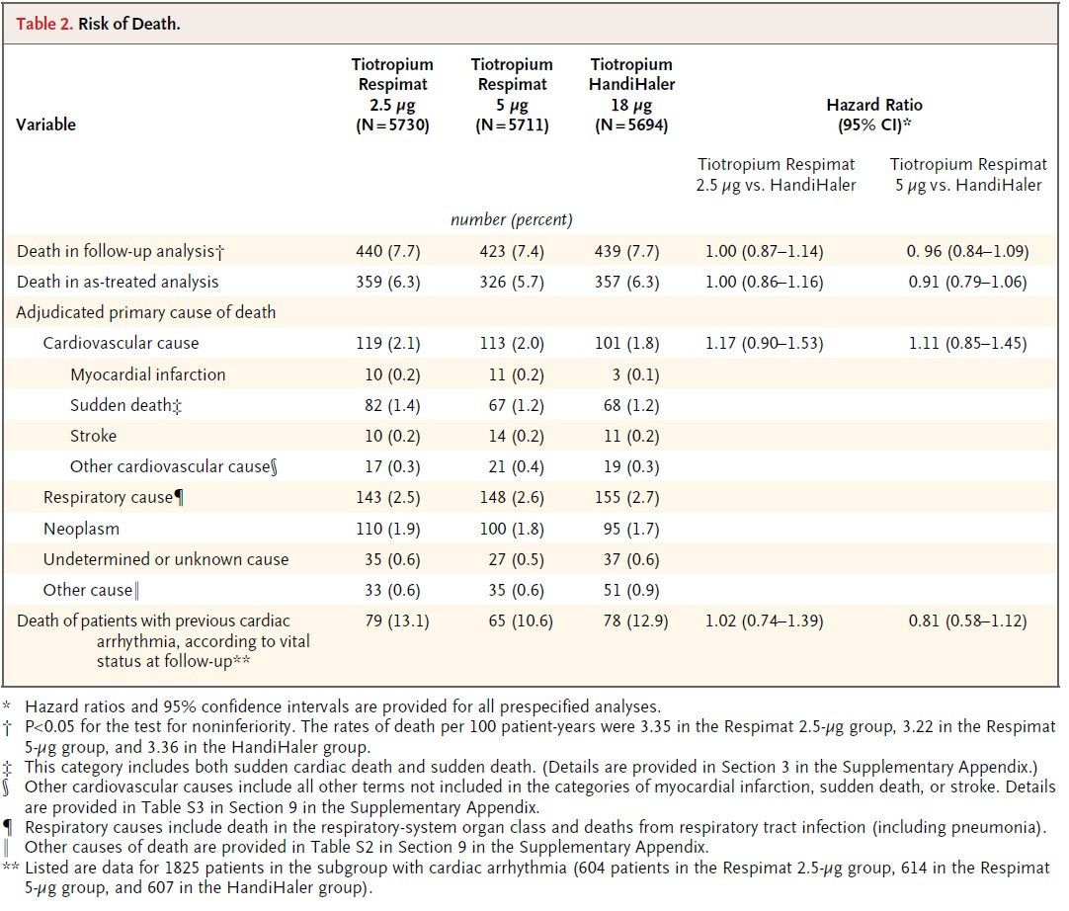

Limitations
- No placebo group: The authors of the paper in the NEJM¹⁶ stated that this was impractical in such a large population and would have resulted in large numbers of drop outs and lack of adherence. They further stated that the comparator, tiotropium delivered by the HH device, had been shown in the UPLIFT Trial not to increase the risk of death compared to placebo.
- Patients with unstable cardiac conditions (MI within 6 months, Class III/IV heart failure, unstable or life threatening arrhythmia) or moderate/severe renal impairment were excluded. The results cannot be generalised to these groups.

Risk management plan
As per EU-RMP Version 6.0, the important potential risks for Spiriva should be closely monitored by periodic review of individual case safety reports (ICSRs) from clinical trial and post approval sources for the following topics:
- All fatal cases
- Arthralgia, myalgia and muscular weakness
- Blood glucose increased
- Blood and lymphatic system disorders
- Cardiac disorders (stroke, angina pectoris, ischaemic heart disease, myocardial infarction, cardiac arrhythmia, cardiac failure)
- Cataract
- Lower respiratory tract infections
- Medication error
- Overdose
- Psychiatric disorders (hallucination)
- Renal failure
- Syncope
- Vascular disorders (aneurysm, hypertension)
In addition, all fatal cases, independently of whether they had an important potential risk or not, should be reviewed on a weekly basis.
Close monitoring of ICSRs should be carried out by safety physicians who perform, among other activities, individual case review, continuous safety screening, and numerical and qualitative signal detection.
A mechanism for identification of the Spiriva formulation (powder for inhalation or inhalation solution; that is, HH or Respimat) is needed, to allow for an allocation of AE reports to the individual product.
In addition, all listed risks for Spiriva, including those not classified as ‘important’, should be followed up in terms of updated frequency estimation from the post marketing safety database.
Note that the above pharmacovigilance activities are based on the EU-RMP, which only applies to ‘add-on to high dose ICS plus LABA’. Further discussion with TGA may be required if ACPM advises registration for ‘add-on to at least ICS’.

Discussion

Add-on to high dose ICS + LABA (Studies 416/417)
(High dose ICS: 800 µg of budesonide per day or equivalent.)
This is the indication that has been approved in various countries in the EU (with the additional criterion of one or more exacerbations in the previous year to match the entry criteria for Studies 416/417). It is also similar to the indication under evaluation in Canada and Switzerland.

Use of placebo comparator is acceptable
The use of placebo as the comparator in the studies for tiotropium as add on to high dose ICS + LABA is acceptable given the known adverse effects of oral steroids, the limited evidence for some other treatments (for example, leukotriene inhibitors, theophylline) and the limited subgroup of patients suitable for omalizumab.

Results for FEV₁ are statistically and clinically significant
The results for FEV₁ are clinically significant for this highly treated group. For example, the placebo subtracted improvement in trough FEV₁ on top of high dose ICS + LABA was 0.093 L, 95% CI (0.050, 0.137). This is similar to the treatment effect reported from a Cochrane review in a less highly treated, less severe group: 0.110 L for ICS + LABA versus ICS alone. The original studies for Seretide showed an additional improvement when salmeterol was added to ICS of 0.220 to 0.230 L, but this has not been replicated; it is likely that background therapy was suboptimal. The Goal study (2004) showed an improvement with the addition of salmeterol of 0.120 to 0.140 L.

Results for exacerbations are statistically and clinically significant
The absolute reduction in the percentage of patients with at least one severe asthma exacerbation was 6% (27% versus 33%); the associated hazard ratio (time to first exacerbation) was 0.79, 95% CI (0.62, 1.00). This is roughly equivalent to the reduction in severe exacerbations 0.79, 95% CI (0.62, 1.00). This is roughly equivalent to the reduction in severe exacerbations (9%) from the FACETT study of formoterol as an add-on to ICS in patients on low/medium dose ICS. That is, an absolute reduction of 6% (or a relative reduction of 21%, based on the HR) is clinically important, in this heavily treated, severe group.

Safety
There is a lack of long term safety data for use of tiotropium in asthma; however, there were no concerning signals from the clinical development program. Bronchitis was consistently observed at higher frequency in the tiotropium group than placebo. In the COPD trials, bronchitis was reported at lower frequency. The sponsor has argued that this is related to the efficacy of tiotropium in reducing the frequency of asthma. That is, if tiotropium were to reduce the intensity of an asthma exacerbation, it might be reported as bronchitis. Safety profile for tiotropium in COPD patients is well characterised.

Add on to low/medium dose ICS (Studies 418/419)
This part of the proposed indication was not pursued by the sponsor through the decentralised process in Europe, although it was in the initial European application.

Lack of a non-inferiority trial against salmeterol
An important methodological issue is whether a non-inferiority trial of tiotropium versus LABA should have been conducted.
By way of background, the sponsor has provided a draft ‘reflection paper’ from the EMA on active versus placebo comparators.
The paper states that benefits should be contextualised in terms of an active comparator because inferior efficacy could lead to harm to the patient. For this submission, the point estimates for the primary endpoints suggest similar efficacy for tiotropium versus salmeterol, but there was no formal comparison because the study was not designed as a non-inferiority trial with a pre specified non-inferiority margin.

Table 35: Placebo adjusted change in peak/trough FEV₁, mL, 24 weeks, pooled 418/419
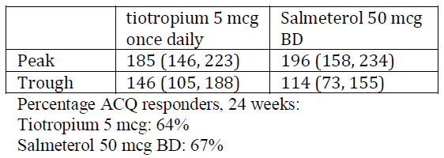
The draft reflection paper also states:
‘it is not necessary for the benefit risk profile of an experimental medicine to at least be as favourable as the benefit risk profile of any or all established medicines in order to receive marketing authorisation. This is appropriate as frequently more than one treatment is required per indication (some medicines suit some people better than others) and clinical trials do not definitively capture all information on benefits and risks; knowledge accumulates during a product’s lifecycle. It is important to recognise that the purpose of regulatory approval is not to determine clinical practice (over and above the act of issuing a particular license for a medicine) and there is no limit to the number of medicines that can be licensed for any given therapeutic indication providing the benefit risk of each is favourable.’
‘Two of the most common primary objectives for pivotal clinical trials are to demonstrate superiority to placebo control, or to demonstrate non inferiority or equivalence to an active control.’
‘For trials where it can be agreed (in line with a relevant CHMP guidance document or scientific advice) that an appropriate primary objective is to demonstrate non inferiority or equivalence to an active treatment, the assay sensitivity of the trial and evidence (possibly ‘indirect’) of superiority to placebo must be established. Requirements for the demonstration of assay sensitivity are described in ICH E10. The most compelling evidence for assay sensitivity will be inclusion of a treatment arm against which superiority can be demonstrated, usually placebo, though differentiating between multiple doses of test and / or reference treatment can also suffice. Hence, a three arm, active and placebo controlled trial will often be required even where the primary objective is to demonstrate non inferiority or equivalence to an active treatment. In this situation, the requirements to establish assay sensitivity are usually equivalent to the requirements to show superiority to placebo for the active treatments and thus the study should be planned with the additional objective of demonstrating superiority to placebo (as a precursor to the test for non-inferiority / equivalence). It may therefore be that the randomisation scheme is unbalanced to allocate fewer patients to placebo than to either active treatment.’
‘For trials where it can be agreed that an appropriate primary objective is demonstration of superiority to placebo, objectives for comparison to active control can vary. Including a third arm of similar size (assuming 1:1 randomisation) would usually give sufficient power to demonstrate superiority of the active control compared to placebo, but would not necessarily give the statistical properties (in particular, statistical power) desirable for a formal comparison of non-inferiority, that is, exclusion from the confidence interval (CI) for the estimated differences between groups of all differences of clinical importance. However, the absence of a formal demonstration of non-inferiority may not be critical in circumstances where primary evidence of efficacy is based on a comparison to placebo (that is, where exclusion of clinically important inferiority to the control is not necessary to establish favourable benefit risk).’
In short, the methodological issue is whether the regulatory objective is to establish non-inferiority to salmeterol or superiority to placebo.

Asthma guidelines
The TGA adopted the EMA guidelines for asthma products, which came into operation in 2003.⁴ The EMA has published new draft guidelines¹³ but these have not yet been adopted by the EMA or TGA. Both the current and draft guidelines recommend three arm studies (new product, active comparator, placebo), but neither guideline discusses whether these studies should be designed to show superiority against placebo or non-inferiority to active comparator. As the sponsor says, neither guideline recommends a non-inferiority margin for (pre bronchodilator) FEV₁ (unlike diabetes guidelines, for example, that recommend 0.3% as the non-inferiority margin for HbA1c).

A study of non-inferiority in asthma for the HandiHaler
TALC (Tiotropium as an Alternative to Increased ICS for patients inadequately controlled on lower dose ICS).
The patients enrolled were all older than 18, with FEV₁ > 40%; non-smokers, 14 week treatment period.
Not the sponsor’s trial; it was conducted by an independent US asthma research network.
- Primary objective: to show superiority of tiotropium (via HH) 18 µg qd (added on to beclomethasone 80 µg BD) over beclomethasone 160 µg BD, on the endpoint of morning peak expiratory flow (PEF).
- Secondary objective: to show non inferiority of tiotropium (via HH) 18 µg qd (added on to beclomethasone 80 µg BD) and salmeterol (50 µg BD) (added on to beclomethasone 80 µg BD), on the endpoint of morning peak expiratory flow (PEF).

Table 36: Results for PEF_{am} and prebronchodilator FEV₁
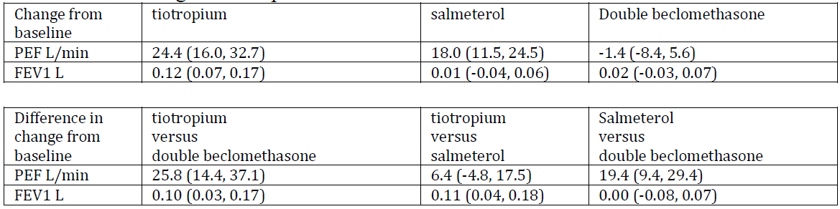
Setting aside issues of statistical multiplicity, in this trial, the point estimate for pre bronchodilator FEV₁ favoured add on tiotropium delivered by the HH device and the CI was all on the favourable side of the null value (0.00 L). However, add on salmeterol did not have the expected effect on pre bronchodilator FEV₁.

Dose ordering
If the broader indication of ‘add-on to ICS’ was approved, then there is the issue that in Studies 418/419, the 5 µg dose did not show superior efficacy over the 2.5 µg dose. That is, a lack of ordering was observed.

Sponsor’s argument
- Phase II showed dose ordering
- A Japanese study showed dose ordering
- 5 µg is well tolerated.

Off label use
Off label use is possible because some patients may prefer the Respimat inhaler. Also, dosing qd might be preferred by some patients.

Questions for sponsor
- The TGA’s understanding of the sponsor’s reasoning for not conducting an active controlled trial for the indication of ‘add-on to low/medium dose ICS’ is that:
  - neither the current nor the draft EMA guidelines on asthma products discuss active controlled trials
  - there is no consensus on the correct non inferiority margin for (pre bronchodilator) FEV₁, the preferred endpoint for lung function.
Does the sponsor wish to expand on, clarify, or add to this reasoning?
- In addition to TALC (which was a non-inferiority study comparing tiotropium, delivered by HH , to increased ICS [primary] and salmeterol [secondary] on PEF), the sponsor refers to a BI non-inferiority study with PEF as the primary endpoint. Does the sponsor wish to briefly summarise the design and results of this study for the pre ACPM response?

Conditions of registration
Implement EU‐RMP Version 6.0 (dated 22 October 2014, DLP 31 December 2013 (COPD), DLP11 April 2014 (Asthma)) and Australian Specific Annex Version 2.0 (dated 11 November 2014), and any future updates as agreed with the TGA as a condition of registration.
Provide the results of any studies on the use of tiotropium in asthma to the TGA as soon as they become available.

Delegate’s considerations

Add on to high dose ICS + LABA
This patient group with severe asthma has unmet clinical need for additional treatments.
The use of placebo as the comparator in the studies for tiotropium as add on to high dose ICS + LABA is acceptable given the know adverse effects of oral steroids, the limited evidence for some other treatments (for example, leukotriene inhibitors, theophylline) and the limited subgroup of patients suitable for omalizumab.
The size of the treatment effects for FEV₁ and exacerbations were statistically and clinically significant. At this point in time and pending advice from ACPM, registration could be approved for this patient group.

Add on to medium / low dose ICS
The sponsor did not proceed with this part of the indication in Europe. Only the add-on to high dose ICS + LABA was approved in Europe. The proposed indication in Canada and Switzerland (where the product is still under evaluation) is also along the lines of ‘add-on to high dose ICS + LABA. In the US, the proposed indication is the same as the broader indication proposed in Australia (add-on to at least ICS); however, the age group is not adults, but 12 years and older. That is, the US dossier includes data for adolescents, which was not submitted in Australia.
A key methodological issue for this Australian submission is the choice of comparator for the Phase III trials for the addition of tiotropium to ICS. These trials (418/419) use placebo; salmeterol was used for ‘assay sensitivity’, but the trials were not designed to establish non-inferiority to salmeterol or an increased dose of ICS.
Asthma patients are a heterogeneous group. It is possible that some patients could respond better to a LAMA than to a LABA; but, based on currently available knowledge, we have no way of identifying these patients. The other evidence gap is whether there are any benefits in adding a LAMA to low / medium dose ICS + LABA.
LABAs are an established treatment for add on to ICS in asthma patients. The standard argument in support of the need for active comparators in situations where there is an established treatment is: if the possibility of inferior efficacy is not explicitly excluded, then this could lead to harm to patients. Specifically, positioning tiotropium as an alternative to LABA, in the absence definitive evidence of non-superiority, raises the possibility of more exacerbations (say), which could harm patients.
Given that tiotropium is only approved as an ‘add-on for adult patients on high dose ICS plus LABA’ in various countries in the EU, Australia would be the first regulator in a high income country to accept the wider indication of ‘add on to ICS’.

Proposed action
The Delegate has no reason to say that the application for Spiriva Respimat should not be approved for the indication of:
‘as an add-on maintenance bronchodilator treatment in adult patients with asthma who are currently treated with the maintenance combination of inhaled corticosteroids (≥ 800 µg budesonide/day or equivalent) and long acting β2 agonists and who experienced one or more severe exacerbations in the previous year.’
The Delegate requires advice from the ACPM before deciding whether Spiriva Respimat should be approved for the broader indication of:
‘add-on in patients who remain symptomatic on at least ICS.’

Request for ACPM advice
Given that the available evidence for add on of tiotropium in patients who are symptomatic on low/medium ICS is against placebo, has the sponsor satisfactorily established the efficacy and safety of tiotropium in this patient group, where tiotropium would be an alternative to LABA or increased dose of ICS?

Response from Sponsor
The sponsor welcomes the Delegate’s recommendation to approve Spiriva Respimat as add-on therapy for patients with asthma who remain symptomatic on ICS maintenance therapy + LABA. The sponsor would like to respond to the Delegate’s questions and to provide evidence that supports the use of Spiriva Respimat as add-on therapy for patients with asthma who remain symptomatic on at least medium dose ICS maintenance therapy. Also included at the end of the response is a supportive statement from [information redacted], who is one of the leading asthma experts in Australia, and has held several national leadership roles including chairing the National Asthma Reference Group and the Asthma Expert Advisory Committee in the Department of Health and Ageing.

Delegate’s question to the ACPM
Given that the available evidence for add-on of tiotropium in patients who are symptomatic on low/medium ICS is against placebo, has the sponsor satisfactorily established the efficacy and safety of tiotropium in this patient group, where tiotropium would be an alternative to LABA or increased dose of ICS?

Sponsor’s response
Asthma treatment is optimised on an individual patient level and therefore, it is considered important to provide alternative treatment options with comparable clinical benefit. This allows the prescribing physician to decide based on the level of control and on the individual tolerability of a certain drug which treatment option should be added to the patient’s ICS maintenance therapy. Currently, there is no therapeutic alternative in terms of a long acting bronchodilator for patients who do not tolerate LABAs. Tiotropium is the first and only bronchodilator drug from a different pharmacological class (long acting inhaled muscarinic antagonists [LAMAs]) that can be used as add-on therapy to patients with asthma who remain symptomatic on ICS maintenance therapy.
For regulatory approval of the indication of asthma, statistically significant improvements over placebo in a co primary pulmonary function endpoint, in a co primary symptom based endpoint, and a favourable safety profile are required as per current TGA adopted asthma guideline. In patients with asthma who were symptomatic on medium dose ICS maintenance therapy, tiotropium showed statistically significant improvements over placebo in lung function and symptom based endpoints and a favourable safety profile (pivotal Trials 205.418/419). Moreover, tiotropium was shown to have comparable efficacy and safety with the LABA salmeterol in all three trials within the clinical program where salmeterol was included as active comparator (Trials 205.342, 205.418, and 205.419). Thereby, the statutory regulatory requirements to establish approval for the indication of asthma for tiotropium were fulfilled.
In addition, the TALC Study (Tiotropium bromide as an Alternative to increased inhaled glucocorticoid in patients inadequately controlled on a Lower dose of ICS), showed that tiotropium was non-inferior to salmeterol in terms of the morning peak expiratory flow (PEF_{am}). As a result, there is sufficient clinical evidence to establish tiotropium as a treatment option for patients with asthma who remain symptomatic on ICS maintenance therapy.
In conclusion, the statutory regulatory requirements to establish approval for the indication of asthma for tiotropium were fulfilled as a comprehensive clinical program has shown that tiotropium statistically significantly improves pulmonary function and symptom based endpoints compared with placebo by clinically relevant margins and has a favourable safety profile. The improvements in pulmonary function and symptom based endpoints were in the same range as for the active comparator salmeterol. Therefore, tiotropium represents a treatment option for patients with asthma who remain symptomatic on at least medium dose ICS maintenance therapy and thus require additional treatment.

Delegate’s questions for sponsor
- The TGA’s understanding of the sponsor’s reasoning for not conducting an active controlled trial for the indication of ‘add on to low/medium dose ICS’ is that:
  - neither the current nor the draft EMA guidelines on asthma products discuss active controlled trials;
  - there is no consensus on the correct non inferiority margin for (pre bronchodilator) FEV₁, the preferred endpoint for lung function;
Does the sponsor wish to expand on, clarify, or add to this reasoning?

Sponsor’s response
Boehringer Ingelheim generally concurs with the reasoning given above and would like to expand and clarify. Statistically significant improvements over placebo in a co primary pulmonary function endpoint, in a co primary symptom based endpoint, and a favourable safety profile are required for regulatory approval for the indication of asthma. This risk/benefit profile is obtained through a comparison versus placebo; a non-inferiority study comparing the investigational treatment with the current standard treatment is not a requirement.
Using a non-inferiority study to compare the investigational drug with a current standard treatment is not common practice for regulatory approval of respiratory inhalation therapies. This is partially due to the fact that a non-inferiority margin is not defined for FEV₁, which is the endpoint that is preferred by the FDA to evaluate lung function improvements and therefore used in global clinical programs. With respect to clinical endpoints, a non-inferiority study in terms of severe exacerbations is not feasible because the frequency of severe exacerbations is low in patients with asthma when adequately treated with ICS; therefore, a non-inferiority study in terms of exacerbations would require a very large sample size. For details on the frequency of patients with severe exacerbations in Trials 205.418/419. Please note that it is recommended in the TGA adopted asthma guideline⁴ to evaluate (severe) asthma exacerbations in a more severe asthma population, that is, not in patients on medium dose ICS maintenance therapy but in patients on high dose ICS maintenance therapy + LABA. Moreover, a non-inferiority margin is not defined to evaluate exacerbations in patients with asthma.
Although a non-inferiority study is not required to establish regulatory approval for the indication of asthma or common practice for regulatory approval of respiratory inhalation therapies, the sponsor agrees that the comparability of the investigational drug with a current standard treatment is of clinical interest. For this reason, the LABA salmeterol was included in the clinical program as active control treatment (Trials 205.342, 205.418, and 205.419). In this regard, please note that the Delegate’s statement that no active controlled trial has been conducted in patients on medium dose ICS maintenance therapy is not correct as patients in Trials 205.418/419 and 205.342 were on medium dose ICS maintenance therapy and medium to high dose ICS maintenance therapy, respectively. In all three trials, tiotropium and salmeterol were shown to have a comparable efficacy and safety profile. Moreover, non-inferiority of tiotropium to salmeterol in terms of lung function (that is, PEF_{am}) was demonstrated in Trial 205.342. In the independently conducted TALC study, tiotropium was also non inferior to salmeterol in terms of PEF_{am}. With respect to the pre bronchodilator FEV₁, add on of tiotropium was superior over doubling of the ICS dose in the TALC study, while salmeterol did not show statistically significant improvements in this endpoint compared with doubling of the ICS dose. Tiotropium was as effective as salmeterol in terms of a symptomatic benefit in the TALC study. Please note that according to the current TGA adopted asthma guideline, FEV₁ and PEF are equally accepted as co primary lung function endpoints.
In conclusion, a non-inferiority study is not required to establish regulatory approval for the indication of asthma and also not common practice for regulatory approval of respiratory inhalation therapies. Salmeterol was included in the clinical program as active control treatment, and tiotropium and salmeterol were shown to have comparable efficacy and safety. In addition, non-inferiority of tiotropium to salmeterol was demonstrated in terms of lung function (that is, PEF_{am}) in the Phase II Trial 205.342 and the externally conducted TALC study.
- In addition to TALC (which was a non-inferiority study comparing tiotropium, delivered by HH , to increased ICS [primary] and salmeterol [secondary] on PEF), the sponsor refers to a BI non inferiority study with PEF as the primary endpoint. Does the sponsor wish to briefly summarise the design and results of this study for the pre ACPM response?
Sponsor’s response
Non inferiority of tiotropium to salmeterol was evaluated in Trial 205.342 and in the TALC study. In both trials, tiotropium was shown to be non-inferior to salmeterol in terms of PEF_{am}, which was assessed after similar treatment durations in both trials (16 weeks in Trial 205.342 and 14 weeks in the TALC study). In addition, tiotropium and salmeterol were shown to have comparable efficacy in terms of other lung function parameters including pre dose FEV₁ in both trials. Short summaries of Trial 205.342 and the TALC study are provided below.
Trial 205.3424 compared the efficacy and safety of 5 µg tiotropium qd in the evening delivered by the Respimat inhaler (Tio R5) with that of salmeterol in patients with asthma who were taking medium to high dose ICS maintenance therapy (400 to 1000 µg budesonide or equivalent). Only patients with the B16 Arg/Arg genotype were included because efficacy and safety of inhaled LABA in 3 asthmatic patients with this genotype had been questioned, and therefore, the use of anticholinergics had been proposed as an alternative to the use of LABAs in patients whose symptoms are not controlled by ICS. Data from prospective clinical trials have since confirmed that the B16 Arg/Arg genotype has no influence on the response to salmeterol, when given in combination with ICS. The primary objective of Trial 205.342 was to show non inferiority of Tio R5 to salmeterol after 16 weeks of treatment. Superiority of tiotropium over placebo was also to be demonstrated. Based on the predefined non inferiority margin of a delta of 20 L/min, Tio R5 was non inferior to salmeterol in terms of the primary endpoint of weekly mean pre dose PEF_{am} response after 16 weeks of treatment. Both active treatments (Tio R5 and salmeterol) were statistically superior to placebo. Secondary endpoints included the morning pre dose FEV₁ measured by spirometry after 16 weeks of treatment, for which Tio R5 was statistically significantly more effective than placebo and as effective as salmeterol. Tiotropium had a similar safety profile as placebo.
The TALC study¹⁹ compared the efficacy and safety of 18 µg tiotropium qd in the morning delivered by the HH with that of doubling of the ICS dose or the addition of salmeterol in patients with asthma who were taking low dose ICS maintenance therapy (160 µg beclomethasone). The primary objective was to show superiority of tiotropium over doubling of the ICS dose; the secondary objective was to show non inferiority of tiotropium to salmeterol after 14 weeks of treatment. The primary outcome measure was the PEF_{am}. Tiotropium was statistically superior to doubling of the ICS dose and also non inferior to salmeterol in terms of PEF_{am}. Analysis of secondary endpoints (including PEF_{pm}, the pre bronchodilator FEV₁, the proportion of asthma control days, the score for daily symptoms, and the ACQ score) demonstrated comparable efficacy of tiotropium and salmeterol. With respect to the secondary endpoint pre bronchodilator FEV₁, tiotropium was superior over doubling of the ICS dose, while salmeterol did not show statistically significant improvements in this endpoint compared with doubling of the ICS dose.
In conclusion, non-inferiority of tiotropium to salmeterol in terms of lung function (that is, PEF_{am}) was shown in Trial 205.342 and in the TALC study. In the TALC study, tiotropium was also superior to doubling of the ICS dose in terms of PEF_{am} and at least as effective as salmeterol in terms of other lung function (for example, FEV₁) and symptom based endpoints. This demonstrates the comparability of tiotropium and salmeterol as add on treatments in patients with asthma who remain symptomatic on ICS maintenance therapy.

Delegate’s statement
The Delegate has stated: positioning tiotropium as an alternative to LABA, in the absence of definitive evidence of non-inferiority, raises the possibility of more exacerbations (say), which could harm patients.

Sponsor’s response
The non-inferiority of tiotropium to salmeterol in terms of exacerbations was not evaluated in the clinical program because of the non-feasibility of such a trial design. As discussed the frequency of severe exacerbations is low in patients with asthma when adequately treated with ICS, and therefore a non-inferiority study in terms of exacerbations would require a very large sample size. In addition, patients with asthma on medium dose ICS maintenance therapy do not have the appropriate asthma severity to evaluate exacerbations according to the TGA adopted asthma guideline^{.4} Moreover, a non-inferiority margin is not defined to evaluate exacerbations in patients with asthma. While the inclusion of a non-inferiority study in the clinical program was discussed with the responsible regulatory authority of the Netherlands, the MEB, the objective of this study would have been to evaluate non inferiority in terms of lung function only. As a consequence, a non-inferiority statement in terms of exacerbations would not have been possible as all statistical assessments for endpoints other than lung function, including exacerbation endpoints, would have been descriptive.
Although non inferiority of tiotropium to salmeterol in terms of exacerbations was not demonstrated in the clinical program, comparable efficacy of tiotropium and salmeterol with respect to an improvement in exacerbation outcomes are nevertheless expected. In line with the 2014 GINA guideline, the overall goal of asthma management is to achieve and maintain asthma control and thereby prevent future risks like exacerbations. Factors that are considered predictive of exacerbations include the lack of asthma control and low FEV₁ values. In Trial 205.342 and in the TALC study, non-inferiority of tiotropium to salmeterol was shown in terms of lung function (that is, PEF_{am}), which is a very sensitive endpoint considering the mode of action of a bronchodilator. Based on the non-inferiority in terms of lung function, it is expected that the efficacy of tiotropium and salmeterol is also comparable for other endpoints, including exacerbation endpoints.
In agreement with this, tiotropium was shown to be as efficacious and safe as salmeterol in terms of the improvement of lung function and clinical endpoints (that is, symptoms and exacerbations) in Trials 205.418/419.
For lung function, the analysed co primary endpoints were FEV₁ peak_{0−3h} response and trough FEV₁ response. For clinical outcomes, the endpoints in the pooled analysis 205.418/419 were ACQ responder rate as co primary endpoint and time to first severe asthma exacerbation and time to asthma worsening as secondary endpoints.
Asthma worsening’s were reported for 31.7% of the patients in the placebo group, for 27.9% of the patients in the Tio R5 group, and for 25.2% of the patients in the salmeterol group in Trials 205.418/419. The HR of salmeterol versus Tio R5 in terms of the time to first asthma worsening was 1.16 (95% CI 0.92, 1.47), indicating a comparable risk for asthma worsening in both Tio R5 and salmeterol treatment groups. Severe asthma exacerbations were reported for 8.3% of the patients in the placebo group, for 6.0% of the patients in the Tio R5 group, and for 6.4% of the patients in the salmeterol group in Trials 205.418/419. The HR of salmeterol versus Tio R5 in terms of the time to first severe asthma exacerbation was 0.96 (95% CI 0.59, 1.56), indicating a comparable risk for a severe exacerbation in both Tio R5 and salmeterol treatment groups. Respiratory AEs were also reported with a similar frequency in patients treated with tiotropium and salmeterol. In summary, there was no indication of an increased risk of severe exacerbations in patients treated with Tio R5 compared with salmeterol.
It should also be considered that the combination therapy with ICS and a bronchodilator has been shown to be superior to ICS monotherapy with respect to asthma control (Gaining Optimal Asthma controL [GOAL] study) and to be superior to doubling of the ICS dose with respect to lung function improvement (TALC study). Thus, bronchodilator options with comparable clinical benefit are needed for patients who do not tolerate LABAs. Tiotropium can fill this gap with the benefit of qd dosing.
In conclusion, although non inferiority of tiotropium to salmeterol in terms of exacerbations was not demonstrated in the clinical program, comparable efficacy of tiotropium and salmeterol in terms of exacerbations and other clinical outcomes is nevertheless expected, based on the non-inferiority in terms of lung function (that is, PEF_{am}) that has been shown in Trial 205.342 and in the TALC study. Comparable safety and efficacy in terms of lung function and clinical endpoints (that is, symptoms and exacerbations) was shown for tiotropium and salmeterol in patients with asthma who remain symptomatic on medium dose ICS maintenance therapy in Trials 205.418/419, and there was no indication of an increased risk of respiratory events, including exacerbations, in patients treated with tiotropium compared with salmeterol. As tiotropium and salmeterol were shown to have a comparable clinical benefit, tiotropium represents a treatment option for patients with asthma who remain symptomatic on at least medium dose ICS maintenance therapy.

Advisory Committee considerations
The Advisory Committee on Prescription Medicines (ACPM), taking into account the submitted evidence of efficacy, safety and quality, agreed with the delegate and considered Spiriva, Favint, Spiriva Respimat Favint Respimat aqueous solution delivered by Respimat mist haler containing per puff, 2.5 µg of tiotropium bromide monohydrate, to have an overall positive benefit-risk profile for the delegate's amended indication;
Spiriva Respimat is indicated as an add on maintenance bronchodilator treatment in adult patients with asthma who are currently treated with the maintenance combination of inhaled corticosteroids (≥ 800 µg budesonide / day or equivalent) and long acting β2 agonists and who experienced one or more severe exacerbations in the previous year.

Proposed conditions of registration
The ACPM agreed with the Delegate on the proposed conditions of registration.

Proposed Product Information (PI) / Consumer Medicine Information (CMI) amendments
The ACPM advised on the proposed amendments to the Product Information (PI) and Consumer Medicine Information (CMI) in the answer to the specific question below.

Specific advice
The ACPM advised the following in response to the delegate's specific question on this submission:
Given that the available evidence for add on of tiotropium in patients who are symptomatic on low / medium ICS is against placebo, has the sponsor satisfactorily established the efficacy and safety of tiotropium in this patient group, where tiotropium would be an alternative to LABA or increased dose of ICS?
The ACPM noted the arguments in the sponsor's pre ACPM response, including the summary statement: ‘In conclusion, a non-inferiority study is not required to establish regulatory approval for the indication of asthma and also not common practice for regulatory approval of respiratory inhalation therapies. Salmeterol was included in the clinical program as active control treatment, and tiotropium and salmeterol were shown to have comparable efficacy and safety. In addition, non-inferiority of tiotropium to salmeterol was demonstrated in terms of lung function (that is, PEF_{am}) in the Phase II Trial 205,342 and the externally conducted TALC study.’
The ACPM also noted the letter from [information redacted], in support of the sponsor's position.
The ACPM noted there was only marginal clinical benefit shown by adding tiotropium to ICS alone, even if the bronchodilator effect was comparable to salmeterol in Trials 418/9.
The ACPM discussed the sponsor's argument that an indirect comparison of the point estimates for effect on FEV₁ of tiotropium and salmeterol in Trials 4/8/419 suggested they had similar efficacy as an add-on to ICS. The ACPM was of the view that this could only be considered suggestive evidence for registration. It did not satisfactorily establish efficacy. The ACPM favoured a direct comparison.
The ACPM accepted that EMA guidelines (adopted by the TGA and as outlined in the Delegate's overview) do not mandate a trial against an active comparator. However, in this particular circumstance, the ACPM advised that, given LABA is a well-established treatment (as add-on to ICS); for the purposes of registration in Australia (to satisfactorily establish efficacy) definitive information on the efficacy of tiotropium relative to LABA was required.
That is, the ACPM advised that it was necessary to know where tiotropium fitted in the clinical algorithm for asthma control. For example: Is it therapeutically non inferior to LABA and prescribers could use either (tiotropium or LABA) and expect the same health gain, on average, in an individual patient? Or, should it only be used in patients who are intolerant to, or not responding to, LABA?

Outcome
Based on a review of quality, safety and efficacy, TGA approved the registration of Spiriva Respimat tiotropium 2.5 micrograms /actuation solution for inhalation cartridge, indicated for:
Asthma
Spiriva Respimat/ Favint Respimat is indicated as add-on maintenance bronchodilator treatment in adult patients with asthma who are currently treated with the maintenance combination of inhaled corticosteroids (≥ 800 µg budesonide/day or equivalent) and long acting β₂ agonists and who experienced one or more severe exacerbations in the previous year.
COPD
Spiriva Respimat/ Favint Respimat is indicated for the long term maintenance treatment of bronchospasm and dyspnoea associated with chronic obstructive pulmonary disease (COPD).
Spiriva Respimat/ Favint Respimat is indicated for the prevention of COPD exacerbations

Specific conditions of registration applying to these goods
- The tiotropium bromide monohydrate EU Risk Management Plan (RMP), Version 6.0, dated 22 October 2014 [data lock point 31 December 2013 ICOPD), data lock point 11 April2014 (Asthma)] and Australian Specific Annex Version 2.0, dated 11 November 2014, and any subsequent revisions, as agreed with the TGA will be implemented in Australia.
- Provide the results of any studies on the use of tiotropium in asthma to the TGA as soon as they become available.

Attachment 1. Product Information
The PI approved for Spiriva Respimat/ Favint Respimat approved with the submission which is described in this AusPAR is at Attachment 1. For the most recent PI, please refer to the TGA website at <https://www.tga.gov.au/product-information-pi>.

Attachment 2. Extract from the Clinical Evaluation Report

Therapeutic Goods Administration
PO Box 100 Woden ACT 2606 Australia
Email: info@tga.gov.au Phone: 1800 020 653 Fax: 02 6232 8605
https://www.tga.gov.au

Future references in this AusPAR describing the products in this submission will only refer to Spiriva Respimat but will apply to both tradenames
Peters SP, et al. National Heart, Lung, and Blood Institute Asthma Clinical Research Network. Tiotropium bromide step-up therapy for adults with uncontrolled asthma. N. Engl J Med 2010; 363: 1715-1726.
CPMP/EWP/2922/01 Note for Guidance on the Clinical Investigation of Medicinal Products in the Treatment of Asthma
ICH E 4 Dose Response Information to Support Drug Registration
Treatment group: 50 µg salmeterol administered via a hydrofluoralkane metered dose inhaler
AM3 is a peak flow meter and eDiary asthma monitoring system
EMA/129698/2012 Concept paper on extrapolation of efficacy and safety in medicine development Draft 22 June 2012
Wise RA et al TIOSPIR Investigators. Tiotropium Respimat inhaler and the risk of death in COPD. N Engl J Med 2013; 36:1491–501.
Ferner RE, Aronson JK. Clarification of terminology in medication errors: definitions and classification. Drug Saf 2006; 29:1011–1022.
EMA/465932/2013 Rev.1 dated 25 July 2013
Hodder et al Low incidence of paradoxical bronchoconstriction in asthma and COPD patients during chronic use of Respimat soft mist inhaler Respiratory Medicine 2005; 99: 1087-1095
CHMP/EWP/2922/01-Rev1 Guideline on the clinical investigation of medicinal products for the treatment of asthma (22 October 2015).
Boehringer Ingelheim (2010). Tiotropium (SPIRIVA) Respimat: evaluation of fatal events. http://trials.boehringeringelheim.com.content/dam/internet/opu/clinicaltrial/com_EN/results/Pooled%20analysis/PA_205.372_251_252_254_255_U210-3255-3201.pdf.
Singh, S., et al. Inhaled anticholinergics and risk of major adverse cardiovascular events in patients with chronic obstructive pulmonary disease: a systematic review and meta-analysis. JAMA 2008; 300: 1439-1450.
Wise, R. A., et al. Tiotropium Respimat inhaler and the risk of death in COPD. N Engl J Med 2013; 369: 1491-1501
EMA/759784/2010 (2010). Reflection paper on the need for active control in therapeutic areas where use of placebo is deemed ethical and one or more established medicines are available.
EMEA CPMP: Note for Guidance on the Clinical Investigation of Medicinal Products in the Treatment of Asthma (London, 21 November 2002, CPMP/EWP/2922/01)
Peters SP, et al. National Heart, Lung, and Blood Institute Asthma Clinical Research Network. Tiotropium Bromide Step Up Therapy for Adults with Uncontrolled Asthma. N Engl J Med 2010; 363:1715-1726
EMEA CPMP: Note for Guidance on the Clinical Investigation of Medicinal Products in the Treatment of Asthma (London, 21 November 2002, CPMP/EWP/2922/01)
Wechsler ME, et al. National Heart Lung, and Blood Institute’s Asthma Clinical Research Network. Effect of beta2 adrenergic receptor polymorphism on response to long acting beta2 agonist in asthma (LARGE Trial): a genotype stratified, randomised, PBO controlled, crossover trial. Lancet 2009; 374: 1754 – 1764.
GINA. Revised 2014. Website: ginasthma.org; 2014.
Current submission, Sub No. PM-2014-00350-1-5: CTR 205.418/419 [U12-2468, Tables 15.2.1.2.1: 3 and 15.2.1.2.1: 4]
Current submission, Sub No. PM-2014-00350-1-5: CTR 205.418/419 [U12-2468, Tables 15.2.1.2.1: 1 and 15.2.1.2.1: 2]
Current submission, Sub No. PM-2014-00350-1-5: Summary of Clinical Safety [U13-1599, Section 2.1.1.2.1]
Bateman ED, et al. GOAL Investigators Group. The correlation between asthma control and health status: the GOAL study. Eur Respir J 2007; 29: 56–63.
Peters SP, et al. National Heart, Lung, and Blood Institute Asthma Clinical Research Network. Tiotropium Bromide Step Up Therapy for Adults with Uncontrolled Asthma. N Engl J Med 2010; 363:1715-1726.

