|  |
| --- |
| **Date of CER: First round – December 2012**  **Second round – April 2013**  **Third round – July 2013** |

|  |
| --- |
| AusPAR Attachment 2 |
| Extract from the Clinical Evaluation Report for Tocilizumab |
| Proprietary Product Name: Actemra |
| Sponsor:Roche Products Pty Ltd |

About the Therapeutic Goods Administration (TGA)

* The Therapeutic Goods Administration (TGA) is part of the Australian Government Department of Health, and is responsible for regulating medicines and medical devices.
* The TGA administers the *Therapeutic Goods Act 1989* (the Act), applying a risk management approach designed to ensure therapeutic goods supplied in Australia meet acceptable standards of quality, safety and efficacy (performance), when necessary.
* The work of the TGA is based on applying scientific and clinical expertise to decision-making, to ensure that the benefits to consumers outweigh any risks associated with the use of medicines and medical devices.
* The TGA relies on the public, healthcare professionals and industry to report problems with medicines or medical devices. TGA investigates reports received by it to determine any necessary regulatory action.
* To report a problem with a medicine or medical device, please see the information on the TGA website <<http://www.tga.gov.au>>.

About the Extract from the Clinical Evaluation Report

* This document provides a more detailed evaluation of the clinical findings, extracted from the Clinical Evaluation Report (CER) prepared by the TGA. This extract does not include sections from the CER regarding product documentation or post market activities.
* The words [Information redacted], where they appear in this document, indicate that confidential information has been deleted.
* For the most recent Product Information (PI), please refer to the TGA website <<http://www.tga.gov.au/hp/information-medicines-pi.htm>>.

Copyright

© Commonwealth of Australia 2013  
This work is copyright. You may reproduce the whole or part of this work in unaltered form for your own personal use or, if you are part of an organisation, for internal use within your organisation, but only if you or your organisation do not use the reproduction for any commercial purpose and retain this copyright notice and all disclaimer notices as part of that reproduction. Apart from rights to use as permitted by the *Copyright Act 1968* or allowed by this copyright notice, all other rights are reserved and you are not allowed to reproduce the whole or any part of this work in any way (electronic or otherwise) without first being given specific written permission from the Commonwealth to do so. Requests and inquiries concerning reproduction and rights are to be sent to the TGA Copyright Officer, Therapeutic Goods Administration, PO Box 100, Woden ACT 2606 or emailed to <[tga.copyright@tga.gov.au](mailto:tga.copyright@tga.gov.au)>.

Contents

List of abbreviations 4

1. Clinical rationale 7

2. Contents of the clinical dossier 8

2.1. Scope of the clinical dossier 8

2.2. Paediatric data 8

2.3. Good clinical practice 8

3. Pharmacokinetics 9

3.1. Studies providing pharmacokinetic data 9

3.2. Summary of pharmacokinetics 9

3.3. Comparison of PK data between polyarticular and systemic JIA, and adult patients with RA 16

3.4. Evaluator’s overall conclusions on pharmacokinetics 17

4. Pharmacodynamics 18

4.1. Studies providing pharmacodynamic data 18

4.2. Summary of pharmacodynamics 18

4.3. Evaluator’s overall conclusions on pharmacodynamics 24

5. Dosage selection for the pivotal studies 24

6. Clinical efficacy 25

6.1. Pivotal efficacy study 25

7. Clinical safety 45

7.1. Studies providing evaluable safety data 45

7.2. Pivotal studies that assessed safety as a primary outcome 45

7.3. Patient exposure 45

7.4. Adverse events 46

7.5. Laboratory tests 51

7.6. Post-marketing experience 53

7.7. Safety issues with the potential for major regulatory impact 55

7.8. Evaluator’s overall conclusions on clinical safety 55

8. First round benefit-risk assessment 57

8.1. First round assessment of benefits 57

8.2. First round assessment of risks 57

8.3. First round assessment of benefit-risk balance 58

9. First round recommendation regarding authorisation 58

10. Clinical questions 58

10.1. Pharmacokinetics 58

10.2. Pharmacodynamics 59

10.3. Efficacy 59

10.4. Safety 59

11. Second round evaluation of clinical data submitted in response to questions 59

12. Second round benefit-risk assessment 60

12.1. Second round assessment of benefits 60

12.2. Second round assessment of risks 60

12.3. Second round assessment of benefit-risk balance 60

13. Second round recommendation regarding authorisation 61

14. References 61

## List of abbreviations

| Abbreviation | Meaning |
| --- | --- |
| ACR | American College of Rheumatology |
| AE | Adverse Event |
| AUC | Area under the curve |
| BSA | Body Surface Area |
| BW | Body Weight |
| CHAQ-DI | Childhood Health Assessment Questionnaire – Discomfort Index |
| CI | Confidence interval |
| CL | Clearance |
| Cmax | Peak (or maximum) concentration |
| CrCl | Creatinine clearance |
| CRP | C-Reactive Protein |
| CS | Corticosteroids |
| CV | Coefficient of Variation |
| DMARD | Disease Modifying Anti-Rheumatic Drug |
| ESR | Erythrocyte Sedimentation Ratio |
| FAS | Full Analysis Set |
| GCP | Good Clinical Practice |
| IL | Interleukin |
| ILAR | International League of Associations for Rheumatology |
| Ig | Immunoglobulin |
| ITT | Intention-to-Treat |
| IV | Intravenous |
| JADAS | Juvenile Arthritis Disease Activity Score |
| JPMS | Japanese Post-Marketing Surveillance |
| LLQ | Lower Limit of Quantification |
| LOCF | Last Observation Carried Forward |
| LOM | Limitation of Movement |
| MTX | Methotrexate |
| OLE | Open-Label Extension |
| PD | Pharmacodynamic |
| pJIA | Polyarticular Juvenile Idiopathic Arthritis |
| PK | Pharmacokinetic |
| PPS | Per Protocol Set |
| PY | Patient-Years |
| q4w | Every 4 weeks |
| RA | Rheumatoid Arthritis |
| RF | Rheumatoid Factor |
| SAE | Serious adverse event |
| SD | Standard Deviation |
| SEM | Standard Error of the Mean |
| sIL-6R | Soluble Interleukin-6 Receptor |
| SOC | System Organ Class |
| TCZ | Tocilizumab |
| TNF | Tissue Necrosis Factor |
| T1/2 | Half-life of drug elimination |
| ULN | Upper Limit of Normal |
| URTI | Upper Respiratory Tract Infection |
| VAS | Visual Analogue Scale |
| Vd | Volume of distribution |

## Clinical rationale

Juvenile Idiopathic Arthritis (JIA) is arthritis of unknown aetiology that begins before the sixteenth birthday and persists for at least 6 weeks. It is one of the most physically disabling conditions of childhood, with prevalence in Australia of approximately 1 in 1000 children under the age of 16 years. According to the Australian Institute of Health and Welfare 2008 report, about 22,000 persons suffer from JIA in Australia, and the Polyarticular Juvenile Idiopathic Arthritis (pJIA) subset is estimated to comprise approximately one third of all cases of JIA.

The International League of Associations for Rheumatology (ILAR) definition of JIA includes seven categories of the disease (Table 1 below; taken from Petty *et al*, 2004). The category of oligoarthritis is sub-divided into those with persistent or extended disease. In this submission, the pJIA population studied in the pivotal Cherish Study consisted of three subsets of JIA patients: Rheumatoid Factor (RF)-positive polyarthritis, RF-negative polyarthritis, and extended oligoarthritis.

Table 1: Frequency, Age at Onset and Gender Distribution of the ILAR Categories of JIA

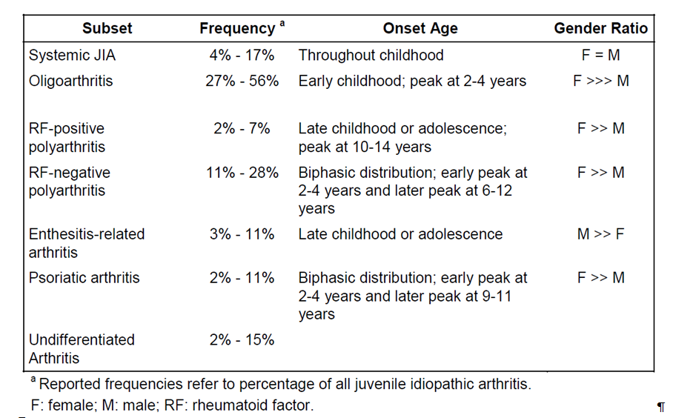

Oligoarthritis accounts for up to half of all cases of JIA. It mainly affects preschool Caucasian girls with a gender ratio of 5:1. The knee is the most frequently affected joint, followed by the ankle and wrist. The hip joint is rarely affected. One third of children with oligoarthritis, whose disease during the first six months affects less than four joints, continue to develop arthritis in further joints thereafter, hence the nomenclature, “extended”. Many of these children (20%) may develop chronic anterior uveitis, which typically is asymptomatic and insidiously progressive without specific treatment and monitoring. These patients have a different immunogenetic background to those with persistent oligoarthritis and carry a prognosis similar to those with polyarthritis.

RF-negative polyarthritis accounts for approximately one-quarter of all cases of JIA and usually affects preschool girls with a predominately symmetrical arthritis of the upper and lower limbs. Chronic anterior uveitis and growth disturbance are important but rare potential complications. RF-positive polyarthritis is a condition similar in features and prognosis to adult Rheumatoid Arthritis (RA). It primarily affects girls and usually presents in late childhood or adolescence. Although it only affects about 5% of all patients with JIA it can be rapidly progressive and destructive.

Interleukin (IL)-6 is a pro-inflammatory cytokine, which is present in patients with JIA in significantly elevated serum and synovial concentrations. It affects a variety of pathophysiological processes including activation of T-cells, induction of acute phase proteins, and stimulation of haemopoietic precursor cell growth and differentiation. Tocilizumab (TCZ) is a recombinant humanised monoclonal Immunoglobulin G (IgG) antibody directed against the soluble and membrane-bound IL-6 receptor. Current approved treatment options in Australia for moderately to severely active pJIA include non-steroidal anti-inflammatories (NSAIDs), corticosteroids (CS), non-biological Disease Modifying Anti-Rheumatic Drug (DMARDs) mainly Disease Modifying Anti-Rheumatic Drug , methotrexate (MTX) and anti- Tissue Necrosis Factor (TNF) therapy. However, a proportion of patients fail to respond to these treatment options and as such there is an unmet need for additional therapies for active, treatment refractory pJIA.

## Contents of the clinical dossier

### Scope of the clinical dossier

The submission contained the following clinical information:

* Three clinical pharmacology sub-studies, which provided pharmacokinetic (PK) and pharmacodynamic (PD) data collected from 188 subjects with pJIA treated with TCZ in Study WA19977, as well as 19 Japanese subjects treated with TCZ in Studies MRA318JP and MRA319JP.
* Two independent population PK (PopPK) analyses of the data obtained in Studies WA19977 and MRA318JP.
* One pivotal efficacy/safety Study WA19977, also known as the Cherish Study.
* No specific dose-finding studies.
* One supporting open-label trial of 12 weeks duration (MRA318JP) providing efficacy/safety data, which had a long-term extension phase (Study MRA319JP).
* One observational cohort study of six months duration in Japanese patients, ML21939, also known as Japanese Post-Marketing Surveillance (JPMS) which provided supporting safety data.

### Paediatric data

The submission included paediatric pharmacology, efficacy and safety data as the requested extension of indication is for patients aged 2 years or older.

### Good clinical practice

The two main studies (Cherish, and Studies MRA318JP/MRA319JP ) evaluating the use of TCZ in children and adolescents with active pJIA were conducted in accordance with the principles of Good Clinical Practice (GCP) and compliance with ethical requirements was met.

## Pharmacokinetics

### Studies providing pharmacokinetic data

PK data for this submission was provided by the single pivotal Cherish Study in which 188 subjects with severely active pJIA were treated with TCZ, with additional PK data provided by the supportive Studies MRA318JP and MRA319JP involving 19 Japanese subjects. The submission also contained two independent PopPK analyses including data obtained from Studies WA19977 and MRA318JP.

### Summary of pharmacokinetics

The information in the following summary is derived from conventional PK studies in humans.

#### Pharmacokinetics in the target population

##### Study WA19977

PK data was presented separately for Part I (initial 16 weeks of treatment) and Part II (up to Week 40) of the Cherish Study. Blood samples in Part I were collected for TCZ serum concentrations pre-dose and post-dose (that is, within 15 minutes following a saline flush marking the end of infusion) on Day 1, at Weeks 4, 8 and 12 infusion visits, at any time during Weeks 1, 2, 6 and 10, and pre-dose at Week 16. In Part II of the study, pre-dose blood samples for TCZ serum concentrations were collected at Weeks 20, 24, 28, 32, 36 and 40 infusion visits, and additional samples were also obtained at any time between Weeks 18 and 22. A total of 2693 TCZ serum concentrations were collected from 188 subjects with pJIA. The PopPK dataset for Study WA19977 consisted of 2631 TCZ serum concentrations as 62 (2.3%) of those samples were excluded because of inconsistent serum concentrations.

A PopPK model which used data from patients who received all four TCZ infusions in Part I, and for all subjects who received all six scheduled TCZ infusions in Part II was constructed. Non-linear effects modelling using NONMEM software (Version 7.1.0) analysed the serum TCZ concentration over time data collected in Study WA19977. The serum concentration-time course for TCZ in patients with active pJIA was best described by a two-compartment disposition PK model with parallel first-order and Michealis-Menten elimination kinetics. The influence of covariates such as age, gender, race, Body Surface Area (BSA), body weight (BW), height and creatinine clearance on the PK parameters was investigated.

The PopPK parameters were precisely estimated, with clearance (CL) being 5.8 mL/hr, a central volume of distribution (Vd) of 1.98 L, a peripheral Vd of 2.10 L, and a maximum elimination rate of 6.58 mg/day. Moderate inter-patient variability was seen for CL (CV=29%), peripheral Vd (CV=29%) and the maximum elimination rate (CV=32%). BSA was the most significant covariate explaining the variability in CL, leading to a deviation of -52% to +46% from the typical value for the lowest and highest observed BSA. BSA also correlated with variability in the peripheral Vd, leading to a deviation of -60% to +59% in the observed values. Height was identified to be significantly correlated with variability in the central Vd of TCZ, leading to a deviation of -69% to +67% from the typical value for the lowest and highest observed height. Age, gender, race and creatinine clearance were not identified to have any influence on the PK of TCZ.

The time to steady state was relatively short for both area under the curve (AUC) and maximum serum TCZ concentration (Cmax) with 90% of steady state drug levels being reached after the first and second TCZ infusion (for all three dose groups). Due to non-linear CL, the time to reach 90% of steady state TCZ concentrations for minimum serum TCZ concentration (Cmin)as longer: 12 weeks for the 8 mg/kg dose in the patients with BW >30 kg and 10 mg/kg for those with BW <30 kg; compared to 16 weeks for subjects with BW <30 kg who received TCZ 8 mg/kg.

The PopPK analysis computed the following PK exposure parameters:

* AUC serum TCZ concentration-time during the four week dosing interval between Weeks 12-16 in Part I, and from Weeks 36-40 in Part II;
* Cmax post-infusion at Week 12 in Part I, and Week 36 in Part II; and
* Cmin at Week 16 in Part I, and at Week 40 in Part II.

From the observed sparse PK sampling in Study WA19977, the following PK parameters were directly obtained:

* Pre-dose serum TCZ concentration at Week 16 (Cwk16); and
* Within-subject average pre-dose serum TCZ concentration from Week 20-40 in Part II (Ctrough).

###### Part I

The demographic characteristics of the population included in the PK analysis of Part I is summarised in Table 2. Expectedly, the majority of patients were female (78%) and Caucasian in ethnicity (79%). For patients with a BW <30 kg, the mean age and BW was comparable between the TCZ 8 and 10 mg/kg groups.

Table 2: Baseline Demographic Data for Pharmacokinetic Population in Part I of Study WA19977

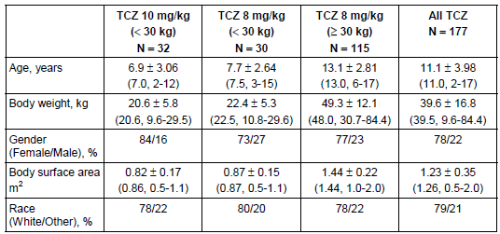

Table 3 displays the key PK parameters for TCZ in Part I of Study WA19977. The mean PK parameters of interest were modestly higher for some variables in the >30 kg group who received TCZ 8 mg/kg compared to the <30 kg arm given TCZ 10 mg/kg (for example, mean AUCwk12-16 was 1231 μg.day/mL versus 968 μg.day/mL), but Cmax results were similar (182 versus 175 μg/mL) between the two groups. In contrast, the PK exposure parameters comparing the two different doses of TCZ (8 and 10 mg/kg) in the group with a BW <30 kg showed significantly less comparable exposure for the subjects who received 8 mg/kg: mean AUCwk12-16 was 702 μg.day/mL versus 968 μg.day/mL for 10 mg/kg; Cmax 140 μg/mL versus 175 μg/mL for TCZ 10 mg/kg; and for Cmin 0.95 μg/mL versus 2.35 μg/mL for TCZ 10 mg/kg.

Table 3: Summary of Key Tocilizumab PK Parameters in Part I of Study WA19977

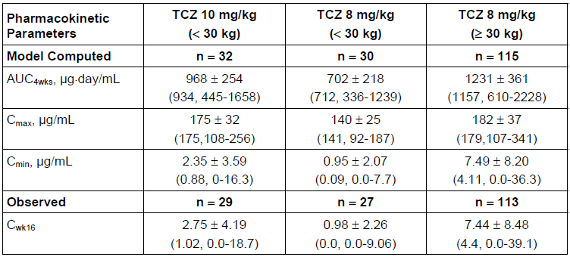

Table 4supports the hypothesis that overall PK exposure for those with a BW <30 kg most resembles that of patients weighing at least 30 kg (receiving TCZ 8 mg/kg) when these low BW subjects are given TCZ 10 mg/kg. When patients with a BW <30 kg were compared to those weighing at least 30 kg, the geometric mean ratios for AUC at 4 weeks, Cmax and Cwk16 were higher in the group given TCZ 10 mg/kg (0.79, 0.97 and 0.40, respectively for AUC, Cmax and Cmin) compared to those who received 8 mg/kg (0.57, 0.77 and 0.22, respectively for AUC, Cmax and Cmin). As such, the PK analysis supports the use of a higher TCZ dose (10 mg/kg) in those subjects weighing <30 kg.

Table 4: Geometric Mean Ratios for Tocilizumab PK Parameters in Part I of Study WA19977

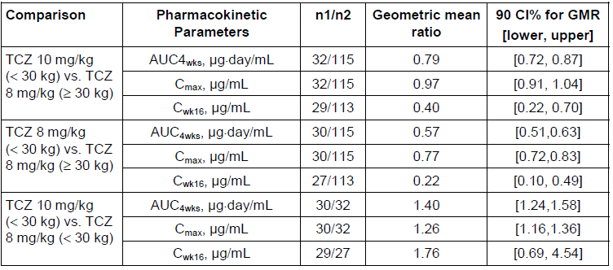



Study WA19977 also assessed the relationships between PK exposure, and efficacy and safety. Table 5 provides a summary of PK exposure by JIA American College of Rheumatology (ACR) response status[1] at Week 16. Clinical non-responders were seen to have a lower exposure to TCZ (as determined by model derived AUC at 4 weeks, and Cmax) compared to responders, and this observation is particularly seen at the lower definition of clinical response (that is, JIA ACR30 and JIA ACR50 response). Comparing the mean PK exposures across non-responders for all JIA ACR categories (JIA ACR30/50/70/90), there was a trend towards lower drug exposure in those showing the least response (JIA ACR30 response). In contrast, when comparing the key PK variables across the responders, there was no trend towards a higher drug exposure. Hence, for responding patients, factors other than PK parameters explain the variability in the degree of response.

Table 5: Summary of Tocilizumab PK Exposure Parameters by ACR Response Status in Part I

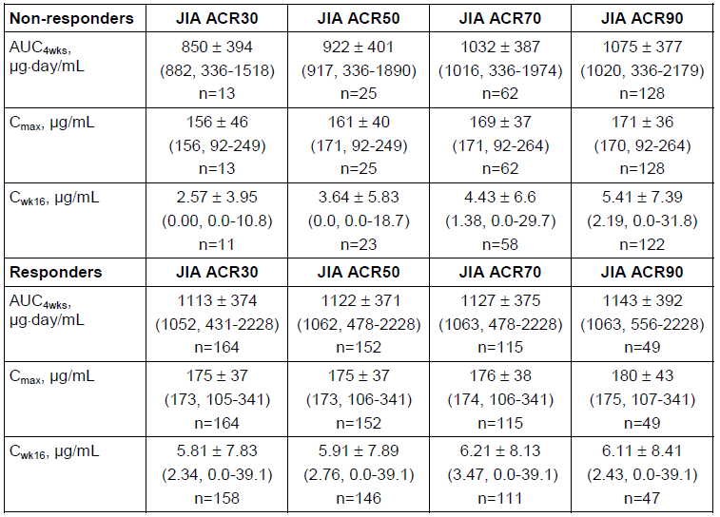

The rate of Adverse Events (AEs) per 100 patient-years up to Week 16 was calculated by AUC at 4 weeks, Cmax and Cwk16 exposure quartiles. There was no trend across the quartiles relating drug exposure to the incidence of overall AEs, and the two most common system types of AEs (infections, and gastrointestinal disorders).

###### Part II

The baseline demographic features of patients randomized to TCZ in Part II of the trial are summarised in Table 6, and are similar to the characteristics seen in the Part I PK population. A total of 166 patients (82 in the TCZ group and 84 in the control arm) were randomised and dosed with study medication in Part II of the study. Most (89%; 73/82) of the TCZ treated subjects were included in the PK data analysis for Part II of the trial.

Table 6: Baseline Demographic Data for Pharmacokinetic Population in Part II of Study WA19977

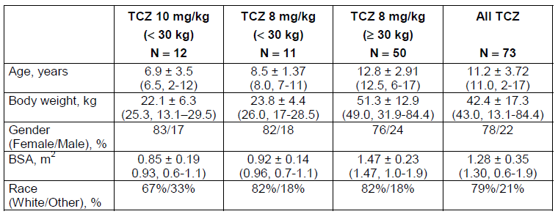

In Part II, blood samples for TCZ concentration were not taken at the end of infusion. Pre-dose serum TCZ concentrations from Week 20-40 were averaged for each subject to determine the within-subject mean Ctrough as 1 of the key PK variables from Part II of the study. Mean computed PK exposures (AUCwk36-40, Cmax and Cmin), and the observed within-subject mean Ctrough are summarised in Table 7. Again, the mean PK parameters of interest were modestly higher for some variables in the >30 kg group who received TCZ 8 mg/kg compared to the <30 kg arm given TCZ 10 mg/kg (for example, mean AUCwk36-40 was 1417 μg.day/mL versus 1204 μg.day/mL), but Cmax results were nearly identical (198 versus 201 μg/mL) between the two groups. In contrast, the PK exposure parameters comparing the 2 different doses of TCZ (8 and 10 mg/kg) in the group with a BW <30 kg showed significantly less comparable exposure for the subjects who received 8 mg/kg: mean AUCwk36-40 was 853 μg.day/mL versus 1204 μg.day/mL for 10 mg/kg; Cmax 155 μg/mL versus 201 μg/mL for TCZ 10 mg/kg; and for Cmin 3.14 μg/mL versus 5.34 μg/mL for TCZ 10 mg/kg; and for Ctrough 2.03 μg/mL versus 4.12 μg/mL for TCZ 10 mg/kg.

Table 7: Summary of Key Tocilizumab PK Parameters in Part II of Study WA19977

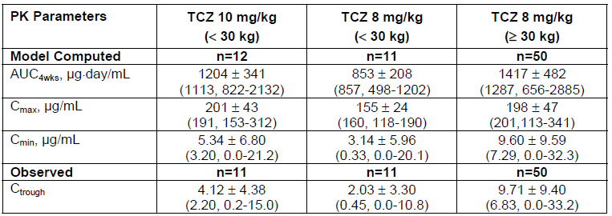

When patients with a BW <30 kg were compared to those weighing at least 30 kg, the geometric mean ratios for AUC at 36-40 weeks, Cmax and Ctrough were higher in the group given TCZ 10 mg/kg (0.87, 1.03 and 0.50, respectively for AUC, Cmax and Ctrough) compared to those who received 8 mg/kg (0.62, 0.79 and 0.26, respectively for AUC, Cmax and Ctrough). As such, PK exposure for patients weighing <30 kg was most similar to the >30 kg cohort (TCZ 8 mg/kg) in those subjects who received TCZ 10 mg/kg versus 8 mg/kg.

Up to Week 40, the rate of AEs per 100 patient-years was calculated by PK exposure (AUCwk36-40, Cmax and Ctrough) quartiles. Patients in Quartile 1 had the lowest incidence of overall AEs, and the two most common system types of AEs (infections, and gastrointestinal disorders) – refer to Table 8. However, there was no difference across Quartiles 2-4 with respect to the incidence of overall AEs, and the two most common system types of AEs (infections, and gastrointestinal disorders).

Table 8: Rate of Adverse Events per 100 Patient-Years by Preferred System Organ Class compared with Pharmacokinetic Exposure Quartiles to Week 40 in Study WA19977

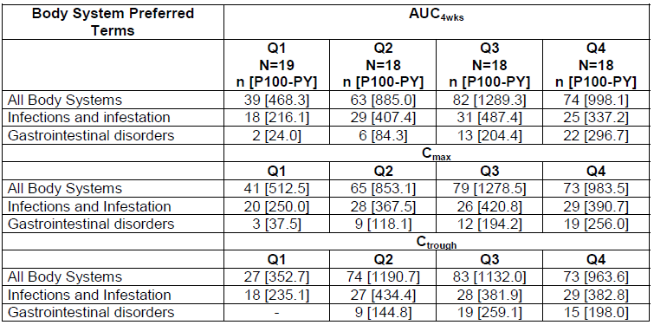

##### Studies MRA318JP and MRA 319JP

Study MRA318JP was an open-label, single arm, Phase III study involving 19 Japanese patients aged 3-19 years with active pJIA who were given at total of three infusions (over one hour) of TCZ 8 mg/kg every 4 weeks. Final observations for Study MRA318JP were made four weeks after last dose of TCZ (that is, at Week 12 of therapy) and all 19 recruited subjects contributed data to the overall PK analysis. Blood samples for PK analysis were taken immediately prior to and one hour after completion of each infusion (Weeks 0, 4 and 8). Additional PK samples were collected at Weeks 1, 2, 6, 10, 11 and 12.

The mean Ctrough value for TCZ was 3.83 +/- 3.47 μg/mL in Week 4 of treatment, 5.71 +/- 5.71 μg/mL in week 8, and 4.88 +/- 4.68 μg/mL in Week 12 of therapy. The serum TCZ concentration was at or below the LLQ of 1.0 μg/mL in all 19 subjects at Weeks 1 and 2 of follow-up, in 61.1% (11/18) in Week 4, 94.4% (17/18) in Week 6, 64.7% (11/17) in Week 8, 94.1% (16/17) in Week 10, 82.4% (14/17) in Week 11, and 61.1% (11/18) in Week 12. The serum TCZ concentration was at or below the LLQ throughout the entire 12 week study period in nine subjects. This was not associated with a lack of clinical efficacy (e.g. joints with active arthritis). Table 9 provides a summary of the key PK parameters for TCZ at the end of the first and third infusions. The T1/2 values for the first (123 +/- 41.5 hours) and third infusions (130 +/- 50.6 hours) of TCZ were comparable.

Table 9: Key PK Parameters Following First and Third TCZ Infusions in Study MRA318JP

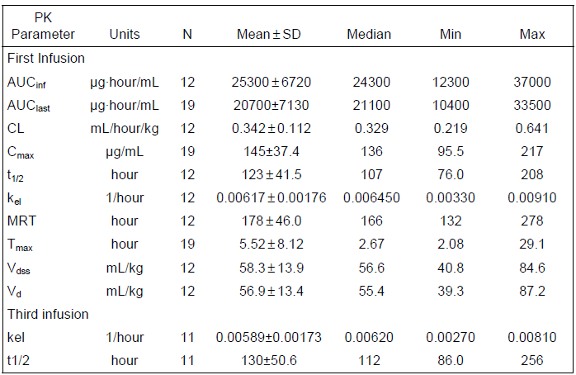

A PopPK approach was performed on the data from Study MRA318JP to examine the relationship between PK (simulated TCZ AUC versus BW) and clinical efficacy (expressed as the probability of obtaining either a JIA ACR50 or 70 response). After 12 weeks of TZC 8 mg/kg q4w, 88% (7/8) of patients weighing <30 kg versus 100% (11/11) of subjects weighing at least 30 kg reached a JIA ACR50 response; and 38% (3/8) of patients weighing <30 kg versus 82% (9/11) of subjects weighing at least 30 kg reached a JIA ACR70 response. Using modelled data, the difference in JIA ACR response was associated with a trend towards lower systemic TCZ exposure in patients with BW <30 kg – see Figure 1. In contrast, for subjects with BW >30 kg, drug exposure appeared to be independent of BW.

Figure 1: Modelled TCZ Exposure (8 mg/kg or 10 mg/kg) versus Body Weight in Study MRA318JP

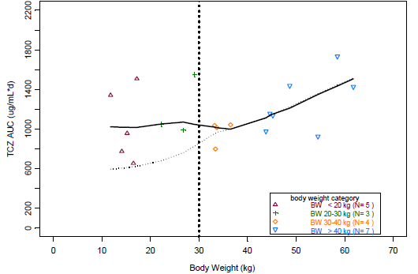

The full black line in Figure 1 represents a smoothed spline through the data, and the dotted line is a smoothed spline indicating the reference trend in the data without any change from TCZ 8 mg/kg in patients with BW <30 kg.

The same study population involved in Study MRA318JP were further evaluated in an open-label extension (OLE) phase of treatment (Study MRA319JP). The median duration of reported follow-up in the OLE was 3.22 years (range: 0.35-3.53 years). In Study MRA319JP, blood samples for PK evaluation were collected prior to every third infusion (that is, first, fourth, seventh, and so on), and at the last observation day visit. The OLE trial explored the relationship between serum trough TCZ concentration and clinical efficacy indices (e.g. active joint count) and found no clear relationship in the extended treatment phase.

### Comparison of PK data between polyarticular and systemic JIA, and adult patients with RA

The sponsor also provided a comparison for the PK parameters of AUC, Cmax and Cmin in patients with pJIA to those with systemic JIA (sJIA) (using data from the pivotal Phase III Study WA18221) and adult subjects with RA (data from four Phase III studies – Studies WA17822, WA17824, WA18062 and WA18063) – Table 10. For pJIA patients involved in Study WA19977, TCZ 8 mg/kg q4w in subjects with a BW of at least 30 kg, and the 10 mg/kg q4w dose in patients with a BW of <30 kg resulted in similar TCZ PK exposure parameters to those observed in adult patients with active RA dose with TCZ 8 mg/kg q4w. Children with systemic JIA appear to require a higher dose of TCZ given more frequently (8 or 12 mg/kg q2w) which reflects the increased systemic activity of their illness.

Table 10: Comparison of Key PK Parameters in patients with pJIA, sJIA and Adult RA Patients

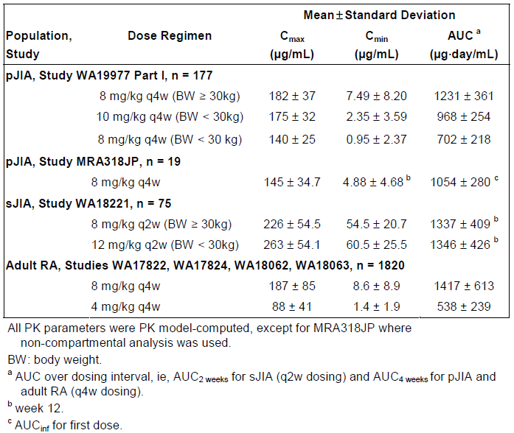

### Evaluator’s overall conclusions on pharmacokinetics

In this submission, the PK properties of TCZ when used in patients aged 2-19 years with active pJIA was assessed from data collected in a single pivotal trial (Study WA19977) involving 188 patients who received intravenous (IV) TCZ (8 or 10 mg/kg) every four weeks for up to 40 weeks, as well as 19 Japanese subjects involved in the MRA318JP/319JP Studies who were given IV TCZ 8 mg/kg every 4 weeks for up to 168 weeks. The majority of patients involved in Study WA19977 were female (78%), with Caucasian ethnicity (79%) and had a median age of 11 years. The 19 Japanese subjects in the MRA318JP/319JP studies were also predominately female (79%; 15/19) with a median age of 12 years.

The key PK findings of the TCZ clinical trial program in patients with active pJIA were:

* TCZ demonstrates moderate between patient variability for clearance, peripheral volume of distribution and the maximum elimination rate;
* Differences in subject BSA principally explains the variability in drug clearance;
* Study WA19977 (Parts I and II) showed that the model computed (for example, AUC and Cmax), as well as observed PK parameters (that is, Ctrough) for the TCZ 10 mg/kg dose in subjects with a BW <30 kg was most comparable to the drug exposure demonstrated in the patients weighing >30 kg who received TCZ 8 mg/kg;
* Part I (first 16 weeks) of Study WA19977 showed that clinical non-response was associated with a lower exposure to TCZ (as evidenced by AUC and Cmax results);
* However, clinical response in Part I of Study WA19977 was not associated with a higher drug exposure;
* Patients with the lowest quartile of drug exposure to TCZ in Part II of Study WA19977 had the lowest incidence of overall AEs, and also the two most common types of AEs (infections and gastrointestinal disorders);
* Study MRA318JP shows that the mean elimination half-life of TCZ at steady state for patients with active pJIA is approximately 123-130 hours;
* Modelled data from Study MRA318JP suggests that if patients weighing <30 kg receive TCZ 8 mg/kg they have a lower drug exposure compared to subjects >30 kg who receive TCZ 8 mg/kg, and that this finding may be associated with a lower rate of clinical response;
* Comparison of the PK data between subjects with pJIA, sJIA and adult RA indicates that patients with BW <30 kg suffering from active pJIA require a dose of TCZ 10 mg/kg (versus 8 mg/kg) every four weeks to achieve a comparable drug exposure to the other TCZ arthritis treatment indications.

## Pharmacodynamics

### Studies providing pharmacodynamic data

Pharmacodynamic (PD) data for this submission was provided by the single pivotal Cherish Study with 188 subjects with severely active pJIA treated with TCZ, with additional PD data provided by the supportive studies MRA318JP and MRA319JP involving 19 Japanese subjects.

### Summary of pharmacodynamics

The information in the following summary is derived from conventional PD studies in humans.

#### Mechanism of action

TCZ binds competitively and specifically to both soluble and membrane-bound IL-6 receptors, and has been shown to inhibit their signalling. The actions of IL-6 are diverse and include induction of immunoglobulin secretion, T-lymphocyte activation, induction of hepatic acute phase proteins, and stimulation of haematopoiesis.

IL-6 has a unique receptor system, and while IL-6 receptor specifically binds to IL-6, it does not have a direct role in signal transduction. IL-6 forms a complex by binding with membrane-bound IL-6 receptor, which then combines with gp130 on the cell membrane to form a homodimer that gives rise to intracellular signal transduction. The soluble form of IL-6 receptor (sIL-6R) can also combine with gp130 on the cell membrane to enable signalling. In summary, TCZ is effective in blocking the induction of intracellular signal transduction through interrupting the biological activity of gp130 via membrane-bound and soluble IL-6 receptors.

#### Pharmacodynamic effects

##### Primary pharmacodynamic effects

###### Study WA19977

In Part I of Study WA19977 serum samples for PD analysis were collected pre- and post-dose (within 15 minutes following saline flush marking end of infusion) on Day 1; at the Weeks 4, 8 and 12 infusion visits; at any time during Weeks 1, 2, 6 and 10; and pre-dose at Week 16. In Part II of the trial, pre-dose blood samples for PD analysis were collected at Weeks 20, 24, 28, 32, 36 and 40 infusion visits, and additional samples were also obtained at any time between Weeks 18 and 22.

The appropriate primary PD markers were evaluated: IL-6 and sIL-6R. C-Reactive Protein (CRP) activates the production of sIL-6R. Serum samples for both biomarkers were analysed by validated enzyme-linked immune-sorbent assay (ELISA) methods (Xendo Drug Development B.V., Netherlands). For soluble interleukin-6 Receptor (sIL-6R), the LLQ was 12.5 ng/mL. The assay precision (CV%) ranged from 7.3% to 9.2%, and the overall accuracy was between 102.2% and 104.6%. For IL-6, the LLQ was 3.12 pg/mL (low sensitivity assay) and 0.156 pg/mL (high sensitivity assay). The assay precision (Coefficient of Variation (CV%)) ranged from 8.0% to 10.0% for the low sensitivity assay, and 3.0% to 11.9% for the high sensitivity assay. Overall accuracy was between 101.2% and 101.9% for the low sensitivity assay, and between 95.4% and 105.2% for the high sensitivity assay.

Part I

Mean IL-6 concentrations increased rapidly in the first week following TCZ infusion, and then declined to their baseline value by Week 4, then fluctuating up to three-fold above baseline between administered doses, but in general remaining low between Weeks 4 and 16 – refer to Figure 2. Apart from the Week 10 mean value for IL-6 in the lower dose (8 mg/kg) subgroup of children <30 kg, all of the three TCZ treatment groups displayed similar mean values for IL-6 up to Week 16.

Figure 2: Mean Serum Interleukin-6 by visit to Week 16 in Part I of Study WA19977

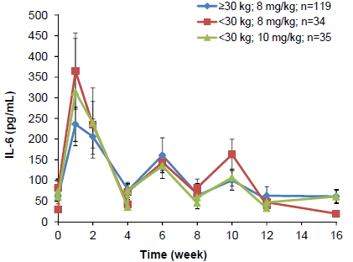

Following administration of TCZ, mean sIL-6R concentrations increased rapidly by Week 1 in all three TCZ dose groups. Mean sIL-6R levels fluctuated with up to a two-fold difference between infusions, but in general were lower for the TCZ 8 mg/kg dose in subjects with BW <30 kg, particularly at Weeks 12 and 16 – refer to Figure 3.

Figure 3: Mean Serum sIL-6R value by visit to Week 16 in Part I of Study WA19977

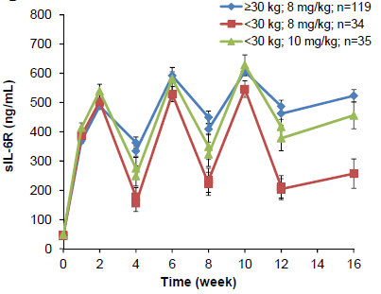

###### Part II

Patients who continued to receive TCZ (any dose – 8 or 10 mg/kg for those with BW <30 kg; and 8 mg/kg for subjects with BW of at least 30 kg) in Part II of Study WA19977 continued to have persistently low mean serum IL-6 concentrations (<50 pg/mL) at every four-week evaluation time point up to Week 40. Mean sIL-6R concentrations remained constant between Weeks 16 and 40 for patients who received TCZ 10 mg/kg if BW <30 kg and TCZ 8 mg/kg if BW at least 30 kg. However, in the small subgroup of patients (n=11) with a BW <30 kg who received TCZ 8 mg/kg, the mean sIL-6R concentrations were up to half the value of the other two TCZ dose groups from Weeks 12 to 40 – refer to Figure 4.

Figure 4: Mean Serum sIL-6R value by visit to Week 40 in Study WA19977

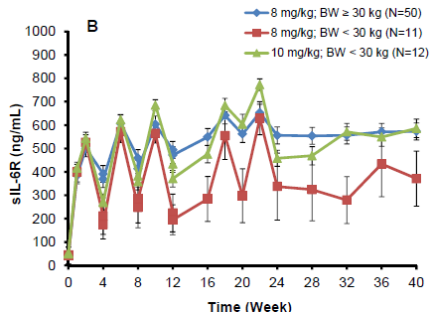

###### Studies MRA318JP and 319JP

Mean serum IL-6 concentrations (38 pg/mL at baseline) did not show any significant change over time in Study MRA318JP and MRA319JP. The mean serum sIL-6R value at baseline in Study MRA318JP was 20 ng/mL and this level increased to 200 ng/mL at Week 4 of treatment and remained constant (200-300 ng/mL) thereafter at all evaluable time points up to Week 168 in Study MRA319JP.

##### Secondary pharmacodynamic effects

There is a significant inter-relationship between IL-6 and CRP. IL-6 is the main cytokine involved in the induction of the acute phase response, which includes the hepatic synthesis of CRP. In the TCZ JIA studies, CRP and another disease associated serum inflammatory marker, Erythrocyte Sedimentation Ratio (ESR) were assessed.

###### Study WA19977

High-sensitivity CRP was measured at a central laboratory in Study WA19977, and ESR was performed at the local laboratories using a standardised kit. Both of these markers were assessed at baseline, and every 2-4 weeks up until Week 40 of the trial.

Part I

At baseline in Study WA19977, the mean (and median) CRP concentration was 23.7 (6.74) mg/L in the all exposure population. As seen in Table 11, the mean and median baseline CRP values were significantly higher in the group of children with a BW <30 kg who received TCZ 8 mg/kg compared to the two other TCZ dose groups. After 16 weeks of TCZ therapy, all three groups achieved a significant mean (and median) reduction in CRP, with no significant differences between the three subgroups being observed.

The same data was also considered in a subgroup analysis of those subjects with an elevated CRP reading at baseline. In total, 41.5% patients (78/188) had an elevated CRP value (>10 mg/L) at baseline in Study WA19977. For the majority of these patients (97.4%; 76/78), CRP normalised by two weeks after receiving their first dose of TCZ. The proportion of patients who had an elevated CRP at baseline, who then reached a normal value at the end of Part I (Week 16), was higher in the subjects with a BW >30 kg (87.0%; 40/46) compared to those with a BW <30 kg (76.9% [10/13] for TCZ 10 mg/kg and 63.2% [12/19] for TCZ 8 mg/kg).

Table 11: Mean CRP (mg/L) by visit to Week 16 in Part I of Study WA19977

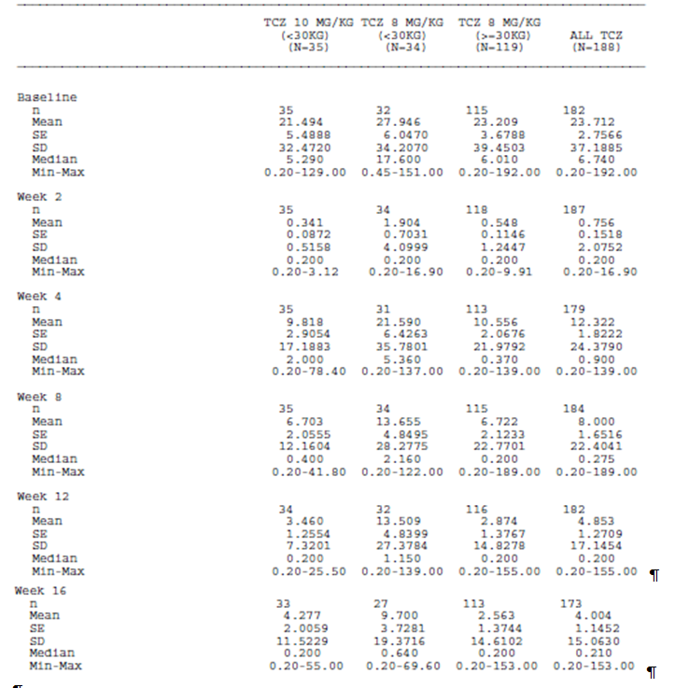At baseline in Study WA19977, the mean ESR was 34.8 mm/hr in the all exposure population. The mean baseline ESR was similar in all three TCZ dose groups (refer to Table 13). After 16 weeks of TCZ therapy, all three groups achieved a significant mean reduction in ESR with no significant differences between the three subgroups being observed: mean of 5.8 mm/hr in children with BW of at least 30 kg, and for those with BW <30 kg the mean ESR was 9.3 mm/hr in TCZ 10 mg/kg, and 11.4 mm/hr in the TCZ 8 mg/kg. In total, 64.9% patients (122/188) had an elevated ESR (>18 mm/hr) at baseline in Study WA19977. For most of these patients (74.6% or 91/122), ESR normalised two weeks after receiving their first dose of TCZ. The proportion of patients who had an elevated ESR at baseline, who then reached a normal value at the end of Part I (Week 16), was lower in the subjects with a BW <30 kg who received TCZ 8 mg/kg (57.7%; 15/26) compared to those with a BW <30 kg who received TCZ 10 mg/kg (82.6% [19/23] and subjects weighing at less 30 kg (87.7%; 64/73).

Part II

From Week 16 to 40, patients randomised to TCZ in Part II of the study maintained the mean reduction in ESR seen at Week 16 through to Week 40. In contrast, subjects randomised to placebo in Part II were observed to have a significant increase in their mean ESR soon after ceasing TCZ – refer to Figure 5. The same observation was seen with mean changes in CRP between Weeks 16 and 40.

Figure 5: Line Plot of Mean ESR (mm/hr) by Visit to Week 40 in Study WA19977

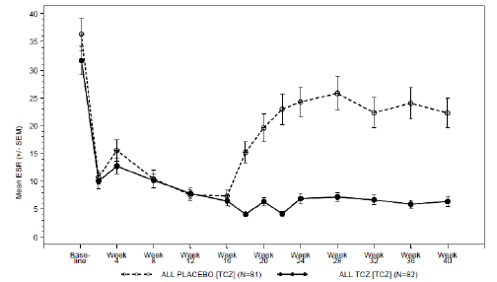

###### Studies MRA318JP and 319JP

The mean (+/- SD) CRP at baseline for the 19 subjects in Study MRA318JP was 2.63 (+/- 1.99) mg/dL. It was assessed fortnightly and the mean CRP value decreased to <0.5 mg/dL after the first and second subsequent infusions, but rose slightly to approximately 1.0 mg/dL prior to each of the two subsequent infusions (at Weeks 4 and 8). On the last observation day (Week 12), the mean (+/- SD) CRP reading was 0.64 +/- 1.5 mg/dL. In the long-term extension phase (Study MRA319JP), the mean CRP was <1.0 mg/dL in each evaluable subject at each assessment up until Week 168.

The mean (+/- SD) ESR at baseline in Study MRA318JP was 43.6 (+/- 4.6) mm/hr. It was assessed every four weeks and ESR decreased significantly by Week 2 and remained low thereafter. On the last observation day (Week 12) in Study MRA318JP, the mean (+/- SD) ESR was 15.1 +/- 4.2 mm/hr. In the long-term extension phase (Study MRA319JP), the mean ESR was below the lower limit of normal (18 mm/hr) in each evaluable subject at each assessment up until Week 168.

#### Time course of pharmacodynamic effects

The primary and secondary PD effects are seen within two weeks of administration of TCZ by IV infusion with persistence of those effects over the proposed dosing cycle of every four weeks.

#### Relationship between drug concentration and pharmacodynamic effects

The MRA318JP and 319JP Studies correlated CRP and ESR results to serum TCZ concentrations every two-four weeks in the subjects who continued to receive TCZ 8 mg/kg every four weeks up until Week 168. Scatter plotter diagrams indicate that when CRP (<1.0 mg/dL) and ESR (<18 mm/hr) were normal, serum TCZ concentrations were maintained above 1.0 μg/mL throughout the TCZ dosing cycle. In addition, the sIL-6R concentration reached plateau when the serum TCZ concentration was approximately 10 μg/mL.

### Evaluator’s overall conclusions on pharmacodynamics

In this submission, the PD properties of TCZ when used in patients aged 2-19 years with active pJIA was assessed from data collected in a single pivotal trial (Study WA19977) involving 188 patients who received IV TCZ (8 or 10 mg/kg) every four weeks for up to 40 weeks, as well as 19 Japanese subjects involved in the MRA318JP/319JP studies who were given IV TCZ 8 mg/kg every four weeks for up to 168 weeks. The majority of patients involved in Study WA19977 were female (78%), with Caucasian ethnicity (79%) and had a median age of 11 years. The 19 Japanese subjects in the MRA318JP/319JP studies were also predominately female (79%; 15/19) with a median age of 12 years.

The sponsor has appropriately nominated mean changes in serum IL-6R and sIL-6 R levels as the primary PD markers of interest for TCZ. Mean serum changes in serum inflammatory markers (ESR and CRP) were evaluated as the secondary PD biomarkers of relevance.

Expectedly for the mechanism of action of TCZ, the pivotal and supporting studies demonstrated a decrease in serum inflammatory markers (CRP and ESR) within two to four weeks of first administration. Similarly, the mean values for sIL-6R increased rapidly (one to four weeks) following TCZ infusion and remained constant thereafter for extended periods of follow-up (at least 40 weeks). In the pivotal study (WA19977), the small subgroup of patients with a BW <30 kg who received TCZ 8 mg/kg (n=11), recorded mean sIL-6R concentrations from Weeks 12 to 40 that were approximately half the value of the other two TCZ dose groups. This suggests that the higher dose of TCZ (10 mg/kg) may be required in patients with BW <30 kg to achieve the optimal PD response equating to dosing with TCZ 8 mg/kg in patients with BW >30 kg. Mean serum IL-6 concentrations increased rapidly in the first week following TCZ infusion in Study WA19977, and then declined to its baseline value by Week 4, then fluctuated up to three-fold above baseline between administered doses, but in general remaining low between Weeks 4 and 16. No consistent difference in the mean value for serum IL-6 was seen in any of the three TCZ treatment groups. Mean serum IL-6 concentrations did not show any significant change over time in the supporting MRA studies.

The MRA318JP and 319JP studies showed that CRP (<1.0 mg/dL) and ESR (<18 mm/hr) were within the normal range when serum TCZ concentrations were maintained above 1.0 μg/mL (the LLQ) throughout the TCZ dosing cycle. Furthermore, serum sIL-6R concentrations reached a plateau when the serum TCZ concentration was around 10 μg/mL.

## Dosage selection for the pivotal studies

Although no specific dose-finding studies have been performed for patients with active pJIA, the dose and administration frequency of TCZ used in the pivotal Study WA19977, and proposed by the sponsor for licensing, has been reasonably justified by the sponsor. The sponsor is proposing that TCZ be administered every four weeks by IV infusion at a dose of 8 mg/kg for those with a body weight of 30 kg or more, and a dose of 10 mg/kg in children with a BW of <30 kg. In the pivotal trial (Study WA19977) patients weighing <30 kg were randomised 1:1 to either TCZ 8 or 10 mg/kg. The rationale for assessing the higher TCZ dose in children of lower BW is based on PK/PD modelling data obtained in Study MRA318JP. The simulation results suggest that TCZ 10 mg/kg q4w in patients with BW <30 kg should be able to achieve a comparable drug exposure to that observed in patients weighing >30 kg who are administered TCZ 8 mg/kg – refer to Figure 1.

The approved TCZ dose in patients with sJIA is dependent on the patient’s body weight, using two weight bands with a cut-off value of 30 kg. In sJIA, TCZ is administered more frequently (every two weeks) and also at a higher dose (12 mg/kg for those with BW <30 kg; and 8 mg/kg for subjects weighing >30 kg). The adjustment of TCZ dosing using weight bands in sJIA has resulted in comparable PK exposure and efficacy outcomes across the range of BW. Children with sJIA have a higher clearance of TCZ (mean of 7.1 mL/hr) compared to those with pJIA (mean CL=5.8 mL/hr) which justifies the shorter dosing interval.

The doses of background treatment with MTX, CS and NSAID when used by patients in the pivotal Cherish study were appropriate, and consistent with contemporary clinical practice in Australia.

## Clinical efficacy

The sponsor proposes the additional indication: - “ACTEMRA is indicated for the treatment of active polyarticular juvenile idiopathic arthritis in patients 2 years of age or older. ACTEMRA can be given alone or in combination with methotrexate (MTX)”.

### Pivotal efficacy study

#### Study WA19977 (also known as the Cherish Study)

##### Study design, objectives, locations and dates

Study WA19977 is a Phase III, randomised, active treatment then withdrawal trial conducted in three parts to evaluate the efficacy of TCZ in patients with pJIA. The study was initiated in October 2009, with the second part completed by November 2011 (main efficacy analysis), with the final data collection for Part III expected to be completed in September 2012. The Part III data was provided at a later date during the submission. The study was conducted at 58 sites including Argentina (4), Australia (2), Belgium (2), Brazil (4), Canada (4), France (4), Germany (4), Italy (4), Mexico (4), Peru (3), Poland (5), Russian Federation (6), Spain (2), United Kingdom (3), and USA (7).

The main objective of the study was to evaluate the efficacy and safety of TCZ in patients with active pJIA with a history of an inadequate response to MTX (due to either lack of efficacy or toxicity), who were receiving the standard of care with or without NSAID, low dose CS, or concomitant MTX. The primary efficacy outcome was to compare the proportion of patients on TCZ versus placebo who developed a JIA ACR30 flare by Week 40 compared to Week 16. Secondary objectives included assessment of the efficacy of continued, open-label TCZ in terms of maintenance of clinical response (not presented in this submission), as well as the efficacy and safety of TCZ 8 mg/kg versus 10 mg/kg in patients weighing < 30 kg.

The overall study design is consistent with regulatory guidelines in the USA and European Union (EU). Study WA19977 was a two-year trial conducted in three phases. Part I consisted of a 16-week, active-treatment, lead-in period whereby all eligible patients were to receive TCZ. At Week 16, patients who achieved a treatment outcome of at least a JIA ACR30 response (compared to their baseline assessment), were eligible to enter the blinded withdrawal phase (Part II). Patients who completed Part I without obtaining a JIA ACR30 response at Week 16 were withdrawn from the trial.

Part II was a 24-week, double-blind withdrawal phase. Beginning at Week 16, patients were randomised 1:1 to receive either on-going TCZ infusions (at the same dose as given in Part I) or matching placebo infusions. Randomisation was stratified according to concurrent use of MTX and oral CS at baseline. Each subject continued in Part II of the study until Week 40, or until they met the criteria for a JIA ACR30 flare (relative to their Week 16 assessment). Patients who flared in Part II were eligible to receive escape treatment with TCZ at the same dose they received in Part I. Part III was a 64-week, open-label treatment phase whereby if a subject completed Part II of the trial (including those who received escape treatment) were eligible to receive on-going TCZ infusions. Part III of the study will conclude when the last patient completes their last scheduled visit of Part III, which was expected to be in September 2012. The Part III data was provided at a later date during the submission.

The design of Study WA19977 is similar to other pivotal trials examining the efficacy of biologic disease modifying anti-rheumatic drugs (DMARD) in patients with active JIA. The active treatment, then withdrawal study design reduces the risk to paediatric patients of prolonged, untreated active disease, while maintaining data integrity because of the randomisation process leading into Part II.

##### Inclusion and exclusion criteria

To be eligible for inclusion, patients had to be at least two years of age but less than 17 years at the time of enrolment, and meet the International League of Associations for Rheumatology (ILAR) criteria for the three subtypes of pJIA outlined previously (that is, RF positive or negative pJIA, or extended oligoarthritis for at least six months). The pJIA had to be clinically active at screening with at least five active joints (swollen and/or limited movement), including at least three active joints having limitation of motion (LOM) at baseline. Patients were required to have a history of either inadequate response to MTX, or it not being tolerated. MTX could be continued at a stable dose of 10-20 mg/m2 in those receiving it for at least 12 weeks prior to study entry. Continuing treatment with NSAID and low dose prednisone (no more than 10 mg/day or 0.2 mg/kg/day, whichever was less) was also permitted if the patient had received a stable dose for the two to four weeks prior to baseline. Prior biological DMARD therapy was allowed as long as the therapy had been ceased for at least five half-lives prior to enrolment. The number of patients with prior biologic DMARD exposure was not to exceed 30% of the total number of study participants. If appropriate, female patients were required to use contraception.

The exclusion criteria involved four domains and patients meeting any one of the criterion were excluded:

* General – wheelchair bound, bedridden, or having little or no ability to self-care; not recovered from recent surgery occurring at least six weeks ago; and lack of peripheral venous access or unwilling to undergo multiple venipunctures;
* Co-morbidities – active infection, history of recurrent infection including but not limited to renal, chest and skin/soft tissue infection (for example, recurrent pyelonephritis or bronchiectasis), primary or secondary immunodeficiency, history of reactivated or recent onset systemic infection with Epstein Barr virus or herpes zoster, asthma requiring the use of oral or parenteral CS for more than two weeks in the six months prior to baseline, active uveitis within 12 weeks of baseline, history of any gastrointestinal disorder such as ulceration or inflammatory bowel disease, congenital or valvular heart disease, evidence of latent or previously treated tuberculosis, and any history of malignancy;
* Baseline laboratory results – haemoglobin <9.0 g/dL, total WCC <5000/mm3, neutrophil count <2500/mm3, Platelet count <150,000/mm3, alanine aminotransferase (ALT) or aspartate aminotransferase (AST) > 1.5 upper limit of normal (ULN), total bilirubin >1.3 mg/dL, serum creatinine > 1.5 ULN for age and gender, and positive hepatitis B surface antigen or hepatitis C antibody;
* Past treatments – prior treatment with any conventional DMARD (other than MTX) including anti-malarials, azathioprine, gold, sulfasalazine or cyclosporine (CYC); use of CYC within the preceding 12 months; IV immunoglobulin within the last four weeks; treatment with leflunomide within the last three months; and live or attenuated vaccines within four weeks of randomisation.

##### Study treatments

Study treatments were given in three phases in the WA19977 trial. Part I was an active treatment lead-in period, whereby all patients received TCZ IV infusions every four weeks for a total of four doses. In Part I, patients weighing < 30 kg were randomised 1:1 to receive either 8 mg/kg or 10 mg/kg. For those with a BW ≥ 30 kg, TCZ was given at a dose of 8 mg/kg. No change in concurrent NSAID, CS or MTX dosing was permitted during Part I, except for documented safety reasons.

Part II was the double-blind, withdrawal phase of the trial. All subjects who successfully completed Part I (that is, they attained at least a JIA ACR30 response) were then randomised to receive either ongoing TCZ infusions (at the same dose they received in Part I) or matching placebo infusions. Each patient continued in Part II until Week 40 or until they satisfied the JIA ACR30 flare criteria (relative to Week 16), whereby they qualified for escape TCZ therapy (resuming therapy with the same TCZ dose as given in Part I). Patients who entered escape treatment in Part II could also receive intra-articular CS injections or a change in concomitant medications (for example, oral prednisone could be increased up to a maximum of 10 mg/day or 0.2 mg/kg/day, whichever was less). Otherwise, no change in concurrent NSAID, CS or MTX dosing was permitted during Part II, except for documented safety reasons.

In Part III, all patients were administered open-label treatment with TCZ for up to 64 weeks at the same dose they had received in Part I. Patients could have their CS dose reduced in this phase as long as they were able to maintain at least a JIA ACR50 response relative to baseline. If patients were not receiving CS and had inactive disease for at least six months, MTX tapering or discontinuation could be considered. In Part III only, patients receiving TCZ 10 mg/kg that had increased their BW to ≥ 30 kg and at least 5 kg over their baseline BW for three consecutive visits, could have their TCZ dose decreased to 8 mg/kg (at investigator discretion).

##### Efficacy variables and outcomes

The main efficacy variables were:

* JIA ACR30 Flare (at Week 40 compared to Week 16)
* Juvenile Arthritis Disease Activity Score (JADAS)-27 score
* JIA ACR core components

The primary efficacy endpoint in the Cherish Study was the proportion of subjects experiencing JIA ACR30 flare at Week 40 (end of Part II) relative to Week 16 (end of Part I) in patients treated with TCZ (all three dose groups combined) compared to the rate in patients treated with placebo. The JIA ACR response is derived from six variables: parent/patient global assessment of overall well-being (range: 0-100), physician global assessment of disease activity (range: 0-100), number of joints with active arthritis, number of joints with LOM, ESR, functional ability determined by Childhood Health Assessment Questionnaire (CHAQ) – Disability Index (DI). In Study WA19977, the patient was considered to have attained a JIA ACR30 response if three of the six core variables had improved by at least 30%, and no more than one of the other variables had worsened by more than 30%. The JIA ACR30 index is a validated, internationally accepted disease activity measure in JIA.

Secondary efficacy outcomes included:

* JIA ACR30/50/70/90 response rate, and the individual core components of the JIA ACR criteria, at Week 16 (end of Part I) and Week 40 (end of Part II). For the varying degrees of overall JIA ACR response, the same criteria as the JIA ACR30 response were applied, but at a higher percentage level.
* JADAS-27 score at Week 16 and 40 – This is a composite score with a range of 0-57 derived from parent/patient global assessment of overall well-being, physician global assessment of disease activity, normalized ESR, and a count of active arthritis in 27 selected joints.
* Visual Analogue Scale (VAS) of pain at Week 16 and 40, as reported by the patient or parent/guardian on a 100 mm scale.
* Proportion of patients with inactive disease at Week 40. Inactive disease was defined as achieving the following criteria at a single visit: no joints with active arthritis, absence of uveitis, normal ESR, and patient/parent’s global assessment of overall well-being being equal to or less than 10 (range: 0-100).

##### Randomisation and blinding methods

In Part I of the study, all patients received TCZ. If subjects weighed < 30 kg, they were randomly assigned 1:1 to either 8 mg/kg or 10 mg/kg of TCZ IV every four weeks for a total of four doses. If patients weighed ≥ 30 kg, they received four doses of 8 mg/kg of TCZ IV every four weeks in Part I.

In Part II of the trial, patients were randomized 1:1 to either TCZ (same dose as given in Part I) or matching placebo infusions. Furthermore, subjects were stratified upon entering Part II according to their concurrent use of MTX and oral CS.

To maintain treatment blinding during Part II, various vial combinations were distributed based on the patient’s weight. For example, for patients weighing less than 30 kg, five vials of either TCZ or matching placebo were assigned; and for patients weighing 30-50 kg, two vials were distributed. In addition, a dual assessor approach was used to evaluate efficacy during Parts I and II to prevent potential blind breaks due to observed efficacy or laboratory changes. The joint assessor performing all joint examinations in Parts I and II was blinded. CRP was measured by a high-sensitivity assay and analysed centrally. Study participants, investigator, and site personnel were unaware of treatment assignment throughout the active-treatment lead-in phase (Part I) and double-blind period of the study (Part II). Blinding of the CRP continued until Week 52.

##### Analysis populations

The Intention-to-Treat (ITT)-1 population included all subjects who received at least one dose of TCZ in Part I. However, the primary efficacy analysis was performed on data obtained from patients involved in Part II of the study. This was called the ITT-2 population, and consisted of all patients who were randomised into Part II and who received at least one dose of study medication (TCZ or placebo infusions). A secondary analysis of the primary efficacy endpoint used the per-protocol population defined as all patients meeting the inclusion and exclusion criteria, which received their appropriate randomized study medication.

##### Sample size

The primary endpoint of Study WA19977was the rate of JIA ACR30 flare during Part II relative to Week 16 in patients treated with TCZ (all three TCZ dose groups were combined) compared to the rate of the same endpoint in patients treated with placebo. Patients had to achieve a JIA ACR30 response at the end of Week 16 (Part I) in order to progress to Part II of the trial. The Part I JIA ACR30 response rate was estimated to be 65% for the purpose of sample size calculations. The sample size calculation anticipated the JIA ACR30 flare rates in Part II to be 35% for TCZ treated patients and 65% for placebo treatment subjects. Therefore, in order to achieve at least 80% statistical power to detect a significant treatment related difference in the JIA ACR30 flare rates during Part II using a two-sided test with a 5% significance (α=0.05), at least 60 patients per treatment group were required to be randomised to Part II. Using these estimations, it was calculated that 185 patients would need to be recruited into Part I of the study to provide the required number of subjects for Part II.

##### Statistical methods

The primary efficacy analysis was based on an analysis using the Cochran-Mantel-Haenszel (CMH) test. All statistical hypotheses for the primary and secondary endpoints were tested at the 5% significance level (α=0.05) using a two-sided test. To control for the Type I error rate, secondary efficacy endpoints were tested in a fixed hierarchical sequence approach (Table 12), if the primary endpoint was found to be statistically significant. Each secondary endpoint in the sequence had to achieve a significant outcome (p<0.05) before subsequent endpoints could be analysed. All efficacy analyses were performed using the ITT population relevant to the study phase (ITT-1 or ITT-2).

Table 12: Hierarchical Fixed Sequence Testing of Efficacy Endpoints

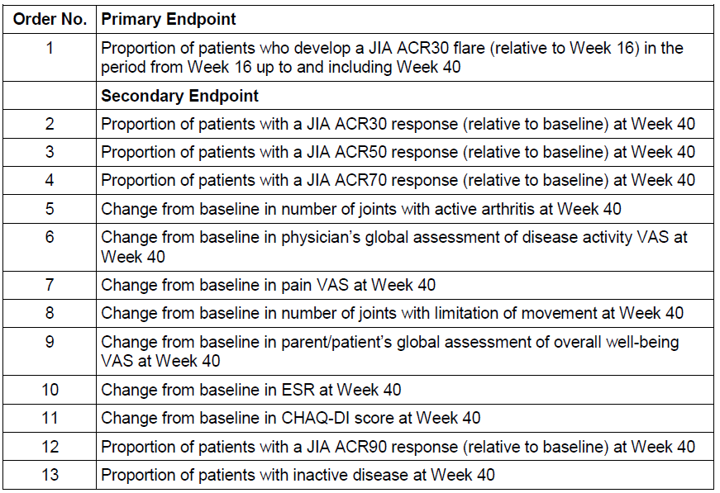

During Part II of the study, missed data for the binary endpoints (that is, JIA ACR criteria and response, and inactive disease state) was assumed to be the worst case scenario (that is, flare or non-responder status). However, for continuous variables such as the JIA ACR core components, pain VAS and JADAS score, a Last Observation Carried Forward (LOCF) was used to handle missing data.

##### Participant flow

Figure 6 provides a summary of participant flow during Part I of Study WA19977. A total of 218 patients were screened for inclusion in the study, and 188 patients entered into Part I of the trial. Sixty-six patients initially failed screening but 36 of them were subsequently randomised into the study following re-screening. Of the 188 patients randomised to TCZ during Part I, 153 subjects (119 patients weighing 30 kg or more, and 34 patients weighing < 30 kg) were treated with TCZ 8 mg/kg, and 35 patients (all weighing less than 30 kg) were treated with TCZ 10 mg/kg. In total, 166 patients completed Part I of the trial. Of the 22 subjects who withdrew in Part I, 15 did so because of lack of efficacy. The other seven patient withdrawals from Part I were due to AEs;(three subjects), refusal of treatment (three patients) and lost to follow-up (one patient).

Figure 6: Participant Flow in Part I of Cherish Study

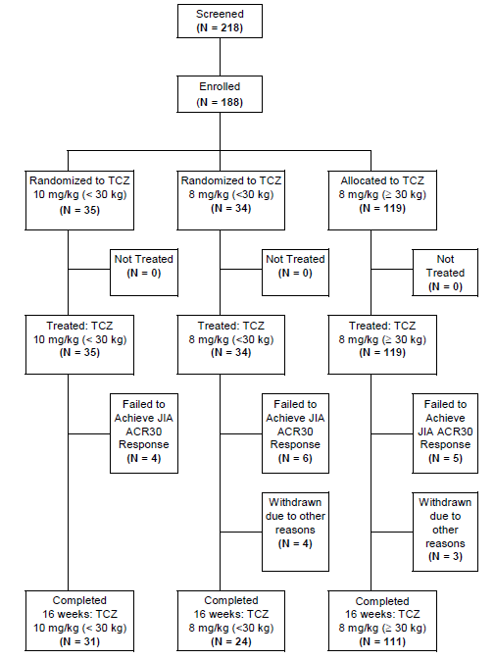

After 16 weeks of open-label TCZ treatment (dose blinded), 82 patients were randomised to TCZ in Part II: 66 patients were treated with 8 mg/kg (55 patients ≥ 30 kg and 11 patients < 30 kg), and 16 patients (all with BW < 30 kg) were administered 10 mg/kg. Of the 84 patients randomised to placebo during Part II, 81 (53 patients ≥ 30 kg and 28 patients < 30 kg) received placebo infusions. In total, 160 patients completed Part II of the study: 100 subjects reached Week 40 of follow-up, and 60 patients flared (including those who received escape treatment or withdrew for any reason). Figure 7 summarises patient disposition during Part II of the trial.

Figure 7: Participant Flow in Part II of Cherish Study

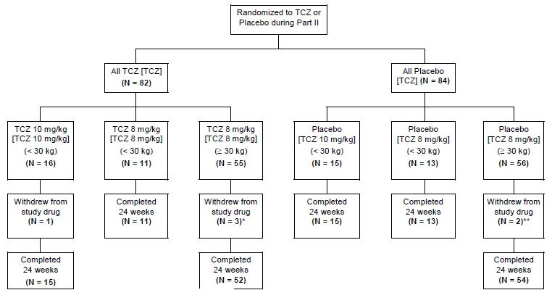

##### Major protocol violations/deviations

No major protocol deviations were recorded during the study. However, at a single site in Spain it was identified that for 19 out of a possible 67 study visits involving six actively treated patients, joint assessments were not performed in an independent, blinded manner as specified by the protocol. Instead, these assessments were performed by the treating physicians. As such, the integrity of the primary efficacy data from this site may have been compromised.

##### Baseline data

Table 13 summarises the key baseline demographic and disease characteristics of the patients involved in the Cherish Study. As expected, the majority of patients were female (77%), and of Caucasian ethnicity (80%) with a mean age of 11 years. Three patients were aged 2 years, seven patients aged 3 years and four patients aged 4 years. A total of 10 patients weighed < 15 kg: 7 of whom received TCZ 10 mg/kg and three were administered TCZ 8 mg/kg. The mean disease duration at baseline was 4.2 years, with patients with BW ≥ 30 kg having a longer mean duration of disease (4.7 years) than those weighing < 30 kg (3.45 years). This is to be expected given the mean age of children in each of these BW categories. The majority of patients were RF-negative at baseline (67%, 126/188). Eight patients (4.3% of 188) had no recorded RF status at baseline. Demographic characteristics were similar for the patient populations involved in Part I and II, as well as well balanced between the two treatment groups for Part II.

Patients had severely active pJIA at baseline with the mean number of active joints being 20.3, mean patient/parent global assessment VAS score being 52.9 mm, mean physician global assessment VAS score being 61.4 mm, and the mean CHAQ-DI score being 1.39 (range: 0-3). Treatment groups in Part I and II were well matched for baseline disease characteristics. The randomisation stratification variables were also similar between the treatment groups with the mean background CS dose at baseline being 0.13 mg/kg/day (received by 46% of subjects), and the mean MTX dose at baseline being 11.8 mg/m²/week (received by 79% of patients). Concomitant NSAID use was recorded in 65% of subjects at baseline, and 32% of patients had a history of prior biologic DMARD therapy. In total, only 5% of patients had a previous history of infection including varicella, tonsillitis (acute and chronic), pharyngitis, rubella and viral respiratory tract infection.

Table 13: Key Demographic and Disease Characteristics at baseline in Study WA 19977

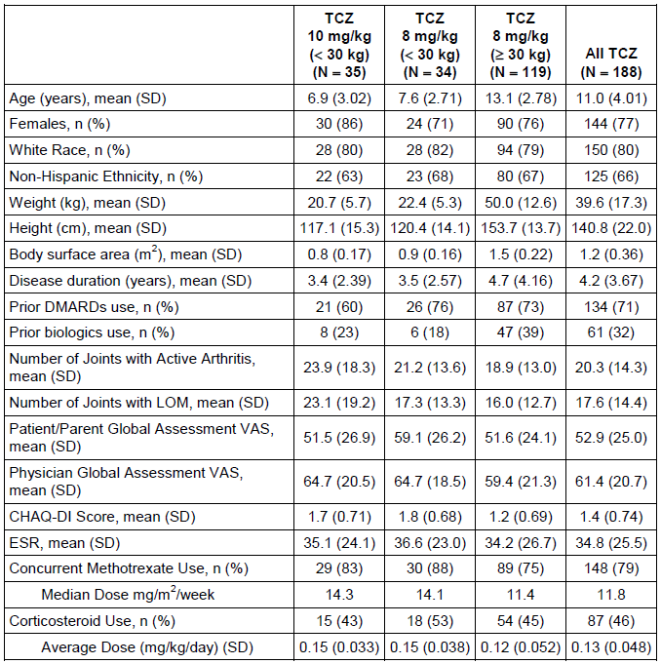

##### Results for the primary efficacy outcome

The primary efficacy outcome was the rate of JIA ACR30 flare at Week 40 compared with Week 16. In patients receiving TCZ (any dose), the rate of disease flare was statistically lower than the placebo-treated group (25.6% [21/82] versus 48.1% [39/81]). The weighted difference in the rate of flares between Weeks 16 and 40 was -0.21 (95% CI -0.35, -0.08; p=0.0024). Supporting analyses of the primary efficacy endpoint, such as alternative missing data imputation, and using the per-protocol population, detected a similar statistically significant treatment difference. Twelve patients who were randomised at Week 16, but withdrew or took escape therapy prior to Week 40 without experiencing a JIA ACR30 flare did not change the overall outcome. Using the per-protocol population, 44.3% (31/70) of patients in the control group and 24.7% (18/73) of subjects treated with TCZ experienced a JIA ACR30 flare between Weeks 16 and 40.

Overall, this finding represents a statistically significant benefit which is clinically meaningful in the treatment of children with severely active pJIA.

The rate of experiencing JIA ACR30 flare at Week 40 was analysed according to prior or concurrent treatments of interest, as well as RF status at baseline. Concurrent MTX (79% of subjects) and oral CS use (46% of patients) at baseline were stratification factors in the randomization of patients at Week 16. For patients receiving CS at baseline compared to those who did not, the interaction of TCZ with the rate of JIA ACR30 flare at Week 40 was not statistically significant (p=0.3267). However, there was a difference in the incidence of JIA ACR30 flare between Weeks 16 and 40 in those subjects who received TCZ with concurrent MTX (lower flare rate at 19.4%; 13/67), versus those who were not using concurrent MTX (higher flare rate at 53.3%; 8/15). The treatment effect of MTX was also observed in the placebo group between Weeks 16 and 40. The rate of JIA ACR30 flare was 82.4% (14/17) in the placebo subgroup not taking MTX between Weeks 16-40, compared with 39.1% (25/64) in the control subjects receiving background MTX. Similarly, the rate of JIA ACR30 flare at Week 40 in TCZ treated patients previously exposed to biologic DMARD was higher (44.4%; 12/27) compared to TCZ patients who were biologic treatment naïve ((16.4%; 9/55). The same observation was seen in the Part II placebo group with the rate of JIA ACR30 flare at Week 40 being 78.3% in the biologic DMARD experienced patients versus 36.2% (21/58) in the biologic naïve subjects. The result is to be expected as patients who have failed at least one biologic DMARD represent a treatment refractory subgroup of pJIA. RF status (positive/negative) at baseline had no effect on the rate of JIA ACR30 flare at Week 40 for either the active TCZ treatment or placebo group.

##### Results for other efficacy outcomes

JIA ACR30/50/70/90 Responses at Weeks 16 and 40:

After 16 weeks of open-label TCZ treatment, 89.4% (168/188) of patients achieved at least a JIA ACR30 response and were eligible to continue into Part II of the study – Table 14. The JIA ACR30 response rate for patients with BW < 30 kg was slightly lower in the TCZ 8 mg/kg arm (76.5%, 26/34) compared to the TCZ 10 mg/kg treatment group (88.6%, 31/35). The onset of a JIA ACR30 response was rapid with 50% of responders at Week 16 achieving this outcome at the Week 2 assessment. In addition, more than 90% of responders at Week 16 did so by the scheduled Week 12 evaluation visit. A similar pattern of onset was seen for JIA ACR50 and 70 responders at Week 16.

Overall, a high proportion of subjects were able to achieve a JIA ACR50 (83.0%, 156/188) and JIA ACR70 response (62.2%, 117/188) at Week 16.

Table 14: Proportion of Patients with JIA ACR30/50/70/90 Responses at Week 16 (ITT population)

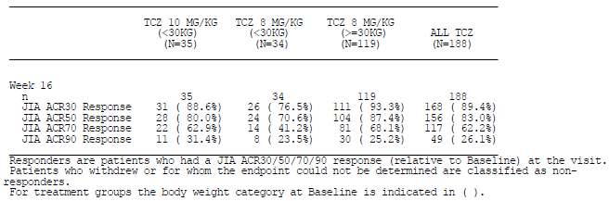

At Week 40, a higher proportion of patients who continued TCZ after Week 16 maintained JIA ACR responses than those who were randomised to receive placebo infusions in Part II - Table 13. There was a statistically higher rate of JIA ACR30/50/70 response at Week 40 in patients given TCZ. However, the statistical significance of the relative rates of JIA ACR90 response at Week 40 between the two treatment groups could not be determined as this endpoint was lower in the hierarchical chain of analysis than other statistically non-significant efficacy endpoints.

Table 15: Proportion of Patients with JIA ACR30/50/70/90 Responses at Week 40 (ITT population)

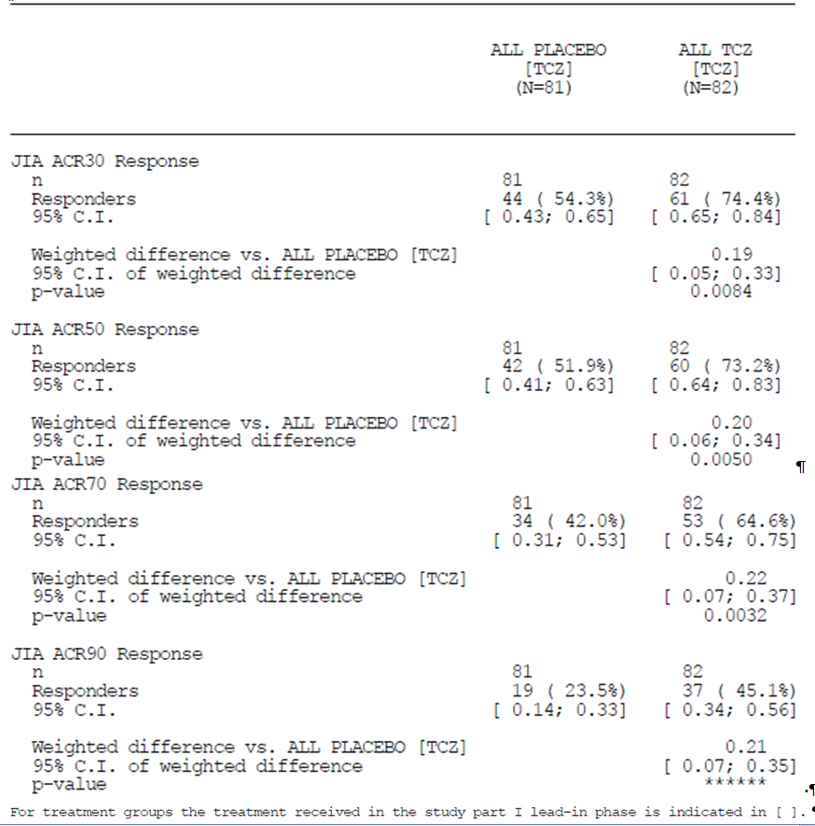

As per the primary efficacy endpoint analysis, the rate of obtaining JIA ACR30/50/70/90 response at Week 40 was analysed according to prior or concurrent treatments of interest, as well as RF status at baseline. Concurrent MTX (79% of subjects) and oral CS use (46% of patients) at baseline were stratification factors in the randomisation of patients at Week 16. For patients receiving CS at baseline compared to those who did not, the interaction of TCZ with the attainment of JIA ACR30/50/70/90 response at Week 40 was equal or slighter higher, but not significantly different when assessed by logistic regression. Like the primary endpoint analysis, there was a higher rate of achieving JIA ACR30/50/70/90 response between Weeks 16 and 40 in those subjects who received TCZ with concurrent MTX versus those given TCZ who were not using concurrent MTX – refer to Table 16. The positive treatment effect of MTX was also observed in the placebo group between Weeks 16 and 40.

Table 16: Proportion of Patients with JIA ACR30/50/70/90 Response at Week 40 by background, methotrexate use at baseline

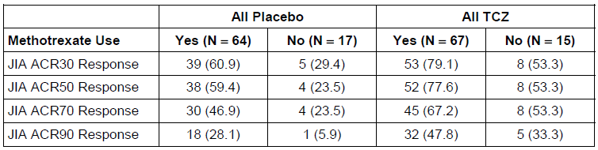

The rate of JIA ACR30/50/70/90 response at Week 40 in TCZ treated patients previously exposed to biologic DMARD was higher compared to TCZ patients who were biologic treatment naïve –refer to Table 17.

Table 17: Proportion of Patients with JIA ACR30 Flare and JIA ACR30/50/70/90 Response at Week 40 according to previous biologic DMARD use

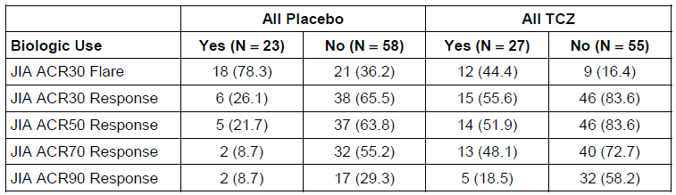

RF status (positive/negative) at baseline had no effect on the rate of JIA ACR30/50/70/90 response at Week 40 for either the active TCZ treatment or placebo group.

###### JIA ACR Core Components at Weeks 16 and 40:

After 16 weeks of open-label TCZ treatment in Part I, the mean (and median) change from baseline in each of the six components comprising the JIA ACR criteria were:

* Number of active joints (baseline mean 20.3): -13.6 joints (-11.0 joints) with n=182,
* Number of joints with LOM (baseline mean 17.6): -10.1 joints (-8.0 joints) with n=182,
* Patient/Parent Global VAS assessment (baseline mean 52.9 mm): -30.9 mm (-32 mm) with n=181,
* Physician Global VAS assessment (baseline mean 61.4 mm): -42.9 mm (-42 mm) with n=181,
* CHAQ-DI score (baseline mean 1.4): -0.708 (-0.625) with n=182, and
* ESR (baseline mean 34.8 mm): -25 mm (-17 mm) with n=182.

At Week 40, patients who continued to receive TCZ after Week 16 (-14.5 active joints) showed a statistically significant reduction in the number of active joints compared to the control group (-11.5 active joints; difference in means of -3.0 [95% CI: -5.7, -0.1]; p=0.0435) – Table 18. TCZ-treated patients also showed a statistically significant improvement in the physician global assessment of disease activity by 100 mm VAS (treatment difference in means -7.4 mm [95% CI: -16.5, -3.4]; p=0.0031). Because there was no statistically significant treatment difference at Item 8 of the hierarchical chain of endpoint testing (that is, change from baseline to Week 40 in number of joints with LOM), subsequent testing of the other four individual JIA ACR core components was not undertaken.

Table 18: JIA ACR Core Components at Week 40 in the ITT-2 Population of Study WA19977

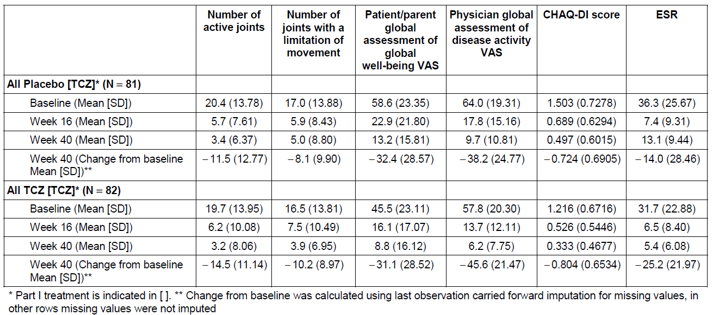

###### JADAS-27 Score at Weeks 16 and 40:

The mean change from baseline in the JADAS-27 score was not considered in the hierarchical testing sequence, and as such no p-value for the possible effect of TCZ treatment versus control therapy was presented at either Week 16 or 40. The mean JADAS-27 scores decreased (clinical improvement) from baseline to Week 16 in both treatment groups: 26.86 at baseline and 8.07 at week 16 for placebo (n=81); and 24.64 at baseline and 7.36 at Week 16 for all TCZ patients (n=82). The mean change from baseline to Week 40 in the JADAS-27 score was -19.76 for all TCZ subjects (n=62) and -19.26 for placebo (n=45).

###### Pain VAS at Weeks 16 and 40:

The mean pain VAS score at baseline (Week 0) was 45.0 for patients who received TCZ in Part II of the study and 58.3 for subjects in the placebo group. As shown in Figure 8, both treatment groups reported less pain during the first 20 weeks of treatment. However, after Week 20 the pain VAS score in the placebo group began to increase, and then remained steady from Weeks 24 to 40. For the TCZ treated patients in Part II of the trial, the mean pain VAS score continued to decrease slightly (8.6) over time between Weeks 16 and 40. Patients who continued to receive TCZ after Week 16 compared to placebo had a statistically significant improvement in the mean pain VAS score at Week 40 with the treatment difference in means being -10.2 (95% CI: -17.6, -2.7; p=0.0076).

Figure 8: Line Plot of Mean Pain VAS (0-100 mm) by Visit in Part I and II (ITT Population)

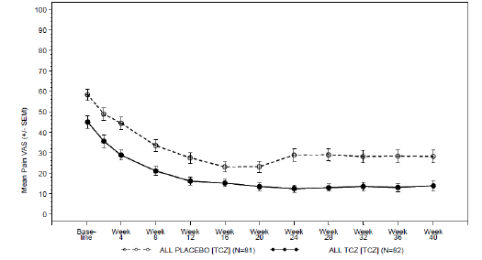

###### Patients with Inactive Disease at Week 40:

A greater proportion of patients treated with TCZ (26/82; 31.7%; 95% CI: 0.22, 0.42) fulfilled the criteria for inactive disease at Week 40 compared with those who received placebo (12/81; 14.8%; 95% CI: 0.07, 0.23). Due to a break in the hierarchical chain of testing, statistical quantification for this endpoint was not undertaken, however, the weighted treatment difference for the percentage of subjects with inactive disease was 0.16 (95% CI: 0.03, 0.29).

#### Studies MRA318JP and MRA319JP

##### Study design, objectives, locations and dates

Study MRA318JP was an open-label, single arm, Phase III study conducted in five centres in Japan between November 2004 and July 2005. The primary objective of the study was to evaluate the short-term safety, efficacy and pharmacokinetics of TCZ in patients with pJIA. Patients with active pJIA were given at total of three infusions of TCZ 8 mg/kg every four weeks. Final observations for Study MRA318JP were made four weeks after last dose of TCZ (that is, at Week 12 of therapy). This study population were further evaluated in an open-label extension (OLE) phase of treatment (Study MRA319JP). The OLE study was conducted for 42 months from the conclusion of Study MRA318JP in the same Japanese centres. There was no blinding or control group. The objective of this study was to investigate the long-term safety, efficacy and pharmacokinetics of TCZ in patients with pJIA.

In terms of patient recruitment, two centres enrolled two subjects, one site recruited three patients, another site enrolled five subjects and the largest study centre enrolled seven patients.

##### Inclusion and exclusion criteria

To be included in Study MRA318JP patients had to be between the ages of 2 and 19 years at entry, with the onset of arthritis symptoms before their 16th birthday. Subjects were required to be diagnosed with one of three subtypes of pJIA (as per the 1997 ILAR classification): RF-positive polyarthritis, RF-negative polyarthritis, or extended oligoarthritis. Patients had to meet all of the following clinical criteria in the two weeks prior to starting TCZ:

1. pain, tenderness and limited range of motion in three or more of the 74 joints examined;
2. inflammatory swelling of five or more of the 74 joints examined; and
3. ESR ≥ 30 mm/hr (Westergren method) or CRP ≥ 1 mg/dL.

Patients meeting any one of the following exclusion criterion were not allowed to participate:

1. Severe functional limitation (defined as Steinbroker class IV within two weeks of inclusion)
2. Prior treatment with biologic DMARDs or leflunomide within 12 week of starting TCZ
3. Any previous use of TCZ
4. Prior treatment with any of these within two weeks :
   1. DMARDs or immunosuppressants
   2. Parenterally or intra-articularly administered CS
   3. Commencement or escalation of dose of oral CS
   4. Oral CS at a dose > 0.2 mg/kg (to maximum daily dose of 10 mg prednisolone or equivalent)
   5. Surgical procedure
   6. Plasmapheresis
5. Any of the following within two weeks, or at the start of treatment with TCZ
   1. WCC less than 3500 cells/μL
   2. Neutrophil count less than 1000 cells/μL
   3. Platelet count of less than 10 x 104 cells/μL
   4. Lymphocyte count less than 500 cells/μL
   5. Serum ALT 5 fold or more above the ULN range for the study site
   6. Total serum bilirubin three fold or more above the ULN range for the study site
6. Other significant concurrent illness affecting any organ system
7. History of serious allergy (for example, anaphylactoid reaction)
8. Infection within the past four weeks
9. Female subjects who were pregnant or lactating, or who expected to become pregnant during the study period.

As Study MRA319JP was an OLE of the preceding trial, the same original inclusion and exclusion criteria were applicable.

##### Study treatments

Active treatment in Study MRA318JP consisted of TCZ 8 mg/kg given at four weekly intervals by IV infusion over one hour for a total of three doses. No TCZ dose or scheduling changes were permitted in Study MRA318JP but in the OLE phase (Study MRA319JP) the dosing interval could be adjusted depending on changes in clinical signs and laboratory test values, with 14 days being the shortest interval between infusions, and six weeks being the maximal infusion interval. Patients were followed for a median of 3.22 years (range: 0.35 – 3.53 years) with an average administered TCZ dose of 8.56 mg/kg, which is slightly higher than the protocol recommended dose of 8mg/kg. Concurrent MTX use was not permitted in either of the MRA studies, in contrast to the majority of subjects (79%) involved in Study WA19977.

##### Efficacy variables and outcomes

The main efficacy variable for Study MRA318JP was the rate of JIA ACR30 response at the last day of observation (that is, Week 12 after the first dose). For the OLE Study MRA319JP, the rate of continued JIA ACR30 response compared with baseline assessments in the forerunner study (MRA318JP) was considered the primary efficacy endpoint.

###### Secondary endpoints assessed:

* Percentage of patients achieving JIA ACR50 and 70 improvement in the core set criteria up to the last day of observation in Study MRA318JP, and compared with the previous study baseline in Study MRA319JP;
* Time course for each of the JIA ACR core set up to the last day of observation in Study MRA318JP, and compared with previous study baseline in Study MRA319JP;
* Time course of pain up to the last day of observation in Study MRA318JP, and compared with previous study baseline in Study MRA319JP.
* Time course of CRP up to the last day of observation in Study MRA318JP, and compared with previous study baseline in Study MRA319JP; and
* Change in CS dose requirement over time in Study MRA319JP only.

##### Randomisation and blinding methods

This was an open-label study, and hence no blinding or randomisation was performed. No blinded joint assessor was used in the MRA studies (in contrast to Study WA19977).

##### Analysis populations

A total of 19 patients enrolled in Study MRA318JP and all were included in the Full Analysis Set (FAS) and safety analysis. Because two patients had significant protocol violations, the Per Protocol Set (PPS) totalled 17 patients in Study MRA318JP. In Study MRA319JP, the efficacy analysis was performed using the FAS. No PPS analysis was conducted in the OLE phase.

##### Sample size

The target sample size was 15 for enrolment into both studies. The patient sample size of 15 was based the incidence and prevalence of pJIA in the Japanese population. Fifteen was also considered the minimum number of patients required to evaluate efficacy and safety after considering the following information from previous studies of TCZ in patients with RA and systemic onset JIA:

1. The CRP normalisation rate was 76.4% in the phase II study of TCZ therapy in subjects with RA (Study MRA009JP; previously evaluated by the TGA as part of the RA indication submission). If the expected CRP normalisation rate in Study MRA318JP is 75%, then the 90% CI for 15 patients, which was the target number of patients, would be 50.7%–91.4%.
2. When the target number of patients is 15, the probability of missing AEs with an incidence of at least 20%, is less than 5%. In Study MRA318JP and two other trials of sJIA, it is expected that TCZ will be used in at least 70 children. If TCZ is received by 70 children, then the probability of missing AEs with an incidence of at least 5% would be less than 5%.
3. For determining similarities in PK in Study MRA318JP and Study MRA009JP, examination of the power to detect a difference using the AUC was considered. The coefficient of variation for the AUC in Study MRA009JP was 34% (mean: 32,073.73; standard deviation: 10,818.55). Assuming that a similar result is also obtained in Study MRA318JP, the probability (power to detect a difference) that the mean AUC for 15 patients would be within ±10% and ±15% of the mean in Study MRA009JP would be 79% and 94%, respectively.

##### Statistical methods

Statistical analysis was straightforward and unchanged by the time of patient data locking. Patient demographic data and baseline laboratory values were tabulated in a descriptive form. The primary efficacy endpoint was recorded and 95% CI were calculated.

##### Participant flow

Nineteen patients enrolled into Study MRA318JP and TCZ was given on three occasions to each participant as per protocol. All 19 patients involved in Study MRA318JP, continued their treatment and follow-up in Study MRA319JP. Of the 19 patients who entered into the OLE phase, four (21.1%) withdrew over time: two patients withdrew because of no change or aggravation of arthritis symptoms (that is, lack of efficacy), one patient discontinued because of an AE, and another subject withdrew due to the development of anti-TCZ antibodies. The rates of continuation in Study MRA319JP were 94.7% (18/19) at 1 year, 84.2% (16/19) at 2 years, and 78.9% (15/19) at 3 years.

##### Major protocol violations/deviations

Four patients in Study MRA318JP experienced a total of five protocol deviations. For two of the patients these were considered significant with the potential to impact upon their efficacy assessments, hence, the PPS for the efficacy analysis of Study MRA318JP excluded them. One patient received a higher dose of CS (>0.2 mg/kg/day) at baseline and on-trial, as well as at least two concurrent NSAID which is a concomitant drug violation. Three other patients also received two or more concurrent NSAID while on-trial, and for one of these subjects it was considered to have potentially impacted on their efficacy measurements.

No significant additional protocol deviations were recorded in Study MRA319JP. However, one patient developed neutralising antibodies to TCZ and the study protocol at the time of the event recommended this patient be withdrawn. This patient had their TCZ treatment temporarily discontinued, and the protocol was subsequently amended to allow for patients with neutralising antibodies to continue after consultation with a medical expert. The potential effect of anti-TCZ antibody formation on enhanced drug elimination, with a possible reduction in efficacy, was considered. Another patient received prohibited concomitant therapy during Study MRA319JP but was included in the FAS.

##### Baseline data

Study MRA318JP enrolled four males and 15 females with a mean age of 11.6 years (range: 3 to 19 years). The median age of pJIA onset was 7 years (four were <2 years of age at onset, three were 2-5 years, eight were 5-10 years, and four were 10-16 years). In all patients, RF status was negative at baseline. The mean disease duration was 5.3 years (range: 1 to 17 years). The mean baseline CRP was 2.66 mg/dL and mean ESR was 46 mm/hr. The mean number of active joints at baseline was 14.3 (range: 5 – 43) and the mean number of joints with LOM was 9.4 (range: 1 – 21). Patients had moderately-severely active pJIA at baseline with the mean patient/parent global assessment VAS score being 58.5 mm, mean physician global assessment VAS score being 63.8 mm, and the mean CHAQ-DI score being 1.39 (range: 0-2.88). Fifteen patients were taking CS at baseline at a mean daily dose of 1.4 mg/kg (range: 0.02 – 0.3 mg/kg). Six patients had a BW <25 kg, and three patients had a BW >50 kg. Subjects had taken a median of two DMARDs (range: 1-5 medicines) in the past. For the OLE Study MRA319JP, the same baseline patient data and disease characteristics were applicable.

There are some significant differences between the baseline disease characteristics and populations involved in the MRA versus WA19977 studies. The Cherish trial recruited a wide geographical distribution of patients but the MRA studies only involved Japanese subjects who had a longer duration of disease, less severe arthritis at baseline (for example, lower numbers of active joints at entry) and were slightly older in age.

##### Results for the primary efficacy outcome

In Study MRA318JP the rate of JIA ACR30 response was 94.7% (18/19 patients) at the last observation day (12 weeks following initiation of TCZ treatment). In Study MRA319JP (OLE phase) the rate of clinical improvement was maintained. The rate of JIA ACR30 response was 94.1% (16/17 of patients) at 24 weeks, and 100% for each 24 week period between weeks 48 and 168 (excluding patient withdrawals at each time point).

##### Results for other efficacy outcomes

###### JIA ACR50 and 70 Response Rates:

At 12 weeks of follow-up in Study MRA318JP, the JIA ACR50 response rate was 94.7% (18/19 patients) and the JIA ACR70 response rate was 57.9% (11/19 subjects).

In the OLE Study MRA 319JP, the rate of JIA ACR50 and JIA ACR70 response at 24 weeks were both 94.1% (16/17 patients). The percentage of patients showing 50% improvement was 94.1% (16/17) at 48 weeks, 100% for each 24 week period between 72 and 144 weeks (16/16 and 14/14), and 93.3% (14/15) at 168 weeks. The proportion of patients reaching a JIA ACR70 response was 88.2% (15/17) at 48 weeks, 93.8% (15/16) at both 72 and 96 weeks, 100% (14/14) at both 120 and 144 weeks, and 93.3% (14/15) at 168 weeks.

###### Mean Change in JIA ACR Core Set Variables:

All six of the JIA ACR core set variables showed a rapid and sustained improvement from baseline in Study MRA318JP (see Table 19), which continued to Week 168 in the OLE Study MRA319JP.

Table 19: Time Course of Means for ACR JIA Core Set Criteria in Study MRA318JP

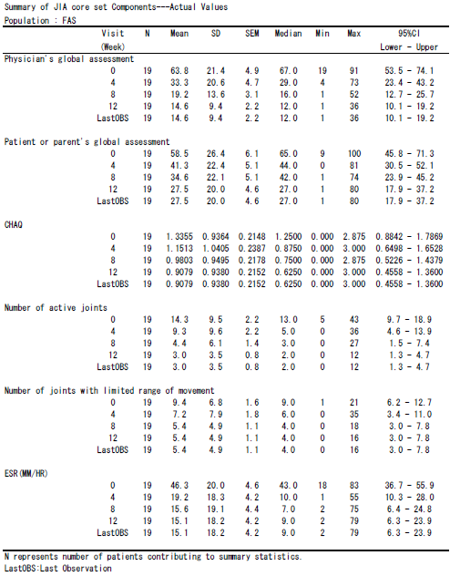

###### Mean Change in Pain VAS Score:

Arthritis related pain, as assessed by VAS, showed a rapid and sustained improvement after the commencement of TCZ. The mean (+/- SD) baseline VAS pain score was 64.2 (+/- 27.5), and this decreased to 24.1 (+/- 26.8) at 24 weeks. The improvement in the mean pain VAS score was maintained from Week 48 until Week 168 in the range of 11.2 to 17.0.

###### Mean Change in CRP:

There was a rapid improvement in CRP with TCZ therapy in Study MRA318JP, the effect of which was maintained in the OLE trial. The mean (+/- SD) baseline CRP reading was 2.66 (+/- 1.99) mg/dL, and this decreased rapidly after the commencement of TCZ in Study MRA318JP. From Week 24 to Week 168, the mean CRP value remained in the range of 0.01-0.04 mg/dL.

###### Mean Change in Corticosteroid Dose

The mean (+/- SD) daily dose of prednisone up to 12 weeks of therapy in Study MRA318JP was 3.74 +/- 3.29 mg. In the OLE Study MRA319 JP, the mean (+/-SD) daily dose of prednisone was 3.78 +/- 3.38 mg from Weeks 12-24, 3.02 +/- 2.97 mg from Weeks 36-48, 1.54 +/- 2.04 mg between Weeks 96-108, and 0.98 +/-1.97 mg from Week 144 up until Week 154. The proportion of patients not requiring any CS treatment at baseline in Study MRA318JP was 21.1% (4/19); but increased after 48 weeks of TCZ treatment to 27.8% (5/18), rising further to 43.8% (7/16) by 108 weeks, and 73.3% (11/15) at 156 weeks. However, the proportion of patients whose dose of CS had decreased by at least 50% from baseline was 7.1% (1/14) at 24 weeks, 28.6% (4/14) at 48 weeks, 84.6% (11/13) at 108 weeks and 84.6% (11/13) at 156 weeks.

#### Other efficacy studies

Not applicable

#### Analyses performed across trials (pooled analyses and meta-analyses)

A pooled analysis was not performed between the pivotal Study WA19977 and the supporting studies (MRA318JP/MRA319JP) as there were differences in dose, study design and background therapy with MTX.

#### Evaluator’s conclusions on clinical efficacy for Tocilizumab for the treatment of active polyarticular juvenile idiopathic arthritis in patients aged 2 years and older either given alone or in combination with methotrexate.

JIA affects approximately 1 in 1000 children in Australia, and 30% of cases are polyarticular. There is significant unmet need for additional effective therapies as response to current treatment options is variable. In support of the extension of indication of TCZ to include the treatment of active pJIA in patients 2 years of age and older, the sponsor has provided data from a single pivotal Phase III study (WA19977) which had a 16-week, open-label, active treatment, lead-in period; followed by a randomised withdrawal phase in treatment responders (Weeks 16-40). The study recruited 188 patients who had demonstrated either an inadequate response to or intolerance of MTX, and prior biologic use was recorded in 32% of the study participants. Supportive evidence of efficacy was provided by a 12-week, open-label, single-arm Phase III Study (MRA318JP) which enrolled 19 Japanese subjects. This study had a long-term extension phase (MRA319JP) whereby the 19 patients received ongoing TCZ for up to 168 weeks. The submission is consistent with the specific regulatory guideline pertaining to the requested extension of indication: EU guideline CPMP/EWP/422/04 “Guideline on Clinical Investigation of Medicinal Products for the Treatment of Juvenile Idiopathic Arthritis” (effective 26 June 2009) – adopted by the TGA. In particular, the trial design of the pivotal study was appropriate for the claimed indication and studied a sufficient number of patients for an acceptable duration of therapy. For Study WA19977, randomisation procedures, strategies to maintain blinding, choice of efficacy endpoints and statistical analysis were appropriately performed.

The pivotal Study WA19977 enrolled patients with severely active pJIA, and demonstrated that TCZ is an effective treatment in those who have either failed or are intolerant to MTX. The primary efficacy endpoint of Study WA19977 was met, whereby a statistically significant difference in the rate of JIA ACR30 flares at Week 40 (compared with Week 16) was detected between the control group (48.1%; 39/81) and TCZ treated patients was observed (25.6%; 21/82). This result also represents a clinically meaningful, treatment related outcome. The secondary efficacy endpoint analysis also showed that while 89.4% of TCZ treated patients had a JIA ACR30 response at Week 40, the majority of patients achieved an even higher level of clinical response (JIA ACR50 83%, JIA ACR70 62% and JIA ACR90 26%). The timeline to achieve these responses was relatively rapid with the majority of the clinical effect evident in the first 12 weeks of treatment. Response to TCZ treatment was also seen using different outcome measures such as JADAS-27 and pain VAS scores. A proportion of patients (31.7%) achieved inactive disease status at Week 40.

The majority (79%) of patients in the pivotal study population were taking MTX during the study treatment period. A lower rate of JIA ACR30 flares at Week 40 was observed in patients receiving MTX concurrently with TCZ. In contrast, there was no consistent difference in the JIA ACR30 flare rate in patients receiving a stable dose of CS (limited to 0.2 mg/kg/day, or a maximum of prednisone 10 mg/day) during the study period. Approximately, one third of subjects in the Cherish Study population had received at least one biologic DMARD prior to entry. The biologic DMARD experienced patients had a higher rate of JIA ACR30 flare at week 40, and lower rates of JIA ACR30/50/70/90 responses in both the TCZ and placebo groups, compared to patients not previously exposed to biologic DMARD. This is to be expected and reflects a relatively treatment refractory subgroup of patients. Rheumatoid factor status had no influence upon the clinical efficacy response to TCZ.

The baseline demographic and disease related characteristics of patients in the pJIA TCZ treatment studies are similar to those in the anticipated Australian patient cohort, and therefore generalisation of these results to the Australian context is expected. The majority of patients were female (77%), of Caucasian ethnicity (80%) with a mean age of 11 years. However, there are some caveats to the generalisability of the treatment population. Study WA19977 excluded patients who were at a significant risk of infection, or who had various abnormal laboratory results at baseline (for example, abnormal haematology or liver function tests).

The pivotal WA19977 Study found a small difference in the rate of JIA ACR30 response in patients with BW <30 kg according to dose of TZC administered. In this subgroup, a higher rate of JIA ACR30 response was seen with the 10 mg/kg dose of TCZ compared with 8 mg/kg. This difference was also seen across the other JIA ACR response categories. This is consistent with the increased efficacy seen in patients with systemic JIA who have a BW <30 kg treated with a higher dose of TCZ. However, statistical significance could not be demonstrated in the Cherish Study due to the low subject numbers.

The MRA318JP and MRA319JP Studies are supportive of the key efficacy findings of the pivotal trial by demonstrating:

* JIA ACR30 response was seen in 94.7% (18/19) of patients after 12 weeks of TCZ treatment in Study MRA318JP, the rate of JIA ACR30 response was 94.1% (16/17 of patients) at 24 weeks, and 100% for each 24 week period between Weeks 48 and 168 (excluding patient withdrawals at each time point) indicating sustained response in many individuals.
* High rates of JIA ACR50 response rate (94.7%) and JIA ACR70 response (57.9%) in Study MRA318JP were maintained during the long-term, open-label extension phase.
* All six of the JIA ACR core set variables showed a rapid and sustained improvement from baseline in Study MRA318JP, which continued to Week 168 in the OLE Study MRA319JP.
* A possible CS sparing effect with the proportion of patients whose dose of CS had decreased by at least 50% from baseline was 7.1% (1/14) at 24 weeks, 28.6% (4/14) at 48 weeks, 84.6% (11/13) at 108 weeks and 84.6% (11/13) at 156 weeks.

Overall the efficacy data in this submission supports the efficacy of TCZ in the treatment of moderately-severely active pJIA (as per the ILAR criteria), with or without MTX, in patients aged 2 years to 18 years. For maximum clinical benefit, concurrent MTX treatment is preferred in patients who are not intolerant to MTX. In MTX intolerant patients, TCZ monotherapy has demonstrated sufficient efficacy in treating severely active pJIA. Patients weighing <30 kg should receive TCZ every four weeks at a dose of 10 mg/kg, and all other patients should receive TCZ 8 mg/kg every four weeks.

## Clinical safety

### Studies providing evaluable safety data

The following studies provided evaluable safety data:

#### Pivotal efficacy studies

There was a single pivotal efficacy study (Cherish), which collected the following safety data:

* General AEs were assessed by AE reporting and clinical assessment performed at weekly intervals during Part I and II of the study (first 40 weeks).
* AEs of special interest, including infections, infusion reactions, neutropenia, thrombocytopenia, abnormal liver function tests, and gastrointestinal AEs, were assessed by their overall rate and number of individual events.
* Laboratory tests, including haematology, chemistry and urinalysis performed at baseline, weekly for the first four weeks of the trial; and then every one to four weeks for the remainder of the first 40 weeks of treatment follow-up.
* Anti-TCZ antibodies were assessed at baseline, Weeks 20, 27, 34 and 40, or during any flare visit in Part II of the study.
* Chest imaging (by plain x-ray) was performed at baseline and Week 20.

AE reporting was standardised by the sponsor for analysis by assigning preferred terms as set out in the Medical Dictionary for Regulatory Activities (MedDRA) Version 14.1. All AEs were graded according to the National Cancer Institute’s Common Terminology Criteria (Version 3.0).

#### Pivotal studies that assessed safety as a primary outcome

There were no studies that assessed safety as the primary outcome.

#### Dose-response and non-pivotal efficacy studies

No specific dose-response studies have been conducted but additional safety data was provided by the following non-pivotal efficacy studies:

* Study MRA318JP which was a 12-week, open-label TCZ treatment trial involving 19 Japanese children with active pJIA, and
* Study MRA319JP which was the open-label, long-term extension phase of Study MRA318JP involving 19 Japanese children who were followed for up to 168 weeks.

#### Other studies evaluable for safety only

Supporting safety data collected as part of the regulatory requirement for the Japanese Post-Marketing program (Study ML21939) was also presented in this submission.

### Pivotal studies that assessed safety as a primary outcome

Not applicable

### Patient exposure

A total of 188 patients received TCZ in Study WA19977 and all of these subjects were included in the safety analysis. Of the 188 patients, 28 received TCZ 10 mg/kg, 153 received TCZ 8 mg/kg (119 patients weighed at least 30 kg, and 34 patients had BW <30 kg), and seven switched from TCZ 10 to 8 mg/kg. All 7 of the TCZ dose switches were due to the subjects increasing their BW by at least 5 kg (and above 30 kg) during the study. As Study WA19977 was on-going at the time of this submission (data cut-off date of 4 November 2011), the median exposure to TCZ was 0.92 years which represents a total of 184.4 patient-years (PY) of exposure. A summary of exposure to TCZ in Study WA19977 is presented in Table 20. Most (94%) of patients received all four TCZ infusions in Part I of the trial. During Part II, a greater percentage of subjects received all six infusions of TCZ (70%; 57/82) compared to those administered placebo IV infusions (53%; 43/81).

Table 20: Summary of Exposure to TCZ and Duration of Follow-Up in Study WA19977

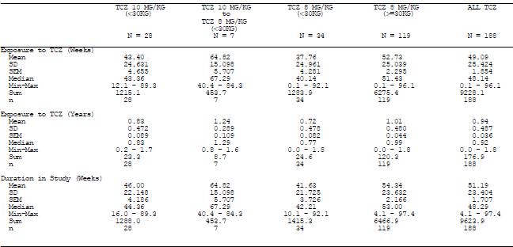

The exposure to TCZ in Studies MRA318JP and 319JP was summed from the first infusion in MRA318JP until the last observation recorded in the OLE trial (MRA319JP). A total of 19 patients were included in this safety population with median treatment duration of 3.22 years (range: 0.35-3.53 years). The total exposure to TCZ was 55.7 PY. The mean dose of TCZ administered was 8.56 mg/kg every four weeks.

### Adverse events

#### All adverse events (irrespective of relationship to study treatment)

##### Pivotal study

The sponsor has presented AE data collected during Part I and Part II of Study WA19977 (first 40 weeks of follow-up), as well as interim data collected from Part III up until the data cut-off date of 4 November 2011. This population is referred to as the all exposure population. The rate of AEs in the all exposure population was 479.8 per 100 PY of follow-up. There were no significant differences between the different patient weight (<30 kg, or greater) and TCZ dose groups (8 or 10 mg/kg). A total of 159 (84.6%) patients reported at least one AE in the all exposure population. The most common types of AEs by system organ classes (SOC) are summarised in Table 21.

Table 21: Incidence and rates of Adverse Events by SOC in Study WA19977

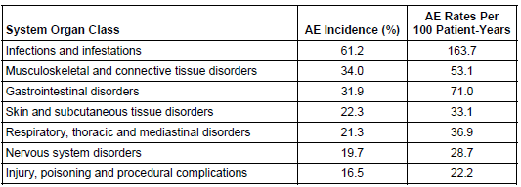

There were five types of AEs by SOC which affected at least 20% of patients in the all exposure population of Study WA19977 which will be considered in more detail.

###### Infections and Infestations:

In total, 115 patients (61.2% of 188) reported 242 AEs as infection or infestation at a rate of 163.7 AEs per 100 PY. The most common AEs in this category were nasopharyngeal infection (30.4 per 100 PY) and upper respiratory tract infection (19.4 per 100 PY). These AEs were equally distributed across the 3 TCZ treatment groups (TCZ 8 or 10 mg/kg, as well BW <30 kg or greater). There were 4 severe AE’s in this SOC including 2 cases of pneumonia, and 1 case each of parasitic infection and pyoderma. One patient (9 year old girl) reported 11 infections (repeated upper respiratory tract and ear infections) in 1.5 years while receiving TCZ 8 mg/kg q4w. A similar overall number of infection related AEs occurred in patients taking concurrent CS in the preceding fortnight (49.7%; 150/302; n=87) versus those not taking concomitant CS (50.3%; 152/302; n=101). A similar trend was observed for concurrent MTX use at baseline.

###### Musculoskeletal and Connective Tissue Disorders:

The overall event rate of musculoskeletal and connective tissue disorders was 53.1 per 100 PY. This was predominantly comprised of patients with flares of their underlying disease reported as AE (32 per 100 PY) followed by arthralgia (5.4 AEs per 100 PY).

###### Gastrointestinal Disorders

Gastrointestinal disorders had an AE rate of 71.0 per 100 PY. For patients with BW <30 kg, the rate of gastrointestinal AEs was higher in the TCZ 8 mg/kg group (66.4 AEs per 100 PY) compared to the TCZ 10 mg/kg arm (24.3 AEs per 100 PY). However, patients weighing at least 30 kg had the highest rate of gastrointestinal AEs at 83.9 per 100 PY. The most frequent AEs in this SOC were nausea (13.6 per 100 PY), abdominal pain (9.2 per 100 PY), vomiting (9.2 per 100PY) and diarrhoea (8.7 per 100 PY).

###### Skin and Subcutaneous Tissue Disorders:

All AEs in the skin and subcutaneous tissue SOC were considered mild to moderate with the exception of one case of contact dermatitis reported as severe. The overall event rate was 33.1 per 100 PY. The most frequent type of AE in this SOC was rash (6.0 per 100 PY), urticaria (4.3 per 100 PY) and ingrown nail (3.3 per 100 PY). Overall, this category of AE was more frequent in the <30 kg BW subjects who received TCZ 8 mg/kg (51.6 per 100 PY) compared with the TCZ 10 mg/kg group (20.3 per 100 PY).

###### Respiratory, Thoracic and Mediastinal Disorders:

The overall AE rate for this particular SOC was 36.9 per 100 PY. The most frequent AE type in this SOC was cough (11.9 per 100 PY) and oropharyngeal pain (10.3 per 100 PY). No significant differences between the three TCZ treatment groups were observed.

###### Subgroup Analysis of Overall AEs by Characteristics at Baseline

Patients with baseline CS use had a similar overall rate of AEs (440.0 per 100 PY) compared to subjects not taking CS at screening (510.9 per 100 PY). A total of 148 patients were receiving MTX at baseline and had an overall AE rate of 473.0 per 100 PY compared to 40 subjects not taking MTX at entry who had an overall AE rate of 505.7 per 100 PY. Additional subgroup analyses by age, duration of disease and prior biologic DMARD exposure did not reveal any significant differences in AEs.

###### Individual AE Types

Table 22 provides a summary of the individual AE types occurring at an incidence of at least 5% in the all exposure group. The most commonly reported individual type of AE was “juvenile arthritis” which represents a flare of the underlying condition. All other individual types of AEs are at least possibly related to study medication. Patients with BW of at least 30 kg reported upper respiratory tract infections and diarrhoea more commonly (>3% difference in incidence) than subjects with BW <30 kg (either TCZ dose group). Given the small overall number of AEs in patients with BW <30 kg it is difficult to make any conclusions about the comparative incidence of individual types of AEs between the two TCZ dose groups (8 versus 10 mg/kg) in this subset of patients.

Table 22: AEs affecting at least 5% of Patients in the All Exposure Population of Study WA19977

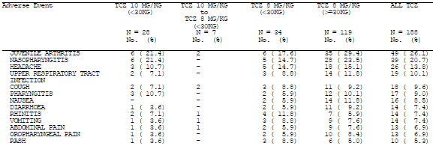

##### Other studies

The overall AE data for Studies MRA318JP and MRA319JP was grouped. The occurrence of AEs by SOC is presented in Table 23. A total of 142 AEs were observed in 19 patients in the safety dataset. Most of these AEs were mild in severity (96%; 136 of 142 AEs), five were moderate and one was recorded as severe. Infections and infestations were the most commonly reported type of AE affecting 94.7% of subjects, followed by gastrointestinal disorders (63.2% of patients) and skin and subcutaneous tissue disorders (63.2% of patients).

Table 23: AEs by SOC occurring in >10% of patients for Studies MRA318JP and MRA319JP

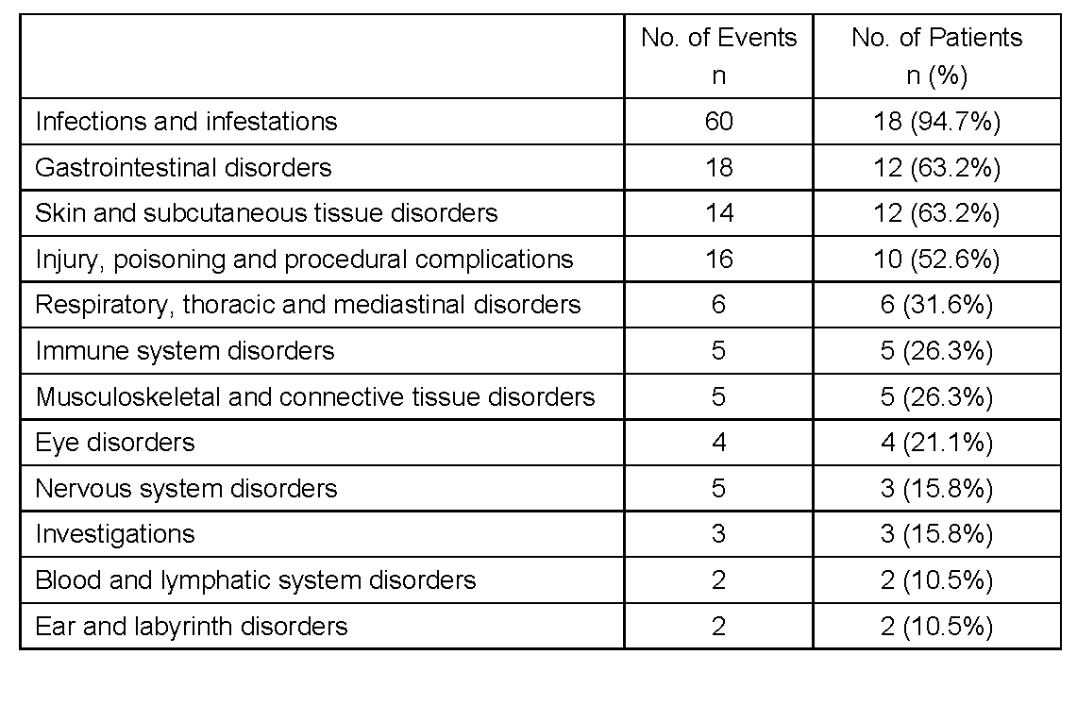

The most common individual types of AE (>10% incidence) were nasopharyngitis (78.9%; 15 patients); pharyngitis (42.1%; 8 subjects); gastroenteritis, upper respiratory tract infection and arthropod sting (31.6%; 6 patients each); seasonal allergy and eczema (21.1%; 4 subjects); bronchitis, impetigo, influenza, allergic conjunctivitis, abdominal pain, diarrhoea, stomatitis and urticaria (15.8%; 3 patients each); and pneumonia, headache, rhinitis, and constipation (10.5%; 2 patients each).

#### Treatment-related adverse events

##### Pivotal study

The submission did not specifically present AEs according to relationship to treatment. However, infusion related events were a pre-specified AE of special interest for TCZ. Infusion related AEs were classified as either occurring during or within 24 hours of infusion.

A total of 11 patients (six subjects were >30 kg and received TCZ 8 mg/kg; two patients were <30 kg and had TCZ 10 mg/kg; and three subjects were <30 kg and received TCZ 8 mg/kg) experienced an AE during TCZ infusion at an overall event rate of 7.6 per 100 PY. The most frequent AE during TCZ infusion was hypotension (three reports; 2.2 per 100 PY) followed by headache (three reports; 1.6 per 100 PY) and nausea (two reports; 1.6 per 100 PY). All these events were considered mild and resolved without sequelae.

Infusion related AEs that occurred in the 24 hour period following infusion were reported in 33 patients (17.6% of 188) at an event rate of 23.3 per 100 PY. The rate of 24-hour infusion related AEs was similar in the 8 mg/kg (<30 kg) group and the 10 mg/kg (<30 kg) group at 18.4 and 16.2 per 100 PY, respectively. However, a higher rate of peri-infusion AEs was seen in the TCZ 8 mg/kg (>30 kg) group at 35.5 per 100 PY. Nervous system disorders (ten events), gastrointestinal disorders (eight events) and administration site conditions (seven events) were the most commonly reported AEs by SOC – refer to Table 24. Two severe infusion related AEs occurred: viral infection and oropharyngeal pain. However, the majority of these AE were mild and resolved spontaneously.

Table 24: Summary of Infusion Related AEs by SOC and Preferred Term in Study WA19977

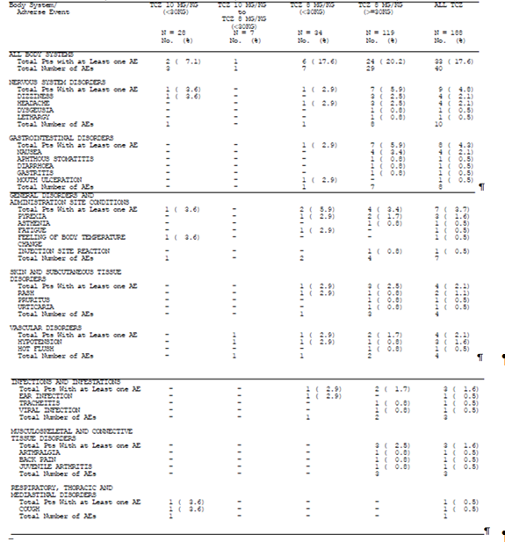

##### Other studies

The submission did not specifically present AEs according to relationship to treatment. In Studies MRA318JP and MRA319JP, two infusion related reactions were recorded, both of which were mild and did not require discontinuation from TCZ therapy.

#### Deaths and other serious adverse events

##### Pivotal study

No deaths have been reported in the all exposure population of Study WA19977.

However, 17 patients (9.0% of 188) have reported 22 serious adverse events (SAEs) at a rate of 12.5 SAEs per 100 PY. Given the overall low number of SAEs, no meaningful difference between the patient weight and TCZ dosage groups can be concluded. The two most common SAE categories (by SOC) were infection (nine patients; 4.8% of 188; 4.9 per 100 PY) and injury/poisoning/procedural complications (three patients; 1.6%; none of which were treatment related). The infection related SAEs included four patients with pneumonia (three of whom were >30 kg and received TCZ 8 mg/kg; and 1 had BW <30 kg and was given TCZ 10 mg/kg), two subjects reporting bronchitis (both had BW <30 kg and received TCZ 10 mg/kg) and two patients developing cellulitis (both weighed > 30 kg and received TCZ 8 mg/kg). Another patient with BW <30 kg who received TCZ 8 mg/kg developed varicella pneumonitis. Other noteworthy individual types of SAEs included benign intracranial hypertension (14 year old female weighing 85 kg; onset Day 6) and uveitis (patient <30 kg on TCZ 8 mg/kg; indicating treatment failure).

##### Other studies

No deaths were recorded in the MRA318JP and MRA319JP Studies. However, four patients reported six SAEs. These events included two cases of gastroenteritis; and singular reports of influenza, pneumonia, myasthenia gravis and sensory disturbance. The patient who developed myasthenia gravis was withdrawn from the study on Day 615, and treated appropriately (IV CS, plasmapheresis and tacrolimus). The SAE was considered to be possibly related to TCZ.

#### Discontinuation due to adverse events

##### Pivotal study

Seven patients withdrew from Study WA19977 because of AEs at an event rate of 3.3 per 100 PY. Two patients withdrew because of an arthritis flare which represents a lack of efficacy rather than true AEs. Another patient withdrew with gastroenteritis whilst receiving placebo in Part II of the trial. Two of the AEs leading to withdrawal were classified as serious – one patient developed significant elevation in serum transaminases (reported as not related to TCZ; 11 year old male weighing 59 kg; onset Day 6), and another experienced benign intracranial hypertension (considered as possibly related to TCZ). Other AEs leading to treatment withdrawal included serum sickness (5 year old female weighing 20 kg; onset Day 40; given TCZ 8 mg/kg), gastroenteritis (17 year old male weighing 49 kg; onset Day 269), pneumonia (11 year old male weighing 72 kg; onset Day 68) and hyperbilirubinaemia (11 year old female weighing 22 kg with onset Day 148; given TCZ 10 mg/kg).

Patients were allowed to have dose interruptions for safety reasons in Study WA19977. In the all exposure population, 12.8% (24/188) of patients had TCZ dose interruptions because of safety concerns. A higher frequency of AEs requiring dose interruptions were observed in patients with BW <30 kg who received 10 mg/kg (28.6%; 8/28) versus 8 mg/kg (5.9%; 2/34). The most common reason for dose interruption was infection (9.0%; 17/188) which included five cases of pneumonia (2.7%) and two cases each of streptococcal pharyngitis, urinary tract infection and varicella (incidence of 1.1% for each AE type).

##### Other studies

No patients withdrew from Study MRA318JP. In Study MRA319JP, one patient withdrew due to the development of myasthenia gravis as outlined above. A second patient was withdrawn due to the development of anti-TCZ antibodies, but no clinical consequences ensued.

### Laboratory tests

#### Liver function

##### Pivotal study

Most patients in Study WA19977 had a normal AST (96.8%; 182/188) and ALT (97.9%; 184/188) value at baseline. During routine laboratory monitoring in the all exposure population, elevation in ALT ≥ 3 × ULN occurred in 3.7% of patients and elevation in AST ≥ 3 × ULN occurred in < 1% of patients. Mild elevations in serum bilirubin were seen in 14.5% of patients (27/187) during the study period. One patient with a BW >30 kg who received TCZ 8 mg/kg developed a transient Grade 3 elevation of ALT and AST, which prompted treatment cessation.

##### Other studies

In the MRA318JP and MRA 319JP studies no patients withdrew due to abnormal liver function tests. Serum transaminases (ALT and AST) remained stable in all 19 subjects. However, two patients developed Grade 2 elevations in total serum bilirubin, which were transient and did result in discontinuation from treatment in the studies.

#### Kidney function

##### Pivotal study

No significant impact upon renal function was noted during the study period.

##### Other studies

No significant changes in renal function were observed in Studies MRA318JP and MRA319JP.

#### Other clinical chemistry

##### Pivotal study

In Study WA19977, 98.9% (179/181) of patients had normal baseline total cholesterol concentrations. An elevation in total cholesterol to >170 mg/dL was seen in 34.6% (64/185) patients during the 40-week study period. Grade 1 elevations in serum triglyceride levels were observed in 37 subjects (20.0% of 185) with one patient developing a Grade 2 increase in their triglyceride concentration. Of the 185 patients assessed, 21 (11.4%) developed a post-baseline elevation of LDL cholesterol to >110 mg/dL at any time during the study period. The clinical significance of these elevated lipid levels in children is not known. However, consideration should be given to ongoing lipid monitoring during and after treatment with TCZ.

##### Other studies

Total cholesterol and HDL cholesterol levels increased within the normal range up to Week 24 in Studies MRA318JP and MRA319JP, and remained stable thereafter. This is similar to the observation in Study WA19977 and supports the potential for lipid monitoring in children who receive TCZ.

#### Haematology

##### Pivotal study

There were no reported AEs involving neutropenia during Study WA19977. However, 31.4% (59/188) of patients did experience some degree of neutropenia associated with TCZ treatment. The majority of these were Grade 1 (7.4%; 14/188) or Grade 2 (20.2%; 38/188). However, some patients developed Grade 3 (3.2%; 6/188) or Grade 4 (one subject; 0.5%) neutropenia. A higher percentage of patients with BW <30 kg (7.1% [2/28] for TCZ 10 mg/kg and 8.8% [3/34] for TCZ 8 mg/kg) developed Grade 3 or 4 neutropenia compared to subjects weighing >30 kg (1.7%; 2/119). Two patients were reported to experience non-serious infections (gastroenteritis and tracheitis) at the same time as the neutropenia was identified. Another two patients (TCZ 10 mg/kg in subject <30 kg; and TCZ 8 mg/kg in patient >30 kg) who experienced Grade 3 neutropenia developed infection related SAEs (both cases were pneumonia) 85-216 days after the identification of the neutropenic episode. These SAEs were considered unrelated to the neutropenia.

Consistent with control of active systemic inflammation, mean platelet counts decreased with TCZ treatment during Study WA19977. All 188 patients had platelet counts in the normal range at the commencement of the trial, and most (91.5%; 172/188) patients maintained normal platelet counts during the study period. Thirteen (6.9%) patients developed Grade 1 decreases in platelet counts with TCZ therapy. Higher Grades (2-4) of platelet count reduction were seen in single patients in each Grade (three subjects in total; 1.6% of 188).

No patients withdrew from Study WA19977 because of haematological abnormalities.

##### Other studies

In Studies MRA318JP and MRA319JP, a 30% decrease from baseline in the mean neutrophil count by Week 24 was observed. This remained stable after this time. One patient experienced a Grade 3 decrease in their neutrophil count which was not associated with infection. The mean platelet count also decreased by 30% from baseline at Week 24 in the MRA studies. No AE attributable to thrombocytopenia was recorded in the MRA studies.

#### Anti-TCZ antibodies

##### Pivotal study

In total, 185 of 188 (98.4%) potential patients were tested at any time with the screening assay for anti-TCZ antibodies during Study WA19977. Of these, 20 (10.6%) patients had a positive baseline screening anti-TCZ result, and three (1.6%) subjects developed newly positive screening anti-TCZ results post-baseline. One additional subject had a positive confirmation test, as well as neutralizing anti-TCZ antibodies detected post-baseline (at Week 20). Unfortunately this particular patient did not have PK sampling to evaluate the potential impact of anti-TCZ antibodies on drug clearance. The patient did not experience any AEs or clinical loss of efficacy.

##### Other studies

One of 19 (5.3%) patients in Study MRA319JP became positive for neutralising anti-TCZ antibodies before receiving their fourth infusion of TCZ. This subject also became positive for IgE antibodies after their fifth TCZ infusion, and was subsequently withdrawn because of this, despite no clinical sequelae.

#### Vital signs

##### Pivotal study

During Study WA19977, mean values for vital signs remained stable in the all exposure population. The incidence of individual values outside the normal range (high or low) for systolic blood pressure were 14%-37%; and for diastolic blood pressure were 17% -26%, respectively. No patients withdrew from the trial because of blood pressure abnormalities. Non-invasive blood pressure measurement can be difficult to perform accurately in children, and equipment and technique may have varied across the study sites.

Overall, BW measurements reflected the expected increase in body size as a result of normal growth in children. In total, 60.6% (114/188) of patients had a weight gain of more than 10% during the study period. However, three patients (1.6% of 188) had a weight loss of greater than 10%. The reasons for weight loss in these individuals were not stated.

##### Other studies

In Studies MRA318JP and MRA319JP, no significant changes were seen in vital signs.

### Post-marketing experience

TCZ has been licensed in Japan for pJIA, sJIA and RA since April 2008. The Japanese Health Authority requires all new biologic DMARDs to be monitored in specific post-marketing surveillance programs through open-label, non-comparative patient registries. Study ML21939 (also known as JPMS) enrolled patients with pJIA treated with TCZ in Japan. Up until a data cut-off date of 3 August 2010, 179 patients with pJIA representing a total exposure of 93.63 PY had been collected. The median duration of treatment follow-up was 6 months in this observational cohort study. Patients had an average age of 15.3 years (range: 2-41 years), and a mean disease duration of 6.8 years (range: 0.2-28.3 years). Most patients (83%) were female. Similar to the clinical trials of TCZ in pJIA, there was frequent concomitant use of CS (78%) and conventional DMARDs (82%), with MTX being the most common DMARD (76.5%). Prior biologic DMARD use was reported in 31% of cases. In the JPMS Study, AEs were assessed as not related, possibly, probably or definitely related to TCZ. The overall incidence of AEs was 39.1% (70/179 subjects) at an event rate of 149.39 per 100 PY (138 events). The overall rate of AEs is less than the 479.8 events per 100 PY recorded in the pivotal clinical trial (WA19977) but is likely to reflect more rigorous reporting of AEs in clinical trials compared to post-marketing surveillance. The incidence of serious AEs was 7.3% (13/179 patients) at a rate of 19.2 per 100 PY (18 events). No deaths were reported.

###### AEs by SOC in Study ML21939:

Similar to the Phase III clinical studies, infection was the most commonly reported AE with an event rate of 52.33 events per 100 PY (49 infections affected 35 of 179 patients [19.6%]). Serious infections occurred at a frequency of 8.54 events per 100 PY (8 infections affected 6 of 179 subjects [3.4%]). One patient developed sepsis after receiving their first dose of TCZ. This responded rapidly to antibiotic treatment. Most of the infectious events were mild and self limiting. There was a trend towards a higher rate of infection in the group receiving concurrent CS, however statistical significance could not be established due to small patient numbers.

There were no serious AEs that occurred during TCZ infusion. However, AEs occurring within 24 hours of infusion affected in 2.8% of patients. All were mild and did not require cessation of therapy or dose alteration. There were no reports of anaphylactic reactions.

Gastrointestinal perforation (gastric ulcer perforation) was seen in one patient after their second dose of TCZ. Concomitant treatment with ibuprofen may have contributed to this presentation.

Lipid abnormalities were seen in 4.5% of patients, consisting of hypercholesterolaemia in five patients, and one patient with hypertriglyceridaemia. None of these events were considered to be serious. Abnormal liver function test abnormalities were seen in 3.4% of patients. Decreases in white blood cell and platelet counts were also seen in a small number of patients (3.4% and 1.1%, respectively). None of the laboratory abnormalities were considered serious.

There were no reports of malignant disease, cardiac dysfunction, interstitial lung disease or demyelinating disorders in the JPMS cohort.

###### Other Post-Marketing Data

Post marketing data was also collected from a number of other sources for analysis. The sponsor’s global drug safety data base was interrogated for all serious cases in the indication of juvenile arthritis with a data cut-off date of 17 December, 2011. This included reports from spontaneous sources, the sJIA Japanese post-marketing surveillance, non-interventional programs and literature reports. The database was also investigated for all cases reported in patients under the age of 18 years with an unknown treatment indication. Data from the sponsor’s clinical trials MRA318JP, MRA319JP, WA19977, WA18221 (the pivotal study in patients with sJIA) and compassionate supply programs were excluded in this analysis.

A total of 259 SAEs were reported in 128 patients. However, for the treatment indication of pJIA, only one SAE report of urticaria in a 15 year old boy from El Salvador was identified. The majority of reports came from the sJIA treatment indication. This reflects the widespread use of TCZ for this indication at the time of the analysis. A total of 225 SAEs were reported in 106 patients followed in the Japanese sJIA program (ML21940). A further 18 SAEs were reported in 12 patients with sJIA, nine events in eight patients with unspecified JIA and six events in two paediatric patients where the indication was unknown.

The largest proportion of SAEs was from the SOC of infections and infestations (30% of all reports). A total of 72 SAEs pertaining to infection were reported including 12 cases of pneumonia, 11 reports of severe gastroenteritis and seven cases of bronchitis. Two fatal cases of infection were also in the database.

Regarding the SOC of investigation abnormalities, 24 SAEs were received, including 13 cases of leucopenia, and five reports of thrombocytopenia. There were 22 SAEs reported in the SOC of gastrointestinal disorders with no discernible pattern in the presentation of these SAEs. Gastrointestinal disorders included vomiting, diarrhoea and ileus. No intestinal perforations or deaths were reported for this SOC. Of concern, there were 23 SAEs reported in the SOC of malignancy, none of which were fatal.

Three deaths were recorded in this post-marketing search, all in Japanese patients with sJIA. One case involved a 21 month old girl who died of acute respiratory distress syndrome with multi-organ failure. She had concurrent pneumonia on a background of congenital anomaly, hepatomegaly, anaemia, lung disorder, lymphadenopathy, significant renal abnormalities, serositis and rash. The second fatal case involved a 4 month old boy who died of pseudomonas infection, sepsis and interstitial lung disease. He has a concurrent respiratory syncytial virus infection, pancytopenia, skin necrosis and renal impairment. His medical history included macrophage activation syndrome.

The third fatal case involved a 2 year old male who died of cardiac failure, vasculitis, respiratory failure and hepatic failure.

### Safety issues with the potential for major regulatory impact

#### Liver toxicity

This has already been addressed in section 7.5.1 of this report.

#### Haematological toxicity

This has been covered in section 7.5.4 of this evaluation report.

#### Infusion related reactions

This has already been addressed in section 7.4.2 of this report.

#### Risk of tuberculosis infection

Screening for tuberculosis (TB) was a requirement of screening at baseline, and was repeated at Week 52 of follow-up. Nine patients were positive for TB at baseline by PPD testing. Prophylactic TB treatment was given, and all of the patients continued in the trial. As of the data cut-off date, 11 patients tested positive for TB at their Week 52 assessment. Of the nine patients who were positive at study entry, five remained positive at Week 52, while the other four had not yet reached their Week 52 evaluation. The other six patients that tested positive at Week 52 had immunoconverted since screening. None of these patients had clinical symptoms of active TB. One Peruvian patient had chest x-ray (CXR) findings consistent with pulmonary TB, as well as a positive purified protein derivative (PPD) test. This child was treated with isoniazid and continued in the study. There were no cases of TB reactivation.

### Evaluator’s overall conclusions on clinical safety

The total clinical safety dataset for the use of TCZ in patients aged 2-19 years with active pJIA consists of a patient exposure of 386 patients in four studies, all of whom received TCZ 8-10 mg/kg every four weeks by IV infusion. Most of the patients received concurrent MTX and low dose oral CS.

In the pivotal Study WA19977, 177/188 (94%) of patients received all four scheduled infusions of TCZ during Part I. During Part II of the trial, 57/82 (69.5%) received all six planned infusions of TCZ and 43/81 (53.1%) of subjects were given all six scheduled placebo infusions. At the time of data cut-off (4 November 2011), the median exposure to TCZ in Study WA19977 was 48 weeks and the total duration of TCZ exposure was 184.4 PY. In the supporting Studies MRA318JP and MRA319JP, open-label TCZ treatment was given to 19 Japanese subjects for 0.35-3.5 years, representing a TCZ exposure of 55.7 PY. In addition, the submission contained safety data from a post-marketing experience in 179 Japanese subjects treated with TCZ for pJIA who were followed a median duration of six months. The total duration of TCZ exposure in this cohort (known as JPMS) was 93.63 PY. There is sufficient data to make a meaningful assessment of safety in the short to medium-term (almost up to one year), however long term (multi-year) safety data is not yet available in the paediatric population.

Infection was the most common AE recognised in the TCZ pJIA studies with 61.2% of patients in the pivotal study experiencing an infection related AE. The majority of infections were mild in severity, self-limiting and predominately involved either the upper respiratory tract or gastrointestinal system. However, nine infectious SAEs at a rate of 4.9 per 100 PY in Study WA19977 were reported, with the most common site being the respiratory tract. One patient in the pivotal study developed pulmonary tuberculosis. The use of concurrent MTX and/or CS does not appear to increase the risk of infection associated with TCZ use. Subject weight and TCZ dose (8 or 10 mg/kg in those weighing <30 kg) did not appear to be a determinant of infection. However, a greater proportion of AEs resulting in TCZ dose interruptions were observed in patients with BW <30 kg who received 10 mg/kg (28.6%; 8/28) versus 8 mg/kg (5.9%; 2/34), and the most common reason for TCZ dose interruption was intercurrent infection.

Infusion related AEs (either during or within 24 hours of administration) occurred in patients given TCZ. In Study WA19977, 11 subjects (5.6% of 188) experienced an AE during and 33 patients (17.6% of 188) reported an AE within 24 hours of having an infusion. A higher rate of infusion related reactions were seen in the subjects weighing >30 kg in Study WA19977 compared to those with BW <30 kg (regardless of TCZ dose). In the supporting MRA studies, two patients were observed to have experienced infusion related reactions. The majority of infusion related AEs (during or within 24 hours of administration) were mild and resolved without specific intervention.

No deaths were reported in the pivotal or supporting studies. However three deaths were identified in the post-marketing surveillance, of which infection was contributory in at least two of these cases.

Some patients developed significant abnormalities in haematological parameters during the studies involving patients with pJIA. Nearly one third of patients (31.4%) experienced a decline in neutrophil count from baseline in Study WA19977, and seven patients developed Grade 3-4 neutropenia in this trial. Thrombocytopenia was identified in 15 patients (8.0% of 188) during Study WA19977. None of the haematological changes were associated with infection or bleeding, or required withdrawal from TCZ.

Elevations in hepatic transaminases (AST and ALT) were occasionally seen in patients treated with TCZ. The majority of these changes in liver function tests were mild and transient. Minor elevations of serum total bilirubin were also seen in up to 14.5% of patients in Study WA19977, but without associated clinical implications. Adverse changes in lipid profile (mainly, increases in total serum cholesterol) were observed during TCZ treatment in 34.6% of patients in Study WA19977. Minor elevations in triglyceride levels were also seen. The long-term clinical significance of these lipid changes in children is unknown, however monitoring of serum lipids should be considered.

The incidence of developing anti-TCZ antibodies is low (2.1%-5.3%) and their clinical relevance is yet to be defined with no discernible link to the risk of infection, infusion related reactions or loss of efficacy.

In summary, the safety data indicates that TCZ has an acceptable overall safety profile in the treatment of pJIA in patients aged 2 to 18 years with moderately to severely active disease. There are some significant safety concerns including the risk of serious infection, tuberculosis infection, infusion related reactions, neutropenia and thrombocytopenia. Significant pharmacovigilance would be required if approval is granted for pJIA. This would include vigilance for opportunistic infections, malignancy and cardiovascular AEs.

## First round benefit-risk assessment

### First round assessment of benefits

The benefits of TCZ in the proposed usage are:

* Significant rates of clinically meaningful JIA ACR responses (JIA ACR50, 70 and 90) were seen in the first 16 weeks of treatment with TCZ in Study WA19977, as well as for extended periods of treatment in Studies MRA318JP and MRA319JP.
* Pivotal study (WA19977) met its primary endpoint of a statistically significant and clinically meaningful lower rate of JIA ACR30 flare at Week 40 relative to Week 16 in TCZ treated patients (25.6%) compared to placebo subjects (48.1%; p=0.0024).
* Higher proportion of patients treated with ongoing TCZ versus placebo from Weeks 16 to 40 in Study WA19977 obtained JIA ACR30, 50, and 70 responses at Week 40.
* Study WA19977 showed that patients who were not receiving concurrent MTX and who had prior exposure to biologic DMARD achieved lower efficacy outcomes than those not in these subgroups of interest, but the differences were independent of TCZ treatment.
* A potential reduction in CS exposure in children with pJIA secondary to adequate disease control with TCZ (as observed in Study MRA319JP).
* TCZ offers an alternative treatment strategy for patients with moderately-severely active pJIA, which currently has limited treatment options and a significant unmet therapeutic need.

### First round assessment of risks

The risks of TCZ in the proposed usage are:

* TCZ treatment carries an increased risk of infection, and serious infection. While most infections are mild and self limiting, it is likely to TCZ therapy will lead to cases of serious infection and potentially death. No deaths were reported in the studies, however post-marketing experience has identified deaths with infection as a contributing factor.
* Increased risk of opportunistic infections, in particular tuberculosis, was observed in the pivotal WA19977 Study.
* TCZ carries a risk of infusion related reactions (17.6% of 188 patients in Study WA19977).
* TCZ is given by IV infusion and IV access in children can be difficult and lead to procedure related complications. Children can also develop significant psychological distress as a result of repeat attempts at IV access, and experience disruptions to social functioning (for example, school absenteeism) to attend IV infusion centres for ongoing care.
* Changes in haematological parameters, in particular neutropenia and thrombocytopenia, were seen in the studies involving pJIA patients. These were of no clinical significance to the majority of subjects in the studies, but some individual patients develop clinically significant haematological abnormalities.
* Changes in lipid profiles were identified which were not clinically relevant during the study period. The significance of the long term impact of the alterations seen in the lipid profile in children is not known and remains a potential long-term risk.
* Sufficient numbers of treated patients with long-term (multi-year) follow-up has not been achieved. This may be important for issues such as malignancy development and cardiovascular disease.

### First round assessment of benefit-risk balance

The benefit-risk balance of TCZ in the target population of subjects aged 2-18 years with active pJIA is favourable. TCZ is administered by IV infusion every four weeks and the sponsor has proposed a dose of 8 mg/kg for those with a body weight of 30 kg or more, and a dose of 10 mg/kg in children with a body weight of less than 30 kg. This dosing regimen has been justified in this submission, based primarily on the results of the single pivotal trial (Study WA19977). In addition, the sponsor request to use TCZ as either monotherapy or in combination with MTX has been justified in this submission.

## First round recommendation regarding authorisation

The evaluator recommends acceptance of the sponsor’s proposed extension of indication for TCZ to include the treatment of pJIA subject to the following conditions:

* Satisfactory response to the questions raised in Clinical Questions,
* Refinement of the indication wording to include “moderately-severely active pJIA” (as per the studied populations),
* Implementation of an Australian specific RMP,
* Provision of the final clinical study report for Part III of Study WA19977 to the TGA as soon as possible. The final clinical study report should be submitted for formal evaluation as part of a Category 1 submission.
* Provision of regular periodic safety update reports as a condition of registration.

## Clinical questions

### Pharmacokinetics

Could the sponsor please comment on why actual body weight versus BSA was chosen as the dose determining variable in the pivotal Study WA19977 when the PopPK analysis indicates that BSA was the most significant covariate in explaining the moderate inter-patient variability in drug clearance and peripheral volume of distribution?

Could the sponsor please provide a detailed description of why 62 (2.3% of 2631) serum TCZ concentration samples were excluded from the PopPK dataset for Study WA19977?

### Pharmacodynamics

Nil

### Efficacy

Could the sponsor please provide an update (if available) on the efficacy data collected in Part III of Study WA19977?

### Safety

Could the sponsor please provide an update (if available) on the safety data collected in Part III of Study WA19977?

Could the sponsor please present the safety data for Parts I and II of Study WA19977 in a tabular format which identifies those AEs which were considered related to study treatment?

## Second round evaluation of clinical data submitted in response to questions

The sponsor’s response to further information requested by the TGA dated 1 March 2013 addresses six questions that were raised in the first round clinical assessment. Each of these responses will be assessed in order.

*Q1: Please comment on why actual body weight versus BSA was chosen as the dose determining variable in the pivotal Study WA19977 when the PopPK analysis indicates thatBSA was the most significant covariate in explaining the moderate inter-patient variability in drug clearance and peripheral volume of distribution?*

The sponsor concurs that of the four body size parameters (BSA, BMI, weight and height) assessed in the PopPK analysis using data from Study WA19977, BSA was shown to be the most statistically significant covariate on TCZ clearance and peripheral volume of distribution. Analysis shows that the four body size parameters are highly correlated with each other, and the sponsor hypothesises that all of these covariates have similar relationships with the key PK parameters of interest (in particular, TCZ clearance). The sponsor also asserts that dosing by BSA is not familiar to rheumatologists, and therefore has an increased propensity to dosing error in clinical practice than dosing by body weight. The evaluator does not concur with the later part of the opinion as the sponsor should provide clinicians with the appropriate education to optimise the use of therapy as part of good quality use of medicines principles.

*Q2: Please provide a detailed description of why 62 (2.3% of 2631) serum TCZ concentration samples were excluded from the PopPK dataset for Study WA19977?*

The sponsor states that the reasons for excluding 62 serum TCZ concentrations (2.3% of 2631 samples) from the PopPK dataset include: peak concentration too low, mid-concentration lower than trough concentration, trough concentration too high and inconsistent PK profile. Given the small overall number of anomalous samples in the total dataset, and the quality of the goodness-of-fit plots for various PK parameters, the proposed population PK model for TCZ in children with active pJIA is an acceptable and reliable result.

*Q3: Please provide an update (if available) on the efficacy data collected in Part III of Study WA19977?*

The sponsor states that the last patient is scheduled to complete Part III of Study WA19977 in January 2013, and there is plan to submit a clinical study report, including efficacy data, to regulatory authorities in the fourth quarter of 2013.

*Q4: Please provide an update (if available) on the safety data collected in Part III of Study WA19977?*

The sponsor states that the last patient is scheduled to complete Part III of Study WA19977 in January 2013, and there is plan to submit a clinical study report, including safety data, to regulatory authorities in the fourth quarter of 2013.

*Q5: Please present the safety data for Parts I and II of Study WA19977 in a tabular format which identifies those AEs which were considered related to study treatment?*

The sponsor has presented an analysis of treatment related AEs by TCZ treatment group (each of the three TCZ dose groups [TCZ 8 or 10 mg/kg for those with BW 30 kg or less; and TCZ 8 mg/kg for those with BW >30 kg]), as well as a pooled TCZ treatment AE profile for the all exposure safety population involved in Study WA19977. Data regarding the placebo treatment group in the study’s Part II withdrawal phase was excluded from the data presentation making it impossible to determine a treatment related AE difference between placebo and TCZ therapy. The determination of relationship between study drug and AE was assessed by the study investigator, and appears to be inconsistently applied. For example, commonly occurring infections such as nasopharyngitis and pneumonia were either equally, but often more frequently not attributed to active treatment. Furthermore, for the individual TCZ dose groups, the small patient numbers make it difficult to conclude any statistically significant differences (that is, insufficient statistical power). The incidence and type of treatment related AEs showed a similar pattern to that observed in the overall AE assessment (irrespective of relationship to study medication - section 7.4.1.1 of this report). The major finding of this ancillary analysis was that patients with a BW > 30 kg were observed to have a higher frequency of treatment related infections (25.0%; 47/188) compared to TCZ treatment patients weighing < 30 kg (14.3% [4/28] for TCZ 10 mg/kg and 23.5% [8/34] for TCZ 8 mg/kg). No other specific pattern of TCZ related AE was observed.

*Q6: Please comment on the recommendation to amend the wording in the clinical trials and indication sections to reflect the baseline disease activity (that is, moderately to severely active disease at baseline) of the recruited population in the pivotal Study WA19977?*

The sponsor accepts the suggested amendment to the indication wording to include “moderate or severe” disease activity. At baseline in the pivotal Study WA19977, patients had active disease with the mean (and SD) number of active joints being 20.3 (14.3), mean patient/parent global assessment being 52.9 mm (25.0), mean physician global assessment being 61.4 mm (20.7), mean CHAQ-DI score was 1.39 (0.74) and mean ESR being 34.8 mm/hr (25.5).

## Second round benefit-risk assessment

### Second round assessment of benefits

After consideration of the responses to clinical questions, the benefits of TCZ in the proposed usage are unchanged from those identified in Section 8.1.

### Second round assessment of risks

After consideration of the responses to clinical questions, the risks of TCZ in the proposed usage are unchanged from those identified in Section 8.2.

### Second round assessment of benefit-risk balance

Upon assessment of the available data, the benefit-risk balance of TCZ, given in the proposed posology for less than one year of therapy, is favourable. However, the final clinical study report for Part III of Study WA19977 (in particular, the safety data) should be submitted for formal evaluation as part of this Category 1 submission before a final recommendation can be made.

## Second round recommendation regarding authorisation

Although the data submitted thus far demonstrates a favourable, short-term benefit-risk assessment for TCZ in the proposed usage, the evaluator would not recommend acceptance of the sponsor’s proposed extension of indication for TCZ to include the treatment of pJIA at this point in time. The data pertaining to the final clinical study report for Part III of Study WA19977 should be formally evaluated as part of a Category 1 submission. As the request for extension of treatment indication is based on one pivotal study involving less than 200 children in total, it is important to evaluate the two year data (Part III) in addition to the currently submitted 40 Week data (Parts I and II). The two year follow-up period provides an appropriate time frame and overall patient exposure dataset to assess safety outcomes over the short and medium term. The TGA has adopted the EU guideline CPMP/EWP/422/04 “Guideline on Clinical Investigation of Medicinal Products for the Treatment of Juvenile Idiopathic Arthritis” (effective 26 June 2009) which advises that an observation period of at least 12 months is required to assess clinical safety and identify relevant adverse events in the paediatric population, particularly when the profile of risks may not be consistent with the adult population experience. The same guideline proposes that for disease modifying therapies in JIA, study duration of at least six months is necessary for evaluating the maintenance of efficacy. The minimum standard for determination of efficacy has been met by the current submission. However, for the safety assessment, the current submission does not meet guideline criterion.

TCZ has marketing approval in Australia for the treatment of active systemic JIA based on a smaller subject number (n<100) and shorter duration of follow-up (12 weeks) in the single pivotal study. However, in contrast to pJIA, the systemic subtype of JIA is of very low prevalence (10-15% of all JIA cases), has a distinctive auto-inflammatory pathogenesis that is mechanistically related to cytokine activation (especially IL-6), and a high rate of disease progression without effective treatment. There is scope within the relevant JIA regulatory guideline for accepting a lower volume of supporting evidence in such circumstances (that is, rare conditions with a significantly high unmet clinical need). Polyarticular JIA has a relatively higher prevalence (approximately 50% of all JIA cases), and there are several currently approved treatment options in Australia for moderately to severely active pJIA including NSAIDs, corticosteroids, non-biological DMARDs (mainly MTX) and two anti-TNF therapies. As such, the safety data for Part III of the single pivotal Study WA19977 should be reviewed as part of the submission for extension of TCZ indication to include the treatment of active pJIA. This viewpoint is consistent with the principles outlined in the relevant regulatory guideline (CPMP/EWP/422/04).

If this submission is approved, a recommended condition of registration is the provision of regular periodic safety update reports by the sponsor.

## References

Consolaro A*, et al*. Paediatric Rheumatology International Trials Organization. Remission, Minimal Disease Activity, and Acceptable Symptom State in Juvenile Idiopathic Arthritis: Defining Criteria Based on the Juvenile Arthritis Disease Activity Score. *Arthritis Rheum* 2012; 64: 2366-2374.

Daniels SR, Greer FR, and the Committee on Nutrition. Lipid Screening and Cardiovascular Health in Childhood. *Paediatrics* 2008; 122: 198-208.

Giannini EH, Ruperto N, Ravelli A, *et al.* Preliminary definition of improvement in juvenile arthritis. *Arthritis Rheum* 1997; 40: 1202-1209.

Lovell DJ, Ruperto N, Goodman S, *et al*. Long-term Efficacy and safety of Adalimumab with or without Methotrexate in Juvenile Rheumatoid Arthritis. *N Engl J Med* 2008; 359: 810-820.

Petty RE, Southwood TR, Manners P, *et al*. International League of Associations for Rheumatology (ILAR): ILAR classification of juvenile idiopathic arthritis: second version. *J Rheumatol* 2004; 31: 390-392.

Ravelli A and Martini A. Juvenile Idiopathic Arthritis. *Lancet* 2007; 369: 767-

1. ACR criteria is indicated as ACR20, ACR50, and ACR70. ACR criteria measures improvement in tender or swollen joint counts and improvement in three of the following five parameters:

   * acute phase reactant
   * patient assessment
   * physician assessment
   * pain scale
   * disability/functional questionnaire

   Clinical trials report the percentage of study participants who achieve ACR20, ACR50, and ACR70. For example, if a study reported that 55 percent of patients achieved ACR20, that means 55 percent of patients in the study achieved a 20 percent improvement in tender or swollen joint counts as well as 20 percent improvement in three of the other five criteria.