|  |
| --- |
| **January 2022** |

|  |
| --- |
| Australian Public Assessment Report for Tocilizumab (rch) |
| Proprietary Product Name: Actemra |
| Sponsor: Roche Products Pty Ltd |

About the Therapeutic Goods Administration (TGA)

* The Therapeutic Goods Administration (TGA) is part of the Australian Government Department of Health and is responsible for regulating medicines and medical devices.
* The TGA administers the *Therapeutic Goods Act 1989* (the Act), applying a risk management approach designed to ensure therapeutic goods supplied in Australia meet acceptable standards of quality, safety and efficacy (performance) when necessary.
* The work of the TGA is based on applying scientific and clinical expertise to decision-making, to ensure that the benefits to consumers outweigh any risks associated with the use of medicines and medical devices.
* The TGA relies on the public, healthcare professionals and industry to report problems with medicines or medical devices. TGA investigates reports received by it to determine any necessary regulatory action.
* To report a problem with a medicine or medical device, please see the information on the TGA website <<https://www.tga.gov.au>>.

About AusPARs

* An Australian Public Assessment Report (AusPAR) provides information about the evaluation of a prescription medicine and the considerations that led the TGA to approve or not approve a prescription medicine submission.
* AusPARs are prepared and published by the TGA.
* An AusPAR is prepared for submissions that relate to new chemical entities, generic medicines, major variations and extensions of indications.
* An AusPAR is a static document; it provides information that relates to a submission at a particular point in time.
* A new AusPAR will be developed to reflect changes to indications and/or major variations to a prescription medicine subject to evaluation by the TGA.

Copyright

© Commonwealth of Australia 2022  
This work is copyright. You may reproduce the whole or part of this work in unaltered form for your own personal use or, if you are part of an organisation, for internal use within your organisation, but only if you or your organisation do not use the reproduction for any commercial purpose and retain this copyright notice and all disclaimer notices as part of that reproduction. Apart from rights to use as permitted by the *Copyright Act 1968* or allowed by this copyright notice, all other rights are reserved and you are not allowed to reproduce the whole or any part of this work in any way (electronic or otherwise) without first being given specific written permission from the Commonwealth to do so. Requests and inquiries concerning reproduction and rights are to be sent to the TGA Copyright Officer, Therapeutic Goods Administration, PO Box 100, Woden ACT 2606 or emailed to <[tga.copyright@tga.gov.au](mailto:tga.copyright@tga.gov.au)>.

Contents

List of abbreviations 4

I. Introduction to product submission 6

Submission details 6

Product background 7

Regulatory status 8

Product Information 8

II. Registration timeline 8

III. Submission overview and risk/benefit assessment 9

Quality 9

Nonclinical 9

Clinical 9

Risk management plan 20

Discussion 21

Delegate’s considerations 23

Outcome 27

Attachment 1. Product Information 29

## List of abbreviations

|  |  |
| --- | --- |
| ACM | Advisory Committee on Medicines |
| ARTG | Australian Register of Therapeutic Goods |
| CL | Clearance |
| COVID-19 | Coronavirus disease 2019 |
| CRP | C-reactive protein |
| CSR | Clinical study report |
| ECMO | Extracorporeal membrane oxygen |
| ECMP | Exceptional change management process |
| EU | European Union |
| EUA | Emergency use authorization |
| FDA | Food and Drug Administration (United States of America) |
| HR | Hazard ratio |
| ICU | Intensive care unit |
| IL-6R | Interleukin 6 receptor |
| IL-1 | Interleukin-1 |
| IL-6 | Interleukin-6 |
| IQR | Interquartile range |
| ITT | Intention to treat |
| IV | Intravenous |
| MA | Marketing authorisation |
| mITT | Modified intention to treat |
| NNT | Number needed to treat |
| OR | Odds ratio |
| PBO | Placebo |
| PD | Pharmacodynamic(s) |
| PK | Pharmacokinetic(s) |
| q4w | Every 4 weeks |
| RA | Rheumatoid arthritis |
| RDV | Remdesivir |
| SARS‐CoV‐2 | Severe acute respiratory syndrome coronavirus 2 |
| sIL-6R | Soluble interleukin-6 receptor |
| SoC | Standard of care |
| TNF-α | Tumour necrosis factor alpha |
| ULN | Upper limit of normal |
| US(A) | United States (of America) |

## I. Introduction to product submission

### Submission details

|  |  |
| --- | --- |
| *Type of submission:* | Extension of indications |
| *Product name:* | Actemra |
| *Active ingredient:* | Tocilizumab (rch) |
| *Decision*: | Approved for provisional registration |
| *Date of decision:* | 1 December 2021 |
| *Date of entry onto ARTG:* | 2 December 2021 |
| *ARTG numbers:* | 149402, 149403, 149404 |
| ▼*Black Triangle Scheme:[1]* | Yes  This product will remain in the scheme for 5 years, starting on the date the new indication was approved. |
| *Sponsor’s name and address:* | Roche Products Pty Ltd  30-34 Hickson Road  Sydney NSW 2000 |
| *Dose form:* | Injection, concentrated |
| *Strengths:* | 80 mg/4 mL  200 mg/10 mL  400 mg/20 mL |
| *Container:* | Vial |
| *Pack sizes:* | Packs of one vial; and 4 vials |
| *Approved therapeutic use:* | ***Coronavirus disease 2019 (COVID-19) (IV formulation only)***  *Actemra has provisional approval for the treatment of coronavirus disease 2019 (COVID-19) in hospitalised adults who are receiving systemic corticosteroids and require supplemental oxygen or mechanical ventilation.*  *Provisional approval has been made on the basis of short-term efficacy and safety data. Continued approval depends on the evidence of longer-term efficacy and safety from ongoing clinical trials and post-market assessment.* |
| *Route of administration:* | Intravenous Infusion |
| *Dosage:* | The recommended dose of Actemra for treatment of adult patients with COVID-19 is a single 60-minute infusion of 8 mg/kg.  Doses exceeding 800 mg per infusion are not recommended in patients with COVID-19.  For further information regarding dosage, refer to the Product Information. |
| *Pregnancy category:* | C  Drugs which, owing to their pharmacological effects, have caused or may be suspected of causing, harmful effects on the human fetus or neonate without causing malformations. These effects may be reversible. Accompanying texts should be consulted for further details.  The use of any medicine during pregnancy requires careful consideration of both risks and benefits by the treating health professional. This must not be used as the sole basis of decision making in the use of medicines during pregnancy. The TGA does not provide advice on the use of medicines in pregnancy for specific cases. More information is available from obstetric drug information services in your State or Territory. |

### Product background

This AusPAR describes the application by Roche Products Pty Ltd (the sponsor) to register Actemra (Tocilizumab) 400 mg/20 mL, 80 mg/4 mL, 200 mg/10 mL concentrated injection for the following proposed extension of indications:

***Coronavirus disease 2019 (COVID-19) (IV formulation only)***

*For the treatment of coronavirus disease 2019 (COVID-19) (IV formulation only) in hospitalised adults who are receiving systemic corticosteroids and require supplemental oxygen or mechanical ventilation.*

Coronavirus disease 2019 (COVID-19) is a variable clinical syndrome caused by infection with the severe acute respiratory syndrome coronavirus 2 (SARS-CoV-2) virus that has been circulating as a global pandemic since early 2020. Infection with SARS-CoV-2 is frequently asymptomatic or of mild presentation, particularly in individuals who have received an effective vaccine. Age, immunosuppression, and co-morbid chronic conditions (such as obesity, cardiovascular disease and hypertension) increase the risk of severe COVID-19 in which viral pneumonitis leads to hypoxia, respiratory failure, and shock. The management of patients with critical disease is largely supportive and mortality rates are high in this group.

#### Current treatment options

Hypoxic respiratory failure in COVID-19 is associated with markers of systemic inflammation such as elevated pro-inflammatory cytokines such as interleukin-1 (IL-1), interleukin-6 (IL-6), tumour necrosis factor alpha (TNF-α), and D-dimer, ferritin and C-reactive protein (CRP). The use of corticosteroids to reduce inflammation has emerged as useful treatment to reduce mortality from COVID-19 in patients who require supplemental oxygenation or ventilation.

Tocilizumab is a recombinant antibody that binds to the human IL-6 receptor and has been approved for use in the treatment of rheumatoid arthritis, giant cell arteritis, and cytokine release syndrome. The product’s mechanism of action has suggested a plausible role for achieving reduction in the effect of pro-inflammatory IL-6 in patients with severe COVID-19 disease.

### Regulatory status

Tocilizumab received initial registration on the Australian Register of Therapeutic Goods (ARTG) in May 2009.

Determination of the acceptability of this application for consideration under the provisional registration pathway[2] was made on 27 September 2021.

At the time the TGA considered this application, a similar application was under consideration in the European Union via its’ centralised procedure, submitted on 27 July 2021.

Similar applications for COVID-19 treatment have been made to several international regulators.

On 24 June 2021, the United States (US) Food and Drug Administration(FDA) granted Emergency Use Authorization (EUA) for the use of tocilizumab for the treatment of hospitalised adults and paediatric patients (2 years of age and older) who are receiving systemic corticosteroids and require supplemental oxygen, non-invasive or invasive mechanical ventilation, or extracorporeal membrane oxygenation (ECMO).

### Product Information

The Product Information (PI) approved with the submission which is described in this AusPAR can be found as Attachment 1. For the most recent PI, please refer to the TGA website at <<https://www.tga.gov.au/product-information-pi>>.

## II. Registration timeline

The following table captures the key steps and dates for this application and which are detailed and discussed in this AusPAR.

Table 1: Timeline for Submission PM-2021-04601-1-2

|  |  |
| --- | --- |
| Description | Date |
| Determination (Provisional) | 27 September 2021 |
| Submission dossier accepted and first round evaluation commenced | 7 October 2021 |
| First round evaluation completed | 19 October 2021 |
| Sponsor provides responses on questions raised in first round evaluation | 26 October 2021 |
| Second round evaluation completed | 1 November 2021 |
| Delegate’s Overall benefit-risk assessment and request for Advisory Committee advice | 9 November 2021 |
| Sponsor’s pre-Advisory Committee response | 15 November 2021 |
| Advisory Committee meeting | 18 November 2021 |
| Registration decision (Outcome) | 1 December 2021 |
| Completion of administrative activities and registration on the ARTG | 2 December 2021 |
| Number of working days from submission dossier acceptance to registration decision* | 40 |

*Statutory timeframe for standard applications is 255 working days

## III. Submission overview and risk/benefit assessment

The submission was summarised in the following Delegate’s overview and recommendations.

### Quality

There was no requirement for a quality evaluation in a submission of this type. Tocilizumab has been satisfactorily assessed from a quality and pharmaceutical chemistry perspective in earlier submissions to the TGA.

### Nonclinical

There was no requirement for a nonclinical evaluation in a submission of this type. Tocilizumab has been satisfactorily assessed from a nonclinical perspective in earlier submissions to the TGA.

### Clinical

The application is based on five clinical studies.

Two of these studies, Study WA42380 and Study CA42481 also provided clinical pharmacology data.

Table 2: Summary of clinical trials relating to the use of tocilizumab in patients hospitalised with COVID-19

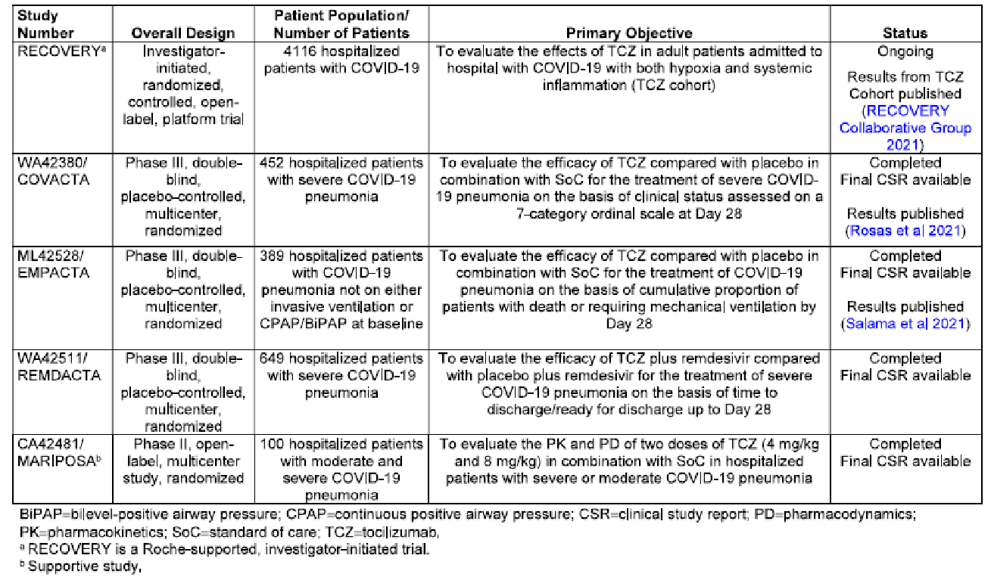

BIPAP = bi-level-positive airway pressure; CPAP = continuous positive airway pressure; CSR = clinical study report; PD = pharmacodynamics; PK = pharmacokinetics; SoC = standard of care; TCZ = tocilizumab

a: The Recovery trial is a sponsor-supported, investigator-initiated trial.

b: Supportive study.

Study WA42511, also known as the REMDACTA trial, has now been published.[3]

The Recovery trial[4] was considered pivotal as it provided the only statistically robust estimate of benefit for tocilizumab therapy. The Delegate noted that it was not a sponsor-initiated study, and so only the published version of the trial was available for review. While this is acceptable, it limits the extent of information available to the clinical evaluator and sponsor for review compared to a full regulatory submission. The remaining Phase III trials were, however, sponsor initiated.

#### Pharmacology

Of the two studies, the Delegate felt Study WA42380 (also known as the Covacta) provided more informative pharmacodynamic (PD) information as it is a Phase III randomised, double-blind, placebo-controlled trial and more closely matched the proposed clinical dosing. Details of submitted studies providing PK and PD data are listed in Table 3.

Table 3: Overview of studies contributing clinical pharmacology data

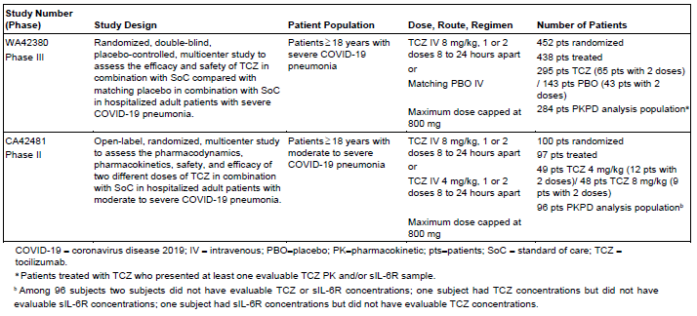

COVID-19 = coronavirus disease 2019; IV = intravenous; PBO = pharmacokinetic; pts = patients; SoC = standard of care; TCZ = tocilizumab.

a: Patients treated with tocilizumab who presented at least one evaluable tocilizumab pharmacokinetic and/or soluble interleukin-6 receptor sample.

b: Among 96 subjects, two subjects did not have evaluable tocilizumab or soluble interleukin-6 receptor concentrations; one subject had tocilizumab concentrations but did not have evaluable soluble interleukin-6 receptor concentrations; one subject had soluble interleukin-6 receptor concentrations but did not have evaluable tocilizumab concentrations.

In the Covacta trial (Study WA42380), tocilizumab concentrations peaked at the end of each infusion (1 or 2 doses) and declined to below the limit of quantification from Day 21 in patients who received one dose, and from Day 35 in patients who received two doses (see Figure 1).

Figure 1: Covacta trial (Study WA42380) Geometric mean (± geometric standard deviation) plot of serum tocilizumab concentration over time by dose group (Pharmacokinetic population)

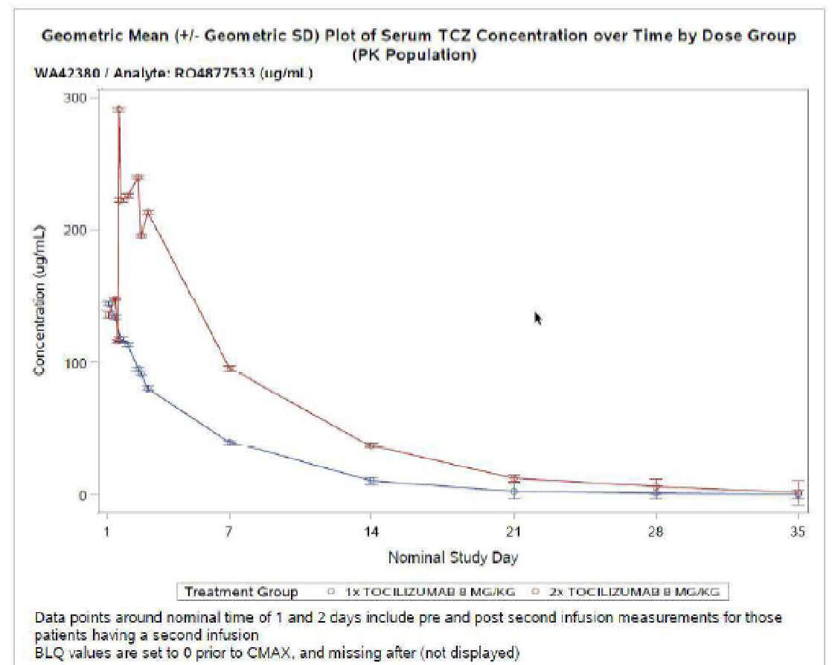

Soluble Interleukin-6 receptor (sIL-6R) concentrations increased rapidly after the first dose and continued to increase through Day 14 before declining to Day 60.

The following figure (Figure 2) describes the median C-reactive protein (CRP) concentration by visit after one dose.

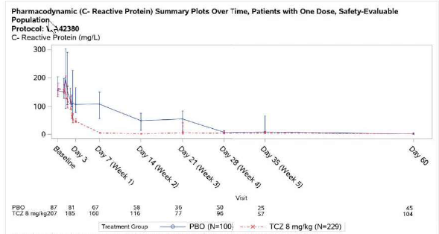Figure 2: Covacta trial (Study WA42380) Plot of median (± 95% confidence intervals) CRP concentration by visit after one dose of tocilizumab (Safety population)

Among patients who received tocilizumab with standard of care (n = 229), median CRP levels decreased slowly following administration and remained below upper limit of normal (ULN) from Day 7 to Day60. In the placebo with standard of care arm (n = 100), CRP levels decreased and normalised from Day 28 to Day60.

The Delegate noted that sIL-6R levels increased after tocilizumab administration, probably due to longer elimination half-life of the receptor/tocilizumab complex. Decreased CRP levels provides an indication of a lower level of functional IL-6 signalling after tocilizumab administration. Overall, this indicated that the effect of tocilizumab was its expected effect in reducing IL-6 signal transduction when administered to COVID-19 patients.

A population pharmacokinetic (PK) analysis was performed using data from the two pharmacology studies. This found that severity of COVID-19 measured on a 7-point scale had a significant influence on the clearance of tocilizumab, which increased 22.3% (95% confidence interval (CI) 21.2 to 23.4%) for each point of severity. Mechanical ventilation had no effect on PK parameters.

#### Efficacy

##### Pivotal trial

Pivotal efficacy data is provided by the randomised evaluation of COVID-19 therapy trial, also known as the Recovery trial. This is an ongoing adaptive and open‑label trial in which hospitalised patients with COVID-19 receive standard of care before being randomised to receive additional treatment from three active arms (A, B and C). Up to 21 days after the first randomisation, at the main (initial) randomisation , Recovery trial participants could undergo a second randomisation to tocilizumab therapy if they had had hypoxia (saturated oxygen level (SO2) < 92% on room air) and evidence of systemic inflammation (CRP ≥5 mg/L).

The Delegate noted that while participants could be randomised to tocilizumab up to 21 days after the first randomisation, in practice the median time to second randomisation was less than one day. The Delegate felt that this limited the potential biasing of effect which could have resulted from a prolonged initial treatment of patients before allocation to tocilizumab therapy.

A total of 21,550 patients were enrolled in the Recovery at the first randomisation and, between April 2020 and January 2021, 4116 adults were included in an assessment of tocilizumab cohort (see Figure 3). The primary outcome of the Recovery trial’s tocilizumab cohort was all-cause mortality 28 days after the second randomisation. A secondary endpoint was discharge from hospital within 28 days of second randomisation.

Figure 3: Recovery trial Participant recruitment, randomisation and allocation across the trial

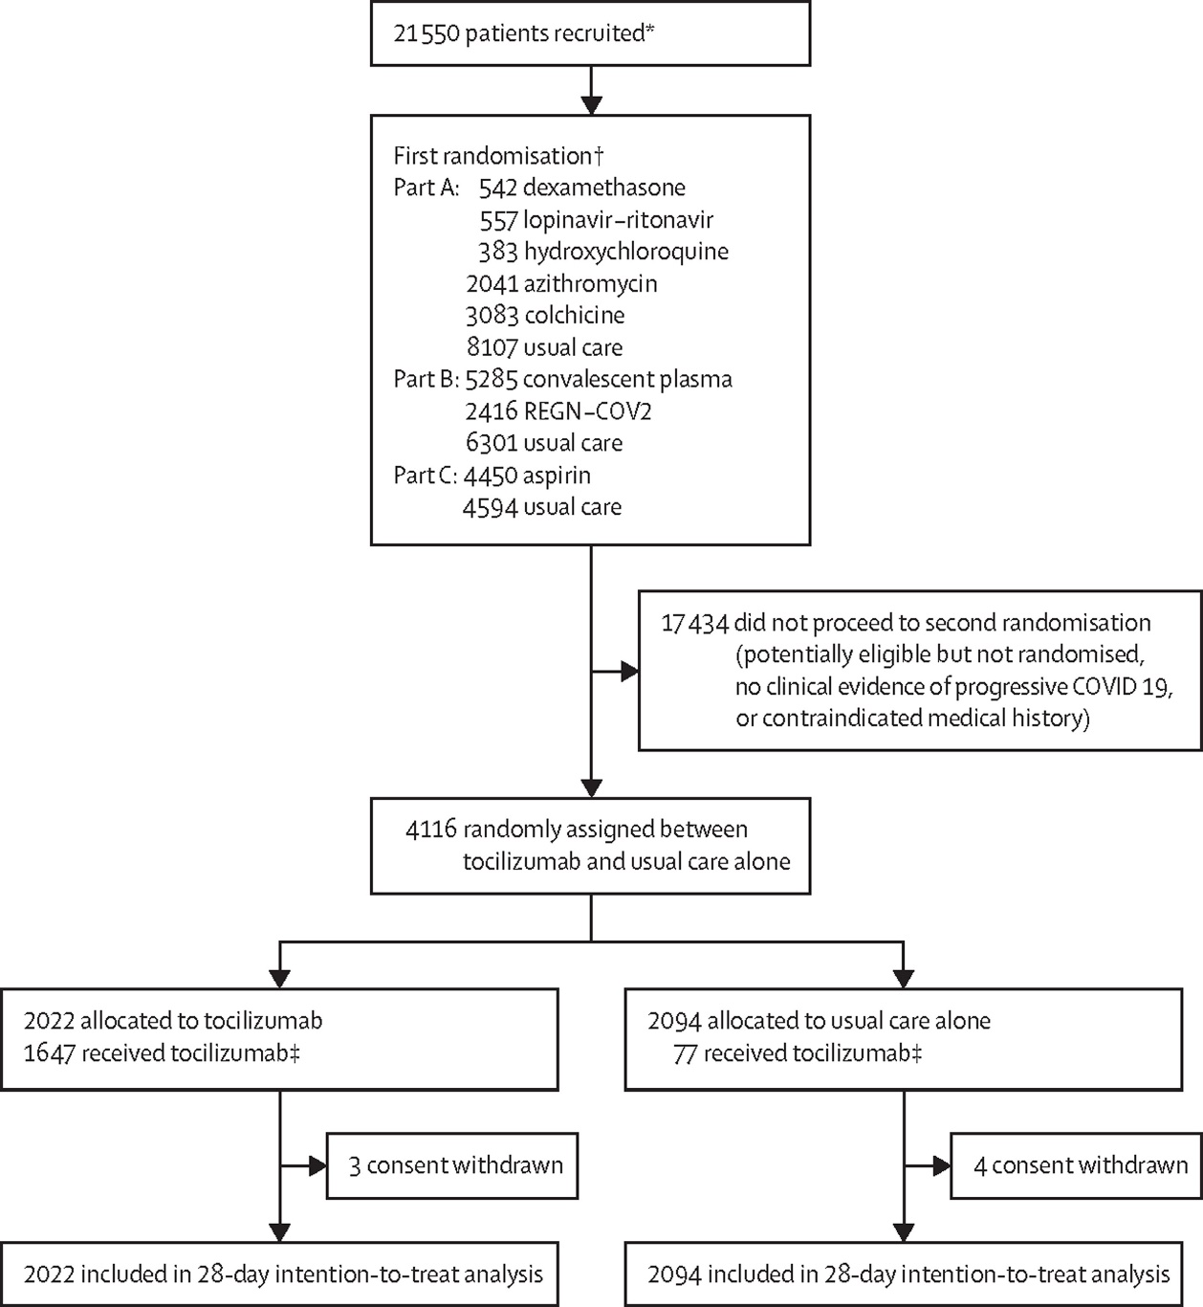

REGN-COV2 = a combination of two monoclonal antibodies directed against SARS-CoV-2 spike protein.

* Number of adult patients recruited at a site activated for the tocilizumab comparison.

† The first randomisation comprised up to three factorial elements such that an eligible patient could be entered into between one and three randomised comparisons, depending on the then current protocol, the patient's suitability for particular treatments, and the availability of the treatment at the site. Median time between first and second randomisation was 0·3 h (interquartile range: 0·1 to25·3).

‡ 1964 (97%) of 2022 patients of those allocated to tocilizumab and 2049 (98%) of 2094 of those allocated to usual care had a completed follow-up form at time of analysis.

Patients assigned to receive tocilizumab received a single infusion of tocilizumab over 60 minutes based on body weight (Table 3).[5]

Table 4: Recovery trial Body weight dosing of tocilizumab used in trial

|  |  |  |
| --- | --- | --- |
| Patient body weight range | Tocilizumab infusion dose | Dose/weight (or dose/weight range) |
| 90 kg or more | 800 mg | 8.88 mg/kg at 90 kg |
| 66 to 89 kg | 600 mg | 6.74 mg/kg to 9 mg/kg |
| 41to 65 kg | 400 mg | 6.15 mg/kg to 9.75 mg/kg |
| 40 kg or less | 8mg/kg | 8 mg/kg |

The Delegate noted that 82% of the patients allocated to either tocilizumab or usual care group were also receiving corticosteroids. In tocilizumab allocated patients, most of the enrolled population was relatively young for severe COVID disease (< 70 years) but with a relatively high rate of diabetes (28%), heart disease (22%) and chronic lung disease (23%). COVID vaccination status was not provided in this data, although the trial dates precede the widespread availability of vaccines (Table 5).

Table 5: Recovery trial Baseline characteristics of patients randomised to the tocilizumab group versus usual care group

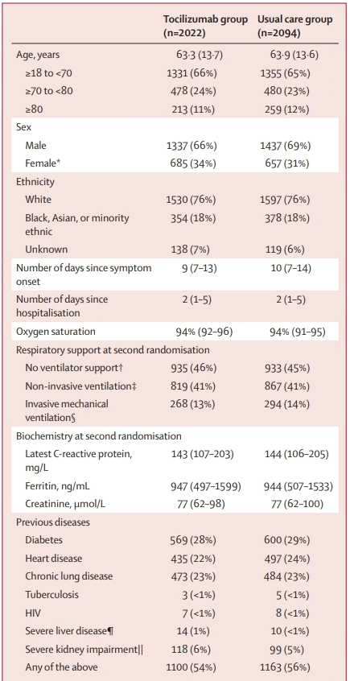

* Includes ten pregnant women.

† Includes nine patients not receiving any oxygen and 1859 patients receiving low-flow oxygen.

‡ Includes patients receiving high-flow nasal oxygen, continuous positive airway pressure, or other non-invasive ventilation.

§ Includes patients receiving invasive mechanical ventilation or extracorporeal membranous oxygenation.

¶ Defined as requiring ongoing specialist care. ||Defined as estimated glomerular filtration rate

The Recovery trial found significant reduction in 28-day mortality with tocilizumab (death rate ratio 0.85 (95% CI, 0.76 to 0.94)) (Table 6 and Figure 4).

Table 6: Recovery trial Assessment of tocilizumab efficacy for primary and secondary outcomes

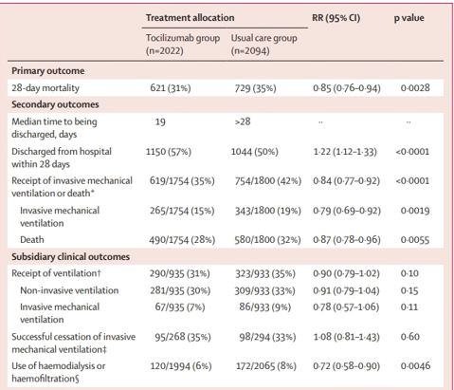

* Includes ten pregnant women.

‡ Includes patients receiving high-flow nasal oxygen, continuous positive airway pressure, or other non-invasive ventilation.

§ Includes patients receiving invasive mechanical ventilation or extracorporeal membranous oxygenation.

Figure 4: Recovery trial28-day mortality stratified by baseline characteristics for the tocilizumab versus usual care group 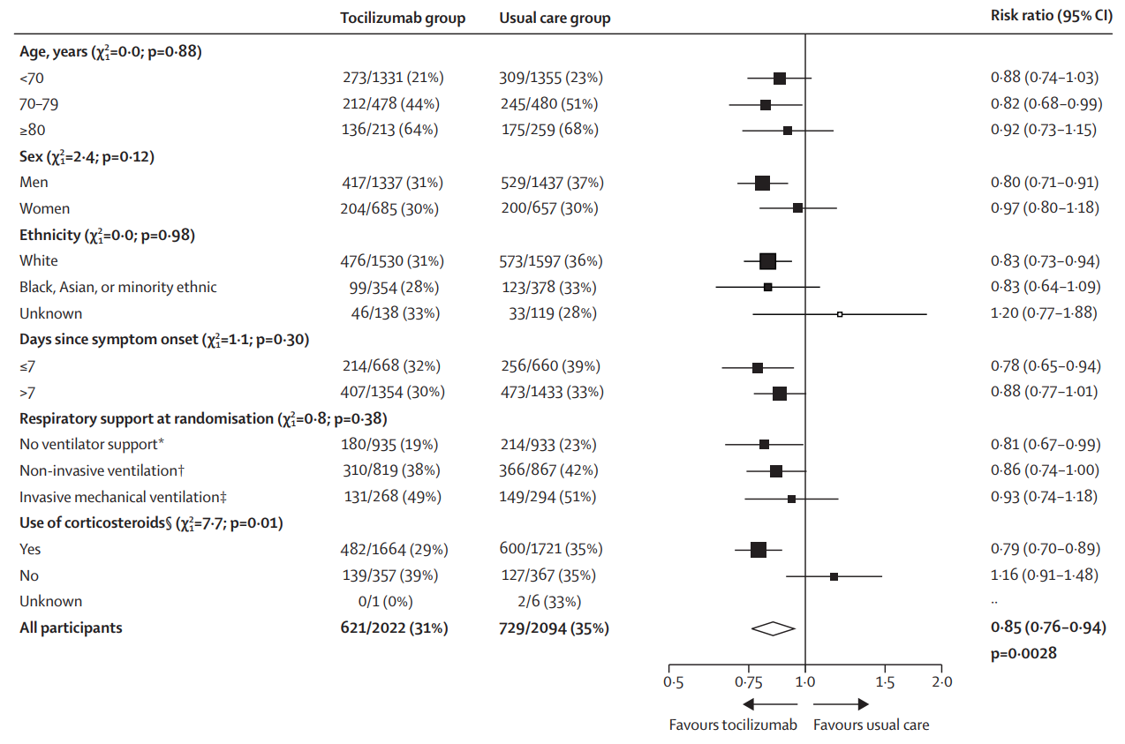

Effect of allocation to tocilizumab on 28-day mortality by baseline characteristics.

Subgroup-specific rate ratio estimates are represented by squares (with areas of the squares proportional to the amount of statistical information) and the lines through them correspond to the 95% CIs.

* Includes nine patients not receiving any oxygen and 1859 patients receiving simple oxygen only.

† Includes patients receiving high-flow nasal oxygen, continuous positive airway pressure ventilation, and other non-invasive ventilation. ‡Includes patients receiving invasive mechanical ventilation and extracorporeal membranous oxygenation. §Information on use of corticosteroids was collected from 18 June 2020, onwards following announcement of the results of the dexamethasone comparison from the Recovery trial. Participants undergoing first randomisation before this date (and who were not allocated to dexamethasone) are assumed not to be receiving systemic corticosteroids. In a model adjusted for all 6 baseline subgroups (in the categories shown) the overall rate ratio was 0·88 (95% CI 0·79 to 0·98).

The Delegate noted that the beneficial effect of tocilizumab is consistent across the strata analysed. When stratified for corticosteroid use, the benefit of tocilizumab therapy was only statistically significant for patients who were taking corticosteroids at Baseline.

#### Other efficacy data

The clinical evaluator reviewed the non-pivotal data from the three remaining Phase III trials, that is, the Covacta, Empacta and Remdacta trials (Studies WA42380, ML42528, and WA42511 respectively) and noted that these do not provide consistent or robust confirmation of the beneficial effect seen in the Recovery trial.

A meta-analysis has been provided across the Covacta, Empacta and Remdacta trials which included a total of 1489 patients, of whom 994 were allocated to tocilizumab and 495 were located to placebo (plus standard of care) therapy.

Figure 5: Meta-analysis (Phase III studies) Forest plot of time to death up to Day 28 (pooled modified intent to treat population)

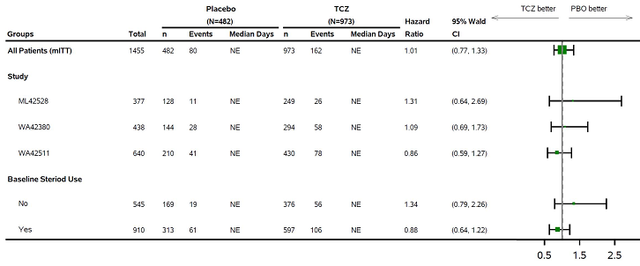

Summary of hazard ratio for time to death up to Day 28, pooled modified intent-to-treat population

Protocol: Study WA42380, Study ML42528, and Study WA42511

The pooled analysis does not provide more information on the significance of the results seen in Recovery trial. The analysis, however, remains non-statistically significant and the Delegate noted that the sample size in these three trials pooled remains lower than that in the Recovery trial alone.

A further pooled analysis including the Recovery trial with these three trials provided an estimated hazard ratio of death to 28 days of 0.87 (95% CI: 0.79 to 0.86) for tocilizumab versus placebo therapy (Figure 5). The Delegate noted that this result appears driven by the Recovery trial data and the estimate of effect is essentially the same that from the Recovery trial alone.

#### Safety

Safety data was available from all five clinical studies submitted, and the sponsor provided 60 day safety monitoring results from their Phase III studies (that is the Covacta, Empacta, Remdacta trials; or Studies WA42380, ML42528, and WA42511).

The effect of the Recovery trial on reducing all-cause mortality in tocilizumab treated patients is noted as an efficacy endpoint. This was mainly due to COVID-19 mortality, and mortality from other reasons was similar between tocilizumab and placebo arms.

Table 7 contains a meta-analysis of pooled adverse events of special interest from other Phase III studies.

Table 7: Meta-analysis of Roche-sponsored studies Summary of adverse events of special interest (Pooled safety population)

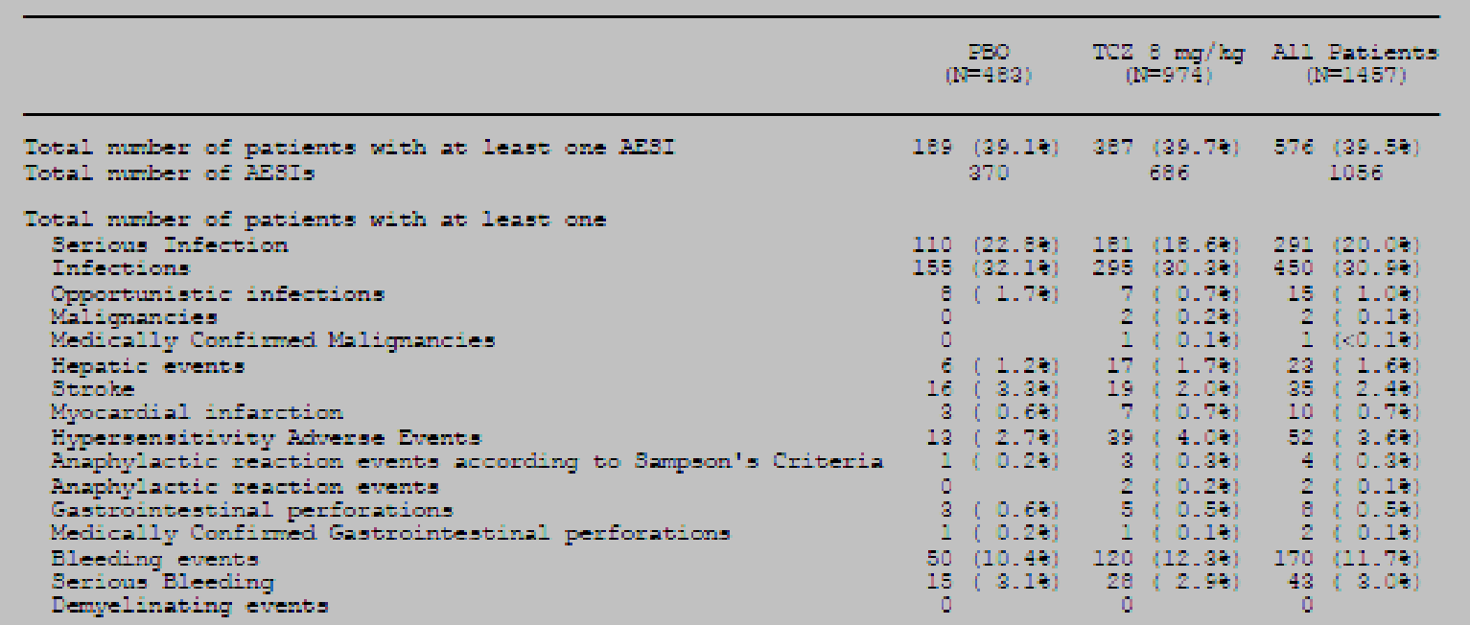

Table 8 summaries the laboratory abnormalities by worst Common Terminology Criteria for Adverse Events (CTCAE) at anytime up to Day 60.

Table 8: The Covacta, Empacta, Remdacta trials Summary of laboratory abnormalities by worst Common Terminology Criteria for Adverse Events at any time up to Day 60, by study (Safety evaluable populations)

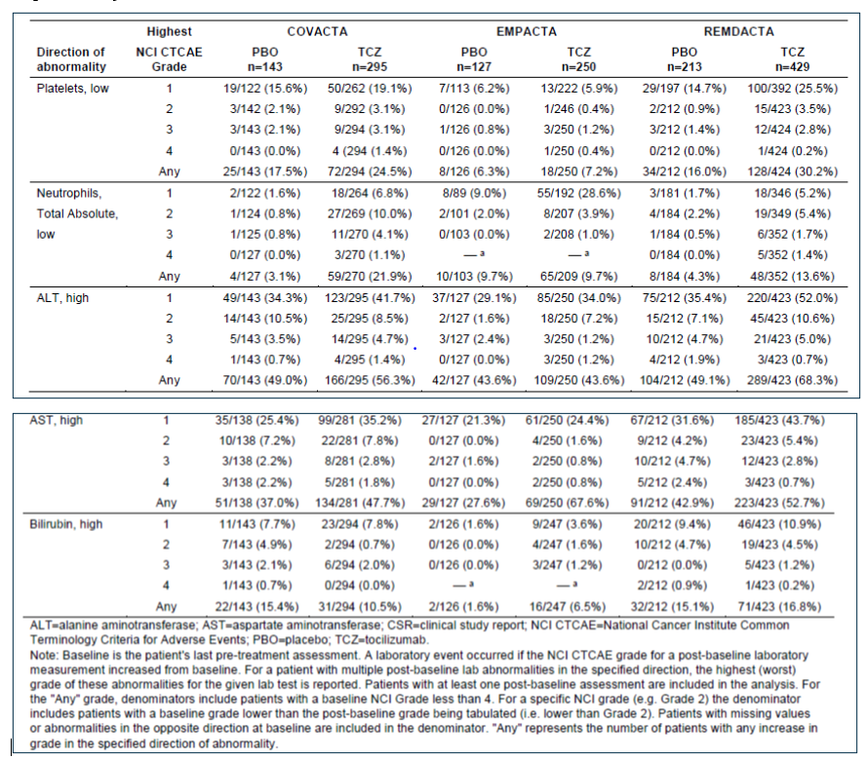

A potentially important observation in the Covacta trial was an apparent increase in the rate of haemorrhage in patients receiving tocilizumab compared to placebo. Bleeding events were higher in the tocilizumab arm (15.9% versus placebo 12.6%) including serious bleeding events (tocilizumab 4.4% versus placebo 3.5%): 7 patients, 6 in the tocilizumab and standard of care arm and one in the placebo and standard of care arm experienced Grade 5 (fatal) serious bleeding events (laboratory platelets low: any grade tocilizumab 24.5% versus placebo 17.5%).

The sponsor provided additional data on bleeding from the Recovery trial. The Delegate noted that this does not indicate a disparity in overall bleeding rates between the two treatment arms (2% in both cases). The sponsor has noted that there are many potential confounders to the Covacta trail observations, including the effects of COVID-19 on haemostasis, and that all tocilizumab patients who experienced bleeding were also receiving anticoagulants.

#### Clinical evaluator’s recommendation

The clinical evaluator has recommended a number of amendments to conditions of registration:

1. **A specific warning regarding the risk of bleeding**
2. **Amending the proposed indications to include the following:**

*The benefit of Actemra in COVID-19 patients who are not receiving systemic corticosteroids has not been established. Use of Actemra is not recommended in COVID‑19 patients who are not receiving systemic corticosteroids.*

*The decision has been made on the basis of short-term efficacy and limited safety data. Continued approval depends on the evidence of longer-term efficacy, safety from ongoing clinical trials and post-market assessment.*

1. **An amendment of the dosing instructions to allow a second infusion after 12 hours rather than the 8 hours proposed in the submission**

The Delegate’s response to all points raised above is summarised in the Delegate’s discussion, below.

### Risk management plan

The most recently evaluated European Union (EU)- risk management plan (RMP) was version 26.0 (dated 7 May 2020; data lock point (DLP) April 2020) and Australia-specific annex (ASA) version 13.0 (dated 14 December 2020). In support of the extended indications, the sponsor has submitted EU-RMP version 27.0 (dated 21 July 2021; DLP June 2021) and annotated copy of the ASA version 14.0 (date not provided). During the evaluation phase, a further updated ASA version 14.0 (date 4 October 2021) was provided.

The summary of safety concerns and their associated risk monitoring and mitigation strategies are summarised below in Table 9.

Table 9: Summary of safety concerns

|  |  |  |  |  |  |
| --- | --- | --- | --- | --- | --- |
| Summary of safety concerns | | Pharmacovigilance | | Risk Minimisation | |
| Routine | Additional | Routine | Additional |
| Important identified risks | Serious infection | ✔# | ✔‡ § | ✔ | – |
| Complications of diverticulitis | ✔# | ✔‡ § | ✔ | – |
| Serious hypersensitivity reactions | ✔# | ✔‡ | ✔ | ✔†,¶ |
| Neutropenia | ✔ | ✔‡ | ✔ | – |
| Hepatotoxicity | ✔# | ✔‡ | ✔ | ✔†¶ ǁ |
| Important potential risks | Thrombocytopenia and the potential risk of bleeding | ✔# | ✔‡ | ✔ | – |
| Elevated lipid levels and the potential risk of cardiovascular and cerebrovascular events | ✔# | ✔‡ | ✔ | – |
| Malignancies | ✔# | ✔‡ | ✔ | – |
| Demyelinating disorders | ✔# | ✔‡ | ✔ | – |
| Immunogenicity | – | – | ✔ | – |
| Missing information | None | – | – | – | – |

# Guided questionnaire; ‡ Long-term observational registry study; § Paediatric registry study for paediatric juvenile idiopathic arthritis. For rheumatoid arthritis, giant cell arteritis, paediatric juvenile idiopathic arthritis pJIA and systemic juvenile idiopathic arthritis indications; † Healthcare provider/professional information brochure and patient information brochure; ¶ Dosing guide; ǁ Direct healthcare professional communications.

The RMP evaluator has not raised objections to approval of this application.

The sponsor does not intend to provide further studies to support the conversion of a potential *Provisional* registration to a *Full* registration but has undertaken to provide updated results from the Recovery trial.

### Discussion

Treatment for severe COVID-19 has had to evolve rapidly and has involved the ‘re‑purposing’ of medicines to treat the manifestations of disease in the absence of effective antiviral medication. The Recovery trial is an adaptive study that has incorporated new potential models of COVID-19 management as they have been proposed by research into the pathophysiology of the infection. It is, therefore, a complex trial to analyse statistically and the Delegate noted that this is made more complex by not having full regulatory information available.

The Recovery trial is, however, the single adequately powered trial that supports the current application to provisionally register tocilizumab as a treatment for severe COVID-19 (that is, where patients are hospitalised and require either supplemental oxygen or ventilation). The Delegate noted that the absolute risk reduction in 28-day mortality observed in the Recovery trial is 4% (35% to 31%). This implies a number needed to treat for benefit of 25 patients.

#### Delegate’s response to clinical evaluator’s conditions of registration

The clinical evaluator has recommended a number of amendments to conditions of registration:

1. **A specific warning regarding the risk of bleeding**

The sponsor has noted that an increased rate of haemorrhage in tocilizumab treatment was only observed in one non-pivotal trial, and that in the Recovery trial, the rate of haemorrhage was the same between placebo and active treatment arms. Tocilizumab patients who experienced haemorrhage were receiving anti-coagulation medicines, which may have contributed to this adverse event. The Delegate noted that tocilizumab is known to potentially cause low platelet counts and hypofibrinogenaemia, and COVID-19 patients are anticoagulated because of the risk of thrombosis. The proposed warning does not appear to have been included in the FDA EUA professional information. The Delegate is therefore minded not to include this warning in the PI as it is considered the results of the Recovery trial do not require it.

1. **Amending the proposed indications to include:**

*The benefit of Actemra in COVID-19 patients who are not receiving systemic corticosteroids has not been established. Use of Actemra is not recommended in COVID‑19 patients who are not receiving systemic corticosteroids.*

*The decision has been made on the basis of short-term efficacy and limited safety data. Continued approval depends on the evidence of longer-term efficacy, safety from ongoing clinical trials and post-market assessment.*

The sponsor has noted that while the Recovery trial did not demonstrate statistically significant benefit in patients who had not received corticosteroid, neither did it show harm. Therefore, it is considered unnecessary to recommend against using tocilizumab in this group.

The sponsor has also noted that among patients receiving systemic corticosteroids at Baseline, the rate ratio for 28-day mortality was 0.79 (95% Cl: 0.70 to 0.89). Among the much smaller subgroup of patients not receiving systemic corticosteroids at baseline, the risk ratio was 1.16 (95% Cl: 0.91 to 1.48). Although the point estimate of the rate ratio was larger than 1 (favouring usual care), due to the smaller sample size, the 95% CI was wide and crossed ‘1’.

Given the number of hypothesis tests performed, the observed difference might have reflected the play of chance (multiplicity unadjusted interaction: p = 0.01; and Bonferroni‑corrected interaction: p = 0.06).

The sponsor’s argument is difficult to appreciate given that the direction of effect in the Recovery trial favours standard of care and so, presumably, achieving statistical significance would not recommend tocilizumab in the steroid-free population. As it is, it is a statistically insignificant result in this strata and further over-analysis should be avoided. It is clear that the beneficial effect of tocilizumab was proven in a population that overwhelmingly had received steroids, which is a matter of the external validity of these results rather than their statistical certainty.

However, the Delegate noted that corticosteroid therapy is now standard for severe COVID-19 (because of the earlier Recovery trial dexamethasone cohort results), and so the use of tocilizumab without steroids is likely to be unusual in the future. The Delegate felt that, as the indication stipulates patients who have received steroid therapy, a reciprocal contraindication is unnecessary.

The Delegate agreed with the clinical evaluator that the indication should include a statement to the effect that a *Provisional Approval* is based on limited information.

1. **Amendment of the dosing instructions to allow a second infusion after 12 hours rather than the 8 hours proposed in the submission**

The clinical evaluator has noted that, in the Recovery trial, the minimum period between infusions was 12 hours. The sponsor has noted in their response that they disagree with the proposed revision to limit the dosing regimen. The recommendation to allow for a second infusion at least 8 hours after the initial infusion is considered appropriate based on the totality of evidence from the Recovery and sponsor Phase III studies. In the sponsor studies, a second dose of tocilizumab 8 to 24 hours after the initial infusion was permitted if clinical signs or symptoms worsened or did not improve. Allowing for treatment from 8 hours post initial infusion will provide flexibility for prescribing physicians.

### Delegate’s considerations

The Delegate noted that the three sponsor studies provided no reliable demonstration of a treatment effect on mortality. Since the Recovery trial is pivotal to this submission, that would be the logical place to specify the dosing interval from this trial, which was 12 hours. The FDA EUA appears to nominate the 8-hour interval as proposed in this application.

Overall, the Delegate felt that, while the clinical evaluator has a point, given the long half‑life of this product the difference between 8 and 12 hours is not pharmacokinetically relevant. The second infusion is mainly an additional loading dose titrated against the clinically observed anti-inflammatory response to initial treatment, and the same total dose is likely to be achieved by either interval. The Delegate recommended that the 8 hourly minimum dosing interval is retained.

The safety of tocilizumab in COVID-19 treatment is not well described in the Recovery trial, and longer-term data would be welcome. However, tocilizumab is not a new chemical entity and many of the adverse events observed across all trials appear to be consistent with those which can occur in chronic treatment for rheumatoid arthritis and other autoimmune conditions. By comparison, treatment for severe COVID-19 is not expected to be long term (2 infusions) as it is an acute condition, and the main ‘safety’ outcome for tocilizumab therapy is the reduced mortality from COVID-19 itself. The Delegate therefore felt that the safety profile of tocilizumab is acceptable for use within the limited scope of severely compromised COVID-19 patients who are under hospital-level care.

#### Proposed action

The Delegate is currently minded to extend the Indications for Actemra (tocilizumab) to include:

*Actemra has provisional approval for the treatment of coronavirus disease 2019 (COVID-19) in hospitalised adults who are receiving systemic corticosteroids and require supplemental oxygen or mechanical ventilation.*

*Provisional approval has been made on the basis of short-term efficacy and safety data. Continued approval depends on the evidence of longer-term efficacy, safety from ongoing clinical trials and post-market assessment.*

With a PI document amended as specified in the clinical evaluation report with amendments outlined in the 3 points included in the Discussion section above.

The Delegate noted that advice of the Advisory Committee on Medicines (ACM) is sought on whether the degree of effect observed in the Recovery trial constitutes clinical meaningful efficacy, and the Delegate will consider the view of the ACM as determinative in this matter.

#### Questions for the sponsor

The sponsor provided the following response to questions from the Delegate.

##### Question 1

The Recovery trial provides a statistically significant demonstration of an absolute reduction in 28-day mortality of 4% in tocilizumab treated patients compared to usual care (31% versus 35% respectively). Advice is sought on whether the treatment effect observed in the Recovery trial constitutes clinically meaningful efficacy.

###### Sponsor’s response

The sponsor considers the observed mortality benefit associated with tocilizumab treatment to be clinically meaningful in the context of the global pandemic, which has resulted in more than 5 million deaths to date. Furthermore, tocilizumab treatment is associated with additional clinically meaningful benefits such as shortened hospital stay and reduced risk for progression to mechanical ventilation, which may also have important public health implications. These benefits, combined with a well-tolerated safety profile with no increased risk of infection, support the use of tocilizumab in the proposed patient population.

In the intent-to-treat (ITT) population of the Recovery trial, the 28-day mortality was 30.7% in the tocilizumab group versus 34.9% in the usual care group (rate ratio 0.85; 95% CI: 0.76, 0,94; p = 0·0028) [as per the appropriate Lancet (2021) paper]the absolute death rate difference at Day 28 (tocilizumab – usual care) was ‑4.13% (95%CI: -7.00%, -1.26%). Based on this mortality reduction, 25 treated patients are needed to save one life. In the pre-specified subgroup analysis, a greater mortality benefit was observed in patients who were on systemic corticosteroids at baseline, which is the proposed indicated population. Table 10 shows the higher absolute mortality difference (rate difference - 5.95%, 95% CI: 9.09% to -2.81%) observed in this subset of patients with a rate ratio of 0.79 (95% CI: 0.70, 0.89). Based on this mortality reduction, 17 treated patients are needed to save one life.

Table 10: All cause 28 day mortality in the intent to treat population; and by baseline corticosteroid use

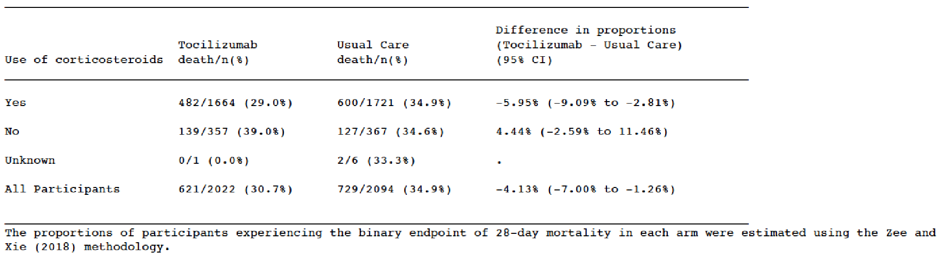Results from the Recovery trial were cited as ‘consistent evidence that tocilizumab, when administered with corticosteroids, offers a modest mortality benefit’ in the rationale for recommending tocilizumab in the US National Institutes of Health COVID treatment guidelines (https://www.covid19treatmentguidelines.nih.gov). Recommendations for the use of tocilizumab were also added to the Infectious Disease Society of America and United Kingdom National Institute for Health Care Excellence guidelines following the release of the Recovery trial results. Subsequently, the World Health Organization issued a guidance recommending IL-6 receptor blockers, including tocilizumab, for patients hospitalized with severe or critical COVID-19 based on their prospective meta-analysis of 27 randomised trials involving 10,930 patients; the recovery trial contributed 38% of the patients included in this meta-analysis. The rapid incorporation of tocilizumab into treatment guidelines globally demonstrates the clinical meaningfulness of the relatively small mortality benefit associated with tocilizumab in the Recovery trial. Furthermore, in June 2021, the totality of evidence from the Recovery and the 3 [sponsor-sponsored studies] (Covacta, Empacta and Remdacta trials) resulted in an FDA Emergency Use Authorization (EUA) of tocilizumab in the US for the treatment of hospitalised adults and paediatric patients (2 years of age and older) who are receiving systemic corticosteroids and require supplemental oxygen, non-invasive or invasive mechanical ventilation, or extracorporeal membrane oxygenation (ECMO).

An important point of reference is the mortality benefit associated with corticosteroids, which have been adopted as part of standard of care in severe COVID-19 management globally. In the RECOVERY dexamethasone cohort, a relatively small absolute reduction in 28-day mortality was detected in the dexamethasone arm compared to placebo group (22.9% vs 25.7% respectively) with a rate ratio of 0.83 (95% CI:0.75, 0.93; p<0.001) similar to the rate ratio from the Recovery trial tocilizumab cohort (rate ratio 0.85; 95% CI: 0.76, 0.94; p = 0·0028). It is worth emphasizing that the mortality benefit associated with tocilizumab in the Recovery trial among patients receiving corticosteroids at baseline is larger and is in addition to the mortality benefit associated with corticosteroids. To our knowledge, no other therapy has demonstrated a statistically significant mortality benefit in severe COVID-19 similar to that associated with tocilizumab.

Moreover, the clinical meaningfulness of the mortality benefit is supported by other clinically meaningful benefits that are of particular importance in the pandemic setting when healthcare resources may be limited. The Recovery trial and the sponson’s studies consistently demonstrated that patients treated with tocilizumab were discharged sooner and had a lower likelihood of progression to mechanical ventilation (in those not ventilated at baseline). Importantly, the robust safety evidence from the double-blind and placebo-controlled Roche studies indicated a consistent safety profile between tocilizumab and placebo with no increased risk of infection and no new safety signals.

In summary, the observed relatively small mortality benefit demonstrated in the Recovery trial is clinically meaningful and can result in many lives saved in the context of the ongoing global pandemic. This clinical meaningfulness is reflected in the adoption of tocilizumab use in global treatment guidelines for severe COVID-19 patients and in the US EUA. Furthermore, tocilizumab is associated with other important clinically meaningful benefits and no safety concerns.

#### Advisory Committee considerations[6]

The Advisory Committee on Medicines (ACM), having considered the evaluations and the Delegate’s overview, as well as the sponsor’s response to these documents, advised the following.

##### Specific advice to the Delegate

The ACM advised the following in response to the Delegate’s specific request for advice:

1. ***The Recovery trial provides a statistically significant demonstration of an absolute reduction in 28-day mortality of 4% in tocilizumab treated patients compared to placebo (31% versus 35% respectively).***

***Advice is sought on whether the treatment effect observed in the Recovery trial constitutes clinically meaningful efficacy.***

The ACM was of the view that the primary trial endpoint of 28-day mortality is a relatively short timeframe for this severely unwell population, highlighting that 43% of the trial participants who received tocilizumab were still in hospital at day 28.

The ACM noted that disease modulation generally occurs over a long period of time, with clinical practice suggesting that a significant proportion of COVID-19 mortality occurs after 28 days.

On balance, the ACM acknowledged that severe COVID-19 is a serious and difficult to treat disease with a high mortality rate. The ACM agreed that a 4% absolute reduction in 28-day mortality is clinically meaningful within this provisional registration context.

The ACM recommended that the number needed to treat (NNT) be included within the PI.

1. ***Other advice.***

The ACM was supportive of provisional registration with the expectation that long-term data is provided in alignment with the provisional registration requirements.

The ACM discussed the option for repeat dosing within 8 to 12 hours. They were unsure of the logic of a second dose and expressed some concern about the limited clarity regarding situations where a second dose is warranted. The ACM reiterated that severe COVID-19 is a condition that has a slow progression and slow recovery, often with prolonged ICU and hospital admission. Based on this, the ACM was of the view that repeat dosing should be removed from the dosing instructions in the PI as the use of a second dose within 8 to 12 hours does not appear warranted based on current data.

The ACM noted that the Recovery trial recruited participants with an inflammatory phenotype and were supportive of the clinical trials section of the PI indicating that trial inclusion criteria included CRP ≥ 75 mg/L. The ACM discussed inclusion of a CRP ≥ 75 mg/L cut-off in the indication, however on balance were supportive of this statement remaining within the clinical trials section of the PI until further data are available.

The ACM noted that the Recovery trial was completed prior to widespread availability of COVID-19 vaccination. The ACM discussed the potential impact of vaccination status on results and indicated that there are currently no data to understand the use of tocilizumab in vaccinated patients.

The ACM emphasised that this therapy is not an alternative or substitute for vaccination. The ACM reiterated its view that vaccination is the preferred and primary option to prevent COVID-19.

##### Conclusion

The ACM considered this product to have an overall positive benefit-risk profile for the indication:

*ACTEMRA has provisional approval for the treatment of coronavirus disease 2019 (COVID-19) in hospitalised adults who are receiving systemic corticosteroids and require supplemental oxygen or mechanical ventilation.*

*Provisional approval has been made on the basis of short-term efficacy and safety data. Continued approval depends on the evidence of longer-term efficacy, safety from ongoing clinical trials and post-market assessment.*

### Outcome

Based on a review of quality, safety and efficacy, the TGA approved the registration of Actemra (tocilizumab (rch)) 400 mg/20 mL, 80 mg/4 mL, 200 mg/10 mL, concentrated injection, vial, indicated for the following extension of indications:

***Coronavirus disease 2019 (COVID-19) (IV formulation only)***

*Actemra has provisional approval for the treatment of coronavirus disease 2019 (COVID-19) in hospitalised adults who are receiving systemic corticosteroids and require supplemental oxygen or mechanical ventilation.*

*Provisional approval has been made on the basis of short-term efficacy and safety data. Continued approval depends on the evidence of longer-term efficacy and safety from ongoing clinical trials and post-market assessment.*

As such, the full indications at this time were:

***Rheumatoid Arthritis (IV and SC formulations)***

*Actemra is indicated for the treatment of moderate to severe active rheumatoid arthritis (RA) in adult patients in combination with methotrexate (MTX) or other nonbiological disease-modifying anti-rheumatic drugs (DMARDs) in case of either an inadequate response or intolerance to previous therapy with one or more DMARDs.*

*Actemra is indicated for the treatment of moderate to severe active rheumatoid arthritis in adult patients with poor prognostic factors (see section 5.1 Pharmacodynamic Properties, Clinical Trials) in combination with MTX in those not previously treated with MTX.*

*In the two groups of patients above, Actemra can be given as monotherapy in case of intolerance to MTX or where continued treatment with MTX is inappropriate.*

*Actemra has been shown to inhibit the progression of joint damage in adults, as measured by X-ray, when given in combination with methotrexate.*

***Giant Cell Arteritis (SC formulations only)***

*Actemra is indicated for the treatment of giant cell arteritis (GCA) in adult patients.*

***Coronavirus disease 2019 (COVID-19) (IV formulation only)***

*Actemra has provisional approval for the treatment of coronavirus disease 2019 (COVID-19) in hospitalised adults who are receiving systemic corticosteroids and require supplemental oxygen or mechanical ventilation.*

*Provisional approval has been made on the basis of short-term efficacy and safety data. Continued approval depends on the evidence of longer-term efficacy and safety from ongoing clinical trials and post-market assessment.*

***Polyarticular Juvenile Idiopathic Arthritis (IV and SC formulations)***

*Actemra is indicated for the treatment of moderate to severe active polyarticular juvenile idiopathic arthritis in patients 2 years of age and older who have had an inadequate response to or intolerance to methotrexate (MTX). Actemra can be given alone or in combination with MTX.*

***Systemic Juvenile Idiopathic Arthritis (IV and SC formulations)***

*Intravenous formulation*

*Actemra is indicated for the treatment of active systemic juvenile idiopathic arthritis in patients 2 years of age and older.*

*Subcutaneous formulation*

*Actemra is indicated for the treatment of active systemic juvenile idiopathic arthritis in patients 1 year of age and older.*

*Actemra IV and SC can be given alone or in combination with methotrexate (MTX).*

***Cytokine Release Syndrome (CRS) (IV formulation only)***

*Actemra is indicated for the treatment of chimeric antigen receptor (CAR) T cell-induced severe or life-threatening cytokine release syndrome (CRS) in adults and paediatric patients 2 years of age and older.*

#### Specific conditions of registration applying to these goods

Actemra (tocilizumab) is to be included in the Black Triangle Scheme. The PI and CMI for Actemra must include the Black Triangle symbol and mandatory accompanying text for the products entire period of provisional registration.

Any changes to which the sponsor has agreed should be included in a revised RMP and ASA. However, irrespective of whether or not they are included in the currently available version of the RMP document, the agreed changes become part of the risk management system.

The Actemra EU-Risk Management Plan (RMP) (version 27.0, dated 21 July 2021; DLP June 2021), with Australian Specific Annex (version 14.0, dated 4 October 2021), included with submission PM-2021-04601-1-2, and any subsequent revisions, as agreed with the TGA will be implemented in Australia.

An obligatory component of risk management plans is routine pharmacovigilance. Routine pharmacovigilance includes the submission of periodic safety update reports (PSURs).

Unless agreed separately between the supplier who is the recipient of the approval and the TGA, the first report must be submitted to TGA no later than 15 calendar months after the date of this approval letter. The subsequent reports must be submitted no less frequently than annually from the date of the first submitted report until the period covered by such reports is not less than three years from the date of this approval letter, or the entire period of provisional registration, whichever is longer.

If the product is approved in the EU for the indication of treatment of COVID-19, safety reports (monthly summary safety reports if applicable, and PSURs) are to be provided in line with the published list of EU reference dates.

The reports are to at least meet the requirements for PSURs as described in the European Medicines Agency’s Guideline on good pharmacovigilance practices (GVP) Module VII-periodic safety update report (Rev 1), Part VII.B Structures and processes. Note that submission of a PSUR does not constitute an application to vary the registration. Each report must have been prepared within ninety calendar days of the data lock point for that report.

For all injectable products the PI must be included with the product as a package insert.

## Attachment 1. Product Information

The PI for Actemra approved with the submission which is described in this AusPAR is at Attachment 1. For the most recent PI, please refer to the TGA website at <<https://www.tga.gov.au/product-information-pi>>.

|  |
| --- |
| Therapeutic Goods Administration |
| PO Box 100 Woden ACT 2606 Australia  Email: [info@tga.gov.au](mailto:info@tga.gov.au) Phone: 1800 020 653 Fax: 02 6232 8605  [**https://www.tga.gov.au**](https://www.tga.gov.au) |

1. The **Black Triangle Scheme** provides a simple means for practitioners and patients to identify certain types of new prescription medicines, including those being used in new ways and to encourage the reporting of adverse events associated with their use. The Black Triangle does not denote that there are known safety problems, just that the TGA is encouraging adverse event reporting to help us build up the full picture of a medicine's safety profile.
2. As part of the **provisional approval pathway**, the provisional registration process will allow certain medicines to be provisionally registered in the Australian Register of Therapeutic Goods (ARTG) for a limited duration. These medicines are registered on the basis of preliminary clinical data, where the benefit of early availability of the medicine outweighs the risk inherent in the fact that additional data are still required.
3. Available from: https://link.springer.com/article/10.1007%2Fs00134-021-06507-x
4. University of Oxford initiated trial. ClinicalTrials.gov Identifier: NCT04381936
5. Sponsor clarification: A second dose could be given 12 to 24 hours later if, in the opinion of the attending clinician, the patient's condition had not improved. 29% of tocilizumab patients received a second dose.
6. The ACM provides independent medical and scientific advice to the Minister for Health and the Therapeutic Goods Administration (TGA) on issues relating to the safety, quality and efficacy of medicines supplied in Australia including issues relating to pre-market and post-market functions for medicines. Further information on TGA statutory advisory committees can be found here: <https://www.tga.gov.au/tga-statutory-advisory-committees>.