|  |
| --- |
| **First round 26 May 2016**  **Second round 31 October 2016** |

|  |
| --- |
| AusPAR Attachment 2 |
| Extract from the Clinical Evaluation Report for Tolvaptan |
| Proprietary Product Name: Jinarc |
| Sponsor: Otsuka Australia Pharmaceutical Pty Ltd |

About the Therapeutic Goods Administration (TGA)

* The Therapeutic Goods Administration (TGA) is part of the Australian Government Department of Health, and is responsible for regulating medicines and medical devices.
* The TGA administers the *Therapeutic Goods Act 1989* (the Act), applying a risk management approach designed to ensure therapeutic goods supplied in Australia meet acceptable standards of quality, safety and efficacy (performance), when necessary.
* The work of the TGA is based on applying scientific and clinical expertise to decision-making, to ensure that the benefits to consumers outweigh any risks associated with the use of medicines and medical devices.
* The TGA relies on the public, healthcare professionals and industry to report problems with medicines or medical devices. TGA investigates reports received by it to determine any necessary regulatory action.
* To report a problem with a medicine or medical device, please see the information on the TGA website <<https://www.tga.gov.au>>.

About the Extract from the Clinical Evaluation Report

* This document provides a more detailed evaluation of the clinical findings, extracted from the Clinical Evaluation Report (CER) prepared by the TGA. This extract does not include sections from the CER regarding product documentation or post market activities.
* The words [Information redacted], where they appear in this document, indicate that confidential information has been deleted.
* For the most recent Product Information (PI), please refer to the TGA website <<https://www.tga.gov.au/product-information-pi>>.

Copyright

© Commonwealth of Australia 2018  
This work is copyright. You may reproduce the whole or part of this work in unaltered form for your own personal use or, if you are part of an organisation, for internal use within your organisation, but only if you or your organisation do not use the reproduction for any commercial purpose and retain this copyright notice and all disclaimer notices as part of that reproduction. Apart from rights to use as permitted by the *Copyright Act 1968* or allowed by this copyright notice, all other rights are reserved and you are not allowed to reproduce the whole or any part of this work in any way (electronic or otherwise) without first being given specific written permission from the Commonwealth to do so. Requests and inquiries concerning reproduction and rights are to be sent to the TGA Copyright Officer, Therapeutic Goods Administration, PO Box 100, Woden ACT 2606 or emailed to <[tga.copyright@tga.gov.au](mailto:tga.copyright@tga.gov.au)>.

Contents

List of abbreviations 5

1. Introduction 8

1.1. Drug class and therapeutic indication 8

1.2. Dosage forms and strengths 8

1.3. Dosage and administration 8

2. Clinical rationale 9

2.1. Orphan drug designation 9

3. Contents of the clinical dossier 9

3.1. Scope of the clinical dossier 9

3.2. Paediatric data 11

3.3. Good clinical practice 11

4. Pharmacokinetics 11

4.1. Studies providing pharmacokinetic data 11

4.2. Summary of pharmacokinetics 12

4.3. Evaluator’s overall conclusions on pharmacokinetics 18

5. Pharmacodynamics 18

5.1. Studies providing pharmacodynamic data 18

5.2. Summary of pharmacodynamics 20

5.3. Evaluator’s overall conclusions on pharmacodynamics 21

6. Dosage selection for the pivotal studies 21

7. Clinical efficacy 21

7.1. Pivotal efficacy Study (156-04-251) 21

7.2. Other efficacy studies 36

7.3. Analyses performed across trials (pooled analyses and meta-analyses) 43

7.4. Evaluator’s conclusions on clinical efficacy 44

8. Clinical safety 46

8.1. Studies providing evaluable safety data 46

8.2. Patient exposure 47

8.3. Adverse events 49

8.4. Laboratory tests 59

Additional studies 65

8.5. 65

8.6. Post-marketing experience 66

8.7. Safety issues with the potential for major regulatory impact 66

8.8. Other safety issues 67

8.9. Evaluator’s overall conclusions on clinical safety 67

9. First round benefit-risk assessment 67

9.1. First round assessment of benefits 67

9.2. First round assessment of risks 68

9.3. First round assessment of benefit-risk balance 68

10. First round recommendation regarding authorisation 69

11. Clinical questions 69

11.1. Efficacy 69

11.2. Safety 69

12. Second round evaluation of clinical data submitted in response to questions 69

13. Second round benefit-risk assessment 77

13.1. Second round assessment of benefits 77

13.2. Second round assessment of risks 78

13.3. Second round assessment of benefit-risk balance 78

14. Second round recommendation regarding authorisation 80

15. References 81

## List of abbreviations

| Abbreviation | Meaning |
| --- | --- |
| ADPKD | Autosomal Dominant Polycystic Kidney Disease |
| AE | Adverse Event |
| ALKP | Alkaline Phosphatase |
| ALT | Alanine Transaminase |
| aPTT | activated partial thromboplastin time |
| ARTG | Australian Register of Therapeutic Goods |
| AST | Aspartate Transaminase |
| AUC | Area under the curve |
| BD | Twice daily |
| BP | Blood pressure |
| BT | Total Bilirubin |
| cAMP | Cyclic adenosine monophosphate |
| CI | Confidence interval |
| CKD | Chronic Kidney Disease |
| Cmax | Maximum concentration |
| CMI | Consumer Medicines Information |
| CL | Clearance |
| CrCl | Creatinine clearance |
| CT | X-Ray Computed Tomography |
| CV | Coefficient of variation |
| dBP | Diastolic blood pressure |
| DILI | Drug-induced liver injury |
| ECG | Electrocardiograph |
| eCrCl | Estimated creatinine clearance |
| eGFR | Estimated glomerular filtration rate |
| EMA | European Medicines Agency |
| FDA | Food and Drug Administration |
| GCP | Good Clinical Practice |
| GFR | Glomerular Filtration Rate |
| ICH | International Conference on Harmonisation |
| INR | International normalised ratio |
| IV | Intravenous |
| L | Litre(s) |
| LDH | Lactate Dehydrogenase |
| LFTs | Liver function tests |
| LLoQ | Lower limit of Quantification |
| MAP | Mean arterial pressure |
| MED | Minimally effective dose |
| MEDRA | Medical dictionary for regulatory activities |
| Mg | Milligram(s) |
| mOsm | Milliosmoles |
| MRI | Magnetic Resonance Imaging |
| MTD | Maximum Tolerated Dose |
| OD | Once daily |
| PD | Pharmacodynamics |
| PI | Product Information |
| PK | Pharmacokinetics |
| RBF | Renal blood flow |
| SAE | Serious Adverse Event |
| sBP | Systolic blood pressure |
| SCS | Summary of Clinical Safety |
| TGA | Therapeutic Goods Administration |
| TKV | Total kidney volume |
| Tmax | Time of maximum concentration |
| ULN | Upper limit of normal |
| Vss | Volume of distribution at steady state |

## Introduction

This is an abbreviated submission to register a new indication for tolvaptan. The submission also proposes a new trade name for the product and the registration of additional strengths.

### Drug class and therapeutic indication

Tolvaptan is an antagonist of the vasopressin V2 receptor.

Tolvaptan is currently registered in Australia under the trade name Samsca. The approved indication is:

*“Samsca is indicated for the treatment of clinically significant hypervolemic or euvolemic hyponatremia (serum sodium less than 125 mmol/L, or less marked hyponatremia that is symptomatic and has resisted correction with fluid restriction) including patients with heart failure and Syndrome of Inappropriate Antidiuretic Hormone (SIADH).*

*Important Limitations*

*Patients requiring intervention to raise serum sodium urgently to prevent or to treat serious neurological symptoms should not be treated with Samsca. It has not been established that raising serum sodium with Samsca provides a symptomatic benefit to patients.”*

It is proposed to register the new indication for tolvaptan under a new trade name (Jinarc). The proposed new indication is:

*Jinarc is indicated to slow the progression of cyst development and renal insufficiency of autosomal dominant polycystic kidney disease (ADPKD) in adults with CKD stage 1 to 3 at initiation of treatment with evidence of rapidly progressing disease (see PHARMACOLOGY).*

### Dosage forms and strengths

Samsca is registered as immediate release tablets in two strengths; 15 and 30 mg.

For Jinarc, it is proposed to register immediate release tablets in five strengths; 15, 30, 45, 60 and 90 mg.

### Dosage and administration

The proposed dosage regimen for Jinarc is a twice-daily regime, with the first dose taken upon wakening and the second dose 8 hours later. Three dose levels are proposed:

* 45 mg + 15 mg (total 60 mg/day);
* 60 mg + 30 mg (total 90 mg/day);
* 90 mg + 30 mg (total 120 mg/day).

The morning dose is to be taken at least 30 minutes before the morning meal. The second dose can be taken with or without food.

The proposed starting dose is the 45 + 15 regimen. The dose is then titrated upwards (with at least weekly intervals between titrations) through the two higher regimens. Patients are maintained on the highest dose regimen tolerated. Treatment is to continue indefinitely.

The currently approved regimen for Samsca is a starting dose of 15 mg once daily, increasing up to a maximum of 60 mg once daily. Administration for more than 30 days is not recommended due to the risk of hepatic toxicity.

## Clinical rationale

Autosomal dominant polycystic kidney disease (ADPKD) is an inherited disorder characterised by the formation of multiple fluid filled cysts in the kidneys. The cysts develop from mutated tubular epithelial cells scattered throughout the kidney. It is caused by a mutation in one of two genes (PKD1 or PKD2) which encode transmembrane proteins (polycystin 1 and polycystin 2 respectively) involved in the regulation of tubular and vascular development in the kidneys and other organs. Mutations in PKD1 are more common, accounting for 85% of ADPKD cases. (1)

Clinical manifestations of ADPKD are highly variable. Common features include hypertension, flank pain, haematuria, pyelonephritis and renal cyst infections. Renal failure requiring dialysis develops in approximately 50% of subjects, usually between the ages of 30 and 60 years (1). Adverse prognostic factors for disease progression include PKD1 mutation, increased age, male sex, impaired renal function and higher total kidney volume. (2) Extrarenal manifestations include polycystic liver disease, cysts in other organs (for example pancreas, seminal vesicles), intracranial and coronary artery aneurysms and mitral valve prolapse (3).

In ADPKD, cyclic AMP (cAMP) is known to promote abnormal cyst cell proliferation and secretion of fluid into the cysts, and vasopressin is a potent activator of renal adenyl cyclase, the enzyme responsible for conversion of ATP to cAMP. (1) ADPKD is also associated with upregulation of the vasopressin V2 receptor and increased circulating levels of vasopressin. (3) The rationale for the clinical development of tolvaptan as a treatment for ADPKD is therefore based on the drug’s ability to inhibit the effects of vasopressin through inhibition of the vasopressin V2 receptor.

There are currently no drugs registered in Australia for the treatment of ADPKD.

### Orphan drug designation

Tolvaptan has not been designated as an orphan drug by the TGA for the new indication.

## Contents of the clinical dossier

### Scope of the clinical dossier

The submission included a large number of studies that had previously been evaluated by the TGA in considering the registration application for Samsca. These studies have not been reviewed in this report. The previously evaluated studies which were included in the current submission are listed in Table 1. None of these studies were conducted in subjects with ADPKD. It should be noted that several of these studies were identified by the sponsor as new studies, in the table of contents for the submission. However, review of the previous clinical evaluation report indicates that these studies have already been evaluated by the TGA.

Table 1: Previously evaluated studies included in the submission

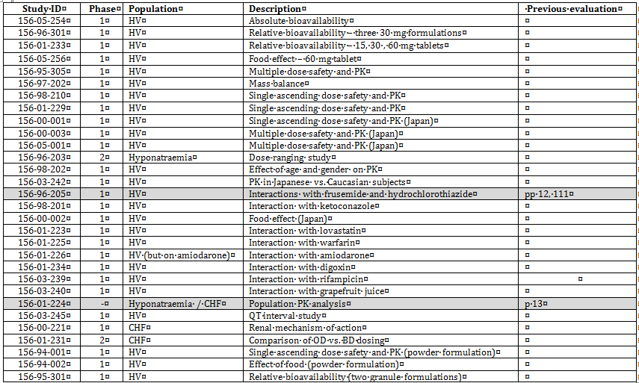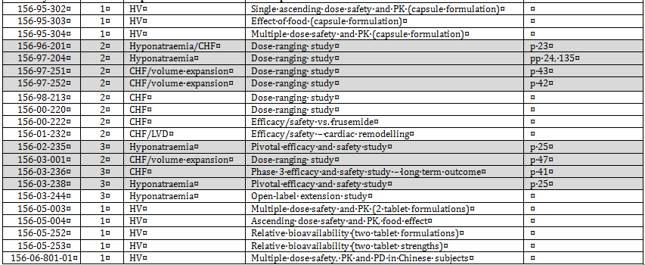

Shaded studies were identified by the sponsor as being not previously evaluated by the TGA. However, examination of the previous clinical evaluation report indicates that they have been previously evaluated

The submission contained the following new clinical information:

* 10 clinical pharmacology studies, that in general provided both pharmacokinetic pharmacodynamic data.
* 1 population pharmacokinetic and pharmacokinetic/pharmacodynamic analysis (Study 156-11-296).
* 1 pivotal Phase III efficacy/safety study (Study 156-04-251).
* 5 open label long term extension efficacy/safety studies. Three of these were designated as Phase III studies (156-08-271, 156-09-003 and 156-10-003) and two were designated as Phase II studies (156-05-002 and 156-04-250).
* 1 pooled analysis of efficacy data from two of the extension studies (Study 156-09-283).
* 2 studies in subjects with other indications which have not previously been reviewed by the TGA (156-03-002 and 156-04-247). The safety data from these 2 studies are reviewed in this evaluation.
* Literature references.
* Clinical Overview, Summary of Biopharmaceutics, Summary of Clinical Pharmacology, Summary of Clinical Efficacy and Summary of Clinical Safety. Supplementary tables and figures for the summaries were included in the clinical dossier.

### Paediatric data

The submission did not include paediatric data. The sponsor has received a waiver for paediatric data from the FDA on the grounds that the drug has received orphan designation for the treatment of ADPKD. The sponsor has an agreed paediatric investigation plan (PIP) with the EMA in Europe, which includes the conduct of studies in children with polycystic kidney disease (both autosomal dominant and autosomal recessive). The plan is due to be completed by November 2020 (7).

### Good clinical practice

The clinical study reports in the submission all contained an assurance that they were conducted in accordance with Good Clinical Practice (GCP) guidelines (usually the ICH guideline) and in accordance with the principles of the Declaration of Helsinki.

## Pharmacokinetics

### Studies providing pharmacokinetic data

The submission largely relies on previously evaluated PK data from the application to register Samsca. However, some new studies containing PK data have been submitted. Summaries of the new pharmacokinetic studies were provided. Table 2 shows the new studies relating to each pharmacokinetic topic.

Table 2: New submitted pharmacokinetic studies

| PK topic | Subtopic | Study ID | * |
| --- | --- | --- | --- |
| PK in healthy adults | General PK |  |  |
| Single dose (45 + 15 split dose) | 156-07-262 |  |
| Single dose (Korean subjects) | 156-KOA-0801 | * |
| Bioequivalence† - Single dose | 156-11-295 | * |
| Food effect | 156-11-295 | * |
| PK in renal impairment | 156-09-282 | * |
| PK in ADPKD subjects | General PK |  |  |
| -Single dose | 156-04-248 | * |
| -Multiple dose | 156-04-001 | * |
| -Multiple dose | 156-04-249 | * |
| -Multiple dose (90 + 30 split dose) | 156-09-285 |  |
| Renal impairment | 156-06-260  156-09-284 |  |
| Population PK and PK/PD analyses | ADPKD subjects | 156-11-296 | * |

* Indicates the primary aim of the study. † Bioequivalence of different formulations.

None of these pharmacokinetic studies had deficiencies that excluded their results from consideration.

There were two studies listed in the table of contents for the submission as studies not previously evaluated by the TGA. However, both of these have in fact been previously reviewed by the TGA and are therefore not reviewed in this report. These studies are listed in Table 3.

Table 3: Pharmacokinetic studies not evaluated

| Study ID | Subtopic(s) |
| --- | --- |
| 156-96-205 | Interactions with frusemide and hydrochlorothiazide |
| 156-01-224 | Population PK analysis in subjects with hyponatraemia or heart failure. |

### Summary of pharmacokinetics

The following is a summary of the new PK data contained in the submission. The information in the summary is derived from conventional pharmacokinetic studies unless otherwise stated.

#### Pharmacokinetics in healthy subjects

##### Bioavailability

###### Bioequivalence of different dosage forms and strengths

A previously evaluated study (Study 156-01-233) had established bioequivalence between the 15, 30 and 60 mg formulations of the proposed product. The current submission included a bioequivalence study (Study 156-11-295) comparing the 30 and 90 mg formulations. The two formulations were found to be bioequivalent.

In the submission, the sponsor included a justification for not conducting a bioequivalence study for the proposed 45 mg formulation. Relevant arguments included the following:

* The 45, 60 and 90 mg tablets are direct scales of each other, manufactured from a common blend;
* Dissolution profiles for the 45, 60 and 90 mg tablets were very similar;
* Systemic exposure to tolvaptan (AUC) increases in a dose proportional manner over the proposed dose range.

**Comment:** The clinical aspects of the justification are considered acceptable. Given that the 45 mg tablet is a direct scale of the 60 and 90 mg tablets, it is unlikely that there will be any clinically significant change in the PK of tolvaptan when switching between tablet strengths.

###### Influence of food

Two previously evaluated studies (156-00-002 and 156-05-256) had demonstrated that the extent of tolvaptan exposure (AUC) was unaffected by co-administration with food, but that Cmax was increased. These studies had been conducted with the 30 and 60 mg tablets. The current submission included a new study examining the effect of food on the proposed 90 mg tablet. In this study, the AUC was again unaffected by co-administration with food. However, the Cmax was increased by 96%.

**Comment:** The currently approved PI for Samsca states that doses up to 60 mg can be taken without regard to food. The proposed PI for Jinarc recommends that the morning dose (45, 60 or 90 mg) should be taken at least 30 minutes before the morning meal, and that the afternoon dose (15 or 30 mg) may be taken with or without food. The aim of the proposed dosage regimen is to increase the final morning dose to 90 mg, and it is possible that the almost two-fold increase in Cmax may result in some increase in toxicity. Therefore, the proposed recommendation to administer the morning dose in the fasting state is appropriate.

###### Dose proportionality

In a single dose study conducted in healthy Korean volunteers, Cmax increased in a less than dose proportional manner, and AUC increased in an approximately dose proportional manner over a dose range of 15 to 60 mg (Table 4).

Table 4: Pharmacokinetic results from study 156-KOA-0801

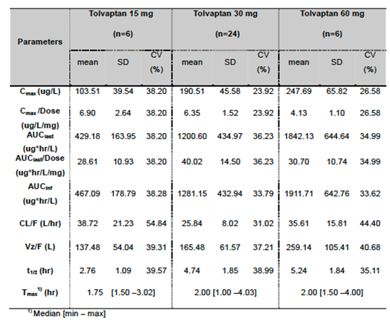

##### Metabolism

###### Pharmacokinetics of metabolites

Limited data on the PK of the metabolite DM-4107 following a single day of the 45 + 15 split dose regimen were provided in Study 156-07-262 (Tables 5 and 6).

Table 5: Pharmacokinetic parameters for tolvaptan following the IR tablet

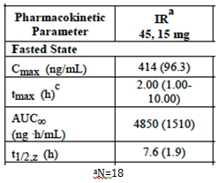

Table 6: Pharmacokinetic parameters for the metabolite DM-4107 following the IR tablet

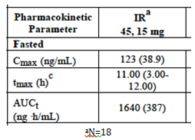

##### Pharmacokinetics in special populations

###### Pharmacokinetics in subjects with impaired renal function

In a single dose study (Study 156-09-282; Table 7), decreased renal function was associated with increased systemic exposure to tolvaptan and reduced clearance.

Table 7: Tolvaptan PK parameters

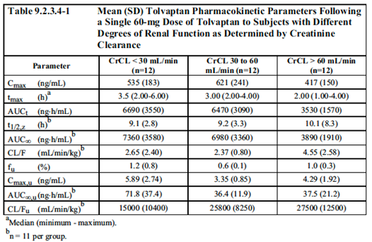

#### Pharmacokinetics in the target population

##### Absorption

###### Dose proportionality

After single doses of 15 to 120 mg in ADPKD subjects, Cmax and AUC increased in an approximately dose proportional manner (Study 156-04-248; Table 8).

Table 8: Study 156-04-248 PK results

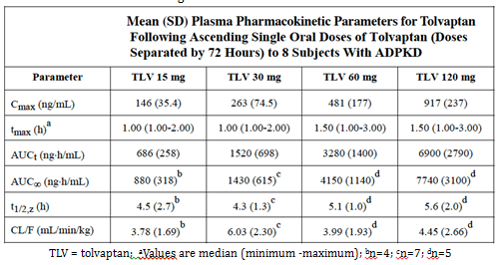

In another study (156-04-001) Cmax and AUC increased in an approximately dose proportional manner over the 15 to 30 mg dose range after single doses. After 5 days of BD dosing, increases in Cmax and AUC were less than dose proportional over the 15 to 30 mg dose range.

In a third Study (156-04-249), increases in Cmax and AUC were again less than dose proportional over the 15 to 30 mg dose range after 5 days of BD dosing (Tables 9 and 10).

Table 9: Study 156-04-249 PK on Day 1

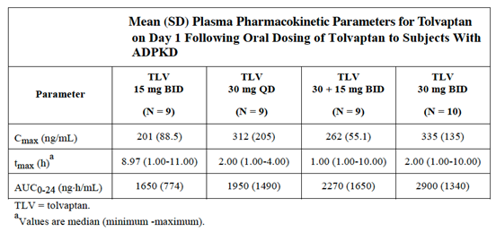

Table 10: Study 156-04-249 PK on Day 5

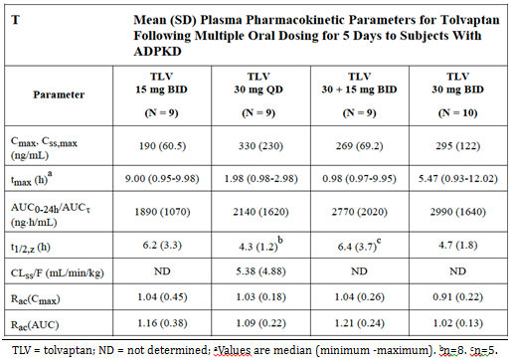

###### Bioavailability during multiple-dosing

In two studies that compared the PK of tolvaptan and after a single dose and five days of dosing, there was no evidence of accumulation of tolvaptan; 156-04-001 and 156-04-249.

##### Metabolism

###### Pharmacokinetics of metabolites

Limited data on the PK of the metabolites DM-4103 and DM-4107 were obtained in two studies; Study 156-06-260 and Study 156-09-284.

##### Intra- and inter-individual variability of pharmacokinetics

According to the Summary of Clinical Pharmacology in Module 2 of the submission, intra-subject variability for Cmax and AUC0-24h were 15.3% and 26.6%, respectively, for tolvaptan given as a single 30 mg dose on repeated occasions in Study 156-04-001. Inter-subject variability was similar for healthy subjects and subjects with ADPKD with relatively intact renal function with percent coefficients of variation (%CV) ranging from 20 to 75%. Values in the range of 35 to 50% were the most frequently observed.

#### Pharmacokinetics in other special populations

##### Pharmacokinetics in subjects with impaired renal function

Two studies examined PK in ADPKD subjects with varying degrees of renal impairment; Study 156-06-260 and Study 156-09-284. In both studies systemic exposure to tolvaptan was increased in subjects with the greatest degree of renal impairment. Systemic exposure to tolvaptan metabolites also appeared to increase.

In the population PK analysis baseline eGFR was a significant covariate affecting tolvaptan clearance (reduced clearance with reduced eGFR).

**Comment:** The sponsor has included a statement in the pharmacokinetics section of the draft Jinarc PI outlining the results of the population PK analysis, and a separate statement in the Dosage and Administration section regarding a potential increased risk of toxicity in subjects with severe renal impairment.

##### Pharmacokinetics according to age

In the population PK analysis, age had a modest effect on tolvaptan volume of distribution, such that a 79 year old subject would have a 17% reduction in volume compared to a 40 year old subject.

##### Pharmacokinetics according to gender

In the population PK analysis, females had a more rapid absorption of tolvaptan. However, gender had no effect on clearance or volume of distribution.

### Evaluator’s overall conclusions on pharmacokinetics

Only limited PK data were submitted with the application. In general, the PK of tolvaptan appear broadly similar in ADPKD and hyponatraemia subjects. The new PK studies indicate that:

* The proposed new 45, 60 and 90 mg tablets are bioequivalent with the currently registered 15 and 30 mg tablets.
* Co-administration of the 90 mg tablet with food results in an approximate doubling of Cmax but no increase in AUC.
* Renal impairment increases tolvaptan systemic exposure.
* Twice daily administration of tolvaptan (as proposed for the new indication) is not associated with significant accumulation.
* The PK profiles produced by the three proposed dosage regimens have not been directly compared. This is not considered a significant deficiency, as the regimens are to be used to determine a tolerable dose for each subject. Changing regimens on efficacy grounds is not being proposed.

## Pharmacodynamics

### Studies providing pharmacodynamic data

Summaries of new pharmacodynamic studies contained in the submission were provided. Table 11 shows the studies relating to each pharmacodynamic topic.

Table 11: Submitted pharmacodynamic studies

| PD Topic | Subtopic | Study ID | * |
| --- | --- | --- | --- |
| Primary Pharmacology | Effect on urine osmolality, urine output, free water clearance, excretion, urine solute concentrations and fluid balance | 156-KOA-0801 | * |
| 156-07-262 | * |
| 156-09-282 | * |
| 156-04-248 | * |
| 156-04-001 | * |
| 156-04-249 | * |
| 156-06-260 |  |
| 156-09-284 |  |
| 156-09-285 | * |
| Effect on plasma vasopressin and markers of vasopressin | 156-04-248 |  |
| 156-04-001 |  |
| 156-04-249 |  |
| 156-09-284 |  |
| Secondary Pharmacology | Effect on serum/plasma osmolality and concentrations of solutes | 156-09-282 | * |
| 156-04-248 | * |
| 156-04-001 | * |
| 156-04-249 | * |
| 156-06-260 | * |
| 156-09-284 | * |
| Effect on GFR, RBF | 156-06-260 | * |
| 156-09-284 | * |
| Effect on serum PTH and calcium | 156-04-248 |  |
| 156-04-001 |  |
| 156-04-249 |  |
| Effect on renin, aldosterone | 156-06-260 |  |
| 156-09-284 |  |
| Population PK-PD analyses | ADPKD subjects | 156-11-296 | * |

* Indicates the primary aim of the study.

None of the pharmacodynamic studies had deficiencies that excluded their results from consideration.

### Summary of pharmacodynamics

The information in the following summary is derived from conventional pharmacodynamic studies in humans unless otherwise stated.

#### Pharmacodynamic effects

##### Primary pharmacodynamic effects

In studies in human volunteers and ADPKD subjects, tolvaptan administration was associated with the following effects relevant to the drug’s primary pharmacodynamics:

* An increase in urine volume and free water clearance. For example, in a study that examined the pharmacodynamic effects of the proposed 90 + 30 mg maximum dose, median 24 hour urine volume increased from 3,010 mLs at baseline to 7,410 mLs after 7 days treatment. In another study using the proposed dose, mean 24 hour urine volume increased from 1,981.7 mLs at baseline to 6,532.8 mLs at 21 days, and free water clearance increased from 0.885 mLs/min to 5.219 mLs/min.
* A reduction in urine osmolality and the concentration of solutes in urine (for example sodium, potassium, albumin, creatinine). With the 90 + 30 mg dose, mean urine osmolality decreased from 506 mOsm/kg at baseline to 153 mOsm/kg after 21 days in subjects with a baseline eGFR > 60 ml/min/1.73 m2. In another study using the proposed dose, urine osmolality was maintained below 300 mOsm/kg for a median duration of 24.0 hours, compared with 14.0 hours at baseline.
* An initial negative fluid balance. After several days of treatment, 24 hour fluid balance was restored to baseline levels. For example, in subjects receiving tolvaptan 30 mg BD, 24 hour fluid balance was -114 mLs at baseline, -869 mLs on Day 1 and -214 mLs on Day 5.
* A small increase in plasma concentrations of vasopressin or biomarkers of vasopressin secretion (neurophysin and copeptin).

##### Secondary pharmacodynamic effects

* In two studies (Study 156-06-260 and Study 156-09-284), tolvaptan administration was associated with a small reduction in GFR (approximately 5 to 10%). This was not associated with any demonstrable reduction in renal plasma flow or filtration fraction. The reduction in GFR was reversible on cessation of the drug.
* The drug was also associated with a small reduction in clearance of some analytes such as uric acid and creatinine. For example, in ADPKD subjects with a baseline eGFR of > 60 mL/min/1.73 m2 receiving the recommended dose, mean creatinine clearance was reduced from 131 mLs/min at baseline to 115 mLs, and mean uric acid clearance from 12.2 mL/min to 9.3 mL/min.
* Serum osmolality was increased. In ADPKD subjects with an eGFR of > 60 mL/min receiving the 45 + 15 split dose mean serum osmolality increased by approximately 3 to 5 mOsm/kg from baseline to Day 8.
* Serum/plasma concentrations of sodium, creatinine and uric acid were increased. There was no consistent effect on potassium concentrations.

The drug was not associated with:

* Increases in urinary albumin/creatinine ratio or reductions in serum albumin;
* Alterations in serum parathyroid levels or calcium concentrations;
* Alterations in renin or aldosterone levels.

#### Time course of pharmacodynamic effects

Vasopressin, acting on the kidney’s distal collecting ducts, increases urine osmolality above plasma osmolality (approximately 290 mOsm/L) when required. When urine osmolality remains below 300 mOsm, effective V2 receptor blockade by tolvaptan can be assumed.

With twice daily administration the effects of tolvaptan on urine volume and urine osmolality persisted for approximately 24 hours. The pharmacodynamic effects of the drug were reversible.

#### Relationship between dose/drug concentration and pharmacodynamic effects

In one study (Study 156-04-249) twice daily dose regimens were more effective in reducing urine osmolality than a once daily regimen, with 30 mg BD being more effective than 15 mg BD or 30 + 15 mg BD.

A population PK/PD model was developed that described the relationship between tolvaptan exposure (Cmin,ss) and urine osmolality. This model predicted that the proposed 45 + 15 mg split dose regimen would produce 50% of the maximum effect on urine osmolality, whereas the 90 + 30 regimen would result in 70.9% of the maximum effect.

### Evaluator’s overall conclusions on pharmacodynamics

The submitted PD studies were acceptable. The observed PD effects were consistent with tolvaptan’s mechanism of action.

## Dosage selection for the pivotal studies

The dosage regimens chosen for the pivotal study were based on the findings of an earlier Phase II Study (156-04-250). In the titration period of this study the maximum tolerated dose was 90 mg per day (60 + 30) and the minimum effective dose was 60 mg per day (45 + 15).

**Comment:** In Study 156-04-250, the highest proposed dose (90 + 30) was found to be not tolerable (because < 50% of subjects could tolerate it) and was not studied in the subsequent fixed-dose period of the study. Despite this the 90 + 30 dose was included in the pivotal study. No justification for this could be found in the pivotal study report. However, in the pivotal study 54.4% of subjects were able to tolerate 90 + 30 mg dose in the long term. The sponsor also cites the results of the PK/PD model for tolvaptan, which predicts that the 90 + 30 mg dose will be associated with improved efficacy.

## Clinical efficacy

### Pivotal efficacy Study (156-04-251)

#### Study design, objectives, locations and dates

Study 156-04-251 was a Phase III, randomised, double blind trial with two parallel groups (tolvaptan versus placebo). The study enrolled adult subjects (aged 18 to 50) with a diagnosis of ADPKD and evidence of rapidly advancing disease, but with an estimated eGFR of ≥ 60 mLs/min. A study schema is shown in Figure 1.

Figure 1: Study 156-04-251; Study schema

Figure 1: Study 156-04-251; Study schema
After randomisation subjects underwent an initial 3 week titration phase where treatment was commenced at the 45 + 15 split dose level and then increased weekly as tolerated up to a maximum dose of 90 + 30 mg. Randomised treatment was then continued for 36 months. During the treatment phase subjects were reviewed in the clinic at 4 monthly intervals. At the end of the treatment phase there were two follow–up visits; Follow-Up 1 occurred 7 to 21 days after the 36 month visit and Follow-Up 2 occurred a further 7 to 21 days later.


After randomisation, subjects underwent an initial 3 week titration phase where treatment was commenced at the 45 + 15 split dose level and then increased weekly as tolerated up to a maximum dose of 90 + 30 mg. Randomised treatment was then continued for 36 months. During the treatment phase subjects were reviewed in the clinic at 4 monthly intervals. At the end of the treatment phase there were two follow–up visits; Follow-Up 1 occurred 7 to 21 days after the 36 month visit and Follow-Up 2 occurred a further 7 to 21 days later.

The primary objective of the trial was to evaluate the long term efficacy of tolvaptan in slowing cystogenesis of ADPKD by comparing the rate of kidney volume change (%) for tolvaptan subjects with placebo subjects.

The key secondary objective was to evaluate long term efficacy of tolvaptan in slowing the progression of ADPKD through a composite of clinical outcome events (that is, progressive hypertension, renal pain, albuminuria, and renal function). Other secondary objectives were to evaluate:

* Long term efficacy of tolvaptan in slowing the progression of ADPKD using individual clinical markers of ADPKD progression;
* Long term safety of tolvaptan through standard clinical measures;
* Pharmacokinetic (PK), pharmacodynamic (PD), and exploratory parameters for effects of tolvaptan in ADPKD.

The trial was conducted at 128 sites in 15 countries; the United States (379 subjects at 29 sites), Canada (44 subjects at 3 sites), Argentina (52 subjects at 5 sites), Australia (72 subjects at 8 sites), Belgium (69 subjects at 3 sites), Denmark (10 subjects at 2 sites), France (115 subjects at 9 sites), Germany (158 subjects at 5 sites), Italy (70 subjects at 5 sites), Netherlands (68 subjects at 2 sites), Poland (93 subjects at 9 sites), Romania (35 subjects at 3 sites), Russia (31 subjects at 5 sites), United Kingdom (72 subjects at 11 sites), and Japan (177 subjects at 30 sites).

The study commenced in 2007 and was completed in 2012. The study report was dated 30 May 2013. The study has been published (8). The study has also been referred to as the TEMPO 3:4 trial.

#### Inclusion and exclusion criteria

The key entry criteria were:

* A diagnosis of ADPKD based on imaging;
* Age 18 to 50 years;
* A total kidney volume of at least 750 cm3;
* An estimated GFR of ≥ 60 mL/min;

Complete inclusion criteria are listed in Table 12 and exclusion criteria in Table 13.

Table 12: Study 156-04-251;inclusion criteria

| No | Inclusion criteria |
| --- | --- |
| 1. | Adult subjects providing informed consent:  [Defined as men or women ≥ 18 years and ≥ regional legal age of maturity to age 50 years, inclusive who are able to provide informed consent and/or give assent. In the US and Europe, this is generally 18 years, while in Japan it is 20 years, inclusive.] |
| 2. | Adult subjects with a diagnosis of ADPKD:  [Diagnosis of ADPKD (age 18 or 20 to 50) requires several cysts in each kidney (3 if by sonography, 5 if by computed tomography (CT) or MRI) in those with a family history of ADPKD and 10 cysts (by any radiologic method) in each kidney and exclusion of other cystic kidney diseases if there is no family history. Conditions to be excluded include: multiple simple renal cysts, renal tubular acidosis, cystic dysplasia of the kidney, multicystic kidney, multilocular cysts of the kidney, medullary cystic kidney and acquired cystic disease of the kidney.] |
| 3. | Willing to comply with required reproductive precautions:  [Limited to women who are capable of becoming pregnant (that is, not abstinent, not surgically sterile by hysterectomy, bilateral oophorectomy nor those who have been postmenopausal for at least 12 consecutive months). These individuals must be willing to remain abstinent or comply with approved birth control (Protocol Section 5.4) from two-weeks prior to, and for 0 days, after taking investigational product. Further, breast-feeding is not permitted while taking tolvaptan in this trial.] |
| 4. | Estimated GFR ≥ 60 mL/min within -31 days of randomization.  [Established using Cockcroft-Gault with correction for gender and race where possible] |
| 5. | Rapid estimated rate of renal volume increase based on total renal size ≥ 750 cc by MRI at randomization. [Excluding those meeting volumetric criteria solely due to six or fewer predominant cysts.] |

Table 13: Study 156-04-251; Exclusion criteria

| No | Exclusion criteria |
| --- | --- |
| 1. | Subjects who in the opinion of the trial investigator and/or sponsor present a safety risk.  [For example: Subjects having disorders in thirst recognition or inability to access fluids. Subjects who have clinically significant allergic reactions to tolvaptan or chemically related structures such as benzazepines (benzazepril, conivaptan, fenoldopam mesylate or mirtazapine), those with critical electrolyte imbalances, or low blood volume, those with clinically significant anemia, pregnant or breast-feeding women] |
| 2. | Subjects who are unlikely to adequately comply with the trial’s procedures.  [For example: Subjects having medical conditions likely to require an extended interruption or discontinuation during the first year of trial, with a history of substance abuse (within the last 3 years), with a history of persistent non-compliance with anti-hypertensive or other important medical therapy] |
| 3. | Subjects having contraindications to, or interference with MRI assessments  [For example: ferromagnetic metal prostheses, aneurysm clips, severe claustrophobia, large abdominal/back tattoos, etcetera] |
| 4. | Subjects taking medications or having concomitant illnesses likely to confound endpoint assessments  [For example: chronic use of diuretics, advanced diabetes (that is, those with poor glycemic control evidenced by a history of severely elevated hemoglobin A1C, or with evidence of advanced retinopathy, nephropathy or peripheral vascular disease due to micro-or-macro vascular disease), evidence of significant renal disease (that is, currently active glomerular nephritidies), renal cancer, single kidney, recent (within last 3 years) renal surgery etcetera] |
| 5. | Subjects taking other experimental (that is, non marketed) therapies, or taking approved therapies for the purpose of affecting PKD cysts, or those taking or have a history of taking tolvaptan.  [For example: tolvaptan, anti-sense RNA therapies, rapamycin, sirolimus, everolimus, somatostatin analogs (that is, octreotide,sandostatin), recent (within 3 years) or anticipated cyst decompression, etcetera] |

**Comment:** The trial attempted to recruit subjects with a higher likelihood of disease progression over the study period. Larger total kidney volume (TKV) had been associated with more rapid disease progression and hence subjects were required to have a minimum TKV of 750 cm3 (before age 50). Subjects were required to have a creatinine clearance of ≥ 60 mL/min as it was anticipated that the product would be used as a preventative therapy (that is initiated prior to inexorably progressive kidney damage).

The entry criteria are generally consistent with the proposed indication. However, the indication includes subjects with CKD stages 1 to 3 rather than subjects with an estimated GFR of ≥ 60 mL/min. The difference is based on the actual population of subjects enrolled. The proposed indication also does not exclude use in subjects aged > 50 years.

#### Study treatments

Subjects were randomised to receive tolvaptan or placebo. Tolvaptan was initiated as a split dose regimen of 45 mg in the morning and 15 mg in the afternoon (45 + 15). If tolerated, and after an interval of at least 7 days, the dose was increased to 60 + 30 mg. If this dose was also tolerated for at least 7 days, the dose was increased again to the maximum dose of 90 + 30 mg. Subjects remained on the dose which they were able to tolerate.

The dose could be down titrated at any time. Investigators could also up titrate subjects (with the approval of the study medical monitor) if a change in clinical status, lifestyle or concomitant treatment suggested a possibility that a higher dose might be tolerated. The morning dose was to be administered on waking and the afternoon dose approximately 9 hours later, irrespective of meals. Tolvaptan was supplied as 15 or 30 mg tablets.

To prevent dehydration, it was recommended that subjects ingest adequate fluid to prevent excessive thirst during the day, an additional 1 to 2 cups of water before bedtime and additional replenishment with each episode of nocturia.

Chronic use of diuretics was prohibited, as these could affect certain efficacy measures. Potent CYP3A4 inhibitors were to be avoided.

#### Efficacy variables and outcomes

The main efficacy variables were:

* Change in kidney size (TKV);
* Change in blood pressure;
* Change in renal function and albuminuria;
* Renal pain events.

The primary efficacy outcome was the rate of kidney volume change from baseline (total, for both kidneys), normalized as a percentage, for tolvaptan (combining all doses) relative to placebo, as assessed by MRI. Only MRI results obtained in the period between the first dose of study medication and two weeks after the last dose (‘within treatment’) were to be included in the analysis.

The key secondary efficacy outcome was a composite endpoint - the time to multiple investigator reported ADPKD clinical progression events for tolvaptan (combining all doses) relative to placebo while on treatment. This endpoint combined the following four clinical progression events:

* Onset or progression of hypertension. At baseline subjects were classified into four categories; normotensive (sBP < 120 and dBP < 80 mmHg and off therapy), low pre-hypertensive (sBP ≤ 129 and dBP ≤ 84 mmHg but not normotensive and off therapy), high pre-hypertensive (sBP ≤ 139 and dBP ≤ 89 mmHg but not normotensive/low pre-hypertensive and off therapy) and hypertensive (sBP > 139 and/or dBP > 89 mmHg or on anti-hypertensive therapy). Progression was considered to have occurred if, compared to the first visit of a set of three consecutive observed visits, a subject had moved to a higher category at the latter two observed visits. A change in antihypertensive medication due to hypertension was also classified as a hypertension progression event.
* Events of severe renal pain, defined as events requiring significant intervention for relief of pain (surgical or invasive radiological procedures, introduction or increasing the dose of narcotic or tricyclic antidepressant medication, prescribing medical leave or activity restrictions or being formally prescribed a non-narcotic which carries some risk to the subject).
* Worsening albuminuria. At baseline subjects were classified into three categories based on urine albumin/creatinine ratio; “normal” (< 2.8 mg/mmol female or < 2.0 mg/mmol male), “microalbuminuria” (2.8 to 28 mg/mmol female or 2.0 to 20 mg/mmol male), and “overt proteinuria” (> 28 mg/mmol female or > 20 mg/mmol male). Progression was considered to have occurred if, compared to the first visit of a set of four consecutive observed visits, a subject had moved to a higher category at the second and at least one of the third/fourth visits.
* Worsening renal function, defined as a reduction of renal function equivalent to a 25% reduction in the reciprocal of serum creatinine from baseline, and each subsequent further 25% reduction based on the reciprocal of serum creatinine observed at the previous event.

The four types of event were pooled together.

For hypertension, albuminuria and renal pain all events occurring between the first dose of study medication and two weeks after the last dose (‘within treatment’) were to be included in the analysis. However, for worsening renal failure, only events occurring between the end of the titration period and two weeks after the last dose of study medication were included. This was specified in the protocol on the grounds that tolvaptan was known to produce an initial but reversible reduction in GFR (and increase in serum creatinine). The sponsor argued that the long term, on-study effects of the drug would be best judged against a baseline of stable therapy.

Other secondary efficacy outcomes were:

* Rate of renal function change from End of Titration (EOT) to last on-drug trial visit. The primary measure was the reciprocal of serum creatinine. Additional exploratory measures were based on estimates using creatinine clearance by Cockcroft-Gault (eCrCLCG), and estimated GFR by Modification of Diet in Renal Disease (eGFRMDRD) or Chronic Kidney Disease Epidemiology Collaboration (eGFRCKD-EPI);
* For subjects who were non-hypertensive at baseline, change from baseline for resting mean arterial pressure (MAP) at scheduled clinic visits up to the point of exposure to antihypertensive therapy for any reason;
* Change from baseline in renal pain (assessed by a 0 to 10 pain scale) as average area under the concentration-time curve (AUC) between baseline and the last trial visit or the last visit prior to initiating medical (for example, narcotic or antinociceptives [for example, tricyclic antidepressants]) or surgical therapy for pain;
* For subjects who were non-hypertensive at baseline, time to progress to a) high pre‑hypertensive (sBP > 129 mmHg and/or dBP > 84 mmHg), b) hypertensive (sBP > 139 mmHg and/or dBP > 89 mmHg), or c) requiring antihypertensive therapy.
* For subjects who were taking antihypertensive therapy at baseline, the percentage with clinically sustained decreases in BP leading to a sustained reduction in antihypertensive therapy compared with baseline at visit on Months 12, 24, and 36.

The secondary endpoints were tested sequentially in the above order. There were also a number of exploratory endpoints specified in the protocol.

MRI scans were performed at baseline and at Months 12, 24 and 36 (or at the end of treatment visit). The scans were read and analysed centrally. Data for the secondary efficacy endpoints (blood pressure, serum creatinine, spot urine for albumin/creatinine ratio, pain rating over the past 4 months) were collected at screening, baseline, Day 1, Week 3 (or end of titration), at Months 4, 8, 12, 16, 20, 24, 28, 32, 36/end of treatment and at Follow-up Visit 1, and Follow-up Visit 2.

#### Randomisation and blinding methods

Subjects were randomised (2:1) to receive tolvaptan or placebo. Randomisation was stratified for the following factors:

* The presence or absence of hypertension at baseline, defined as systolic BP > 139 mmHg and diastolic BP > 89 mmHg or treatment for elevated BP;
* Baseline eCrCL (< 80 mL/min versus ≥ 80 mL/min); and
* Baseline TKV (< 1000 mL versus ≥ 1000mL).

Subjects were randomised centrally in each of three regions (the Americas, Japan, Europe plus Rest of World). Randomisation was implemented using an interactive voice response system (IVRS).

Blinding was achieved through the use of matching placebos.

#### Analysis populations

The intent-to-treat (ITT) dataset was defined as a dataset including data from all subjects who were randomized. No per-protocol dataset was defined. The safety dataset included data from all subjects who were randomised and treated.

#### Sample size

The original sample size required was estimated to be approximately 1,200 subjects. Based on previous data the average increase in renal volume in the placebo arm was assumed to be 7% per year. A reduction of 20% to 5.6% per year was assumed for the tolvaptan group. With a power of 85%, a 2:1 randomisation and an alpha of 0.049, it was calculated that a total of 504 subjects would be required. This was increased to 600 to allow for a 20% rate of withdrawal. This number was doubled, to enable a power equivalent to two independent studies.

After discussions with the FDA the sample size was re-estimated after 1,000 subjects had been enrolled, without unblinding of the data. The FDA considered that the primary endpoint of TKV was of uncertain clinical significance, and that therefore the sample size should be based on the composite secondary endpoint. As this was to be the only comparative trial, an alpha of 0.01 was used. The recalculation estimated that a total of 1,400 subjects would be required.

#### Statistical methods

For the primary endpoint, the renal volume data were log10 transformed, to reduce heterogeneity in variance and achieve linearity over time. These data were fitted to a linear mixed effect (Laird and Ware) model. The model provided an estimate of the ratio of geometric means of the slope of TKV of the 2 treatment groups and the 95% confidence interval. A planned sensitivity analysis was conducted using a mixed-model repeated measures analysis.

For the composite secondary endpoint an analysis of time to multiple events using an extended Cox model (Andersen-Gill approach) was used to provide a point estimate of the hazard ratio and its p-value.

For the other secondary endpoints, rate of GFR change and change from baseline in MAP were analysed using methods similar to those used for the primary endpoint. Change from baseline in kidney pain was analysed using analysis of covariance. Time to progression of hypertension was analysed using methods similar to those used for the key secondary composite endpoint. The percentage of patients with sustained decreases in blood pressure was analysed using the Cochran-Mantel-Haenszel statistic stratified by baseline stratification factors.

The secondary endpoints were tested in sequence after the key composite secondary endpoint, using a two-sided alpha level of 0.05, without adjustment for multiplicity. No interim analyses were conducted.

#### Participant flow

A total of 2,122 subjects were screened for the study and 1,445 subjects were randomised. The most common reasons for screening failure were failure to meet inclusion criteria (n = 501) or exclusion criteria (n = 31) or withdrawal of consent (n = 45). 961 subjects were randomised to the tolvaptan arm and 484 to placebo. Subject disposition is summarised in Table 23.

Table 23: Study 156-04-251; Subject disposition

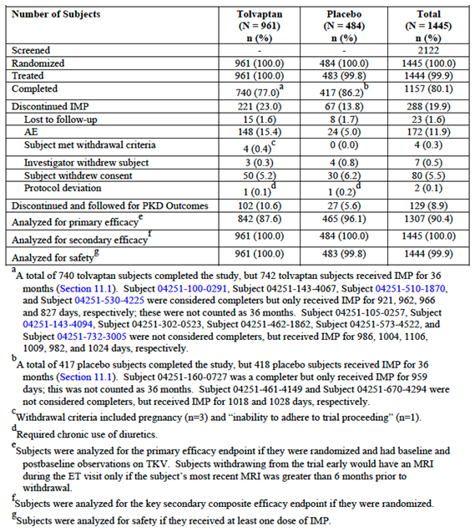

**Comment:** The only notable difference in disposition of the two groups was an increased rate of discontinuation in the tolvaptan arm; 77.0% of subjects in the tolvaptan arm completed the study compared to 86.2% of subjects in the placebo arm. An excess number of subjects discontinuing due to adverse events (15.4% versus 5.0%) accounted for the difference. The most common AES leading to discontinuation were those related to tolvaptan’s mechanism of action; polyuria, pollakiuria, nocturia and thirst. Discontinuations due to AEs are discussed in Section 8.

#### Major protocol violations/deviations

A listing of protocol deviations was provided as an attachment to the study report. However, an analysis was not provided. According to the study report, none of the deviations were considered to have affected the integrity of the trial or compromised the safety of subjects.

#### Baseline data

Baseline demographics, baseline stratification factors, baseline renal function and baseline ADPKD history were provided. The two treatment arms were well balanced with respect to these variables.

The median age of the population was 39.0 years (range 18 to 51). In terms of race, 84.3% of subjects were Caucasian, 12.7% were Asian, 1.5% were Hispanic, 1.3% were black and 0.2% were from other races. Renal function was reasonably well preserved with 74.3% of subjects having a creatinine clearance > 80 mLs/min. 79.4% of subjects had hypertension at baseline. Mean TKV was 1,692.3 mLs (SD ± 905.31 mLs). Median age at diagnosis was 27.4 years.

**Comment:** One of the inclusion criteria for entry in the study was an estimated GFR of ≥ 60 mL/min, using the Cockcroft-Gault formula. When the population was assessed using the eGFRCKD-EPI formula, CKD stages at baseline were as follows (tolvaptan versus placebo): Stage 1; 34.5% versus 35.9%; Stage 2; 48.5% versus 46.5%; Stage 3; 17.0% versus 17.4%. The proposed indication includes subjects with CKD Stages 1 to 3.

A history of hypertension was present in 80.0% of subjects in the tolvaptan arm and 80.2% of subjects in the placebo arm. 76.9% of subjects in each arm were using anti-hypertensive medication. The proportion of subjects using medication for renal pain at baseline was comparable in the two arms (5.1% versus 5.8%).

#### Results for the primary efficacy outcome

Results for the primary endpoint of rate of growth of total kidney volume are summarised in Table 24 and in Figure 2. Rate of growth over three years in the placebo arm was 5.51% per year, whereas in the tolvaptan arm, it was 2.80% per year, a reduction of 49.2%. The absolute difference between treatment arms was 2.71% per year (95%CI 2.15% to 3.27%). The difference was statistically significant (p < 0.0001).

Table 24: Study 156-04-251; Total kidney volume; Rate of growth (Primary endpoint)

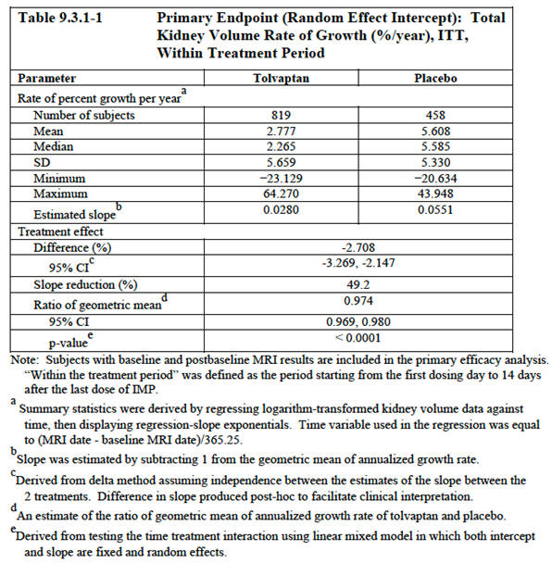

Figure 2: Study 156-04-251; Total kidney volume, Rate of growth (Primary endpoint)

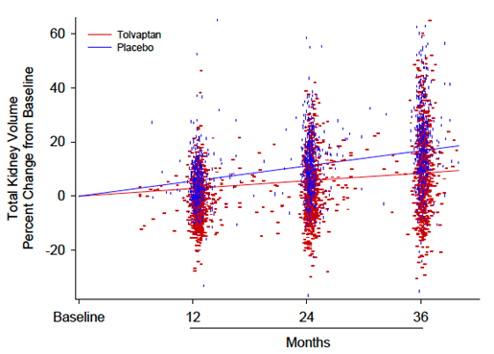

The sensitivity analysis using a mixed-model repeated measures analysis also demonstrated a halving of TKV growth with tolvaptan compared to placebo. At Month 36, the least squares mean TKV growth was 9.56% for tolvaptan compared with 18.75% for placebo, with a treatment group difference of −9.19% (95% CI −11.1 to −7.32, p < 0.0001). This analysis also demonstrated that the effect of treatment on TKV growth was greatest in the first year. However, progression was still significantly slower in tolvaptan subjects compared with placebo subjects in the second and third years.

A number of other sensitivity analyses also demonstrated a statistically significant benefit for tolvaptan over placebo:

* The primary analysis was restricted to MRI scans obtained “within treatment”. A sensitivity analysis was conducted using all available data (that is regardless of the timing of the MRI). Rate of growth over three years in the placebo arm was 5.6% per year, whereas in the tolvaptan arm, it was 2.9% per year, a reduction of 47.2%. The difference was statistically significant (p < 0.0001).
* The primary analysis assumed a normal distribution of data. Several non-parametric tests were used to compare the rate of growth between treatment groups. These analyses were nominally statistically significant for each test (p < 0.0001).
* A number of analyses were conducted to account for potential effects of MRI scan measurement error (for example excluding subjects identified as outliers or excluding scan results where the reader had made comments on the quality of the scan). The results of these analyses were consistent with the primary analysis.
* A mixed model repeated measures analysis was also conducted to account for the effects of missing data caused by the higher rate of discontinuation from the tolvaptan arm. Subjects who discontinued from the tolvaptan arm were assumed to have the same rate of increase in TKV as subjects in the placebo arm. In this analysis, at Month 36, the mean increase from baseline in TKV was 185 (± 337) mLs in the tolvaptan arm and 348 (± 407) mLs in the placebo arm. The ratio of geometric means for rate of growth (tolvaptan/placebo) was 0.947; (95% CI 0.932 to 0.962) p < 0.0001.

Several subgroup analyses were specified in the protocol as exploratory analyses. Subgroups examined were according to the following baseline variables; geographical region, age, sex, race, presence of hypertension, creatinine clearance, TKV and presence of microalbuminuria. Results of these analyses are summarised in Figure 3. Tolvaptan demonstrated a significant benefit over placebo in all subgroups examined.

Figure 3: - Study 156-04-251; Subgroup analyses of primary endpoint

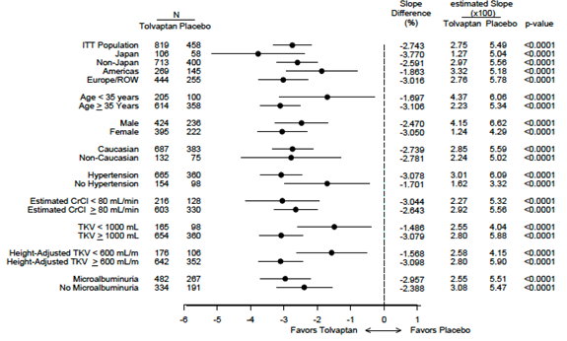

#### Results for other efficacy outcomes

##### Key composite secondary endpoint

Results for the key secondary composite endpoint are summarised in Table 25. In the placebo arm, clinical progression events occurred at a rate of 50.04 per 100 follow-up years. In the tolvaptan arm, the rate was 43.94 per 100 follow-up years. The difference was statistically significant (hazard ratio 0.865; 95%CI: 0.775 – 0.965; p = 0.0095).

The trial design incorporated an independent clinical events committee (CEC), which reviewed and adjudicated all potential clinical progression events. Potential clinical events were identified via trigger computer programs run on data in the sponsor’s clinical database (for example, case report forms, central laboratory results etc.). The analysis of adjudicated events was used as a sensitivity analysis. Results for this analysis (Table 25) were consistent with the analysis based on investigator-identified events. As shown in the table only a small number of additional clinical events were identified for this analysis.

Table 25: Study 156-04-251; Key composite secondary endpoint Time to multiple composite ADPKD events; ITT within treatment period

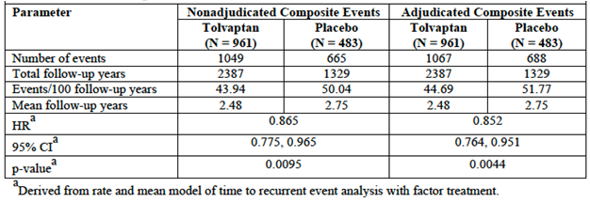

Other sensitivity analyses conducted on the key composite secondary endpoint included the following:

* Analysis of the time to the first clinical progression event (where subjects were censored at the time of their first event) gave a result similar to the main analysis (HR 0.826; 95% CI 0.722 to 0.944, p = 0.0051).
* An analysis using Week 3 (or end of titration) as the baseline for all four components of the composite endpoint also gave similar results (HR 0.877, 95% CI 0.785 to 0.980, p = 0.0203). The sponsor argued that this analysis excluded any “noise” associated with initiation of treatment.
* An analysis that included data collected off-treatment (that is not just data collected ‘within treatment’) gave similar results (HR 0.874, 95% CI 0.784 to 0.974, p = 0.0147).
* Another analysis was conducted to account for the effect of partial missing data. Only subjects who experienced an event, or those who had had all four components of the composite endpoint evaluated, were included. Results were consistent with the main analysis (HR 0.878, 95% CI 0.787 to 0.979, p = 0.0194).
* Other analyses were conducted to account for missing data due to the increased rate of discontinuation from the tolvaptan arm. If subjects who discontinued tolvaptan were assumed to have the same risk of an event (after discontinuation) as placebo subjects, the tolvaptan arm was still associated with a statistically significant benefit (HR 0.888, 95% CI 0.794 to 0.993, p = 0.0372). If the risk was assumed to be 105% of that associated with placebo, the benefit was of marginal statistical significance (HR 0.894, 95% CI 0.799 to 1.000, p = 0.0495). If the risk was assumed to be 110% of that associated with placebo, the benefit was no longer statistically significant (HR 0.901, 95% CI 0.806 to 1.007, p = 0.0663).

Subgroup analyses for the key secondary composite endpoint indicated a consistent benefit for tolvaptan over placebo in the various subgroups tested with hazard ratios being consistently < 1.0 (Figure 4). Subgroups examined were according to the following baseline variables; geographical region, age, sex, race, presence of hypertension, creatinine clearance, TKV and presence of microalbuminuria.

Figure 4: Study 156-04-251; Subgroup analyses for key composite secondary endpoint

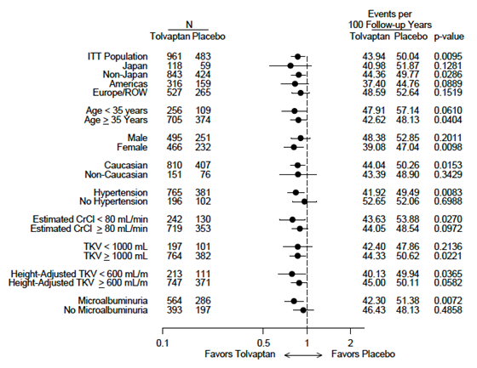

Examination of the individual components of the composite endpoint indicated that the overall benefit was largely driven by a reduction in the occurrence of worsening renal failure events and renal pain events (Table 26):

* The risk of experiencing a worsening renal function event was reduced by 61.4% (hazard ratio 0.386; 95% CI: 0.263 to 0.566; p < 0.0001);
* The risk of experiencing a severe renal pain event was reduced by 35.8% (hazard ratio 0.642; 95% CI: 0.466 to 0.887; p < 0.0071);
* There was no significant reduction in the risk of experiencing a worsening hypertension event or a worsening albuminuria event.

Table 26: Study 156-04-251; Components of the key secondary composite endpoint Supplemental analysis; time to multiple events for components of the key secondary composite endpoint; ITT, within treatment period

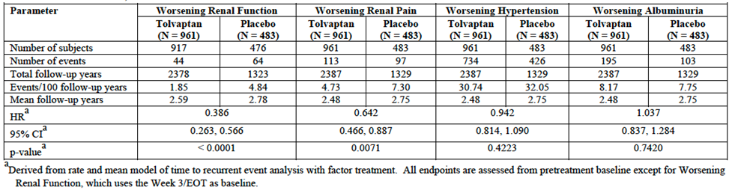

##### Rate of renal function change

Results for renal function change are summarised in Table 27. For the reciprocal of serum creatinine, the mean rate of change was -2.555 mL/mg per year in the tolvaptan group compared to -3.812 mL/mg per year in the placebo group, indicating less rapid decline with tolvaptan. The difference was statistically significant (p < 0.0001). Subgroup analyses indicated a benefit for tolvaptan over placebo in all subgroups examined, but suggested a greater benefit in subjects with more advanced disease (for example those with the following baseline characteristics: hypertension, TKV > 1,000 mL, CrCl < 80 mL/min or microalbuminuria).

Table 27: Study 156-04-251; Rate of renal function decline Secondary endpoint; rate in change of renal function; ITT subjects with at least 4 month follow up, excluding observations deemed unreliable by investigators, within treatment period

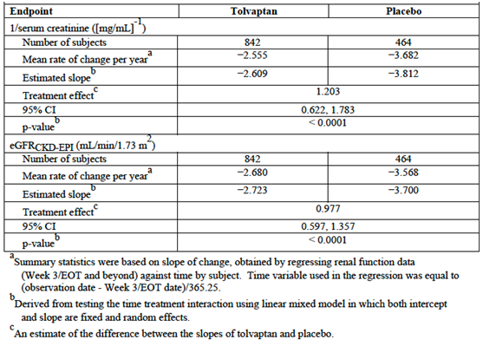

For eGFRCKD-EPI, the rate of decline in the tolvaptan group was -2.723 mL/min/1.73 m2 per year, compared with -3.812 mL/min/1.73 m2 per year in the placebo group (p < 0.0001). Results for eCrCLCG and eGFRMDRD were similar.

Figure 5 illustrates eGFRCKD-EPI over the entire course of the study. Tolvaptan treatment was associated with an initial reduction in eGFR, but with a slower subsequent rate of decline. After withdrawal of treatment, a higher final eGFR is seen in the tolvaptan arm.

Figure 5: Study 156-04-251; Change in eGFR over entire study. Renal function (eGFR calculated by CKD-EPI) change from pretritration baseline over time

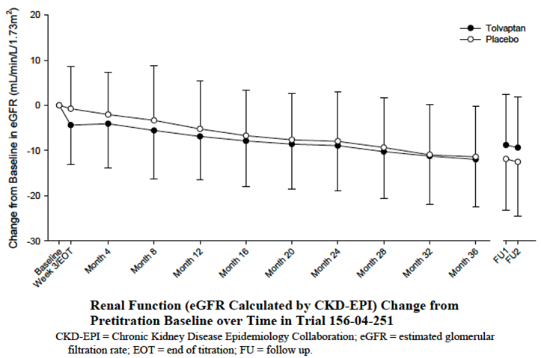

##### Rate of change in mean arterial pressure (MAP)

MAP increased in both treatment arms at a rate of approximately 2.6 mmHg per year. The difference between treatment arms was not statistically significant.

##### Change from baseline in renal pain

There was no significant difference between the two treatment arms.

##### Time to onset/progression of hypertension

Among non-hypertensive subjects, tolvaptan treatment was not associated with a significant reduction in the risk of onset of hypertension.

##### Sustained reduction in antihypertensive therapy

The percentage of subjects who achieved reduction in antihypertensive therapy was low in both treatment groups. The difference between treatments was not statistically significant.

### Other efficacy studies

#### Study 156-04-250

This study was a Phase II open label trial which enrolled subjects who had participated in two clinical pharmacology studies; Study 156-04-248 and Study 156-04-249 and were ineligible to be enrolled in the pivotal efficacy study. Evaluation of efficacy was a secondary objective of the study. It was conducted at 11 centres in the USA, commencing in 2005 and being completed in 2010.

A study schema for the trial is shown in Figure 6. After screening, subjects entered a titration period the purpose of which was to define a minimally effect dose (MED) and maximum tolerated dose (MTD). Subjects were initially commenced on 30 + 15 split dose regimen. At weekly intervals the daily dose was increased through the following regimens, if tolerated: 45 + 15, 60 + 30 and 90 + 30. If a subject did not tolerate a dose level, he or she was returned to previous level. Subjects who were unable to tolerate the 30 + 15 regimen could decrease the dose to a 15 + 15 regimen. Once a tolerable dose had been determined, the subject continued on that dose until the end of Month 2. The MTD was defined as the highest dose tolerated by at least 50% of the study population. Morning doses were administered after wakening and evening doses approximately 8 hours later. Tolvaptan was supplied as 15 or 30 mg tablets.

Figure 6: Study 156-04-250; Study schema

Figure 6: Study 156-04-250; Study schema
After screening, subjects entered a titration period the purpose of which was to define a minimally effect dose (MED) and maximum tolerated dose (MTD). Subjects were initially commenced on 30 + 15 split dose regimen. At weekly intervals the daily dose was increased through the following regimens, if tolerated: 45 + 15, 60 + 30 and 90 + 30. If a subject did not tolerate a dose level, he or she was returned to previous level. Subjects who were unable to tolerate the 30 + 15 regimen could decrease the dose to a 15 + 15 regimen. Once a tolerable dose had been determined, the subject continued on that dose until the end of Month 2. The MTD was defined as the highest dose tolerated by at least 50% of the study population. Morning doses were administered after wakening and evening doses approximately 8 hours later. Tolvaptan was supplied as 15 or 30 mg tablets.

Spot urine osmolality was used as an efficacy measure. The study aimed to identify a dose at which urine osmolality would be maintained below 300 mOsm/L over 24 hours. Spot urine samples were collected prior to the morning and evening doses and at bedtime. The dose at which the osmolality target was achieved in a vast majority of subjects (ideally 100%) was to be considered a MED.

An interim analysis was performed after the initial 4 weeks of the titration period to determine the MTD and MED.

After the titration period subjects entered a fixed-dose period in which two doses (both falling between the MED and MTD) would be compared. Subjects were to be randomised to one of the two doses and maintained on the randomised treatment for 36 months. Subjects unable to tolerate the higher dose could be down-titrated to the lower dose. Subjects unable to tolerate the lower dose were withdrawn. Subjects who completed the fixed-dose period could enter an open extension period

The trial enrolled subjects with ADPKD who had previously participated in studies 156-04-248 or 156-04-249. Subjects with an estimated GFR below 30 mL/min were excluded. Efficacy was assessed using urine osmolality, estimated GFR, total renal volume on MRI, blood pressure measurements, assessment of renal pain (on a scale of 0 to 10), abdominal girth assessment and a Polycystic Kidney Disease (PKD) Outcomes Survey.

##### Results

A total of 46 subjects were enrolled and treated. 34 were female and 12 were male. Mean age was 41.7 years (range 24 to 59). All 46 subjects completed the titration period and were entered into the fixed dose period. Disposition of subjects is summarised in Table 28. 35 subjects entered the 12 month extension period (17 subjects in the tolvaptan 45 + 15 group and 18 subjects in the tolvaptan 60 + 30 group. All of these subjects completed the extension period.

Table 28: Study 156-04-250; Subject disposition

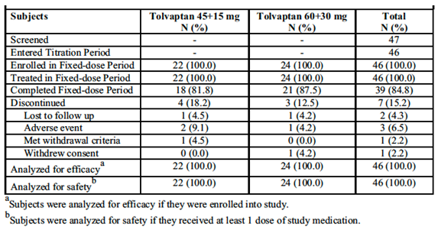

The interim results for the titration period are summarised in Figure 7. The MTD was determined to be 90 mg/day and the MED 60 mg/day. Based on these results the two regimens to be tested in the fixed-dose period were the 45 + 15 and 60 + 30 regimens.

Figure 7: Study 156-04-250; Results of titration period

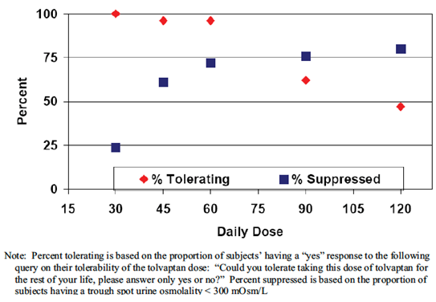

###### Results for the fixed dose and extension periods were:

* Urine osmolality results over the first 12 months of the fixed dose period are summarised in Table 29. Results at 24 and 36 months were similar. Mean urine osmolality was maintained at < 300 mOsm/kg throughout the 36 months of the trial.
* TKV by MRI results are summarised in Figure 8. There was a small decrease in TKV in both treatment groups at the end of the titration period. TKV subsequently increased in both groups over the 36 month period of the trial. TKV also increased over the 12 month extension period. There were no significant differences between the two treatment arms.
* Changes from baseline in eGFR are illustrated in Figure 9. There was an initial decline in eGFR at the end of the titration period. eGFR then increased during the first 12 months of the study and then steadily decreased. There were no significant differences between the two dosage regimens. Further decline was not observed among subjects who entered the extension period.
* No clinically significant effects on blood pressure were observed.
* Mean renal pain scores were low at baseline (~ 1.0 in each group, with the possible range of scores being 0-10). Scores increased slightly over the course of the study. There were no differences between treatment arms.
* Abdominal girth measurements increased slightly over the course of the study. There were no differences between treatment arms.
* There were no notable differences between treatments on the PKD outcomes survey.

Table 29: Study 156-04-250; Urine osmolality (fixed dose period)

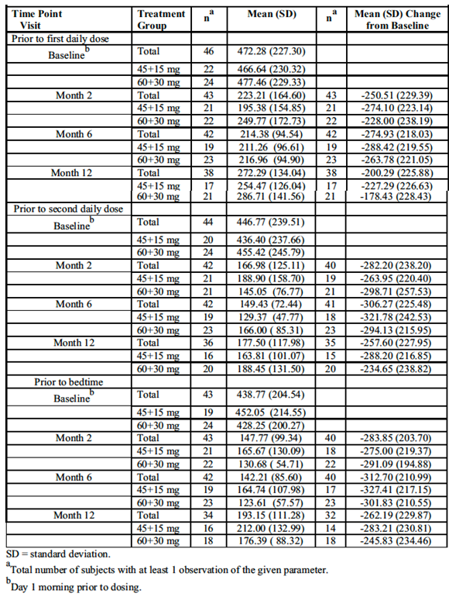

Figure 8: Study 156-04-250; TKV results

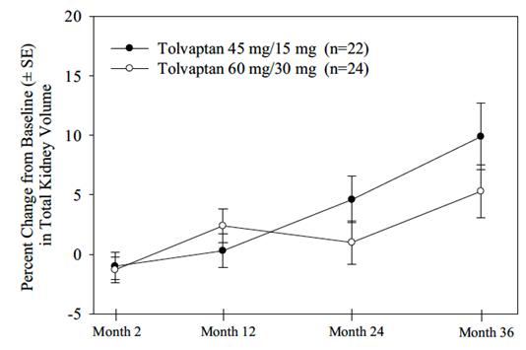

Figure 9: Study 156-04-250; eGFR results

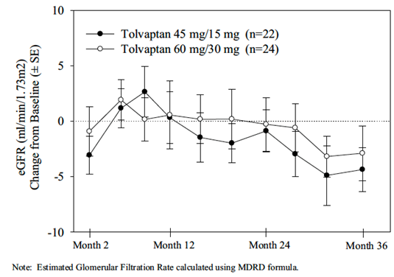

#### Studies 156-05-002 and 156-09-003

##### Study 156-05-002

Study 156-05-002 was a Phase II open label trial which enrolled ADPKD subjects who had participated in a previous clinical pharmacology study in Japan (156-04-001). The objective of the study was to investigate long term safety and efficacy. It was conducted at 10 sites in Japan between 2006 and 2010.

All subjects were treated with a regimen of 15 mg BD for up to 3 years. Efficacy was assessed by determining TKV (by MRI or CT scan) at yearly intervals, estimated creatinine clearance/GFR and serum cystatin-C concentrations at 12 week intervals and morning pre-dose urine osmolality at baseline and Weeks 1, 4, 8, 24, 52, 104 and 156.

17 subjects were enrolled and treated and 12 subjects completed the study. There were 8 males and 9 females. Mean age was 41.8 years (range 26 to 61).

###### Results of the study included the following:

There was no notable change in TKV over the course of the study. The mean percent change from baseline was -0.95%.

Mean creatinine clearance (using the Cockcroft-Gault formula) decreased from 85.7ml/min at baseline to 78.9 mL/min at the final measurement.

Mean serum cystatin C concentration was 0.909 mg/L at baseline and 0.998 mg/L at the final time point.

Mean urine osmolality at baseline was 477.5 mOsm/L at baseline. Mean osmolality was reduced at all subsequent time points (nadir = 336.8 mOsm/L at week 1). At no point did the mean value fall below 300 mOsm/L.

**Comment:** The findings of this study are of limited relevance to the current application, as the dose used (15 mg BD) is below the minimum proposed dose. The urine osmolality results suggest that this dose is unlikely to be effective. The low dose chosen for the study was based on “regulatory considerations” in Japan.

##### Study 156-09-003

Study 156-09-003 was a Phase III, open label extension study for subjects who had completed Study 156-05-002. It was conducted at 7 sites in Japan commencing in 2009. Treatment with tolvaptan 15 mg BD was to continue until marketing approval had been granted for tolvaptan in ADPKD in Japan. The data cut-off date for the submitted interim study report was 1 December 2011.

13 subjects entered the study. Efficacy assessments were similar to those used in Study 156‑05‑002 although urine osmolality was not monitored. Efficacy results were similar.

#### Study 156-10-003

This study is an ongoing Phase III, open label extension study for subjects in Japan who had completed the pivotal study. The objective of the study was to obtain data for safety and efficacy analysis on long term use of tolvaptan in Japanese ADPKD patients who participated in the pivotal study and had completed 3 years of repeated administration. It is being conducted at 30 centres in Japan, having commenced in 2010. The date for data cut-off for the interim study report included in the submission was 1 December 2011.

Subjects were commenced on the 45 + 15 regimen and the dose was titrated up to a maximum of 90 + 30 mg, as in the pivotal study. The titration was repeated because some subjects had only received placebo in the pivotal trial. Treatment was to continue at the tolerated dose until marketing approval was obtained in Japan.

Efficacy was assessed by determining TKV (by MRI) at yearly intervals, estimated creatinine clearance/GFR, urinary albumin and serum cystatin-C concentrations at 3 monthly intervals, and urine osmolality and urinary MCP-1 concentrations at yearly intervals.

A total of 108 subjects were enrolled and treated. There were 63 males and 45 females. Mean age was 43.1 years (range 24-53). The only efficacy data presented in the interim study report were descriptive statistics for eGFR, cystatin-C concentrations and urine albumin. The results for eGFR and cystatin C concentrations were provided. There was a slight decrease in eGFR and increase in cystatin-C concentrations. There was no consistent pattern to the changes in urinary albumin/creatinine ratio.

#### Study 156-08-271

This study is an ongoing, Phase IIIb, open label extension study. The primary objective is to demonstrate whether tolvaptan modifies ADPKD progression as measured by changes in TKV and renal function. The trial has enrolled 904 ADPKD subjects who have completed a previous study, including 823 subjects who completed the pivotal study. Subjects are treated with the proposed ascending split-dose regimen. The submission contained an interim study report (data cut-off 31 March 2012) which did not contain any efficacy or pharmacodynamic data.

### Analyses performed across trials (pooled analyses and meta-analyses)

#### Study 156-09-283

This was a pooled analysis of efficacy data from Studies 156-04-250 and 156-05-002. In both of these studies subjects who had completed previous clinical pharmacology studies were treated for 3 years with open label tolvaptan. Doses used in the former study were the 45 + 15 and 60 + 30 split dose regimens. In the latter study the dose was 15 mg BD. Efficacy data (on TKV and eGFR) from these two studies were pooled and compared with historical matched control data obtained from two non-interventional studies in ADPKD subjects (the CRISP and MDRD studies). Two control subjects from the observational studies were matched to each subject from the tolvaptan studies. Subjects were matched by the following baseline characteristics: gender, hypertension status (present, non-present), age and parameter of interest (TKV divided by height or eGFR).

The primary objective of this study was to compare the rate of TKV change, as a percent, over a 3 year period between tolvaptan-treated subjects and matched control subjects receiving standard of care. The secondary objective was to compare clinical markers of ADPKD progression (for example, renal function and hypertension).

The analysis was performed on those subjects who completed 3 years of therapy in the tolvaptan trials. There were a total of 51 such subjects; 39 from Study 156-04-250 and 12 from Study 156-05-002.

Results for TKV are summarised in Table 30. The annual percentage growth rate in TKV in the control group was 5.80% per annum, whereas in the tolvaptan group it was 1.66%. The ratio of the geometric mean values for growth rate in TKV (tolvaptan to placebo) was 0.961 (95% CI: 0.949 to 0.973). The difference between the groups was statistically significant (p < 0.0001). Results for rate of change in eGFR are summarised in Table 31. Mean change in the control group was -2.06 mL/min/1.73m2, whereas in the tolvaptan group it was -0.71 mL/min/1.73m2. The least squares mean difference between the groups was 1.076 mL/min/1.73m2 (95% CI: 0.235 to 1.917); p = 0.0122. There were no notable differences between the two groups in terms of hypertension outcomes.

**Comment:** As subjects were not randomised to tolvaptan or control, the findings of this study should be interpreted with caution. However, the benefits shown with tolvaptan were of a similar magnitude to those observed in the pivotal study.

Table 30: Study 156-09-283; Growth rate in TKV

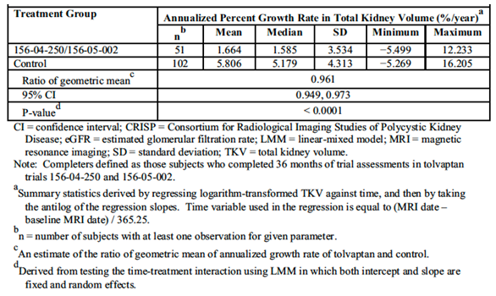

Table 31: Study 156-09-283; Rate of change in eGFR

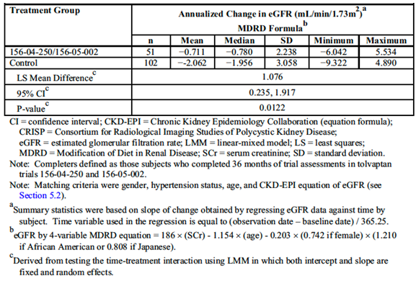

### Evaluator’s conclusions on clinical efficacy

The efficacy data come from a single randomised controlled trial and a collection of open label, non-comparative studies.

The pivotal study was well designed and executed. The population enrolled had evidence of rapid disease progression but reasonably good renal function. Within these criteria, it is likely that the results of the study are generalizable to an Australian population of ADPKD subjects.

The primary endpoint in the pivotal study was total kidney volume (TKV). The pivotal study demonstrated that tolvaptan treatment is associated with a statistically significant reduction in the progressive increase in TKV. Rate of increase over three years in the placebo arm was 5.51% per year, whereas in the tolvaptan arm, it was 2.80% per year, a reduction of 49.2%. The absolute difference between treatment arms was 2.71% per year (95%CI 2.15% to 3.27%). TKV has been shown to be directly correlated with total cyst volume in ADPKD and a correlation has also been shown between TKV and subsequent decline in renal function. However, everolimus has been shown to decrease progression in TKV, while at the same time producing a decline in renal function (9). The validity of TKV as a surrogate endpoint for efficacy in ADPKD has therefore been questioned. Of note, the FDA did not accept TKV as a valid primary endpoint for the pivotal study, and appears to have assessed efficacy based on the study’s secondary endpoints. The EMA and the Canadian regulatory authority have accepted TKV as a valid surrogate endpoint.

On the key secondary composite endpoint, tolvaptan treatment was associated with a 13.5% decrease in the risk of experiencing a clinical progression event (hazard ratio 0.865; 95% CI: 0.775 to 0.965; p = 0.0095). Clinical events occurred at a rate of 43.94 per 100 follow-up years in the tolvaptan arm compared with 50.04 per 100 follow-up years in the placebo arm. This benefit was largely due to a reduction in the risk of worsening renal failure events and renal pain events.

A beneficial effect of tolvaptan in terms of reducing the decline in overall renal function was also demonstrated. The effect was modest, with an overall benefit in GFR of approximately 1 ml/min/1.73m2 per annum (Table 27). This effect would need to be sustained for many years for the drug to produce meaningful clinical benefits such as a delay in the need for renal replacement therapy. Tolvaptan was not associated with any benefits in terms of the onset or progression of hypertension or microalbuminuria.

The findings of the pivotal study were supported by a comparison of long term data from two open label studies with historical data from observational studies. As subjects were not randomised to tolvaptan or control, the findings of this study should be interpreted with caution. Study 156-04-250 demonstrated that mean urine osmolality was maintained at < 300 mOsm/kg throughout over a period of 36 months.

The proposed dosing regimen is considered acceptable, as it is supported by pharmacodynamic data. In effect patients will be treated with a dose they can tolerate.

The proposed indication is generally acceptable, as it reflects the population enrolled in the pivotal study. However, subjects aged over 50 years were excluded from the pivotal study and this is not reflected in the indication. The sponsor has included a statement in the PI that safety and efficacy have not been established in subjects aged > 50 years, and this is considered a reasonable approach.

The submission for the new indication is based on a single pivotal study and the TGA has adopted an EMA guideline that deals with this situation (4). This guideline sets out certain ‘prerequisites’ that must be met for approval of such a submission. These are:

1. The study must have internal validity, with no indications of potential bias;
2. The study must have external validity, with the population studied being suitable to allow extrapolation of data to the population to be treated;
3. The size of the efficacy benefit must be large enough to be considered clinically valuable;
4. The degree of statistical significance should be “considerably stronger” than p < 0.05, and confidence intervals should be narrow.
5. The data should be of acceptable quality;
6. There should be internal consistency, with similar effects in sub-populations and important endpoints showing similar findings;
7. Results should not differ notably between study centres;
8. The hypothesis being tested should be plausible.

Overall it is considered that these prerequisites have been met.

As discussed above there have been differing opinions among foreign agencies as to whether TKV is an acceptable surrogate endpoint for efficacy. Preservation of renal function is a more clinically relevant endpoint than kidney size and a statistically significant benefit has been shown for this outcome in the pivotal study. Therefore, for this submission, the issue of whether TKV is a valid surrogate endpoint is not critical. Overall, based on the data showing a preservation of renal function, it can be concluded that tolvaptan has shown activity in the treatment of ADPKD. However, the clinical significance of this activity appears modest.

## Clinical safety

The Summary of Clinical Safety (SCS) in Module 2 of the submission provided a systematic review of the safety data from the new clinical trials included in the submission. The SCS reviewed safety results in the following order:

* Results from the pivotal Study 156-04-251;
* Results from the two long term studies that enrolled subjects who had completed the pivotal study (studies 156-08-271 and 156-10-003). Subjects in these trial were classified as “early treated” (that is received tolvaptan in the pivotal study) or ‘delayed-treated” (received placebo in the pivotal study);
* Results from the other long term studies (156-04-250, 156-05-002 and 156-09-003).
* Results from ADPKD subjects enrolled in short-term clinical pharmacology studies;
* Results from healthy volunteers enrolled in short-term clinical pharmacology studies.

The safety findings from the clinical pharmacology studies were briefly reviewed in the tables in the clinical evaluation report. Apart from adverse events consistent with the mechanism of action of tolvaptan (polyuria, nocturia, polydipsia, thirst etc.) these studies did not raise any safety concerns and therefore they will not be reviewed further in this section.

### Studies providing evaluable safety data

The following studies provided evaluable safety data:

#### Pivotal efficacy study

In the pivotal efficacy study, the following safety data were collected:

* General adverse events (AEs) were assessed at each clinic visit through the use of a standard non-leading question.
* A number of AEs were identified as AEs of special interest. These are reviewed below.
* Vital signs were measured at each clinic visit.
* ECGs were performed at baseline, during initial titration and at Month 36.
* Laboratory tests, were performed at screening, baseline, titration Weeks 1, 2, and 3 (or the end of titration visit), Months 4, 8, 12, 16, 20, 24, 28, 32, 36/end of treatment and at the two follow-up visits. Tests included the following:
  + Haematology: white blood cell count with differential, haematocrit or RBC and haemoglobin, MCV, MCHC, platelet count, prothrombin time as INR and aPTT;
  + Serum Chemistry: AST, ALT, GGT, LDH, ALP, total bilirubin, cholesterol, calcium, glucose, sodium, blood urea nitrogen, potassium, total protein, albumin. Creatinine and uric acid were monitored as pharmacodynamic endpoints.
  + Urinalysis: Specific gravity, pH, colour, clarity, blood, protein, glucose, microscopic analysis (including quantitation of RBC, WBC, and casts per high power field)

#### Long term efficacy studies

The long term efficacy studies provided safety data similar to that generated in the pivotal study although laboratory testing was generally less frequent.

### Patient exposure

The safety database for the current submission consisted of a total of 1581 subjects exposed to at least one dose of tolvaptan from 16 clinical studies (including the clinical pharmacology studies). This total included 1,432 subjects with ADPKD, 37 non-ADPKD subjects with varying degrees of renal function and 112 healthy volunteers.

Duration of exposure is summarised in Table 32. A total of 1,275 subjects had been exposed to the proposed doses of tolvaptan (60 to 120 mg per day) for at least 6 months and 1,002 subjects for at least 12 months.

For the pivotal study, the modal dose over time is shown in Figure 10. While 80.9% of subjects in the tolvaptan arm were titrated up to 120 mg per day at the end of the 3 week titration period, the proportion of subjects tolerating this dose decreased over time. At Month 36, only 54.4% of subjects in the tolvaptan arm had a modal dose of 120 mg per day. Average daily dose was around 100 mg per day.

Table 32: Safety database; Duration of exposure cumulative exposure to tolvaptan in all trials in the ADPKD clinical program by dose received

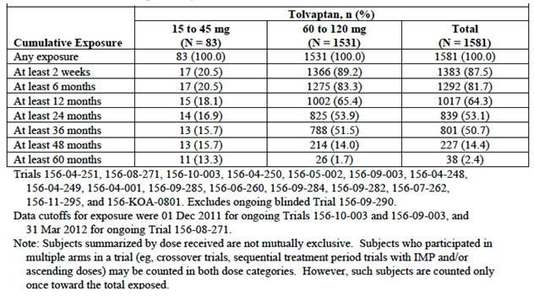

Figure 10: Study 156-04-251; Modal dose received over time

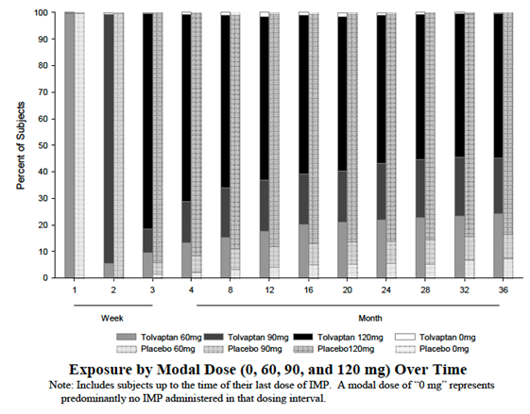

### Adverse events

The overall incidence of AEs in the pivotal study is summarised in Table 33.

Table 33: Study 156-04-251; Overall incidence of AEs

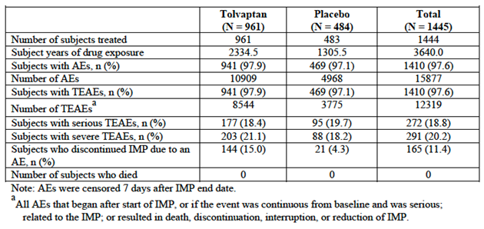

#### All adverse events (irrespective of relationship to study treatment)

##### Pivotal study

AEs occurred with a similar overall incidence in the two treatment groups – 97.9% of subjects in the tolvaptan arm and 97.1% of subjects in the placebo arm. Common AEs (those occurring in at least 2% of subjects in either group) are summarised in Table 34. AEs that were notably more common in the tolvaptan arm included the following:

* Events consistent with the mechanism of action of tolvaptan – thirst (55.3% versus 20.5%), polydipsia (10.4% versus 3.5%), polyuria (38.3% versus 17.2%), pollakiuria (that is urinary frequency - 23.2% versus 5.4%), nocturia (29.1% versus 13.0%);
* Gout 2.9% versus 1.4%), hyperuricaemia (3.9% versus 1.9%), blood uric acid increased (2.5% versus 1.2%);
* Hypernatraemia (2.8% versus 1.0%);
* Other events which could be plausibly related to dehydration such as constipation (8.4% versus 2.5%), dry skin (4.9% versus 1.7%) and rash (4.2% versus 1.9%).

Some AEs normally associated with ADPKD had a lower incidence in the tolvaptan arm – renal pain (27.1% versus 35.4%), haematuria (7.8 versus 14.1%), nephrolithiasis (1.6 versus 2.9%), urinary tract infection (8.4 versus 12.6%) and renal cyst infection (0.9% versus 2.7%).

The incidence of severe AEs was 21.1% in the tolvaptan arm and 18.2% in the placebo arm. The pattern of severe events was similar to that observed for all AEs.

Table 34: Study 156-04-251; Common AEs; incidence of treatment emergent adverse events in at least 2% of subjects in any group by MedDRA system organ class and preferred term

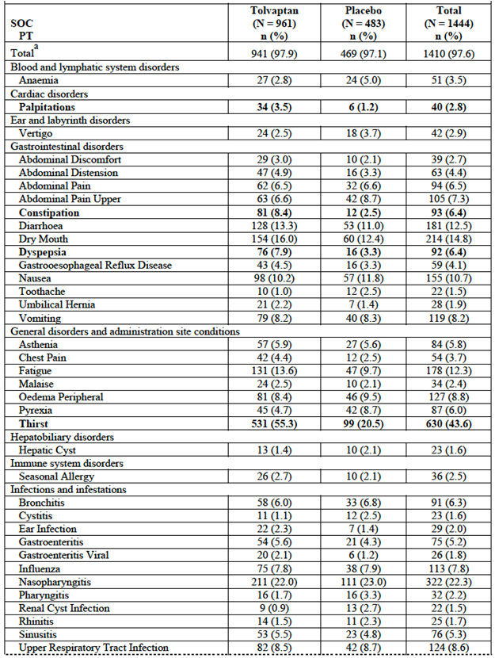

Table 34 (continued): Study 156-04-251; Common AEs

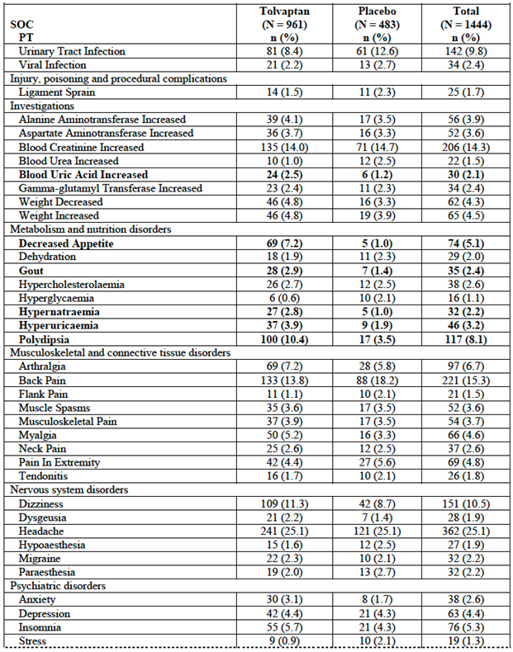

Table 34 (continued): Study 156-04-251; Common AEs

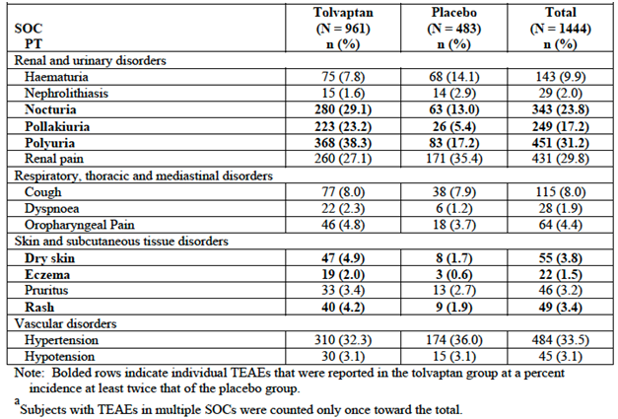

##### Long term studies

###### Studies 156-08-271 and 156-10-003

Common AEs occurring in these two studies are summarised in Table 35. The incidence of AEs was higher in subjects previously treated with placebo than in those previously treated with tolvaptan. The pattern of common AEs was similar to that observed in the pivotal study. For subjects previously treated with tolvaptan, the incidence of AEs during the long term extension studies was lower than that seen during the pivotal study.

Table 35: Studies 156-08-271 and 156-10-003; Common AEs; incidence of treatment emergent adverse events in at least 5% of subjects in any group in Trial 156-08-271 or Trial 156-10-003 by MedDRA system organ class and preferred term

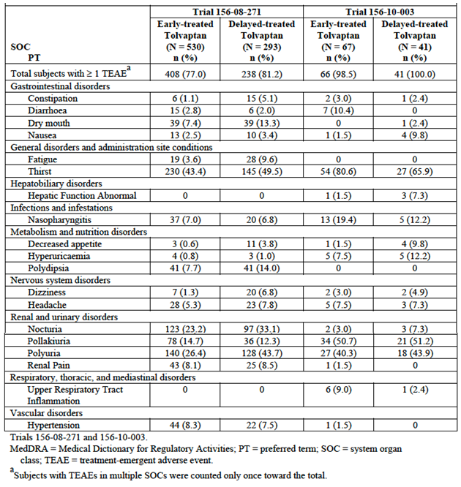

###### Studies 156-04-250, 156-05-002 and 156-09-003

AEs that occurred in at least 20% of subjects in these studies were provided. The pattern and frequency of events was consistent with that observed in the pivotal study.

#### Treatment-related adverse events (adverse drug reactions)

##### Pivotal study

The incidence of AEs assessed as potentially related to treatment was 88.6% in the tolvaptan arm and 62.5% in the placebo arm. Events that were notably more common in the tolvaptan arm were:

* Thirst (54.6% on tolvaptan vs 19.3% on placebo), polyuria (38.1% vs 16.6%), nocturia (29.1% vs 12.6%), pollakiuria (23.2% vs 5.2%), dry mouth (15.8% vs 11.6%), polydipsia (10.4% vs 3.5%);
* Headache (13.4% vs 9.1%) and dizziness (7.5% vs 4.6%);
* Fatigue (9.8% vs 4.8%);
* Decreased Appetite (5.7% vs 0.2%) and constipation (5.4% vs 0.6%).

##### Long term studies

###### Studies 156-08-271 and 156-10-003

The incidences of treatment-related AEs in these studies were:

* 66.0% in 156-08-271 (59.1% in the early-treated group and 73.0% in the delayed-treated group);
* 98.1% in 156-10-003. A breakdown by early versus delayed treatment was not provided.

For subjects previously treated with tolvaptan in 156-08-271, the incidence of treatment-related AEs during the long term extension was lower than that seen during the pivotal study.

###### Studies 156-04-250, 156-05-002 and 156-09-003

The incidences of treatment-related AEs in these studies were:

* 69.9% in 156-04-250;
* 100% in 156-05-002;
* 92.3% in 156-09-003.

In all the long term studies the types of AEs assessed as treatment related were similar to those in the pivotal study. The most commonly reported treatment-related events were polyuria, nocturia, pollakiuria, thirst and polydipsia.

#### Deaths and other serious adverse events

##### Deaths

There were no deaths in the pivotal study.

There were two deaths in other ADPKD studies:

* A 49 year old male who was enrolled in Study 156-08-271 (after completing the pivotal study) died of a self-inflicted gunshot wound. He had a past history of anxiety but no history of suicidal ideation. The investigator assessed the event as being not likely related to tolvaptan.
* A 39 year old female who was enrolled in Study 156-05-002, collapsed on Day 74 of treatment. She was diagnosed with a subarachnoid haemorrhage and died 17 days later. An autopsy was not performed. The investigator assessed the event as being unrelated to tolvaptan.

##### Non-fatal serious AEs (SAEs)

An AE was considered serious if it was fatal; life-threatening; persistently or significantly disabling or incapacitating; required in-subject hospitalization or prolonged hospitalization; a congenital anomaly/birth defect; or other medically significant event that, based on appropriate medical judgment, may have jeopardized the subject and may have required medical or surgical intervention to prevent one of the outcomes listed above.

###### Pivotal study

The incidence of SAEs was 18.4% in the tolvaptan arm and 19.7% in the placebo arm. SAEs occurring in at least 2 subjects in either arm were provided. SAEs that occurred with a notably higher frequency in the tolvaptan group were:

* Increased AST and ALT (0.9% versus 0.4% for both);
* Headache (0.5% versus 0%);
* Chest pain (0.8% versus 0.4%).

###### Long term studies

Studies 156-08-271 and 156-10-003

SAEs occurring in Study 156-08-271 were provided. The overall incidence was 6.3%. Serious LFT abnormalities occurred in 3 subjects:

* A 43 year old female developed elevated AST and ALT levels (peak > 20 xULN for both) starting on Day 100 of the study. Total bilirubin was slightly elevated (peak 1.4 xULN). The subject was discontinued and the LFT abnormalities resolved;
* A 42 year old female developed elevated AST and ALT levels (peak approximately 5 xULN for both) starting on Day 121 of the study. Results for bilirubin were not reported in the subject narrative. The subject was discontinued and the LFT abnormalities resolved;
* A 42 year old male developed elevated AST and ALT levels (peak approximately 3 xULN for both) starting on Day 98 of the study. Gamma GT was also elevated (peak 10x ULN). Bilirubin levels were not reported in the subject narrative. The subject had a prior history of high alcohol intake with abnormal LFTs prior to study entry. The subject continued on tolvaptan and AST and ALT decreased. The event was assessed as unrelated to tolvaptan.

In Study 156-10-003, the incidence of SAEs was 2.8%. Five SAEs were reported - hepatic cyst infection, ligament rupture, dizziness, renal cyst haemorrhage, and renal pain.

Studies 156-04-250, 156-05-002 and 156-09-003

The incidences of SAEs in these studies were:

* 23.9% in 156-04-250. Events reported in more than 1 subject were atrial fibrillation (2) and renal pain (2).
* 5.9% (1 subject) in 156-05-002 – 1 event of colonic diverticulitis;
* 7.7% (1 subject) in 156-09-003 - hepatic cyst infection with abdominal pain and pyrexia.

#### Discontinuation due to adverse events

##### Pivotal study

The incidence of discontinuation due to AEs was increased in the tolvaptan arm; 15.0% versus 4.3%. Discontinuations by system organ class were summarised and individual event terms that resulted in discontinuation in at least 0.5% of subjects are listed in Table 36.

Table 36: Study 156-04-251; Discontinuations due to AEs (incidence ≥ 0.5%)

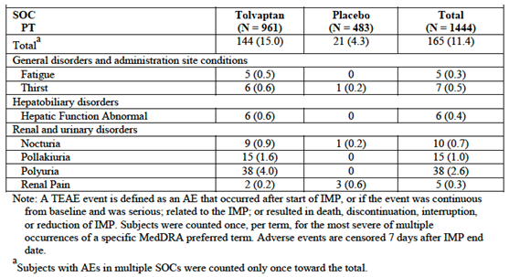

The most common AEs leading to discontinuation of tolvaptan were those related to the drug’s mechanism of action – polyuria, pollakiuria, nocturia and thirst. Other AE terms that were notably more common with tolvaptan were:

* Fatigue (0.5% versus 0.0%) and asthenia (0.3% versus 0.0%);
* Abnormal hepatic function (0.6% versus 0.0%), abnormal AST or ALT (0.4% versus 0.0% for both) and hepatitis (0.1% versus 0.0%);
* Depression and insomnia (0.3% versus 0.0% for both).

Discontinuation due to gastrointestinal events was also more common with tolvaptan (1.1% versus 0.0%). There were a number of individual GIT event terms in the tolvaptan arm. The only ones that occurred in more than 1 subject were nausea (n = 3), abdominal discomfort (2) and constipation (2).

##### Long term studies

###### Studies 156-08-271 and 156-10-003

Discontinuations due to AEs in these studies are summarised in Table 37. The overall incidence of AEs leading to discontinuation was 3.9% in 156-08-271 and 1.9% 156-10-003. Similar to the pivotal study, polyuria and LFT abnormalities were the most common events.

Table 37: Studies 156-08-271 and 156-10-003; Discontinuations due to AEs

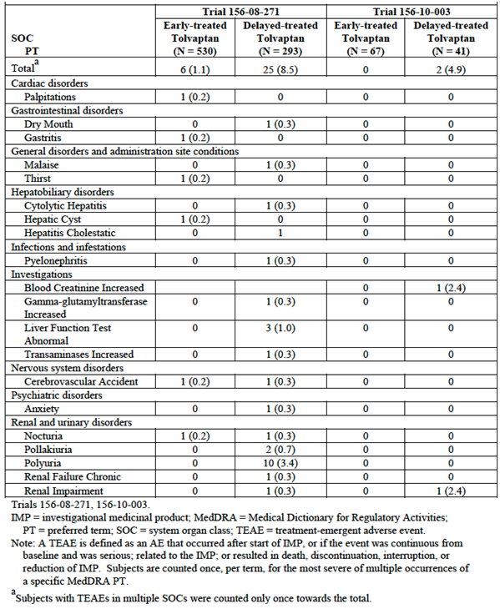

###### Studies 156-04-250, 156-05-002 and 156-09-003

The incidences of AEs leading to discontinuation in these studies were:

* 8.7% (4 subjects) in 156-04-250 – eye swelling, benign pituitary tumour, transient ischaemic attack and acute renal failure.
* 17.6% (3 subjects) in 156-05-002 – decreased kidney function, subarachnoid haemorrhage (fatal) and increased serum creatinine;
* 0% in 156-09-003.

#### Adverse events of special interest

Adverse events of special interest were assessed on data from the pivotal study, mainly using Standardised MedDRA Queries (SMQs) or Customised MedDRA Queries (CMQs).

##### Hepatic toxicity

Hepatic toxicity is discussed below.

##### Effects of Tolvaptan related to V2 inhibition

Adverse events of thirst/dry mouth were more common in the tolvaptan arm (67.2% versus 30.6%), as were urination and related events (71.9% versus 30.2%) and dehydration and related events (70.9% versus 44.9%).

##### Effects on sodium, potassium and calcium

These events are discussed below.

##### Renal function

Effects on renal function are discussed below.

##### Uric acid

These events are discussed below.

##### Hypertension

AE reports of hypertension occurred in 33.5% of subjects on tolvaptan compared with 37.1% of subjects on placebo.

##### Thrombosis/hypercoagulable state

Arterial thrombotic/embolic events occurred in 0.1% of tolvaptan subjects and 1.0% of placebo subjects. Venous thrombotic/embolic events occurred in 0.6% of tolvaptan subjects and 0.4% of placebo subjects.

##### Haemorrhage

Haemorrhagic events occurred in 1.7% of subjects in the tolvaptan arm and 2.1% of subjects in the placebo arm.

##### Effects on glucose

These events are discussed below.

##### Glaucoma

Tolvaptan treatment was associated with a slightly higher incidence of glaucoma (0.7% versus 0.4%). A similar increase had been observed in heart failure/hyponatraemia subjects.

##### ADPKD-related conditions

The incidences of AEs related to ADPKD were as follows (tolvaptan versus placebo):

* Renal pain: 27.7% versus 36.9%;
* Nephrolithiasis: 1.6% versus 2.9%;
* Haematuria: 7.8% versus 14.3%;
* Albuminuria: 1 subject versus 0 subjects;
* Urinary Tract Infection: 8.5% versus 12.6%;
* Anaemia: 3.6% versus 5.8%;
* Colonic diverticulum: 0.8% versus 0.6%;
* Vascular abnormalities: 0.8% versus 1.2%;
* Hernias: 3.2% versus 4.1%;
* Hepatic cysts: 1.5% versus 2.5%;
* Other cysts: 1.9% versus 4.1%.

##### Cardiac disorders

The results of an arrhythmia-related disorders SMQ showed a slight excess of such events in the tolvaptan arm (7.4% versus 4.6%). The main event terms responsible for the difference were palpitations (3.5% versus 1.2%) and syncope (1.7% versus 0.6%). The sponsor considered that such events may be a manifestation of dehydration.

An SMQ analysis for myocardial infarction/ischaemic heart disease showed incidence rates of 0.7% for tolvaptan and 0.6% for placebo.

### Laboratory tests

#### Liver function

##### Pivotal study

Testing of liver function during the pivotal study revealed an increased incidence of transaminase elevations in the tolvaptan arm (Table 38). In addition, there were two subjects that met Hy’s law criteria for severe drug-induced liver injury (DILI) - elevation in hepatic transaminases (AST or ALT) greater than 3 x the upper limit of normal (ULN), associated with elevation in total bilirubin (BT) to greater than 2 x ULN without associated evidence of cholestasis (that is, serum ALP less than 2 x ULN); and exclusion of other medical explanations.

Analyses of subjects with elevated transaminases suggested that that such events were more likely in subjects with reduced baseline creatinine clearance. There was no apparent association with higher dose. Elevations were more frequent in the tolvaptan arm compared to the placebo commencing at around 3 months and up to 14 months after initiation of therapy (Figure 11).

AE reports suggestive of hepatotoxicity were analysed using various Standardised MedDRA Queries (SMQs). The results of one of these analyses are presented in Table 39. Tolvaptan was associated with an increased incidence of these hepatic AEs (12.0% versus 8.1%). Serious hepatic AEs were also more common in the tolvaptan arm (2.1% versus 1.0%). There were no reports of liver failure or liver transplant and no fatal hepatic AEs.

Table 38: Study 156-04-251; LFT abnormalities elevated LFTs as assessed by central and local laboratory data combined, all randomised subjects

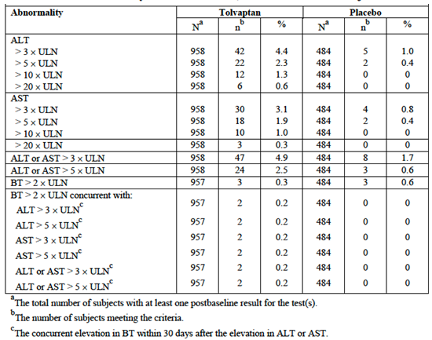

Figure11: Study 156-04-251; Time to onset of ALT elevations Kaplan-Meier curves for time to first elevation in ALT of greater than 3 times ULN, safety population

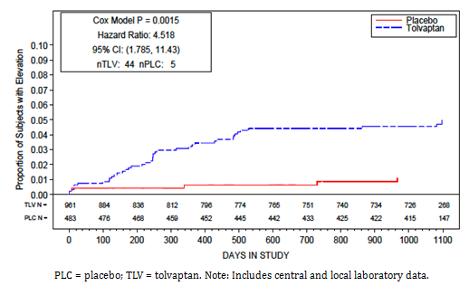

Table39: Study 156-04-251; Hepatic AEs; treatment emergent Adverse events in the SMQ of Liver related investigations, signs and symptoms

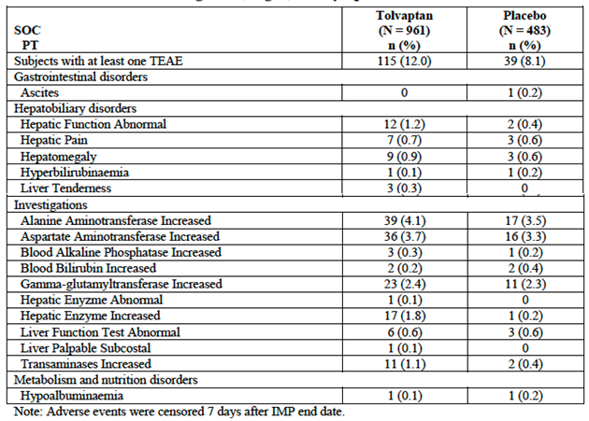

###### Hepatic adjudication committee

After the results of the pivotal study became available, the sponsor set up an independent, blinded Hepatic Adjudication Committee comprised of four expert hepatologists. The Committee reviewed all cases from the ADPKD program that met certain criteria (hepatic AEs that were serious or led to discontinuation, AST or ALT 3 x ULN with BT 2 x ULN, AST or ALT 5 x ULN, BT > 2 x ULN). Cases from previous studies in heart failure, cirrhosis and hyponatraemia, and relevant post-marketing reports were also reviewed. The date of data cut-off for the review was 31 March 2012.

The Committee identified a total of three cases that met Hy’s law criteria; 2 in the pivotal study and 1 in Study 156-08-271. The latter subject had been treated with placebo in the pivotal trial. The Committee concluded that “in patients with Autosomal Dominant Polycystic Kidney Disease tolvaptan has the potential to cause liver injury capable of progression to liver failure”. It was estimated that the incidence of liver failure among subjects who received long term treatment would be approximately 1 in 3,000.

Details of the three Hy’s law cases were as follows:

* Subject [information redacted] was a 34 year old female who presented with jaundice on Day 246 of the pivotal study. She had been treated with the 90 + 30 mg dose of tolvaptan. Peak AST and ALT levels were approximately 10x ULN and peak total bilirubin was approximately 13 x ULN. Tolvaptan was discontinued and the LFT abnormalities resolved on Day 438.
* Subject [information redacted] was a 45 year old female who presented with abnormal LFTs on Day 202 of the pivotal study. She had been treated with the 90 + 30 mg dose of tolvaptan. Peak AST and ALT levels were approximately 20 x ULN and peak total bilirubin was approximately 6 x ULN. Tolvaptan was discontinued and the LFT abnormalities resolved on Day 249.
* Subject [information redacted] was a 44 year old female who presented with abnormal LFTs on Day 89 of Study 156-08271. She had been treated with the 90 + 30 mg dose of tolvaptan. Peak AST and ALT levels were > 20 x ULN and peak total bilirubin was approximately 12 x ULN. A liver biopsy showed changes consistent with drug-induced hepatitis. Tolvaptan was discontinued and the LFT abnormalities were resolving at the time of last follow-up.

#### Kidney function

##### Pivotal study

Renal function was one of the efficacy parameters in the pivotal study and tolvaptan treatment was associated with a beneficial effect on renal function, as measured by eGFR or creatinine clearance. Serum creatinine was a pharmacodynamic endpoint for the study. Mean concentrations increased after commencement of tolvaptan but were lower after cessation of treatment. Similar changes were observed for serum cystatin-C, another biomarker for renal function. The incidence of potentially clinically significant increases in serum creatinine was lower in the tolvaptan arm (16.7% versus 21.0%). Increases in BUN were also less frequent (15.6% versus 29.4% -Table 40).

Table 40: Study 156-04-251; Biochemistry abnormalities Incidence of clinically significant abnormalities in serum chemistry laboratory tests

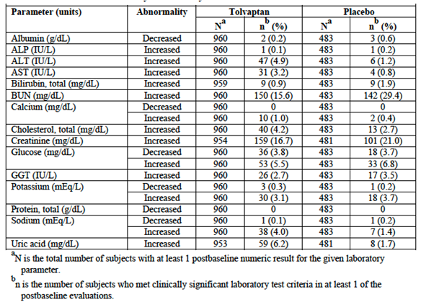

##### Other studies

Potentially significant elevations of serum creatinine and BUN occurring in the largest extension Study (156-08-271) were provided. Results were consistent with those obtained in the pivotal study.

#### Other clinical chemistry

##### Pivotal study

The incidence of potentially clinically significant biochemistry parameters is summarised in Table 40.

###### Sodium

Tolvaptan treatment was associated with an increased incidence of potentially clinically significant hypernatraemia (> 150 mEq/L) - 4.0% versus 1.4%. AE reports of hypernatraemia were also elevated (5.2% versus 1.4%).

###### Potassium

Tolvaptan treatment was not associated with an increased incidence of potentially clinically significant hyperkalaemia or hypokalaemia.

###### Calcium

Tolvaptan treatment was not associated with an increased incidence of potentially clinically significant changes in calcium concentrations.

###### Uric acid

Uric acid was a pharmacodynamic endpoint for the study. Mean concentrations were elevated in the tolvaptan arm. The drug was also associated with an increased incidence of potentially clinically significant elevations in serum uric acid (6.2% versus 1.7%, Table 40) and AE reports of gout were more common in the tolvaptan arm (2.9% versus 1.4%). Use of allopurinol at any time during the study occurred in 6.8% of tolvaptan subjects and 5.2% of placebo subjects.

**Comment:** No studies have been conducted examining potential interactions between tolvaptan and drugs used in the management of gout (for example allopurinol).

###### Glucose

Potentially clinically significant changes in blood glucose occurred with similar frequency in the two study arms (Table 40).

Adverse event reports of “hyperglycaemia” were less common in the tolvaptan group (0.6% versus 2.1%; Table 34). A CMQ for hyperglycaemia/new onset diabetes AE terms found a similar incidence of such events in the two arms; 18.4% versus 17.0%. However, the AE term “diabetes mellitus” was reported for 7 subjects in the tolvaptan arm and none in the placebo arm. Because of this finding, the sponsor concluded that an association between tolvaptan and hyperglycaemia/new onset diabetes could not be excluded. A warning regarding hyperglycaemia has been included in the draft PI.

**Comment:** No studies have been conducted examining potential interactions between tolvaptan and drugs used in the management of diabetes.

##### Other studies

Potentially significant elevations of biochemistry parameters occurring in the largest extension Study (156-08-271) were provided. Results were consistent with those obtained in the pivotal study.

#### Haematology

##### Pivotal study

The incidences of potentially clinically significant biochemistry parameters were provided. Abnormalities occurred with similar frequency in the two arms.

##### Other studies

Potentially significant elevations of haematology parameters occurring in the largest extension Study (156-08-271) are summarised in Table 41. Results were consistent with those obtained in the pivotal study.

Table 41: Study 156-04-271; Haematology abnormalities

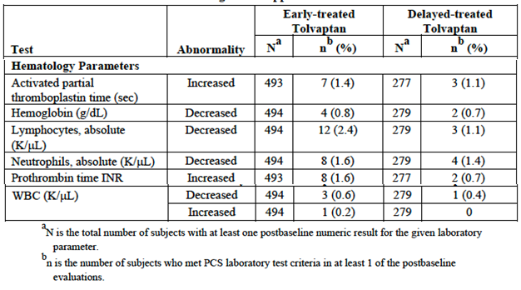

#### Urinalysis

In the pivotal study urinary albumin/creatinine ratio was monitored as a pharmacodynamic endpoint and there were no consistent differences observed between the treatment groups. There were no notable differences between treatment groups for the other urinalysis parameters.

#### Electrocardiograph

In the pivotal study, potentially clinically significant changes on ECG occurred with similar frequencies in the two treatment arms.

#### Vital signs

Overall, no clinically meaningful changes in mean vital signs were observed over time in the pivotal study or in the long term extension studies. The incidence of potentially clinically significant changes in the pivotal study is summarised in Table 42.

Table 42: Study 156-04-251; potentially clinically significant changes in vital signs

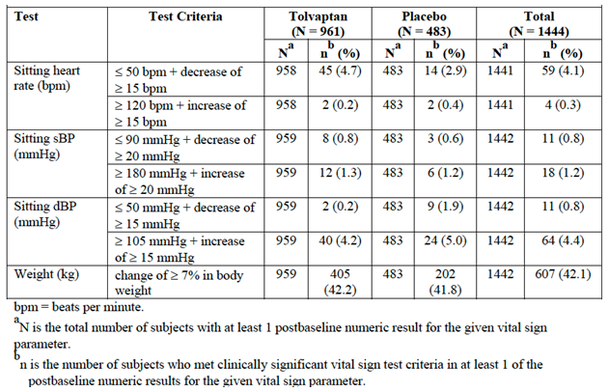

### Additional studies

#### Study 156-09-290

This was a Phase II, randomised, double-blind, placebo controlled trial with four parallel groups. Subjects with ADPKD were randomised to receive a 50 mg modified release (MR) formulation of tolvaptan once daily, an 80 mg MR formulation OD, the 60 + 30 mg split dose regimen of the IR tablets or placebo. Treatment was continued for 8 weeks.

Some safety data from this study were included in the Summary of Clinical Safety (SCS). The date of data-cut-off for inclusion in the SCS was 31 March 2012 and as a result only data from 18 subjects were included. The submission to the TGA also included a final study report of this trial dated 20 April 2015. The primary objective of the study was to compare the efficacy of the MR and IR formulations. As registration of the MR formulations is not being proposed, only the safety data are relevant to the current submission.

A total of 175 subjects were randomised and treated; 45 to 50mg MR, 44 to 80mg MR, 44 to 60 + 30mg IR and 43 to placebo. The adverse event profile was consistent with that previously observed, with subjects on tolvaptan having increased incidences of nocturia, polyuria, pollakiuria, thirst, polydipsia and fatigue.

The following serious AEs were reported in single tolvaptan treated subjects: sinus tachycardia, increased creatinine, increased hepatic enzyme, increased ALT, dehydration and renal pain. All of these subjects were discontinued. Another subject discontinued due polydipsia, polyuria and weight loss. Transaminase elevation to > 3 x ULN occurred in 3 tolvaptan-treated subjects. However, there were no cases meeting Hy’s Law criteria. There were no deaths in the study.

**Comment:** This was a short-term trial using doses of tolvaptan lower than those being proposed for registration. No new safety issues were identified.

#### Other studies

The submission included a large number of other study reports of trials conducted in healthy volunteers and in patients with hyponatraemia or cardiac failure. Most of these studies have been previously reviewed by the TGA. However, the following two trials appear not to have been previously evaluated:

* Study 156-03-002 was a dose ranging study in the treatment of oedema due to hepatic disease. Only a synopsis of the study (26 pages) was provided. Subjects were administered single doses of 15, 30 and 60 mg of tolvaptan. 18 subjects were enrolled.
* Study 156-04-247 was a randomised, double-blind, placebo-controlled trial with four parallel groups in subjects with NYHA Class 3 or 4 heart failure. Subjects were randomised to receive a single dose of tolvaptan 15, 30 or 60 mg or placebo. They underwent haemodynamic assessments using cardiac catheterisation. A total of 181 subjects were treated.

The safety results of these studies have been reviewed and no other safety concerns were identified.

### Post-marketing experience

The submission included six periodic safety update reports (PSURs) and one periodic adverse drug experience report (PADER). Together these reports covered the period 19 May 2009 to 18 May 2012 (that is 3 years). The reports described post-marketing reports for the Samsca presentation of tolvaptan.

The estimated cumulative exposure to the drug over the three-year period was 3,789.7 patient years. Reports of rapid increases in serum sodium levels led to amendments to prescribing information documents worldwide. In addition, raised intraocular pressure/glaucoma was added as an important potential risk to the risk management plan. Otherwise no significant new safety issues were raised.

A search was conducted for post-marketing reports of hepatic dysfunction. The period covered by the search was 1 June 2009 to 31 March 2012. A total of five cases were referred to the hepatic adjudication committee for review. No Hy’s law cases were identified and the committee considered that the hepatic events in these cases were unlikely to be related to tolvaptan.

**Comment:** Tolvaptan obtained marketing approval for use in ADPKD in February 2015 in Canada and May 2015 in Europe. The sponsor should be requested to provide any available post-marketing data on tolvaptan use in ADPKD.

### Safety issues with the potential for major regulatory impact

#### Liver toxicity

Tolvaptan is likely to be associated with rare cases of severe drug-induced liver injury when used in subjects with ADPKD.

#### Haematological toxicity

As outlined, the new studies in this submission did not identify any significant haematological toxicity with tolvaptan.

#### Serious skin reactions

In the pivotal study there were three subjects (0.3%) with serious skin AEs reported with tolvaptan – hidradenitis, angioedema and urticaria – compared with none in the placebo group.

#### Cardiovascular safety

As outlined, the new studies in this submission did not identify any significant cardiac or vascular toxicity with tolvaptan.

#### Unwanted immunological events

In the pivotal study there one subject with anaphylactic shock in the tolvaptan arm, compared with none in the placebo arm. The reaction occurred after ingesting amoxycillin. Tolvaptan treatment was continued. There have been post-marketing reports of anaphylaxis with the Samsca presentation of tolvaptan and the draft PI for Jinarc contains a warning statement regarding this risk.

### Other safety issues

#### Safety in special populations

For the pivotal study, subgroup analyses were conducted for the incidence of AEs according to gender, race (Caucasian versus Non-Caucasian), age (< 35 years versus ≥ 35 years), baseline hypertension status (present or absent), baseline TKV and baseline creatinine clearance. No notable differences between subgroups were noted.

### Evaluator’s overall conclusions on clinical safety

The extent of exposure to tolvaptan in ADPKD studies is considered adequate with over 1,000 subjects having been treated for at least 12 months. The monitoring of safety in the submitted clinical trials was also acceptable.

The major safety issue associated with tolvaptan in ADPKD is hepatotoxicity. Although the observed cases of hepatotoxicity in the clinical studies were reversible, the occurrence of three cases meeting Hy’s law criteria indicates that the drug is likely to be associated with rare cases of severe drug-induced liver injury; that is liver failure resulting in death or the need for transplantation. The sponsor is proposing a more rigorous program of LFT monitoring than was used in the pivotal study; it is recommended that LFTs be monitored at monthly intervals for the first 18 months and then at 3 monthly intervals thereafter.

The most common adverse events associated with tolvaptan were those associated with drug’s mechanism of action; polyuria, nocturia, thirst, polydipsia etc. Most subjects were able to tolerate these events. However, such events led to discontinuation of treatment in approximately 5% of subjects.

Other toxicities that appeared to be associated with tolvaptan were fatigue and increased uric acid concentrations with an increased incidence of gout. It is noted that no studies have been performed examining interactions between anti-gout medications and tolvaptan.

## First round benefit-risk assessment

### First round assessment of benefits

The benefits of tolvaptan in the treatment of ADPKD are:

* A slowing of the decline of renal function associated with the disease. The effect is modest with a benefit in terms of GFR of approximately 1 mL/min/1.73m2 per year;
* A reduction in the occurrence of events of severe renal pain. The risk of experiencing a severe renal pain event was reduced by 35.8%. The incidence of severe renal pain events was 7.30 per 100 follow-up years in the placebo group, and 4.73 per 100 follow-up years in the tolvaptan group. This difference is also modest being a reduction of only approximately 2.6 events per 100 follow-up years.
* A reduction in the rate of kidney enlargement. The rate is reduced by approximately 50%.

### First round assessment of risks

The risks of tolvaptan in the treatment of ADPKD are:

* Hepatotoxicity and a risk of serious drug-induced liver injury (DILI). DILI events are likely to be rare, with an estimated incidence of 1 in 3,000 subjects, but will be serious, resulting in death or the need for liver transplantation;
* A number of adverse events associated with the drug’s mechanism of action, such as thirst (incidence versus placebo 55.3% versus 20.5%), polydipsia (10.4% versus 3.5%), polyuria (38.3% versus 17.2%), pollakiuria (23.2% versus 5.4%) and nocturia (29.1% versus 13.0%). While most subjects are able to tolerate these effects, approximately 5% of subjects will discontinue therapy because of them;
* Increased serum uric acid concentrations with a possible increased risk of gout. Adverse events of gout occurred in 2.9% of subjects on tolvaptan compared with 1.4% of subjects on placebo.
* Hypernatraemia. AEs of hypernatraemia occurred in 2.8% of subjects on tolvaptan compared with 1.0% of subjects on placebo.
* Fatigue (13.6% versus 9.7%).

### First round assessment of benefit-risk balance

* ADPKD is a serious condition for which no effective therapies are currently available. It would therefore be highly desirable for effective and safe treatments to be made available for subjects with the disease. However, the benefit-risk balance of tolvaptan in the treatment of ADPKD is considered borderline.
* The main clinical benefit of the drug is preservation of renal function. However, the magnitude of this benefit is modest, with an average benefit in terms of GFR of approximately 1 mL/min/1.73m2 per year. This effect will need to be maintained for many years before clinically important outcomes are achieved (that is a delay or reduction in the need for renal replacement therapy). The only other efficacy benefit demonstrated for the drug was a reduction in the occurrence of events of severe renal pain, an effect which was also modest.
* Apart from DILI, the risks of tolvaptan use in the treatment of ADPKD appear acceptable, especially as ADPKD is a serious disease. Discontinuation due to AEs occurred in 15.0% of subjects treated with tolvaptan compared with 4.3% of subjects treated with placebo. This indicates that the majority of subjects are able to tolerate the drug’s adverse effects (most commonly polyuria, polydipsia, thirst, nocturia etc.). The incidence of serious AEs was comparable in the two treatment groups.
* DILI is the major safety issue associated with tolvaptan in the treatment of ADPKD. No cases of fatal hepatic failure or hepatic failure requiring liver transplant were reported in the submitted studies. However, three cases meeting Hy’s law criteria were observed and it is therefore likely that the drug will cause cases of hepatic failure resulting in death or liver transplantation.

## First round recommendation regarding authorisation

On balance this evaluator is inclined to recommend rejection of the application on the grounds that the modest efficacy benefits (some preservation of renal function and a small decrease in the incidence of severe renal pain events) are outweighed by the risk of severe DILI.

It is noted that in 2013, the FDA requested an additional efficacy study, to be conducted in ADPKD subjects with more advanced renal impairment. The benefits of tolvaptan may be greater in such a population and the sponsor should be requested to provide details of the progress of this study. Any post-marketing data that might better define the risk of severe DILI should also be requested.

## Clinical questions

### Efficacy

The efficacy benefits of tolvaptan in the treatment of ADPKD appear to be modest – a preservation of renal function of approximately 1 mL/min/1.73m2 per year, and a small decrease in the occurrence of severe renal pain events. Please provide comment on the clinical significance of these efficacy benefits.

In 2013, the FDA requested an additional efficacy study, to be conducted in ADPKD subjects with more advanced renal impairment than those enrolled in Study 156-04-251. Please advise whether such a study is planned or has commenced. If commenced, please provide details of progress.

### Safety

Tolvaptan obtained marketing approval for use in ADPKD in February 2015 in Canada and May 2015 in Europe. Please provide any available post-marketing data on tolvaptan use in ADPKD.

Please provide an update on whether any further Hy’s law cases have been identified and whether any cases of liver failure have been reported.

Please provide an integrated analysis across all clinical studies (that is those submitted for the currently approved indication and those submitted for the proposed ADPKD indication) of LFT elevations and hepatic adverse events, including by dose.

## Second round evaluation of clinical data submitted in response to questions

Question

***The efficacy benefits of tolvaptan in the treatment of ADPKD appear to be modest – a preservation of renal function of approximately 1 mL/min/1.73m2 per year, and a small decrease in the occurrence of severe renal pain events. Please provide comment on the clinical significance of these efficacy benefits.***

***Sponsor’s response***

The sponsor noted that the endpoints in Study 156-04-251 were chosen in consultation with regulators in the USA, EU and Japan. The progress of ADPKD is determined by the level of cystogenesis (cyst formation and expansion), renal function decline and clinical outcomes. The study sought to measure these factors using % change in total kidney volume (TKV), glomerular filtration rate and clinical outcomes (including but not limited to renal pain).

The sponsor acknowledged the comments in the Round 1 Clinical Evaluation Report about modest outcomes and provided further discussion about the magnitude of the effect size to address these comments.

TKV was the primary endpoint of the study and has been previously determined to be a predictive measure of disease progression. This biomarker of disease was chosen because improvement in this parameter is likely to impact later renal function in patients with early disease, where efficacy measured by eGFR would be difficult because of relatively stable renal function in early disease.

The sponsor referenced the following table from the CSR (Table 43, below).

Table 43: Sensitivity analysis: Mixed effect Model Repeat Measure analysis of Change from Baseline in total Kidney Volume (%) ITT, Within Treatment Period*

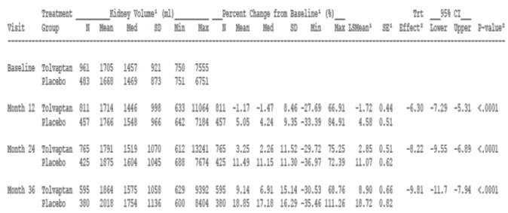

*TKV observations of Tolvaptan Subjects Post last dose of IMP were excluded

The sponsor stated tolvaptan significantly attenuated the increase in kidney volume by up to 50% over three years, although there was an increase in mean TKV in both groups (see Table 43, above).The treatment effect (placebo subtracted treatment difference from baseline) was -6.3% (-7.3 to -5.3%) at 12 months, -8.22% (-9.55% to -6.89%) at 24 months and -9.81% (-11.7% to -7.94%) at 36 months. Between years 2 and 3 of the study the mean TKV increased 14.14% in the placebo group and 10.62% in the tolvaptan group. The effects on TKV included those patients with relatively intact renal function.

The sponsor provided the FDA analysis of mean TKV over time (Figure 12, below). The analysis shows an initial effect on the TKV and then a return to a similar slope of decline as the placebo group after approximately 1 year.

Figure 12: FDA analysis of mean TKV over time

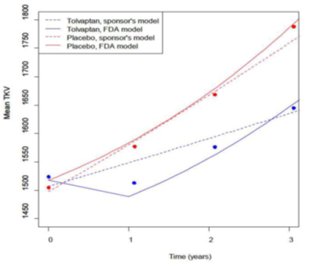

The key (composite) secondary endpoint was the time to one of four events. This endpoint outcome was driven largely by worsening renal function and worsening renal pain. The events of renal function worsening were reduced from 4.84 events per 100 patient years to 1.85 events per 100 patient years. The other two components (new onset micro-or macro-albuminuria, and worsening hypertension) showed no difference between the two groups.

The decline in renal function in ADPKD occurs in a reverse exponential and more rapid fashion than other renal conditions but the progressive increase in kidney volume is linear. The estimated rate of decline in renal function with tolvaptan compared to placebo was 0.977 mL/min/1.73 m2/year with an estimated placebo slope of -3.7 ml/min/1.73m2. This was comparable to the estimated treatment effect off treatment of 1.029 mL/min/1.73m2/year. The overall effective reduction in chronic growth of TKV of approximately 25% was similar to the overall effective reduction in the rate of decline in eGFR (approximately 25%).The analyses were not adjusted for the age related decline in eGFR after 40 years of age.

The sponsor compared the rate of renal decline in ADPKD to hypertensive nephropathy and provided comparisons of studies for losartan (RENAAL), irbesartan (IDNT) and ramipril (AASK). The rate of renal function effect size for the angiotensin receptor blocker studies that compared the active treatment with placebo were 0.8 mL/min/1.73 m2/year decrease and creatinine clearance 1.0 mL/min decrease, in the RENAAL and IDNT studies, respectively. In the AASK study the decrease in eGFR was 1.16 mL/min/1.73 m2/year. The sponsor did not state which formula for estimation of eGFR was used in the RENAAL and AASK studies. The sponsor performed a post-hoc analysis of patients in Study 156-04-251 with similarly severe CKD (stage 2 and 3) to the patients with hypertensive nephropathy in the hypertension studies. It noted that the decline in eGFR slope was reduced by 1.33 ml/min/1.73 m2/year (RRR 29.1%) and 1.66 mL/min/1.73 m2/year (RR 31.0%) in Study 156-04-251 in patients with CKD stage 2 and 3 respectively, but for CKD stage 1 patients it was 0.4 mL/min/1.73 m2/year ( RR 15.5%). It concluded the difference in rate of decline should be favourable when compared to hypertensive nephropathy, that also leads to ESRD.

The sponsor obtained an opinion from its Australian Otsuka Advisory Board that a difference in renal function decline of 1 mL/min/1.73 m2/year is clinically significant in the setting of general renal decline and concluded that a reduction of this magnitude for 4 years of treatment would equate to the delay in dialysis by 1 year. The sponsor noted the approximately 100 fold increased mortality risk for patients on dialysis, and improved quality of life if dialysis were delayed.

The sponsor provided the following survival curves for pain and worsening renal function comparing tolvaptan and placebo in Study 156-04-251.

Figure 13: Tolvaptan outcomes; worsening renal function and renal pain

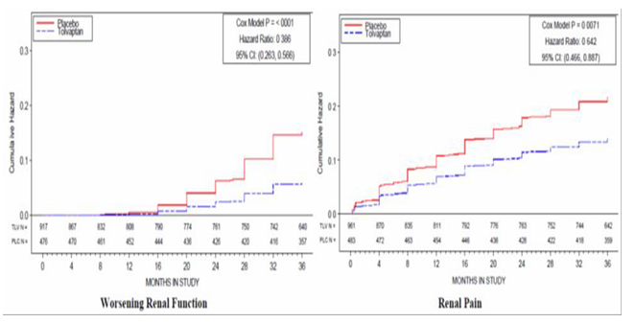

A reduction in renal pain was considered of benefit for those patients. Since pain can reflect increased cystogenesis and increased cyst size with accompanying local ischaemia, haemorrhage or capsular stretch, in addition to the increased risk of infection and renal calculi, the sponsor has considered the endpoint relevant. The sponsor has made no comment about the effect size in the difference between the tolvaptan and the placebo groups.

**Comment:** The focus of the question was the clinical significance of the observed benefits.

TKV was the primary efficacy endpoint. The EMA noted in its discussion paper on TKV as an endpoint that the correlation with clinical endpoints were less firmly established than for a 57% reduction (doubling of serum creatinine). The EMA points out in this paper that the incremental change was acceptable for the sponsor’s proposed prediction modelling but may not be suitable for the clinical trial, however this endpoint has subsequently been accepted by the EMA for tolvaptan in ADPKD.

Baseline height adjusted TKV was found to have a 74% sensitivity and 75% specificity at a cut-point of 600 mL/m of predicting a stage 3 CKD endpoint (Chapman et al, 2012).[1]

The reduction in worsening renal failure events represents a 61% reduction, but overall the difference in the mean rate of change per year in estimated eGFR was 0.9 mL/min/1.73 m2/year. Rapid progression of renal function decline is generally accepted to be more than 5 ml/min/1.73 m2/year. To give context, the age-adjusted rate of decline in eGFRMSDS in patients with type 2 diabetes and hypertension was found to be 1.0 ml/min/1.73 m2/year (Zoppini et al 2012)(12). The rate of reduction in eGFR was not age-adjusted so age-based comparisons are difficult from the data set.

***Question***

***In 2013, the FDA requested an additional efficacy study, to be conducted in ADPKD subjects with more advanced renal impairment than those enrolled in Study 156-04-251. Please advise whether such a study is planned or has commenced. If commenced, please provide details of progress.***

***Sponsor’s response***

The sponsor and the FDA agreed to the following clinical study:

*Protocol 156-13-210, A Phase 3b, Multi-center, Randomized -withdrawal, Placebo-controlled, Doubleblind, Parallel group Trial to Compare the Efficacy and Safety of Tolvaptan (45 to 120 mg/day, Split-dose) in Subjects with Chronic Kidney Disease Between Late Stage 2 to Early Stage 4 Due to Autosomal Dominant Polycystic Kidney Disease.*

The study commenced in May 2014 and the last subject is due for the last visit in April 2017. Of the 1371 participants enrolled from 21 countries, including 34 patients from 10 sites in Australia, 917 (67%) remain on treatment and 361 (26%) have completed the trial on treatment.

The sponsor anticipates resubmitting the marketing application to the FDA with the additional clinical data from this study in the second half of 2017.

**Comment:** This study will provide additional efficacy and safety information regarding the use of tolvaptan in later stages of ADPKD than Study 156-04-251 (TEMPO 3:4). Ideally, this study would be available to the TGA prior to it making a decision regarding registration for the proposed indication, particularly given the proximity of its anticipated completion date with the projected decision date in the Prescription Medicines Registration Process for this submission.

***Question***

***Tolvaptan obtained marketing approval for use in ADPKD in February 2015 in Canada and May 2015 in Europe. Please provide any available postmarketing data on tolvaptan use in ADPKD.***

***Sponsor’s response***

The sponsor provided a post-market safety analysis of tolvaptan use for the ADPKD indication that covered the post-market period from 24 March 2014 to 18 May 2016 in Japan. Safety data were included for Europe, and Canada. It was approved but not marketed for the ADPKD indication in Korea and Switzerland at the time of this report. The periods of data inclusion varied depending on the approval dates in those countries/regions. The report was in summary form and no individual case reports were provided.

The estimated exposure was 9,447 patient-years, mostly (9,344 patient-years) in Canada, and mostly from the 60 mg dosage group (45/15 mg combination pack). A total of 2651 adverse events were reported for 799 cases, 337 of which were considered serious. Of those, 72 cases (178 events) were from spontaneous reports, 717 cases (2438 adverse events) from post-marketing non-interventional studies, and 10 cases (35 adverse events) were from literature.

By SOC most were general disorders and administration site conditions (17%), Renal and urinary disorders (14%), Investigations (13.9%), and Hepatobiliary disorders 8.4%. For the SOC Hepatobiliary disorders, 223 events were reported, with 88 serious. The most common were Hepatic function abnormal (n = 162) with 66 of those were considered serious. Of the Investigations, ALT increased was reported in 16 cases (3 serious) and AST increased in 13 cases (2 serious), GGT increased in 17 cases (2 serious). The most commonly reported abnormal investigations were creatinine increased (56 cases), urea increased (26 cases) and GFR decreased (22 cases). Blood sodium increased was reported in 14 cases. Polydipsia (n = 69), hyperuricaemia (n = 67) and hypernatraemia (n = 61) were the most common metabolic disorders. Fifty cases of insomnia and sleep disorder were reported. Of the Renal and urinary disorders pollakiuria (n = 108) and nocturia (n = 104) were the most common.

The liver safety of tolvaptan in the treatment of ADPKD was assessed by the sponsor’s external hepatic adjudication committee (HAC), and the results of the adjudication performed between 31 March 2015 and 30 April 2015 did not reveal any Hy’s Law cases in the post-market setting. The estimated incidence of acute liver failure remains 1:4,400 ADPKD patients.

**Comment:** The sponsor has provided a summary of the post-market findings response to the question. The response to the question is satisfactory. No new apparent safety signals and no amplification of existing signals emerged from the analysis based on the information provided. The individual case reports were not provided so no comment can be made regarding the sponsor’s adjudication of events.

***Question***

***Please provide an update on whether any further Hy’s law cases have been identified and whether any cases of liver failure have been reported.***

***Sponsor’s response***

Three cases were identified in a report from the HAC established by the sponsor in 2012. Since then the scope of the review broadened to include cases from clinical trials for all indications and post-market cases. No new Hy’s Law cases and no reports of liver failure attributed to tolvaptan treatment have been identified the HAC up to 30 April 2016.

**Comment:** The sponsor’s response is acceptable.

***Question***

***Please provide an integrated analysis across all clinical studies (that is those submitted for the currently approved indication and those submitted for the proposed ADPKD indication) of LFT elevations and hepatic adverse events, including by dose.***

***Sponsor’s response***

The sponsor provided an integrated safety analysis of hepatic adverse events and elevations of liver function tests from the study programmes of Jinarc and Samsca that also included placebo controlled and non-controlled studies for healthy subjects (see Table 44 and Table 45 below). All participants exposed to one or more doses of tolvaptan were included, and data were extracted from the study data sets based on hepatic Standardised Medical Queries (SMQs). Patients were exposed to doses of 5 mg to 60 mg. The sponsor divided the patients into 6 groups for the purpose of analysis.

Table 44: Hepatic adverse events; integrated analysis

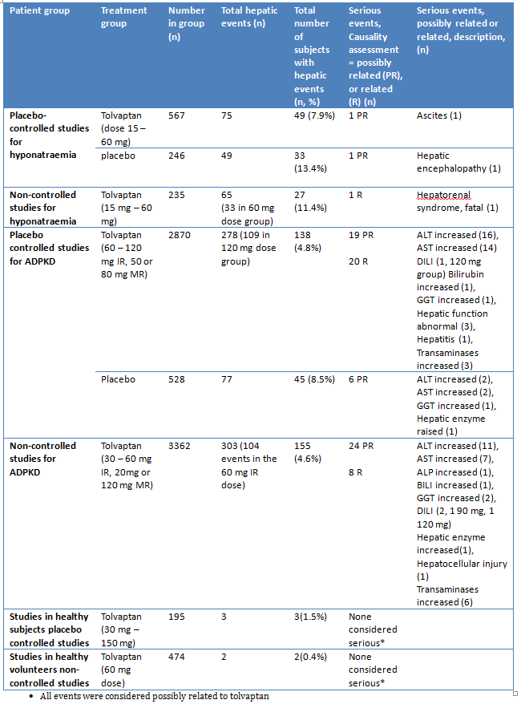

The sponsor also provided an analysis by elevations of liver function tests in studies conducted for hyponatraemia and ADPKD.

Table 45: Liver function test abnormalities; integrated safety analysis

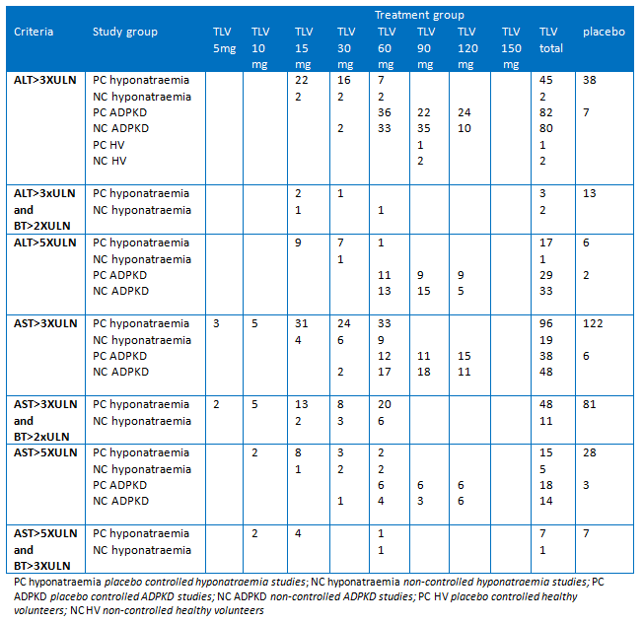

The sponsor provided the following exposure data for its analysis of the hepatic adverse events in the integrated safety analysis.

Table 46: Tolvaptan exposure by dose; integrated hepatic safety analysis

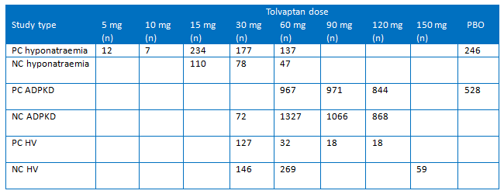

No LFT abnormalities were reported for tolvaptan patients in studies using MR products.

**Comment:** No clear relationship between dose and liver function abnormalities was seen in the ADPKD studies although AST increases were more common with 60 mg dosing in the hyponatraemia studies. Increases in bilirubin that occurred concurrently with increases in transaminases were not reported in the sponsor’s analysis of the ADPKD studies in this summary.

Three cases of DILI were reported in the analysis with higher doses of tolvaptan. The sponsor noted in its answers to questions that 6 cases of DILI have been reported in total. As noted above no new cases were reported from the post-market analysis to 18 May 2016.

## Second round benefit-risk assessment

### Second round assessment of benefits

After consideration of the responses to clinical questions, the benefits of tolvaptan in the proposed usage are essentially unchanged from those identified in the first round assessment of benefits.

The sponsor has provided a justification for use of TKV as an endpoint and has highlighted the reduction in progression of disease demonstrated by this endpoint and the renal function component of the key secondary endpoint.

The sponsor has highlighted that tolvaptan does not prevent further progression of the ADPKD pathology but slows its progress. As noted in the Round 1 report the effects on the slowing of disease are modest across the study.

The sponsor has requested the Indication include patients with CKD stage 3, although these patients were specifically excluded from the pivotal study. At the commencement of the study approximately 250 patient with CKD stage 3 were enrolled, of whom 166 were randomised to receive tolvaptan. Because of the deterioration of renal function in both patient groups the CKD stage 3 group increased in size to a total of 253 in the tolvaptan group and 122 in the placebo group by the third year of the study. In a post-hoc analysis published by Torres et al the reduction in decline in renal function in the CKD stage 3 group was 1.66 mL/min/1.73 m2/year compared to 0.9 mL/min/1.73 m2/year in the CKD stage 1 group. This exploratory analysis does not raise specific concerns about the efficacy in this CKD stage 3 group.

The sponsor is conducting an additional study that includes patients with CKD stage 2 to early stage 4. This will provide additional information about the efficacy in these groups.

The sponsor has presented at least one year of data for each of the three CKD stages included in the proposed Indication. ADPKD is however a slowly progressive disease. There is uncertainty about the sustainability of the slowing of progression of the disease. There is uncertainty about the impact of discontinuation of tolvaptan on disease progression, and whether the rate of decline parallels that of placebo or whether there is an increase in the rate of decline (some kind of rebound effect).

It is important to note that extra-renal manifestations of PKD were not studied in the pivotal trial. The benefit of tolvaptan for reduction in cerebral aneurysm formation and the development of liver cysts has not been established in this submission.

### Second round assessment of risks

After consideration of the responses to clinical questions, the risks of tolvaptan in the proposed usage are essentially unchanged from those identified in the first round assessment of risks.

The additional information regarding hepatic toxicity indicates that while severe idiosyncratic hepatotoxicity occurs in about 1 in 4,400 tolvaptan patients, abnormalities of liver function were much more common (about 3 to 4 fold higher) with tolvaptan than placebo.. The sponsor has agreed to a boxed warning for the PI to emphasise the risk of hepatic toxicity.

In addition to the risks identified at Round 1 it should be highlighted that there are tolerability issues for tolvaptan compared with placebo as shown by the greater proportion of discontinuations due to adverse event in the pivotal study (15% v 4.3%).

At the initiation of tolvaptan therapy there was a small and reversible reduction in GFR, the mechanism of which is not well defined. The sponsor proposes to include this risk in the Precautions section of the PI.

Signals about glaucoma or increased intraocular pressure was noted in the pivotal study with events from the glaucoma SMQ occurring in 2.1% of the tolvaptan groups and 1.0% of the placebo group. On further analysis most were mild to moderate in severity. One patient with the SAE of glaucoma discontinued permanently from the study although not directly related to the adverse event. The sponsor has included glaucoma/ increased intra-ocular pressure as a potential risk in the RMP.

The risks in older patients are not well characterised. It is reasonable to expect that most patients starting on this treatment would be younger than 50 years but that the likely duration of therapy, makes this a relevant risk.

In its responses to the RMP questions the sponsor has provided additional details of its proposed controlled distribution programme for tolvaptan for the proposed indication that restricts its prescription to certified renal physicians. Certification would be obtained by undergoing a training course. This is considered to be an important risk mitigation strategy, however the RMP evaluator will consider the detail of the sponsor’s proposal.

### Second round assessment of benefit-risk balance

Having considered the benefits, risks and uncertainties, and having given consideration to the unmet clinical need in the patients with ADPKD the benefit-risk balance of tolvaptan, given the proposed usage, is marginal and only just favourable. This assessment is provided the recommendations regarding the PI are implemented. It is noted that Study 156-13-210 is underway and that this will provide additional information about ADPKD patients with CKD stages 2 to early stage 4. It is noted this study is due to concluded in 2017. The provision of this study, in addition to information provided in the submission, would have provided a more complete data set.

Although the incremental benefit over 3 years is modest ADPKD is a slow progressive disease. Benefit was demonstrated for both the primary and secondary endpoints. Two of the four components of the key secondary endpoint drove the positive outcome but none of the endpoints demonstrated poorer outcomes for the respective variable.

The patients in the TEMPO 3:4 were relatively young with a median age of 27.4 years. It may be considered that a reduction in deterioration of renal function of a modest 26% may be meaningful in this group whereas in advanced disease it may not to be so.

The PKPD modelling suggests a more favourable effect with poorer renal function. To further investigate the effects in patients with stage II and stage III CKD a study is underway to provide data on the use of tolvaptan in later stages of the disease. There is insufficient information about the progression of disease, delay of ESRD, delay of dialysis or renal transplant from the long term use of tolvaptan. There are no data to determine the optimal stage of disease at which treatment should commence; however the sponsor has proposed to restrict the indication to patients with evidence of rapidly progressive disease.

Although there is some experience with tolvaptan with its indication for the treatment of clinically significant hypervolaemic or euvolaemic hyponatraemia the doses are larger raising the possibility of dose-related toxicity. In the ADPKD clinical programme the most common adverse effects were thirst, polyuria, nocturia, pollakiuria, and dry mouth. While these symptoms are manageable, thirst and frequent urination have significant lifestyle restrictions and may have implications for compliance with tolvaptan. Careful fluid balance is required, particularly in patients with more advanced disease and may become problematic as renal function deteriorates.

Idiosyncratic hepatic failure is a major cause for concern. The sponsor has estimated 1 in 4,400 patients will have severe idiosyncratic hepatic toxicity while taking tolvaptan. The risk of hepatic events appears to be greater in the ADPKD population than for hyponatraemia but that may be related to the dose. Of the three cases of DILI that have occurred in clinical trials none have been fatal or required transplant but this observation may be tempered by the occurrence of the events in clinical trials, with frequent monitoring and prompt action by the trial investigators. The numbers of events is small, and wider exposure may reveal more severe reactions. The sponsor has proposed risk minimisation activities in the form of a controlled distribution system, a boxed warning and extensive warnings throughout the PI. Frequent monitoring is recommended, and although the usefulness of frequent monitoring to detect idiosyncratic hepatic disease with other medicines has been recently questioned, but abnormalities of liver enzymes that will be detected by the laboratory tests. The sponsor has proposed recommendations for discontinuation of therapy based on the results of liver function tests in the PI to guide the prescriber.

There are a number of uncertainties in the efficacy and safety data. The placebo-controlled duration of exposure is for only three years, and although acceptable for a submission for long term therapy in general, limits the conclusions that can be drawn because ADPKD is a slowly progressive disease. Of particular concern is uncertainty about the durability of the tolvaptan effect. Historical controls have been used by the sponsor, but they are potentially confounded by advances in the management of other risk factors for renal disease. Data were missing from 23% of the tolvaptan subjects and 14% of the placebo patients) and the disproportionate number of discontinuations due to adverse events occurred in the tolvaptan group, adding to the uncertainty.

There is an unmet clinical need for a treatment for ADPKD, which is a progressive condition requiring in renal replacement therapy in the majority of patients by the age of 60 years. This is a major factor in concluding a positive benefit-risk balance for tolvaptan for the proposed indication. While Figure 14 shows signalling pathways that are potential targets for therapies for ADPKD there are no other medicines are approved in Australia to halt or modify the progression of this disease. Tolvaptan has a demonstrated modest effect in slowing the progression of the disease, this is balanced against significant safety concerns that will require careful patient selection and vigilant clinical and laboratory monitoring by the treating physician. It will also require meticulous compliance by the patient not only in following the hydration recommendations but also for attendance for follow-up. It will therefore not be suitable for all adult patients with CKD stages 1 to 3.

Figure 14: Renal tubular cell signalling pathways found to be increased or decreased in PKD

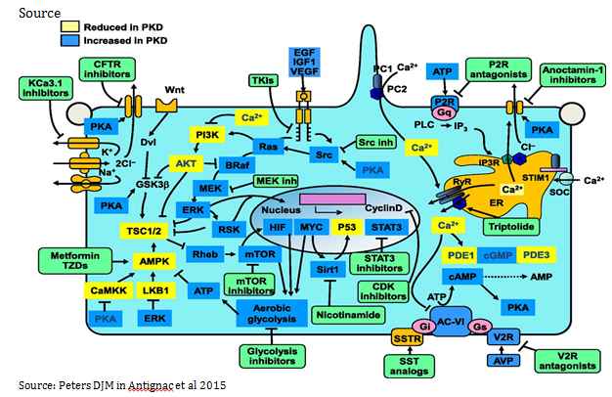

## Second round recommendation regarding authorisation

The Round 2 evaluation concludes Jinarc (tolvaptan) is recommended for authorisation for the sponsor’s proposed indication. This recommendation is provided subject to the following:

* The PI is updated as requested.
* The sponsor provides Study 156 -13-210 for evaluation as soon as it becomes available.
* The provision of all clinically relevant information from the ongoing studies listed in the pharmacovigilance plan.

The RMP team will evaluate the details of the restricted access programme but this programme is considered a most important aspect of the mitigation of the risks, and integral to the recommendation for authorisation.

## References

1. Grantham JJ. Autosomal Dominant Polycystic Kidney Disease. N Engl J Med 2008; 359:1477-85.
2. Ong ACM, Devuyst O, Knebelmann B et al. Autosomal dominant polycystic kidney disease: the changing face of clinical management. Lancet 2015; 385: 1993–2002.
3. Torres VE, Harris PC and Pirson Y. Autosomal dominant polycystic kidney disease. Lancet 2007; 369: 1287–301.
4. European Medicines Agency. Points to consider on application with 1. Meta-analyses; 2. One pivotal study; CPMP/EWP/2330/99 (2001).
5. Note for Guidance on the Evaluation of the Pharmacokinetics of Medicinal Products in Patients with Impaired Renal Function. CHMP/EWP/225/02 (2004).
6. Guideline on the Investigation of Bioequivalence. CPMP/EWP/QWP/1401/98 Rev. 1/ Corr **. (2010).
7. European Medicines Agency. European Medicines Agency decision P/0045/2016. 26 February 2016. Available from: http://www.ema.europa.eu/ema/index.jsp?curl=pages/medicines/landing/pip_search.jsp&mid=WC0b01ac058001d129 (Accessed May 2016)
8. Torres VE, Chapman AB, Devuyst O et al. Tolvaptan in Patients with Autosomal Dominant Polycystic Kidney Disease. N Engl J Med 2012; 367: 2407-18.
9. Walz G, Budde K, Mannaa M et al. Everolimus in Patients with Autosomal Dominant Polycystic Kidney Disease. N Engl J Med 2010; 363: 830-40.
10. Gansevoort RT, Arici M, Benzing T, Birn H et al Recommendations for the use of tolvaptan in autosomal dominant polycystic kidney disease: a [position statement on behalf of the ERA-EDTA Working Groups on Inherited Kidney Disorders and European Renal Best Practice Nephrol Dial Transplant (2016)0:1-12
11. Thong KM and Ong ACM the natural history of autosomal dominant polycytic kidney disease: 30 year experience from a single centre QJ Med published 15 April 2013.
12. Zoppini G, Tragher G, Choncol M, Ortalda et al Predicotrs of Estimated GFR Decline in Patients with Type 2 Diabetes and Preserved Renal Function CJASN 2012; 7: 401-408
13. EMA/CHMP/SAWP/473433/2015 Qualification opinion Total Kidney Volume (TKV) as a prognostic biomarker for use in clinical trials evaluating patients with Autosomal Dominant Polycystic Kidney Disease
14. Antignac C, Calver JP, Germino GC et al The Future of Polycystic Kidney Disease Research – As Seen By the 12 Kaplan Awardees J Am Soc Nephrol ePub 10.61681/ASN.2014121192

|  |
| --- |
| Therapeutic Goods Administration |
| PO Box 100 Woden ACT 2606 Australia  Email: [info@tga.gov.au](mailto:info@tga.gov.au) Phone: 1800 020 653 Fax: 02 6232 8605  [**https://www.tga.gov.au**](https://www.tga.gov.au) |

1. Chapman A B et al Kidney Volume and Functional Outcomes in Autosomal Dominant Polycystic Kidney Disease *Clin J Am Soc Nephrol* 2012; 7