|  |
| --- |
| **November 2018** |

|  |
| --- |
| Australian Public Assessment Report for Trametinib and Dabrafenib |
| Proprietary Product Name: Mekinist and Tafinlar |
| Sponsor: Novartis Pharmaceuticals Australia Pty Limited |

About the Therapeutic Goods Administration (TGA)

* The Therapeutic Goods Administration (TGA) is part of the Australian Government Department of Health and is responsible for regulating medicines and medical devices.
* The TGA administers the *Therapeutic Goods Act 1989* (the Act), applying a risk management approach designed to ensure therapeutic goods supplied in Australia meet acceptable standards of quality, safety and efficacy (performance) when necessary.
* The work of the TGA is based on applying scientific and clinical expertise to decision-making, to ensure that the benefits to consumers outweigh any risks associated with the use of medicines and medical devices.
* The TGA relies on the public, healthcare professionals and industry to report problems with medicines or medical devices. TGA investigates reports received by it to determine any necessary regulatory action.
* To report a problem with a medicine or medical device, please see the information on the TGA website <<https://www.tga.gov.au>>.

About AusPARs

* An Australian Public Assessment Report (AusPAR) provides information about the evaluation of a prescription medicine and the considerations that led the TGA to approve or not approve a prescription medicine submission.
* AusPARs are prepared and published by the TGA.
* An AusPAR is prepared for submissions that relate to new chemical entities, generic medicines, major variations and extensions of indications.
* An AusPAR is a static document; it provides information that relates to a submission at a particular point in time.
* A new AusPAR will be developed to reflect changes to indications and/or major variations to a prescription medicine subject to evaluation by the TGA.

Copyright

© Commonwealth of Australia 2018  
This work is copyright. You may reproduce the whole or part of this work in unaltered form for your own personal use or, if you are part of an organisation, for internal use within your organisation, but only if you or your organisation do not use the reproduction for any commercial purpose and retain this copyright notice and all disclaimer notices as part of that reproduction. Apart from rights to use as permitted by the *Copyright Act 1968* or allowed by this copyright notice, all other rights are reserved and you are not allowed to reproduce the whole or any part of this work in any way (electronic or otherwise) without first being given specific written permission from the Commonwealth to do so. Requests and inquiries concerning reproduction and rights are to be sent to the TGA Copyright Officer, Therapeutic Goods Administration, PO Box 100, Woden ACT 2606 or emailed to <[tga.copyright@tga.gov.au](mailto:tga.copyright@tga.gov.au)>.

Contents

Common abbreviations 5

I. Introduction to product submission 7

Submission details 7

Product background 8

Regulatory status 13

Product Information 14

II. Registration time line 14

III. Quality findings 15

IV. Nonclinical findings 15

V. Clinical findings 16

Introduction 16

Pharmacokinetics 17

Pharmacodynamics 18

Dosage selection for the pivotal studies 18

Efficacy 18

Safety 20

First round benefit-risk assessment 28

First round recommendation regarding authorisation 30

Clinical questions 30

Second round evaluation and benefit-risk assessment 30

VI. Pharmacovigilance findings 30

VII. Overall conclusion and risk/benefit assessment 30

Background 31

Quality 33

Nonclinical 33

Clinical 33

Risk management plan 39

Risk-benefit analysis 39

Outcome 44

Attachments 1 A and B: Product Information 45

## Common abbreviations

|  |  |
| --- | --- |
| Abbreviation | Meaning |
| AE | Adverse event |
| ALP | Alkaline phosphatase |
| ALT | Alanine transaminase |
| AST | Aspartate transaminase |
| BICR | Blinded independent central review |
| BID | Twice daily |
| CI | Confidence interval |
| CMI | Consumer Medicine Information |
| CT | (X-Ray) Computed tomography |
| CTCAE | Common Terminology Criteria for Adverse Events |
| DFS | Disease free survival |
| DMFS | Distant metastasis-free survival |
| ECG | Electrocardiograph |
| ECOG | Eastern Cooperative Oncology Group |
| EMA | European Medicines Agency |
| ESMO | European Society for Medical Oncology |
| FDA | Food and Drug Administration (United States) |
| FFR | Freedom from relapse |
| GCP | Good Clinical Practice |
| HR | Hazard ratio |
| ITT | Intention to Treat |
| IV | Intravenous |
| L | Litre(s) |
| LDH | Lactate dehydrogenase |
| LFTs | Liver function tests |
| MedDRA | Medical Dictionary for Regulatory Activities |
| MRI | Magnetic resonance imaging |
| NCCN | National Comprehensive Cancer Network |
| NCI | National Cancer Institute |
| OS | Overall survival |
| PD | Pharmacodynamics |
| PFS | Progression free survival |
| PI | Product Information |
| PS | Performance status |
| QoL | Quality of life |
| RFS | Relapse free survival |
| RMP | Risk Management Plan |
| SAE | Serious adverse event |
| SCC | Squamous cell carcinoma |
| TGA | Therapeutic Goods Administration |
| ULN | Upper limit of normal |

## I. Introduction to product submission

### Submission details

|  |  |
| --- | --- |
| *Type of submission:* | Extension of indications |
| *Decision*: | Approved |
| *Date of decision:* | 6 June 2018 |
| *Date of entry onto ARTG:* | 8 June 2018 |
| *ARTG numbers:* | 205919, 205917 and 200922, 200936 |
| *Black Triangle Scheme* | No |
| *Active ingredients:* | Trametinib and dabrafenib |
| *Product names:* | Mekinist and Tafinlar |
| *Sponsor’s name and address:* | Novartis Pharmaceuticals Australia Pty Limited  54 Waterloo Road Macquarie Park NSW 2113 |
| *Dose forms:* | Film-coated tablet (Mekinist) and Hard capsules (Tafinlar) |
| *Strengths:* | 0.5 mg and 2 mg trametinib (as dimethyl sulfoxide)  50 mg or 75 mg dabrafenib mesilate |
| *Container:* | High density polyethylene (HDPE) bottle |
| *Pack sizes:* | 7 or 30 tablets  28 or 120 capsules |
| *Approved therapeutic use:* | *‘Adjuvant treatment of melanoma*  *Mekinist in combination with dabrafenib is indicated for the adjuvant treatment of patients with melanoma with a BRAF V600 mutation and involvement of the lymph node(s), following complete resection.’* and  *‘Adjuvant treatment of melanoma*  *Tafinlar in combination with trametinib is indicated for the adjuvant treatment of patients with melanoma with a BRAF V600 mutation and involvement of the lymph node(s), following complete resection.’* |
| *Route of administration:* | Oral (PO) |
| *Dosage:* | *Mekinist*: The recommended dose of Mekinist, used as monotherapy or in combination with dabrafenib, is 2 mg given orally once daily with a full glass of water.  *Tafinlar*: The recommended dosage of Tafinlar is 150 mg orally taken twice daily in combination with trametinib until disease recurrence or unacceptable toxicity for up to 1 year. |

### Product background

This AusPAR describes two submissions for the extension of indications for two separate products already registered in Australia, Mekinist (trametinib) and Tafinlar (dabrafenib mesilate), which are to be used in combination. The sponsor has proposed the following indications:

Mekinist:

*Adjuvant treatment of melanoma: Mekinist in combination with dabrafenib, is indicated for the adjuvant treatment of patients with Stage III melanoma with a BRAF V600 mutation, following complete resection.*

Tafinlar:

*Adjuvant treatment of melanoma: Tafinlar in combination with Mekinist is indicated for the adjuvant treatment of patients with Stage III melanoma with a BRAF V600 mutation, following complete resection.*

The United States (US) Food and Drug Administration (FDA) approved indication says ‘involvement of lymph nodes’ not ‘Stage III’. These terms are identical but the TGA Delegate would prefer ‘involvement of lymph nodes’ for worldwide consistency.

#### Drug class and therapeutic indication

Trametinib is an inhibitor of mitogen-activated extracellular signal regulated kinases 1 and 2 (MEK1 and MEK2).

The currently approved indications for trametinib are:

In combination with dabrafenib, for the treatment of patients with BRAF V600 mutation positive unresectable Stage III or metastatic (Stage IV) melanoma.

As monotherapy, for the treatment of patients with BRAF V600 mutation positive unresectable Stage III or metastatic (Stage IV) melanoma and in whom either there is intolerance to BRAF inhibitors, or BRAF inhibitors cannot be used.

Dabrafenib is an inhibitor of BRAF kinases.

The currently approved indications for dabrafenib are:

In combination with trametinib, for the treatment of patients with BRAF V600 mutation positive unresectable Stage III or metastatic (Stage IV) melanoma.

As monotherapy, for the treatment of patients with BRAF V600 mutation positive unresectable Stage III or metastatic (Stage IV) melanoma.

The proposed new indication for both products in combination is:

*‘... for the adjuvant treatment of patients with Stage III melanoma with a BRAF V600 mutation, following complete resection.’*

The combination of trametinib and dabrafenib is already registered for the treatment of unresectable Stage III and Stage IV melanoma.

#### Dosage and administration

Trametinib is already registered in Australia as 0.5 mg and 2.0 mg tablets and dabrafenib is already registered in Australia as 50 mg and 75 mg hard capsules. No new dosage forms or strengths are proposed with the current submission.

The proposed starting doses for the new indication are:

* Trametinib: 2 mg once daily.
* Dabrafenib: 150 mg twice daily.

Dose reductions are recommended in the event of toxicity. For trametinib the dose may be reduced to 1.5 mg and then 1.0 mg once daily. For dabrafenib the dose may be reduced to 100 mg, then 75 mg, then 50 mg twice daily.

The proposed dosage regimens for the new indication are identical to those currently registered for unresectable/metastatic melanoma.

In the ‘Dosage and Administration’ section of the draft trametinib Product Information (PI) submitted with the application, no advice is provided on duration of treatment, either for the existing indications or the proposed new indication.

In the ‘Dosage and Administration’ section of the draft dabrafenib PI submitted with the application, it is recommended that treatment should continue until disease progression or the development of unacceptable toxicity. This recommendation appears to apply to both the existing and new indications.

Most of the proposed changes to the dabrafenib and trametinib PI documents are based on data submitted in support of the new indication. In addition, some minor editorial changes were proposed.

#### Information on the condition being treated

Melanoma is a malignancy arising in melanocytes, the cells responsible for the production of melanin, a brown pigment that provides protection against harmful effects of ultraviolet radiation in sunlight. Most tumours arise in the skin; however other sites include the eye, mucosal membranes and the meninges.[1] Exposure to ultraviolet light is an important risk factor for development of the disease.[2]

The most common sites for metastases are regional lymph nodes. Distant metastases can occur in virtually any organ site, with the most common being skin and soft tissues, the lung and the liver.[3] Staging of melanoma is usually according to the tumour, node and metastasis (TNM) system. This is summarised in Figure 1, shown below.

Figure 1: Melanoma staging (AJCC 2009)

Melanoma staging (AJCC 2009)

Adverse prognostic factors in melanoma include: [4]

* increased thickness and/or level of invasion of the primary melanoma;
* higher mitotic index, defined as mitoses per millimetre, in the primary lesion;
* ulceration or bleeding at the primary site;
* a higher number of regional lymph nodes involved; and
* Lymph node macro metastasis (versus micro metastasis) in subjects with regional lymph node involvement.

In subjects with distant metastases:

* Site: non-visceral, versus lung, versus all other visceral sites; and
* elevated serum lactate dehydrogenase (LDH) level.

According to Cancer Council Australia,there were 13,134 new cases of melanoma diagnosed in Australia in 2014 and 1520 people died from the disease in 2015.[5]

Approximately 50% of melanomas have mutations in the BRAF gene[6], located on chromosome 7. Most mutations occur at codon 600. A valine to glutamate substitution (V600E) is the most common abnormality, accounting for approximately 70% of BRAF mutations. Other mutations include valine to lysine (V600K; 10 to 30%), valine to arginine (V600R; 3 to 7%) and valine to aspartic acid (V600D).[7]

The BRAF gene encodes for the intracellular enzyme B-raf, a component of the Ras-Raf-Mek-Erk (or mitogen-activated protein kinase (MAPK)) signal transduction pathway, which stimulates proliferation, differentiation and survival of the cell. The mutated B-raf protein results in constitutive activation of this pathway. Dabrafenib inhibits the mutated B-raf protein whereas trametinib inhibits the Mek proteins which are downstream components of the MAPK pathway.7,[8]

BRAF mutations are more common in tumours from young patients, tumours with a truncal location, tumours with superficial spreading and nodular histopathology, those containing mitoses and those from patients with a single or occult primary melanoma.7

#### Current treatment options

Early stage melanoma (Stages 0 to 2) is treated with surgical excision.

A number of agents have been approved in recent years for the treatment of unresectable Stage III and Stage IV disease. These include dabrafenib and another BRAF inhibitor, vemurafenib, which are effective in subjects with melanoma positive for a BRAF V600 mutation. As indicated above, trametinib, a MEK inhibitor, has also been registered for use in combination with dabrafenib, or as monotherapy in BRAF mutation positive subjects in whom BRAF inhibitors cannot be used. The checkpoint inhibitors ipilimumab, nivolumab and pembrolizumab have also been registered in Australia for the treatment of unresectable melanoma. Talimogene laherparepvec, an attenuated herpes simplex virus (type 1) expressing granulocyte-macrophage colony-stimulating factor (GM-CSF) was registered by the TGA in 2015 for the treatment of melanoma in patients with unresectable cutaneous, subcutaneous or nodal lesions after initial surgery.

The current applications seek approval for adjuvant use of dabrafenib and trametinib in combination after complete surgical resection of Stage III disease. The following agents have been used in this setting:

* Interferon alfa-2b (Intron-A): This agent is registered in Australia for the adjuvant therapy of malignant melanoma following surgery, in patients who are at high risk of recurrence. Use is funded under the Pharmaceutical Benefits Scheme.
* Peg interferon alfa-2b (Sylatron): This agent has been approved in the USA (in 2011) but not in Australia or Europe.
* Ipilimumab: Use of ipilimumab for the adjuvant treatment of resected Stage III melanoma was approved by the FDA in the United States in October 2015. However, the indication does not appear to have been granted in either Australia or Europe.
* Nivolumab: In a recently published Phase III trial (the Checkmate 238 study) nivolumab was demonstrated to produce prolonged relapse free survival (RFS) compared to ipilimumab.[9] Approval for adjuvant use of nivolumab in the USA was granted by the FDA in December 2017. At the time of writing approvals had not been granted in Australia or Europe.

The published version of the pivotal study contained in the current submission (the COMBI-AD trial);[10] was published simultaneously with the results of the Checkmate 238 study.

The current National Comprehensive Cancer Network (NCCN) guidelines from the USA recommend the use of nivolumab (preferred), dabrafenib in combination with trametinib, ipilimumab, and interferon alfa-2b or peg interferon afla-2b as appropriate adjuvant therapies for Stage III disease.[11] Observation is also listed as an alternative strategy.

Guidelines published by the European Society of Medical Oncology (ESMO) in 2015 recommend the use of either interferon alfa-2b or peg interferon afla-2b.[12] Participation in a clinical trial is also recommended.

In Australia, the eviQ website of the Cancer Institute of NSW includes a protocol for interferon alfa-2b for the adjuvant treatment of melanoma in patients at high risk of recurrence following surgery.[13]

Interferon alfa-2b appears to have been approved for adjuvant use in melanoma in Australia in the late 1990’s. A consensus clinical practice guideline for the management of melanoma in Australia and New Zealand was published in 2008.[14] Although this guideline is no longer considered current, it stated that toxicity associated with interferon is ‘considerable’ and it recommended that observation, or enrolment in a clinical trial, were acceptable alternative management strategies for subjects with resected Stage III melanoma.

New Australian clinical practice guidelines for the diagnosis and management of melanoma are currently under development through the Cancer Council Australia Cancer Guidelines Wiki site. One topic that has been finalised is the appropriate treatment of *macroscopic* (that is, detectable clinically or by ultrasound) nodal metastases. In relation to systemic adjuvant treatment this guideline (dated April 2017) states the following:

*‘The use of adjuvant systemic therapies at the present time is highly controversial. Currently routine systemic therapy after lymphadenectomy cannot be recommended. Interferon alpha 2B (four week high dose induction therapy followed by 11 months maintenance therapy) is associated with a small improvement in survival (3% at five years) but with potential significant toxicity’.[15]*

### Regulatory status

Trametinib was originally approved by the TGA on 11 February 2014. The initial approval included both use in combination with dabrafenib and use as monotherapy.

Currently approved indications for trametinib are:

* In combination with dabrafenib, for the treatment of patients with BRAF V600 mutation positive unresectable Stage III or metastatic (Stage IV) melanoma.
* As monotherapy, for the treatment of patients with BRAF V600 mutation positive unresectable Stage III or metastatic (Stage IV) melanoma and in whom either there is intolerance to BRAF inhibitors, or BRAF inhibitors cannot be used.

Dabrafenib was originally approved by the TGA on 21 August 2013. The initial approval included use as monotherapy. Use in combination with trametinib was the subject of a separate submission.

Currently approved indications for dabrafenib are:

* Tafinlar in combination with Mekinist is indicated for the treatment of patients with BRAFV600 mutation positive unresectable Stage III or metastatic (Stage IV) melanoma.
* Tafinlar as monotherapy is indicated for the treatment of patients with BRAF V600 mutation positive unresectable Stage III or metastatic (Stage IV) melanoma.

The only product currently registered in Australia for the adjuvant treatment of Stage III melanoma is interferon alfa-2b (Intron-A).

#### Orphan drug designation

Neither of the two drugs has received orphan drug designation from the TGA for the adjuvant treatment of Stage III melanoma.

Both drugs had previously been designated as orphan drugs for the treatment of unresectable Stage III or Stage IV melanoma.

#### International regulatory history

At the time of lodgement of this submission in Australia (December 2017) similar applications had been lodged in the USA (October 2017), the European Union (EU) and Japan (November 2017 for both). At the time of writing, the two products had been approved in the USA but were still under review in the other jurisdictions (shown below in Tables 1 and 2).

Table 1: International regulatory status of Mekinist

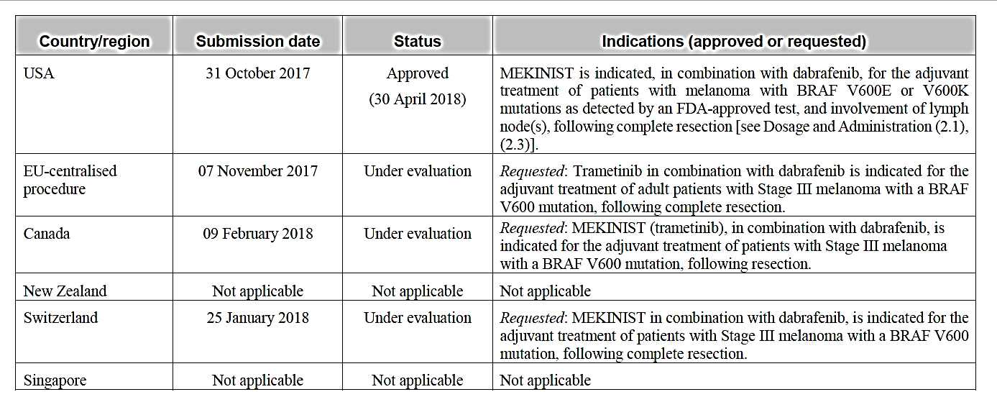

Table 2: International regulatory status of Tafinlar

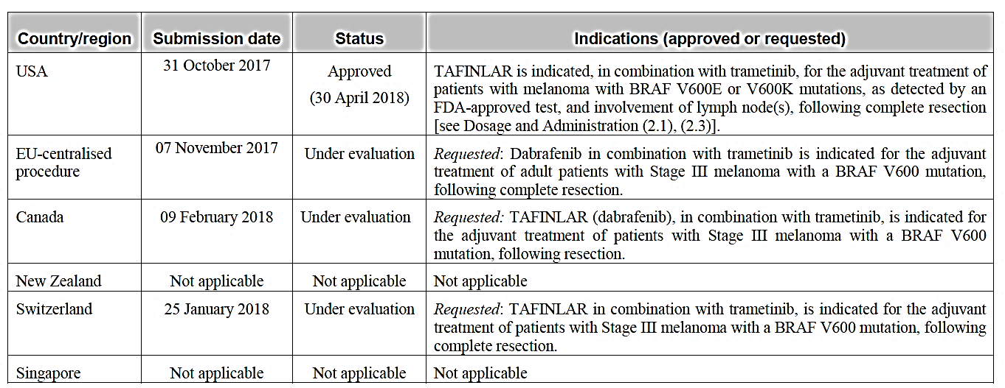

### Product Information

The Product Information (PI) documents approved with the submissions which are described in this AusPAR can be found as Attachment 1 and 2. For the most recent PI, please refer to the TGA website at <<https://www.tga.gov.au/product-information-pi>>.

## II. Registration time line

The following table captures the key steps and dates for the two applications and which are detailed and discussed in this AusPAR.

|  |  |
| --- | --- |
| Description | Date |
| Positive Designation (Orphan or Provisional if applicable) | Not applicable |
| Submission dossier accepted and first round evaluation commenced | 16 January 2018 |
| Evaluation completed | 26 April 2018 |
| Delegate’s Overall benefit-risk assessment and request for Advisory Committee advice | 12 May 2018 |
| Sponsor’s pre-Advisory Committee response | Not applicable |
| Advisory Committee meeting | Not applicable |
| Registration decision (Outcome) | 6 June 2018 |
| Completion of administrative activities and registration on ARTG | 8 June 2018 |
| Number of working days from submission dossier acceptance to registration decision* | 96 |

*Target timeframe for priority applications is 150 working days from acceptance for evaluation to the decision.

## III. Quality findings

No new dosage forms or strengths are proposed with the current submission. There was therefore no requirement for a quality evaluation in a submission of this type.

Trametinib tablets registered in Australia contain the following excipients: mannitol, microcrystalline cellulose, hypromellose, croscarmellose sodium, magnesium stearate, sodium lauryl sulphate, anhydrous colloidal silica. The film coatings on the tablets contain: hypromellose, titanium dioxide, macrogol, iron oxide yellow (0.5 mg tablet only), polysorbate 80, and iron oxide red (2 mg tablet only).

Dabrafenib hard capsules registered in Australia contain the following excipients: Microcrystalline cellulose, magnesium stearate, colloidal anhydrous silica, iron oxide red, titanium dioxide, hypromellose, iron oxide black, shellac, butan-1-ol, isopropyl alcohol, propylene glycol, and ammonium hydroxide.

The chemical structures of trametinib and dabrafenib are shown in Figure 2 below.

Figure 2: Chemical structure of trametinib and dabrafenib

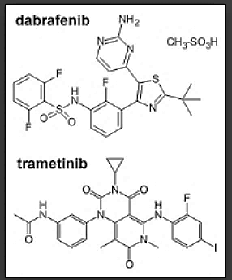

## IV. Nonclinical findings

There was no requirement for a nonclinical evaluation in a submission of this type.

## V. Clinical findings

A summary of the clinical findings is presented in this section.

### Introduction

#### Clinical rationale

In two Phase III clinical trials the combination had produced a prolongation of overall survival compared with BRAF inhibitor monotherapy in subjects with unresectable Stage III or Stage IV disease.

In the submission it is stated that many subjects with completely resected Stage III melanoma develop disease recurrence and die from the disease. Overall 5 year RFS rates for Stage IIIA, IIIB, and IIIIC patients were estimated to be 63%, 32%, and 11%, respectively and estimated 5 year survival rates from time of first relapse were 20%, 20%, and 11%, respectively.[16] There was therefore an unmet clinical need for new adjuvant treatments to prevent disease recurrence after complete resection of Stage III disease.

#### Formulation development

The submission contained one pivotal clinical trial (Study BRF115532). In this study, dabrafenib was supplied as 75 and 150 mg capsules and trametinib was supplied as 0.5 and 2.0 mg tablets. The formulations of the capsules and tablets used in the study were not described.

For completeness, the sponsor should be asked to provide an assurance that the formulations used in the study were identical to those currently registered in Australia.

#### Guidance

The following EU guidelines which have been adopted by the TGA are considered relevant to the current submission:

* Guideline on the evaluation of anticancer medicinal products;[17]
* Appendix 1 to the guideline on the evaluation of anticancer medicinal products in man. (Methodological consideration for using progression free survival or disease free survival in confirmatory trials);[18]

The sponsor’s compliance with these guidelines was considered where appropriate in the clinical report.

The background information contained in the submission was acceptable.

#### Contents of the clinical dossier

##### Scope of the clinical dossier

The following data were submitted:

Study BRF115532: This was a pivotal Phase III, randomised double blind trial with two parallel groups (dabrafenib plus trametinib versus two placebos) in subjects with completely resected Stage III melanoma. The study provided data on the pharmacokinetics, efficacy and safety of the combination in the new indication.

Literature references were also included with the submission.

#### Paediatric data

The submission did not include any paediatric data. Subjects enrolled in the single pivotal study in the submission were required to be at least 18 years of age.

From information included in the submission it appears that the sponsor has an agreed Paediatric Investigation Plan with the European Medicines Agency (EMA) for dabrafenib that includes the conduct of studies in subjects with BRAF V600 mutant melanoma aged 12 to 18. These studies are due for completion by 2022.

The EMA has issued a waiver for studies in subjects aged less than 12 years.

The sponsor has requested a waiver for paediatric studies from the FDA for both drugs on the grounds that the drugs have been designated as orphan drugs.

#### Good clinical practice

The report for the pivotal study included assurances that it was conducted according to the ethical principles of the Declaration of Helsinki and that site visits were conducted to ensure compliance with the International Conference on Harmonisation (ICH) Good Clinical Practice (GCP) guidelines.

#### Evaluator’s commentary on the clinical dossier

The clinical dossier was considered acceptable for evaluation.

### Pharmacokinetics

#### Studies providing pharmacokinetic information

Sparse pharmacokinetic (PK) sampling was performed in the pivotal efficacy and safety study. These PK data are summarised in Table 3, below. No other new PK data were included in the submission.

Table 3: Summary of dabrafenib/trametinib plasma PK concentration time data (PK population)

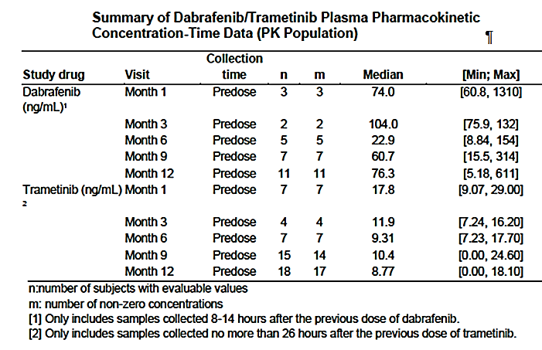

#### Evaluator’s overall conclusions on pharmacokinetics

Although data were very limited, the PK of dabrafenib and trametinib in the adjuvant setting are similar to those previously observed in the metastatic disease setting.

### Pharmacodynamics

No new pharmacodynamic data were provided in the submission.

### Dosage selection for the pivotal studies

According to the sponsor, pharmacodynamic models had demonstrated that the doses of dabrafenib 150 mg twice a day (BD) and trametinib 2 mg daily these doses had shown near to maximum predicted target inhibition. The combination of these doses was chosen for the pivotal study on the grounds that this combination was efficacious in two randomised Phase III studies in metastatic melanoma.

#### Evaluator’s conclusions on dose finding for the pivotal studies

The choice of dose for the two drugs in the combination was considered acceptable.

### Efficacy

#### Studies providing efficacy data

Efficacy data in support of the new indication come from a single randomised, double blind placebo-controlled Phase III trial Study BRF115532.

#### Evaluator’s conclusions on efficacy

The design of the pivotal study complied with the relevant EU guidelines for oncology drugs adopted by the TGA and the study was well executed. RFS (aka disease free survival (DFS)) is an acceptable primary endpoint for Phase III oncology trials according to the EU guidelines.

The presence or absence of disease relapse was assessed by the investigators and not by a blinded independent central review (BICR) panel. The EU Guideline on progression free survival (PFS) and DFS;[19] suggests that BICR is desirable in order to avoid investigator bias, even for double blinded trials. However, it also states that: *‘If important investigator bias can be reasonably excluded, investigator evaluation can be planned to be used for the primary analysis.’* Arguments put forward by the sponsor to support the use of investigator assessment were:

* the study was blinded;
* recurrence of disease is a dichotomous variable (disease absent versus present). Therefore, it is less subject to assessment bias and inter-reader variability (compared with progression free survival); and
* use of investigator assessment was discussed and agreed with the FDA prior to the study.

The sponsor chose to use placebo as the comparator treatment. The study commenced in 2013 and at that time interferon alfa-2b had been approved in several countries and peg interferon alfa-2b (Sylatron) had been approved in the USA. The sponsor’s arguments for not using one of these agents as the comparator were:

* although studies of interferon alfa products in the adjuvant treatment of melanoma had established a significant benefit in terms of RFS, a beneficial effect on overall survival had not been consistently observed;
* interferon treatment is associated with substantial toxicity;
* as a result of the limited evidence of efficacy and substantial toxicity, acceptance of interferon products in clinical practice is low;
* current clinical practice guidelines state that observation or participation in a clinical trial is acceptable options for subjects with resected Stage III disease; and
* the protocol for the trial was reviewed and approved by both the FDA and the EMA.

These arguments are considered acceptable to justify the use of placebo as the comparator.

The study did not involve a comparison of the dabrafenib/trametinib combination against monotherapy with either drug. As trials in the metastatic setting demonstrated superiority of the combination over BRAF inhibitor monotherapy, comparison of the combination against placebo was reasonable. Of note, the recently published BRIM-8 study failed to demonstrate the superiority of BRAF inhibitor monotherapy (with vemurafenib) over placebo in the adjuvant treatment of Stage III disease.[20]

The duration of adjuvant treatment chosen for the study was 12 months. The sponsor provided the following arguments in support of this decision:

* The optimal treatment duration for adjuvant therapy in patients with melanoma is currently unknown.
* The choice of 12 months was based on expert opinion and was similar to the treatment duration used in previous studies conducted with adjuvant interferon alfa-2b.
* In studies with interferon, longer treatment duration was not associated with improved clinical outcomes.
* With placebo treatment or observation, relapse occurs prior to 12 months in a substantial proportion of subjects. For example, in the pivotal study for interferon alfa‑2b (ECOG 1684);[21] approximately 50% of subjects in the observation arm had relapsed at 12 months.
* Treatment durations of less than 12 months have not been studied with other adjuvant therapies.

These arguments are also considered acceptable. The PI documents for both drugs should state that the recommended duration of adjuvant treatment should be limited to 12 months.

The pivotal study only included subjects with a V600E or V600K BRAF mutation whereas the proposed indication includes all types of BRAF V600 mutation. Given the rarity of V600 mutations other than V600E and V600K, this is considered acceptable.

The study demonstrated a substantial reduction in the risk of experiencing disease relapse or death with dabrafenib/trametinib treatment (hazard ratio (HR) = 0.47; 95% confidence interval (CI): 0.39 to 0.58). The effect on RFS was highly statistically significant (p=1.53 x 10-14). Median RFS was 16.6 months in the placebo arm and had not been reached in the dabrafenib/trametinib arm. However, the estimated lower 95% CI for median RFS in the dabrafenib/trametinib arm was 44.5 months. The probability of being alive and free of recurrence at 2 years was increased from 44% in the placebo arm to 67% in the dabrafenib/trametinib arm.

The study also demonstrated a strong trend towards improved overall survival (OS) (HR = 0.57; 95%CI: 0.42 to 0.79). However, the result was not statistically significant. OS data were not mature with only 153 of 870 subjects (17.6%) having died. A second interim analysis of OS was planned to occur after 299 deaths and it would be of interest to know when this analysis is likely to be available.

Quality of life was examined as an exploratory endpoint only and interpretation of the data is difficult due to withdrawal of subjects from the placebo arm. Taken at face value the data suggest that dabrafenib/trametinib treatment is not associated with adverse effects on quality of life.

Overall the efficacy data are considered convincing and sufficient to support approval of the proposed new indication.

### Safety

#### Studies providing safety data

Known safety issues with dabrafenib and trametinib as reflected in their currently approved PI documents include the following:

*Dabrafenib:*

* Pyrexia and non-infectious febrile events;
* Renal failure, usually in the setting of pyrexia and dehydration;
* Squamous cell carcinoma and keratoacanthoma of the skin;
* New primary melanoma;
* Secondary malignancies arising in cells with *RAS* mutations;
* Skin toxicity;
* Ocular toxicity such as uveitis, retinal vein occlusion and retinal detachment;
* Pancreatitis;
* Hyperglycaemia;
* Haemorrhagic events;
* Left ventricular dysfunction;
* QT prolongation;
* Bradycardia;
* Hepatic toxicity;
* Hypertension;
* Interstitial lung disease;
* Deep vein thrombosis and pulmonary embolus;
* Rhabdomyolysis.

*Trametinib:*

* Haemorrhagic events
* QT prolongation;
* Bradycardia;
* Left ventricular dysfunction;
* Ocular toxicity such as retinal vein occlusion and retinal detachment;
* Interstitial lung disease;
* Deep vein thrombosis and pulmonary embolus;
* Pyrexia;
* Skin toxicity;
* Hepatic toxicity;
* Colitis and gastrointestinal tract (GIT) perforation.

#### Studies providing evaluable safety data

The only new safety data presented in the submission were those from the pivotal efficacy trial Study BRF115532.

In the pivotal study the following safety data were collected:

* General adverse events (AEs): Details of AEs were collected at each study visit. AEs were recorded from the time of the first dose until 30 days after the last dose. Serious AEs (SAEs) assessed as being related to study drug were recorded and followed up regardless of the time of cessation of the study drug. AEs were coded using the Medical Dictionary for Regulatory Activities (MedDRA) and were graded according to the NCI-CTCAE, Version 4.0.
* AEs of special interest (AESI) were a group of AEs that were of scientific and medical concern specific to trametinib and dabrafenib. For this study AESIs were: pyrexia, skin related toxicities, diarrhea, hepatic disorders, hypersensitivity, oedema, hyperglycemia, ocular events, uveitis, bleeding events, hypertension, neutropenia, cardiac related events, pre-renal and intrinsic renal failure, deep vein thrombosis/pulmonary embolism, pancreatitis, cutaneous squamous cell carcinoma (SCC) including keratoacanthoma, non-cutaneous treatment-emergent malignancies, new primary melanoma, and pneumonitis/interstitial lung disease.
* Laboratory tests included the following:
  + Haematology: white blood cell (WBC) count (absolute); WBC differential (%): neutrophils, lymphocytes, monocytes, eosinophils, and basophils; haemoglobin; and platelet count.
  + Clinical chemistry: albumin, total bilirubin, alkaline phosphatase, creatinine, alanine aminotransferase (ALT), aspartate aminotransferase (AST), blood urea nitrogen, calcium, glucose, lactate dehydrogenase (LDH), potassium, total protein, and sodium.

Samples were collected at screening, at each monthly visit during the treatment phase, at Months 15 and 18 and then annually. They were also collected at the time of disease recurrence.

* A complete physical examination was performed at screening and at Month 12 (or at time of earlier discontinuation). A brief physical examination was performed at all other study visits. This included measurement of weight, blood pressure, pulse rate, temperature and respirations.
* A dermatological examination was performed at screening, at Months 2, 4, 6, 8, 10 and 12 during the treatment phase, at the time of study discontinuation, every 3 months during the follow-up phase for 24 months and then every 6 months.
* An ophthalmic examination, to detect retinal vein occlusion (RVO) or central serous retinopathy (CSR) was performed at screening, at Months 1, 3, 6 and 12 during the treatment phase and at the time of study discontinuation.
* Electrocardiography (ECG) and echocardiograms (ECHO) were performed at screening, at Months 1, 3, 6, 9 and 12 during the treatment phase and at the time of study discontinuation.

#### Patient exposure

Exposure to study drugs is summarised in Table 4. Median exposure to both dabrafenib and trametinib was 11.0 months. Median exposure to both placebos was 10.0 months.

Dose interruptions were more common in the active treatment arm and were more common with dabrafenib than with trametinib. Dose reductions were more frequent in the active arm (43% dabrafenib and 24% trametinib) compared to the placebo arm (12% dabrafenib placebo and 2% trametinib placebo).

Table 4: Study BRF115532 Study drug exposure

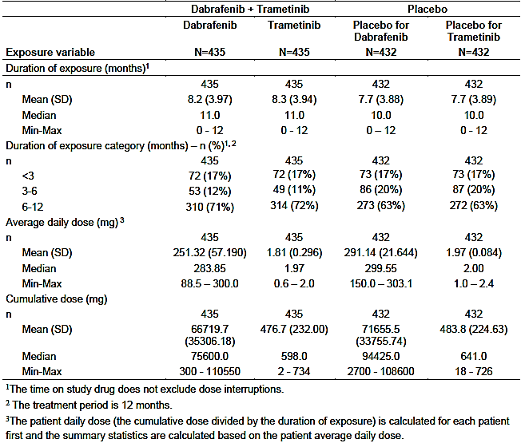

#### Safety issues with the potential for major regulatory impact

##### Liver function and liver toxicity

The current PI documents indicate that hepatic adverse events have been observed with trametinib monotherapy and with the combination of dabrafenib and trametinib.

In the pivotal study in this submission abnormalities of liver function tests (LFT) were more common in the active treatment arm as shown in Table 5 below.

Table 5: Study BRF115532 LFT abnormalities

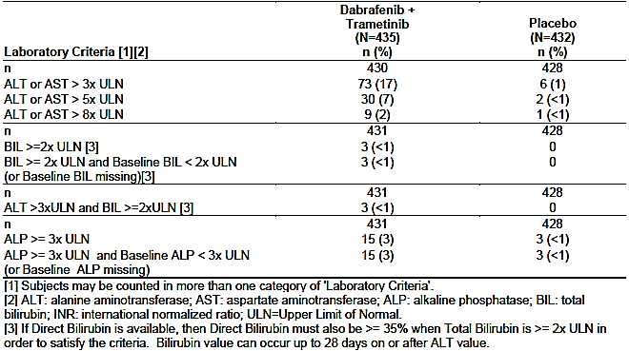

Three subjects had LFT abnormalities that potentially fulfilled Hy’s law criteria (ALT >3 x upper limit of normal (ULN) and bilirubin ≥ 2x ULN). However, all three subjects had simultaneous elevation of serum alkaline phosphatase (ALP) to levels > 2 x ULN, and other possible explanations for the abnormal LFTs (for example, reactivation of Epstein-Barr virus (EBV) infection, concomitant use of paracetamol and heavy alcohol use).

Hepatic AEs were reported by 21% of subjects in the active treatment arm and 3% of subjects in the placebo arm. The most commonly reported AEs were increased ALT (15% versus 1%), increased AST (14% versus 2%) and increased gamma glutamyltransferase (4% versus <1%). There were no reports of hepatic failure.

##### Renal function and renal toxicity

The current PI documents list renal failure as an adverse reaction associated with dabrafenib monotherapy and with the combination of dabrafenib and trametinib, usually in the setting of pyrexia and dehydration.

Abnormalities of serum creatinine occurred with comparable frequency in the two treatment arms (Table 6).

Table 6: Study BRF115532 Abnormalities in serum creatinine

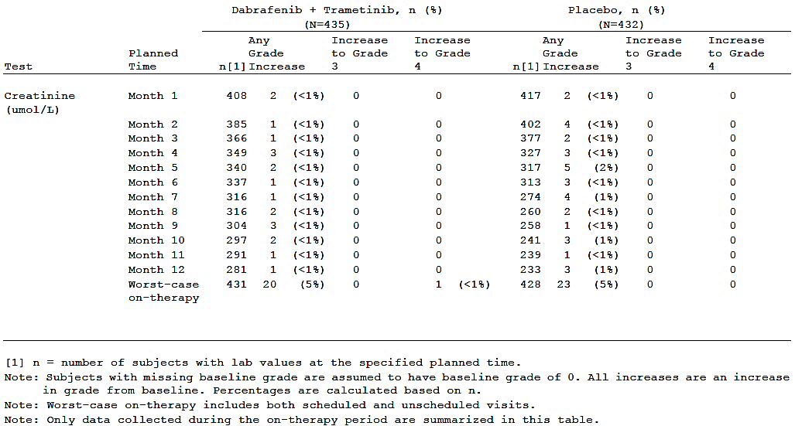

Renal and urinary AEs were reported in 8% of subjects in the active treatment arm and 3% of subjects in the placebo arm (Table 7). Renal failure as an AE was reported in 2 subjects in the active treatment arm and none in the placebo arm (Table 7).

Table 7: Study BRF115532 Renal and urinary AEs

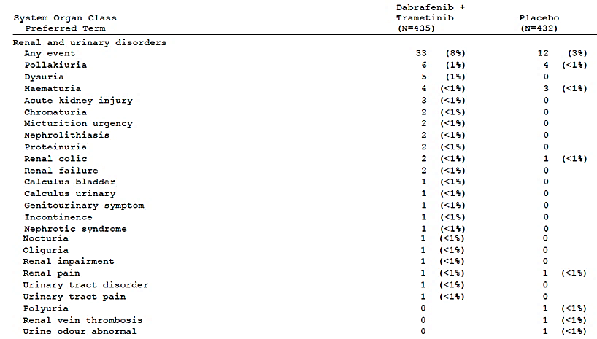

##### Other clinical chemistry observations

* Abnormalities of serum albumin occurred more commonly in the active treatment arm (25% versus <1%). However only 1 subject (in the active treatment arm) developed a new Grade 3 abnormality and no subject developed a new Grade 4 abnormality;
* Hyponatraemia occurred more commonly in the active treatment arm (16% versus 3%). New Grade 3 abnormalities were also more common (2.8% versus 0.5%). There were no new Grade 4 abnormalities. Hyponatraemia is listed as an AE in the current dabrafenib PI.
* Hyperglycaemia was more common with active treatment (63% versus 47%). The incidence of new Grade 3 or 4 abnormalities was comparable (3% versus 2%). Hyperglycaemia is listed as an AE in the current dabrafenib PI;
* Abnormalities in phosphate concentrations were more common with active treatment (42% versus 10%). Grade 3 abnormalities were also more common (6.4% versus 0.9%). Hypophosphataemia is listed as an AE in the current dabrafenib PI.
* Hypomagnesaemia occurred in 8 subjects (1.8%) in the active arm and 1 subject (0.2%) in the placebo arm. There was no Grade 3 or 4 abnormalities in either arm.

##### Haematology and haematological toxicity

Cytopaenias (neutropaenia, anaemia, thrombocytopaenia and leukopaenia) are listed in the current PI documents for trametinib and dabrafenib.

For Study BRF115532, abnormalities of laboratory haematology parameters are summarised in Table 8. Cytopaenias occurred more frequently in the active treatment arm.

Table 8: Study BRF115532 Laboratory haematology abnormalities

Study BRF115532 Laboratory haematology abnormalities

##### Electrocardiograph findings and cardiovascular safety

###### ECG

ECGs were classified as normal, abnormal but not clinically significant and abnormal and clinically significant. The proportion of subjects that fell into each of these three categories was comparable in the two treatment arms at each clinic visit.

Abnormalities of the QT interval (measured using the Bazett method) occurred with similar frequency in the two treatment arms.

###### LVEF

Left ventricular ejection fraction (LVEF) dysfunction is a known adverse reaction to trametinib. In the pivotal study, decreases in LVEF (of any magnitude) were observed more commonly with active treatment (74% versus 63%).

* A decrease of 10%, to a level below the lower limit of normal, occurred in 4% and 2% of subjects respectively.
* A decrease of 20%, to a level below the lower limit of normal, occurred in 1 subject in each treatment arm.

###### Cardiac AEs

Cardiac AEs occurred in 6% of subjects in each treatment arm. There was no notable difference between the arms in the types of AEs reported.

###### Vascular AEs

Vascular AEs were more common with dabrafenib/trametinib: 27% versus 19%. The most common events were hypertension (11% versus 8%), lymphoedema (8% versus 6%) and hypotension (4% versus <1%).

##### Vital signs and clinical examination findings

An increase in heart rate to > 100 beats per minute (bpm) was observed more commonly in the active treatment arm (14% of subjects versus 6%). Decreases in heart rate to < 60 bpm occurred with a similar frequency (25% versus 22%).

Increases in systolic or diastolic blood pressure occurred with similar frequencies in the two treatment arms.

Increases in body temperature to ≥ 38.0°C were observed more frequently with active treatment (16% versus 3%). Pyrexia is a known adverse reaction to dabrafenib.

##### Immunogenicity and immunological events

Hypersensitivity was an adverse event of special interest. Such events occurred more commonly with dabrafenib/trametinib (22% versus 6%). The most common events were:

* dermatitis acneiform: 12% versus 2%;
* erythema nodosum: 3% versus 0%; and
* urticarial: 3% versus 0.9%.

There were no reports of anaphylaxis.

##### Serious skin reactions

There were 2 serious skin AEs in the dabrafenib/trametinib arm compared with none in the placebo arm. Skin AE terms listed as serious were erythema nodosum (1), rash generalised (1) and rash pustular (1).

#### Post-marketing data

No post-marketing data were included in clinical part of the submission.

#### Evaluator’s conclusions on safety

The only new safety data include in the submission came from the pivotal Study BRF115532. In this study a total of 435 subjects were treated with the dabrafenib/trametinib combination. 63% of these subjects completed 12 months of dabrafenib treatment and 64% completed 12 months of trametinib treatment. The patient population is considered adequate to assess the safety of the combination for the new indication.

The combination was associated with significant toxicity. The incidence of Grade 3 or 4 AEs was increased in the combination arm compared to the placebo arm (41% versus 16%). This was also true for SAEs (36% versus 10%) and discontinuations due to AEs (26% versus 3%). However, there was no evidence of an increased risk of fatal AEs and there was a trend towards a favourable effect of the combination on overall mortality.

The pattern of toxicities observed in the pivotal study was consistent with that previously observed with use of the combination in the metastatic disease setting. Toxicities with an increased incidence in the combination arm included the following:

* Pyrexia, chills and influenza-like illness;
* GIT events: nausea, diarrhoea, vomiting, constipation, decreased appetite;
* Fatigue;
* Skin toxicities: rash, dry skin, dermatitis acneiform, erythema;
* Abnormal liver function tests: mainly increased AST and ALT;
* Left ventricular dysfunction;
* Ocular events such as blurred vision, dry eye, chorioretinopathy and uveitis;
* Oedema;
* Musculoskeletal complaints such as myalgia, arthralgia and pain in an extremity;
* Hypersensitivity events;
* Bleeding events: mainly epistaxis.

The toxicities were such that approximately a quarter of subjects were unable to tolerate 12 months of the combination and withdrew from treatment.

The only other agent currently available in Australia for adjuvant treatment of resected Stage III melanoma is interferon alfa-2b. The pivotal study that supported registration of this agent in Australia was the ECOG 1684 trial.21 In this study, Grade 3 toxicities were observed in 67% of subjects and Grade 4 toxicities in 9%. In addition, two subjects had treatment related fatal AEs. In Study BRF115532, Grade 3 toxicities were observed in 39% of subjects and Grade 4 toxicities in 3%. No subjects had treatment-related fatal AEs. Although cross-trial comparisons may be unreliable, these data might suggest that the dabrafenib/trametinib combination is less toxic than interferon alfa-2b.

Stage III melanoma is a serious medical condition; 5 year survival rates range from 40% for Stage IIIC disease to 78% for Stage IIIA disease.[22] Given the serious nature of the condition being treated, the toxicity profile of the combination observed in the trial is considered acceptable.

### First round benefit-risk assessment

#### First round assessment of benefits

A summary of the benefits of dabrafenib/trametinib for the indication of adjuvant treatement of Stage III melanoma, as evaluated at the first round, is given in Table 9, below.

Table 9: Assessment of benefits

| **Indication: Adjuvant treatment of Stage III melanoma** | |
| --- | --- |
| **Benefits** | **Strengths and Uncertainties** |
| The pivotal study demonstrated that dabrafenib in combination with trametinib had superior efficacy compared to placebo, in preventing disease recurrence following surgery in subjects in subjects with Stage III melanoma. The risk of relapse (or death from any cause) was reduced by approximately 53% (HR = 0.47; 95%CI: 0.39 to 0.58; p=1.53 x 10-14). Median RFS was 16.6 months in the placebo arm and had not been reached in the dabrafenib/trametinib arm. The probability of being alive and free of recurrence at 2 years was increased from 44% in the placebo arm to 67% in the dabrafenib / trametinib arm.  The combination was also associated with a non-significant trend towards improved overall survival (HR = 0.57; 95%CI 0.42 to 0.79; p = 0.0006). Survival data were immature and the statistical analysis of the survival data came from a planned early interim analysis.  Quality of Life (QoL) was only an exploratory endpoint and interpretation of the data was complicated by a higher drop-out rate for subjects in the placebo arm. Taken at face value the data suggest that dabrafenib/trametinib treatment is not associated with adverse effects on quality of life.  The safety data suggest that the combination may be associated with lower overall toxicity than interferon alfa-2b, the only other agent approved in Australia for the adjuvant treatment of Stage III melanoma. | *Strengths*  The pivotal study was well-designed and executed.  Superior efficacy to placebo was demonstrated in all subgroups tested.  *Uncertainties*  A beneficial effect on overall survival has not been proved.  The efficacy of the combination has not been compared to that of interferon alfa-2b.  The pivotal study did not include subjects with significantly impaired organ function or poor performance status at baseline. The benefit–risk balance in these subjects therefore cannot be assessed. |

#### First round assessment of risks

A summary of the risks of dabrafenib/trametinib for the indication of adjuvant treatement of Stage III melanoma, as evaluated at the first round, is given in Table 10, below.

Table 10: Assessment of risks

| **Risks** | **Strengths and Uncertainties** |
| --- | --- |
| Compared with placebo, the combination was associated with an increased risk of:   * Pyrexia, chills and influenza-like illness; * GIT events: nausea, diarrhoea, vomiting, constipation, decreased appetite; * Fatigue; * Skin toxicities: rash, dry skin, dermatitis acneiform, erythema; * Abnormal liver function tests: mainly increased AST and ALT; * Left ventricular dysfunction; * Ocular events such as blurred vision, dry eye, chorioretinopathy and uveitis; * Oedema; * Musculoskeletal complaints such as myalgia, arthralgia and pain in an extremity; * Hypersensitivity events; * Bleeding events: mainly epistaxis.   The toxicity profile for the combination in the pivotal study was consistent with that previously identified for the combination in the metastatic disease setting.  In terms of overall toxicity, combination treatment was associated with an increased incidence of Grade 3/4 adverse events (41% versus 14%), SAEs (36% versus 10%) and discontinuations due to AEs (26% versus 3%) compared to placebo. There was no increase in the incidence of fatal AEs. | *Strengths*   * No new toxicities were identified in the proposed new patient population.   *Uncertainties*   * The pivotal study excluded subjects with significant organ dysfunction or poor performance status at baseline. Safety in these subjects has not been established. |

#### First round assessment of benefit-risk balance

Stage III melanoma is serious medical condition with a substantial risk of disease recurrence and death despite complete surgical excision. The only agent available for adjuvant therapy in Australia at the current time is interferon alfa-2b. Due to limited efficacy and high toxicity, the benefit-risk balance of interferon alfa-2b has not been universally accepted as favourable. Current clinical practice guidelines recommend that observation or enrolment in a clinical trial is acceptable alternatives to interferon.

The pivotal trial in this submission has demonstrated that treatment with dabrafenib and trametinib results in a substantial (53%) reduction in the risk of an RFS event (disease recurrence or death) compared to placebo. RFS is an acceptable primary endpoint for adjuvant studies, and the magnitude of the effect is clinically significant. Although the combination is associated with significant toxicity, it is manageable in most patients, and not unacceptable given the serious nature of the disease. It is likely that toxicity with the combination is less than that associated with interferon alfa-2b.

Overall it is considered that the efficacy benefits obtained with the combination in the adjuvant setting outweigh the risks associated with its use. The benefit-risk balance of the combination of dabrafenib and trametinib, for the proposed usage, is favourable.

### First round recommendation regarding authorisation

Approval of the combination of dabrafenib and trametinib is recommended for: *‘the adjuvant treatment of patients with Stage III melanoma with a BRAF V600 mutation, following complete resection.’*

### Clinical questions

#### General

For completeness, the sponsor should be asked to provide an assurance that the formulations of dabrafenib and trametinib used in the pivotal study were identical to those currently registered in Australia.

##### Sponsor’s response

All batches used in the clinical study were manufactured at the same site and on the same scale as the commercially available products.

#### Efficacy

Please advise when the second interim analysis of overall survival data from the pivotal study will be available.

##### Sponsor’s response

Based on the predicted rate of survival events occurring in the COMBI-AD study, the sponsor projects that the clinical study report for the next interim analysis for OS (50 % of OS events met) will be available by May 2024.

### Second round evaluation and benefit-risk assessment

A second round clinical evaluation was not considered necessary for this application.

## VI. Pharmacovigilance findings

The sponsor submitted Risk Management Plans and Australian Specific Annexes for each product.

There is not a significant change to the population group from previous submissions and a full RMP evaluation was therefore not conducted.

## VII. Overall conclusion and risk/benefit assessment

The submission was summarised in the following Delegate’s overview and recommendations:

### Background

#### BRAF mutated melanoma:

* 40% to 60% of advanced melanomas.
* V600E (90%); V600K (10%).
* Associated with: truncal primary; earlier age of onset; lack of chronic skin damage; aggressive course; OS shorter if not treated with a BRAF inhibitor.

#### BRAF inhibitors

##### Efficacy

###### Vemurafenib (single agent)

* Phase III, BRIM-3 trial (n=675), versus decarbazine, unresectable Stage IIIc (5%) or metastatic (95%)
* Median (Md) (PFS): 7 months versus 2 months; HR (PFS)=0.38 (0.32, 0.46)
* Md(OS): 14 months versus 10 months; HR (OS) = 0.81 (0.67, 0.98) (cross-over occurred)

###### Dabrafenib (single agent)

* Phase III, unresectable Stage III or Stage IV (n=250)
* Md (PFS): 5 months versus 3 months; HR (PFS) = 0.33 (0.20, 0.54)
* Md (OS): 15 months versus 13 months; HR (OS) = 0.76 (0.48, 1.21) (cross-over occurred)

##### Toxicity

###### Secondary cutaneous tumours

* Squamous cell carcinomas (including keratoacanthomas): 20% to 25%
  + Occur within weeks of starting of treatment with BRAF inhibitors and are generally treated with excision. The development of such lesions did not require discontinuation of BRAF inhibitor.
  + The short latency period until the development of these skin lesions is consistent with the presence of pre-existing RAS mutations in the skin which enhance their activation of downstream proteins in the MAP kinase pathway when subjected to BRAF inhibition.
  + MEK inhibitors reduce the incidence of skin toxicity, including the development of skin cancers, presumably by blocking this paradoxical activation of the MAP kinase pathway.
* Second primary melanoma: approximately 2%
  + Patients with advanced melanoma are at risk for development of further primary melanomas; whether the incidence rates in patients treated with BRAF inhibitors is higher than in those not receiving these agents is not clear.

###### Other skin toxicities

Rash, photosensitivity reactions and alopecia

###### Other toxicities

Fatigue

Arthralgias

Ocular toxicity: uveitis, conjunctivitis and dry eyes.

###### Toxicities more common with vemurafenib

QT prolongation

Decreased creatinine clearance.

###### Toxicities more common with dabrafenib

Pyrexia, chills, flu-like illness: approximately 30%

Hyperglycaemia: approximately 5%.

#### MEK inhibitors

Now mainly used in combination with BRAF inhibitors.

##### Trametinib

###### Efficacy

Phase III METRIC trial (n=322), single agent trametinib versus decarbazine/paclitaxel, 33% had prior chemo, 30% had prior immunotherapy.

Md (PFS): 5 months versus 2 months; HR (PFS) = 0.47 (0.34, 0.65).

6 month OS: 81% versus 67%; HR (OS) = 0.54 (0.32, 0.92) (cross-over allowed).

###### Toxicity

* GI toxicity
* Decreased cardiac ejection fraction
* MEK inhibitor associated retinopathy
* Retinal vein occlusion
* The increased risk of cutaneous SCC with the BRAF inhibitors is reduced with the addition of a MEK inhibitor.

##### Other MEK inhibitors

Cobimetinib: approved for use with vemurafenib.

Binimetinib: trials as single agent in NRAS-mutated melanoma and with encorafenib in BRAF mutated melanoma (no marketing approvals, at this point in time).

#### Combined BRAF+MEK inhibition

MEK inhibitors are added to BRAF inhibitors to delay the development of resistance and to reduce some toxicities directly associated with BRAF inhibition.

##### Dabrafenib+trametinib

###### Efficacy

Phase III, Combi-d (n=423), dabrafenib/trametinib versus dabrafenib, untreated advanced BRAF mutated melanoma:

* Md (PFS) 11 months versus 9 months; 3-year PFS: 22% versus 12%; HR (PFS) =0.71 (0.57, 0.88).
* Md (OS) 25 months versus 19 months; 3 year OS: 44% versus 32%; HR (OS) =0.75 (0.58, 0.96).

Phase III (n=704), versus vemurafenib, untreated advanced BRAF mutated melanoma:

* Md (PFS) 11 months versus 7 months; HR (PFS) =0.58 (0.46, 0.69).
* 1 year OS: 72% versus 65%; HR (OS) =0.69 (0.53, 0.89).

###### Toxicities

Toxicities less frequent with the combination:

* SCC: 3% versus 10%.
* Other skin toxicities: dry skin, pruritus, hyperkeratosis, hand-foot syndrome, alopecia and skin papilloma.

Toxicities more frequent with the combination were:

* GI (nausea/vomiting, diarrhoea): about 20% versus 10%.
* Pyrexia/chills: about 50% versus 25%.

#### Other combinations

Vemurafenib + cobimetinib

Encorafenib + binimetinib

### Quality

There was no requirement for a quality evaluation in a submission of this type.

### Nonclinical

There was no requirement for a nonclinical evaluation in a submission of this type.

### Clinical

#### Pivotal Study BRF115532 (COMBI-AD)

##### Study design

Phase III trial Study BRF115532 COMBI-AD

Published in Long GV et al. NEJM DOI: 10.1056/NEJMoa1708539 (2017)

Enrolment: January 2013 through December 2014

169 sites in 26 countries

Data cut-off date: 30 June 2017.

Table 11: Design of study

| **Patients** | Dabrafenib/ trametinib n=438  Placebo: n=432  Complete resection of histologically confirmed Stage IIIA (limited to lymph-node metastasis of >1 mm), IIIB, or IIIC cutaneous melanoma (according to the criteria of the American Joint Committee on Cancer, seventh edition)  BRAF V600E or V600K mutations  No previous systemic anticancer treatment or radiotherapy for melanoma  ECOG: 0 or 1 |
| --- | --- |
| **Intervention** | Dabrafenib: 150 mg twice daily  plus  Trametinib: 2 mg once daily  (combination therapy)  For up to 12 months |
| **Control** | Placebo |
| **Endpoints** | *Primary*  RFS  *Secondary*  OS  Distant MFS  Safety |

* Imaging was performed every 3 months during the first 24 months, then every 6 months until disease recurrence or the completion of the trial.
* All disease-recurrence analyses were based on investigator assessment.
* Follow-up for disease recurrence continued until the first recurrence was observed, and thereafter patients were followed for survival.

##### Sample size

870 patients: (two-sided type I error rate of 5%) power of more than 90% to detect a hazard ratio of 0.71 (corresponding to a median RFS of 21 months in the combination-therapy group and 15 months in the placebo group).

##### Statistical analysis

No interim analysis was performed for efficacy or futility for the primary end point. Overall survival, as the key secondary end point, was to be tested in a hierarchical manner only if the primary end point met the criteria for significance. The OS analysis used a pre-planned three-look Lan–DeMets group sequential design with an O’Brien–Fleming–type boundary, which was used to determine the significance threshold for the first interim OS analysis (two-sided P = 0.000019).

***Baseline characteristics***

Table 12 describes the baseline characteristics.

Table 12: Baseline characteristics

|  |  |  |
| --- | --- | --- |
|  | Dabrafenib/Trametinib  N=438 | Placebo  N=432 |
| Age, Md(range) | 50(18, 89) | 51(20, 85) |
| Men | 195(45%) | 193(45%) |
| BRAF mutation V600E  V600K | 397(91%)  41(9%) | 395(91%)  37(9%) |
| ECOG  0  1 | 402(92%)  33(8%) | 390(90%)  41(9%) |
| Stage  IIIa  IIIb  IIIc | 83(19%)  169(39%)  181(41%) | 71(16%)  187(43%)  166(38%) |
| Number of LNs  1  2 or 3  4+ | 177(40%)  158(36%)  73(17%) | 183(42%)  150(35%)  72(17%) |
| Primary tumour  ulceration | 179(41%) | 177(41%) |
| In-transit metastases | 51(12%) | 36(8%) |

In-transit metastases: clinically evident cutaneous or subcutaneous metastases identified at a distance of more than 2 cm from the primary melanoma in the region between the primary melanoma and the first echelon of regional lymph nodes. LNs=lymph nodes

##### Patient disposition

Table 13 describes the patient disposition.

Table 13: Patient disposition

|  |  |  |  |
| --- | --- | --- | --- |
|  | Dabrafenib  N=435 | Trametinib  N=435 | Placebo  N=432 |
| Completed 12 months of treatment | 272(63%) | 277(64%) | 227(53%) |
| Reason for early discontinuation of treatment | | | |
| AE | 108(25%) | 104(24%) | 12(3%) |
| Disease recurrence | 23(5%) | 23(5%) | 175(41%) |
| Formal withdrawal | 27(6%) | 26(6%) | 11(3%) |
| Loss to FU, etc | 5(1%) | 5(1%) | 7(1%) |

No patients were still on treatment (planned for 12 months) at data cut-off.

##### Treatments, post-recurrence

Table 14 describes treatments after recurrence.

Table 14: Treatments post-recurrence

|  |  |  |  |  |
| --- | --- | --- | --- | --- |
|  | Dabrafenib/Trametinib recurrence n=163 | | Placebo recurrence  n=247 | |
|  | n | % | n | % |
| Any anti-cancer therapy | 148 | 91 | 217 | 88 |
| Surgery | 78 | 48 | 131 | 53 |
| Radiotherapy | 60 | 37 | 72 | 29 |
| Any systemic therapy | 120 | 74 | 183 | 74 |
| Any BRAF inhibitor | 63 | 39 | 137 | 55 |
| Any MEK inhibitor | 47 | 29 | 77 | 31 |
| Anti PD-L1, PD-1 | 71 | 44 | 68 | 28 |
| CTLA-4 | 53 | 33 | 68 | 28 |
| Interferon | 6 | 4 | 11 | 4 |
| T-VEC | 0 | 0 | 1 | <1 |
| Chemotherapy | 20 | 12 | 23 | 9 |

##### Results

As at the data cut-off (June 2017), min(FU)=2.5 years; Md(FU)=2.8 years.

###### Primary endpoint

The results for the primary end point RFS are shown in Table 15.

Table 15: Recurrence free survival

|  |  |  |
| --- | --- | --- |
|  | Dabrafenib/Trametinib  N=438 | Placebo  N=432 |
| n(%) | 163(37%) | 247(57%) |
| RFS 1 year | 88% | 56% |
| RFS 2 years | 67% | 44% |
| RFS 3 years | 58% | 39% |
| Md(RFS), (95% CI) | NR (45 months, NE) | 17 months (13, 22) |
| HR(RFS), (95% CI) | 0.47 (0.39, 0.58); p<0.001 | |

NR: not reached. NE: not evaluable.

###### Secondary endpoints

Results for the secondary end point OS is shown in table 16 below.

Table 16: Overall survival

|  |  |  |
| --- | --- | --- |
|  | Dabrafenib/Trametinib  N=438 | Placebo  N=432 |
| n(%) | 60(14%) | 93(22%) |
| OS 1 year | 97% | 94% |
| OS 2 years | 91% | 83% |
| OS 3 years | 86% | 77% |
| HR(OS), (95% CI) | 0.57 (0.42, 0.79); p=0.0006 | |

HS (OS) was not statistically significant because it did not cross the pre-specified interim boundary of p = 0.000019.

###### Distant metastasis free survival

HR (DMFS) =0.51 (0.40, 0.65); p<0.001

###### Subgroup analyses

Table 17 shows the results for sub group analyses.

Table 17: Subgroup analyses

|  |  |
| --- | --- |
|  | HR(RFS) |
| BRAF status  V600K  V600E | 0.54  0.48 |
| Men  Women | 0.43  0.55 |
| < 65 years  65+ years | 0.51  0.38 |
| IIIa  IIIb  IIIc | 0.44  0.50  0.45 |
| LN  Micro  Macro | 0.44  0.43 |
| Ulceration+micro  No ulceration+micro  Ulceration+macro  No ulceration+macro | 0.49  0.43  0.33  0.51 |
| LN  1  2-3  4+ | 0.52  0.37  0.51 |

LN=lymph node

##### Safety

Table 18 shows the number (%) of AEs, SAEs and AEs that caused dose interruption, reduction or discontinuation reported from the study.

Table 18: AEs, SAEs and AEs that caused dose interruption, reduction or discontinuation

|  |  |  |
| --- | --- | --- |
|  | Dabrafenib/Trametinib N=438 | Placebo N=432 |
| SAE | 155(36%) | 44(10%) |
| AE dose interruption | 289(66%) | 65(15%) |
| AE dose reduction | 167(38%) | 11(3%) |
| AE discontinuation | 114(26%) | 11(3%) |

* One fatal serious adverse event (pneumonia) was reported in the combination-therapy group.
* A new primary melanoma was reported in 11 patients (3%) in the combination therapy group and in 10 (2%) in the placebo group.
* Cutaneous SCC or keratoacanthoma was reported in 8 patients (2%) in the combination therapy group and in 7 (2%) in the placebo group; basal cell carcinoma was reported in 19 (4%) and 14 (3%), respectively, and non-cutaneous cancers in 10 (2%) and 4 (1%), respectively.

Common AEs were:

* Pyrexia/chills/flu-like symptoms approximately 60%
* GI toxicity (nausea/vomiting, diarrhoea, constipation) approximately 40%
* Rash approximately 24%
* Increased AST/ALT approximately 15%.

No new types of AEs were identified in the adjuvant setting.

### Risk management plan

The sponsor submitted Risk Management Plans and Australian Specific Annexes for each product. There is no significant change to the population group from the previous submissions and a full RMP evaluation was therefore not conducted.

### Risk-benefit analysis

#### Delegate’s considerations

##### Condition

The prognosis of Stage III melanoma patients is variable.

There are various estimates of 5 year RFS for Stage III melanoma:

* IIIa: 63%; IIIb: 32%; IIIc: 11%.[23]
* From AJCC seventh edition:
  + 5 year melanoma specific survival (MSS) IIIa: 78%, IIIb: 59%, IIIc: 40% (these were before immune therapies and targeted therapies).

(AJCC eigth edition has categories a to d; implemented: January 2018)

A summary of changes to Stage III from version 7 to version 8 is shown below (Table 20). The criteria for inclusion in Stage III are the same. There is an additional category ‘d’, and some movement between categories.).

The RFS for the placebo arm of COMBI-AD (the pivotal study for this application) Md (FU) =2.8 years, were:

* IIIa: Md(RSF) not reached
* IIIb: Md(RFS)=17 months
* IIIc: Md(RFS)=7 months

Aside: Patients without lymph node involvement (Stage II) but with high risk features in their primary tumour are at increased risk for recurrence and disease dissemination. High risk primary tumours include those that are >4 mm thick, or >2 mm thick with ulceration. High risk node-negative patients were excluded from the Phase III clinical trials evaluating nivolumab and targeted therapy with dabrafenib plus trametinib.

A patient’s decision on whether to have adjuvant treatment will depend on their preferences/values, age, comorbidities, and the risk of recurrence (which can vary, as above).

##### Current treatment options

Nivolumab was approved for *the adjuvant treatment of patients with melanoma with involvement of lymph nodes or metastatic disease who have undergone complete resection* by the FDA in December of 2017 and by the TGA in April of 2018.

For Stage IIIA disease, the risk of disease recurrence might be <30%; therefore observation might be the preferred option for some patients.

##### Benefits

The pivotal study was COMBI-AD

Dabrafenib/Trametinib: n=438; placebo: n=432

BRAF+, Stage III (a to c) lymph node (LN) metastases >1 mm

###### RFS (primary endpoint)

3 year RFS: 58% versus 39%

HR(RFS)=0.47 (0.39, 0.58)

###### OS (secondary endpoint)

3 year OS: 86% versus 77%

HR(OS)=0.57 (0.42, 0.79)

###### Subgroup analyses

Benefit was reported in all subgroups examined.

##### Risks

No new types of adverse events for the combination of dabrafenib/trametinib were identified.

26% of patients discontinued the combination therapy due to AEs in the adjuvant setting compared with (the previously reported) 15% in the metastatic setting. Patients might be more likely to discontinue adjuvant treatment.

Common AEs were:

* Pyrexia/chills/flu like symptoms in approximately 60%
* GI toxicity (nausea/vomiting, diarrhoea, constipation) in approximately 40%
* Rash in approximately 24%
* Increased AST/ALT in approximately 15%.

##### Benefit risk balance

The decision about whether to undertake adjuvant treatment (twice daily tablets for 12 months) is a decision for each individual patient in consultation with their medical oncologist. Adjuvant treatment is secondary prevention. Some patients, who decide to have adjuvant treatment (perhaps one third, depending on the subgroup of Stage III disease; for example, 5 year RFS for IIIb is 32%), would never have had a recurrence (without adjuvant treatment) by 5 years and so will be exposed to the possible toxic effects of combination targeted therapy without benefit.

Dabrafenib/trametinib will be prescribed by medical oncologists, who are well versed in the benefit-risk trade-offs involved in the adjuvant treatment of any cancer and will be able to assist patients with decisions about whether to embark on adjuvant treatment of their (completely resected) melanoma.

There is some uncertainty about whether BRAF positive patients should have adjuvant treatment with immunotherapy or dabrafenib/trametinib.

Dabrafenib/trametinib might be an option particularly for patients who are unable to take adjuvant immunotherapy due to active autoimmune disease or the need for immunosuppressive therapy.

Table 20: Summary of changes between version 7 and version 8 of AJCC melanoma staging manual for Stage III*[24]*

*Main changes, Stage III*

Definitions of N subcategories are revised, with the presence of microsatellites, satellites, or in-transit metastases now categorised as N1c, N2c, or N3c based on the number of tumour involved regional lymph nodes (N1c: 0, N2c: 1, N3c: 2+).

Prognostic stage III groupings are based on N category criteria and T category criteria (that is, primary tumour thickness and ulceration) and increased from 3 to 4 subgroups (Stages IIIa to IIId)

For regional LN metastases, *microscopic* is now called *clinically occult* and *macroscopic* is now called *clinically apparent*.

N category is now composed of 4 sub-stages rather than 3, and Stage III subgroupings are based on multivariable models, including T category (tumor thickness and ulceration) and N category (number of lymph nodes, satellites/in-transits/microsatellites) elements that demonstrate a significant impact of primary tumor factors in assigning N sub-stage.

Table 19: Comparison of seventh and eighth edition, AJCC Stage III

|  |  |  |
| --- | --- | --- |
|  | Seventh edition | Eighth edition |
| IIIa | T1-4a  any thickness without ulceration  N1a/N2a  1-3 clinically occult LNs (micromets) | T1a/T1b thickness <0.8 mm, -/+ ulceration  T2a thickness >1.0-2.0 mm, no ulceration  N1a/N2a  1-3 clinically occult LNs (micromets) |
| IIIb | T1-4b  any thickness with ulceration  N1a/N2a  1-3 clinically occult LNs (micromets)  T1-4a  any thickness without ulceration  N1b/N2b  1-3 clinically apparent LNs (macromets)  T1-4a  any thickness without ulceration  N2c  0 regional LN; presence of in-transit satellite, &/or micro-satellite mets | T2b/T3a  thickness >1.0-2.0 mm, ulceration  thickness >2.0-4.0 mm, no ulceration  N1a/N1b/N1c/N2a/N2b  1-3 clinically apparent or occult LN, or  0 regional lymph node disease; presence of in-transit satellite, and/or micro-satellite mets  T1a/T2a: thickness <2.0 mm, no ulceration  T1b: thickness<0.8 mm, ulceration  N1b/N1c/N2b  1 clinically apparent LN or  0 regional lymph node disease; presence of in-transit satellite, and/or micro-satellite mets  T0  No evidence of primary tumour  N1b/N1c  1 clinically apparent LN or  0 regional lymph node disease; presence of in-transit satellite, &/or micro-satellite mets |
| IIIc | T1-4b  any thickness with ulceration  N1b/N2b  1-3 clinically apparent LNs (macromets)  N2c  0 regional LN; presence of in-transit satellite, &/or micro-satellite mets  Any T  N3  4+ LN mets  matted LNs  1+ regional LN; presence of in-transit satellite, &/or micro-satellite mets | T0  No evidence of primary tumour  N2b  2 or 3 LN, at least 1 clinically detected  T3b/T4a/T4b  thickness >2.0-4.0 mm, ulceration  thickness >4.0 mm, no ulceration  thickness >4.0 mm, ulceration  Any N, except N3a/b/c (IIId, see next row)  N2c, N3a/b/c  1 clinically occult or clinically detected; presence of in-transit satellite, and/or micro-satellite mets  4+ clinically occult (detected by SLN biopsy)  4+, at least one of which was clinically detected, or the presence of any number of matted nodes  2+ clinically occult or clinically detected and/or presence of any number of matted nodes; presence of in-transit satellite, &/or micro-satellite mets  Any T, except T4b (IIId, see next row) |
| IIId |  | T4b  thickness >4.0 mm, ulceration  N3a/b/c  4+ clinically occult (detected by SLN biopsy)  4+, at least one of which was clinically detected, or the presence of any number of matted nodes  2+ clinically occult or clinically detected and/or presence of any number of matted nodes; presence of in-transit satellite, and/or micro-satellite mets |

Mets= metastases; LN=lymph node

*Summary of changes in edition 8 for Stage III*

IIIa includes:

* <0.8 mm lesions (T1b) with ulceration (previously IIIb)

IIIb includes:

* all T3a tumours (thickness >2.0-4.0 mm, no ulceration) (previously IIIa)
* T1–2b tumours (thickness <2.0 mm +/- ulceration) with N1b/c or N2b nodal involvement (up to 3 clinically apparent LNs or presence of in-transit satellite, and/or micro-satellite mets, 0 LNs) (previously IIIc)
* Patients with no evidence of primary tumor (T0) and N1b/c nodal involvement are now classified as Stage IIIB. These patients were not previously classified.

IIId is a new category and includes:

T4b (thickness >4.0 mm, ulceration) and any N3 nodal involvement: N3a (4+ clinically occult) or N3b (4+, at least one of which was clinically detected, or the presence of any number of matted nodes) or N3c (2+ clinically occult or clinically detected and/or presence of any number of matted nodes; presence of in-transit satellite, and/or micro-satellite metastases) (previously IIIc).

###### Non-nodal loco-regional metastases (microsatellite, satellite, and in-transit metastases)

The presence and absence of microsatellite, satellite, or in-transit metastases, regardless of the number of such lesions, are components of the N category in the eighth edition (and are at assigned at least IIIb, given their relatively poor prognosis).

They are all thought to represent metastases that are a consequence of intralymphatic or possibly angiotrophic tumor spread.

Satellite metastases have classically and somewhat arbitrarily been defined as clinically evident cutaneous and/or subcutaneous metastases occurring within 2 cm of the primary melanoma.

Microsatellites have classically been defined as microscopic cutaneous and/or subcutaneous metastases found adjacent or deep to a primary melanoma on pathological examination (see discussion below).

In-transit metastases have classically and somewhat arbitrarily been defined as clinically evident cutaneous and/or subcutaneous metastases identified at a distance more than 2 cm from the primary melanoma in the region between the primary and the first echelon of regional lymph nodes.

#### Advisory Committee Considerations[25]

The Delegate did not refer this application to the Advisory Committee on Medicines (ACM) for advice.

### Outcome

#### Mekinist

Based on a review of quality, safety and efficacy, TGA approved the registration of Mekinist containing trametinib (as dimethyl sulfoxide) for oral administration for the new extended indication:

*‘Adjuvant treatment of melanoma*

*Mekinist in combination with dabrafenib is indicated for the adjuvant treatment of patients with melanoma with a BRAF V600 mutation and involvement of the lymph node(s), following complete resection.’*

##### Specific conditions of registration applying to these goods

1. Submit the clinical study report at the time of the analysis for overall survival (OS) at 295 events of Trial BRF115532 entitled ‘A Phase III Randomized Double blind Study of Dabrafenib in COMBInation with Trametinb Versus Two Placebos in the Adjuvant Treatment of High-Risk BRAF V600 Mutation-Positive Melanoma after Surgical Resection (COMBI-AD)’ to revise the PI with updated OS data. Noting the Final Report Submission is expected May 2024.
2. This approval does not impose any requirement for the submission of Periodic Safety Update reports. You [the sponsor] should note that it is a requirement that all existing requirements for the submission of PSURs as a consequence of the initial registration or subsequent changes must be completed.

#### Tafinlar

Based on a review of quality, safety and efficacy, TGA approved the registration of approve the registration of Tafinlar containing dabrafenib (as mesilate) with Mekinist for oral administration for the new indication:

‘Adjuvant treatment of melanoma

Tafinlar in combination with trametinib is indicated for the adjuvant treatment of patients with melanoma with a BRAF V600 mutation and involvement of the lymph node(s), following complete resection.’

##### Specific conditions of registration applying to these goods

1. Submit the clinical study report at the time of the analysis for overall survival (OS) at 295 events of Trial BRF115532; entitled ‘A Phase III Randomized Double blind Study of Dabrafenib in COMBInation with Trametinb Versus Two Placebos in the Adjuvant Treatment of High-Risk BRAF V600 Mutation-Positive Melanoma After Surgical Resection (COMBI-AD)’, to revise the PI with updated OS data. Noting the Final Report Submission is expected May 2024.
2. This approval does not impose any requirement for the submission of Periodic Safety Update reports. You [the sponsor] should note that it is a requirement that all existing requirements for the submission of PSURs as a consequence of the initial registration or subsequent changes must be completed.

## Attachments 1 A and B: Product Information

The PI for Mekinist approved with the submission which is described in this AusPAR is at Attachment 1. For the most recent PI, please refer to the TGA website at <<https://www.tga.gov.au/product-information-pi>>.

The PI for Tafinlar approved with the submission which is described in this AusPAR is at Attachment 2. For the most recent PI, please refer to the TGA website at <<https://www.tga.gov.au/product-information-pi>>.

|  |
| --- |
| Therapeutic Goods Administration |
| PO Box 100 Woden ACT 2606 Australia  Email: [info@tga.gov.au](mailto:info@tga.gov.au) Phone: 1800 020 653 Fax: 02 6232 8605  [**https://www.tga.gov.au**](https://www.tga.gov.au) |

1. Murphy GF, Sellheyer K and Mihm MC. Robbins and Cotran Pathological Basis of Disease. 7th ed. Philadelphia: Elsevier Saunders; 2005. Chapter 25, The Skin; pp 1227-1271.
2. Eggermont AMM, Spatz A and Robert C. Cutaneous melanoma. Lancet; 2014; 383: 816–27.
3. American Joint Committee on Cancer (AJCC). AJCC Cancer Staging Handbook. 6th ed. New York: Springer; 2002. Chapter 24, Melanoma of the Skin; pp 239-254.
4. American Joint Committee on Cancer (AJCC). AJCC Cancer Staging Handbook. 6th ed. New York: Springer; 2002. Chapter 24, Melanoma of the Skin; pp 239-254.
5. Cancer Council Australia. [Internet]. Cancer Council Australia; 2018. Melanoma; 2018 January 3 [cited 6 March 2018];
6. BRAF is a human [gene](https://en.wikipedia.org/wiki/Gene) that encodes a [protein](https://en.wikipedia.org/wiki/Protein) called B-Raf. The gene is also referred to as [proto-oncogene](https://en.wikipedia.org/wiki/Proto-oncogene) B-Raf and v-Raf murine sarcoma viral oncogene homolog B, while the protein is more formally known as serine/threonine-protein kinase B-Raf. The B-Raf protein is involved in sending [signals](https://en.wikipedia.org/wiki/Signal_transduction) inside cells which are involved in directing [cell growth](https://en.wikipedia.org/wiki/Cell_growth).
7. Mandalà M and Voit C. Targeting BRAF in melanoma: biological and clinical challenges. Crit Rev Oncol Hematol. 2013; 87 (3): 239-55.
8. Jang S and Atkins MB. Which drug, and when, for patients with BRAF-mutant melanoma? Lancet Oncol. 2013; 14 (2): e60-9
9. Weber J, Mandala M, Del Vecchio M et al. Adjuvant Nivolumab versus Ipilimumab in Resected Stage III or IV Melanoma. N Engl J Med 2017; 377: 1824-35.
10. Long GV, Hauschild A, Santinami M et al. Adjuvant Dabrafenib plus Trametinib in Stage III BRAF-Mutated Melanoma. N Engl J Med. 2017; 377 (19): 1813-1823.
11. National Comprehensive Care Network (NCCN). NCCN Clinical Practice Guidelines in Oncology Melanoma. Version 2.2018 (2018). Available from: <https://www.nccn.org/professionals/physician_gls/default.aspx>
12. Dummer R, Hauschild A, Lindenblatt N et al. Cutaneous melanoma: ESMO Clinical Practice Guidelines for diagnosis, treatment and follow-up. Ann Oncol. 2015; 26 Suppl 5: v126-32.
13. eviQ is an Australian Government, freely available online resource of cancer treatment protocols developed by multidisciplinary teams of cancer specialists.
14. Australian Cancer Network Melanoma Guidelines Revision Working Party. Clinical Practice Guidelines for the Management of Melanoma in Australia and New Zealand. Cancer Council Australia and Australian Cancer Network, Sydney and New Zealand Guidelines Group, Wellington (2008). Available from: <https://www.cancer.org.au/content/pdf/HealthProfessionals/ClinicalGuidelines/ClinicalPracticeGuidelines-ManagementofMelanoma.pdf>
15. Henderson M, Spillane J, Hughes TM et al. Cancer Council Australia Melanoma Guidelines Working Party. What is the appropriate treatment for macroscopic (i.e. detectable clinically or by ultrasound) nodal metastasis?].
16. Romano E, Scordo M, Dusza SW et al. Site and timing of first relapse in stage III melanoma patients: implications for follow-up guidelines. J Clin Oncol. 2010; 28 (18): 3042-7.
17. European Medicines Agency. Guideline on the evaluation of anticancer medicinal products in man. EMA/CHMP/205/95/Rev.4; (2012). Available from: <http://www.tga.gov.au/clinical-efficacy-and-safety-guidelines#antineoplastic>
18. European Medicines Agency. Appendix 1 to the guideline on the evaluation of anticancer medicinal products in man. Methodological consideration for using progression-free survival (PFS) or disease-free survival (DFS) in confirmatory trials. EMA/CHMP/27994/2008/Rev.1; (2012). Available from: <https://www.tga.gov.au/clinical-efficacy-and-safety-guidelines#antineoplastic>
19. European Medicines Agency. Appendix 1 to the guideline on the evaluation of anticancer medicinal products in man. Methodological consideration for using progression-free survival (PFS) or disease-free survival (DFS) in confirmatory trials. EMA/CHMP/27994/2008/Rev.1; (2012). Available from: <https://www.tga.gov.au/clinical-efficacy-and-safety-guidelines#antineoplastic>
20. Maio M, Lewis K, Demidov L et al. Adjuvant vemurafenib in resected, BRAFV600 mutation-positive melanoma (BRIM8): a randomised, double-blind, placebo-controlled, multicentre, phase 3 trial. Lancet Oncol. 2018; 19:510-520. doi: 10.1016/S1470-2045(18)30106-2.
21. Kirkwood JM, Strawderman MH, Ernstoff MS, et al. Interferon Alfa-2b adjuvant therapy of high risk resected cutaneous melanoma: The eastern cooperative oncology group trial EST 1684. J Clin Oncol. 1996; 14 (1): 7-17
22. American Cancer Society. Survival Rates for Melanoma Skin Cancer, by Stage. 2016. Available from: <https://www.cancer.org/cancer/melanoma-skin-cancer/detection-diagnosis-staging/survival-rates-for-melanoma-skin-cancer-by-stage.html>
23. Romano et al. JCO 2010;28(18):3042-7
24. Gershenwald JE et al. CA Cancer J Clin 2017;67:472-492
25. The ACM provides independent medical and scientific advice to the Minister for Health and the Therapeutic Goods Administration (TGA) on issues relating to the safety, quality and efficacy of medicines supplied in Australia including issues relating to pre-market and post-market functions for medicines.

    The Committee is established under Regulation 35 of the Therapeutic Goods Regulations 1990. Members are appointed by the Minister. The ACM was established in January 2017 replacing Advisory Committee on Prescription Medicines (ACPM) which was formed in January 2010. ACM encompass pre and post-market advice for medicines, following the consolidation of the previous functions of the Advisory Committee on Prescription Medicines (ACPM), the Advisory Committee on the Safety of Medicines (ACSOM) and the Advisory Committee on Non-Prescription Medicines (ACNM). Membership comprises of professionals with specific scientific, medical or clinical expertise, as well as appropriate consumer health issues relating to medicines.