|  |
| --- |
| **January 2022** |

|  |
| --- |
| Australian Public Assessment Report for Trientine tetrahydrochloride |
| Proprietary Product Name: Cuprior |
| Sponsor: JACE Pharma Pty Ltd |

About the Therapeutic Goods Administration (TGA)

* The Therapeutic Goods Administration (TGA) is part of the Australian Government Department of Health and is responsible for regulating medicines and medical devices.
* The TGA administers the *Therapeutic Goods Act 1989* (the Act), applying a risk management approach designed to ensure therapeutic goods supplied in Australia meet acceptable standards of quality, safety and efficacy (performance) when necessary.
* The work of the TGA is based on applying scientific and clinical expertise to decision-making, to ensure that the benefits to consumers outweigh any risks associated with the use of medicines and medical devices.
* The TGA relies on the public, healthcare professionals and industry to report problems with medicines or medical devices. TGA investigates reports received by it to determine any necessary regulatory action.
* To report a problem with a medicine or medical device, please see the information on the TGA website <<https://www.tga.gov.au>>.

About AusPARs

* An Australian Public Assessment Report (AusPAR) provides information about the evaluation of a prescription medicine and the considerations that led the TGA to approve or not approve a prescription medicine submission.
* AusPARs are prepared and published by the TGA.
* An AusPAR is prepared for submissions that relate to new chemical entities, generic medicines, major variations and extensions of indications.
* An AusPAR is a static document; it provides information that relates to a submission at a particular point in time.
* A new AusPAR will be developed to reflect changes to indications and/or major variations to a prescription medicine subject to evaluation by the TGA.

Copyright

© Commonwealth of Australia 2022  
This work is copyright. You may reproduce the whole or part of this work in unaltered form for your own personal use or, if you are part of an organisation, for internal use within your organisation, but only if you or your organisation do not use the reproduction for any commercial purpose and retain this copyright notice and all disclaimer notices as part of that reproduction. Apart from rights to use as permitted by the *Copyright Act 1968* or allowed by this copyright notice, all other rights are reserved and you are not allowed to reproduce the whole or any part of this work in any way (electronic or otherwise) without first being given specific written permission from the Commonwealth to do so. Requests and inquiries concerning reproduction and rights are to be sent to the TGA Copyright Officer, Therapeutic Goods Administration, PO Box 100, Woden ACT 2606 or emailed to <[tga.copyright@tga.gov.au](mailto:tga.copyright@tga.gov.au)>.

Contents

List of abbreviations 4

I. Introduction to product submission 6

Submission details 6

Product background 7

Regulatory status 8

Product Information 8

II. Registration timeline 8

III. Submission overview and risk/benefit assessment 9

Quality 9

Nonclinical 11

Clinical 12

Risk management plan 26

Risk-benefit analysis 27

Outcome 31

Attachment 1. Product Information 31

## List of abbreviations

|  |  |
| --- | --- |
| Abbreviation | Meaning |
| ACM | Advisory Committee on Medicines |
| AE | Adverse event |
| ARTG | Australian Register of Therapeutic Goods |
| ASA | Australian specific annex |
| AUC | Area under the concentration versus time curve |
| AUC0-inf | Area under the concentration versus time curve from time zero to infinity |
| Cmax | Maximum plasma concentration |
| CMI | Consumer Medicines Information |
| CV | Coefficient of variation |
| DAT | N1, N10-diacetyltriethylenetetramine |
| DLP | Data lock point |
| EU | European Union |
| FDA | Food and Drug Administration (United States of America) |
| GVP | Good Pharmacovigilance Practices |
| MAT | N1-acetyltriethylenetetramine |
| NDA | New Drug Application (Food and Drug Administration, United States of America) |
| PI | Product Information |
| PK | Pharmacokinetic(s) |
| PSUR | Periodic safety update report |
| RMP | Risk management plan |
| Tmax | Time of maximum plasma concentration |
| TTM | Trientine and tetrathiomolybdate |
| UK | United Kingdom |
| US(A) | United states (of America) |
| USP | United States Pharmacopeia |
| 2HCl | Dihydrochloride |
| 4HCl | Tetrahydrochloride |

## I. Introduction to product submission

### Submission details

|  |  |
| --- | --- |
| *Type of submission:* | New chemical entity |
| *Product name:* | Cuprior |
| *Active ingredient:* | Trientine tetrahydrochloride |
| *Decision*: | Approved |
| *Date of decision:* | 15 July 2021 |
| *Date of entry onto ARTG:* | 28 September 2021 |
| *ARTG number:* | 337139 |
| *Black Triangle Scheme:[1]* | Yes  This product will remain in the scheme for 5 years, starting on the date the product is first supplied in Australia. |
| *Sponsor’s name and address:* | JACE Pharma Pty Ltd  Level 2, 8 Clunies Ross Court, Brisbane Technology Park  Eight Mile Plains, Queensland 4113 |
| *Dose form:* | Film coated tablet |
| *Strength:* | 150 mg (300 mg trientine tetrahydrochloride salt is equivalent to 150 mg trientine base) |
| *Container:* | Blister pack |
| *Pack size:* | 72 tablets |
| *Approved therapeutic use:* | *Cuprior is indicated for the treatment of Wilson’s disease in adults, adolescents and children ≥ 5 years intolerant to D‑penicillamine therapy.* |
| *Route of administration:* | Oral |
| *Dosage:* | Treatment should only be initiated by specialist physicians with experience in the management of Wilson’s disease.  **Posology**  The starting dose would usually correspond to the lowest dose in the range and the dose should subsequently be adapted according to the patient’s clinical response (see Section 4.4 Special warnings and precautions for use in the Product Information).  The recommended dose is between 450 mg and 975 mg (3 to 6.5 film coated tablets) per day in 2 to 4 divided doses.  Dosage is based on age of the patient.  For further information regarding dosage, refer to the Product Information. |
| *Pregnancy category:* | D  Drugs which have caused, are suspected to have caused or may be expected to cause, an increased incidence of human fetal malformations or irreversible damage. These drugs may also have adverse pharmacological effects. Accompanying texts should be consulted for further details.  The use of any medicine during pregnancy requires careful consideration of both risks and benefits by the treating health professional. This must not be used as the sole basis of decision making in the use of medicines during pregnancy. The TGA does not provide advice on the use of medicines in pregnancy for specific cases. More information is available from obstetric drug information services in your State or Territory. |

### Product background

This AusPAR describes the application by JACE Pharma Pty Ltd (the sponsor) to register Cuprior (trientine tetrahydrochloride) 150 mg, film coated tablets for the following proposed indication:

*Cuprior is indicated for the treatment of Wilson’s disease in adults, adolescents and children ≥ 5 years intolerant to D-penicillamine therapy*

Wilson’s disease is an inherited autosomal recessive disorder in which defective cellular copper transportation leads to reduced biliary excretion of copper and accumulation of copper in tissues, initially in the liver, but also in the brain, kidneys and cornea (Kayser-Fleischer rings). Wilson’s disease is caused by mutations of the *ATP7B* gene on Chromosome 13, which encodes a copper-transporting ATPase (ATP7B) in the liver. The condition affects about 1 in 30,000 people and most commonly presents between the ages of five and 35 years, although it may be diagnosed at any age.

Wilson’s disease requires lifelong treatment to remove excess copper deposits in the tissues and to prevent reaccumulation. Chelating agents, including D-penicillamine and trientine, have been used for many years to remove excess copper. Penicillamine has been used for the treatment of Wilson’s disease since 1956 and has been included on the Australian Register of Therapeutic Goods (ARTG) since 1994. Penicillamine has generally been used as the primary chelating agent, but its long-term use can be limited by adverse effects in about 30% of patients. Trientine was first registered in the United states of America (USA) and the United Kingdom (UK) in 1985, but has been in clinical use since 1969 as an alternative to penicillamine. There are no controlled trials comparing these chelating agents, so their use is based mainly on observational data and clinical experience. Other treatments for Wilson’s disease include zinc salts and tetrathiomolybdate (in clinical development).

Trientine was originally formulated as a dihydrochloride (2HCl) salt. The sponsor’s rationale for developing Cuprior is that the stability of the tetrahydrochloride (4HCl) formulation allows for storage at room temperature rather than requiring refrigeration, providing greater convenience for patients.

### Regulatory status

This product is considered a new chemical entity for Australian regulatory purposes.

At the time the TGA considered this application, similar applications had been approved in the European Union (EU) on 5 September 2017, Switzerland on 26 January 2021. A similar application was under consideration in New Zealand (submitted on 9 August 2019).

Table 1, shown below, summarises these applications and provides the indications where approved.

Table 1: International regulatory status

|  |  |  |  |
| --- | --- | --- | --- |
| Region | Submission date | Status | Approved indications |
| European Union | 31 December 2015 | Approved on 5 September 2017 | *Cuprior is indicated for the treatment of Wilson’s disease in adults, adolescents and children ≥ 5 years intolerant to D-penicillamine therapy.* |
| New Zealand | 9 August 2019 | Under consideration | Under consideration |
| Switzerland | 22 January 2020 | Approved on 26 January 2021 | *Cuprior is indicated for the treatment of Wilson’s disease in adults, adolescents and children ≥ 5 years intolerant to D-penicillamine therapy.* |

### Product Information

The Product Information (PI) approved with the submission which is described in this AusPAR can be found as Attachment 1. For the most recent PI, please refer to the TGA website at <<https://www.tga.gov.au/product-information-pi>>.

## II. Registration timeline

The following table captures the key steps and dates for this application and which are detailed and discussed in this AusPAR.

Table 2: Timeline for Submission PM-2020-02473-1-3

|  |  |
| --- | --- |
| Description | Date |
| Designation (Orphan) | 3 July 2019 |
| Submission dossier accepted and first round evaluation commenced | 30 June 2020 |
| First round evaluation completed | 1 December 2020 |
| Sponsor provides responses on questions raised in first round evaluation | 1 February 2021 |
| Second round evaluation completed | 16 March 2021 |
| Delegate’s Overall benefit-risk assessment and request for Advisory Committee advice | 3 May 2021 |
| Sponsor’s pre-Advisory Committee response | 18 May 2021 |
| Advisory Committee meeting | 3 and 4 June 2021 |
| Registration decision (Outcome) | 15 July 2021 |
| Completion of administrative activities and registration on the ARTG | 28 September 2021 |
| Number of working days from submission dossier acceptance to registration decision* | 212 |

*Statutory timeframe for standard applications is 255 working days

## III. Submission overview and risk/benefit assessment

The submission was summarised in the following Delegate’s overview and recommendations.

A relevant guideline referred to by the Delegate is given below:

* European Association for the Study of the Liver (EASL) Clinical Practice Guidelines: Wilson's disease. J Hepatology. 2012; 56:671-685.

### Quality

The chemical name of trientine tetrahydrochloride is triethylenetetramine tetrahydrochloride (trientine 4HCl). The strength of the medicine is expressed as the quantity of the free base, 150 mg trientine (equivalent to 300 mg of trientine 4HCl).

The TRIUMPH trial compared the pharmacokinetics (PK) of 4 x trientine 4HCl 150 mg tablets (600 mg trientine) to 3 x Univar’s trientine 2HCl 200 mg capsules (600 mg trientine). This study showed higher bioavailability of the trientine 4HCl tablets compared to Univar’s trientine 2HCl capsules. The *in vitro* to *in vivo* comparison showed a correlation between dissolution rate and systemic exposure (Figure 1). The difference in exposure observed in this study was attributed to the slower dissolution of Univar’s trientine 2HCl capsules compared to the trientine 4HCl tablets.

Figure 1: The TRIUMPH trial *In vitro* and *in vivo* comparison between the reference capsules and test tablets oral trientine

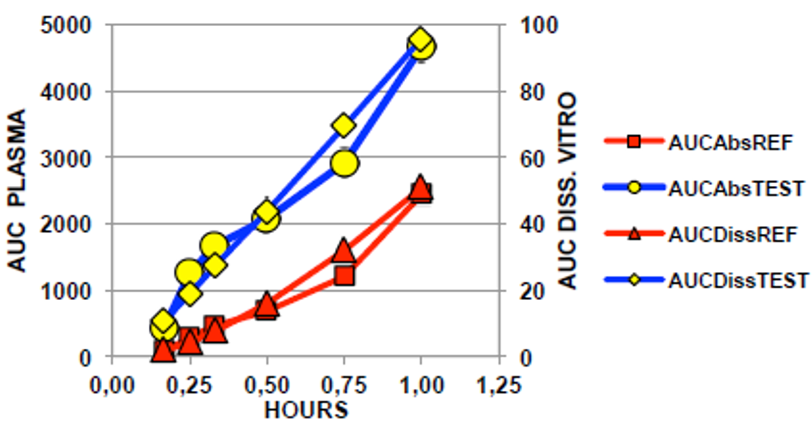

AUC = area under the concentration time curve, AUCAbs = area under the concentration time curve, absorbance; AUCDiss = area under the concentration time curve, dissolution; REF = reference.

Figure 2: The TRIUMPH-2 trial Mean dissolution profiles (50 rpm) of sponsor’s trientine tetrahydrochloride tablets, Syprine trientine dihydrochloride capsules, and Univar’s trientine dihydrochloride capsules

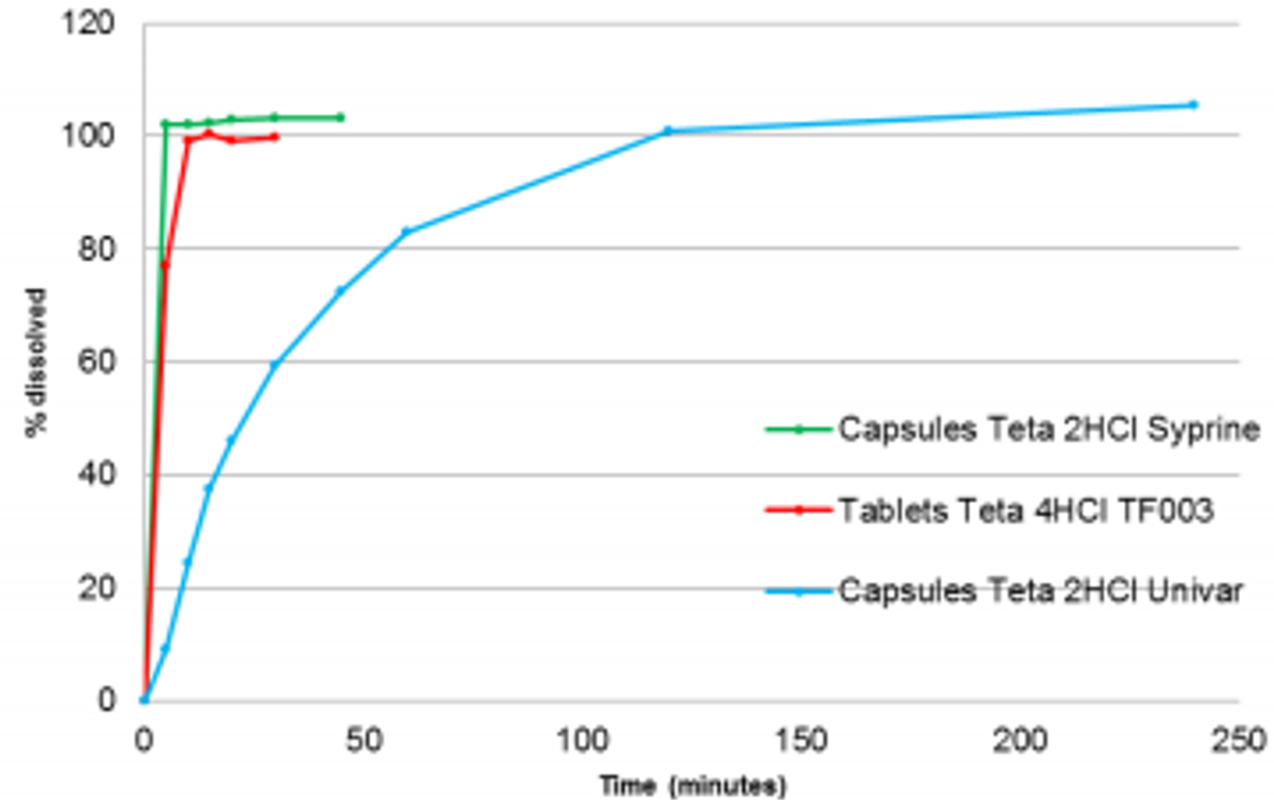

2HCl = dihydrochloride; 4HCl = tetrahydrochloride.

The TRIUMPH-2 trial compared the PK of two dose levels of the proposed trientine 4HCl tablets and Syprine capsules;[2]. The dissolution profile of the sponsor’s trientine 4HCl tablets was similar to Syprine capsules, in contrast to the slower dissolution of Univar’s trientine 2HCl capsules (Figure 2). Both the test and reference formulation showed dose proportional increase in trientine exposure with increased oral dose. A dose normalisation approach was used to compare the PK of 3 of the sponsor’s trientine 4HCl tablets (450 mg trientine) to 3 Syprine capsules (500 mg trientine), and 5 Cuprior tablets (750 mg trientine) to 5 Syprine capsules (833 mg trientine). After dose normalisation, the results suggested that bioequivalence was observed (Table 4 and Table 5). The assay of the reference Syprine batch was not tested. The applicant advised that Syprine is approved and marketed in the USA and this medicinal product should therefore comply with the United States Pharmacopeia (USP) monograph of trientine hydrochloride capsules. The USP monograph limit is 90.0 to 110.0%. Given the assay of the test batch was 103.4%, the assay of Syprine could differ in a worst case scenario by as much as 13.4%, so the reliability of bioequivalence results from this study cannot be guaranteed.

In response to the evaluator’s comments regarding limitations of the TRIUMPH and TRIUMPH-2 trials, the sponsor clarified that the comparative PK studies were not designed as bioequivalence studies and the submission is not dependent on demonstrating bioequivalence to Univar’s trientine 2HCl (UK Medicines and Healthcare products Regulatory Agency reference product now marketed as Cufence or Syprine (US reference product)). The TRIUMPH and TRIUMPH-2 trials informed the PK of the sponsor’s trientine 4HCl formulation compared to Univar’s trientine 2HCl (now marketed as Cufence) and Syprine, respectively, and were used to support the proposed dose of Cuprior.

Based on long term stability data for the film coated tablets that cover up to 24 months, a shelf life of 24 months Store below 25°C is acceptable.

The product labels are acceptable. The PI is acceptable from a quality perspective. Approval is recommended from a pharmaceutical chemistry perspective.

### Nonclinical

Primary pharmacology studies, showing copper chelation activity in all laboratory animal species tested, support the use for the proposed indication. Studies with other metals suggest perturbations to zinc, iron and calcium homeostasis may be seen in patients if trientine doses exceed the patient’s need based on copper levels.

Following oral dosing, trientine was absorbed at a fast to moderate rate, but oral bioavailability was low. The oral bioavailability of trientine was negatively affected by food. There was no significant difference in oral bioavailability in rats between dihydrochloride and tetrahydrochloride salts of trientine. Urinary excretion was the main route of excretion for absorbed trientine related material in rats.

Toxicological findings in mice, rats and dogs in repeat dose studies were consistent with the drug’s known primary activity (namely, chelation of copper and other metals). However, the most prominent finding was irreversible histopathological changes in the lungs (inflammation of the lung interstitium and broncho-alveolar pneumonia) of all species (mice, rats and dogs).

The set of reproductive and development studies was limited, but this should not preclude registration. Embryofetal development studies suggest some teratogenic potential of trientine, likely to be secondary effects due to copper chelation. The evaluator recommends pregnancy category D.[3]

Trientine was genotoxic in some *in vitro* studies, but negative in a mammalian gene mutation assay and consistently negative in *in vivo* mouse micronucleus studies. There was no carcinogenicity study for orally administered trientine. The absence of a carcinogenicity study for oral trientine is acceptable based on the negative results in *in vivo* genotoxicity studies, the negative findings of tumours or other proliferative lesions at the application site in a mouse dermal carcinogenicity study, the absence of findings in the repeat dose studies that would give cause for concern and the history of clinical use with the drug.

The draft PI is acceptable from a nonclinical perspective.

### Clinical

The clinical dossier consisted of the following studies:

* the TRIUMPH PK study comparing the sponsor’s trientine 4HCl tablet to UK approved trientine 2HCl capsules (Univar’s trientine 2HCl now marketed as Cufence).
* the TRIUMPH-2 PK study comparing the sponsor’s trientine 4HCl tablet to USA approved trientine 2HCl capsules (Aton’s Syprine).
* the Lariboisière Retrospective Survey reviewing the use of trientine 4HCl and trientine 2HCl in 43 patients in a single centre in Paris.
* published literature identified from a TGA approved systematic search strategy.
* post-market safety data from periodic safety update reports (PSURs).

#### Pharmacology

The pharmacology of trientine 4HCl is derived from published literature, as well as data from clinical studies comparing the PK of the sponsor’s trientine 4HCl product to trientine 2HCl products marketed in the EU and the USA.

Trientine is poorly absorbed following oral administration. The absolute bioavailability of trientine has not been characterised in humans. The effect of food on absorption has not been formally evaluated, but administration with food is expected to result in reduced absorption of trientine. There is a substantial degree of intra- and inter-subject variability in the PK of trientine. Trientine displays effectively linear PK. Trientine and its metabolites, N1-acetyltriethylenetetramine (MAT) and N1, N10-diacetyltriethylenetetramine (DAT), are excreted in the urine. Unabsorbed trientine is excreted in the faeces.

The PK of the sponsor’s trientine 4HCl tablets has been compared to trientine 2HCl capsules in two PK studies: the TRIUMPH trial (comparison against EU reference product) and the TRIUMPH-2 trial (comparison against USA reference product).

The TRIUMPH trial was a Phase I, single centre, randomised, single dose (600 mg trientine base), open label cross over study in healthy volunteers comparing the PK of the sponsor’s trientine 4HCl tablets to Univar’s trientine 2HCl capsules. The primary objective was to evaluate the PK parameters of both oral formulations in order to propose an adequate strength of trientine 4HCl to support an application for Marketing Authorisation (that is, a strength providing a PK profile similar to Univar’s trientine 2HCl).

Following oral administration of a single dose of 600 mg trientine base in healthy male and female subjects, median time of maximum plasma concentration (Tmax) was 2.00 hours for the sponsor’s trientine 4HCl tablets and 3.00 hours for Univar’s trientine 2HCl capsules. Trientine maximum plasma concentration (Cmax) and area under the concentration versus time curve from time zero to infinity (AUC0-inf) were greater for trientine 4HCl tablets than for trientine 2HCl capsules (approximately 68% and approximately 56% increase in Cmax and AUC0-inf, respectively, Table 3). Differences in dissolution of the trientine 4HCl tablets and Univar’s trientine 2HCl capsules (Figure 3) are considered to have contributed to the observed differences in systemic exposure.

There was a substantial degree of intra- and inter-subject variability in Cmax and AUC0-inf. The between subject coefficient of variation (%CV) for Cmax was 50.0% and 58.1% for trientine 4HCl and trientine 2HCl, respectively, and the corresponding %CVs for AUC0-inf were 56.7% and 58.1%. Intra-subject variability is shown in Table 3.

Table 3: The TRIUMPH trial Statistical comparisons of pharmacokinetics parameters for trientine, N1-acetyltriethylenetetramine and N1, N10-diacetyltriethylenetetramine after administration of trientine dihydrochloride and trientine tetrahydrochloride in healthy subjects

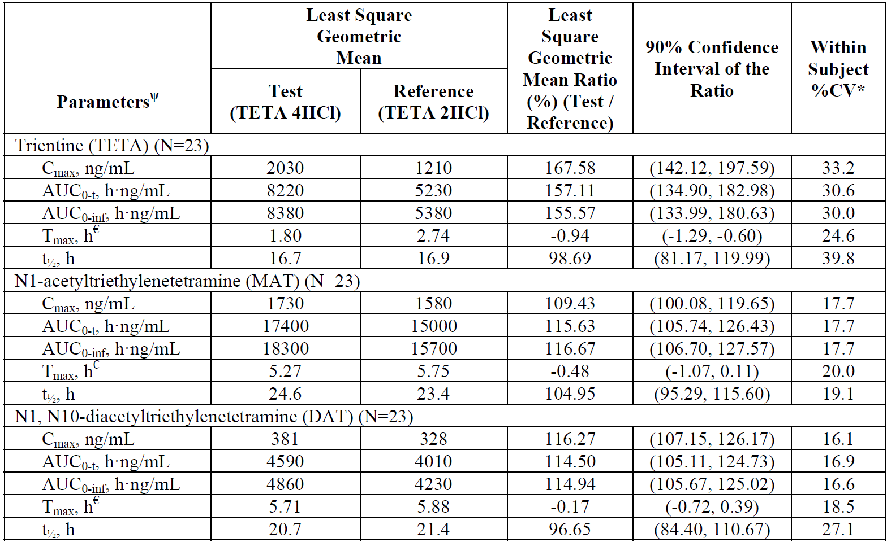

AUC0-t = area under the concentration time curve from time zero to time t; AUC0-inf = area under the concentration versus time curve from time zero to infinity; Cmax = Maximum plasma concentration; CV = coefficient of variation; DAT = N1, N10-diacetyltriethylenetetramine; h = hour; 2HCl = dihydrochloride; 4HCl = tetrahydrochloride; MAT = N1-acetyltriethylenetetramine; N = population size; T1/2 = half life; TETA = trientine; Tmax = time of maximum plasma concentration.

𝛹 The least square geometric means and confidence intervals were performed on ln-transformed parameter values from analysis of variance (ANOVA) model, including treatment, period, sequence, gender, sequence* gender and gender* treatment and subject (sequence* gender) as fixed model effects.

€ Least square mean and least square mean difference of test minus reference and the confidence interval of the least square mean difference are reported for Tmax.

* Within subject %CV was calculated as 100 x ($\sqrt{e^{MSE}-1}$) on ln-transformed data (that is, Cmax and AUC) and was calculated as 100 x ( / ref ) on non-transformed data (that is, Tmax), where MSE is the mean square.

Treatment A: reference trientine dihydrochloride capsules, each capsule of 300 mg contains the equivalent of 200 mg trientine base, 3 capsules.

Treatment B: test trientine tetrahydrochloride tablets, each tablet of 300 mg contains the equivalent of 150 mg trientine base, 4 tablets.

Figure 3: Comparison of *in vitro* dissolution profiles for trientine tetrahydrochloride core tablets and Univar’s trientine dihydrochloride capsules; hydrochloric acid buffer pH 1.2 to 50 rpm

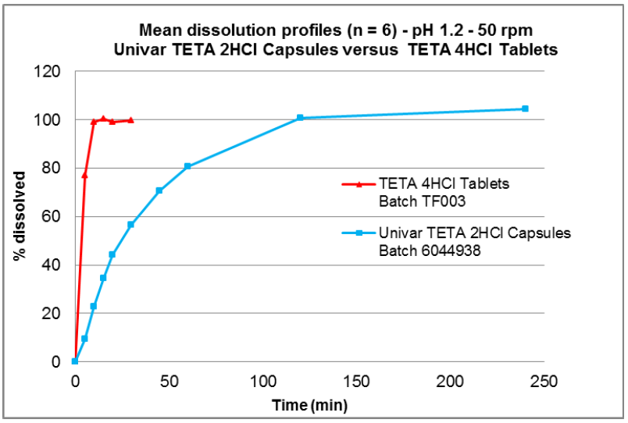

2HCl = dihydrochloride; 4HCl = tetrahydrochloride; n = sample size; TETA = trientine.

The TRIUMPH-2 trial was a Phase I, single centre, randomised, interventional, single dose, open label, 4 way cross over study in healthy volunteers to compare the PK of two dose levels of the sponsor’s trientine 4HCl tablets to USA approved Syprine (trientine 2HCl) capsules. The dose levels assessed in this study were 450 mg and 750 mg of trientine base for the trientine 4HCl tablets, and 500 mg and 833 mg trientine base for the trientine 2HCl capsules.

Mean Tmax was 1.25 and 2.00 hours for the lower and higher doses of trientine 4HCl, and 2.00 and 3.00 hours for the lower and higher doses of trientine 2HCl. Similar outcomes for Cmax and area under the concentration time curve (AUC) were evident in the dose-normalised comparisons at both the lower (Table 4) and higher dose levels (Table 5).

Table 4: The TRIUMPH-2 trial Statistical comparisons of dose normalised pharmacokinetic parameters for trientine, N1-acetyltriethylenetetramine and N1, N10-diacetyltriethylenetetramine after administration of lower dose level of trientine dihydrochloride and trientine tetrahydrochloride in healthy male and female subjects

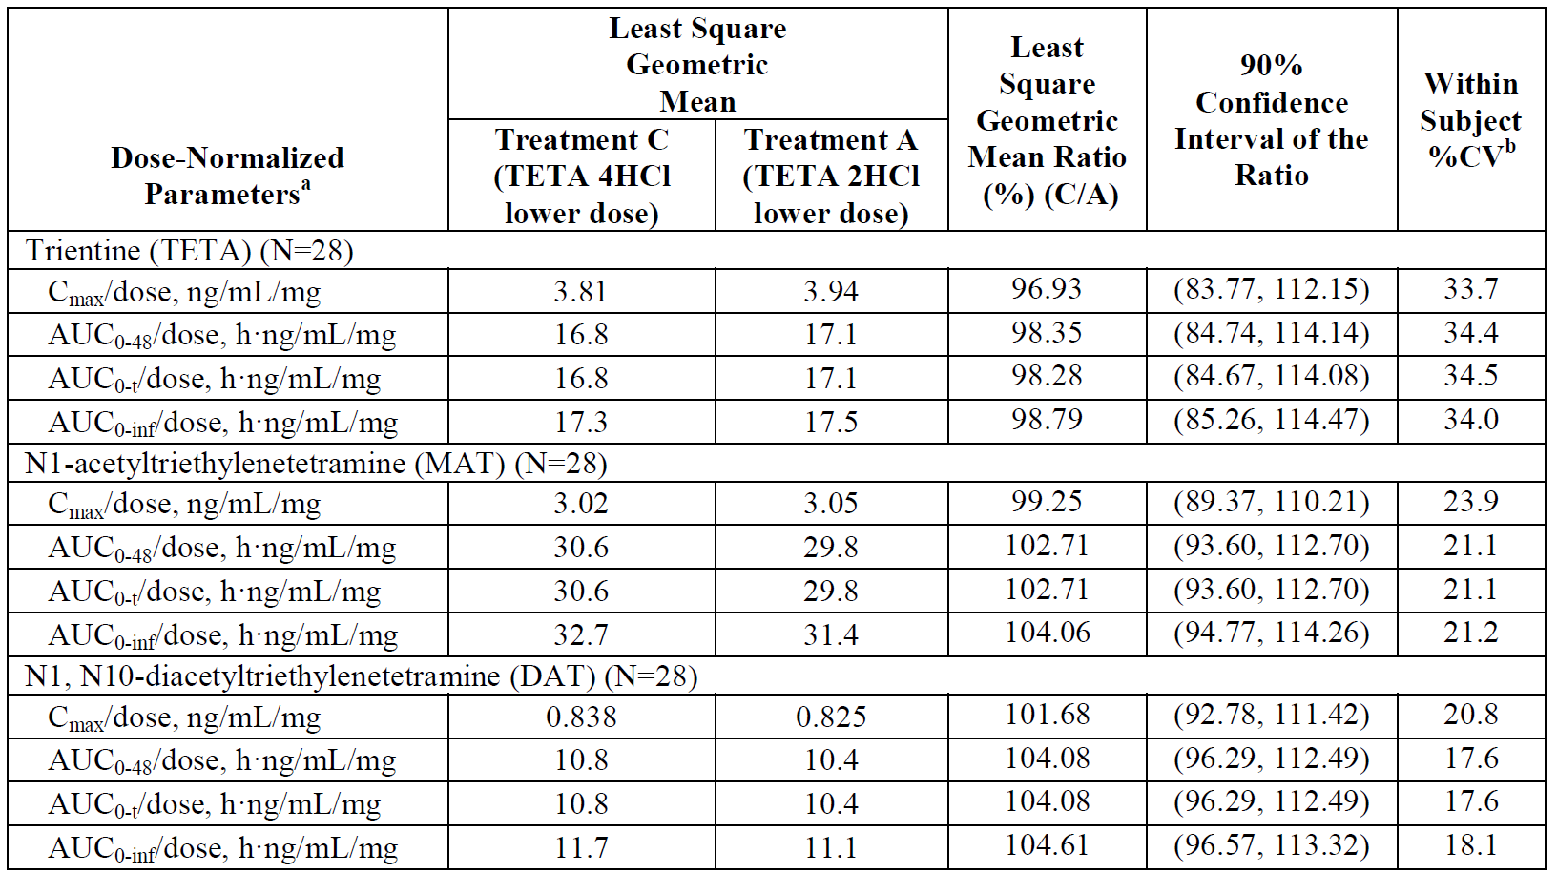

AUC0-48 = area under the concentration time curve from time zero to 48 hours; AUC0-inf = area under the concentration versus time curve from time zero to infinity; AUC0-t = area under the concentration time curve from time zero to the last quantifiable time point; C/A = treatment C/treatment A; Cmax = maximum plasma concentration; CV = coefficient of variation; DAT = N1, N10-diacetyltriethylenetetramine; h = hour; 2HCl = dihydrochloride; 4HCl = tetrahydrochloride; MAT = N1‑acetyltriethylenetetramine; N = population size; TETA = trientine; Tmax = time of maximum plasma concentration; Treatment A = TETA 2HCl ‘lower dose’ = 3 capsules of Syprine (500 mg trientine base); Treatment C = TETA 4HCl ‘lower dose’ = 3 tablets (450 mg of trientine base).

a. The least square geometric means and confidence intervals were performed on ln-transformed parameter values from analysis of variance (ANOVA) model, including treatment, period, sequence, gender, sequence*gender and gender*treatment and subject (sequence*gender) as fixed model effects.

b. Within subject %CV was calculated as 100 x ($\sqrt{e^{MSE}-1}$), where MSE is the mean square error.

Table 5: The TRIUMPH-2 trial Statistical comparisons of dose normalised pharmacokinetic parameters for trientine, N1-acetyltriethylenetetramine and N1, N10-diacetyltriethylenetetramine after administration of higher dose level of trientine dihydrochloride and trientine tetrahydrochloride in healthy male and female subjects

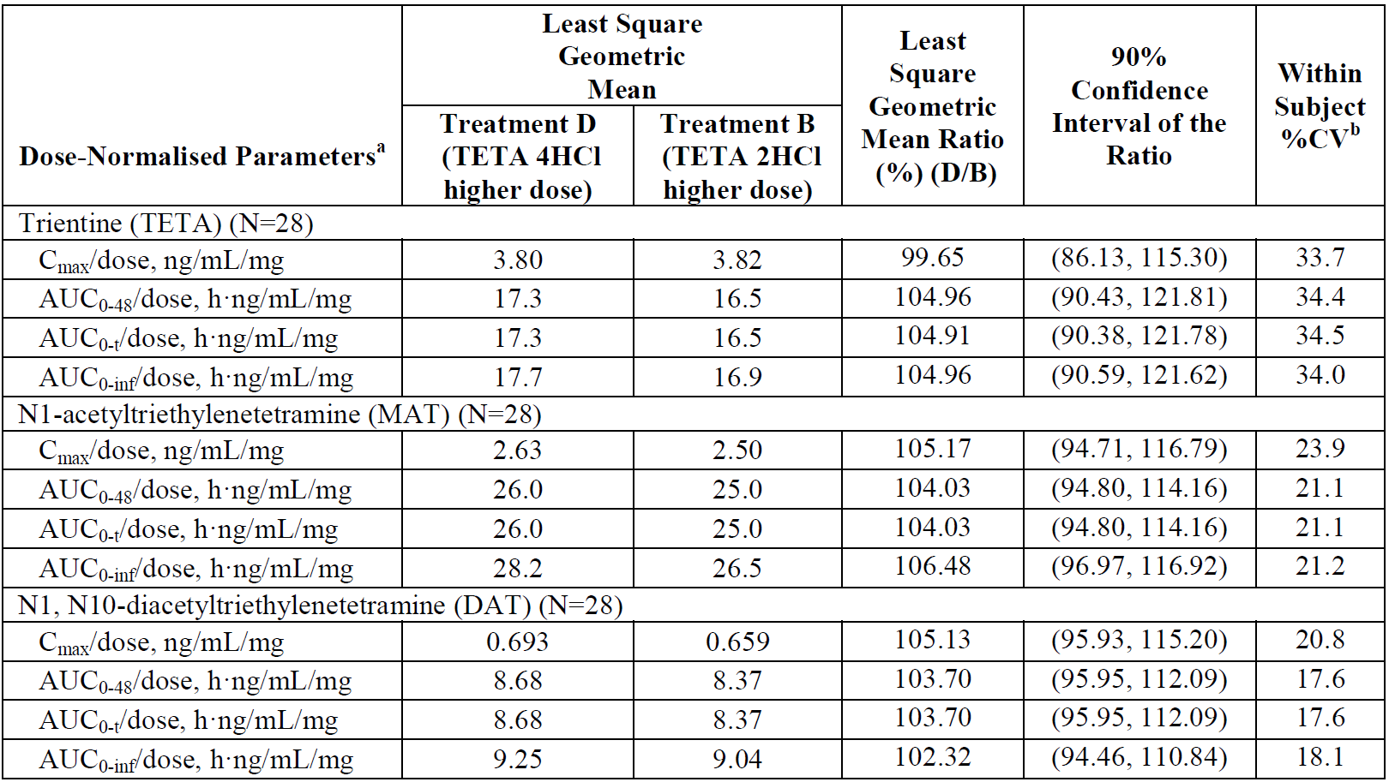

AUC0-48 = area under the concentration time curve from time zero to 48 hours; AUC0-inf = area under the concentration versus time curve from time zero to infinity; AUC0-t = area under the concentration time curve from time zero to the last quantifiable time point; D/B = treatment D/treatment B; Cmax = maximum plasma concentration; CV = coefficient of variation; DAT = N1, N10-diacetyltriethylenetetramine; h = hour; 2HCl = dihydrochloride; 4HCl = tetrahydrochloride; MAT = N1-acetyltriethylenetetramine; N = population size; TETA = trientine; Tmax = time of maximum plasma concentration; Treatment B = TETA 2HCl ‘higher dose’ = 5 capsules of Syprine (833 mg trientine base); Treatment D = TETA 4HCl ‘higher dose’ = 5 tablets (750 mg trientine base).

a. The least square geometric means and confidence intervals were performed on ln-transformed parameter values from analysis of variance (ANOVA) model, including treatment, period, sequence, gender, sequence*gender and gender*treatment and subject (sequence*gender) as fixed model effects.

b. Within subject %CV was calculated as 100 x ($\sqrt{e^{MSE}-1}$), where MSE is the mean square error.

The evaluation of two dose levels in the TRIUMPH-2 trial allowed an assessment of dose proportionality (Table 6). The ratios for Cmax and AUC0-inf for the higher and lower doses were similar to the oral dose ratio (1.67) for both the trientine 2HCl and trientine 4HCl formulations, supporting a conclusion of dose proportionality.

Table 6: The TRIUMPH-2 trial Summary of relative trientine exposure, after administration of two dose levels of trientine tetrahydrochloride and trientine dihydrochloride

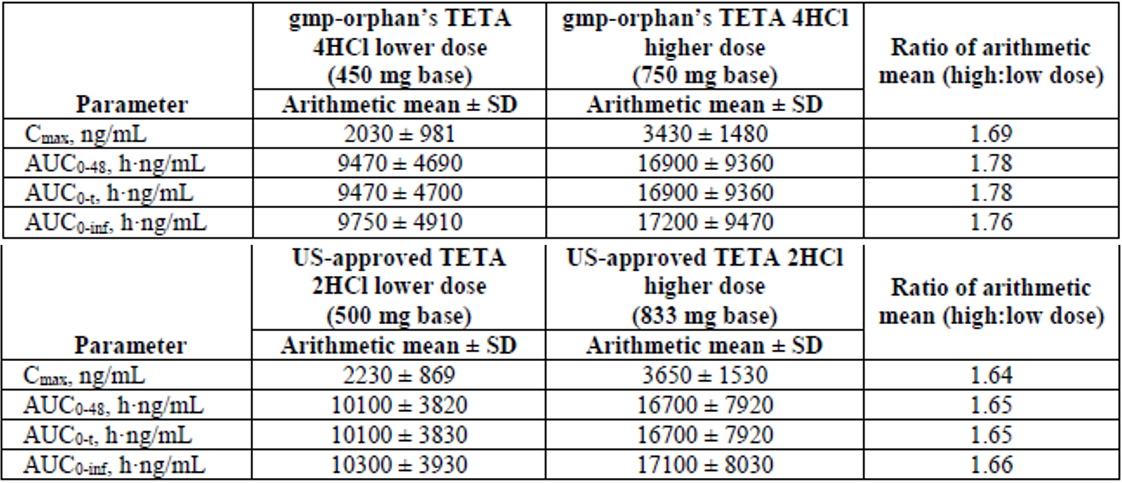

AUC0-48 = area under the concentration time curve from time zero to 48 hours; AUC0-inf = area under the concentration versus time curve from time zero to infinity; AUC0-t = area under the concentration time curve from time zero to the last quantifiable time point; Cmax = maximum plasma concentration; CV = coefficient of variation; h = hour; 2HCl = dihydrochloride; 4HCl = tetrahydrochloride; SD= standard deviation; TETA = trientine; US = United states (of America).

##### Dose selection

The TRIUMPH trial was designed to evaluate the PK of the sponsor’s trientine 4HCl tablets and Univar’s trientine 2HCl capsules (now marketed in the EU as Cufence) in order to propose an adequate strength (dose) of Cuprior to support an application for marketing authorisation in the EU. Based on the PK findings in the TRIUMPH trial (Cmax is approximately 68% greater and AUC0-inf is approximately 56% greater for trientine 4HCl compared to Univar’s trientine 2HCl), an adjustment factor was applied to select a dose of Cuprior that would be expected to achieve similar exposure to the recommended dose of Univar’s trientine 2HCl now marketed in the EU as Cufence.

The proposed dose of Cuprior is between 450 mg and 975 mg trientine base (3 to 6.5 film coated tablets) per day in 2 to 4 divided doses. The starting dose would usually correspond to the lowest recommended dose and the dose should subsequently be adapted according to the patient’s clinical response.

The recommended dose of Cufence in the EU is between 800 mg and 1600 mg trientine base (4 to 8 capsules) per day in 2 to 4 divided doses. Therefore, the proposed dose of Cuprior is between 56% (450/800) and 61% (975/1600) of the corresponding dose of Univar’s trientine 2 HCl now marketed in the EU as Cufence

#### Efficacy

The efficacy of Cuprior is based primarily on published literature, which is supported by the PK findings from the TRIUMPH and TRIUMPH-2 trials, and efficacy findings from the Lariboisière Retrospective Survey.

##### Lariboisière retrospective survey

This was a retrospective survey of clinical experience with trientine 4HCl (a different formulation to the one proposed in this submission) and Univar’s trientine 2HCl in 43 patients with Wilson’s disease. The study reviewed patient data recorded between June 1970 and July 2010 at Lariboisière hospital in Paris, the national reference centre for Wilson’s disease in France. The review identified 57 sequences of patients treated with trientine as monotherapy for at least 12 months (13 sequences with trientine 4HCl and 44 sequences with trientine 2HCl). Trientine was given as first line treatment in 4 sequences (2 for each trientine salt) and as second/third line treatment in 53 sequences (11 for trientine 4HCl and 42 for trientine 2HCl). Treatment was given according to standard medical practice through compassionate use, with doses adjusted based on the individual patient’s needs.

Hepatic assessment included clinical symptoms, measurements of aminotransferases, bilirubin, prothrombin time, abdominal ultrasonography and cirrhosis (presence of typical findings on imaging and presence of clinical signs of portal hypertension). Neurological assessment was based on clinical symptoms, standardised neurological assessments, and cerebral imaging. The presence of Kayser-Fleischer rings (slit-lamp examination) was assessed.

Assessments were recorded at the time of initiation of trientine treatment (Baseline), at each follow-up visit (every 6 to 12 months), or at each change in trientine treatment. Hepatic and neurologic outcomes were scored as ‘improved’, ‘unchanged’, or ‘worsened’. The evolution of Kayser-Fleischer rings was scored as ‘increase’, ‘diminution’, or ‘disappearance’.

Efficacy findings were presented by treatment sequence (Table 7). Hepatic symptoms were assessed as ‘improved’ or ‘unchanged’ in 100% of trientine 4HCl sequences and 95.46% of trientine 2HCl sequences. Neurologic symptoms were assessed as ‘improved’ or ‘unchanged’ in 100% of trientine 4HCl sequences compared to 97.73% of trientine 2HCl sequences. No significant differences in the evolution of symptoms were observed between trientine 4HCl and trientine 2HCl sequences. Kayser-Fleischer ring evolution was comparable for the two trientine salts.

Table 7: Lariboisière retrospective survey Evolution of symptoms, all patients

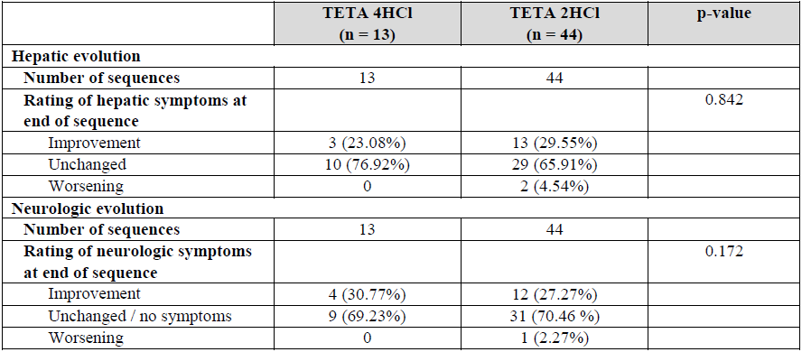

2HCl = dihydrochloride; n = sample size; TETA = trientine.

##### Weiss et al. (2013)

This was a retrospective cohort study of 380 patients with Wilson’s disease treated at six tertiary care centres in Germany and Austria, and 25 patients from the EuroWilson registry.[4] The purpose of the study was to evaluate the efficacy and safety of trientine and penicillamine therapy, in terms of hepatic and neurological outcomes and adverse events (AEs) leading to discontinuation.

Medical records of the 405 patients were reviewed. 207 (51.1%) patients presented with hepatic symptoms only, 92 (22.7%) presented with neurologic symptoms only, 52 (12.8%) presented with hepatic and neurologic symptoms, and 54 (13.3%) were asymptomatic at diagnosis. 21 patients (5.2%) presented with fulminant Wilson’s disease with hepatic failure at diagnosis.

No systematic criteria were applied in the initial choice of chelating agent. Patients with a stable course were assessed in the tertiary centres approximately once a year. Patients were reviewed more frequently (3, 6, and 12 months) after initiating or changing therapy. Data were collected for a mean of 13.3 years after therapy began.

Hepatic and neurologic outcomes were assessed from patient records at 6, 12, 24, 36 and 48 months after initiation of the treatment. Hepatic outcome measures were based on clinical symptoms, course of liver enzymes, and liver function tests. Neurologic outcomes were evaluated by the physician. Hepatic and neurologic outcomes were scored as unchanged, improved to normal, improved but not normal, deteriorated, or asymptomatic over duration.

The analysis identified 467 chelator based treatments with a duration of more than 6 months: 326 involved penicillamine monotherapy (295 as first line, 31 as second line) and 141 involved trientine monotherapy (38 as first line and 103 as second line). No specific dosage information was presented.

Baseline characteristics, recorded at the time of initiation of, or change in, chelator based treatment, were generally similar across the treatment groups but penicillamine was used more commonly as first line treatment.

Hepatic and neurologic improvement and worsening were reported for penicillamine and trientine, stratified by first line and second line use (Table 8).

For trientine in the second line setting (proposed for registration):

* 31 of 45 (68.9%) patients with hepatic symptoms showed hepatic improvement.
* 10 (22.2%) patients with hepatic symptoms showed stable hepatic disease.
* 4 (8.9%) patients with hepatic symptoms showed hepatic worsening.
* No hepatic worsening was observed in asymptomatic patients.
* 26 of 51 (50.9%) patients with neurologic symptoms showed neurologic improvement.
* 17 (33.3%) patients with neurologic symptoms showed stable neurologic disease.
* 8 (15.7%) patients with neurologic symptoms showed neurologic worsening.
* No neurologic worsening was observed in asymptomatic patients.

Hepatic improvement was lower in the second line setting compared to the first line setting for both penicillamine and trientine. The authors attributed this finding to advanced liver disease and irreversible structural liver damage.

Neurologic deterioration occurred more frequently with trientine than penicillamine in both the first line and second line settings.

Table 8: Weiss et al. (2013) Rate of hepatic or neurological improvement and worsening in all or only symptomatic patients stratified by first and second line treatment

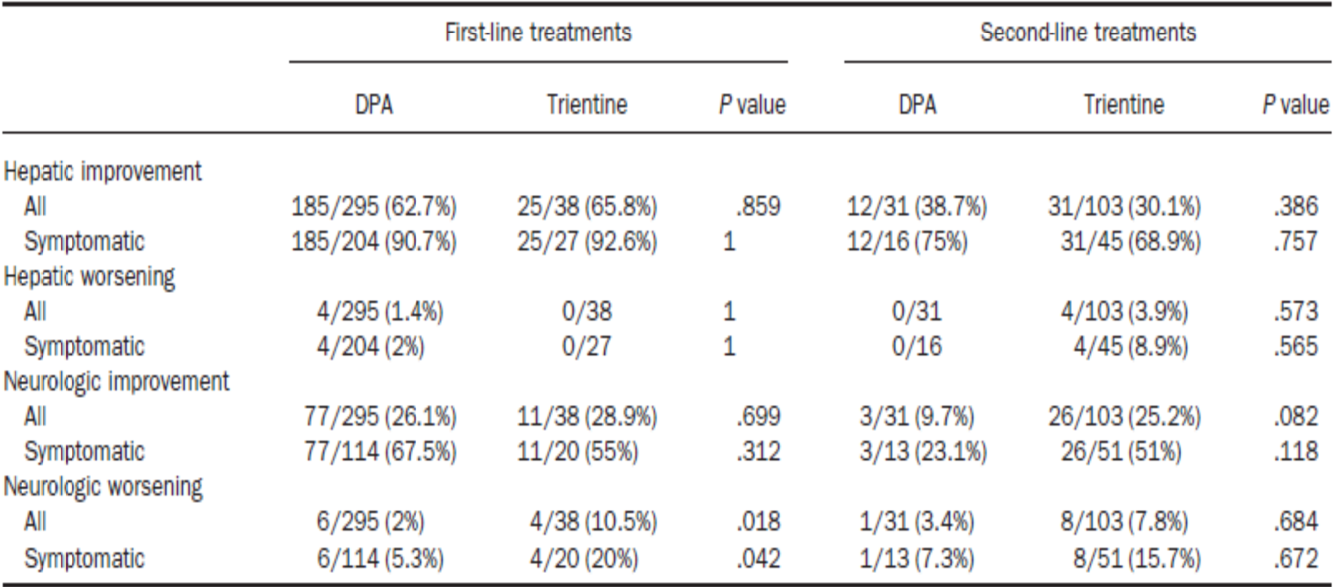

DPA = D-penicillamine.

P-values were established using the two tailed Fisher test.

##### Weiss et al. (2011)

This was a retrospective analysis of data on 288 patients with Wilson’s disease treated at two tertiary care centres in Germany and Austria, between 1954 and 2008.[5] Patients were primarily treated with chelation therapy (n = 244; 220 D-penicillamine, 24 trientine), zinc salts (n = 23), or a combination of a chelator and zinc (n = 11, D‑penicillamine and zinc; n = 3, trientine and zinc).

There is likely to be overlap between the patients in this study and those patients presented in Weiss et al. (2013).4 The most relevant efficacy finding was that chelation therapy had higher adherence and lower discontinuation due to treatment failure, death or liver transplantation compared with zinc monotherapy; however, the majority of chelation therapy involved D-penicillamine rather than trientine, so conclusions on the efficacy of trientine are limited.

##### Walshe (1982)

This was a retrospective review of file notes for 20 penicillamine-intolerant patients treated with trientine dihydrochloride for a minimum of one year over the preceding 13 years.[6] The aim was to describe the clinical response to trientine in patients with Wilson’s disease intolerant to penicillamine. The study reported trientine doses between 400 mg 3 times daily and 800 mg 3 times daily before meals.

The analysis grouped patients according to the stage at which they developed penicillamine intolerance: patients in whom penicillamine intolerance developed within days or weeks of commencing treatment (Group A, n = 8); patients who had received less than one year of continuous penicillamine before developing intolerance (Group B, n = 3); and patients who had responded well to penicillamine before developing intolerance at a later stage (Group C, n = 9).

Clinical responses for patients in Group A are shown in Table 9. All patients in Group A experienced improvement in symptoms after treatment with trientine (duration of treatment ranging from 14 to 120 months). The three patients in Group B were reported to have considerable neurological deficit which improved after commencing trientine, although two had some residual deficit. The patients in Group C had been adequately ‘de‑coppered’ at the time of changeover. They remained symptomatically well controlled after changing to trientine, the penicillamine-related toxicities resolved, and no new toxicities were observed other than iron deficiency.

Table 9: Walshe (1982)6 Clinical and pharmacodynamic response to treatment with trientine after early intolerance to penicillamine (Group A)

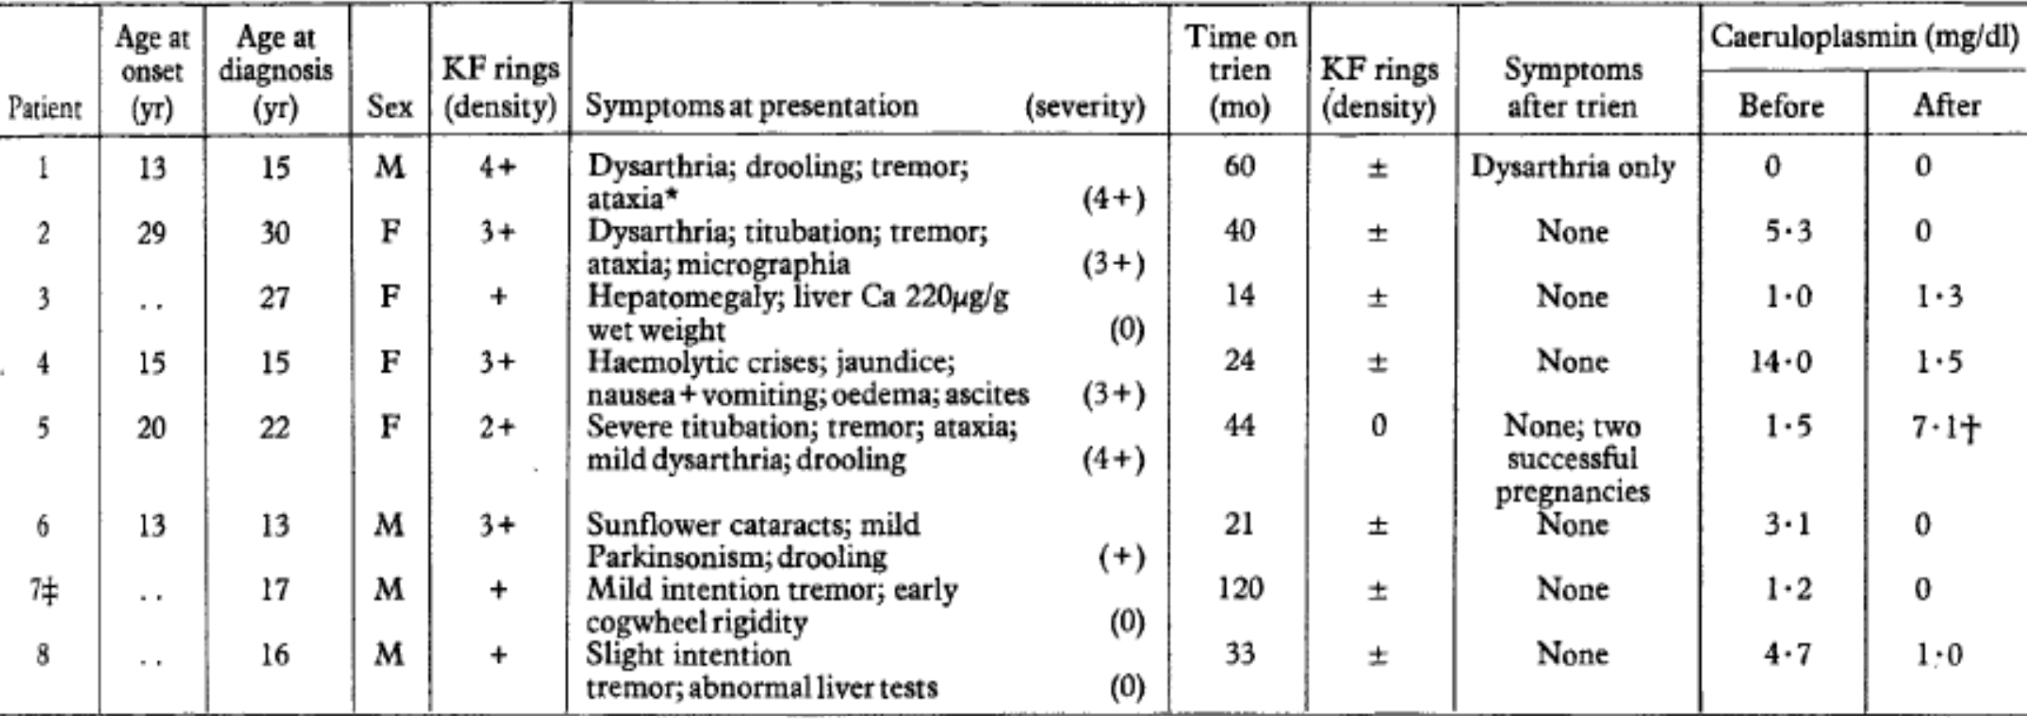

KF rings= Kayser-Fleischer pericorneal pigment rings; Yr= year.

* Has splenectomy at age 11 years

† 22 weeks pregnant when estimated

‡ Previously reported

##### Scheinberg et al. (1987)

Scheinberg et al (1987)[7] retrospectively compared the clinical outcomes of three groups of patients with Wilson’s disease in the USA. Group 1 comprised 11 patients who had been treated with penicillamine (1000 to 2000 mg/day) for three to 16 years before ceasing treatment. Ten patients in Group 1 were asymptomatic on penicillamine before ceasing treatment. Eight patients died with hepatic failure within six years of ceasing treatment with penicillamine, one required liver transplantation, and two recovered partly or fully with recommencing treatment. Group 2 comprised 13 patients who had been treated with penicillamine for 0.5 to 15 years before developing adverse reactions and switching to trientine dihydrochloride (1000 to 1500 mg/day) for ongoing therapy. All patients were alive at the time of publication (duration of trientine treatment ranged from 2 to 15 years) except for one patient who died by unrelated accident. A third group of 320 patients remained on treatment with penicillamine. Outcomes in this group are not directly relevant to the proposed indication.

##### Dahlman et al. (1995)

This was a case series of 19 patients with Wilson’s disease, 17 of whom were treated initially with penicillamine and subsequently switched to trientine due to adverse effects, lack of improvement or worsening of neurological symptoms, and 2 of whom were treated with trientine from diagnosis.[8] Trientine doses ranged from 1000 to 1800 mg per day, and duration of treatment ranged from 4 months to 17.5 years. Efficacy was evaluated based on clinical symptoms and Kayser-Fleischer rings. The authors reported that all patients responded well to trientine with the exception of one patient who was treated initially with trientine and developed neurological deterioration. 13 remained on trientine at final review, and the mean duration of trientine treatment was 8.5 years.

##### Taylor et al. (2009)

This retrospective study reviewed the medical records of 96 children with Wilson’s disease treated at a single hospital in the UK between 1981 and 2006.[9] Of these, 16 children (5 females, 11 males) aged between 6.6 years and 15.6 years had been treated with trientine 2HCl as either initial treatment (n = 3) or following AEs with D‑penicillamine (n = 13). Trientine dose ranged from 600 to 1500 mg/day in children under 12 years and between 1200 and 2400 mg/day in those over 12 years of age. Efficacy of treatment was based on normalisation of liver function tests and cessation of symptoms. Liver function normalised in the majority of children, and children with hepatic-only presentation were symptom-free. One child in the trientine conversion group went on to require liver transplantation due to progressive liver disease, probably due to non-adherence. Trientine did not rectify symptoms in those children who had accompanying neurological or psychiatric features of Wilson disease.

##### Brewer et al. (2006)

This was a USA based prospective, randomised controlled double blind comparison study comparing the effects of trientine and tetrathiomolybdate (TTM) on the neurological manifestations of Wilson’s disease.[10] Of the enrolled patients, 23 received 500 mg trientine hydrochloride twice daily (1000 mg daily) while 25 patients received 20 mg of TTM six times daily (120 mg daily) for eight weeks. All patients also received zinc co‑therapy. Patients were monitored in hospital for eight weeks then went home on daily zinc maintenance therapy and were reviewed annually for three years. The trientine group (11 males, 12 females) were aged between 13 and 43 years (seven were aged ≤ 18 years). Seven had previously been treated with D-penicillamine (no more than 28 days) and two had previously been treated with trientine (7 days and 21 days respectively).

Six of 23 (26%) patients in the trientine arm and one of 25 (4%) patients in the TTM arm underwent neurologic deterioration (p < 0.05). The authors concluded that TTM is a better choice than trientine for preserving neurologic function in patients who present with neurologic disease. TTM is still in clinical trial phase, so conclusions regarding the efficacy of trientine in the proposed indication are limited.

##### Merle et al. (2011)

This was a retrospective record review of 163 patients (98 women, 65 men) treated for Wilson’s disease at one hospital in Germany between 2000 and 2005 to determine clinical presentation, diagnostic course and long term outcome.[11] 138 patients were treated initially with D-penicillamine (900 to 1800 mg/day), 9 with trientine (900 to 2100 mg/day), 13 with zinc salts (150 to 250 mg/day), and 3 underwent urgent liver transplantation due to acute liver failure without prior treatment. At the end of the review period, 63 patients were receiving D-penicillamine, 44 patients (28%) were receiving trientine, 45 were receiving zinc salts, and 8 patients had undergone liver transplantation. Clinical outcomes were assessed but were not presented by treatment group, so outcomes according to treatment type are uncertain.

##### Appenzeller-Herzog et al. (2019)

This was a systematic review and meta-analysis of the effectiveness and safety of common therapies for Wilson’s disease.[12] Of the 23 studies that met the inclusion criteria, 17 were retrospective observational studies, 3 were prospective observational studies, 2 were non-randomised controlled trials, and one was a randomised controlled trial. 23 studies were included, mostly comparing D-penicillamine to no treatment, zinc, trientine or succimer. One study compared tetrathiomolybdate and trientine. Eleven of 23 studies were of low quality. The main analyses assessed penicillamine versus no treatment, and penicillamine versus zinc salts. With regard to analyses of trientine, the authors commented:

*‘There were not enough studies comparing other drug combinations to perform meta-analysis. For the comparisons trientine with DPen* [D-penicillamine] *and trientine with TTM, the authors found no difference in effectiveness in primary outcomes. However, they found early neurological deterioration to occur more frequently under therapy with trientine (5/16, 31% or 6/23, 26%) as compared to DPen (8/97, 8%) or TTM (1/25, 4%). At the same time, the relative risk for side effects was found to be lower under trientine therapy (9/38, 24% or 1/23, 4%) compared to DPen (182/295, 62%) or TTM (7/25, 28%).’*

The authors concluded that high quality evidence for the comparative effectiveness and safety of Wilson’s disease therapies is scarce. All studies but one did not correct for confounding factors, including age, clinical presentation and disease stage. Selection bias was identified as a severe limitation of many of the studies included in this systematic review. Non‑uniform definitions of clinical outcomes was also identified as a limitation of the studies.

#### Safety

The safety evaluation for Cuprior is based primarily on published experience with trientine 2HCl formulations. In addition, safety data specific to trientine 4HCl were assessed from the TRIUMPH and TRIUMPH-2 trials (single doses of the proposed trientine 4HCl formulation in healthy volunteers), the Lariboisière Retrospective Survey (patients with Wilson’s disease treated with another formulation of trientine 4HCl), and PSURs for Cuprior since its authorisation in the EU in September 2017.

Much of the published safety data is from retrospective reviews, as well as case reports of AEs. Safety reporting was generally limited and inconsistent across the published studies. but some of the literature references reported extended exposure periods, including Weiss (2013)4 (median follow-up period 13.3 years), Dahlman et al., (1995)8 (up to 17.5 years, mean 8.5 years/patient), and Taylor et al., (2009)9 (median 6.4 years, range 0.8 to 18.6 years). Overall estimates of the extent of exposure to trientine from the published literature may not be accurate due to potential duplication of patients in retrospective studies, and variability in reporting of dose and duration of treatment.

The Lariboisière retrospective survey included 43 patients who received 57 sequences of trientine monotherapy of at least 12 months duration (13 sequences of trientine 4HCl, 44 sequences of trientine 2HCl). This study presented data for more than 186 patient years of trientine 4HCl treatment and 326 patient-years of trientine 2HCl treatment. For trientine 4HCl sequences, one patient experienced a Kayser-Fleischer ring re‑occurrence, without neurologic or hepatic deterioration, and treatment with trientine 4HCl was stopped for approximately 18 months before being restarted. The patient continued to receive trientine 4HCl and later trientine 2HCl without any further re-occurrence of Kayser-Fleischer rings and with stable hepatic and neurological symptoms. No other safety findings were reported for trientine 4HCl treatment sequences. The safety profile for trientine 2HCl sequences was consistent with the safety profile of trientine reported in the literature.

In the TRIUMPH and TRIUMPH-2 PK studies in healthy volunteers, each formulation was well tolerated. No serious AEs, deaths or discontinuations due to a treatment emergent AE were reported in these studies.

In Weiss et al. (2013)4, safety reporting was limited to AEs leading to discontinuation of therapy (Table 10). Discontinuation of treatment due to AEs was more frequent with penicillamine (94 of 326 (28.8%) treatments) than trientine (10 of 141 (7.1%) treatments, p = 0.039). There were no deaths related to AE.

Table 10: Weiss et al. (2013)4 Adverse events leading to discontinuation of treatment

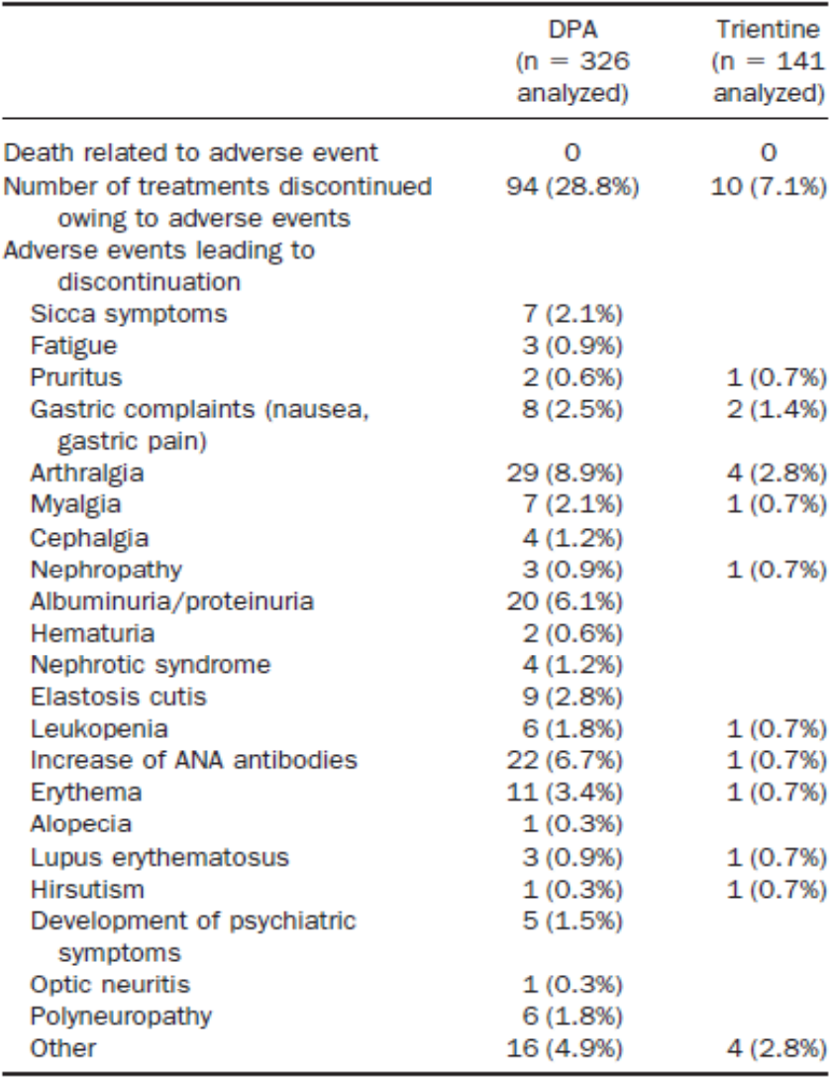

ANA = antinuclear antibody; DPA = D-penicillamine; n = sample size.

Brewer et al. (2006)10 was a randomised, double blind, controlled trial comparing trientine to TTM in the treatment of primarily newly diagnosed patients with neurologic presentation of Wilson’s disease. TTM is not registered in Australia. Criteria for adverse effects included anaemia (a replicable haemoglobin value < 80% of Baseline), leukopenia (a replicable white blood cell count < 80% of Baseline), and transaminase elevations consisting of a replicable quadrupling of Baseline values of either aspartate aminotransferase or alanine aminotransferase. One of 23 patients in the trientine arm reported anaemia as an AE; 3 of 25 patients in the TTM arm reported anaemia and/or leukopenia and 4 had further transaminase elevations during 8 weeks of treatment.

In Merle et al. (2007)11, side effects were reported in 19 of 59 patients (32.2%) ever treated with trientine. These included arthritis (n = 4), treatment failure (progressive liver disease on maintenance therapy, n = 2), rash (n = 1), epigastric discomfort (n = 1); neurological deterioration was reported by 11 patients on trientine.

Dahlman et al. (1995)8 retrospectively reviewed 19 patients treated with trientine dihydrochloride 1000 to 1800 mg/day (duration 4 months to 17.5 years), 2 as first line treatment and 17 following treatment with penicillamine. Colitis was reported in two patients, one of whom also developed duodenitis. Two patients with neurological Wilson’s disease experienced worsening symptoms on trientine, of whom one later recovered. One male developed iron deficiency and some patients developed zinc deficiency.

Walshe (1982)6 did not report any toxic signs or symptoms relating to treatment with trientine in the retrospective review of 20 penicillamine intolerant patients treated with trientine 2HCl.

Taylor et al. (2009)9 reviewed the medical records of 96 children with Wilson’s disease treated at a single hospital in the UK between 1981 and 2006. Of these, 16 children aged between 6.6 years and 15.6 years had been treated with trientine 2HCl as either initial treatment (n = 3) or following AEs with D-penicillamine (n = 13). All of the children who had initial treatment with trientine continued to receive it at the last follow-up. Trientine was discontinued in three children who had switched from D-penicillamine, one for an allergic rash (trientine was restarted 5 years later due to elevated copper on liver biopsy, and was well tolerated), one for low copper excretion and one for persistent abnormal liver function which required liver transplantation in adulthood 8.2 years after diagnosis.

The submission included published literature reporting use of trientine in pregnancy. Pfeiffenberger et al. (2018)[13] reviewed outcomes of 282 pregnancies in 136 women with Wilson’s disease treated at three tertiary hospitals between 1965 and 2015. The highest rates of spontaneous abortion were reported in patients with undiagnosed Wilson’s disease , followed by patients who discontinued therapy during pregnancy (Table 11). Birth defects occurred in 7 of 209 (3%) live births (4 were treated with penicillamine, one with trientine, 2 were not on treatment).

Dathe et al. (2016) reported pregnancy outcomes for 3 women treated with trientine throughout pregnancy. One infant had transient bradycardia on Day 2 and 3 and elevated blood copper levels. Walshe (1982)6 reported no evidence of teratogenicity in 6 infants of mothers who became pregnant while taking trientine. Walshe (1982) reported outcomes for 11 pregnancies in 8 women with Wilson’s disease treated with trientine. Eight pregnancies resulted in the delivery of normal infants. One infant was born premature (31 weeks) and was later shown to have a chromosomal defect, isochromosome X. There was one therapeutic termination and one miscarriage associated with a contraceptive coil.

Table 11: Pfeiffenberger et al. (2018)13 Pregnancies and abortion rates with respect to the Wilson's disease medical therapy during pregnancy

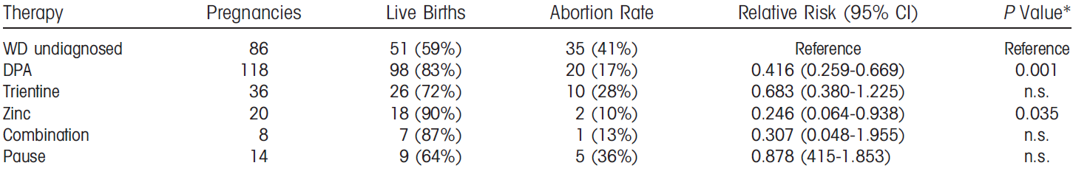

CI = confidence interval; DPA = D-penicillamine; n.s. = not significant; WD = Wilson’s disease.

Relative risks for abortion for each therapy are shown in comparison to pregnancies in undiagnosed patients.

* P-value adjusted according Bonferroni.

Four PSURs covering the period 5 September 2017 to 5 September 2019 were submitted for evaluation. Review of the post-marketing and clinical trial cases received during the reporting interval did not raise any significant safety concerns which would alter the benefit-risk profile of the product or warrant any further action.

### Risk management plan

The sponsor has submitted EU-risk management plan (RMP) version 1.5 (dated April 2017; data lock point (DLP) 31 October 2015) and Australian specific annex (ASA) version 0.0 (dated July 2019) in support of this application. At the second round of evaluation, an updated ASA was provided (version 0.1, dated January 2020).

The summary of safety concerns and their associated risk monitoring and mitigation strategies are summarised in Table 12.[14]

Table 12: Summary of safety concerns

|  |  |  |  |  |  |
| --- | --- | --- | --- | --- | --- |
| Summary of safety concerns | | Pharmacovigilance | | Risk minimisation | |
| Routine | Additional | Routine | Additional |
| **Important identified risks** | Iron deficiency anaemia | ✓ | - | ✓ | - |
| Copper deficiency | ✓ | - | ✓ | - |
| Colitis (including severe colitis) | ✓ | - | ✓ | - |
| Exacerbation of Wilson’s disease symptoms and signs on starting treatment | ✓ | - | ✓ | - |
| **Important potential risks** | Lupus erythematosus syndrome/disease | ✓ | - | ✓ | - |
| Rash | ✓ | - | ✓ | - |
| **Missing information** | Treatment in patients with renal impairment, hepatic impairment/cirrhosis | ✓ | - | ✓ | - |
| Management/outcome of pregnancy | ✓ * | - | ✓ | - |
| Use during lactation | ✓ | - | ✓ | - |
| Co-administration with other Wilson’s disease treatments | ✓ | - | ✓ | - |

* Follow-up questionnaire

* The summary of safety concerns listed above reflect published experience with trientine; the summary is acceptable. The summary differs from the current European Medicines Agency approved summary for trientine dihydrochloride, noting that the clinical evaluator’s view is that ‘the safety and efficacy of the dihydrochloride can be extrapolated to tetrahydrochloride at the same comparable systemic exposure’.
* Routine pharmacovigilance has been proposed for all safety concerns, with enhanced pharmacovigilance for the area of missing information on use in pregnancy. The pharmacovigilance plan is acceptable.
* Routine risk minimisation has been proposed and is acceptable.

### Risk-benefit analysis

#### Delegate’s considerations

##### Proposed indication

The proposed indication is the same as the approved indication for Cuprior in Europe. Several trientine dihydrochloride products have recently been registered in Australia for the treatment of patients with Wilson’s disease who are intolerant of penicillamine. The Cuprior indication is worded slightly differently to the indications of these trientine products, but the proposed use and treatment populations are essentially the same. The proposed indication is acceptable.

##### Proposed dose

The proposed dose of Cuprior was selected based primarily on findings from the TRIUMPH trial, which compared the PK of the proposed product to Univar’s trientine 2HCl capsules (now marketed in the EU as Cufence). In the TRIUMPH trial, trientine Cmax and AUC0-inf were 68% and 56% higher, respectively, following administration of a single 600 mg oral dose of the sponsor’s trientine 4HCl tablets compared to Univar’s trientine 2HCl capsules. Based on these PK findings, and taking into account the strength of Cuprior tablets (150 mg trientine), a dose range for Cuprior was selected that would be expected to achieve exposure similar to that of Univar’s trientine 2HCl now marketed as Cufence. The proposed dose of Cuprior is 450 to 975 mg trientine base (3 to 6.5 film coated tablets) per day in 2 to 4 divided doses. The recommended dose of Cufence is 800 to 1600 mg trientine base (4 to 8 capsules) per day in 2 to 4 divided doses.

In the TRIUMPH-2 trial, the PK of the sponsor’s trientine 4HCl tablets was similar to Syprine capsules in dose normalised comparisons. This study also showed dose proportionality for both formulations. The recommended initial dose of Syprine is 500 to 833 mg trientine base per day in 2 to 4 divided doses, which may be increased to a maximum of 1333 mg trientine base per day.

Neither of the PK comparator reference products are registered in Australia, but this limitation needs to be viewed in the context that trientine had never been registered in Australia at the time of this application.

The proposed dose of Cuprior is reasonable in the context of the PK findings from the TRIUMPH and TRIUMPH-2 trials, the inter individual variability in the PK of trientine, and the established clinical practice of adjusting the dose for individual patients according to clinical response and serum copper level.

Differences in the trientine content and PK of different trientine products, some of which have been in clinical use for many years, may be an issue when switching between different trientine products. This risk is addressed in a warning in the proposed PI.

##### Efficacy

The efficacy of Cuprior is derived primarily from published literature describing the efficacy of trientine, supported by PK findings from the TRIUMPH and TRIUMPH-2 trials and efficacy findings from the Lariboisière retrospective survey. The published studies provide data informing dosage and efficacy in adults, adolescents and children.

Weiss et al. (2013)4 was a retrospective cohort study of 380 patients with Wilson’s disease treated at six tertiary care centres in Germany and Austria, and 25 additional patients from the EuroWilson registry. For trientine in the second line setting (proposed for registration), 31 of 45 (68.9%) patients with hepatic symptoms showed hepatic improvement, and 26 of 51 (51%) patients with neurologic symptoms showed neurologic improvement. 4 of 45 (8.9%) patients with hepatic symptoms showed hepatic worsening, and 8 of 51 (15.7%) patients with neurologic symptoms showed neurologic worsening. Asymptomatic patients treated with trientine did not show hepatic worsening or neurologic worsening.

There are limitations in the strength of the evidence provided by retrospective studies, because the study design is subject to biases and uncertainties due to missing information. Weiss (2013)4 did not report dosages, dose titration, and the formulation of trientine used by patients, and neurologic outcomes were not assessed by a standardised or quantitative neurologic scale. No systematic criteria were applied in the initial choice of chelating agent. Treatment decisions were made according to accepted standards at the time and may have been influenced by confounders. Despite the recognised limitations of a retrospective cohort study, Weiss et al. (2013)4 reported outcomes for 405 patients treated for this rare disease over a mean duration of 13.3 years. The reported outcomes support a clinical benefit with trientine in patients who are intolerant of penicillamine.

The Lariboisière study reviewed clinical outcomes following compassionate use treatment with a trientine 4HCl formulation and Univar’s trientine 2HCl capsules. This survey of 186 patient years of trientine 4HCl treatment and 326 patient-years of trientine 2HCl treatment represents a large cohort in this rare disease. This retrospective review provides supportive evidence of similar efficacy of a trientine 4HCl formulation to trientine 2HCl.

##### Safety

The safety evaluation for Cuprior is based primarily on published literature, supported by studies assessing the safety of trientine 4HCl. Most of the literature reports are retrospective reviews, case series, or case reports reliant on clinical notes to identify significant safety signals. Safety reporting was limited and inconsistent across the published studies, but the literature overall supports the safety of trientine in the proposed indication. Although there are limitations in the safety dataset based on published literature, there is a long history of clinical experience with trientine, including 36 years of marketing authorisation internationally.

Trientine 4HCl specific safety data were evaluated from the TRIUMPH and TRIUMPH-2 trials, the Lariboisière retrospective survey, and PSURs for Cuprior. The safety data for trientine 4HCl are consistent with the established safety profile of trientine 2HCl.

##### Deficiencies and limitations of the data

Efficacy and safety data relevant to the proposed indication are derived mostly from retrospective studies, which can be subject to bias and missing information. Many of the literature references did not specify the trientine formulation or dose.

The proposed dose of Cuprior is based on PK comparisons with Univar’s trientine 2HCl capsules (now marketed in the EU as Cufence) and Syprine capsules, yet neither of these reference products is registered in Australia. No trientine product was registered in Australia prior to 2021, but there is a long history of Australian patients accessing trientine products through the Special Access Scheme. Two trientine 2HCl formulations were registered in Australia in 2021, both of which are approved in the USA as generics of Syprine.

#### Proposed action

Cuprior (trientine tetrachloride) is a different formulation and strength to the trientine dihydrochloride products that have been in clinical use for many years. The rationale for developing this formulation is that the stability of the tetrahydrochloride formulation will offer patients greater convenience in terms of storing the medicine.

The manufacturing quality of Cuprior has been satisfactorily established. The long term stability data support a shelf life of 24 months when stored below 25°C.

The dosing of Cuprior was informed by PK studies comparing Cuprior to two formulations of trientine dihydrochloride (Univar’s trientine 2HCl capsules (now marketed in the EU as Cufence) and Syprine capsules. The PK of Cuprior is not equivalent to Univar’s trientine dihydrochloride now marketedas Cufence in the EU) so an adjustment was applied to the dose of Cuprior to achieve similar trientine exposure to Univar’s trientine 2HCl (now marketed in the EU as Cufence) at recommended doses.

Switching between different trientine products may present a risk due to differences in trientine content and PK. This risk is addressed as a warning in the draft PI.

The efficacy and safety of Cuprior are based primarily on the efficacy and safety of trientine as reported in published literature, supported by the comparative PK studies, the Lariboisière retrospective survey, and post-market safety data since marketing authorisation in the EU in 2017. Although there are limitations in the efficacy and safety data from published literature, much of which was derived from retrospective studies, there is a long history of clinical experience with trientine, including 36 years of marketing authorisation internationally.

The use of trientine as a chelating agent in patients with Wilson’s disease is recommended in clinical practice guidelines internationally. Wilson’s disease is a rare disease which is managed by specialists with expertise in the treatment of the condition. Treatment options are limited in patients who are intolerant of penicillamine. The clinical consequences of untreated or inadequately treated disease are severe, and include hepatic failure, neurologic impairment and death. In this context, the data presented in this submission are sufficient to establish the efficacy and safety of Cuprior in the proposed indication.

#### Questions for the sponsor

The sponsor provided the following response to questions from the Delegate.

1. ***Please provide an update on the status of the NDA* [New Drug Application] *for Cuprior in the USA.***

A decision on the NDA for Cuprior in the USA is expected by 30 June 2021.

#### Advisory Committee considerations[15]

The Advisory Committee on Medicines (ACM), having considered the evaluations and the Delegate’s overview, as well as the sponsor’s response to these documents, advised the following.

##### Specific advice to the Delegate

1. ***What is the committee’s view regarding the PK bridging strategy used to establish the efficacy and safety of Cuprior from published efficacy and safety data for trientine dihydrochloride?***

The ACM considered the PK bridging that has been used to establish the efficacy and safety of Cuprior from published evidence relating to dihydrochloride formulations of trientine is acceptable, and the data presented are sufficient to establish the efficacy and safety of Cuprior for the proposed indication.

1. ***Other advice***

The ACM discussed the dosing regimen of Cuprior for children. The ACM noted that Cuprior is proposed for children down to five years old, and a lower starting dose is recommended for children which depends on the age and body weight. However, the conversion of dose based on the age and body weight is not clearly described in the PI. The ACM commented that 20 mg/kg/day is used as a guide for trientine dihydrochloride in children, but Cuprior is a different formulation. The ACM advised that guidance for dosing in children based on body weight should be added to the dosing section in the PI.

The proposed dose of Cuprior is between 450 mg and 975 mg trientine base which is equivalent to 3 to 6.5 tablets/day. Regarding the use of half-tablets, the ACM questioned whether the physical shape of the tablets is suitable for splitting, and whether leaving the remaining half tablet exposed will affect the efficacy of the drug.

The ACM discussed the information in the PI regarding monitoring for Cuprior and noted that monitoring recommendations vary in guidelines. The ACM also noted that in the PI measuring of non-caeruloplasmin-associated copper is described for monitoring copper levels as part of the maintenance treatment, however, non‑caeruloplasmin bound copper assays are not available in Australia.

##### Conclusion

The ACM considered this product to have an overall positive benefit-risk profile for the indication:

*Cuprior is indicated for the treatment of Wilson’s disease in adults, adolescents and children ≥ 5 years intolerant to D-penicillamine therapy.*

### Outcome

Based on a review of quality, safety and efficacy, the TGA approved the registration of Cuprior (trientine tetrahydrochloride) 150 mg, film coated tablet, blister pack, indicated for:

*Cuprior is indicated for the treatment of Wilson’s disease in adults, adolescents and children ≥ 5 years intolerant to D-penicillamine therapy.*

#### Specific conditions of registration applying to these goods

* Cuprior (trientine tetrahydrochloride) is to be included in the Black Triangle Scheme. The PI and Consumer Medicines Information (CMI) for Cuprior must include the black triangle symbol and mandatory accompanying text for five years, which starts from the date that the sponsor notifies the TGA of supply of the product.
* The Cuprior EU-RMP (version 1.5, dated April 2017, DLP 31 October 2015), with ASA (version 0.1, dated January 2020), included with Submission PM-2020-02473-1-3, and any subsequent revisions, as agreed with the TGA will be implemented in Australia.

An obligatory component of risk management plans is routine pharmacovigilance. Routine pharmacovigilance includes the submission of PSURs.

Reports are to be provided in line with the current published list of EU reference dates and frequency of submission of PSURs until the period covered by such reports is not less than three years from the date of the approval letter.

The reports are to at least meet the requirements for PSURs as described in the European Medicines Agency’s Guideline on Good Pharmacovigilance Practices (GVP) Module VII-periodic safety update report (Rev 1), Part VII.B Structures and processes. Note that submission of a PSUR does not constitute an application to vary the registration.

## Attachment 1. Product Information

The PI for Cuprior approved with the submission which is described in this AusPAR is at Attachment 1. For the most recent PI, please refer to the TGA website at <<https://www.tga.gov.au/product-information-pi>>.

|  |
| --- |
| Therapeutic Goods Administration |
| PO Box 100 Woden ACT 2606 Australia  Email: [info@tga.gov.au](mailto:info@tga.gov.au) Phone: 1800 020 653 Fax: 02 6232 8605  [**https://www.tga.gov.au**](https://www.tga.gov.au) |

1. The **Black Triangle Scheme** provides a simple means for practitioners and patients to identify certain types of new prescription medicines, including those being used in new ways and to encourage the reporting of adverse events associated with their use. The Black Triangle does not denote that there are known safety problems, just that the TGA is encouraging adverse event reporting to help us build up the full picture of a medicine's safety profile.
2. Syprine capsules contain 250 mg trientine dihydrochloride (referred to in the USA as trientine hydrochloride), equivalent to 167 mg trientine base.
3. Pregnancy category D: Drugs which have caused, are suspected to have caused or may be expected to cause, an increased incidence of human fetal malformations or irreversible damage. These drugs may also have adverse pharmacological effects. Accompanying texts should be consulted for further details.
4. Weiss, K. H. et al. Efficacy and Safety of Oral Chelators in Treatment of Patients with Wilson Disease, *Clin Gastroenterol Hepatol*. 2013; 11: 1028-1035.
5. Weiss, K. H. et al. Zinc Monotherapy is Not as Effective as Chelating Agents in Treatment of Wilson Disease, *Gastroenterology*, 2011; 140(4): 1189-1198.
6. Walshe, J. M. Treatment of Wilson’s Disease with Trientine (Triethylene Tetramine) Dihydrochloride, *Lancet*, 1982; 1(8273):643-647.
7. Scheinberg, H. et al. The Use of Trientine In Preventing the Effects of Interrupting Penicillamine Therapy in Wilson’s Disease, *N Engl J Med*,1987; 317: 209-213.
8. Dahlman, T. et al. Long-term Treatment of Wilson’s Disease with Triethylene Tetramine Dihydrochloride (Trientine), *Q J Med*, 1995; 88: 609-616.
9. Taylor, R. M. et al. Triethylene Tetramine Dihydrochloride (Trientine) in Children with Wilson Disease: Experience at King's College Hospital and Review of the Literature, *Eur J Pediatr*, 2009; 168(9): 1061-1068.
10. Brewer, G. J. et al. Treatment of Wilson Disease with Ammonium Tetrathiomolybdate IV. Comparison of Tetrathiomolybdate and Trientine in a Double-blind Study of Treatment of the Neurologic Presentation of Wilson Disease, *Arch Neurol*, 2006; 63: 521-527.
11. Merle, U. et al. Clinical Presentation, Diagnosis and Long-term Outcome of Wilson's Disease: a Cohort Study, *Gut*, 2007; 56(1): 115-120.
12. Appenzeller-Herzog, C. et al. Comparative Effectiveness of Common Therapies for Wilson Disease: a Systematic Review and Meta-analysis of Controlled Studies, *Liver Int*, 2019; 39(11): 2136-2152.
13. Pfeiffenberger, J. et al. Pregnancy in Wilson's Disease: Management and Outcome, *Hepatology*, 2018; 67(4): 1261-1269.
14. *Routine risk minimisation* activities may be limited to ensuring that suitable warnings are included in the product information or by careful use of labelling and packaging.

    *Routine pharmacovigilance* practices involve the following activities:

    All suspected adverse reactions that are reported to the personnel of the company are collected and collated in an accessible manner;

    Reporting to regulatory authorities;

    Continuous monitoring of the safety profiles of approved products including signal detection and updating of labelling;

    Submission of PSURs;

    Meeting other local regulatory agency requirements.
15. The ACM provides independent medical and scientific advice to the Minister for Health and the Therapeutic Goods Administration (TGA) on issues relating to the safety, quality and efficacy of medicines supplied in Australia including issues relating to pre-market and post-market functions for medicines.

    The Committee is established under Regulation 35 of the Therapeutic Goods Regulations 1990. Members are appointed by the Minister. The ACM was established in January 2017 replacing Advisory Committee on Prescription Medicines (ACPM) which was formed in January 2010. ACM encompass pre and post-market advice for medicines, following the consolidation of the previous functions of the Advisory Committee on Prescription Medicines (ACPM), the Advisory Committee on the Safety of Medicines (ACSOM) and the Advisory Committee on Non-Prescription Medicines (ACNM). Membership comprises of professionals with specific scientific, medical or clinical expertise, as well as appropriate consumer health issues relating to medicines.