|  |
| --- |
| **March 2021** |

|  |
| --- |
| Australian Public Assessment Report for Trifarotene |
| Proprietary Product Name: Aklief |
| Sponsor: Galderma Australia Pty Ltd |

About the Therapeutic Goods Administration (TGA)

* The Therapeutic Goods Administration (TGA) is part of the Australian Government Department of Health and is responsible for regulating medicines and medical devices.
* The TGA administers the *Therapeutic Goods Act 1989* (the Act), applying a risk management approach designed to ensure therapeutic goods supplied in Australia meet acceptable standards of quality, safety and efficacy (performance) when necessary.
* The work of the TGA is based on applying scientific and clinical expertise to decision-making, to ensure that the benefits to consumers outweigh any risks associated with the use of medicines and medical devices.
* The TGA relies on the public, healthcare professionals and industry to report problems with medicines or medical devices. TGA investigates reports received by it to determine any necessary regulatory action.
* To report a problem with a medicine or medical device, please see the information on the TGA website <<https://www.tga.gov.au>>.

About AusPARs

* An Australian Public Assessment Report (AusPAR) provides information about the evaluation of a prescription medicine and the considerations that led the TGA to approve or not approve a prescription medicine submission.
* AusPARs are prepared and published by the TGA.
* An AusPAR is prepared for submissions that relate to new chemical entities, generic medicines, major variations and extensions of indications.
* An AusPAR is a static document; it provides information that relates to a submission at a particular point in time.
* A new AusPAR will be developed to reflect changes to indications and/or major variations to a prescription medicine subject to evaluation by the TGA.

Copyright

© Commonwealth of Australia 2021  
This work is copyright. You may reproduce the whole or part of this work in unaltered form for your own personal use or, if you are part of an organisation, for internal use within your organisation, but only if you or your organisation do not use the reproduction for any commercial purpose and retain this copyright notice and all disclaimer notices as part of that reproduction. Apart from rights to use as permitted by the *Copyright Act 1968* or allowed by this copyright notice, all other rights are reserved and you are not allowed to reproduce the whole or any part of this work in any way (electronic or otherwise) without first being given specific written permission from the Commonwealth to do so. Requests and inquiries concerning reproduction and rights are to be sent to the TGA Copyright Officer, Therapeutic Goods Administration, PO Box 100, Woden ACT 2606 or emailed to <[tga.copyright@tga.gov.au](mailto:tga.copyright@tga.gov.au)>.

Contents

List of abbreviations 4

I. Introduction to product submission 7

Submission details 7

Product background 8

Regulatory status 10

Product Information 11

II. Registration timeline 11

III. Submission overview and risk/benefit assessment 12

Quality 12

Nonclinical 12

Clinical 14

Risk management plan 30

Risk-benefit analysis 31

Outcome 35

Attachment 1. Product Information 35

## List of abbreviations

|  |  |
| --- | --- |
| Abbreviation | Meaning |
| ACM | Advisory Committee on Medicines |
| AE | Adverse event |
| AESI | Adverse event of special interest |
| ANCOVA | Analysis of covariance |
| ARTG | Australian Register of Therapeutic Goods |
| ASA | Australia specific annex |
| AUC | Area under concentration time curve |
| AUC0-24hr | Area under the concentration time curve from time zero to 24 hours |
| AusPAR | Australian Public Assessment Report |
| CI | Confidence interval |
| CMI | Consumer Medicines Information |
| COR-B | Comparable Overseas Regulator approach B |
| cps | Centipoise |
| Ctrough | Trough concentration |
| CYP | Cytochrome P450 system |
| DLP | Data lock point |
| EMA | European Medicines Agency (European Union) |
| EU | European Union |
| FDA | Food and Drug Administration (United States of America) |
| GLP | Good Laboratory Practice |
| GVP | Good pharmacovigilance practices |
| hERG | Human Ether-à-go-go-Related Gene |
| HPLC | High performance liquid chromatography |
| ICH | International Council for Harmonisation (of Technical Requirements for Pharmaceuticals for Human Use) |
| IGA | Investigator Global Assessment |
| ITT | Intent to treat |
| ITTT | Intent to treat on the trunk |
| IV | Intravenous |
| LC/MS/MS | Tandem mass spectrometry |
| LOQ | Limit of quantification |
| LS | Least squares |
| Max | Maximum |
| Min | Minimum |
| NOAEL | No observed adverse effect level |
| PBPK | Physiologically based pharmacokinetic(s) |
| PGA | Physician Global Assessment |
| PI | Product Information |
| PK | Pharmacokinetic(s) |
| PO | Oral (Latin: *per os*) |
| PSUR | Periodic safety update report |
| PT | Preferred Term |
| RAR | Retinoic acid receptor |
| RAR α | Retinoic acid receptor alpha |
| RAR β | Retinoic acid receptor beta |
| RAR γ | Retinoic acid receptor gamma |
| RMP | Risk management plan |
| RXR | Retinoid X receptor |
| SAE | Serious adverse event |
| SAF | Safety population |
| SAFP | Safety population for the analysis of the Physician Global Assessment |
| SAFT | Safety on the trunk population |
| SD | Standard deviation |
| SE | Standard error |
| SOC | System Organ Class |
| TEAE | Treatment emergent adverse event |
| TGA | Therapeutic Goods Administration |
| TGO 91 | Therapeutic Goods Order Number 91 |
| TPA | 12-O-tetradecanoylphorbol-13-acetate |
| US(A) | United States (of America) |
| v/v | Volume/volume |
| w/w | Weight/weight |

## I. Introduction to product submission

### Submission details

|  |  |
| --- | --- |
| *Type of submission:* | New chemical entity |
| *Product name:* | Aklief |
| *Active ingredient:* | Trifarotene |
| *Decision*: | Approved |
| *Date of decision:* | 11 January 2021 |
| *Date of entry onto ARTG:* | 18 January 2021 |
| *ARTG numbers:* | 332220 and 340375 |
| *Black Triangle Scheme:[1]* | Yes  This product will remain in the scheme for 5 years, starting on the date the product is first supplied in Australia |
| *Sponsor’s name and address:* | Galderma Australia Pty Ltd  Suite 4, 13B Narabang Way  Belrose NSW 2085 |
| *Dose form:* | Cream |
| *Strength:* | 50 µg/g |
| *Containers:* | Bottle and tube |
| *Pack sizes:* | Bottle: 15 g, 30 g and 75 g  Tube: 5 g |
| *Approved therapeutic use:* | *Aklief is indicated for the topical treatment of Acne Vulgaris of the face and/or the trunk in patients from 12 years of age and older, when many comedones, papules and/or pustules are present* |
| *Route of administration:* | Topical |
| *Dosage:* | Apply a thin layer of Aklief cream to the affected areas of the face and/or trunk once a day, in the evening, on clean and dry skin.  One pump actuation should be enough to cover the face; two pump actuations should be enough to cover the upper trunk (reachable upper back, shoulders and chest). One additional pump actuation may be used for middle and lower back if acne is present.  For topical use only; avoid contact with the eyes, eyelids, lips and mucous membranes and wash hands after applying Aklief.  Use of a moisturiser is recommended as needed from the initiation of treatment, while allowing sufficient time before and after the application of Aklief cream to allow the skin to dry.It is recommended that the physician assesses the continued improvement of the patient after three months of treatment. The duration of treatment should be determined by the doctor based on the clinical response.  For further information regarding dosage, refer to the Product Information. |
| *Pregnancy category:* | D  Drugs which have caused, are suspected to have caused or may be expected to cause, an increased incidence of human fetal malformations or irreversible damage. These drugs may also have adverse pharmacological effects. Accompanying texts should be consulted for further details.  The use of any medicine during pregnancy requires careful consideration of both risks and benefits by the treating health professional. This must not be used as the sole basis of decision making in the use of medicines during pregnancy. The TGA does not provide advice on the use of medicines in pregnancy for specific cases. More information is available from obstetric drug information services in your State or Territory. |

### Product background

This AusPAR describes the application by Galderma Australia Pty Ltd (the sponsor) to register Aklief (trifarotene) 50 µg/g, cream for the following proposed indication:

*Aklief is indicated for the cutaneous treatment of Acne Vulgaris of the face and/or the trunk in patients from 9 years of age and older, when many comedones, papules and pustules are present.*

Acne vulgaris (often simply referred to as acne) is one of the most common skin diseases. Although it is a disease typical of adolescence, with 50% to 95% of teenagers affected by acne in Western countries, it can also affect a significant proportion of adults.

The pathophysiologic factors primarily responsible for influencing the development of acne are sebaceous gland hyperplasia with seborrhoea, altered follicular growth and differentiation, as shown in Figure 1, below. Acne has a variable presentation with a range of lesion types including open and closed comedones, papules, pustules, nodules, and cysts.[2]

Figure : Pathophysiology of acne vulgaris

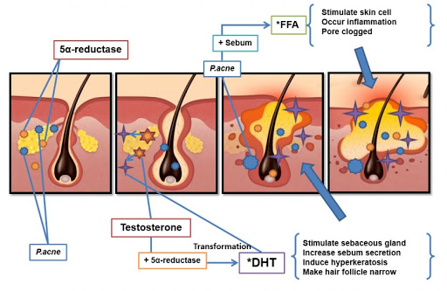

P. acne = *Cutibacterium acnes* (formerly *Propionibacterium acnes;* 5α reductase = 5-alpha reductase; DHT = dihydrotestosterone; FFA = free fatty acids.

Comedones are the non-inflammatory types of acne. Papules, pustules, and cysts are the inflammatory counterparts. Figure 2, below, demonstrates the variety of the inflammatory and non-inflammatory types of acne vulgaris.

Figure : Inflammatory and non-inflammatory types of acne vulgaris[3]

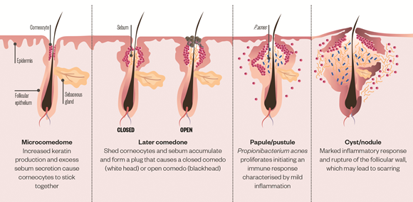

Retinoids exert multiple biological effects that include modulation of cell proliferation and differentiation, anti-keratinisation, alteration of cellular cohesiveness, anti-acne and anti‑seborrhoeic effects, immunologic and anti-inflammatory effect, induction of apoptosis and effects on extracellular matrix components in the skin. Retinoids impact cell signalling pathways through binding to nuclear receptors: retinoid X receptors (RXR) and retinoic acid receptors (RAR). RAR have 3 sub-types α, β and γ. The retinoic acid receptor gamma (RAR γ) is the receptor subtype present in keratinocytes and is recognised to be the most relevant in acne over the retinoic acid receptors alpha and beta (RAR α and RAR β).

To date, the TGA has approved tretinoin, adapalene and tazarotene as retinoids for the topical treatment of acne vulgaris. Oral isotretinoin, also a retinoid, has been approved for the treatment of acne vulgaris, whilst tretinoin (in oral form) is used for the treatment of acute promyelocytic leukaemia. Topical tretinoin is also available in combination with clindamycin (an antibiotic) and adapalene is available in combination with benzoyl peroxide.

This application was submitted through the TGA’s Comparable Overseas Regulator approach B (COR-B)[4] process, using evaluation reports from European Medicines Agency (EMA). The full dossier was also submitted to the TGA.

### Regulatory status

This product is considered a new chemical entity for Australian regulatory purposes.

At the time the TGA considered this application, similar applications had been approved in United States of America (USA) on 4 October 2018, European Union (EU) on 18 December 2019 and Canada on 25 November 2019.

Table : International regulatory status

|  |  |  |  |
| --- | --- | --- | --- |
| Region | Submission date | Status | Approved indications |
| United States of America | 4 October 2018 | Approved on 4 October 2019 | *Aklief (trifarotene) cream for the topical treatment of acne vulgaris in patients 9 years of age and older*. |
| European Union | 31 October 2018 | Approved on 18 December 2019 | *Aklief is indicated for the cutaneous treatment of Acne Vulgaris of the face and/or the trunk in patients from 12 years of age and older, when many comedones, papules and pustules are present.* |
| Canada | 30 November 2018 | Approved on 25 November 2019 | *Aklief (trifarotene 50 µg/g) topical cream is indicated for the topical treatment of acne vulgaris of the face and/or the trunk in patients 12 years of age and older.* |

### Product Information

The Product Information (PI) approved with the submission which is described in this AusPAR can be found as Attachment 1. For the most recent PI, please refer to the TGA website at <<https://www.tga.gov.au/product-information-pi>>.

## II. Registration timeline

The following table captures the key steps and dates for this application and which are detailed and discussed in this AusPAR.

Table : Timeline for Submission PM-2020-01095-1-1

|  |  |
| --- | --- |
| Description | Date |
| Submission dossier accepted and first round evaluation commenced | 30 April 2020 |
| First round evaluation completed | 28 August 2020 |
| Sponsor provides responses on questions raised in first round evaluation | 28 September 2020 |
| Second round evaluation completed | 15 October 2020 |
| Delegate’s Overall benefit-risk assessment and request for Advisory Committee advice | 3 November 2020 |
| Sponsor’s pre-Advisory Committee response | 12 November 2020 |
| Advisory Committee meeting | 3 and 4 December 2020 |
| Registration decision (Outcome) | 11 January 2021 |
| Completion of administrative activities and registration on the ARTG | 18 January 2021 |
| Number of working days from submission dossier acceptance to registration decision* | 166 |

* The COR-B process has a 175 working day evaluation and decision timeframe.

## III. Submission overview and risk/benefit assessment

This section is a TGA summary of wording used in TGA’s evaluation report, which discussed numerous aspects of overseas evaluation reports and included some information that was commercial-in-confidence.

### Quality

Pharmaceutical chemistry and microbiology evaluators have recommended approval.

Figure 3, shown below, demonstrates the chemical structure of trifarotene.

Figure : Chemical structure of trifarotene (Aklief)

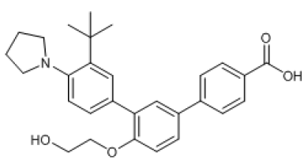

The following are the evaluator's comments:

Trifarotene is formulated as a semi-solid, light, oil-in water emulsion and appears as a white, homogenous cream containing trifarotene 50 µg/g (0.005% weight/weight (w/w)). It is a semi-solid preparation and is not a pourable liquid and the viscosity is > 30,000 centipoise (cps). The formulation contains > 50% of water and volatiles and is thus considered as a hydrophilic cream. The ethanol content for the cream (5.0% w/w) equates to 6.335% volume/volume (v/v) and is specified on the product labels as required by the Labelling Order for Prescription Medicines, *TGO 91*.

The drug product is stable upon storage and the stability data supplied supported a shelf life of 24 months for the unopened product (bottles and tubes) when stored at or below 25°C. No other storage conditions are required.

### Nonclinical

The nonclinical evaluator has recommended approval.

The submitted nonclinical dossier was in accordance with the relevant International Council for Harmonisation of Technical Requirements for Pharmaceuticals for Human Use (ICH) guideline for the nonclinical assessment of pharmaceuticals (ICH M3(R2)).[5] The overall quality of the nonclinical dossier was satisfactory with no major deficiencies. All pivotal safety-related studies were Good Laboratory Practice (GLP) compliant except the *in vitro* human Ether-à-go-go-Related Gene (hERG) assay.

*In vitro*, trifarotene showed agonistic activity at the RAR γ with relatively high selectivity over the RAR α and RAR β receptors. In keratinocytes, trifarotene showed activity in modulating retinoid target genes for keratinisation and/or inflammation at clinically-relevant concentrations. *In vivo*, trifarotene showed efficacy in an adequate mouse acne model with comedone reductions and increases in epidermal thickness, supporting the proposed indication.

Secondary pharmacodynamic effects of trifarotene are anti-inflammatory effects in the 12‑O-tetradecanoylphorbol-13-acetate (TPA) induced ear oedema model in mice (1000 µg/g) and at clinically relevant doses, depigmentation in two mouse models at ≥ 0.003% to 0.01% (30 µg/g to 100 µg/g). Safety pharmacology studies indicated acute effects on central nervous system, cardiovascular or respiratory function in patients are unlikely.

Dermal bioavailability was low in rats and negligible in minipigs. Oral bioavailability was higher in rats and dogs, therefore, this route of administration was chosen to assess systemic toxicity. Following intravenous (IV) and oral (PO) dosing, tissue distribution of drug-related material was wide. There was no evidence of binding to or retention in melanin containing tissues. There was minimal metabolism of trifarotene in human skin in an *in vitro* study. More extensive metabolism was evident in the liver. Experiments with recombinant human cytochromes P450 (CYP)[6] enzymes indicated a predominant role for CYP2C9 in the metabolism of trifarotene with lesser roles by CYP3A4, CYP2C8 and CYP2B6.

Once absorbed systemically, drug-related material was excreted primarily in the faeces in animals and humans. Overall, the pharmacokinetic profile in animals was qualitatively similar to that of humans.

Based on low anticipated systemic exposures to trifarotene, systemic pharmacokinetic interactions are not expected.

Trifarotene had a low order of acute dermal or IV toxicity in rats. Following single dermal and IV doses, skin (crusts/scabs, desquamation, discoloration) and the growth plate were the target organs of toxicity, respectively.

Repeat-dose toxicity studies by the dermal route were conducted in mice (up to 13 weeks) and minipigs (up to 39 weeks) and by the oral route in rats (up to 6 months) and dogs (up to 9 months). Systemic clinical signs and toxicity were only observed following oral dosing in rats and dogs (and in mice following dermal dosing) at very high exposure levels, and these can largely be attributed to the (dose-related) pharmacological action of trifarotene. No clear signs of overt systemic toxicity were observed following dermal dosing in minipigs.

Local dermal irritation reactions were very slight to severe at clinically-relevant concentrations (0.005%) in minipigs with minimal to slight histological findings (greater irritation at 0.01%).

In a standard battery of *in vitro* and *in vivo* genotoxicity studies, trifarotene returned mostly negative results. While an equivocal result was seen in an *in vitro* micronucleus assay, this was not reproduced in a second clastogenicity assay and negative results were seen in an *in vivo* micronucleus assay. On balance, trifarotene is not considered to be mutagenic or clastogenic.

There were no trifarotene-related neoplastic findings (either local or systemic) that could be attributed to trifarotene cream (final clinical formulation with dermal dosing in mice) or trifarotene in solution given to rats (PO dosing) in 2 year rodent carcinogenicity assays.

Functional fertility was unaffected in male and female rats treated with trifarotene at exposure levels > 1700 times the clinical area under the concentration time curve (AUC). However, testicular germ cell degeneration and hypospermatogenesis were seen in dogs treated with ≥ 0.02 mg/kg/day PO trifarotene.

A no observed adverse effect level (NOAEL) was not established. Similar to other retinoids, trifarotene was teratogenic in both rats and rabbits, but at high maternal exposures. No adverse effects on pups at birth or postnatal development were evident in pups of rats treated with trifarotene during pregnancy and lactation.

Trifarotene gel was considered to show ocular irritant potential in rabbits, but trifarotene cream was considered not to be a skin sensitiser in guinea pigs.

A photoirritation/photosensitisation (phototoxicity) study with trifarotene gel in guinea-pigs was inconclusive. Trifarotene was not photomutagenic or photoclastogenic *in vitro*.

### Clinical

#### Pharmacology

The assessment of systemic exposure was made primarily from a safety perspective.

##### Absorption

Trifarotene plasma concentrations were determined by high performance liquid chromatography (HPLC) coupled with tandem mass spectrometry (LC/MS/MS) and solid phase extraction. The method was initially validated with a Limit of Quantification (LOQ) of 10 pg/ml.

A dose-dependent increase in the systemic absorption of trifarotene was noted. Pre-dose concentrations (Ctrough) were generally below LOQ in bioavailability studies. A higher proportion of subjects had quantifiable concentrations at Day 15, compared to Day1. The mean area under the concentration time curve during 24 hours (AUC0-24hr) at Day 15 was comparable to Day 29, indicative of steady state achievement after two weeks of treatment.

No studies were conducted that specifically examined absolute bioavailability.

##### Metabolism

Trifarotene is primarily metabolised via CYP2C9, CYP3A4, CYP2C8, and to a lesser extent by CYP2B6 *in vitro*. None of the four phase one metabolites that were identified in-vitro were reported from the use of trifarotene 50 µg/g cream in bioavailability Studies 18327 and 40182.

##### Excretion

The terminal half-life and clearance were not able to be determined as the plasma levels of trifarotene declined below the LOQ rapidly following topical administration.

##### Pharmacokinetics in children

The AUC0-24h values in adults and children were from 89 to 106 pg.h/mL and 75 to 104 pg.h/mL, based on findings from pharmacokinetics (PK) Studies 18237 and 40182 respectively. It was noted that in Study 18237, there were only two subjects in the 9 to 12 years of age range. Rest of the study population was adolescents. Similarly, another PK study also had two subjects in the 9 to 11 years of age group. For these reasons, physiologically based pharmacokinetic (PBPK) modelling was utilised to simulate systemic exposure in this age group.

The PBPK model did not include 9 year old children and limited number of samples from children in the 10 to 11 year age group.

The evaluator highlighted that the PBPK model had limitations such as model mis‑specification and lack of information about percentiles. The evaluator concluded that the model did not adequately describe variability and hence not able to simulate the exposure in 9 to 11 year old children.

The Delegate agrees with the evaluator's conclusions regarding the PBPK model and its potential implications on the data provided by the model. The Delegate considers that a fair representation of all age groups is pivotal in a PBPK model to account for the variabilities due to developmental changes across age groups. The level of evidence provided by the PBPK model for the efficacy and safety of trifarotene for subjects in 9 to 11 year age group is not sufficient enough to waive the requirement for clinical data in this age group.

#### Efficacy

##### Dose selection for the pivotal studies

Trifarotene demonstrated a dose dependent increase in total skin penetration, when applied from 25 to 100 µg/g.

The effect of formulation on skin penetration was assessed across two preparations of cream (Cream A and Cream B) and gel forms of trifarotene. Skin penetration was comparable between gel and Cream B and 3 fold higher with gel, compared to Cream A. Studies 18314 and 40129 compared efficacy and tolerability between cream and gel preparations of trifarotene. Efficacy was comparable, meanwhile tolerability was higher for the cream, compared to gel formulations.

Study 18223 compared the efficacy and safety of 25 µg/g, 50 µg/g and 100 µg/g strengths of trifarotene to tazarotene 0.1%, when administered once daily for 12 weeks. The magnitude of efficacy was not large and was comparable across doses of trifarotene. The 100 µg/g cream of trifarotene caused more local irritation than the 50 µg/g cream.

The safety and local tolerability of the 50 µg/g cream was the rationale to choose this dose for the pivotal study.

Two pivotal Phase III studies (Study 18251 and 18252) were included in this submission. Both studies were identical in study design.

##### Pivotal Studies 18251 and 18252

*Study design*: Multicentre, parallel group, randomised vehicle controlled study.

The objective of these studies were to assess efficacy and safety of trifarotene 50 µg/g cream applied once daily for 12 weeks in subjects with moderate acne vulgaris.

The studies had 2 weeks of screening period, followed by 12 weeks of treatment period. The primary efficacy endpoint was measured at Baseline and Weeks 1, 2, 4, 8 and 12.

###### Key inclusion criteria

Key inclusion criteria included:

* ≥ 9 years of age;
* facial acne severity Grade of 3 (moderate) on the Investigator Global Assessment(IGA) scale;[7]
* a minimum of 20 inflammatory lesions and 25 non-inflammatory lesions on the face;
* truncal acne severity Grade of 3 (moderate) on the Physician Global Assessment (PGA) scale on trunk (shoulders, upper back and upper anterior chest) reachable for self‑application (optional criterion for subject between 9 and 11 years of age);[8] and
* a minimum of 20 inflammatory lesions and 20 non-inflammatory lesions but no more than 100 non-inflammatory lesion counts on the trunk.

###### Key exclusion criteria

Key exclusion criteria included:

* severe or secondary forms of acne;
* more than 1 nodule on the face or trunk; and
* any acne cyst on the face or trunk.

*Study treatment*: 50 µg/g of trifarotene and vehicle.[9]

*Dose*: One pump actuation to cover the facial region and two pump actuations for the upper truncal regions. Both trifarotene and vehicle were applied once daily in the evening.

There were three co-primary endpoints:

* success rate: defined as the percentage of subjects with an IGA score of 1 (almost clear) or 0 (clear) and at least a two grade improvement from Baseline at Week 12. Success rate was calculated as the number of subjects who achieved success divided by the number of subjects with IGA data at Week 12;
* absolute change in facial inflammatory lesion count; and
* absolute change in facial non-inflammatory lesion count from Baseline at Week 12.

There were three co-secondary endpoints

* percentage of subjects with a PGA score of 1 or 0 and at least a 2 grade improvement from Baseline at Week 12,
* absolute change in truncal inflammatory lesion count and
* absolute change in truncal non-inflammatory lesion count from Baseline at Week 12.

Percentage change in facial and truncal inflammatory and non-inflammatory lesion counts from Baseline at Week 12 were supportive endpoints.

###### Statistical analysis

The intent to treat (ITT) population included all subjects; meanwhile, the intent to treat on the trunk (ITTT) population included subjects with moderate truncal acne at Baseline.

IGA success rate was analysed using the Cochran-mantel Haenszel test. Changes from Baseline in facial counts were analysed by lesion type using analysis of covariance (ANCOVA). Superiority of trifarotene 50 μg/g to vehicle cream on the face was tested (p < 0.05) for all three co-primary efficacy endpoints. If successful then, all three co‑secondary efficacy endpoints were tested (p < 0.05) for superiority.

###### Baseline characteristics

A total of 1208 subjects were randomised, with 612 in trifarotene arm and 596 in placebo arm. The median age was 18, with 9 years as the lowest age and 58 years as the highest age. There were 10 and 9 subjects in the 9 to 11 years of age group in trifarotene and placebo arms respectively. Overall, 49% of subjects were children and 52% of subjects were females. 100% of subjects had a baseline IGA grade that corresponds to moderate grade of severity. Similarly, 98% of subjects had a PGA score reflecting moderate severity.

The summary of quantitative assessment of facial lesions at Baseline are shown in Table 3, below.

Table : Studies 18251 and 18252 Facial lesions at Baseline

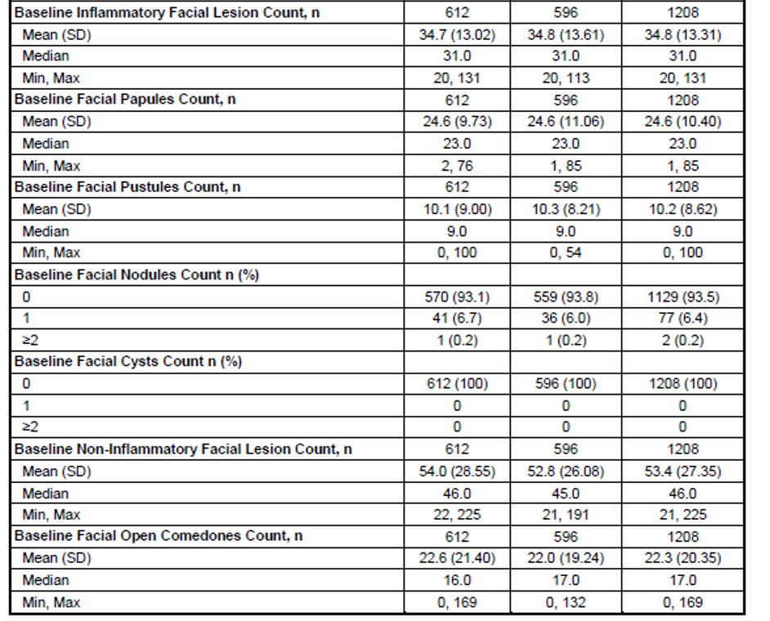

SD = Standard deviation, Min = minimum, Max = maximum.

###### Results

Co-primary endpoints: 29.4% of subjects in trifarotene arm achieved ‘success’, compared to 19.5% subjects in placebo arm as shown in Table 4, below. The treatment difference was statistically significant.

Table : Studies 18251 and 18252 Success rate on face based on Investigator’s Global Assessment severity score

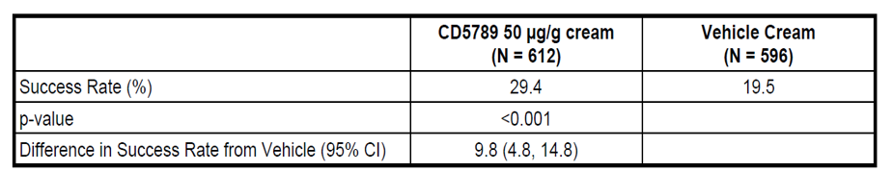

CI = Confidence interval

The mean absolute change (reduction) from Baseline in the facial inflammatory and non-inflammatory lesion count were significantly higher for subjects in trifarotene arm, compared to placebo arm. At 12 weeks of treatment period, subjects treated with trifarotene had fewer inflammatory lesions by a count of 3 and non-inflammatory lesions by a count of 7, as shown in Tables 5 and 6, below.

A greater treatment response was observed in trifarotene arm as early as Week 2 of treatment period, compared to placebo arm, as shown in Figure 4, below.

Figure : Studies 18251 and 18252 Comparison of treatment response between trifarotene and placebo arms

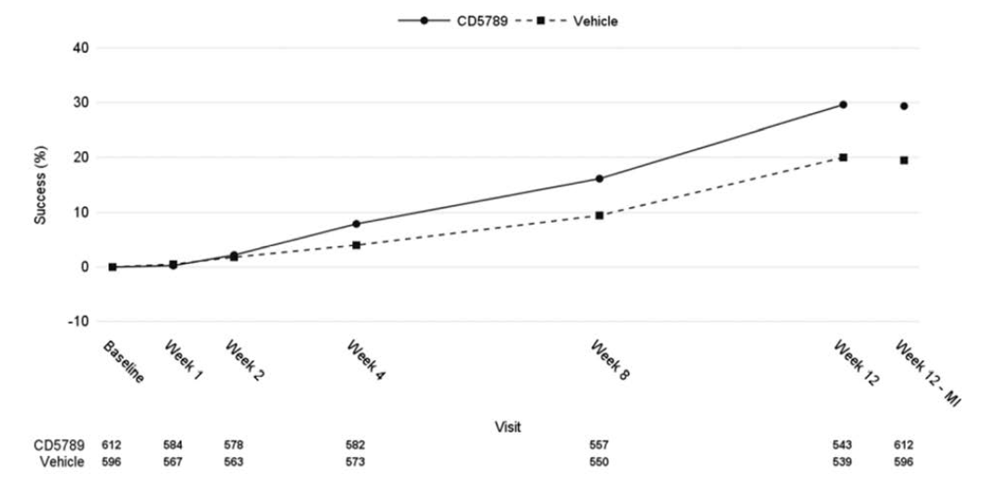

Table : Studies 18251 and 18252 Absolute reduction in facial inflammatory lesion count

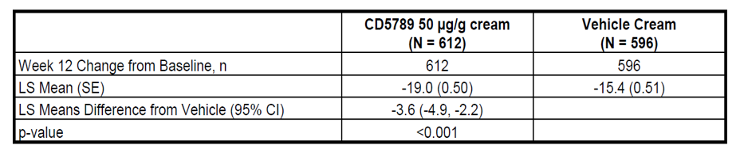

LS = least square, SE = standard error, CI = confidence interval

Table : Studies 18251 and 18252 Absolute reduction in facial non-inflammatory lesion count

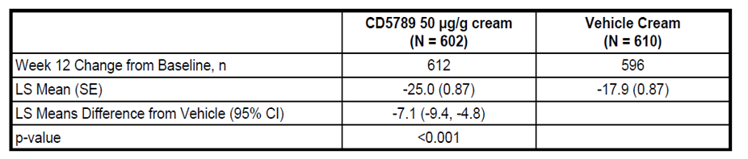

LS = least square, SE = standard error, CI = confidence interval

*Secondary endpoints*:

A significantly higher percentage of subjects in trifarotene arm achieved success, compared to placebo arm, as shown in Table 7, below. The mean absolute change from Baseline in the inflammatory and non-inflammatory lesion count on the trunk was significantly higher in trifarotene arm, compared to placebo arm, shown in Tables 8 and 9, below.

Table : Studies 18251 and 18252 Success rate on trunk based on Physician Global Assessment severity score

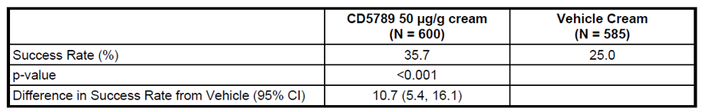

CI = confidence interval

Table : Studies 18251 and 18252 Absolute reduction in truncal inflammatory lesion count

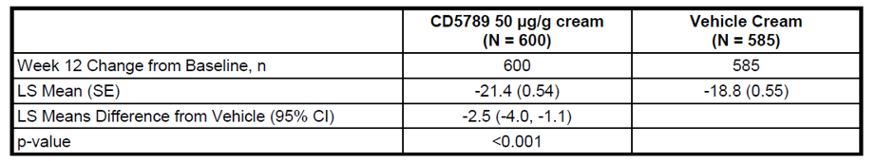

LS = least square, SE = standard error, CI = confidence interval

Table : Studies 18251 and 18252 Absolute reduction in truncal non-inflammatory lesion count

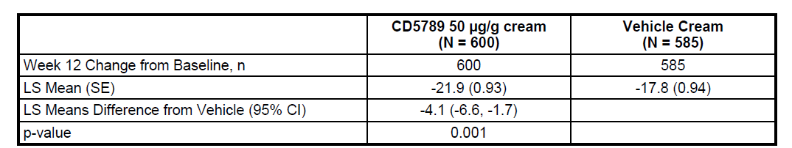

LS = least square, SE = standard error, CI = confidence interval

*Supportive endpoints*

Subjects in trifarotene arm achieved 54.4% and 49.7% mean reduction in inflammatory and non-inflammatory lesion counts in face respectively. Meanwhile, subjects in placebo arm achieved a 44.8% and 35.7% reduction in inflammatory and non-inflammatory lesion counts and the treatment difference was statistically significant.

A similar outcome was reported for truncal inflammatory and non-inflammatory lesion counts.

##### Study 18252

The overall baseline characteristics of subjects were comparable to Study 18251 (discussed above). 1252 subjects were randomised, with 602 and 610 subjects in trifarotene and placebo arms respectively. There were 9 and 6 subjects in the 9 to 11 years age group in trifarotene and placebo arms respectively.

###### Results

A significantly higher percentage of subjects in trifarotene arm achieved success, compared to placebo arm, as shown in Table 10, below.

Table : Study 18252 Success rate based on Investigator’s Global Assessment severity score

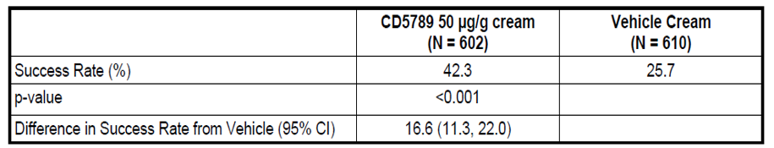

CI = confidence interval

The mean reduction in facial inflammatory and non-inflammatory lesion count was significantly higher in trifarotene arm, compared to placebo arm. At Week 12, subjects in trifarotene arm benefited by having around five fewer inflammatory lesions and around eight non-inflammatory lesions, compared to placebo, shown in Tables 11 and 12 respectively.

Table : Study 18252 Absolute reduction in facial inflammatory lesion count

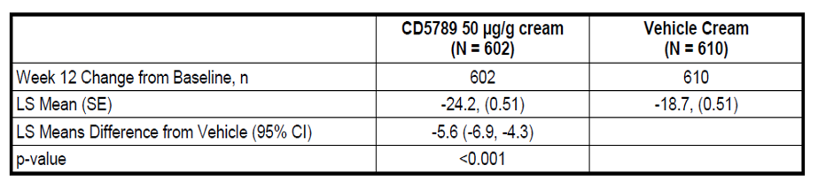

LS = least square, SE = standard error, CI = confidence interval

Table : Study 18252 Absolute reduction in facial non-inflammatory lesion count

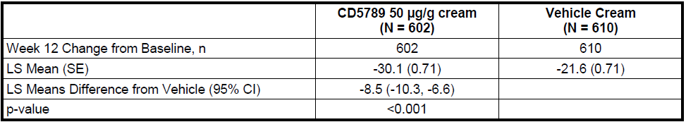

LS = least square, SE = standard error, CI = confidence interval

*Secondary endpoints*

The significantly higher percentage of subjects in trifarotene arm achieved success as per PGA assessment (see Table 13, below). A significantly higher reduction in truncal inflammatory and non-inflammatory lesion counts were reported for subjects in trifarotene arm, compared to placebo arm, shown below in Tables 14 and 15 respectively.

Table : Study 18252 Success rate based on Physician Global Assessment

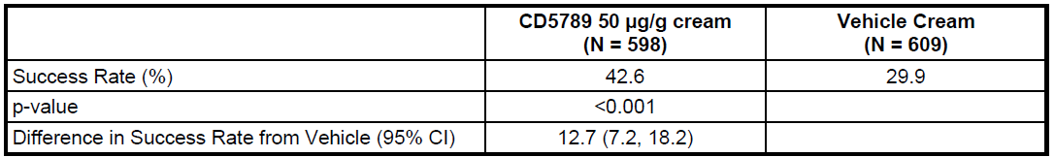

CI = confidence interval

Table : Study 18252 Absolute reduction in truncal inflammatory lesion count

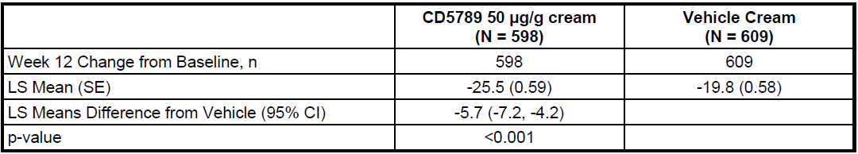

LS = least square, SE = standard error, CI = confidence interval

Table : Study 18252 Absolute reduction in truncal non-inflammatory lesion count

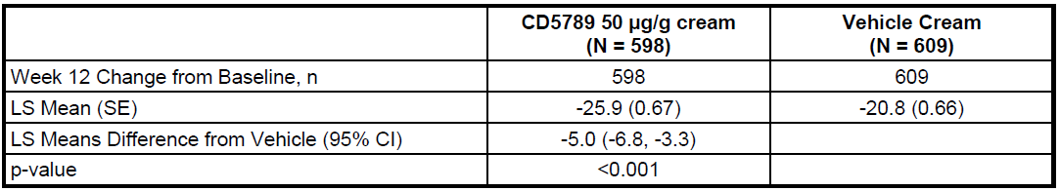

LS = least square, SE = standard error, CI = confidence interval

*Supportive endpoints*

Subjects in trifarotene arm achieved a 66.2% and 57.7% reduction in facial inflammatory and non-inflammatory lesion counts. Subjects in placebo achieved a 51.2% and 43.9% reduction for inflammatory and non-inflammatory lesion counts and the treatment difference was statistically significant.

##### Sub group analyses

Success rate for facial inflammatory lesions at Week 12: The percentage of subjects who achieved success was not significantly greater in 9 to 11 years age group in the trifarotene age group. Statistical significance was achieved for subjects in 12 to 17 years age group and adults. Sub group analysis is detailed in Table 16, below.

Table : Sub group analysis of success rate across age groups

|  |  |  |
| --- | --- | --- |
|  | Trifarotene 50 μg/g (N = 1214) | Vehicle  (N = 1206) |
| **9 to 11 Years (N = 34)** | | |
| Week 12 Change from Baseline, n | 19 | 15 |
| LS Mean (SE) | -22.5 (11.46) | -3.5 (12.56) |
| LS Means Difference from Vehicle (95% CI) | -19.0 (-58.9, 21.0) | |
| p-value | 0.352 | |
| **12 to 17 Years (N = 1128)** | | |
| Week 12 Change from Baseline, n | 571 | 557 |
| LS Mean (SE) | -29.4 ( 0.91) | -19.5 ( 0.91) |
| LS Means Difference from Vehicle (95% CI) | -9.9 (-12.2, -7.5) | |
| p-value | < 0.001 | |
| **≥ 18 Years (N = 1258)** | | |
| Week 12 Change from Baseline, n | 624 | 634 |
| LS Mean (SE) | -26.4 ( 0.87) | -19.7 ( 0.86) |
| LS Means Difference from Vehicle (95% CI) - | 6.7 (-8.6, -4.7) | |
| p-value | < 0.001 | |

LS = least square, SE = standard error, CI = confidence interval

The mean change from Baseline in inflammatory and non-inflammatory facial lesions for subjects in 9 to 11 year age group in trifarotene arm was not significantly greater than the corresponding placebo arm. The treatment difference was statistically significant for 12 to 17 years age group and adults. Sub group analysis of mean reduction in facial inflammatory lesion count across age groups is discussed in Table 17, below.

Table : Sub group analysis of mean reduction in facial inflammatory lesion count across age groups

|  |  |  |
| --- | --- | --- |
|  | Trifarotene 50 μg/g (N = 1214) | Vehicle  (N = 1206) |
| **9 to 11 Years (N = 34)** | | |
| Week 12 Change from Baseline, n | 19 | 15 |
| LS Mean (SE) | -16.0 ( 5.62) | -16.9 ( 5.92) |
| LS Means Difference from Vehicle (95% CI) | 0.9 (-19.0, 20.9) | |
| p-value | 0.927 | |
| **12 to 17 Years (N = 1128)** | | |
| Week 12 Change from Baseline, n | 571 | 557 |
| LS Mean (SE) | -21.0 ( 0.61) | -15.9 ( 0.61) |
| LS Means Difference from Vehicle (95% CI) | -5.1 (-6.7, -3.6) | |
| p-value | < 0.001 | |
| **≥ 18 Years (N = 1258)** | | |
| Week 12 Change from Baseline, n | 624 | 634 |
| LS Mean (SE) | -21.2 ( 0.53) | -17.2 ( 0.52) |
| LS Means Difference from Vehicle (95% CI) - | -4.0 (-5.2, -2.7) | |
| p-value | < 0.001 | |

LS = least square, SE = standard error, CI = confidence interval

##### Study 18250

Open label study that assessed long term efficacy as a secondary objective. Study duration was 52 weeks.

###### Results

The success rate for IGA assessed facial lesion counts was 26.6% at Week 12 and 65.1% at Week 52. A similar success rate was achieved for PGA as well. The overall success rate was 22.0% at Week 12 and 57.9% at Week 52.

#### Safety

Safety data was based on pooled analysis of pivotal studies and long term safety study, where 50 µg/g of trifarotene was used (primary safety pool) and studies in healthy volunteers and subjects with acne vulgaris who were treated with 25, 50 and 100 µg/g strengths of trifarotene (supportive safety pool).

*Treatment exposure*: 3662 subjects were exposed to treatment with trifarotene across 31 studies.

##### Study 18250

Open label, non comparative study to evaluate long term safety of trifarotene in children (> 9 years) and adults with acne vulgaris.

The study duration was 52 weeks. Long term safety of trifarotene was the primary objective and efficacy was evaluated as secondary objective.

###### Key inclusion and exclusion criteria

Moderate facial acne, defined as IGA of grade 3, with a minimum of 20 inflammatory and 25 non-inflammatory lesions on face were required as inclusion criteria. Subjects > 12 years of age were required to have moderate truncal acne as an inclusion criteria and it was optional for subjects 9 to 11 years of age.

The study treatments were trifarotene and vehicle that were applied only if the IGA score was > 0.

Local tolerability parameters were erythema, scaling, dryness and burning.

###### Analysis populations

The safety (SAF) population comprised of all subjects who received at least one dose of trifarotene. The safety on the trunk (SAFT) population population comprised of all subjects who applied trifarotene to the trunk. Safety population for the analysis of PGA (SAFP) population were subjects with moderate truncal acne.

###### Baseline characteristics

453 subjects were included in the SAF population. 18 subjects were in the 9 to 11 years of age, 268 subjects in the 12 to 17 years and the rest were adults. The median age was 16 years with a minimum of 9 and maximum of 54 years. 49.9% of subjects were females. All subjects had moderate IGA grade for acne. Non-inflammatory lesion count was higher than the inflammatory type on the face and trunk. The baseline characteristics for the SAF and SAFP populations in Study 18250 are shown in Table 18, below.

Table : Study 18250 Baseline characteristics

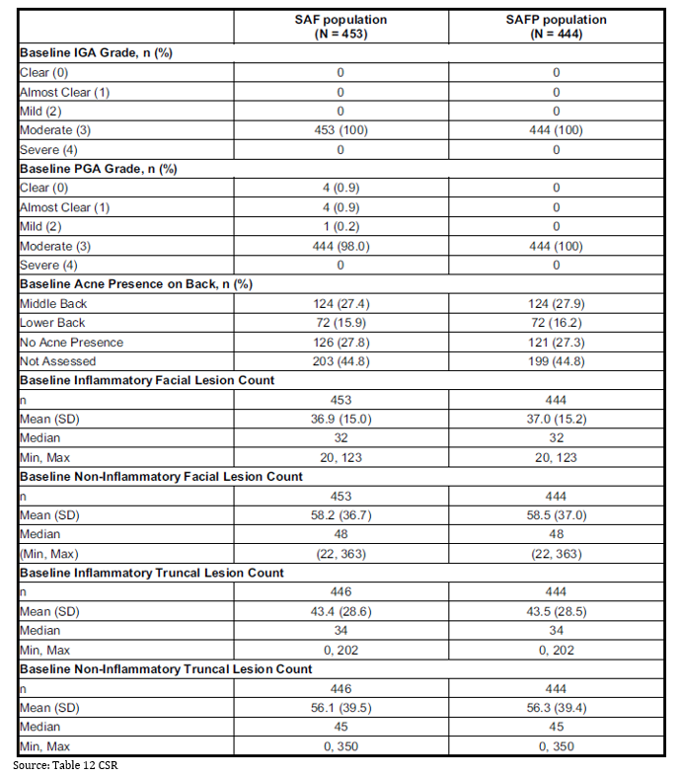

SAF = safety population, SAFP = . Ssafety population for the analysis of PGA, SD = Standard deviation, Min = minimum, Max = Maximum

Treatment exposure: The mean treatment duration was 298.2 days for face and 281.6 days for the trunk. Around 75% and 68% of subjects had treatment exposure for > 270 days for face and trunk respectively.

###### Results

Local tolerability on the face and trunk: The majority of safety events such as erythema, scaling, dryness and stinging/burning were mild to moderate in severity, when trifarotene was applied to both face (see Table 19) and trunk (see Table 20).

Table : Study 18250 Local tolerability for face

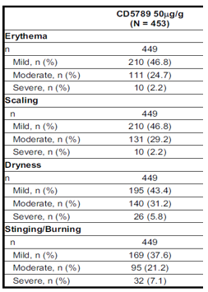

CD5789 = drug development name for trifarotene cream

Table : Study 18250 Local tolerability for trunk

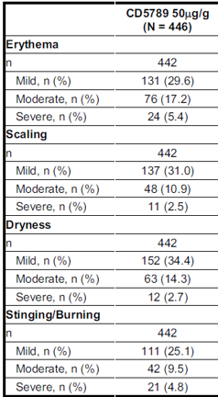

CD5789 = drug development name for trifarotene cream

##### Adverse events

Majority of adverse events (AE) were respiratory tract infections. An increase in the incidence of AEs was noted in Quarter 1, which is closer to the first application of trifarotene, followed by a relative reduction in the following quarters. Overall, around 5% of subjects experienced pruritus and irritation as signs of local irritability. The incidence of AEs was largely comparable across age groups, except for sunburn. Around 22% of subjects in the 9 to 11 years age group experienced sunburn, compared to around 5% of subjects in the adolescent and adults age groups. A summary of treatment emergent adverse events (TEAE) is given in Table 21, and by age group in Table 22, below.

Table : Summary of incidence of adverse events by System Order Class and Preferred Term

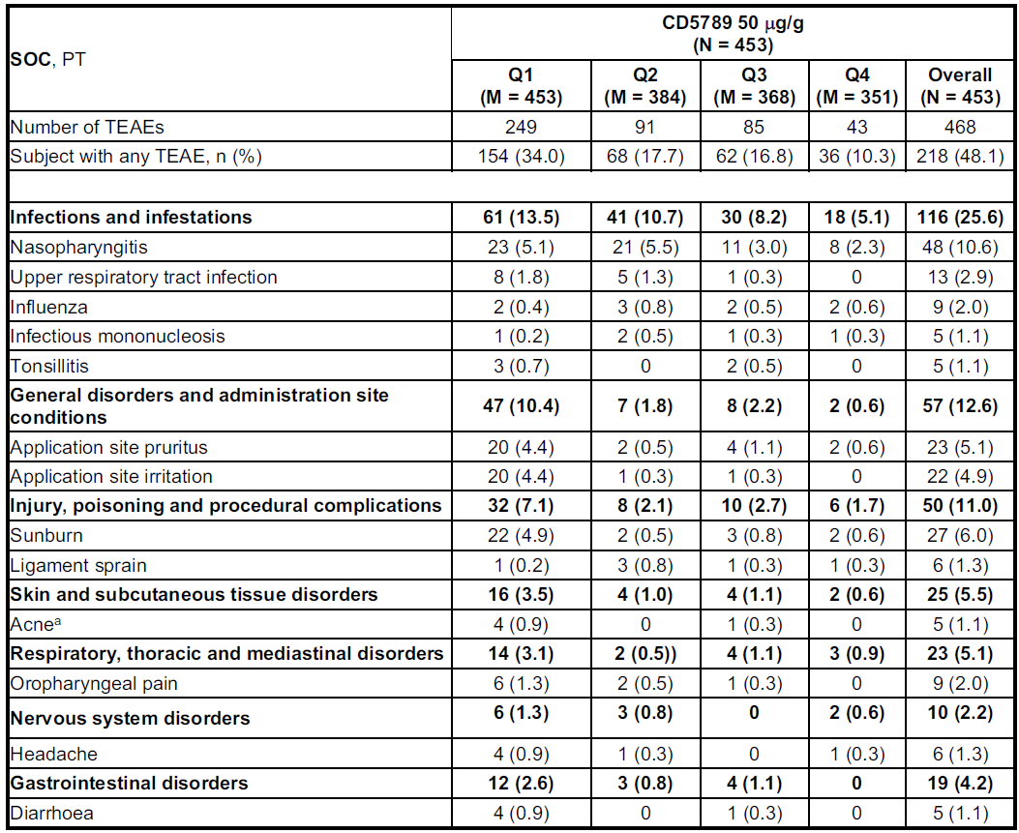

CD5789 = drug development name for trifarotene cream, SOC = System Organ Class, PT = Preferred Term, TEAE = treatment emergent adverse event.

Table : Summary of incidence of treatment emergent adverse events across age groups, by System Organ Class and Preferred Term

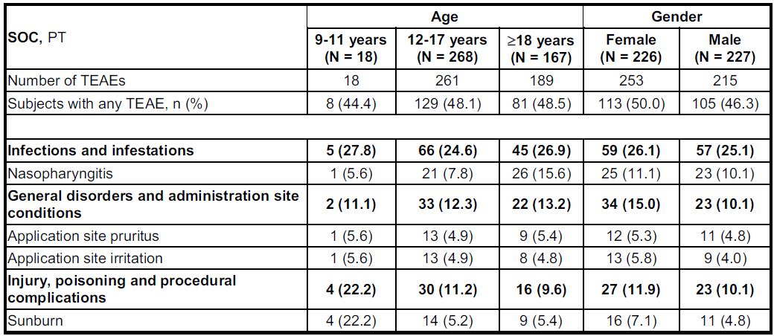

SOC = system organ class, PT = preferred term, TEAE = treatment emergent adverse event

Most of the AEs were mild or moderate in severity. Nine severe AEs were reported in nine subjects, of which three events were signs of local irritability such as pruritus, erythema and irritation and were considered as related to study drug.

##### Serious adverse events

12 events were reported as serious adverse events (SAE), with none considered as related to study treatment.

Treatment emergent adverse events (TEAE) that led to discontinuation were reported in 3.5% of subjects. Application site irritation was the commonest, with 2.2% of subjects experiencing these events.

#### Pooled safety data

##### Pool 1: Pivotal Studies 18251 and 18252

The proportion of subjects with TEAEs was comparable between trifarotene and placebo arms. However, a considerably higher proportion of subjects in trifarotene arm experienced TEAEs that were related to study treatment, compared to placebo (11.8 versus 1.5). Most of these events appear to be mild to moderate severity. The proportion of subjects with TEAEs related to study treatment and leading to discontinuation was higher in trifarotene arm, compared to placebo. A summary of the incidence of TEAEs is given in Table 23, below.

Table : Incidence of treatment emergent adverse events

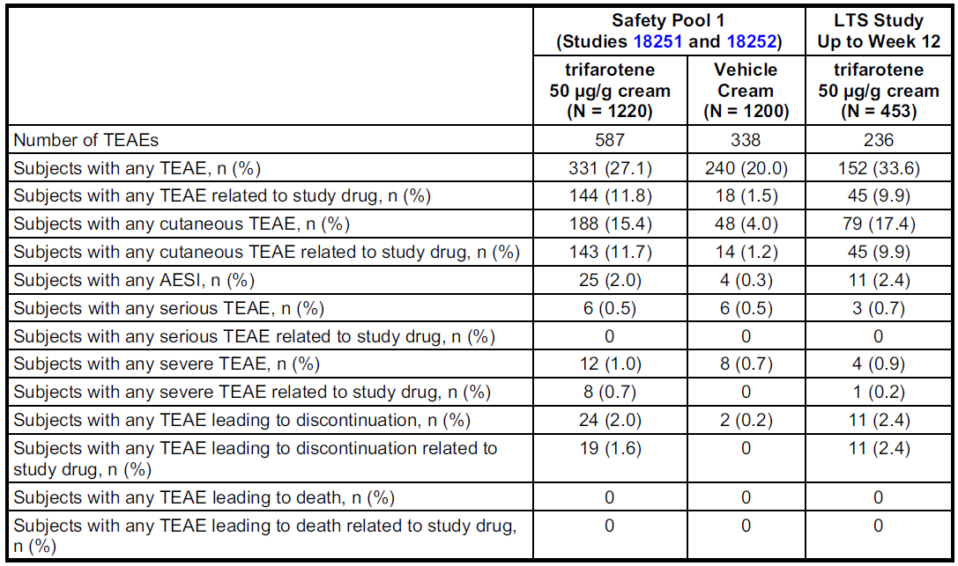

TEAE = treatment emergent adverse event, AESI = adverse event of special interest

A considerably higher proportion of subjects in trifarotene arm experienced application site irritation, pruritus and sunburn, compared to placebo, as shown in Table 24, below. Most of these events were adverse drug reactions, discussed in Table 25.

Table : Summary of treatment emergent adverse events by System Organ Class and Preferred Term

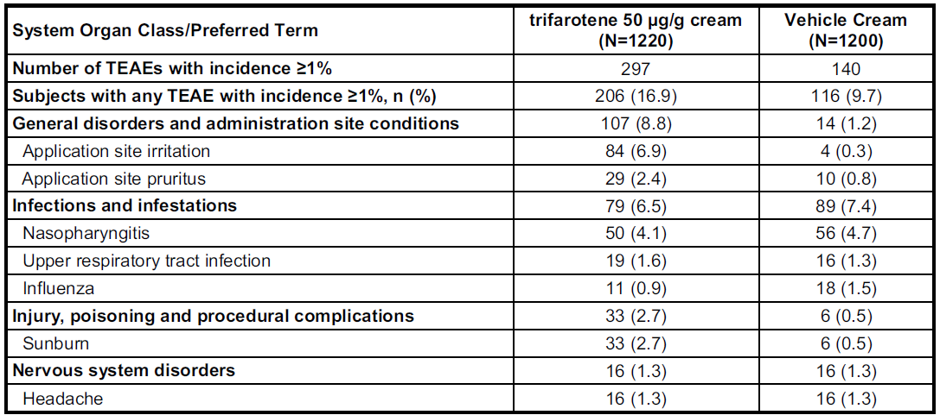

TEAE = treatment emergent adverse event

Table : Adverse drug reactions

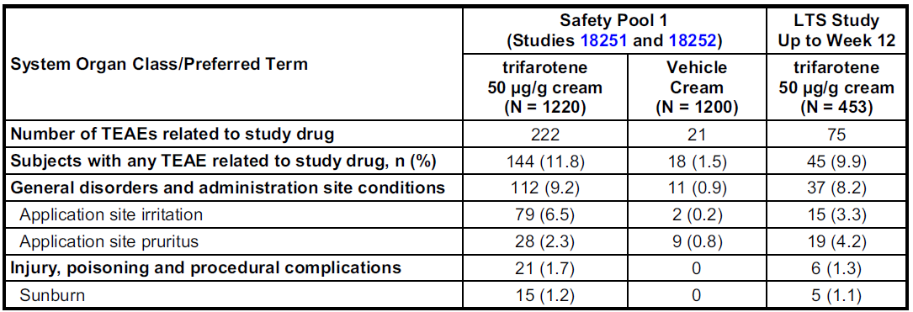

No deaths were reported during the study period.

###### Serious adverse events

None of the SAEs were considered as related to study treatment. The proportion of subjects who experienced SAEs was comparable across treatment groups (0.5% subjects).

###### Discontinuations due to adverse events

2% of subjects in trifarotene arm discontinued treatment due to an AE. 20 subjects experienced signs of local irritability. Except for one, all these events were determined as related to trifarotene.

###### Safety in 9 to 11 year old subjects

Four subjects in the 9 to 11 year age group reported AEs. No SAEs were reported.

###### Pregnancy and lactation

12 pregnancies were reported during the clinical development programme.

Five miscarriages, four in the trifarotene arm and one in vehicle arm were reported. Four normal deliveries, one elective termination of pregnancy in a subject exposed to vehicle and two pregnancies with unknown outcomes due to loss of follow-up were reported. Miscarriages were not considered as related to treatment with trifarotene.

##### Pool 2: Healthy volunteers

340 subjects were administered trifarotene and 116 subjects received vehicle. 97.9% of subjects completed the study. A higher proportion of subjects in the trifarotene arm experienced at least one AE (around 80 to 90%), compared to the vehicle arm (around 20%). Skin irritation, erythema, pruritus were the common AEs, and were considered to be related to trifarotene.

##### Pool 3: Subjects with acne vulgaris who were treated with various types of trifarotene preparations and strengths

The proportions of subjects who reported AEs and treatment-related AEs were higher in the trifarotene 100 μg/g cream concentration (46.3% and 28.4%, respectively) versus the 50 μg/g cream (32.9% and 12.2%, respectively) and 25 μg/g cream (26.2% and 3.3%, respectively). An increased incidence of AEs were reported in the trifarotene arm, compared to the vehicle arm. The proportion of subjects with AEs increased with progression of study.

### Risk management plan

The sponsor has submitted EU-risk management plan (RMP) version 1.3 (dated 9 December 2019; data lock point (DLP) 14 March 2018) and Australia specific annex (ASA) version 1.0 (dated March 2020) in support of this application. In response to TGA questions, the sponsor provided an updated ASA version 1.1 (dated August 2020).

The summary of safety concerns and their associated risk monitoring and mitigation strategies are summarised in Table 26.[10]

Table : Summary of safety concerns

|  |  |  |  |  |  |
| --- | --- | --- | --- | --- | --- |
| Summary of safety concerns | | Pharmacovigilance | | Risk Minimisation | |
| **Routine** | **Additional** | **Routine** | **Additional** |
| **Important identified risks** | None |  |  |  |  |
| **Important potential risks** | Teratogenicity: safety during pregnancy | ✓* | – | ✓ | – |
| **Missing information** | Use longer than 1 year | ✓ | – | ✓ | – |
| Use with concomitant acne medications | ✓ | – | ✓ | – |

The summary of safety concerns is acceptable from an RMP perspective.

Routine pharmacovigilance activities, including follow-up questionnaires to monitor the risk of teratogenicity, have been proposed. The pharmacovigilance plan is acceptable.

Only routine risk minimisation activities have been proposed. Routine risk minimisation measures are considered acceptable to address the risks associated with this product.

The RMP evaluator has commented that *‘there are no RMP related issues that would impede decision on this submission’*. The evaluator considered the summary of safety concerns and the pharmacovigilance plans as acceptable.

### Risk-benefit analysis

#### Delegate’s considerations

Trifarotene's selectivity for RARγ could possibly eliminate off-target drug effects as currently registered agents for topical acne therapy are RARβ and RARγ dual agonists. However, the lack of active comparators in the pivotal trials limits the availability of comparative data to confirm this hypothesis. The bioavailability of trifarotene at the proposed dose of marketing appears to be minimal. No obvious safety signals were noted during nonclinical evaluation.

The study design, including inclusion criteria and efficacy endpoints of both pivotal studies were in line the relevant US Food and Drug Administration (FDA) guideline.[11],[12] The rationale for selection of dose and dosage form for pivotal studies are acceptable. The patient population in both pivotal studies represent the targeted patient population for the proposed indication. Around 10 to 20% greater number of subjects in trifarotene arm achieved ‘success’, compared to placebo arm. The treatment difference was statistically significant. In subgroup analysis, the treatment difference for this endpoint did not achieve statistical significance for the 9 to 11 years of age group. The *post-hoc* nature of this analysis was considered and the study might not have been powered for this analysis. The sponsor had mentioned the difficulty in recruiting children in this age group. However, the evaluator has highlighted the reasonably large number of children recruited in studies with previously approved retinoids (Epiduo (adapalene and benzoyl peroxide) 0.1%/2.5% gel, 285 children in 9 to 11 years age group with acne).[13]

The magnitude of reduction in both inflammatory and non-inflammatory lesion counts achieved statistical significance for the trifarotene arm, compared to placebo arm. However, the treatment difference, in terms of reduction in the absolute number of these lesions were as low as two to a maximum of ten lesions. The clinical significance of these outcomes are uncertain, particularly whether it will have any positive impact on the quality of life;[14],[15] of individuals with moderate severity of acne vulgaris. The treatment benefit appears to be sustained for up to 52 weeks. However, the persistence of treatment benefits, once the treatment with trifarotene is stopped is unknown.11 There is evidence to suggest an increase in the number of microcomedones and a reduction in visible lesions, once treatment with retinoids were stopped.11 The dosage of trifarotene once the lesions have been controlled and a strategy for cessation of treatment have not been studied. The Delegate considers that these aspects need to be evaluated by the treating physician on a case by case basis.

The evaluator has highlighted that the magnitude of improvement with efficacy endpoints were 50% higher in Study 18252, compared to Study 18251. The sponsor will be requested to clarify any possible reasons for this observation. Across pivotal studies, a greater reduction in non-inflammatory lesions was observed, compared to inflammatory lesions. The comedolytic action of retinoids;[16] is considered as the possible mechanistic basis for this observation. This mechanism of action is also the basis for the use of retinoids as a maintenance treatment option for acne vulgaris.

Subjects in the trifarotene arm experienced a considerable increase in the incidence of adverse events and adverse drug reactions, compared to placebo. Overall, the type of safety signals, particularly the adverse drug reactions that were reported in subjects treated with trifarotene appear to be similar to previously reported events from studies with already approved retinoids (class effects). Most of the events were mild to moderate in severity and appears to decrease in incidence with continued use of trifarotene. High incidence of sunburn was noted in trifarotene arm. 6% of subjects in the long term study and 2.7% of subjects across pivotal studies in trifarotene arm experienced sun burn. The rate of incidence was much higher in the 9 to 11 years of age group with around 22% of children affected by this event. This is a known class effect. The incidence rate in pivotal studies with trifarotene is comparable to adapalene (2.2% in pivotal studies). Adequate precautionary statements are included in the PI. Except for sunburn, the incidence of adverse events appears to be largely comparable between pivotal studies and the long-term safety study.

Following the evaluator's questions, the sponsor clarified that the overall paediatric safety population (9 to 11 years) across all studies in the clinical development programme of trifarotene comprised of 52 subjects, with 44 subjects who were 11 years of age, six were 10 years of age and two were 9 years of age. Across the pivotal studies and the long-term study, no 9 year old children were recruited. There were four children aged 10 years old and 34 children aged 11 years old across these studies. These are summarised in Table 27, below.

Table : Number of children in the 9 to 11 years age groups in pivotal and long-term studies

|  |  |  |  |
| --- | --- | --- | --- |
| Study | 9 years old | 10 years old | 11 years old |
| 18237 | 0 | 1 | 1 |
| 18251 | 0 | 1 | 9 |
| 18252 | 0 | 0 | 9 |
| 18250 | 0 | 2 | 15 |
| Total | 0 | 4 | 34 |

The sponsor's initial proposed indication was for the treatment of acne vulgaris in adults and children as young as 9 years of age. During the evaluation process, in line with the evaluator's conclusions on the limitations of evidence to support trifarotene's efficacy and safety in in the 9 to 11 years of age group, the evaluator has recommended a modified indication to limit the paediatric age of 12 years and above. The sponsor has accepted the recommendation.

In summary, trifarotene appears to have a modest treatment effect on mild to moderate acne vulgaris on face and trunk. The safety profile of trifarotene is largely in line with the previously approved retinoids. From a clinical perspective, the cream formulation of trifarotene may limit its use in individuals with oily skin.

#### Proposed action

The Delegate has no reason to say, at this time, that the application for trifarotene should not be approved for registration.

#### Questions for the sponsor

The sponsor provided the following responses to questions from the Delegate.

1. ***Around 50% greater treatment benefit was observed for efficacy endpoints in Study 18252, compared to Study 18251. Please explain any possible reasons for this observation.***

The applicant considers that the development program of trifarotene 50 µg/g cream has provided substantial evidence and independent substantiation of the efficacy of trifarotene 50 µg/g cream versus vehicle in two well-controlled, identical studies in the target population. The difference in IGA success rate of vehicle between the two pivotal studies, that is 6.8% (16.6% minus 9.8% = 6.8%), was due to variability between the studies. In this development program, variability between studies might have resulted from the increase of the number of research centers participating in the studies (120 centers in Study 18251 compared to 85 centers in Study 18252). However, whatever the sources of the observed variability between the studies might be, important for the final interpretation of the outcome is the fact that the difference between active and vehicle was clinically meaningful and statistically significant in the two independent, pivotal studies.

1. ***Please confirm whether the placebo vehicle used in both pivotal studies were identical***

Both pivotal studies were double-blinded, vehicle controlled to evaluate efficacy and safety of trifarotene 50 µg/g cream. The active drug cream (trifarotene 50 µg/g) and vehicle drug cream were identical in pharmaceutical form cream except for the absence of the active ingredient (trifarotene 50 µg/g). Packaging type, size and storage conditions for both treatment arms were also identical (Study 18251 Section 9.4.2; Study 18252 Section 9.4.2 in sponsor’s submitted dossier).

#### Advisory committee considerations[17]

The Advisory Committee on Medicines (ACM), having considered the evaluations and the Delegate’s overview, as well as the sponsor’s response to these documents, advised the following.

##### Specific advice to the delegate

1. ***What are the committee's views on the magnitude of efficacy of trifarotene, compared to placebo in the pivotal studies?***

The ACM considers the comparison between the placebo and treatment group to be an imperfect comparison, rather trifarotene should have been compared with other retinoids currently approved for treatment of acne vulgaris. Skincare is a crucial part of acne management, but it is not controlled between placebo and treatment groups. The ACM was of the view that there are minor flaws in the experimental design of the clinical trials, however, the results of the studies do support the indication.

1. ***Please comment whether the safety aspects of trifarotene are adequately covered in the PI.***

The ACM was of view that the *Precaution* section of the PI for Aklief (trifarotene) should include *increased risk of sun burn/skin sensitivity*. The ACM was of the opinion that monitoring of patients for sunburn is not required to be mentioned in the PI. However, added statements in the consumer medicines information (CMI) to inform patients to take sun protection measures was considered as adequate.

The ACM was of view that the PI will require amendments to keep details consistent to the prescribing information and proofreading to keep the PI consistent with TGA editing and styling standards.

1. ***The committee is (also) requested to provide advice on any other issues that it thinks may be relevant to a decision on whether or not to approve this application.***

Nil further advice.

##### Conclusion

The ACM considered this product to have an overall positive benefit-risk profile for the indication:

*Aklief is indicated for the topical treatment of acne vulgaris of the face and/or the trunk in patients 12 years of age or older, when comedones, papules and/or pustules are present.*

### Outcome

Based on a review of quality, safety and efficacy, the TGA approved the registration of Aklief (trifarotene) 50 µg/g, cream, bottle and tube, indicated for:

*Aklief is indicated for the topical treatment of Acne Vulgaris of the face and/or the trunk in patients from 12 years of age and older, when many comedones, papules and/or pustules are present.*

#### Specific conditions of registration applying to these goods

* Aklief (trifarotene) is to be included in the Black Triangle Scheme. The PI and CMI for Aklief must include the black triangle symbol and mandatory accompanying text for five years, which starts from the date that the sponsor notifies the TGA of supply of the product.
* The Aklief EU-RMP (version 1.3, dated 9 December 2019; DLP 14 March 2018), with ASA (version 1.1, August 2020), included with submission PM-2020-01095-1-1, and any subsequent revisions, as agreed with the TGA will be implemented in Australia.

An obligatory component of risk management plans is routine pharmacovigilance. Routine pharmacovigilance includes the submission of periodic safety update reports (PSURs).

Unless agreed separately between the supplier who is the recipient of the approval and the TGA, the first report must be submitted to TGA no later than 15 calendar months after the date of the approval letter. The subsequent reports must be submitted no less frequently than annually from the date of the first submitted report until the period covered by such reports is not less than three years from the date of this approval letter. The annual submission may be made up of two PSURs each covering six months. If the sponsor wishes, the six monthly reports may be submitted separately as they become available.

Once the EU reference dates are available, reports are to be provided in line with the published list of EU reference dates and frequency of submission of PSURs until the period covered by such reports is not less than three years from the date of this approval letter.

The reports are to at least meet the requirements for PSURs as described in the European Medicines Agency’s Guideline on good pharmacovigilance practices (GVP) Module VII-periodic safety update report (Rev 1), Part VII.B Structures and processes. Note that submission of a PSUR does not constitute an application to vary the registration. Each report must have been prepared within ninety calendar days of the data lock point for that report.

## Attachment 1. Product Information

The PI for Aklief approved with the submission which is described in this AusPAR is at Attachment 1. For the most recent PI, please refer to the TGA website at <<https://www.tga.gov.au/product-information-pi>>.

|  |
| --- |
| Therapeutic Goods Administration |
| PO Box 100 Woden ACT 2606 Australia  Email: [info@tga.gov.au](mailto:info@tga.gov.au) Phone: 1800 020 653 Fax: 02 6232 8605  [**https://www.tga.gov.au**](https://www.tga.gov.au) |

1. The **Black Triangle Scheme** provides a simple means for practitioners and patients to identify certain types of new prescription medicines, including those being used in new ways and to encourage the reporting of adverse events associated with their use. The Black Triangle does not denote that there are known safety problems, just that the TGA is encouraging adverse event reporting to help us build up the full picture of a medicine's safety profile.
2. Thiboutot, D.M., et al., Practical management of acne for clinicians: An international consensus from the Global Alliance to Improve Outcomes in Acne*.* *J Am Acad Dermatol*, 2018. 78(2 Suppl 1): p. S1-S23.e1.
3. Source: Francis, N.A et al. The management of acne vulgaris in primary care: a cohort study of consulting and prescribing patterns using the Clinical Practice Research Datalink. *British Journal of Dermatology*, 2016; 176.
4. The TGA makes use of assessments from **comparable overseas regulators** (**COR**), where possible, in the evaluation of prescription medicines. Under the **COR-B** approach, the TGA regulatory decision will be mostly based on a critical review of the COR assessment reports. The COR-B process has a 175 working day evaluation and decision timeframe, allowing for TGA evaluation of certain data, in addition to the label, Product Information (PI) and Risk Management Plan (RMP).

   The amount and type of additional data requiring evaluation will determine whether the application is best processed under the COR-B approach or as a Category 1 application.

   Examples of additional data that may be considered under the COR-B process include updated stability data, validation data for an additional manufacturing site and updates to pivotal studies that support the proposed indication.
5. ICH M3 (R2) Non-clinical safety studies for the conduct of human clinical trials for pharmaceuticals. This document aims to recommend international standards for the non-clinical safety studies recommended to support human clinical trials as well as marketing authorisation for pharmaceuticals. Access via European Medicines Agency site.
6. **Cytochrome P450 (CYP) enzymes:** CYPs are the major enzymes involved in drug metabolism, accounting for large part of the total metabolism. Most drugs undergo deactivation by CYPs, either directly or by facilitated excretion from the body. Also, many substances are bioactivated by CYPs to form their active compounds.

   Many drugs may increase or decrease the activity of various CYP isozymes either by inducing the biosynthesis of an isozyme (enzyme induction) or by directly inhibiting the activity of the CYP (enzyme inhibition). This is a major source of adverse drug interactions, since changes in CYP enzyme activity may affect the metabolism and clearance of various drugs. Such drug interactions are especially important to take into account when using drugs of vital importance to the patient, drugs with important side-effects and drugs with small therapeutic windows, but any drug may be subject to an altered plasma concentration due to altered drug metabolism
7. The **Investigator’s Global Assessment** (**IGA**) of acne vulgaris severity is a 5 category scale for the scoring of facial acne severity; 0 = clear skin, 1 = almost clear skin, 2 = mild acne, 3 = moderate acne and 4 = severe acne.
8. The **Physician’s Global Assessment** (**PGA**) of acne vulgaris severity is a 5 category scale for the scoring of truncal acne severity; 0 = clear skin, 1 = almost clear skin, 2 = mild acne, 3 = moderate acne and 4 = severe acne.
9. A topical **vehicle** refers to the carrier system for the active drug substance. In the context of comparison of treatment versus vehicle, the vehicle is identical to the treatment formulation in terms of excipients, minus the active drug component.
10. *Routine risk minimisation* activities may be limited to ensuring that suitable warnings are included in the product information or by careful use of labelling and packaging.

    *Routine pharmacovigilance* practices involve the following activities:

    All suspected adverse reactions that are reported to the personnel of the company are collected and collated in an accessible manner;

    Reporting to regulatory authorities;

    Continuous monitoring of the safety profiles of approved products including signal detection and updating of labelling;

    Submission of PSURs;

    Meeting other local regulatory agency requirements.
11. Thiboutot, D.M., et al., Practical management of acne for clinicians: An international consensus from the Global Alliance to Improve Outcomes in Acne. *J Am Acad Dermatol*, 2018. 78(2 Suppl 1): p. S1-S23.e1.
12. USFDA, Acne Vulgaris: Establishing Effectiveness of Drugs Intended for Treatment Guidance for Industry.2018
13. FDA prescribing information for Epiduo gel. Accessible via www.fda.gov.
14. Kotekoglu, D., et al., Internalized stigma in acne vulgaris and its relationship with quality of life, general health, body perception, and depression. *Niger J Clin Pract*, 2020. 23(9): p. 1289-1294.
15. Öztekin, C. and A. Öztekin, The association of depression, loneliness and internet addiction levels in patients with acne vulgaris. *Biopsychosoc Med*, 2020. 14: p. 17.
16. Valente Duarte De Sousa, I.C., New and emerging drugs for the treatment of acne vulgaris in adolescents. *Expert Opin Pharmacother*, 2019. 20(8): p. 1009-1024.
17. The ACM provides independent medical and scientific advice to the Minister for Health and the Therapeutic Goods Administration (TGA) on issues relating to the safety, quality and efficacy of medicines supplied in Australia including issues relating to pre-market and post-market functions for medicines.

    The Committee is established under Regulation 35 of the Therapeutic Goods Regulations 1990. Members are appointed by the Minister. The ACM was established in January 2017 replacing Advisory Committee on Prescription Medicines (ACPM) which was formed in January 2010. ACM encompass pre and post-market advice for medicines, following the consolidation of the previous functions of the Advisory Committee on Prescription Medicines (ACPM), the Advisory Committee on the Safety of Medicines (ACSOM) and the Advisory Committee on Non-Prescription Medicines (ACNM). Membership comprises of professionals with specific scientific, medical or clinical expertise, as well as appropriate consumer health issues relating to medicines.