# Australian Product Information TUKYSA® (tucatinib) Tablets

▼ This medicinal product is subject to additional monitoring in Australia. This will allow quick identification of new safety information. Healthcare professionals are asked to report any suspected adverse events at [www.tga.gov.au/reporting-problems](http://www.tga.gov.au/reporting-problems).

# Name of the medicine

Tucatinib

# Qualitative and quantitative composition

TUKYSA film-coated tablets contain either 50 mg or 150 mg of tucatinib.

TUKYSA 50 mg contains 9.2 mg sodium and 10 mg potassium per tablet and TUKYSA 150 mg contains 27.6 mg sodium and 30 mg potassium per tablet.

For the full list of excipients, see Section 6.1 List of excipients.

# Pharmaceutical form

Film coated tablet.

TUKYSA 50 mg tablets are round, yellow, film-coated, debossed with “TUC” on one side and “50” on the other side.

TUKYSA 150 mg tablets are oval-shaped, yellow, film-coated, debossed with “TUC” on one side and “150” on the other side.

# Clinical particulars

## Therapeutic indications

TUKYSA is indicated in combination with trastuzumab and capecitabine for treatment of patients with advanced unresectable or metastatic HER2-positive breast cancer, including patients with brain metastases, who have received one or more prior anti-HER2-based regimens in the metastatic setting.

## Dose and method of administration

TUKYSA treatment should be initiated and supervised by a physician experienced in the administration of anti-cancer medicinal products.

The recommended dose of TUKYSA is 300 mg taken orally twice daily in combination with trastuzumab and capecitabine until disease progression or unacceptable toxicity (see section 5.1 Pharmacological properties – Clinical trials).

TUKYSA tablets should be swallowed whole, and not chewed, crushed, or split prior to swallowing. Advise patients not to take any tablet that is broken, cracked or otherwise not intact.

TUKYSA should be taken approximately 12 hours apart, at the same times every day, and can be taken with or without a meal. In the case of a missed dose, the next dose should be taken at the regularly scheduled time.

In the case of a missed dose, the next dose should be taken at its usual scheduled time.

When given in combination with TUKYSA, the recommended dosage of capecitabine is 1000 mg/m2 orally twice daily taken within 30 minutes after a meal. TUKYSA and capecitabine can be taken at the same time.

Refer to the full Product Information for co-administered trastuzumab and capecitabine for additional information.

### Dose modifications

Dose modifications for adverse reactions

The recommended TUKYSA dose modifications for patients with adverse reactions are provided in Tables 1 and 2. Refer to the full Product Information for co-administered trastuzumab and capecitabine for information about dose modifications for these drugs.

Table 1: TUKYSA dose reduction schedule

|  |  |
| --- | --- |
| **Dose level** | **TUKYSA dose** |
| Recommended starting dose | 300 mg twice daily |
| First dose reduction | 250 mg twice daily |
| Second dose reduction | 200 mg twice daily |
| Third dose reduction | 150 mg twice daily |

Permanently discontinue TUKYSA in patients unable to tolerate 150 mg orally twice daily.

Table 2: Recommended TUKYSA dose modifications for adverse reactions

|  |  |  |
| --- | --- | --- |
| Adverse Reaction1 | Severity | TUKYSA Dose Modification |
| Diarrhoea  (see Section 4.4 Special Warnings and Precautions for Use) | Grade 3 without anti-diarrhoeal treatment | Initiate or intensify appropriate medical therapy. Hold TUKYSA until recovery to ≤ Grade 1, then resume TUKYSA at the same dose level. |
| Grade 3 with anti-diarrhoeal treatment | Initiate or intensify appropriate medical therapy. Hold TUKYSA until recovery to ≤ Grade 1, then resume TUKYSA at the next lower dose level. |
| Grade 4 | Permanently discontinue TUKYSA. |
| Hepatotoxicity2  (see Section 4.4 Special Warnings and Precautions for Use) | Grade 2 bilirubin (>1.5 to 3 × ULN) | Hold TUKYSA until recovery to ≤ Grade 1, then resume TUKYSA at the same dose level. |
| Grade 3 ALT or AST (> 5 – ≤ 20 x ULN)  OR  Grade 3 bilirubin (> 3 – ≤ 10 x ULN) | Hold TUKYSA until severity ≤ Grade 1. Then resume TUKYSA at the next lower dose level. |
| Grade 4 ALT or AST (> 20 x ULN)  OR  Grade 4 bilirubin (> 10 x ULN) | Permanently discontinue TUKYSA. |
| ALT or AST > 3 x ULN  AND  Bilirubin > 2 x ULN | Permanently discontinue TUKYSA. |
| Other adverse reactions (see Section 4.8 Adverse Effects) | Grade 3 | Hold TUKYSA until recovery to ≤ Grade 1, then resume TUKYSA at the next lower dose level. |
| Grade 4 | Permanently discontinue TUKYSA. |

1. Grades based on National Cancer Institute Common Terminology Criteria for Adverse Events Version 4.03

2. Abbreviations: ULN = upper limit of normal; ALT = alanine aminotransferase; AST = aspartate aminotransferase

Dose modifications in special patient populations

*Patients with renal impairment*

No dose adjustment is required in patients with mild or moderate renal impairment. The use of TUKYSA in combination with capecitabine and trastuzumab is not recommended in patients with severe renal impairment (CLcr < 30 mL/min estimated by Cockcroft-Gault Equation), because capecitabine is contraindicated in patients with severe renal impairment.  Refer to the Prescribing Information of capecitabine for additional information in severe renal impairment.

*Patients with hepatic impairment*

No dose adjustment is required in patients with mild or moderate hepatic impairment. For patients with severe hepatic impairment (Child-Pugh C), reduce the recommended dosage to 200 mg orally twice daily.

*Elderly*

No dose adjustment is required in patients ≥ 65 years of age.

*Paediatrics*

The safety and effectiveness of TUKYSA in paediatric patients has not been established.

Concomitant use with strong CYP2C8 inhibitors

Avoid concomitant use of strong CYP2C8 inhibitors with TUKYSA. If concomitant use with a strong CYP2C8 inhibitor cannot be avoided, reduce the recommended dosage to 100 mg orally twice daily. After discontinuation of the strong CYP2C8 inhibitor for 3 elimination half-lives, resume the TUKYSA dose that was taken prior to initiating the inhibitor (see Section 4.5 Interactions with other Medicines).

## Contraindications

Hypersensitivity to tucatinib or to any of the excipients listed in section 6.1.

## Special warnings and precautions for use

### Diarrhoea

TUKYSA can cause severe diarrhoea, leading to dehydration, hypotension, acute kidney injury and death (see Section 4.8 Adverse effects [undesirable effects]). If diarrhoea occurs, administer anti-diarrhoeal treatment as clinically indicated. Perform diagnostic tests as clinically indicated to exclude other causes of diarrhoea. Based on the severity of the diarrhoea, interrupt dose, then dose reduce or permanently discontinue TUKYSA (see Section 4.2 Dose and method of administration).

### Hepatotoxicity

TUKYSA can cause severe hepatotoxicity. Assess ALT, AST, and bilirubin prior to starting TUKYSA, every three weeks during treatment, and as clinically indicated. Based on the severity of hepatotoxicity, interrupt dose, then dose reduce or permanently discontinue TUKYSA. (see Section 4.2 Dose and method of administration).

### Embryo-fetal toxicity

Based on findings from animal studies and its mechanism of action, TUKYSA may cause fetal harm when administered to a pregnant woman. In animal reproduction studies, administration of tucatinib to pregnant rats and rabbits during organogenesis caused embryo-fetal mortality, reduced fetal weight and fetal abnormalities at maternal exposures ≥ 1.3 times the human exposure (AUC) at the recommended dose. Advise pregnant women and patients of reproductive potential of the potential risk to a fetus. Advise patients of reproductive potential to use effective contraception during treatment with TUKYSA and for at least 1 week after the last dose (see Section 4.6 Fertility, Pregnancy & Lactation).

TUKYSA is used in combination with trastuzumab and capecitabine. Refer to the full Product Information of trastuzumab and capecitabine for reproductive toxicity information.

## Interactions with other medicines and other forms of interactions

Effects of other substances on TUKYSA

Tucatinib is metabolised primarily by CYP2C8 and to a lesser extent via CYP3A. Co-administration of the strong CYP2C8 inhibitor gemfibrozil resulted in a 3.0-fold increase in the plasma exposure of tucatinib in healthy volunteers. Co-administration of tucatinib with rifampin, a strong CYP3A/moderate CYP2C8 inducer, decreased the plasma exposure of tucatinib by 50% in healthy volunteers. Tucatinib was identified as a substrate for P-gp and BCRP *in vitro*. Co-administration of tucatinib with itraconozole, a strong CYP3A and strong P-gp inhibitor, resulted in a 30% increase in the plasma exposure of tucatinib in healthy volunteers. Table 3 summarises drug interactions that affect the pharmacokinetics of tucatinib.

**Table 3. Drug interactions that affect TUKYSA**

|  |  |
| --- | --- |
| **Strong CYP3A inducers or moderate CYP2C8 inducers** | |
| Clinical impact | Concomitant use of TUKYSA with a strong CYP3A or moderate CYP2C8 inducer decreases tucatinib plasma concentration, which may reduce tucatinib efficacy. |
| Prevention or management | Avoid concomitant use of TUKYSA with a strong CYP3A or a moderate CYP2C8 inducer. |
| **Strong or moderate CYP2C8 inhibitors** | |
| Clinical impact | Concomitant use of TUKYSA with a strong CYP2C8 inhibitor increases tucatinib plasma concentration, which may increase the risk of tucatinib toxicity. |
| Prevention or management | Avoid concomitant use of TUKYSA with strong CYP2C8 inhibitors. Increase monitoring for TUKYSA toxicity with moderate CYP2C8 inhibitors. |

Effects of TUKYSA on other substances

In *in vitro* studies, tucatinib had inhibitory activity on CYP2C8, CYP3A, OCT2, MATE1, and MATE2-K and on intestinal BCRP and P-gp at clinically relevant concentrations. Tucatinib may increase plasma concentrations of drugs that are substrates of these enzymes or transporters. In healthy volunteers, co-administration of tucatinib with repaglinide (CYP2C8 substrate), midazolam (CYP3A substrate), digoxin (P-gp substrate), or metformin (MATE1/2-K substrate) increased the plasma exposure of the respective substrates 1.7-fold, 5.7-fold, 1.5-fold, and 1.4-fold. Table 4 summarises the effect of TUKYSA on other drugs.

**Table 4. TUKYSA drug interactions that affect other drugs**

|  |  |
| --- | --- |
| **CYP3A substrates** | |
| Clinical impact | Concomitant use of TUKYSA with a CYP3A substrate increased the plasma concentrations of CYP3A substrate, which may increase the toxicity associated with a CYP3A substrate. |
| Prevention or management | Avoid concomitant use of TUKYSA with CYP3A substrates for which minimal plasma concentration changes may lead to serious or life-threatening toxicities. If concomitant use is unavoidable, decrease the CYP3A substrate dose as described in the medication’s prescribing information. |
| **P-glycoprotein (P-gp) substrates** | |
| Clinical impact | Concomitant use of TUKYSA with P-gp substrates increased the plasma concentrations of P-gp substrate, which may increase the toxicity associated with a P-gp substrate. |
| Prevention or management | Be cautious about concomitant use of TUKYSA with P-gp substrates for which minimal plasma concentration changes may lead to serious or life-threatening toxicities (such as digoxin), and consider reducing the dosage of such P-gp substrates as described in the medication’s prescribing information. |

## Fertility, pregnancy and lactation

TUKYSA is indicated in combination with trastuzumab and capecitabine. Refer to the Product Information of trastuzumab and of capecitabine for fertility, pregnancy and lactation information specific to those drugs.

### Females and males of reproductive potential

Based on findings in animal studies and its mechanism of action, TUKYSA can cause fetal harm when administered to a pregnant woman (see *Use in Pregnancy*, below). Verify the pregnancy status of females of reproductive potential prior to initiating treatment with TUKYSA.

Advise females of reproductive potential to use effective contraception during treatment with TUKYSA and for at least 1 week after the last dose.

Advise males with female partners of reproductive potential to use effective contraception during treatment with TUKYSA and for at least 1 week after the last dose of TUKYSA.

### Effects on fertility

No dedicated fertility studies have been conducted in humans or animals, however, based on findings from other animal studies, TUKYSA may impair fertility in males and females of reproductive potential.

In repeat-dose toxicity studies up to 13 weeks duration, decreased corpora lutea/corpus luteum cyst, increased interstitial cells of the ovary, atrophy of the uterus, and mucification of the vagina were observed in female rats at doses of ≥6 mg/kg/day (0.1 times the human exposure at the recommended dose based on AUC). Atrophy and oedema in the testes and oligospermia/germ cell debris in the epididymides were observed in male rats at doses ≥120 mg/kg/day (13 times the human exposure at the recommended dose based on AUC).

### Use in pregnancy – pregnancy category D

Based on findings in animal studies and its mechanism of action, TUKYSA can cause fetal harm when administered to a pregnant woman. There are no available human data on TUKYSA use in pregnant women. Advise pregnant patients and patients of reproductive potential of the potential risk to the fetus.

In pilot embryo-fetal development studies, pregnant rats and rabbits received oral doses of tucatinib up to 150 mg/kg/day during the period of organogenesis.

In rats, maternal toxicity (body weight loss, reduced body weight gain, low food consumption) was observed at doses ≥90 mg/kg/day (3.5 times the human exposure at the recommended dose based on AUC). Fetal effects also occurred at maternal doses ≥90 mg/kg/day, including reduced number of live fetuses, decreased fetal weights and fetal abnormalities (increase in skeletal variations, incomplete ossification).

In rabbits, increased resorptions, decreased percentages of live fetuses, and skeletal, visceral, and external malformations in fetuses were observed at maternal doses ≥90 mg/kg/day (1.3 times the human exposure at the recommended dose based on AUC). Fetal abnormalities included domed head, brain dilation, incomplete ossification of frontal and parietal bones, and a hole in the parietal bone.

### Use in lactation

No data are available regarding the presence of tucatinib or its metabolites in human or animal milk or its effects on the breastfed child or on milk production. Because of the potential for serious adverse reactions in a breastfed child, advise women not to breastfeed during treatment with TUKYSA and for at least 1 week after the last dose.

## Effects on ability to drive and use machines

TUKYSA has no influence on the ability to drive and use machines. The clinical status of the patient should be considered when assessing the patient’s ability to perform tasks that require judgment, motor, or cognitive skills.

## Adverse effects (undesirable effects)

**Summary of the safety profile**

The safety of TUKYSA in combination with trastuzumab and capecitabine was evaluated in HER2CLIMB (see section 5.1 Pharmacodynamic properties – Clinical trials). Patients received either TUKYSA 300 mg twice daily plus trastuzumab and capecitabine (n=404) or placebo plus trastuzumab and capecitabine (n=197). The median duration of treatment was 5.8 months (range: 3 days, 2.9 years) for the TUKYSA arm.

Serious adverse reactions occurred in 26% of patients who received TUKYSA. Serious adverse reactions in ≥ 2% of patients who received TUKYSA were diarrhoea (4%), vomiting (2.5%), nausea (2%), abdominal pain (2%), and seizure (2%). Fatal adverse reactions occurred in 2% of patients who received TUKYSA including sudden death, sepsis, dehydration, and cardiogenic shock.

Adverse reactions leading to treatment discontinuation occurred in 6% of patients who received TUKYSA. Adverse reactions leading to treatment discontinuation of TUKYSA in ≥1% of patients were hepatotoxicity (1.5%) and diarrhoea (1%).

Adverse reactions leading to dose reduction occurred in 21% of patients who received TUKYSA. Adverse reactions leading to dose reduction of TUKYSA in ≥2% of patients were hepatotoxicity (8%) and diarrhoea (6%).

The most common adverse reactions in patients who received TUKYSA (≥20%) were diarrhoea, palmar-plantar erythrodysaesthesia, nausea, fatigue, hepatotoxicity, vomiting, stomatitis, decreased appetite, abdominal pain, headache, anaemia, and rash.

Table 5 summarises the adverse reactions in HER2CLIMB.

**Table 5. Adverse reactions in HER2CLIMB with an incidence ≥10% in the TUKYSA arm and with an incidence at least 5% higher in the TUKYSA arm compared to placebo**

|  |  |  |  |  |  |  |
| --- | --- | --- | --- | --- | --- | --- |
| **Adverse reaction** | **TUKYSA + trastuzumab  + capecitabine**  **N = 404** | | | **Placebo + trastuzumab  + capecitabine**  **N = 197** | | |
|  | **All Grades %** | **Grade 3  %** | **Grade 4  %** | **All Grades %** | **Grade 3  %** | **Grade 4  %** |
| **Gastrointestinal disorders** | | | | | | |
| Diarrhoea | 81 | 12 | 0.5 | 53 | 9 | 0 |
| Nausea | 58 | 3.7 | 0 | 44 | 3 | 0 |
| Vomiting | 36 | 3 | 0 | 25 | 3.6 | 0 |
| Stomatitis1 | 32 | 2.5 | 0 | 21 | 0.5 | 0 |
| **Skin and subcutaneous tissue disorders** | | | | | | |
| Palmar-plantar erythrodysaesthesia syndrome | 63 | 13 | 0 | 53 | 9 | 0 |
| Rash2 | 20 | 0.7 | 0 | 15 | 0.5 | 0 |
| **Hepatobiliary disorders** | | | | | | |
| Hepatotoxicity3 | 42 | 9 | 0.2 | 24 | 3.6 | 0 |
| **Metabolism and nutrition disorders** | | | | | | |
| Decreased appetite | 25 | 0.5 | 0 | 20 | 0 | 0 |
| **Blood and lymphatic system disorders** | | | | | | |
| Anaemia4 | 21 | 3.7 | 0 | 13 | 2.5 | 0 |
| **Musculoskeletal and connective tissue disorders** | | | | | | |
| Arthralgia | 15 | 0.5 | 0 | 4.6 | 0.5 | 0 |
| **Investigations** | | | | | | |
| Creatinine increased5 | 14 | 0 | 0 | 1.5 | 0 | 0 |
| Weight decreased | 13 | 1 | 0 | 6 | 0.5 | 0 |
| **Nervous system disorders** | | | | | | |
| Peripheral neuropathy6 | 13 | 0.5 | 0 | 7 | 1 | 0 |
| **Respiratory, thoracic, and mediastinal disorders** | | | | | | |
| Epistaxis | 12 | 0 | 0 | 5 | 0 | 0 |

1. Stomatitis includes stomatitis, oropharyngeal pain, oropharyngeal discomfort, mouth ulceration, oral pain, lip ulceration, glossodynia, tongue blistering, lip blister, oral dysaesthesia, tongue ulceration, and aphthous ulcer
2. Rash includes rash maculo-papular, rash, dermatitis acneiform, erythema, rash macular, rash papular, rash pustular, rash pruritic, rash erythematous, skin exfoliation, urticaria, dermatitis allergic, palmar erythema, plantar erythema, skin toxicity, and dermatitis
3. Hepatotoxicity includes hyperbilirubinemia, blood bilirubin increased, bilirubin conjugated increased, alanine aminotransferase increased, transaminases increased, hepatotoxicity, aspartate aminotransferase increased, liver function test increased, liver injury, and hepatocellular injury
4. Anaemia includes anaemia, haemoglobin decreased, and normocytic anaemia
5. Due to inhibition of renal tubular transport of creatinine without affecting glomerular function
6. Peripheral neuropathy includes peripheral sensory neuropathy, neuropathy peripheral, peripheral motor neuropathy, and peripheral sensorimotor neuropathy

**Table 6. Laboratory abnormalities worsening from baseline in HER2CLIMB with an incidence ≥20% in the TUKYSA arm and with an incidence at least 5% higher in the TUKYSA arm compared to placebo**

|  |  |  |  |  |
| --- | --- | --- | --- | --- |
|  | **TUKYSA + Trastuzumab +Capecitabine1** | | **Placebo + Trastuzumab +Capecitabine1** | |
|  | **All Grades %** | **Grade ≥3  %** | **All Grades %** | **Grade ≥3  %** |
| **Haematology** | | | | |
| Decreased haemoglobin | 59 | 3.3 | 51 | 1.5 |
| **Chemistry** | | | | |
| Decreased phosphate | 57 | 8 | 45 | 7 |
| Increased bilirubin | 47 | 1.5 | 30 | 3.1 |
| Increased ALT | 46 | 8 | 27 | 0.5 |
| Increased AST | 43 | 6 | 25 | 1 |
| Decreased magnesium | 40 | 0.8 | 25 | 0.5 |
| Decreased potassium2 | 36 | 6 | 31 | 5 |
| Increased creatinine3 | 33 | 0 | 6 | 0 |
| Decreased sodium4 | 28 | 2.5 | 23 | 2 |
| Increased alkaline phosphatase | 26 | 0.5 | 17 | 0 |

1. The denominator used to calculate the rate varied from 351 to 400 in the TUKYSA arm and 173 to 197 in the control arm based on the number of patients with a baseline value and at least one post-treatment value. Grading was based on NCI-CTCAE v.4.03 for laboratory abnormalities, except for increased creatinine which only includes patients with a creatinine increase based on the upper limit of normal definition for grade 1 events (NCI CTCAE v5.0).
2. Laboratory criteria for Grade 1 is identical to laboratory criteria for Grade 2.
3. Due to inhibition of renal tubular transport of creatinine without affecting glomerular function.
4. There is no definition for Grade 2 in CTCAE v.4.03.

### Description of selected adverse reactions

*Diarrhoea*

In HER2CLIMB, 81% of patients who received TUKYSA experienced diarrhoea, including 12% with Grade 3 diarrhoea and 0.5% with Grade 4 diarrhoea. Both patients who developed Grade 4 diarrhoea subsequently died, with diarrhoea as a contributor to death. The median time to onset of the first episode of diarrhoea was 12 days and the median time to resolution was 8 days. Diarrhoea led to dose reductions of TUKYSA in 6% of patients and discontinuation of TUKYSA in 1% of patients. Prophylactic use of antidiarrheal treatment was not required in HER2CLIMB.

*Hepatotoxicity*

In HER2CLIMB, 8% of patients who received TUKYSA had an ALT increase > 5 × ULN, 6% had an AST increase > 5 × ULN, and 1.5% had a bilirubin increase > 3 × ULN (Grade ≥3). Hepatotoxicity led to dose reduction of TUKYSA in 8% of patients and discontinuation of TUKYSA in 1.5% of patients.

The median time to onset of any episode of increased ALT, AST, or bilirubin was 36 days and the median time to resolution was 22 days.

*Creatinine increased*

In HER2CLIMB, the mean increase in serum creatinine was 32% within the first 21 days of treatment with TUKYSA. Elevated serum creatinine levels were persistent but stable throughout treatment and were reversible upon treatment discontinuation. Consider alternative markers that are not based on creatinine (such as BUN, cystatin C, or calculated GFR) if assessment of renal function is required.

### Reporting suspected adverse effects

Reporting suspected adverse reactions after registration of the medicinal product is important. It allows continued monitoring of the benefit-risk balance of the medicinal product. Healthcare professionals are asked to report any suspected adverse reactions at [www.tga.gov.au/reporting-problems](http://www.tga.gov.au/reporting-problems).

## Overdose

There is no known antidote for overdosage with TUKYSA. In case of overdosage, the patient should be closely monitored for adverse reactions, and supportive treatment should be administered as appropriate.

For information on the management of overdose, contact the Poisons Information Centre on 13 11 26 (Australia).

# Pharmacological properties

## Pharmacodynamic properties

### Mechanism of action

Tucatinib is a tyrosine kinase inhibitor of HER2. *In vitro*, tucatinib inhibits phosphorylation of HER2 and HER3, resulting in inhibition of downstream MAPK and AKT signalling and cell proliferation, and showed anti-tumour activity in HER2-expressing tumour cells. *In vivo*, tucatinib inhibited the growth of HER2-expressing tumours. The combination of tucatinib and trastuzumab showed increased anti-tumour activity *in vitro* and *in vivo* compared to either drug alone.

### Clinical trials

The efficacy of TUKYSA in combination with trastuzumab and capecitabine was evaluated in HER2CLIMB: a randomised (2:1), double-blind, placebo-controlled trial conducted in 612 patients with HER2-positive, unresectable locally advanced or metastatic breast cancer, with or without brain metastases. Patients were required to have had prior treatment with trastuzumab, pertuzumab, and ado-trastuzumab emtansine (T-DM1), separately or in combination, in the neoadjuvant, adjuvant or metastatic setting. HER2-positivity (defined as HER2 IHC 3+ or ISH positive) was confirmed by central laboratory analysis prior to enrolment.

Patients with brain metastases, including those with progressing or untreated lesions, were eligible provided they were neurologically stable and did not require immediate radiation or surgery. Patients who required immediate local intervention could receive local therapy and be subsequently enrolled. The trial excluded patients with leptomeningeal disease. Randomisation was stratified by the presence or history of brain metastases (yes vs. no), Eastern Cooperative Oncology Group (ECOG) performance status (0 vs. 1), and region (U.S., Canada, or rest of world).

Patients were randomized to receive TUKYSA 300 mg (N=410) or placebo (N=202) orally twice per day, with trastuzumab given either intravenously (a loading dose of 8 mg/kg on Day 1 of Cycle 1, then a maintenance dose of 6 mg/kg on Day 1 of each subsequent 21-day cycle) or subcutaneously (a fixed dose of 600 mg on Day 1 of each 21-day cycle) and with capecitabine 1000 mg/m2 given orally twice per day on Days 1 through 14 of each 21-day cycle. Treatment was continued until disease progression or unacceptable toxicity.

The primary endpoint was progression-free survival (PFS) in the first 480 randomised patients assessed by blinded independent central review (BICR) using Response Evaluation Criteria in Solid Tumors (RECIST) v1.1. Secondary endpoints were evaluated in all randomised patients and included overall survival (OS), PFS among patients with a history or presence of brain metastases (PFSBrainMets), and confirmed objective response rate (ORR).

The median age was 54 years (range: 22 to 82); 116 (19%) patients were age 65 or older. The majority were white (73%) and female (99%), and 51% had an ECOG performance status of 1. Sixty percent had estrogen and/or progesterone receptor-positive disease. Forty-eight percent of patients had a presence or history of brain metastases; of these, 23% had untreated brain metastases, 40% had treated but stable brain metastases, and 37% had treated but radiographically progressing brain metastases. Seventy-four percent of patients had visceral metastases. Patients had received a median of 4 (range, 2 to 17) prior lines of systemic therapy in any setting, and a median of 3 (range, 1 to 14) prior lines of systemic therapy in the metastatic setting.

Efficacy results are summarised in Table 7 and Figure 1 to 3. Efficacy results were consistent across patient subgroups defined by stratification factors (presence or history of brain metastases, ECOG status, region of world) and hormone receptor status.

Table 7: Efficacy results in HER2CLIMB

|  |  |  |
| --- | --- | --- |
|  | **TUKYSA + trastuzumab  + capecitabine** | **Placebo + trastuzumab  + capecitabine** |
| **PFS1** | **N=320** | **N=160** |
| Number of events (%) | 178 (56) | 97 (61) |
| Median, months (95% CI) | 7.8 (7.5, 9.6) | 5.6 (4.2, 7.1) |
| Hazard ratio (95% CI)2 | 0.54 (0.42, 0.71) | |
| P-value3 | <0.00001 | |
| **OS** | **N=410** | **N=202** |
| Number of deaths (%) | 130 (32) | 85 (42) |
| Median, months (95% CI) | 21.9 (18.3, 31.0) | 17.4 (13.6, 19.9) |
| Hazard ratio (95% CI)2 | 0.66 (0.50, 0.87) | |
| P-value4 | 0.00480 | |
| **PFSBrainMets5** | **N=198** | **N=93** |
| Number of events (%) | 106 (53.5) | 51 (54.8) |
| Median, months (95% CI) | 7.6 (6.2, 9.5) | 5.4 (4.1, 5.7) |
| Hazard ratio (95% CI)2 | 0.48 (0.34, 0.69) | |
| P-value6 | <0.00001 | |
| **Confirmed ORR for patients with measurable disease** | **N=340** | **N=171** |
| ORR (95% CI)7 | 40.6 (35.3, 46.0) | 22.8 (16.7, 29.8) |
| CR (%) | 3 (0.9) | 2 (1.2) |
| PR (%) | 135 (39.7) | 37 (21.6) |
| P-value3 | 0.00008 | |
| **DOR** | | |
| Median, months (95% CI)8 | 8.3 (6.2, 9.7) | 6.3 (5.8, 8.9) |

BICR=blinded independent central review; CI=confidence interval; PFS=progression-free survival; OS=overall survival; ORR=objective response rate; CR=complete response; PR=partial response; DOR=duration of response.

1. Primary PFS analysis conducted in first 480 randomised patients.
2. Hazard ratio and 95% confidence intervals are based on stratified Cox proportional hazards regression model controlling for stratification factors (presence or history of brain metastases, ECOG status, and region of world)
3. Two-sided p-value based on re-randomisation procedure (Rosenberger and Lachin 2002) controlling for stratification factors, compared with the allocated alpha of 0.05
4. Two-sided p-value based on re-randomisation procedure (Rosenberger and Lachin 2002) controlling for stratification factors, compared with the allocated alpha of 0.0074 for this interim analysis (with 60% of the planned number of events for final analysis)
5. Analysis includes patients with history or presence of parenchymal brain metastases at baseline, including target and non-target lesions. Does not include patients with dural lesions only.
6. Two-sided p-value based on re-randomisation procedure (Rosenberger and Lachin 2002) controlling for stratification factors, compared with the allocated alpha of 0.0080 for this interim analysis (with 71% of the planned number of events for final analysis)
7. Two-sided 95% exact confidence interval, computed using the Clopper-Pearson method (1934)
8. Calculated using the complementary log-log transformation method (Collett, 1994)

Figure 1: PFS per BICR

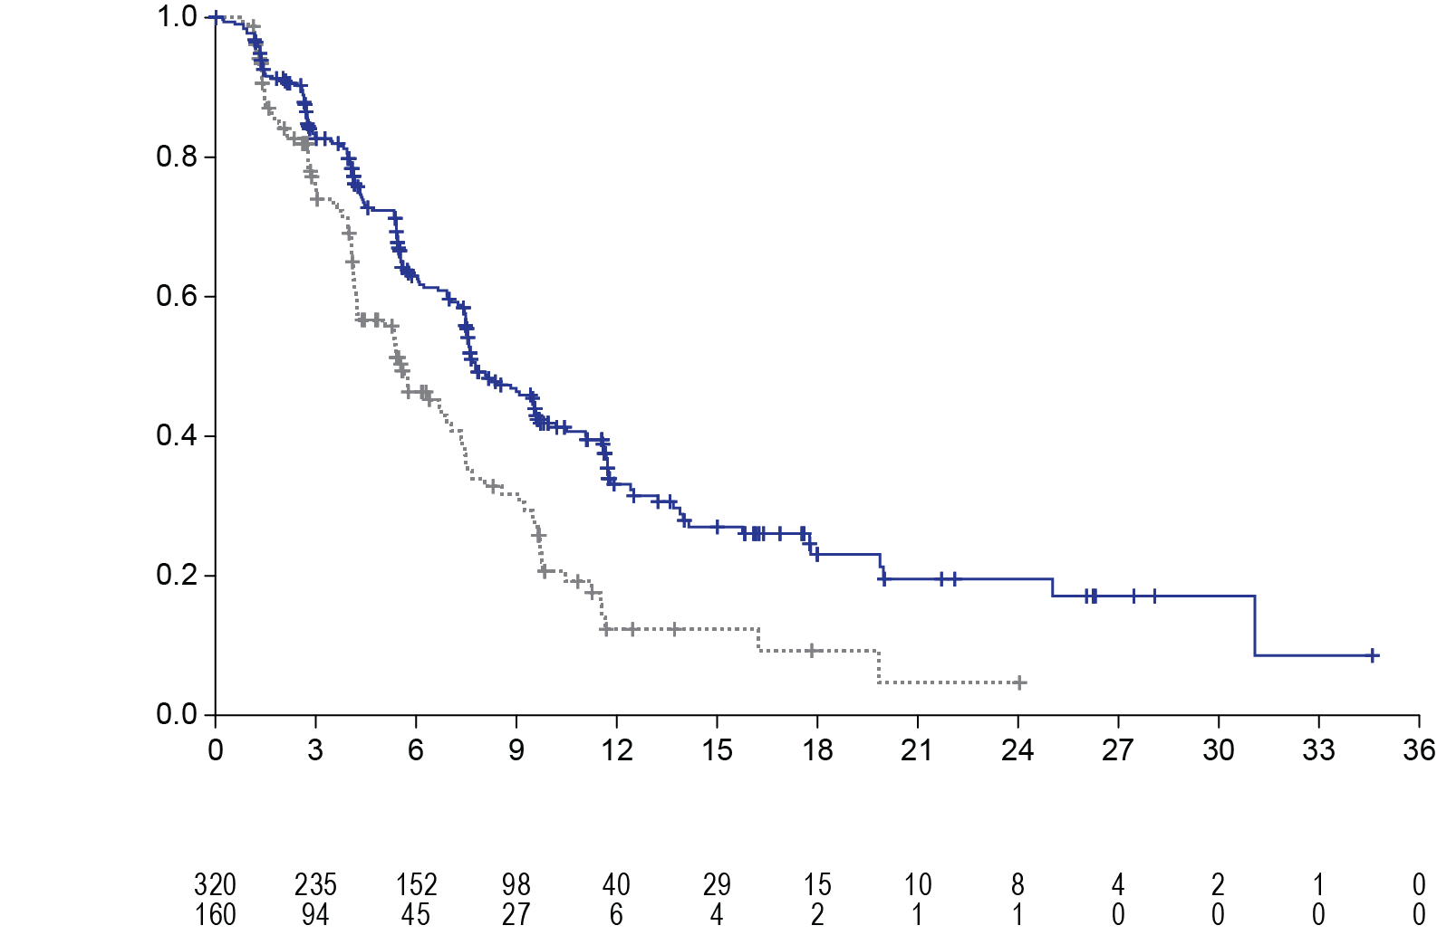

TUC+Tras+Cape

Pbo+Tras+Cape

Months since Randomization dRandomizrandomisation

Progression free survival (%)

**No. at Risk**

TUC+Tras+Cape

Pbo+Tras+Cape

Figure 2: Overall survival

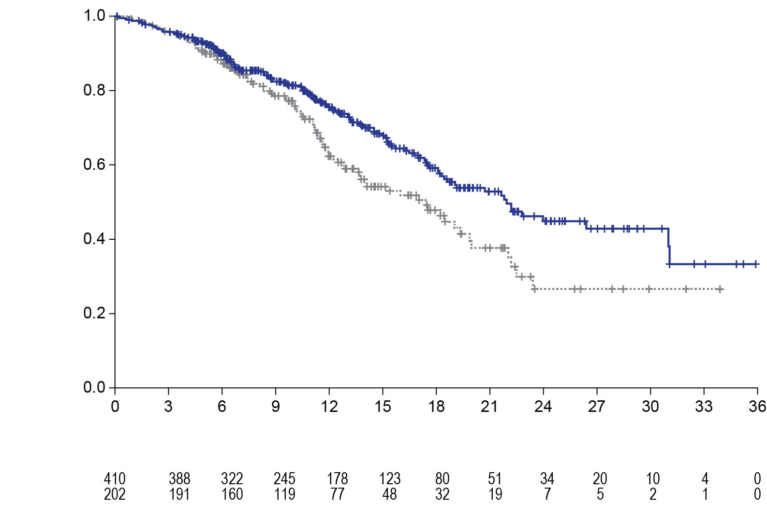

TUC+Tras+Cape

Pbo+Tras+Cape

Months since Randomisation

Overall survival (%)

**No. at risk**

TUC+Tras+Cape

Pbo+Tras+Cape

Figure 3: PFS per BICR in patients with brain metastases

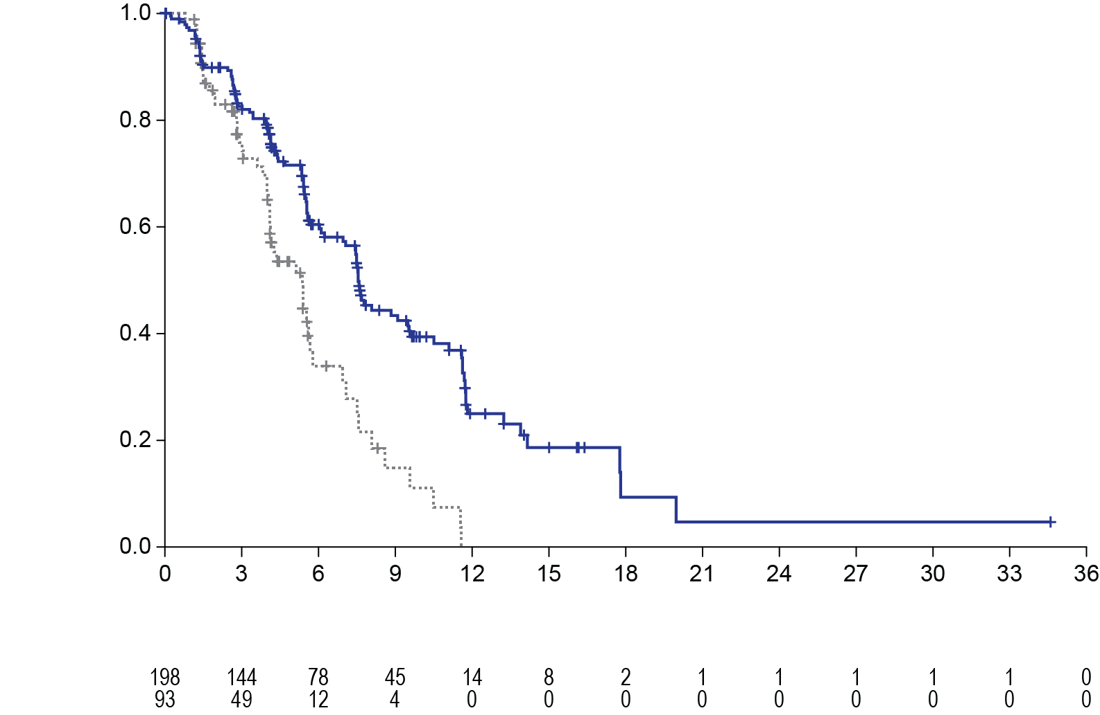

TUC+Tras+Cape

Pbo+Tras+Cape

Months since randomisation

Progression free survival (%)

**No. at risk**

TUC+Tras+Cape

Pbo+Tras+Cape

## Pharmacokinetic properties

Plasma tucatinib exposure (AUCinf and Cmax) demonstrated dose proportional increases at oral doses from 50 to 300 mg (0.17 to 1 times the recommended dose). Tucatinib exhibited 1.7-fold accumulation for AUC and 1.5-fold accumulation for Cmax following administration of 300 mg tucatinib twice daily for 14 days. Time to steady state was approximately 4 days.

### Absorption

Following a single oral dose of 300 mg tucatinib, the median time to peak plasma concentration was approximately 2 hours (range 1 to 4 hours).

Following administration of a single dose of tucatinib in 11 subjects after a high-fat meal (approximately 58% fat, 26% carbohydrate, and 16% protein), the mean AUCinf increased by 1.5-fold, the Tmax shifted from 1.5 hours to 4 hours, and Cmax was unaltered. The effect of food on the PK of tucatinib was not clinically meaningful.

### Distribution

The geometric mean (CV%) volume of distribution of tucatinib was 1670 L (66%). The plasma protein binding was 97.1% at clinically relevant concentrations.

### Metabolism

Tucatinib is metabolised primarily by CYP2C8 and to a lesser extent via CYP3A

### Excretion

Following a single oral dose of 300 mg [14C]-tucatinib, 86% of the total radiolabelled dose was recovered in faeces (16% of the administered dose as unchanged tucatinib) and 4% in urine with an overall total recovery of 90% within 13 days post-dose. In plasma, 76% of the plasma radioactivity was unchanged, 19% was attributed to identified metabolites, and 5% was unassigned.

### Pharmacokinetics in specific populations

Age (< 65 (n =211); ≥ 65 (n = 27)), albumin (25 to 52 g/L), creatinine clearance (60 to 89 mL/min (n = 89); 30 to 59 mL/min (n = 5)), body weight (41 to 138 kg), and race (white (n=168), black (n=53), or Asian (n=10)) did not have a clinically meaningful effect on tucatinib exposure.

*Renal Impairment*

No clinically significant differences in the pharmacokinetics of tucatinib were observed in patients with mild to moderate renal impairment (creatinine clearance: 30 to 89 mL/min by Cockcroft-Gault). The effect of severe renal impairment (creatinine clearance: < 30 mL/min) on the pharmacokinetics of tucatinib is unknown.

*Hepatic Impairment*

Mild (Child-Pugh A), moderate (Child-Pugh B) and severe (Child-Pugh C) hepatic impairment had no clinically relevant effect on tucatinib exposure. Tucatinib AUCinf was increased 1.6-fold and tucatinib Cmax was increased 1.2-fold in subjects with severe (Child-Pugh C) hepatic impairment compared to subjects with normal hepatic function.

## Preclinical safety data

### Genotoxicity

Tucatinib was not genotoxic in bacterial reverse mutation assays, an *in vitro* mammalian chromosome aberration assay and an *in vivo* mouse micronucleus assay.

### Carcinogenicity

Carcinogenicity studies have not been conducted with tucatinib.

# Pharmaceutical particulars

## List of excipients

Copovidone, crospovidone, sodium chloride, potassium chloride, sodium bicarbonate, silicon dioxide, magnesium stearate, microcrystalline cellulose, Opadry II Yellow 85F9272

## Incompatibilities

Incompatibilities were either not assessed or not identified as part of the registration of this medicine.

## Shelf life

In Australia, information on the shelf life can be found on the public summary of the Australian Register of Therapeutic Goods (ARTG). The expiry date can be found on the packaging.

## Special precautions for storage

Store below 25ºC.

## Nature and contents of container

150 mg blister presentation: 4 tablets per blister pack and 21 packs per carton.

50 mg blister presentation: 8 tablets per blister pack and 11 packs per carton.

oPA/ALU/PVC blister sealed with aluminium foil.

Not all pack sizes may be marketed.

## Special precautions for disposal

In Australia, any unused medicine or waste material should be disposed of in accordance with local requirements.

## Physicochemical properties

The chemical name for tucatinib is (N4-(4-([1,2,4]triazolo[1,5-a]pyridin-7-yloxy)-3-methylphenyl)-N6-(4,4-dimethyl-4,5-dihydrooxazol-2-yl)quinazoline-4,6-diamine. The molecular formula is C26H24N8O2 and the molecular weight is 480.52 g/mol.

### Chemical structure



### -CAS number

937263-43-9

# Medicine schedule (Poisons Standard)

Prescription Only Medicine (Schedule 4)

# Sponsor

AA-Med Pty Ltd.

Level 8, 1 Chandos Street

St Leonards

NSW 2065

# Date of first approval

13 August 2020

# Date of revision

Not Applicable

## Summary table of changes

|  |  |
| --- | --- |
| Section Changed | Summary of new information |
| N/A | New Document |