|  |
| --- |
| **Date of first round CER: April 2013**  **Date of second round CER: August 2013** |

|  |
| --- |
| AusPAR Attachment 2 |
| Extract from the Clinical Evaluation Report for turoctocog alfa (rch) |
| Proprietary Product Name: NovoEight |
| Sponsor: Novo Nordisk Pharmaceuticals Pty Ltd |

About the Therapeutic Goods Administration (TGA)

* The Therapeutic Goods Administration (TGA) is part of the Australian Government Department of Health, and is responsible for regulating medicines and medical devices.
* The TGA administers the *Therapeutic Goods Act 1989* (the Act), applying a risk management approach designed to ensure therapeutic goods supplied in Australia meet acceptable standards of quality, safety and efficacy (performance), when necessary.
* The work of the TGA is based on applying scientific and clinical expertise to decision-making, to ensure that the benefits to consumers outweigh any risks associated with the use of medicines and medical devices.
* The TGA relies on the public, healthcare professionals and industry to report problems with medicines or medical devices. TGA investigates reports received by it to determine any necessary regulatory action.
* To report a problem with a medicine or medical device, please see the information on the TGA website <<http://www.tga.gov.au>>.

About the Extract from the Clinical Evaluation Report

* This document provides a more detailed evaluation of the clinical findings, extracted from the Clinical Evaluation Report (CER) prepared by the TGA. This extract does not include sections from the CER regarding product documentation or post market activities.
* The words [Information redacted] indicate confidential information has been deleted.
* For the most recent Product Information (PI), please refer to the TGA website <<http://www.tga.gov.au/hp/information-medicines-pi.htm>>.

Copyright

© Commonwealth of Australia 2014  
This work is copyright. You may reproduce the whole or part of this work in unaltered form for your own personal use or, if you are part of an organisation, for internal use within your organisation, but only if you or your organisation do not use the reproduction for any commercial purpose and retain this copyright notice and all disclaimer notices as part of that reproduction. Apart from rights to use as permitted by the *Copyright Act 1968* or allowed by this copyright notice, all other rights are reserved and you are not allowed to reproduce the whole or any part of this work in any way (electronic or otherwise) without first being given specific written permission from the Commonwealth to do so. Requests and inquiries concerning reproduction and rights are to be sent to the TGA Copyright Officer, Therapeutic Goods Administration, PO Box 100, Woden ACT 2606 or emailed to <[tga.copyright@tga.gov.au](mailto:tga.copyright@tga.gov.au)>.

Contents

List of abbreviations 5

1. Clinical rationale 7

2. Contents of the clinical dossier 7

2.1. Scope of the clinical dossier 7

2.2. Paediatric data 8

2.3. Good clinical practice 8

3. Pharmacokinetics 8

3.1. Studies providing pharmacokinetic data 8

3.2. Pharmacokinetics in patients with haemophilia 10

3.3. Evaluator’s overall conclusions on pharmacokinetics 17

4. Pharmacodynamics 19

5. Dosage selection for the pivotal studies 19

6. Clinical efficacy 19

6.1. Overview of the clinical efficacy studies 19

6.2. Trial 3543: pivotal study 20

6.3. Trial 3545 36

6.4. Trial 3568: extension trial 46

6.5. Evaluator's conclusions on clinical efficacy 54

7. Clinical safety 57

7.1. Studies providing evaluable safety data 57

7.2. Exposure 57

7.3. Adverse events 58

7.4. Laboratory tests 62

7.5. Other safety parameters 62

7.6. Post-marketing experience 63

7.7. Safety issues with the potential for major regulatory impact 63

7.8. Safety in special populations 63

7.9. Evaluator's overall conclusion on clinical safety 64

8. First round benefit-risk assessment 66

8.1. First round assessment of benefits 66

8.2. First round assessment of risks 67

8.3. First round assessment of benefit-risk balance 68

9. First round recommendation regarding authorisation 69

10. Clinical questions 69

10.1. Pharmacokinetics 69

10.2. Pharmacodynamics 69

10.3. Efficacy 69

10.4. Safety 69

11. Second round evaluation of clinical data submitted in response to questions 70

11.1. Question 1 70

11.2. Question 2 71

11.3. Question 3 72

11.4. Question 4 72

11.5. Question 5 73

11.6. Question 6 73

11.7. Question 7 74

11.8. Question 8 74

12. Second round benefit-risk assessment 74

12.1. Second round assessment of benefits 74

12.2. Second round assessment of risks 76

12.3. Second round assessment of benefit-risk balance 77

13. Second round recommendation regarding authorisation 77

## List of abbreviations

| **Abbreviation** | **Meaning** |
| --- | --- |
| ALT | alanine transferase |
| aPTT | activated partial thromboplastin time |
| AST | aspartate transferase |
| AUC | area under the curve from time zero to infinity |
| BMI | Body mass index |
| BU | Bethesda unit |
| CER | Clinical Evaluation Report |
| CHMP | Committee for Medicinal Products for Human Use |
| CHO | Chinese hamster ovary |
| CI | confidence interval |
| CL | clearance |
| CTR | Clinical Trial Report |
| Cmax | maximum drug activity in plasma |
| ECG | electrocardiogram |
| ED | exposure days |
| EMA | European Medicines Agency |
| EU | European Union |
| FAS | full analysis set |
| FDA | US Food and Drug Administration |
| FVIII | coagulation factor VIII |
| FX | coagulation factor X |
| FXa | activated coagulation factor X |
| HCP | host cell protein |
| HCV | hepatitis C virus |
| HIV | human immunodeficiency virus |
| ICH | International Conference on Harmonisation |
| IgE | immunoglobulin E |
| IgG | immunoglobulin G |
| IgM | immunoglobulin M |
| IV | intravenous(ly) |
| ISTH | International Society on Thrombosis and Haemostasis |
| IU | international unit |
| kDa | kiloDalton |
| LLOQ | lower limit of quantification |
| MRT | mean residence time |
| PD | pharmacodynamic |
| PK | pharmacokinetic |
| rFVIII | recombinant coagulation factor VIII |
| SAS | safety analysis set |
| SD | standard deviation |
| t1/2 | half-life |
| WFH | World Federation of Hemophilia |

## Clinical rationale

The following clinical rationale was provided by the sponsor in the letter of application and is considered to be acceptable.

Haemophilia A, also known as classical haemophilia, is the most common subtype of haemophilia and is caused by a deficiency or abnormality of human blood clotting factor eight (FVIII). It is largely an X-linked inherited disorder affecting males, although in about 30% of cases there is no familial history of the disorder and the condition is the result of a spontaneous gene mutation. In Australia, the standard treatment for patients with haemophilia A is substitution therapy including intravenous (iv) administration of high-purity, plasma-derived FVIII concentrates or recombinant FVIII. Replacement therapy can be provided either as prophylaxis to prevent bleeding episodes, as surgical prophylaxis, or as on-demand treatment of bleeding episodes. Prophylactic therapy instituted early in life (prior to the onset of frequent bleeds) is recommended as optimal therapy for patients with severe haemophilia A (FVIII <1% of normal level) by national guidelines in Australia,[1] New Zealand,[2] and other international jurisdictions. In newly diagnosed persons with haemophilia A, administration of FVIII replacement therapy occurs in hospital or at a specialised haemophilia treatment centre. Over time, many individuals or their families undergo training which allows treatment to occur in the home setting.[3] The mechanism of action of turoctocog alfa is based on replacement of FVIII in patients with haemophilia A. Following injury to the vessel wall, the coagulation cascade is activated. Replacing the endogenous FVIII, turoctocog alfa acts as an important co-factor in the activation of FX in the human coagulation cascade, leading to thrombin generation and the formation of a stable haemostatic clot.

## Contents of the clinical dossier

### Scope of the clinical dossier

The submission contained the following clinical information:

* 3 clinical pharmacology trials, including PK and PD data;
* 2 pivotal efficacy/safety trials, including PK data;
* 1 efficacy/safety extension trial including ongoing patients from the two pivotal trials; and
* reports of bioanalytical and analytical methods for human studies;
* literature references.

### Paediatric data

The sponsor declared that there is a paediatric development program in place. The submission included paediatric pharmacokinetic, pharmacodynamic, efficacy and safety data. The submission included a pivotal efficacy and safety trial in children aged < 12 years (Trial 3543), and an on-going clinical efficacy and safety extension trial (Trial 3568) that included children from the pivotal paediatric trial. The sponsor also referred to an on-going phase 3b clinical efficacy and safety trial in children (not submitted).

### Good clinical practice

The submitted clinical trials were stated to have been conducted in accordance with the Declaration of Helsinki and the International Conference on Harmonisation (ICH) Guideline for Good Clinical Practice (GCP).

## Pharmacokinetics

### Studies providing pharmacokinetic data

#### Overview of pharmacokinetics trials

PK data for turoctocog alfa in male patients with severe haemophilia A (FVIII ≤ 1%) were derived from five completed clinical trials (three Phase I; two Phase III). These trials are outlined in Table 1. The submission included no PK data in healthy volunteers.

Table 1: Relative exposure in repeat dose toxicity studies.

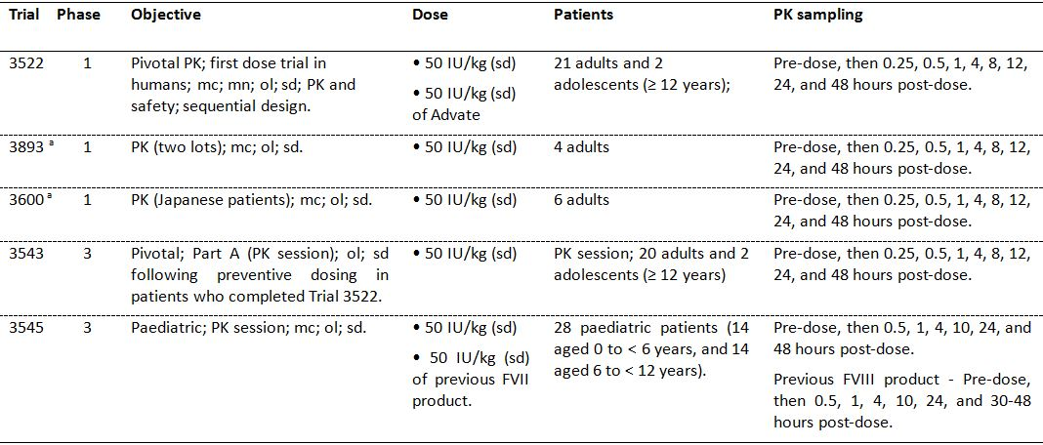

mc = multicentre; mn = multinational; ol = open-label; sd = single-dose

a. Trials 3600 and 3893: single dose PK assessment was preceded by preventive dosing for 3-6 months according to the dosing regimen in Trial 3543 (washout period of ≥ 4 days prior to the PK session)

As of the data cut off date of 21 November 2011, a total of 61 patients with haemophilia A had participated in trials that included full PK assessment of turoctocog alfa, and 28 of these patients were children aged < 12 years. Of the 61 patients, 22 had PK profiles from both Trial 3522 and Trial 3543.

All trials included previously treated male patients aged from 1 to 54 years with severe haemophilia A (FVIII activity level ≤ 1%), and no history of FVIII inhibitors. Patients were required to be non bleeding at the time of PK assessment. Previously treated adolescents aged ≥ 12 years and adults with a documented history of ≥ 150 exposure days to any FVIII product were included in Trials 3522, 3543, 3893 and 3600, and previously treated children aged < 12 years of age with a documented history of ≥ 50 days exposure to any FVIII product were included in Trial 3545.

The pivotal PK trial was considered to be Trial 3522, the first “in-human” Phase I dose trial. In this trial, the single dose PK profile of turoctocog alfa was investigated and compared with the single dose pharmacokinetic profile of octocog alfa (Advate) in adults and adolescent (aged ≥ 12 years). Patients from Trial 3522 continued treatment in the pivotal (adult) Phase III efficacy and safety trial (Trial 3543) during which second PK assessments were carried out after 3-6 months of preventive dosing with turoctocog alfa and were compared with first pharmacokinetic assessments from Trial 3522.

The PK of turoctocog alfa following single dose administration were investigated in paediatric patients aged < 12 years in the pivotal (paediatric) Phase III efficacy and safety trial (Trial 3545). In this trial, the pharmacokinetics of the patient’s previous FVIII product was investigated prior to first administration of turoctocog alfa.

The PK of turoctocog alfa were assessed in a small number of Japanese patients in Phase I Trial 3600), and the PK of two lots of turoctocog alfa were compared in a small number of patients in Trial 3893. In an ongoing Phase IIIb extension trial (Trial 3568), the PK of turoctocog alfa will be assessed prior to use of continuous infusion during surgery in paediatric, adolescent and adult patients. However, as of 21 November 2011, no patients undergoing surgery with continuous infusion had been included in the trial.

The clinical trials including patients with PK data were multinational and included patients from Germany, Israel, Italy, Japan, Lithuania, Macedonia, Malaysia, Poland, Russian Federation, Switzerland, Turkey, the UK and the US. The majority of the patients with PK data were “White”, while one PK trial was conducted in adult Japanese patients.

#### Dosage

A single intravenous (iv) dose of turoctocog alfa 50 IU/kg body weight was used for the pharmacokinetic assessment of the drug. This dose was within the estimated clinical dose range. All pharmacokinetic profiles from the clinical trials were obtained after dosing with 2000 IU vials, but in the paediatric trial (Trial 3545) children aged 0 to < 6 years were dosed with turoctocog alfa from either 250 or 2000 IU vials. There was a wash-out period before pharmacokinetic assessment of ≥ 4 days in patients aged ≥ 12 years, and ≥ 3 days in patients aged < 12 years. In all trials, blood sampling for pharmacokinetic assessment was undertaken at regular intervals throughout the 48 hours after administration of the trial product.

#### Pharmacokinetic parameters

The pharmacokinetic properties of turoctocog alfa were evaluated using standard pharmacokinetic parameters based on FVIII activity. It is common practice to use activity based assays as a surrogate endpoint for the assessment of the pharmacokinetic properties of coagulation products rather than drug concentrations. FVIII activity is known to correlate to the clinical efficacy of FVIII products.

The primary pharmacokinetic parameters were: (a) incremental recovery of FVIII defined as FVIII activity recorded 30 minutes after the end of an infusion relative to the administered dose [IU/mL]/[IU/kg]; (b) area under the curve from zero to infinity (AUC); (c) clearance (CL), total and weight-normalised; and (d) terminal half-life (t1/2). The secondary pharmacokinetic parameters were: (a) volume of distribution at steady state (Vss); (b) maximum concentration (activity) in plasma (Cmax); and (c) mean residence time (MRT).

The pharmacokinetic parameters in all studies were dose-adjusted and excluded data from pre-specified outliers. Identification of outliers was based on the following criteria: profiles with pre-dosing activity > 5% (possibly indicating inadequate wash-out); administered dose deviated more than 20% from the intended dose (i.e., dose outside the range 40-60 IU/kg); and profiles were not indicative of normal iv bolus administration. All pharmacokinetic parameters were calculated using standard non-compartmental methods based on the dose-adjusted profiles calculated by multiplying individual plasma FVIII activity levels by (planned dose)/(actual dose). In the pivotal trial (Trial 3522), the dose was adjusted based on both the actual dose (IU/kg) and the strength of the trial product (IU/vial) according to the certificates of analysis for turoctocog alfa and Advate.

The pharmacokinetic parameters were analysed by analysis of variance (ANOVA) after log-transformation. The MRTs were not log-transformed prior to analysis. In Trial 3522 pharmacokinetic parameters were calculated in a similar manner for Advate. The turoctocog alfa and Advate pharmacokinetic parameters were compared using a multiplicative linear mixed effects model, with treatment as a fixed effect and patient as a random effect. The treatment ratio for the two products was estimated from the model and presented together with the 90% confidence interval (CI).

#### Analytical methods

FVIII activity was determined using two assays, a one-stage activated partial thromboplastin time (aPPT) assay (clotting assay) and a two-stage chromogenic substrate assay (chromogenic assay). The clotting assay measures FVIII activity by time to clot formation, while the chromogenic assay is based on measuring the generation of activated factor X (FXa). Coagulation factor X (FX) is activated to FXa by FIXa, and FVIII acts as a cofactor for the reaction and accelerates the conversion of FX to FXa. At optimal concentrations of Ca2+ phospholipids and FIXa, and an excess of FX, the rate of activation of FX is linearly related to the amount of FVIII. The end-product FXa hydrolyses the chromogenic substrate and releases the chromogenic group, p-nitroanilide. The colour of the reaction is followed photometrically at 405 nm. Hydrolysis of the chromogenic substrate by thrombin is prevented by adding a thrombin inhibitor to the reaction mixture. The generated FXa, and consequently the intensity of colour, is proportional to the FVIII activity in the sample. As the reagents include thrombin this ensures that all FVIII is activated and the chromogenic assay measures the activity of all FVIII.

In both the clotting and chromogenic assays, the activity of turoctocog alfa is expressed in International Units (IU), which is related to the World Health Organisation (WHO) standard for FVIII products. One IU of FVIII activity is equivalent to the quantity of FVIII in 1 mL of normal human plasma. The lower limit of quantification (LLOQ) was 0.0125 IU/mL for both assays.

In the clinical trials conducted with turoctocog alfa, the mean FVIII activity measured after administration of turoctocog alfa was generally higher using the chromogenic assay compared with the clotting assay. The mean pharmacokinetic parameters (i.e., AUC, Cmax and incremental recovery) derived from the chromogenic assay were approximately 1.3-fold higher than those derived from the clotting assay. Neither age nor trial appeared to have any impact on the difference between the two assays.

### Pharmacokinetics in patients with haemophilia

#### Single-dose pharmacokinetics

The pharmacokinetics of turoctocog alfa after single-dose iv administration to previously treated adult and adolescent patients aged ≥ 12 years with haemophilia A was investigated in the pivotal pharmacokinetic trial (Trial 3522). In this trial, 25 patients were screened for entry (2 were screening failures) and 23 were eligible for inclusion and received trial product (both Advate and turoctocog alfa). The mean age of the 23 patients was 24 years (range: 13, 54), and 22 (95.7%) were “White/Caucasian” (not Hispanic or Latino).

Of the 23 patients, 2 had turoctocog alfa plasma profiles that were not indicative of a normal short iv, and 1 patient had a single outlying value in the turoctocog alfa plasma profile 30 minutes after dosing. In addition, 1 patient had a pre-turoctocog alfa FVIII activity of 0.105 IU/mL. The full analysis set (FAS) for the pharmacokinetic analyses, using data adjusted for actual dose and product strength and excluding outliers, included 23 patients exposed to Advate and 20 patients exposed to turoctocog alfa.

The key PK results for turoctocog alfa in the FAS are summarised below in Table 2.

Table 2: Trial 3522 – Single-dose (50 IU/kg) pharmacokinetics of turoctocog alfa (n = 20); FAS, dose-adjusted for actual dose and strength and excluding outliers.

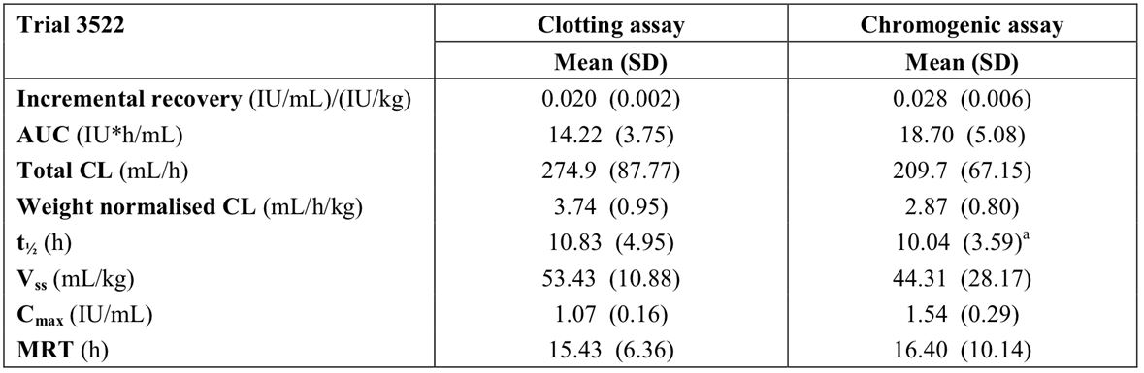

a = outlier excluded.

The FVIII activity level suggested biexponential decay after completion of the turoctocog infusion. In 17 out of 23 patients, FVIII activity was measurable for up to 48 hours post-dosing with turoctocog alfa. The mean residual FVIII activity level at 48 hours post-dosing was 0.03 IU/mL, ranging from 0.0125 IU/mL (LLoQ) to 0.13 IU/mL. The remaining 6 patients had FVIII values below the LLoQ at 48 hours post-dosing.

*Comment: In this trial the primary pharmacokinetic analyses were undertaken in the FAS using dose-adjusted data (i.e., adjusted for actual dose and for product strength) and excluding outliers. The actual doses administered deviated from the planned doses, and the actual strengths of trial product deviated from the labelled strengths. The dose-adjusted analyses give more precise estimates of the comparative pharmacokinetic properties of turoctocog alfa and Advate, given that the mean difference in the administered dose between the two products was 16% (i.e., 53.1 IU/kg Advate vs 45.8 IU/kg turoctocog alfa). The two batches of 1500 IU/vial Advate product used for the pharmacokinetic assessment in this trial contained 1505 IU/vial and 1622 IU/vial, respectively, and the 2000 IU/vial of turoctocog alfa contained 1944 IU/vial. When corrected for actual strength of trial products (i.e., IU/vial) the median administered dose of Advate was 54.0 IU/kg (mean: 53.1 IU/kg [range: 50.2, 57.3 IU/kg]), and the median administered dose of turoctocog alfa was 45.2 IU/kg (mean: 45.8 IU/kg [range: 42.4, 50.0 IU/kg]). Three (3) patients were considered to be outliers, while 1 patient had pre-dose FVIII activity.*

#### Pharmacokinetics following 3 to 6 months of preventive treatment

The pharmacokinetic profile after the first injection of turoctocog alfa (Trial 3522) was compared with the pharmacokinetic profile obtained after 3 to 6 months of preventive dosing with turoctocog alfa (Trial 3543). The preventive regimen in Trial 3543 was 20-40 IU/kg every second day or 20-50 IU/kg three times weekly, and patients received 36 to 65 doses of turoctocog alfa prior to the pharmacokinetic session. A single-dose of turoctocog alfa (50 IU/kg) was administered in the pharmacokinetic session of each trial, and Trial 3543 included a turoctocog alfa wash-out period of ≥ 4 days prior to the session.

Only patients with evaluable pharmacokinetic profiles in both trials were included in the comparison. As data from 3 patients were excluded from Trial 3522 and data from 4 patients were excluded from Trial 3543, the "compare analysis set" included 15 patients. The mean (SD) number of doses in the "compare analysis set" (n = 15) was 50.0 (8.5), the median number of doses was 48 (range: 36, 65), and the mean (SD) duration of treatment was 3.9 (0.7) months. The single-dose pharmacokinetic profiles from the two trials are summarised below in Table 3.

Table 3: Pharmacokinetic parameters of turoctocog alfa after first dose administration (Trial 3522) and after preventive dosing for 3-6 months (Trial 3543), adult and adolescent patients (n=15) with haemophilia A; compare analysis set (n=15), dose adjusted and outliers excluded.

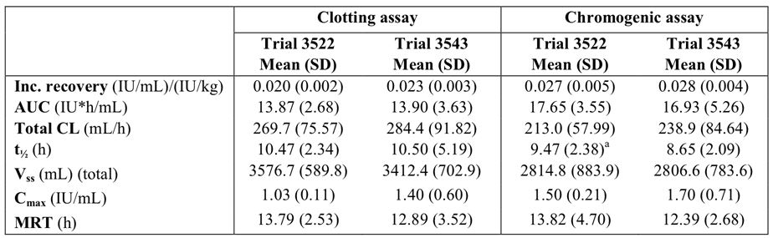

Note: Dose 50 /kg, single-dose; a = outlier excluded.

*Comment: The single-dose (50 IU/kg) pharmacokinetic parameters were similar after the first dose of turoctocog alfa (Trial 3522) and following 3-6 months of preventive treatment with the drug (Trial 3543). The ratios with 90% CIs for the pharmacokinetic endpoints from Trial 3522 and Trial 3543 in the "compare analysis set" were calculated, and the only endpoint for which the 90% CI was outside the interval of 0.8 to 1.25 was the terminal half-life (t1/2) measured by the chromogenic assay.*

#### Bioavailability and bioequivalence

##### Absolute bioavailability

Absolute bioavailability studies are not required as, by definition, products administered intravenously are 100% bioavailable.

##### Bioequivalence of clinical trial and market formulation

The composition of the reconstituted turoctocog alfa drug product examined in all clinical trials is identical to the product to be marketed.

##### Bioequivalence of different lots

In Trial 3893, in accordance with recommendations from the European Medicines Agency (EMA) the pharmacokinetic variation between individual turoctocog alfa production lots was investigated after single iv administration (50±5 IU/kg). This trial included only 4 adult patients, 2 allocated to each of the turoctocog alfa lots. There were no marked differences in the pharmacokinetic profiles of the two lots. However, due to the low number of observations (two PK profiles for each lot), no statistically meaningful conclusions can be drawn with respect to the pharmacokinetic similarity between the two lots.

##### Bioequivalence to relevant registered products

No studies were required testing the bioequivalence of turoctocog alfa and other registered rFVIII products. However, while the primary objective of Trial 3522 was to compare the single-dose (50 IU/kg) pharmacokinetic profiles of turoctocog alfa and Advate the trial also included an assessment of the bioequivalence of the two products. In order to claim bioequivalence between the two treatments, it was necessary to show that the 90% CI of the ratio of incremental recovery, t1/2, AUC and CL for the two treatments were contained within the bioequivalence interval (0.8-1.25). The bioequivalence criteria were in accordance with published guidelines.[4] The dose adjusted results assessed by clotting and chromogenic assays for 20 patients are summarised below in Table 4.

Table 4: Trial 3522 – Bioequivalence of turoctocog alfa and Advate; FAS (n=20) dose-adjusted and excluding outliers.

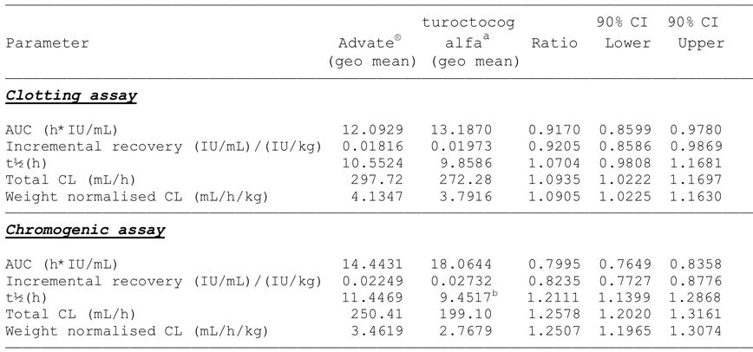

Note: N = 20; a = geometric means of endpoints; b = outlier excluded.

*Comment: For the clotting assay, the 90% CI for all parameters was contained within the interval of 0.8 to 1.25, which is the standard interval for demonstrating bioequivalence of two products. For the chromogenic assay, higher FVIII activity for turoctocog alfa compared with Advate was observed and bioequivalence was not demonstrated for any of the measured endpoints. In addition, overall FVIII activity following both turoctocog alfa and Advate were higher when obtained from the chromogenic assay than from the clotting assay. The sponsor states that the clinical observation relating to the difference in FVIII activity measured by the two assays is consistent with the results from the Field Study in which the performance of turoctocog alfa and Advate from different assays and laboratories was assessed and compared. A total of 36 laboratories participated in the international, multicentred, randomized, blinded, Field Study designed to evaluate and compare assay performance of turoctocog alfa and Advate in spiked haemophilic A plasma; 33 laboratories used the one-stage clotting assay; 5 used the chromogenic assay, and 2 laboratories used both assays. All results were collected and analysed centrally and comparable and consistent estimates of FVIII activity levels were observed for turoctocog alfa and Advate. In the Field Study, FVIII activities were greater when measured by the chromogenic assay compared with the one-stage clotting assay (30% and 19%, respectively) with both turoctocog alfa and Advate at the highest concentration of 0.9 IU/mL.*

##### Dose proportionality

There were no pharmacokinetic data on dose proportionality.

#### Absorption

The product is administered intravenously. Consequently, absorption studies are not required.

#### Distribution

The mean (SD) apparent volume of distribution at steady state (Vss) following single-dose turoctocog alfa (50 IU/kg) administered iv to adults and adolescent (n=20) with haemophilia A was 53.43 (10.88) mL/kg (clotting assay) and 44.31 (28.17) mL/kg (chromogenic assay).

*Comment: The Vss is small and indicates that turoctocog alfa is primarily confined to the vascular compartment with limited distribution to the extravascular space. There were no protein binding studies, but this is considered to be acceptable for a therapeutic rFVIII protein with a comparable structure to the naturally occurring FVIII protein.*

#### Metabolism

There were no in vitro studies or in vivo trials in humans investigating the metabolism of turoctocog alfa.

*Comment: The absence of metabolic studies is considered to be acceptable for a therapeutic rFVIII protein with a comparable structure and mechanism of action to the naturally occurring endogenous FVIII protein. It can be anticipated that turoctocog alfa will follow the same catabolic routes as endogenous FVIII.*

#### Excretion

In Trial 3522 the mean (SD) terminal half-life was 10.8 (5.0) hours measured by the clotting assay and 10.0 (3.6) hours measured by the chromogenic assay following a single-dose of turoctocog alfa (50 IU/kg) administered to adult and adolescent male patients (n=20). The mean (SD) total clearance (CL) of turoctocog alfa was 274.9 (87.8) mL/hour measured by the clotting assay and 209.7 (67.2) mL/hour measure by the chromogenic assay. There were no marked differences in the "compare analysis set" (n=15) for the terminal half-life and for the total clearance between single-doses of turoctocog alfa (50 IU/kg) assessed following the first dose (Trial 3522) and after 2-3 months of preventive dosing (Trial 3543).

*Comment: The terminal half-life of turoctocog alfa is about 10 to 11 hours (which is consistent with the in vivo half-life of FVIII of 8-12 hours4). The terminal half-life data from Trial 3522 and from the "compare analysis set" from Trials 3522 and Trial 3543 indicate that following single-dose turoctocog alfa (50 IU/kg) the drug will be eliminated in approximately 50 to 55 hours (i.e., five half-lives). In Trial 3522, in 17 out of 23 patients FVIII activity was measurable for up to 48 hours post-dosing of turoctocog alfa. The mean residual activity levels at 48 hours post-dosing was 0.03 IU/mL, ranging from 0.0125 IU/mL (LLoQ) to 0.13 IU/mL. The remaining 6 patients had FVIII values below the LLoQ at 48 hours post-dosing.*

*There were no data in the submission investigating renal or hepatic clearance of turoctocog alfa in humans. However, this is considered to be acceptable, although the relevant TGA adopted EMA Guideline on the Clinical Investigation of the Pharmacokinetics of Therapeutic Proteins[5] states that “the main elimination pathway should be identified”. However, the guideline goes on to state that for therapeutic proteins the elimination pathway “could be predicted to a large extent, from molecular size and specific studies may not be necessary. Catabolism of proteins occurs, usually by proteolysis”. The approximate molecular mass of turoctocog alfa is 166 kDa (calculated excluding post-translational modifications). As the molecular mass of the drug is greater than 50 kDA it can be predicted that elimination by tissue mechanisms, such as receptor mediated endocytosis followed by catabolism, is likely to be more important than elimination by renal filtration.[6] The EMA guideline also states that in the case of therapeutic proteins mass-balance studies “are not useful for determining the excretion pattern of the drug and drug-related material. Excreted proteins are not necessarily recovered in urine or faeces as intact substance, but instead are metabolised and reabsorbed as amino acids and incorporated in the general protein synthesis”.*

#### Pharmacokinetics in special populations

##### Pharmacokinetics in children with haemophilia A

The pharmacokinetics of a single-dose of turoctocog alfa in children (n=28) aged 0 to < 12 years with haemophilia A was investigated in Trial 3545. The mean age of the younger children aged 0 to < 6 years (n=14) was 3.7 years (range: 1−5 years) and the mean age of the older children aged 6 to < 12 years (n=14) was 8.2 years (range: 6-11 years). The dose-adjusted mean (SD) pharmacokinetic endpoints for turoctocog alfa following a single dose of 50 IU/kg in children aged 0 to < 6 years and 6 to < 12 years are summarised below in Tables 5 and 6, respectively.

Table 5: Trial 3545 - Children aged 0 to < 6 years (n=14), pharmacokinetic parameters of turoctocog alfa following single-dose (50 IU/kg); FAS, dose-adjusted.

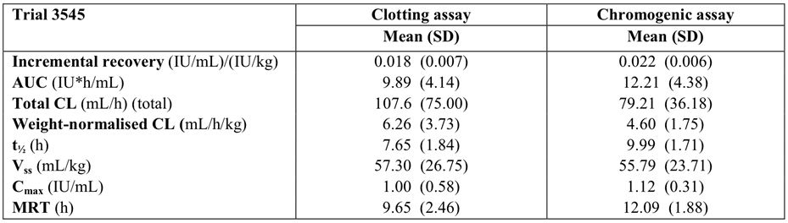

Table 6: Trial 3545 – Children aged 6 to < 12 years (n=14), pharmacokinetic parameters of turoctocog alfa following single-dose (50 IU/kg); FAS, dose-adjusted.

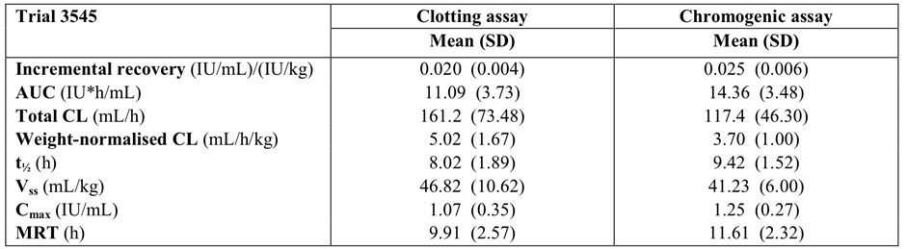

In study 3545, a pharmacokinetic assessment of the child’s previous FVIII product was investigated prior to first administration of turoctocog alfa in the "compare analysis set". Each patient received one dose of their previous FVIII product (50 IU/kg) and one dose of turoctocog alfa (50 IU/kg). The mean FVIII activity vs time profiles of turoctocog alfa and previous FVIII product were similar. Post-hoc statistical analyses compared the pharmacokinetic parameters of turoctocog alfa and the previous FVIII products using ratios with 90% CIs. The 90% CI for all primary pharmacokinetic parameters were within the interval of 0.8 to 1.25, with the exception of incremental recovery of FVIII activity which was slightly lower for the previous FVIII product than for turoctocog alfa when measured in the chromogenic assay. However, the results for the previous FVIII product represented a pool of different FVIII products and the pharmacokinetic profile for previous FVIII product was based on fewer sampling time points compared with the pharmacokinetic profile of turoctocog alfa.

*Comment: Overall, the pharmacokinetics were comparable between younger (0 to < 6 years) and older (6 to < 12 years) children. The main difference in the single-dose pharmacokinetics between the two age groups was the increased total clearance in older compared with younger children. However, the difference became less marked when clearance was weight-normalised. The pharmacokinetic profile of turoctocog alfa was similar to the pharmacokinetic profile of previous FVIII product. The number of patients in the "compare analysis set" used for the post-hoc analysis could not be identified, but cross-checking with the CTR for Trial 3545 suggests that it probably included 26 patients with pharmacokinetic data for both turoctocog alfa and previous FVIII product.*

*There were differences in the pharmacokinetic parameters of turoctocog alfa between children (Trial 3545) and adults (Trial 3543) with haemophilia A. The mean AUCs in younger (0 to < 6 years) and older (6 to < 12 years) children were 30% and 22% lower, respectively, than in adults using the clotting assay, and 35% and 23% lower than in adults using the chromogenic assay. The mean clearances in younger and older children were 67% and 34% higher, respectively, than in adults using the clotting assay, and 60% and 29% higher than in adults using the chromogenic assay. The mean terminal half-lives in younger and older children were 29% and 26% shorter, respectively, than in adults using the clotting assay, and 0.4% and 6% shorter than in adults using the chromogenic assay. The sponsor notes that the lower AUC, higher CL and shorter t1/2 seen in children compared to adults with haemophilia A following administration of turoctocog alfa have also been described for other FVIII products.[7]*

##### Pharmacokinetics in Japanese patients with haemophilia A

The pharmacokinetics of turoctocog alfa following a single-dose (50 IU/kg) in Japanese patients with haemophilia A (n=6) was investigated in Trial 3600. The results are summarised below in Table 7.

Table 7: Trial 3600 - Pharmacokinetics of turoctocog alfa following single-dose (50 IU/kg) in Japanese patients (n=6); FAS, dose-adjusted.

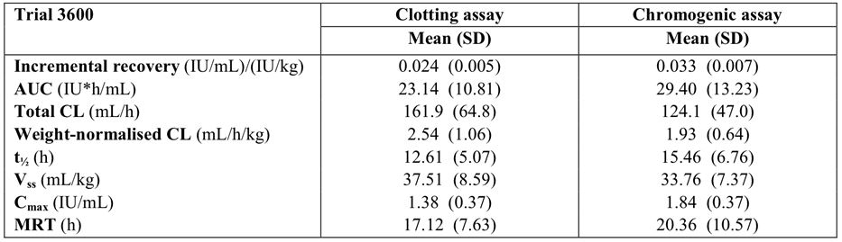

*Comment: There were differences between the pharmacokinetics of turoctocog alfa in Japanese patients (Trial 3600) and in predominantly “White” patients (Trial 3522). The differences were due to higher FVIII activity levels in Japanese patients, mainly occurring within the first 4 hours post-dosing. The mean incremental recovery was 20% and 18% higher in Japanese patients, based on clotting and chromogenic assays, respectively, than in "White patients". The mean AUC was 63% and 57% higher in Japanese patients, based on clotting and chromogenic assays, respectively, than in "White patients". The mean terminal-half life was 16% and 54% longer in Japanese patients, based on clotting and chromogenic assays, respectively, than in "White" patients. The sponsor considered that the difference in the age of the Japanese patients compared with the "white patients contributed to the differences seen in the pharmacokinetic endpoints. The mean age of the Japanese patients was 33 years, whereas the mean age of the "White" patients was 24 years. However, there are no confirmatory studies indicating that the relatively small mean age difference observed in Japanese and "White" adult patients is likely to affect the pharmacokinetics of turoctocog alfa.*

##### Pharmacokinetics in other special populations with haemophilia A

There no pharmacokinetic data for turoctocog alfa in female patients, elderly patients aged > 65 years, patients with hepatic impairment, and patients with renal impairment.

##### Pharmacokinetic interactions

There were no studies investigating PK interactions between turoctocog alfa and other drugs.

*Comment: The sponsor stated that “no drug interactions have been described for other rFVIII products, and no such studies were therefore initiated”.*

### Evaluator’s overall conclusions on pharmacokinetics

* The PK of turoctocog alfa for the treatment of haemophilia A are considered to have been adequately characterised. The product is a therapeutic protein and once activated by thrombin cleavage the resulting rFVIII has the same structure as endogenous activated FVIII.
* Single dose (50 IU/kg) PK data were available from a total of 61 previously treated male patients aged from 1 to 54 years with severe haemophilia A (FVIII activity ≤ 1%). Of these 61 patients, 22 had PK data from both Trial 3522 (Phase I) and Trial 3543 (Phase III), and 28 were children aged < 12 years from Trial 3545 (Phase I). There were no repeat dose PK data, although Trial 3543 (Phase III) included single dose data on patients from the pivotal Phase I PK trial (Trial 3522) following 2 to 3 months of preventive dosing with turoctocog alfa.
* The composition of the reconstituted turoctocog alfa drug product used in all clinical trials was identical to the product to be marketed. No specific bioavailability or bioequivalence trials were performed. However, in the pivotal Phase I PK trial (Trial 3522) the bioequivalence of turoctocog alfa and Advate was investigated in 20 patients, although the trial was not specifically designed to test bioequivalence. The trial showed that the two rFVIII products administered at a dose of 50 IU/kg were bioequivalent as regards AUC, incremental recovery, half life (t1/2), total clearance (CL), and weight normalised CL when the parameters were measured using the clotting assay, but were not bioequivalent when the parameters were measured using the chromogenic assay. However, the observed differences between the two rFVIII products in the PK parameters measured by the chromogenic assay are unlikely to be clinically significant.
* In the clinical trials, mean FVIII activity after administration of turoctocog alfa was generally higher when measured using the chromogenic assay compared with the clotting assay. In the pivotal Phase I PK trial (Trial 3522), factor FVIII activity following single dose turoctocog alfa (50 IU/kg) was greater in patients (n = 20) when measured using the chromogenic assay than the clotting assay: mean incremental recovery was 40% higher (0.028 versus 0.020 [IU/mL]/[IU/kg]); mean AUC was 32% higher (18.70 versus 14.22 IU*h/mL); and Cmax was 44% higher (1.54 versus 1.07 IU/mL).
* The PK of turoctocog alfa were similar in patients (n = 15) after the first single dose of turoctocog alfa (Trial 3522) and after a single dose following 3-6 months of preventive treatment with the drug (Trial 3543). The 90% confidence intervals (CIs) for the ratios of the PK parameters at the two time points were within the interval 0.80 to 1.25 for all endpoints, apart from the terminal half life measured by the chromogenic assay. In particular, there were no noteworthy changes in incremental recovery between the two time points. The results suggest that there is unlikely to be loss of efficacy over time.
* The sponsor undertook a trial (Trial 3893) in adult patients (n = 4) comparing the PK of turoctocog alfa from two production lots in order to meet a request from the European Union regulatory authorities to evaluate the PK properties of the drug in at least three production lots. There were no marked differences in the PK profiles of the two lots. However, due to the low number of observations (two PK profiles for each lot), no statistically meaningful conclusions can be drawn with respect to the pharmacokinetic similarity between the two lots.
* The mean (SD) apparent volume of distribution at steady state (Vss) in adults and adolescent patients (n = 20) was small as measured by both the clotting assay (53.43 [10.88] mL/kg) and the chromogenic assay (44.31 [28.17] mL/kg). The low Vss suggests that following IV administration, turoctocog alfa remains primarily in the intravascular compartment with limited distribution to the extravascular compartments.
* The mean t1/2 in adults and adolescent patients (n = 20) was approximately 10 to 11 hours, indicating that following IV administration turoctocog alfa is likely to be eliminated from the plasma in approximately 50 to 55 h. The mean (SD) total CL of turoctocog alfa was 274.9 (87.8) mL/h measured by the clotting assay and 209.7 (67.2) mL/h measured by the chromogenic assay. There were no studies investigating the metabolism of turoctocog alfa or its renal clearance. However, as the drug is a protein with a molecular mass of ~166 kDA, it can be predicted that it will eliminated by tissue mechanisms, such as receptor mediated endocytosis followed by catabolism, rather than by hepatic metabolism or renal excretion.
* In Trial 3545, the pharmacokinetics of turoctocog alfa was investigated in children (n = 28) with haemophilia A aged < 12 years of age. The trial showed that the pharmacokinetics of the drug were similar in children aged 0 to < 6 years and 6 to < 12 years. However, in children aged < 12 years the AUC was lower, the CL was higher, and the t1/2 was shorter compared with adults and adolescents aged ≥ 12 years. The observed differences in the PK of turoctocog alfa in children and adults in the submitted data have also been reported for other FVIII products. In children, the PK of turoctocog alfa were similar to the PK of a range of other FVIII products taken prior to turoctocog alfa. There were no data on the PK turoctocog alfa patients aged less than 1 year or more than 54 years.
* There were differences between the pharmacokinetics of turoctocog alfa in Japanese patients (Trial 3600) and in “White” patients (Trial 3522). These differences were primarily due to higher FVIII activity levels in Japanese patients, mainly occurring within the first 4 h post dosing. However, there was a notable imbalance in patient numbers between the two racial groups (6 Japanese versus 23 “White”) suggesting that the observed differences should be interpreted cautiously. There were no pharmacokinetic data for racial groups other than “White” or Japanese.
* There were no data on the PK of turoctocog alfa in patients with renal or hepatic impairment. There were no data on PK interactions between turoctocog alfa and other drugs. There were no data on the PK of turoctocog alfa in female patients with haemophilia A. However, it is considered that the absence of PK data in these special populations should not preclude registration of turoctocog alfa.

## Pharmacodynamics

PK assessments were based on the FVIII activity assay. This parameter is known to correlate to clinical efficacy of FVIII products. Therefore, FVIII activities are considered to be PD in nature as they reflect the biologic response to turoctocog alfa. No other specific PD endpoints were assessed.

## Dosage selection for the pivotal studies

The protocol of the pivotal (adult) Phase 3 trial (Trial 3543) discussed the rationale for treatment and noted that the preclinical pharmacokinetics of turoctocog alfa and Advate were similar. Therefore, based on these results the protocol commented that it was reasonable to expect that turoctocog alfa will demonstrate comparable pharmacokinetics to existing plasma and recombinant products. Consequently, the protocol stated that it is expected that turoctocog alfa dosing will be the same as that of similar marketed products, and the same potency and efficacy is expected for the drug as for marketed products.

*Comment: The submission included no clinical dose ranging studies and the proposed dosing was based on the comparable preclinical pharmacokinetics of turoctocog alfa and Advate. The clinical pharmacokinetic data in adults indicates that single-doses (50 IU/kg) of turoctocog alfa and Advate are bioequivalent, and the clinical pharmacokinetic data in children indicates that the single-doses (50 IU/kg) of turoctocog alfa and FVIII products (pooled) have comparable pharmacokinetic profiles. The proposed dosages for turoctocog alfa for the proposed indications are identical to those approved for Advate. Based on the available preclinical and clinical data it is considered that the turoctocog alfa dosing regimens used in pivotal adult and paediatric clinical efficacy and safety trials are acceptable.*

## Clinical efficacy

### Overview of the clinical efficacy studies

The application to register turoctocog alfa for the proposed indication was supported by three Phase III, multi national, multi centred, uncontrolled, open label, single arm efficacy and safety studies in previously FVIII treated male patients with severe haemophilia A (FVIII activity ≥ 1%) without inhibitors. The three studies are outlined below in Table 8. As of the data cut off date of 21 November 2011, a total of 214 patients had been exposed to turoctocog alfa. Each of the three clinical efficacy and safety studies has been fully evaluated in this clinical evaluation report. Each of the three studies was sponsored by the sponsor.

Table 8: Overview of the three Phase III clinical efficacy and safety trials.

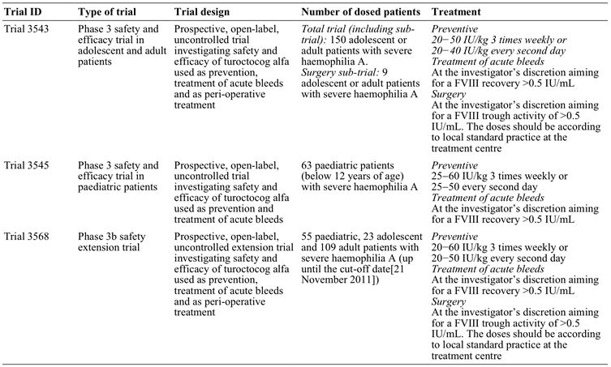

*Comment: There were no studies in females with severe haemophilia A. However, Haemophilia A is rare in women. Data in the Australian Bleeding Disorders Registry Annual Report 2010-2011 indicates that the prevalence of severe haemophilia in men at 30 June 2011 was 56 times that of women (5.6 patients/100,000 males versus 0.1 patients/100,000 females). These figures indicate that women comprised ~1.8% of the total population of patients with severe haemophilia A in Australia at 30 June 2011. The sponsor argues that as haemophilia is extremely rare, “it is impossible to include woman in the development programme in order to obtain usable data”. The sponsor’s rationale for not including women patients in the clinical trial program is acceptable. Furthermore, it is considered unlikely that the efficacy and safety of turoctocog alfa will significantly differ between male and female patients with haemophilia A.*

### Trial 3543: pivotal study

#### Study design, objectives, location and dates

##### Design

Trial 3543 was designed as a Phase 3, multi-national, multi-centred, open-label, single-arm, efficacy and safety trial in patients with severe haemophilia A (FVIII activity ≤ 1%). The treatment period was approximately 20 to 28 weeks per patient depending on the frequency of preventive dosing The sponsor stated that the data from Trial 3543 were intended to provide pivotal information regarding the safety and efficacy of turoctocog alfa for the treatment of patients with haemophilia A. The trial had three parts:

* Part A included only patients who had completed the pivotal PK Trial 3522. Patients in Part A underwent a second PK assessment 3 to 6 months after preventive treatment with turoctocog alfa. Apart from the second PK assessment, the treatment and assessment of patients in Part A were identical to the patients in Part B.
* Part B aimed to included patients who had not previously participated in the pivotal PK Trial 3522.
* Part C (surgery sub-trial) included patients from Part A or Part B who had received at least one dose of turoctocog alfa and needed a major or minor surgical procedure during the course of the trial that required at least 7 days of daily FVIII treatment, including the day of surgery.

##### Objectives

* Primary objective for Parts A, B, and C:
  + To assess the incidence rate of FVIII inhibitors (≥0.6 BU).
* Secondary objectives for Parts A and B:
  + To evaluate the clinical efficacy of turoctocog alfa in bleeding prevention in patients with haemophilia A.
  + To evaluate the clinical efficacy of turoctocog alfa when treating bleeds in patients with haemophilia A.
  + To evaluate the safety of turoctocog alfa when used for prevention of bleeds and treatment of mild/moderate and severe bleeds in patients with haemophilia A.
  + To assess changes in patient-reported outcomes (PROs) from screening to end of trial.
  + Part A only: to describe and compare the pharmacokinetic profile of turoctocog alfa in patients who participated in both this trial and Trial 3522.
* Secondary objective for Part C:
  + To evaluate the efficacy of turoctocog alfa during surgical procedures in patients with haemophilia A.
  + To evaluate the haemostatic response to turoctocog alfa in the post-surgery period for patients with haemophilia A.
  + To evaluate the safety of turoctocog alfa when used for prevention and treatment of bleeding during surgical procedures and in the post-surgery period in patients with haemophilia A.
  + To assess changes in PROs from pre-surgery to last day of the surgical recovery period.

##### Locations and dates

The patients were recruited from 48 sites in 15 countries: Brazil (2 sites), Croatia (2 sites), Germany (4 sites), Israel (1 site), Italy (2 sites), Japan (8 sites), Malaysia (1 site), Russian Federation (1 site), Republic of Serbia (5 sites), Spain (2 sites), Switzerland (1 site), Taiwan (1 site), Turkey (5 sites), the UK (3 sites) and the US (10 sites). One principal investigator was appointed for each trial site.

The first patient visit was 7 April 2009, the last patient visit was 21 September 2011, and the report was dated 8 February 2012. The results presented in the clinical trial report (CTR) reflected data available in the clinical database as of 18 October 2011. The database was updated on 20 December 2011 in order to correct the unit used for the surgical haemoglobin values "pre-surgery" and "1 hour post surgery".

*Comment: The primary objective for Parts A, B, and C of Trial 3543 was the incidence rate of FVIII inhibitors (≥ 0.6 BU). This is a safety (immunogenicity) endpoint rather than an efficacy endpoint, and the trial specifies clinical efficacy endpoints as secondary rather than primary objectives. The sponsor comments that the original primary objective of Trial 3543 was efficacy, but was changed to safety by Protocol Amendment 14 (dated 15 October 2009) as a result of FDA feedback to the sponsor regarding the protocol. However, in an advice letter to the sponsor from the Committee for Medicinal Products for Human Use (CHMP) of the EMA, the CHMP stated that it did not agree to have clinical efficacy as a secondary endpoint as recommended by FDA, and further stated that it will consider the clinical efficacy data as a primary endpoint when assessing the results of the trial.*

*The trial was open-label and single arm in design. The sponsor states that the use of a placebo control arm would have been "unethical due to the risk of serious bleeding complications". This justification is considered to be acceptable. The sponsor states that the "inclusion of an active comparator product was considered irrelevant as turoctocog alfa is replacement therapy". This justification is considered to be somewhat unusual as it is conceivable that there could be differences in efficacy and safety between two "replacement" therapies. However, the PK data from the pivotal Phase 1 PK trial (Trial 3522) showed that turoctocog alfa (50 IU/kg) and Advate (50 IU/kg) were bioequivalent when the relevant PK parameters were assessed by the clotting assay, although not when assessed by the chromogenic assay. However, the observed differences in the PK parameters between turoctocog alfa and Advate measured by chromogenic assay are unlikely to be clinically significant. It can be reasonably inferred from the available clinical data that the efficacy and safety of turoctocog alfa and TGA approved Advate are likely to be similar. Furthermore, the clinical development program for turoctocog alfa is consistent with that outlined in the published guidelines.[8]*

#### Inclusion and exclusion criteria

The key inclusion criteria were: male patients with a diagnosis of severe (FVIII ≤ 1%) haemophilia A aged from 12 to 56 years and weighing from 10 to 120 kg; willing to undergo preventive treatment of 75 days exposure; documented history of at least 150 days exposure to any other FVIII products; no history of FVIII inhibitors; and no detectable inhibitors to FVIII (≥ 0.6 BU) at the time of screening. Patients with any known congenital or acquired coagulation disorders, other than congenital haemophilia A, were excluded from the trial. HIV seropositive patients with HIV viral load ≥ 400,000 copies/mL and CD4+ lymphocyte counts < 200 µL were also excluded. In addition, patients with severe hepatic dysfunction or severe hepatic disease during the 12 months preceding the trial were excluded, as were patients with creatinine levels 50% above the normal level.

Each of the three parts of the trial had their own inclusion criteria, while Parts A and B had the same exclusion criteria. However, patients were only eligible to participate in Part C if they had been included in either Part A or Part B and received at least one dose of turoctocog alfa. Therefore, patients in Part C did not require separate exclusion criteria.

Patients could withdraw from the trial at any time. In addition, patients could be withdrawn from the trial at any time at the discretion of the investigator or sponsor. The trial included pre-specified withdrawal criteria. If considered relevant, all data collected prior to withdrawal could be used in the analysis of the trial. Patients who were withdrawn from the trial prior to administration of the trial product could be replaced until 140 patients had received trial product.

#### Study treatment

##### Overview of treatments

The study treatments in Parts A and B are summarised below in Table 10, and Part C in Table 11.

Table 9: Trial 3543 - Overview of study treatments in Part A and Part B.

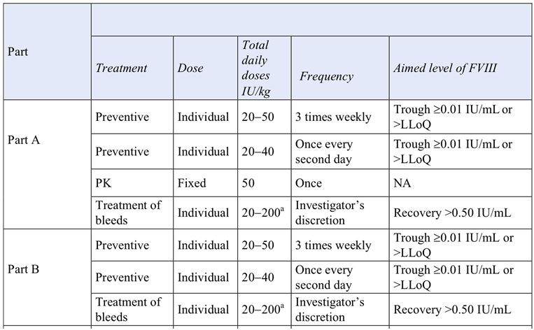

a = Trial product could be administered more than once a day. LLoQ = Lower limit of quantification; NA = Not applicable.

Table 10: Trial 3543 - Overview of study treatment in Part C.

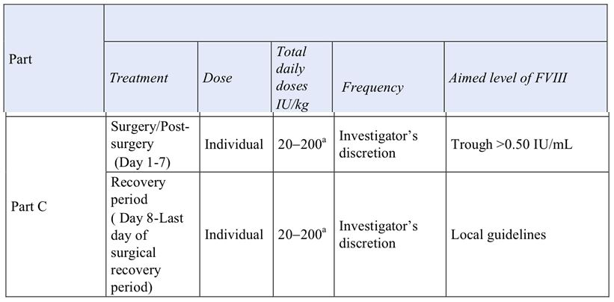

a = Trial product could be administered more than once a day. LLoQ = Lower limit of quantification; NA = Not applicable.

##### Treatment in Part A or Part B

**In Part A or Part B,** doses were individualised based on the trough FVIII activity level (i.e., lowest level of FVIII activity measured by the local laboratory immediately prior to dosing and expressed as IU/mL). The preventive dose levels were 20-40 IU/kg every second day or 20-50 IU/kg three times per week. The sponsor stated that these doses are recommended by the International Society for Thrombosis and Haemostasis (ISTH), and published guidelines.[9] The frequency of dosing (either every second day or three times per week) was selected at the investigator’s discretion, and the frequency of dosing could be changed if deemed necessary by the investigator. In Parts A and B, treatment for prevention of bleeds or for treatment of bleeds was carried out at home by the patient or a support person.

**For preventive treatment,** the initial dose was 20 IU/kg administered every second day or three times per week to achieve a trough FVIII activity level ≥ 0.01 IU/mL or above the assay lower limit of quantification (LLoQ) of the clinic. If the trough FVIII activity level was below the assay LLoQ of the clinic, the dose could be increased by 5 IU/kg to a level that secured prevention of bleeds. Dose adjustments could be performed at planned as well as at unscheduled visits. If the trough FVIII activity level was ≥ 0.01 IU/mL or above the assay LLoQ of the clinic and a bleed occurred, the dose could be increased until no bleeding occurred.

**For the treatment of bleeds,** the bleed had to be treated as soon as identified. The dose was chosen to achieve an expected post-injection FVIII activity level of at least 0.50 IU/mL. The number of doses and frequency of dosing was decided by the investigator. For the treatment of severe bleeds, doses up to 200 IU/kg per day could be used at the discretion of the investigator. Blood sampling to assess post-injection FVIII activity levels by the local laboratory could be done at the discretion of the investigator. If a haemostatic response was not achieved after 48 hours using maximum doses (up to 200 IU/kg per day) of turoctocog alfa when treating bleeds, another FVIII product could be selected at the discretion of the investigator. The use of other FVIII products resulted in withdrawal of the patient from the trial.

##### Treatment in Part C

The trial period for individual patients undergoing surgery was divided into two time periods: (a) surgery period (C1) consisted of pre-surgery Day and then Days 1, 2, 3, 4, 5, 6 and 7 where Day 1 was the day of surgery; and (b) surgical recovery period (C2) consisted of Day 8 to the last day for trial product infusion after surgery deemed appropriate (i.e., return to preventive treatment).

Dose adjustments in patients undergoing surgery were: (a) a **pre-surgery loading dose** of turoctocog alfa determined by the standard practice at the study site was received by all patients immediately prior to surgery; (b) in the **surgery period** turoctocog alfa was administered on the day of surgery (Day 1) through to and including Day 7, and the dose was adjusted aiming to keep the trough FVIII activity level above 0.50 IU/mL; and (c) in the **post-surgical period** turoctocog alfa was dosed according to standard practice at the site from Day 8 to the last day of the surgical recovery period (if relevant).

##### Prior and concomitant therapy

Concomitant medication was defined as any medication other than the trial product that was taken during the trial, including the screening and run-in periods. The following medications were not allowed during trial participation: (a) FVIII concentrates other than turoctocog alfa or other FVIII containing products; (b) with amendment 14, "whole blood" was added to the list of prohibited therapy/medication; (c) heparin (sealing of central venous access port was allowed), vitamin-K antagonists, and direct thrombin inhibitors from one week prior to first dosing of turoctocog alfa to end of trial (allowed in conjunction with Part C and other surgical procedures [OSPs]); (c) with amendment 15, "Fresh frozen plasma (FFP) and cryoprecipitate (allowed in conjunction with Part C and OSPs)" was added to the list of prohibited therapy/medication; and (d) with amendment 15, "turoctocog alfa 4 days prior to dosing and 48 hours post-dosing for the pharmacokinetic session (only applicable for part A)" was added to the list of prohibited therapy/medication. Treatment requiring bleeds were to be reported as "bleeding episodes" and related haemostatic treatment as "haemostatic concomitant medication". All bleeds were to be treated with turoctocog alfa.

#### Study visits

The relationship between the visits in Parts A, B, and C of the trial are provided schematically below in Figure 1.

Figure 1. Trial 3543 - Trial design for Parts A, B, and C.

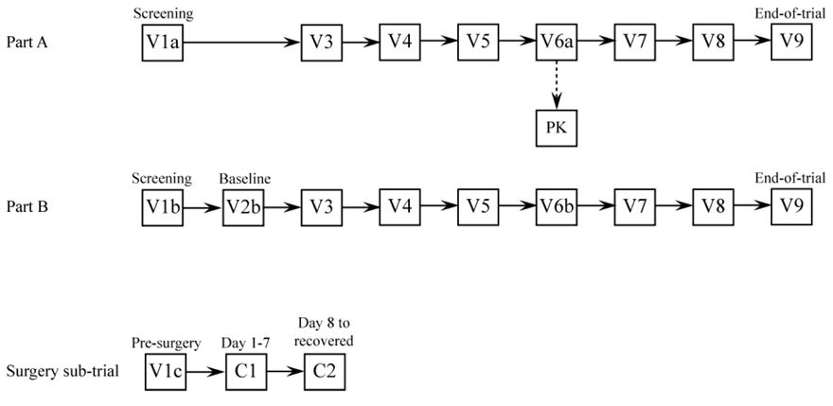

The main features of the trial visits (V) are summarised below:

* V1a or V1b were screening visits, and V1b was performed at least 48 hours after the last dose of the previous FVIII product.
* V2b was the baseline visit and was applicable only to patients in Part B of the trial, patients were required to have stopped their treatment with previous FVIII product at least 48 hours prior to visit V2b and had to be in a non-bleeding state (otherwise the visit was postponed). V2b lasted until 48 to 72 hours after the first turoctocog alfa administration, but no overnight stay at the treatment site was required.
* V3, V4, V5, V6b (applied only to patients in Part B), V 7 and V8. All assessment visits were to be performed on the day of planned trial product administration. All assessment visits had to take place at least 48 hours after the last dose of turoctocog alfa. In the event of a treatment requiring bleed, the assessment visit could be rescheduled. The trial product was administered after blood sampling to minimise potential interference of alfa turoctocog alfa on the assays.
* V6a was the pharmacokinetic session visit. It was applicable only to patients in Part A and took place at least 3 months after the first dose of turoctocog alfa. V6a consisted of Day -1, and Days 1 to 3, and patients could be admitted to hospital or accommodated as preferred by the investigator. A wash-out period of 4 days was required prior to turoctocog alfa dosing in the PK session.
* V9 was the end-of-trial (EOT) visit. For patients who completed 75 preventive exposure days or withdrew from the trial, the EOT visit was to occur within 28 days after the last dose of turoctocog alfa or prior to administration of another FVIII product. A wash-out period of at least 48 hours was required prior to the EOT visit.
* Follow-up visits were only applicable to patients who were withdrawn due to development of FVIII inhibitors.
* Unscheduled visits could be performed (telephone and clinic visit) in cases of severe bleeding or due to adverse events, dose adjustment, laboratory re-test or suspicion of inhibitor development.

#### Efficacy variables and outcomes

##### Assessment of the bleeding episodes (efficacy outcomes)

Bleeds and preventive treatment were recorded in a patient diary. Novo Nordisk data management entered the diary details into the trial database. Severe bleeds were to be recorded by the investigator in the eCRF and mild/moderate bleeds were to be recorded by the patient in the diary.

The following information was recorded for the bleeds:

* Date and time of onset of the bleed.
* Cause of the bleed (spontaneous or traumatic).
* Site of the bleed (central nervous system, joint, gastrointestinal, subcutaneous, muscular or other). Joint bleeds were either categorised as target joint or non-target joint bleeds. A target joint was defined as a joint with 3 or more bleeds within 6 months.
* Haemostatic drug used for treatment of the bleed (turoctocog alfa or other drug if haemostasis could not be achieved with turoctocog alfa, dose(s) and time(s) of administration).
* Other therapy used (compression/other).
* Date and time that the bleed stopped.
* The bleeds were categorised as mild/moderate or severe:
  + Mild/Moderate: Minor bleeds which were uncomplicated joint, muscular or subcutaneous bleeds.
  + Severe: Major bleeds which required hospitalisation. All head and neck bleeds were categorised as severe.
  + All mild/moderate bleeds which were active after 24 hours changed category to severe and treatment responsibility was transferred to the investigator.
* Clinical evaluation of haemostasis (none, moderate, good or excellent):
  + Excellent: abrupt pain relief and/or unequivocal improvement in objective signs of bleeding within approximately 8 hours after a single infusion.
  + Good: definite pain relief and/or improvement in signs of bleeding within approximately 8 hours after an infusion, but possibly requiring more than one infusion for complete resolution.
  + Moderate: probable or slight beneficial effect within approximately 8 hours after the first infusion; usually requiring more than one infusion.
  + None: no improvement, or worsening of symptoms.

**For preventive treatment,** dose level and date of time of dose administration were recorded in the diary.

**For haemostatic response during surgery,** clinical evaluation of haemostatic response was evaluated as: none (uncontrolled bleeding); moderate (blood loss more than expected); good (blood loss as expected); excellent (blood loss less than expected).

**For haemostatic response after surgery,** clinical evaluation was evaluated as: none (bleeding due to inadequate therapeutic response with adequate dosing, change of regimen required; moderate (less than optimal for the type of procedure, maintained without change of treatment regimen); good (as expected); or excellent (better than expected in this type of patient and for this type of procedure).

##### Secondary efficacy endpoints - Parts A and B

* Bleeding prevention
  + Total consumption of turoctocog alfa per patient (prevention and treatment of bleeds) per month.
  + Actual consumption of turoctocog alfa (IU/kg/month) for prevention.
  + Average number of bleeds per month.
* Treatment of bleeds
  + Haemostatic effect of turoctocog alfa evaluated according to a predefined four grade scale none, moderate, good or excellent). See paragraph a (above) for definitions.
  + Number of infusions of turoctocog alfa required per bleeding episode.
  + Time to control of bleeding after the first dose of turoctocog alfa used for treatment of bleeds.
  + Actual consumption of turoctocog alfa (IU/kg/month).

##### Secondary efficacy endpoints - Part C

* Haemostatic effect of turoctocog alfa assessed by evaluation according to a predefined four grade scale (none, moderate, good, excellent). See paragraph above for definitions during surgery and after surgery.
* Actual consumption of turoctocog alfa (IU/kg) in the time period Day 1 to Day 7 and in the time period Day 8 to return to preventive treatment.
* Comparison of actual and anticipated blood loss.
* Haemoglobin level prior to surgery, during, and after surgery.
* Blood product transfusion.

#### Randomisation and blinding methods

Randomisation and blinding were not applicable as the trial was open-label and single-arm.

#### Analysis populations

All main descriptions and analyses of safety, efficacy, and pharmacokinetic data were based on the full analysis set (FAS). The FAS included all dosed patients with data after dosing. No formal per-protocol analysis was planned. The safety analysis set was identical to the FAS. The analyses of PK endpoints were based on the FAS, excluding outlier PK profiles and outlier individual plasma concentrations, and normalised to planned dose.

#### Sample size

The sample size was not based on the secondary efficacy endpoints, but on the primary safety endpoint (i.e., the incidence rate of FVIII inhibitors [≥0.6 BU]). To be able to conclude adequate safety with regard to inhibitor formation the upper 1-sided 97.5% confidence limit for the incidence rate of FVIII inhibitor needed to be below 6.8%. If 3 inhibitors out of 127 patients were observed the upper 1-sided 97.5% confidence limit was below 6.8%. In order to allow for a 10% withdrawal rate before the 50 exposure days, the trial was planned to have 140 patients dosed with turoctocog alfa. If the true inhibitor rate was 2% (in line with that been seen for other FVIII products) then the chance of seeing 3 or less inhibitors out of 140 dosed patients was 69%. Therefore, the trial aimed to dose approximately 140 patients and to have 127 patients with a minimum of 50 exposure days.

#### Statistical methods

No formal testing of statistical hypotheses was performed for the secondary efficacy endpoints, and evaluation of data was based on descriptive statistics. An interim analysis of the safety and efficacy of turoctocog alfa took place after the first 20 patients had 50 exposures in order to initiate the paediatric trial (Trial 3545).

**Consumption of turoctocog alfa:** Total actual consumption of turoctocog alfa (IU/kg) per patient was calculated for the prevention of bleeds (per month and per year), for the treatment of bleeds (from start to stop) and for the prevention plus the treatment of bleeds.

**Prevention:** The annualised bleeding rate was estimated in total and by cause of bleed (spontaneous, traumatic or other) using a Poisson model allowing for overdispersion.

**Treatment of bleeds:** The haemostatic effect of turoctocog alfa used for treatment of acute bleeds was evaluated according to a four-point scale (none, moderate, good or excellent). If the haemostatic response was rated as excellent or good, treatment was counted as a success. If the haemostatic response was rated as moderate or none, treatment was counted as a failure. The haemostatic effect of turoctocog alfa was also summarised by cause of bleed (spontaneous or traumatic or other), site of the bleed (central nervous system, joint, gastrointestinal, subcutaneous, muscular or other), classification of the bleed (mild/moderate or severe), time of the bleed (day divided into 6 time intervals, each of 4 hours), and compliance with treatment (good compliance or less compliance).

#### Participant flow

A total of 172 patients were screened and 150 of these patients were treated with turoctocog alfa. Of the 150 treated patients, 22 had previously participated in the pivotal PK trial (Trial 3522) and were included in Part A Trial 3543. The remaining 128 treated patients who had not previously been exposed to turoctocog alfa were included in Part B of Trial 3543. In addition, 9 patients from Part or B participated in the surgery sub-trial (Part C), and after surgery these patients transferred back to Part A or B. Of the 150 treated patients, 24 were adolescents (aged 12 to <18 years) and 126 were adults (ages ≥ 18 years). Of the 24 adolescent patients, 2 were included in Part A and 1 was included in Part C. Of the 150 treated patients, 4 (2.7%) patients (4 adults and 1 adolescent) withdrew from the trial. Patient disposition (including reasons for withdrawal) are summarised below in Table 11.

Table 11: Trial 3543 - Patient disposition.

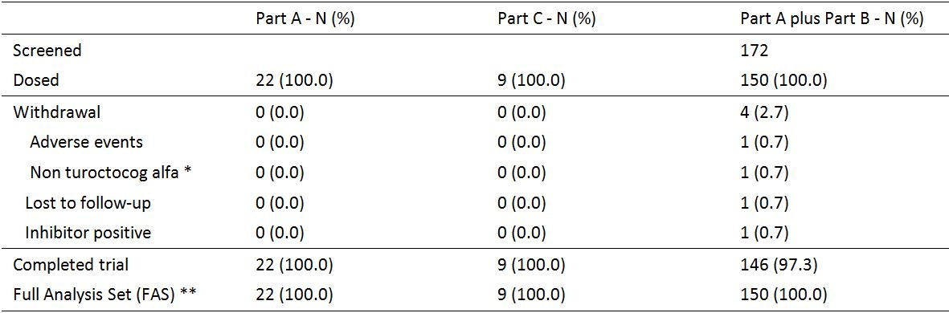

* Initiation of treatment with other FVIII products (concentrate or rFVIII); ** FAS includes all patients either data after dosing.

#### Major protocol violations

There were 397 important protocol deviations at the patient level and these are summarised below in Table 12.

Table 12: Trial 3543 - Important protocol deviations at patient level.

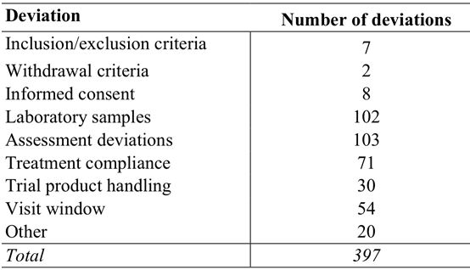

The sponsor considered that none of the important protocol deviations at the patient level had a major effect on trial outcome or on the safety of patients. Comments relating to selected categories of important protocol deviations at the patient level are provided below.

**Deviations related to inclusion/exclusion criteria:** A total of 7 deviations were reported and most were related to screening laboratory results not being available at the time of inclusion of patients in the trial.

**Deviations related to laboratory samples:** A total of 102 deviations were reported and most were missing samples or samples taken outside of the sampling window.

**Deviations related to assessments:** A total of 103 were reported. Missed blood samples and blood samples taken outside the sampling window were also included in this category. Many of the deviations in this category were a result of mild/moderate bleeds not changing category to a severe bleed and therefore not treated at the site, as they should have been according to the protocol.

**Deviations related to treatment compliance:** A total of 71 deviations were reported, and these were mainly due to patients not following the dose regimen, patients taking wrong doses, problems with drug accountability and problems with the interactive voice response system/interactive web response system (IVRS/IWRS).

**Deviations related to trial product handling:** A total of 30 deviations were reported, mostly related to dispensing of the trial product and storage temperature deviations.

**Deviations related to visit windows:** A total of 54 deviations were reported, mostly related to minor overruns of the visit windows.

**Other important protocol deviations:** A total of 20 other deviations were reported and most of these were related to the problems with diary records or PRO questionnaires.

#### Baseline data

##### Baseline demographic characteristics and laboratory parameters

**Demographics:** The population consisted of males with severe haemophilia (FVIII activity ≤ 1%), with a mean age of 28 years (range: 12 to 60 years), a mean weight of 73.2 kg (range: 32.7 to 120.0 kg) and a mean BMI of 24.1 kg/m2 (range: 13.8 to 40.4 kg/m2). The majority of patients were "White" (80.7%) with the second-largest racial group being Asian (13.3%). Of the 150 patients, 19% were from the US, 13% were from Serbia and 11% were from Brazil, while the remaining 57% were distributed among the other 12 countries contributing patients to the trial. In the adolescents (n=24), the mean age was 14 years (range: 12 to 17 years), the mean weight was 52.6 kg (range: 32.7 to 95.0 kg) and the mean BMI was 19.3 kg/m2 (range: 13.8 to 32.5 kg/m2).

**Physical examination:** Clinically relevant abnormal findings in the musculo-skeletal system due to haemophilia A were reported in 55% of patients, while 13 other clinically relevant abnormal findings were reported in 12 (8%) patients (one of which was haematuria). None of the abnormal physical findings excluded patients from participating in the trial.

**Haematology laboratory tests:** At baseline, 8 patients had one or more clinically relevant haematology parameters outside the normal reference ranges. None of the abnormal values excluded the patients from participating in the trial.

**Other laboratory tests:** There were 41 (27.3%) patients with ALT and/or AST levels above the upper limit of the reference range at baseline (reference range for ALT = 6-48 IU/L; reference range for AST = 10-45 IU/L). The mean baseline ALT was 36 IU/L (range: 7 to 222 IU/L), and the mean baseline AST was 30 IU/L (range: 10 to 160 IU/L). The sponsor states that the relatively large number of patients with baseline standard liver function tests outside the normal reference range can be partly explained by the relatively large proportion of patients who were anti-HCV antibody positive at baseline (58 [39%] patients). HIV seropositivity at baseline was reported in 8% of patients at baseline and HIV seronegativity was reported in 91% of patients. All patients except one were negative for hepatitis B surface antigen (i.e., 99.3% negative). Urinalysis showed that 9 (6%) patients had blood in their urine and 1 patient (0.7%) had glucose in the urine.

**Coagulation parameters:** The majority of patients had a prolonged prothrombin time (PT) and/or a prolonged activated partial thromboplastin time (aPTT) at baseline. The mean PT at baseline was 12.4 seconds (range: 9.9 to 19.0 seconds) with normal reference range of 10 to 13 seconds, and the mean aPTTT at baseline was 39.5 seconds (range: 25.5 to 96.1 seconds) with a normal reference range of 20.6 to 39.9 seconds.

**Baseline FVIII activity:** The mean FVIII activity at baseline was 2.95% ranging from 0 to 98%.

##### Medical history/concomitant disease

###### Haemophilia A

Based on medical records, all patients had severe haemophilia A with a mean FVIII activity of 0.6% (ranging from 0.0 to 1.0%). A total of 91 of the 150 patients had relatives with haemophilia A. None of the patients had clinical suspicion of inhibitors at baseline and 42.6% had yearly or half-yearly inhibitor tests taken.

Of the 150 patients in the study, 61% (n=91) had received prophylactic FVIII treatment prior to entering the trial and 65% (n=97) had received treatment on-demand, suggesting that a notable proportion of patients had received both treatments. Prophylaxis had been administered for a mean of 79 months ranging from 2 to 480 months, and the mean prophylactic dose was 25 IU/kg ranging from 7 to 63 IU/kg. The frequency of prophylactic dosing varied considerably between patients, as did the number of bleeds within the 12 months preceding the trial, with a mean of 8.9 bleeds/patient/year ranging from 0 to 55 bleeds/patient/year. Patients receiving on-demand treatment experienced 43.2 bleeds/patient/year in the 12 months preceding the trial, ranging from 0 to 216 bleeds/patient/year. Patients receiving on-demand treatment were only asked about the average number of bleeds per month within the last year and this number was multiplied by 12 to give the yearly bleeding rate. The majority of patients used plasma-derived FVIII products prior to trial entry (54% on prophylaxis and 73% on-demand).

*Comment: Based on medical records, all patients in the trial had severe haemophilia A with FVIII activity ≤ 1%. However, at baseline the mean FVIII activity was 2.95% with a range of from 0% to 98%. The wide range in FVIII activity at baseline might indicate that not all patients withheld treatment with their usual FVIII product for at least 48 hours prior to the baseline visit. The sponsor argues that the baseline FVIII activity did not influence the overall conclusions of the trial as the median baseline FVIII activity was 1% and the trial was multiple dose.*

*In the CRT it was stated that a total of 35% of the patients had been on prophylactic regimens prior to trial entry and 39% had been on on-demand treatment regimens, while the remaining 26% had been on both prophylaxis and on-demand treatment. The sponsor stated that these percentages were calculated from EOT Table 14.1.73, but it was not clear how these percentages had been calculated from the data in the table.*

###### Concomitant medications

Concomitant medications were any medications, other than the trial product, that were taken during the trial including the screening visits. The majority of concomitant medications were related to concomitant illnesses and to symptoms that were consequences of the underlying disease. In addition, a significant proportion of the concomitant medication was related to medical events reported as adverse events.

#### Efficacy results

##### Total consumption of turoctocog alfa (secondary endpoint)

The total consumption of turoctocog alfa IU/kg during the trial period for the both prevention of bleeding and treatment of bleeding, and for the combination of prevention of bleeding, treatment of bleeding and use in surgery are summarised below in Table 13.

Table 13: Trial 3543 - Turoctocog alfa consumption during the trial; FAS.

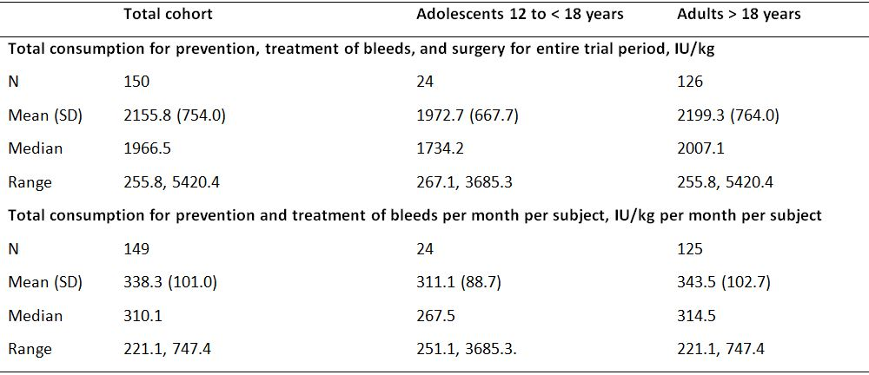

*Comment: Mean total consumption of turoctocog alfa for the prevention, treatment of bleeds, and surgery for the entire trial was similar in patients with good compliance and in patients with less compliance (2161.4 vs 2085.2 IU/kg). Mean total consumption of turoctocog alfa for the prevention and treatment of bleeds was higher in patients with good compliance compared with patients with less compliance (340.5 vs 303.8 IU/kg per month per patient). However, these data should be interpreted cautiously due to the marked imbalance in patient numbers between patients with good compliance and less compliance, with the majority of patients in both the total consumption analyses having good compliance (i.e., 93.3% [140/150] in the IU/kg analysis and 94.0% [140/149] in the IU/kg per month per subject analysis). Good compliance with the preventive regimen was defined if both of the following two criteria had been met: the preventive doses of turoctocog alfa were within the dose range defined as minimum 18 IU/kg for at least 80% of the preventive doses; and no less than 3 preventive doses were taken for at least 80% of the weeks. Less compliance with the preventive regimens was defined if one or both of the following criteria had been met: more than 20% of the preventive doses were outside the dose range defined as less than 18 IU/kg; or less than 3 preventive doses/week were taken for more than 20% of the weeks.*

##### Prevention of bleeds (secondary endpoint)

###### Actual consumption of turoctocog alfa for prevention of bleeds

The actual consumption for prevention of bleeds (mean dose and yearly consumption) is summarised below in Table 14, and was similar for adolescents and adults.

Table 14: Trial 3543 - Turoctocog alfa consumption during the trial; FAS.

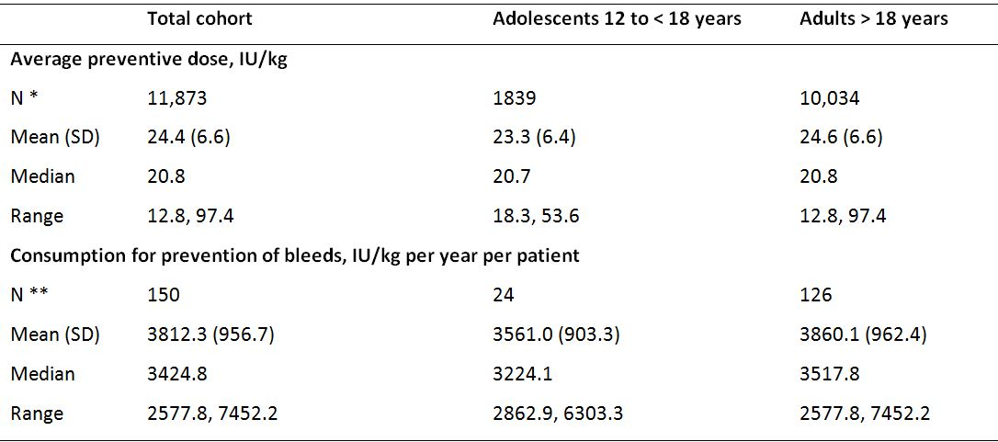

N * = Number of doses; N ** = Number of patients

###### Annualised bleeding rates

The annualised bleeding rates were estimated using a Poisson model allowing for over-dispersion and presented with 95% CIs. The annualised bleeding rates for the total population, adolescents and adults are summarised below in Table 15.

Table 15: Trial 3543 - Annualised bleeding rates; FAS.

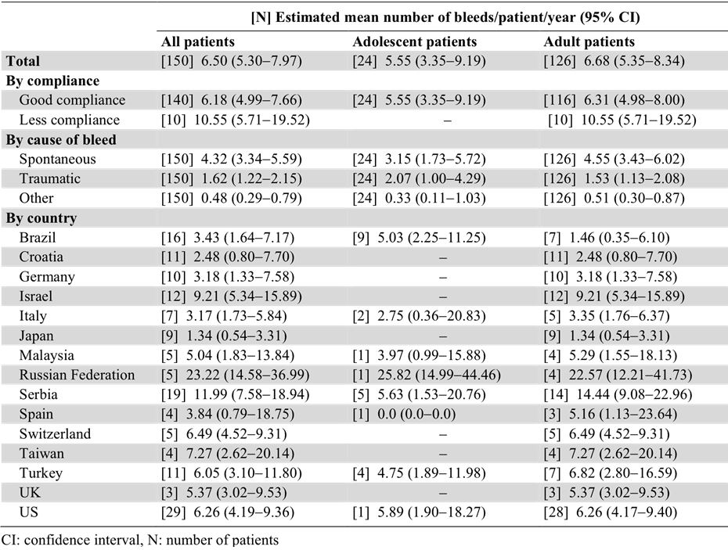

*Comment: The estimated mean annualised bleeding rate was similar in adult and adolescent patients treated preventively with turoctocog alfa (6.68 vs 5.55 bleeds/patient/year, respectively). The majority of bleeds in the total population were spontaneous rather than traumatic (4.32 vs 1.62 bleeds/patient/year), with traumatic bleeds occurring relatively more frequently compared with spontaneous bleeds in adolescents than in adults. The estimated mean annualised bleeding rate in the total population was lower in patients with good compliance compared with patients with less compliance (6.18 vs 10.55 bleeds/patient/year, respectively), but there was a marked imbalance in patient numbers between the two groups with 93.3% of patients having good compliance. The estimated mean annualised bleeding rate patients in the total population varied considerably among countries with the lowest rate in Japan (1.34 bleeds/patient/year) and the highest rate in the Russian Federation (23.22 bleeds/patient/year).*

*Excluding bleeds and corresponding exposure periods that occurred more than 72 hours after the last preventive dose resulted in a slight decrease in the total estimated mean bleeding rate from 6.50 to 6.25 bleeds/patient/year. Excluding bleeds and corresponding exposure periods that occurred more than 48 hours after the last preventive dose resulted in a noteworthy decrease in the total estimated mean bleeding rate from 6.50 to 5.43 bleeds/patient/year. This indicates that shorter time intervals between the preventive doses led to fewer bleeds on a yearly basis.*

*The CTR refers to published data9 showing that the estimated mean annualised bleeding rate for Advate (n=107) was comparable to that of turoctocog alfa (n=150) in a similar patient population using the same estimation method (6.3 vs 6.5 bleeds/patient/year, respectively). In the Advate trial,9 the mean estimated annualised bleeding rate was 6.3 bleeds/patient/year, with a range of 0.0 to 46.6, in patients with haemophilia A with a median age of 18 years (range: 10 to 65 years). The median age of patients in Parts A and B of Trial 3453 was 25 years (range: 12 to 60 years). The mean estimated annualised bleeding rate for patients aged > 18 years (n=55) treated with Advate[10] was 5.3 bleeds/patient/year compared with 6.7 bleeds/patient/year for adults aged ≥ 18 years (n=126) in Trial 3543. The mean estimated annualised bleeding rate for patients aged 10 to 18 years (n=52) treated with Advate[11] was 7.3 bleeds/patient/year compared with 5.6 bleeds/patient/year for adolescents aged 12 to < 18 years (n=24) in Trial 3543.*

#### Treatment of bleeds (secondary endpoint)

##### Actual turoctocog alfa consumption to treat a bleed

The actual consumption of turoctocog alfa for the treatment of bleeding episodes is summarised below in Table 16. The mean doses for treatment of a bleed were lower than the mean doses for treatment of bleeding episodes from start to stop of the bleed as some bleeds required treatment with more than one dose.

Table 16: Trial 3543 - Turoctocog alfa actual consumption used for prevention of bleeding; FAS.

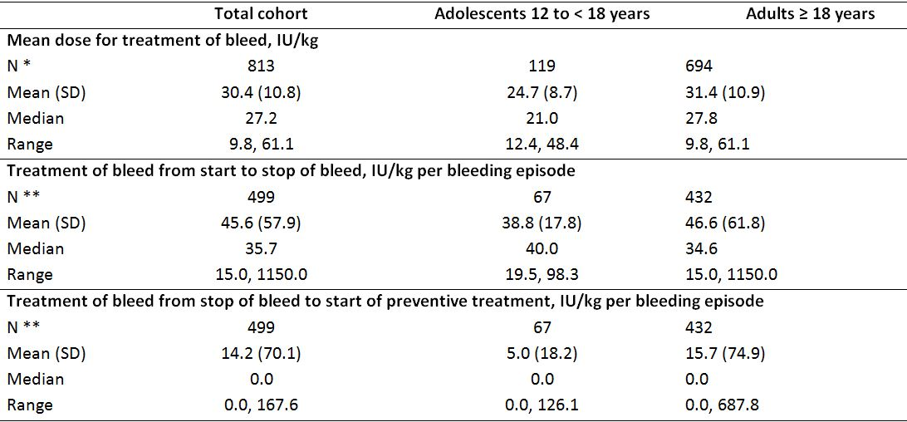

N * = Number of doses; N ** = Number of bleeding episodes.

##### Details of bleeds

A total of 499 bleeds were treated during the trial. The majority of the bleeds (66.5%, n=332) were spontaneous, while 24.8% (n=124) were caused by trauma and 8.6% (n=43) were of other origin or with missing information. The mean (SD) duration of a bleed from start to stop (460 bleeds) was 16.4 (24.2) hours, with a range of from 15 minutes to 304 hours. The mean time from start of a bleed until the first administration of turoctocog alfa was 2.83 hours ranging from 0 to 56 hours, and the mean time from the first administration of turoctocog alfa until the bleed stopped was 13.6 hours ranging from 0 to 300 hours.

The majority of bleeds required only one infusion to treat the bleed from start to stop (71.5%, n=357), with two infusions being required for 17.8% (n=89) of bleeds. Therefore, 89.4% (n=446) of bleeds were stopped with one or two infusions. The maximum number of infusions required to treat the bleed from start to stop of the bleed was 26 (9.2%, n=1). The mean number of infusions required from start to stop of a bleed was 1.5 infusions/bleed. The majority of bleeds required only one infusion from start of the bleed until preventive treatment was resumed (62.7%, 313), with two infusions being required for 20.4% (n=102) of bleeds.

The bleeds were classified as mild/moderate in 90.0% (n=449) of cases and as severe in 9.2% (n=46) of cases. Information about severity was missing for 0.8% (n=4) of the bleeds. The most frequent location of the bleeds was in a joint, which accounted for 67.4%% (n=31) of the bleeds and 56.5% (n=36) of the total number of the bleeds were in a target joint. The most frequently reported start time of a bleed was in the morning from 7 am to 11 am (27.1%, n=135) and the least frequent start time was in the late evening and early night from 11 pm to 3 am (6.8%, n=43). Re-bleeds were reported in 7.8% (n=39) of patients.

##### Haemostatic response

The haemostatic response after treatment of a bleed with turoctocog alfa was evaluated on a 4-point scale and the results are summarised below in Table 17. The success rates (haemostatic response excellent or good) excluding missing data were 84.5%, 71.6% and 86.6% for the total, adolescent, and adult cohorts, respectively. The corresponding success rates when assessed more conservatively by including the missing values in the denominator were 80.8%, 71.6% and 82.2%, respectively.

Table 17: Trial 3543 - Haemostatic response (number [%]) to treatment of bleeds; FAS.

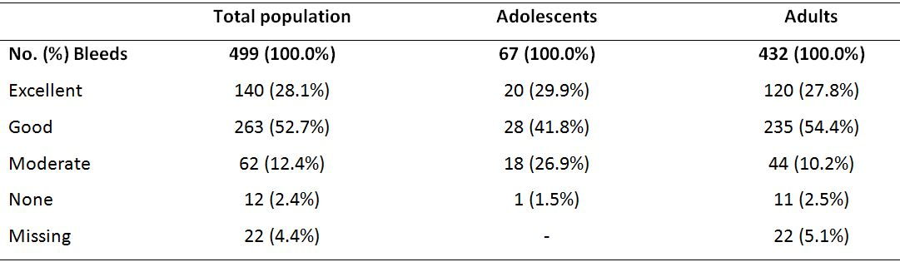

Overall, the haemostatic response was successful in the total population irrespective of the subgroups in which it was examined (e.g., location of bleed, cause of bleed, time from start of bleed to first infusion of turoctocog alfa, and time of bleed). However, compliance with treatment was an exception with the success rate in bleeds in which there had been good compliance with treatment was higher than in bleeds in which there had been less compliance with treatment (83.9% vs 57.6%).

*Comment: The published haemostatic success rate for Advate for treatment of a bleed was 86% (434/410),[12] which is comparable with the success rate of 84.5% (403/477) in Trial 3543.*

#### Total exposure to turoctocog alfa

Of the 150 patients exposed to turoctocog alfa, 148 were exposed for at least 50 days and 142 were exposed for at least 75 days. The mean number of doses for preventive treatment per patient was 79.2 doses/patient (range: 11, 135). The mean dose per patient for prevention, treatment of bleeds and surgery was 86.4 IU/kg per patient (range: 11, 213), and the mean number of exposure days per patient was 84.6 days per patient (range: 11, 213). All patients received preventive dosing, and (83.3%; 125/150) followed the three times per week dosing schedule, while 16.7% (25/150) were dosed every second day and one patient (0.7%) changed dosing schedule from three times per week to every second day.

#### Surgery (secondary endpoint)

Surgery (n=9) was performed in 9 patients (8 major, 1 minor), and included only 1 adolescent patient. Surgery was undertaken for arthropathy and chronic pain in left knee for 1 patient, synovitis for 1 patient, semi-impacted tooth and removal of tooth root for 1 patient, arthropathy for 4 patients, religious (circumcision) for 1 patient and recurrent haemarthrosis for 1 patient. In addition, 3 "other surgical procedures" were performed in 3 patients and 2 were related to tooth extractions and 1 was treatment of a peri-umbilical abscess.

Haemostasis was successful in all 9 surgical procedures and no treatment failures were reported. The haemostatic response during surgery was rated as excellent in 77.8% (n=7) of procedures and good in 22.2% (n=2) of procedures. The haemostatic response when haemostasis had been achieved was rated as excellent in 66.7% (n=6) of procedures and good in 33.3% (n=3) of procedures.

During the entire surgical period, the mean consumption of turoctocog alfa was 831 IU/kg per surgery ranging from 331 to 1468 IU/kg. From Day 1 to Day 7 of the surgery, the mean consumption was 432 IU/kg per surgery, and from Day 8 and until the patients returned to the preventive regimen the mean consumption was 399 IU/kg per surgery. The actual mean blood loss during surgery was 258 mL/surgery, and the anticipated blood loss was 236 mL/surgery.

The mean haemoglobin level before surgery was 9.53 mmol/L ranging from 8.32 to 10.35 mmol/L, and the mean haemoglobin levels 1 hour and 24 hours after surgery were 9.4% and 16.2% lower, respectively, than the mean pre-surgery level. One blood product transfusion of 3 units of red blood cells was reported for 1 patient who underwent surgery for haemophilic arthropathy.

#### Patient reported outcomes (other endpoints)

The trial included a number of patient reported outcome (PRO) questionnaires to be completed by patients and/or parents at Visit 1a and end-of-trial Visit for Part A, baseline Visit 2b and end-of-trial Visit for Part B, and Visit C1 (pre-surgery) and Visit C2 (last day of surgical recovery period) for Part C. The questionnaires included: Haemophilia Quality of Life Questionnaire (HAEMO-QOL) for children and parents; HAEM- A-QOL for adults; Haemophilia Treatment Satisfaction Questionnaire (HEMO-SAT) for adults and parents; and European Quality of Life - 5 Dimensions (EQ-5D) questionnaire.

The CTR indicated that a separate report will be made with detailed analyses of all PRO data. However, the CTR included comment on the data from the EQ-5D and the HAEM-A-QOL score. The EQ-5D had 5 domains: mobility, self-care, usual activities, pain/discomfort, and anxiety /depression. For each domain, 3 answers were available. In the "mobility" and "pain/discomfort" domains, most of the patients reported some problems with mobility and moderate pain at both the baseline and end-of-trial visits, probably as a consequence of their haemophilia. In the three other domains, most of the patients reported no problems at baseline or end-of-trial visits.

In addition to the domains, EQ-5D has a VAS scale ranging from 0-100 measuring current state of health. The mean change in the VAS scale from the baseline to the end-of-trial visits was a modest improvement of 2.5 points. A total summary score for EQ-5D was calculated for each patient at the baseline and end-of-trial visits. The mean total summary score at baseline was 0.725 ranging from -0.181 to 1.000, and the mean change from the baseline to the end-of-trial visit in the total summary score was modest (0.008).

The patients who underwent surgery also completed the PRO questionnaires on the pre-surgery day and again on the day where they returned to their preventive treatment. The mean change on the EQ-5D VAS scale over this period was an improvement of 11.1 points ranging from a worsening of 2 points to an improvement of 30 points. The mean change from the pre-surgery day to return on preventive treatment in the EQ-5D total summary score was modest (0.041).

### Trial 3545

#### Design, objectives, location, and dates

##### Design

Trial 3545 was a Phase 3, multi-national, multi-centred, non-controlled, open-label, safety, efficacy, and pharmacokinetic trial in previously treated paediatric patients aged < 12 years with haemophilia A without inhibitors. The trial was planned to include at least 50 patients in two age cohorts: one cohort including 25 children aged 0 to < 6 years, and one cohort including 25 children aged 6 to < 12 years.

An overview of the trial design is presented below in Figure 2. Patients attended a screening visit (Visit 1) in order to assess their eligibility. The first patients enrolled in the trial (at least 13 patients from each age cohort) were enrolled in the pharmacokinetic part of the trial and underwent pharmacokinetic sessions at Visit 2 and Visit 3. At Visit 2, the pharmacokinetic profile of the patients’ previous FVIII product was investigated and at Visit 3 the pharmacokinetic profile of turoctocog alfa was assessed. An exception was patients who had an evaluation of the terminal half-life of their previous FVIII product within the last year with at least three time points. These patients underwent the evaluation part of Visit 2 only. Upon completion of the pharmacokinetic sessions the patients initiated preventive treatment with turoctocog alfa from Visit 3 to Visit 8. In the patients not undergoing PK assessment, the clinical part of the trial, preventive treatment was initiated at Visit 2.

Figure 2. Trial 3545 - Design.

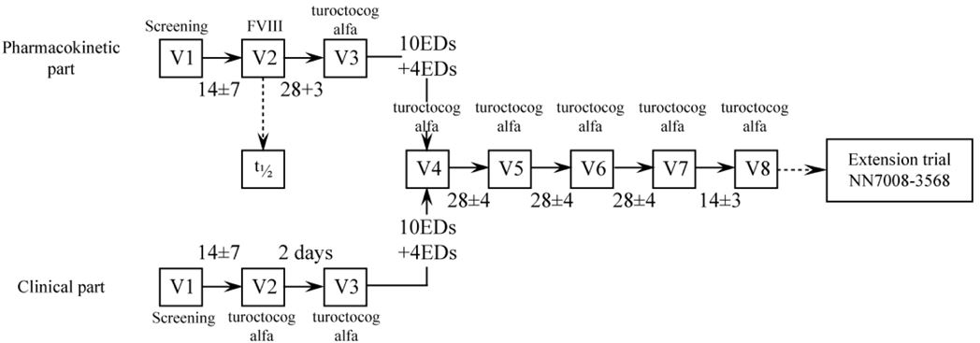

Note: V = visit; ED = Exposure Days.

Visits 4 to 8 were similar for all patients. V4 was scheduled 10-14 exposure days after Visit 3. The other visits were separated by 28 ± 4 days, with the exception of the end-of-trial visit, Visit 8 (14 ± 3 days after Visit 7). Unscheduled visits took place as applicable (e.g., treatment requiring bleeding episodes, development of inhibitors). Follow-up visits took place for patients who had been withdrawn or for whom inhibitors had developed.

Preventive treatment continued until each patient reached at least 50 exposure days with turoctocog alfa. An exposure day was defined as any day that the patient had been exposed to trial product, including exposure to turoctocog alfa during PK sessions. After completion of the trial, patients were invited to continue in a Phase 3b extension trial (Trial 3568).

##### Objectives

* The primary objective was:
  + To evaluate the safety of turoctocog alfa in previously treated paediatric patients aged < 12 years of age with haemophilia A.
* The secondary objectives were:
  + To evaluate the pharmacokinetics of turoctocog alfa in previously treated paediatric patients aged < 12 years of age with haemophilia A.
  + To evaluate the efficacy of turoctocog alfa in previously treated paediatric patients aged < 12 years of age with haemophilia A.
  + To assess and compare patient reported outcomes from baseline to end of trial in previously treated paediatric patients aged < 12 years of age with haemophilia A.

##### Locations and dates

Of the 39 trial sites, 26 sites enrolled and dosed at least one patient. The country distribution was as follows (number of actively recruiting sites): Brazil (3), Italy (1), Lithuania (1), Macedonia (1), Malaysia (1), Poland (2), Russia (2), Serbia (1), Taiwan (1), Turkey (3) and the US (10).

The first patient visit was 18 June 2010, the last patient visit was 21 November 2011, and the CTR was dated 20 March 2012. The results presented in the CTR reflected data available in the clinical database as of 13 December 2011. The database was updated on 1 February 2012 in order to change the coding of one adverse from "anti-factor VIII antibody positive" to "anti-factor VIII antibody test negative" following further testing.

*Comment: The primary objective of this trial was safety rather than efficacy, with efficacy being categorised as secondary objective. The trial was open-label with a single-arm (turoctocog alfa), and the sponsor's rationale for the design of the paediatric trial (Trial 3545) was essentially the same as for the adult trial (Trial 3543). The sponsor states that in accordance with the relevant EMA guideline, a PK assessment of the patients’ previous FVIII product was included in the trial design. The PK profile of turoctocog alfa and previous FVIII products were found to be similar, suggesting that the efficacy and safety of turoctocog alfa and other FVIII product are also likely to be similar.*

#### Inclusion and exclusion criteria

The key inclusion criteria for the trial were male patients with severe haemophilia A (FVIII activity ≤ 1%) aged < 12 years with a weight of ≥ 11 kg with no FVIII inhibitors at screening, and a documented history of a minimum of 50 days exposure to FVIII products. The exclusion criteria included patients with significant liver and/or renal impairment or other conditions that could present a hazard to children included in the trial.

The trial included satisfactory criteria for re-scheduling/re-screening planned visits, and for withdrawing patients from the study. Withdrawn patients were to be replaced to ensure that 50 patients (25 in each age group) completed the trial with at least 50 exposure days. Assuming a drop-out rate of 15% it was estimated that 60 patients should be started on turoctocog alfa to obtain the 50 completed patients. This was, however, to be adjusted during the trial based on the actual drop-out rate.

#### Study treatment

##### Overview of treatment

The overview of treatment is summarised below in Table 18.

Table 18: Trial 3545 - Overview of treatment.

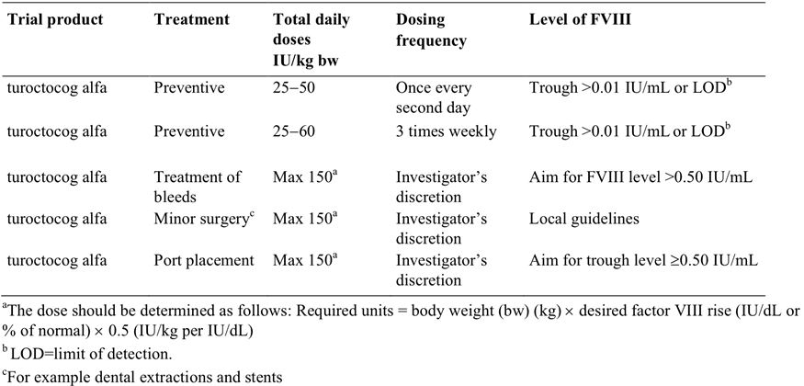

##### Preventive treatment

Patients received preventive treatment with a single-dose of turoctocog alfa of 25-50 IU/kg every second day or 25-60 IU/kg three times weekly. In most cases this was done by home treatment with iv injection by the patient or a support person. The trial product was preferably administered in the morning as a slow bolus iv injection (approximately 1-2 mL/min). For patients who had previously treated only on-demand, the recommended initial dose of turoctocog alfa for the preventive regimen was 25 IU/kg. For patients previously on preventive treatment, the initial preventive dose of turoctocog alfa was selected by the investigator based on their clinical profile. The initial preventive dose of turoctocog alfa could also be calculated from the FVIII recovery or trough value of turoctocog alfa. The trough level was defined as the lowest level of FVIII measured immediately prior to dosing and was determined at the local laboratory at the discretion of the investigator. If the trough level was below the local clinic's assay limit of detection (LOD), the preventive dose level could be increased by up to 10 IU/kg if needed as decided by the investigator The duration of treatment from first to last turoctocog alfa administration was approximately 18−22 weeks corresponding to at least 50 exposure days.

##### Treatment of bleeds

If a patient experienced a bleed during preventive treatment, the bleed was required to be treated as soon as it was identified. Mild/moderate bleeds could be treated at home. Patients with severe bleeds should always have been referred to the investigator, but treatment should have been started immediately at home if possible. The dose level for treatment of bleeds was determined according to the formula presented above in footnote "a" Table 18. The dose for treatment of bleeds aimed to achieve an expected post-injection level of at least 0.50 IU/mL of turoctocog alfa. Higher doses of turoctocog alfa up to a total dose of 150 IU/kg per day could be used at the investigator’s discretion based on the site and severity of the bleed, and the clinical situation. When the bleed had resolved, the patient could resume the preventive regimen. If a haemostatic response could not be achieved after 48 hours using adequate doses of turoctocog alfa, another FVIII product could be selected at the discretion of the investigator. Use of other FVIII products resulted in withdrawal of the patient.

##### Prior and concomitant therapy

Details of all concomitant illnesses and medications were recorded at trial entry, and any changes in concomitant medication were recorded at each visit during the trial. Concomitant illnesses were defined as any illnesses that were present at the first visit, and concomitant medications were defined as any medications, other than trial products, that were taken during the trial (including screening and run-in periods). The following concomitant medications were not permitted during the course of the trial: treatment with cryoprecipitate or FVIII concentrates other than turoctocog alfa (apart from the specified times during the PK sessions, and if haemostasis could not be obtained with turoctocog alfa).

#### Efficacy variables and outcomes

The assessment of the bleeding episodes (efficacy outcomes) was consistent with that previously described for the pivotal trial (Trial 3543). However, the investigation of the use of turoctocog alfa during surgery was not defined as an efficacy endpoint in the pivotal paediatric trial (Trial 3545).

**The secondary efficacy endpoints** relating to bleeding were:

* Bleeding prevention:
  + Total consumption of turoctocog alfa per patient (prevention and treatment of bleeds) per month and annualised value.
  + Actual consumption of turoctocog alfa (IU/kg /month) for bleeding prevention.
  + Average number of bleeds per month.
* Treatment of bleeds:
  + Haemostatic effect of turoctocog alfa on treatment of bleeds assessed on a predefined four point scale: none, moderate, good or excellent.
  + Number of infusions of turoctocog alfa per bleed.
  + Actual consumption of turoctocog alfa (IU/kg /bleed) for treatment of bleeds.

#### Randomisation and blinding methods

Randomisation and blinding were not applicable as the trial was open-label and single-arm.

#### Analysis populations

The analysis populations were identical to those described for the pivotal adult trial (Trial 3543).

#### Sample size

No formal sample size calculations were performed. The sample size was based on the EMA draft guideline.[13] This guideline states that "an open multicentre trial should include at least 50 children allocated to 2 age cohorts ... a minimum of 25 patients ... 6-12 years of age and at least 25 patients should be < 6 years who have undergone > 50 [exposure days] with previous factor VIII products. The clinical trial in children should not start before data are available on 50 [exposure days] for 20 patients (older than 12 years)".

#### Statistical methods

No formal statistical hypothesis testing was performed for the secondary efficacy endpoints, and evaluation of the data was based on descriptive statistics. The methods used to describe turoctocog consumption and bleeding episodes were the same as those previously described for the pivotal adult trial (Trial 3543).

#### Participant flow

A total of 69 patients were screened, 65 were enrolled, and 60 completed the trial. Of the 65 enrolled patients, 2 were withdrawn before dosing with turoctocog alfa and 3 were withdrawn after dosing. Of the 60 patients completing the trial, 29 were children aged from 0 to < 6 years and 31 were children aged from 6 to < 12 years. Of the 63 dosed patients, 28 (14 in each age cohort) were dosed in the PK part of the trial while the remaining 35 (17 younger and 18 older children) were dosed in the clinical part of the trial.

#### Major protocol violations

##### Patient level

The important protocol deviations on a patient level are summarised below in Table 19. The sponsor stated that none of the important protocol deviations at patient level were regarded as having a major effect on the trial outcome or on the safety of the patients.

Table 19: Trial 3545 - Important protocol deviations at patient level.

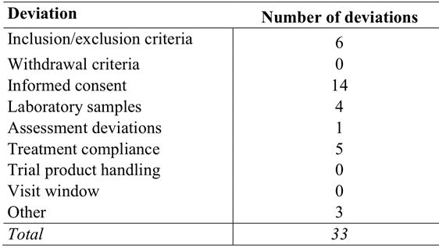

The most commonly reported protocol deviations were related to procedural problems relating to informed consent (n=14). However, all informed consent forms had been appropriately signed prior to the trial related assessments.

There were 6 protocol deviations relating to the inclusion and exclusion criteria. These were: 1 x documented diagnosis of obesity; 1x BMI greater than 95th percentile for age at V2 and V3; 1 x inhibitor result uncertain for first available result; 1 x completed V2 without all screening laboratory results being available; 1 x previous documented inhibitor positive with 0.7 BU at most recent (about 6 years before entry to trial); 1 x documented inhibitor positive relating to confusion about the cut-off level.

There were 5 protocol deviations relating to treatment compliance, mainly due to patients not following the dosing regimen and taking the wrong dose.

The remaining protocol deviations at patient level have been reviewed and are not considered to be significant.

##### Protocol deviations at the trial, country, and trial site levels

The CTR also reported on protocol deviations at the trial (3 deviations), country (1 deviation) and trial site (13 deviations) levels. These protocol deviations have been examined and are considered unlikely to have placed patients at risk or to have invalidated the findings of the trial.

#### Baseline data

**Demographics and baseline characteristics:** The population was equally divided between the two age cohorts (31 children aged 0 to < 6 years; 32 children aged 6 to <12 years), and consisted of males with severe haemophilia (FVIII activity ≤ 1%), with a median age of 6 years old (ranging from 1 to 11 years old) and a median weight of 21.0 kg (ranging from 11.7 to 56.0 kg). The majority of the patients were "White" (84%) and the second-largest racial group was "Asian" (10%). Nineteen percent (19%) of the patients were from the US, 14% were from Brazil, 13% were from Russia and 11% were from Turkey, while the remaining 42% of the patients were distributed between the other 7 countries. There were 54 patients (24 younger and 35 older children) with information on FVIII genotype, and the most commonly occurring polymorphisms were inversions (38.9%) and substitutions (31.5%).

**Physical examination:** Of the total patients (n=63), 8.1% (n=5) had clinically significant abnormal findings in the musculoskeletal system at screening as a result of haemophilia A. Other clinically relevant abnormal findings were reported in 3 patients at screening (1 x mild autism, 1 x acute pharyngitis, and 1 x cerebral haemorrhage resulting in total amblyopia of the left eye). None of the abnormal findings resulted in patients being excluded from participating in the trial. Mean results for vital signs (blood pressure, pulse rate) were within normal ranges, and no patients were excluded for abnormalities in these parameters.

**Baseline laboratory values:** None of the laboratory findings were judged by the sponsor as having an impact on patient safety or on the outcomes of the trial. There were 9 (14.3%) children with haematology laboratory results outside the normal range and there were no noteworthy baseline abnormalities in clinical chemistry parameters. None of the patients tested positive for anti-HIV or anti-HCV antibodies. Two (2) patients (3.4%) were positive for anti-murine IgG antibodies and 7 patients (12.1%) were positive for anti-HCP antibodies. Seven (7) patients were positive for lupus anticoagulant. Two (2) patients had proteinuria and 1 patient had bilirubinuria.

**Haemophilia A details:** All patients had severe haemophilia A with a mean FVIII activity of 0.4% (ranging from 0.0 to 1.0%) based on medical records. A total of 34 of the 63 patients had relatives with haemophilia A. None of the patients had clinical suspicion of inhibitors at baseline and 36% had yearly or half-yearly inhibitor tests taken.

**Haemophilia A treatment:** Prior to trial entry, 76.2% (n=48) of all patients had been on prophylactic regimens, 28.6% (n=18) of all patients had been on on-demand treatment, and some patients had been on both prophylaxis and on-demand treatment. The mean number of exposure days to FVIII products prior to trial entry was 326 days (range: 50 to 2340 days), the mean time on prophylaxis was 34 months (range: 1 to 110 months), and the mean prophylactic dose was 37 IU/kg (range: 15 to 250 IU/kg). The frequency of prophylactic dosing varied, as did the mean number of bleeds within the 12 months prior to study entry for patients on prophylaxis (6.0 bleeds/patient/year, with a range of 0 to 36 bleeds/patient/year). The mean number of bleeds per month within the 12 months prior to study entry for patients treated on-demand was 2.8 bleeds/patient/month (range: 1 to 7 bleeds/patient/month). The majority (60.4%; n=29) of patients on prophylaxis used rFVIII products, while only 16.7% (n=3) of the patients being treated on-demand used rFVIII products. Major surgery within the last 5 years had been undertaken on 22 patients, with a mean of 1.4 surgeries (range: 1 to 3 surgeries).

#### Efficacy results

##### Total consumption of turoctocog alfa (secondary efficacy endpoint)

The mean total consumption of turoctocog alfa IU/kg per year per patient in the total patient group used for both prevention and treatment of bleeding was 5974.1 (range: 3541.7 to 9531.8), and there was no marked difference between the two age cohorts (see Table 20).

Table 20: Trial 3545 - Turoctocog consumption used for both prevention and treatment of bleeds (IU/kg per year per patient); FAS.

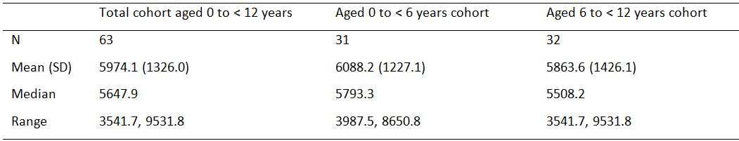

##### Prevention of bleeds (secondary efficacy endpoint)

###### Actual consumption of turoctocog alfa for prevention of bleeds

The actual consumption of turoctocog alfa for prevention of bleeds is summarised in Table 21.

Table 21: Trial 3545 - Turoctocog alfa actual consumption used for prevention of bleeds; FAS.

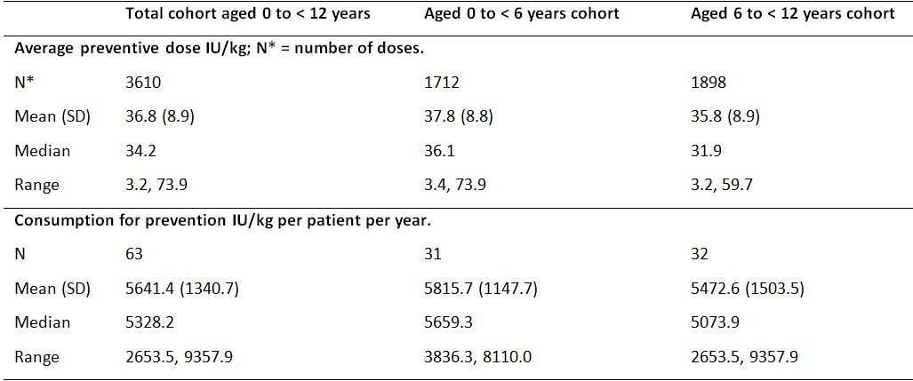

###### Estimated annualised bleeding rates

The annualised bleeding rates were estimated using a Poisson model allowing for overdispersion and presented with 95% CIs. The estimated annualised bleeding rates for all patients, small children (aged 0 to < 6 years) and older children (aged 6 to < 12 years) are summarised below in Table 22.

Table 22: Trial 3545 - Estimated mean annualised bleeding rates; FAS.

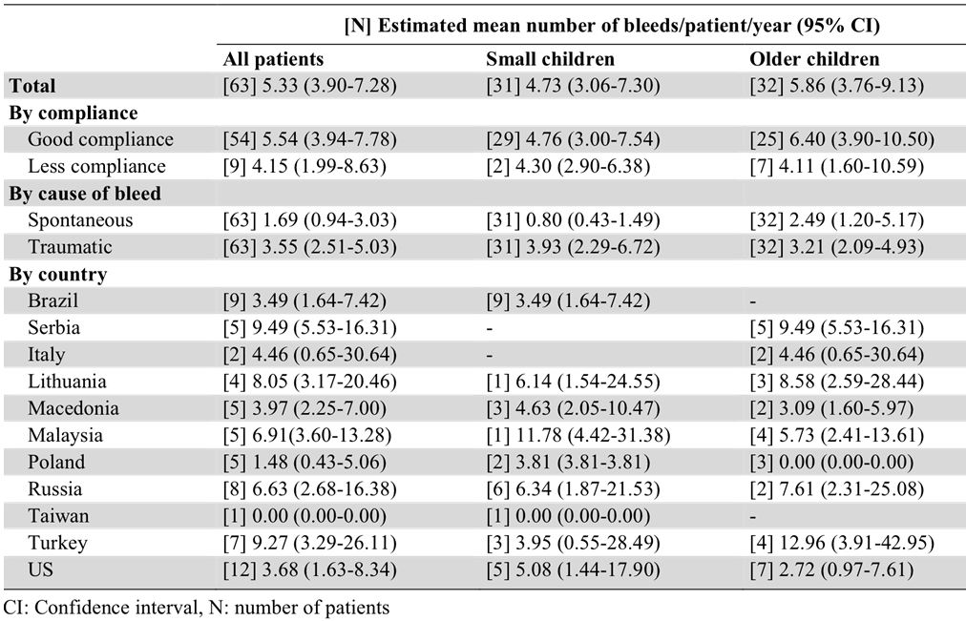

*Comment: Approximately one third of all patients (34.9%; 22/63) did not have a bleed during the trial. The estimated annualised bleeding rate for spontaneous bleeds was low with a mean rate of 1.69 bleeds/patient/year, and a lower rate was seen in the younger compared with the older cohort (0.80 vs. 2.49 bleeds/patient/year, respectively). However, the estimated annualised bleeding rate for traumatic bleeds was similar in the two cohorts (3.93, younger vs 3.21, older bleeds/patient/year). The estimated annualised bleeding rate for all patients varied considerably among the participating countries, with the lowest rate in Taiwan (0.0 bleeds/patient/year) and the highest rate in Serbia (9.49 bleeds/patient/year). However, only one patient was included from Taiwan and this patient did not experience any bleeds during the trial. In the total population, the estimated annualised bleeding rate did not change when excluding bleeds and corresponding exposure periods that occurred more than 72 hours after the last preventive dose (5.43 [excluded] vs 5.33 [not excluded] bleeds/patient/year). However, excluding bleeds and corresponding exposure periods that occurred more than 48 hours after the last preventive dose resulted in a noteworthy decrease in the total estimated annualised bleeding rate from 5.33 to 3.71 bleeds/patient/year. This indicates that shorter time intervals between the preventive doses led to fewer bleeds on a yearly basis.*

*Due to the large variation in the estimated annualised bleeding rate among patients, the sponsor considered that it was relevant to look at the median rates. The total median bleeding rate was 3.02 bleeds/patient/year, which was noticeably lower than the estimated mean annualised bleeding rate of 5.33 bleeds/patient/year. Similarly, the median annualised bleeding rate was lower than the mean annualised bleeding rate in children aged 0 to < 6 years (2.95 vs 4.73 bleeds/patient/ year, respectively) and children aged 6 to < 12 years (3.57 vs 5.86 bleeds/patient/year, respectively).*

##### Treatment of bleeds (secondary efficacy endpoint)

###### Actual turoctocog alfa consumption to treat a bleed

The actual consumption of turoctocog alfa for the treatment of bleeding episodes is summarised below in Table 23.

Table 23: Trial 3545 - Turoctocog alfa actual consumption used treatment of bleeding episodes; FAS.

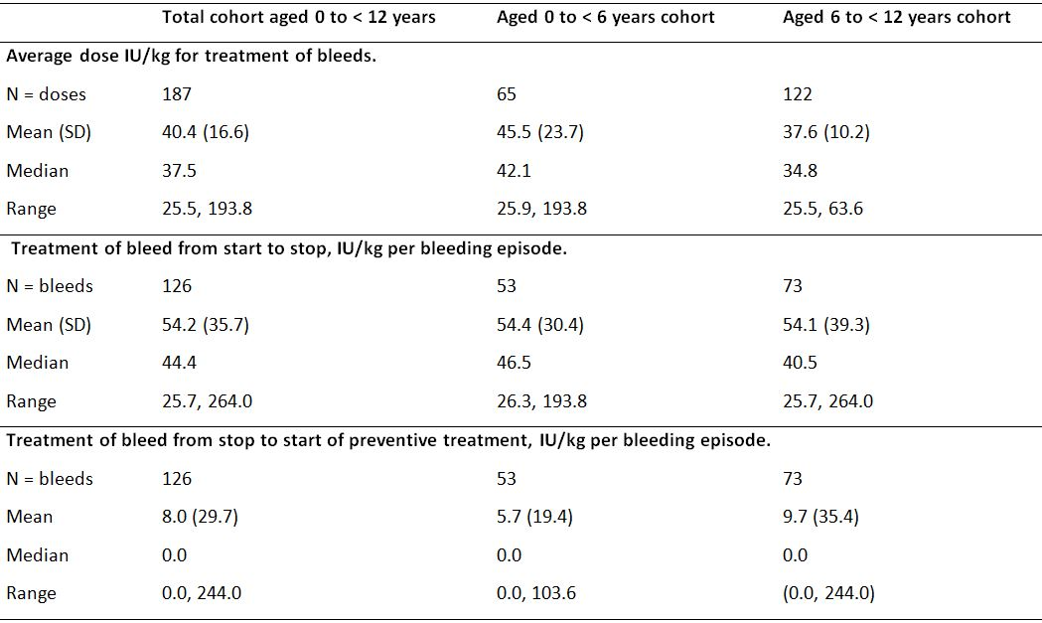

###### Details of bleeds

A total of 126 bleeds were treated during the trial in 41 patients (65.1%), and 22 patients (34.9%) did not experience any bleeds during the trial. The frequency of bleeds in the total population is summarised below in Table 24.

Table 24: Trial 3545 - Frequency of bleeds; FAS.

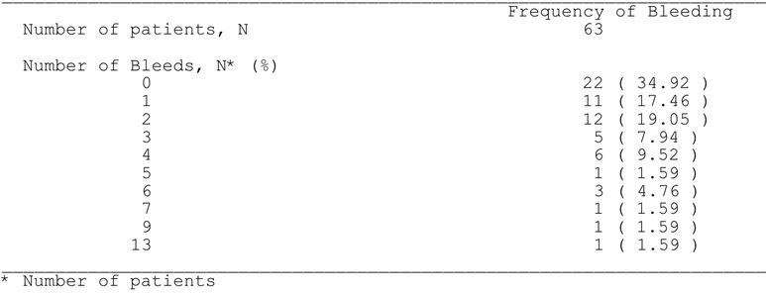

In the total population, 66.7% (84/126) of bleeds were due to trauma, 31.7% (40/126) were spontaneous and for the remaining 1.6% (2/126) the cause was not reported in the diary. The proportion of bleeds due to trauma was greater in the younger cohort than in the older cohort (83%, 44/53 vs 54.8%, 40/73). In the total population, bleeds were classified as mild/moderate in 91.3% (115/126) of cases and severe in 6.3% (8/126) of cases, and for the remaining 2.4% (3/126) of cases the classification was not reported in the diary. Joints were the most frequent locations of bleeds and accounted for 46.8% (59/126) of bleeds, and 22.2% (28/126) of bleeds were in target joints. The most frequently reported start time of a bleed was from 7 pm to 11 pm (28.6%, 36/126), and the least frequently reported start time of a bleed was from 11 pm to 3 am (4.8%, 6/126). Two (2) of the 126 bleeds were categorised as re-bleeds. A re-bleed was defined as a worsening of the bleeding site conditions after an initial period of improvement, either on treatment or within 72 hours after stopping treatment. It was considered as a new bleeding episode if worsening occurred more than 72 hours after stopping of treatment. Classification of re-bleeds was done by the trial statistician based on collected trial data at the time of statistical analysis.

In the total population, the majority of bleeds required only one infusion to stop the bleed (81.0%, 102/126) with most of the remaining bleeds requiring only two infusions to stop the bleed (14.3%, 18/126). The maximum number of infusions to stop a bleed was 8 (0.8% of bleeds; 1/126). The mean number of infusions required from start to stop of a bleed was 1.3 infusions/bleed, and the median number of infusions was 1 infusion/bleed. From the start of the bleed until prevention was resumed, 1 infusion was required for 94 (74.6%) bleeds and two infusions were required for 17 (13.5%) bleeds.

In the total population, the mean duration of time to stop a bleed was 8.88 hours (range: 0.17, 53.5 hours), and the corresponding times the younger and older age cohorts were similar (8.36 [range: 0.17, 53.50] vs 9.27 [range: 0.42, 48.67] hours, respectively). In the total population, the mean time from start of bleed until the first administration of turoctocog alfa was 1.68 hours (range: 0 to 16.8 hours) and the mean time from first administration of turoctocog alfa until the bleeding stopped was 7.5 hours (range: 0, 53.5 hour). In the younger cohort the corresponding figures were 2.35 hours (range: 0.00, 16.83 hours) and 6.64 hours (range: 0.00, 53.50 hours), and in the older cohort the corresponding figures were 1.19 hours (range: 0.00, 10.07 hours) and 8.11 hours (range: 0.20, 46.75 hours).

###### Haemostatic response

The haemostatic response after treatment of a bleed with turoctocog alfa was evaluated on a 4-point scale and the results are summarised below in Table 25. The success rates (haemostatic response excellent or good) excluding missing data were 94.3%, 96.2%, and 92.9% for the total, 0 to < 6, and 6 to < 12 years of age cohorts, respectively. The corresponding success rates when assessed more conservatively by including the missing values in the denominator were 92.1%, 96.2%, and 89.0%, respectively.

Table 25: Trial 3545 - Haemostatic response (number [%]) to treatment of bleeds; FAS.

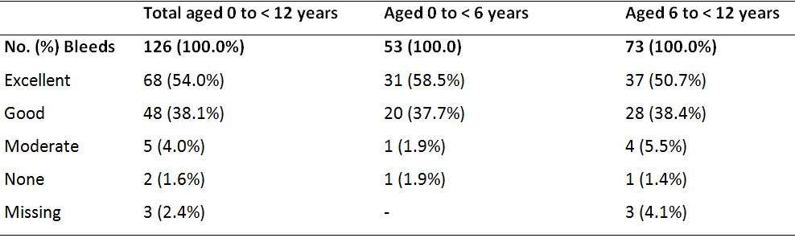

Overall, the haemostatic response was successful in the total population irrespective of the subgroups in which it was examined (e.g., location of bleed, cause of bleed, time of bleed). However, compliance with treatment was an exception with the success rate in bleeds in which there had been good compliance with preventive treatment was higher than in bleeds in which there had been less compliance with preventive treatment (96.4% vs 60.0%). However, most of the bleeds (88.1%, 111/126) occurred in patients with good compliance. The definitions of good compliance and less compliance were consistent with those in the adult trial (Trial 3543).

##### Surgery

In the pivotal paediatric trial, the effect of turoctocog alfa in patients undergoing surgery was not pre-specified as a sub-trial. However, there were 2 minor surgeries in the trial: 1 dental extraction; 1 removal of a central venous access port. Haemostasis was rated as excellent in both procedures. The patient who had a dental extraction received a pre-surgery dose of turoctocog alfa of 50 IU/kg and during the post-surgical recovery period he received tranexamic acid 500 mg two times daily for 3 days. The other patient had a pre-surgery dose of turoctocog alfa of 100 IU/kg and a single dose of 50 IU/kg during the post-surgical recovery period.

##### Overall exposure to turoctocog alfa

A total of 63 patients were exposed to turoctocog alfa, and 59 patients (28 younger cohort, 31 older cohort) had at least 50 exposure days. The mean number of doses used for the PK session, prevention, treatment of bleeds and surgery was 60.7 (range: 20-104), and was very similar to the mean number of exposure days per patient of 60.0 (range: 20-104). All patients received preventive treatment, and 74.6% (47/63) were treated three times weekly while 25.4% (16/63) were treated once every second day. Nine (9) patients changed from dosing every second day to dosing three times weekly, while 4 patients changed from three times weekly to every second day

##### Patient report outcomes (other efficacy endpoints)

PROs were measured at Visit 1 and Visit 8. The HAEMO-QOL questionnaire was available for two age groups (4-7 years and 8-12 years of age) in a patient version and in a parent version. The biggest change in the mean total summary score was seen in the parents’ versions for patients who were treated on-demand prior to trial entry (an improvement of 10.42 points for 4-7 year old patients and an improvement of 14.30 points for 8-12 year old patients). No other noteworthy changes were observed from the baseline visit to the end-of-trial visit in the total HAEMO-QOL scores. The CTR indicates detailed analyses of all patient reported outcome data will be provided as a separate report.

### Trial 3568: extension trial

#### Design, objectives, location and dates

Trial 3568 was designed as an extension trial for patients completing trials 3543, 3545, 3600 and 3893. It is a Phase 3b, multi-national, multi-centred, open-label, single-arm trial designed to investigate the long-term safety and efficacy of turoctocog alfa for the prevention and on-demand treatment of bleeding in patients with severe haemophilia A (FVIII activity ≤ 1%) without inhibitors. In addition, a surgical sub-trial was designed to investigate the efficacy and safety of turoctocog alfa for the prevention and treatment of bleeding during surgical procedures in patients with haemophilia A.

The objectives of the main part of trial were to assess the safety (primary objective) and efficacy (secondary objective) of turoctocog alfa for the prevention and treatment of bleeds. The primary objective of the sub-trial was to assess the efficacy of turoctocog alfa in surgery, and the secondary objectives were to evaluate the safety of turoctocog alfa in surgery, and to evaluate the haemostatic response to turoctocog alfa in the post-surgery period.

The patients were enrolled at 51 sites in 18 countries: Brazil (4 sites), Croatia (2 sites), Germany (3 sites), Israel (1 site), Italy (2 sites), Japan (5 sites), Lithuania (1 site), Macedonia (1 site), Malaysia (1 site), Poland (2 sites), Russian Federation (2 sites), Republic of Serbia (5 sites), Spain (2 sites), Switzerland (1 site), Taiwan (1 site), Turkey (5 sites), the UK (1 site) and the US (12 sites). The trial was initiated (first patient visit) on 27 October 2009 and the trial is still on-going. The CTR described interim data as of the cut-off date of 21 November 2011.

The main part of the trial consists of 19 visits (7 assessment and 19 dispensing), but the sponsor stated that this may change if the trial is extended or shortened depending on when turoctocog alfa becomes available in the participating countries. When turoctocog alfa becomes commercially available, the patients in Trial 3568 will be invited to continue in a Phase 4 trial (Trial 3553).

#### Inclusion, exclusion and withdrawal criteria

The main inclusion criteria were completion of trials 3543 (Phase 3 trial in adults and adolescents), 3545 (Phase 3 trial in children), 3600 (Japanese trial) or 3893 (PK trial). The eligibility criteria for patients undergoing surgery were a documented history of at least 150 exposure days to any FVIII concentrates and major or minor surgical procedures required. The withdrawal criteria were comprehensive and were generally consistent with the four trials providing patients to Trial 3586.

#### Study treatment

The turoctocog treatment regimens are summarised below in Table 26. In general, the dose for each of the treatment regimens was at the investigator's discretion primarily based on FVIII trough levels and individual patient response. The dose regimens for preventive treatment, on-demand treatment and surgery were consistent with the Phase 3 trials (Trial 3543 and Trial 3545).

Table 26: Trial 3568 - Treatments with turoctocog alfa.

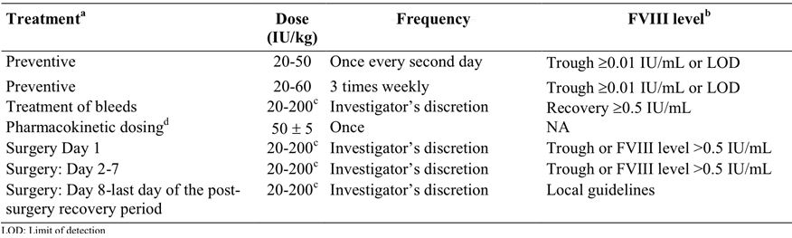

a. The patient was only dosed with one of these treatments at a time.

b. Dose adjustment was based on the trough level (or FVIII level in case of continuous infusion regimen in surgery) and an assessment of the clinical efficacy in the individual patient (i.e. bleeds).

c. The daily dose must not exceed 200 IU/kg.

d. Pharmacokinetic dosing was performed before continuous infusion in surgery only.

#### Efficacy variables and endpoints (secondary)

The bleeding variables were consistent with those previously described for the Phase 3 trials (Trial 3543 and Trial 3545). The secondary efficacy endpoints for Trial 3568 are summarised below.

**Main trial:**

* **Preventive treatment (secondary efficacy endpoint)**
  + Annualised bleeding rate related to the preventive period.
  + Haemostatic response to turoctocog alfa for treatment of bleeds (none, moderate, good or excellent).
* **On-demand treatment (secondary efficacy endpoint)**
  + Haemostatic response to turoctocog alfa for treatment of bleeds (none, moderate, good or excellent).

**Surgery sub-trial:**

* **Primary efficacy endpoint**
  + Haemostatic effect of turoctocog alfa (none, moderate, good or excellent).
* **Secondary efficacy endpoints**
  + assessment of actual consumption of turoctocog alfa (IU/kg) in the time period Day 1 to Day 7, and in the time period Day 8 to return to pre-surgery regimen;
  + comparison of actual and anticipated blood loss;
  + haemoglobin level prior to surgery, during surgery, and after surgery;
  + blood product transfusion.

#### Randomisation and blinding

Randomisation and blinding was not applicable as the trial was open-label and single-arm.

#### Analysis populations

The analysis populations were the same as those previously described for the two Phase 3 trials (3543, 3545).

#### Sample size

There were no formal sample size calculations. The sample size was based on the number of patients who completed Trials 3543, 3545, 3600, and 3893.

#### Statistical methods

The CTR presented an interim analysis of the efficacy data covering the period up until the date of the last patient visit in the paediatric trial (Trial 3545), which was 21 November 2011. The purpose of the interim analysis was to include data from the extension trial in the turoctocog alfa registration submissions. No formal testing of statistical hypotheses was performed for the secondary efficacy endpoints, and evaluation of the efficacy data was based on descriptive statistics. The statistical methods were consistent with those previously described for the two Phase 3 trials (3543, 3545). As only 2 patients were included in the surgery sub-trial at the cut-off date, information on primary and secondary surgery endpoints was listed rather than summarised.

#### Participant flow

A total of 189 patients were included in Trial 3568, and 187 patients were dosed with turoctocog alfa (1 patient withdrew before dosing; 1 patient had no diary information at the cut-off date). Patient disposition is summarised below in Table 27.

Table 27: Trial 3568 - Patient disposition.

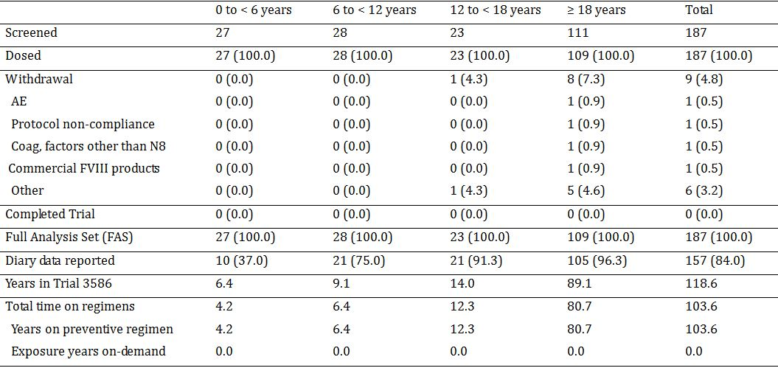

In Trial 3568 years is the calendar time from inclusion in the trial until 21 November 2011 (or date of withdrawal).

*Comment: Of the 187 patients in the trial, 8 (4.3%) patients who had been dosed with turoctocog alfa had withdrawn as of the cut-off data. The reasons for withdrawal were: 1 withdrew due to "use of coagulation factors other than turoctocog alfa" and "use of commercial FVIII products"; 1 withdrew due to AE at end of previous trial with reason listed as "other"; 1 withdrew due to an AE of psychotic disorder; 1 withdrew due to non-planned surgery; 1 withdrew due to non-compliance with the protocol; 1 withdrew on own initiative; and 2 withdrew consent.*

#### Major protocol deviations

There were 79 important protocol deviations at the patient level (i.e., 39.0% of turoctocog alfa dosed patients). The most commonly reported important protocol deviation at the patient level was related to treatment compliance (23 patients, 12.3%), mainly due to patients not following the treatment regimen or taking the wrong dose. Other reported important protocol deviations at the patient level were: 14 (7.5%) assessment deviations; 13 (7.0%) related to informed consent; 9 (4.8%) related to collection of laboratory samples; 9 (4.4%) related to handling of the trial product; 6 (3.2%) related to visits outside the treatment window; and 5 (2.7%) for "other" reasons. The sponsor considered that none of the important protocol deviations at the patient level had a major effect on the trial outcome or on the safety of the patients.

#### Baseline data

Of the 187 patients in the trial, 109 (58.3%) were adults aged ≥ 18 years, 28 (15.0%) were children aged 6 to < 12 years, 27 (14.4%) were children aged 0 to < 6 years, and 23 (12.3%) were adolescents aged 12 to < 18 years. In the total population, the mean (SD) age at entry to Trial 3586 was 21.7 years (13.8) with a range of from 1 to 60 years. In the total population, the mean (SD) number of turoctocog alfa infusions before dosing in Trial 3568 was 80.8 (18.3) with a range of 50 to 214. The majority of patients were "White" (83.4%) and the second-largest racial group was "Asian" (11.2%). The three countries contributing the greatest number of participants were the US (16.6%), Serbia (12.8%) and Brazil (11.8%), while the remaining 58% of patients were distributed among the other 15 participating countries.

The haemophilia histories reflect the status prior to entering the trials contributing to Trial 3568. All patients had severe haemophilia A with a mean FVIII activity of 0.6% (ranging from 0.0 to 1.0%) based on medical records. A total of 82 of the 187 patients had relatives with haemophilia A. None of the patients had clinical suspicion of inhibitors at baseline, and 47% had yearly or half-yearly tests for inhibitors. Of the 187 patients, 65.1% (n=121) had been on prophylactic FVIII regimens prior to entering the turoctocog alfa program and 57.5% (n=107) received on-demand FVIII treatment, while some received both treatments. Patients had been on prophylaxis for a mean of 61.8 months ranging from 1 to 480 months, and the mean prophylactic dose was 27.6 IU/kg ranging from 7 to 63 IU/kg. The mean number of bleeds in the 12 months prior to entering the turoctocog alfa clinical development program for patients who had received prophylactic treatment was 8 bleeds/patient/year ranging from 0 to 55 bleeds/patient/year. For patients receiving on-demand treatment, the mean number of bleeds within the 12 months prior to entering the turoctocog alfa clinical development program was 3.5 bleeds/patient/month ranging from 0 to 18 bleeds/patient/month. For patients on prophylaxis, 48% used rFVIII products and 52% used pdFVIII products, and for patients receiving on-demand treatment, 23% used rFVIII products and 77% used pdFVIII products.

Of the 187 patients, 33.9% (n=63) had clinically relevant abnormal findings in the musculo-skeletal system at baseline as a result of haemophilia A. The proportion of patients having clinically relevant abnormal findings in the musculo-skeletal system was lower in children (3.7%, n=1, [0 to < 6 years]; 10.7%, n=3 [6 to < 12 years]) compared with adolescents and adults (39.1%, n= 9 and 46.3%, n=50, respectively). Apart from baseline musculo-skeletal system abnormalities, 8 (4.3%) patients had other baseline clinically relevant abnormal findings (2 patients with psoriasis; 1 patient with autism; 1 patient with parodontitis; 1 patient with cutaneous haemangioma; 1 patient with tender hepatomegaly; 1 patient with thyroid enlargement; and 1 patient with rough breath sounds and arterial hypertension).

Of the 187 patients, 93% (n=147) had negative HIV antibody results at baseline, 5.7% (n=9) were HIV positive and 1.3% (n=2) had inconclusive HIV antibody results. All children and adolescents were HIV negative. All patients were negative for hepatitis B surface antigen. Positive test results for lupus anticoagulant at baseline were obtained for 4 (4%) patients out of 99 tested patients.

#### Efficacy results

##### Main trial - preventive treatment (secondary efficacy endpoint)

###### Annualised bleeding rate

The annualised bleeding rates were estimated using a Poisson model allowing for over-dispersion and presented with 95% CIs. At the cut-off date (21 November 2011), a total of 366 bleeds had been reported in 86 of the 187 participating patients. Thirty (30) patients (16%) had no available diary data as of the cut-off date of 21 November 2011, since they had not yet attended Visit 2 at which the first diary data were collected. Therefore, data were available on 157 patients from the diary data at the cut-off date, and patients with available data at the cut-off data were referred to "subjects at risk during the risk period". Therefore, there were 366 bleeds in 54.8% (86/157) of the "subjects at risk during the risk period". The estimated annualised bleed rates are summarised below in Table 28. The annualised bleeding rates refer to the 157 patients for whom data from the diary were available at the date of data cut-off (i.e., "subjects at risk during the risk period".

Table 28: Trial 3586 - Annualised bleeding rate (Poisson estimate) preventive regime in the subjects at risk; FAS.

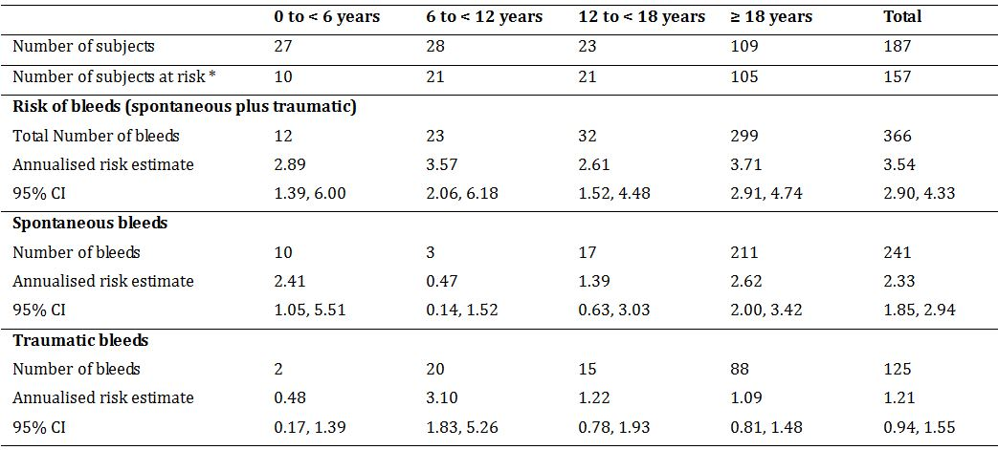

* = Number of subjects at risk during the risk period (i.e., with available diary data the date of cut-off).

Excluding bleeds and corresponding exposure periods that occurred more than 72 hours after the last preventive dose resulted in a decrease in the total estimated annualised bleeding rate from 3.54 to 3.10 bleeds/patient/year. Excluding bleeds and corresponding exposure periods that occurred more than 48 hours after the last preventive dose resulted in a decrease in the total estimated annualised bleeding rate from 3.54 to 2.53 bleeds/patient/year.

The mean (SD) average preventive dose in the total population (n=187) was 30.4 (9.1) IU/kg with a range of from 4.3 to 86.0 IU/kg. The highest mean preventive dose was in children aged 0 to < 6 years and the lowest mean preventive dose was in adults (44.7 IU/kg and 27.4 IU/kg, respectively).

##### Main trial - acute bleeds (secondary efficacy endpoint)

###### Details of bleeds

At the cut-off date of 21 November 2011, a total of 366 bleeds had been reported in 86 of the 187 participating patients. In the total population, the majority of bleeds (65.8%) were spontaneous while 34.2% were caused by trauma. The only age cohort in which traumatic bleeds occurred more frequently than spontaneous bleeds was children aged 6 to < 12 years (87.0% and 13.0%, respectively). In the total population, bleeds were classified as mild/moderate in 86.1% of the cases and as severe in 13.9% of the cases, and this pattern was observed in each of the age cohorts.

In the total population, the mean (SD) duration of a bleed was 19.68 (28.39) hours, ranging from 0.17 to 273.25 hours. The shortest mean duration of a bleed was in children aged 0 to < 6 years and the longest was in children aged 6 to < 12 years (7.67 vs 25.10 hours, respectively). In the total population, the majority of bleeds were in a joint (77.9%, 285/366), and the incidence of joint bleeds was notably lower in patients aged 0 to < 6 years (16.7%) than in the three other age cohorts (73.9% to 84.4%). In the total population, the majority of patients required only one infusion to stop a bleed (78.7%, 288/366 bleeds), and 90.7% (332/366) of all bleeds required no more than one or two infusions. The mean number of infusions to stop a bleed was 1.5 infusions/ bleed and the median number of infusions was 1 infusion/bleed, ranging from 1 to 25 infusions. The mean number of infusions to stop a bleed was similar for each of the age cohorts (1.3 to 2.0 infusions/bleed), and the median number was identical in the age cohorts (1 infusion/bleed).

In the total population, the mean (SD) dose of turoctocog alfa for treatment of a bleed was 35.6 (11.7) IU/kg, ranging from 19.9 to 104 IU/kg. The highest mean treatment dose was reported in children aged 6 to < 12 years and the lowest was reported in adolescents aged from 12 to < 18 years (45.9 IU/kg vs 33.8 IU/kg, respectively). In the total population, the mean (SD) consumption of turoctocog alfa to stop a bleed was 53.2 (57.6) IU/kg, ranging from 19.9 to 735.3 IU/kg. The highest mean consumption to stop a bleed was in children aged 6 to < 12 years and the lowest mean consumption to stop a bleed was in adolescents aged 12 to < 18 years (89.8 IU/kg and 46.5 IU/kg, respectively).

###### Haemostatic response

The haemostatic response after treatment of a bleed with turoctocog alfa was evaluated on a 4-point scale as excellent, good, moderate, or none. Overall, the haemostatic response was rated as excellent for 170 (46%) bleeds, good for 149 (41%) bleeds, moderate for 44 (12%) of bleeds, and none for 3 (1%) bleeds. The results for the haemostatic response after treatment of a bleed is summarised below in Table 29.

Table 29: Trial 3586 - Haemostatic response after treatment of a bleed; n (%) in the FAS.

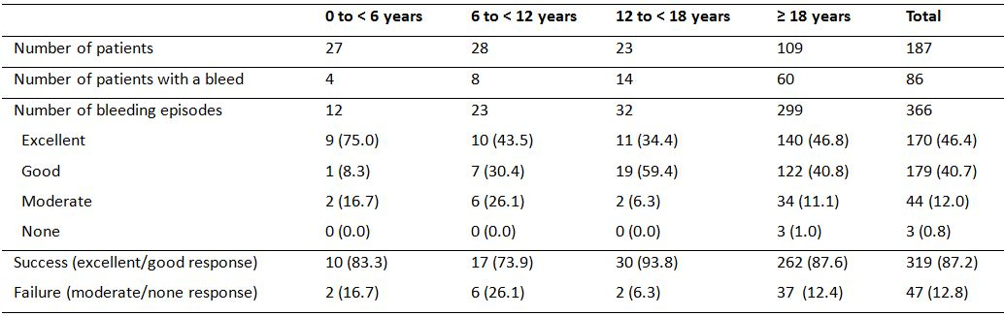

There were 3 bleeds in adult patients aged ≥ 18 years where the haemostatic response was rated as none (0.8% of bleeds): a mild/moderate traumatic bleed requiring 4 infusions to stop the bleed with a duration of 47 hours; a severe spontaneous joint bleed requiring 3 infusions to stop the bleed with a duration of 47 hours; and a severe spontaneous joint bleed requiring 5 infusions to stop the bleed with a duration of 43 hours. For 11 of the bleeds, the haemostatic response was rated as excellent even though more than 1 infusion was used to stop the bleed. The success rate was generally high irrespective of the sub-group factors investigated.

##### Main trial - exposure to turoctocog (main trial)

A total of 187 patients were exposed to turoctocog. All patients followed a preventive regimen. The majority of patients (82.9%) started the trial on a three times weekly dosing schedule, and 6 patients (3.2%) changed dosing frequency at least once during the trial. The mean number of turoctocog alfa doses per patient was 88.8 IU/kg (range: 1, 363 IU/kg), and the total number of exposure days per patient was 88.3 days (range: 1, 363 days). The majority of doses were for prevention (85.8 doses/patient), while 2.9 doses/patient were used for treatment of bleeds.

In a plot of the mean preventive dose by month, an increase was observed from Month 1 to Month 6 in the adult trial (Trial 3543) and from Month 1 to Month 4 in the paediatric trial (Trial 3545). In a plot of mean doses of turoctocog alfa for prevention of bleeds an increase in mean dose was observed in Trial 3568 for patients continuing from the adult trial and a decrease in the mean dose was observed in Trial 3568 for patients continuing from the paediatric trial. However, the increases and decreases in mean dose over time were small and within the dose ranges prescribed in the protocols.

##### Surgical sub-trial

Two major surgeries were performed up until the cut-off date (21 November 2011). The surgery indications were pain in left ankle (1 patient) and poly-trauma (1 patient). Both patients received turoctocog alfa as bolus administrations during surgery.

In the patient undergoing left ankle surgery, the consumption of turoctocog alfa during the 7 days of hospitalisation was 192 IU/kg. No blood product transfusions, no blood loss and no wound haematomas were reported. The haemostatic response both during and after surgery was rated as excellent. The difference in haemoglobin level from pre-surgery to 1 hour post-surgery was -13.7% and from pre-surgery to 24 hours post-surgery was -3.6%.

In the patient undergoing surgery for poly-trauma following a fall (fractured femur, fractured hand), the consumption of turoctocog alfa during the 7 days of hospitalisation was 278 IU/kg. The actual blood loss during the surgical procedure was 500 mL and 2 units (538 mL) of red blood cells were transfused. No wound haematoma was reported. The haemostatic response during surgery was rated as good and the haemostatic response after surgery was rated as excellent. The difference in haemoglobin level from pre-surgery to 1 hour post-surgery was -30.9% and from pre-surgery to 24 hours post-surgery was -16.1%.

#### Analyses performed across trials

The Summary of Clinical Efficacy included a post-hoc analysis of the pooled efficacy data from 213 patients with severe haemophilia A who had participated in Trials 3543, 3545, and 3568. The limitations of this analysis relate to the notably longer duration of treatment of patients in the extension trial (Trial 3568), and the inclusion of patients in the extension trial who had been previously treated in Trial 3543 (pivotal adult trial) or Trial 3545 (pivotal paediatric trial). However, the Clinical Trials section of the proposed Product Information (PI) includes efficacy data from the pooled analysis. The key efficacy results from the pooled analysis are provided immediately below and/or presented below (efficacy conclusions). The summarised results include annualised bleeding rate (Panel A), haemostatic success rate (Panel B), average dose of turoctocog alfa for prevention (Panel C), and average dose of turoctocog alfa for treatment of bleeding (Panel D).

The estimated annualised bleeding rate during preventive treatment in the 213 patients included in the pooled analysis was 4.89 (95% CI: 4.16, 5.74) bleeds/patient/year, and the mean dose of turoctocog alfa for the prevention of bleeds was 28.9 IU/kg ranging from 3.2 to 97.4 IU/kg. Overall, the 213 patients in the FAS receiving preventive treatment experienced 205 patient years of exposure to turoctocog alfa, with a mean (SD) of 0.96 patient years of exposure. There were 991 bleeds in 158 patients, and the success rate for treatment of acute bleeds based on the haemostatic response of excellent/good was 84.6% (838/991 bleeds). In the pooled analysis, the success rate remained relatively constant irrespective of the number of months that a patient had been on preventive turoctocog alfa treatment.

Overall, the haemostatic response to turoctocog alfa for the treatment of acute bleeds was rated as excellent for 38.14% (378/991), good for 46.42% (460/991), moderate for 11.20% (111/991), none for 1.72% (17/991), and data were missing for 2.52% (25/991) of bleeds. Of the 991 bleeds, 898 (90.6%) resolved with 1 or 2 infusions of turoctocog alfa (75.4%, 747 bleeds and 15.2%, 151 bleeds, respectively). The majority of bleeds (92%) for which the haemostatic response was "excellent’” resolved with 1 infusion while the remaining 8% of the bleeds with "excellent" response needed more than 1 infusion for resolution. In addition, 83% of the bleeds for which the haemostatic response was rated as "moderate" or "none" were resolved with 3 or fewer infusions. The mean duration from start to stop of a bleed was 16.7 hours ranging from 0.17 to 304.0 hours.

The majority of the bleeds were in joints (72.4%, 717/991) and 51.5% (510/991) of these joint bleeds were target joint bleeds (defined as 3 or more bleeds in the same joint within 6 months). The success rates (haemostatic response rated as "excellent" or "good") were 84.4% (605/717) for joint bleeds, 85.1% (451/530) for target joint bleeds, 87.8% (36/41) for subcutaneous bleeds, 85.7% (60/70) for muscular bleeds, 86.3% (88/102) for bleeds where the location of the bleed was reported as "other" and 80% (20/25) for bleeds where the location of the bleed was not reported. Few gastrointestinal (5) and mucosal (10) bleeds were reported and the corresponding success rates were 60% (3/5) and 90% (9/10).

##### Efficacy in surgery across the trials

The submission included a post-hoc pooled analysis on the use of turoctocog alfa from Trials 3543 and 3468. The surgical data from the pivotal paediatric trial (Trial 3546) was not included in the pooled analysis, presumably because the information derived from surgery from this trial was not from a formally defined surgical sub-trial.

The pooled surgery data from Trials 3543 and 3568 included information on 11 patients who had undergone surgery (7.3%, 11/150); major surgery in 10 and minor surgery in 1. The mean age of the 11 patients at surgery was 27.3 years (range: 14, 54 years), and 10 were adults aged ≥ 18 years and 1 was an adolescent aged 12 to < 18 years. All patients were "White", and came from Israel (n=2), Italy (n=1), Serbia (n=2), Switzerland (n=1), Turkey (n=1), the UK (n=1) and the US (n=3). Indications for surgery included arthropathy and chronic pain in left knee for 1 patient, synovitis for 1 patient, semi-impacted tooth and removal of tooth root for 1 patient, arthropathy for 4 patients, circumcision for 1 patient, recurrent haemarthrosis for 1 patient, pain in left ankle for 1 patient and poly-trauma for 1 patient.

The haemostatic response during surgery was rated as excellent in 72.7% (8/11) of patients and good in 27.3% (3/11) of patients, and the haemostatic response was the same after surgery when haemostasis had been achieved. The mean (SD) total consumption of turoctocog alfa across the 11 surgical procedures during the entire hospitalisation period was 823.2 (503.2) IU/kg, ranging from 191.8 to 1482 IU/kg. From Day 1 to Day 7, the mean (SD) consumption was 417.8 (169.4) IU/kg, ranging from 191.8 to 727.9 IU/kg, and from Day 8 until the preventive regimen was resumed, the mean (SD) consumption was 557.4 (406.0 IU/kg, ranging from 90.5 to 1196 IU/kg.

There were no data on surgery in children aged < 12 years in the post-hoc pooled analysis. However, in the pivotal paediatric trial (Trial 3545), 2 patients underwent minor surgical procedures (1 dental extraction; 1 removal of central venous access port), and haemostasis was rated as excellent for both surgeries. The patient who had a dental extraction received a pre-surgery dose of turoctocog alfa of 50 IU/kg and tranexamic acid 500 mg two times daily for 3 days during the recovery period. The patient who underwent removal of the central venous port had a pre-surgery dose of turoctocog alfa of 100 IU/kg and a single dose of 50 IU/kg during the post-surgical recovery period.

### Evaluator's conclusions on clinical efficacy

* It is considered that the submission has satisfactorily established the efficacy of turoctocog alfa for the prevention and treatment of bleeding episodes in children and adults with haemophilia A, without inhibitors, who have been previously treated with FVIII products. There were limited efficacy data on the use of turoctocog alfa in the surgical setting, but the submitted data are considered to satisfactorily establish the efficacy of the drug for this indication.
* The submission to register turoctocog alfa for the proposed indications was supported by three, good quality, Phase III, multi national, multi centred, open label, single arm efficacy and safety studies in previously treated male patients with severe haemophilia A (FVIII activity ≥ 1%), without inhibitors (Trials 3543, 3545, and 3568). The submission included 214 patients who had been exposed to turoctocog alfa up to the data cut off date of 21 November 2011. Of these 214 patients, 213 were included in the efficacy analysis, with 1 adult patient not continuing from the pivotal Phase I PK trial (Trial 3522) into the pivotal Phase III trial (Trial 3543). Of the 213 treated patients, 126 were adults aged ≥ 18 years, 24 were adolescents aged ≥ 12 years to < 18 years, 32 were children aged 6 to < 12 years, and 31 were children aged 0 to < 6 years.
* In each of the Phase III trials, efficacy endpoints relating to prevention of bleeding and on-demand treatment of acute bleeding episodes were defined as secondary endpoints, with the primary endpoint in each of the trials being the incidence rate of FVIII inhibitors (that is, a safety endpoint). However, the TGA adopted European Union note for guidance on the clinical investigation of rFVIII products indicates that clinical efficacy should be assessed from clinical response as reported by patients in safety trials,[14] and the efficacy endpoints in the submitted trials were consistent with those defined in the guidance document.
* There was no comparator arm in the three Phase I clinical efficacy and safety trials. While a placebo arm would have been unethical, it would have been useful to have included a commercially available rFVIII product as an active comparator arm. However, in adults and adolescents (≥ 12 years to < 18 years) single dose turoctocog alfa 50 IU/kg and single dose Advate 50 IU/kg were found to be bioequivalent as assessed by the clotting assay (Trial 3543), while in children (0 to 12 years of age) the pharmacokinetics of single dose turoctocog alfa were similar to the PK of a range of other FVIII products taken prior to turoctocog alfa (Trial 3545). Based on the single dose PK data in adults, adolescents and children it is reasonable to infer that the efficacy of turoctocog alfa is likely to similar to that of other FVIII products. Furthermore, the TGA adopted EU note for guidance document on the clinical investigation of rFVIII products does not specify that an active comparator is required for assessment of clinical efficacy endpoints.[15]
* In the pivotal adult trial (Trial 3543), all patients were treated with preventive turoctocog alfa with the majority (83.3%; 125/150) receiving the 20 to 50 IU/kg three times a week regimen and the minority (16.7%; 23/150) receiving the 20 to 40 IU/kg every second day regimen. Of the 150 patients exposed to turoctocog alfa, 148 were exposed for at least 50 days and 142 were exposed for at least 75 days. The estimated mean annualised bleeding rate in the 150 treated patients was 6.50 (95% CI: 5.30, 7.97) bleeds/patient/year, with the mean annualised bleeding rate being higher in adults aged ≥ 18 years (n = 126) than in adolescents aged ≥ 12 to < 18 years (n = 24) (6.68 versus 5.55 bleeds/patient/year, respectively). The mean preventive dose of turoctocog in the total population was 24.6 IU/kg, ranging from 12.8 to 97.4 IU/kg, and the mean consumption of turoctocog alfa for the prevention of bleeds was 3860.1 IU/kg per patient per year, ranging from 2577.8 to 7452.2 IU/kg per patient per year. The estimated mean annualised bleeding rate in the total population in this trial was similar to the corresponding rate reported for Advate from published data[16] in a similar population (6.5 versus 6.3 bleeds/patient/year, respectively).
* In the pivotal adult trial (Trial 3543), there were 499 bleeds in the total population (n = 150), of which 66.5% (332/499 bleeds) were spontaneous and 24.8% (124/499 bleeds) were traumatic, with information being missing on 8.6% (43/499 bleeds). The mean duration of a bleed was 16.4 h, ranging from 15 minutes to 304 h. The mean time from start of a bleed until the first administration of turoctocog alfa was 2.83 h, ranging from 0 to 56 h, and the mean time from the first administration of turoctocog alfa until the bleed stopped was 13.6 h, ranging from 0 to 300 h.
* In the pivotal adult trial (Trial 3543), the haemostatic response in the total population following turoctocog alfa to treat an acute bleed was rated as excellent for 28.1% of bleeds, good for 52.7% of bleeds, moderate for 12.4% of bleeds and none for 2.4% of bleeds, with haemostatic data being missing for 4.4% of bleeds. In the total population, the success rate (excellent/good haemostatic response) for treatment of acute bleeds with turoctocog alfa was 84.5% (excluding missing data), which compares with a success rate of 86.0% for Advate reported in the published data.[17] In the total population, the mean turoctocog alfa dose for the treatment of an acute bleed was 30.4 IU/kg, ranging from 9.8 to 61.1 IU/kg, and the mean consumption of the drug to stop a bleed was 46.6 IU/kg, ranging from 15.0 to 1150.0 IU/kg. Of the 499 bleeds, 71.5% were stopped with one infusion and 17.8% were stopped with two infusions. The mean number of infusions to stop a bleed from start to finish was 1.5 infusions/bleed.
* In the pivotal paediatric trial (Trial 3454), all patients were treated with preventive turoctocog alfa with the majority (74.6%; 47/63) receiving the three times a week regimen (25 to 60 IU/kg, 3x/week) and the minority (25.4%; 16/63) receiving the once every second day regimen (25 to 50 IU/kg, 2nd daily). Of the 63 patients exposed to turoctocog alfa, 59 were exposed for at least 50 days. The estimated mean annualised bleeding rate in the total paediatric population (n = 63) was 5.33 (95% CI: 3.90, 7.28) bleeds/patient/year, with the rate being lower in children aged 0 to < 6 years (n = 31) compared with children aged 6 to < 12 years (n = 32) (4.73 versus 5.86 bleeds/patient/year, respectively). The estimated annualised bleeding rate in the total paediatric population was lower than in the total adult/adolescent population (5.33 versus 6.50 bleeds/day, respectively). The mean preventive dose of turoctocog alfa in the paediatric population was 36.8 IU/kg, ranging from 3.2 to 73.9 IU/kg, and the mean consumption of the drug for prevention of bleeding was 5641.4 IU/kg per patient per year, ranging from 2653.5 to 9357.9 IU/kg per patient per year.
* In the pivotal paediatric trial (Trial 3454), 126 bleeds were reported in 41 patients (65.1%). Of the 126 bleeds, 66.7% (84/126) were traumatic, 31.7% (40/126) were spontaneous, and 1.6% (2/126) were unclassified. The proportion of traumatic bleeds was greater in younger children aged 0 to <6 years than in older children 6 to < 12 years (83.0%; 44/53 versus 54.8%, 40/73; respectively). The mean duration of a bleed was 8.88 h, ranging from 10 minutes to 53.5 hours. Of the 126 bleeds, 81.0% were stopped with one infusion and 14.3% were stopped with two infusions. The mean number of infusions required to stop a bleed from start to finish was 1.3 infusions/bleed.
* In the pivotal paediatric trial (Trial 3454), the haemostatic response following turoctocog alfa for the treatment of an acute bleed was rated as excellent for 54.9%, good for 38.1%, moderate for 4.0%, and none for 1.6%, with haemostatic data being missing for 2.4% of bleeds. The haemostatic response was similar in children aged 0 to < 6 years and 6 to < 12 years. The success rate (excellent/good haemostatic response) for treatment of acute bleeds with turoctocog alfa was 94.3% (excluding missing data), which was higher than in the pivotal adult trial (84.5%). The mean turoctocog alfa dose for the treatment of an acute bleed was 40.4 IU/kg, ranging from 25.5 to 193.8 IU/kg, and the mean consumption of the drug to stop a bleed was 54.2 IU/kg, ranging from 25.7 to 264.0 IU/kg. The mean number of turoctocog alfa infusions required to stop a bleed was 1.3 infusions/patient.
* In the extension trial (Trial 3568), the annualised bleeding rates in the total population (n = 157: 31 children < 12 years and 126 adults/adolescents) was lower than in the total population (n = 150) in the pivotal adult trial (Trial 3543) and in the total population (n = 63) in the pivotal paediatric trial (Trial 3524) (3.54 versus 6.50 versus 5.33 bleeds/patient/year, respectively). The decrease in the estimated annualised rate bleeding rate associated with increased duration of exposure to turoctocog alfa was also observed in the pooled patient population from Trials 3568, 3543, and 3545 where the estimated annualised bleeding rate plotted against month on preventive treatment showed a drop from Month 6 to 7, corresponding to the time at which patients transferred from the pivotal adult trial (Trial 3543) to the extension trial (Trial 3568). The reason for the drop in the estimated annualised bleeding rate is unknown. However, the pooled data for the success rate based on the haemostatic response (excellent/good) remained relatively constant over time.
* In the pooled analysis, 68 patients received preventive treatment with turoctocog alfa for at least 12 months, with cumulative exposure of 114.8 years (that is, mean of 1.69 years per patient). The 68 patients experienced 492 bleeds resulting in a mean estimated annualised bleeding rate of 4.29 (95% CI: 3.28, 5. 60) bleeds/patient/year. These 68 patients experienced 318 bleeds in the first 12 months of treatment (cumulative exposure 68 years) resulting in an estimated mean annualised bleeding rate of 4.68 (95% CI: 3.52, 6.21). The results indicate that the bleeding rate in the 68 patients was similar following > 12 months and ≤ 12 months preventive treatment with turoctocog alfa, suggesting that there is no decrease in efficacy over time. In addition, the mean estimated annualised bleeding rate of 4.29 bleeds/patient/year for the 68 patients exposed for a mean of 1.69 years/patient is comparable to the annualised bleeding rate of 4.89 bleeds/patient/year for the total population of 213 patients exposed for a mean of 0.96 years/patient.
* The pooled analysis included a comparison between pre trial and post trial bleeding rates. At baseline, a total of 85 (40.1%) patients had at least 12 months of prophylactic exposure to FVIII products prior to trial entry, ranging from 12 to 480 months. The mean number of bleeds, as reported by the investigator, within the last year prior to trial entry for these patients was 6.1 bleeds/patient/year. During the trial period the annualised bleeding rate for these patients was lower at 3.86 bleeds/patient/year. At baseline, a total of 73 (34.4%) patients had received on-demand FVIII treatment prior to trial entry. The mean number of bleeds per month within the last year prior to trial entry for these patients was 3.9 bleeds/patient/month corresponding to 47 bleeds/patient/year, as reported by the investigator. The mean annualised bleeding rate for these patients was 5.53 bleeds/patient/year after preventive treatment with turoctocog alfa. In addition, 44 (20.8%) patients were reported to have been on both preventive and on-demand treatment regimens prior to trial entry, and 10 (4.7%) of patients were reported to have been on preventive treatment for less than 12 months. These 54 patients were not included in the comparison between the pre trial and during the trial bleeding rates.
* There were limited data on the use of turoctocog alfa in surgery. The pooled data from the two surgical sub trials (Trials 3543 and 3468) included information on 11 patients (10 major and 1 minor surgeries) with a mean age of 27.3 years, ranging from 14 to 54 years. The haemostatic response was reported as excellent in 72.8% (8/11) of patients and good in 27.3% (3/11) of patients both during surgery and after haemostasis had been achieved.

## Clinical safety

### Studies providing evaluable safety data

The submission included an evaluation of safety in patients undergoing preventive and on-demand treatment based on data from five completed trials (Trials 3522, 3893, 3600, 3543, 3545), and from one on-going trial (Trial 3568). The data from the on-going trial (Trial 3568) included information on non serious adverse events (AEs) up to the cut off date of 21 November 2011, and information on serious adverse events (SAEs), development of inhibitors and hypersensitivity reactions up to the later cut off date of 1 May 2012. The submission also included a separate evaluation of safety in patients undergoing surgery from the two surgical sub trials (Trials 3543 and 3568). In this clinical evaluation report, the evaluation of safety focuses on separate analyses of the pooled safety data in patients undergoing preventive and on-demand and of the pooled safety data in patients undergoing surgery.

### Exposure

The number of patients exposed to turoctocog alfa in each of the clinical trials (safety analysis set [SAS]) are summarised below in Table 30.

Table 30: Number of patients exposed to turoctocog alfa in the clinical trials; SAS.

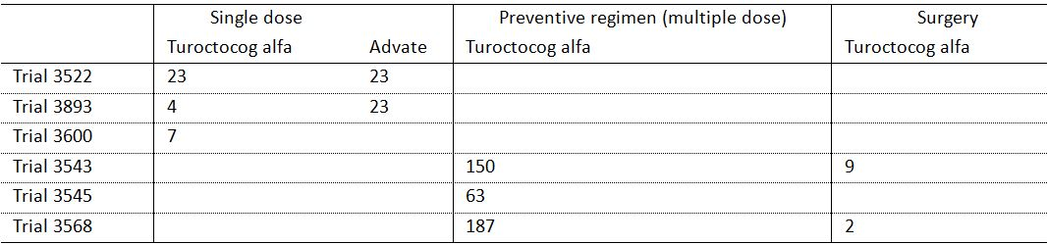

As of the cut-off date (21 November 2011), 214 patients in the safety database had a total of 32,929 exposure days to turoctocog alfa for the prevention and treatment of bleeds, with a mean (SD) exposure of 153.9 (93.29) days ranging from 1 to 442 days and mean (SD) consumption of 4901 (1544) IU/kg per patient per year. The exposure data correspond to 205 patient years of exposure, and a mean of 0.96 years of exposure/patient for the 214 patients in the safety database. The duration of exposure for patients exposed to turoctocog alfa for the prevention and treatment of bleeds is summarised below in Table 31.

Table 31: Number of patients exposed to turoctocog alfa for prevention and treatment of bleeds; SAS.

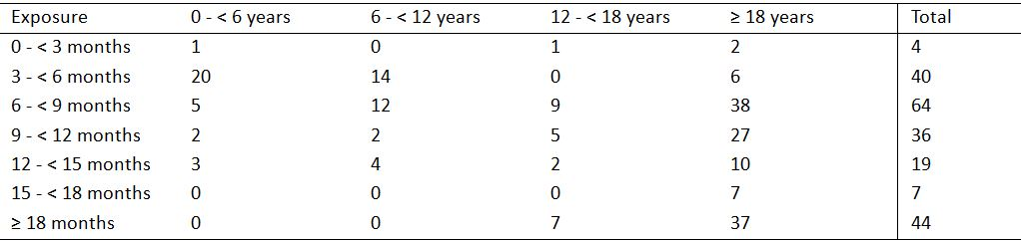

In the surgical sub-trials (Trials 3543 and 3568), 11 patients (1 adolescent and 10 adults) had a total of 201 exposure days to turoctocog alfa with a mean (SD) of 18.3 (12.55) exposure days per patient, ranging from 7 to 41 days, and mean (SD) turoctocog alfa consumption of 462 (360) IU/kg.

### Adverse events

#### Definitions

The safety data used standard definitions of adverse events (AEs), serious adverse events (SAEs), and severity of adverse events. An AE could also be a clinical laboratory abnormality regarded as clinically significant (i.e., an abnormality that suggested a disease and/or organ toxicity), and required active management (i.e., change of dose, discontinuation of trial product, more frequent follow-up or diagnostic investigation). AEs included events from the first trial-related activity after the patient signed the informed consent until the end of the post-treatment follow-up period as defined in the protocol. Treatment-related adverse events were identified by the investigator using standard clinical trial definitions of probable, possible and unlikely. Adverse event outcomes were defined as recovered, recovering, recovered with sequelae, not recovered, fatal and unknown. The safety data also included medical events of special interest (i.e., a noteworthy event of scientific and medical concern that the sponsor continued to monitor). AEs of special interest were also assessed, and these included formation of FVIII inhibitors, allergic type hypersensitivity reactions and thromboembolic events. Disease related bleeds were not to be reported as AEs, unless considered by the investigator to be related to the trial product. In cases of fatal outcome, disease related bleeds were to be reported as SAEs. All serious and non-serious AEs were coded according to the Medical Dictionary for Regulatory Activities (current version at the time of database lock).

#### Common adverse events

##### During prevention and treatment of disease - pooled data

###### Irrespective of relationship to treatment

A total of 503 AEs were reported in 154 (72.0%) patients during prevention and treatment of bleeds (19, 61.3% [0 to < 6 years]; 18, 56.3% [6 to < 12 years]; 19, 79.2% [12 to < 18 years]; and 98, 77.7% [adults≥ 18 years]). The overall AE rate was 2.45 AEs/patient years of exposure, and the rates were similar across the four age cohorts (range: 2.30 to 3.53 AEs/patient years of exposure). The highest AE rate was reported in children aged 0 to < 6 years (3.53 AEs/patient years of exposure). AEs reported during prevention and treatment of bleeds are summarised below in Table 32.

Table 32: Pooled Analysis (Safety) - Adverse events reported during prevention and treatment of bleeds; SAS.

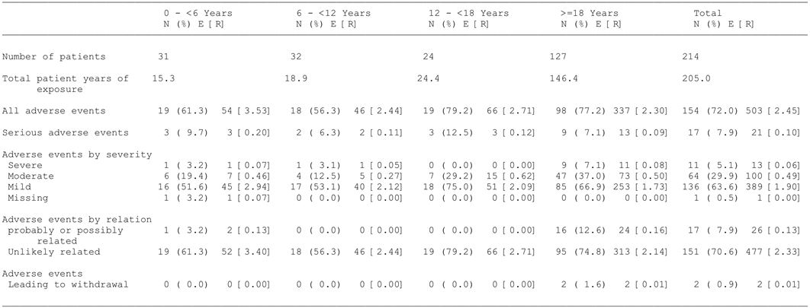

In the total population, the most commonly occurring categories of AEs (System, Organ, Class [SOC]) including ≥ 10% of patients, and preferred term AEs occurring in ≥ 5% of patients within the SOC were: "infections and infestations", 30.4%, n=65 (nasopharyngitis, 10.3%; URTI, 5.1%); "injury poisoning, procedural complication", 27.6%, n=59 (incorrect dose administered, 8.9%); gastrointestinal disorders 19.2%, n=41 (toothache, 5.1%); "respiratory, thoracic and mediastinal disorders", 15.9%, n=34; "musculoskeletal and connective tissue disorders", 15.0%, n=32 (arthralgia, 6.1%); "nervous system disorder", 14.5%, n=31 (headache, 10.3%); and "general disorders and administration site conditions", 11.7%, n=25 (pyrexia, 6.1%).

AEs (preferred term), irrespective of causality, occurring in ≥ 2% of patients in the total patient population were: nasopharyngitis (10.3%); headache (10.3%); incorrect dose administered (8.9%); arthralgia (6.1%); pyrexia (6.1%); URTI (5.1%); toothache (5.1%); contusion (4.7%); cough (4.7%); oropharyngeal pain (4.2%); nasal congestion (3.3%); pharyngitis (2.8%); joint injury (2.8%); sinusitis (2.3%); vomiting (2.3%); and pain in extremity (2.3%). AEs reported in ≥ 1% of all patients and more frequently in children aged 0 to < 6 years compared with the three other age groups included URTI, pyrexia, vomiting, cough, allergic rhinitis, ear pain, and dizziness.

In the total population, AEs were categorised as severe in 5.1% (n=11) of patients (13 events, 0.06 AEs/patient years of exposures), moderate in 29.8% (n=64) of patients (100 events, 0.49 AEs/patient years of exposure), and mild in 63.6% (n=136) of patients (389 events, 1.90 AEs/patient years of exposure). In the total population, the incidence rate of AEs per patient years of exposure diminished with increasing time from first administration of turoctocog alfa (see Table 33).

Table 33: Pooled Analysis (Safety) - AE rate by time to onset from administration of turoctocog alfa; SAS.

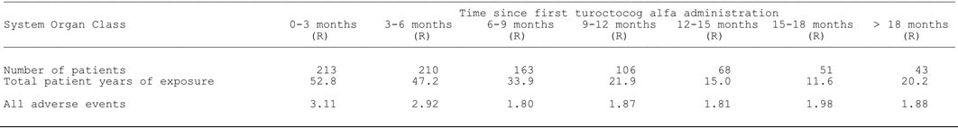

###### Treatment-related

A total of 26 AEs in 17 (7.9%) patients were considered by the investigator to be possibly or probably related to treatment with turoctocog alfa. The most frequently reported treatment-related AEs reported in 2 or more patients were: incorrect dose administered (4 events in 4 patients); increased levels of hepatic enzymes (4 events in 3 patients); injection site erythema (3 events in 3 patients); and pyrexia (2 events in 2 patients). Of the 26 treatment-related AEs, 2 were reported in children aged 0 to < 6 years (0.13 events/patient years of exposure), 0 were reported in children aged 6 to < 12 years, 0 were reported in adolescents aged ≥ 12 to < 18 years, and 24 were reported in adults aged ≥ 18 years (0.16 events/patient years of exposure).

##### During surgery - pooled population

There were 5 AEs reported in 5 patients during surgery, and all were considered by the investigator to be unlikely to be related to turoctocog alfa. The 5 events were: paraesthesia (patient aged 36 years, mild severity, recovered); haemorrhage (patient aged 36 years, moderate severity, recovered); allergy to chemicals (patient aged 18 years, mild severity, not recovered); arthralgia (aged 24 years, mild severity, recovered); and vomiting (aged 55, mild severity, recovered).

#### Deaths and other serious adverse events

##### Deaths

As of the 1 May 2012 cut-off, 1 death had occurred during the trials. This death occurred in a 27 year-old patient in Trial 3568, and was related to an acute subdural haemorrhage with midline shift and cerebral oedema following an alleged assault. The patient underwent emergency craniotomy with evacuation of the haematoma, but was declared dead 2 days after arrival in hospital. The patient received turoctocog alfa pre- and post-operatively.

##### Other serious adverse events

In the total population, a total of 21 SAEs were recorded in 17 (7.9%) patients during prevention and treatment of bleeds, corresponding to a rate of 0.10 SAEs/patient years of exposure. Of the 21 SAEs, 3 were reported in children aged 0 to < 6 years (0.20 events/patient years of exposure), 2 were reported in children aged 6 to < 12 years (0.11 events/patient years of exposure), 3 were reported in adolescents aged ≥ 12 to < 18 years, and 13 were reported in adults aged ≥ 18 years (0.09 events/patient years of exposure).

SAEs occurred after 11 to 368 turoctocog alfa exposure days, and no association between frequency of the events and exposure time was observed. The only SAEs in the total population reported in 2 or more patients were: road traffic accident (2, 0.9%); and melena (2, 0.9%). SAEs reported as treatment related were hypertension, sinus tachycardia, and hypertension in 1 patient, and hepatic enzyme increased in 1 patient.

A total of 4 SAEs in 4 patients were reported in Trial 3568 between the cut-off dates of 21 November 2011 and 1 May 2012. The SAEs were subdural haemorrhage (fatal outcome), cellulitis/staphylococcal infection, pancreatitis and cholelithiasis. All 4 SAES were regarded by the investigator as unlikely to be related to turoctocog alfa administration.

No SAEs were reported during surgery.

#### Adverse events leading to withdrawal

In the pooled population, 2 (0.9%) patients were withdrawn due to AEs. One (1) patient aged 54 years was withdrawn from Trial 3543 due to mild fatigue occurring 1 day after every exposure to turoctocog alfa and considered to be possibly related to treatment. The patient was reported to have recovered at follow-up. One (1) patient aged 22 years was withdrawn from Trial 3568 due to a moderately severe serious AE categorised as a chronic psychotic disorder occurring after 368 days of exposure and considered unlikely to have been related to treatment. This patient was reported not to have recovered at follow-up. No patients were withdrawn due to lack of efficacy and no patients were withdrawn during surgery.

#### Adverse events of special interest

##### Immunogenicity

###### FVIII inhibitors

In all trials, patients were examined for development of FVIII inhibitors at scheduled visits  
(Trial 3543: Visits 1a, 1b, 2b, 4, 5, 6a, 6b, 7, 8, 9, C1 and C2; Trial 3545: Visits 1, 3, 4, 5, 6 and 8; Trial 3568: Visits 1, 2, 3, 4, 5, 6, 7, 8 and during surgery). If FVIII inhibitor development was suspected during the trial, samples for additional inhibitor tests could be taken at unscheduled visits. In the event that a patient had a positive inhibitor test (≥ 0.6 BU), the patient had to attend an unscheduled visit for a confirmatory inhibitor test on a separately drawn sample. The patient was considered to have developed inhibitors only if the confirmatory test was positive. Testing for FVIII inhibitors was performed using the Nijmegen modified Bethesda assay measured by the central laboratory. All samples for inhibitor testing were to be drawn at least 48 hours after the last dose of turoctocog alfa to minimise drug interference with the assay. A cut-point for clinical relevant levels of inhibitors was set to ≥ 0.6 BU according to guideline recommendations.[18] All cases of inhibitors were to be recorded as AEs and as medical events of special interest.

As of 1 May 2012, no patients had developed FVIII inhibitors (≥ 0.6 BU). The one-sided 97.5% upper confidence limit for the inhibitor incidence rate of zero was 1.77%. Furthermore, no signs of early inhibitor development were observed as evaluated by FVIII activity (incremental recovery), and the pharmacokinetic results of 15 patients in Trial 3543 (3−6 month after first injection of turoctocog alfa) were comparable to the results obtained after the first dose of turoctocog alfa in Trial 3522.

In the pivotal paediatric trial (Trial 3545), 1 patient had a positive FVIII inhibitor test (1.3 BU) at Visit 4. However, the result of a second sample was negative and, therefore, the criterion for development of FVIII inhibitors was not met. The positive FVIII inhibitor test (1.3 BU) at Visit 4 was reported as an adverse event and as a medical event of special interest.

###### Anti-host cell protein antibodies

Turoctocog alfa is synthesised in a well-characterised Chinese hamster ovary (CHO) mammalian cell line and purified using murine-immunoglobulin G (IgG). Tests for anti-host cell protein antibodies were performed by enzyme-linked immunosorbent assay (ELISA), and positive samples were re-analysed in a confirmatory assay. All assays were validated according to internationally recognised recommendations.

Assessments for development of anti-host cell protein antibodies were performed at regular time points during Trials 3522, 3543 and 3545. A total of 19 patients were positive for anti-CHO antibodies at some point during the trials: 2 changed from negative to positive during the trial; 6 changed from positive to negative during the trial; 6 were positive throughout the trial; 2 were negative at baseline and end-of-trial but with transient positive samples between; and 3 were positive at baseline and end-of-trial but with transient negative samples between. There were 7 patients who were anti-murine IgG positive at baseline, and of these patients 5 subsequently became negative and 2 remained positive throughout the trial. No patients changed from anti-murine IgG negative to positive during the trials.

##### Allergic type hypersensitivity reactions

Allergic type hypersensitivity reactions, including anaphylaxis/anaphylactoid reactions, might occur after administration of turoctocog alfa. These include acute immunoglobulin E (IgE) mediated reactions (including clinical signs of anaphylactic reactions, angioedema and urticaria) and delayed type hypersensitivity (including clinical signs of various types of skin rashes). It was stated that as of the 1 May 2012 cut-off, no drug related allergic type hypersensitivity reactions were reported as medical events of special interest. However, examination of the listed AEs indicates that drug hypersensitivity was reported in 1 patient (SOC "immune system disorders").

##### Thromboembolic events

No thromboembolic events were reported.

##### Medication errors

As of the cut-off date of 21 November 2011, a total of 34 medication errors were recorded. Most of the errors were related to incorrect dosing (26 errors in 19 patients [8.9%]; 0.13 events/patient years of exposure). Other medication errors were wrong technique in drug administration (3 errors), underdose (2 errors), overdose (3 errors). All medication errors were rated as mild and none were judged to have any impact on the safety of the patients or on the outcome of the treatment. One medication error was reported in Trial 3568 between 21 November 2011 and 1 May 2012.

### Laboratory tests

Overall, no clinically relevant changes associated with exposure to trial product have been observed for parameters of haematology, biochemistry and urinalysis in any of the clinical trials with turoctocog alfa. Abnormalities in haematological, hepatic and renal laboratory test results are summarised below in Section 7.7.

### Other safety parameters

#### Vital signs and physical examination

No noteworthy changes over the trial period were apparent in vital signs or physical examination.

#### Electrocardiograph (ECG)

In Trial 3543, results of the ECG assessments were reported as normal for 80% of the patients, while 20% had "abnormal, not clinically significant" findings. None of the patients in this study were reported to have "abnormal clinically significant" ECG findings. In Trial 3543, two AEs of sinus arrhythmia (evaluated as mild and unlikely related to trial product, patient recovering) and sinus tachycardia (evaluated as moderate and possibly related to trial product, patient recovered) were recorded in 2 patients. In Trial 3522, no new abnormalities were reported at the ECG evaluation 24 hours post-dosing. One (1) patient reported a mild AE of palpitations with onset 3 hours post-dosing of turoctocog alfa. The event was evaluated as unlikely to be related to trial product and the patient recovered without any treatment being required.

#### Injection site tolerability

Injection site tolerability was assessed in Trials 3522, 3600 and 3545. In Trial 3522, injection site reactions were reported in 4 patients post-dosing of turoctocog alfa and all were reported as having recovered. All reactions were reported as mild AEs possibly or probably related to turoctocog alfa. In Trial 3545, injection site inspection was performed during the PK session only. Redness was recorded 1 hour post-dosing in 1 patient, and no other findings were observed by injection site inspections. No injection site reactions were reported in Trial 3600.

### Post-marketing experience

There is no post-marketing experience with turoctocog alfa.

### Safety issues with the potential for major regulatory impact

#### Liver safety

There were 18 AEs associated with liver function test (LFT) abnormalities in 10 patients (4.7%). The abnormalities were: increased alanine aminotransferase (3 events, 3 patients); increased aspartate aminotransferase (3 events, 3 patients); increased bilirubin conjugated (1 event, 1 patient); increased blood alkaline phosphatase (1 event, 1 patient); increased total bilirubin (1 event, 1 patient); hyperbilirubinaemia (1 event, 1 patient); increased gamma-glutamyltransferase (1 event, 1 patient); and "hepatic enzymes increased" (4 patients, 4 events). The majority of patients (80%, 8/10) with abnormal LFT parameters were positive for hepatitis C, which most likely explains the findings. Most of the events (14/18=78%) were evaluated by the investigator as unlikely to be related to turoctocog alfa.

#### Renal safety

"Renal and urinary disorders" (SOC) were reported in only 1 (0.5%) patient, and this disorder was 1 AE of nephrolithiasis in an adult. "Investigations" (SOC), urine analysis abnormal (PT) was reported in 1 (0.5%) patient.

#### Haematological safety

"Blood and lymphatic system disorders" (SOC) were reported in 2 (0.9%) patients (3 disorders: 1 each for anaemia, neutropenia, thrombocytopenia). Abnormal haematological AEs grouped under "Investigations" (SOC) were reported in 3 patients: decreases in red blood cell count, haemoglobin and haematocrit in 1 patient reported 49 hours after administration of turoctocog alfa, and increases in neutrophil count (1 patient) and white blood cell count (1 patient). All events were rated by the investigator as unlikely to be related to turoctocog alfa.

#### Serious skin reactions

There were 9 (4.2%) patients with 10 "skin and subcutaneous tissue disorders" in the total population (0.05 events/patient years of exposure). There were 2 events each reported in 2 patients each (rash and urticaria), and in 1 patient each for alopecia, allergic dermatitis, atopic dermatitis, contact dermatitis, ephelides, and purpura.

#### Cardiac safety

"Cardiac disorders" (SOC) were reported in 3 (1.4%) patients, and these were (1 patient each) palpitations, sinus arrhythmia, and sinus tachycardia.

#### Immune system disorders

"Immune system disorders" (SOC) were reported in 3 (1.4%) patients: drug hypersensitivity (1 patient); hypersensitivity (1 patient); and seasonal allergy (1 patient).

### Safety in special populations

* **Previously untreated patients with haemophilia A:** No information available. All patients with haemophilia A in the submitted clinical trials had been previously treated with FVIII products.
* **Patients with FVIII inhibitors:** The clinical trials included 3 patients with inhibitors, despite the protocols specifying that patients were required to be FVIII inhibitor negative (≤ 0.6 BU). There are no meaningful data in FVIII inhibitor positive patients.
* **Patients with mild or moderate haemophilia A:** No information available. All patients with haemophilia A in the submitted clinical trials had severe disease (FVIII activity ≤ 1%).
* **Age:** The safety of turoctocog alfa has been investigated in patients aged from 1 year to 60 years; mean (SD) age 21.5 year and median age 20.0 years. Over the age range evaluated there were no significant differences in the safety profile of turoctocog alfa. There were no safety data in patients younger than 1 year or older than 60 years.
* **Sex:** All the safety data were in males, and there were no safety data in females.
* **Race:** There were limited safety data on Japanese patients with haemophilia A (i.e., 9 Japanese patients with a total of 1,138 exposure days to turoctocog alfa in Trial 3600). There were a total of 23 AEs recorded in 7 Japanese patients. Of these, 4 events (dizziness, lymphoedema, musculoskeletal stiffness and heart rate increased) were evaluated by the investigator as possibly or probably related to trial product. All other events were evaluated as unlikely related to trial product. Two (2) events (lymphoedema and gastroenteritis) were evaluated as moderate. All other events were evaluated as mild. No death, serious adverse events, adverse events leading to withdrawal or other significant adverse events (i.e., FVIII inhibitors, allergic type hypersensitivity reactions, thromboembolic events or medication errors) were reported in Japanese patients. The majority of patients in the pooled safety population were "White" (81.8%, 175/214), while 12.1% (26/214) were "Asian", 4.7% (10/214) were "Other", and 1.4% (3/214) were "Black or African American".
* **Extrinsic factors:** The limited size of the investigated population and the fact that all trials, except from the first human dose trial (Trial 3522), were single-arm trials, precludes meaningful comparison and analysis of AEs based on HIV status, hepatitis C status, hepatic impairment, renal impairment, concomitant medication and drug-drug interactions.
* **Pregnancy and lactation:** No information available.
* **Withdrawal and rebound:** No information available.

### Evaluator's overall conclusion on clinical safety

It is considered that the safety of turoctocog alfa for the proposed usage has been satisfactorily established in children and adults. However, there were no comparative safety data with either placebo or active control, which limits the interpretation of the data. The submission included pooled safety data on 214 previously treated patients with severe haemophilia A (FVIII activity ≤ 1%), without inhibitors, who had received turoctocog alfa for the prevention and treatment of bleeds, and 11 patients who had received the drug in a surgical setting.

#### Prevention and treatment of bleeds

* The 214 patients who received turoctocog alfa for the prevention and treatment of bleeds had a total 32,929 exposure days to the drug, ranging from 1 to 442 days, with a mean of 153.9 exposure days per patients.
* AEs (irrespective or relationship to treatment) were reported in 72.0% (n = 154) of the total patient population (503 events; 2.45 events/patient years of exposure). The event rates were similar across the four age cohorts ranging from a low of 2.30 events/patient years of exposure in adults aged ≥ 18 years to a high of 3.53 events/patient years of exposure in children aged 0 to < 6 years. The overall rate of AEs decreased with time on turoctocog alfa treatment.
* The most commonly occurring AEs (preferred term) reported in ≥ 2% of the total population were: nasopharyngitis (10.3%); headache (10.3%); incorrect dose administered (8.9%); arthralgia (6.1%); pyrexia (6.1%); Upper respiratory tract infection (URTI) (5.1%); toothache (5.1%); contusion (4.7%); cough (4.7%); oropharyngeal pain (4.2%); nasal congestion (3.3%); pharyngitis (2.8%); joint injury (2.8%); sinusitis (2.3%); vomiting (2.3%); and pain in extremity (2.3%). AEs reported in ≥ 2% of all patients and more frequently in children aged 0 to < 6 years compared with the three other age groups included URTI, pyrexia, vomiting, cough, allergic rhinitis, ear pain, and dizziness. Overall, the AE safety profile does not give rise to concern in children, adolescents, or adults.
* There were a total of 26 treatment related AEs reported in 17 (7.9%) patients. The most frequently reported treatment related AEs in 2 or more patients were: incorrect dose administered (4 events in 4 patients); increased levels of hepatic enzymes (4 events in 3 patients); injection site erythema (3 events in 3 patients); and pyrexia (2 events in 2 patients). Of the 26 treatment related AEs, 2 were reported in children aged 0 to < 6 years (0.13 events/patient years of exposure), 0 were reported in children aged 6 to < 12 years, 0 were reported in adolescents ages ≥ 12 to < 18 years, and 24 were reported in adults aged ≥ 18 years (0.16 events/patient years of exposure).
* There was one death reported in the clinical trials up to 1 May 2012. The death was related to a traumatic subdural haematoma following an alleged assault. There were a total of 21 SAEs reported in 17 (7.9%) patients up to 21 November 2011, and the only events occurring in 2 or more patients were road traffic accident (2, 0.9%) and melena (2, 0.9%). Of the 21 SAEs, 4 were considered to be treatment related (hypertension, tachycardia, and insomnia all reported in 1 patient; hepatic enzyme increased in 1 patient). Of the 21 SAEs, 3 were reported in children aged 0 to < 6 years (0.20 events/patient years of exposure), 2 were reported in children aged 6 to < 12 years (0.11 events/patient years of exposure), 3 were reported in adolescents aged ≥ 12 to < 18 years (0.12 events/patient years of exposure), and 13 were reported in adults aged ≥ 18 years (0.09 events/patient years of exposure). A further 4 SAEs were reported in the period from 21 November 2011 to 1 May 2012, including the fatal subdural haematoma, and none were considered to be treatment related.
* Withdrawal from treatment due to AEs was reported in 2 (0.9%) adult patients, 1 due to fatigue lasting for about 24 hours after every infusion and considered to be possibly related to treatment, and 1 due to a psychotic disorder occurring after 386 exposure days considered to be unlikely to be related to treatment. No patients were withdrawn due to a lack of efficacy.
* No patients had developed FVIII inhibitors (≥ 0.6 Bethesda units [BU]) as of 1 May 2011. A total of 19 patients were positive for anti CHO antibodies at some point during the trials: 2 changed from negative to positive during the trial; 6 changed from positive to negative during the trial; 6 were positive throughout the trial; 2 were negative at baseline and end of trial but with transient positive samples between; and 3 were positive at baseline and end of trial but with transient negative samples between. There were 7 patients who were anti murine IgG positive at baseline, and 5 subsequently became negative and 2 remained positive throughout the trial. No patients changed from anti murine IgG negative to positive during the trials. No drug related allergic type hypersensitivity reactions were reported as medical events of special interest as of 1 May 2011. However, examination of the listed AEs indicates that drug hypersensitivity was reported in 1 patient (System Organ Class [SOC] “immune system disorders”). No thromboembolic events occurred during the trials.
* As of 21 November 2011, 34 medication errors were recorded, and most were related to incorrect dosing. There were three overdosing errors, but no symptoms associated with overdosing were reported in the trials. All medication errors were rated as mild, and none were judged to have any impact on the safety of the patients or on the outcome of the treatment.
* The only noteworthy clinical laboratory abnormalities in the trials related to 18 AEs (reported in 10 patients) characterised by increases in liver function test parameters (mainly increases in transaminase levels). However, the majority of patients (80%, 8/10) with liver function test (LFT) abnormalities were hepatitis C positive, which most likely explains the findings. Most of the LFT abnormalities (14/18 = 78%) were considered by the investigator as unlikely to be related to turoctocog alfa. There were no noteworthy changes in vital signs or ECG findings.
* There were no safety data in patients with previously untreated haemophilia A, female patients, patients younger than 1 year and older than 60 years, patients with hepatic impairment, patients with renal impairment, or in racial groups other than “Whites” or Japanese. The safety data on patients with FVIII inhibitors were too limited to allow meaningful conclusions to be drawn. There were no safety data on the effect of HIV status or hepatitis C status on turoctocog alfa treatment. There were no safety data relating to the concomitant use of medications or drug-drug interactions with turoctocog alfa. There is no post marketing experience.

#### Safety in the surgical setting

* The safety data in patients undergoing surgery is limited to 11 patients (10 adults and 1 adolescent) from the two surgical sub trials (Trials 3543 and 3568). In the two surgical sub trials, 11 patients had a total of 201 exposure days to turoctocog alfa with a mean (SD) of 18.3 (12.55) exposure days per patient ranging from 7 to 41 days.
* There were 5 AEs reported in 5 patients during surgery, and all were considered by the investigator to be unlikely to be related to turoctocog alfa. The 5 events were: paraesthesia (patient aged 36 years, mild severity, recovered); haemorrhage (patient aged 36 years, moderate severity, recovered); allergy to chemicals (patient aged 18 years, mild severity, not recovered); arthralgia (aged 24 years, mild severity, recovered); and vomiting (aged 55, mild severity, recovered). There were no deaths or SAEs reported in patients in the surgical sub trials, and no patients were withdrawn due to AEs.

## First round benefit-risk assessment

### First round assessment of benefits

There are no data comparing the benefits of turoctocog alfa with other FVIII products for the prevention and treatment of bleeding or in the surgical setting in previously treated patients with severe haemophilia A (FVIII activity ≤ 1%), without inhibitors. However, it can be reasonably inferred from the single dose PK and bioequivalence data in adults and adolescents that turoctocog alfa and Advate are likely to have similar benefits for the treatment of patients with haemophilia A. In addition, it can be reasonably inferred from the PK data in children with haemophilia A that turoctocog alfa is likely to have similar benefits to other FVIII products when used for the treatment of haemophilia A in this patient group.

In the pivotal adult trial (n = 150), the estimated mean annualised bleeding rate was 6.50 (95% CI: 5.30, 7.97) bleeds/patient/year, with the rate being higher in adults aged ≥ 18 years (n = 126) than in adolescents aged ≥ 12 to < 18 years (n = 24) (6.68 versus 5.55 bleeds/patient/year, respectively). The estimated mean annualised bleeding rate in the pivotal adult trial was similar to the corresponding rate reported for Advate from published data in a similar patient population (6.5 versus 6.3 bleeds/patient/year, respectively).

In the pivotal adult trial, the success rate (excellent/good haemostatic response) for treatment of acute bleeds with turoctocog alfa in the total population (n = 150) was 84.5% (excluding missing data), which compares with a success rate of 86.0% for Advate from published data. Of the 499 reported bleeds in the pivotal adult trial, 71.5% were stopped with one turoctocog alfa infusion and 17.8% were stopped with two infusions. The mean number of turoctocog alfa infusions to stop a bleed was 1.5 infusions/bleed.

In the pivotal paediatric trial (n = 63), the estimated mean annualised bleeding rate was 5.33 (95% CI: 3.90, 7.28) bleeds/patient/year, with the rate being lower in children aged 0 to < 6 years (n = 31) compared with children aged 6 to < 12 years (n = 32) (4.73 versus 5.86 bleeds/patient/year, respectively). The estimated mean annualised bleeding rate in the total paediatric population was lower than in the total adult/adolescent population (5.33 versus 6.50 bleeds/patient/year, respectively).

In the pivotal paediatric trial, the success rate (excellent/good haemostatic response) for treatment of acute bleeds with turoctocog alfa was 94.3% (excluding missing data), which was higher than the corresponding success rate in the total population in the pivotal adult trial (84.5%). Of the 126 reported bleeds, 81.0% were stopped with one turoctocog alfa infusion and 14.3% were stopped with two infusions. The mean number of turoctocog alfa infusions to stop a bleed was 1.5 infusions/bleed.

The data from the extension trial (n=157) indicates that the benefits of treatment with turoctocog alfa are maintained with continuous treatment, based on the estimated annualised bleeding rates and the success rates. In addition, in the pooled efficacy analysis, 68 patients received preventive treatment with turoctocog alfa for at least 12 months and experienced 492 bleeds resulting in an estimated mean annualised bleeding rate of 4.29 (95% CI: 3.28, 5. 60) bleeds/patient/year (compared to 318 bleeds in these 68 patients in ≤ 12 months of treatment resulting in an estimated mean annualised bleeding rate of 4.68 [95% CI: 3.52, 6.21] bleeds/patient/year).

There were limited data on the use of turoctocog alfa in surgery. The pooled data from the two surgical sub trials included information on 11 patients (10 major and 1 minor surgeries) with a mean age of 27.3 years, ranging from 14 to 54 years. The haemostatic response was reported as excellent in 72.8% (8/11) patients and good in 27.3% (3/11) of patients both during surgery and after haemostasis had been achieved.

### First round assessment of risks

There are no data comparing the risks of turoctocog alfa with other FVIII products for the prevention and treatment of bleeding or in the surgical setting in previously treated patients with severe haemophilia A (FVIII activity ≤ 1%), without inhibitors. However, the submitted data do not give rise to significant safety concerns or unexpected safety signals relating to the use of turoctocog alfa for the proposed indications. In particular, no patients had developed FVIII inhibitors (≥ 0.6 BU) as of 1 May 2011, and no patients experienced thromboembolic events or drug related allergic type hypersensitivity reactions during the trials defined as medical events of special interest.

The risk of experiencing an adverse event (irrespective of relationship to treatment) occurred very commonly in association with turoctocog alfa for the prevention and treatment of bleeding. In the pooled safety population, 72.0% (154/214) of patients experienced at least one AE. There were 503 events resulting in an event rate of 2.45 events/patient years of exposure in the total safety population. The risk of experiencing an adverse event was similar in the four age cohorts, with the event rate ranging from a low of 2.30 events/patient years of exposure in adults aged ≥ 18 years to a high of 3.53 events/patient years of exposure in children aged 0 to < 6 years. The risk of experiencing an adverse event decreased with the length of time on turoctocog alfa treatment. The most commonly occurring AEs (preferred term) reported in ≥ 5% of the total population were: nasopharyngitis (10.3%); headache (10.3%); incorrect dose administered (8.9%); arthralgia (6.1%); pyrexia (6.1%); URTI (5.1%); and toothache (5.1%).

AEs considered by the investigator to be possibly or probably related to treatment were reported uncommonly (26 treatment related events in 17 [7.9%] of patients). Treatment-related AEs reported in 2 or more patients were: incorrect dose administered (4 events in 4 patients); increased levels of hepatic enzymes (4 events in 3 patients); injection site erythema (3 events in 3 patients); and pyrexia (2 events in 2 patients). Of the 26 treatment related AEs, 2 were reported in children aged 0 to < 6 years (0.13 events/patient years of exposure) and 24 were reported in adults aged ≥ 18 years (0.16 events/patient years of exposure), with no events being reported in older children or adolescents.

The risk of experiencing a SAE was uncommon. In the total safety population, 21 SAEs were reported in 17 (7.9%) patients up to 21 November 2011, and the only events reported in 2 or more patients were road traffic accident (2, 0.9%) and melena (2, 0.9%). Of the 21 SAEs, 4 were considered to be treatment related (hypertension, tachycardia, and insomnia all reported in 1 patient; hepatic enzymes increased in 1 patient). Of the 21 SAEs, 3 were reported in children aged 0 to < 6 years (0.20 events/patient years of exposure), 2 in children aged 6 to < 12 years (0.11 events/patient years of exposure), 3 in adolescents aged ≥ 12 to < 18 years (0.12 events/patient years of exposure), and 13 in adults aged ≥ 18 years (0.09 events/patient years of exposure). A further 4, non treatment related SAEs were reported in the period from 21 November 2011 to 1 May 2012, including 1 fatal subdural haematoma due to an alleged assault. The risk of death due to treatment with turoctocog alfa is negligible.

The only noteworthy clinical laboratory abnormalities in the trials related to 18 AEs (reported in 10 patients) characterised by abnormal increases in liver function test parameters (mainly increases in transaminase levels). However, the majority of patients (80%, 8/10) with LFT abnormalities were hepatitis C positive, which most likely explains the findings. Most of the LFT abnormalities (14/18 = 78%) were considered by the investigator as being unlikely to be related to turoctocog alfa. There were no noteworthy changes in vital signs or ECG findings.

A total of 19 patients were positive for anti CHO antibodies at some point during the trials: 2 changed from negative to positive during the trial; 6 changed from positive to negative during the trial; 6 were positive throughout the trial; 2 were negative at baseline and end of trial but with transient positive samples between; and 3 were positive at baseline and end of trial but with transient negative samples between. There were 7 patients who were anti murine IgG positive at baseline, and 5 subsequently became negative and 2 of remained positive throughout the trial. No patients changed from anti murine IgG negative to positive during the trials.

There is limited information on the risks of treatment with turoctocog alfa in the surgical setting. However, the available data suggest that the risks associated with turoctocog alfa in the surgical setting appear to be common, but unrelated to treatment (that is, 5, non treatment related AEs reported in 45.5% [5/11] of patients). In the surgical patients, there were no treatment related AEs, no SAEs (including deaths), and no withdrawals due to AEs.

There was no information on the risks of treatment with turoctocog alfa in patients with previously untreated haemophilia A, female patients, patients younger than 1 year, patients older than 60 years, patients with hepatic impairment, patients with renal impairment, or in patients from racial groups other than “White” or Japanese. The safety data on patients with FVIII inhibitors were too limited to allow meaningful conclusions to be drawn about the risks of treatment in this patient group. There was no information on the risks of turoctocog alfa treatment based on HIV or hepatitis C status. There was no information on the risks of turoctocog alfa when administered in combination with other drugs.

### First round assessment of benefit-risk balance

The benefit-risk balance of turoctocog alfa, given the proposed usage, is favourable.

## First round recommendation regarding authorisation

It is recommended that turoctocog alfa be approved for the treatment and prophylaxis of bleeding episodes in patients with haemophilia A, including control and prevention of bleeding in surgical settings.

## Clinical questions

### Pharmacokinetics

1. What were the baseline demographic characteristics of the 30 paediatric patients included in the PK population of Trial 3545?

2. Please provide a breakdown of the individual FVIII products included in the pooled FVIII product data set used for the PK comparison between “previous FVIII product” and turoctocog alfa in the PK part of Trial 3545.

3. The Summary of Clinical Pharmacology included a post hoc analysis of the PK parameters for turoctocog alfa and “previous [PK] product” from Trial 3545 measured by both the chromogenic and the clot assay. Crosschecking with the original Clinical Trial Report for Trial 3545 indicates that the summary data for “previous [FVIII] product” are based on 26 patients, but the summary data for turoctocog alfa could not be identified. As the post hoc analysis is a “compare analysis set” it is assumed that the data for turoctocog in this analysis is based on the same 26 patients with “previous [FVIII] product” data. Please confirm that the post hoc analysis includes 26 patients in the “compare analysis set” with both “previous [FVIII] product” and turoctocog alfa PK data.

### Pharmacodynamics

No questions.

### Efficacy

4. In the Clinical Trial Report for Trial 3543, it is stated that: “A total of 35% of the patients had been on prophylactic regimens prior to trial entry and 39% had been on on-demand treatment regimens, while the remaining 26% had been on both prophylaxis and on-demand treatment; calculated from EOT Table 14.1.73”. Please explain how the provided percentages have been calculated from EOT Table 14.1.73.

5. In Trial 3543, the mean baseline FVIII activity was 2.95% (range: 0 to 98%). Please comment on the potential effect this might have had on the trial outcomes given that the mean baseline FVIII activity level was greater than 1%.

6. What was the mean baseline FVIII activity (in percentage terms) in the pivotal paediatric trial (Trial 3545)? Please comment on the potential effect that baseline FVIII activity might have had on the outcomes of the pivotal paediatric trial.

7. The definition of re-bleeding could be identified in Trial 3545 (pivotal paediatric trial), but not in Trial 3543 (pivotal adult trial). What was the definition of re-bleeding used in Trial 3543?

### Safety

8. In the Summary of Clinical Safety (2.7.4), it was stated that no drug related allergic type hypersensitivity reactions were reported as medical events of special interest as of 1 May 2011. However, examination of the listed AEs in the total safety population indicates that drug hypersensitivity was reported in 1 patient and hypersensitivity was reported in 1 patient (SOC “immune system disorders”); see Summary of Clinical Efficacy, Appendix 1, Table 7. Please comment on the apparent discrepancy between drug related allergic type reactions reported as medical events of special interest and the listed AEs of drug hypersensitivity and hypersensitivity reported in the Summary of Clinical Efficacy.

## Second round evaluation of clinical data submitted in response to questions

### Question 1

*Please advise what were the baseline demographic characteristics of the 30 paediatric patients included in the PK population of Trial 3545.*

#### Sponsor’s section 31 response

A total of 30 patients were enrolled in the PK part of Trial 3545. Two patients were withdrawn between Visits 2 and 3. The reason for withdrawal was stated as “other” in both cases. Since these two patients did not receive turoctocog alfa, they were not included in the full analysis set. The baseline demographics for the paediatric PK population are included in Table 34.

Table 34: Baseline characteristics for the paediatric PK population – Trial 3545.

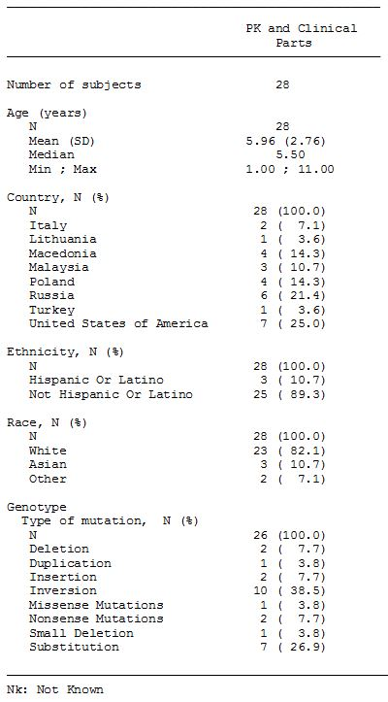

#### Evaluator’s comment

The sponsor’s response is satisfactory.

### Question 2

*Please provide a break-down of the individual FVIII products included in the pooled FVIII product dataset used for the PK comparison between “previous FVIII product” and turoctocog alfa in the PK part of Trial 3545.*

#### Sponsor’s section 31 response

A total of 30 patients were enrolled in the pharmacokinetic part of Trial 3545. Two patients were withdrawn between Visits 2 and 3. Since these two patients did not receive turoctocog alfa, they were not included in the full analysis set. (The response included reference to two additional patients for whom the sponsor excluded PK data from the previous FVIII product. Justification for excluding the data from these two patients was provided and is considered to be acceptable.) Therefore, a total of 26 patients were included in the pharmacokinetic evaluation of previous product.

Mean FVIII activity profiles for the paediatric patients’ previous products (plasma derived and recombinant) are presented in the Figures 3-4 for the chromogenic assay and the clotting assay, respectively.

Figure 3. Chromogenic Assays - FVIII Mean profile activity of previous products based on chromogenic assay (linear scale): Trial 3545 - full analysis set, dose adjusted.

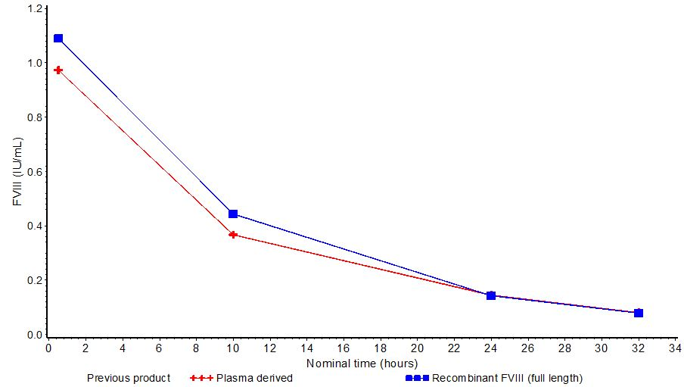

Figure 4. Clot Assay - FVIII Mean profile activity of previous products based on clot assay (linear scale): Trial 3545 - full analysis set, dose adjusted.

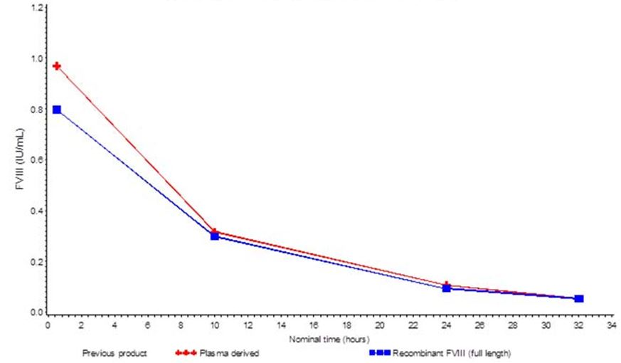

#### Evaluator’s comment

The sponsor’s response is satisfactory. The FVIII mean activity profiles (chromogenic and clot assays) are similar for the previous plasma derived and recombinant FVIII (full length) products. The mean FVIII activity profiles for the two product groups indicate that it was reasonable to pool the PK data from the “previous products”.

### Question 3

*The Summary of Clinical Pharmacology included a post hoc analysis of the PK parameters for turoctocog alfa and “previous [PK] product” from Trial 3545 measured by both the chromogenic and the clot assay. Crosschecking with the original Clinical Trial Report for Trial 3545 indicates that the summary data for “previous [FVIII] product” are based on 26 patients, but the summary data for turoctocog alfa could not be identified. As the post hoc analysis is a “compare analysis set” it is assumed that the data for turoctocog in this analysis is based on the same 26 patients with “previous [FVIII] product” data. Please confirm that the post-hoc analysis includes 26 patients in the “compare analysis set” with both “previous [FVIII] product” and turoctocog alfa PK data.*

#### Sponsor’s section 31 response

Yes, that is correct. Only the 26 patients with useable profiles for both previous product and turoctocog alfa are included in this comparison.

#### Evaluator’s comment

The sponsor’s response is satisfactory.

### Question 4

*In the Clinical Trial Report for Trial 3543, it is stated that: “A total of 35% of the patients had been on prophylactic regimens prior to trial entry and 39% had been on on-demand treatment regimens, while the remaining 26% had been on both prophylaxis and on-demand treatment; calculated from EOT Table 14.1.73”. Please explain how the provided percentages have been calculated from EOT Table 14.1.73.*

#### Sponsor’s section 31 response

A total of 39 patients (26%) had been on both prophylaxis and on-demand treatment prior to the trial. In the previously submitted Module 5.3.5.2, Trial 3543, EOT Table 14.1.73, these patients were included in both categories (prophylaxis and on-demand). For clarification, please find included the complete overview of the patients’ previous treatment regimens in Table 35.

Table 35: Patients’ previous product – Trial 3543.

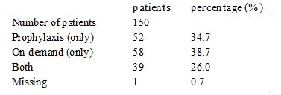

#### Evaluator’s comment

The sponsor’s response is satisfactory.

### Question 5

*In Trial 3543, the mean baseline FVIII activity was 2.95% (range: 0 to 98%). Please comment on the potential effect this might have had on the trial outcomes given that the mean baseline FVIII activity level was greater than 1%.*

#### Sponsor’s section 31 response

All enrolled patients had a diagnosis of severe (FVIII ≤1%) haemophilia A documented in medical records. Inclusion in the trial was based on the medical records and not the baseline FVIII activity measured at the screening visit. The wide range in FVIII activity at screening most likely reflects that some patients did not withhold treatment with their previous FVIII product for at least 48 hours prior to the screening visit. Therefore, FVIII activity levels assessed at screening did not necessarily reflect the actual endogenous FVIII levels. The level of the FVIII activities at screening are not considered to influence the outcomes of the trial.

#### Evaluator’s comment

The sponsor’s response is satisfactory.

### Question 6

*What was the mean baseline FVIII activity (in percentage terms) in the pivotal paediatric trial (Trial 3545)? Please comment on the potential effect that baseline FVIII activity might have had on the outcomes of the pivotal paediatric trial.*

#### Sponsor’s section 31 response

Due to the limited use of the collected baseline FVIII activity level measured at screening in Trial 3543, baseline FVIII activity was not recorded in Trial 3545. Inclusion of patients was based on documented diagnosis of severe haemophilia A with FVIII levels of < 1% and the contribution of baseline FVIII activity is therefore considered to be very small.

#### Evaluator’s comment

The sponsor’s response is satisfactory.

### Question 7

*The definition of re-bleeding could be identified in Trial 3545 (pivotal paediatric trial), but not in Trial 3543 (pivotal adult trial). Please advise what the definition of re-bleeding used was in Trial 3543?*

#### Sponsor’s section 31 response

Classification of re-bleeds was done by the trial statistician based on collected trial data at the time of statistical analysis. The definition of re-bleeding used was identical for the two trials:

*Re-bleed is defined as when after an initial period of improvement, there is a worsening of the bleeding site conditions, either on treatment or within 72 h after stopping treatment. It is considered as a new bleeding episode if worsened >72 h after stopping of treatment.*

#### Evaluator’s comment

The sponsor’s response is satisfactory.

### Question 8

*In the Summary of Clinical Safety (2.7.4), it was stated that no drug related allergic type hypersensitivity reactions were reported as medical events of special interest as of 1 May 2011. However, examination of the listed AEs in the total safety population indicates that drug hypersensitivity was reported in 1 patient and hypersensitivity was reported in 1 patient (SOC “immune system disorders”); see Summary of Clinical Efficacy, Appendix 1, Table 7. Please comment on the apparent discrepancy between drug related allergic type reactions reported as medical events of special interest and the listed AEs of drug hypersensitivity and hypersensitivity reported in the Summary of Clinical Efficacy.*

#### Sponsor’s section 31 response

Allergic type hypersensitivity reactions, including anaphylaxis/anaphylactoid reactions, is a potential risk with the administration of turoctocog alfa and to ensure adequate adverse event follow up information from the clinical trial sites these events were specifically defined as medical events of special interest. No events of hypersensitivity against turoctocog alfa were reported in any trial.

The two events of hypersensitivity referred to in the previously submitted Summary of Clinical Safety, Appendix 1, Table 7 were not reported with a causality related to turoctocog alfa treatment. Details of the two events are included below:

* In Trial 3568, one event of drug hypersensitivity against trimethoprim/polymyxin drops was reported for one patient. This event was mild, non-serious and unlikely related to turoctocog alfa.
* In Trial 3545, one patient reported an event of hypersensitivity caused by an insect bite. The event was evaluated as mild and considered unlikely related to turoctocog alfa.

#### Evaluator’s comment

The sponsor’s response is satisfactory.

## Second round benefit-risk assessment

### Second round assessment of benefits

After consideration of the responses to the clinical questions, the benefits of turoctocog alfa (NovoEight) for the proposed indications remain favourable. For ease of reference, the benefits are outlined below and, apart from some minor editorial changes, the wording remains unchanged from that provided in the first round recommendation.

There are no data comparing the benefits of turoctocog alfa with other FVIII products for the prevention and treatment of bleeding or in the surgical setting in previously treated patients with severe haemophilia A (FVIII activity ≤ 1%), without inhibitors. However, it can be reasonably inferred from the single dose PK and bioequivalence data in adults and adolescents that turoctocog alfa and Advate are likely to have similar benefits for the treatment of patients with haemophilia A. In addition, it can be reasonably inferred from the PK data in children with haemophilia A that turoctocog alfa is likely to have similar benefits to other FVIII products when used for the treatment of haemophilia A in this patient group.

In the pivotal adult trial (n = 150), the estimated mean annualised bleeding rate was 6.50 (95% CI: 5.30, 7.97) bleeds/patient/year, with the rate being higher in adults aged ≥ 18 years (n = 126) than in adolescents aged ≥ 12 to < 18 years (n = 24) (6.68 versus 5.55 bleeds/patient/year, respectively). The estimated mean annualised bleeding rate in the pivotal adult trial was similar to the corresponding rate reported for Advate from published data in a similar patient population (6.5 versus 6.3 bleeds/patient/year, respectively).

In the pivotal adult trial, the success rate (excellent/good haemostatic response) for treatment of acute bleeds with turoctocog alfa in the total population (n = 150) was 84.5% (excluding missing data), which compares with a success rate of 86.0% for Advate from published data. Of the 499 reported bleeds in the pivotal adult trial, 71.5% were stopped with one turoctocog alfa infusion and 17.8% were stopped with two infusions. The mean number of turoctocog alfa infusions needed to stop a bleed was 1.5 infusions/bleed.

In the pivotal paediatric trial (n = 63), the estimated mean annualised bleeding rate was 5.33 (95% CI: 3.90, 7.28) bleeds/patient/year, with the rate being lower in children aged 0 to < 6 years (n = 31) compared with children aged 6 to < 12 years (n = 32) (4.73 versus 5.86 bleeds/patient/year, respectively). The estimated mean annualised bleeding rate in the total paediatric population was lower than in the total adult/adolescent population (5.33 versus 6.50 bleeds/day, respectively).

In the pivotal paediatric trial, the success rate (excellent/good haemostatic response) for treatment of acute bleeds with turoctocog alfa was 94.3% (excluding missing data), which was higher than the corresponding success rate in the total population in the pivotal adult trial (84.5%). Of the 126 reported bleeds, 81.0% were stopped with one turoctocog alfa infusion and 14.3% were stopped with two infusions. The mean number of turoctocog alfa infusions to stop a bleed was 1.5 infusions/bleed.

The data from the extension trial (n = 157) indicates that the benefits of treatment with turoctocog alfa are maintained with continuous treatment, based on the estimated annualised bleeding rates and the success rates. In the pooled analysis, 68 patients received preventive treatment with turoctocog alfa for at least 12 months and experienced 492 bleeds resulting in an estimated mean annualised bleeding rate of 4.29 (95% CI: 3.28, 5. 60) bleeds/patient/year (compared to 318 bleeds in these 68 patients in ≤ 12 months of treatment resulting in an estimated mean annualised bleeding rate of 4.68 [95% CI: 3.52, 6.21]).

There were limited data on the use of turoctocog alfa in surgery. The pooled data from the two surgical sub trials included information on 11 patients (10 major and 1 minor surgeries) with a mean age of 27.3 years, ranging from 14 to 54 years. The haemostatic response was reported as excellent in 72.8% (8/11) patients and good in 27.3% (3/11) of patients both during surgery and after haemostasis had been achieved.

### Second round assessment of risks

After consideration of the responses to the clinical questions, the risks of turoctocog alfa (NovoEight) for the proposed indications remain favourable. For ease of reference, the risks are outlined below and, apart from some minor editorial changes, the wording remains unchanged from that provided in the first round recommendation.

There are no data comparing the risks of turoctocog alfa with other FVIII products for the prevention and treatment of bleeding or in the surgical setting in previously treated patients with severe haemophilia A (FVIII activity ≤ 1%), without inhibitors. However, the submitted data do not give rise to significant safety concerns or unexpected safety signals relating to the use of turoctocog alfa for the proposed indications. In particular, no patients had developed FVIII inhibitors (≥ 0.6 BU) as of 1 May 2011, and no patients experienced thromboembolic events or drug related allergic type hypersensitivity reactions during the trials.

The risk of experiencing an adverse event (irrespective of relationship to treatment) occurred very commonly in association with turoctocog alfa for the prevention and treatment of bleeding. In the pooled safety population, 72.0% (154/214) of patients experienced at least one AE. There were 503 events resulting in an event rate of 2.45 events/patient years of exposure in the total safety population. The risk of experiencing an adverse event was similar in the four age cohorts, with the event rate ranging from a low of 2.30 events/patient years of exposure in adults aged ≥ 18 years to a high of 3.53 events/patient years of exposure in children aged 0 to < 6 years. The risk of experiencing an adverse event decreased with the length of time on turoctocog alfa treatment. The most commonly occurring AEs (preferred term) reported in ≥ 5% of the total population were: nasopharyngitis (10.3%); headache (10.3%); incorrect dose administered (8.9%); arthralgia (6.1%); pyrexia (6.1%); URTI (5.1%); and toothache (5.1%).

AEs considered by the investigator to be possibly or probably related to treatment were reported uncommonly (26 treatment related events in 17 [7.9%] of patients). Treatment related AEs reported in 2 or more patients were: incorrect dose administered (4 events in 4 patients); increased levels of hepatic enzymes (4 events in 3 patients); injection site erythema (3 events in 3 patients); and pyrexia (2 events in 2 patients). Of the 26 treatment related AEs, 2 were reported in children aged 0 to < 6 years (0.13 events/patient years of exposure) and 24 were reported in adults aged ≥ 18 years (0.16 events/patient years of exposure), with no events being reported in older children or adolescents.

The risk of experiencing a serious adverse event was uncommon. In the total safety population, 21 SAEs were reported in 17 (7.9%) patients up to 21 November 2011, and the only events reported in 2 or more patients were road traffic accident (2, 0.9%) and melena (2, 0.9%). Of the 21 SAEs, 4 were considered to be treatment related (hypertension, tachycardia, and insomnia all reported in 1 patient; hepatic enzymes increased in 1 patient). Of the 21 SAEs, 3 were reported in children aged 0 to < 6 years (0.20 events/patient years of exposure), 2 in children aged 6 to < 12 years (0.11 events/patient years of exposure), 3 in adolescents aged ≥ 12 to < 18 years (0.12 events/patient years of exposure), and 13 in adults aged ≥ 18 years (0.09 events/patient years of exposure). A further 4, non treatment related SAEs were reported in the period from 21 November 2011 to 1 May 2012, including 1 fatal subdural haematoma due to an alleged assault. The risk of death due to treatment with turoctocog alfa was negligible in the submitted trials.

The only noteworthy clinical laboratory abnormalities in the trials related to 18 AEs (reported in 10 patients) characterised by abnormal increases in liver function test parameters (mainly increases in transaminase levels). However, the majority of patients (80%, 8/10) with LFT abnormalities were hepatitis C positive, which most likely explains the findings. Most of the LFT abnormalities (14/18 = 78%) were considered by the investigator as unlikely to be related to turoctocog alfa. There were no noteworthy changes in vital signs or ECG findings.

A total of 19 patients were positive for anti CHO antibodies at some point during the trials: 2 changed from negative to positive during the trial; 6 changed from positive to negative during the trial; 6 were positive throughout the trial; 2 were negative at baseline and end of trial but with transient positive samples between; and 3 were positive at baseline and end of trial but with transient negative samples between. Seven (7) patients were anti murine IgG positive at baseline, 5 of these patients subsequently became negative and 2 remained positive throughout the trial. No patients changed from anti murine IgG negative to positive during the trials.

The risks associated with turoctocog alfa in the surgical setting appear to be relatively minor with 5 non treatment related AEs being reported in 11 (45.5%) patients. There were no treatment related AEs, no SAEs, and no withdrawals due to AEs. However, there is limited information on the risks of treatment with turoctocog alfa in the surgical setting.

There was no information on the risks of treatment with turoctocog alfa in patients with previously untreated haemophilia A, female patients, patients younger than 1 year, patients older than 60 years, patients with hepatic impairment, patients with renal impairment, or in patients from racial groups other than “White” or Japanese. The safety data on patients with FVIII inhibitors were too limited to allow meaningful conclusions to be drawn about the risks of treatment in this patient group. There was no information on the risks of turoctocog alfa treatment based on HIV or hepatitis C status. There was no information on the risks of turoctocog alfa when administered in combination with other drugs.

### Second round assessment of benefit-risk balance

After consideration of the responses to the clinical questions, the benefit-risk balance of turoctocog alfa (NovoEight) for the proposed indications remains favourable.

## Second round recommendation regarding authorisation

After consideration of the response to the clinical questions, the first round recommendation regarding authorisation stands. It is recommended that turoctocog alfa (NovoEight) be approved for the treatment and prophylaxis of bleeding episodes in patients with haemophilia A, including control and prevention of bleeding in surgical settings.

1. Evidence-based clinical practice guidelines for the use of recombinant and plasma-derived FVIII and FIX products. AHMAC, NBA and AHCDO, June 2006; pp. 77-84.
2. Medical Advisory Committee of Haemophilia Foundation of New Zealand. Management of Haemophilia - Treatment protocols. 2005; pp. 6-7.
3. “Haemophilia treatment.” Chapter 4 of “Haemophilia folder – for parents of children recently diagnosed with haemophilia”, Haemophilia Foundation of Australia, 2009.
4. European Medicines Agency, “Committee for Medicinal Products for Human Use: Guideline on the Investigation of Bioequivalence (CPMP/EWP/QWP/1401/98)”, 20 January 2010.
5. European Medicines Agency, “Committee for Medicinal Products for Human Use: Guideline on the Clinical Investigation of the Pharmacokinetics of Therapeutic Proteins (CHMP/EWP/89249/2004)”, 24 January 2007.
6. European Medicines Agency, “Committee for Medicinal Products for Human Use: Guideline on the Clinical Investigation of the Pharmacokinetics of Therapeutic Proteins (CHMP/EWP/89249/2004)”, 24 January 2007.
7. Barrowcliffe T, et al. (2006) State of the art international symposium on pharmacokinetics of factor concentrates in haemophilia: challenges and relevance to clinical practice. Summary statement. *Haemophilia* 12 Suppl 4: 3-5; Blanchette VS, et al. (2008) Plasma and albumin-free recombinant factor VIII: pharmacokinetics, efficacy and safety in previously treated pediatric patients. *J Thromb Haemost.* 6: 1319-1326; Hay CRM, et al. (2006) The diagnosis and management of factor VIII and IX inhibitors: a guideline from the United Kingdom Haemophilia Centre Doctors Organisation. *Br J Haematol.* 133: 591-605.
8. European Medicines Agency, “Committee for Medicinal Products for Human Use (CHMP): Guideline on the Clinical Investigation of Recombinant Factor VIII and IX Products (CPMP/BPWG/1561/99 rev.1)”, 19 July 2007.
9. European Medicines Agency, “Committee for Medicinal Products for Human Use (CHMP): Guideline on the clinical investigation of recombinant and human plasma-derived factor VIII products (EMA/CHMP/BPWP/144533/2009)”, 21 July 2011.
10. Tarantino MD, et al. (2004) Clinical evaluation of an advanced category antihaemophilic factor prepared using a plasma/albumin- free method: pharmacokinetics, efficacy, and safety in previously treated patients with haemophilia A. *Haemophilia* 10: 428-437.
11. Tarantino MD, et al. (2004) Clinical evaluation of an advanced category antihaemophilic factor prepared using a plasma/albumin- free method: pharmacokinetics, efficacy, and safety in previously treated patients with haemophilia A. *Haemophilia* 10: 428-437.
12. Tarantino MD, et al. (2004) Clinical evaluation of an advanced category antihaemophilic factor prepared using a plasma/albumin- free method: pharmacokinetics, efficacy, and safety in previously treated patients with haemophilia A. *Haemophilia* 10: 428-437.
13. European Medicines Agency, “Committee for Medicinal Products for Human Use (CHMP): Guideline on the clinical investigation of recombinant and human plasma-derived factor VIII products (EMA/CHMP/BPWP/144533/2009)”, 21 July 2011.
14. European Medicines Agency, “Committee for Medicinal Products for Human Use (CHMP): Guideline on the Clinical Investigation of Recombinant Factor VIII and IX Products (CPMP/BPWG/1561/99 rev.1)”, 19 July 2007.
15. European Medicines Agency, “Committee for Medicinal Products for Human Use (CHMP): Guideline on the Clinical Investigation of Recombinant Factor VIII and IX Products (CPMP/BPWG/1561/99 rev.1)”, 19 July 2007.
16. Tarantino MD, et al. (2004) Clinical evaluation of an advanced category antihaemophilic factor prepared using a plasma/albumin-free method: pharmacokinetics, efficacy, and safety in previously treated patients with haemophilia A. *Haemophilia* 10: 428-437.
17. Tarantino MD, et al. (2004) Clinical evaluation of an advanced category antihaemophilic factor prepared using a plasma/albumin-free method: pharmacokinetics, efficacy, and safety in previously treated patients with haemophilia A. *Haemophilia* 10: 428-437.
18. Giles AR, et al. (1998) A detailed comparison of the performance of the standard versus the Nijmegen modification of the Bethesda assay in detecting factor VIII:C inhibitors in the haemophilia A population of Canada. Association of Hemophilia Centre Directors of Canada. Factor VIII/IX Subcommittee of Scientific and Standardization Committee of International Society on Thrombosis and Haemostasis. *Thromb Haemost.* 79: 872-875.