|  |
| --- |
| **July 2021** |

|  |
| --- |
| Australian Public Assessment Report for Upadacitinib |
| Proprietary Product Name: Rinvoq |
| Sponsor: AbbVie Pty Ltd |

About the Therapeutic Goods Administration (TGA)

* The Therapeutic Goods Administration (TGA) is part of the Australian Government Department of Health and is responsible for regulating medicines and medical devices.
* The TGA administers the *Therapeutic Goods Act 1989* (the Act), applying a risk management approach designed to ensure therapeutic goods supplied in Australia meet acceptable standards of quality, safety and efficacy (performance) when necessary.
* The work of the TGA is based on applying scientific and clinical expertise to decision-making, to ensure that the benefits to consumers outweigh any risks associated with the use of medicines and medical devices.
* The TGA relies on the public, healthcare professionals and industry to report problems with medicines or medical devices. TGA investigates reports received by it to determine any necessary regulatory action.
* To report a problem with a medicine or medical device, please see the information on the TGA website <<https://www.tga.gov.au>>.

About AusPARs

* An Australian Public Assessment Report (AusPAR) provides information about the evaluation of a prescription medicine and the considerations that led the TGA to approve or not approve a prescription medicine submission.
* AusPARs are prepared and published by the TGA.
* An AusPAR is prepared for submissions that relate to new chemical entities, generic medicines, major variations and extensions of indications.
* An AusPAR is a static document; it provides information that relates to a submission at a particular point in time.
* A new AusPAR will be developed to reflect changes to indications and/or major variations to a prescription medicine subject to evaluation by the TGA.

Copyright

© Commonwealth of Australia 2021  
This work is copyright. You may reproduce the whole or part of this work in unaltered form for your own personal use or, if you are part of an organisation, for internal use within your organisation, but only if you or your organisation do not use the reproduction for any commercial purpose and retain this copyright notice and all disclaimer notices as part of that reproduction. Apart from rights to use as permitted by the *Copyright Act 1968* or allowed by this copyright notice, all other rights are reserved and you are not allowed to reproduce the whole or any part of this work in any way (electronic or otherwise) without first being given specific written permission from the Commonwealth to do so. Requests and inquiries concerning reproduction and rights are to be sent to the TGA Copyright Officer, Therapeutic Goods Administration, PO Box 100, Woden ACT 2606 or emailed to <[tga.copyright@tga.gov.au](mailto:tga.copyright@tga.gov.au)>.

Contents

List of abbreviations 4

I. Introduction to product submission 8

Submission details 8

Product background 9

Regulatory status 11

Product Information 12

II. Registration timeline 12

III. Submission overview and risk/benefit assessment 13

Quality 13

Nonclinical 13

Clinical 13

Risk management plan 31

Risk-benefit analysis 31

Outcome 34

Attachment 1. Product Information 35

## List of abbreviations

|  |  |
| --- | --- |
| Abbreviation | Meaning |
| ACM | Advisory Committee on Medicines |
| ACR | American College of Rheumatology |
| ADA | Adalimumab |
| AE | Adverse event |
| AESI | Adverse event(s) of special interest |
| ALC | Absolute lymphocyte count |
| ALT | Alanine aminotransferase |
| ANC | Absolute neutrophil count |
| AO | As observed |
| ARDS | Acute respiratory distress syndrome |
| ARTG | Australian Register of Therapeutic Goods |
| AS | Ankylosing spondylitis |
| ASAS | Assessment of SpondyloArthritis International Society |
| ASQoL | Ankylosing Spondylitis Quality of Life |
| AST | Aspartate aminotransferase |
| AUC | Area under the concentration versus time curve |
| AUCinf | Area under the concentration versus time curve from time zero to infinity |
| AusPAR | Australian Public Assessment Report |
| axSpA | Axial spondyloarthritis |
| BASDAI | Bath Ankylosing Spondylitis Disease Activity Index |
| BASFI | Bath Ankylosing Spondylitis Functional Index |
| BASMI | Bath Ankylosing Spondylitis Metrology Index |
| bDMARD | Biological disease-modifying anti-rheumatic drug |
| BMI | Body mass index |
| CASPAR | Classification Criteria for Psoriatic Arthritis |
| Cavg | Average plasma concentration |
| cDMARD | Conventional disease-modifying anti-rheumatic drug |
| csDMARD | Conventional synthetic disease-modifying ant-rheumatic drug |
| CL | Clearance |
| CL/F | Oral clearance |
| Cmax | Maximum plasma concentration |
| CPK | Creatine phosphokinase |
| CrCL | Creatinine clearance |
| CRP | C-reactive protein |
| DMARD | Disease-modifying anti-rheumatic drug |
| DVT | Deep vein thrombosis |
| ER | Exposure response |
| EU | European Union |
| FAS | Full analysis set |
| HAQ-DI | Health Assessment Questionnaire – Disability Index |
| IL | Interleukin |
| IR | Inadequate responder |
| JAK | Janus kinase |
| MACE | Major adverse cardiovascular event(s) |
| MASES | Maastricht Ankylosing Spondylitis Enthesitis Score |
| MRI | Magnetic resonance imaging |
| NI | Non-inferiority |
| NMSC | Non-melanoma skin cancer |
| nr-axSpA | Non-radiographic axial spondyloarthritis |
| NRI | Non-responder imputation |
| NSAID | Non-steroidal anti-inflammatory drug |
| PASI | Psoriasis Area and Severity Index |
| PD | Pharmacodynamic(s) |
| PE | Pulmonary embolism |
| PI | Product Information |
| PK | Pharmacokinetics |
| popPK | Population pharmacokinetic(s) |
| PPS | Per-protocol (analysis) set |
| PsA | Psoriatic arthritis |
| PT | Preferred Term |
| PY | Patient-year |
| RA | Rheumatoid arthritis |
| SAE | Serious adverse event |
| sIGA | Static Investigator’s Global Assessment |
| SOC | System Organ Class |
| SPARCC | Spondyloarthritis Research Consortium of Canada |
| STAT | Signal transducer and activator of transcription |
| TB | Tuberculosis |
| TGA | Therapeutic Goods Administration |
| TNF | Tumour necrosis factor |
| TYK2 | Tyrosine kinase 2 |
| ULN | Upper limit of normal |
| URTI | Upper respiratory tract infection |
| USA | United States of America |
| VC/F | Apparent volume of distribution in central compartment |
| VD | Volume of distribution |
| VTE | Venous thromboembolism |
| WPAI | Work productivity and activity impairment |

## I. Introduction to product submission

### Submission details

|  |  |
| --- | --- |
| *Type of submission:* | Extension of indications |
| *Product name:* | Rinvoq |
| *Active ingredient:* | Upadacitinib |
| *Decision*: | Approved |
| *Date of decision:* | 6 May 2021 |
| *Date of entry onto ARTG:* | 7 May 2021 |
| *ARTG number:* | 312687 |
| *Black Triangle Scheme:[1]* | Yes  This product will remain in the scheme for 5 years, starting on the date the new indication was approved |
| *Sponsor’s name and address:* | AbbVie Pty Ltd  241 O’Riordan Street  Mascot, NSW, 2020 |
| *Dose form:* | Modified release tablets |
| *Strength:* | 15 mg |
| *Container:* | Blister pack |
| *Pack sizes:* | 7 tablets (starter pack); and 28 tablet pack |
| *Approved therapeutic use:* | *Psoriatic Arthritis*  *Rinvoq is indicated for the treatment of moderate to severe active psoriatic arthritis in adult patients who have responded inadequately to, or are intolerant to one or more DMARDs.*  *Rinvoq may be used as monotherapy or in combination with a non-biological DMARD.*  *Ankylosing Spondylitis*  *Rinvoq is indicated for the treatment of adults with active ankylosing spondylitis.* |
| *Route of administration:* | Oral |
| *Dosage:* | Therapy with Rinvoq (upadacitinib) should be initiated and monitored by a rheumatologist or specialist physician with expertise in the management of the indicated conditions.  Rinvoq should not be initiated in patients with an absolute lymphocyte count (ALC) less than 500 cells/mm3, an absolute neutrophil count (ANC) less than 1000 cells/mm3 or who have haemoglobin levels less than 8 g/dL (See Section4.4 Special warnings and precautions for use; and Section 4.8 adverse effects in the Product Information).  Rinvoq (upadacitinib) tablets should be taken orally with or without food. Rinvoq tablets should be swallowed whole. Rinvoq should not be split, crushed, or chewed.  *Psoriatic Arthritis*  The recommended dose of Rinvoq is 15 mg once daily.  Rinvoq may be used as monotherapy or in combination with a non-biological disease modifying anti-rheumatic drug (DMARD).  *Ankylosing Spondylitis*  The recommended dose of Rinvoq is 15 mg once daily  For further information regarding dosage, refer to the Product Information. |
| *Pregnancy category:* | D  Drugs which have caused, are suspected to have caused or may be expected to cause, an increased incidence of human fetal malformations or irreversible damage. These drugs may also have adverse pharmacological effects. Accompanying texts should be consulted for further details.  The use of any medicine during pregnancy requires careful consideration of both risks and benefits by the treating health professional. This must not be used as the sole basis of decision making in the use of medicines during pregnancy. The TGA does not provide advice on the use of medicines in pregnancy for specific cases. More information is available from obstetric drug information services in your State or Territory. |

### Product background

This AusPAR describes the application by AbbVie Pty Ltd (the sponsor) to register Rinvoq (upadacitinib) 15 mg, modified release tablet for the following proposed extension of indications:

*Psoriatic Arthritis*

*Rinvoq is indicated for the treatment of adults with active psoriatic arthritis. Rinvoq may be used as monotherapy or in combination with non-biologic DMARDs.*

*Ankylosing Spondylitis*

*Rinvoq is indicated for the treatment of adults with active ankylosing spondylitis.*

Upadacitinib is an oral anti-cytokine therapy, which inhibits the function of Janus kinase (JAK) proteins. The JAK proteins are intracellular molecules involved in signal transduction of Type I and II cytokine receptors including the interleukin (IL)-6 receptor. There are four Janus kinus (JAK) isoforms: JAK1, JAK2, JAK3; and tyrosine kinase 2 (TYK2), which act in pairs to phosphorylate other intracellular proteins including members of the signal transducer and activator of transcription (STAT) family of DNA binding proteins. Phosphorylation of STATs promotes their translocation to the cell nucleus and subsequent gene transcription. Through this process JAKs are directly and indirectly involved in a range of immune and homeostatic functions, which may be interrupted or modified by the JAK inhibitor. The sponsor states that upadacitinib has preferential affinity for the JAK1 isoform over JAK2, JAK3 and TYK2.

Psoriatic arthritis (PsA) is a chronic inflammatory form of arthritis associated with skin psoriasis. It affects men and women equally. The prevalence of PsA in the general population is approximately 1 to 2 per 1000 of the general population, and estimates in the population of patients with psoriasis have varied between 4% and 30%. In the majority of PsA patients, psoriasis precedes the onset of arthritis with a median time between the diagnosis of skin and joint disease of seven to eight years. Since 2006, the diagnosis of PsA in a patient with an inflammatory musculoskeletal disease (peripheral arthritis, spondylitis or enthesitis), for research purposes, has been based on achieving a total of at least three points on the Classification Criteria for Psoriatic Arthritis (CASPAR) criteria.[2]

The initial treatment of PsA usually involves managing pain and inflammation, particularly in the peripheral joints, with oral non-steroidal anti-inflammatory drugs (NSAIDs). Intra-articular steroid injections may be considered for oligoarthritis of larger joints. Generally, patients will be commenced on conventional disease-modifying anti-rheumatic drugs (cDMARDs), for example methotrexate, sulfasalazine and leflunomide, or the targeted non-biological DMARD apremilast. Biological disease modifying anti-rheumatic drugs (or bDMARD) including tumour necrosis factor (TNF) inhibitors, the IL-17A inhibitor secukinumab (Cosentyx) and the IL-12/23 inhibitor ustekinumab (Stelara), have been approved as second line therapies following failure of or intolerance to conventional disease modifying anti-rheumatic drugs (cDMARD). JAK inhibitors are oral anti-cytokine DMARDs that have come to the market in the last ten years. Currently, the only JAK inhibitors approved for the treatment of PsA is tofacitinib (Xeljanz). Treatment with tofacitinib is restricted to adults with PsA who have had an inadequate response to prior conventional or biological DMARDs.

Axial spondyloarthritis (axSpA), which includes radiographic axSpA and non-radiographic axial spondyloarthritis (nr-axSpA), is a chronic inflammatory condition manifested by back pain and progressive spinal stiffness. Radiographic axSpA and nr-axSpA differ in that significant abnormalities of affected sacroiliac joints are observed by conventional radiography in patients with radiographic axSpA but require magnetic resonance imaging (MRI) to be detected with nr-axSpA.

Ankylosing spondylitis (AS) affects up to 0.5% of the population and occurs predominantly in men. The majority (85 to 90%) of affected individuals carry the human leukocyte antigen B27 gene. Disease severity varies considerably between patients. Initially it usually affects the sacroiliac joints (sacroiliitis) before involving other areas of the spine. Although primarily thought of as a spinal disease, up to 50% of patients with radiographic axSpA may also develop enthesitis and arthritis of peripheral joints. In addition, the disease can affect organs including the eyes, bowel, lungs, heart, and kidneys.

The Australian Therapeutic Guidelines consider symptom control with NSAIDs as first line therapy for radiographic axSpA, in combination with an appropriate exercise program and other lifestyle changes. Disease modifying therapies, in particular bDMARDs, are added for persistent axial inflammation and enthesitis not responding to NSAIDs. Although patients may be treated with cDMARDs, these are generally considered to have limited effect on axial inflammation and to be more useful in patients with predominantly peripheral arthritis. TGA has registered several bDMARDs for the treatment of radiographic axSpA including five TNF inhibitors as well as two IL-17A antibodies: secukinumab and ixekizumab (Taltz).

This is the first submission requesting approval to register a JAK inhibitors for the treatment of AS.

### Regulatory status

The product received initial registration on the Australian Register of Therapeutic Goods (ARTG) on 17 January 2020 for the below indications:

*Rinvoq is indicated for the treatment of moderate to severe active rheumatoid arthritis in adult patients who have responded inadequately to, or who are intolerant to, one or more disease-modifying anti-rheumatic drugs (DMARDs).*

*Rinvoq may be used as monotherapy or in combination with methotrexate or other conventional synthetic disease-modifying anti-rheumatic drugs (csDMARDs).*

At the time the TGA considered this application, a similar application had been approved in European Union (EU) on 22 January 2021 and was under consideration in United States of America (USA), Canada, New Zealand, Singapore and Switzerland.

Table 1: International regulatory status

|  |  |  |  |
| --- | --- | --- | --- |
| Region | Submission date | Status | Approved indications |
| European Union (Centralised procedure) | 1 June 2020 | Approved on 22 January 2021 | *Rinvoq is indicated for the treatment of active psoriatic arthritis in adult patients who have responded inadequately to, or who are intolerant to one or more DMARDs. Rinvoq may be used as monotherapy or in combination with methotrexate.*  *Rinvoq is indicated for the treatment of active ankylosing spondylitis in adult patients who have responded inadequately to conventional therapy.* |
| United States of America | 28 May 2020 | Under consideration | Under consideration |
| Canada | 30 June 2020 | Under consideration | Under consideration |
| New Zealand | 2 December 2020 | Under consideration | Under consideration |
| Singapore | 18 February 2021 | Under consideration | Under consideration |
| Switzerland | 16 June 2020 | Under consideration | Under consideration |

### Product Information

The Product Information (PI) approved with the submission which is described in this AusPAR can be found as Attachment 1. For the most recent PI, please refer to the TGA website at <<https://www.tga.gov.au/product-information-pi>>.

## II. Registration timeline

The following table captures the key steps and dates for this application and which are detailed and discussed in this AusPAR.

Table 2: Timeline for Submission PM-2020-02479-1-3

|  |  |
| --- | --- |
| Description | Date |
| Submission dossier accepted and first round evaluation commenced | 30 June 2020 |
| First round evaluation completed | 30 November 2020 |
| Sponsor provides responses on questions raised in first round evaluation | 4 January 2021 |
| Second round evaluation completed | 1 February 2021 |
| Delegate’s Overall benefit-risk assessment and request for Advisory Committee advice | 26 February 2021 |
| Sponsor’s pre-Advisory Committee response | 8 March 2021 |
| Advisory Committee meeting | 9 and 10 April 2021 |
| Registration decision (Outcome) | 6 May 2021 |
| Completion of administrative activities and registration on the ARTG | 7 May 2021 |
| Number of working days from submission dossier acceptance to registration decision* | 191 |

*Statutory timeframe for standard applications is 255 working days

## III. Submission overview and risk/benefit assessment

The submission was summarised in the following Delegate’s overview and recommendations.

### Quality

There was no requirement for a quality evaluation in a submission of this type.

### Nonclinical

There was no requirement for a nonclinical evaluation in a submission of this type.

### Clinical

The clinical dossier consisted of:

* one new Phase I study (Study M20-017);
* three pivotal studies collected pharmacokinetic (PK) data in subjects with psoriatic arthritis (PsA) and ankylosing spondylitis (AS);
* population PK (popPK) and exposure response analyses for Rinvoq (upadacitinib) in subjects with PsA and AS;
* two pivotal Phase III efficacy- and safety-based studies (Studies M15-572 and M15‑554) in patients with PsA;
* one pivotal Phase II/III efficacy and safety study (Study M16-098) conducted in adult patients with AS;
* a pooled efficacy dataset of the two Phase III PsA studies; and
* integrated safety datasets for subjects with active PsA and rheumatoid arthritis (RA).

#### Pharmacokinetics

Study M20-017 (a Phase I study) was a multicentre, single dose, open label, randomised four period, four sequence two part crossover trial to assess the bioavailability of 15 mg and 30 mg ‘market image’ formulations of upadacitinib (manufactured in Sligo, Ireland) with the clinical trial formulations (manufactured in North Chicago, Illinois) in both fed state (high fat/high calorie meal) and fasted state, but otherwise healthy volunteers. The study demonstrated that the 15 mg market image formulation is bioequivalent to the 15 mg study formulation both under fasting conditions and after a high fat/high calorie meal. In addition, the 30 mg market image formulation is bioequivalent to the 30 mg study formulation under fasting conditions and after a high fat/high calorie meal. At both doses, dosing 30 minutes after a high fat/high calorie meal increased maximum plasma concentration (Cmax) by about 50% and area under the concentration versus time curve from time zero to infinity (AUCinf) by about 20 to 30% compared to dosing in fasted patients.

#### Population pharmacokinetics

Study R&D/19/1199 is nonlinear mixed effects modelling was used to characterise the PK of upadacitinib in 1694 patients with PsA who had received at least one dose of 15 mg or 30 mg upadacitinib in the two pivotal Phase III studies. The model was based on the population pharmacokinetics (popPK) data model for healthy volunteers and patients with RA, and included covariates of creatinine clearance (CrCL) on the clearance (CL) of upadacitinib and baseline bodyweight on both the CL and volume of distribution (VD) of upadacitinib. The analysis concluded that plasma exposures of upadacitinib are similar in PsA and RA. Body weight had a statistically significant but clinically non-relevant effect on the area under the concentration versus time curve (AUC); subjects with mild (CrCL 60 to < 90 mL/min) or moderate (CrCL 30 to < 60 mL/min) renal impairment were predicted to have approximately 15% and 26% higher AUC and 8% and 13% higher Cmax, respectively, compared to subjects with normal renal function. Concomitant medications including pH modifying agents and conventional or targeted DMARDs (such as methotrexate, sulfasalazine, leflunomide, hydroxychloroquine, and apremilast) had no relevant effect on upadacitinib pharmacokinetics. Previous *in vitro* studies had demonstrated that strong CYP3A;[3] inhibitors increase the AUC of upadacitinib by 75% and Cmax by 70% while strong inducers of CYP3A reduce upadacitinib plasma exposures by approximately half.

Study R&D/20/0181 is a nonlinear mixed effects modelling was used to characterise the PK of upadacitinib in 92 patients with AS who had received at least one dose of 15 mg upadacitinib in the pivotal Phase II/III study. The model was based on the popPK model for healthy volunteers and patients with RA. Inter-subject variability and residual error terms were evaluated in the AS population using the same model, and visual predictive checks assessed whether estimated oral clearance (CL/F) and apparent VD in the central compartment (VC/F) differed significantly from those reported in patients with RA. The analysis concluded that the PK parameters of upadacitinib are similar in AS and RA.

#### Pharmacodynamics

Janus kinase 1 (JAK1) is preferentially expressed in T-lymphocytes and mediates the action of the common γ-chain cytokines, including IL-2, IL-4, IL-7, IL-9, IL-15 and IL-21, which are integral to lymphocyte activation, proliferation and function. The predicted side effects of JAK1 inhibition include infection, hyperlipidaemia and possible natural killer cell effects.

Previous submissions have provided evidence that upadacitinib is a highly selective and reversible inhibitor of JAK1. In cellular potency assays that correlate with *in vivo* pharmacodynamics (PD) responses, upadacitinib showed 50 to 70 folds greater selectivity for JAK1 over JAK2 and > 100 folds greater selectivity for JAK1 over JAK3. JAK1 and JAK2 directly phosphorylate the STAT-3 transcription factor to form phosphorylated STAT-3 in response to cytokine stimulation (mainly, IL-6). The sponsor developed an *ex vivo* assay method that measures IL-6 (JAK-1/JAK-2) stimulated phosphorylated STAT-3 formation as well as IL-17 (JAK-1/JAK-3) stimulated phosphorylated STAT-5 formation in human blood as a means of examining the primary PD effects of upadacitinib.

##### Psoriatic arthritis

Exposure response (ER) analyses for efficacy and safety endpoints were explored using quartile plots of average plasma concentrations (Cavg) of upadacitinib calculated from the popPK study. Logistic regression models evaluated the relationship between Cavg and efficacy measures including American College of Rheumatology (ACR) 20/50/70;[4] responses at Week 12 and 24, Psoriasis Area and Severity Index (PASI) 75;[5] response at Week 16 and 24 and static Investigator’s Global Assessment (sIGA);[6] at Week 16 and 24. Only the ACR50 and ACR70 responses at Week 12, and the sIGA responses at Weeks 16 and 24 appeared to indicate a dose response effect.

Statistically significant safety ER relationships were observed between upadacitinib Cavg and the occurrence of serious infection, decrease in haemoglobin by > 2 g/dL from Baseline at Week 24 as well as the decrease in haemoglobin by > 2 g/dL in subjects with haemoglobin < lower limit of normal at Baseline at Week 24. Participant age at Baseline was identified as a significant covariate on the intercept, suggesting that independent of upadacitinib treatment the probability of experiencing a serious infection increases with subject age.

##### Ankylosing spondylitis

Efficacy and safety endpoints for 93 patients with AS who received upadacitinib 15 mg once daily and 94 patients with AS who received placebo were assessed using ER plots against Cavg quartiles calculated from the popPK study. There was no identified significant relationship between ASAS20/40 responses and upadacitinib Cavg.[7] The sponsor concluded that daily oral dosing with 15 mg upadacitinib was likely to achieve maximal efficacy in AS.

There were no reported cases of serious infection, herpes zoster or Grade 3 or higher neutropenia by Week 14. Only one safety outcome (> 1 g/dL decrease in haemoglobin from Baseline) showed a trend between upadacitinib Cavg and the percentage of subjects experiencing an AE at Week 14 (incidence of 19 to 21% in the two highest Cavg quartiles versus 7 to 8% in the two lowest quartiles).

#### Efficacy

##### Psoriatic arthritis

Study M15-572 was a randomised, double blinded, placebo and active treatment controlled trial that enrolled 1705 adults with moderate to severe PsA, according to CASPAR criteria,2 with symptoms for at least six months. The study enrolled participants who had not responded to a minimum of twelve weeks therapy with at least one non-bDMARD, or who had an intolerance or contraindication to a non-biological DMARD. Additional inclusion criteria included the presence of at least one joint erosion on plain X-ray or a high sensitivity C-reactive protein (CRP) measure at Baseline greater than the upper limit of normal (ULN). Exclusion criteria were typical for studies of this type, including other inflammatory rheumatic diagnoses, prior exposure to JAK inhibitor, concurrent use of strong CYP3A;3 modulators, recent severe infection or chronic recurrent infections including herpes virus, tuberculosis (TB), HIV and hepatitis B or C, and other significant or severe medical conditions.

Figure 1: Study M15-572 Design schema

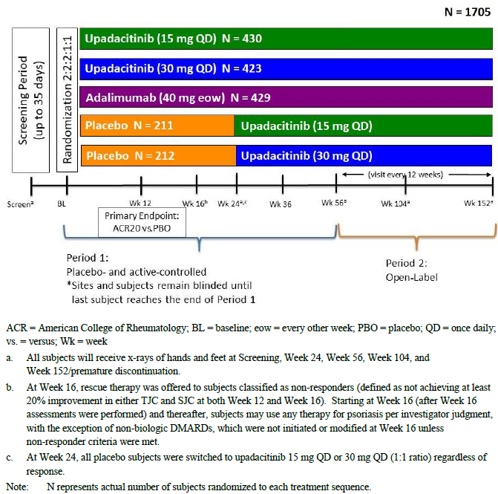

ACR = American College of Rheumatology; BL = baseline; eow = every other week; PBO = placebo; QD = once daily; vs = versus; Wk = week.

a All subjects will receive x-rays of hands and feet at screening, Week 24, Week 56, Week 104, and Week 152/premature discontinuation.

b At Week 16, rescue therapy was offered to subjects classified as non-responders (defined as not achieving at least 20% improvement in either tender joint count and swollen joint count at both Week 12 and Week 16). Starting at Week 16 (after Week 16 assessments were performed) and therefore, subjects may use any therapy for psoriasis per investigator judgment, with the exception of non-biological DMARDs, which were not initiated or modified at Week 16 unless non-response criteria were met.

c At Week 24, all placebo subjects were switched to upadactinib 15 mg QD or 30 mg QD (1:1 ratio) regardless of response.

Note: N represents actual number of subjects randomised to each treatment sequence.

The study was conducted at 281 study centres in 44 countries including Australia. The first patient was enrolled in April 2017 and the last participant completed Week 24 evaluations in December 2019. The submission contained an interim report with a data cutoff date of 13 December 2019. Six global amendments to the original trial protocol were not considered to impact significantly upon the trial’s findings.

Participants were randomised to five treatment arms, including placebo to upadacitinib 15 mg, placebo to upadacitinib 30 mg, an adalimumab (ADA) active comparator arm, an upadacitinib 15 mg daily arm, and an upadacitinib 30 mg daily arm. At 24 weeks, participants were switched from placebo to continued treatment with 15 mg or 30 mg upadacitinib per original randomisation. Period II of the study was an open label long term extension phase from Week 56 up to a total three years exposure (See Figure 1).and later extended to five years of exposure..

Participants were permitted to take up to two concomitant non-biological DMARDs at fixed doses during the trial. Non-responders could be rescued at Week 16 or later if they failed to achieve at least 20% improvement in either tender or swollen joint count at two consecutive evaluations.

Table 2: Study M 15-572 and Study M15-554 Primary and key secondary efficacy endpoints

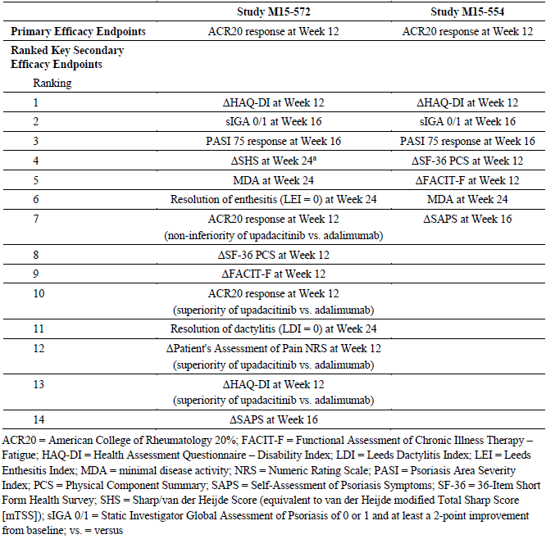

ACR20 = American College of Rheumatology 20%; FACIT-F = Functional Assessment of Chronic Illness Therapy- Fatigue; HAQ-DI = Health Assessment Questionnaire – Disability Index; LDI = Leed Dactylitis Index; LEI = Leeds Enthesitis Index; MDA = minimal disease activity; NRS = numeric rating scale; PASI = psoriasis area severity; pCS = physical component summary; SAPS = self-assessment of psoriasis symptoms; SF-36 = 36-Item Short Form Health Survey; SHS = Sharp/van der Heijde Score (equivalent to van der Heijde modified total sharp socre (mTSS)); sIGA 0/1 = Static Investigator Global Assessment of Psoriasis of 0 or 1 and at least a 2-point improvement from Baseline; vs = versus

The primary efficacy endpoint was the ACR20;[8] response at Week 12. Secondary endpoints included measures of the symptoms and signs of PsA and psoriasis (skin endpoints at 16 weeks), physical functioning, and radiographic progression (the latter assessed at 24 weeks). The evaluator considered the outcome measures and statistical analysis plan appropriate.

In total, 1626 participants (95.4% of 1705) had completed study treatment at Week 12, and 1548 participants (90.8% of 1705) completed study drug at Week 24. The most frequent primary reason for study treatment discontinuation before Week 24 was study withdrawal (4.5%) for the placebo group, adverse events (AEs) and study withdrawal (2.3% each) for the upadacitinib 15 mg arm, and AEs for the upadacitinib 30 mg (4.5%) and ADA groups (4.2%). At the data cutoff date for the interim report included in the submission, 649 participants (38.1%) had completed Period 1 (Week 56) on study drug, 240 participants (14.1%) had discontinued study medication during Period 1 and 816 participants were ongoing in Period 1.

There were no clinically significant differences between the treatment groups at Baseline with respect to demographic characteristics. Participants had a median age of 51 years (range: 19 to 83 years) with 86.1% aged < 65 years of age at Baseline. Just over half of participants were female and 88.9% were of Caucasian background. The overall population had a mean body mass index (BMI) of 30.3 kg/m2 (range: 16 to 87 kg/m2). Some three quarters of participants had BMI of ≥ 25 kg/m2 at Baseline. Baseline disease activity was comparable in the treatment arms, and consistent with a population with a moderate severe disease activity at risk of functional impairment and damage over months to years. For the overall enrolled population, the baseline mean Patient Global Assessment of disease activity was 6.4 (on 0 to 10 NRS) and the mean Physician Global Assessment of disease activity was 6.5 (on 0 to 10 NRS).

During Study M15-572, subjects could continue on stable doses of methotrexate and/or another non-biological DMARD, oral corticosteroids and NSAIDs. At Baseline, around four in five participants were taking at least one non-biological DMARD, the most common (63.6%) of which was methotrexate alone. Only 5.2% of participants were taking a combination of methotrexate with one other non-biological DMARD. At Baseline, the proportions of subjects taking oral corticosteroid was comparable between the four treatment groups (around 16 to 17% overall). In each group, a similar proportion of subjects were taking NSAIDs at Baseline (63.2% overall).

The primary efficacy outcome was met. At Week 12 in Study M15-572, a significantly greater proportion of patients treated with upadacitinib (either dose) achieved an ACR20 response compared to patients treated with placebo. The Week 12 ACR20 response rate in the full analysis set (FAS), applying non-responder imputation (NRI) ranged from 70.6% in the upadacitinib 15 mg group and 78.5% in the upadacitinib 30 mg arm to 36.2% in the placebo group. In the ADA group, the ACR20 response rate at Week 12 was 65.0%. The point estimate for determining a treatment related difference for upadacitinib 15 mg versus placebo was 34.5% (95% CI 28.2, 40.7) and for upadacitinib 30 mg versus placebo was 42.3% (95% CI 36.3, 48.3, both p< 0.0001). Results from supplementary analyses using ‘as observed’ (AO) measures for the FAS cohort and NRI on the per-protocol analysis set (PPS) were consistent with the primary analysis of ACR20 response rate at Week 12. Based on multiplicity adjusted p-values, most of the ranked secondary endpoints supported the primary outcome (Table 3). Of particular interest, neither dose of upadacitinib was significantly superior to ADA, based on Health Assessment Questionnaire – Disability Index (HAQ-DI) change from Baseline at Week 12.

Table 3: Study M15-572 Results for secondary efficacy outcomes

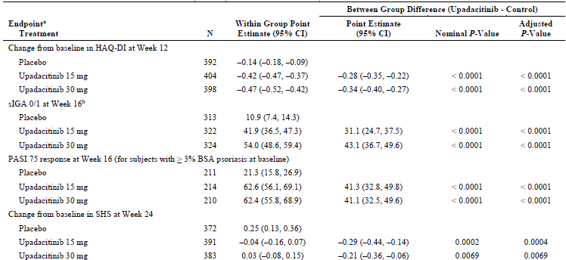

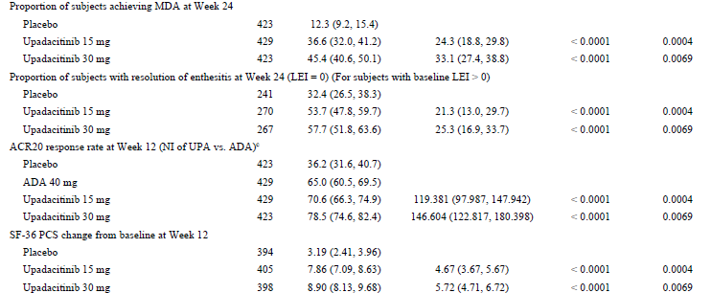

Table 3: Study M15-572 Results for secondary efficacy outcomes

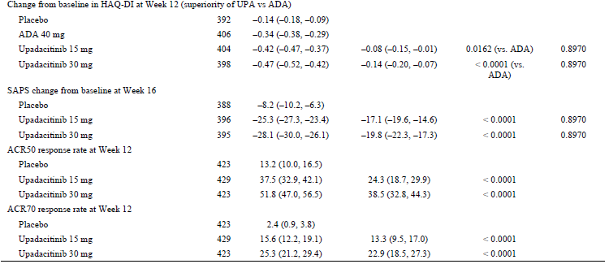

ACR20/50/70 = American College of Rheumatology 20%, 50%, 70% response; ADA = adalimumab; ANCOVA = analysis of covariance; BSA = body surface area; CI = confidence interval; FACIT-F = Functional Assessment of Chronic Illness Therapy – Fatigue; FAS = Full Analysis Set; HAQ-DI = Health Assessment Questionnaire Disability Index; LDI = Leed Dactylitis Index; LEI = Leeds Enthesitis Index; MDA = minimal disease activity; MMRM = mixed effects model repeated measure; NI = non-inferiority; NRI = non-responder imputation; PASI = psoriasis area severity index; SAPS = self-assessment of psoriasis symptoms; SF-36 = 36-Item Short Form Health Survey; SHS = Sharp/van der Heijde Score; sIGA 0/1 = Static Investigator Global Assessment of Psoriasis of 0 or 1 and at least a 2-point improvement from Baseline; UPA = upadactinib.

a Results for binary endopoints except for MDA at Week 24 are based on NRI. Results for MDA, resolution of enthesitis, and resolution of dactylitis at Week 24 re based on NRI with additional rescue handling, where subjects rescued at Week 16 is imputed as non-responders. Resultss for SHS were based on ANCOVA with linear extrapolation for missing data and rescue handling. Results for other continuous endpoints were based on MMRM model.

b sIGA 0/1 for subject with baseline sIGA ≥ 2.

c NI test of UPA versus ADA was based on three arm NI testing aiming UPA preserves at least 50% of the placebo-subtracted ADA effect.

Adjusted P-value are provided for multiplicity-adjusted endpoints.

Study M15-572 showed statistical significance for the non-inferiority (NI) analysis (seventh ranked secondary efficacy endpoint) of ACR20 response rate at Week 12 compared with ADA for both upadacitinib doses. The percentages of ADA effect preservation were 119.4% (95% CI: 98.0, 147.9) and 146.6% (95% CI: 122.8, 180.4) for the upadacitinib 15 mg and 30 mg groups, respectively. For both upadacitinib doses, the lower bound of the 95% CI exceeded the pre-specified NI ratio of at least 50% of the placebo subtracted ADA effect. The ACR20 response rate differences at Week 12 between the upadacitinib 15 and 30 mg doses and ADA were 5.6% (95% CI: –0.6, 11.8) and 13.5% (95% CI: 7.5, 19.4), respectively. The analysis of the PPS showed consistent results for both difference in response rate and preservation of ADA effect.

In the subsequent testing of superiority versus ADA (tenth ranked secondary efficacy endpoint), the upadacitinib 30 mg once daily group showed superiority versus ADA for the ACR20 response rate at Week 12 (the point estimate of treatment related difference was 13.5% (95% CI: 7.5, 19.4); p < 0.0001). However, the upadacitinib 15 mg dose did not achieve statistical significance for superiority (the point estimate of treatment related difference was 5.6% (95% CI: -0.6, 11.8) p = 0.0815).

Study M15-554 was a randomised, double blinded, placebo controlled trial that enrolled 642 adults with moderate to severe PsA, according to CASPAR criteria,2 with symptoms for at least six months. The study enrolled participants who had not responded to a minimum of twelve weeks therapy with at least one bDMARD, or who had an intolerance or contraindication to a bDMARD. The participants had to wait a minimum of five half-lives of the preceding bDMARD before commencing the trial. Otherwise, the same exclusion criteria applied as in Study M15-572.

The study was conducted at 123 study centres in 16 countries. The first patient was enrolled in May 2017 and the last participant completed Week 24 evaluations in October 2019. The submission contained an interim report for Study M15-554 with a data cutoff date of 9 October 2019. Six global amendments to the original trial protocol were not considered to impact significantly upon the trial’s findings.

Participants were randomised to upadacitinib 15 mg daily, upadacitinib 30 mg daily, placebo to upadacitinib 15 mg, or placebo to upadacitinib 30 mg. At Week 24, participants in the placebo arm were switched to upadacitinib 15 mg or 30 mg daily per the original randomisation. An open label phase commenced at Week 56 (See Figure 2)

Figure 2: Study M15-554 Design schema

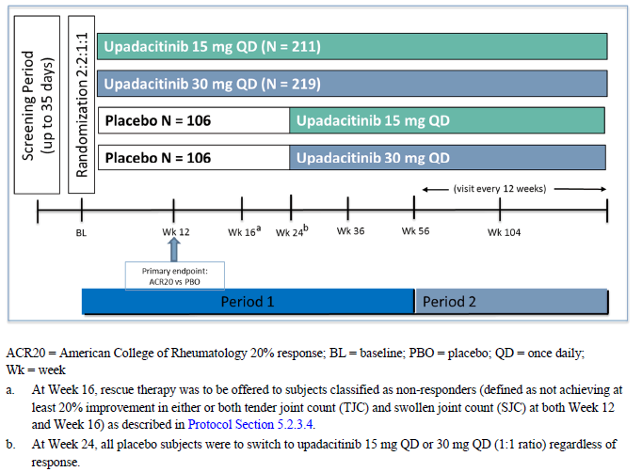

ACR20 = American College of Rheumatology 20% response; BL = baseline; PBO = placebo; QD = once daily; Wk = week.

a At Week 16, resuce therapy was to be offered to subjects classified as non-responders (defined as not achieving at least 20% improvement in either or both tender joint count (TJC) and swollen joint count (SJC) at both Week 12 and Week 16)

b At Week 24, all placebo subjects were to switch to upadacitinib 15 mg QD or 30 mg QD (1:1 ratio) regardless of response.

Participants were permitted to take up to two concomitant non-biological DMARDs during the trial. Inadequate responders could be rescued at Week 16 or later if they failed to achieve at least 20% improvement in either tender or swollen joint count at two consecutive evaluations.

The primary efficacy endpoint was the ACR20 response at Week 12. Ranked secondary endpoints included measures of the symptoms and signs of PsA and psoriasis and physical functioning (see Table 2). The evaluator considered the outcome measures and statistical analysis plan appropriate.

Overall 591 participants (92.1%) completed Week 12 and 543 participants (84.6%) completed Week 24 in the study. The most frequent primary reason for study medication discontinuation by Week 24 was lack of efficacy for the placebo group and AEs for the two upadacitinib dose arms. At the data cutoff date, 297 participants (46.3%) had completed Period 1 (Week 56), 182 (28.3%) had discontinued study drug during Period 1 and 163 subjects were ongoing in Period 1. Of the 182 subjects who discontinued by data cutoff, the most frequent primary reason for study drug discontinuation was lack of efficacy for the placebo and upadacitinib 15 mg groups, and AEs for the upadacitinib 30 mg arm.

There were no clinically significant differences between the treatment groups at Baseline with respect to demographic characteristics. The participants had a median age of 54 years (range 22 to 83 years) with 80.7% aged < 65 years of age at Baseline. Just over half were female and almost 90% were of Caucasian background. The overall population had a mean BMI of 31.3 kg/m2 (range: 16 to 65 kg/m2) and around four in five had a BMI of ≥ 25 kg/m2 at Baseline. The treatment groups were also comparable with regard to baseline disease characteristics and activity, which were consistent with moderate to severe activity in patients who are at a significant risk of disease progression.

Overall, adalimumab was the most frequently reported (46.6%) prior bDMARD. Almost 80% of participants had recorded exposure to at least one anti-TNF therapy and 44.8% recorded exposure to a prior biological medicine other than anti-TNF drugs. Regarding past non-biological DMARD exposure, 21.5% had no prior experience, 50.2% had taken one, 20.7% had taken two, and 7.5% had prior experience with three or more non-biological DMARDs.

During Study M15-554, participants could continue on stable doses of non-biological DMARDs, oral corticosteroids (equivalent to prednisone < 10 mg daily) and NSAIDs. At Baseline, 46.2% were taking at least one non-biological DMARD, the most common of which was methotrexate (34.6%). Only 2.8% were taking the combination of methotrexate with one other non-biological DMARD. The proportion of participants taking oral corticosteroid at Baseline was generally comparable between the three treatment groups although lower in the upadacitinib 30 mg group (11.3% in the placebo group, 10.4% in the upadacitinib 15 mg arm and 6.0% in the upadacitinib 30 mg group).

The primary efficacy outcome was met. A significantly greater proportion of subjects treated with upadacitinib (either dose) achieved an ACR20 response compared to placebo. For the FAS cohort (using NRI) the Week 12 ACR20 response rate was 56.9% in the upadacitinib 15 mg group and 63.8% in the upadacitinib 30 mg arm compared with 24.1% in the placebo group. The point estimate for determining a treatment related difference for upadacitinib 15 mg versus placebo was 32.8% (95% CI 24.0, 41.6, p < 0.0001) and for upadacitinib 30 mg versus placebo was 39.7% (95% CI 31.1, 48.3, p < 0.0001). Supplementary analyses using AO for the FAS cohort and NRI on the PPS were consistent with the primary analysis of ACR20 response rate at Week 12. Based on multiplicity adjusted p-values, the study also achieved all ranked secondary efficacy endpoints (using FAS dataset).

Table 4: Study M15-554 Results for secondary efficacy outcomes

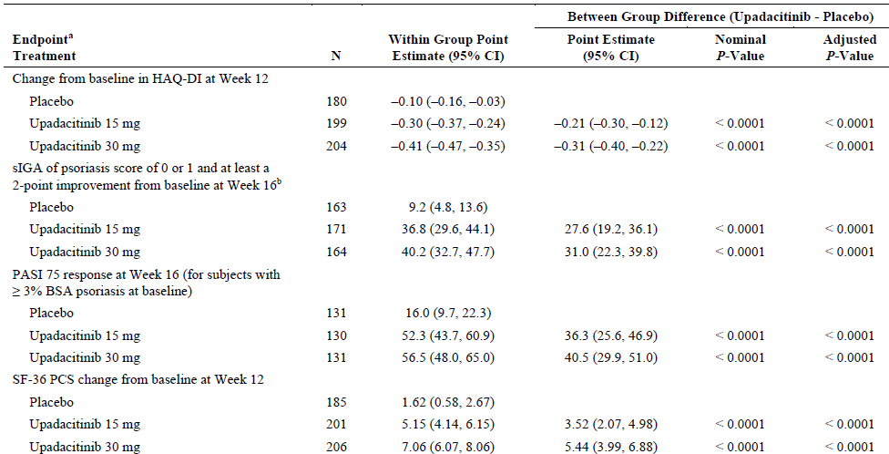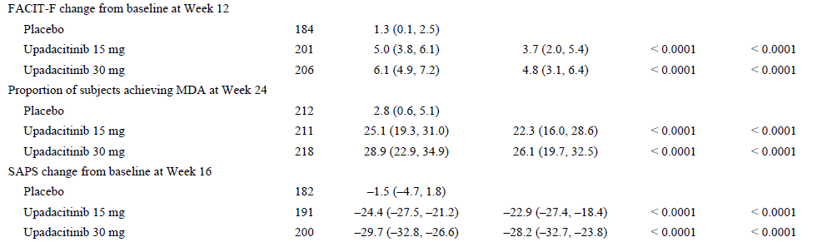

An integrated analysis combined the efficacy data from the 24 week placebo controlled periods of Study M15-572 (non-biological DMARD-IR PsA population) and Study M15-554 (bDMARD-IR PsA population). The main objectives of the pooled efficacy analysis were:

* to assess the efficacy of upadacitinib versus placebo on key endpoints;
* to assess the efficacy in subgroups defined by demographic and baseline disease characteristics;
* to examine the efficacy of upadacitinib as monotherapy versus in combination with background non-biologic DMARD; and
* to examine the efficacy of upadacitinib in combination with methotrexate versus with other non-biologic DMARDs.

The results of the pooled analysis were consistent with the individual Phase III study results, which showed the superior efficacy of both doses of upadacitinib versus placebo, and that upadacitinib 30 mg once daily provided an incremental efficacy benefit compared to 15 mg once daily, particularly for the more stringent efficacy endpoints.

The concurrent use of non-biological DMARDs (84% methotrexate) did not appear to have a major effect on the ACR20 response rate at 12 weeks. The point estimates of placebo-subtracted treatment effects in the pooled analysis for 15 mg daily dosage were 34.0% with non-biological DMARD versus 33.7% in upadacitinib monotherapy; and in the pooled analysis for 30 mg daily dosage were 39.6% with non-biological DMARD versus 45.7% in upadacitinib monotherapy. The greater difference between combination therapy and upadacitinib monotherapy in the 30 mg daily cohort appeared to reflect greater variation in responsiveness in the smaller Study M15-554 enrolling participants previously intolerant or poorly responsive to bDMARD therapy.

##### Ankylosing Spondylitis

Study M16-098 was a randomised, double blinded, placebo controlled trial that enrolled 187 adults with active AS, according to the modified New York criteria for AS. The study enrolled participants who had not responded to a minimum of four weeks (total) therapy with at least two NSAIDs, or who had an intolerance or contraindication to a NSAID, and who had not been previously treated with a bDMARD. Established and stable doses of NSAIDs, cDMARDs and/or oral corticosteroids were allowed as concomitant therapy. Exclusion criteria were typical for studies of this type, including other inflammatory arthritis, fibromyalgia, prior exposure to JAK inhibitor, concurrent use of strong CYP3A modulators,3 recent severe infection or chronic recurrent infections including herpes virus, TB, HIV and hepatitis B or C, and other significant or severe medical conditions including malignancy.

The study was conducted at 62 study centres in 20 countries (including Australia). The first patient was enrolled in October 2017 and the last patient assessment for this interim report occurred in January 2020. Global and local amendments to the original trial protocol were not considered to impact significantly upon the trial’s findings.

Participants were randomised to 15 mg upadacitinib daily or matching placebo, for an initial period of 14 weeks (Period 1), after which placebo patients were switched to 15 mg upadacitinib daily. All patients were then reviewed regularly up to a total of 104 weeks treatment (Period 2, open label), with an additional safety follow up period of 30 days (see Figure 3, below).

Participants who did not achieve an Assessment of SpondyloArthritis International Society (ASAS) 20 response;7 at two consecutive visits starting at Week 16 were allowed additional or modified doses of NSAIDS, paracetamol, low potency opioids, and/or modifed doses of methotrexate or sulfasalazine from Week 20. Participants who did not achieve at least ASAS20 response at two consecutive visits starting at Week 24 were discontinued from study treatment.

Figure 3: Study M16-098 Design schema

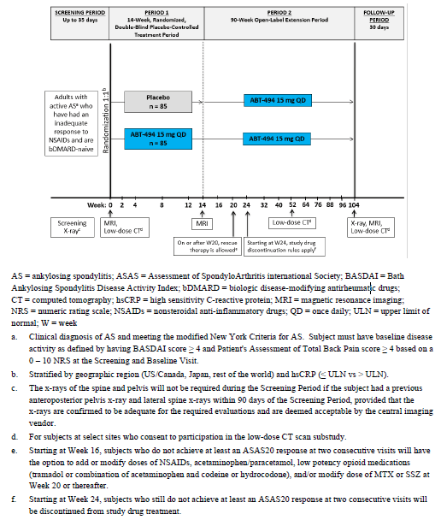

AS = ankylosing spondylitis; ASAS = Assessment of SpondyloArthritis International Society; BASDAI = Bath Ankylosing Spondylitis Disease Activity Index; bDMARD = biologic disease-modifying antirheumatic drugs; CT = computed tomography; hsCRP = high sensitivity C-reactive protein; MRI = magnetic resonance imaging; NRS = numeric rating scale; NSAIDs = nonsteroidal anti-inflammatory drugs; QD = once daily; ULN = upper limit of normal; W = week.

a Clinical diagnosis of AS and meeting the modified New York Criteria for AS. Subject must have baseline disease activity as defined by having BASDAi score ≥ 4 and Patient’s Assessment of Total Back Pain Score ≥ 4 based on a 0 to 10 NRS at the screening and baseline visit.

b Stratified by geographic region (USA/Canada, Japan, rest of the world) and hsCRP (≤ ULN versus > ULN)

c The x-rays of the spine and pelvis will not be required during the screening period if subject has a previous anteroposterior pelvis x-ray and lateral spine x-rays within 90 days of the screening period, provided that the x-ray are confirmed to be adequate for the required evaluations and are deemed acceptable by the central imaging vendor.

d For subjects at select sites who consent to participation in the low-dose CT scan sub -study.

e Starting at Week 16, subjects who do not achieve at least an ASA20 response at two consecutive visits will have the option to add or modify dose of NSAIDs, acetaminophen/paracetamol, low potency opioid medications (tramadol or combination of acetaminophen and codeine or hydrocodone), and/or modify dose of methotrexate or SSZ at Week 20 or thereafter.

f Starting at Week 24 , subjects who still do not achieve at least an ASA20 response at two consecutive visits will be discontinued from study drug treatment.

The primary efficacy endpoint for Study M16-098 was the ASAS40 response;[9] at Week 14. The key multiplicity adjusted secondary endpoints for Study M16-098 (all assessed at Week 14) include:

* Mean change from Baseline in Ankylosing Spondylitis Disease Activity Score (ASDAS),
* Mean change from Baseline in Spondyloarthritis Research Consortium of Canada (SPARCC) MRI spinal score,
* Proportion of subjects achieving at least 50% improvement in Bath Ankylosing Spondylitis Disease Activity Index (BASDAI 50 response rate),[10]
* Mean change from Baseline in Ankylosing Spondylitis Quality of Life (ASQoL), and
* Proportion of subjects achieving ASAS partial remission.

Mean changes from Baseline were also examined for the following outcomes: Bath Ankylosing Spondylitis Functional Index (BASFI), linear Bath Ankylosing Spondylitis Metrology Index (BASMI linear), Maastricht Ankylosing Spondylitis Enthesitis Score (MASES), work productivity and activity impairment (WPAI) and ASAS Health Index.

The evaluator considered the outcome measures and statistical analysis plan appropriate.

Of the 187 subjects randomised into Study M16-098, all were included in the FAS and 168 (89.8%) subjects met the criteria for inclusion in the PPS at Week 14. Eleven subjects (11.8%) in the upadacitinib group and eight in the placebo arm (8.5%) were excluded from the PPS.

Adverse events were the most frequent primary reason for discontinuing study drug in the placebo group (n = 3); while in the upadacitinib arm, AEs and subject withdrawal each accounted for two discontinuations.

There were no clinically significant differences between the two treatment groups at Baseline with respect to demographic characteristics. Randomised subjects had a median age of 46 years (range: 21 to 74 years) with 94.1% aged < 65 years. Males (70.6%) and White (82.9%) participants predominated. The overall population had a mean BMI of 26.8 kg/m2 (range: 17 to 44 kg/m2) and 58.8% had BMI ≥ 25 kg/m2. Baseline disease characteristics and activity were comparable in upadacitinib and placebo groups. All but one of the 187 participants reported prior NSAID use. One participant in the upadacitinib group had a recorded contraindication to a NSAID. The most commonly used prior NSAIDs included ibuprofen (48.1%), diclofenac (44.4%) and naproxen (34.2%). More than half of participants in each treatment group had no prior exposure to cDMARDs (placebo 61.7% to upadacitinib 63.4%). The most commonly used cDMARDs included sulfasalazine (26.7%) and methotrexate (10.7%). Approximately 18% to 19% of subjects in each group had prior corticosteroid use.

The primary efficacy outcome was met. The ASAS40;9 response rate at Week 14 was 51.6% in the upadacitinib arm and 25.5% in the placebo arm. The treatment related difference for achieving ASAS40 response for upadacitinib versus placebo was 26.1% (95% CI 12.6, 39.5, p < 0.001). Results from the supporting analyses using observed data (without missing data imputation) and the PPS were consistent with the primary statistical analysis. Treatment effects in all subgroups were in favour of upadacitinib versus placebo. In general, the analyses of secondary outcomes supported the primary outcome, although based on multiplicity adjusted testing not all were statistically significant (see Table 5). An analysis of Week 14 spinal MRI results (using only available MRI data) supported the primary analysis. The mean change from Baseline in the MRI SPARCC score of the sacroiliac joints at Week 14 (using observed data) showed an improvement for the upadacitinib versus placebo group with a nominal p value of < 0.001 for the difference.

Preliminary results from Period 2 of the study demonstrated that the treatment response to upadacitinib was maintained or continued to improve up to Week 64. For patients who switched from placebo to upadacitinib 15 mg daily at the conclusion of Period 1, a similar magnitude of treatment response was observed in Period 2.

Table 5: Study M16-098 Results for secondary efficacy outcomes

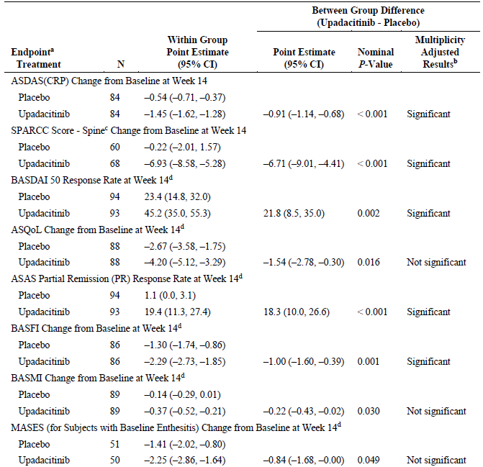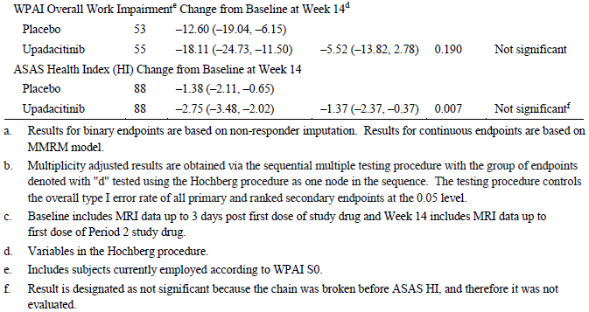

a) Results for binary endpoints are based on non-responder imputation. Results for continuous endpoints are based on a mixed model for repeated measures (MMRM) model.

b) Multiplicity adjusted results are obtained via the sequential multiple testing procedure with the group of endpoints denoted with ‘d’ tested using the Hochberg procedure as one node in the sequence. The testing procedure controls the overall type I error rate of all primary and ranked secondary endpoints at the 0.05 level.

c) Baseline includes MRI data up to 3 days post first dose of study drug and Week 14 includes MRI data up to first dose of Period 2 study drug.

d) Variables in the Hochberg procedure.

e) Includes subjects currently employed according to WPAI S0.

f) Result is designed as not significant because the chain was broken before ASAS HI, and therefore it was not evaluated.

#### Safety

Safety reports from the clinical studies were presented for the placebo controlled periods (placebo controlled analysis sets, Week 0 to 24 in PsA studies, Week 0 to 14 in AS study) and for all periods including the long term open label periods (any upadacitinib analysis sets).

Table 6: PsA studies drug exposure by duration

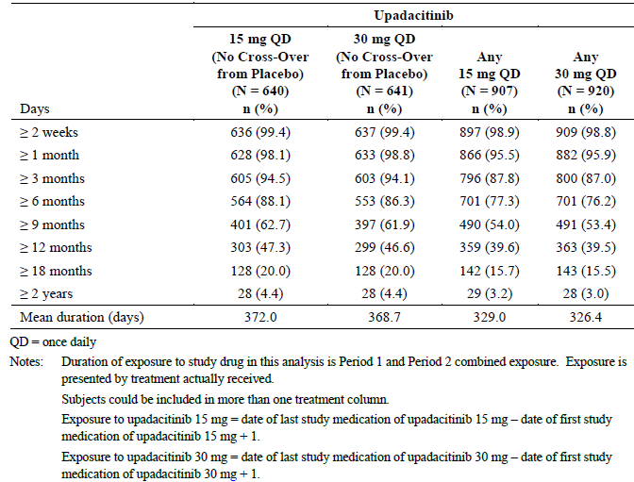

QD = once daily

Notes: Duration of exposure to study drug in this analysis is Period 1 and 2 combined exposure. Exposure is presented by treatment actually received. Subjects could be included in more than on treatment column.

Exposure to upadacitinib 15 mg = date of last medication of upadacitinib 15 mg – date of first study mediciation of upadacitinib 15 mg + 1.

Exposure to upadacitinib 30 mg = date of last study medication of upadacitinib – date of first study medication of upadacitinib 30 mg + 1.

The PsA Study M15-572 also included a third report that compared safety outcomes with ADA up to the data cutoff date of 13 December 2019 (ADA controlled analysis set). Updated reports from the RA development program provided additional safety data. AEs were summarised by the MedDRA classification (version 22.0) using System Organ Class (SOC) and Preferred Term (PT) nomenclature. Exposure information for the PsA studies is presented in Table 6.

Overall exposure in the AS study with 182 participants was significantly lower. In the long-term safety dataset, the mean duration of exposure to upadacitinib 15 mg therapy was 476.9 days (median of 507.5 days; range 6 to 742 days). Up to the data cutoff date, 87.9% of participants who received ≥ 1 dose of upadacitinib 15 mg had at least 12 months of exposure to upadacitinib, 34.1% had > 18 months of use and 2.2% had > 2 years exposure.

In the PsA studies, by SOC, the most frequent types of AEs (affecting ≥ 10% of subjects) were infections and infestations, gastrointestinal disorders, abnormal investigations and musculoskeletal and connective tissue disorders for upadacitinib 15 mg therapy; and infections and infestations, and gastrointestinal disorders for upadacitinib 30 mg treatment. For the placebo group, the most common SOCs were infections and infestations, gastrointestinal disorders and musculoskeletal disorders. In the AS study, the most frequently reported types of AEs by SOC in the upadacitinib group were infections and infestations, gastrointestinal disorders and abnormal investigations. Infections and infestations, and gastrointestinal disorders were also the most frequently reported AEs in the placebo group in the AS study.

By PT nomenclature, the most frequently reported AEs (incidence ≥ 5%) in the PsA studies upadacitinib 15 mg group were upper respiratory tract infection (URTI) and increased blood creatine phosphokinase (CPK); in the upadacitinib 30 mg group were URTI, blood CPK levels increased, nasopharyngitis and increased serum alanine aminotransferase (ALT); and in the placebo group were URTI and nasopharyngitis. No AEs by PT occurred in ≥ 10% of subjects in any group. The rates of AEs reported in ≥ 2% of subjects were generally higher in the upadacitinib groups compared with placebo, although AEs of psoriatic arthropathy and skin psoriasis were higher in the placebo arm. Of note, the frequency of oral herpes and herpes zoster infection in the upadacitinib 30 mg treatment group was approximately two fold that recorded in the placebo and upadacitinib 15 mg once daily treatment cohorts. In addition, the incidence of haematological AEs (neutropaenia, anaemia and lymphopaenia) as well as raised serum transaminases (ALT and aspartate aminotransferase (AST)) were significantly higher with 30  mg upadacitinib once daily. In the ADA treatment group, the most common types of AEs (incidence > 5%) reported up to Week 24 in Study M15-572 were URTI, nasopharyngitis, increased blood CPK levels, elevated serum ALT and elevated serum AST.

In the AS study, the most frequently reported types of AEs by PT (≥ 5% incidence) in the upadacitinib group were elevated blood CPK, diarrhoea, nasopharyngitis and headache. The frequency of elevated blood CPK was notably higher in the upadacitinib group compared with the placebo arm (eight versus two cases). Moreover, a greater proportion of upadacitinib treated subjects reported hepatic disorders compared with the placebo group (five versus two cases, respectively).

In the PsA study ADA controlled treatment set, the frequency of most types of AEs was similar between upadacitinib 15 mg orally and ADA treatment groups, and somewhat higher in the upadacitinib 30 mg group (see Table 7).

Table 7: Study M15-572 Adalimumab controlled safety set; most common adverse event by preferred term (> 5 per 100 patient-year)

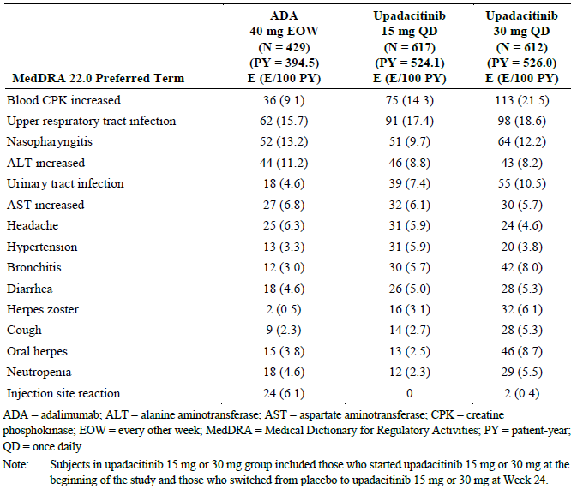

ADA = adalimumab; ALT = alanine aminotransferase; AST = aspartate aminotransferase; CPK = creatine phosphokinase; EOW = every other week; MedDRA = Medical Dictionary for Regulatory Activities; PY = patient-year; QD = once daily.

Note: Subjects in upadacitinib 15 mg or 30 mg group included those who started upadacitinib 15 mg or 30 mg at the beginning of the study and those who switched from placebo to upadacitinib 15 mg or 30 mg at Week 24.

Reports of AE in the long-term safety dataset of the AS study more or less reflected the placebo controlled and PsA study reports and were consistent with the known safety profile of JAK inhibitor in adults with RA. AEs were reported most frequently in the SOC of infections and infestations, musculoskeletal and connective tissue disorders, gastrointestinal disorders and abnormal investigations. Among adverse events of special interest (AESI), there were six cases of latent TB (2.5 per 100 Patient-Year (PY)) and five cases of herpes zoster in four participants (2.1 per 100 PY) in the long term safety set. One subject who received upadacitinib in both periods of Study M16-098 experienced two AEs of oesophageal candidiasis (opportunistic infection), one in each study period. Each AE was considered moderate severity and non-serious, and was assessed by the investigator as having a reasonable possibility of being related to study medication.

No deaths related or probably related to upadacitinib were reported in the placebo-controlled period of any of the PsA or AS studies. In the any upadacitinib PsA safety set, the death of one male receiving 30 mg upadacitinib daily was considered reasonably related to upadacitinib. The patient developed pancytopenia, acute respiratory distress syndrome (ARDS) and pneumothorax, and required mechanical ventilation. Additional complications included interstitial pneumonia, opportunistic infections with *Pneumocystis jirovecii* and cytomegalovirus, cerebral infarction, disseminated intravascular coagulation. Comorbidities included alcoholic liver disease and active smoking.

Across the studies, serious adverse events (SAE) were more frequently reported in upadacitinib treated groups than in placebo treated groups, and the PsA studies identified a dose response relationship with higher exposure adjusted event rates with the higher dose of upadacitinib. With regard to adverse events of special interest (AESI) in the PsA studies a significantly higher proportion of upadacitinib 30 mg treated patients reported serious infections (2.7%; 17 out of 641) compared to those treated with upadacitinib 15 mg (0.9%; 6 out of 640) and placebo (0.8%; 5 out of 635). Of note, each upadacitinib treatment group recorded three neoplasms (compared to one in the placebo arm). One deep vein thrombosis (DVT) SAE was reported in a placebo treated participant and one person in each upadacitinib dose group experienced an SAE of pulmonary embolism (PE). Two participants developed interstitial lung disease and complications after ceasing upadacitinib, these AEs were considered to have a reasonable possibility of relationship to upadacitinib.

In Period 1 of the AS study, no SAEs of serious infection, malignancy, non-melanoma skin cancer (NMSC), lymphoma, gastrointestinal perforation, herpes zoster, active or latent TB, independently adjudicated major adverse cardiovascular events (MACE) or adjudicated events of venous thromboembolism (VTE) were reported. In the any upadacitinib report, 14 single incidents of SAEs were reported by 12 participants, among those squamous cell carcinoma of the tongue (former smoker with onset on treatment Day 146), iridocyclitis, multiple fractures, hypertensive emergency and raised serum ALT levels.

The clinical evaluator concluded that:

*‘data indicates that upadacitinib 15 mg once daily in both newly proposed treatment indications (PsA and AS) has an acceptable overall safety profile up to one year of therapy in the treatment of adult patients with moderately to severely active disease. There is limited long-term safety data in the current submission to assess the risk of some types of AEs such as malignancy and MACE, which will require additional longitudinal safety follow-up. From this reviewer’s assessment of the safety dataset, there are some significant safety concerns with upadacitinib therapy including the risk of infection, opportunistic infection (mainly, oral herpes and zoster infection), increased serum CPK values, anaemia, neutropenia, abnormal liver function tests (raised serum transaminases) and dyslipidaemia. These safety concerns are consistent with the known profile of upadacitinib therapy in adult patients with RA.’*

The evaluator recommended and the sponsor agreed to an amended indication for upadacitinib in PsA:

*‘Rinvoq is indicated for the treatment of moderate to severe active psoriatic arthritis in adult patients when the response to one or more disease modifying anti-rheumatic drugs (DMARDs) has been inadequate, or inadequately tolerated. Rinvoq can be given as monotherapy or in combination with conventional DMARDs including methotrexate.’*

The sponsor proposed and the evaluator agreed to the following indication for upadacitinib in AS:

*Rinvoq is indicated for the treatment of adults with active ankylosing spondylitis.*

#### Clinical evaluator’s recommendation

The clinical evaluator recommends approval of the submission to extend the indications of upadacitinib (upadacitinib) to include the treatment of both psoriatic arthritis (PsA) and ankylosing spondylitis (AS). The indications supported by the clinical evaluator are:

*Psoriatic Arthritis*

*Rinvoq is indicated for the treatment of moderate to severe active psoriatic arthritis in adult patients when the response to one or more disease modifying anti-rheumatic drugs (DMARDs) has been inadequate, or inadequately tolerated. Rinvoq can be given as monotherapy or in combination with conventional DMARDs including methotrexate.*

*Ankylosing Spondylitis*

*Rinvoq is indicated for the treatment of adults with active ankylosing spondylitis.*

### Risk management plan

There was no requirement for a risk management plan evaluation for a submission of this type.[11]

### Risk-benefit analysis

#### Delegate’s considerations

The studies in PsA examined the efficacy and safety of two doses of upadacitinib in patients with moderate to severe PsA who had inadequately responded to or were intolerant to non-biological DMARDs, and in patients who had inadequately responded to or were intolerant to at least one bDMARD. The studies were well designed and, with regard to efficacy, convincingly indicated that upadacitinib was superior to placebo in both populations. Although there may be some incremental efficacy benefits with upadacitinib 30 mg once daily compared to 15 mg once daily, there is an increased risk of AEs that outweighs the additional (inconsistent) benefits. This supports the opinion that the most appropriate dose in PsA should be 15 mg once daily, and that there is no important reason to register the 30 mg once daily dose regimen for patients with PsA.

The study in AS is relatively small and short term, but appropriately designed. There is considerable consensus among rheumatologists that the mechanism of action of any specific JAK inhibitor is likely to be the same in the wide range of inflammatory rheumatic diseases in which evidence of efficacy and safety of the JAK inhibitor has been investigated. In the case of upadacitinib, the relative specificity for JAK1 supports its use in the range of inflammatory conditions known to be mediated, at least in part, by IL-6. The sponsor has clearly reported the statistical design of the study, and has justified that a statistically significant, and presumably clinically relevant, response was identified in spite of the small population. In the absence of direct head to head studies, the apparent treatment effect in AS would appear to be similar to or approach that of already registered bDMARDs, and the safety findings in AS are also consistent with those reported with upadacitinib in RA and PsA. An additional benefit of upadacitinib in AS is the oral formulation and associated lower risk of immunogenicity.

#### Proposed action

Overall, the benefit-risk balance of upadacitinib for the proposed indication of use in adult patients with active PsA is favourable. The recommended dose in adult patients with active PsA is 15 mg once daily orally (as either monotherapy or in conjunction with non-biological DMARDs). However, the proposed treatment indication is amended to reflect that upadacitinib should only be commenced after a prior trial of at least one conventional or non-biological DMARD, as this indication wording is consistent with the supporting dataset. The Delegate supports approval for the amended indication:

*Rinvoq is indicated for the treatment of moderate to severe active psoriatic arthritis in adult patients who have responded inadequately to, or who are intolerant to one or more DMARDs. Rinvoq may be used as monotherapy or in combination with a non-biological DMARD.*

Overall, the benefit-risk balance of upadacitinib for the proposed indication of use in adult patients with active AS is also favourable. The Delegate concurs with the sponsor’s recommended dose of upadacitinib 15 mg once daily in adult patients with active AS and the proposed treatment indication wording is consistent with the supporting data.

#### Questions for the sponsor

The sponsor provided the following response to questions from the Delegate.

1. ***In Section 5.1 Pharmacodynamic properties in the annotated Product Information* [not included here] *dated 15 December 2020, the sponsor proposes to restrict information regarding ‘small transient increase in mean absolute lymphocyte count (ALC) [et seq]’ to patients with rheumatoid arthritis. According to the second round of clinical evaluation report, similar changes were seen in the long term Phase III studies of psoriatic arthritis. Please clarify whether this effect of upadacitinib on lymphocyte count is specific to rheumatoid arthritis or is likely to occur in all treated patients?***

The sponsor would like to clarify that the observed effect of upadacitinib 15 mg once daily on lymphocyte count as presented in the label was based on findings from the RA study. However, this effect is not considered to be specific to RA. As noted, similar changes were observed in the long-term Phase III studies for psoriatic arthritis (PsA) and AS. The sponsor’s approach to the Product Information is to state the observed effects for the lead indication of RA in Section 5.1 [of the proposed PI] for all parameters and affirm the consistency of this observation for other indications in Section 4.8 Adverse Effects. The sponsor proposes to retain the following wording in Section 5.1:

* In Section 5.1 Pharmacodynamic properties, under Lymphocytes:

‘In patients with rheumatoid arthritis, treatment with upadacitinib was associated with a small, transient increase in mean ALC from Baseline up to Week 36 which gradually returned to, at or near Baseline levels with continued treatment.’

Furthermore, Section 4.8 supports sponsor's position to maintain the wording in Section 5.1:

* In Section 4.8 Adverse Effects, under PsA:

‘Overall, the safety profile observed in patients with active psoriatic arthritis treated with Rinvoq 15 mg was consistent with the safety profile observed in patients with rheumatoid arthritis. During the 24 week placebo controlled period, the frequencies of herpes zoster and herpes simplex were > 1% (1.1% and 1.4%, respectively) with Rinvoq 15 mg and 0.8% and 1.3%, respectively, with placebo. A higher incidence of acne and bronchitis was also observed in patients treated with Rinvoq 15 mg (1.3% and 3.9%, respectively) compared to placebo (0.3% and 2.7%, respectively).’

* In Section 4.8 Adverse Effects, under AS:

‘Overall, the safety profile observed in patients with active ankylosing spondylitis treated with Rinvoq 15 mg was consistent with the safety profile observed in patients with rheumatoid arthritis. No new safety findings were identified.’

This approach allows for a more concise label and also offers flexibility so that specific descriptions can be placed under a particular indication if different observations of effects on these laboratory parameters are noted.

#### Advisory Committee considerations[12]

The Advisory Committee on Medicines (ACM), having considered the evaluations and the Delegate’s overview, as well as the sponsor’s response to these documents, advised the following.

##### Specific advice to the Delegate

1. ***What is the opinion of the committee on the benefit-risk balance of upadacitinib in the proposed indication for ankylosing spondylitis?***

The ACM was of the view that despite the small numbers of patients with AS enrolled in the Phase II/III study, the effect size of upadacitinib is similar to other biological disease modifying anti-rheumatic drugs, and were of the opinion that the safety profile in patients with AS is unlikely to be different to patients with PsA and RA.

The ACM advised that the overall benefit-risk balance of upadacitinib (15 mg dose regimen) for the proposed indication of use in adult patients with active AS is favourable.

1. ***The committee is also requested to provide advice on any other issues that it thinks may be relevant to a decision on whether or not to approve this application.***

The ACM advised that the overall benefit-risk balance of upadacitinib (15 mg dose regimen) for the proposed indication of use in adult patients with active PsA is favourable.

##### Conclusion

The ACM considered this product to have an overall positive benefit-risk profile for the indications:

*Rinvoq is indicated for the treatment of moderate to severe active psoriatic arthritis in adult patients who have responded inadequately to, or who are intolerant to, one or more DMARDs. Rinvoq may be used as monotherapy or in combination with a non-biological DMARD.*

*Rinvoq is indicated for the treatment of adults with active ankylosing spondylitis.*

### Outcome

Based on a review of quality, safety and efficacy, the TGA approved the registration of Rinvoq (upadacitinob) 15 mg, modified release tablet, blister pack, indicated for the following extension of indications:

*Psoriatic Arthritis*

*Rinvoq is indicated for the treatment of moderate to severe active psoriatic arthritis in adult patients who have responded inadequately to, or are intolerant to one or more DMARDs.*

*Rinvoq may be used as monotherapy or in combination with a non-biological DMARD.*

*Ankylosing Spondylitis*

*Rinvoq is indicated for the treatment of adults with active ankylosing spondylitis.*

As such, the full indications at this time were:

*Rheumatoid Arthritis*

*Rinvoq is indicated for the treatment of moderate to severe active rheumatoid arthritis in adult patients who have responded inadequately to, or who are intolerant to, one or more disease-modifying anti-rheumatic drugs (DMARDs). Rinvoq may be used as monotherapy or in combination with methotrexate or other conventional synthetic disease-modifying anti-rheumatic drugs (csDMARDs).*

*Psoriatic Arthritis*

*Rinvoq is indicated for the treatment of moderate to severe active psoriatic arthritis in adult patients who have responded inadequately to, or are intolerant to one or more DMARDs.*

*Rinvoq may be used as monotherapy or in combination with a non-biological DMARD.*

*Ankylosing Spondylitis*

*Rinvoq is indicated for the treatment of adults with active ankylosing spondylitis.*

#### Specific conditions of registration applying to these goods

* Rinvoq (upadacitinib) is to be included in the Black Triangle Scheme. The Product Information and Consumer Medicines Information for Rinvoq must include the black triangle symbol and mandatory accompanying text for five years, which starts from the date the new indication is registered.
* Provision to the TGA of the final clinical study reports for the Phase III studies in PSA (Study M15-572 and M15-554) and the Phase II/III study in AS (Study M16-098), when available.
* This approval does not impose any requirement for the submission of Periodic Safety Update reports (PSUR). Sponsor should note that it is a requirement that all existing requirements for the submission of PSURs as a consequence of the initial registration or subsequent changes must be completed.

## Attachment 1. Product Information

The PI for Rinvoq approved with the submission which is described in this AusPAR is at Attachment 1. For the most recent PI, please refer to the TGA website at <<https://www.tga.gov.au/product-information-pi>>.

|  |
| --- |
| Therapeutic Goods Administration |
| PO Box 100 Woden ACT 2606 Australia  Email: [info@tga.gov.au](mailto:info@tga.gov.au) Phone: 1800 020 653 Fax: 02 6232 8605  [**https://www.tga.gov.au**](https://www.tga.gov.au) |

1. The **Black Triangle Scheme** provides a simple means for practitioners and patients to identify certain types of new prescription medicines, including those being used in new ways and to encourage the reporting of adverse events associated with their use. The Black Triangle does not denote that there are known safety problems, just that the TGA is encouraging adverse event reporting to help us build up the full picture of a medicine's safety profile.
2. The **Classification Criteria For Psoriatic Arthritis** criteria (or **CASPAR**) consisted of established inflammatory articular disease with at least three points from the following features: current psoriasis (assigned a score of 2; all other features were assigned a score of 1), a history of psoriasis (unless current psoriasis was present), a family history of psoriasis (unless current psoriasis was present or there was a history of psoriasis), dactylitis (or severe inflammation of the finger and/or toe joints), juxtaarticular new bone formation (or new bone formation next to or close to the affected joint), rheumatoid factor negativity, and nail dystrophy (or abnormal nail formation).
3. **Cytochrome P450 (CYP) enzymes:** CYPs are the major enzymes involved in drug metabolism, accounting for large part of the total metabolism. Most drugs undergo deactivation by CYPs, either directly or by facilitated excretion from the body. Also, many substances are bioactivated by CYPs to form their active compounds.

   Many drugs may increase or decrease the activity of various CYP isozymes either by inducing the biosynthesis of an isozyme (enzyme induction) or by directly inhibiting the activity of the CYP (enzyme inhibition). This is a major source of adverse drug interactions, since changes in CYP enzyme activity may affect the metabolism and clearance of various drugs. Such drug interactions are especially important to take into account when using drugs of vital importance to the patient, drugs with important side-effects and drugs with small therapeutic windows, but any drug may be subject to an altered plasma concentration due to altered drug metabolism
4. American College of Rheumatology is acomposite measure of the severity of inflammatory arthritis (RA and PsA)
5. Psoriasis Area and Severity Index, a measure of the severity of psoriasis
6. Investigator’s Global Assessment (static) of psoriasis at a point in time based on induration, erythema and scaling
7. The **Assessment of SpondyloArthritis International Society Response Criteria** **(ASAS 20; ASAS 40)** is defined as an improvement of at least 20% (or 40%) and an absolute improvement of at least 10 units on a 0‑100 scale in at least three of the following domains: Patient global assessment, Pain assessment, Function (BASFI), and Inflammation (last 2 questions of Bath Ankylosing Spondylitis Disease Activity Index).
8. **ACR20** defined as a 20% decrease in the combined number of swollen (maximum of 66) and tender (maximum of 68) joint counts, with a 20% improvement in any three of the five core-set measures: Patient’s Global Assessment of disease activity, Physician’s Global Assessment of disease activity, Patient’s Assessment of Pain score (on 10 cm VAS), and Patient’s assessment of physical function as measured by the HAQ-DI and an acute phase reactant (ESR or CRP).
9. The primary endpoint is the proportion of subjects with ASAS 40 response at Week 14, which is defined as a ≥ 40% improvement and an absolute improvement of ≥ 2 units (on a scale of 0 to 10) from Baseline in at least three of the following four domains, with no worsening at all in the remaining domain:

   Patient's Global Assessment – Represented by the PtGA NRS score (0 to 10);

   Pain – Represented by the Patient's Assessment of Total Back Pain NRS score (0 to 10);

   Function – Represented by the BASFI NRS score (0 to 10);

   Inflammation – Represented by the mean of the two morning stiffness-related BASDAI NRS scores (mean of items 5 and 6 of the BASDAI [0 to 10]).
10. The Bath Ankylosing Spondylitis Disease Activity Index (BASDAI) disease activity questionnaire in ankylosing spondylitis contains six questions regarding subjective symptoms in during the week prior to answering the questions.
11. The sponsor must still comply with routine product vigilance and risk minimisation requirements.
12. The ACM provides independent medical and scientific advice to the Minister for Health and the Therapeutic Goods Administration (TGA) on issues relating to the safety, quality and efficacy of medicines supplied in Australia including issues relating to pre-market and post-market functions for medicines.

    The Committee is established under Regulation 35 of the Therapeutic Goods Regulations 1990. Members are appointed by the Minister. The ACM was established in January 2017 replacing Advisory Committee on Prescription Medicines (ACPM) which was formed in January 2010. ACM encompass pre and post-market advice for medicines, following the consolidation of the previous functions of the Advisory Committee on Prescription Medicines (ACPM), the Advisory Committee on the Safety of Medicines (ACSOM) and the Advisory Committee on Non-Prescription Medicines (ACNM). Membership comprises of professionals with specific scientific, medical or clinical expertise, as well as appropriate consumer health issues relating to medicines.