|  |
| --- |
| **July 2014** |

|  |
| --- |
| Australian Public Assessment Report for vortioxetine hydrobromide |
| Proprietary Product Name: Brintellix |
| Sponsor: Lundbeck Australia Pty Ltd |

About the Therapeutic Goods Administration (TGA)

* The Therapeutic Goods Administration (TGA) is part of the Australian Government Department of Health and is responsible for regulating medicines and medical devices.
* The TGA administers the *Therapeutic Goods Act 1989* (the Act), applying a risk management approach designed to ensure therapeutic goods supplied in Australia meet acceptable standards of quality, safety and efficacy (performance), when necessary.
* The work of the TGA is based on applying scientific and clinical expertise to decision-making, to ensure that the benefits to consumers outweigh any risks associated with the use of medicines and medical devices.
* The TGA relies on the public, healthcare professionals and industry to report problems with medicines or medical devices. TGA investigates reports received by it to determine any necessary regulatory action.
* To report a problem with a medicine or medical device, please see the information on the TGA website <<http://www.tga.gov.au>>.

About AusPARs

* An Australian Public Assessment Record (AusPAR) provides information about the evaluation of a prescription medicine and the considerations that led the TGA to approve or not approve a prescription medicine submission.
* AusPARs are prepared and published by the TGA.
* An AusPAR is prepared for submissions that relate to new chemical entities, generic medicines, major variations, and extensions of indications.
* An AusPAR is a static document, in that it will provide information that relates to a submission at a particular point in time.
* A new AusPAR will be developed to reflect changes to indications and/or major variations to a prescription medicine subject to evaluation by the TGA.

Copyright

© Commonwealth of Australia 2014  
This work is copyright. You may reproduce the whole or part of this work in unaltered form for your own personal use or, if you are part of an organisation, for internal use within your organisation, but only if you or your organisation do not use the reproduction for any commercial purpose and retain this copyright notice and all disclaimer notices as part of that reproduction. Apart from rights to use as permitted by the *Copyright Act 1968* or allowed by this copyright notice, all other rights are reserved and you are not allowed to reproduce the whole or any part of this work in any way (electronic or otherwise) without first being given specific written permission from the Commonwealth to do so. Requests and inquiries concerning reproduction and rights are to be sent to the TGA Copyright Officer, Therapeutic Goods Administration, PO Box 100, Woden ACT 2606 or emailed to <[tga.copyright@tga.gov.au](mailto:tga.copyright@tga.gov.au)>.

Contents

List of Abbreviations 5

I. Introduction to Product Submission 9

Submission details 9

Product background 9

Regulatory status 10

Product information 10

II. Quality findings 10

Drug substance (active iIngredient) 10

Drug product 11

Biopharmaceutics 11

Quality summary and conclusions 14

III. Nonclinical findings 14

Introduction 14

Pharmacology 15

Pharmacokinetics 24

Toxicology 28

Nonclinical summary and conclusions 46

IV. Clinical findings 50

Introduction 50

Pharmacokinetics 52

Pharmacodynamics 54

Dosage selection for the pivotal studies 55

Efficacy 56

Safety 59

First round benefit-risk assessment 66

First round recommendation regarding authorisation 66

Clinical questions 66

Second round evaluation of clinical data in response to questions 69

Second round benefit-risk assessment 83

Second round recommendation regarding authorisation 85

V. Pharmacovigilance findings 86

Risk management plan 86

VI. Overall conclusion and risk/benefit assessment 94

Quality 94

Nonclinical 95

Clinical 95

Risk management plan 102

Risk-benefit analysis 103

Outcome 113

Attachment 1. Product Information 113

Attachment 2. Extract from the Clinical Evaluation Report 113

## List of Abbreviations

| **Abbreviation** | **Meaning** |
| --- | --- |
| 5-HT | 5-hydroxytryptmaine |
| 5-HTT | 5-hydroxytryptmaine transporter |
| ADR | adverse drug reaction |
| AE | adverse event |
| ANCOVA | analysis of covariance |
| API | Active Pharmaceutical Ingredients |
| ASA | Australian Specific Annex |
| ASEX | Arizona sexual experience scale |
| AUC | area under the plasma concentration-time curve |
| AUC0-∞ | area under the plasma concentration-time curve from time zero to infinity |
| AUC0-tlqc,u | AUC of the unbound fraction to last quantifiable concentration |
| AUCt1-t2 | area under the plasma concentration-time curve from t1 to t2 |
| BID | twice daily (*bis in die*) |
| Cmax | maximum plasma drug concentration |
| C-CASA | Columbia Classification Algorithm for Suicide Assessment |
| C-SSRS | Columbia Suicide Severity Rating Scale |
| CGI-I | Clinical Global Impression – Global Improvement |
| CGI-S | Clinical Global Impression – Severity of Illness |
| CHO | Chinese Hamster Ovary |
| CI | confidence interval |
| Cl | clearance |
| CL/F | oral clearance |
| CMI | Consumer Medicine Information |
| CNS | central nervous system |
| CrCL | creatinine clearance |
| CSR | Clinical Safety Report |
| CYP | cytochrome P450 |
| DB | double blind |
| DESS | Discontinuation Emergent Signs and Symptoms Scale |
| DRN | dorsal raphe nucleus |
| EC50 | effective concentration 50% |
| ECG | electrocardiogram |
| ED50 | effective dose 50% |
| EM | extensive metaboliser |
| EMA | European Medicines Agency |
| ER | exposure ratio |
| FAS | Full Analysis Set |
| FDA | Food and Drug Administration (US) |
| HAM-A | Hamilton Anxiety Rating Scale |
| HAM-D | Hamilton Depression Rating Scale |
| HBr | hydrobromide |
| HD | high dose |
| HR | hazard ratio |
| GAD | generalised anxiety disorder |
| GCP | Good Clinical Practice |
| GD | gestational day |
| GI | gastrointestinal |
| GLP | Good Laboratory Practice |
| GR | Gastro Resistant |
| IC50 | inhibitory concentration 50% |
| ICH | International Conference on Harmonisation |
| ICSR | Integrated Clinical Study Report |
| IM | intermediate metaboliser |
| IP | intraperitoneal |
| IR | Immediate Release |
| IV | intravenous(ly) |
| Ki | inhibition constant |
| LC-MS/MS | liquid chromatography-mass spectrometry/mass spectrometry |
| LOCF | Last Observation Carried Forward |
| LTP | long term pool |
| Lu AA21004 | vortioxetine |
| Lu AA34443 | metabolite of Lu AA21004 (vortioxetine) |
| Lu AA39835 | metabolite of Lu AA21004 (vortioxetine) |
| MADRS | Montgomery and Åsberg Depression Rating Scale |
| MD | medium dose |
| MDD | major depressive disorder |
| MDE | major depressive episode |
| MINI | Mini International Neuropsychiatric Interview |
| MMRM | Mixed Model Repeated Measures |
| MRHD | maximum recommended human dose |
| NNT | number needed to treat |
| OC | Observed Case(s) |
| OL | open label |
| OLP | open label period |
| PASS | post authorisation safety study |
| PET | positron emission tomography |
| PI | Product Information |
| PND | postnatal day |
| PO | oral administration (*per os*) |
| Pop-PK | population pharmacokinetic |
| PPS | Per Protocol Set |
| PYE | patient years of exposure |
| QCS | quality control samples |
| SAE | serious adverse event |
| SAG | Scientific Advisory Group |
| SC | subcutaneous |
| SCID | Structured Clinical Interview for DSM Disorders |
| SDS | Sheehan Disability Scale |
| SmPC | Summary of Product Characteristics |
| SNRI | serotonin norepinephrine reuptake inhibitor |
| SSRI | selective serotonin reuptake inhibitor |
| STP | short term pool |
| t1/2 | elimination half life |
| Tmax | time to reach maximum plasma concentration following drug administration |
| TEAE | treatment emergent adverse event |
| TESD | treatment emergent sexual dysfunction |
| TOF-SIMS | time-of-flight secondary ion mass spectrometry |
| UM | ultra metaboliser |
| VTX | vortioxetine |
| Vz/F | volume of distribution |

## I. Introduction to Product Submission

### Submission details

|  |  |  |
| --- | --- | --- |
| *Type of submission:* | New chemical entity | |
| *Decision*: | Approved | |
| *Date of decision:* | 19 March 2014 | |
| *Active ingredient:* | Vortioxetine hydrobromide |
| *Product names:* | Brintellix |
| *Sponsor’s name and address:* | Lundbeck Australia Pty Ltd Ground Floor 1 Innovation Road North Ryde NSW 2113 |
| *Dose form:* | Immediate release film coated tablets |
| *Strengths:* | 5 mg, 10 mg, 15 mg and 20 mg |
| *Containers:* | polyvinyl chloride (PVC)/polyvinylidine chloride (PVdC)/aluminium (Al) foil blister packs |
| *Pack sizes:* | 7 and 28 tablets (10 mg)  28 tablets (5 mg, 15 mg and 20 mg) |
| *Approved therapeutic use:* | Treatment of major depressive disorder in adults including prevention of relapse. Vortioxetine is not indicated for paediatric use. |
| *Route of administration:* | Oral |
| *Dosage:* | The starting and recommended dose for Brintellix is 10 mg once daily, taken with or without food. Depending on individual patient response, the dose may be increased to a maximum of 20 mg daily or reduced to a minimum of 5 mg daily. |
| *ARTG numbers:* | 203986 (5 mg), 203955 (10 mg), 203981 (15 mg), 203970 (20 mg) |

### Product background

This AusPAR describes a submission by the sponsor, Lundbeck Australia Pty Ltd, to register a new chemical entity, vortioxetine hydrobromide, with the trade names Brintellix. Vortioxetine (VTX) is a new chemical compound belonging to a new class of antidepressants, the bis-aryl-sulfanyl amines. Vortioxetine is a multimodal antidepressant thought to work through a combination of two pharmacological modes of action: modulation of various 5-hydroxytryptmaine (5-HT) receptor activities and inhibition of serotonin transporter. The proposed indication in adults is:

*Treatment of major depressive disorder (MDD) including prevention of relapse Vortioxetine is not indicated for paediatric use.*

In the present submission, the sponsor seeks to register four strengths of immediate release film coated tablets containing vortioxetine (as the hydrobromide) 5 mg, 10 mg, 15 mg and 20 mg under the primary trade name “Brintellix”, to be administered once daily with or without food at a recommended starting dose of 10 mg, and a maximum dose of 20 mg.

Brintellix is not indicated for paediatric use.

### Regulatory status

During the course of evaluation by the TGA, vortioxetine was approved in the USA (30 September 2013) and the EU (18 December 2013). The Australian indication requested by the sponsor is somewhat different from that requested in other jurisdictions. The sponsor indicated that this difference was due to the definition of depression used in Australia.

The approved indication in the USA is:

*Brintellix is indicated for the treatment of major depressive disorder (MDD).*

The efficacy of Brintellix was established in six 6 to 8 week studies (including one study in the elderly) and one maintenance study in adults.

The CHMP issued a positive opinion to the European Medicines Agency (EMA) on 24 October 2013 for the indication:

*Treatment of major depressive episodes in adults.*

### Product information

The approved Product Information (PI) current at the time this AusPAR was prepared can be found as Attachment 1. For the most recent PI please refer to the TGA website at <<http://www.tga.gov.au/hp/information-medicines-pi.htm>>.

## II. Quality findings

### Drug substance (active iIngredient)

Vortioxetine (designated Lu AA21004 by the company; structure reproduced in Figure 1) is achiral, and is manufactured by chemical synthesis.

Figure 1. Vortioxetine hydrobromide (HBr) (left) and vortioxetine (right)

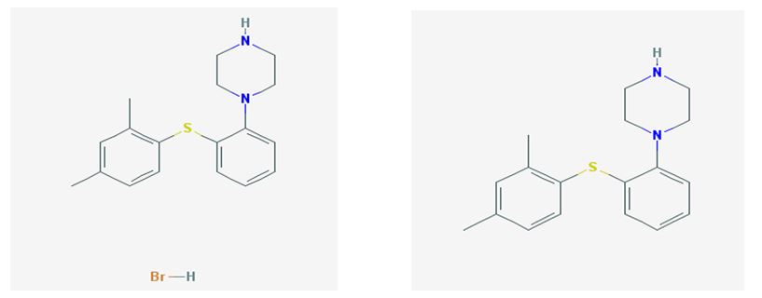

Different crystalline forms of VTX-HBr were described. The β-form is the most thermodynamically stable form and the form manufactured.

The Biopharmaceutics Classification System (BCS) Class could not be established.

The pKa = 9.1 (± 0.1) and 3.0 (± 0.2). The LogD7.4 and LogP were determined to be 3.1 and 4.7, respectively, in octanol/water.

The aqueous solubility of free VTX is 1.3 mg/mL, corresponding to 1.7 mg/mL of VTX-HBr.

The controls over particle size distribution are considered acceptable.

Ten impurities are controlled in the drug substance; each is limited in accordance with the International Conference on Harmonisation (ICH) requirements.[1]

### Drug product

The drug products are immediate release film coated tablets containing VTX (as VTX-HBr) 5 mg, 10 mg, 15 mg or 20 mg.

Each strength of the proposed tablets is an unscored, almond shaped, biconvex film coated tablet engraved with “TL” on one side. The four strengths are distinguished by the tablet colour (pink [5 mg], yellow [10 mg], orange [15 mg] and red [20 mg]) and the mass of the quantity of VTX which is marked on the opposite side (“5”, “10”, “15” or “20” for 5 mg, 10 mg, 15 mg and 20 mg, respectively). All tablet strengths will be marketed in transparent polyvinyl chloride (PVC)/polyvinylidine chloride (PVdC)/aluminium (Al) foil blister packs in pack sizes of 7 (10 mg only) and 28 (all strengths).

The tablets are **not** direct scales; instead, the same nominal tablet core mass is used for all four presentations, with the nominal quantity of mannitol adjusted to accommodate the different masses of drug substance in each presentation. No overage is employed.

Four different Immediate Release (IR) tablet formulations were developed and evaluated with respect to stability and process ability (Formulations 1, 2, 3 and 4), of which Formulation 4 is identical to those proposed to be marketed, and Formulation 2 was not used in any clinical trials.

The dissolution specification and test methods are considered acceptable.

The stability data support a shelf life of 36 months stored below 30°C to the tablets packaged in the PVC/PVDC aluminium blisters proposed for Australia.

The expiry limit proposed for each of the degradants in the finished products is consistent with the ICH guideline qualification limit,[2] based on a maximum recommended daily dose of 20 mg.

### Biopharmaceutics

Seven bioavailability/bioequivalence studies were included in the submission: Studies 10982, 106, 13119A, 13138a, 13921a, 123 and 14520a. Details of each are presented below.

#### Study 10982

In addition to determination of the absolute bioavailability, this study investigated the absorption profile of VTX using pharmacoscintigraphic methods, assessed the tolerability of VTX when given intravenously (IV), orally as IR tablets, and when released at two sites within the small intestine, and determined the pharmacokinetic parameters of VTX and its Lu AA34443 and Lu AA39835 metabolites after IV administration and oral delivery of VTX to different sites in the gastrointestinal (GI) tract.

#### Study 13921A

This study, which determined the relative bioavailability of VTX when administered as an oral drops solution (20 mg) compared with a Formulation IV 20 mg tablet, found that the 2 Treatments are bioequivalent with respect to VTX Cmax (estimate: 1.01; 90% confidence intervals [CIs): 0.975-1.051) and AUC0-72h (estimate: 1.06; 90% CIs: 1.029-1.097), and also had identical Tmax values (6.00 h).

#### Study 13119A

Part A of this study, which was not included in the Overview of clinical phase II/III and bioequivalence studies (above), assessed the tolerability of VTX following multiple oral doses of Gastro Resistant (“GR”) and IR tablets, investigated the relative bioavailability of VTX following multiple oral doses when administered as 20 mg GR tablets compared to two 10 mg IR tablets, and determined the pharmacokinetic parameters of VTX and its metabolites Lu AA34443 and Lu AA39835 after multiple oral doses of the IR and GR tablets. In Part B, a possible food interaction following a standardised high fat breakfast after a single oral dose of VTX when given as GR tablets was investigated. **None** of the formulations used in the study are the same as proposed for Australia.

As a GR tablet is not proposed for Australia, the outcomes from this study are of limited relevance to the submission.

#### Study 13138A

This study, which also was not included in the overview of clinical Phase II/III and bioequivalence studies (above), investigated the dose corrected relative bioavailability of VTX when administered in the proximal small bowel as either a solution containing 30 mg VTX and 99mTc-DTPA (via Enterion capsule) or a 30 mg GR tablet compared to 2 encapsulated 10 mg Formulation III IR tablets, and determined the relative bioavailability of VTX when administered as a 30 mg GR tablet compared to the above solution (via Enterion capsule) administered in the proximal small bowel.

This study is also of limited relevance to the submission.

#### Study 106

The primary objective was to evaluate the effect of food on the pharmacokinetics (PK) of VTX after administration a single oral dose of Formulation 3 of VTX (as HBr) 10 mg IR tablets, with the secondary objectives being to determine the relative bioavailability of Formulation 3 to Formulation 1 of VTX 10 mg in healthy adult subjects, and to evaluate the safety and tolerability of VTX 10 mg taken with or without food. Chosen subjects were genotyped for common CYP2C9, CYP2C19, and CYP2D6 allelic variants. This study found that the 90% Confidence Intervals (CIs) for the Least Squares (LS) means ratios of AUC0-∞, AUC0-t, and Cmax of VTX, Lu AA34443 and Lu AA39835 were within the 80% to 125% no effect boundary with the exception of Cmax of Lu AA34443 (90% CI: 79.79-98.84), which is considered insignificant given the substance is pharmacologically inactive. No food effect was found.

In relation to the comparison of the Formulation 1 and Formulation 3, 10 mg tablets under fasted conditions, the study found that the 90% CIs for the LS mean ratios of AUC0-∞,  
AUC0-t, and Cmax for VTX, Lu AA34443 and Lu AA39835 were within the 80% to 125% no effect boundary. The sponsor found these formulations to be bioequivalent.

The mean concentration of VTX, Lu AA34443 and Lu AA39835 excreted in urine was also evaluated, and the relative amounts (as measured by Ae[0-168]) were found to be comparable to those observed in a previous Study 10477 after adjustment for the higher dilution factor during urine sample collection; the pharmacologically inactive Lu AA34443 was excreted in the greatest concentration.

Of the 23 subjects with genotyping data, 18 were classified as CYP2C9 extensive metabolisers (EMs) and 5 as CYP2C9 intermediate metabolisers (IMs). All 23 subjects were classified as CYP2C19 EMs. In addition, 17 of the 23 subjects were classified as CYP2D6 EMs, 4 subjects as CYP2D6 IMs, 1 subject as a CYP2D6 ultra metaboliser (UM), and 1 subject as CYP2D6 unable to assign phenotype (UP). The majority of subjects classified as IMs or UMs had exposures similar to the mean values of the evaluable population for of AUC0-∞, AUC0-t and Cmax of VTX (changes <1.7 fold). One subject classified as a CYP2C9 IM and a CYP2D6 UM, had a 2.0 to 2.2 fold decrease in AUC0-t and AUC0-∞ of VTX and a 1.3 to 1.5 fold decrease in Cmax of VTX across all treatment groups, in comparison with the corresponding means for the evaluable population, with the decreases similar for the 3 treatments. One subject classified as a CYP2D6 IM, had increases of 1.9 to 2.2 fold in AUC0-t, 2.2 to 2.7 fold in AUC0-∞, and 1.7 to 2.4 fold in Cmax of VTX across all treatment groups, in comparison with the corresponding means for the evaluable population; the highest increases were observed with Treatment C. The result was considered inconclusive by the company due to the limited number of subjects in this single Phase I study.

#### Study 123

This study evaluated the effect of food on VTX PK following a single oral dose of the Formulation 4 20 mg tablet, and determined the relative bioavailability of Formulation 4 to Formulation 3 VTX tablets following a single oral dose of 20 mg in healthy adult subjects.

Statistical analysis of the results showed that VTX 20 mg Formulation 4 tablet (20 mg) is bioequivalent to Formulation 3 (2 x 10 mg) tablets, and there is no food effect on the PK of Formulation 4 tablets. These conclusions were not altered after statistical analysis of the recalculated PK parameters due to the removal of the results from the 5 subjects with pre-dose VTX concentrations > 5% of Cmax.

All subjects were genotyped for common CYP2C9, CYP2C19, and CYP2D5 allelic variants, but no correlation with Study outcomes was reported.

#### Study 14520a

This study, which assessed and confirmed the bioequivalence of one 20 mg Formulation 4 VTX tablet in comparison with four 5 mg Formulation 4 VTX tablets, under single dose, fasted conditions, was conducted as an adjunct to the sponsor’s application for a biowaiver in respect of the 10 mg and 15 mg tablets. The results of the sponsor’s PK and statistical analyses (subsequently confirmed by the evaluator) are reproduced in Table 1.

Table 1. Statistical analysis of plasma PK parameters following administration of one 20 mg Formulation 4 VTX tablet in comparison with four 5 mg Formulation 4 VTX tablets, under single dose, fasted conditions.

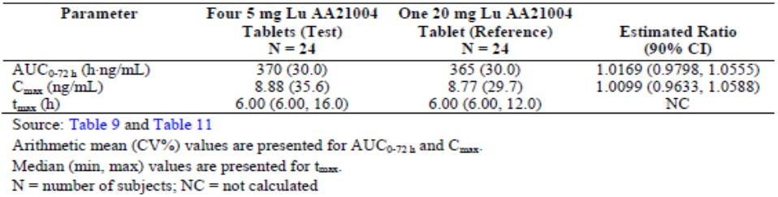

#### Scientific misconduct by supportive bioanalytical laboratory

In a pre submission TGA Consultation Paper, the sponsor detailed a case of scientific misconduct by Aptuit Ltd affecting the bioanalysis for a number of nonclinical, clinical, method validation, and long term stability studies in the vortioxetine development program for which remedial actions were sufficient except for one clinical Phase I study and two nonclinical studies where some bioanalytical data were to be rejected. The overall conclusions of the affected studies were not altered by this scientific misconduct. Evidence of other studies being affected has not been seen. The misconduct was not related to any vortioxetine related good clinical practice (GCP) activities.

#### Biowaiver in respect of 10 mg and 15 mg formulation 4 tablets

An acceptable justification was provided for a biowaiver in respect of the proposed 10 mg and 15 mg tablets.

### Quality summary and conclusions

There are no objections in respect of Chemistry, Manufacturing, Controls and Biopharmaceutics to registration of these products.

## III. Nonclinical findings

### Introduction

The overall quality of the submission was high, with the majority of nonclinical studies being appropriate and well conducted. All pivotal toxicity studies (single dose, repeat dose, genotoxicity, carcinogenicity and reproductive toxicity studies) were Good Laboratory Practice (GLP) compliant. However, some of the safety studies were not GLP compliant, most notably the *in vitro* studies (studies of effects on human hERG and SCN5A channels, on isolated spontaneously beating rat atria and on guinea pig tracheal rings), but also the *in vivo* studies on cardiovascular effects in anesthetised rabbits and on GI transit in rats. Critical cardiovascular studies in dogs, as well as central nervous system (CNS) studies in rats, were GLP compliant.

The bioanalytical phases of 12 nonclinical studies (1 pharmacology study, 1 safety pharmacology study, and 10 toxicity studies) were affected by a case of misconduct at the contract research laboratory, Aptuit Ltd. Except for the safety study 10950 (a study of renal function in saline loaded rats), all other phases of the 11 remaining studies were not affected by the misconduct. The misconduct was associated with the quantification of compounds in plasma samples, validation of analytical methods and analysis of long term stability of study samples, with 10 deficiency types related to the procedures of acquisition and processing of analytical data within these studies. These included, for example, carryover not conducted according to procedure (wash inserted between upper limit of quantification and blank matrix) when internal standard response indicated that autosampler misinjection had occurred, reinjection of unknown samples for quantification without bracketing with acceptance quality control samples (QCS), not documenting on the sample list the batches that were restarted, repeating one batch without justification, using poor or unacceptable integrations (particularly for standards and QCS), manually integrating of incorrect peaks, and removal of integrations for pre dose sample blanks and carryover blanks.

The sponsor reviewed all the studies in which the misconduct was involved to determine how the data were affected (Study 14336). The following studies were affected:

1. Study 10950: Renal function in saline loaded rats
2. Study 11468 (146-855; 356/240): Rat micronucleus study
3. Study LBK0202 (11688): Mouse carcinogenicity study
4. Study LBK0201 (11689): Rat carcinogenicity study
5. Study LBK0240 (11682): Rat fertility and early embryonic development study
6. Study LBK0153 (10144): Rat embryofoetal development study
7. Study LBK0276 (12392): Pre/postnatal development study
8. Study LBK0256 (12685): Dose range finding study in juvenile rats
9. Study LBK0251 (12592): Toxicity study in juvenile rats
10. Study 12475: Effect on Bezold-Jarisch reflex in anaesthetised rats
11. Study LBK/150 (11013): 26 week rat study, and
12. Study LBK/156 (10892): 52 week dog study

The following conclusions, which appear appropriate, were drawn by the sponsor after investigating the impact of the various deficiencies for each study. There was little or no impact of the deficiencies on the reliability of the results from studies 1-9, and GLP compliance was claimed for all these studies, following the outcome of the assessment. For study 10, there was no impact of the deficiencies on the determination of vortioxetine concentrations, but ondansetron concentrations were considered investigative. The main studies affected were studies 11 and 12 (the 26 week rat study and the 52 week dog study). One deficiency resulted in recalculation of results (small changes) and the reprocessed results were included in the report, while in another instance, the reprocessed data failed to reach acceptance criteria and the results were therefore deemed unreliable, and reported as ‘not calculated’.

### Pharmacology

#### Primary pharmacology

Vortioxetine belongs to a new chemical class of antidepressants, the bis-aryl-sulfanyl amines. It is structurally different from currently registered antidepressants and possesses unique pharmacological properties, involving inhibition of the 5-HT transporter (5-HTT) and activity at several 5-HT receptors. Its mode of action is therefore considered to be multimodal. The rationale for the development of multimodal compounds (or the use of combinations of antidepressants with different mechanisms of action) is that it achieves greater efficacy and may also treat some of the associated symptoms of major depressive disorder, such as anxiety and cognitive dysfunction.[3]

The *in vitro* binding of vortioxetine was studied in human receptors, generally cloned in Chinese Hamster Ovary (CHO) cells. Binding affinities at relevant targets were as follows: 5-HT3 (IC50 5.3 nM, inhibition constant [Ki] 3.7 nM), 5-HT1A (Ki 15.2 nM), 5-HT7 (IC50 53 nM, Ki 20 nM [mean of 2 studies]), 5-HT1D (IC50 130 nM, Ki 54.2 nM), 5-HT1B (Ki 33 nM), and 5-HTT (Ki 1.6 nM). As Cmax values of 17.9 ng/mL (60 nM) at the recommended dose of 10 mg/day and 33.0 ng/mL (111 nM) were observed at the maximum recommended human dose (MRHD; 20 mg/day), binding at these receptors/transporters was within a clinically relevant range for total drug, however, the high protein binding of vortioxetine will mean that free plasma drug concentrations will be well below these values (assuming plasma protein binding of 98.8%, free concentrations of 0.72 and 1.33 nM at 10 and 20 mg doses, respectively, can be estimated).

Binding at the following human receptors/transporters was likely to be outside the clinically relevant range: 5-HT4e (IC50 not calculable), 5-HT5A (IC50 0.41 µM, Ki 0.25 µM), 5-HT6 (IC50 0.42 µM, Ki 0.2 µM), 5-HT1E (IC50 2.1 µM, Ki 714 nM), 5-HT1F (IC50 2.1 µM; Ki 829 nM), D1 (IC50 2.8 µM, Ki 1.1 µM), H2 (IC50 1.8 µM, Ki 1.7 µM), δ2 (IC50 0.88 µM, Ki 0.52 µM), µ (MOP) (IC50 0.51 µM, Ki 0.21 µM) and the norepinephrine transporter, NET (Ki 113 nM) and dopamine transporter, DAT (Ki 1.14 µM).

Functional assays at the cellular level were conducted to investigate whether binding to a receptor would also lead to functional cellular events and whether the compound is an agonist or antagonist at the receptor. The results are summarised in Table 2 for the relevant receptors.

Table 2. Results from functional assays investigating receptor binding.

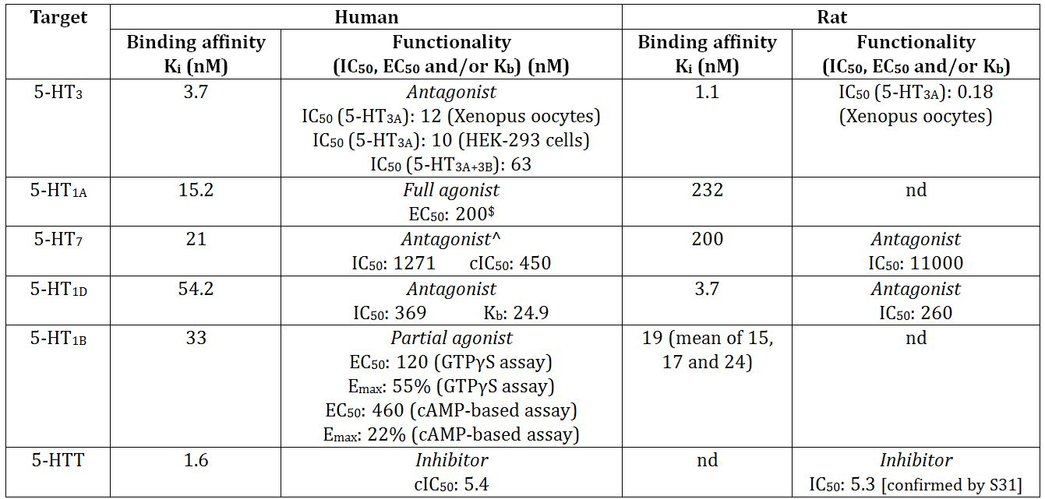

^ Data are from Study 929-900 2010 107 (data from Study 841057 revealed an IC50 of ≥10000 nM and a Ki of >10000 nM)

$ From amended report for Study 929-300 2008 012 provided with Section 31 response

nd = no data

The IC50/Ki data for functional effects at the human receptors/transporter suggest that the most clinically relevant effects are likely to be at the 5-HT3 receptor and the 5-HTT. Based on plasma concentrations observed in patients, data in Table 10 are not highly predictive of functional activity at the 5-HT1D, 5-HT1A, 5-HT1B and 5-HT7 receptors, but interspecies differences in a variety of parameters make such predictions difficult. The functional activity and/or binding affinity data suggested that vortioxetine may be more active/have greater affinity at the human compared to the rat 5-HT7 and 5-HT1A receptors, with the reverse being the case at the 5-HT3 and 5-HT1D receptors, which suggests that in vivo studies in the rat may overestimate effects at the 5-HT3 and 5-HT1D receptors and underestimate them at the 5-HT7 and 5-HT1A receptors.

Vortioxetine was also tested for functionality at the human 5-HT2B receptor at which it showed slight antagonist activity (IC50 >1µM), and at the human 5-HT6 receptor at which it showed neither agonist nor antagonist activity. While vortioxetine showed an agonistic response at the 5-HT3A receptor, at the higher doses this could only be induced once, thus vortioxetine is considered to be a functional antagonist at this receptor.

The role of inhibiting 5-HTT in the treatment of depression is well established, and is the basis of the mode of action of the selective serotonin reuptake inhibitors (SSRIs) which enhance postsynaptic 5-HT levels by blockade of the reuptake of synaptic 5-HT. Vortioxetine was shown to potentiate the 5-HTP behavioural syndrome in mice which is a strong correlate of enhanced 5-HT neurotransmission in the CNS.

The dose dependent inhibition of the Bezold-Jarisch reflex over the clinically relevant dose range (0.01-3 mg/kg subcutaneous [SC]) confirmed that vortioxetine antagonised the function of peripheral 5-HT3 receptors in the rat. The role for 5-HT3 receptor antagonism in the treatment of depression is not well documented in the literature.[4] However, there are some nonclinical findings which support such a role. Thus, the 5-HT3 receptor antagonist, ondansetron, showed antidepressant like effects in the forced swim and tail suspension models for assessing antidepressant activity, and enhanced the effect of fluoxetine in the olfactory bulbectomised rat model.[5]

The role of 5-HT1A receptors in the treatment of depression is well known, and buspirone, a partial 5-HT1A agonist, is used clinically for the treatment of anxiety and depression.

5-HT1D receptors are understood to be involved in anxiety and depression. Torrado and colleagues[6] reported that a single compound combining 5-HT reuptake inhibition with 5-HT1D receptor antagonism would be expected to elevate synaptic levels of 5-HT above those evoked by reuptake inhibition alone, and to levels that are only obtained following chronic SSRI treatment. From a review of the literature, Ruf and Bhagwagar[7] concluded that there was strong evidence from a number of lines of research that 5-HT1B receptors are involved in the pathophysiology of depression.

It is speculated that the 5-HT7 receptor may be involved in mood regulation, suggesting that it may be a useful target in the treatment of depression.[8]

In conclusion, a compound with the 5-HT receptor profile and 5-HTT inhibitory activity shown by vortioxetine might be expected to show efficacy in the treatment of depression.

It is unlikely that vortioxetine metabolites contribute to the pharmacological activity of vortioxetine. The only two non glucuronide circulating human metabolites were Lu AA34443 and Lu AA39835. Lu AA39835 inhibited 5-HTT with a cIC50 of 15.5 nM but because it was present in human plasma at such low levels (Cmax of 1 ng/mL [3.2 nM] at the MRHD) and because it does not appear to cross the blood-brain barrier (Study 929-900 2007 026), it is unlikely to make any significant contribution to the pharmacological activity of vortioxetine in patients. In Study 929-300 2013 066 (provided with the Section 31 response), the major metabolite, Lu AA34443, was tested in a 3H-5-HT reuptake assay in rat brain synaptosomes, with only weak activity (IC50 360 nM); Lu AA25790 (metabolite M4a) was also weak in this assay (IC50 1600 nM). A Cerep *in vitro* screening panel (Studies 810166, 810170) also did not record any notable activity for Lu AA34443 (Lu C-434).

*Ex vivo* or *in vivo* receptor occupancy data were presented for 5-HTT and 5-HT3, 5-HT1B and 5-HT1A receptors after SC dosing in the rat, but there were no data for 5-HT1D or 5-HT7 receptors. At a clinically relevant dose of about 1 mg/kg SC, highest receptor occupancies were observed at the 5-HT3 receptor, followed by 5-HTT, then the 5-HT1B receptor and finally the 5-HT1A receptor. The following predictions of receptor occupancy in patients based on receptor occupancy at various plasma concentrations in rats and a clinical Cmax value of 17.9 ng/mL (at 10 mg/day) and 33.0 ng/mL (at 20 mg/day): >94% at the 5-HT3 receptor (Study 929-300 2012 059), considerably <36% at the 5-HT1B receptor (Study 929-300 2011 041), considerably <7% at the 5-HT1A receptor (Study 929-300 2011 042), and about 30% at 5-HTT (Study 929-300 2007 034) (about 45% at a dose of 20 mg/day). Receptor occupancy data from Study 929-300 2012 060 were broadly similar to those obtained in the individual studies noted above, although somewhat higher for the 5-HT1B receptor and lower for the 5-HT3 receptor. However, these predictions may be affected by various differences between rats and humans in various parameters, and actual receptor occupancies in patients, at least for 5-HTT, were about double that predicted (65% at 10 mg/day and >80% at 20 mg/day; data from positron emission temography studies).

Extracellular concentrations of various neurotransmitters were measured in different regions of the forebrain in freely moving rats given vortioxetine using microdialysis. The results are summarised in Tables 3-4.

Table 3. Extracellular concentrations of various neurotransmitters: single dose studies.

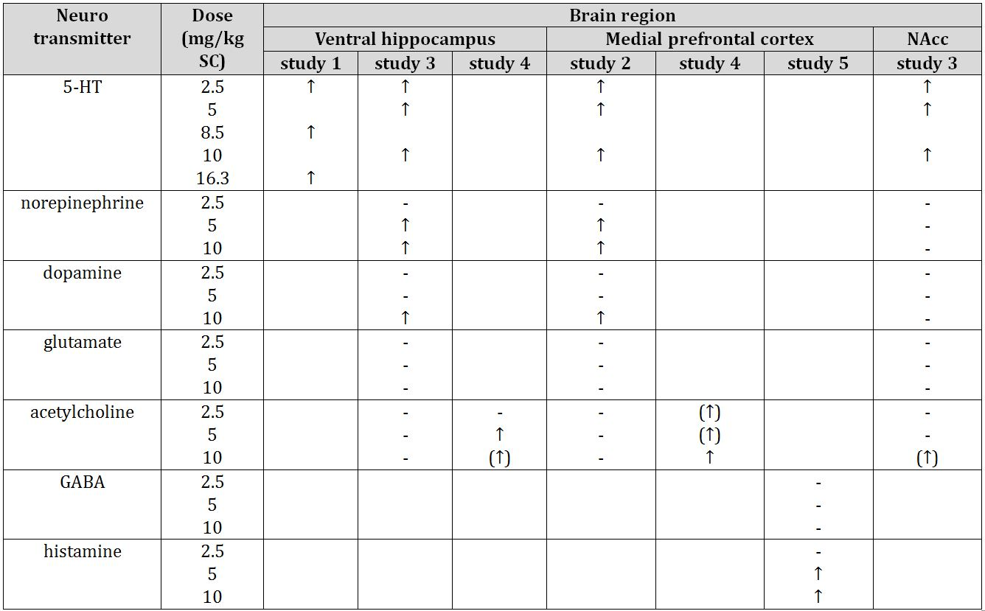

Study 1 = Study 007-308-2007; study 2 = Study 929-900 2007 032; study 3 = Study 929-900 2007 033; study 4 = Study 005-308-2007; study 5 = Study 929-900 2010 110; NAcc = nucleus accumbens; - = no effect; blank = not determined; (↑) = NS effect

As expected, the most marked effect of single doses of vortioxetine on extracellular concentrations of neurotransmitters was an increase in 5-HT levels in all regions of the forebrain investigated, at all doses tested. Increases in extracellular concentrations of norepinephrine, and to a lesser extent, dopamine, acetylcholine and histamine were observed in some brain regions, although largely at ≥5 mg/kg SC, which may not be clinically relevant.

Table 4. Extracellular concentrations of various neurotransmitters: repeat dose studies (3 days administration) (‘basal’ levels).

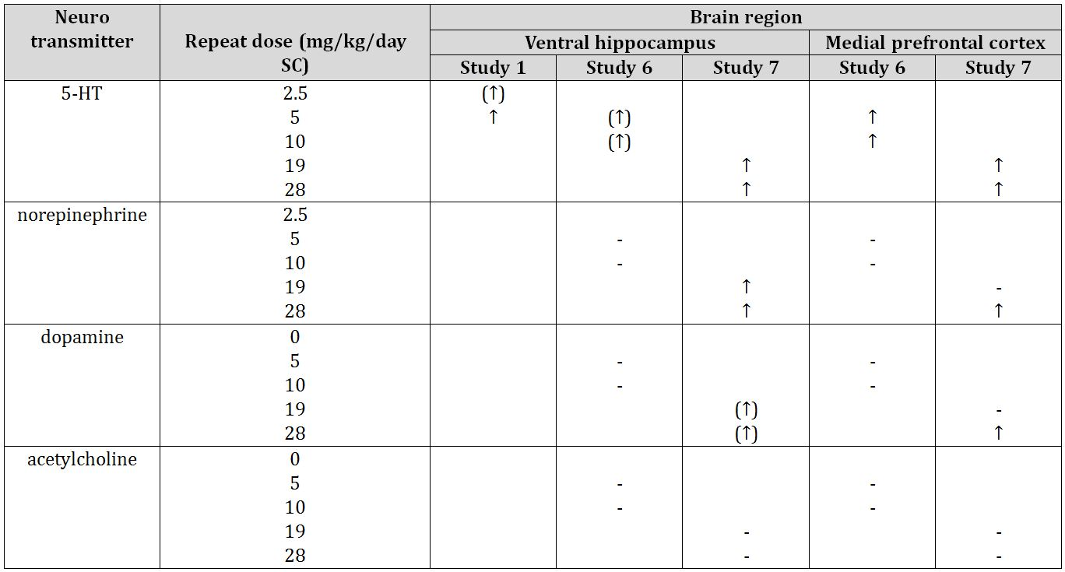

Study 1 = Study 007-308-2007; study 6 = Study 929-900 2010 095; study 7 = Study 929-900 2010 111; - = no effect; blank = not determined; (↑) = NS increase

Again, the most marked effect of the continuous SC infusions of vortioxetine on ‘basal’ extracellular concentrations of neurotransmitters was an increase 5-HT levels in both regions of the forebrain investigated at most doses tested. Increases in extracellular concentrations of norepinephrine and dopamine were observed in both regions but only at the higher doses of 19 and/or 28 mg/kg/day; there were no effects on acetylcholine concentrations. There were no data on plasma vortioxetine concentrations after the minipump infusions.

When an acute SC vortioxetine dose was given after a 3 day SC infusion (2 studies), at some dose levels there were additional increases (above the basal levels after the 3 days) in the concentrations of 5-HT and, to a lesser extent, norepinephrine and dopamine, mainly in the prefrontal cortex, but little effect on acetylcholine was observed.

In summary, vortioxetine consistently increased extracellular concentrations of 5-HT in various regions of the rat forebrain; concentrations of noradrenaline were increased at higher doses, and to a lesser extent, concentrations of dopamine, acetylcholine and histamine.

Vortioxetine was tested in a number of animal models for assessing antidepressant and/or anxiolytic activity and these are summarised in Table 5. Vortioxetine generally (but not always) elicited positive responses in various animal models for antidepressant and/or anxiolytic activity.

Table 5. Testing of vortioxetine in a number of animal models for assessing antidepressant and/or anxiolytic activity.

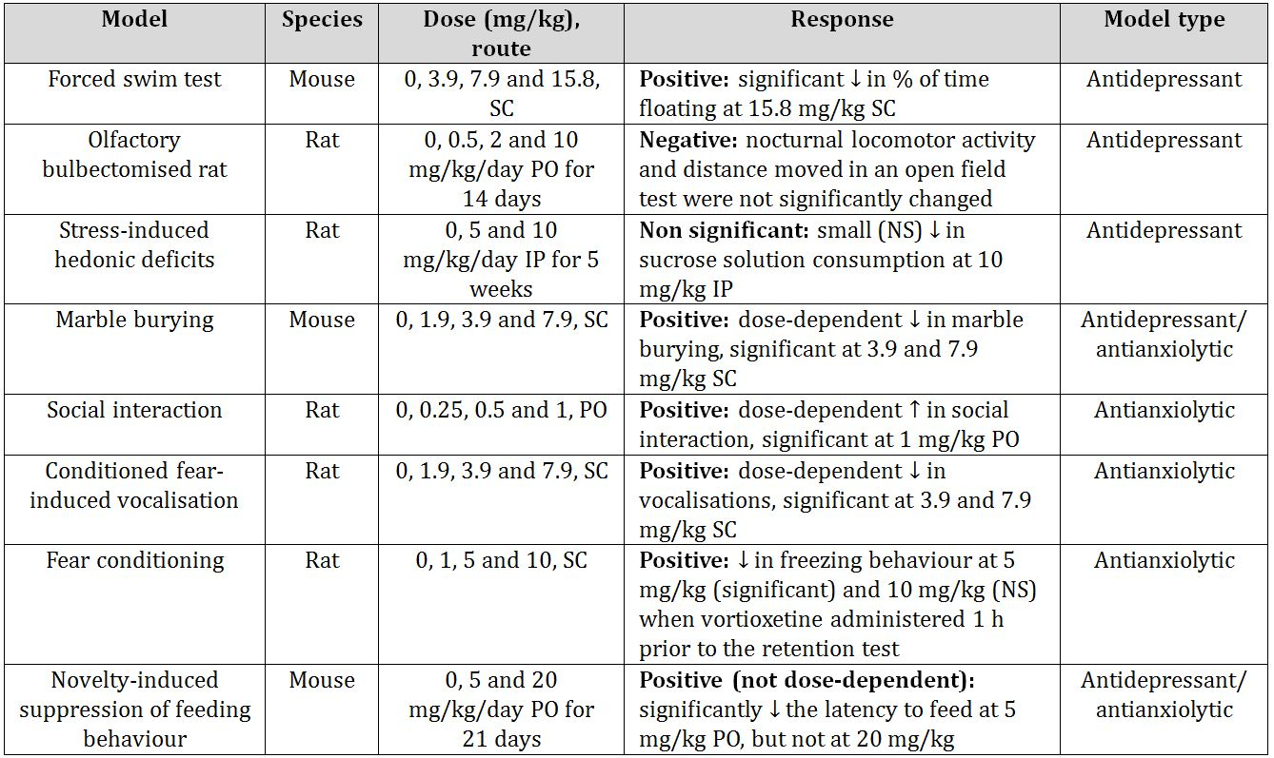

Vortioxetine was also tested in a number of animal models for assessing cognitive activity and these are summarised in Table 6.

Table 6. Testing of vortioxetine in a number of animal models for assessing cognitive activity.

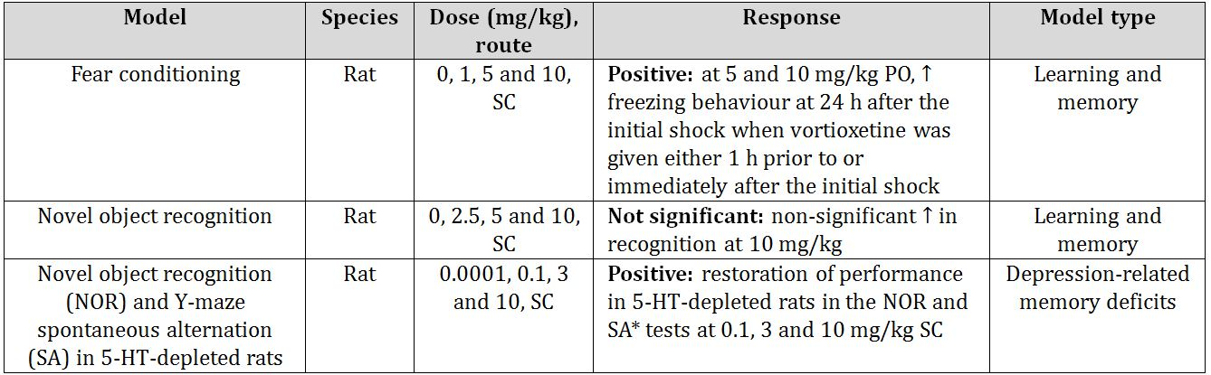

* partial restoration at 0.1 mg/kg

Vortioxetine elicited positive responses in some, but not all, animal models for learning and memory.

Plasma vortioxetine concentrations were only measured in one of the studies summarised in the above table (social interaction study at oral doses up to 1 mg/kg), and were, in accordance with other PK data submitted, below the level expected in patients at the recommended dose. No PK data are available for the intraperitoneal (IP) route in rats or for mice by the SC route but doses up to 1.9 mg/kg SC and 10 mg/kg PO in rats might be expected to give exposures in the clinically relevant range for patients at the recommended and maximum recommended doses. Some studies used doses above these (for example, 3.9, 5, 7.9 and 10 mg/kg SC and 20 mg/kg PO), although species differences in various factors make it difficult to accurately assess the clinical relevance of the doses administered from plasma concentrations. Receptor occupancy data (5-HTT) from Study 929-900 2007 034 at the SC doses used in some of these models suggest that receptor occupancy for 5-HTT at the SC doses of 1.9 and 3.9 mg/kg in rats correlates closely with receptor occupancies observed at the recommended and maximum recommended clinical doses of 10 and 20 mg/day.

Depression is associated with a decrease in hippocampal neurogenesis.[9] Many studies have shown that antidepressant treatment increases both the proliferation and survival of newborn neurons in adult hippocampus[10] and a correlation between the stimulation of hippocampal neurogenesis induced by antidepressants and their therapeutic effects has been reported.[11] Vortioxetine displayed some neurogenic effects in three studies. It increased proliferation of progenitor cells in the dentate gyrus of the mouse hippocampus at 5 mg/kg but not 20 mg/kg/day PO for 21 days (Study 929-000 2010 092) and in the dentate gyrus of the rat ventral but not the dorsal hippocampus after 5 mg/kg/day SC for 3 days (Study 929-900 2008 065). In Study 929-300 2011 044, a time course for this effect was investigated following administration of 5 mg/kg/day SC vortioxetine for 1, 3, 7 and 14 days, which revealed a more rapid onset of effect after administration of vortioxetine (increases in the dorsal hippocampus after 1 day and in the ventral hippocampus after 1, 3 and 14 days) compared with fluoxetine (increases in both ventral and dorsal hippocampus after 14 and 21 days treatment with 10 mg/kg/day SC but not after 7 days treatment). At 5 and 20 mg/kg/day PO for 21 days in mice, vortioxetine accelerated the maturation of immature neurons in the hippocampus, but did not increase the survival of newborn progenitor neurons (Study 929-000 2010 092).

Nonclinical studies have shown that antidepressants initially induce a strong decrease in dorsal raphe nucleus (DRN) 5-HT neuronal firing frequency, which was observed for vortioxetine, as well as the reference compound, fluoxetine, in rats. This is understood to be due, at least in part, to an inhibition of 5-HT reuptake which increases extracellular 5-HT concentrations, and in turn, stimulates the inhibitory somatodendritic 5-HT1A autoreceptors which inhibit 5-HT neuron firing. This may explain the therapeutic delay observed after initiation of treatment with SSRIs. With chronic treatment, sustained occupancy of the 5-HT1A autoreceptors results in their densensitisation and firing is recovered to normal rates despite the presence of receptor uptake blockade and facilitated serotinergic transmission.[12]

Acute IV treatment of anaesthetised rats with vortioxetine was shown, as expected, to suppress the firing of DRN 5-HT neurons, and this inhibitory effect was reversed by the selective 5-HT1A receptor antagonist, WAY-100,635. This finding is consistent with inhibition of 5-HT neuronal firing by vortioxetine being mediated via 5-HT1A receptors. The time course of the effect of vortioxetine on neuronal firing of DRN 5-HT neurons was then investigated in rats fitted with osmotic pumps delivering an SC dose of 5 mg/kg/day. As expected, the magnitude of the inhibition of neuronal firing decreased over time; the decrease was significant after treatment for 5 h and 10 h, but not significant after 1, 3 and 7 days, and by 14 days, firing rate had returned to control levels (data from two similar experiments, Studies 929-900 2008 065 and 929-300 2011 044). In contrast, decreases in neuronal firing induced by fluoxetine (administered by minipump at 10 mg/kg/day SC) were observed after 7, 14 and 21 days (significant after 7 days). Thus, while substantial recovery of neuronal firing (reduction in firing no longer significant) was achieved after 1 day of treatment with vortioxetine, 7 days were required with fluoxetine. These results suggest that vortioxetine will have a faster onset of action than fluoxetine, which would be of clinical benefit, given the delay of 2-4 weeks before fluoxetine (and other available SSRIs) achieves its therapeutic effect. Further experiments in these studies suggested that vortioxetine desensitises 5-HT1A autoreceptors as, after 3 days treatment at 5 mg/kg/day SC, it inhibited the inhibition of 5-HT1A autoreceptors firing rate induced by flesinoxan. This may explain, at least in part, the rapid recovery of 5-HT neuronal firing following administration of vortioxetine, although fluoxetine was not investigated in these experiments. There may also be an involvement of 5-HT3 receptors in vortioxetine-induced inhibition of DRN 5-HT neuronal firing, since the 5-HT receptor agonist, SR57227, inhibited vortioxetine induced, but not fluoxetine-induced, inhibition.

Vortioxetine (up to 10 mg/kg IV) did not affect ventral tegmental area dopaminergic neuronal firing rate, and in the locus coeruleus, it only decreased noradrenergic neuronal firing rate marginally (25%) at this high dose.

#### Secondary pharmacodynamics and safety pharmacology

##### Secondary pharmacodynamics

Vortioxetine was tested for functional activity at the human β1 and β2 receptors where it showed weak antagonist activity (IC50 840 and 1100 nM, respectively, and Kb 140 and 190 nM, respectively). This activity is likely to be of little clinical relevance as Kb values were above Cmax values for total drug at the recommended and maximum recommended doses (60 and 111 nM, respectively) and protein binding is high.

Secondary pharmacology studies investigated the effects of vortioxetine on pain since some antidepressants have shown analgesic activity. Effects on sexual behaviour in males were also investigated since most SSRIs and serotonin norepinephrine reuptake inhibitors (SNRIs) cause male sexual dysfunction.

Three pain models were used:

* the mouse formalin model in which the response over ~0-10 min represents direct chemical irritation (nociceptive pain), while the response over ~20-30 min appears to be dependent on the combination of an inflammatory reaction in the peripheral tissue and functional changes in the dorsal horn of the spinal cord (inflammatory and neuropathic pain);[13]
* the rat chronic constriction nerve injury model of neuropathic pain; and
* the rat carrageenan-induced model of inflammatory pain. Vortioxetine was tested at doses up to 20, 10 and 10 mg/kg SC, in the respective models.

In the mouse formalin model, vortioxetine significantly inhibited behavioural responses over 20-30 min after formalin injection (ED50 1.3 mg/kg SC), as well as over 0-5 min (at 20 mg/kg SC). The vortioxetine concentration at 30 min post formalin injection that corresponded to the ED50 was 125.2 ng/mL which is 7 fold higher than the Cmax at the recommended clinical dose of 10 mg (17.9 ng/mL) or 4 fold higher than the Cmax at the recommended clinical dose of 20 mg (33.0 ng/mL), suggesting that the effect of vortioxetine on both nociceptive pain and inflammatory/neuropathic pain is not likely to be clinically relevant. At a dose giving an AUC about 5 fold (and Cmax 20 fold) expected values at the recommended human dose (calculated from rat PK data from Study 10504 and human data in Table 7), vortioxetine showed limited activity in neuropathic pain in the rat nerve injury model, and did not show activity in inflammatory pain in the rat carrageenan model, while the comparator analgesic, morphine, showed significant activity in both models. Overall, the data from these models suggest that vortioxetine is unlikely to have any significant analgesic effect in the clinic.

Table 7. PK parameters for vortioxetine in humans (healthy volunteers).

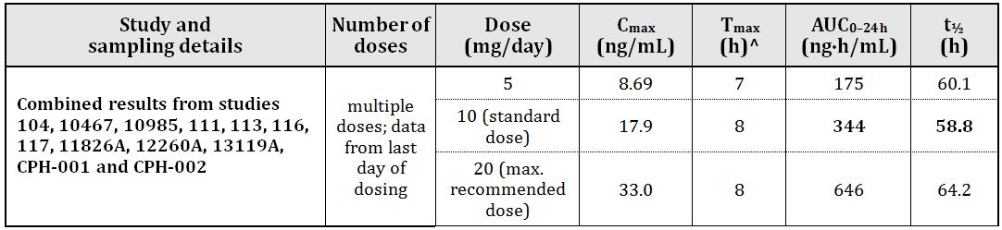

^ median; – = not determined

Vortioxetine, at doses up to 10 mg/kg twice daily (BID) PO for 24 days did not affect sexual behaviour in male rats. This dose achieved a level of 5-HTT occupancy (70%) comparable to the human value of >80% at a dose of 20 mg/kg) and a plasma concentration of 44 ng/mL (1.3 fold the clinical Cmax at the MRHD). The comparator SSRI, fluoxetine, elicited significant changes in sexual behaviour at a dose achieving a clinically relevant plasma concentration. Although the dose tested gave exposures only marginally higher than the MRHD, these data suggest that vortioxetine is unlikely to affect sexual behaviour in male patients at the MRHD.

##### Safety pharmacology

Specialised safety pharmacology studies covered the core systems: CNS, cardiovascular, and respiratory. In addition, effects on renal function were investigated in male rats because the kidney was a target organ in the male rat after repeated dosing, and effects on gastrointestinal transit were investigated in rats because presumed abdominal pain/abdominal muscle contraction was observed in dogs in the cardiovascular studies (pilot and main), and in the 7-14 day toxicity study.

Findings in the safety studies were relatively minor. In the CNS studies in rats, there were no biologically significant effects of vortioxetine in the Irwin test or in tests of motor coordination and muscle tone at doses of up to 40 mg/kg PO. Exposure ratio (compared to the MRHD) achieved at this dose (based on AUC values from Day 1 in males in the 4, 13 and 26 week rat studies) was 2.

In cardiovascular studies, vortioxetine inhibited the cloned hERG channel with an IC50 of 3.3 µM and the cloned human cardiac SCN5A sodium ion channel with an IC50 930 nM. These IC50 values are well above the Cmax value of 111 nM for total drug at the MRHD. Further, these *in vitro* studies were conducted in protein free media and the Cmax value, when corrected for protein binding, would be much lower. It is concluded that vortioxetine is unlikely to have any clinically relevant effect on hERG.

There were some effects on isolated spontaneously beating rat atria (positive inotropic effects at ‘lower’ concentrations and negative inotropic effects at ‘higher’ concentrations), but due to the instability of vortioxetine in the oxygenated solutions, the exact concentrations eliciting these effects could not be determined.

*In vivo* studies examining effects on electrocardiogram (ECG) parameters and blood pressure in conscious dogs (administration by IV infusion) revealed no significant effect on ECG interval, and no arrhythmias were observed. Cmax value (end of infusion) at the highest dose tested (3 mg/kg) was 703 nmol/L (210 ng/mL, that is, 6 fold the Cmax at the MRHD). In the anaesthetised dog (IV infusion, results not statistically analysed), there were small increases PR interval[14] (up to 7.7%) compared to baseline but maximum plasma concentrations were high (1560-3850 nmol/L [466-1149 ng/mL, 14-35 fold the Cmax at the MRHD]). ECG parameters were also not affected in anaesthetised rabbits at doses up to 10 mg/kg IV (infusion) vortioxetine (Cmax up to 2410 nmol/L [719 ng/mL], 22 fold the Cmax at the MRHD). There were minor effects on blood pressure in the various studies, most notably, small reductions in systolic, diastolic and mean arterial blood pressures (6-16%) in anaesthetised dogs. Effects on heart rate were minor.

In the repeat dose toxicity studies in dogs (4, 13 and 52 weeks), there was little evidence of an effect on ECG, blood pressure and heart rate, although some changes, including increases in PR interval, were observed in females at 7.5 and 15 mg/kg/day PO in the 4 week study; these were not confirmed in the 13 and 52 week studies at doses up to 7.5 mg/kg/day PO (ER 5).

There were no biologically significant effects on haemodynamic parameters in anaesthetised rabbits at plasma concentrations up to 2410 nmol/L (22 fold the Cmax at the MRHD), and in anaesthetised dogs at plasma concentrations up to 3850 nmol/L (35 fold the Cmax at the MRHD).

In respiratory studies, vortioxetine, at concentrations up to 1 µM (well above the expected Cmax of 111 nM for total drug at the MRHD), had no effect on salbutamol induced dilation of carbachol induced contraction of isolated guinea pig tracheal rings, while the positive control, ICI-118551, showed effects consistent with its β2 antagonist activity. In *in vivo* studies examining effects on respiratory rate and blood gases in conscious dogs, the most notable effect was a decrease in arterial blood pH at the highest dose tested (3 mg/kg IV [infusion]) which achieved a Cmax of 703 nmol/L (6 fold the Cmax at the MRHD), but not at 1.5 mg/kg (3 fold the Cmax at the MRHD). A study in rats showed no effects except for a decrease in peak expiratory flow at 40 mg/kg PO (expected to achieve 2 fold the AUC at the MRHD) but not at 20 mg/kg. Airway resistance and dynamic lung compliance were not affected in anaesthetised guinea pigs at vortioxetine doses up to 20 mg/kg (IV infusion; no PK data available for this species).

The results of the renal function study in rats are discussed together with urinalysis findings from the repeat dose toxicity studies under ‘Repeat dose toxicity’. In the study of gastrointestinal transit and gastric emptying in rats, vortioxetine elicited non significant reductions in charcoal transit, but significant increases in stomach weight and weight of stomach contents at 40 and 100 mg/kg PO (but not at 20 mg/kg), suggesting that vortioxetine decreased gastric emptying. However, this effect is unlikely to be clinically relevant because the plasma concentrations achieved at these doses were very high (1666 and 2511 nmol/L (corresponding to 497 and 749 ng/mL, respectively; 15 and 23 fold the expected Cmax at the MRHD).

Overall, effects on the cardiovascular and respiratory systems in the safety pharmacology studies were minor and not considered of clinical relevance.

### Pharmacokinetics

#### Absorption

Vortioxetine was rapidly absorbed in mice, rats and dogs after oral administration. Tmax values were about 1-4 h (generally 1-2 h) in rats and about 2-6 h (generally 2-3 h) in dogs. Tmax values in mice were generally 1-2 h but up to 8 h. It is more slowly absorbed in humans (Tmax 7-11 h).

Oral bioavailability (AUCPO/AUCIV) was estimated as 7-10% in rats and 48% in dogs, which was lower than the estimate in humans (75%). However, the excretion data (biliary and urinary) in bile duct cannulated rats, and the low percentage of the administered dose present as unchanged drug in the faeces of all species (2.2-2.3% in mice, 2.7-2.8% in rats and 5.9-9.4% in dogs) suggest that the absorption of vortioxetine after oral administration is high.

The drug was relatively rapidly cleared, with clearance (Cl) being about 4 L/h/kg in rats, 2 L/h/kg in dogs and 33 L/h (0.47 L/h/kg assuming a body weight of 70 kg) in humans. Half life in mice and rats was short (about 2-4 h) and hence, twice daily dosing was used in the repeat dose toxicity studies in rats and in the initial mouse studies (see ‘Repeat dose toxicity). Half life was longer in dogs (about 5-9 h) and once daily dosing was acceptable. Half life in humans was considerably longer at 66 h.

There was no clear evidence of any sex difference in exposures to vortioxetine at a given dose in rats or dogs, but in mice, exposures were higher in males than females at a given dose.

Over the dose ranges used in the oral repeat-dose toxicity studies, Cmax and AUC values were broadly dose proportional in mice, and broadly dose proportional in dogs up to doses of about 10 mg/kg/day, but becoming supraproportional at 15 mg/kg/day. They were supraproportional in rats over the range 10-40 mg/kg BID (doses used in the 4, 13 and 26 week studies) in both sexes, on both Day 1 and at the end of the study.

There was no evidence of accumulation in mice or dogs following repeated dosing, whereas in rats, accumulation was clearly evident in both males and females. At Week 4, 13 and 26, AUC0-24h values were, on average, 5.3, 6.7 and 8.4 fold, respectively, those on Day 1. At Weeks 13 and 26, accumulation became more marked with increasing dose.

After SC administration, there was no evidence of any differences between the Sprague Dawley and Wistar strains with regard to the plasma PK of vortioxetine.

#### Distribution

Vortioxetine was highly bound to plasma proteins in all species investigated (mice, rats, dogs, rabbits, cynomolgus monkeys, minipigs and humans). Estimates of protein binding in human plasma ranged from 98.2%-99.3%, while in mice, rats, dogs and rabbits (inclusive), they ranged from 98.2%-99.9%. Plasma protein binding was not concentration dependent in any species. Vortioxetine bound highly to human serum albumin and, to a lesser extent, α1 acid glycoprotein.

Vortioxetine/metabolites were distributed roughly evenly between plasma and blood following administration of 14C-vortioxetine to both rats and mice. Thus, there was no selective uptake by red blood cells.

Volume of distribution was estimated at about 12 L/kg in rats and 20 L/kg in dogs. While these values are high, they will be influenced by high protein binding. Tissue distribution of radioactivity following oral administration of 14C-vortioxetine to male rats (both albino (Han Wistar) and pigmented (Long Evans)) revealed rapid absorption (Tmax in most tissues was 2 h) and extensive distribution of drug/metabolites to tissues. High tissue:blood Cmax ratios for radiolabel were observed in organs associated with excretion, including contents of the intestines (presumably reflecting the substantial biliary excretion of vortioxetine/metabolites), urinary bladder, liver and kidney (with the latter two also being target organs). There was substantial distribution of radioactivity to the brain, the target organ for primary pharmacological activity (brain:blood Cmax ratio of 2.73). As with the brain, there was also no evidence of a barrier to distribution of radioactivity to the testes (testes:blood Cmax ratio of 4.2). There was evidence of melanin binding as, in the Long Evans strain, the uveal tract was relatively highly labelled and pigmented skin had a higher tissue:blood Cmax ratio than nonpigmented skin. The limited tissue distribution data for the dog (408 h post dose; 12 tissues) were broadly consistent with the findings in the rat. Tissue distribution data for pregnant Han Wistar rats were similar to that for males. There was no evidence of retention of radioactivity in any organ, with elimination of radioactivity occurring at a comparable or faster rate to elimination of radioactivity from blood.

The *ex vivo* receptor occupancy studies (primary pharmacology) provided brain:blood ratio data for vortioxetine and revealed high ratios (mean ratio for Studies 929-300 2012 059, 929-300 2011 041 and 929-900 2007 034 [over all doses] was 11.4), while an even higher ratio was estimated from the data for the social interaction study (39; Study 929-900 2008 057).

#### Metabolism

Vortioxetine was extensively metabolised in the liver in all species, with no unchanged drug being detected in the urine of mice, rats or humans, and little in the urine of dogs. As noted above, the percentage of unchanged drug in the faeces of all species was low, consistent with extensive absorption and metabolism. Vortioxetine was largely metabolised by oxidation and subsequent glucuronidation in all species (mice, rats, dogs and humans).

In addition to parent drug, six metabolites were identified in human plasma. However, a larger number of metabolites (21) were detected following the incubation of 14C-vortioxetine with hepatocytes from humans and laboratory animal species (mice, rats, dogs, rabbits, cynomolgus monkeys and minipigs). All of the metabolites detected in human hepatocyte incubations were detected in the hepatocytes from 2 or more of the laboratory animal species, although Lu AA25790 (the sulfoxide metabolite, M4(a)) was not detected in any of the major species (mice, rats and dogs). However, this glucuronide was not a circulating metabolite in humans (it was present in low amounts in faeces).

The circulating metabolites identified in humans included the carboxylic acid metabolite, Lu AA34443 (a major circulating metabolite), the hydroxy metabolite, Lu AA39835 (M8), as well as the glucuronides of these metabolites (M4(b) and M3), and 2 additional glucuronides, M11 and M12. M11 was the glucuronide of a hydroxy metabolite, Lu AE22404, which was not detected in plasma. M12, a major metabolite, also appeared to be formed via the intermediate, Lu AE22404.

All the circulating human metabolites were detected in dog plasma, and the dog is considered the best animal model. M12 and M11 were not detected in rat plasma, and concentrations of M3 were minimal. Lu AA39835 and M11 were not detected in mouse plasma. While M4(a) (Lu AA25790) and M4(b) (Lu AA34443 glucuronide) were not distinguished in the metabolic profiling studies in rats and mice (Studies 11694 and 11304, respectively), later studies measured the concentrations of Lu AA34443 glucuronide (after 7 days oral dosing) in the plasma of mice, rats and dogs. This metabolite was not detected in rat plasma.

As reference standards were not available for the majority of the glucuronides,[15] human:laboratory animal ERs for the glucuronides were estimated by comparing peak areas following liquid chromatography-mass spectrometry/mass spectrometry (LC-MS/MS) after administration of the sponsor determined No Observed Adverse Effect Level (NOAEL) dose in the animal species (50 mg/kg/day in mice, 10 mg/kg BID in rats, 7.5 mg/kg/day in dogs) and the recommended therapeutic dose of 10 mg/day (Study 13141, August 2011), which superseded an earlier study (Study 13236, November 2009) which had made comparisons based on AUC values for metabolite radioactivity following administration of 14C-vortioxetine (AUC values were scaled [assuming linearity] to the NOAEL for the various species, and to the MRHD of 20 mg/day).[16] In the absence of reference standards, the technique used in Study 13141 is considered to be acceptable for estimating relevant ERs, particularly with the improvements in analytical methods over the years; the technique used in Study 13236 is subject to the possibility of radioactive peaks being partially attributable to compounds other than the relevant compound, and this may explain the relatively high ERs determined in this study for Lu AA39835 (12.8) and for Lu AA34443 glucuronide (7.2) in the dog compared to the ERs calculated for these compounds (0.8-1.6 for Lu AA39835 and 2.1-2.4 for Lu AA34443 glucuronide) from accurate measurement of the compounds (see ER tables under ‘Repeat dose toxicity’). Note that the ER values estimated in Study 13141 need to be halved to give the ER at the MRHD. At the NOAEL, ERs in the dog for all circulating human metabolites were >1, with the exception of M12 for which it was 0.1, while the ERs for Lu AA39835 and for Lu AA34443 glucuronide were low, as noted above. In both the rat and mouse, ERs were <1 for both M12 and M11 (M12 was not detected in mice). Any lack of/poor exposure of the nonclinical species to the circulating metabolites in humans was overcome by the detailed examination (including appropriate mechanistic studies) of the major target organ toxicities observed in the repeat dose studies (see ‘Repeat dose toxicity’).

Metabolic profiles for plasma, urine and faeces did not reveal any qualitative sex differences for mice, rats or dogs, although there were some quantitative differences (for example, a larger proportion of Lu AA34443 and a smaller proportion of Lu AA39835 in faeces of males than females in both mice and rats; also in rat plasma, concentrations of Lu AA34443 and Lu AA39835 glucuronide [M3] were higher in males than females, while the reverse was true Lu AA39835).

There was evidence from *in vitro* studies for the involvement of seven CYP isozymes in the metabolism of vortioxetine: CYP2D6, CYP3A4/5, CYP2A6, CYP2C9, CYP2C19, CYP2C8 and CYP2B6. There was also evidence for the involvement of aldehyde dehydrogenase, alcohol dehydrogenase and aldehyde oxidase.

#### Excretion

The excretion of radioactivity after oral administration of 14C-vortioxetine was studied in mice, rats and dogs (over 0-168 h) and humans (over 0-360 h). Faecal radioactivity will reflect both unabsorbed drug as well as radioactivity excreted in bile. In humans, the main route of excretion was urinary (accounting for about two thirds of excreted radioactivity). In contrast, in the laboratory animal species, faecal excretion was a more major route of excretion than urinary excretion. In mice, in particular, the main route of excretion was the faeces (accounting for about 85% of the dose), while in rats and dogs, faeces and urine were both important routes of excretion, with about 30% of the dose being excreted in urine in both species, and the remainder in faeces. Biliary excretion was shown to be an important component of faecal excretion in bile duct cannulated rats, with bile accounting for 88% of radioactivity excreted in faeces plus bile over 48 h. Recoveries of radioactivity in the mass balance studies were about 100% in rats and mice and about 90% in dogs, with a large proportion of radioactivity being excreted over 0-48 h in all species. This is consistent with the relatively rapid clearance of the drug and the lack of retention of radioactivity in any specific tissue.

#### PK drug interactions

Vortioxetine and two of its metabolites detected in human plasma (Lu AA34443 and Lu AA39835), as well as metabolites LuAA25790 (M4(a), detected in human faeces) and Lu AA34994 (an intermediate in the formation of Lu AA34443) were tested *in vitro* for inhibition of CYP isozymes (CYP1A2, 2A6, 2B6, 2C9, 2C19, 2D6, 2E1 and 3A4, and additionally, 2C8 for vortioxetine and Lu AA34443). All test compounds showed no or weak inhibition of CYP isozymes. Vortioxetine inhibited CYP2C8 (Ki 9.3 µM), CYP2C9 (Ki ~15-30 µM) and CYP2C19 (IC50 ~20-40 µM), while Lu AA34443 inhibited CYP2C8 (Ki 4.2 µM) and Lu AA39835 inhibited CYP2C19 (Ki <1 µM), CYP2C9 (Ki 8 µM) and CYP2D6 (IC50 ~20-40 µM). These levels of inhibition are unlikely to be of clinical significance as the Cmax values (total compound) of vortioxetine, Lu AA34443 and Lu AA39835 at the MRHD were 111, 58 and 3.2 nM, respectively. The low inhibitory interaction potential of vortioxetine was confirmed by clinical interaction studies.

Vortioxetine (at concentrations up to 2.54 µM, 23 fold the Cmax at the MRHD) and its Lu AA34443 (at concentrations up to 20 µM, 240 fold the Cmax at the MRHD) had little or no effect when tested for induction of CYP isozymes (CYP2A1, 2A6, 2B6, 2C8, 2C9, 2C19 and 3A4 by measurement of enzyme activities, and CYP1A2, 2A6, 2B6, 2C8, 2C9, 2C19 and 3A4 by measurement of mRNA levels). Therefore, enzyme induction in patients given the MRHD is unlikely.

The potential for PK drug interactions mediated by vortioxetine acting as a substrate or inhibitor of human P-glycoprotein was investigated in appropriately validated assays with MDR1-MDCK, MDCK and Caco-2 cells. The data suggested that vortioxetine is a weak P‑glycoprotein substrate. Thus, efflux ratios of 3.25 in Caco-2 cells, 1.46-3.60 in MDR1-MDCK cells and 1.82-2.38 in MDCK cells, while >2 in some cases, were only marginally >2, whereas the positive control, digoxin (10 µM) had efflux ratios of 122 and 20.7 in MDR1-MDCK cells and MDCK cells, respectively. Net efflux ratios in MDR1-MDCK cells were 2.93, 1.94 and 1.25 at vortioxetine concentrations of 1, 5 and 20 µM. The latter values were <2, while the value of 2.93 had a high standard deviation (1.56), suggesting that net efflux was not mediated by P-glycoprotein. Experiments with P-glycoprotein inhibitors, cyclosporin A and ketoconazole, showed that vortioxetine at 1 µM was inhibited by about 53% by the two inhibitors in MDR1-MDCK cells, whereas digoxin was inhibited by about 99%. A clinical interaction study with ketoconazole (both a P-glycoprotein and CYP3A4 inhibitor) elicited a modest 30% increase in plasma exposure to vortioxetine, consistent with the conclusions of the in vitro studies.

Vortioxetine inhibited P-glycoprotein but only at relatively high concentrations (IC50 4.14 µM), well above the Cmax at the MRHD (111 nM).

### Toxicology

#### Acute toxicity

Single dose toxicity studies of vortioxetine were conducted in mice and rats by oral and IV routes. In both species, oral doses were given either as a single dose or a split dose (2 equal doses 1 h apart). The maximum non lethal doses following a single oral administration was 300 mg/kg in mice and 500 mg/kg in rats. No target organs were identified in these studies. Clinical signs were observed in both species following both routes of administration, including tremors and convulsions (except no convulsions in mice after IV administration). In conclusion, vortioxetine showed relatively low acute toxicity by the clinical route.

#### Repeat dose toxicity

Repeat dose toxicity studies were conducted in mice (1, 4 and 13 weeks), rats (1, 4, 13 and 26 weeks) and dogs (1, 4, 13 and 52 weeks) by the oral (clinical) route, and in rats (1 and 2 weeks) and dogs (1 and 2 weeks) by the IV route. All pivotal studies were GLP compliant. Studies were well designed, with adequate group sizes; appropriate parameters were investigated and all studies included both sexes. As noted above, due to the short half life of the drug in rats, a BID dosing schedule was used, which is appropriate. BID dosing was also used in the 1 week mouse studies and the initial 4 week mouse study, but this was changed to once daily in the second 4 week study and the 13 week study because BID dosing resulted in unacceptable toxicity (mortality and clinical signs), although the alternative option of maintaining a BID schedule but reducing the dose was not discussed.

Although slightly higher doses could have been used in the 4 and 13 week rat studies, overall, it is considered that adequate dose levels were used in the repeated dose toxicity studies. In rodents, doses in short term studies (up to 1 week) were limited by neurological clinical signs, but in the longer duration studies, by deposition of crystalline material in the liver, and additionally, in rats, in the kidneys. Doses in dogs were limited by neurological clinical signs, particularly convulsions, and by vomiting and body weight loss at higher doses.

Overall, the compilation of repeat dose toxicity studies is consistent with the requirements outlined in ICH guidelines.

##### Relative exposure

Exposure ratios for vortioxetine and its two circulating non glucuronide metabolites, Lu AA34443 and Lu AA39835, and for Lu AA34443 glucuronide, have been calculated based on animal:human plasma AUC values (Tables 8-11). High exposure ratios for vortioxetine were achieved in rodents, particularly mice, while exposure ratios in dogs were adequate. Adequate or high (rats and dogs, particularly rats) exposure ratios for Lu AA34443 were achieved in all species. Adequate to high exposure ratios for Lu AA39835 were achieved in mice, but lower exposure ratios were achieved in rats (about <1-3) and dogs (about 1-4). Exposure ratios for Lu AA34443 glucuronide were low to adequate in mice and dogs, but this metabolite was not detected in rats.

Table 8. Relative exposure to vortioxetine in repeat dose toxicity studies.

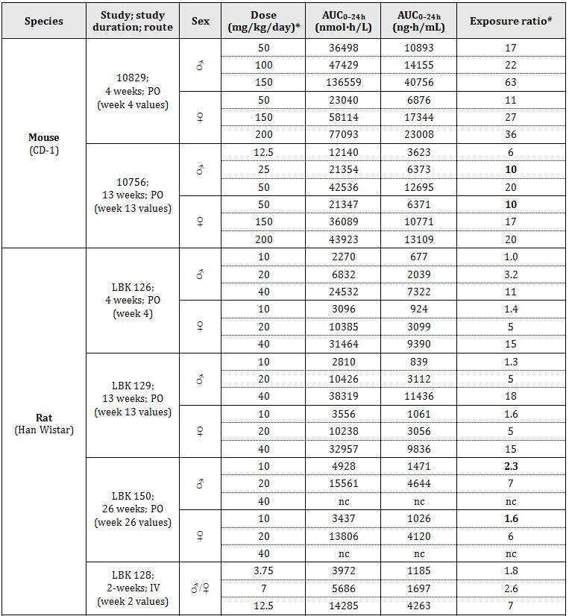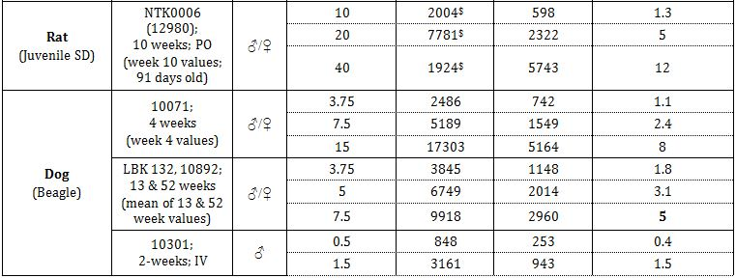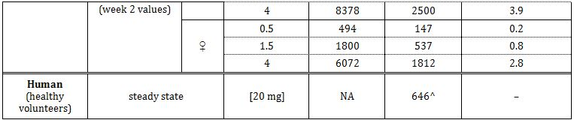

# = animal:human plasma AUC0–24 h; * mg/kg BID for rats; ^ the human value was taken from combined Studies 104, 10467, 10985, 111, 113, 116, 117, 11826A, 12260A, 13119A, CPH-001 and CPH-002 (Table 15); $ calculated as 2 x AUC0-10h; exposure ratios for vortioxetine have not been adjusted for interspecies differences in protein binding because protein binding was high in all laboratory animal species, as well as humans; NA = not applicable; nc = not calculated; values in bold are exposure ratios achieved at the NOAEL; juvenile rat values have been compared with adult human values.

Table 9. Relative exposure to metabolite Lu AA34443 in repeat dose oral studies.

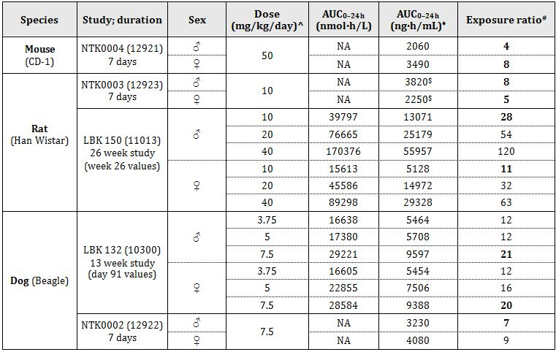

^ mg/kg BID for rats; ♦ calculated using the molecular weight of Lu AA34443 (328.43); # = animal:human plasma AUC0–24 h (the human value used in this calculation was 465 ng.h/mL, a mean of the values from 5 studies for a 20 mg dose of vortioxetine; $ AUC0-t; NA = not applicable; values in bold are exposure ratios achieved at the NOAEL; values have not been adjusted for the relatively small differences between species in plasma protein binding which averaged 63.9% in rats, 65.7% mice, 67.5% in dogs and 74.5% in humans.

Table 10. Relative exposure to metabolite Lu AA39835 in repeat dose oral studies.

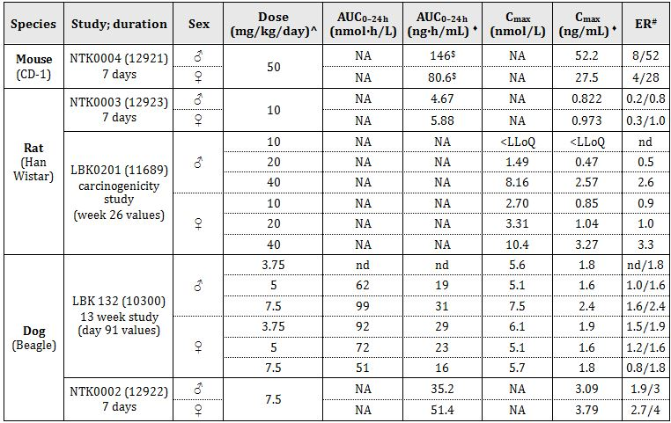

^ mg/kg BID for rats; ♦ calculated using the molecular weight of Lu AA39835 (314.45); # ER = exposure ratio (animal:human plasma AUC0-24h), ER calculated from AUC/ER calculated from Cmax; the human values used in the calculation of ER were 19 ng.h/mL for AUC0-24h and 1.0 ng/mL for Cmax, mean of the values from 2 studies given in Table 6.16 for a 20 mg dose of vortioxetine; $ AUC0-t; NA = not applicable; nd= not determined

Table 11. Relative exposure to metabolite Lu AA34443 glucuronide [M4(b)] in repeat dose oral studies at the NOAEL.

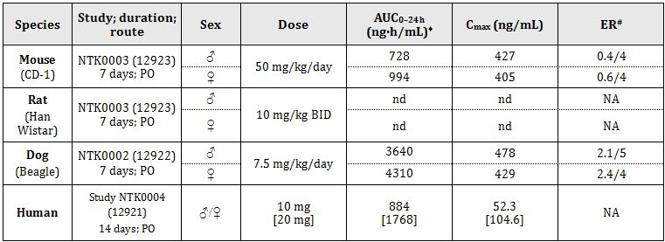

♦ AUC0-t for mice and humans; # ER = exposure ratio (animal:human plasma AUC0-24h) (the human AUC and Cmax values have been doubled for this calculation, assuming linearity → values in [ ]), ER calculated from AUC/ER calculated from Cmax; nd = systemic exposure not demonstrated; NA = not applicable

##### Major toxicities

The major target organs for vortioxetine were the liver (and gall bladder) (mice and rats) and kidney (rats, particularly males). There were no clear target organs in dogs, although at the higher doses used in the 4 week study, some changes were observed in the liver.

In the repeat dose toxicity studies, renal toxicity was observed in male rats, but not in females. However, after prolonged administration (carcinogenicity study), renal toxicity was also observed in females. Histopathological changes in the kidney of male rats were observed in the 8/10 day study at doses of ≥80 mg/kg BID PO. No changes were observed after 4 weeks at 40 mg/kg BID, but changes were observed after 13 and 26 weeks at this dose. The NOAEL for kidney changes in male rats was therefore 20 mg/kg BID (ER 5-7). The aetiolgy of the effects appeared to be the deposition of crystals in the kidney tubules and glomerulus, with secondary inflammatory changes/subsequent lesions (inflammation, dilatation, vacuolation, hyperplasia, fibrosis and necrosis). Some of the histological changes were observed at doses below those at which crystalline deposits were observed, presumably because the crystalline material was not detectable histologically at low levels.

The kidney changes in males were associated with increased kidney weights in the 13 week (not significant) and 26 week studies at 40 mg/kg BID PO; however, they were not associated with consistent increases in creatinine or urea concentrations.

The kidney lesions appeared to be associated with some changes in kidney function as revealed by urinalysis and clinical chemistry data. Increases in urine volume and decreases in specific gravity were seen in male rats at 20 and/or 40 mg/kg BID PO in the 13 and 26 week studies, although the opposite changes were seen acutely (over 2-6 h post dose) in saline loaded rats in the safety study at 40 mg/kg BID given over a shorter period (5 days). Additionally, changes in urinary electrolytes and increases in plasma electrolytes were observed. In urine, the direction of the changes was not consistent, with urinary Na, Cl and K being increased in males at 20 and 40 mg/kg BID in the 13 week study (urinary Na was also increased over 0-2 h post dose at 40 mg/kg BID in the safety study), but in the 26 week study, urinary Na and K were reduced in males at 20 and 40 mg/kg BID. Plasma concentrations of Ca, Na, Cl, K and/or phosphorus were increased in the 4, 13 and 26 week studies in males given 20 and/or 40 mg/kg BID PO, with the most consistent finding (all these studies) being an increase in Ca concentration. The kidney changes appeared to be reversible, since in the 13 and 26 week studies, kidney histological findings had largely resolved by the end of a 4 week or 12 week (respectively) recovery period, and associated changes in clinical chemistry, urinalysis and organ weights had fully resolved.

A mechanistic study (Study LBK0255), conducted to investigate the nature of the crystalline material found in the kidney of vortioxetine treated rats, revealed the presence of needle shaped crystals in urine of treated animals (all doses tested, 40, 60 and 80 mg/kg BID) but not controls at all time points investigated (2, 4, 13 and 26 weeks; not all time points at each dose); there was no change in urinary counts of triphosphate, calcium oxalate or urate crystals following vortioxetine treatment. Histological examination in this study confirmed the crystal deposition observed in the liver and kidneys in the repeat dose toxicity studies and confirmed that the effect was progressive with time. The results of another mechanistic study (Study 11982) examining the chemical composition of the crystalline material deposited in rat kidney (and liver) using the time-of-flight secondary ion mass spectrometry (TOF-SIMS) surface analysis technique suggested that the compounds associated with the crystals in the kidney were Lu AA34443, Lu AA39835, and a glucuronide of hydroxy-vortioxetine (M3, Lu AA39835 glucuronide) The deposition of crystals of drug related material presumably reflected the saturation of excretory mechanisms. The reasons for this sex difference in susceptibility to the renal toxicity of vortioxetine were not explored, although data from Study 11304 show a slightly higher urinary excretion of radioactivity in males than females (after administration of 14C-vortioxetine), and a higher percentage of Lu AA34443 in urine in males than females.

Liver/gall bladder toxicity was observed in the 4 and 13 week mouse studies and the 13 and 26 week rat studies. In the 13 week study in mice, effects were observed in the liver and gall bladder in females at ≥150 mg/kg/day, and in males at the High Dose (HD) of 50 mg/kg/day in the gall bladder. Males were more susceptible to the toxic effects to the liver and gall bladder than females, and hence the lower doses used in the 13 week study in males (12.5, 25 and 50 mg/kg/day) than females (50, 150 and 200 mg/kg/day). In the 4 week study, hepatotoxicity was observed at ≥100 mg/kg/day in males, whereas in females hepatotoxicity was not observed at doses up to 200 mg/kg/day. The NOAEL for the 13 week study was 25 mg/kg/day in males (ER 10) and 50 mg/kg/day in females (ER 10).

In rats, since doses of 10, 20 and 40 mg/kg BID were used in the 4, 13 and 26 week studies, the effect of duration of dosing was clear, with no liver/gall bladder toxicity observed in the 4 week study, and observations relating to this toxicity being much more pronounced in the 26 week than the 13 week study. The NOAEL in the 26 week study was 10 mg/kg BID (ER 1.6-2.3), although this excludes 2 cases of hepatocyte vacuolation of minimum severity in males at this dose. Some findings were observed in both mice and rats, including crystalline material in bile ducts, bile duct hyperplasia, foci of hepatocyte necrosis and inflammation/inflammatory cell infiltration. Additionally, peribiliary fibrosis was observed in mice, and centrilobular hepatocyte hypertrophy and vacuolation were observed in rats. Increased liver weights were a consistent feature of the hepatotoxicity in rats but to a lesser extent in mice. These increases in liver weight and the centrilobular hepatocyte hypertrophy observed in rats may have been associated with enzyme induction. Increases in plasma concentrations of ALP were consistently observed in both mice and rats, and are all likely to be related to the hepatotoxic effects induced by vortioxetine.

The liver changes appeared to be reversible, since hepatotoxicity had largely resolved by the end of the 4 and 12 week recovery periods of the 13 and 26 week (respectively) rat studies, although elevated plasma ALP values had not fully resolved in either study and bile duct hyperplasia was still observed in 6/11 animals previously treated with 40 mg/kg BID PO in the 26 week study.

As in the kidney, the aetiology appeared to be the deposition of crystalline material, in this instance, in the bile ducts. As for the kidney, the results of TOF-SIMS surface analysis suggested that the compounds associated with the crystals in the liver were Lu AA34443 and a glucuronide of hydroxy-vortioxetine (M3), however, unlike the kidney, there was no evidence for the presence of Lu AA39835. In Study 13185, it was shown that, after the administration of vortioxetine to rats, LuAA34443 appeared to be the main component of drug-related material in urine and urine sediment, with M3 being only a minor constituent. In contrast, the data from one liver sample suggested that M3 represented a substantial proportion of drug related material in this tissue (since tissue from only one animal was analysed, the variability around this result is not known) and might therefore be a major contributor to the crystalline material deposited in bile ducts in the rat, and therefore to the hepatotoxicity observed in this species (and probably also in mice). In bile duct cannulated rats, M3 was a significant biliary metabolite (although M4 was quantitatively more important). M3 was not detected in faeces of humans, suggesting a low risk for hepatic toxicity in humans. The results for two kidney samples were somewhat variable, but Lu AA34443 was quantitatively a more significant metabolite than M3 in this tissue, with M3 concentrations representing 1.3-28% of Lu AA34443 concentrations. No analysis was conducted for Lu AA39835 which was also detected in urine, urine sediment and kidney tissue in Study 13185, consistent with its detection in crystalline deposits in kidney tissue in Study 11982. However, Lu AA39835 was a considerably more significant excretory product in female than in male rats (representing 8.0% of the administered dose in urine + faeces in males and 29.7% in females), whereas kidney toxicity was seen largely in male rats. Further, Lu AA39835 was not detected in either urine or faeces of humans. Other drug related compounds appeared to be present in liver and kidney tissue in very small amounts (although response factors in the LC-MS/MS assay were not determined for these compounds).

Since neither M3 nor Lu AA39835 were detected in either urine or faeces of humans, they are unlikely to be a risk factor for the formation of crystals in the kidney tubules or bile ducts during clinical use. However, Lu AA34443 is a significant circulating metabolite in humans, as well as the major identified urinary and faecal metabolite. The sponsor made the following calculations to estimate urinary and biliary concentrations of Lu AA34443 in the various species (Table 12).

Table 12. Calculations to estimate urinary and biliary concentrations of Lu AA34443 in the various species.

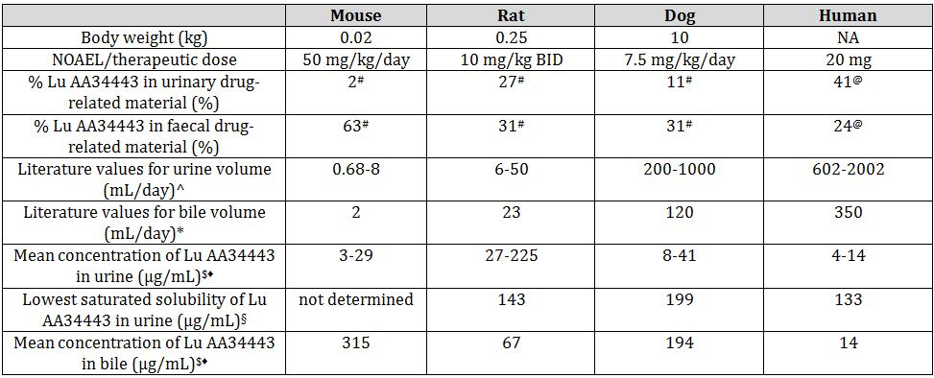

^ Davis and Morris (1993),[17] Meneton et al. (2000),[18] The National BioResource Projects (NBRP) for the rat (2011),[19] Dukes’ Physiology of Domestic Animals;[20] * Davis and Morris (1993);[21] # data for males (data from Studies 11694 (mice), 11304 (rats) and 12284 (dogs)); § data from Study 13285; @ calculated from the results from the human single dose Studies 10477 and 10882, and confirmed by Section 31; $ concentration at the NOAEL for animals and at 20 mg (MRHD) for humans assuming dose linearity; ♦ concentration of Lu AA34443 in urine = dose x %Lu AA34443 in urine/volume of urine (0-24 h), concentration of Lu AA34443 in bile = dose x %Lu AA34443 in urine/volume of bile (0-24 h); NA = not applicable

These calculations are considered appropriate by the nonclinical evaluator. While the sponsor conducted the calculations with data for males, there are not likely to be substantial differences between males and females (excretory percentages were reasonably similar between the sexes). In rats, the estimated concentration of Lu AA34443 in urine (up to 225 µg/mL) exceeded the solubility of Lu AA34443 in urine (143 µg/mL) which is consistent with crystal formation in the kidney in this species. In contrast, in dogs, the estimated concentration of Lu AA34443 in urine (up to 41 µg/mL) was below the solubility of Lu AA34443 in urine (199 µg/mL), consistent with the lack of any crystal formation. The data do not predict crystal formation in humans in which the estimated concentration of Lu AA34443 in urine at the MRHD (up to 14 µg/mL) is below the solubility of Lu AA34443 in urine (133 µg/mL) with a substantial margin of safety (ca10).

Although the solubility limit of vortioxetine in bile was not determined, it might be expected it would be greater in bile than in urine given that vortioxetine is a fat soluble compound. The calculated data therefore do not predict crystal formation in bile ducts in rats as the concentration of Lu AA34443 estimated in bile (67 µg/mL) was relatively low, and below the saturated solubility of Lu AA34443 in rat urine (143 µg/mL). Although the solubility limit in mouse urine was not estimated, it is likely to be similar to the values for the other species which fell in a relatively narrow range (133-199 µg/mL) in which case, crystal formation in the liver would be consistent with the high biliary concentrations of Lu AA34443 estimated in the mouse (315 µg/mL). The biliary concentrations estimated in humans at the MRHD (14 µg/mL) are well below the (estimated) 133-199 µg/mL range.

Effects on salivary glands were observed in the 4 week mouse study and in some rat studies (4 and 26 week oral studies, 2 week IV study and the juvenile rat study). Reductions in salivary gland weight were observed in both species and histological changes (degranulation of striated ducts, acinar degranulation and/or acinar atrophy) were observed in rats. These findings were often, but not always, associated with salivation as a clinical sign. They were not consistently observed, were generally seen at high doses (and high ERs), were not observed in dogs (even though salivation was observed as a clinical sign in the 1/2 and 4 week studies) and salivation seems unlikely to be an issue in patients given the MRHD.

Increased prothrombin time was consistently observed in rats, and might be associated with effects of changes in serotonin levels in platelets on platelet aggregation. Increased prothrombin time was observed at ≥20 mg/kg BID in males (ER ≥7) and at 40 mg/kg BID in females (ER 24) in the 13 and 26 week studies. The clinical risk is likely to be low, given the relatively high ERs and the lack of the same effect in dogs.

Vortioxetine elicited CNS clinical signs, including convulsions. Convulsions were observed in mice only in the supplementary 8 day (nominal) study at the very high dose of 300 mg BID PO (>maximum nonlethal dose). Convulsions were not observed in rats in the repeat dose studies but in the mechanistic Study LBK0255, convulsions were observed on Day 13 in 1/20 rats (males) given 80 mg/kg BID PO.

Convulsions were observed in two dogs in the 13 week study (in one female after the first dose of 15 mg/kg, and in another female that was later given a dose of 10 mg/kg). A number of clinical signs (particularly CNS clinical signs) were observed in several dogs after the administration of two doses at 15 mg/kg. It is unclear why convulsions were observed and clinical signs were more pronounced in this study than in the 1 week and 4 week studies that used the same (or higher) doses (results of analysis of the dosing solutions revealed values to be within ±10% in both these studies and toxicokinetic data were similar for the 4 week study and 13 week study at the 15 mg/kg dose), but may simply reflect the susceptibility of individual dogs and the relatively limited numbers of dogs given doses ≥15 mg/kg/day. Plasma vortioxetine concentrations tended to be lower, rather than higher, in the two convulsive dogs than in the rest of the dogs in the group following the 15 mg/kg and 10 mg/kg doses in the 13 week study. Thus, Study 10727 was conducted to determine whether Lu AA34443 had any convulsive potential in dogs. Lu AA34443 was administered by continuous IV infusion (2.1 mg/kg/h) for 2 h to one male and one female dog. The IV route was chosen to ensure sufficient exposure, given the limited knowledge about the oral bioavailability of Lu AA34443 in dogs. High concentrations of Lu AA3443 were achieved (6.32 and 8.39 µmol/L in the male and female, respectively). These concentrations were well above those observed at 10 and 15 mg/kg in the 13-week toxicity in dogs at which convulsions were observed (0.89-1.8 µmol/L). Thus, there was no evidence for any convulsive potential of Lu AA3443. Another similar study (Study 13228) in which Lu AA34443 was given by IV infusion for 1 h to 2 dogs/sex confirmed this result. No convulsions were observed and high concentrations of Lu AA34443 were achieved (8.55 and 8.31 µmol/L in males and females, respectively). Lu AA34443 AUC0-8h values in this study (19.8-21.9 µmol.h/L) were also higher than AUC0-24h values observed at 10 and 15 mg/kg in the 13 week study (8.68-17.46 µmol.h/L). Further, Study 10459 revealed that the animal experiencing the convulsions at 10 mg/kg in the 13-week study had Cmax and AUC values for vortioxetine, Lu AA34443 and Lu AA34994 that were within the range observed for all 9 remaining animals in the group. This result is consistent with other data for vortioxetine and Lu AA34443 and also suggests that Lu AA34994 is unlikely to be the compound responsible for causing convulsions. The risk of convulsions in the clinic is considered to be relatively low as no convulsions were observed in any of the dog studies (including the 52 week study) at a dose of 7.5 mg/kg/day PO (ER 5).

Pupil dilation, observed at doses ≥3.75 mg/kg/day PO (ER 1.1-1.8), was a frequent clinical sign in dogs and is considered related to the pharmacological action.

Vortioxetine had relatively little effect on body weight. Body weight loss was observed at high doses in mice (≥200 mg/kg BID), rats (≥80 mg/kg BID) and dogs (≥15 mg/kg/day). However, there was evidence for increases at lower doses, most notably in female rats, but also in male mice. Body weight gain was consistently increased in female rats at 20 and 40 mg/kg BID in the 4, 13, and 26 week studies. It was increased at 100 and 150 mg/kg/day in the 4 week mouse study and at 50 mg/kg/day in the 13 week study.

IV dosing for 2 weeks in rats at doses up to 12.5 mg/kg BID (ER 7) did not reveal any toxicities not seen in the oral studies, with the exception of alveolar congestion in the lungs and bronchi. Inflammatory changes at the injection site were observed at all doses (≥3.75 mg/kg BID; ER 1.8). IV dosing for 2 weeks in dogs at doses up to 4 mg/kg/day (ER ~3-4) did not reveal any target organ toxicities.

A specific immunotoxicity study was not conducted but an investigation of the immunotoxic potential of vortioxetine was performed as part of the 13 week rat toxicity study, which achieved ERs of up to 18 in both sexes. The investigation included an examination of lymphocyte phenotype by flow cytometry and measurement of natural killer cell activity using a chromium release assay. There were no or minimal effects of vortioxetine in these investigations, and there were no indications in the repeat dose toxicity studies in mice, rats, or dogs of an effect on organs of the immune system.

#### Genotoxicity

An acceptable set of genotoxicity studies compliant with ICH guidelines was submitted (bacterial reverse mutation assay, *in vitro* chromosome aberration assay in human lymphocytes and in vivo rat micronucleus test). All studies were adequately conducted and used appropriate concentrations/doses, with cytotoxicity to all strains at least at the highest concentrations tested in the bacterial reverse mutation assay, inhibition of mitotic index by ≥50% in both chromosome aberration experiments (±S9), and a dose close to the maximum nonlethal dose (500 mg/kg for a single oral dose) in the rat micronucleus test. Although the target HD for the micronucleus test was 2 x 500 mg/kg, a dose of only 2 x 305 mg/kg was achieved because the test article concentration in the dose formulation was 30.5 mg/mL rather than 50 mg/mL; formulation difficulties were encountered and it appeared that 30.5 mg/mL was the approximate solubility limit of the test article in the HPβCD vehicle (note that the dose volume in this study was 10 mL/kg, whereas in the single dose toxicity study a dose volume of 20 mL/kg was used with a concentration of 25 mg/mL). The bacterial reverse mutation assay included strains that detect mutations at A-T sites, as well as mutations at G-C sites, and included both plate incorporation and pre-incubation tests. The *in vitro* studies were conducted in the presence and absence of metabolic activation using rat liver S9 mix which, based on metabolism data for the rat, should provide adequate activation. Toxicokinetic data for the rat micronucleus study revealed that high plasma concentrations of vortioxetine (up to 4818 nmol/L [1438 ng/mL] or 44 x Cmax at the MRHD) and Lu AA34443 (up to 16894 nmol/L [5548 ng/mL] or >200 x Cmax at the MRHD) were achieved, and distribution studies in the rat revealed distribution of vortioxetine/metabolites to the bone marrow. Male rats only were used in the micronucleus test, but this is acceptable given that in the pilot study which used both sexes, there were no substantial differences in toxicity between the sexes. Results were negative for all the genotoxicity studies, while positive controls elicited the expected results. Given the negative results in the genotoxicity studies, the positive carcinogenicity findings are likely to be due to epigenetic mechanisms.

#### Carcinogenicity

Appropriate long term carcinogenicity studies were conducted (104 week studies in mice and rats given vortioxetine by the oral [clinical] route). The doses selected, in particular, the HD, were appropriate in both species, being at or above (HD female rats) the maximum tolerated dose. Study designs, including group sizes, were appropriate and the studies were compliant with the relevant guidelines. In mice, survival was not affected by treatment, but in rats survival was reduced in HD females (based on trend analysis).

In the discussion below, reference will be made to the views of the Scientific Advisory Group (SAG) of eminent toxicologists established by the sponsor to evaluate the clinical significance of the rodent tumours induced by vortioxetine.

##### Mice – hepatocellular adenomas

In mice, the liver was the sole organ showing a neoplastic change (an increase in the incidence of benign hepatocellular adenomas in males at the HD [50 mg/kg/day PO]). The effect was significant at the P <0.05 level by the trend test (P = 0.026) but not by pairwise comparison. The tumour incidence did not reach significance at P < 0.005 which is the accepted level for common tumours. However, the incidence of 30% was outside the historical control range (6.1%-24.1%; data provided by the SAG, source not indicated; or 2.9%-28%[22] for male CD-1 mice). Such a finding is not unexpected given the deposition of crystals in the hepatobiliary system of mice and the subsequent inflammatory changes. The restriction of the carcinogenicity findings to HD males correlates closely with the non neoplastic changes seen in the liver in the carcinogenicity study which were restricted to the HD and were observed at higher incidences in males than in females. Incidences of hepatocellular carcinoma were not significantly increased, but the incidence of combined hepatocellular adenoma and carcinoma, like adenoma alone, was significantly increased (P <0.05) according to the trend test but not by pairwise comparison. The clinical risk of hepatocellular adenomas is likely to be low, because, as discussed under ‘Repeat dose toxicity’, crystal deposition in the hepatobiliary system is unlikely in patients given the MRHD.

Toxicokinetic data for this study were restricted to plasma concentrations at 2 time points (2 and 24 h post dose). A high ER (65) can be calculated for male mice based on a plasma concentration of 7136 nmol/L (2130 ng/mL) at 2 h in week 104 and a Cmax in humans at the MRHD of 33; the ER of 24 at the NOAEL (15 mg/kg/day) is also high.

##### Rats – hepatocellular adenomas

There were a number of carcinogenicity findings (mainly at the HD) in rats in the 104 week study (doses of 10, 20 and 40 mg/kg BID). As in mice, significant increases in hepatocellular adenomas were observed in HD males, but in rats, HD females were also affected. In both sexes, the increases were significant by the Peto trend test at the P <0.05 level, and in males, additionally by pairwise comparison. The incidence of hepatocellular adenoma (7.3%) in HD males was marginally above the historical control range (0-6.7%) and similarly for females (7.3% compared with 0-5.5%). As in mice, there were no significant increases in the incidences of hepatocellular carcinoma, but the incidence of combined hepatocellular adenoma and carcinoma, like adenoma alone, was significantly increased (P <0.05) according to the trend test (and additionally, by pair-wise comparison in males). Also, as in mice, this finding of an increased incidence of hepatocellular adenomas is not unexpected given the deposition of crystals in the hepatobiliary system of rats, and the subsequent inflammatory changes, which as discussed above (Repeat-dose toxicity) are not expected in humans at the MRHD, and for this reason the finding is considered to be of low clinical risk.

##### Rats – haemangiomas (mesenteric lymph node)

There was an increase in the incidence of benign haemangiomas in the mesenteric lymph node in MD and HD male rats. This increase was significant by the trend test (the P value of 0.003 was below 0.005, which is the cut off value for the trend test for common tumours) and at the HD, by pairwise comparison at the P <0.05 level. Females were not affected and there was no increase in the incidence of haemangiosarcomas in mice. There was no increase in the incidence of haemangiomas at other sites. In HD (but not MD) males, the increased incidence of haemangioma was associated with an increased incidence of angiomatous hyperplasia. Historical control values were not provided but Giknis and Clifford[23] quoted a range of 0-12.73% for all lymph nodes in the male Wistar rat. The incidences in both MD and HD males (23.6% and 27.3%, respectively) were outside of this range. In male rats in the carcinogenicity study, the plasma vortioxetine C2 h value at 104 weeks was 2294 nmol/L (685 ng/mL) at the HD and 245 nmol/L (70.9 ng/mL) at the MD, giving ERs of 21 and 2.1, respectively, based on Cmax at the MRHD.

The nonclinical expert has argued that the effect is rat specific due to the exaggerated susceptibility of rats to angioproliferative stimuli, quoting Roe et al.[24] and Ohnishi et al.[25] Ohnishi et al.[26] only measured unstimulated proliferation. They showed that human tissue (only liver and white fat were investigated) had a lower endothelial cell proliferative rate than rodent (rat or mouse) tissue based on dual immunohistochemical staining of endothelial cells for Ki-67 and CD31, but for the rodent tissues examined (liver, and brown and white fat), the mouse had a greater rate than the rat, and male and female rats showed similar rates of angioproliferation. These latter two findings are not consistent with the data from the carcinogenicity studies with vortioxetine, in which rats, not mice, were affected and only male rats, but not females, were affected. The study by Roe et al.[27] suggests a high sensitivity of the Wistar rat to the development of haemangiomas in the mesenteric lymph node as the incidence of these tumours was significantly increased by the feeding of a high fibre diet.

The increased incidences of haemangiomas observed in the mesenteric lymph node in male rats are considered to represent a relatively low risk to humans because they are benign tumours, they were observed only in rats (not in mice) and only in males (not in females, even though females received higher doses and were exposed to higher vortioxetine concentrations), they were seen only in the mesenteric lymph node and not other sites, and only the finding at the HD (ER 21) was significant by pair-wise analysis.

##### Rats – polypoid adenomas in the rectum

Vortioxetine treatment of rats resulted in a significant increase in benign polypoid adenomas in the rectum of HD females, and there were also single cases in a MD male and a MD female for this tumour which is rare in rats. The P value of 0.002 for trend was below the generally accepted cutoff for a rare tumour in a trend test (P <0.025), with the incidence in HD females (4/54, 7.4%) being high for a rare tumour; no historical control data were provided. These tumours were only observed at a significant incidence at a high ER of 50, calculated from the plasma vortioxetine C2 h value at 104 weeks (5533 nmol/L [1651 ng/mL]) in HD females.

In this study, the mucosa of the rectum and other parts of the large intestine (caecum and colon) showed an increased incidence of mucosal hyperplasia and inflammation in the vehicle control group and all vortioxetine-treated groups compared to the water control group, and incidences of these findings were comparable across all these groups, suggesting an effect of the vehicle. The vehicle used in this study was hydroxypropyl-β-cyclodextrin. Gould and Scott[28] reviewed the toxicology of this compound and noted that in dietary carcinogenicity studies in Wistar rats, polypoid tumours of the large intestines were observed in 4/50 males and 2/50 females (compared with 0/50 in controls) at the HD (5000 mg/kg/day). The mechanism is believed to be associated with increased osmotic activity of the intestinal contents after oral administration of raw starches, caramels, sugar alcohols and lactose, which induces colonic mucosal hyperplasia.[29] The authors considered these tumours to be rat specific, although the reasons for this conclusion were not articulated. Further, the carcinogenicity study referred to by these authors was not readily accessible as the reference was a personal communication. In another review of cyclodextrins, Stell and He[30] noted that in a rat carcinogenicity study (Janssen Research Foundation, NDA 20-966, 1999) in which hydroxypropyl-β-cyclodextrin was given by the dietary route, a slight increase in neoplasms in the large intestine was observed, also at a dose of 5000 mg/kg/day. The daily dose of HPβCD at which tumours were observed in both these studies (5000 mg/kg/day) was 5 fold the dose given in the vortioxetine rat carcinogenicity study (500 mg/kg BID, calculated based on a 5 mL/kg dose volume of a 10% solution given BID), although the route was dietary in the literature studies compared to gavage in the vortioxetine study.

A direct vortioxetine specific effect cannot be excluded, but it seems likely that the polypoid tumours in the rectum were associated in some way with the vehicle. However, as no cases were observed in the vehicle control groups in either males or females (and the dose of vehicle in the vehicle control group was the same as that in the HD group), it appears that there may be an interaction between the vehicle and vortioxetine (for example, a drug related exacerbation of a vehicle effect) at the higher doses of vortioxetine.

Given that this tumour is benign, was observed at a significant incidence in rats only (not in mice), in females only (not in males), at a high ER (50), and was probably somehow related to the vehicle, hydroxypropyl-β-cyclodextrin (which is not a component of the formulation proposed for clinical use), the clinical risk associated with this finding is considered low.

##### Rat – histiocytic sarcomas

The incidence of malignant histiocytic sarcomas was significantly increased in HD males at the P <0.05 level in the trend test, but not significantly increased by pairwise comparison. The incidence in HD males (3/55, 5.5%) appears to be above the historical control range, although exact values for this range are not clear. While the SAG cited a range of 0-1.8% and Giknis and Clifford[31] reported a similar range of (0-1.7%) in the male Wistar rat, Kemmochi et al.[32] have reported an incidence of 1-5% depending on strain and the SAG noted that this tumour has a highly variable incidence, but a specific reference was not quoted. The concurrent control incidence was 0.9% in male rats in the vortioxetine study (1/55 in water control and 0/55 for the vehicle control).

The background incidence of this tumour type is just above the incidence for a rare tumour. The P value of 0.016 for the trend test in males was below the cut off P value for rare tumours (P <0.025) but above the cut off P value for a common tumour (P <0.005). This tumour type was not seen in females or in mice, but it was seen in 1/55 in MD males. Histiocytic sarcoma appears not to be readily induced in humans as it is a rare tumour type in humans[33] and, as noted above, the ER at the HD in male rats was high (21).

Although difficult to judge, the clinical risk associated with the finding of an increased incidence of histiocytic sarcomas in HD male rats would seem to be low. Although this is a malignant tumour:

* it is apparently not readily induced in humans;
* the occurrence of a significantly increased incidence was restricted to male rats (no increase in females or in mice);
* the magnitude of the increase was moderate;
* the ER at the dose at which the increase was observed was high; and
* there is some evidence of a high variability in the incidence of this tumour in rats.

##### Rat – thyroid follicular cell adenomas

The incidence of thyroid follicular cell adenoma in HD males (7/55, 12.7%) nearly reached significance at the P <0.05 level for the trend test, and was well above the cut off level for a common tumour (P <0.005) in this test. This incidence lay within the historical control range for male Wistar rats as reported by Giknis and Clifford,[34] 1.67%-12.73%, and there was no other evidence of an effect on the thyroid, so this finding seems likely to be incidental.

##### Overall conclusion

This evaluator is in agreement with the overall conclusions reached by the SAG that none of the tumours elicited by vortioxetine poses a significant risk to humans given vortioxetine at doses up to 20 mg/day.

#### Reproductive toxicity

A standard set of reproductive and developmental toxicity studies was submitted, comprising a fertility and early embryonic development study in rats, embryofoetal development studies in rats and rabbits, and a pre/postnatal study in rats. All study designs were appropriate (including species, group sizes, timing and duration of treatment, dosing frequency and doses) and consistent with the relevant guidelines. The fertility study, and the embryofoetal development studies in both species, were preceded by dose range finding studies. The embryofoetal development studies in both species were supplemented by additional studies that tested higher doses than the original main studies (Tables 13-16).

Table 13. Relative exposure for vortioxetine based on Cmax.

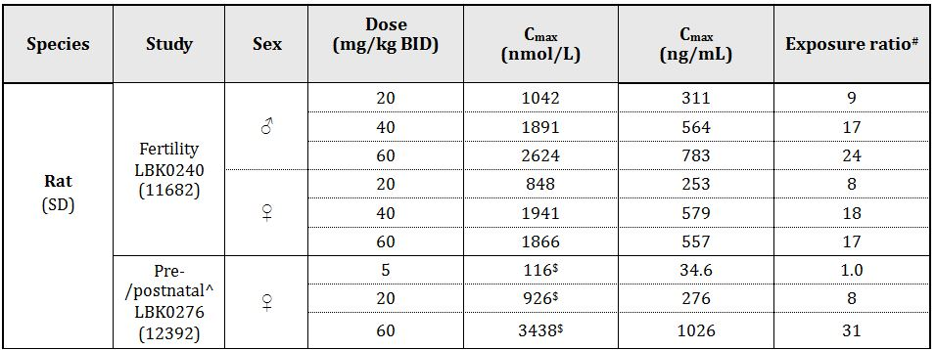

# = animal:human plasma Cmax; ^ Cmax values from PND11; the human value of 33.0 ng/mL was taken from combined Studies 104, 10467, 10985, 111, 113, 116, 117, 11826A, 12260A, 13119A, CPH-001 and CPH-002.

Table 14. Relative exposures for vortioxetine based on AUC.

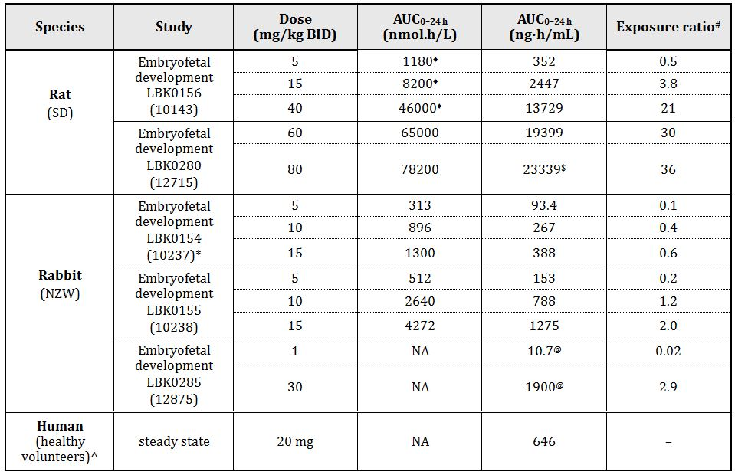

# = animal:human plasma AUC0-24h; * data from GD18; ^ the human value was taken from combined Studies 104, 10467, 10985, 111, 113, 116, 117, 11826A, 12260A, 13119A, CPH-001 and CPH-002; ♦ calculated as 2 x AUC0-10h (data from GD17); $ this value (the sum of the arithmetic means of AUC0-10h and AUC10-24h) is at variance with the value from the Nonclinical Expert Report, which was the AUC10-24h geometric mean; @ AUC0-t; NA = not applicable

Table 15. Relative exposures for metabolite Lu AA34443.

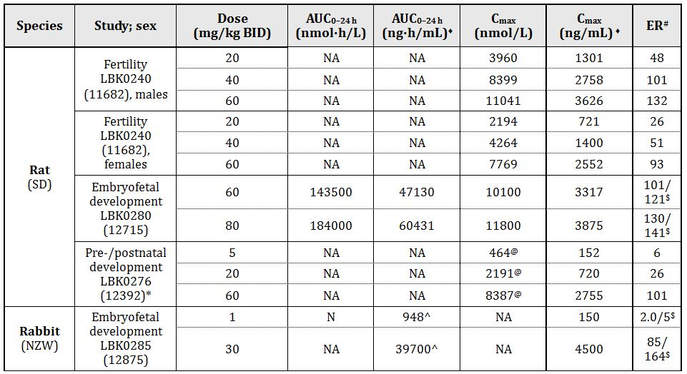

^ AUC0-t; ♦ calculated using the molecular weight of Lu AA34443 (328.43); # = animal:human plasma AUC0-24h; the human values used in this calculation were 465 ng.h/mL for AUC and 27.4 ng/mL for Cmax, means of the values from 5 studies for a 20 mg dose of vortioxetine; * data from PND11; @ C2 h; $ ER calculated from AUC values/ER calculated from Cmax values; NA = not applicable

Table 16. Relative exposures for Lu AA39835.

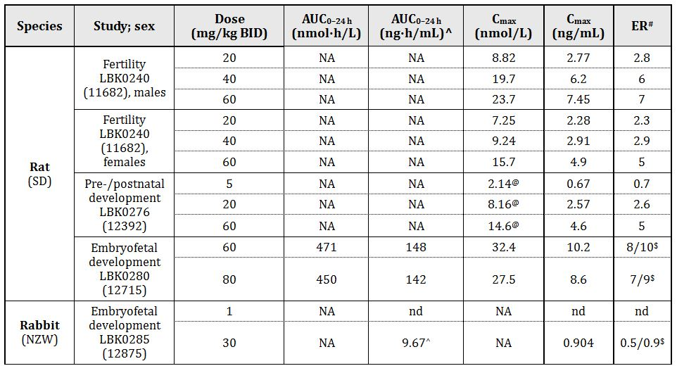

^ AUC0-t; ♦ calculated using the molecular weight of Lu AA39835 (314.45); # ER = exposure ratio (animal:human plasma AUC0-24h) (the human values used in this calculation were 19 ng.h/mL for AUC0-24h and 1.0 ng/mL for Cmax, mean of the values from 2 studies) for a 20 mg dose of vortioxetine; @ C2 h, data from PND 11; $ER calculated from AUC/ER calculated from Cmax; NA = not applicable; nd = not determined

Exposure ratios achieved for vortioxetine in the reproductive toxicity studies were high for rats but relatively low for rabbits. High exposure ratios for Lu AA34443 were achieved in all reproductive toxicity studies, including embryofoetal development studies in both rats and rabbits. Adequate exposure ratios for Lu AA39835 were achieved in the reproductive toxicity studies in rats, but exposure ratios for Lu AA39835 were ≤1 in rabbits.

Exposure comparisons in the fertility and pre/postnatal development studies were made based on Cmax values because the limited sampling conducted in these studies did not allow an estimation of AUC. For the two rabbit embryofetal development studies, 10237 and 10238, there were quite substantial differences in AUC values at the same doses (about 2-3 fold, possibly due to differences in sampling times).

Placental transfer was clearly demonstrated in the rat (GD18), with high foetal:maternal plasma ratios (5.3 at 2 h post dose declining to 1.7 at 8 h post dose). Excretion into milk was also demonstrated (PND14) with milk:plasma ratios in the range 0.5-1.2 over 2-72 h post dose.

In the pilot fertility and early embryofoetal development study, doses up to 40 mg/kg BID had no effect on mating, fertility and litter values and a higher dose (60 mg/kg BID) was therefore included in the main study. This dose elicited considerable toxicity, at least in males (2 HD males were euthanased in poor condition). There were no effects of vortioxetine on oestrus cycling, mating, fertility or litter values. There were no effects on sperm motility or morphology except for an increase in headless sperm observed at 60 mg/kg BID. The number of headless sperm in a sperm smear at this dose (2.33) was stated to be within that laboratory’s historical control range (1.00-5.84) (information provided in Section 31 response). There were no effects on testicular weights which is consistent with the results of the repeat dose toxicity studies. The lack of effects on reproductive performance is also consistent with the lack of any histological findings in the reproductive organs or related endocrine organs in any of the repeat dose toxicity studies. For both males and females, the NOAEL for fertility was ≥60 mg/kg BID (ER 24 in males and 17 in females based on Cmax). This is a large safety margin and no effects on fertility would be expected in patients at the MRHD.

In the embryofoetal development studies in rats at oral vortioxetine doses of up to 80 mg/kg BID, there were no teratogenic effects or effects on foetal viability, but foetal weights were reduced at 60 and 80 mg/kg BID (ER 30 and 36, respectively), along with clear evidence for delayed ossification at ≥60 mg/kg BID. An increased incidence of delayed ossification was also observed at ≥15 mg/kg BID (ER 4), although mostly remaining within background ranges. Maternal toxicity, most notably a decrease in body weight gain associated with a reduction in food consumption, was observed at ≥40 mg/kg BID (ER 21).

In the embryofoetal development studies in rabbits, at doses up to 30 mg/kg BID, there were no effects of vortioxetine on foetal viability, but foetal weights were reduced at ≥5 mg/kg BID (ER 0.1-0.2), at least in the main study with the larger group sizes, but there was no clear dose relationship. There were no teratogenic effects of vortioxetine at doses up to 30 mg/kg BID (ER 2.9), but delayed ossification was observed at ≥5 mg/kg BID (ER 0.1-0.2), and an increase in foetal incidence of runts at 30 mg/kg BID. Maternal toxicity, most notably an increase in body weight loss (compared to the vehicle control group), associated with a reduction in food consumption, was observed at all doses (≥1 mg/kg BID; ER 0.02). As is commonly the case, the delayed ossification was observed at the same doses as the reduction in foetal weights (≥5 mg/kg BID; ER 0.1-0.2), which was, in turn, observed at maternotoxic doses. The rabbit was affected by the vehicle since food consumption and body weight gain were reduced in the vehicle treated group compared with the water control group.

In the main supplementary study (LBK0285), there was a significant increase in the incidence of foetuses with the left common carotid artery arising from the innominate artery, at the 1 mg/kg BID dose, but there was no significant increase in the incidence of this variation in the main study (LBK0155) at doses of 5, 10 and 15 mg/kg BID. Therefore, the finding at the 1 mg/kg BID dose was considered to be incidental and the NOAEL for embryofoetal toxicity was 1 mg/kg BID (ER 0.02). An increase in the incidence of runts was observed at 30 mg/kg BID (ER 2.9). Although exposure ratios in the rabbit were low, this finding is unlikely to be clinically relevant because of the apparent particular susceptibility of the rabbit to a reduction in food consumption following administration of vortioxetine and of the vehicle, as well as the large litter size of rabbits.

In the pre/postnatal study in rats over GD6-PND20 at doses up to 60 mg/kg BID, some adverse effects of maternal treatment were observed in pups. At 60 mg/kg BID (ER 31 based on Cmax), the proportion of pups born alive was reduced, and pup viability and body weight gains were reduced over the lactation period. There was also a reduction in one developmental index (percentage of pups with eyes open at PND15) at this dose. Additionally, at 20 mg/kg BID (ER 8 based on Cmax), pup viability over PND4-21 was reduced. The reduction in pup viability was associated with an increase in the incidence of a necropsy finding of no milk in the stomach, suggesting a change in nursing behaviour by the dams and/or in suckling behaviour by the pups. Effects on pups correlated with maternotoxicity as manifested by dose dependent reductions in body weight gain over GD6-20, although maternal body weight gains were increased over the lactation period. The reduction in maternal weight gain over GD6-20 was significant at 60 mg/kg BID, and although non significant at 20 mg/kg BID, a reduction of 5.5% was observed. The NOAEL for embryofoetal toxicity was 5 mg/kg BID (ER 1 based on Cmax), but the reduction in pup survival over PND4-21 at 20 mg/kg BID (ER 8) was quantitatively small.

##### Pregnancy classification

The sponsor has proposed Pregnancy Category B3.[35] This is considered appropriate due to the increased incidence of runts at a dose of 30 mg/kg BID in rabbits.

#### Paediatric use

The current submission does not include a proposal for paediatric use of vortioxetine. However, a specific study in juvenile rats was submitted which will be relevant for any future extension of the patient population to include use in patients under 18 years of age. This was a comprehensive study of 10 weeks duration (which is appropriate) with a 4 week recovery period, and toxicokinetic data were collected. The study was preceded by a dose range finding study. The doses used in the main study were the same as those used in the 26 week toxicity study in adults. This was appropriate as these doses elicited the same toxicities as seen in adult rats (renal toxicity and hepatotoxicity) but were not excessively toxic (there were no treatment related premature deaths or significant reductions in body weight gain over the treatment period). The clinical (oral) route was used and treatment was started at weaning (21 days of age).

The endpoints investigated were appropriate and extensive, including a measurement of growth (change in ulna length), external indices of sexual maturation (day of preputial separation and vaginal opening), and subsequent reproductive performance, as well as the standard endpoints for adult animals (mortality, clinical signs, body weight, food consumption, haematology, clinical chemistry, organ weights, gross and microscopic examinations, urinalysis and ophthalmoscopy). Some neurotoxicity assessment was also included: effects on reflex ontogeny (auditory startle habituation response), learning ability and memory (Morris maze) and locomotor activity.

Histological changes in the liver were similar to those observed in adults at the same doses in the 13 week toxicity study (centrilobular hepatocyte hypertrophy and vacuolation) and were mainly graded as minimal in severity. As in adults, the kidney was a target organ, but the main finding was corticomedullary mineralisation, whereas this was not specifically observed in adult rats. There was no evidence of crystal deposition in either the liver or kidney. There was evidence of partial recovery of histological changes, particularly in the liver, after a 4 week treatment free period. Other findings in the treated animals were relatively minor (small changes in clinical chemistry and urinalysis parameters and organ weights, mainly at the HD [40 mg/kg BID] and to a lesser extent at the MD [20 mg/kg BID]) and an increase in peak startle amplitude in HD males in the auditory startle habituation response test. A reduction in salivary gland weights was consistent with findings in adult animals. A reduction in weight of seminal vesicles was observed and this was also seen in some studies in adult rats, although it was not a consistent finding in adults. Overall, there was no clear evidence of effects on juveniles that were not observed in adult animals. ERs were similar in juvenile animals and adult animals (juvenile rat AUC values were compared with adult human values).

There were no effects on the reproductive performance of the treated juveniles, but the offspring of the treated juveniles had a reduced viability over PND 1-7 which was associated with clinical signs of cold to touch and no milk in the stomach. This may have been associated with poor nursing behaviour in the previously treated dams.

#### Impurities

Impurities in the drug substance and degradants in the drug product are controlled to acceptable limits. The nonclinical assessment of all potential impurities, including starting materials, reagents, intermediates and by-products, was adequate.

#### Dependence

The first signals pointing to dependence potential can be derived from receptor binding data. Vortioxetine does bind to some known targets involved in drug dependence (5-HTT and 5-HT receptors) but not to other implicated receptors/transporters such as the opioid and GABA-A receptors, and the dopamine receptor and transporter.

Several studies suggest dopaminergic innervation of the nucleus accumbens has a central role in the brain processes underlying drug dependence.[36] The effects of vortioxetine on extracellular levels of dopamine in the nucleus accumbens were investigated by dialysis in freely moving rats in Study 929-900 2007 033. Vortioxetine (at doses up to 10 mg/kg SC) did not significantly alter the extracellular concentration of dopamine (or norepinephrine) in the nucleus accumbens, while concentrations of 5-HT were increased in this brain region, and concentrations of dopamine (and norepinephrine) were increased in the ventral hippocampus at 5 mg/kg. In the recovery periods of the repeat dose toxicity studies, there was no evidence of withdrawal reactions. Based on these results, and PK characteristics of vortioxetine in humans (slow absorption, long half life, and flat concentration time profile around the Cmax) the sponsor considered that it was unnecessary to conduct *in vivo* dependence studies. This is acceptable.

#### Local tolerance

Local tolerance studies are not required for a medicine that is proposed for oral administration, but for occupational health and safety purposes, skin sensitisation potential was assessed using the local lymph node assay. The assay was adequately conducted (including appropriate species, group sizes and procedures, a positive control, and appropriate concentrations based on an initial irritation/toxicity screen) and revealed that vortioxetine has skin sensitisation potential.

#### Other issues

Antigenicity testing is not relevant for this compound.

Phototoxicity testing was not conducted because the ultraviolet absorption spectra revealed that the active compound absorbs minimally in the visible range 290-310 nm.

There are no novel excipients used in the manufacture of the drug product.

### Nonclinical summary and conclusions

#### Summary

* *In vitro* studies indicated that vortioxetine is an inhibitor of the 5-HT transporter (5-HTT) and a 5-HT3, 5-HT7 and 5-HT1D receptor antagonist, a 5-HT1B receptor partial agonist, and a 5-HT1A receptor agonist. Vortioxetine increased the extracellular concentrations of 5-HT in various regions of the rat forebrain. Norepinephrine, and to a lesser extent, dopamine, acetylcholine and histamine concentrations were also increased, but at higher doses, making the clinical relevance of these changes unclear. A faster recovery (compared to fluoxetine) of 5-HT neuronal firing frequency in the dorsal raphe nucleus suggests that vortioxetine may have a more rapid onset of action than the SSRIs. Vortioxetine showed some neurogenic effects. Vortioxetine showed antidepressant and anxiolytic like effects in some, but not all, animal models investigated. It also showed positive effects in some animal models of cognitive function. The role of the different receptors in the clinical action of vortioxetine is unclear, but in rats, the following order for the extent of receptor/transporter occupancy was observed: 5-HT3 > 5-HTT > 5-HT1B > 5-HT1A (receptor occupancy at 5-HT7 and 5-HT1D was not investigated). The major circulating human metabolites, Lu AA34443 and Lu AA39835, are unlikely to contribute to the pharmacological activity of vortioxetine due to relatively weak activity and/or low exposure levels.
* Any receptor binding/functional activity of vortioxetine observed at the following receptors/transporters was unlikely to be clinically relevant: 5-HT4e, 5-HT5A, 5-HT6, 5-HT1E, 5-HT1F, D1, H2, δ2, µ, β1 and β2 receptors, and the norepinephrine and dopamine transporters. Results of secondary pharmacology tests for analgesic activity in various models of pain (including neuropathic pain) in mice and rats suggested that vortioxetine is unlikely to have analgesic activity at the MRHD. Investigation of the effects of vortioxetine on sexual behaviour in male rats at a clinically relevant oral dose did not suggest a potential for adverse effects.
* Vortioxetine was tested in a core set of safety studies (CNS, cardiovascular and respiratory), and additionally for effects on the renal and gastrointestinal systems. These studies did not reveal any effects that are likely to be clinically relevant.
* The PK of vortioxetine were characterised by rapid absorption in the nonclinical species and slower absorption in humans. Oral bioavailability was estimated as 7-10% in rats, 48% in dogs and 75% in humans. Vortioxetine was relatively rapidly cleared (Cl of 4 L/h/kg in rats, 2 L/h/kg in dogs and 0.47 L/h/kg in humans). Half life was short in the laboratory animal species, particularly rodents (about 2-4 h in rats and mice, and about 5-9 h in dogs), but was longer in humans (66 h). Radioactivity was rapidly and extensively distributed to tissues after oral administration of 14C-vortioxetine to rats. There was no evidence of retention of radioactivity in any organ, but there was evidence of melanin binding. Highest concentrations of radioactivity were observed in gastrointestinal contents, urinary bladder and liver. High (>10) brain:blood ratios were observed for vortioxetine. Protein binding was high in all species. Vortioxetine was extensively metabolised in humans and the laboratory animal species, mainly by oxidation and subsequent glucuronidation. All circulating human metabolites were also observed in dog plasma, and some in mouse and rat plasma. Seven CYP isozymes were identified in the metabolism of vortioxetine. Excretion was via urine and faeces, with humans having the highest proportion of urinary excretion and mice, the highest proportion of faecal excretion. Vortioxetine/metabolites crossed the placenta in rats and there was substantial excretion of vortioxetine/metabolites in rat milk. In in vitro studies, vortioxetine showed a low potential for drug interactions at clinically relevant concentrations (little or no clinically relevant inhibition and induction of CYP enzymes, and no/weak activity as a P-glycoprotein substrate or inhibitor).
* Single dose toxicity studies were conducted by the oral and IV routes in mice and rats. Vortioxetine showed relatively low acute toxicity by the oral route, with a maximum non-lethal dose of 300 and 500 mg/kg in mice and rats, respectively. No target organs were identified but clinical signs, including convulsions, were observed in both species after both routes.
* Repeat dose toxicity studies were conducted in mice (1, 4 and 13 weeks), rats (1, 4, 13 and 26 weeks) and dogs (1, 4, 13 and 52 weeks) by the oral route, and in rats and dogs (1 and 2 weeks) by the IV route. A BID dosing schedule was used in rats. High exposure ratios were achieved in rodents (up to 20 in the 13 week mouse study and 24-30 in the 26 week rat study), and acceptable exposure ratios were achieved in dogs (up to 5 in the 52-week study). High exposure ratios were achieved in all species for the main human metabolite, Lu AA34443 (carboxylic acid metabolite). Exposures to the other non glucuronidated circulating human metabolite, Lu AA39835 (hydroxy metabolite) were up to ~6, 3 and 2, in mice, rats and dogs, respectively. In dogs, exposures equivalent to or greater than human exposure were achieved for all the major human circulating metabolites, except for M12, a glucuronide formed via the hydroxy metabolite intermediate, Lu AE22404.
* The major target organs for vortioxetine were the liver (and gall bladder) (mice and rats) and kidney (male rats). Evidence was provided that these toxicities were due to deposits of crystalline material in the bile ducts and renal tubules, and associated inflammatory changes. The crystals were identified as vortioxetine metabolites, Lu AA34443 and M3 (the glucuronide of Lu AA39835), and additionally Lu AA39835 (in kidney). Since neither M3 nor Lu AA39835 were detected in either urine or faeces of humans, they are unlikely to be a risk factor for the formation of crystals in the kidney tubules or bile ducts during clinical use. Although Lu A34443 is a major circulating, urinary and biliary metabolite in humans, estimates of its urinary and biliary concentrations suggested that it is unlikely to be deposited in the kidney or liver at the MRHD. Both the kidney and liver lesions in rats showed reversibility. Convulsions were occasionally observed following administration of vortioxetine to the nonclinical species, particularly dogs. However, they were seen only at high exposures in rodents, and were not seen in dogs at 7.5 mg/kg/day PO (ER was 5), suggesting a low risk of convulsions in patients given the MRHD. Salivation in rodents and pupillary dilation in dogs were consistently observed clinical signs.
* A full 10 week juvenile animal study was conducted in rats. There was no evidence of any effects other than those seen in adult rats. Exposure ratios achieved in juvenile animals were similar to those in adult animals.
* An adequate set of appropriately conducted genotoxicity studies (bacterial reverse mutation assay, *in vitro* chromosome aberration assay in human lymphocytes and *in vivo* rat micronucleus test) was conducted, all with negative results.
* Two year oral carcinogenicity studies were conducted in mice and rats. An increase in incidence of benign hepatocellular adenomas was observed in male mice at the HD (50 mg/kg/day) and in male and female rats at the HD (20 and 40 mg/kg BID, respectively) which were likely to be associated with the hepatotoxicity due to crystal deposition and therefore not considered of clinical relevance. Other tumour incidences were increased in rats:
  + benign haemangioma in the mesenteric lymph node in MD (7 mg/kg BID) and HD males, associated with an increased incidence of angiomatous hyperplasia
  + benign polypoid adenomas in the rectum of HD females, and
  + histiocytic sarcomas in HD males.

None of these was considered to be of particular relevance to humans.

* A full set of reproductive toxicity studies comprising fertility and early embryonic development studies in rats, embryofoetal development studies in rats and rabbits, and a pre/postnatal development study in rats, all by the oral route, was submitted. There was no evidence of an effect on fertility in male or female rats at oral doses up to 60 mg/kg BID PO (ER ~20). In embryofoetal development studies in rats and rabbits, embryofoetal survival was not affected and there was no evidence of teratogenicity. Exposure ratios achieved were adequate in rats, but were low in rabbits, in part due to doses being limited by the effect of the vehicle and vortioxetine in reducing food consumption. The main effects seen in both species were a reduction in foetal weights and delayed ossification. An increase in the incidence of runts was also observed in rabbits at 30 mg/kg/day (ER 2.9). These findings generally correlated with a maternotoxic effect (except for delayed ossification of some bones at the MD (15 mg/kg BID, ER 3.8) in the main rat study). In the pre/postnatal development study, live birth index was reduced, and pup viability and body weight gains were reduced over the lactation period, mainly at the HD (60 mg/kg BID [ER 31]), with smaller changes at the MD (20 mg/kg BID [ER 8]); pup development was little affected (reduction in percentage of pups with eyes open on PND15 at the HD).
* Vortioxetine was shown to have skin sensitisation potential in the local lymph node assay. Specific *in vivo* dependence studies were not conducted, but factors such as a lack of in vitro binding to the classic targets and lack of an effect on extracellular levels of dopamine in the nucleus accumbens suggested that dependence will not be a concern. Immunotoxicity potential was investigated in the 13 week rat study, and there was little evidence of an effect. Phototoxicity testing was not conducted because the ultraviolet absorption spectra revealed that vortioxetine absorbs minimally in the visible range 290-310 nm.

#### Conclusions and recommendation

* Vortioxetine would appear to have a multimodal action. It is an inhibitor of the 5-HT transporter and a 5-HT3, 5-HT7 and 5-HT1D receptor antagonist, a 5-HT1B receptor partial agonist, a 5-HT1A receptor agonist, although the precise contribution of the individual targets to the antidepressant effects observed in patients remains unclear. Primary pharmacology data support use for the proposed indication.
* No clinically relevant hazards were identified in the safety pharmacology studies and there was no evidence of an effect on male sexual behaviour in the rat.
* PK data did not reveal any issues of critical significance. Of the nonclinical species, the dog was the best model as exposures equivalent to or greater than human exposure were achieved in this species for all the major human circulating metabolites, except for one glucuronide metabolite (M12). In *in vitro* studies, vortioxetine showed a low potential for drug interactions at clinically relevant concentrations.
* Repeat dose toxicity studies did not reveal any target organs in dogs (doses were limited by convulsions but there was a safety margin of 5 at the no effect dose). The liver (in mice and rats) and the kidney in male rats were identified as target organs, due to the deposition of crystalline material in the hepatobiliary system and renal system, respectively. Mechanistic studies were conducted to reveal the compounds (metabolites) responsible. Determination of the solubility of these metabolites in urine and estimations of their levels in urine and bile suggested that the crystallisation observed in rodents would be unlikely to occur in patients at the MRHD.
* Genotoxicity studies were negative. There were some positive carcinogenicity findings but these were not considered to pose a carcinogenic risk in patients at the MRHD.
* Fertility was not affected in rats. There was no evidence of a teratogenic effect or of an adverse effect on embryofoetal survival in rats or rabbits. Findings in the embryofoetal development studies in rats and rabbits were largely limited to reductions in foetal weight and delays in ossification, (which were observed at maternotoxic doses and/or doses which achieved acceptable exposure ratios) and to an increase in the incidence of runts in rabbits at a high dose.
* There are no nonclinical objections to registration of vortioxetine for the treatment of major depressive disorder, including prevention of relapse, in adults.
* The draft PI document should be amended as directed.

## IV. Clinical findings

A summary of the clinical findings is presented in this section. Further details of these clinical findings can be found in Attachment 2.

### Introduction

#### Clinical rationale

Nonclinical studies indicate vortioxetine is a 5-HT3, 5-HT7 and 5-HT1D receptor antagonist, a 5-HT1B receptor partial agonist, a 5-HT1A receptor agonist, and an inhibitor of the 5-HT transporter (5-HTT). These affinities are all considered to be of clinical relevance and involved in the mechanism of action of vortioxetine at therapeutic doses. Data from serotonergic receptor and transporter occupancy studies coupled with neuronal firing and microdialysis studies in rats suggest the targets interact in a complex fashion, leading to modulation of neurotransmission in several systems, including the serotonin, noradrenaline, dopamine, histamine and acetylcholine systems within the rat forebrain. These multimodal pharmacological actions are thought to be responsible for the antidepressant effects of vortioxetine. In addition, vortioxetine shows anxiolytic and cognitive enhancing properties and analgesic potential in animal models.

The Phase II/III clinical development program for vortioxetine was initiated in 2006 and was jointly conducted by H Lundbeck and Takeda Pharmaceutical Company Ltd.

#### Guidance

The application was preceded by a pre submission meeting between officers of the TGA and sponsor representatives. The application content is consistent with TGA advice provided at the pre submission stage.

In a pre submission TGA Consultation Paper, the sponsor detailed a case of scientific misconduct by Aptuit Ltd affecting the bioanalytical analysis for a number of nonclinical, clinical, method validation and long term stability studies in the vortioxetine development program. The misconduct was not related to any vortioxetine related good clinical practice (GCP) activities. Following a thorough sponsor led investigation, the US Food and Drug Administration (FDA), Medicines Health & Regulatory Agency, EMA, Health Canada, and the Japanese Pharmaceutical and Medical Devices Agencies accepted the sponsor’s remedial actions. In particular, the regulatory agencies were satisfied all unreliable data were identified and rejected from the Category I application dossier (82 plasma concentration samples in Study 10985 and two plasma concentration samples in Study 12260A). The overall conclusions of the nonclinical and clinical studies were considered scientifically valid (including the modified Phase I population pharmacokinetic [Pop-PK] analysis).

TGA has adopted the relevant EU guideline.[37]

#### Contents of the clinical dossier

The clinical dossier documented a full development program of clinical pharmacology, efficacy and safety studies. The electronic version of the dossier was comprehensive and well structured.

The submission contained the following clinical information:

* Completed clinical pharmacology studies
  + Single and multiple dose PK: 10272, 10467
  + Japanese single and multiple dose PK: CPH-001, CPH-002, CPH-003
  + Mass balance: 10477
  + Absolute and relative bioavailability: 10982, 123, 106, 13921A, 13138A, 13119A, 14520A
  + Intrinsic factor a: 111, 114, 112
  + Extrinsic factor b: 17, 115, 103, 11826A, 101, 102, 109, 113, 110, 116, 118
  + Pharmacodynamic (PD): 104, 12689A, 10985, 12260A, 124
  + Pop-PK of vortioxetine in healthy subjects and PK/PD.
* Ongoing clinical pharmacology studies (as of 29 February 2012)
  + Polysomnographic: 14029A*
  + Japanese food effect: CPH-004*
* Completed clinical studies in MDD
  + Short term, placebo controlled, fixed dose:
    - 11492A: 6 week, (5 or 10mg/day), active reference (venlafaxine 225 mg/day),
    - 11984A: 8 week, (2.5, 5 or 10mg/day), active reference (duloxetine 60mg/day),
    - 305: 8 week, (1, 5 or 10mg/day),
    - 13267A: 8 week, (15 or 20mg/day), active reference (duloxetine 60mg/day),
    - 315: 8 week, 15 or 20mg/day); active reference (duloxetine 60mg/day),
    - 316: 8 week, (10 or 20mg/day),
    - 303: 6 week, (5 mg/day),
    - 304: 8 week, (2.5 or 5 mg/day), active reference (duloxetine 60 mg/day).
  + Short term, placebo controlled, elderly:
    - 12541A: 8 week, (5mg/day), active reference (duloxetine 60 mg/day).
  + Long term, placebo controlled, relapse prevention:
    - 11985A: 12 week, open label (OL), flexible dose (5 or 10 mg/day), followed by 24 to 64 week, double blind (DB), placebo controlled, fixed dose (5 or 10 mg/day).
  + Long term, OL, safety: 11492C, 11984B, 301.
* Completed clinical studies in generalised anxiety disorder (GAD)
  + Short term, placebo controlled fixed dose: 308, 309, 310, 311.
  + Long term, placebo controlled, relapse prevention: 12473A.
* Ongoing clinical studies in MDD (as of 29 February 2012)
  + Short term, placebo controlled fixed dose: 317*, CCT-002*, CCT-003, 14122A*.
  + Short term, active comparator, flexible dose: 14178A*, 318.
  + Long term, OL, safety: 13267B*, 314*, OCT-001.

* represents studies completed and submitted for second round evaluation

#### Paediatric data

Vortioxetine is not indicated for children. The submission did not include paediatric data. The EMA approved the development of a paediatric investigation plan for vortioxetine aimed at treating MDD and GAD in 7 to 18 year olds.

#### Good clinical practice

Studies were designed and conducted in accordance with the principles of the Declaration of Helsinki and in compliance with the principles of GCP. However, Clinical Safety Report (CSR) 101 identified 11 noncompliant batches and CSR 102 Amendment identified one noncompliant batch. Integrated CSR 10985 states:

*For the bioanalyical phase compliance with Good Clinical Practice (ICH GCP Guidance) and Good Laboratory Practice (GLP Guidance) could not be claimed.*

### Pharmacokinetics

#### Studies providing pharmacokinetic data

Submitted PK studies are shown in Table 17 and PK results excluded from consideration are shown in Table 18.

Table 17. Submitted PK studies.

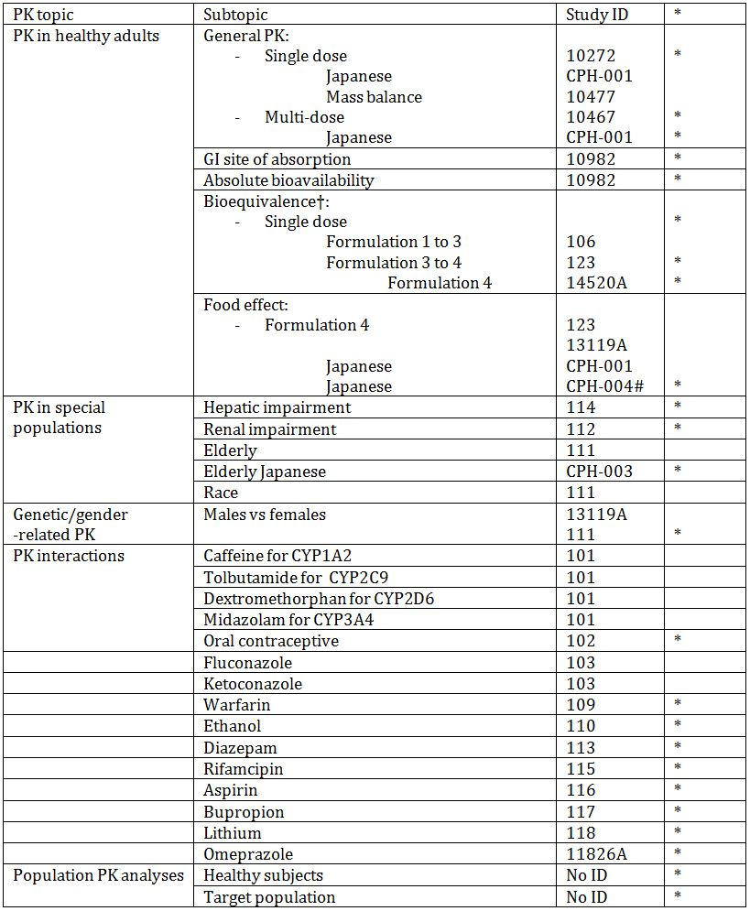

* Indicates primary study aim.

† Bioequivalence of different formulations.

# Studies completed and submitted for second round evaluation.

Table 18. PK results excluded from consideration.

Table 18. PK results excluded from consideration.

#### Evaluator’s overall conclusions on PK

Across 10 mg vortioxetine studies, mean (CV) results for multi dose studies were AUC0-24h 344.0 (47) ng.h/mL; Cmax 17.9(44) ng/mL and Tmax 8 h. For 5 to 20mg vortioxetine mean results in multi dose studies were AUC0-24h 175 to 646 ng.h/mL; Cmax 8.7 to 33.0ng/mL and Tmax 7 to 8h; and in single dose studies were AUC0-∞ 157 to 561 ng.h/mL; Cmax 1.87 to 8.03ng/mL and Tmax 8 to 11h.

Following single and multiple doses of vortioxetine across studies, the estimated volume of distribution (Vz/F) was ~2500 to 3400L, while in the phase I PopPK analysis, the sum of the volumes of distribution in the central (V2/F) and peripheral (V3/F) compartments was approximately 2600L and ~4,000L in the Phase III analysis.

The mean oral clearance (CL/F) was 33L/h in the Phase I Pop-PK study and 40 L/h in the Phase III. Across studies, for vortioxetine 5 to 20 mg (inclusive), this ranged from 30 to 42 L/h.

The mean elimination half life (t1/2) was 66 h in the Phase I Pop-PK study compared with 59 to 69 h across the vortioxetine therapeutic range.

For vortioxetine, AUC0-t was 9, 16, and 11% higher in the subjects with mild, moderate, or severe renal impairment, respectively, than in their healthy controls. The predicted AUC of the unbound fraction to last quantifiable concentration (AUC0-tlqc,u) value from the regression model for a subject at about the midpoint CrCL for each renal impairment group differed from those in the normal renal function group by less than 32%.

While Study 111 showed women had a 30% greater AUC, the Pop-PK study of Phase I studies, body size (height) explained the difference between the sexes.

While in Study 111 following multiple doses, the AUC0-24h and Cmax of vortioxetine were 25% and 33% higher, respectively, in Black subjects than in White subjects, in Study 12260A following multiple vortioxetine doses, AUC0-24h and Cmax of vortioxetine were slightly higher (8% and 9%, respectively) in Japanese subjects than in Caucasian subjects.

In the Pop-PK study, race, ethnicity or region did not impact as covariates.

Japanese Study CPH-004 demonstrated no food interaction with vortioxetine (10 mg). This confirmed the results of Study 123, in which a 20 mg vortioxetine dose was administered. Bioequivalence was demonstrated between 4 x 5 mg vortioxetine tablets Formulation 4 and 1 x 20 mg vortioxetine tablet Formulation 4, in Study 14520A. Hence, bioequivalence is expected for the intermediate dose strengths, that is, 10 mg and 15 mg tablets.

### Pharmacodynamics

#### Studies providing PD data

Table 19 summarises the PD studies in the first and second rounds.

Table 19. Submitted pharmacodynamic studies.

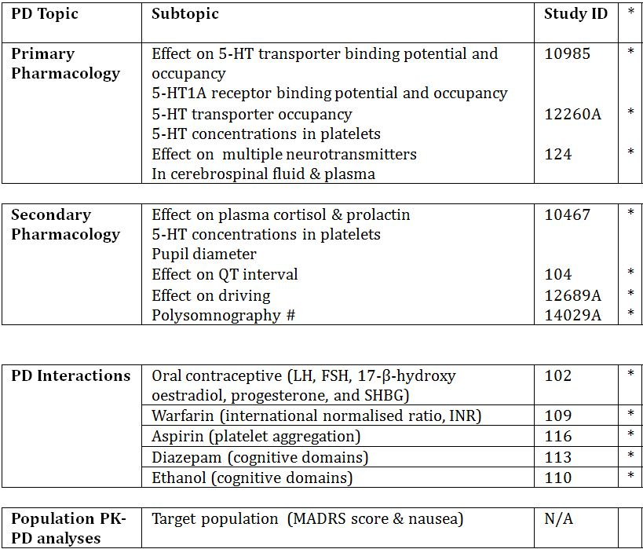

* Indicates the primary aim of the study.

# Study completed and submitted for second round evaluation.

### Dosage selection for the pivotal studies

Vortioxetine is efficacious at a lower 5-HTT occupancy level than currently available antidepressants. Studies have previously demonstrated that at therapeutic doses of SSRIs and SNRIs, the 5-HTT occupancies are ~80% or above. This suggests a high 5-HTT blockade is important for the therapeutic effects of SSRIs and SNRIs. In the clinical development program with vortioxetine, doses giving rise to approximately 50% 5-HTT occupancy (5 mg/day dose) demonstrated a clinically relevant effect. A possible explanation could be the multimodal mechanism of action of vortioxetine, where it acts both at 5-HT receptors and at the 5-HTT, contributes to enhanced serotonin neurotransmission and, through combined activities, mediates vortioxetine antidepressant activity. Nonclinical mechanistic studies suggest at low vortioxetine doses, where there is a high level of occupancy at 5-HT3 receptors; a synergistic action with 5-HTT inhibition could be expected.

At 20 mg/day, 5-HTT occupancies >80% were observed in humans. Nonclinical occupancy data, *in vitro* human binding data and occupancy data in healthy subjects, predict greater involvement of the 5-HT receptors and of 5-HTT with increasing vortioxetine dose. The modulation of multiple neurotransmitter systems may contribute to the incremental overall antidepressant effect with increasing dose seen in patients. These modulations have been shown to be brain region specific, as determined by receptor localisations in nonclinical studies.

Vortioxetine acts broadly at several 5-HT receptors and at the 5-HTT, which could hypothetically be a concern with respect to safety and tolerability. However, vortioxetine is very well tolerated at the higher doses. This suggests the complex interaction of these targets includes a counterbalancing effect. Furthermore, the agonistic activity of vortioxetine at the 5-HT1A receptor predicts a low level of sexual side effects, as might modulation of other 5-HT receptor subtypes (such as 5-HT1B and 5-HT7). In addition, the antagonistic activity of vortioxetine at the 5-HT7 receptor may potentially contribute to a favourable sleep profile.

Vortioxetine was initially developed globally in MDD at doses up to 10mg/day, focusing on 5 and 10 mg/day. However, the efficacy of 5mg/day was not consistently confirmed, being negative in the studies conducted in the US. The results for 10mg/day were more consistent and 10 mg/day was more effective than 5 mg/day. Based on these results and the mechanism of action of vortioxetine (higher doses lead to higher occupancies at all targets and consequently a broader pharmacological profile), an extended Phase III program was initiated, which included doses up to 20 mg/day.

Randomised DB comparisons versus placebo were selected, as reliable evaluation of treatments intended for the management of psychiatric illness is not possible without the use of placebo, and to provide unambiguous evidence of efficacy. Comparison with placebo is also valuable for distinguishing disease manifestations from adverse reactions of the medicinal product and is in line with the guidelines in depression.

The placebo response has been shown to be as high as 40% in MDD trials. Although the use of placebo in conditions where effective treatment is known may be considered controversial, existing literature justifies its use in disorders characterised by a fluctuating course with only a slight chance of permanent harm associated with treatment delay or assignment to placebo. It is recommended to include an active reference to distinguish between a failed trial, where the reference also fails, and a negative study. The reference drugs (duloxetine, venlafaxine) were considered safe, effective and widely used in MDD treatment.

### Efficacy

#### Evaluator’s conclusions on efficacy

##### Acute treatment of MDD in adults

Overall, three (11492A, 305 and 13267A) of ten MDD short term adult studies were positive in the primary efficacy analysis, that is, vortioxetine demonstrated statistical separation versus placebo (at all doses). No US studies were positive. While Study 14122A was ‘positive’ according to the above criterion, analysis of depressive symptoms was a secondary efficacy endpoint. Hence, Study 14122A is supportive of vortioxetine in adult MDD. Two US studies (315 and 316) were supportive of vortioxetine efficacy in adult MDD, that is, at least one vortioxetine regimen demonstrated statistical superiority versus placebo in the primary efficacy analysis. Five short term MDD studies (11984A, 303, 304, CCT-002 and 317) were negative studies, that is, vortioxetine failed to demonstrate statistical superiority versus placebo for any vortioxetine dose in the primary efficacy analysis. In summary, the short term adult MDD studies provided three positive studies (none in the US), three supportive and five negative studies (three in the US). No clear dose response relationships were demonstrated.

Studies 11984A and CCT-002 were negative studies in the primary efficacy analysis (Last Observation Carried Forward, LOCF) but became positive for Study 11984A and supportive for CCT-002 in the Mixed Model Repeated Measures (MMRM) sensitivity analysis. In the meta analysis of the MDD short term studies MMRM was used (and justified). The addition of Studies CCT-002, 317 and 14122A to the updated meta analysis generally lowered the treatment difference versus placebo, especially for the 15 mg vortioxetine dose but did not greatly affect the overall pattern, that is, statistical separation versus placebo was statistically significant for the 5 mg, 10 mg and 20 mg vortioxetine doses and not significant for the 15 mg dose. However, the vortioxetine therapeutic range achieved > 2 points treatment difference versus placebo, which is regarded as clinically significant. In the non US study meta analysis the dose response relationship seen in the original meta analysis was lost for the 20 mg vortioxetine regimen in the updated meta analysis. Again treatment differences across the therapeutic vortioxetine range exceeded 2 points versus placebo treatment. Hence, the sensitivity analysis in the individual studies and the meta analyses of the short term MDD studies in adults provide support for the primary efficacy findings. No meta analysis for US only studies was provided but these would be expected to show little or no benefit from vortioxetine treatment.

In general, the sensitivity, subgroup and secondary efficacy analyses supported the primary efficacy results in terms of Montgomery and Åsberg Depression Rating Scale (MADRS) single item scores, sustained remission, changes in Clinical Global Impression (CGI) scores and Sheehan Disability Scale (SDS) scores. In terms of ≥ 50% responder and remitter rates, in the updated meta analyses (see ‘Clinical Questions’), the clinically relevant treatment difference the sponsor identified (> 16% versus placebo) was not achieved at any vortioxetine dose in the overall responder analysis (but did so in the non US results in a dose response pattern).

Females demonstrated a dose response relationship across the therapeutic dose range, a trend not evident with male participants. However, this may reflect the greater proportion of female participants (approximately 2:1 females:males).

Severe cases of depression (MADRS total score ≥ 30 at baseline) followed a similar trend to the meta analysis results, in which 15 mg/day vortioxetine failed to demonstrate statistical separation versus placebo, although the 5 mg, 10 mg and 20 mg doses did. Mild and moderate cases of depression were analysed as one group and demonstrated statistical separation versus placebo consistent with the primary efficacy results. An analysis of ≥ 50% responder rate (see ‘Clinical Questions’) by severity of depression (severe or mild/moderate) demonstrated vortioxetine efficacy versus placebo in the severity groups tested, albeit the most severe subjects appeared to derive greatest benefit from the lower vortioxetine doses (5 and 10 mg) than the mild/moderate group, who appeared to derive the greatest benefit from the higher vortioxetine doses (15 and 20 mg).

While subjects who participated in non US studies appeared to derive greater benefit from vortioxetine treatment in the dose range 5 to 20 mg/day than US participants, the reasons the sponsor provided to explain the differences (primarily non adherence to study medication) are unsubstantiated and speculative. A total of 32 US subjects concurrently participated in more than one vortioxetine trial compared with no subject in non US trials. Also, US subjects had proportionately more subjects who exceeded 100% and 120% of their allocated study medication (in Studies 303 and 304). While it was beyond the scope of this submission to examine the role of socioeconomic factors and motivation of trial participants in subject recruitment into MDD clinical trials, there appear to be fundamental differences between subjects recruited from the US versus those recruited from outside the US that may warrant further examination in future studies.

While study design features and methodologies used in the eleven pivotal efficacy trials were consistent with the TGA adopted guideline,[38] a number of potential study design limitations are identified. In particular, internal validity may have been compromised by not using a reference group in five of the studies. Furthermore, only three studies used the Mini International Neuropsychiatric Interview (MINI) or Structured Clinical Interview for DSM Disorders (SCID) to confirm the diagnosis of Major Depressive Episode (MDE). Hence, most subjects recruited into the adult MDD short term program did not have their MDE diagnosis confirmed, potentially leading to significant selection bias (and investigator bias). Selection of subjects who had not had a prior episode of MDE, that is, an established history of major depressive disorder, could result in the introduction of significant selection bias into the studies. An analysis of ≥ 50% responder rate by prior history of MDE (see ‘Clinical Questions’) failed to demonstrate statistical separation versus placebo for subjects who had not had a prior MDE. Although this subgroup of subjects were restricted to 5 mg and 10 mg vortioxetine doses, this result lends support to a selection/diagnostic problem, especially in US subjects, that may have significantly contributed to the negative study results seen in this application. While those subjects who were treated with recurrent MDE demonstrated a similar pattern to the overall meta analysis of the primary efficacy results, no vortioxetine dose achieved > 16% treatment difference versus placebo, the clinically relevant endpoint determined by the sponsor in its response document to clinical questions.

In the active comparator Study 14178A, vortioxetine was non inferior and even superior to agomelatine in the treatment of MDD patients with a previous inadequate response to SSRI/SNRI antidepressant monotherapy. However, this study had no placebo control and Total doses of vortioxetine and agomelatine were analysed rather than individual doses as per the relapse prevention trial. It was beyond the scope of this submission to include comparator antidepressant data within the proposed PI.

In Study 14122A, vortioxetine demonstrated a significant and independent effect on cognitive dysfunction associated with MDD, which was not captured by the MADRS.

##### Acute treatment of MDD in the elderly

Vortioxetine 5 mg/day was statistically significantly superior to placebo in reducing the HAM-D24 total score at Week 8 (p = 0.001), with a mean difference to placebo of -3.32 points, and demonstrated statistical separation at Week 6 (compared with duloxetine at Week 4). In the pooled data, the magnitude of the reduction in MADRS total score in this elderly population was much greater (two fold) than the corresponding 5 mg vortioxetine dose in the pooled MDD adult short term study results (-4.74 versus -2.57, respectively).

The results from the sensitivity analyses (MMRM, OC and PPS) were consistent with the results from the primary efficacy analysis, which also support internal validity of the study. Furthermore, while MMRM results were numerically higher than corresponding LOCF results, these differences were much smaller than observed in the adult MDD short term studies. This further supports the internal validity of the study.

The treatment difference to placebo for vortioxetine and duloxetine was higher in more depressed patients, although these differences were not statistically significant. However, in the pooled analysis, with patients with severe MDD, vortioxetine 5 mg/day separated from placebo (p <0.001) in the MMRM (and LOCF) analysis of the change from baseline in MADRS total score at Week 8, with a mean change from baseline of -17.6 points and a mean difference to placebo of -6.5 points.

The treatment difference to placebo for vortioxetine and duloxetine was higher in more anxious patients, although these differences were not statistically significant. However, in the pooled analysis with patients with high anxiety, vortioxetine 5 mg/day separated favourably from placebo (p <0.001) in the MMRM (and LOCF) analysis of the change from baseline in MADRS total score at Week 8, with a mean change from baseline of -15.9 points and a mean difference to placebo of -5.6 points.

Overall, the results for the aged population for the 5 mg/day vortioxetine dosage regimen in the acute treatment of MDD are more consistent than those ≤65 years of age. The key difference between the elderly and the adult populations was the elderly were required to have an established history of MDD, unlike several of the adult studies. While Study 12541A incorporated participants from within and outside the US, and US subjects had less favourable reductions in HAM-D24 and MADRS total scores than non US subjects, the overall study results support vortioxetine use in this elderly population in the acute treatment of MDD.

##### Relapse prevention

The proportion of patients who relapsed over 24 weeks DB treatment was lower in the vortioxetine group combined (13.2%) than in the placebo group (26.0%). The Cox proportional hazard model gave a hazard ratio (HR) of 2.01 (p = 0.0035), that is, the risk of relapse for the patients in the placebo group was twice that for patients in the vortioxetine group and the number needed to treat (NNT) to prevent one relapse event in 24 weeks treatment was 1/0.13 = 8. However, analysis by individual vortioxetine dose showed vortioxetine 5 mg failed to separate from placebo (albeit borderline statistical significance), that is, only the 10 mg vortioxetine dose demonstrated statistical superiority versus placebo. The latter supports the proposed dosage regimen for relapse prevention but only in adults ≤ 50 years of age.

Efficacy was not clearly demonstrated in subjects > 50 years of age and especially in those in the elderly (≥ 65 years of age). Hence, although the acute MDD trial in the elderly appears to support efficacy in this age group for up to 8 weeks treatment, long-term efficacy in this aged population has not been established.

Since the sponsor submitted the primary (and secondary) efficacy results for Study 11985A in terms of ‘Total vortioxetine’ administered during DB treatment, that is, combined 5 mg and 10 mg vortioxetine doses, it is difficult to draw meaningful conclusions from the study results. The clinician may have difficulty in determining the most appropriate maintenance dose for their patient. From the Total vortioxetine subgroup analyses, sensitivity analyses and secondary efficacy analyses, the overall results are generally consistent with the primary efficacy results (although there was a statistically significant difference noted between the vortioxetine 5 mg and 10 mg doses: see previous comment).

### Safety

#### Studies providing safety data

In the Summary of Clinical Safety, the safety and tolerability of vortioxetine in the treatment of MDE within MDD was evaluated primarily on data from 13 completed phase II/III studies. Nine studies were 6 to 8 week, DB, placebo controlled, with or without an active reference, and included 2755 patients exposed to vortioxetine, 1461 patients exposed to placebo, and 866 patients exposed to active reference. One long term (24 to 64 week) relapse prevention study included 639 patients exposed to vortioxetine 5 or 10 mg/day. A total of 1443 patients included in the short term studies continued in the three completed OL, long term extension studies with flexible doses of vortioxetine 2.5 to 10 mg/day. Of these, 908 patients completed the 1 year treatment periods. As of the safety data cut off date of 29 February 2012, a further 1057 patients were included in the ongoing, OL, long term extension studies with flexible doses of vortioxetine 15 and 20 mg/day. Of these, 112 patients have completed the 1 year treatment periods.

The safety and tolerability of vortioxetine were further evaluated based on data from five completed Phase III studies in GAD, which included 1755 patients as well as 31 completed clinical pharmacology studies, which included 1169 subjects.

Finally, safety data from two ongoing clinical pharmacology studies, six ongoing short term Phase III studies in MDD, and one ongoing OL long term Japanese study in MDD are presented (including 44 subjects, 1359 patients, and 57 patients, respectively, as of 29 February 2012).

In the second round evaluation, the sponsor provided additional safety-related data from five completed clinical efficacy and/or safety studies, and three pharmacology studies (see Section 8.1 below). In the Addendum to the original Summary of Clinical Safety, safety data cut off dates are further defined:

* 31 July 2013 provided a full update for the MDD short term pool (“STP”);
* 26 October 2012 provided a 240 day update for the MDD OL long term pool (“LTP”).

Unless otherwise indicated, the methodology used to summarise and tabulate data in this Addendum is identical to that used in the Summary of Clinical Safety.

Evaluable safety data was provided as follows:

I. A Clinical Pharmacology Integrated Safety Database was made that included exposure, disposition and AEs from 31 completed clinical pharmacology studies.

In the second round evaluation, the sponsor provided safety data for an additional three completed clinical pharmacology studies. These studies are summarised in Table 20.

Table 20. Overview of clinical pharmacology studies completed between 29 February 2012 and 31 August 2013.

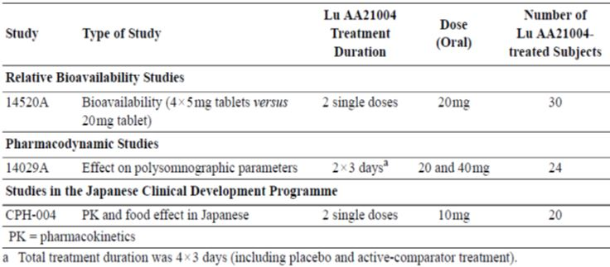

II. An Integrated Safety Database was made that included data from the Phase II/III studies with designs that allowed for pooling and safety data comparisons. Five pools were made:

##### Short term

* STP (11492A, 11984A, 305, 13267A, 315, 316, 303, 304 and 12541A)
* GAD STP (308, 309, 310 & 311)
* MDD and GAD STP

Note: The primary pool for the evaluation of the short term safety and tolerability of vortioxetine was the STP, supported by the MDD and GAD STP. Serious adverse events (SAEs) for the GAD STP are presented separately. All other safety data from the GAD short term studies are presented as part of the MDD and GAD STP.

In the second round evaluation, the sponsor provided additional safety related data from five completed clinical efficacy and/or safety studies. These studies are summarised in Table 21.

Table 21. Overview of studies in MDD completed between TGA submission and 31 August 2013.

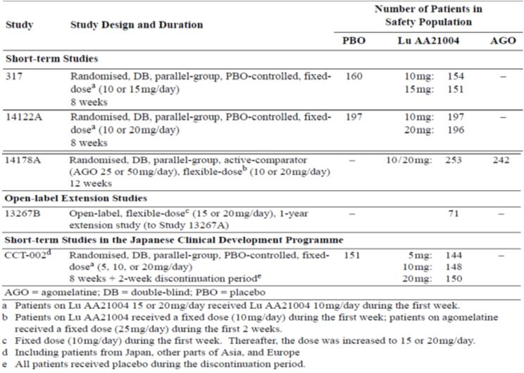

Safety and tolerability data from Studies 317, 14122A and CCT-002 are included in the updated STP. The LTP has been updated with final data from the OL, 1 year extension study (13267B) and updated data from the ongoing OL, 1 year extension study (314). In the LTP, 391 subjects had completed 52 week treatment as of 26 October 2012 compared with 112 subjects in the original cut off date. The safety data for the active comparator Study 14178A is presented separately. The safety related data package in the second round evaluation is comprehensive and acceptable.

##### MDD OL long term

* LTP (completed studies with doses of 2.5 to 10 mg vortioxetine: 11492C, 11984B and 301).
* MDD ongoing OL LTP (ongoing studies with doses of 15 and 20 mg vortioxetine: 13267B and 314). Data regarding SAEs, withdrawals due to AEs, and body weight are presented for this pool.

Data from the two long term relapse prevention studies, 11985A (MDD) and 12473A (GAD), are presented by individual study, as are data from the six ongoing short term MDD studies (317, CCT-002, CCT-003, 14122A, 14178A & 318) and the one OL long term MDD study conducted in Japan (Study OCT-001).

The design of the relapse prevention studies in MDD and GAD made them unsuitable for pooling. Therefore, these studies are presented individually, primarily based on data from the CSRs. However, tabulations and listings of AEs of special interest, other safety considerations, and the C-SSRS (Study 12473A only) are presented based on the Integrated Safety Database.

#### Patient exposure

Exposure to vortioxetine was calculated for all completed clinical (and pharmacology) studies in the development program. The duration of exposure was calculated for the Core Treatment Period from the first day of the Investigational Medicinal Product (IMP) to the last day of IMP. Down taper IMP was not included in the exposure calculations. The overall exposure is tabulated by number of patients and patient years of exposure (PYE) (Table 22). For the STP and the MDD and GAD STP, exposure was also summarised by demographic variables (age, sex and race). Due to the flexible dosing in the OL, long term studies, a summary of exposure (mean, SD, median and range [minimum and maximum]) was provided for the LTP.

Table 22. Exposure to vortioxetine (APTS) – completed studies.

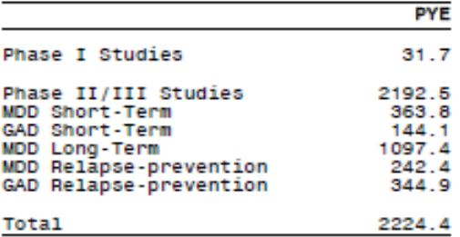

In the completed Phase II/III studies, 5709 patients with MDD (3954 patients in 13 studies) or GAD (1755 patients in five studies) received vortioxetine at doses up to 20 mg/day; 1479 of these patients received vortioxetine for 26 weeks or more and 981 received vortioxetine for 52 weeks or more (Table 23). In addition, 1169 subjects in 31 clinical pharmacology studies in healthy subjects, elderly subjects, and subjects with hepatic or renal impairment have been exposed to vortioxetine. Subjects received vortioxetine orally (as solution or tablets) as a single dose (up to 75 mg) or repeated doses (up to 60 mg/day).

Table 23. Number of subjects exposed to vortioxetine (APTS) – completed studies.

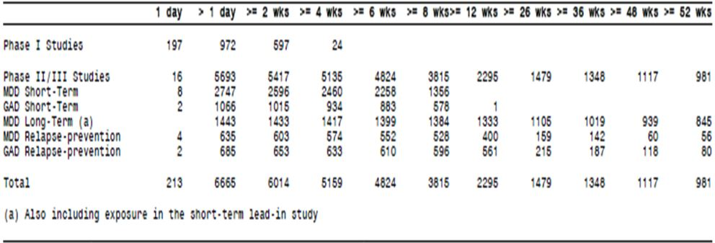

For vortioxetine, 302 of the PYE (83%) were accrued for 5 to 20 mg/day, 243 of the PYE (67%) were accrued in women, 325 of the PYE (89%) were accrued in patients aged <65 years, and 294 of the PYE (81%) were accrued in Caucasians.

There were no clinically meaningful differences between the STP and the MDD and GAD STP in respect to exposure based on the demographics sex, age and race.

*Comment: Long term exposure to vortioxetine is limited to the Phase II/III clinical trials included in this application as vortioxetine is a NCE with non post marketing exposure.*

#### Safety issues with the potential for major regulatory impact

##### Sexual dysfunction

###### Phase II/III studies

In the STP, the overall incidence of sexual dysfunction treatment emergent adverse events (TEAEs) during treatment with vortioxetine was low (1.7%) versus placebo (1.2%). Overall incidence of sexual dysfunction TEAEs during treatment with vortioxetine ranged from 0% to 5.0% in the individual studies (not in a dose related manner) compared with placebo, duloxetine and venlafaxine groups. The incidence rates were 13, 9, 34, and 119 per 100 PYE in the total vortioxetine, placebo, duloxetine and venlafaxine groups, respectively. The most common sexual dysfunction TEAE during treatment with vortioxetine was libido decreased: overall incidence was 0.8%, which was similar to placebo (0.8%).

Addition of the GAD studies to the short term pool did not change the overall pattern between the groups in incidences, incidence rates or types of sexual dysfunction TEAEs. During the open label period (OLP) MDD long term relapse prevention Study 11985A, 2.5% patients had a sexual dysfunction TEAE. The most common (> 2 patients) TEAEs were libido decreased (1.4%), erectile dysfunction (1.7%), and ejaculation delayed (1.2%). During the DBP, 2.0% patients in the vortioxetine group and 1.0% in the placebo group had a sexual dysfunction TEAE. No event was reported by >2 patients. The types and incidences of sexual dysfunction TEAEs in GAD long term relapse prevention study, 12473A, were similar to those in the MDD relapse prevention study, 11985A, in OLP and DBP. During long term treatment with vortioxetine in the LTP, the incidence of sexual dysfunction TEAEs remained low (1.7%). The incidence rate was 2.2 per 100 PYE. The most common sexual dysfunction TEAEs during long term treatment with vortioxetine were libido decreased (0.9%) and erectile dysfunction (1.0%).

###### Sexual dysfunction based on the Arizona sexual experience scale (ASEX)

The ASEX is a 5 item, patient self-rated scale that evaluated a patient’s recent sexual experiences. Patients were asked to assess their own experiences over the last week (for example, "How strong is your sex drive?", "Are your orgasms satisfying?") and respond on a 6 point scale for each item. The ASEX was used to dichotomously divide patients into those with and those without sexual dysfunction (sexual dysfunction status). Based on the ASEX, sexual dysfunction was defined as at least one of the following: an ASEX total score ≥ 19; a score ≥ 5 on any ASEX item; a score ≥ 4 on ≥ 3 ASEX items. For patients who did not fulfil these criteria at baseline, but who did so during the Core Treatment Period, the sexual dysfunction was considered treatment emergent (TESD).

In the Phase II/III program, the ASEX was assessed in MDD short term Studies 304 and 13267A, and GAD short term Study 308 at all visits from screening to completion/withdrawal and in MDD short term Studies 315 and 316 from baseline to completion/withdrawal. In MDD short term Study 11984A, the ASEX was assessed at all visits (from screening to completion/withdrawal) after local approval of Amendment SA01. The assessment of TESD was based on the subset of patients without sexual dysfunction at baseline. As there is no confounding by indication, data from all these studies in MDD and GAD were pooled. A Mantel-Haenszel approach with ‘stratification by study’ estimated the pairwise treatment differences between the placebo, vortioxetine Total and duloxetine groups with the associated two sided 95% CI. Using a similar approach, a comparison between the placebo group and each vortioxetine dose group was performed. The ASEX total scores and individual item scores and changes from baseline therein were summarised by dose (Table 24).

Table 24. Incidence of TESD, Core Treatment Period, by Dose (APTS) in Studies 11984A, 304, 13267A, 315, 316 and 308.

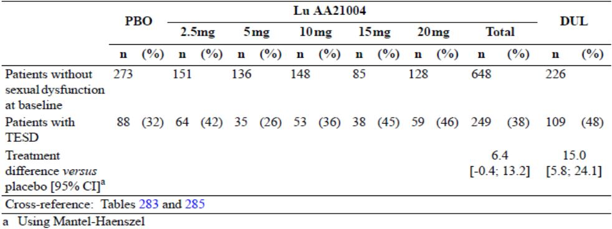

In the dose range 5 to 20mg/day there appeared a modest dose response relationship. Vortioxetine 15mg and 20mg/day demonstrated a similar rate of TESD as duloxetine (45% and 46% versus 48%, respectively). There was a tendency for the proportion of women with TESD to be slightly larger than the proportion of men with TESD for all doses and in all treatment groups: 42% of the women versus 35% of the men in the vortioxetine Total group, 37% of the women versus 28% of the men in the placebo group, and 50% of the women versus 46% of the men in the duloxetine group (similar incidences for the vortioxetine 15 mg and 20 mg doses).

In Studies 11984A, 304, 13267A, 315, 316 and 308, at baseline, the mean ASEX total score was approximately 20 in each treatment group (range: 18.6-20.4), which corresponded to a moderate level of sexual dysfunction, and the changes over time were small. Mean changes in the ASEX individual item scores reflected the mean changes in the ASEX total score, with very small changes in all treatment groups and no clear trends over time.

The incidences and pattern of TEAEs captured for sexual dysfunction in the updated and original STPs were similar. Incidence of TESD, based on the ASEX, in the updated STP (that included additional subjects from Study 317), tended to occur with vortioxetine in a dose-related pattern. A similar trend was observed in the original STP. Incidence of sexual dysfunction related TEAEs was generally low (0.4% in the vortioxetine group and 0% in the agomelatine group) in Study 14178A.

##### Discontinuation symptoms

In accordance with the TGA adopted guideline for depression,[39] five short term studies (11492A, 13267A, 315, 316 and 303) and one long term relapse prevention study (11985A) were designed to investigate the occurrence of potential discontinuation symptoms following abrupt discontinuation of treatment with vortioxetine in patients with MDD.

Studies 13267A, 315 and 316 included a dedicated scale, the Discontinuation Emergent Signs and Symptoms Scale (DESS) checklist. This checklist evaluated possible effects of discontinuation of antidepressant therapy. It is a clinician rated instrument that queries for signs and symptoms on a 43 item checklist (for example, agitation, insomnia, fatigue and dizziness) to assess whether the item (event) is discontinuation emergent. An event is considered discontinuation emergent if it is reported for the first time or if a previously reported event worsened. In either case, the event scores one point on the checklist and the DESS total score is the sum of all scores on the checklist. In addition, in GAD, one short term study (308) and one relapse prevention study (12473A) were prospectively designed to look for potential discontinuation symptoms. The DESS was assessed in Studies 13267A, 315 and 316 at Weeks 8, 9 and 10 for patients who completed the Core Treatment Period only (APCS). In Study 13267A, the DESS was added after study start.

Overall incidence of AEs in the vortioxetine dose groups tended to be lower in the second week than in the first week of the 2 week Discontinuation Period in Studies 11492A, 303, 13267A, 315, 316, 308, 11985A and 12473A. There was no clear dose response relationship in the incidences of AEs in the first or second week of the Discontinuation Period.

In the first week after discontinuation, overall incidence of AEs in the STP was similar in patients who abruptly discontinued vortioxetine 2.5 to 20 mg/day (range: 5 to 21%), in patients who discontinued placebo (range: 5 to 15%), and in patients who down tapered duloxetine from 60 to 30 mg/day (range: 8 to 20%).

Compared with the first week, the incidence of AEs in the second week was similar to or decreased in the vortioxetine (range: 2 to 13%) and placebo (range: 4 to 10%) groups. In the duloxetine group, in which duloxetine was discontinued in the second week, the incidences of AEs was at the same level or increased (range: 8 to 22%) compared to those in the first week.

In the first week of the Discontinuation Period, the DESS total scores in the vortioxetine 10 mg, 15 mg and 20 mg groups was 1.41, 1.58, and 1.58, respectively, which was similar to or slightly higher than that in the placebo (0.96) and duloxetine (1.33) groups. In the second week of the Discontinuation Period, the DESS total score in the vortioxetine 10 mg, 15 mg and 20 mg groups (1.60, 1.60, and 1.56, respectively) was similar to the placebo group (1.19) and similar to the first week. In the duloxetine group, in which the patients received duloxetine 30 mg/day in the first week of the Discontinuation Period, the DESS total score was twice as high in the second week (2.85) than in the first week (1.33).

The DESS single items with the highest incidences in the first and second weeks of the 2 week Discontinuation Period were consistent with the types of AEs reported in the same period. The DESS single items with an incidence ≥ 10% in any treatment group in the first week of the Discontinuation Period were:

* irritability: vortioxetine 10 mg (15%), 15 mg (11%), and 20mg (13%);
* fatigue/tiredness: vortioxetine 10 mg (11%) and 20 mg (10%);
* trouble sleeping/insomnia: vortioxetine 20 mg (10%);
* increased dreaming or nightmares: vortioxetine 20 mg (11%) and duloxetine (14%).

For vortioxetine, the DESS total score and the nature of the events in the Discontinuation Period were similar to those in the treatment period. In the first and second weeks after abrupt discontinuation of treatment in Studies 13267A, 315 and 316, DESS total score in the vortioxetine groups was slightly higher than the placebo group. In the duloxetine group, in which patients were down tapered, the DESS total score increased in the second week to twice that in the first week.

*Comments: The DESS only evaluated short term studies.*

Potential discontinuation symptoms were not systematically evaluated in Studies 14122A and 317. Study CCT-002 included a 2 week Discontinuation Period that evaluated AE incidence following abrupt discontinuation of placebo or vortioxetine 5, 10 or 20 mg/day. Potential discontinuation symptoms were assessed based on AE reporting and the Discontinuation Emergent Signs and Symptoms (DESS) scale in patients who completed the 8 week Treatment Period. Overall reporting of TEAEs after the last dose in the treatment period was similar in the treatment groups following abrupt discontinuation: placebo (18%), vortioxetine 5 mg (17%), 10 mg (13.5%) and 20 mg (19%). These results were similar to those in the first round evaluation.

#### Postmarketing data

Vortioxetine hydrobromide is not currently approved for marketing in any country.

#### Evaluator’s conclusions on safety

Overall, the safety data from the vortioxetine clinical development program appears consistent with SSRIs and SNRIs (and antidepressants as a therapeutic class of drugs). However, vortioxetine exposure was limited to subjects enrolled in the clinical development program and so, the safety profile of vortioxetine, especially in long term use, is not clearly established.

The most consistent TEAE identified in clinical trials was elevated incidence of nausea, in a dose dependent manner, although few subjects withdrew because of severe nausea and nausea was transient in many cases. Dizziness (but not insomnia and somnolence) was also demonstrated in a dose dependent manner, and vomiting to a lesser extent. The incidence of TEAEs that lead to study drug withdrawal had a modest dose response relationship too, but this was not found for serious or severe AEs.

While it was beyond the scope of the clinical trials in the MDD STP to compare vortioxetine against the active controls, duloxetine and venlafaxine, TEAE incidence rates were similar, especially for the vortioxetine 15 mg and 20 mg doses. In the MDD short term active comparator Study 14178A, which compared vortioxetine (10/20 mg combination) versus agomelatine (25/50 mg combination), overall incidence rates of TEAEs were similar.

The important potential risks and missing information are described in the draft Risk Management Plan (RMP). The effect of the nonclinical findings of crystallisation in the liver and kidney in rats and mice, as well as the potential of adenoma formation in these organs is not yet known. A high rate of neoplasms in the ongoing MDD OL LTP HD (15 mg and 20 mg vortioxetine) has been mentioned in this application but no further details are provided. Two of the six deaths as of 29 February 2012 cut off were from carcinoma (including a case of gallbladder carcinoma). Given the short exposure period of vortioxetine treatment before diagnosis of carcinoma and death, it is highly improbable the events are strongly associated. Post marketing surveillance will help to identify whether vortioxetine is associated with neoplastic disease. Similarly, while the spontaneous AEs and Columbia Suicide Severity Rating Scale (C-SSRS) analysis of suicide ideation and behaviour did not demonstrate a positive association with vortioxetine treatment, long term data will be required to ascertain if there is a causal link. One death was attributed to suicide and two deaths were unknown, so a causal link with vortioxetine treatment is possible even though depression per se has a positive association with suicidal behaviours.

Vortioxetine treatment did not demonstrate discontinuation symptoms in the short term MDD and GAD studies. While this may provide some reassurance for short term (6 to 8 week) exposure to vortioxetine treatment, lack of development of discontinuation symptoms after long term vortioxetine exposure has not been demonstrated.

Generally, vortioxetine did not demonstrate higher incidence than placebo (or active controls) in all the AEs of special interest except for TESD, which appeared to have a dose response relationship, with higher incidences reported in females. The significance of this finding is unclear.

In the elderly (those aged ≥ 65 years), the safety profile was consistent with those aged <65 years, except the 15 mg and 20 mg vortioxetine regimens appeared to give rise to proportionately higher rates of overall TEAEs, particularly nausea and constipation.

The updated safety reports the sponsor provided in the second round were generally consistent with the original submission. No new deaths or new safety signals were identified.

### First round benefit-risk assessment

The benefits, risks and benefit-risk balance for vortioxetine in the proposed indication could not be undertaken until the sponsor had provided answers to specific clinical questions.

### First round recommendation regarding authorisation

A recommendation for vortioxetine in the proposed indication could not be undertaken until sponsor had provided answers to specific clinical questions.

### Clinical questions

#### Additional expert input

Not required.

#### Pharmacokinetics

##### Question 1

The report for Study 10477 was amended:

*The pharmacokinetic parameters originally reported in the Integrated Clinical Study Report (ICSR) for Lundbeck Study 10477 were calculated using incorrect plasma and whole blood total radioactivity data. In the original report, the plasma concentration data were converted from units of ng/mL to nmol/L using incorrect molecular weights for Vortioxetine and Lu AA34443. The plasma and whole blood total radioactivity data were also incorrectly converted from units of ng equiv/g to nmol/L.*

*For the purposes of this amendment, the Vortioxetine and metabolite Lu AA34443 plasma concentration data were provided in units of nmol/L and were back corrected to units of ng/mL, using conversion factors supplied by H. Lundbeck A/S. The plasma and whole blood total radioactivity data were provided in the original units of ng equiv/g. The pharmacokinetic parameters for both plasma concentration and total radioactivity data were recalculated and the ICSR was updated accordingly with the revised data.*

*A modification was also made to the results of the protein binding, in order to clarify the information originally reported.*

Please provide details of the conversion factors used and how derived. Please explain the modification to the results of the protein binding. It is recommended the responses to these questions be directed to the nonclinical evaluator.

#### Pharmacodynamics

##### Question 2

In the Summary of Clinical Pharmacology:

*Comparable Vortioxetine EC50 values were observed for the raphe nuclei (4.2 to 6.5 ng/mL; Studies 10985 and 12260A).*

Study 10985 Panel 19 gives a mean Kd of 12.2nmol/L, using the conversion factor of 0.29845 gives 3.6 ng/mL.

Please explain the conversion of vortioxetine 12.2 nmol/L to 4.2 ng/mL.

#### Efficacy

##### Question 3

The inclusion criteria were chosen to select patients with mild to severe MDD (MADRS total score ≥22 [Study 304]). It is unclear from the submission whether subjects with mild depression were recruited into Study 304 or indeed any of the other seven pivotal efficacy short-term adult MDD studies.

Please clarify the proportion of subjects by randomised treatment group with mild depression (MADRS total score ≥22 and ≤26) who were recruited in the pivotal efficacy short term MDD studies, especially the designated trial, Study 304. If no (or few) mild cases were recruited into the designated trial, Study 304, what reasons do you have to explain the change in subject selection?

If mild cases of depression were recruited into the pivotal studies, please provide the meta analysis results by change in baseline in MADRS Total score at Week 6/8 (FAS, MMRM), baseline MADRS ≥22 to ≤26, for all the MDD short term studies.

##### Question 4

Why has the Sponsor categorised treatment compliance for the adult MDD pivotal efficacy short term studies (11492A, 11984A, 305, 13267A, 315, 316, 303 AND 304) in the range 80 to 120%, instead of 80 to 100%?

Please provide mean and median treatment compliance rates for the ranges 80 to 100% and >100%, by randomised treatment for each of the adult MDD pivotal efficacy studies.

##### Question 5

What are the pooled 50% response rates for vortioxetine 5 mg, 10 mg, 15 mg and 20 mg dosage regimens in the adult MDD short term pivotal efficacy studies (11492A, 11984A, 305, 13267A, 315, 316, 303 and 304)?

##### Question 6

In the primary efficacy analysis in Study 11985A, the time to relapse within 24 weeks of the double blind period (FAS), the Sponsor provided results for vortioxetine 5 mg and 10 mg dosages **combined** rather than by individual doses.

What is the rationale for combining the vortioxetine 5 mg and 10 mg dosage regimens in Study 11985A?

Please provide the primary efficacy results (OC analysis), by double blind randomised treatment, for (a) vortioxetine 5 mg/day and (b) vortioxetine 10 mg/day. Furthermore please provide the LOCF analysis for each dosage regiment too.

##### Question 7

The responder and remitter rates for the open label phase of Study 11985A are presented in the Summary of Clinical Efficacy. Based on MADRS, 90% of observed cases responded to vortioxetine treatment and 85% remitted. These results differ markedly from the responder and remitter rates observed in the MDD short term pivotal studies.

How does the sponsor reconcile the marked differences between responder and remitter rates in the open label phase of the relapse prevention study compared with the DB treatment phase of the MDD short term pivotal studies?

##### Question 8

In Study 11985A, what proportion of subjects had ‘sustained remission’ from Baseline II to Week 24 in (a) OC analysis and (b) LOCF analysis?

#### Safety

##### Question 9

In Study 314, an ongoing extension study of subjects who had completed lead in Studies 315, 316 or 317, a total of 986 patients had enrolled in Study 314 as of 29 February 2012. Of these 986, patients, 112 had completed the study and 313 had withdrawn. This seems an unusually high proportion of withdrawals (for subjects receiving vortioxetine 15 mg or 20 mg/day at flexible doses).

Does the sponsor have current information on the proportion of subjects who withdrew from Study 314 and the main reasons for study withdrawal?

##### Question 10

The sponsor has provided overall TEAE incidence rates, and rates for SAEs and TEAEs that lead to study drug withdrawal but has not provided an overall table that summarises the MDD STP in terms of overall drug related TEAEs, drug related SAEs, drug related serious TEAEs and drug related TEAEs that lead to study withdrawal, by vortioxetine dosage, that is, adverse drug reactions (ADRs) per se.

Where in this submission can the above information on ADRs be found?

##### Question 11

The integrated safety database for the phase II/III clinical trials had a cut off date of 29 February 2012.

Will the sponsor be prepared to provide a more current safety update to include the following treatment emergent information from its clinical development program?

* Deaths (by numbers, study treatment received and primary cause of death)
* Other serious TEAEs (by proportions, study treatment received, systems organ classification)
* Severe TEAEs (by proportions, study treatment received, systems organ classification)
* TEAEs leading to study drug withdrawal (by proportions, study treatment received, systems organ classification)

##### Question 12

The proportions of MDD patients with post baseline suicidal ideation was 12% in the elderly versus 19% in adult patients with MDD (in the vortioxetine 5 mg group in Studies 303, 304, 305, 13267A and 316).

Is the sponsor able to provide the proportions of males and females with post baseline suicidal ideation in the (a) elderly and (b) adult populations?

### Second round evaluation of clinical data in response to questions

#### Pharmacology

##### Question 1

The first round evaluator requested clarification on (a) the conversion factors used in the calculations of pharmacokinetic parameters for plasma and whole blood radioactivity data for vortioxetine and one of its metabolites, LU AA34443 and (b) the protein binding results. The first round evaluator also requested Question 1 be directed to the nonclinical evaluator for comment.

**Sponsor’s response:** The sponsor acknowledged incorrect calculations were made for vortioxetine and LU AA34443 in plasma and whole blood radioactivity, as a consequence of incorrectly using molecular weights from the hydrobromide salt of vortioxetine rather than its free base. The sponsor provided a detailed explanation and example calculations to clarify the correct conversions (reported in the integrated clinical study report for Study 10477). Protein binding could not be determined due to the low radioactivity in the plasma samples.

*Evaluator’s comment: The sponsor’s explanation is acceptable.*

##### Question 2

The first round evaluator requested clarification of the conversion calculation of ‘nmol/L’ to ‘ng/mL’ for mean Kd of vortioxetine in the raphe nuclei in Study 10985, Panel 19.

**Sponsor’s response:** Mean Kd of 14.0 nmol/L in the Panel 19 amendment in the clinical study report replaced 12.2 nmol/L in the original Panel 19 data, thereby giving rise to 4.2 ng/mL as stated in the Summary of Clinical Pharmacology.

*Evaluator’s comment: The sponsor’s explanation is acceptable.*

#### Efficacy

##### Question 3

The first round clinical evaluator requested the sponsor to clarify the proportion of subjects in the pivotal efficacy adult MDD studies with mild depression symptoms (MADRS total score ≥ 22 to ≤ 26), as well as the efficacy results for those classified as ‘mild depression’, to ascertain whether there was any benefit in treating this group of subjects. This information was not readily identified in the first round submission documentation.

**Sponsor’s response:** Panel 1 in the clinical response document summarises the baseline MADRS severity (FAS) for Study 304, the only pivotal efficacy study in MDD that allowed inclusion of patients with mild to severe depression (a baseline MADRS total score ≥ 22). From Panel 1, subjects with mild depression symptoms were evenly distributed across treatment groups (range: 16.4% in the V2.5 group to 20.8% in the duloxetine group).

*Evaluator’s comments: The sponsor has not provided any efficacy results for subjects categorised with ‘mild depression’ based on MADRS scores, and therefore its response to the first round clinical question is unsatisfactory. While it was beyond the scope of Study 304 to investigate vortioxetine treatment for mild depression, it remains unclear whether vortioxetine treatment provides any positive effect on efficacy in the acute phase of a MDE (for example, improved symptoms) or indeed provides a negative effect (for example, failure to prevent deterioration in symptoms or unacceptable adverse effect rates for little or no change in efficacy parameters), for this group of patients*

##### Question 4

In the eight adult MDD pivotal efficacy studies (11492A, 11984A, 305, 303, 304, 13267A, 315 and 316) the sponsor considered a subject was treatment compliant if they received 80 to 120% (inclusive) of their randomised study drug treatment. Mean treatment compliance rates in the individual CSRs were often listed as >100%, which is not clinically useful. Hence, the first round clinical evaluator requested recalculation of mean and median compliance rates for the ranges: 80-100% and >100% (the latter to gauge the potential for ‘overdose’ as well as a possible indicator of lack of efficacy).

**Sponsor’s response:** Lundbeck was the sponsor of Studies 11492A, 11984A and 13267A, and Takeda for Studies 305, 315, 316, 303 and 304. Treatment compliance was categorised and calculated differently in the short term studies in MDD depending on the sponsor:

* Lundbeck: expressed in percentages
  + calculated as: (number of capsules dispensed – number of capsules returned) / (date of last dose –date of first dose + 1) × 100
* Takeda: < 80%, 80 to 120%, and > 120%
  + calculated as: ratio between exposure and the number of doses the patient should have taken

Due to the way compliance was calculated in Studies 11492A, 11984A & 13267A, it was not possible to achieve a compliance rate > 100%. Hence, mean and median treatment compliance was presented in the CSRs as ≤ 100%. The sponsor recalculated compliance rates (mean and median) for the ranges 80-100% and > 100% as requested (Panel 2 of its response document) for the Takeda studies, whereas Panel 3 in the response document summarised the ≤ 100% compliance rates (taken from the Lundbeck sponsored clinical study reports).

*Evaluator’s comments: The results in Panel 2 of the clinical response document demonstrated consistency between all the treatment groups in the five Takeda sponsored clinical trials (Studies 305, 315, 316, 303 and 304). Mean and median compliance rates across all study treatments were greater than 97.9% and consistent with the Clinical Safety Reports for the individual studies. Few subjects in any study group had a <80% treatment compliance rate. While subjects in Studies 305, 315 & 316 had low (<1.5%) or very low treatment (<0.5%) compliance rates >120% (as per individual Clinical Safety Reports), subjects in Studies 303 and 304 had proportionately greater numbers of subjects (in all treatments) >120% [placebo range 4.0 to 6.4% and vortioxetine range 3.0 [V5] to 6.7% [v2.5]). Vortioxetine 15 mg and 20 mg treatments had low or very low treatment compliance >120%. Given the similar rates between placebo and vortioxetine treatments, these differences are not clinically meaningful. Treatment compliance >100% was approximately 20% across all treatments in the Takeda sponsored studies, that is, treatment compliance in the range 80 to 100% (inclusive) approximated 80% across all study treatments in these five studies.*

*While the overall mean and median treatment compliance rates for Studies 11492A, 11984A and 13267A (Panel 3) were consistently high (>92%) across studies, and within randomised treatment groups (including placebo) across the vortioxetine range 2.5 mg to 20 mg (inclusive), the sponsor did not provide the range of compliance values for each treatment. Examination of the individual Clinical Safety Reports (Table 26 of Study 13267A, Table 42 of Study 11984A and Table 39 of Study 1429A) revealed a very broad range of compliance percentages (13 to 100% for Study 1429A; 12.5 to 143.2% for Study 13267A, and 5 to 100% for Study 11984A). In all three studies some vortioxetine treatments had the lowest compliance rates (V10 in Study 11492A, V20 in Study 13267A and V10 in Study 11984A) compared with placebo treatments.*

*While the sponsor claimed in its response document compliance could not exceed 100%, in Study 13267A treatment compliance did exceed 100% in two of four treatment groups, that is, 143.2% in the duloxetine group and 101.7% in the vortioxetine 20 mg group. No explanation for these supra maximal percentages was provided.*

*In conclusion, the use of different methods to calculate treatment compliance rates makes cross study comparisons difficult. On balance, this clinical evaluator is satisfied the sponsor has demonstrated a reasonably high and consistent adherence to randomised study treatment across the eight pivotal adult MDD studies. The relatively higher rates of supra maximal compliance ( both >100% and >120%) observed in the US Studies 303 and 304 may reflect lack of efficacy for the 2.5 mg and 5 mg vortioxetine treatments and/or patient selection issues (for example, no prior history of MDE required for study participation).*

##### Question 5

The sponsor was requested to provide further information in relation to pooled ≥ 50% response rates for therapeutic vortioxetine (5 to 20 mg, inclusive) in the short term adult MDD pivotal efficacy studies (11492A, 11984A, 305, 13267A, 315, 316, 303 and 304) in terms of (a) overall pooled response rates, (b) response rates sub grouped by history of MDE (no previous MDE or recurrent MDE) and (c) response rates sub grouped by severity of depression (mild/moderate or severe).

#### Overall pooled response rates:

**Sponsor’s response:** The four non US studies (11492A, 11984A, 305 and 13267A) were positive or supportive and a pooled analysis of these studies could be expected to show a relevant treatment difference. A treatment difference in responder rates >16 percentage points has been regarded as sufficient to establish the clinical relevance of investigational treatments in studies submitted for licensing approval. The US Studies 303 and 304 were failed/negative studies and so might be expected to influence any treatment effect in a pooled analysis, and Studies 315 and 316 were positive. The proportion of responders, based on a ≥ 50% reduction from baseline in MADRS total score, are summarised by individual studies, pooled MDD studies and pooled non US studies by LOCF analysis (Figure 2) and by OC analysis (Figure 3):

Figure 2. Response (greater than or equal to 50% decrease in MADRS) at Week 6/8 (FAS, LOCF); all short term studies.

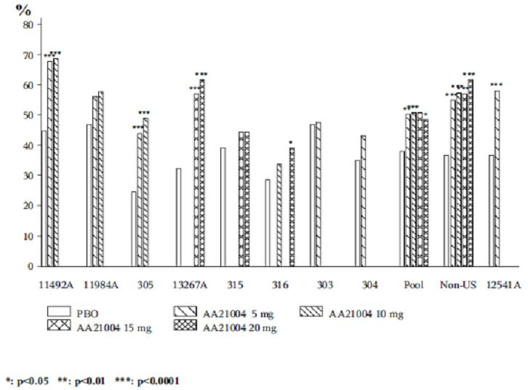

1. LOCF: Non US Studies 11492A, 305 and 13267A positively demonstrated statistical separation from placebo and treatment differences >16%;

2. LOCF: US Study 316, 20 mg dose demonstrated statistical separation from placebo but the treatment difference was < 16%;

3. LOCF: Pooled non US response rates positively demonstrated statistical separation from placebo across the therapeutic vortioxetine range with treatment differences >16% for all treatments but the % of responders were similar among all vortioxetine dose groups;

4. LOCF: MDD short term pool response rates positively demonstrated statistical separation from placebo for the 5 mg, 10 mg and 20 mg vortioxetine doses, but not for the 15 mg dose. All treatment differences were <16% and the % of responders were similar among all vortioxetine dose groups.

Figure 3. Response (greater than or equal to 50% decrease in MADRS) at Week 6/8 (FAS, OC); all short term studies.

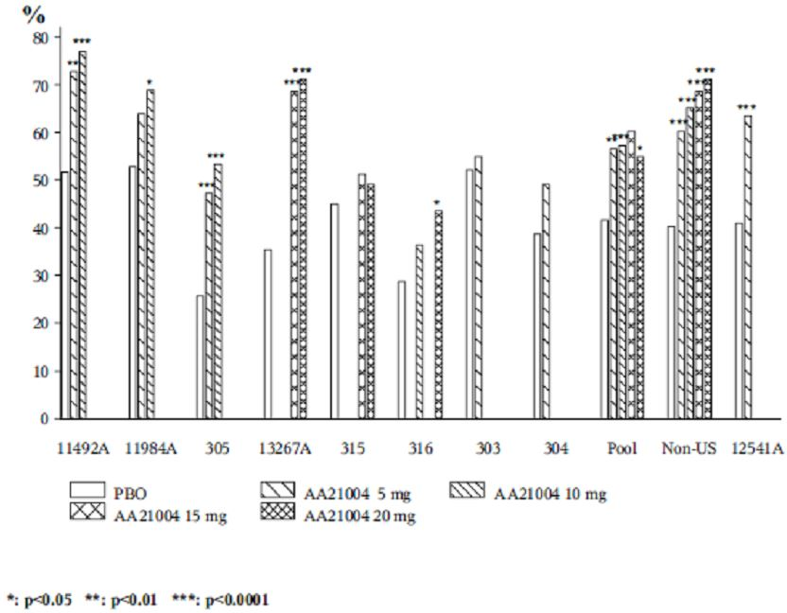

1. OC: Non US Studies 11492A, 305 and 13267A positively demonstrated statistical separation from placebo and treatment differences >16%. The 10 mg vortioxetine regimen in Study 11984A demonstrated statistical separation from placebo but the treatment difference was < 16%;

2. OC: US Study 316, 20 mg dose demonstrated statistical separation from placebo but the treatment difference was <16%;

3. OC: Pooled non US response rates positively demonstrated statistical separation from placebo across the therapeutic vortioxetine range with treatment differences >16% for all treatments in a dose response trend;

4. OC: MDD STP response rates positively demonstrated statistical separation from placebo for the 5 mg, 10 mg and 20 mg vortioxetine doses, but not for the 15 mg dose. All treatment differences were <16% except for the 15 mg dose. The % of responders was similar among all vortioxetine dose groups.

*Evaluator’s comments: In terms of overall responder rates, no dose response patterns were identified in the overall MDD STP results in the LOCF and OC analyses. Furthermore, applying the sponsor’s definition of >16% as a clinically relevant treatment difference (versus placebo), the overall pooled results in the LOCF analysis failed to achieve >16% for any therapeutic vortioxetine dose, irrespective of achieving statistical separation versus placebo. Generally, the LOCF and OC analysis results were very similar. The evaluator notes the only vortioxetine treatment in the OC analysis that achieved a treatment difference >16% was the 15 mg regimen, but this dose group failed to demonstrate statistical separation versus placebo.*

*While a dose response trend was observed in the OC analysis of the non US pooled studies (but not LOCF), as well as statistically significant separation versus placebo at each vortioxetine dose, as well as treatment differences that exceeded >16% for all vortioxetine treatments in LOCF and OC analyses, this evaluator considers it improper to consider US studies and non US studies as separate groups. Given the lack of dose-response in the overall pooled data for the short term MDD studies, the similar response rates between therapeutic vortioxetine treatments and generally treatment differences <16%, vortioxetine in the proposed therapeutic range has failed to satisfactorily demonstrate superior efficacy versus placebo using ≥50% overall responder rates.*

#### Response rates sub-grouped by history of MDE (no previous MDE or recurrent MDE):

**Sponsor’s response:** In the Vortioxetine clinical development program, Studies 11492A, 11984A, 305, 303 and 304 (Vortioxetine 5 and 10 mg/day) included patients with no previous MDE as well as patients with recurrent MDE. Studies 13267A, 315, and 316 (Vortioxetine 10, 15, and 20 mg/day) included only patients with recurrent MDE.

The proportion of responders, based on a ≥50% reduction from baseline in MADRS total score, with recurrent MDE are summarised in the clinical response document (LOCF and OC analyses, respectively).

##### Recurrent MDE

###### LOCF analysis

* Three of four non US studies demonstrated statistical separation versus placebo at all vortioxetine doses, in a dose response trend with a treatment difference >16% versus placebo. The 10 mg vortioxetine dose in Study 11984A also demonstrated statistical separation versus placebo, in a dose response trend but with a treatment difference <16% versus placebo;
* Only one of the four US studies demonstrated statistical separation versus placebo (Study 304), although with a treatment difference <16% versus placebo. The 20 mg regimen in Study 316 also demonstrated statistical separation versus placebo, but again with a treatment difference <16% versus placebo;
* Pooled non US response rates positively demonstrated statistical separation from placebo across the therapeutic vortioxetine range with treatment differences >16% for all treatments with a dose response tendency;
* MDD STP response rates positively demonstrated statistical separation from placebo for the 5 mg, 10 mg and 20 mg vortioxetine doses, but not for the 15mg dose. All treatment differences were <16%. The % of responders was similar among all vortioxetine dose groups.

###### OC analysis

* For non US studies, the OC results were very similar to the LOCF results except the 10mg vortioxetine dose in Study 11984A had a treatment difference >16% versus placebo;
* For US studies, the OC results were very similar to the LOCF results except the treatment difference in Study 304 became >16% versus placebo;
* For Pooled non US studies, the OC results were very similar to the LOCF results with a dose response trend observed;
* MDD STP response rates positively demonstrated statistical separation from placebo for the 5 mg, 10 mg and 20 mg vortioxetine doses, but not for the 15 mg dose. All treatment differences were <16% except for the 15 mg dose. The % of responders was similar among all vortioxetine dose groups.

##### Without MDE

###### LOCF analysis

* Only one dose (vortioxetine 10 mg in Study 305) in the three non US studies demonstrated statistical separation versus placebo, and this was with a treatment difference >16% versus placebo;
* No dose regimen demonstrated statistical separation versus placebo in the two US studies. Indeed, placebo response exceeded vortioxetine response in each study;
* Pooled non US study response rates did not demonstrate statistical separation versus placebo and treatment differences were <16% compared with placebo;
* MDD STP response rates did not demonstrate statistical separation versus placebo and treatment differences were <16% compared with placebo. There appeared to be a dose response trend.

###### OC analysis

* For non US studies, the OC results were very similar to the LOCF results;
* For US studies, the OC results were very similar to the LOCF results except in Study 303 the vortioxetine response rate was higher compared with placebo, albeit <16% treatment difference and not statistically significant;
* For pooled non US studies, the OC results were very similar to the LOCF results;
* MDD STP response rates for OC were very similar to the LOCF results.

*Evaluator’s comments: In terms of overall responder rates for subjects with recurrent MDE, no dose response patterns were identified in the overall MDD STP results in the LOCF and OC analyses. Furthermore, applying the sponsor’s definition of >16% as a clinically relevant treatment difference (versus placebo), the overall pooled results for recurrent MDE in the LOCF analysis failed to achieve >16% for any therapeutic vortioxetine dose, irrespective of achieving statistical separation versus placebo. Generally the LOCF and OC analysis results were very similar for recurrent MDE as well as overall responder rates (see [a] above). The evaluator notes the only vortioxetine treatment in the OC analysis that achieved a treatment difference >16% was the 15 mg regimen, but this dose group failed to demonstrate statistical separation versus placebo.*

*While a dose response trend was observed in the OC analysis of the non US pooled studies (and tendency in the LOCF analysis), as well as statistically significant separation versus placebo at each vortioxetine dose, as well as treatment differences that exceeded >16% for all vortioxetine treatments in LOCF and OC analyses, this evaluator considers it improper to consider US studies and non US studies as separate groups. Given the lack of dose response in the overall pooled data for the short term MDD studies, the similar response rates between therapeutic vortioxetine treatments and generally treatment differences <16%, vortioxetine in the proposed therapeutic range has failed to satisfactorily demonstrate superior efficacy versus placebo using ≥50% responder rates in those subjects with an established history of recurrent MDE.*

*In subjects with no prior history of MDE, the LOCF and OC analysis results were very similar. Apart from one vortioxetine dose (10 mg) in Study 305, no other non US or US study, or pooled analysis, demonstrated statistical separation versus placebo. While adult subjects with no prior history of MDE were only exposed to lower doses of vortioxetine (5 mg and 10 mg doses) than those with recurrent MDE, the submitted data does not indicate any therapeutic benefit in vortioxetine treatment in this population, Indeed, in Studies 303 and 304, placebo treatment was superior to vortioxetine 5 mg treatment.*

#### Response rates sub grouped by severity of depression (mild/moderate or severe):

**Sponsor’s response:** In the vortioxetine clinical development program, Studies 11984A, 305, 13267A, 315 and 316 (vortioxetine 5, 10, 15 and 20 mg/day) included patients with a baseline MADRS total score ≥ 26 (moderate) and Studies 11492A and 303 (vortioxetine 5 & 10 mg/day) included patients with a baseline MADRS total score ≥ 30 (severe). Study 304 included patients with a baseline MADRS total score ≥ 22 (mild).

The proportion of responders, based on a ≥50% reduction from baseline in MADRS total score, with severe MDD are summarised in Tables 7 and 8 of the clinical response document (LOCF and OC analyses, respectively).

##### Severe depression (baseline MADRS total score ≥ 30)

###### LOCF analysis

* Three of four non US studies demonstrated statistical separation versus placebo at all vortioxetine doses, in a dose response trend with a treatment difference >16% versus placebo;
* No US study demonstrated statistical separation versus placebo and all treatment differences were <16% versus placebo;
* Pooled non US response rates positively demonstrated statistical separation from placebo across the therapeutic vortioxetine range with treatment differences >16% for all treatments (no dose response trend);
* MDD short term pool response rates positively demonstrated statistical separation from placebo for the 5 mg and 10 mg vortioxetine doses, but not for the 15 mg and 20 mg doses. All treatment differences were < 16% versus placebo and no response trend was observed.

###### OC analysis

* For non US studies, the OC results were very similar to the LOCF results except the 10mg vortioxetine dose in Study 11984A demonstrated statistical separation from placebo (but with <16% treatment difference);
* For US studies, the OC results were very similar to the LOCF results;
* For Pooled non US studies, the OC results were very similar to the LOCF results with a small dose response trend observed;
* MDD STP response rates for OC were very similar to the LOCF results.

##### Mild/moderate depression (baseline MADRS total score < 30)

###### LOCF analysis

* Two of three non US studies demonstrated statistical separation versus placebo at all vortioxetine doses, in a dose response trend with a treatment difference >16% versus placebo;
* No US study demonstrated statistical separation versus placebo and all treatment differences were <16% versus placebo except the 20 mg vortioxetine regimen in Study 316;
* Pooled non US response rates positively demonstrated statistical separation from placebo for vortioxetine 5 mg, 15 mg and 20 mg with treatment differences >16% for 10 mg, 15 mg and 20 mg treatments;
* MDD STP response rates positively demonstrated statistical separation from placebo for the 5 mg, 15 mg and 20 mg vortioxetine doses, but not for the 10 mg dose. The 15 mg and 20 mg doses achieved treatment differences >16% versus placebo. No response trend was observed.

###### OC analysis

* For non US studies, the OC results were very similar to the LOCF results except the 10 mg vortioxetine dose in Study 11984A had a treatment difference >16% versus placebo;
* For US studies, the OC results were very similar to the LOCF results except the 20 mg vortioxetine dose in Study 316 demonstrated statistical separation from placebo and the 15 mg dose, while not demonstrating statistical superiority versus placebo did demonstrate a >16% treatment difference against placebo;
* For pooled non US studies, the OC results were very similar to the LOCF results except all vortioxetine treatments positively demonstrated statistical separation from placebo;
* MDD STP response rates for OC were very similar to the LOCF results.

*Evaluator’s comments: The response rate profiles by severity are similar and consistent with the rates and distribution for the overall responder rates, and those with recurrent MDE (but not with subjects with any prior history of MDE). The OC analyses generally resulted in slightly more favourable outcomes for vortioxetine treatments. Of note, in the pooled analysis of MDD short term studies, those subjects with mild/moderate depression appeared to derive greater benefit from higher vortioxetine dosing (15 mg and 20 mg) compared with subjects with severe depression, which appeared to derive greatest benefit from the lower vortioxetine regimens (5 mg and 10 mg), although the latter did not achieve the >16% treatment difference the sponsor made reference to. The results of the breakdown in responder rates by severity of depression were unexpected and, as a result, it is difficult to identify which patient groups (if any) derive the greatest benefit from vortioxetine treatment. Breakdown in responder rates by dose, severity and history of MDE may provide more meaningful results. Alternatively, further breakdown of subjects who failed to respond to treatment may assist in identification of those subject groups most likely to benefit from vortioxetine treatment.*

##### Question 6

The first round clinical evaluator asked the sponsor to explain why the primary efficacy analyses (and other important efficacy endpoints) were not presented by individual vortioxetine dose (5 mg or 10 mg), but the combined vortioxetine group instead, for Study 11985A, the relapse prevention trial. This information was requested for the OC and LOCF analyses.

**Sponsor’s response:** Compliant with the TGA adopted guideline for depression,[40] the sponsor did not randomise patients into the DB period by dose. Hence, the primary efficacy results for Study 11985A were presented for the combined (Total) vortioxetine dose (~75% received 10 mg and 25% the 5 mg regimen) versus placebo. Study 11985A was powered based on the analysis of time to relapse in the DB period for the combined doses. Analyses by individual doses are regarded as exploratory subgroup analyses. Table 25 summaries the time to relapse within the 24 week DB period of Study 11985A for the 5 mg and 10 mg vortioxetine doses.

Table 25. Time to relapse within the first 24 weeks of the DB period (FAS, Cox Model): Study 11985A.

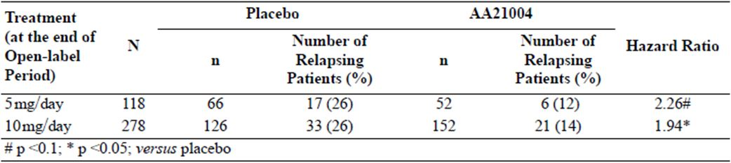

The sponsor provided tabulated results of the mean change from Baseline II in MADRS total score up to Week 24 of the DB period, using LOCF and OC. During the DB period, a considerably larger proportion of patients in the placebo group than in the vortioxetine group withdrew from the study (mainly due to relapse), resulting in a larger difference to placebo in the analysis of covariance (ANCOVA) based on LOCF than on OC. Hence, the OC data is more conservative.

The vortioxetine 5 mg dose regimen (OC analysis) did not statistically separate from placebo at any time point in the 24 week DB period. In contrast, the LOCF analysis demonstrated statistical separation from placebo from Weeks 4 to 16 (inclusive), but ‘borderline significance’ at Weeks 20 and 24 (inclusive). The vortioxetine 10 mg dose regimen (OC analysis) demonstrated statistical separation from placebo from Weeks 4 to 16 (inclusive) and at Week 24 but not at Week 20 (p = 0.1864). In contrast, the LOCF analysis demonstrated statistical separation from placebo from Weeks 4 to 24 (inclusive).

*Evaluator’s comments: While the primary efficacy analysis for Total vortioxetine treatment resulted in a statistically significant HR (2.01, p = 0.0035), the result for the 5 mg regimen did not reach statistical significance, although there was a tendency towards statistical significance per se. The latter finding may be due to the smaller subject numbers in the 5 mg group. Not providing efficacy results by individual dose may comply with the TGA adopted guideline for depression but does not help to guide clinicians on the most appropriate maintenance dose for their patients.*

*In the analysis of time to relapse within the 24 week DB period, using the more conservative OC analysis for MADRS score (the secondary efficacy analyses in this study), the vortioxetine 5 mg regimen did not show superiority versus placebo at any time point, and while the 10 mg regimen did so at multiple points (including the 24 week endpoint), it did not separate from placebo at the 20 week time point. Furthermore, the upper 95% CIs for most 10 mg time points that attained statistical separation versus placebo were between -0.22 and -0.62, that is, close to zero (not statistically significant).*

*The less conservative LOCF analysis of the 5 mg vortioxetine regimen, while showing statistical separation versus placebo at several time points in the DB period, did not show an overall statistical significant result at the end of the DB period (24 weeks), thereby supporting the OC analysis results. Of those time points that reached statistical significance, the 95% upper CI ranged from -0.08 to -0.30, that is, close to zero (not statistically significant). The LOCF analysis of the 10 mg vortioxetine regimen gave a more favourable efficacy profile than the OC analysis.*

*In conclusion, combining the 5 mg and 10 mg vortioxetine regimens into a total combined vortioxetine group gives a more statistically significantly favourable outcome than vortioxetine regimens singly, but is not helpful to the clinician in establishing the most appropriate maintenance dose for their patient. While it was beyond the scope of the study to examine the efficacy results of individual doses, the submitted data, albeit on small subject numbers, does not support the 5 mg vortioxetine regimen in relapse prevention of a MDE. The use of a 10 mg vortioxetine regimen may provide a benefit in preventing relapse of a MDE, but the OC analysis results as a whole are inconsistent. Further study is needed to ascertain the optimal dose in maintenance treatment, especially the aged population (no breakdown by dose and age provided but subject numbers are expected to be too small to draw meaningful conclusions about optimal dosing in this subpopulation).*

##### Question 7

The first round clinical evaluator asked the sponsor to reconcile the marked differences between responder and remitter rates in the open label phase of the relapse prevention Study 11985A compared with the DB treatment phase of the MDD short term pivotal studies.

**Sponsor’s response:** The differences between the response and remission rates in the OLP of Study 11985A and the MDD short term studies may be explained by differences in treatment duration (Study 11985A: 12 weeks; MDD short term studies: 6/8 weeks) and study design characteristics (Study 11985A: OL, flexible dose; MDD short term studies: DB, fixed dose, placebo controlled). The high response and remission rates observed at the end of the OLP may be explained by the anticipation of a better treatment effect by raters or patients when treated with active drugs as compared with a study where placebo is included as a treatment arm. The response and remission rates for Study 11985A and the MDD short term studies are summarised in Table 26.

Table 26. Response and remission rates.

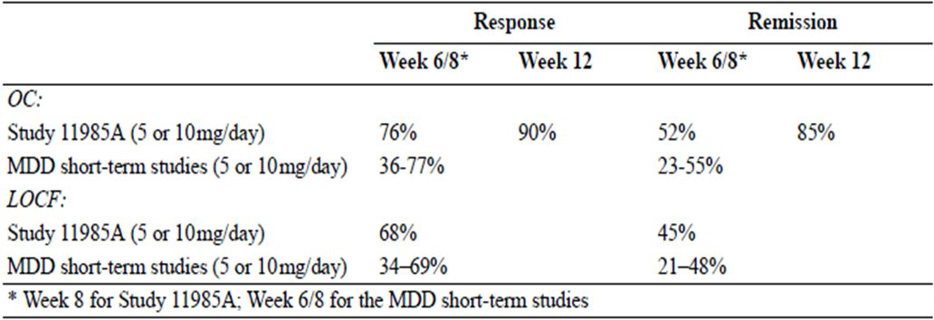

*Evaluator’s comments: The short term adult MDD studies were limited to 6 or 8 weeks DB treatment so no comparison at 12 weeks can be made. The response and remission rates for the OC analysis during the first 6-8 weeks OL treatment were consistent with the MDD short term studies, on an equivalent dose basis (although the results of Study 11985A are presented as a total combined 5/10 mg vortioxetine group rather than as individual regimens). The high response rate and especially the high remission rate at 12 weeks of OL treatment may be explained by the OL design of Study 11985A.*

##### Question 8

The first round clinical evaluator requested the proportions of subjects who had sustained remission (MADRS total score ≤ 10) from Baseline II up to Week 24 of the DP period in Study 11985A by OC and LOCF analyses.

**Sponsor’s response:** Since all observations for a patient are used to determine whether loss of remission has occurred, the results based on OC or LOCF data are identical. Table 27 summarises the requested information.

Table 27. MADRS sustained remission up to Week 24 (FAS): Study 11985A MADRS total score less than or equal to 10 throughout 24 weeks of DP period.

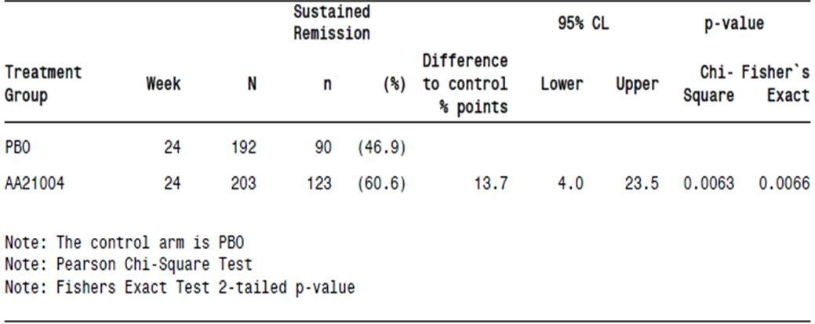

*Evaluator’s comments: The sponsor’s response is generally acceptable, although vortioxetine treatments by dose groups have not been provided, which may provide information on the more optimal dose for maintaining patients in remission. The NNT for one vortioxetine treated subject to remain in remission over 24 weeks treatment was 1/0.137 = 7. The treatment difference between total vortioxetine and placebo for sustained remission, and the primary efficacy variable (proportion of patients who relapsed over 24 weeks DB treatment) was similar, as were the patients needing to be treated (7 cases and 8 cases, respectively).*

#### Safety

##### Question 9

In the first round evaluation, the sponsor provided safety data for Study 314, to the 29 February 2012 cut off date. The evaluator requested further information on the proportions of subjects who withdrew from Study 314 (an ongoing extension study of subjects who had completed lead in Studies 315, 316 or 317 where subjects received flexible dosed 15 mg or 20 mg vortioxetine per day), as well as the main reasons for study withdrawal. The basis of this request was that of 986 subjects enrolled as of 29 February 2012, 112 had completed the study while 313 had withdrawn, that is, proportionately more subjects had withdrawn from the study than completed the study, which may indicate a new safety signal, especially at higher doses of vortioxetine. This first round evaluation data referred to withdrawals and completions by subjects originally recruited from US studies 315 and 316 not from 317.

**Sponsor’s response:** The sponsor provided tabulated data from Study 314 with a cut off date of 26 October 2012 (Table 28). From the table, the study withdrawal rate for the 26 October 2012 cut off date had reduced proportionately compared with subjects who had completed the study as of 29 February 2012. The primary reasons for withdrawal were ‘withdrawal of consent’ (11.9%), AEs (10.8%), and lost to follow up (8.8%).

Table 28. Patient disposition and withdrawals by primary reason (APTS): Study 314.

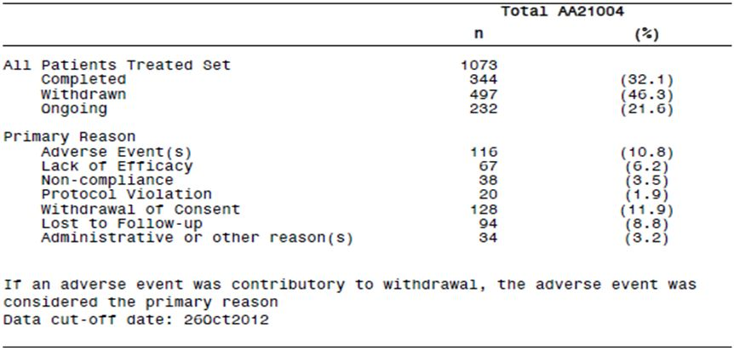

The sponsor also provided a list of references that suggested the extent of study drug withdrawals for vortioxetine 15/20 mg day is comparable with other antidepressant agents (range: 26 to 59%).

*Evaluator’s comments: The sponsor did not provide detailed information on the reasons why subjects withdrew consent, so the information provided here is of limited usefulness. With 21.6% subjects still ongoing, proportionately an overall withdrawal rate of between 55 to 60% might be expected, or thereabouts. This compares with 35% withdrawals in Study 13267B using vortioxetine 15 mg and 20 mg doses. This evaluator still considers the withdrawal rate in Study 314 to be much higher than expected for this agent, but the reason/s for this unexpectedly higher rate cannot be determined given ~20% of the study population were either lost to follow up or did not provide further details on why consent was withdrawn*

##### Question 10

The sponsor did not provide a summary table of incidences of ADRs for vortioxetine in the MDD STP in its original Summary of Clinical Safety document. These ADRs relate to those TEAEs deemed possibly or probably related to study drug treatment by the investigator. The first round clinical evaluator requested ADRs in relation to overall TEAE incidence, and incidence of SAEs, severe TEAEs, and TEAEs leading to withdrawal by vortioxetine dose for the STP.

**Sponsor’s response:** Related TEAEs are summarised for the Core Treatment Period (from first to last dose of IMP in the DB Period), except for related SAEs, which are summarised for the Entire Study Period (from first dose of the Investigational Medicinal Product to last visit/contact, including the Discontinuation and Safety Follow up Periods). The sponsor collated overall incidence of treatment related TEAEs by SOC from individual study reports.

* Overall ADR incidences of therapeutic vortioxetine doses occurred with a dose dependent trend. GI disorders and CNS disorders accounted for most ADRs, with nausea the most common, observed in a dose response manner.
* Eight vortioxetine cases (0.3% total group) had SAEs versus two cases (0.1%) with placebo treatment. No dose response trends were observed in the vortioxetine groups. The only related serious TEAE that occurred in ≥2 patients in any treatment group (including the vortioxetine total group) was depression: 1 patient (<0.1%) in the placebo group; 1 patient (<0.1%) in the vortioxetine 5 mg/day group; 2 patients (0.4%) in the vortioxetine 10mg/day group.
* No dose response trends were observed in the vortioxetine groups for severe TEAEs. There were no related severe TEAEs with an incidence ≥1% in the vortioxetine total group. The incidence of related severe nausea was 0.1% in the placebo group and 1.3% in the vortioxetine 20 mg/day group (highest incidence).
* There was an overall dose related trend for therapeutic vortioxetine doses versus placebo (3.7% for 5 mg, 5.1% for 10 mg, 7.0% for 15 mg and 8.1% for 20 mg versus 3.0%, respectively) in the withdrawal related data. There was a dose dependent trend for GI disorders. The only related TEAE leading to withdrawal in ≥1% of the patients in the vortioxetine total group was nausea (2.0%), with a trend towards a dose response relationship (1.2%, 1.8%, 3.4% and 4.4% in the 5, 10, 15 and 20 mg groups, respectively, versus 0.3% for placebo treatment).

*Evaluator’s comments: The information provided by the sponsor is satisfactory. Overall, the pattern of ADRs in the MDD STP is consistent with those seen for AEs irrespective of relationship to study drug. While no new safely signals were identified from the submitted data, nausea is consistently the TEAE that gave rise to the highest overall incidence of TEAEs, with highest severity, highest incidence of SAEs and TEAEs that lead to study withdrawal. The (adverse) effect of nausea appears to be dose related across the proposed therapeutic vortioxetine range.*

*Summary tables of ADRs have been incorporated into the main text of this report.*

##### Question 11

Since the integrated safety database for the Phase II/III clinical trials had a cut-off date of 29 February 2012, the first round clinical evaluator requested an updated safety report to include any new deaths, and further incidence data for treatment-emergent SAEs, severe TEAEs and TEAEs that lead to study withdrawal.

**Sponsor’s response:** The sponsor provided clinical study reports for an additional five clinical studies in MDD completed since the data package was originally submitted to TGA (four short term studies and one long term OL study):

* Study 317: 8 weeks, placebo controlled, fixed dose (10 or 15 mg/day);
* Study 14122A: 8 weeks, placebo controlled, fixed dose (10 or 20 mg/day);
* Study 14178A: 12 weeks, flexible dose (10 or 20 mg/day), active comparator (agomelatine 25 or 50 mg/day). Not placebo controlled;
* Study 13267B:1 year extension to Study 13267A, OL, flexible dose (15 or 20 mg/day);
* Study CCT-002: 8 weeks, placebo controlled, fixed dose (5, 10, or 15 mg/day).

Studies 317, 14122A and CCT-002 are included in the updated MDD STP. The design of Study 14178A made it unsuitable for pooling with other MDD studies. Study 13267B results are included in the updated MDD Ongoing Open label Long term Pool. All patients in the updated MDD Ongoing Open label Long term Pool received vortioxetine 15 or 20 mg/day.

*Evaluator’s comments: The information the sponsor provided is acceptable. In addition to the information the first round clinical evaluator requested, the sponsor also provided an integrated safety update that encompassed adverse events of special interest. The updated safety data has been incorporated into the relevant sections of the main text of this report and identified. In summary, the additional data added to the body of clinical knowledge of the safety of vortioxetine in the proposed therapeutic dose range. The updated safety report is generally consistent with the original findings documented in individual study reports, the original Summary of Clinical Safety document and the RMP. No new safety signals have been identified in the updated safety report and no new deaths were recorded with vortioxetine treatment since the original 29 February 2012 cut off.*

##### Question 12

The proportion of MDD patients with post baseline suicidal ideation was 12% in the elderly versus 19% in adult patients with MDD (in the vortioxetine 5 mg group in Studies 303, 304, 305, 13267A and 316). The first round clinical evaluator requested a breakdown in incidence rates for suicidal ideation by gender for the elderly and adult groups, respectively.

**Sponsor’s response:** The sponsor provided suicidal ideation and behaviour data (based on C-SSRS scores during the study by C-CASA) for the elderly (Study 12541A) in its response document. Male gender was associated with 5.9% rate of suicidal ideation compared with 14.0% in females. The sponsor provided suicidal ideation and behaviour data (based on C-SSRS scores during the study by C-CASA) for the adult population in Studies 303, 304, 305, 13267A, 315 and 316 in its response. Male gender was associated with 15.6% total rate of suicidal ideation and 19.6% incidence at a 5 mg vortioxetine dose. Female gender was associated with 15.9% total rate of suicidal ideation and 18.8% incidence at a 5 mg vortioxetine dose.

*Evaluator’s comments: In the elderly, there appeared to be a higher incidence of suicidal ideation in females than males, but these results were based on small subject numbers and the differences versus placebo treatment were not clinically significant. On this basis, vortioxetine treatment was not clinically associated with suicidal ideation in the elderly in total and by gender at a vortioxetine dose of 5 mg/day. In adults, vortioxetine treatment did not demonstrate a dose response relationship with suicidal ideation in total or by gender breakdown for Studies 303, 304, 305, 13267A, 315 and 316. Although the incidence rates for adults for 5 mg vortioxetine treatment were relatively higher than those demonstrated in the elderly population, the treatment differences versus placebo were not clinically significant.*

*Of note, whereas no male adult subject reported a C-SSRS score higher than 5 (1-5 = suicidal ideation or behaviour), one female who received 5 mg vortioxetine had a C-SSRS score of 6-8, that is, preparatory action towards imminent suicidal behaviours and two female subjects who received 10 mg vortioxetine recorded C-SSRS scores of 9, that is, not fatal suicide attempt. The incidence rates are too small (0.3% and 1.0%, respectively) to draw meaningful conclusions of any possible association with vortioxetine treatment and suicidal ideation and behaviour, especially in female subjects. However, suicidal ideation and behaviour is well documented in the risk management plan and is a recognised adverse event of special interest for antidepressants as a class of drugs.*

### Second round benefit-risk assessment

The benefit-risk balance is favourable for registration of vortioxetine hydrobromide in MDD.

In general, the pattern and incidence of TEAEs (overall incidence, incidence of SAEs or AEs leading to withdrawal) were similar between placebo and vortioxetine across the proposed therapeutic range (5 to 20 mg once daily, inclusive). Nausea in particular, and dizziness to a lesser extent, gave rise to proportionately more AEs than any other preferred term in most studies submitted. There was some suggestion tolerance to the development of nausea occurred in some subjects. Development of nausea, while distressing to some subjects is the only detailed risk identified in the submission. While there was a dose response relationship for this AE in most analyses, the relatively minor trade off of having worse severity nausea over the potential therapeutic gain of improved MDD symptom control at a higher vortioxetine dose makes this risk more acceptable.

The potential risks for vortioxetine as an antidepressant agent are extensive (see RMP for further details) and this must be kept in perspective should vortioxetine be granted registration for MDD (and future indications such as GAD). For instance, subjects were selected with a relatively low risk of suicidal behaviour but in the post marketing clinical setting this is not likely to remain the case, particularly with patients with severe depressive symptoms, prior history of self-harming behaviour, co-morbidities and Axis II disorders. Any association between development of neoplasms and vortioxetine exposure will only become apparent after much longer exposure. The long term safety of vortioxetine in MDD (and other indications) has not been established. Comprehensive post marketing pharmacovigilance activities will need to be undertaken to more fully establish the safety profile of vortioxetine over time.

For vortioxetine to be registered in MDD, the clinical data submitted needed to demonstrate efficacy in a broad range of subjects from diverse racial and cultural origins. While this appeared to have been satisfactorily demonstrated in non US studies this was not the case with US based studies. Hence, the decision to approve or reject the application should be based primarily on the overall results, that is, US and non US studies combined.

Notwithstanding the more favourable non US study results in terms of the primary efficacy endpoint, when the MMRM sensitivity analyses of the primary efficacy endpoint were taken into consideration, this resulted in more positive studies, more supportive studies and less negative studies (3 of 10 in total compared with 5 of 10 before the sensitivity analyses were undertaken). The large number of short term adult studies in MDD is indicative of the number of failed or negative studies usually expected in a MDD submission of this type. There is a significant placebo effect in MDD and this was seen across all the MDD studies in this submission. Thirty per cent (30%) failed or negative study (after sensitivity analyses) provides reasonable demonstration of vortioxetine efficacy in the acute phase of adult MDD. The designated study in the elderly also produced a positive study result. Efficacy was further supported in the relapse prevention study and the active comparator (agomelatine) study, as well as the meta analyses of the primary efficacy endpoint.

The meta analysis of all the short term adult MDD studies did not demonstrate a clear dose response relationship (as compared with the non US studies meta analysis). In part, the poor response in US subjects may have been due to subject selection issues, such as misdiagnosis of MDE or MDD, or non recruitment of subjects without an established history of recurrent MDE/MDD, or perhaps suboptimal dosing in US subjects. However, given > 2 points treatment difference of vortioxetine versus placebo is regarded as clinically relevant, the point estimates did indeed reach clinical significance in favour of vortioxetine across the whole proposed therapeutic range (5 to 20 mg, inclusive). While the 15mg vortioxetine regimen did not reach statistical significance (in either meta analysis), the point estimate was still clinically relevant. The wide confidence intervals of the 15mg group did not allow for statistical separation versus placebo. The latter may, in part, have occurred because of a change in emphasis within the clinical development program for vortioxetine when doses up to and including 10 mg once daily were not found to produce optimal efficacy outcomes. The program was changed and doses up to 20 mg once daily were included in subsequent trials. Hence, the lack of statistical significance in the 15 mg vortioxetine regimen is, in part, due to lack of subject numbers who received this dose. The PK and PD results suggest there is dose proportionality across the vortioxetine therapeutic range and so a dose response relationship in patients with MDD would be expected, given sufficient participant numbers and studies are well conducted. Furthermore, analysis of individual short term adult MDD studies and pooled analyses in terms of subgroup, sensitivity and key secondary endpoints generally supported the primary efficacy results. On this basis, efficacy in acute phase MDD in adults has been satisfactorily demonstrated across the therapeutic range.

In the elderly (≥ 65 years), efficacy was clearly established at a 5 mg once daily regimen in the designated study. There were too few participants in the pooled analysis over the vortioxetine therapeutic range to make recommendations of alternative regimens. On this basis, elderly patients should commence on a starting dose of 5 mg once daily.

The relapse prevention study only examined subjects taking 5 mg or 10 mg vortioxetine. While the 10 mg regimen demonstrated statistical separation versus placebo, the 5 mg regimen did not, although the result was borderline significant. On this basis, adult (and maybe elderly) subjects maintained on doses of 10 mg once daily or less may provide a benefit in reducing a single episode of relapse (NNT 8). The submission did not provide relapse prevention data for doses >10 mg once daily and hence the maximum dose recommended should not exceed 10 mg once daily in maintenance treatment (for adults and especially the elderly, who are more likely to have comorbidities and concomitant medications that have the potential to change the benefit-risk balance away from vortioxetine treatment). Furthermore, the relapse prevention study was not designed to demonstrate prevention of remission of MDD. This aspect of MDD treatment requires further study.

In view of the results of responder rates > 50% by prior history of MDD (see ‘List of Questions’), in which subjects who did not have a previous history of MDE/MDD did not appear to derive benefit from vortioxetine treatment versus placebo, vortioxetine administration in this group of patients is not acceptable to this evaluator. While vortioxetine across the therapeutic range was well tolerated and nausea is the only currently identified risk, the benefit-risk balance for this group is not acceptable in view of the extensive list of known potential risks **plus** there may be yet unknown risks for a new chemical entity that may only become apparent over time. It is therefore recommended only subjects with an established history of recurrent MDD should receive vortioxetine. Hence, vortioxetine should not be administered as first line treatment in MDD, in adults at least.

### Second round recommendation regarding authorisation

The evaluator recommends approval of the sponsor’s application to register Brintellix (vortioxetine hydrobromide) for major depressive disorder in adults (and the aged) provided the following conditions are met:

* Vortioxetine should only be administered to patients with an established history of MDE or MDD;
* Vortioxetine should be reserved for second line use in MDD, upon initial registration;
* The aged (≥ 65 years of age) should commence vortioxetine on a dose of 5 mg once daily;
* Maintenance treatment, that is, relapse prevention doses of vortioxetine for adults and the aged should be restricted to 10 mg once daily, upon initial registration;

The sponsor should provide detailed assurance it will be proactive in undertaking post marketing pharmacovigilance activities and in its reporting of any new safety signals or potential safety signals, until the safety profile of vortioxetine as a new class of chemicals for human administration, becomes well established.

## V. Pharmacovigilance findings

### Risk management plan

The sponsor submitted a RMP:

*European Risk Management Plan (EU-RMP) with an Australian Specific Annex (ASA) submitted by Lundbeck Australia Pty Ltd in support of application to register a new chemical entity: Brintellix vortioxetine (as hydrobromide) 5, 10, 15 and 20 mg film coated tablets*

which was reviewed by the TGA’s Office of Product Review (OPR).

#### Safety specification

The sponsor provided a summary of Ongoing Safety Concerns which are shown at Table 29.

Table 29. Ongoing Safety Concerns for Brintellix.

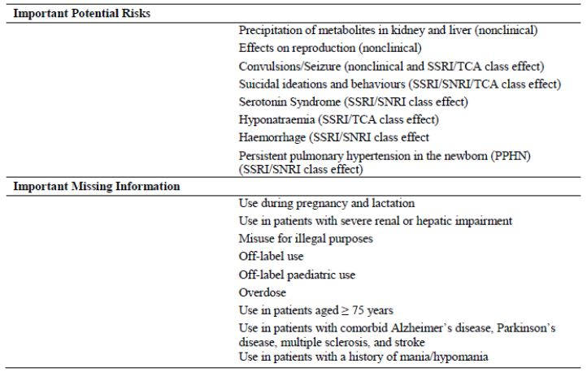

##### OPR reviewer comment:

Notwithstanding the evaluation of the nonclinical and clinical aspects of the Safety Specification, at this time the above summary of the Ongoing Safety Concerns is considered acceptable.

#### Pharmacovigilance plan

##### Proposed pharmacovigilance activities

The ASA states that the Lundbeck Australia subsidiary is a local pharmacovigilance centre and is responsible for numerous processes including the:

* Collection, tracking and follow up of AE reports;
* Literature surveillance of local literature, not covered by the centrally conducted literature searches;
* Forwarding of AE/ADR reports to Global Pharmacovigilance, H. Lundbeck A/S for data entry;
* Submission of expedited reports to the TGA and Centre for Adverse Reactions Monitoring (CARM), NZ;
* Training of affiliate staff in pharmacovigilance obligations;
* Archiving of source documents;
* Compliance and maintenance of Pharmacovigilance Standard Operating Procedures (SOPs);
* Establishment and maintenance of third party pharmacovigilance agreements; and
* Compliance with local regulatory safety requirements (for example, submission of Periodic Safety Update Reports [PSURs], updates to existing RMPs).

The sponsor proposes routine pharmacovigilance activities to monitor all the specified Ongoing Safety Concerns.

Furthermore, the sponsor proposes to further characterise and monitor all the specified ongoing safety concerns, except the important potential risks: ‘Serotonin Syndrome (SSRI/SNRI class effect)’, ‘Hyponatraemia (SSRI/TCA class effect)’ and ‘Haemorrhage (SSRI/SNRI class effect) and the important missing information: ‘Misuse for illegal purposes’ and ‘Overdose’, by conducting a non interventional post authorisation safety study (PASS) of vortioxetine in Europe. A historical cohort design using European longitudinal electronic healthcare databases is intended to explore:

* the patterns of use of vortioxetine in some populations or situations considered as important missing information; and
* the frequency of occurrence of selected important potential risks (suicidal behaviours, convulsions/seizures and severe renal or hepatic events due to precipitation of metabolites in kidney and liver).

The sponsor has provided a synopsis of this study in Annex 5 of the EU-RMP, which states the analyses will be performed separately in each database and the different datasets will not be pooled. The sample size calculation is thus made for each database and relies on the precision estimation with 95% confidence of the prevalence of events of interest, using normal approximation of the binomial distribution. Based on a conservative hypothesis taking into account potential market access delays, the sponsor expects that within one to two years from market entry, at least 2,000 exposed patients will be observable in each database which would allow to detect proportions of users with important missing information of at least 1/666 = 0.15%. Evaluation is anticipated to be performed in 2017 with reporting to be made by beginning 2018. These milestones are to allow for a sufficient number of vortioxetine prescriptions after marketing authorisation, taking into account the anticipated duration of pricing and reimbursement negotiations in the different countries.

The current ASA states:

*The principles outlined in the routine pharmacovigilance program are applicable to the Australian environment. As described above, there are no significant differences between EU and Australia with respect to epidemiology, indication, or patient population. The clinical setting and prescribing practice is not expected to differ, with the large majority of MDD patients being treated in the primary care setting. Although not generating Australia specific data, the drug utilisation study proposed as part of additional pharmacovigilance activities, will be applicable to the Australian environment.*

##### OPR reviewer’s comments in regard to the pharmacovigilance plan (PP) and the appropriateness of milestones

In principle, there is no objection to the sponsor implementing additional pharmacovigilance activities to further monitor the specified ongoing safety concerns. However, the submitted synopsis will be considered by the Advisory Committee on the Safety of Medicines (ACSOM) as to whether the study design is adequate and if not, how could it be strengthened. In addition the committee will consider if Australian patient involvement is required. The sponsor should also provide an assurance that it will submit to the TGA a draft protocol for the proposed PASS for review once it becomes available.

The ASA should also be revised to include amended details of the PASS when this document is next updated.

#### Risk minimisation activities

##### Sponsor’s conclusion in regard to the need for risk minimisation activities

The ASA states:

*No additional risk minimisation measures are warranted at this time.*

The sponsor has provided justification and concluded that routine risk minimisation activities are sufficient for all the specified ongoing safety concerns, although no such activity is proposed for the important missing information: ‘Misuse for illegal purposes’.

##### OPR reviewer comment:

The sponsor’s justification and conclusion that no additional risk minimisation activities are needed appears reasonable and it is agreed the specified ongoing safety concerns would not appear to warrant additional risk minimisation activities. Therefore at this time the sponsor’s conclusion is considered acceptable. Nevertheless, it is recommended that ‘Planned Actions for Safety Concerns’ be corrected to indicate that no routine risk minimisation activity is proposed for the important missing information: ‘Misuse for illegal purposes’.

#### Summary of recommendations

The OPR provides these recommendations in the context that the submitted RMP is supportive to the application; the implementation of a RMP satisfactory to the TGA is imposed as a condition of registration; the submitted EU-RMP is applicable without modification in Australia unless so qualified; and the draft product information and consumer medicine information documents should **not** be revised until the Delegate’s Overview has been received:

* Safety considerations may be raised by the nonclinical and clinical evaluators through the consolidated Section 31 request and/or the nonclinical and clinical evaluation reports, respectively. It is important to ensure that the information provided in response to these include a consideration of the relevance for the RMP, and any specific information needed to address this issue in the RMP. For any safety considerations so raised, the sponsor should provide information that is relevant and necessary to address the issue in the RMP.
* In principle, there is no objection to the sponsor implementing additional pharmacovigilance activities to further monitor the specified ongoing safety concerns. However, the submitted synopsis will be considered by the ACSOM as to whether the study design is adequate and if not, how could it be strengthened. In addition the committee will consider if Australian patient involvement is required. The sponsor should also provide an assurance that it will submit to the TGA a draft protocol for the proposed PASS for review once it becomes available.
* The ASA should also be revised to include amended details of the PASS when this document is next updated.
* The sponsor’s justification and conclusion that no additional risk minimisation activities are needed appears reasonable and it is agreed the specified Ongoing Safety Concerns would not appear to warrant additional risk minimisation activities. Therefore, at this time the sponsor’s conclusion is considered acceptable. Nevertheless, it is recommended that ‘Planned Actions for Safety Concerns’ be corrected to indicate that no routine risk minimisation activity is proposed for the important missing information: ‘Misuse for illegal purposes’.
* The sponsor’s proposed application of routine risk minimisation activities would appear to be in general reasonable and therefore acceptable. Nevertheless, in regard to the proposed routine risk minimisation activities, it is recommended to the Delegate that the draft PI document be revised as follows:
  + For the important potential risk: ‘Effects on reproduction (nonclinical)’ and the important missing information: ‘Use during pregnancy and lactation’, the statement:

*There are no or limited data (fewer than 300 pregnancy outcomes) from the use of vortioxetine in pregnant women.*

may be included under the subheading: ‘Use in pregnancy’ in the ‘Precautions’ section of the PI to enhance safe use of these medicines.

* + For the important potential risk: ‘Effects on reproduction (nonclinical)’ and the important missing information: ‘Use during pregnancy and lactation’, the current precautionary statement:

*A pre and postnatal study in rats showed reduced pup survival during the lactation period at exposures similar to those achieved during clinical use in humans.*

may be amended to:

*A pre and postnatal study in rats showed reduced pup survival,* ***reduced bodyweight gain and delayed pup development*** *during the lactation period at exposures similar to those achieved during clinical use in humans.*

to enhance safe use of these medicines.

* + For the important potential risk: ‘Hyponatraemia (SSRI/TCA class effect)’, the statement:

*Discontinuation of Brintellix should be considered in patients with symptomatic hyponatraemia and appropriate medical intervention should be instituted.*

may be included under the subheading: ‘Hyponatraemia’ in the ‘Precautions’ section of the PI to enhance safe use of these medicines.

* + For the important potential risk: ‘Haemorrhage (SSRI/SNRI class effect)’, the following examples of medicinal products known to affect platelet function may also be included under the sub-heading: ‘Haemorrhage’ in the ‘Precautions’ section of the PI to enhance safe use of these medicines: atypical antipsychotics, phenothiazines and most tricyclic antidepressants.
  + For the important missing information: ‘Use in patients with a history of mania/hypomania’, the current precautionary statement:

*As with all drugs effective in the treatment of depression, Brintellix should be used with caution in patients with a history of mania.*

may be amended to:

*As with all drugs effective in the treatment of depression, Brintellix should be used with caution in patients with a history of mania and should be discontinued in any patient entering a manic phase.*

to enhance safe use of these medicines.

* In regard to the proposed routine risk minimisation activities, it is recommended to the Delegate that the draft Consumer Medicine Information (CMI) document be revised to adequately reflect any changes made to the Australian PI as a result of the above recommendations.

#### Reconciliation of issues outlined in the RMP report

Reconciliation of issues outlined in the RMP report is as follows.

##### Recommendation in RMP evaluation report #1

Safety considerations may be raised by the nonclinical and clinical evaluators through the consolidated Section 31 request and/or the nonclinical and clinical evaluation reports, respectively. It is important to ensure that the information provided in response to these include a consideration of the relevance for the RMP, and any specific information needed to address this issue in the RMP. For any safety considerations so raised, the sponsor should provide information that is relevant and necessary to address the issue in the RMP.

##### Sponsor’s response

The sponsor states that it has evaluated the consolidated Section 31 requests and has not detected any additional safety considerations for inclusion into RMP.

##### OPR evaluator’s comment

On the basis of the now available clinical evaluation report, it is suggested that the important potential risk: ‘Neoplasms’ and the important missing information: ‘Long-term safety data’ should be included as new Ongoing Safety Concerns. Consequently, changes to the pharmacovigilance and RMP must be considered (see Section 1: ‘Outstanding Issues’). To capture these various changes in their entirety, the sponsor should provide a tabular ‘Summary of the Risk Management Plan in Australia’ in a revised ASA, including reference to specific routine risk minimisation in the Australian PI.

##### Recommendation in RMP evaluation report #2

The sponsor should also provide an assurance that it will submit to the TGA a draft protocol for the proposed PASS for review once it becomes available.

##### Sponsor’s response

The sponsor has provided an assurance that it will submit a draft protocol of the PASS when it becomes available.

##### OPR evaluator’s comment

This is acceptable.

##### Recommendation in RMP evaluation report #3

The ASA should also be revised to include amended details of the PASS when this document is next updated.

##### Sponsor’s response

The sponsor has provided an assurance that the ASA will be updated based on the current version of the EU-RMP.

##### OPR evaluator’s comment

This is acceptable.

##### Recommendation in RMP evaluation report #4

The sponsor’s justification and conclusion that no additional risk minimisation activities are needed appears reasonable and it is agreed the specified Ongoing Safety Concerns would not appear to warrant additional risk minimisation activities. Therefore, at this time the sponsor’s conclusion is considered acceptable. Nevertheless, it is recommended that ‘Planned Actions for Safety Concerns’ be corrected to indicate that no routine risk minimisation activity is proposed for the important missing information: ‘Misuse for illegal purposes’.

##### Sponsor’s response

The sponsor claims that the fact vortioxetine is available only upon prescription is considered by the sponsor to be a routine risk minimisation activity and consequently this activity is so stated in Table 1 Part V of the updated EU-RMP for the important missing information: ‘Misuse for illegal purposes’.

##### OPR evaluator’s comment

This is noted.

##### Outstanding issues

###### Issues in relation to the RMP

The sponsor was asked to respond to safety considerations raised by the nonclinical and clinical evaluators through the consolidated Section 31 request and/or the nonclinical and clinical evaluation reports, respectively, in the context of relevance to the RMP. The sponsor states that it has evaluated the consolidated Section 31 requests and has not detected any additional safety considerations for inclusion into RMP. However, the clinical evaluation report (see below) states:

*Post marketing surveillance will help to identify whether vortioxetine is associated with neoplastic disease. Similarly, while the spontaneous AEs and C-SSRS analysis of suicide ideation and behaviour did not demonstrate a positive association with vortioxetine treatment, long term data will be required to ascertain if there is a ‘causal link’ and ‘any association between development of neoplasms and vortioxetine exposure will only become apparent after much longer exposure. The long term safety of vortioxetine in MDD (and other indications) has not been established. Comprehensive post marketing pharmacovigilance activities will need to be undertaken to more fully establish the safety profile of vortioxetine over time.’*

Consequently, on the basis of the clinical evaluation report, it is suggested that the important potential risk: ‘Neoplasms’ and the important missing information: ‘Long-term safety data’ should now be included as new Ongoing Safety Concerns. Furthermore, these new Ongoing Safety Concerns should be characterised and monitored by routine pharmacovigilance and by the proposed non interventional post authorisation safety study (PASS) of vortioxetine in Europe. It follows that the draft protocol for this PASS will need to be revised to accommodate these changes and Section 2.2: ‘Studies Referenced in the EU-RMP’ of the ASA (Version: 2.0) will need to be rewritten to accurately detail which Ongoing Safety Concerns will be the focus of this study when this document is next updated. At this time routine risk minimisation is not required for the new Ongoing Safety Concerns. To capture these various changes in their entirety, the sponsor should provide a tabular ‘Summary of the Risk Management Plan in Australia’ in a revised ASA, including reference to specific routine risk minimisation in the Australian PI.

In addition, the ACSOM considered the draft protocol synopsis of the PASS dated 12 April 2013 and stated:

*The committee noted that the sponsor has proposed to supplement the routine pharmacovigilance with a drug utilisation study. The committee advised that the drug utilisation study would collect data on off label use of vortioxetine in specific populations. However, the study did not align with any of the risks in the summary of ongoing safety concerns and was not being used to collect any safety data. Therefore, the proposed pharmacovigilance was essentially only routine pharmacovigilance. The committee advised that while they were supportive of the sponsor undertaking the drug utilisation study, in view of the novel multimodal characteristics of the drug, it would be desirable for the sponsor to expand the study design to gather additional data on outcomes of drug use and therefore include information on safety.*

The sponsor has provided an updated draft protocol synopsis of the PASS dated 22 August 2013 but it is not clear what changes have been made in this update. Nevertheless, the draft protocol synopsis of this study should be expanded to capture all of the specified Ongoing Safety Concerns, as well as the suggested new Ongoing Safety Concerns (see above). As previously mentioned, the revised draft protocol/synopsis of the PASS should be provided to the TGA for review once it is available.

The ACSOM also stated:

*The committee noted that the precautions in the Australian Product information (PI) differed from the EU Summary of Product Characteristics (SmPC) in the sections relating to concomitant use with monamine oxidase inhibitors, induction of hypomania/mania and use in patients with concomitant illness. ACSOM advised that where possible, precautions should be consistent and, this should be taken into consideration when evaluating the RMP and PI in the Australian context.*

This advice is raised with the Delegate for consideration, as are the various revisions to the draft PI and CMI recommended to the Delegate in the RMP Evaluation Report (28 June 2013).

Finally the ACSOM stated:

*The committee advised that the signal for convulsions and seizures in dogs with overdose was concerning. In particular the committee was concerned that seizures were observed in dogs with plasma levels only five times that of the recommended human dose. In a drug which for a condition which is often associated with medication overdoses, the committee considered that this threshold was quite low. Based on the nonclinical data, seizures are the most serious expected AE and ACSOM advised that the overdose section of the PI should be updated to reflect this.*

This advice is raised with the Delegate for consideration.

###### Advice from the Advisory Committee on the Safety of Medicines (ACSOM)

The ratified advice regarding Brintellix from the 18th meeting of ACSOM is attached. As previously mentioned, the ACSOM considered the draft protocol synopsis of the PASS dated 12 April 2013 and advised that this study should be expanded to align with the risks in the summary of Ongoing Safety Concerns to gather additional data on outcomes of drug use and therefore include information on safety. Furthermore, the committee advised that there was no reason that the sponsor should be expected to include Australian subjects in this study and as part of the pharmacovigilance plan would be applicable to the Australian environment.

The committee expressed concern that the precautions in the Australian PI differed from the EU SmPC in the sections relating to concomitant use with monamine oxidase inhibitors, induction of hypomania/mania and use in patients with concomitant illness. ACSOM advised that where possible, precautions should be consistent and, this should be taken into consideration when evaluating the RMP and PI in the Australian context.

The committee was also concerned that the signal for convulsions and seizures in dogs with overdose was concerning. In particular, the committee was concerned that seizures were observed in dogs with plasma levels only five times that of the recommended human dose. In a drug which for a condition which is often associated with medication overdoses, the committee considered that this threshold was quite low. Based on the nonclinical data, seizures are the most serious expected adverse event and ACSOM advised that the overdose section of the PI should be updated to reflect this.

##### Comments on the safety specification of the RMP

###### Clinical evaluation report

*The important potential risks and missing information are described in the draft RMP. The effect of the nonclinical findings of crystallisation in the liver and kidney in rats and mice, as well as the potential of adenoma formation in these organs is not yet known. A high rate of neoplasms in the ongoing MDD OL LTP HD (15 mg and 20 mg vortioxetine) has been mentioned in this application but no further details are provided. Two of the six deaths as of 29 February 2012 cut off were from carcinoma (including a case of gallbladder carcinoma). Given the short exposure period of vortioxetine treatment before diagnosis of carcinoma and death, it is highly improbable the events are strongly associated. Post marketing surveillance will help to identify whether vortioxetine is associated with neoplastic disease. Similarly, while the spontaneous AEs and C-SSRS analysis of suicide ideation and behaviour did not demonstrate a positive association with vortioxetine treatment, long term data will be required to ascertain if there is a causal link. One death was attributed to suicide and two deaths were unknown, so a causal link with vortioxetine treatment is possible even though depression per se has a positive association with suicidal behaviours.*

and

*While the safety specification in the draft RMP appears satisfactory, a determination could not be made until the sponsor provided the second round safety update.*

and

*The potential risks for vortioxetine as an antidepressant agent are extensive (see RMP for further details) and this must be kept in perspective should vortioxetine be granted registration for MDD (and future indications such as GAD). For instance, subjects were selected with a relatively low risk of suicidal behaviour but in the post-marketing clinical setting this is not likely to remain the case, particularly with patients with severe depressive symptoms, prior history of self harming behaviour, comorbidities and Axis II disorders. Any association between development of neoplasms and vortioxetine exposure will only become apparent after much longer exposure. The long-term safety of vortioxetine in MDD (and other indications) has not been established. Comprehensive post marketing pharmacovigilance activities will need to be undertaken to more fully establish the safety profile of vortioxetine over time.*

and

*No new safety concerns were identified in the second round evaluation. The Australian draft RMP safety specification appears to be comprehensive and complete.*

###### Nonclinical evaluation report

*Results and conclusions drawn from the nonclinical program for vortioxetine detailed in the sponsor’s draft RMP are in general concordance with those of the nonclinical evaluator.*

##### Suggested wording for conditions of registration

###### RMP

The EU-RMP (Version: 3.0, dated 22 August 2013), with an Australian Specific Annex (Version: 2.0, dated 5 September 2013) to be revised to the satisfaction of the TGA, must be implemented.

###### PSUR

The Office of Medicines Authorisation (OMA) is to provide wording.

##### Key changes to the updated RMP

In their response to the TGA Section 31 requests, the sponsor provided an updated EU-RMP (Version: 3.0, dated 22 August 2013) with an updated ASA (Version: 2.0, dated 5 September 2013). Key changes from the version evaluated at Round 1 are summarised in Table 30.

Table 30. Key changes from Round 1 to Round 2 RMPs.

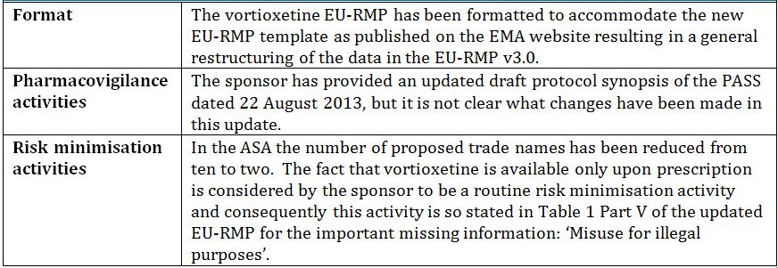

## VI. Overall conclusion and risk/benefit assessment

The submission was summarised in the following Delegate’s overview and recommendations:

### Quality

While there was no overall objection to registration a quality perspective, the evaluator has concerns regarding the apparent inter batch dissimilarity between the dissolution profiles of each strength of the proposed tablets.

The evaluator considered the sponsor’s justification for a biowaiver in respect of the 15 mg tablets could not be accepted due to the dissimilarity between the dissolution profiles of the proposed 5 mg and 15 mg tablets at pH 6.8. This issue was discussed at the Pharmaceutical Chemistry Subcommittee (PSC) meeting on 25 November 2013.

The pharmaceutical chemistry evaluator has noted that there are multiple polymorphs for vortioxetine hydrobromide but that the manufacturing process consistently yields the most thermodynamically stable polymorph (the β-Form) which is stable to milling, pressure, high humidity, and grinding. The BCS Class could not be established.

Ten impurities are controlled in the drug substance; each is limited in accordance with the ICH requirements.

There are 4 tablet strengths, 5 mg, 10 mg, 15 mg and 20 mg. The tablets are **not** direct scales. The same nominal tablet core mass is used for all four presentations, with the nominal quantity of mannitol adjusted to accommodate the different masses of drug substance in each presentation.

### Nonclinical

There were no nonclinical objections to registration of vortioxetine for the treatment of MDD, including prevention of relapse, in adults.

*In vitro* studies indicated that vortioxetine is an inhibitor of the 5-HT transporter (5-HTT) and a 5-HT3, 5-HT7 and 5-HT1D receptor antagonist, a 5-HT1B receptor partial agonist, and a 5-HT1A receptor agonist. Vortioxetine increased the extracellular concentrations of 5-HT in various regions of the rat forebrain. Noradrenaline, and to a lesser extent, dopamine, acetylcholine and histamine concentrations were also increased, but at higher doses, making the clinical relevance of these changes unclear. A faster recovery (compared to fluoxetine) of 5-HT neuronal firing frequency in the dorsal raphe nucleus suggests that vortioxetine may have a more rapid onset of action than the SSRIs.

Vortioxetine showed some neurogenic effects. Vortioxetine showed antidepressant and anxiolytic like effects in some, but not all, animal models investigated. It also showed positive effects in some animal models of cognitive function. The major circulating human metabolites, Lu AA34443 and Lu AA39835, are unlikely to contribute to the pharmacological activity of vortioxetine due to relatively weak activity and/or low exposure levels.

High (>10) brain:blood ratios were observed for vortioxetine. Vortioxetine was extensively metabolised in humans, mainly by oxidation and subsequent glucuronidation. Seven CYP isozymes were identified in the metabolism of vortioxetine. In *in vitro* studies, vortioxetine showed a low potential for drug interactions at clinically relevant concentrations (little or no clinically relevant inhibition and induction of CYP enzymes, and no/weak activity as a P-glycoprotein substrate or inhibitor).

Genotoxicity studies were negative. There were some positive carcinogenicity findings but these were not considered to pose a carcinogenic risk in patients at the MRHD. Fertility was not affected in rats. There was no evidence of a teratogenic effect or of an adverse effect on embryofoetal survival in rats or rabbits.

### Clinical

#### Pharmacology

Within the proposed dose range the absolute bioavailability of vortioxetine is in the region of 75% of an oral dose. Mean Tmax was 7-11 h across PK studies and t1/2 was ~60 h. PK is linear within the proposed dose range. Vortioxetine is over 98% protein bound . Volume of distribution (Vd) is 2500 to 3400 L and CL 30 to 40 L/h. In the single dose, relative bioavailability studies the inter subject CV% for Cmax and AUC0-∞ of vortioxetine ranged from 24.5 to 26% and from 42.5 to 49%, respectively. The intra subject variability was <15% (CV%) for Cmax and AUC0-∞ (Studies 106 and 123).

Vortioxetine is extensively metabolised via oxidation followed by conjugation. The major hepatic enzyme involved in metabolism is CYP2D6; however, CYP3A4/5, CYP2C19, CYP2C9, CYP2A6, CYP2C8, and CYP2B6 contribute to its metabolism. Two major metabolites were identified, neither of these reaches the brain. Renal clearance of unchanged drug is negligible. Vortioxetine accumulates with multiple dosing, accumulating 5 to 6 fold.

Women had ~30% greater AUC than men with this difference accounted for by differences in body size (assessed using height rather than body weight). Renal impairment had little impact on PK with vortioxetine AUC0-t 9%, 16%, and 11% higher in subjects with mild, moderate, or severe renal impairment, respectively than in their healthy controls. Mild and moderate hepatic impairment reduced exposure to vortioxetine with AUC0-t 9% and 2% lower respectively in the subjects with mild or moderate hepatic impairment compared with healthy control subjects. Exposure to metabolites was reduced in subjects with hepatic impairment.

Extensive interaction studies were performed. Of most clinical significance was the combination with bupropion, an inhibitor of CYP2D6, which was associated with a 2.3 fold increase in the AUC of vortioxetine. Co-administration of vortioxetine with fluconazole (CYP2C19, CYP2C9, and CYP3A4/5 inhibitor), ketoconazole (CYP3A4/5 and P-gp inhibitor), rifampicin (multiple CYP inducer) and omeprazole (CYP2C19 substrate and inhibitor) had little effect on the PK of vortioxetine. Co-administration of vortioxetine with alcohol, aspirin, caffeine, diazepam, lithium, ethinyl oestradiol, levonorgestrel omeprazole and diazepam did not result in significant changes to the exposure to those compounds.

At steady state, the vortioxetine plasma concentrations in CYP2D6 poor metabolisers were approximately two times higher than those in extensive metabolisers.

In two ligand based positron emission tomography (PET) Studies 10985 and 12260A, the frontal cortex, the insular, the hippocampus, and the raphe nuclei were chosen as regions of interest based on the 5-HT1A receptor distribution demonstrated *in vitro* and, with the exception of raphe, because these regions are relatively large and homogenous giving reliable time activity data. In these studies the mean 5-HT occupancy in the raphe nuclei was ~50% with vortioxetine 5 mg/day, 65% at 10 mg/day, and increased to above 80% at 20 mg/day.

Vortioxetine had no clinically significant effect on QT interval[41] at doses of up to 40 mg daily. Effects on ability to drive and cognitive function were examined in Study 12689A. In that study single and multiple doses of 10 mg/day vortioxetine did not impair driving performance, compared to placebo, as measured using an on-the-road driving test. There were no statistically significant differences between vortioxetine and placebo in the outcomes of learning and recall tasks included as part of the cognitive assessment in this study. However, these analyses were exploratory only. This study was not designed to determine non inferiority of vortioxetine with placebo for any cognitive outcome.

#### Efficacy

##### Acute depressive episodes

Phase III studies of 6 to 8 weeks duration investigated the efficacy, safety and tolerability of vortioxetine at doses between 1 and 20 mg/day in adults with MDD, acute phase. These studies were randomised, DB, parallel group, multi centre, placebo controlled and fixed dosed. In 5 pivotal studies, an active reference (duloxetine 60 mg daily or venlafaxine 225 mg daily) was included for internal validation. A study in elderly patients also included duloxetine 60 mg daily as an active reference.

The primary objective of each of these studies was to evaluate vortioxetine efficacy compared with placebo by change from baseline in MADRS or HAM-D24 total scores after 6 or 8 weeks of DB treatment in subjects with MDD. The major inclusion criterion was a diagnosis of mild to severe MDD (Montgomery and MADRS total score ≥22 [Study 304], ≥26 [Studies 11984A, 305, 13267A, 315 and 316], or ≥30 [Studies 11492A and 303]). In Studies 13267A, 315 and 316, there was an additional requirement for a Clinical Global Impression – Severity of Illness (CGI-S) score ≥4. The duration of the current MDE had to be ≥3 months (>3 months in Study 13267A) and, in Study 11492A, the current MDE had to have lasted <12 months. In Studies 13267A, 315 and 316, patients had to have had at least one MDE prior to the current episode. A MADRS total score of ≥22 equates to mild to moderate depression while a score of 34 is the usual starting score for severe depression. Notable exclusion criteria were: treatment resistant depression (defined as resistant to two adequate antidepressant treatments of ≥6 weeks duration, judged by the investigator) and the receipt of formal cognitive or behavioural therapy or electroconvulsive therapy.

Only one study (Study 11492A) had a withdrawal period for vortioxetine. Treatment was abruptly stopped in the remaining studies. The active comparators, venlafaxine and duloxetine were tapered at the end of each active treatment period.

The primary efficacy endpoint was the change from baseline to Week 6 or 8 in MADRS or HAM-D24 total score. The primary analyses were performed on the FAS, defined as all randomised patients who took at least one dose of investigational medicinal product and who had at least one valid post baseline measurement of the primary efficacy variable. Missing values for post baseline assessments were imputed by LOCF of the value immediately prior to the missing value.

Figure 4 shows the primary efficacy results for each study. Statistical separation from placebo for any dose of vortioxetine was achieved in 6 of the 8 pivotal studies and in the study in elderly subjects. There were 2 failed or failed/negative studies (Studies 303 and 304) and 2 studies in which only the 20 mg dose showed a statistically significant difference from placebo (Studies 315 and 316). The mean difference from placebo in change from baseline MADRS was in the region of 2 to 6 across studies where a statistically significant difference was demonstrated.

Figure 4. Change from baseline in MADRS total score at Week 6/8 (FAS, MMRM) MDD short term studies.

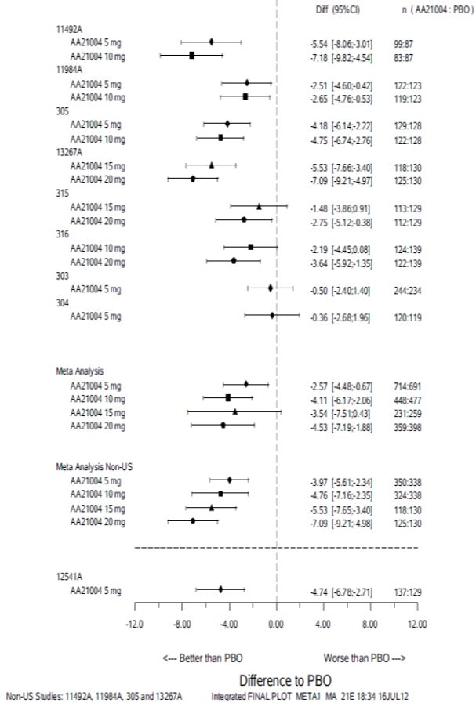

Response rates (defined as at least a 50% reduction in MADRS total score) across the studies was examined across the studies. Differences from placebo in clinical response for any dose of vortioxetine were statistically significant in 5 of the 8 pivotal studies and the in study in elderly subjects. Differences in response rate for any dose of vortioxetine compared with placebo ranged from 9.2% to 29.3% across the positive studies. No clear dose response was apparent for either the change from baseline to Week 6 or 8 in MADRS or in clinical response.

Remission (defined as MADRS total score ≤10) rates in placebo groups ranged from 14.2% (Study 316) to 33.8% (Study 11984A). Remission rates in groups given any dose of vortioxetine ranged from 21.4% (Study 316) to 48.5% (Study 11492A). Differences from placebo in remission rates ranged from 0.1% for the 15 mg dose of vortioxetine in Study 315 to 21.8% for the 10 mg dose in Study 11492A.

A meta analysis (MMRM of the full analysis set) of the 8 pivotal short term studies was conducted for difference from placebo in change from baseline MADRS total score at Week 6/8. The meta analysis was updated with results from a further 3 short term studies during the evaluation process. In the initial meta analysis the overall mean difference compared with placebo across the studies was statistically significant: -2.6 points (p = 0.008), -4.1 points (p <0.001), and -4.6 points (p <0.001) for the 5, 10, and 20 mg/day doses, respectively. The 15 mg/day dose did not separate from placebo; the mean difference from placebo was -3.5 points.

In the subsequent meta analysis of 11 studies the results were separately reported for studies conducted outside the US (which included Australia) and within the US. In general, patients treated in the US showed less difference from placebo across studies for the primary efficacy measure. The sponsor has offered limited explanations as to why this may have occurred. It was noted that a larger proportion of subjects in the US had low or no vortioxetine in their serum, suggesting compliance may be a factor.

For the non US studies the difference from placebo in mean change from baseline MADRS score was -3.20, -4.24, -5.53 and -5.41 for the 5 mg, 10 mg, 15 mg and 20 mg dose regimens, respectively. All dose regimens of vortioxetine were statistically significantly superior to placebo. For studies conducted in the US differences from placebo in mean change from baseline MADRS total score were smaller for each dose compared with the non US studies and for the 15 mg dose did not reach statistical significance in comparison with placebo. The difference from placebo for the other vortioxetine doses did reach statistical significance.

A subgroup analysis for patients with baseline MADRS total scores of ≥30 was also conducted. Generally there was a slightly greater mean change from baseline for each dose given compared with subjects who had lower baseline MADRS scores. Once again, patients in the US did worse overall than those outside of the US. All doses of vortioxetine were statistically significantly superior to placebo in this patient subgroup in the pooled studies conducted outside of the US and for the 5 mg, 10 mg and 20 mg doses in pooled studies conducted in the US.

Responder rates across the pivotal studies were also determined. Responder rates were superior to placebo for each dose in the pooled studies conducted outside the US and for all except the 15 mg dose for the overall pool of studies. That analysis did not include the 3 new studies.

The responder rate in the non US studies for subjects given placebo was 36.6%. Responder rates varied from 55.0% to 61.6% for subjects given any of the 4 vortioxetine dose regimens. The difference in responder rates between placebo and any of the 4 vortioxetine dose regimens was from 18.4% to 25% (NNT from 5.4 to 4). For the overall study pool, which included the studies conducted in the US, the responder rate was 38% for subjects given placebo and from 48.4% to 50.7% for subjects given any of the 4 vortioxetine dose regimens. The difference from placebo in responder rates was between 10.4% and 12.7% (NNT 9.6 to 7.9). No dose response for response rates was clearly apparent in either analysis. There was a suggestion of dose response for responder rates in the non US studies.

Treatment of a MDE in patients aged at least 65 years was examined in Study 12541A; that study enrolled patients aged at least 65 years who met the following major inclusion criteria:

* MADRS total score ≥26 at screening and baseline;
* at least one previous MDE before the age of 60 years;
* current MDE for ≥4 weeks; and
* Mini Mental State Examination (MMSE) score ≥24 (to exclude dementia).

These criteria are more rigorous than those generally applied in studies conducted in younger patients. For this study, the primary efficacy measure was the change in HAM-D24 rather than change from baseline in MADRS, which was a secondary measure. The study compared vortioxetine 5 mg daily with placebo and duloxetine 60 mg daily and had an 8 week DB treatment period.

In the primary efficacy analysis of Study 12541A vortioxetine 5 mg/day was statistically significantly superior to placebo in reducing the HAM-D24 total score at Week 8 (p = 0.001). Mean difference from placebo was -3.32 points compared with -5.48, p < 0.001 for duloxetine 60 mg. Vortioxetine 5 mg/day demonstrated statistical separation from placebo at Week 6 (HAM-D24 reduction -2.1 points, p = 0.024) compared with duloxetine which separated at Week 4. Responder rates, using the 50% reduction from baseline MADRS for LOCF, FAS were: 38% for placebo; 62% for 5 mg vortioxetine; and 72% for duloxetine. The NNT with vortioxetine to achieve a clinical response was about 4. Both actives were superior to placebo. That study included subjects enrolled in the US and outside the US. The sponsor provided a subgroup analysis showing subjects outside the US generally had better responses to treatment (refer to Section 31 response).

##### Relapse prevention

Relapse prevention was examined in Study 11985A. This was a DB, randomised, placebo controlled, multicentre, multinational, relapse prevention study with two doses (5 mg and 10 mg daily) of vortioxetine in patients with MDD. It was conducted in 66 centres in 17 countries in Asia, Australia, Canada, Europe and South Africa, but no centres in the US. The study included a 12 week OL, flexible dose period, followed by a randomised, DB, placebo controlled, fixed dose period of at least 24 weeks. Patients in remission (MADRS total score ≤10) at both Weeks 10 and 12 (baseline II visit/randomisation) were assigned to treatment with either vortioxetine (at their final dose of either 5 mg or 10 mg daily in the OL period) or placebo. Blinded treatment continued for between 24 and 64 weeks. Non remitters at Week 10 and/or Week 12 left the study and were treated at the investigator’s discretion. Relapse was defined as a MADRS total score ≥22 or lack of efficacy, as judged by the investigator.

A total of 639 patients were treated with OL vortioxetine. At baseline 1 (commencement of OL treatment), mean (± SD) MADRS total score was 32.3 ± 4.1 (consistent with severe depression) and mean (± SD) CGI-S score was 4.8 ± 0.7 (consistent with moderate to marked illness). The remission rate in the OL phase of this study was 62.6%. This was considerably higher than the remission rates achieved with active treatment in the DB short term pivotal studies. In those studies, the highest remission rate for a group given vortioxetine was 48.5% in Study 11492A. The next highest remission rate was 38.4% in Study13267A.

A total of 400 (62.6%) patients attained remission during the OLP and entered the DB, randomised phase. Of these, 159 (25%) did not change dose during the OLP and remained on vortioxetine 5 mg/day. Of those who achieved an initial remission with OL treatment, the relapse rates during the first 24 weeks of the DB treatment period were 13.2% in the combined vortioxetine groups and 26.0% in the placebo group (HR of 2.01; p = 0.0035; NNT to prevent one relapse event in 24 weeks treatment was ~ 8).

##### Maintenance of effect

Maintenance of effect was examined in OL extension studies to 3 pivotal short term studies. Subjects who elected to continue to the extension studies were switched from placebo or active comparator to vortioxetine or, if initially randomised to vortioxetine, continued their treatment. A clinical response was not required for inclusion in these extension studies. Subjects were followed for up to 52 weeks of continuing OL treatment with vortioxetine doses of up to 10 mg vortioxetine daily. Doses of up to 20 mg daily were subsequently assessed in studies submitted during the evaluation of this submission.

Subjects enrolled in Studies 301 and 11984B were previously enrolled in Studies 304/305 and 11984A, respectively. The continuation rate for these studies was high with >80% of subjects completing the short term studies electing to continue into the OLP. However, for Study 11492A only 21% of subjects elected to continue to the maintenance study, 11492C. For the feeder short term studies, the NNT for one subject to achieve a response over what was achieved with placebo treatment was ~9 in Study 11984A, 4 to 5 in Studies 11492A, and 305 (for HAM-D response rather than MADRS response ) and ~14 in Study 304 (HAM-D response; difference from placebo was not statistically significant).

The number of subjects who had responded to placebo and were switched to vortioxetine in any of the OL maintenance studies was not able to be determined from the study reports. Generally those electing to continue had low MADRS scores at commencement of the OLP and this low level was generally maintained during the OLP.

#### Safety

In the completed Phase II/III studies, 5709 patients with MDD (3954 patients in 13 studies) or GAD (1755 patients in five studies) received vortioxetine at doses up to 20 mg/day; 1479 of these patients received vortioxetine for 26 weeks or more and 981 received vortioxetine for 52 weeks or more. In addition, 1169 subjects in 31 clinical pharmacology studies in healthy subjects, elderly subjects, and subjects with hepatic or renal impairment have been exposed to vortioxetine. Subjects received vortioxetine as a single dose (up to 75 mg) or repeated doses (up to 60 mg/day).

For the overall safety population, TEAEs were 6.9% more frequent in subjects given any dose of vortioxetine compared with placebo. The incidence of TEAEs in subjects given vortioxetine increased with dose: from 53% given 5 mg daily to 60.7% in subjects given 20 mg daily. The most frequently reported TEAE was nausea, which was reported in from 20.4% to 30.3% of subjects given vortioxetine compared with 7.9% given placebo. There was a dose-response for nausea. The incidence for any dose of vortioxetine was lower than the incidence of nausea with venlafaxine or duloxetine. Dry mouth, constipation, dizziness, flushing, pruritus and abnormal dreams were also more frequent in subjects taking vortioxetine compared with placebo.

For the overall safety population, the rate of SAEs was similar to that of placebo (1% placebo versus 1.1% vortioxetine). In the MDD studies, the overall incidence of SAEs was 2.4% in subjects given vortioxetine with breast cancer female, cholelithiasis and suicide attempt each reported in 2 patients. No other serious TEAE occurred in > 1 patient. Six deaths (all subjects received vortioxetine treatment) were reported in the 27 Phase II/III studies in MDD and GAD. None of these deaths were considered by investigators to be related to treatment with investigational drug. The deaths included one suicide and one death from morphine intoxication. Both these deaths were in studies of GAD.

Suicidal ideation was assessed in the MDD studies. In the short term studies in MDD (303, 304, 305, 13267A, 315 and 316), the proportion of patients with suicidal ideation (C-SSRS Categories 1 to 5) in the post baseline assessment was 16% for any dose of vortioxetine versus 17% for placebo. In the Phase II/III studies in MDD and GAD, for subjects given any dose of vortioxetine the incidence of *suicidal ideation* ranged from 7.1% to 21%, with no indication of a dose-response relationship. There were no clinically relevant differences between the treatment groups in the overall proportions of patients with severe suicidal ideation.

In Study 12541A, conducted in elderly subjects, using the C-CASA categories, 2 patients (both in the placebo group) had a history of *preparatory action towards imminent suicidal behaviours* and ~5% of the patients in each treatment group had a history of *not fatal suicide attempt*. Within the study, *suicidal ideation* was reported in 12% of subjects given vortioxetine 5 mg versus 9.6% given placebo. No patient had severe suicidal ideations (C-SSRS Categories 4 and 5) or *preparatory action towards imminent suicidal behaviours, not fatal suicide attempt, or completed suicide* during the study.

The proportions of MDD patients with post baseline *suicidal ideation* was 12% in the elderly versus 19% in adult patients with MDD (in the vortioxetine 5 mg group in Studies 303, 304, 305, 13267A and 316).

Five patients had an *intentional overdose*. Of these, one patient in the vortioxetine 5 mg group, also had *suicide attempt* and 2 patients in the vortioxetine 20 mg group also had *intentional self injury* reported on the same day (Patients 1396 and 1390 in Study 13267A). In these studies, 15 patients who received vortioxetine had an *intentional overdose*. For 9 of these patients the intentional overdose was 1 additional tablet/capsule on one or more occasions due to lack of efficacy (2 patients), stress (1 patient), anxiety (1 patient), vomiting (1 patient), or unknown (4 patients). No event was reported as an SAE and no patient withdrew due to the event.

TESD was common for all groups, including placebo in the Phase II/III MDD and GAD studies where it was specifically assessed. There was an overall excess of TESD of 6.4% for any dose of vortioxetine and of 15% for duloxetine compared with placebo.

Withdrawal effects due to vortioxetine were not apparent, though these were most thoroughly assessed in the short term studies.

### Risk management plan

The sponsor proposes routine pharmacovigilance activities to monitor all the specified Ongoing Safety Concerns and a drug utilisation study.

The sponsor proposes to further characterise and monitor all the specified ongoing safety concerns, except the important potential risks: ‘Serotonin Syndrome (SSRI/SNRI class effect)’, ‘Hyponatraemia (SSRI/TCA class effect)’ and ‘Haemorrhage (SSRI/SNRI class effect) and the important missing information: ‘Misuse for illegal purposes’ and ‘Overdose’, by conducting a non interventional PASS of vortioxetine in Europe. A historical cohort design using European longitudinal electronic healthcare databases is intended to explore:

* the patterns of use of vortioxetine in some populations or situations considered as important missing information; and
* the frequency of occurrence of selected important potential risks (suicidal behaviours, convulsions/seizures and severe renal or hepatic events due to precipitation of metabolites in kidney and liver).

Evaluation is anticipated to be performed in 2017 with reporting to be made by beginning 2018.

#### Outstanding issue #1 (sponsor's numbering)

On the basis of the clinical evaluation report, it was suggested that the important potential risk: ‘Neoplasms’ and the important missing information: ‘Long-term safety data’ should be included as new Ongoing Safety Concerns. The sponsor provided justification as to why it does not consider ‘Neoplasms’ as an important potential risk. The sponsor also does not consider 'Long-term safety data' in general to be important missing information citing additional long-term safety data which was provided as part of the “Updated MDD Ongoing Open-label Long-term Pool”, where an additional 279 patients were treated with doses of 15 or 20 mg/day for 1 year.

#### Outstanding issue #2

The sponsor agreed to prepare a “Summary of the Risk Management Plan in Australia” in a revised ASA to the RMP, including references to the specific routine risk minimisation in the Australian PI. This document is to be provided during the pre ACPM response period to ensure that the table captures the relevant text from the Australian PI.

#### Outstanding issue #3

The ACSOM stated:

*The committee advised that the signal for convulsions and seizures in dogs with overdose was concerning. In particular the committee was concerned that seizures were observed in dogs with plasma levels only five times that of the recommended human dose. In a drug which for a condition which is often associated with medication overdoses, the committee considered that this threshold was quite low. Based on the nonclinical data, seizures are the most serious expected AE and ACSOM advised that the overdose section of the PI should be updated to reflect this.*

The sponsor responded that the nonclinical risk assessment considered the risk of convulsions low and a precaution for seizures with therapeutic use of vortioxetine is included in the Australian PI. Consequently, the sponsor does not consider it appropriate to add additional text in the overdose section. However, the sponsor proposes to update the section “Preclinical Safety” of the Australian PI to reflect the data.

The RMP evaluator noted that the sponsor does not appear to have responded to the other outstanding issue as follows.

The ACSOM considered the draft protocol synopsis of the PASS dated 12 April 2013 and stated:

*The committee noted that the sponsor has proposed to supplement the routine pharmacovigilance with a drug utilisation study. The committee advised that the drug utilisation study would collect data on off-label use of vortioxetine in specific populations. However, the study did not align with any of the risks in the summary of ongoing safety concerns and was not being used to collect any safety data. Therefore the proposed pharmacovigilance was essentially only routine pharmacovigilance. The committee advised that, while they were supportive of the sponsor undertaking the drug utilisation study, in view of the novel multimodal characteristics of the drug, it would be desirable for the sponsor to expand the study design to gather additional data on outcomes of drug use and therefore include information on safety.*

The sponsor provided an updated draft protocol synopsis of the PASS dated 22 August 2013. It is not clear what changes have been made in this update. The RMP evaluator recommended the draft protocol synopsis of this study should be expanded to capture all of the specified Ongoing Safety Concerns, as well as the suggested new Ongoing Safety Concerns. The revised draft protocol/synopsis of the PASS should be provided to the TGA for review once it is available.

### Risk-benefit analysis

#### Delegate’s considerations

The clinical evaluator had recommended that:

* Vortioxetine should only be administered to patients with an established history of MDE or MDD;
* Vortioxetine should be reserved for second line use in MDD, upon initial registration;
* The aged (≥ 65 years of age) should commence vortioxetine on a dose of 5 mg once daily;
* Maintenance treatment, that is, relapse prevention doses of vortioxetine for adults and the aged should be restricted to 10 mg once daily, upon initial registration;
* The sponsor should provide detailed assurance it will be proactive in undertaking post marketing pharmacovigilance activities and in its reporting of any new safety signals or potential safety signals, until the safety profile of vortioxetine as a new class of chemicals for human administration, becomes well established.

The sponsor had responded to these recommendations in a separate document. For completeness, the Delegate considered the evaluator’s recommendations and sponsor responses below:

* The sponsor noted that the clinical trials were not designed to determine differences in subpopulations such as subjects with a first MDE and that the poor efficacy results in this group were driven by inclusion of the failed/negative Study 303 and negative Study 304 in the meta analysis. Given the overall demonstration of efficacy in the population that included this subgroup, the Delegate does not consider there is a reasonable basis for excluding patients with an initial MDE from receiving vortioxetine. It would be an issue of medical practise that treating doctors accurately diagnose their patients.
* The rationale for restricting vortioxetine to second line treatment is unclear. Patients with previous failure to respond to antidepressants were not specifically included in the clinical trial program and treatment resistant depression was an exclusion criteria in the majority of studies. The Delegate is not inclined to restrict use to this group of patients.
* The 5 mg starting dose in elderly patients recommended by the clinical evaluator has been accepted by the sponsor. The sponsor also noted that it is consistent with the dosing recommendations for vortioxetine in elderly patients in the EU.
* The basis for recommending only a 10 mg dose for maintenance is that the submission included no comparative efficacy assessment of the 15 mg and 20 mg doses in longer term MDD studies that were initially submitted. The Delegate considers that if relapse prevention is approved, the dose should be titrated according to response and patients should ideally be maintained on the dose at which their symptoms were satisfactory treated. The ACPM’s advice is requested on this issue.
* The RMP will address post marketing pharmacovigilance activities and has been separately evaluated.

##### Acute treatment

The major issue for vortioxetine is the quite low and variable level of efficacy demonstrated across the clinical study program. From the pooled analysis of pivotal short term studies, approximately 1 in 8 people who receive treatment is likely to obtain a clinically significant benefit in acute treatment of MDD. However, if acute treatment in studies conducted outside of the US is considered separately, the NNT is closer to 1 in 4.

Limited demonstration of efficacy with antidepressants has been increasingly apparent in clinical studies during the last 10 years or so and may be contributed to by difficulties with appropriate patient and site selection. The clinical evaluator has highlighted some factors that are likely to have had an effect on the results of the pivotal efficacy and safety studies. The major factors were that patients could be enrolled during a first MDE and the MDD diagnosis was confirmed with an additional diagnostic test in only 5 of the 8 pivotal studies. Thus, patients who did not have an established depressive episode may have been included in the studies. The studies generally excluded patients who had previously not responded to treatment with an antidepressant. This may also have reduced the proportion of patients in those studies who had an episode of depression that could be consistently confirmed.

Although there were differences in the degree of efficacy demonstrated, consistent efficacy was demonstrated for each dose regimen of vortioxetine. However, in the acute episode studies:

* No clear dose response was demonstrated. It is not clear that patients derive any increased benefit from increasing dose. The additional clinical utility of the 20 mg dose above a lower dose has not been demonstrated.
* Patients with more severe depression were more likely to have larger reductions in MADRS scores on treatment than the general patient population.
* No subgroup analysis for patients with mild depression (MADRS score ≤22) was conducted and only 1 pivotal study included patients with mild depression. Thus, the benefit of vortioxetine in this patient group is unclear.
* The sponsor was requested to provide a subgroup analysis of efficacy for patients with previously treated depression in order to identify the extent of benefit in that population. This analysis was not provided and the effect of vortioxetine in these patients is unclear.

The difference in efficacy outcomes across countries suggests the illness present in patients selected for these studies varied between the countries from which the patients were recruited. Greater efficacy was consistently demonstrated in studies conducted outside the US.

##### Prevention of relapse

The Delegate is not satisfied that the clinical trial program has adequately demonstrated the likely extent of response compared with placebo in patients given ongoing treatment.

An exceptionally high level of remission was reported in the OL phase of the relapse prevention Study 11985A. Those patients in remission were then randomised to DB treatment with either vortioxetine or placebo. Given the high levels of placebo response seen in the DB acute treatment studies it would have been more appropriate to initiate treatment in a DB manner and then re-randomise the remitters or responders in the active treatment group. That would have given a clearer indication of the NNT to have maintenance of effect with vortioxetine above what would have occurred with placebo. Given the results of the short term studies, the relapse prevention study is likely to have given continuing treatment to a substantial proportion of patients who would have remitted had they been given placebo in the first 12 weeks of the study. The extent of benefit from vortioxetine, above that of placebo, in the prevention of relapse cannot be determined from the presented study. However, the study design was similar to that which was accepted for prevention of relapse with agomelatine and the extent of reported benefit is similar.

While there is likely to be a benefit from continued treatment for some patients, neither the required dose nor the extent of benefit has been adequately established. As with any antidepressant, careful patient selection and follow-up will be required to maximise benefit from treatment with vortioxetine. The Delegate notes the EMA has not approved vortioxetine for prevention of relapse. This limited approval, if applied in Australia would create difficulties because the Royal Australian and New Zealand College of Psychiatrists (RANZCP) clinical practise guideline for treatment of depression (2004) recommends continuation of an effective treatment for at least 1 year for an initial episode and 3 years for recurrent episodes. *Therapeutic Guidelines: Psychotropic* recommends 6 to 12 months after full resolution of symptoms after a first episode.[42]

The Delegate considers that most of these concerns can be addressed by appropriate disclosure in the PI.

##### Safety

The safety of vortioxetine has been quite thoroughly examined. Given its action on serotonin receptors and transporter, serotonergic side effects would be anticipated and the pattern of adverse effects is consistent with its mechanism of action.

#### Summary of issues

* The clinical utility of vortioxetine in the prevention of relapse is not clear.
* The clinical utility of vortioxetine in patients with mild depression has not been comprehensively examined.
* There is a lack of clear evidence of a dose response.
* The maximum dose appears not to have been adequately justified.

#### Request for ACPM advice

The committee is requested to provide advice on the following specific issues:

* Given that the submission included no comparative efficacy assessment of the 15 mg and 20 mg doses in longer term MDD studies, is it appropriate to limit the maximum dose of vortioxetine for the prevention of relapse in MDD to 10 mg daily?
* Given the absence of a clear dose response, does the ACPM consider treatment for both MDE and prevention of relapse should be limited to a maximum of 10 mg daily?
* Given the limited data for subjects with mild depression, does the ACPM consider it would be appropriate to restrict the indication to patients with moderate to severe depression?
* The currently proposed indication could be aligned with that of the most recently approved antidepressant, agomelatine: “*Treatment of major depression in adults including prevention of relapse.”* This would give consistency without loss of meaning. The ACPM is requested to comment on whether alignment of indications among antidepressants wherever appropriate is desirable.
* The EMA has not approved vortioxetine for prevention of relapse. In the relapse prevention study, the remission rate of MDD in the initial OL treatment phase was very high compared to the remission rates in the DB, placebo controlled studies. Due to the design of this study, it is not possible to accurately determine the benefit above placebo in the prevention of relapse for vortioxetine. Does the ACPM consider this study provides adequate evidence of prevention of relapse?

The committee is also requested to provide advice on any other issues that it thinks may be relevant to a decision on whether or not to approve this application.

#### Proposed action

The Delegate has no reason to say, at this time, that the application for Brintellix should not be approved for registration.

The EU RMP (Version: 3.0, dated 22 August 2013), with an ASA (Version: 2.0, dated 5 September 2013) to be revised to the satisfaction of the TGA, must be implemented as a condition of registration

#### Response from sponsor

##### Proposed changes to the indication

The sponsor agrees with the Delegate’s proposal to modify the proposed indication for Lu AA21004 (vortioxetine). However, for the reasons stated in the response to Outstanding Issue 4, the sponsor considers that “Major Depressive Disorder” should replace “major depression” in the indication:

*Treatment of major depression in adults including prevention of relapse.*

##### Summary

Treatment with Lu AA21004 in the dose range of 5 to 20 mg/day is effective, safe, and well tolerated in adult and elderly patients with MDD in short and long term treatment. This statement is supported by the results of the clinical development programme for Lu AA21004, which was designed in line with the EMA guideline for depression.[43] In particular, the sponsor would like to highlight the following:

* adult and elderly patients with a broad range of disease severity were included in the clinical studies and efficacy was established across the range
* the relapse prevention study, which was a prerequisite for approval in the EU, included the two lower therapeutic doses (5 and 10 mg) of Lu AA21004 and convincingly established the efficacy of Lu AA21004 in preventing relapse while providing controlled long term efficacy and safety data. These data, together with the substantial efficacy and safety data from the controlled short term studies and OL long term extension studies provide evidence of the efficacy and tolerability of Lu AA21004 across the entire therapeutic dose range of 5 to 20 mg.

##### Outstanding issue 1

1. *Given that the submission included no comparative efficacy assessment of the 15 mg and 20mg doses in longer term MDD studies, is it appropriate to limit the maximum dose of vortioxetine for the prevention of relapse in MDD to 10 mg daily?*

The relapse prevention study, Study 11985A, was designed in accordance with the EMA guideline in depression[44] in which a relapse prevention study using a standard randomised withdrawal design is recommended to demonstrate the maintenance of effect during the index episode. This study demonstrated the efficacy of Lu AA21004 (5 and 10 mg/day) in the prevention of relapse. Section 6.5 of the guideline states:

*The usefulness of including more than one dose of the test product to investigate the optimal dose for long-term treatment should be considered.*

The two doses in Study 11985A cover the most conservative end of the therapeutic dose range. Therefore, the sponsor considers that the relapse prevention study is in line with the recommendations for doses made in the EMA guideline.[45]

In the short term, placebo controlled studies with Lu AA21004, the efficacy increased with increasing dose (5 to 20 mg/day) and Lu AA21004 was well tolerated, also at the higher doses. In addition, Studies 13267B and 314 (OL, long term [1 year] studies with flexible doses of Lu AA21004 15 and 20 mg/day) not only confirmed the safety and tolerability of Lu AA21004 at higher doses but also provided supportive evidence of the maintenance of efficacy of Lu AA21004 at higher doses. Based on this, it is reasonable to conclude that the higher doses of Lu AA21004, 15 and 20mg/day, are at least as efficacious in preventing relapse as 5 and 10 mg/day, while at the same time showing good tolerability.

Therefore, the sponsor considers that the positive data on maintenance of effect with Lu AA21004 5 or 10 mg/day in Study 11985A can be extrapolated to doses of 15 and 20 mg/day and agrees with the Delegate’s recommendation that “the dose should be titrated according to response and patients should ideally be maintained on the dose at which their symptoms were satisfactory treated” and proposed recommended changes to the PI: “If the depressive symptoms resolve, treatment for at least 6 months is recommended for consolidation of the antidepressive response”.

These changes are consistent with the recommendations in *Therapeutic Guidelines: Psychotropic*.[46]

In conclusion, the maintenance of effect of Lu AA21004 has been demonstrated in a relapse prevention study (5 and 10 mg/day) and is supported by the results from five OL, long term extension studies, of which two (Studies 13267B and 314) were studies with flexible doses of 15 and 20 mg/day. Individual study results and meta analyses of the primary endpoints in the short term, placebo controlled studies generally showed an increase in efficacy with increasing dose (5 to 20 mg/day). Together, these data provide convincing evidence of the efficacy of all doses (5 to 20 mg/day) of Lu AA21004 in long term maintenance treatment.

##### Outstanding issue 2

1. *Given the absence of a clear dose response, does the ACPM consider treatment for both MDE and prevention of relapse should be limited to a maximum of 10 mg daily?*

In each of the short term, placebo-controlled studies in adults in which more than one dose of Lu AA21004 in the therapeutic dose range from 5 to 20 mg/day was used, the effect of Lu AA21004 increased with increasing dose. Furthermore, the results of the individual studies were supported by the results of the meta analyses, which clearly supported a dose response and clinically relevant effects for all four doses in the therapeutic dose range of Lu AA21004. In this addendum, the updated meta analysis of all the short term, placebo controlled studies, the overall mean difference to placebo across the studies was statistically significant: -2.3 (p = 0.007), -3.6 (p <0.001), and -4.6 points (p <0.001) for the 5, 10, and 20 mg/day doses, respectively; the 15 mg/day dose did not separate from placebo in the meta analysis, but the -2.6 points mean difference to placebo was clinically relevant. In the meta analysis of all the short term, placebo controlled non US studies in adults, the overall mean difference to placebo was statistically significant for all four therapeutic doses. The increased effect sizes with increasing dose were even more pronounced (-3.2, -4.2, -5.5, and -5.4 points at Week 6/8 for the 5, 10, 15, and 20 mg/day doses, respectively). In addition, a PK/PD analysis for efficacy showed a statistically significant relationship between the average Lu AA21004 plasma concentration and the change from baseline in MADRS total score.

The long term, placebo controlled relapse prevention study in adults and the 5 supportive OL extension studies (with doses of 2.5 to 20 mg/day) demonstrated the maintenance of the short term effect over time and the good safety/tolerability profile in the entire therapeutic dose range.

Lu AA21004 in the full dose range of 5 to 20 mg/day has been approved by the EMA and the US FDA:

* In the EU, the starting and recommended dose is 10 mg/day in adults <65 years of age. Depending on individual patient response, this may be increased to a maximum of 20 mg/day. In addition, section 5.1 of the SmPC states “The efficacy of vortioxetine increased with increasing dose” and “The maintenance of antidepressant efficacy was demonstrated in a relapse-prevention study.”
* In the US, the recommended starting dose is 10 mg/day. The dose should then be increased to 20 mg/day as tolerated.

In conclusion, treatment for both acute MDD and prevention of relapse should not be limited to a maximum of 10 mg daily, as the efficacy and safety of Lu AA21004 have been established for the full therapeutic dose range of 5 to 20 mg/day for both the short term and long term treatment of MDD. Furthermore, an increase in efficacy with increasing dose has been demonstrated and Lu AA21004 was well tolerated, also at the higher doses. The starting and recommended dose for Lu AA21004 is 10 mg/day in adults <65 years of age. Depending on individual patient response, the dose can be increased to a maximum of 20 mg/day or decreased to a minimum of 5 mg/day, to provide the prescribing physician the full flexibility to adjust the dose to the needs of the individual patient.

##### Outstanding issue 3

1. *Given the limited data for subjects with mild depression, does the ACPM consider it would be appropriate to restrict the indication to patients with moderate to severe depression?*

The Category 1 application for Lu AA21004 is based on a clinical development programme that consists of 12 short term, placebo controlled studies, including a dedicated study in the elderly, and one long term, placebo controlled, relapse prevention study. Different baseline cut offs on the MADRS were used to cover the full spectrum of severity in MDD. This clinical development programme was designed in line with the EMA guideline on depression,[47] which states that:

*Clinical trials will usually recruit patients who are moderately ill, as it is difficult to demonstrate an effect in mildly ill patients. Demonstration of an acceptable benefit/risk in moderately ill patients will be considered sufficient for a registration package to get a general license for ‘Episodes of Major Depression’.*

In conclusion, the applicant considers it would be inappropriate to limit the indication of Lu AA21004 to the treatment of patients with moderate to severe MDD.

##### Outstanding issue 4

1. *The currently proposed indication could be aligned with that of the most recently approved antidepressant, agomelatine: “Treatment of major depression in adults including prevention of relapse.” This would give consistency without loss of meaning. The ACPM is requested to comment on whether alignment of indications among antidepressants wherever appropriate is desirable.*

The sponsor agrees with the Delegate’s proposal to align indications across antidepressants and accepts the Delegate’s proposed indication for Lu AA21004. However, the sponsor considers that “Major Depressive Disorder” should replace “major depression”, because it is a legitimate DSM-IV-TR (and now DSM-V) Axis I disorder.[48] Furthermore, patients enrolled in the Lu AA21004 clinical studies were required to fulfil the diagnostic criteria for MDE according to DSM-IV-TR.

##### Outstanding issue 5

1. *The EMA has not approved vortioxetine for prevention of relapse. In the relapse prevention study, the remission rate of MDD in the initial OL treatment phase was very high compared to the remission rates in the DB, placebo controlled studies. Due to the design of this study, it is not possible to accurately determine the benefit above placebo in the prevention of relapse for vortioxetine. Does the ACPM consider this study provides adequate evidence of prevention of relapse?*

The sponsor would like to provide some clarification regarding the indication for Lu AA21004 in the EU. For licensing approval, a sponsor must demonstrate that a short term effect can be maintained during the index episode; see the response above to Outstanding Issue 1. Therefore, a positive long term efficacy study is a prerequisite for approvability. The approved SmPC for Lu AA21004 states:

*The maintenance of antidepressant efficacy was demonstrated in a relapse prevention study.*

In accordance with the EMA guideline in depression, a randomised withdrawal study (also called relapse prevention) was chosen to evaluate the maintenance of the short-term effect as it represents the best study design; a placebo controlled extension study is less advisable for reasons mentioned in section 2.2 of the EMA guideline.[49] The success of such a study depends largely on the relapse rate in the placebo group, since patients with an unstable response are more likely to relapse when they are switched to placebo. Therefore, by using a strict randomisation criterion, that is, selecting patients who are in stable remission, as in Study 11985A, the study becomes more conservative and robust in terms of providing evidence of the maintenance of effect.

The remission rate in the first 6 to 8 weeks of the OLP of the relapse prevention study is consistent with the remission rates during the first 6/8 weeks in the short term, placebo controlled studies, and also in line with other relapse prevention studies in adults using similar criteria; see the sponsor’s response to Question 7 in the first round evaluation, dated 2 September 2013.

As recommended in the EMA guideline,[50] the sponsor has submitted the results for both standard efficacy criteria, namely, number of patients worsening (relapsing) and the time to relapse. The relapse prevention study was powered based on the primary endpoint, that is, the time to relapse within the first 24 weeks of the DB period, and showed that long term treatment with Lu AA21004 significantly reduced the risk of relapse in patients with MDD compared with placebo. The proportion of patients who relapsed was significantly lower in the Lu AA21004 group (13%) than in the placebo group (26%). The Cox proportional hazard model gave a HR of 2.01 (FAS, Cox model, p = 0.0035); that is, the risk of relapse was two times higher for placebo-treated patients than for Lu AA21004 treated patients.

In conclusion, Lu AA21004 has been approved by the EMA for relapse prevention. The relapse prevention study was designed according to the requirements of the EMA guideline on depression and the sponsor considers that the positive results of this study provide convincing evidence of the maintenance of effect of Lu AA21004 during the continuation phase.

#### Advisory committee considerations

The submission seeks to register a new chemical entity.

The ACPM, taking into account the submitted evidence of efficacy, safety and quality, agreed with the Delegate and considered Brintellix film coated tablets containing 5 mg, 10 mg, 15 mg and 20 mg of vortioxetine (as hydrobromide) to have an overall positive benefit-risk profile for the indication;

*Treatment of major depressive disorder in adults including prevention of relapse.*

*Vortioxetine is not indicated for paediatric use.*

The ACPM advised that the recommended staring dose should be 10 mg with the option of increasing it to 20 mg depending on patient need.

In making this recommendation, the ACPM was of the view that treatment for “mild” major depressive disorder should be subsumed in the Clinical Trials section, which would conform to the relevant EMA guideline.

##### Proposed conditions of registration

The ACPM agreed with the Delegate on the proposed conditions of registration.

##### Proposed Product Information (PI)/Consumer Medicine Information (CMI) amendments:

The ACPM agreed with the delegate to the proposed amendments to the Product Information (PI) and Consumer Medicine Information (CMI) and specifically advised on the inclusion of the following:

* A statement in the *Precautions and Adverse events* sections of the PI and relevant sections of the CMI to more accurately reflect sexual dysfunction as an important and significant adverse effect with vortioxetine treatment.
* There was insufficient evidence provided to support any claims regarding improvement in cognitive function and these should not appear in the PI.

##### Specific advice

* Given that the submission included no comparative efficacy assessment of the 15 mg and 20 mg doses in longer term MDD studies, is it appropriate to limit the maximum dose of vortioxetine for the prevention of relapse in MDD to 10 mg daily?

The ACPM advised it was standard clinical practice to continue patients on the dose which was efficacious rather than try an alternative dose to maintain efficacy. Therefore, limiting the maximum dose of vortioxetine for the prevention of relapse in MDD to 10 mg daily was not supported.

* Given the absence of a clear dose response does the committee consider treatment for both MDE and prevention of relapse should be limited to a maximum of 10 mg daily?

The data show a reasonable, statistically significant but small increase in response with 20 mg compared with that at 10 mg. There was no major change in the type of adverse effect if the dose is increased to 20 mg, with nausea and sexual dysfunction observed as the main adverse events at both doses. Therefore, the ACPM advised dose instructions in line with those approved in the EU, where the recommended starting dose is 10 mg daily but there is the option to increase to 20 mg daily depending on patient response.

* Given the limited data for subjects with mild depression does the committee consider it would be appropriate to restrict the indication to patients with moderate to severe depression?

The ACPM accepted the evidence of efficacy provided was limited to patients with moderate to severe depression. However, in practice, antidepressants are often tried in mild depression. Nevertheless, the indication should reflect the evidence provided, that is, patients with moderate to severe depression, or ‘major depression’. The ACPM noted it was difficult to demonstrate efficacy against placebo in clinical trials of patients with mild depression.

* The currently proposed indication could be aligned with that of the most recently approved antidepressant, agomelatine: *Treatment of major depression in adults including prevention of relapse.* This would give consistency without loss of meaning. The committee is requested to comment on whether alignment of indications among antidepressants wherever appropriate is desirable.

The ACPM strongly supported the concept of indications for antidepressants being aligned wherever possible. For vortioxetine, the indication:

*Treatment of major depression in adults including prevention of relapse*

was appropriate and was consistent with the indications approved recently for other antidepressants including the most recently registered Valdoxan (agomelatine). However, given the sponsor’s contention that “Major Depressive Disorder” should replace “major depression” because it is a legitimate DSM-IV-TR (and now DSM-V) Axis I disorder, the ACPM supported the term “major depressive disorder” rather than major depression in the indication. The committee also noted that patients enrolled in the clinical studies for vortioxetine were required to fulfil the diagnostic criteria for MDE according to DSM-IV-TR.

* The EMA has not approved vortioxetine for prevention of relapse. In the relapse prevention study, the remission rate of MDD in the initial OL treatment phase was very high compared to the remission rates in the DB, placebo controlled studies. Due to the design of this study, it is not possible to accurately determine the benefit above placebo in the prevention of relapse for vortioxetine. Does the ACPM consider this study provides adequate evidence of prevention of relapse?

The ACPM was satisfied that vortioxetine for the prevention of relapse had been investigated in line with requirements in the relevant guidelines. While the evidence against a high placebo effect is no overwhelming the evidence does support *“prevention of relapse”.*

Members noted the differences in terminology used in other jurisdictions. In the EU, the indication is for ‘major depressive episodes’, which encompasses treatment and prevention of relapse; however, this term is not in standard use in Australia.

The ACPM advised that the implementation by the sponsor of the recommendations outlined above to the satisfaction of the TGA, in addition to the evidence of efficacy and safety provided would support the safe and effective use of these products.

#### Post ACPM PI negotiations

In post ACPM PI negotiations with the TGA, the sponsor contended, inter alia, that cognitive symptoms are an integral part of the diagnosis of MDD and Brintellix demonstrated positive effects on cognitive function based on pre-specified endpoints. Improvements in the cognitive dysfunction of adult patients were a primary objective of Study 14122A, and the results of this study are clinically relevant to the prescribing physician. Therefore, the details of this study were included in the PI.

### Outcome

Based on a review of quality, safety and efficacy, TGA approved the registration of:

* Brintellix vortioxetine (as hydrobromide) 5 mg film coated tablet blister pack
* Brintellix vortioxetine (as hydrobromide) 10 mg film coated tablet blister pack
* Brintellix vortioxetine (as hydrobromide) 15 mg film coated tablet blister pack
* Brintellix vortioxetine (as hydrobromide) 20 mg film coated tablet blister pack

indicated for:

*Treatment of major depressive disorder in adults including prevention of relapse. Vortioxetine is not indicated for paediatric use.*

#### Specific conditions of registration applying to these goods

* The European RMP for Brintellix vortioxetine (as hydrobromide), (Version: 3.0 dated 22 August 2013) with on ASA (Version: 2.0 dated 5 September 2013) must be implemented.

## Attachment 1. Product Information

The Product Information approved for main Brintellix at the time this AusPAR was published is at Attachment 1. For the most recent Product Information please refer to the TGA website at <<http://www.tga.gov.au/hp/information-medicines-pi.htm>>.

## Attachment 2. Extract from the Clinical Evaluation Report

|  |
| --- |
| Therapeutic Goods Administration |
| PO Box 100 Woden ACT 2606 Australia  Email: [info@tga.gov.au](mailto:info@tga.gov.au) Phone: 1800 020 653 Fax: 02 6232 8605  [**http://www.tga.gov.au**](http://www.tga.gov.au) |

1. European Medicines Agency, “Note for Guidance on Impurities Testing: Impurities in New Drug Substances (CPMP/ICH/2737/99)”, October 2006.
2. European Medicines Agency, “Note for Guidance on Impurities in New Drug Products (CPMP/ICH/2738/99)”, June 2006.
3. Richelson E, et al. (2013) Multimodality as a new approach for the treatment of major depressive disorder. Abstract, 11th World Congress of Biological Psychiatry, Kyoto, Japan.
4. Faerber LS, et al. (2007) The neuronal 5-HT3 receptor network after 20 years of research – evolving concepts in management of pain and inflammation. *Eur J Pharmacol.* 560: 1-8; Thompson AJ, Lummis SC. (2007) The 5-HT3 receptor as a therapeutic agent. *Expert Opin Ther Targets* 11: 527-540.
5. Ramamoorthy RM, et al. (2008) Antidepressant-like effects of sertotonin type-3 antagonist, ondansetron: an investigation in behaviour-based rodent models. *Behav Pharmacol.* 19: 29-40.
6. Torrado A, et al. (2004) Novel selective and potent 5-HT reuptake inhibitors with 5-HT1D antagonist activity: chemistry and pharmacological evaluation of a series of thienopyran derivatives. *Bioorg Medicinal Chem.* 12: 5277-5295.
7. Ruf BM, Bhagwagar Z. (2009) The 5-HT1B receptor: a novel target for the pathophysiology of depression. *Curr Drug Targets* 11: 1118-1138.
8. Hedlund PB, Sutcliffe JG. (2004) Functional, molecular and pharmacological advances in 5-HT7 receptor research. *Trends Pharmacol Sci.* 25: 481-486.
9. Belmaker RH, Agam G. (2008) Major depressive disorder. *New Engl J Med.* 358: 55-68; Faure C, et al. (2006) Long-term adaptive changes induced by serotonergic antidepressant drugs. *Expert Rev Neurother.* 6: 235-245.
10. Duman RS. (2004) Depression: a case of neuronal life and death? *Biol Psychiatry* 56: 140-145.
11. Santarelli L, et al. (2003) Requirement of hippocampal neurogenesis for the behavioural effects of antidepressants. *Science* 301: 805-809.
12. Blier P, de Montigny C. (1994) Current advances and trends in the treatment of depression. *Trends Pharmacol Sci.* 15: 220-226.
13. Tjolsen A, et al. (1992) The formalin test: an evaluation of the method. *Pain* 51: 5-17.
14. If a Q wave is measured by ECG, the PR interval is also commonly termed the PQ interval.
15. Lu AA34443 glucuronide was synthesised at a relatively late stage in drug development.
16. The nonclinical evaluator considered the NOAEL in mice to be 25 mg/kg/day in males and 50 mg/kg/day in females.
17. Davis B, Morris T. (1993) Physiological parameters in laboratory animals and humans. *Pharmac. Res.* 10: 1093-1095.
18. Meneton P, et al. (2000) Renal physiology of the mouse. *Am J Physiol Renal Physiol.* 278: F339-F351.
19. The National BioResource Projects (NBRP) for the rat (2011).
20. Dukes’ Physiology of Domestic Animals (1977) Ninth edition, Swenson, M. J. (ed.), Comstock Publishing Company, Inc., Cornell University, p 490.
21. Davis B, Morris T. (1993) Physiological parameters in laboratory animals and humans. *Pharmac. Res.* 10: 1093-1095.
22. Giknis MLA, Clifford CB. (2005) Spontaneous neoplastic lesions in the Crl:CD-1(ICR) mouse in control groups from 18 month to 2 year studies. Charles River Laboratories.
23. Giknis MLA, Clifford CB. (2003) Spontaneous neoplasms and survival in Wistar Han rats: compilation of control group data. Charles River Laboratories.
24. Roe FJC, et al. (1995) The Biosure Study: Influence of composition of diet and food consumption on longevity, degenerative diseases and neoplasia in Wistar rats studied for up to 30 months post weaning. *Food Chem Toxicol.* 33, Supplement I: 1S-100S.
25. Ohnishi T, et al. (2007) Comparison of endothelial cell proliferation in normal liver and adipose tissue in B6C3F1 mice, F344 rats, and humans. *Toxicol Pathol.* 35: 904-909.
26. Ohnishi T, et al. (2007) Comparison of endothelial cell proliferation in normal liver and adipose tissue in B6C3F1 mice, F344 rats, and humans. *Toxicol Pathol.* 35: 904-909.
27. Roe FJC, et al. (1995) The Biosure Study: Influence of composition of diet and food consumption on longevity, degenerative diseases and neoplasia in Wistar rats studied for up to 30 months post weaning. *Food Chem Toxicol.* 33, Supplement I: 1S-100S.
28. Gould S, Scott RC. (2005) 2-hydroxypropyl-beta-cyclodextrin (HP-beta-CD): A toxicology review. *Food Chem Toxicol.* 43: 1451-1459.
29. Gould S, Scott RC. (2005) 2-hydroxypropyl-beta-cyclodextrin (HP-beta-CD): A toxicology review. *Food Chem Toxicol.* 43: 1451-1459.
30. Stell VJ, He Q. (2008) Cyclodextrins. *Toxicol Pathol.* 36: 30-42.
31. Giknis MLA, Clifford CB. (2003) Spontaneous neoplasms and survival in Wistar Han rats: compilation of control group data. Charles River Laboratories.
32. Kemmochi Y, et al. (2010) Spontaneous histiocytic sarcoma of the popliteal lymph node in a young Sprague Dawley rat. *J Toxicol Pathol.* 23: 161-164.
33. Greaves, P. (2007) Histopathology of Preclinical Toxicity Studies. Third Edition, Amsterdam, Academic Press/Elsevier.
34. Giknis MLA, Clifford CB. (2003) Spontaneous neoplasms and survival in Wistar Han rats: compilation of control group data. Charles River Laboratories.
35. Pregnancy Category B3: Drugs which have been taken by only a limited number of pregnant women and women of childbearing age, without an increase in the frequency of malformation or other direct or indirect harmful effects on the human foetus having been observed. Studies in animals have shown evidence of an increased occurrence of foetal damage, the significance of which is considered uncertain in humans.
36. Hemby SE, et al. (1999) Synergistic elevations in nucleus accumbens extracellular dopamine concentrations during self-administration of cocaine/heroin combinations (Speedball) in rats. *J Pharmacol Exp Ther.* 288: 274-280.
37. European Medicines Agency, “Committee for Proprietary Medicinal Products (CPMP): Note for Guidance on Clinical Investigation of Medicinal Products in the Treatment of Depression (CPMP/EWP/518/97 Rev. 1)”, 25 April 2002.
38. European Medicines Agency, “Committee for Proprietary Medicinal Products (CPMP): Note for Guidance on Clinical Investigation of Medicinal Products in the Treatment of Depression (CPMP/EWP/518/97 Rev. 1)”, 25 April 2002.
39. European Medicines Agency, “Committee for Proprietary Medicinal Products (CPMP): Note for Guidance on Clinical Investigation of Medicinal Products in the Treatment of Depression (CPMP/EWP/518/97 Rev. 1)”, 25 April 2002.
40. European Medicines Agency, “Committee for Proprietary Medicinal Products (CPMP): Note for Guidance on Clinical Investigation of Medicinal Products in the Treatment of Depression (CPMP/EWP/518/97 Rev. 1)”, 25 April 2002.
41. In cardiology, the QT interval is a measure of the time between the start of the Q wave and the end of the T wave in the heart’s electrical cycle.
42. Psychotropic Expert Groups. Therapeutic Guidelines: psychotropic. Version 7. Melbourne Therapeutic Guidelines Limited (2013).
43. European Medicines Agency, “Committee for Proprietary Medicinal Products (CPMP): Note for Guidance on Clinical Investigation of Medicinal Products in the Treatment of Depression (CPMP/EWP/518/97 Rev. 1)”, 25 April 2002.
44. European Medicines Agency, “Committee for Proprietary Medicinal Products (CPMP): Note for Guidance on Clinical Investigation of Medicinal Products in the Treatment of Depression (CPMP/EWP/518/97 Rev. 1)”, 25 April 2002.
45. European Medicines Agency, “Committee for Proprietary Medicinal Products (CPMP): Note for Guidance on Clinical Investigation of Medicinal Products in the Treatment of Depression (CPMP/EWP/518/97 Rev. 1)”, 25 April 2002.
46. Psychotropic Expert Groups. Therapeutic Guidelines: psychotropic. Version 7. Melbourne Therapeutic Guidelines Limited (2013).
47. European Medicines Agency, “Committee for Proprietary Medicinal Products (CPMP): Note for Guidance on Clinical Investigation of Medicinal Products in the Treatment of Depression (CPMP/EWP/518/97 Rev. 1)”, 25 April 2002.
48. American Psychiatric Association (APA). Diagnostic and Statistical Manual of Mental Disorders. Fourth Ed., Text Revision (DSM-IV-TR). Washington DC: American Psychiatric Association (2000).
49. European Medicines Agency, “Committee for Proprietary Medicinal Products (CPMP): Note for Guidance on Clinical Investigation of Medicinal Products in the Treatment of Depression (CPMP/EWP/518/97 Rev. 1)”, 25 April 2002.
50. European Medicines Agency, “Committee for Proprietary Medicinal Products (CPMP): Note for Guidance on Clinical Investigation of Medicinal Products in the Treatment of Depression (CPMP/EWP/518/97 Rev. 1)”, 25 April 2002.