|  |
| --- |
| Australian electronic submission basics |
| eCTD and NeeS Basics |
| Version 1.0, June 2021 |

Copyright

© Commonwealth of Australia 2021  
This work is copyright. You may reproduce the whole or part of this work in unaltered form for your own personal use or, if you are part of an organisation, for internal use within your organisation, but only if you or your organisation do not use the reproduction for any commercial purpose and retain this copyright notice and all disclaimer notices as part of that reproduction. Apart from rights to use as permitted by the *Copyright Act 1968* or allowed by this copyright notice, all other rights are reserved and you are not allowed to reproduce the whole or any part of this work in any way (electronic or otherwise) without first being given specific written permission from the Commonwealth to do so. Requests and inquiries concerning reproduction and rights are to be sent to the TGA Copyright Officer, Therapeutic Goods Administration, PO Box 100, Woden ACT 2606 or emailed to <[tga.copyright@tga.gov.au](mailto:tga.copyright@tga.gov.au)>.

Contents

eSubmissions 4

eSubmissions terminology and key concepts 4

Electronic Common Technical Document (eCTD) 4

Starting with eCTD 4

Non-eCTD electronic Submission (NeeS) 5

Starting with NeeS 5

Organisation of information in eCTD and NeeS 5

Sequences 5

Submissions and dossiers 5

Specifications 6

eCTD specifications 7

NeeS specifications 7

XML envelope 7

Information in the XML envelope 7

Validation criteria 7

eCTD validation criteria 8

NeeS validation criteria 8

Version history 8

This information is for users who are new to the TGA’s electronic submissions. It is an introduction to the basics of electronic submissions in Australia, focusing on the electronic Common Technical Document (eCTD) and non eCTD electronic Submission (NeeS) formats.

## eSubmissions

Electronic submissions (eSubmissions) are the electronic presentation of information related to your therapeutic good that is provided in a standardised paperless structure.

eCTD and NeeS are the standard electronic submission formats and allow the [Common Technical Document (CTD)](https://www.tga.gov.au/publication/common-technical-document-ctd) structure to be provided in an electronic format that is supported by specifications and validation criteria.

If you are submitting data to us in the eCTD or NeeS format, you will need to understand:

* eSubmissions terminology and key concepts
* [CTD structure](https://www.tga.gov.au/publication/common-technical-document-ctd)
* specifications (Australian and International Council for Harmonisation of Technical Requirements for Pharmaceuticals for Human Use (ICH))
* validation criteria

## eSubmissions terminology and key concepts

### Electronic Common Technical Document (eCTD)

The eCTD is the global industry standard for transferring information to regulators.

It consists mainly of PDF documents, which are stored in an eCTD directory structure and accessed through the XML backbone (index.xml). This structure enables you to see all of the changes that have been made to the product(s) within the one view via the use of lifecycle operation attributes such as ‘new’, ‘replace’ and ‘delete’. Rather than provide new standalone documents, eCTD allows documents within the structure to be replaced, creating the product lifecycle; this referred to as ‘**lifecycle management’**.

We use ‘MD5 Checksum’, also known as ‘Message-Digest algorithm 5’ to check each eCTD file. It is a commonly used function for validating data integrity. This ensures each transferred file arrives intact and has not been tampered with.

#### Starting with eCTD

Specific eCTD software is generally required for eCTD compilation and publication. We do not recommend any specific eCTD tools or vendors.

You should use a tool or consultancy service that complies with the latest version of the Australian eCTD specifications and validation criteria.

For information on how to submit an eCTD sequence to the TGA refer to [Submitting data in the eCTD format](https://www.tga.gov.au/publication/submitting-data-ectd-format).

### Non-eCTD electronic Submission (NeeS)

NeeS is another electronic submission format for transferring information to regulators, however it is not as widely utilised as the eCTD format.

It consists mainly of PDF documents and a PDF table of contents that link all content for navigational purposes. This structure does not contain an XML backbone or MD5 Checksums and does not allow for lifecycle management. It is a collection of electronic files organised in folders.

#### Starting with NeeS

NeeS can be compiled manually or by eCTD compilation and publication software that have the capability to compile and publish NeeS.

Compliance with the Australian NeeS specifications and validation criteria is required for both manually and software compiled NeeS sequences.

For information on how to submit a NeeS sequence to the TGA refer to [Submitting data in the NeeS format](https://www.tga.gov.au/publication/submitting-data-nees-format).

### Organisation of information in eCTD and NeeS

#### Sequences

Each package of data provided to the TGA is referred to as a ‘sequence’. A sequence is a package of information bundled together and provided to us at a point in time. For example, your initial data set to support an application or a response to an information request.

Each sequence:

* is given a four-digit **sequence number**. The first sequence is usually [0000], the second is [0001], and so on.
* has a **sequence type** and **sequence description** to identify the type of data it contains. Each sequence type and description consists of a definition and a unique code.

You must choose the most appropriate sequence type and sequence description from the lists available in the eCTD and NeeS specifications. If you are unsure which sequence type or description is most appropriate please email [eSubmissions@health.gov.au](mailto:eSubmissions@health.gov.au) for assistance.

##### Sequence type

The [sequence type](http://apps.tga.gov.au/downloads/ectd-31/sequence-type.xml) defines the purpose for submitting the sequence.

For example, A – NCE New Chemical Entity [seq-type-1] or OTC – N2 [seq-type-22].

##### Sequence description

The[sequence description](http://apps.tga.gov.au/downloads/ectd-31/sequence-description.xml) identifies the type of documents within the sequence.

For example, Pre-Advisory Committee response [seq-desc-11] or Response to Request for Information [seq-desc-5].

#### Submissions and dossiers

A **submission (or regulatory activity)** consists of one or more sequences, depending on how complex the activity is.

This information in then grouped together as a **dossier**, with an **e-Identifier (e-ID)**:

* A **dossier** is a collection of electronic documents specific to a sponsor and an active ingredient (or fixed combination product) filed under an e-ID. It contains a number of sequences and submissions.
* The **e-ID** is a combination of a letter and six digits, for example e123456 for eCTD or n123456 for NeeS. It is the unique identifier for a dossier and tracks the included product(s) through their lifecycle.

Below is a graphical representation of the relationship between the dossier, submission (or regulatory activity) and sequence.

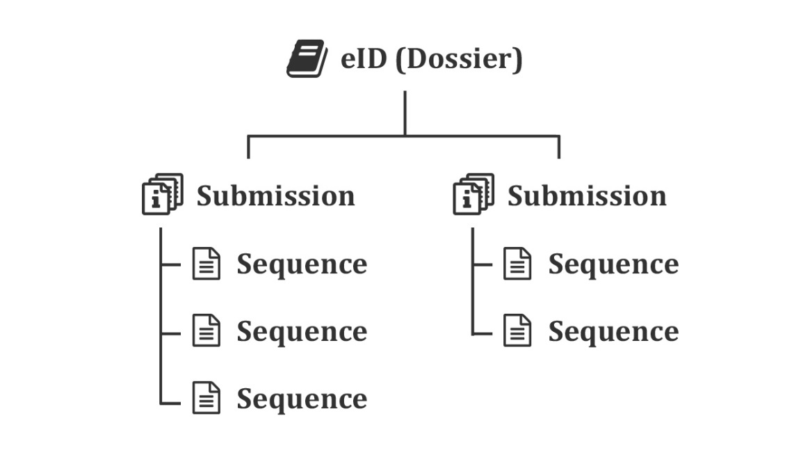

## Specifications

Essential information to compile data within the eCTD and NeeS format is described within ‘Specifications’.

Specifications are living documents are will be updated to reflected changes in requirements and improvements in best practice regulation. Early notification of specification updates will be provided via the TGA website electronic submissions home page.

Both the eCTD and NeeS specifications consist of the:

* requirements
* guidance to clarify your understanding of the requirements
* optional style sheets (templates)
* schemas to show how the data should be organised
* codes and defined lists which outline the allowable terms for populating your sequence XML envelope
* matrices outlining appropriate combinations of documents and codes

Follow the specifications to ensure your eCTD or NeeS sequence is compliant.

### eCTD specifications

* [eCTD Australian regional specifications](https://www.tga.gov.au/electronic-submissions)
* [ICH eCTD specifications](https://ich.org/page/ich-electronic-common-technical-document-ectd-v322-specification-and-related-files)

### NeeS specifications

* [NeeS Australian regional specifications](https://www.tga.gov.au/electronic-submissions)
* best practices from eCTD specifications where appropriate

### XML envelope

The **XML envelope** contains important information for sequence processing and categorising. It is a critical part of the specifications and is required for all eCTD and NeeS sequences.

Within eCTD, the envelope forms part of the **XML backbone**, which forms the basic architecture of eCTD. Further details on the eCTD envelope is available within the [eCTD Specifications](https://www.tga.gov.au/book-page/au-module-1-general-architecture-0#envelope)

NeeS does not have an XML backbone. Instead we have built an XML envelope form to hold this important information. While compiling a NeeS sequence you will need to populate the [NeeS envelope form](https://www.tga.gov.au/book-page/appendix-1-nees-envelope-form-guidance) and include it with the cover letter in Module 1.0.1.

#### Information in the XML envelope

It is important that the information contained within the eCTD envelope and NeeS envelope form is complete and correct as this information is used to:

* contact you if we have any validation questions
* file the sequence within the correct location in our dossier management system
* determine the evaluation pathway

|  |  |
| --- | --- |
| Information | If you are using a specific software program to compile your eCTD or NeeS sequences, most of the specifications will be built into the software. |

## Validation criteria

Validation criteria assess compliance of your eCTD or NeeS sequence with the specifications.

We validate every sequence before it is uploaded to our system. **Only sequences that pass validation will be uploaded.**

If your sequence contains a validation error or failure you will receive an email from [eSubmissions@health.gov.au](mailto:eSubmissions@health.gov.au) outlining the error and requesting that you fix the error and resubmit the corrected sequence to the TGA.

To avoid unnecessary processing delays, we recommend that you validate every sequence prior to sending it to us to ensure no validation errors or failures are present.

### eCTD validation criteria

For Australian-specific eCTD, validation criteria refer to [eCTD validation.](https://www.tga.gov.au/electronic-submissions#validation)

There are three types of eCTD validation findings:

* Error – critical finding which must be resolved before your sequence is uploaded to our system.
* Warning - validation warnings should be eliminated wherever possible. If you can’t eliminate validation warnings you must justify them within the sequence cover letter. Sequences with warning/s can be uploaded to our system.
* Information – indicates that we have collected information on particular aspects of the sequence. We use this information to inform specification updates. Sequences with the information finding will be uploaded to our system.

### NeeS validation criteria

For Australian-specific NeeS validation criteria refer to [NeeS validation](https://www.tga.gov.au/electronic-submissions#validation).

There are three types of NeeS validation findings:

* Fail - critical finding which must be resolved before your sequence is uploaded to our system.
* Best Practice – while the non-compliance is not critical, its presence must be justified within the cover letter if elimination is not possible. Sequences with these warning/s can be uploaded to our system.
* Information – indicates that we have collected information on particular aspects of the sequence. This information is used to inform specification updates. Sequences with the information finding will still be uploaded to our system.

## Version history

|  |  |  |  |
| --- | --- | --- | --- |
| Version | Description of change | Author | Effective date |
| V1.0 | Original publication | BSRR / PMAB / MRD | June 2021 |

|  |
| --- |
| Therapeutic Goods Administration |
| PO Box 100 Woden ACT 2606 Australia  Email: [info@tga.gov.au](mailto:info@tga.gov.au) Phone: 1800 020 653 Fax: 02 6203 1605  [**https://www.tga.gov.au**](https://www.tga.gov.au) |
| Reference # D19-5485379 |