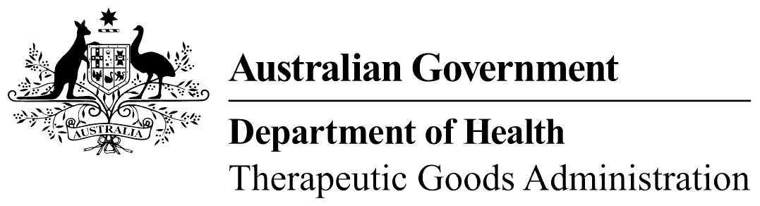
TGA use only

This form, when completed, will be classified as 'For official use only'.
For guidance on how your information will be treated by the TGA see: Treatment of information provided to the TGA at <http://www.tga.gov.au/treatment-information-provided-tga>.

Add or remove an Agent from your organisation
Complete this form if you wish to authorise or remove an Agent (e.g. a regulatory affairs consultant) or people external to your company to undertake regulatory correspondence with us.
Please note: Agents will have full access to all of your approved records.
 | TGA Business Services (TBS) Terms and Conditions

Organisation for which the Agent relationship is being amended
Organisation business name:
Organisation ID:
I want to: | Add an Agent  Remove an Agent

Details of Agent
Agency name:
Agency organisation ID:
Telephone: |  | Fax:

Declaration
Printed name:
Position in organisation:
Signature: |  | Date:

